Pulsed Electromagnetic Field Therapy and its Applications and Usage in the Equine Industry

A Thesis Presented for the
Master of Science
Degree
The University of Tennessee, Knoxville

Delaney Rostad
December 2022
ACKNOWLEDGEMENTS
I cannot begin to thank to Dr. Jennie Ivey. She has helped to guide me throughout this process from start to finish. Without her this research and my time at UT would not have been possible. I also want to thank Last Lap Ranch and Sandra and Roger Elder along with their entire family for hosting the UT equestrian team at their farm for 2 years. Without their support of the UT equestrian program and team, I would not have had this opportunity to pursue this degree. I would also like to thank my committee members Dr. Lew Strickland and Dr. Amanda McLean for their insight and support throughout this project.
I would also like to thank all of my lab mates: Sawyer Main, Olivia Watson, Ashley Self, Kelly Melvin, and honorary lab mate Amy Berger. Their help was instrumental in completing this study. There were many below freezing mornings they helped me complete this project.
I would also like to thank Dr. Steve Adair for his help in analyzing the lameness locator data and lending me the lameness locator for the project. This project would also not have been possible without MagnaWave who graciously lent a PEMF device.
ABSTRACT
Therapeutic modalities in the equine industry are constantly progressing due to evolving needs of horse owners who desire to make their horse perform at their best. Pulsed electromagnetic field (PEMF) therapy is a lesser understood modality when it comes to its use in the horse. Despite its widespread use, there is little research pertaining to how or if PEMF therapy affects performance of the equine athlete and influences various equine medical conditions; however, PEMF therapy use in humans improves delayed onset muscle soreness, and increases stride rate and length which could possibly be applied to the equine athlete. The objective of this study was to assess how PEMF is utilized throughout the equine industry including its use as a therapeutic aid, reasons for use, and usage protocols. An online survey was constructed through Qualtrics, where participants were recruited using existing contact lists, social media, and a national Extension network during a 9-week period. A live animal experiment was also done to determine its short-term effects on horses in a moderate exercise program. We hypothesized that PEMF therapy would improve overall performance and stress indicators in the performance horse. All survey and live experiment data was analyzed using the frequency procedure in SAS (v9.4). Survey respondents received a set of questions pertaining to their industry involvement and their views on PEMF and each respondent could select multiple groups if they pertained to their industry involvement. A total of 86% (n=305) of respondents said they ride or exercise their horse and 85.08% (n=268) of individuals who ride have used PEMF therapy on their performance horse. In the live experiment, horses showed a lower heart rate and differences in forelimb and hindlimb displacement values. Though results show PEMF
widely used and there are beneficial effects, more research is needed to determine how to best utilize therapy.

TABLE OF CONTENTS
Chapter I: Literature Review of Alternative Therapies in Horses…………………………………….…….……1
Abstract…………………………………………………………………………………………………………………………..…………2
1. Introduction……………………………………………………………………………………………………..………..3
2. Alternative Therapies………………………………………………………………………………..……………….5
  - Whole Body Vibration..…………………………………………………………….…….……..…....5
  - Massage………………………………………………………………………………….………………..….7
  - Chiropractic Manipulation……………………………………………………..………..…….…..10
  - Acupuncture……………………………………………………………………………………………....11
  - Pulsed Electromagnetic Field Therapy………………………………………………………...13
3. Conclusion………………………………………………………………………………………………………………..19
References……………………………………………………………………………………………………………….….……….…20
Chapter II: Survey on the usage, prevalence and perceptions of pulsed electromagnetic field therapy in the equine industry……………………………………………………………………………………….…….….25
Abstract……………………………………………………………………………………………………………………….26
Introduction………………………………………………………………………………………………..27
Materials and Methods……………………………………………………………………………….29
2.1 Sample population and survey distribution……………………………….……29
  - Survey development………………..……………………………………………………..30
  - Data handling and statistical analysis………………………………………………31
3. Results………………………………………………………………………………………….……….……..32
3.1 Respondent demographics………………………………………………………..……32
3.2 Respondent classification, ownership, and discipline participation….33
3.3 PEMF prevalence………………..…………………………………………………………..33
3.4 Perception of PEMF…………………………………………………………………………34
3.5 Treatment…………………..…………………………………………………………………..35
3.5a Types and cost…………………………..……..……………………………….35
3.5b Reasons for use……………………………..…………………………..……..35
3.5c Session time and intensity………………………………..………………..36
3.5d PEMF delivery……………………………..…………………………………….36
4. Discussion……………………………………………………………………………………………….…….37
5. Conclusions……………………………………………………………………..….………………………..46
6. Acknowledgements…………………………………………………………..………………………….46
7. Funding……………………………………………………………………………………..………………….46
References……………………………………………………………………………………..……………………………………….47
Chapter III: Short-term effects of pulsed electromagnetic field therapy on the performance horse……………………………………………………………………………………………………………………………………….50
Abstract……………………………………………………………………………………………………………………………………51
- Introduction…………………………………………………………………………………………..……52
- Materials and methods……………………………………………………………………………….54

  - Horses……………………………………………………………………………………….………….54
  - Study design…………………………………………………………………………….………..….55
  - PEMF therapy………………………………………………………………………….……….…..56
  - Salivary cortisol……………………………………………………………………….……..…....57
  - Heart rate……………………………………………………………………………….…….………58
  - Lameness locator………………………………………………………………….………………58
  - Stride Length and quality of movement…………………………………….………….59
  - Statistical analysis………………………………………………………………………….………60
- Results……………………………………………………………………………………………….…..…..60
  - Heart rate…………………………………………………………………………………...………..60
  - Salivary cortisol…………………………………………………………………………………....61
  - Judged gait scores…………………………………………………………………………………61
  - Stride length………………………………………………………………………………………….61
  - Lameness locator data…………………………………………………………………..……..61
3.5a Forelimb vector sum and stride rate………………………………….………….61
3.5b Hind hip difference and hind stride rate………………………………………..62
- Discussion…………………………………………………………………………………..………………63
- Conclusion………………………………………………………………………………………………….68
- Acknowledgements………………………………………………………………………….…………68
- Declarations……………………………………………………………………………………………….69
References…………………………………………………………………………………………………………………..…..…..…70
Appendix……………………………………………………………………………………………………………………..………….73
Tables and Figures…………………………………………………………………………………………….73
Survey questions on the usage, prevalence and perceptions of pulsed electromagnetic field therapy………………………………………………………………..…………95
Vita……………………………………………………………………………………………………………………………..…………119

List of Tables
Chapter II Tables
Table 1: Discipline breakdown………………………………………………………………………………………74
Table 2: Exercise workload according to the national research council…………………………75
Table 3: Conditions that owners and leasers have applied therapy………………………………83

List of Figures
Figure 1: Survey question flow……………………………………………………………………………………..73
Figure 2 A-D: Location of respondents, respondent average yearly gross income, age of respondents, respondent gender………………………………………………………………………..……….76
Figure 3: Division of respondents based on self-selected involvement …………………….….79
Figure 4: Number of horses owned/leased by owners/leasers and trainers/coaches…...80
Figure 5: Owner/leaser reported horse workloads……………………………………………………….80
Figure 6: Timeframe when greatest effects seen among all respondents……………………..81
Figure 7: Reasons for PEMF use among owners and leasers, trainers and coaches, and administrators………………………………………………………………………………………………………………82
Figure 8 A-B: Administrator and owner/leaser reported length of PEMF session and treatment time by device reported by administrators………………………………………………….83
Figure 9: Administrator Reported Hertz Level During Treatment………………………………….84
Figure 10: Administrator reported treatment time by area………………………………………….85
Figure 11 A-B: Usage among administrators and usage among owners and leasers and trainers and coaches…………………………………………………………………………………………………….86
Figure 12: PEMF delivery prior to competition among owners/leasers and trainers/coaches…………………………………………………………………………………………………………..87
Figure 13 A-B: Heart rate based on treatment and lunge heart rates…………………….……..87
Figure 14: Salivary cortisol concentration…………………………………………………………………….88
Figure 15 A-B: Judge’s scores for walk quality and judge’s scores for trot quality….……..89
Figure 16 A-B: Length of stride at walk and length of stride at trot……………………….………90
Figure 17: Forelimb vector sum………………………………………………………………………….…….....91
Figure 18: Forehand stride rate………………………………………………………………………….…………92
Figure 19: Hind Hip Difference…………………………………………………………………………….……….93
Figure 20: Hind Stride Rate………………………………………………………………………………….……….94

Chapter I: Literature review of Pulsed Electromagnetic Field therapy and other modalities associated with the improvement of performance and stress factors in the horse

Rostad, Delaney Rª, McLean, Amandaª, Strickland, Lewrell G^{a, b}, Ivey, Jennie LZª
ªHerbert College of Agriculture, University of Tennessee, Knoxville, TN
^{b}College of Veterinary Medicine, University of Tennessee, Knoxville, TN
Corresponding author: Ivey, Jennie LZ, jzivey@utk.edu
Highlights
• Many non-invasive alternative therapies are available for use in horses.
• Often, modalities are limited in research in horses.
• Public and veterinary views on modalities may differ.
Abstract
With continual advancement in technology and therapeutic modalities, scientific research is lagging behind the current uses of modalities to prevent, maintain, and treat a variety of conditions and the general welfare of the horse. Many of these modalities have more available research in human medicine than equine. The common goal among owners and competitors is to improve the welfare and performance of their horse, so many turn to unresearched, but generally safe, methods of improving athletic performance. Certain modalities like massage and chiropractic have been utilized for decades in the horse industry and are more proven as an effective therapy, but many like whole body vibration and pulsed electromagnetic field therapy are minimally researched when compared to the variety of conditions they are used to treat. Consumers generally use therapies for pain or stress relief in the working horse, but also use them to treat diagnosed conditions like navicular syndrome. Many modalities have evidenced pain relief and stress relief in factors such as heart rate and cortisol levels, however for performance horse owners who use these therapies for performance enhancement, there is little evidence that supports it usage.

1. Introduction
In athletic competition, the desire to maintain a competitive edge while maintaining peak performance is paramount. As human medicine advances, the array of alternative therapies available has increased. Certain therapies have proven to be successful in a human athlete’s recovery and are now being used to assist in the equine athlete’s performance health such as massage which has shown to decrease self-assessed pain scores and perceived pain in triathlon athletes [1]. Many of the demands that human athletes experience are found in horses, which leads to the usage of alternative therapies [2]. This is largely in part to the perceived benefits human athletes have observed even if they are based on anecdotal evidence from athlete experience and testimony [3].
Human research often leads to findings for many therapeutic modality benefits [4]. However, many of these therapies, such as pulsed electromagnetic field therapy, have limited available research in the equine industry [5]. Oftentimes, alternative therapies are viewed as controversial among practitioners of veterinary medicine [6]. Veterinarians are left to answer questions about the effectiveness and safety of many of these treatments. Many supporters of alternative medicine believe that it should complement evidence-based veterinary treatments and should be evaluated and used much in the same way as existing accepted treatment evaluation [4]. Issues arise with complementary modalities due to certification methods for the therapies with some requiring little professional training, though others may require hundreds of hours and formal degrees [6]. Often, many of these therapies have no clear, developed protocol standards when administering treatment [7].
Though many established veterinary professionals may have a negative outlook on alternative therapies, much of the public and veterinary schools, with some even increasing offerings of these types of treatments, have a positive outlook on the future of alternative modalities [6, 7]. The equine industry in particular often looks to unproven alternative medicine to aid in the treatment of certain conditions or to generally improve the welfare of the horse [6]. Among horse owners, only 4% reported in a recent survey to have never used a complementary therapy on their horse [8]. This could also be due to competitors desiring to find ways for their horses to feel their best. The need for alternative therapies that help promote whole body wellness and decrease stress levels has grown with the development of new therapies [9]. Trainers and owners are looking not just to target a specific issue on their horse, but improve that horse’s general wellbeing by either decreasing body soreness, providing relaxation, or improving mobility [10].
This review will focus on common therapeutic modalities used by horse owners with a focus on PEMF and briefly look at how the public and equine veterinary professionals view these therapies. These modalities have been shown or are thought to benefit the horse’s overall athletic performance and stress related factors according to research or manufacturer claims.
2. Alternative Modalities and Therapies
2.1 Whole Body Vibration
Whole body vibration (WBV) is the use of a plate device that uses an intensity of vibrations set by the user to stimulate blood flow and aid in the body’s natural healing cycle. WBV was first used in human medicine and was successful in showing muscle stimulation, essentially warming up the muscles [11]. This created a particular draw to the horse industry as a means to minimize injury risk and physical exertion prior to exercise [12]. Typically, in a performance horse, WBV is thought to warm up horses prior to exercise by increasing blood flow and is thought to aid in pain relief, but vibration therapy companies also advertise as a way to shorten rehabilitation periods [13, 14]. Currently, there are no known side effects of WBV and the therapy is considered safe. Also, WBV lacks clear protocols on usage as to vibration frequency and treatment programs, and its efficacy is still being studied [15]. WBV does not require the use of a licensed technician. Anyone can purchase a vibration plate and treat their animal. Many testimonials of WBV are positive with many using it as an aid in rehabilitation after injury [14].
In research to date, WBV research has shown little to prove it is a viable warm-up program. In a ten-horse study, WBV was tested as a warm-up program where four different regimens were tested. There was no difference between surface temperature of the horse without receiving WBV or after a warm-up regimen on the vibration plate consisting of a 10-minute vibration session. Muscle activity remained the same during vibration as measured during rest [15]. These results suggest a difference in findings present in human medicine for WBV as a useful warm-up aid for performance [11]. For this study’s 10-minute therapy sessions, vibration rates were set at 15Hz for 3 minutes, moved to 22Hz for 4 minutes, then ended with 25Hz for 3 minutes. In an alternate study, a lower vibration setting and shorter treatment time was used, when compared to a 45-minute session at 50Hz which looked at bone mineral content [15, 16].
When analyzing stride length, 11 horses from a similar background were studied. Horses were put into a control or experimental group. All horses were exercised in a free-stall hot walker for 60min/day, 6 days a week for 28 days along with vibration therapy. Horses’ stride lengths were measured on day 0 and day 28, and stride length was shown to decrease over this time period regardless of treatment [16]. However, Nowlin and others found when stride length at the trot was measured immediately following treatment, there was an observed lengthening of stride, though stride also increased in the control group. In this study, horses were assessed for lameness by both a licensed veterinarian and a lameness locator along with measuring stride length. Horses received a 30-minute treatment five days a week for 3 weeks for a total of 15 treatments. At completion of the study, there were no differences found in lameness scores of veterinarians or by the lameness locator [12].
Whole body vibration has been shown to have relaxation effects when used on a low intensity. WBV lowered serum cortisol and creatine-kinase after a 10-minute low intensity vibration session when compared to the samples taken immediately before therapy [17]. Resting heart rate has also been shown to decrease when a horse consistently receives WBV over a 60-day period. Resting heart rate for the control group increased over the treatment period while heart rate decreased in the vibration therapy group by 4.7 bpm [16]. Researchers have also noticed calm behavior in horses receiving frequent treatments and their behavior improving when becoming accustomed to WBV treatment [12]
As a therapeutic pain reliever, WBV did not have a statistically significant effect on a group of 8 previously lame horses through 60 days of WBV therapy [13]. Horses in this study were known to have chronic lameness for inclusion to the study. Horses underwent 60 days of WBV and were evaluated at days 30 and 60 while being exposed to vibration therapy 5 days a week, twice daily for 30 minutes. Results from this study found that WBV could benefit musculoskeletal injuries after 30 days of WBV but could cause a worsening of musculoskeletal injuries after 60 days of WBV. Lameness scores varied between each horse after treatment, with one showing improvement in lameness in one limb, but 2 horses showing a worsening in lameness scores while the rest had no change.
2.2 Massage
Massage is a form of manual therapy that manipulates tissue by the addition of force and touch. It is commonly recommended for aiding in pain relief, increasing range of motion, and providing relaxation [18]. There are no known long-term side effects associated with massage, however, acute muscle soreness and pain may be associated with some aggressive forms [19]. Due to the muscle relaxation involved in massage, horses previously in discomfort may appear more sore due to the release of tension in the muscle. Critics of massage therapy argue there is a lack of scientific evidence of its benefits, with most praise coming from personal experience and observed behavior. Even with this, massage usage is becoming more common among veterinarians [2]. In a past survey evaluating musculoskeletal injury treatment, massage was the most commonly reported form of therapy [8]. Massage therapists do not need to be veterinarians, and there are many programs that offer certificates, but the quality and amount of time needed to earn certain certificates varies. The International Equine Body Workers Association does offer a list of practitioners that have completed coursework from a recognized school and maintain continuing education hours [10].
Massage has been found to have pain relieving qualities. Mechanical nociceptive thresholds (MNTs) were assessed in 8 horses across their backs prior to a massage therapy session and after a 35-45 min treatment. Mechanical nociceptive thresholds are located within the axial skeleton and are combined with pressure algometry to produce a score indicative to pain level [20]. MNTs were assessed at day 1, 3, and 7 following therapy. Massage increased MNT scores on day 1 7.9% from the baseline. At day 3, MNTs were increased though not significantly and at final day 7, MNT values were increased again. The gradual increase of MNT values suggest that there are additional factors at work in the body besides the immediate endorphin release that massage offers and these factors can have long term effects [21].
As a stress reliever, massage therapy has been shown to lower heart rate and have positive behavior outcomes in horses [22]. Behavior was influenced by massage at allogrooming sites where massage produced positive behavior ratings. Heart rate lowered an average of 4.6% during the massage session, and horses maintained an average of 2.6% lower heart rate after the session. Certain sites on the body produced a greater change in heart rate than others. Massaging the withers and mid-neck produced the greatest change in heart rate while the forelimbs had no change [22]. In a study with working Arabian racehorses, researchers also found that heart rate lowered. Horses were included in the study if they were in their first year of racing and worked 1 hour per day 6 days a week. Horses received massage therapy for 25-30 minutes 3 days a week for 7 months. Horses’ heart rates were monitored during rest, saddling, and warm up and Heart rate variability (HRV) was measured. After 2 months of training, horses receiving massage generally had lower HRV than those who did not receive therapy [23].
Furthering massage as a stress reducer, a study with 60 3-year-old Arabian race horses was performed where a control and 2 groups of horses receiving massage and 2 groups receiving relaxing music were studied over a 6-month period. Horses receiving massage after exercise 6 day per week were found to have significantly lower HRs after 2 months of training than the control group and baseline measurements and were also found to be lower when horses were groomed and saddled and also during walking. Salivary cortisol concentrations were lowered in the frequent massage group as well, finding lower levels at rest. Lowered cortisol concentrations detail massage’s effects as a stress reliever and a potential way to mitigate stress responses [24].
Evaluating stride length was performed in a study with 8 horses that were measured for their stride length before and after massage. Horses were placed on a treadmill and walked and trotted for 100 strides in each gait. This was done first to achieve a baseline measurement for each horse, then the horse received a massage and was placed on the treadmill again and performed 100 strides at the walk and the trot. Horses underwent ultrasound on 4 sites: the shoulder extensor and flexor and hip extensor and flexor. The muscles were observed at the muscle belly and muscle tendon junctions. Ultrasound findings saw increased transverse diameters of all 4 muscle sites by up to 18% after massage. This could possibly be explained by shifts in fluid and vascular resistance, changes in muscle fibers due to massage. The change is muscle belly and tendon junctions could correlate to findings on stride length. Stride length increased after massage at the walk and trot, while stride frequency decreased. At the walk, stride frequency slowed by 4.6% while stride length was increased 4.8 inches. At the trot, stride frequency decreased by 1.4% and stride length increased by 1.7 inches. These results are indicative that massage can have an effect on the locomotion of the horse by acutely changing muscle fibers to increase athletic performance [25].
2.3 Chiropractic manipulation
Chiropractic manipulation is the usage of applied force to specific areas of the body using manual manipulation done with the hands or with tools. The goals of chiropractic work are to decrease pain, improve range of motion, and better the reflex response and thus healing the relationship between structure and function. Chiropractic manipulation is commonly recommended for horses who exhibit a history of injury. It is often recommended as a conservative treatment for musculoskeletal disorders related to the spine. These injuries could stem from a single event or a series of repetitive microtraumas such as improper saddle fit or long durations of stall confinement [26]. A survey of equine veterinarians found chiropractic manipulation to be the most accepted form of musculoskeletal injury treatment while horse owners used it only second to massage [27, 8]. In order to become a certified chiropractic practitioner, he or she must be certified through the American Veterinary Chiropractic Association and must currently be a veterinarian or human chiropractor [10]. There are some possible side effects with chiropractic treatments and complications can still occur when chiropractic is applied properly. These can include increased soreness and stiffness across worked areas of the body, but should resolve in 1 to 2 days. If horses are improperly adjusted, severe tissue and loss of function can occur [26].
In terms of chiropractic treatment as a pain reducer, several studies have documented its ability to improve pain. In a study with 40 horses, without a history of back problems, chiropractic therapy was applied once after baseline measures were taken, and MNTs were collected before therapy and afterwards for 7 days [21]. Horses receiving chiropractic treatment generally had lower pain thresholds after the first day, non-significant changes by day 3, and by day 7, had significantly higher MNTs describing an increase in pain tolerance. These results suggest the effect of chiropractic work may not be immediate in its effects. The lower MNTs after day 1 can be explained by the mechanical irritation to the tissues that is created by chiropractic work [21].
Chiropractic treatment has been shown to increase range of motion (ROM). ROM was generally increased immediately following treatment. When testing the effects of one chiropractic treatment, ROM decreased when tested 3 weeks after treatment possibly due to the treatment’s effects wearing off [28]. Chiropractic treatment has shown that it can improve trunk and pelvic flexion reflexes, but was not beneficial on its own in improving back pain [29]. Symmetry can also be improved across pelvic motion with treatment [28]

2.4 Acupuncture
Acupuncture is an ancient practice of inserting needles into the skin at acupuncture sites associated with certain structures of the nervous system. It has often been used in human medicine to complement other treatment methods by its analgesic effects and to help rebalance physiologic functions [30]. In Western medicine, acupuncture is thought to focus the body’s pain response to the site of the needle in order for the nervous system to recognize areas of repair [31]. There have been many studies to show its efficacy to treat injury, improve fatigue, and increase blood flow in humans [30-34]. To be certified in acupuncture, an individual must be a licensed veterinarian and must be certified through one of three recognized institutions that offer course work [10].
After acupuncture treatment, horses have shown an increase in behaviors expressing relaxation like frequency in chewing and softer ear position [33]. In a study of 6 horses, acupuncture was applied to several sites on the hoof lasting 20 minutes. These horses were outfitted with a special shoe that applied pressure to the frog and the navicular bone in order to achieve a pain response. In 4 of 6 horses, HR was lowered when compared to their baseline scores once acupuncture was complete. The results of this study suggest that acupuncture can have an effect on the stress response in the presence of pain by having an analgesic effect [34]. Acupuncture’s effects on laminitis have been evaluated in several studies. In a study with 12 horses suffering from chronic laminitis, horses were evaluated for effects of 2 separate acupuncture treatments one week apart. Though each horse’s case differed in pain level and degree of condition, degree of lameness improved after 2 treatments [35].
Acupuncture has also shown promise in identifying pain responses. In a study of 102 horses, 51 were sound and 51 lame, an acupuncture scan was used which is the palpation of certain acupoints to determine sensitivity. In the horses classified as lame, acupuncture scans were positive for sensitivity 82.4% of the time for the lame group while scans for the sound group were positive 17.6%. However, there was no way to identify which limb suffered the lameness through the acupuncture scan, though there was correlation between the sensitivity degree of the scan and the side the lameness was present [36].
In a study of acupuncture's effects on core and surface temperature, thoroughbred horses competed in 2 official races and were later transported on a truck for hauling. Horses were transported to the racetrack before each race. Acupuncture was performed 30 minutes prior to trailer hauling and was performed for 30 minutes each day on each horse. Horses were evaluated for changes in rectal and skin temperature. Researchers found an effect on body and skin temperature on transported and exercised horses when compared to those who did not receive treatment. Horse's body temperature increased in the flank area and rectally when compared to the control group. This was after horses were exercised and transported suggesting acupuncture has an effect on circulation and microcirculation of the skin [37].
2.5 Pulsed Electromagnetic Field Therapy
Pulsed Electromagnetic Field Therapy (PEMF) is emerging as a commonly used modality in equine medicine. The main claim of many companies that market and sell PEMF machines is that PEMF works to decrease inflammation [38]. On the cellular level this is accomplished by PEMF stimulating the release of calcium which then binds to the protein calmodulin that acts as a signal to various pathways such as those related to inflammation and vascular tone. This binding signals to nitric oxide synthase which produces nitric oxide (NO) which is known for its anti-inflammatory response and enhancement of blood flow [39].
Pulse electromagnetic field devices work by a copper coiled wire that is inserted into a hose or blanket device and is then placed on the body in the desired area of treatment. An electromagnetic pulse is generated then sent through the hose or blanket device that causes stimulation in the conductive tissue [5]. Often, when therapy is being delivered, the muscles of the horse will visibly twitch, and the strength of the twitching can be used to determine areas of soreness of the body [38]. The hertz frequency or intensity of the pulse can be varied depending on the patient’s pain tolerance and targeted tissue depth, though there is no standard for intensity level for horses as many practitioners and studies vary their therapy depending on each individual horse’s response [40]. Anyone is able to purchase and operate a PEMF machine. Training is available, but it is not required to practice the therapy [38].
There are two main types of devices available on the equine market: hose and blanket devices [41]. Hose devices work by initiating the pulse wave through an analog spark chamber or digitally [38]. This pulse is then sent through the hoses laid on the horse’s body. Hoses vary the size of the loops and can be placed nearly anywhere on the horse’s body. These devices use circular loops to deliver therapy with tissue surrounded by the loops being affected. The blanket device or BEMER® system is unique in that it has been shown to increase vasomotion which is the rhythmical contraction of blood vessels which has a vagal effect on the horse [42]. Pulsed electromagnetic field therapy has been FDA approved in humans for a variety of conditions such as the treatment of non-union bone fractures, depression, and brain cancer among other conditions. BEMER® is FDA Class II cleared medical device in humans [41]. Both PEMF systems claim to enhance oxygen delivery to tissues, increase blood flow, and muscle recovery among other conditions [41, 38]. Both BEMER® and companies that produce hose devices like MagnaWave state their devices are safe to use with no documented side effects and can be used without sedation in horses.
Though PEMF has been well studied in human medicine, its effects in equine medicine are not as well understood, although it is frequently used among performance horses. In human performance, PEMF studies have compiled a variety of results. In a study by Jeon and others, delayed onset muscle soreness (DOMS) was induced and PEMF therapy ensued to determine its effects on diminishing muscle soreness. There were 30 patients recruited for the study with 15 patients divided into a PEMF group and 15 with a sham therapy group for 3 consecutive days. Patients were blinded to which treatment they received. Delayed onset muscle soreness was induced by an isokinetic dynamometer applied at the biceps brachii and all patients were confirmed to have DOMS after exercise. This study showed patients receiving PEMF treatment showed quicker electromechanical delay (EMD), which is the time between muscle activation and muscle force production. Though both sham and PEMF groups decrease EMD, the delay in recovery time to return to baseline was longer in the sham group versus the PEMF group. The PEMF treatment group also had less pain at 72 hours post exercise according to the visual assessment score where patients rated their pain. These results suggest that PEMF therapy can reduce the severity of DOMS symptoms and improve recovery time from exercise [42].
Pulsed electromagnetic field therapy has also shown to improve stride length in humans. In a study by Giusti and others, 41 patients who were aged greater than 70 and had low bone density were observed for stride length and gait speed. All patients recorded baseline values for stride length and gait speed before treatment. A single 10-minute treatment was performed and then patients were assessed immediately following treatment. Researchers found self-selected gait speed was improved and differed significantly from the placebo group by nearly 10cm/s. This outcome was also observed in stride length, where length increased from the baseline for those receiving therapy by over 3cm in length, whereas those receiving the placebo treatment remained unchanged [43]. This research suggests PEMF can influence stride length and gait speed.
Range of motion (ROM) has also been studied in humans, specifically those suffering from cervical osteoarthritis (COA). Sutbeyaz and others ran a study with 34 patients who had been diagnosed with COA and had a history of neck pain but had not received therapy for their pain within the last 6 months. Each patient received baseline testing for pain values, ROM, and neck pain and disability scale (NPDS) which were comparable between the treatment and sham group. Researchers found patients receiving a 30-minute PEMF treatment twice a day for three weeks showed reduced pain scores using the visual assessment scoring (VAS) system compared to those patients in the sham group who received a placebo treatment. Range of motion and NPDS scores also improved after PEMF therapy in this study. Average VAS scores for PEMF patients dropped over 4 points when scored out of 10 while the sham group remained unchanged. Patients receiving PEMF were able to have a greater ROM for chin-manubrium distance and Occiput-C7 PS distance. Patients were able to have more flexion and movement through their necks and had improved NPDS scores after receiving the PEMF treatments [44].
The effect of PEMF on heart rate and ventilation has also been studied. In a study with 14 college athletes, 2 groups of PEMF and sham treatments were tested. Athletes were tested at sea level for baselines then tested from sea level to altitudes of 1322m above sea level during 6 training days. Therapy was given over the 6-day training period before and after exercise for a total of 12 therapy sessions. After 6 days, there was no change in heart rate after physical activity or during rest from baseline to post exercise rates in either group. However, PEMF therapy did promote relative ventilation during peak aerobic capacity with a significant difference between pre and post tests for PEMF patients. This is explained by PEMF’s angiogenesis effect which promotes the development of blood [45].
Though studies with PEMF on equines are limited, there has been some research in pain and stress responses. In a study using the BEMER® blanket device, twelve warmblood horses were treated with PEMF therapy for fifteen minutes for 2 weeks. Each therapy session followed a fifteen-minute lunge exercise. The goal of this study was to determine BEMER®’s effect as a vascular therapy. For the BEMER® therapy session, the blanket device was set to alternate between 10 Hz and 30 Hz during therapy while the placebo treatment used a blanket identical to the BEMER® but lacked coils to perform the therapy. Blood samples were taken immediately following and one hour after exercise completion. Heart rate and behavior were also documented in this study. Hemocrit (HCT), which is the indirect measurement of red blood cell (RBC) numbers in circulation, was measured in the blood work. Hemocrit levels are influenced by hydration status, splenic contraction and other medical conditions that may cause anemia. Levels of HCT tended to be lower in the treatment group than the placebo, but the results were not significant. Heart rate itself did not vary but there tended to be a lowered low frequency/high frequency, which describes presence of vagal activity, in those receiving treatment which describes a possible vagal effect in therapy inducing relaxation. Overall, researchers in this study found inconclusive results on PEMF’s ability to induce vascular changes on equines [46].
Pulsed electromagnetic field therapy for the treatment of back pain has been evaluated in polo horses by measuring MNTs. In this study, 20 polo horses were evaluated for back pain over two 10-day treatment periods. Twenty-five sites were analyzed using pressure algometry along the horse’s back both at the start and end of each day. Results from this study were inconclusive, showing horses receiving PEMF treatment and those receiving a placebo both having decreases in MNTs during the timeframe of the study. Limitations in this study acknowledged that horses may not have exhibited severe enough back pain to quantify and demonstrate a difference before and after treatment [40].
In an alternate study on pain assessment, 8 horses from a riding program who had similar exercise regimes were examined for back pain. These horses were not diagnosed with back pain prior, but were subjected to a certified equine chiropractic examiner who evaluated each horse for a baseline and post study score of 0-3 with 0 being absent from back pain and 3 being severe pain. MNTs were also measured with a pressure gauge along with gait analysis performed by an inertial sensor system to assess limb lameness. The study took place over 3 consecutive days with each horse receiving PEMF therapy twice a day, once in the AM and once in the PM. Baseline chiropractic scores of pain were significantly higher than those reported at the end of the study. MNTs were significantly higher at both timepoints during each PEMF treatment after therapy completion showing more pressure could be applied to the back before a reaction. The increase in MNTs was also seen in the baseline measurements compared to the measures at the completion of all treatments. Though pain was improved, there was no difference seen in the inertial sensor data [47].
PEMF’s effects on back surface temperature have also been evaluated to determine if there is an increase in the amount of blood circulation. In this study researchers found a 0.69K increase on horse’s backs after receiving a 40-minute therapy session. This finding, however, was not statistically different when compared to their control group who received a placebo treatment [48]. A similar result was also found by Dai and other researchers when determining the vascular response to PEMF therapy [47]. The increase in temperature could be due to the blanket device itself on the horse acting as a means to keep heat in the body.
3. Conclusions
Though studies in equine medicine are limited when it comes to alternative therapies on the equine market, much evidence for its usage can be drawn from human and animal medicine [49]. In therapies like massage and chiropractic treatment, many more studies are available due the long history of these therapies throughout human and animal medicine. In the case of PEMF, much research still needs to be done to validate its efficacy in equines especially on its usage as a way to better athletic performance. The average horse owner typically seeks non-invasive treatments to treat injuries and health conditions though their perceptions may differ from equine veterinarians. Newer modalities consistently develop and become available to horse owners, though the research does not always keep up with the usage of the therapies.
References
[1] Nunes, Bender, P. U., de Menezes, F. S., Yamashitafuji, I., Vargas, V. Z., & Wageck, B. (2016). Massage therapy decreases pain and perceived fatigue after long-distance Ironman triathlon: a randomised trial. Journal of Physiotherapy, 62(2), 83–87. https://doi.org/10.1016/j.jphys.2016.02.009
[2] Scott, M. Swenson, L. A. (2009). Evaluating the Benefits of Equine Massage Therapy: A Review of the Evidence and Current Practices. Journal of Equine Veterinary Science, 29(9), 687–697. https://doi.org/10.1016/j.jevs.2009.07.017
[3] Hemmings, B. J. (2001). Physiological, psychological and performance effects of massage therapy in sport: a review of the literature. Physical therapy in sport, 2(4), 165-170.
[4] B.A. McKenzie. (2012)Is complementary and alternative medicine compatible with evidence-based medicine?. Journal of American Veterinary Medicine Association, 241 (2012), pp. 421-426. https://doi.org/10.2460/javma.241.4.421
[5] Hug, K., Röösli, M. (2012). Therapeutic effects of whole‐body devices applying pulsed electromagnetic fields (PEMF): A systematic literature review. Bioelectromagnetics, 33(2), 95–105. https://doi.org/10.1002/bem.20703
[6] Haussler, K. K. (2009). Current status of integrative medicine techniques used in equine practice. Journal of equine veterinary science. 29(8), 639- 641.
[7] Wynn, S. G., & Wolpe, P. R. (2005). The majority view of ethics and professionalism in alternative medicine. Journal of the American Veterinary Medical Association, 226(4), 516-520.
[8] Thirkell, & Hyland, R. (2017). A Survey Examining Attitudes Towards Equine Complementary Therapies for the Treatment of Musculoskeletal Injuries. Journal of Equine Veterinary Science, 59, 82–87. https://doi.org/10.1016/j.jevs.2017.10.004
[9] Kędzierski, Janczarek, I., Stachurska, A., & Wilk, I. (2017). Comparison of Effects of Different Relaxing Massage Frequencies and Different Music Hours on Reducing Stress Level in Race Horses. Journal of Equine Veterinary Science, 53, 100–107. https://doi.org/10.1016/j.jevs.2017.02.004
[10] Crabbe, B. (December, 2011). Alternative therapies: 7 steps to success: learn how to make the most of chiropractic, acupuncture, and massage therapy in your horse’s management plan. Horse & Rider, 60(12). 49-52.
[11] Cochrane, D. (2013). The sports performance application of vibration exercise for warm-up, flexibility and sprint speed. European Journal of Sport Science, 13(3), 256-271. https://doi.org/10.1080/17461391.2011.606837
[12] Nowlin, Nielsen, B., Mills, J., Robison, C., Schott, H., & Peters, D. (2018). Acute and Prolonged Effects of Vibrating Platform Treatment on Horses: A Pilot Study. Journal of Equine Veterinary Science, 62, 116–122. https://doi.org/10.1016/j.jevs.2017.12.009
[13] Halsberghe, B.T. (2017). Long-Term and Immediate Effects of Whole Body Vibration on Chronic Lameness in the Horse: A Pilot Study. Journal of Equine Veterinary Science, 48, 121–128.e2. https://doi.org/10.1016/j.jevs.2015.12.007
[14] Equivibe. (2022). Rehab, Recover, Rebuild. EquiVibe: A Proven Track Record. https://equivibe.com/rehabilitation/
[15] Buchner H. H., Zimmer, L., Haase, L., Perrier, J., & Peham, C. (2017). Effects of Whole Body Vibration on the Horse: Actual Vibration, Muscle Activity, and Warm-up Effect. Journal of Equine Veterinary Science, 51, 54–60. https://doi.org/10.1016/j.jevs.2016.12.005
[16] Maher, K., Spooner, H., Hoffman, R., & Haffner, J. (2020). The influence of whole-body vibration on heart rate, stride length, and bone mineral content in the mature exercising horse. Comparative Exercise Physiology, 16(5), 403-408.
[17] Carstanjen, B., Balali, M., Gajewski, Z., Furmanczyk, K., Bondzio, A., Remy, B., & Hartmann, H. (2013). Short-term whole body vibration exercise in adult healthy horses. Polish Journal of Veterinary Sciences. DOI 10.2478/pjvs-2013-0057
[18] Law, L. A. F., Evans, S., Knudtson, J., Nus, S., Scholl, K., & Sluka, K. A. (2008). Massage reduces pain perception and hyperalgesia in experimental muscle pain: a randomized, controlled trial. The Journal of Pain, 9(8), 714-721.
[19] Haussler, K. K. (2009). Review of Manual Therapy Techniques in Equine Practice. Journal of Equine Veterinary Science, 29(12), 849–869. https://doi.org/10.1016/j.jevs.2009.10.018
[20] Haussler, K. K., Erb, H. (2006). Mechanical nociceptive thresholds in the axial skeleton of horses. Equine Veterinary Journal, 38(1), 70–75. https://doi.org/10.2746/042516406775374315
[21] Sullivan, K.A., Hill, A. E., & Haussler, K. K. (2008). The effects of chiropractic, massage and phenylbutazone on spinal mechanical nociceptive thresholds in horses without clinical signs. Equine Veterinary Journal, 40(1), 14–20. https://doi.org/10.2746/042516407X240456
[22] McBride, S. D., Hemmings, A., Robinson, K. (2004). A preliminary study on the effect of massage to reduce stress in the horse. Journal of Equine Veterinary Science, 24(2), 76–81. https://doi.org/10.1016/j.jevs.2004.01.014
[23] Kowalik, Janczarek, I., Kędzierski, W., Stachurska, A., & Wilk, I. (2017). The effect of relaxing massage on heart rate and heart rate variability in purebred Arabian racehorses: Massage and HRV in Horses. Animal Science Journal, 88(4), 669–677. https://doi.org/10.1111/asj.12671
[24] Kędzierski, Janczarek, I., Stachurska, A., & Wilk, I. (2017). Comparison of Effects of Different Relaxing Massage Frequencies and Different Music Hours on Reducing Stress Level in Race Horses. Journal of Equine Veterinary Science, 53, 100–107. https://doi.org/10.1016/j.jevs.2017.02.004
[25] Wilson, J.A. (2002). Effects of Sports Massage on Athletic Performance and General Function. Massage Therapy Journal, summer, 90-100.
[26] Haussler, K. K. (1997). Application of chiropractic principles and techniques to equine practice. In Proceedings of the Annual Convention of the American Association of Equine Practitioners, 43, 312-318.
[27] Bergenstrahle A., Nielsen, B. D. (2016). Attitude and Behavior of Veterinarians Surrounding the Use of Complementary and Alternative Veterinary Medicine in the Treatment of Equine Musculoskeletal Pain. Journal of Equine Veterinary Science, 45, 87–97. https://doi.org/10.1016/j.jevs.2016.05.019
[28] Alvarez, C. G., L'ami, J. J., Moffatt, D., Back, W., & Van Weeren, P. R. (2008). Effect of chiropractic manipulations on the kinematics of back and limbs in horses with clinically diagnosed back problems. Equine veterinary journal, 40(2), 153-159. https://doi.org/10.2746/042516408X250292
[29] Haussler, K. K., Manchon, P. T., Donnell, J. R., Frisbie, D. D. (2020). Effects of Low-Level Laser Therapy and Chiropractic Care on Back Pain in Quarter Horses. Journal of Equine Veterinary Science, 86, 102891–102891. https://doi.org/10.1016/j.jevs.2019.102891
[30] Vincent, C. A., Richardson, P. H. (1986). The evaluation of therapeutic acupuncture: concepts and methods. The Journal of Pain. 24(1), 1-13. https://doi.org/10.1016/0304-3959(86)90022-9
[31] Edgell, J. (2006). The holistic horse: Alternative therapies for equine health. Journal of Agricultural & Food Information, 7(1), 83-91. https://doi.org/10.1300/J108v07n01_09
[32] Karvelas, B. R., Hoffman, M. D., & Zeni, A. L. (1996). Acute effects of acupuncture on physiological and psychological responses to cycle ergometry. Archives of physical medicine and rehabilitation, 77(12), 1256-1259.
[33] Rodrigues, C. A. D. C. C., de Andrade, J. S., de Oliveira, B. S., Fortuna, P. S., Bezerra, A. B. G., & Abdalla, P. P. (2022). Effect of laser acupuncture on humans: systematic review. Brazilian Journal of Development, 8(1), 7945-7957. D OI:10.34117/bjdv8n1-533
[34] Hackett, G. E., Spitzfaden, D. M., May, K. J., Savoldi, M., & Dodd, M. (1997). Acupuncture: Is it effective for alleviating pain in the horse. In Proc. Am. Assoc. Equine Pract, 43, 333-335).
[35] Faramarzi, B., Lee, D., May, K., Dong, F. (2017). Response to acupuncture treatment in horses with chronic laminitis. The Canadian Veterinary Journal, 58(8), 823.
[36] Le Jeune, S. S., Jones, J. H. (2014). Prospective Study on the Correlation of Positive Acupuncture Scans and Lameness in 102 Performance Horses. American Journal of Traditional Chinese Veterinary Medicine, 9(2), 33-41.
[37] Rizzo, M., Arfuso, F., Giudice, E., Abbate, F., Longo, F., & Piccione, G. (2017). Core and surface temperature modification during road transport and physical exercise in horse after acupuncture needle stimulation. Journal of Equine Veterinary Science, 55, 84-89. https://doi.org/10.1016/j.jevs.2017.03.224
[38] MagnaWave. (2021). MagnaWave for Horses. Magnawavepemf. https://magnawavepemf.com/magnawave-for-horses/
[39] Gaynor, J. S., Hagberg, S., & Gurfein, B. T. (2018). Veterinary applications of pulsed electromagnetic field therapy. Research in Veterinary Science, 119, 1–8. https://doi.org/10.1016/j.rvsc.2018.05.005
[40] Biermann, N.M., Rindler, N., Heinz Hans, F. (2014). The Effect of Pulsed Electromagnetic Fields on Back Pain in Polo Ponies Evaluated by Pressure Algometry and Flexion Testing—A Randomized, Double-blind, Placebo-controlled Trial. Journal of Equine Veterinary Science, 34(4), 500–507. https://doi.org/10.1016/j.jevs.2013.10.177
[41] Bemer Group. (2021). The Positive Effects of Bemer Horse-Set. Bemer Group. https://bemergroup.com/en_US/equine-line/benefits/positive-effects
[42] ] Jeon, H.S., Kang, S.Y., Park, J.H., Lee, H.S. (2014). Effects of pulsed electromagnetic field therapy on delayed-onset muscle soreness in biceps brachii. Physical Therapy in Sport, 16(1), 34–39. https://doi.org/10.1016/j.ptsp.2014.02.006
[42] Klopp, R.C., Niemer, W., Schmidt, W., 2013a. Effects of various physical treatment
methods on arteriolar vasomotion and microhemodynamic functional characteristics
in case of deficient regulation of organ blood flow. Results of a placebo-controlled,
double-blind study. J. Complement. Integr. Med. 10, S39–S46. https://doi.org/
10.1515/jcim-2013-0035.

[43] Giusti, Giovale, M., Ponte, M., Fratoni, F., Tortorolo, U., De Vincentiis, A., & Bianchi, G. (2013). Short-term effect of low-intensity, pulsed, electromagnetic fields on gait characteristics in older adults with low bone mineral density: A pilot randomized-controlled trial. Geriatrics & Gerontology International, 13(2), 393–397. https://doi.org/10.1111/j.1447-0594.2012.00915.x

[44] Sutbeyaz, S.T., Sezer, N. Koseoglu, B.F. (2006). The effect of pulsed electromagnetic fields in the treatment of cervical osteoarthritis: a randomized, double-blind, sham-controlled trial. Rheumatology International, 26(4), 320–324. https://doi.org/10.1007/s00296-005-0600-3

[45] Tamulevicius, N., Wadhi, T., Oviedo, G. R., Anand, A. S., Tien, J.-J., Houston, F., Vlahov, E. (2021). Effects of acute low-frequency pulsed electromagnetic field therapy on aerobic performance during a preseason training camp: A pilot study. International Journal of Environmental Research and Public Health, 18(14), 7691–. https://doi.org/10.3390/ijerph18147691

[46] Dai, F., Dalla Costa, E., Giordano, A., Heinzl, E. U., Giongo, P., Pagnozzi, G., Minero, M. (2022). Effects of BEMER® physical vascular therapy in horses under training. A randomized, controlled double blind study. Research in Veterinary Science, 144, 108-114. https://doi.org/10.1016/j.rvsc.2022.01.017

[47] King, Seabaugh, K. A., & Frisbie, D. D. (2022). Effects of a Bio-Electromagnetic Energy Regulation Blanket on Thoracolumbar Epaxial Muscle Pain in Horses. Journal of Equine Veterinary Science, 111, 103867–103867. https://doi.org/10.1016/j.jevs.2022.103867

[48] Rindler, N., Biermann, N. M., Westermann, S., & Buchner, H. H. F. (2014). The effect of pulsed electromagnetic field therapy on surface temperature of horses’ backs. Wiener Tierarztliche Monatsschrift, 101, 137-141.

[49] Di Bartolomeo, Cavani, F., Pellacani, A., Grande, A., Salvatori, R., Chiarini, L., Nocini, R., & Anesi, A. (2022). Pulsed Electro-Magnetic Field (PEMF) Effect on Bone Healing in Animal Models: A Review of Its Efficacy Related to Different Type of Damage. Biology (Basel, Switzerland), 11(3), 402–. https://doi.org/10.3390/biology11030402

Chapter II: Survey on the usage, prevalence and perceptions of pulsed electromagnetic field therapy in the equine industry

Rostad, Delaney Rª, McLean, Amandaª, Strickland, Lewrell G^{a, b}, Adair, H. Steven^{b}, Ivey, Jennie LZª

ªHerbert College of Agriculture, University of Tennessee, Knoxville, TN
^{b}College of Veterinary Medicine, University of Tennessee, Knoxville, TN
Corresponding author: Ivey, Jennie LZ, jzivey@utk.edu
Highlights
- Equine owners and trainers who use pulsed electromagnetic field view therapy positively.
- Pulsed electromagnetic field therapy is used in a variety of disciplines and conditions.
- Therapy users and administrators reported similar perceived benefits and outcomes.

Abstract
Therapeutic modalities in the equine industry are constantly progressing due to evolving needs of horse owners who desire to make their horse perform at their best. Pulsed electromagnetic field (PEMF) therapy is a lesser understood modality when it comes to its use in horses. Despite its widespread use, there is little research pertaining to how or if PEMF therapy affects performance of the equine athlete and influences various equine medical conditions. However, PEMF therapy use in humans improves delayed onset muscle soreness and increases stride rate and length which could possibly be applied to the equine athlete. The objective of this study was to assess how PEMF is utilized throughout the equine industry including its use as a therapeutic aid, reasons for use, and discipline usage. An online survey was constructed through Qualtrics, where participants were recruited using existing contact lists, social media, and a national Extension network during a 9-week period. Participants were over 18 years old, United States residents, and had prior familiarity with PEMF. All data was analyzed using the frequency procedure in SAS (v9.4). Survey respondents (n=355) were divided into categories, which could include multiple categories based on involvement, when applicable: owners and leasers (OL, n=316) trainers, coaches, grooms, and jockeys (TC, n=91), and PEMF administrators (AD, n=221). Each group received a set of questions pertaining to their industry involvement and their views on PEMF and each respondent could select multiple groups if they pertained to their industry involvement. Of individuals who ride or exercise their horse, 85.08% (n=268) have used PEMF therapy on their performance horse. Among TC, 84.62% (n=77) said they have used PEMF therapy on a horse under their care. Whole body therapy was the most commonly reported location for PEMF by OL (91.6%, n=240) and AD (96.12%, n=223), with spot treatments less frequently reported among users and AD. Within 1 d of treatment, the majority of AD (n=85, 40.28%) and OL (n=104, 39.54%) perceived the greatest effects of PEMF therapy. Though respondents overwhelmingly viewed PEMF therapy as beneficial, there is still more research needed to determine its effects on the horse.
Keywords: PEMF, Alternative Therapy, Therapeutic Survey

1. Introduction
Modern horse owners and trainers have more options for treatments of equine health conditions than ever before. Many treatment options stem from outside conventional veterinary medicine and come from the expanding alternative therapy markets [1]. The financial limitations of veterinary treatment and long recovery times have prompted many individuals within the equine industry to delve into seeking alternative therapies such as acupuncture, whole body vibration, and massage. Often, treatments are used to improve the horse’s comfort and performance, though there may be a lack of evidence supporting the modality’s uses [2]. For performing or working horses, lameness and musculoskeletal soreness has been documented in a variety of western disciplines, racing, and over fences work [3, 4]. The tolls of everyday work have been documented to cause a multitude of injuries regardless of discipline, furthering many owners and trainers to search for ways to prevent injury and lameness which often lead them to turn to alternative therapies [3].
Pulsed electromagnetic field therapy (PEMF) has been documented in humans to improve stride length and rate and improve the length of delayed onset muscle soreness [5, 6]. PEMF therapy has been FDA approved in humans for a variety of reasons including the treatment of non-union fractures, depression, and post-operative edema and pain [7]. These benefits explored in human athletes hold promise to the therapy’s potential benefits to equine athletes. There is little information regarding how PEMF is viewed and utilized within the equine industry. Though there have been a handful of studies done to determine the effectiveness of PEMF on certain conditions of the horses, little is known on its total usage throughout the industry. To date, there have been no negative side effects documented with PEMF and its use in horses and other veterinary medicine [8].
The need for PEMF therapy is present in the equine industry though little has been researched. According to the device manufacturers, PEMF therapy improves a variety of conditions that better the horse’s ability to adapt to show environments and recover from periods of exercise. There is little information discussing how the equine industry utilizes PEMF and the reasons why an owner or trainer may use the therapy. Pulsed electromagnetic field therapy has shown to be beneficial to human athletes but this has yet to be seen in horses leading to questions why an unproven therapy has become increasingly popular. Most research to date has assessed back pain and differences in heart rate and cardiac function [9, 10]; however, equine PEMF manufacturing companies claim therapy has many more possible benefits. Further, there is also no set therapy protocol with time and intensity varying among studies [10-12]. Even in studies assessing common injuries such as back pain in horses, therapy methods vary where one study utilized one 40-minute session per day for 10 d at a varying rate of 1 to 30 Hz and 50 microTesla [11], while another implemented therapy twice a day for 3 d by increasing the therapy time to 5, 10, and 15 minutes set at 35 microTesla [9]. Thus, the objective of this study was to characterize the use of PEMF within the equine industry, including application methods, perceived benefits, and utilization demographics.

2. Materials and Methods
2.1 Sample Population and Survey Distribution
United States residents over the age of 18 were recruited to participate. Survey respondents were solicited using existing contact lists cultivated by Extension service, where individuals indicated they were willing to participate in research surveys. Social media outlets, including Facebook, Instagram, and Twitter, were utilized to share information to professional networks, and organized equine and PEMF interest groups. Survey information was also distributed nationally to equine Extension specialists for dissemination within their respective states. Data was collected for 9 weeks, from July 5 to September 12, 2021. All survey implements and recruiting materials were approved by the University of Tennessee Institutional Review Board (UTK IRB-21-06410-XM).
Categorization questions were provided early in the survey to allow for compartmentalization of latter survey questions and respective data. Participants were divided into categories based on their industry involvement in one or more of the groups: owners and leasers (OL), trainers/coaches/grooms/jockeys (TC), and/or administers (AD). A respondent could categorize themselves into all or any of these options, and each group received a different set of questions relating to their involvement within the industry and how PEMF, if familiar or used, was utilized. Respondents were classified into regions based on US Census regions from self-reported state of residence data [13].
2.2 Survey Development
The survey consisted of 51 total questions, spanning multiple choice, short answer and open-ended formats and was conducted using Qualtrics (Provo, Utah, XM). The survey was divided into 5 sections where questions displayed to each participant varied depending on their self-reported role within the industry as a horse owner or leaser (OL), PEMF administrator (AD), or a trainer/coach/groom/jockey (TC), where individuals could self-select participation in any/all categories (figure 1). Initially, respondents were provided with participation consent and industry involvement classification questions. Then, survey participants were categorized into OL, AD, and TC where they received questions about the number of horses they owned or cared for, the workload of the horses if they are ridden, and disciplines in which they participate. Disciplines were then categorized by seat type and activity of work (table 1). Participants selected the average workload for their primary horse based on the National Research Council [14] (table 2).
All respondents were then asked if they were familiar with PEMF therapy and then if they had used a PEMF device on a horse for which led to the second section of the survey for administrators and those familiar with PEMF. Anyone who was not familiar with PEMF was sent to the final demographics section as the remainder of the survey addressed PEMF specific questions. Administrators were asked about machine usage, therapy protocols, including treatment length, targeted body areas, intensity, and cost. Owners and leasers and TCs who have had horses receive treatment answered questions based on treatment time, reasons for treatment, and cost. Then, OLs and TCs were asked to provide their perceptions of treatment including how long after therapy results are identified, observed result longevity, and treatment frequency. Both groups were also asked if they used therapy while in a competition setting.
Lastly, respondents identified if they felt PEMF was beneficial to their horse or the horse they treated and were asked to select specific reasons, if any, therapy was performed. The section also targeted OLs and TCs who used PEMF therapy in a competitive setting and asked their potential reasons for use. Demographic information including income, ethnicity, race, location, and gender concluded the survey.
2.3 Data Handling and Statistical Analysis
Any short answer section was divided into a numerical range, if applicable, on length of time and intensity of treatment. For short answer options which were available as an “other” response with text entry option, selection results were identified as “other”. Questions assessing PEMF machine type if “other” was selected were classified to a device type based on brand if noted in short response. For the free response question, key words and phrases were identified, matched, and analyzed according to response type.
Data were analyzed using the frequency procedure in SAS (version9.4, Cary, NC). Short answer questions relating to numbers were categorized into ranges to calculate answer totals. Open-ended questions were reviewed but not included into results as they detailed specific treatment protocols.

3. Results
In total, 366 individuals participated in the survey. Only 11 were exited due to being under the age of 18 years old (n=3) or being unfamiliar with PEMF therapy (n=8), resulting in a final respondent population of 355.
3.1 Respondent Demographics
The majority of respondents were from the South region, which comprised 58.6% (n=163) of the total survey participants. Within this subset, Tennessee was the largest state represented (n=49) followed regionally by the Midwest n=47, 16.9%), followed by the Northeast (12.6%, n=35) , and then the West (9%, n=25; figure 2a). Annual gross income was most commonly reported above $150,000 (n=59, 22.61%; figure 2b). The average age of respondents was between 25-34 (n=69, 24.73%) followed by those aged 35-44 (n=57, 20.43%; figure 2c). Respondents were 94.68% (n=267) female and 5.32% (n=15) male (figure 2d), and 92.5% (n=259) were Caucasian.

3.2 Respondent Classification, Ownership, and Discipline Participation
Industry classification of survey respondents (n=355) resulted in the following breakdown: OL (n=316), TC (n=91), AD (n=221; figure 3). The majority of OL selected they owned or cared for 2-3 horses (n=124, 39.74%) while most TC evenly selected having 7 to 10 horses (n=12) and 11 to 20 horses (n=12) in their program (figure 4).Most respondents (n=305, 86%) stated they ride or exercise their horse, and of these respondents that exercise their horse, the most frequently selected category for OL (n=316) were english disciplines (hunter/jumper, dressage, foxhunting, driving, eventing) (n=232), followed by western disciplines (rodeo, cutting, reining, team penning, and working ranch), and recreational pleasure and trail horses (n=136) were the third most selected. Trainers and coaches (n=91) most commonly selected english disciplines (n=117) (table 1) . When asked to categorize their riding activity, respondents (n=309) that exercise their horses most commonly reported a moderate workload (n=160; figure 5).
3.3 PEMF Prevalence
Respondents indicated they first learned of PEMF from a current user (n=161, 35.23%) followed by an instructor or trainer (n=65, 14.22%) while only 52 respondents (11.38%) reported first hearing about PEMF from a veterinarian. Within this survey subset reflective of OL and TC, most participants (n=295, 91.05%) reported using PEMF on a horse they own, lease, or manage. Pulse electromagnetic field therapy device ownership was reported by 65% of all survey respondents (n=207) while 72.7% indicated they have operated PEMF equipment in the past (n=237), and 82.5% both own and operate their own machine. Of these operators, who are considered AD, most (n= 221, 93.25%) have used a PEMF device to treat their own or a client owned horse. Of these AD, the majority (n=180, 81.45%) stated they have received professional training on equipment use and treatment. In competitive settings, AD (n=151, 72.6%) selected they have performed PEMF treatment while at a show. For OL and TC who show (n=260), PEMF is reported to be used in a competition setting with treatment performed prior to competition (n=179, 68.85%), during the timeframe of competition (n=104, 40%), and/or after competition (n=134, 51.54%). A small percentage of OL and TC (n=52, 20%) indicated they do not use PEMF while at a competition.
3.4 Perception of PEMF
Owners and leasers using PEMF (n=262, n=82.91%) had positive perceptions of the therapy. A large majority (n=213, 81.3%) of OL reported a perceived definitive positive effect from PEMF, whereas 12.21% (n=32) felt that it was probable PEMF had a beneficial effect. Only 1.52% (n=4) felt PEMF probably or definitely did not benefit their horse in some way.
Administrators (n=85, 40.28%), OL (n=104, 39.54%), and TC (n=22, 33.33%) all felt PEMF’s greatest effects were seen within one day of treatment (figure 6). Most users indicated an effect was seen they attributed to PEMF therapy with only 0.95% of AD (n=2), 1.9% of OL (n=5), and 3.03% of TC (n=2) selecting there was no effect on their horse from PEMF treatment. In a competition setting, users most often felt PEMF had a positive effect on their horse’s performance at a competition (n=198, 77.95%). 11.02% (n=28) said that it probably benefited, 10.24% (n=26) said it might or might not have, and only 0.78% (n=2) thought it did not have a positive effect.
3.5 Treatment
3.5a Types and Cost
Owners of a PEMF device indicated they used a blanket device (n=60) or hose device (n=102). The hose device was most prevalent among owners with several (n=22) reporting additional attachments for both device types like hoof pads and boots. The majority of AD charge $50-$75 per treatment (n=57, 32.02%) followed closely by $75-$100 (n=56, 31.46%), while OL stated they most often expect to pay $75-$100 (n=90, 34.75%) followed by $50-$75 (n=74, 28.24%).
3.5b Reasons for use
Owners and leasers, TC, and AD indicated a variety of reasons for PEMF usage. Improving general health (OL=218, TC=61, AD=199) was the most selected reason use PEMF therapy. Reducing inflammation (OL=209, TC=61, AD=194) was second most chosen. All groups designated improving performance (OL=199, TC=54, AD=184), relieving pain (OL=191, TC=50, AD=171), injury rehabilitation (OL=187, TC=53, AD=176), reducing recovery time (OL=181, TC=48, AD=175) and detecting areas of soreness (OL=181, TC=53, AD=160) as other leading reasons they use PEMF (figure 7). For specific conditions, OL indicated they most often use PEMF to treat skeletal muscle injury or soreness (n=201, 82.38%), (table 3); however, all answer choices were represented in the survey population. When asked why PEMF was delivered at a competition, AD most commonly responded to improve performance (n=129, 85.43%) and to reduce soreness (n=128, 84.77%). Exercise recovery (n=114, 75.5%) was also selected as a main reason to perform therapy while less often it was recommended by a veterinarian (n=31, 20.53) or trainer/coach (n=55, 36.42%). Owners and leasers also selected improving performance (n=173, 84.39%) was their main reason for using PEMF at a show followed by reducing soreness (n=162, 79.02%) and exercise recovery (n=146, 71.22). Trainer/coach recommendation (n=55, 23.83%) and veterinarian recommendation (n=31, 15.12%) were less frequently selected by OL as reasons for seeking PEMF therapy for horses.
3.5c Session Time and Intensity
Treatments most frequently ranged from 20-45 minutes among AD (n=113) and OL (n=153; figure 8a). AD with blanket devices most often performed treatment for less than 20 minutes (n=20, 15.27%) followed by 20-30 minutes (n=15, 11.45%). However, AD with a hose device mainly performed treatments lasting 30-45 minutes (n=29, 22.14%) followed by 45-60 minutes (n=27, 20.61%). Only 1.53% of AD (n=2) with hose devices reported treating for less than 20 minutes (figure 8b). Most frequently, hertz level for treatment was 16-20Hz (n=35, 33.33%), with treatment 20Hz and under being the most common (n=68, 67.61%; figure 9).
3.5d PEMF Delivery
Whole body treatments were most frequently performed by AD (n=223, 96.12%) and utilized by OL (n=240, 91.6%). Among administrators, spot treatments (head/ poll/ neck, n= 127, 54.74%; shoulders, n= 123, 53.02%; front legs, n= 131, 56.47%; back and loin, n= 128, 55.17%; hindquarters, n= 123, 53.02%; hind legs, n=126, 54.31%; hooves, n=109, 46.98%) were lesser used than whole body treatments, and whole body treatments were most frequently used across all treatment times (figure 10). Administrators were asked to describe their treatment practices in a free response format. Frequently, AD stated in a free response format that they scan over the entire body from head to hindquarter when working with a hose device, noting areas where the horse is reactive that may indicate soreness. Sore areas are then treated as a spot treatment along with other sites of known injury.. Treatment frequency was differentially reported within AD, where treatment before a horse show or period of intense work (n=107, 49.08) was similar to treatment on a regular basis of once per week (n=97, 44.26%; figure 11a). Few AD recommended only one treatment (n=21, 9.59%), with most opting for regularly scheduled treatments either on a monthly, bi-monthly, or weekly basis. Owners and leasers also opted most frequently for weekly treatments (n=88, 69.84%), followed by bi-monthly (n=22, 17.46%) and once per month (n=16, 12.89%; figure 11b). Only 4.53% of OL horses (n=12) received a single treatment. When PEMF was administered prior to competition, most often it was delivered within 1 d of the contest (n=151, 77.84%) with nearly half of competitors seeking therapy within 4 h of competition (n=75, 49.67%; figure 12).

4. Discussion
Pulse electromagnetic field therapy is currently used throughout the equine industry, across a variety of disciplines, and with applications within competitive performance outlets to horses kept for recreational or pleasure use. Though there is little published data regarding the effect of PEMF therapy on the equine athlete, data from this study indicates that OL, AD, and TC believe PEMF elicits positive effects on a horse’s performance among its users. Similar sentiments have been identified for other therapeutic modalities marketed to the public. Previously published surveys have found that massage and chiropractic manipulation were the most accepted therapeutic modalities among veterinarians and were similarly sought by owners as well [15, 1]. Owners and leasers and TC who use PEMF identified they first heard of the therapy from another user rather than a veterinarian or other professional. Veterinary trial studies of PEMF on the performance horse are limited to specific conditions and are often specific in their testing of performance markers. The results on these performance markers may be broadly interpreted and applied by OL on their horse for improving general health and performance [9,11]. Further, PEMF equine therapy company websites and promotional materials state a multitude of beneficial effects of PEMF therapy including aiding in the treatment of chronic hock soreness, laminitis, and soreness across the body [16,17]. While some of these claims are substantiated by research within human, rodent, and equine models, the majority have yet to be fully evaluated [6, 18, 9, 19]. The limited number of studies that have been performed in equids deal with pain responses, especially across the back, and the treatment of specific conditions such as soft tissue injuries [9,20]. Though these studies provide some evidence for PEMF as a therapeutic aid in the performance horse, limited findings focus on PEMF as an alternate therapy for an existing medical condition rather than on the possible improvement of the performance horse. Survey findings show that many individuals using PEMF on their horse seek therapy for performance improvement, though to the author’s knowledge, research in this capacity does not yet exist.
Certification, training, and credentialing for PEMF machine AD remains as an area of concern regarding consistency of therapy application and an individual’s knowledge of equine physiology, performance, and therapy utilization. Within this study, operators of PEMF often own their device (n=202, 65.3%) and many have received professional training of some form (n=180, 85.31%) on how to operate and administer therapy, despite no training requirement to own a machine or administer therapy. Operators are still able to perform therapy whether it be on their own horse or a client’s without having a certification, though within the surveyed population, the majority of respondents did complete a certification course. Currently, several programs are offered by private corporations to provide online certification courses and require continuing education hours each year to stay certified within the company [16]. However, it remains the responsibility of the horse owner to understand credentialing requirements, veterinary practice laws, and training level of potential PEMF therapists to employ for animals in their care. Similarly, operation of whole-body vibration devices does not require certification and the device can be purchased by the public as there are no certification programs available from primary companies [21]. Conversely, chiropractic must be performed by a certified individual through an accredited program. Chiropractors must first be licensed as a veterinarian or human chiropractor, then attend a program from 1 of 5 approved schools that the American Veterinary Chiropractic Association recognizes. Massage, however, does not need to be performed by a veterinarian. For example, the International Equine Body Workers Association only permits membership for practitioners that have completed 150 h of coursework from a recognized school. This requirement compiles a master list of individuals who are more accredited to perform massage therapy than an individual who has only taken a weekend course [23]. Individuals seeking PEMF therapy for their horse should be aware that some AD may not have training in performing therapy. Though instances of negative side effects with PEMF are rare, those seeking therapy should look for individuals certified in some manner with the therapy to better ensure proper treatment.
Two main device types exist within the equine industry: a blanket device which covers the withers, back, loin and croup of the horse, and a device with hoses that can be placed on the body in a variety of configurations to target specific tissues. The blanket device also can only be set to a series of hertz levels during treatment to treat the entire body, often fluctuating between 2-3 intensity settings (hertz) during a 15 min therapy session. The BEMER® system is the most common blanket device and is targeted to increase vasodilation and microcirculation [17]. The blanket device was most commonly used for a much briefer treatment length than a hose device, which can be due to its limited intensity settings and its full body coverage allowing therapy to progress at a much faster pace. Alternatively, the hose device allows for more specific treatment for each part of the body, where hoses are shaped in loops which are placed on the horse’s body in the desired treatment location. Specific attachments for legs and hooves also exist for targeted therapy application. Comparatively to blanket devices, hose device treatment time reported be longer, but hose devices provide a wider range of hertz levels that can be varied as applied to different areas of the body depending on the level of reaction of the tissue it is placed upon. Studies involving back pain most often were performed using the BEMER® while studies focusing on specific areas of the body most often used a hose device as a more targeted approach to treat a specific area.
Across blanket and hose devices, there is little information on treatment protocols for device types. Administrators and OL selected they use blanket devices most frequently for less than 20 minutes while hose devices were used most frequently for 30-45 minutes by AD and OL. Administrators most often reported the use of a hose device, showing they may prefer the specificity of treatment over the efficiency and quickness of treatment. Companies state that each treatment protocol should vary depending on the horse as to where their pain is located, level of pain, and treatment tolerance [11].
Hertz level also varied greatly between AD, which aligns with the varied use of PEMF therapy across species, protocols, and applications. Commonly, AD kept hertz level at 20hz or below, suggesting lower levels are most frequently used on equids; however ranges from 1 to over 50 Hz were reported. A prior study using the BEMER®, programmed therapy from 1-30 Hz for their treatment and did not use a continuous hertz level [11]. Additionally, 50 Hz was used in a study determining PEMF’s effects on the healing of tendonitis in the leg [18], while in comparison with humans having cervical osteoarthritis, patients received PEMF treatment on a mat where Hz level ranged from 0.1-64 Hz [18]. Studies across species and varying conditions show the differences in potential treatment protocols based on devices and areas of treatment.
Administrators and OL both reported frequency of treatments should occur on a regular basis of once per week, and identified that PEMF therapy elicited positive effects in treated horses. Also, ADs perceive PEMF is beneficial before intense work, such as prior to a competition. For soft tissue injuries in equids, 15 mins of PEMF therapy twice per day resulted in significant improvement of superficial digital flexor tendon core lesion size when compared to the control group [18]. In a study evaluating back pain, PEMF showed improvement in pain responses when PEMF therapy was applied for 3 d, twice a day [9]. While these studies concentrate on PEMF’s effects over a short time frame, implications of long-term PEMF usage indicated by AD in this study have yet to be evaluated. In a case study addressing long term PEMF usage to aid in the symptom relief of Parkinson’s disease in humans, the patient underwent 26 weeks of treatment every other week and was found to maintain better hand control for 11 weeks after therapy concluded [24]. Despite a limited number of PEMF therapy assessments, studies do support PEMF as a beneficial treatment for specific conditions and potentially explain why PEMF therapy is positively viewed within study groups. Many studies provide evidence for PEMF delivering short term results quickly, like Giusti and others who found that a single PEMF treatment improved stride length in geriatric patients immediately following treatment [5]. These short-term benefits could be drawing OL to provide therapy to their horses at shows or during periods of intense work since there is evidence of immediate performance benefits.
Owners and leasers and TC who use PEMF selected a variety of reasons they use the therapy. From basic skeletal muscle soreness to laminitis and gastrointestinal issues, PEMF is identified as a treatment among users for these specific conditions [16]. Respondents having performance horses also believe PEMF will help improve general health and improve their horse’s overall performance. Owners and leasers most often use the therapy based on what effects they feel it has on their horse like relieving stress and soreness, rather than solely on a professional recommendation or training requirement. Though pain relief has been documented [9], there are limited to no studies available for each condition which is said to be improved with PEMF use. Many of the conditions PEMF is said to treat have been identified by PEMF companies or independently by consumers rather than research studies. Human studies have been more varied in studied conditions. In humans, studies focusing on musculoskeletal soreness have shown decreases in soreness when PEMF was used, along with stride length and gait speed improvement [6, 5].
Performance horses have an increased workload and work demands specific to their discipline which may cause more pain and soreness in the body due to performance demands [25]. Many PEMF users look to therapy for help with the treatment of musculoskeletal soreness associated with exercise. In a study using a blanket device, mechanical nociceptive thresholds were tested along the back and found to increase after therapy meaning the amount of pressure the horse could withstand was greater after treatment than before [9]. In the horse industry, many horse owners ride or exercise their horse in some manner. Many studies focus on the use of the working horse such as polo horses [11]. The majority of respondents in this survey ride or exercise their horse, implying PEMF is commonly used as a therapy for the working horse as 85% of these respondents selected they have used PEMF therapy on their horse. As the majority of respondents identified their horses were in the moderate workload category, these horses can be assumed to be in regular work, as these horses are ridden 3-5 h a week. Light and heavy workloads were also represented, showing horses of all workloads use PEMF regardless of exercise level. Previous PEMF studies have examined performance horse responses to therapy on back pain involving polo ponies who were actively used for polo throughout the study, though no differences were seen. These horses were subject to a heavy workload, being ridden twice a day for 5 d each week [11]. Other studies also looked at horses under a heavy workload. In determining vascular effects of the BEMER®, show jumpers who were mounted 3 h per day were studied, but again no differences were seen [10]. Each of these studies looked at horses performing in heavy work conditions. Though most respondent horses are only exercised a fraction of these two studies, survey results show that even though the majority of the survey population have less demanding exercise programs, respondents still looked to PEMF as a means to improve performance. Surprisingly, each discipline identified in the study was represented by a population of survey respondents that use PEMF therapy, further evidence of its prevalence across the industry. Though English disciplines were most commonly selected, all disciplines were represented, even those associated with gaited horses and recreational riding were identified.
Performance horses are documented to be exposed to stressful environments, especially when trailering [26]. The lifestyle of the performance horse can also predispose them to stress. Many are stalled which limits movement throughout the day and constant environment changes due to traveling to shows can also have a negative effect on stress levels [27]. Due to these stressors, equine owners and competitors aim to reduce stress, bringing PEMF into popularity potentially due to evidence in humans, where PEMF therapy was quicker in restoring a normal resting heart rate after exercise than with no treatment [28]. These results have helped lead to the use of PEMF as a potential stress reliever as shown with owners and leasers in our survey (n=162, 62.8%). In horses, studies have shown pain responses to improve after PEMF treatment, and inconclusive results when evaluating heart rate [9, 10].
All users generally felt PEMF’s effects were seen soon after treatment, reflecting users feel its effects are rather immediate. This feeling follows research in equines showing immediate differences following treatment. King and others using a BEMER found increased MNTs across the back immediately after treatment demonstrating horses were less painful after treatment, although Biermann and others found inconclusive results on PEMF’s ability to significantly effect MNTs across the back [9, 11]. All groups-OL, TC, and AD- observed greatest effects of treatment within one day. However, respondents were not asked how long they felt PEMF’s effects lasted. For users identifying as using PEMF for competitive reasons, treatment was given less than 24 h prior to competition, aligning with when users feel its effects are most prominently seen, and competitors felt the therapy improved their horse’s performance. PEMF does show results in human for improving athletic performance. The degree of delayed onset muscle soreness (DOMs) was improved with PEMF treatment, yet effects of treatment were not seen until 48 h post inducing DOMs. Improvement in DOMs was seen 48 and 72 h post exercise. These results suggest muscle soreness may take longer to improve in humans, but DOMs has not yet been studied in horses.
Several limitations do exist in this study. The survey was designed for an individual in the equine industry who was familiar with PEMF, potentially biasing results as respondents who felt strongly about PEMF were more likely to take the study rather than individuals who were unfamiliar with the therapy. Similarly, a survey regarding biological therapies for musculoskeletal diseases in horses found a specific target respondent group, allowing only board-certified equine specialists to participate [29], which when assessing a niche component may be beneficial for elucidating trends and current adoption practices. Thus, the high percentage of PEMF usage noted in the survey may be due to this inherent interest and familiarity with PEMF therapy. There was also a large population of respondents from the South who may not be representative of the entire U.S. population. All other U.S. regions were represented in the respondent population even though unequal and preferences toward PEMF uses and perspectives were not related to region. In a similar survey regarding equine alternative therapies, similar distribution methods were used for an online survey through the use of social media [1].
5. Conclusions
Pulsed electromagnetic field therapy is widely used across the equine industry regardless of discipline. Its benefits among its users are varied, but it is perceived as having many positive benefits to the horse. This survey highlights the need for further research into the benefits of PEMF therapy on the equine as an athlete in order to validate perceptions on how the industry views PEMF. Research regarding treatment protocols such as length and hertz level of treatment need to be further investigated to determine when PEMF is most effective.

6. Acknowledgements
The authors would like to thank Dr. Liesel Schneider and Dr. Sun Xiaocun for their assistance with statistical analysis and SAS programming.

7. Funding
This research did not receive any specific grant from funding agencies in the public, commercial, or
not-for-profit sectors.

References
[1]Thirkell, & Hyland, R. (2017). A Survey Examining Attitudes Towards Equine Complementary Therapies for the Treatment of Musculoskeletal Injuries. Journal of Equine Veterinary Science, 59, 82–87. https://doi.org/10.1016/j.jevs.2017.10.004
[2] Haussler, K. K. (2009). Review of manual therapy techniques in equine practice. Journal of equine veterinary science, 29(12), 849-869. https://doi.org/10.1016/j.jevs.2009.10.018
[3] Johnson, Donnell, J. R., Donnell, A. D., & Frisbie, D. D. (2021). Retrospective analysis of lameness localisation in Western Performance Horses: A ten‐year review. Equine Veterinary Journal, 53(6), 1150–1158. https://doi.org/10.1111/evj.13397
[4] Pinchbeck, G.L., Clegg, P. D., Proudman C. J., Morgan, K. L., & French, N. P. (2004). A prospective cohort study to investigate risk factors for horse falls in UK hurdle and steeplechase racing. Equine Veterinary Journal, 36(7), 595–601. https://doi.org/10.2746/0425164044864552
[5] Giusti, Giovale, M., Ponte, M., Fratoni, F., Tortorolo, U., De Vincentiis, A., & Bianchi, G. (2013). Short-term effect of low-intensity, pulsed, electromagnetic fields on gait characteristics in older adults with low bone mineral density: A pilot randomized-controlled trial. Geriatrics & Gerontology International, 13(2), 393–397. https://doi.org/10.1111/j.1447-0594.2012.00915.x
[6] Jeon, H.S., Kang, S.Y., Park, J.H., Lee, H.S. (2014). Effects of pulsed electromagnetic field therapy on delayed-onset muscle soreness in biceps brachii. Physical Therapy in Sport, 16(1), 34–39. https://doi.org/10.1016/j.ptsp.2014.02.006
[7] Holden, K. R. (2012). Biological Effec’rs of Pulsed Elec’rromegne’ric Field (PEMF) Therapy. Anti-aging Medical News, 152-154.
[8] Gaynor, J. S., Hagberg, S., & Gurfein, B. T. (2018). Veterinary applications of pulsed electromagnetic field therapy. Research in Veterinary Science, 119, 1-8. https://doi.org/10.1016/j.rvsc.2018.05.005
[9] King, Seabaugh, K. A., & Frisbie, D. D. (2022). Effects of a Bio-Electromagnetic Energy Regulation Blanket on Thoracolumbar Epaxial Muscle Pain in Horses. Journal of Equine Veterinary Science, 111, 103867–103867. https://doi.org/10.1016/j.jevs.2022.103867
[10] Dai, F., Dalla Costa, E., Giordano, A., Heinzl, E. U., Giongo, P., Pagnozzi, G., ... & Minero, M. (2022). Effects of BEMER® physical vascular therapy in horses under training. A randomized, controlled double blind study. Research in Veterinary Science, 144, 108-114. https://doi.org/10.1016/j.rvsc.2022.01.017
[11] Biermann, N.M., Rindler, N., Heinz Hans, F. (2014). The Effect of Pulsed Electromagnetic Fields on Back Pain in Polo Ponies Evaluated by Pressure Algometry and Flexion Testing—A Randomized, Double-blind, Placebo-controlled Trial. Journal of Equine Veterinary Science, 34(4), 500–507. https://doi.org/10.1016/j.jevs.2013.10.177
[12] Rindler, N., Biermann, N. M., Westermann, S., & Buchner, H. H. F. (2014). The effect of pulsed electromagnetic field therapy on surface temperature of horses’ backs. Wiener Tierarztliche Monatsschrift, 101, 137-141.
[13] U.S. Department of Commerce Economics and Statistics Administration: U.S.Census Buearu.2010. Census Regions and Divisions within the United States.
[14] Committee on Nutrient Requirements of Horses, Board on Agriculture and Natural Resources, Division on Earth and Life Studies, National Research Council of the National Academies. (2007). Nutrient requirements of horses. Washington, D.C. :National Academies Press.
[15] Bergenstrahle A., & Nielsen, B. D. (2016). Attitude and Behavior of Veterinarians Surrounding the Use of Complementary and Alternative Veterinary Medicine in the Treatment of Equine Musculoskeletal Pain. Journal of Equine Veterinary Science, 45, 87–97. https://doi.org/10.1016/j.jevs.2016.05.019
[16] MagnaWave. (2021). MagnaWave for Horses. magnawavepemf. https://magnawavepemf.com/magnawave-for-horses/
[17] Bemer Group. (2021). The Positive Effects of Bemer Horse-Set. Bemer Group. https://bemergroup.com/en_US/equine-line/benefits/positive-effects
[18] Sutbeyaz, S.T., Sezer, N. Koseoglu, B.F. (2006). The effect of pulsed electromagnetic fields in the treatment of cervical osteoarthritis: a randomized, double-blind, sham-controlled trial. Rheumatology International, 26(4), 320–324. https://doi.org/10.1007/s00296-005-0600-3.
[19] Jiao, Yin, H., Hu, J., Xu, W., Zhang, X., & Zhang, P. (2019). Effects of Low-Frequency Pulsed Electromagnetic Fields on High-Altitude Stress Ulcer Healing in Rats. BioMed Research International, 2019, 6354054–6354058. https://doi.org/10.1155/2019/6354054
[20] Abdulrazaq, A.W., Afshar, F. S., Masoudifard, M. (2018). Effects the pulsed electromagnetic field on the superficial digital flexor tendonitis in donkey: sonography study. Basrah Journal of Veterinary Research, 17(3).
[21] Equivibe. (2022). Rehab, Recover, Rebuild. EquiVibe: A Proven Track Record. https://equivibe.com/rehabilitation/
[22] Vitafloor. (2022). Why Vitafloor?. Vitafloor. https://www.vitafloor.com/about-us/
[23] Crabbe, B. (December, 2011). Alternative therapies: 7 steps to success: learn how to make the most of chiropractic, acupuncture, and massage therapy in your horse’s management plan. Horse & Rider, 60(12). 49-52.
[24] Jensen, B.R., Malling, A.S.B, Morberg, B.M., Gredal, O., Bech, B., Wermuth, L.S., Karger, A.G. (2018). Effects of Long-Term Treatment with T-PEMF on Forearm Muscle Activation and Motor Function in Parkinson’s Disease. Case Reports in Neurology, 10(2), 242–251. https://doi.org/10.1159/000492486
[25] Johnson, D., J. R., Donnell, A. D., & Frisbie, D. D. (2021). Retrospective analysis of lameness localisation in Western Performance Horses: A ten‐year review. Equine Veterinary Journal, 53(6), 1150–1158. https://doi.org/10.1111/evj.13397
[26] Clark, D. K., Friend, T. H., & Dellmeier, G. (1993). The effect of orientation during trailer transport on heart rate, cortisol and balance in horses. Applied Animal Behaviour Science, 38(3-4), 179-189.
[27] Kędzierski, Janczarek, I., Stachurska, A., & Wilk, I. (2017). Comparison of Effects of Different Relaxing Massage Frequencies and Different Music Hours on Reducing Stress Level in Race Horses. Journal of Equine Veterinary Science, 53, 100–107. https://doi.org/10.1016/j.jevs.2017.02.004
[28] Grote, V., Lackner, H., Kelz, C. et al. (2007). Short-term effects of pulsed electromagnetic fields after physical exercise are dependent on autonomic tone before exposure. European Journal of Applied Physiology. 101, 495–502). https://doi.org/10.1007/s00421-007-0520-x
[29] Knott, L. E., Fonseca‐Martinez, B. A., O'Connor, A. M., Goodrich, L. R., McIlwraith, C. W., & Colbath, A. C. (2022). Current use of biologic therapies for musculoskeletal disease: A survey of board‐certified equine specialists. Veterinary Surgery, 51(4), 557-567. DOI: 10.1111/vsu.13805

Chapter III: Short term effects of pulsed electromagnetic field therapy on the performance horse

Rostad, Delaney Rª, McLean, Amandaª, Strickland, Lewrell G^{a, b}, Adair, H. Steve ^{b}, Ivey, Jennie LZª

aHerbert College of Agriculture, University of Tennessee, Knoxville, TN
bCollege of Veterinary Medicine, University of Tennessee, Knoxville, TN
Corresponding author: Ivey, Jennie LZ, jzivey@utk.edu

Highlights
• Heart rate was lowered immediately following a pulsed electromagnetic field treatment.
• Pulsed electromagnetic field treatment reduced stride asymmetry on the forelimb.
• There was no difference in quality of gait after pulsed electromagnetic field treatment.

Abstract
Pulsed electromagnetic field (PEMF) therapy is used throughout the equine industry to treat a variety of conditions, though many of the reasons for its usage lack research and evidence behind its efficacy. In this study, 14 horses were enlisted and underwent a single 30-minute whole body PEMF therapy session at 5 Hz and a sham therapy session with a 2-week washout period between treatments. Following each treatment, resting heart rate, salivary cortisol concentration, stride length, quality of movement, and lameness evaluation using a lameness locator (forelimb vector sum, hip height difference, forehand stride rate, hind stride rate) on crushed gravel and loose sand surfaces were evaluated at 8 different time points. Samples were taken prior to treatment, immediately after, and at 2, 4, 8, 24, 48, and 72 h post treatment. At 7.5 h post treatment, horses were subjected to a 30 min lunge simulating a moderate exercise session. Results saw an effect on resting heart rate immediately following treatment with heart rate being lower than any other timepoint across both treatments (p< 0.0001). Forelimb vector sum and hind hip difference showed difference between sham and PEMF therapy. For walk quality of movement, judges found walk quality to decrease immediately following PEMF treatment and at 4 h post when compared to 2 h sham (p= 0.0061). Walk stride length increased at 8 h post PEMF treatment when compared to pre-treatment sampling (p= 0.0274) but not trot. Salivary cortisol concentration was unaffected by treatment but did have an effect of time (p< 0.0001). Forehand and hind stride rate was affected by surface (p=0.0041, p=0.0038) and time (p< 0.0001, p< 0.0001) but no other factors. Heart rate is affected by PEMF therapy, however more work is needed to determine its full effects.
Keywords: PEMF, Stress relief, Performance horse

1. Introduction
The performance horse poses unique management challenges due to their needs as an athlete [1]. The performance horse is challenged to be the best version of themselves often in a variety of events. Certain disciplines can predispose a horse to injury such as the reining, which commonly sees forelimb injury and lameness, but all disciplines are susceptible to injury [2]. Many common performance limiting conditions involve lameness or musculoskeletal pain and can occur in any discipline and may require time off from exercise or prolonged stabling [3]. Minor pain can also arise from ill-fitted saddles and other equipment that can affect the movement and performance of the horse [4]. Along with physical stressors, physiological stress also plays a role in the health of the performance horse. Often brought about by living situations or training routines, stress can often be interpreted by heart rate (HR) and cortisol levels [5]. Riders of performance horses desire to lessen physical and psychological stressors in order for their horse to perform at its best.
Owners and trainers want to allow a horse’s stride to move freely, without pain and discomfort. A horse that moves in a quality gait is described as ground covering, rhythmical, and cadenced [6]. When soreness or discomfort begins to affect the horse’s movement, length of stride, rhythm, and cadence can be affected causing a negative effect on the horse’s way of going. Poor quality of movement will have an adverse effect on gait quality and could possibly limit a horse’s performance. There are several therapeutic devices marketed to horse owners to improve their horse’s performance. Whole body vibration devices have shown to have relaxing effects [7], while massage has shown to increase stride length and decrease stride frequency [8]. Pulsed electromagnetic field (PEMF) therapy has been emerging in the equine industry as a means to improve a variety of conditions and general welfare.
Pulsed electromagnetic field therapy is gaining popularity among performance horses as a post exercise recovery aid or as a way to better performance. PEMF works by a coiled wire that delivers an electrical current to a targeted area on the body and creates a magnetic field. The magnetic field then stimulates the tissues affected producing a variety of results, some of which are not well understood or documented [4]. Treated sites experience a rise in blood flow and decreased pain [9]. Prior studies have found a decrease in the pain response across the back after PEMF treatment in horses, and in humans, PEMF treatment has been shown to increase stride length and decrease the length of delayed onset muscle soreness [4, 10, 11]. The decrease in measurable pain responses in horses in prior studies and its promising results on humans could contribute to PEMF’s usage in the equine industry. Owners and trainers are looking more to complementary and alternative veterinary medicine to help improve their horse’s health and performance while minimizing any possible downtime due to injury or soreness [3].
Currently there are a handful of studies determining PEMF’s effects on back pain in horses, though there is a lack of research on its effects to improve the quality of the horse’s gait in regards to stride length and visual perceptions of gait quality. There is also the need to further document PEMF’s effect on stress related markers like salivary cortisol and heart rate. Each of these stress factors could contribute to a horse’s performance. With the industry’s wide usage of PEMF, especially among performance horses, we wanted to test performance indicators in the horse to see if there was a detectable difference. We hypothesized that a single treatment of PEMF has a short-term effect on the stride length, quality of movement, detectable soreness, heart rate, and stress in the horse.

2. Materials and Methods
2.1 Horses
Fourteen American quarter horses, 3 mares and 11 geldings (11 ± 4.1 years) that were trained and have performed in a variety of hunt seat and western disciplines were recruited for the study. Horses were all selected from an individual farm where all animals were privately owned and an informed consent form was obtained from all owners prior to study commencement. In order to be considered for enrollment, horses must have met the following criteria: be in moderate work (ridden 3-5 h a week) as defined by the National Research Council (NRC), be considered sound verified by an industry professional, and be free of NSAIDs or any other medication to mask pain within 72 h of sampling.
All horses consumed a similar diet of grass hay, alfalfa, and a pelleted 14% concentrate feed. All horses were stalled in a 12’x12’ box stall prior to the beginning of the project and turned out at least 3 times per week. Horses had previously resided on the farm where the study was conducted, and thus were acclimated to housing, turnout, and arena conditions. During sampling days, horses were housed in stalls only (no turnout) and were only exercised within the approved protocol. During washout periods, horses continued their typical exercise and turnout routines. All horses were considered sound prior to the start of the project. The Institutional Animal Care and Use Committee (IACUC) approved the study protocol (UTK IACUC Protocol Number 2879-1221).
2.2 Study Design
A randomized crossover design was used to assess the effect of a single PEMF treatment. Horses were randomly divided into two groups of 7 and each group received a PEMF treatment or a sham treatment during their treatment period. After an initial treatment period of either PEMF or sham, a 2 week washout was provided before horses swapped treatments. During each treatment period, horses were measured at a pre-sampling period, immediately following treatment, and at 2, 4, 8, 24, 48, and 72 h post treatment.
At 7.5 h post treatment, horses were lunged for 30 mins to simulate a moderate exercise routine as described by the NRC [13]. Briefly, the lunge began to the left, the horse was lunged for 15 mins with 2 mins at the walk, 8 mins of trot, 2 mins of walk, 1.5 mins of canter, 45 s of extended cantering, and 30 s of walk. The horse was then asked to change direction to the right and repeated the gait sequence.
2.3 PEMF Therapy
A MagnaWave (Louisville, KY) Julian device was used to deliver PEMF therapy treatment, where each horse received one PEMF treatment and one sham treatment throughout the entirety of the study. Prior to study commencement, horses did not receive a PEMF therapy session and were acclimated to PEMF during a brief therapy session (<5 min) at least 30 d prior. During the PEMF treatment, the device was set to 5 hertz(Hz) throughout treatment which lasted a total of 30 mins. The hoses were left on each treatment area for 7.5 mins starting with the neck, then moving to the shoulders, back, and hindquarters. Legs were not treated. Briefly, the large loops were placed on the top of the spinal column with each butterfly loop laying across each side of the horses for equal treatment on both sides of the body. Starting at the neck, the loops were gradually moved down over the 7.5-min period until they rested at the point of the shoulder where they were then placed for 7.5 min at the top of the wither. For the back, the loops were placed behind the wither and gradually moved down the spine during the 7.5 min session until they were at the mid-point of the loin. For the final 7.5 mins of treatment, the loops were placed on top of the croup at the tuber sacrale. For the sham treatment, the machine was not turned on, and the machine’s hoses were placed onto the horse for 30 mins in the same manner of moving body location every 7.5 mins.

2.4 Salivary Cortisol
Salivary cortisol (μg/dL) was taken by using oral swabs from Salimetrics (State College, PA). Swabs were inserted into the corner of the mouth where horses were able to chew on the swab for 60 seconds. The swab was then placed into an individual plastic container and placed in a -18C freezer for 24 hours, until transferred to a -80 C freezer until later analysis. Saliva swabs collected for pre-sample and hours 24, 48, and 72 were taken at 7 am each morning of sampling. Swabs were also taken immediately following treatment and at hours 2, 4, and 8 post treatment, respectively.
To assess salivary cortisol concentrations swabs were thawed then centrifuged for 15 mins at room temperature. Saliva was pipetted out of the swab tube and onto a plate. The concentration of cortisol was measured using the salivary cortisol ELISA kit (Salimetrics, State College, PA). All samples were assayed in duplicate and optical density (OD) was measured by BioTek Synergy microplate reader (Agilent Technologies, Santa Clara, CA). Absorbance was measured at 450 n and the average OD was subtracted from the NSB wells from the zero, standards, controls, and saliva samples. Percent bound (B/Bo) was calculated for each standard, control, and saliva sample by dividing the OD of each well by the average OD for the zero. BioTek Gen5 data analysis software was used to determine the concentrations of controls and saliva samples, coefficient of variation (10%), and standard deviation. A 4-parameter nonlinear regression curve was fitted. Concentrations were measured in micrograms per deciliter (μg/dL).

2.5 Heart Rate
Heart rate (HR, BPM) was measured using Polar heart rate monitors (H10, Kempele, Finland). Each HR monitor was snapped onto a belly band that was dampened with water. The belly bands were placed behind the horse’s shoulder and wither in the heart girth area in alignment with manufacturer recommendations. Monitors were placed on horses for approximately 5 mins before readings were taken to provide for a consistent reading prior to sampling. Heart rate was taken 3 times at rest at the start of each sampling time point, with 1 minute between each reading. Heart rate was also monitored before, during (average HR and maximum HR), and after a 30 min lunge simulating a warm-up exercise ride at moderate intensity exercise.
2.6 Lameness Locator
An Equinosis Lameness Locator (Columbia, MO) was used to analyze stride symmetry and locate gait abnormalities. Three inertial sensors were placed on the horse in accordance with manufacturer instructions, with the first attached to the poll on the head to measure vertical movement through a uni-axial accelerometer. The second sensor was attached to the right forelimb to measure stride rate (Hz) and the variance of the front limb in motion through a uni-axial gyroscope. The final sensor was placed at the tuber sacral which measures the vertical motion and acceleration of the pelvis through a uni-axial accelerometer.
At each sampling time point, horses were trotted 3 times in a 23 m straight line back and forth on a gravel and loose sand surface, totaling of 6 replicates. A minimum of 25 strides were collected for each replicate. Within each replicate, lameness locator software selected strides that fell into the program’s default selections of ± 10% of median stride rate. Within these program selected strides, a minimum of 25 strides collectively totaled from the three replicates per surface were then averaged together for a mean forelimb vector sum (VS) for the front legs, which is the variability in head movement, and the average sum of the rear differences of the maximum height of the hip and the minimum hip height (HD) during a stride. Forehand stride rate and hind stride rate were also collected which were determined by the number of strides taken per second measured in Hertz.
2.7 Stride Length and Visual Assessment of Movement Quality
Stride length was analyzed using Dartfish software (Fribourg, Switzerland). Video recordings of each horse at all sampling time points were taken in a sand arena. At each timepoint, all horses were walked and trotted down and back a 24m track, for a total of three replicates per gait. A camera was placed 20 m away from the midpoint of the track length to adequately capture the entire track distance. From each replicate, 3 stride length measurements were collected and then averaged for each sampling time.
Video recordings of the walk and trot were also sent out to three, blinded, carded judges from the American Quarter Horse Association and/or the American Stock Horse Association. Judges were asked to evaluate each horse for quality of movement and assign each time point gait with a numerical score ranging from 1-10 with 1 being extremely poor, 5 denoting average, and 10 being excellent. Scores for each timepoint and gait were then averaged from all judges.

2.8 Statistical Analysis
The effects of treatment and time and their interaction on response variables were examined using mixed model analysis for crossover design with repeated measures. Ranked transformation was applied when diagnostic analysis on residuals exhibited violation of normality and equal variance assumptions using Shapiro–Wilk test and Levene's test respectively. Post hoc multiple comparisons were performed with Tukey’s adjustment. Statistical significance was identified when p< 0.05. Analyses were conducted in SAS 9.4 TS1M7 (SAS institute Inc., Cary, NC). The summary data are presented as mean+ SE.

3. Results
3.1 Heart Rate
Resting HR was significantly different for treatment by time interaction (p=0.0059, figure 13a). Immediately after a single PEMF treatment, HR was significantly lower than all other timepoints and respective treatment comparisons (28.58 ± 0.92 BPM, p< 0.0001). Additionally, horses receiving a sham treatment had higher heart rates at 8 hours post (46.33 ± 2.36 BPM) than at sham 48 h post (37.05 ± 1.19 BPM), and PEMF treated horses at 2, 4, and 72 hours, respectively (36.81 ± 1.59, 36.5 ± 1.14, 36.17 ± 1.12 BPM)).
Heart rate did not differ during the lunge due to treatment (p = 0.2535). Horses averaged 99.3bpm ( SE ± 3.8 bpm) in the PEMF treatment group and 102.4bpm (SE ± 6.1) in the sham group. Time during the lunge did affect HR when comparing pre lunge, average, maximum, and post lunge (p<0.0001) (figure 13b). No interactions were identified.
3.2 Salivary Cortisol
No difference was observed in cortisol concentrations based on treatment and no significant interactions were detected (figure 14). There was an observed difference in time (p<0.0001) with 4h post treatment being lower when compared to all other timepoints except 2 h post treatment. Additionally, 2 h and 4 h post also differed from the immediate post time point.
3.3 Judged Gait Scores
Judges' walk scores reflected a significant treatment by time interaction (p=0.0061, figure 15a). Judges scored horses’ walks significantly lower immediately following PEMF treatment (5.68 ± 0.18) and at 4 h post PEMF treatment(5.59 ± 0.16) than at 2 h post Sham . There was no difference noted in judges’ trot scores (p=0.40,9) (figure 15b).
3.4 Stride Length
Stride Length at the walk differed by time of sample (p=0.0274) but not treatment (p=0.677) with 8 h post time point stride length (2.49 ± 0.04 m) longer than pre-sampling stride length (2.42 ± 0.04 m, p=0.0057) (figure 16a). There was no difference in trot stride length for time, treatment, and associated interactions (p>0.05) (figure 16b).
3.5 Lameness Locator Data
3.5a Forelimb Vector Sum and Forehand Stride Rate
A significant effect of treatment on forelimb vector sum was identified (p=0.0172) (figure 17). However, there was no effect of surface, time, and all appropriate interactions (p>0.05). The PEMF group showed a mean vector sum of-0.25 ± 2.67 mm and the sham group 2.55 ± 3.53 mm.
Forehand stride rate was affected by surface (p=0.0041) when horses trotting on a loose sand surface were slower in stride rate (1.48 ± 0.02 Hz) than when trotted on a gravel surface (1.50 ± 0.03 Hz) (Figure 18). Time also affected stride rate (p<0.0001), where stride rate was faster early in the morning and slowed as the day progressed with timepoints pre-treatment (1.52 ± 0.03 Hz) and immediately after treatment (1.50 ± 0.02 m/s) being faster than 2 h (1.49 ± 0.02 Hz) , 4 h (1.48 ± 0.02 Hz) , 8 h (1.45 ± 0.02 Hz) , and 24 h (1.48 ± 0.04 Hz) post treatment. Samples at 8 h post treatment differed from 48 h (1.50 ± 0.02 Hz) and 72 h (1.51 ± 0.03 Hz) samples, as well as 4 h post which differed from 72 h post samples with all 8 h and 4 h samples having a slower stride rate. No other significant differences were ascertained.
3.5b Hind Hip Difference and Hind Stride Rate
Hind hip difference was significantly affected by treatment, where Sham had less HD (-0.70 ± 1.55 mm, p=0.0127) compared to PEMF (1.56 ± 1.79 mm, figure 19). No other effects were found with surface, time, and all other interactions (p>0.05)
Hind stride rate was affected by surface with loose sand surface (1.48± 0.02 Hz) having a slower stride rate than gravel (1.41 ± 0.03 Hz, p=0.0038, figure 20). Time also significantly affected hind stride rate (p<0.0001) with pre-treatment (1.52± 0.02 Hz) and immediate post treatment (1.51 ± 0.02 Hz) having a faster stride rate than 2 h (1.49 ± 0.02 Hz), 4 h (1.48 ±0.02 Hz), 8h (1.45 ± 0.02 Hz) , and 24 h (1.48 ± 0.03 Hz)post treatment. Samples at 8 h post treatment differed from 48 h (1.5 ± 0.02 Hz) and 72 h (1.51 ±0.03 Hz) samples with 8 h having a slower stride rate, and samples at 4 h were slower than at 72 h.

4. Discussion
With the gaining popularity of PEMF among performance horses prior to periods of work, there has been no evidence that PEMF therapy has a measurable effect on improving performance. From a practicality standpoint, this study aims to determine if one PEMF treatment is beneficial to a horse’s performance as assessed by quality of movement, stride length, lameness, and stress as expressed by salivary cortisol concentrations and heart rates. Throughout this study, no adverse effects were seen with PEMF treatment similar to other studies' reported results in horses [4, 22]. Past equine studies performed multiple treatments of PEMF across a span of several days or weeks, while in human medicine there have been promising and lasting results after just one PEMF treatment. Giusti and others found that after one low frequency (8.15 Hz), 10-minute PEMF procedure, stride length in senior adults significantly lengthened along with their gait speed. These patients selected faster gait speeds voluntarily after therapy and studies show that as gait speed increases, stride frequency increases as well [10,12].
Often at an equine competition, if a horse is not performing at their normal level or appears sore, riders and trainers will look for ways to improve the horse’s performance for the success of the competition. With the competing performance horse in mind, this study was structured to model the lingering effects of PEMF treatment in a moderate exercise workload. Seven time points after treatment were selected as a gauge to determine when PEMF was the most effective on improving the stress level and physical well-being of the performance horse short-term. At 7.5 h post treatment, horses were lunged to simulate a warm-up ride prior to competing. The NRC defines average exercising HR for moderate exercise at 90bpm [13]. Though horses were slightly above the average HR for a horse in moderate exercise, they fell below the heavy workload range (120 bpm) showing horses met, but did not exceed moderate exercise intensity during the lunge.
Resting HR has been found to be a poor indicator of athletic fitness in the horse, but it can be used as an indicator for stress [14]. Grooming, tacking, and other activities can cause an elevated HR even if the horse is not physically active suggesting that handling can trigger a stress response [16]. Horses were at rest during PEMF treatment, however were haltered and undergoing therapy which could trigger a stress response due to human handling and touch during PEMF treatment. Heart rate was not monitored during therapy due to the electromagnetic field emitted by the PEMF device which caused incorrect readings during therapy. Heart rate was taken immediately after PEMF device removal and found to be lower than any other PEMF and Sham sampling time point. This suggests that PEMF therapy has an immediate effect on HR as a stress response in the horse by lowering HR. In competition settings, horses experience an increased amount of physiological stressors such as trailering, stabling, and increased workload [15]. Therapy provided by PEMF can potentially mitigate these stressors in these situations.
Salivary cortisol fluctuations are normal throughout the day. Most often levels are highest in the morning and decrease into the afternoon and evening [17]. This study found similar results to the diurnal rhythm of salivary cortisol, but this study did differ slightly, as cortisol levels increased in the evening at 8 h post sampling from treatment. This is due to the inclusion of a 30-minute lunge immediately prior to taking salivary cortisol. Exercise and intensity of exercise has been shown to increase salivary cortisol levels, which aligns with data collected from this study. Horses were subjected to a lunge simulating a 30 min moderate exercise level, which would cause an elevation in salivary cortisol levels [18]. Salivary cortisol levels were lowest at 4 h post treatment as that was the latest time point taken during a sampling day when horses were not undergoing a situation where salivary cortisol would be expected to rise. Salivary cortisol levels did not differ between treatments. Though horses were briefly acclimated to the device, most horses had never undergone a full body treatment. These data do show PEMF itself does not cause additional stress to the horse by way of measurement of salivary cortisol concentrations even after a full PEMF treatment. Multiple treatments would be needed to conclude if PEMF treatment causes changes in salivary cortisol concentrations to ensure that a slight spike is not just due to the horse’s unfamiliarity with the device. With whole body vibration, horses showed a decrease in salivary cortisol levels over a 28 d period. Horses were on a vibration plate 5 days per week, and thus received multiple vibration sessions [19]. Perhaps the repetitive nature of treatments allowed for a lowered cortisol concentration which may be seen after multiple treatments of PEMF as well. One treatment may not be adequate in soliciting a lowered cortisol level.
Though horses showed no difference in length of stride at the trot, there was a difference in length of stride at a walk by time. There was a significant difference in stride length at 8 h post treatment than at pre-treatment. This lengthening of stride is explained by the 30 min lunge horses experienced prior to stride being measured. Warming up a horse has been shown to have positive effects on horse performance. Dressage test scores have shown a positive correlation to warm-up time with a longer warm-up leading to a higher test score [20]. The brief lunge can explain the longer walk stride post exercise when compared to the pre-treatment walk stride since horses were brought out of their stalls without a warm-up period leading them to possibly be stiffer and tighter in their movement.
In quality of movement, there was no effect on the trot. At the walk, judges felt walk quality was poorer immediately following PEMF treatment and at 4 h post PEMF when compared to 2 h Sham. Though judges felt there was a decrease in walk quality immediately after PEMF treatment, this data point had the highest maximum score (7.56) followed by 4 h post PEMF (7.33), while 2 h Sham had a lower maximum score (6.33). Though PEMF immediate and 4 h post walk scores were lower, their ranges (range= 2.44, min= 5.11, max= 7.56) were also wider than 2 h post sham (range= 1, min= 5.33, max= 6.33). Judges may have felt that since the horse appeared more relaxed immediately following PEMF treatment, the horse appeared to lack impulsion and depth of step. Some judges may have rewarded this relaxed demeanor while others penalized it leading to the wider range of scores for these timepoints.
Stride rate was shown to slow over time and by different surfaces. Horses moved at a faster rate at the first sampling period and tended to slow their stride rate as the day progressed. This can be explained by horses being less stiff and less energetic after several sessions of trotting during the sampling day. Stride rate has been shown to decrease as speed decreases [20]. If horses are more tired after multiple trotting sessions and a 30 min lunge, this explains why stride rate would decrease as time of day progresses. Contradictory to this study’s results, harness trotting horses showed an increased stride as ground became more penetrable. Asphalt had a slower stride rate and longer stride than horses on deep wet sand [20]. This study found stride rate decreased on a loose sand surface while stride rate increased on crushed gravel. Horse’s in the previously mentioned study also pulled a cart which could have altered the mechanical action of the gait explaining the difference in stride rate in this study where horses were hand trotted.
Lameness locator usage has been shown to be reliable and accurate in localizing and identifying lameness [23;24]. All horses used were considered to be sound at the start of the study. Equinosis Q describes horses to be sound in the forelimb at ±8.5 mm and at ±3 mm [25]. Though there was a change noted after PEMF therapy in the forelimb and hindlimb results, these horses were still considered clinically sound according to their Equinosis Q metrics. Horses that are sound are not perfectly symmetric nor is each stride a perfect match as the last. The same is true in the lame horse which may vary in asymmetry between horses [25]. Results indicated an improved result with PEMF therapy, but results had a wide range of variability. Horses were trotted on cold mornings in January and were stalled during the time of sampling with exercise limited to study sampling. These conditions led to horses exhibiting an increased level of difficulty to handle based on conditions which could have resulted in wider ranges of head movement during tracking. Results for hind difference showed increased variability in HD with PEMF having a greater range than the sham treatment. Again, horse behavior could have played a factor in the results of this data set. Though results indicated differences, horses remained within the sound metrics range for the Equinosis Q.

5. Conclusions
In this study, PEMF showed an acute lower HR immediately following treatment, showing PEMF as a potential way to mitigate stress. Other parameters such as stride length, stride rate, scored trot quality, and salivary cortisol concentrations were unaffected by PEMF. Further research is needed to validate lameness locator results of forehand and hindlimb variability. Scored walk quality decreasing after PEMF was an unexpected result of the study especially since stride length at the walk tended to increase over time. Judges did exhibit a wide range of scores on the immediate sampling of walk post PEMF treatment. There is still much research needed on PEMF’s effects on the performance horse. Results of this study do show a single treatment of PEMF can have a relaxing effect on the horse, along with a possible improvement of forehand variability. Research regarding multiple PEMF treatments and their effects are still needed.

6. Acknowledgements
The authors would like to recognize Magnawave® for providing the PEMF machine utilized in this study. This project would not have been possible without the generosity of Last Lap Ranch for facility use, including Mr. Roger Elder, Mrs. Sandra Elder, Mrs. Sarah Elder Chabot, and Mr. Andrew Chabot. Additionally, the authors are grateful to the horse owners who allowed for equine enrollment into the study. Also, a thankyou is owed to Xiaocun Sun for her help in data analysis. The authors also wish to thank Sawyer Main, Olivia Watson, Ashley Self, Madeline Parr, Tessa Henderson, Laura Goodrich, Maddie Ashburn , and numerous other students and farm workers for their extensive assistance in data collection.

7. Declarations
Magnawave® provided PEMF machinery for use in this study. No additional funding or support sources were used to complete this work.

References

[1] Casey, R. A. (2007). Clinical problems associated with the intensive management of performance horses. In The welfare of horses (pp. 19-44). Springer, Dordrecht.
[2] Johnson, Donnell, J. R., Donnell, A. D., & Frisbie, D. D. (2021). Retrospective analysis of lameness localisation in Western Performance Horses: A ten‐year review. Equine Veterinary Journal, 53(6), 1150–1158. https://doi.org/10.1111/evj.13397
[3] Thirkell, & Hyland, R. (2017). A Survey Examining Attitudes Towards Equine Complementary Therapies for the Treatment of Musculoskeletal Injuries. Journal of Equine Veterinary Science, 59, 82–87. https://doi.org/10.1016/j.jevs.2017.10.004
[4] King, Seabaugh, K. A., & Frisbie, D. D. (2022). Effects of a Bio-Electromagnetic Energy Regulation Blanket on Thoracolumbar Epaxial Muscle Pain in Horses. Journal of Equine Veterinary Science, 111, 103867–103867. https://doi.org/10.1016/j.jevs.2022.103867
[5]Kędzierski, Janczarek, I., Stachurska, A., & Wilk, I. (2017). Comparison of Effects of Different Relaxing Massage Frequencies and Different Music Hours on Reducing Stress Level in Race Horses. Journal of Equine Veterinary Science, 53, 100–107. https://doi.org/10.1016/j.jevs.2017.02.004
[6] American Quarter Horse Association. (2022). Official Handbook of Rules and Regulations (69th edition). 113-119.
[7]Nowlin, Nielsen, B., Mills, J., Robison, C., Schott, H., & Peters, D. (2018). Acute and Prolonged Effects of Vibrating Platform Treatment on Horses: A Pilot Study. Journal of Equine Veterinary Science, 62, 116–122. https://doi.org/10.1016/j.jevs.2017.12.009
[8] Wilson, J.A. (2002). Effects of Sports Massage on Athletic Performance and General Function. Massage Therapy Journal, summer, 90-100.
[9] Schlachter, & Lewis, C. (2016). Electrophysical Therapies for the Equine Athlete. The Veterinary Clinics of North America. Equine Practice, 32(1), 127–147. https://doi.org/10.1016/j.cveq.2015.12.011.
[10] Giusti, Giovale, M., Ponte, M., Fratoni, F., Tortorolo, U., De Vincentiis, A., & Bianchi, G. (2013). Short-term effect of low-intensity, pulsed, electromagnetic fields on gait characteristics in older adults with low bone mineral density: A pilot randomized-controlled trial. Geriatrics & Gerontology International, 13(2), 393–397. https://doi.org/10.1111/j.1447-0594.2012.00915.x
[11] Jeon. (2014). Effects of pulsed electromagnetic field therapy on delayed-onset muscle soreness in biceps brachii. Physical Therapy in Sport, 16(1), 34–39. https://doi.org/10.1016/j.ptsp.2014.02.006
[12] Hak, Houdijk, H., Beek, P. J., & Van Dieë, J. H. (2013). Steps to take to enhance gait stability: The effect of stride frequency, stride length, and walking speed on local dynamic stability and margins of stability. PloS One, 8(12), e82842–e82842. https://doi.org/10.1371/journal.pone.0082842.
[13] Committee on Nutrient Requirements of Horses, Board on Agriculture and Natural Resources, Division on Earth and Life Studies, National Research Council of the National Academies. (2007). Nutrient requirements of horses. Washington, D.C. :National Academies Press.
[14] Von Borell, E., Langbein, J., Després, G., Hansen, S., Leterrier, C., Marchant-Forde, J., ... & Veissier, I. (2007). Heart rate variability as a measure of autonomic regulation of cardiac activity for assessing stress and welfare in farm animals—A review. Physiology & behavior, 92(3), 293-316.
[15] Janczarek, I., & Kędzierski, W. (2011). Emotional response of young race horses to a transfer from a familiar to an unfamiliar environment. Animal Science Papers & Reports, 29(3).
[16] Kowalik, Janczarek, I., Kędzierski, W., Stachurska, A., & Wilk, I. (2017). The effect of relaxing massage on heart rate and heart rate variability in purebred Arabian racehorses: Massage and HRV in Horses. Animal Science Journal, 88(4), 669–677. https://doi.org/10.1111/asj.12671
[17] Aurich, Wulf, M., Ille, N., Erber, R., von Lewinski, M., Palme, R., & Aurich, C. (2015). Effects of season, age, sex, and housing on salivary cortisol concentrations in horses. Domestic Animal Endocrinology, 52, 11–16. https://doi.org/10.1016/j.domaniend.2015.01.003
[18] Kędzierski, Cywińska, A., Strzelec, K., & Kowalik, S. (2014). Changes in salivary and plasma cortisol levels in Purebred Arabian horses during race training session. Animal Science Journal, 85(3), 313–317. https://doi.org/10.1111/asj.12146
[19] Sugg, S. (2018). Effects of Whole Body Vibration on Lameness, Stride Length, Cortisol, and Other Parameters in Healthy Horses. ProQuest Dissertations Publishing.
[20] Mann, Murray, R., Parkin, T., & Roberts, M. (2006). Does warm-up in dressage horses change with level and competition type, and affect the final score? In Management of Lameness Causes in Sport Horses: Muscle, Tendon, Joint and Bone Disorders (pp. 201–205). https://doi.org/10.3920/978-90-8686-577-2
[21] CHATEAU, HOLDEN, L., ROBIN, D., FALALA, S., POURCELOT, P., ESTOUP, P., DENOIX, J.-M., & CREVIER-DENOIX, N. (2010). Biomechanical analysis of hoof landing and stride parameters in harness trotter horses running on different tracks of a sand beach (from wet to dry) and on an asphalt road. Equine Veterinary Journal, 42(s38), 488–495. https://doi.org/10.1111/j.2042-3306.2010.00277.x
[22] Biermann. (2014). The Effect of Pulsed Electromagnetic Fields on Back Pain in Polo Ponies Evaluated by Pressure Algometry and Flexion Testing—A Randomized, Double-blind, Placebo-controlled Trial. Journal of Equine Veterinary Science, 34(4), 500–507. https://doi.org/10.1016/j.jevs.2013.10.177
[23] McCracken, Kramer, J., Keegan, K. G., Lopes, M., Wilson, D. A., Reed, S. K., LaCarrubba, A., & Rasch, M. (2012). Comparison of an inertial sensor system of lameness quantification with subjective lameness evaluation. Equine Veterinary Journal, 44(6), 652–656. https://doi.org/10.1111/j.2042-3306.2012.00571.x
[24] Donnell, J. R., Frisbie, D. D., King, M. R., Goodrich, L. R., & Haussler, K. K. (2015). Comparison of subjective lameness evaluation, force platforms and an inertial-sensor system to identify mild lameness in an equine osteoarthritis model. The Veterinary Journal, 206(2), 136-142. https://doi.org/10.1016/j.tvjl.2015.08.004
[25] Keegan, K., Lameness is variable: understanding the statitistics of the lameness locator lameness metrics. Equinosis Veterinary Services, 2022.
Appendix
Survey Question Flow
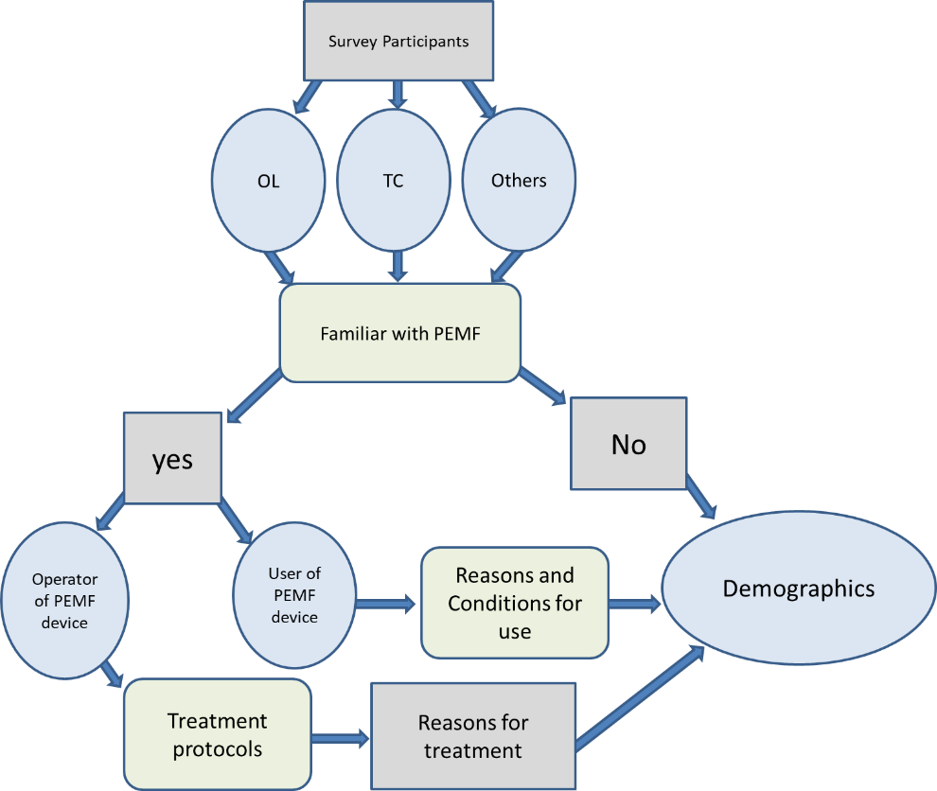
OL and TC whose horses receive PEMF
Figure 1: Survey was divided into 5 sections. All participants received questions on industry participation. All participants were asked if they were familiar with PEMF, and if they answered “yes”, they were asked if they operate and deliver PEMF therapy. If they selected “yes” to this question, they were placed into the AD category along with OL and/or TC if they identified as such. If participants were classified as an AD, they received questions for AD and questions on reasons for PEMF usage and treatment protocols. If participants selected they were an OL or TC familiar with PEMF, they would receive questions for PEMF users and reasons for usage. All participants received demographic questions at the end of the survey.

Discipline Breakdown
Discipline | Number | Category
Breeding | 47 | Breeding (n=47)
Breed Show | 43 | Breed Show (n=43)
Dressage | 81 | English (n=243)
Hunter/ Jumper | 89 | English (n=243)
Foxhunting | 10 | English (n=243)
Endurance | 11 | English (n=243)
Driving | 19 | English (n=243)
Eventing | 33 | English (n=243)
Rodeo | 61 | Western (n=193)
Cutting | 24 | Western (n=193)
Working Ranch | 45 | Western (n=193)
Team Penning | 9 | Western (n=193)
Roping | 28 | Western (n=193)
Reining | 26 | Western (n=193)
Gaited | 21 | Gaited (n=30)
Saddlebred | 9 | Gaited (n=30)
Racing | 14 | Racing (n=14)
Pleasure/Trail | 136 | Recreational (n=156)
Therapeutic Lesson | 20 | Recreational (n=156)
Other | 26 | Other (n=26)
Non-working | 52 | Non-Working (n=52)
Table 1. Disciplines were classified into similar groups for respondents (n=315). The largest category was English, followed by western events.

Table 2. 2007 NRC table of workload per week based on the amount of hours of work and type of work.
Exercise Workload According to the National Research Council
Exercise Category | Mean Heart Rate | Description | Type of Events
Light | 80 beats/min | 1-3 hours per week; 40% walk, 50% trot, 10% canter | Recreational riding  Beginning of training programs  Show horses (occasional)
Moderate | 90 beats/min | 3-5 hours per week; 30% walk, 55% trot, 10% canter, 5% low jumping, cutting, other skill work | School horses  Recreational riding  Beginning of training/breaking  Show horses (frequent)  Polo  Ranch Work
Heavy | 110 beats/min | 4-5 hours per week; 20% walk, 50% trot, 15% canter, 15% gallop, jumping, other skill work | Ranch Work  Polo  Show horses (frequent, strenuous events)  Low-medium level eventing  Race training (middle stages)
Very Heavy | 110-150 beats/min | Various, ranges from 1 hour per week speed work to 6-12 hours per week slow work | Racing (Quarter horse, Thoroughbred, Standardbred, Endurance)  Elite 3-day event

Figure 2. A) Regional location of respondents . Regional divisions based on U.S. census regions and divisions [13]. B) Yearly gross income reported by respondents. C) Respondent reported age. D) Respondent reported gender.

B
Figure 2 continued

C

Figure 2 continued

Figure 2 continued

Division of Respondents Based on Self-Selected Involvement

Figure 3. Respondents self-selected categorization based on industry involvement. Respondents were able to select all categories describing their roles.

Figure 4. Respondents who are horse owners based on their selection of being an owner or leaser and/ or a trainer/ coach/ groom/ jockey.

Figure 5: NRC workload selected by respondents that ride/exercise their horse.

Figure 6: All groups of respondents reported the timeframe they feel the greatest effects are seen from PEMF therapy.

Figure 7. Respondents consisting of all groups selected all possible reasons they have used PEMF.

Table 3. Respondents who were OL and use PEMF on their horse selected all conditions for which they have used therapy.
Conditions that Owners and Leasers Have Applied Therapy.
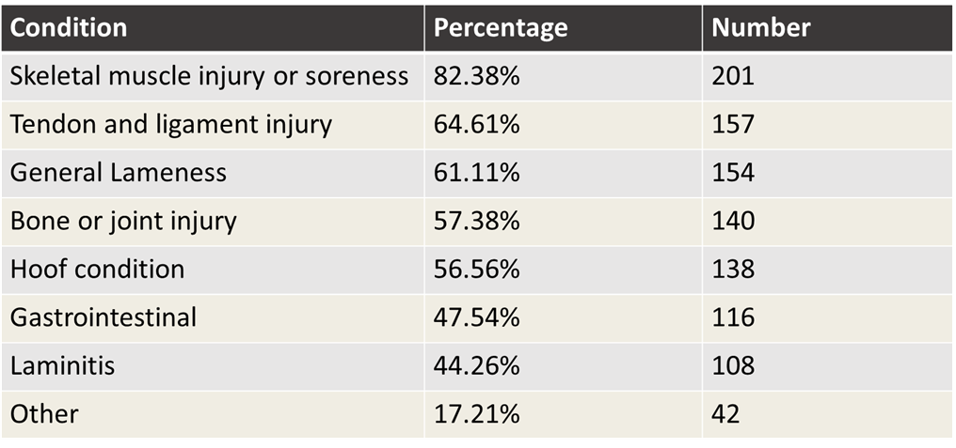

A
Figure 8: A) Length of PEMF session by owners and leasers and trainers/ coaches/ grooms/ jockeys. B) Treatment time by device as reported by administrators using blanket versus hose devices.
B
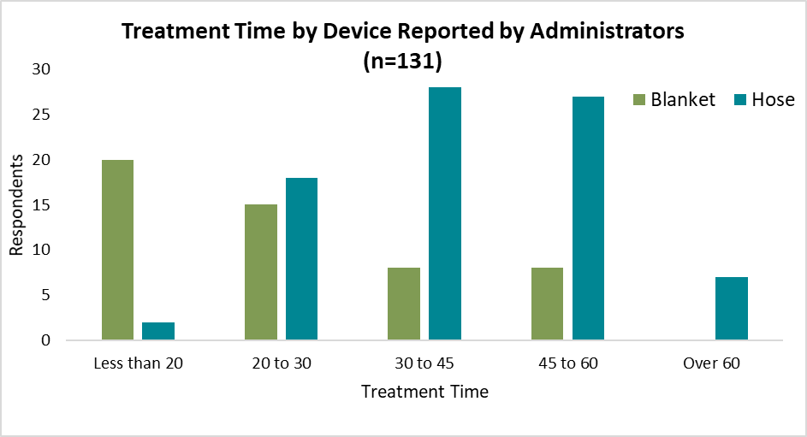
Figure 8 continued

Figure 9: Hertz level reported by ADs during treatment. Most often Hz level was set between 16-20Hz.

Figure 10: Administrator reported time spent on each treatment location of the body. Whole body treatment was the most commonly reported across all time frames.




Figure 11: A) The frequency of treatments recommended by administrators. B) The frequency of treatment reported by owners and leasers and trainers/ coaches/ grooms/ jockeys on horses they care for.

Figure 12: The number of hours before competition that PEMF is administered to the horse as reported by owners and leasers and /or trainers/ coaches/ grooms/ jockeys.
A
Figure 13. A) Resting heart rates across treatments and sampling times. B) Heart rates reported prior to lunge, average during lunge, maximum, and post lunge for both treatments.
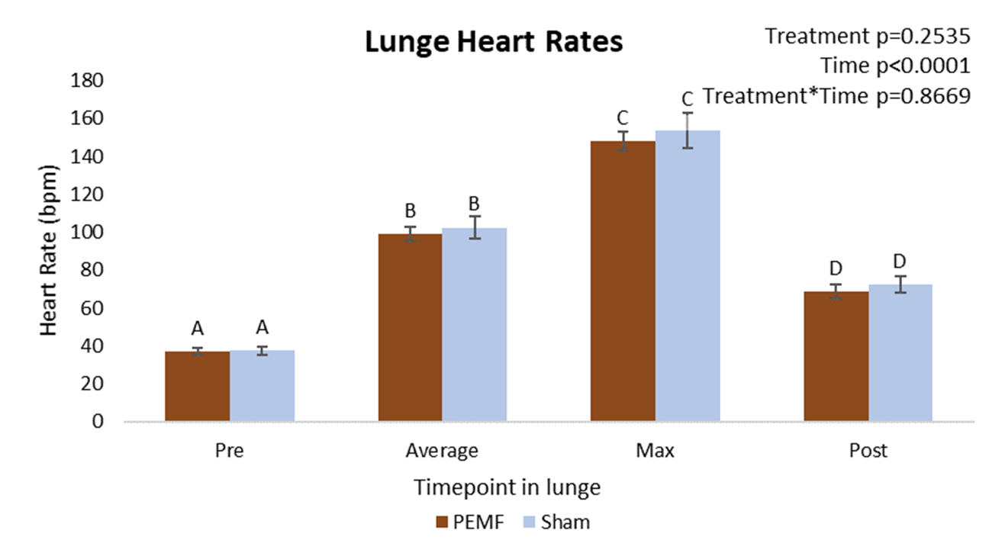
B
Figure 13 continued
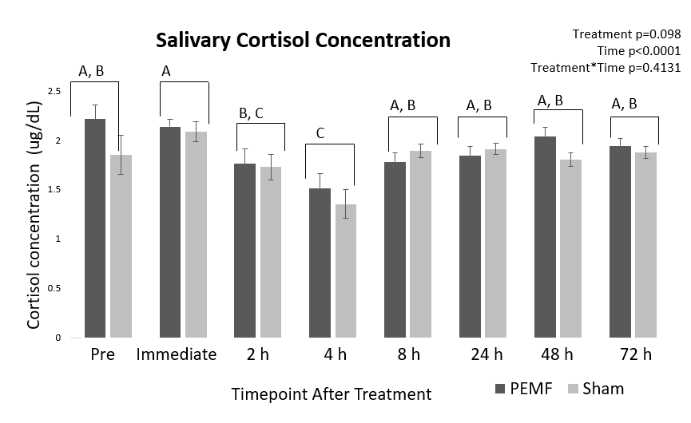
Figure 14. Salivary cortisol concentrations across sampling times and treatments. Significant differences denoted by different letters.

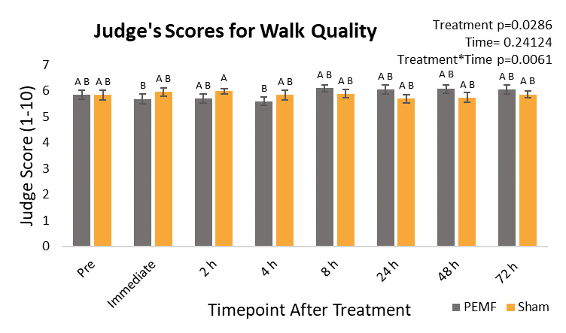
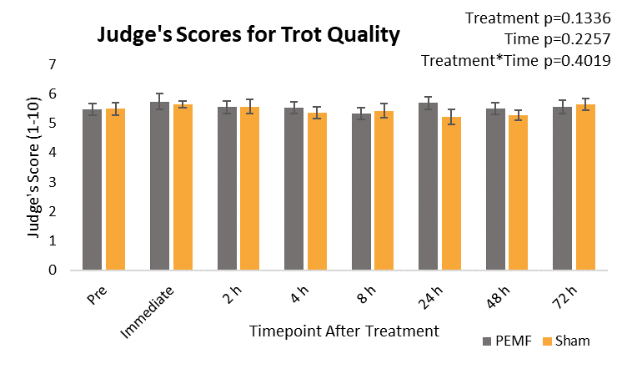Figure 15. A) Average score for 3 judges on the walk taken at each sampling timepoint and treatment. Significant differences denoted by different letters. B) Average score for 3 judges taken at each sampling timepoint and treatment.
B

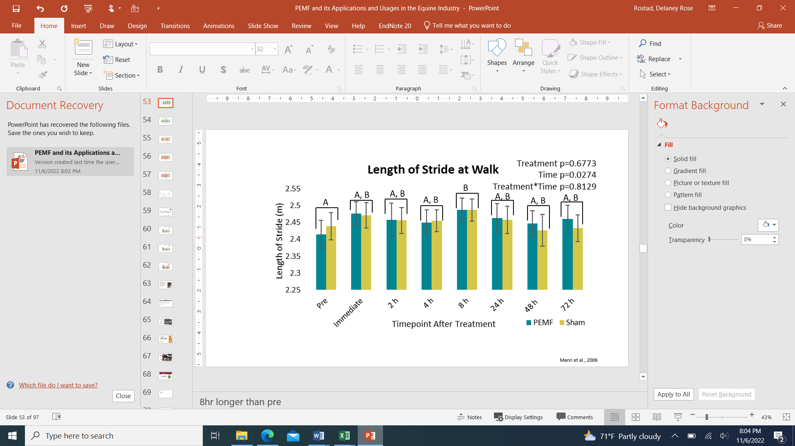
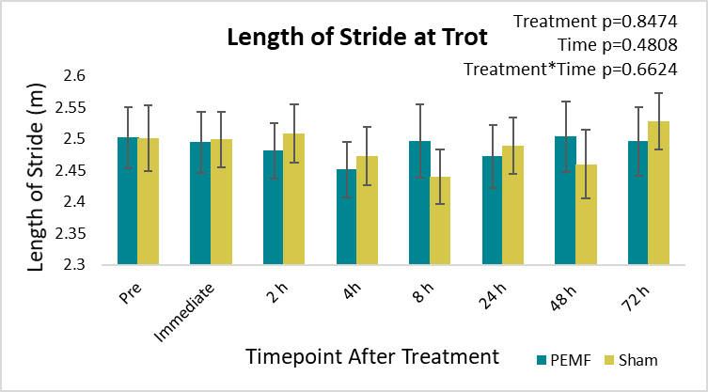
B
Figure 16. A) Length of stride at the walk per each sampling time and for each treatment. Significant differences are denoted by differing superscripts. B) Length of stride at the trot per each sampling time and for each treatment.
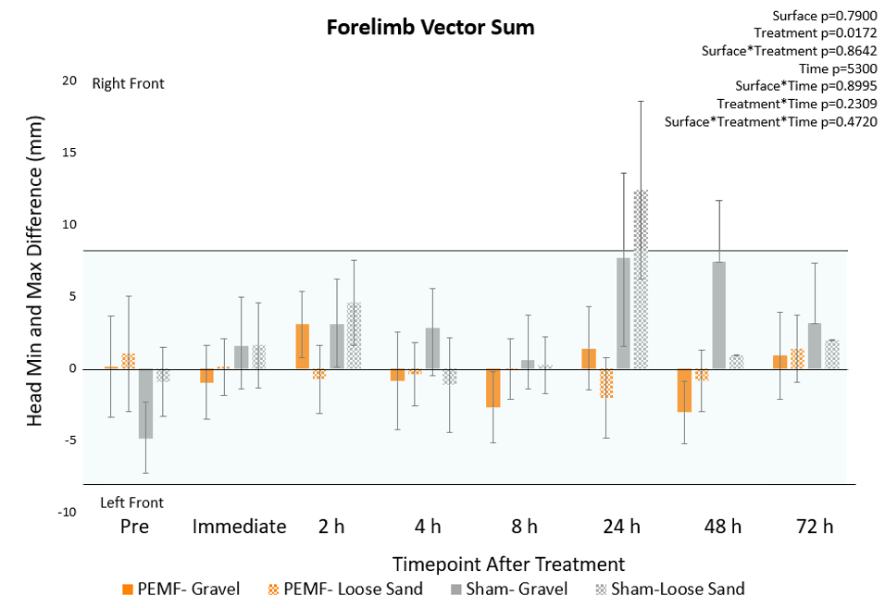Figure 17. Forelimb vector sum for each sampling time point and treatment for each surface tested. Treatment was significant across all timepoints. All means falling within ±8.5mm are considered within the range of clinically sound. Positive values indicate a right front asymmetry while negative indicate a left front.
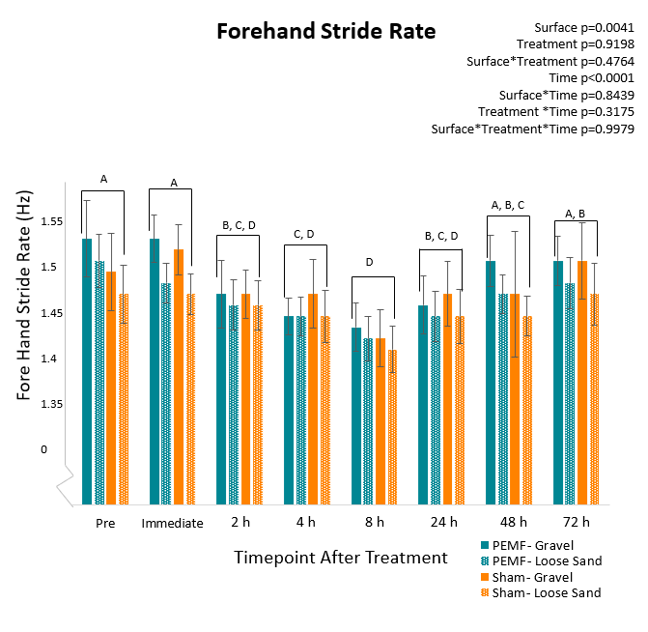
Figure 18. Forehand stride rate reported for each treatment and across all sampling time points for each surface tested. Significant differences for time are denoted by letters. Surface was significant with gravel having a faster stride rate than loose sand.

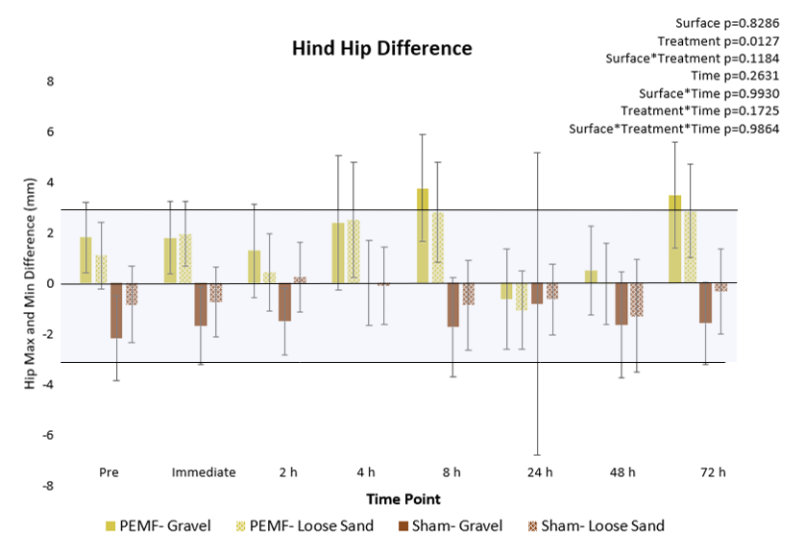
Figure 19. The Hind hip differences between hip height maximum and minimum. Treatment was significant across all time points. Values falling within ±3 mm are considered normal in the clinically sound horse. Positive values indicate a right hind lameness, while negative values indicate a left hind lameness.
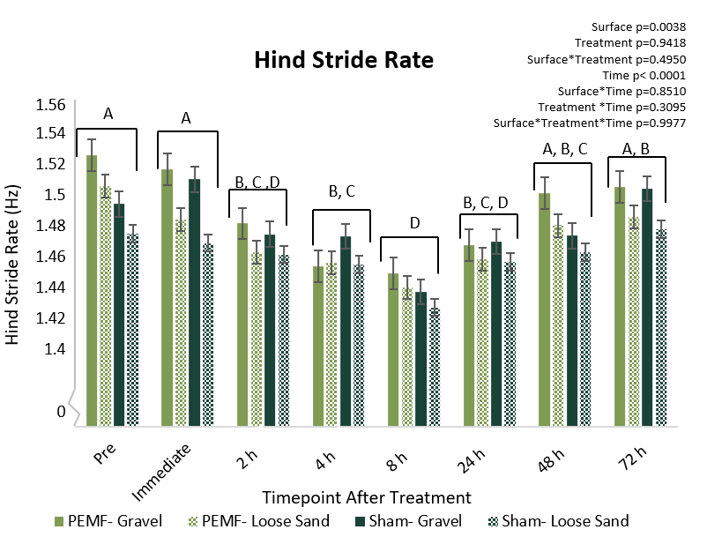
Figure 20. Hind stride rate across all time points for each treatment for each surface tested. Treatment was significant regardless of surface and sampling time point. Differences denoted by letter.

Survey on the usage, prevalence, and perceptions of PEMF within the equine industry questions
Q1 The University of Tennessee Institute of Agriculture is conducting a survey to determine the familiarity of members in the equine industry with pulsed electromagnetic field (PEMF). This information will be taken into account for an upcoming research project determining the effects of PEMF treatments on the healthy horse.
Completion of the survey will take approximately 5 minutes. Your participation is greatly appreciated. Response to this survey is voluntary and not required by law, and you can skip any question you wish. We believe there are no more risk to you that what is experienced in everyday life from participating in this study. There are no direct benefits or compensation to you for participating in this study. Your participation or decision not to participate will not impact your relationship with UTIA.
Participants in the study should be 18 years of age or older, and residents of the United States. Should you have any questions about your rights as a research participant, please contact the University of Tennessee’s IRB office at (865) 974-7697.
We will do our best to keep data from this survey confidential. To help protect your responses, we will store information within password-protected computer files, accessible only by the faculty conducting this survey. The survey is anonymous, and thus your name or other identifiable information will not be asked of you, included with your response, or distributed during any reporting of the information collected.
By completing the survey, you consent to participation. You may stop at any time and close the screen.
If you may print or ask questions at any time. Please contact Dr. Jennie Ivey at (865) 974-3157 or jzivey@utk.edu with any inquiries. Thank you for your participation!
UTK IRB-21-06410-XM
Approved 6/21/21
o I certify that I am over 18 years of age, a resident of the United States, and wish to participate in the survey (1)
o I am not over 18 years of age, not a resident of the United States, and/or do not wish to participate in the survey (2)

Skip To: End of Survey If The University of Tennessee Institute of Agriculture is conducting a survey to determine the fami... = I am not over 18 years of age, not a resident of the United States, and/or do not wish to participate in the survey

Q2 Which categories below best describe your involvement in the equine industry? Check all that apply.
· Own/lease a horse(s) or other equids (including ponies, mules, donkeys) (1)
· Trainer/ Coach/ Groom/ Jockey (16)
· Veterinary (17)
· Rehabilitation/ Equine Therapy (19)
· Boarding Facility Owner (2)
· Academic/ Extension (3)
· Agricultural Worker (ex. hay producer, feed mill) (4)
· Animal Rights Advocate (5)
· Breed/Discipline Organization (6)
· Facility Management (boarding/ show) (7)
· Facility Worker (boarding/show) (8)
· Farrier (9)
· Government/ Law Enforcement (10)
· Marketing/ Promotion/ Journalism (11)
· Parent of youth involved in industry (12)
· Rescue (13)
· Sales (feed/tack/equipment) (14)
· Show Facility Owner (15)
· Other (18)

Display This Question:
If Which categories below best describe your involvement in the equine industry? Check all that apply. = Trainer/ Coach/ Groom/ Jockey

Q3 What primary activities or discipline(s) do you train, teach, or work with? Select all that apply.
· Breeding (1)
· Breed Shows (2)
· Cutting (3)
· Dressage (English and/or Western) (4)
· Driving (5)
· Endurance (6)
· Eventing (7)
· Foxhunting (8)
· Gaited (9)
· Hunter/ Jumper (10)
· Pleasure/ Trail Riding (11)
· Racing (12)
· Reining (13)
· Rodeo (including speed events like barrels and poles) (14)
· Roping (15)
· Saddleseat (16)
· Team Penning (17)
· Therapeutic Riding (18)
· Working (Ranch horses, etc) (19)
· Other (20)

Display This Question:
If Which categories below best describe your involvement in the equine industry? Check all that apply. = Own/lease a horse(s) or other equids (including ponies, mules, donkeys)
Or Which categories below best describe your involvement in the equine industry? Check all that apply. = Boarding Facility Owner
Q4 What primary activities or discipline(s) are your horse(s) used for? Select all that apply.
· Breeding (1)
· Breed Shows (2)
· Cutting (3)
· Dressage (English and/or Western) (4)
· Driving (5)
· Endurance (6)
· Eventing (7)
· Foxhunting (8)
· Gaited (9)
· Hunter/Jumper (10)
· Idle/ Retired/ Not Working (11)
· Pleasure/ Trail Riding (12)
· Racing (13)
· Reining (14)
· Rodeo (including speed events like barrels and poles) (15)
· Roping (16)
· Saddleseat (17)
· Team Penning (18)
· Therapeutic Riding (19)
· Working (ranch horses, etc) (20)
· Other (21)

Display This Question:
If Which categories below best describe your involvement in the equine industry? Check all that apply. = Own/lease a horse(s) or other equids (including ponies, mules, donkeys)
Q5 How many horses do you personally own or lease?
· (1)
· 2-3 (2)
· 4-6 (3)
· 7-10 (4)
· 11-20 (5)
· More than 20 (6)

Display This Question:
If Which categories below best describe your involvement in the equine industry? Check all that apply. = Boarding Facility Owner
Q6 How many horses do you manage at your facility?
· (1)
· 2-3 (2)
· 4-6 (3)
· 7-10 (4)
· 11-20 (5)
· More than 20 (6)

Display This Question:
If Which categories below best describe your involvement in the equine industry? Check all that apply. = Trainer/ Coach/ Groom/ Jockey
Q7 As a trainer/ coach/ groom/ or jockey, how many horses do you have in your training/ teaching program?
· 1-5 (1)
· 6-10 (2)
· 11-15 (3)
· 16-20 (4)
· More than 20 (5)

Display This Question:
If Which categories below best describe your involvement in the equine industry? Check all that apply. = Own/lease a horse(s) or other equids (including ponies, mules, donkeys)
Q8 Do you ride or exercise your horse(s)?
· Yes (1)
· No (2)

Display This Question:
If Do you ride or exercise your horse(s)? = Yes

Q9
How many times a week do you ride your primary horse?
Primary horse is defined as the horse you use/ride/show most frequently.
▼ Less than once a week (1) ... 6 or more times a week (5)

Display This Question:
If Which categories below best describe your involvement in the equine industry? Check all that apply. = Trainer/ Coach/ Groom/ Jockey
Q10 How many times a week on average do you ride/ train/ teach with a horse in your program?
▼ Less than once a week (1) ... 6 or more times a week (5)

Display This Question:
If Do you ride or exercise your horse(s)? = Yes
Q11
How long on average do you ride your primary horse per ride?

Primary horse is defined as the horse you use/ride/ show most frequently
▼ 30 minutes or less (1) ... 2 hours or more (4)

Display This Question:
If Which categories below best describe your involvement in the equine industry? Check all that apply. = Trainer/ Coach/ Groom/ Jockey
Q12 As a trainer, coach, groom, and/or jockey, how long on average do you work/use each horse per ride or session?
▼ 30 minutes or less (1) ... 2 hours or more (4)

Display This Question:
If Which categories below best describe your involvement in the equine industry? Check all that apply. = Own/lease a horse(s) or other equids (including ponies, mules, donkeys)
Or Which categories below best describe your involvement in the equine industry? Check all that apply. = Trainer/ Coach/ Groom/ Jockey

Q13 How strenuous is your typical riding week per horse? Categories are set by National Research Council.
· Light: 1–3 hours per week; 40% walk, 50% trot, 10% canter (Recreational riding, beginning of training program, occasional show horses) (1)
· Moderate: 3–5 hours per week; 30% walk, 55% trot, 10% canter, 5% low jumping, cutting, other skill work (School horses, recreational riding, beginning of training/breaking, frequent show horses, polo, ranch work) (2)
· Heavy: 4–5 hours per week; 20% walk, 50% trot, 15% canter, 15% gallop, jumping, and other skill work (ranch work, polo, frequent and strenous event show horses, low-medium level eventing, race training) (3)
· Very Heavy: Various; ranges from 1 hour per week speed work to 6-12 hours per week slow work (racing, elite 3 day eventing) (4)
· Unsure (5)

End of Block: General Information

Start of Block: PEMF Administrators

Q14 Have you ever heard of Pulsed Electromagnetic Field Therapy (PEMF)? PEMF is a device that delivers magnetic fields through tissue to a targeted area. This device commonly comes in a series of tubes that are placed on the horse or through a blanket device. Are you familar with this techonology? For the remainder of this survey, Pulsed Electromagnetic Field Therapy will be referred to as PEMF.
· Yes (1)
· No (2)

Skip To: End of Survey If Have you ever heard of Pulsed Electromagnetic Field Therapy (PEMF)? PEMF is a device that deliver... = No

Display This Question:
If Have you ever heard of Pulsed Electromagnetic Field Therapy (PEMF)? PEMF is a device that deliver... = Yes
Q15 Do you own a PEMF machine (Bemer, Magnawave, Pulse Equine, etc)?
· Yes (1)
· No (2)

Display This Question:
If Do you own a PEMF machine (Bemer, Magnawave, Pulse Equine, etc)? = Yes
Q16 What type of PEMF delivery system do you own? Please include brand if known in text box and select all that apply.
· Blanket (1) __________________
· Hoses (2) ___________________
· Unsure (3)
· Other (4) ___________________

Display This Question:
If Have you ever heard of Pulsed Electromagnetic Field Therapy (PEMF)? PEMF is a device that deliver... = Yes
Q17 Have you ever personally operated any PEMF equipment?
· Yes (1)
· No (2)

Display This Question:
If Have you ever personally operated any PEMF equipment? = Yes
Q18 Do you use PEMF to treat client or personally owned horse(s)?
· Yes (1)
· No (2)

Display This Question:
If Do you use PEMF to treat client or personally owned horse(s)? = Yes
Q19 How often do you recommend PEMF treatments? Select all that apply.
· Single treatment (1)
· Once a week (2)
· Every 2 weeks (3)
· Once a month (4)
· Before a horse show or period of strenuous work (5)
· Other (6) _______________

Display This Question:
If Do you use PEMF to treat client or personally owned horse(s)? = Yes

Q20 How long after a PEMF treatment would you expect to see desired results?
· 1 hour (1)
· 2-4 hours (2)
· 12 hours (3)
· 24 hours (4)
· 24-48 hours (5)
· 1 week (6)
· 1 month (7)
· Other (8) ___________

Display This Question:
If Have you ever heard of Pulsed Electromagnetic Field Therapy (PEMF)? PEMF is a device that deliver... = Yes
Q21 Where did you first hear of PEMF therapy?
· Veterinarian (1)
· Trainer/ Instructor (2)
· Scientific paper or journal (3)
· Current PEMF user (4)
· Horse show flyer (5)
· Social media (6)
· Popular press article (7)
· Other (8) __________

Display This Question:
If Have you ever heard of Pulsed Electromagnetic Field Therapy (PEMF)? PEMF is a device that deliver... = Yes
Q22 Has any horse you own/ lease or manage received a PEMF treatment while under your care?
· Yes (1)
· No (2)

Display This Question:
If Do you use PEMF to treat client or personally owned horse(s)? = Yes
Or Has any horse you own/ lease or manage received a PEMF treatment while under your care? = Yes
Q23 Why do you use PEMF therapy on your personal horse or client horses?
· Injury rehabilitation (1)
· Professional recommendation (2)
· Relieve pain (3)
· Training requirement (4)
· Improve performance (5)
· Reduce recovery time (6)
· Improve overall health and well-being (7)
· Detect areas of soreness or imbalance (8)
· Reduce inflamation (9)
· Stress relief (10)
· Other (11) _________

Display This Question:
If Have you ever personally operated any PEMF equipment? = Yes

Q24 What parts of the horse do you treat with PEMF? Select all that apply.
· Total body treatment (1)
· Head/poll/neck (2)
· Shoulder/withers (3)
· Front legs (4)
· Back and loin (5)
· Hindquarters (6)
· Hind legs (7)
· Hooves (8)

Display This Question:
If Have you ever personally operated any PEMF equipment? = Yes
Q25 How long is an average PEMF session that you deliver? Please enter session time in minutes.

Display This Question:
If you have ever personally operated any PEMF equipment? = Yes
Q26 At what average frequency do you treat the majority of horses with PEMF? Please enter in unit of hertz.

Display This Question:
If Have you ever personally operated any PEMF equipment? = Yes
Q27 Please briefly describe your methodology of administering PEMF therapy.

Display This Question:
If Has any horse you own/ lease or manage received a PEMF treatment while under your care? = Yes
Q28 How much do you pay or expect to pay for a typical PEMF session?
▼ $30 or less (1) ... Greater than $150 (6)

Display This Question:
If Do you use PEMF to treat client or personally owned horse(s)? = Yes
Q29 How much do you charge for a typical PEMF session?
▼ $30 or less (1) ... More than $150 (6)

Display This Question:
If Do you use PEMF to treat client or personally owned horse(s)? = Yes
Q30 How long does a PEMF session typically last?
· Over 60 minutes (1)
· 45-60 minutes (2)
· 30-45 minutes (3)
· 20-30 minutes (4)
· Less than 20 minutes (5)

Display This Question:
If Have you ever personally operated any PEMF equipment? = Yes
Q31 Within what time frame do you feel you see the greatest effect of PEMF on a horse?
· Immediately after treatment (1)
· Within 3 hours after treatment (2)
· Within one day of treatment (3)
· Within 3 days of treatment (4)
· Within a week of treatment (5)
· Within a month of treatment (6)
· Longer than a month after treatment (7)
· Unsure (8)
· No effect seen (9)

Display This Question:
If Have you ever personally operated any PEMF equipment? = Yes

Q32 Have you ever received professional training in operating PEMF equipment and structuring treatments?
· Yes (1)
· No (2)

End of Block: PEMF Administrators

Start of Block: PEMF Users
Display This Question:
If Has any horse you own/ lease or manage received a PEMF treatment while under your care? = Yes

Q33 Please indicate the frequency that your horse recieves PEMF treatments.
· Only one time (3)
· As needed (4)
· Regularly scheduled treatments (5)

Display This Question:
If Please indicate the frequency that your horse recieves PEMF treatments. = Regularly scheduled treatments

Q34 How many PEMF sessions do you use on your horse per month?
· 4 or more (1)
· 2 (2)
· (3)
· Less than 1 per month (4)

Display This Question:
If Has any horse you own/ lease or manage received a PEMF treatment while under your care? = Yes

Q35 How long does your horse's PEMF session(s) typically last?
· Over 60 minutes (1)
· 45-60 minutes (2)
· 30-45 minutes (3)
· 20-30 minutes (4)
· Less than 20 minutes (5)

Display This Question:
If Has any horse you own/ lease or manage received a PEMF treatment while under your care? = Yes
Q36 What type of PEMF machine is used on your horse?
· Device with hoses (include brand if known) (1)
· Blanket device (include brand if known) (2)
· Unsure (3)

Display This Question:
If Has any horse you own/ lease or manage received a PEMF treatment while under your care? = Yes
Q37 Within what time frame do you feel you see the greatest effect of PEMF on your horse?
· Immediately after treatment (1)
· Within 3 hours after treatment (2)
· Within one day of treatment (3)
· Within 3 days of treatment (4)
· Within a week of treatment (5)
· Within a month of treatment (6)
· Longer than a month after treatment (7)
· Unsure (8)
· No effect seen (9)

Display This Question:
If Has any horse you own/ lease or manage received a PEMF treatment while under your care? = Yes
Q38 What parts of your horse do you treat with PEMF? Select all that apply.
· Total body treatment (1)
· Head/poll/neck (2)
· Shoulder/withers (3)
· Front legs (4)
· Back and loin (5)
· Hindquarters (6)
· Hind legs (7)
· Hooves (8)

Display This Question:
If Have you ever personally operated any PEMF equipment? = Yes
Q39 Have you ever delivered treatment to a horse while at a show?
· Yes (1)
· No (2)

Display This Question:
If Have you ever delivered treatment to a horse while at a show? = Yes
Q40 Why did you choose to treat a client horse(s) with PEMF at a show? Select all that apply.
· Trainer/ coach recommendation or requirement (1)
· Veterinary recommendation (2)
· Improve performance (3)
· Exercise recovery (4)
· Reduce soreness (5)
· Other (6) _________

End of Block: PEMF Users

Start of Block: PEMF Reasons For Use
Display This Question:
If Has any horse you own/ lease or manage received a PEMF treatment while under your care? = Yes
Q41 Have you seen beneficial effects on your horse that you attribute to PEMF?
· Definitely yes (1)
· Probably yes (2)
· Might or might not (3)
· Probably not (4)
· Definitely not (5)

Display This Question:
If Has any horse you own/ lease or manage received a PEMF treatment while under your care? = Yes
Q42 In reference to a show or competition, when do you use PEMF prior to or after competing? Select all that apply.
· Prior to any competition (1)
· During timeframe of competition (4)
· After all competition has concluded (2)
· I do not use PEMF for competition purposes (3)

Display This Question:
If In reference to a show or competition, when do you use PEMF prior to or after competing? Select a... = Prior to any competition
Or In reference to a show or competition, when do you use PEMF prior to or after competing? Select a... = During timeframe of competition
Q43 How long before you showed your horse was PEMF treatment administered?
· Less than 2 hours before showing (1)
· 2-4 hours before showing (2)
· 4-8 hourse before showing (3)
· 8-12 hours before showing (4)
· 12-23 hours before showing (5)
· 24hrs or greater before showing (6)
· Unsure (7)
Display This Question:
If In reference to a show or competition, when do you use PEMF prior to or after competing? Select a... = Prior to any competition
Or In reference to a show or competition, when do you use PEMF prior to or after competing? Select a... = After all competition has concluded
Or In reference to a show or competition, when do you use PEMF prior to or after competing? Select a... = During timeframe of competition

Q44 Why did you choose to treat your horse with PEMF for compeition purposes? Select all that apply.
· Trainer/ coach recommendation or requirement (1)
· Veterinary recommendation (2)
· Improve performance (3)
· Exercise recovery (4)
· Reduce soreness (5)
· Other (6) ______

Display This Question:
If Has any horse you own/ lease or manage received a PEMF treatment while under your care? = Yes

Q45 Do you think PEMF had a positive effect on your horse's performance?
· Definitely yes (1)
· Probably yes (2)
· Might or might not (3)
· Probably not (4)
· Definitely not (5)
Display This Question:
If Has any horse you own/ lease or manage received a PEMF treatment while under your care? = Yes
Or Have you ever personally operated any PEMF equipment? = Yes
Q46 Have you ever used PEMF therapy to help treat the following conditions? Select all that apply.
· Tendon and ligament injury (1)
· Bone and joint injury (2)
· Skeletal muscle injury and soreness (3)
· Laminitis/ Founder (4)
· Hoof conditions (5)
· Gastrointestinal (6)
· General lameness (7)
· Other (8) __________________________________________________

End of Block: PEMF Reasons For Use

Start of Block: Demographics

Q47 What is your annual gross household income?
· Less than $25,000 (1)
· $25,001- $50,000 (2)
· $50,000- $75,000 (3)
· $75,001- $100,000 (4)
· $100,001- $150,000 (5)
· Greater than $150,000 (6)

Q48 What state are you from?
▼ Alabama (1) ... District of Columbia (51)

Q49 What is your age?
· 18-24 (1)
· 25-34 (2)
· 35-44 (3)
· 45-54 (4)
· 55-64 (5)
· 65-74 (6)
· 75-84 (7)
· 85 or older (8)

Q50 What is your gender?
Male (1)
Female (2)
Non-binary / third gender (3)
Prefer not to say (4)

Q51 What is your race?
Hispanic or Latino (1)
American Indian or Alaska Native (2)
Asian (3)
Black or African American (4)
Native Hawaiian or Other Pacific Islander (5)
Caucasian or White (6)
Multiracial (7)
Other (8)
Prefer not to say (9)

End of Block: Demographics

Vita
Delaney Rostad is originally from Maryville, TN. She attended college at Middle Tennessee State University where she earned a Bachelor’s degree in Animal Science with a focus on horse science. After graduation, she worked as an assistant horse trainer for 3 years in Texas before moving back to Tennessee and attending the University of Tennessee for their master’s program in animal science. While working towards her master’s, she coached the University of Tennessee Equestrian Team. Her research interests are alternative therapies on the performance horse. After graduation she plans to expand on her horse training business and work towards her judge’s card in several equine associations.

