Plastic Anisotropy of Complex Crystals and Hierarchically Structured Alloys Using Micro-Mechanical Computational Analysis

A Dissertation Presented for the
Doctor of Philosophy
Degree
The University of Tennessee, Knoxville

Lin Li
December 2014

Copyright 2014 by Lin Li
All rights reserved.

Dedication

This dissertation is dedicated to my mother and father, Yuping Lin and Jinming Li, the two people I love the most in this world. They have always been there for me through ups and downs, laughter and tears. They mean everything in the world to me and I would not have become anything remotely close to who I am today without their endless support and I hope I have made them proud.
I would also like to dedicate this writing to all my relatives and friends. I am very lucky to have known the best people in my life. I will always remember your unconditional support and I am very thankful for your existence in my life.

Acknowledgement

I wish to show my sincere gratitude to all those people who have offered me help throughout my Ph.D study. I would like to give my greatest appreciation to Prof. Yanfei Gao who have been so patient and supportive of me throughout the past four years and I cannot ask for a better adviser than him.
I would also I would also like to give my greatest appreciation to my committee members: Prof. George Pharr, Prof. Peter Liaw, and Prof. Zhili Zhang who have given me so many help and guidance during my Ph.d study. I am very grateful to be blessed with such wonderful mentors.
I would like to show my appreciation to my colleagues and friends, Amit, Gian, Zhiqian, Dr. Wei Wu, Dr. Lili Zheng, Dr. Tianlei Li, Jianyong, Dr. Weidong Li, Dr. Yuzhi Xia, Haoling and Chao. I am very lucky to have worked with these wonderful people.
This project is financially supported by Department of Energy and Department of Defense with National Science Foundation project number CMMI-0926798.

Abstract

The material anisotropy is one of the most important material properties that cannot be disregarded in today’s world of materials designing and manufacturing. As new materials being developed and new material demands are introduced the inevitable focus on anisotropic materials has been brought under the spotlight. In this dissertation, several experimental and simulation project regarding material anisotropic effects on hexagonal close packed crystals such as Silicon Carbide as well and hierarchically structured solid solution ferritic based alloys. The general purpose was to demonstrate the improvement on various intended material properties using finite element method. Since indentation is a widely used experimental method nowadays to study different aspects of material properties, the use of theoretical modeling with computer aided programs to study the anisotropic behavior of multiple complex material structures is highly demanded. To this end, simulation was designed by using both conical and spherical indentation test to study the HCP single crystal responses. The result was compared and shown consistency with respect to the orientation dependence of HCP [hexagonal close packed] single crystals related to material hardness. In order to understand anisotropy on a microstructural level, structural alloys operating at high temperatures have attracted significant attention from industry due to the increasing demand for materials to be operated at high temperature conditions. Using finite element method to simulate the single phase alloy, alloy containing a L2₁ (Heusler phase precipitate type) precipitate also alloy containing both L2₁ precipitate and a B2 precipitate was done to study the strength improvement at high temperatures for these cases. The process of NiAl and Ni₂TiAl (Nickel based intermetallic precipitate) precipitates embedded in Fe alloys tested at high temperature is an innovative approach to study the toughness improvement of these alloys. The material hardness improvement is carried out by combining experimental and finite element simulation to examine the lattice strain load transferring effect between alloy matrix and precipitates.

Table of Contents

Chapter I Introduction 1

Chapter II Deformation anisotropy of HCP single crystals under indentation loading
2.1 Introduction 4
2.2 Background 5
2.3 Model setup and results 8
2.4 Summary 13

Chapter III Plastic anisotropy arising from various slip systems
3.1 Introduction 15
3.2 Prismatic slip systems only 18
3.3 Pyramidal <a> slip systems only 19
3.4 Pyramidal <a+c> slip systems only 20
3.5 Summary 21

Chapter IV Lattice strain anisotrypy in hierarchically structured ferritic alloys
4.1 Introduction 23
4.2 Constitutive model 26
4.3 Finite element model 28
4.4 Single phase polycrystal 32
4.5 Ferritic Matrix + NiAl Precipitate 34
4.6 Ferritic Matrix + NiAl Precipitate + Ni₂TiAl Precipitate 35
4.7 Summary 38

Chapter V Effect of thermal residual stress on lattice strain evolution
5.1 Introduction 40
5.2 Lattice strain variation at different temperature level 41
5.3 Lattice parameter variation at different temperature level 42
5.4 Loading with pre-existing thermal stress 43
5.5 Summary 45

Chapter VI Conclusion and future work 46

Bibliography 49
Appendix 56
Vita 97

List of Tables

Table. 2.1 Experimental findings for material hardness from the Berkovich indentation test using the Oliver-Pharr method (Oliver and Pharr 1992) H_OP and the corrected hardness $H_{corr}$.. By comparison of finite element simulation result with $H_{corr}$. 73
Table. 4.1 Crystal plasticity parameters for copper & a Ni-based superalloy (HASTELLOY C-22HS) polycrystal.(Zheng 2012). 80
Table. 4.2 Crystal plasticity parameters for Iron & a Ni-based superalloy (NiAl) polycrystal. (Huang 2011) 80
Table. 4.3 Crystal plasticity parameters for Iron & a Ni-based superalloy (L21 structure NiAl and B2 structure Ni2TiAl) polycrystal. (G. Song et al. 2014 [64]) 81
Table. 5.1 Thermal expansion parameters for Iron, NiAl & a Ni2TiAl. 92
Table. 5.2 Lattice strain for Ferritic alloy and Ni-based super alloy variation according to temperature change. 92
Table. 5.3 Lattice parameter for Ferritic alloy and Ni-based super alloy variation according to temperature change 93

List of Figures

Fig. 1.1. The most common ceramics used for armors mainly include 3 types of materials, a) Al2O3, b) B4C, and c) SiC 57
Fig. 1.2 Condensing steam turbine and gas turbine. (link: http://www.greenesolpower.com/steam.html) 57
Fig. 1.3. shows the turbine efficiency at various temperature levels under different pressure. As the diagram shows, turbine efficiency shows a linear increasing trend with the increase of temperature. This explains the reason of the demand of high temperature withstanding materials. (S. Huang 2011[3]). 58
Fig. 1.4 The dark-field (DF) TEM image (using 100 B2 reflection) showing β΄(bright) particles ( S. Huang and Z.K. Teng et al. 2010 [3], [8]). 59
Fig. 2.1 The typical 6 Slip systems of Hexagonal Close Packed crystals. (Motyka 2004) 60
Fig. 2.2 Load versus displacement relationships for SiC crystals at different directions. As we can see from the diagram that at the same displacement <0001> requires larger load than <$1\overline{1}00$> and <$\overline{1}2\overline{1}0$> direction. (A. Dayte, L. Li et al, 2014 [65]) 61
Fig. 2.3 SEM diagrams using a spherical indenter loading on different orientations with respect to the HCP crystal. a) Spherical indentation impression from the indentation process. b) following the dot line cut cross-sectional view on the internal dislocation behavior. (Kwon et al. 2013 [7]) 62
Fig. 2.4 SEM image of Cross-sectional cut of the internal dislocation behavior when the HCP unit cell is placed laterally. For this type of indentation test we can see all 4 slip systems present. (Kwon et al. 2013 [7]). 63
Fig. 2.5 Constitutive law employed in this modeling process to represent the HCP material elastic-plastic behavior. (Staroselsky and Anand et al. 1998, [1]). 64,65
Fig. 2.6 Illustration of how Schmid’s law is being applied for crystal plasticity law. In this diagram, cosλcosɸ in this case is called Schmid’s factor which λ represents the angle between the normal axis from direction of the applied stress, and ɸ is the angle between the slip direction and the direction of the direction of the slip plane normal unit vector. (Weinberger 2012 [20]). 66
Fig. 2.7 Illustrates various parameters involved in indentation hardness test. “P” represents the applied indenter load. “h” is the actual depth the indenter pressed into the sample substrate before unloading. 66
Fig. 2.8 Stress veruss strain diagram for basal only HCP single crystal sample under uniaxial loading. Orientation 0° and 90° shows infinite elasticity while orientations between 1° to 89° degrees to the applied stress direction are also tested in order to further testify this result to Schmid’s Law.. 67
Fig. 2.9 The yield stress versus zenith angle diagram again shows the infinite stress level of 0° and 90° stress level. Any degree in between happens to be a finite magnitude of stress according to the Schmid’s law. Symmetry of the yield stress over 45°angle when plot the yield stress versus the orientation angle. 68
Fig. 2.10 The load versus displacement relationship shows that when indentation is loading at an angle that is 90° to the vertical center line of the HCP unit cell the load level is at its highest and it is at its lowest when this angle is 0° that is parallel to the center line direction... 69
Fig. 2.11 shows the hardness versus loading orientation relationship for this indentation simulation test. The hardness at different loading depth is taken in percentage which is the indentation depth into the sample substrate over the total height of the sample. Diagram shows that the 2% and 4% curves seem to be off by a large scale compared to the other curves.... 70
Fig. 2.12 The curve with 6% indentation depth to total height ratio was chosen to be the intended curve and compare that with the experimental result which was concluded from Dayte’s work using a Berkovich indenter. (A. Dayte, L. Li et al, 2014 [65]).. 71
Fig. 3.1 Load versus displacement curve for prismatic slip systems only. The 90° angle, which is the direction that makes up 90° with the centerline of the unit cell and is therefore parallel to the bottom plane of the unit cell has the highest load level and the largest displacement recovery. The 0°, as oppose to the 90° angle, which is parallel to the centerline of the unit cell and is perpendicular to the bottom plane of the unit cell has the lowest load level and the smallest displacement recovery during unloading.. 73
Fig. 3.2 Load versus displacement curve for pyramidal <a> slip systems only. The 90° orientation has the largest load at the same displacement level and the largest displacement recovery during unloading as oppose to 0° which has the lowest load level at the same displacement and the smallest recovery after load removal. 74
Fig. 3.3 Load versus displacement curve for pyramidal <a+c> slip systems only. The curves for all degree angles does not vary very much from each other and the displacement recovery is somewhat similar for all curves. The curves seem to be identical for all indentation directions. This indicates that the direction of the load that is being applied to the sample does not have a distinct effect on the load level of the material under this unique slip system. 75
Fig. 3.4 Hardness versus indentation orientation trend for prismatic slip system being active only. The 2% curve which indicates the percentage of indentation depth versus the total height of the sample is quite different compare to the 4%, 6%, 8%, 10% and 11%. The other curves seem to show a rather steady level of hardness so we can choose a curve to represent the hardness of the material. 76
Fig. 3.5 Hardness versus orientation diagram for pyramidal <a> slip system being allowed only during the simulation. The curves represent the depth percentage of the indenter going into the sample compared to the total height of the sample. It shows in the diagram that the 2% and 4% lines are both off by a lot on the hardness level compared to the 6%, 8%, 10% and 11% curves which demonstrate similar hardness level.. 77
Fig. 3.6 Hardness versus indentation orientation relationship for pyramidal <a+c> slip system only. The 4%, 6%, 8%, 10% and 11% curves all have a rather steady hardness compared to the 2% curve, which are all eligible to represent the hardness of the material... 78
Fig. 4.1 Shows the size and orientation of the dog-bone shaped sample as well as the direction of the incident beam coming in at a certain angle and the diffracted beam hitting the different grain orientations within the sample and coming out at different angles in order to determine the peaks that are appearing for that particular phase. (L. Zheng. 2012 [2]).. 81
Fig. 4.2 Resulting peaks for all 3 phases. The black lines represent the peaks visible for the ferritic matrix and the red line represents the peaks for the super alloy which includes both L21 and B2 precipitates. The 2 precipitates cannot be differentiated using neutron diffraction and they appear as a super alloy peak in the diagram. The peaks we have collected from the diagram are (110), (200), (211), (220), (222), and (321) for the ferritc matrix and (111), (200), (222), (311) and (420) for the super alloy. (G. Song et al. 2014 [64]). 82
Fig. 4.3 SEM images of the internal structure of the sample. a) The super lattice reflection of the super alloy. b) Shows the L21 precipitate in a more quantified measure, the average diameter observed using the SEM machine appears to be 50 to 80 nm. c) and d) are more direct view of the precipitates. In these images the orange object represents the L2₁ precipitate and the dark zones embedded within the orange object are believed to be the B2 precipitate. (G. Song et al. 2014 [64]).. 83
Fig. 4.4 A 10×10×10 elements cubic which each cubic element represent a single grain of copper and is being assigned with material properties of copper. The boundary conditions used for this model is a simply supported system with the nodes on the bottom plane restricted from movement at the vertical direction (Y direction) and 1 corner node is restricted in all 6 degree of freedoms while the diagonal corner node is restricted to move in only X,Y and Z directions. 84
Fig. 4.5 Top diagram is experimental results (L. Zheng 2012 [2]) and bottom diagram is simulation result. Orientation peaks <100>, <110> and <111> direction were collected. It was straight forward to see that grains in the <100> direction started to yield at stress level approximately at 45MPa which is 3 times the appointed $τ_{0}$. The 3 peaks for this single phase alloy have all yielded at a relatively low stress level at a relatively low temperature (773K). (L. Zheng 2012 [2]) 85
Fig. 4.6 A 15×15×15 elements cubic with each 27 elements making up a 3×3×3 small cubic acting as a single grain. There are a total of 125 grains in the sample model and within each grain. There will be a total of 5 elements randomly selected assigned with the properties of the L21 precipitate while the rest of the elements are assigned with iron properties to simulate the idea of ferritic alloy containing L21 precipitate. This model is simply supported on the bottom as well same as the first case. 86
Fig. 4.7 Top diagram is experimental result and bottom diagram is simulation result. Lattice strain predicted by crystal plasticity model at 773K. This temperature level with the slip system {110}<111> being the basic slip system for BCC material. Matrix phase yielded at a relatively low level at around 400MPa stress level. The stress versus lattice strain curve for matrix peak <200> and <420> reversed its increasing trend on the lattice strain scale after reached yielding point and a distinct load transfer has occurred from the matrix to the precipitate due to the fact that the peak <100> and <210> for L2₁ precipitate continued increasing on the lattice strain scale after the matrix has yielded. (S. Huang 2011 [3]). 87
Fig. 4.8 A 15×15×15 elements cubic model. With simply supported boundary conditions, the cubic was divided into 125 grains with each 27 elements making up a 3×3×3 cubic grain. 5 elements were assigned with L21 precipitates. A second type B2 precipitates was introduced with an element smaller in size to be embedded in the pre-existing L21 elements in each grain. The remaining 5 elements each contain 6 trapezoidal elements at the 6 faces of the cubic element with a smaller cubic elements attached at the center of these 5 elements... 88
Fig. 4.9 Top diagram is experimental result and bottom diagram is simulation result. In Huang’s results, both matrix and precipitate have yielded at 973K. In simulation result, when B2 phase precipitate is introduced to the system, the material strength have been improved significantly again. The ferritic alloy yields around 350MPa and the <110> and (200) peaks for the matrix starts to decrease on the lattice strain scale after it reaches yielding point. There is a distinct stress transfer present in the system and resulted in the L21 precipitate and B2 precipitate carries on the stress and continues increasing in the lattice strain scale until the maximum applied stress level has been reached. (S. Huang et al. 2011 [3]).... 89
Fig. 4.10 Top diagram is experimental result and bottom diagram is simulation result. While at 973K, the creep test response of the Fe alloy containing L21 and B2 precipitates shows clear lattice strain drift and load transferring. Matrix yielded around 150 MPa and super alloy carries on the stress and never reached yield until the ultimate applied stress is reached. (G. Song et al. 2014 [64]).. 90
Fig. 5.1 Top diagram is experimental result and bottom diagram is simulation result. At room temperature the lattice strain for both matrix and precipitates sits at 0 which means at this temperature level the coherent structure of the matrix and the precipitate does not generate residual stresses within the sample. As temperature increase, the lattice strain within the sample increase as well. The originally overlapping lattice strain for precipitates and matrix starts to part as well with the increase of temperature level/ (G.Song et al. 2014 [64]) 93
Fig. 5.2 Top diagram is experimental result and bottom diagram is simulation result. The original lattice parameter for matrix is 2.88941A and the lattice parameter for precipitate is 5.82247A at room temperature. When temperature level rises the lattice parameter of the matrix and precipitates increase as well as both curves displays an increasing trend with increasing temperature. The relationship between the lattice parameter and temperature level appears to be linear for both matrix and precipitate with the precipitate increase slightly faster due to a higher thermal expansion coefficient. (G. Song et al. 2014 [64]).... 94
Fig. 5.3 The curves for L2₁ precipitates with <200> and <420> orientation results in negative lattice strains while the matrix with its <110> and <200> orientation and then B2 precipitates at <100> and <210> directions both result in position lattice strains. This is because when heating the material before applying the load, the pre-existing thermal stress will generate a residual stress within the model therefore results in a differentiated starting point for the lattice strain in the stress versus lattice strain diagram. (G. Song et al. 2014 [64]).. 95
Fig. 5.4 When bring all curves for the matrix, L21 and B2 precipitates to the same starting point in this case and setting it to the origin diagram shows very close resemblance to the pure loading case. The <110> and <200> peaks for matrix both demonstrate yielding behavior towards after reaching the yield stress for the iron matrix and both<200> and <420> peaks for L21 precipitate and <100> and <210> peaks for B2 precipitates carries the load from load transferring from the matrix and shows a proportional increase in lattice strain while load increases. (G. Song et al. 2014 [64]). 96

Chapter I
Introduction

The first portion of this dissertation was prepared for materials toughness at regular temperature research regarding protective armors or defensive materials used for military purposes. In today’s world protective armors used in military are mostly made up with ceramic material. The reason ceramics are chosen is due to their natural properties of low density and high strength which happens to have a low stress intensity factor. Detailed comparison of ceramic material versus others in terms of its relative density and strength correlation can be found using the Ashby plot. The most common ceramics used for armors mainly include 3 types of materials, Al₂O_{3,} B₄C, and SiC shown in Fig.1.1(J.C Lasalvia et al. 2010 [5], ). The inherent brittleness of ceramic materials makes them susceptible to tensile cracking and fragmentation. Because of the fact that tensile crack leads to hydrostatic pressure drop within the ceramic material itself. A drop in hydrostatic pressure will reduce the hardness of the ceramic material which evidently weakens the toughness since hardness is pressure dependent. This disadvantage of ceramic materials raised many attentions from engineers hoping to find a solution to improve the material toughness under tension. One mostly used material is SiC, which shows very strong plastic anisotropy. Research is needed for the study of fracture characteristics in SiC polycrystals. In this research, a proposed simulation including both uniaxial and indentation modeling scheme was designed to relate the strength of HCP material to the Schmid’s law as well as using the Oliver-Pharr indentation technique (W.Oliver and G.Pharr 1992 [6]) to predict ceramic material toughness under specific slip systems. The challenges were facing in this research include studying the uncertainties of crack deflection as well as characterizing the material plastic anisotropic behavior.
As for improve alloy strength at high temperatures, the second portion was prepared high temperature steam engine study. Steam engines (Fig.1.2) now a day mostly operate around 750°C. This is a very high temperature that most alloys, without strength enhancement, cannot withstand. Fig.1.3 is a visual plot showing the turbine efficiency at various temperature levels under different pressure. As the diagram shows, turbine efficiency shows a linear increasing trend with the increase of temperature. This explains the reason of the demand of high temperature withstanding materials. Engineers have come up with ideas to add solid solution precipitate into the alloy to improve its strength under high temperatures. Fig.1.4 shows a TEM diagram of the added precipitate β΄ embedded in material in order to improve the strength of materials at high temperatures (S. Huang and Z.K. Teng et al. 2010 [8]). In this dissertation, discussion of using coherent precipitate which means fitting internal lattice structure between the matrix alloy and the precipitates to improve the strength of ferritic alloys under high temperatures was made. The method used was to added solid solution precipitate with L2₁ structure embedded with another B2 type of precipitate to improve the material strength at high temperatures through anticipated load transferring from matrix alloy to precipitates. The challenges need to be considered in this portion was to understand the material behavior at microstructural level. Detailed explanation of background information, experimental results and simulation findings will be elaborated in following chapters.

Chapter II
Deformation anisotropy of HCP single crystals under indentation loading

2.1 Introduction
The properties of HCP structure are amongst one of the intensely studied topics in the materials research world today. The fact that it is extremely high strength to withstand large load makes it a perfect material for strength critical manufacturing products. Ceramic armor, for instance, is one of product that uses this type of material for its high toughness property. In order to study how strength of HCP material behave under various type of loading scenario and to explore how to optimize the use of its strength properties (M.V. Silva et al [74], J.C. LaSalvia et al. 1992 [5]). This chapter will discuss a study carried out on silicon carbide material which is a HCP structured material mainly used for armor production. This work is entirely modeled using a finite element software ABAQUS (Simulia, 2012 [11]). Based on the crystal plasticity constitutive laws of HCP materials a series of indentation test simulations to study the deformation anisotropy of HCP materials was conducted. ABAQUS itself does not include the constitutive law of HCP material therefore a User-defined material subroutine was used for SiC material definition. The user-defined material subroutine was developed by (Staroselsky and Anand 1998 [1]). This work consists of three major sections which breaks down the process of elastic and plastic behavior of a HCP material going through loading and explains each steps in detail.
The first part of this chapter simulated a compression test on the cubic HCP sample with parameters set to have silicon carbide characteristics. The purpose of this section is to build up the fundamental understanding of the crystal plasticity behavior in HCP single crystals as well as validating that the model and VUMAT (A. Staroselsky 1990 [1], F.R.N Nabarro 2004 [15]). Second part of this chapter was to simulate indentation loading on the same material as the first section with a conical indenter to study the effect and relationship between the hardness of the material with only basal slip of HCP single crystals allowed. Subsequent analysis is shown in details in the following section.

2.2 Background
For typical HCP materials, the specialty of its structure is there are three layers of atoms with their horizontal or basal direction being the most densely packed atom layer. Horizontal atom packing density is comparatively stronger than the vertical bonding strength. The ratio of its atomic distance horizontally to its vertical atom distance from the bottom layer to the upper layer is called the a/c ratio which is an important parameter to define material strength. In this ratio, “a” represents the side length of the base layer. In other words, the nucleus to nucleus distance between two atoms in the base layer (W.D. Callister 2010 [70]). The potential slipping and twinning systems in a HCP material include basal slip {1000}<$11\overline{2}0$>, prismatic slip {$1\overline{1}00$}<$11\overline{2}0$>, pyramidal <a> {$1\overline{1}01$}<$11\overline{2}0$>, pyramidal <a+c> {11$\overline{2}2$}<$\overline{1}\overline{1}23$>, second order pyramidal <a+c> {11$\overline{2}2$}<$\overline{1}\overline{1}23$>, and twinning systems {$10\overline{1}2$}<$\overline{1}011$>.
The plastic behavior of HCP materials is highly anisotropic due to the different nature of slip systems in HCP crystals therefore having different deformation resistance. The anisotropy of HCP structure is caused by the crystallographic texturing from the crystal lattice reorientation. Unlike Face-Centered-Cubic (FCC) material, which aside from twelve common slip systems {111}<110> there also exist twelve twin systems {111}<$11\overline{2}$>. This makes anisotropic behavior for HCP materials hard to predict. Also, deformation twinning in HCP materials maintains its plastic flow which is sensitive to applied stress. The yield stress for tension and compression for HCP materials is different because of this phenomenon (Hosford et al. 1968 [53], E. Garlea et al. 2010 [57], M.J. Philippe et al. 1988 [69]). Twinning is a very different deformation mode than slipping. However, it is being disregarded for this portion of the work. In this modeling work, theoretical derivation of a crystal plasticity model that defines the elasticity plastic anisotropy of HCP crystals was employed.
The parameters involved in simulating SiC materials based on Staroselsky’s model were mainly the Elastic constants of the HCP structure, the initial and saturated shear stresses which define the yielding and hardening point for this model and also the texture properties of intended HCP material. The test material used in this work is SiC which is a brittle HCP material with elastic constants,
$C_{11}$=501GPa, $C_{12}$=111GPa, $C_{13}$=52GPa,
$C_{33}$=553GPa, $C_{44}$=163GPa, $C_{66}$=195GPa
The initial shear stress was set to be 1GPa and saturated shear stress was 1.2GPa. SiC material normally have four slip systems which are shown in Fig.2.1 It also has one twinning system but in this case all twinning are set to be inactive for the purpose of focusing closely on the behavior of slip systems so it is being neglected from simulation and discussion (C.W Oliver and G.M. Pharr 1992 [6], B.W. Plinkett, 2005 [12], T. Gnaupel-Herold et al. 1998 [22], S.H. Shim et al. 2008 [31], K.Kamitanni et al. 1997 [35]).
In this modeling work each individual slip system is held active by itself during each testing process and others being inactive to study the slip behavior on each slip system respectively. The actual method used in this project was carried out by implementing HCP crystal user-subroutine to study the anisotropic effect of the material using both uniaxial compression and indentation simulation and compare result to theory to validate its legitimacy (S.D. Mesarovic et al. 2000 [26], B. Louchmeshky 2009 [34]). The user-subroutine provides a constitutive law that mathematically explains elastic-plastic behavior under different loading cases. In order to achieve this, two loading cases were designed to simulate the loading process, a uniaxial compression loading case and an indentation loading case. Results were extracted to study the elasticity, plasticity and hardness when positioned at different orientations with respect to each activated slip systems then compared with theoretical results for validation purposes. The actual approach used in this project is explained in the following sections (F.J. Harewood et al 2007 [13], C.R. Weinberger et al 2008 [18], G.Cailletaud et al. 2003 [23], Y.F. Gao 2003 [30]).
Experimental work that this simulation was done by Dayte (Dayte et al. 2014, K.E. Johanns et al. 2014 [39], A.A. Wereszczak et al. 2009 [41]) and Kwon (Kwon et al. 2013 [7]) which both analyzed the indentation Schmid’s factor related to the crystal plasticity theory of HCP single crystals. Fig. 2.2 is a diagram showing Dayte’s results on load versus displacement relationships for SiC crystals at different orientation. As the diagram shows, the same displacement $<0001>$ requires larger load than <$1\overline{1}00$> and <$\overline{1}2\overline{1}0$> direction.
Fig. 2.3 are a set of SEM diagrams from Kwon’s experiment using a spherical indenter loading on different orientations with respect to the HCP crystal (J.I. Jang et al. 2008 [18], C.R. Weinberger 2012 [20]). A spherical indentation impression from the indentation process from Fig. 2.3a can be seen. Following the dotted line cut is a cross-sectional view on the internal dislocation behavior shown in Fig. 2.3b. As the diagram clearly show, when indenting on the vertical direction of the HCP unit cell, most dislocations triggered were basal slip, there are some pyramidal <a+c> present as well but basal slip is the dominating slip type in this process. Fig. 2.4 is a cross-sectional cut of the internal dislocation behavior when the HCP unit cell was placed laterally. For this type of indentation test all four slip systems are present.

2.3 Model setup and results
A constitutive VUMAT document for HCP materials was obtained (Staroselsky et al. 1998 [1]) to help simulate SiC material. HCP material has four common slip systems with basal slip having the lowest critical resolved shear stress (CRSS) (R.Sanchez-Martin et al. 2014. [4], R. Hill et al. [32], J.H. Lee et al. 2011 [42]). Fig.2.5 shows the actual theoretical constitutive law used in this simulation work that defines the elastic plastic behavior of HCP single crystals. That means basal slip is more likely to slip before other slip initiates. That being said, in order to eliminate uncertainties due to other slip systems, only basal slip is activated in this case. The orientation of the HCP crystal is tested under different angles and the anisotropic behavior is investigated under these conditions (F.R.N. Nabarro 2004 [15]).
In the first loading case, a uniaxial compressive loading simulation was used to check the relationship between critical resolved shear stress of the material with Schmid’s factor. A cubic test model of dimension 0.0009x0.0009x0.0009 was set up in the computer aided finite element software ABAQUS with cubic element (P.R. Dawson 2000 [37]). The model contained 1000 nodes and 729 elements with each element correspond to a single grain to the experiment. However, a single crystal HCP material was assumed for this modeling work therefore all the grains in the material were assumed to have the same orientation so the cubic model itself act as a single grain. The boundary condition for this test case was set to be simply supported which means that the nodes on the bottom plane was supported in the Y direction and one corner node was set to be fixed in all degree of freedoms and the diagonal corner node was set to be restricted in only X, Y, and Z direction. The load was applied perpendicular to the Y-axis on the opposite side at a rate of 5E-6/s (S. Sohn 2008 [19], B. Clausen et al. 1998 [33], A.A. Wereszczak et al. 2008 [40], Y.F. Gao et al. 2006 [47], Y.F. Gao et al. 2004 [36]).
Schmid’s Law was used to validate this result. This law was defined as that for single crystals, atom planes slip at different stress applied for different materials. This shear stress that causes dislocation to initiate on a specific plane is called Critical Resolved Shear Stress on that particular plane. In order to determine the CRSS, Schmid’s Law proposed that,
$τ=\frac{F}{A}cosλcosϕ$ (2.1)
In this case, τ is the CRSS and F and A are the applied force and cross-sectional area. cosλcosɸ in this case is called Schmid’s factor which λ represents the angle between the normal axis from direction of the applied stress, and ɸ is the angle between the slip direction and the direction of the slip plane normal unit vector. This is shown more illustratively in Fig.2.6. As one can see from the Schmid’s Law, the applied stress $\frac{F}{A}$ is inversely proportional to the Schmid’s factor. Since τ is the CRSS that means the yield stress is inversely proportional to Schmid’s factor.
According to Schmid’s Law, the two angles involved in the Schmid’s factor happens to be complimentary angles. This means that when indenting towards 0° and 90° orientation with respect to the c-axis, the Schmid’s factor is 0 which according to Schmid’s Law, means that yield stress is at infinity. However, orientations with angles between 0° and 90° angle with respect to c-axis have a finite yield stress due to Schmid’s Law. Validation of simulation result according to this phenomenon is shown in Fig.2.8.
It is clear to see that 0° and 90° shows infinite elasticity in Fig.2.8 orientations between 1° to 89° degrees to the applied stress direction are also tested in order to further testify this result to Schmid’s Law. As it shows in Fig.2.9 , the angles between 0° to 90° (not inclusive) degrees shows finite yield stress and yield stresses for these degrees are symmetric over 45°. This makes perfect sense since the two angles involved in Schmid’s factor are complimentary angles. Fig.2.9 shows the symmetry of the yield stress over 45°angle when plot the yield stress versus the orientation angle (T.L. Li et al. 2011 [16], T.L. Li et al. 2009 [17]). Conclusions can be made from Fig.2.9 is that, for the definition of Schmid factor,
$S=cosθcos⁡(\frac{π}{2}-θ)$ (2.2)
and the fact that yield stress is inversely proportional to the Schmid factor.
$σ_{Y}∝\frac{1}{S}$ (2.3)
In order for the plane to start slipping, the resolved shear stress must reach the critical resolved shear stress which can be expressed as,
$τ_{RSS}=σ_{applied}S=CRSS$ (2.4)
Therefore, the applied stress must satisfy the following conditions for the plane to start slipping.
$σ_{app}=\frac{CRSS}{S}$ (2.5)
The indentation simulation work involved an indentation loading using conical indenter and this chapter is focusing on the method and findings using conical indenter simulation.
The geometric setup of this model includes a testing sample and conical indenter. In this simulation, the HCP material substrate was set with dimension 29x29x13 elements and the conical indenter with surface to center line angle equal to$70.3°$, that means the angle from indenter surface to the center axis. The boundary condition of this simulation was set to be simply supported system, the same as the uniaxial loading case. The top plane where contact took place with indenter does not have any restrictions. Indenter surface was set to be rigid and moving straight down to the substrate sample at a constant rate of 5E-6/s. As Fig.2.7 shows, when indenter is being pressed into the test sample it reaches a total depth of “h” and this defines the loading portion of indentation test. The result will not be accurate with only the loading portion of the indentation test, unloading needs to be applied too in order to calculate hardness of material. For unloading, indenter simply has to be removed from the material surface at an equal rate and therefore the material indented depth recovers back up a little resulting with indentation depth $h_{c}$ see Fig.2.7. This combined process of loading and unloading process is called indentation and the reason this simulation is used aside from uniaxial simulation is because in uniaxial simulation, stress flow in the uniaxial direction only but for indentation simulation the indenter surface induces a shear stress in lateral direction as well. This being said, the result for uniaxial loading for 0° and 90° cause no shear stress in the basal slip direction hence, it will be different for indentation simulation because the indenter surface will induce a lateral shear force that can cause basal slip along with a uniaxial compressive stress (J. Alcala et al. 2008 [28]).
In order to calculate the hardness of the material, the following equation is being used.
$H=\frac{P}{24.5h^{2}}$ (2.6)
In this expression, “P” represents the applied indenter load. “h” is the actual depth the indenter pressed into the sample substrate before unloading.
As the Fig.2.10 shows, the diagram demonstrates finite element simulated load versus displacement relationship for the scenario of only basal slip system being active and the other three slip systems held never to be triggered. The load versus displacement relationship shows that when indentation is loading at an angle that is 90$°$ to the vertical center line of the HCP unit cell the load level is at its highest and it is at its lowest when this angle is 0$°$ that is parallel to the center line direction. Fig.2.11 illustrates the hardness versus loading orientation relationship for this indentation simulation test. From this diagram, the hardness at different loading depth in percentage which is the indentation depth into the sample substrate over the total height of the sample was taken. The 2% and 4% curves seem to be off by a large scale compared to the other curves and therefore 6% curve was chosen to be the intended curve and being compared with the experimental result which concluded from Dayte’s work using a Berkovich indenter. Fig.2.12 shows the comparison between simulation result and experimental result from Dayte’s work. Table.2.1 shows the experimental findings for material hardness from the Berkovich indentation test using the Oliver-Pharr method (C.W Oliver and G.M Pharr 1992 [6], D. Catoor et al. 2013 [29], K.L. Johnson 1985 [73])$H_{OP}$ and the corrected hardness $H_{corr}$. By comparison of finite element simulated hardness with $H_{corr}$, the agreement of hardness findings can be seen.

2.4 Summary
Based on the two tests with HCP structured single crystals, a conclusion can be made that the result of the uniaxial compression simulation and the indentation hardness simulation agrees well with theory and experimental findings. When all other slip systems are restrained in an HCP material and only basal slip is allowed, the uniaxial compression simulation shows symmetric relationship with respect to 45° when orientation of the HCP crystal is placed in different angle to the loading direction. Also, since no shear stress was induced when loading at 0° and 90° angle, these two orientations shows no plasticity.
For indentation hardness test, it also shows a symmetric relationship with respect to 45° with orientation of the HCP crystals are placed in different angles to the loading direction. However, since there is shear stressed induced by the indenter surface, the hardness vs orientation curve is going to be similar to the $σ_{Y}$ vs orientation angle curve from uniaxial compression test with milder curvature and 0° and 90° being finite values. It is suggested from the simulation results that the hardness of material is independent of indentation orientations with respect to the slip plane when only basal slip is activated. However, for pyramidal <a+c> and prismatic slip systems being activated respectively the simulated hardness of HCP single crystals agrees well with the experimental hardness using Oliver-Pharr method.

Chapter III
Plastic anisotropy arising from various slip systems

3.1 Introduction
It was mentioned in previous chapter that HCP crystals normally consist of 4 major slip systems which includes basal slip, prismatic slip, pyramidal <a> and pyramidal <a+c>. It also includes twinning systems which makes up the other part of the crystal plasticity theory. However, twinning will not be considered in this discussion. The 4 slip systems of HCP crystals can be visually seen in Fig.2.1. Basal slip is described as the slip system on the top or bottom plane of the hexagonal unit cell. It is normally described using {0001}<11$\overline{2}$0> to express its slip direction and plane unit vector. It is the slip system that is generally triggered before all other slip systems therefore known as the most easily activated slip system. Prismatic slip system, {100}<11$\overline{2}$0>, is spread smoothly parallel to the side of the hexagonal unit cell and perpendicular to the basal slip system. The pyramidal <a> slip system, {10$\overline{1}$1}<11$\overline{2}$0>, has its slip plane slanted from two symmetrical corner points down to two nearby corner points (B. Lawn 1973 [71], S.P. Timoshenko 1951 [72], A. Prakash et al. 2009 [63], M.H. Yoo 1981 [62], W. Yang et al 2004 [61], ). Pyramidal <a+c> can be divided into two orders as shown in Fig.2.1. The first order has the same slip plane as pyramidal <a> only varying in slip direction which is expressed as {10$\overline{1}$1}<11$\overline{2}$3>. The second order slip pyramidal <a+c> slip system is slanted diagonally across from the top plane to the bottom plane with an expression of {11$\overline{2}$2}<11$\overline{2}$3>. Both basal and prismatic slip systems include a total of six slips systems and both pyramidal <a> and pyramidal <a+c> slip systems include a total of twelve slip systems (K.L. Johnson 1970 [27], ).
The nature of HCP crystals is that basal slip system is the most easily activated slip system during loading due to its low critical resolved shear stress level which is defined as the minimum stress required for a slip to initiate. Under most circumstances basal slip will occur before any other slip systems is triggered. Often at times, material failure is resulted by basal slip before other types of slip takes place (S.M. Xia et al. 2007 60, C.W. Oliver et al. 2004 [24], G.B. Sinclair et al. 1985 [25]). This being said, understanding the concept of basal slip in HCP crystals is very important. Since that have been done in previous chapters and the existence of other three slip systems which theoretically speaking, do have contributions to HCP slip regime cannot be ignored, the focus is going to be fixated on discussing the indentation behavior of the prismatic, pyramidal <a> and pyramidal <a+c> slip systems respectively to study the relationship between hardness and orientation effect of HCP single crystals (S.L. Wong et al. 2010 [58]). Similar work have been found in literatures using Magnesium samples with single crystals to investigate the crystal plasticity feature of HCP materials (Sanchez-Martin et al. 2014 [4]). A more in depth study on SiC ceramic material will reinforce the understanding of the microstructural crystal plasticity behavior of HCP material.
The following subsections include a series of finite element simulation results of indentation hardness study based on the same HCP model with prismatic slip, pyramidal <a> slip and pyramidal <a+c> slip. Each slip system is set to active individually while other slip systems were held inactive to study the effect of hardness on that particular slip system for a specific case. The constitutive law used for this HCP model is the same one we have used in the previous chapter and the model setup and boundary conditions is the same as the previous chapter as well.
To further study the effect of anisotropy, similar method according to the uniaxial simulation was used again to study the hardness at different indentation orientations. In this simulation, the substrate cube was reoriented with variation of 10° for each case with respect to the c-axis for each indentation simulation from 0° to 90° (parallel to a1-axis). Fig.3.1, Fig.3.2 and Fig.3.3 are the load displacement curves plotted from simulation results for each singularly activated slip systems. In this simulation, all four slip systems were taken out individually to be active with the other three being inactive and the result of that is being compared to theoretical Schmid’s factor to validate its legitimacy. The three cases are explained in details in the following paragraphs.
Fig.7
Figures.3.4, Fig.3.5, and Fig.3.6 shows the hardness vs angle inclination between indentation applied stress with respect to the slip direction for each four of the slip systems individually. It can be seen that for slip systems Pyramidal <a+c> and prismatic <a>, the material hardness decreases with increasing angle. The reason that the pyramidal <a+c> and prismatic <a> systems depends largely on the orientation angles is due to the fact that regarding the complex stress state underneath the indenter the pyramidal <a+c> and prismatic <a> slip systems are mainly governed by their schmid’s factors compared to their stress component parallel to the loading direction.
3.2 Prismatic Slip System only
Prismatic slip system test case was conducted by restricting all other slip systems and allowing prismatic slip system to be available only during the simulation process.
Fig.3.1 shows the load versus displacement curves for this particular case with only prismatic slip system being active. As the diagram shows, there are several orientation angles being tested in this simulation. These orientation angles represent the angles which the direction the indenter is being applied on with respect to the centerline of the hexagonal unit cell. The 90° angle, which is the direction that makes up 90° with the centerline of the unit cell and is therefore parallel to the bottom plane of the unit cell has the highest load level and the largest displacement recovery. The 0°, as oppose to the 90° angle, which is parallel to the centerline of the unit cell and is perpendicular to the bottom plane of the unit cell has the lowest load level and the smallest displacement recovery during unloading. This trend can be described in a way that the load level and load resistance increases with the orientation angle of the indentation direction. The displacement recovery magnitude increases with the orientation angle as well.
Fig.3.4 shows the hardness versus indentation orientation trend for prismatic slip system being active only. It can be discovered from the diagram that the 2% curve which indicates the percentage of indentation depth versus the total height of the sample is quite different compare to the 4%, 6%, 8%, 10% and 11%. The other curves seem to show a rather steady level of hardness so a curve among these curves can be chosen to represent the hardness of the material. From Fig.3.4, the hardness of the material seems to be the largest when indentation direction is close to being directly perpendicular to the top plane of the hexagonal unit cell and the trend of the hardness decrease as the angle of the indentation direction increase. This phenomena can be concluded as when prismatic slip systems are the only slip systems being active in a HCP single crystal sample, the hardness of the sample is the strongest at the direction close to perpendicularly aligned to the top of the hexagonal unit cell and is the weakest when the direction is parallel to the top plane of the hexagonal unit cell.

3.3 Pyramidal <a> Slip System
For pyramidal <a> slip system being allowed individually, the results of the simulation for its load versus displacement diagram is shown in Fig.3.2 and the hardness versus indentation orientation is shown in Fig.3.5.
From the load versus displacement diagram, one can visualize the load vs displacement curves at different orientations with respect to indentation direction. The indenter followed the same testing routine as the one for basal slip test and carried out the load vs displacement curves from 0° to 90° with 10° interval. In Fig.3.2, 90° orientation has the largest load at the same displacement level and the largest displacement recovery during unloading as oppose to 0° which has the lowest load level at the same displacement and the smallest recovery after load removal. A trend of load level decreasing with the degree angle from 90° and displacement recovery decreases with the angle as well can be seen from the diagram. This is a sign indicating that for pyramidal <a> slip system activated only, when loading at an increasing angle towards the sample from direction that is perpendicular to the hexagonal unit cell to a direction that is parallel to the hexagonal unit cell, the highest load is achieved at 90° and lowest at 0° indicating the increase in load resistance with increase in degree angle. The recovery in displacement increases with the degree angle as well.
Fig.3.5 shows the hardness versus orientation diagram for pyramidal <a> slip system being allowed only during the simulation. The curves represent the depth percentage of the indenter going into the sample compared to the total height of the sample. From the diagram, observations can be made that the 2% and 4% lines are both off by a lot on the hardness level compared to the 6%, 8%, 10% and 11% curves which demonstrate similar hardness level. As a result, one can conclude that, after the indenter has indented deep enough into the sample the hardness of the material converges at a steady level. And for pyramidal <a> slip system only, the hardness trend shows a rather flat curve versus the orientation of the indentation angle. This indicates that there is not much variation according to the direction of the indentation.

3.4 Pyramidal <a+c> Slip System
The last case for this simulation is to find the hardness behavior of the sample when pyramidal <a+c> slip systems are the only active slip systems. The same method as the previous cases was used and pyramidal <a+c> slip systems was the only slip system allowed throughout this testing case.
Fig.3.3 shows the load versus displacement curves for this testing case with curves from 0° to 90°. These curves, again, indicates the angle of indentation directions with respect to the centerline of the hexagonal unit cell. As it shows from the load versus displacement diagram in Fig.3.3, the curves for all degree angles does not vary very much from each other and the displacement recovery is somewhat similar for all curves. The curves seem to be identical for all indentation directions. This indicates that the direction of the load that is being applied to the sample does not have a distinct effect on the load level of the material under this unique slip system.
As for the hardness versus indentation orientation relationship which can be seen from Fig.3.6, the 4%, 6%, 8%, 10% and 11% curves all have a rather steady hardness compared to the 2% curves which are all eligible to represent the hardness of the material. The hardness of the material with pyramidal <a+c> slip system only shows its strongest level at a direction directly coincides with the centerline of the hexagonal unit cell or in other words directly perpendicular to the top plane of the hexagonal unit cell. The hardness decreases exponentially with the direction of the direction the load is being applied and is the weakest when the angle is 90° which is the direction that is perpendicular to the centerline of the hexagonal unit cell.

3.5 Summary
This chapter summarizes the general load versus displacement and hardness versus loading direction relationship for indentation simulation for the other three slip systems in HCP single crystals. The method used in this chapter to investigate the characteristics of each slip system is by allowing one slip system active while restricting other slip systems from slipping at each time. The load versus displacement relationship for prismatic and pyramidal <a> slip systems displays a feature of highest load level and largest displacement recovery at 90° while 0° having the lowest magnitude in each of these 2 categories. Pyramidal <a+c> slip system does not show distinct different for all indentation directions for its load versus displacement relationship. The prismatic and pyramidal <a> slip systems shows similar trend of hardness versus indentation orientation relationship with when indenting at 0° both hardness is at its largest value and 90° direction is when the hardness is at its lowest value. For pyramidal <a> slip system, the hardness does not show distinct difference for all indentation directions. The curve for all indentation directions shows a rather flat trend.

Chapter IV
Lattice strain anisotrypy in
hierarchically structured ferritic alloys

4.1 Introduction
Following the introduction in Chapter I, the purpose of this portion of the project is to develop new alloy for use under high temperature. To improving ferritic based alloy strength at high temperature using added solid solution precipitates is the main research topic that is going to be discussed in this chapter. This work was primarily combining an experimental work with finite element modeling to establish the material strength enhancement using a more numerical and illustrative method.
The lattice strain of materials undergoing deformation is defined as the change in inter-atomic bonding distance in a crystal lattice compared to the original distance. It is used to describe the grain incompatibility of materials when load is being applied. Deformation is accompanied by an elastic stage and a plastic stage. The elastic stage of the material is majorly governed by the elastic modulus, in other words the anisotropic behavior of the material as well as the texture while plastic stage is governed by the crystal slip and twinning systems and etc. Lattice strain is a unique parameter to study the residual stress in materials. The latter is defined as the remaining stress within the material when load has been removed. When plastic strains have been established within material and the incompatible grains will generate residual stresses on each other due to the fact that grains cannot overlap each other.
Material strength can be largely improved by solid precipitate addition at high temperatures. The strength enhancements at high temperature of a Fe based alloy have been previously done by Zheng (L. Zheng et al., 2012 [2], L. Zheng et al. 2013 [44]) and Huang (S. Huang et al. 2011 [3], S. Huang et al. 2014 [43]). These models have been improved in terms of material strength to study the microstructrural level behavior of material strength at a higher temperature by adding another nickel based precipitate within the pre-existing precipitate. In order to study this strength enhancement process and to better understand the process of carrying out residual stresses based on lattice strain, a non-disruptive study with respect to the microstructure of the material needs to be done which in this case a neutron diffraction experimental test was conducted to analyses the crystal orientation of the internal microstructure of the material sample (A.F. Bower et al. [50], D.W. Brown 2005 [55], Y.D. Wang et al. 2003 [59]). A micro-mechanical analysis using finite element method was used to further analyze the concept for the purpose of theoretical result comparison to experimental results. Direct information to have prior to any analysis is that the lattice strain $ϵ_{hkl}$ for different orientation regarding different phases within the material sample can be determined both experimentally and theoretically which is a key variable to have when analyze the behavior of different phases at a microstructural level.

In this study, three finite element simulations were conducted in order to study the anisotropic behavior as well as residual stress of polycrystalline materials. These three cases has a hierarchal relationship which is designed as,
- Single phase polycrystal
- Ferritic alloy + NiAl precipitate.
- Ferritic alloy + NiAl + Ni₂TiAl precipitates.
Study of these three cases were done individually and analyze the inter-granular affect using lattice strain respectively.
The experimental portion of this project was conducted by Song (G. Song et al. 2014 [64], Z. Sun. et al. 2014 [75], Z. Sun et al. 2013 [76]) took place in Los Alamos National Laboratory using Neutron diffraction method. As Fig.4.1 shows in the Appendix, the experiment uses a dog-bone shaped sample with iron based alloy embedded with a L2₁ structured NiAl precipitate containing another B₂ structured Ni₂TiAl precipitate. The experimental process was to establish the diffracted peaks for all three phases using neutron diffraction beams and to analyze these collected diffraction peaks based on their change in lattice strain. Fig.4.1 shows the size and orientation of the dog-bone shaped sample as well as the direction of the incident beam coming in at a certain angle and the diffracted beam hitting the different grain orientations within the sample and coming out at different angles in order to determine the peaks that are appearing for that particular phase.
Fig.4.2 shows the resulting peaks for all 3 phases, as it can be seen from the diagram the black lines represents the peaks visible for the ferritic matrix and the red line represents the peaks for the super alloy which includes both L2₁ and B2 precipitates. Unfortunately, the two precipitates cannot be differentiated using neutron diffraction and they appear as a super alloy peak in the diagram. The peaks we have collected from the diagram are (110), (200), (211), (220), (222), and (321) for the ferritc matrix and (111), (200), (222), (311) and (420) for the super alloy.
Fig.4.3 shows a few more visualized SEM images of the internal structure of the sample. In Fig.4.3.a, the super lattice reflection of the super alloy are shown. Fig.4.3.b shows the L2₁ precipitate in a more quantified measure, the average diameter observed using the SEM machine appears to be 50 to 80 nm. Fig.4.3.c and Fig.4.3.d are more direct view of the precipitates. In these images the orange object represents the L2₁ precipitate and the dark zones embedded within the orange object are believed to be the B2 precipitate.

4.2 Constitutive model
The finite element simulation was conducted using commercial software ABAQUS (Simulia 2012) with Material constitutive relationship developed using FORTRAN language (Y.G.Huang, 1989 [38]).
The crystal plasticity constitutive relationship and the lattice strain evolution defined in this simulation was based on the Pierce hardening model (Pierce et al. 1982 [9]) as well as the user-material subroutine developed by Huang (Y.G. Huang 1991 [38]).
${\dot{γ}}^{\left(α\right)}={\dot{γ}}_{0}{\left|\frac{τ^{\left(α\right)}}{τ_{flow}^{\left(α\right)}}\right|}^{n}sgn(τ^{\left(α\right)})$ (4.1)
In this power law expression ${\dot{γ}}^{\left(α\right)}$ is the characteristic strain rate, $τ^{\left(α\right)}=\sum_{β}{h_{αβ}}|{\dot{γ}}^{\left(β\right)}|$ is the resolved shear stress $h_{αβ}$ is the hardening moduli and $τ_{flow}^{\left(α\right)}$ represents the flow strength of the $α$-th slip system. $n$ is the stress exponent.
The kinematic behavior of the model is described using multiplicative decomposition:
$F_{ij}=F_{ik}^{e}F_{kj}^{p}$ where ${ F}_{ij}=\frac{dx_{i}}{dX_{j}}$ (4.2)
In this case, $F_{ik}^{e}$ represents the elastic portion and $F_{kj}^{p}$ represents the plastic portion of the total deformation gradient $F_{ij}$. The elastic constitutive behavior is described using the following relationship,
$T_{ij}=C_{ijkl}E_{kl}^{e}$ (4.3)
In this case, $E_{kl}^{e}$ is the Lagrange-Green strain, $T_{ij}$ represent the material stress tensor which relates to the Cauchy stress $σ_{ij}$ through the following relationship,
$Jσ_{ij}=F_{ik}^{e}T_{kl}F_{jl}^{e}$ where $J=\det\left(F^{e}\right)$ (4.4)
as for the plastic portion $F_{kj}^{p}$, the following relationship was considered,
${\dot{F}}_{ik}^{p}F_{kj}^{p-1}=\sum_{α=1}^{NSLIP}{{\dot{γ}}^{(α)}}s_{i}^{\left(α\right)}m_{j}^{\left(α\right)}$ (4.5)
Where in this case, NSLIP is the total number of slip systems, ${\dot{γ}}^{(α)}$ is the strain rate of slip and $s_{i}^{\left(α\right)}m_{j}^{\left(α\right)}$ represents the slip direction and slip plane normal respectively of the $α$-th system. The hardening law employed in this model was based on the Pierce, Asaro and Needleman’s hardening law (Pierce et al. 1982 [9]) which is expressed in terms of,
${\dot{γ}}^{\left(α\right)}={\dot{γ}}_{0}{\left|\frac{τ^{\left(α\right)}}{τ_{flow}^{\left(α\right)}}\right|}^{n}sgn(τ^{\left(α\right)})$ (4.6)
${\dot{τ}}_{flow}^{\left(α\right)}=\sum_{β}{h_{αβ}|{\dot{γ}}^{\left(β\right)}|}$ where ${ h}_{αβ}=h\left(γ\right)[q+\left(1-q\right)δ_{αβ}]$
However, for self-hardening model, the following equation can be used,
$h_{αα}=h\left(γ\right)h_{0}{sech}^{2}{|\frac{h_{0}γ}{τ_{s}-τ_{0}}|}$, (4.7)
in this case, $h_{0}$ is the initial hardening modulus, $τ_{0}$ is the initial slip strength and $τ_{s}$ is the saturated slip strength. ${\dot{γ}}_{0}^{\left(α\right)}$ is the characteristic strain rate, n is the stress component and $h_{αβ}$ is the latent hardening moduli. The terms $τ^{\left(α\right)}$ and $τ_{flow}^{\left(α\right)}$ are the resolved shear stress and flow strength of the $α$-th slip system respectively, q is the ratio of latent to self-hardening in the same set of slip systems.

4.3 Finite Element Model
There are 3 cases included in this entire simulation. The first case was a single phase copper alloy (L. Zheng et al., 2012 [2]) which the simulation model general consist of a $10×10×10$ elements cubic which each cubic element represent a single grain of copper and is being assigned with material properties of copper. The boundary conditions used for this model is a simply supported system with the nodes on the bottom plane restricted from movement at the vertical direction (Y direction) and 1 corner node is restricted in all six degree of freedoms while the diagonal corner node is restricted to move in only X,Y and Z directions.
The second case of this project is made up with a $15×15×15$ elements cubic with each 27 elements making up a $3×3×3$ small cubic acting as a single grain. There are a total of 125 grains in the sample model and within each grain. There will be a total of 5 elements randomly selected assigned with the properties of the L2₁ precipitate while the rest of the elements are assigned with iron properties to simulate the idea of ferritic alloy containing L2₁ precipitate (S. Huang 2011 [3]). This model is simply supported on the bottom as well same as the first case.
The third case also includes a $15×15×15$ elements cubic model. with simply supported boundary conditions. The cubic was divided into 125 grains with each 27 elements making up a $3×3×3$ cubic grain. 5 elements were randomly selected and assumed to be the L2₁ precipitates in each grain just like the second case. The volume fraction of L2₁ precipitates compared to Fe matrix was set to be 18.5%. A second type B2 precipitates were introduced with an element smaller in size to be embedded in the pre-existing L2₁ elements in each grain. The B2 elements were set to have a volume fraction of 50% compared to L2₁ elements and 9.26% compared to Fe matrix. In essence, each 27 element grain contains a total of 22 elements with Fe matrix crystal plasticity parameters assigned to them. The remaining 5 elements each contain 6 trapezoidal elements at the 6 faces of the cubic element with a smaller cubic elements attached at the center of these 5 elements. The trapezoidal elements were assumed to have the L2₁ precipitate crystal plasticity parameters and the smaller cubic elements were assumed to have B2 precipitate properties. All the fore mentioned elements, including Fe matrix, L2₁ or B2 elements, have different crystallographic orientations.
The crystal plasticity (Y.G. Huang, 1991 [38]) implementation in details with the numerical input parameters is being provided in this section. The numerical parameters are used for purposes to enable ABAQUS to obtain the material properties from the user-subroutine file. The content of these parameters includes elasticity and plasticity, slip systems and crystallographic orientations.
*SOLID SECTION, ELSET=ONE, MATERIAL=CRYSTAL
*MATERIAL,NAME=CRYSTAL
*USER MATERIAL,CONSTANTS=160,UNSYMM
** All the constants below must be real numbers!
166700.0000, 124900.0000, 111500.0000
** c11 , c12 , c44 , (elastic constants of copper crystal)in unit: MPa , MPa , MPa ,
0. ,
** constants only used for an elastic orthotropic or anisotropic material in unit: MPa ,
0. ,
** constants only used for an elastic anisotropic material in unit: MPa ,
** The elastic constants above are relative to crystal axes, where 1 --[100], 2 --[010], 3 --[001] .
** These elastic constants are arranged in the following order: eight constants each line (data card)
** (1) isotropic:
** E , Nu (Young's modulus and Poisson's ratio)
** 0.
** 0.
** (2) cubic:
** c11 , c12 , c44
** 0.
** 0.
** (3) orthotropic:
** D1111, D1122, D2222, D1133, D2233, D3333, D1212, D1313,
** D2233
** 0.
** (4) anisotropic:
** D1111, D1122, D2222, D1133, D2233, D3333, D1112, D2212,
** D3312, D1212, D1113, D2213, D3313, D1213, D1313, D1123,
** D2223, D3323, D1223, D1323, D2323
3. ,
** number of sets of slip systems
1. , 1. , 0. , 1. , 1. , 1. ,
** normal to slip plane , slip direction , of the1st set
0.
** normal to slip plane , slip direction , of the 2nd set
0.
** normal to slip plane , slip direction , of the 3rd set
1.0000, 1.0000,-2.0000, 0.9601,-1.7910, 1.3677,
** direction in local system , global system , of the 1st vector (the first vector to determine
crystal ** orientation in global system)
1.0000, 1.0000, 1.0000,-1.2092,-1.0941,-0.5838,,
** direction in local system , global system , of the 2nd vector (the second vector to determine
** crystal orientation in global system)
** constraint: The angle between two non-parallel vectors in the local and global systems should be
the same. The relative difference must be less than 0.1%.
10. , .001 ,
** n , adot , of 1st set of slip systems
** ---, 1/sec ,
** (power hardening exponent and hardening coefficient)
** gammadot = adot * ( tau / g ) ** n
** Users who want to use their own constitutive relation may change the function subprograms F and
** DFDX called by the subroutine
** STRAINRATE and provide the necessary data (no more than 8) in the above line (data card).
31
10. , .001 ,
** n , adot , of 2nd set of slip systems
** ---, 1/sec ,
0.
** n , adot , of 3rd set of slip systems
** --, 1/sec ,
100 , 1300 , 1000,
** h0 , taus , tau0 , of 1st set of slip systems
** MPa , MPa , MPa ,
** (initial hardening modulus, saturation stress and initial critical
** resolved shear stress)
** H = H0 * { sech [ H0 * gamma / (taus -tau0 ) ] } ** 2
** Users who want to use their own self-hardening law may change the
** function subprogram HSELF called by the subroutine LATENTHARDEN
** and provide the necessary data (no more than 8) in the above line
** (data card).
1. , 1. ,
** q , q1 , Latent hardening of 1st set of slip systems
** --, --,
** (ratios of latent to self-hardening in the same and different sets
** of slip systems)
** Users who want to use their own latent-hardening may change the
** function subprogram HLATNT called by the subroutine LATENTHARDEN
** and provide the additional data (beyond the self-hardening data,
** no more than 8) in the above line (data card).
0.
** h0 , taus , tau0 , of 2nd set of slip systems
** MPa , MPa , Mpa ,
1. , 1. ,
** q , q1 , of 2nd set of slip systems
0.
** h0 , taus , tau0 , of 3rd set of slip systems
** MPa , MPa , MPa ,
0.
** q , q1 , of 3rd set of slip systems
.5 , 1. ,
** THETA , NLGEOM ,
** THETA: implicit integration parameter, between 0 and 1
** NLGEOM: parameter determining whether finite deformation of single
** crystal is considered
** NLGEOM=0. ---small deformation
** otherwise ---finite rotation and finite strain, Users must
** declare "NLGEOM" in the input file, at the *STEP card
1. , 10. , 1.E-5 ,
** ITRATN , ITRMAX , GAMERR ,
** ITRATN: parameter determining whether iteration method is used to
** solve increments of stresses and state variables in terms of
** strain increments
** ITRATN=0. ---no iteration
** otherwise ---iteration
** ITRMAX: maximum number of iterations
** GAMERR: absolute error of shear strains in slip systems
* DEPVAR
245
** number of state dependent variables, must be larger than (or equal to) ten times total number of slip
** systems in all sets, plus five, plus the additional number of state variables users introduced for their
own ** single crystal model, For example, {110}<111> has twelve slip systems. There are
12*10+5=113 state ** dependent variables.

The orientations of each Fe grain were set to be random within the setup of the model. In order to simulate the lattice strain measurement from the neutron diffraction results for those orientations that was concluded using the diffraction method we select a certain set of grains which have the orientation <hkl> that the degree angle to be within a certain range of error margin from the diffraction vector q (L. Zheng et al. 2011 [46]). This set of grains is normally about 2% of the total grains and the orientation error margin is normally set to be $5°$ compared to the vector q.

4.4 Single phase polycrystal
The study begins with a uniaxial compression simulation with a 10X10X10 element cubic which contains 125 grains within the testing sample shown in Figure.4.4. The sample used material properties of copper which is indicated in table.4.1 was obtained from the self-consistent method from Clausen’s model (B. Clausen et al. 1998 [33]). The crystallographic orientation of each grain was generated randomly thus the testing sample is considered to have no texture. The lattice strain, $ϵ_{hkl}$ is a volume average of the projected elastic strain,
$ϵ_{hkl}=\frac{\sum_{N=1}^{NGRAIN}{\int{ϵ_{ij}^{elastic}q_{i}q_{j}d}}V_{N}}{\sum_{N=1}^{NGRAIN}{\int{dV_{N}} }}$ (4.8)
where $dV_{N}$ is the differential volume of the N-th grain, and NGRAIN is the total number of grains selected (L. Zheng et al. 2014 [51], S. Huang et al. 2012 [45]).
When loaded uniaxially, lattice strain of each orientation can be grouped respectively by selecting the grains which has orientation $<hkl>$ parallel to the diffraction vector $q$. The tolerance of orientation misalignment between the $<hkl>$ and the vector $q$ is set to be $±5°$ according to Clausen’s model. The compression load used was 60MPa on the top surface of the Y-direction. Stress versus lattice strain diagram can be seen in Figure.4.5 for <100>, <110> and <111> direction. It was straight forward to see that grains in the <100> direction started to yield at stress level approximately at 45MPa which is three times the appointed $τ_{0}$. By comparing the simulation results with the experimental results in Fig. , the stress versus lattice strain curves appears to match nicely with the experimental results. The three peaks for this single phase alloy have all yielded at a relatively low stress level at a relatively low temperature (773K).

4.5 Ferritic matrix with NiAl precipitate
The second case included a ferric material referred to be the matrix containing a nickel based precipitate which is manufactured into the matrix sample for strengthening purposes. This model, like mentioned in previous section, is made up with a cubic test sample with $15×15×15$ cubic elements. The sample also contains 125 grains with each grain made up of 27 elements ($3×3×3$). Each grain is assigned a random orientation to simulate its polycrystalline characteristics (S.Huang et al. 2014 [52]). The precipitation is assigned to 5 elements randomly with the same orientations within each grain therefore resulting in a volume fraction of 18.5% in comparison to each grain to correspond to the cube on cube orientation of the matrix and the precipitates in the experiment sample. The material parameters are listed in table.4.2. The method used in this finite element analysis to calculate lattice strain on various orientations is the same as the previous chapter, to choose those grains of orientations whose plane normal is within $±5°$ of diffraction vector $q$.
Fig.4.6 is an overview of the finite element model used to simulate this process after uniaxial load is being imposed. Figure.4.7 is the lattice strain predicted by crystal plasticity model at 773K. It agrees well with Huang’s result at this temperature level with the slip system {110}<111> being the basic slip system for BCC material. As one can see from the diagram, the matrix phase yielded at a relatively low level of lattice strain at around 400MPa stress level. The stress versus lattice strain curve for matrix peak <200> and <420> reversed its increasing trend on the lattice strain scale after reached yielding point and a distinct load transfer has occurred from the matrix to the precipitate due to the fact that the peak <100> and <210> for L2₁ precipitate continued increasing on the lattice strain scale after the matrix has yielded until the applied stress level 700 MPa have been reached the two curves does not show any sign of yield. By comparing this simulation result to experimental result from Huang’s work in Fig.4.7, the curve trend for matrix and precipitates agrees very well can be observed.
This is a strong statement to prove the material with L2₁ precipitate embedded in itself have improved its strength magnificently at the same temperature level compared to single phase alloy.

4.6 Ferritic matrix with NiAl and Ni₂TiAl precipitates
To further study the solid solution strengthening of ferritic alloy using hierarchically structured matrix containing precipitates alloys, in this last section we add another precipitate within the pre-existing nickel based precipitate NiAl we call L2₁ and this newly added precipitate in our experiment is Ni₂TiAl we call B2. To maximize the simulation accuracy to experiments we include a B2 precipitate within each previously included L2₁ element taking up 50% of each L2₁ element volume. Therefore, the volumetric fraction of L2₁ substance compared to total matrix grain volume is 18% and the volumetric fraction of B2 precipitate compared to total grain is roughly 2% which correspond to experiment sample nicely. Experiments took place in Los Alamos National Laboratory conducted by Song (Song et al. 2014). In Fig.4.10, the experiment was conducted using creep method and a clear stress partitioning can be seen from the results after the ferritic matrix have reached its yield stress. Fig.4.9 is the simulation work to model this process and by using the same parameters and set up, the simulation result agrees perfectly with the experiment using creep method.
Huang’s work is a solid evident saying the addition of L2₁ precipitate improved the material strength at 773K by a large margin compared to single phase alloy. However, to achieve the material strength requirement for steam turbine which normally operates at 973K is the main purpose of this project. In Fig.4.9 the single ferrtic phase alloy with L2₁ precipitate enhanced material have been heated up to 973K and the result of the stress versus lattice strain diagram has been plotted in the diagram. Observations can be made from the diagram that both matrix and precipitate have yielded at this temperature. There is no distinct load transferring trend for both materials. Therefore, in order to improve the material strength to an extend that can successfully withstand this temperature level at a high stress level, addition of another precipitate B2 into the pre-existing L2₁ precipitate was done.
To achieve this numerical ratio in volume fraction we included another smaller cubic element within each of the five randomly distributed elements which were assigned the properties of L2₁ in the matrix grains based on Huang’s work. By assigning this smaller element with the properties of B2 precipitate. The eight corner nodes of the L2₁ elements and the B2 were connected together correspond to their positions to avoid element distortion or incompatibility. The orientation of the B2 precipitates placed within L2₁ precipitate were set to be the same. For a more visualized view of the setup of the model please refer to Fig.4.8 for its internal and external looks. In this case of simulation scenario as we have mentioned each grain contains twenty two large cubic elements that were assigned with matrix properties. Thirty hexahedron shaped element which were assigned L2₁ properties and five smaller cubic elements with B2 properties. Each six hexahedron element and one smaller cubic element makes up a cubic element that has the same volume as each large cubic element.
The parameters used for this simulation was calculated using the same technique from previous chapter in Huang’s work. The elastic moduli for all three materials were shown in table.4.3. The simulation was a uniaxial loading simulation which is essentially the same as the simulation from previous chapter with only L2₁ precipitates and with Ferritic matrix only. Assumption was made that the test took place at 973K to match the experimental conditions. Applied stress level used in this case was also 600 MPa. Due to the extremely similar material properties of NiAl and Ni₂TiAl precipitates the difference might not be very illustrative when only plotted with applied stress versus lattice strains diagram shown in Fig.4.9. The actual experiment was conducted.
Observations from the simulated result in Fig.4.9 can be made that when a second B2 phase precipitate is being introduced to the hierarchically structured system, the material strength have been improved significantly again. The ferritic alloy yields around 350MPa and the <110> and (200) peaks for the matrix starts to decrease on the lattice strain scale after it reaches yielding point. There is a distinct stress transfer present in the system and resulted in the L2₁ precipitate and B2 precipitate carries on the stress and continues increasing in the lattice strain scale until the maximum applied stress level has been reached. This, compare to the experimental result from Huang’s work for the ferritic matrix reinforced with only L2₁ precipitate, shows a clear improvement in material strength at the same temperature level which is 973K.
The experiment, while at 973K, also includes a creep test which the applied stress was held at different levels for a certain amount of time to study the creep response of this material at high temperatures. Fig.4.10 is a diagram showing the experimental creep response of the Fe alloy containing L2₁ and B2 precipitates. However, the two precipitates cannot be separated experimentally so it’s shown as a super alloy. The general load transferring behavior and tendency follows the fore mentioned simulation where the matrix yielded around 150 MPa and super alloy carries on the stress and never reached yield until the ultimate applied stress is reached. Fig. is simulation analysis which by comparing the results of both, an obvious conclusion can be made is that the results for experiment and simulation agree well.

4.7 Summary
This project included three simulation scenarios which were all simulated using a rate-dependent single crystal plasticity model. The model includes the behavior of elasticity and plasticity. In the elastic stage the lattice strain anisotropy was entirely dependent on elastic constant and micro-constituent of the materials. During the plastic stage, the anisotropic behavior of the material is mainly governed by its slip systems. The first two models agree well with literature as Zheng et al. and Huang et al. have already concluded in their respective works. The last part of the model which is the matrix strengthened by L2₁ precipitates and B2 precipitate agrees well with experiment conducted by Song at 973K. The conclusion can be drawn from these three cases is that the third case with L2₁ and B2 precipitate enhanced material yields the material with the highest strength at 973K temperature level.

Chapter V
Effect of thermal residual stress on lattice strain evolution

5.1 Introduction
The previous chapter has discussed material strength improvement at high temperature from reinforcing the ferritic alloy using NiAl precipitate embedded with Ni₂TiAl precipitate. That chapter considers the effect of the reinforcement precipitates from a pure loading perspective with the assumption that the experiment was conducted at a high temperature. The improvement of material strength based on the addition of reinforcement precipitates has been discussed extensively in the previous chapter. However, the experiment was conducted under the condition of a temperature gradient gradually introduced during the experiment process which eventually reaching a temperature level of 973K (V.Seetharaman et al. 1981 [66], C. Stallybrass et al. 2004 [67], C. Stallybrass et al. 2005 [68]).
This chapter will show the simulation process of how this precipitates reinforced ferritic alloy behaves with increasing temperature specifically the lattice parameter change and lattice strain change of precipitates with respect to the increase in temperature from room temperature to 973K. Also, the internal residual stress resulted from thermally treating the test sample first to the intended temperature level before applying the uniaxial stress and how the result of this simulation correlates to the result of applying the stress directly on the test sample without taking temperature change into consideration is being discussed (Z.Wu et al. 2014 [49], D.W. Brown 2005 [49], J.W.L. Pang 1999 [56]).

5.2 Lattice strain variation at different temperature level
It is easy to perceive that temperature increase will result in the change in lattice strain of the alloy containing two precipitates because of the difference in the nature of different materials. The difference in the thermal expansion coefficient of these three different materials will result in an interactive within the alloy therefore resulting in a residual stress in the material after the thermal treatment process.
In this simulation, the thermal expansion coefficient used for the matrix alloy and the two precipitates were all different and the exact values can be find in Table.5.1. The thermal treatment consist an increasing in temperature level for the sample originally sitting at room temperature and gradually increasing to 973K and the different level of lattice strain along with the changing temperature is recorded and plotted in Fig.5.1, observation can be made that at room temperature the lattice strain for both matrix and precipitates sits at 0 which means at this temperature level the coherent structure of the matrix and the precipitate does not generate residual stresses within the sample. As temperature increase, the lattice strain within the sample increase as well, this can be found in Table.5.2. The originally overlapping lattice strain for precipitates and matrix starts to part as well with the increase of temperature level. As the matrix and precipitate curve in Fig.5.1 illustrates, the increasing trend of lattice strain with respect to temperature follows a somewhat linear relationship meaning that the change in lattice strain of the alloy sample is quite steady according to temperature rise as opposed to encountering sudden rise or drop during temperature change.
Fig.5.1 shows a diagram of lattice strain relationship with temperature level from the experiment conducted by Song ((G. Song et al. 2014 [64])). By comparing the simulation result with the Song’s where the results from finite element simulation matches nicely with experimental results in terms of lattice strain relationship with temperature increase explains the fact that the strength enhancement prediction is legitimate.

5.3 Lattice parameter variation at different temperature level
It is obvious that increase in temperature level will lead to a rise in lattice parameters as well since there is a distinctive increase in lattice strain as discussed in previous chapter. How will the lattice parameters change according to temperature rise during the experiment was another critical aspect that needs to be settled. The finite element simulation used the same set up as the previous testing sample with a ferritic matrix containing NiAl precipitate embedded with Ni₂TiAl precipitate in each of the NiAl precipitate. In order to explore the lattice parameter change according to temperature rise, the simulation model introduced a thermal expansion coefficient from literature (Miracle 1993 [54]) which is the same as the previous chapter and this will lead to the volume change in matrix and precipitate when temperature change is being introduced during the simulation process therefore resulting in residual stress within the sample body.
Based on Table.5.3 and Fig.5.2, the original lattice parameter for matrix is 2.88941A and the lattice parameter for precipitate is 5.82247A at room temperature. When temperature level rises slowly, the lattice parameter of the matrix and precipitates increase as well as both curves displays an increasing trend with increasing temperature. At the temperature of 973K, the lattice parameter of matrix is at 2.917988A and the lattice parameter for precipitates sits at 5.889011A. The relationship between the lattice parameter and temperature level appears to be linear for both matrix and precipitate with the precipitate increase slightly faster due to a higher thermal expansion coefficient.
When compare the simulation result to the experimental result from Song (G. Song et al. 2014 [64]), the result from simulation in Fig.5.2 shows a great resemblance to the experimental result. This shows that with identical material properties for the three phases involved in this experiment and simulation, when applying same temperature gradient to the sample, the result of the change in lattice parameter of different phases appears to be the same at these points of interest. The lattice mismatch for both methods shows almost a perfect match for both matrix and precipitate.

5.4 Loading with pre-existing thermal stress
At the same temperature level 973K, The second portion of the simulation consist of the same sample setup with the pre-existing thermal load to distinguish the matrix and precipitates respectively before imposing the uniaxial load. The simulation procedure used in this case was to add a thermal expansion coefficient to the matrix and both L2₁ and B2 precipitate in order for them to differentiate when temperature gradient is applied to the sample. The sample is heated from room temperature of 298K to 973K slowly and temperature was held at 973K when the uniaxial loading part which is the second part of the simulation took place. As figure.5.3 shows, instead of curves converging according to the materials’ grain orientation like the result from previous chapter, the trend tends to converge according to material property. As illustrated in Fig.5.3 curves for L2₁ precipitates with <200> and <420> orientation results in negative lattice strains while the matrix with its <110> and <200> orientation and then B2 precipitates at <100> and <210> directions both result in position lattice strains. This is because when heating the material before applying the load, the pre-existing thermal stress will generate a residual stress within the model therefore results in a differentiated starting point for the lattice strain in the stress versus lattice strain diagram. Because of the coherent nature of the internal structure between the matrix and the L2₁ and B2 precipitates, the L2₁ precipitates shrinks in lattice parameter while the matrix and B2 precipitate both increased in lattice parameters.
When applied uniaxial stress was applied to the sample after the thermal stress treatment was completed, one can see in Fig.5.3 after the applied stress has reached its yield for the ferritic alloy matrix the curves behaves the same way as the previous case that they start to show a decreasing trend in magnitude of lattice strain. The curves for the two precipitates, however on the other hand continues increasing in lattice strain magnitude before reaching their yield stress.
In order to bring this simulation case to a comparable case to the result concluded in the pure loading case in the previous chapter. When bringing all curves for the matrix, L2₁ and B2 precipitates to the same starting point in this case and setting it to the origin as illustrated in Fig.5.4, one can see that the diagram shows very close resemblance to the pure loading case. The <110> and <200> peaks for matrix both demonstrate yielding behavior towards after reaching the yield stress for the iron matrix and both<200> and <420> peaks for L2₁ precipitate and <100> and <210> peaks for B2 precipitates carries the load from load transferring from the matrix and shows a proportional increase in lattice strain while load

5.5 Summary
To conclude this chapter, understanding of how the sample material reacts to temperature rise is the fundamental key. When temperature rises from room temperature to 973K, the lattice parameter and lattice strain both increase linearly with temperature and simulation results is comparable to experimental results. The internal mechanism for the hierarchically structured material is quite complicated when temperature rise. There is a residual stress taking place between the coherent structures of the material when temperature rises results in matrix and B2 precipitate having positive lattice strain and L2₁ precipitates having negative lattice strain. The residual stress due to temperature in the sample material resulted in a lattice strain offset from the origin for all three materials when plotting the stress versus lattice strain diagram. When bringing all curves back to the origin, the result of these curves is comparable to the pure loading case we have concluded in previous chapter.

Chapter VI
Conclusions and future work

Combining the feature of experimental finding and finite element simulation result has proven to be a very effective and accurate method to study anisotropic materials during complex micro-mechanical loading tests. During this entire research work, the main focus has been set on using finite element simulation to simulate multiple loading scenarios for materials with complex structures in order to study its behavior under these circumstances. The hexagonal close packed material was chose to be SiC ceramic and a series of study was conducted to study its behavior under different slip systems using indentation simulation and how crystal plasticity behavior of HCP materials can be used to further study or improve the material strength of SiC ceramics. Also, Fe based and solid solution embedded hierarchically structured materials were manufactured and simulated to study the strength improvement of materials due to precipitate addition at high temperatures. The result of these special featured materials all demonstrated great improvement on strength level and its progress on failure resistance.
The following points are the specific summaries for all findings made during this entire research process and throughout this dissertation writing.
- Uniaxial compression simulation on HCP single crystals with only basal slip system activated and restricting prismatic, pyramidal <a> and pyramidal<a+c> slip systems to find the stress-strain relationship as well as the yield strength and loading orientation relationship.
- Indentation simulation on HCP single crystals when only activating basal slip and restricting prismatic, pyramidal <a> and pyramidal <a+c> slip systems to study the load and displacement relationships as well as the hardness versus indentation orientation relationship. Compared the resulting hardness to experiment and concluded good findings.
- Indentation simulation on HCP single crystals when allowing prismatic slip, pyramidal <a> slip and pyramidal <a+c> slip respectively each time while restricting the other 2 slip systems and basal slip from happening. Examined the load versus displacement relationship and hardness versus indentation orientation relationship for each slipping scenario individually.
- Simulated Cu single alloy polycrystal under uniaxial compression test at 773K temperature level and gathered stress versus lattice strain relationship for intended diffracted peaks to study the yielding scenario of single phase alloy and compared to experiments.
- Simulated a uniaxial compression test on Fe matrix embedded with a NiAl precipitate randomly located within the matrix at 773K temperature level. Collected stress versus lattice strain relationship for intended peaks to study the yielding and load transferring phenomena during the strength improvement process.
- Simulated a compression test with Fe matrix with a NiAl precipitate embedded with a Ni₂TiAl second precipitate at temperature level 973K. Using collected lattice strain peaks to study the load transferring process in order to study the strength improvement at high temperatures for steam turbine.
- Simulated pure thermal treating case for the Fe matrix plus 2 precipitates case to study the change of lattice strain and lattice parameter with respect to temperature change.
- Simulated a uniaxial compression test of the Fe matrix plus 2 precipitates case with pre-existing thermal gradient introduced to study the effect of residual stress induced in the system and how it will influence the stress versus lattice strain relationship when compression stress is applied afterwards.
Future work on the study of anisotropy of material behavior needs to be focused more on fresh criteria and ideas that were proposed at the beginning. For the indentation model for HCP single crystals, twinning phenomena needs to be taken into account eventually since it is a major factor in the crystal plasticity process of ceramic materials. Also, fracture is a major part of this study as well especially for HCP polycrystals study with fracture along the grain boundaries. As for the hierarchically structured material under high temperature testing work, the topic of dislocation versus precipitate research needs to be further studied especially on the focus on continuum level model. Also, the project needs to suggest microstructure design of the material in order to explore room for further strength improvement and finite element models can be done to compare to experimental results.

Bibliography

[1] A. Staroselsky. Crystal Plasticity Due to slip and twinning. Mechanical Engineering, vol. Ph.D.: Ph.D. thesis, MIT, 1998.
[2] L. Zheng. Micromechanical Studies of Intergranular strain and Lattice Misorientation Fields and Comparisons to Advanced Diffraction Measurements. Materials Science & Engineering, vol. Ph.D.: Ph.D. thesis, University of Tennessee, 2011.
[3] S. Huang. Computational and experimental study of structure-property relationships in NiAl precipitate-strengthened ferritic superalloys. Materials Science & Engineering, vol. Ph.D.: Ph.D. thesis, University of Tennessee, 2011.
[4] R. Sanchez-Martin, M.T. Perez-Prado. Measuring the critical resolved shear stresses in Mg alloys by instrumented nanoindentation. Acta Materialia. 71(2014), 283-292.
[5] J.C. LaSalvia, J. Campbell, J.J. Swah, J.W.McCauley. Beyond hardness: ceramic and ceramic-based composites for protection. J.Mater.Res. Vol.7, No.6, June 1992.
[6] C.W Oliver, G.M Pharr. An improved technique for determining hardness and elastic modulus using load and displacement sensing indentation experiments. J.Mater.Res. Vol.7, No.6, June 1992.
[7] J. Kwon, M.C. Brandes, Sudharshan Phani, M.J. Mills. Characterization of deformation anisotropies in -Ti alloy by nanoindentation and electron microscopy. Acta Materialia. 61 (2013), 4743-4756.
[8] Z.K. Teng, M.K. Mille, G. Ghosh, C.T. Liu, S. Huang, K.F. Russell, M.E. Fine, P.K. Liaw. Characterization of nanoscale NiAl-type precipitates in a ferritic steel by electron microscopy and atom probe tomography. Scr. Mater. Vol 2010, 63-61.
[9] D. Pierce, R.J. Asaro, A. Needleman. An analysis of nonuniform and localized deformation in ductile single crystals. Acta Metall. Vol.30, pp.1087 to 1119, 1982.
[10] J.L. Bassani, T.Y. Wu. Latent gardening in single crystals II. Analytical characterization and predictions. Proc. R. Soc. Lond. A 435, October 1991.
[11] ABAQUS, commercial software. Simulia, 2002.
[12] B.W. Plinkett. Plastic anisotropy of hexagonal closed packed metals. vol. Ph.D.: Ph.D. thesis, UNIVERSITY OF FLORIDA, 2005.
[13] F.J. Harewood, P.E. McHugh. Comparison of the implicit and explicit finite element methods using crystal plasticity. Computational Materials Science, 39 (2007) 481-494.
[14] F.Roters, P. Eisenlohr, L. Hantcherli, D.D. Tjahjanto, T.R. Bieler, D. Raabe. Overview of constitutive laws, kinematics, homogenization and multiscale methods in crystal plasticity finite-element modeling: Theory, experiments, applications. Acta Materialia. 58(2010) 1152-1211.
[15] F.R.N Nabarro, Do we have an acceptable model of power-law creep? Materials Science and Engineering A 387–389 (2004) 659–664.
[16] T.L. Li, Y.F. Gao, H. Bei, E.P. George. Indentation Schmid factor and orientation dependence of nanoindentation pop-in behavior of NiAl single crystals. Journal of the Mechanics and Physics of Solids Volume 59, Issue 6, Pages 1147–1162, 2011.

[17] T.L. Li, J.H. Lee, Y.F. Gao. An approximate formulation of the effective indentation modulus of elastically anisotropic film-on-substrate systems. International Journal of Applied Mechanics. Volume 01, Issue 03, 515-525, September 2009.

[18] J.I. Jang, G.M. Pharr. Influence of indenter angle on cracking in Si and Ge during nanoindentation . Acta Materialia 56 (2008) 4458–4469.
[19] S. Sohn. A Study of Indentation Creep Using the Finite Element Method. Materials Science & Engineering, vol. Ph.D.: Ph.D. thesis, University of Tennessee, 2007.
[20] C.R. Weinberger, W. Cai. Plasticity of metal nanowires. J. Mater. Chem, 22, 3277-3292, 2012.
[21] M. Motyka, K. Kubiank, J. Sieniawski, W.Ziaja. An hot plasticity of alpha beta alloys. ISBN 978-953-51-0354-7, Published: March 16, 2012.
[22] T. Gnaupel-Herold, P.C. Brand, H.J. Prask. Calculation of single-crystal elastic constants for cubic crystal symmetry from powder diffraction data. J. Appl. Cryst. (1998). 31, 929-935.
[23] G. Cailletaud, O. Diard, F. Feyel, S. Forest. Computational crystal plasticity: from single crystal to homogenized polycrystals. TECHNISCHE MECHANIK, Band 23, Heft 2-4, (2003), 130– 145.
[24] C.W. Oliver, G.M. Pharr. Measurement of hardness and elastic modulus by instrumented indentation: Advances in understanding and refinements to methodology. J. Mater. Res., Vol. 19, No. 1, Jan 2004
[25] G.B. Sinclair, P.S. Follansbee, K.L. Johnson. Quasi-static normal indentation of an elasto-plastic half-space by a rigid sphere-II. Results. Int. J. Solid Structures vol. 21, No. 8, pp. 865-888, 1985.
[26] S.D. Mesarovic, K.L. Johnson. Adhesive contact of elastic–plastic spheres. Journal of the Mechanics and Physics of Solids 48 (2000) 2009–2033.
[27] K.L. Johnson. The correlation of indentation experiments. J. Mech. Phys. Solids, 1970, Vol. 18, pp. 115 to 126.
[28] J. Alcala, O. Casals, J. Ocenasek. Micromechanics of pyramidal indentation in fcc metals: Single crystal plasticity finite element analysis. Journal of the Mechanics and Physics of Solids 56 (2008) 3277–3303.
[29] D. Catoor, Y.F. Gao, J. Geng, M.J.N.V. Prasad, E.G. Herbert, K.S. Kumar, G.M. Pharr, E. P. George. Incipient plasticity and deformation mechanisms in single-crystal Mg during spherical nanoindentation. Acta Materialia 61 (2013) 2953–2965.
[30] Y.F. Gao. Passing stiffness anisotropy in multilayers and its effects on nanoscale surface self-organization. International Journal of Solids and Structures 40 (2003) 6429–6444.
[31] S.H. Shim, J.I. Jang, G.M. Pharr. Extraction of flow properties of single-crystal silicon carbide by nanoindentation and finite-element simulation. Acta Materialia 56 (2008) 3824–3832.
[32] R. Hill, J.R. Rice. Constitutive analysis of elastic-plastic crystals at arbitrary strain. J. Mech. Phys. Solids, 1972, Vol. 20, pp. 401 to 413.
[33] B. Clausen, T. Lorentzen, T. Leffers. Self-consistent modelling of the plastic deformation of FCC polycrystals and its implications for diffraction measurements of internal stresses. Acta Materillia. Vol. 46, No. 9, pp. 3087-3098, 1998.
[34] B. Kouchmeshky. A multiscale approach for tailoring the macro-properties of polycrystalline materials. vol. Ph.D.: Ph.D. thesis, Cornell University, 2009.
[35] K. Kamitani, M. Grimsditch, J.C. Nipko, C.K. Loong, M. Okada. The elastic constants of silicon carbide: A Brillouin-scattering study of 4H and 6H SiC single crystals. J. Appl. Phys. 82, 3152 (1997).
[36] Y.F. Gao, A.F. Bower. A simple technique for avoiding convergence problems in finite element simulations of crack nucleation and growth on cohesive interfaces. Modeling and Simulation of Material Science and Engineering, 12 (2004), 453-463.
[37] P.R. Dawson. Computational crystal plasticity. International Journal of Solids and Structures, 37 (2000), 115-130.
[38] Y.G. Huang. A user-material subroutine incorporating single crystal plasticity in the ABAQU finite element program. Mechanics Report 179, Division of Engineering and Applied Science, Harvard University.
[39] K.E. Johanns, J.H. Lee, Y.F. Gao, and G.M. Pharr. An evaluation of the advantages and limitations in simulating indentation cracking with cohesive zone finite elements, Sod. and Sim. in Mat. Sci. and Eng. 22 (2014) 015011, January 2014.
[40] A.A. Wereszczak and K.E. Johanns. Spherical indentation of SiC, Adv. Cer. Armor II 27 (2008) pp. 43.
[41] A.A. Wereszczak, K.E. Johanns, O.M. Jadaan. Hertzian ring crack initiation in hot-pressed silicon carbides, JACerS 92 (2009) pp. 1788.
[42] J.H. Lee, Y.F. Gao, K.E. Johanns, G.M. Pharr. Cohesive interface simulations of indentation cracking as a fracture toughness measurement method for brittle Materials, Acta. Mat. 15 (2011), pp. 5448.
[43] S. Huang, Y.F. Gao, K. An, L.L. Zheng, W. Wu, Z.K. Teng, P.K. Liaw. Deformation mechanisms in a precipitation-strengthened ferritic superalloy revealed by in situ neutron diffraction studies at elevated temperatures. Acta Materialia, vol. 83, pp. 137-148, January 2015.
[44] L. Zheng, Y.F. Gao, Y.D. Wang, A.D. Stoica, K. An, X.L. Wang. Grain orientation dependence of lattice strains and intergranular damage rates in polycrystals under cyclic loading. Scripta Materialia, vol. 68, iss. 5, pp. 265-268, March 2013.
[45] S. Huang, D.W. Brown, B. Clausen, Z.K. Teng, Y.F. Gao, P.K. Liaw. In situ neutron-diffraction studies on the creep behavior of a ferritic superalloy. Metallurgical and Materials Transactions A, vol. 43, no. 5, pp. 1497-1508, 2012.
[46] L. Zheng, Y.F. Gao, S.Y. Lee, R.I. Barabash, J.H. Lee, P.K. Liaw. Intergranular strain evolution near fatigue crack tips in polycrystalline metals. Journal of the Mechanics and Physics of Solids, vol. 59, iss. 11, pp. 2307-2322, 2011.
[47] Y.F. Gao, A.F. Bower, K.-S. Kim, L.C. Lev, Y.T. Cheng. The behavior of an elastic-perfectly plastic sinusoidal surface under contact loading. Wear, 261, 145-154, 2006.
[48] G.M. Pharr, E.G. Herbert, Y.F. Gao. The indentation size effect: A critical examination of experimental observations and mechanistic interpretations. Annual Review of Materials Research, 40, 271-292, 2010.
[49] Z. Wu, H. Bei, G.M. Pharr, E.P. George. Temperature dependence of the mechanical properties of equiatomic solid solution alloys with face-centered cubic crystal structures. Acta Materialia 81(2014), 428–441.
[50] A.F. Bower, E. Wininger. A two-dimensional finite element method for simulating the constitutive response and microstructure of polycrystals during high temperature plastic deformation. Journal of the Mechanics and Physics of Solids, 52, 1289-1317.
[51] L. Zheng, W. Yuan, H. Badarinarayan. Crystal plasticity and grain-orientation-dependent hkl-lattice strain in polycrystalline SUS316. TMS 2014 143rd Annual Meeting & Exhibition, Annual Meeting Supplemental Proceedings. John Wiley & Sons, 2014.
[52] S. Huang, Y.F. Gao, K. An, L. Zheng, W. Wu, Z Teng. Deformation mechanisms in a ferritic superalloy revealed by in situ neutron diffraction studies at elevated temperatures. Acta Materialia, Volume 83, 15, 137–148, 2014.
[53] W.F. Hosford. The Mechanics of Crystals and Textured Polycrystals. Oxford University Press, 2010.
[54] D.B. Miracle. The physical and mechanical properties of NiAl. Acta Metall. Mater. Vol. 41, No. 3, pp. 649-684, 1993
[55] D.W. Brown, S.R. Agnew, M.A.M. Bourke, T.M. Holden, S.C. Vogel, C.N. Tome. Internal strain and texture evolution during deformation twining in magnesium. Material Science and Engineering A, 399, 1-12, 2005
[56] J.W.L Pang, T.M. Holden, P.A. Turner, T.E. Mason. Intergranular stresses in zircaloy-2 with rod texture. Acta Materialia, 47(1999), 373-383.
[57] E. Garlea, B. Clausen, E.A. Kenlk, D. Ciurchea, S.C. Vogel, J.W.L. Pang, H. Choo. Intergranular strain evolution in a Zircaloy-4 alloy with basketweave morphology. Metallurgical and Materials Transactions A, 41(2010), 1255-1260.
[58] S.L. Wong, P.R. Dawson. Influence of directional strength-to-stiffness on the elastic-plastic transition of fcc polycrystals under uniaxial tensile loading. Acta Materialia, 58 (2010), 1658-1678.
[59] Y.D. Wang, H.B. Tian, A.D. Stoica, X.L. Wang, P.K. Liaw, J.W Richardson. The development of grain-orientation-dependent-residual stresses in a cyclically deformed alloy. Nature Materials, 2 (2003), 101-106.
[60] S.M. Xia, Y.F. Gao, A.F. Bower, L.C. Lev, Y.T. Cheng. Delamination mechanism maps for a strong elastic coating on an elastic-plastic substrate subjected to contact loading. International Journal of Solids and Structure, 44 (2007), 3685-3699.
[61] W. Yang, B.C. Larson, G.M. Pharr, G.E. Ice, J.D. Budai, J.Z. Tischler, W. Liu. Deformation microstructure under microindents in single-crystal Cu using three-dimensional X-Ray structural microscopy. Journal of Materials Research, 19 (2004), 66-72.
[62] M.H. Yoo. Twinning and fracture in hexagonal close-packed metals. Metallurgical Transactions A, 12A (1981), 409-418.
[63] A. Prakash, S.M. Weygand, H. Riedel. Modeling the evolution of texture and grain shape in Mg alloy Az31 using the crystal plasticity finite element method. Computational Materials Science, 45 (2009), 744-750.
[64] G. Song, L. Li, Y.F. Gao, P.K. Liaw, Superior Creep Resistance of a Ferritic Alloy Reinforced by Coherent Hierarchical Intermetallic Precipitates. 2014 (In preparation)
[65] A. Dayte, L. Li, Y.F. Gao, G.M. Pharr. Indentation hardness effect of HCP polycrystals. 2014 (In preparation).
[66] V. Seetharaman, M. Sundararaman, R. Krishnan. Precipitation hardening in a PH-13-8-Mo stainless-steel. Materials Science and Engineering, 47(1981), 1.
[67] C. Stallybrass, G. Sauthoff. Ferritic Fe-Al-Ni-Cr alloys with coherent precipitates for high-temperature applications. Materials Science and Engineering, 387 (2004), 985.
[68] Stallybrass C, Schneider A, Sauthoff G. The strengthening effect of (Ni,Fe)Al precipitates on the mechanical properties at high temperatures of ferritic Fe-Al-Ni-Cr alloys. Intermetallics. 13 (2005), 1263.
[69] M.J. Philippe, C. Esling, B. Hocheid. Role of twinning in texture development and in plastic-deformation of hexagonal materials. Textures and microstructures, 7 (1988), 265-301.
[70] W.D. Callister, D.G. Rethwisch. Materials Science and Engineering, an introduction. John Wiley & Sons, 52-54, 2010.
[71] B. Lawn. Fracture of brittle solids. Cambridge University Press, 249-304, 1973.
[72] S.P. Timoshenko, J.N. goodier. Theory of Elasticity. McGraw-Hill, 15-33, 1951.
[73] K.L. Johnson. Contact Mechanics, Cambridge University Press, 175-176, 1985.
[74] M.V. Silva, D. Stainer, H.A. Al-Qureshi, O.R.K. Montedo, D. Hotza. Alumina-based ceramics for armor application: mechanical characterization and ballistic testing. Hindawi Publishing Corporation Journal of Ceramics Volum 2014, Article ID 618154, 6 pages.
[75] Z. Sun, G, Song, S. Huang, P.K. Liaw. Load transfer and relaxation in a NiAl-strengthened ferritic alloy studied by in-situ neutron diffraction. 2014. (In preparation)
[76] Z. Sun, C.H. Liebscher, S. Huang, Z. Teng, G. Song, G. Wang, M. Asta, M. Rawlings, M.E. Fine, P.K. Liaw. New design aspects of creep-resistant NiAl-strengthened ferritic alloys. Scr. Mater., 68 (2013) 384-388.

Appendix

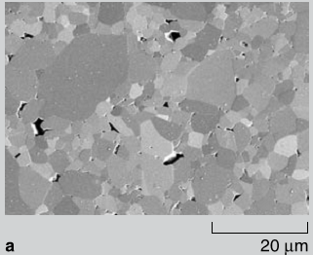
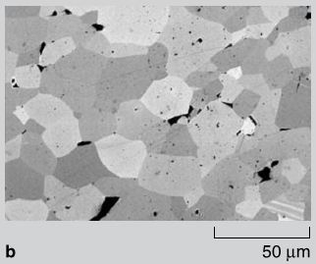
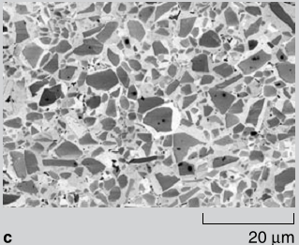
Fig.1.1 The most common ceramics used for armors mainly include 3 types of materials, a) Al₂O₃, b) B₄C, and c) SiC. (Lasalvia et al. 2010 [5])

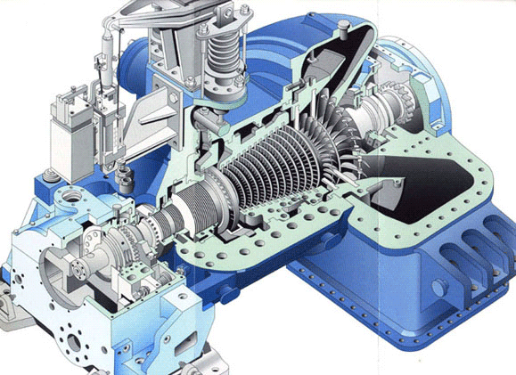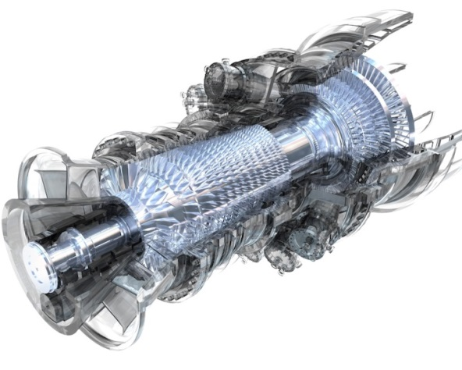
Fig. 1.2 Condensing steam turbine (left) and gas turbine (right ).
(link: http://www.greenesolpower.com/steam.html)

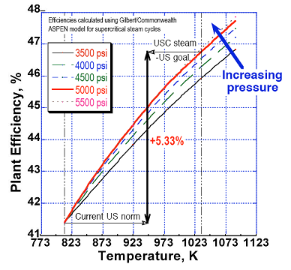
Fig.1.3 shows the turbine efficiency at various temperature levels under different pressure. As the diagram shows, turbine efficiency shows a linear increasing trend with the increase of temperature. This explains the reason of the demand of high temperature withstanding materials. (Huang 2011[3])

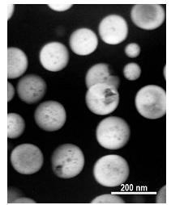
Fig. 1.4 The dark-field (DF) TEM image (using 100 B2 reflection) showing β΄(bright) particles ( Huang 2010[3], Teng et al. 2010 [8])

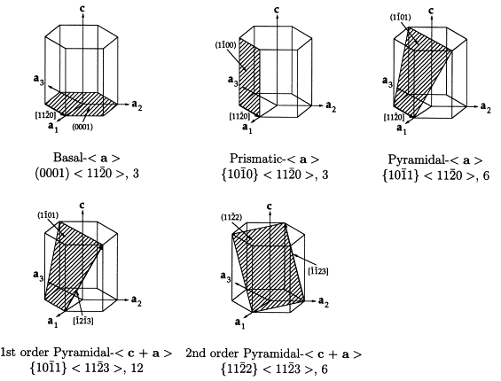
Fig. 2.1 The typical 6 Slip systems of Hexagonal Close Packed crystals. (Motyka et al. 2004 [21])

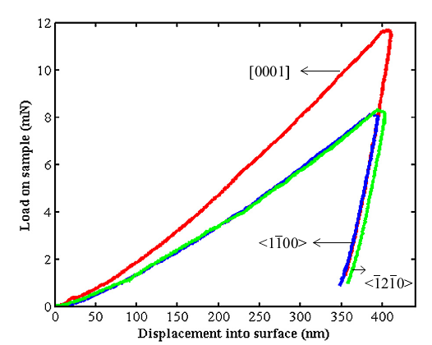
Fig. 2.2 Load versus displacement relationships for SiC crystals at different directions. As we can see from the diagram that at the same displacement <0001> requires larger load than <$1\overline{1}00$> and <$\overline{1}2\overline{1}0$> direction. (Dayte et al. 2014 [65])

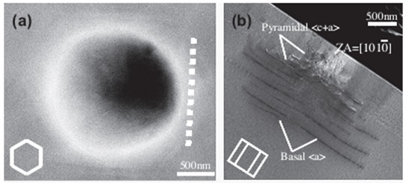
Fig. 2.3 SEM diagrams using a spherical indenter loading on different orientations with respect to the HCP crystal. a) Spherical indentation impression from the indentation process. b) Following the dotted line cut is a cross-sectional view on the internal dislocation behavior.. (Kwon et al. 2013 [7])

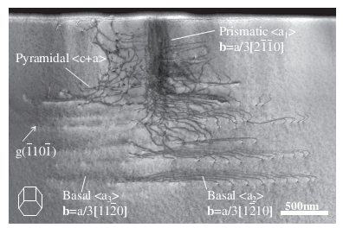
Fig. 2.4 SEM image of Cross-sectional cut of the internal dislocation behavior when the HCP unit cell is placed laterally. For this type of indentation test we can see all 4 slip systems present.(Kwon et al. 2013 [7])

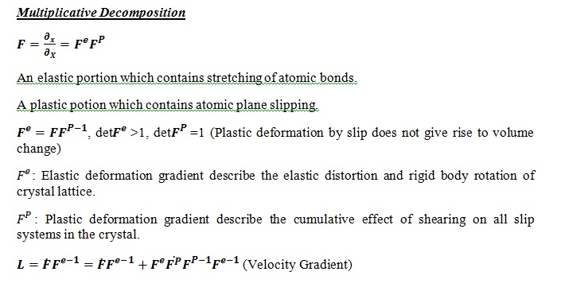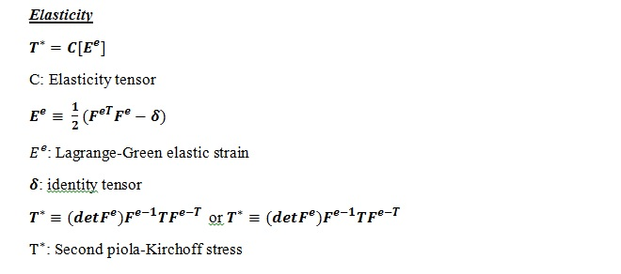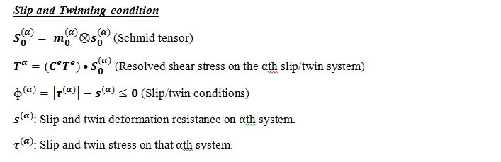

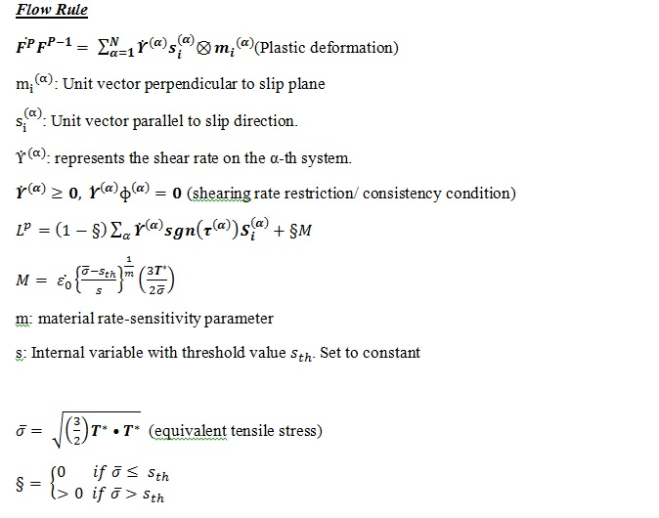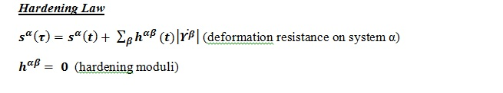
Fig. 2.5 Constitutive law employed in this modeling process to represent the HCP material elastic-plastic behavior. (Staroselsky and Anand et al. 1998, [1], D. Pierce et al. 1982 [9], J.L. Bassani 1991 [10])
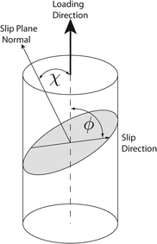
Fig. 2.6 Illustration of how Schmid’s law is being applied for crystal plasticity law. In this diagram, cosλcosɸ in this case is called Schmid’s factor which λ represents the angle between the normal axis from direction of the applied stress, and ɸ is the angle between the slip direction and the direction of the direction of the slip plane normal unit vector. (Weinberger 2008 [12] )
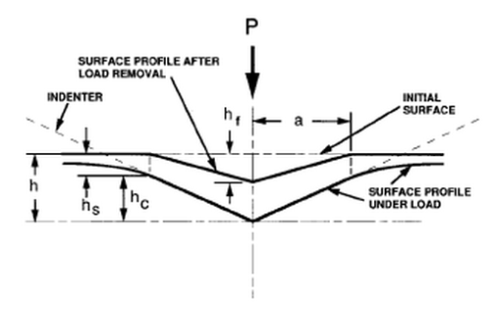

Fig. 2.7 illustrates various parameters involved in indentation hardness test. “P” represents the applied indenter load. “h” is the actual depth the indenter pressed into the sample substrate before unloading (G.M. Pharr et al. 2010 [48], W.C. Oliver et al. 1992 [6]).

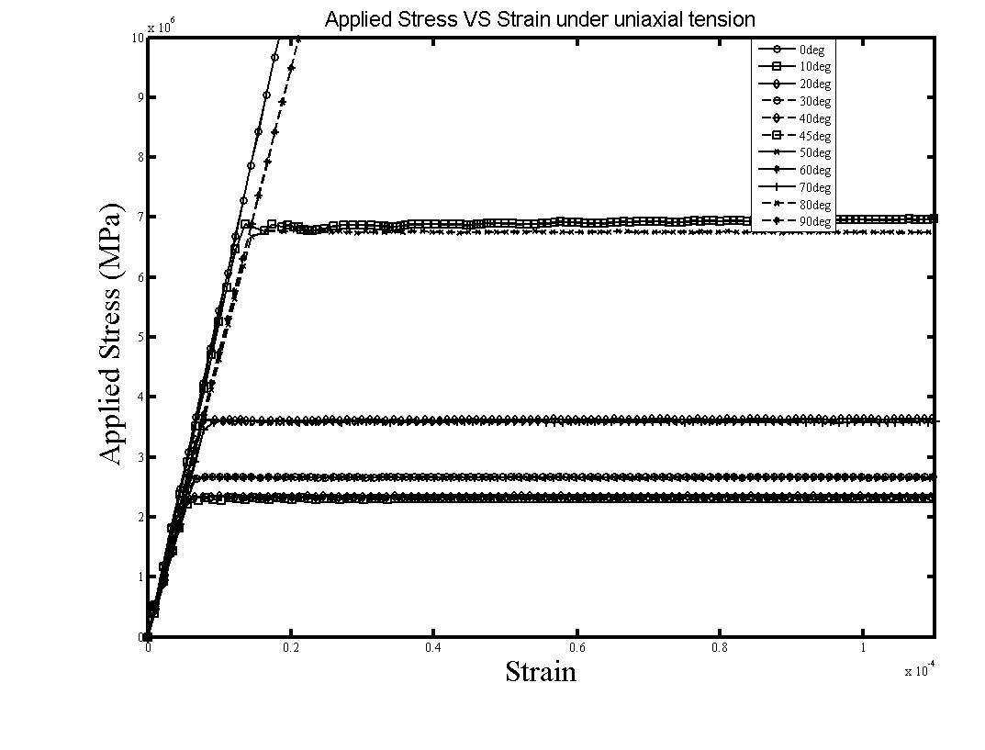
Fig.2.8 Stress veruss strain diagram for basal only HCP single crystal sample under uniaxial loading. Orientation 0° and 90° shows infinite elasticity while orientations between 1° to 89° degrees to the applied stress direction are also tested in order to further testify this result to Schmid’s Law. (A. Dayte, L. Li et al, 2014 [65])

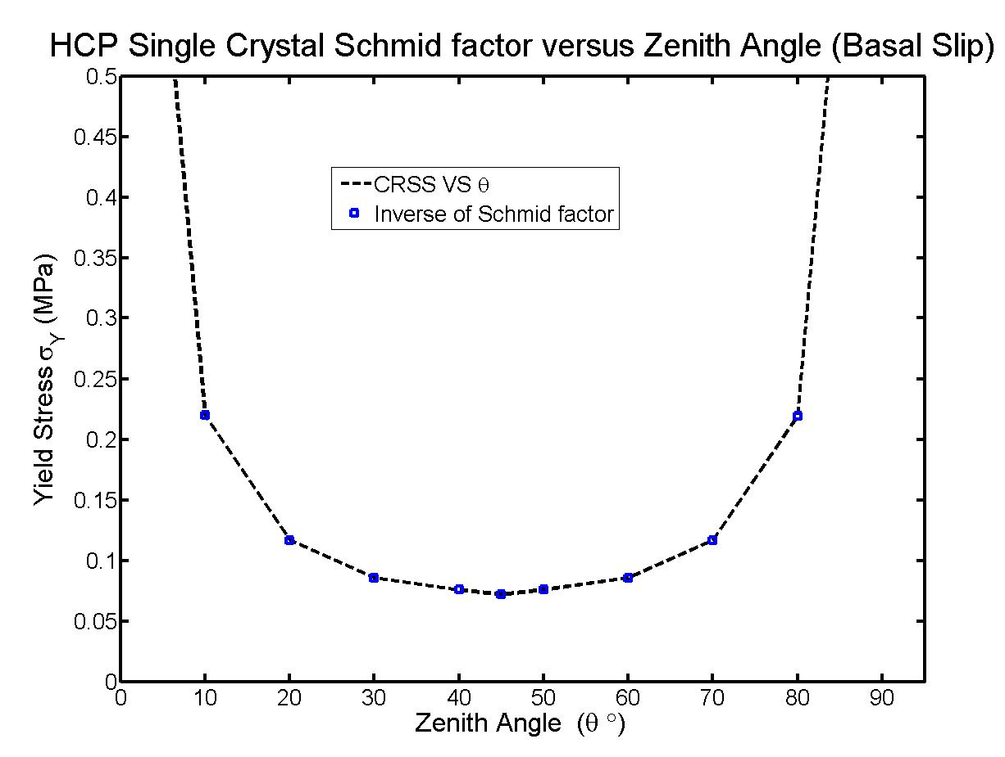
Fig. 2.9 The yield stress versus zenith angle diagram again shows the infinite stress level of 0° and 90° stress level. Any degree in between happens to be a finite magnitude of stress according to the Schmid’s law. Symmetry of the yield stress over 45°angle when plot the yield stress versus the orientation angle. (A. Dayte, L. Li et al, 2014 [65])

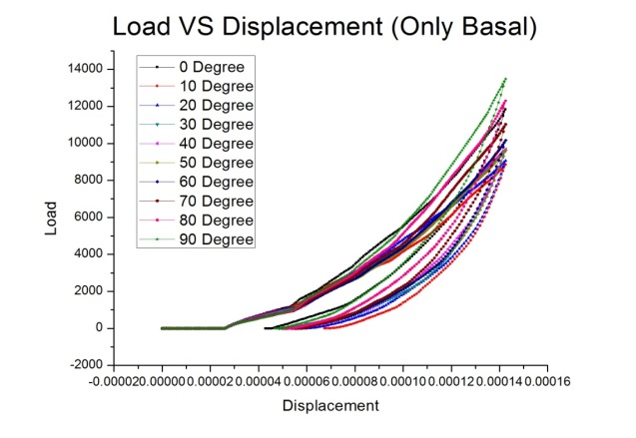
Fig. 2.10 The load versus displacement relationship shows that when indentation is loading at an angle that is 90° to the vertical center line of the HCP unit cell the load level is at its highest and it is at its lowest when this angle is 0° that is parallel to the center line direction. (A. Dayte, L. Li et al, 2014 [65])
Fig.12d

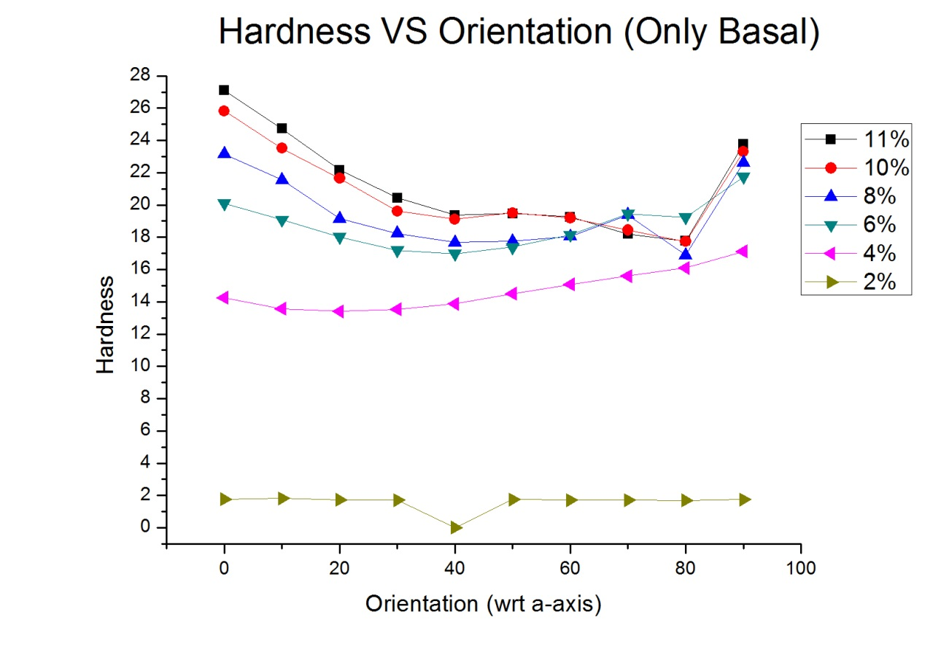
Fig. 2.11 shows the hardness versus loading orientation relationship for this indentation simulation test. The hardness at different loading depth is taken in percentage which is the indentation depth into the sample substrate over the total height of the sample. Diagram shows that the 2% and 4% curves seem to be off by a large scale compared to the other curves. (A. Dayte, L. Li et al, 2014 [65])
Fig.13d

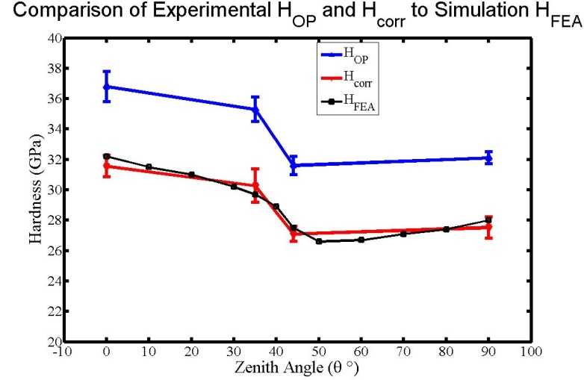
Fig. 2.12 The curve with 6% indentation depth to total height ratio was chosen to be the intended curve and compare that with the experimental result which was concluded from Dayte’s (Dayte 2014) work using a Berkovich indenter. (A. Dayte, L. Li et al, 2014 [65])

Table. 2.1 Experimental findings for material hardness from the Berkovich indentation test using the Oliver-Pharr method (Oliver and Pharr 1992) H_OP and the corrected hardness $H_{corr}$.. By comparison of finite element simulation result with $H_{corr}$. (A. Dayte, L. Li et al, 2014 [65])
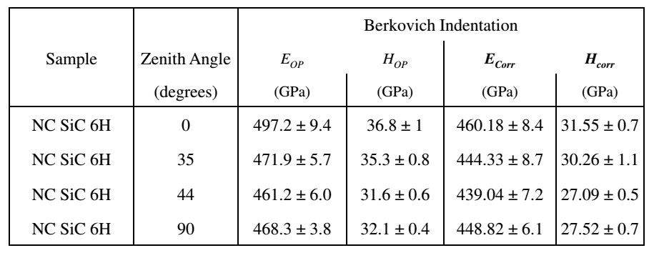

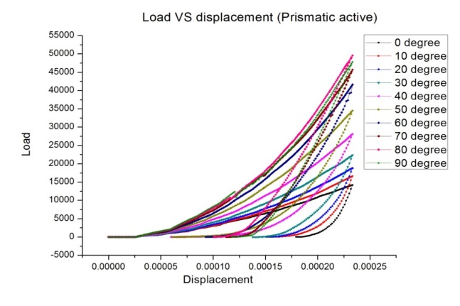
Fig. 3.1, Load versus displacement curve for prismatic slip systems only. The 90° angle, which is the direction that makes up 90° with the centerline of the unit cell and is therefore parallel to the bottom plane of the unit cell has the highest load level and the largest displacement recovery. The 0°, as oppose to the 90° angle, which is parallel to the centerline of the unit cell and is perpendicular to the bottom plane of the unit cell has the lowest load level and the smallest displacement recovery during unloading

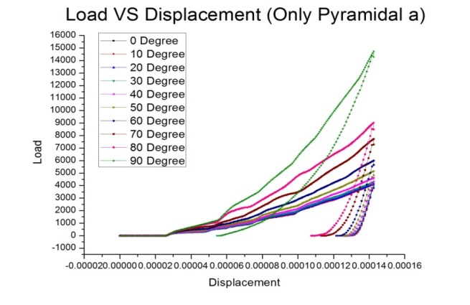
Fig. 3.2 Load versus displacement curve for pyramidal <a> slip systems only. The 90° orientation has the largest load at the same displacement level and the largest displacement recovery during unloading as oppose to 0° which has the lowest load level at the same displacement and the smallest recovery after load removal.

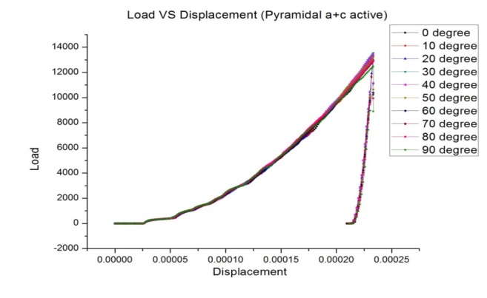
Fig. 3.3 Load versus displacement curve for pyramidal <a+c> slip systems only. The curves for all degree angles does not vary very much from each other and the displacement recovery is somewhat similar for all curves. The curves seem to be identical for all indentation directions. This indicates that the direction of the load that is being applied to the sample does not have a distinct effect on the load level of the material under this unique slip system.

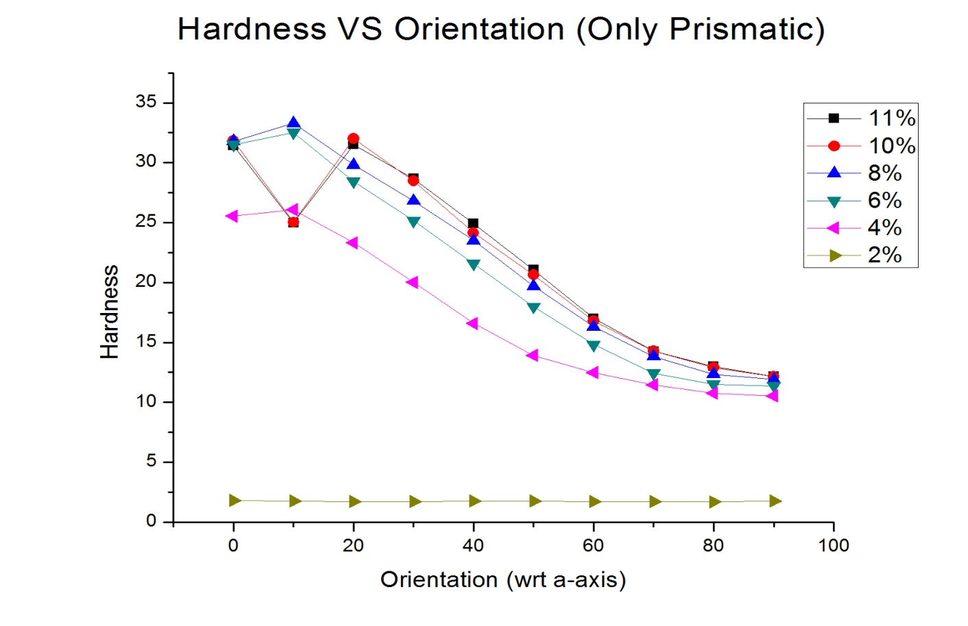
Fig. 3.4 Hardness versus indentation orientation trend for prismatic slip system being active only. The 2% curve which indicates the percentage of indentation depth versus the total height of the sample is quite different compare to the 4%, 6%, 8%, 10% and 11%. The other curves seem to show a rather steady level of hardness so we can choose a curve to represent the hardness of the material.

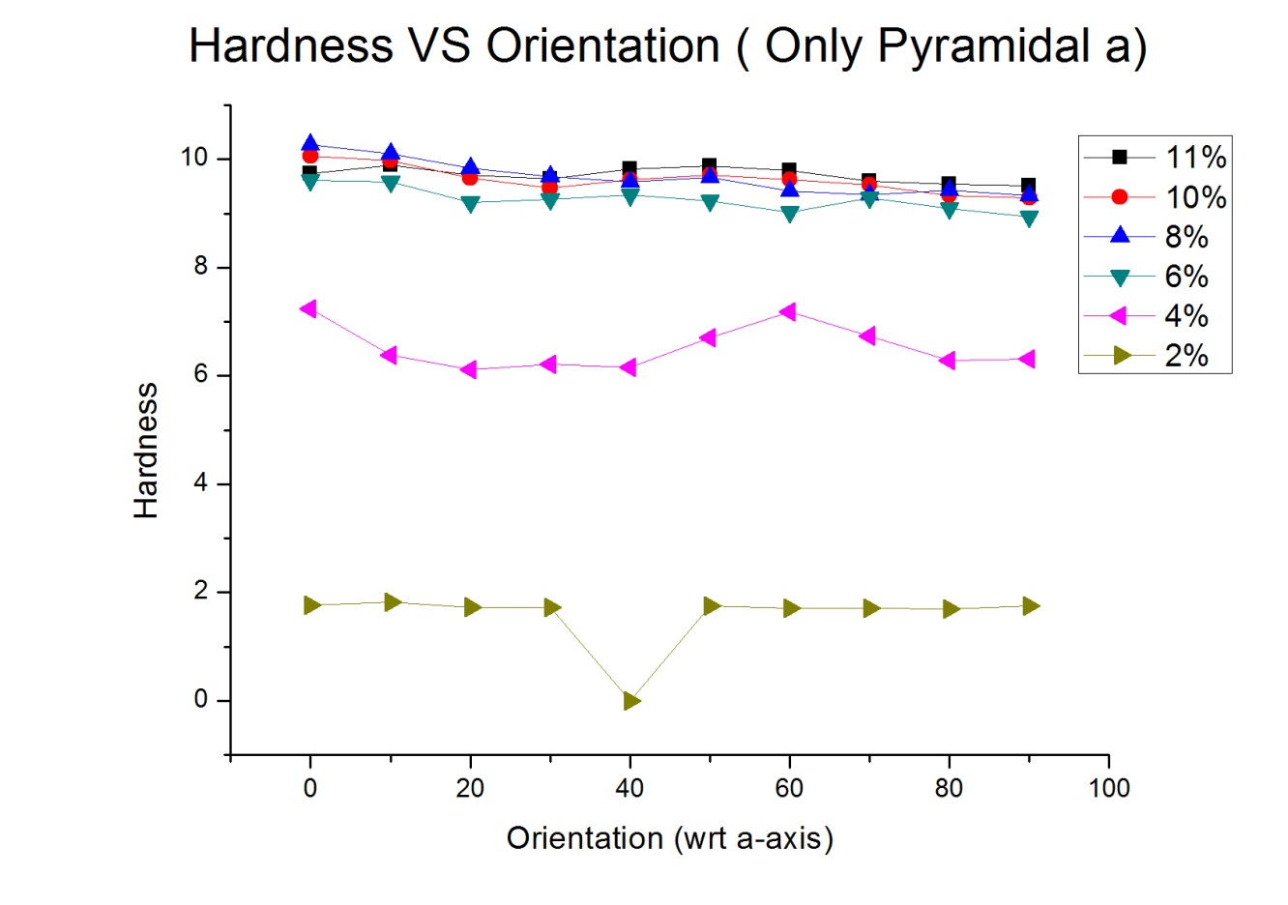
Fig.13c
Fig. 3.5 Hardness versus orientation diagram for pyramidal <a> slip system being allowed only during the simulation. The curves represent the depth percentage of the indenter going into the sample compared to the total height of the sample. It shows in the diagram that the 2% and 4% lines are both off by a lot on the hardness level compared to the 6%, 8%, 10% and 11% curves which demonstrate similar hardness level.

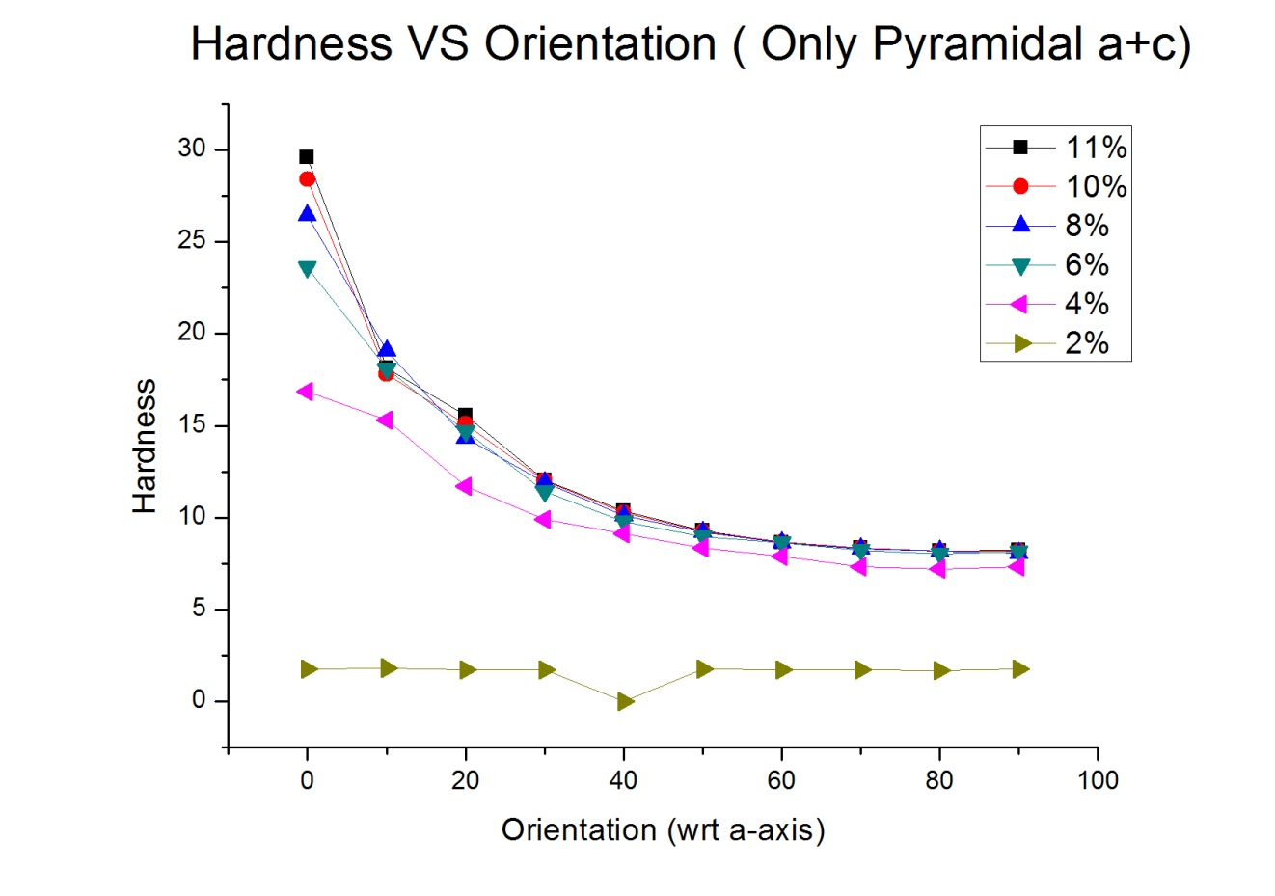
Fig. 3.6 Hardness versus indentation orientation relationship for pyramidal <a+c> slip system only. The 4%, 6%, 8%, 10% and 11% curves all have a rather steady hardness compared to the 2% curve, which are all eligible to represent the hardness of the material.

Table 4.1. Crystal plasticity parameters for copper & a Ni-based superalloy (HASTELLOY C-22HS) polycrystal. (L. Zheng 2012 [2])
 | $C_{11}$(MPa) | $C_{12}$(MPa) | $C_{44}$(MPa) | n | q | $h_{0}$(MPa) | $τ_{s}$(MPa) | $τ_{0}$(MPa)
Copper | 168400 | 121400 | 75400 | 50 | 1.0 | 120 | 20 | 15
C-22HS | 303000 | 210000 | 106000 | 50 | 1.0 | 550 | 750 | 120

Table 4.2. Crystal plasticity parameters for Iron & a Ni-based superalloy (NiAl) polycrystal. (S. Huang 2011 [3])
 | $C_{11}$(MPa) | $C_{12}$(MPa) | $C_{44}$(MPa) | n | q | $h_{0}$(MPa) | $τ_{s}$(MPa) | $τ_{0}$(MPa)
Fe | 198000 | 164000 | 98000 | 10 | 1.0 | 100 | 157 | 150
NiAl | 190000 | 165000 | 106000 | 10 | 1.0 | 100 | 800 | 500

Table 4.3. Crystal plasticity parameters for Iron & a Ni-based superalloy (L21 structure NiAl and B2 structure Ni₂TiAl) polycrystal. (G. Song et al. 2014 [64])
 | $C_{11}$(MPa) | $C_{12}$(MPa) | $C_{44}$(MPa) | n | q | $h_{0}$(MPa) | $τ_{s}$(MPa) | $τ_{0}$(MPa) | $α$ (/$°\text{c}$)
Fe | 113800 | 96000 | 51100 | 10 | 1.0 | 100 | 157 | 120 | 1.66e-6
NiAl | 166700 | 124900 | 111500 | 10 | 1.0 | 100 | 1300 | 1000 | 3.56e-6
Ni₂Al | 152000 | 103900 | 94000 | 10 | 1.0 | 100 | 1400 | 1100 | 3.79e-6

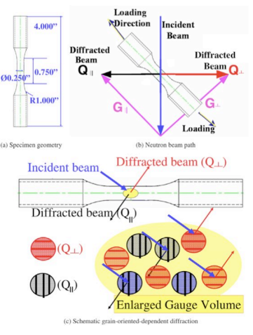
Fig.4.1 shows the size and orientation of the dog-bone shaped sample as well as the direction of the incident beam coming in at a certain angle and the diffracted beam hitting the different grain orientations within the sample and coming out at different angles in order to determine the peaks that are appearing for that particular phase. (Zheng et al. 2012 [2])

Fig. 4.2 Resulting peaks for all 3 phases. The black lines represent the peaks visible for the ferritic matrix and the red line represents the peaks for the super alloy which includes both L21 and B2 precipitates. The 2 precipitates cannot be differentiated using neutron diffraction and they appear as a super alloy peak in the diagram. The peaks we have collected from the diagram are (110), (200), (211), (220), (222), and (321) for the ferritc matrix and (111), (200), (222), (311) and (420) for the super alloy. (Song et al. 2014 [64])

Fig. 4.3 SEM images of the internal structure of the sample. a) The super lattice reflection of the super alloy. b) Shows the L21 precipitate in a more quantified measure, the average diameter observed using the SEM machine appears to be 50 to 80 nm. c) and d) are more direct view of the precipitates. In these images the orange object represents the L2₁ precipitate and the dark zones embedded within the orange object are believed to be the B2 precipitate. (Song et al. 2014 [64])

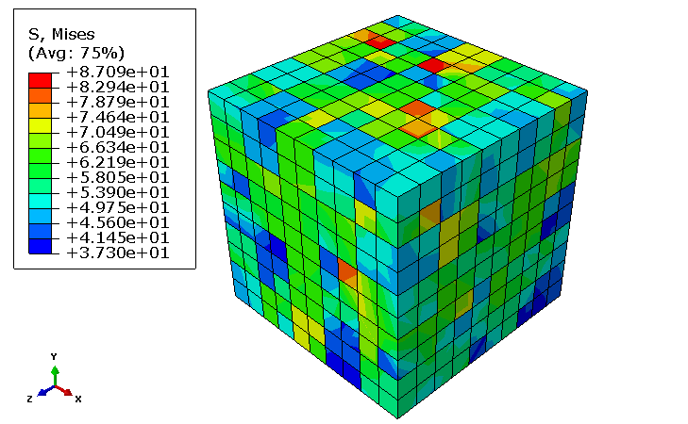
Fig. 4.4 A 10×10×10 elements cubic which each cubic element represent a single grain of copper and is being assigned with material properties of copper. The boundary conditions used for this model is a simply supported system with the nodes on the bottom plane restricted from movement at the vertical direction (Y direction) and 1 corner node is restricted in all 6 degree of freedoms while the diagonal corner node is restricted to move in only X,Y and Z directions. (Song et al. 2014 [64])

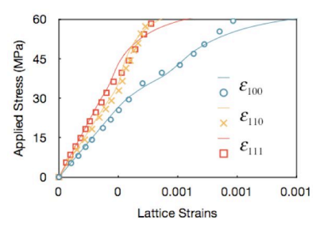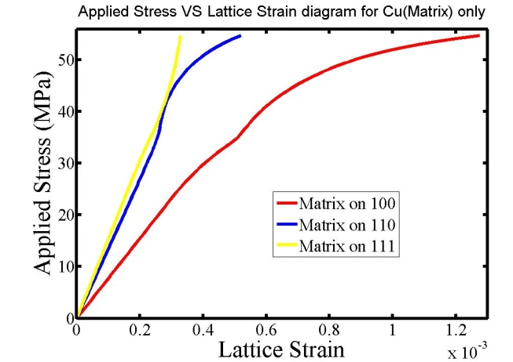

Fig. 4.5 Top diagram is experimental results (Zheng 2012) and bottom diagram is simulation result. Orientation peaks <100>, <110> and <111> direction were collected. It was straight forward to see that grains in the <100> direction started to yield at stress level approximately at 45MPa which is 3 times the appointed $τ_{0}$. The 3 peaks for this single phase alloy have all yielded at a relatively low stress level at a relatively low temperature (773K). (Zheng et al. 2012 [2], Song et al. 2014 [64])

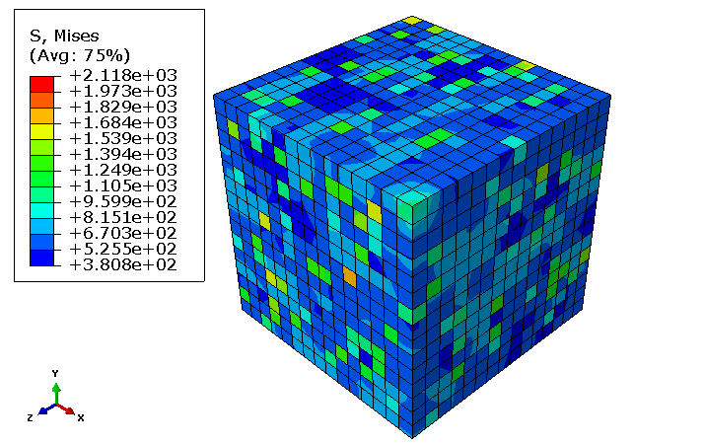
Fig. 4.6 A 15×15×15 elements cubic with each 27 elements making up a 3×3×3 small cubic acting as a single grain. There are a total of 125 grains in the sample model and within each grain. There will be a total of 5 elements randomly selected assigned with the properties of the L21 precipitate while the rest of the elements are assigned with iron properties to simulate the idea of ferritic alloy containing L21 precipitate. This model is simply supported on the bottom as well same as the first case. (Song et al. 2014 [64])

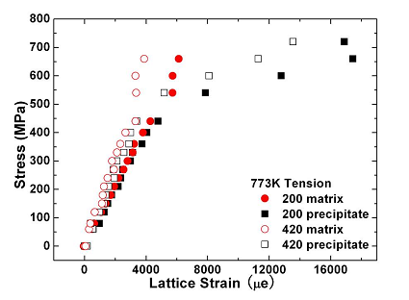
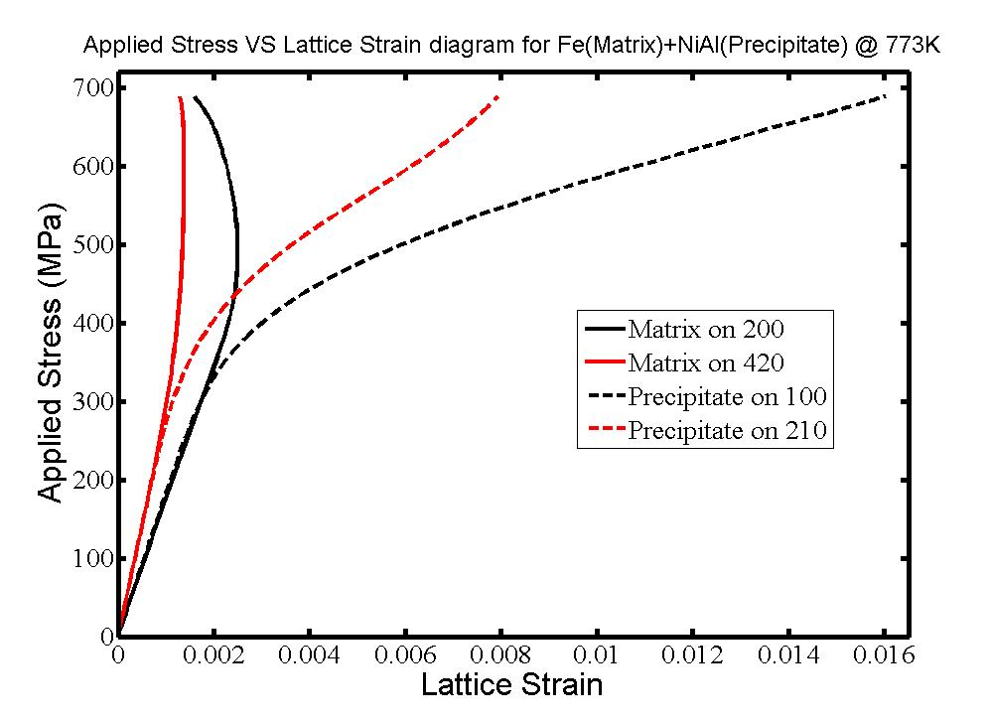
Fig. 4.7 Top diagram is experimental result and bottom diagram is simulation result. Lattice strain predicted by crystal plasticity model at 773K. This temperature level with the slip system {110}<111> being the basic slip system for BCC material. Matrix phase yielded at a relatively low level at around 400MPa stress level. The stress versus lattice strain curve for matrix peak <200> and <420> reversed its increasing trend on the lattice strain scale after reached yielding point and a distinct load transfer has occurred from the matrix to the precipitate due to the fact that the peak <100> and <210> for L2₁ precipitate continued increasing on the lattice strain scale after the matrix has yielded. (Huang et al. 2011 [3],)
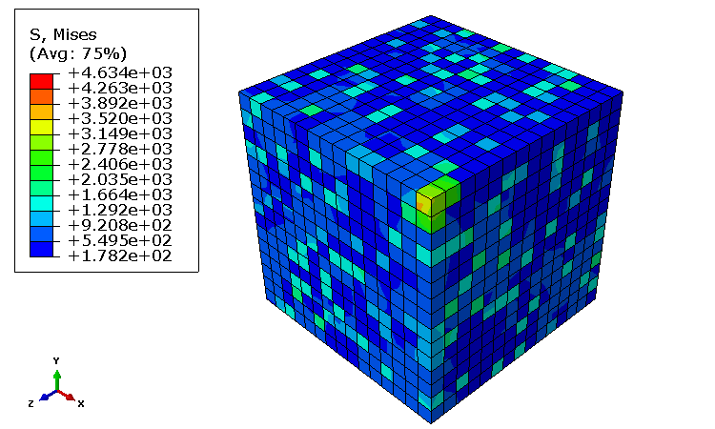
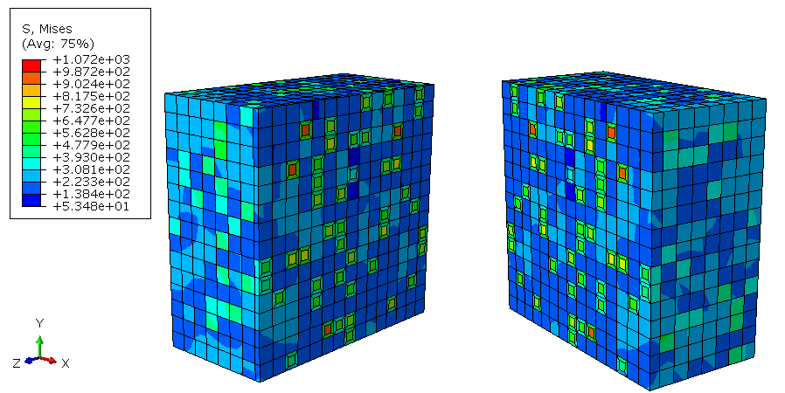
Fig. 4.8 A 15×15×15 elements cubic model. With simply supported boundary conditions, the cubic was divided into 125 grains with each 27 elements making up a 3×3×3 cubic grain. 5 elements were assigned with L21 precipitates.B2 precipitates was introduced with an element smaller in size to be embedded in the pre-existing L21 elements in each grain. The remaining 5 elements each contain 6 trapezoidal elements at the 6 faces of the cubic element with a smaller cubic elements attached at the center of these 5 elements. (Song et al. 2014 [64])
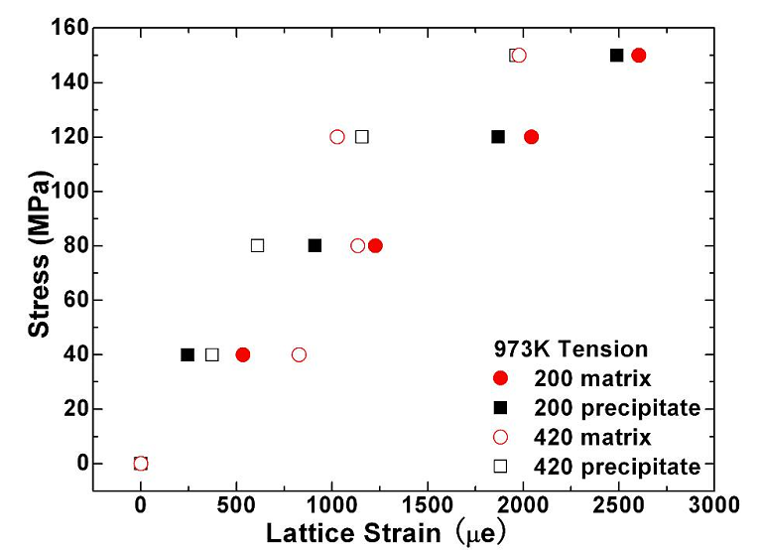
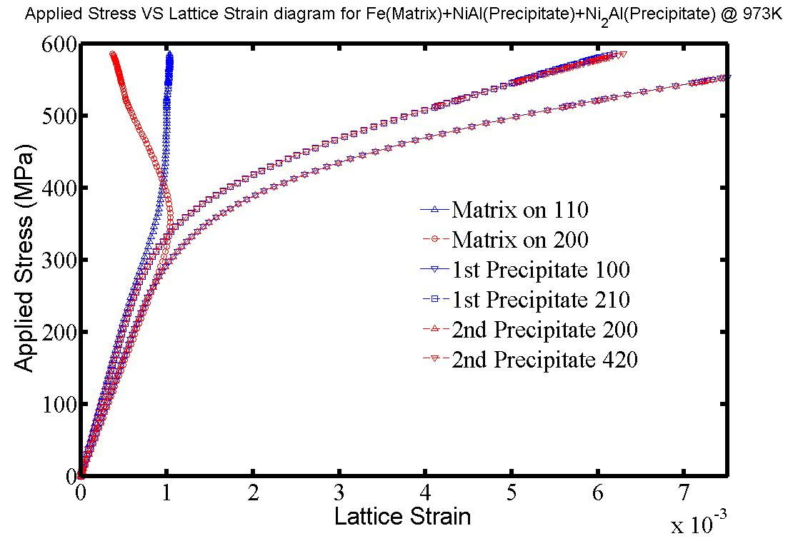
Fig.4.9 Top diagram is experimental result (Huang 2011) and bottom diagram is simulation result. In Huang’s results, both matrix and precipitate have yielded at 973K. In simulation result, when B2 phase precipitate is introduced to the system, the material strength have been improved significantly again. The ferritic alloy yields around 350MPa and the <110> and (200) peaks for the matrix starts to decrease on the lattice strain scale after it reaches yielding point. There is a distinct stress transfer present in the system and resulted in the L21 precipitate and B2 precipitate carries on the stress and continues increasing in the lattice strain scale until the maximum applied stress level has been reached. (Huang et al. 2011 [3])
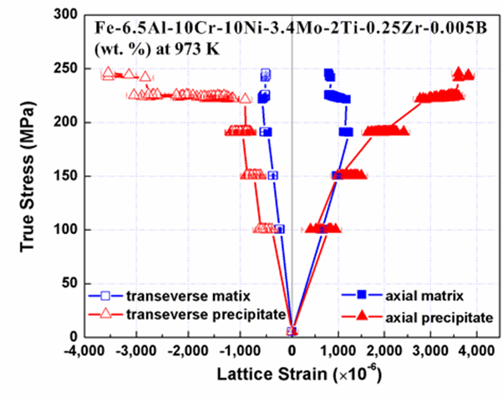
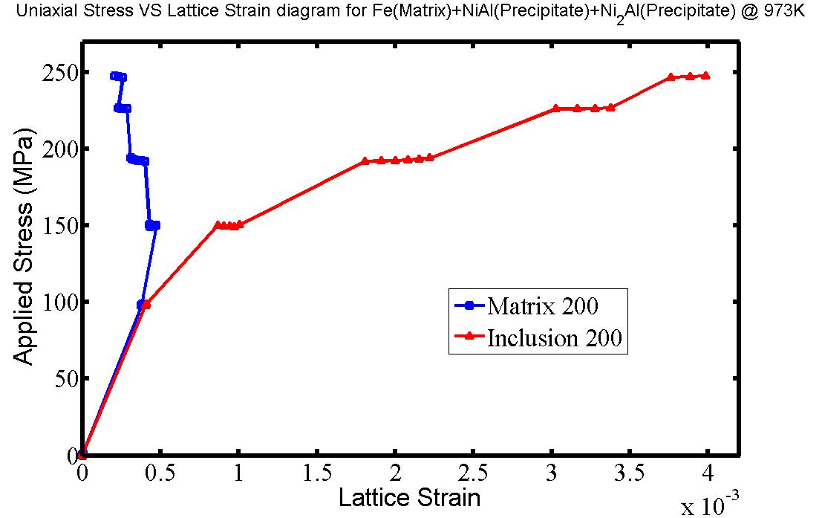
Fig. 4.10 Top diagram is experimental result (Song 2014) and bottom diagram is simulation result. While at 973K, the creep test response of the Fe alloy containing L21 and B2 precipitates shows clear lattice strain drift and load transferring. Matrix yielded around 150 MPa and super alloy carries on the stress and never reached yield until the ultimate applied stress is reached. (Song et al. 2014 [64])

Table 5.1. Thermal expansion parameters for Iron, NiAl & a Ni₂TiAl (Miracle 1993 [54])
Table. 5.1
Thermal Expansion Coefficient | Fe-Matrix  (CTE) | NiAl  (CTE) | Ni₂TiAl  (CTE)
$$α$$ | $$1.45×10^{-5}$$ | $$3.48×10^{-5}$$ | $$3.48×10^{-5}$$

Table 5.1. Lattice strain for Ferritic alloy and Ni-based super alloy variation according to temperature change. (G. Song et al. 2014 [64])
Temperature (̊C) | Matrix (Å) | Precipitate(Å)
25 | 2.88941 | 5.82247
374 | 2.90151 | 5.8507
474 | 2.90557 | 5.86175
574 | 2.90957 | 5.871
624 | 2.91193 | 5.87655
700 | 2.91608 | 5.88631

Table. 5.1

Table 5.1. Lattice parameter for Ferritic alloy and Ni-based super alloy variation according to temperature change. (G. Song et al. 2014 [64])
Table. 5.1
Temp.(̊C) | Matrix lattice strain | Precipitate lattice strain
25 | 1.01 $×$ 10⁻⁵ | 1.17 $×$ 10⁻⁵
374 | 1.36 $×$10⁻⁵ | 1.63 $×$ 10⁻⁵
474 | 1.47 $×$ 10⁻⁵ | 1.76 $×$10⁻⁵
574 | 1.57 $×$ 10⁻⁵ | 1.89 $×$ 10⁻⁵
624 | 1.62$×$10⁻⁵ | 1.96 $×$10⁻⁵
700 | 1.70 $×$ 10⁻⁵ | 2.06 $×$ 10⁻⁵

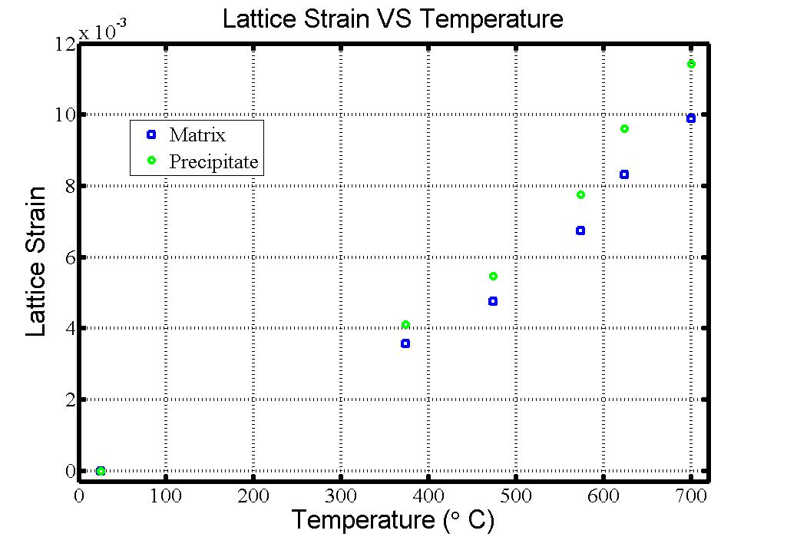
Fig. 5.1 Top diagram is experimental result and bottom diagram is simulation result. At room temperature the lattice strain for both matrix and precipitates sits at 0 which means at this temperature level the coherent structure of the matrix and the precipitate does not generate residual stresses within the sample. As temperature increase, the lattice strain within the sample increase as well. The originally overlapping lattice strain for precipitates and matrix starts to part as well with the increase of temperature level. (G. Song et al. 2014 [64])
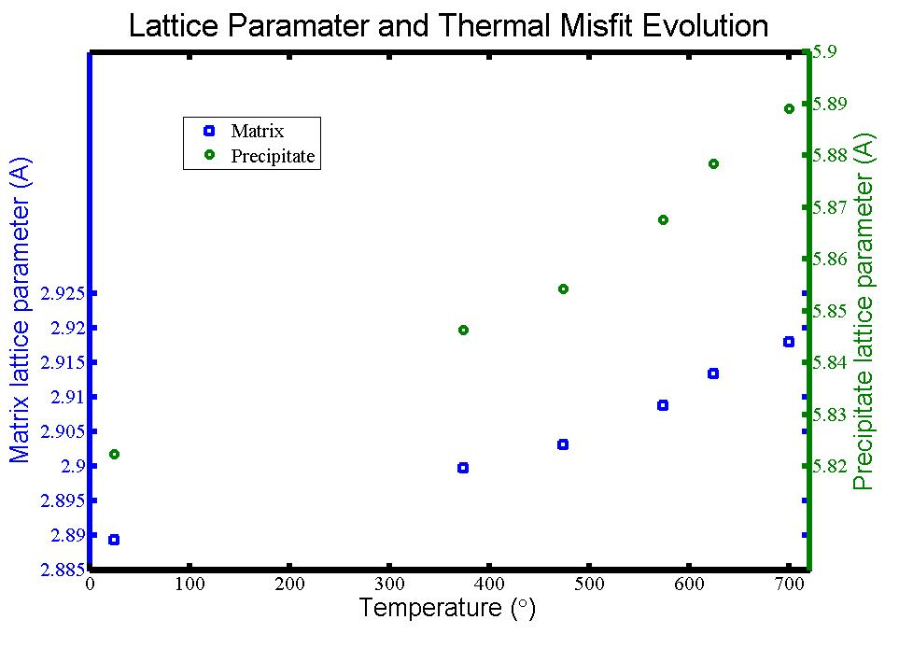
Fig. 5.2 Top diagram is experimental result and bottom diagram is simulation result. The original lattice parameter for matrix is 2.88941A and the lattice parameter for precipitate is 5.82247A at room temperature. When temperature level rises the lattice parameter of the matrix and precipitates increase as well as both curves displays an increasing trend with increasing temperature. The relationship between the lattice parameter and temperature level appears to be linear for both matrix and precipitate with the precipitate increase slightly faster due to a higher thermal expansion coefficient. (Song et al. 2014 [64])

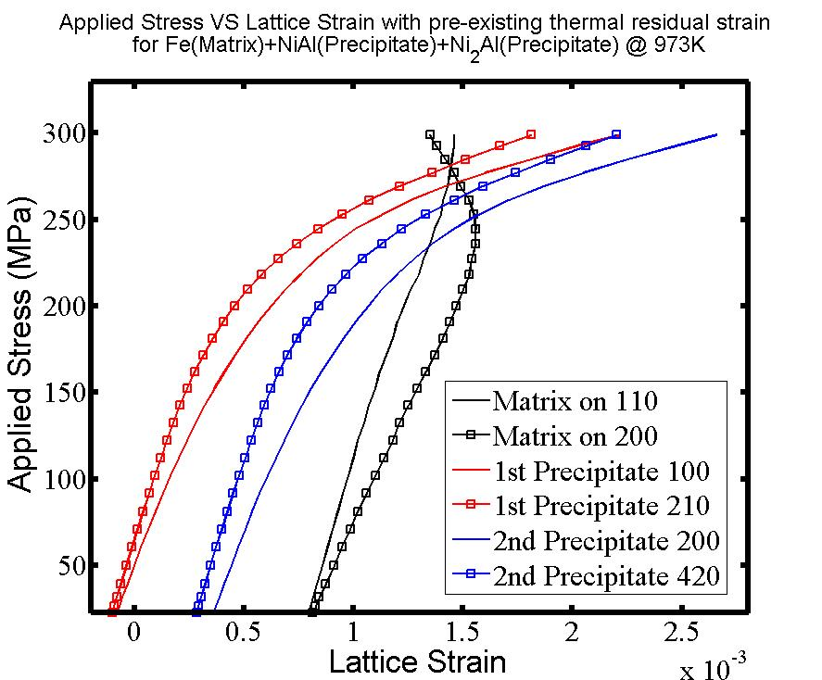
Fig. 5.3 The curves for L2₁ precipitates with <200> and <420> orientation results in negative lattice strains while the matrix with its <110> and <200> orientation and then B2 precipitates at <100> and <210> directions both result in position lattice strains. This is because when heating the material before applying the load, the pre-existing thermal stress will generate a residual stress within the model therefore results in a differentiated starting point for the lattice strain in the stress versus lattice strain diagram. (G. Song et al. 2014 [64])

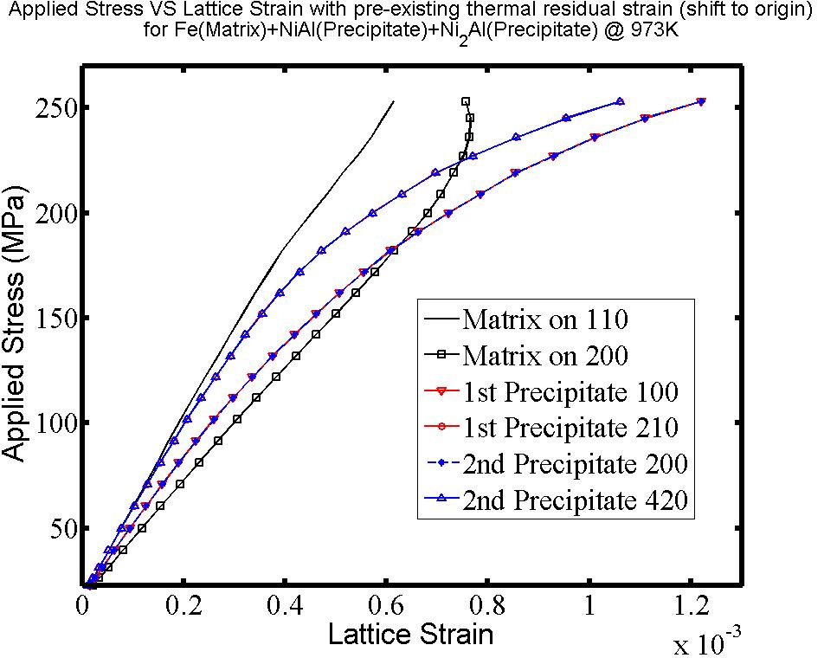
Fig. 5.4 When bring all curves for the matrix, L21 and B2 precipitates to the same starting point in this case and setting it to the origin diagram shows very close resemblance to the pure loading case. The <110> and <200> peaks for matrix both demonstrate yielding behavior towards after reaching the yield stress for the iron matrix and both<200> and <420> peaks for L21 precipitate and <100> and <210> peaks for B2 precipitates carries the load from load transferring from the matrix and shows a proportional increase in lattice strain while load increases. (G. Song et al. 2014 [64])

Vita
Lin Li was born in Zhengzhou, Henan province, China. He lived in Zhengzhou until he was sixteen years old before moving to Canada. He obtained his Bachelor’s degree from McMaster University from Hamilton, Canada in Civil Engineering in the year of 2010. In 2010, immediately after getting his bachelor’s degree, he moved to the United States and joined Dr.Yanfei Gao’s group to pursue a Ph.D degree in the Materials Science and Engineering Department focusing on computational micro-mechanics at the University of Tennessee. He obtained his Master’s degree in July 2013 and completed His Ph.D degree in December 2014.

