An Investigation of Diabetes Mellitus in Postmortem Human Remains

A Dissertation Presented for the
Doctor of Philosophy
Degree
The University of Tennessee, Knoxville

Shannon Elizabeth May
August 2014

Copyright © 2014 by Shannon May
All rights reserved.

Acknowledgements

This project would not have been completed without the help and encouragement from numerous individuals. I would first like to thank my committee chair Dr. Richard Jantz for his in fallible advice and support. Dr. Jantz stuck it out through two graduate degrees as my advisor, which deserves an award by itself. Thank you to the member of my graduate committee (in no particular order!) – Dr. Graciela Cabana, thank you so much for your tireless assistance reviewing and revising this work. I am a better writer because of you. Dr. Benjamin Auerbach, thanks for you statistical critique and suggestions. And Dr. Collier, thank you for training me in laboratory procedures, providing bench-space and research time, and for your methodological advice.
I am indebted to Dr. Dixie Thompson, who spent so many afternoons with me perfecting our technique with the iDXA densitometer and scanning long bones. Thanks you to Dr. Susan Collier who helped train me biochemistry lab protocol and patiently spent many Saturdays assisting with my research and answering an endless number of questions. I greatly appreciate Dr. Ann Reed for her statistical genius. Gratitude is also owed to the graduate students in the Department of Anthropology: thanks to Heli Maijanen for helping my haul skeletal donations across campus for scanning, Frankie Pack for removing blood card samples for testing, and any individuals who entered antemortem data into the William M. Bass donor database.
And finally, the greatest appreciation is owed to my family. Your love and unfailing confidence in me has always been my greatest strength.

This work is dedicated to Mimi, a strong independent woman ahead of her time. I miss you.

Abstract
Diabetes mellitus is one of the most prevalent and significant metabolic diseases impacting modern human populations. The goal of this research is to explore several analytical methods to better appreciate how diabetes impacts the skeleton, and to determine if this effect can be recognized in postmortem remains. Anthropologists are tasked with elucidating the relationship between nutrition, metabolism, growth, development, and skeletal health. Diabetes represents a crucial point of interface between these factors. Furthermore, as the percentage of diabetics increases in the general population, so will their representation in forensic cases. This study will provide tools for identifying characteristics of diabetes in the postmortem material available to anthropologists.
Diabetes is a disease process that can alter the function of many tissues and systems. For these reasons, three analytical approaches were conducted including: blood serum protein analysis using ELISA, bone mineral density (BMD) scans with a dual-energy x-ray absorptiometry (DXA) scanner, and macroscopic osteological analysis. This study was completed employing a sample of 80 known skeletal donations and 20 blood samples from the William M. Bass Donated Skeletal Collection at the University of Tennessee, Knoxville.
Results indicated that pro-inflammatory biomarkers may be quantified in postmortem blood samples, and that diabetics showed slightly higher average concentrations of cytokines associated with diabetes and lower concentrations of those related to insulin sensitivity. Bone density analysis revealed that diabetics and non-diabetics significantly differ in BMD, but this relationship varies between the sexes. Female diabetics had consistently denser bones in all measured variables of the lower limb, and one-third of forearm variables. Results based on male data did not display a similar outcome, with little difference observed between male diabetics and non-diabetics. Analysis of skeletal pathologies identified a set of three osteological variables, concentrated in the feet, as having the highest discriminatory potential. An accuracy rate of 83% was achieved in classifying individuals into diabetic versus non-diabetic categories.

Table of Contents

Chapter 1. INTRODUCTION 1
Introduction 1
Background to Diabetes Mellitus 2
Brief History of Diabetes 3
Current Prevalence of Diabetes Mellitus 4
Forms and Diagnoses of Diabetes .6
Etiology of Diabetes 9
Pathophysiology of Type 2 Diabetes 13
Diabetes as an Inflammatory Disease 13
Research Design and Methods 15
Implications for Skeletal Biology and Forensic Anthropology 18
Chapter 2. BONE AND ENERGY METABOLISM 20
Interrelationship of Bone and Energy Metabolism 20
Effect of Adipose Tissue and Glucose-Handling Molecules on Bone 22
Leptin 22
Adiponectin 25
The Effect of Bone on Energy Metabolism 28
Esp Gene 29
Osteocalcin 29
Completing the Metabolic Pathway 32
Pharmaceutical and Clinical Applications 35
Summary 36
Chapter 3. DIABETES AND THE BODY 37
Background 37
The Effects of Hyperglycemia 37
Angiopathy 39
Soft Tissue Pathologies 39
Nephropathy 40
Retinopathy 41
Neuropathy 43
Osteological Pathologies 45
Bone Mineral Density 46
Fractures 48
Periostitis, Osteomyelitis, and Amputation 50
Periodontitis 53
Chapter 4. MATERIALS 55
Blood Sample 57
Chapter 5. BLOOD PROTEIN CYTOKINE ANALYSIS 59
Background 59
Preliminary Methods and Preliminary Results 63
Dissertation Methods 67
Results 70
Discussion 77
Chapter 6. BONE MINERAL DENSITY ANALYSIS 81
Background 81
Methods 86
Results 90
Discussion 100
Chapter 7. EXAMINAION OF OSTEOLOGICAL PATHOLOGIES 103
Background 103
Methods 107
Results 109
Discussion 117
Chapter 8. CONCLUSIONS 120
Overview 120
Summary and Interpretation of Results 121
Methodological Limitation 125
Future Research 126
Literature Cited 129
Appendix 142
Vita 163
List of Tables

Table 1.1. Criteria for Diagnosis of Type 2 Diabetes 8
Table 4.1. Demographics of the Total Research Sample 57
Table 5.1. Results from Multiplex ELISA, Diabetic vs. Non-diabetic Samples .66
Table 5.2. Results from Bradford Quantification Assay 70
Table 5.3. Results from Paired T-test of Leptin Concentrations 71
Table 5.4. Results from Paired T-test of Adiponectin Concentrations 72
Table 5.5. Results from Paired T-test of IL-8 Concentrations 73
Table 5.6. Results from Paired T-test of MCP-1/CCL-2 Concentrations 74
Table 6.1. Results from Pearson Correlation of Demographic versus Femur Variables 91
Table 6.2. Results from Pearson Correlation of Demographic versus Forearm Variables 91
Table 6.3. Results from Pearson Correlation of Demographic versus Tibia Variables 92
Table 6.4. Femur MANOVA Results 93
Table 6.5. Forearm MANOVA Results 94
Table 6.6. Tibia MANOVA Results 95
Table 6.7. ANOVA Results: Femur Neck 96
Table 6.8. ANOVA Results: Radius Ultra-distal 98
Table 6.9. ANOVA Results: Tibia Distal ⅓ Shaft 99
Table 7.1. Chi-Square Results: Fractures Tarsals and Metatarsals 111
Table 7.2. Chi-Square Results: Porosity Carpals 111
Table 7.3. Chi-Square Results: Osteomyelitis Distal ⅓ Tibia and Fibula 111
Table 7.4. Chi-Square Results: Osteomyelitis Tarsals and Metatarsals 112
Table 7.5. Chi-Square Results: Osteophytes Distal Tibia and Fibula 112
Table 7.6. Chi-Square Results: Heel Spurs 112
Table 7.7. Chi-Square Results: Osteophytes Tarsals and Metatarsals 113
Table 7.8. Pathology Variables used in Logistic Regression 113
Table 7.9. Forward Wald Logistic Regression Results 115

List of Figures

Figure 2.1. Leptin signaling pathway and its effect on bone cells 25
Figure 2.2. Osteocalcin and its effect on energy metabolism 31
Figure 2.3. The Esp gene – osteoblast – osteocalcin pathway 34
Figure 3.1. Charcot foot, normal and x-ray view of bony malformation 45
Figure 4.1. Number diabetic individuals in the William M. Bass Donated Collection, past 20 years 56
Figure 5.1. Sandwich ELISA 62
Figure 5.2. Samples used in preliminary ELISA multiplex, prior to extraction 66
Figure 5.3. Singleplex ELISA 69
Figure 5.4. Results from leptin ELISA, Diabetic vs. Non-diabetic sample 71
Figure 5.5. Results from adiponectin ELISA, Diabetic vs. Non-diabetic sample 72
Figure 5.6. Results from IL-8 ELISA, Diabetic vs. Non-diabetic sample 73
Figure 5.7. Results from MCP-1 / CCL-2 ELISA, Diabetic vs. Non-diabetic sample 74
Figure 5.8. Results from the four singleplex ELISAs, mean and median values 75
Figure 5.9. Total protein concentration vs. interval between death and blood sampling (days) 76
Figure 6.1. GE Lunar iDXA scanner and desktop computer with user interface software 85
Figure 6.2. Arrangement of femur in rice for scanning 86
Figure 6.3. Regions of interest scanned on tibiae 88
Figure 6.4. Means for Neck BMD, separated by sex 97
Figure 6.5. Means for Radius Ultra-distal BMD, separated by sex 98
Figure 6.6. Means for Tibia distal ⅓ shaft BMD, separated by sex 99
Figure 7.1. Osteomyelitis in tarsals and metatarsals, diabetic versus non-diabetics 115
Figure 7.2. Heel spurs, diabetic versus non-diabetics 116
Figure 7.3. Osteophytes, diabetic versus non-diabetics 116

CHAPTER 1. INTRODUCTION
Introduction
Diabetes mellitus has a profound effect on the human body and this research will provide an anthropological perspective and a means for recognition in postmortem remains. Type 2 diabetes is a metabolic disease that has reached epidemic proportions in the unique biocultural environment afforded by the twentieth and twenty-first centuries. Anthropologists are tasked with understanding the interaction between nutrition, growth, development, and skeletal health, as well as identifying pathological conditions in human remains. However, diabetes has not been systematically examined in anthropological literature or forensic anthropology case studies. The current work addresses this deficit by examining the clinical complications of diabetes that are observable in postmortem blood and skeletal samples, and recording a pattern of pathological traits. The research question driving this study is: Are the human remains of diabetics discernable from those of non-diabetics?
Diabetes is a disease process with many stages. An individual represents a single point in the pathological progression from good health to critical illness. Diabetics who expire in the early phases of the disease will demonstrate a different suite of characteristics than those in middle or later stages of the disease. Furthermore, diabetes alters the function of many different tissues in the body. This research will identify diabetic characteristics in each stage, and underscore those which may be recognized in postmortem remains. For these reasons, three separate methodological approaches are pursued: enzyme-linked immunosorbent assay (ELISA), dual-energy x-ray absorptiometry (DXA), and macroscopic osteological analysis. Each technique informs about a different aspect or stage of the disease. The three approaches will be analyzed independently in answering the aforementioned research question. Results will be incorporated into suggestions for best practices in forensic anthropology.
Anthropologists have a wealth of information to add to the dialog concerning diabetes. Anthropology offers a significant time depth perspective rarely matched in other fields. Among many pursuits, biological anthropologists seek to understand osseous material, track changes in morphology and function over time, characterize population level and within-groups differences, and often do so without the living of living testable subjects.
This research provides skeletal biologists with insight into how bone is involved in energy metabolism. It also expands the role of the skeleton from a mechanical, structural, and hemopoitic system, to one that also influences energy storage and metabolism. This work may supplement current knowledge of how dietary factors are affecting bone growth, development, and deterioration. Just as paleopathologists investigate anomalies and defects in ancient and historical remains, biological anthropologists must be prepared to recognize contemporary pathologies in the present population and modern forensic cases. The data collected will allow researchers to better understand how human skeletal material is interfacing with the modern environment and provide a foundation for future research concerning diabetes and skeletal health.
Initially, this chapter will introduce diabetes, provide historical background, and explain its epidemiology and pathophysiology. Next, the theory of diabetes as an inflammatory disease will be discussed, underscoring the significance of inflammatory proteins circulating in the blood that interact with skeletal tissue. Finally, this chapter will conclude with the research design outlining the project, a description of the chapters and analyses conducted, and implications for practice in forensic anthropology

Background to Diabetes Mellitus
Diabetes mellitus, or simply diabetes, is a complex metabolic disorder characterized by hyperglycemia, excess glucose in blood. The disease results from defective insulin secretion, inadequate insulin action, or a combination of both factors (American Diabetes Association [ADA] 2011a). Metabolic disorders, in which diabetes is the hallmark example, are abnormal chemical processes or reactions that disrupt the normal break-down of food into nutrient particles for energy expenditure and storage. Given the steadily rising incidence in the general population, diabetes has been heavily studied in clinical research and the medical community.
Diabetes has been largely disregarded in anthropology for several pertinent reasons. First, diabetes induces well-known functional alterations in soft tissues, but much less is known concerning how diabetes affects the skeleton. Diabetes is intimately related with obesity, and separating the two diseases and their independent contributions to the observed phenotype is methodologically difficult. Obtaining an appropriately large sample of modern human skeletal remains, with clinically diagnosed diabetes mellitus has also proven a constraint. Diabetes is generally considered to be a recent disease, characterizing modern human groups. However, evidence for diabetes and diabetic symptoms has been recognized throughout recorded history (Karanastasis and Mantzoros 2004).

Brief History of Diabetes
Though diabetes is certainly more prevalent in today’s culture, description of both type 1 and 2 diabetes have been documented historically. In texts dated from 230 BC, Apollonius of Memphis devised the term diabetes, meaning “to pass through” in Latin, referring to profuse urine production of afflicted individuals (Karanastasis and Mantzoros 2004). Diabetics suffer from polydipsia (excessive thirst) and polyuria (disproportionate urination), symptoms readily recognized even in prescientific eras. In the 1500s Phillipus Aureolus Theophrastus Bombast von Hohenheim (known as Paracelus) noted a white precipitate formed in the urine of certain polyuric individuals. He erroneously classified this residue as salt accumulating from a kidney malfunction, deducting that excess salt in the body caused the unquenchable thirst and relentless urine associated of diabetes (Medvei 1993b). In reality the precipitate is formed by surplus glucose. The glycemic nature of diabetic bodily fluids was simultaneously observed by physicians in India. They noted that ants and flies were drawn to diabetic’s urine. This observation constituted the first rudimentary test for diabetes, a condition they named madhumeha meaning “honey urine” (Karanastasis and Mantzoros 2004).
Matthew Dobson, a British physiologist working in Liverpool in the 1800s, concluded that the sweet essence in diabetic urine was sugar. Dobson further discovered that this component originated in the bloodstream rather than being a kidney byproduct, marking the first time hyperglycemia was conceived as being in the blood. Dobson’s contemporary, Dr. John Rollo first linked blood sugar with food intake and was among the first European physicians to use the term diabetes mellitus, with “mellitus” being the Greek work for honey. Later in 1849 Hermann von Fehling developed the first method to measure glucose levels in urine and started the first clinical criteria for diagnosing diabetes (Medvei 1993a).
Anatomist Paul Langerhans identified groups of specialized cells within the pancreas but failed to discern their function. Edouard Laguesse completed the work by performing a series of pancreatectomies. He found that partial removal of the pancreas failed to produce symptoms of diabetes, while total extraction the cell clusters caused diabetic symptoms. Laguesse recognized the cells as intrinsic in development of the disease and named them “islets of Langerhans” after his predecessor (Karanastasis and Mantzoros 2004).
In the early twentieth century, a Toronto research team isolated the hormone product of the islets of Langerhans in the pancreas. They initially named it “isletin” but changed the term to insulin (Bliss 1990). They extracted and purified the first form of insulin for therapeutic purposes. The discovery and development of insulin earned Macleod, Banting, Collip and Best the Nobel Prize in 1923.

Current Prevalence of Diabetes Mellitus
The number of individuals suffering from diabetes and obesity has reached epidemic proportions globally and within the United States (US). In 2000, over 171 million people worldwide suffered from some form of diabetes, and that number is projected to increase to 366 million by the year 2030 (Wild et al. 2004). Within the US, 18.8 million people are currently diagnosed with some form of diabetes, and another 7 million are estimated to be living with the condition undiagnosed. This accounts for almost 9% of the total US population (Centers for Disease Control [CDC] 2011). Diabetes afflicts different sectors of the population disproportionately. Diabetes is slightly more common in adult men than in women, affecting 11.8% versus 10.8% of the US population, respectively (CDC 2011). However the total number of female patients is greater, given the greater numbers of elderly women living in the population relative to men. Nonetheless, elderly individuals of both sexes, represent the largest group suffering from some form of diabetes. In developing nations, the majority of adults diagnosed with diabetes fall into the 45–60 year-old age-group. In more developed nations, the largest group of diabetics is 65 years and older, owing to the longer life-expectancy and more advanced healthcare systems available. In the US, diabetics constitutes 27% of all persons over the age of 65 years (CDC 2011).
Certain US minority groups are predisposed to higher rates of diabetes and run a much high risk for developing insulin resistance. Data are available for some, but not all, minority groups via the National Health and Nutrition Examination Survey (NHANES), the Indian Health Services (IHS), and the National Patient Information Reporting System (NPIRS) 2007–2009 national survey. After adjusting for age differences, compiled data indicate that 7.1% of all non-Hispanic whites, 8.4% of Asian American, 12.6% of non-Hispanic blacks, and 11.8% of all Hispanics have been diagnosed with diabetes. Among Hispanics, rates were 7.6% for both Cubans and for Central and South Americans, 13.3% for Mexican Americans, and 13.8% for Puerto Ricans. Compared to non-Hispanic whites, risk of developing diabetes is 77% higher for African Americans and 87% higher for Mexican Americans (CDC. NCHS. 2007-2009). Explanations for the discrepancy include items such as socioeconomic status, access to healthcare and educational resources, cultural norms, and opportunities for physical activity. Some of these factors will be subsequently discussed below.
This metabolic disorder also afflicts juveniles. About 215,000 people under age 20 suffer from diabetes (CDC 2011). Type 1 diabetes (discussed below) is the predominant form affecting this age group. Search for Diabetes in Youth is a national study co-sponsored by the CDC and the National Institute for Diabetes, Digestive, and Kidney Disease (NIDDK) initiated in 2002. Search represents the largest survey to date studying diabetes in juveniles; incorporating multi-regional data collection sites, wide age distribution (0 – 19 years), and including all available ethnic groups (Cavallo 2006). Recent results revealed that for the first time, rates of newly-diagnosed cases were higher for type 2 vs. type 1 in children from certain ethnic groups (Native Americans and Asian-Pacific Islanders). Search II, a follow-up study, has already commenced to better understand the factors driving this outcome.
Forms and Diagnoses of Diabetes
Multiple forms of diabetes have been identified and may be clinically diagnosed. The different types share a common malfunction in insulin production or function, and may display overlapping symptoms in different stages of the disease process. The present study will selectively focus on type 2 diabetes, as it is most common in the United States and worldwide adult population, and the only form of diabetes documented in the skeletal collection used in this research. Nonetheless, alternate type of diabetes should be noted and described to fully understand the breadth of the disease.
Type 1 diabetes was formerly referred to as juvenile-onset diabetes, or insulin-dependent diabetes mellitus (IDDM). Type 1 is instigated when the body’s autoimmune system destroys the pancreatic β-cells, which house the islets of Langerhans. β-cells represent the body’s sole source of insulin. Individuals diagnosed with type 1 diabetes are essentially devoid of insulin and therefore must reply on regular daily injections to supplement this vital hormone. Type 1 represents the minority of diabetic cases, accounting for approximately 5% of all diabetic sufferers (World Health Organization [WHO] 2006). This form is most prevalent in children and adolescents below the age of 20, but a portion of type 1 diabetics diagnosed with Latent Autoimmune Diabetes of Adults (LADA) actually developed the condition in adulthood (ADA 2011a). In contrast to type 2, type 1 diabetes is not correlated with surplus body fat or obesity, nor do type 1 diabetics share the classic characteristics of metabolic syndrome.
Causes of type 1 diabetes appear to be primarily genetic, but some factors such as excess mass and obesity may hasten progression or exacerbate the disease presentation. Results from the Search study have identified a “hybrid” version of type 1 and type 2, which they are calling type 1.5. These patients demonstrate characteristics and clinical complication of both type 1 and type 2 diabetes. Type 1.5 patients exhibit the autoimmune response that renders the pancreas unable to produce any insulin, yet they tend to be older at the age of diagnosis (adolescence and young adulthood), and are more likely to be obese and carry a higher risk of early cardiovascular disease (Cavallo 2006). This has provided the impetus for longitudinal study to track the development of this type and identify the most effective treatment.
Type 2, formally termed adult-onset, or non-insulin-dependent diabetes mellitus (NIDDM) is the most common in the US and worldwide population, constituting 90-95% of all diagnosed cases (Codario 2005). Type 2 diabetes begins as insulin resistance, whereby the body does not properly engage insulin action, or there is an inadequate response to insulin secretion (National Institute of Diabetes Digestive and Kidney Diseases [NIDDK] 2008). This leads to insulin de-sensitivity and causes a significant accumulation of glucose in the bloodstream, rather than being transported into tissues and cells for energy storage and expenditure. Eventually the pancreatic beta-cells deteriorate, decrease in size, and cease to produce insulin. This denotes the transition from insulin resistance to type 2 diabetes (ADA 2011a). Early in this process an individual’s glucose level might fall within the normal range and/or the patient may be asymptomatic. Thus, insulin resistance can be prolonged and complications intensified prior to diagnosis.
Causes of type 2 diabetes are multifactorial and complex. Diabetes is one of several traits characteristic of “metabolic syndrome,” which also includes hypertension, cardiovascular disease, elevated LDL cholesterol, etc. Metabolic syndrome, also referred to as insulin resistant syndrome, is a significant risk factor, and is pit stop on the road to developing full type 2 diabetes (Codario 2005). Type 2 diabetes is found in high prevalence among minority groups, particularly African Americans, Hispanics, Native American, and Pacific Islanders. The type 2 phenotype (regardless of ethnic background) is typically overweight or obese; almost 90% of all diagnosed patients have a BMI above 24. Body fat distribution is equally important, with diabetics tending to carry their weight centrally in the abdominal region (CDC 2011).
Pre-Diabetes, formerly termed “intermediate diabetes” is a condition in which individuals consistently demonstrate blood glucose levels above the norm, but do not surpass the threshold for diabetic classification. The National Health and Nutrition Survey (NHANES) 2005–2008 survey estimates that in 2010, 79 million people in the United States were pre-diabetics (Centers for Disease Control [CDC] and National Center for Health Statistics [NCHS] 2007-2009). Individuals with pre-diabetes run a much higher risk of developing the full diabetic condition. However, therapeutic studies have shown that pre-diabetics who engage in weight-loss program and increase their physical activity can prevent or delay the onset of diabetes (ADA 2011b). The reduction in relative risk ranges from 27% in the India Diabetes Prevention Program, to 67% in the Toranomon Diabetes Study, conducted by researchers in Japan (Kosaka et al. 2005; Ramachandran et al. 2006).
Gestational diabetes occurs when women develop chronic hyperglycemia exclusively during pregnancy. New criteria for estimation indicate that gestational diabetes affect 18% of all pregnancies (ADA 2011a). For many of these women, gestational diabetes has severe health consequences after delivery. Women who suffered from gestational diabetes have a 35-60% chance of developing type 2 diabetes postpartum (CDC 2011).
See Table 1.1, Criteria for diagnosis of type 2 diabetes

Table 1.1. Criteria for diagnosis of type 2 diabetes

Re-printed from the American Diabetes Association Diagnosis and Classification for Diabetes Mellitus 2011

Type 2 diabetes | Pre-diabetes
HbA1C level* ≥ 6.5% | HbA1c level 5.7 – 6.4%
Fasting plasma glucose ≥ 126 mg/dl ** | Fasting plasma glucose 100 – 125 mg/dl
2-hr plasma glucose ≥ 200 mg/dl, during OGTT*** | 2-hr plasma glucose 140 – 199 mg/dl during OGTT
Patients with classic symptoms of hyperglycemia, random plasma glucose ≥ 200 mg/dl

*HbA1c- Glycated hemoglobin; test should be standardized to the Diabetes Complications and Control Trial (DCCT) reference assay
**Fasting is defined as no caloric intake for at least 8 hours prior
***Oral glucose tolerance test; uses a glucose load containing 75g anhydrous glucose dissolved in water

Etiology of Diabetes
Diabetes is a heterogeneous disorder. This disease is heterogeneous in the different tissues affected, the rate of its progression, and the severity of symptoms. This may be due, in part, by the multiple causative factors. Type 1 appears to have a strong genetic influence. Of the juveniles who develop type 1, 56% have a first-degree relative also suffering from type 1 (Cavallo 2006). The risk is dramatically elevated in twins; a monozygotic twin runs a 1:3 risk if their counterpart develops diabetes.
The data for type 1 diabetes are consistent with a polygenic threshold model for the inheritance. This involves multiple (poly) genes which additively contribute to the phenotype, and once the influence surpasses a threshold the trait or condition is expressed. As early as 1988, three programs were initiated to gather data from families with at least one sibling affected by diabetes. The Human Biological Data Interchange (HBDI) in the United States (n = 331), the British Diabetic Association repository (n = 320), and the French labs of Phillip Froguel and Mark Lathrop (n = 150) cooperatively performed genome-wide scans on sib pairs using 250 microsatellite markers (Bain et al. 1992; Hashimoto et al. 1994). These efforts revealed several susceptibility loci, the most significant of which resides in a major histocompatability complex (MHC) located on chromosome 6 (staining region 6p21) (Shetty et al. 2004). Referred to collectively as IDDM1, this area contains class I human leukocyte antigen genes, which express B-lymphocytes, macrophages, and activated T-lymphocytes (Concannon et al. 1998; Mein et al. 1998). These antigens are responsible for the major pathological feature of type 1 diabetes: leukocyte-mediated autoimmune destruction of β cells (Todd 1997). Moreover, IDDM1 is implicated in more than 42% of familial type 1 diabetes cases (Singal and Blajchma 1973). Since then, more than 20 genetic loci have been implicated in contributing to the developments of type 1 diabetes. Other additional loci to note are IDDM2, which has been linked to the genes controlling insulin, and IDDM4, which is related to fibroblast growth factors and low-density lipoprotein (LDL) receptor (Concannon et al. 1998; Mein et al. 1998).
Development of type 2 diabetes is generally attributed to the combined actions of both genetic and environmental components. Genes associated with type 2 diabetes, coupled with detrimental lifestyle, jointly act upon a number of intermediate traits of relevance. These include pancreatic beta-cell actions , insulin receptivity, and adipose tissue distribution. Each of these factors can individually contribute to the type 2 phenotype. The proportion of genetic influence ranges from 20% (risk for full siblings) to 60% (documented risk factor for monozygotic twins) (Shetty et al. 2004). Multiple contributory loci have been identified through genome-wide linkage scans. As of 2011 more than 40 genes have been associated with the risk of developing type 2 diabetes. The locus 2q37.3, named NIDDM, has been strongly associated with type 2 diabetes in Mexican American populations, and is involved in cleavages and intracellular signaling (Horikawa et al. 2000). One of the stronger, more reproducible associations with type 2 diabetes is found with peroxisome proliferative activated receptor gamma (PPARγ), a transcription factor that plays a central role in adipocyte development (Deeb et al. 1998; Sanoudou and Mantzoros 2004). PPARγ amino acid substitution has been related to morbidly obese BMI and has become an important target for insulin-sensitizing drugs known as thiazolidinediones (Yen et al. 1997). All identified genes acting together still constitute only 10% of the total genetic heritability of the disease (Herder and Roden 2011).
Studies indicate that the environmental factors like diet and physical activity presumably act upon a genotype that is predetermined to be more or less susceptible to develop type 2 diabetes (Keller et al. 2008). Greater genetic predisposition, coupled with stronger environmental factors, results in a more amplified diabetic phenotype. The major behavioral factors predisposing individuals to both type 2 diabetes and obesity are inappropriate levels/sources of nutrition and sedentary life-style. The most commonly evoked theory relating there two factors is the “Thrifty Gene” hypothesis.
The “Thrifty Gene” hypothesis describes the human metabolic system as being far more inclined towards caloric storage rather than expenditure (Neel 1962). Human groups evolved in environments where resource scarcity was a primary selective pressure, so that survival depended upon the ability to conserve energy. However, in a modern environment, resources are plentiful and laden with fats and calories. Simultaneous changes in technology and mechanization require fewer people to engage in physical labor in their occupation or even in their daily routine. The result: what was probably a former metabolic advantage has become detrimental in the contemporary age (Neel et al. 1998).
Neel’s hypothesis is still heavily debated in many areas of study. Though multiple research teams have undertaken the challenge of investigating genes associated with diabetes, employing genome-wide scanning capabilities, no set of irrefutably “thrifty” genes has been identified (Corona et al. 2013). Recently, a research team examined over 65 diabetes susceptibility loci, but found no global signal for positive selection (Ayub et al. 2014). When considered individually, fourteen loci demonstrated slight population-level differentiation, but protective and risk allele variants were observed at equal frequencies. These loci exhibited the same selective power as any fourteen loci chosen at random. Investigators concluded that past positive selection has not been a major driving force in the current prevalence of diabetes risk alleles (Ayub et al. 2014).
Other concepts have been proposed suggesting that genes favoring obesity and diabetes were subject to random drift, in the absence of selection. This alternate hypothesis has been termed the “drifty gene hypothesis” (Speakman 2008). Proponents of drifting critique several aspects of the original hypothesis, alleging that mortality rates from famine do not appear high enough to select for thrifty gene, and that the majority of individuals in famine do not die from starvation (where obesity would clearly benefit), but rather disease. Furthermore, obesity has a well-known negative impact on reproductive performance. The “drifty gene” hypothesis concludes that past human groups removed major predation risks with the advent of social behavior and technology, thus eliminating selective force against the upper limit of body mass. Over the past two million years, genes defining the upper limit have been subject to random mutation and drift. Mutations that adversely affect fat storage and lipid oxidation would consequently vary between individuals, having no negative consequences as long as diets remain low in fat (Speakman 2008). Embedded in modern society, where energy is freely available, drifting obesity genes emerge in a pattern of susceptibility that has become a modern epidemic.
The “Thrifty Phenotype” is another hypothesis that focuses on the contribution of the developmental environment, particularly that which is experienced in utero (Hales and Barker 1992). The Thrifty Phenotype suggests that resources available during fetal and early postpartum development shape an individual’s metabolism into adulthood. For example, mothers exposed to famine or malnutrition during pregnancy will produce children with a metabolic system attuned to scarcity. If the external environment changes to one of nutritional affluence, pre-programmed low levels of insulin secretion and glucose handling will be ineffective (Hales and Barker 2001). Though the thrifty gene versus phenotype theories are often considered contradictory, they are not necessarily mutually exclusive and collectively may be reasonable explanations for the rise in metabolic dysregulation.
The rise in diabetes has paralleled that of obesity levels. Few risk factor – disease relationships are as strong as the association between obesity and diabetes. Data from the Behavioral Risk Factors Surveillance System suggest that for every added kilogram of body weight, the risk for diabetes jumps about nine percent (Mokdad et al. 2003). Obesity introduces a number of complications that serve to intensify diabetic risk factors. One key feature, visceral fat distribution, plays a significant role in the etiology of type 2 diabetes. Visceral adiposity is a condition in which fat cells that have accumulated in the mid-section, around the central digestive organs. Adipocytes located in and around the viscera increase the amount of free-fatty acids absorbed by insulin-sensitive tissues not equipped for lipid storage. Fatty acids compete with glucose for substrate use, which increases the glucose imbalance in the bloodstream. Furthermore, excess lipids can impair cellular function and lead to tissue death in a process known as lipotoxicity (Codario 2005; Unger 1995).
However, not all obese individuals develop diabetes. Encouraging studies show pre-diabetics are not inevitably destined to suffer from the fully-developed disease. Several major clinical trials have demonstrated efficacy in diet/activity modification in diabetes treatment and remission. The Diabetes Prevention Study conducted in the US tested 3234 diabetic patients with impaired glucose tolerance and BMI above 24 (overweight or obese). Three trials groups were created: individuals administered diabetic medication, individuals given a placebo pill, and patients engaged in intensive behavioral change including calories restriction and increased exercise. Relative risk of developing diabetes was reduced by 58% in the altered life-style group, vs. 31 % risk reduction in the medication group. These results were replicated in the Finnish Diabetes Prevention Study. The trial group with a modified life-style demonstrated exactly 58% reduction in relative risk. The Da Qing Diabetes Study conducted in China tested the impact of physical exercise versus dietary changes on high-risk patients. The greatest reduction in relative risk was observed in the increased exercise group (46%) over the reduced diet group (31%).

Pathophysiology of Type 2 Diabetes
The pathogenic process of type 2 diabetes is complex and highly variable, both in rate of development and pathological manifestations. Type 2 diabetes universally begins as deficient insulin action resulting from inadequate secretion and diminished tissue response (Kahn et al. 2005). Insulin is synthesized by specialized β-cells in the pancreas, located within the islets of Langerhans. β-cells constitute 65-80% of the cells in the islets and are also in charge of secreting amylin and C-peptide. Insulin is a vital hormone responsible for glucose uptake and metabolism. Insulin receptors exist in all tissues, including bone cells. Glucose uptake by insulin primarily occurs in liver, fat cells, and in skeletal muscle. When receptors fail to recognize or respond to insulin, a state of insulin resistance ensues. De-sensitivity to insulin causes glucose metabolism to decrease, resulting in hyperglycemia. The pancreatic islets counteract by producing yet more insulin, working beyond the normal capacity and accelerating their functional exhaustion. Defective responsiveness eventually leads to cessation of insulin production due to cell apoptosis (Donath et al. 2009). At this juncture type 2 diabetics also become dependent on external provision of insulin for glucose metabolism, similar to their type 1 counterparts.

Diabetes as an Inflammatory Disease
Several mechanisms have been suggested to explain the origin of insulin resistance. This includes oxidative stress (Evans et al. 2003), endoplasmic reticulum stress (Hotamisligil 2010; Ozcan et al. 2004), lipotoxicity (Unger 1995; Unger et al. 2010) and glucotoxicity (Donath et al. 1999). All processes may be caused by a single source: over-nutrition, which instigates metabolic stress within the body (Donath and Shoelson 2011). The normal physiological response to functional stress involves activation of the immune system and inflammation of the affected area. Inflammation is a complex biological response in tissue to harmful stimuli such as pathogens, damaged cells, or irritants foreign and innate (Ferrero-Miliani et al. 2007). Inflammation is a protective function, using a number of cellular sensing mechanisms to remove harmful insults and initiate the healing process. When the stress is acute inflammation has positive effect, which results in cell repair, tissue regeneration, and return to homeostasis.
Conversely, when the condition is sustained like obesity and insulin resistance, chronic inflammation becomes deleterious and maladaptive (Lago et al. 2007; Pickup and Crook 1998). The acute phase instigates movement of specific molecules to the affected site. Interleukin proteins and macrophages are significant mediators in human autoimmune responses. Tissues have not evolved to sustain prolonged exposure to pro-inflammatory molecules, whose presence is ultimately destructive to the affected tissue rather than restorative.
Inflammation provides a causal link between exogenous factors like obesity and highly correlated complications like type 2 diabetes and cardiovascular disease. As early as the 1950s and 1960s, researchers noticed that therapeutic treatments for arthritis and rheumatic fever simultaneously alleviated both tissue inflammation and hyperglycemia (Shoelson et al. 2006). Not until recently have such observations been framed in a pathological processes framework. Numerous studies have identified that patients suffering from type 2 diabetes demonstrate a pro-inflammatory response in tissues that is related to adiposity and glucose handling (Ehses et al. 2007; Fernandez-Real and Pickup 2012; Kolb and Mandrup-Poulsen 2005; Pickup and Crook 1998; Shoelson et al. 2006; Xu et al. 2003).
High fat diets lead to obesity and lipid accumulation in the adipocytes, which triggers cellular stress (Hotamisligil 2006; Newgard and McGarry 1995). This activates certain metabolic pathways inside the adipose cell, such as IKKβ and NF-κB pathways. The transcription factor NF-κB translocates inside the adipocyte nucleus, which causes selective upregulation of pro-inflammatory molecules: macrophages and cytokines (Kolb and Mandrup-Poulsen 2005; Weisberg et al. 2003). Macrophages play an important role digesting cellular debris and pathogens, while stimulating lymphocytes (white blood cells) and other immune cells (Fernandez-Real and Pickup 2012; Weisberg et al. 2003).
Cytokines are cell-signaling proteins that serve as mediators of inflammation and instigators of a downstream response. Complementary cytokine receptors are located throughout the body in multiple tissues to produce varied action. “Adipositis” is the pro-inflammatory response produced in fat cells. Studies indicate that this innate immune reaction plays a causal role in diabetes, rather than being a consequential factor (Kolb and Mandrup-Poulsen 2005).
Studies have also discovered inflammation within the pancreatic beta-cell islets of diabetic patients (Gepts and Lecompte 1981). This condition has been termed “insulitis” and may clarify the degradation of the beta-cells and reduction in insulin production (Donath et al. 2009). Insulitis is characterized by elevated levels of cytokines in the blood stream, the presence immune cells, fibrosis (reparative fiber formation), and β-cell apoptosis (death) (Donath and Shoelson 2011; Ehses et al. 2007; Weisberg et al. 2003). Consensus has not been reached on the precise mechanism producing β-cell death. Immune mediators can also directly interfere with insulin phosphorylation and signaling, which consequently inhibits cellular response and insulin sensitivity (Kolb and Mandrup-Poulsen 2005). Biomarkers of inflammation, like cytokines, can be quantified and may be used to track the progression of insulin resistance, to determine the severity of the disease, and likelihood of associated complications (Esposito et al. 2003; Spranger et al. 2003b).
The present study will follow this line of research, investigating cytokines in blood as an indicator for inflammatory stress associated with type 2 diabetes. Furthermore, common comorbidities of diabetes will be investigated in skeletal material to determine if symptoms documented in clinical practice may be observed postmortem.

Research Design and Methods
This research examines the effects of diabetes on the human body. The condition is a complex disease that affects any number of tissues and causes a multitude of secondary ailments. This study will investigate type 2 diabetes in postmortem human remains, given the different biological materials that may be available to the forensic anthropologist. Three major modes of analyses will be investigated: (1) enzyme-linked immunosorbant assay (ELISA) analysis of circulating cytokines in postmortem blood samples, (2) bone mineral density (BMD) scanning, and (3) osteological analysis of skeletal pathologies. The analyses will identify distinctive characteristics of diabetes in different tissues. Analytical methods are separated into three independent chapters. Each represents a different modality in which diabetes may be interpreted from human remains, and indicates a different stage in the diabetic disease progression.
Chapter Two will review the inter-relationship between bone and energy metabolism. The skeleton has recently been re-conceptualized as a major contributor to energy homeostasis. This is an important theoretical foundation elucidating how diabetes disrupts normal bone function. Chapter Three describes comorbidities and pathologies associated with diabetes. Medical research constitutes the majority of literature on the effects of diabetes, and provides a reference for pathologies that may be observed postmortem. Clinical work also substantiates the progression of diabetes, beginning as a blood glucose imbalance, progressing to soft tissues malfunction, and terminating in organ failure. The skeleton is one such organ vulnerable to diabetes.
Chapter Four describes the sample used in this study, sourced from the William M. Bass Skeletal Collection, maintained by The University of Tennessee’s Department of Anthropology. The total research sample consists of 80 modern individuals. This assemblage provides a unique opportunity to study remains with known demographics factors and medical history. Sex, age at death, body mass, and diabetic status are documented for each individual included in the research. By utilizing the Bass Skeletal Collection, the anthropological sampling issue that has previously prevented investigation of diabetes was resolved. The Collection also includes postmortem blood samples preserved on collection cards, providing the means to study multiple tissues affected by diabetes.
The next three chapters encompass the methodological investigation of diabetes. The background, methodological techniques employed, the results, and their interpretation will be presented separately within Chapters Five, Six, and Seven. Each represents a discrete investigation, utilizing different postmortem tissues, analytical methods, and statistical tests
Chapter Five involves the ELISA examination of postmortem blood samples. The first clinically detectable biomarkers of pre- and fully-developed diabetes are elevated levels of blood glucose and inflammatory proteins (cytokines). Inflammation is a significant component in the pathophysiology of diabetes. An ELISA affords the identification and quantification of various proteins circulating in blood samples. ELISA is generally conducted to assess the concentration of pro-inflammatory cytokines for patients in the pre-diabetic category and those who demonstrated glucose intolerance in fasting plasma glucose tests. The goal in this portion of the dissertation is to determine is pro-inflammatory cytokines are detectable and elevated in postmortem diabetic blood samples
Preliminary research was conducted at the University of Tennessee Obesity Research Center; data for this project was collected with assistance from the UT Department of Nutrition. While ELISA is not an independently diagnostic test for diabetes, results may be used in conjunction with other tests to conceive a therapeutic plan. Prior to this point in time, ELISA analysis had not been performed on postmortem sample. This research marks the first time ELISA has been attempted on blood samples collected from deceased individuals. Preliminary results by this author indicated that proteins are viable in postmortem samples and that they exist in levels quantifiable by ELISA. If soft tissue and blood are available, they provide essential information about diabetic status after death.
Chapter Six discusses the application bone mineral density (BMD) analysis. The integral relationship between bone and energy homeostasis will be discussed in the following chapter. BMD data is often employed as an indicator of bone quality. Incidence of non-osteoporotic fractures in diabetic patients, particularly those with a 10-15 year history of the disease, suggests that diabetes has a delayed negative impact on bone quality. The goal in this portion of the research is to investigate if altered metabolism (diabetes) is affecting bone deposition.
Collaborating with the University of Tennessee Kinesiology, Recreation, and Sport Science Department samples from the Bass Skeletal Collection were scanned using dual energy X-ray absorptiometry (iDEXA). BMD scans are neither invasive nor destructive to bone, and thus may be used as a remote method to estimate how metabolism might be influencing osteoblast/osteoclast function. To develop as complete a perspective as possible, loading-bearing and non-mechanically-significant bones were scanned. If diabetes is affecting bone quality, as evidenced by denser bones, than BMD results should be consistent throughout skeletal locations.
Chapter Seven describes macroscopic osteological analysis conducted on the research sample. Many pathological conditions associated with diabetes potentially leave lasting impression on bone. For example, periodontitis, heel spur development, and periostitis are secondary symptoms of diabetes, and all may be observed on preserved skeletal material. Many such pathologies will be discussed in greater detail in Chapter Three to provide sufficient background.
As diabetes progresses towards end stages, the combined effect of vascular dysfunction and soft tissue deterioration often culminates with the exposure and destruction of osteological elements. An apt example is the diabetic ulcer preceding osteomyelitis. The goal of this analysis was to determine the suite of pathologies with the highest correlation with diabetes, so that they may be used to suggest diabetic status in a set of remains.
And finally, Chapter Eight will review the major findings from the blood protein, bone density, and pathological analyses. Results will be interpreted and synthesized. Methodological short-comings in this study will be discussed and suggestions for future research and suggestions for future research will be proposed.

Implications for Skeletal Biology and Forensic Anthropology
Anthropologists are tasked with recognizing and interpreting pathological conditions in human remains. In forensic contexts, knowledge of bone pathology should be described, imaged, and included in the biological profile. This report is estimates the sex, age, ancestry, and stature of a set of unidentified human remains, and includes osteological anomalies produced by disease or injury. If soft tissue is available, ELISA analysis for inflammatory proteins may be amended to standard set of laboratory blood tests performed in a medical examiner’s context. Bone mineral density may inform about expected or unusual bone quality. Given the best suite of osteological characteristics to look for, forensic anthropologists may investigate markers of diabetes in a set of remains. Though diabetic status is certainly not an individualizing trait, additional sources of information may aid in the identification of unknown remains.

CHAPTER 2. BONE AND ENERGY METABOLISM
This chapter will introduce the intrinsic relationship between the skeletal system and energy metabolism. This connection is significant because diabetes cannot affect one factor (metabolism) without influencing the other (bone). Certain molecules released and functionally altered by diabetes also interact with bone cells. Furthermore, recent research suggests that bone may affect change in metabolism.

Interrelationship of Bone and Energy Metabolism
The skeleton is a multi-functional system providing mechanical support, protection, and locomotion for vertebrates. Bone serves vital roles as a structural and metabolic organ. Current research suggests that another utility should be attributed to bone, that of an endocrine organ influencing hormone secretion and energy regulation (Confavreux et al. 2009). In the past two decades numerous observations about bone have emerged from an integrative physiology perspective. These observations indicate that the skeleton has a substantial relationship with total energy metabolism, and that both systems may be regulated by a common homeostatic feedback loop.
The first point advocating an inter-relationship stems from the sheer size and nutritional requirements imposed by the skeleton. The skeletal system is a considerably large organ that requires a significant amount of energy throughout an organism’s lifespan. Variable nutrient availability has always been a challenge for mammals. Towards this end, species evolved sensitive networks to monitor energy expenditure and to communicate metabolic information between the major organs that produce, store, and use fuel (Fulzele and Clemens 2012). Bone expends energy during its initial formation, throughout growth and development, and commandeers resources for constant maintenance and reparative processes. Energy availability and allocation in the body became a survival function for skeletal vertebrates.
Likewise, bone possesses many post-developmental features that function under tight regulation. This suggests that the skeletal system may be related to other energy systems which are similarly controlled (Wei and Ducy 2010). Bone has the ability to regenerate and repair itself through a remodeling mechanism. The well-choreographed actions of bone remodeling, whereby resorption from osteoclast cells is seamlessly followed by osteoblastic restoration, occurs in a balanced manner to maintain bone mass at nearly constant levels (Martin et al. 1998). This level of synchrony implies a homeostatic function. Since most homeostatic operations are centrally controlled, this sugges that bone remodeling should also be centrally controlled.
Furthermore, bone’s ability to repair micro and macro damage is another meticulously organized, multi-cellular process. Preservation of bone quality is an essential survival function, common throughout vertebrate physiology. Perpetual maintenance is another tightly regulated and ancient development shared by this evolutionary branch.
Additional evidence of the skeleton-energy relationship is derived from the bone and fat cells. Both osteoblasts and adipocytes originate from common pre-cursor cells called mesenchymal stem cells (MSCs, also: Marrow Stromal Cells, and Multipotent Mesenchymal Marrow Skeletal Stem Cells) (Rickard et al. 1996). During development these cells are capable of differentiating into a number of cell types including: osteoblasts, adipocytes, and chondrocytes. Osteoclasts do not fall into this category. They are derived from hemopoietic cells in a separate cell-line, the monocyte-macrophage lineage. Research has shown a multiplicity of transcription factors and intracellular signaling pathways control the developmental fate of the MSC (Abdallah and Kassem 2012). An inverse relationship has been observed between the amounts of bone versus fat cells in the bone marrow microenvironment. The suspected cause is preferential differentiation into one cell-type at the expense of the other (Gimble et al. 2006). A number of studies have demonstrated that many of the factors promoting adipocyte differentiation simultaneously inhibit osteoblast formation, and vice versa (Gimble et al. 2006; Neumann et al. 2007; Takeda et al. 2003). This intricate relationship also implies a central control for fat and bone cells at their genesis.
Interpreted collectively, the biological ramifications of these observations signify that regulation of bone structure and energy metabolism is intimately connected. Bone plays an important role in the energy feedback loop common to many vertebrates and this function likely evolved with the advent of bone remodeling (Confavreux et al. 2009). To better elucidate the relationship between bone and metabolism, two interrelated lines of inquiry have emerged: How do organs responsible for energy storage and expenditure affect bone cells? And, how do bone cells in turn influence energetic systems?

The Effect of Adipose Tissue and Glucose-Handling Molecules on Bone
Adipose cells were previously considered an inert tissue, primarily utilized for energy storage. However, the discovery of adipocyte-derived hormones forced researchers to modify their concept of the role of adipose tissue (Zhang et al. 1994). The adipocyte’s ability to secrete proteins, called adipokines, changed the concept of fat cells into a dynamic endocrine tissue, capable of producing and secreting molecules that assist in glucose homeostasis (Shetty et al. 2006). Some of these circulating molecules, such as leptin and adiponectin, simultaneously have an influential relationship with bone cells. The first aspect of the bone-energy homeostatic loop is how peripherally secreted molecules affect bone.

Leptin
The first adipokine discovered and the best-understood is leptin. Leptin was initially detected in 1994 by endocrinologists cloning the obesity (ob) gene (Zhang et al. 1994). Leptin is a 16kDa hormone protein which relays information about satiety to the brain. Leptin acts as a lipostat: as the amount of available fat stored in adipocytes changes, leptin is released or withheld into the blood stream and it signals the brain about nutrition sufficiency. During periods of resource scarcity leptin levels are low, indicating to the brain that more food need be acquired. Alternatively, leptin levels rise in response to over-feeding and increases in the number of adipocytes cells. Circulating leptin concentrations are consistently elevated in clinically diagnosed type 2 diabetics (Auwerx and Staels 1998). The diabetic group appears to be resistant or insensitive to leptin. The leptin signal that should normally indicate excess energy accumulation in the body is not being transmitted and/or it is not properly received (Karsenty 2006).
Leptin probably first appeared in vertebrate evolutionary biology along with the ability to remodel bone. Leptin primarily functions as a signal of energy storage or deficit. Nonetheless, it is logical that leptin would be created at a time when these when energy and bone regulation first co-existed (Wei and Ducy 2010). Thus, it appears that leptin may have a very close relationship with bone.
Advances in genetic testing and transgenic models, whereby specific genes can be “silenced” or “knocked-out” in murine subjects, have granted scientists the ability to identify the actions of certain secretory molecules like leptin. Such knock-out models revealed that leptin has a complex, and sometimes conflicting effect on bone properties. Ob/ob mice have had their leptin gene inactivated; alternatively db/db mice lack functional leptin receptors. Leptin-deficient mice are clinically obese, demonstrate insulin resistance, compromised glucose handling, and have significantly higher bones mass when compared to the wild-type littermates. Higher bone mass was specifically observed as a two-fold increase in trabecular bone in both long bones and vertebrae (Ducy et al. 2000). Leptin-receptor deficient mice display a virtually identical phenotype (Ducy et al. 2000). Histomorphometric analysis showed that results were due to a massive increase in bone formation parameters, far exceeding the slight augmentation in resorptive action.
The de facto assumption is that the ob/ob mice demonstrate increased bone properties due to the amplified mechanical loading conferred by their obesity. This is a critical hypothesis which necessitated testing. Consequently another sample of transgenic mice was created: mice lacking both leptin and adipocytes (“fat-free mice”). These mice demonstrated the same high bone mass phenotype as the original set, yet lacked obesity or increased loading stress. These results indicate that leptin plays a role in bone metabolism in the absence of mechanical forces (Ducy et al. 2000). Furthermore, transgenic samples producing surplus leptin (l/l mice, “gain-of-leptin-function”), demonstrate normal appetite and body weight, but relatively lower bone mass (Shi et al. 2008). Bone accrual is the only phenotypic feature altered in the presence of extra leptin. This further confirms that regulation of bone mass is a significant function of leptin (Wei and Ducy 2010).
The next stage in leptin research was to clarify how leptin signals from adipocytes are transmitted to bone cells. Leptin possesses a number of receptors throughout the body, but the most significant pathways in terms of bone function are the central neuronal relay and the peripheral pathway.
Central control of bone mass employs neuronal mediation through the brain (Takeda et al. 2002). A large concentration of leptin receptors is located on the ventromedial and the arcuate hypothalamic nuclei (VMH and ARC, respectively). The VMH has proven more influential in skeletal research. Leptin binding on the VMH activates the sympathetic nervous system (SNS), increasing the sympathetic tone. The SNS accordingly sends signals to osteoblasts via the beta-2 adrenergic receptor (β2Ar). This is the only sympathetic receptor located on osteoblasts and thus the only target for a leptin central pathway (Elefteriou et al. 2005).
Sympathetic nervous system signaling favors bone resorption, acting through the osteoblast cell. Increasing the sympathetic tone increases the expression of Receptor Activator of NF-Kappaβ Ligand (RANK-L) in osteoblast progenitor cells. RANK-L is a well-established promoter of osteoclast differentiation. This explains why transgenic mice that are deficient in leptin (ob/ob mice) have higher bone mass: leptin’s normal osteoclast stimulatory function is eliminated.
A second, peripheral mediator of leptin action on bone is Cocaine and Amphetamine Regulated Transcript (CART). This amino acid protein is produced in the hypothalamus, the pituitary gland and pancreatic islets; then directly binds and interacts with the osteoblast cell. CART inhibits bone resorption by decreasing RANK-L expression in osteoblasts, thereby decreasing osteocladogenesis (Elefteriou et al. 2005). In the absence of CART signaling, mice have relatively lower bone mass though their appetite and body weight remain unaffected. The ability of the brain to regulate bone mass via the central and peripheral actions of leptin has now been confirmed and independently verified by studies conducted in multiple labs (Cornish et al. 2002; Karsenty 2006; Reid 2008).
See Figure 2.1 for the Leptin Pathway.

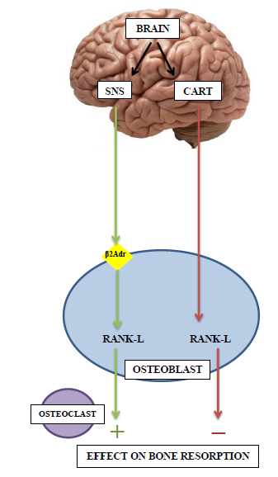
Figure 2.1. Leptin signaling pathway and its effect on bone cells

Adiponectin
Adiponectin is a hormone protein exclusively produced by adipocytes. Identified in 1995, it was originally termed adipocyte complement-related protein of 30kDa. Adiponectin is also referred to as adipose most abundant gene transcript 1, due to its abundance in adipocytes (Guerre-Millo 2008). Adiponectin circulates as several different multimeric species. The high-molecular weight form seems to be the most physiologically and clinically relevant. Two adiponectin receptors have been identified:
AdipoR1 and AdipoR2. The majority of adiponectin receptors reside in skeletal muscle and liver cells, but a relatively smaller number exists on osteoblast cells. Immunoblot assays revealed that only AdipoR1 receptor is detected in primary osteoblasts (Luo et al. 2005). Because adiponectin is solely produced by fat cells, it is paradoxical that circulating adiponectin levels diminish with increased adiposity. Adiponectin levels subsequently rise in response to weight-loss (Arita et al. 1999).
In 1999, Arita et al. identified adiponectin’s positive anti-atherosclerotic action. These researchers showed that adiponectin infusions inhibits monocyte adhesion on arterial walls and suppresses macrophage-to-foam cell transformation. Moreover, detrimental vascular anomalies were observed in transgenic adiponectin-deficient mice (Arita et al. 1999).
Significantly, this adipokine has also been associated with insulin sensitivity. Adiponectin levels are low in states of insulin resistance and increase with improved insulin sensitivity, usually resulting from weight-reduction or use of diabetes-mediating drugs (Otabe et al. 2007). Several studies have independently confirmed this observation (Hotta et al. 2001; Lenchik et al. 2003; Spranger et al. 2003a). Using mouse-models, Yamauchi et al. found that when insulin-resistant mice were given supplementary adiponectin in their diet, their lipid catabolism was enhanced, leading to reduced tissue triglyceride content and eventually correcting their insulin sensitivity (Yamauchi et al. 2001). Conducting a longitudinal study of non-human primates with dietary-induced obesity, Hotta et al. found that adiponectin levels progressively decreased parallel to increased body mass and insulin resistance in these animals (Hotta et al. 2001). In a sample of obesity-prone Pima, a Native Americans group residing in the southwest US, individuals with low circulating adiponectin concentrations were more likely to develop diabetes than those with high concentrations (Lindsay et al. 2002; Spranger et al. 2003a). Other well-established metabolic effects of adiponectin include lower hepatic glucose production (Combs et al. 2001).
Reactive-oxygen species (ROS) and pro-inflammatory cytokines are potent inhibitors of adiponectin gene expression in cultured adipocytes. As diabetics and obese individuals show markedly higher concentrations of cytokines, this pro-inflammatory microenvironment could contribute to the low adiponectin levels observed in these individuals (Bruun et al. 2003). Adiponectin itself can exert anti-inflammatory effects on endothelial cells and macrophages (Arita et al. 1999). Thus, decreased adiponectin can exacerbate inflammation, which leads to even lower circulating adiponectin, and so forth in a downward spiral (Ouchi et al. 2001).
Adiponectin also appears to have a relationship with bone cells. However, this relationship is complex and often contradictory. Research has shown disparate effects on bone cells depending on the cell-line, species investigated, the model employed, and in vitro versus in vivo methodology. Several studies have shown a positive effect of adiponectin on bone properties. Luo et al. (2005) showed that adiponectin acts in a dose-dependent manner on primary mice osteoblasts developed in the lab. Adiponectin increased osteoblast proliferation and differentiation, type I collagen secretion, and mineral matrix nodule formation. Oshima et al (2005) applied a dual in vitro/ in vivo approach. This group developed an adiponectin-producing adenovirus, which they subsequently injected into mice samples. This resulted in increased trabecular bone mass at the tibial growth plate. They also treated mice bone marrow stromal cells with adiponectin, which resulted in RANK-L suppression and lower osteoclast differentiation. When adiponectin was applied directly to osteoblast cells in the lab, this treatment increased mRNA expression of alkaline phosphatase (ALP), a common marker of mineralization. Williams et al (2009) used a similar dual approach, demonstrating in vitro that adiponectin was dose-dependently mitogenic to primary rat and human osteoblasts, even at low concentrations (10 μg/ml). Using a group of adiponectin knock-out mice, they determined that these mice had an identifiable skeletal phenotype: most skeletal parameters were augmented, but not dramatically. The observed increase varied with age and became most apparent at age 14 weeks.
Alternatively, research on human populations reveals a strong inverse association between adiponectin and bone mass. This has been consistently demonstrated in several independent clinical studies (Dimitri et al. 2012; Jurimae et al. 2005; Lenchik et al. 2003; Napoli et al. 2010; Richards et al. 2007). Lenchik et al. (2003) studied serum adiponectin level compared against bone mineral densities in a group of 80 men and women (86% type 2 diabetics). They found serum adiponectin was inversely associated with areal BMD, volumetric BMD, and visceral fat volume. This association remained significant after adjusting for whole body fat mass. Richards et al. (2007) performed a similar study on 1735 non-diabetic women and found that when serum adiponectin levels doubled, BMD decreased by 2–3.2%. The relationship remained significant after adjusting for BMI, serum leptin, fat mass, and exercise level.
Low adiponectin levels have even been suggested as a risk factor for incidence of fracture in postmenopausal women (Jurimae et al. 2005). This may be explained by adiponectin’s influence on osteoclasts, activated by osteoblasts conducted. Using a human osteoblast cell-line, Luo et al. (2006) found that adiponectin induced RANKL secretion, while simultaneously inhibiting osteoprogerin (OPG) expression. The combined actions promote osteoclastogenesis and increased osteoclast function. Pretreating the osteoblasts with MAPK inhibitor (SB203580), abolished adiponectin-regulated RANK-L and OPG expression. Interestingly, adiponectin had a null effect on differentiation when directly applied to osteoclast precursor cells. Thus, osteoblast activation by the AdipoR1 receptor and RANK-L expression must be an important part of the pathway (Luo et al. 2006).
The compilation of conflicting data indicates that adiponectin may play a role in bone maintenance function, but the contribution is modest and the relationship may not necessarily be causative. Adiponectin operates in more than one metabolic pathway; this potential interchange may clarify the discrepancy between laboratory results and clinical observation.

The Effect of Bone on Energy Metabolism
The above section explains one aspect of the potential metabolic feedback pathway. To complete the loop, bone must have a complementary mechanism to affect change in energy metabolism and insulin regulation. Bone-derived molecules must exist that can act upon other glucose-handling organs. The search for instrumental osteological compounds was simplified by the fact that few osteoblast-specific genes exist.

Esp Gene
Esp was the first gene identified as a potential candidate. Esp is an osteoblast-specific gene that codes for secretory molecules (Confavreux et al. 2009). Esp-/- osteoblast-specific knock-out mice display a positive metabolic phenotype including improved glucose handling, higher insulin secretion and peripheral sensitivity, bigger islets, and increased β-cell mass (Lee et al. 2007). Therefore it appears that osteoblast expression of Esp is related to insulin secretion, β-cell proliferation, and its product, insulin. Adiponectin expression is also increased 2-3-fold in Esp-deficient mice. Mice with Esp deleted are also lean, even with age, and the reduction in fat mass is restricted to visceral fat. When provided a high fat diet, Esp knock-outs were still leaner than wild-type counterparts. Furthermore, markers of inflammation (like TNf–α and IL-6) were low or insignificant in the fat mass of Esp knock-outs. Thus, proper Esp function is probably necessary to develop obesity (Lee et al. 2007).
Transgenic mutant mice that over-express the Esp gene (Esp +/+) display a contrasting (negative) metabolic phenotype (Guerre-Millo 2008; Lee and Karsenty 2008; Lee et al. 2007). These mice developed all the features of type 2 diabetes: decreased β-cell proliferation, impaired insulin secretion, hypoinsulinemia, and lower circulating adiponectin.
OST-PTP (Osteotesticular protein tyrosine phosphatase) is the gene product of Esp in mice; PTP1B is the homolog product in humans. OST-PTP is a trans-membrane, unable to affect distant tissues like adipocytes, pancreatic or liver cells. Therefore, OST-PTP must regulate the synthesis, processing, and/or secretion of an intermediary osteoblast-derived molecule.

Osteocalcin
Osteocalcin (OCN) is a good candidate for this target molecule. The OCN gene is potentially the most osteoblast-specific gene; it has not been located on any other cell type (Hauschka et al. 1989). OCN is synthesized by osteoblasts in a premolecular form, bearing three glutamic acid residues (hence the alternate name, “bone Gla protein”) (Price 1989). The majority of OCN molecules go through the processing stage where the Gla-residue is gamma-carboxylated. This allows OCN to bind with high affinity to calcium ions of hydroxyapatite and exist as a non-functional component of the bone extracellular matrix (Motyl et al. 2010; Murshed et al. 2004). However, a relatively small portion of OCN molecules do not undergo processing; instead they remain uncarboxylated and are released into the bloodstream. This is considered the bioactive form of OCN, functioning as a hormone.
Increased levels of circulating bioactive OCN appears to be associated with metabolic benefits: β-cell proliferation and augmented size, increased insulin secretion, and improved glucose handling (Ferron et al. 2012; Lee et al. 2007; Yoshikawa et al. 2011). Bioactive OCN directly interacts directly with adipocytes to stimulate adiponectin expression, which further improves insulin sensitivity in target tissues (Otabe et al. 2007; Yamauchi et al. 2001). Many studies have implicated serum OCN as a marker of glucose tolerance (Fulzele et al. 2010; Kanazawa et al. 2009a; Kindblom et al. 2009; Lee et al. 2007; Saleem et al. 2010). Most, but not all studies have shown that diabetics have lower circulating total OCN (Ferron et al. 2012; Pittas et al. 2009). Longitudinal data demonstrated that improved fasting glucose and insulin level are associated with increased OCN.
It is problematic to differentiate under- versus fully-carboxylated osteocalcin in human samples; two methods exist employing either hydroxyapatite binding or a (private owned and controlled) direct ELISA. While uncarboxylated (UnOCN) is the form of interest, clinical studies have encountering challenges isolating this component. Furthermore, an OCN receptor has not yet been discovered in the pancreas. Thus it is unclear if OCN has a direct consequence on the pancreas or works primarily through its positive effect on adiponectin production.

See Figure 2.2 for the relationship of Osteocalcin with energy metabolism.
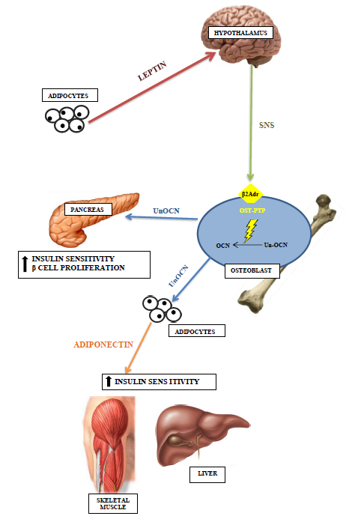

Figure 2.2 Osteocalcin and its effect on energy metabolism

The Esp gene is causally linked with OCN carboxylation (Lee and Karsenty 2008; Lee et al. 2007). Approximately 90% of total OCN is bound with hydroxyapatite in the serum of in WT mice, with the remaining 10% in the circulating uncarboxylated form. Conversely, in the Esp knock-out mice only 74% of the OCN was bound in the extra-cellular matrix. This means that when Esp is inactivated, more bioactive OCN is available conferring metabolic benefits (Lee et al. 2007). The contradictory effects of Esp-/- versus Osteocalcin-/-, suggests that these two genes are opposite sides of the same pathway. This hypothesis was proven by a simple test: removing a single OCN allele from the Esp knock-out group returned their metabolic phenotype to normal. Esp-/- mice are a model of Osteocalcin gain-of-bioactivity. But how precisely are the genes related; how does Esp control OCN bioactivity?

Completing the Metabolic Pathway
These questions were answered in a seminal study by Ferron et al. (2010). The authors pursued in vitro and in vivo approaches to conclude that insulin signaling is the critical link between bone and energy metabolism, utilizing OCN as the vehicle for glucose homeostasis.
The first step was to understand the relationship between the Esp gene (mice), the insulin receptor, and OCN. Esp produces a protein tyrosine phosphatase (OST-PTP); in humans the synonymous protein is PTP1B. The insulin receptor is a substrate of OST-PTP; giving this protein the ability to dephosphorylate (turn-off) the IR. When Esp is knocked-out, no OST-PTP is produced and the insulin receptor is continually active and signaling. Given increased insulin signaling, the calculated ratio of uncarboxylated (active GLU) to carboxylated (inactive GLA) in mice osteoblasts was increased, along with the expected improved metabolism. Importantly, when the insulin receptor was de-activated only in the osteoblast, the opposite negative phenotype resulted: decreased number and size pancreatic islets, beta-cell mass, beta cell proliferation, and total insulin content. This signifies that insulin signaling from bone cells is an important part of the puzzle.
Ferron et al. (2010) simultaneously made another important discovery: insulin signaling in osteoblast favors bone resorption. Bone remodeling parameters (such as CTx) were severely decreased in IR-knockout mice. Moreover, insulin signaling did not affect the number of osteoclasts present; rather, their action as evidenced by larger area covered by the resorption pit. Researchers identified Fox01 (“chief of staff” in energy metabolism) as the downstream target of insulin signaling in osteoblasts. This pathway ultimately leads to down-regulation of osteoprogerin (Opg) and increased expression of RANKL, a known promoter for osteoclast action.
Ferron et al. (2010) found that osteoclast’s acidification of the bone extra cellular matrix (ECM) during resorption is both a sufficient and a necessary condition to decarboxylate OCN. Bone resorption occurs at pH of 4.5; when incubated at this exact pH, the ratio of under to fully-carboxylated OCN significantly increased.
See Figure 2.3 for the OCN – insulin signaling pathway

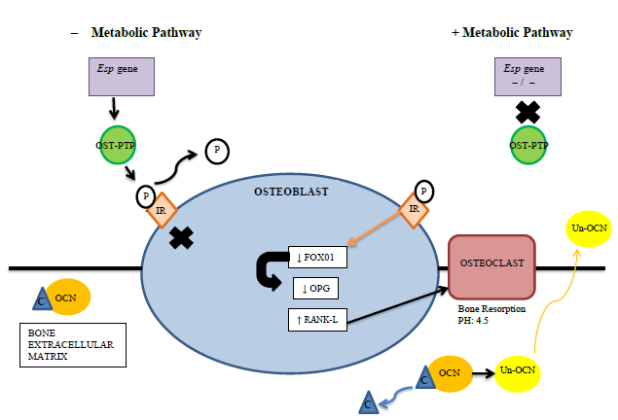
Figure 2.3. The Esp gene – osteoblast – osteocalcin pathway

Similar to investigations on leptin and adiponectin, the results are not entirely conclusive for osteocalcin. Irwin et al. (2006) reported normal bone mass for a group of insulin receptor-deficient mice aged six months. Fulzele et al. (2010) performed a comparable test, finding diminished bone mass in IR-knockout mice but only at an age of three weeks. The clinical effects on bone may still be inconclusive, but Ferron et al. (2010) made a significant contribution in completing our understanding of bone as an endocrine organ: establishing that insulin signaling in osteoblasts favors glucose homeostasis by promoting bone resorption and osteocalcin bioactivation.

Pharmaceutical and Clinical Applications
Different aspects of the energetic feed-back loop have been validated through clinical observations. Considering the leptin–sympathetic nervous system pathway, β-blocker supplements have been tested to treat osteoporosis in postmenopausal women. This family of medication acts upon the β-adrenergic receptors in osteoblasts and inhibits activations of RANKL. β–blockers have demonstrated clinical success, with a significant decreased risk of fracture in the postmenopausal female trial group (Fernandez-Garcia et al. 2008; Pasco et al. 2004; Reid et al. 2005; Schlienger et al. 2004). However, Ferron and others have warned that many drugs administered to reduce bone resorption and fractures put patients at risk for negative metabolism. By halting the resorption process decreases osteocalcin bioactivity and could lead to deleterious glucose handling.
Coumarin is an anti-coagulant used to treat hypertension, inflammation, and osteoporosis, among other conditions. Coumarin impedes normal osteocalcin carboxylation, leaving more bioactive osteocalcin available. Patients on coumarin treatment demonstrate lower blood glucose and decreased hyperglycemia (Egan et al. 1990). The medication warfarin has a similar function, classified as an anticoagulant that inhibits Vitamin K-dependent carboxylation of osteocalcin (Barone et al. 1994; Motyl et al. 2010). Nevertheless, results from warfarin trials are inconclusive. Warfarin also interacts with mRNA expression of uncarboxylated osteocalcin, making its effects on glucose metabolism ambiguous.
Systemic infusions with low doses of purified uncarboxylated OCN (0.3–3.0 ng/h) appear to have promising anti-diabetic results in mice (Ferron et al. 2008; Motyl et al. 2010). Direct OCN administration reduces blood glucose, improves glucose tolerance, increases serum insulin, and produced more circulating adiponectin; even in test groups provided a high fat diet. Importantly, it also had a positive effect on insulin target tissues: pancreas, liver, and muscle. However, comparable unOCN treatment has not yet been developed for humans.

Summary
The following points summarize the current understanding of the relationship between bone and energy metabolism:
- The past decade of research suggests that bone and energy metabolism is intimately linked in a partnership that likely developed early in the evolution of bone maintenance.
- A feed-back loop exists in which molecules secreted by adipose tissue, such as leptin and adiponectin, affect bone remodeling; correspondingly, bone cells secrete proteins, primarily in the form of bioactive osteocalcin, which affect energy metabolism.
- Both of these pathways impact whole-body energy regulation.
- The skeleton can no longer be conceived as an inert structural tissue.
- Bone pays a role in the development and progression of diabetes, as well as mitigates the complicating factors such as inflammation.

How does metabolic disease, specifically type 2 diabetes, manifest itself clinically in bone tissue and organs? The next chapter will elucidate the clinical manifestations of bone/energy/glucose malfunction.

CHAPTER 3. DIABETES AND THE BODY
This chapter broadens the examination of diabetes, moving from molecular causal pathways, to the observable consequences on human tissue. First, hyperglycemia will be defined and the significance of this condition will be clarified. Second, hyperglycemia’s negative effect on soft tissues is described. Finally, the effect of diabetic hyperglycemia on osteological structures that may be identified postmortem is illustrated.

Background
Diabetes is the seventh leading cause of death in the United States based on death certificates issued in 2007, and was a contributing factor in another 160,000 deaths (CDC 2011). Diabetes carries with it a number of long-term complications that significantly increase morbidity and mortality. This affords diabetics a life expectancy that is only two-thirds that of the general population (Ahmed 2005). Furthermore, treating diabetes elicits tremendous healthcare costs. The total (direct and indirect) medical cost related to diabetes in the US in a single year (2007) is estimated at $174 million (CDC 2011). This chapter will examine the detrimental effects that diabetes extracts on the human body, both soft tissue and osteological structures.

The Effect of Hyperglycemia
Hyperglycemia is a defining feature of both type 1 and type 2 diabetes, primarily due to absolute or relative insulin deficiency. Hyperglycemia also plays an important role in the pathogenesis of diabetic complications. Two benchmark studies, the United Kingdom Prospective Diabetes Study (UKPDS), and the Diabetes Control and Complications Trial (DCCT) each independently identified hyperglycemia as the principle source of many comorbidities of diabetes. The syndromes considered in these studies were cardiovascular disease and myocardial infarction, neuropathy, peripheral vascular disease, nephropathy and end-stage renal disease, retinopathy, ulceration and amputation. The UK study recognized that the long-term risk of developing diabetic complications was strongly associated with baseline levels of hyperglycemia. Any subsequent reduction in HbA1c was likely to significantly reduce the risk of complications. The group with the lowest risk were non-diabetics whose HbA1c values fell within the normal range (< 6.0%) (Stratton et al. 2000).
Chronic hyperglycemia increases protein glycation, the non-enzymatic covalent bonding between protein and glucose molecules. This occurs in many tissues, even those organs lacking receptors for glucose, thus damaging a diverse array of cellular structures and affecting systemic metabolic change. These primary biochemical changes cause secondary tissue-specific alterations, namely modification of neuronal and vascular cell structure and function (Sheetz and King 2002). Some of these changes include: hemodynamic alterations, activation of inflammatory signaling molecules, and endothelial dysfunction.
Several theories have been proposed to explain the precise mechanism of hyperglycemia’s negative impact. These theories fall into two major camps: those highlighting the toxic effects of hyperglycemia, like Oxidative Stress Theory and the Aldose Reductase Theory, and those focusing on the altered cell signaling pathways, like the Advanced Gycation Activation (AGE) Theory and the Protein Kinase C (PKC) Theory (Ahmed 2005; Sheetz and King 2002). Oxidative Stress is created when hyperglycemia increases mitochondrial oxidative phosphorylation and glucose autoxidation. The by-products of these oxidative processes are free radicals that can damage vascular proteins. The Aldose Reductase Theory focuses on its namesake enzyme which converts glucose into sorbitol. Excessive sorbitol may cause negative osmotic vascular changes. The AGE theory pinpoints covalent modification and cross-linking of proteins and glucose as a form of cellular aging that may cause many diabetic complications. And finally, PKC is a critical intracellular signaling molecule regulating vascular permeability, vasodilator release, and endothelial action. Diabetes can chronically activate PKC. Additional details on these complex and heavily-debated theories are beyond the scope of this work. Pharmaceutical companies are currently developing compounds that target and attempt to neutralize the common pathways in which both glucose and glucotoxins exert their adverse effects. Coupled with strict control over glucose levels, prescription therapies may offer relief to diabetics in the future (Sheetz and King 2002).

Angiopathy
Angiopathy, a term for the malfunction of the blood vessels, is caused by hyperglycemia, high levels of glucose circulating in blood plasma, and by dyslipidemia, disordered lipid metabolism manifested as elevated total cholesterol and/or low density lipoproteins (LDL or “bad” cholesterol). In diabetes mellitus, two anigiopathic processes develop simultaneously: arteriosclerosis, calcification of the arterial walls rendering them less pliable; and atherosclerosis, plugging of the lumen with plaque (concentrated lipoproteins) (Kahn et al. 2005).
Macroangiopathy describes clogging of major vessels which may cause stroke and ischemic heart disease. This vascular condition inherently prevents blood flow from reaching smaller vessels. Occurring primarily in the walls of minor vessels, microagiopathy causes them to become progressively thickened while simultaneously weak to stress. Angiopathy is particularly significant in diabetics because it can be observed in a diverse group of tissues at grossly different levels. Consequently, crucial blood cells and proteins leak into surrounding tissues; oxygen transfer and CO² absorbance is ineffective. This is severely detrimental to tissues sensitive to blood flow and oxygen supply (NIDDK 2008). Disruption of blood vessel mediated physiology is a trademark of prolonged diabetes.

Soft Tissue Pathologies
Hyperglycemia is the common thread relating most diabetic complications, but it has extensive and variable effects. This distinguishes diabetes as both very difficult to treat clinically and to control progressive symptoms. Soft tissue pathologies derive from malfunction in vital organs. The complex units require extensive vascularization and neural networks, both of which are compromised by hyperglycemia. Soft tissue failure greatly increases morbidity and may contribute to hard tissue complications.
Nephropathy
Diabetic nephropathy is the leading cause of end-stage renal disease (ESRD) in the kidneys. Twenty-five percent of patients entering renal dialysis programs and 35-40% of all kidney transplant recipients cite diabetic nephropathy as the source of their ESRD (Ojo 2002). Incidence of diabetic nephropathy is disparate in its distribution, being more prevalent among African Americans, Native American and Asians groups (CDC 2011).
Nephropathy is a disorder of the kidney, an organ whose purpose is to filter blood of waste products – nitrogenous waste, surplus potassium, proteins, and excess water. Glomeruli are the structures within the kidneys responsible for filtration. Each nephron unit possesses one glomerulus for filtration. Properly operating glomeruli are vital for normal metabolic function. Kidney functional ability may be tested with a BUN (blood urea nitrogen) test, which measures the amount of nitrogen in blood serum that comes from urea (waste product). Normal BUN levels fall at or below 2.3 (Kagan 2010). If BUN is abnormally high, this indicates the kidneys are not filtering properly and waste remains in the blood stream. Kidney function can also be evaluated with a proteinuria test, which measures the amount of albumin in urine. Albumin is an important protein found in blood. When albumin is detected in urine, this indicates that the glomeruli did not function appropriately and critical proteins are lost into urine (Kahn et al. 2005).
Diabetic nephropathy is often divided into two stages based on values of urinary albumin excretion. Microalbuminuria (a.k.a. initial or incipient nephropathy), may commence within two to four weeks of glucose intolerance. Microalbuminuria is characterized by a small amount of albumin present in urine, thickening of the glomerular basement membrane, and increase in the glomerular filtration rate GFR (Valk et al. 2011). Hyperfiltration is brought about by a dilation of the afferent glomerular arteriole, without corresponding dilation in the efferent arteriole. Essentially, this forces the glomerulus to work overtime. Macroalbuminuria (also termed overt or clinical nephropathy) is identified by significant amounts of albumin in urine (≥0.5g / 24h), and Kimmelstiel-Wilson lesions on the glomeruli. The overburdened filtration system reaches its functional limit and GFR rapidly declines (Valk et al. 2011). If detected late or poorly controlled, macroalbuminuria progresses to ESRD.
ESRD is typified by a filtration rate of <20cc fluid/minute (Ojo 2002). It takes approximately 15-25 years from the onset of glucose intolerance to develop full ESRD, though progression rate is highly variable and patient-dependent. End-stage renal disease ensues when kidneys can no longer filter toxins independently; an alternative, external filtration system may be utilized to maintain correct levels.
Approximately 500,000 people are dialysis-dependent in the US (Kagan 2010). Two major methods of dialysis exist: hemodialysis and peritoneal dialysis. Hemodialysis is by far the most common form. Hemodialysis is a process wherein the patient is connected to a blood filtration machine using (typically) the radial artery and cephalic vein of the non-dominant arm. Rudimentary dialysis was first successfully performed in the Netherlands in 1945 using a semi-permeable membrane (prototype of cellophane) as the blood filter. Current models utilize complex synthetic polymers to maximize the dialyzing surfaces (Kagan 2010). Diabetics with end-stage renal disease cannot miss a single dialysis treatment; their kidney damage is permanent and life-threatening. Twenty percent of dialysis patients in the US die each year. A number of issues can be lethal: missed treatments, non-compliance with dietary restrictions (dialysis-dependent diabetics require low potassium and low-protein diets), unmonitored blood pressure, infections at the dialysis puncture sites, and inappropriate care (NIDDK 2008). ESRD diabetics have a higher mortality rate than their cohort.

Retinopathy
In the US, type 2 diabetes is the leading cause of blindness for individuals between the ages of 20 and 74 years (CDC 2011). In a national study of diabetics diagnosed for 15 or more years, 80% demonstrated some degree of diabetic retinopathy (Clarke et al. 2006). As described above, hyperglycemia targets vascular structures, including the delicate vessels of the eye.
Diabetic retinopathy encompasses a number of complications that progressively impairs vision and may cause blindness. Chronic hyperglycemia is responsible for many of the early functional changes in vascular structures of the eye. This includes leukocyte and monocyte adhesions to microvessels, reduced retinal blood flow, and capillary closure (Sheetz and King 2002). Destruction of pericytes is one of the earliest and most specific changes in the retina produced by hyperglycemia. Pericytes are specialized contractile cells lining the delicate retinal vessels. The death of pericytes predisposes the vessels to endothelial proliferation and developing microaneurysms, leaking blood/fluid into the vitreous (Kagan 2010).
There are two major forms of diabetic retinopathy: proliferative diabetic retinopathy (PDR) and degenerative macular edema (DME). With PDR the retinal blood vessels clot, reducing oxygen supply, resulting in hypoxia. In an attempt to provide the necessary oxygen, neovascularization occurs. Neovascularization is a process where new blood vessels are formed in novel areas. New vascular growth is not well-organized: the new vessels are weak, and their paths haphazard, often crossing structures or blocking light from reaching the retina. The supplementary vessels are prone to clotting, rupturing and scarring. Throughout healing the scars contract and may dislodge the retina, leading to partial or total loss of vision (Johnson and Kurtz 2002). In DME microaneurysms occur in or near the macula, a critical portion on the retina that contains the fovea and cone cells responsible for color vision. Significant swelling and edema in the macula causes permanent destruction to the sensitive tissue, resulting in permanent vision loss (Johnson and Kurtz 2002).
Development of retinopathy is directly related to the length of time one has suffered from diabetes. Insulin-dependent diabetics have a 50% risk of developing retinopathy over a four-year period (Klein et al. 1984). In addition to retinopathy, diabetics are also more likely to develop visual co-morbidities, like glaucoma and cataracts. Sudden changes in blood sugar alter the osmolarity of the vitreous fluid, causing the lens to swell and may result in near-sightedness (Aiello 2003). Early detection of retinopathy with regular eye exams, glycemic control, and blood pressure monitoring can reduce the risks and the symptoms of retinopathy (Aiello 2003).

Neuropathy
Sixty to seventy percent of diabetics experience some form of neuropathy. Chronic hyperglycemia evokes changes in myelinated and non-myelinated nerves; neuropathy ensues shortly thereafter. The prevalence of neuropathy increases with known length of the diabetic disease (Simmons and Feldman 2002). This may affect any aspect of the nervous system: Autonomic, Motor, or Sensory nervous systems.
Autonomic neuropathy is much more common in type 1 diabetes, but advanced type 2 diabetes also shows symptoms. Cardiovascular Autonomic Neuropathy (CAN) is the most widely-researched expression of autonomic neuropathy. CAN is defined as impaired regulation of blood pumping through the cardiovascular system (Tesfaye et al. 2010). Type 1 and 2 diabetics suffering from CAN are disposed to developing tachycardia, silent myocardial ischemia, coronary artery disease, and stroke; all of which are highly associated with morbidity and mortality (Tesfaye et al. 2010). Additional forms of autonomic neuropathy include gastrointestinal autonomic/motor neuropathy, erectile dysfunction, and uncontrolled bladder (Kagan 2010). The form of autonomic neuropathy specific to type 2 diabetics involves loss of functional sweat glands in the extremities, known as sudomotor dysfunction. Sudomotor dysfunction particularly affects the extremities (hands and feet). Feet become dry and cracked; especially the thick dermal layers cover the calcaneus (heel). Fissures in skin, coupled with poor circulation and loss of sensation together elevate the propensity for infections.
Motor neuropathy is loss of muscle control due the nerve damage. Unused, the muscle atrophies, leaving the area disfigured and vulnerable to secondary trauma. In type 2 diabetics, this is often manifested as “foot drop.” Foot drop is caused by peroneal nerve damage; the individual cannot lift the foot upward during normal ambulation. The diabetic’s toes drag against the ground with each step (Kagan 2010). Similarly, “wrist drop” results from loss of radial nerve control, whereby the patient is unable to lift the hand into a stop position. Asymptomatic carpal tunnel syndrome has also been observed in 6–11% of diabetics. This is caused by degradation of the median nerve by hyperglycemic factors (Simmons and Feldman 2002)
Sensory neuropathy, also termed diabetic peripheral neuropathy (or polyneuropathy) is the most common form of neuropathy, affecting 45% of type 2 diabetics upon diagnosis (Simmons and Feldman 2002). Polyneuropathy is experienced as either positive creation of sensation, or negative loss of feeling. Positive phenomena include a burning feeling, aching pain, allodynia (heightened sensitivity), and pins-and-needles sensation. Negative neuropathy is the gradual loss of feeling, typically beginning as localized numbness and ending in complete loss of sensation. This is the more prevalent form of diabetic neuropathy. Polyneuropathy is characterized by thickening of the axons, decrease in microfilaments, and the narrowing of capillaries involving myelinated and nonmyelinated fibers (Sheetz and King 2002). These changes directly result from hyperglycemia-induced damage to nerve axons and indirectly caused by glycaemia-provoked decreases in neurovascular flow the extremities. The hands, ankles, and feet including toes are the most frequently impaired areas (Sheetz and King 2002). The earliest symptoms involve the distal toes and progress in a predictable direction toward the ankle and calf. Sensory neuropathy is the major cause of diabetic foot ulceration (Kagan 2010).
Multiple forms of neuropathy combine in a phenomenon known as “diabetic foot” (Simmons and Feldman 2002). Motor-neuropathy-induced atrophy of intrinsic foot muscles produces unusual foot shape (“foot drop”, mentioned above). This leads to unnatural distribution of body weight during mobility, increasing plantar pressure. Constant heightened pressure in an unequipped area breaks down fragile dermal tissue and development of ulcers under the first metatarsal head. Sensory polyneuropathy eliminates protective sensation in the feet, ensuring that any minor trauma or ulceration is painless and may go undetected (Reiber and Ledoux 2002). Furthermore, loss of moisture due to sudomotor dysfunction causes skin to dry and crack and cause additional arteriovenous clotting. This can cause skin and bone perfusion, which may lead to change in normal bony architecture and permanent foot deformities (Singh et al. 2005). Charcot foot is a specific form of diabetic foot involving microvascular changes, microfractures, and permanent foot deformity. (Figure 3.1) Characterized by arch collapse the foot takes on a convex shape, making it very difficult to walk (American College of Foot and Ankle Surgery 2006).
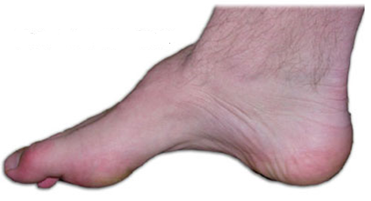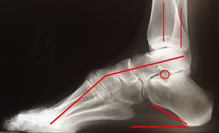
Figure 3.1 Charcot foot, normal and x-ray view of bony malformation

As diabetic foot infections prolong, the bacteria proliferates inward, toward bony structures. Incidences of neuropathic infection preceding osteomyelitis are discussed in the osteological pathologies section.

Osteological Pathologies
Many of the osteological pathologies associated with diabetes originate with soft tissue complications. Decreased vascular function, tissue hypoxia, and retarded healing can exacerbate symptoms. If allowed to fester, minor concerns can lead to significant medical problems affecting and debilitating the skeletal system.
Bone Mineral Density
Diabetes does not evoke a universal effect on bone quality. In general the diabetic influence appears to be type-specific and contradictory between type 1 and type 2 diabetes. The diverse results may be related to the demographics and specific pathophysiology unique to each type.

Bone mineral density: Type 1 Diabetes
The majority of data relating diabetes and bone density are primarily derived from treatment-based clinical literature. Type 1 diabetics demonstrate universally reduced bone density and greater bone fragility (de Liefde et al. 2005; Tuominen et al. 1999; Vandaele et al. 1995). The effects of type 1 diabetes are unambiguous and more severe, presumably because type 1 arises at an earlier age during crucial periods of skeletal development and peak bone acquisition. Bone mineral density (BMD) is reduced in virtually all studies on type 1 patients (Tuominen et al. 1999; Vandaele et al. 1995). The World Health Organization determined that more than 50% of type 1 diabetic juveniles and adolescents experience low BMD and/or trabecular and cortical bone loss (WHO 2004).
Evidence from both experimental and clinical data now shows that the major skeletal alteration in type 1 diabetes is reduced bone formation, rather than increased bone resorption (McCabe 2007). Specifically, onset of type 1 diabetes appears to cause de-differentiation of osteoblasts as well as suppression of osteoblast maturation and even apoptosis (Rosen and Bouxsein 2006). Decline in insulin production typical of type 1 diabetes is also a contributor to bone fragility. Experimental data have shown that insulin has anabolic effects on osteoblasts. The inulin-deficient skeletal system has fewer osteoblasts available to keep up with normal osteoclastic resorption (McCabe 2007), or to progress on to mature osteocytes. This indicates that the skeleton is rapidly affected by impaired glucose and insulin control.

Bone Mineral Density: Type 2 Diabetes
The relationship between type 2 diabetes and bone mineral density is more controversial. In sharp contrast to type 1, type 2 diabetic patients typically demonstrate higher BMD values at multiple skeletal sites. Several studies relating bone and diabetes have shown a significant increase in BMD–scores at the hip, spine, and limbs (Barrett-Connor and Holbrook 1992; Merlotti et al. 2010; Schwartz et al. 2005; Strotmeyer et al. 2004) . Due to the high correlation between diabetes and obesity, increased mechanical loading is the hypothesis commonly invoked to explain the thicker, more robust bones observed in this group. Wolff’s Law is used to explain the relationship between bone structural morphology and environmental factors. Wolff’s Law has been more recently referred to as bone functional adaptation: bone morphology adapts to the imposed mechanical environment, while accounting for specific genetic, developmental, hormonal, and environmental variation (Ruff et al. 2006).
The type 2 phenotype of higher bone mineral density appears to result from increased bone formation, suppressed osteocladogenesis, and osteoclast action. Though some of these functions could be attributed to mechanical forces, increased load-bearing cannot be the singular positive stimulus. Several clinical comparative studies shown than even when controlling for age (Burghardt et al. 2010b), for sex, (Barrett-Connor and Holbrook 1992), and menopausal state (Nicodemus and Folsom 2001), type 2 diabetic patients still had higher BMD values (Burghardt et al. 2010a). Furthermore, even after adjusting for body size the discrepancy between diabetic and non-diabetic BMD values persists. Strotmeyer and colleagues (2004) found type 2 diabetes was associated with 4–5% higher total hip BMD, independent of body composition in both white and black males and females.
Increased adiposity inevitably has an effect on bone formation, although it may not be solely related to mechanical loading. Adipokines and other hormone protein molecules produced by fat cells may be influencing osteoblast function (Melton et al. 2008). Early in diabetic research, insulin was examined as a possible instigator due to the overwhelming incidence of type 1 diabetics with osteoporosis. In osteoblast cultures insulin has been shown to stimulate glucose uptake, regulate the Na⁺/K⁺ pump, and to simulate type I collagen synthesis (Thomas et al. 1997). Additionally, insulin has definite mitogenic effect on osteoblast cells in vitro (Thomas et al. 2001). Hyperinsulinaemia also shows a strong association with diffuse idiopathic hyperostosis and hyperostosis frontalis externa, both conditions which display excess bone formation in mechanically insignificant areas. Using data from the Rancho Bernardo Heart and Chronic Disease Study, researchers found a significant fasting insulin–BMD association after adjusting for covariates (Barrett-Connor and Kritz-Silverstein 1996). In women, higher BMD may be explained by increased androgen due to lower circulating globulin (Schwartz et al. 2002). As described in chapter 3, the adipocyte-produced protein leptin has also been identified as a mediator of the positive effect of fat mass on the skeleton. Thomas et al. (2001) found sexual dimorphism in leptin’s influence. Adjusting for leptin levels eliminated the strong association between mass and BMD in the female (but not male) test group; thus protein hormones may be more influential for bone density in females than males.
Interestingly, a few studies have demonstrated the polar opposite of decreased BMD in the presence of type 2 diabetes. Wakasugi and colleagues (1993) found decreased BMD at the lumbar spine and femora in diabetics compared with control subjects. Levin (1976) found reduced BMD values type 2 diabetics at forearm measurements, compared with data from the controls and type one diabetics.
Incidence of fractures may be a better indicator of bone quality for type 2 diabetics. Bone density indices may not capture true bone strength. Moreover, estimates of deposition do not necessarily suggest enhanced loading capacity. Bone mineral density has a complicated relationship with type 2 diabetes, the nature of which depends heavily upon sex, age, and stage of the disease; these covariates contribute to the heterogeneous survey.

Fractures
Bone mineral density is generally considered a strong predictor of fracture. However, both type 1 and 2 diabetics have an increased risk of fracture when compared to healthy controls. Type 2 diabetics, with their heavier body mass and generally increased bone mineral density, demonstrate a paradoxically higher incidence of fracture (Merlotti et al. 2010). Areas typically subjected to fracture include proximal humerus, foot, and ankle (Forsen et al. 1999; Keegan et al. 2002; Nicodemus and Folsom 2001; Sagray et al. 2013; Schwartz 2003).
Type 2 diabetics likely experience more fractures for dual reasons: higher propensity to fall, and poor bone quality that may not be captured in measurements of bone mineral density (Schwartz et al. 2002). Several risk factors predispose diabetics to fall, and increase the likelihood that their injury will be severe. These factors include neuropathic loss of sensation, unsteady gait, poor balance, retinopathic decrease in sight and impaired stereoscopic vision, as well as stroke (Schwartz 2003). History of falls is also notable when considering risk factors; re-injuring an area weakened by prior trauma will have greater consequences with longer healing time than damage to a virgin territory (Retzepi and Donos 2010).
The Study of Osteoporotic Fracture was a prospective study on older women in the US, that demonstrated a relationship between type 2 diabetics and fracture that could not be entirely explained when risk factors and history of prior falls were accounted for (Schwartz et al. 2001). The risk factors that were accounted for in the study included: peripheral neuropathy, history of stroke, walking speed, poor vision, and benzodiazepine use. This indicates that inherent bone strength is likely contributing to fractures, allowing bone to break more easily. Verhaeghe and colleagues (1994) conducted a study on bone strength in streptozotocin-induced type 2 diabetic rats. The rat femora performed poorly under stress, displaying lower torsional strength, and energy absorption. The rodent subjects had normal to slightly lower BMD (though not significantly decreased). So what is causing poor quality in diabetic bone?
Research has shown that low endogenous insulin levels may inhibit normal bone deposition (Thomas et al. 2001). As diabetes advances the pancreas exhausts its capacity to produce the hormone. Insulin has an anabolic effect on bone. Absence of insulin has the potential to decrease bone turnover without significantly altering BMD. Hyperglycemia, the scourge of diabetes, appears to have negative impacts on bone that is not captured in density measurements. Experimental studies have shown that glucose can increase osteoclast activity by providing excess nutrition (Williams et al. 1997). Both acute and chronic hyperglycemia may suppress the expression of genes associated with osteoblast maturation (McCabe 2007). Additionally, hyperglycemia increases lactic acid synthesis, which may reduce gene expression and mineralization of pH-sensitive osteoblasts (McCabe 2007).
A plethora of research has identified advanced glycogen end-products (AGEs) as significant factor in diabetic bone quality. AGEs form as a secondary consequence of chronic hyperglycemia and they have a similar detrimental impact on soft tissues and their functions (Ahmed 2005). AGEs accrue in collagen within the bone matrix and may increase fragility. It is not fully understood how AGE affect fragility; it has been suggested that AGEs alter bone collagen properties, AGEs may suppress osteoblast expression, and that AGE’s induce production of cytokines like interleukin-6 (Schwartz 2003). Wang (2002) found that AGEs were associated with reduced strength and work to fracture in human bone, specifically observed in bone collagen network. Therefore, other molecules may be modified by hyperglycemia which decreases bone strength but are not being captured in measures of bone mineral density.
Longitudinal studies have revealed an important nuance related to the timing of diabetic fractures. Using data from the Rotterdam study, researchers showed increased fracture risk of the hip for established type 2 diabetics who were receiving treatment; much lower risk was noted for newly diagnosed and non-diabetic subjects (de Liefde et al. 2005). Similarly, a Canadian study demonstrated that diabetics diagnosed for more than five years had increased fracture risk at multiple sites, while newly diagnosed diabetics had reduced risk (Leslie et al. 2007). Together these data indicate that pre-diabetes and early stages of the disease may lend protective benefits to bone. But prolonged diabetes, with accumulated comorbidity factors and extended metabolic disturbance, combine to increase overall fracture risks.

Periostitis, Osteomyelitis, and Amputation
Periostitis is an inflammation of the sheer lining of connective tissue surrounding bone, the periosteum. Given the right environment, periostitis can proceed to osteomyelitis, though not in all cases. Osteomyelitis is defined as an infection of skeletal tissue. Both conditions can be caused by infection traveling through the bloodstream, but the initial event for diabetics is typically an injury involving the soft-tissue (Kagan 2010).
Trauma may be unbeknownst to the diabetic given the enabling effects of retinopathy and neuropathy. Periosteal infections often begin with a superficial injury to the site. For example, a “shin strike” is described as a blow to the anterior tibia breaking the skin with damage to underlying tissue. Diabetic patients experience delayed or impaired wound-healing due to compromised vascular function, which may advance infections inward (Vogt et al. 1997). Moreover, depressed sensation may downplay the severity of the injury.
Osteomyelitis commonly presents in areas prone to ulcers, such as the metatarsal head, digit terminus, and the calcaneus (Malone et al. 2013). Ulcers precede 71–84% of non-traumatic amputations performed each year (Reiber and Ledoux 2002). The risk factors for developing foot ulcers and osteomyelitis reads like a playbook for diabetic complications, including: neuropathy and peripheral vascular disease, retinopathy, increased plantar pressure, foot deformity, poor glycemic control, and prolonged hyperglycemia (Reiber and Ledoux 2002). Incidence of foot ulcers and osteomyelitis was shown to be proportional to number of risk factors in a case-control study of Pima Indians. Test subjects diagnosed with one risk factor were 2.1 times more likely to develop ulcers. Subjects suffering from two risk factors were 4.5 more likely than controls; and those with four or more risk factors increased their likelihood to 9.7 times more than control subjects (Mayfield et al. 1996).
“Diabetic foot” and charcot foot have been previously described in this chapter. Both cause disfigurement of the foot leading to misplaced weight distribution (increased plantar pressure) and uneven gait. Progressive break-down of the fragile epidermis during mobility causes ulceration, typically over the first metatarsal head. The diabetic often cannot feel pain or discomfort due to neuropathy and may not realize how serious the condition has become. Approximately 50% of patients with limb-threatening infections do not display systemic signs or symptoms (Lipsky 2004). Tissue freshly exposed to an anaerobic, moist environment, with reduced capacity for immune response is the perfect storm for diabetic foot infections. The greater the insensitivity to touch, the higher the chance of developing foot ulcers (Boyko et al. 1999) and more severe complications.
The gold standard for diagnosing osteomyelitis is bone biopsy conducted under fluoroscope; but this technique tends to be underutilized due to expense and lack of experience performing the test. In absence of bone biopsies, Malone and colleagues (2013) recommend deep wound culture, whereby the ulcerated area is probed and the exposed bone surface is swabbed. This technique allows clinicians to determine the amount of tissue affected and to isolate and culture the bacterium responsible for causing the bone infection. The predominate pathogens involved in diabetic foot osteomyelitis are gram-positive Staphylococcus aureus (Lipsky 2004).
Once the infection has reached bone, there is a real concern that bacteria have entered the bloodstream and that sepsis will ensue. A number of diabetic patients die from septic shock, secondary to their diabetes and prior to amputation (Kagan 2010).
Amputation is the clinical removal of a terminal, nonviable portion of a limb. The goal of diabetic amputations is to maximize the amount of salvageable bone and soft tissue, while ensuring adequate vascularization for proper healing. Any portion of the bone which has experienced osteonecrosis or tissue that has become gangrenous must be removed.
Six major types of amputation exist (Kagan 2010): (1) Partial toe amputation – dissection through any of the foot phalanges; (2) Complete toe (Raye) amputation – removing phalanges and metatarsal head of the isolated toe; (3) Transmetatarsal amputation – involves removing all phalanges and metatarsal heads of all five digits, essentially eliminating the forefoot; (4) Complete foot (Syme) amputation – removing the entire foot by dissecting through the ankle joint. This amputation is no longer performed, though it may be observed in older diabetic patients. The stump experiences poor healing because the skin covering the cartilaginous ends of residual tibia and fibula are exposed to excessive pressure, even when using prosthesis; (5) Below the knee amputation – currently the most common diabetic amputation. The limb is dissected at the distal third of the tibia/fibula; (6) Above the knee amputation – this amputation is necessary for patients with infection or significant arteriosclerosis extending above the knee and is performed by cutting through.
Surgeons do not amputate through a joint (between bones). Cartilage-lined joints provide poor blood supply insufficient for adequate healing. Rather, long bones and phalanges are bisected, allowing enough residual skin and tissue to comfortably cover the stump. More than 68% of the non-traumatic amputations completed each year are performed on type 2 diabetics (CDC 2011).

Periodontitis
Periodontal disease (PD) has been recognized since the 1960s as a significant complication of type 2 diabetes. Periodontitis was suggested as the sixth major complication by Loe in (1993). Diabetics have a threefold higher incidence of periodontitis than the normal population (Preshaw et al. 2012). Risk of cardiorenal mortality (ischemic heart disease and diabetic nephropathy combined) is also three times higher in diabetic patients with severe periodontitis than in diabetics without periodontal disease (Preshaw et al. 2012). Examining the (NHANES) III data, adults with an HbA1c level greater than 9% (diagnosing them as type 2 diabetics) had significantly higher prevalence of severe periodontitis than those without diabetes, after controlling for age, ethnicity, education, sex and smoking (Tsai et al. 2002).
Lalla et al. (2007) examined a group of pair-matched children (ages 6-18 years) with and without diabetes for signs of PD: loss of ligament attachment, gingival bleed, and combined symptoms. They observed a high prevalence of PD in the diabetic group. This is significant because it identifies PD as the first clinical complication of diabetes to manifest in juveniles. Other comorbidities (retinopathy, neuropathy, etc.) do not present prior to maturity.
Periodontal disease and diabetes are locked in a self-perpetuating cycle. Chronic high blood sugar promotes periodontitis; while the body’s inflammatory response to dental infection further exacerbates insulin resistance and hyperglycemia (Lalla and Papapanou 2011). Periodontal disease begins as bacterial biofilm (plaque) accumulates at and below the gum line (just above the cement-enamel junction). Early and mild forms of periodontal disease are termed gingivitis. Without treatment or intervention the gums become chronically inflamed by the foreign bacteria. The shallow crevasses around the teeth (periodontal pocket) become deeper as the infected ligament pulls away from the alveolar line. This augmented anaerobic environment allows diverse bacteria to flourish and leads to polymicrobial break down of the bone and connective tissue that hold teeth in place (Lalla and Papapanou 2011).
Periodontal disease initiates an immune response in the body. White blood cells and inflammatory cytokines are released to fight the infection. Diabetics already demonstrate a hyperinflammatory phenotype; they exist in a chronic state of inflammation and are ill-equipped to fight acute stresses. As the inflammatory response continues with no resolution, on-going persistent periodontal disease is termed periodontitis (Taylor and Borgnakke 2008). The inflammatory cytokines released at the infected ligament enter circulation via periodontal microcirculation. These proteins can travel through the body to affect other organs like the pancreas, intensifying the inflammatory response and aggravating insulin resistance (Taylor and Borgnakke 2008).
If not properly treated, the bones, gums, and connective tissue supporting the teeth degrade. Dentition may eventually become loose, fallout, or must be removed. Research indicates that diabetes prevents collagen synthesis in periodontal tissues through an AGE (advanced glycation end product) mediated pathway (Ren et al. 2009).
Conversely, studies have shown that treating periodontal infections significantly improves glycemic control of diabetic patients (Lalla et al. 2011; Taylor and Borgnakke 2008). Given the strong association between the two diseases, it has been proposed that dental professionals may be able to identify undiagnosed or intermediate diabetics in their dental practice; allowing earlier detection and better management of diabetes (Lalla et al. 2011; Lamster et al. 2008)

The current research seeks to examine those pathologies related to diabetes which leave lasting impression on bone postmortem. This includes osteoporosis (as evidenced by bone mineral density), fractures, presence of periostitis and osteomyelitis, and periodontitis.
CHAPTER 4. MATERIALS

The data for this dissertation was sourced from the William M. Bass Donated Skeletal Collection, housed in the Department of Anthropology at the University of Tennessee, Knoxville. The William M. Bass Collection was initiated in 1981 and has increased exponentially over the past thirty years. At the time data were collected for this study, the racial composition of the 1,255 total skeletons was 99% European American, 0.06 % African American, 0.02% Hispanic, and 0.02 % Other, including Native America and Asian.
Remains may be self-donated and are accompanies with documents completed by the individual prior to their death. Samples are also donated by the next-of-kin, and a small percentage is sourced from Medical Examiner’s offices. A wealth of information is documented for each individual, including basic information such as birth year, race, stature, and weight, demographic information such as city and state of residence and occupation, medical data such as chronic conditions and comorbidities, and finally cause of death. Information is self-reported for self-donors, but data are also provided by family to the best of their knowledge. The donor documents have been modified over the years. Each subsequent version has requested additional information as new research questions are being developed. Consequently donations from early years 1980s have less associated information than more recent donations.
The donation program is a multi-step process, beginning with body retrieval, donation placement and sampling at the Anthropology Research Facility, followed by natural decomposition in an outdoor environment. Remains are then processed using water heated to less than 100 ºC and physical removal of any residual soft-tissue. After air-drying remains are accessioned into the Collection and housed in the Anthropology Department (FAC. Forensic Anthropology Center 2012).
The number of diagnosed diabetic individuals in the Bass Collection has increased over the years. (Figure 4.1) This may be explained for two reasons. As the number of diabetics in the general population, particularly in the southeastern US increases, these individuals will be represented in greater numbers in skeletal collections and forensic cases. Also, as popular interest in forensic sciences and anthropological donation programs rises, the number of donation received each year increases. The William M. Bass Skeletal Collection currently receives an average of 111 donations per year, an exponential increase from only three donations in the inaugural year 1981.
For the purposes of this investigation, a sample was constructed of eighty individuals using a pair-matched research design. Pair-matching is optimal for this investigation as difference in sex, age, and weight can all influence hormones and metabolism; these factors can in turn affect some of the variables under investigation. Forty diabetics were identified using self-reported antemortem information. Diabetes or type 2 diabetes was listed as a medical complication and/or cause of death. Diabetic type was assumed to be type 2, unless otherwise specified, due to its high prevalence in the US. Duration of the disease, calculated from date of diagnosis to date of death, is additionally recorded known for a few of the later samples. Forty non-diabetics were also selected, whose null diabetic status was inferred through the absence of diabetes listed in the medical history. Diabetic and non-diabetic samples were pair-matched based on sex, age-at-death, and weight-at-death. While sex and age were relatively unproblematic factors to match between samples, body mass proved to be more difficult. Nonetheless, subjects were successfully matched within 75 pounds of one another.

Year
Figure 4.1. Number diabetic individuals in the William M. Bass Donated Collection, past 20 years
Table 4.1 Demographics of the Total Research Sample (n = 80)

Sample group | Males  (n) | Females  (n) | Total  (n) | Avg. Age at Death  (years) | Avg. Weight at Death  (lbs)
Diabetic group | 22 | 18 | 40 | 62 | 205.2
Non-diabetic group | 22 | 18 | 40 | 66 | 170.4.
Sample average | 22 | 18 | 80 | 64

Blood Samples
Blood samples collected from human donations were used to investigate cytokines postmortem. The FAC, in collaboration with the Molecular Anthropology Laboratory (MAL) at the University of Tennessee, initiated blood sample collection was in 2008. Currently, upon placement at the Anthropological Research Facility, samples including blood, hair, and fingernails are collected from each donation. Those donations lacking viable fluids cannot be sampled for blood. Protocol dictates that aortic blood, approximately 9cc, should be drawn using a sterile syringe at the jugular notch. Liquid blood samples are absorbed onto Fitzco Classic Collection Cards (FP709); three cards are collected for each donation (FAC. Forensic Anthropology Center 2012). The Fitzco paper was initially developed to preserve DNA integrity in samples without cold storage. They are made with a filter paper that is ot FTA-coated. One of the initial research questions specifically addresses whether and how well blood molecules other than DNA, such as cytokines, are preserved on the Fitzco cards.
For blood protein analysis, a sample set was culled from the previously-described 80 paired-matched samples. Only donations those with available blood samples, i.e. those donated after 2008, could be used in this portion of the analysis. This decreased the available sample size considerably. Some potential samples were eliminated from blood analysis due to an extended postmortem interval, determined as the number of days between date of death and date of sample collection. This was a significant preemptive strategy, to increase the probability that samples contain viable molecules. Little data are available concerning sustainability of proteins after death. The designated sample size included twenty pair-matched samples: ten diabetics, and ten non-diabetics.

CHAPTER 5. BLOOD PROTEIN CYTOKINE ANALYSIS
The following chapter encompasses the investigation of diabetes in postmortem human blood samples. Diabetes is an inflammatory disease, instigated by metabolic stress. The primary characteristic of diabetes that may be observed in blood plasma is hyperglycemia. However, the immune response to stress also prompts the release of pro-inflammatory cytokines (proteins) that may be quantified in blood. The research question addressed in this chapter is whether diabetics and non-diabetics differ in their levels of circulating cytokines. Important background to cytokines and methods for quantifying their concentration in blood samples will be covered. The techniques utilized in this study on the William M. Bass samples, as well as the results and discussion all will be contained within this chapter.

Background
The conceptualization of diabetes as an inflammatory disease has been transformative, altering the understood pathophysiology of the disease and identifying new targets for therapeutic treatment. This perspective has revealed a new source of information, cytokines, which are significant biomarkers of the inflammatory process (Donath and Shoelson 2011). In 2006 The World Health Organization (WHO) established new standards and criteria for diagnoses and treatment of type 2 diabetes diagnoses and management. The WHO recommends a diverse approach that applies multiple diverse and confirmatory tests. This underscores the highly variable nature of the disease and the importance of early diagnosis (World Health Organization [WHO] 2006).
One of the more novel approaches for examining inflammation is investigating cytokines circulating in the body. Multiple studies indicate that high concentrations of cytokines and other inflammatory markers are highly predictive of type 2 diabetes (Pradhan et al. 2001; Spranger et al. 2003b). Cytokines are a broad family of low molecular-weight proteins which regulate the nature, intensity, and duration of the immune response. The name is derived from the Greek words “cyto”, meaning cell, and “kinos” meaning movement. Cytokines play an integral role in the inflammatory phase of the immune process by detecting the first sign of infection, insult, or trauma. They subsequently signal the nature of the affliction throughout the cell network and initiate the appropriate immune response (McInnes 2013).
Cytokines differ from other hormone proteins in that they are produced by multiple cellular sources in broad ranges, increasing by one thousand-fold concentration in response to injury. Cytokines are pleiotropic; a single cell induces multiple effects in a variety of cells, affecting local and systemic change. They are also redundant, overlapping in their influence, and may synergize with one other (Dinarello 2007). As presented in Chapter Two, many cytokines like and leptin and adiponectin are also intimately involved in energy regulation and contribute to bone metabolism.
Cytokines were originally classified by their specific role in the immune response, functionally pro- or anti-inflammatory, and by cellular source from which they are secreted. Broad categories include the interleukins, interpherons, mesenchymal growth factors, the chemokine family, and the adipokine family (McInnes 2013). The tumor necrosis factor (TNF) family, for example, causes apoptosis of injurious cells; granulocyte colony stimulating factor (GCSF) stimulates bone marrow to produce and release white blood cells into circulation.
More recent classification systems designate cytokines into superfamilies. Superfamilies of cytokines exhibit structural homology, share sequence similarity, and reciprocal receptor systems (McInnes 2013). They are numerically ordered according to discovery date.
As discussed in earlier chapters, the paradigm of diabetes as inflammatory disease has transformed the perception of cytokines from passive by-products to integral mediators of chronic illness. Inflammation is a series of go (pro-inflammatory) and stop (anti-inflammatory) signals. In standard acute inflammation, mediators detect the insult, initiate an effective response, and healing commences in a seamless cycle (Esposito et al. 2003). If inflammation progresses, but the next step in the cascade is hindered, then the process may detour into a holding pattern. Prolonged and perpetuating inflammation is classified as chronic, and become detrimental to the exposed tissues (Lago et al. 2007; Pickup and Crook 1998). When the immune system perpetuates under a constant green light, it becomes overtaxed, exhausted, and degraded. Tissues may become infiltrated with excess leukocytes (white blood cells) and macrophages, and become distorted with collagen bundles (fibrosis) (Nathan 2002). Chronic inflammation effectually hijacks normal immune function. Classic examples of inflammatory diseases include arteriosclerosis, rheumatoid arthritis, and osteoporosis (Ferrucci and Guralnik 2003). Diabetes has been recently added to the list.
The diabetic inflammatory theory proposes that chronic inflammation causes toxic stress on the pancreatic beta-cells, leading to pancreatitis. Pancreatitis culminates with the destruction of the beta-cells and type 2 diabetes (Donath and Shoelson 2011). A number of inflammatory cytokines have been linked to the development of diabetes. For this study, I selected a group of extensively researched cytokines that exhibit a significant relationship with diabetes. These include leptin, one of the first and most-heavily researched cytokines; chemokines, a superfamily responsible for cell-signaling migration; and adiponectin, an adipocyte-derived protein with a negative relationship with diabetes. The role that both of these cytokines play in the energy–bone feedback loop was also presented in Chapter Two.
The ability to measure circulating proteins was achieved in the 1970s with the development of the first enzyme-linked immunosorbant assay (ELISA) (Engvall and Perlmann 1971; VanWeemem and Schuurs 1971). Since this time, ELISA has become an essential tool in toxicology and biomedical research. The assay tests a sample (blood or tissue) for the presence of a biomarker of unknown amount and quantifies the concentration. The most commonly utilized technique is a double antibody sandwich ELISA. A capture antibody is embedded at the bottom of a well, serving as anchor. When the sample is added, the antigen (cytokine) is immobilized onto the antibody forming a ligand. A detection antibody is then added to the well, binding specifically to the ligand. The ELISA is developed by adding a final enzymatic substrate (such as streptavidin), that when run under a laser will produce a fluorescent signal. Results for each biomarker are quantified based on the strength of this signal (Lequin 2005).
See Figure 5.1.
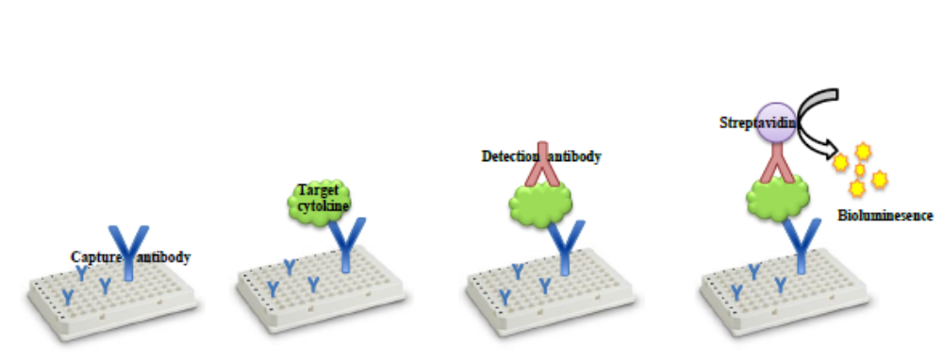

Figure 5.1. Sandwich ELISA

First generation ELISAs were limited by the capacity to test only one cytokine in a given sample aliquot. The number of inflammatory markers being discovered and warranting testing vastly outpaced researcher’s testing efficacy. Development of the multiplex array resolved many of these issues.
Multiplexed ELISA allows several cytokines to be investigated simultaneously, as well as testing multiple subjects, all within the same well-plate. This is beneficial as some proteins are good indicators of disorder, while some inform about severity or progression of an illness (Leng et al. 2008). Compared to the former ELISA methods, multiplex assays have a number of advantages including: high throughput capabilities, expend lower sample volume, are more cost effective and less labor intensive, and the ability to reliably detect different proteins across a broad range of concentrations (Leng et al. 2008). The ELISA process is time-consuming, usually requiring six to eight hours for incubation and washing steps; merging tests into a single process greatly increases lab efficiency. Current cytokine research is providing important information about the pathophysiology, diagnostic options, and potential therapeutic tools for diabetes. To date, cytokines have not been investigated in postmortem human material.
The specific goals of this portion of the research are: 1) to determine if cytokines are preserved in the blood sample collected on Fitzco Cards from William M. Bass donations; 2) to successfully extract these proteins at concentrations sufficient for further testing; 3) to discern which inflammatory cytokines are present and quantifiable in postmortem samples using ELISA multiplex technology; 4) to determine if significant differences exists between the diabetic and non-diabetic sample groups in the concentration of inflammatory biomarkers, and if results are consistent with biomedical research; and 5) to establish a point in the postmortem interval that cytokines are no longer viable in sample aliquots.

Preliminary Methods and Preliminary Results
Preliminary research for this project was initiated in 2011, requiring a number of pilot trials to establish project feasibility. The University of Tennessee Obesity Research Center (ORC) in the Animal Sciences Department provided invaluable assistance, resources, and lab time in order to complete preliminary work. The University of Tennessee FAC was an integral resource through all stages of the research. To test the Fitzco paper’s capability to preserve blood proteins, a set of cards was embedded with fresh blood samples and with a solution containing adiponectin. A blank card served as negative control. Ina sterile environment including latex gloves, a sample circle was removed from each card and reduced into small pieces using a sterile scalpel. This extract was placed in a beaker along with 25 ml of buffer, and agitated for 25 minutes. The ensuing solution was filtered into a sterile tube. Coomassie brilliant blue reagent was applied to solution. Results revealed that proteins from fresh blood samples are preserved on the Fitzco paper and they can be successfully extracted into solution.
Blood samples collected from Bass donation are obtained postmortem, once the process of decomposition has already begun, inevitably degrading the molecules within. Thus, the next step was to repeat the process using postmortem blood. If postmortem proteins could not be extracted, this portion of the research would not possible. Results demonstrated that blood samples collected after death contained preserved proteins that could be extracted at testable levels. Two buffer solutions were tested in the extraction process – phosphate buffer saline (PBS) and radioimmnoprecipitation assay (RIPA) buffer. Buffers were tested to determine which one rendered higher concentrations of potentially fragile proteins. The solution created with the RIPA buffer yielded a higher concentration of total protein, and thus RIPA buffer was used for subsequent tests on postmortem material.
The utility of mouse-model ELISA versus human-based ELISA technology also warranted testing. The antibodies included in manufactured kits are generally genus-specific for maximum binding affinity, though some murine kits may be applied to human samples in research contexts. Mouse ELISA kits were readily available through the UT ORC and are less expensive, and therefore would be desirable for this study. A murine multiplex ELISA was selected that tests for four well-established inflammatory cytokines: TNF-α, IL-6, MCP-1, and Leptin. The ELISA multiplex was conducted on the previously extracted postmortem sample. Results showed positive but low concentrations for all four markers, concentrations ranging from 0.0 (undetectable) to 1.5 pg/ml. This indicates that inflammatory biomarkers are indeed present, but a human-based model is necessary for further testing. The assumption is that proteins begin to degrade over the postmortem interval and maximum specificity is needed to detect potentially low concentrations.
Four additional postmortem bloodcard samples were collected for the purpose of completing preliminary research. Two samples were taken from donations with diagnosed diabetes, and two from donors with no documented diabetic history (Figure 5.2). These samples were extracted and submitted to a human-based multiplex ELISA to choose from the litany of inflammatory markers which should be targeted in dissertation research.
This multiplex included antibodies for 26 inflammatory cytokines. The multiplex produced sufficient protein concentrations for two cytokines: Interleukin 8 (IL-8) and Monocyte chemoattractant protein 1 (MCP-1), which is also known as C-chemokine ligand-2 (CCL-2). Il-8 has a strong relationship with diabetes (Bruun et al. 2000), obesity (Sharabiani et al. 2011), and some cancers (Hsu et al. 2010). MCP-1/CCL-2 demonstrates a strong correlation with diabetes (Zhang et al. 2011) and arteriosclerosis (Charo and Taubman 2004). Both cytokines are associated with bone function and metabolism (Ferrucci and Guralnik 2003; Kim et al. 2005). Results from the multiplex were compared between the groups, diabetics vs. non-diabetics. Sample size was far too small to reach conclusions (n = 4); however, the diabetic subjects possessed a higher average concentrations of both inflammatory markers (See Table 5.1).
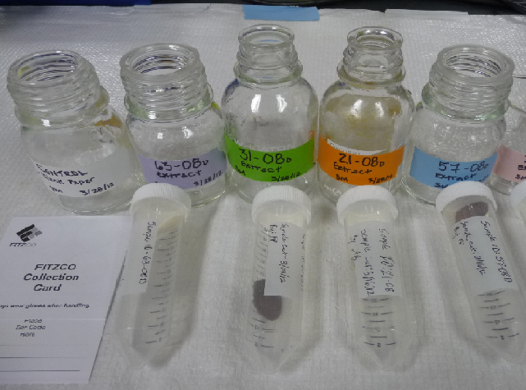
Figure. 5.2 Samples used in preliminary ELISA multiplex, prior to extraction

Table 5.1 Results from Multiplex ELISA, Diabetic vs. Non-diabetic Samples (n=4)
Sample | Diabetic status | Average IL-8 (μg/ml) | Average MCP-1 (μg/ml)
63-08D | Diabetic | 11.7978 | 13.9263
57-08D | Diabetic | 10.1304 | 15.4178
31-08D | Non-Diabetic | 0.91109 | 4.05986
21-08D | Non-Diabetic | 4.2711 | 13.125

Both IL-8 and MCP-1/CCL-2 showed promising results for future research. Leptin and adiponectin are two of the best-documented and thoroughly studied cytokines in relation to diabetes and inflammation in human populations. Therefore, these four cytokines were selected to complete data collection for this project.
Dissertation Methods
The sample for this research was culled from the 80 pair-matched individuals previously selected from the William M. Bass Skeletal Collection. Permission was granted by the Forensic Anthropology Center to use blood samples preserved on Fitzco cards collected from ten diabetic and ten non-diabetic pair-matched individuals. Molecular analysis was conducted in collaboration with the University of Tennessee Nutrition Department. Funding was provided by the Williams M. Bass Endowment for forensic research to purchase four singleplex ELISA kits. Singleplex ELISA is routinely used in cytokine research to confirm results from multiplex ELISAs and provide detailed information.
To meet criteria set for this project, subjects must have been donated after January 2008 to ensure available bloods samples, and have completed the decomposition process so that osteological analysis could be conducted (discussed in Chapter 8).
A single circle was removed from each subject’s card using sterile scissors and the paper matrix reduced into small pieces (1-2mm) using a sterile scalpel. Pieces were combined with RIPA buffer in a beaker, agitated for 20 minutes, and filtered into a test tube. Agitation and filtration steps were repeated. The remaining aliquot liquid containing preserved proteins were preserved at -80º C prior to and after testing.
A Bradford Quantification Assay (BQA) was run to determine if sufficient protein existed in the sample to justify subsequent testing. A standard curve is created using a control, a protein of known and increasing concentrations. Bovine serum albumin (BSA) is most commonly used. Control concentration data is plotted on a graph and a regression equation is generated from the line of best fit. Optimally, R² values should equal as close to 1.0 as possible. Samples are compared against the control line and their unknown protein concentrations are calculated from regression equation. The samples are always run in duplicate or triplicate to minimize human /operational error and to identify outlying values. Samples in this study were run in duplicate; an average of the two values was taken and used for analysis. Results for the BQA will be provided in the next section.
ELISA singleplex kits were purchased from the RayBiotech Company. Each kit contains most materials for the assay, including a pre-coated 96-well plate, reagents, and ELISA protocol. Some of the reagents required dilution and/or reconstitution into solution prior to testing. The protocol for the four singleplex ELISAs are generally similar, though each kit is antibody-specific with slight variations in amount/concentration of certain reagents. Similar to the BQA, a standard control protein of known concentrations is run alongside the samples to generate a standard curve. The linear equation produced is used to calculate the concentration of the cytokine of interest. Concentration results were compared between diabetic and non-diabetics groups. A paired T-test was used to test significant differences between the groups. In addition, Pearson Correlation and Spearman rho were used to assess the relationship between postmortem interval (days) and total protein concentration in each sample (diabetic and non-diabetic, n=20).


A
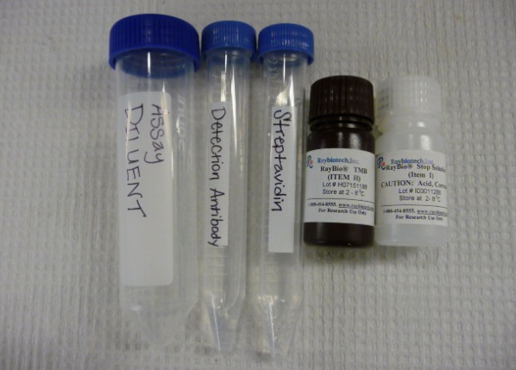
B
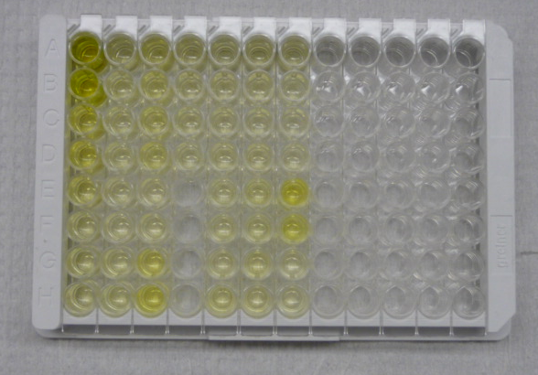
C
Column 1: standard control, decreasing protein concentration from top (Row A) to bottom (Row G)

Figure 5.3. Singleplex ELISA:
A) RayBiotech sigleplex ELISA kit
B) ELISA reagents
C) 96-well plate, just prior to fluorescence
Results
Bradford Quantification Assay
Each of the twenty samples demonstrated a sufficient positive protein value (See Table 5.2). Results indicated that enough protein was present in the postmortem extracted samples that they might be successfully subjected to singleplex ELISA.

Table 5.2. Results from Bradford Quantification Assay, average protein concentrations (ng/ml)

Diabetic Sample |  | Non-diabetic Sample
Sample number | Avg. concentration (ng/ml) | Sample number | Avg. concentration (ng/ml)
09-08D | 3.85806506 | 46-08D | 3.110878313
14-08D | 2.256913253 | 26-08D | 1.277324096
28-08D | 0.609272289 | 12-08D | 3.339972289
53-08D | 1.619507229 | 29-08D | 1.271087952
56-08D | 2.327321687 | 13-08D | 1.766012
57-08D | 2.01492 | 21-08D | 1.049689
63-08D | 1.94731 | 31-08D | 1.85314
72-08D | 1.466760241 | 54-08D | 1.21501
73-08D | 1.434724096 | 16-08D | 0.383106024
108-08D | 1.856661446 | 11-08D | 0.685424096

Leptin ELISA
Results from the Leptin kit were not very encouraging. Even run in duplicates, some of the leptin samples produced null values. Inconclusive and partial data may be due in part to operational/researcher error. Consequently, the number of data points for the subsamples (diabetic vs. non-diabetic) is not equal.
The diabetic group demonstrated a much higher average leptin concentration, though this was primarily due to a high value from a single subject. This data point was not eliminated due to the very small sample size, but should be interpreted with caution. Paired sample T-test revealed that diabetics and non-diabetics were not significantly different in leptin concentration. See Table 5.3 and Figure 5.4.

Table 5.3. Results from Paired T-test of Leptin Concentrations (pg/ml)

 | n | Mean | Median | Standard Deviation | Standard Mean Error | Significance
Diabetics | 10 | 114.84 | 8.12 | 274.74 | 86.88 | 0.294
Non-diabetics | 10 | 25.55 | 19.51 | 27.33 | 8.64 | 0.294
Total | 20 | 89.29  (mean difference) | 9.49 | 253.8 | 80.06 | 0.294

Figure 5.4 Results from leptin ELISA, Diabetic vs. Non-diabetic sample
Adiponectin ELISA
The adiponectin ELISA required the largest dilution of all four kits, stemming from the adipokine’s high proportion in blood and tissue. The alternate name for adiponectin is “adipose most abundant gene transcript 1” (apM1). Results were much higher for the adiponectin, and are thus reported at a higher order of magnitude from pico- to nanograms, to make results more manageable.
Paired sample T-test showed that the diabetic and non-diabetic groups show significant difference in adiponectin concentrations. The diabetic subsample in this study produced a lower average adiponectin concentration that the non-diabetic sample (3.75ng/ml and 26.78ng/ml respectively). Adiponectin has a well-documented inverse relationship with diabetes. See Table 5.4 and Figure 5.5

Table 5.4. Results from Paired T-test of adiponectin concentrations (ng/ml)
 | n | Mean | Median | Standard Deviation | Standard Error Mean | Significance
Diabetics | 10 | 3.76 | 2.31 | 3.62 | 1.14 | 0.0001
Non-diabetics | 10 | 26.78 | 24.66 | 11.54 | 3.64 | 0.0001
Total | 20 | 23.02  (mean difference) | 10.10 | 12.75 | 4.03 | 0.0001

Figure 5.5 Results from adiponectin ELISA, Diabetic vs. Non-diabetic sample
Adiponectin concentration (ng/ml)
IL-8 ELISA
The IL-8 ELISA produced no missing or null values. The diabetic group displayed a slightly higher average IL-8 concentration than the non-diabetic group (74.5pg/ml versus 68.9 pg/ml, respectively). This is consistent with clinical research, showing a strong relationship between diabetes and increased levels of IL-8, independent of metabolic syndrome risk factors like body mass or with age (Herder 2005). Paired sample T-test found no difference between groups. See Table 5.5 and Figure 5.6.

Table 5.5. Results from Paired T-test of IL-8 concentrations (pg/ml)

 | n | Mean | Median | Standard Deviation | Standard Error Mean | Significance
Diabetics | 10 | 74.51 | 87.19 | 51.10 | 16.16 | 0.470
Non-diabetics | 10 | 65.14 | 57.03 | 42.88 | 13.56 | 0.470
Total | 20 | 9.36  (mean difference) | 72.75 | 39.24 | 12.41 | 0.470

IL-8 concentration (pg/ml)
Figure 5.6 Results from IL-8 ELISA, Diabetic vs. Non-diabetic sample

MCP-1/CCL-2 ELISA
The MCP-1/CCL-2 ELISA produced only one sample with values below the detection threshold. Similar to leptin and IL-8, this cytokine had higher average concentrations in the diabetics, but no significance difference was found between the groups.
See Table 5.6 and Figure 5.7.

Table 5.6. Results from Paired T-test of MCP-1/CCL-2 concentrations (pg/ml)

 | n | Mean | Median | Standard Deviation | Standard Error Mean | Significance
Diabetics | 10 | 9.52 | 4.34 | 12.01 | 3.79 | 0.130
Non-diabetics | 10 | 3.27 | 3.25 | 2.52 | 0.799 | 0.130
Total | 20 | 6.25  (mean difference) | 3.91 | 11.86 | 3.75 | 0.130

Figure 5.7 Results from MCP-1/CCL-2 ELISA, Diabetic vs. Non-diabetic sample
IL-8 concentration (pg/ml)

Results for all four proteins are summarized in Figures 5.8. An additional figure displaying median protein values is found in the appendix.

Figure 5.8. Results from the four singleplex ELISAs, mean protein concentration

*Leptin, MCP-1/CCL-2, and IL-8 reported in pg/ml. Adiponectin reported in μg/ml
Postmortem Interval
Death initiates a process of biochemical breakdown and deterioration of tissues and structures in the human body. Decomposition is the first phase in a regimented succession, followed by putrefaction and skeletonization. At the earliest stages of decomposition, tissues and fluids may be sampled, preserved, and tested for their constituent parts. This is the impetus for removing samples for DNA testing and toxicological examinations. This project demonstrated that circulating proteins may also be sampled and investigated multiple days after death. The nature of decomposition suggests that at some point during the post-mortem interval, proteins and other circulating molecules will cease their viability.
The interval between date-of-death and date-of-sampling is recorded for each subject in the Williams M. Bass Collection, recorded as number of days between the two dates. The interval (numbered days) was compared against the total protein concentration detected for each sample in this study (n=20). Correlation tests showed non-significant, low correlation between postmortem interval and total protein concentration (Pearson r = -0.333, Spearman ρ = -0.093). See Figure 5.9.

Figure 5.9. Total protein concentration vs. interval between death and blood sampling (in days)
Discussion
Data from this study indicate strong potential for protein research using postmortem samples. This project has answered several questions, while posing many more. Several additional inflammatory markers can and should be investigated for their relationship with diabetes. Elevated levels of pro-inflammatory cytokines are present during the early stages of diabetes and throughout. Testing cytokines in postmortem blood samples provides the opportunity to investigate diabetes in recently diagnosed individuals, who do not yet exhibit more advanced symptoms of the disease.
I began my investigation with a human-based multiplex ELISA including 26 cytokines, but this is not a fully exhaustive search. Many more cytokines potentially exist in the samples which may be tested using different combinations of kits. Furthermore, the protein milieu itself may complicate detection. Leng (2008) noted that some common inflammatory markers have been shown to bind to carriers proteins such as α2-macroglobulin. Levels of proteins like α2-macroglobulin change with inflammation state, aging, disease or frailty, as well as specific assay conditions. Thus, all these factors can influence the ability of multiplex assays to detect these specific cytokines by potentially altering the amount of free cytokine available for detection.
Certain data from both the multi and singleplex ELISAs produced negative or null values. It is possible that proteins are present but at very low values due to the deterioration in postmortem samples. Very limited research has been published on the rate of degradation for various proteins after death. Some unstable proteins may be exhausted within a few hours of the postmortem interval, making their preservation, extraction, and detection problematic. A comprehensive search for viable proteins and a comparison of their sustainability would be beneficial.
Additional dilutions of the ELISA standards and reagents might extend the standard curve to the lower end of the spectrum so that protein concentration below the minimum threshold can be read. Very low concentrations are not validated for all kits (Lequin 2005), but may be necessary for research utilizing postmortem samples.
Blood samples inherently heterogeneous, containing eythrocytes leukocytes, plasma, proteins, and other constituents; the samples used in this study were no exception. Additional filtration and/or purification steps should be investigated to eliminate additional molecules from competing with antibodies and/or interfering with fluorescence. Although many of these factors may be eliminated during the postmortem interval, they constitute an unnecessary liability which could obscure results. Other operational concerns include validation of the reported results. Each of the four singleplex ELISAs would benefit from confirmatory tests, and a statistically significant sample size. This is particularly true for the leptin ELISA. Though the diabetic group showed higher average concentration of this cytokine, too many data points were unavailable to draw conclusions.
Sample size caveats aside, each of the four cytokines demonstrated the expected relationship with diabetes. Results from the leptin ELISA provided the fewest datapoints, but adhered to the known positive relationship with diabetes. Leptin is released or withheld in response to energy availability (Auwerx and Staels 1998). Leptin also assists in glucose regulation and synthesis of glucocorticoids. In a state of high energy storage and hyperglycemia, leptin is continually produced and released, but leptin receptors have become impaired or unresponsive. This may be due to a leptin-induced increase in the suppressor of cytokine signaling-3 (SOCS3) gene which blocks intercellular transmission of the leptin signal (Bjorbaek et al. 1999). Consequently, many diabetics display unusually high circulating leptin values.
There is growing evidence that high levels of circulating leptin promote inflammation (Spranger et al. 2003b). Leptin contributes to the production of T-lymphocytes, induces several pro-inflammatory cytokines in macrophages and monocyte, and influences the differentiation, activity and cytotoxicity of natural killer (NK) cells (Otero et al. 2006; Raso et al. 2002; Tian et al. 2002). Furthermore, ob/ob mice, which lack genetic production of leptin, are immunodeficient and suffer from high mortality. Therefore, leptin logically plays a role in immunity and inflammation (Lago et al. 2007).
Adiponectin has a paradoxical relationship with diabetes, showing very low values for those diagnosed with impaired insulin and glucose handling and obesity (Arita et al. 1999). Adiponectin is closely related to insulin sensitivity. High levels of adiponectin confer improved glucose handling. However, the exact pathway of adiponectin’s action has not been elucidated. Notably, average adiponectin concentration was lower in the diabetic group in this study, suggesting impaired insulin action. High circulating levels of adiponectin have also been described as a potent anti-atherogenic factor that protects vascular endothelium against inflammation (Lago et al. 2007). This is likely due to adiponectin’s ability to promote phagocytosis of apoptotic cells, removing cellular debris from plasma and tissues that would otherwise become inflamed. Moreover, its production is inhibited by pro-inflammatory cytokines like IL-6, TNF-α, two additional cytokines which show elevated levels in diabetics (Bruun et al. 2003; Fasshauer et al. 2003). The observation that diabetics in this study have lower average adiponectin concentrations is consistent with clinical research.
IL-8 and MCP-1/CCL-2 are part of the chemokine superfamily of very low molecular-weight inflammatory markers. Chemokines have multiple functions in the immune process, ranging from hematopoiesis, angiogenesis, arteriosclerosis, as well as allergic and autoimmune reactions. They also play a role in regulation of leukocyte migrations along concentration gradients (Herder 2005). It has been proposed that chemokines are partially responsible for macrophage infiltration in adipose tissue and into the pancreatic islets, promoting pancreatitis. Clinical research shows increased levels of chemokines in type 2 diabetic patients (Esposito et al. 2003; Herder et al. 2005; Zozulinska et al. 1999). Results in this study are consistent with this observation. It would be beneficial to conduct other ELISA multiplexes to identify additional chemokines that may be equally or more indicative of diabetes in postmortem samples.
Though results may be inconclusive given small sample size, it appears that protein concentration considerably decreases at four days after death. Samples collected more than four days (96 hours) after death may no longer be viable. At this juncture, more friable proteins may have degraded past their detection and testability. After four days the blood sample may not be representative of the inflammatory status antemortem. There is potential to include recommendations for protein sampling in future Forensic Anthropology Center Standard Operating Procedures (SOPs).
Results from the single and multiplex ELISA would benefit from confirmatory testing and a significantly large samples size. This would allow testing between subsets of the total sample. Certain adipokines are highly influenced by sex hormones. For example leptin production is promoted by estrogen. Given an appropriately large sample size, it would be important to examine if the relationship between cytokine concentration and diabetes status if different between the sexes. Sample context should also be recorded including: medical examiner cases versus natural deaths, environmental temperature and humidity, and other influential variables.
If inflammatory cytokines are detected in a blood sample from human remains, this will not single-handedly conclude diabetic or inflammatory status. Hyperglycemia and increased pro-inflammatory cytokine concentrations represent changes that occur early in the diabetic disease process. Coupled with additional skeletal information, such as bone density and the presence of osteological pathologies, these data may suggest diabetic status.

The next chapter will focus on the influence that hyperglycemia and chronic inflammation have upon bone quality. Bone mineral density examination was conducted to discern how diabetes affects bone in intermediary stages of the disease.

CHAPTER 6. BONE MINERAL DENSITY ANALYSIS
Bone mineral density (BMD) is often employed as a measure of bone quality. In this chapter, attention is turned to how altered metabolic regulation typical of diabetes affects bone quality. Bone mineral density is used most often in clinical settings to diagnose osteoporosis and risk factors like osteopenia. The major objective in this section of the study is to identify differences in bone density that may be attributed to the influence of diabetic dysregulation. This chapter is organized as follows: background, the methods employed in this study for testing bone mineral density, results and discussion

Background
There are four methods to clinically measure bone density: Quantitative Computed Tomography (QCT), Peripheral Quantitative Computed Tomography (pQCT), Dual Energy X-ray Absorptiometry (DEXA) and Quantitative Ultrasound (QUS), each possessing benefits and disadvantages. DEXA examines integral bone mass and aerial density, using relatively low levels of radiation and thus is safe for living patients and non-destructive to the bone. DEXA is sensitive to subtle changes in density, rendering it optimal to monitor response over time to therapeutic treatments. Additional advantages include a short scan time, relatively low operational cost, and consensus in data interpretation using World Health Organization T-scores (Blake and Fogelman 2007). Shortcomings of DEXA include the inability to differentiate between cortical and trabecular bone, and failure to measure volumetric density. Rather, the DEXA scanner captures a programmed region of interest, calculating the density of the bone contained within that area. Nonetheless, DEXA is ubiquitous in clinical practice and has become the gold standard for assessing bone mineral density and osteoporosis.
Bone mineral density is a product of intrinsic and external factors including age, sex, activity level, nutrition, and body mass. These factors individually influence, compound, and contradict one another’s effect on bone density. A considerable amount of research has been dedicated to understanding and treating the effects of age and menopause on bone density in females. Reduced hormone levels take a negative toll on regular bone maintenance; the result is lower bone density and increased risk of fracture. On the other hand increased body mass offers protection against bone loss. Overweight women have denser bones when compared against normal weight and slender females of similar age and menopausal status (Reid 2008). The relationship with weight is similar but weaker for males and has been confirmed for subjects from diverse ethnic backgrounds (Reid 2002). Consequently, a strong relationship persists between body mass and bone density regardless of sex or ethnicity (Rosen and Bouxsein 2006).
The challenge in the current project is to tease out the contribution of diabetes and energy metabolism from other factors. As discussed in Chapter Three, the relationship between bone density and diabetes depends of the type and availability of insulin. Research has shown that insulin has an anabolic effect on bone (Cornish et al. 1996). This is clearly shown in the low BMD and osteopenia characteristic of type 1 diabetes, particularly apparent in periods of longitudinal growth (Levin et al. 1976; McCabe 2007). Furthermore, type 2 diabetics consistently show higher than average bone density, possibly due in part to hyperinsulinaemia (Barrett-Connor and Kritz-Silverstein 1996; Merlotti et al. 2010; Strotmeyer et al. 2004). Increased visceral adiposity, common in diabetes and contributing to its pathophysiology, provides an important source of other anabolic hormones like estrogen. In addition, adipocytes play a significant role in bone maintenance by releasing influential cytokines such as leptin (Cornish et al. 2002; Karsenty 2006), adiponectin (Kanazawa et al. 2009b), and osteocalcin (Ferron et al. 2008).
Diabetes and obesity are essentially two sides of the same coin that contributes to bone density.
Although diabetics characteristically carry more body mass, they paradoxically demonstrate a high incidence of fracture (Melton et al. 2008). This suggests that increased mechanical loading concordant with obesity is not necessarily mechanically advantageous. Furthermore, those suffering from advanced diabetes and excessive body mass may have ceased normal loading patterns due to limited mobility and edema. This removes mechanical forces from the equation, but does not alter the metabolism-bone interaction. As discussed in Chapter 2, bone and energy metabolism are intricately locked in a positive feedback loop (Confavreux et al. 2009). Diabetes is a systemic disease and the consequences should not be limited to those skeletal areas under mechanical pressure.
For this reason, I intentionally examined areas that are consistently loaded such as the femur, as well as skeletal sites experiencing reduced loading like the forearm. The tibia was also included in this study, as diabetics face exceptionally high incidence of fracture in this bone (Kagan 2010; Keegan et al. 2002). The femoral neck and vertebrae are renowned hotspots for osteoporotic fractures, but diabetics have a higher rate of fracture in the lower limb and ankle. Tibiae experience a distinctive loading pattern. Distal elements, like the tibia, are energetically more costly and consequently are morphologically smaller and more slender than proximal bones such as the femur (Alexander 1998; Dellanini et al. 2003). Lieberman and Crompton (1998) suggest that limbs respond to strain in a proximal-distal gradient from the axis, with distal elements experiencing more micro-damage. Other researchers have failed to confirm this hypothesis, finding an equivalent rate of Haversian remodeling in the femur and tibia (Drapeau and Streeter 2006). Nonetheless, diabetics have a uniquely high incidence of fracture in the distal limb, due in no small part to the effects of neuropathy (decreased sensation) and retinopathy (impaired sight).
This project marks the first time data have been collected from the tibia using a GE Lunar iDXA scanner, using a protocol created by myself and Dr. Dixie Lee. This research not only provides comparison across limb compartments, but also provides a new source of data for future research.
The forearm, distal radius and ulna, was also scanned in this the study to examine skeletal elements that are not involved in ambulatory loading. If diabetic metabolism is a whole-body phenomenon, then its effects on bone density should be observed throughout the skeleton. The forearm was also important as a source of comparison in females of advanced age. Considered a risk factor for fracture, low BMD measurements in the radius and ulna are expected in non-diabetic females of normal weight. It should be noted that in individuals demonstrating extreme obesity, who probably suffer from a diabetic comorbidity, often utilize the upper limbs to assist in walking. The pressure of bearing undue weight requires these individuals to rely on their arms to reach a standing position. They may also use their arms for assistance with walking device (four-prong walker, cane, etc.) using all four limbs to distribute weight. This trend in obese mobility was noted in the William M. Bass Skeletal Collection (Moore 2008). Morbidly obese individuals in the collection were excluded from the present study, to eliminate the extreme cases and focus on moderate changes in metabolism, most common in the modern population.
The goals of this portion of the project are: 1) to compare bone density data from the William M. Bass Skeletal Collection against clinical research and population-based study data conducted on type 2 diabetics; 2) to determine if significant differences in bone density exist between individuals in the diabetic versus non-diabetic sample groups, and if so, at what skeletal sites is the disparity observed; and 3) to discern how potentially influential factors like age, sex, and body mass affect the relationship between bone density and diabetic status.

Methods
This section of the research focuses on bone mineral density examined in three skeletal areas: the proximal femur, the distal tibia, and distal forearm (radius and ulna). The sample is derived from the William M. Bass Skeletal Collection, containing 80 pair-matched individuals of known age, sex, and body mass. This includes 40 individuals with diagnosed diabetes, 22 males and 18 females, with and average age of 62 years. The corresponding non-diabetic sub-sample also includes 40 total individuals, with 22 males, 18 females, with an average age of 66 years.
To scan the skeletal elements, I followed the basic methodology created by Moore (2008), who also used the William M. Bass Skeletal collection in her research. A General Electric (GE) Lunar iDXA scanner was employed for this study, which boasts higher scanning sensitivity, improved accuracy and data reproducibility than the previous generation of DEXA technology (General Electric 2008).
(See Figure 6.1) The iDXA scanner is owned and operated by the University of Tennessee Kinesiology and Recreation Sciences Department, housed in the Applied Physiology Laboratory. The interface software is designed to analyze and catalogue data from each subject. Prior to scanning, demographic data – sex, birthdate, race, and weight – was entered for each sample; the Bass Collection number was used in lieu of name. All samples in this study were of European American ancestry.
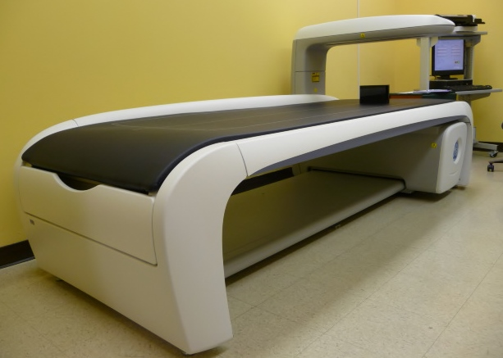

Figure 6.1. GE Lunar iDXA scanner and desktop computer with user interface software.

The individual’s age at death was subtracted from the date of scan, to calculate a birthdate that would reflect their actual age. A uniform weight of 90 lbs was used for every sample to account for the minimal soft tissue detected by the scanner and standardize the amount of radiation emitted. This is consistent with about 12cm of soft tissue, as recommended by General Electric manufacturers. The iDXA scanner must accommodate different tissue thickness, including obese and emaciated individuals. Using a standard weight ensures that the scanner will anticipate minimal tissue over the bone, will maintain a constant level of radiation, and will produce accurate results.
The iDXA software also uses this information to generate two indices: a Z-score and a T-score. The Z-score compares the individual’s density to age and sex-matched individuals from a master database. The T-score compare’s the subject to the optimal bone density of a young healthy individual of the same sex. T-scores are used clinically to diagnose osteoporosis and osteopenia. Z- and T-scores have no bearing on the current study.
To conduct the scans, dry bones were placed in a plastic container measuring 65cm long, 14 cm tall and 11 cm wide. The container is designed as a planter box, but easily accommodates all bones used in the study. This is the very same box utilized by Moore (2008) that was retained by the Kinesiology Department for future anthropological work. White rice served as the soft-tissue density equivalent. The GE Lunar scanner is programmed to detect soft tissue before initiating the scan. Without sensing tissue, the iDXA will abort the scan to prevent unnecessary exposure to radiation. A thin layer of rice (10cm) was placed at the bottom of the box so that the bones would be completely encapsulated.
When scanning the femur, condyles were placed directly on the rice with the posterior side down, anterior side up. Femora were rotated medially in rice to assume anatomical position, and then covered in rice up to 20cm below the container rim. (See figure 6.2) The box was placed on the scanner table, in the approximate position of a human’s lower limb. The arm of the machine began in a position just superior to the midshaft. The regions of interest (ROI) are pre-determined for the femur and include: total neck, upper neck, lower neck, Ward’s triangle, shaft, and total femur average. This final variable (total femur average) is an independent measurement taken by iDXA, rather than derived from other measurements.

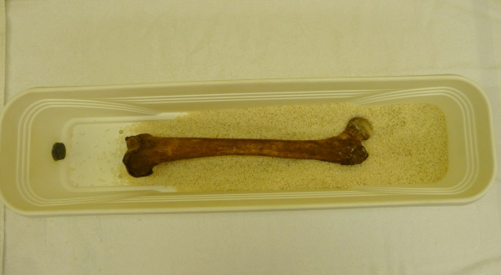
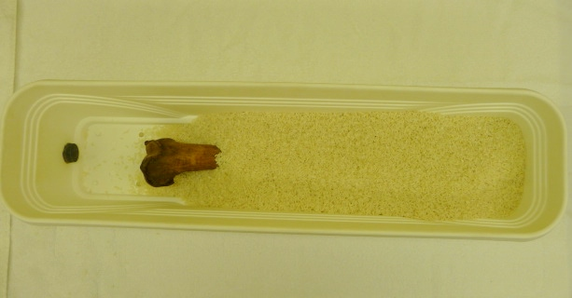
Figure 6.2. Arrangement of femur in rice for scanning
To obtain forearm scans, radius and ulna were articulated together in anatomical position, as the machine is programmed to detect a live human arm. Great care was taken to keep the elements connected, lest they shift while covering bones with rice or while placing container on the table. For this scan the machine arm was placed more superiorly, beginning the scan at the proximal end of the elements (near the elbow) and scanning distally. Areas of data collection for the forearm includes radius ultra-distal, ulna ultra-distal, both (radius and ulna) ultra-distal, radius distal ⅓, ulna distal ⅓, radius total, ulna total, both total. As with the femoral variables, radius/ulna “totals” do not suggest a calculated average, but independently collected values.
Tibiae are not part of the standard set of elements under investigation and no protocol exists for image capture or analysis. The GE research and development team recommended the scans be conducted in femur mode, being the closest bone in size and morphology to the tibia. Tibiae were placed in the container similar to femora and covered with rice. Because femur mode was being utilized, tibiae were scanned with the distal end facing the top (head) of the machine, so that the iDXA believed it was scanning the proximal femur. Regions of interest were created using the “free capture” function, including the distal third of the tibia, along the metaphyseal line of metaphysis, and the medial malleolus. The distal 1/3 was individually measured on each bone, given inter-personal variation in bone size. A small metal marker was placed in the rice matrix to indicate where the ROI should be placed. The marker is actually designed as a fishing line sinker, but several preliminary trials confirmed that the metal alloy could be imaged by the scanner without altering the image or creating background interference. The ROI is the designated area in which the scanner detects bone mineral content (BMC). Bone density is derived from the amount of BMC within each region of interest.

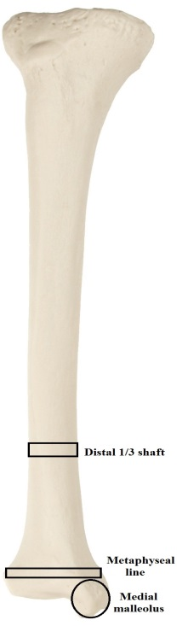

Figure 6.3. Regions of interest scanned on tibiae

In all cases the left element was used for study, unless absent or otherwise in too poor quality due to taphonomic processes. For data collection purposes, each sample was scanned twice, with the average of the two values used in statistical analysis. All statistical analyses were conducted in SPSS Statistics version 21.
Preliminary testing began by assessing the reliability of measurements. Researcher intra-observer error was tested using a subsample of ten femora, ten tibiae, and ten radius/ulna pairs, selected at random.
Skeletal BMD measurements were gathered by the researcher using the iDXA scanner, and then re-taken after an interim period of a week (seven days). Repeatability was tested with a paired t-test of significance, as well as a correlation between the two trials. No significant difference exists between the two trials for the nineteen total measured areas. The two trials are also highly correlated (correlation values ranging from 0.91 to 0.99).
Percentage error on bone mineral content (BMC) and on region of interest (ROI) were calculated for each variable using another fifteen samples, values fell within the range of acceptability, <6% and <5% respectively. Data were also screened for normality and extreme outlying values in each of the nineteen total variables.
The first objective in the analysis was to determine if demographic variables age, sex, and body mass have potential influence on the results. Each of these factors has an independent relationship with bone density, shown in clinical research. If samples were not matched closely enough, these variables could obscure the analysis on the effects of diabetes. First, a paired-sample T-test was run on the demographics factors (age, sex and body mass) for the two groups. .
Obesity has a close association with diabetes and the contribution of each condition to bone density is difficult to separate. For this reason, the relationship between weight and bone density data warranted further investigation. Next, the correlation between each of the continuous demographic variables and BMD was investigated. Pearson Correlation test was used. Three separate correlations were run, one for each skeletal element under investigation.
Then, Multivariate analysis of variance (MANOVA) was used to determine if significant difference exists in bone mineral density between the two groups. Pilai’s trace multivariate methods were selected to evaluate a large number of variables within each skeletal area simultaneously, thus decreasing the probability of type 1 error. The MANOVAs were run on femur, forearm, and tibia data separately. In the MANOVA model, bone density variables were included as continuous dependent variables. Sample (diabetic versus non-diabetic), sex, and the sample-sex interaction were used as fixed categorical factors. The interaction between sample and sex is important because diabetic status may affect males and females differently. MANOVA results will be reported separately for the femur, forearm, and tibia.
Finally, Analysis of variance (ANOVA) was also performed on each of the BMD variables. This was done to examine the interaction between sex and diabetic status. This relationship may vary for each BMD variable, and ANOVA allows analysis on variable by variable basis. As with the previous MANOVA tests, sample group, sex, and the interaction between sample and sex were designated as fixed categorical factors.
Results were subjected to discriminant function analysis (DFA) to confirm differences found between groups and identify the most discriminatory BMD variables. All statistical analyses were conducted in SPSS Statistics version 21.

Results
Paired T-test Results
No significant difference was found between the diabetic and non-diabetic groups based on demographic factors of age, sex, and body mass. Demographics may influence bone density, but the effect should be comparable between the groups and should not confound the analysis.

Correlation Results
Three Pearson’s Correlation tests were run to evaluate the correlation between demographic variables (age, weight, BMI) and BMD variables of the femur, forearm, and tibia variables. Results for the Pearson Correlation demonstrated that body mass was significantly correlated with five of the femoral variable at the p ≤ 0.05 level (2-tailed). Alternatively, results showed that weight was not significantly correlated with any of the forearm variables or the tibia variables. Correlation R-values were low, even those indicated as statistically significant. Weight was not included as a covariate in any subsequent analyses. Results from the Pearson Correlations are displayed in Tables 6.1–6.3.

Table 6.1. Results from Pearson Correlation of Demographic versus Femur Variables

 | Age | Weight | BMI
Age | 1.0 | -0.116 | -0.081
Weight (lb) | -0.116 | 1.0 | 0.936
BMI | -0.081 | 0.956* | 1.0
Neck | -0.252* | 0.305* | 0.144
Upper Neck | -0.270 | 0.314* | 0.146
Lower Neck | -0.183 | 0.302* | 0.170
Ward’s Triangle | -0.270* | 0.222 | 0.057
Trochanter | -0.171 | 0.217* | 0.056
Shaft | -0.153 | 0.288* | 0.138
Femur Total | -0.206 | 0.268* | 0.116
*Correlation with weight which are significant at the 0.05 level (2-tailed).

Table 6.2. Results from Pearson Correlation of Demographic versus Forearm Variables
 | Age | Weight | BMI
Age | 1.0 | -0.116 | -0.066
Weight | -0.116 | 1.0 | 0.931
BMI | -0.066 | -0.931* | 1.0
Radius ultra-distal | -0.170 | 0.099 | 0.046
Ulna ultra-distal | -0.141 | 0.044 | 0.064
Both ultra-distal | -0.130 | 0.105 | 0.028
Radius distal 33% | -0.254 | 0.143 | -0.015
Ulna distal 33% | -0.283* | 0.182 | 0.041
Both distal 33% | -0.278* | 0.154 | -0.005
Radius total | -0.236 | 0.123 | 0.021
Ulna total | -0.269* | 0.142 | -.0110
Both total | -0.290* | 0.156 | 0.009
*Correlation with weight which are significant at the 0.05 level (2-tailed).

Table 6.3. Results from Pearson Correlation of Demographic versus Tibia Variables

 | Age | Weight | BMI
Age | 1.0 | -0.116 | -0.066
Weight | -0.116 | 1.0 | 0.931
BMI | -0.066 | -0.931* | 1.0
Distal 1/3 Shaft | -0.208 | 0.213 | 0.079
Metaphysis | -0.098 | 0.146 | 0.016
Medial Malleolus | -0.274 | 0.230 | 0.112
*Correlation with weight which are significant at the 0.05 level (2-tailed).

MANOVA Results
MANOVA was conducted to evaluate the difference between the diabetic and non-diabetic groups, incorporating all BMD variables within a skeletal element. This involves seven femoral variables, nine forearm variables, and three tibia variables. The interaction between sample and sex was also included into the models. Results are reported separately for the three skeletal areas.

Femur MANOVA
With all variables in the model, Sample group membership (diabetic versus non-diabetic) had a significant effect (p = 0.008), as did Sex (p < 0.0). Notably, there is a significant interaction between sample and sex. (p = 0.028). MANOVA results confirm the significant effects on each of the seven femoral variables. See Table 6.4, also continued on the following page.

Forearm MANOVA
With all nine forearm variables included in the model, no significant difference was found between the sample groups. However, individual BMD variables show significant difference between sample groups in eight of the nine variables (p <0.05). Sex proved a significant factor in the total model. This is consistent with clinical data for differences between males/females in wrist bone density. The relationship between the diabetics and non-diabetics is not dependent on sex, rather it is the same (replicated) in males and females. See Table 6.5.

Table 6.4. Femur MANOVA Results

Effect | Test | Value | F | Hypothesis  df | Error  df | Significance
Sample | Pillai’s Trace | .231 | 2.998 | 7.000 | 70.000 | .008
Sex | Pillai’s Trace | .443 | 7.954 | 7.000 | 70.000 | .000
Sample*Sex | Pillai’s Trace | .195 | 2.421 | 7.000 | 70.000 | .028

Table 6.4 continued. Femur MANOVA Results, Effect of Demographic Factors on BMD Variables

Factor | Dependent  Variable | Type III Sum of Squares | DF | Mean Square | F | Significance
Sample  Group | Neck | .222 | 1 | .222 | 7.960 | 0.006
Sample  Group | Upper neck | .133 | 1 | .133 | 4.861 | 0.031
Sample  Group | Lower neck | .244 | 1 | .244 | 7.312 | 0.008
Sample  Group | Wards | .151 | 1 | .151 | 4.346 | 0.040
Sample  Group | Trochanter | .290 | 1 | .290 | 15.507 | 0.000
Sample  Group | Shaft | .451 | 1 | .451 | 10.315 | 0.002
Sample  Group | Total Femur | .351 | 1 | .351 | 12.975 | 0.001
Sex | Neck | .943 | 1 | .943 | 33.735 | 0.000
Sex | Upper neck | .880 | 1 | .880 | 32.248 | 0.000
Sex | Lower neck | .790 | 1 | .790 | 23.648 | 0.000
Sex | Wards | 1.281 | 1 | 1.281 | 36.747 | 0.000
Sex | Trochanter | 1.020 | 1 | 1.020 | 54.609 | 0.000
Sex | Shaft | 1.403 | 1 | 1.403 | 32.116 | 0.000
Sex | Total Femur | 1.104 | 1 | 1.104 | 40.819 | 0.000
Sex *Sample | Neck | .299 | 1 | .299 | 10.703 | 0.002
Sex *Sample | Upper neck | .198 | 1 | .198 | 7.242 | 0.009
Sex *Sample | Lower neck | .502 | 1 | .502 | 15.029 | 0.000
Sex *Sample | Wards | .349 | 1 | .349 | 9.998 | 0.002
Sex *Sample | Trochanter | .221 | 1 | .221 | 11.845 | 0.001
Sex *Sample | Shaft | .592 | 1 | .592 | 13.563 | 0.000
Sex *Sample | Total Femur | .384 | 1 | .384 | 14.208 | 0.000
Table 6.5. Forearm MANOVA Results

Effect | Test | Value | F | Hypothesis  df | Error  df | Significance
Sample | Pillai’s Trace | .181 | 1.672 | 9.000 | 68.000 | 0.113
Sex | Pillai’s Trace | .572 | 10.104 | 9.000 | 68.000 | 0.001
Sample*Sex | Pillai’s Trace | .145 | 1.286 | 9.000 | 68.000 | 0.261

Table 6.5 continued. Forearm MANOVA Results, Effect of Demographic Factors on BMD Variables

Factor | Dependent  Variable | Type III Sum of Squares | DF | Mean Square | F | Significance
Sample  Group | Radius UD | .045 | 1 | .045 | 6.853 | 0.011
Sample  Group | Ulna UD | .008 | 1 | .008 | .719 | 0.399
Sample  Group | Radius 33% | .166 | 1 | .166 | 10.804 | 0.002
Sample  Group | Ulna 33% | .120 | 1 | .120 | 8.345 | 0.005
Sample  Group | Both UD | .043 | 1 | .043 | 6.905 | 0.010
Sample  Group | Both 33% | .153 | 1 | .153 | 11.995 | 0.001
Sample  Group | Radius Total | .085 | 1 | .085 | 8.836 | 0.004
Sample  Group | Ulna Total | .103 | 1 | .103 | 10.433 | 0.002
Sample  Group | Both Total | .067 | 1 | .067 | 7.425 | 0.008
Sex | Radius UD | .357 | 1 | .357 | 53.889 | 0.000
Sex | Ulna UD | .151 | 1 | .151 | 13.522 | 0.000
Sex | Radius 33% | .954 | 1 | .954 | 62.014 | 0.000
Sex | Ulna 33% | .694 | 1 | .694 | 48.375 | 0.000
Sex | Both UD | .303 | 1 | .303 | 48.991 | 0.000
Sex | Both 33% | .868 | 1 | .868 | 67.839 | 0.000
Sex | Radius Total | .552 | 1 | .552 | 57.659 | 0.000
Sex | Ulna Total | .419 | 1 | .419 | 42.277 | 0.000
Sex | Both Total | .530 | 1 | .530 | 58.724 | 0.000
Sex*Sample | Radius UD | .003 | 1 | .003 | .399 | 0.530
Sex*Sample | Ulna UD | .003 | 1 | .003 | .249 | 0.619
Sex*Sample | Radius 33% | .038 | 1 | .038 | 2.448 | 0.122
Sex*Sample | Ulna 33% | .066 | 1 | .066 | 4.583 | 0.036
Sex*Sample | Both UD | .010 | 1 | .010 | 1.566 | 0.215
Sex*Sample | Both 33% | .047 | 1 | .047 | 3.646 | 0.050
Sex*Sample | Radius Total | .013 | 1 | .013 | 1.349 | 0.249
Sex*Sample | Ulna Total | .047 | 1 | .047 | 4.794 | 0.032
Sex*Sample | Both Total | .018 | 1 | .018 | 1.976 | 0.164

Tibia MANOVA Results
With all variables in the model, both sample group and sex again had significant effects (p = 0.036, and p < 0.00, respectively). The interaction between sex and sample was also significant for tibia BMD (p = 0.05). When individual variables model were investigated in the MANOVA, sex was a significant factor for all variables, sex-sample interaction was significant for the distal 1/3 shaft and the medial malleolus, but not at the metaphysis. See Table 6.6.

Table 6.6. Tibia MANOVA Results

Effect | Test | Value | F | Hypothesis  df | Error  df | Significance
Sample | Pillai’s Trace | .108 | 2.988 | 3.000 | 74.000 | 0.036
Sex | Pillai’s Trace | .338 | 12.615 | 3.000 | 74.000 | 0.000
Sample*Sex | Pillai’s Trace | .100 | 2.736 | 3.000 | 74.000 | 0.050

Table 6.6 continued. Tibia MANOVA Results, Effect of Demographic Factors on BMD Variables

Factor | Dependent  Variable | Type III Sum of Squares | DF | Mean Square | F | Significance
Sample | Distal 1/3 shaft | .250 | 1 | .250 | 2.570 | 0.113
Sample | Metaphysis | .287 | 1 | .287 | 4.532 | 0.036
Sample | Medial Malleolus | .291 | 1 | .291 | 9.066 | 0.004
Sex | Distal 1/3 shaft | 2.865 | 1 | 2.865 | 29.454 | 0.000
Sex | Metaphysis | 1.738 | 1 | 1.738 | 27.498 | 0.000
Sex | Medial Malleolus | .932 | 1 | .932 | 29.066 | 0.000
Sex*Sample | Distal 1/3 shaft | .370 | 1 | .370 | 3.804 | 0.050
Sex*Sample | Metaphysis | .048 | 1 | .048 | .755 | 0.388
Sex*Sample | Medial Malleolus | .129 | 1 | .129 | 4.015 | 0.049

ANOVA Results
Analysis of variance (ANOVA) was performed to investigate the relationship between diabetic status and sex. Sample group membership (diabetic status) appears to have a significant effect on bone density, but this effect may not be consistent between males and females. Furthermore, this relationship may vary depending on the skeletal element and variable examined. Only those variables which displayed a significant sample-sex interaction were subjects to ANOVA. Results are separated by skeletal element: femur, forearm, and tibia.
Femur ANOVA
ANOVA was run on seven femoral variables. Within the female subsample, the diabetic group BMD is significantly different from non-diabetic BMD. Additionally, female diabetics have significantly heavier bone density values than non-diabetics. This relationship does not hold true for the male subsample. Males do not show such an exaggerated discrepancy, and the diabetics actually show decreased BMD values in six of the seven variables. Results for one of the femoral variables: Neck, are shown in Table 6.7 and Figure 6.4. Additional femur ANOVA results may be found in the Appendix.

Table 6.7. ANOVA Results: Femur Neck

Sex | Diabetic Status | n | Mean BMD | Standard deviation | Significance
Female | Diabetic | 18 | 0.9325 | 0.1677 | 0.0001
Female | Non | 18 | 0.7036 | 0.1501 | 0.0001
Male | Diabetic | 22 | 1.0278 | 0.1759 | 0.748
Male | Non | 22 | 1.0447 | 0.1707 | 0.748

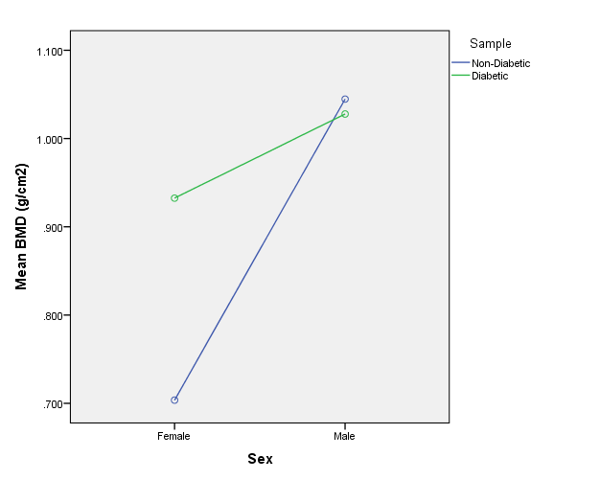

Figure 6.4. Means for Neck BMD, separated by sex.

Forearm ANOVA
ANOVA was run on the nine forearm variables. Results for the first of the forearm variables, Radius Ultra-distal are shown in Table 6.8 and Figure 6.5. Additional forearm ANOVA results may be found in the Appendix. Forearm ANOVA demonstrates that significant difference exists between diabetic and non-diabetics in eight variables. This difference is observed in both sexes; diabetics show denser forearm bone in both the females and the males.

Table 6.8. ANOVA Results: Radius Ultra-distal

Sex | Diabetic Status | n | Mean BMD | Standard deviation | Significance
Female | Diabetic | 18 | 0.4150 | 0.0841 | 0.040
Female | Non | 18 | 0.3555 | 0.0825 | 0.040
Male | Diabetic | 22 | 0.5377 | 0.0739 | 0.138
Male | Non | 22 | 0.5014 | 0.0851 | 0.138

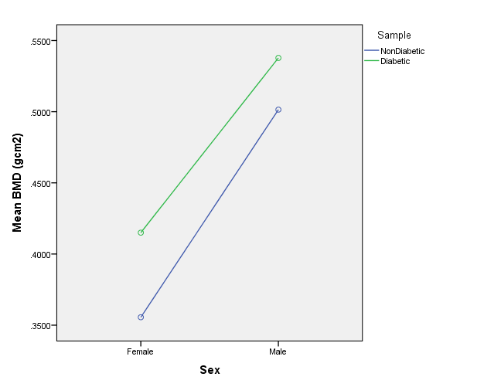

Figure 6.5. Means for Radius Ultra-distal BMD, separated by sex.

Tibia ANOVA
ANOVA was performed on the three tibia variables. Similar to the femur ANOVA, the female subsample showed greater diversity. Female diabetics have significantly higher BMD values than the non-diabetics. The male subsample did not show a significant disparity between groups. Results for one of this tibia variables: Distal ⅓ shaft, are shown in Table 6.9 and Figure 6.6., and the remaining tibia ANOVA results may be found in the Appendix.

Table 6.9. ANOVA Results: Tibia Distal ⅓ shaft

Sex | Diabetic Status | n | Mean BMD | Standard deviation | Significance
Female | Diabetic | 18 | 1.5452 | 0.3745 | 0.045
Female | Non | 18 | 1.2961 | 0.3437 | 0.045
Male | Diabetic | 22 | 1.7888 | 0.2631 | 0.764
Male | Non | 22 | 1.8132 | 0.2711 | 0.764

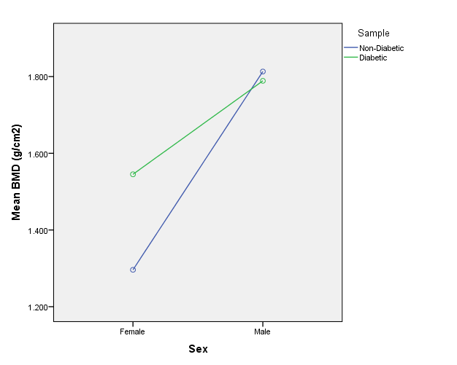

Figure 6.5. Means for Tibia distal ⅓ shaft BMD, separated by sex.

Discriminant Function Analysis Results
Discriminant function analysis (DFA) was used to confirm differences found between groups. Tests were run at each skeletal area to compare diabetic and non-diabetic groups, separated by sex. DFA substantiated the significant differences between diabetic and non-diabetic females in femur, forearm, and tibia bone density (Wilks’ Lambda significance: p = 0.000 – 0.002). Step-wise variable selection identified Trochanter BMD, Ulna total BMD, and Malleolus BMD as the most differentiating variables in each skeletal region. DFA showed no significant difference between diabetic and non-diabetic males (Wilks’ Lambda significance values: p = 0.531 – 0.680). No single variable or set of variables could be identified as being highly differentiating in the male subgroup. See results from DFA in the Appendix.

Discussion
Results showed that the significant difference may be found in the bone mineral density of diabetics versus non-diabetics. However, sex status has a substantial influence on this relationship. In variables of the forearm (radius and ulna), diabetics generally produced heavier BMD values, regardless of sex. But in the lower limb, the relationship between groups is different for males and females.
In the analysis of femur and tibia data, female diabetics displayed dense bones than their counterparts. This is consistent with previous research, finding greater relative modification in BMD in the female samples, versus male subsamples (Barrett-Connor and Holbrook 1992). Findings are also consistent with obesity research, where a higher correlation was found between body weight and BMD for female than for males (Moore 2008). Diabetic females also dominate in forearm BMD values, but the difference between the groups is less prominent and is not always significant (in three of nine variables).
Results are likely connected to the relationship between elderly females and osteoporosis. With an average age of 64.25 years, the majority of females in the total sample are probably postmenopausal. The non-diabetic female group displayed the expected postmenopausal bone loss characteristic of this demographic. Alternatively, the diabetic group has additional factors affecting the regulation of bone cells. While body mass is comparable in the two group, the diabetics inevitably possess more fat cell, specifically more visceral fat. Adipocytes provide a supplemental source of estrogen in females. Also, diabetics likely had high amounts of adipocyte-released cytokines like leptin. Leptin is known to have a direct positive effect on osteoblasts (through the CART pathway), even in the absence of extreme obesity. This trend is not necessarily dependent upon sex, but seems most apparent only in females for the current sample. Hyperinsulinaemia may have a similar positive effect. Additionally, diabetics have lower levels of circulating osteocalcin (un-OCN). These insulin-sensitizing molecules become bioactive as a result of low pH created by osteoclast activity. The end result of this process is an elevated high proportion of inactive OCN bound up in the bone matrix and decreased osteoclast action. Future research should focus on premenopausal females to further investigate the relationship between diabetes, innate estrogen production, and bone density.
The male sample showed conflicting results. In variables of the lower limb, the non-diabetic group demonstrated higher bone density. However, in the forearm, male (and female) diabetics produced higher BMD. The male subsample did not show as much variability and the females, and disparity between diabetic and non-diabetic males was rarely statistically significant.
Research has shown that aging has a less profound effect on male bone density. While older males experience lower testosterone and estrogen levels, it does not extract such a high cost on their bone health. While diabetes may be acting in the same way on males bone as female bone, the absence of osteoporosis in males may make the discrepancy indiscernible. Furthermore, clinical data shows that diabetic males typically suffer from more severe comorbidities. The combined effects of retinopathy, neuropathy, and nephropathy may debilitate diabetic males more so than females. Diabetic men may be loading their bones less than normal healthy males. Thus, the benefit of mechanical loading outweighs the effect of altered energy metabolism. Additional research should be conducted on a sample with known diabetic complications and activity levels, as this may be the more significant factors for males.
This part of the research addressed the skeletal biological questions pertaining to how diabetes affects bone quality, and at which skeletal areas. Results suggest that the relationship between energy and bone metabolism plays a small but intrinsic role in total bone density. Along with other factors like sex, age, and mechanical loading, energy metabolism constitutes an important influence on bone density. Nutrition denotes another essential factor contributing to bone density. A number of dietary components have been identified as contributing to bone health including vitamins D, C, A, magnesium, zinc, copper, iron, fluoride, and protein. Significant among these nutrients are calcium and phosphorous, comprising roughly 80-90% of the mineral component of the bone matrix. Variations in calcium consumption early in life can account for approximately five to ten percent difference in peak adult bone mass. This relatively slight difference can translate into a 50% decrease in adult hip-fracture rates (Ilich and Kerstetter 2000; Matkovic et al. 1979).

Additionally, effects of diabetes are additive and may require time before detection. Type 2 diabetics generally experience changes in bone mineral density and increased incidence of fracture five to ten years after initial diagnosis. This trend is more evident in one sex (females) and more easily recognized when other hormones like estrogen are eliminated from the equation. Therefore, altered energy metabolism, commonly manifested as diabetes, represents more modest contribution than that of sex hormones and mechanical loading.
In the broader application of this research, bone density offers another source of data for the forensic anthropologist. Because the relationship is more obvious in females, analysis of bone density may be more applicable in this group. A female skeleton aged at approximately 60 years or older, having abnormally high bone density in femoral and forearm measurements, may indicate metabolic dysregulation. This information coupled with pathological conditions which will be discussed in the next chapter, lends credence to a suspected diagnosis of diabetes.

CHAPTER 7. EXAMINATION OF OSTEOLOGICAL PATHOLOGIES

Chapter Seven represents the final analytical chapter, covering the macroscopic examination of skeletal pathologies associated with diabetes. Prolonged hyperglycemia and poor glucose control are the primary causes of diabetic complications such as neuropathy, retinopathy, and nephropathy. As these conditions progress they begin to negatively affect bone by reducing vascular oxygen supply, desensitizing to fractures and ulcers, and providing a conduit for infectious pathogens. The appearance of osteological diabetic complications signifies a later stage in the disease process, requiring a longer infirmary period to develop. The effects of hyperglycemia and the pathway to bone will be reviewed, followed by a description of the methods used to record osteological pathologies, and concluding with the results from this investigation.

Background
Diabetes is a complex disease with the ability to affect nearly every system and tissue in the body.
This is primarily related to hyperglycemia and the negative impact of excess blood glucose. Chronic hyperglycemia is the major source of micro- and macrovascular diabetic complications like nephropathy, retinopathy, and neuropathy (Sheetz and King 2002). Glucose is an important component in multiple metabolic and chemical processes, thus a glucose imbalance can affect many pathways. Several theories have been waged to explain the relationship between hyperglycemia and vascular derangements.
One of the more well-established theories explaining the relationship between hyperglycemia and vascular derangements involves advanced glycation end-products (AGEs). Glycation is a chemical process where excess glucose (a defining feature of hyperglycemia) bonds with proteins, creating insoluble molecules, called AGEs (Ahmed 2005). AGEs are deposited in the small blood vessels and vascular basement membranes. Deposits in the glomeruli of the kidneys retard and over-burden the filtration process (nephropathy), lead to functional exhaustion, and eventually end stage renal failure. In the delicate vessels of the eye, AGE deposits impede blood flow which may cause vascular penetration and rupture. Intraocular hemorrhage can results in permanent damage and blindness (retinopathy). When deposited in particularly sensitive locations, such as the macula or on the lens, AGEs may induce macular edema, or form opaque cataracts. AGE deposits in the terminal microvessels of the limbs produce one of the hallmark complications of diabetes, peripheral vascular disease (PVD), or peripheral neuropathy. Nerve deterioration in the hands and feet causes selective anesthesia (loss of feeling). Decreased sensation, coupled with compromised sight leads to a greater number of injuries to the hands, feet, and distal legs of diabetics. Reduced blood flow also increases healing time (Ahmed 2005).
Diabetic complications do not terminate in soft tissue or vascular structures. Soft tissue pathologies, like ulcers provide an entry point for infectious pathogens. Unattended infection progresses inward, further debilitating blood supply, affecting muscle, and eventually contacting bone. Osteomyelitis is an infectious disease, caused by a foreign microorganism, characterized by progressive inflammatory destruction of bone (Lew and Waldvogel 1997). The major pathogen observed in diabetic osteomyelitis is Staphylococcus aureus, which has the ability to adhere to the bone surface by expressing receptors (adhesins) for components of the bone matrix: collagen, fibronectin, and lamanin. Once affixed to bone, S. aureus expresses phenotypic resistance to antimicrobial treatment (Sia and Berbari 2006). Cytokines and other pro-inflammatory molecules which are common in diabetes promote the progression of osteomyelitis infection. Leukocytes respond to the infected area, attempt to engulf the infectious microorganisms, and release enzymes that lyse the bone. Necrotic boney abscess, isolated segments of necrotic bone (sequestra), and an aperture in tissue (fistula, or cloaca) providing drainage for pus, and the irregular formation of new bone are identifying features of osteomyelitis (Lew and Waldvogel 2004).
Diabetics experience a high incidence of fracture, regardless of their bone density measurements
This may also be due to vascular complications brought about by hyperglycemia. AGE deposits create collagen cross-linked formations in the bone matrix rendering the bone structure weaker and more susceptible to stress and strain (Wang et al. 2002). Animal studies have shown that rabbits with high AGE content in bone have impaired mechanical properties, despite normal BMD (Saito et al. 2010). Human studies show serum levels of AGEs are increased in diabetics, and positively associate with increased prevalence of fractures in this group (Kanazawa et al. 2008). Additional features which may contribute to bone fragility in diabetics include more rapid bone loss with retarded apposition, differences in bone geometry, higher propensity to fall and accumulation of micro damage at low bone turnover sites. Net depreciation in bone quality potentially leads to porosity and fractures in skeletal areas unique to diabetics. Longitudinal data suggest that early stages of type 2 diabetes may provide protective benefits to bone strength. However, detrimental factors predominate over the course of diabetic disease and have a negative impact on bone integrity in the long run (Schwartz et al. 2005).
Diabetes has been identified as a major causal force in the development of periodontitis (Preshaw et al. 2012). Diabetics have a threefold higher risk of developing periodontal disease than the health non-diabetic population (Emrich et al. 1991). Periodontitis is inflammation that begins in the gingiva, extending into the periodontal ligament, and results in deterioration of alveolar bone. The initial stages of disease are often asymptomatic and painless. But as periodontitis progresses, fibers of the periodontal ligament are destroyed (attachment loss) and alveolar bone is resorbed simultaneously. This creates slack in the anchoring structures of teeth and a gap in the alveolar pocket, leading to tooth loss (Lalla et al. 2011). Diabetic patients may be unaware of their periodontitis until destruction has proceeded to the point of tooth mobility.
There has been recent focus on a two-way relationship between periodontitis and diabetes. Diabetes is not only a significant risk factor for periodontitis, but periodontal disease in turn has a negative impact on glycemic control. The major culprits connecting the two diseases are inflammation and hyperglycemia. Hyperglycemia (excess sugar) creates dental biofilm (plaque) along the gum line. This foreign element irritates the soft tissue and instigates an immune response. In diabetic patients, baseline inflammation is already elevated, and plaque intensifies the effect. The inflammatory response stimulates cytokines, which promote insulin resistance and diabetes. Thus, periodontitis and diabetes are locked in a feed-forward cycle (Lalla and Papapanou 2011).
Clinical studies demonstrate that many diabetic complications affect bone in the later stages of the disease. There is potential to recognize diabetic comorbidities in postmortem human material by examining osteological pathologies present in the skeleton. Medical research indicates that the following pathologies may present on the diabetic skeletons: fractures and increased porosity in the distal lower limbs, proximal humerus, and distal forearm (radius and ulna); osteomyelitis in distal lower limbs and the feet; development of osteophytes and exostoses in the distal leg, tarsals, and metatarsals; and periodontitis with associated dental deterioration (Barrett-Connor and Holbrook 1992; Buchbinder 2004; Kagan 2010; Lew and Waldvogel 2004; Ortner 2008; Taylor and Borgnakke 2008).
A confounding factor in this research is that the pathologies observed are not mutually exclusive in their source. Many of the above-described pathologies may present on skeletal remain for reasons other than diabetes. However, the pattern and location of pathologies within a set of remain potentiates the distinction of diabetes. Fractures, for example, show dramatically higher incidence in elderly individuals of both sexes, regardless of diabetic status. Osteoporotic fractures and fractures due to age-related changes in bone quality are observed most often in the hip (femoral head and acetabulum joint complex), and in the wrist, often as a result of breaking a fall. Alternatively, diabetics show a higher number of macro- and micro-fractures in the lower limb (distal tibia and fibula) and the ankle (Keegan et al. 2002). Therefore, fractures and porosity may be present in skeletal areas significant for diabetics, but not typically associated with osteoporosis.
Similar discrepancy in pattern is noted with regards to osteomyelitis. Within the general clinical population osteomyelitis occurs with greatest frequency in post-operative patients, particularly those receiving joint prostheses and implanted devices (Sia and Berbari 2006). Osteomyelitis secondary to surgery can occur in any bone, though rarely in the cranium. The second most commonly encountered type is diabetic osteomyelitis, a chronic bone infection caused by diabetic foot ulcers and vascular insufficiency. Diabetic osteomyelitis may be observed in the absence of major surgery or prostheses, and is found almost exclusively in the distal leg, tarsals, metatarsals, and foot phalanges. “Diabetic foot” is a well-known complication in radiological studies and medical research, but has yet to be documented in postmortem osteological samples.
Another confounding factor is physical activity pattern. Degenerative changes in bone can result from minor trauma and repetitive activities. This type of degeneration commonly occurs with vocations pastimes that require a high level of physical activity place increased stress on the legs and feet. “Heel spurs” are exostoses known to develop in highly mobile individuals (Buchbinder 2004), and are also associated with type 2 diabetes. But most diabetics who suffer multiple comorbidities have limited mobility. Rather than intense activity, the etiology of diabetic heel spurs is related to bearing excessive body mass while simultaneously overproducing anabolic hormones like leptin and insulin. Heel spurs form from calcification deposits on the medial process on the inferior calcaneus, at the origin the plantar fascia (Riddle et al. 2003). Exposure to strain may tear the fascia and calcification occurs in response. Infrequent mobility and disproportionate body weight, coupled with overactive anabolic hormones promotes the development of heel spurs in diabetics. Diabetic may express heel spurs but do not demonstrate the well-developed muscle attachment sites observed in active individuals.

The hypothesis for this part of the research is that the presence and pattern of osteological pathologies will be distinct in diabetics, and will differ from non-diabetics who may still present some of the described conditions. The goals for this portion of the research include: 1) to determine if pathological complications of diabetes described in clinical literature are observable in bone, 2) to determine if diabetics and non-diabetics significantly differ in the presence/extent of the osteological pathologies, 3) to determine the best set of characteristics that differentiate diabetics from non-diabetics.

Methods
Diabetes is a disease primarily characterized by altered glucose metabolism, a phenomenon which cannot be examined postmortem. However, gross osteological features may serve as markers of the disease presence. The previously described pair-matched sample used in bone mineral density scanning was also used for analysis of skeletal pathologies. This includes a skeletal sample of 39 diabetics and 40 non-diabetics, matched on demographic factors sex, age, and weight. One set of remains from the original pair-matched sample (described in Chapter 4) was returned to next of kin after bone density scanning but prior to osteological analysis. Thus, the total number of samples in each subgroup is not equal. Each skeleton was examined and scored in its entirety for pathologies. This was done blindly with regards to diabetic status. Data for this portion of the research are binary and ordinal in nature.
Seventeen total variables were investigated, concerning five major diabetic indicators: fractures, macroscopic porosity, osteomyelitis, osteophyte/exostosis formation, and periostitis with associated dental conditions.
Fractures were scored as the total number observed in each specified area: distal humerus, distal forearm (radius and ulna), distal lower limb (tibia and fibula), and feet (metatarsals and foot phalanges). A major fracture exhibiting any radiating fractures would be counted as a single failure event, in order to quantify the number of incidents rather than severity of breakage. Left and right elements were scored additively, so that one fracture in the left distal tibia and another fracture in the right distal tibia would be given a total score of “2”. No perimortem fractures were observed in the current sample
Areas examined for macroscopic porosity include: humeral head, distal forearm (radius and ulna, including both styloid processes), carpal bones, distal one-third of the lower limb (tibia and fibula, including medial and lateral malleoli), and the tarsal bones. Porosity was scored according to extent of the area affected, as described in Standards for Data Collection from Human Skeletal Remains (Buikstra and Ubelaker 1994). This was done on a quarter scale of increasing involvement from “0” (no porosity observed) to “4” (entire area porous). For example, if one-fourth of the total observed area contains viable porosity, a score of “1” was designated. If one-half of the area was porous, a “2” was recorded.
Osteophyte and exostosis formation was examined on the distal tibia and fibula (terminal ends, including both malleoli), inferior edge of the calcaneus (heel spur), tarsals and foot metatarsals (including other joint articular surfaces of the calcaneus). Osteophytes were scored as present (“1”) or absent (“0”).
Areas investigated for osteomyelitis include the distal tibia and fibula, tarsals, metatarsal, and foot phalanges. Skeletal sites were examined for any of the following characteristics (or combination of features): abscess-related bone destruction, a cloaca cavity, sequestra of necrotic bone, and deposition of new bone (involcrum) with uneven or scalloped edges (Ortner 2008). Osteomyelitis was scored as present (“1”) or absent (“0”) in each skeletal location.
Periodontitis has several corresponding dental conditions, related to inflammation and progressive destruction of the periodontal ligament. Periodontitis was investigated as the loss of alveolar bone at the cement-enamel junction (ligament connection point), not caused by antemortem tooth loss. A score of “1” indicating loss of alveolar bone and “0” normal alveolar sockets. Periodontitis often promotes plaque development along the gumline, which was also scored on a present/absent scale. Diabetic hyperglycemia furthermore stimulates the development of dental caries. Caries were scored as total number observed in a set of dentition.
Preliminary data screening was performed to test the reliability of scoring methods. Then, chi-square tables were used to examine and eliminate variables with limited or no response. Extraneous variables were removed to prevent confounding the statistical analysis. Finally, logistic regression was used to select the set of variables that best classify samples in the study into either diabetic or non-diabetic groups. This test was employed due to the categorical (binary) and ordinal nature of both outcome and predictor variables. Logistic regression also calculates the percentage of correctly classified samples using the model of best fit. All statistical analyses were conducted in SPSS Statistics version 21.

Results
Preliminary testing began by assessing the reliability of scoring methods. Researcher intra-observer error was tested by selecting five skeletons at random and scoring them in their entirety (seventeen total variables). These same five samples were re-scored after an interim of one week. Data from trial one and trial two were subjected to a paired T-test for significant difference and a Pearson Correlation test. Tests revealed no significant different between the two trials (p<0.0001), with correlation coefficient values = 0.958. Therefore, scoring methods were considered reproducible and valid for further evaluation.
Of the 79 available skeletons, half (n=40) were edentulous, and thus any observed deterioration may be due to antemortem tooth loss. Dental pathologies like plaque development and carious lesions could not be scored for edentulous sample, though they may have been present in life. Samples with available dentition (n=39) were scored for dental pathologies, but these variables not included in the logistic regression due to the significant number of missing variables (n=40, unavailable for analysis).
This reduced the number of total variables from seventeen to fourteen.

Chi-Square Tests
Data were screened using chi-square tables, comparing the expected and observed observations in each predictor variable. Some of the variables were rarely observed in the entire skeletal sample. Variables with no or very few data points are not informative or differentiating in terms of group membership. Limited responses in multiple variables can also limit the statistical analysis. As an example, in the 79 total skeletons examined, not a single fracture was observed in the humeri.
A chi-square test was run on each of the fourteen variables. In addition to observed and expected counts and percentages, chi-square generates an adjusted residual. This is a measure of the departure of the observed from the expected counts (similar to a z-score). Predictor variables that are associated with group membership will have observed counts much greater or much less than the expected. Those variables with adjusted residuals greater than an absolute value of 1.0 were considered predictors of interest.
Chi-square tests eliminated seven variables (adjusted residual <1.0), reducing the number of variables under investigation to seven in total. See tables 7.1 – 7.7 for chi-square tables of the seven variables of interest. See Table 7.8 for a list of variables retained for logistic regression.

Table 7.1. Chi-Square Results: Fractures Tarsals and Metatarsals
 |  | Fractures Tarsals/Metatarsals
 |  | 0 | 1 | 2
Non-diabetic | Observed count | 37 | 3 | 0
Non-diabetic | Expected count | 34.4 | 4.6 | 1.0
Non-diabetic | % within group | 92.5% | 7.5% | 0%
Diabetic | Observed count | 31 | 6 | 2
Diabetic | Expected count | 33.6 | 44 | 1.0
Diabetic | % within group | 79.5% | 15.4% | 5.1%
Total | % within group | 86.1% | 11.4% | 2.5%
Total | Adjusted residual  (absolute value) | 1.7 | 1.1 | 1.5

Table 7.2. Chi-Square Results: Porosity Carpals
 |  | Porosity carpals
 |  | 0 | 1 | 2 | 3
Non-diabetic | Observed count | 15 | 10 | 7 | 8
Non-diabetic | Expected count | 13.2 | 10.1 | 9.1 | 7.6
Non-diabetic | % within group | 37.5% | 25% | 17.5% | 20%
Diabetic | Observed count | 11 | 10 | 11 | 7
Diabetic | Expected count | 12.8 | 9.9 | 8.9 | 7.4
Diabetic | % within group | 28.2% | 25.6% | 28.2% | 17.9%
Total | % within group | 32.9% | 25.3% | 22.8% | 19%
Total | Adjusted residual  (absolute value) | 0.9 | 9.1 | 1.1 | 0.2

Table 7.3. Chi-Square Results: Osteomyelitis Distal ⅓ Tibia and Fibula
 |  | Osteomyelitis Tibia/Fibula
 |  | 0 | 1
Non-diabetic | Observed count | 34 | 6
Non-diabetic | Expected count | 25.8 | 14.2
Non-diabetic | % within group | 85% | 15%
Diabetic | Observed count | 19 | 20
Diabetic | Expected count | 25.2 | 13.8
Diabetic | % within group | 48% | 52%%
Total | % within group | 66% | 35.4%
Total | Adjusted residual  (absolute value) | 3.8 | 3.8
Table 7.4. Chi-Square Results: Osteomyelitis Tarsals and Metatarsals
 |  | Osteomyelitis Tarsals/metatarsals
 |  | 0 | 1
Non-diabetic | Observed count | 39 | 1
Non-diabetic | Expected count | 30.9 | 9.1
Non-diabetic | % within group | 97.5 | 2.5
Diabetic | Observed count | 22 | 17
Diabetic | Expected count | 30.1 | 8.9
Diabetic | % within group | 56.4% | 43.6%
Total | % within group | 77.2% | 22.8%
Total | Adjusted residual  (absolute value) | 4.4 | 4.4

Table 7.5. Chi-Square Results: Osteophytes – Distal Tibia and Fibula
 |  | Osteophytes- Tibia/Fibula
 |  | 0 | 1
Non-diabetic | Observed count | 24 | 16
Non-diabetic | Expected count | 16.2 | 23.8
Non-diabetic | % within group | 60% | 40%
Diabetic | Observed count | 8 | 31
Diabetic | Expected count | 15.8 | 23.2
Diabetic | % within group | 20.5% | 79.5%
Total | % within group | 40.5% | 59.5%
Total | Adjusted residual  (absolute value) | 3.6 | 3.6

Table 7.6. Chi-Square Results: Heel Spurs
 |  | Heel Spurs
 |  | 0 | 1
Non-diabetic | Observed count | 30 | 10
Non-diabetic | Expected count | 21.3 | 18.7
Non-diabetic | % within group | 75% | 25%
Diabetic | Observed count | 12 | 27
Diabetic | Expected count | 20.7 | 18.3
Diabetic | % within group | 30.8% | 69.2%
Total | % within group | 53.2% | 46.8%
Total | Adjusted residual  (absolute value) | 3.9 | 3.9
Table 7.7. Chi-Square Results: Osteophytes Tarsals and Metatarsals
 |  | Osteophytes Tarsals/Metatarsals
 |  | 0 | 1
Non-diabetic | Observed count | 30 | 10
Non-diabetic | Expected count | 19.2 | 20.8
Non-diabetic | % within group | 75% | 25%
Diabetic | Observed count | 8 | 31
Diabetic | Expected count | 18.8 | 20.2
Diabetic | % within group | 20.5% | 79.5%
Total | % within group | 48.1% | 51.99%
Total | Adjusted residual  (absolute value) | 4.8 | 4.8

Table 7.8. Pathology Variables used in Logistic Regression

Pathology Type | Variable location
Fractures | Tarsals and metatarsals
Porosity | Carpals and metacarpals
Osteomyelitis | Distal third leg (tibia and fibula)
Osteomyelitis | Tarsals and metatarsals
Osteophyte formation | Distal third leg (tibia and fibula)
Osteophyte formation | Heel spur (inferior calcaneus)
Osteophyte formation | Tarsal and metatarsals joint interfaces
Dental pathologies | Plaque development

Logistic Regression
The major goal was to find the set of pathologies that best differentiates diabetic from non-diabetics. Binary logistic regression was selected to predict membership in a categorical outcome variable (diabetic or non-diabetic) using a combination of binary and ordinal predictor variables (pathologies). Logistic regression uses logarithmic transformations to model a non-linear association in a linear way.

In the regression, seven pathology variables were entered as predictors, the dependent outcome variable was coded as “1” (diabetic) and “0” (non-diabetic). Backward Wald was the method used to enter variables into the model (0.10 level of significance for removal from the model).
Results produced a model including six variables: Porosity of the carpals, osteomyelitis in tarsals and metatarsals, heel spurs, osteophyte development in the distal tibia/fibula and in the tarsals/metatarsals, and plaque development. One variable (carpal porosity) selected by the Backward Wald shows statistical non-significance (p=0.097, odds ratio = 0.616). This suggests that a smaller model, including fewer variables may be more effective.
To test legitimacy of the model, the regression was repeated using Forward Wald methodology. This test selected a model of best fit including three variables: osteomyelitis in tarsals and metatarsals, heel spurs, and osteophytes in the tarsals/metatarsals. The model uses fewer variables, and had a slightly higher percentage of correctly predicted cases. This means that more samples were correctly assigned to the diabetic or non-diabetic categories.
The final model selected to best differentiate diabetics from non-diabetics includes the above-listed three variables. See Table 7.9.
Results from the logistic regression show an average classification rate 82.75%. The variables selected as having the most differentiating potential are concentrated in the foot and ankle.
See Figures 7.1 – 7.3 for observed counts (diabetic versus non-diabetic) in the three predictor variables.

Table 7.9. Forward Wald Logistic Regression Results

Model Summary
Step | -2 Likelihood | Cox & Snell R-Square | Nagelkerke R-Square
1 | 84.67 | 0.270 | 0.360
2 | 75.88 | 0.347 | 0.462
3* | 69.04 | 0.401 | 0.534
*Estimation terminated at iteration number 4 because parameter estimates changed by < 0.001

Classification Table
 |  | Non-diabetic | Diabetic | Percentage Correct
Step 3 | Non-diabetic | 36 | 4 | 90.0
 | Diabetic | 10 | 29 | 75.5
 | Overall percentage |  |  | 82.75

Model
Variables | Standard  error | Wald  Statistic | Degrees of  Freedom | p-value | Odds ratio
Osteomyelitis- tarsals/metatarsals | 1.146 | 5.908 | 1 | .015 | 0.620
Heel spurs | .610 | 6.598 | 1 | .010 | 0.209
Osteophytes- tarsals/metatarsals | .612 | 5.995 | 1 | .014 | 0.224

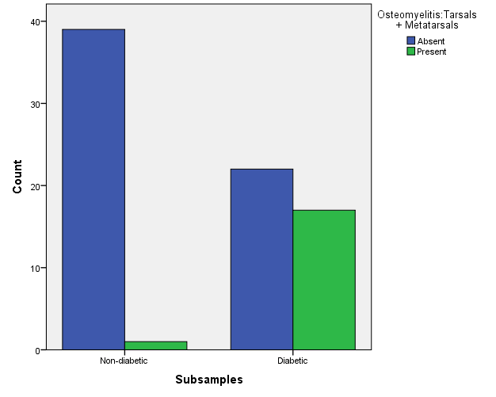

Figure 7.1 Osteomyelitis in tarsals and metatarsals, diabetic versus non-diabetics
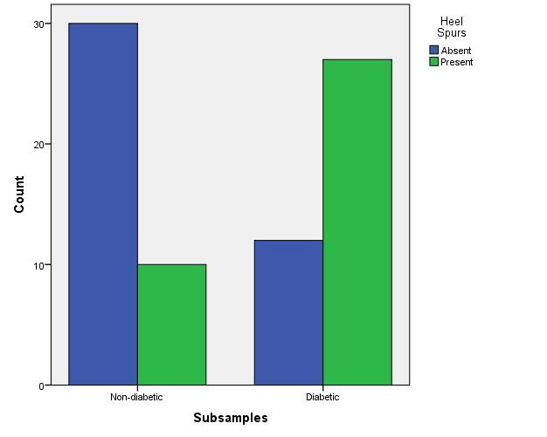

Figure 7.2 Heel spurs, diabetic versus non-diabetics

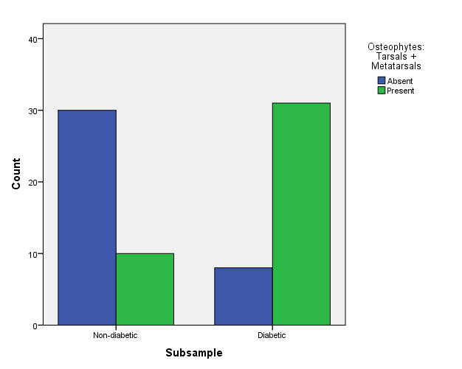

Figure 7.3 Osteophytes in tarsals and metatarsals, diabetic versus non-diabetics

The selected model had better classification of non-diabetic sample than for diabetic samples (90% and 75%, respectively). This is likely due to the heterogeneous nature of the disease and treatment regimens. Not all diabetics will present every complication, and their hyperglycemia is variably managed.
Predictor variables examined separately may not be considered conclusive, but when the selected three are expressed in a set of skeletal remains, this indicates a systemic pathological condition that alters bone health and metabolism, such as diabetes

Discussion
Results indicate that a specific set of skeletal pathologies may suggest diabetes in a set of skeletal remains. However, a number of limiting issues must be discussed related to methods and the collection used.
The William M. Bass Collection has a large proportion of individuals that are edentulous. Without prior dental records it is difficult to identify the cause of dental decay. More recently, medical records like dental radiographs are provided for donated remains in the collection. It might be useful to examine another modern skeletal collection with more complete dentition for the relationship between diabetes and periodontitis and tooth loss. Once a sufficient number of antemortem dental records have been collected it may be beneficial to use these documents as the data source to investigate periodontal destruction in diabetic remains.
Few fractures were observed in the research sample. Type 2 diabetics report a high incidence rate of fracture (Merlotti et al. 2010; Vestergaard 2007), though this was unconfirmed in the present study. This may be related to form of analysis employed (gross observation) rather than x-ray or computerized tomography (CT) imaging which would reveal greater level of detail. A number of amputations were observed in the sample. Amputations may have been performed subsequent to fractures that become infected and necrotic, but antemortem records to not relate this information. The absence of fractures could be related to mobility patterns, or lack thereof. Diabetes decreases mobility of many patients suffering from PVD, ESRD, and retinopathy. Reduced mobility decreases the probability of experiencing a fracture event.
Furthermore, the highest rate of fractures in any form among diabetics is in type 1 diabetic pre-menarchal females. Hyperglycemia appears to have the greatest negative influence on bone quality during vulnerable periods of peak bone acquisition. The subjects in this study were all type 2 diabetic adults, who acquired their peak bone mass prior to developing diabetes. In addition, corticosteroids (commonly used to treat asthma and chronic obstructive pulmonary disease, COPD) have a well-documented negative effect, increasing risk of fractures (Kanis et al. 2004; van Staa et al. 2002). The limited fractures observed in the sample might have been related to medication regimen rather than diabetes and hyperglycemia.
Osteomyelitis was a significant pathology detected in the diabetic subset. This observation supported by clinical literature, as “diabetic foot” is one of the most commonly diagnosed complications of the disease. Clinical manifestation of diabetic foot include reduced sensation and blood supply, altered weight distribution, accumulation of microfractures, and development of ulcers. The inward progression of infectious pathogens and depression healing capacity leads to soft tissue and bone infections, necrosis, and eventual amputations. Features of diabetic foot were observed in the diabetic skeletal samples from the William M. Bass Collection. Amputation was not included as a predictor a variable for diabetes, as the root cause might be related to a non-diabetic injury. Osteomyelitis is the primary cause of diabetic amputations, and represents the culmination of neuropathic complications.
Diabetes is manifested first as hyperglycemia that progressively affects multiple organ systems, including the skeleton. Diabetic pathologies observed in bone imply that diabetes had a significant amount of time to advance. Longitudinal studies have revealed that the number of diabetic complications is directly related to the duration of the disease. Pre-diabetes and early stages of the disorder may lend protective benefits to bone, as evidence by increased BMD. But prolonged diabetes, with accumulated pathologies and chronic hyperglycemia vastly increases morbidity. For a limited number of remains in the collection, date of diagnosis is provided and length of the disease may be calculated. Given more complete antemortem information, duration of disease could be compared with to the extent of skeletal pathologies. One would expect to find a positive correlation in these two factors.
Socioeconomic status may be a major factor in this study. Access to treatment, prescription medication, and adequate nutrition could be significant determinants in the presence/absence of diabetic skeletal complications. Given proper glycemic control, diabetic complications decrease in manifestation and severity. Socioeconomic status, including access to medical resources, is unknown for the Bass Skeletal Collection. It may be inferred however through proxy variables like occupation and residence (derived from economic status of the city/state in which one resides). Notably, skeletal donation is a relatively cost-effective option for disposition of remains. Donations in the Bass Skeletal Collection may not be representative of the full spectrum of socioeconomic statuses and the consequences. Although this collection provides an opportunity to examine diabetic complications in bone, the osteological pathologies may not be represented at the same prevalence in other skeletal assemblages.

CHAPTER 8. CONCLUSIONS
This concluding chapter will discuss the purpose and goals of the research. Major findings and implications will be reviewed. And finally, future research questions and projects will be proposed to continue the discussion about bone and metabolism.

Overview
This research served dual purposes in skeletal biology and forensic anthropology. The skeletal biology focus was to assess whether type 2 diabetes has affects skeletal health, as evidenced in bone density and osteological pathologies. The forensic goal was to determine if type 2 diabetes could be identified in a set of human remains, utilizing postmortem blood samples or by examining a “best set” of macroscopic skeletal characteristics. This work represents an integrative approach, combining medical and clinical information with biochemical and radiological methodology, to further anthropological understanding about how this disease is affecting the modern US population.
Nutrition and metabolism undeniably influence skeletal development. As researchers redefine the intrinsic relationship between energy metabolism and bone, diabetes should be included in the list of modern conditions affecting humans. The effect of over-nutrition and excess energy storage (obesity) changes human mechanical load-bearing. Simultaneous changes in the molecular environment, promoting the release of cytokines and a pro-inflammatory response hold equal significance. These microscopic changes have the ability to alter bone metabolism in ways we are just now beginning to understand.
Furthermore, this research allowed investigation of the full spectrum of the diabetic disease process. Like most diseases, diabetes goes through a natural progression in the human body. Diagnosis of diabetes signifies the tipping of a precariously balanced scale of risk factors and lifestyle choices. As symptoms and complications accumulate, the diabetic patient becomes increasingly debilitated. The final stages generally terminate with a combination of primary cause (hyperglycemia) and multiple morbidity factors. The research design was selected in order to investigate the beginning, middle, and end of the diabetic disease process. Postmortem blood analysis represents early changes in the inflammatory response to hyperglycemia. Changes in bone mineral density convey an intermediary stage of the disease, foreshadowing more serious symptoms. Macroscopic skeletal pathologies embody the culmination of many diabetic complications developed over the long duration of illness. The analytical methods in this research were undertaken to provide information about different stages and aspects of diabetes.

Summary and Interpretations of Results
Blood protein analysis showed that cytokines may be successfully investigated using postmortem blood samples. Though cytokines are informative concerning inflammatory state, they remain a proxy variable for diabetic status. Sample size was a significantly limiting factor in this study. The diabetic subsamples produced slightly higher average concentration in pro-inflammatory cytokines IL-8 and MCP-1/CCL-2, and higher levels of leptin, a hormone positively correlated with obesity and diabetes. Moreover, the diabetic group had significantly lower concentrations of adiponectin, a protein associated with insulin sensitivity and glycemic control. When compared with the non-diabetic group, diabetics showed great variability in average protein concentrations. This is likely due to variation in individual immune response and as well as stage of the disease. Research indicates that therapeutic treatment and glycemic control decreases the inflammatory response in diabetics, even if insulin resistance remains a symptom.
It is imperative to note that high levels of circulating cytokines are not exclusively observed in type 2 diabetes. Many cytokines are derived from adipocytes, and as adiposity increases, secretion of cytokines follows suit. Inflammatory proteins play a key role in the transition from pre-diabetes to the full-blown disorder. Once elevated, cytokine concentrations typically remain high. But obese individuals in the pre-diabetes stage may demonstrate a cytokine profile similar to diagnosed diabetics.
In addition, it is not simply the sheer number of adipocytes, but more importantly, the location. As discussed in chapters one and two, visceral adiposity is more harmful because in surrounds and interfaces with insulin sensitive organs. A non-diabetic individual with a greater percentage of visceral adiposity produces more inflammatory proteins, but their glucose metabolism may not be affected yet. Results presented in this dissertation should be interpreted with caution and supplemented with additional research on postmortem samples with a variety of metabolic phenotypes.
This study also indirectly demonstrated that diabetes has an impact on bone quality. Bone mineral density was significantly different between the diabetic and non-diabetic group in seven BMD measurements of the femur, eight in the forearm, and two variables in the tibia. More importantly, the relationship between diabetics and non-diabetics varied between the sexes. Female diabetics displayed significantly denser bones than non-diabetic females in all measured sites of the lower limb and forearm. The male subsample did not reflect significant difference between groups. Furthermore, non-diabetic males had (slightly) higher BMD values leg variables, while the non-diabetics showed higher values in the forearm.
Sex-differences in these results are likely related to menopausal state in the female subsample. Excess adipocytes in the diabetic group are a supplemental source of bone-promoting hormones like estrogen and leptin, while insulin resistance ensures high circulating levels of this anabolic hormone in the early and middle stages of the disease. Non-diabetic females lack these fleeting advantages in bone density. Notably, sex-related differences were not noted in forearm BMD measurements. Both male and female diabetics displayed higher BMD in the forearm. Though the difference was not unanimously significant, forearm data confirm a moderate but tangible metabolic contribution to density in the absence of significant mechanical forces.
Macroscopic osteological pathologies represent the advanced stages of diabetes and the deleterious effect of hyperglycemia and compromised tissue function. This project demonstrated that clinical characteristics of diabetes are recognized in postmortem skeletal material. Of the seventeen variables investigated, three skeletal pathologies concentrated in the feet had the highest classification power. “Diabetic foot,” caused by the three forms of diabetic neuropathy, is one of the most commonly diagnosed and treated diabetic complications. Data from this research confirm that features of diabetic foot can identified in postmortem skeletal samples.
Two of the pathologies selected by logistic regression involve development of osteophytes, which also occur in conjunction with arthritis. Osteoarthritis (OA) is typically observed in highly mobile, elderly, and obese individuals due to increased or prolonged loading of the skeleton. There is a significant amount of overlap in diabetic and obese complications, as one condition often perpetuates the other. Obese subjects experience OA, but overweight diabetics are also likely to develop chronic ulcers that progress into osteomyelitis. A pattern of osteophyte/exostosis development, coupled with infection in the lower limb and feet is more indicative of diabetes than obesity.
The diabetic profile observed in this research includes slightly elevated inflammatory biomarkers, increased bone mineral density (particularly pronounced in females), and osteological pathologies related to “diabetic foot”. Each of these interrelated factors has the potential to interact and promote diabetic characteristics downstream in the disease process. For examples, increased cytokines not only mediate inflammation but they may have anabolic influence on bone deposition. Heightened baseline inflammation retards healing and reduces capacity to identify and eradicate infectious pathogens.

As discussed in earlier chapters, lifestyle, nutrition, and socioeconomic status may have a significant effect on the manifestation of diabetes, and the results rendered in this study. It is not simply caloric intake, but specific food sources which impact metabolism and bone health. Studies have unequivocally shown that inappropriate diets that are high in carbohydrates, sugars, and fats, and simultaneously low in essential vitamins and nutrients promote diabetes (Drewnowski and Darmon 2005). Foods with heavy concentrations of simple sugars, triglycerides, and fatty acid contribute to lipotoxicity and endoplasmic reticulum stress, which stimulate the inflammatory response. Negative food choices, even consumed in moderate levels, may produce high cytokine levels.
Diet also impacts bone density and regular bone maintenance. Poor nutrition, particularly when experienced at key periods of bone acquisition, universally has a negative impact on bone. As endocrinologist Charles Dent stated in a keynote address to the International Symposium on the Clinical Aspects of Metabolic Bone Disease: “senile osteoporosis is a pediatric disease”(Dent 1973). Individuals with greater peak bone mass acquired in youth have a higher baseline and run a lower risk of developing osteoporosis and fractures later in life (Ilich and Kerstetter 2000). Peak antemortem bone mass is unknown for this research sample. But those individuals who experienced poor nutrition in youth or early adulthood enter the skeletal maintenance and depreciation phase at a BMD deficit (Ilich and Kerstetter 2000).
For postmenopausal women, who constituted the majority of female subjects in this study, nutritional status is even more significant, due to loss of gonadal hormones. Research indicates that bone loss observed in mid- to late-postmenopausal women is exacerbated by calcium deficiency (Cumming 1990; Heaney 2000). Multiple studies have shown that postmenopausal bone density significantly improves with calcium supplementation (Cumming and Nevitt 1997; Devine et al. 1997; Prince et al. 1995). Moreover, the combined effects of calcium and estrogen replacement therapy appear to have the largest positive influence on female bone density in later stages of life (Haines et al. 1995; Prestwood et al. 1999). As mentioned earlier in this work, dietary regimen and supplementation is unknown for the William M. Bass Collection, but potentially has a large impact on both cytokine and BMD results.
Physical activity is another undoubtedly significant factor in this work. Mechanical loading experienced throughout life strongly influences overall bone strength observed in adult load-bearing bones (Frost 2001). Routine exercise or intense bursts of physical activity help maintain bone density at optimal levels (Warburton et al. 2006). Like nutrition, mechanical loading contributes to peak bone mass acquired in the first few decades of life. Regular exercise also improves or sustains bone density in elderly individuals of both sexes (Klibanski et al. 2001).
The close relationship between load-bearing and bone strength could obscure the moderate effect of altered (diabetic) metabolism. Diabetic males who were moderately to extremely physically active in youth may not demonstrate the same patterns of reduced bone density observed in this study, owing to their higher baseline BMD. Likewise, non-diabetic females who maintain high levels of activity throughout life may demonstrate high BMD values, on par with those observed in the diabetic female group in this study. At present, level of physical activity is not directly measured in the Bass Collection, and therefore this important factor cannot be fully controlled between groups.
Access to adequate nutrition, physical activity, and medical resources collectively contribute to socioeconomic status. Individuals from lower educational and socioeconomic backgrounds are more likely to develop obesity and diabetes (Flegal et al. 2002). Economic analyses show that foods high in fats/sugars are lower in cost and provide more calories per unit price (Drewnowski and Darmon 2005). Public health agencies contend that low income and minority groups (who suffer higher rates of metabolic syndrome) should be better educated about food choices to improve long-term health (ADA 2001). However, from an economic and consumer perspective these choices are rational and effective (Drewnowski and Darmon 2005). Furthermore, underprivileged individuals may be less physically active because they lack expendable income, available time, and may reside in areas considered unsafe for leisure activities. Socioeconomic status and access to medical resources is another crucial factor that could affect any of the diabetic characteristics discussed in this research.

Methodological Limitations
Some methodological short-comings in this research should be noted. A larger sample size should be used for all the analytical methods, but particularly in the blood protein investigation. Multiple collection cards also should be obtained for each sample, to allow confirmatory trials for both multiplex and singleplex ELISAs. The Fitzco Company manufactures collection cards specifically designed to capture and preserve proteins, which may enhance protein viability even after death. The extraction methodology used in the study was sufficient for the original analysis but could be improved upon. Extraction protocol should be optimized to eliminate molecules that may compete with proteins for antibody-binding in the ELISA.
To investigate bone quality this study used a GE Lunar iDXA scanner, the most current generation in DEXA technology. The iDXA permits standardization of tissue depth to scan bones devoid of tissue, the ubiquitous use of DEXA in clinical practice allows comparison across literature. However, problems with DEXA are the inability to distinguish between trabecular and cortical bone, failure to measure volumetric changes, and the assumption of a common cylinder shape for bones. Peripheral quantitative computed tomography (pQCT) allows for more detailed examination and assessment of trabecular thickness and density. Studies conducted on diabetics with pQTC have shown decreased bone volume and cross-sectional area (Melton et al. 2008). In trabecular regions, increased bone density compensated for lower area. No comparable change in cortical density was observed, resulting in reduced bending strength and potential fracture (Petit et al. 2010). More nuanced changes in bone quality, and potential difference between diabetic and non-diabetic males may have gone undetected because trabecular density could not be determined in the current research.
This study was unable to confirm the relationship between diabetes and periodontitis. A sample set with a higher percentage of complete and partial dentition is necessary to complete this analysis. The Bass Collection is not currently optimal for such a study, alternate skeletal collections may be more suitable. However, as dental records are provided more often with donations, dental radiographs may provide a better picture of antemortem dental health.

Future Research
Currently, little research has been conducted concerning degradation of blood serum proteins over the postmortem interval (Ubelaker et al. 2004). Protein’s amino acid and collagen triple helix structure permits extensive cross-linking and lends a certain level of fortification. Similar to hair, proteins are one of the later elements to yield to decay, though high temperatures (above 50º C) and acidic pH promote denaturation of the chemical bonds (Voet and Voet 2004). Going forward, samples should be drawn from postmortem remains at consecutive intervals (0 days, one day, two days, etc. after death). Total concentration of available proteins should be quantified to determine a cut-off point after which obtaining sufficient number of viable proteins is not possible. Cytokines are highly variable in their size, structure, and function, and they may differ in their sustainability. Some proteins may have longer viable period after death, so those biomarkers should be targeted when working with postmortem material. This information could be incorporated into standard operating procedures for the Forensic Anthropology Center, medical examiner’s offices, or any research entity that has an interest in establishing the inflammatory and/or diabetic status in a set of remains.
The original project design intended to test blood samples for the cytokine Osteocalcin (OCN). Recent research has implicated osteocalcin as a major player in the energy and bone feedback loop (Confavreux et al. 2009; Ferron et al. 2008; Lee and Karsenty 2008). It appears that this osteoblast-specific molecule may be the link between bone maintenance and energy metabolism. At the time of data collection, human-specific ELISAs testing for osteocalcin were not commercially available (though a few murine models exist). However, as pro-inflammatory cytokines become increasingly important in diabetes research and diagnosis, this limitation will likely change. Future studies should repeat the cytokine testing protocol, beginning with a multiplex ELISA including osteocalcin, followed by an (OCN) singleplex to provide more detailed concentration results. Once available, uncarboxylated (bioactive) osteocalcin should be targeted, which has the ability to mobilize from the bone matrix and affect insulin sensitivity.
Moreover, there is great potential in combining analyses into a more comprehensive examination involving both bone density and osteological pathologies. The assumption is that individuals experiencing low bone quality will potentially demonstrate more pathologies Low levels of macroscopic porosity were recorded and very few fractures were observed in the current research, so the correlation between density and associate pathologies was negated. Given a larger sample size to observe more pathologies and bone density collected with pQCT, data could be combined into a single analysis. Statistical methods like fuzzy clustering and decision trees may hold potential to combine categorical and continuous data to assign an unknown set of remains into diabetic or non-diabetic categories.
Finally, type 2 diabetes is rapidly increasing in the juvenile population. The SEARCH for Diabetes in Youth study noted that in some minority groups (American Indian, African American, and Pacific Islanders) the rate of newly diagnosed cases of type 2 diabetes has surpassed that of type 1 diabetes (Cavallo 2006). It is critical to determine when diabetic changes in the skeletal system begin to occur. Given that diabetic complications are directly related to duration of the disease, will individuals diagnosed in youth start demonstrating changes in bone density and the development of skeletal pathologies at early ages? Moreover, what effect will prolonged type 2 diabetes take on their long-term adult skeletal health?
Medical professionals typically diagnose and treat an extensive list of diabetic complications in patients 60 years and older, as this age-group has the highest percentage of diabetics. But as the age at diagnosis decreases, the time-line similarly shifts so that younger individuals may suffer from more severe comorbidities. The consequence may be evident in the skeletal material of young and middle-age adults. Data sources like blood samples, radiographs, DEXA scan, and pQCT density data may be most informative for these living subjects. Recognizing early diabetic changes and monitoring the progression will be key in future studies.

This research marks an important introduction in the field of anthropology to the multidisciplinary investigation of diabetes in human body, and may generate additional research into the ongoing public health crisis. The current century has been termed: “The obesity era” (Berreby 2013). From a retrospective view, obesity and comorbidities like type 2 diabetes may characterize the populations living during this era. The biological consequences of diabetes demand documentation, as they will inevitably become hallmark features of 21st century peoples in the skeletal records. As anthropologists, we must be able to recognize alterations in the skeleton due to the unique metabolic state caused by diabetes, and anticipate identifying this effect in the postmortem materials in which we will inevitably encounter.

LITERATURE CITED

Abdallah BM, and Kassem M. 2012. New factors controlling the balance between osteoblastogenesis and adipogenesis. Bone 50(2):540-545.
Ahmed N. 2005. Advanced glycation endproducts - role in pathology of diabetic complications. Diabetes Research and Clinical Practice 67(1):3-21.
Aiello LM. 2003. Perspectives on diabetic retinopathy. American Journal of Ophthalmology 136(1):122-135.
Alexander R. 1998. Symmorphosis and safety factors. In: Weibel E, Taylor C, and Bolis L, editors. Principles of animal design: The optimization and symmorphosis debate. Cambridge: Cambridge University Press. p 28-35.
American College of Foot and Ankle Surgery. 2006. Charcot foot. Consumer Education Committee of the American College of Foot and Ankle Surgeons.
American Diabetes Association [ADA]. 2011a. Diagnosis and classification of diabetes mellitus. Diabetes Care 34(Supplement 1):S62-S69.
American Diabetes Association [ADA]. 2011b. Standards of Medical Care in Diabetes. Diabetes Care 34(Supplement 1):S11-S61.
Arita Y, Kihara S, Ouchi N, Takahashi M, Maeda K, Miyagawa J, Hotta K, Shimomura I, Nakamura T, Miyaoka K et al. . 1999. Paradoxical decrease of an adipose-specific protein, adiponectin, in obesity. Biochem Biophys Res Commun 257(1):79-83.
Auwerx J, and Staels B. 1998. Leptin. Lancet 351(9104):737-742.
Ayub Q, Moutsianas L, Chen Y, Panoutsopoulou K, Colonna V, Pagani L, Prokopenko I, Ritchie GRS, Tyler-Smith C, McCarthy MI et al. . 2014. Revisiting the Thrifty Gene Hypothesis via 65 Loci Associated with Susceptibility to Type 2 Diabetes. American Journal of Human Genetics 94(2):176-185.
Bain S, Prins J, Hearne C, Rodrigues N, Rowe B, Pritchard L, Ritchie R, Hall J, Undlien D, Ronningen K et al. . 1992. Use of the British Association Warren Repository to investigate insulin gene region encoded susceotibility to type 1 diabetes mellitus. Diabetic Medicine 2:212-215.
Barone LM, Aronow MA, Tassinari MS, Conlon D, Canalis E, Stein GS, and Lian JB. 1994. Differential effects of warfarin on messenger-RNA levels of developmentally-regulated Vitamin K-dependent proteins, osteocalcin, and matrix CLA protein in-vitro. Journal of Cellular Physiology 160(2):255-264.
Barrett-Connor E, and Holbrook TL. 1992. Sex-differences in osteoporosis in older adults with non-insulin-dependent diabetes mellitus. Jama-Journal of the American Medical Association 268(23):3333-3337.
Barrett-Connor E, and Kritz-Silverstein D. 1996. Does hyperinsulinemia preserve bone? Diabetes Care 19(12):1388-1392.
Berreby D. 2013. The obesity era. aeon Magazine: www.aeon.com.
Bjorbaek C, El-Haschimi K, Frantz JD, and Flier JS. 1999. The role of SOCS-3 in leptin signaling and leptin resistance. Journal of Biological Chemistry 274(42):30059-30065.
Blake GM, and Fogelman I. 2007. The role of DXA bone density scans in the diagnosis and treatment of osteoporosis. Postgraduate Medical Journal 83(982):509-517.
Bliss M. 1990. Triumph.The discovery of insulin. Chicago: University of Chicago Press.
Boyko EJ, Ahroni JH, Stensel V, Forsberg RC, Davignon DR, and Smith DG. 1999. A prospective study of risk factors for diabetic foot ulcer - The Seattle diabetic foot study. Diabetes Care 22(7):1036-1042.
Bruun JM, Lihn AS, Verdich C, Pedersen SB, Toubro S, Astrup A, and Richelsen B. 2003. Regulation of adiponectin by adipose tissue-derived cytokines: in vivo and in vitro investigations in humans. American Journal of Physiology-Endocrinology and Metabolism 285(3):E527-E533.
Bruun JM, Pedersen SB, and Richelsen B. 2000. Interleukin-8 production in human adipose tisse. Inhibitory effects of anti-diabetic compounds, the thiazolidinedione ciglitazine and the biguanide metformin Hormone Metabolism Research 32:537-541.
Buchbinder R. 2004. Plantar fasciitis. New England Journal of Medicine 350(21):2159-2166.
Buikstra JE, and Ubelaker DH. 1994. Standards for Data Collection from Human Skeletal Remains. Proceedings of a seminar at The Field Museum of Natural History Organized by Jonathan Haas. Fayetteville: Arkansas Archeological Survey.
Burghardt AJ, Issever AS, Schwartz AV, Davis KA, Masharani U, Majumdar S, and Link TM. 2010a. High-resolution peripheral quantitative computed tomographic imaging of cortical and trabecular bone microarchitecture in patients with type 2 diabetes mellitus. Journal of Clinical Endocrinology & Metabolism 95(11):5045-5055.
Burghardt AJ, Kazakia GJ, Ramachandran S, Link TM, and Majumdar S. 2010b. Age- and gender-related differences in the geometric properties and biomechanical significance of intracortical porosity in the distal radius and tibia. Journal of Bone and Mineral Research 25(5):983-993.
Cavallo J. 2006. SEARCH for Juvenile Diabetes. Juvenile Diabetes Reasearch Foundation. p 10-19.
CDC. Centers for Disease Control and Prevention. 2011. National diabetes fact sheet: National estimates and general informaion on diabetes and prediabetes in the United States. Atlanta, GA: US Departmet of Health and Human Services. p 1-12.
Centers for Disease Control [CDC]. 2011. National diabetes fact sheet: National estimates and general information on diabetes and prediabetes in the Unisted States. Atlanta,GA: US Department of Health and Human Services. p 1-12.
Centers for Disease Control [CDC], and National Center for Health Statistics [NCHS]. 2007-2009. NHANES: National Health and Nutrition Examination Survey Data. Hyattsville, MD: US Department of Health and Human Services, Centers for Disease Control and Prevention. [2007-2009]. www.cdc.gov/nchs/nhanes.html
Charo IF, and Taubman MB. 2004. Chemokines in the pathogenesis of vascular disease. Circulation Research 95(9):858-866.
Clarke PM, Simon J, Cull CA, and Holman RR. 2006. Assessing the impact of visual acuity on quality of life in individuals with type 2 diabetes using the short form-36. Diabetes Care 29(7):1506-1511.
Codario RA. 2005. Diabetes: Guidelines and Classifications. Type 2 Diabetes, Pre-Diabetes, and the Metabolic Syndrome The Primary Care Guide to Diagnosis and Management. Totowa, NJ: Humana Press. p 13-24.
Combs TP, Berg AH, Obici S, Scherer PE, and Rossetti L. 2001. Endogenous glucose production is inhibited by the adipose-derived protein Acrp30. J Clin Invest 108(12):1875-1881.
Concannon P, Gogolin-Ewens KJ, Hinds DA, Wapelhorst B, Morrison VA, Stirling B, Mitra M, Farmer J, Williams SR, Cox NJ et al. . 1998. A second-generation screen of the human genome for susceptibility to insulin-dependent diabetes mellitus. Nature Genetics 19(3):292-296.
Confavreux CB, Levine RL, and Karsenty G. 2009. A paradigm of integrative physiology, the crosstalk between bone and energy metabolisms. Mol Cell Endocrinol 310(1-2):21-29.
Cornish J, Callon KE, Bava U, Lin C, Naot D, Hill BL, Grey AB, Broom N, Myers DE, Nicholson GC et al. . 2002. Leptin directly regulates bone cell function in vitro and reduces bone fragility in vivo. J Endocrinol 175(2):405-415.
Cornish J, Callon KE, and Reid IR. 1996. Insulin increases histomorphometric indices of bone formation in vivo. Calcif Tissue Int 59(6):492-495.
Corona E, Chen R, Sikora M, Morgan AA, Patel CJ, Ramesh A, Bustamante CD, and Butte AJ. 2013. Analysis of the Genetic Basis of Disease in the Context of Worldwide Human Relationships and Migration. PLoS Genet 9(5).
Cumming RG. 1990. Calcium intake and bone mass - A quantitative review of the evidence. Calcif Tissue Int 47(4):194-201.
Cumming RG, and Nevitt MC. 1997. Calcium for prevention of osteoporotic fractures in postmenopausal women. J Bone Miner Res 12(9):1321-1329.
de Liefde, II, van der Klift M, de Laet C, van Daele PLA, Hofman A, and Pols HAP. 2005. Bone mineral density and fracture risk in type-2 diabetes mellitus: the Rotterdam Study. Osteoporosis Int 16(12):1713-1720.
Deeb SS, Fajas L, Nemoto M, Pihlajamaki J, Mykkanen L, Kuusisto J, Laakso M, Fujimoto W, and Auwerx J. 1998. A Pro12Ala substitution in PPAR gamma 2 associated with decreased receptor activity, lower body mass index and improved insulin sensitivity. Nature Genetics 20(3):284-287.
Dellanini L, Hawkins D, Martin RB, and Stover S. 2003. An investigation of the interactions between lower-limb bone morphology, limb inertial properties and limb dynamics. Journal of Biomechanics 36(7):913-919.
Dent C. 1973. Keynote address: Problems in metabolic bone disease. In: Frame B, and Duncan H, editors. Exerpta Medica. Amsterdam. p 1-7.
Devine A, Dick IM, Heal SJ, Criddle RA, and Prince RL. 1997. A 4-year follow-up study of the effects of calcium supplementation on bone density in elderly postmenopausal women. Osteoporosis Int 7(1):23-28.
Dimitri P, Bishop N, Walsh JS, and Eastell R. 2012. Obesity is a risk factor for fracture in children but is protective against fracture in adults: A paradox. Bone 50(2):457-466.
Dinarello CA. 2007. Historical insights into cytokines. European Journal of Immunology 37:S34-45.
Donath MY, Bӧni-Schnetzler M, Ellingsgaard H, and Ehses J. 2009. Islet inflammation impairs the pancreatic β-cell in Type 2 diabetes. Physiology 24:325-331.
Donath MY, Gross DJ, Cerasi E, and Kaiser N. 1999. Hyperglycemia-induced beta-cell apoptosis in pancreatic islets of Psammomys obesus during development of diabetes. Diabetes 48(4):738-744.
Donath MY, and Shoelson SE. 2011. Type 2 diabetes as an inflammatory disease. Nature Reviews: Immunology 11:98-107.
Drapeau MSM, and Streeter MA. 2006. Modeling and remodeling responses to normal loading in the human lower limb. American Journal of Physical Anthropology 129(3):403-409.
Drewnowski A, and Darmon N. 2005. Food choices and diet costs: An economic analysis. Journal of Nutrition 135:900-904.
Ducy P, Amling M, Takeda S, Priemel M, Schilling AF, Beil FT, Shen JH, Vinson C, Rueger JM, and Karsenty G. 2000. Leptin inhibits bone formation through a hypothalamic relay: A central control of bone mass. Cell 100(2):197-207.
Egan D, Okennedy R, Moran E, Cox D, Prosser E, and Thornes RD. 1990. The pharmacology, metabolism, analysis, and applications of coumarin and coumarin-related compounds. Drug Metabolism Reviews 22(5):503-529.
Ehses JA, Perren A, Eppler E, Ribaux P, Pospisilik JA, Maor-Cahn R, Gueripel X, Ellingsgaard H, Schneider MKJ, Biollaz G et al. . 2007. Increased number of islet-associated macrophages in type 2 diabetes. Diabetes 56(9):2356-2370.
Elefteriou F, Ahn JD, Takeda S, Starbuck M, Yang XL, Liu XY, Kondo H, Richards WG, Bannon TW, Noda M et al. . 2005. Leptin regulation of bone resorption by the sympathetic nervous system and CART. Nature 434(7032):514-520.
Emrich LJ, Shlossman M, and Genco RJ. 1991. Periodontal disease in non-insulin dependent diabetes mellitus\. Journal of Periodontology 62(2):123-131.
Engvall E, and Perlmann P. 1971. Enzyme-linked immunosorbent assay (ELISA) quantitative assay of immunoglobulin-G. Immunochemistry 8(9):871-&.
Esposito K, Nappo F, Giugliano F, Di Palo C, Ciotola M, Barbieri MA, Paolisso G, and Giugliano D. 2003. Cytokine milieu tends toward inflammation in type 2 diabetes. Diabetes Care 26(5):1647-1647.
Evans JL, Goldfine ID, Maddux BA, and Grodsky GM. 2003. Are oxidative stress-activated signaling pathways mediators of insulin resistance and beta-cell dysfunction? Diabetes 52(1):1-8.
FAC. Forensic Anthropology Center. 2012. Forensic Laboratory Manual, Standard Operating Procedures SOP 2.0. Knoxville, TN.
Fasshauer M, Kralisch S, Klier M, Lossner U, Bluher M, Klein J, and Paschke R. 2003. Adiponectin gene expression and secretion is inhibited by interleukin-6 in 3T3-L1 adipocytes. Biochemical and Biophysical Research Communications 301(4):1045-1050.
Fernandez-Garcia D, Munoz-Torres M, Mezquita-Raya P, de la Higuera M, Alonso G, Reyes-Garcia R, Ochoa AS, Ruiz-Requena ME, Luna JD, and Escobar-Jimenez F. 2008. Effects of raloxifene therapy on circulating osteoprotegerin and RANK ligand levels in post-menopausal osteoporosis. Journal of Endocrinological Investigation 31(5):416-421.
Fernandez-Real JM, and Pickup JC. 2012. Innate immunity, insulin resistance and type 2 diabetes. Diabetologia 55(2):273-278.
Ferrero-Miliani L, Nielsen OH, Andersen PS, and Girardin SE. 2007. Chronic inflammation: importance of NOD2 and NALP3 in interleukin-1 beta generation. Clinical and Experimental Immunology 147(2):227-235.
Ferron M, Hinoi E, Karsenty G, and Ducy P. 2008. Osteocalcin differentially regulates beta cell and adipocyte gene expression and affects the development of metabolic diseases in wild-type mice. Proc Natl Acad Sci U S A 105(13):5266-5270.
Ferron M, McKee MD, Levine RL, Ducy P, and Karsenty G. 2012. Intermittent injections of osteocalcin improve glucose metabolism and prevent type 2 diabetes in mice. Bone 50(2):568-575.
Ferrucci L, and Guralnik JM. 2003. Inflammation, hormones, and body composition at a crossroad. Am J Med 115(6):501-502.
Flegal KM, Carroll MD, Ogden CL, and Johnson CL. 2002. Prevalence and trends in obesity among US adults, 1999-2000. Jama-Journal of the American Medical Association 288(14):1723-1727.
Forsen L, Meyer HE, Midthjell K, and Edna TH. 1999. Diabetes mellitus and the incidence of hip fracture: results from the Nord-Trondelag Health Survey. Diabetologia 42(8):920-925.
Frost HM. 2001. From Wolff's law to the Utah paradigm: Insights about bone physiology and its clinical applications. Anatomical Record 262(4):398-419.
Fulzele K, and Clemens TL. 2012. Novel functions for insulin in bone. Bone 50(2):452-456.
Fulzele K, Riddle RC, DiGirolamo DJ, Cao XM, Wan C, Chen DQ, Faugere MC, Aja S, Hussain MA, Bruning JC et al. . 2010. Insulin Receptor Signaling in Osteoblasts Regulates Postnatal Bone Acquisition and Body Composition. Cell 142(2):309-319.
General Electric. 2008. enCORE Lunar iDXA Operator's Manual. Prodigy Series. China.
Gepts W, and Lecompte PM. 1981. The pancreatic islets in diabetes. American Journal of Medicine 70(1):105-115.
Gimble JM, Zvonic S, Floyd ZE, Kassem M, and Nuttall ME. 2006. Playing with bone and fat. J Cell Biochem 98(2):251-266.
Guerre-Millo M. 2008. Adiponectin: An update. Diabetes Metab 34(1):12-18.
Haines CJ, Chung TKH, Leung PC, Hsu SY, and Leung DHY. 1995. Calcium supplementation and bone mineral density in postmenopausal women using strogen replacement therapy. Bone 16(5):529-531.
Hales CN, and Barker DJP. 1992. Type 2 (Non-insulin dependent) diabetes mellitus - The thrifty phenotype hypothesis. Diabetologia 35(7):595-601.
Hales CN, and Barker DJP. 2001. The thrifty phenotype hypothesis. British Medical Bulletin 60:5-20.
Hashimoto L, Habita C, Beressi JP, Delepine M, Besse C, Cambonthomsen A, Deschamps I, Rotter JI, Djoulah S, James MR et al. . 1994. Genetic mapping of a susceptibility locus for insulin dependent diabetes mellitus on chromosone 11q. Nature 371(6493):161-164.
Hauschka PV, Lian JB, Cole DEC, and Gundberg CM. 1989. Osteocalcin and matrix GLA protein: Vitamin K-dependent proteins in bone Physiol Rev 69(3):990-1047.
Heaney RP. 2000. Calcium, dairy products and osteoporosis. Journal of the American College of Nutrition 19(2):83S-99S.
Herder C, Haastert B, Muller-Scholze S, Koenig W, Thorand B, Holle R, Wichmann HE, Scherbaum WA, Martin S, and Kolb H. 2005. Association of systemic chemokine concentrations with impaired glucose tolerance and type 2 diabetes - Results from the Cooperative Health Research in the Region of Augsburg Survey S4 (KORA S4). Diabetes 54:S11-S17.
Herder C, and Roden M. 2011. Genetics of type 2 diabetes: pathophysiologic and clinical relevance. European Journal of Clinical Investigation 41(6):679-692.
Horikawa Y, Oda N, Cox NJ, Li XQ, Orho-Melander M, Hara M, Hinokio Y, Lindner TH, Mashima H, Schwarz PEH et al. . 2000. Genetic variation in the gene encoding calpain-10 is associated with type 2 diabetes mellitus. Nature Genetics 26(2):163-175.
Hotamisligil GS. 2006. Inflammation and metabolic disorders. Nature 444(7121):860-867.
Hotamisligil GS. 2010. Endoplasmic Reticulum Stress and the Inflammatory Basis of Metabolic Disease. Cell 140(6):900-917.
Hotta K, Funahashi T, Bodkin NL, Ortmeyer HK, Arita Y, Hansen BC, and Matsuzawa Y. 2001. Circulating concentrations of the adipocyte protein adiponectin are decreased in parallel with reduced insulin sensitivity during the progression to type 2 diabetes in rhesus monkeys. Diabetes 50(5):1126-1133.
Hsu Y-L, Hung J-Y, Ko Y-C, Hung C-H, Huang M-S, and Kuo P-L. 2010. Phospholipase D signaling pathway in involved in lung cancer-derived IL-8 increased osteoclastogenesis. Carcinogenesis 31(4):587-596.
Ilich JZ, and Kerstetter JE. 2000. Nutrition in bone health revisited: A story beyond calcium. Journal of the American College of Nutrition 19(6):715-737.
Irwin R, Lin HV, Motyl KJ, and McCabe LR. 2006. Normal bone density obtained in the absence of insulin receptor expression in bone. Endocrinology 147(12):5760-5767.
Johnson TM, and Kurtz RM. 2002. Treatment of Retinopathy. In: Williams R, Herman W, Kinmonth AL, and Wareham NJ, editors. The Evidence Base for Diabetes Care. West Sussex, England: John Wiley & Sons. p 501-511.
Jurimae J, Rembel K, Jurimae T, and Rehand M. 2005. Adiponectin is associated with bone mineral density in perimenopausal women. Horm Metab Res 37(5):297-302.
Kagan A. 2010. Type 2 Diabetes: Social and scientific origins, medical complications, and other implications for patients and others. Jefferson, NC: McFarland & Company.
Kahn CR, Weir GC, King GL, Jacobson AM, Moses AC, and Smith RJ, editors. 2005. Joslin's diabetes mellitus. 14 ed. Boston, MA: Lippincott Williams & Wilkins.
Kanazawa I, Yamaguchi T, Yamamoto M, Yamauchi M, Kurioka S, Yano S, and Sugimoto T. 2009a. Serum Osteocalcin Level Is Associated with Glucose Metabolism and Atherosclerosis Parameters in Type 2 Diabetes Mellitus. J Clin Endocrinol Metab 94(1):45-49.
Kanazawa I, Yamaguchi T, Yamamoto M, Yamauchi M, Yano S, and Sugimoto T. 2008. Combination of Obesity with Hyperglycemia is a Risk Factor for the Presence of Vertebral Fractures in Type 2 Diabetic Men. Calcif Tissue Int 83(5):324-331.
Kanazawa I, Yamaguchi T, Yamamoto M, Yamauchi M, Yano S, and Sugimoto T. 2009b. Relationships between serum adiponectin levels versus bone mineral density, bone metabolic markers, and vertebral fractures in type 2 diabetes mellitus. Eur J Endocrinol 160(2):265-273.
Kanis JA, Johansson H, Oden A, Johnell O, de Laet C, Melton LJ, Tenenhouse A, Reeve J, Silman AJ, Pols HAP et al. . 2004. A meta-analysis of prior corticosteroid use and fracture risk. Journal of Bone and Mineral Research 19(6):893-899.
Karanastasis G, and Mantzoros CS. 2004. Obesity and diabetes: The historical events marking the evolution of the understanding of the pathophsiology and treatment of two related diseases. In: Mantzoros CS, editor. Obesity and Diabetes. Totowa, NJ: Humana Press Inc. p 1-13.
Karsenty G. 2006. Convergence between bone and energy homeostases: Leptin regulation of bone mass. Cell Metab 4(5):341-348.
Keegan THM, Kelsey JL, Sidney S, and Quesenberry CP. 2002. Foot problems as risk factors of fractures. American Journal of Epidemiology 155(10):926-931.
Keller MP, Choi Y, Wang P, Davis DB, Rabaglia ME, Oler AT, Stapleton DS, Argmann C, Schueler KL, Edwards S et al. . 2008. A gene expression network model of type 2 diabetes links cell cycle regulation in islets with diabetes susceptibility. Genome Res 18(5):706-716.
Kim MS, Day CJ, and Morrison NA. 2005. MCP-1 is induced by receptor activator of nuclear factor-kappa B ligand, promotes human osteoclast fusion, and rescues granulocyte macrophage colony-stimulating factor suppression of osteoclast formation. Journal of Biological Chemistry 280(16):16163-16169.
Kindblom JM, Ohlsson C, Ljunggren O, Karlsson MK, Tivesten A, Smith U, and Mellstrom D. 2009. Plasma Osteocalcin Is Inversely Related to Fat Mass and Plasma Glucose in Elderly Swedish Men. J Bone Miner Res 24(5):785-791.
Klein R, Klein BEK, Moss SE, Davis MD, and Demets DL. 1984. The Wisconsin epidemiologic study of diabetic retinopathy III. Prevalence and risk of diabetic retinopathy when age at diagnosis is 30 or more years. Archives of Ophthalmology 102(4):527-532.
Klibanski A, Adams-Campbell L, Bassford T, Blair SN, Boden SD, Dickersin K, Gifford DR, Glasse L, Goldring SR, Hruska K et al. . 2001. Osteoporosis prevention, diagnosis, and therapy. Jama-Journal of the American Medical Association 285(6):785-795.
Kolb H, and Mandrup-Poulsen T. 2005. An immune origin of type 2 diabetes? Diabetologia 48(6):1038-1050.
Kosaka K, Noda M, and Kuzuya T. 2005. Prevention of type 2 diabetes by lifestyle intervention: a Japanese trial in IGT males. Diabetes Research and Clinical Practice 67(2):152-162.
Lago F, Dieguez C, Gomez-Reino J, and Gualino O. 2007. The emerging role of adipokines as mediators of inflammation & immune resposes. Cytokine & Growth Factor Reviews 18:313-325.
Lalla E, Cheng B, Lal S, Kaplan S, Softness B, Greenberg E, Goland RS, and Lamster IB. 2007. Diabetes mellitus promotes periodontal destruction in children. Journal of Clinical Periodontology 34(4):294-298.
Lalla E, Kunzel C, Burkett S, Cheng B, and Lamster IB. 2011. Identification of unrecognized diabetes and pre-diabetes in a dental setting. Journal of Dental Research 90(7):855-860.
Lalla E, and Papapanou PN. 2011. Diabetes mellitus and periodontitis: a tale of two common interrelated diseases. Nature Reviews Endocrinology 7(12):738-748.
Lamster IB, Lalla E, Borgnakke WS, and Taylor GW. 2008. The relationship between oral health and diabetes mellitus. Journal of the American Dental Association 139:19S-24S.
Lee NK, and Karsenty G. 2008. Reciprocal regulation of bone and energy metabolism. Trends Endocrinol Metab 19(5):161-166.
Lee NK, Sowa H, Hinoi E, Ferron M, Ahn JD, Confavreux C, Dacquin R, Mee PJ, McKee MD, Jung DY et al. . 2007. Endocrine regulation of energy metabolism by the skeleton. Cell 130(3):456-469.
Lenchik L, Register TC, Hsu FC, Lohman K, Nicklas BJ, Freedman BI, Langefeld CD, Carr JJ, and Bowden DW. 2003. Adiponectin as a novel determinant of bone mineral density and visceral fat. Bone 33(4):646-651.
Leng MM, Ricks C, and Lea P. 2008. Multiplexing molecular diagnostics and immunoassays using emerging microarray technologies. Expert Review of Molecular Diagnostics 7(1):87-102.
Lequin RM. 2005. Enzyme immunoassay (EIA) / Enzyme-linked immunosorbent assay (ELISA). Clinical Chemistry 51(12):2415-2418.
Leslie WD, Lix LM, Prior HJ, Derksen S, Metge C, and O'Neil J. 2007. Biphasic fracture risk in diabetes: A population-based study. Bone 40(6):1595-1601.
Levin M, Boisseau V, and Avioli L. 1976. The effects of diabetes mellitus on bone mass in juvenile and adult-onset diabetes. New England Journal of Medicine 294:241-245.
Lew DP, and Waldvogel FA. 1997. Osteomyelitis. New England Journal of Medicine 336(14):999-1007.
Lew DP, and Waldvogel FA. 2004. Osteomyelitis. Lancet 364(9431):369-379.
Lieberman D, and Crompton A. 1998. Responses of bone to stress constraints on symmorphosis. In: Webel E, Taylor C, and Bolis L, editors. Principles of animal design: The optimization and symmorphosis debate. Cambridge: Cambridge University Press. p 78-86.
Lindsay RS, Funahashi T, Hanson RL, Matsuzawa Y, Tanaka S, Tataranni PA, Knowler WC, and Krakoff J. 2002. Adiponectin and development of type 2 diabetes in the Pima Indian population. Lancet 360(9326):57-58.
Lipsky BA. 2004. A report from the international consensus on diagnosing and treating the infected diabetic foot. Diabetes-Metabolism Research and Reviews 20:S68-S77.
Loe H. 1993. Periodontal disease - the 6th complication of diabetes mellitus. Diabetes Care 16(1):329-334.
Luo XH, Guo LJ, Xie H, Yuan LQ, Wu XP, Zhou HD, and Liao EY. 2006. Adiponectin stimulates RANKL and inhibits OPG expression in human osteoblasts through the MAPK signaling pathway. J Bone Miner Res 21(10):1648-1656.
Luo XH, Guo LJ, Yuan LQ, Xie H, Zhou HD, Wu XP, and Liao EY. 2005. Adiponectin stimulates human osteoblasts proliferation and differentiation via the MAPK signaling pathway. Exp Cell Res 309(1):99-109.
Malone M, Bowling FL, Gannass A, Jude EB, and Boulton AJM. 2013. Deep wound cultures correlate well with bone biopsy culture in diabetic foot osteomyelitis. Diabetes-Metabolism Research and Reviews 29(7):546-550.
Martin R, Burr D, and Sharkey N. 1998. Analysis of bone remodeling. In: Martin R, Burr D, and Sharkey N, editors. Skeletal Tissue Mechanics. New York: Springer.
Matkovic V, Kostial K, Simonovic I, Buzina R, Brodarec A, and Nordin BEC. 1979. Bone status and fracture rates in 2 regions of Yugoslavia. American Journal of Clinical Nutrition 32(3):540-549.
Mayfield JA, Reiber GE, Nelson RG, and Greene T. 1996. A foot risk classification system to predict diabetic amputation in Pima Indians. Diabetes Care 19(7):704-709.
McCabe LR. 2007. Understanding the pathology and mechanisms of type I diabetic bone loss. J Cell Biochem 102(6):1343-1357.
McInnes IB. 2013. Cytokines. In: Firestein GS, Budd RC, Gabriel SE, McInnes IB, and O'Dell JR, editors. Kelly's book of rheumatology 9th ed. Philadelphia, PA: Elsevier Health. p 367-378.
Medvei V. 1993a. Endocrinology in the 18th century and the beginningof the 19th century. In: Medvei V, editor. The History of Clinical Endocrinology: A Comprehensive Account of Endocrinology from Earliest Times to the Present Day. New York: CRC Press. p 97-110.
Medvei V. 1993b. The history of insulin. In: Medvei V, editor. The history of clinical endocrinology: A comprehensive account of endocrinology from earliest times to the present day. New York: CRC Press. p 249-256.
Mein CA, Esposito L, Dunn MG, Johnson GCL, Timms AE, Goy JV, Smith AN, Sebag-Montefiore L, Merriman ME, Wilson AJ et al. . 1998. A search for type 1 diabetes susceptibility genes in families from the United Kingdom. Nature Genetics 19(3):297-300.
Melton LJ, Riggs BL, Leibson CL, Achenbach SJ, Camp JJ, Bouxsein ML, Atkinson EJ, Robb RA, and Khosla S. 2008. A bone structural basis for fracture risk in diabetes. Journal of Clinical Endocrinology & Metabolism 93(12):4804-4809.
Merlotti D, Gennari L, Dotta F, Lauro D, and Nuti R. 2010. Mechanisms of impaired bone strength in type 1 and 2 diabetes. Nutrition Metabolism and Cardiovascular Diseases 20(9):683-690.
Mokdad AH, Ford ES, Bowman BA, Dietz WH, Vinicor F, Bales VS, and Marks JS. 2003. Prevalence of obesity, diabetes, and obesity-related health risk factors, 2001. Jama-Journal of the American Medical Association 289(1):76-79.
Moore MK. 2008. Body mass estimation from the human skeleton. Knoxville: University of Tennessee.
Motyl KJ, McCabe LR, and Schwartz AV. 2010. Bone and glucose metabolism: A two-way street. Arch Biochem Biophys 503(1):2-10.
Murshed M, Schinke T, McKee MD, and Karsenty G. 2004. Extracellular matrix mineralization is regulated locally; different roles of two gla-containing proteins. Journal of Cell Biology 165(5):625-630.
Napoli N, Pedone C, Pozzilli P, Lauretani F, Ferrucci L, and Incalzi RA. 2010. Adiponectin and bone mass density The InCHIANTI study. Bone 47(6):1001-1005.
Nathan C. 2002. Points of control in inflammation. Nature 420:846-852.
National Institute of Diabetes Digestive and Kidney Diseases [NIDDK]. 2008. Your Guides to Diabets: Type 1 and Type 2. National Institute of Health: U.S. Department of Health and Human Services. NIH Publication No. 094016. p 1-76.
Neel JV. 1962. Diabetes mellitus - A thrifty genotype rendered detrimental by progress. American Journal of Human Genetics 14(4):353-&.
Neel JV, Weder AB, and Julius S. 1998. Type II diabetes, essential hypertension, and obesity as "syndromes of impaired genetic homeostasis": The "thrifty genotype" hypothesis enters the 21st century. Perspectives in Biology and Medicine 42(1):44-74.
Neumann K, Endres M, Ringe J, Flath B, Manz R, Haupi T, Sittinger M, and Kaps C. 2007. BMP7 promotes adipogenic but not osteo-/chondrogenic differentiation of adult human bone marrow-derived stem cells in high-density micro-mass culture. J Cell Biochem 102(3):626-637.
Newgard CB, and McGarry JD. 1995. Metabolic coupling factors in pancreatic beta-cell signal transduction. Annual Review of Biochemistry 64:689-719.
Nicodemus KK, and Folsom AR. 2001. Type 1 and type 2 diabetes and incident hip fractures in postmenopausal women. Diabetes Care 24(7):1192-1197.
NIDDK. National Institute of Diabetes and Digestive and Kidney Diseases. 2008. Your guide to diabetes: type 1 and type 2. National Institutes of Health: U.S. Department of Health and Human Services. NIH Publication No. 09 4016. p 1-76.
Ojo A. 2002. Treatment of nephropathy. In: Williams R, Herman W, Kinmonth AL, and Wareham NJ, editors. The Evidence Base for Diabetes Care. West Sussex, England: John Wiley and Sons. p 513-522.
Ortner DJ. 2008. Differential diagnosis of skeletal lesions in infectious diseases. In: Pinhasi R, and Mays S, editors. Advances in Human Paleopathology. West Sussex: Wiley & Sons. p 191-214.
Oshima K, Nampei A, Matsuda M, Iwaki M, Fukuhara A, Hashimoto J, Yoshikawa H, and Shimomura I. 2005. Adiponectin increases bone mass by suppressing osteoclast and activating osteoblast. Biochem Biophys Res Commun 331(2):520-526.
Otabe S, Yuan XH, Fukutani T, Wada N, Hashinaga T, Nakayama H, Hirota N, Kojima M, and Yamada K. 2007. Overexpression of human adiponectin in transgenic mice results in suppression of fat accumulation and prevention of premature death by high-calorie diet. Am J Physiol-Endocrinol Metab 293(1):E210-E218.
Otero M, Lago R, Gomez R, Dieguez C, Lago F, Gomez-Reino J, and Gualillo O. 2006. Towards a pro-inflammatory and immunomodulatory emerging role of leptin. Rheumatology 45(8):944-950.
Ouchi N, Kihara S, Arita Y, Nishida M, Matsuyama A, Okamoto Y, Ishigami M, Kuriyama H, Kishida K, Nishizawa H et al. . 2001. Adipocyte-derived plasma protein, adiponectin, suppresses lipid accumulation and class A scavenger receptor expression in human monocyte-derived macrophages. Circulation 103(8):1057-1063.
Ozcan U, Cao Q, Yilmaz E, Lee AH, Iwakoshi NN, Ozdelen E, Tuncman G, Gorgun C, Glimcher LH, and Hotamisligil GS. 2004. Endoplasmic reticulum stress links obesity, insulin action, and type 2 diabetes. Science 306(5695):457-461.
Pasco JA, Henry MJ, Sanders KM, Kotowicz MA, Seeman E, and Nicholson GC. 2004. beta-adrenergic blockers reduce the risk of fracture partly by increasing bone mineral density: Geelong osteoporosis study. J Bone Miner Res 19(1):19-24.
Petit M, Paudel ML, Taylor B, Hughes J, Stromeyer ES, and Schwartz AV. 2010. Bone mass and strength in older men with type 2 diabetes. Journal of Bone and Mineral Research 25:285-291.
Pickup JC, and Crook MA. 1998. Is Type II diabetes mellitus a disease of the innate immune system? Diabetologia 41(10):1241-1248.
Pittas AG, Harris SS, Eliades M, Stark P, and Dawson-Hughes B. 2009. Association between Serum Osteocalcin and Markers of Metabolic Phenotype. J Clin Endocrinol Metab 94(3):827-832.
Pradhan AD, Manson JE, Rifai N, Buring JE, and Ridker PM. 2001. C-reactive protein, interleukin 6, and risk of developing type 2 diabetes mellitus. JAMA-J Am Med Assoc 286(3):327-334.
Preshaw PM, Alba AL, Herrera D, Jepsen S, Konstantinidis A, Makrilakis K, and Taylor R. 2012. Periodontitis and diabetes: a two-way relationship. Diabetologia 55(1):21-31.
Prestwood KM, Thompson DL, Kenny AM, Seibel MJ, Pilbeam CC, and Raisz LG. 1999. Low dose estrogen and calcium have an additive effect on bone resorption in older women. J Clin Endocrinol Metab 84(1):179-183.
Price PA. 1989. GLA-containing proteins of bone. Connect Tissue Res 21(1-4):381-390.
Prince R, Devine A, Dick I, Criddle A, Kerr D, Kent N, Price R, and Randell A. 1995. The effects of calcium supplementation (milk powder or tablets) and exercise on bone-density in postmenopausal women. J Bone Miner Res 10(7):1068-1075.
Ramachandran A, Snehalatha C, Mary S, Mukesh B, Bhaskar AD, Vijay V, and Idpp. 2006. The Indian Diabetes Prevention Programme shows that lifestyle modification and metformin prevent type 2 diabetes in Asian Indian subjects with impaired glucose tolerance (IDPP-1). Diabetologia 49(2):289-297.
Raso GM, Pacilio M, Esposito E, Coppola A, Di Carlo R, and Meli R. 2002. Leptin potentiates IFN-gamma-induced expression of nitric oxide synthase and cyclo-oxygenase-2 in murine macrophage J774A.1. British Journal of Pharmacology 137(6):799-804.
Reiber GE, and Ledoux WR. 2002. Epidemiology of diabetic foot ulcers and amputations: Evidence for prevention. In: Williams R, Herman W, Kinmonth AL, and Wareham NJ, editors. The Evidence Base for Diabetes Care. Hoboken, NJ: John Wiley & Sons. p 641-665.
Reid IR. 2002. Relationships among body mass, its components, and bone. Bone 31(5):547-555.
Reid IR. 2008. Relationships between fat and bone. Osteoporosis Int 19(5):595-606.
Reid IR, Gamble GD, Grey AB, Black DM, Ensrud KE, Browner WS, and Bauer DC. 2005. beta-blocker use, BMD, and fractures in the study of osteoporotic fractures. J Bone Miner Res 20(4):613-618.
Ren L, Fu Y, Deng YQ, Qi LY, and Jin LJ. 2009. Advanced Glycation End Products Inhibit the Expression of Collagens Type I and III by Human Gingival Fibroblasts. Journal of Periodontology 80(7):1166-1173.
Retzepi M, and Donos N. 2010. The effect of diabetes mellitus on osseous healing. Clinical Oral Implants Research 21(7):673-681.
Richards JB, Valdes AM, Burling K, Perks UC, and Spector TD. 2007. Serum adiponectin and bone mineral density in women. J Clin Endocrinol Metab 92(4):1517-1523.
Rickard DJ, Kassem M, Hefferan TE, Sarkar G, Spelsberg TC, and Riggs BL. 1996. Isolation and characterization of osteoblast precursor cells from human bone marrow. J Bone Miner Res 11(3):312-324.
Riddle D, Pulisic M, Pidcoe P, and Johnson RE. 2003. Risk factors for plantar fasciitis: A matched case-control study. Journal of Bone and Joint Surgery-American Volume 85A(5):872-877.
Rosen CJ, and Bouxsein ML. 2006. Mechanisms of disease: is osteoporosis the obesity of bone? Nat Clin Pract Rheumatol 2(1):35-43.
Ruff C, Holt B, and Trinkaus E. 2006. Who's afraid of the big bad wolff? "Wolff is law" and bone functional adaptation. American Journal of Physical Anthropology 129(4):484-498.
Sagray BA, Stapleton JJ, and Zgonis T. 2013. Diabetic calcaneal fractures. Clinics in Podiatric Medicine and Surgery 30(1):111-+.
Saito M, Marumo K, Soshi S, Kida Y, Ushiku C, and Shinohara A. 2010. Raloxifene ameliorates detrimental enzymatic and nonenzymatic collagen cross-links and bone strength in rabbits with hyperhomocysteinemia. Osteoporosis Int 21(4):655-666.
Saleem U, Mosley TH, and Kullo IJ. 2010. Serum osteocalcin Is associated with measures of insulin resistance, adipokine levels, and the presence of metabolic syndrome. Arterioscler Thromb Vasc Biol 30(7):1474-1478.
Sanoudou D, and Mantzoros CS. 2004. Genetics of obesity and diabetes. In: Mantzoros CS, editor. Obesity and Diabetes. Totowa, NJ: Humana Press Inc. p 39-67.
Schlienger RG, Kraenzlin ME, Jick SS, and Meier CR. 2004. Use of beta-blockers and risk of fractures. JAMA-J Am Med Assoc 292(11):1326-1332.
Schwartz AV. 2003. Diabetes mellitus: Does it affect bone? Calcified Tissue International 73(6):515-519.
Schwartz AV, Hillier TA, Sellmeyer DE, Resnick HE, Gregg E, Ensrud KE, Schreiner PJ, Margolis KL, Cauley JA, Nevitt MC et al. . 2002. Older women with diabetes have a higher risk of falls. Diabetes Care 25(10):1749-1754.
Schwartz AV, Sellmeyer DE, Ensrud KE, Cauley JA, Tabor HK, Schreiner PJ, Jamal SA, Black DM, Cummings SR, and Study Osteoporot Fractures Res G. 2001. Older women with diabetes have an increased risk of fracture: A prospective study. Journal of Clinical Endocrinology & Metabolism 86(1):32-38.
Schwartz AV, Sellmeyer DE, Strotmeyer ES, Tylavsky FA, Feingold KR, Resnick HE, Shorr RI, Nevitt MC, Black DM, Cauley JA et al. . 2005. Diabetes and bone loss at the hip in older black and white adults. Journal of Bone and Mineral Research 20(4):596-603.
Sharabiani MTA, Vermeulen R, Scoccianti C, Hosnijeh S, Minelli L, Sacerdote C, Palli D, Krogh V, Tumino R, Chiodini P et al. . 2011. Immunogic profile of excess body weight. Biomarkers 16(3):243-251.
Sheetz MJ, and King GL. 2002. Molecular understanding of hyperglycemia's adverse effects for diabetic complications. Jama-Journal of the American Medical Association 288(20):2579-2588.
Shetty G, Barb D, and Mantzoros CS. 2006. Nutrients and peripherally secreted molecules in regulation of energy homeostasis. In: Mantzoros CS, editor. Obesity and Diabetes. Totowa, NJ: Humana Press. p 69-86.
Shetty GK, Barb D, and Mantzoros CS. 2004. Obesity and diabetes: The historical events marking the evolution of the understanding of the pathophsiology and treatment of two related diseases. In: Mantzoros CS, editor. Obesity and Diabetes. Totowa, NJ: Humana Press Inc. p 69-86.
Shi Y, Yadav VK, Suda N, Liu XS, Guo XE, Myers MG, and Karsenty G. 2008. Dissociation of the neuronal regulation of bone mass and energy metabolism by leptin in vivo. Proc Natl Acad Sci U S A 105(51):20529-20533.
Shoelson SE, Lee J, and Goldfine AB. 2006. Inflammation and insulin resistance. Journal of Clinical Investigation 116(7):1793-1801.
Sia IG, and Berbari EF. 2006. Osteomyelitis. Best Practice & Research in Clinical Rheumatology 20(6):1065-1081.
Simmons Z, and Feldman EL. 2002. Treatment of diabetic neuropathy. In: Williams R, Herman W, Kinmonth AL, and Wareham NJ, editors. The Evidence Base for Diabetes Care. West Sussex, England: John Wiley & Sons. p 556-576.
Singal DP, and Blajchma M. 1973. Histocompatibility (HLA) antigens, lymphocytotoxic antibodies, and tissue antibodies in patients with diabetes mellitus. Diabetes 22(6):429-432.
Singh N, Armstrong DG, and Lipsky BA. 2005. Preventing foot ulcers in patients with diabetes. Jama-Journal of the American Medical Association 293(2):217-228.
Speakman JR. 2008. Thrifty genes for obesity, an attractive but flawed idea, and an alternative perspective: the 'drifty gene' hypothesis. International Journal of Obesity 32(11):1611-1617.
Spranger J, Kroke A, Mohlig M, Bergmann MM, Ristow M, Boeing H, and Pfeiffer AFH. 2003a. Adiponectin and protection against type 2 diabetes mellitus. Lancet 361(9353):226-228.
Spranger J, Kroke A, Mohlig M, Hoffmann K, Bergmann MM, Ristow M, Boeing H, and Pfeiffer AFH. 2003b. Inflammatory cytokines and the risk to develop type 2 diabetes - Results of the prospective population-based European Prospective Investigation into Cancer and Nutrition (EPIC)-Potsdam study. Diabetes 52(3):812-817.
Stratton IM, Adler AI, Neil HAW, Matthews DR, Manley SE, Cull CA, Hadden D, Turner RC, Holman RR, and Grp UKPDS. 2000. Association of glycaemia with macrovascular and microvascular complications of type 2 diabetes (UKPDS 35): prospective observational study. British Medical Journal 321(7258):405-412.
Strotmeyer ES, Cauley JA, Schwartz AV, Nevitt MC, Resnick HE, Zmuda JM, Bauer DC, Tylavsky FA, de Rekeneire N, Harris TB et al. . 2004. Diabetes is associated independently of body composition with BMD and bone volume in older white and black men and women: The health, aging, and body composition study. J Bone Miner Res 19(7):1084-1091.
Takeda S, Elefteriou F, and Karsenty G. 2003. Common endocrine control of body weight, reproduction, and bone mass. Annu Rev Nutr 23:403-411.
Takeda S, Elefteriou F, Levasseur R, Liu XY, Zhao LP, Parker KL, Armstrong D, Ducy P, and Karsenty G. 2002. Leptin regulates bone formation via the sympathetic nervous system. Cell 111(3):305-317.
Taylor GW, and Borgnakke WS. 2008. Periodontal disease: associations with diabetes, glycemic control and complications. Oral Diseases 14(3):191-203.
Tesfaye S, Boulton AJM, Dyck PJ, Freeman R, Horowitz M, Kempler P, Lauria G, Malik RA, Spallone V, Vinik A et al. . 2010. Diabetic neuropathies: update on definitions, diagnostic criteria, estimation of severity, and treatments. Diabetes Care 33(10):2285-2293.
Thomas DM, Ng KW, and Best JD. 1997. Insulin and bone: A clinical and scientific review. Endocrinology and Metabolism 4(1):5-17.
Thomas T, Burguera B, Melton LJ, Atkinson EJ, O'Fallon WM, Riggs BL, and Khosla S. 2001. Role of serum leptin, insulin, and estrogen levels as potential mediators of the relationship between fat mass and bone mineral density in men versus women. Bone 29(2):114-120.
Tian ZG, Sun R, Wei HM, and Gao B. 2002. Impaired natural killer (NK) cell activity in leptin receptor deficient mice: leptin as a critical regulator in NK cell development and activation. Biochemical and Biophysical Research Communications 298(3):297-302.
Todd JA. 1997. Genetics of type 1 diabetes. Pathologie Biologie 45(3):219-227.
Tsai C, Hayes C, and Taylor GW. 2002. Glycemic control of type 2 diabetes and severe periodontal disease in the US adult population. Community Dentistry and Oral Epidemiology 30(3):182-192.
Tuominen JT, Impivaara O, Puukka P, and Ronnemaa T. 1999. Bone mineral density in patients with type 1 and type 2 diabetes. Diabetes Care 22(7):1196-1200.
Ubelaker DH, Lowenstein JM, and Hood DG. 2004. Use of solid-phase double-antibody radioimmunoassay to identify species from small skeletal fragments. Journal of Forensic Sciences 49(5):924-929.
Unger RH. 1995. Lipotoxicity in the pathogenesis of obesity-dependent NIDDM- Genetic and clinical implications. Diabetes 44(8):863-870.
Unger RH, Clark GO, Scherer PE, and Orci L. 2010. Lipid homeostasis, lipotoxicity and the metabolic syndrome. Biochimica Et Biophysica Acta-Molecular and Cell Biology of Lipids 1801(3):209-214.
Valk EJJ, Bruijn JA, and Bajema IM. 2011. Diabetic nephropathy in humans: pathologic diversity. Current Opinion in Nephrology and Hypertension 20(3):285-289.
van Staa TP, Leufkens HGM, and Cooper C. 2002. Utility of medical and drug history in fracture risk prediction among men and women. Bone 31(4):508-514.
Vandaele PLA, Stolk RP, Burger H, Algra D, Grobbee DE, Hofman A, Birkenhager JC, and Pols HAP. 1995. Bone-density in non-insulin-dependent diabetes mellits: The Rotterdam Study. Ann Intern Med 122(6):409-414.
VanWeemem BK, and Schuurs AHWM. 1971. Immunoassay using antigen-enzyme conjugates. FEBS Letters 15(3):232-236.
Verhaeghe J, Suiker AMH, Einhorn TA, Geusens P, Visser WJ, Vanherck E, Vanbree R, Magitsky S, and Bouillon R. 1994. Brittle bones in spontaneously diabetic female rats cannot be predicted by bone mineral measurements - studies in diabetic and ovariectomized rats. Journal of Bone and Mineral Research 9(10):1657-1667.
Vestergaard P. 2007. Discrepancies in bone mineral density and fracture risk in patients with type 1 and type 2 diabetes - a meta-analysis. Osteoporosis International 18(4):427-444.
Voet D, and Voet J. 2004. Biochemistry. Hoboken, New Jersey: Wiley.
Vogt MT, Cauley JA, Kuller LH, and Nevitt MC. 1997. Bone mineral density and blood flow to the lower extremities: The study of osteoporotic fractures. Journal of Bone and Mineral Research 12(2):283-289.
Wakasugi M, Wakao R, Tawata M, Gan N, Koizumi K, and Onaya T. 1993. Bone mineral density measured by dual energy xray absorbiometry in patients with non-insulin dependent diabetes mellitus. Bone 14(1):29-33.
Wang X, Shen X, Li X, and Agrawal CM. 2002. Age-related changes in the collagen network and toughness of bone. Bone 31(1):1-7.
Warburton DER, Nicol CW, and Bredin SSD. 2006. Health benefits of physical activity: the evidence. Canadian Medical Association Journal 174(6):801-809.
Wei JW, and Ducy P. 2010. Co-dependence of bone and energy metabolisms. Arch Biochem Biophys 503(1):35-40.
Weisberg SP, McCann D, Desai M, Rosenbaum M, Leibel RL, and Ferrante AW. 2003. Obesity is associated with macrophage accumulation in adipose tissue. Journal of Clinical Investigation 112(12):1796-1808.
WHO. World Healh Organization. 2004. Assessment of risk fracture and its application to screening for postmenopausal osteoporosis. World Health Organization Techncal Report Series. p 1-129.
Wild S, Roglic G, Green A, Sicree R, and King H. 2004. Global prevalence of diabetes - Estimates for the year 2000 and projections for 2030. Diabetes Care 27(5):1047-1053.
Williams GA, Wang Y, Callon KE, Watson M, Lin JM, Lam JBB, Costa JL, Orpe A, Broom N, Naot D et al. . 2009. In Vitro and in Vivo Effects of Adiponectin on Bone. Endocrinology 150(8):3603-3610.
Williams JP, Blair HC, McDonald JM, McKenna MA, Jordan SE, Williford J, and Hardy RW. 1997. Regulation of osteoclastic bone resorption by glucose. Biochemical and Biophysical Research Communications 235(3):646-651.
World Health Organization [WHO]. 2006. Definition, diagnosis, and classification of diabetes mellits and its complications. Geneva: WHO Department of Noncommunicable Disease Surveillance.
Xu HY, Barnes GT, Yang Q, Tan Q, Yang DS, Chou CJ, Sole J, Nichols A, Ross JS, Tartaglia LA et al. . 2003. Chronic inflammation in fat plays a crucial role in the development of obesity-related insulin resistance. Journal of Clinical Investigation 112(12):1821-1830.
Yamauchi T, Kamon J, Waki H, Terauchi Y, Kubota N, Hara K, Mori Y, Ide T, Murakami K, Tsuboyama-Kasaoka N et al. . 2001. The fat-derived hormone adiponectin reverses insulin resistance associated with both lipoatrophy and obesity. Nat Med 7(8):941-946.
Yen CJ, Beamer BA, Negri C, Silver K, Brown KA, Yarnall DP, Burns DK, Roth J, and Shuldiner AR. 1997. Molecular scanning of the human peroxisome proliferator activated receptor gamma (hPPAR gamma) gene in diabetic Caucasians: Identification of a Pro12Ala PPAR gamma 2 missense mutation. Biochemical and Biophysical Research Communications 241(2):270-274.
Yoshikawa Y, Kode A, Xu LL, Mosialou I, Silva BC, Ferron M, Clemens TL, Economides AN, and Kousteni S. 2011. Genetic Evidence Points to an Osteocalcin-Independent Influence of Osteoblasts on Energy Metabolism. J Bone Miner Res 26(9):2012-2025.
Zhang Y, Zhang J, Tian C, Narenqimuge, Deng Y, Zhao Y, Fan H, and Huang J. 2011. The -2518A/G polymorphism in the monocyte chemoattractant protein-1 (MCP-1) gene and diebetes risk: A mete-analysis. Diabetes Research and Clinical Practice 94:89-92.
Zhang YY, Proenca R, Maffei M, Barone M, Leopold L, and Friedman JM. 1994. Positional cloning of the mouse obese gene and its human homolog Nature 372(6505):425-432.
Zozulinska D, Majchrzak A, Sobieska M, Wiktorowicz K, and Wierusz-Wysocka B. 1999. Serum interleukin-8 level is increased in diabetic patients. Diabetologia 42(1):117-118.

APPENDIX

Figure A.1. Results from the four singleplex ELISAs, median protein concentration.

*Leptin, MCP-1/CCL-2, and IL-8 reported in pg/ml. Adiponectin reported in μg/ml

Femur ANOVA Results

Table A.1. ANOVA Results: Femur Upper Neck

Sex | Diabetic Status | n | Mean BMD | Standard deviation | Significance
Female | Diabetic | 18 | 0.7677 | 0.1731 | 0.001
Female | Non | 18 | 0.5860 | 0.1408 | 0.001
Male | Diabetic | 22 | 0.8786 | 0.1862 | 0.728
Male | Non | 22 | 0.8967 | 0.1541 | 0.728

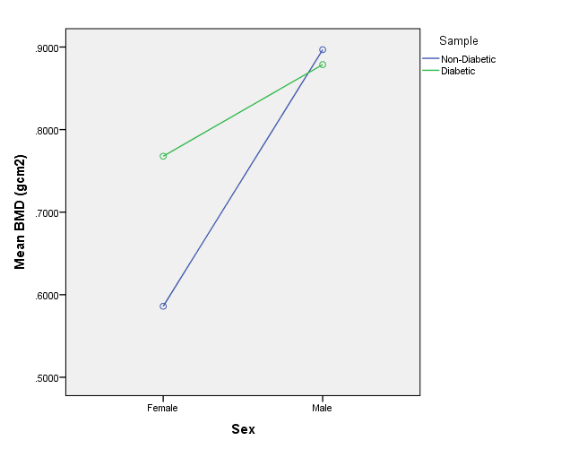
Means for Femur Upper Neck BMD, Separated by Sex.

Table A.2. ANOVA Results: Femur Lower Neck

Sex | Diabetic Status | n | Mean BMD | Standard deviation | Significance
Female | Diabetic | 18 | 1.0630 | 0.1702 | 0.0001
Female | Non | 18 | 0.7927 | 0.1622 | 0.0001
Male | Diabetic | 22 | 1.1035 | 0.1987 | 0.417
Male | Non | 22 | 1.1516 | 0.1911 | 0.417

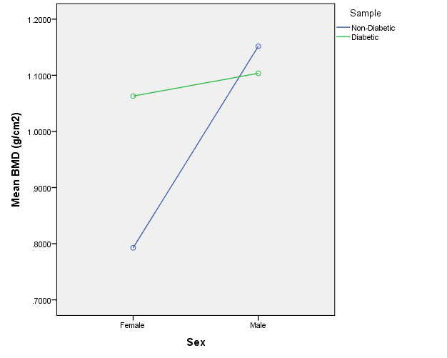
Means for Femur Upper Neck BMD, Separated by Sex.

Table A.3. ANOVA Results: Femur Ward’s Triangle

Sex | Diabetic Status | n | Mean BMD | Standard deviation | Significance
Female | Diabetic | 18 | 0.7585 | 0.2016 | 0.001
Female | Non | 18 | 0.5384 | 0.1493 | 0.001
Male | Diabetic | 22 | 0.8802 | 0.1886 | 0.444
Male | Non | 22 | 0.9263 | 0.1988 | 0.444

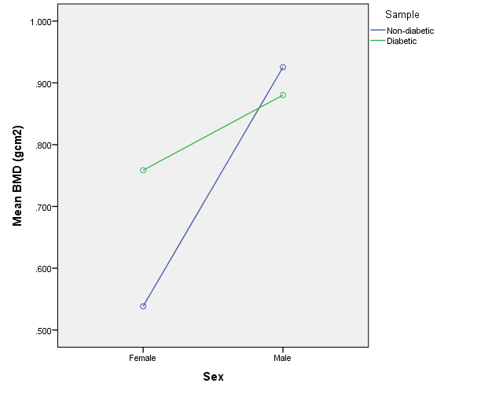
Means for Ward’s Triangle BMD, Separated by Sex.

Table A.4. ANOVA Results: Femur Trochanter

Sex | Diabetic Status | n | Mean BMD | Standard deviation | Significance
Female | Diabetic | 18 | 0.7670 | 0.1474 | 0.0001
Female | Non | 18 | 0.5404 | 0.9776 | 0.0001
Male | Diabetic | 22 | 0.8883 | 0.1358 | 0.730
Male | Non | 22 | 0.8731 | 0.1544 | 0.730

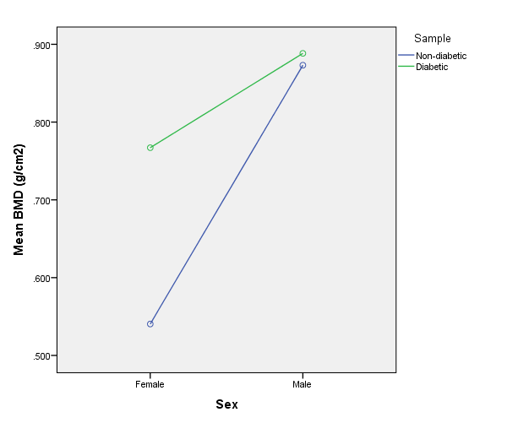
Means for Femur Trochanter BMD, Separated by Sex.

Table A.5. ANOVA Results: Femur Shaft

Sex | Diabetic Status | n | Mean BMD | Standard deviation | Significance
Female | Diabetic | 18 | 1.1621 | 0.2275 | 0.0001
Female | Non | 18 | 0.8383 | 0.1757 | 0.0001
Male | Diabetic | 22 | 1.2554 | 0.2136 | 0.773
Male | Non | 22 | 1.2775 | 0.2132 | 0.773

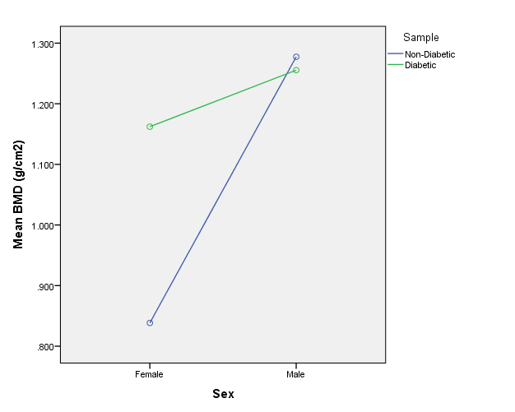
Means for Femur Shaft BMD, Separated by Sex.

Table A.6. ANOVA Results: Femur Total

Sex | Diabetic Status | n | Mean BMD | Standard deviation | Significance
Female | Diabetic | 18 | 0.9824 | 0.1815 | 0.0001
Female | Non | 18 | 0.7099 | 0.1314 | 0.0001
Male | Diabetic | 22 | 1.0792 | 0.1608 | 0.904
Male | Non | 22 | 1.0854 | 0.1770 | 0.904

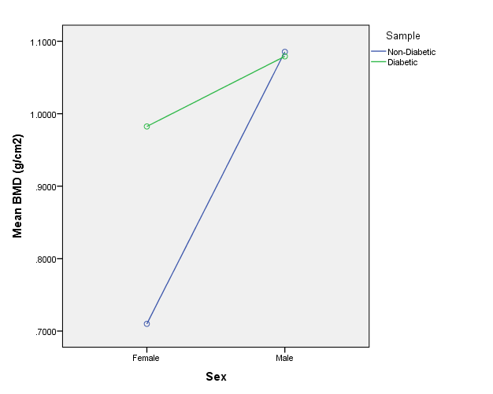
Means for Femur Total BMD, Separated by Sex.

Forearm ANOVA Results

Table A.7. ANOVA Results: Ulna Ultra-Distal

Sex | Diabetic Status | n | Mean BMD | Standard deviation | Significance
Female | Diabetic | 18 | 0.3315 | 0.0764 | 0.462
Female | Non | 18 | 0.2995 | 0.1656 | 0.462
Male | Diabetic | 22 | 0.4069 | 0.0663 | 0.739
Male | Non | 22 | 0.3986 | 0.949 | 0.739

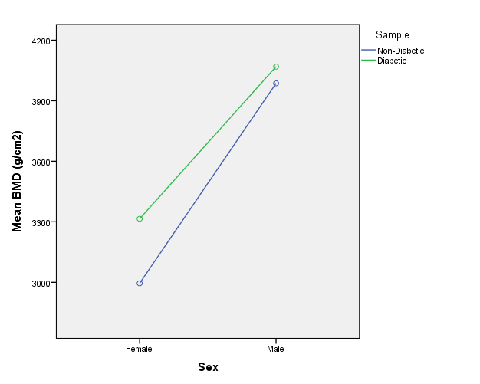
Means for Ulna Ultra-distal BMD, Separated by Sex.

Table A.8. ANOVA Results: Both Ultra-Distal

Sex | Diabetic Status | n | Mean BMD | Standard deviation | Significance
Female | Diabetic | 18 | 0.3881 | 0.0823 | 0..010
Female | Non | 18 | 0.3195 | 0.0677 | 0..010
Male | Diabetic | 22 | 0.4897 | 0.0694 | 0.326
Male | Non | 22 | 0.4654 | 0.0914 | 0.326

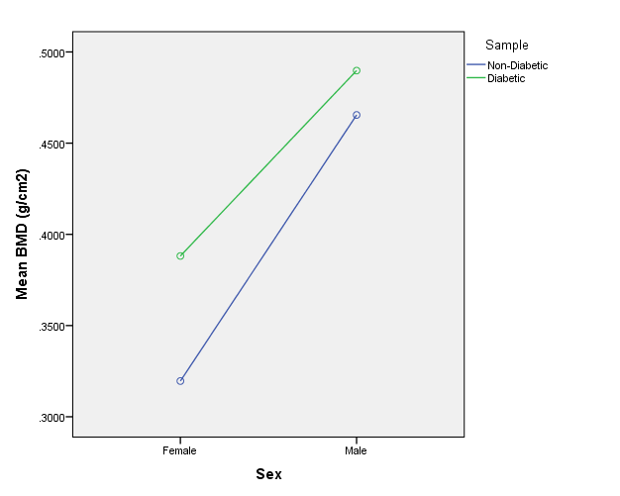
Means for Both Ultra-distal BMD, Separated by Sex.

Table A.9. ANOVA Results: Distal 33% Radius

Sex | Diabetic Status | n | Mean BMD | Standard deviation | Significance
Female | Diabetic | 18 | 0.7910 | 0.1409 | 0.009
Female | Non | 18 | 0.6558 | 0.1515 | 0.009
Male | Diabetic | 22 | 0.9669 | 0.0865 | 0.128
Male | Non | 22 | 0.9189 | 0.1162 | 0.128

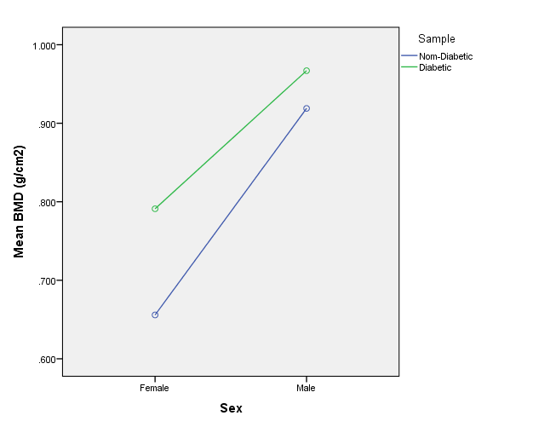
Means for Distal 33% Radius BMD, Separated by Sex.

Table A.10. ANOVA Results: Distal 33% Ulna

Sex | Diabetic Status | n | Mean BMD | Standard deviation | Significance
Female | Diabetic | 18 | 0.7189 | 0.1611 | 0.006
Female | Non | 18 | 0.5836 | 0.1111 | 0.006
Male | Diabetic | 22 | 0.8485 | 01039 | 0.517
Male | Non | 22 | 0.8284 | 01005 | 0.517

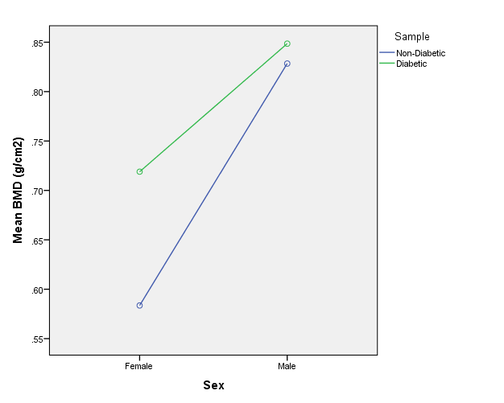
Means for Distal 33% Ulna BMD, Separated by Sex.

Table A.11. ANOVA Results: Both Distal 33%

Sex | Diabetic Status | n | Mean BMD | Standard deviation | Significance
Female | Diabetic | 18 | 0.7551 | 01472 | 0.006
Female | Non | 18 | 0.6185 | 0.1285 | 0.006
Male | Diabetic | 22 | 0.9160 | 0.0776 | 0.143
Male | Non | 22 | 08765 | 0.1285 | 0.143

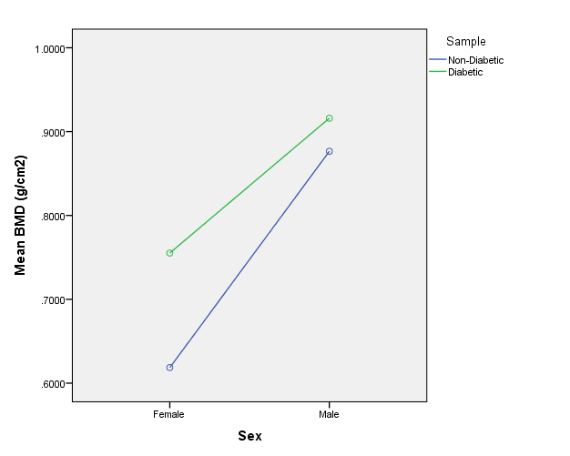
Means for Both Distal 33% BMD, Separated by Sex.

Table A.12. ANOVA Results: Radius Total

Sex | Diabetic Status | n | Mean BMD | Standard deviation | Significance
Female | Diabetic | 18 | 0.6043 | 0.1111 | 0.021
Female | Non | 18 | 0.5134 | 0.1137 | 0.021
Male | Diabetic | 22 | 0.7458 | 0.0705 | 0.124
Male | Non | 22 | 0.7060 | 0.0960 | 0.124

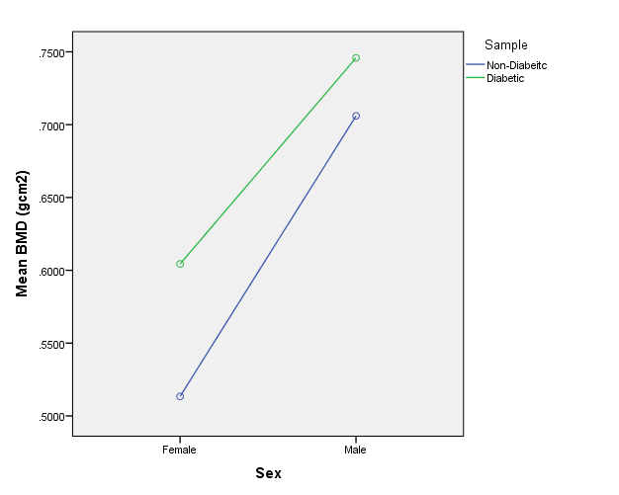
Means for Radius Total BMD, Separated by Sex.

Table A.13. ANOVA Results: Ulna Total

Sex | Diabetic Status | n | Mean BMD | Standard deviation | Significance
Female | Diabetic | 18 | 0.5709 | 0.1321 | 0.002
Female | Non | 18 | 0.4497 | 0.0826 | 0.002
Male | Diabetic | 22 | 0.6674 | 0.0873 | 0.396
Male | Non | 22 | 0.6441 | 00925 | 0.396

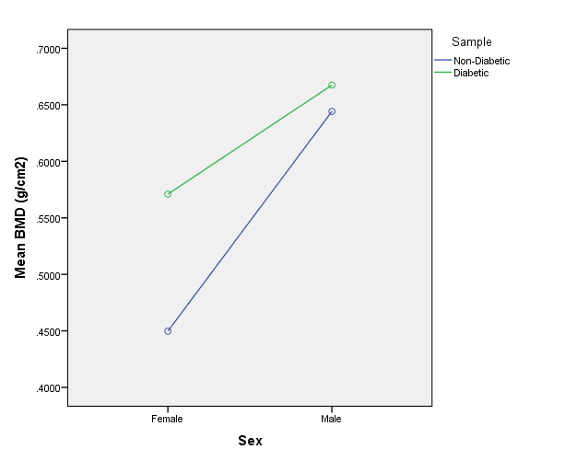
Means for Ulna Total BMD, Separated by Sex.

Table A.14. ANOVA Results: Both (Radius Ulna) Total

Sex | Diabetic Status | n | Mean BMD | Standard deviation | Significance
Female | Diabetic | 18 | 0.5736 | 0.1125 | 0.018
Female | Non | 18 | 0.4854 | 0.0989 | 0.018
Male | Diabetic | 22 | 0.7072 | 0.0790 | 0.278
Male | Non | 22 | 0.6790 | 0.0906 | 0.278

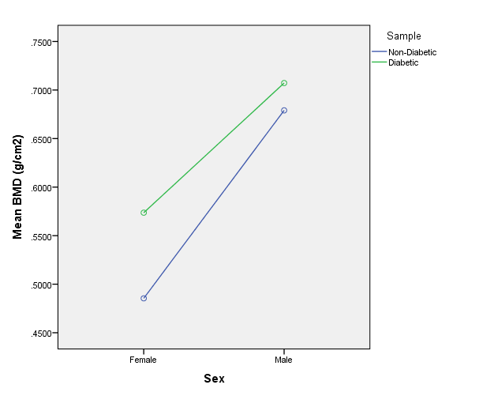
Means for Both (Radius/Ulna) Total BMD, Separated by Sex

Tibia ANOVA Results

Table A.15. ANOVA Results: Tibia Metaphysis
Sex | Diabetic Status | n | Mean BMD | Standard deviation | Significance
Female | Diabetic | 18 | 1.0457 | 0.2296 | 0.046
Female | Non | 18 | 0.8763 | 0.2595 | 0.046
Male | Diabetic | 22 | 1.2929 | 0.2169 | 0.362
Male | Non | 22 | 1.2217 | 0.2906 | 0.362

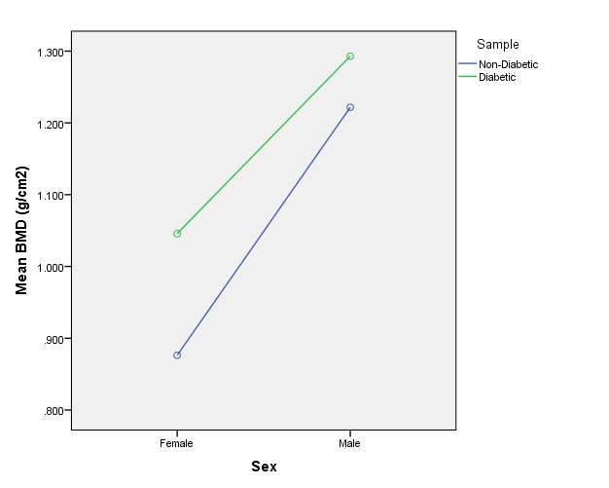
Means for Tibia Metaphysis BMD, Separated by Sex.

Table A.16. ANOVA Results: Tibia Medial Malleolus
Sex | Diabetic Status | n | Mean BMD | Standard deviation | Significance
Female | Diabetic | 18 | 0.7755 | 0.1278 | 0.001
Female | Non | 18 | 0.5738 | 0.1840 | 0.001
Male | Diabetic | 22 | 0.9118 | 0.1325 | 0.492
Male | Non | 22 | 0.8713 | 0.2403 | 0.492

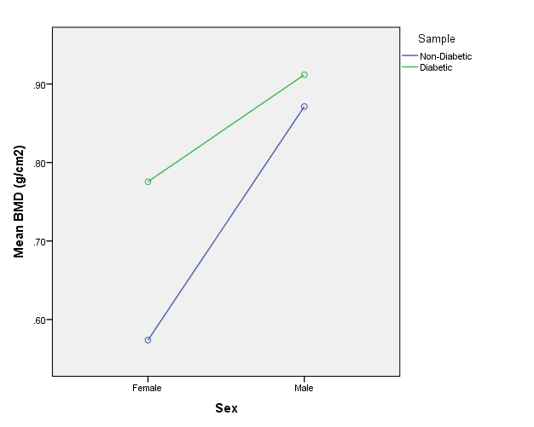
Means for Tibia Medial Malleolus BMD, Separated by Sex

Table A.17. Step-wise Discriminant Function Analysis Results. Femur – Females
Wilks’ Lambda Test of Function
Function | # Variables Selected | Variable Name | Wilks’ Lambda | Chi Square | df | Exact F Statistic | Significance
1 | 1 | Trochanter | 0.535 | 20.97 | 1 | 29.59 | 0.000
Eigenvalues
Function | Eigenvalue | Canonical Correlation
1 | 0.870 | 0.682
Functions at Group Centroid
Diabetic | 0.907
Non-Diabetic | -0.907

Cross-validated Classification Results
 |  | Predicted Group Membership |  | Total
 |  | Non-Diabetic | Diabetic | Total
Count | Non-Diabetic | 15 | 3 | 18
Count | Diabetic | 3 | 15 | 18
Percent | Non-Diabetic | 83.3% | 16.7% | 100%
Percent | Diabetic | 16.7% | 83.3% | 100%
*83.3% correctly classified

Table A.18. Step-wise Discriminant Function Analysis Results. Forearm – Females
Wilks’ Lambda Test of Function
Function | # Variables Selected | Variable Name | Wilks’ Lambda | Chi Square | df | Exact F Statistic | Significance
1 | 1 | Ulna Total | 0.757 | 9.312 | 1 | 10.89 | 0.002
Eigenvalues
Function | Eigenvalue | Canonical Correlation
1 | 0.320 | 0.493
Functions at Group Centroid
Diabetic | 0.55
Non-Diabetic | -0.55

Cross-validated Classification Results
 |  | Predicted Group Membership |  | Total
 |  | Non-Diabetic | Diabetic | Total
Count | Non-Diabetic | 13 | 5 | 18
Count | Diabetic | 6 | 12 | 18
Percent | Non-Diabetic | 72.2% | 27.8% | 100%
Percent | Diabetic | 33.3% | 66.7% | 100%
*69.5% correctly classified
Table A.19. Step-wise Discriminant Function Analysis Results. Tibia – Females
Wilks’ Lambda Test of Function
Function | # Variables Selected | Variable Name | Wilks’ Lambda | Chi Square | df | Exact F Statistic | Significance
1 | 1 | Malleolus | 0.70 |  | 1 | 14.59 | 0.001
Eigenvalues
Function | Eigenvalue | Canonical Correlation
1 | 0.429 | 0.548
Functions at Group Centroid
Diabetic | 0.637
Non-Diabetic | -0.637

Cross-validated Classification Results
 |  | Predicted Group Membership |  | Total
 |  | Non-Diabetic | Diabetic | Total
Count | Non-Diabetic | 14 | 4 | 18
Count | Diabetic | 3 | 15 | 18
Percent | Non-Diabetic | 77.8% | 22.2% | 100%
Percent | Diabetic | 16.7% | 83.3% | 100%
*80.5% correctly classified

Table A.20. Discriminant Function Analysis Results. Femur – Males (All variable included)
Wilks’ Lambda Test of Function
Function | # Variables Included | Wilks’ Lambda | Chi Square | df | Significance | Eigenvalue | Canonical  Correlation
1 | 7 | 0.854 | 6.072 | 7 | 0.531 | 0.171 | 0.302
Functions at Group Centroid
Diabetic | 0.404
Non-Diabetic | -0.404

Cross-validated Classification Results
 |  | Predicted Group Membership |  | Total
 |  | Non-Diabetic | Diabetic | Total
Count | Non-Diabetic | 12 | 10 | 18
Count | Diabetic | 10 | 12 | 18
Percent | Non-Diabetic | 54.5% | 45.5% | 100%
Percent | Diabetic | 45.5% | 54.5% | 100%
*54.5% correctly classified
Table A.21. Discriminant Function Analysis Results. Forearm – Males (All variables included)
Wilks’ Lambda Test of Function
Function | # Variables Included | Wilks’ Lambda | Chi Square | df | Significance | Eigenvalue | Canonical  Correlation
1 | 7 | 0.824 | 7.23 | 9 | 0.612 | 0.213 | 0.419
Functions at Group Centroid
Diabetic | 0.451
Non-Diabetic | -0.451

Cross-validated Classification Results
 |  | Predicted Group Membership |  | Total
 |  | Non-Diabetic | Diabetic | Total
Count | Non-Diabetic | 8 | 14 | 18
Count | Diabetic | 10 | 12 | 18
Percent | Non-Diabetic | 36.4% | 63.6% | 100%
Percent | Diabetic | 45.5% | 54.5% | 100%
*45.45% correctly classified

Table A.22. Discriminant Function Analysis Results. Tibia – Males (All variables included)
Wilks’ Lambda Test of Function
Function | # Variables Included | Wilks’ Lambda | Chi Square | df | Significance | Eigenvalue | Canonical  Correlation
1 | 7 | 0.963 | 1.51 | 3 | 0.680 | 0.038 | 0.191
Functions at Group Centroid
Diabetic | -0.190
Non-Diabetic | 0.190

Cross-validated Classification Results
 |  | Predicted Group Membership |  | Total
 |  | Non-Diabetic | Diabetic | Total
Count | Non-Diabetic | 14 | 8 | 18
Count | Diabetic | 11 | 11 | 18
Percent | Non-Diabetic | 63.6% | 36.4% | 100%
Percent | Diabetic | 50% | 50% | 100%
*56.8% correctly classified
VITA

Shannon May was born in Houston, Texas on March 1, 1983. She graduated from James Bowie High School in Austin, Texas in May 2001. Shannon attended Western Maryland College for one year as a pre-med student, and then transferred to Texas State University in San Marcos, Texas. She graduated summa cum laude in 2005 with a major in anthropology and a minor in biochemistry. Shannon entered the University of Tennessee Master’s program in biological anthropology in May 2005 and graduated in 2008 with a Masters of Arts. She began her doctoral work at the University of Tennessee in January 2008 and received her Doctor of Philosophy in August 2014. Throughout her graduate scholarship Shannon has pursued a career in forensic science, employed in crime scene and forensic death investigation.

