Effects of Repeated Reading with a Reader’s Theater Approach on First Graders’ Reading Fluency, Comprehension, and Prosody

A Thesis Presented for the
Specialist in Education
Degree
The University of Tennessee, Knoxville

Allison Michelle Murray
May 2024

ACKNOWLEDGEMENTS

There are many people who have helped and supported me throughout this journey. First, I would like to thank my family for their belief in my abilities to accomplish whatever I aspire to do. I truly appreciate their encouragement along the way.
Next, I would like to thank Dr. Philippakos, my advisor, for her extensive guidance and patience. I would never have accomplished this thesis without the many hours she spent meeting with me and revising my work. Her frequent and direct feedback also helped me stay on track throughout this process. I would not have been able to complete this study without her help.
I also want to thank my committee members for their expertise and assistance throughout the process of this study. Their feedback helped me to examine my work from differing perspectives, and their flexibility in working and meeting with me played a major role in the completion of this project.
Finally, I would like to thank my boyfriend for believing in me and supporting me throughout this challenging process. Through all the long nights and weekends I spent reading articles and writing, he demonstrated patience and understanding that I could never thank him enough for.

ABSTRACT

Reading fluency is a critical skill to acquire to advance reading achievement in elementary grades and beyond. The purpose of this study was to determine how a reading fluency intervention using repeated reading methods influences first graders’ oral reading fluency, prosody, and comprehension. Participants were 21 students from a first-grade classroom (n = 9 male, 12 female) in a suburban school. The study was based on action research with the teacher engaging in educational practices and reflection. Students took part in a fluency intervention using Reader’s Theater scripts from the adopted curriculum at the school. Assessments examined accuracy, prosody, retelling, comprehension, and reading motivation. Analysis was based on paired-sample t-tests. Results found that students’ reading rate and accuracy increased significantly, as well as their responses to retelling. Students’ prosody, responses to comprehension questions, and motivation did not show significant effects.

Keywords: reading fluency, reader’s theater, repeated reading, prosody, first grade, motivation
TABLE OF CONTENTS

CHAPTER 1: INTRODUCTION 1
Reading Comprehension and Fluency 3
Reading Theory and Fluency 6
Research Recommendations on Fluency Instruction 7
CHAPTER 2: LITERATURE REVIEW 12
Instructional Components of Repeated Reading 13
Adult-led fluency instruction: use of a model 15
Corrective Feedback 15
Effects of number of repetitions in rereading 16
Integrated repeated reading approaches for fluency instruction 17
Fluency oriented reading instruction 17
Wide fluency oriented reading instruction 19
Fluency development lesson 20
Peer-assisted learning strategies 22
Reader’s theater 23
Summary of recommendations 28
Text Types 29
Other Studies Using Repeated Reading Methods 31
Physical Movement and Reading Achievement 31
English Learners and Reading Fluency 32
Reading Motivation 35
Limitations in Research 36
CHAPTER 3: MATERIALS AND METHODS 38
Methods 39
Participants 39
Setting 39
Research Design 41
Action research 41
My role 42
Procedures 43
Overview of procedures 43
Measures 45
Reading Fluency 45
Aimsweb oral reading fluency 45
Correct words per minute 46
Prosody 46
Time 47
Comprehension 47
Responses to comprehension questions 47
Responses to retelling 47
Motivation 48
Analysis 48
CHAPTER 4: RESULTS AND DISCUSSION 49
Results 49
Reading Fluency 49
Aimsweb oral reading fluency 49
Correct words per minute 51
Prosody 51
Time 51
Comprehension 51
Responses to comprehension questions 51
Responses to retelling 51
Motivation 52
ELL and SPED students 52
Discussion 52
CHAPTER 5: CONCLUSIONS AND RECOMMENDATIONS 58
Implications 58
Practical Implications 58
Research Implications 59
Limitations 60
Conclusion 61
References 62
Appendix 79
Vita 85

LIST OF TABLES

Table 1. Gender. 40
Table 2. Ethnicity 40
Table 3. Pretest and posttest data. 50

CHAPTER 1
INTRODUCTION

Students’ inadequate growth in reading achievement has become a major issue distressing policy makers, educators, parents, and students of the United States. The National Assessment of Educational Progress (NAEP), an assessment mandated by Congress to assess the achievement of U.S. students in various subject areas, has long been the “nation’s report card” revealing what students know and can do (National Center for Education Statistics, 2011). According to NAEP, only 33% of fourth-grade students scored at or above the proficient level on the 2022 NAEP reading assessment, showing a decline of 4 percentage points since the 2017 results, and 31% of eighth-grade students scored at or above the proficient level, a 5% decline over the past five years. Furthermore, 37% of twelfth-grade students scored at or above the proficient level on the 2019 NAEP assessment, showing no significant change over the past five years. Internationally, the 2022 PISA Reading Literacy results (OECD, 2023) show that the United States ranked 22nd overall. In reading the U.S. ranked sixth and tenth in science. The scores in reading for 15-year old learners were 504 points with an average of 476 for the countries participating in the Organization for Economic Cooperation and Development (OECD). In the 2018 results, the U.S. ranked ninth among 76 other countries (OECD, 2023). In 2022, 20% of these students were considered low-performers, scoring at proficiency level 2 and below (OECD, 2023), while in 2018, 19% of students were considered low performers. These results indicate that the underperformance of these students is persistent and, in some areas, declining.
Several efforts have been made to remedy the reading performance of adolescent students by enacting conventions on schools and teachers. From as early as 2001, the No Child Left Behind Act (2001) stressed the importance of reading and mandated reading instruction with the intent that by the end of third-grade, all students would be reading on grade level. Additionally, in 2004, the reauthorization of the Individuals with Disabilities Education Act (IDEA) mandated students with disabilities were provided quality education by ensuring high quality instruction and intervention support. The Common Core State Standards initiated in 2010 aimed to raise academic requirements; however this posed increasing challenges for already struggling students (Bennett et al., 2017). Despite those policy efforts, students’ performance has not changed indicating a crisis in literacy.
With this persistence in underperforming adolescent students, it is important to consider what is expected in these grades for becoming competent readers in order to determine where they are falling short. According to Wanzek et al. (2010), upper elementary students are expected to “read to learn”, and Chall’s stages of reading (1983), specifically indicate that fourth graders should be entering this Stage 3 phase of reading-to-learn. In order for this to happen, it is imperative that these students can proficiently read complex narrative and expository texts (Wanzek, et al., 2010) so they have the ability to focus on comprehension and meaning-making. Without this capability, such students face the impending challenge of what is called the “fourth grade slump” (Chall & Jacobs, 1983) and the likelihood of minimal growth in reading achievement (Paige, Magpuri-Lavell, Rasinski, & Smith, 2014). Considering this dilemma, one might wonder the strength of these students’ early reading skills and how these skills impact these current reading outcomes. Juel (1988) found that first graders who are poor readers have a .88 probability of remaining poor readers by the end of fourth grade, confirming that once students fall behind in reading, it is likely they will remain struggling readers as they progress through school (Juel, 1988). Therefore, acknowledging that literacy begins much earlier than fourth grade, it is important to examine specific theories, practices, and strategies that have the potential to increase students’ reading ability in order for them to reach the later grades as competent readers, as “early success with reading appears critical” (Juel, 1988).
Reading Comprehension and Fluency
In order to address the gaps in reading achievement for students, it is essential to understand the processes behind reading and comprehending text. Snow and the RAND Reading Study Group (2002) define comprehension as “the process of simultaneously extracting and constructing meaning through interaction and involvement with written language” (Snow, 2002, p. 11). They detail a heuristic for thinking of reading comprehension by explaining three dimensions of comprehension: the reader, the text, and the activity. The reader brings capacities, abilities, knowledge, motivation, and experience to the act of reading. The text brings content in printed or electronic form and in a range of difficulty. The activity includes purposes, operations, and consequences for the act of reading. These three processes are combined in a sociocultural context made up of classrooms, neighborhoods, and homes, as readers engage with a text.
Snow stresses the complexity of the reading comprehension process and acknowledges the dynamic interactions among the reader, text, and activity. The relationship among these three elements evolve and change from before reading, during reading, and after reading, as the reader engages with the text. Further explaining the skills needed to attain comprehension, the Simple View of Reading by Gough and Tunmer (1986) theorizes that reading comprehension is the product of decoding and language comprehension. Language comprehension consists of a student’s ability to interpret spoken language (Gough & Tunmer, 1986). Decoding is the ability to “read isolated words quickly, accurately, and silently” using letter-sound correspondences (Gough & Tunmer, 1986, p. 7). A deficit in one of these aspects leads to poor comprehension. Because the ultimate goal of reading is to comprehend, it is essential that students have both of these skills in order to be successful and competent readers.
The Cognitive Model by McKenna & Stahl (2020) further builds off the notion of the Simple View of Reading by explaining that reading comprehension is dependent on skills contained in three integral pathways. Pathway 1 attends to Automatic Word Recognition. This pathway consists of phonological awareness and print concepts, decoding and sight word knowledge, and fluency in context. Pathway 2 concerns Oral Language Comprehension, or one’s ability to understand the language of a text (McKenna & Stahl, 2020). This consists of a student’s background knowledge, vocabulary knowledge, and knowledge of text and sentence structures. Pathway 3 involves Strategic Knowledge or having “different strategies for reading different types of texts for different purposes” (Stahl et al., 2019, p. 21). This pathway is made up of general purposes for reading, specific purposes for reading, and knowledge of strategies for reading. Each of these pathways contribute to students’ ability to make meaning from text, and a deficit in any of these areas will cause comprehension to suffer.
All three theories of comprehension define the importance of the processes and skills needed in order for competent reading to occur. What is seen throughout the models is that decoding and word recognition play a significant role in comprehension, as students must have some level of fluency with word recognition in order to comprehend text. While the Simple View of Reading shows that both decoding and language comprehension are essential to reading comprehension, proficient decoding abilities are imperative for students to be able to fluently read grade-level text. Further, the Cognitive Model conveys the importance of automatic word recognition, specifically fluency in context, to reading comprehension. Snow notes the role fluency in word recognition plays in the process of reading comprehension, indicating it can be “both an antecedent to and a consequence of comprehension” (Snow, 2002, p. 13). A certain level of fluency with word recognition is required to engage in a text, but the process of reading and understanding a text may also increase a reader’s level of fluency with the text. Therefore, it is obvious the interrelationship of fluency and comprehension, and according to Pikulski and Chard (2005), fluency is the bridge between decoding and comprehension. Thus, oral reading fluency is a crucial factor in students’ ability to comprehend text, and it has been identified as a challenge to the national issue of students’ poor reading performance (Rasinski & Padak, 1998; Valencia & Buly, 2004).

Reading Theory and Fluency
Reading fluency and its connection with comprehension stems from the LaBerge and Samuels’ (1974) Automatic Information Processing Theory. According to that theory, people have a finite cognitive capacity and therefore must become automatic in basic word-reading skills in order to devote more cognition to higher-order tasks such as comprehension.
The National Reading Panel defines fluency as the ability to read text accurately, quickly, and with prosody (National Reading Panel, 2000). Although reading fluency was previously considered a neglected aspect of reading (Allington, 1983), it is now highly regarded as an important component of reading achievement and instruction (Kuhn & Stahl, 2003; National Reading Panel, 2000). Reading fluency has a strong relationship with reading comprehension, as students who are able to recognize words automatically will likely have more attention devoted to comprehension (Perfetti, 1985; LaBerge & Samuels, 1974; Yopp & Yopp, 2009). In other words, fluency is the link between decoding and comprehension (Copple & Bredekamp, 2009).
Sadly, instruction in elementary classrooms may not adequately address fluency and its components, as teachers may believe it is not an important instructional topic or rarely receive training or instructional strategies to teach fluency (Begeny et al., 2010; Gamse et al., 2008). However, Rasinski et al. (2020) show that fluency instruction may benefit students as early as the beginning of first grade, before obtaining high levels of word decoding, when paired with phonics instruction. Fluency development is important because it helps students shift from slow word decoding to automatic word recognition, and it also helps students apply expressive oral language elements as they read (LaBerge & Samuels, 1974; Benjamin & Schwanenflugel, 2010). The latter can potentially aid their comprehension.
Reading fluency is developed through both wide reading and deep reading (Rasinski, 2012). Rasinski (2012) defines wide reading as the single reading of a text followed by discussion and instruction targeting specific reading skills. This is also described by the National Reading Panel (2000) as independent reading, in which students are reading a significant amount of texts on their own. While the panel stated there was not enough research to determine positive effects of wide reading on reading fluency, Pikulski and Chard (2005) comment that wide reading may lead to greater improvements in vocabulary and comprehension for students who are making adequate progress in reading. Deep reading, on the other hand, involves reading a text multiple times to achieve a level of fluency, also referred to as repeated reading. Pikulski and Chard (2005) determined that this approach is important for students struggling with fluency.
Research Recommendations on Fluency Instruction
The current research conducted on fluency provides further guidance for instruction. The National Reading Panel (2000) conducted an extensive review of research on the concept of fluency and how it is an essential component to reading. The members of the panel, selected by the National Institute of Child Health and Human Development, first state that automaticity, or fluency, is a continuum in which readers show gradual improvement with practice. Readers must be both accurate and automatic in word recognition to ensure fluency and comprehension are reached. As readers become automatic, cognitive demand is reduced, allowing readers to understand and interpret the text.
Further, the National Reading Panel members examined two approaches to teaching fluency: guided oral reading procedures and procedures that encourage independent or recreational reading. The panel reviewed 77 articles on repeated oral reading and 14 articles on independent reading practice using established research and synthesis procedures. In their analysis, they found that guided oral reading procedures had a more extensive body of research, and most results showed that these procedures improve fluency, word recognition, and comprehension across a span of grade levels. Specifically, repeated reading procedures were found to be effective with students up to grade four, and with students with reading problems through high school. On the other hand, there was not substantial evidence at that time to suggest that procedures encouraging students to read independently, such as Sustained Silent Reading and Accelerated Reader, promote better fluency and reading achievement. The few studies found on this topic primarily examined how the procedures impact overall reading achievement as opposed to reading fluency, and most did not find a positive relationship between the two.
Shanahan (2005) reviewed the results of the National Reading Panel in order to give teachers practical advice on how to use the findings in the classroom. In his review, he notes the instructional approaches the Panel members have found to improve oral reading fluency: repeated reading, in which a reader reads a passage multiple times (Samuels, 1979); paired reading, where partners take turns reading aloud (Stevens et al., 1987); neurological impress, in which the students and teacher read in unison, (Heckelman, 1969); echo reading, involving the student repeating, or echoing, the teacher by sentences or paragraphs (Mathes et al., 2001); listening-while-reading, where the student reads a text while listening to a fluent model, (Rasinski, 1990); radio reading, which includes reading a text in order to discuss and communicate (Greene, 1979); and work with tape recorders, where students read and listen to recorded texts (Chomsky, 1976). Additionally, choral reading, shared reading, and assisted reading are known approaches that are effective in improving oral reading fluency. Shanahan also shares three features the National Reading Panel found in quality fluency instruction, including oral reading practice instead of silent reading practice, repetition of reading or listening to a text, and guidance and feedback by a teacher, parent, volunteer, or peer.
In addition, Shanahan commented on the effectiveness of technology as a way to further support fluency instruction, as it has the potential to allow students to listen to a model of reading that is fluent. Further, technology gives students the opportunity to record and listen to themselves reading. This practice can aid them to practice and to improve their rate and prosody.
Although not addressed in the National Reading Panel’s work, Shanahan (2005) comments on the difficulty of text in fluency instruction. He mentions that a wide range of difficulty can be effective in texts for teaching fluency, but the more difficult the text, the more scaffolded support is needed. He also cautions that independent-level texts are not recommended for fluency instruction (Kuhn & Stahl, 2003).
Shanahan (2005), also criticized the use of a round-robin reading approach, a notion agreed upon by the National Reading Panel (2000). He points out that studies suggest only the reader is benefited in this process, while most others spend their time listening and waiting. Therefore, this approach is not effective in building fluency.
As depicted in the previous works, fluency plays a crucial role in the attainment of comprehension, and many instructional practices and models go into the process of attaining fluency. These studies show that fluency instruction has a positive impact on students’ ability to understand complex text, a requirement of students as they take required assessments each year. With the third-grade reading laws expanding across the United States, more and more students are being retained or requiring intensive interventions and monitoring of progress if they do not meet performance standards on third-grade assessments (Learning Disabilities Association of America, 2013). NAEP (2018) also indicated that 1.27 million fourth-grade students performing below the NAEP Basic score are significantly challenged in being able to read fluently, with a portion of these students also showing a lack of appropriate expression when reading aloud. The reading framework points out that “without these foundational skills, comprehension will not occur” (National Assessment Governing Board 2017, p. 4). In these situations, the motivation of students who are already underperforming can also be negatively affected. As students in these grades are moving towards reading to learn, less time is spent on phonics and fluency instruction, as this should already be in place in order to comprehend the content. Hence, proficiency in reading fluency has to become an important pillar of early elementary instruction, with students in these grades taking part in quality fluency interventions.
The purpose of this study is to provide a specific intervention to support primary learners’ literacy practices. The study will focus on repeated oral reading as a main practice, because of the wealth of evidence on the effectiveness of repeated oral reading. However, in an effort to scaffold students’ engagement, the designed intervention will incorporate repeated oral readings in a fluency practice. The focus of this work will be on first grade, as students are solidifying decoding skills and beginning to automize word recognition. With these skills at the forefront of content, first graders are at an advantage to build the foundations of reading fluency in conjunction with phonics instruction in order to prepare them for becoming competent readers.

CHAPTER 2
Literature Review

Repeated oral readings are based on a highly-researched practice used to increase students’ reading fluency. This practice consists of multiple readings of a short passage until a “satisfactory level of fluency is reached” (Samuels, 1979, p. 404). The National Reading Panel (2000) findings concluded that repeated reading procedures are effective in improving word recognition, fluency, and comprehension. Furthermore, many studies have found that repeated reading can improve reading fluency with struggling readers (Turner, 2012; Vadasy & Sanders, 2008; Escarpio & Barbetta, 2016), students with reading disabilities (Lee & Yoon, 2017; Therrien, 2004; Freeland, Skinner, Jackson, McDaniel, & Smith, 2000), and students in urban settings (Telesman et al., 2019). Repeated reading interventions can be used to improve a student’s ability to fluently read and comprehend a specific passage after multiple rereadings, called nontransfer, or new passages after rereading other passages, called generalization or transfer (Therrien, 2004). In 2004, William Therrien conducted a meta-analysis of studies from 1977 to 2001 on the effectiveness and instructional components of repeated reading on students’ reading fluency and comprehension in both transfer and nontransfer situations. His analysis determined that repeated reading is an effective strategy to improve students’ reading fluency and comprehension on both passages that are repeatedly read and on new passages. However, current studies investigating the effects of repeated reading on students’ reading fluency on untrained passages have only shown marginal gains (Gibson Jr. et al., 2014; Silber & Martens, 2010; Ardoin et al., 2008). Regardless, the value of reading and rereading with different purposes can support readers’ growth as prosodic readers (Rasinski, 2014).
Instructional Components of Repeated Readings
Typical repeated reading interventions use a multidimensional approach. Therrien’s meta-analysis showcased that adult-led implementation showed more gains in fluency and comprehension than peer-led implementations. In addition, corrective feedback given on word errors in adult-led interventions yielded significant improvements in reading fluency. In regards to instructional components of repeated reading, Therrien (2004) determined that providing students with a cue, also called performance feedback, such as focusing on comprehension and speed, and reading a passage three to four times yields the greatest gains in reading fluency and comprehension. In addition, he concluded that using performance criteria, such as reading a passage within a fixed time period or reading a passage until a certain number of words correct per minute was reached produced significant gains in fluency.
Alber-Morgan (2006) also reviewed research on repeated reading and determined ten ways to enhance the effectiveness of these types of interventions. He determined that repeated readings should be used daily as a supplement to effective reading instruction and that passages should be at students’ instructional level. He recommended providing instruction individually, reinforcing student performance, and monitoring progress using a visual graph. In agreement with Therrien, he also recommended providing systematic error correction and performance feedback. Additionally, he advised assessing reading comprehension and including a comprehension strategy during instruction, especially if reading comprehension is not increasing with reading fluency.
Hudson, Koh, Moore, and Binks-Cantrell (2020) reviewed research from 2000-2019 to determine whether fluency interventions improved oral reading fluency and comprehension in elementary students with reading difficulties, and to determine the characteristics of effective oral reading fluency interventions. Contrary to previous studies, they only included studies with a group-design and a control group to “allow for more definite conclusions to be made about the effectiveness of fluency interventions” (Hudson et al., 2020, p. 4 - 5). The majority of the included studies examined repeated reading interventions for improving fluency. In regards to their first goal, they found that the fluency interventions benefited students’ comprehension in addition to their fluency, with comprehension gains outweighing gains in fluency. They also determined that the majority of studies used accuracy and rate to measure fluency gains, while only three studies included a measure of prosody. Addressing their second goal, they found that the most effective interventions included a trained model of fluent and accurate reading and took place in a one-on-one setting. Their limitations included the sustainability of fluency interventions over time, the effects of interventions on reading prosody, and the efficacy of additional fluency interventions other than repeated reading. The specifics of instructional practices are reviewed and discussed in detail below.

    - Adult-Led Fluency Instruction: Use of a Model
Adult modeling of a reading passage, whether in an initial reading or a subsequent reading, can provide students with a model for what accurate and prosodic reading sounds like, and previous research has shown this can improve fluency with consecutive student readings (Therrien, 2004). Modeling of a passage also helps students develop a distinct understanding of their goal when reading for fluency (Pearson, 2010). Chard et al. (2002) synthesized research on interventions designed to increase reading fluency with students with learning disabilities and found that repeated reading with an explicit model of fluent reading was highly effective for students with low reading fluency. Vadasy and Sanders (2008) also found the use of a model of fluent reading was beneficial for struggling readers’ fluency. Hawkins et al. (2015) conducted a study on the effects of adult-mediated repeated reading versus listening-while-reading. In this study, fourth-grade students repeatedly read passages with immediate error correction and then repeatedly read passages along with an audio recording of the passage. They found that both conditions led to similar reading fluency rates, but listening-while-reading was more efficient in improving reading fluency. This highlights the effectiveness of an adult-led or modeled repeated reading intervention.
    - Corrective Feedback
Corrective feedback consists of the adult correcting the reading errors of a student, either in an immediate fashion, as requested by the student, or at the conclusion of a specified passage of text. Therrien (2004) found that all studies containing a corrective feedback component displayed adequate improvement in students’ fluency. Several other studies have found similar results. For example, Lo, Cooke, and Starling (2011) found that a multicomponent repeated reading intervention including an error-correction component improved fluency for three second-grade students on transfer passages. Another study by van Gorp, Segers, and Verhoeven (2017) studied the effects of feedback on repeated word reading with first-grade students, consisting of 48 good readers and 47 struggling readers. They found that the type of feedback offered did not show any significant differences in both good and struggling readers’ word reading.
    - Effects of Number of Repetitions in Rereadings
As Therrien found, repeatedly reading a text three to four times yields the greatest gains in reading fluency for students. Another meta-analysis conducted by Lee and Yoon (2017) on the effects of repeated reading on students with reading disabilities concurred that repetition was “a critical variable”, indicating that reading a passage at least four times showed the greatest gains in fluency (Lee & Yoon, 2017, p. 221). Additional studies have shown improved reading fluency with three or more repeated readings of a passage (Lo, Cooke, and Starling, 2011; Ardoin et al., 2016). Furthermore, Turner (2012) found that repeatedly reading the same text, as opposed to multiple texts within the time period of a week, yielded greater reading fluency rates for African American and Latino second-grade students. In regards to early or struggling readers still building fluency with decoding skills, van Gorp et al. (2017) determined that repeated reading of words can strengthen students’ early decoding skills.
Integrated Repeated Reading Approaches for Fluency Instruction
All of the components explained by Therrien (2004) and Alber-Morgan (2006) are often found in combination in effective repeated reading interventions. Kuhn, Rasinski, and Zimmerman (2014) detailed three of these integrated approaches for improving struggling readers’ fluency that include many of the previously mentioned components. Many other integrated approaches have been highly-researched as effective methods for improving reading fluency and will be detailed below.
Fluency oriented reading instruction. The first is Fluency Oriented Reading Instruction (FORI). This approach includes scaffolded repeated reading of a text over the course of a five-day lesson and involves a gradual release of responsibility by the teacher. It also involves students reading the text at home on days 2-4. Kuhn (2020) cautions to choose texts that are typical in length for the grade level, as opposed to short selections, as students will need to read for a duration of 20-30 minutes. On Day 1, the teacher introduces the text with pre-teaching activities, such as building background knowledge or pre-teaching vocabulary, that are specific to the content in the passage. The teacher then models reading the text aloud while students follow along. This allows students to initially see the words before having to decode them and hear what the text sounds like, allowing them to maintain a focus on meaning (Kuhn, 2020). This is followed by a discussion of the text with a focus on comprehension. Day 2 consists of echo reading the text while interspersing questions throughout. It is recommended that the students begin by echo reading two or three sentences at a time and increasing the amount of text so that students are not relying on short-term memory to repeat the words, but actively tracking the words as they read (Kuhn et al., 2014; Kuhn, 2020). Students complete an extension activity, such as a written response, after reading. On Day 3, the teacher will choral read the story with students, making sure that all students are engaged in the reading. Day 4 is comprised of partner reading the story by pairing a more experienced reader with a less experienced reader or by having students select their own partners. Partners take turns reading sections of the text and offering assistance and support to one another as needed. On Day 5, students are involved in extension activities, such as writing about or discussing the text.
Stahl and Heubach (2005) conducted a study using a modified version of the Fluency Oriented Reading Instruction model to study its effects on reading achievement. This two-year study took place with 14 second-grade classrooms in Georgia and involved 125 students over the course of the two years. The majority of students were African American and of mixed to low socioeconomic status. The purpose of this study was to redesign basal reading lessons in these classrooms to include repeated reading, partner reading, choice reading, and home reading. Addressing their research questions, they found that their program was sustainable over the course of a school year and that all but two students whose initial reading level was primer or higher could read on grade-level or higher by the end of the school year. For those initially reading below the primer level, half of these students were reading on grade-level by the end of the school year. Stahl and Heubach (2005) also found through the partner reading portion of their study that having students self-select partners for partner reading was most effective and students most often chose partners out of friendship. Students also tended to select books for partner reading that were at or slightly below their instructional level, and their choices were highly influenced by their teacher. Finally, they found that the high level of support and scaffolds offered in their program allowed students to benefit from more difficult texts than had previously been accepted.
Wide fluency oriented reading instruction. The second approach, called Wide Fluency Oriented Reading Instruction (Wide FORI), follows the same scaffolded approach as FORI, but uses a range of three texts within a one-week time period. In this approach, Day 1 follows the same approach as the initial day of FORI, by introducing the primary text, reading it aloud as students follow along, then discussing the text with the possibility of engaging in additional response methods. Day 2 of this approach also consists of echo reading the primary text, interspersing comprehension activities to maintain a focus on meaning (Kuhn, 2020). Wide FORI differs from FORI on this day by including the option of having students partner read at the completion of the echo read. On Day 3, students complete extension activities, much like Day 5 of FORI, to strengthen their understanding of the text. Days 4 and 5 involve echo reading and discussing two additional texts, with the option to partner read these texts if time permits.
Kuhn et al. (2006) carried out an experimental study on the effects of a fluency-oriented reading instruction intervention versus a wide-reading intervention on students’ reading fluency. The study included 349 second-grade students from 24 classrooms in eight schools in New Jersey and Georgia. Teachers were assigned to a group that focused on repetition of text, wide reading of a number of texts, or a control group, and all teachers used grade-level texts in the interventions. Following the study, Kuhn et al. (2006) found that both intervention approaches showed similar positive effects on students’ word reading efficiency and reading comprehension. However, the gains from the wide-reading approach emerged earlier than the FORI approach when compared to the control group, and the wide-reading approach also showed significant improvement in oral reading of connected text. Despite these differences, Kuhn et al. (2006) acknowledges that both approaches are successful for improving reading fluency and comprehension.
Fluency development lesson. The Fluency Development Lesson (FDL), constructed by Rasinski, Padak, and Sturtevant (1994) uses the same scaffolded format to repeatedly read one text, but it takes place within one day’s lesson. This more intensive procedure is meant to accelerate the progress of the most struggling readers. It can also increase motivation for these students, as they can see improvements in reading fluency more instantaneously than the other fluency approaches. Kuhn et al. (2014) also suggests that short rhythmic texts, such as poems or song lyrics, work best for these brief daily lessons. The protocol for FDL begins with a reading of the previous days’ text. The teacher then introduces a new text and reads it aloud two or three times while students follow along. The teacher varies the way the text is read each time, then discusses the content of the text and the quality of his or her own reading with students. Next, the teacher and students chorally read the text multiple times. This can include echo reading or other variations to maintain engagement. Following this, students take turns partner reading the text and providing feedback and support to one another. Once students can read the text fluently and with meaning, they can record themselves or perform it for an audience, either in groups or individually. After performing, the teacher guides students in a brief word study session using a variety of activities, including word chaining or examining word families. Finally, students place a copy of the text in a fluency notebook and take another copy home to practice with family members. When Rasinski et al. (1994) conducted the initial study with this approach, they found that FDL showed gains in students’ reading rate; however, there was not a significant difference in overall reading level between FDL and traditional reading activities (Rasinski et al., 1994).
Kuhn (2020) also developed two research-based small-group approaches for fluency support. Fluency-Oriented Oral Reading (FOOR) and Wide Fluency-Oriented Oral Reading (Wide FOOR) use many of the principles and strategies from the previous approaches, but are modified to a small-group setting. Kuhn’s (2020) study involved a FOOR group, a Wide FOOR group, a group that listened to fluent reading of the Wide FOOR texts, and a control group. The FOOR and Wide FOOR groups were designed to meet the needs of a small group of five to six struggling readers that met three times a week for 15-20 minutes each session. FOOR follows the principles of FORI, in that students read one text over the course of a week. Wide FOOR follows the general format of Wide FORI, in that three texts are read over the course of a week. In the FOOR approach, Day 1 involves echo reading a text and conducting comprehension activities. On Day 2, teacher and students choral read the text. Day 3 involves partner reading the text once, with an additional reading if time allows. On each day of the three days in the Wide FOOR approach, a new text is echo read and followed by a discussion of the text. In her study of these approaches, Kuhn (2020) found that students in both groups improved their automaticity and prosody in connected texts, but those in the Wide FOOR group showed greater improvement in comprehension than the FOOR group, revealing that wide reading may cause students to focus more heavily on meaning than in repeated reading interventions.
Peer-assisted learning strategies. An additional approach used to enhance reading fluency is Peer-Assisted Learning Strategies (Fuchs et al., 1997). This approach, originally intended for grades 2-6, engages students in structured peer tutoring that requires students to use specific prompts and feedback, participate in frequent verbal interaction and take on multiple roles as they read. An extension of PALS is First-Grade PALS (Mathes et al., 1998). This protocol differs in that it employs a stronger reader to read first, and a weaker reader to read second. It also begins with 10 minutes of gradual activities that begin with letter sounds and progress to words in decodable stories. Following this, partners engage in 3 minutes of making predictions from story pictures, 15 minutes of reading aloud, and 2 minutes of retelling.
Because First-Grade PALS does not include a fluency activity and therefore was not shown to increase first-graders reading fluency, Fuchs et al. (2021) conducted a study in which a RR element was added to see if this positively affected first-graders’ reading fluency. The study consisted of 33 first-grade classroom teachers with 491 students from 8 schools in an urban setting. These classrooms were divided into a PALS-Only group, a PALS+Fluency group, and a control group. The two former groups conducted each intervention three times per week for 35-minute sessions for a duration of 22 weeks. Both the PALS-Only and PALS+Fluency groups followed the same procedures that would be found in a First-Grade PALS lesson, except the PALS+Fluency groups spent 5 fewer minutes on the sounds-and-words activities in order to spend 5 minutes on fluency-building activities. Following the interventions, Fuchs et al. (2021) found that but did not show any significant improvements in students’ reading fluency. They contribute this finding to the limited amount of time spent in the fluency activity and the lack of instructional components found in a peer-led PALS lesson that are known to be effective with repeated reading, such as being adult-led and including modeling.
Reader’ theater. The National Reading Panel (2000) and Shanahan (2005), in their review of fluency, stated that there was no support for the effectiveness of Reader’s Theater as a way to increase fluency. They cautioned that the differing amounts of dialogue and the time spent waiting on other students to read lines do not provide all students with sufficient amounts of reading practice. Some researchers have noted that Reader’s Theater can provide students with a greater purpose and motivation for reading (Martinez et al., 1998). In 1999, for example, Rinehart conducted action research to describe how Reader’s Theater can be implemented into a reading tutorial program. This study was conducted for six weeks by 22 graduate students and included 22 first- and second-grade students with reading difficulties. Reader’s Theater lessons and performances took place during 18 sessions. Rinehart found, through anecdotal observations, that the sufficient reading practice and engaging nature of Reader’s Theater increased students’ motivation, prosodic elements, and attitude towards reading. However, he did not collect any measures on its effect on reading fluency other than the prosodic elements and motivation. Because of these kinds of results, NRP and Shanahan recommended Reader’s Theater as an occasional motivational reading activity until more research can prove its effectiveness.
Contrary to the findings by the National Reading Panel, recent research has been conducted with Reader’s Theater and fluency and has found more positive results. Keehn (2003) studied the effects of Reader’s Theater and explicit fluency instruction on students’ oral reading fluency. The study took place for nine weeks in a rural school district in four second-grade classrooms. Two classrooms conducted Reader’s Theater with explicit fluency lessons and provided coaching and modeling as needed, while the other two classrooms implemented Reader’s Theater only without coaching or modeling during practice. Results indicated that both treatment groups made gains in oral reading fluency and comprehension over the course of the intervention; however, there were no significant differences in improvements in rate, accuracy, retelling, fluidity, phrasing and expressiveness across treatment groups. The low-ability readers also made significant growth in more areas than the average and high ability readers. The results demonstrate that the addition of explicit fluency instruction did not have a significant effect on reading fluency and comprehension, and Keehn concludes that the repeated reading of appropriate text is a significant factor in improving reading fluency.
Additionally, in 2009, Clark, Morrison, and Wilcox studied the effects of an 8-week Reader’s Theater fluency intervention on three fourth-grade students’ fluency processes and motivation. Students took part in reading the script at least 30 minutes per week individually, with partners and groups, or in a performance. They received explicit fluency instruction 40 minutes per week in both whole-group and small groups. Findings reveal only one student significantly increased rate and accuracy when reading, but all three students improved in one or more of the prosodic elements of reading fluency. Students also increased their motivation, as they were able to experience successful reading. Scripts included a wide range of levels, allowing all students to participate, and students received sufficient repeated reading practice as they worked to perform for an audience.
The connection of readers’ theater with dramatization and singing has also been examined. Young, Valadez, and Gandara (2016) researched the effects of Reader’s Theater and Rock and Read, a fluency strategy in which students read and sing along to popular songs, on students’ reading fluency. This study included 51 second-grade students from a Title 1 school and lasted for four weeks. It consisted of two treatment groups and one control group. Of the treatment groups, one used Rock and Read along with their regular reading curriculum, while the other utilized Rock and Read and Reader’s Theater along with the regular reading curriculum. The results indicated that both treatment groups had large effects on students’ reading fluency. Specifically, the Rock and Read group yielded a larger effect on expression and volume than the Rock and Read and Reader’s Theater group. Both groups displayed gains in phrasing and reading rate. However, the control group also showed increases in rate. This may indicate that regular classroom fluency instruction focuses highly on rate, while the instructional approaches in the treatment groups maintained a greater focus on prosody, which had an unintended effect on rate.
Young and Rasinski (2018) studied the effects of a daily 15-minute Reader’s Theater intervention on students’ word recognition automaticity and reading prosody. Because previous research on Reader’s Theater had primarily consisted of anecdotal observations, Young and Rasinski decided to take a more analytical approach to further prove the positive effects of Reader’s Theater. They conducted the study over the course of two years with second-grade students and the same teacher. Of the students included in the study, about one-third were identified as English Learners. The first year was the comparison group, in which the teacher implemented book-box reading for the first 15 minutes of the reading block. In the second year, the teacher replaced this time with a Reader’s Theater intervention following Young and Rasinski’s five-day lesson plan (2009). Day 1 involved introducing and choosing a script, followed by reading the full script for meaning. On Day 2, students met with groups and selected parts, then practiced the script with the goal of accurate word reading. Day 3 consisted of reading the script for expression as the teacher provided modeling and feedback. On Day 4, students rehearsed for their performance while the teacher provided feedback, and Day 5 involved performing the script for each other or guests. Findings suggest that while both groups showed gains in word recognition automaticity and prosody, Reader’s Theater had a much larger effect on these measures. Young and Rasinski conclude that these positive effects could be from a number of factors found in Reader’s Theater, including aspects of collaboration, peer and teacher feedback, motivation and engagement, or repeated reading.
Young et al. (2019) expand upon previous research on Reader’s Theater by adding components that engage students in reading comprehension and vocabulary practice. They are also the first study on Reader’s Theater to use a standardized measure of reading comprehension to measure growth, the Gates-MacGinitie Reading Test (4th ed.; GMRT-4). The study lasted 18 weeks, with the first and last week reserved for testing, and included 76 second-grade students from three school districts. Three classrooms served as the treatment group and four classrooms the comparison group. The treatment groups followed a Reader’s Theater plus reading comprehension and word study format, constructed by the researchers, while the comparison groups used their typical instructional format in their reading block. Results showed that the students in the Reader’s Theater treatment made significant gains in decoding, word knowledge, and comprehension, with greater improvement seen over the comparison group in word knowledge and comprehension. These results indicate that Reader’s Theater can be a viable option for classroom reading instruction to improve both reading fluency and comprehension.
The effects of Readers’ theater have been also examined in motivation. In Finland, Hautala et al. (2024) studied the effects of Reader’s Theater on struggling boys’ motivation to read. They suggested that boys typically show poorer engagement in reading and prefer more active methods of learning with explicit goals. They predicted that Reader’s Theater (RT) could have positive effects because of its active and collaborative nature. The study consisted of 99 struggling third and fourth grade students that were divided into two groups: a RT Goal group, in which students practiced RT with the goal of performing it for an audience; and a RT Practice group, in which students practiced RT without the goal of performing it. Both groups, however, were given the opportunity to perform their script for an audience. Their primary finding was that the RT Goal intervention had a more positive impact on boys’ perceptions of learning than girls’, with boys reporting learning to act and immerse themselves in the text more often than boys in the RT Practice intervention. Disaffection in boys was also reduced more than girls in both groups over the course of the study. These findings suggest that Reader’s Theater can reduce boys’ disengagement over time and that having a goal to perform for an audience can help boys acknowledge their learning in RT.
All of the previously discussed repeated reading methods are effective approaches for improving reading fluency with primary grade students and struggling readers (Kuhn et al., 2014). Kuhn, Rasinski, and Zimmerman (2014) do suggest that the type of text and the purpose for reading will influence which repeated reading approach should be chosen by teachers.
Summary of Recommendations
Overall, the findings of comprehensive reviews of the literature by Therrien (2004), Alber-Morgan (2006), and Hudson et al. (2020) show that repeated oral readings have the potential to improve students’ reading fluency and comprehension. Pedagogically, repeated oral readings are more effective in small settings with immediate feedback and the use of a trained model. Success is also achieved through the provision of a purpose to reread, the opportunity for the reader to draft their performance, and the opportunity to monitor progress. Further, including elements of comprehension in repeated oral reading practice and assessing students’ comprehension after instruction is additive to the gains in fluency and comprehension found from these practices.
Text Types
Few studies have been conducted examining the effects of text characteristics on reading fluency and on repeated oral readings. However, it can be anticipated that the word types in a text have influence on a student’s rate and accuracy in reading. In 2005, Hiebert and Fisher studied the characteristics of texts and their role in building fluency with early and struggling readers. In their study, they examined 49 studies used in the National Reading Panel’s (2000) conclusions on reading fluency. From the various controlled text types, they analyzed the frequency of each unique word in written English and categorized them by word zones, from highly frequent to rare. They also determined the number of multisyllabic words contained in each text. From their analysis, Hiebert and Fisher found that the controlled texts used in the National Reading Panel’s positive findings on the critical role of fluency contained significant amounts of highly and moderately frequent words and contained a limited percentage of infrequent and rare words. Contrarily, they examined literature texts in basal reading programs used after the National Reading Panel report and found these texts to contain a greater percentage of rare words.
Hiebert (2005) conducted an experimental study with second-grade students to determine the effects of text types on reading rate, comprehension, and prosody using the repeated reading technique Fluency-Oriented Reading Instruction. The author found that controlled, scaffolded texts produced higher fluency gains than literature texts. In regards to the results, she stated “opportunities to read repeatedly in texts with considerably few rare, multisyllabic words” produced greater increases in reading rate, especially for struggling readers (Hiebert, 2005, p. 203).
There are conflicting findings about the degree of text difficulty that should be selected for repeated reading practice. Turner (2012) affirmed that struggling readers should be able to read passages above their independent level with the instructional supports of modeling and repeated readings of the text. Vadasy and Sanders (2008) also found that repeatedly reading texts at the students’ instructional level benefited the fluency of students in the emergent stage of reading fluency. Therrien (2004) noted limitations in the type of reading material that should be used in repeated reading interventions. While some studies have found that passages with a large amount of word overlap could be effective for use in repeated reading (Rashotte & Torgeson, 1985), others have discovered passages at the student’s instructional level showed strong gains in fluency (O’Connor et al., 2002).
Kuhn, Rasinski, and Zimmerman (2014) note that students should be reading text that is at or above their grade level to provide an appropriate challenge, as the teacher supplies significant scaffolding and support during repeated reading interventions. Specifically, they suggest, in agreement with Stahl and Heubach (2005), using texts where students’ accuracy rate is 85%. A benefit is that these more challenging texts expose students “to a wider variety and volume of words as well as a greater range of concepts (Kuhn et al., 2014, p. 79).
Other Studies Using Repeated Reading Methods
Zavala and Cuevas (2019) studied the effects of a repeated reading intervention and a rhyming poetry intervention on first-grade students’ reading fluency and motivation. The study was conducted in a rural population with 12 first-grade students from a single classroom, with a majority of students identified as Hispanic. The students were placed either in a repeated reading group or a rhyming poetry group. Both groups used the same word family passages during instruction; however, the repeated reading group did not explicitly teach the word patterns, while the rhyming poetry group did specific activities that explored the word patterns each week. The interventions took place over the course of four weeks with sessions occurring two times per week for 10-15 minutes. The findings concluded that the rhyming poetry group had a greater effect on students’ reading fluency than the repeated reading group. They also found that both interventions showed gains in students’ motivation towards reading, with the rhyming poetry group showing slight higher gains than the repeated reading group. Although contrasting to previously discussed research about repeated reading, these results demonstrate the important relationship between phonics knowledge and reading fluency.
Physical Movement and Reading Achievement
Another effective way that has been shown to increase motivation in students is the implementation of physical activity. In Finland, Haapala et al. (2017) studied the associations of moderate-to-vigorous physical activity (MVPA) and sedentary time (ST) with students’ academic achievement. The study included 89 boys and 69 girls ages six to eight years old in Finland. They studied the amount of time students spent engaged in MVPA and ST by use of a combined heart rate monitor and movement sensor. They also assessed students’ reading fluency, comprehension, and math skills. They found that lower levels of MVPA and higher levels of ST were associated with insufficient reading skills in boys; they also discovered higher levels of MVPA and lower levels of ST were associated with higher reading skills in second and third grade boys. The relationship between these measures were insignificant for girls. Haapala et al.’s recommendations from their findings suggest “increasing daily physical activity and decreasing sedentary time may improve academic performance particularly in boys” (Haapala et al., 2017, p. 589).
English Learners and Reading Fluency
When discussing the reading achievement of U.S. students, it is important to consider English Learners (ELs), a subset of students that continues to make up an increasingly significant portion of students. These students have steadily increased in number and now make up approximately 10.4% of students enrolled in United States public schools (National Clearinghouse for English Language Acquisition, 2022). Additionally, research continues to find a significant reading achievement gap between English Learners and their native English-speaking peers, with only 10% of EL students performing at or above the proficient level on the 2022 National Assessment of Educational Progress, while 37% of non-EL students performed at or above the proficient level (U.S. Department of Education & National Assessment of Educational Progress, 2022).
English learners in other countries show similar achievement levels in English reading achievement. For example, only 25-27% of third grade students in Pakistan are able to read English sentences fluently (Annual Status of Education Reports, 2012; 2013). In a study conducted by Zaman and Asghar (2019), they observed 10 teachers’ instructional practices for teaching English in Pakistan over the course of three, 60-minute sessions. Using a checklist of instructional strategies for teaching fluency, they found that teachers used a chunking strategy for teaching fluency 80% of the time and almost half of teachers modeled fluent reading. However, teachers failed to implement any other research-based strategies, such as peer or independent reading, for teaching fluency at a reasonable percentage. This shows the importance of implementing research-based strategies for improving reading fluency with English learners.
With these matters in mind, it is important to address the research that has been done on this group of students’ reading skills and what interventions and instructional practices have been shown to successfully increase their reading fluency.
English Learners What Works Clearinghouse shows a strong recommendation for providing intensive small-group reading interventions for English Learners who are at risk for reading problems. They state that interventions should be delivered with explicit, direct instruction in the five core elements of reading: phonological awareness, phonics, reading fluency, vocabulary, and comprehension (Gerston et al., 2007). Some instructional strategies that have shown positive effects with EL students are timed reading (Chung & Nation, 2006), extensive reading (McLean & Rouault, 2017), and repeated reading (Shimono, 2019). Milliner (2021), for example, conducted a study that combined all three of these approaches to measure their combined effects on EL students’ silent reading fluency. The study consisted of 56 students aged 18-21 enrolled in elementary-level English classes. Within these classes, 18 of the 50 hours of class time were devoted to the practices, with 14 hours on timed reading and repeated oral reading and 4 hours on extensive reading. The timed reading and repeated oral reading sessions involved the students timing their reading of a new text followed by answering eight comprehension questions. After checking their answers and recording their reading times, they reread the text to a partner with a different text and answered comprehension questions about their partner’s text. The extensive reading sessions consisted of 10-minute segments in which the students engaged in silent reading and book discussions, and students were encouraged to read large volumes of material. At the conclusion of the 12-week study, significant improvements were observed in students’ silent reading rate, with an approximate increase of 50 swpm. They concluded that EL students benefit from encouragement to increase their reading rate and from having opportunities to repeatedly read texts and read extensively (Milliner, 2021).
There is little research done on the effects of repeated reading as a method of reading fluency instruction with EL students. However, the few studies that have addressed this found that repeated reading instruction can increase EL students’ reading comprehension and/or reading fluency (Tam et al., 2006; Johnston, Mercer, & Geres-Smith, 2018; Landa & Barbetta, 2017; Kupzyk, McCurdy, Hofstander, & Berger, 2011).
Reading Motivation
While many highly effective research-based strategies and components have been discussed for improving students’ reading fluency, it is also important to note the role of motivation in students’ reading achievement, especially for struggling readers. As these students are learning to read and become more self-aware of their difficulties, they can often experience frustration and an aversion to reading. Over time, this can cause a reduction in the amount of time spent reading, therefore perpetuating their failure in reading (Morgan & Fuchs, 2007). This situation is often associated with the widely-known theory of the Matthew Effect (Stanovich, 1986), in which struggling readers tend to read less and fall further behind their more proficiently reading peers, therefore widening the achievement gap between these students. What’s more, anxiety is known to be associated with learning difficulties in older students, and, although not yet extensively researched, it may be important to intervene with anxiety prevention when students are of a young age (Grills et al., 2014). In order to prevent these negative aspects, many researchers have studied strategies to increase motivation with struggling readers, especially those at an early age, before their underachievement becomes too established (Torgeson, 2004; Wanzek et al., 2018). One study by Brandes et al. (2022) studied the effects of a dialogically oriented intervention program on struggling second-grade Hebrew readers’ reading abilities. This dialogic approach to reading instruction can empower students and promote student motivation, engagement and self-efficacy (Aukerman & Chambers Schuldt, 2015). In this study, teachers conducted small group interventions of 5 students two times a week using a dialogic approach to reading, which employed engaging reading activities that involved in-depth thinking, extended discussion, and social interaction (Brandes et al., 2022). The results indicated that the intervention participants improved significantly more than the control group on reading rate, but there was no significant difference between the two groups on reading comprehension measures. However, teachers indicated that the intervention positively affected students’ confidence, motivation, and participation with reading tasks (Brandes et al., 2022). These results suggest that the intervention’s “holistic, meaning-centered approach” is most beneficial for improving motivation of struggling readers, but also shows some benefit in improving their reading abilities (Brandes et al., 2022, p. 2241).
Limitations in Research
Although there are substantial findings that show repeated reading is effective in improving students’ reading fluency and comprehension, there are still many questions left unanswered about repeated reading’s effect on other aspects of students' reading achievement. Therrien (2004) noted limitations in the significance of a comprehension component in repeated reading interventions and its effectiveness in improving students’ comprehension ability. In addition, he indicates that more research is needed on the importance of including a modeling component in the interventions, as none of the adult-led studies in his meta-analysis included this component.
Limited studies have included a measure of prosody in their studies on repeated reading and fluency, primarily focusing on accuracy and rate. While there is a growing amount of literature on repeated reading that addresses its effects with early elementary students, a significant portion of studies of this grade band are conducted with second-grade students. Those studies that have been conducted with first-grade students show positive effects for implementing repeated reading practices with first graders. The results of Rasinski et al.’s (2020) study on the effect of a repeated reading program on first grade students’ reading performance in an urban school suggest that simultaneous phonics and fluency instruction with first graders can boost their reading achievement greater than solely phonics instruction.
There is also little research done on the effects of physical activity specifically on students’ reading fluency and comprehension. Another note taken from the current research base is that a majority of studies on repeated reading are conducted individually or in a small group of students, with a limited number of studies addressing the effects of a whole-class protocol. Finally, research on the effects of Reader’s Theater have thus far been limited. While many of these studies comment on its effectiveness in increasing motivation and prosody, few studies have addressed its effects on comprehension.

CHAPTER 3
Materials and Methods
The current study aimed to address some of the limitations found in previous research on repeated reading. Because a significant number of RR studies are conducted one-on-one or in small groups, this study took place as a whole-group intervention with a first-grade classroom. The repeated reading instruction consisted of differential purposes for rereading, including reading for accuracy, expression, and prosody; and answering text-based questions orally. Research has shown that listening-while-reading and adult modeling of a reading passage may be more effective in improving reading fluency in repeated reading interventions (Hawkins et al., 2015; Vadasy & Sanders, 2008). Because of this, the current study incorporated teacher modeling of a reading passage on the initial reading component of the intervention. For this study, the researcher was a classroom teacher who engaged in an Action Research study. The study strived to answer the following research questions:
- What are the effects of a multicomponent Reader’s Theater repeated reading intervention on first graders' reading rate, prosody, and time?
- What are the effects of the instructional intervention on first graders’ comprehension and motivation?

Methods
    - Participants
The study took place in a first grade classroom located in a large district in the Southeastern United States. Participants initially were 21 students whose parents agreed for their data to be used in this study and they also agreed for their responses to be analyzed through assent. The final number of participants were 20 as one student was removed from the analysis due to absenteeism that resulted in missing instructional time and in missing testing. Of the 20 participating students, 11 (55%) were female and 9 (45%) were male. There were 12 (60%) African American students, 7 (35%) Caucasian students, and 1 (5%) Hispanic student included in the study. One student received ELL services and one student received SPED services. See Table 1 and 2 for demographics.
    - Setting
The study took place in a suburban school in the Southeastern United States. This school includes Kindergarten through fifth grade and approximately serves 480 students. Of those students, 36% are African American, 31% are Caucasian, 22% are Hispanic, and 10% are two or more races (National Center for Education Statistics, 2023). This school is a Title I school and a Community School, and all students receive free breakfast and lunch. The chronic absenteeism rate at this school is 40.2% (State’s Department of Education, 2023).

Table 1. Gender.
Gender
Female | Male | Total
11 (55%) | 9 (45%) | 20

Table 2. Ethnicity
Ethnicity
Black | Hispanic | White | Total
12 (60%) | 1 (5%) | 7 (35%) | 20

    - Research Design
The study employed a pretest-posttest group design. The study utilized Action Research principles and guidelines. The following section provides additional information on the design.
Action research. According to Carr and Kemmis (1986), action research is a self-reflective analysis to improve the rationality and understanding of the practitioner’s own practices. This type of research involves practitioners acting as researchers to learn about their own practice. The process is reflective in nature because it requires the researchers to look at their practice and determine if it is effective, or if action should be taken to improve it (McNiff and Whitehead, 2002). The method of Action Research was developed in the 1940s by Kurt Lewin, a social psychologist who created the field theory in psychology, which studies interactions between a subject and its environment. To assist in the collaboration of researchers and practitioners, Lewin wanted to combine social scientists’ theory with practical research, thus coming up with action research (Cunningham, 1993).
Action research can take place in social settings such as education, healthcare, and community development and follows a cycle of planning, acting, observing, and reflecting. There are several types of action research used in these social settings that require varying amounts of involvement from practitioners.
First, practitioner action research takes place in social settings outside of education, such as healthcare and communities. Practitioners conduct the research in their specific fields to improve and enhance their professional practice (Stringer, 2014).
In collaborative action research, practitioners partner with researchers, community leaders, and/or administration to find solutions to challenges or improve practices that are a shared responsibility among the parties involved. The teacher’s role in collaborative action research is to be a part of all parts of the research process and provide input and expertise on the subject matter (Kemmis & McTaggart, 2005).
Participatory action research’s focus is to enact positive social change in communities. This process often involves the teacher facilitating collaboration with community members to identify problems within a community and develop solutions (Reason & Bradbury, 2001).
Finally, educational action research involves improving strategies within educational settings, including developing curriculum, professional development, school improvement, and policy development (Carr & Kemmis, 1986). In this type of action research, the teacher analyzes their own practices to enhance student learning, perfect instructional practices, or address classroom challenges (Sagor, 2011). In this research, the teacher follows the research cycle to make improvements and is highly involved in all processes.
My role. In the following study, my role was one of a practitioner taking part in educational action research. Therefore, as the classroom teacher and researcher, I analyzed my current practices and worked to modify the pedagogical and instructional delivery of existing high-quality instructional resources. Then I worked to analyze the results and reflected, examining the effects of these pedagogical and instructional modifications. The decision to adhere to students’ prosody and reading fluency was based on observations of their reading that was monotonous and resembled word calling. Furthermore, as a teacher-researcher I was concerned that this way of reading affected students’ meaning making. Therefore, my role was one of an educational researcher who applied different practices and evaluated their effectiveness on students’ performance and on their own instructional delivery through reflective practice.
Procedures
Overview of procedures. In this work, Reader’s Theater was used to enhance students’ oral reading fluency, comprehension, and prosody. The tasks were completed in the students’ classroom as part of everyday classroom learning practice and assessments were embedded in classroom experience and learning. All reading tasks were part of regular classroom activities as students completed readings daily across several instances. The procedures involved all students in a whole-class intervention through teacher initial modeling and students’ gradual application. During teacher modeling, students followed in their booklets and read silently. Remaining lessons involved students taking different roles reading chorally, in partners, and in groups with the goal of reading with voice, attitude and manners of the character. Therefore, students were involved in reading with intention while they also engaged their body in performing the character’s intentions. Two lessons were taught each day, with the exception of the first day of instruction. The duration of each lesson ranged from 20 to 30 minutes. Each lesson’s procedures differed across a six-day cycle, as detailed below. The books used were part of the grade-level resources on Reader’s Theater from Benchmark Advance and included controlled text.

Lesson 1: Reading for Meaning
- build background knowledge
- teacher modeling of full script
- students answer comprehension questions orally
- students and teacher choral read sections of script assuming different roles
Lesson 2: Reading for Accuracy
- teacher models sections for accuracy
- choral read sections for accuracy assuming different roles
- Reader’s Theater read sections for accuracy assuming different roles
Lesson 3: Reading for Expression (e.g., Addressing Dialogue)
- teacher models sections for dialogue/expression
- choral read sections for dialogue/expression assuming different roles
- Reader’s Theater read sections for dialogue/expression assuming different roles
Lesson 4: Reading for Expression and Character Understanding (character intentions)
- assign roles/groups (discuss expectations)
- read entire script in groups with assigned roles
- teacher circulates and provides feedback
- discuss/reflect on dialogue/expression
- answer question about their character with partner
Lesson 5: Rehearsal with Actions
- made props (during independent time)
- discussion of how to add action to performance with props
- rehearsed script with group practicing actions/movement
Lesson 6: Performance
- performance expectations
- performances (4 groups)
- self-reflect (one thing they did well, one thing they could improve next time)
Measures
In order to address research question one and two, several measures were used. Specifically, in order to address reading accuracy and rate, the measure of Aimsweb Oral Reading Fluency (ORF) was used as well as the measure of Fluency Quick Checks by the curriculum Benchmark Advance. In order to examine students’ comprehension, a researcher-created measure was utilized, which was drawn from the High-Quality Instructional Materials approved by the school district. To examine prosody, learners were evaluated on their reading using a rubric (see section below). Finally, in order to examine students’ reading motivation, a validated reading inventory was used. Detailed information on the measures can be found below.
Reading Fluency
Aimsweb oral reading fluency. Students’ oral reading fluency was assessed by asking them to read aloud an Aimsweb grade-level passage (see Appendix A). Their accuracy and rate on this passage was recorded by totaling the number of correct words per minute and the number of errors. Students were individually assessed with the teacher in a one-on-one setting in the classroom. According to AimswebPlus, norms indicate that first graders at the middle of the year at the 26th percentile should read 36 words correct per minute. Students at the 50th percentile should read 53 words correct per minute.
Correct words per minute. Students’ correct words per minute (cwpm) was assessed using the Benchmark Advance curriculum’s fluency quick checks (see Appendix B). Students were timed on their reading of the entirety of a passage. Correct words per minute were calculated based on students’ correct number of words and their time. According to Benchmark Advance, reading rate norms for the middle of the year in first grade are 29 words correct per minute for the 50th percentile, as taken from Hasbrouk and Tindal (2017). The same reading passage was used in measures for correct words per minute, prosody, time, and comprehension measures.
Prosody. Students were asked to read a grade-level text and their reading was recorded in order to score it for prosody. A rubric to measure prosody was used from the National Assessment of Educational Progress (NAEP) (https://nces.ed.gov/nationsreportcard/studies/orf/scoring.aspx) (see Appendix C). The teacher/researcher used the rubric to score each child’s reading. An independent rater who was unaware of the purposes of the study listened to participants’ reading and independently scored their prosody using the same rubric that the researcher used. Interrater reliability between the two raters was 96% exact agreement and 100% within one point. The correlation between them was .96 indicating overall high reliability. The texts provided to students were counterbalanced, meaning that half of the students were asked to read the text titled Shadows at pretest and the other half read the text titled Jan’s Day. The two groups were switched at posttest and were asked to read the opposite passage. Both passages were chosen based on grade-level expectations at the time of the study and were expected to be of equivalent difficulty and complexity. These texts were part of the Benchmark Advance Fluency Quick Checks. All tasks were part of classroom instruction.
Time. Students’ time to read a fluency passage was calculated. Students were asked to read a fluency passage from Benchmark Advance at pretest and posttest and the total time was recorded for each reading.
Comprehension
Responses to comprehension questions. There were two measures of comprehension. First, there was a measure of responses to comprehension questions that were part of the text. Students were asked to independently read a grade-level text and respond to three text-dependent questions at the end to assess their comprehension (questions found on reading passages in Appendix B). Questions were formulated by Benchmark Advance and were included with each Fluency Quick Check story. Students were given partial credit, if necessary, for answers to the three comprehension questions. The hypothesis was that engagement in Readers’ Theater would change their ability to respond to questions. The reading of the passages was reversed at the posttest. The same texts were used for both prosody and comprehension.
Responses to retelling. The second measure was one of retelling. Students were asked to retell elements of the passage following the reading of the grade-level passage. Elements retold were recorded as a checklist based on elements found in the beginning, middle, and end of the story, including events, problem, solution, and characters’ feelings and emotions (see Appendix D).
Motivation
The Elementary Reading Attitude Survey (McKenna and Kear, 1990) was used to evaluate students’ reading motivation. The first ten questions relate to students’ recreational reading motivation and the last ten questions relate to students’ academic reading motivation. The survey was administered in a whole group setting to the class with visual prompts given under a document camera to ensure students stayed on the correct question. Students used privacy folders around their desk to safeguard students from the influence of peer’s answers. Before administration, each Garfield picture was explained so students understood the feeling or emotional state associated with each picture. Each question was then read aloud and students were prompted to circle the picture indicating how they felt about each question in regards to reading. The norms for this survey indicate that students at mid-year should have a score of 61-62 to be at the 50th percentile.
Analysis
In order to examine change from pretest to posttest, a paired sample t-test was completed. The analysis examined changes in oral reading fluency, comprehension responses, and motivation. The Bonferroni correction was also applied.

CHAPTER 4

Results and Discussion
The purpose of this study was to examine the effects of a multicomponent Reader’s Theater repeated reading intervention on first graders' reading fluency, comprehension, and motivation under the following research questions:
- What are the effects of a multicomponent Reader’s Theater repeated reading intervention on first graders' reading rate, prosody, and time?
- What are the effects of the instructional intervention on first graders’ comprehension and motivation?
The hypothesis was that the intervention would increase students’ reading rate, prosody, comprehension, and motivation, and decrease students’ overall time for reading a passage as measured by Aimsweb Oral Reading Fluency, Benchmark Advance Fluency Quick Checks, and McKenna and Kear’s Elementary Reading Attitude Survey (1990). The following section addresses findings as those relate to the initial research questions. All pretest and posttest data can be found in Table 3.

Results

Reading Fluency
Aimsweb oral reading fluency. A paired-samples t-test was performed to compare Aimsweb oral reading fluency in pretest and posttest conditions. There was a significant difference in the scores for pretest (ˆM = 42.80, SD = 24.672) and posttest (M = 58.25, SD = 32.910) conditions; t(19)= - 4.018, p = < .001. These results suggest that
Table 3. Pretest and posttest data.
Measure | Mean | One-Sided p | Two-Sided p
pre_time_seconds | 209.30 | .027 | .054
post_time_seconds | 171.25 | .027 | .054
pre_AimswebORF_score | 42.80 | <.001 | <.001
post_AimswebORF_score | 58.25 | <.001 | <.001
pre_cwpm_QuickChecks | 35.40 | .002 | .003
post_cwpm_QuickChecks | 41.95 | .002 | .003
pre_retell_QuickChecks | 2.70 | .015 | .031
post_retell_QuickChecks | 3.65 | .015 | .031
pre_comp_QuickChecks | 1.475 | .393 | .786
post_comp_QuickChecks | 1.550 | .393 | .786
pre_prosody_QuickChecks | 1.70 | .107 | .214
post_prosody_QuickChecks | 1.90 | .107 | .214
pre_motivation_%ile | 49.20 | .429 | .857
post_motivation_%ile | 48.35 | .429 | .857

Reader’s Theater had an effect on first-graders’ oral reading fluency resulting in improvements on the rate of reading.
Correct words per minute. The results indicated that there was a statistically significant difference in the scores for pretest (M = 35.40, SD = 27.273) and posttest (M =41.95, SD=29.922) conditions; t(19)=-3.352, p = .003. The results suggest that first graders increased the number of correct words per minute reading with higher accuracy after the intervention.
Prosody. There was no significant difference in the first graders’ prosody scores for pretest (M = 1.70, SD = .979) to posttest (M = 1.90, SD = 1.119) conditions; t(19) = -1.285, p=.214.
Time. A paired-samples t-test was conducted to compare Benchmark Advance Fluency Quick Checks total time in pretest and posttest conditions. There was marginally no statistically significant difference in the time spent on Quick Check reading from pretest (M = 209.30, SD = 148.605) to posttest (M = 171.25, SD = 127.093); t(19) = -2.054, p = .054. There was a noticeable decline in time students’ spent in reading indicating improvement; however, this improvement was not significant.
Comprehension
Responses to comprehension questions. There was not a significant difference in the scores for pretest (M = 1.475, SD = 1.1295) and posttest (M = 1.550, SD = 1.2968) conditions; t(19)= -.276, p = .786.
Responses to retelling. Results indicate that the scores for posttest (M = 3.65, SD=2.519) conditions were significantly higher than pretest (M = 2.70, SD = 1.895) conditions; t(19)= -2.334, p = .031. The results suggest that there was improvement on students’ responses to retelling resulting in statistical significance. Specifically, when students engage in Reader’s Theater, their responses to retelling increases.
Motivation
A paired-samples t-test was conducted to compare reading motivation in pretest and posttest conditions. There was not a significant difference in the scores for pretest (M = 49.20, SD = 33.869) and posttest (M = 48.35, SD = 27.070) conditions; t(19) = .182, p = .857. The results suggest that there was no effect on students’ reading motivation.
ELL and SPED students
Results indicate that the one student in SPED did not show any statistically significant improvement in reading fluency, comprehension, or motivation. This student showed a decrease in motivation, from the 28th percentile at pretest to the 18th percentile at posttest. The student also remained at 0 words for both pretest and posttest Aimsweb oral reading fluency.
The ELL student reduced his overall time for reading a passage from 7:38 on a passage of 89 words to 6:45 on a passage of 102 words. All other indicators from pretest to posttest did not show any significant improvement.
Discussion
The purpose of this study was to examine the effects of a multicomponent Reader’s Theater repeated reading intervention on first graders' reading fluency, comprehension, and motivation. The study was conducted as action research by the classroom teacher. The research questions were as follows:
- What are the effects of a multicomponent Reader’s Theater repeated reading intervention on first graders' reading rate, prosody, and time?
- What are the effects of the instructional intervention on first graders’ comprehension and motivation?
The results found that students’ oral reading fluency and correct words per minute significantly increased as a result of Reader’s Theater instruction. Although students’ prosody increased, results were not significantly different from pretest to posttest, indicating the intervention did not change students’ prosody. Students’ overall time to read a passage decreased from pretest to posttest, but results were not significant. Therefore, the Reader’s Theater intervention did not affect time. Responses to comprehension questions were not significantly different from pretest to posttest, indicating that Reader’s Theater did not have an effect on this measure. However, students’ responses to retelling significantly increased, indicating that Reader’s Theater does have a positive effect on students’ ability to retell. Finally, students’ reading motivation did not change significantly in this study, indicating that Reader’s Theater did not change students’ motivation.
Repeated reading practices such as Reader’s Theater have been shown through research to improve students’ oral reading fluency (Keehn, 2003; Clark et al., 2009; Young et al., 2016; Young & Rasinski, 2018). Many studies using repeated reading practices have thus far been conducted with small groups or one-on-one (Hawkins et al., 2015; Vadasy & Sanders, 2008; Lo et al., 2011; van Gorps et al., 2017; Kuhn, 2020). Specifically, the study by Hawkins et al.(2015) conducted their study individually with students to find that listening-while reading and repeated reading improved students’ oral reading fluency. Also, the study by Vadasy and Sanders (2008) worked with pairs of students to find that a repeated reading intervention had positive effects on students’ word reading and fluency. The current study investigated the effects of repeated reading on whole group instruction with Reader’s Theater. The findings of this study suggest that a Reader’s Theater instruction in a whole group setting could be beneficial in improving students’ oral reading fluency, as students’ Aimsweb oral reading fluency scores and their correct words per minute on Benchmark Advance Fluency Quick Check passages both increased significantly from pretest to posttest. These increases in reading rate could be attributed to the volume and difficulty of words students encountered in the Reader’s Theater texts. The scripts used contained 507 to 1109 words, and they contained many unfamiliar, above-grade-level words. As research has shown, repeated reading with texts at or above students’ instructional level can increase students’ reading fluency, as they provide students with an appropriate challenge paired with teacher modeling and feedback (Turner, 2012; Vadasy and Sanders, 2008; Therrien, 2004; O’Connor et al., 2002; Kuhn et al., 2014; Stahl & Heubach, 2005).
Previous research has also shown that listening-while-reading and adult modeling of a reading passage could be more efficient in improving reading fluency in repeated reading interventions (Hawkins et al., 2015; Vadasy & Sanders, 2008). Hawkins et al.’s (2015) study with fourth-grade students examined the effects of adult-mediated repeated reading versus listening-while-reading by having students repeatedly read passages with immediate error correction and then repeatedly read passages along with an audio recording of the passage. While both conditions led to similar reading fluency rates, listening-while-reading was more efficient in improving reading fluency. In Vadasy and Sanders’ (2008) study on repeated reading with second and third grade students, they found that the use of a model of fluent reading was beneficial for struggling readers’ fluency. The current study included these elements of listening-while-reading and adult modeling, indicating that these could also be factors that improved students’ reading fluency in this study.
In this study, students’ prosody, or how they read with expression and phrasing, increased minimally and did not show statistical significance. This is contrary to previous research by Young and Rasinski (2018) and Young, Valadez, and Gandara (2016) that has shown prosody can be improved through Reader’ Theater instruction.
Previous research by Young et al. (2019) has shown that Reader’s Theater instruction with a focus on comprehension can improve second grade students’ comprehension. Although the current study included first grade students, their reading comprehension scores in the current study did not significantly increase from pretest to posttest. This could be impacted by the measure used to test students’ comprehension, which used 3 questions provided by the Benchmark Advance quick checks. These questions may have not been sufficient enough to gauge students’ comprehension abilities. The lack of growth could also be that the intervention did not necessarily target reading comprehension and text structure.
Students’ retelling scores in this study did increase significantly from pretest to posttest, while previous research in Reader’s Theater has not found significant change with this measure (Keehn, 2003). Students’ ability to recall more elements of the story could be affected by the repeated readings and character analyses within the Reader’s Theater lessons. By being repeatedly exposed to more words and answering questions about characters’ actions and feelings, students may have been better equipped to recall information in unread stories in the posttest.
Students’ overall motivation decreased from pretest to posttest according to McKenna and Kear’s Elementary Reading Attitude Survey (1990). While previous research has shown that Reader’s Theater can improve student motivation (Rinehart, 1999; Clark et al., 2009; Hautala et al., 2024), the findings in this study did not support the hypothesis. However, as the classroom teacher acting as researcher, my observations of students as they engaged in the Reader’s Theater lessons showed increases in motivation. Across the days of lessons, I observed students’ excitement increase for the opportunity to read with one another. Students were visibly joyful as they were placed with partners or groups to read, and they often questioned when the next Reader’s Theater lesson would be. The students also displayed enthusiasm in anticipation of and during their performances for their classmates. Many students brought in their own props, without prompting, to use in their performance. When deciding the order for group performances, students were also eager for their group to perform first. The decrease in scores for the motivation survey could have been due to young students becoming preoccupied with the visual Garfield pictures and circling them based on the picture they like best, and not necessarily listening to the questions.
This study was conducted as action research with the classroom teacher as the researcher. This type of research is important as it allows teachers to engage in reflective practices as they analyze current practices, modify instructional delivery, and analyze the results to determine their effectiveness.

CHAPTER 5
Conclusions and Recommendations
Implications
Practical Implications
From the findings of this study as well as previous research, it is apparent that classroom interventions including a repeated reading aspect such as Reader’s Theater can improve students’ oral reading fluency, in both small group, one-on-one, and whole-group settings. Therefore, teachers can beneficially include Reader’s Theater in normal classroom instruction in a variety of group compositions that work for a specific classroom.
The findings of this study also suggest that texts that are at or above grade-level should be used in repeated reading practices such as Reader’s Theater. Therefore, teachers should use challenging texts that meet this criteria as they work with students, as this has been shown to positively affect students’ reading rate and accuracy.
The elements of modeling and providing feedback based on specific purposes for rereading, such as accuracy and expression, are also key instructional strategies that teachers should use with Reader’s Theater. The findings of this study, as well as previous research, has shown that these instructional strategies, paired with challenging texts, provide students with the best practice for improving reading rate and accuracy.
This study also showed that Reader’s Theater can be beneficial in improving students’ ability to recall information from a story. For teachers looking to improve students’ retelling, Reader’s Theater could be a viable option.

Research Implications
When comparing the results of this study with previous research, several implications arise. First, the current study found that students’ reading rate and accuracy showed significant improvements following the implementation of Reader’s Theater practice. These findings support previous research findings on Reader’s Theater and reading fluency (Keehn, 2003; Young, Valadez, and Gandara, 2016).
In addition, the intervention did not have a significant effect on students’ prosody, contrary to what previous research has shown (Young and Rasinski, 2018; Young, Valadez, and Gandara, 2016). These results could be affected by the length of the scripts and the number of repeated readings used in the current study. As students performed the script in Lesson 6 of each lesson cycle, it was apparent that some students were still struggling to decode words and therefore were not able to read with prosody. Future research could include additional repetitions in readings or could address the difficulty of the texts.
Current findings on repeated reading and text structure show that
using texts at or above students’ instructional level can provide an appropriate challenge that contributes to increased reading fluency when combined with teacher modeling and feedback (Turner, 2012; Vadasy and Sanders, 2008; Therrien, 2004; O’Connor et al., 2002; Kuhn et al., 2014; Stahl & Heubach, 2005). However, the readings used in the current study may have had an effect on students’ lack of growth in prosody, comprehension, and motivation. Because the readings consisted of text of a more difficult level than what students were currently reading in first grade, coupled with the length of the texts and the amount of practice time, students may not have been able to master the text well enough to devote practice time to reading with prosody or being able to understand the story. As a result, their motivation may have also suffered because they had not mastered the text. Future research potentially could examine a transition from lower-level to higher level text or even the effect of text use on students’ motivation. Furthermore, the motivation measure used may not have been as appropriate for first graders as they were especially drawn to select the “happy” character, and since the measure was administered as a group, it is not clear if they indeed paid as much attention to the prompt or were distracted by the images.
Limitations
Several factors influenced the reliability and inferential validity of this study. First, the study was conducted in one classroom of 21 students. This small sample size prevents findings from being generalizable as there was no control group and there was no random assignment of participants. Future studies can be conducted with a larger sample size and with a different research design (e.g., randomized control group design or single-case design). Another limitation is that the study was conducted using action research, meaning that the classroom teacher was the primary researcher. Even though steps were taken to assure that the analysis was reliable utilizing an external rater who was not aware of the purposes of the study, teacher/researcher bias can affect the data collection as there is a relationship forged between teacher and students. Future studies could be conducted by outside researchers who have no prior relationship with the participants and data is not collected by the teacher/researcher. However, it is important to engage teachers in this practice of teacher as a researcher.
In addition, the study was not conducted across a sufficient number of days, meaning that there may have not been enough practice time provided in the Reader’s Theater intervention. If the study had been conducted for a longer period of time, results may have shown more positive growth.
Students’ reading comprehension in this study did not have any significant change after the intervention. This could be attributed to the minimal focus on comprehension within the lessons or the measure used to assess reading comprehension. In future studies, a different measure for reading comprehension could be used and more comprehension elements could be added to the intervention.
Conclusion
The results of this study add to previous research on the effects of repeated reading practice such as Reader’s Theater on students’ reading fluency, comprehension, and motivation. Previous studies have found that Reader’s Theater can improve students’ reading rate, prosody, comprehension, and motivation. This study, working specifically with first graders, showed that Reader’s Theater can improve reading accuracy and rate, as well as students’ responses to retelling. These results further support previous findings that Reader’s Theater is a feasible option for improving students’ reading fluency and comprehension.

REFERENCES
Alber-Morgan, S. R. (2006). Ten ways to enhance the effectiveness of repeated readings. Journal of Early and Intensive Behavior Intervention, 3(3), 273.
Allington, R.L. (1983). Fluency: The neglected reading goal. The Reading Teacher 36: 556–61.
Anderson, J. (2015). Inspector insector. Benchmark Education Company.
Aukerman, M., & Chambers Schuldt, L. (2015). Children’s perceptions of their reading ability and epistemic roles in monologically and dialogically organized bilingual classrooms. Journal of Literacy Research, 47(1), 115-145.
Annual Status of Education Reports. (2012). ASER Pakistan. Idara-e- Taleem-o- Agahi(ITA): Lahore Pakistan.
Annual Status of Education Reports. (2013). ASER Pakistan., Idara-e- Taleem-o- Agahi(ITA): Lahore Pakistan.
Ardoin, S. P., Eckert, T. L., & Cole, C. A. A. (2008). Promoting generalization of reading: A comparison of two fluency-based interventions for improving general education student’s oral reading rate. Journal of Behavioral Education, 17(3), 237–252.
Ardoin, S. P., Binder, K. S., Foster, T. E., & Zawoyski, A. M. (2016). Repeated versus wide reading: A randomized control design study examining the impact of fluency interventions on underlying reading behavior. Journal of School Psychology, 59, 13-38.
Begeny, J. C., Laugle, K. M., Krouse, H. E., Lynn, A. E., Tayrose, M. P., & Stage, S. A. (2010). A control-group comparison of two reading fluency programs: The Helping Early Literacy with Practice Strategies (HELPS) program and the Great Leaps K-2 reading program. School Psychology Review, 39(1), 137-155.
Benchmark Advance. (2022). Fluency Quick Checks. New Rochelle; Benchmark Education Company.
Benjamin, R.G.; Schwanenflugel, P.J. Text Complexity and Oral Reading Prosody in Young Readers. Read. Res. Q. 2010, 45, 388–404.
Bennett, J., Gardner, R., Cartledge, G., Council, M. R., III, & Ramnath, R. (2017). Second-grade learners: Preliminary findings for computer-assisted culturally relevant, repeated reading intervention. Education and Treatment of Children, 40, 145–186.
Brandes, G., Evanhaim, N., Dalal-Zarotski, S., Levie, R., Patael, S., Hora, A., & Bar-On, A. (2023). The effect of a dialogically oriented intervention program on the reading abilities of struggling readers in second grade. Reading and Writing, 36(8), 2221-2249.
Butler, D. (2015). The Time Capsule. Benchmark Education Company.
Carr, W., & Kemmis, S. (1986). Becoming critical: education knowledge and action research. Routledge.
Chall, J. S., & Jacobs, V. A. (1983). Writing and reading in the elementary grades: Developmental trends among low SES children. Language arts, 60(5), 617-626.
Chard, D. J., Vaughn, S., & Tyler, B. J. (2002). A synthesis of research on effective interventions for building reading fluency with elementary students with learning disabilities. Journal of learning disabilities, 35(5), 386-406.
Chomsky, C. (1976). After decoding: What? Language Arts, 53, 288–296.
Chung, T. M., & Nation, I. S. P. (2006). The effect of a speed reading course. English Teaching, 61(4), 181–204.
Clark, R., Morrison, T. G., & Wilcox, B. (2009). Readers' theater: A process of developing fourth-graders' reading fluency. Reading Psychology, 30(4), 359-385.
Copple, C., & Bredekamp, S. (2009). Developmentally appropriate practice in early childhood programs serving children from birth through age 8.3rd ed. Washington, D.C., National Association for the Education of Young Children.
Cunningham, J. B. (1993) Action Research and Organizational Development. Westport, CT: Praeger.
Escarpio, R., & Barbetta, P. M. (2016). Comparison of repeated and non-repeated readings on the reading performances of students with emotional and behavioral disorders. Journal of Emotional and Behavioral Disorders, 24(2), 111-124.
Freeland, J. T., Skinner, C. H., Jackson, B., McDaniel, C. E., & Smith, S. (2000). Measuring and increasing silent reading comprehension rates: Empirically validating a repeated reading intervention. Psychology in the Schools, 37, 415–429.
Fuchs, D., Fuchs, L., Mathes, P., & Simmons, D. (1997). Peer assisted learning strategies: Making classrooms more responsive to diversity. American Educational Research Journal, 34, 174-206.
Fuchs, D., Cho, E., Toste, J. R., Fuchs, L. S., Gilbert, J. K., McMaster, K. L., ... & Thompson, A. (2021). A quasiexperimental evaluation of two versions of first-grade PALS: One with and one without repeated reading. Exceptional children, 87(2), 141-162.
Gamse, B. C., Bloom, H. S., Kemple, J. J., & Jacob, R. T. (2008). Reading first impact study: Interim report. Washington, DC: U.S. Department of Education, National Center for Education Evaluation and Regional Assistance.
Gersten, R., Baker, S. K., Shanahan, T., Linan-Thompson, S., Collins, P., & Scarcella, R. (2007). Effective Literacy and English Language Instruction for English Learners in the Elementary Grades. IES Practice Guide. NCEE 2007-4011. What Works Clearinghouse.
Gibson Jr, L., Cartledge, G., Keyes, S. E., & Yawn, C. D. (2014). The effects of a supplementary computerized fluency intervention on the generalization of the oral reading fluency and comprehension of first-grade students. Education and Treatment of Children, 25-51.
Gough, P. B., & Tunmer, W. E. (1986). Decoding, Reading, and Reading disability. Remedial and Special Education, 7(1), 6–10. https://doi.org/10.1177/074193258600700104
Greene, F. (1979). Radio reading. In C. Pennock (Ed.), Reading comprehension at four linguistic levels (pp. 104–107). Newark, DE: International Reading Association.
Grills, A. E., Fletcher, J. M., Vaughn, S., Barth, A., Denton, C. A., & Stuebing, K. K. (2014, August). Anxiety and response to reading intervention among first grade students. In Child & youth care forum (Vol. 43, pp. 417-431). Springer US.
Haapala, E. A., Väistö, J., Lintu, N., Westgate, K., Ekelund, U., Poikkeus, A. M., ... & Lakka, T. A. (2017). Physical activity and sedentary time in relation to academic achievement in children. Journal of science and medicine in sport, 20(6), 583-589.
Hasbrouck, J., & Tindal, G. (2017). An Update to Compiled ORF Norms. Technical Report# 1702. Behavioral Research and Teaching.
Hautala, J., Karhunen, R., Junttila, E., Ronimus, M., & Young, C. (2024). The Goal to Perform in Readers’ Theater Motivates Boys Who Struggle With Reading. Journal of Research in Childhood Education, 1-17.
Hawkins, R. O., Marsicano, R., Schmitt, A. J., McCallum, E., & Musti-Rao, S. (2015). Comparing the efficiency of repeated reading and listening-while-reading to improve fluency and comprehension. Education and Treatment of Children, 49-70.
Heckelman, R. G. (1969). A neurological impress method of reading instruction. Academic Therapy, 4, 277–282.
Hiebert, E. H. (2005). The effects of text difficulty on second graders' fluency development. Reading Psychology, 26(2), 183-209.
Hiebert, E. H., & Fisher, C. W. (2005). A review of the National Reading Panel’s studies on fluency: The role of text. The Elementary School Journal, 105(5), 443-460.
Hudson, A., Koh, P. W., Moore, K. A., & Binks-Cantrell, E. (2020). Fluency interventions for elementary students with reading difficulties: A synthesis of research from 2000–2019. Education Sciences, 10(3), 52.
Individuals With Disabilities Education Act, 20 U.S.C. § 1400 (2004).
Johnston, L. E., Mercer, S. H., & Geres-Smith, R. (2018). Incorporating vocabulary instruction in individual reading fluency interventions with English language learners. Canadian Journal of School Psychology, 33(1), 63-81.
Juel, C. (1988). Learning to read and write: A longitudinal study of 54 children from first through fourth grades. Journal of Educational Psychology, 80(4), 437–447. https://doi.org/10.1037/0022-0663.80.4.437
Keehn, S. (2003). The effect of instruction and practice through readers theatre on young readers’ oral reading fluency. Literacy Research and Instruction, 42(4), 40-61.
Kemmis, S., McTaggart, R., Nixon, R., Kemmis, S., McTaggart, R., & Nixon, R. (2014). Introducing critical participatory action research. The action research planner: Doing critical participatory action research, 1-31.
Kuhn, M. R., & Stahl, S. A. (2003). Fluency: A review of developmental and remedial practices. Journal of educational psychology, 95(1), 3.
Kuhn, M., Rasinski, T., & Zimmerman, B. (2014). Integrated Fluency Instruction: Three Approaches for Working with Struggling Readers. International Electronic Journal of Elementary Education, 7(1), 71-82.
Kuhn, M. R. (2020). Whole class or small group fluency instruction: A tutorial of four effective approaches. Education Sciences, 10(5), 145.
Kuhn, M. R., Schwanenflugel, P. J., Morris, R. D., Morrow, L. M., Woo, D. G., Meisinger, E. B., ... & Stahl, S. A. (2006). Teaching children to become fluent and automatic readers. Journal of literacy research, 38(4), 357-387.
Kupzyk, S., McCurdy, M., Hofstadter, K. L., & Berger, L. (2011). Recorded readings: A taped parent-tutoring intervention. Journal of Behavioral Education, 20, 87-102.
LaBerge, D., & Samuels, S. J. (1974). Toward a theory of automatic information processing in reading. Cognitive Psychology, 6(2), 293–323. https://doi.org/10.1016/0010-0285(74)90015-2
Landa, K. G., & Barbetta, P. M. (2017). The effects of repeated readings on the reading performances of Hispanic English language learners with specific learning disabilities. Journal of International Special Needs Education, 20(1), 1-13.
Learning Disabilities Association of America, & National Center for Learning Disabilities. (2013). Third-Grade Reading Laws. Allison Park; Learning Disabilities Association of America.
Lee, J., & Yoon, S. Y. (2017). The effects of repeated reading on reading fluency for students with reading disabilities: A meta-analysis. Journal of learning disabilities, 50(2), 213-224.
Lo, Y. Y., Cooke, N. L., & Starling, A. L. P. (2011). Using a repeated reading program to improve generalization of oral reading fluency. Education and Treatment of Children, 34(1), 115-140.
Martinez, M., Roser, N. L., & Strecker, S. (1998). “I never thought I could be a star”: A reader’s theatre ticket to fluency. The Reading Teacher, 52, 326–334.
Mathes, P. G., Howard, J. K., Allen, S. H., & Fuchs, D. (1998). Peer-assisted learning strategies for first-grade readers: Responding to the needs of diverse learners. Reading Research Quarterly, 33, 62-94.
Mathes, P. G., Torgesen, J. K., & Allor, J. H. (2001). The effects of peer-assisted literacy strategies for first-grade readers with and without additional computer-assisted instruction in phonological awareness. American Educational Research Journal, 38(2), 371-410.
McKenna, M.C., & Kear, D.J. (1990, May). Measuring attitude toward reading: A new tool for teachers. The Reading Teacher, 43(8), 626-639. http://dx.doi.org/10.1598/RT.43.8.3
McLean, S., & Rouault, G. (2017). The effectiveness and efficiency of extensive reading at developing reading rates. System, 70(1), 92–106.
McNiff, J., & Whitehead, J. (2002). Action research in organisations. In Action Research in Organisations (pp. 237-240). Routledge.
Milliner, B. (2021). The effects of combining timed reading, repeated oral reading, and extensive reading.
Morgan, P. L., & Fuchs, D. (2007). Is there a bidirectional relationship between children's reading skills and reading motivation?. Exceptional children, 73(2), 165-183.
National Center for Education Statistics. (2011). NCES Handbook of Survey Methods - National Assessment of Educational Progress (NAEP). National Center for Education Statistics. https://nces.ed.gov/statprog/handbook/naep.asp
National Reading Panel. (2000). Report of the National Reading Panel: Teaching children to read. Report of the subgroups. Washington, DC: U.S. Department of Health and Human Services, National Institutes of Health.
NAEP Nations Report Card - The NAEP Reading Achievement Levels by grade. (n.d.). Retrieved October 16, 2023, from https://nces.ed.gov/nationsreportcard/reading/achieve.aspx
National Assessment Governing Board. (2017). Reading Framework for the 2017 National Assessment of Educational Progress. Washington, DC: Author.
Organisation for Economic Cooperation and Development. (2023). "Changes in performance and equity in education between 2018 and 2022", in PISA 2022 Results (Volume I): The State of Learning and Equity in Education, OECD Publishing, Paris,https://doi.org/10.1787/da799b6c-en
Office of English Language Acquisition. (2022). English learners: Demographic trends. National Clearinghouse for English Language Acquisition. https://ncela.ed.gov/sites/default/files/2022-09/ELDemographics_20220805_508.pdf
O’Conner, R. E., Bell, K. M., Harty, K. R., Larkin, L. K., Sackor, S. M., & Zigmond, N. (2002). Teaching reading to poor readers in the intermedi- ate grades: A comparison of text difficulty. Journal of Educational Psy- chology, 94, 474–485.
Paige, D. D., Rasinski, T., Magpuri-Lavell, T., & Smith, G. S. (2014). Interpreting the relationships among prosody, automaticity, accuracy, and silent reading comprehension in secondary students. Journal of Literacy Research, 46(2), 123-156.
Pearson, P.D. (2010). Handbook of Reading Research. In Handbook of Reading Research; Informa UK Limited: Milton Park, UK, 2016; Volume IV.
Perfetti, C. A. (1985). Reading ability. Oxford University Press.
Pikulski, J. J., & Chard, D. J. (2005). Fluency: Bridge between decoding and reading comprehension. The reading teacher, 58(6), 510-519.
Rasinski, T. V. (1990). Effects of repeated reading and listening-while-reading on reading fluency. The Journal of Educational Research, 83(3), 147-151.
Rasinski, T. V. (2012). Why reading fluency should be hot!. The Reading Teacher, 65(8), 516-522.
Rasinski, T. (2014). Fluency matters. International electronic Journal of elementary education, 7(1), 3-12.
Rasinski, T. V., Padak, N., Linek, W., & Sturtevant, E. (1994). Effects of fluency development on urban second-grade readers. The Journal of Educational Research, 87(3), 158-165.
Rasinski, T. V., & Padak, N. D. (1998). How elementary students referred for compensatory reading instruction perform on school‐based measures of word recognition, fluency, and comprehension. Reading Psychology: An International Quarterly, 19(2), 185-216.
Rasinski, T. V., Yates, R., Foerg, K., Greene, K., Paige, D., Young, C., & Rupley, W. (2020). Impact of classroom-based fluency instruction on grade one students in an urban elementary school. Education Sciences, 10(9), 227.
Rashotte, C. A., & Torgesen, J. K. (1985). Repeated reading and reading fluency in learning disabled children. Reading Research Quarterly, 20, 180 –188.
Reason, P., & Bradbury, H. (Eds.). (2001). Handbook of action research: Participative inquiry and practice. sage.
Rinehart, S. D. (1999). " DON'T THINK FOR A MINUTE THAT I'M GETTING UP THERE": OPPORTUNITIES FOR READERS'THEATER IN A TUTORIAL FOR CHILDREN WITH READING PROBLEMS. Reading Psychology, 20(1), 71-89.
Sagor, R. (2011). The action research guidebook: A four-stage process for educators and school teams (2nd Ed.). Thousand Oaks, CA: Corwin. Pp. 224.
Samuels, S. J. (1979). The method of repeated reading. The Reading Teacher, 32, 403–408.
Shanahan, T. (2005). The National Reading Panel Report. Practical Advice for Teachers. Learning Point Associates/North Central Regional Educational Laboratory (NCREL).
Shimono, T. (2019). The dynamic cognitive processes of second language reading fluency [Doctoral thesis]. Temple University Electronic Theses and Dissertations.
Silber, J. M., & Martens, B. K. (2010). Programming for the generalization of oral reading fluency: Repeated readings of entire text versus multiple exemplars. Journal of Behavioral Education, 19, 30-46.
Snow, C. (2002). Reading for understanding: Toward an R&D program in reading comprehension. Rand Corporation.
Stahl, S. A., & Heubach, K. M. (2005). Fluency-oriented reading instruction. Journal of literacy Research, 37(1), 25-60.
Stahl, K. A. D., Flanigan, K., & McKenna, M. C. (2019). Assessment for reading instruction. Guilford Publications.
Stanovich, K. E., Nathan, R. G., & Vala-Rossi, M. (1986). Developmental changes in the cognitive correlates of reading ability and the developmental lag hypothesis. Reading research quarterly, 267-283.
Stevens, R. J., Madden, N. A., Slavin, R. E., & Farnish, A. M. (1987). Cooperative integrated reading and composition: Two field experiments. Reading Research Quarterly 22, 433–454.
Stringer, E. T. (2014). Action research: A handbook for practitioners. Sage Publications.
Tam, K. Y., Heward, W. L., & Heng, M. A. (2006). A reading instruction intervention program for English-language learners who are struggling readers. The Journal of Special Education, 40(2), 79–93.
Telesman, A. O., Konrad, M., Cartledge, G., Gardner, R., III, & Morris Council. (2019). Preventing reading failure for first-grade students in an urban school. The Journal of Special Education, 53(2), 85–95. https://doi.org/10.1177/0022466918806494
Therrien, W. J. (2004). Fluency and Comprehension Gains as a Result of Repeated Reading: A Meta-Analysis. Remedial and Special Education, 25(4), 252-261. https://doi.org/10.1177/07419325040250040801
Torgesen, J. K. (2004). Avoiding the devastating downward spiral: The evidence that early intervention prevents reading failure. American Educator, 28(3), 6–19.
Turner, F. D. (2012). Increasing word recognition with racially diverse second-grade students using fluency-oriented reading approaches. The Journal of Educational Research, 105(4), 264–276. https://doi.org/10.1080/00220671.2011.627395
United States. Congress (107th, 1st session : 2001). (2001). No Child Left Behind Act of 2001:conference report to accompany H.R. 1. Washington :U.S. Government Printing Office.
U.S. Department of Education, & National Assessment of Educational Progress. (2022). NAEP Report Card: Reading. The Nation’s Report Card. https://www.nationsreportcard.gov/reading/nation/achievement/?grade=4
U.S. Department of Education. (2023). Search for Public Schools. National Center for Education Statistics.
Vadasy, P. F., & Sanders, E. A. (2008). Repeated reading intervention: Outcomes and interactions with readers' skills and classroom instruction. Journal of Educational Psychology, 100(2), 272.
Valencia, S. W., & Buly, M. R. (2004). Behind Test Scores: What Struggling Readers Really Need. The Reading Teacher, 57(6), 520–531. http://www.jstor.org/stable/20205395
van Gorp, K., Segers, E., & Verhoeven, L. (2017). The role of feedback and differences between good and poor decoders in a repeated word reading paradigm in first grade. Annals of Dyslexia, 67, 1-25.
Wanzek, J., Stevens, E. A., Williams, K. J., Scammacca, N., Vaughn, S., & Sargent, K. (2018). Current evidence on the effect of intensive early reading interventions. Journal of Learning Disabilities, 51(6), 612–624.
Wanzek J, Wexler J, Vaughn S, & Ciullo S (2010). Reading interventions for struggling readers in the upper elementary grades: A synthesis of 20 years of research. Reading and Writing, 23, 889–912. doi:10.1007/s11145-009-9179-5 [PubMed: 21072128]
White, S., Sabatini, J., Park, B. J., Chen, J., Bernstein, J., and Li, M. (2021). The 2018 NAEP Oral Reading Fluency Study (NCES 2021-025) (pp. 10). U.S. Department of Education. Washington, DC: Institute of Education Sciences, National Center for Education Statistics. Retrieved April 14, 2024 from https://nces.ed.gov/pubsearch/pubsinfo.asp?pubid=2021025.
Yopp, H. K., & Yopp, R. H. (2009). Phonological awareness is child’s play. Young Children, 64(1), 12-21.
Young, C., & Rasinski, T. (2009). Implementing readers theatre as an approach to classroom fluency instruction. The Reading Teacher, 63(1), 4-13.
Young, C., & Rasinski, T. (2018). Readers theatre: Effects on word recognition automaticity and reading prosody. Journal of Research in Reading, 41(3), 475-485.
Young, C., Valadez, C. & Gandara, C. (2016). Using performance methods to enhance students’ reading fluency. Journal of Educational Research, 109(6), 624–630.
Young, C., Durham, P., Miller, M., Rasinski, T. V., & Lane, F. (2019). Improving reading comprehension with readers theater. The Journal of Educational Research, 112(5), 615-626.
Zaman, S., & Asghar, S. (2019). Evaluation of teaching reading strategies used by early grade teachers. Journal of Early Childhood Care and Education, 3, 27-42.
Zavala, E., & Cuevas, J. (2019). Effects of repeated reading and rhyming poetry on reading fluency. International Journal of Social Sciences & Educational Studies, 6(2), 64.

Appendix A
Aimsweb Oral Reading Fluency Passage
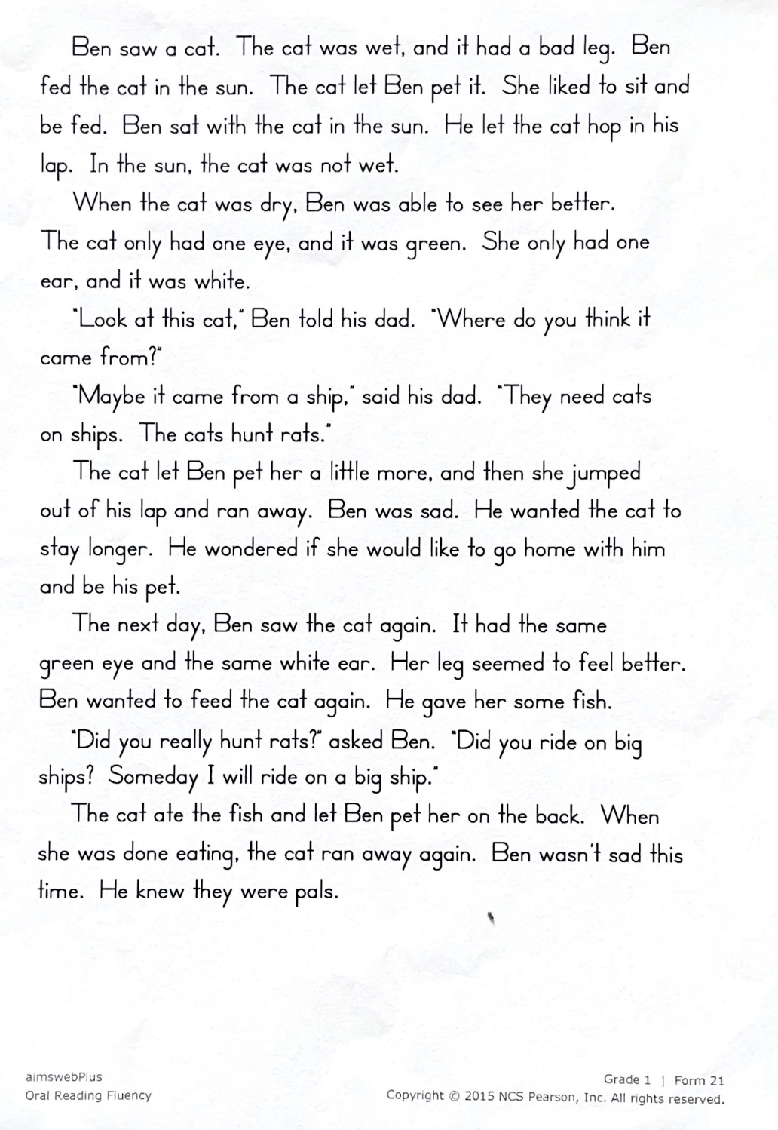
Appendix B
Benchmark Advance Fluency Quick Check Passages
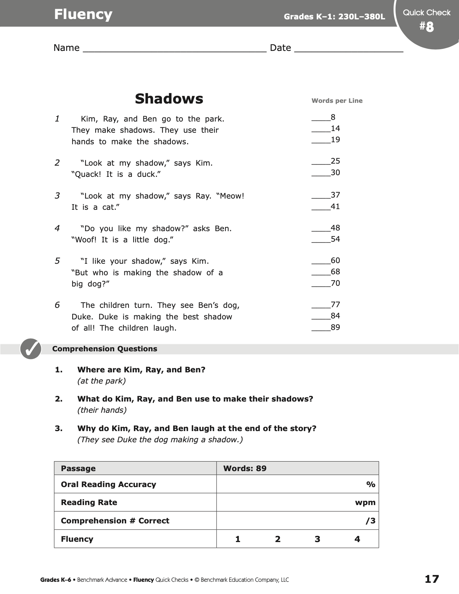
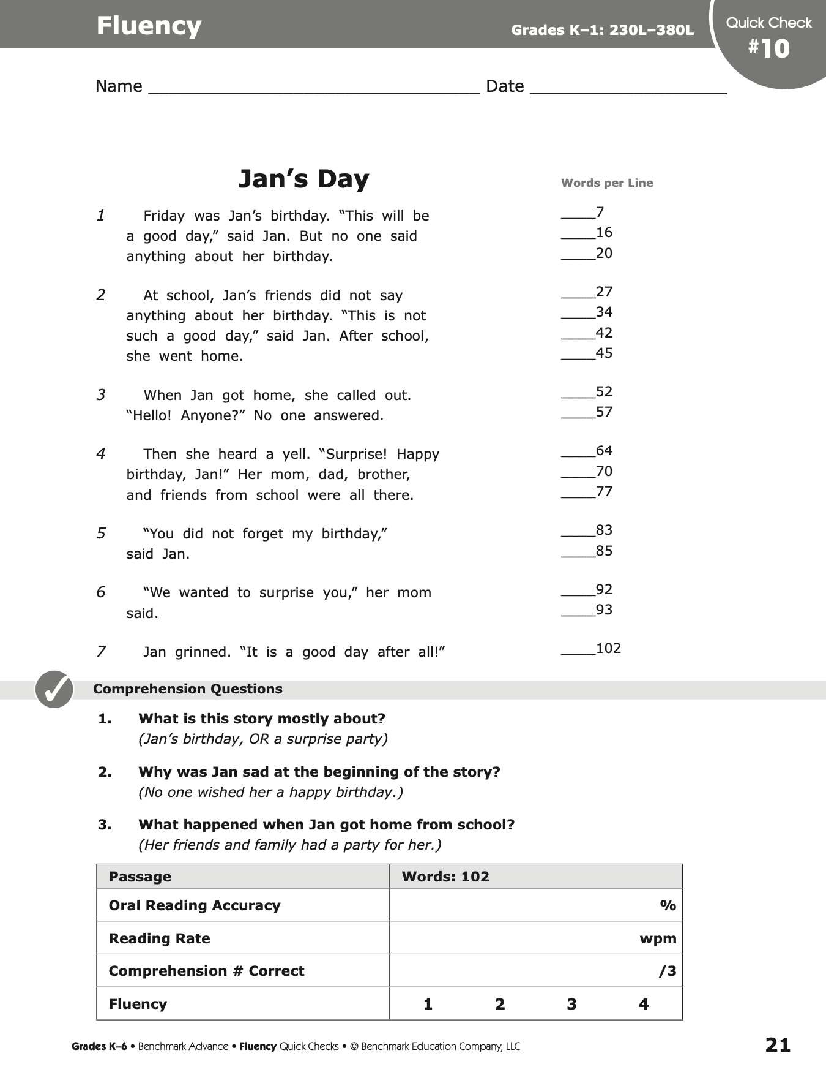

Appendix C
NAEP Oral Reading Prosody Rubric
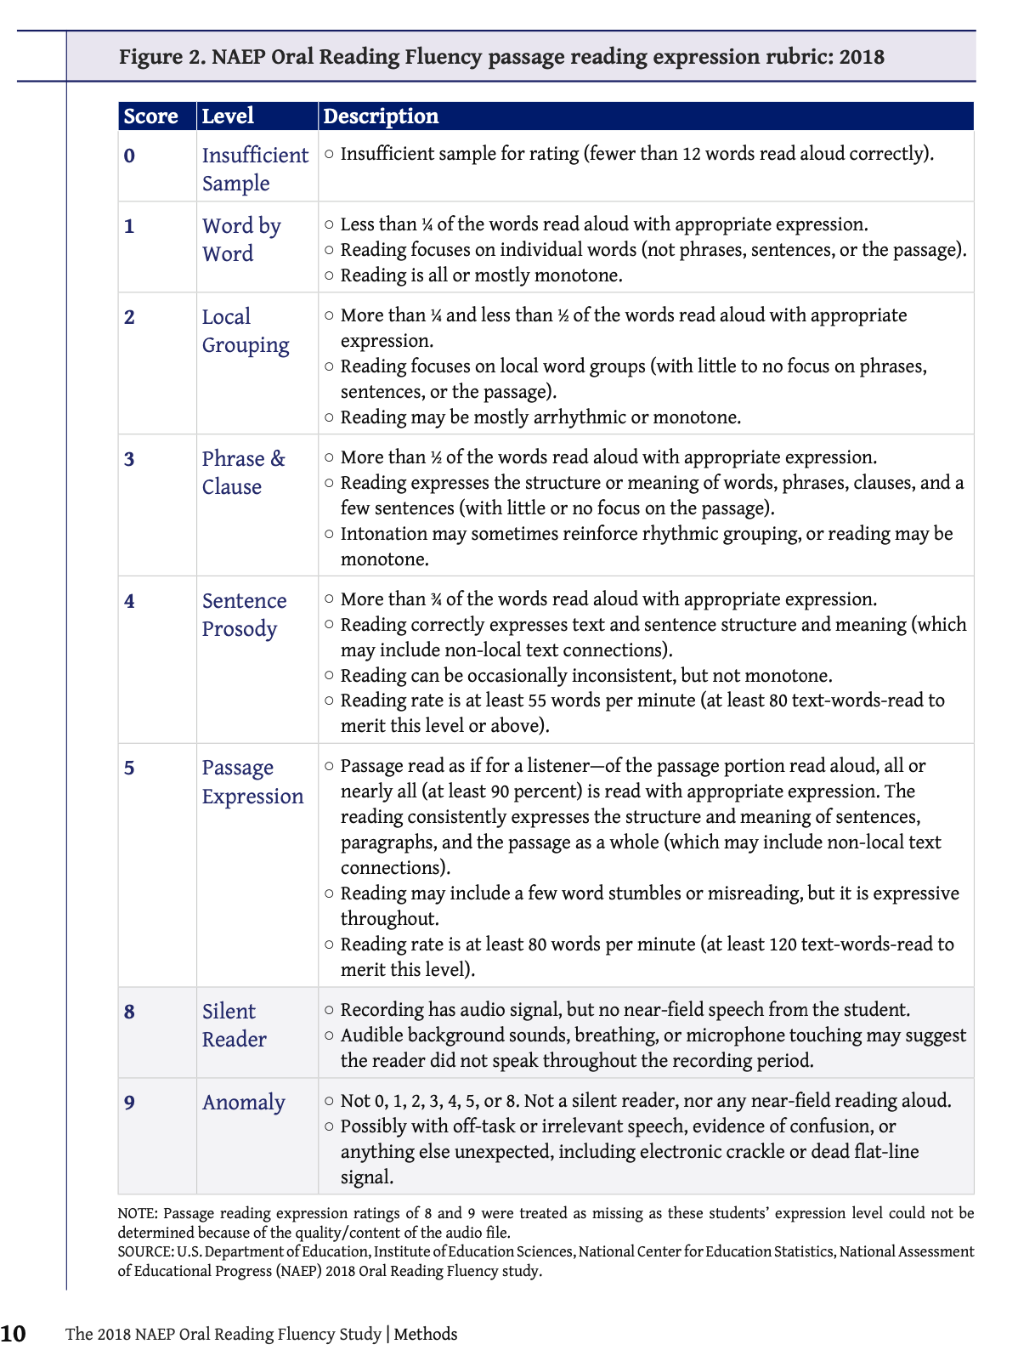
Appendix D
Retelling Checklists
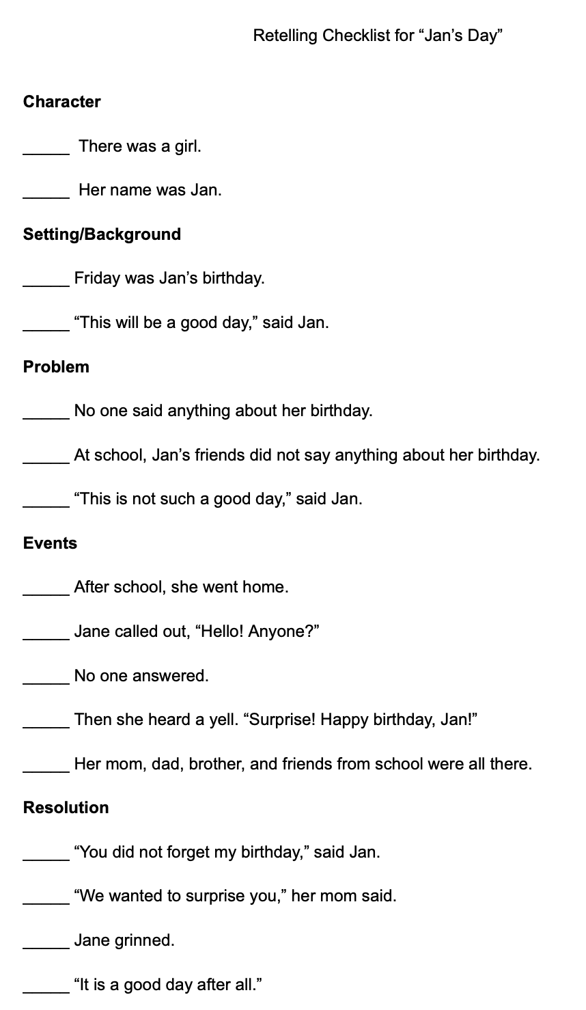
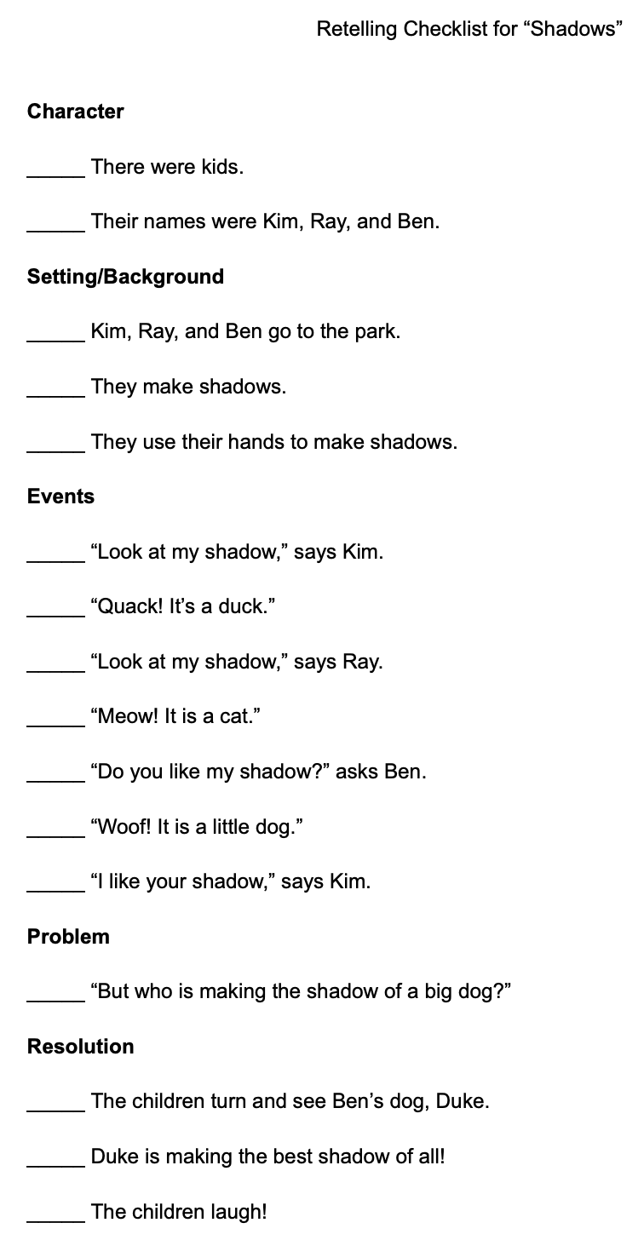
Vita
Allison Murray was born and grew up in Knoxville, TN. She graduated from the University of Tennessee, Knoxville with a Bachelor of Arts in Psychology with minors in Elementary Education and Business Administration, then obtained a Master of Science degree in Elementary Teaching from the University of Tennessee, Knoxville. She most recently obtained a Literacy Specialist certificate from the University of Tennessee, Knoxville and a Specialist in Education degree in Literacy Education from the University of Tennessee, Knoxville. Allison has been a first grade teacher for the past six years.

