Effects of climate, depth, and exposure history on the degradation of biodegradable plastic mulch fragments in soil under field-relevant conditions

A Dissertation Presented for the

Doctor of Philosophy

Degree

The University of Tennessee, Knoxville

Alexis Gillmore

December 2024
ACKNOWLEDGEMENTS
I am very grateful to everyone who has helped me over the course of this degree. A PhD was a task I undertook lightly, and I can confidently say I would not have completed it without the significant support I received from all corners. There are many people to whom I owe thanks, and not all of them are mentioned here.
Academically and scientifically, I could not have completed my dissertation without the help and guidance of my committee members: Prof. Sean Schaeffer, Prof. Seeta Sistla, Prof. Doug Hayes and Prof. Joe Zhuang. Thank you, Dr. Schaeffer, for your guidance and advise in my work, as well as your curiosity. Thank you, Dr. Sistla, for your support and encouragement, as well as the opportunity to visit and work on the Central Coast. My studies were very much enriched because I was able to see the soils, climates, agricultural systems, and resources that make California one of the most agriculturally productive regions of the planet – and a major user of plastic mulch films. Thank you, Dr. Hayes, for helping me to connect with resources and researchers studying biodegradable plastics mulches, especially your and your students’ work on previous biodegradable plastic mulch projects. I could not have set up the PBAT quantification method that enabled my other research projects without your help. Thank you, Dr. Zhuang, for encouraging me throughout my PhD to do high-quality research toward answering impactful scientific questions. Whenever we talk, you encourage me to be the best possible scientist.
Thank you very much to Prof. Keith Stanfill, for mentoring me and supporting me as a teacher. You provided tremendous trust and encouragement which motivated me to do excellent work in teaching as well as to continue in my graduate studies. I’m extremely proud of the work we did together during my time in UTK ISD – which few graduate teaching assistants get to enjoy – and very grateful to continue to call you a colleague after my graduation.
Thank you also to Prof. Courtney Faber. As a role model and a collaborator, you provided essential help for me to develop my identity and confidence as a researcher. Thank you for inviting me to join your lab, and for sticking with me even when you moved to Buffalo. I’m also very grateful that I can call you a colleague in my new work after graduation.
I also want to share a large thanks with my family: my partner Madison and my parents Cheryl and Bryan. Thank you each for being an external support I could fuss, complain, and cry to when things were difficult during this degree. I am sure you are quite relieved that I’ve finally finished!
A great thanks to my fellow grad students and supportive peers in the Schaeffer lab: Shannon Newell, Kara Grosso, Cori Martin, Ning Duan, Morgan Issacs – and at the last minute, Jacob Clements – as well as to my adoptive labmates in the Faber lab: Lorna Treffert, Isabel Boyd, and Chulin Chen. Each of you supported me by your knowledge, your example, your camaraderie, and your direct assistance in my work. Thank you as well to the UTK chapter of the United Campus Workers and the UTK Graduate Student Senate, whose members worked tirelessly on top of already tiring responsibilities to advocate for – and win – better working and learning conditions for graduate students at The University of Tennessee.
I also owe thanks to many researchers and educators at UT and beyond who helped me progress in my research, whether it had anything to do with their job duties or not. Thank you to Dr. Calos Steren, Rebecca Bergee, Dr. Anton Astner, Dr. Stacy Taylor, Kyle Brown, Gemma Forshaw, Sophie Ortiz, Anna Cardwell and Will Hatcher. Anna and Will, I’m excited to graduate with you and see your promising next steps as soil scientists. And a special thanks to Matt Nalepa for always opening the door to Bueler 216 for me when I needed it.
Lastly, I would like to thank Prof. Alex Hessler and Prof. Ryan Stewart, for helping me develop my interest in soil science as an undergraduate and to Drs. Jesse Radolinski, Ayush Gyawali, and Jingjing Chen for each serving as excellent PhD student role models while I learned to work with them at Virginia Tech. Go Hokies!
ABSTRACT
Biodegradable plastic mulches are a promising alternative to manage the plastic waste produced by the use of agricultural mulches. Biodegradable plastic mulches are designed to biodegrade in the fields where they are used, turning into carbon dioxide and microbial biomass. This would reduce labor and costs associated with waste management and prevent environmental contamination by plastic waste. Existing biodegradable plastic mulches are certified as biodegradable based on laboratory testing in conditions that are quite different from field degrading conditions. In order for biodegradable plastic mulches to be a viable alternative to conventional materials, the mulches must completely biodegrade in field conditions without negative impacts on the agroecosystem. I investigated how one biodegradable plastic mulch product fragmented under field conditions in two field sites with distinct climates. I also investigated the capacity of microplastics and nanoplastics derived from the biodegradable plastic mulch to degrade in field-like conditions and in subsurface soil and how soil biodegradation might respond to repeated addition of this biodegradable plastic mulch. To complete these investigations, I developed a method to quantify microplastics and nanoplastics composed of the biodegradable polymer polybutylene adipate co-terephthalate, the main constituent of the mulch I studied, using nuclear magnetic resonance spectroscopy. Under field conditions in Knoxville, Tennessee and San Luis Obispo, California, plastic mulches fragmented into microplastics within 6 months of burial, but total soil plastic did not decrease over 18 months of burial near the soil surface. In laboratory incubations, microplastics and nanoplastics did not significantly biodegrade over 9 months in a Typic Hapludult loam (Shady series, Knoxville, TN) at 20 degrees Celsius, nor in a Pachic Argixeroll (Elkhorn series, Prunedale, CA) over 6 months at the same temperature. The microplastics I tested may degrade 10 percent more quickly in soil that has been previously exposed to biodegradable plastic compared to similar soil that has not. Long-term studies of biodegradable plastic mulches are needed to assess the complete biodegradation of the materials especially the residence time and behaviors of micro- and nanoplastics. Because of the slow degradation I observed at two field locations and at field-relevant temperatures in laboratory incubations, I suggest that these products need further development before they are suitable for repeated use in agricultural production systems under the studied conditions. The presence of large plastic fragments and microplastics in the soil, even if temporary, could have negative effects on agricultural productivity and unknown effects on agroecosystems.

TABLE OF CONTENTS
Introduction 1
Conventional plastic mulching 2
Biodegradable plastic mulch 5
Biodegradation 8
Knowledge gaps and needs 11
Research Questions 15
Objectives 16
Approach 17
Appendix 20
Chapter I Quantification of polybutylene adipate terephthalate (PBAT)-based micro- and nanoplastics from soil using proton nuclear magnetic resonance spectroscopy 25
Abstract 26
Introduction 27
Protocol 31
Representative results 43
Discussion 47
Appendix 53
Chapter II Fragmentation of biodegradable plastic mulch at two depths in two contrasting climates 68
Abstract 69
Introduction 70
Methods 72
Sites 72
Plastic additions 72
Moisture and temperature sensors 73
Soil sampling 74
Soil plastic analyses 75
Soil core analyses 76
Mesh bag retrieval and plastic analyses 76
Statistical analysis 77
Results 78
Climate data 78
Soil properties 79
Biodegradable plastic from mesh bags 80
Biodegradable plastic recovered from soil 81
Discussion 82
Conclusion 86
Appendix 87
Chapter III Degradation of biodegradable PBAT micro- or nanoplastic in surface or subsurface soils during 9-month incubation 98
Abstract 99
Introduction 99
Methods 102
Soils 102
Plastic material 103
Incubation set-up 104
Respiration measurements 105
Destructive sampling and post-processing 106
PBAT quantification by QNMR 106
Calculating potential additive remaining based on respiration 107
Analysis of variance 108
Results 109
Cumulative respiration 109
Additive remaining estimated by respiration data 110
PBAT quantified by NMR 111
Extractable organic carbon and microbial biomass carbon 111
Discussion 112
Conclusion 117
Appendix 119
Chapter IV Homefield advantage in soil degradation of a biodegradable polybutylene adipate terephthalate Mulch microplastic 128
Abstract 129
Introduction 131
Methods 135
Soils 135
Plastic material 136
Incubation set-up 136
CO₂ mineralization measurements 137
Respiration gas carbon isotope analysis 138
Post-processing 138
PBAT quantification by QNMR 139
Calculating potential plastic remaining based on CO₂ mineralization 139
Extrapolating degradation rates 140
Calculating homefield advantage 141
Statistical analysis 142
Results 143
Cumulative CO₂ mineralization 143
Plastic remaining estimated by CO₂ mineralization 144
PBAT quantified by NMR 144
Carbon Isotope ratios and discrimination 145
Homefield advantage calculations 145
Extractable organic carbon and microbial biomass carbon 146
Discussion 146
Water content 147
Plastic degradation 149
Homefield advantage 152
Conclusion 154
Appendix 156
Conclusion 170
References 176
Vita 211

LIST OF TABLES
Table 1. Summary of selected PBAT BDM field trial fragmentation results 23
Table 2. Selected impacts of PBAT BDM MPs observed in agroecosystems 24
Table 3. ¹H-NMR spectral peaks of polybutylene adipate terephthalate (PBAT) in deuterated chloroform solvent. The hydrogens attributed to each peak are labelled in Figure 6. Peak assignments are based on Herrera et al. (2002). 63
Table 4. ¹H-NMR peaks of 1,4-dimethoxybenzene (DMB) in deuterated chloroform solvent. The hydrogens attributed to each peak are labelled in Figure 6, panel B. Peak assignments are based on Nelson et al. (2020). 64
Table 5. Properties of the three soils which were used to demonstrate the PBAT extraction method. 65
Table 6. List of materials 66
Table 7. Experimental site details 97
Table 8. Biomass recovered from each site during sampling 97
Table 9. Estimated additive remaining over time in each soil. Intervals represent a 95% confidence interval. 127
Table 10. Mean carbon produced in each incubation treatment 168
Table 11. Estimated PBAT plastic residence time and degradation rate based on bootstrapped mean degradation estimates during the incubation 169
Table 12. Estimated PBAT plastic residence time and degradation rate based on maximum degradation estimates during the incubation (upper bound of 95% confidence interval) 169
LIST OF FIGURES
Figure 1. Plastic mulch films used in pepper cultivation at Virginia Tech’s Homefield Farm in 2019. Photo by Alex Hessler. 21
Figure 2. Chemical structure of polybutylene adipate terephthalate. Image from Wikipedia By DGH91 CC BY-SA 3.0. 22
Figure 3. Chemical structure of polyethylene. Image from Wikipedia By Template:Av, Public Domain. 22
Figure 4. Visual overview of the polybutylene adipate terephthalate (PBAT) extraction and quantification procedure. 54
Figure 5. ¹H-NMR spectrum collected in deuterated chloroform solvent with a 500 MHz spectrometer on an extract from a Shady loam soil with polybutylene adipate terephthalate (PBAT) MPs added. 1,4-Dimethoxybenzene (DMB) was added to the extract as an internal calibrant. 55
Figure 6. Structures of polybutylene adipate terephthalate (PBAT) and 1,4-dimethoxybenzene (DMB) with labelled protons corresponding with Tables 1 and 2. A) structure of one BA-BT unit of PBAT. B) structure of T-B-T, T-B-A, and A-B-A triads from PBAT. 56
Figure 7. ¹H-NMR spectrum collected in deuterated chloroform solvent with a 500 MHz spectrometer on an extract of a Shady loam with no PBAT polymer present. PBAT characteristic peaks are not present, while DMB (added as an internal calibrant) peaks are. 57
Figure 8. Fitted region of the deuterated chloroform solvent ¹H-NMR spectrum shown in Figure 5. The green background shows the region of the spectrum that was fit. Purple lines show the fitted peaks while red lines show the error (portions of the spectrum signal not included in fitted peaks). PBAT peaks 5, 6, 6’, 3’, and 3 are included in the fit along with DMB peaks A and B. 58
Figure 9. ¹H-NMR spectra in deuterated chloroform solvent collected with a 500 MHz spectrometer on an extract of an Elkhorn sandy loam with PBAT MPs added. Both PBAT and DMB characteristic peaks are present in the spectrum. A) PBAT peaks cannot be distinguished to quantify the polymer. If sample extracts produce spectra like this, they should be diluted, then used to collect a new ¹H-NMR spectrum. B) The same extract diluted so that all spectral peaks are clearly resolved. 59
Figure 10. PBAT concentrations measured by 1H-QNMR in extracts in deuterated chloroform solvent from a Shady loam soil, a Los Osos loam, and an Elkhorn sandy loam containing known amounts of PBAT. 60
Figure 11. Extraction efficiency of PBAT MPs and NPs from spiked samples in a Shady loam soil. PBAT recovery is significantly lower for NPs (p = 0.0002). 61
Figure 12. Plastic content of two Elkhorn soils measured with two methods as part of a laboratory incubation. Black squares refer to experimental treatments that had been previously exposed to a PBAT plastic before the experiment. Grey triangles refer to treatments of the same soil from the same site which had no history of exposure to PBAT. The two large shapes indicate the mean plastic content of each treatment based on soil respiration produced during the experiment and the error bars show a bootstrapped 95% confidence interval for the plastic content. The small shapes indicate the plastic content of each experimental unit measured by QNMR according to the method described in this manuscript. There is no significant difference between plastic content estimated by respiration or measured by NMR or either treatment (p > 0.05). 62
Figure 13. Soil temperature and moisture during the experiment at each site, plot, and depth. I) Daily average soil temperature at the Knoxville, Tennessee site. II) daily average soil temperature at the San Luis Obispo, California site. III) Daily average soil volumetric water content at the Knoxville, Tennessee site. IV) Daily average soil volumetric water content at the San Luis Obispo, California site. For each site, temperature and moisture were measured in plastic and no-plastic plots at both 5 cm and 25 cm depth. Black vertical lines show the dates when mesh bags containing biodegradable plastic mulch were removed from the field. 88
Figure 14. Weather station data from Knoxville, Tennessee and San Luis Obispo, California during the experiment. I) Daily average air temperature in Knoxville. II) Daily average air temperature in San Luis Obispo. III) Accumulated thermal time in Knoxville. IV) Accumulated thermal time in San Luis Obispo. V) Daily precipitation in Knoxville. VI) Daily precipitation in San Luis Obispo. VII) Cumulative precipitation in Knoxville. VIII) Cumulative precipitation in San Luis Obispo. 89
Figure 15. Soil temperature data from a weather station at the University of Tennessee East Tennessee Research and Education Center Plant Science Unit in Knoxville, Tennessee. I) Daily average soil temperature at 10 cm below the soil surface. II) Accumulated thermal time in the soil. 90
Figure 16. Soil respiration (surface CO₂ flux) measured at each plot at each sampling time. P indicates plastic-added plots while NP indicates no plastic plots (n=4 for each group). Comparison p-values are reported for the two P-NP pairs that showed significant differences in post-hoc contrast tests. For all other pairs, p>0.05. 91
Figure 17. Soil saturated hydraulic conductivity (K_{sat}) measured on collected soil cores at each sampling time. Distinct letters represent groups where K_{sat} was significantly different based on pairwise comparisons with Sidak adjusted p-values (α=0.05). Shared letters represent groups where K_{sat} was not found to be significantly different. 91
Figure 18. Soil bulk density measured on soil cores at each sampling time. Distinct letters represent groups where density was significantly different based on pairwise comparisons with Sidak adjusted p-values (α=0.05). Shared letters represent groups where density was not found to be significantly different. 92
Figure 19. Mass and surface area of plastic buried in mesh bags over time by treatment. Points represent the mean of each group and bars represent one standard error of the mean (n=3 in each group). Distinct letters represent groups where mass or surface area was significantly different based on pairwise comparisons with Sidak adjusted p-values (α=0.05). Shared letters represent groups where mass or surface area was not found to be significantly different. 93
Figure 20. The form of plastic recovered from buried mesh bags over time reported as fraction of initial mass. Results are grouped by the burial site (Knoxville or San Luis Obispo) and burial depth (5 or 25 cm). Error bars represent one standard error deviation from the mean (n=3 for each group). 94
Figure 21. Images of biodegradable mulch film recovered after burial in mesh bags 95
Figure 22. Plastic recovered from soil samples over time reported as the parts per million concentration of plastic on a log scale. SLO refers to the San Luis Obispo site and Knox refers to the Knoxville site. Bar heights represent the mean measured concentration and bars represent one standard error of the mean (n=5 for each bar). 96
Figure 23. Biodegradable plastic residue in soil. i) Biodegradable plastic fragments in soil 18-months after plastic mulch was tilled into soil in San Luis Obispo, California. Soil was fallowed after biodegradable plastic mulch fragments were incorporated. ii) Biodegradable plastic mulch 2 years after it was applied to strawberry beds in Watsonville, California. 120
Figure 24. Cumulative CO₂ production over time in each soil for the duration of the incubation. Marker shapes and colors represent different additive treatments: red circles are data from mesocosms with MCC added; green triangles are from mesocosm with MPs added; blue squares are from mesocosms with NPs added and purple crosses are from mesocosms with no additive. 121
Figure 25. Log response ratio of cumulative respiration at three points in a 9-month incubation compared by soil horizon and additive. Response ratios are the ratio of respiration produced in that treatment to respiration produced in the same soil with no additive. Additives are microcrystalline cellulose (MCC), biodegradable microplastic (MP) and biodegradable nanoplastic (NP). Error bars represent bootstrapped 95% confidence intervals of the mean estimate. Stars indicate confidence intervals which do not overlap with zero. 122
Figure 26. Estimated plastic content over the duration of the incubation based on differential respiration measurements between additive treatments and no additive treatments in each soil. Error bars represent bootstrapped estimates of one standard deviation of the population mean. Additives are microcrystalline cellulose (MCC), biodegradable microplastic (MP) and biodegradable nanoplastic (NP). 123
Figure 27. PBAT polymer content in soil measured during the incubation. There was no significant effect of time or plastic additive on measured PBAT content, though there was a significant effect of soil, where more PBAT was recovered from Ap soil than from Bt soil. At no time for no treatment was PBAT content significantly different than the initial added concentration of 230 mg/kg dry soil based on a set of one-way t-tests (p > 0.1 for all tests). 124
Figure 28. Extractable organic carbon measured in mesocosms i) over time and ii) for each soil horizon. i) Extractable organic carbon content is higher at days 195 and 276 than at days 0 or 96 based on mean separations at α = 0.05. ii) Extractable organic carbon content is higher in Ap horizon soil than in Bt soil. Neither soil is significantly different from AB soil based on mean separations at α = 0.05. 125
Figure 29. Microbial biomass carbon of experimental mesocosms shown by soil horizon over time (i) and by additive type in each soil (ii). i) A soils were collected from 0-5 cm below the soil surface, AB soils were collected from 15-20 cm below soil surface, and Bt soils were collected from 30-35 cm below soil surface. Error bars represent one standard error above and below the estimated mean. Uppercase letters (A, B) show groupings within one soil horizon treatment over time at the α = 0.05 level. Lowercase letters (a, ab, b) show groupings withing one time point for all three soils at the α = 0.05 level. ii) Microbial biomass carbon of experimental mesocosms shown by additive in each soil. Additives are microplastic (MP), nanoplastic (NP), or no additive (null). Error bars represent one standard error above and below the estimated mean. Uppercase letters (A, B) show groupings within one soil between additive treatments at the α = 0.05 level. Lowercase letters (a, b) show groupings between soil treatments within each additive treatment at the α = 0.05 level. 126
Figure 30. Cumulative carbon dioxide (CO₂) mineralization at the end of a 190-day incubation compared by BDM exposure history. On BDM-exposed soil, PBAT-based BDM was used in strawberry production for two years. On BDM-unexposed soil, a conventional polyethylene-based plastic mulch was used. BDM-exposed soil mineralized more CO₂ than BDM-unexposed soil (p = 0.015). Letter groupings reflect mean separation at the a = 0.05 level. 157
Figure 31. Mean cumulative respiration in each incubation treatment over time. Bars represent one standard error. 158
Figure 32. Final cumulative respiration produced during the incubation. This figure separates experimental units based on the interaction of soil history and PBAT addition. There was no significant effect of this interaction term on the cumulative respiration based on ANOVA. 159
Figure 33. Estimated plastic content over the duration of the incubation based on differential CO₂ mineralization between MP-added and no MP-added treatments. On BDM-exposed soil, polybutylene adipate terephthalate (PBAT) biodegradable plastic mulch was used in strawberry production for two years. On BDM-unexposed soil, a conventional polyethylene-based plastic mulch was used. Error bars represent bootstrapped estimates of one standard deviation of the population mean. There are no significant differences in estimated plastic content over the course of the incubation. 160
Figure 34. Estimated PBAT remaining in mesocosms after 190-day incubation based on NMR quantification of PBAT in soil samples. On BDM-exposed soil, polybutylene adipate terephthalate (PBAT) biodegradable plastic mulch was used in strawberry production for two years. On PBAT-unexposed soil, a conventional polyethylene-based plastic mulch was used. There is no significant difference in measured PBAT content between the two soils (p = 0.4). 161
Figure 35. Carbon-13 isotope ratio of respired carbon dioxide from mesocosms. Isotope ratios are separated by measurement time, soil history and PBAT addition. Letter groupings reflect significant differences at the α=0.05 level (no significant differences between any groups). 162
Figure 36. Carbon-13 isotope ratio discrimination between respiration gas and soil organic carbon. Negative values for the discrimination, Δ¹³C, indicate that respired CO₂ had a more negative δ¹³C_{vpdb} than bulk soil organic carbon. Letters groupings reflect significant differences at the p = 0.05 level. On BDM-exposed soil, polybutylene adipate terephthalate (PBAT) biodegradable plastic mulch was used in strawberry production for two years. On BDM-unexposed soil, a conventional polyethylene-based plastic mulch was used. 163
Figure 37. Carbon-13 isotope ratio discrimination between respired carbon dioxide from mesocosms and bulk soil carbon. Isotope ratios are separated by measurement time, soil history and PBAT addition. Letter groupings reflect significant differences at the α=0.05 level. 164
Figure 38. Homefield advantage index at each CO₂ mineralization measurement time. The homefield advantage index is the ratio of additional CO₂ mineralization when PBAT microplastic is added to soil between BDM-exposed and BDM-unexposed mesocosms. On BDM-exposed soil, polybutylene adipate terephthalate (PBAT) biodegradable plastic mulch was used in strawberry production for two years. On BDM-unexposed soil, a conventional polyethylene-based plastic mulch was used. A positive homefield advantage index indicates greater mineralization of added PBAT MPs in the PBAT-exposed soil. Points represent mean estimates and error bars represent bootstrapped 95% confidence intervals of the mean estimate. 165
Figure 39. Soil extractable organic carbon by treatment. No significant difference between treatments at α = 0.05. On BDM-exposed soil, polybutylene adipate terephthalate (PBAT) biodegradable plastic mulch was used in strawberry production for two years. On BDM-unexposed soil, a conventional polyethylene-based plastic mulch was used. Add the start of the incubation, PBAT-based BDM microplastics were added to MP-added treatments, while no microplastic was added to no MP-added treatments. Letter groupings reflect significant differences at the α=0.05 level (no significant differences between treatment groups). 166
Figure 40. Microbial biomass carbon recovered from soil in each mesocosm at the end of the 6-month incubation. Results are separated based on BDM exposure history and BDM MP addition treatments. Letter groupings reflect significant differences at the α=0.05 level; there were no significant differences in microbial biomass between treatments. 167

Introduction

Biodegradable plastic mulches have been proposed as a beneficial replacement for conventional plastic mulch products because of their potential benefits for agricultural producers and the environment. However, these biodegradable materials may not function as intended in agricultural ecosystems and could lead to negative outcomes for both producers and environment. Potential users need more information about the environmental behavior of biodegradable plastic mulch products before they can confidently choose to use the materials in their own production systems.

Conventional plastic mulching
Plastic mulches are thin sheets of plastic that are used to cover a shaped bed of soil, then crops are transplanted into holes in the plastic mulch as shown in Figure 1 (all introduction figures are located in an appendix at the end of the introduction section). These mulches are commonly used in the production of specialty vegetable crops because they provide a variety of benefits including weed control, increased crop yield or quality, increased soil temperature (leading to decreased time until harvest), water conservation and erosion prevention (Lamont, 1993; Espí et al., 2006; Scarascia-Mugnozza et al., 2012). More than 15 million metric tons of plastic are used globally in agriculture each year, much of it mulch films (Plastics Europe, 2022), because of the significant benefits they can provide. Plastic mulches are most commonly used with high value crops like tomatoes, cucumbers, and strawberries (Tarara, 2000). Among surveyed Tennessee fruit and vegetable farmers, about 60% use plastic mulches on their farms (Velandia et al., 2020). Plastic mulches are typically removed and replaced with each crop planting, between 1-3 times per year depending on the cropping system (Beriot et al., 2023).
Plastic mulches might be chosen over other means of mulching because they provide greater benefits than other weed suppression alternatives (paper mulch, straw or other plant litter, cultivation, herbicides) in a wide variety of production systems (Mugalla et al., 1996; Nachimuthu et al., 2017) if mechanized equipment is available to assist in laying and removing the plastic mulch (Schonbeck, 1999). Plastic provides consistent benefits throughout a growing season, compared to paper mulches which disintegrate during use (Li et al., 2014b). Conventional plastic mulches are typically made from polyethylene (PE), one of the most common globally produced polymers (Plastics Europe, 2022). PE plastic is desirable as a mulch because it is lightweight, machinable, flexible, and durable; low-density polyethylene (LDPE), linear low-density polyethylene (LLDPE) and their blends can be formed into thin films suitable for making plastic mulches (Yilmazer, 1991). Compared to mulch materials produced on farm like crop residue plastic mulch may be more expensive, but it can be cheaper than straw sourced from off-farm or paper mulch due in part it its lighter weight (Brown et al., 2018; Marí et al., 2019).
After crops are harvested, mulch films must be removed from the field and disposed of. To manage plastic waste, films are often landfilled or incinerated at the end of their useful lives. These disposal methods require additional expense and labor (in the form of off-site transportation) from farmers. The infrastructure to clean and recycle plastic mulch films is uncommon because the mulches require intensive cleaning to remove adhered soil if they are to be processed for recycling (Briassoulis et al., 2013; Shah and Wu, 2020; Dong et al., 2022). When improperly disposed of, used plastic mulch fragments can contaminate environmental soil and water (Hahladakis et al., 2018; Hahladakis, 2020; Madrid et al., 2022). Even when proper disposal is attempted, it can be difficult to fully remove fragments of plastic mulch from the soil where they are used (Liu et al., 2014).
Despite the production of plastic waste, crop production systems that use plastic mulch provide significant economic benefits compared to systems that do not use plastic. Using plastic mulches in mechanized production systems requires an initial startup cost for equipment to lay and recover the mulch plus additional seasonal purchases of new plastic mulch film (Mugalla et al., 1996). Increased income can come from increased crop yield and increased crop quality (Mugalla et al., 1996; Nachimuthu et al., 2017; Ghimire et al., 2021; Hao et al., 2024). Decreased costs could come from decreased labor needs for weeding and decreased irrigation needs (Schonbeck, 1999), although additional labor required to recover plastic mulches could negate those labor savings (Schonbeck, 1999; Velandia et al., 2020). In some vegetable production systems, plastic mulching leads to harvests that are 1-3 weeks earlier than without mulch and yields that are 2-3 times higher (Lamont, 1993), providing a strong economic incentive for growers to use plastic mulches (Nachimuthu et al., 2017).
In addition to difficulties managing plastic waste, conventional plastic mulch products also do not fit well into a circular economy framework for agricultural development. The circular economy framework is a sustainable design approach intended eliminate waste. In a circular economy materials are continuously conserved, reused and repurposed to create closed loop material flows, unlike a traditional linear system where products are manufactured, used and then discarded (Ellen MacArthur Foundation, 2012). Creating a circular economy is essential for continued human development within the finite resources afforded by the Earth and is also a key strategy to minimize and mitigate the impacts of climate change (Ellen MacArthur Foundation, 2021). Product circularity refers to what extent a given product lifecycle accomplishes the goal of continuous material cycling with minimal inputs and waste. Conventional plastic mulches are designed to be used for a relatively short time (less than one year), while the plastic material will persist as waste for much longer periods (Chamas et al., 2020). From a circular economy perspective, this is wasteful of the material resources and embedded energy required to make these products. More circular product design would favor using renewable product feedstocks, keeping products in use for the longest possible amount of time, and maintaining them at the highest level of quality possible during their life. For plastic mulches, product circularity would be increased by systems like compostable plant-based mulch, recyclable plastic mulch, or durable plastic landscape fabrics that can be reused for many growing seasons.

Biodegradable plastic mulch
Biodegradable plastic mulches are a promising alternative to conventional products because the biodegradable mulches can be metabolized by microbes into biomass and carbon dioxide as they decompose. Biodegradable mulches are designed to decompose in soil in the same fields where they are used to grow crops. This model would all mulches to be tilled into fields at the end of a growing season, eliminating the need for other forms of plastic waste disposal and the risk of environmental contamination. These products aim to reduce labor requirements compared to conventional plastic mulches which must be removed from the field after their use.
In order for users of plastic mulch to benefit from biodegradable products compared to conventional mulches, the BDMs should improve the cost-to-benefit ratio of the user’s production system. BDMs are expected to provide cost savings in the form of labor reduction (Velandia et al., 2019), and may improve the net profitability of operations compared to conventional material (Marí et al., 2019; Velandia et al., 2019; Abduwaiti et al., 2021). If BDMs do provide cost savings or increase income for producers, then they could be a valuable addition to a cropping system, even if they cost more than conventional materials. Indeed, some farmers and crop advisors might be willing to pay a premium price for biodegradable plastic mulch compared to the conventional if it results in less plastic residue in soil, increases soil health, or allows crops to be sold for a premium price (Chen et al., 2020). However, many BDMs currently retail for almost double the price of conventional plastic mulches (Marí et al., 2019; Velandia et al., 2019; Abduwaiti et al., 2021) – although some may be available for only 20% more than conventional PE mulch (Marí et al., 2019). Additionally, the labor-saving benefits of BDMs can only be realized if the plastics are tilled into the field soil and biodegrade there. Surveyed farmers and crop advisors have indicated that they would be less willing to pay for BDM that results in plastic residues in soil at the end of a growing season (Chen et al., 2020) and plastic mulch users recruited to field trial BDMs are hesitant leave the materials in the field (Sistla, personal communication). If plastics are removed from the soil where they are used, their use is likely to increase labor costs rather than decrease them. However, if BDMs function as designed, they can provide a valuable tool to reduce plastic waste disposal problems because they are relatively simple to adopt into conventional production systems.
BDMs can play a role in adapting agricultural plastic use toward a circular economy model. Instead of laboriously removing and landfilling plastic waste for long-term storage, BDMs are designed to be transformed into renewable resources – carbon dioxide, water and microbial biomass. For biodegradable plastics derived from petroleum, this only represents a waste-management strategy in a linear product life. But for bio-based biodegradable plastics, which are manufactured from renewable organic feedstocks, biodegradation can be used to create a cyclical product life, where the products of BDM biodegradation are used to regenerate the feedstocks used to produce new material. However, from a circular economy perspective, biodegradation is one of the least desirable circular outcomes for a material, because it turns a relatively high-value and high-embedded energy product into a low-value one with low embedded energy. Reusable, repairable, or recyclable plastic mulch products might provide more benefit in reducing manufacturing and purchasing costs while avoiding waste. However, any other solutions that improve product circularity represent larger changes from the status quo compared to BDMs so they can be expected to face their own challenges with large-scale adoption. For instance, recyclable plastic mulch would require plastic cleaning and recycling infrastructure. Comparatively, BDMs do not require off-farm investment or technology.

Biodegradation
To understand how biodegradable plastic mulches work, it is important to understand their composition. Biodegradable plastics are made from biodegradable polymers. Compared to non-biodegradable polymers, these materials have more chemically reactive organic linkages like polyester bonds, which can be broken by microbes as a source of energy (Zumstein et al., 2018). Soil microbes use the same extracellular enzymes and metabolic processes to biodegrade organic polymers like lignin or cellulose as they do synthetic biodegradable polymers (Zumstein et al., 2018). The most common biodegradable polymers are polyesters (Hayes et al., 2019), one of the most widely used is polybutylene adipate terephthalate (PBAT). This polymer is a block polyester with a random combination of butylene adipate and butylene terephthalate diacid dimers. The adipate and butylene groups are aliphatic (linear organic molecules) while the terephthalate group is aromatic (containing of a carbon ring). Their structural differences make the aliphatic adipate group more accessible to biochemical degradation while the aromatic terephthalate is more difficult to break apart. The two monomers are combined to create a polymer that has the desired balance of durability for its intended use, while still being quickly degraded at the end of its useful life (Hayes et al., 2019). A structural representation of PBAT is shown in Figure 2. In contrast to this biodegradable polyester, polyethylene - a conventional plastic mulch polymer – is shown in Figure 3. The polyethylene polymer does not have ester bonds or any reactive functional groups that can be chemically altered to gain energy, which makes it much more inert in the presence of microbial enzymes.
Biodegradable polymers are commonly blended with additives to achieve the desired material properties and cost. Thermoplastic starch is a common additive in biodegradable plastic mulches to increase the degradation rate of the products (Kasirajan and Ngouajio, 2012; Hayes et al., 2019). Other common plastic mulch additives include antioxidants, dyes, plasticizers, stabilizers, lubricants, and fillers (Hayes et al., 2019).
Biodegradable plastic mulch degradation can occur via three main routes: photodegradation, chemical degradation, and biodegradation. Photodegradation is caused by solar ultraviolet radiation. This radiation generally causes either breaking of a polymer chain, which makes it more accessible to microbial degradation, or cross-linking of multiple chains, which inhibits biodegradation (Ngouajio et al., 2008; Kasirajan and Ngouajio, 2012). Chemical degradation of polyesters occurs when contact with water causes hydrolysis of a polymer chain. Biodegradation is caused by the activity of microbial enzymes breaking polymer chains. To biodegrade a plastic, microbes first colonize the material’s surface, then secrete extracellular enzymes to break apart polymers into smaller pieces that can be transported across cellular membranes and metabolized inside the cell (Kasirajan and Ngouajio, 2012). Biodegradation rates have been shown to increase in the presence of soil microbes (Karamanlioglu and Robson, 2013), with increased microbial biomass (Adhikari et al., 2016), or with the presence of specific bacterial strains that have demonstrated degrading capabilities (Apinya et al., 2015).
Polymer characteristics influence biodegradation. More crystalline polymers resist the diffusion of water compared to amorphous polymers of the same time. This slows chemical hydrolysis by water, biodegradation by enzyme attachment, and diffusion of oligomers out of the bulk polymer. Those three factors lead to a slower degradation in more crystalline polymers (Pantani and Sorrentino, 2013). When a plastic has regions of higher and lower crystallinity, microbes will preferentially degrade the low crystallinity regions first (Boyandin et al., 2013). Lower polymer molecular weight also leads to faster degradation as enzymes have access to more chain ends (Kyrikou and Briassoulis, 2007; Ahmed et al., 2018). Cross-linking between polymer chains slows biodegradation because chain ends are less accessible for microbial enzymatic degradation (De Hoe et al., 2019). Polymer chain-scission caused by solar UV irradiation of plastic mulches during their use aboveground could increase plastic mulch biodegradation rates, while polymer crosslinking caused by the same solar irradiation could slow plastic mulch biodegradation (Anunciado et al., 2021b). Larger specific surface area also speeds degradation because enzymatic attack happens at the surface of a plastic object (Kasirajan and Ngouajio, 2012; Ahmed et al., 2018). This means that plastic shapes like films can be more quickly degraded than pellets (Boyandin et al., 2013), and that smaller particles can be degraded more quickly than larger ones (Chinaglia et al., 2018). Because biodegradable plastic mulches fragment into smaller pieces during the biodegradation process, they may become increasingly susceptible to biodegradation as the process progresses (Chinaglia et al., 2018).
Site conditions like temperature and moisture also have important effects on biodegradation. Biodegradation of plastic has been shown to occur more quickly in warmer climates in the field (Sintim et al., 2020) or at elevated temperatures in a lab environment (Karamanlioglu and Robson, 2013; Al Hosni et al., 2019). Enzyme activity is sensitive to pH and temperature; higher temperatures lead to increased activity until the point where enzymes denature and lose their functionality. Higher temperatures can also reduce the crystallinity of a polymer to make it more accessible to enzymatic attack (Ahmed et al., 2018). Abundant water speeds both chemical hydrolysis and microbial activity to accelerate degradation (Ahmed et al., 2018), but low oxygen concentrations, like those sometimes found in saturated or compacted soils, can limit the rate of more efficient aerobic degradation (Brodhagen et al., 2015).

Knowledge gaps and needs
Biodegradable plastic mulches are made from polymer materials that have been demonstrated to be inherently biodegradable in controlled laboratory test conditions, but they also need further testing to demonstrate they perform appropriately in field environments and are suitable replacements for conventional mulches. Biodegradable mulches must fit into the economic and labor allocation needs of a production system, i.e. they will be most valuable if they can be easily installed and disposed of (decreasing labor requirements) and degrade in such a way to avoid interfering with subsequent seasons’ production activities (tilling, bed shaping, etc). Large plastic residues can complicate soil manipulations, restrict water movement, and prevent crop growth (Liu et al., 2014). The frequency of plastic mulch use varies between production systems up to several applications per year (Beriot et al., 2023) and the impact of any mulch residues can be expected to depend on the particulars of each system. Plastic degradation in field conditions varies widely depending on the product and location (Li et al., 2014b; Moreno et al., 2017; Sintim et al., 2020; Griffin-LaHue et al., 2022). Existing Field trial degradation results for PBAT-based BDMs are summarized in Table 1. Observed fragmentation ranged from complete disappearance of the visible material in mesh bags after 2 years to no fragmentation after 2 years (Li et al., 2014b). These factors together suggest that biodegradable plastic mulch products need additional testing in diverse field locations to ensure their suitability for use in any particular climate and production system.
As biodegradable plastic mulches fragment in field soil, they form microplastics (plastics between 1 μm and 5 mm in effective diameter) and nanoplastics (plastics smaller than 1 μm) (Sintim et al., 2019; Griffin-LaHue et al., 2022), which can behave differently in soil than the larger macroplastic (De Souza Machado et al., 2018; Lehmann et al., 2021). It is expected that smaller plastic fragments will be more quickly biodegraded due to their higher specific surface area (Tosin et al., 2019; Huo et al., 2024), but changes to the materials or interactions with soil as plastics fragment into smaller pieces may also slow degradation rates (Astner et al., 2023). The impacts of biodegradable MPs on agroecosystems are still emerging, but PBAT MPs have been shown to harm soil biota, change soil properties, and harm crop plant growth, especially at high concentrations (details summarized in Table 2). The impacts of MPs depend on MP polymer type, shape, size, and plastic additives, as well as environmental characteristics (Lozano et al., 2021; Lehmann et al., 2021), where conventional non-biodegradable polymers have been studied more often than biodegradable polymers like PBAT. Because of the potential for negative impacts from biodegradable MPs in soil ecosystems, the biodegradation of microplastics and nanoplastics should be assessed in field conditions as biodegradable plastic mulches fragment to ensure that these plastics do not persist in the environment and that they do not have negative effects while present.
As biodegradable plastics fragment into microplastics and nanoplastics, these particles become small enough that they may be transported vertically through a soil profile by soil fauna or percolating water (Yu and Flury, 2021a). Because biodegradable plastics are designed to be biodegraded by soil microbes which are most abundant and most active in surface soil (Tate, 1979; Federle et al., 1986; Blume et al., 2002), vertical transport could slow the biodegradation of these MPs and NPs. While soil biodegradation of PBAT in subsurface soil has not previously been studied to my knowledge, the effects of depth on plastic degradation may be polymer dependent: when PLA-PHA film blends were buried at 20 cm or 40 cm depths, blends with higher PHA content degraded more quickly at 20cm, while blends with higher PLA content degraded more quickly at 40 cm (Weng et al., 2013).
Biodegradable plastic mulches, may be less favorable for microbial degradation than other carbon substrates added to agroecosystems like crop residue – in part due to their high carbon to nitrogen ratio (Taylor et al., 1989). However, microbial litter decomposers are theorized to be adapted to more quickly biodegrade local plant residues compared to foreign residues (the homefield advantage hypothesis) (Coleman et al., 1988; Gholz et al., 2000; Ayres et al., 2009). Soil microbial communities may be able to adapt to repeated BDM additions and could more quickly degrade the BDMs after some amount of exposure time compared to initial degradation rates observed in field trials. Positive HFA effects appear to be more likely when foreign litter and native liter are less similar (Veen et al., 2015) and Biodegradable plastics are relatively unlike crop litter inputs in annual agricultural systems where plastic mulches are used. Homefield advantage effects also change over time (Veen et al., 2018), and could change after several years of BDM use.
Investigation of microplastic in soil is limited by the new and developing techniques to isolate, identify and quantify MPs (Bläsing and Amelung, 2018), with many depending on expensive, high-resolution, or specialized spectroscopy equipment (Möller et al., 2020). The most common techniques – micro-Fourier-transformed infrared spectroscopy (µFTIR), micro-Raman spectroscopy (µRaman), gas chromatography-mass spectroscopy (GCMS including pyrolysis GCMS and thermal extraction desorption GCMS), and thermogravimetric analysis – are discussed in more detail in Chapter I. In contrast, the most popular visual identification techniques are limited in the size of particles they can reliably identify, do not provide information about MP’s chemical makeup, and may suffer from low replicability between different analysts (Lusher et al., 2020; Kotar et al., 2022). While consistent methods for microplastic quantification from soil are still developing within the research community (Provencher et al., 2020), the development of new methods using diverse techniques offers potential to help fill gaps in microplastics research questions (Bläsing and Amelung, 2018; Provencher et al., 2020). NMR has promising potential quantify PBAT polymer in soil extracts (Nelson et al., 2020; Peez et al., 2022), and could be a valuable analytical tool for researchers to whom µFTIR, µRaman and GCMS tools are not available.

Research Questions
Even given existing work studying biodegradable plastic mulches, we still lack a robust understanding of how and when these materials will fragment and biodegrade in field conditions. My goal for this dissertation work was to provide information about the degradation behaviors of biodegradable plastic mulches under conditions that reflect in-field environments so that prospective users of these materials can evaluate the materials’ suitability for their crop production systems. To that end, I designed my dissertation work to help answer three key questions related to the degradation behavior of biodegradable plastic mulches:
- When does the biodegradable plastic mulch Bio360 fragment into microplastics and nanoplastics when buried in soil in San Luis Obispo, California and Knoxville, Tennessee?
- To what extent can Bio360 biodegradable plastic mulch microplastics and nanoplastics be biodegraded in subsurface agricultural soil?
- Can Bio360 biodegradable plastic mulch be degraded more quickly in soil that has been previously exposed to the material compared to soil that has not?
While there is some information about macroplastic disappearance after BDMs are incorporated into soil and some information about MP appearance and disappearance in soil from the same, question 1 is necessary to pursue because, as far as I know, the appearance or persistence of MPs from BDMs had not been studied in either of these two locations. Conventional plastic mulches are commonly used in vegetable production in the regions around these two sites, and prospective users of BDMs need to know that plastic will biodegrade in their soil without negative impacts on their production systems before using the materials.
Question 2 is necessary to address because some reports demonstrate that BDM MPs, or more likely NPs, can be translocated into subsurface soil after BDMs are incorporated into surface soil. Because BDMs are designed to be degraded by soil microorganisms and because soil microorganism abundance and activity typically decreases rapidly with soil depth, it is unclear whether BDM fragments can biodegrade in subsurface soil. It is possible that BDM residence times in subsurface soil may be much longer than in surface soil.
Question 3 was of interest to address because the presence of a homefield advantage effect, where BDMs are biodegraded more quickly in soil that has previously been exposed to the same BDM material, could mean that soil biodegradation rates observed in previous trials of these materials would reflect the slowest possible degradation rates and that BDM degradation rates could increase with soil exposure time.

Objectives
To address the overarching goal of my dissertation, to provide needed field-relevant information about the fragmentation and biodegradation of biodegradable plastic mulches in diverse field conditions, I identified four core objectives:
- To provide a new method to quantify PBAT-based micro- and nanoplastics in soil which does not rely on access to a μFTIR or μRaman spectrometer or a pyrolysis-GCMS (using resources available to the Schaeffer lab at UTK).
- To identify the timeline of macroplastic degradation and microplastic formation for PBAT-based biodegradable plastic mulch in field soil in two agricultural regions with distinct climates
- To investigate the potential for PBAT-based microplastic and nanoplastic degradation in subsurface soil compared to surface soil under environmental conditions
- To investigate the existence of a homefield advantage effect for biodegradable plastic degradation, where biodegradable plastics might be degraded more quickly in soils which had been previously exposed to the material compared to soils which were naïve to the plastic
These objectives were selected to provide valuable information to those who develop or use biodegradable plastic mulches about how these materials behave in field conditions at the sites studied, as described in the research questions section.

Approach
My approach to address objective 1 was to use solvent extraction to remove the PBAT polymer from soil, coupled with quantitative proton nuclear magnetic resonance spectroscopy (¹H-QNMR) to quantify the extracted polymer. This technique extends existing microplastic NMR quantification technology (Nelson et al., 2020) to include PBAT nanoplastic recovered from soil. Further development of NMR for MP and NP quantification is valuable because a diversity of available techniques allows more researchers, scientists, and public stakeholders the ability to measure microplastics in their soils. This technique was also necessary to gain information about PBAT plastic in soil to meet objectives 2-4. I did not use the more common μ-FTIR or μ-Raman approaches MP quantification approaches simply because those tools were not available to us.
To address objective 2, I buried field-weathered PBAT-based plastic mulch in soil at two sites in two different forms: mulch squares buried in nylon mesh bags and mulch tilled directly into soil. Plastic was recovered from the soil by visual inspection and QNMR while plastic from the mesh bags was recovered by visual inspection only. The two methods of burial allowed me to gain information both about concentrations of plastic in bulk field soil over time and also to track the fragmentation of individual plastic pieces after their burial. The NMR quantification of PBAT from soil was also important to gather information about plastic fragments smaller than those that could be identified visually.
To address objectives 3 and 4, soil was incubated with PBAT-based plastic mulch microplastics and nanoplastics in a laboratory under controlled moisture and temperature conditions and at plastic addition rates designed to reflect the conditions where MPs and NPs may occur in the soil after biodegradable plastic mulching. During these incubations, cumulative soil respiration was measured. Plastic degradation was estimated based on additional respiration in soil with plastic added compared to identical soil treatments with no plastic additive. This method is widely used to test the mineralization of biodegradable plastics including in ASTM standard methods to test for biodegradability. Plastic degradation was also assessed by NMR quantification of PBAT in order to deconvolute plastic mineralization measured by CO₂ production from any potential priming effects. For objective 3, MPs and NPs formed from PBAT-based biodegradable plastic mulch were combined with soil from one of three horizons collected from a single soil profile and their degradation was assessed over 9 months. The incubation conditions were designed to simulate conditions a fallow field between cropping seasons. For objective 4, mulch MPs were added either to soils with a previous history of PBAT-based biodegradable plastic mulch use, or adjacent agricultural soil without a history of this mulch use. Plastic degradation and homefield advantage effect were assessed. This reciprocal litter transplant method was necessary to calculate a homefield advantage index and assess the presence of a homefield advantage.

Appendix
This section contains the figures referenced in the introduction.

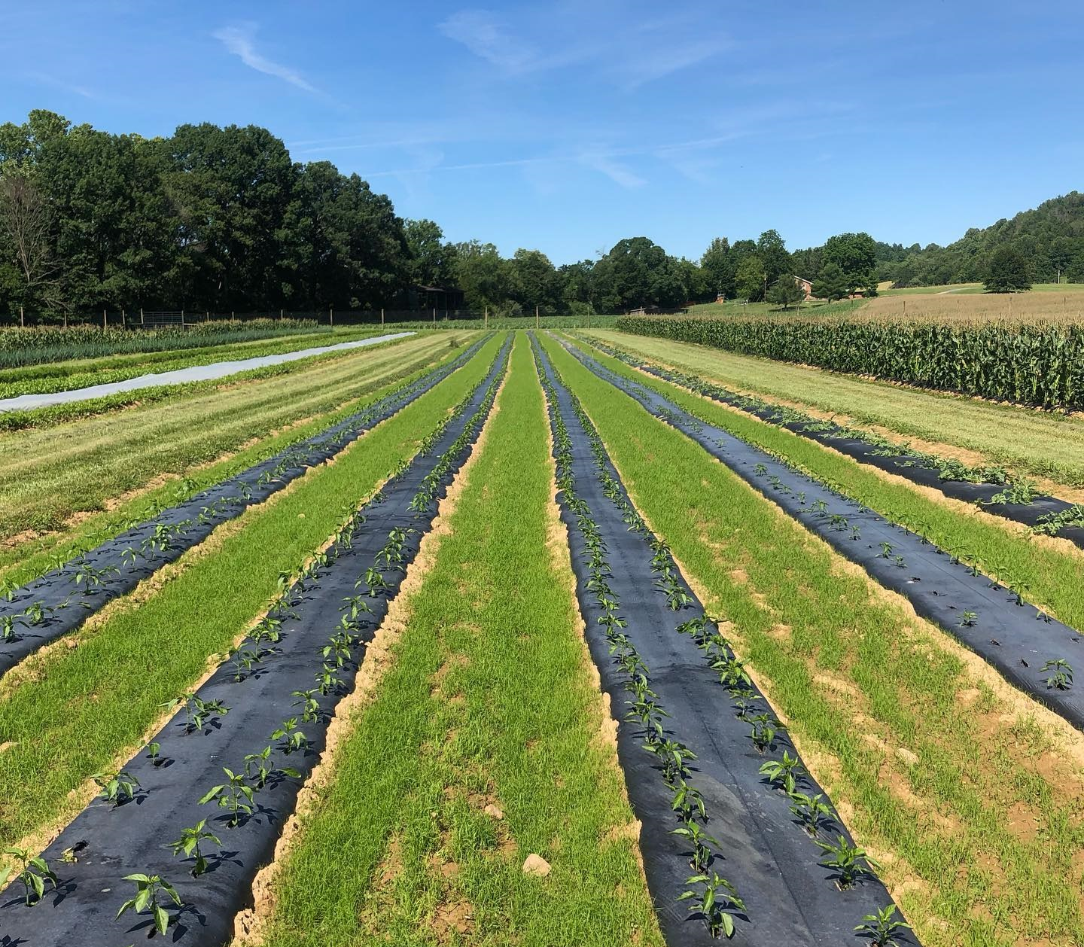
Figure 1. Plastic mulch films used in pepper cultivation at Virginia Tech’s Homefield Farm in 2019. Photo by Alex Hessler.

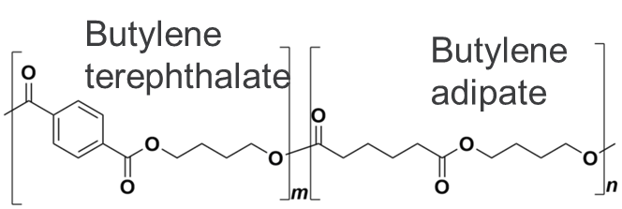
Figure 2. Chemical structure of polybutylene adipate terephthalate. Image from Wikipedia By DGH91 CC BY-SA 3.0.


Figure 3. Chemical structure of polyethylene. Image from Wikipedia By Template:Av, Public Domain.

Table 1. Summary of selected PBAT BDM field trial fragmentation results
Degradation conditions | Degradation results | Reference
Field-weathered mulch buried in mesh bag in Mount Vernon, Washington, USA | 100% of visible mulch surface area remained after 24 months | Li et al., 2014b
Field-weathered mulch buried in mesh bag in Knoxville, Tennessee, USA | 40-60% of visible mulch surface area remained after 24 months | Li et al., 2014b
Field-weathered mulch buried in mesh bag in Lubbock, Texas, USA | 0% of visible mulch surface area remained after 24 months | Li et al., 2014b
New mulch above soil with no crop in Ciudad Real, Spain | 20% of surface area remained covered by mulch after 145 days | Moreno et al., 2017
New mulch above soil with crop in Ciudad Real, Spain | 75% of surface area remained covered by mulch after 145 days | Moreno et al., 2017
New mulch buried in soil Ciudad Real, Spain | 60% of visible mulch surface area remained after 145 days | Moreno et al., 2017
Field-weathered mulch buried in mesh bag in Mount Vernon, Washington, USA | 50-80% of visible mulch surface area remained after 36 months | Sintim et al., 2020
Field-weathered mulch buried in mesh bag in Knoxville, Tennessee, USA | 20-70% of visible mulch surface area remained after 36 months | Sintim et al., 2020
Field-weathered mulch tilled into soil in Mount Vernon, Washington, USA | 20% of mulch surface area recovered 2 years after 4 years of mulching | Griffin-LaHue et al., 2022

Table 2. Selected impacts of PBAT BDM MPs observed in agroecosystems
Affected property | Affect | Reference
Soil properties | Increased soil pH a pot study | (Serrano-Ruiz et al., 2023)
Soil properties | Decreased soil aggregate size | (Wang et al., 2024b)
Soil properties | Decreased soil total organic carbon | (Wang et al., 2024b)
Soil biota | Decrease nematode reproduction in vitro | (Schöpfer et al., 2020)
Soil biota | Decreased microbial activity | (Wang et al., 2024b)
Soil biota | Changed soil microbial community functional potential with respect to C, N, P and S | (Han et al., 2024)
Crop growth | Decreased lettuce and tomato aboveground biomass in a pot study | (Serrano-Ruiz et al., 2023)
Crop growth | Decreased strawberry biomass and increased aboveground cucumber biomass. Mixed effects for tomato, cabbage and adzuki bean in a pot study | (Liang et al., 2024)
Crop growth | Decreased Arabidopsis biomass and leaf area in a pot study | (Liu et al., 2022)
Crop growth | Decreased maize and soybean root growth in a pot study | (Yu et al., 2023b)
Crop growth | Decreased wheat germination, lettuce root length, and carrot shoot length in a pot study | (Zantis et al., 2024)

Chapter I
Quantification of polybutylene adipate terephthalate (PBAT)-based micro- and nanoplastics from soil using proton nuclear magnetic resonance spectroscopy

A version of this chapter has been submitted to The Journal of the Visualized Experiment for review:
Alexis B. Gillmore, Carlos A. Steren, Douglas A. Hayes, Sean M. Schaeffer. “Quantification of polybutylene adipate terephthalate (PBAT)-based micro- and nanoplastics from soil using proton nuclear magnetic resonance spectroscopy.” Journal of the Visualized Experiment (in review).
The work described in this article was conducted by Alexis Gillmore. This chapter was written by Alexis Gillmore with feedback from the other listed coauthors. Full author contributions are described in this CRediT authorship statement:
- Alexis Gillmore: methodology, investigation, formal analysis, writing – original draft, writing – review and editing, visualization, supervision
- Carlos Steren: methodology, resources, writing – review and editing
- Douglas Hayes: conceptualization, funding acquisition, writing - review and editing
- Sean Schaeffer: methodology, resources, funding acquisition, writing – review and editing, supervision, project administration

Abstract
A method to recover and quantify micro- and nanoplastics (MPs and NPs) formed in soil during biodegradation is needed to accurately assess the degradation and environmental impact of biodegradable plastic products. The presence of MPs and NPs in soil may alter soil properties like aggregation behavior or have toxic effects on soil biota. Existing MP recovery methods are not always suitable to measure biodegradable polymers like polybutylene adipate terephthalate (PBAT); some common digestion procedures with acids or oxidizers can destroy PBAT-based biodegradable MPs. Identification methods like micro-FTIR and micro-Raman spectroscopy are also limited by a minimum size of particle that can be recovered and analyzed. Therefore, this method was developed to extract and quantify PBAT from soil to assess the mass fraction of MPs and NPs in the soil without chemically transforming PBAT. In the protocol, a chloroform-methanol solution is used to selectively extract PBAT from the soil. The solvent is evaporated from the extract, then the extract is redissolved in deuterated chloroform. The extract is analyzed by proton nuclear magnetic resonance spectroscopy under quantitative parameters (¹H-QNMR) to quantify the amount of PBAT in each sample. Solvent extraction efficiencies for PBAT range from 76% in a Shady loam soil to 45% in an Elkhorn sandy loam soil. PBAT recovery may be reduced for photo-oxidized materials compared to pristine ones and may be reduced in soils with high clay content. Extraction efficiencies do not depend on PBAT concentration within the test range, but lower extraction efficiencies were observed for NPs than for MPs. PBAT quantification results were comparable to quantification of plastic degradation by measuring cumulative soil respiration in a laboratory incubation study.

Introduction
Methods to measure MP contamination in soil are necessary to understand the scope of plastic contamination in global soils (Andrady, 2017; Corradini et al., 2021), sources of plastic contamination (Schmiedgruber et al., 2019; Fakour et al., 2021), and potential solutions (Talvitie et al., 2017; Wang et al., 2024a). Agricultural soils are uniquely exposed to plastic contamination: more than 15 million metric tons of plastic are used in agriculture each year as of 2021 (Plastics Europe, 2022), including 2.5 million tons of plastic mulch (Food and Agriculture Organization, 2021). Agricultural plastics like plastic mulch and irrigation tape are used in close contact with soil, are reapplied to soil one or more times per year (Beriot et al., 2023), and can be difficult to fully remove from soil after their useful life (Liu et al., 2014). Plastic contamination in agricultural soils also comes from applications of contaminated water, sewage sludge, or compost and from plastic-coated pelletized fertilizers and seed (Sa’adu and Farsang, 2023).
One key area where MP measurement methods are needed is in the assessment of biodegradable plastic products like biodegradable plastic mulches for use in vegetable systems (Sintim et al., 2019). Biodegradable-in-soil plastic products are promising alternatives to conventional agricultural plastics because they could eliminate plastic contamination of soil if they work as intended. In 2022, less than 1 million metric tons of biodegradable plastic were produced globally, with rapid growth expected for the industry (European Bioplastics, 2023; Pia Skoczinski et al., 2024). The four most common biodegradable polymers: PLA (polylactic acid), polymerized starch, PHA (polyhydroxyalkanoates), and PBAT (polybutylene adipate terephthalate) (European Bioplastics, 2023), are all used commercially or experimentally in agricultural biodegradable plastic mulches (Hayes et al., 2017, 2019a). Despite their promise, the degradation of these biodegradable plastic products in field conditions is variable (Li et al., 2014b; Moreno et al., 2017; Griffin-LaHue et al., 2022). While some studies of biodegradable plastic mulch degradation in the field have focused on macroplastic fragments (Li et al., 2014b; Sintim et al., 2021), assessing the complete degradation of plastic materials requires the ability to recover MPs and NPs from soil (Griffin-LaHue et al., 2022; Li et al., 2023; Wang et al., 2024a). Microplastic quantification from soil is also important to assess the potential for negative impacts on soil ecosystems from MP pollution (Wang et al., 2021; Lehmann et al., 2021; Bodor et al., 2024).
Some commonly used techniques for MP identification and quantification include visual analysis, micro-Fourier-transformed infrared spectroscopy (µFTIR), micro-Raman spectroscopy (µRaman), gas chromatography-mass spectroscopy (GCMS including pyrolysis GCMS and thermal extraction desorption GCMS), and thermogravimetric analysis (Möller et al., 2020). Other developing techniques include near-infrared spectroscopy for in-situ MP measurement in soils (Paul et al., 2019), fatty acid methyl esterification extraction for GCMS analysis (Wortman et al., 2021), and nuclear magnetic resonance spectroscopy (Peez et al., 2019a; Nelson et al., 2020). As many as 90% of studies quantifying MPs in soil used visual analysis (alone or paired with other techniques) to identify plastic particles, while 77% used FTIR, Raman or GCMS spectroscopy techniques (Praveena et al., 2022). Developing and harmonizing a diverse variety of MP quantification techniques can help expand the scientific community’s ability to answer diverse microplastics research questions (Primpke et al., 2020; Provencher et al., 2020). Both µFTIR and µRaman spectroscopy require MPs to be separated from soil before they can be chemically identified (Käppler et al., 2016; Xu et al., 2019) while pyro-GCMS may be performed on isolated plastic particles separated from soil (Fries et al., 2013), or on bulk soil (Watteau et al., 2018). Separating biodegradable MPs from soil can be difficult because some digestions used to remove soil organic matter can degrade or otherwise chemically alter biodegradable polymers including PBAT (Fojt et al., 2020; Pfohl et al., 2021; Qin et al., 2021). Micro-Raman and μ-FTIR spectroscopy both also have a spatial resolution limit: particles must be larger than 10-20 μm for μ-FTIR and 1 μm for μ-Raman (if individual particles this small can be prepared for analysis) (Käppler et al., 2016; Xu et al., 2019). These techniques can provide chemical identification of MP polymers, and spectroscopic imaging can be employed to measure MP size (Xu et al., 2019). When individual plastic particles are analyzed by Pyro-GCMS, particles must be individually fed into the instrument to quantify MP, imposing a size limit around 100 μm for handling (Fries et al., 2013; Dekiff et al., 2014). In all types of pyro-GCMS, samples are destroyed during analysis (White et al., 2004; Wampler, 2021).
NMR has been used successfully to characterize soil constituents and contaminants (Cardoza et al., 2004), to quantify MPs (Peez et al., 2019a, 2022; Günther and Imhof, 2023; Papini et al., 2024), and to assess the degradation of PBAT and another polymer, polystyrene (Herrera et al., 2002; Mauel et al., 2022). When run under quantitative parameters, ¹H-NMR spectroscopy produces spectra where the area of each spectral peak is directly proportional to the number of contributing hydrogens in the sample; this allows for quantification of the constituent components in a sample (Bharti and Roy, 2012). NMR is a valuable analytical technique for quantifying some MPs, including PBAT, within soil because it allows for simultaneous quantification and identification, it is suitable for complex and impure mixtures, and it does not require chemically identical reference standards (Simmler et al., 2014; Li and Hu, 2017). NMR spectroscopy of a solvent extract could quantify MPs or NPs smaller than those which can be processed for µFTIR, µRaman or GCMS quantification. Despite these advantages, quantitative NMR approaches still provide lower sensitivities than destructive mass spectroscopy-based approaches (Giraudeau, 2017).
Our proposed method, diagramed in Figure 1, describes a workflow to process and analyze soil samples containing PBAT - including nano-sized PBAT plastics. In the method, PBAT polymer is extracted from soil samples by shaking the soils with a mixture of chloroform and methanol. The solvent extracts containing PBAT are dried and then redissolved in deuterated chloroform with an added internal calibrant. NMR spectroscopy is conducted on the extracts using quantitative parameters. The resulting spectra are analyzed to quantify PBAT by comparing the area of fitted peaks corresponding to hydrogen atoms of the PBAT and calibrant molecules. This method applies the solvent extraction and proton nuclear magnetic resonance spectroscopy (¹H-NMR) approach demonstrated by Nelson et al. (2020). Our goal was to employ a method suitable to process environmental scale samples (~100 g of soil) and able to process a number of samples in parallel without specialized extraction equipment.

Protocol
- Collect and prepare soil
NOTE: Sampling and processing equipment should not contain the polymer PBAT or its constituents to avoid sample contamination. Other polymer materials do not necessarily interfere with the quantification of PBAT from the soil. For example, polyethylene and polypropylene do not produce spectral peaks in chloroform ¹H-NMR which interfere with the quantification of PBAT (Brandolini and Hills, 2000; Acik et al., 2018), but polyethylene terephthalate, with its terephthalate group, most likely would interfere (Matsuda et al., 2002), as could other polyesters (Acik et al., 2018). Reference texts like Brandolini and Hills (2000) (Brandolini and Hills, 2000) can be used to determine the ¹H-NMR spectra of various polymers and screen for overlapping peaks with the PBAT peaks used for quantification (described below).
  - Collect at least 100 g equivalent dry weight of soil for each sample. Determine soil sample size based on the expected concentration of plastics in order to collect a representative sample and homogenize the soil to collect a subsample if needed (Yu and Flury, 2021b).
NOTE: Soil systems are inherently heterogeneous (Cambardella et al., 1994), as are contaminant distributions (e.g. MPs) within them (Ramsey and Argyraki, 1997; Lei et al., 2023). There is also variability associated with methods used to measure contaminant concentrations (Desaules, 2012). Therefore, it is recommended to create a sampling design or experimental design which includes replicate samples as a tool to estimate uncertainty and to collect representative sample volumes based on plastic conentration (Pennock et al., 2006; White, 2008). MP concentrations in soil have been documented to range from near zero to 10 million items per kg of soil, with most sites containing less than 10,000 items per kg of soil (Büks and Kaupenjohann, 2020). A theoretical representative elementary volume could range from 23 m² at a MP concentration of 10 items per square meter to 0.02 m² when MP concentrations are 10,000 items per square meter (Yu and Flury, 2021b).
NOTE: One possibility for increasing effective sampling area from a field site while minimizing the amount of soil that must be processed is to collect soil from a large area (e.g. 1 m²), then to use the quartering method to homogenize and consolidate the sample (e.g. to 500 g of soil) (Yu and Flury, 2021b). In the quartering method, soil from a large area is piled onto a tarp or other surface, mixed thoroughly using a shovel, then divided into quarters. One quarter of the sample is retained, and the other three quarters are discarded. This process is repeated until the sample is of the desired size.
  - Sieve the soil through a 2 mm mesh sieve. Completely clean the sieve and catch pan between soil samples.
  - Air dry soil, then store in sealed sample bags. Dry soil may be stored in this state before PBAT extraction.
- Extract PBAT from soils
CAUTION: Chloroform is volatile and toxic. Store chloroform in the dark in amber glass, away from oxidizers. While working with chloroform, wear appropriate gloves, eye protection, and protective clothing. Handle chloroform only in a fume hood.
NOTE: Chloroform is not compatible with most plastics or with metal. Ensure that all materials are compatible (e.g. glass or polytetrafluoroethylene, PTFE plastic).
CAUTION: Methanol is flammable, volatile and toxic. Store methanol in a fire-proof cabinet. While working with methanol, wear appropriate gloves, eye protection, and protective clothing. Handle methanol only in a fume hood.
CAUTION: Glassware may break and cause injury. Wear eye protection when handling glassware. Avoid touching broken glass with bare hands. Instead, clean up broken glass with cut-resistant gloves, tongs, broom, or another tool.
  - In a fume hood, prepare 100 mL of 90:10 v/v mixture of chloroform (trichloromethane; CHCl₃) and methanol (CH₃OH) per sample to be extracted. For example, to extract from 5 samples, mix 450 mL of chloroform with 50 mL of methanol.
  - Add 100 g of dry soil, 100 mL of chloroform-methanol solution, and 20 glass beads into a glass extraction jar. Seal extraction jars tightly with PTFE-lined lids so that no solvent vapor can exit the jars. PBAT is highly soluble in chloroform; a chloroform-methanol mixture was used because methanol can hydrogen bond with solutes, competing with soil mineral and organic constituents and increasing the recovery of PBAT from the soil (Nelson et al., 2020).
  - Use a shaker table to shake the extraction jars for 8 hours at 200 rpm. After shaking, allow soil in the extraction jars to settle for at least 4 hours.
  - Separate extract from soil. In the fume hood, uncap an extraction jar and transfer the liquid by pipet through a qualitative paper filter into a labeled clean glass jar. Record the volume of solvent recovered from the extraction jar. The filter paper is intended to remove large pieces of organic matter from the solvent solution; we used filter paper with a pore size of 11 μm. Avoid transferring soil solids with the extract; leave a few milliliters of solvent behind if needed.
  - Dry the extracts by leaving them in the fume hood until solvent is completely evaporated. This may take up to 24 hours. Dry soil in the fume hood as well. Once soil is completely dry, it can be discarded.
  - Once extracts are dry, cap each sample jar and store in a cool, dark, dry area until needed.
- Collect NMR spectra
CAUTION: Deuterated chloroform poses the same risks and requires the same precautions as protonated chloroform described above.
  - Add an internal calibrant (Bowen et al., 1974) to the sample. Use a balance to weigh 1.00 mg of 1,4-dimethoxybenzene (DMB; C₆H₁₄O), into each sample jar containing a dried extract.
  - Resuspend the sample in deuterated chloroform (CDCl₃; trichloro(deutero)methane). In the fume hood, use a micropipette to add 500 µL of deuterated chloroform to the jar with dried sample extract.
  - Cap the jar and shake to dissolve the dried extract by taping the jar gently against a hand or benchtop approximately 10 times on each side. Then use a clean pipet tip to transfer the liquid into an NMR tube.
  - Repeat steps 3.2 and 3.3 with an additional 500 µL of deuterated chloroform, adding the second portion of the sample to the same NMR tube as the first. The second rinse is intended to ensure full dissolution and recovery of the dried extract from the container.
  - Cap the NMR tube and store up to 3 days before collecting the NMR spectra. Appropriate storage time will depend on the evaporation rate of solvent from the NMR tube. It is recommended to analyze samples shortly after preparing them with deuterated chloroform.
  - To transport NMR tubes to the spectrometer, use a holder designed to support the long, delicate tubes. These typically have support near the base and near the top of the tube. Tubes should be held in an upright position during transport.
  - Using a 500 MHz NMR spectrometer, collect a ¹H proton spectrum with a 90-degree pulse angle (Bharti and Roy, 2012), a pulse width of 8 μs (Nelson et al., 2020), a 25 second delay time (determined by inversion recovery experiment (Bharti and Roy, 2012; Frank et al., 2014)), 262K points per scan, and 32 composite scans (Malz and Jancke, 2005; Bharti and Roy, 2012) from 12 to -2 ppm for a 25-minute total runtime.
NOTE: We used a Bruker Neo 500 MHz spectrometer with a broadband optimized probe and autosampler at a controlled temperature of 300K. Other similar spectrometers are manufactured by JOEL and others.
NOTE: If using an instrument with a different magnetic field strength, the appropriate delay time can be calculated based on the T1 relaxation time for PBAT and 1,4-dimethoxybenzene using an inversion recovery experiment (Bharti and Roy, 2012; Frank et al., 2014).After the sample has been run, save, transfer or access the spectral data as necessary.
  - Inspect spectral data. Check that all PBAT peaks used in quantification are clearly resolved if present. PBAT Peaks 5 (8.10 ppm), 6 (4.44 ppm), 6’ (4.38 ppm), 3’ (4.15 ppm), and 3 (4.09 ppm) are used in quantification (details in Table 1). DMB peaks A (6.84 ppm) and B (3.77 ppm) are also needed for quantification (details in Table 2). Take particular note of the 6, 6’, 3’, and 3 peaks of PBAT which appear very close to each other and may overlap. See Figure 3 for peak assignments of the PBAT and DMB molecules.
  - If some peaks are not clearly resolved, dilute the sample. Combine 100 μL of sample and 500 μL of deuterated chloroform in a clean NMR tube and rerun the sample under the same parameters defined in step 3.7.
- Analyze NMR spectra to quantify PBAT
NOTE: Spectral analysis may be conducted at any time after collection. Analysis the same day spectra are produced is preferred to ensure samples are still available to rerun in case of any issue.
  - Open the FID file created by the spectrometer in the NMR FID processing software (we used MestreNova from MestreLab, other options include TopSpin from Bruker and plugins for R and MATLAB).
  - Apply line broadening to the spectra (Chan and Comisarow, 1983): In the FID processing software, select Processing Template in the Processing menu, then navigate to the Apodization section. Select an exponential model with a magnitude of 0.5 Hz and a first point of 0.5 Hz.
  - Apply auto phase correction (Zorin et al., 2017) by clicking the Auto Phase Correction button in the Processing menu.
  - Apply auto baseline correction (Izquierdo-García et al., 2011) by clicking the Auto Baseline Correction button in the Processing menu.
  - Use peak deconvolution (Crockford et al., 2005) to fit the measured spectral peaks: in the Analysis tab of the spectra processing software, in the Fitting section, click the New Fit button. Use the cursor to click on the spectra at a shift of 8.5 ppm, then drag the cursor to a shift of 3.0 and release.
  - Click Line Fitting Table under the Fitting section to view all fitted peaks.
  - Retain the peaks used for quantification as described in Tables 1 and 2 and labelled in Figure 2. PBAT Peaks 5 (8.10 ppm), 6 (4.44 ppm), 6’ (4.38 ppm), 3’ (4.15 ppm), and 3 (4.09 ppm) are used in quantification (details in Table 1). As are DMB peaks A (6.84 ppm) and B (3.77 ppm). The hydrogen atoms that correspond to each peak listed in Tables 1 and 2 are labelled in the structural diagrams in Figure 3. Panel A shows the structure of the two PBAT dimers, Panel B shows how the dimers’ position in the polymer interacts to alter peak shift in hydrogens from the 1,4-butanediol monomer, and Panel C shows the structure of DMB.
  - Delete all other peaks from the fit by selecting the unwanted peaks and clicking Delete Peak.
  - Use the Fitting Table to copy the area of each peak into a spreadsheet application for calculations (we chose to use Excel. Other options include LibreOffice Calc and Google Sheets).
  - To copy peak areas to a spreadsheet, first select all the peak information in the Line Fitting Table. Then right click and choose Copy from the pop-up menu. Paste the data into the spreadsheet.
  - Calculate the number of moles of DMB added to the sample, n_{DMB}, using the equation $n_{DMB}(mol)=\frac{m_{DMB}\left(g\right)}{MM_{DMB}\left(\frac{g}{mol}\right)}$ where m_{DMB} is the mass of DMB added to the sample in grams (suggested 1.00 mg) and MM_{DMB} is the molar mass of DMB (138.17 g/mol).
  - Calculate the number of moles of the butylene terephthalate dimer of PBAT in the sample, n_{BT}, using the equation $n_{BT}(mol)=\frac{1}{2}\left(\left(\frac{A_{5}}{A_{A}}\right)+\left(\frac{6A_{5}}{4A_{B}}\right)\right)*n_{DMB}(mol)$ where $A_{5}$ is the measured area of PBAT peak 5, A_{A} is the measured area of DMB peak A and A_{B} is the measured area of DMB peak B. The area units produced by the spectral analysis software are arbitrary.
  - Calculate the number of moles of the butylene adipate dimer of PBAT in the sample, n_{BA}, using the equation $n_{BA}(mol)=\frac{A_{3}+A_{3'}}{A_{6}+A_{6}'}$* $n_{BT}(mol)$ where $A_{3}$ is the measured area of PBAT peak 3, A_{3’} is the measured area of PBAT peak 3’, $A_{6}$ is the measured area of PBAT peak 6, and A_{6’} is the measured area of PBAT peak 6’. The area units produced by the spectral analysis software are arbitrary.
  - Calculate the mass of PBAT in the sample, m_{PBAT,recovered}, using the equation $m_{PBAT, recovered} \left(g\right)=n_{BA}(mol)*MM_{BA}\left(\frac{g}{mol}\right)+n_{BT}*MM_{BT} \left(\frac{g}{mol}\right)$ where MM_{BA} is the molar mass of a BA dimer from PBAT (200 g/mol) and MM_{BT} is the molar mass of a BT dimer from PBAT (220 g/mol).
  - If a known amount of PBAT was present in the sample, then the percent recovery, η, can be calculated for the sample as a measure of extraction efficiency according to the equation $η=\frac{m_{PBAT, recovered} (g)}{m_{PBAT, added} (g)}$.
  - Calculate the concentration of PBAT in a sample, C_{PBAT}, using the equation $C_{PBAT}\left(\frac{mg}{kg dry soil}\right)= \frac{m_{PBAT, recovered} \left(g\right)*1000 \left(\frac{mg}{g}\right)}{m_{dry soil}(kg)}*\frac{V_{solvent recovered} (mL)}{V_{solvent added} (mL)}$ where m_{dry soil} is the mass of dry soil used to produce the extract (0.1 kg), V_{solvent recovered} is the volume of solvent recovered from the soil in step 2.4, and V_{sovlent added} is the initial amount of solvent added to the soil sample (100 mL).
- Prepare a calibration curve for quantification of PBAT from a particular soil
NOTE: A calibration curve created based on soil samples with known amounts of PBAT added will provide useful information about how PBAT is extracted and recovered from a particular soil. Extraction is not the same for all soils or for all forms of PBAT. We suspect extraction efficiency is dependent on soil clay and organic matter content, (Nelson et al., 2020) and recommend creating a calibration curve for each soil series and horizon of interest. The calibration curve can be created before or after unknown samples are processed with this method.
  - Collect and prepare the equivalent of 2.5 kg of dry soil as described in steps 1.1-1.3.
  - Determine the range to be covered by the calibration curve; the maximum concentration of PBAT used in the calibration curve should be higher than the highest PBAT concentration among unknown samples.
  - Prepare or obtain sufficient PBAT plastic to create 5 spiked samples of 100 g of soil with 0%, 25%, 50%, 75%, and 100% of the maximum concentration (25 samples total). For example, if 40 mg/kg is the desired maximum concentration, a total of 50 mg of PBAT will be needed to create the spiked samples.
  - Prepare 25 samples of 100 g of soil each. Spike the samples by weighing PBAT-based plastic and adding it to soil samples at the prescribed rates. For example, if 40 mg/kg of PBAT is the desired maximum concentration, create 5 samples with no PBAT, 5 samples with 1 mg of PBAT, 5 samples with 2 mg of PBAT, 5 samples with 3 mg of PBAT, and 5 samples with 4 mg of PBAT. After adding PBAT to soil, mix well.
  - Extract PBAT from the 25 spiked samples, then collect NMR spectra from the extracts and analyze the resulting spectra as described in steps 2.1 through 4.16.
  - Identify the equation of a calibration curve for PBAT in this soil by performing a linear regression between the measured amount of PBAT in each spiked sample and the actual amount of PBAT added in a statistical analysis tool. We used Excel; other options include MATLAB, SAS or R. If no PBAT is detected in the spiked samples with no PBAT added, then force b = 0 in the regression.
NOTE: A linear regression test assesses the strength of the linear relationship between two continuous numerical variables x and y according to the relationship $y = mx + b$. The values of m and b that best fit the data are computed by the test. The r² coefficient of the regression test describes how closely correlated the two variables are to each other.
  - Test for a significant relationship between extraction efficiency and PBAT concentration using the statistical analysis tool. Calculate the extraction efficiency of PBAT from the spiked samples as $η=\frac{C_{PBAT, measured}}{C_{PBAT, actual}}$. Use the statistical analysis tool to calculate the probability that the observed data could occur randomly without a correlation between extraction efficiency and PBAT concentration. If this p-value is greater than the predetermined significance threshold, α, then fail to reject the null hypothesis that there is no relationship between the two variables. If this is the case, the extraction efficiency can be assumed to be constant for all concentrations of PBAT within the tested range. If the null hypothesis is rejected, the linear model described here may not be the best way to model the data.
  - Use the calibration curve linear regression equation to estimate the amount of PBAT in unknown samples processed using this method. If the regression x variable was the actual amount of PBAT in calibration curve spiked samples, the y variable was the measured amount of PBAT, and b was set to 0, then $C_{PBAT, estimated}=C_{PBAT, measured}/m$.
Note: The PBAT content of replicate samples estimated using a calibration curve equation can be used to generate a confidence interval for the amount of PBAT in a particular soil, or a mean and confidence interval could be calculated for the PBAT concentrations in replicate extracts, then the calibration curve could be applied to estimate the PBAT concentration in soil. Either order of operations produces the same confidence interval for PBAT content in a soil. E.g. consider extracts from 10 replicate samples which have PBAT concentrations of 10, 5, 2, 4, 10, 11, 2, 6, 8, and 5 mg/kg and the calibration curve equation y_{(measured PBAT in extract)} =0.75x_{(true PBAT in soil)}. Soil PBAT concentrations in each replicate could be estimated as 13, 7, 3, 5, 13, 15, 3, 8, 11, and 7 mg/kg. Then mean PBAT concentration in soil would be estimated as 8.4 mg/kg with a standard deviation of 4.4 mg/kg. If a mean and standard deviation are first calculated for extract PBAT concentrations (10, 5, 2, 4, 10, 11, 2, 6, 8, and 5), a mean of 6.3 mg/kg and standard deviation of 3.3 mg/kg would be calculated. Then the calibration curve could be applied to both mean and standard deviation to estimate the PBAT concentration in soil: mean 8.4 mg/kg, standard deviation of 4.4 mg/kg.

Representative results
To assess the efficacy of this method to quantify PBAT polymer from soil, calibration curves were constructed by extracting PBAT from spiked samples created from three different soils. For each of the three soils (details in Table 3), soil was passed through a 2 mm sieve then air dried. Spiked samples were created by adding 0, 9, 18, 27, or 36 mg of PBAT-based MP to 100 g of dry soil (5 replicates of each). This is equivalent to 0, 63, 126, 189, or 252 mg / kg of PBAT polymer. MPs were made from Bio360 plastic mulch (70% PBAT by mass; 50 μm thickness; manufactured by Dubois Agroinnovation, Simcoe, QC) according to the grinding procedure described in Astner et al. (2022) and were smaller than 840 μm. To create each calibration curve, PBAT was extracted from each spiked sample following the procedure defined above. The recovery of PBAT was then compared to the amount of PBAT added to each sample. PBAT recovery rate and quantification were also tested for NPs (mean diameter 780 nm, polydispersity index 0.77, prepared according to Astner et al. (Astner et al., 2022)) in one soil (Shady loam).
For all soils, no PBAT was detected in samples with no PBAT added, i.e. there were no false positives observed by this method. Figure 7 shows a spectrum collected from a Shady loam soil which did not contain PBAT (and did contain DMB added during the preparation process). The two characteristic peaks from the internal calibrant DMB are present, but PBAT characteristic peaks are not. For soils with PBAT added, the five characteristic peaks used to identify PBAT were present. Figure 2 shows a spectrum collected from a Shady loam soil with 63 mg / kg of PBAT added. All PBAT and DMB peaks used in quantification are clearly resolved. Figure 8 shows the fitted region of the spectrum shown in Figure 2 with integrated peaks overlaid. Because of the overlap of 3, 3’, 6, and 6’ peaks with other signals in the spectrum, it is important to calculate PBAT content based on the integrals of fitted peaks rather than simple peak integrals (Crockford et al., 2005). This removes the area contributed by other constituents of the soil extract and from overlapping PBAT peaks. Figure 9 shows the effects of dilution on NMR spectral resolution. The figure shows a spectrum collected from an Elkhorn sandy loam with 252 mg / kg of PBAT added. In panel A, the 3, 3’, 6, and 6’ PBAT peaks in the 4.5 – 4.0 ppm range cannot be resolved. Panel B shows a spectrum collected from the same sample after it was diluted by 1:5 with additional deuterated chloroform. After dilution, the four peaks are distinct and their area can be fit.
Calibration curves varied between the three soils we tested. Figure 4 shows the estimated PBAT concentrations of each soil based on the PBAT measured (C_{PBAT,m}) in each extract compared to the actual amount of PBAT (C_{PBAT,a}) added to the soil. The amount of PBAT recovered from Shady loam soils was strongly correlated with the amount of PBAT added (r² = 0.99). For the calibration curve equation C_{PBAT,m} = m*C_{PBAT,a}, m = 0.76 ± 0.02 (mean ± one standard error) and m was significantly different from zero (df = 24; F = 2000; p < 1*10⁻¹⁶). PBAT was recovered at an efficiency of η = 76 % ± 10 % (mean ± one standard deviation) from this soil. Extraction efficiency from the Shady soil was not correlated with the amount of PBAT in samples (r² = 0.009; p = 0.7). NP was recovered at an efficiency of η = 59 % ± 8 % (mean ± one standard deviation). Figure 5 shows the extraction efficiency of MPs and NPs from the Shady loam; efficiency was significantly lower for NP (p = 0.0002). The amount of PBAT recovered from the Los Osos loam was less strongly correlated with the amount of PBAT added (r² = 0.85) than in the Shady soil. For the calibration curve equation C_{PBAT,m} = m*C_{PBAT,a}, m = 0.57 ± 0.05 (mean ± one standard error) and m was significantly different than zero (df = 23; F = 100; p = 8*10⁻¹¹). PBAT was recovered at an efficiency of η = 57 % ± 22 % (mean ± one standard deviation) from this soil. Extraction efficiency in the Los Osos soil was not correlated with the amount of PBAT in samples (r² = 0.01; p = 0.6). The amount of PBAT recovered from the Elkhorn sandy loam was strongly correlated with the amount of PBAT added (r² = 0.88). For the calibration curve equation C_{PBAT,m} = m*C_{PBAT,a}, m = 0.70 ± 0.05 (mean ± one standard error) and m was significantly different than zero (df = 23; F = 200; p = 5*10⁻¹²). PBAT was recovered at an efficiency of η = 70 % ± 14 % (mean ± one standard deviation) from this soil. Extraction efficiency was not correlated with the amount of PBAT in samples (r² = 0.006; p = 0.7) for the Elkhorn soil.
Furthermore, this method was applied to quantify the PBAT in an Elkhorn series soil. In this experiment, Elkhorn soil was collected from two sites within an agricultural field, sieved through a 2 mm sieve, then air dried. Soil was mixed with PBAT-based mulch MPs (created as described above, diameter < 840 μm), with of 50 mg of MPs and 150 g of dry soil in each mesocosm (250 mg/kg of PBAT) to create 5 mesocosms with MPs mixed into soil from site A and 5 with MPs mixed into soil from stie B (10 total). Five mesocosms composed of soil from each site without added MPs served as a negative control (10 total). Mesocosms were incubated for 6 months to investigate the biodegradation of the PBAT-based mulch MPs. During the incubation, cumulative soil respiration was measured via headspace CO₂ concentrations (Li-Cor infrared gas analyzer; Lincoln, NE, USA) and used to quantify PBAT degradation. The amount of plastic remaining in the mesocosms at the end of the incubation was calculated as C_{Frac from plastic, final} = [m_{Plastic, i} / C_{frac plastic} – (C_{CO2, plastic added} – C_{CO2 no plastic})*m_{dry soil}]/(m_{Plastic, i}/ C_{frac plastic}); where m_{dry soil} is the amount of soil in each incubation jar, C_{frac Plastic} is the carbon content of the added microplastics, C_{CO2, plastic added} is the cumulative amount of CO₂ produced in a mesocosm with plastic added per gram of dry soil, C_{CO2 no plastic} is the amount of CO₂ produced in a mesocosm with no plastic added per gram of dry soil, and m_{plastic, i} is the initial mass of the plastic added. We used bootstrapping to estimate confidence intervals for plastic remaining in soils A and B by calculating plastic remaining with 10,000 theoretical subsamples of random pairings of the 10 experimental mesocosms from each site. At site A, the estimated mean plastic remaining from respiration data was 86% with a bootstrapped 95% confidence interval range from 62 to >100%. At site B, the estimated mean plastic remaining was 98% with a 95% confidence interval range from 79 to >100%. At the end of the 6 months, PBAT content was also measured by the extraction and NMR quantification method described in this manuscript (n = 5 for site A and n = 4 for site B). At site A, the estimated mean plastic remaining from NMR data was 79% with a 95% confidence interval (mean ± 1.96*SE) range from 71 to 87%. At site B, the estimated mean plastic remaining was 88% with a 95% confidence interval range from 71 to >100%. Figure 6 shows the confidence intervals for plastic content of soil from the two sites estimated by the two different methods. The plastic content estimates from the two methods appear mutually consistent based on the large portion of overlap between each pair of confidence intervals.

Discussion
We propose a method for solvent extraction of PBAT from soil coupled with ¹H-NMR to quantify PBAT in the extract. Key elements of the extraction process include the extraction technique and equipment, the solvent used to extract, and the time requirements. We chose to use an extraction technique which requires relatively simple and inexpensive equipment (glass jars, glass beads and a shaker table) compared to the Soxhlet extraction and accelerated solvent extraction (ASE) demonstrated by Nelson et al. (Nelson et al., 2020) Our goal for this method is that many samples can be extracted in parallel to speed in the processing of bulk soil samples. Another advantage of the simple solvent shaking extraction is that larger volumes of soil can be accommodated compared to Soxhlet or ASE approaches, allowing for easier processing of environmentally representative samples. (Möller et al., 2020; Yu and Flury, 2021b) We selected the chloroform-methanol solvent solution based on the successful results presented by Nelson et al. (Nelson et al., 2020) and based on the availability of deuterated chloroform as an ¹H-NMR solvent. We tested ultrasonication of solvent-matrix mixtures aligned with the protocol described in Nelson et al. (Nelson et al., 2020) compared to the simple solvent shaking method and found no significant difference in PBAT recovery rates between the two methods. We found that 8 hours of shaking at 200 rpm was sufficient to break soil aggregates in 100 g of soil matrix for the three soils we tested, while shorter shaking times or lower shaking speeds were insufficient. Settling was then required to recover solvent free of soil particles. One advantage of solvent extraction methods like the ones presented here and in Nelson et al. (Nelson et al., 2020) compared to other MP quantification approaches like FTIR, Raman or GCMS is that there is conceptually no size limit to the PBAT MPs and NPs that can be quantified. PBAT recovery was tested with nano-sized plastics and recovery was significantly lower than that of MPs. This means the method may need further development to accurately quantify environmental samples of unknown NPs, but partial recovery and measurement of NPs is still valuable compared to other size-limited methods, even though particle size information cannot be obtained by this method.
While Nelson et al. (Nelson et al., 2020) reported extraction efficiencies near 100% for an ultrasonication extraction method, we found ultrasonication and the shaker-based extraction method described here both led to extraction efficiencies significantly below 100%. We believe this may be due to the effects of environmental weathering including photooxidation on the plastic mulch: Nelson et al. (Nelson et al., 2020) observed significantly reduced extraction efficiency for UV-irradiated PBAT MPs compared to non-weathered material. The plastic we used to test our quantification method was field weathered in sunlight for a full growing season before it was processed into MPs. Despite the photo-stabilizers added to commercial plastic mulch films, the mulches’ polymer’s structure changes due to UV-radiation (e.g. chain cross-linking that increases the material’s gel content) (Touchaleaume et al., 2016; Anunciado et al., 2021b; a; Zhang et al., 2023) in environmental weathering conditions. This may contribute to the lower PBAT recovery rates we observed compared to Nelson et al²⁶. We also found that PBAT extraction efficiency varied between the three soils we tested. The Shady soil contains mostly low activity clays while the other two soils have smectitic (Los Osos) and mixed, superactive (Elkhorn) clays. The presence of high activity and 2:1 clay minerals may have inhibited the solvent extraction of PBAT from those soils (Nelson et al., 2020; Zhang et al., 2022) leading to the lower PBAT recovery we observed. We recommend further research which investigates plastic-mineral associations in soil for biodegradable MPs and NPs including PBAT as well as for conventional non-degradable polymer MPs and NPs. This is important both to understand how MP polymers can be extracted and measured from soil, but also to understand how they might biodegrade or otherwise affect soil systems.
Key elements of the NMR spectrum acquisition process include the instrument magnet strength, the number of scans used, sample relaxation time between scans, and total measurement time per sample. We used a 500 MHz spectrometer; higher magnetic field strengths provide greater sensitivity and resolution in NMR spectra. Spectral signal-to-noise ratio can be increased by collecting repeated scans of the same sample and adding them together. Collecting n scans will increase the signal-to-noise ratio by a factor of √n but will increase the measurement time by a factor of n (Bharti and Roy, 2012). This means if a higher signal-to-noise ratio is needed to quantify PBAT in a sample, the number of scans can be increased at the cost of longer sample runtimes. A signal to noise ratio of 150 for a particular signal is needed to maintain an error <1% in quantification (Malz and Jancke, 2005). Under our acquisition parameters (instrument, probe, number of scans), around 5 mg of PBAT per sample (or 50 μg PBAT per mL of extract) was necessary to obtain a signal to noise ratio of 150 and thereby error <1% in quantification; this concentration is specific to our data collection set-up. This PBAT concentration is higher than the limits of quantification achieved by others using 1H-NMR to quantify other types of MPs in the absence of soil (Peez et al., 2019a, 2022), demonstrating the impact of soil organic matter and other co-extracted compounds on the quantification method. The quantifiable range of PBAT is also limited on the upper end because of the line broadening seen at PBAT concentrations greater than 25 mg per sample (250 μg PBAT per mL of extract) which led to PBAT peak overlap as described in the representative results and shown in Figure 9. However, this method allows flexibility in responding to these limitations in order to ensure samples are quantifiable. The amount of soil used to create extracts can be increased or decreased and extracts can be diluted and reanalyzed to adjust the PBAT concentration to within the optimal range.
Key elements of the process to quantify PBAT based on NMR spectra include: the peaks used to quantify PBAT, the use of line fitting to calculate peak areas, and the calibration curve. Conceptually, any pair of PBAT and DMB peaks could be compared to calculate the ratio of the two compounds in a sample. We found the most accurate results when we calculated the BT:DMB ratio as the average of the 5:A peak areas and the 5:B peak areas (normalized by their respective number of protons). PBAT peak 5 only provides quantification of the 1,4-butanediol-terephthalate (BT) monomer, so the area of 3 and 3’ peaks (representing the 1,4-butanediol-adipate, or BA, monomer) was compared to the area of 6 and 6’ peaks (representing the BT monomer) to quantify the BA groups present in the sample. The amount of BT and BA were added together to represent the total amount of PBAT remaining. It was not possible to use PBAT peak 1 or 2 in BA quantification due to the interference of coextracted compounds (hypothesized to be soil organic matter) which created multiple broad peaks in the 2.7-0.7 ppm range. We explored removing these unwanted signals from spectra with background correction (i.e. subtracting a blank spectrum from each sample spectrum) but we found creating equivalent comparable background and sample spectra without the use of a calibrant to be unreliable. Line fitting was used to calculate the area of fitted peaks rather than integrating the spectral peaks directly. Due to the overlap between PBAT 3 and 3’ peaks and between 6 and 6’ peaks, this provided more accurate estimates of PBAT content based on our preliminary analysis. We recommend the creation of a calibration curve to account for varying recovery rates of PBAT from different soils. PBAT recovery rates were significantly different between one pair out of the three soils we tested, as indicated by the non-overlapping 95% confidence intervals for calibration curve slope. PBAT recovery in a third soil was not significantly different from either of the other two. In the absence of a mechanistic understanding of how soil composition impacts PBAT recovery, we recommend that calibration curves be created to assess PBAT recovery in each soil series of interest and for each horizon within a soil profile. If calibration curves are found to be statistically similar between soils, the soils can easily be analyzed in combination.
We believe this method can provide a valuable tool to those interested in quantifying PBAT MPs and NPs in soil especially for quantifying PBAT in a large number of samples collected in similar soils, for instance in a long-term plastic biodegradation field study. We hope that further work will improve the robustness of this method, perhaps by addressing the coextracted soil constituents that interfere with PBAT peak resolution in the NMR spectra. Further work is also needed to establish the relationship between PBAT plastic weathering and extraction efficiencies via this method. Based on our results and those of Nelson et al. (Nelson et al., 2020), this quantification procedure performs best for quantifying unweathered PBAT plastics in soils with low organic matter and without high-activity clays. While we used this method only to quantify PBAT-based MPs from soil, the solvent extraction and ¹H-NMR quantification procedure could be useful to quantify other MPs and NPs from additional soils (Peez et al., 2019b; Papini et al., 2024). Extending the method to MPs made of another polymer requires ensuring the solubility of the polymer in the solvent and identifying characteristic NMR peaks from the polymer in the chosen solvent. It may be necessary to select a new internal calibrant which is soluble in the chosen solvent and which does not produce peaks that overlap with those of the polymer of interest (Bowen et al., 1974).

Appendix
Figures and tables referenced in the chapter above are shown in this appendix, as is the list of materials for the procedure described.

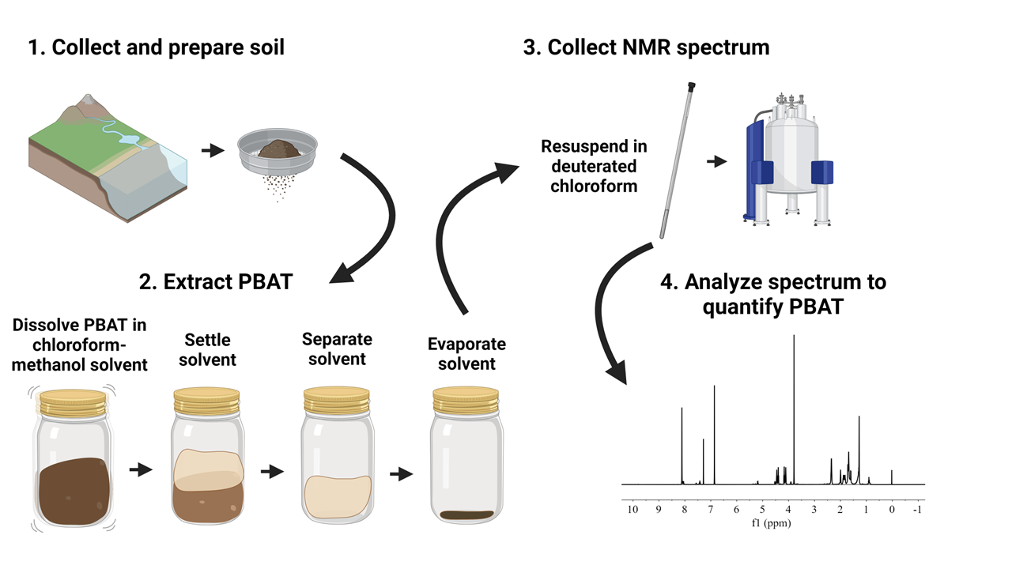
Figure 4. Visual overview of the polybutylene adipate terephthalate (PBAT) extraction and quantification procedure.

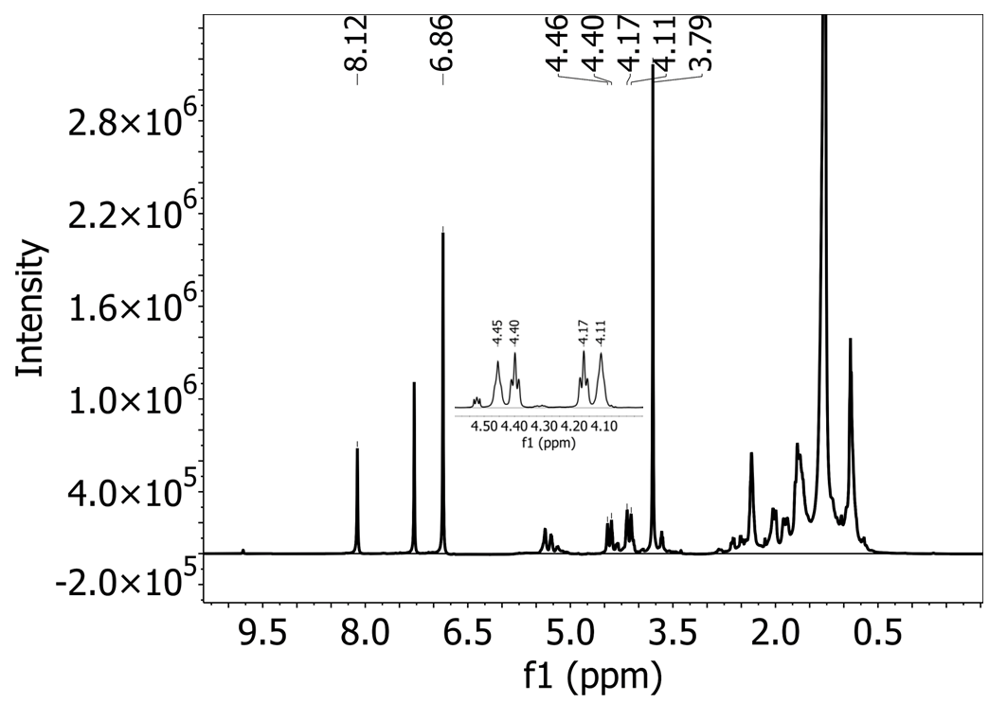
Figure 5. ¹H-NMR spectrum collected in deuterated chloroform solvent with a 500 MHz spectrometer on an extract from a Shady loam soil with polybutylene adipate terephthalate (PBAT) MPs added. 1,4-Dimethoxybenzene (DMB) was added to the extract as an internal calibrant.

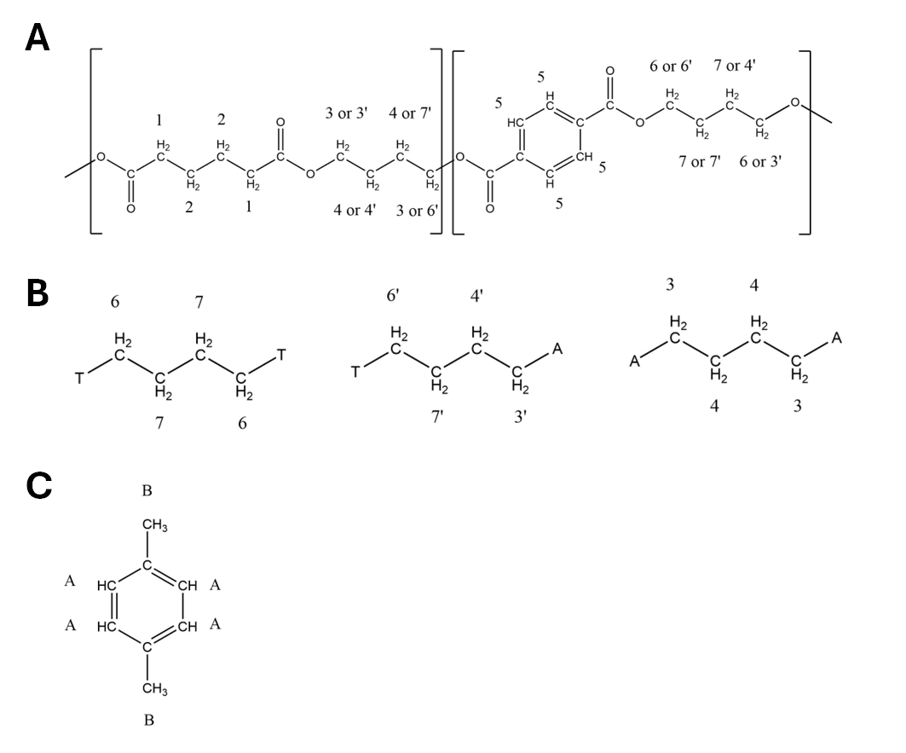
Figure 6. Structures of polybutylene adipate terephthalate (PBAT) and 1,4-dimethoxybenzene (DMB) with labelled protons corresponding with Tables 1 and 2. A) structure of one BA-BT unit of PBAT. B) structure of T-B-T, T-B-A, and A-B-A triads from PBAT.

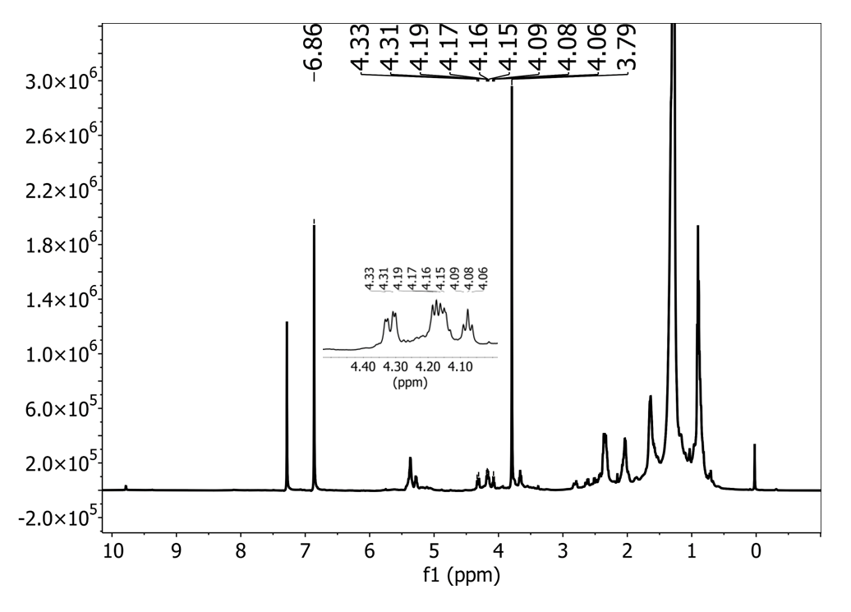
Figure 7. ¹H-NMR spectrum collected in deuterated chloroform solvent with a 500 MHz spectrometer on an extract of a Shady loam with no PBAT polymer present. PBAT characteristic peaks are not present, while DMB (added as an internal calibrant) peaks are.

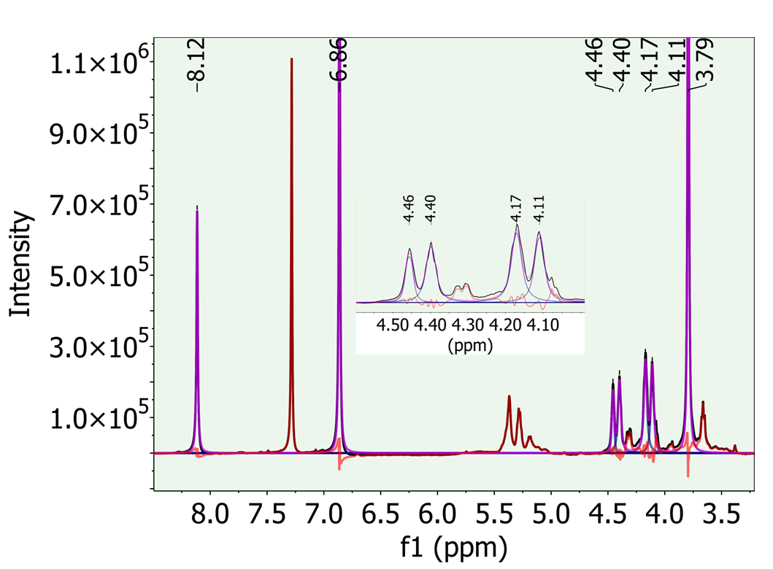
Figure 8. Fitted region of the deuterated chloroform solvent ¹H-NMR spectrum shown in Figure 5. The green background shows the region of the spectrum that was fit. Purple lines show the fitted peaks while red lines show the error (portions of the spectrum signal not included in fitted peaks). PBAT peaks 5, 6, 6’, 3’, and 3 are included in the fit along with DMB peaks A and B.

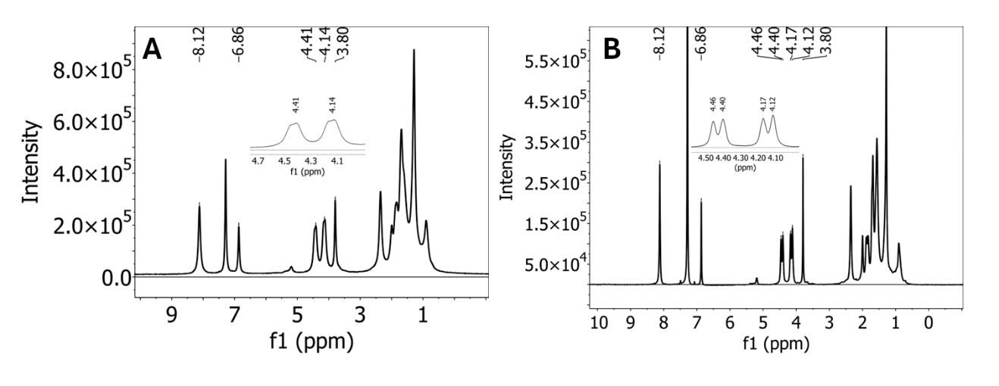
Figure 9. ¹H-NMR spectra in deuterated chloroform solvent collected with a 500 MHz spectrometer on an extract of an Elkhorn sandy loam with PBAT MPs added. Both PBAT and DMB characteristic peaks are present in the spectrum. A) PBAT peaks cannot be distinguished to quantify the polymer. If sample extracts produce spectra like this, they should be diluted, then used to collect a new ¹H-NMR spectrum. B) The same extract diluted so that all spectral peaks are clearly resolved.

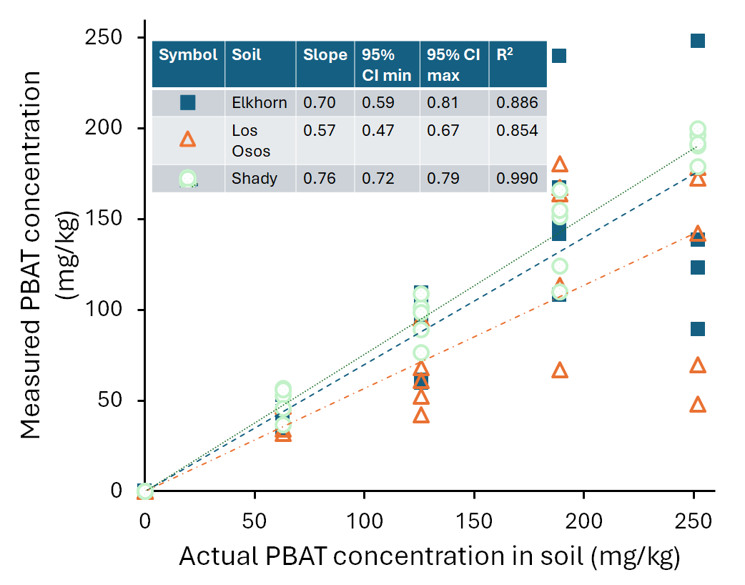
Figure 10. PBAT concentrations measured by 1H-QNMR in extracts in deuterated chloroform solvent from a Shady loam soil, a Los Osos loam, and an Elkhorn sandy loam containing known amounts of PBAT.

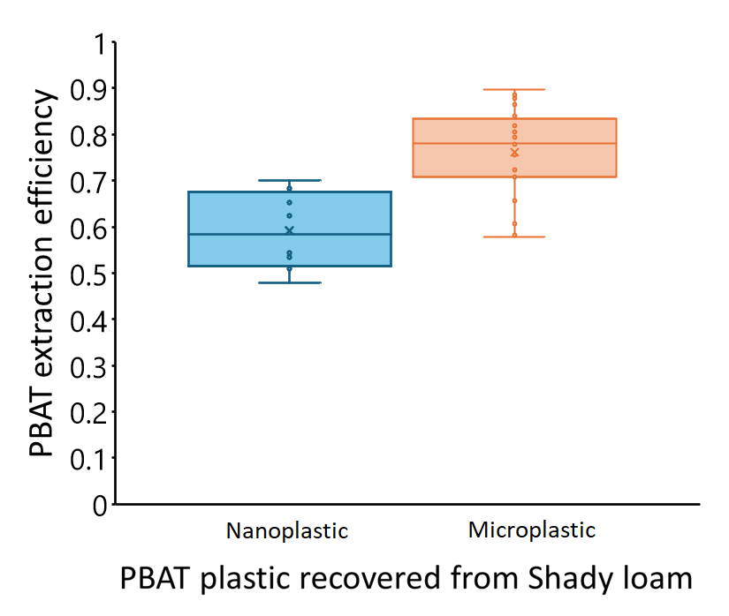
Figure 11. Extraction efficiency of PBAT MPs and NPs from spiked samples in a Shady loam soil. PBAT recovery is significantly lower for NPs (p = 0.0002).

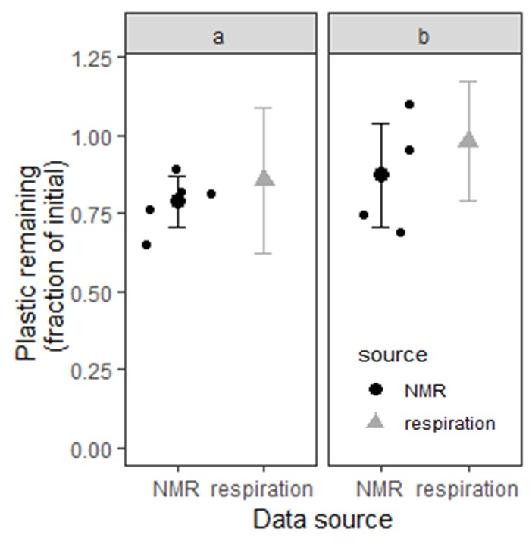
Figure 12. Plastic content of two Elkhorn soils measured with two methods as part of a laboratory incubation. Black squares refer to experimental treatments that had been previously exposed to a PBAT plastic before the experiment. Grey triangles refer to treatments of the same soil from the same site which had no history of exposure to PBAT. The two large shapes indicate the mean plastic content of each treatment based on soil respiration produced during the experiment and the error bars show a bootstrapped 95% confidence interval for the plastic content. The small shapes indicate the plastic content of each experimental unit measured by QNMR according to the method described in this manuscript. There is no significant difference between plastic content estimated by respiration or measured by NMR or either treatment (p > 0.05).

Table 3. ¹H-NMR spectral peaks of polybutylene adipate terephthalate (PBAT) in deuterated chloroform solvent. The hydrogens attributed to each peak are labelled in Figure 6. Peak assignments are based on Herrera et al. (2002).
Peak ID | Location | Number of protons | Multiplicity | Monomer | used in quantification
5 | 8.1 | 4 | Singlet | T | yes
6 | 4.44 | 2 | Triplet | B | yes
6’ | 4.38 | 2 | Triplet | B | yes
3’ | 4.15 | 2 | Triplet | B | yes
3 | 4.09 | 2 | Triplet | B | yes
1 | 2.34 | 4 | Triplet | A | no
7 | 1.97 | 2 | Multiplet | B | no
7’ | 1.87 | 2 | Multiplet | B | no
4’ | 1.81 | 2 | Multiplet | B | no
4 | 1.68 | 2 | Multiplet | B | no
2 | 1.66 | 4 | Multiplet | A | no

Table 4. ¹H-NMR peaks of 1,4-dimethoxybenzene (DMB) in deuterated chloroform solvent. The hydrogens attributed to each peak are labelled in Figure 6, panel B. Peak assignments are based on Nelson et al. (2020).
Peak ID | Location | Number of protons | Multiplicity | Used in Quantification
A | 6.84 | 4 | Singlet | Yes
B | 3.77 | 6 | Singlet | Yes

Table 5. Properties of the three soils which were used to demonstrate the PBAT extraction method.
Soil series | Classification | Texture | Total organic carbon | pH | Collection location | Collection depth (cm)
Shady | Fine-loamy, mixed, subactive, thermic Typic Hapludult | Loam | 1.75 ± 0.02 % | 6.16 ± 0.05 | Knoxville, Tennessee, USA | 0-5
Los Osos | Fine, smectitic, thermic Typic Argixeroll | Loam | 3.36 ± 0.06 % | 7.7 ± 0.1 | San Luis Obispo, California, USA | 0-5
Elkhorn | Fine-loamy, mixed, superactive, thermic Pachic Argixeroll | Sandy loam | 0.73 ± 0.01 % | 6.60 ± 0.03 | Watsonville, California, USA | 0-5

Table 6. List of materials
Name of Material/ Equipment | Company | Catalog Number | Comments/Description
1,4-dimethoxybenzene | Arcos Organics 99%+ | AC115411000 | 1 mg per sample
Amber glass bottle with PTFE lined lid (1 L) | Kimble | 5223253C-26 | reusable
Chloroform; trichloromethane | Fisher Chemical | AA43685M6 | 90 mL per sample; Fisher Optima
Deuterated chlorform; trichloro(deuterio)methane | Sigma Aldrich | 1034200025 | 1 mL per sample; minimum 99.8% deuterated; stabilized with silver
Glass beads (3 mm diameter) | Propper Manufacturing | 3000600 | 20 per sample
Glass extraction jars with PTFE lined lid (~250 mL volume) | Kimble | 5510858B | 2 per sample, reusable
Graduated cylinder, 1 L, polypropylene | Nalgene | 3662-1000 | reusable
Graduated cylinder, 500 mL, polypropylene | Nalgene | 3662-0500 | reusable
Methanol | Fisher Chemical | A412-4 | 20 mL per sample; certified ACS
Micropipette wth range of 0.5 - 1 mL | Fisher Scientific | 3123000063 | reusable
NMR spectrometer | Bruker | n/a | 500 MHz instrument
NMR tube (7 inch height, high-throughput) | Wilmad | WG-1000-7 | 1 per sample
Platform shaker | Eppendorf, Excella E5 | M1355-0000 | reusable
Polyethylene pipette tip (10 mL volume) | Eppendorf | 22492098 | 1 per sample, single use

Table 6. Continued
Polypropylene micropipette tips (1 mL volume) | Fisher Scientific | 02-707-510 | 3 per sample, single use
Semi-microbalance | Mettler Toledo | 30532226 | reusable

Chapter II
Fragmentation of biodegradable plastic mulch at two depths in two contrasting climates

Abstract
In this study, we sought to develop a timeline of macroplastic disintegration, microplastic formation, microplastic movement, and microplastic disappearance for a commercial biodegradable plastic mulch buried in agricultural soil in two diverse climates. As biodegradable plastics mulches degrade in agricultural soils, they fragment into microplastics and nanoplastics. These small particles are more difficult to identify in soil and little is known about biodegradable microplastic or nanoplastic degradation and behavior in diverse field conditions. Microplastics or nanoplastics may be transported vertically through soil pore networks into subsurface soil or groundwater. We tilled field-weathered biodegradable plastic mulch into field soil in Knoxville, Tennessee and San Luis Obispo, California in the United States of America and buried the same mulch at two depths (5 cm and 25 cm) in nylon mesh bags (1 mm mesh). We recovered mesh bags and sampled loose soil for plastic at 6-month intervals for 18 months. We found microplastics formed from fragmentation of plastic mulch buried in mesh bags after 18 months, while microplastic was found in field soil only 6 months after the incorporation of plastic mulch. Macroplastic remained in the field at 18 months at concentrations close to the amount initially added and the quantity of plastic mulch remaining in mesh bags after 18 months was comparable to the initial amount except for bags buried in San Luis Obispo at 25 cm depth. Under these conditions, less than 25% of plastic remained in mesh bags after 18 months. This may be due to physical stress from shrinking and swelling smectite clays causing additional strain and fragmentation to the plastic mulch compared to other treatments. Persistence of large macroplastics in the soil for longer than 18 months may interfere with crop production activities, but longer field trials of biodegradable plastic mulches with larger sampling areas are needed to ensure the suitability of particular products for long-term use at particular sites.

Introduction
Biodegradable plastic mulches are an emerging technology with the potential to provide the advantages of conventional plastic mulching to vegetable producers (weed control, water conservation, temperature control, improved crop quality) (Lamont, 1993; Espí et al., 2006) while mitigating negative aspects of the conventional product (laborious mulch removal and plastic waste) (Hayes et al., 2019b). To certify these products as biodegradable, manufacturers must demonstrate that feedstock materials can meet the requirements of laboratory degradation tests like EN 17033 (EN 17033, 2018; Hayes and Flury, 2018). The EN 17033 certification is designed to ensure that the materials are inherently biodegradable, but in-field degradation of biodegradable plastic mulch products can vary substantially, especially between locations with diverse climates (Brodhagen et al., 2017). It is necessary to understand the degradation behavior of particular biodegradable plastic mulches in particular climates to ensure their suitability for long-term agricultural use – because plastic persistence along with continual reapplication could have negative consequences for crop production (Liu et al., 2014; Gao et al., 2019; Zhang et al., 2020b) or agroecosystem functions (Li et al., 2014a; Lehmann et al., 2021; Bodor et al., 2024).
Similarly, the formation and fate of microplastics (MPs) and nanoplastics (NPs) from the disintegration of biodegradable plastic mulches has received less attention than the macroplastic degradation of these biodegradable products. Some field trials of biodegradable plastic mulches have only assessed visible plastic fragmentation (Li et al., 2014b; Moreno et al., 2017; Sintim et al., 2020; Bianchini et al., 2022), which does not confirm mulch biodegradation (Krzan et al., 2006; Briassoulis et al., 2015; Tosin et al., 2020). The impacts of MPs and NPs in agricultural soil are not yet well understood, but MPs can have negative impacts on plant growth (Qi et al., 2018; De Souza Machado et al., 2019; Chen et al., 2022) or soil properties (Kim and Rillig, 2021; Lehmann et al., 2021; Qiu et al., 2022) under some conditions. Impacts are material-specific (Lehmann et al., 2021) and concentration dependent (Lozano et al., 2021; Qiu et al., 2022; Yu et al., 2023a). MPs and NPs can also be transported below their incorporation depth by soil fauna or percolating water (Yu and Flury, 2021a). Because biodegradation is dependent on microbial activity, which decreases rapidly with depth in most soils (Tate, 1979; Federle et al., 1986; Blume et al., 2002), MPs or NPs that migrate vertically may be degraded more slowly than at the surface. It is important to understand both the timing and quantity of MP formation and degradation from biodegradable plastic mulch in soil conditions as well as biodegradable plastic mulch degradation in subsurface soil as part of ensuring these materials are suitable for repeated in-field use.
The primary objective of this study was to determine the timing and quantity of MP formation from biodegradable plastic mulches in field conditions. A secondary objective was to compare the fragmentation of the same plastic mulches in surface and subsurface soils. We hypothesized that more MPs would form more quickly at the warmer, wetter site from fragmentation of the bulk plastic mulch. We also hypothesized that macroplastic would fragment more slowly in subsurface soil than in surface soil due to the smaller magnitude of wet-dry cycles and lower activity of meso- and microfauna in the subsurface soil. To test our hypotheses, we incorporated field-weathered biodegradable plastic into soil at two sites and repeatedly sampled those plastic-added plots for MPs and macroplastic over 18 months. We also buried pieces of the same biodegradable plastic in 1 mm nylon mesh bags at two depths at each site, then recovered them at six-month intervals over 18 months.

Methods

Sites
Identical degradation trials were carried out in two field sites (Knoxville and San Luis Obispo) with contrasting climates within the United States of America (USA). Specifics of each site’s soil and climate are shown in Table 5. Both sites had no known history of PBAT application or black plastic mulch use, though black plastic drip tape and colored plastic films had been used around the San Luis Obispo site. Before beginning the experiment two 3 m by 3 m plots separated by a 1 m buffer strip were identified at each site. The plots were rototilled to homogenize and plots at the Knoxville site were treated with herbicide.

Plastic additions
The biodegradable plastic mulch used in this study was Bio360 brand biodegradable plastic mulch with a thickness of 50 μm (2 mil) manufactured by Dubios Agroinovation (Simcoe, Quebec Canada). Bio360 mulch is made from Mater-Bi, a blend of about 70% PBAT and 30% polymerized starch produced by Novamont (Novara, Italy). The plastic mulch was field-weathered in strawberry rows in San Luis Obispo, California USA for a full growing season from October 2019 to August 2020. After removal from the field, the mulch was washed with deionized water and air dried.
Plastic was incorporated into the field sites in two ways. Firstly, 8 m² (818 g) of weathered Bio360 mulch were rototilled into the top 15 cm of soil in the 9 m² plastic-added plot at each site (equivalent to 550 ppm plastic mulch or 400 ppm PBAT polymer). Secondly, 18 nylon mesh bags (1 mm x 1 mm openings) each containing one 8 x 8 cm square of weathered Bio360 mulch were buried in the plastic-added plot at each site: 9 bags at a depth of 5 cm and 9 bags at a depth of 25 cm. Mesh bags were buried along the peripheral edge of the plot. Bags were tied together in groups of three with nylon twine then tied to a colored PVC marking flag to aid retrieval.

Moisture and temperature sensors
Moisture and temperature sensors (5MT) from Decagon, now METER Group (Pullman, Washington, USA) were installed in the plastic-added and no-plastic plots at both sites. Two sensors were buried at a depth of 5 cm in opposite corners of the inner 1x1 m square of the plot and two sensors were buried at 25 cm directly below the 5 cm sensors. Sensors were connected to dataloggers (EM50 from Decagon, now METER Group), which were used to record hourly average moisture and temperature measurements from each sensor. Data was physically retrieved from each datalogger bi-monthly. Average daily temperatures were computed for each plot and soil depth.
At each site, data loggers failed during the experiment, leading to missing soil moisture and temperature data. After some time, loggers were repaired (San Luis Obispo) or replaced (Knoxville). To supplement the missing soil data, air temperature and precipitation data was obtained from weather stations nearby each field site for the duration of the experiment. Daily average air temperature data was used to calculate accumulated thermal time (TT) during the experiment using the formula TT = ∑ T_{daily avg} summed for each day during the experiment. Days with an average temperature below 0°C were counted as 0.

Soil sampling
Loose soil and soil cores were sampled from each plot five times: 1) on day 0 of the experiment, immediately before plastic was incorporated into the plastic-added plot, 2) the day after plastic was incorporated, 3) six months after plastic was incorporated, 4) 12 months after plastic was incorporated, and 5) 18 months after plastic was incorporated. Samples were collected from 5 random locations within the inner 2.4 x 2.4 m of the 3 x 3 m plot. This left an outer 60 cm strip of the plot unsampled so that collected samples would not reflect edge effects in the transition area between the experimental plot and surrounding field. At each of the five sampling sites, a 35 cm soil corer (AMS, American Falls, Idaho, USA) was used to collect ~500 g of loose soil from 0-5 cm and from 20-25 without cross-contamination. Two corer holes were required at each of the 5 sampling sites to collect sufficient soil. A 10 cm soil corer (AMS) was used to collect one 5 x 5 cm cylindrical intact soil core from the upper 0-5 cm of soil at each sample location. Soil cores were capped with water-tight and air-tight plastic caps, transported to our laboratory at the University of Tennessee-Knoxville, and refrigerated until analysis. Loose soil was sieved through a 2 mm sieve, air dried, then transported to the same laboratory for analysis.
At each sampling interval (6 months, 12 months, 18 months), aboveground plant material from 1 ft² of each site was collected, air dried, and weighed. At day 0 and day 1, there was no living aboveground biomass due to recent tillage. After 18 months, 1 m² of each plot was excavated to a depth of 20 cm and all excavated soil was passed through a 4 mm sieve to isolate macroplastics (>5 mm effective diameter). Recovered plastic was washed gently with water to remove soil and organic matter, then air dried and weighed.

Soil plastic analyses
Macroplastic (>5 mm effective diameter) and large MPs (2-5 mm effective diameter) were recovered from soil samples during sieving. Only black plastic films (matching the description of the incorporated biodegradable mulch) were kept for further analysis. Plastics were wiped down with deionized water to remove adhered soil, then air dried. Clean, dry plastics were weighed to determine their mass and photographed according to the procedure described in Cowan et al. (2013). Plastic surface area was determined using image analysis in ImageJ (National Institute of Health, USA) as described in Cowan et al. (2013) and Astner et al. (2022). The air-dry mass of each soil sample containing plastic was recorded in order to calculate the concentration of plastic recovered from the soil. PBAT from MPs smaller than 2 mm was extracted from sieved dry soil by shaking with a chloroform methanol mixture, then quantified using ¹H-NMR spectroscopy as described in Gillmore et al. in review.

Soil core analyses
Soil cores were saturated in degassed tap water by placing the cores face up in a basin with cheese cloth securing the bottom opening of the core. Then water was slowly poured into the basin to the level of the core ring, taking care not to flood the top surface of the soil core. Soil cores were left to saturate for two days before measurement. Saturated hydraulic conductivity was measured for intact soil cores using the falling head method (KSAT instrument by METER Group). The average of three replicate measurements is reported for each soil core.
After we measured hydraulic conductivity, soil cores were air dried for one week, then oven dried at 105 °C for 48 hours. Oven dry soil was weighed and soil mass was used to calculate the bulk density of the soil.

Mesh bag retrieval and plastic analyses
Mesh bags containing PBAT-based mulch were recovered after 6, 12, or 18 months of burial. At each sampling, one group of three bags (marked by a single marking flag) from each depth (5 cm burial and 25 cm burial) was carefully excavated from the plot by digging around the marking flag and cord with a trowel. Once the soil over the group of bags was removed, the three bags were carefully lifted out of the soil and transferred to a plastic bag. Care was taken not to bend, strain, or stress the plastic mulch within the bags during handling. Mesh bags were refrigerated at 4 °C in zip-top plastic bags until cleaning. To clean the plastic mulch, a mesh bag was gently rinsed in deionized water over a 250 μm sieve to catch any visible plastic fragments. This allowed us to break down soil aggregates inside the plastic mulch and remove small soil particles while retaining any visible plastic fragments. Then, the mesh bag was cut open at the seam at all four sides. Plastic mulch fragments were carefully lifted off the nylon mesh, then gently wiped with a lint-free tissue to remove adhered soil. Plastic was air dried on a piece of white paper, then pressed flat, photographed according to the procedure described in Cowan et al. (2013), weighed, then stored in a dark cabinet at room temperature.

Statistical analysis
All statistical analyses were performed in R version 4.3.1 (R Foundation for Statistical Computing) using RStudio build 524 (RStudio, Inc.). For all models, the Shapiro-Wilks test was used to check for normality and Levene’s test was used to check for homogeneity of variance. The data met all assumptions of the ANOVA model
The effects of burial site (Knoxville or San Luis Obispo), burial depth (5 cm or 25 cm) and burial time (6, 12, or 18 months), as well as their interactions on plastic surface area and mass recovered from mesh bags were modeled using a completely randomized design in the car package (Fox J. and Weisberg S., 2019). A three-way ANOVA was used to test for effects of the three treatment variables or their interactions on the two response variables.
The effects of location (Knoxville or San Luis Obispo), sampling date (0 days, 1 day, 6 months, 12 months, or 18 months after tillage) and plastic addition (plastic added or no plastic added) as well as their interactions on soil respiration, soil saturated hydraulic conductivity, and soil bulk density were modeled using a completely randomized design in the car package. A three-way ANOVA was used to test for effects of the three treatment variables or their interactions on each of the three response variables.
Where significant effects of plastic addition were discovered by ANOVA, post-hoc mean separations with Sidak’s method for p-value adjustment were used to test for significant differences between treatment groups using emmeans (Lenth, R., 2023). Letter groupings were assigned with a threshold of α = 0.05 to differentiate between significantly different treatment levels.

Results

Climate data
Soil moisture and temperature from in-field sensors are reported in Figure 13. The Knoxville and San Luis Obispo sites experienced similar warm season (summer) average soil temperatures with lower cool season (winter) temperatures in Knoxville. Soil moisture followed a seasonal pattern in both sites with a dry autumn in Knoxville and dry summer and autumn in San Luis Obispo.
Local air temperature and daily precipitation at each site are shown in Figure 14. Accumulated thermal time during the plastic burial period was similar between the two sites (9000 degree-days in Knoxville and 8500 degree-days in San Luis Obispo). There was significantly greater precipitation in Knoxville than in San Luis Obispo during the 18-month experiment (2000 mm in Knoxville and 300 mm in San Luis Obispo). Soil temperature and accumulated thermal time at a Knoxville weather station are shown in Figure 15; this includes data from periods when our site-specific soil temperature data were not collected.

Soil properties
The single measurement of dried living biomass present in the plots at each sampling time in each site is reported in Table 6. There was about 80% less biomass present in San Luis Obispo than in Knoxville at both winter samplings, while summer biomass was only 20% lower in San Luis Obispo than in Knoxville.
Soil respiration was significantly affected by the three-way interaction of measurement site, measurement time, and plastic addition (F=2.86, df=4, p=0.03) as well as by each factor individually (site: F=51.8, df=1, p=2*10⁻⁹; time: F=58.1, df=4, p<1*10⁻¹⁶; plastic: F=13.1, df=1, p=7*10⁻⁴). However, respiration differed between plastic-amended and no-plastic plots only in Knoxville at day 0, before plastic was added (p<0.001: plastic-amended mean 6.4±0.9 μmol CO₂ m⁻² s⁻¹, no-plastic mean 4.1±1.5 μmol CO₂ m⁻² s⁻¹) and in California at day 1 (p=0.001: plastic-amended mean 2.5±1.5 μmol CO₂ m⁻² s⁻¹, no plastic mean 0.5±0.4 μmol CO₂ m⁻² s⁻¹). Soil respiration for each plot at each measurement time is shown in Figure 16.
Soil saturated hydraulic conductivity was significantly affected by site (F=10.9, df=1, p=0.002), time (F=6.2, df=4, p=8*10⁻⁴), and their interaction (F=9.0, df=3 p=4*10⁻⁵), while plastic addition did not have a significant effect (F=1.6, df=1, p=0.2). Saturated hydraulic conductivity decreased over time in Knoxville from 1*10⁴±4*10³ cm day⁻¹ at day 0 to 6*10²±6*10² cm day⁻¹ after 18 months. In San Luis Obispo, conductivity was highest at day 0 (6*10³±7*10³ cm day⁻¹) and lowest at day 1 (4*10²±8*10² cm day⁻¹) and 18 months (2*10²±5*10² cm day⁻¹). Saturated hydraulic conductivity for each plot at each measurement time is shown in Figure 17.
Soil bulk density was significantly affected by the interaction of site and time (F=3.0, df=4, p=0.02), but neither main effect. Bulk density at the San Luis Obispo site did not vary significantly over time (mean 1.08±0.1 g cm³). In Knoxville, bulk density was highest at day 0 (1.2±0.2 g cm³) and lowest at 6 months (1.05±0.08 g cm³) and 12 months (1.05±0.03 g cm³). Bulk density in Knoxville was also most variable at day 0 and day 1 compared to later measurements. Bulk density for each plot at each measurement time is shown in Figure 18.

Biodegradable plastic from mesh bags
Regarding plastic mulch squares recovered from buried mesh bags, plastic surface area was significantly affected by the three-way interaction of burial site, burial depth, and burial time (F=26.6, df=2, p=8*10⁻⁷), as well as each of the three main effects of site (F=20.2, df=1, p=1*10⁻⁴), depth (F=33.3, df=1, p=6*10⁻⁶), and time (F=36.1, df=2, p=6*10⁻⁸). Mulch surface area is shown for each treatment group at each sampling time in Figure 19. Surface area change was only non-zero for mulches buried at the California site at 25 cm for 18 months (14±13% of surface area remaining compared to 100±6% remaining for all other groups).
The mass of mulch squares recovered from buried mesh bags was also significantly affected by the three-way interaction of burial site, burial depth, and burial time (F=22.8, df=2, p=3*10⁻⁶), as well as each of the three main effects of site (F=8.8, df=1, p=0.007), depth (F=43.5, df=1, p=8*10⁻⁷), and time (F=41.9, df=2, p=1*10⁻⁸). Plastic mulch mass for each treatment group at each sampling time is shown in Figure 2.7. Mass change was only non-zero for mulches buried at the California site at 25 cm depth for 18 months (15±13% of mass remaining compared to 89±7% remaining for all other groups). The form of plastic recovered from mesh bags is shown in Figure 20. Microplastic formation was negligible under all treatments until 18 months. Figure 21 shows photographs of every piece of plastic mulch buried in mesh bags after burial.

Biodegradable plastic recovered from soil
PBAT-based plastic mulch was recovered in 23 of 200 (12%) of soil samples collected during the experiment, 10 from San Luis Obispo and 13 from Knoxville. The average PBAT polymer concentration in samples that contained plastic mulch was 1.1*10⁴±2.0*10⁴ ppm. Only one sample from a no-plastic treatment plot was found to contain plastic mulch (in the form of macroplastic), from the San Luis Obispo plot at 0-5 cm after 12 months. Five samples from the 20-25 cm sampling depth of plastic-added plots were found to contain PBAT-based plastic mulch, two in the form of macroplastic and 3 in the from of microplastic < 2 mm detected by NMR. The average plastic content in the 5 samples was 5*10²±9*10² ppm.
Fourteen samples contained macroplastic, which constituted the most abundant form of plastic in samples that contained it (>50% in all cases, >99% in 12 of 14). The average macroplastic concentration in those 14 samples was 1.1*10⁴±1.7*10⁴ ppm. Nine samples contained microplastic between 2-5 mm in size; all 9 of these samples also contained macroplastic mulch. The average microplastic concentration in these 9 samples was 400±600 ppm. Twelve samples contained microplastics which were quantified by NMR but not recovered by visual inspection because they were smaller than 2 mm. The average PBAT concentration in these samples was 50±80 ppm.
The mean plastic mulch recovered from each plot at each sampling is shown in Figure 22. Microplastics smaller than 2 mm were present in the plastic-added plots in both Knoxville and San Luis Obispo as soon as 6 months after plastic burial. Macroplastic was still present in both plots 18 months after plastic burial. This macroplastic was recovered in soil corer samples from day 1 to 18 months and in the 1 m² of plastic sampled from each plot at 18 months. In Knoxville, 74 g of plastic mulch was recovered from the 1 m² sample (equivalent to 450 ppm in the upper 15 cm). In San Luis Obispo, 110 g of plastic mulch was recovered from the 1 m² sample (equivalent to 670 ppm in the upper 15 cm).

Discussion
Biodegradable plastic mulches fragmented but did not substantially disappear from two field sites (humid subtropical and Mediterranean climates) after 18 months of soil burial. Plastic was added to each site at a rate of 90 g m⁻² and macroplastic was recovered at 110 g m⁻² from the Mediterranean site (San Luis Obispo) and 70 g m⁻² from the humid subtropical site (Knoxville). Plastic recovery at points between 0-18 months was sporadic due to the small surface area of collected soil samples and the heterogeneous dispersal of plastic in the soil (Yu and Flury, 2021b). Plastic fragmented into MPs, both when tilled into the soil and when buried in nylon mesh bags.
Comparing climate conditions between the two experimental sites, Knoxville and San Luis Obispo experienced similar mean annual soil and air temperatures, while Knoxville experienced higher high temperatures and lower low temperatures. Both sites accumulated a similar amount of thermal time during the 18-month experiment, while Knoxville experienced about 7 times as much precipitation as San Luis Obispo, which had a more pronounced dry season.
During the 18-month field experiment, soil bulk density and saturated hydraulic conductivity changed over time, but not due to plastic addition. Soil respiration was observed to be higher in plastic-added plot than in no-plastic plot at day 0 in Knoxville, before any plastic was added. At this measurement point, both plots were disturbed by tillage earlier in the day leading to elevated respiration. We do not have any evidence that the difference in respiration measurements reflects a baseline difference between the two plots. At San Luis Obispo on day 1, the plastic-added plot was observed to respire more rapidly than the no-plastic plot. This may be because the plastic-added plot was tilled the same day as respiration measurements while the no-plastic plot was tilled the previous day (Akbolat et al., 2009). No subsequent differences were seen between the two plots during the remainder of the experiment.
Plastic buried in mesh bags in San Luis Obispo at 25 cm below the surface cracked sooner and disappeared substantially by 18 months (around 25% mass remaining; less than 25% surface area remaining), while around 90% of plastic mass remained in mesh bags at 18 months for all other burial treatments (San Luis Obispo at 5 cm and Knoxville at 5 or 25 cm). Plastic that was not recovered within the 1 mm mesh bags may have biodegraded (been assimilated into microbial biomass or respired as carbon dioxide) or may have fragmented into pieces small enough to exit the mesh but still persist in the form of microplastic. We expected to see less plastic remaining when mesh bags were buried in surface soil because of the greater microbial activity and organic matter at the surface (Federle et al., 1986). Soil at the San Luis Obispo site contains a high proportion of smectite clays, which cause the soil to expand during wetting and contract during drying. This led to cracks forming in the experimental plots during dry seasons that were up to 30 cm deep and 4 cm wide. Stress exerted on the mesh bag and plastic mulch due to soil shrinking and swelling may have contributed to the greater cracking and disappearance of the San Luis Obispo plastics at 25 cm (the clay content of the soil is greater at 25 cm than at 5 cm). Our results suggest that in the moderate degrading environment presented by the field sites, this physical disturbance contributed more strongly to plastic fragmentation and disappearance than biodegradation did. This phenomenon of physical stress leading to fragmentation may not apply in the same way to microplastics that are transported from surface to subsurface soil because they may be too small to be pulled apart between shrinking soil aggregates. Smectites are influential soil minerals on the Pacific coast of the United States and in the American Midwest (Gradusov, 1974), though smectite rich soils may pose challenges for agricultural production (Borchardt, 1989). If our interpretation of this phenomenon is correct, it may be useful for users of biodegradable mulch in smectite-rich soils. In these conditions, producers may see faster macroscopic disappearance of biodegradable plastic from their fields if they can till it into the soil more deeply, or if they irrigate during a dry season to increase the number of shrink-swell cycles the plastic is exposed to. Faster fragmentation may lead to quicker biodegradation if it increases the available specific surface area for enzymatic biodegradation.
Outside of mesh bags, biodegradable plastic mulch tilled into the soil fragmented to form some MPs in as little as 6 months, while MPs within the mesh bags were minimal until 18 months. MPs were still present in the soil at 18 months, and we cannot say whether MPs biodegraded or otherwise left the system (ex. through vertical transport) during that time. Qualitatively, the material properties of the recovered plastic (tensile strength and elasticity) were much decreased compared to the condition of the material when it was buried, as has been observed in other field trials of biodegradable plastic mulches (Hayes et al., 2017).
Our quantification of plastic present in the field site is appropriate, with measured plastic concentrations ranging over 5 orders of magnitude between replicate samples. This is likely because each of our soil samples was taken from an area of 20 cm², while the initial size of plastic fragments tilled into the soil was between 500-1000 cm². Soil samples were too small to collect a representative sample volume regarding plastic content. We encourage future researchers interested in the in-field biodegradation of plastic mulch to plan sampling strategies that accommodate the large size of plastic mulch pieces and the probably heterogeneous distribution of plastic in the soil after tillage (Yu and Flury, 2021b). To gain a more representative measurement of soil plastic content, after 18 months we sampled a single square meter of each plastic-added plot and quantified all the macroplastic contained within it. These estimates agreed more closely with the initial concentration of plastic tilled into the soil than estimates based on 20 cm² sampling.

Conclusion
While biodegradable plastic mulch fragmented during 18 months of soil burial in the two field sites we studied, we believe most plastic added to the soil was still present after 18 months. Users of this biodegradable plastic mulch can expect large macroplastic mulch fragments to persist for 18 months after tilling plastic into the soil for at least two growing seasons (Beriot et al., 2023). These large plastic films can interfere with bed-shaping, planting and other production activities and decrease crop yields (Liu et al., 2014; Gao et al., 2019; Zhang et al., 2020b). This work does not shed light on what might happen to macroplastic in the soil at these sites after 18 months, nor microplastics and nanoplastics. Other in-field trials have shown minimal degradation of biodegradable plastic mulch in soil for up to 18 months (Zhang et al., 2020a), continuous decreases in macroplastic concentration over time after plastic mulching is stopped (Griffin-LaHue et al., 2022), and that MP concentrations peak several years after the application of biodegradable plastic mulch, then decrease (Li et al., 2023). We continue the call for multi-year in-field trials of biodegradable plastic mulches in diverse climates, soils and production systems to assess their biodegradation in a variety of conditions (Brodhagen et al., 2017). Biodegradable plastic mulch users should exercise attention in ensuring that the plastic mulch products they use are biodegradable in their specific field conditions on a satisfactory timeline based on their production system.

Appendix
Figures and tables referenced in the chapter above are shown in this appendix.

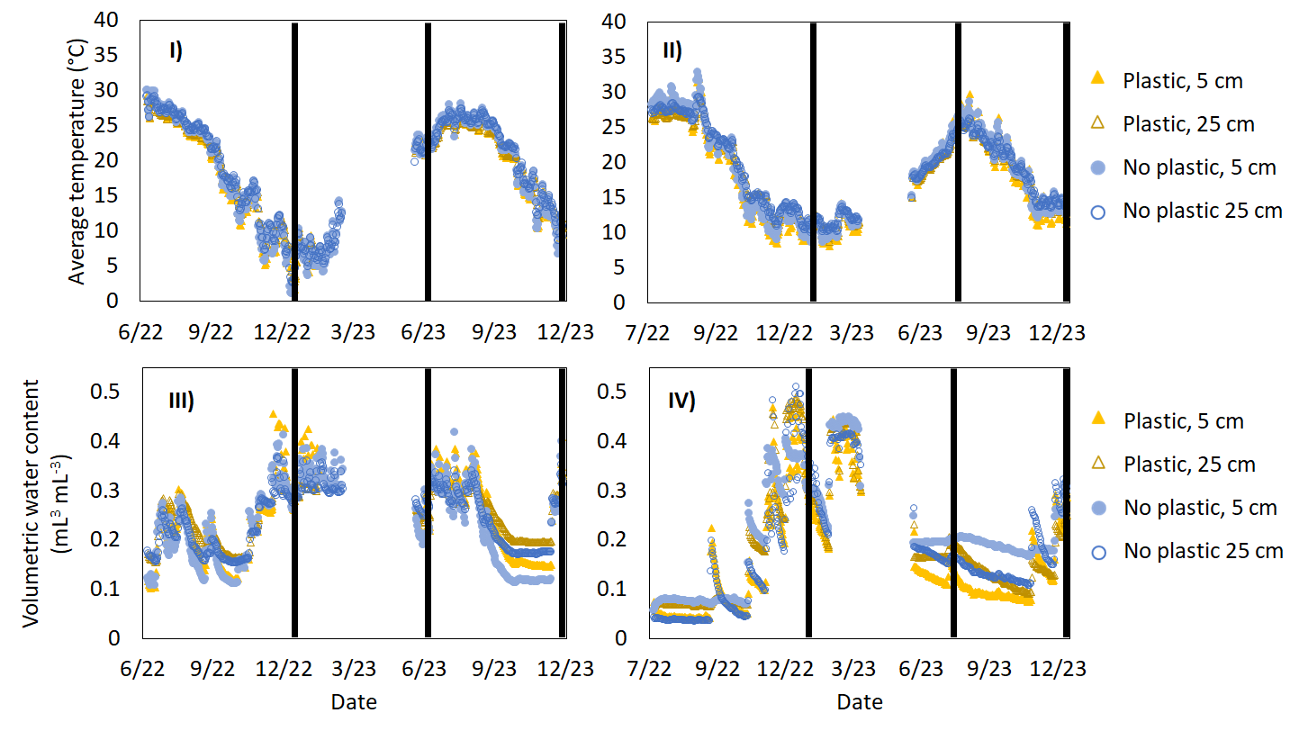
Figure 13. Soil temperature and moisture during the experiment at each site, plot, and depth. I) Daily average soil temperature at the Knoxville, Tennessee site. II) daily average soil temperature at the San Luis Obispo, California site. III) Daily average soil volumetric water content at the Knoxville, Tennessee site. IV) Daily average soil volumetric water content at the San Luis Obispo, California site. For each site, temperature and moisture were measured in plastic and no-plastic plots at both 5 cm and 25 cm depth. Black vertical lines show the dates when mesh bags containing biodegradable plastic mulch were removed from the field.

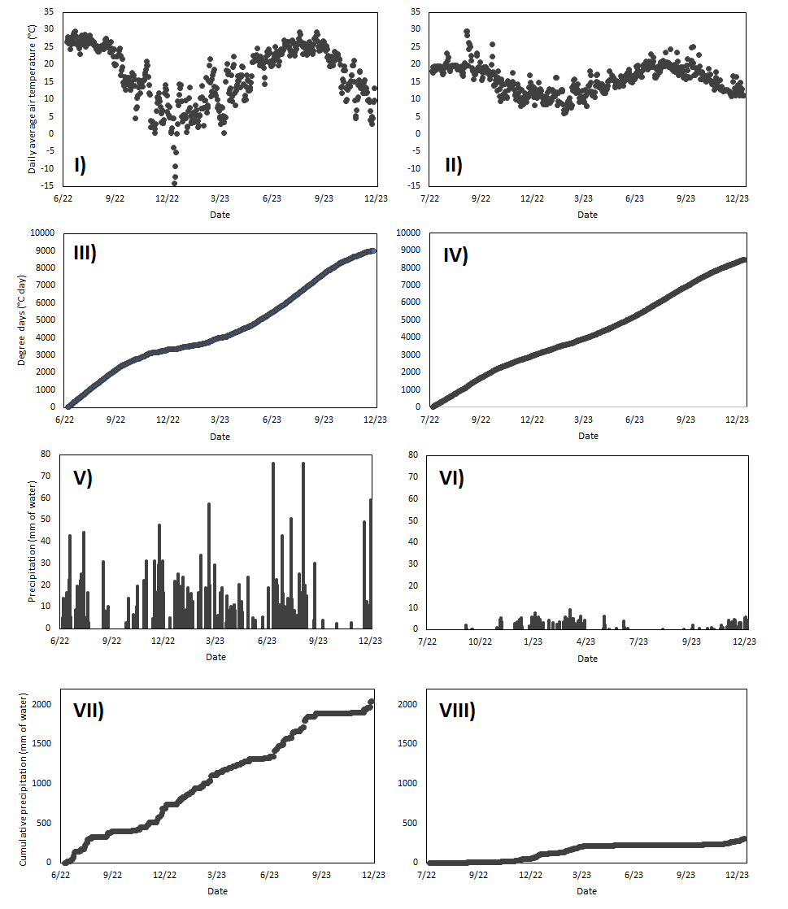
Figure 14. Weather station data from Knoxville, Tennessee and San Luis Obispo, California during the experiment. I) Daily average air temperature in Knoxville. II) Daily average air temperature in San Luis Obispo. III) Accumulated thermal time in Knoxville. IV) Accumulated thermal time in San Luis Obispo. V) Daily precipitation in Knoxville. VI) Daily precipitation in San Luis Obispo. VII) Cumulative precipitation in Knoxville. VIII) Cumulative precipitation in San Luis Obispo.
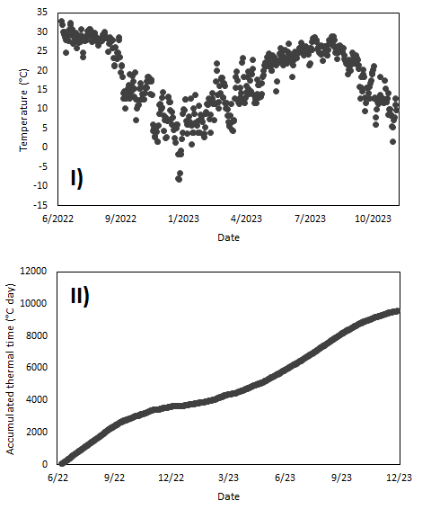
Figure 15. Soil temperature data from a weather station at the University of Tennessee East Tennessee Research and Education Center Plant Science Unit in Knoxville, Tennessee. I) Daily average soil temperature at 10 cm below the soil surface. II) Accumulated thermal time in the soil.

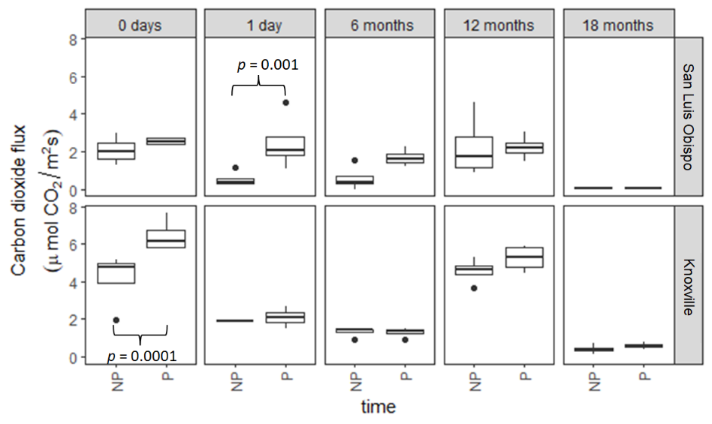
Figure 16. Soil respiration (surface CO₂ flux) measured at each plot at each sampling time. P indicates plastic-added plots while NP indicates no plastic plots (n=4 for each group). Comparison p-values are reported for the two P-NP pairs that showed significant differences in post-hoc contrast tests. For all other pairs, p>0.05.

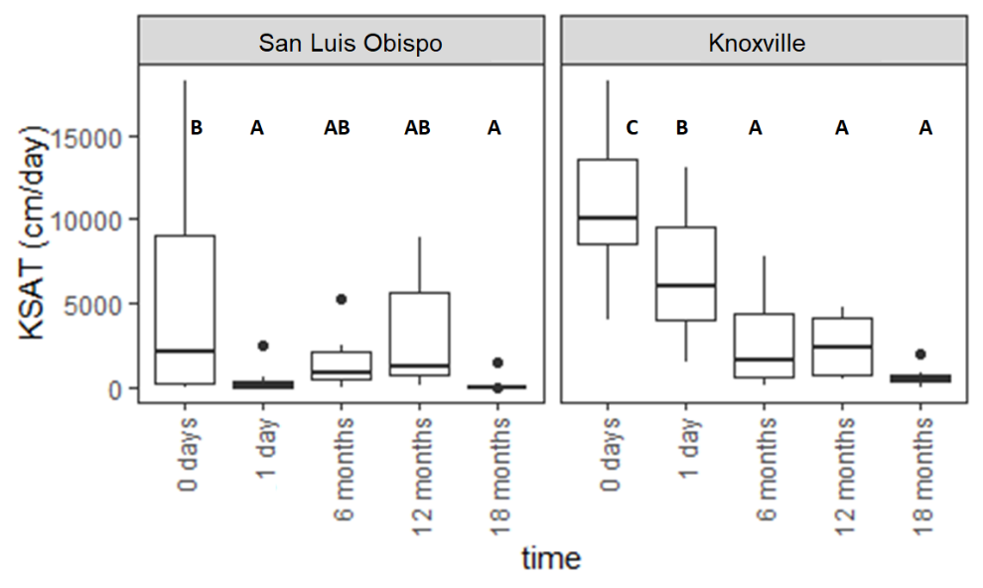
Figure 17. Soil saturated hydraulic conductivity (K_{sat}) measured on collected soil cores at each sampling time. Distinct letters represent groups where K_{sat} was significantly different based on pairwise comparisons with Sidak adjusted p-values (α=0.05). Shared letters represent groups where K_{sat} was not found to be significantly different.

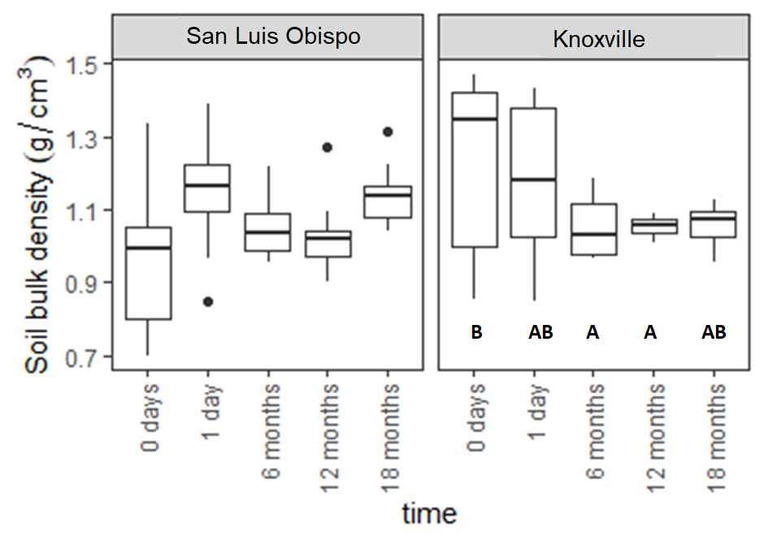
Figure 18. Soil bulk density measured on soil cores at each sampling time. Distinct letters represent groups where density was significantly different based on pairwise comparisons with Sidak adjusted p-values (α=0.05). Shared letters represent groups where density was not found to be significantly different.

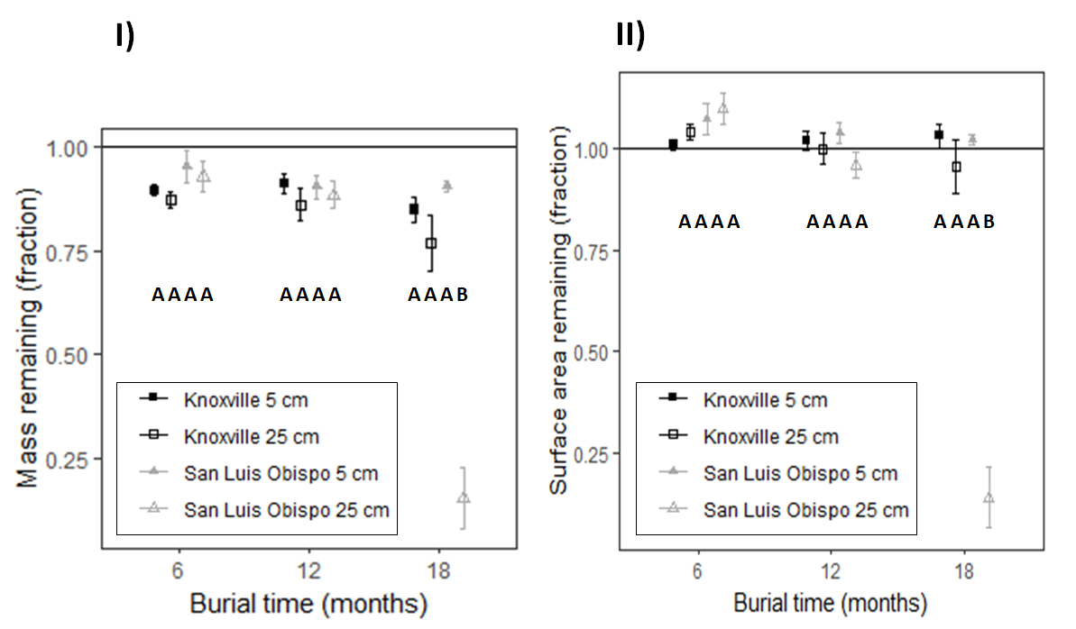
Figure 19. Mass and surface area of plastic buried in mesh bags over time by treatment. Points represent the mean of each group and bars represent one standard error of the mean (n=3 in each group). Distinct letters represent groups where mass or surface area was significantly different based on pairwise comparisons with Sidak adjusted p-values (α=0.05). Shared letters represent groups where mass or surface area was not found to be significantly different.

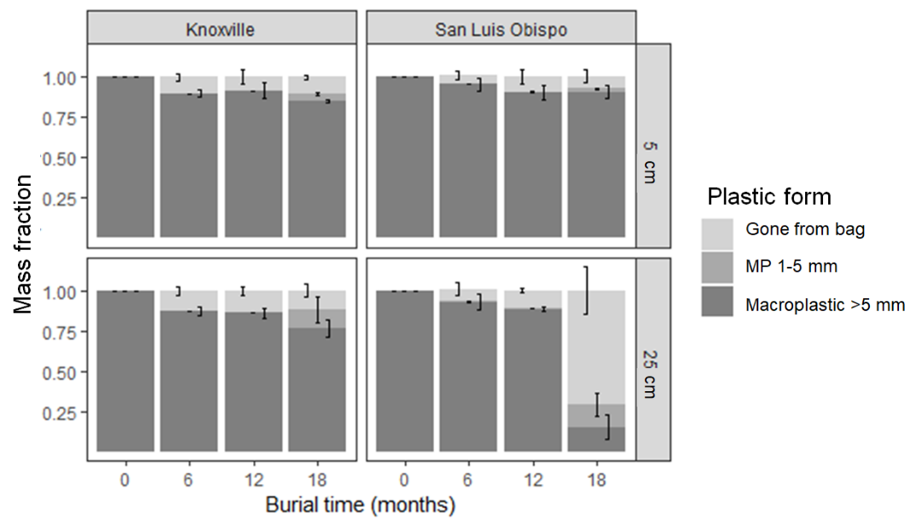
Figure 20. The form of plastic recovered from buried mesh bags over time reported as fraction of initial mass. Results are grouped by the burial site (Knoxville or San Luis Obispo) and burial depth (5 or 25 cm). Error bars represent one standard error deviation from the mean (n=3 for each group).

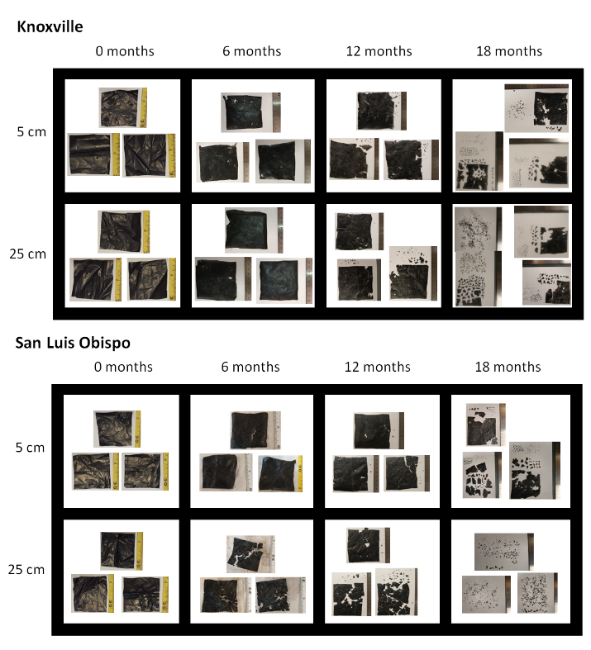
Figure 21. Images of biodegradable mulch film recovered after burial in mesh bags

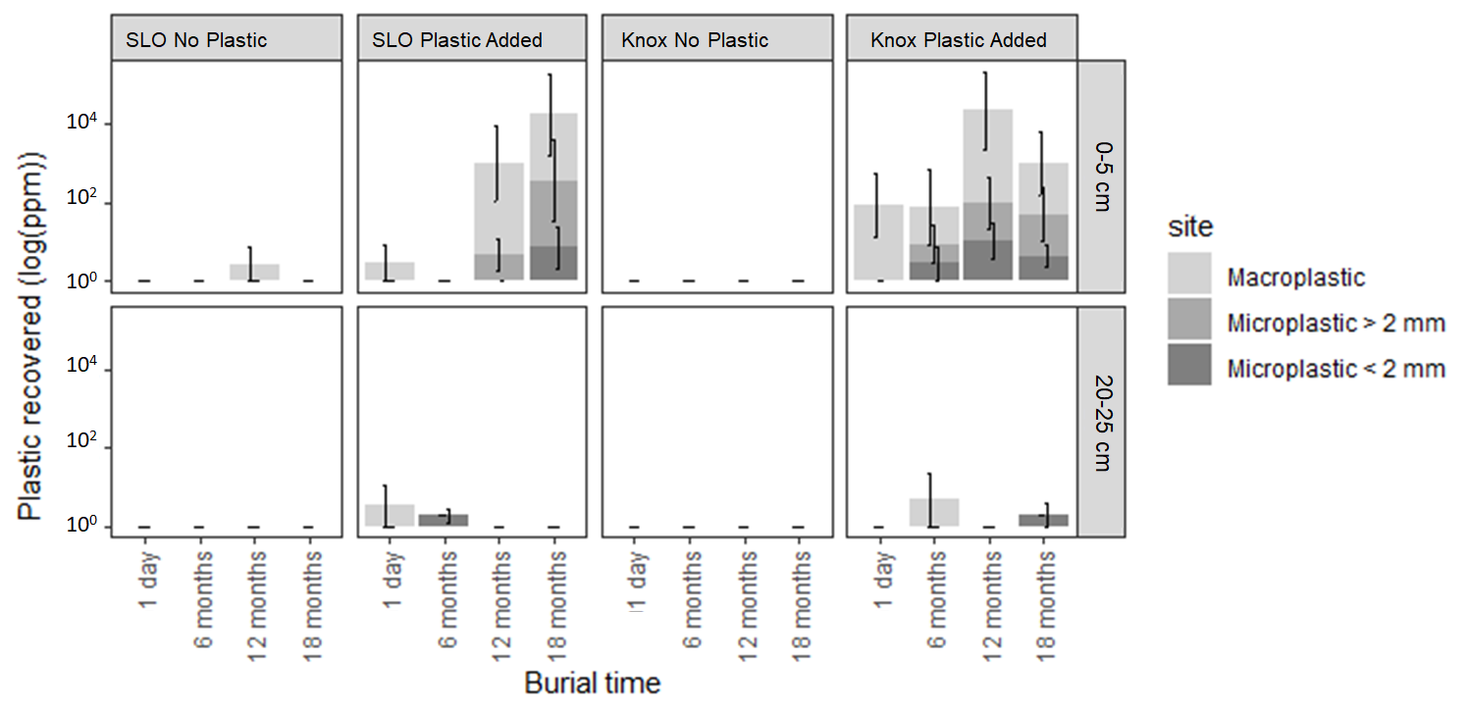
Figure 22. Plastic recovered from soil samples over time reported as the parts per million concentration of plastic on a log scale. SLO refers to the San Luis Obispo site and Knox refers to the Knoxville site. Bar heights represent the mean measured concentration and bars represent one standard error of the mean (n=5 for each bar).

Table 7. Experimental site details
Site | Location | Climate (Köppen) | Mean annual precipitation (inches) | Soil | Soil texture 0-20 cm (USDA) | Slope
University of Tennessee-Knoxville East Tennessee Research and Education Center (Knoxville) | (35.8925 N, -83.9584 W) | Cfa (humid sub-tropical) | 52 | Shady series: fine-loamy, mixed, subactive, thermic Typic Hapludult | Loam | < 5%
California Polytechnic State University Student Experimental Farm  (San Luis Obispo) | (35.3099 N, -120.6729 W) | Csb (Cool Mediterranean) | 22 | Los Osos series: fine smectitic, thermic Typic Argixeroll | Loam | < 5%

Table 8. Biomass recovered from each site during sampling
Measurement time | Site | Dry aboveground biomass (g m⁻²)
6 months | San Luis Obispo | 30
6 months | Knoxville | 160
12 months | San Luis Obispo | 140
12 months | Knoxville | 180
18 months | San Luis Obispo | 20
18 months | Knoxville | 100

Chapter III
Degradation of biodegradable PBAT micro- or nanoplastic in surface or subsurface soils during 9-month incubation

Abstract
Biodegradable plastic mulches could be a valuable alternative to conventional non-degradable plastic mulches by reducing plastic waste in vegetable production systems, but these mulches fragment into micro- and nano-sized particles during degradation. Smaller plastic particles have greater potential to move vertically through the soil profile, where their fate is unknown. We investigated the biodegradation of biodegradable mulch microplastics and nanoplastics in soils collected from three horizons within the same soil profile (Ap: 0-5 cm, AB: 15-20 cm, and Bt: 30-35 cm) using a nine-month laboratory incubation. Based on cumulative respiration measurements and polymer quantification, we found no evidence that microplastics or nanoplastics biodegraded under the experimental conditions in any of the three soils. Our positive control for biodegradation, microcrystalline cellulose, did appear to completely degrade in the soil collected from Ap and AB horizons, but not in the Bt horizon soil, where at least 86% of the cellulose remained at the end of nine months. Slow degradation of micro- and nanoplastics in soil means more times for those particles to travel into subsurface soil or groundwater and more time for the particles to impact soil systems, so it is important to ensure these materials biodegrade as advertised in field conditions.

Introduction
Biodegradable plastics are useful to replace conventional, non-degradable plastic materials to eliminate plastic waste, especially from products with a short useful life. One potential use is plastic mulches which are applied to vegetable crops to prevent weed competition and increase crop yield (Lamont, 2005). An estimated 2.5 million metric tons of plastic mulch films are used in global crop production each year (Food and Agriculture Organization, 2021); these mulches are typically applied to the soil for a single growing season, then removed and disposed of as plastic waste. A biodegradable plastic product could have advantages compared to conventional plastics because biodegradable plastic could not only eliminate plastic waste, but also reduce the agricultural labor required for disposal of the material (Liu et al., 2014; Steinmetz et al., 2016; Flury and Narayan, 2021). These biodegradable plastics are designed to be biodegraded by soil microorganisms into carbon dioxide, water, and microbial biomass (EN 17033, 2018). During degradation, biodegradable plastics form microplastics (MPs; particles smaller than 5 mm effective diameter) and nanoplastics (NPs; particles smaller than 1 μm effective diameter) (Sintim et al., 2019; Griffin-LaHue et al., 2022; Li et al., 2022). Polybutylene adipate terephthalate (PBAT) is a biodegradable polymer that is commonly used in biodegradable plastic mulches. Biodegradation is dependent on soil microorganisms; PBAT can be degraded by microbes through ester hydrolysis (Zumstein et al., 2018).
While biodegradable plastic mulches are a promising technology to reduce agricultural the plastic waste burden, degradation rates are different in field environments than in the laboratory conditions where biodegradable plastics are tested and certified (Briassoulis and Innocenti, 2017; ASTM D5988 − 18, 2018). Macroscopic degradation of biodegradable plastic mulch varies between sites (Li et al., 2014b; Moreno et al., 2017; Griffin-LaHue et al., 2022). Plastic mulches are typically reapplied to agricultural soils annually or seasonally (Lamont, 1993; Beriot et al., 2023), so degradation that takes longer than a growing period will result in the biodegradable plastic remaining in the soil between mulch applications. Figure 23 shows biodegradable plastic mulch fragments still present in two field sites 18-24 months after the biodegradable plastic was used. The impacts of biodegradable MPs and NPs on soil physical properties and soil organisms are not well understood (Zhao et al., 2021; Lehmann et al., 2021; Bodor et al., 2024), but in some conditions MPs or NPs may be transported from surface soil into subsurface soil or groundwater (Yu and Flury, 2021a; Li et al., 2024). Because microbial activity and microbial biomass typically decrease with increasing soil depth (Federle et al., 1986), MPs or NPs that move downward within the soil profile may degrade more slowly there than in surface soil. Slower degradation in subsurface soil has been commonly observed for other biodegradable soil contaminants, including dichloroethanes, atrazine, and metolachlor (Klier et al., 1999; Accinelli et al., 2001). Alternatively, biodegradable MPs and NPs may be more utilized by subsurface microbes that at the surface, because the biodegradable plastics provide a valuable carbon source to subsurface microbial communities which live and grow with limited organic inputs (Fierer et al., 2003a).
Using a 9-month long soil incubation experiment, we sought to test for differences in: (1) biodegradable plastic degradation between surface and subsurface soils and (2) degradation between MPs and NPs produced from the same material. We hypothesized that biodegradable plastic derived NPs would degrade more quickly than MPs due to their greater specific surface area and that plastics would degrade more quickly in surface soils than subsurface soils due to the greater microbial biomass and activity in surface soil. Our incubation study was a completely randomized design which consisted of three treatments: soil horizon (Ap, AB, or Bt horizon), additive (MPs added, NPs added, microcrystalline cellulose added or no addition) and degradation time (3 months, 6 months, or 9 months). Over the 9-month incubation period, we measured cumulative soil respiration to estimate biodegradable plastic decomposition.

Methods

Soils
Soil was collected from three different depths within a profile from fallow field in Knoxville, Tennessee, part of the Plant Science Unit of the East Tennessee Research and Education Center at the University of Tennessee. The soil is a Shady series Typic Hapludult. Soil was collected from a depth of 0-5 cm (Ap horizon), 15-20 cm (AB horizon) and 30-25 cm (Bt horizon). The sampling trowel was sanitized between collecting the three samples. In the lab, soil from each depth was sieved with a 2 mm mesh sieve and homogenized. Rocks and plant litter larger than 2mm were removed. Soils were refrigerated at 4°C for one week during sieving.
The Ap and AB soils were silt loams and the Bt soil was a silt clay loam. The Ap soil had a pH of 6.2, an organic carbon content of 1.4% ± 0.07%, a C:N ratio of 10.7 ± 0.07, and a water content of 0.4 mL/mL or about 90% of field capacity for the sieved soil. The AB soil had a pH of 6.4, an organic carbon content of 0.96 ± 0.02%, a C:N ratio of 9.85 ± 0.04 and a water content of 0.4 mL/mL or 85% of field capacity. The Bt soil had a pH of 6.3, an organic carbon content of 0.406 ± 0.005%, an CN ratio of 8.24 ± 0.04 and a water content of 0.3 mL/mL or 59% of field capacity. The water content of collected soils was not adjusted before incubation to maintain this difference between the three soil horizons. There was no inorganic carbon in any of the three soil samples. Soil pH was measured by creating a 2:1 v:m slurry of water and soil. After the slurry settled for three minutes, a pH probe was submerged in the slurry and stirred gently until the pH reading stabilized. Carbon and nitrogen content were measured with a Costech Elemental Analyzer (Valencia, CA).

Plastic material
MPs and NPs were created from field-weathered Bio360 brand biodegradable plastic mulch (Dubios Agroinovation, Simcoe, Quebec Canada) with a thickness of 50 μm following the procedure described in Astner et al (2022). Bio360 is made from Mater-Bi, a blend of 70% PBAT and 30% polymerized starch produced by Novamont (Novara, Italy). MPs were smaller than 840 μm. The surface area of the generated MPs followed a Weibull distribution with a scale parameter of 1 and a shape parameter of 0.1. The mean size of MPs was 0.2 mm² and the most common size bin was 0 – 0.1 mm². The MPs had a mean carbon content of 57% after milling. MPs were sterilized based on the method described in Bailes et al. (2013). The material was spread in a single layer on a tray under UV light for four 30-minute intervals. MPs were stirred thoroughly between each interval. After sterilization, MPs were subjected to wet-grinding to form NPs (Astner et al., 2022). The NPs’ mean diameter was 780 nm with a size polydispersity index of 0.77. The NPs had a mean carbon content of 60%. Total carbon content for MPs and NPs was determined by grinding dry soil into a powder, then sending 40 mg of each soil to the Stable Isotope Laboratory at The University of Tennessee, Knoxville for analysis by combustion using a Costech Elemental Analyzer.

Incubation set-up
Sieved soil was pre-incubated at 20 °C for seven days prior to beginning experimental treatments. Soil from each of the three horizons was divided into experimental units in four treatment groups: soil with microplastic added, soil with nanoplastic added, and soil with nothing added (negative control). For each treatment combination, sixteen replicate samples were prepared for destructive sampling at four time points. To create each treatment group, the additive was added at a rate of 330 mg of additive per kg of dry soil to the entire batch of soil, which was then homogenized. This is equivalent to 0.25 mg PBAT per g of dry soil for MP and NP additives, or about 10 times the annual plastic application from plastic mulching. The additions were equivalent to 0.19 mg of carbon per g of dry soil for MPs, 0.20 mg of carbon per g of dry soil for NPs.
For each experimental unit, moist soil equivalent to a dry mass of 150 grams was weighed into a sterilized glass jar with an airtight seal to create a mesocosm. The lid of each jar was fitted with a rubber septum to allow headspace gas sampling during the experiment. Jars were then returned to the incubator, set to 20 °C. The location of each jar within the incubator was randomized and 18 additional mesocosms were included as negative controls. Twelve controls were soil (four jars with each for the three soils) with microcrystalline cellulose (MCC) added to serve as a positive control for degradation. MCC was added to moist soil equivalent to a dry mass of 150 grams at a rate of 330 mg per kg of dry soil or 0.14 mg of carbon per gram of soil. Three additional controls were empty sterilized jars and three were sterilized jars with only microplastic added. These negative controls were included to ensure that carbon dioxide production did not occur in the absence of soil. Mesocosms were incubated at 20 °C for the duration of the experiment to parallel belowground temperatures at the soil collection site (Baxter, 1997).

Respiration measurements
To track cumulative CO₂ production during the incubation, headspace gas samples were collected periodically and CO₂ content was measured with a flow-through infrared gas analyzer (LI-COR; Lincoln, NE). Gas samples were collected from each mesocosm for CO₂ analysis 24 and 72 hours after the beginning of the incubation. After 72 hours, gas was sampled twice a week for the first month of the experiment, then was sampled every other week during months 2-6, and monthly for the remainder. Mesocosms containing the same soil were measured on the same days. When CO₂ concentration in the headspace gas exceeded 2% for at least one of the mesocosms, every jar containing that soil was opened to vent gas. Headspace gas was sampled before and after venting and the CO₂produced between every venting period was summed to calculate the total CO₂ production of each mesocosm over time.
Differences in respiration response over time between treatments were represented as log response ratios (comparing respiration from mesocosms with each additive in each soil to respiration in the corresponding no-additive treatment). Confidence intervals (95%) were calculated by bootstrapping using the boot package in R. In this technique, log response ratios were calculated using 10,000 different theoretical samples of the measured experimental units from each time point. This yielded a distribution of response ratios used to calculate a theoretical confidence interval.

Destructive sampling and post-processing
Destructive sampling was conducted on days 0, 95, 196 and 276 of the incubation. At each time point, headspace CO₂ was measured for all mesocosms, then four mesocosms from each treatment group were destructively sampled. Moist incubation soil was allocated to measure extractable organic carbon (EOC), microbial biomass carbon (MBC), and pH. Remaining soil was air dried, then used to measure PBAT plastic content. Extractable organic carbon and microbial biomass carbon were measured by the slurry chloroform fumigation method and persulfate oxidation method (Vance et al., 1987; Fierer, 2003b). Respiration produced per unit microbial biomass (specific respiration, qCO₂) was calculated as an average over the entire incubation by dividing the cumulative mass of CO₂-C produced in each mesocosm by the final microbial biomass in each (Anderson and Domsch, 1985). Values of EOC, MBC and qCO₂ are reported as mean ± one standard deviation in the results.

PBAT quantification by QNMR
The PBAT polymer content of the soil was measured using the solvent extraction and ¹H-NMR (Nuclear magnetic resonance spectroscopy) quantification method described in Chapter I based on Nelson et al. (2020). Air dried soil (100 g) was shaken with 100 mL of a 90:10 v/v chloroform methanol mixture for 8 hours, then allowed to settle for 8 hours. After settling, the solvent was transferred into a clean glass vial to dry. An internal calibrant, 1,4-dimethoxybenzene, was added to each dried extract, then the extract was resuspended in deuterated chloroform. Extracts were analyzed with a Bruker 500 MHz NMR spectrometer with a 90-degree pulse angle, 30 second relaxation delay, and 32 repeated scans of the sample from -2-12 ppm. In the resulting spectra, the areas of five distinct PBAT peaks (8.10, 4.44, 4.38, 4.15, 4.09 ppm) were compared to two distinct 1,4-dimethoxybenzene peaks (6.84, 3.77 ppm) to quantify the PBAT in each sample. PBAT content in each plastic-added treatment group at 96 days, 195 days and 276 days was compared to the initial value (230 mg/kg) with a group of 18 one-way t-tests using the Holm method for family-wise error control. PBAT content is reported as mean ± one standard deviation in the results section.

Calculating potential additive remaining based on respiration
The amount of additive remaining in each addition treatment was estimated based on the difference between cumulative respiration for that treatment compared to cumulative respiration in the no additive treatment composed of the same soil using the equation CC_{excess, A} = CC_{A} – CC_{none}, where CC is the mean cumulative CO₂ production in each treatment at a particular time point expressed in units of mg C-CO₂ per g dry soil, A is the additive of interest (MP, NP, or MCC), and none is the same soil with no additive.
We calculated the remaining carbon from each additive treatment according to the following equation: Frac_{A, remaining} = (m_{A, final} / C_{frac A} – CC_{excess, A}*m_{dry soil})/m_{A, initial}; where m_{Pplastic, i} is the initial mass of the plastic added, C_{frac A} is the carbon content of the additive, and m_{dry soil} is the amount of soil in each incubation jar. Bootstrapping was used to estimate 95% confidence intervals for plastic remaining at each timepoint as described in section 2.4, which are reported in the results.

Analysis of variance
All statistical analyses were performed in R version 4.3.1 (R Foundation for Statistical Computing) using RStudio build 524 (RStudio, Inc.). The effects of soil horizon treatment (Ap, AB, or Bt) and additive treatment (MP, NP, MCC, or none), as well as their interaction on cumulative respiration were modeled using a completely randomized design in the car (Fox and Weisberg, 2019) package. A two-way ANOVA was used to test for effects of the plastic addition and soil horizon, as well as their interaction on the respiration response variable using car.
The effects of soil horizon treatment (Ap, AB, or Bt), plastic additive treatment (MP, NP), and measurement time (96 days, 195 days, 276 days), as well as their interaction on PBAT content were modeled using a completely randomized design using lmer (Bates et al., 2015). The day 0 samples were not included in the ANOVA because PBAT quantification was not possible for all four samples in one treatment group (MPs in Bt soil) due to sample processing errors: organic matter in the extracts interfered with NMR spectra collection. The effects of soil horizon treatment (Ap, AB, or Bt), additive treatment (MP, NP, or none), and measurement time (0 days, 96 days, 195 days, 276 days), as well as their interaction on extractable organic carbon and microbial biomass carbon were modeled using completely randomized designs with the lmer package. Three-way ANOVAs were used to test for effects of the three treatments and their interaction on each outcome variable using car.
For all models, the Shapiro-Wilks test was used to check for normality and Levene’s test was used to check for homogeneity of variance. The data met all assumptions of the ANOVA model except for the final cumulative respiration model, the PBAT content model, and the microbial biomass model which all failed Levene’s test (p = 5*10⁻⁴, p = 7*10⁻³, p = 2*10⁻² respectively). In all three cases, we judged the model to be sufficiently representative of the data to proceed with analysis despite the failed test; however heterogeneous variance combined with small sample sizes and missing values can increase the rate of type I errors in the interpretation of ANOVA results (Harwell et al., 1992; Troncoso Skidmore and Thompson, 2013). Treatment effects were considered significant if p < 0.05. Where significant treatment effects were discovered by ANOVA, post-hoc mean separations with Sidak’s method for p-value adjustment were used to test for significant differences between treatment groups using emmeans (Depth, 2023). Letter groupings were assigned with a threshold of α = 0.05 to differentiate between significantly different treatment levels.

Results

Cumulative respiration
Soil cumulative respiration at the end of the incubation period was significantly affected by soil horizon (F = 970, p < 2*10⁻¹⁶). The Ap horizon soil respired 0.75 ± 0.07 mg CO₂ per g of dry soil, AB soil respired 0.54 ± 0.05 mg CO₂ per g of dry soil, and the Bt soil respired 0.08 ± 0.01 mg CO₂ per g of dry soil. Respiration in the A horizon was greater than in the AB and Bt (p < 0.0001) while respiration in the AB was greater than in the Bt (p < 0.0001). Final cumulative respiration was not significantly affected by additive (F = 1.9, p = 0.1) or the interaction of additive and soil horizon (F = 1.1, p = 0.4). Figure 24 shows the cumulative respiration of each mesocosm over time.
We compared respiration in treatments where plastic or microcrystalline cellulose was added to respiration from the no-additive treatments. Normalized cumulative respiration in the experimental mesocosms is shown in Figure 25. Microcrystalline cellulose treatment increased respiration relative to the control in all three soils in the first time period (0-96 days) and in the Bt soil during the second period (0-195 days). The NP treatment reduced respiration relative to the control in Bt soil in the third period (196-276 days). All other intervals overlap with zero.

Additive remaining estimated by respiration data
Figure 26 shows the estimated additive remaining in each treatment over time, while Table 7 summarizes the estimates at the end of each three-month period of the experiment. In Ap and AB horizon soils, respiration from MCC treatments was consistent with the complete biodegradation of added MCC within the first 6 months of the incubation, while there was no significant change in MP or NP content based on respiration. In Bt horizon soil, respiration from all treatment mesocosms indicated no significant biodegradation of any additive. Over months 6-9 in Ap and AB, estimates of additive degradation became highly variable due to accumulated variability between replicate mesocosms and low overall respiration rates (which made differences between mesocosms proportionally larger). By 9 months, confidence intervals for all additives in the Ap and AB soils span the range from 100% additive remaining to 0% additive remaining.

PBAT quantified by NMR
PBAT was not detected by NMR in any of the mesocosms where PBAT was not added. PBAT was detected in all the mesocosms where PBAT was added across the 9-month incubation period (Figure 27). Neither sampling time (F = 1.7, p = 0.2) nor plastic additive (between MP addition and NP addition) (F = 1.7, p = 0.2) significantly affected PBAT as measured by NMR. PBAT recovery varied by soil type (F = 4.5, p = 0.03), with more PBAT recovered from A horizon soil than from Bt soil (p = 0.01). Mean PBAT content measured in A horizon soil was 270 ppm ± 90 ppm. Mean PBAT content measured in the Bt horizon soil was 210 ppm ± 40 ppm (mean ± one standard deviation). However, PBAT content did not significantly differ from the initial concentration (230 ppm PBAT from 330 ppm plastic added) in any treatment group at any time in the experiment (group of 18 one-way t-tests, p > 0.1). Mean PBAT content for all mesocosms was 240 ppm ± 70 ppm (mean ± one standard deviation).

Extractable organic carbon and microbial biomass carbon
During the incubation, soil horizon and time had significant effects on extractable organic carbon (F = 10; p = 1*10⁻⁴ and F = 24; p = 8*10⁻¹² respectively). The plastic additive treatment did not significantly affect extractable organic carbon (F = 0.8; p = 0.4), nor did any interaction between the three treatments. Extractable organic carbon was higher across the treatments in the second half of the incubation than it was in the first half (28±13 μg C per g dry soil at 0 days; 34±11 μg C per g dry soil at 96 days; 48+18 μg C per g dry soil at 195 days; 55±20 μg C per g dry soil at 276 days). Extractable organic carbon was higher in A horizon soil (0-5 cm) than in Bt horizon soil (30-35 cm): 47±23 μg C per g dry soil in A, 34±16 μg C per g dry soil in Bt, p = 0.0001. Figure 28 shows the extractable organic carbon content of mesocosms over time and between soil types.
Soil microbial biomass was significantly affected by soil horizon (F = 46; p = 2*10⁻¹⁴), plastic treatment (F = 6; p = 4*10⁻³), sampling time (F = 6; p = 1*10⁻³), the interaction of soil horizon and time (F = 5; p = 2*10⁻⁴) (Figure 29i), and the interaction of additive treatment and soil (F = 3; p = 2*10⁻²) (Figure 29ii). In terms of biomass over time for each soil, microbial biomass did not change over time in the AB and Bt horizons (36±21 μg C per g dry soil in AB; 23±18 μg C per g dry soil in Bt). For Ap horizon soil, microbial biomass was higher at 96 days (94±10 μg C per g dry soil) than at the other measurement times (52±27 μg C per g dry soil). In Ap and Bt soil, microbial biomass was similar for all plastic additives (64±30 μg C per g dry soil for Ap, 23±18 μg C per g dry soil for Bt). However in AB soil, microbial biomass was higher in soil amended with MPs (53±26 μg C per g dry soil) compared to soil with NP or with no additive (28±13 μg C per g dry soil).
Respiration produced per unit microbial biomass averaged over the entire incubation (specific respiration, qCO₂), was not significantly affected by soil horizon, or additive treatment. The mean specific respiration was 60 μg CO₂-C per μg microbial biomass per day.

Discussion
For agricultural producers to benefit from biodegradable plastic mulches, the mulches must degrade in soil without interfering with crop production or negatively impacting the agroecosystem. We assessed the biodegradation of biodegradable mulch MPs and NPs in three soil horizons over 3–9-month degradation periods through a laboratory incubation under field-relevant conditions. These incubations mimicked a fallow period between crop production seasons, where no external inputs would be added to a field and plant growth would be minimal. In temperate vegetable production systems these fallow periods often range from 3 to 7 months during the cool season (Arguez et al., 2012; United States Forest Service, 2018; Rennie et al., 2022), while fallowing of a field could rarely last longer due to particularities of farm management and planning. We found no evidence that significant degradation of MPs or NPs occurred at any time in any of the three soils under the experimental conditions, while microcrystalline cellulose did appear to degrade in Ap and AB soils. Because the degradation of MPs and NPs in subsurface soil is not well studied, this investigation raises important questions about the potential in-field degradation of biodegradable MPs and NPs in soil, especially at depth.
The increase in respiration when microcrystalline cellulose was added in each soil in the first period of the incubation (days 0-96, Figure 23) is consistent with the degradation of the microcrystalline cellulose as microbes exploit it as an energy source (Degli-Innocenti et al., 1998; ASTM D5988 − 18, 2018). We estimate that microcrystalline cellulose was completely degraded in the Ap and AB soils, but we cannot rule out the potential for priming effects: microcrystalline cellulose addition could increase the mineralization of existing soil carbon, leading to the CO2 production we observed without complete cellulose degradation (El-Din Sharabi and Bartha, 1993; Kuzyakov et al., 2000; Perveen et al., 2019). Less than 20% of microcrystalline cellulose added to Bt soil appears to have degraded during the 9-month incubation. Consistent with this outcome, lower microbial biomass and extractable organic carbon were measured in Bt soil compared to the Ap soil. These responses suggest that subsurface soil is not a suitable environment to biodegrade cellulose or biodegradable plastics. Soil respiration variability increased over the course of the experiment—challenging our ability to interpret respiration data collected in months seven through nine. Further, the relatively low addition rate of 0.3 mg of additive per g dry soil created a low ‘signal-to-noise ratio’ (El-Din Sharabi and Bartha, 1993). After month six, experimental noise was thus high enough to obscure any treatment-driven differences in microbial decomposition dynamics.
Based on respiration response, MPs and NPs appear not to have degraded at any point in the nine-month incubation in any of the three soils. Respiration measurements do not rule out potential priming effects, which could decrease the mineralization of existing soil carbon, masking the CO₂ produced by plastic degradation (Kuzyakov et al., 2000). Priming may have caused the reduction in respiration relative to the control observed for NP addition to Bt soil between days 196-276 of the incubation. Priming effects caused by microbial decomposition of non-additive carbon generally decrease in intensity and can become negative when the additive to microbial biomass ratio increases (Blagodatskaya and Kuzyakov, 2008). Despite the potential for priming, no change in PBAT concentration over time in any soil with either MPs or NPs was detected, supporting the assumption that no significant plastic degradation occurred during the experiment.
The fact that no biodegradable MPs or NPs degraded during the experiment was surprising, as PBAT is inherently biodegradable (Bastioli et al., 1993), PBAT mulches have been found to biodegrade in soil in previous laboratory experiments (Zumstein et al., 2018; Astner et al., 2023), and mulches made from PBAT visibly disappear in agricultural field trials (Sintim et al., 2020; Griffin-LaHue et al., 2022). We expected that biodegradable plastic mulch MPs would degrade more quickly than macroplastic fragments and that NPs would degrade more quickly than MPs because of their greater specific surface area (Tosin et al., 2019). Based on the minimal biodegradation of PBAT MPs and NPs, we might expect similarly little biodegradation of macroplastic under the same conditions. However, literature estimates of PBAT-plastic mulch degradation rates are highly variable (Li et al., 2014b; Sintim et al., 2020; Francioni et al., 2022) and depend on experimental conditions like climate (Li et al., 2014b; Sintim et al., 2020), temperature (Anunciado et al., 2021a), and plastic weathering (Mantia et al., 2020; Anunciado et al., 2021a; Astner et al., 2023).
In order to investigate how plastic degradation would proceed in these field-relevant conditions, we incubated soil at 20 °C (National Weather Service Climate Prediction Center, 2024), included only naturally occurring soil organic matter and microbes in the incubation, and added MPs and NPs at a rate of 330 ppm plastic (equivalent to 230 ppm PBAT; within one order of magnitude of a typical plastic addition by mulching (Baxter, 1997; Pecchiari et al., 2024)). Previous studies demonstrating PBAT degradation in soil employed higher temperatures (Bettas Ardisson et al., 2014; Touchaleaume et al., 2016; Šerá et al., 2016; Palsikowski et al., 2018; Zumstein et al., 2018; Tosin et al., 2020; Anunciado et al., 2021b; Astner et al., 2023), inoculated soils with active microbes and labile carbon in the form of compost (Bettas Ardisson et al., 2014; Anunciado et al., 2021a; Astner et al., 2023), or added plastic to soil at higher concentrations than we used in our incubation (Gómez and Michel, 2013; Bettas Ardisson et al., 2014; Touchaleaume et al., 2016; Šerá et al., 2016; Tosin et al., 2020; Anunciado et al., 2021a; Astner et al., 2023). These differences could lead to different degradation responses, not only in the case of temperature (Šerá et al., 2020; Anunciado et al., 2021a), but also in the case of labile organic carbon (Zhang et al., 2017), microbial identity and biomass (Garcia-Pausas and Paterson, 2011) and plastic addition rate (El-Din Sharabi and Bartha, 1993; Shahbaz et al., 2017). While the conditions of our incubation mimic a low-input fallow period for an agricultural field, degradation might look different during crop production seasons with tillage (Bianchini et al., 2022), plant growth (Janczak et al., 2020), or inputs of water, organic amendments or fertilizers.
Even though we did not observe differences in plastic degradation between soils collected from different depths, there were differences in extractable organic carbon content and microbial biomass which could have implications for plastic degradation. As we expected, microbial biomass and extractable organic carbon concentrations were higher in Ap soil than in Bt over the duration of the experiment. Microbial biomass was consistent over time in the AB and Bt soils but in Ap soil, biomass was higher at 96 days than at 0, 195 or 276 days. This suggests that there was greater capacity for microbial population growth in response to changing conditions in the Ap soil compared to the two subsurface soils, perhaps due to the higher initial microbial biomass (Creamer et al., 2016). In Ap and Bt soil microbial biomass was similar between treatments with different plastic additives (MP, NP or no additive). However in AB soil, microbial biomass was greater in soil with MPs added compared to soil with NPs or no additive. This could be because the MPs offered a new site for microbial colonization in the AB soil (Ogonowski et al., 2018; Bandopadhyay et al., 2020) but MP addition did not create a significant habitat change in Ap soil and was not able to be exploited by microbes in Bt soil. NPs were likely not suitable for microbial colonization due to their smaller size. Soil extractable organic carbon was greater at 195 days and 276 days than it was as 0 or 95 days. This is likely due to the closed nature of the mesocosms, where microbial degradation products accumulated over time but could not exit the system. Perhaps in field conditions where extractable organic carbon is regularly removed from the soil system by leaching, differences in labile carbon availability could make microbial plastic degradation occur differently than in incubation conditions (Oburger and Jones, 2009; Cotrufo et al., 2010; Francioni et al., 2022).

Conclusion
We found no evidence that biodegradable plastic MPs or NPs degraded in incubated soil mesocosms during a nine-month incubation at 20 °C. This initial finding highlights the need to further investigate biodegradable plastic mulch MP and NP degradation in field conditions. Because these biodegradable plastic materials are designed to be inherently biodegradable, further research is needed to determine the conditions (soil temperature, soil carbon, soil microbial populations and activity, field conditioning, plastic weathering) and timespans in which they degrade. It is particularly important to ensure rapid degradation of biodegradable plastic mulches because these plastics are reapplied to the same field sites annually or more than once per year (Beriot et al., 2023). If MP and NP degradation is slow in field conditions, this means more plastic interacts with the agro-environment for a longer time. Longer degradation times also increase the potential for MPs and NPs to be transported vertically through the soil profile or into groundwater. We were not able to investigate the differences in MP or NP degradation between soil horizons because we did not observe plastic degradation under our study conditions in any soil. We recommend that further research also investigate the mechanistic differences in plastic degradation between different soil horizons under more rapid artificial degrading conditions and under field conditions to assess the potential environmental impacts of MP and NP vertical migration.

Appendix
This appendix contains the figures and tables referenced in this chapter.

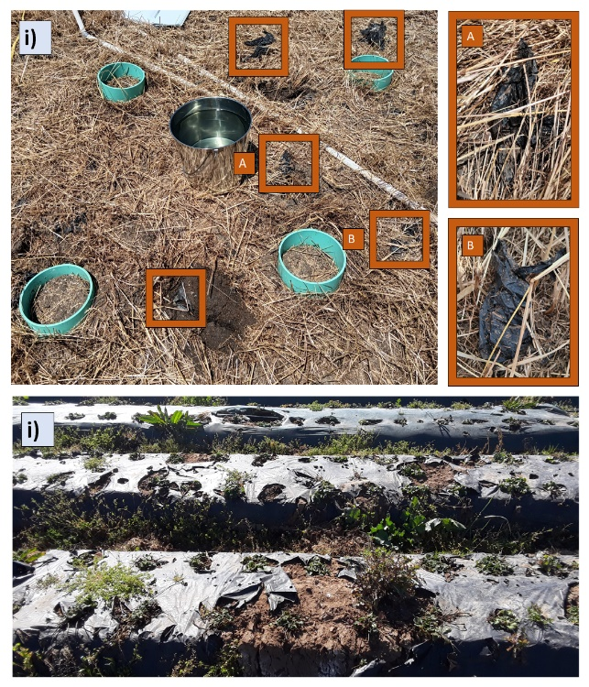
Figure 23. Biodegradable plastic residue in soil. i) Biodegradable plastic fragments in soil 18-months after plastic mulch was tilled into soil in San Luis Obispo, California. Soil was fallowed after biodegradable plastic mulch fragments were incorporated. ii) Biodegradable plastic mulch 2 years after it was applied to strawberry beds in Watsonville, California.

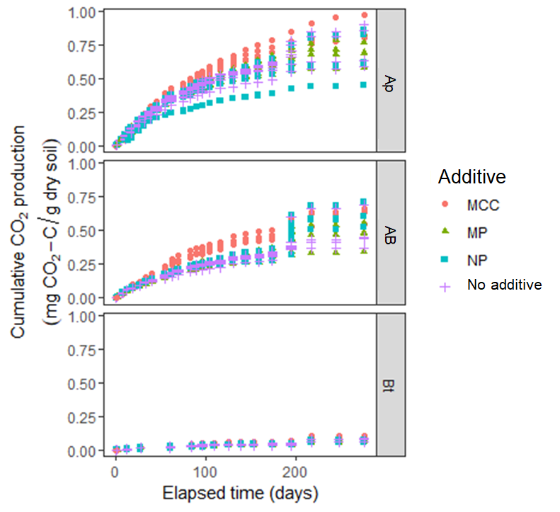
Figure 24. Cumulative CO₂ production over time in each soil for the duration of the incubation. Marker shapes and colors represent different additive treatments: red circles are data from mesocosms with MCC added; green triangles are from mesocosm with MPs added; blue squares are from mesocosms with NPs added and purple crosses are from mesocosms with no additive.

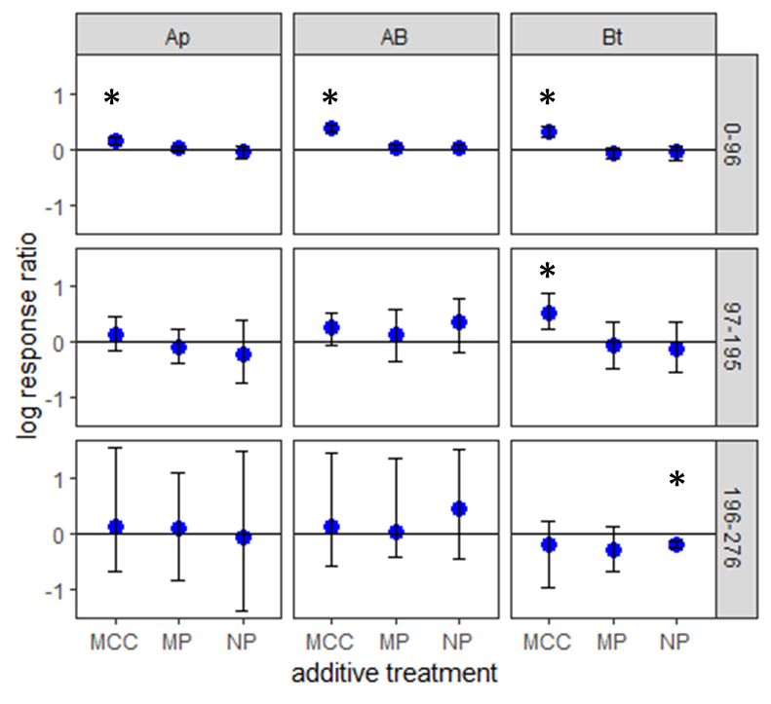
Figure 25. Log response ratio of cumulative respiration at three points in a 9-month incubation compared by soil horizon and additive. Response ratios are the ratio of respiration produced in that treatment to respiration produced in the same soil with no additive. Additives are microcrystalline cellulose (MCC), biodegradable microplastic (MP) and biodegradable nanoplastic (NP). Error bars represent bootstrapped 95% confidence intervals of the mean estimate. Stars indicate confidence intervals which do not overlap with zero.

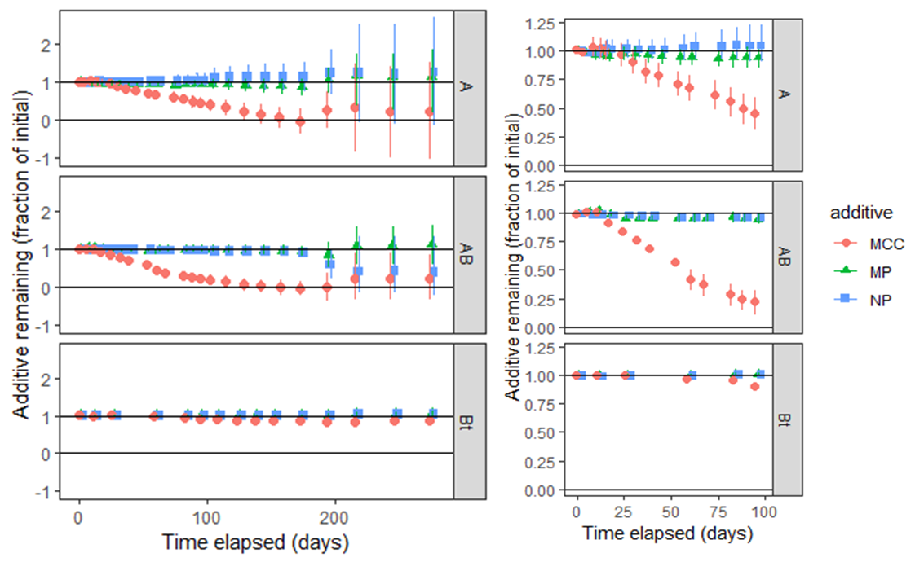
Figure 26. Estimated plastic content over the duration of the incubation based on differential respiration measurements between additive treatments and no additive treatments in each soil. Error bars represent bootstrapped estimates of one standard deviation of the population mean. Additives are microcrystalline cellulose (MCC), biodegradable microplastic (MP) and biodegradable nanoplastic (NP).

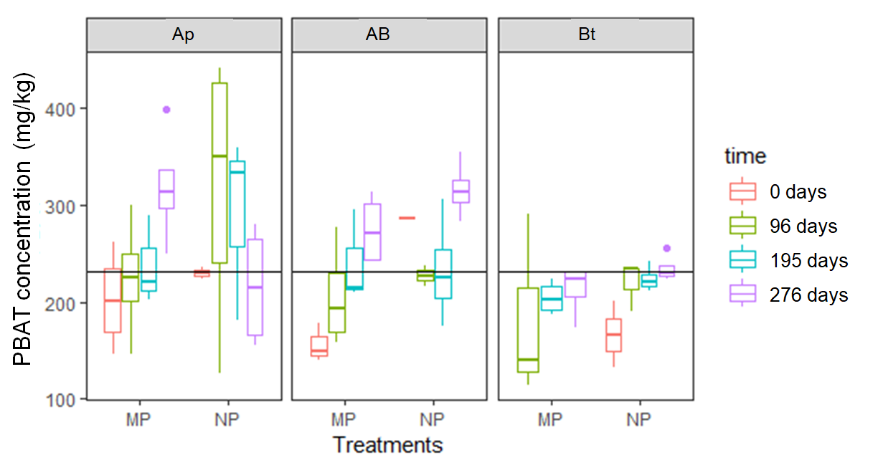
Figure 27. PBAT polymer content in soil measured during the incubation. There was no significant effect of time or plastic additive on measured PBAT content, though there was a significant effect of soil, where more PBAT was recovered from Ap soil than from Bt soil. At no time for no treatment was PBAT content significantly different than the initial added concentration of 230 mg/kg dry soil based on a set of one-way t-tests (p > 0.1 for all tests).

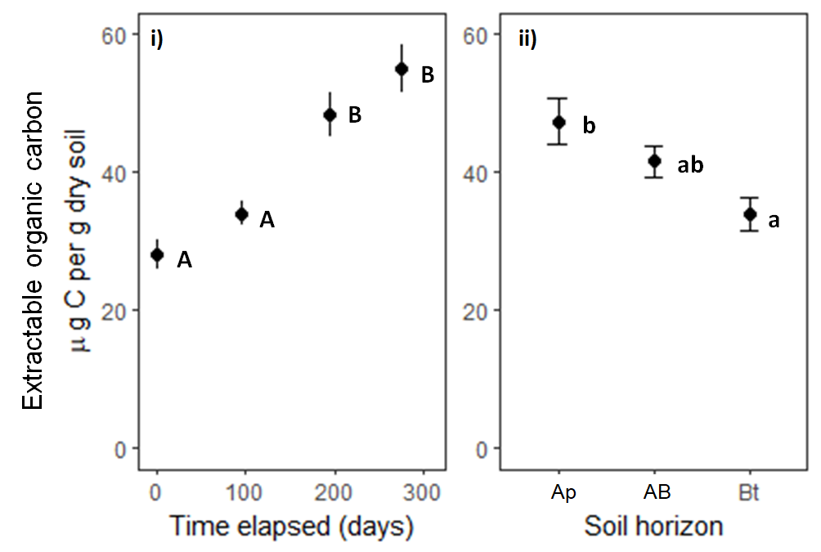
Figure 28. Extractable organic carbon measured in mesocosms i) over time and ii) for each soil horizon. i) Extractable organic carbon content is higher at days 195 and 276 than at days 0 or 96 based on mean separations at α = 0.05. ii) Extractable organic carbon content is higher in Ap horizon soil than in Bt soil. Neither soil is significantly different from AB soil based on mean separations at α = 0.05.

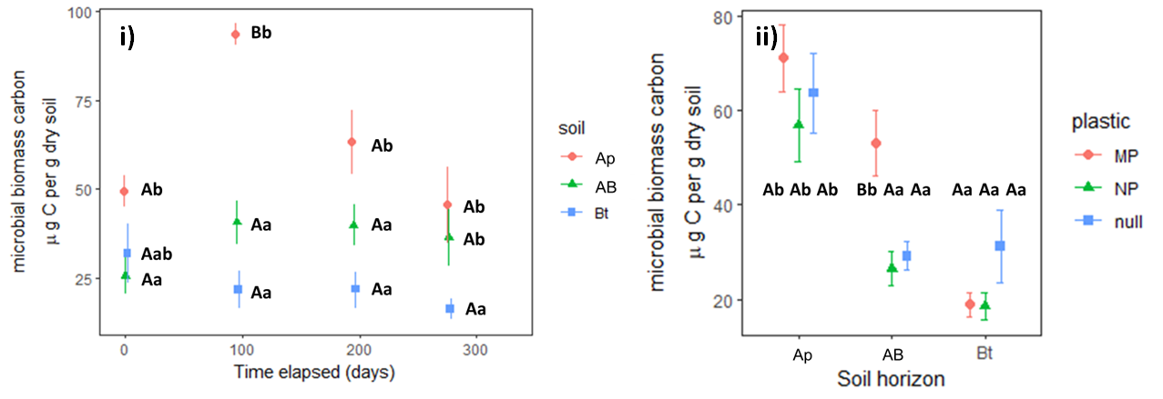
Figure 29. Microbial biomass carbon of experimental mesocosms shown by soil horizon over time (i) and by additive type in each soil (ii). i) A soils were collected from 0-5 cm below the soil surface, AB soils were collected from 15-20 cm below soil surface, and Bt soils were collected from 30-35 cm below soil surface. Error bars represent one standard error above and below the estimated mean. Uppercase letters (A, B) show groupings within one soil horizon treatment over time at the α = 0.05 level. Lowercase letters (a, ab, b) show groupings withing one time point for all three soils at the α = 0.05 level. ii) Microbial biomass carbon of experimental mesocosms shown by additive in each soil. Additives are microplastic (MP), nanoplastic (NP), or no additive (null). Error bars represent one standard error above and below the estimated mean. Uppercase letters (A, B) show groupings within one soil between additive treatments at the α = 0.05 level. Lowercase letters (a, b) show groupings between soil treatments within each additive treatment at the α = 0.05 level.

Table 9. Estimated additive remaining over time in each soil. Intervals represent a 95% confidence interval.
Ap soil | 96 days | 195 days | 276 days
MPs | 86-100% | 72-100% | 19-100%
NPs | 90-100% | 67-100% | 0-100%
MCC | 31-60 % | 0-77% | 0-100%
AB soil
MPs | 91-99% | 52-100% | 59-100%
NPs | 92-99% | 22-100% | 0-100%
MCC | 11-32% | 0-36% | 0-80%
Bt soil
MPs | 100% | 98-100% | 97-100%
NPs | 99-100% | 98-100% | 100%
MCC | 88-93% | 81-87% | 81-99%

Chapter IV
Homefield advantage in soil degradation of a biodegradable polybutylene adipate terephthalate Mulch microplastic
A version of this chapter has been submitted for publication. It is currently under review by the Journal Applied Soil Ecology:
Alexis B. Gillmore, Seeta A. Sistla, Sean M. Schaeffer. “Homefield advantage in soil degradation of a biodegradable polybutylene adipate terephthalate mulch microplastic.” Applied Soil Ecology. (in review)
The work described in this article was conducted by Alexis Gillmore. This article was written by Alexis Gillmore with feedback from Seeta Sistla and Sean Schaeffer. Douglas Hayes and Joe Zhuang also contributed feedback to the written draft. Full author contributions are described in this CRediT authorship statement:
- Alexis Gillmore: methodology, investigation, formal analysis, writing – original draft, writing – review and editing, visualization, supervision
- Seeta Sistla: conceptualization, methodology, resources, funding acquisition, writing – review and editing
- Sean Schaeffer: methodology, resources, funding acquisition, writing – review and editing, supervision, project administration

Abstract
Biodegradable plastic mulches (BDMs) could be a valuable alternative to conventional non-degradable plastic mulches because BDM waste is transformed into carbon dioxide, water and microbial biomass, eliminating a plastic waste management problem in conventional plastic mulch vegetable systems. Field trials show BDM fragmentation can take longer than a single growing season even though the materials are designed to be reapplied to the soil annually or more often. The objective of this study was to test for a homefield advantage effect, where polybutylene adipate terephthalate (PBAT)-based BDM microplastic would degrade more quickly in soils which had previously been exposed to BDMs made from PBAT (BDM-exposed soils) compared to BDM-unexposed soils (with no history of PBAT BDM mulching). Understanding whether previous exposure to biodegradable plastics accelerates decomposition of newly added material (a positive homefield advantage effect) is important for predicting degradation of BDMs after long-term use in field systems. Soil with a two-year history of BDM use (BDM-exposed soil) and soil from the same field with no history of PBAT BDM use (BDM-unexposed soil) were incubated with or without added PBAT BDM microplastics (MP-added or no MP-added) for six months. Cumulative CO₂ mineralization was measured throughout the incubation and PBAT remaining in the soil was measured at the end of the incubation. A positive homefield advantage effect of 12% was found at the end of the 190-day incubation with a 95% confidence interval spanning 9% to 17%. This means the increase in CO₂ mineralization in response to MP addition was approximately 12% stronger in BDM-exposed soils compared to BDM-unexposed soils. After the 6 month incubation, respiration gas from BDM-exposed soil had a lower ¹³C isotope ratio discrimination from bulk soil C compared to BDM-unexposed soil with MP added. Microbial biomass carbon, extractable organic carbon and soil pH were not affected by the soil’s history of exposure to BDM or by microplastic addition during the experiment. Between 0-36% of added BDM microplastics were mineralized during the 6-month incubation. Even accounting for the positive homefield advantage effect, degradation of BDM microplastics was slow in both BDM-exposed soils and BDM-unexposed soils. Slower microplastic degradation means a higher steady state concentration of microplastics in soil when BDMs are applied to the soil repeatedly.

Introduction
The United Nations Food and Agriculture Organization has identified plastic mulching as the second highest-risk use of plastic in agriculture due to widespread plastic contamination of agricultural soils resulting from mulching practices (Food and Agriculture Organization, 2021). Plastic mulches are used because they provide benefits in row crop systems like preventing weed competition (Lamont, 2005). However, plastic mulching creates waste plastic (Steinmetz et al., 2016) and can lead to plastic contamination in soil (Liu et al., 2014). Biodegradable plastic mulches (BDMs) are a promising alternative to conventional plastic materials that could solve plastic waste management issues (Flury and Narayan, 2021). BDMs which are designed to degrade in soil are certified as inherently biodegradable in laboratory conditions (EN 17033, 2018). This is demonstrated by a test with powdered materials incubated with soil and compost; this method is used to demonstrate that the BDM is inherently biodegradable rather than establish that it biodegrades in a particular soil environment (ASTM D5988 − 18, 2018). Laboratory certifications do not provide potential users of BDMs with sufficient information to determine if biodegradable plastic mulches are suitable for their location and production system. One key question about BDMs in the field is how mulch degradation might change over time with repeated application of same biodegradable plastic. Short-term testing does not allow researchers to investigate the possibility that soil microbial communities might change over time in response to inputs of biodegradable plastic.
Polybutylene adipate co-terephthalate (PBAT) is a biodegradable polyester that is commonly used in biodegradable plastic mulch products. PBAT can be degraded by soil microbes through ester hydrolysis (Zumstein et al., 2018). The degradation process can be conceptualized as three co-occurring processes: colonization, in which microorganisms grow on the surface of a biodegradable plastic; fragmentation, in which microbial enzyme activity breaks apart the material near the site of colonization; and mineralization, in which carbon from the biodegradable plastic is transformed by microbial processes into carbon dioxide (Zumstein et al., 2018). BDM carbon can also be assimilated into microbial biomass (Zumstein et al., 2018). The biodegradation process is similar to the microbial degradation of polymeric soil organic matter (Schimel and Weintraub, 2003). Plastic products, including PBAT biodegradable plastic mulches are made from long polymer chains and are processed into a densely-packed arrangement so enzyme access to ester bond sites is limited, which can slow degradation (Brodhagen et al., 2015)
The fragmentation of BDMs in field conditions is highly variable: observations of BDM degradation in field trials range from no observed disappearance after 2 years to 100% visible disappearance after 2 years (Li et al., 2014; Moreno et al., 2017; Sintim et al., 2020; Griffin-LaHue et al., 2022). Degradation rates in the field depend on environmental temperature and moisture as well as mulch material and thickness (Li et al., 2014; Moreno et al., 2017). In the field, BDMs fragment into smaller pieces, including microplastics (MPs; effective diameter less than 5 mm) which have been shown to persist in the soil for a year after macro-sized plastic is detectable (Griffin-LaHue et al., 2022; Li et al., 2023). The effects of biodegradable MPs in soil are not well established (Wang et al., 2021; Lehmann et al., 2021; Bodor et al., 2024). Because plastic mulches are designed to be reapplied to crop fields annually, BDM degradation that takes more than a year would lead to plastic persistence in the soil between applications.
Homefield advantage (HFA) is a hypothesized effect sometimes observed in plant litter decomposition. According to the HFA hypothesis, soil microbial communities have an advantage when degrading local litter compared to foreign litter; they can degrade local litter more quickly because they are adapted to it (Coleman et al., 1988; Gholz et al., 2000; Ayres et al., 2009). Homefield advantage effects are typically tested by reciprocal litter transplant experiments where the degradation of two litters is monitored at each of two sites with one of the two litters being native to each site. Homefield advantage can be quantified with a homefield advantage index, which represents the relative increase in each litter’s degradation at the local site compared to the foreign site (Ayres et al., 2009). A positive HFA effect indicates that home litter is preferentially degraded at a site while a negative HFA effect indicates that foreign litter is preferentially degraded at that site. Degradation rates reported from reciprocal plant litter transplant studies range from 34% slower degradation at home (negative HFA effect) to 58% faster degradation at home (positive HFA effect) (Veen et al., 2015). Positive HFA effects appear to be more likely when foreign litter and native liter are less similar (Veen et al., 2015). Biodegradable plastics are relatively recalcitrant substrates compared to the crop litter inputs in annual agricultural systems where plastic mulches are used. Homefield advantage effects can also change over time, for example during ecosystem successional processes (Veen et al., 2018). The emergence of HFA effects over time is especially interesting in the case of biodegradable plastic because a positive HFA effect could reduce the expected plastic burden in soils where biodegradable plastic mulches are used.
The primary objective of this study was to examine a potential homefield advantage effect for biodegradable plastic mulch degradation in an agricultural field soil with two years of exposure to biodegradable plastic (BDM-exposed), compared to an adjacent soil with no history of biodegradable plastic exposure (BDM-unexposed). A secondary objective was to determine how the homefield advantage effect changed over time for the two soils. We designed a laboratory incubation experiment to test for a homefield advantage effect in BDM degradation by adding microplastics (MPs) made from PBAT BDM to BDM-exposed and BDM-unexposed soil. We measured cumulative soil CO2 mineralization in all incubated mesocosms to calculate a homefield advantage index. We used a completely randomized design of two treatments with two levels each: the soil history treatment (BDM-exposed and BDM-unexposed) and the plastic addition treatment (MP-added and no MP-added). We hypothesized that a positive homefield advantage effect would manifest for BDM-exposed soil compared to BDM-unexposed soil.

Methods

Soils
Soil exposed to PBAT BDM (referred to as BDM-exposed soil) was collected from two rows of a Certified Organic strawberry field in Prunedale, California where PBAT-containing BDM Bio360 (Dubois Agroinnovation, Simcoe, QC) was used to cover strawberry rows for two years. The mulch was approximately 70% PBAT (polybutylene adipate terephthalate, a biodegradable polyester; determined by NMR) and 30% starch with small amounts of other additives (Hayes et al., 2017). The mulch was not tilled into the soil; instead, it weathered in place on top of the soil. Soil not exposed to PBAT BDM (BDM-unexposed soil) was collected from the same field, from two rows where polyethylene mulch was used as a covering and BDM had never been used. For both BDM-exposed and BDM-unexposed soils, about 300g of soil was collected at a depth of 0-5 cm from three random locations in each of two rows using a trowel. The six subsamples were homogenized to create a single sample of BDM-exposed soil and a single sample of BDM-unexposed soil. The sampling trowel was sanitized between collecting the two samples. Both soils were sandy loams. The two soils had a mean pH of 6.6 with a standard deviation of 0.1 pH units (no significant difference, p = 0.39). The PBAT-exposed soil had a water content of 0.09 cm³/ cm³ dry soil and the PBAT-unexposed soil had a water content of 0.15 cm³/ cm³ dry soil. The water content at field capacity of both soils was calculated to be 0.41 cm³/ cm³ dry soil, so the water content of the collected soil was about 22% of field capacity for the PBAT-exposed soil and 36% of field capacity for the PBAT-unexposed soil. Total carbon content was determined by grinding dry soil into a uniform powder, then sending 40 mg of each sample to the Stable Isotope Laboratory at The University of Tennessee, Knoxville for carbon content analysis by combustion using a Costech Elemental Analyzer. After collection, the soil was frozen at -20 °C for four months.

Plastic material
We created microplastics from field-weathered Bio360 brand BDM according to the procedure described in Astner et al (2022). The BDM was used in strawberry cultivation during the growing season from October 2019 to August 2020 in San Luis Obispo, California. The surface area of the generated microplastics followed a Weibull distribution with a scale parameter of 1 and a shape parameter of 0.1. The mean size of measured particles was 0.2 mm² and the most common size bin was 0 – 0.1 mm². The generated microplastics had a mean carbon content of 57% after milling. Microplastics were sterilized based on the method described in Bailes et al. (2013). The material was spread in a single layer on a tray under UV light for four 30-minute intervals. Microplastics were stirred thoroughly between each interval. The energy from UV radiation during microplastic sterilization is estimated to be negligible (<0.1%) compared to UV radiation from the field use of the BDM.

Incubation set-up
To begin the experiment, soil was thawed in a refrigerator at 4 °C for three days. Soil was then sieved with a 2 mm mesh sieve while rocks and plant litter larger than 2 mm were removed. For 10 replicate samples of each soil (BDM-exposed and BDM-unexposed), 150 g of moist soil were weighed into a sterilized glass jar with an airtight seal to create a mesocosm. The lid of each jar was fitted with a rubber septum to allow headspace gas sampling during the experiment. Mesocosms were pre-incubated at 20 °C for six days to allow soil microbial communities to adjust to the temperature change before beginning the experiment. to begin the experiment, 50 mg of microplastic was added to half of the mesocosms (five PBAT-exposed and five PBAT-unexposed). This is equivalent to 0.2 mg of carbon per gram of dry soil and 0.25 mg PBAT per gram of dry soil, about 10 times the annual plastic application from plastic mulching and about 3% 0f pre-existing soil carbon. Jars were then recapped and returned to the incubator. Water content was not adjusted from collected water content described above. The location of each jar within the incubator was randomized and six additional mesocosms were included as negative controls. Three empty sterilized jars and three sterilized jars with only microplastic added served as negative controls used to verify that carbon dioxide production did not occur in the absence of soil.

CO₂ mineralization measurements
Headspace gas samples were collected during the incubation and CO₂ content was measured with a flow-through infrared gas analyzer (LI-COR; Lincoln, NE). Gas samples were collected from each mesocosm for CO₂ analysis 24 and 72 hours after the addition of microplastics. After 72 hours, gas was sampled twice a week for the first 33 days of the experiment, then was sampled every other week for the remainder. When CO₂ concentration in the headspace gas exceeded 2% for at least one of the twenty mesocosms, every jar was opened to vent gas (excluding the soilless controls). Headspace gas was sampled before and after venting. The carbon dioxide produced between every venting period was summed to calculate the total CO₂ production of each mesocosm. Mass was lost in the form of water vapor from each mesocosm when they were opened for venting. Water was added to mesocosms once during the experiment, when mass loss was equivalent to a ~10% reduction in water content in three out of 20 mesocosms. Water was added to each mesocosm after venting on day 57. After adding water, soil in each mesocosm was stirred with a sterilized rod to distribute water, then the mesocosm was resealed.

Respiration gas carbon isotope analysis
Before mesocosms were vented on day 22 and day 190, headspace gas was collected and stored in 12 mL vials previously purged with nitrogen gas. The ¹³C / ¹²C isotope ratio of the samples was measured via isotope ratio mass spectroscopy, then compared between samples and a reference material, then reported as $δ^{13}C =\left(\frac{{{{}_{ }^{13}C}/{{}_{ }^{12}C}}_{sample} }{{\left({{}_{ }^{13}C}/{{}_{ }^{12}C}\right)}_{VPDB}}-1\right)*1000$ in units of per mil. Isotopic discrimination between each respiration gas sample and total organic carbon in the soils was calculated as Δ¹³C = $\frac{δ13Csoil - δ13C_{CO_{2}} }{1 +(δ13C_{CO_{2}}/1000)}$ (Farquhar et al., 1989; Bowling et al., 2008).

Post-processing
On the 190th day of the incubation, headspace CO₂ was measured for the last time and the incubation was ended. Moist soil was partitioned to measure extractable organic carbon (EOC), microbial biomass carbon (MBC), and pH. The remaining soil was set out to air dry, then used to measure PBAT plastic content. Extractable organic carbon and microbial biomass carbon were measured by K₂SO₄ slurry extraction and persulfate oxidation method; chloroform fumigated and unfumigated C was compared to quantify MBC (Vance et al., 1987; Fierer, 2003). Soil pH was measured by creating a 2:1 v:m slurry of water and soil. After slurry settled for three minutes, a pH probe was submerged in the slurry and stirred gently until the pH reading stabilized.

PBAT quantification by QNMR
The PBAT polymer content of the soil was measured using the solvent extraction and ¹H-NMR quantification method based on Nelson et al. (2020). Air dried soil (100 g) was shaken with 100 mL of a 90:10 v/v chloroform methanol mixture to extract PBAT. After soil settled, the solvent was decanted into a clean glass vial to dry. An internal calibrant, 1,4-dimethoxybenzene, was added to each dried extract, then the extract was resuspended in deuterated chloroform and transferred to an NMR tube. Extracts were analyzed with a Bruker 500 MHz NMR spectrometer with a 90-degree pulse angle, 30 second relaxation delay, and 32 repeated scans of the sample from -2-12 ppm. In the resulting spectra, the integrated areas of five distinct PBAT peaks were compared to two distinct 1,4-dimethoxybenzene peaks to quantify the PBAT in each sample. See Nelson et al. (2020) for details of peak assignment and quantification.

Calculating potential plastic remaining based on CO₂ mineralization
For both BDM-exposed and BDM-unexposed mesocosms, the amount of BDM MP remaining in MP-added mesocosms was estimated based on the difference between cumulative CO₂ mineralization between the MP-added mesocosms and no MP-added mesocosms with the same BDM exposure history using the equation CC_{excess} = CC_{MP added} – CC_{No MP added} where CC is the cumulative CO₂ production in a mesocosm at the end of the experiment expressed in units of mg C-CO₂ per g dry soil. We calculated the remaining carbon from BDM MPs added in the experiment according to ASTM D5988 using the following equation: Frac_{C from plastic, f} = (m_{Plastic, i} / C_{frac plastic} – CC_{excess}*m_{dry soil})/m_{Plastic, i}; where m_{dry soil} is the amount of soil in each incubation jar, C_{frac Plastic} is the carbon content of the added microplastics and m_{Pplastic, i} is the initial mass of the plastic added. This calculation is accurate only if no positive or negative priming occurred in the mesocosms. Bootstrapping was used to estimate confidence intervals for plastic remaining at each timepoint. In this technique, plastic remaining was calculated using 10,000 different theoretical samples of the 20 sampled experimental units from each time point. This yielded a distribution of possible confidence intervals used to calculate a theoretical confidence interval.

Extrapolating degradation rates
We used the initial concentration of BDM microplastic added along with the calculated mean plastic remaining in each soil at the end of the experiment as two points to define potential degradation time courses for microplastic in each of the experimental soils using an exponential decay model (first order model) and a linear decay model (pseudo zeroth order model). The linear model is defined by $C_{MP}(t)=C_{0}(1-kt)$, where C_{MP} is the concentration of microplastics at a given time t, C₀ is the initial concentration of microplastic and k is the degradation rate. This model is sometimes used to estimate biodegradable plastic degradation (Tosin et al., 2019) and would be an accurate predictor of microplastic degradation if the degradation rate does not change over time, perhaps because reaction rate is limited by the attachment of microbial enzymes to microplastics rather than by the concentration of MP or enzymes (Cook and Cleland, 2007). The exponential decay model is defined as $C_{MP}=C_{0}\left.e^{-kt}\right.$. This model is widely used to describe plant litter decomposition in soil (Jenny et al., 1949; Olson, 1963; Rovira and Rovira, 2010) and could be an accurate predictor of microplastic decay if the degradation rate decreases as MP concentration decreases.
For both models, we solved for k using a known value of C₀ and C_{MP} at t = 0 days as well as the calculated value of C_{MP} at t = 190 days. We used these model equations and k values to extrapolate the time required until 50% of plastic would remain (mean residence time) in both soils under both model conditions. The mean residence time was reported instead of time until complete degradation because in the exponential decay model, plastic concentrations asymptotically approach zero. Other potentially more accurate, but more complicated models to describe microplastic degradation (Chinaglia et al., 2018) were not included in the analysis because of the limited experimental data used to extrapolate the degradation models.

Calculating homefield advantage
We calculated homefield advantage for PBAT plastic degradation in the PBAT-exposed soil using equations for a homefield advantage coefficient modified from Ayers et al. (2009). For this study, these equations were modified to account for the lack of a reciprocal transplant of a second litter; only BDM biodegradation was of interest. The HFA index (HFAI) became $HFAI=\left({\frac{CC_{EP}}{CC_{EN}}}/{\frac{CC_{UP}}{CC_{UN}}}-1\right)*100$, where EP refers to the PBAT-exposed soil with PBAT added, EN refers to the PBAT-exposed soil with no PBAT added, UP refers to the PBAT-unexposed soil with PBAT added, and UN refers to the PBAT-unexposed soil with no PBAT added. The HFA index describes the ratio of additional CO₂ mineralization when PBAT is added to PBAT-exposed soil compared to when PBAT is added to PBAT-unexposed soil (Ayres et al., 2009).
Bootstrapping was used to estimate means and confidence intervals for values of the homefield advantage index (HFAI) at each timepoint. In this technique, HFAI was calculated using 10,000 different theoretical samples of the 20 sampled experimental units from each time point. This yielded a distribution of possible HFAI values used to calculate a theoretical mean and 95% confidence interval.

Statistical analysis
All analyses were performed in R version 4.3.1 (R Foundation for Statistical Computing) using RStudio build 524 (RStudio, Inc.). For these analyses, the data sets met all assumptions of the ANOVA model. The Shapiro-Wilks test was used to check for normality and Levene’s test was used to check for homogeneity of variance.
The effect of soil history treatment (PBAT-exposed or PBAT-unexposed) and plastic treatment (PBAT-added or no PBAT-added) as well as their interaction on cumulative CO₂ mineralization, microbial biomass carbon, extractable organic carbon, and pH at the end of the experiment were modeled using completely randomized design with the car package. A two-way ANOVA was used to test for effects of the plastic addition and soil history treatments as well as their interaction on each outcome variable using car. To test for effects of soil history treatment, plastic treatment, measurement time, or the interaction of these variables on the δ¹³C values of respiration gas produced in the incubation and the isotopic discrimination between respiration gas carbon and soil carbon (Δ¹³C), data was modeled as a repeated measures completely randomized design and tested with a repeated measures ANOVA.
Where significant treatment effects were discovered, post-hoc mean separations with Tukey’s Honest Significant Differences were used to understand the nature of the effect using emmeans. Letter groupings were assigned with α = 0.05 to differentiate between significantly different treatments. In ANOVA analysis, treatment effects were considered significant if p < 0.05.
To compare PBAT content measured by ¹H-QNMR between the two PBAT-added soil treatments at the end of the experiment, we used a two-tailed two-sample t-test.

Results

Cumulative CO₂ mineralization
At the end of the 6-month (190 day) incubation, there was no effect of plastic addition on cumulative soil CO₂ mineralization (F = 1, df = 16, p = 0.3). There was an effect of BDM exposure history (F = 7, df = 16, p = 0.02), where BDM-exposed soil mineralized more CO₂ than BDM-unexposed soil (p = 0.015). Figure 30 in the appendix at the end of this section shows the cumulative CO₂ mineralization values measured for each of the two soil history treatments. The mean cumulative CO₂ mineralization for BDM-exposed soil was 0.27 ± 0.04 mg CO₂ per g dry soil (one standard deviation) compared to 0.22 ± 0.03 mg CO₂ per g dry soil for BDM-unexposed soil. Figure 31 shows the mean CO₂ mineralization of mesocosms by treatment over the 190-day incubation. Figure 32 shows the cumulative CO₂ mineralization for each mesocosm treatment group as of day 190. Table 10 summarizes the amount of CO₂ produced in each group of mesocosms compared to the available organic carbon.

Plastic remaining estimated by CO₂ mineralization
Based on bootstrapped confidence intervals, BDM MP content of mesocosms at the end of the experiment was not significantly different from starting MP content, nor was there a significant difference between the BDM-exposed and BDM-unexposed soils. The mean final MP content was estimated as 98% ± 22% (one standard deviation) in BDM-unexposed soil and 86% ± 27% in BDM-exposed soil. Figure 33 shows the estimated amount of added BDM MPs remaining over time for both the BDM-exposed and BDM-unexposed mesocosms. At day 71 and beyond, confidence intervals became much larger than they were before day 71.

PBAT quantified by NMR
PBAT polymer was not detected by NMR in any of the no PBAT added mesocosms composed of either PBAT-exposed or PBAT-unexposed soil, indicating that there was undetectably little of the polymer in the soil before beginning the experiment. PBAT was detected in all PBAT-added samples, indicating that the polymer was still present at the end of the incubation. There was no difference between PBAT measured by Q-NMR in PBAT-exposed and PBAT-unexposed soils with plastic added (p = 0.4). The measured PBAT content of each plastic-added mesocosm at the end of the incubation is shown in Figure 34 as a fraction of the initial amount of PBAT.

Carbon Isotope ratios and discrimination
There was no significant effect of BDM exposure history, MP addition, measurement time or their interactions on δ¹³C_{vpdb} measured from respiration gas collected during the incubation (p > 0.05 for each). The measured δ¹³C_{vpdb} of the respired carbon dioxide was -24.6 ± 1‰ (mean ± one standard deviation). Both the microplastic material and soil had a more negative mean δ¹³C_{vpdb} than the respired CO₂ from the mesocosms (-25.78 ± 0.05‰ and -26.2 ± 0.2‰ respectively). Figure 35 shows the δ¹³C_{vpdb} of each group of mesocosms at both measurement times.
There was a significant effect of BDM exposure history on the discrimination between respiration gas carbon and bulk soil carbon isotope ratios (F= 0.08, df = 16, p = 0.01), where BDM-exposed soil had a lower discrimination from the bulk soil organic matter (mean -1 ± 1 ‰) than BDM-unexposed soil (mean -2 ± 1 ‰). Figure 36 shows the carbon isotope discrimination for each soil treatment. Figure 37 shows the Δ¹³C of each group of mesocosms at both measurement times.

Homefield advantage calculations
Figure 38 shows the homefield advantage index at each time CO₂ mineralization was measured during the experiment. The index was nonzero (based on bootstrapped 95% confidence intervals) at every point in the experiment except at day 3. In the first half of the experiment before day 85, the HFA index fluctuated between positive and negative values, but after day 85 the index became increasingly positive. The final HFA index on day 190 is estimated between 9-17% with a mean of 12%. This means that microbial communities in BDM-exposed soil produced on average 12% more carbon dioxide when PBAT MPs were added compared to a similar soil that had not previously been exposed to PBAT BDM when the microplastics were added. Figure 5 shows the homefield advantage index as calculated at each time point when CO2 mineralization was measured. At day 71 and beyond, confidence intervals are much larger than they were before day 71. Confidence intervals are asymmetrical because the bootstrapped possible values of HFAI are not normally distributed.

Extractable organic carbon and microbial biomass carbon
At the end of the incubation, there were no significant effects of BDM-exposure history, MP addition or their interaction on extractable organic carbon (p = 0.5, 0.06, and 0.08 respectively). The mean measured extractable organic carbon was 20 ± 10 μg C per g dry soil (one standard deviation). Figure 39 shows the extractable organic carbon measured in each group of mesocosms.
There were no significant effects of soil history, plastic addition, or their interaction effect microbial biomass carbon measured at the end of the incubation (p > 0.38). The microbial biomass carbon in all soils was 25 ± 13 ug-C per g dry soil (mean ± one standard deviation). Figure 40 shows the microbial biomass carbon measured in each group of mesocosms.

Discussion
We assessed the degradation of PBAT-based BDM MPs in two incubated soils and found no significant MP biodegradation occurred over 6 months based on both CO₂ mineralization (respiration) measurements and PBAT polymer quantification. Based on the CO₂ mineralization we observed, we extrapolated the time to degrade 90% of the BDM microplastic we added to the soil. Based on our model, this would take more than two years for either BDM-exposed or BDM-unexposed soil. Despite the insignificantly small plastic degradation we observed, we found evidence of a positive homefield advantage effect: 9-17% more plastic was mineralized in BDM-exposed soil compared to BDM-unexposed soil during the 6-month incubation. Based on this result, we recommend investigating homefield advantage for BDM degradation in field contexts over the entire course of BDM biodegradation.

Water content
We observed a greater cumulative CO₂ mineralization in BDM-exposed soil than in BDM-unexposed soil during the incubation. Because BDM-exposed and BDM-unexposed mesocosms respired CO₂ differently, we were concerned about the impact the soil’s different initial water contents may have had on the CO₂ mineralization and BDM degradation observed during the experiment. Because CO₂ mineralization variability was increased when water was added to mesocosms on day 57, we were also concerned about a potential impact to CO₂ mineralization measurements from added water. To clarify the impact of water content and water addition on key experimental results we conducted post-hoc regression tests to determine the correlations between a) cumulative carbon dioxide respired in each mesocosm from day 0-190 and total water lost from day 0-190, b) cumulative carbon dioxide respired from day 0-190 and amount of water added at day 57, c) cumulative carbon dioxide respired from day 58-190 and amount of water added at day 57, d) cumulative carbon dioxide respired from day 0-190 and initial soil water content, and e) cumulative carbon dioxide respired from day 58-190 and initial soil water content. We found that a) cumulative carbon dioxide respired from day 0-190 was not correlated with total water lost from day 0-190 (R² = 0.003, F = 0.06, df = 19, p = 0.8), b) cumulative carbon dioxide respired from day 0-190 was not correlated with amount of water added at day 57 (R² = 0.01, F = 0.6, df = 19, p = 0.6), c) cumulative carbon dioxide respired from day 58-190 was not significantly correlated with amount of water added at day 57 (R² = 0.02, F = 0.5, df = 19, p = 0.5), d) cumulative carbon dioxide respired from day 0-190 was significantly correlated with initial soil water content (R² = 0.3, F = 8, df = 19, p = 0.01), and e) cumulative carbon dioxide respired from day 58-190 was not significantly correlated with initial soil water content (R² = 0.02, F = 0.4, df = 19, p = 0.5).
The results of A-C demonstrate that while the variability of mesocosm respiration increased after water was added on day 57, adding water did not bias respiration in any particular direction; we believe that the water addition did not change the calculated homefield advantage index or the estimated plastic remaining at the end of the incubation. D demonstrates that differences in initial water content alone could not explain 70% of differences in cumulative CO₂ mineralization during the entire experiment (days 0-190); while we cannot rule out some effect of the two soil’s different initial water contents, differences in water cannot explain all of the observed results. The homefield advantage index developed by Ayers et al. (2009) is designed to assess homefield advantage between two sites with different degrading capabilities and is robust to assessing homefield advantage between the two soils we used with different baseline respiration rates. E demonstrates that differences in initial water content did not correlate with respiration during days 58-190. Because a consistently positive homefield advantage effect did not occur until after day 57, it appears unlikely that the observed positive homefield advantage in days 58-190 was an artifact of differences in initial water content.

Plastic degradation
Our estimate of BDM MP degradation during the incubation is highly variable. This is due in part to the cumulative nature of the respiration measurements in the experiment, where measurement variability compound over time. Even though there was no statistically significant degradation of plastic during the experiment, there may have been some degradation as indicated by the additional respiration measured when plastic was added to the soil. However, we cannot attribute respired carbon dioxide directly to a microplastic source because of the potential for priming effects, where mineralization of native soil organic matter could increase or decrease due to the addition of microplastics (Kuzyakov et al., 2000; Perveen et al., 2019). Priming effects that decrease the mineralization of soil organic matter are more often associated with substrates with a high C:N ratio (Nicolardot et al., 1986; Dalenberg and Jager, 1989; Kuzyakov et al., 2000) and the microplastics we added had a 400:1 C:N ratio (the polymeric structure of PBAT and starch polymers do not contain N, but the small amounts measured in our elemental analysis likely come from processing additives added to transform the raw polymer materials into a plastic mulch product). If a priming effect decreased the mineralization of soil organic matter, then more plastic would have been degraded during the incubation than we assumed. However, our quantification of the PBAT polymer in soil supports the conclusion that little or no microplastic was degraded at the end of the incubation. While it is not appropriate to directly compare PBAT remaining based on NMR analysis with total BDM biodegradation (the BDM is comprised of 70% PBAT and 30% starch and other additives), there was no significant difference between initial and final mesocosm PBAT concentrations just as CO₂ mineralization results suggested no significant biodegradation of the BDM MPs occurred during the incubation.
The carbon-13 isotope ratio of respired carbon dioxide produced during the incubation can differ from the isotope ratio of the bulk soil organic carbon because different soil organic matter constituents are relatively enriched or depleted in ¹³C compared to each other (Dijkstra et al., 2006; Bowling et al., 2008). There was a difference in Δ¹³C discrimination from soil organic matter between the BDM-exposed soil and BDM-unexposed soil. This suggests that in BDM-unexposed soils mineralization more of a carbon source with more ¹³C than the PBAT MPs we added compared to the BDM-exposed soil. This high ¹³C carbon source was consistent with some pools of soil organic matter (Bowling et al., 2008). In contrast, in BDM-exposed soils, soil microbes mineralized relatively more carbon with less ¹³C – consistent with the mineralization of MPs or of some soil organic carbon pools (Bowling et al., 2008) (although the result was not speific to mesocosms with PBAT MP added). There was no change in δ¹³C_{vpdb} measurements or Δ¹³C discrimination from soil organic carbon between the beginning and end of the experiment, so whatever drove the difference in discrimination between the BDM-exposed and BDM-unexposed soils, we have no evidence it changed between day 22 and day 190 of the incubation. Δ¹³C discrimination also did not differ between soils with or without MPs added, so the phenomenon was likely not related to BDM MP biodegradation.
Extractable organic carbon was comparable between mesocosms with MP added mesocosms with no added PBAT MPs. Additions of polylactic acid-based biodegradable microplastic have been shown to increase the extractable organic carbon content of incubated soils compared to controls and to alter the stability of soil organic matter (Shi et al. 2022; Qiu et al., 2024), but we did not see the same effect on extractable organic carbon concentration when we added PBAT microplastics.
We extrapolated the mean residence time of the PBAT microplastic based on the mean and maximum (one standard deviation above the mean) amount of plastic degradation measured in each soil during the experiment. Minimum estimates of plastic degradation were 0% in 6 months for both BDM exposed and BDM unexposed soils. If BDMs continued to degrade at the mean rates shown in Figure 33, then Table 11 shows the mean residence time of MPs in each soil. If BDMs continued to degrade at the maximum rates shown in Figure 33, then Table 12 shows the mean residence time of MPs in each soil. While the extrapolated average mean residence times shown in Table 11 are greater than one year under all modeled conditions, these residence times are much shorter than what would be expected for non-biodegradable plastics like conventional polyethylene (Colin et al., 1981; Otake et al., 1995). This is an estimate of the time required for the MP to biodegrade. It does not include any estimate of time for biodegradable plastic mulch to disintegrate into microplastic form, which also takes time (Li et al., 2023).
We expect that measuring plastic degradation within our laboratory incubation could lead to overestimates of the material’s residence time, as this has been observed when assessing plant litter decomposition rates (Cotrufo et al., 2010). Degradation patterns for these microplastics in a field environment could look quite different than what we measured in the laboratory incubation due to water inputs and dynamics (Petraglia et al., 2019; Kong et al., 2022); temperature fluctuations (Gregorich et al., 2017); and structural disturbance by tillage (Lupwayi et al., 2004) or other management activities. It is important to learn more about how biodegradable plastic mulches fragment and degrade from in field conditions, because mulch fragments remaining in the field can negatively impact crop development (Serrano-Ruiz et al. 2023).

Homefield advantage
While there was no difference in absolute respiration between BDM-exposed soil with PBAT MPs added and BDM-unexposed soil with MPs added, this is not sufficient to discount the presence of a homefield advantage effect for BDM degradation. That assumption would conflate microbial community degrading ability for a generic substrate with homefield advantage for BDM degradation (Keiser et al., 2014). In fact, the calculated homefield advantage index indicates that there was an ~12% positive homefield advantage effect for the BDM-exposed soil by the end of the experiment. This could indicate that the soil microbial community adapted to BDMs as a carbon substrate during the exposure period and were able to decompose it more quickly during the experiment (Ayres et al., 2009). This positive homefield advantage effect was observed even when soil pre-exposure to PBAT BDM consisted of mulches weathering in place over the surface of plots. Tillage of BDM into the soil would increase soil contact with BDM and might increase the strength of a homefield advantage effect or accelerate its emergence.
Homefield advantage index oscillated between negative and positive for the first 57 days of the experiment, and then became positive after day 57. This suggests that any homefield advantage for plastic degradation was not present immediately but manifested over 57+ days. This could be consistent with a plastic degradation model like the one discussed by Zumstein (2018), where microbes require time to colonize and attack plastic surfaces, after which polymer degradation speeds up. Perhaps there was no clear homefield advantage effect during the colonization stage but there was a positive advantage during the mineralization stage, although we do not know when or if microbial colonization of the PBAT BDM MPs took place during the incubation.
We do not know what homefield advantage might look like for plastic biodegradation beyond the range observed in this incubation study. HFA may or may not manifest over the full biodegradation course of a BDM material. The size of homefield advantage effects on litter decomposition can be dwarfed by the influence of litter quality on decomposition rates (Fanin et al., 2016); if this is the case for BDM, homefield advantage effects might do little to increase slow biodegradation rates. Biodegradable plastic mulches have been observed to change soil microbial communities where they are used (Bandopadhyay et al., 2018), to change the storage of soil carbon (English, 2019) and to affect plant and microbial functionality associated with nitrogen cycling (Wang et al., 2022; Zhang et al., 2024a; b). It is possible changes to a soil microbial community that lead to a positive homefield advantage effect for BDM degradation could come with other changes to elemental cycling in agroecosystems.

Conclusion
We conducted this experiment to test for a homefield advantage effect in the soil biodegradation of PBAT plastic based on BDM exposure history. In a laboratory incubation, we observed an ~12% homefield advantage in CO₂ production for soil with a history of exposure to PBAT BDMs. Larger, more positive homefield advantage is typically measured in field studies compared to laboratory incubations (Veen et al., 2015), yet we found a small positive effect in our incubation. However, BDM microplastic degradation was slow in both soil with and without a history of BDM-plastic exposure. For both BDM-exposed and BDM-unexposed soils, we expect microplastic degradation times longer than one year. This means that microplastic is likely to remain in the soil between annual applications of biodegradable plastic mulch. We do not know if the microplastic degradation pattern we observed would pose an issue for long term use of the BDM material in the field. It is important to assess MP biodegradation in soil in field trials of BDM to eliminate the potential for concern. The homefield advantage effect of 12% faster MP biodegradation rates in BDM-exposed soil does not equate to much plastic degradation when rates are slow. We recommend that further research investigate the magnitude and direction of a homefield advantage and the in-field degradation of biodegradable plastic mulch products. Long term studies of biodegradable plastic degradation in the field are needed to investigate potential homefield advantage in-situ. If homefield advantage does exist for biodegradable plastic mulches in soil, it must develop over time because the plastic mulch is at first foreign to all soil. Further studies should investigate how homefield advantage effects change over time in soil systems where they do occur. Potential homefield advantage also must be investigated in diverse site conditions because plastic biodegradation is highly heterogeneous between sites, and especially dependent on soil temperature and moisture.

Appendix
Figures and tables referenced in the chapter above are shown in this appendix

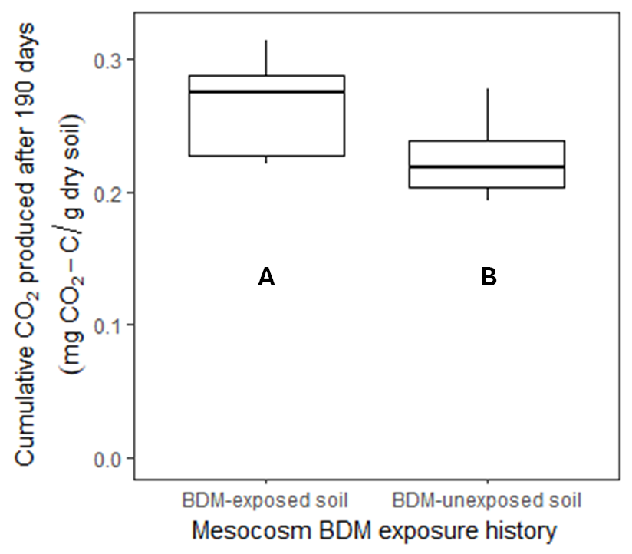
Figure 30. Cumulative carbon dioxide (CO₂) mineralization at the end of a 190-day incubation compared by BDM exposure history. On BDM-exposed soil, PBAT-based BDM was used in strawberry production for two years. On BDM-unexposed soil, a conventional polyethylene-based plastic mulch was used. BDM-exposed soil mineralized more CO₂ than BDM-unexposed soil (p = 0.015). Letter groupings reflect mean separation at the a = 0.05 level.

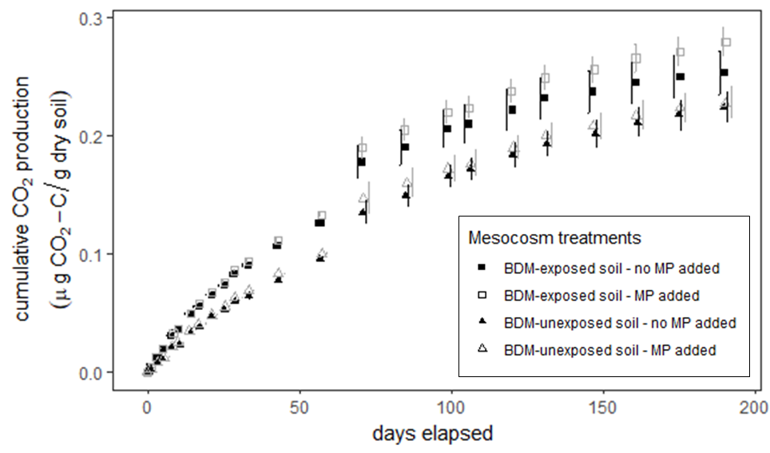
Figure 31. Mean cumulative respiration in each incubation treatment over time. Bars represent one standard error.

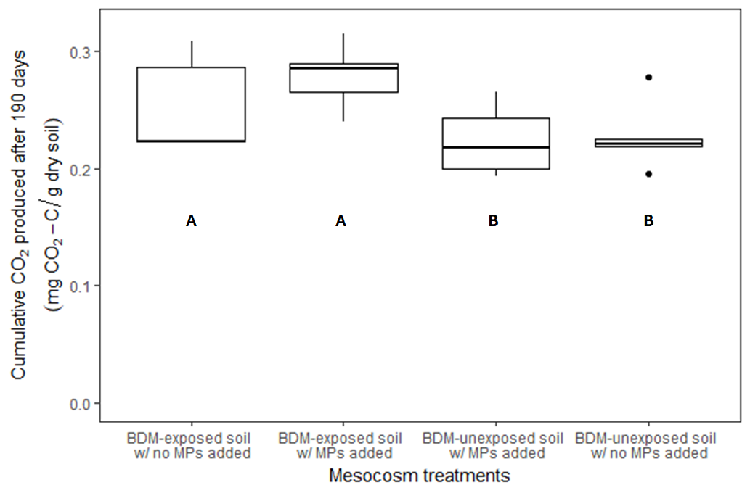
Figure 32. Final cumulative respiration produced during the incubation. This figure separates experimental units based on the interaction of soil history and PBAT addition. There was no significant effect of this interaction term on the cumulative respiration based on ANOVA.

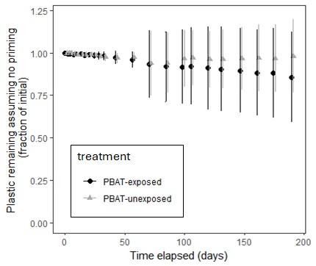
Figure 33. Estimated plastic content over the duration of the incubation based on differential CO₂ mineralization between MP-added and no MP-added treatments. On BDM-exposed soil, polybutylene adipate terephthalate (PBAT) biodegradable plastic mulch was used in strawberry production for two years. On BDM-unexposed soil, a conventional polyethylene-based plastic mulch was used. Error bars represent bootstrapped estimates of one standard deviation of the population mean. There are no significant differences in estimated plastic content over the course of the incubation.
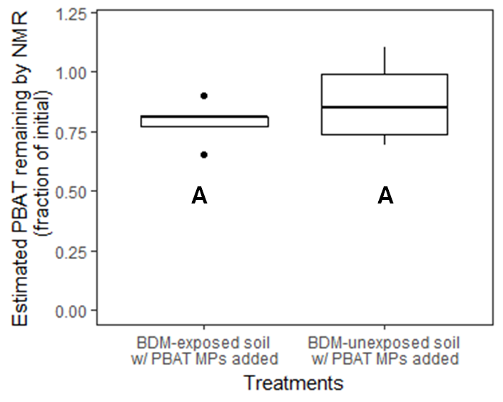
Figure 34. Estimated PBAT remaining in mesocosms after 190-day incubation based on NMR quantification of PBAT in soil samples. On BDM-exposed soil, polybutylene adipate terephthalate (PBAT) biodegradable plastic mulch was used in strawberry production for two years. On PBAT-unexposed soil, a conventional polyethylene-based plastic mulch was used. There is no significant difference in measured PBAT content between the two soils (p = 0.4).

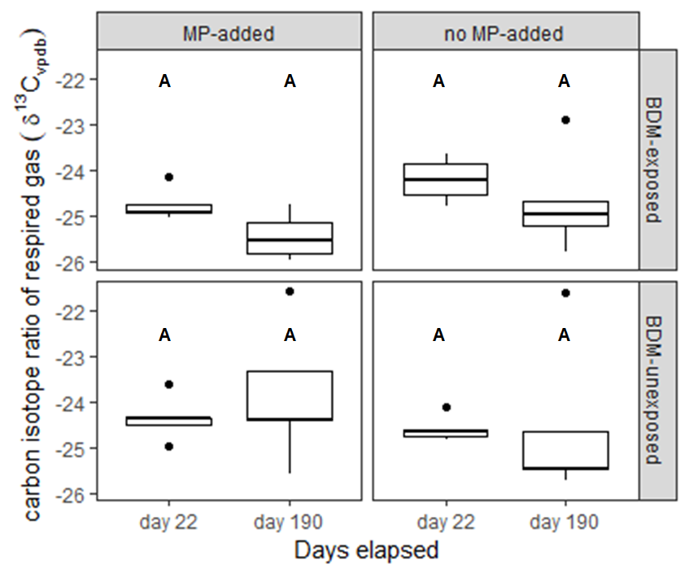
Figure 35. Carbon-13 isotope ratio of respired carbon dioxide from mesocosms. Isotope ratios are separated by measurement time, soil history and PBAT addition. Letter groupings reflect significant differences at the α=0.05 level (no significant differences between any groups).

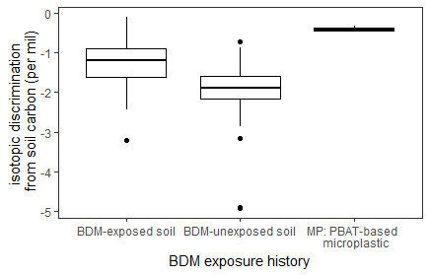
Figure 36. Carbon-13 isotope ratio discrimination between respiration gas and soil organic carbon. Negative values for the discrimination, Δ¹³C, indicate that respired CO₂ had a more negative δ¹³C_{vpdb} than bulk soil organic carbon. Letters groupings reflect significant differences at the p = 0.05 level. On BDM-exposed soil, polybutylene adipate terephthalate (PBAT) biodegradable plastic mulch was used in strawberry production for two years. On BDM-unexposed soil, a conventional polyethylene-based plastic mulch was used.

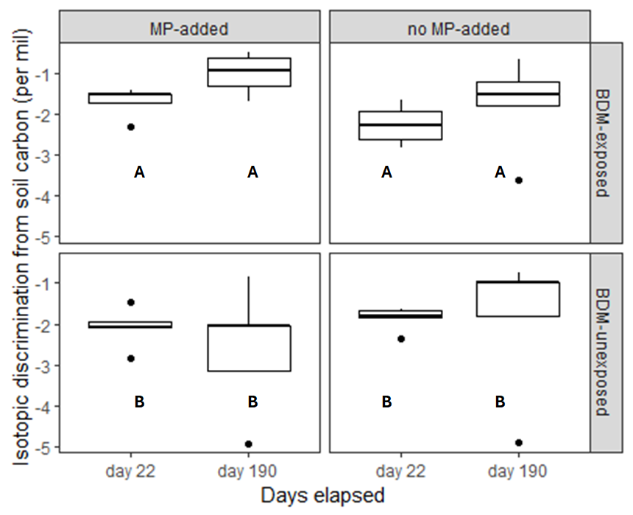
Figure 37. Carbon-13 isotope ratio discrimination between respired carbon dioxide from mesocosms and bulk soil carbon. Isotope ratios are separated by measurement time, soil history and PBAT addition. Letter groupings reflect significant differences at the α=0.05 level.

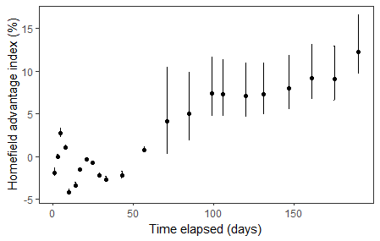
Figure 38. Homefield advantage index at each CO₂ mineralization measurement time. The homefield advantage index is the ratio of additional CO₂ mineralization when PBAT microplastic is added to soil between BDM-exposed and BDM-unexposed mesocosms. On BDM-exposed soil, polybutylene adipate terephthalate (PBAT) biodegradable plastic mulch was used in strawberry production for two years. On BDM-unexposed soil, a conventional polyethylene-based plastic mulch was used. A positive homefield advantage index indicates greater mineralization of added PBAT MPs in the PBAT-exposed soil. Points represent mean estimates and error bars represent bootstrapped 95% confidence intervals of the mean estimate.

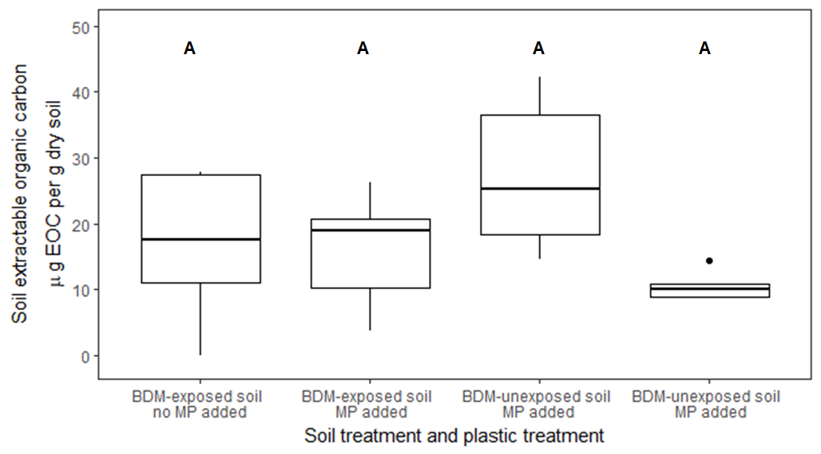
Figure 39. Soil extractable organic carbon by treatment. No significant difference between treatments at α = 0.05. On BDM-exposed soil, polybutylene adipate terephthalate (PBAT) biodegradable plastic mulch was used in strawberry production for two years. On BDM-unexposed soil, a conventional polyethylene-based plastic mulch was used. Add the start of the incubation, PBAT-based BDM microplastics were added to MP-added treatments, while no microplastic was added to no MP-added treatments. Letter groupings reflect significant differences at the α=0.05 level (no significant differences between treatment groups).
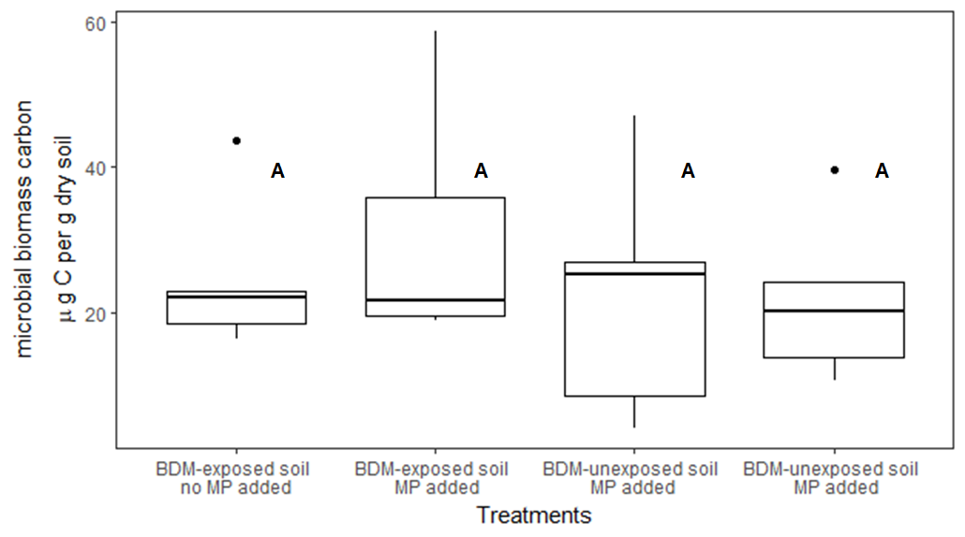
Figure 40. Microbial biomass carbon recovered from soil in each mesocosm at the end of the 6-month incubation. Results are separated based on BDM exposure history and BDM MP addition treatments. Letter groupings reflect significant differences at the α=0.05 level; there were no significant differences in microbial biomass between treatments.

Table 10. Mean carbon produced in each incubation treatment
Mesocosm treatment | Mean CO₂ produced (mg CO₂-C) per gram of dry soil | Ratio of CO₂ produced to total organic
PBAT-exposed soil, no PBAT added | 0.25 | 3.5%
PBAT-exposed soil, PBAT added | 0.28 | 4%
PBAT-unexposed soil, no PBAT added | 0.22 | 3.1%
PBAT-unexposed soil, PBAT added | 0.23 | 3.3%

Table 11. Estimated PBAT plastic residence time and degradation rate based on bootstrapped mean degradation estimates during the incubation
Degradation model | Microplastic mean residence time |  | k (days⁻¹)
Degradation model | PBAT-exposed soil | PBAT-unexposed soil | PBAT-exposed soil | PBAT-unexposed soil
Linear | 700 days  (2 years) | 4800 days  (13 years) | 7e-4 | 1e-4
Exponential decay | 900 days  (2 years) | 6500 days  (18 years) | 8e-4 | 1e-4

Table 12. Estimated PBAT plastic residence time and degradation rate based on maximum degradation estimates during the incubation (upper bound of 95% confidence interval)
Degradation model | Minimum microplastic mean residence time |  | Maximum k (days⁻¹)
Degradation model | PBAT-exposed soil | PBAT-unexposed soil | PBAT-exposed soil | PBAT-unexposed soil
Linear | 300 days  (less than 1 year) | 400 days  (1 year) | 2e-3 | 1e-3
Exponential decay | 200 days  (less than 1 year) | 400 days  (1 year) | 2e-3 | 1e-3

Conclusion
I conducted the work described above to provide additional understanding of biodegradable plastic mulch degradation in field-relevant conditions with particular attention to microplastics, degradation at depth, and changing degradation over time. I did not fully realize the objectives of this dissertation, largely because plastic degradation was much slower than expected under the conditions I studied it. I was unable to answer some of my research questions, like how PBAT degradation differed between MPs and NPs because I saw no significant degradation of the material under study conditions. Instead, this work is most significant in calling attention to the variability of plastic degradation depending on the degrading conditions. BDMs do not degrade uniformly in all conditions, and so stimulated laboratory degrading conditions can provide an inaccurate indicator of field degradation behavior.
I attempted to develop an NMR-based method to quantify PBAT micro- and nanoplastics from soil. I found this method to have sub-standard results compared to the μRaman and μFTIR techniques that are becoming the state of the art in MP quantification. While NMR offers the promising ability to quantify PBAT polymer regardless of size, I was unable to fully recover PBAT from soil through the extraction procedures I used. More sophisticated extraction procedures (ex. using elevated temperature or pressure, or using a solvent rinsing or refluxing type of strategy) could provide better quantification results, but at the cost of greater sample processing time and expense. Obtaining NMR spectra of the soil extracts that were suitable for quantification was also a challenge. Soil organic matter co-extracted along with the PBAT of interest created spectral peaks that interfered with the resolution of PBAT peaks. Eliminating or reducing the impact of this interference will be key to any future improvements in the quantification method I have defined.
During my in-field investigation of BDM fragmentation, I found minimal disappearance of the materials tilled into soil over 18 months, while microplastics formed as soon as 6 months. The large plastic residues in the soil after 18 months suggest that the product I tested currently fails to deliver on core value proposition of biodegradable plastic mulch in the two sites I tested it – that it will quickly degrade in-situ with no negative effects on production systems. Because I saw BDM persist in large fragments for at least 18 months in surface soil, users might expect these fragments to interfere with production activities such as shaping new beds, laying new plastic mulch and planting crops for one or more growing season after the BDM is used. If these BDM products require additional interventions like tillage or irrigation to increase fragmentation and avoid impacts on the next cropping season, then they may increase on-farm labor and expenses rather than decreasing them.
Because I saw only partial fragmentation of BDMs under my study conditions, it is difficult to extrapolate what fragmentation and biodegradation might look like over a full degradation timeline. Longer term field studies are needed to document the fragmentation of BDMs in fallow field conditions in more climatic conditions. It will also be important to track the biodegradation of BDMs by accurately quantifying micro- or nano-scale BDM constituents in the soil. This will require field trials with sampling designs sufficient to collect representative samples of BDM of all sizes and spatial distributions. Tracking MPs and smaller BDM remnants is essential to ensure complete biodegradation occurs in field conditions. The end goal of this research would be for potential users of BDMs to know with confidence whether a product could be expected to fully biodegrade in their context with no negative impact on the production system or surrounding environment.
In the field, I saw the most fragmentation of BDMs when I buried a biodegradable plastic mulch under 25 cm of soil in a Central California Argixeroll. In these conditions, 75% or more of the plastic fragmented into pieces smaller than 1 mm compared to 15% or less for the same material buried under 5 cm of soil. I suspect that this fragmentation was due to mechanical stress placed on the material by expanding and contracting of the smectite-rich soil as it wetted or dried. While most producers will not bury their plastic mulch under 25 cm of smectitic soil, it may be valuable to further investigate how soil cultivation and other mechanical stresses impact plastic mulch degradation rates in field conditions as users could easily take advantage of these tools.
In laboratory incubations with small additions of mulch at soil temperatures comparable to those observed in the field trial locations, I saw minimal degradation of microplastics and nanoplastics formed from biodegradable plastic mulch over 6 or 9 months. I expected the smaller size of these particles to make them more readily degradable by soil microorganisms, compared to macroplastic. However, the lower temperature and slower microbial activity in these incubations compared to ASTM standard D5988 test conditions helped to reveal the plastic degrading capacity of the minimally altered agricultural soils I tested – which was far less than the plastic degradation seen at higher temperatures in modified soil under the ASTM D5988 test conditions. Future work is needed to delineate the conditions in which BDM MPs and NPs do and do not biodegrade. I recommend investigating relative rates of MP and NP degradation in subsurface soils under accelerated laboratory degrading conditions to understand the mechanisms at play compared to surface soil degradation. Regarding a potential homefield advantage effect, I recommend future field trials of biodegradable plastic mulches consider and test for this possible effect in field conditions. The HFA effect should also be studied over the entire degradation course of a BDM material to determine the net effect after complete biodegradation.
My results suggest that biodegradable plastic mulches may not be a one-size fits all solution for plastic mulch waste management. These products appear to need further technical development to make them more usable for agricultural producers, and to ensure they protect the long-term health of agricultural systems where they are used. This product development should focus on ensuring complete and rapid biodegradation of the materials in field conditions and ensuring competitive production prices for these materials. Perhaps biodegradable plastic mulches could meet the needs of plastic mulch users through a continuum of products that are tailored to degrade in different field conditions – perhaps focusing on soil temperature or USDA growing zone.
In many modern vegetable production systems, plastic mulches outperform other alternatives in part because the costs of plastic waste management are not part of users’ cost-benefit analyses. Biodegradable plastic mulches are not the only option to solve plastic waste problems, but they may be attractive because they are not dependent on off-farm waste management infrastructure like recycling or incineration are. Eliminating plastic mulch waste without biodegradable plastic or waste management infrastructure might require agricultural producers to make much larger changes to their production systems, like the adoption of living mulches, perennial production systems, or high-intensity cultivation. These alternatives would likely have different labor and cost requirements and result in different productivity. Any such changes would require large amounts of support for producers in terms of knowledge, technology, and economic analysis and would not be quick or easy to implement.

References
Accinelli, C., G. Dinelli, A. Vicari, and P. Catizone. 2001. Atrazine and metolachlor degradation in subsoils. Biol. Fertil. Soils 2001 336 33(6): 495–500. doi: 10.1007/S003740100358.
Acik, G., E. Sey, and M.A. Tasdelen. 2018. Polypropylene-based graft copolymers via CuAAC click chemistry. Express Polym. Lett. 12(5): 418–428. doi: 10.3144/expresspolymlett.2018.35.
Adhikari, D., M. Mukai, K. Kubota, T. Kai, N. Kaneko, et al. 2016. Degradation of Bioplastics in Soil and Their Degradation Effects on Environmental Microorganisms. J. Agric. Chem. Environ. 05(01): 23–34. doi: 10.4236/jacen.2016.51003.
Ahmed, T., M. Shahid, F. Azeem, I. Rasul, A.A. Shah, et al. 2018. Biodegradation of plastics: current scenario and future prospects for environmental safety. Environ. Sci. Pollut. Res. 25(8): 7287–7298. doi: 10.1007/s11356-018-1234-9.
Akbolat, D., F. Evrendilek, A. Coskan, and K. Ekinci. 2009. Quantifying soil respiration in response to short-term tillage practices: a case study in southern Turkey. Acta Agric. Scand. Sect. B – Soil Plant Sci. 59(1): 50–56. doi: 10.1080/09064710701833202.
Anderson, T.H., and K.H. Domsch. 1985. Maintenance carbon requirements of actively-metabolizing microbial populations under in situ conditions. Soil Biol. Biochem. 17(2): 197–203. doi: 10.1016/0038-0717(85)90115-4.
Andrady, A.L. 2017. The plastic in microplastics: A review. Mar. Pollut. Bull. 119(1): 12–22. doi: 10.1016/J.MARPOLBUL.2017.01.082.
Anunciado, M.B., D.G. Hayes, A.F. Astner, L.C. Wadsworth, C.D. Cowan-Banker, et al. 2021a. Effect of Environmental Weathering on Biodegradation of Biodegradable Plastic Mulch Films under Ambient Soil and Composting Conditions. J. Polym. Environ. 29(9): 2916–2931. doi: 10.1007/s10924-021-02088-4.
Anunciado, M.B., D.G. Hayes, L.C. Wadsworth, M.E. English, S.M. Schaeffer, et al. 2021b. Impact of Agricultural Weathering on Physicochemical Properties of Biodegradable Plastic Mulch Films: Comparison of Two Diverse Climates Over Four Successive Years. J. Polym. Environ. 29(1): 1–16. doi: 10.1007/S10924-020-01853-1/FIGURES/8.
Apinya, T., N. Sombatsompop, and B. Prapagdee. 2015. Selection of a Pseudonocardia sp. RM423 that accelerates the biodegradation of poly(lactic) acid in submerged cultures and in soil microcosms. Int. Biodeterior. Biodegrad. 99: 23–30. doi: 10.1016/j.ibiod.2015.01.001.
Arguez, A., I. Durre, S. Applequist, R.S. Vose, M.F. Squires, et al. 2012. NOAA’s 1981-2010 U.S. climate normals. Bull. Am. Meteorol. Soc. 93(11): 1687–1697. doi: 10.1175/BAMS-D-11-00197.1.
ASTM International. 2018. ASTM D5988 – 18: Standard test method for determining aerobic biodegradation of plastic materials in soil. West Conshohocken, PA.
Astner, A.F., D.G. Hayes, H.M. O’neill, B.R. Evans, S.V. Pingali, et al. 2022. Forming Micro-and Nano-Plastics from Agricultural Plastic Films for Employment in Fundamental Research Studies. J. Vis. Exp. 2022(185): 1–24. doi: 10.3791/64112.
Astner, A.F., D.G. Hayes, H. O’Neill, B.R. Evans, S.V. Pingali, et al. 2023. Assessment of cryogenic pretreatment for simulating environmental weathering in the formation of surrogate micro- and nanoplastics from agricultural mulch film. Sci. Total Environ. 870: 161867. doi: 10.1016/J.SCITOTENV.2023.161867.
Ayres, E., H. Steltzer, S. Berg, and D.H. Wall. 2009. Soil biota accelerate decomposition in high-elevation forests by specializing in the breakdown of litter produced by the plant species above them. J. Ecol. 97(5): 901–912. doi: 10.1111/J.1365-2745.2009.01539.X.
Bandopadhyay, S., J.E. Liquet y González, K.B. Henderson, M.B. Anunciado, D.G. Hayes, et al. 2020. Soil Microbial Communities Associated with Biodegradable Plastic Mulch Films. Front. Microbiol. 11: 2840. doi: 10.3389/FMICB.2020.587074/BIBTEX.
Bandopadhyay, S., L. Martin-Closas, A.M. Pelacho, and J.M. DeBruyn. 2018. Biodegradable Plastic Mulch Films: Impacts on Soil Microbial Communities and Ecosystem Functions. Front. Microbiol. 9. doi: 10.3389/fmicb.2018.00819.
Bailes, G., M. Lind, A. Ely, M. Powell, J. Moore-Kucera, et al. 2013. Isolation of native soil microorganisms with potential for breaking down biodegradable plastic mulch films used in agriculture. Journal of the Visualized Experiment (75): e50373. doi: 10.3791/50373.
Bastioli, C., V. Bellotti, L. Del Giudice, and G. Gilli. 1993. Mater-Bi: Properties and Biodegradability.
Baxter, D.O. 1997. A comparison of deep soil temperature: Tennessee versus other locations. Trans. ASAE 40(3): 727–738.
Beriot, N., R. Zornoza, E.H. Lwanga, P. Zomer, B. van Schothorst, et al. 2023. Intensive vegetable production under plastic mulch: A field study on soil plastic and pesticide residues and their effects on the soil microbiome. Sci. Total Environ. 900: 165179. doi: 10.1016/J.SCITOTENV.2023.165179.
Bettas Ardisson, G., M. Tosin, M. Barbale, and F. Degli-Innocenti. 2014. Biodegradation of plastics in soil and effects on nitrification activity. A laboratory approach. Front. Microbiol. 5(DEC): 710. doi: 10.3389/fmicb.2014.00710.
Bharti, S.K., and R. Roy. 2012. Quantitative 1H NMR spectroscopy. TrAC Trends Anal. Chem. 35: 5–26. doi: 10.1016/J.TRAC.2012.02.007.
Bianchini, M., L. Trozzo, P. D’ottavio, M. Giustozzi, M. Toderi, et al. 2022. Soil refinement accelerates in-field degradation rates of soil-biodegradable mulch films. Ital. J. Agron. 17(3). doi: 10.4081/ija.2022.2044.
Blagodatskaya, Е., and Y. Kuzyakov. 2008. Mechanisms of real and apparent priming effects and their dependence on soil microbial biomass and community structure: critical review. Biol. Fertil. Soils 45(2): 115–131. doi: 10.1007/s00374-008-0334-y.
Bläsing, M., and W. Amelung. 2018. Plastics in soil: Analytical methods and possible sources. Sci. Total Environ. 612: 422–435. doi: 10.1016/j.scitotenv.2017.08.086.
Blume, E., M. Bischoff, J.M. Reichert, T. Moorman, A. Konopka, et al. 2002. Surface and subsurface microbial biomass, community structure and metabolic activity as a function of soil depth and season. Appl. Soil Ecol. 20(3): 171–181. doi: 10.1016/S0929-1393(02)00025-2.
Bodor, A., G. Feigl, B. Kolossa, E. Mészáros, K. Laczi, et al. 2024. Soils in distress: The impacts and ecological risks of (micro)plastic pollution in the terrestrial environment. Ecotoxicol. Environ. Saf. 269: 115807. doi: 10.1016/J.ECOENV.2023.115807.
Borchardt, G. 1989. Smectites. Minerals in soil environments. 2nd ed. Soil Science Society of America, Madison, WI. p. 675–727
Bowen, M., I. O’Neill, and M. Pringuer. 1974. Quantitiative Applications of Nuclear Magnetic Resonance in Phramaceutical Analysis. Procedings Soc. Anal. Chem.: 294–297.
Bowling, D.R., D.E. Pataki, and J.T. Randerson. 2008. Carbon isotopes in terrestrial ecosystem pools and CO₂ fluxes. New Phytologist. 178(1): 24–40. doi: 10.1111/j.1469-8137.2007.02342.x.
Boyandin, A.N., S. V. Prudnikova, V.A. Karpov, V.N. Ivonin, N.L. Dỗ, et al. 2013. Microbial degradation of polyhydroxyalkanoates in tropical soils. Int. Biodeterior. Biodegrad. 83: 77–84. doi: 10.1016/j.ibiod.2013.04.014.
Brandolini, A.J., and D.D. Hills. 2000. NMR Spectra of Polymers and Polymer Additives. NMR Spectra Polym. Polym. Addit. doi: 10.1201/9781482293425.
Briassoulis, D., E. Babou, M. Hiskakis, and I. Kyrikou. 2015. Analysis of long-term degradation behaviour of polyethylene mulching films with pro-oxidants under real cultivation and soil burial conditions. Environ. Sci. Pollut. Res. 22(4): 2584–2598. doi: 10.1007/s11356-014-3464-9.
Briassoulis, D., M. Hiskakis, and E. Babou. 2013. Technical specifications for mechanical recycling of agricultural plastic waste. Waste Manag. 33(6): 1516–1530. doi: 10.1016/j.wasman.2013.03.004.
Briassoulis, D., and F.D. Innocenti. 2017. Standards for Soil Biodegradable Plastics.: 139–168. doi: 10.1007/978-3-662-54130-2_6.
Brodhagen, M., M. Peyron, C. Miles, and D.A. Inglis. 2015. Biodegradable plastic agricultural mulches and key features of microbial degradation. Applied Microbiology and Biotechnology 99(3): 1039–1056. doi: 10.1007/S00253-014-6267-5/FIGURES/4.
Brodhagen, M., J.R. Goldberger, D.G. Hayes, D.A. Inglis, T.L. Marsh, et al. 2017. Policy considerations for limiting unintended residual plastic in agricultural soils. Environ. Sci. Policy 69: 81–84. doi: 10.1016/j.envsci.2016.12.014.
Brown, B., A.K. Hoshide, and E.R. Gallandt. An economic comparison of weed management systems used in small-scale organic vegetable production. doi: 10.1007/s13165-018-0206-1.
Büks, F., and M. Kaupenjohann. 2020. Global concentrations of microplastics in soils - A review. SOIL 6(2): 649–662. doi: 10.5194/SOIL-6-649-2020.
Cambardella, C.A., T.B. Moorman, J.M. Novak, T.B. Parkin, D.L. Karlen, et al. 1994. Field-­Scale Variability of Soil Properties in Central Iowa Soils. Soil Sci. Soc. Am. J. 58: 1501–1511. doi: 10.2136/sssaj1994.03615995005800050033x.
Cardoza, L.A., A.K. Korir, W.H. Otto, C.J. Wurrey, and C.K. Larive. 2004. Applications of NMR spectroscopy in environmental science. Prog. Nucl. Magn. Reson. Spectrosc. 45(3–4): 209–238. doi: 10.1016/J.PNMRS.2004.06.002.
Chan, S.O., and M.B. Comisarow. 1983. Apodization and exact “integration” of fourier transform nuclear magnetic resonance spectra. J. Magn. Reson. 54(2): 201–215. doi: 10.1016/0022-2364(83)90043-4.
Chen, S., Y. Feng, L. Han, D. Li, Y. Feng, et al. 2022. Responses of rice (Oryza sativa L.) plant growth, grain yield and quality, and soil properties to the microplastic occurrence in paddy soil. J. Soils Sediments 22(8): 2174–2183. doi: 10.1007/S11368-022-03232-W/FIGURES/3.
Chinaglia, S., M. Tosin, and F. Degli-Innocenti. 2018. Biodegradation rate of biodegradable plastics at molecular level. Polym. Degrad. Stab. 147: 237–244. doi: 10.1016/j.polymdegradstab.2017.12.011.
Coleman, D.C., P. Forest, H.W. Hunt, E.R. Ingham, D.C. Coleman, et al. 1988. Nitrogen limitation of production in decomposition in praire mountain meadow in pine forest Nitrogen Limitation of Production and Decomposition in Prairie, Mountain Meadow, and. Source Ecol. 69(4): 1009–1016.
Colin, G., J.D. Cooney, D.J. Carlsson, and D.M. Wiles. 1981. Deterioration of plastic films under soil burial conditions. Journal of Applied Polymer Science 26(2): 509–519. doi: 10.1002/APP.1981.070260211.
Cook, P.F., and W.W. Cleland. 2007. Enzyme Kinetics and Mechanism. 1st ed. Taylor & Francis, New York, NY.
Corradini, F., F. Casado, V. Leiva, E. Huerta-Lwanga, and V. Geissen. 2021. Microplastics occurrence and frequency in soils under different land uses on a regional scale. Sci. Total Environ. 752: 141917. doi: 10.1016/J.SCITOTENV.2020.141917.
Cotrufo, M.F., J. Ngao, F. Marzaioli, and D. Piermatteo. 2010. Inter-comparison of methods for quantifying above-ground leaf litter decomposition rates. Plant Soil 334(1): 365–376. doi: 10.1007/S11104-010-0388-0.
Cowan, J.S., D.A. Inglis, and C.A. Miles. 2013. Deterioration of three potentially biodegradable plastic mulches before and after soil incorporation in a broccoli field production system in Northwestern Washington. Horttechnology 23(6): 849–858. doi: 10.21273/horttech.23.6.849.
Creamer, C.A., D.L. Jones, J.A. Baldock, Y. Rui, D. V. Murphy, et al. 2016. Is the fate of glucose-derived carbon more strongly driven by nutrient availability, soil texture, or microbial biomass size? Soil Biol. Biochem. 103: 201–212. doi: 10.1016/J.SOILBIO.2016.08.025.
Crockford, D.J., H.C. Keun, L.M. Smith, E. Holmes, and J.K. Nicholson. 2005. Curve-fitting method for direct quantitation of compounds in complex biological mixtures using 1H NMR: Application in metabonomic toxicology studies. Anal. Chem. 77(14): 4556–4562. doi: 10.1021/AC0503456/ASSET/IMAGES/MEDIUM/AC0503456U00003A.GIF.
Dalenberg, J.W., and G. Jager. 1989. Priming effect of some organic additions to 14C-labelled soil. Soil Biology and Biochemistry 21(3): 443–448. doi: 10.1016/0038-0717(89)90157-0.
Degli-Innocenti, F., M. Tosin, and C. Bastioli. 1998. Evaluation of the Biodegradation of Starch and Cellulose Under Controlled Composting Conditions.
Dekiff, J.H., D. Remy, J. Klasmeier, and E. Fries. 2014. Occurrence and spatial distribution of microplastics in sediments from Norderney. Environ. Pollut. 186: 248–256. doi: 10.1016/j.envpol.2013.11.019.
Desaules, A. 2012. Critical evaluation of soil contamination assessment methods for trace metals. Sci. Total Environ. 426: 120–131. doi: 10.1016/J.SCITOTENV.2012.03.035.
Dijkstra, P., A. Ishizu, R. Doucett, S.C. Hart, E. Schwartz, et al. 2006. 13C and 15N natural abundance of the soil microbial biomass. Soil Biology and Biochemistry 38(11): 3257–3266. doi: 10.1016/J.SOILBIO.2006.04.005.
Dong, H., G. Yang, Y. Zhang, Y. Yang, D. Wang, et al. 2022. Recycling, disposal, or biodegradable-alternative of polyethylene plastic film for agricultural mulching? A life cycle analysis of their environmental impacts. J. Clean. Prod. 380: 134950. doi: 10.1016/J.JCLEPRO.2022.134950.
El-Din Sharabi, N., and R. Bartha. 1993. Testing of Some Assumptions about Biodegradability in Soil as Measured by Carbon Dioxide Evolutiont. Appl. Environ. Microbiol. 59(4): 1201–1205. https://journals.asm.org/journal/aem.
English, M.E. 2019. The role of biodegradable plastic mulches in soil organic carbon cycling.
European Bioplastics. 2023. Bioplastics Market Development Update. https://www.european-bioplastics.org/market/# (accessed 24 September 2024).
European Committee for Standardization, EN 17033. 2018. Plastics-Biodegradable mulch films for use in agriculture and horticulture- Requirements and test methods. Brussels, Belgium.
Espí, E., A. Salmerón, A. Fontecha, Y. García, and A.I. Real. 2006. PLastic Films for Agricultural Applications. J. Plast. Film Sheeting 22(2): 85–102. doi: 10.1177/8756087906064220.
Fakour, H., S.L. Lo, N.T. Yoashi, A.M. Massao, N.N. Lema, et al. 2021. Quantification and Analysis of Microplastics in Farmland Soils: Characterization, Sources, and Pathways. Agric. 2021, Vol. 11, Page 330 11(4): 330. doi: 10.3390/AGRICULTURE11040330.
Farquhar, G. D., Ehleringer, L. R., Hubick, K. T. 1989. Carbon isotope discrimination and photosynthesis. Annual Reviews in Plant Physiology and Plant Molecular Biology vol. 40, pp. 503–540.
Fanin, N., N. Fromin, and I. Bertrand. 2016. Functional breadth and home-field advantage generate functional differences among soil microbial decomposers. Ecology 97(4): 1023–1037. doi: 10.1890/15-1263.1.
Federle, T.W., D.C. Dobbins, J.R. Thornton-Manning, and D.D. Jones. 1986. Microbial Biomass, Activity, and Community Structure in Subsurface Soils. Groundwater 24(3): 365–374. doi: 10.1111/J.1745-6584.1986.TB01013.X.
Fierer, N. 2003. Stress ecology and the dynamics of microbial communities and processes in soil.
Fierer, N., J.P. Schimel, and P.A. Holden. 2003. Variations in microbial community composition through two soil depth profiles. Soil Biol. Biochem. 35(1): 167–176. doi: 10.1016/S0038-0717(02)00251-1.
Flury, M., and R. Narayan. 2021. Biodegradable plastic as an integral part of the solution to plastic waste pollution of the environment. Curr. Opin. Green Sustain. Chem. 30: 100490. doi: 10.1016/J.COGSC.2021.100490.
Fojt, J., J. David, R. Přikryl, V. Řezáčová, and J. Kučerík. 2020. A critical review of the overlooked challenge of determining micro-bioplastics in soil. Sci. Total Environ. 745: 140975. doi: 10.1016/j.scitotenv.2020.140975.
Food and Agriculture Organization. 2021. Assessment of agricultural plastics and their sustainability: A call for action. Rome.
Francioni, M., A.W. Kishimoto-Mo, S. Tsuboi, and Y.T. Hoshino. 2022. Evaluation of the mulch films biodegradation in soil: a methodological review. Ital. J. Agron. doi: 10.4081/IJA.2021.1936.
Frank, O., J.K. Kreissl, A. Daschner, and T. Hofmann. 2014. Accurate determination of reference materials and natural isolates by means of quantitative 1H NMR spectroscopy. J. Agric. Food Chem. 62(12): 2506–2515. doi: 10.1021/JF405529B/SUPPL_FILE/JF405529B_SI_001.PDF.
Fries, E., J.H. Dekiff, J. Willmeyer, M.T. Nuelle, M. Ebert, et al. 2013. Identification of polymer types and additives in marine microplastic particles using pyrolysis-GC/MS and scanning electron microscopy. 15(10): 1949–1956. https://pubs.rsc.org/en/content/articlehtml/2013/em/c3em00214d (accessed 6 January 2020).
Gao, H., C. Yan, Q. Liu, W. Ding, B. Chen, et al. 2019. Effects of plastic mulching and plastic residue on agricultural production: A meta-analysis. Sci. Total Environ. 651: 484–492. doi: 10.1016/J.SCITOTENV.2018.09.105.
Garcia-Pausas, J., and E. Paterson. 2011. Microbial community abundance and structure are determinants of soil organic matter mineralisation in the presence of labile carbon. Soil Biol. Biochem. 43(8): 1705–1713. doi: 10.1016/J.SOILBIO.2011.04.016.
Gholz, H.L., D.A. Wedin, S.M. Smitherman, M.E. Harmon, and W.J. Parton. 2000. Long-term dynamics of pine and hardwood litter in contrasting environments: Toward a global model of decomposition. Glob. Chang. Biol. 6(7): 751–765. doi: 10.1046/J.1365-2486.2000.00349.X.
Giraudeau, P. 2017. Challenges and perspectives in quantitative NMR. Magn. Reson. Chem. 55(1): 61–69. doi: 10.1002/MRC.4475.
Gómez, E.F., and F.C. Michel. 2013. Biodegradability of conventional and bio-based plastics and natural fiber composites during composting, anaerobic digestion and long-term soil incubation. Polym. Degrad. Stab. 98(12): 2583–2591. doi: 10.1016/j.polymdegradstab.2013.09.018.
Gradusov, B.P. 1974. A tentative study of clay mineral distribution in soils of the world. Geoderma 12(1–2): 49–55. doi: 10.1016/0016-7061(74)90038-X.
Gregorich, E.G., H. Janzen, B.H. Ellert, B.L. Helgason, B. Qian, et al. 2017. Litter decay controlled by temperature, not soil properties, affecting future soil carbon. Global Change Biology 23(4): 1725–1734. doi: 10.1111/GCB.13502.
Griffin-LaHue, D., S. Ghimire, Y. Yu, E.J. Scheenstra, C.A. Miles, et al. 2022. In-field degradation of soil-biodegradable plastic mulch films in a Mediterranean climate. Sci. Total Environ. 806: 150238. doi: 10.1016/J.SCITOTENV.2021.150238.
Günther, M., and W. Imhof. 2023. Simultaneous quantification of microplastic particles by non-deuterated (NoD) 1 H-qNMR from samples comprising different polymer types. Analyst 148(5): 1151–1161. doi: 10.1039/D2AN01751B.
Hahladakis, J.N. 2020. Delineating and preventing plastic waste leakage in the marine and terrestrial environment. Environ. Sci. Pollut. Res. 27(11): 12830–12837. doi: 10.1007/S11356-020-08139-Y/FIGURES/1.
Hahladakis, J.N., C.A. Velis, R. Weber, E. Iacovidou, and P. Purnell. 2018. An overview of chemical additives present in plastics: Migration, release, fate and environmental impact during their use, disposal and recycling. J. Hazard. Mater. 344: 179–199. doi: 10.1016/J.JHAZMAT.2017.10.014.
Harwell, M.R., E.N. Rubinstein, W.S. Hayes, and C.C. Olds. 1992. Summarizing Monte Carlo Results in Methodological Research: The One- and Two-Factor Fixed Effects ANOVA Cases. J. Educ. Stat. 17(4): 315. doi: 10.2307/1165127.
Hayes, D.G., M.B. Anunciado, J.M. DeBruyn, S. Bandopadhyay, S. Schaeffer, et al. 2019. Biodegradable Plastic Mulch Films for Sustainable Specialty Crop Production. Polymers for Agri-Food Applications. Springer International Publishing. p. 183–213
Hayes, D.G., and M. Flury. 2018. Summary and Assessment of EN 17033:2018, a New Standard for Biodegradable Plastic Mulch Films. Rep. No. EXT-2018-01 (June): 1–7. https://ag.tennessee.edu/biodegradablemulch/Documents/EU regs factsheet.pdf.
Hayes, D.G., L.C. Wadsworth, H.Y. Sintim, M. Flury, M. English, et al. 2017. Effect of diverse weathering conditions on the physicochemical properties of biodegradable plastic mulches. Polym. Test. 62: 454–467. doi: 10.1016/j.polymertesting.2017.07.027.
Herrera, R., L. Franco, A. Rodríguez-Galán, and J. Puiggalí. 2002. Characterization and degradation behavior of poly(butylene adipate-co-terephthalate)s. J. Polym. Sci. Part A Polym. Chem. 40(23): 4141–4157. doi: 10.1002/POLA.10501.
Al Hosni, A.S., J.K. Pittman, and G.D. Robson. 2019. Microbial degradation of four biodegradable polymers in soil and compost demonstrating polycaprolactone as an ideal compostable plastic. Waste Manag. 97: 105–114. doi: 10.1016/j.wasman.2019.07.042.
Huo, Y., F.A. Dijkstra, M. Possell, and B. Singh. 2024. Mineralisation and priming effects of a biodegradable plastic mulch film in soils: Influence of soil type, temperature and plastic particle size. Soil Biol. Biochem. 189: 109257. doi: 10.1016/J.SOILBIO.2023.109257.
Izquierdo-García, J.L., P. Villa, A. Kyriazis, L. Del Puerto-Nevado, S. Pérez-Rial, et al. 2011. Descriptive review of current NMR-based metabolomic data analysis packages. Prog. Nucl. Magn. Reson. Spectrosc. 59(3): 263–270. doi: 10.1016/J.PNMRS.2011.02.001.
Janczak, K., G.B. Dąbrowska, A. Raszkowska-Kaczor, D. Kaczor, K. Hrynkiewicz, et al. 2020. Biodegradation of the plastics PLA and PET in cultivated soil with the participation of microorganisms and plants. Int. Biodeterior. Biodegrad. 155(September). doi: 10.1016/j.ibiod.2020.105087.
Jenny, H., S. Gessel, and F. Bindham. 1949. Comparative study of decomposition rates of organic matter in temperate and tropical regions. Soil Science 68(8): 419–432.
Käppler, A., D. Fischer, S. Oberbeckmann, G. Schernewski, M. Labrenz, et al. 2016. Analysis of environmental microplastics by vibrational microspectroscopy: FTIR, Raman or both? Anal. Bioanal. Chem. 408(29): 8377–8391. doi: 10.1007/S00216-016-9956-3/TABLES/3.
Karamanlioglu, M., and G.D. Robson. 2013. The influence of biotic and abiotic factors on the rate of degradation of poly(lactic) acid (PLA) coupons buried in compost and soil. Polym. Degrad. Stab. 98(10): 2063–2071. doi: 10.1016/j.polymdegradstab.2013.07.004.
Kasirajan, S., and M. Ngouajio. 2012. Polyethylene and biodegradable mulches for agricultural applications: A review. Agron. Sustain. Dev. 32(2): 501–529. doi: 10.1007/s13593-011-0068-3.
Keiser, A.D., D.A. Keiser, M.S. Strickland, and M.A. Bradford. 2014. Disentangling the mechanisms underlying functional differences among decomposer communities. Journal of Ecology 102(3): 603–609. doi: 10.1111/1365-2745.12220.
Kim, S.W., Y. Liang, T. Zhao, and M.C. Rillig. 2021. Indirect Effects of Microplastic-Contaminated Soils on Adjacent Soil Layers: Vertical Changes in Soil Physical Structure and Water Flow. Front. Environ. Sci. 9: 152. doi: 10.3389/FENVS.2021.681934.
Kim, S.W., and M.C. Rillig. 2021. Research trends of microplastics in the soil environment: Comprehensive screening of effects. Soil Ecol. Lett.: 1–10. doi: 10.1007/s42832-021-0077-3.
Klier, N.J., R.J. West, and P.A. Donberg. 1999. Aerobic biodegradation of dichloroethylenes in surface and subsurface soils. Chemosphere 38(5): 1175–1188. doi: 10.1016/S0045-6535(98)00485
Kong, J., Y. Lin, F. Huang, W. Liu, Q. He, et al. 2022. Effects of fertilization and dry-season irrigation on litterfall dynamics and decomposition processes in subtropical eucalyptus plantations. Frontiers in Ecology and Evolution 10: 919571. doi: 10.3389/FEVO.2022.919571
Kotar, S., R. McNeish, C. Murphy-Hagan, V. Renick, C.F.T. Lee, et al. 2022. Quantitative assessment of visual microscopy as a tool for microplastic research: Recommendations for improving methods and reporting. Chemosphere 308(April). doi: 10.1016/j.chemosphere.2022.136449.
Krzan, A., S. Hemjinda, S. Miertus, A. Corti, and E. Chiellini. 2006. Standardization and certification in the area of environmentally degradable plastics. Polym. Degrad. Stab. 91(12): 2819–2833. doi: 10.1016/J.POLYMDEGRADSTAB.2006.04.034.
Kuzyakov, Y., J.K. Friedel, and K. Stahr. 2000. Review of mechanisms and quantification of priming effects. Soil Biol. Biochem. 32(11–12): 1485–1498. doi: 10.1016/S0038-0717(00)00084-5.
Kyrikou, I., and D. Briassoulis. 2007. Biodegradation of agricultural plastic films: A critical review. J. Polym. Environ. 15(2): 125–150. doi: 10.1007/s10924-007-0053-8.
Lamont, W.J. 1993. Plastic Mulches for the Production of Vegetable Crops. Horttechnology 3(1): 45–60. doi: 10.1016/b978-0-08-102170-5.00003-8.
Lamont, W.J. 2005. Plastics: Modifying the microclimate for the production of vegetable crops. Horttechnology 15(3): 477–481. doi: 10.21273/horttech.15.3.0477.
Lehmann, A., E.F. Leifheit, M. Gerdawischke, and M.C. Rillig. 2021. Microplastics have shape- and polymer-dependent effects on soil aggregation and organic matter loss – an experimental and meta-analytical approach. Microplastics and Nanoplastics 1(1): 1–14. doi: 10.1186/s43591-021-00007-x.
Lei, J., X. Zhang, W. Yan, X. Chen, Z. Li, et al. 2023. Urban Microplastic Pollution Revealed by a Large-Scale Wetland Soil Survey. Environ. Sci. Technol 57: 8043. doi: 10.1021/acs.est.2c08567.
Leinweber, P., G. Jandl, C. Baum, K.U. Eckhardt, and E. Kandeler. 2008. Stability and composition of soil organic matter control respiration and soil enzyme activities. Soil Biology and Biochemistry 40(6): 1496–1505. doi: 10.1016/J.SOILBIO.2008.01.003.
Li, S., F. Ding, M. Flury, and J. Wang. 2023. Dynamics of macroplastics and microplastics formed by biodegradable mulch film in an agricultural field. Sci. Total Environ. 894: 164674. doi: 10.1016/J.SCITOTENV.2023.164674.
Li, S., F. Ding, M. Flury, Z. Wang, L. Xu, et al. 2022. Macro- and microplastic accumulation in soil after 32 years of plastic film mulching. Environ. Pollut. 300: 118945. doi: 10.1016/J.ENVPOL.2022.118945.
Li, X., and K. Hu. 2017. Quantitative NMR Studies of Multiple Compound Mixtures. Annual Reports on NMR Spectroscopy. Academic Press. p. 85–143
Li, F., D. Huang, G. Wang, M. Cheng, H. Chen, et al. 2024. Microplastics/nanoplastics in porous media: Key factors controlling their transport and retention behaviors. Sci. Total Environ. 926: 171658. doi: 10.1016/J.SCITOTENV.2024.171658.
Li, C., J. Moore-Kucera, J. Lee, A. Corbin, M. Brodhagen, et al. 2014a. Effects of biodegradable mulch on soil quality. Appl. Soil Ecol. 79: 59–69. doi: 10.1016/j.apsoil.2014.02.012.
Li, C., J. Moore-Kucera, C. Miles, K. Leonas, J. Lee, et al. 2014b. Degradation of Potentially Biodegradable Plastic Mulch Films at Three Diverse U.S. Locations. Agroecol. Sustain. Food Syst. 38(8): 861–889. doi: 10.1080/21683565.2014.884515.
Liu, Y.R., M. Delgado-Baquerizo, J.T. Wang, H.W. Hu, Z. Yang, et al. 2018. New insights into the role of microbial community composition in driving soil respiration rates. Soil Biology and Biochemistry 118: 35–41. doi: 10.1016/J.SOILBIO.2017.12.003.
Liu, E.K., W.Q. He, and C.R. Yan. 2014. “White revolution” to “white pollution” - Agricultural plastic film mulch in China. Environ. Res. Lett. 9(9). doi: 10.1088/1748-9326/9/9/091001.
Lozano, Y.M., T. Lehnert, L.T. Linck, A. Lehmann, and M.C. Rillig. 2021. Microplastic Shape, Polymer Type, and Concentration Affect Soil Properties and Plant Biomass. Front. Plant Sci. 12: 616645. doi: 10.3389/FPLS.2021.616645/BIBTEX.
Lupwayi, N.Z., G.W. Clayton, J.T. O’Donovan, K.N. Harker, T.K. Turkington, et al. 2004. Decomposition of crop residues under conventional and zero tillage. Canadian Journal of Soil Science 84(4):403-410. doi: 10.4141/S03-082 84(4): 403–410. doi: 10.4141/S03-082.
Lusher, A.L., I.L.N. Bråte, K. Munno, R.R. Hurley, and N.A. Welden. 2020. Is It or Isn’t It: The Importance of Visual Classification in Microplastic Characterization. Appl. Spectrosc. 74(9): 1139–1153. doi: 10.1177/0003702820930733/ASSET/IMAGES/LARGE/10.1177_0003702820930733-FIG4.JPEG.
Madrid, B., S. Wortman, D.G. Hayes, J.M. DeBruyn, C. Miles, et al. 2022. End-of-Life Management Options for Agricultural Mulch Films in the United States—A Review. Front. Sustain. Food Syst. 6: 921496. doi: 10.3389/FSUFS.2022.921496/BIBTEX.
Malz, F., and H. Jancke. 2005. Validation of quantitative NMR. J. Pharm. Biomed. Anal. 38(5): 813–823. doi: 10.1016/J.JPBA.2005.01.043.
Mantia, F.P.L., L. Ascione, M.C. Mistretta, M. Rapisarda, and P. Rizzarelli. 2020. Comparative Investigation on the Soil Burial Degradation Behaviour of Polymer Films for Agriculture before and after Photo-Oxidation. Polym. 2020, Vol. 12, Page 753 12(4): 753. doi: 10.3390/POLYM12040753.
Marí, A.I., G. Pardo, A. Cirujeda, and Y. Martínez. 2019. Economic Evaluation of Biodegradable Plastic Films and Paper Mulches Used in Open-Air Grown Pepper (Capsicum annum L.) Crop. Agron. 2019, Vol. 9, Page 36 9(1): 36. doi: 10.3390/AGRONOMY9010036.
Matsuda, H., T. Asakura, and T. Miki. 2002. Triad sequence analysis of poly(ethylene/butylene terephthalate) copolymer using 1H NMR. Macromolecules 35(12): 4664–4668. doi: 10.1021/MA020126B/ASSET/IMAGES/LARGE/MA020126BF00008.JPEG.
Mauel, A., B. Pötzschner, N. Meides, R. Siegel, P. Strohriegl, et al. 2022. Quantification of photooxidative defects in weathered microplastics using 13 C multiCP NMR spectroscopy. RSC Adv. 12(18): 10875–10885. doi: 10.1039/D2RA00470D.
Möller, J.N., M.G.J. Löder, and C. Laforsch. 2020. Finding Microplastics in Soils: A Review of Analytical Methods. Environ. Sci. Technol. 54(4): 2078–2090. doi: 10.1021/acs.est.9b04618.
Moreno, M.M., S. González-Mora, J. Villena, J.A. Campos, and C. Moreno. 2017. Deterioration pattern of six biodegradable, potentially low-environmental impact mulches in field conditions. J. Environ. Manage. 200: 490–501. doi: 10.1016/j.jenvman.2017.06.007.
Mugalla, C.I., C.M. Jolly, and N.R. Martin. 1996. Profitability of Black Plastic Mulch for Limited Resource Farmers. J. Prod. Agric. 9(2): 283–288. doi: 10.2134/JPA1996.283.
Nachimuthu, G., N. V. Halpin, and M.J. Bell. 2017. Productivity Benefits from Plastic Mulch in Vegetable Production Likely to Limit Adoption of Alternate Practices that Deliver Water Quality Benefits: An On-Farm Case Study. Hortic. 2017, Vol. 3, Page 42 3(3): 42. doi: 10.3390/HORTICULTURAE3030042.
National Weather Service Climate Prediction Center. 2024. US Soil Moisture and Temperature Monitoring. https://www.cpc.ncep.noaa.gov/soilmst/t.shtml.
Nelson, T.F., S.C. Remke, H.P.E. Kohler, K. McNeill, and M. Sander. 2020. Quantification of Synthetic Polyesters from Biodegradable Mulch Films in Soils. Environ. Sci. Technol. 54: 266–275. doi: 10.1021/acs.est.9b05863.
Ngouajio, M., R. Auras, R.T. Fernandez, M. Rubino, J.W. Counts, et al. 2008. Field performance of aliphatic-aromatic copolyester biodegradable mulch films in a fresh market tomato production system. Horttechnology 18(4): 605–610. doi: 10.21273/horttech.18.4.605.
Nicolardot, B., G. Guiraud, R. Chaussod, and G. Catroux. 1986. Mineralisation dans le sol de materiaux microbiens marques au carbone 14 et a l’azote 15: Quantification de l’azote de la biomasse microbienne. Soil Biology and Biochemistry 18(3): 263–273. doi: 10.1016/0038-0717(86)90060-X.
Oburger, E., and D.L. Jones. 2009. Substrate mineralization studies in the laboratory show different microbial C partitioning dynamics than in the field. Soil Biol. Biochem. 41(9): 1951–1956. doi: 10.1016/J.SOILBIO.2009.06.020.
Ogonowski, M., A. Motiei, K. Ininbergs, E. Hell, Z. Gerdes, et al. 2018. Evidence for selective bacterial community structuring on microplastics. Environ. Microbiol. 20(8): 2796–2808. doi: 10.1111/1462-2920.14120.
Olson, J.S. 1963. Energy storage and the balance of producers and decomposers in ecological systems. Ecology 44(2): 322–331.
Otake, Y., T. Kobayashi, H. Asabe, N. Murakami, and K. Ono. 1995. Biodegradation of low‐density polyethylene, polystyrene, polyvinyl chloride, and urea formaldehyde resin buried under soil for over 32 years. Journal of Applied Polymer Science 56(13): 1789–1796. doi: 10.1002/APP.1995.070561309.
Palsikowski, P.A., C.N. Kuchnier, I.F. Pinheiro, · Ana, and R. Morales. 2018. Biodegradation in Soil of PLA/PBAT Blends Compatibilized with Chain Extender. J. Polym. Environ. 26: 330–341. doi: 10.1007/s10924-017-0951-3.
Pantani, R., and A. Sorrentino. 2013. Influence of crystallinity on the biodegradation rate of injection-moulded poly(lactic acid) samples in controlled composting conditions. Polym. Degrad. Stab. 98(5): 1089–1096. doi: 10.1016/j.polymdegradstab.2013.01.005.
Papini, G., G. Petrella, D.O. Cicero, C. Boglione, and A. Rakaj. 2024. Identification and quantification of polystyrene microplastics in marine sediments facing a river mouth through NMR spectroscopy. Mar. Pollut. Bull. 198: 115784. doi: 10.1016/j.marpolbul.2023.115784.
Paul, A., L. Wander, R. Becker, C. Goedecke, and U. Braun. 2019. High-throughput NIR spectroscopic (NIRS) detection of microplastics in soil. Environ. Sci. Pollut. Res. 26(8): 7364–7374. doi: 10.1007/S11356-018-2180-2/TABLES/4.
Pecchiari, M., F. Degli-Innocenti, and M. Tosin. 2024. Biodegradation rate and build-up of plastics in soil: A theoretical approach. Polym. Degrad. Stab. 228: 110900. doi: 10.1016/J.POLYMDEGRADSTAB.2024.110900.
Peez, N., J. Becker, S.M. Ehlers, M. Fritz, C.B. Fischer, et al. 2019a. Quantitative analysis of PET microplastics in environmental model samples using quantitative 1H-NMR spectroscopy: validation of an optimized and consistent sample clean-up method. Anal. Bioanal. Chem. 411(28): 7409–7418. doi: 10.1007/S00216-019-02089-2/TABLES/2.
Peez, N., M.C. Janiska, and W. Imhof. 2019b. The first application of quantitative 1H NMR spectroscopy as a simple and fast method of identification and quantification of microplastic particles (PE, PET, and PS). Anal. Bioanal. Chem. 411(4): 823–833. doi: 10.1007/s00216-018-1510-z.
Peez, N., T. Rinesch, J. Kolz, and W. Imhof. 2022. Applicable and cost-efficient microplastic analysis by quantitative 1H-NMR spectroscopy using benchtop NMR and NoD methods. Magn. Reson. Chem. 60(1): 172–183. doi: 10.1002/MRC.5210.
Pennock, D., T. Yates, and J. Braidek. 2006. Soil Sampling Designs. In: Carter, M.R. and Gregorich, E.G., editors, Soil Sampling and Methods of Analysis. 2nd ed. CRC Press, Boca Raton, FL. p. 25–38
Perveen, N., S. Barot, V. Maire, M.F. Cotrufo, T. Shahzad, et al. 2019. Universality of priming effect: An analysis using thirty five soils with contrasted properties sampled from five continents. Soil Biol. Biochem. 134: 162–171. doi: 10.1016/J.SOILBIO.2019.03.027.
Petraglia, A., C. Cacciatori, S. Chelli, G. Fenu, G. Calderisi, et al. 2019. Litter decomposition: effects of temperature driven by soil moisture and vegetation type. Plant and Soil 435(1–2): 187–200. doi: 10.1007/S11104-018-3889-X/FIGURES/5.
Pfohl, P., C. Roth, L. Meyer, U. Heinemeyer, T. Gruendling, et al. 2021. Microplastic extraction protocols can impact the polymer structure. Microplastics and Nanoplastics 1(1): 1–13. doi: 10.1186/S43591-021-00009-9.
Pia Skoczinski, M. Carus, G. Tweddle, P. Ruiz, N. Hark, et al. 2024. Bio-based Building Blocks and Polymers – Global Capacities, Production and Trends 2023–2028. Hürth, Germany.
Plastics Europe. 2018. Plastics – the Facts. Brussels. Belgium.
Plastics Europe. 2022. Plastics – the Facts. Brussels. Belgium.
Praveena, S.M., A.Z. Aris, and V. Singh. 2022. Quality assessment for methodological aspects of microplastics analysis in soil. Trends Environ. Anal. Chem. 34: e00159. doi: 10.1016/J.TEAC.2022.E00159.
Primpke, S., S.H. Christiansen, W. Cowger, H. De Frond, A. Deshpande, et al. 2020. Critical Assessment of Analytical Methods for the Harmonized and Cost-Efficient Analysis of Microplastics. Appl. Spectrosc. 74(9): 1012–1047. doi: 10.1177/0003702820921465/ASSET/IMAGES/LARGE/10.1177_0003702820921465-FIG9.JPEG.
Provencher, J.F., G.A. Covernton, R.C. Moore, D.A. Horn, J.L. Conkle, et al. 2020. Proceed with caution: The need to raise the publication bar for microplastics research. Sci. Total Environ. 748: 141426. doi: 10.1016/J.SCITOTENV.2020.141426.
Qi, Y., X. Yang, A.M. Pelaez, E. Huerta Lwanga, N. Beriot, et al. 2018. Macro- and micro- plastics in soil-plant system: Effects of plastic mulch film residues on wheat (Triticum aestivum) growth. Sci. Total Environ. 645: 1048–1056. doi: 10.1016/J.SCITOTENV.2018.07.229.
Qin, M., C. Chen, B. Song, M. Shen, W. Cao, et al. 2021. A review of biodegradable plastics to biodegradable microplastics: Another ecological threat to soil environments? J. Clean. Prod. 312: 127816. doi: 10.1016/j.jclepro.2021.127816.
Qiu, X., Ma, S., Pan, J., Cui, Q., Zheng, W., Ding, L., Liang, X., Xu, B., Guo, X. et al., 2024. Microbial metabolism influences microplastic perturbation of dissolved organic matter in agricultural soils. International Society for Microbial Ecology Journal, vol. 18, no. 1, pp. 1–12, doi: 10.1093/ISMEJO/WRAD017.
Qiu, Y., S. Zhou, C. Zhang, Y. Zhou, and W. Qin. 2022. Soil microplastic characteristics and the effects on soil properties and biota: A systematic review and meta-analysis. Environ. Pollut. 313: 120183. doi: 10.1016/J.ENVPOL.2022.120183.
Ramsey, M.H., and A. Argyraki. 1997. Estimation of measurement uncertainty from field sampling: implications for the classification of contaminated land. Sci. Total Environ. 198(3): 243–257. doi: 10.1016/S0048-9697(97)05456-9.
Rennie, J.J., I. Durre, and M.. Palecki. 2022. U.S. Daily Gridded Precipitation and Temperature Climate Normals for 1991-2020.
Rovira, P., and R. Rovira. 2010. Fitting litter decomposition datasets to mathematical curves: Towards a generalised exponential approach. Geoderma 155(3–4): 329–343. doi: 10.1016/J.GEODERMA.2009.11.033.
Sa’adu, I., and A. Farsang. 2023. Plastic contamination in agricultural soils: a review. Environ. Sci. Eur. 35(1): 1–11. doi: 10.1186/S12302-023-00720-9/TABLES/1.
Scarascia-Mugnozza, G., C. Sica, and G. Russo. 2012. Plastic materials in European agriculture: Actual use and perspectives. J. Agric. Eng. 42(3): 15. doi: 10.4081/jae.2011.3.15.
Schimel, J.P., and M.N. Weintraub. 2003. The implications of exoenzyme activity on microbial carbon and nitrogen limitation in soil: a theoretical model. Soil Biology and Biochemistry 35(4): 549–563. doi: 10.1016/S0038-0717(03)00015-4.
Schjønning, P., I.K. Thomsen, P. Moldrup, and B.T. Christensen. 2003. Linking soil microbial activity to water- and air-phase contents and diffusivities. Soil Science Society of America Journal 67(1): 156–165. doi: 10.2136/SSSAJ2003.1560.
Schmiedgruber, M., R. Hufenus, and D.M. Mitrano. 2019. Mechanistic understanding of microplastic fiber fate and sampling strategies: Synthesis and utility of metal doped polyester fibers. Water Res. 155: 423–430. doi: 10.1016/J.WATRES.2019.02.044.
Schonbeck, M.W. 1999. Weed Suppression and Labor Costs Associated with Organic, Plastic, and Paper Mulches in Small-Scale Vegetable Production. J. Sustain. Agric. 13(2): 13–33. doi: 10.1300/J064V13N02_04.
Schulten, H., and P. Leinweber. 2001. Thermal stability and composition of mineral‐bound organic matter in density. European Journal of Soil Science 50(2): 237–248.
Šerá, J., L. Serbruyns, B. De Wilde, and M. Koutný. 2020. Accelerated biodegradation testing of slowly degradable polyesters in soil. Polym. Degrad. Stab. 171: 109031. doi: 10.1016/J.POLYMDEGRADSTAB.2019.109031.
Šerá, J., P. Stloukal, P. Jančová, V. Verney, S. Pekařová, et al. 2016. Accelerated Biodegradation of Agriculture Film Based on Aromatic-Aliphatic Copolyester in Soil under Mesophilic Conditions. J. Agric. Food Chem. 64(28): 5653–5661. doi: 10.1021/acs.jafc.6b01786.
Serrano-Ruiz, H., Martin-Closas, L., and Pelacho, A. 2023. Impact of buried debris from agricultural biodegradable plastic mulches on two horticultural crop plants: Tomato and lettuce. Science of the Total Environment vol. 856, p. 159167, doi: 10.1016/J.SCITOTENV.2022.159167.
Shah, F., and W. Wu. 2020. Use of plastic mulch in agriculture and strategies to mitigate the associated environmental concerns. Adv. Agron. 164: 231–287. doi: 10.1016/BS.AGRON.2020.06.005.
Shahbaz, M., Y. Kuzyakov, M. Sanaullah, F. Heitkamp, V. Zelenev, et al. 2017. Microbial decomposition of soil organic matter is mediated by quality and quantity of crop residues: mechanisms and thresholds. Biol. Fertil. Soils 53: 287–301. doi: 10.1007/s00374-016-1174-9.
Shi, J., Wang, J., Lu, J., Wang, Z., Peng, Y., Shang, J., and Wang, X. 2022. Microplastic additions alter soil organic matter stability and bacterial community under varying temperature in two contrasting soils. Science of the Total Environment, vol. 838, p. 156471, Sep. 2022, doi: 10.1016/J.SCITOTENV.2022.156471.
Simmler, C., J.G. Napolitano, J.B. McAlpine, S.N. Chen, and G.F. Pauli. 2014. Universal quantitative NMR analysis of complex natural samples. Curr. Opin. Biotechnol. 25: 51–59. doi: 10.1016/J.COPBIO.2013.08.004.
Sintim, H.Y., S. Bandopadhyay, M.E. English, A. Bary, J.E. Liquet y González, et al. 2021. Four years of continuous use of soil-biodegradable plastic mulch: impact on soil and groundwater quality. Geoderma 381: 114665. doi: 10.1016/j.geoderma.2020.114665.
Sintim, H.Y., A.I. Bary, D.G. Hayes, M.E. English, S.M. Schaeffer, et al. 2019. Release of micro- and nanoparticles from biodegradable plastic during in situ composting. Sci. Total Environ. 675: 686–693. doi: 10.1016/J.SCITOTENV.2019.04.179.
Sintim, H., A. Bary, D. Hayes, L. Wadsworth, M. Anunciado, et al. 2020. In situ degradation of biodegradable plastic mulch films in compost and agricultural soils. Sci. Total Environ. 727. doi: https://doi.org/10.1016/j.scitotenv.2020.138668.
Skopp, J., M.D. Jawson, and J.W. Doran. 1990. Steady-state aerobic microbial activity as a function of soil water content. Soil Science Society of America Journal 54(6): 1619. doi: 10.2136/sssaj1990.03615995005400060018x.
De Souza Machado, A.A., C.W. Lau, W. Kloas, J. Bergmann, J.B. Bachelier, et al. 2019. Microplastics Can Change Soil Properties and Affect Plant Performance. Environ. Sci. Technol. 53(10): 6044–6052. doi: 10.1021/acs.est.9b01339.
De Souza Machado, A.A., C.W. Lau, J. Till, W. Kloas, A. Lehmann, et al. 2018. Impacts of Microplastics on the Soil Biophysical Environment. Environ. Sci. Technol. 52(17): 9656–9665. doi: 10.1021/acs.est.8b02212.
Steinmetz, Z., C. Wollmann, M. Schaefer, C. Buchmann, J. David, et al. 2016. Plastic mulching in agriculture. Trading short-term agronomic benefits for long-term soil degradation? Sci. Total Environ. 550: 690–705. doi: 10.1016/j.scitotenv.2016.01.153.
Talvitie, J., A. Mikola, A. Koistinen, and O. Setälä. 2017. Solutions to microplastic pollution – Removal of microplastics from wastewater effluent with advanced wastewater treatment technologies. Water Res. 123: 401–407. doi: 10.1016/J.WATRES.2017.07.005.
Tarara, J.M. 2000. Microclimate modification with plastic mulch. HortScience 35(2): 169–180. doi: 10.21273/hortsci.35.2.169.
Tate, R.L. 1979. Microbial Activity in Organic Soils as Affected by Soil Depth and Crop. Appl. Environ. Microbiol. 37(6): 1085–1090.
Taylor, B., D. Parkinson, and W.F.. J.. Parsons. 1989. Nitrogen and Lignin Content as Predictors of Litter Decay Rates: A Microcosm Test. Ecology 70(1): 97–104.
Tosin, M., M. Barbale, S. Chinaglia, and F. Degli-Innocenti. 2020. Disintegration and mineralization of mulch films and leaf litter in soil. Polym. Degrad. Stab. 179: 109309. doi: 10.1016/J.POLYMDEGRADSTAB.2020.109309.
Tosin, M., A. Pischedda, and F. Degli-Innocenti. 2019. Biodegradation kinetics in soil of a multi-constituent biodegradable plastic. Polym. Degrad. Stab. 166: 213–218. doi: 10.1016/J.POLYMDEGRADSTAB.2019.05.034.
Touchaleaume, F., L. Martin-Closas, H. Angellier-Coussy, A. Chevillard, G. Cesar, et al. 2016. Performance and environmental impact of biodegradable polymers as agricultural mulching films. Chemosphere 144: 433–439. doi: 10.1016/j.chemosphere.2015.09.006.
Trivedi, P., M. Delgado-Baquerizo, C. Trivedi, H. Hu, I.C. Anderson, et al. 2016. Microbial regulation of the soil carbon cycle: evidence from gene–enzyme relationships. International Society of Microbial Ecology Journal 10(11): 2593–2604. doi: 10.1038/ISMEJ.2016.65.
Troncoso Skidmore, S., and B. Thompson. 2013. Bias and precision of some classical ANOVA effect sizes when assumptions are violated. Behav. Res. Methods 45(2): 536–546. doi: 10.3758/S13428-012-0257-2/FIGURES/3.
United States Forest Service. 2018. Length of Growing Season: 1971-2000. https://usfs.maps.arcgis.com/apps/mapviewer/index.html?webmap=efac5e389b8546fd9af2e0f8f1de5c8f.
Vance, E.D., P.C. Brookes, and D.S. Jenkinson. 1987. An extraction method for measuring soil microbial biomass C. Soil Biology and Biochemistry 19(6): 703–707. doi: 10.1016/0038-0717(87)90052-6.
Veen, G.F., G.T. Freschet, A. Ordonez, and D.A. Wardle. 2015. Litter quality and environmental controls of home-field advantage effects on litter decomposition. Oikos 124(2): 187–195. doi: 10.1111/OIK.01374.
Veen, G.F., A.D. Keiser, W.H. van der Putten, and D.A. Wardle. 2018. Variation in home-field advantage and ability in leaf litter decomposition across successional gradients. Functional Ecology 32(6): 1563–1574. doi: 10.1111/1365-2435.13107.
Velandia, M., K.L. Delong, A. Wszelaki, S. Schexnayder, C. Clark, et al. 2020. Use of polyethylene and plastic biodegradable mulches among tennessee fruit and vegetable growers. Horttechnology 30(2): 212–218. doi: 10.21273/HORTTECH04559-19.
Wampler, T.P. 2021. Analytical pyrolysis: An overview. Applied Pyrolysis Handbook. 3rd ed. CRC Press. p. 1–22
Wang, K., W. Min, M. Flury, A. Gunina, J. Lv, et al. 2024. Impact of long-term conventional and biodegradable film mulching on microplastic abundance, soil structure and organic carbon in a cotton field. Environ. Pollut. 356: 124367. doi: 10.1016/J.ENVPOL.2024.124367.
Wang, F., Q. Wang, C.A. Adams, Y. Sun, and S. Zhang. 2021. Effects of microplastics on soil properties: Current knowledge and future perspectives. doi: 10.1016/j.jhazmat.2021.127531.
Wang, K., C. Wang, M. Chen, T. Misselbrook, Y. Kuzyakov, et al. 2022. Effects of plastic film mulch biodegradability on nitrogen in the plant-soil system. Sci. Total Environ. 833: 155220. doi: 10.1016/J.SCITOTENV.2022.155220.
Watteau, F., M.F. Dignac, A. Bouchard, A. Revallier, and S. Houot. 2018. Microplastic Detection in Soil Amended With Municipal Solid Waste Composts as Revealed by Transmission Electronic Microscopy and Pyrolysis/GC/MS. Front. Sustain. Food Syst. 2: 407866. doi: 10.3389/FSUFS.2018.00081/BIBTEX.
Weng, Y.-X., L. Wang, M. Zhang, X.-L. Wang, and Y.-Z. Wang. 2013. Biodegradation behavior of P(3HB,4HB)/PLA blends in real soil environments. Polym. Test. 32: 60–70. doi: 10.1016/j.polymertesting.2012.09.014.
White, G.H. 2008. Basics of Estimating Measurement Uncertainty. Clin Biochem Rev 29: 53. http://www.bipm.org/en/publications/guides/vim.html (accessed 9 July 2024).
White, D.M., D.S. Garland, L. Beyer, and K. Yoshikawa. 2004. Pyrolysis-GC/MS fingerprinting of environmental samples. J. Anal. Appl. Pyrolysis 71(1): 107–118. doi: 10.1016/S0165-2370(03)00101-3.
Xu, J.L., K. V. Thomas, Z. Luo, and A.A. Gowen. 2019. FTIR and Raman imaging for microplastics analysis: State of the art, challenges and prospects. TrAC Trends Anal. Chem. 119: 115629. doi: 10.1016/J.TRAC.2019.115629.
Yilmazer, U. 1991. Effects of the Processing Conditions and Blending with Linear Low-Density Polyethylene on the Properties of Low-Density Polyethylene Films. J. Appl. Polym. Sci. 42: 2379–2384. doi: 10.1002/app.1991.070420901.
Yu, Y., A.K. Battu, T. Varga, A.C. Denny, T.M. Zahid, et al. 2023. Minimal Impacts of Microplastics on Soil Physical Properties under Environmentally Relevant Concentrations. Environ. Sci. Technol. 57(13): 5296–5304. doi: 10.1021/ACS.EST.2C09822/ASSET/IMAGES/LARGE/ES2C09822_0005.JPEG.
Yu, Y., and M. Flury. 2021a. Current understanding of subsurface transport of micro‐ and nanoplastics in soil. Vadose Zo. J. 20(2): e20108. doi: 10.1002/vzj2.20108.
Yu, Y., and M. Flury. 2021b. How to take representative samples to quantify microplastic particles in soil? Sci. Total Environ. 784: 147166. doi: 10.1016/j.scitotenv.2021.147166.
Zhang, H., M. Flury, C. Miles, H. Liu, and L. Devetter. 2020a. Soil-Biodegradable Plastic Mulches Undergo Minimal in-Soil Degradation in a Perennial Raspberry System after 18 Months. Hortic. 2020, Vol. 6, Page 47 6(3): 47. doi: 10.3390/HORTICULTURAE6030047.
Zhang, X., X. Han, W. Yu, P. Wang, and W. Cheng. 2017. Priming effects on labile and stable soil organic carbon decomposition: Pulse dynamics over two years. PLoS One 12(9). doi: 10.1371/journal.pone.0184978.
Zhang, Y., Y. Luo, X. Yu, D. Huang, X. Guo, et al. 2022. Aging significantly increases the interaction between polystyrene nanoplastic and minerals. Water Res. 219: 118544. doi: 10.1016/J.WATRES.2022.118544.
Zhang, Z., M. Lyu, P. Guo, Y. Xu, H. Niu, et al. 2023. Natural weathering behavior and photo stability improvement of poly (butylene succinate-co-butylene terephthalate)-based mulch films under two typical climatic conditions. Environ. Technol. Innov. 30: 103055. doi: 10.1016/J.ETI.2023.103055.
Zhang, D., E.L. Ng, W. Hu, H. Wang, P. Galaviz, et al. 2020. Plastic pollution in croplands threatens long-term food security. Glob. Chang. Biol. 26(6): 3356–3367. doi: 10.1111/GCB.15043.
Zhang, Q., Q. Qu, T. Lu, M. Ke, Y. Zhu, et al. 2018. The combined toxicity effect of nanoplastics and glyphosate on Microcystis aeruginosa growth. Environ. Pollut. 243: 1106–1112. doi: 10.1016/j.envpol.2018.09.073.
Zhang, H., D. Shu, J. Zhang, X. Liu, K. Wang, et al. 2024a. Biodegradable film mulching increases soil microbial network complexity and decreases nitrogen-cycling gene abundance. Sci. Total Environ. 933: 172874. doi: 10.1016/J.SCITOTENV.2024.172874.
Zhang, H., W. Zhu, J. Zhang, C. Müller, L. Wang, et al. 2024b. Enhancing soil gross nitrogen transformation through regulation of microbial nitrogen-cycling genes by biodegradable microplastics. J. Hazard. Mater. 478: 135528. doi: 10.1016/J.JHAZMAT.2024.135528.
Zhao, Z.Y., P.Y. Wang, Y.B. Wang, R. Zhou, K. Koskei, et al. 2021. Fate of plastic film residues in agro-ecosystem and its effects on aggregate-associated soil carbon and nitrogen stocks. J. Hazard. Mater. 416: 125954. doi: 10.1016/j.jhazmat.2021.125954.
Zorin, V., M.A. Bernstein, and C. Cobas. 2017. A robust, general automatic phase correction algorithm for high-resolution NMR data. Magn. Reson. Chem. 55(8): 738–746. doi: 10.1002/MRC.4586.
Zumstein, M.T., A. Schintlmeister, T.F. Nelson, R. Baumgartner, D. Woebken, et al. 2018a. Biodegradation of synthetic polymers in soils: Tracking carbon into CO2 and microbial biomass. Sci. Adv. 4(7): 9024. doi: 10.1126/sciadv.aas9024.

Vita
Alexis Gillmore pursued a PhD in plant, soil, and environmental sciences at The University of Tennessee Knoxville after earning a Bachelor of Science degree in chemical engineering at Virginia Tech. While studying chemical engineering, Alexis connected their love for cooking and sharing food with a chemE-based interest in mass and energy flows throughout the material world by working in the university vegetable farm, Homefield Farm, and studying soil science. At Homefield Farm, Alexis worked with the same plastic mulch materials they would later study.
Alexis joined the Schaeffer lab at the University of Tennessee Knoxville to study how biodegradable plastic mulches degrade in soil and address the gaps in usability that limit the success of these biodegradable plastic mulch products as a potential alternative to conventional materials. In their PhD work, Alexis developed new methodological capabilities for the Schaeffer lab to investigate microplastics using analytical resources around the UT campus. Alexis was passionate to extend the existing scientific understanding of biodegradable plastic mulch biodegradation to develop new understandings about how these products behave in field conditions, especially microplastics and nanoplastics that form as the plastic mulches biodegrade – so that users and product developers could make better choices about how to use and design these materials.
While at UTK, Alexis worked as a teaching assistant in the Interdisciplinary Senior Design program, a capstone course where business and engineering students work together to provide design solutions for local businesses. In the program, Alexis helped students learn the design process and refine their design and professional skills. Alexis also served at the department of Biosystems Engineering and Soil Science representative to the UTK Graduate Student Senate for three years, completed a graduate certificate in engineering education, and studied qualitative social science research methods in Prof. Courtney Faber’s ENLITE lab.
After graduating with their PhD, Alexis will teach at the University of North Carolina Chapel Hill in the Applied Physical Sciences department as part of a new applied sciences bachelor’s degree program. Alexis has already moved to Chapel Hill and is excited for what the future holds.

