Examination of Hypothetical Transportation Accidents for Transportable Nuclear
Power Plants

A Thesis Presented for the
Master of Science
Degree
The University of Tennessee, Knoxville

Richard Louis Calvin
May 2023

Copyright © by Richard Louis Calvin
All rights reserved.
ACKNOWLEDGEMENTS

The author would like to thank Doctor Nicholas Brown for his trust, mentorship, and guidance over the last two years. None of this work would be possible without the opportunities given by Dr. Brown’s and his constant support and attention. The author would like to thank several senior members of Dr. Brown’s research group including Edward Duchnowski, Robert Kile, Carlotta Ghezzi, and Nicholas Meehan. The willingness of these individuals to assist in any way was instrumental in keeping this work moving forward in a worthwhile manner.

The author would also like to thank his wife, Ashley, and kids, Mason and Emilia, for always being there and supporting his goals. This work has been a huge challenge and your support has been instrumental.

ABSTRACT

The reintroduction of Transportable Nuclear Power Plants (TNPPs) opens the doors for potential accidents which have not been previously considered under current licensing standards. TNPPs transported via truck, rail, aircraft, or boat may be involved in various hypothetical transportation accidents. 10 CFR 71, Packaging and Transportation of Radioactive Material, regulatorily addresses various accident scenarios. However, when applying logistics and design constraints alternative methods to license and transport these TNPPs will be required. These alternative methods require the use of Probabilistic Risk Assessments, modeling of accident scenarios, and experimental data to demonstrate an equivalent level of safety to 10 CFR 71.
This study examines various hypothetical transportation accident scenarios to determine the worse-case outcomes. The initial accident scenario was a large impact of a reactor module that would lead to a rearrangement of the core into a potentially more critical geometry. Each rearranged model was also submerged and immersed in both salt and freshwater to examine the effects. To observe the most conservative scenarios, reactivity control materials, such as control rods or drums and burnable poisons, were absent. These core rearrangement accidents were modeled in the continuous-energy Monte Carlo code Serpent and the point kinetics equations analyzed the resulting transient. A radiation source term was developed with inputs from both the transient and release mechanisms outlined in PNNL-33607. The health physics code HotSpot was then used to generate a visualization of potential releases.
Analysis of these highly conservative accidents scenarios and rearrangements demonstrated that TRISO failure due to a transient was likely limited to incidents with a submerged core and in leakage of water. In these cases, core rearrangement was not a prerequisite for TRISO failure as the control design of the reactor yielded the worst-case result in terms of maximum fuel temperature. When examining radiation releases, initial scoping analysis shows that emergency planning zones could be as small as 10s of meters based on 10 CFR 100, Reactor Siting Criteria, for accidents which occur on land. This analysis demonstrates the safety of expected TNPP reactor designs in that, with conservative assumptions, relatively small releases can be expected.

Keywords: Microreactor, Nuclear, Battery, TNPP, Transportation, Accident

TABLE OF CONTENTS

Chapter One: Introduction 1
Chapter Two: Literature Review 5
- TNPP History and Background 5
- Pele Program Design Criteria 6
- Transportation Accident Considerations 13
- Radiation Release Mechanisms 26
- Core Design 29
- Irradiation Effects on Graphite 35
- Reactor Dynamics 37
- Tool Description 43
Chapter Three: Modeling Methodology 47
- Control Models and Performance 47
- Core Rearrangement Models 60
Chapter Four: Results and Analysis 76
  - Criticality Comparison 76
  - Doppler Coefficients 85
  - Peaking Factor 88
  - Transient Analysis 91
Chapter Five: Radiological Release Modeling 100
- Source Term Determination 100
- HotSpot Plume Modeling 103
Chapter Six: Controls and Barriers 120
Chapter Seven: Conclusions 128
References 132
Appendices 137
Appendix A: Volume Comparisons 137
Appendix B: Transient Pulses for the Worst-Case Scenarios 139
Appendix C: Source Terms 147
Vita 160

LIST OF TABLES

Table 1. Project Pele Baseline Criteria 10
Table 2. International Standard Container Nominal Dimensions and Weights 12
Table 3. 10 CFR 71 Accident Conditions and Tests 16
Table 4. Water-filled Reactor Analysis 22
Table 5. Shutdown Margin for Stuck Control Drum Accident 24
Table 6. Release Fractions from Fuel to Core Materials & Pressure Boundary 27
Table 7. Source Term Inputs 28
Table 8. TRISO Layer Radii 32
Table 9. Modeled Material Temperatures 61
Table 10. Case Indices 75
Table 11. K-effective for Design #1 Cases 77
Table 12. K-effective for Design #2 Cases 78
Table 13. Six Factor Formula Factors 80
Table 14. Six-Factor Formula Factors for Generalized Cases 81
Table 15. Serpent Output Data for Generalized Cases 82
Table 16. Doppler Coefficients for Design #2 86
Table 17. $β_{eff}$ for Design #2 87
Table 18. Cases with Expected TRISO Failure Due to Transient 92
Table 19. Temperature Peaking Factors and TRISO Failure Percentages 96
Table 20. Total Core Activity for Selected Timesteps 102
Table 21. Hotspot Case Indices 104
Table 22. Source Terms for HotSpot Cases 105
Table 23. Maximum Expected TEDEs for HotSpot Cases 107
Table 24. Isotopes in all EOC, 2073 K TRISO Failure Limit Source Terms 113
Table A.1. Design #1 Rearranged Volume Comparisons 137
Table A.2. Design #2 Rearranged Volume Comparisons 138
Table C.1. Day 0 Source Terms 147
Table C.2. Day 1102 Source Terms 148
Table C.3. Day 1145 Source Terms 150
Table C.4. Day 2290 Source Terms 152
Table C.5. Day 1832 Source Terms 154
Table C.6. Day 1875 Source Terms 156
Table C.7. Day 3650 Source Terms 158

LIST OF FIGURES

Figure 1. U.S. Nuclear Electricity Generation Capacity and Generation 7
Figure 2. International Standard 668 Container 11
Figure 3. Example Spent Nuclear Fuel Cask 15
Figure 4. Control Drum Angles 21
Figure 5. Example Tristructural Isotropic Fuel Particle 30
Figure 6. TRISO Failure Probability at Given Temperatures above 3100 K 33
Figure 7. Traditional Fort Saint Vrain assembly versus Microassembly 36
Figure 8. Elastic Modulus of Graphite under Irradiation 38
Figure 9. Example Transient Power Pulse 40
Figure 10. Example Transient Temperature Pulse 44
Figure 11. Example HotSpot Output 46
Figure 12. Design #1 Radial View 49
Figure 13. Design #2 Radial View 50
Figure 14. Design #1 Axial View – X-Y Axis 51
Figure 15. Design #2 Axial View – X-Y Axis 52
Figure 16. Depletion of Design #1 53
Figure 17. Depletion of Design #2 54
Figure 18. Design #2 Burnup at 10 MWe 56
Figure 19. Design #1 k-effective Changes Post-Shutdown at EOC 57
Figure 20. Design #2 k-effective Changes Post-Shutdown at MOC 58
Figure 21. Design #1 k-effective Changes Post-Shutdown at EOC 59
Figure 22. Design #1 Radial View of Heterogeneous Rearrangement 63
Figure 23. Design #2 Radial View of Heterogeneous Rearrangement 64
Figure 24. Design #1 Axial View of Heterogeneous Rearrangement 65
Figure 25. Design #2 Axial View of Heterogeneous Rearrangement 66
Figure 26. Design #1 Homogeneous Rearrangement 67
Figure 27. Design #2 Homogeneous Rearrangement 68
Figure 28. Compacted Cylinder Radial View 70
Figure 29. Compacted Cylinder Axial View - X-Z Axis 71
Figure 30. Representation of a Submerged Model 73
Figure 31. Representation of an Immersed Model 74
Figure 32. Total Number of Fissions at Midline – Case #18 89
Figure 33. Total Number of Fissions at Midline – Case #21 90
Figure 34. Adiabatic Temperature Pulse – Case #18 93
Figure 35. Adiabatic Temperature Pulse – Case #21 94
Figure 36. Percent of Fuel Above a Given Temperature – Cases #18 and #21 98
Figure 37. Distribution of Fissions per 51x51x51 Mesh Grid 99
Figure 38. Activity in Core Post-Shutdown 101
Figure 39. HotSpot Comparison at MOC with TRISO Failure at 2073 K 109
Figure 40. HotSpot Comparison at MOC with TRISO Failure at 3100 K 110
Figure 41. HotSpot Comparison at EOC with TRISO Failure at 2073 K 111
Figure 42. HotSpot Comparison at EOC with TRISO Failure at 3100 K 112
Figure 43. Case L Maximum Dose versus Wind Speed 116
Figure 44. HotSpot Plot with 0.1 m/s Wind 117
Figure 45. HotSpot Plot with 1.0 m/s Wind 118
Figure 46. Case L Maximum Dose versus Atmospheric Stability Class 119
Figure 47. Barrier Analysis Framework 121
Figure B.1. Power Pulse – Case #18 139
Figure B.2. Power Pulse – Case #21 140
Figure B.3. Power Pulse – Case #29 141
Figure B.4. Adiabatic Temperature Pulse – Case #29 142
Figure B.5. Power Pulse – Case #40 143
Figure B.6. Adiabatic Temperature Pulse – Case #40 144
Figure B.7. Power Pulse – Case #50 145
Figure B.8. Adiabatic Temperature Pulse – Case #50 146

LIST OF EQUATIONS

Equation 1. Source Term 29
Equation 2. Total Source Term 29
Equation 3. Point Kinetics Equations 39
Equation 4. Adiabatic Change in Reactivity 39
Equation 5. C_{qt} & C_{it} 41
Equation 6. Specific Heat Capacity 41
Equation 7. Doppler Coefficient 42
Equation 8. Reactivity 42
Equation 9. Doppler Feedback Coefficient 42
Equation 10. Temperature Change 43
Equation 11. Six Factor Formula 79
Equation 12. Peaking Factor 88

CHAPTER ONE

Introduction

“For packages that transport fissile material, such as a microreactor with its unirradiated or irradiated contents, adequate protection is provided by using a design and safety-assessment philosophy that effectively eliminates the possibility of a criticality event occurring under any and all … transport scenarios. As such, the microreactor system … must always maintain subcriticality in all conceivable transport configurations and during all transportation modes.” [1]

To meet the regulatory transportation requirements listed in 10 Code of Federal Regulations (CFR) 71 - Packaging and Transportation of Radioactive Material, Transportable Nuclear Power Plants (TNPPs) must always maintain a subcritical configuration during transportation and in the event of a transportation accident. Reactor designers must consider several important factors when considering criticality safety. These are: “1) type, mass, and form of the fissile material; 2) moderator-to-fissile material ratio (degree of moderation); 3) amount and distribution of absorber materials; 4) package geometry—internal and external; and 5) reflector effectiveness.”[1] These considerations become increasingly important when considering the possibilities of an accident while a reactor is in transit by truck, rail, air, or boat. Based upon 70+ years of reactor design activities, it can be assumed that engineers and operators can maintain a subcritical condition during normal transportation operations. However, extreme impact forces and/or exposure to bodies of water during a transportation accident could have severe repercussions when it comes to criticality.
As of February 2022, the Nuclear Regulatory Commission and the Department of Transportation had not yet evaluated the transportability of the prototype reactor for the Pele Program planned to be constructed in 2024. [2] This lack of evaluation led to transportation constraints for the prototype such that it cannot use any public roads. [2] While analyses will undoubtedly be completed on the prototype to assist with the transportation portion of licensing of the reactor, this information will be limited to a classified space due to the nature of the Pele Program which established the baseline criteria for this thesis. [3] So, while work will be done in this area, it will have limited applicability outside of the Department of Defense (DoD) due to classification constraints. This lack of licensing evaluation coupled with the importance of maintaining a subcritical configuration leaves space for analysis of an open source TNPP design to observe the potential effects of a transportation accident.
In this light, this work addresses potential outcomes of a hypothetical transportation accident for an open source TNPP design. The hypothetical transportation accidents examined are ones in which a reactor experiences a large impact which have potential to cause a reconfiguration of the core material into a more critical state. These accidents could include aircraft crashes at terminal velocity or truck/rail crashes off a tall bridge. In these hypothetical instances, there is potential for the reactor to experience an environment with a body of water. If the reactor is immersed in water, the water will act as an additional reflector. If it is submerged, it is possible that in leakage of water could increase moderation and reflection while also displacing the coolant. Some other considerations that will affect both the criticality of the system and the potential source term of a radiation release are the core burnup and the cooling time after shutdown. These variations allow for a large range of accident scenarios to be examined.
The primary purpose of this work is to examine the effects of several hypothetical transportation accident scenarios to determine the worst-case criticality conditions and radiation releases. To achieve this purpose, these questions are considered:

- Is there a rearranged core which results in a more critical configuration of the core throughout different points in the reactor’s lifetime?
- What is the expected behavior during a transient caused by a hypothetical transportation accident?
- What is the expected radiation release into the environment from the worst-case scenarios of these transportation accidents?
- What controls can be implemented to ensure minimal radiation release and damage to the core?

To address these questions, a base model of a TNPP was required. The chosen starting point was a pre-conceptual reactor design created by Duchnowski et al. [4] This pre-conceptual reactor is a High Temperature, Gas-Cooled Reactor (HTGR) design which was created as an Advanced Research Projects Agency – Energy (ARPA-E) project. [4] The reactor design constraints were those listed in Request for Solutions for the Pele Program which was published by the Office of the Secretary of Defense Strategic Capabilities Office. [3] As such, theses constraints were applied in considering these hypothetical transportation accidents and are discussed in Chapter Two.
A key assumption to these hypothetical transportation accident scenarios was the exclusion of absorber materials. This assumption was made to provide the most conservative estimation of the effects a hypothetical accident. In a real-world scenario, there will undoubtedly be engineering and administrative controls that will help prevent the worst-case effects. A short discussion of potential controls is included to provide some considerations to limit the radiation and criticality effects of a hypothetical transportation accident for a TNPP.

CHAPTER TWO

Literature Review

Addressing the posed questions requires examination of many topics including transportable nuclear power plant history, reactor design, reactor dynamics, material properties under irradiation, TRISO particle failure, fission product release mechanisms, and a description of the tools used for this analysis.

TNPP History and Background

To begin, it is important to understand the term microreactor and some of the historical reactors that fit into this category. A microreactor is a very small reactor with a defined maximum power output of 50 MWe or lower which also meets the design specifications of an “advanced nuclear reactor”. [5] They are factory built, modular, and some variants can be considered transportable. If a reactor is designed to be transported while completely assembled and fueled, then it is considered a Transportable Nuclear Power Plant (TNPP) which is the general term used here. [5]
TNPPs are desirable for a multitude of reasons. According to Lee and Diaconeasa, highly publicized accidents, such as Three Mile Island, Chernobyl, and Fukushima, caused very large political and financial burden to the nuclear industry in the late 1900s and the first decades of the 2000s. [6] These burdens were largely caused by public concerns for the safety of extremely large-scale nuclear plants. [6] This led to a dramatic decrease in the rate of new nuclear power plant construction as seen in Figure 1 which demonstrates the stagnation of nuclear electricity generation capacity starting in the 1980s. [7] As a way to move forward, the nuclear industry is favoring smaller scale advanced reactor designs. This can be seen on the NRC website where there are five small-modular reactors in pre-licensing activities with one reactor design already licensed. Meanwhile, there are no new large-scale water reactor designs in the licensing process. [8] Small reactors are more economically feasible because a company can produce a large quantity of parts and modules that can be more easily replaced, and construction can occur significantly faster on a smaller footprint. The advanced designs are also considered to be safer due to engineered controls and the simple fact that there is far less material in these reactors. For example, the Pele Program reactor is projected to have around 400 kg of fuel, while the Westinghouse AP-1000 has nearly 100,000 kg. [2][9] This significant downsizing reduces the material at risk and the potential source term for a fission product release.

Pele Program Design Criteria

As the Pele Program reactor is intended for military purposes, the motivations behind it should also be addressed. According to the Environmental Impact Statement and the Request for Solutions outlined for this project, the Department of Defense (DoD) is one of the largest energy consumers in the world. The DoD uses 30 terawatt-hours of energy yearly and up to 10 million gallons of fuel per day with its current technology. [2] As military technology advances with the implementation of directed energy and
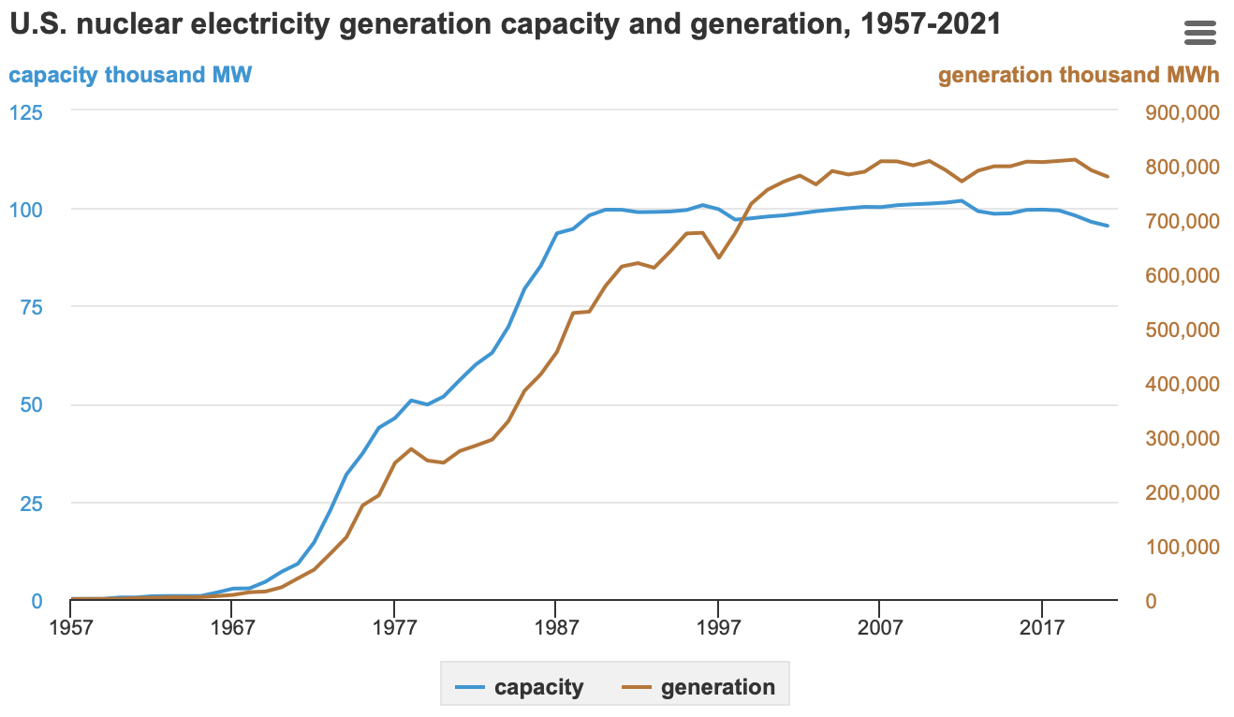Figure 1. U.S. Nuclear Electricity Generation Capacity and Generation [7]

electromagnetic weapons and the ever-increasing role of UAVs on the battlefield, energy requirements will also increase. To meet energy demands in a combat environment with current technology, logistics requirements to keep diesel fuel coming into a theater will eventually become unsustainable and extremely dangerous to both personnel and the ability to accomplish the assigned missions. [3] Thus, the DoD is pursuing TNPP technology for use on Forward Operating, Remote Operating, and Expeditionary Bases to support the warfighter. [2] The DoD is also looking to provide nuclear power to their stateside bases as well. [10] By keeping its power sources in-house, the DoD can better protect its energy assets and national security. This technology can also support civilian applications such as disaster response, critical infrastructure such as hospitals, and remote civilian and industrial applications. [2]
TNPPs are not a new idea, especially to the U.S. Military. Since this work focuses on terrestrial applications, the past U.S. Army attempts at TNPPs are the most relevant for this study. According to Adkins, Jr. et al., there have been nine small reactors deployed by the U.S. Army from 1957 to 1977. [1] These projects had a thermal output between 2.2 and 20.2 MWt. A comparable reactor to the Pele Project it the Mobile Lower Power Plant (ML-1). This reactor system could be transported in four special built containers. ML-1 contained 49kg of highly enriched Uranium (HEU), was gas-cooled, and had an output of 3.3MWt. Full-scale mock-ups were done to test transportability via truck, train, and air with some creative work arounds required to meet clearance restrictions. [1] ML-1 also contributed to the understanding of shielding requirements and the major contribution that shielding will have to the overall weight of the system. It seems that the lessons learned from ML-1 contributed the logistics requirements listed in Table 1 where standardized shipping methods are to be used.
The current military approach to a TNPP is captured in the Initial Request for Solutions for the Pele Program with the criteria for this TNPP listed in Table 1. [3] It must be acknowledged that these criteria may have changed over the subsequent years because the work was upgraded in classification after the first phase of the project was completed. [3] However, these general guidelines seem to still be in effect when analyzing more recent publicly available documents such as the “Construction and Demonstration of a Prototype Mobile Microreactor Environmental Impact Statement” and the “Parametric Study of Factors that Affect Calculated Dose from TRISO Fueled Microreactor Transportation Accident”. [2][5] Figure 2 and Table 2 show a depiction and nominal dimensions, respectfully, of the ISO 668 Container specified for the Pele Program. [11] [12] The primary takeaway of Table 2 is the gross weight which is about 40 tons, or the same weight restriction listed in Table 1. Additionally, many of the criteria seem to be sound requirements to apply to civilian applications of TNPPs.
There is also a requirement for what is described as an “inherently safe design”. This safe design must use the ground or ambient air passive cooling while maintaining the ability to safely shutdown autonomously in any “off normal or upset conditions”. [3] This means that the reactor must not need an operator to conduct any actions to initiate any measures to safely shutdown the reactor. Safety based language is included to ensure containment of fission products and minimize risks to both the public and first responders in the case of an incident. [3] Details on some of these more advanced requirements are not known.
Table 1. Pele Program Baseline Criteria [3]

Pele Program Baseline Criteria
Technical Requirements | Logistics Requirements
1-10 MWe (2-20 MWt @ 50% thermal efficiency) | Utilize ISO 668 container (standard 20’ or 40’ shipping container)
Greater than 3 effective full power years before refueling | Start up to full power in less than 72 hours
Advanced Gas Reactor (AGR) | Safe to transport in less than 7 days
Tristructural Isotopic (TRISO) Fuel | Less than 40 tons (80,000 lbs) in weight
High-assay, Low Enriched Uranium (HALEU) enriched to $≤$19.8% U-235
Semiautonomous with minimal manning and minimal maintenance

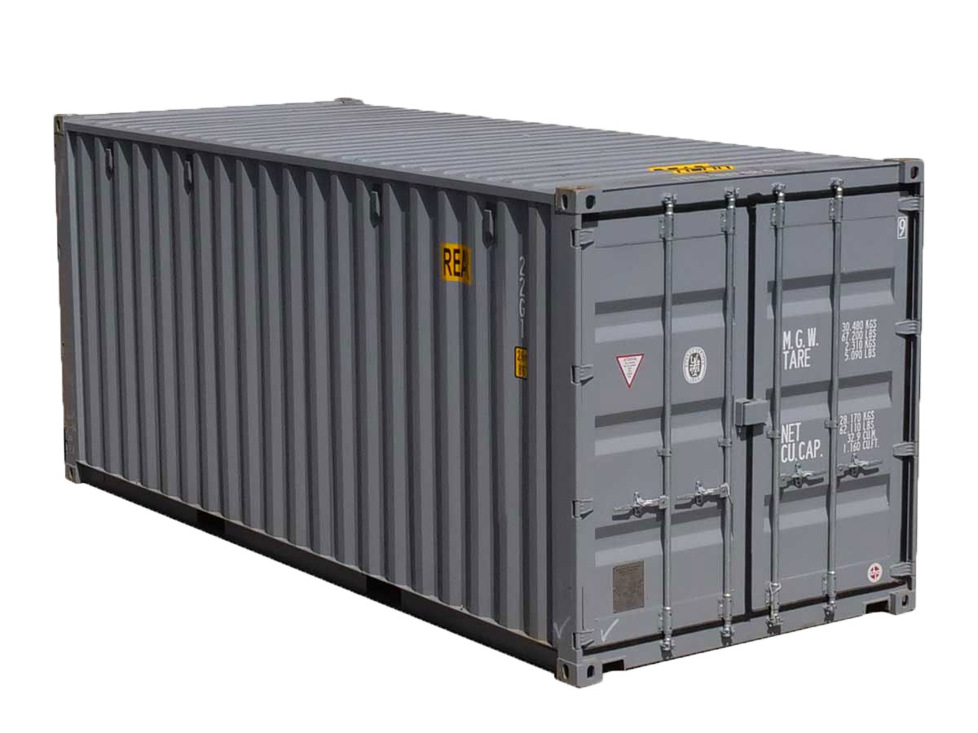
Figure 2. International Standard 668 Container [11]

Table 2. International Standard Container Nominal Dimensions and Weights [12]

ISO 668 Nominal Dimensions and Weights
Width | 8’
Height | 8.5’
Length | 20’ or 40;
Tare Weight | 4,853 or 8380 lbs
Gross Weight | 79,370 lbs
Outer Surface Thickness | 2mm

Transportation Accident Considerations

One of the additional design criteria listed in the Request for Solutions which will undoubtedly impact the assumptions required for this study is the “design (of) functional containment (which) ensures exceedingly low (fission product) releases” in all conditions. [3] It can be expected that shielding materials will also double as limited internal containment within the container. However, due to weight restrictions, it may be difficult to implement a satisfactory level of shielding and containment. This is discussed in both PNNL-33607 and by Adkins, Jr. et al. [1][5] These papers acknowledge the difficulties in providing adequate containment when using the standards outlined in 10 CFR 71, “Packaging and Transportation of Radioactive Material” while also attempting to meet logistics requirements. [5] This TNPP will have an expected radioisotope inventory in the irradiated fuel that normally necessitates the use of a Nuclear Regulatory Commission (NRC) approved Type B package. [5] Appendix B lists the source terms that will be used in future analysis. Based on the second column of Table C.2., 6.71E+03 Curies (Ci) of Ag-111 will be present in the reactor. According to Appendix A of 10 CFR 71, 1.6E+01 (Ci) is the maximum activity of Ag-111 permitted in a Type A container. [13] Because the inventory will exceed the Type A container limit, a Type B container would be required. Time does not change this requirement. Five years after shutdown, in Table C.7., there are still 9.98E+04 Ci of Cs-137 in the reactor. The regulatory limit is 1.6E+01, so a Type B container would still be required five years after the reactor is shutdown. [13] The values in Appendix B are based on a 390 kg fuel load and the Pele Program fuel load will be roughly 400 kg, so source terms should be somewhat similar and required a Type B container. [2]
A visualization of an example of a Type B package is a spent nuclear fuel cask as seen in Figure 3. Dry cask storage which would meet the requirements for Type B packaging could be upwards of 150 tons, which greatly exceeds the logistics requirements and demonstrates that a different approach must be taken. [13]
While a TNPP is not likely to meet the standard Type B certification requirements, 10 CFR 71 standards should be the basis for testing and certifications for the packaging that does house the reactor during transportation. According to Adkins Jr. et al., there are alternatives to NRC approvals listed in 10 CFR 71. [1][13] These alternatives include probability risk analysis (PRA) of packaging to ensure an equivalent level of safety is maintained. To support the certification of a separate type of packaging, it is imperative to demonstrate that the packaging can maintain the same level of safety using the same tests or those of similar conservatism.
To demonstrate commensurate levels of safety, the accident scenarios, and their associated testing, shown in Table 3, listed in 10 CFR 71.73 should be addressed in depth. [13] These hypothetical accident scenarios were the basis of the approach taken in this thesis to address transportation incidents. The selected scenarios most closely resemble the effects of a free drop or free-fall accident. In these two tests, especially the free-fall test, there is the greatest chance of a reconfiguration of the core due to the large forces involved when a 40-ton container impacts the ground. A puncture is not likely to greatly affect the core due to the expected gap between the outside of the RPV and the outer surface of the container itself. However, the area of greatest concern is
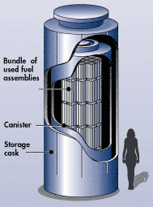
Figure 3. Example Spent Nuclear Fuel Cask [14]

Table 3. 10 CFR 71 Accident Conditions and Tests [13]

10 CFR 71 Accident Conditions and Tests
Free Drop | 9 m drop
Crush | 500 kg mass dropped from 9 m
Puncture | 1 m drop onto 15 cm, vertical steel bar
Thermal | 800°C fire for 30 minutes
Immersion | Immersion in 0.9 meters of water
Free-fall (Pu only) | Drop from terminal velocity with right angle impact onto unyielding, horizontal surface
Deep submersion test (Pu Only) | Submerged with external water pressure of 4 MPa
Subcritical with in leakage | Modeling of system with water in leakage

the determination of a subcritical configuration when water is introduced into the system in either submersion or immersion conditions. Normally, the free-fall and submersion tests apply only to Plutonium, but this is due to criticality concerns and a fueled reactor would have the same concerns no matter the fuel type.
To address subcriticality, 10 CFR 71 sets certain conditions when a package in subjected to in leakage of water. These are (1) materials are in the most credible configuration, (2) moderation of water at most reactive credible extent, and (3) full reflection of the containment system. [13] To pass this modeling test, the package must be designed to (1) maintain subcritical configuration test, (2) geometry of the contents must not greatly change, (3) there is no in leakage unless moderation from the water will not cause a critical or supercritical condition, and (4) there is not reduction in effectiveness of the package. [13] This testing scenario was a primary area of modeling for this thesis and will be addressed in depth.
Because the requirements of Type B packaging are not likely to be met, it is important to address the challenges of defense in depth when it comes to TNPPs. Defense in depth for nuclear reactors is “an approach to designing and operating nuclear facilities that prevents and mitigates accidents that release radiation or hazardous materials”. [15] This approach seeks to create redundancy so that the failure of one layer of defense does not lead to total safety failure of the system. Standard, stationary reactors are thought of having five physical layers to defense in depth. The fuel itself is the first layer as most solid fission products are caught inside of the fuel itself. The second layer is the fuel cladding which seeks to keep gaseous fission products inside of the fuel channel. The third layer is the reactor pressure vessel (RPV) and primary coolant loop and the fourth is the containment building that houses all current reactors. A fifth layer is an emergency planning zone, or EPZ. The standardized EPZ for large reactors is 10km and is simply an unsecured area where emergency response plans and training are maintained. [15] [16]
A TNPP of this design will lose one major layer of defense in depth when operating and two layers while in transportation. TRISO fuel will perform the roles of the first two layers by capturing fission products. TRISO will be discussed in more detail shortly. The graphite compact, moderator, and reflector are also expected to capture fission products. There is a stainless steel (SS) RPV and the pressure boundary act as the third layer. And the last layer will be some version of an EPZ which will be significantly smaller than the traditional 10km based on the actual quantity of material at risk and in-depth analysis of the final design. Noticeably missing is the containment facility. During operation, the reactor may be buried, which will provide some containment, but it will not be as effective as several feet of special purpose concrete which is used for large scale reactors. More importantly for this study, during transportation there will not be containment or a previously established EPZ. If, as expected, the reactor is not transported inside a Type B container, containment is generally limited to the RPV itself. Additionally, it will be difficult to maintain an EPZ while conducting movements for potentially thousands of miles. It will be imperative to conduct planning to move the reactor at the safest times and along the safest routes. The Environmental Impact Statement (EIS) indirectly addresses defense in depth for the prototype reactor. While undergoing testing, the reactor will either be inside the Experimental Breeder Reactor - II dome at Idaho National Labs or inside a temporary shielding apparatus. [2] The description of the temporary shielding apparatus includes “concrete T-walls, steel-reinforced concrete roof panels, concrete wall blocks, steel bladders for water, and HESCO bags”. [2] Both set ups will provide shielding to the surrounding area, but don’t seem to be used for containment. It can be inferred that the prototype reactor is not expected to contain adequate shielding for radiation work, therefore, it is not likely to have significant containment capabilities outside of the RPV. Another key area that demonstrates lack of containment was the removal of the containment attenuation terms when radiation release analysis was conducted for the EIS. [2]
When addressing transportation of the reactor, the EIS is very specific about limitations. It reads, “(the reactor) must not utilize public roads for shipment to the outdoor location because the transportation of the mobile microreactor has not been evaluated by the US DOT or the NRC.” [2] This statement limits the prototype to utilizing roads that are owned and operated by the Department of Energy while it is at Idaho National Lab (INL). The statement also suggests that work such as this and that of PNNL-33607, which will be discussed later, is necessary to license these reactors for publicly owned land. It is important to acknowledge that the fuel and reactor components will be shipped to INL separately, so the TRISO fuel will be shipped in accordance with 10 CFR 71 in preapproved containers, not as part of a fueled reactor system. The EIS also specifies an in-depth transportation plan will be required. This includes route planning, anticipated areas of concern, security, and safety – both radiological and vehicle. [2]
The 10 CFR 71 accident scenarios require the examination of the effect of water on the reactor, especially when considering criticality. According to King and El-Genk, water inside or outside of the core can result in a “spectrum shift (which increases) the effective fission cross-section and, thus, reactivity, potentially making the reactor supercritical.” [17] This “spectrum shift” is the increase in flux of thermal neutrons due to reflection or moderation. When considering King’s and El-Genk’s statement with the quote from Adkins Jr. in the introduction and the sub-criticality requirements of 10 CFR 71, it is clear to see the importance of analyzing accident scenarios which include water. [1] [13] [17]
Sun et al. completed an analysis of a submersion accident in the paper “Conceptual Design and Analysis of a Multipurpose Micro Nuclear Reactor Power Source”. [18] This accident was selected as an example because water increases moderation when inside the core and as extra reflector outside of the core. It also adds cooling to the reactor during a transient. This allows temperatures in the core to stay low which decreases the effectiveness of the doppler coefficient to control the transient. These compounding effects could lead to an increase in k-effective to supercritical values. In the Sun et al. analysis, water was limited to the gap between the fuel compacts and the graphite matrix. [18] A depiction of the control drum angles are seen in Figure 4. The darker material is the actual absorbing material which controls the reactivity in the reactor. The Sun et al. analysis, with results shown in Table 4, showed that the reactor began to experience supercritical conditions when the control drums
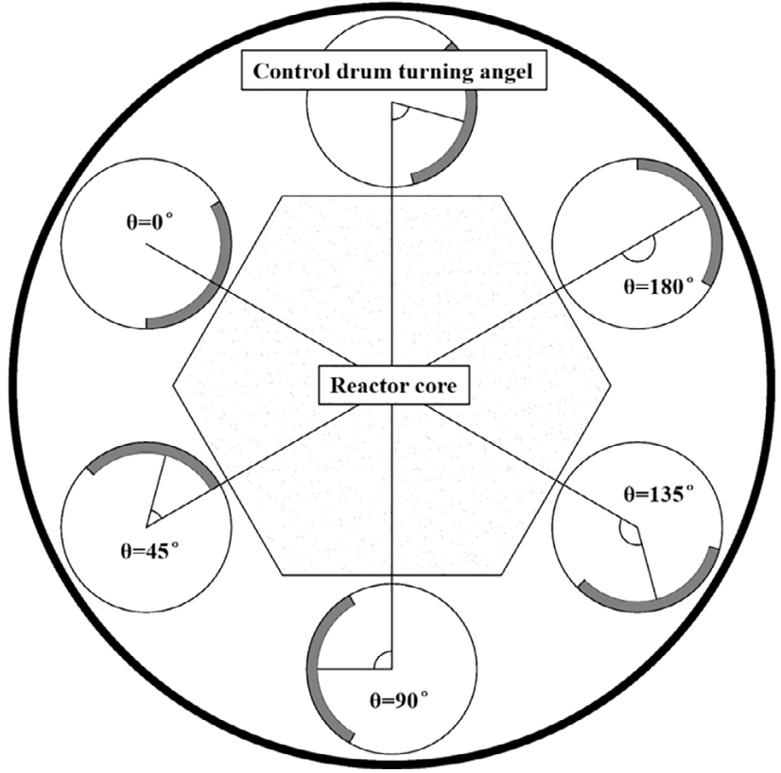
Figure 4. Control Drum Angles [18]

Table 4. Water-filled Reactor Analysis [18]

$$θ$$ | 0$°$ | 45$°$ | 90$°$ | 135$°$ | 180$°$
k-effective (normal) | 0.93096 | 0.94940 | 0.98772 | 1.01313 | 1.02215
k-effective (water-filled) | 0.92680 | 0.94630 | 0.98353 | 1.01080 | 1.01839

were rotated out to 135°. [18] Key differences between Sun’s analysis and this thesis were the addition of water into the coolant channels and neutron poisons are omitted completely. Table 4 does show that the water-filled k-effectives were less than the normal conditions, but this was not consistent with the more conservative assumptions taken in this thesis.
Sun et al. also analyzed accident configurations where the control drums were stuck in their least effective position, rotated 180$°$ away from the center of the core. Sun recognized that a “control drum shaft stuck accident brings serious threats to core safety.” [18] His data, shown in Table 5, agrees with this statement. As more drums are stuck, the shutdown margin of the reactor steadily approaches zero. Once 5 drums are stuck open and there is no remaining shutdown margin. Sun approximates the probability of more than 4 drums getting stuck as less than 10⁻⁸. However, with the hypothetical transportation accidents that were assessed, this probability could be significantly higher given the immense impact that the reactor may experience. This stuck drum accident scenario is important to address to show that control materials would maintain subcriticality if they are able to maintain their designed position.
A potential comparison to this work can be found in Pacific Northwest National Labs (PNNL) report number 33607 titled “Parametric Study of Factors that Affect Calculated Dose from TRISO Fueled Microreactor Transportation Accident.” [5] This report utilized a 20 MWt reactor model to examine the effects of two accidents. The first accident scenario was a vehicle accident with a fuel tanker that engulfed the reactor in flames in a way that would potentially satisfy 10 CFR 71 requirements for thermal accident analysis. [5] [13] The second scenario was a human error accident in which the
Table 5. Shutdown Margin for Stuck Control Drum Accident [18]

# of Stuck Drums | k-effective | Reactivity | Shutdown Margin ($)
1 | 0.94850 | -0.05430 | -7.89
2 | 0.96430 | -0.03702 | -5.38
3 | 0.97213 | -0.02867 | -4.17
4 | 0.98971 | -0.01040 | -1.51
5 | 1.00494 | 0.00492 | -
6 | 1.02293 | 0.02242 | -

pressure boundary was lost. In each of these cases, with the assumptions that were made, PNNL found that a 25 roentgen-equivalent-man (REM) dose limit could be met in either accident scenario when the reactor was allowed to cool for 5 years post-shutdown. This 25 REM limit comes from 10 CFR 100, Reactor Citing Criteria, which states that any individual within the established exclusion area must not receive 25 REM when exposed for two hours. [19] However, after 1 year of cooling, the 25 REM limit was exceeded, reaching a total effective dose (TED) of 33.5 REM. [5] This shows a potential issue when considering the Pele Program requirement to potentially move the reactor only 7 days post-shutdown. Additionally, when the assumptions were adjusted to increase the inputs of the 5 Factor Formula, seen in Equation 1, the dose rose to 155 REM, well above acceptable limits. [5]
Another key assumption made in PNNL-33607 was that the reactor could not achieve a critical or supercritical state due to engineered designs. [5] This is likely to be a valid assumption for a licensed, operating reactor. And, because of this assumption, no TRISO particles fail in either PNNL-33607 accident case because temperatures never approach the potential failure temperatures of the TRISO particles. [5] However, this thesis looks at the opposite assumption where no engineered reactivity controls are in place to observe the effects of neutronics on potential radiological releases. This gives the worst-case accident scenario where all engineering controls have failed.

Radiation Release Mechanisms

A key takeaway from the PNNL-33607 report was that “The literature search did not identify any testing performed on irradiated TRISO fuel under transportation conditions.” [5] This means that that “estimates of release parameters for the TNPP package were developed based on engineering-based assumptions and judgement.” [5] These assumptions were primarily in determining release fractions from three sources: (1) material released by TRISO and retained in the core structure or inside the pressure boundary, (2) material released from the core structure or pressure boundary due to damage caused by the transportation accident, and (3) material released due to the failure of TRISO particles due to the transportation accident. [5] The release fractions, shown in Table 6, listed in PNNL-33607 were those used in this work when determining the activity of radioisotopes that have escaped the TRISO. [5] Since there was an assumption of no criticality during the PNNL-33607 accident scenario, the material released from the TRISO particles due to an impact was limited to the assumed damage ratio of TRISO particles. [5] For impacts on unyielding surfaces at a speed of 60-90 mph, a damage ratio was set at 0.1% and for impacts over 90 mph the damage ratio was set to 1%. The 1% damage ratio was used in this study. [5]
Equation 1 shows the equation for calculation of the source term. When considering the various ways that radiological material may be released as shown in PNNL-33607, Equation 2 shows that the total source term is simply the sum of the various methods. [5] Table 7 defines the variables of the Equation 1 for each release mechanism and lists the quantities used in this study which were used to define the
Table 6. Release Fractions from Fuel to Core Materials & Pressure Boundary [5]

Group/Isotope | Release Fraction to Core Materials (RF_{CM}) | Release Fraction to Pressure Boundary (RF_{PB})
Noble Gases | 0 | 8.11E-06
Xe133 | 0 | 8.01E-06
Kr85 | 0 | 8.13E-06
Kr88 | 0 | 8.18E-06
Halogens  (I, Br, Te, Se) | 0 | 8.09E-06
I131 | 0 | 8.01E-06
I133 | 0 | 8.02E-06
Te132 | 0 | 8.23E-06
Alkali Metals  (Cs, Rb) | 1.46E-04 | 1.64E-04
Cs134 | 1.45E-04 | 1.64E-04
Cs137 | 1.47E-04 | 1.63E-04
Alkaline Earths  (Sr, Ba, Eu) | 3.34E-03 | 1.89E-05
Sr90 | 3.34E-03 | 1.89E-05
Noble Metals  (Ag, Pd) | 0 | 5.19E-03
Ag110m | 0 | 8.39E-03
Ag111 | 0 | 1.98E-03
Metalloid  (Sb) | 2.58E-04 | 1.03E-04
Sb125 | 2.58E-04 | 1.03E-04
Transition Metals  (Mo, Ru, Rh, Tc) | 3.29E-05 | 2.12E-07
Ru103 | 3.29E-05 | 2.12E-07
Lanthanides  (La, Ce) | 3.28E-05 | 2.13E-07
Ce144 | 3.27E-05 | 2.12E-07
La140 | 3.28E-05 | 2.14E-07
Actinides | 2.94E-05 | 1.52E-08
Pu239 | 2.94E-05 | 1.52E-08

Table 7. Source Term Inputs [5]

 | Material at Risk (MAR) | Damage Ratio  (DR) | Airborne Release Fraction  (ARF) | Respirable Fraction (RF) | Leak Path Factor (LPF)¹
 | Available Fission Product Inventory | Fraction of MAR released from its location | Fraction of MAR which can be suspended in air | Fraction of MAR which is small enough to be inhaled (~10$μm$) | Fraction of MAR which can escape from initial location into a person
Pressure Boundary (PB) | $$Inventory* {RF}_{PB}$$ | 1.00E-00 | 1.00E-03 | 3.00E-01 | 5.00E-01
Core Material (CM) | $$Inventory* {RF}_{CM}$$ | 1.00E-01 | 1.00E-03 | 3.00E-01 | 1.00E-01
TRISO-I (Impact) | $$Inventory* 0.01$$ | 1.00E-02 | 1.00E-03 | 3.00E-01 | 5.00E-02
TRISO-T (Transient) | $Inventory* TF$² | TBD | 1.00E-03 | 3.00E-01 | 5.00E-02
1 – LPF set to 1 for all gases
2 – TF – TRISO Failure Fraction listed in Table 19

release due to impact stresses for the tanker accident scenario in PNNL-33607. [5] The damage ratio for TRISO failure due a transient is listed as to be determined as this is

$${Source Term}_{i}={MAR}_{i}*{DR}_{i}*{ARF}_{i}*{RF}_{i}*{LPF}_{i}$$
Equation 1. Source Term [5]
$$Source Term= {Source Term}_{PB}+{Source Term}_{CM}{+Source Term}_{TRISO-I}{+Source Term}_{TRISO-T}$$
Equation 2. Total Source Term

defined as the TRISO failure ratio which will be determined by further analysis in Chapter Four. Equation 2 shows that the sum of source terms from the pressure boundary, core materials, TRISO failure due to impact, and TRISO failure due to the transient yields the final source term used to model releases.

Core Design

A key part of the safety design for these reactors is the fuel type. As shown in Figure 5, Tristructural Isotropic (TRISO) fuel is made of several different layers of material. The carbon buffer layer is designed to allow the UCO kernel to undergo thermal expansion. The inner pyrolytic Carbon (PyC), Silicon Carbide (SiC), and outer PyC layers are designed to absorb stresses and hold fission products inside the particle. [5] As seen in with the release fractions in Table 6, some fission products will
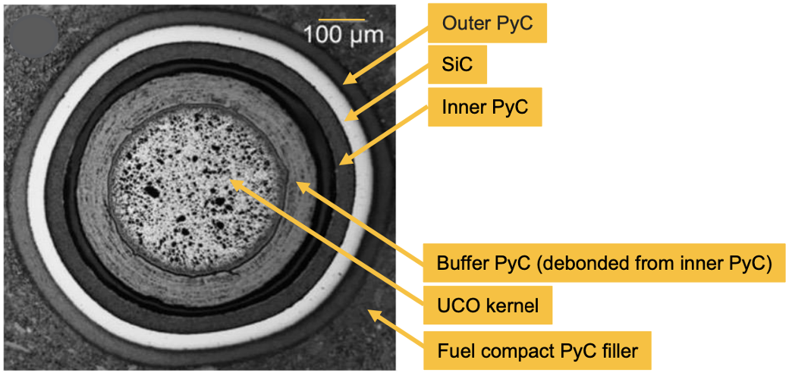
Figure 5. Example Tristructural Isotropic Fuel Particle [5]

still escape the particles over time. The radius of each TRISO layer used in the modeling for this work is shown in Table 8.
A potential failure method of a TRISO particle occurs when the UCO kernel reaches its melting point. Ghezzi et al. conducted simulations in the finite element, fuel performance code, BISON to model fuel failure conditions. [21] They conducted 1D simulations of transient scenarios to determine the failure probability of TRISO particles during the transient. These 1D models were compared to 3D models and experimental data from other sources. [21] The three different methods showed good agreement when it came to comparing energy deposition and fuel failure probability. This agreement demonstrated that the probability of TRISO particles failing began to increase rapidly as the fuel surpassed the phase transition to melting at 3100 K. Figure 6 shows a rough temperature to fuel failure probability which was established by comparing Fig. 5 and Fig. 9 from Ghezzi et al. [21] The data points shown were used in this work to determine the percentage of fuel failure due to transients. Because this TRISO failure threshold is related directly to peak temperature and energy deposition during a transient, it is very applicable to the short-term transients seen in this work.
On the contrary, PNNL-33607 based their failure limits on test data from the Advanced Gas Reactor -1 and -2 experiments in which TRISO particles were exposed to a heat of 2073 K for 300 hours. [5] In this experiment, only 3 of 26,028 particles failed, but “accident condition failures are very sensitive to increases in temperature above 1800°C (2073 K) since the SiC layer chemically decomposes as it approaches and rises above 2000°C (2273 K).” [5] Because of the similarities to the PNNL-33607 study and this one, this 2073 K failure threshold was also modeled alongside the 3100
Table 8. TRISO Layer Radii [20]

Layer | Outer Radius (cm)
UCO Kernel | 0.02125
PyC Buffer | 0.03125
Inner PyC | 0.03525
SiC | 0.03875
Outer PyC | 0.04275

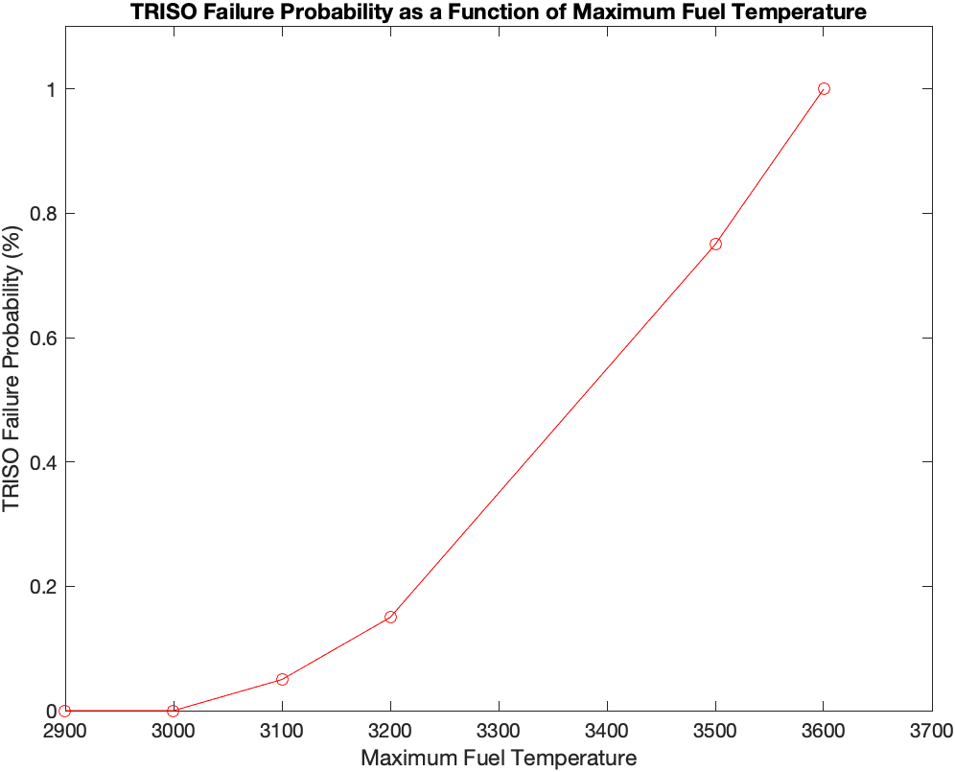
Figure 6. TRISO Failure Probability at Given Temperatures above 3100 K [21]

K threshold from Ghezzi et al. to show a comparison between the two limits. Since no probabilities are provided for the 2073 K threshold and above, a conservative assumption is made that 100% of particles above this temperature fail.
Additionally, because the 2073 K failure threshold corresponds to the AGR-1 and AGR-2 test data, it is likely more accurate for longer term transients than the ones seen here. [5] In longer term transients, immediate TRISO failure is not necessarily the largest concern when considering fission product release. Increased time at higher temperatures lead to increased diffusion of fission products through the TRISO layers as described in PNNL-33607. [5] As such, the 2073 K failure threshold should be seen as a much more conservative threshold with increased applicability in a transient case where the new steady state temperature is a significant increase over the original temperature.
To complete the discussion concerning fuel design, in this AGR design, the TRISO particles are randomly distributed inside a carbon fuel compact. The fuel compacts in this design were modeled as cylinders which occupied the length of the fuel channel. The compacts were 0.625 cm in radius with the fuel channels themselves set to 0.635 cm in radius to allow for coolant flow around the compacts. [20]
With the posed questions and the Pele Program Design Criteria in mind, a starting point for the core design is required. The chosen starting point was conceptual core design for a high temperature, gas cooled reactor from Duchnowski et al. [4] This design was a modified version of INL’s High Temperature Gas Cooled Test Reactor (HTGTR) which was reconfigured to fit inside the ISO 668 container required for the Pele Program. [4] To ensure that the core would fit, while also leaving space for heat exchangers, the core was limited in size to 90 cm in radius and 395.5 cm in height. The SS RPV was limited to an outer radius of 116.5 cm and height of 448.5 cm. [4] This height allowed for three stacked Fort Saint Vrain style fuel blocks with upper and lower reflectors of the same height of 79.1 cm. [4] Duchnowski et al. looked to increase initial fuel loading to maximize power and cycle length. [4] This led to the Fort Saint Vrain style fuel block to be modified to smaller microassemblies seen in Figure 7. This allowed for replacement of reflector blocks with fueled blocks to increase reactor performance. [4]
Duchnowski et al. completed a scoping study to determine the lattice pitch and packing fraction which would lead to the best fuel performance and burnup. [4] Terrani et al. described the maximum TRISO packing fraction in the compact as 0.45 to 0.50 due to manufacturing constraints. [22] A 0.45 packing fraction was used in this study and Duchnowski et al. showed that a lattice pitch of 2.3 to 2.5 cm would maximize fuel performance at this packing fraction. Thus, a lattice pitch of 2.5 cm was used. Duchnowski et al. also looked at a variety of fuel and moderator types, but UCO fuel with a graphite moderator was decided upon as the most developed and understood materials for HTGRs.

Irradiation Effects on Graphite

As seen in the descriptions of this AGR concept, the core is made up of UCO fuel, Helium coolant, and graphite. As seen in Appendix A, graphite takes up a vast majority of the volume of the core. Since the accident scenarios analyzed involve large
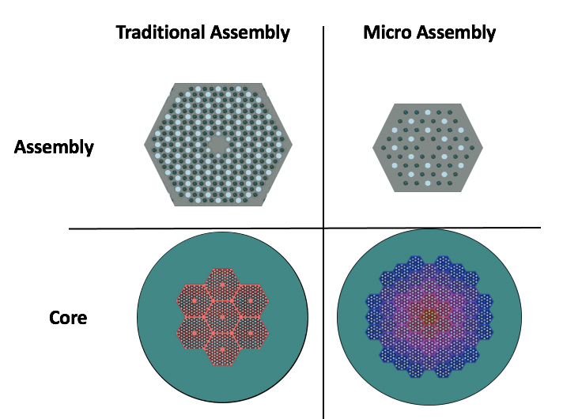
Figure 7. Traditional Fort Saint Vrain assembly versus Microassembly [4]

impacts, it is necessary to shortly describe the effect of irradiation on graphite. Campbell et al. describes the effects of neutron irradiation on graphite as such: “typical property changes include the initial densification to a maximum density, followed by swelling until the material loses all structural integrity.” [23] This statement was supported by experimental data where graphite was exposed to a high neutron fluence as shown in Figure 8. [23] In this data, the elastic moduli were shown to “rapidly rise” while the material was shrinking and then would decrease, but stay greater than the initial value, when the material began to swell. The behavior of the elastic moduli indicates that there is a large increase in brittleness which in turn can lead to increased probability of cracking, breaking, or collapsing. [23] So, while at beginning of cycle (BOC), graphite may generally be expected to hold up to the forces of a large impact, after years of reactor operation, it may be more susceptible to damage. This information supports the core rearrangements that will be discussed later.

Reactor Dynamics

In the event of a core rearrangement, submersion, and/or immersion accident, it is important to understand how the core will respond to the sudden insertion of reactivity. A simple, yet effective way to approach this problem is to utilize the point kinetics equations seen in Equation 1 as described by Ott. [24] The extremely small size of this reactor leads to a very coupled core during the transient. This means that the flux shape will not vary greatly across the core. [2] This allows the point kinetics to be used rather than the special and energy dependent exact kinetics equations. The point
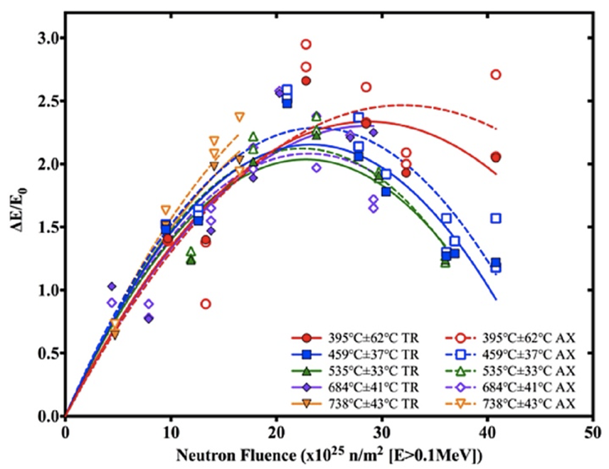
Figure 8. Elastic Modulus of Graphite under Irradiation [23]

kinetics equation calculates the change in power over time ($\dot{p}(t)$) utilizing several of the outputs provided by Serpent. $ρ(t)$ is the reactivity within the core over time and is calculated using Equation 4. $β_{eff}$ is the effective delayed neutron fraction which is the fraction of delayed neutrons produced compared to the total number of neutrons produced. $Λ$ is the neutron generation time or the time between the “birth” of a neutron and the “birth” of a new neutron from the fission event caused by the original neutron. $λ_{k}$ is the decay constant for each of six delayed neutron precursor groups while $ζ_{k}(t)$ is the concentration of each delayed neutron precursor group. Finally, $β_{k}$ is the delayed neutron fraction for each precursor group. These equations were solved using the Theta Method utilizing a Matlab script provided by Brown. [25] An example output of this method is in Figure 9 which shows the power of an example transient over time.

$$\dot{p}\left(t\right)=p\left(t\right)*\left(\frac{ρ\left(t\right)- β_{eff}}{Λ}\right)+\frac{1}{Λ}*\sum_{k}{λ_{k}*ζ_{k}}(t)$$

$${\dot{ζ}}_{k}\left(t\right)= -λ_{k}*ζ_{k}\left(t\right)+β_{k}*p(t)$$

Equation 3. Point Kinetics Equations [24]

$$δρ\left(t\right)= γ^{doppler}*\int_{0}^{t}{\left(p\left(t^{'}\right)- p_{0}\right)dt^{'}}$$
Equation 4. Adiabatic Change in Reactivity [24]

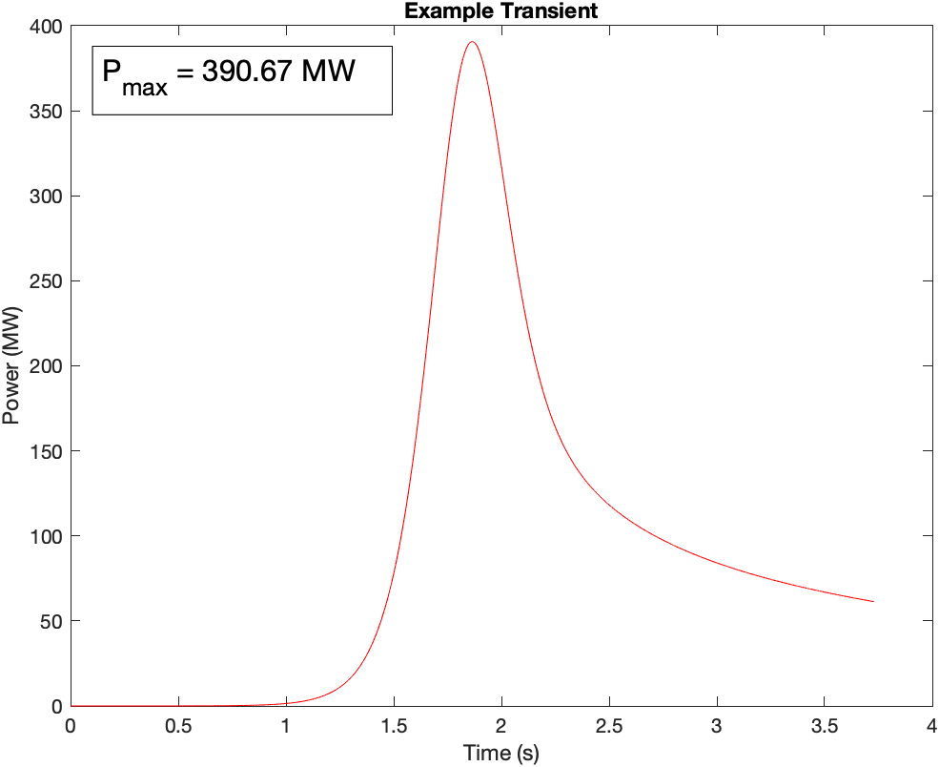
Figure 9. Example Transient Power Pulse

The example transient also includes prompt feedback from the doppler effect within the reactivity term shown in Equations 4 as $γ^{doppler}$. A simple description of the
doppler effect is that as fuel temperature increases, the fission cross sections of the fissile material decreases. This inverse relationship leads to a decrease in the number of fission events occurring and a decrease in the power. Equations 4 through 8 demonstrate the calculation of the doppler feedback coefficient, $γ^{doppler}$. First, the values of $C_{qt}$ and $C_{it}$ are calculated using Equation 4 to determine a relationship between temperature and power within the reactor. These relationships are simply a relationship between the volumetric heat capacity of the fuel and volume of the fuel. The volumetric heat capacity is solved for using Equation 5. The density used for the fuel compact was 1.75 $\left(\frac{g}{{cm}^{3}}\right)$ and the specific heat capacity was set to 1.8 $\left(\frac{W-s}{g-K}\right)$. [26] [27] The fuel volumes can be found in Appendix A and were the sum of all the components of the TRISO particles and the compact.

$$C_{qt}=\frac{1}{c_{h}}*\frac{1}{V_{f }} \left(\frac{K}{W-s}\right) \& C_{it}=\frac{1}{c_{h}}*\frac{P_{nom}}{V_{f }} \left(\frac{K}{fp-s}\right)$$
Equation 5. C_{qt} & C_{it} [24]

$$c_{h}= ρ_{density}*c_{p }\left(\frac{W-s}{K-{mm}^{3}}\right)$$
Equation 6. Specific Heat Capacity

The next step to determine the feedback coefficient is to calculate a doppler coefficient. For this study, the doppler coefficient was calculated by running each model at three different fuel temperatures with all other material temperature held constant. By calculating the reactivity at each temperature using Equation 6, a doppler coefficient, $α$ , can be found using Equation 7. Finally, the doppler feedback coefficient multiplied by $C_{it}$ to find the doppler feedback coefficient for Equation 4.

$$ρ=\frac{k_{eff}-1}{k_{eff}}\left(pcm\right)$$
Equation 7. Reactivity

$$α=\frac{Δρ}{ΔT}*\frac{1}{β_{eff}} \left(\frac{\$}{K}\right)$$
Equation 8. Doppler Coefficient

$$γ^{doppler}=C_{it}*α \left(\frac{\$}{fp-s}\right)$$
Equation 9. Doppler Feedback Coefficient [24]

With a power profile established through the initial transient conditions, the next step is to determine the expected temperature of the fuel using Equation 10. This equation relates the changing power in the reactor to temperature using $C_{qt}$ and gives a spatially averaged maximum temperature in the core. To determine the expected maximum temperature in the core, the change in temperature shown in Equation 10 is multiplied by the core peaking factor discussed later. An example of the temperature output of the same transient in Figure 9 is seen in Figure 10. Adiabatic heating was assumed during the relatively short transient to demonstrate a conservative maximum fuel temperature.

$$δT\left(t\right)= C_{qt}*\int_{0}^{t}{p\left(t^{'}\right)-p_{0} dt} \left(K\right)$$
Equation 10. Temperature Change [24]

Tool Description

“Serpent is a multi-purpose, three-dimensional, continuous-energy neutron and photon transport code”. [28] It was developed and is maintained by the VTT Technical Research Centre in Finland and access was granted through the Radiation Safety Information Computational Center at Oak Ridge National Labs. [28]. This code allows for a wide variety of particle transport problems using the Monte Carlo Method. For this work, it was used to model reactor criticality, depletion, and decay of radioactive isotopes. The Serpent disperse function was also used to randomly distribute TRISO particles in the compacts.
HotSpot is a health physics code developed by the National Atmospheric Release Advisory Center at Lawrence Livermore National Labs (LLNL). [30] LLNL approval was required to access this code. The code is developed to provide conservative radiation dose estimates for atmospheric releases of radioactive materials.
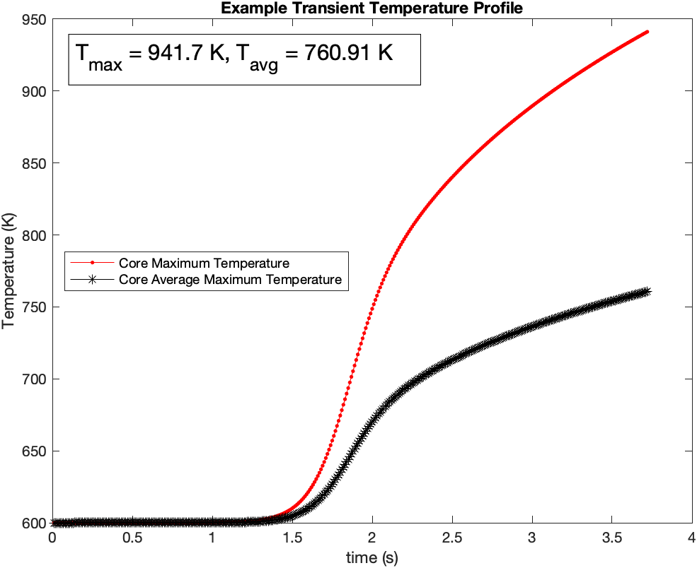
Figure 10. Example Transient Temperature Pulse

The “General Plume” model used provides a short-range (<10 km) estimate of radiation dose for short-term (hours) releases. [30] Only 50 isotopes can be used in a HotSpot input which required the selection of the highest activity isotopes for modeling. [30]
The executed HotSpot inputs were run at simple representative conditions unless otherwise specified. These included a 1 m/s wind at an altitude of 10 m. The release height was set to 0 m in a standard or rural type of environment. The atmospheric conditions were set to a neutral, class D state. All other HotSpot inputs were left at their default values. A representation of a HotSpot output plot is shown in Figure 11. HotSpot outputs downwind distances and areas on the ground which meet the specified thresholds for Total Effective Dose Equivalent (TEDE). All models for this study were assessed at thresholds of 0.01, 0.1, 1, 10, 25, REM TEDE to give a simple logarithmic scale for release visualization. Additionally, the threshold of 25 REM and a two-hour exposure time were selected in reference to the 10 CFR 100 citing requirement for the exclusion area around the reactor. [19]

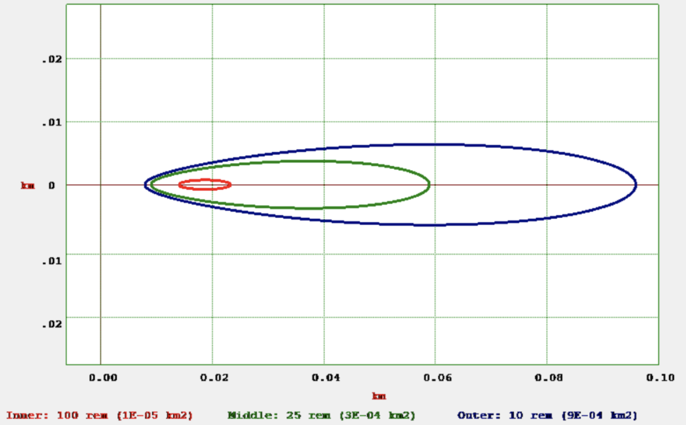
Figure 11. Example HotSpot Output [30]

CHAPTER THREE

Modeling Methodology

Control Models and Performance

To determine whether a more critical configuration could exist, a control was established by developing 3D models of Duchnowski et al.’s core design. [4] The control model has several roles. First, they act as a specific accident condition where there is little to no reconfiguration of core materials. As discussed, at beginning of cycle (BOC) the control model is the most likely because of the unirradiated properties of graphite. The control establishes a baseline k-effective to which the rearranged models can be compared. It also establishes the material volumes which must be maintained throughout the reconfigured models to show a fair comparison to the control. The volumes of all models are listed in Appendix A.
Two different designs were initially examined. Design #1 is modeled after the left-hand core configuration in Figure 7 and Design #2 is the right-hand side. A key difference between the designs is mass of the fuel. Design #1 has 50 kg of fuel and Design #2 has 390 kg of fuel. The results of this large difference will be discussed later. In terms of modeling, the SS RPV was excluded from the Design #1 model but not from the one for Design #2. This was due to the percent difference in k-effective with and without the RPV. For Design #1, there was only a 395 per cent mille (pcm) or a 0.34% difference between models with and without the RPV. Design #2 had a 1538 pcm or 1.15% difference between the models. Figures 12 through 15 show the radial and axial views of the two control designs examined. The difference between these becomes clear when comparing Figures 12 and 13. For Design #1, there is much larger reflector region between the fuel microassemblies and the outer edge of the core than in Design #2 which has very little reflector material, so the RPV has less effect because leakage is already much lower for Design #1.
The two control designs were also used to determine the depletion of the core throughout the lifetime of the reactors. Because one of the major differences between the designs is the quantity of fissile material, the potential power output is very different. As a reminder, the Pele Program requirement is 1-10 MWe for no less than three years. [3] Figures 16 and 17 show the depletion over the core lifetime for each design. For Design #1, k-effective approaches one at the 3-year mark only when power is normalized to 1 MWe, the bare minimum requirement for the Pele Program. Design #2 is capable of operating for over 5 years at 10 MWe. By examining these two very different designs, it is possible to discern the differences in accident scenarios at both ends of the potential Pele Program power spectrum. Each design is assessed at BOC and end of cycle (EOC). EOC for Design #1 is set at three years and five years for Design #2. Both Figures 16 and 17 show that the reactors could go slightly beyond these points, but these timesteps are chosen for simplicity when assessing decay post-shutdown. Design #2 is also assessed at three years as a comparison to the EOC timestep to Design #1 and as a middle of cycle (MOC) timestep to examine an accident scenario where the reactor is moved prior to full depletion of the reactor.
The final reactor performance discussion is an examination of core burnup.

Figure 12. Design #1 Radial View

Purple – RPV, Orange – Reflector, Grey – Moderator and Compact, Red – He Moderator, Black – TRISO particles, Blue – Water

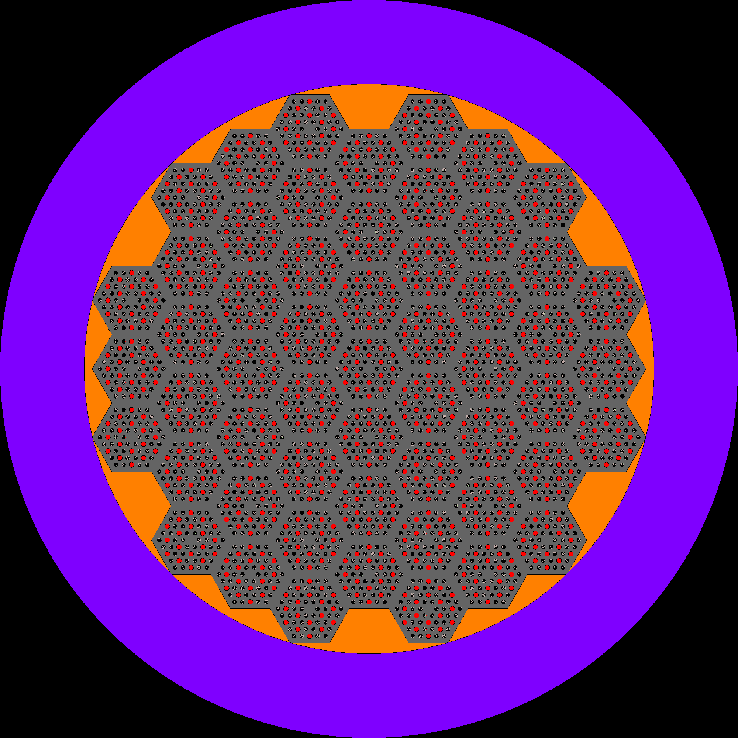
Figure 13. Design #2 Radial View

Purple – RPV, Orange – Reflector, Grey – Moderator and Compact, Red – He Moderator, Black – TRISO particles, Blue – Water


Figure 14. Design #1 Axial View – X-Y Axis

Purple – RPV, Orange – Reflector, Grey – Moderator and Compact, Red – He Moderator, Black – TRISO particles, Blue – Water


Figure 15. Design #2 Axial View – X-Y axis

Purple – RPV, Orange – Reflector, Grey – Moderator and Compact, Red – He Moderator, Black – TRISO particles, Blue – Water

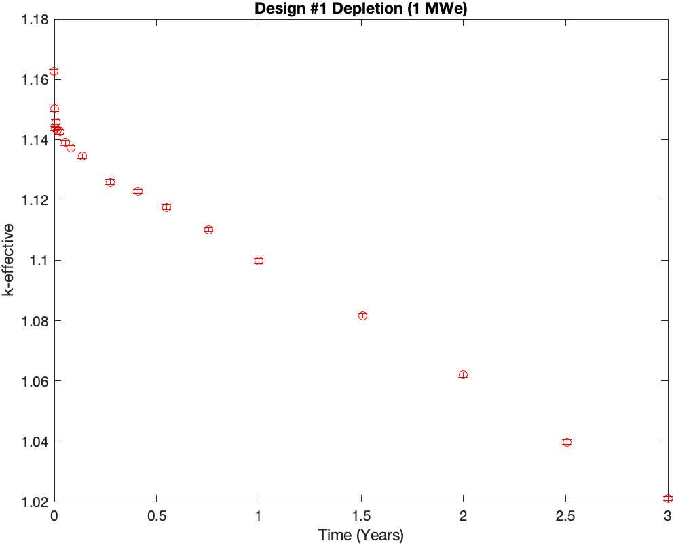
Figure 16. Depletion of Design #1

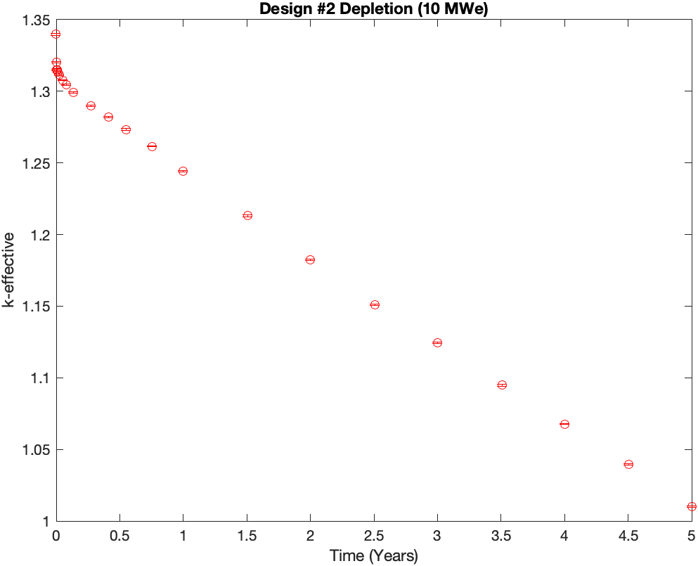
Figure 17. Depletion of Design #2

The current NRC burnup limit is a rod-average 62 MWd/kgU for standard light water reactors. [31] Currently, some potential licensees are looking at accident tolerant fuels that operate to 75 to 80 MWd/kgU. [31] If Design #2 is operated at 10 MWe for roughly three effective full power years (EFPYs), the burnup will surpass the NRC limit as seen in Figure 18. The maximum burnup at five EFPYs is over 105 MWd/kgU. This greatly exceeds even the accident tolerant fuel work that is currently ongoing. [31] This presents concerns about TRISO performance at extremely high burnup and research would be required to license a reactor to operate to this point. However, three EFPYs is more representative of what could be expected to meet current regulatory limits or the reactor could be run at a lower power to increase cycle length.
Another key consideration is fission product decay after shutdown. As these accidents are assumed to take place seven or more days post down, Figures 19 through 21 display k-effective post-shutdown for the MOC and EOC timesteps. BOC is not demonstrated because there has yet to be any fission product build-up. As fission products, specifically Xenon and Samarium, decay, k-effective begins to rise post-shutdown. For all three cases, it is observed that k-eff begins to increase immediately after shutdown and reaches somewhat of a steady-state around 7 days post-shutdown. K-effective ultimately increases by roughly 1% to 1.5% post shutdown and stays in that range through 50 days. Because of this phenomenon, each of the models are assessed at 7 days post-shutdown as a representation of movement at any time from 7 to 50 days post-shutdown. Radiation release was also modeled five years post-shutdown for MOC and EOC for Design #2 to have a comparison with PNNL-33607. [5] K-effective at MOC plus five years was also within 1% of the seven-day post-shutdown k-effective.
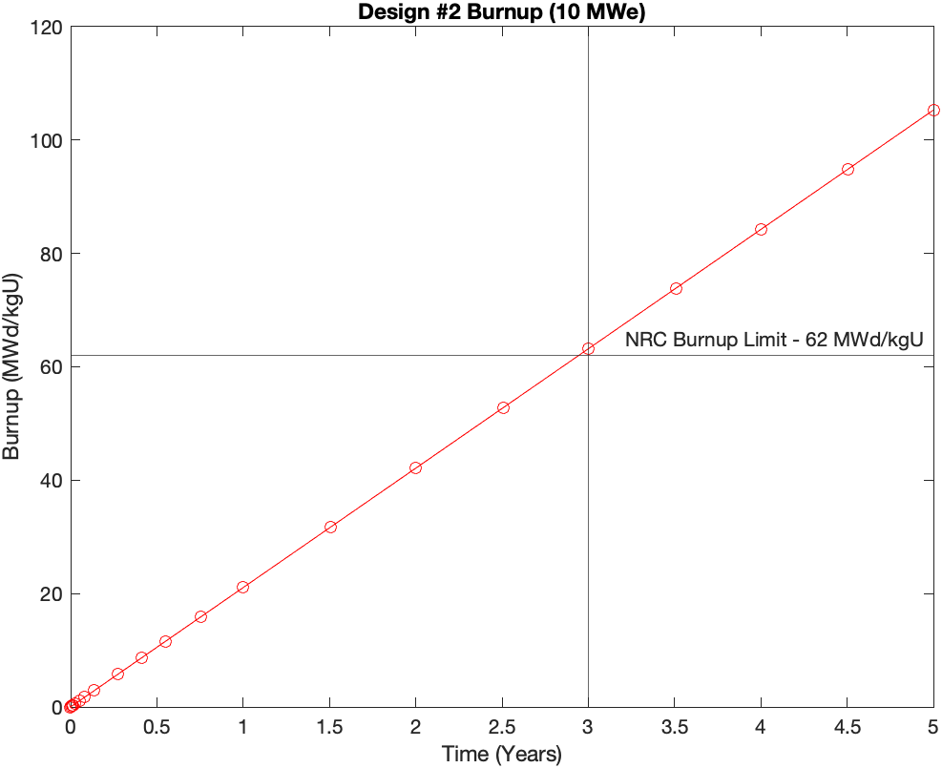
Figure 18. Design #2 Burnup at 10 MWe [31]

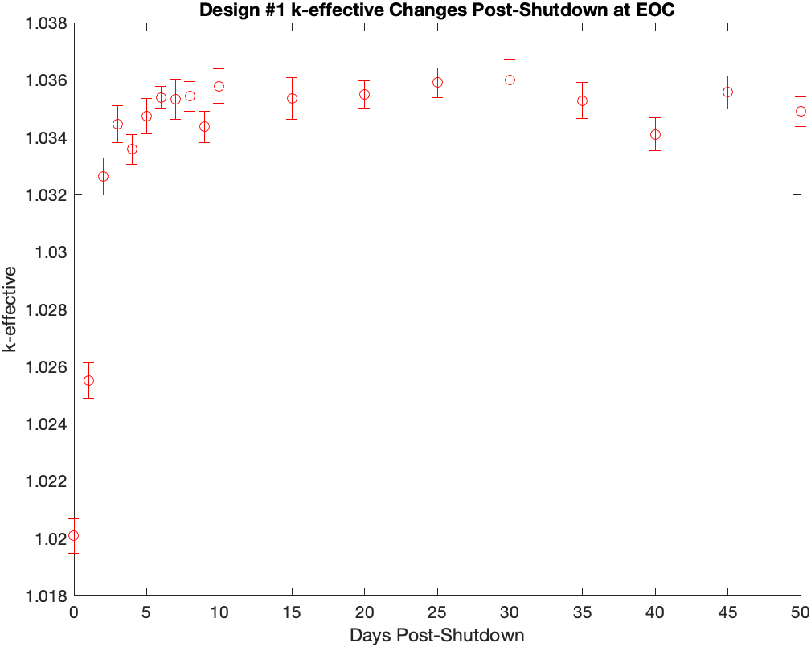
Figure 19. Design #1 k-effective Changes Post-Shutdown at EOC

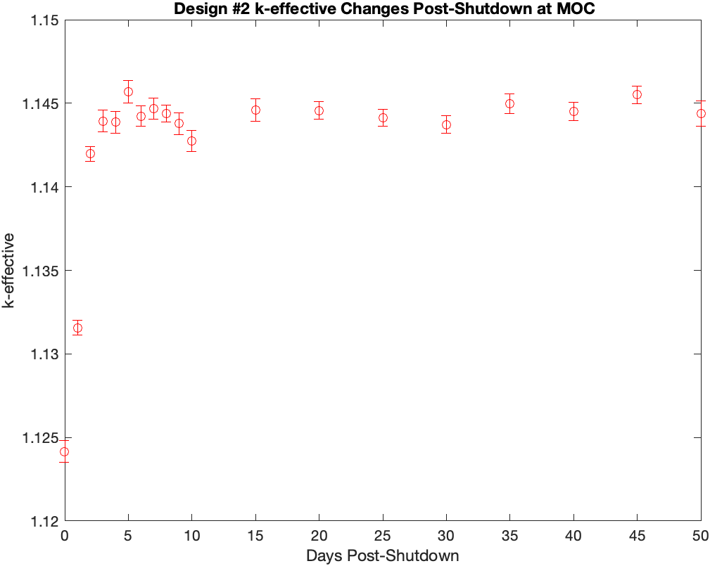
Figure 20. Design #2 k-effective Changes Post-Shutdown at MOC

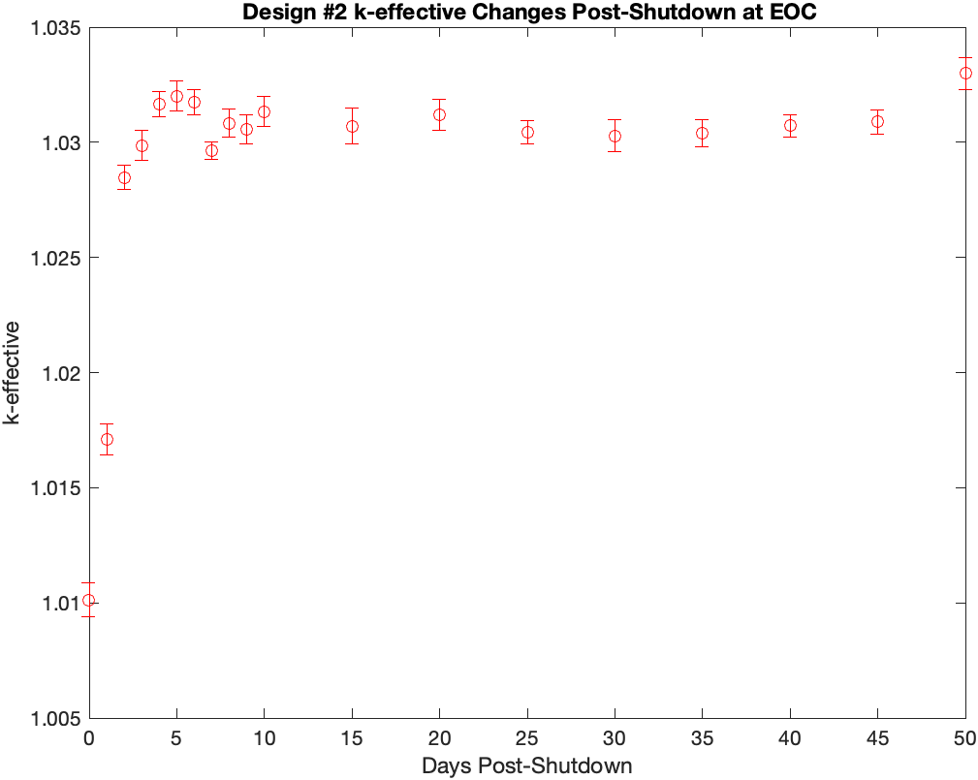
Figure 21. Design #2 k-effective Changes Post-Shutdown at EOC

However, k-effective at EOC plus five years was greater than 1% lower than the seven-day post-shutdown k-effective. Since this value is lower, using the seven-day k-effective is a more conservative assumption, so the seven-day analysis was still used.
To build these models in Serpent, the temperature of each material must be specified. Table 9 shows the specified temperatures for all models. Initially, all analysis was going to be conducted at a hot zero power state with all materials set to 600 K except water which would be set to an ambient temperature of 293.6 K because it would be coming into the system from the environment. As will be discussed later, Design #2 became the focal point of this work and the BOC temperatures were changed to use ambient temperatures for all materials because the reactor would not have been critical at this point and would have no decay heat to keep the reactor warm. The fuel kernel temperatures were adjusted to enable calculation of doppler coefficients as discussed. The bolded values were used for the reported values for k-effective and in transient analyses.

Core Rearrangement Models

Now that the baseline requirements for rearrangement are established, the two designs can be rearranged to determine if a rearrangement would lead a higher criticality state. Since this work is focused on the worst-case scenarios, the core should be rearranged into a sphere. This is because a spherical shape has the smallest surface area to volume rate which leads to the least amount of neutron leakage. Two approaches were taken to rearrange the core into spheres. The first was a
Table 9. Modeled Material Temperatures

Temperature (K) | BOC Design #1 | EOC Design #1 | BOC Design #2 | MOC/EOC Design #2
Fuel Kernel | 293.6/600/1200 | 293.6/600/1200 | 293.6/600/1200 | 293.6/600/1200
TRISO Components | 600 | 600 | 293.6 | 600
Compact and Moderator | 600 | 600 | 293.6 | 600
Water | 293.6 | 293.6 | 293.6 | 293.6
RPV | N/A | N/A | 293.6 | 600

heterogeneous arrangement of the materials. The best way to visualize this arrangement is to break the microassemblies at either end. Then take the broken pieces and rearrange them around the centerline of the core. This maintains the microassembly configuration as designed. Figures 22 through 25 show the axial and radial views for the heterogeneous rearrangement for both designs. The reflector and RPV regions were also rearranged into spherical shapes. The volumes were also maintained as seen in Appendix A to ensure a fair comparison with the controls.
The second method to rearrange into spheres was to create a homogenous mixture of the materials within the core. Most simply put, this model is intended to show a scenario in which the graphite material of the core is essentially pulverized in a large impact. The thought process of this scenario follows from the previous discussion concerning the material changes in graphite during irradiation. As the material is pulverized, it is assumed that all the helium coolant would escape from the core and that the TRISO particles would no longer be constricted to their original compact. To demonstrate this, TRISO particles were systematically placed in a grid pattern inside of a graphite sphere which is made up of the moderator and compact material. The original intent was to randomly place the TRISO particles in the sphere, but this led to memory issues with Serpent because there are over 100 million TRISO particles in the core. The reflector material is left separate from the other graphite in the core but is also rearranged into a sphere surrounding the fuel, compact, and moderator mixture. Again, the volume of the materials is conserved to the greatest possible extent in the model compared to the original control volumes. Figures 26 and 27 display the homogeneous rearrangements.

Figure 22. Design #1 Radial View of Heterogeneous Rearrangement

Purple – RPV, Orange – Reflector, Grey – Moderator and Compact, Red – He Moderator, Black – TRISO particles, Blue – Water

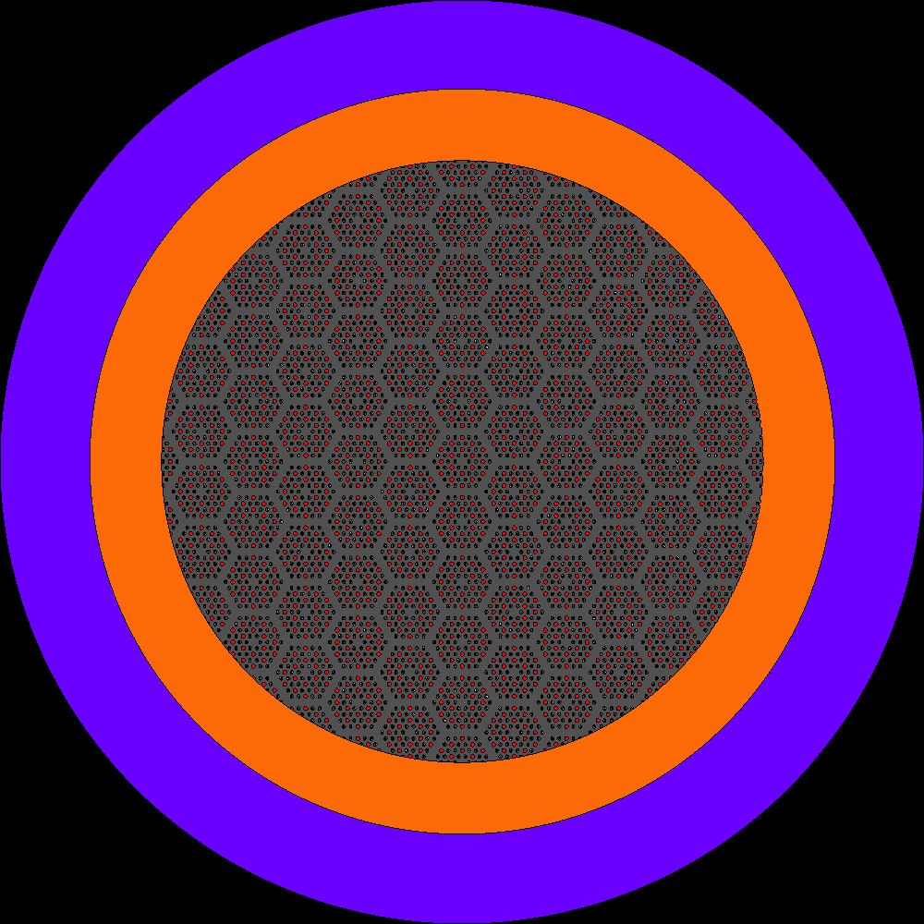
Figure 23. Design #2 Radial View of Heterogeneous Rearrangement

Purple – RPV, Orange – Reflector, Grey – Moderator and Compact, Red – He Moderator, Black – TRISO particles, Blue – Water


Figure 24. Design #1 Axial View of Heterogeneous Rearrangement

Purple – RPV, Orange – Reflector, Grey – Moderator and Compact, Red – He Moderator, Black – TRISO particles, Blue – Water

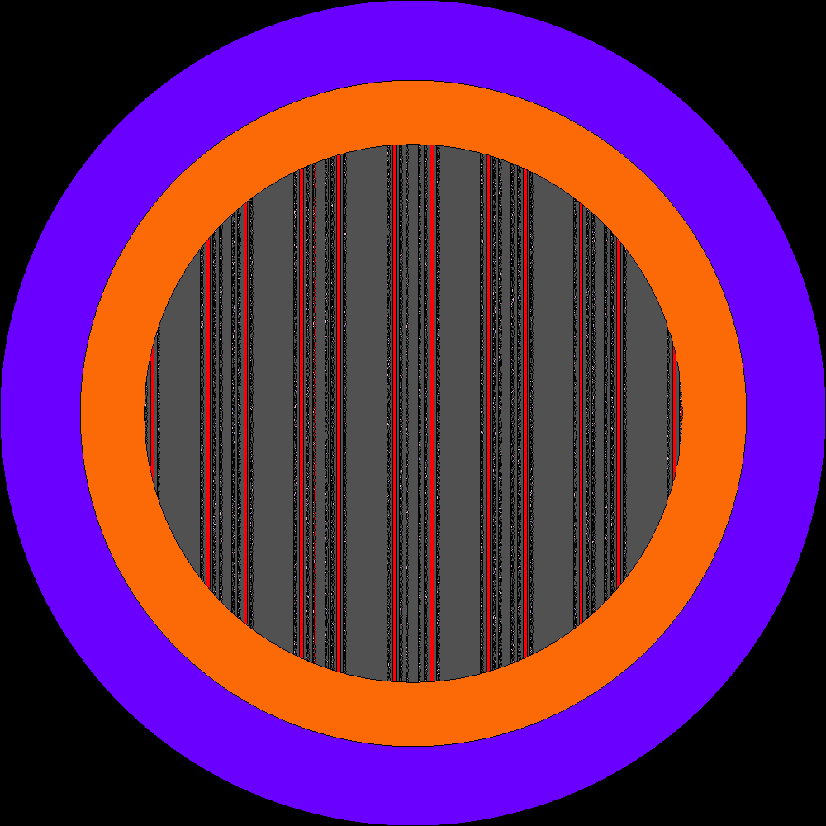
Figure 25. Design #2 Axial View of Heterogeneous Rearrangement

Purple – RPV, Orange – Reflector, Grey – Moderator and Compact, Red – He Moderator, Black – TRISO particles, Blue – Water


Figure 26. Design #1 Homogeneous Rearrangement

Purple – RPV, Orange – Reflector, Grey – Moderator and Compact, Red – He Moderator, Black – TRISO particles, Blue – Water


Figure 27. Design #2 Homogeneous Rearrangement

Purple – RPV, Orange – Reflector, Grey – Moderator and Compact, Red – He Moderator, Black – TRISO particles, Blue – Water

While these spherical rearrangements are the expected worst possible case in terms of criticality and were assumed to be the bounding case for this type of accident, it is important to consider the likelihood of this rearrangement. This would require the stainless-steel pressure vessel to be perfectly reshaped from a cylinder into a sphere, which seems implausible without a constant source of intense heat and pressure. Some deformation, and even cracking with an irradiated RPV, may occur, but not likely to this level. To consider a potentially more likely scenario, the core was then rearranged into a compacted cylinder as seen in Figures 28 and 29. As this model was added later in this analysis, it was only created for Design #2. The compacted cylinder model generally assumed that the moderator filled the coolant channels and that the fuel compacts with the TRISO particles expanded to fill the gap between the compacts and the moderator. Again, the volumes of all materials were conserved except the Helium coolant which was assumed to escape the system. This left a void at the top of the core as seen in Figure 29.
As previously discussed, there are accident scenarios which consider the possibility of the reactor to fall into water. Two general possibilities were assessed concerning an accident in water. In the first, it is assumed that the pressure boundary is lost which allows for in leakage of water. This accident is the submerged accident as described in 10 CFR 71. To simulate this accident, water replaces the helium in the core including in the gap between the fuel compact and moderator and in the coolant channels themselves while also surrounding the exterior of the core. In the second case, it is assumed that the pressure boundary is intact or that water cannot get into the core for some hypothetical reason. This scenario meets the intent of the immersed
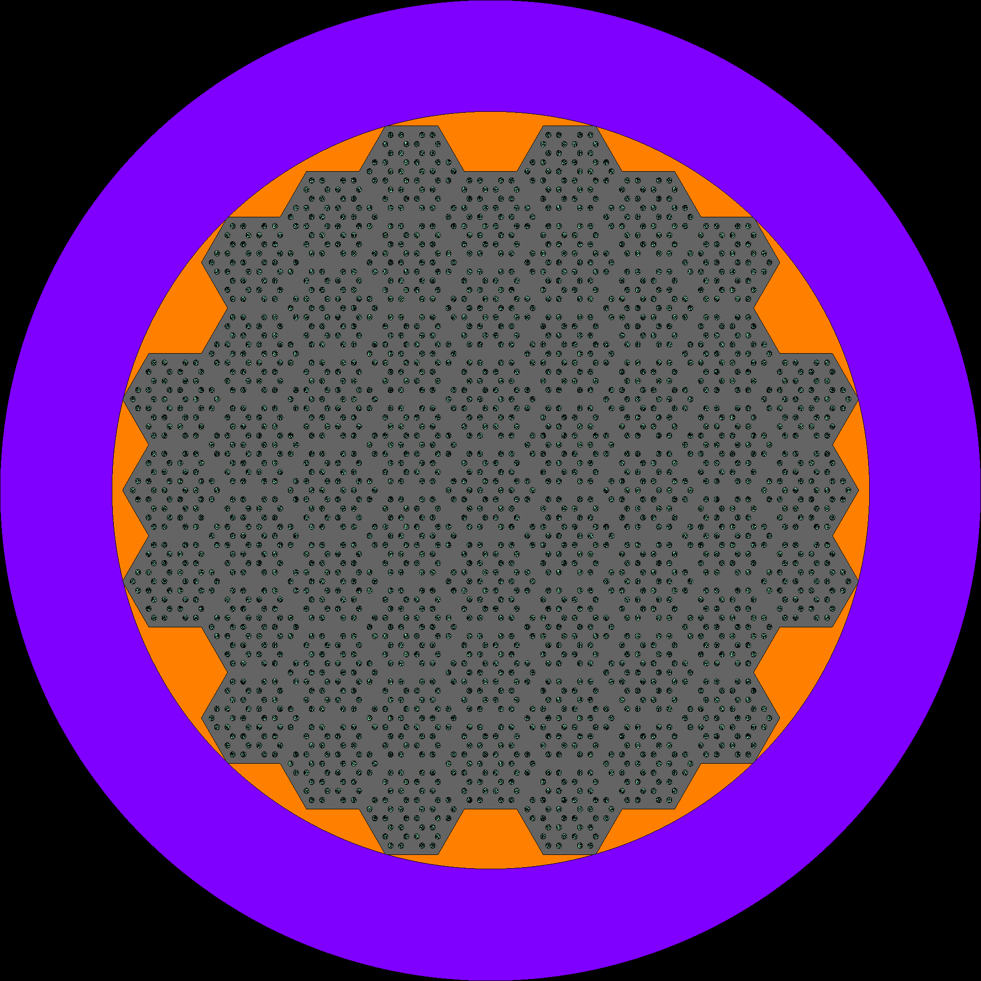
Figure 28. Compacted Cylinder Radial View

Purple – RPV, Orange – Reflector, Grey – Moderator and Compact, Red – He Moderator, Black – TRISO particles, Blue – Water


Figure 29. Compacted Cylinder Axial View - X-Z Axis

Purple – RPV, Orange – Reflector, Grey – Moderator and Compact, Red – He Moderator, Black – TRISO particles, Blue – Water

accident scenario in 10 CFR 71. Additionally, the difference between saltwater and fresh water was considered. In the saltwater cases, the water mixture is changed from 100% H2O to 96.5% H2O and 3.5% NaCl. [32] Figures 30 and 31 show representative models for submerged and immersed cases as described. The homogeneous sphere cases were not assessed for submerged cases because it was assumed that the Helium volume was replaced with solid material. For the compacted cylinder models in the submerged cases, the void above the core was filled with water, but no water leaked into the core materials themselves.
To simplify tracking of all of variations established to this point, each case was given an index as shown in Table 10. Cases which were not assessed are blacked out. The submerged, homogeneous sphere cases were not assessed as discussed. A majority of the saltwater cases were no assessed past the point of calculation of k-effective as will be discussed later.

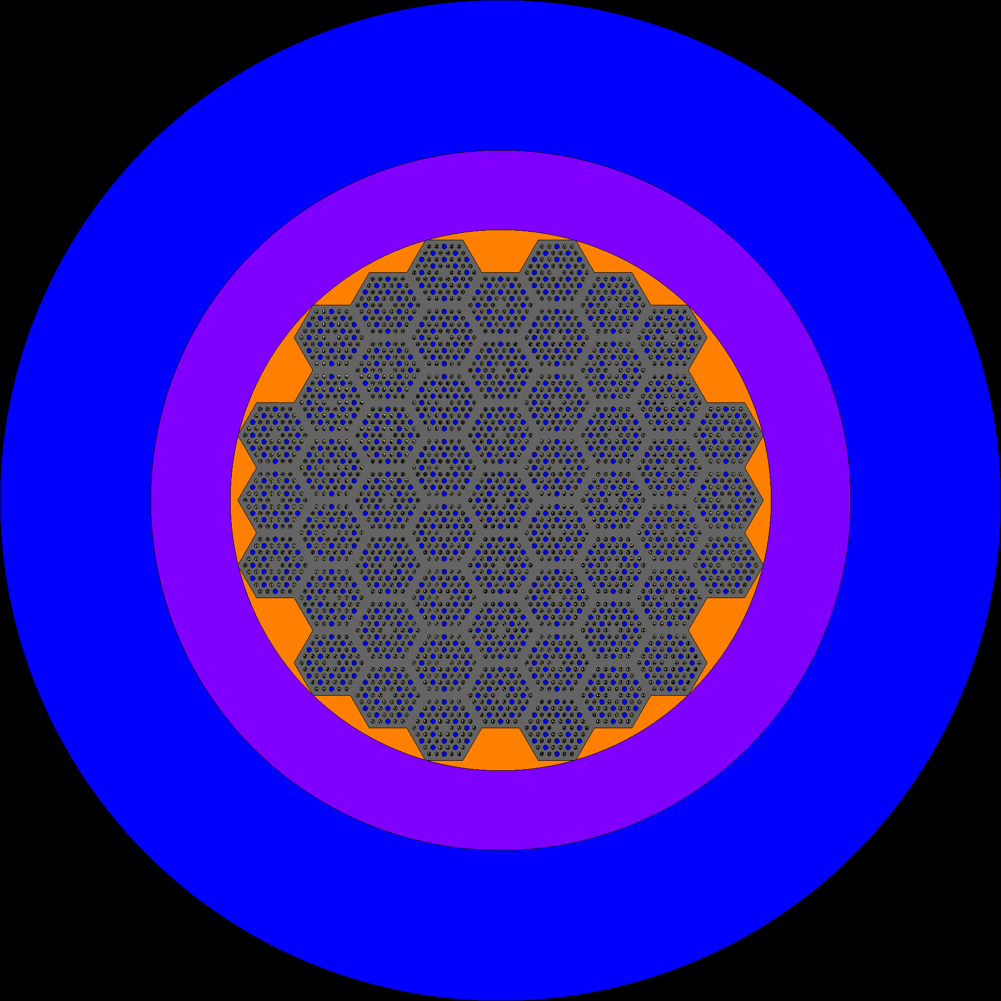
Figure 30. Representation of a Submerged Model

Purple – RPV, Orange – Reflector, Grey – Moderator and Compact, Red – He Moderator, Black – TRISO particles, Blue – Water


Figure 31. Representation of an Immersed Model

Purple – RPV, Orange – Reflector, Grey – Moderator and Compact, Red – He Moderator, Black – TRISO particles, Blue – Water

Table 10. Case Indices

Design #1 |  | On Land | Submerged Freshwater | Immersed Freshwater | Submerged Saltwater
BOC (293K) | Control | 1 | 2 | 3
BOC (293K) | Heterogeneous Sphere | 4 | 5 | 6
BOC (293K) | Homogeneous Sphere | 7 |  | 8
EOC (600K) | Control | 9 | 10 | 11
EOC (600K) | Heterogeneous Sphere | 12 | 13 | 14
EOC (600K) | Homogeneous Sphere | 15 |  | 16
Design #2 |  | On Land | Submerged | Immersed | Submerged Saltwater
BOC (293K) | Control | 17 | 18 | 19 | 50
BOC (293K) | Heterogeneous Sphere | 20 | 21 | 22 | 51
BOC (293K) | Compacted Cylinder | 23 | 24 | 25 | 52
BOC (293K) | Homogeneous Sphere | 26 |  | 27
MOC (600K) | Control | 28 | 29 | 30
MOC (600K) | Heterogeneous Sphere | 31 | 32 | 33
MOC (600K) | Compacted Cylinder | 34 | 35 | 36
MOC (600K) | Homogeneous Sphere | 37 |  | 38
EOC (600K) | Control | 39 | 40 | 41
EOC (600K) | Heterogeneous Sphere | 42 | 43 | 44
EOC (600K) | Compacted Cylinder | 45 | 46 | 47
EOC (600K) | Homogeneous Sphere | 48 |  | 49
53 – Immersed Saltwater Control at BOC for Design #2

CHAPTER FOUR

Results and Analysis

Criticality Comparison

Tables 11 and 12 show the k-effective values for the various models discussed. The first major takeaway from this analysis was the large difference between models of the same arrangement for each design. The Design #1 models are much, much lower than those of Design #2. For example, for the submerged control at beginning of cycle, the Design #2 k-effective is 1.51575 while the Design #1 k-effective is only 1.33057. This constant difference between the two designs quickly demonstrated that the more interesting design in terms of potential transient consequences would be Design #2. As such, Design #1 was generally not assessed past this point because the goal of this work to demonstrate the worst-case scenarios.
Another key takeaway goes back to the first question posed in this thesis which was whether a more critical configuration could exist. The answer to this question is a resounding yes. When comparing the control model k-effectives with any of the other hypothesized rearrangements, submersions, or immersions, it is clearly seen that the on land, control arrangement is the least critical configuration. Additionally, the k-effectives reduce through the fuel cycle because of depletion of the fuel. This reduces risks in accident scenarios since there is less fuel to take part in a transient.

Table 11. K-effective for Design #1 Cases

k-effective (Design #1) |  | On Land |  | Submerged Freshwater |  | Immersed Freshwater
 |  | k-eff | Error | k-eff | Error | k-eff | Error
BOC  (293K – Fuel Temperature Only) | Control | 1.21781 | 0.00018 | 1.33057 | 0.00018 | 1.23202 | 0.00020
BOC  (293K – Fuel Temperature Only) | Heterogeneous Sphere | 1.30931 | 0.00019 | 1.39945 | 0.00018 | 1.31324 | 0.00021
BOC  (293K – Fuel Temperature Only) | Homogeneous Sphere | 1.30084 | 0.00019 |  |  | 1.30468 | 0.00023
EOC  (600K) | Control | 1.07804 | 0.00019 | 1.17714 | 0.00019 | 1.09115 | 0.00020
EOC  (600K) | Heterogeneous Sphere | 1.15719 | 0.00017 | 1.25072 | 0.00018 | 1.16085 | 0.00018
EOC  (600K) | Homogeneous Sphere | 1.14460 | 0.00017 |  |  | 1.14724 | 0.00020
 |  | Submerged Saltwater (600K) |  |  | Immersed Saltwater (600)
 |  | k-eff | Error | % Diff. | k-eff | Error | % Diff.
BOC  (293K – Fuel Temperature Only) | Control | 1.22102 | 0.00017 | -7.04% | 1.21696 | 0.00021 | -0.26%
BOC  (293K – Fuel Temperature Only) | Heterogeneous Sphere | 1.2945 | 0.00016 | -6.98% | 1.29674 | 0.00017 | -0.07%
BOC  (293K – Fuel Temperature Only) | Homogeneous Sphere |  |  |  | 1.28318 | 0.00021 | -0.04%
EOC  (600K) | Control | 1.08348 | 0.00015 | -7.96% | 1.08785 | 0.0002 | -0.30%
EOC  (600K) | Heterogeneous Sphere | 1.15183 | 0.00015 | -7.91% | 1.15998 | 0.00019 | -0.07%
EOC  (600K) | Homogeneous Sphere |  |  |  | 1.14715 | 0.00021 | -0.01%

Table 12. K-effective for Design #2 Cases
k-effective (Design #2) |  | On Land |  | Submerged Freshwater |  | Immersed Freshwater
 |  | k-eff | Error | k-eff | Error | k-eff | Error
BOC  (293 K – All Materials) | Control | 1.42324 | 0.00018 | 1.51575 | 0.00018 | 1.42581 | 0.00019
BOC  (293 K – All Materials) | Heterogeneous Sphere | 1.50699 | 0.00016 | 1.56326 | 0.00014 | 1.50768 | 0.00018
BOC  (293 K – All Materials) | Compacted Cylinder | 1.45364 | 0.0002 | 1.45515 | 0.00023 | 1.45581 | 0.0002
BOC  (293 K – All Materials) | Homogeneous Sphere | 1.47187 | 0.00016 |  |  | 1.47193 | 0.00019
MOC  (600 K) | Control | 1.19808 | 0.00019 | 1.30841 | 0.00016 | 1.20054 | 0.0002
MOC  (600 K) | Heterogeneous Sphere | 1.27658 | 0.00016 | 1.35324 | 0.00013 | 1.27686 | 0.00018
MOC  (600 K) | Compacted Cylinder | 1.2418 | 0.00018 | 1.24338 | 0.00018 | 1.24388 | 0.00019
MOC  (600 K) | Homogeneous Sphere | 1.23603 | 0.00017 |  |  | 1.23638 | 0.00018
EOC  (600 K) | Control | 1.08373 | 0.00017 | 1.17396 | 0.00014 | 1.08613 | 0.00017
EOC  (600 K) | Heterogeneous Sphere | 1.15949 | 0.00015 | 1.21922 | 0.00014 | 1.1599 | 0.00016
EOC  (600 K) | Compacted Cylinder | 1.12576 | 0.00016 | 1.12734 | 0.00019 | 1.12798 | 0.00017
EOC  (600 K) | Homogeneous Sphere | 1.1201 | 0.00015 |  |  | 1.12029 | 0.00017
 |  | Submerged Saltwater |  |  | Immersed Saltwater
 |  | k-eff | Error | % Diff. | k-eff | Error | % Diff.
BOC  (293 K – All Materials) | Control | 1.41079 | 0.00016 | -7.44% | 1.42582 | 0.00020 | 0.00%
BOC  (293 K – All Materials) | Heterogeneous Sphere | 1.46512 | 0.00013 | -6.70% | 1.50757 | 0.00018 | -0.01%
BOC  (293 K – All Materials) | Compacted Cylinder | 1.45429 | 0.00023 | -0.06% | 1.45586 | 0.00019 | 0.00%
BOC  (293 K – All Materials) | Homogeneous Sphere |  |  |  | 1.47233 | 0.00019 | 0.03%
MOC  (600 K) | Control | 1.1986 | 0.00014 | -8.39% | 1.20076 | 0.00018 | 0.02%
MOC  (600 K) | Heterogeneous Sphere | 1.24999 | 0.00013 | -7.63% | 1.27734 | 0.00019 | 0.04%
MOC  (600 K) | Compacted Cylinder
MOC  (600 K) | Homogeneous Sphere |  |  |  | 1.23645 | 0.00016 | 0.01%
EOC  (600 K) | Control | 1.06036 | 0.00013 | -9.68% | 1.08613 | 0.00018 | 0.00%
EOC  (600 K) | Heterogeneous Sphere | 1.11118 | 0.00013 | -8.86% | 1.16003 | 0.00016 | 0.01%
EOC  (600 K) | Compacted Cylinder
EOC  (600 K) | Homogeneous Sphere |  |  |  | 1.11986 | 0.00017 | -0.04%

To understand the differences seen in Tables 11 and 12, one must examine some key data that is output from Serpent for each case. The first group of data to inspect are the inputs to the Six Factor Formula seen in Equation 11. The Six Factor Formula calculates a representative k-effective by multiplying together a series of factors which are described in Table 13. Table 14 captures the variables for a selected group of Serpent cases. Table 15 captures additional variables such as reaction rates for analysis of the various cases. The data in the top half of Tables 14 and 15 compares the variation between the different arrangement models while the bottom half show data from the various water conditions. The data in the two tables are mutually supportive of each other to describe the effects of a rearrangement on k-effective.

$$k_{eff}=η*ε*p*f*P_{FNL}*P_{TNL}$$
Equation 11. Six Factor Formula [33]

When comparing the potential scenarios, the heterogeneous sphere is the worst-case scenario at all points in the reactor lifetime. This model was generally in the thousands of pcm greater than the compacted cylinder, homogeneous sphere, or control models. As Table 14 shows, the two spherical models had the highest fast non-leakage probabilities. This can be attributed to the low surface area to volume ratio of the spherical shapes which give the spherical shapes a much higher k-effective.
The differences between the heterogeneous and homogeneous spheres can be explained by the resonance escape probability and the absorption rate. Because the heterogeneous model maintains the microassembly geometry, neutrons can travel
Table 13. Six Factor Formula Factors [33]

Thermal Fission Factor  ($η$) | Fast Fission Factor  ($ε$) | Resonance Escape Probability  ($p$) | Thermal Utilization Factor  ($f$) | Fast Non-Leakage Probability  ($P_{FNL}$) | Thermal Non-Leakage Probability  ($P_{TNL}$)
Average number of neutrons released from thermal neutron absorption in the fuel | Ratio of the total number of neutrons produced in fission to the number of neutrons produced in just thermal fission | Probability that a neutron escapes capture in the resonance region | Probability that a thermal neutron is absorbed in the fuel and not in another material | Probability that a fast neutron will not leak from the reactor | Probability that a thermal neutron will not leak from the reactor

Table 14. Six-Factor Formula Factors for Generalized Cases

Case # | Description | Thermal Fission Factor  ($η$) | Fast Fission Factor  ($ε$) | Resonance Escape Probability  ($p$) | Thermal Utilization Factor  ($f$) | Fast Non-Leakage Probability  ($P_{FNL}$) | Thermal Non-Leakage Probability  ($P_{TNL}$) | k-eff. Six Factor Formula
17 | Control | 1.165 | 0.894 | 0.743 | 2.032 | 0.916 | 0.988 | 1.42315
20 | Heterogeneous Sphere | 1.153 | 0.861 | 0.768 | 2.033 | 0.982 | 0.990 | 1.50710
23 | Compacted Cylinder | 1.166 | 0.904 | 0.742 | 2.032 | 0.925 | 0.989 | 1.45365
26 | Homogeneous Sphere | 1.160 | 0.867 | 0.737 | 2.033 | 0.985 | 0.992 | 1.47220
17 | On Land | 1.165 | 0.894 | 0.743 | 2.032 | 0.916 | 0.988 | 1.42315
18 | Submerged Freshwater | 1.065 | 0.785 | 0.890 | 2.039 | 1.000 | 1.000 | 1.51596
19 | Immersed Freshwater | 1.165 | 0.788 | 0.764 | 2.032 | 1.000 | 1.000 | 1.42606
50 | Saltwater Submerged | 1.071 | 0.730 | 0.885 | 2.038 | 1.000 | 1.000 | 1.41100
53 | Saltwater Immersed | 1.165 | 0.789 | 0.764 | 2.032 | 1.000 | 1.000 | 1.42557

Table 15. Serpent Output Data for Generalized Cases

Case # | General Description | Neutron Generation Rate  (n/(s-cm3)) | Total Loss Rate  (n/(s-cm3)) | Total Leak Rate  (n/(s-cm3)) | Absorption Rate  (n/(s-cm3)) | Neutron Generation Time  (s) | Thermalization Fraction
17 | Control | 1.50E+18 | 1.05E+18 | 1.00E+17 | 9.54E+17 | 1.77E-04 | 0.684
20 | Heterogeneous Sphere | 1.50E+18 | 9.95E+17 | 2.71E+16 | 9.68E+17 | 1.73E-04 | 0.757
23 | Compacted Cylinder | 1.50E+18 | 1.03E+18 | 8.78E+16 | 9.44E+17 | 1.53E-04 | 0.689
26 | Homogeneous Sphere | 1.50E+18 | 1.02E+18 | 2.32E+16 | 9.96E+17 | 1.55E-04 | 0.728
17 | On Land | 1.50E+18 | 1.05E+18 | 1.00E+17 | 9.54E+17 | 1.77E-04 | 0.684
18 | Submerged Freshwater | 1.50E+18 | 9.89E+17 | 8.43E+12 | 9.89E+17 | 1.47E-04 | 0.890
19 | Immersed Freshwater | 1.50E+18 | 1.05E+18 | 1.24E+13 | 1.05E+18 | 1.77E-04 | 0.764
50 | Saltwater Submerged | 1.50E+18 | 1.06E+18 | 9.99E+12 | 1.06E+18 | 1.49E-04 | 0.885
53 | Saltwater Immersed | 1.50E+18 | 1.05E+18 | 1.31E+13 | 1.05E+18 | 1.77E-04 | 0.764

through more moderator material prior to returning to a fuel compact and other TRISO fuel. In the homogeneous model, the TRISO particles are systematically placed next to each other, so neutrons are more likely to be absorbed in the resonance regions prior to thermalization because there is less moderator material to travel through prior to reaching the next TRISO particle. The shorter neutron generation time for the homogeneous sphere also shows that neutrons are interacting with TRISO particles quicker and therefore have less time to thermalized before a collision with the fuel.
There are few slight differences between the control and the compacted cylinder models which account for the higher k-effective for the compacted cylinder models. The most pronounced of these are the neutron generation time and the total leak rate shown in Table 15. The lower generation time and leak rate demonstrate that fast neutrons have a greater role in k-effective which is seen in the fast fission factor in Table 14 which increases over the control. Again, this can be explained with understanding that fuel compacts are closer together as was discussed in Chapter 3. The fuel compacts were expanded to fill the entire gap region between the fuel and the moderator, which puts TRISO particles in nearby compacts closer together.
The general trend for the water-based cases was that they all had greater k-effectives than the control, on land cases which had no water in the system except for the submerged salt-water models. A key takeaway for the water-based models is the 1.000 non-leakage rates in Table 14 and the much lower total leakage rates in Table 15 in all water-based cases. The addition of the water around the outer edge of the model ensured that neutrons were reflected into the core prior to leaking. For the submerged freshwater case, the much higher resonance escape probability and the much lower fast fission factor shown in Table 14 demonstrate that the increased moderation from the freshwater in leakage into the core significantly shifts the neutron spectrum as was described by King and El-Genk. [18] This is confirmed by the high thermalization fraction in Table 15 and allows for a much higher k-effective with more thermal neutrons in the core. The great difference in moderation between the submerged and immersed freshwater cases explains the difference in their k-effectives.
Another area to discuss is the differences between saltwater and freshwater cases. When the models were submerged, k-effective was generally about 7% lower in the saltwater cases than in the freshwater ones as seen in Tables 11 and 12. Many of the factors between the two models are very similar, however, the fast fission factors and total leakage demonstrate that the saltwater is a much less effective as a moderator, allowing for more neutrons to leak from the system and increasing the importance of the contribution of fast neutrons. An example of why the saltwater is a less effective moderator can be seen in the macroscopic capture cross sections. The saltwater macroscopic capture cross section for Case #50 is 2.09E+18 while the freshwater for Case #18 is 1.23E+18. Because saltwater cross section is nearly twice as high as the freshwater, there is much more absorption and a lower k-effective in the saltwater systems.
These explanations for the water-based models generally describe the effects that water has on the systems, but the main outlier is the submerged, compacted cylinder model. Recall from Figure 29 that the compacted cylinder models do not have space for in leakage inside the core materials themselves. Water in these submerged cases was limited to the void above the core materials. This essentially recreated the immersed models in that the water only acts as a reflector, not a moderator, so k-effective is essentially unchanged between the saltwater and freshwater cases.

Doppler Coefficients

As previously discussed, a doppler coefficient is needed to accurately calculate the maximum temperatures using the point kinetics equations with feedback. Table 16 displays the Design #2 doppler coefficients that were calculated using Equation 6, the temperatures in Table 9, and the $β_{eff}$ values in Table 17. As expected, all doppler coefficients remain negative. Maintaining a negative doppler coefficient in any configuration ensures that the chain reaction will eventually become subcritical, and a runaway reaction will not occur.
It is important to point out that the weakest doppler coefficients, i.e., those that are the highest and will have the least impact in turning a transient around, are those of the submerged cylinder and submerged, heterogeneous sphere cases throughout the core lifetime. For these submerged cases, recall that the neutron generation time for the submerged case was the fastest of all models seen in Table 15. This can be attributed to the combined moderating power of the water and graphite. The higher speed chain reaction leads to a decrease in effectiveness of the doppler effect because the next generation is born much quicker, prior to higher increase in temperature. This leads to more generations at lower temperatures, a steeper power pulse, and higher maximum power and temperature. By also noting that these cases are also those with the highest

Table 16. Doppler Coefficients for Design #2

Doppler Coefficients  ($/K) |  | On Land | Submerged | Immersed | Submerged Saltwater
BOC | Control | -0.00415 | -0.00150 | -0.00410 | -0.00169
BOC | Heterogeneous Sphere | -0.00379 | -0.00160 | -0.00385 | -0.00171
BOC | Compacted Cylinder | -0.00404 | -0.00401 | -0.00403 | -0.00397
BOC | Homogeneous Sphere | -0.00538 | 0.00000 | -0.00538
MOC | Control | -0.00563 | -0.00200 | -0.00319
MOC | Heterogeneous Sphere | -0.00519 | -0.00208 | -0.00518
MOC | Compacted Cylinder | -0.00527 | -0.00533 | -0.00531
MOC | Homogeneous Sphere | -0.00703 | 0.00000 | -0.00716
EOC | Control | -0.00664 | -0.00239 | -0.00391
EOC | Heterogeneous Sphere | -0.00620 | -0.00250 | -0.00616
EOC | Compacted Cylinder | -0.00648 | -0.00638 | -0.00635
EOC | Homogeneous Sphere | -0.00841 |  | -0.00830

Table 17. $β_{eff}$ for Design #2

$β_{eff}$ |  | On Land | Submerged | Immersed | Submerged Saltwater
BOC | Control | 6.77E-03 | 6.74E-03 | 6.77E-03 | 6.69E-03
BOC | Heterogeneous Sphere | 6.74E-03 | 6.64E-03 | 6.69E-03 | 6.63E-03
BOC | Compacted Cylinder | 6.75E-03 | 6.78E-03 | 6.74E-03 | 6.75E-03
BOC | Homogeneous Sphere | 6.69E-03 |  | 6.68E-03
MOC | Control | 6.16E-03 | 6.23E-03 | 6.16E-03
MOC | Heterogeneous Sphere | 6.09E-03 | 6.13E-03 | 6.06E-03
MOC | Compacted Cylinder | 6.23E-03 | 6.21E-03 | 6.24E-03
MOC | Homogeneous Sphere | 6.09E-03 |  | 6.02E-03
EOC | Control | 5.92E-03 | 6.01E-03 | 5.93E-03
EOC | Heterogeneous Sphere | 5.85E-03 | 5.95E-03 | 5.83E-03
EOC | Compacted Cylinder | 6.02E-03 | 6.05E-03 | 6.06E-03
EOC | Homogeneous Sphere | 5.85E-03 |  | 5.88E-03

k-effective values in Table 12, it can begin to be seen that these are to be the limiting cases for this study.

Peaking Factor

To determine the maximum temperatures in the reactor during a transient, a peaking factor must be calculated. It was calculated by using the detector function within Serpent to determine the number of fissions in a 51x51x51 mesh of the reactor. By assuming that all fission events release the same amount of energy, this data also represents the power profile of the reactor. By comparing the maximum number of fissions to the average number of fissions in these mesh grids, the peaking factor can be calculated using Equation 12. This detector grid is also used to determine the percentage of the TRISO fuel in the core is above the discussed threshold temperatures of 2073 K and 3100 K.

$$PF= \frac{p_{max}}{\overline{p}}$$
Equation 12. Peaking Factor

Figures 32 and 33 show the number of fissions in the mesh at the midplane of the reactor for Cases #18 and #21, respectively. The steeper slope moving towards the center of the reactor in Case #18 leads to a much higher peaking factor for Case #18 than that in Case #21. So, although k-effective for Case #21 is 4751 pcm higher and
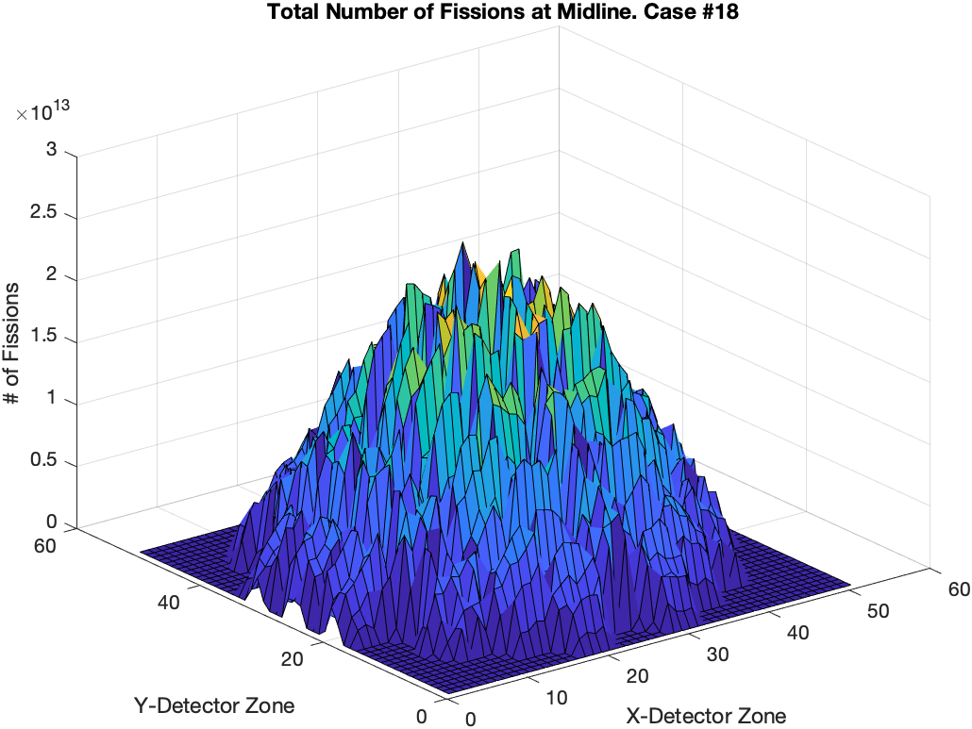
Figure 32. Total Number of Fissions at Midline – Case #18

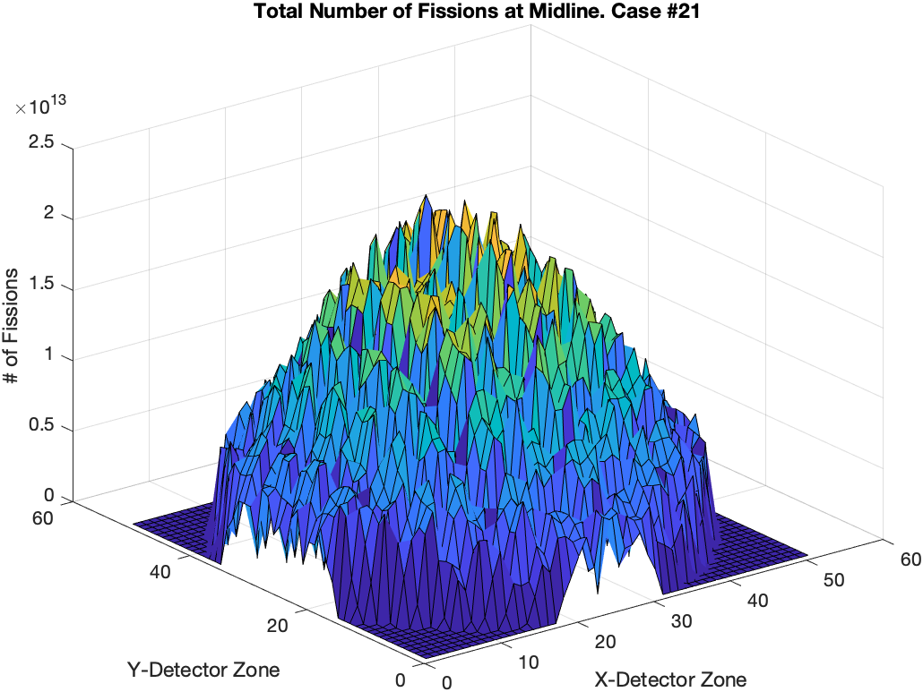
Figure 33. Total Number of Fissions at Midline – Case #21

their doppler coefficients are very similar, the maximum temperature in Case #18 is much higher. This steeper slope is due to the leakage of the cylindrical, control model where neutrons approaching the edges of the reactor are lost while those near the edge of the heterogeneous sphere are not. Recall the non-leakage probabilities and total leakage rate from Tables 14 and 15, respectively. These differences keep the power profile much flatter for the spherical arrangement.

Transient Analysis

With all required values calculated with Serpent or simple hand calculations, power pulse and temperature pulses could be created for all cases with the methods described in Chapter 2. The tabulated results are seen in Table 18. Table 18 only includes those cases in which the temperature is expected to exceed 2073 K in accordance with the failure limit from PNNL-33607 as discussed previously. [5] Cases above 3100 K were also included, but these were limited to Cases #18 and #50, with Case #21 only three K short of the threshold. These cases are limited to the BOC freshwater and saltwater, submerged control and the freshwater, heterogeneous sphere models. Cases #29 and #40 represent the worst-case temperatures for MOC and EOC with maximum temperatures of 3038 K and 2449 K respectively. Both cases are the freshwater, submerged, heterogeneous spheres. Power and temperature pulses for the worst-case scenarios are shown in Figures 34 and 35 and in Appendix B.
Now that the cases with potential TRISO failure are known, it is necessary to determine what percentage of the fuel is above the discussed failure limits so that an
Table 18. Cases with Expected TRISO Failure Due to Transient

Case | Maximum Temperature (K) | Mean Maximum Temperature (K) | Maximum Power (MW) | Peaking Factor
18 | 3.994E+03 | 1.246E+03 | 9.062E+03 | 3.874
21 | 3.097E+03 | 1.236E+03 | 9.792E+03 | 2.974
29 | 3.038E+03 | 1.212E+03 | 2.119E+03 | 3.982
32 | 2.526E+03 | 1.222E+03 | 2.478E+03 | 3.097
40 | 2.449E+03 | 1.085E+03 | 7.080E+02 | 3.809
50 | 3.164E+03 | 1.043E+03 | 5.309E+03 | 3.825
51 | 2.637E+03 | 1.080E+03 | 6.189E+03 | 2.979

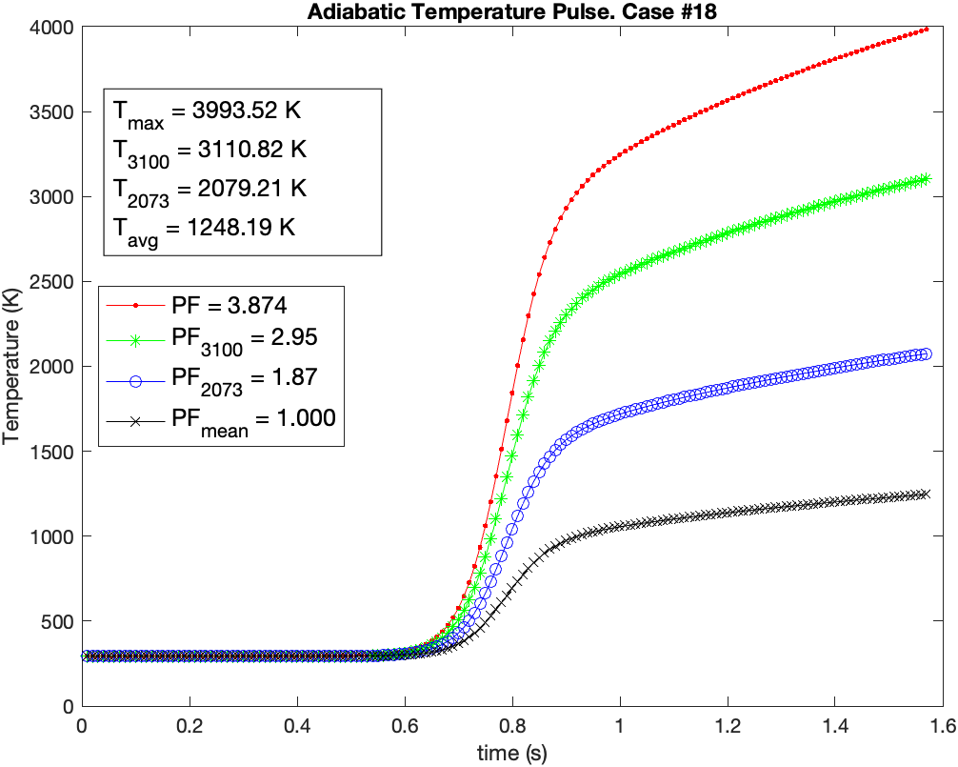
Figure 34. Adiabatic Temperature Pulse – Case #18

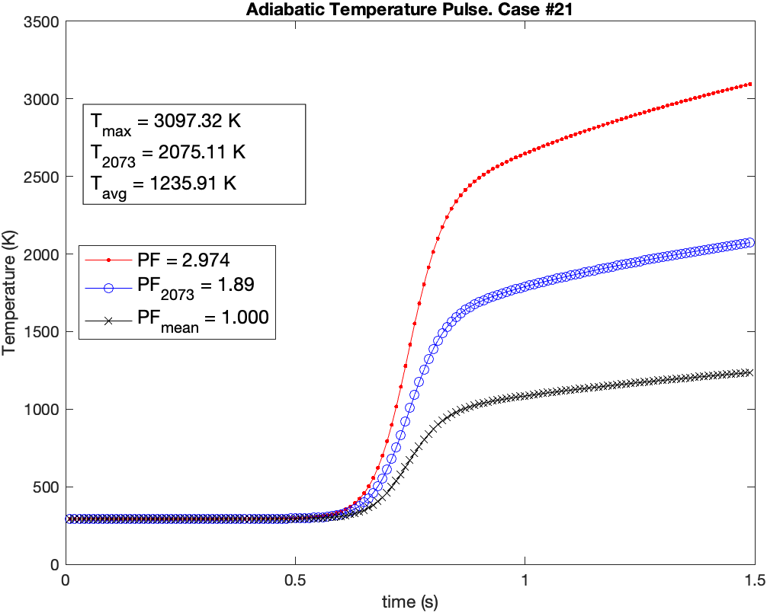
Figure 35. Adiabatic Temperature Pulse – Case #21

applicable source term can be calculated. This was accomplished using the same detector files which were used to find the peaking factor for each case. Instead of finding the peaking factor that would achieve the highest temperature, a peaking factor was found for each case that would achieve that discussed limitations of 2073 K and 3100 K. These are designated as PF₂₀₇₃ and PF₃₁₀₀. These temperature peaking factors were then used to calculate the number of the mesh volumes with a fission count higher than the temperature peaking factor multiplied by the average number of fissions. An example of how these temperature distributions would look in comparison to core average and the core maximum are shown in Figures 34 and 35. In these figures, T₂₀₇₃ and T₃₁₀₀ show that their temperature limits are surpassed in the last timestep of the transient. They are slightly above the temperature limits because the Matlab script that solved for the temperature peaking factors increased by 0.005 for each trial factor which allowed for some temperature gap between the steps.
Table 19 outlines the temperature peaking factors and the failure percentages for all cases were TRISO can be expected to fail. As discussed, the temperature peaking factors were then used to determine the percentage of the core which exceeded the temperature threshold which is used as TF in Table 7 to determine the material at risk. Note 1 in Table 19 reduces the potential failure percentage using the data from Figure 6 which demonstrate the directly proportional relationship between temperature and failure probability based on Ghezzi et al. [21] For Case #50, the maximum temperature just barely exceeded the 3100 K limitation, so very little TRISO failure is expected. As expected, the 2073 K failure percentages are much higher because there is no failure probability versus temperature data to apply for temperatures above 2073 K, so 100%
Table 19. Temperature Peaking Factors and TRISO Failure Percentages

Case | Temperature Peaking Factor  (PF₂₀₇₃) | Failure % (2073 K) (TF) | Temperature Peaking Factor  (PF₃₁₀₀) | Failure % (3100 K) (TF)
18 | 1.870 | 12.89% | 2.950 | 1.63% (0.419%)¹
21 | 1.890 | 7.62% | 0 | 0.00%
29 | 2.410 | 5.33% | 0 | 0.00%
32 | 2.370 | 1.10% | 0 | 0.00%
40 | 3.035 | 1.33% | 0 | 0.00%
50 | 2.395 | 5.33% | 3.775 | 0.00%
51 | 2.265 | 1.67% | 0 | 0.00%
1 – TRISO failure percentage after applying probabilities in Figure 6

failure is assumed. The failure percentages decrease as the reactor progresses through its lifetime in a similar manner to the decrease in k-effective as seen in Figures 16 and 17 and Tables 11 and 12.
Another visualization of the calculation of the temperature peaking factors can be seen in Figures 36 and 37. Figure 36 shows the percentage of the fuel above a given temperature for Cases #18 and #21. The locations where each case intersects the 2073 K and 3100 K thresholds match the data provided in Table 19. Depicting the data in this manner allows one to see how much of the fuel is potentially at risk at any given temperature. This would be useful if a new failure mechanism for TRISO was discovered with a failure temperature of 2500 K. A rough estimation could be established to determine the TRISO failure percentage. On the left-hand side of Figure 37 the median and mean temperatures for Case #18 are shown. It may be expected that when the temperature reaches the mean value, that exactly 50% of the fuel would be above that temperature. However, when looking at Figure 37, the median temperature and median number of fission events is skewed to the left in the distribution of fission events per detector grid. This skew to the left means that for a given temperatures below the mean temperature but above the median, less than 50% of the core experiences the given temperature. Figure 36 also shows the cutoff points for 2073 K and 3100 K where 12.89% and 1.63%, respectfully, of the fuel lies to the right of these lines.

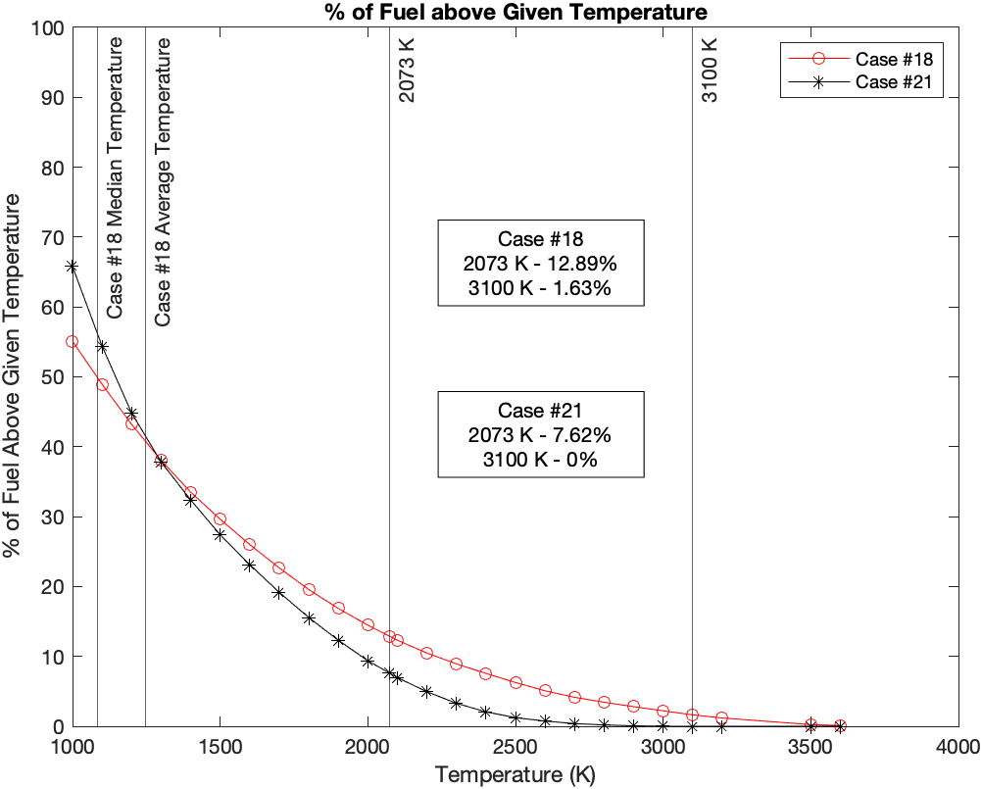
Figure 36. Percent of Fuel Above a Given Temperature – Cases #18 and #21

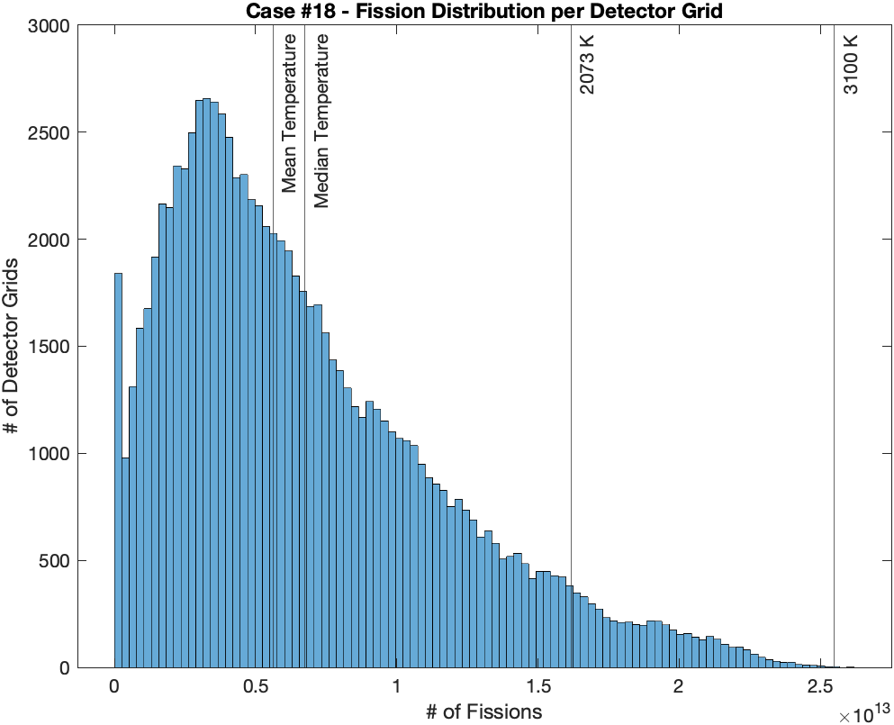
Figure 37. Distribution of Fissions per 51x51x51 Mesh Grid

CHAPTER FIVE

Radiological Release Modeling

Source Term Determination

The first step to determining the effects of a radiation release in these accident scenarios is to determine the source term. It is important to note that the source term at risk for Design #1 is expected to be much lower than that for Design #2 because the initial fuel mass is only about 10% of the fuel mass for Design #2. Figure 38 shows the total activity per day post-shutdown for Design #2 at both MOC and EOC as a percentage of the activity at reactor shutdown. This figure shows that the longer the reactor cools, the smaller the potential source term becomes. At 7 days, about 12% of the initial activity remains, while 50 days post-shutdown roughly 6% remains. To have a comparison point to PNNL-13667, the core was also decayed out to 5 years of cooldown and at this point, less than half of a percent of the initial activity remained. Table 20 lists the total activities at these points in time. Because the reactor has not operated yet at BOC, there is no fission product activity to account for, so the activity is limited to just the fuel material as listed in Table C.1.
As discussed, Hotspot can only use isotope mixes with a maximum of 50 isotopes. As discussed, the activities of the top 50 isotopes at each point in time are used to create the source term. [5] Full lists of the isotopes and their initial activities at each point in time are in Appendix C. Data is provided for post-shutdown days 7, 50,
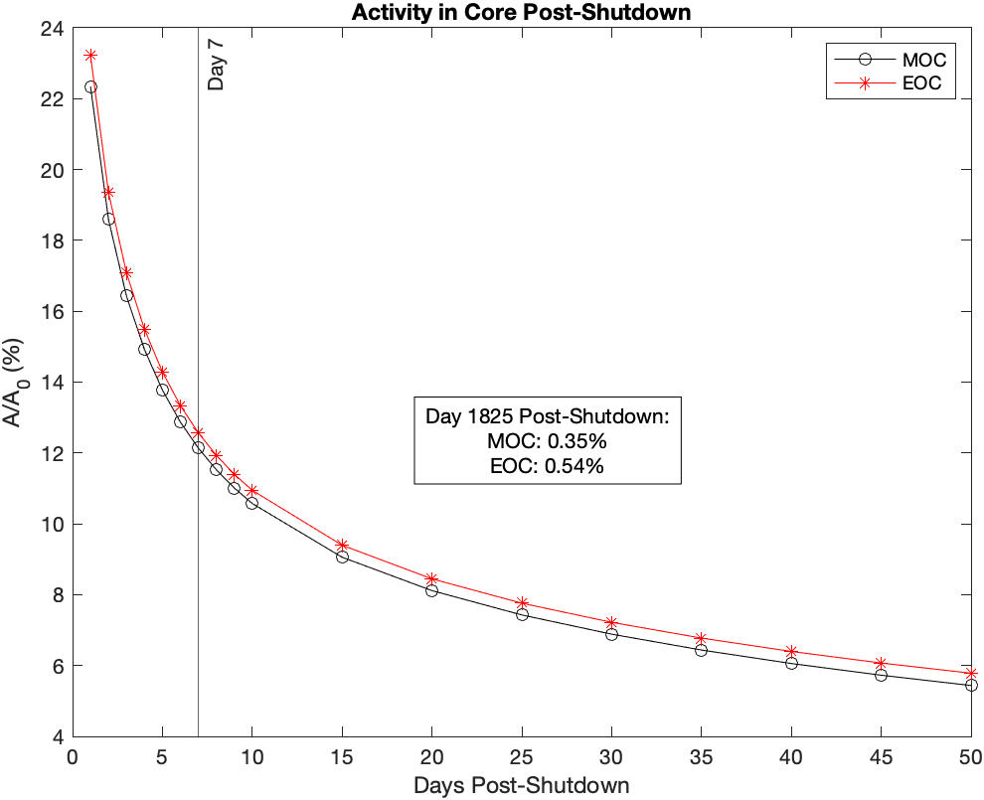
Figure 38. Activity in Core Post-Shutdown

Table 20. Total Core Activity for Selected Timesteps

Days Post-Shutdown | MOC (3 years) | EOC (5 years)
0 | 1.03E+08 (Day 1095) | 1.04E+08 (Day 1825)
7 | 1.25E+07 (Day 1102) | 1.31E+07 (Day 1832)
50 | 5.60E+06 (Day 1145) | 6.02E+06 (Day 1875)
1825 (5 years) | 3.55E+05 (Day 2920) | 5.61E+05 (Day 3650)

and 1825 (five years) for MOC and EOC. The sum of the activities of all modeled isotopes was compared to the total activity at all 6 points in time. The highest 50 isotopes accounted for greater than 99.5% of the total activity for each timestep. This shows that this method of isotope selection adequately accounts for the total. Between the 6 timesteps, there were 89 different isotopes that held a position in the highest 50 activity isotopes.
The final step to calculate the MAR is to input the activity for each isotope at each timestep and temperature threshold using the equations Table 7. The TRISO failure percentage was the highest percentage for BOC, MOC, and EOC which were Cases #18, #29, and #40. Again, the MAR is calculated for each isotope for release from the pressure boundary, release from the core materials, impact failure, and transient failure. Equation 1 is then used, with inputs from Table 2, is used to determine the released activity for each isotope. Finally, the activities for each isotope were added to HotSpot inputs and were recorded in Appendix C. To simplify the visualization of these releases, each timestep and temperature limitation are assigned a case index in Table 21. The final, total source term activities for each case are listed in Table 22.

HotSpot Plume Modeling

As discussed, HotSpot was utilized to create visual representations of the potential releases of radioactive material in these accidents. A key limitation to address is that HotSpot calculates atmospheric plume models while the worst-case scenarios are submerged accidents. However, this does not preclude the use of HotSpot for these
Table 21. Hotspot Case Indices

Day | Day 0 |  | Day 1102 |  | Day 1145 |  | Day 2920 |  | Day 1832 |  | Day 1875 |  | Day 3650
TRISO Failure Temperature (K) | 2073 | 3100 | 2073 | 3100 | 2073 | 3100 | 2073 | 3100 | 2073 | 3100 | 2073 | 3100 | 2073 | 3100
Case #18 | A | B
Case #29 |  |  | C | D | E | F | G | H
Case #40 |  |  |  |  |  |  |  |  | I | J | K | L | M | N

Table 22. Source Terms for HotSpot Cases

Case | Potential Source Term  (Ci) | Released Source Term  (Ci) | % of Potential
A | 2.41E-01 | 5.02E-07 | 0.00021%
B | 2.41E-01 | 5.13E-08 | 0.00002%
C | 1.25E+07 | 3.05E+01 | 0.00024%
D | 1.25E+07 | 5.48E+00 | 0.00004%
E | 5.60E+06 | 5.95E+00 | 0.00011%
F | 5.60E+06 | 1.20E+00 | 0.00002%
G | 3.55E+05 | 5.21E-01 | 0.00015%
H | 3.55E+05 | 1.38E-01 | 0.00004%
I | 1.31E+07 | 1.19E+01 | 0.00009%
J | 1.31E+07 | 5.58E+00 | 0.00004%
K | 6.03E+06 | 2.60E+00 | 0.00004%
L | 6.03E+06 | 1.32E+00 | 0.00002%
M | 5.61E+05 | 3.68E-01 | 0.00007%
N | 5.61E+05 | 2.19E-01 | 0.00004%

accident scenarios. It is still worth examining the HotSpot results due to two assumptions. First, there are multiple scenarios which take place on land or in shallow water, where plume models are more representative of the scenario. Second, in a vast majority of these cases, fuel failure is not the primary method of radioactive material release. Most of the release will come from the leakage from the TRISO into the matrix or pressure boundary or TRISO failure due to the impact. So, analyses of the 3100 K releases are representative of the accident scenarios that are not submerged because the transient TRISO failure fraction is set to 0.
The maximum TEDE in REM for each HotSpot Case is listed in Table 23. When considering this table, it does show that the maximum expected TEDE does exceed the industry standards of 25 REM in several instances at both MOC and EOC. These releases were limited to those cases which used the 2073 K threshold for TRISO failure, but significant releases were still achieved when the 3100 K threshold was considered. All maximum TEDE values are at 18 meters downwind with the previously discussed HotSpot inputs.
Cases #18 and #50 are the only cases where notable fuel failure is expected above 3100 K. There is so little release in these cases that the maximum expected TEDE for Cases A and B were essentially zero, respectively. At BOC there are no fission products to account for in any of the four potential MAR calculations, so there’s only U-235 and U-238. So, while the BOC maximum temperatures and failure percentages may be at their greatest, because there is very little source term, there is very little radiological threat from radiation release. However, there would still be a criticality threat to contend with.
Table 23. Maximum Expected TEDEs for HotSpot Cases

Case | Maximum TEDE  (REM) at 0.018 km downwind | TRISO Failure¹ (%)
A | 4.02E-05 | 13.89
B | 4.11E-06 | 1.42
C | 31 | 6.33
D | 5.3 | 1.00
E | 32 | 6.33
F | 5.3 | 1.00
G | 24 | 6.33
H | 4.1 | 1.00
I | 22 | 2.33
J | 10 | 1.00
K | 30 | 2.33
L | 13 | 1.00
M | 24 | 2.33
N | 11 | 1.00
1 – Includes 1% TRISO failure due to impact and failure due to the transient

The HotSpot models for Cases #29 and #40 are shown in Figures 39 through 42. One observation of these figures is that there is very little difference in Total Effective Dose Equivalence (TEDE) when the reactor has cooled for 7 days, 50 days, or 5 years. This is an interesting result in that there isn’t a large difference in dose whether the reactor has cooled or not, even though the percentage of post-shutdown activity shown in Figure 38 would suggest a much lower dose equivalent as post-shutdown time progresses. It also disagrees with the work done in PNNL-33607, which showed a TEDE decrease of an order of magnitude with one year of cooling versus five years. To explain the relatively small change in TEDE with respect to cooling time, Table 24 shows the source terms for the isotopes that are present in the reactor at the 7-day, 50-day, and 5-year timesteps in the EOC case and 2073 K TRISO failure limitation. There are a handful of isotopes which have greater than 70% of their initial source term after five years of cooling. These include Ba-137m, Cs-137, Kr-85, Pu-241, Sr-90, and Y-90. These isotopes have half-lives in the tens of years or are daughter products of the other longer-lived isotopes. [34] All but the Ba-137m isotopes decay by ß- and all six isotopes release gamma-rays. [34] Since the HotSpot models run here are dominated by inhalation, it can be assumed that these six isotopes dominate the TEDE in the HotSpot models and this is why there is a limited decrease in the TEDE from seven days to five years.
The MOC and EOC maximum TEDEs can be analyzed in a similar manner because the maximum doses and downwind distances are within a few hundred meters of each other. For EOC, consider that the 2073 K threshold uses a TRISO failure fraction of 2.33% and the 3100 K threshold uses 1% failure as shown in Table 20. The
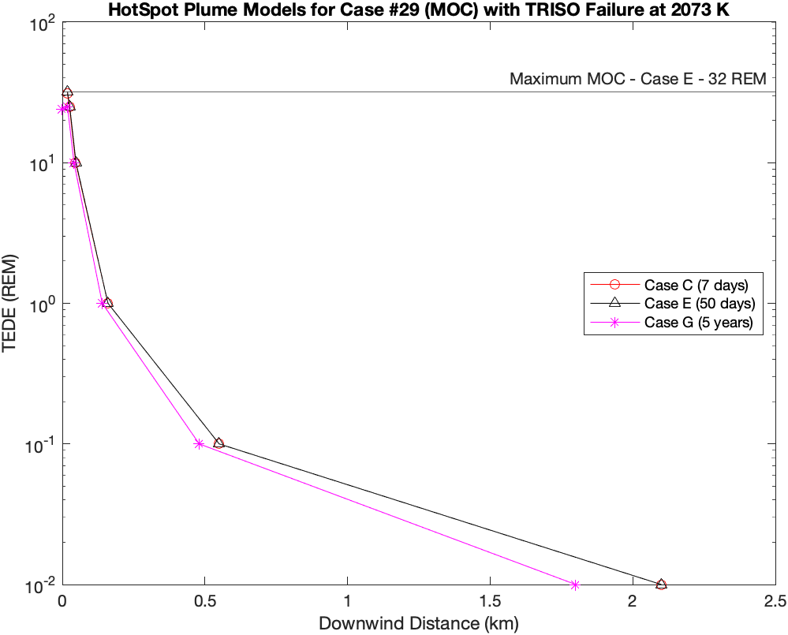
Figure 39. HotSpot Comparison at MOC with TRISO Failure at 2073 K
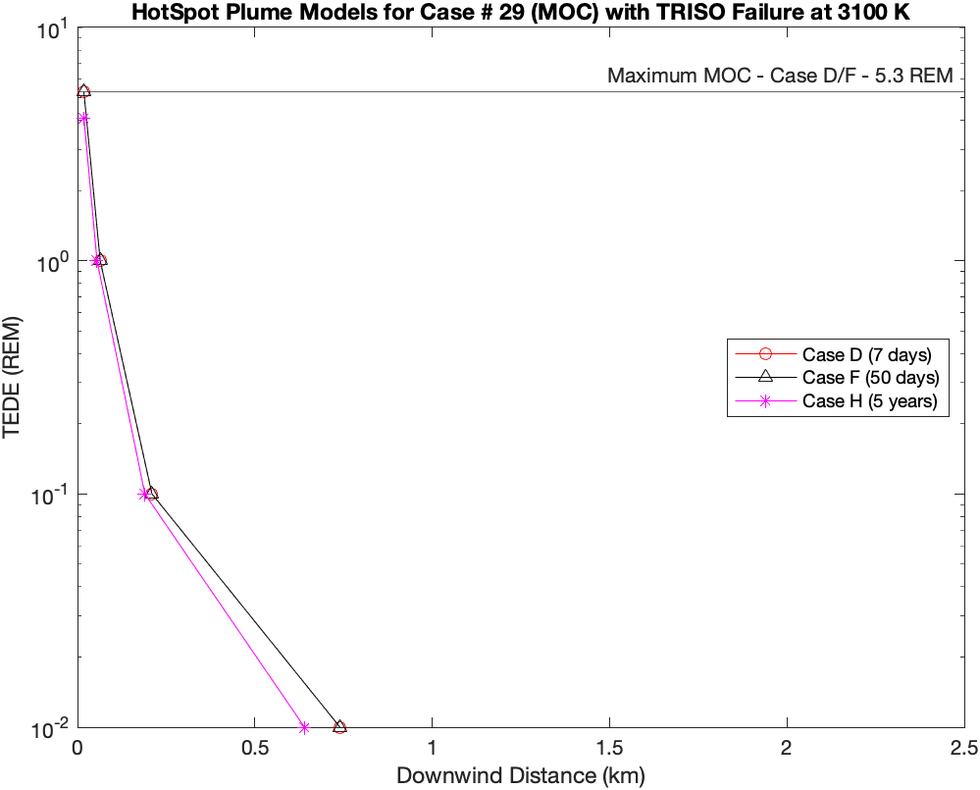
Figure 40. HotSpot Comparison at MOC with TRISO Failure at 3100 K

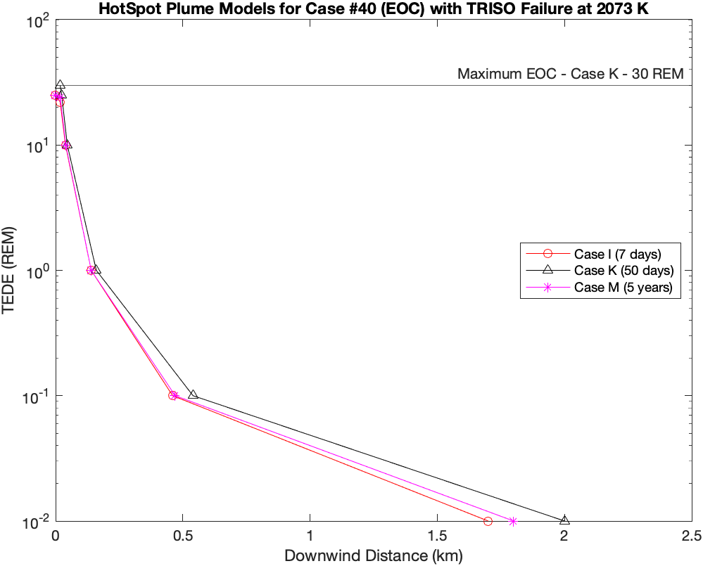
Figure 41. HotSpot Comparison at EOC with TRISO Failure at 2073 K
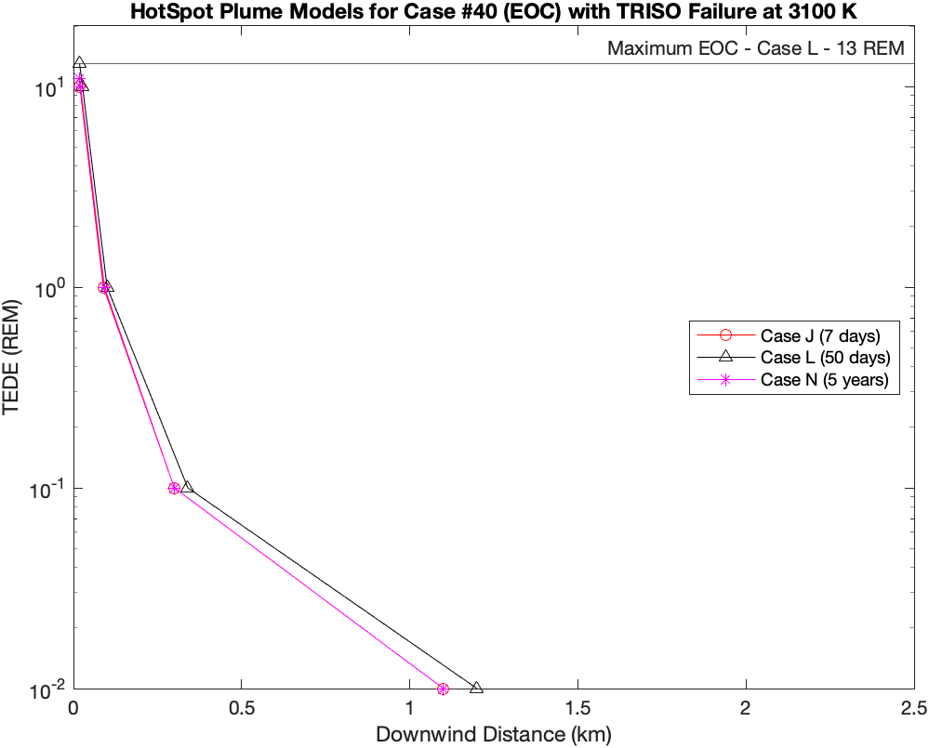
Figure 42. HotSpot Comparison at EOC with TRISO Failure at 3100 K

Table 24. Isotopes in all EOC, 2073 K TRISO Failure Limit Source Terms [34]

Isotope | Half Life¹ | Day 1832  (Case I) | Day 1875  (Case K) | % Remaining | Day 3650  (Case M) | % Remaining
Ba137m | 2.552 m | 9.19E-02 | 9.16E-02 | 99.73% | 8.19E-02 | 89.16%
Ce144 | 284.9 d | 2.88E-01 | 2.59E-01 | 90.07% | 3.46E-03 | 1.20%
Cm242 | 162.8 d | 1.40E-02 | 1.17E-02 | 83.29% | 8.32E-06 | 0.06%
Cs134 | 2.065 y | 4.27E-02 | 4.11E-02 | 96.13% | 8.04E-03 | 18.81%
Cs137 | 30.08 y | 5.02E-02 | 5.01E-02 | 99.73% | 4.48E-02 | 89.16%
Kr85 | 10.74 y | 9.41E-02 | 9.34E-02 | 99.24% | 6.83E-02 | 72.56%
Pm147 | 2.623 y | 6.70E-02 | 6.58E-02 | 98.18% | 1.82E-02 | 27.21%
Pr144 | 17.28 m | 2.88E-01 | 2.59E-01 | 90.07% | 3.46E-03 | 1.20%
Pr144m | 7.2 m | 2.75E-03 | 2.48E-03 | 90.07% | 3.30E-05 | 1.20%
Pu241 | 14.33 y | 3.27E-02 | 3.25E-02 | 99.43% | 2.57E-02 | 78.55%
Rh106 | 30.07 s | 7.67E-02 | 7.08E-02 | 92.30% | 2.59E-03 | 3.37%
Ru106 | 371.8 d | 7.67E-02 | 7.08E-02 | 92.30% | 2.59E-03 | 3.37%
Sb125 | 2.759 y | 2.38E-03 | 2.32E-03 | 97.41% | 6.84E-04 | 28.73%
Sr90 | 28.91 y | 8.33E-02 | 8.31E-02 | 99.72% | 7.39E-02 | 88.71%
U237 | 6.752 d | 6.84E-02 | 8.28E-04 | 1.21% | 6.30E-07 | 0.00%
Y90 | 64.05 h | 3.42E-02 | 3.40E-02 | 99.50% | 3.03E-02 | 88.51%
1 – [34]

3100 K value of 1% only comes from failures due to impact alone and achieves maximum doses up to 13 REM which is over half of the industry standard of 25 REM. Just the addition of 1.33% TRISO failure brings the maximum value to 30 REM. This very small increase is only a fraction of the potential source term as case K only uses 0.00004% of the total activity of the core as shown in Table 23. Many conservative assumptions are used in this assessment, but this small percentage of the activity leads to breaking dose limitations in these models. If releases occurred that are greater than the calculated values, the dose will be significantly greater than the industry standard 25 REM does equivalent. PNNL-33607 discussed this same observation in that, when they changed one assumption, the TEDE significantly went up. This outlines the requirements for licensee to ensure that they fully understand the effect of transportation accidents on TRISO particles.
Recall that, for the MOC and EOC HotSpot releases using the 3100 K TRISO failure threshold shown in Figures 40 and 42, there is no TRISO failure due to the transient. Therefore, the source term for the transient release mechanism is zero. This leaves the other three release mechanisms of release from the pressure boundary, release from the core materials, and release from TRISO failure due to the impact. Also recall that the only models that did reach either of the TRISO failure thresholds were those that were submerged in either freshwater or saltwater. Because the accidents that occur without water experience no TRISO failure due to the transient, Figures 40 and 42 are representative of accidents that occur on the ground.
Based on the 10 CFR 100 limitation of 25 REM with a two-hour exposure, Figures 40 and 42 suggest that an EPZ may not be required because the maximum equivalent dose is 13 REM. However, these figures show only one atmospheric state. Figure 43 depicts the same source term as case L with varying wind speeds. All other HotSpot inputs were kept consistent with previous releases. This shows that when the wind dies down, the same source term could have a maximum TEDE greater than 100 REM. Figures 44 and 45 compare the HotSpot output plots for 0.1 and 1.0 m/s winds, respectively. These show that peak dose for each condition occurs within several meters of each other, but the magnitude of that dose increases by an order of magnitude. Additionally, the downwind distance in Figure 44 suggests that an EPZ in the tens of meters may be acceptable for this accident type as the worst-case scenario release for a ground impact scenario.
Another simple way to examine possible variances in a release is by changing the atmospheric condition. Figure 46 again takes the Case L source term and changes the atmospheric condition while keeping all other HotSpot variables the same. Atmospheric stability from A to G become increasingly stable to simulate releases at various points in the day or at various weather conditions. As the stability classes become more stable, the maximum dose goes up until there a neutral condition and ends up much lower for the extremely stable conditions. The downwind distance of the maximum dose increases with stability. Full understanding of stability classes is not required in the context here. Figures 42, 43, and 46 are simply used to demonstrate that full understanding of a potential release must account for every accident scenario and every atmospheric scenario to appropriately determine an EPZ.

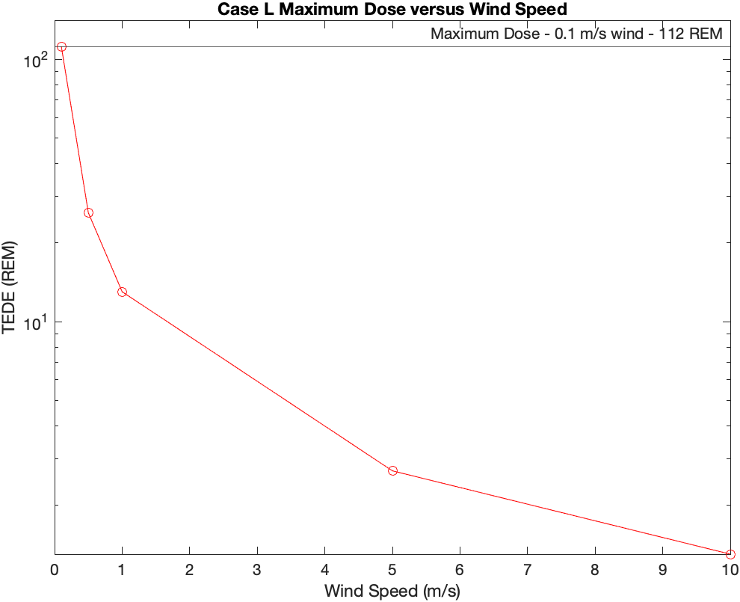
Figure 43. Case L Maximum Dose versus Wind Speed
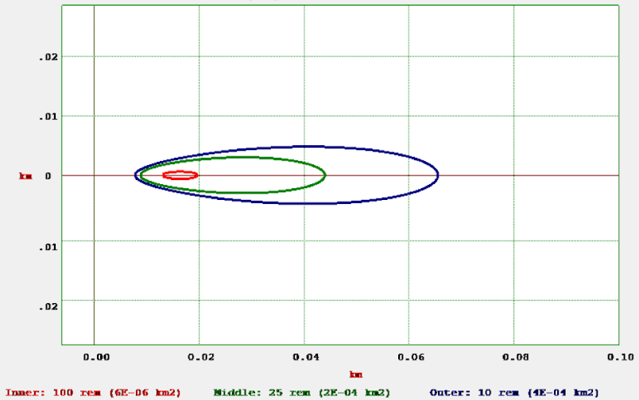
Figure 44. HotSpot Plot with 0.1 m/s Wind

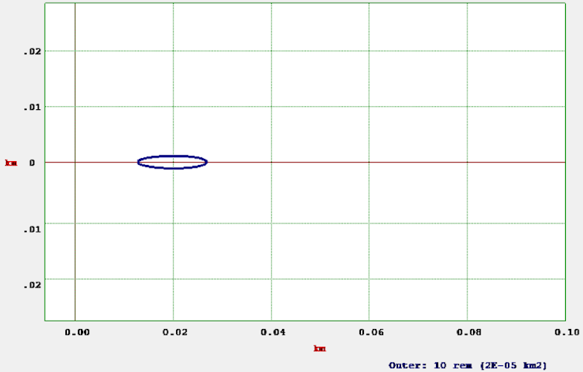
Figure 45. HotSpot Plot with 1.0 m/s Wind
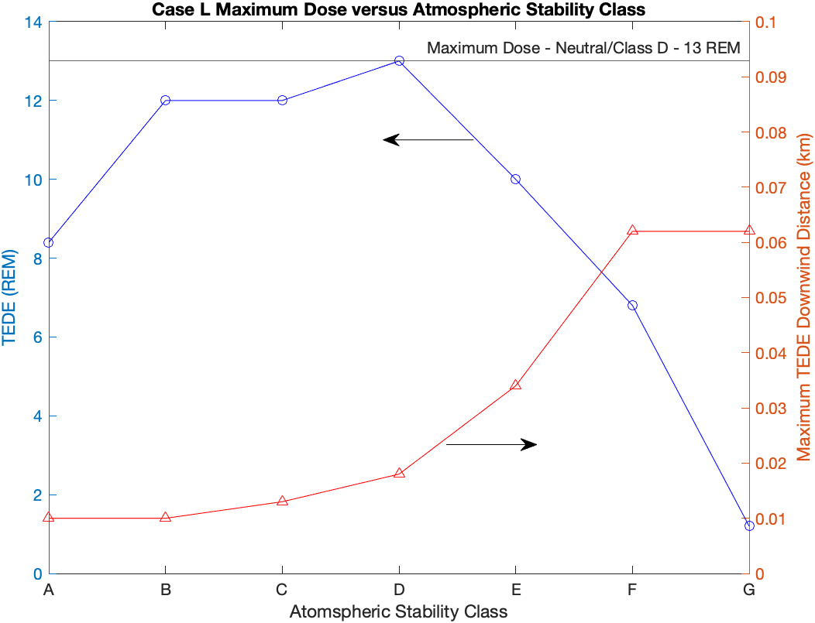
Figure 46. Case L Maximum Dose versus Atmospheric Stability Class

CHAPTER SIX

Controls and Barriers

While this work demonstrates the generally safe nature of these types of reactors, there are still risks associated with transportation accidents that should be mitigated to the greatest extent possible in accordance with future quantitative and qualitative safety goals. This work does not constitute a complete consequence analysis of these types of transportation accidents; therefore, all scenarios should be analyzed for the short and long-term effects of a hypothetical transportation accident. Once the worst-case consequences are found and quantified, controls and barriers should be put in place and a complete probability risk assessment should be completed to determine the likelihood of all accident scenarios and the effects of these accidents. This allows for appropriate emergency response planning and preparations to take place for the worst-case and the most likely accident scenarios.
Figure 47 depicts the framework for the barrier analysis which will be discussed. This framework has areas of responsibility from the highest, strategic level leaders to the individual completing specified tasks on the reactor. [35] The safety goal is to ensure that the differing levels of barriers stop the progression from some triggering event to the potentially negative result. This is a cyclical process and is ongoing throughout the design, operational, and decommissioning processes of the reactor’s lifecycle. For example, the Pele Program reactor would be in the design phase. At this point, strategic level leadership has specified the overarching objectives, purpose, and
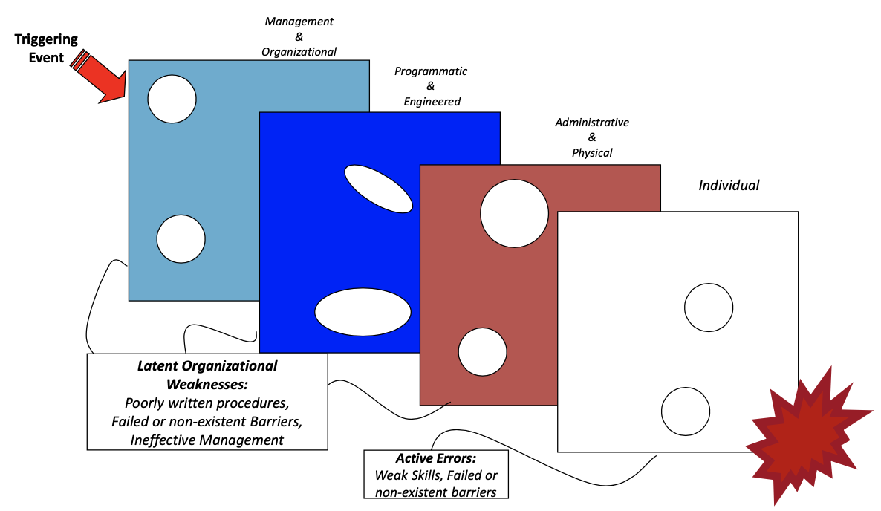
Figure 47. Barrier Analysis Framework [35]

safety goals for the program as seen in the initial Request for Solutions. Then high-level organizations such as those companies that designed reactors and the national labs such as INL and PNNL have developed the more specific programmatic and engineering requirements to meet the higher intent. More than likely, the DoD and the civilian organizations involved will finalize the specific administrative and physical barriers. Finally, trained individuals are responsible for completing their specified tasks with safety in mind. As this work focuses primarily on the operational portion of the reactors lifecycle where a transportation accident could occur, a collection of ideas and thoughts are provided at each barrier level.
The first area for barriers to be established are at the management level, which includes policy and direction from the highest level. The safety of the reactor is under the purview of both the licensing agency and the operator. From both the licenser and licensee and from the top down, a culture of safety must be established alongside policies and procedures that will keep the reactor, its operators and transporters, and the general public safe. The soft science of leadership is required from the highest level to lead by example and hold people accountable for maintaining safety. The management level leaders must hire trusted subject matter experts that can make proper decisions to achieve missions while maintaining safety.
Organizational and programmatic procedures to maintain radiation control will be required as part of citation and licensing of these reactors. Citing requirements should not just include requirements for the operating location but should also include transportation plans and considerations. Maps of population centers, water ways, bridges, hospitals, railroads, and other infrastructure should provide some considerations to planning. Military and civilian Chemical, Biological, Radiological, and Nuclear response unit locations and their capabilities should be considered, and appropriate coordination should be made with these units to alert them to the presence of the reactor as it passes through their jurisdiction or area of operations. Organizational level instructions should include pre-transit requirements such as tie-downs, vehicle inspections, placarding/signage, and quality assurance and control for all manner of air, land, and sea transportation options. Since standardized shipping containers will be used, much of this information already exists, but due to the potential consequences, these areas should not be glossed over as a part of procedures or training.
The team of personnel responsible for the reactor should be well defined, coordinated, and trained. As required of all large operations, there should be a chain of command assigned to support each reactor. This should include a single individual who holds the ultimate responsibility for operations and safety, subject matter experts, reactor operators, and construction, security, and transportation specialists. Reactor operators should be highly trained and certified in similar manners to civilian and military certification programs. Non-reactor personnel should also be trained and drilled in their craft as well as radiation safety and monitoring as they may be required to assist in the case of an emergency. Individuals should be encouraged to have a questioning attitude to ensure the safety and security of the reactor.
Transportation procedures should be in place and certified for every shipment. These procedures should include considerations when in transit such as time of day, speed limits, security vehicles and escorts, and bridge crossings. [36] Because the worst-case scenarios are those in which the core is submerged, decision makers should avoid bodies of water to the greatest extent possible to minimize potential accident consequences. The methods for how to separate the reactor modules into their transportation configurations should also be scrutinized. It has been shown in this work and in PNNL-33607 that a portion of the expected source term comes from radioisotopes that are either in the matrix or in the pressure boundary. PNNL-33607 also addressed an accident scenario where the pressure boundary was lost during transportation due to human error. [5] This could happen in either the reactor or power conversion modules, so procedures on how to reduce this threat while also protecting reactor workers from radiation should also be addressed in detail.
Procedures should also exist for emergency and accident scenarios. For transportation accidents, all personnel involved with the transportation activities should know their roles without needed guidance. There should be personnel designated for life saving actions, securing the accident site, radiation monitoring, establishing a safety perimeter, and coordinating with local authorities to prepare any evacuation or large-scale perimeter outside the transportation teams capabilities. Immediate actions with local authorities should include enforcement of an emergency planning zone. The required size of the zone should be a part of citing and transportation requirements based on the worst case expected dose. For example, the maximum downwind distance to receive 1 REM for Case D is 64 meters as seen in Figure 40. If this is the decided upon safety limit, a 64-meter radius perimeter should immediately be established and monitored. If radiation monitoring shows increased radiation elsewhere, then the perimeter should be adjusted over time. After the initial response is complete, remediation activities should also be included in organizational planning. Requirements for reestablishing transportability to the destination should not be left to on the ground decisions during an emergency.
Of course, the primary way to reduce accident consequences should be engineered solutions. This work has focused on demonstrating a worst-case scenario where essentially all engineered safety systems fail. However, there will be many redundancies. Firstly, the core will have either control rods or control drums. The EIS stated control drums would be used, so they were focused on in the literature review, but control rods or drums are both potentially feasible. As Sun’s worked showed, control drums had the capability to control reactivity if enough drums maintained their rotational angle at 0$°$ as seen in Figure 4. [18] Design of the control drums must include redundancies to ensure that they do not have the ability to turn unless instructed to do so by an operator or semi-autonomous controller. Sun discussed a spring-loaded system in which a loaded spring would force a drum to the 0$°$ position. [18] This, along with off-center, potentially operated installed, locking pins to prevent rotation could be included as well to prevent rotation. With the potential extreme forces of a large impact, considerations to ensure control rods or drums will remain in place must be well understood.
It can also be expected to have burnable absorbers in the reactor during transportation. At BOC, it is likely that the core will have either Gadolinium or Boron included in the design to reduce reactivity during the initial period of operation in a manner similar to standard reactor designs. This will also double as reactivity control in the event of an accident. However, later in the reactor lifecycle, this initial concentration will likely be depleted. To add reactivity control prior to transportation, neutron poisons should be added to the core. it must be kept in mind that there is potential that the reactor will need to be operated again at a new location. So, designing control measures in a way in which they can be removed to continue operation is imperative.
Another method of reducing reactivity in the core during an accident could be the inclusion of a “spectral shift absorber” or SSA. [17] King and El-Genk describe the use of various absorber materials as SSAs in fast reactors to combat the increase in neutron thermalization due to water-based accident scenarios. [17] Because the reactor design utilized here is a thermal spectrum reactor, internal SSAs would likely not be feasible due to depletion while the reactor is normally operating. A SSA coating on the outside of the reactor could be more feasible. Based on the thermal non-leakage probabilities in Table 14, very few thermal neutrons escape the reactor during normal operation, but additional thermal neutrons are reflected into the system when the reactor is underwater. An SSA outside the reactor may not deplete during operation, and it would reduce the effect on reactivity of reflected thermal neutrons by absorbing them prior to their reentry into the system. [17]
PNNL-33607 and Adkins Jr. et al. [1][5] both suggested the possibility to remove the fuel material from the core and instead transporting it in a certified Type B container. Based on logistics requirements, this could be a plausible course of action. For the Pele Program requirements listed in Table 1, it would not be feasible without additional steps. An additional step could be the use of an intermediate storage location where the reactor could safely cool and fuel could be removed. This would still require transport to the intermediate location but would potentially enhance safety for the remainder of the movement. If fuel is expected to be removed, extra infrastructure such as a hot cell would be required to ensure radiation safety for workers. This extra infrastructure would have to be emplaced in potentially remote or challenging areas and would likely only be for a single use.

CHAPTER SEVEN

Conclusions

In conclusion, an analysis of this sort should be required for licensing and citation of a fully designed TNPP. Licensing bodies must ensure that the hypothetical transportation accident scenarios are adequately addressed in engineering design and protocols. Licensees should examine the worst-case accident scenarios with and without the applied engineering controls to provide a demonstration that their control mechanisms adequately limit transportation consequences. Inclusion of the reactivity control mechanisms are the clear next step to this work to determine its effect on both criticality and radiation release. They should also demonstrate how they will maintain reactivity control under scenarios with large impacts which could jar the control rods or drums from position and potentially rearrange the contents of the core. It is also important to examine the effects of in leakage of water into the core as this led to the worst effects, in terms of criticality, in the postulated scenarios examined here.
A key finding of this work is that the highly conservative assumptions used here demonstrate that there is a not a significant release. For ground-based accident scenarios it has been shown that TEDEs can be expected to be below 25 REM past 50 meters downwind, even in the worst-case atmospheric conditions examined. This can be attributed to the reactor design which doesn’t allow for fuel failure due to the transient, even with rearranging the core into more critical geometries. While there is still work to be done with finalized reactor designs, this is a good sign in that dose rates to populations near an accident can be expected to be very low.
The introduced questions have been answered through this analysis:

- Is there a rearranged core which results in a more critical configuration of the core throughout different points in the reactor’s lifetime? Yes. As seen in Tables 11 and 12, hypothetical core rearrangements resulted in higher k-effectives in nearly all cases over the standard control arrangement. This included much less probable rearrangements where the materials were shifted to a spherical shape or more probable rearrangements where the core material was compacted. While k-effective decreased overall with burnup, the rearranged cores still had higher k-effectives than their on land counterparts.
- What is the expected behavior during a transient caused by a hypothetical transportation accident? In most of the examined cases, the doppler feedback in the core was strong enough to turn around the transient prior to any potential TRISO failure due to temperature rise. A handful of cases did experience TRISO failure from the transient, but these were limited to those cases in which water was able to leak into the reactor.
- What is the expected radiation release into the environment from the worst-case scenarios of these transportation accidents? The expected radiation release is affected by whether TRISO particles fail due to the transient. There is potential for accident scenarios to exceed 25 REM TEDE. Because of TRISO failure from impacts and from release from the pressure boundary and matrix, there is still a notable releases in cases where the transient does not cause TRISO failure. A key takeaway is that cooling time did not make a large difference in the TEDE. While the source terms decreased with time, the dose did not due to the longer-lived isotopes that remained present. Finally, EPZs could potentially be established within the 10s of meters with additional modeling for confirmation.
- What controls can be implemented to ensure minimal radiation release and damage to the core? There are a variety of controls that are listed in Chapter 6. The most important of these are engineered controls to ensure the reactor remains subcritical throughout the accident and proper procedures to secure the pressure boundary for transportation. These controls will limit the radiation release to the greatest extent.

Another notable takeaway is the requirement to establish an industry standard failure temperature or energy deposition for TRISO particles. PNNL-33607 cites one set of data in which failure probability begins around 2073 K due to Silicon Carbide decomposition. A failure probability of 100% was chosen for this work, which could be seen as a very over-conservative estimation based on the AGR-1 data shown in PNNL-33607. [5] Ghezzi et al. showed that significant failure probabilities didn’t begin until the melting point of the fuel, around 3100 K, based on modeling and experimental data. [21] This difference creates a notable difference in the failure rates of TRISO particles in these accident scenarios which could create a large difference in doses based on modeling assumptions. The assumptions made in this work limited the dose difference due to this inconsistency, but it was a large enough difference to exceed 25 REM. The burnup to achieve a 5-year operating time for this reactor also greatly exceed current licensing standards. To use TRISO to the high burnups seen here, new standards must be established.
Unexpectedly, based on the assumptions used, reactor cooling time did not greatly decrease the calculated dose. While the total activity released significantly decreases due to decay, the primary isotopes responsible for the dose are still present after these longer cooling times, so the dose does not vary greatly. This contradicts findings in PNNL-33607 where equivalent doses exceeded the 25 REM standard when cooled for 1-year, but not for 5. [5]
This work could be improved in a couple of ways to minimize reliance upon assumptions. Firstly, the transients could be executed in a program such as RELAP-5 to achieve a fully analyzed model. [37] This would require a fully designed reactor system including the coolant system. Secondly, the results of the transient could be input into BISON in a similar manner to which Ghezzi et al. completed their work. [21] These two modeling changes could, and should be, used in future work, especially if that work is aiming to license a TNPP. An additional accident consideration is the effectiveness of wet sands or sediments on the core as wet sand is an even more effective reflector than water. [17]

REFERENCES

[1] Adkins Jr., H. A., & Maheras, S. (March 8 to March 12, 2021). Microreactor Transportability Challenges - 21072 Waste Management 2021, Phoenix, Az.
[2] Final Construction and Demonstration of a Prototype Mobile Microreactor Environmental Impact Statement. (2022). Idaho Falls, ID: Office of the Secretary of Defense - Strategic Capabilities Office
[3] Request for Solutions, Amendment No. 1, Pele Program Phase 1. (2019). Alexandria, VA: Office of the Secretary of Defense - Strategic Capabilities Office
[4] Duchnowski, E. M., Kile, R. F., Bott, K., Snead, L. L., Trelewicz, J. R., & Brown, N. R. (May 23, 2022). Pre-Conceptual High Temperature Gas-cooled Microreactor Design Utilizing Two-phase Composite Moderators. Part I: Microreactor Design and Reactor Performance. Progress in Nuclear Energy(149).
[5] Coles, G., Lowry, P., Phillips, J., Short, S., Condon, C., Maheras, S., Ikenberry, T., & H. Adkins, J. (2022). Parametric Study of Factors that Affect Calculated Dose from TRISO Fueled Microreactor Transportation Accident. (PNNL-33607). Pacific Northwest National Laboratory
[6] Lee, D., & Diaconeasa, M. (2022). Preliminary Siting, Operations, and Transportation Considerations for Licensing Fission Batteries in the United States. Eng, 3, 373-386. https://www.mdpi.com/2673-4117/3/3/27
[7] Nuclear Explained. (April 18, 2022). U.S. Energy Information Administration. Retrieved March 21, 2023 from https://www.eia.gov/energyexplained/nuclear/us-nuclear-industry.php
[8] New Reactors. (September 19, 2022). U.S. Nuclear Regulatory Commission. Retrieved March 24, 2023 from https://www.nrc.gov/reactors/new-reactors.html
[9] AP1000 Design Control Document Rev. 19. (ML071580895). (2011). Rockville, Md
[10] Eielson AFB Announced as Site for Air Force Micro-Reactor Pilot. (2021, October 15).
[11] 20FT. Standard (Dry) Container. (2022). Interport. Retrieved March 28 from https://www.iport.com/container-for-sale/20-ft-standard/
[12] Series 1 Freight Containers - Classification, Dimensions, and Ratings Amendment 1, (2020).
[13] 10 CFR 71 - Packaging and Transportation of Radioactive Material. (2021). Rockville, MD Retrieved from https://www.nrc.gov/reading-rm/doc-collections/cfr/part071/index.html
[14] Typical Dry Cask Storage System. (2020). Nuclear Regulatory Commission. Retrieved March 28 from https://www.nrc.gov/waste/spent-fuel-storage/diagram-typical-dry-cask-system.html
[15] Defense in depth. (March 9, 2021). Nuclear Regulatory Commission. Retrieved March 28 from https://www.nrc.gov/reading-rm/basic-ref/glossary/defense-in-depth.html
[16] Emergency Planning Zones. (2020, November 13, 2020). Nuclear Regulatory Commission. Retrieved March 28, 2023 from https://www.nrc.gov/about-nrc/emerg-preparedness/about-emerg-preparedness/planning-zones.html
[17] King, J. C., & El-Genk, M. S. (2005). Submersion Criticality Safety of Fast Spectrum Space Reactors: Potential Spectral Shift Absorbers. Nuclear Engineering and Design, 236, 238-254.
[18] Sun, H., C., W., & P., M. (2018). Conceptual Design and Analysis of a Multipurpose Micro Nuclear Reactor Power Source. Annals of Nuclear Energy(121), 118-127.
[19] 10 CFR 100 - Reactor Site Criteria. (2020). Rockville, MD Retrieved from https://www.nrc.gov/reading-rm/doc-collections/cfr/part100/full-text.html
[20] Duchnowski, E. (2022). TNPP Serpent Input [Serpent Input]. University of Tennessee.
[21] Ghezzi, C. G., Schappel, D., Pastore, G., Wirth, B. D., & Brown, N. R. (2022). Sensitivity Analysis Applied to SiC Failure Probability in TRISO Modeled with BISON. Progress in Nuclear Energy, 153.
[22] Terrani, K. A., Snead, L. L., & Gehin, J. C. (2012). Microencapsulated Fuel Technology Journal of Nuclear Materials, 427, 209-224.
[23] Campbell, A., Katoh, Y., Snead, M., & Takizawa, K. (2016). Property Changes of G347A Graphite due to Neutron Irradiation. Carbon(109), 860-873.
[24] Ott, K. O., & Neuhold, R. (1985). Introductory Nuclear Reactor Dynamics. American Nuclear Society.
[25] Brown, N. (2018). Control Rod Ejection with 1D Thermal Feedback [Matlab Script].
[26] Folsom, C., Xing, C., Jensen, C., Ban, H., & Marshall, D. W. (2014). Experimental Measurement and Numerical Modeling of the Effective Thermal Conductivity of TRISO Fuel Compacts. Journal of Nuclear Materials(458), 198-205.
[27] Graphite Matrix Thermal. Idaho National Labs. Retrieved March 24 from https://mooseframework.inl.gov/bison/source/materials/GraphiteMatrixThermal.html
[28] Leppanen, J. (2015). Serpent - a Continuous-energy Monte Carolo Reactor Physics Burnup Calculation Code. VTT Technical Research Centre of Finland.
[29] Radiation Safety Information Computational Center. Oak Ridge National Labs. Retrieved March 28 from https://www.ornl.gov/onramp/rsicc
[30] S. Homann, F. A. (2014). HotSpot Health Physics Codes Version 3.0 User’s Guide. https://narac.llnl.gov/content/assets/docs/HotSpot-UserGuide-3-0.pdf
[31] Frequently Asked Questions. (February 9, 2023). Nuclear Regulatory Commission. Retrieved March 28 from https://www.nrc.gov/reactors/power/atf/faqs.html
[32] Why is the Ocean Salty. United States Geological Survey. Retrieved March 28, 2023 from https://www.usgs.gov/faqs/why-ocean-salty
[33] Lamarsh, J. R. and A. J. Barratta (2001). Introduction to Nuclear Engineering (3 ed.). Pearson College Div.
[34] Live Chart of the Nuclides. (2023). International Atomic Energy Agency - Nuclear Data Section. Retrieved March 23, 2023 from https://www-nds.iaea.org/relnsd/vcharthtml/VChartHTML.html
[35] Lagdon, C. (2021). Nuclear Licensing - Root Cause Analysis [Powerpoint]. University of Tennessee - Knoxville.
[36] Coles, G. (2022, June 26 to July 1). Risk-Informed Approach for Regulator Approval of Microreactor Transport. Probabilistic Safety Assessment and Management, Honolulu, HI.
[37] RELAP5-3D. Idaho National Labs. Retrieved March 28, 2023 from https://relap53d.inl.gov/SitePages/Home.aspx

APPENDICES

APPENDIX A

Volume Comparisons

Table A.1. Design #1 Rearranged Volume Comparisons

Volumes (cm³) | Actual | Control |  | Heterogeneous Sphere |  | Homogeneous Sphere
Volumes (cm³) | Actual | Vol.  (cm³) | % Difference | Vol.  (cm³) | % Difference | Vol.  (cm³) | % Difference
Kernel (UCO) | 4.73E+03 | 4.74E+03 | 0.11% | 4.74E+03 | 0.23% | 4.72E+03 | 0.25%
Buffer (C) | 1.03E+04 | 1.03E+04 | 0.10% | 1.03E+04 | 0.01% | 1.03E+04 | 0.42%
Total PyC | 1.64E+04 | 1.64E+04 | 0.05% | 1.64E+04 | 0.02% | 1.63E+04 | 0.31%
SiC | 7.09E+03 | 7.09E+03 | 0.01% | 7.11E+03 | 0.28% | 7.07E+03 | 0.31%
Compact (Graphite) | 4.71E+04 | 4.71E+04 | 0.04% | 5.79E+04 | 23.01% | 0.00E+00² | 100.00%
Moderator (Graphite | 5.27E+05 | 5.27E+05 | 0.00% | 5.11E+05 | 3.07% | 5.74E+05 | 8.95%
Compact + Moderator | 5.74E+05 | 5.74E+05 | 0.00% | 5.68E+05¹ | 0.93% | 5.74E+05 | 0.01%
Reflector (Graphite) | 9.39E+06 | 9.39E+06 | 0.00% | 9.39E+06 | 0.03% | 9.39E+06 | 0.00%
Coolant (He) | 6.20E+04 | 6.20E+04 | 0.00% | 6.18E+04 | 0.23% | 0.00E+00³ | 100.00%
Total | 1.01E+07 | 1.00E+07 | 0.38% | 1.00E+07 | 0.46% | 1.00E+07⁴ | 0.38%
1 – Compact and Moderator combined makes up for large errors in compact and moderator separately
2 – Compact and Moderator combined into one material in Homogeneous models
3 – Coolant not included in Homogeneous models
4 – Coolant volume added to total for Homogeneous models to accurately represent volume

Table A.2. Design #2 Rearranged Volume Comparisons

Volumes (cm³) | Calculated | Control |  | Heterogeneous Sphere
Volumes (cm³) | Calculated | Volume  (cm³) | % Difference | Volume  (cm³) | % Difference
Kernel (UCO) | 3.72E+04 | 3.72E+04 | 0.04% | 3.71E+04 | 0.11%
Buffer (C) | 8.11E+04 | 8.10E+04 | 0.03% | 8.11E+04 | 0.05%
Total PyC | 1.29E+05 | 1.29E+05 | 0.06% | 1.29E+05 | 0.01%
SiC | 5.57E+04 | 5.57E+04 | 0.00% | 5.57E+04 | 0.09%
Compact (Graphite) | 3.70E+05 | 3.70E+05 | 0.01% | 3.70E+05 | 0.00%
Moderator (Graphite | 4.14E+06 | 4.14E+06 | 0.01% | 4.19E+06 | 1.34%
Compact + Moderator | 4.51E+06 | 4.51E+06 | 0.01% | 4.56E+06 | 1.23%
Reflector (Graphite) | 4.77E+06 | 4.77E+06 | 0.00% | 4.77E+06 | 0.01%
Coolant (He) | 4.87E+05 | 4.87E+05 | 0.01% | 4.32E+05 | 11.37%
RPV (SS) | 9.06E+06 | 9.06E+06 | 0.00% | 9.06E+06 | 0.01%
Total | 1.91E+07 | 1.91E+07 | 0.00% | 1.91E+07¹ | 0.01%
Volumes (cm³) | Calculated | Compacted Cylinder |  | Homogeneous Sphere
Volumes (cm³) | Calculated | Volume  (cm³) | % Difference | Volume  (cm³) | % Difference
Kernel (UCO) | 3.72E+04 | 3.72E+04 | 0.01% | 3.71E+04 | 0.12%
Buffer (C) | 8.11E+04 | 8.11E+04 | 0.02% | 8.11E+04 | 0.01%
Total PyC | 1.29E+05 | 1.29E+05 | 0.01% | 1.29E+05 | 0.05%
SiC | 5.57E+04 | 5.57E+04 | 0.05% | 5.57E+04 | 0.00%
Compact (Graphite) | 3.70E+05 | 3.70E+05 | 0.02% | 0.00E+00 | 100.00%
Moderator (Graphite | 4.14E+06 | 4.14E+06 | 0.01% | 4.51E+06 | 8.95%
Compact + Moderator | 4.51E+06 | 4.51E+06 | 0.01% | 4.51E+06³ | 0.01%
Reflector (Graphite) | 4.77E+06 | 4.76E+06 | 0.17% | 4.77E+06 | 0.01%
Coolant (He) | 4.87E+05 | 0.00E+00² | 100.00% | 0.00E+00² | 100.00%
RPV (SS) | 9.06E+06 | 9.06E+06 | 0.00% | 9.06E+06 | 0.00%
Total | 1.91E+07 | 1.91E+07 | 0.04% | 1.91E+07 | 0.00%
1 – Increased moderator and decreased coolant is largest volume error – more conservative due to extra moderator material
2 – Coolant not included in Compacted or Homogeneous Models
3 - Compact and Moderator combined into one material in Homogeneous models
4 – Coolant volume added to total for Compacted and Homogeneous models to accurately represent volume

APPENDIX B

Transient Pulses for the Worst-Case Scenarios

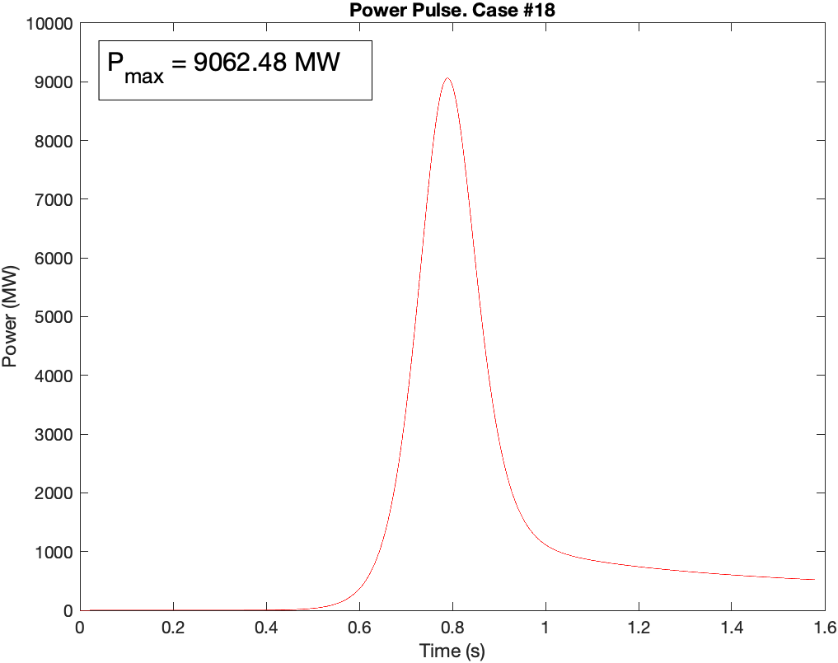
Figure B.1. Power Pulse – Case #18

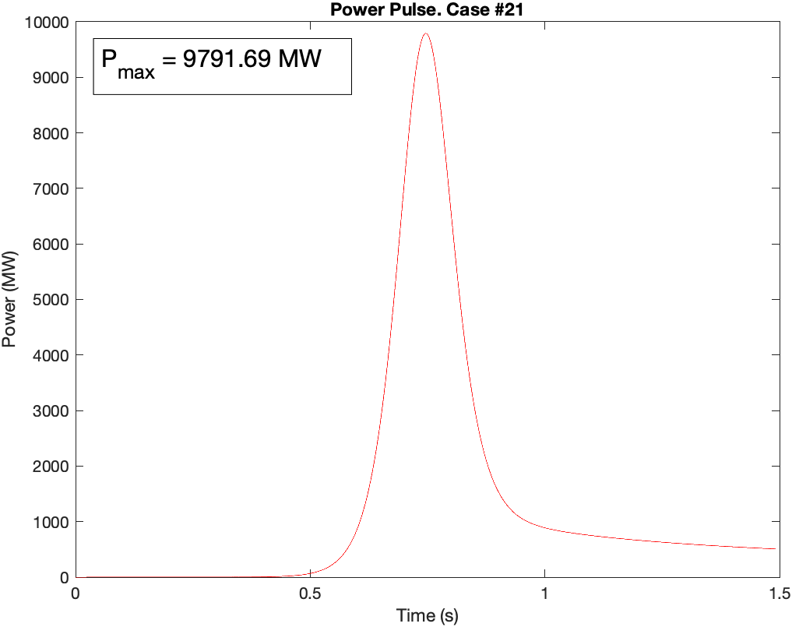
Figure B.2. Power Pulse – Case #21

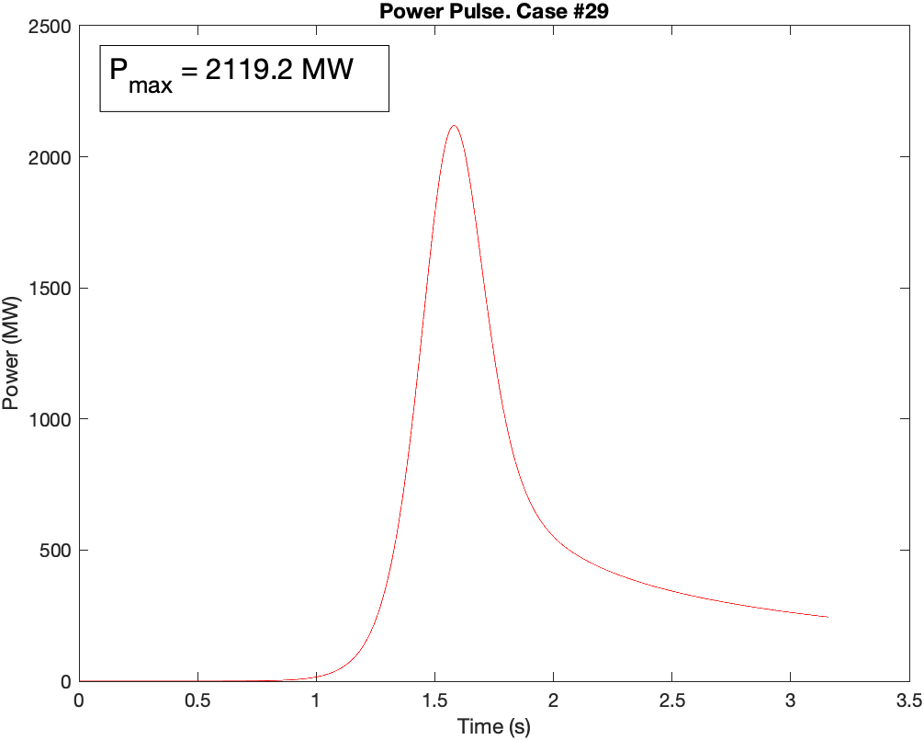
Figure B.3. Power Pulse – Case #29

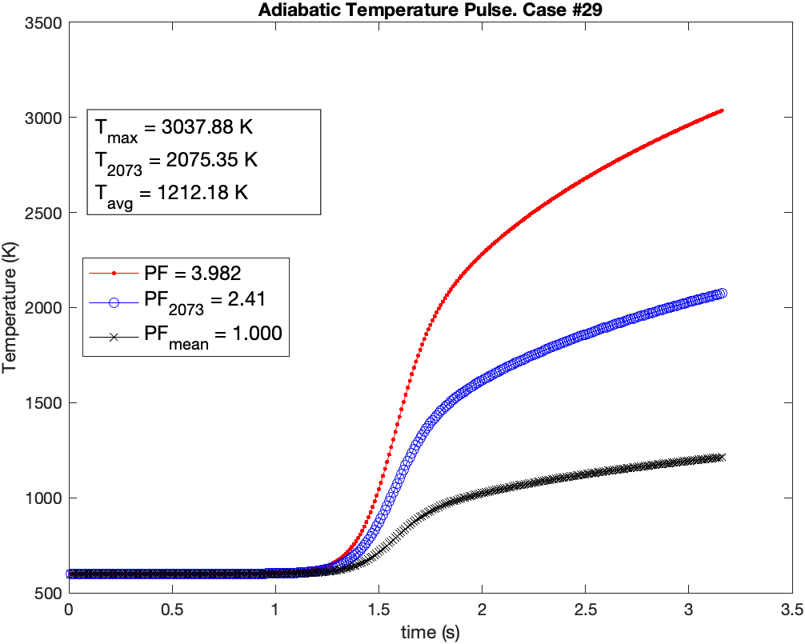
Figure B.4. Adiabatic Temperature Pulse – Case #29

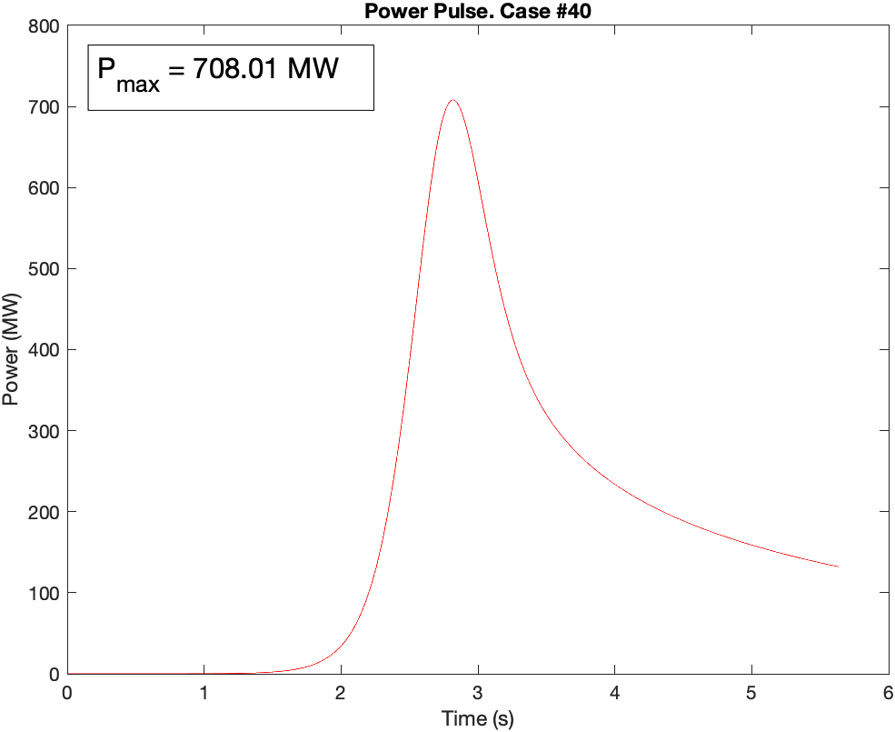
Figure B.5. Power Pulse – Case #40

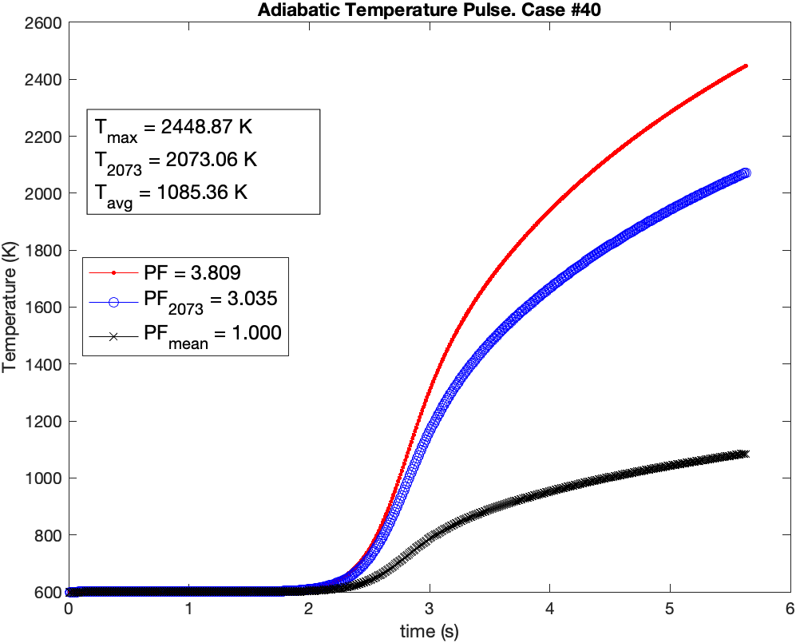
Figure B.6. Adiabatic Temperature Pulse – Case #40
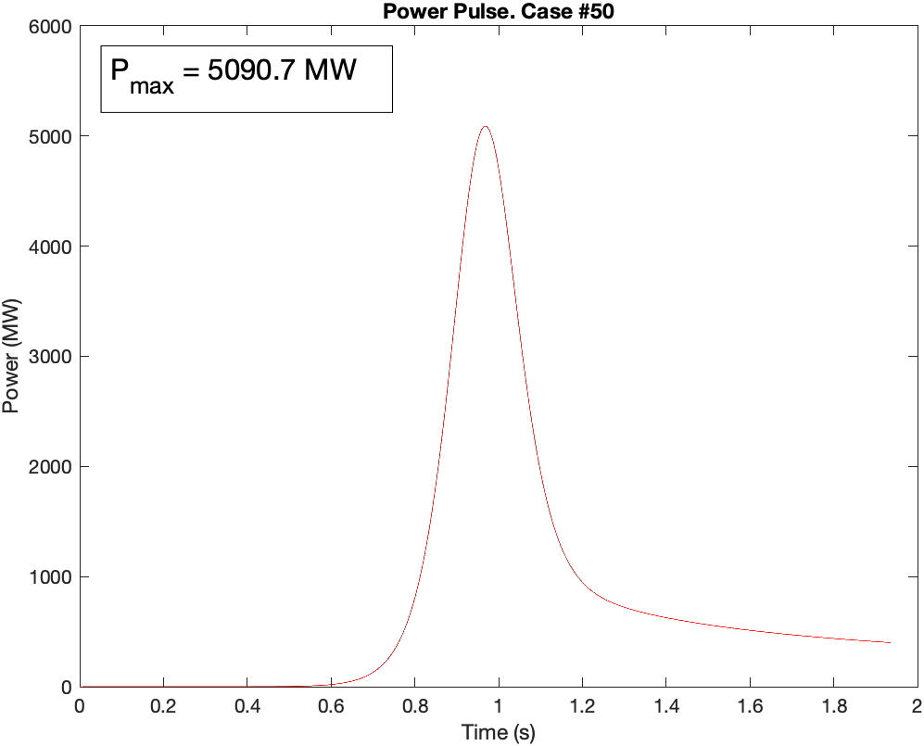
Figure B.7. Power Pulse – Case #50

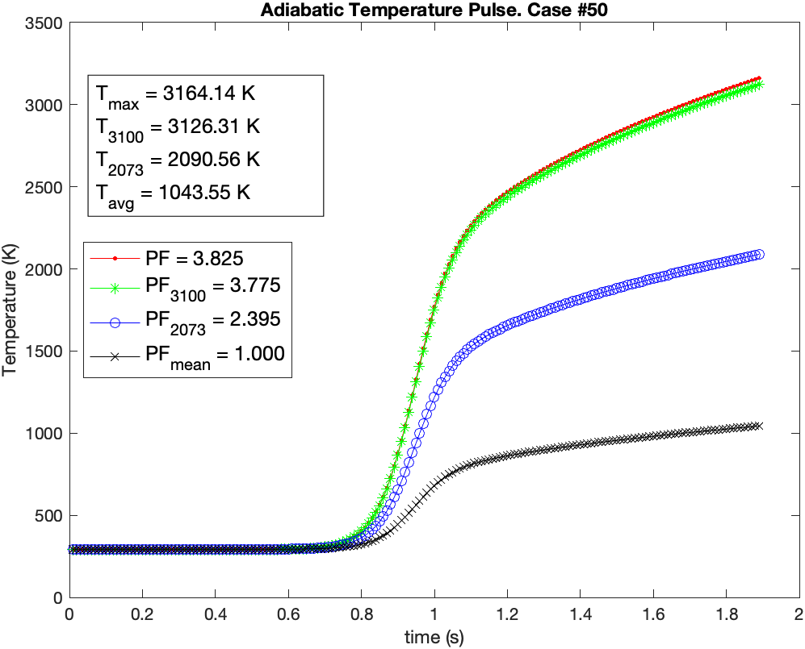
Figure B.8. Adiabatic Temperature Pulse – Case #50

APPENDIX C

Source Terms

Table C.1. Day 0 Source Terms

Day 0 (Case #18)
Initial Activities |  | Case A - 2073 K |  | Case B - 3100 K
Isotope | Activity (Ci) | Activity (Ci) | % of Initial | Activity (Ci) | % of Initial
Total | 2.41E-01 | 5.024E-07 | 0.00021% | 5.132E-08 | 0.00002%
U235 | 1.48E-01 | 3.07E-07 | 0.00021% | 3.14E-08 | 0.00002%
U238 | 9.36E-02 | 1.95E-07 | 0.00021% | 1.99E-08 | 0.00002%

Table C.2. Day 1102 Source Terms

Day 1102
Top 50 % of Total |  |  | 99.77%
Initial Total Core Activity |  |  | 1.25E+07
Initial Top 50 Activity |  |  | 1.25E+07
Initial Activities |  | Case C Activities (2073 K) |  | Case D Activities (3100 K)
Isotope | Activity (Ci) | Activity (Ci) | % of Initial | Activity (Ci) | % of Initial
Total | 1.25E+07 | 3.05E+01 | 0.00024% | 5.48E+00 | 0.00004%
Ag111 | 6.71E+03 | 1.03E-02 | 0.00015% | 4.99E-03 | 0.00007%
Ba137m | 6.49E+04 | 9.51E-02 | 0.00015% | 4.34E-02 | 0.00007%
Ba140 | 6.72E+05 | 9.84E-01 | 0.00015% | 4.49E-01 | 0.00007%
Ce141 | 8.09E+05 | 7.71E-01 | 0.00010% | 1.24E-01 | 0.00002%
Ce143 | 2.71E+04 | 2.58E-02 | 0.00010% | 4.14E-03 | 0.00002%
Ce144 | 7.95E+05 | 7.57E-01 | 0.00010% | 1.21E-01 | 0.00002%
Cm242 | 8.71E+03 | 8.31E-03 | 0.00010% | 1.35E-03 | 0.00002%
Cs134 | 3.79E+04 | 3.97E-02 | 0.00010% | 9.42E-03 | 0.00002%
Cs136 | 9.81E+03 | 9.80E-03 | 0.00010% | 1.96E-03 | 0.00002%
Cs137 | 6.86E+04 | 7.19E-02 | 0.00010% | 1.71E-02 | 0.00002%
Eu156 | 1.92E+04 | 1.83E-02 | 0.00010% | 2.93E-03 | 0.00002%
I131 | 2.79E+05 | 5.30E+00 | 0.00190% | 8.38E-01 | 0.00030%
I132 | 1.63E+05 | 3.10E+00 | 0.00190% | 4.89E-01 | 0.00030%
Kr85 | 8.95E+03 | 1.70E-01 | 0.00190% | 2.69E-02 | 0.00030%
La140 | 7.66E+05 | 7.29E-01 | 0.00010% | 1.17E-01 | 0.00002%
Mo99 | 1.70E+05 | 1.62E-01 | 0.00010% | 2.64E-02 | 0.00002%
Nb95 | 1.02E+06 | 9.70E-01 | 0.00010% | 1.58E-01 | 0.00002%
Nb95m | 1.06E+04 | 1.01E-02 | 0.00010% | 1.64E-03 | 0.00002%
Nd147 | 2.30E+05 | 2.19E-01 | 0.00010% | 3.50E-02 | 0.00002%
Np238 | 4.37E+03 | 4.17E-03 | 0.00010% | 6.75E-04 | 0.00002%
Np239 | 6.17E+05 | 5.89E-01 | 0.00010% | 9.54E-02 | 0.00002%
Pm147 | 1.62E+05 | 1.54E-01 | 0.00010% | 2.47E-02 | 0.00002%
Pm148 | 2.37E+04 | 2.25E-02 | 0.00010% | 3.61E-03 | 0.00002%
Pm148m | 1.76E+04 | 1.67E-02 | 0.00010% | 2.68E-03 | 0.00002%
Pm149 | 2.43E+04 | 2.32E-02 | 0.00010% | 3.71E-03 | 0.00002%
Pr143 | 7.12E+05 | 6.78E-01 | 0.00010% | 1.09E-01 | 0.00002%
Pr144 | 7.95E+05 | 7.57E-01 | 0.00010% | 1.21E-01 | 0.00002%
Pr144m | 7.59E+03 | 7.23E-03 | 0.00010% | 1.16E-03 | 0.00002%
Pu241 | 4.63E+04 | 4.42E-02 | 0.00010% | 7.15E-03 | 0.00002%
Table C.2. Continued

Initial Activities |  | Case C Activities (2073 K) |  | Case D Activities (3100 K)
Isotope | Activity (Ci) | Activity (Ci) | % of Initial | Activity (Ci) | % of Initial
Rh103m | 5.42E+05 | 5.17E-01 | 0.00010% | 8.41E-02 | 0.00002%
Rh105 | 1.28E+04 | 1.22E-02 | 0.00010% | 1.99E-03 | 0.00002%
Rh106 | 1.40E+05 | 1.33E-01 | 0.00010% | 2.17E-02 | 0.00002%
Ru103 | 5.48E+05 | 5.23E-01 | 0.00010% | 8.50E-02 | 0.00002%
Ru106 | 1.40E+05 | 1.33E-01 | 0.00010% | 2.17E-02 | 0.00002%
Sb127 | 1.02E+04 | 1.05E-02 | 0.00010% | 2.31E-03 | 0.00002%
Sm153 | 8.15E+03 | 7.76E-03 | 0.00010% | 1.24E-03 | 0.00002%
Sr89 | 6.21E+05 | 9.09E-01 | 0.00015% | 4.15E-01 | 0.00007%
Sr90 | 6.16E+04 | 9.02E-02 | 0.00015% | 4.11E-02 | 0.00007%
Tc99m | 1.65E+05 | 1.57E-01 | 0.00010% | 2.55E-02 | 0.00002%
Te127 | 1.37E+04 | 1.30E-02 | 0.00010% | 2.09E-03 | 0.00002%
Te129 | 9.70E+03 | 9.24E-03 | 0.00010% | 1.48E-03 | 0.00002%
Te129m | 1.54E+04 | 1.46E-02 | 0.00010% | 2.34E-03 | 0.00002%
Te132 | 1.58E+05 | 1.51E-01 | 0.00010% | 2.41E-02 | 0.00002%
U237 | 1.15E+05 | 1.10E-01 | 0.00010% | 1.78E-02 | 0.00002%
Xe131m | 4.93E+03 | 9.36E-02 | 0.00190% | 1.48E-02 | 0.00030%
Xe133 | 5.28E+05 | 1.00E+01 | 0.00190% | 1.59E+00 | 0.00030%
Xe133m | 5.74E+03 | 1.09E-01 | 0.00190% | 1.72E-02 | 0.00030%
Y90 | 6.17E+04 | 5.89E-02 | 0.00010% | 9.56E-03 | 0.00002%
Y91 | 7.96E+05 | 7.60E-01 | 0.00010% | 1.23E-01 | 0.00002%
Zr95 | 9.41E+05 | 8.98E-01 | 0.00010% | 1.46E-01 | 0.00002%

Table C.3. Day 1145 Source Terms

Day 1145 (MOC + 50 Days)
Top 50 % of Total |  |  | 99.99%
Initial Total Core Activity |  |  | 5.60E+06
Initial Top 50 Activity |  |  | 5.60E+06
Initial Activities |  | Case E Activities (2073 K) |  | Case F Activities (3100 K)
Isotope | Activity (Ci) | Activity (Ci) | % of Initial | Activity (Ci) | % of Initial
Total | 5.60E+06 | 5.95E+00 | 0.00011% | 1.20E+00 | 0.00002%
Ag110m | 2.51E+02 | 8.70E-04 | 0.00035% | 6.70E-04 | 0.00027%
Ag111 | 1.23E+02 | 1.89E-04 | 0.00015% | 9.13E-05 | 0.00007%
Ba137m | 6.48E+04 | 9.48E-02 | 0.00015% | 4.32E-02 | 0.00007%
Ba140 | 6.49E+04 | 9.50E-02 | 0.00015% | 4.33E-02 | 0.00007%
Ce141 | 3.24E+05 | 3.08E-01 | 0.00010% | 4.94E-02 | 0.00002%
Ce144 | 7.16E+05 | 6.82E-01 | 0.00010% | 1.09E-01 | 0.00002%
Cm242 | 7.25E+03 | 6.92E-03 | 0.00010% | 1.12E-03 | 0.00002%
Cs134 | 3.64E+04 | 3.82E-02 | 0.00010% | 9.05E-03 | 0.00002%
Cs136 | 1.02E+03 | 1.02E-03 | 0.00010% | 2.04E-04 | 0.00002%
Cs137 | 6.84E+04 | 7.17E-02 | 0.00010% | 1.70E-02 | 0.00002%
Eu154 | 1.27E+03 | 1.85E-03 | 0.00015% | 8.45E-04 | 0.00007%
Eu155 | 8.13E+02 | 1.19E-03 | 0.00015% | 5.43E-04 | 0.00007%
Eu156 | 2.70E+03 | 2.57E-03 | 0.00010% | 4.12E-04 | 0.00002%
I131 | 6.82E+03 | 1.30E-01 | 0.00190% | 2.05E-02 | 0.00030%
Kr85 | 8.88E+03 | 1.69E-01 | 0.00190% | 2.67E-02 | 0.00030%
La140 | 7.47E+04 | 7.12E-02 | 0.00010% | 1.14E-02 | 0.00002%
Nb95 | 8.51E+05 | 8.12E-01 | 0.00010% | 1.32E-01 | 0.00002%
Nb95m | 6.76E+03 | 6.46E-03 | 0.00010% | 1.05E-03 | 0.00002%
Nd147 | 1.52E+04 | 1.45E-02 | 0.00010% | 2.32E-03 | 0.00002%
Pm147 | 1.59E+05 | 1.52E-01 | 0.00010% | 2.43E-02 | 0.00002%
Pm148 | 5.00E+02 | 4.77E-04 | 0.00010% | 7.64E-05 | 0.00002%
Pm148m | 8.53E+03 | 8.13E-03 | 0.00010% | 1.30E-03 | 0.00002%
Pr143 | 7.95E+04 | 7.57E-02 | 0.00010% | 1.21E-02 | 0.00002%
Pr144 | 7.16E+05 | 6.82E-01 | 0.00010% | 1.09E-01 | 0.00002%
Pr144m | 6.84E+03 | 6.51E-03 | 0.00010% | 1.04E-03 | 0.00002%
Pu238 | 3.79E+02 | 3.61E-04 | 0.00010% | 5.85E-05 | 0.00002%
Pu239 | 1.46E+02 | 1.39E-04 | 0.00010% | 2.26E-05 | 0.00002%
Pu240 | 1.76E+02 | 1.68E-04 | 0.00010% | 2.72E-05 | 0.00002%
Pu241 | 4.60E+04 | 4.39E-02 | 0.00010% | 7.11E-03 | 0.00002%
Table C.3. Continued

Initial Activities |  | Case E Activities (2073 K) |  | Case F Activities (3100 K)
Isotope | Activity (Ci) | Activity (Ci) | % of Initial | Activity (Ci) | % of Initial
Rh103m | 2.54E+05 | 2.42E-01 | 0.00010% | 3.93E-02 | 0.00002%
Rh106 | 1.29E+05 | 1.23E-01 | 0.00010% | 2.00E-02 | 0.00002%
Ru103 | 2.56E+05 | 2.45E-01 | 0.00010% | 3.98E-02 | 0.00002%
Ru106 | 1.29E+05 | 1.23E-01 | 0.00010% | 2.00E-02 | 0.00002%
Sb125 | 3.72E+03 | 3.81E-03 | 0.00010% | 8.42E-04 | 0.00002%
Sm151 | 4.52E+02 | 4.30E-04 | 0.00010% | 6.90E-05 | 0.00002%
Sn123 | 3.28E+02 | 3.13E-04 | 0.00010% | 5.09E-05 | 0.00002%
Sr89 | 3.44E+05 | 5.04E-01 | 0.00015% | 2.30E-01 | 0.00007%
Sr90 | 6.14E+04 | 8.99E-02 | 0.00015% | 4.10E-02 | 0.00007%
Te125m | 8.46E+02 | 8.05E-04 | 0.00010% | 1.29E-04 | 0.00002%
Te127 | 3.25E+03 | 3.09E-03 | 0.00010% | 4.95E-04 | 0.00002%
Te127m | 3.31E+03 | 3.15E-03 | 0.00010% | 5.05E-04 | 0.00002%
Te129 | 4.00E+03 | 3.80E-03 | 0.00010% | 6.09E-04 | 0.00002%
Te129m | 6.33E+03 | 6.03E-03 | 0.00010% | 9.66E-04 | 0.00002%
U235m | 1.46E+02 | 1.39E-04 | 0.00010% | 2.25E-05 | 0.00002%
U237 | 1.39E+03 | 1.33E-03 | 0.00010% | 2.15E-04 | 0.00002%
Xe131m | 7.57E+02 | 1.44E-02 | 0.00190% | 2.27E-03 | 0.00030%
Xe133 | 1.81E+03 | 3.44E-02 | 0.00190% | 5.44E-03 | 0.00030%
Y90 | 6.14E+04 | 5.86E-02 | 0.00010% | 9.52E-03 | 0.00002%
Y91 | 4.78E+05 | 4.56E-01 | 0.00010% | 7.42E-02 | 0.00002%
Zr95 | 5.91E+05 | 5.64E-01 | 0.00010% | 9.16E-02 | 0.00002%

Table C.4. Day 2290 Source Terms

Day 2920 (MOC + 5 years)
Top 50 % of Total |  |  | 100.00%
Initial Total Core Activity |  |  | 3.55E+05
Initial Top 50 Activity |  |  | 3.55E+05
Initial Activities |  | Case G Activities (2073 K) |  | Case H Activities (3100 K)
Isotope | Activity (Ci) | Activity (Ci) | % of Initial | Activity (Ci) | % of Initial
Total | 3.55E+05 | 5.21E-01 | 0.00015% | 1.38E-01 | 0.00004%
Ag110m | 1.82E+00 | 6.31E-06 | 0.00035% | 4.86E-06 | 0.00027%
Am241 | 3.76E+02 | 3.59E-04 | 0.00010% | 5.82E-05 | 0.00002%
Am242 | 2.22E+00 | 2.11E-06 | 0.00010% | 3.42E-07 | 0.00002%
Am242m | 2.23E+00 | 2.12E-06 | 0.00010% | 3.44E-07 | 0.00002%
Am243 | 7.56E-01 | 7.21E-07 | 0.00010% | 1.17E-07 | 0.00002%
Ba137m | 5.79E+04 | 8.48E-02 | 0.00015% | 3.87E-02 | 0.00007%
Cd113m | 4.82E+00 | 4.60E-06 | 0.00010% | 7.47E-07 | 0.00002%
Ce144 | 9.54E+03 | 9.08E-03 | 0.00010% | 1.46E-03 | 0.00002%
Cm242 | 5.65E+00 | 5.39E-06 | 0.00010% | 8.73E-07 | 0.00002%
Cm243 | 9.60E-01 | 9.15E-07 | 0.00010% | 1.48E-07 | 0.00002%
Cm244 | 2.40E+01 | 2.29E-05 | 0.00010% | 3.71E-06 | 0.00002%
Cs134 | 7.13E+03 | 7.47E-03 | 0.00010% | 1.77E-03 | 0.00002%
Cs135 | 6.03E-01 | 6.03E-07 | 0.00010% | 1.21E-07 | 0.00002%
Cs137 | 6.11E+04 | 6.41E-02 | 0.00010% | 1.52E-02 | 0.00002%
Eu152 | 1.13E+01 | 1.66E-05 | 0.00015% | 7.55E-06 | 0.00007%
Eu154 | 8.56E+02 | 1.25E-03 | 0.00015% | 5.71E-04 | 0.00007%
Eu155 | 4.00E+02 | 5.86E-04 | 0.00015% | 2.67E-04 | 0.00007%
Kr85 | 6.49E+03 | 1.23E-01 | 0.00190% | 1.95E-02 | 0.00030%
Nb93m | 3.25E-01 | 3.10E-07 | 0.00010% | 5.03E-08 | 0.00002%
Np237 | 1.05E-01 | 9.99E-08 | 0.00010% | 1.62E-08 | 0.00002%
Np239 | 7.56E-01 | 7.21E-07 | 0.00010% | 1.17E-07 | 0.00002%
Pa233 | 1.05E-01 | 9.99E-08 | 0.00010% | 1.62E-08 | 0.00002%
Pm147 | 4.42E+04 | 4.21E-02 | 0.00010% | 6.75E-03 | 0.00002%
Pr144 | 9.54E+03 | 9.08E-03 | 0.00010% | 1.46E-03 | 0.00002%
Pr144m | 9.11E+01 | 8.67E-05 | 0.00010% | 1.39E-05 | 0.00002%
Pu238 | 4.00E+02 | 3.82E-04 | 0.00010% | 6.18E-05 | 0.00002%
Pu239 | 1.46E+02 | 1.39E-04 | 0.00010% | 2.25E-05 | 0.00002%
Pu240 | 1.76E+02 | 1.68E-04 | 0.00010% | 2.71E-05 | 0.00002%
Pu241 | 3.64E+04 | 3.47E-02 | 0.00010% | 5.62E-03 | 0.00002%
Table C.4. Continued

Initial Activities |  | Case E Activities (2073 K) |  | Case F Activities (3100 K)
Isotope | Activity (Ci) | Activity (Ci) | % of Initial | Activity (Ci) | % of Initial
Pu242 | 2.77E-01 | 2.65E-07 | 0.00010% | 4.29E-08 | 0.00002%
Rh106 | 4.71E+03 | 4.50E-03 | 0.00010% | 7.30E-04 | 0.00002%
Ru106 | 4.71E+03 | 4.50E-03 | 0.00010% | 7.30E-04 | 0.00002%
Sb125 | 1.10E+03 | 1.12E-03 | 0.00010% | 2.48E-04 | 0.00002%
Sb126m | 1.08E-01 | 1.11E-07 | 0.00010% | 2.44E-08 | 0.00002%
Sm151 | 4.35E+02 | 4.14E-04 | 0.00010% | 6.64E-05 | 0.00002%
Sn119m | 1.14E+00 | 1.09E-06 | 0.00010% | 1.76E-07 | 0.00002%
Sn121 | 6.88E+00 | 6.57E-06 | 0.00010% | 1.07E-06 | 0.00002%
Sn121m | 8.87E+00 | 8.46E-06 | 0.00010% | 1.38E-06 | 0.00002%
Sn126 | 1.08E-01 | 1.03E-07 | 0.00010% | 1.67E-08 | 0.00002%
Sr90 | 5.46E+04 | 8.00E-02 | 0.00015% | 3.65E-02 | 0.00007%
Tc99 | 9.68E+00 | 9.24E-06 | 0.00010% | 1.50E-06 | 0.00002%
Te125m | 2.68E+02 | 2.56E-04 | 0.00010% | 4.09E-05 | 0.00002%
Th231 | 9.36E-02 | 8.93E-08 | 0.00010% | 1.45E-08 | 0.00002%
Th234 | 9.15E-02 | 8.73E-08 | 0.00010% | 1.41E-08 | 0.00002%
U235 | 9.36E-02 | 8.93E-08 | 0.00010% | 1.45E-08 | 0.00002%
U235m | 1.46E+02 | 1.39E-04 | 0.00010% | 2.25E-05 | 0.00002%
U236 | 3.02E-01 | 2.88E-07 | 0.00010% | 4.67E-08 | 0.00002%
U237 | 8.92E-01 | 8.51E-07 | 0.00010% | 1.38E-07 | 0.00002%
Y90 | 5.46E+04 | 5.21E-02 | 0.00010% | 8.47E-03 | 0.00002%
Zr93 | 1.36E+00 | 1.30E-06 | 0.00010% | 2.12E-07 | 0.00002%

Table C.5. Day 1832 Source Terms

Day 1832 (EOC + 7 Days)
Top 50 % of Total |  |  | 99.70%
Initial Total Core Activity |  |  | 1.32E+07
Initial Top 50 Activity |  |  | 1.31E+07
Initial Activities |  | Case I Activities (2073 K) |  | Case J Activities (3100 K)
Isotope | Activity (Ci) | Activity (Ci) | % of Initial | Activity (Ci) | % of Initial
Total | 1.31E+07 | 1.19E+01 | 0.00009% | 5.58E+00 | 0.00004%
Ag111 | 9.90E+03 | 9.25E-03 | 0.00009% | 7.29E-03 | 0.00007%
Ba137m | 1.06E+05 | 9.19E-02 | 0.00009% | 7.08E-02 | 0.00007%
Ba140 | 6.60E+05 | 5.69E-01 | 0.00009% | 4.38E-01 | 0.00007%
Ce141 | 7.93E+05 | 2.79E-01 | 0.00004% | 1.21E-01 | 0.00002%
Ce143 | 2.75E+04 | 9.20E-03 | 0.00003% | 3.99E-03 | 0.00001%
Ce144 | 8.17E+05 | 2.88E-01 | 0.00004% | 1.25E-01 | 0.00002%
Cm242 | 3.95E+04 | 1.40E-02 | 0.00004% | 6.11E-03 | 0.00002%
Cs134 | 9.48E+04 | 4.27E-02 | 0.00005% | 2.37E-02 | 0.00002%
Cs136 | 1.75E+04 | 7.00E-03 | 0.00004% | 3.50E-03 | 0.00002%
Cs137 | 1.12E+05 | 5.02E-02 | 0.00004% | 2.79E-02 | 0.00002%
Eu156 | 4.58E+04 | 1.61E-02 | 0.00004% | 6.96E-03 | 0.00002%
I131 | 2.83E+05 | 1.97E+00 | 0.00069% | 8.43E-01 | 0.00030%
I132 | 1.66E+05 | 1.14E+00 | 0.00068% | 4.88E-01 | 0.00029%
Kr85 | 1.34E+04 | 9.41E-02 | 0.00070% | 4.04E-02 | 0.00030%
La140 | 7.53E+05 | 2.64E-01 | 0.00004% | 1.14E-01 | 0.00002%
Mo99 | 1.72E+05 | 5.96E-02 | 0.00003% | 2.60E-02 | 0.00002%
Nb95 | 9.79E+05 | 3.47E-01 | 0.00004% | 1.52E-01 | 0.00002%
Nb95m | 1.02E+04 | 3.62E-03 | 0.00004% | 1.58E-03 | 0.00002%
Nd147 | 2.27E+05 | 7.95E-02 | 0.00004% | 3.45E-02 | 0.00002%
Np238 | 1.36E+04 | 4.69E-03 | 0.00003% | 2.04E-03 | 0.00001%
Np239 | 7.24E+05 | 2.49E-01 | 0.00003% | 1.09E-01 | 0.00002%
Pm147 | 1.90E+05 | 6.70E-02 | 0.00004% | 2.90E-02 | 0.00002%
Pm148 | 3.24E+04 | 1.13E-02 | 0.00003% | 4.89E-03 | 0.00002%
Pm148m | 2.03E+04 | 7.18E-03 | 0.00004% | 3.11E-03 | 0.00002%
Pm149 | 2.72E+04 | 9.30E-03 | 0.00003% | 4.03E-03 | 0.00001%
Pr143 | 6.90E+05 | 2.42E-01 | 0.00004% | 1.05E-01 | 0.00002%
Pr144 | 8.17E+05 | 2.88E-01 | 0.00004% | 1.25E-01 | 0.00002%
Pr144m | 7.80E+03 | 2.75E-03 | 0.00004% | 1.19E-03 | 0.00002%
Pu241 | 9.23E+04 | 3.27E-02 | 0.00004% | 1.43E-02 | 0.00002%
Table C.5. Continued

Initial Activities |  | Case I Activities (2073 K) |  | Case J Activities (3100 K)
Isotope | Activity (Ci) | Activity (Ci) | % of Initial | Activity (Ci) | % of Initial
Rh103m | 5.91E+05 | 2.09E-01 | 0.00004% | 9.14E-02 | 0.00002%
Rh105 | 1.64E+04 | 5.53E-03 | 0.00003% | 2.42E-03 | 0.00001%
Rh106 | 2.16E+05 | 7.67E-02 | 0.00004% | 3.35E-02 | 0.00002%
Ru103 | 5.97E+05 | 2.11E-01 | 0.00004% | 9.24E-02 | 0.00002%
Ru106 | 2.16E+05 | 7.67E-02 | 0.00004% | 3.35E-02 | 0.00002%
Sb125 | 5.58E+03 | 2.38E-03 | 0.00004% | 1.26E-03 | 0.00002%
Sb127 | 1.12E+04 | 4.70E-03 | 0.00004% | 2.50E-03 | 0.00002%
Sm153 | 1.37E+04 | 4.65E-03 | 0.00003% | 2.01E-03 | 0.00001%
Sr89 | 5.72E+05 | 4.95E-01 | 0.00009% | 3.81E-01 | 0.00007%
Sr90 | 9.61E+04 | 8.33E-02 | 0.00009% | 6.42E-02 | 0.00007%
Tc99m | 1.67E+05 | 5.76E-02 | 0.00003% | 2.52E-02 | 0.00002%
Te127 | 1.47E+04 | 5.11E-03 | 0.00003% | 2.21E-03 | 0.00002%
Te129 | 1.61E+04 | 3.58E-03 | 0.00002% | 1.55E-03 | 0.00001%
Te129m | 1.02E+04 | 5.67E-03 | 0.00006% | 2.46E-03 | 0.00002%
Te132 | 1.61E+05 | 5.55E-02 | 0.00003% | 2.40E-02 | 0.00001%
U237 | 1.95E+05 | 6.84E-02 | 0.00004% | 2.98E-02 | 0.00002%
Xe133 | 5.29E+05 | 3.66E+00 | 0.00069% | 1.57E+00 | 0.00030%
Xe133m | 5.90E+03 | 4.00E-02 | 0.00068% | 1.71E-02 | 0.00029%
Y90 | 9.64E+04 | 3.42E-02 | 0.00004% | 1.49E-02 | 0.00002%
Y91 | 7.39E+05 | 2.62E-01 | 0.00004% | 1.14E-01 | 0.00002%
Zr95 | 9.05E+05 | 3.21E-01 | 0.00004% | 1.40E-01 | 0.00002%

Table C.6. Day 1875 Source Terms

Day 1875 (EOC + 50 Days)
Top 50 % of Total |  |  | 99.98%
Initial Total Core Activity |  |  | 6.03E+06
Initial Top 50 Activity |  |  | 6.03E+06
Initial Activities |  | Case K Activities (2073 K) |  | Case L Activities (3100 K)
Isotope | Activity (Ci) | Activity (Ci) | % of Initial | Activity (Ci) | % of Initial
Total | 6.03E+06 | 2.60E+00 | 0.00004% | 1.32E+00 | 0.00002%
Ag110m | 7.92E+02 | 2.27E-03 | 0.00029% | 2.11E-03 | 0.00027%
Ag111 | 1.81E+02 | 1.69E-04 | 0.00009% | 1.33E-04 | 0.00007%
Ba136m | 2.02E+02 | 1.75E-04 | 0.00009% | 1.34E-04 | 0.00007%
Ba137m | 1.06E+05 | 9.16E-02 | 0.00009% | 7.06E-02 | 0.00007%
Ba140 | 6.37E+04 | 5.49E-02 | 0.00009% | 4.23E-02 | 0.00007%
Ce141 | 3.17E+05 | 1.11E-01 | 0.00004% | 4.83E-02 | 0.00002%
Ce144 | 7.36E+05 | 2.59E-01 | 0.00004% | 1.12E-01 | 0.00002%
Cm242 | 3.29E+04 | 1.17E-02 | 0.00004% | 5.09E-03 | 0.00002%
Cm244 | 4.72E+02 | 1.67E-04 | 0.00004% | 7.28E-05 | 0.00002%
Cs134 | 9.12E+04 | 4.11E-02 | 0.00005% | 2.28E-02 | 0.00002%
Cs136 | 1.82E+03 | 7.27E-04 | 0.00004% | 3.64E-04 | 0.00002%
Cs137 | 1.12E+05 | 5.01E-02 | 0.00004% | 2.78E-02 | 0.00002%
Eu154 | 3.38E+03 | 2.93E-03 | 0.00009% | 2.26E-03 | 0.00007%
Eu155 | 1.77E+03 | 1.54E-03 | 0.00009% | 1.18E-03 | 0.00007%
Eu156 | 6.43E+03 | 2.26E-03 | 0.00004% | 9.78E-04 | 0.00002%
I131 | 6.92E+03 | 4.80E-02 | 0.00069% | 2.06E-02 | 0.00030%
Kr85 | 1.33E+04 | 9.34E-02 | 0.00070% | 4.00E-02 | 0.00030%
La140 | 7.34E+04 | 2.57E-02 | 0.00004% | 1.11E-02 | 0.00002%
Nb95 | 8.19E+05 | 2.91E-01 | 0.00004% | 1.27E-01 | 0.00002%
Nb95m | 6.51E+03 | 2.31E-03 | 0.00004% | 1.01E-03 | 0.00002%
Nd147 | 1.50E+04 | 5.27E-03 | 0.00004% | 2.28E-03 | 0.00002%
Pm147 | 1.87E+05 | 6.58E-02 | 0.00004% | 2.85E-02 | 0.00002%
Pm148 | 5.98E+02 | 2.11E-04 | 0.00004% | 9.13E-05 | 0.00002%
Pm148m | 9.87E+03 | 3.49E-03 | 0.00004% | 1.51E-03 | 0.00002%
Pr143 | 7.71E+04 | 2.70E-02 | 0.00004% | 1.17E-02 | 0.00002%
Pr144 | 7.36E+05 | 2.59E-01 | 0.00004% | 1.12E-01 | 0.00002%
Pr144m | 7.03E+03 | 2.48E-03 | 0.00004% | 1.07E-03 | 0.00002%
Pu238 | 1.95E+03 | 6.91E-04 | 0.00004% | 3.01E-04 | 0.00002%
Pu240 | 2.65E+02 | 9.40E-05 | 0.00004% | 4.10E-05 | 0.00002%
Table C.6. Continued

Initial Activities |  | Case K Activities (2073 K) |  | Case L Activities (3100 K)
Isotope | Activity (Ci) | Activity (Ci) | % of Initial | Activity (Ci) | % of Initial
Pu241 | 9.18E+04 | 3.25E-02 | 0.00004% | 1.42E-02 | 0.00002%
Rh103m | 2.76E+05 | 9.79E-02 | 0.00004% | 4.28E-02 | 0.00002%
Rh106 | 1.99E+05 | 7.08E-02 | 0.00004% | 3.09E-02 | 0.00002%
Ru103 | 2.79E+05 | 9.89E-02 | 0.00004% | 4.32E-02 | 0.00002%
Ru106 | 1.99E+05 | 7.08E-02 | 0.00004% | 3.09E-02 | 0.00002%
Sb125 | 5.44E+03 | 2.32E-03 | 0.00004% | 1.23E-03 | 0.00002%
Sm151 | 4.60E+02 | 1.62E-04 | 0.00004% | 7.02E-05 | 0.00002%
Sn123 | 4.03E+02 | 1.43E-04 | 0.00004% | 6.24E-05 | 0.00002%
Sr89 | 3.17E+05 | 2.74E-01 | 0.00009% | 2.11E-01 | 0.00007%
Sr90 | 9.58E+04 | 8.31E-02 | 0.00009% | 6.40E-02 | 0.00007%
Te125m | 1.26E+03 | 4.45E-04 | 0.00004% | 1.92E-04 | 0.00002%
Te127 | 3.31E+03 | 1.17E-03 | 0.00004% | 5.05E-04 | 0.00002%
Te127m | 3.38E+03 | 1.19E-03 | 0.00004% | 5.15E-04 | 0.00002%
Te129 | 4.20E+03 | 1.47E-03 | 0.00004% | 6.38E-04 | 0.00002%
Te129m | 6.65E+03 | 2.34E-03 | 0.00004% | 1.01E-03 | 0.00002%
U237 | 2.36E+03 | 8.28E-04 | 0.00004% | 3.61E-04 | 0.00002%
Xe131m | 7.66E+02 | 5.33E-03 | 0.00070% | 2.29E-03 | 0.00030%
Xe133 | 1.82E+03 | 1.25E-02 | 0.00069% | 5.38E-03 | 0.00030%
Y90 | 9.59E+04 | 3.40E-02 | 0.00004% | 1.49E-02 | 0.00002%
Y91 | 4.44E+05 | 1.57E-01 | 0.00004% | 6.88E-02 | 0.00002%
Zr95 | 5.68E+05 | 2.01E-01 | 0.00004% | 8.81E-02 | 0.00002%

Table C.7. Day 3650 Source Terms

Day 3650 (EOC + 5 Years)
Top 50 % of Total |  |  | 100.00%
Initial Total Core Activity |  |  | 5.61E+05
Initial Top 50 Activity |  |  | 5.61E+05
Initial Activities |  | Case M Activities (2073 K) |  | Case N Activities (3100 K)
Isotope | Activity (Ci) | Activity (Ci) | % of Initial | Activity (Ci) | % of Initial
Total | 5.61E+05 | 3.68E-01 | 0.00007% | 2.19E-01 | 0.00004%
Ag110m | 5.75E+00 | 1.65E-05 | 0.00029% | 1.53E-05 | 0.00027%
Am241 | 7.86E+02 | 2.79E-04 | 0.00004% | 1.21E-04 | 0.00002%
Am242 | 7.43E+00 | 2.63E-06 | 0.00004% | 1.15E-06 | 0.00002%
Am242m | 7.47E+00 | 2.65E-06 | 0.00004% | 1.15E-06 | 0.00002%
Am243 | 6.47E+00 | 2.29E-06 | 0.00004% | 1.00E-06 | 0.00002%
Ba137m | 9.45E+04 | 8.19E-02 | 0.00009% | 6.31E-02 | 0.00007%
Cd113m | 9.49E+00 | 3.37E-06 | 0.00004% | 1.47E-06 | 0.00002%
Ce144 | 9.80E+03 | 3.46E-03 | 0.00004% | 1.50E-03 | 0.00002%
Cm242 | 2.35E+01 | 8.32E-06 | 0.00004% | 3.63E-06 | 0.00002%
Cm243 | 8.40E+00 | 2.98E-06 | 0.00004% | 1.30E-06 | 0.00002%
Cm244 | 3.91E+02 | 1.39E-04 | 0.00004% | 6.04E-05 | 0.00002%
Cs134 | 1.79E+04 | 8.04E-03 | 0.00004% | 4.46E-03 | 0.00002%
Cs135 | 9.59E-01 | 3.84E-07 | 0.00004% | 1.92E-07 | 0.00002%
Cs137 | 9.98E+04 | 4.48E-02 | 0.00004% | 2.49E-02 | 0.00002%
Eu152 | 1.06E+01 | 9.18E-06 | 0.00009% | 7.07E-06 | 0.00007%
Eu154 | 2.29E+03 | 1.98E-03 | 0.00009% | 1.53E-03 | 0.00007%
Eu155 | 8.72E+02 | 7.56E-04 | 0.00009% | 5.82E-04 | 0.00007%
Kr85 | 9.75E+03 | 6.83E-02 | 0.00070% | 2.93E-02 | 0.00030%
Nb93m | 5.95E-01 | 2.11E-07 | 0.00004% | 9.23E-08 | 0.00002%
Np237 | 2.58E-01 | 9.16E-08 | 0.00004% | 3.99E-08 | 0.00002%
Np239 | 6.47E+00 | 2.29E-06 | 0.00004% | 1.00E-06 | 0.00002%
Pa233 | 2.58E-01 | 9.16E-08 | 0.00004% | 3.99E-08 | 0.00002%
Pa234m | 8.98E-02 | 3.18E-08 | 0.00004% | 1.39E-08 | 0.00002%
Pm147 | 5.17E+04 | 1.82E-02 | 0.00004% | 7.90E-03 | 0.00002%
Pr144 | 9.81E+03 | 3.46E-03 | 0.00004% | 1.50E-03 | 0.00002%
Pr144m | 9.36E+01 | 3.30E-05 | 0.00004% | 1.43E-05 | 0.00002%
Pu238 | 2.04E+03 | 7.23E-04 | 0.00004% | 3.15E-04 | 0.00002%
Pu239 | 1.45E+02 | 5.14E-05 | 0.00004% | 2.24E-05 | 0.00002%
Pu240 | 2.65E+02 | 9.40E-05 | 0.00004% | 4.10E-05 | 0.00002%
Table C.7. Continued

Initial Activities |  | Case M Activities (2073 K) |  | Case N Activities (3100 K)
Isotope | Activity (Ci) | Activity (Ci) | % of Initial | Activity (Ci) | % of Initial
Pu241 | 7.25E+04 | 2.57E-02 | 0.00004% | 1.12E-02 | 0.00002%
Pu242 | 1.28E+00 | 4.53E-07 | 0.00004% | 1.97E-07 | 0.00002%
Rh106 | 7.29E+03 | 2.59E-03 | 0.00004% | 1.13E-03 | 0.00002%
Ru106 | 7.29E+03 | 2.59E-03 | 0.00004% | 1.13E-03 | 0.00002%
Sb125 | 1.60E+03 | 6.84E-04 | 0.00004% | 3.63E-04 | 0.00002%
Sb126m | 1.94E-01 | 8.25E-08 | 0.00004% | 4.39E-08 | 0.00002%
`1qwsdc | 4.43E+02 | 1.56E-04 | 0.00004% | 6.76E-05 | 0.00002%
Sn119m | 1.32E+00 | 4.67E-07 | 0.00004% | 2.04E-07 | 0.00002%
Sn121 | 1.19E+01 | 4.22E-06 | 0.00004% | 1.84E-06 | 0.00002%
Sn121m | 1.53E+01 | 5.44E-06 | 0.00004% | 2.38E-06 | 0.00002%
Sn126 | 1.94E-01 | 6.87E-08 | 0.00004% | 3.00E-08 | 0.00002%
Sr90 | 8.52E+04 | 7.39E-02 | 0.00009% | 5.69E-02 | 0.00007%
Tc99 | 1.56E+01 | 5.54E-06 | 0.00004% | 2.42E-06 | 0.00002%
Te125m | 3.93E+02 | 1.38E-04 | 0.00004% | 5.99E-05 | 0.00002%
Th234 | 8.98E-02 | 3.18E-08 | 0.00004% | 1.39E-08 | 0.00002%
U235m | 1.45E+02 | 5.14E-05 | 0.00004% | 2.24E-05 | 0.00002%
U236 | 4.56E-01 | 1.62E-07 | 0.00004% | 7.05E-08 | 0.00002%
U237 | 1.78E+00 | 6.30E-07 | 0.00004% | 2.75E-07 | 0.00002%
U238 | 8.98E-02 | 3.18E-08 | 0.00004% | 1.39E-08 | 0.00002%
Y90 | 8.53E+04 | 3.03E-02 | 0.00004% | 1.32E-02 | 0.00002%
Zr93 | 2.21E+00 | 7.84E-07 | 0.00004% | 3.43E-07 | 0.00002%

VITA

Richard L. Calvin graduated with honors from The United States Military Academy with a Bachelor of Science in Nuclear Engineering in May of 2014. He served as an Explosive Ordnance Disposal Officer in the U.S. Army from 2015 to 2022. He commanded the 756TH Ordnance Company (Explosive Ordnance Disposal) from February 2019 to May 2020 before starting his studies at the University of Tennessee in August of 2021. His anticipated graduation date for his Master of Science in Nuclear Engineering is May of 2023 and he will continue his role in the U.S. Army as a Nuclear and Counter Weapons of Mass Destruction Officer at the United States Military Academy as an instructor in the Physics and Nuclear Engineering Department.

