Integration of Trees and Compost Amendments on an Organic Farm for Soil Carbon and Soil Health Benefits

A Thesis Presented for the
Master of Science
Degree
The University of Tennessee, Knoxville

Cecilia Albert-Black
May 2025
Copyright © 2025 by Cecilia Albert-Black.
All rights reserved.

Acknowledgements
I would first like to express my deepest gratitude to my advisor, Dr. Sindhu Jagadamma, for her unwavering guidance and wisdom throughout my Master’s. Your mentorship has shaped my skills and perspectives in ways that will benefit me both professionally and personally for years to come. I am also grateful to my committee members, Dr. Jennifer Franklin and Dr. Debasish Saha, for their insightful feedback and support in shaping this project. Dr. Franklin and her lab members played a key role in analyzing root samples, adding a unique dimension to my research, for which I am especially appreciative. I give a heartfelt thank you to Wesley Wright for operating the truck-mounted hydraulic probe—spending two long days in the field to collect samples—and for skillfully repairing the probe after it unexpectedly exploded hydraulic fluid on us. I am also grateful to Dr. Julia Zhu for her patience and dedication in helping me navigate data analysis in SAS. Additionally, I extend my sincere thanks to Dr. Rachel Wooliver, Dr. Rounak Patra, and Dr. Ravi Neelipally for their invaluable support in the lab and guidance in my data analysis, presentations, and discussions—you have all set incredible examples for me to follow. To my other fellow lab members, thank you for being by my side and for your help and support throughout. I am also deeply appreciative of the undergraduates who joined me on long drives to Carthage, processed soils in the dusty Butler building, and endured masked sieving sessions or grinding cover crop biomass. My deepest thanks go to my family, partner, and friends for their unwavering love and support throughout this journey. Lastly, I acknowledge the funding support from The Organic Center and Foundation of Food and Agriculture Research Joint Research Grant Program (Award # TOCFFAR-RES-002).

Abstract
While organic farming is growing in the U.S., its climate change mitigation potential is often questioned due to the heavy dependence on tillage for successful crop production at the expense of soil organic carbon (SOC). Therefore, it is critical for organic systems to transition to or implement management practices to balance productivity with environmental stewardship. This thesis tested the effectiveness of two management strategies to improve climate change mitigation and adaptation potential of organic systems. Our objectives were to quantify the SOC accumulation potential of implementing a perennial agroforestry system (AFS) which minimizes soil tillage and maximizes C inputs (study 1). However, when perennial systems cannot be implemented, we also evaluated whether high-quality compost amendments can offset tillage-related soil degradation by adding a source of C (study 2). Both studies were conducted at Caney Fork Farms, a certified organic farm in middle Tennessee. To meet the objectives, the first study quantified SOC stock and fractions near trees of two ages (4- and 7-years-old) and three distances from trees (0.5, 2, and 15 m) on SOC in a silvopasture AFS. The second study involved a field experiment to test 3 rates of compost made using the Biologically Enhanced Agricultural Management (BEAM) principle (0.56, 1.12, 2.24 Mg ha⁻¹) compared to windrow compost (22.4 Mg ha⁻¹), the co-application of BEAM with half the rate of windrow compost, and a control on soil health metrics and crop performance for one year. Study 1 revealed that SOC storage and stabilization were increased at 0.5 m from 7-year-old trees, likely from enhanced tree C inputs from older trees; implying that growing trees in a pasture is an effective climate change mitigation strategy that may increase over time. Study 2 did not reveal any improvement in soil health or crop performance of applying compost to an organic reduced tillage system after one year. This thesis highlights how improving the climate change mitigation potential of organic systems by increasing C inputs is feasible in perennial systems but more challenging for tilled systems and likely takes several years after strategies have been implemented to be effective.

Table of Contents
General Introduction 1
References 4
Chapter 1: Trees for Soil Organic Carbon Storage in a Temperate Organic Agroforestry System 6
Abstract 6
1.1. Introduction 7
1.2. Objectives & Hypotheses 10
1.3. Materials and Methods 11
1.3.1. Experimental Site 11
1.3.2. Experimental Design and Soil Sampling 12
1.3.3. Laboratory Analyses 12
1.4. Statistical Analysis 16
1.5. Results 16
1.6. Discussion 25
1.7. Conclusion 31
References 32
Appendix 44
Appendix A. Tables & Figures 44
References 49
Chapter 2: High-Quality Compost for Tillage-Induced Soil Degradation 50
Abstract 50
2.1. Introduction 51
2.2. Objectives and Hypotheses 55
2.3. Methods 55
2.3.1. Experimental site and design 55
2.3.2. Field Experiment Management and Sampling 58
2.3.3. Laboratory Analyses & Calculations 60
2.4. Statistical Analysis 63
2.5. Results 63
2.6. Discussion 72
2.7. Conclusion 78
References 80
Appendix 91
Appendix B. Tables 91
References 95
Conclusion & Future Directions 96
Vita 99

List of Tables
Table 1.1. Soil organic carbon concentration and stratification ratio by tree age and distance 17
Table A.1. Basic soil properties of the agroforestry system averaged across fields by depth increment 44
Table A.2. Analysis of variance p-values for the interaction term of age*distance and the main effects when the interaction was not significant (α = 0.05) 45
Table 2.1. Least squares mean ± standard error of Mehlich-I extractable nutrients from 0-15 cm at each timepoint 68
Table B.1. Farley east basic soil properties 91
Table B.2. Compost properties at each application timepoint 92
Table B.3. Analysis of variance table of compost treatment effects in the spring (n = 5) and fall of 2024 (n = 8) and time effect on soil health indicators (n = 4) 93
Table B.4. Analysis of variance table of compost treatment effect (n = 5) on cover crop and weed characteristics in the spring of 2024 94

List of Figures
Figure 1.1. Depth-wise soil organic carbon stock by tree age and distance from tree base 18
Figure 1.2. Water extractable organic carbon concentration at 0-10 cm (A) and 10-30 cm (B) and permanganate oxidizable carbon concentration at 0-10 cm (C) and 10-30 cm (D) 20
Figure 1.3. Particulate organic matter carbon at 0-10 cm (A) and 10-30 cm (B) and mineral-associated organic matter carbon at 0-10 cm (C) and 10-30 cm (D) 21
Figure 1.4. Mineral-associated organic matter carbon/nitrogen ratio (A) and proportion of SOC comprised of mineral-associated organic matter carbon (B) in the top 0-10 cm 23
Figure 1.5. Root biomass carbon across distances from 7-year-old trees and 4-year-old trees from 0-60 cm 24
Figure 1.6. Root biomass carbon across distances from 7-year-old trees and 4-year-old trees at 0-10 cm (A) and by tree age at 10-30 cm (B) 24
Figure A.1. Pearson’s correlation matrices of total soil organic carbon concentration and all fractions at 0-10 cm (A) and 10-30 cm (B) 48
Figure 2.1. Aerial view of the study site, outlined in red, within the Farley field, outlined in black, shown true to scale in ArcGIS 57
Figure 2.2. Randomized complete block design layout implemented in the fall of 2023 (n = 5) and spring of 2024 (n = 8). Dimensions are not shown to scale 57
Figure 2.3. Experimental design map showing the type and amount of compost applied at each timepoint for each treatment 59
Figure 2.4. Soil organic carbon (A), water-extractable organic carbon (B), and permanganate oxidizable carbon (C) from 0-5 cm (orange) and 5-15 cm (brown) at each timepoint 65
Figure 2.5. Soil total nitrogen from 0-5 cm (dark gray) and 5-15 cm (light gray) across time 66
Figure 2.6. Soil mineral nitrogen and its components ammonium-N (dark green) and nitrate-N (light green) from 0-15 cm 67
Figure 2.7. Soil Mehlich-I extractable manganese by treatment from 0-15 cm in the fall of 2024 68
Figure 2.8. Soil pH from 0-5 cm by treatment in the spring of 2024 69
Figure 2.9. Mean soil fungi/bacteria ratio (A) and total microbial biomass (B) in the top 5 cm in the fall of 2023 (baseline) and in the spring of 2024 70
Figure 2.10. Mean compost fungi/bacteria ratio (A) and total microbial biomass (B) of Biologically Enhanced Agricultural Management and Windrow composts 70
Figure 2.11. Cover crop dry biomass by treatment in the spring of 2024 71
Figure 2.12. Winter squash marketable yield by treatment harvested in the fall of 2024 72

General Introduction
Anthropogenic land use has contributed significant amounts of greenhouse gases to the atmosphere, which have already warmed global surface temperatures by 1.1°C since pre-industrial times and are projected to increase another 1.5-2°C by the end of the century (Yan et al., 2020; IPCC, 2023). Agriculture has been a major contributor of greenhouse gases, second to fossil fuel emissions, by mobilizing large amounts of carbon (C) from the soil into the atmosphere primarily in the form of carbon dioxide (CO₂) (Sanderman et al., 2017). Mechanization of agricultural land since the Industrial Revolution has largely been responsible for these CO₂ emissions due to enhanced soil organic carbon (SOC) mineralization from tillage. Organic practices are especially reliant on tillage as their only weed management strategy to integrate cover crop residues and organic amendments (Lehnhoff et al., 2017). Therefore, although organic systems provide abundant ecological benefits, their heavy reliance on tillage threatens SOC, which serves critical soil functions and is one of the largest C sinks on Earth (Lal et al., 2004).
Carbon capture and sequestration efforts are a viable strategy to mitigate climate change by removing C in the atmosphere as CO₂ and storing it in other forms (IPCC, 2023). Perennial systems are considered an effective C capture strategy by storing large amounts of C in biomass and promoting SOC formation (Lorenz & Lal, 2014; Siddique et al., 2023). Agroforestry systems (AFS) are a type of perennial system that are broadly defined by the Food and Agriculture Organization (2015) as the integration of woody perennials into the same agricultural land as crops and/or animals. In addition to storing C, AFS can also diversify income streams, yield high-value products, require few inputs, and enhance water availability, thus effectively meeting several United Nations Sustainable Development Goals (Waldron et al., 2017).
Another strategy to mitigate SOC loss and greenhouse gas emissions from organic farms is by composting on-farm waste to amend soil at a low cost (EPA, 2024). Composting organic waste produces lower methane emissions than leaving to decompose anaerobically in landfills or manure ponds (Nordahl et al., 2023). Composting results in partially decomposed organic matter (OM) that can be applied to tilled soil to increase C inputs, which can promote SOC formation and thus overall soil health (Nair & Delate, 2016; Pergola et al., 2018). Producing compost from on-farm waste also allows farmers to become more economically independent and resilient by following the principles of a circular economy, effectively also meeting several Sustainable Development Goals.
Windrow compost is most common because of its wide availability, albeit it comes with a notable C footprint from the high capital and labor costs required to manufacture and transport to farms (EPA, 2024). The newly developed Biologically Enhanced Agricultural Management (BEAM) compost is a promising alternative since it is made on-farm with available waste and decomposes passively, effectively minimizing capital- and labor-associated costs and transportation. Although studies on BEAM compost demonstrate greater crop vigor and enhanced soil microbial communities, its performance has only been studied in the southwestern US and lacks peer-reviewed research. If BEAM compost yields comparable soil health benefits to windrow compost, it could serve as a more economical and sustainable amendment to counteract SOC losses from tillage on organic systems.
We propose to enhance the climate change mitigation potential of organic farms by either (1) establishing a perennial AFS to maximize C inputs and omit tillage or (2) applying compost on a tilled cropping systems to offset tillage-related C losses and maintain soil health. In these regards, Chapter 1: Trees for Soil Organic Carbon Storage in a Temperate Organic Agroforestry System will assess the SOC benefits of integrating a silvopasture type of AFS on an organic grazed pasture by quantifying SOC stock and fractions among two tree ages (4- and 7-years-old) and three distances from trees (0.5, 2, and 15 m). In the case when organic systems must till, Chapter 2: High-Quality Compost for Tillage-Induced Soil Degradation will assess soil health indicators and plant growth attributes of applying BEAM compost at 3 rates (0.56, 1.12, and 2.24 Mg ha⁻¹), windrow compost (22.4 Mg ha⁻¹), and the co-application of BEAM with ½ the rate of windrow compost during one year to determine which amendment can maintain SOC and soil health in a tilled organic vegetable system in the southeastern United States.

References
Environmental Protection Agency (2024). Sustainable Management of Food.
Composting. EPA. Accessed June, 2024 from https://www.epa.gov/sustainable-management-food/composting#:~:text=and%20community%20composting.-,Benefits%20of%20Composting,materials%20and%20keeps%20them%20local
Food and Agriculture Organization (FAO) of the United Nations. (2015).
Agroforestry. Accessed August, 2023 from https://www.fao.org/forestry/agroforestry/80338/en/
IPCC (2023). H. Lee and J. Romero (eds.) Climate Change 2023: Synthesis
Report. Contribution of Working Groups I, II and III to the Sixth Assessment Report of the Intergovernmental Panel on Climate Change (35-115). https://doi.org/10.59327/IPCC/AR6-9789291691647
Lal, R. (2004). Soil carbon sequestration to mitigate climate change. Geoderma, 123(1-2), 1-22.
https://doi.org/10.1016/j.geoderma.2004.01.032
Lehnhoff, E., Miller, Z., Miller, P., Johnson, S., Scott, T., Hatfield, P., & Menalled, F. D. (2017).
Organic agriculture and the quest for the Holy Grail in water-limited ecosystems: managing weeds and reducing tillage intensity. Agriculture, 7(4), 33. https://doi.org/10.3390/agriculture7040033
Lorenz, K., & Lal, R. (2014). Soil organic carbon sequestration in agroforestry systems. A
review. Agronomy for Sustainable Development, 34, 443-454. https://doi.org/10.1007/s13593-014-0212-y
Nair, A., & Delate, K. (2016). Composting, crop rotation, and cover crop practices in organic
vegetable production. Organic Farming for Sustainable Agriculture, 231-257. https://doi.org/10.1007/978-3-319-26803-3_11
Pergola, M., Persiani, A., Palese, A. M., Di Meo, V., Pastore, V., D’Adamo, C., & Celano, G.
(2018). Composting: The way for a sustainable agriculture. Applied Soil Ecology, 123, 744-750. https://doi.org/10.1016/j.apsoil.2017.10.016
Sanderman, J., Hengl, T., & Fiske, G. J. (2017). Soil carbon debt of 12,000 years of human land
use. Proceedings of the National Academy of Sciences, 114(36), 9575-9580. https://doi.org/10.1073/pnas.1706103114
Siddique, I. A., Grados, D., Chen, J., Lærke, P. E., & Jørgensen, U. (2023). Soil organic carbon
stock change following perennialization: A meta-analysis. Agronomy for Sustainable Development, 43(5), 58. https://doi.org/10.1007/s13593-023-00912-w
Waldron, A., Garrity, D., Malhi, Y., Girardin, C., Miller, D. C., & Seddon, N. (2017).
Agroforestry can enhance food security while meeting other sustainable development goals. Tropical Conservation Science, 10, 1940082917720667. https://doi.org/10.1177/1940082917720667
Yan, C., Yuan, Z., Shi, X., Lock, T. R., & Kallenbach, R. L. (2020). A global synthesis reveals
more response sensitivity of soil carbon flux than pool to warming. Journal of Soils and Sediments, 20, 1208-1221. https://doi.org/10.1007/s11368-019-02513-1

Chapter 1: Trees for Soil Organic Carbon Storage in a Temperate Organic Agroforestry System

Abstract
Agroforestry systems (AFS) are an effective land management strategy for restoring soil organic carbon (SOC) in organic systems by contributing significant amounts of biomass inputs and minimizing the need for tillage. Temperate region AFS may promote SOC stabilization by forming C-mineral associations, yet this has largely been overlooked. Thus, this study examined the influence of tree age (4- and 7-years-old) and distance from tree base (0.5, 2, and 15 m) in a silvopasture AFS at three soil depths (0-10, 10-30, and 30-60 cm) on SOC stock and key functional C fractions including microbial biomass C, water-extractable organic C (WEOC), permanganate oxidizable C (POXC), particulate organic matter C (POM-C), and mineral-associated organic matter (MAOM-C). Root biomass C was also quantified to help identify the source of biomass inputs. Results showed that 7-year-old trees enhanced SOC stock down to 60 cm by 18% at 0.5 m from tree base (74.95 ± 2.0 Mg C ha⁻¹) compared to the grass-dominated alleyways at 15 m whereas SOC stock did not vary across distance from 4-year-old trees. Furthermore, SOC stock was 26% greater 0.5 m from 7-year-old trees than from 4-year-old trees, driven by 33.2% greater WEOC, 38.1% greater POXC, 149% greater POM-C, and even 50.5% greater stable MAOM-C in the top 10 cm of soil. At 10-30 cm, only the WEOC fraction was greater 0.5 m from 7-year-old trees. Root biomass C was also 234% greater down to 60 cm 0.5 m from 7-year-old trees than from 4-year-old trees, significant at 0-10 cm, driven by a 575% increase in tree root biomass C but only a 9.5% increase in pasture root biomass C. At 10-30 cm, root biomass C was greater for 7-year-old trees (98% tree-derived) compared to 4-year-old trees (68% tree-derived). These findings demonstrate that planting trees on an organic pasture system increases SOC storage and stabilization, likely from enhanced tree biomass inputs; highlighting their effectiveness at improving the climate change mitigation potential of organic farms.

1.1. Introduction
Although organic agriculture provides several ecological benefits, its heavy reliance on tillage threatens soil organic carbon (SOC) (Lehnhoff et al., 2017; Krauss et al., 2020). Implementing agroforestry systems (AFS) on organic farms can be an effective strategy to enhance SOC by minimizing tillage and enhancing carbon (C) inputs (Garrett et al., 2022; IPCC, 2023). Agroforestry systems integrate woody perennials into the same agricultural land as crops and/or animals (FAO, 2015). These diverse agroecosystems effectively meet several United Nations Sustainable Development Goals such as enhancing food security, economic resiliency, ecosystem services, among many other benefits (Waldron et al., 2017). Trees supply the soil with large amounts of C inputs both above-ground from leaf litter and below-ground from root exudates and turnover, thus promoting SOC formation (Shi et al., 2018; Lim et al., 2018). Agroforestry systems can store between 30 and 300 Mg C ha⁻¹ down to 1 m soil, which depends largely on climate region, previous land use, and type of AFS implemented (Nair et al., 2009; De Stefano & Jacobson, 2018).
Climatic region is a crucial factor influencing the SOC dynamics of AFS (Feliciano et al., 2018; Ma et al., 2020). Temperate region AFS pose a higher potential to accrue SOC due to slower decomposition rates under cooler and less humid conditions compared to tropical AFS (Oelbermann et al., 2004; Lorenz & Lal, 2014; Sayer et al., 2021). The abundance of reactive phyllosilicate clay minerals in temperate soils also favors SOC stabilization by forming strong C-mineral interactions (Ma et al., 2020; Georgiou et al., 2022). Despite the greater SOC storage and stabilization capacity of temperate AFS, they have been largely under-studied (Feliciano et al., 2018; Cardinael et al., 2020b; Mayer et al., 2022).
Previous land use strongly controls the status of native SOC while the type of AFS implemented dictates the change in SOC thereafter (De Stefano & Jacobson, 2018; Ma et al., 2020). Silvopasture AFS integrate trees within a grazed pasture and can support some of the highest tree densities of all AFS and span some of the largest areas of all AFS, thus exhibiting tremendous potential for SOC accumulation from abundant tree C inputs (Valenzuela Que et al., 2022; Fornara et al., 2018; Shi et al., 2018; Clivot et al., 2020). Not only do silvopastures receive C inputs from trees, but also from animal excretions and grass biomass. However, transitioning a grazed pasture to a silvopasture has shown mixed results for SOC since well-managed pastures already favor SOC formation, so land use conversion may not always lead to a measurable increase in SOC (Upson et al., 2016; Cardinael et al., 2017; Ma et al., 2020).
There is a tremendous spatial and temporal heterogeneity of C inputs from trees, grasses, and animals within silvopastures. Trees tend to be the dominant contributor of C inputs in AFS (Shi et al., 2018; Lim et al., 2018); thus, SOC accrual is intimately associated with tree characteristics such as tree type, age, size, and spatial distance from tree base. Some studies claim that AFS initially mineralize some native SOC due to the land disturbance associated with tree planting (Takimoto et al., 2008; Feliciano et al., 2018). However, it’s widely accepted that the highest SOC accumulation rate occurs sometime after planting until around 20-30 years post-planting, after which a quasi-equilibrium between C inputs and mineralization is reached (Upson et al., 2016; Feliciano et al., 2018; Shi et al., 2018; Siddique et al., 2023). In the case of silvopastures, forages also contribute significantly to below-ground C input via profuse root senescence and growth which is stimulated by grazing (Ashworth et al., 2021). At the same time, periodic grazing removes much of the grass above-ground biomass but contributes to C inputs via urine and fecal excretions (Nair et al., 2010; Lorenz & Lal et al., 2014; Lim et al., 2018). Different grazing regimes can also affect the amount of forage C inputs, soil compaction, and thus SOC (Ashworth et al., 2021; Becker et al., 2022). Thus, untangling the effect of only trees within temperate region silvopastures on SOC is difficult and has not been done thoroughly (Beckert et al., 2016; Upson et al., 2016; Cardinael et al., 2020; Orefice et al., 2025), especially during the first few years of establishment.
A meta-analysis by Mayer et al. (2022) found that although most temperate-region AFS exhibited higher SOC stocks compared to a reference location, silvopastures resulted in a slight loss of SOC. This could be due to the difference in reference locations; hedgerow and alleyway AFS are typically compared to adjacent croplands or grasslands while silvopastures to adjacent pastures (Shi et al., 2018; Mayer et al., 2022). The difference in SOC between a silvopasture and a grazed pasture can be much narrower, since pastures already favor SOC storage (Upson et al., 2016; Ma et al., 2020); therefore, the effect size might be less evident. To support this assessment, Lim et al. (2018) found 56-70% higher SOC stocks down to 10 cm near trees of silvopastures compared to hedgerows and shelterbelts in Alberta, Canada. It is important to consider the point of reference when comparing the SOC stock of a system. Also, several studies have highlighted the importance of investigating SOC storage across distance from trees to understand the spatial extent of the effect of trees (Cardinael et al., 2017, 2020; Mayer et al., 2022). Determining the effect of trees on SOC is much more complex in a silvopasture since these systems comprise a much larger and heterogeneous area compared to hedgerows or alleyway AFS, which are typically one long row of trees.
Total SOC is operationally divided into active and passive C fractions with varying chemical composition and turnover rates (Cotrufo & Lavallee, 2022). Active C fractions tend to be derived from more recently added C inputs and are not physically or chemically bound to soil, thus have a shorter residence time (Dungait et al., 2012). Several proxies for active C are common including microbial biomass carbon (MBC), water-extractable organic carbon (WEOC), and particulate organic matter carbon (POM-C) (Cotrufo & Lavallee, 2022). Permanganate oxidizable carbon (POXC), previously considered an active C fraction (Culman et al., 2021), is now chemically defined as a measure of phenolic and polyphenolic compounds, which are low-molecular weight organic acids of primarily plant origin (Adeleke et al., 2017; Woodings & Margenot, 2023; Christy et al., 2023). Microbes are less partial to these aromatic compounds, since they are less energetically favorable than carbohydrates, thus POXC is not considered an active C fraction. The passive C fraction has undergone microbial transformations of C inputs, is chemically bound to soil particles and inaccessible to microbial decomposition, and thus has a longer residence time (Dungait et al., 2012; Cotrufo & Lavallee, 2022). Mineral-associated organic matter carbon (MAOM-C) is the only passive C fraction widely recognized since it is stable for thousands of years and serves as an effective mechanism to ensure the long-term storage of SOC (Cotrufo & Lavallee, 2022). Therefore, quantifying these C fractions can shed light on the changes in storage and stabilization of the SOC pool within AFS.

1.2. Objectives & Hypotheses
To determine the effect of integrating trees in a temperate region organic grazed pasture system to stablish a silvopasture AFS for SOC accrual and stabilization, we measured the effect of two tree ages (4 and 7 years old) and three distances from tree bases (0.5, 2, and 15 m) on total SOC stock, various SOC fractions, and root biomass C at 0-10, 10-30, and 30-60 cm soil depth increments. We hypothesized that total SOC storage (from 0-60 cm) would be higher for 7-year-old trees compared to 4-year-old trees and decrease with increasing distance away from trees and be most significant in the topsoil. We also expected that differences in total SOC would be a result of changes in more active SOC fractions because of their sensitivity to short-term changes in land management and not by the more stable MAOM-C fraction. Furthermore, we expected to observe more root biomass C closer to 7-year-old trees because of their increasing below-ground biomass allocation with age.

1.3. Materials and Methods

1.3.1. Experimental Site
The study was conducted at Caney Fork Farms, a certified organic farm in Carthage, Tennessee. During the sampling year, mean minimum monthly temperature was recorded in December at 6.61°C and mean maximum temperature was recorded in July at 25.3°C. Mean minimum monthly precipitation was 1.68 cm in October and maximum was 18.3 cm in July, with an annual total precipitation of 101.3 cm (National Weather Service, 2024).
Three silvopasture fields were established by planting Chinese and Chinese-American hybrid chestnut trees (Castanea mollissima and Castanea mollissima x dentata, respectively) in 2016 and 2019. Tree rows lie 30 m apart, and trees are spaced 15 m within a row. The understory is comprised of cool season-dominant forages, mostly tall fescue (Schedonorus arundinaceus) and some orchard grass (Dactylis glomerata), which have been rotationally grazed by sheep since 2016. Each field is grazed over 1-2 weeks and left to rest for 30-60 days. The soils belong to Armour series which are fine-silty, mixed, active, thermic Ultic Hapludalfs (USDA, 2023) with characteristics outlined in the Appendix A (Table A.1).

1.3.2. Experimental Design and Soil Sampling
The experiment was set up as a factorial randomized complete block design in which field (n = 3) was the blocking factor and tree age (n = 2) and distance from tree base (n = 3) were the main effects. Within each field, 3 trees of each age (4 years and 7 years) were selected, from which soil samples were taken at each of the three distances from the base of the trees (0.5 m, 2 m, and 15 m) on either side of the tree perpendicular to the tree rows so that each distance from a tree had 2 replicates resulting in 108 sample points.
Soil samples were collected on July 28th and 29th, 2023 using a hydraulic probe to collect undisturbed soil cores 60 cm deep and 8 cm in diameter. Samples were transported to the laboratory without losing moisture and stored at 4°C until further processing. Cores were split into three depth increments (0-10, 10-30, 30-60 cm), after which coarse fractions were removed and discarded from each section while all visible roots were removed and saved for root biomass determination. Additional root samples were taken from the 3 fields at random in July 2024 to determine root C content.

1.3.3. Laboratory Analyses
Bulk Soil Analysis
After determining the fresh weight of soil in each depth section, a subsample was taken to determine gravimetric moisture content by drying at 105°C for 72 hrs. Dry weight of the soil was calculated from the fresh weight and gravimetric moisture content. Bulk density was determined using the dry soil weight and soil volume for each depth increment (Dane & Topp, 2020). Another fresh soil sub-sample was stored at 4℃ for MBC analysis while the remaining soil was air-dried. A portion of the air-dried soil was first sieved through an 8 mm sieve and then through a 4 mm sieve and to obtain 25 g of soil 8-4 mm in diameter for wet aggregate stability analysis (Kemper & Rosenau, 1986). The remaining air-dry soil was passed through a 2 mm sieve to measure basic soil properties (Appendix A Table A.1), SOC, and SOC fractions.
Soil organic carbon concentration (SOC_{conc}) was measured by dry combustion method using the vario MAX Cube CN analyzer (Elementar, Hanau, Germany) on pulverized soil (Provin, 2014) and assumed to be all organic C since soil pH was less than 7 (Al-Kaisi & Kwaw-Mensah, 2020). Depth-wise SOC stock was calculated using SOC_{conc}, bulk density, and layer thickness (Lal et al., 1998). Stratification ratio of SOC was calculated by dividing the SOC concentration in the 0-10 cm depth with that in the 30-60 cm depth (Frabzleubbers, 2002).
Water extractable organic C concentration was measured by shaking 5 g of 2-mm sieved soil with 40 mL MilliQ water at 160 rpm for 5 min and then centrifuged for 30 min at 800 rpm. The supernatant was filtered through a Whatman No. 2 filter paper (pore size 8 μm) and analyzed for purgeable C by the vario TOC Cube elemental analyzer (Elementar, Hanau, Germany).
Soil permanganate oxidizable C concentration was determined following the procedure by Culman et al. (2021) where 2.5 g of 2-mm sieved soil, 18.0 mL MilliQ water, and 2.0 mL 0.2 M potassium permanganate (KMnO₄) were combined and mixed at 150 rpm for 2 min. After allowing the mixture to settle in the dark for 10 mins, 0.4 mL of the supernatant was taken and added to 49.6 mL MilliQ water. Then, the diluted samples were analyzed by photoabsorbance at 550 nm using the Biotek Synergy HT microplate reader.
Microbial biomass C concentration was determined following the direct chloroform fumigation extraction protocol by Vance et al. (1987) updated by Scott-Denton et al. (2006). First, fresh 5 g soil subsamples were fumigated for 24 h by placing a cotton ball with 2 mL of chloroform in each tube. After 24 h, the fumigated soil and duplicate non-fumigated soil samples were extracted by adding 25 mL of 0.5 M potassium sulfate (K₂SO₄), shaking for 1 h at 200 rpm, centrifuging for 2 min at 2500 rpm, then filtering through Whatman No. 1 filter paper (11 μm pore size). Samples were loaded onto a microplate using 100 µL of the extract, 50 µL 10 mM Mn(III)-pyrophosphate, and 50 µL of concentrated hydrochloric acid (H₂SO₄) into individual wells and allowed to react in the darkness for 18 h. Microplates were analyzed by photoabsorbance at 495 nm using the Biotek Synergy HT microplate reader (Bartlett & Ross, 1988). The difference in C concentration between the fumigated and non-fumigated samples was used to calculate MBC concentration, accounting for an extraction efficiency of 0.45 (Beck et al., 1997).
Soil Physical Fractionation
A modified size and density-based fractionation method was used to separate POM and MAOM from bulk soil from only the 0-10 and 10-30 cm depth increments (Poeplau et al., 2018). To have enough soil for analysis, composite 30 g samples were created for each distance from each tree within each field by sieving 5 g of air-dried 2-mm sieved soil from each of the 6 locations, reducing the sample size from 18 to 6. The 30 g composite sample was combined with 100 mL of 0.5% sodium hexametaphosphate solution and shaken for 15 h at 200 rpm to disperse the soil particles. Then, the slurry was passed through a 53 μm sieve, where the silt and clay particles (MAOM) passed through, collected in a vessel, and oven-dried at 60°C for 3-5 days, until fully dry. The POM and sand fractions remaining on the sieve were oven-dried at 60°C for 48 h, after which they were separated by density with the addition of 1.8 g cm⁻³ sodium polytungstate solution, which allowed the heavy sand to settle and the light POM to float. The POM was poured off onto a filter paper and rinsed three times with deionized water, while the sand fraction was also rinsed several times to ensure no remaining SPT residue was left. Both the sand and POM were oven-dried again at 60°C for 48 h. Finally, the POM, MAOM, and sand fractions were analyzed for total C to obtain POM-C, MAOM-C, and sand-C concentrations using the vario MAX cube. The sand fraction was omitted from this study since C concentration remained < 2% of total SOC.
Root Biomass Carbon Determination
Roots from each soil depth increment were washed through a 0.5 mm sieve and categorized morphologically into grass, herbaceous, and woody roots (Freschet et al., 2021). Grass and herbaceous roots were further categorized by size into 0.5-2 mm and 2-5 mm in diameter while woody roots were categorized into <2 mm, 2-10 mm, and >10 mm in diameter. If the identity could not be determined based on morphology, cross-sections were examined under the microscope. Then, roots from each category were dried at 50°C to a constant weight and weighed dry for dry root mass determination. To determine root C content, additional root samples from each category were dried at 50°C to a constant weight, ground, and analyzed for total C by the vario MAX cube. Herbaceous and grass roots of all sizes were 41.0% C, woody roots <2 mm (along with attached non-woody fine roots) 44.2% C, woody roots between 2-10 mm 46.2 C%, and woody roots >10 mm 53.4% C. Then, root biomass C (g) was calculated by multiplying the dry root mass in each category by the C content. Depth-wise root biomass C (Mg ha⁻¹) was calculated for each type of root by dividing the product of root biomass C in each category (g) and depth increment length (m) by the cross-sectional area of the soil core (m²). From this, depth-wise pasture root biomass C was determined by the sum of all grass and herbaceous roots, tree root biomass C by the sum of all woody roots, and total root biomass C by the sum of both tree root biomass C and pasture root biomass C.

1.4. Statistical Analysis
Data analysis was done using Statistical Analysis Software version 9.4 (SAS Institute, 2024) in which response variables were tested for normality and homogeneity of variance using Shapiro-Wilk’s and Levene’s tests, respectively. Log transformations were used to normalize all root biomass C data; however, root biomass C data from 30-60 cm was omitted since it could not be normalized due to several zero values. An analysis of variance was conducted using a generalized linear mixed model to determine the interaction effect of age*distance on each response variable within each depth increment at α = 0.05 with field as the blocking factor. When the interaction of age*distance was not significant, the response variable was run through the model without the interaction term to determine the significance of tree age and distance as main effects. Means were separated using Tukey’s honestly significant difference (HSD) when p ≤ 0.05. Lastly, Pearson’s correlation matrix for SOC concentration and fractions at 0-10 and 10-30 cm depth increments separately was created using the R statistical platform (RStudio Team, 2024).

1.5. Results
SOC Concentration and Stock
The interaction of age*distance had a significant effect on SOC_{conc}, in which the spatial distribution across 7-year-old trees differed from that of 4-year-old trees (Table 1.1). Soil organic C concentration was significantly higher at 0.5 m from 7-year-old trees compared to other distances both at the 0-10 and 10-30 cm depth increments (p < 0.0001 and p = 0.0100, respectively), while 4-year-old trees showed no spatial variation in SOC_{conc} at any depth increment (Table 1.1). Similarly, the stratification ratio of SOC_{conc} from 0-10 cm to 30-60 cm was also significantly higher at 0.5 m from 7-year-old trees compared to other distances but did not differ across distance from 4-year-old trees (p < 0.0001) (Table 1.1).
Soil organic carbon stock from 0-60 cm also exhibited the same trend as SOC_{conc} (Figure 1.1), with significantly higher SOC stock at 0.5 m from 7-year-old trees compared to other distances (74.95 ± 2.0 Mg C ha⁻¹) and no difference across distance from 4-year-old trees (p < 0.0001). This resulted in 26% more SOC stock at 0.5 m from 7-year-old trees compared to 4-year-old trees at the same distance, down to 60 cm. These differences were significant both at 0-10 cm and 10-30 cm (p < 0.0001 and p = 0.006, respectively). At 0-10 cm, 7-year-old trees stored 34.2 ± 1.28 Mg C ha⁻¹ , which was 42% more than at 0.5 m from 4-year-old trees. At 10-30 cm, 7-year-old trees stored 24.6 ± 0.908 Mg C ha⁻¹, which was 15% more than at 0.5 m from 4-year-old trees. In the 30-60 cm depth, SOC stock did not differ by tree age or distance (Appendix A Table A.2).

Table 1.1. Soil organic carbon concentration and stratification ratio by tree age and distance. Stratification ratio from 0-10 cm to 30-60 cm. Least squares mean ± standard error (n = 18) followed by different letters within each column representing significant differences based on Tukey HSD when p ≤ 0.05.
 |  | 0-10 cm | 10-30 cm | 30-60 cm | Stratification Ratio
Age (years) | Distance (m) | SOC_{conc}  --------------------------g kg⁻¹-------------------------
7 | 0.5 | 34.7 ± 1.62 a | 10.1 ± 0.335 a | 4.18 ± 0.403 | 9.13 ± 0.609 a
 | 2 | 21.4 ± 0.809 b | 8.83 ± 0.317 b | 3.97 ± 0.462 | 6.14 ± 0.425 b
 | 15 | 21.6 ± 0.776 b | 8.53 ± 0.293 b | 3.96 ± 0.366 | 6.01 ± 0.419 b
4 | 0.5 | 21.6 ± 0.961 b | 9.07 ± 0.670 b | 3.61 ± 0.292 | 6.42 ± 0.412 b
 | 2 | 21.5 ± 0.938 b | 8.89 ± 0.650 b | 3.63 ± 0.254 | 6.21 ± 0.339 b
 | 15 | 22.5 ± 0.741 b | 9.09 ± 0.475 b | 3.81 ± 0.299 | 6.43 ± 0.459 b
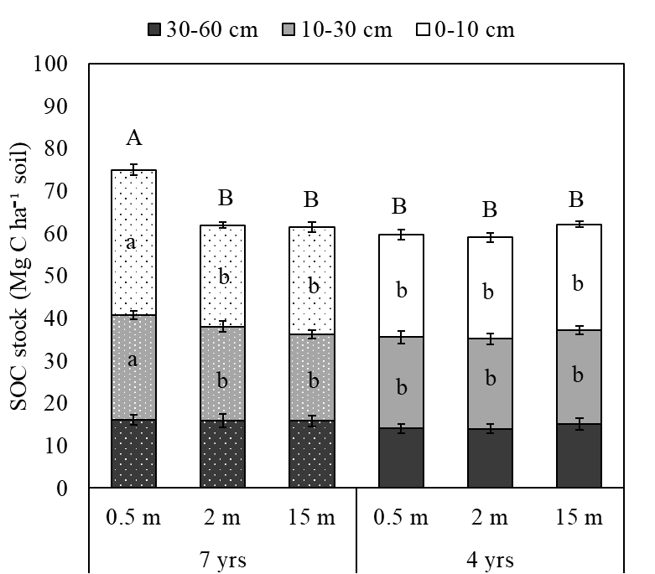
Figure 1.1. Depth-wise soil organic carbon stock by tree age and distance from tree base. Uppercase letters represent significant differences in total SOC stock from 0-60 cm while lowercase letters represent significant differences by depth increment based on Tukey HSD when p ≤ 0.05. Error bars represent standard error of the mean for each depth increment (n = 18).

SOC Fractions
The WEOC fraction showed a similar trend as SOC_{conc} in the 0-10 and 10-30 cm depth increments, where significantly higher concentrations were observed at 0.5 m from 7-year-old trees compared to other distances from both tree ages (p = 0.036 and p = 0.047, respectively) (Figure 1.2 A & B). However, WEOC did not vary by tree age or distance at 30-60 cm (Appendix A Table A.2). At 0-10 cm, the POXC fraction also exhibited a significant interaction effect (p < 0.0001) in which POXC was significantly higher at 0.5 m from 7-year-old trees compared to all other distances from both tree ages (Figure 1.2 C). In the 10-30 cm depth increment, POXC only varied by distance (p = 0.032), which resulted in significantly higher POXC at 0.5 m from trees compared to at 2 m but not significantly different from POXC at 15 m, independent of tree age (Figure 1.2 D). Below 30 cm, POXC did not vary by either tree age or distance from trees (Appendix A Table A.2). The MBC fraction showed no interaction or main effects at any depth (Appendix A Table A.2), although it was significantly higher in the 10-30 cm depth (257 ± 7.0 mg kg⁻¹) than at 0-10 cm (233 ± 5.4 mg kg⁻¹) (p = 0.0005).
Organic carbon concentration in POM and MAOM showed the same interaction effect at 0-10 cm as with SOC_{conc} and most C fractions (p = 0.017 and p = 0.002, respectively). Particulate organic matter-C in the top 0-10 cm was significantly higher at 0.5 m from 7-year-old trees (10.1 ± 1.3 g C kg⁻¹ soil) compared to that at farther distances while POM-C did not differ across distance from 4-year-old trees (Figure 1.3 A). Mineral associated organic matter-C in the top 0-10 cm was also significantly higher at 0.5 m from 7-year-old trees (17.4 ± 1.9 g C kg⁻¹ soil) compared to other distances while MAOM-C for 4-year-old trees did not vary across distance (Figure 1.3 C). In the 10-30 cm depth increment, the interaction effect of tree age*distance was only significant for MAOM-C (p = 0.032) and not for POM-C. The only significant differences
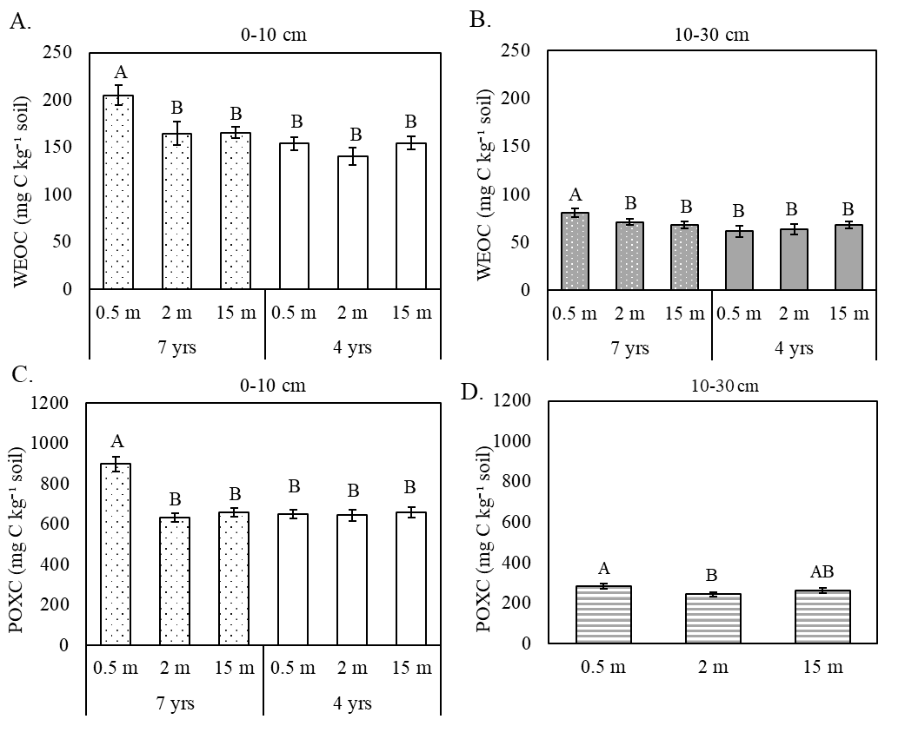
Figure 1.2. Water extractable organic carbon concentration at 0-10 cm (A) and 10-30 cm (B) and permanganate oxidizable carbon concentration at 0-10 cm (C) and 10-30 cm (D). Uppercase letters represent Tukey HSD when p ≤ 0.05 and error bars represent the standard error of the mean (n = 18).

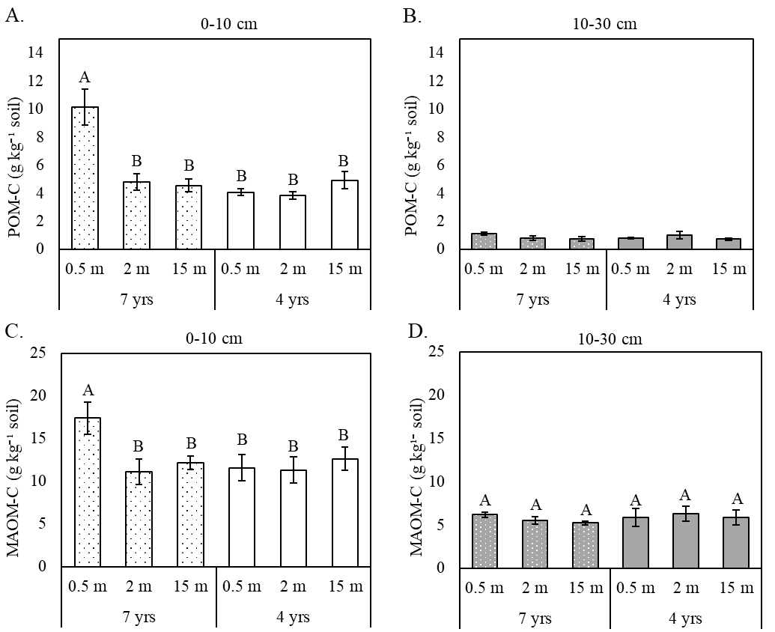

Figure 1.3. Particulate organic matter carbon at 0-10 cm (A) and 10-30 cm (B) and mineral-associated organic matter carbon at 0-10 cm (C) and 10-30 cm (D). Uppercase letters represent Tukey HSD when p ≤ 0.05 and error bars represent the standard error of the mean (n = 6).

in MAOM-C at 10-30 cm were observed between 0.5 m and 15 m from 7-year-old trees, in which MAOM-C was 18% more at 0.5 m than at 15 m, while MAOM-C did not vary across distance from 4-year-old trees at 10-30 cm (Figure 1.3 D).
The C/N ratio of POM did not differ at 0-10 or 10-30 cm depths (Appendix A Table A.2), which were 19.9 ± 0.756 and 38.6 ± 4.07, respectively. However, the C/N ratio of MAOM (MAOM-C/N) showed a significant interaction effect at 0-10 cm (p = 0.038) in which MAOM-C/N was significantly higher at 0.5 m from 7-year-old trees (10.4 ± 0.082) compared to other distances from both trees (Figure 1.4 A). At 10-30 cm, the mean MAOM-C/N was 10.0 ± 0.28; however, it exhibited no interaction or main effects (Appendix A Table A.2).
On average, POM-C comprised 19.6 ± 1.8% of total SOC at 0-10 cm and 11.7 ± 3.5% of total SOC at 10-30 cm; however, neither varied by the interaction or main effects (Appendix A Table A.2). The proportion of SOC comprised of MAOM-C (MAOM-C/SOC) in the top 0-10 cm only differed across distance from tree base (p = 0.026), with a significantly higher proportion of MAOM-C at 15 m (59.0 ± 0.79%) than at other distances (Figure 1.4 B). At 10-30 cm, the mean proportion of MAOM-C/SOC was 63.5 ± 3.3% but did not differ by the interaction or main effects alone (Appendix A Table A.2).
Root Biomass Carbon
Total root biomass C in the whole soil profile (0-60 cm) showed a significant interaction effect (p = 0.016). Total root biomass C did not vary across distance from 4-year-old trees but was highest at 0.5 m from 7-year-old trees (86% tree-derived root biomass C) and lowest at 15 m from 7-year-old trees (100% pasture-derived root biomass C) (Figure 1.5). Pasture root biomass C from 0-60 cm was not affected by the interaction or main effects (Appendix A Table A.2), while tree root biomass C varied by distance from tree base (p < 0.0001), with the most
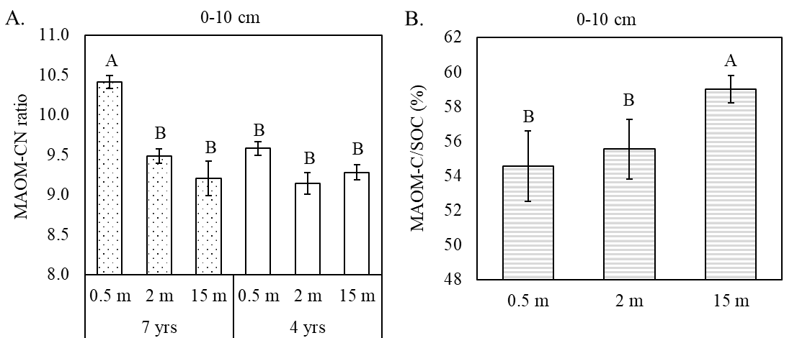
Figure 1.4. Mineral-associated organic matter carbon/nitrogen ratio (A) and proportion of SOC comprised of mineral-associated organic matter carbon (B) in the top 0-10 cm. Uppercase letters represent Tukey HSD when p ≤ 0.05 and error bars denote the standard error of the mean (n = 6).

abundance at 0.5 m (2.01 ± 1.07 Mg C ha⁻¹) compared to at 2 m (0.292 ± 0.147 Mg C ha⁻¹) and absent at 15 m.
Differences in total root biomass C across 0-60 cm were mainly driven by the differences found at 0-10 cm depth. At 0-10 cm, the age*distance interaction was significant (p = 0.0008) (Figure 1.6) with the total root biomass C was significantly higher at 0.5 m from 7-year-old trees (78% tree-derived root biomass C), which was comparable to total root biomass C at 2 and 15 m from 4-year-old trees (99.4% and 100% pasture-derived root biomass C, respectively). Total root biomass C at 0-10 cm was lowest at 2 and 15 m from 7-year-old trees and 0.5 m from 4-year-old trees. Although pasture root biomass C at 0-10 cm did not show a significant interaction or main effects (Appendix A Table A.2), tree root biomass C varied by distance (p = 0.018), as with the 0-60 cm. At 0-10 cm, tree root biomass C was significantly greater at 0.5 m from trees (1.27 ± 0.469 Mg C ha⁻¹) compared to at 2 m (0.172 ± 0.079 Mg C ha⁻¹) and absent at 15 m. At 10-30
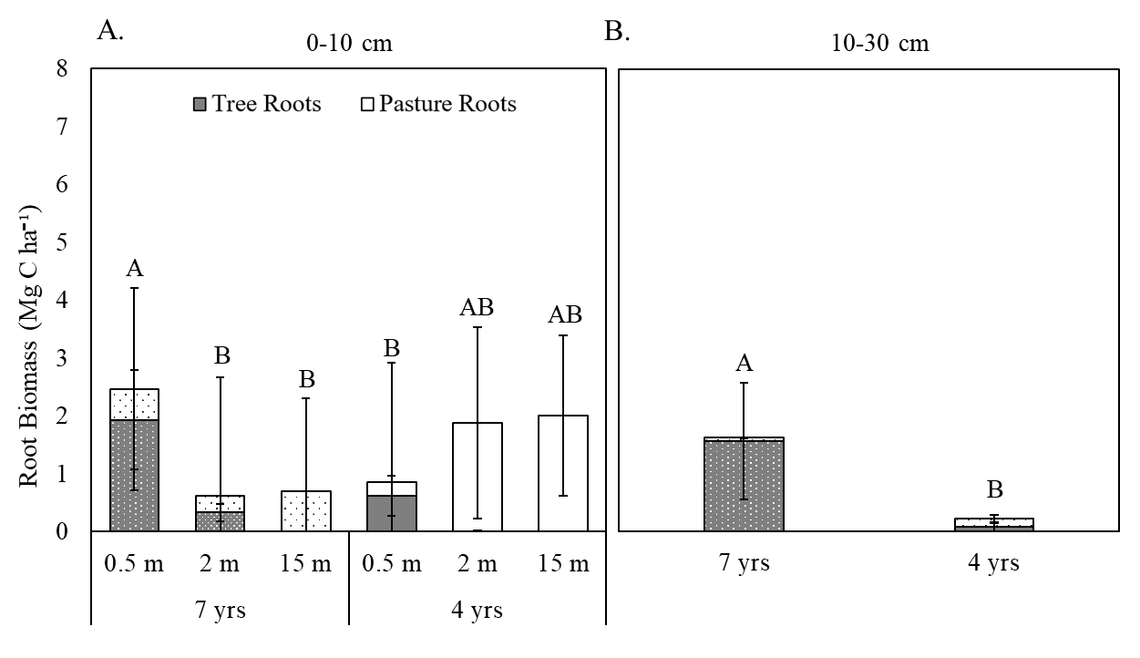
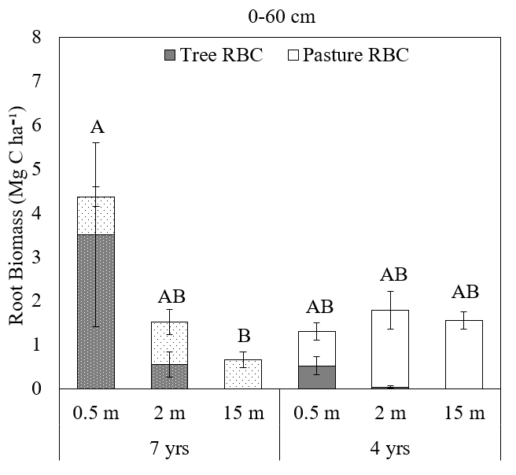
Figure 1.5. Root biomass carbon across distances from 7-year-old trees and 4-year-old trees from 0-60 cm. Dark gray represents tree root biomass C and light gray pasture root biomass C. Uppercase letters indicate Tukey HSD when p ≤ 0.05 and error bars represent the standard error of the mean (n = 18).

Figure 1.6. Root biomass carbon across distances from 7-year-old trees and 4-year-old trees at 0-10 cm (A) and by tree age at 10-30 cm (B). Dark gray represents tree root biomass C and light gray pasture root biomass C. Uppercase letters indicate Tukey HSD when p ≤ 0.05. Error bars represent the standard error of the means (n = 18).

1.6. Discussion
Effect of Tree Age and Distance on SOC Storage
This study revealed that 7-year-old chestnut trees increased SOC stock closest to the tree base (0.5 m) compared to 2 m and 15 m from tree base while 4-year-old trees had no effect on SOC (Figure 1.1). This increase in SOC was mostly manifested in topsoil (0-30 cm), which aligns with a meta-analysis by Mayer et al. (2022) on temperate regions AFS. This difference in SOC with tree age corroborates with a global meta-analysis by Feliciano et al. (2018), which found that AFS take several years after establishment to begin sequestering SOC. We found no variation in SOC stock across distance from 4-year-old trees, which could be due to initial native SOC loss due to tree planting (Takimoto et al., 2008; Feliciano et al., 2018). Trees increasingly return more C inputs to the soil as they age and accumulate above- and below-ground biomass (Casals et al., 2014; Upson et al., 2016; Valenzuela Que et al., 2022). Accordingly, the larger 7-year-old trees with a mean diameter at breast height of 9.07 ± 0.831 cm could be contributing more above-and below-ground plant inputs compared to 4-year-old trees with a mean diameter at breast height of 4.11 ± 0.677 cm.
Our results differ from most studies conducted in temperate region silvopastures which found little to no difference in SOC stock near trees within a silvopasture compared to a reference pasture-only system (Beckert et al., 2016; Upson et al., 2016 Cardinael et al., 2017; Orefice et al., 2025). Our results are, however, more consistent with sub-tropical and tropical region silvopasture studies, which exhibited higher SOC stock near trees compared to pasture-only systems (Haile et al., 2008; Casals et al., 2014; Morales Ruiz et al., 2021). This resemblance could be due to the warm temperate climatic conditions prevalent in our study region in the southeast United States, which is between temperate and sub-tropical. Even though pasture roots and animal excreta are likely the main sources of C between tree rows (15 m from trees), SOC formation may be stifled by the periodic grazing of above-ground grass biomass. Additionally, phenolic-rich tree residues could resist decomposition more than pasture grass inputs and favor SOC formation within proximity to trees (Adamczyk, 2024). In essence, these findings indicate trees could also be major drivers of SOC formation in temperate region AFS mainly because of the abundance of biomass C inputs compared to pasture forages (Beckert et al., 2016; Mayer et al., 2022).
Effect of Tree Age and Distance on SOC Fractions
All SOC fractions, except MBC, were higher near (0.5 m) older trees (7-years-old). Although we hypothesized that only active SOC fractions would increase closer to older trees, surprisingly, so did relatively stable MAOM-C. The effect of tree age and distance was less pronounced with increasing soil depth. Specifically, at 10-30 cm, age*distance only affected WEOC and MAOM-C, only distance affected POXC, and no clear effect was observed for POM-C. Below 30 cm, tree age and distance had no effect on any of the SOC fractions.
Since plant C inputs are the primary precursor of POM (Cotrufo & Lavallee, 2022), it is plausible that POM-C in the top 0-10 cm was significantly higher closer to older trees. Trees could have been the main contributor to POM-C since tree biomass is typically coarse (i.e. leaves, branches, woody roots) and the POM-C fraction is any OM >53 μm. Furthermore, older 7-year-old trees with greater diameter at breast height likely contributed more inputs than younger 4-year-old trees. Total root biomass C was also greater in the top 10 cm of soil closest to older trees and mostly tree derived. Therefore, trees could have contributed the most inputs in the top 10 cm from either above-ground litter deposition or woody root senescence. However, we cannot decipher the relative contribution of above- versus below-ground tree biomass inputs since we did not measure above-ground biomass.
The POXC fraction also exhibited the same pattern as POM-C at 0-10 cm, which was 36.6% greater 0.5 m from 7-year-old trees compared to 15 m and did not vary across distance from 4-year-old trees. No variation in POXC from 4-year-old trees corroborated with findings by Clivot et al. (2020). At 10-30 cm, POXC was significantly greater at 0.5 m compared to at 2 m, which may be indicating the low C input at this depth at 2 m. Since the POXC fraction is composed of predominantly phenolic compounds such as tannins and lignin (Woodings & Margenot, 2023), it is possible that trees are enhancing POXC since trees tend to have higher phenolic content than grasses, especially Chestnut trees (Chang et al., 2020; Silva et al., 2020; Xu et al., 2020). This could explain the higher concentration of POXC near older trees in the top 0-10 cm.
The WEOC fraction was also highest closest to older trees both at 0-10 and 10-30 cm depths. Although the WEOC fraction undergoes seasonal fluctuations, it is strongly controlled by vegetation type and amount of plant inputs (Chantigny, 2003; Lange et al., 2021). Therefore, higher WEOC concentrations closer to older trees could also indicate the abundance of tree-derived OM inputs from larger trees. Plant diversity is also known to influence the amount of dissolved OC (Lange et al., 2021). Previous studies have demonstrated that multi-species systems tend to promote more WEOC than single-species systems (Beckert et al., 2016; Lim et al., 2018). Therefore, the combination of tree inputs, pasture inputs, and livestock excrement at 0.5 m from older trees might have promoted more WEOC formation compared to at 15 m from trees which did not receive tree inputs. Higher concentrations of WEOC in the 10-30 cm depth within proximity of older trees could be a result of the downward movement of dissolved forms of C from the 0-10 cm depth as observed in other studies (Sanderman, 2008; Lorenz & Lal, 2014; Shi et al., 2018).
Dissolved forms of organic C are highly bioavailable to microorganisms. Together with microbial necromass and byproducts, dissolved organic C binds to mineral surfaces to form MAOM (Lugato et al., 2021). This could explain why MAOM-C was also higher closest to older trees in the 0-10 cm and 10-30 cm depth increments, with a similar trend as WEOC. Previous studies on the heavy MAOM-C fraction of temperate region AFS, especially silvopastures, are extremely limited and do not show a clear pattern (Beck et al., 2016; Clivot et al., 2020; Santos et al., 2024), making this result difficult to compare with other similar systems. However, it is remarkable to notice the effect of trees on the MAOM-C fraction just 7 years after establishment even though MAOM-C is less sensitive to short-term changes in land management (Cotrufo & Lavallee, 2022).
The C/N ratio of MAOM-C in the 0-10 cm depth was notably higher closest to older trees, which could be explained by quantity and quality of tree residue inputs. Given the evidence of more tree-derived inputs closer to older trees and the higher C/N ratio of tree biomass compared to grass biomass, tree rhizodeposition and root exudation may be contributing to WEOC with a higher C/N ratio. These low molecular weight compounds of plant-origin have been shown to form mineral-associations, granted at a lower abundance compared to molecules of microbial-origin (Angst et al., 2021; Whalen et al., 2022).
We would expect MBC to reflect the same distribution as WEOC and MAOM since microbes utilize the WEOC fraction for growth and microbial necromass facilitates MAOM formation; however, MBC did not vary by tree age or distance even in the top depth. Additionally, MBC was higher at 10-30 cm compared to 0-10 cm, which is not observed in most previous studies which found higher MBC in the topsoil of AFS (Cardinael et al., 2020, Guillot et al., 2021). However, these studies were conducted on more mature AFS with trees at least 20-years-old. As for a younger AFS, Zhang et al. (2017) found that previous land use was a stronger controlling factor on MBC than climate or plant species. Zhang et al. (2017) observed a net increase in MBC when bare land was transitioned to an AFS while transitioning a forest to an AFS resulted in a net decrease in MBC. Given our study recently transitioned from a continuously grazed pasture to a rotationally grazed silvopasture, no change in MBC by tree age or distance is reasonable since older, intensively grazed grasslands are known to support abundant microbial populations (Yi et al., 2014; Lin et al., 2020).
Below-Ground C Inputs
Plant residues can come from above-ground as litter or below-ground as root exudates and turnover (Shi et al., 2018). While we did not quantify above-ground biomass of trees or pasture forages, we did quantify their below-ground biomass as root biomass C to identify the source of biomass which can drive SOC formation (Dijkstra et al., 2021; Yang et al., 2023). Root biomass C was calculated to understand the abundance of below-ground biomass-C that could be contributing to SOC formation via root exudates and senescence from trees compared to pasture grasses (Upson & Burgess, 2013; Yang et al., 2023). Root biomass C was concentrated in the top 10 cm, which is consistent with other studies (February et al., 2013; Upson & Burgess, 2013; Morales Ruiz et al., 2021). While trees in AFS tend to grow deep rooting systems to avoid competition with pasture grasses (Lorenz & Lal, 2014; Shi et al., 2018), our results demonstrate that tree roots were also dominant in the top 0-10 cm when in proximity to trees (0.5 m). These findings corroborate with a study on root length and root C content by Kumar et al. (2010) which found that both were significantly greater for agroforestry buffers compared to rotationally grazed pastures. Yang et al. (2023) also found that actively growing roots contribute significantly to SOC than decaying roots, suggesting that live tree roots could contribute more to SOC than pasture forage roots which must re-grow periodically after grazing.
The abundance of tree roots and scarcity of pasture roots at the 10-30 cm depth may allow trees to access to resources (Sharrow, 1999; Lorenz & Lal, 2014). Tree roots at this depth could have been contributing to greater SOC stock 0.5 m from 7-year-old trees by excreting root exudates, which could have driven greater WEOC at this depth, and from root senescence, which would have driven greater POXC 0.5 m from trees at this depth. Root biomass C inputs from older trees at the 10-30 cm depth may by more effective at building SOC, given these inputs are more protected from decomposition than biomass inputs at the soil surface (Nair et al., 2009; Lorenz & Lal, 2014).
While pasture root biomass C down to 60 cm did not vary by tree age or distance, it was numerically lower at 2 and 15 m from 7-year-old trees compared to those distance from 4-year-old trees. This effect was observed only in the top 10 cm, where pasture roots were most abundant. Lower pasture root biomass C at 2 and 15 m from older trees is not likely from shading by canopies of older trees, since these trees did not cast continuous shade at these distances. Therefore, this was most likely due to the greater capacity for older trees to outcompete pasture forages in nutrient scavenging thanks to their deep rooting system (Sharrow, 1999; Schenk, 2006). The allelopathic effect of mature Chestnut trees are also known to inhibited germination of many plants, thus could have prevented re-seeding of many pasture forages within proximity to older trees (Cummings et al., 2012). However, we cannot say with certainty since we did not measure pasture above-ground biomass.

1.7. Conclusion
This study improves our understanding of SOC storage and stabilization within temperate region AFS, specifically focusing on silvopastures, which receive diverse C inputs from trees, pasture forages, and animal excretions. By studying the SOC accumulation at 2 different tree ages and 3 distances from trees, we were able to assess the role of trees in SOC accumulation and stabilization in these systems. Our results revealed that tree age and distance significantly influence SOC storage by promoting the formation of multiple SOC fractions including the relatively stable MAOM-C. Both above-ground (leaf litter) and below-ground (root turnover and exudates) biomass-C inputs from trees appear to play vital roles in enhancing SOC storage within proximity to trees as they age. This emphasizes the importance of tree characteristics in determining the C sequestration potential of silvopastures. Given the urgency of mitigating climate change, agroforestry practices, particularly silvopasture systems, present a promising opportunity to store C in soil and biomass while maintaining productive agricultural landscapes in temperate regions. This study only considered tree age and spatial distance from tree base, but future research should further explore how other tree characteristics including tree type, management, and planting density in temperate region silvopastures affect SOC accumulation, particularly in the MAOM-C fraction, which could inform more targeted and effective C sequestration strategies.

References
Adamczyk, B. (2024). Tannins and climate change: are tannins able to stabilize carbon
in the soil?. Journal of Agricultural and Food Chemistry, 72 (16), 8928-8932. https://doi.org/10.1021/acs.jafc.4c00703
Adeleke, R., Nwangburuka, C., & Oboirien, B. (2017). Origins, roles and fate of organic
acids in soils: A review. South African Journal of Botany, 108, 393-406. https://doi/pdfdirect/10.1002/saj2.20003
Al‐Kaisi, M. M., & Kwaw‐Mensah, D. (2020). Quantifying soil carbon change in a long
term tillage and crop rotation study across Iowa landscapes. Soil Science Society of America Journal, 84(1), 182-202. https://doi/pdfdirect/10.1002/saj2.20003
Angst, G., Mueller, K. E., Nierop, K. G., & Simpson, M. J. (2021). Plant- or microbial
derived? A review on the molecular composition of stabilized soil organic
matter. Soil Biology and Biochemistry, 156, 108189. https://doi.org/10.1016/j.soilbio.2021.108189
Ashworth, A. J., Adams, T., Kharel, T., Philipp, D., Owens, P., & Sauer, T. (2021). Root
decomposition in silvopastures is influenced by grazing, fertility, and grass
species. Agrosystems, Geosciences & Environment, 4(3), e20190. https://doi/pdf/10.1002/agg2.20190
Bartlett, R.J., & Ross, D.S. (1988). Colorimetric determination of oxidizable carbon in
acid soil solutions. Soil Science Society of America Journal, 52, 1191-1192. 202https://doi.org/10.2136/sssaj1988.03615995005200040055x
Beck, T., Joergensen, R. G., Kandeler, E., Makeschin, F., Nuss, E., Oberholzer, H. R.,
& Scheu, S. (1997). An inter-laboratory comparison of ten different ways of
measuring soil microbial biomass C. Soil Biology and Biochemistry, 29(7), 1023
1032. https://doi.org/10.1016/S0038-0717(97)00030-8
Becker, A. E., Horowitz, L. S., Ruark, M. D., & Jackson, R. D. (2022). Surface‐soil
carbon stocks greater under well‐managed grazed pasture than row crops. Soil Science Society of America Journal, 86(3), 758-768. https://doi.org/10.1002/saj2.20388
Beckert, M. R., Smith, P., Lilly, A., & Chapman, S. J. (2016). Soil and tree biomass
carbon sequestration potential of silvopastoral and woodland-pasture systems in Northeast Scotland. Agroforestry Systems, 90, 371-383. https://doi.org/10.1007/s10457-015-9860-4
Cardinael, R., Chevallier, T., Guenet, B., Girardin, C., Cozzi, T., Pouteau, V., & Chenu,
C. (2020). Organic carbon decomposition rates with depth and contribution of inorganic carbon to CO2 emissions under a Mediterranean agroforestry system. European Journal of Soil Science, 71(5), 909-923. https://doi.org/10.1111/ejss.12908
Cardinael, R., Mao, Z., Chenu, C., & Hinsinger, P. (2020b). Belowground functioning of
agroforestry systems: Recent advances and perspectives. Plant and Soil, 453, 1-13. https://doi.org/10.1007/s11104-020-04633-x
Cardinael, R., Chevallier, T., Cambou, A., Béral, C., Barthès, B. G., Dupraz, C., Durand,
C., Kouakoua, E., & Chenu, C. (2017). Increased soil organic carbon stocks under agroforestry: A survey of six different sites in France. Agriculture, Ecosystems & Environment, 236, 243-255. https://doi.org/10.1016/j.agee.2016.12.011
Casals, P., Romero, J., Rusch, G. M., & Ibrahim, M. (2014). Soil organic C and nutrient
contents under trees with different functional characteristics in seasonally dry
tropical silvopastures. Plant and Soil, 374, 643-659. https://doi.org/10.1007/s11104-013-1884-9
Chang, X., Liu, F., Lin, Z., Qiu, J., Peng, C., Lu, Y., & Guo, X. (2020). Phytochemical
profiles and cellular antioxidant activities in chestnut (Castanea mollissima BL.) kernels of five different cultivars. Molecules, 25(1), 178. http://dx.doi.org/10.3390/molecules25010178
Chantigny, M. H. (2003). Dissolved and water-extractable organic matter in soils: A
review on the influence of land use and management practices. Geoderma, 113(3-4), 357380. https://doi.org/10.1016/S0016-7061(02)00370-1
Christy, I., Moore, A., Myrold, D., & Kleber, M. (2023). A mechanistic inquiry into the
applicability of permanganate oxidizable carbon as a soil health indicator. Soil Science Society of America Journal, 87(5), 1083-1095. https://doi.org/10.1002/saj2.20569
Clivot, H., Petitjean, C., Marron, N., Dallé, E., Genestier, J., Blaszczyk, N., Santenoise,
P., Laflotte, A., & Piutti, S. (2020). Early effects of temperate agroforestry practices on soil organic matter and microbial enzyme activity. Plant and Soil, 453, 189-207. https://doi.org/10.1007/s11104-019-04320-6
Cotrufo, M. F., & Lavallee, J. M. (2022). Soil organic matter formation, persistence, and
functioning: A synthesis of current understanding to inform its conservation and
regeneration. Advances in Agronomy, 172, 1-66. https://doi.org/10.1016/bs.agron.2021.11.002
Culman, S. W., Hurisso, T. T., & Wade, J. (2021). Permanganate oxidizable carbon: An
indicator of biologically active soil carbon. Soil Health Series: Volume 2 Laboratory Methods for Soil Health Analysis, 152-175. Agronomic Society of America, Crop Science Society of America, Soil Science Society of America Books. https://doi.org/10.1002/9780891189831.ch9
Dane, J. H., & Topp, C. G. (Eds.). (2020). Methods of soil analysis, part 4: Physical
methods (Vol. 20). John Wiley & Sons.
De Stefano, A., & Jacobson, M. G. (2018). Soil carbon sequestration in agroforestry
systems: a meta-analysis. Agroforestry systems, 92, 285-299. https://doi.org/10.1007/s10457-017-0147-9
Dijkstra, F. A., Zhu, B., & Cheng, W. (2021). Root effects on soil organic carbon: a
double edged sword. New Phytologist, 230(1), 60-65. https://doi.org/10.1111/nph.17082
Dungait, J.A., Hopkins, D.W., Gregory, A.S., & Whitmore, A.P. (2012). Soil organic
matter turnover is governed by accessibility not recalcitrance. Global Change Biology, 18(6), 1781-1796. https://doi.org/10.1111/j.1365-2486.2012.02665.x
February, E. C., Cook, G. D., & Richards, A. E. (2013). Root dynamics influence tree-
grass coexistence in an Australian savanna. Austral Ecology, 38(1), 66-75. https://doi.org/10.1111/j.1442-9993.2012.02376.x
Feliciano, D., Ledo, A., Hillier, J., & Nayak, D. R. (2018). Which agroforestry options
give the greatest soil and above ground carbon benefits in different world regions? Agriculture, Ecosystems & Environment, 254, 117-129. https://doi.org/10.1016/j.agee.2017.11.032
Food and Agriculture Organization (FAO) of the United Nations. (2015, October 23).
Agroforestry. https://www.fao.org/forestry/agroforestry/80338/en/
Fornara, D. A., Olave, R., Burgess, P., Delmer, A., Upson, M., & McAdam, J. (2018).
Land use change and soil carbon pools: evidence from a long-term silvopastoral
experiment. Agroforestry Systems, 92, 1035-1046. https://doi.org/10.1007/s10457-017-0124-3
Franzluebbers, A. J. (2002). Soil organic matter stratification ratio as an indicator of soil
quality. Soil and Tillage Research, 66(2), 95-106. https://doi.org/10.1016/S0167-1987(02)00018-1
Freschet, G. T., Pagès, L., Iversen, C. M., Comas, L. H., Rewald, B., Roumet, C.,
Klimešová, J., Zadworny, M., Poorter, H., Postma, J. A., Adams, T. S., Bagniewska-Zadworna, A., Bengough, A. G., Blancaﬂor, E. B., Brunner, I., Cornelissen, J. H. C., Garnier, E., Gessler, A., … & McCormack, M. L. (2021). A starting guide to root ecology: strengthening ecological concepts and standardising root classification, sampling, processing and trait measurements. New Phytologist, 232(3), 973-1122. https://doi.org/10.1111/nph.17572
Garrett, H. E. G., Jose, S., & Gold, M. A. (Eds.). (2022). North American agroforestry
(Vol. 194). John Wiley & Sons.
Georgiou, K., Jackson, R. B., Vindušková, O., Abramoff, R. Z., Ahlström, A., Feng, W.,
Harden, J. W., Pellegrini A. F. A., Polley, H. W., Soong, J. L., Riley, W. J., & Torn, M. S. (2022). Global stocks and capacity of mineral-associated soil organic carbon. Nature Communications, 13(1), 3797. https://doi.org/10.1038/s41467-022-31540-9
Guillot, E., Bertrand, I., Rumpel, C., Gomez, C., Arnal, D., Abadie, J., & Hinsinger, P.
(2021). Spatial heterogeneity of soil quality within a Mediterranean alley cropping agroforestry system: Comparison with a monocropping system. European Journal of Soil Biology, 105, 103330. https://doi.org/10.1016/j.ejsobi.2021.103330
Haile, S. G., Nair, P. R., & Nair, V. D. (2008). Carbon storage of different soil‐size
fractions in Florida silvopastoral systems. Journal of Environmental Quality, 37(5), 1789-1797. https://doi.org/10.2134/jeq2007.0509
IPCC (2023). Climate Change 2023: Synthesis Report. Contribution of Working Groups I,
II and III to the Sixth Assessment Report of the Intergovernmental Panel on Climate Change [Core Writing Team, H. Lee and J. Romero (eds.)]. IPCC, Geneva, Switzerland, pp. 35-115. https://doi.org/10.59327/IPCC/AR6-9789291691647
Kemper, W. D., & Rosenau, R. C. (1986). Aggregate stability and size
Distribution. Methods of soil analysis: Part 1 Physical and mineralogical methods, 5, 425-442. John Wiley & Sons. https://doi.org/10.2136/sssabookser5.1.2ed.c17
Krauss, M., Berner, A., Perrochet, F., Frei, R., Niggli, U., & Mäder, P. (2020). Enhanced
soil quality with reduced tillage and solid manures in organic farming–a synthesis of 15 years. Scientific Reports, 10(1), 1-12. https://doi.org/10.1038/s41598-020-61320-8
Kumar, S., Udawatta, R. P. & Anderson, S. H. (2010). Root length density and carbon
content of agroforestry and grass buffers under grazed pasture systems in a Hapludalf. Agroforestry Systems, 80, 85-96. https://doi.org/10.1007/s10457-010-9312-0
Lal, R., Kimble, J. M., Follett, R. F., & Cole, C. V. (1998). The potential of US cropland
to sequester carbon and mitigate the greenhouse effect. Lewis Publishers.
Lange, M., Roth, V. N., Eisenhauer, N., Roscher, C., Dittmar, T., Fischer‐Bedtke, C.,
González Macé, O., Hildebrandt, A., Milcu, A., Mommer, L., Oram, N. J., Ravenek, J., Scheu, S., Schmid, B., Strecker, T., Wagg, C., Weigelt A., & Gleixner, G. (2021). Plant diversity enhances production and downward transport of biodegradable dissolved organic matter. Journal of Ecology, 109(3), 1284-1297. https://doi.org/10.1111/1365-2745.13556
Lehnhoff, E., Miller, Z., Miller, P., Johnson, S., Scott, T., Hatfield, P., & Menalled, F. D.
(2017). Organic agriculture and the quest for the Holy Grail in water-limited ecosystems: managing weeds and reducing tillage intensity. Agriculture, 7(4), 33. https://doi.org/10.3390/agriculture7040033
Lim, S. S., Baah-Acheamfour, M., Choi, W. J., Arshad, M. A., Fatemi, F., Banerjee, S.,
Carlyle, C. N., Bork, E. W., Park, H., & Chang, S. X. (2018). Soil organic carbon stocks in three Canadian agroforestry systems: From surface organic to deeper mineral soils. Forest Ecology and Management, 417, 103-109. https://doi.org/10.1016/j.foreco.2018.02.050
Lin, D., McCulley, R. L., Nelson, J. A., Jacobsen, K. L., & Zhang, D. (2020). Time in
pasture rotation alters soil microbial community composition and function and increases carbon sequestration potential in a temperate agroecosystem. Science of the Total Environment, 698, 134233. https://doi.org/10.1016/j.scitotenv.2019.134233
Lorenz, K., & Lal, R. (2014). Soil organic carbon sequestration in agroforestry systems.
A review. Agronomy for Sustainable Development, 34, 443-454. https://doi.org/10.1007/s13593-014-0212-y
Lugato, E., Lavallee, J. M., Haddix, M. L., Panagos, P., & Cotrufo, M. F. (2021).
Different climate sensitivity of particulate and mineral-associated soil organic matter. Nature Geoscience, 14(5), 295-300. https://doi.org/10.1038/s41561-021-00744-x
Ma, Z., Chen, H. Y., Bork, E. W., Carlyle, C. N., & Chang, S. X. (2020). Carbon
accumulation in agroforestry systems is affected by tree species diversity, age and regional climate: A global meta‐analysis. Global Ecology and Biogeography, 29(10), 1817-1828. https://doi.org/10.1111/geb.13145
Mayer, S., Wiesmeier, M., Sakamoto, E., Hübner, R., Cardinael, R., Kühnel, A., & Kögel
Knabner, I. (2022). Soil organic carbon sequestration in temperate agroforestry systems–A meta-analysis. Agriculture, Ecosystems & Environment, 323, 107689. https://doi.org/10.1016/j.agee.2021.107689
Morales Ruiz, D. E., Aryal, D. R., Pinto Ruiz, R., Guevara Hernandez, F., Casanova
Lugo, F., & Villanueva Lopez, G. (2021). Carbon contents and fine root production in tropical silvopastoral systems. Land Degradation & Development, 32(2), 738-756. https://doi.org/10.1002/ldr.3761
Nair, P. R., Nair, V. D., Kumar, B. M., & Showalter, J. M. (2010). Carbon sequestration
in agroforestry systems. Advances in agronomy, 108, 237-307. https://doi.org/10.1016/S0065-2113(10)08005-3
Oelbermann, M., Voroney, R. P., & Gordon, A. M. (2004). Carbon sequestration in
tropical and temperate agroforestry systems: a review with examples from Costa Rica and southern Canada. Agriculture, Ecosystems & Environment, 104(3), 359-377. https://doi.org/10.1016/j.agee.2004.04.001
Orefice, J., Smith, M. M., Weinberg, W. C. & Batcheler, M. (2025). Carbon dynamics of
silvopasture systems in the Northeastern United States. Scientific Reports, 15(1), 6995. https://doi.org/10.1038/s41598-025-91268-6
Poeplau, C., Don, A., Six, J., Kaiser, M., Benbi, D., Chenu, C., Cotrufo, M. F., Derrien,
D., Gioacchini, P., Grand, S., Gregorich, E., Griepentrong, M., Gunina, A., Haddix, M., Kuzyakov, Y., Kühnel, A., Macdonald, L. M., Soong, J., Trigalet, S., … & Nieder, R. (2018). Isolating organic carbon fractions with varying turnover rates in temperate agricultural soils–A comprehensive method comparison. Soil Biology and Biochemistry, 125, 10-26. https://doi.org/10.1016/j.soilbio.2018.06.025
Provin, T. (2014). Soil test methods from the southeastern United States. Unit 5: Soil
organic matter. Chapter 5.2: Total carbon and nitrogen and organic carbon via thermal combustion analyses. Southern Cooperative Series Bulletin, 419 (149-154).
National Weather Service. (2024). NOAA Online Weather Data (NOWData). National
Oceanic and Atmospheric Administration. Retried from https://www.weather.gov/wrh/climate
Nair, P. K. R., Kumar, B. M., & Nair, V. D. (2009). Agroforestry as a
strategy for carbon sequestration. Journal of Plant Nutrition & Soil Science, 172(1), 10-23. https://doi.org/10.1002/jpln.200800030
RStudio Team (2024). RStudio Integrated Development Environment for R. Posit Software,
PBC, Boston, MA.
Sanderman, J., Baldock, J. A., & Amundson, R. (2008). Dissolved organic carbon
chemistry and dynamics in contrasting forest and grassland soils. Biogeochemistry, 89, 181-198. https://doi.org/10.1007/s10533-008-9211-x
Santos, J. A. D., Santos, A. D. D. D., Costa, C. R., Araujo, A. S. D., Leite, G. G., Coser,
T. R., & Figueiredo, C. C. D. (2024). Fractions of organic matter and soil carbon balance in different phases of an agroforestry system in the Cerrado: A ten-year field assessment. Soil Systems, 8(2), 44. https://doi.org/10.3390/soilsystems8020044
Sayer, E. J., Baxendale, C., Birkett, A. J., Bréchet, L. M., Castro, B., Kerdraon-Byrne, &
D., Lopez-Sangil, L., & Rodtassana, C. (2021). Altered litter inputs modify carbon and nitrogen storage in soil organic matter in a lowland tropical forest. Biogeochemistry, 156, 115-130. https://doi.org/10.1007/s10533-020-00747-7
Schenk, H. J. (2006). Root competition: beyond resource depletion. Journal of Ecology,
94(4), 725-739. https://doi.org/10.1111/j.1365-2745.2006.01124.x
Scott-Denton, L. E., Rosenstiel, T. N., Monson, R. K. (2006). Differential controls by
climate and substrate over the heterotrophic and rhizospheric components of soil respiration. Global Change Biology, 12, 205–216. https://doi.org/10.1111/j.1365-2486.2005.01064.x
Sharrow, S. H. (1999). Silvopastoralism: competition and facilitation between trees,
livestock, and improved grass-clover pastures on temperate rainfed lands. Agroforestry in sustainable agricultural systems (113-130). Lewis Publ., NY, USA.
Shi, L., Feng, W., Xu, J., & Kuzyakov, Y. (2018). Agroforestry systems: Meta‐analysis of
soil carbon stocks, sequestration processes, and future potentials. Land Degradation & Development, 29(11), 3886-3897. https://doi.org/10.1002/ldr.3136
Siddique, I. A., Grados, D., Chen, J., Lærke, P. E., & Jørgensen, U. (2023). Soil organic
carbon stock change following perennialization: a meta-analysis. Agronomy for Sustainable Development, 43(5), 58. https://doi.org/10.1007/s13593-023-00912-w
Silva, V., Falco, V., Dias, M. I., Barros, L., Silva, A., Capita, R., ... & Poeta, P. (2020).
Evaluation of the phenolic profile of Castanea sativa Mill. by-products and their antioxidant and antimicrobial activity against multiresistant bacteria. Antioxidants, 9(1), 87. https://doi.org/10.3390/antiox9010087
Takimoto, A., Nair, V. D., & Nair, P. K. (2008). Contribution of trees to soil carbon
sequestration under agroforestry systems in the West African Sahel. Advances in Agroforestry, 11-25. Springer, Dordrecht. https://doi.org/10.1007/s10457-008-9179-5
Upson, M. A., & Burgess, P. J. (2013). Soil organic carbon and root distribution in a
temperate arable agroforestry system. Plant and Soil, 373, 43-58. https://doi.org/10.1007/s11104-013-1733-x
Upson, M. A., Burgess, P. J., & Morison, J. I. L. (2016). Soil carbon changes after
establishing woodland and agroforestry trees in a grazed pasture. Geoderma, 283, 10-20. https://doi.org/10.1016/j.geoderma.2016.07.002
Valenzuela Que, F. G., Villanueva‐López, G., Alcudia‐Aguilar, A., Medrano‐Pérez, O.
R., Cámara‐Cabrales, L., Martínez‐Zurimendi, P., Casanova-Lugo, F., & Aryal, D. R. (2022). Silvopastoral systems improve carbon stocks at livestock ranches in Tabasco, Mexico. Soil Use and Management, 38(2), 1237-1249. https://doi.org/10.1111/sum.12799
Vance, E. D., Brookes, P. C., & Jenkinson, D. S. (1987). An extraction method for
measuring soil microbial biomass C. Soil Biology and Biochemistry, 19(6), 703-707. https://doi.org/10.1016/0038-0717(87)90052-6
Waldron, A., Garrity, D., Malhi, Y., Girardin, C., Miller, D. C., & Seddon, N. (2017).
Agroforestry can enhance food security while meeting other sustainable development goals. Tropical Conservation Science, 10, 1940082917720667. https://doi.org/10.1177/1940082917720667
Whalen, E. D., Grandy, A. S., Sokol, N. W., Keiluweit, M., Ernakovich, J., Smith, R. G.,
& Frey, S. D. (2022). Clarifying the evidence for microbial‐and plant‐derived soil organic matter, and the path toward a more quantitative understanding. Global Change Biology, 28(24), 7167-7185. https://doi.org/10.1111/gcb.16413
Woodings, F. S., & Margenot, A. J. (2023). Revisiting the permanganate oxidizable
carbon (POXC) assay assumptions: POXC is lignin sensitive. Agricultural & Environmental Letters, 8(1), e20108. https://doi.org/10.1002/ael2.20108
Xu, Z., Meenu, M., Chen, P., & Xu, B. (2020). Comparative study on phytochemical
profiles and antioxidant capacities of chestnuts produced in different geographic area in China. Antioxidants, 9(3), 190. https://www.mdpi.com/2076-3921/9/3/190
Yang, X., Wang, B., Fakher, A., An, S., & Kuzyakov, Y. (2023). Contribution of roots to
soil organic carbon: From growth to decomposition experiment. Catena, 231, 107317. https://doi.org/10.1016/j.catena.2023.107317
Yi, W. A. N. G., Wen-Xia, D. U. A. N., Tu, C., Washburn, S., Cheng, L., & Hu, S. (2014).
Soil carbon, nitrogen and microbial dynamics of pasturelands: impacts of grazing intensity and planting systems. Pedosphere, 24(3), 408-416. https://doi.org/10.1016/S1002-0160(14)60027-8
Zhang, Q., Yang, J., Koide, R. T., Li, T., Yang, H., & Chu, J. (2017). A meta-analysis of
soil microbial biomass levels from established
tree plantations over various land uses, climates and plant communities. Catena, 150, 256-260. https://doi.org/10.1016/j.catena.2016.11.02

Appendix

Appendix A. Tables & Figures
Table A.1. Basic soil properties of the agroforestry system averaged across fields by depth increment. Mean ± standard error.
Soil Properties | 0-10 | 10-30 |  | 30-60
Soil Properties | ------------------------------------------Depth (cm)--------------------------------------
Textural class ª | Loam |  | Loam |  | Clay Loam
Clay (%) | 22.2 ± 1.5 |  | 25.0 ± 1.9 |  | 32.8 ± 2.8
Silt (%) | 33.3 ± 7.6 |  | 42.8 ± 2.2 |  | 35.6 ± 4.4
Sand (%) | 44.4 ± 6.8 |  | 32.2 ± 1.1 |  | 31.7 ± 1.7
Bulk density (g cm־³) | 1.11 ± 0.015 |  | 1.24 ± 0.013 |  | 1.33 ± 0.016
Mean weight diameter ^{b} (mm) | 3.42 ± 0.16 |  | 1.64 ± 0.056 |  | 0.889 ± 0.016
Electrical conductivity ^{c} (μS cm־³) | 105 ± 4.0 |  | 44.9 ± 2.9 |  | 26.9 ± 2.8
pH ^{c} | 6.77 ± 0.027 |  | 6.00 ± 0.061 |  | 5.94 ± 0.066
Total Nitrogen ^{d} (g kg־¹) | 1.24 ± 0.0071 |  | 0.958 ± 0.0066 |  | 0.859 ± 0.0029
Available Phosphorus ^{e} (mg kg־¹) | 53.7 ± 18 |  | 24.2 ± 5.3 |  | 21.7 ± 4.8
Available Potassium ^{e} (mg kg־¹) | 176 ± 26 |  | 66.6 ± 13 |  | 41.2 ± 9.9
ª Determined by the hydrometer method using 30 g samples of air dry, 2 mm sieved soils (Gee & Or, 2002; Gavlak et al., 2005).
^{b} Determined using a modified Yoder Apparatus on a 30 g samples of air dry, 8-4 mm sieved soil (Kemper & Rosenau, 1986).
^{c} Measured after shaking 5 g air-dried 2 mm soil with 10 mL deionized water at 200 rpm for 30 minutes (Sikora & Kissel, 2014).
^{d} Measured by dry combustion method using the vario MAX Cube CN analyzer (Elementar, Hanau, Germany) on pulverized soil (Provin, 2014).
^{e} Extracted using 5 g air-dried 2 mm soil and 20 mL Mehlich-I solution, filtered through Q5 filter paper (5- 10µm particle retention) (Mylavarapu & Miller, 2014), and analyzed by inductively coupled plasma – optical emission spectrometry at the University of Georgia Agricultural & Environmental Services Laboratory.

Table A.2. Analysis of variance p-values for the interaction term of age*distance and the main effects when the interaction was not significant (α = 0.05). Significant p-values are highlighted in bold letters.
 | Age*Distance |  |  | Age |  |  | Distance
 | df | F | p | df | F | p | df | F | p
SOC stock
(Mg C ha⁻¹)
0-60 cm | 2 | 14.98 | <0.0001
0-10 cm | 2 | 22.24 | <0.0001
10-30 cm | 2 | 5.44 | 0.0064
30-60 cm | 2 | 0.25 | 0.78 | 1 | 0.68 | 0.42 | 2 | 0.11 | 0.89
SOC_{conc}
(g kg⁻¹)
0-10 cm | 2 | 57.04 | <0.0001
10-30 cm | 2 | 4.87 | 0.01
30-60 cm | 2 | 0.31 | 0.73 | 1 | 0.49 | 0.50 | 2 | 0.08 | 0.93
Stratification Ratio of SOC_{conc} | 2 | 11.11 | <0.0001
WEOC
(mg kg⁻¹)
0-10 cm | 2 | 3.43 | 0.036
10-30 cm | 2 | 3.16 | 0.047
30-60 cm | 2 | 1.5 | 0.2287 | 1 | 1.83 | 0.25 | 2 | 0.23 | 0.80
POXC
(mg kg⁻¹)
0-10 cm | 2 | 19.96 | <0.0001
10-30 cm | 2 | 2.72 | 0.073 | 1 | 0.34 | 0.57 | 2 | 3.61 | 0.032
30-60 cm | 2 | 2.71 | 0.074 | 1 | 0.49 | 0.50 | 2 | 0.08 | 0.93

Table A.2. Continued.
 | Age*Distance |  |  | Age |  |  | Distance
 | df | F | p | df | F | p | df | F | p
MBC
(mg kg⁻¹)
0-10 cm | 2 | 0.79 | 0.084 | 1 | 0 | 0.96 | 2 | 0.6 | 0.55
10-30 cm | 2 | 0.49 | 0.61 | 1 | 0.01 | 0.95 | 2 | 2.88 | 0.065
POM-C
(mg kg⁻¹)
0-10 cm | 2 | 10.0 | 0.017
10-30 cm | 2 | 1.46 | 0.34 | 1 | 0.05 | 0.83 | 2 | 1.06 | 0.42
POM C/N Ratio
0-10 cm | 2 | 0.38 | 0.70 | 1 | 1.35 | 0.37 | 2 | 2.85 | 0.13
10-30 cm | 2 | 0.55 | 0.60 | 1 | 5.9 | 0.20 | 2 | 1.68 | 0.30
POM-C/SOC
(%)
0-10 cm | 2 | 1.14 | 0.39 | 1 | 3.45 | 0.21 | 2 | 1.49 | 0.28
10-30 cm | 2 | 0.24 | 0.80 | 1 | 0.02 | 0.90 | 2 | 1.27 | 0.35
MAOM-C
(mg kg⁻¹)
0-10 cm | 2 | 20.19 | 0.0018
10-30 cm | 2 | 7.86 | 0.032
Table A.2. Continued.

 |  | Age*Distance |  |  | Age |  |  | Distance
 |  | df | F | p | df | F | p | df | F | p
MAOM C/N Ratio
0-10 cm |  | 2 | 6.55 | 0.038
10-30 cm |  | 2 | 0.82 | 0.48 | 1 | 0.01 | 0.93 | 2 | 1.59 | 0.25
MAOM-C/SOC
(%)
0-10 cm |  | 2 | 2.4 | 0.15 | 1 | 0.62 | 0.49 | 2 | 5.53 | 0.026
10-30 cm |  | 2 | 0.55 | 0.61 | 1 | 4.31 | 0.17 | 2 | 1.43 | 0.31
Total root biomass C
(Mg C ha⁻¹)
0-60 cm |  | 2 | 4.35 | 0.016
0-10 cm |  | 2 | 8.32 | 0.0008
10-30 cm |  | 2 | 0.31 | 0.73 | 1 | 5.39 | 0.025 | 2 | 3.04 | 0.057
Tree root biomass C
(Mg C ha⁻¹)
0-60 cm |  | 2 | 1.65 | 0.21 | 1 | 1.63 | 0.21 | 1 | 24.04 | <0.0001
0-10 cm |  | 2 | 0.25 | 0.62 | 1 | 0.11 | 0.75 | 1 | 6.53 | 0.018
10-30 cm |  | 2 | 0.3 | 0.60 | 1 | 1.71 | 0.27 | 1 | 1.74 | 0.22
Pasture root biomass C
(Mg C ha⁻¹)
0-60 cm |  | 2 | 2.12 | 0.13 | 1 | 3.34 | 0.096 | 2 | 0.51 | 0.60
0-10 cm |  | 2 | 3.00 | 0.056 | 1 | 2.41 | 0.12 | 2 | 2.46 | 0.12
10-30 cm |  | 2 | 1.73 | 0.19 | 1 | 0.02 | 0.89 | 2 | 0.25 | 0.78

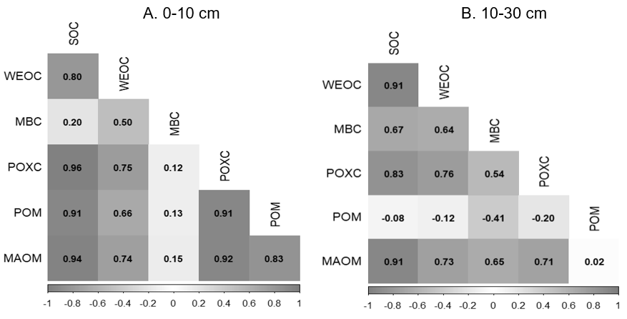
Figure A.1. Pearson’s correlation matrices of total soil organic carbon concentration and all fractions at 0-10 cm (A) and 10-30 cm (B). Values inside the cells represent Pearson’s correlation coefficients and shading denotes the level of significance, where significance increases as the shade darkens (α = 0.05).

Appendix References
Gavlak, R., Horneck, D., & Miller, R. O. (2005). Soil, plant and water reference methods for the
Western region. Western Regional Extension Publication-25, (3), 133-136.
Gee, G. W., & Or, D. (2002). 2.4 Particle‐size analysis. Methods of Soil Analysis: Part 4
Physical Methods, 5.4 (255-293). Soil Science Society of America Book Series. https://doi.org/10.2136/sssabookser5.4.c12
Kemper, W. D., & Rosenau, R. C. (1986). Aggregate stability and size distribution (425-
442). Methods of soil analysis, part 1: Physical and mineralogical methods (Vol. 5). John Wiley & Sons. https://doi.org/10.2136/sssabookser5.1.2ed.c17
Mylavarapu, R. & Miller, R. (2014) Chapter 4.2: Mehlich-1. Southern Cooperative Series
Bulletin, 419 (95-100).
Provin, T. (2014). 5.2: Total carbon and nitrogen and organic carbon via thermal
combustion analyses. Southern Cooperative Series Bulletin, 419 (149-154).
Sikora, F.J., & Kissel, D. E. (2014). Chapter 3.2: Soil pH. Southern Cooperative Series
Bulletin, 419 (48-53).

Chapter 2: High-Quality Compost for Tillage-Induced Soil Degradation

Abstract
Organic cropping systems provide many ecological benefits but are at risk of soil degradation and soil organic carbon (SOC) mineralization from their reliance on tillage. Organic amendments, such as compost, provide C inputs which could offset C loss from periodic tillage. Windrow compost is the most widely used by organic farmers, given its wide commercial-scale availability, yet comes at high capital and labor costs and must be transported to farms. The newly developed Biologically Enhanced Agricultural Management (BEAM) compost is made on-farm at small-scale in a static pile, potentially offering the same benefits as windrow compost at a lower C footprint. To compare the efficacy of BEAM and windrow compost at offsetting tillage-related C loss and maintaining soil health in reduced tilled organic cropping system, we compared BEAM at three rates (0.56, 1.12, and 2.24 Mg ha⁻¹), windrow compost at a standard rate (22.4 Mg ha⁻¹), co-application of BEAM with half the rate of windrow compost, and a non-amended control for one year. We measured total and active fractions of SOC, total nitrogen (N), mineral-N, plant-available nutrients, pH, electrical conductivity, and microbial properties of soil and compost. After two compost applications over the course of one year, neither compost type improved soil health from either baseline levels nor did the non-amended control. Most soil health metrics varied seasonally and were likely more influenced by the recent land use change and extreme climatic conditions. This study indicates that improving soil health of tilled organic systems in response to varying rates and sources of compost applications may not be achieved in the short-term. This may be especially challenging in the southeastern United States because of the warm and humid climatic conditions which favor SOC loss over gain. This study underscores that multi-year studies are needed to assess compost efficacy in this region.

2.1. Introduction
The consumer demand for organic products over the last two decades has risen because of its numerous ecological and human health benefits (USDA, 2024). In contrast to conventional practices, organic farming forbids the use of synthetic fertilizers and plant protection products to “support the cycling of on-farm resources, promote ecological balance, and conserve biodiversity” (USDA, 2015). Because organic practices do not depend on synthetic herbicides for weed management, the USDA loosely regulates tillage intensity to ensure farm profitability. Tillage breaks down plant residues and organic amendments, accelerating mineralization and subsequent release of plant-available nutrients (Lehnhoff et al., 2017; Krauss et al., 2020). Although tillage is essential in organic systems for nutrient availability and weed control, it is detrimental to soil health when the rate of C inputs from organic matter (OM) inputs is less than the rate of mineralization. By frequently mineralizing soil OM, tillage accelerates the release of carbon dioxide and subsequent depletion of soil organic carbon (SOC) (EPA, 2022).
As a consequence, organic farming faces a challenge in building SOC and mitigating climate change due to tillage-induced soil degradation and C emissions. Omitting tillage is seldomly implemented on large-scale organic farms because of the numerous barriers to no-till practices and the resulting yield deficit due to compaction, weed pressure, and limited plant-available nutrients (Dempsey, 2021). However, reduced tillage practices are gaining traction as yields often bounce back after a few years with fewer tillage passes (SARE, 2020; USDA, 2022). Reducing tillage intensity also enhances soil health compared to intensive and frequent tillage by promoting more SOC formation, microbial abundance and diversity, and aggregation (Willikens et al., 2012; Krauss et al., 2020; Littrell et al., 2021).
In addition to reducing tillage intensity, increasing the amount of OM inputs can help mitigate the rate of SOC depletion in organic systems (Tautges et al., 2019; Urra et al., 2019; Paustian et al., 2019). A meta-analysis by Crystal-Ornelas et al. (2021) found that organic amendments were more effective at enhancing SOC than conservation tillage or cover cropping in organic systems. Organic amendments are a broad spectrum of substrates, encompassing all raw or composted living material applied to soil such as manure, mulch, biochar, inoculants, and compost (Kallenbach & Grandy, 2011). Not only do organic amendments promote SOC formation, they have also been shown to enhance plant-available nutrients, aggregation, and microbial activity (Willekens et al., 2014; Nair & Delate, 2016; Urra et al., 2019).
Compost is the safest and a nutrient-rich organic amendment, offering a pathogen-free source of OM (Bernal et al., 2009; Persiani et al., 2021; EPA, 2024). The composting process is a controlled partial degradation of organic waste involving mesophilic, thermophilic, and maturation stages. During the mesophilic stage, readily available substrates are decomposed by fast-growing bacteria, steadily raising the temperature to 40°C (Bernal et al., 2009; Rittenhouse, 2015; Pergola et al., 2018). The thermophilic stage is reached when the substrate reaches its maximum temperature (between 55-65°C) during which pathogenic bacteria are abated (Bernal et al., 2009; Rittenhouse, 2015; Pergola et al., 2018). Proper aeration limits higher temperatures to prevent eradicating beneficial microorganisms (Rittenhouse, 2015; Vigneswaran et al., 2016). Several methods are available to achieve aeration including passive airflow through a ventilation system or active airflow by mechanical turning. Lastly, the cooling and maturation stage is characterized by a pronounced decrease in microbial activity and proliferation of fungi and actinomycetes which decompose more resistant polymers; however, mechanical aeration limits fungal growth at this stage (Bernal et al., 2009). Ultimately, composting results in partially decomposed OM which, when applied to soil, releases nutrients slowly, promotes SOC formation, and prevents nitrogen (N) leaching or volatilization compared to manure application (Vigneswaran et al., 2016; Pergola et al., 2018).
The most commonly used form of compost by organic farmers is windrow compost. It is made at commercial scales since it requires large areas and high capital and labor costs and must be transported to farms (EPA, 2024b). It transforms municipal or industrial waste into compost by creating large, long piles called windrows which are periodically turned to ensure proper aeration. On the other hand, the newly developed Biologically Enhanced Agricultural Management (BEAM) compost is made in vessels called bioreactors which hold much smaller volumes of waste than windrow compost, thus can be made on-farm with available farm waste. These bioreactors decompose waste passively by allowing passive air circulation through perforated PVC pipes which are strategically placed every square foot. Although both types of compost divest waste from landfills (Tautges et al., 2019; Nordahl et al., 2023), BEAM compost offers a more sustainable source of compost by minimizing transportation, labor, area, and mechanization. Furthermore, BEAM recycles farm waste, following the principle of a circular economy, which aligns with the purpose of the USDA’s organic practices to cycle on-farm resources (Urra et al., 2019).
Dr. David Johnson at the New Mexico State University’s Institute of Sustainable Agricultural Research developed BEAM compost with the purpose of restoring the soil microbiome of degraded agricultural land. Because BEAM compost serves as more of a soil inoculant, it is applied at much lower rates than windrow compost. Although BEAM compost takes longer to decompose than windrow compost because of its no-turn aeration method, it yields a substrate with much higher fungal biomass according to Johnson et al. (2015); however, due to the limited number of studies on BEAM, it is uncertain if this result is consistent. If BEAM does have greater fungal abundance, application to soil could enhance crop nutrient availability by enhanced OM decomposition by saprophytic fungi and plant symbioses with arbuscular mycorrhizal fungi and endophytic fungi which help with nutrient scavenging (especially of N, P, and S) (Behie & Bidochka, 2014; Johnson et al., 2015; White, 2018). Enhancing soil fungal populations can also promote fungal-derived microbial biomass carbon (MBC) and decrease C turnover, since fungi decompose C more slowly than bacteria, thus BEAM could also potentially favor SOC storage and formation (Malik et al., 2016).
Peer-review studies on the soil health and agronomic effects of BEAM application are scarce and the available reports or factsheets do not show consistent results. Dr. Johnson published a non-peer reviewed study in 2015, which found that BEAM compost applied at ~0.56 ton ac⁻¹ to an organically managed system in the southwestern United States increased SOC from 0.43% to 1.52% in 4.5 years (Johnson et al., 2015). This study also found that BEAM application increased soil plant-available potassium (K), magnesium (Mg), zinc (Zn), and nitrate-N from baseline levels; however, statistical significance of these results was not mentioned. Another study lacking peer-revision found higher germination rates, foliage growth, and root development from seeds soaked in BEAM compared to untreated seeds (Prasad, 2024). However, a peer-reviewed study conducted by the USDA did not find an agronomic benefit of BEAM treated seeds 12 weeks after germination (Wolf & Tilley, 2022). Thus, insufficient studies have been conducted to determine the benefits of BEAM compost to SOC and soil health. If BEAM compost is comparable to windrow compost at enhancing soil health and ensuring profitable crop yields, it could serve as a more sustainable solution to prevent tillage-induced SOC depletion on organically managed systems.

2.2. Objectives and Hypotheses
The objective of this study was to determine the soil and plant responses of BEAM and windrow compost amendments on a reduced tillage organic system. We examined the response variables under BEAM at 3 application rates (0.56, 1.12, and 2.24 Mg ha⁻¹, abbreviated Ba, Bb, Bc, respectively), a standard windrow compost application rate (22.4 Mg ha⁻¹, abbreviated W), co-application of the 3 BEAM rates with half the windrow compost rate (11.2 Mg ha⁻¹) (namely BaW, BbW, and BcW), and a non-amended control (C) for one year. For soil responses, we hypothesized that only windrow compost at 22.4 Mg ha⁻¹ would significantly enhance soil health from baseline levels within one year due to its high application rate providing the greatest amount of OM to the soil. We also hypothesized that BEAM treatments would not improve soil health within one year due to their low application rates and slow change in soil microbiome. However, we expected some sensitive soil properties to change by co-applying BEAM and windrow compost. For plant responses, we hypothesized that only windrow compost at 22.4 Mg ha⁻¹ would result in significantly greater crop yield because of its highest application rate delivering the most amount of plant-available nutrients for crop growth.

2.3. Methods

2.3.1. Experimental site and design
The study was conducted at Caney Fork Farms, a certified organic farm in Carthage, TN. The experimental site lies in Armour silt loam soil (USDA, 2011) on a uniform gradient between 0-5%. The study began in the spring of 2023, during which mean minimum monthly temperature was recorded in December at -0.167°C and mean maximum temperature in July at 25.3°C. Total minimum monthly precipitation was 1.68 cm in October and maximum was 18.3 cm in July, with an annual total precipitation of 101.3 cm (National Weather Service, 2024). The study continued into 2024, which experienced a mean minimum monthly temperature of -4.67°C in January and maximum of 20°C in July. Total minimum monthly precipitation was 0.102 cm in October and maximum was 24.5 cm in May, with an annual total precipitation of 123 cm (National Weather Service, 2024).
The study took place within the Farley field at Caney Fork Farms along 400 ft of 5 raised beds measuring 5 ft on-center with 1 ft paths (5 raised beds + 4 paths = ~29 ft width) (Figure 2.1). In a randomized complete block design, the study site was divided into 4 blocks which were separated by 8 ft buffers (Figure 2.2). Then, each block was split into 5 experimental units in the fall of 2023 (Figure 2.2). In the spring of 2024, the 3 experimental units with BEAM treatments were split to two subplots to include BEAM alone and BEAM with half the windrow compost application rate, increasing the number of experimental units to 8 (Figure 2.2). The middle raised bed out of the five beds was neglected to act as a buffer between experimental units.
The BEAM compost was made in March of 2023 using approximately 30% sieved, soaked wood chips of the chestnut tree trimmings from the silvopasture mentioned in study 1, 24% fresh horse manure, 36% elephant grass (Pennisetum purpureum), and 9% green vegetable waste. The bioreactor was irrigated once daily to maintain 60-70% moisture content until it reached 60°C, after which red wiggler worms (Eisenia fetida) were added to aid in passive decomposition for 6-9 months until it was applied in the fall of 2023. Following the directions from Dr. Johnson, BEAM compost was applied directly after seeding both cover and cash crops for treatments Ba, Bb, Bc, BaW, BbW, and BcW.

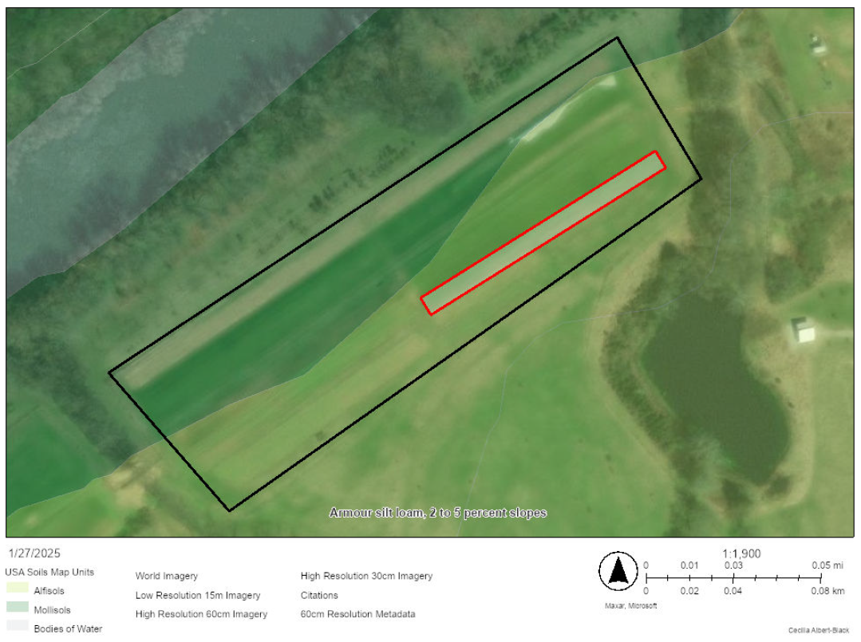
400 ft
29 ft

Figure 2.1. Aerial view of the study site, outlined in red, within the Farley field, outlined in black, shown true to scale in ArcGIS.

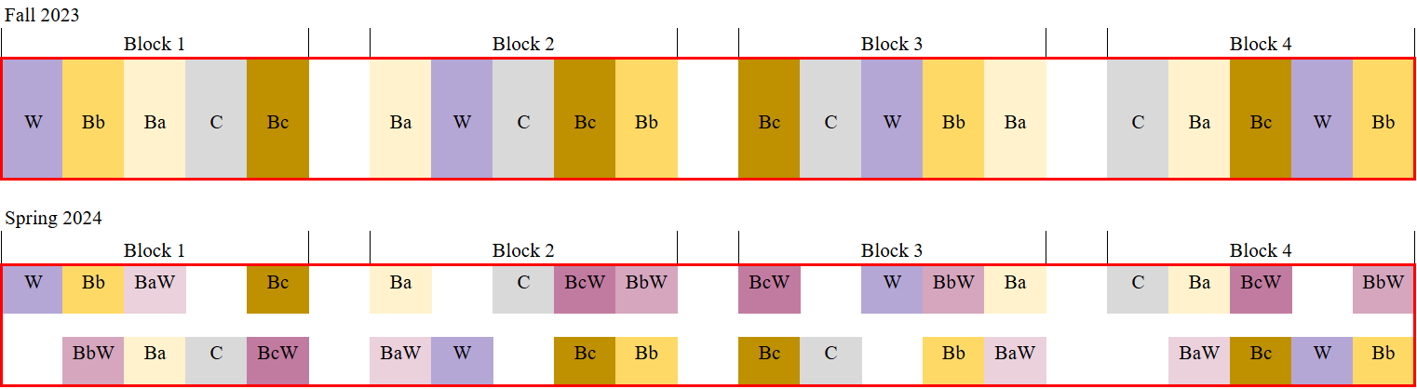
Figure 2.2. Randomized complete block design layout implemented in the fall of 2023 (n = 5) and spring of 2024 (n = 8) on the study site. Dimensions are not shown to scale.

Two windrow compost piles were used for this study since active aeration accelerated decomposition and maturity. Windrow compost was made using approximately 33% horse manure, 33% elephant grass, and 33% vegetable waste. Temperature reached 60°C and piles were turned several times to prevent higher temperatures. One pile was made in the spring of 2023 and applied in the fall while another pile was made in the fall of 2023 and applied in the spring of 2024. Following Caney Fork Farm’s standards, windrow compost was applied once per year for treatments BaW, BbW, BcW, and W in the fall.

2.3.2. Field Experiment Management and Sampling
Farley field was in perennial grasses before the study began in the fall of 2023. On October 3rd, perennial grasses were rototilled after which baseline soil samples were taken at random within each block. On October 16th, a cover crop mix of cereal rye (Secale cereale) at 78.5 kg ha⁻¹ and crimson clover (Trifolium incarnatum) at 11.2 kg ha⁻¹ was seeded followed by the first compost application (Figure 2.3). Cover crop biomass was sampled the following year on April 4th, before being flail mowed and incorporated by rototilling on April 28th. Delayed due to heavy rainfall, soil samples were taken from each treatment two weeks after cover crop incorporation. Then, winter squash (Cucurbita moschata) was seeded on June 14th in one row per bed with 1 ft in-row spacing followed by the second compost application (Figure 2.3). Winter squash was managed without irrigation or cultivation due to operational difficulties. Winter squash was harvested on September 11th and the remaining crop residue was rototilled the day after. Soil samples were then taken two weeks after incorporating the crop residue on September 24th.

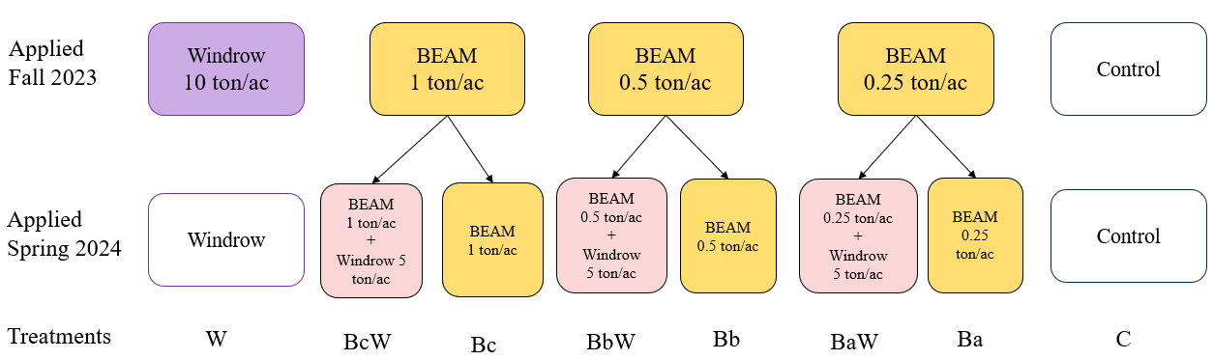
Figure 2.3. Experimental design map showing the type and amount of compost applied at each timepoint for each treatment. Colored boxes indicate compost application at the given timepoint while blank boxes indicate no compost application at the given timepoint.

About 15-20 soil samples were taken randomly within each experimental unit using a push probe from 0-15 cm and composited for mineral N determination. Another set of soil samples were taken in the same manner but split by 0-5 and 5-15 cm depth increments and then composited. After homogenizing the 0-5 and 5-15 cm composite soil samples separately, fresh 25 g subsamples of each were shipped in a chilled environment to the University of Missouri Soil Health Assessment Center for phospholipid fatty acid (PLFA) analysis only from the fall of 2023 and spring 2024. From all timepoints, a fresh 5 g subsample was taken for gravimetric moisture content determination by oven drying at 105°C for 24 hrs. The remaining composite soil samples were air dried, then sieved through 2 mm for further analyses.
Three replicates of BEAM and windrow compost were taken before each application to determine their characteristics. From each compost pile, representative fresh 25 g subsamples were sent in a chilled environment to the University of Missouri Soil Health Assessment Center for PLFA analysis. Another fresh 25 g subsample was sent to the University of Georgia to determine nutrient content by inductively coupled plasma (ICP) analysis. Lastly, moisture content was determined by oven drying a fresh 5 g subsample at 60°C for 48 h and the remaining samples were air dried and sieved through 2 mm for further analyses.
Cover crop biomass was sampled just before termination in the spring of 2024 by taking two replicates within 0.25 m² quadrats per experimental unit. All biomass within the quadrats was cut 2.5 cm from the soil and placed in a paper bag. Then, biomass samples were sorted into weeds, cereal rye, and crimson clover, placed in separate pre-weighed paper bag and oven dried at 60°C for 48 h to obtain dry biomass weights. Dry biomass per quadrat was then scaled to Mg ha⁻¹. Biomass sample replicates were combined into either weed or cover crop (cereal rye and crimson clover combined) and ground in a Wiley mill or coffee grinder to homogenize for total C and N analysis. Winter squash was harvested by collecting all marketable fruits from plants within each experimental unit by tracing each vine to its planting location. Marketable winter squash was weighed fresh on the same day of harvest and the yield was expressed as kg ha⁻¹.

2.3.3. Laboratory Analyses & Calculations
Soil analyses
From each timepoint, samples from the 0-5 and 5-15 cm depths were analyzed separately for the following parameters. Extractable nutrients were measured by shaking 20 mL Mehlich-I solution with 5 g of air-dry 2 mm sieved soil for 5 min at 180 rpm, then passed through a Q5 grade filter paper (pore size 10 µm). Filtrates were analyzed for extractable nutrients using ICP analysis. Soil pH and electrical conductivity were determined by shaking 5 g of air-dry 2 mm soil with 10 mL deionized water at 200 rpm for 30 minutes and measuring from the supernatant within 10 minutes using a Melter Toledo FiveEasy pH/mV Meter and an Orion Star Portable Conductivity Meter, respectively (Sikora & Kissel, 2014; Wang et al., 2014). Total C and N were measured by dry combustion method using the vario MAX Cube CN analyzer (Elementar, Hanau, Germany) on pulverized soil (Provin, 2014). Total C was assumed to be all organic since soil pH was less than 7 (Al-Kaisi & Kwaw-Mensah, 2020). Water extractable organic C (WEOC) concentration was determined by shaking 4 g of air-dry 2 mm soil with 40 mL deionized water at 120 rpm for 5 min and centrifuging the mixtures for 30 min at 800 rpm. The supernatant was then filtered through a Q2 grade filter paper (pore size 2 µm) and analyzed for purgeable C by the vario TOC Cube elemental analyzer (Elementar, Hanau, Germany). Soil permanganate oxidizable C (POXC) concentration was determined following the procedure by Culman et al. (2021) where 2.5 g of air-dry 2-mm sieved soil, 18.0 mL deionized water, and 2.0 mL 0.2 M potassium permanganate (KMnO₄) were combined and shaken at 150 rpm for 2 min. After allowing the mixture to settle in the dark for 10 mins, 0.4 mL of the supernatant was taken and added to 49.6 mL MilliQ water. Then, the diluted samples were analyzed by photoabsorbance at 550 nm using the Biotek Synergy HT microplate reader.
For nitrate-N and ammonium-N determination, 5 g of air-dried soil from the 0-15 cm composite samples were shaken with 25 mL 2.0 M potassium chloride solution for 1 h at 180 rpm. The mixtures were then centrifuged for 5 min at 1500 rpm then filtered through a Q2 grade filter paper. For ammonium-N determination, 100 µL of filtrate was reacted with 100 µL of reagent A and 100 µL of reagent B following the procedure by Verdouw et al. (1978) and Forster (1995). After 1-3 h, samples were analyzed by photoabsorbance using the Biotek Synergy HT microplate reader at 650 nm. For nitrate-N determination, 30 µL of filtrate was reacted with 300 µL of vanadium (III) chloride following the procedure by Doane & Horwath (2003). After 6-8 h, samples were then analyzed by photoabsorbance using the Biotek Synergy HT microplate reader at 540 nm. Mineral N was calculated as the sum of ammonium-N and nitrate-N concentrations.

Compost analyses
Compost pH and electrical conductivity were determined by shaking a 5 g air-dry subsample with 10 mL deionized water for 30 min at 200 rpm and measured in the same way as for soil. Small amounts of air-dry compost were pulverized and analyzed for total C and N by dry combustion method using the vario MAX Cube CN analyzer. Lastly, dry compost subsamples were analyzed for ammonium-N and nitrate-N following the same method as for soils.
Fungi/bacteria ratio
Microbial communities of soil and compost were determined from PLFA abundance of different microbial biomarkers. Following the latest PLFA assignation by Joergensen (2022), fungal biomass was calculated as the sum of arbuscular mycorrhizal fungi (16:1ω5c), Zygomycota (18:1ω9c), and Ascomycota/Basidiomycota (18:2w6c) while bacterial biomass was calculated as the sum of gram-positive bacteria biomarkers (i14:0, i15:0, a15:0, i16:0, a16:0, i17:0, a17:0, a19:0) and gram-negative bacteria biomarkers (cy17:0, cy19:0, 16:1w7c). Fungi/bacteria (F/B) ratio was then calculated as the quotient of fungal biomass by bacterial biomass, while total PLFA was calculated as the sum of PLFAs from 10:0 to 24:0, a proxy for total microbial biomass (Joergensen, 2022; Norris et al., 2023).
Cover Crop Analyses
Ground cover crop (cereal rye and crimson clover) and weed samples were pulverized and analyzed for total C and N (%) by dry combustion method using the vario MAX Cube CN analyzer. The C/N ratio for cover crop and weeds was then determined.

2.4. Statistical Analysis
Data analysis was conducted using the R statistical platform (RStudio Team, 2024) by first testing all response variables for normality and homogeneity of variance using Shapiro-Wilk’s and Levene’s tests, respectively. To determine the effect of compost treatments on soil health indicators at each depth at each timepoint, cover crop biomass, and winter squash yield, a one-way ANOVA was conducted at α = 0.05 using a generalized linear model using block to define the error structure. In the spring of 2024, 5 treatments were compared (Ba, Bb, Bc, W, C) and 8 treatments in the fall of 2024 (Ba, BaW, Bb, BbW, Bc, BcW, W, C). When treatment differences were significant for the spring or fall of 2024 (n = 5 and n = 8, respectively), means were separated using Tukey’s honestly significant difference (HSD). When treatment differences were not significant, the response variable at each timepoint, averaged by block (n = 4), was run through a one-way ANOVA using a general linear model to determine the effect of time at α = 0.05. When the time effect was significant, means were also separated using Tukey’s HSD.
To compare microbial data collected by PLFA analysis between sampling timepoints, a two-way paired t-test was conducted between baseline and spring 2024 soil F/B ratio and total microbial biomass at α = 0.05. Lastly, to test whether BEAM compost promotes greater microbial abundance, especially of fungi, a one-way t-test was conducted between BEAM and windrow compost F/B ratio and total microbial biomass at α = 0.05.

2.5. Results
Soil Health Indicators
Soil organic carbon concentration from 0-5 and 5-15 cm did not vary by treatments at any timepoint (Appendix B Table B.3). However, SOC in the top 0-5 cm did exhibit a significant time effect (p = 0.002) in which SOC showed a steady decrease over time and was significantly lower in the fall of 2024 compared to the previous spring 2024 (Figure 2.4 A). From 5-15 cm, SOC did not vary by time (p = 0.12). As with SOC, both WEOC and POXC from 0-5 and 5-15 cm did not vary by treatment in the spring or fall of 2024 (Appendix B Table B.3). The WEOC fraction varied by time at the 0-5 cm depth (p = 0.002) but not at 5-15 cm as shown in Figure 2.4 B. In the spring of 2024, WEOC at 0-5 cm was significantly lower compared to the previous fall of 2023 and subsequent fall of 2024 (Figure 2.4 B). The POXC fraction varied by time at both 0-5 and 5-15 cm as shown in Figure 2.4. C (p < 0.0001 and p < 0.001, respectively). At 0-5 cm, POXC significantly increased in spring of 2024 from baseline levels and then decreased in the
fall of 2024 but remained higher than baseline levels (Figure 2.4 C). Similarly, POXC in the 5-15 cm depth significantly increased from baseline levels in the spring of 2024 but remained at a similar concentration in the fall of 2024 (Figure 2.4 C).Total N from 0-5 and 5-15 cm also did not exhibit treatment effects in the spring nor fall of 2024 (Appendix B Table B.3). However,
total N varied by time at both 0-5 and 5-15 cm (p < 0.0001) in which total N significantly decreased from baseline levels in the spring of 2024, then increased significantly from the spring to the fall of 2024 but not comparable to baseline levels (Figure 2.5). Ammonium-N and nitrate-N, and their total (mineral N) from 0-15 cm did not vary by treatment at any timepoint either (Appendix B Table B.3). Although mineral N did not vary by time, ammonium-N and nitrate-N did (p = 0.0005 and p = 0.0004, respectively). Nitrate-N significantly increased from baseline levels to the spring of 2024 and remained high in the fall of 2024 while ammonium-N significantly decreased from baseline to the spring of 2024 and remained low in the fall of 2024 (Figure 2.6).

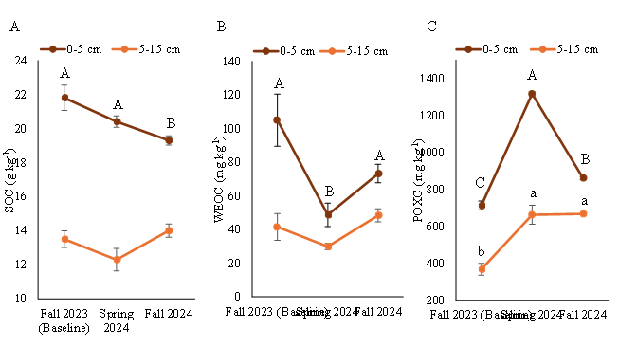

Figure 2.4. Soil organic carbon (A), water-extractable organic carbon (B), and permanganate oxidizable carbon (C) from 0-5 cm (orange) and 5-15 cm (brown) at each timepoint. Uppercase letters represent Tukey HSD when the time effect was significant for 0-5 cm and lowercase letters for 5-15 cm when p ≤ 0.05. Error bars represent the standard error of the mean (n = 4).

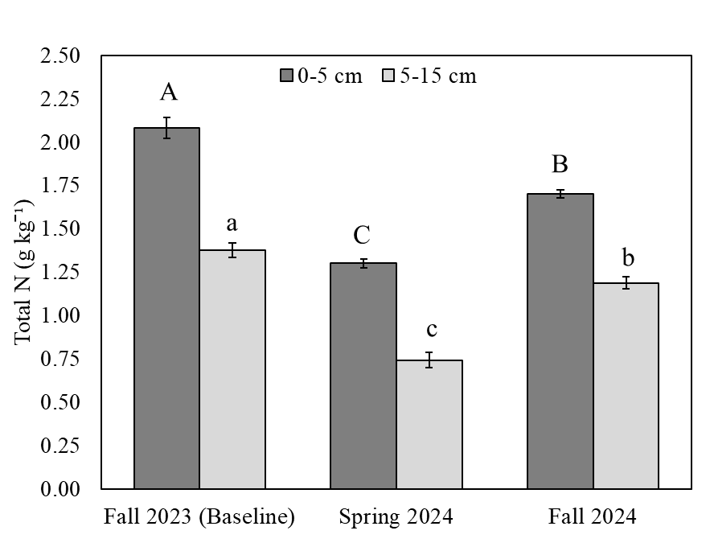
Figure 2.5. Soil total nitrogen from 0-5 cm (dark gray) and 5-15 cm (light gray) across time. Uppercase letters represent Tukey HSD when the time effect was significant from 0-5 cm and lowercase letters from 5-15 cm when p ≤ 0.05. Error bars represent the standard error of the mean (n = 4).

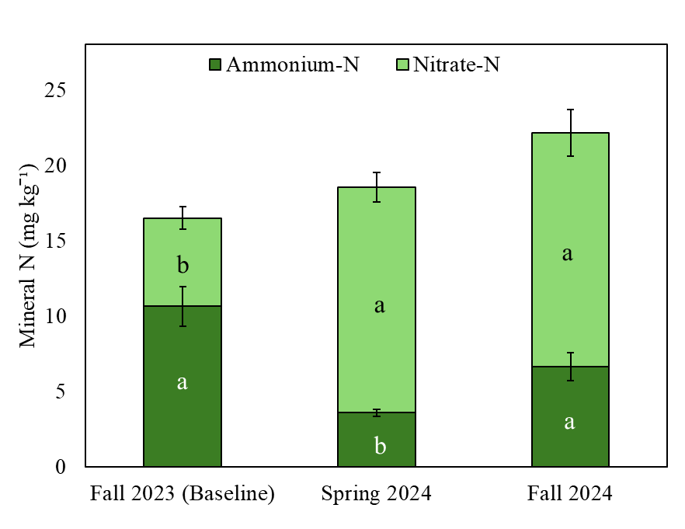
Figure 2.6. Soil mineral nitrogen and its components ammonium-N (dark green) and nitrate-N (light green) from 0-15 cm. Black letters represent Tukey HSD when time effect was significant for ammonium-N and white letters for nitrate-N when p ≤ 0.05. Error bars represent the standard error of the mean (n = 4).

Of the Mehlich-I extractable nutrients, only manganese (Mn) showed a significant treatment effect in the fall of 2024 (p = 0.047). The BcW treatment (co-application of BEAM at 2.24 Mg ha⁻¹ with windrow compost at 11.2 Mg ha⁻¹) exhibited significantly greater Mn content than BaW (co-application of BEAM at 0.56 Mg ha⁻¹ with windrow compost at 11.2 Mg ha⁻¹) while all other treatment combinations did not significantly differ from either extreme (Figure 2.7). While no other plant-available nutrients varied by treatment, magnesium (Mg) did vary by time (p = 0.001), in which concentration significantly declined from baseline levels to the spring of 2024 and remained low in the fall of 2024 (Table 2.1).
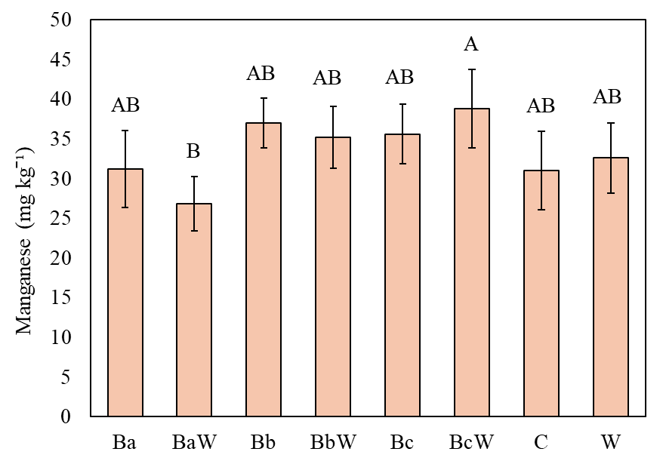
Figure 2.7. Soil plant available manganese by treatment from 0-15 cm in the fall of 2024. Letters represent Tukey HSD resulting from a significant treatment effect when p ≤ 0.05. Error bars represent the standard error of the mean (n = 4).

Table 2.1. Least squares mean ± standard error of Mehlich-I extractable nutrients from 0-15 cm at each timepoint. Uppercase letters represent Tukey HSD when the time effect was significant when p ≤ 0.05 (n = 4).
 | Fall 2023 | Spring 2024 | Fall 2024
Nutrient | --------------------------------------- mg kg⁻¹ -----------------------------------
Potassium (K) | 46.8 ± 3.89 | 42.4 ± 1.55 | 39.6 ± 2.30
Phosphorus (P) | 13.5 ± 3.18 | 17.8 ± 3.30 | 12.5 ± 2.60
Calcium (Ca) | 1,780 ± 41.6 | 1,760 ± 44.2 | 1,670 ± 63.2
Magnesium (Mg) | 284 ± 7.12 A | 266 ± 2.46 B | 238 ± 9.58 B
Manganese (Mn) | 32.8 ± 2.58 | 33.6 ± 3.56 | 27.2 ± 1.30
Zinc (Zn) | 2.20 ± 0.296 | 1.95 ± 0.185 | 1.52 ± 0.169

Baseline soil pH from 0-5 cm was 6.81 ± 0.063 and 6.63 ± 0.19 from 5-15 cm. In the spring of 2024, soil pH varied significantly by treatment (p = 0.048) as shown in Figure 2.8. At this timepoint, the W treatment exhibited significantly higher soil pH (7.27 ± 0.043) compared to other treatments. However, soil pH from 5-15 cm in the spring of 2024 did not vary by treatment (6.78 ± 0.023) (Appendix B Table B.3). In the fall of 2024, soil pH did not vary by treatment at either depth (6.96 ± 0.037 from 0-5 cm and 6.82 ± 0.0132 from 5-15 cm). Soil electrical conductivity did not vary by treatment or time (97.1 ± 24 µS/ cm⁻¹ from 0-5 cm and 52.6 ± 17 µS/ cm⁻¹ from 5-15 cm) (Appendix B Table B.3).
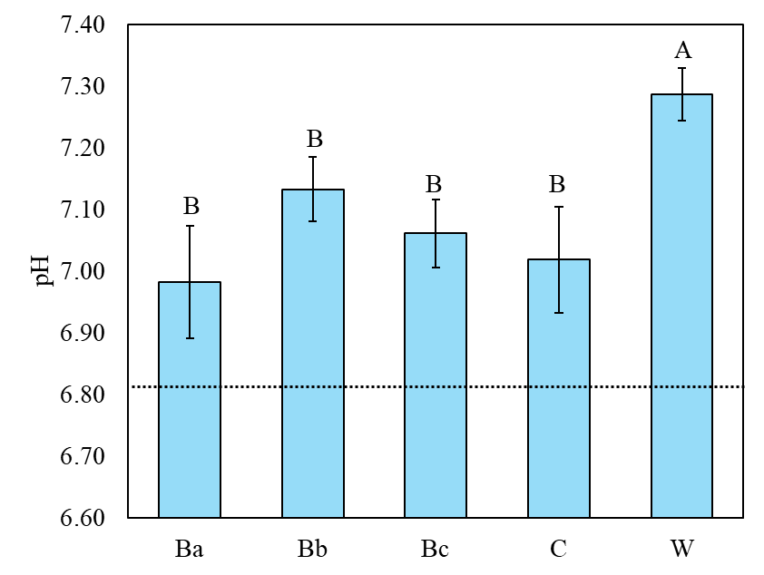
Soil F/B ratio calculated from the PLFA analysis in the top 5 cm was significantly greater at baseline than in the spring of 2024 (p < 0.0001) while total microbial biomass was significantly greater in the spring of 2024 than at baseline (p = 0.044) as shown in Figure 2.9. Compost F/B ratio was significantly greater for BEAM than windrow compost (p = 0.031) while total microbial biomass did not differ between the two types of compost (p = 0.45) as shown in Figure 2.10.
Figure 2.8. Soil pH in the 0-5 cm depth by treatment in the spring of 2024. Uppercase letters denote Tukey’s HSD resulting from significant treatment effect when p ≤ 0.05. Error bars represent the standard error of the mean (n = 4). Dashed line represents the baseline soil pH.
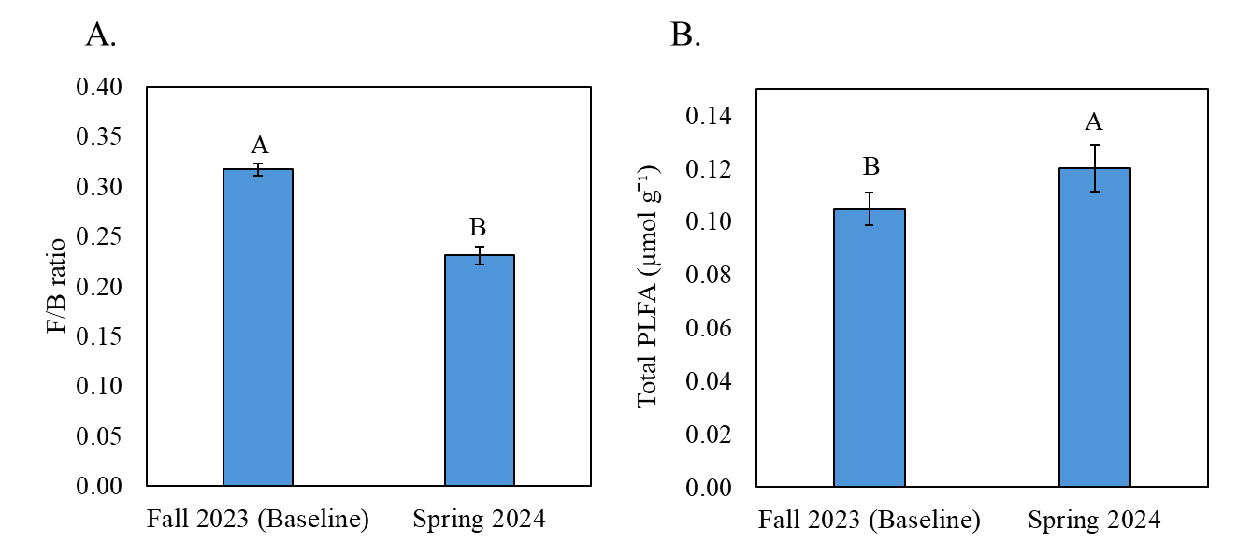
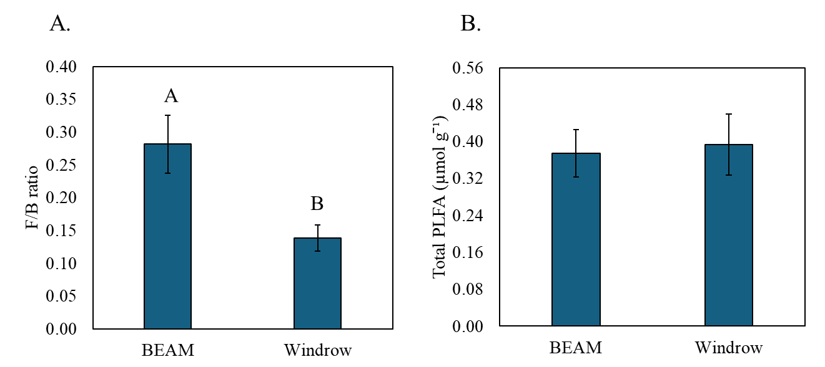
Figure 2.9. Mean soil fungi/bacteria ratio (A) and total microbial biomass (B) at 0-5 cm in the fall of 2023 (baseline) and in the spring of 2024. Letters represent significant differences resulting from a two-way paired t-test when p ≤ 0.05. Error bars represent standard error of the mean in the fall of 2023 (n = 4) and the spring of 2024 (n = 5).

Figure 2.10. Mean compost fungi/bacteria ratio (A) and total microbial biomass (B) of Biologically Enhanced Agricultural Management (BEAM) and windrow composts. Letters represent significant differences resulting from a one-way t-test when p ≤ 0.05. Error bars represent standard error of the mean (n = 3).

Agronomic Performance
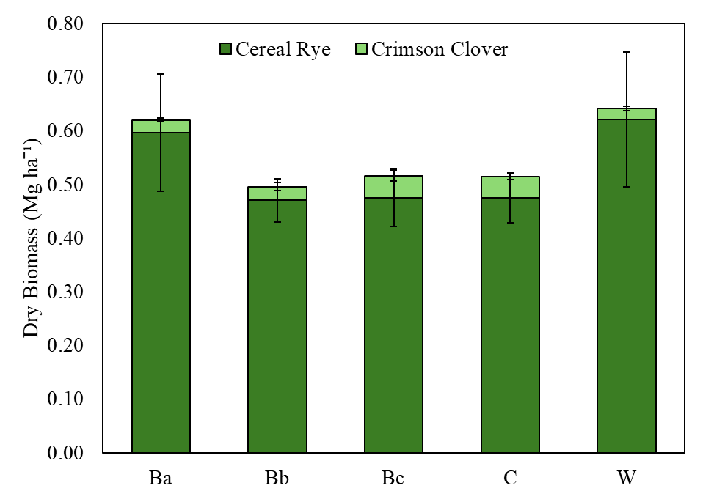
Compost treatments did not result in any agronomic responses in the first year of the study. After the first application of compost in the fall of 2023, total cover crop biomass in the spring of 2024 did not vary among treatments (p = 0.50) and neither did the individual species cereal rye and crimson clover (p = 0.44 and p = 0.10, respectively) (Figure 2.11). Averaged across all treatments, total cover crop biomass was 0.558 ± 0.0359 Mg ha⁻¹ of which 94.6% was cereal rye and 5.40% crimson clover. Weed biomass also did not vary by treatment (p = 0.35) and, on average, was 0.0426 ± 0.00740 Mg ha⁻¹. Total C and N content of cover crops and weeds did not differ by treatments either (Appendix B Table B.4). Following the second compost application, winter squash yield harvested in the fall of 2024 did not vary by treatment (p = 0.14) as shown in Figure 2.12, which averaged 0.401 ± 0.0717 Mg ha⁻¹ across all treatments.

Figure 2.11. Cover crop dry biomass by treatment in the spring of 2024. Dark green represents cereal rye biomass and light green represents crimson clover biomass. Error bars represent the standard error of the means for winer rye and crimson clover (n = 4).

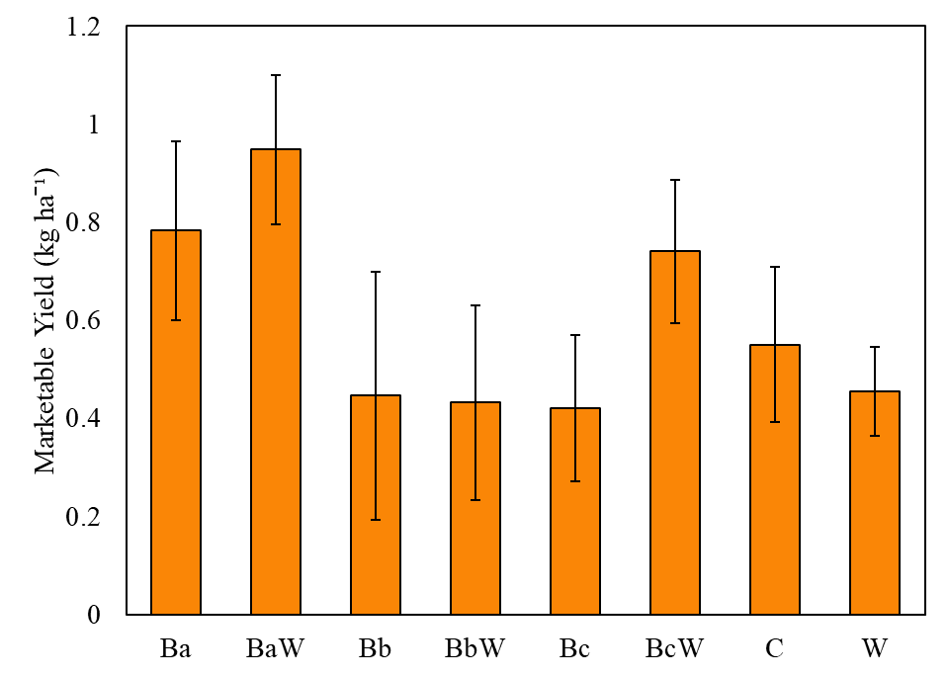
Figure 2.12. Winter squash marketable yield by treatment harvested in the fall of 2024. Error bars represent the standard error of the mean (n = 4).

2.6. Discussion
Soil organic carbon in the top 5 cm decreased by 11.5% in one year, from 21.8 ± 0.75 g kg⁻¹ in the fall of 2023 (baseline) to 19.3 ± 0.27 g kg⁻¹ in the fall of 2024. This decline is likely attributed to the tillage used to convert the perennial grass system to vegetable production. Un-disturbed, diverse grasslands are known to promote SOC formation through continuous C inputs from both above-ground and below-ground biomass (Bai & Cotrufo, 2022). When systems that foster SOC formation experience land disturbance, SOC is susceptible to mineralization and subsequent reduction in content (Smith, 2008). Furthermore, Lucas & Weil (2021) found that soils with high SOC are less responsive to C additions than already degraded soils. Therefore, it is plausible that none of the compost treatments supplied enough OM to offset C mineralization induced by tillage in a soil already high in SOC. Though the windrow only treatment (22.4 Mg ha⁻¹) supplied the most OM, other studies of compost applied at similar rates take several years before SOC is enhanced (Willekens et al., 2014; D’Hose et al., 2014; Romano et al., 2017; Kraut-Cohen et al., 2023). Therefore, the windrow only treatment has the potential to promote SOC formation if the study were to continue over several years.
Compost treatments also had no effect on active C fractions WEOC and POXC, which were more variable across time. Water extractable organic carbon started at a high concentration under the recently tilled perennial grasses and declined by 53.6% in the spring of 2024. Spring soil samples were taken in May, after the field received a total of 24.5 cm of rainfall, the highest in the last 25 years (National Weather Service, 2024). This pulse in wet field conditions could have increased microbial activity and production of WEOC (Wang et al., 2023), as evidenced by higher total microbial biomass in the spring of 2024. However, such intense rainfall events could have also caused leaching and/or runoff loss of WEOC, decreasing WEOC significantly in the topsoil (Tiefenbacher et al., 2021). While compost amendments are expected to increase WEOC by supplying OM and stimulating microbial activity, the effect is often short-lived (Bastida et al., 2012). Thus, the extreme precipitation in spring 2024 likely exerted a stronger influence on WEOC, overshadowing any compost treatment effects.
Independent of compost treatment, POXC significantly increased by 84.7% at 0-5 cm and by 80.2% at 5-15 cm in spring 2024 from baseline levels. This spike in POXC in the top 5 cm likely reflects the addition of above-ground cover crop residues (Hu et al., 2023), since they were incorporated prior to sampling in the spring of 2024. Greater topsoil microbial biomass in the spring of 2024 could have enhanced decomposition of these residues, releasing phenolic compounds which primarily constitute POXC (Woodings & Margenot, 2023; Hu et al., 2023). Higher POXC at 5-15 cm in the spring of 2024 could have been from root-derived C inputs from the cover crops, especially from the deep rooted cereal rye (Woodings & Margenot, 2023; Patra et al., 2024). In the fall of 2024, POXC at 0-5 cm significantly decreased by 34.5% relative to spring levels but did not significantly change at 5-15 cm. Residual POXC from the decomposition of cover crops in the spring of 2024 could have been assimilated, respired, or transformed to simpler C molecules by microbes, decreasing POXC concentration at 0-5 cm, while it could have been protected from decomposition at 5-15 cm and thus remained unchanged. However, overall, compost treatments had no effect on POXC likely because of the dominant effect of cover crop residues in adding phenolic compounds to the soil matrix.
Similar to the effect on SOC, compost treatments had no effect on total N; instead, total N significantly decreased by 37.5% at 0-5 cm and 45.5% at 5-15 cm in the spring of 2024 from baseline levels. Baseline total N was higher due to being under perennial grasses prior to implementing a reduced tillage cropping system, which promotes soil N by continuous and abundant biomass inputs (Schittenhelm et al., 2021; Shang et al., 2024; Li et al., 2024). Thus, converting the field from a no-till perennial grass system to a reduced tilled cropping system likely enhanced soil OM mineralization which could have been leached as nitrate-N, decreasing total N. Deep rooted cereal-type cover crops are used to prevent nitrate-N leaching and leguminous cover crops can fix atmospheric N during fallow periods (Nouri et al., 2022). However, given that total cover crop biomass from our study in the spring of 2024 fell 83.4% below typical biomass production in East Tennessee (Sykes et al., 2021), its effectiveness at preventing N loss via leaching and fixing N was likely minimal, as shown by the lower total N in the spring of 2024 compared with the fall of 2023. Since cover crop biomass incorporation likely returned some N to the soil after the slow decomposition of the cereal-rye dominated mixture, total N increased in fall of 2024 compared to spring 2024 by 30.8% at 0-5 cm and 60.8% at 5-15 cm. However, total N did not return to comparable levels to baseline since the amount of cover crop residue incorporated was drastically less compared to the residue addition from perennial grasses.
Mineral N was not affected by compost treatments either. The difference in relative amounts of nitrate-N to ammonium-N at baseline compared to spring and fall of 2024 was likely a reflection of the stage of OM decomposition at the time of sampling. Since soil samples were taken a few days after perennial grass incorporation by tillage in the fall of 2023, higher ammonium-N and lower nitrate-N at baseline could be indicative of the early stage of residue decomposition. On the other hand, soil samples in the spring and fall of 2024 were taken at least 2 weeks after cultivation, therefore higher nitrate-N relative to ammonium-N is indicative of a later stage in soil OM decomposition. Nitrate-N remained at low levels (< 11 mg kg⁻¹), according to soil fertility recommendations for the southeastern United States (Sikora & Kissel, 2014), which could have contributed to the poor agronomic performance of winter squash over the summer of 2024. Although compost amendments are known to enhance mineral-N compared to non-amended soils, the rate of mineralization is very slow (Flavel & Murphy, 2006). Release of mineral-N from compost is also inversely proportional to its C/N ratio (Zarabi & Jalai, 2012). Therefore, lack of treatment effects on mineral-N could have been compounded by the inconsistent C/N ratios between BEAM and W compost at each application and slow mineralization rate when applied (Appendix B Table B.2). Despite this, the windrow compost only treatment has the potential to significantly increase total and mineral N if either applied consistently over at least 5 years or in less than 5 years if application rate were doubled, as shown by previous studies (Erhart et al., 2005; Ros et al., 2006; D’Hose et al., 2014; Romano et al., 2017; Kraut-Cohen et al., 2023). The long-term effects of BEAM compost on total and mineral N, however, have not been studied and remain unknown, thus warrant further investigation.
Plant available Mn was the only nutrient to vary by treatment. In the spring of 2024, co-application of BEAM at its highest rate with half the rate of windrow compost (BaW) significantly increased plant-available Mn (38.8 ± 4.96 kg ha⁻¹) while BEAM at its lowest rate with half the rate of windrow compost (BcW) significantly decreased plant-available Mn (27.0 ± 3.40 kg ha⁻¹). Manganese availability is strongly linked to litter decomposition (Keiluweit et al., 2015; Neupane et al., 2023). Structural Mn⁺³ in plant matter is oxidized to soluble Mn⁺² by exo-enzymes produced by saprophytic fungi during lignin decomposition (Keiluweit et al., 2015). Therefore, the higher F/B ratio of BEAM could have enhanced the lignin decomposition from soil and/or compost and released soluble Mn⁺² from BaW (BEAM at 2.24 Mg ha⁻¹) treatment relative to BcW (BEAM at 0.56 Mg ha⁻¹). However, due to the marginal significant difference in soil plant-available Mn concentrations between the two treatments (p = 0.047), more studies are needed to confirm our findings. While all other plant-available nutrients were unaffected by compost treatment, plant-available Mg decreased over time. While Mg remained at adequate levels for plant growth throughout the study, a significant decrease over time could have been due to Mg leaching in soluble forms during extreme precipitation in the spring of 2024 (Metson, 1974). Magnesium levels remained low in the fall of 2024 likely because the rate of Mg release from minerals is a slow process (Metson, 1974).
While plant-available P and K did not vary by time, they remained low throughout the study. Low P and K for the windrow compost only treatment could be due to the slow decomposition of the organic form of nutrients from compost. The windrow only treatment also resulted in greater soil pH in the topsoil during the spring of 2024, which would have limited P and K availability. This highlights the challenges of meeting immediate crop nutrient demands with only compost amendments; additional amendments which release nutrients quickly are likely necessary in combination with compost. On the other hand, immediate crop nutrient requirements could be met if windrow compost is applied at rates > 22.4 Mg ha⁻¹. However, this might lead to an excess P and K over time as the nutrients are released slowly or it might not release P and K in plant-available forms in the pH remains >7.
While low plant-available P, K, and nitrate-N across all treatments could have limited cover crop growth in winter of 2023-2024 and winter squash growth in the summer of 2024, other factors could have had a greater impact. The winter cover crop was seeded slightly later than usual and harvested slightly earlier than usual, which could have impeded full cover crop growth. On the other hand, lack of irrigation and difficulty managing weeds over the summer were likely the culprit of winter squash failure (Maynard & Ward, 2021).
Lastly, W compost significantly increased soil pH compared to other treatments in the spring of 2024, which slightly exceeded the optimal soil pH range for agronomic crops (6-7) (Sikora & Kissel, 2014). Windrow compost could have increased soil pH by releasing high amounts of soluble salts to soil, given its high application rate but similar electrical conductivity to BEAM. While this could be a concern for W compost application, pH did not differ by treatment in the fall of 2024. Thus, soluble salts could have been dissolved and leached away over time. This signals the potential drawbacks of applying too much windrow compost. While a higher compost application can increase OM inputs and SOC (D’Hose et al., 2014), it could also significantly alter soil pH and inhibit nutrient availability (Rittenhouse, 2015).

2.7. Conclusion
This study aimed to determine the differences in plant and soil responses of BEAM compared to W compost amendments in a reduced tillage organic vegetable system in the southeastern U.S. The purpose was to determine if BEAM compost could offset tillage-induced C mineralization and maintain soil health compared to a standard rate of windrow compost, which could offer a more sustainable type of organic amendment. Over the course of one year, we assessed the effects of BEAM at three application rates, windrow compost, and the co-application of BEAM with half the rate of windrow compost on key soil health indicators and plant growth attributes. Although we hypothesized that windrow compost at 22.4 Mg ha⁻¹ would significantly enhance soil health from baseline levels, we did not observe a noticeable improvement. We also expected the co-application of BEAM at 2.24 Mg ha⁻¹ and half the rate of windrow compost at 11.2 Mg ha⁻¹ to improve soil properties compared to BEAM alone, which did marginally increase plant-available Mn in the fall of 2024; however, this could have been a fluke observation.
Our findings indicate that compost application to a reduced tillage organic systems did not improve soil health one year of application in the southeastern United States. Irrespective of compost treatment, soil nitrate-N and plant-available P and K remained below fertility recommendations for optimal agronomic performance across all timepoints, highlighting the slow decomposition of the organic form of nutrients from compost. Soil organic carbon, total N, and plant-available Mg decreased over time while WEOC, POXC, nitrate-N, and ammonium-N varied seasonally, suggesting that conversion of perennial pasture to a reduced tillage vegetable system and seasonal climatic conditions have a stronger controlling effect on soil health than compost treatments. Thus, the effects of land-use change and unfavorable weather on soil health could have overshadowed any compost treatment effects; however, since this study is ongoing, treatment effects on soil health might arise over a longer period of time, once the system has come to an equilibrium under the new land management.

References

Al‐Kaisi, M. M., & Kwaw‐Mensah, D. (2020). Quantifying soil carbon change in a long term
tillage and crop rotation study across Iowa landscapes. Soil Science Society of America Journal, 84(1), 182-202. https://doi/pdfdirect/10.1002/saj2.20003
Bai, Y., & Cotrufo, M. F. (2022). Grassland soil carbon sequestration: Current understanding,
challenges, and solutions. Science, 377(6606), 603-608. https://doi.org/10.1126/science.abo2380
Bastida, F., Jindo, K., Moreno, J. L., Hernández, T., & García, C. (2012). Effects of organic
amendments on soil carbon fractions, enzyme activity and humus–enzyme complexes under semi-arid conditions. European Journal of Soil Biology, 53, 94-102. https://doi.org/10.1016/j.ejsobi.2012.09.003
Behie, S. W., & Bidochka, M. J. (2014). Nutrient transfer in plant–fungal symbioses. Trends in
Plant Science, 19(11), 734-740. http://dx.doi.org/10.1016/j.tplants.2014.06.007
Bernal, M. P., Alburquerque, J. A., & Moral, R. (2009). Composting of animal manures and
chemical criteria for compost maturity assessment. A review. Bioresource Technology, 100(22), 5444-5453. https://doi.org/10.1016/j.biortech.2008.11.027
Crystal-Ornelas, R., Thapa, R., & Tully, K. L. (2021). Soil organic carbon is affected by organic
amendments, conservation tillage, and cover cropping in organic farming systems: A meta-analysis. Agriculture, Ecosystems & Environment, 312, 107356. https://doi.org/10.1016/j.agee.2021.107356
Culman, S. W., Hurisso, T. T., & Wade, J. (2021). Permanganate oxidizable carbon: An
indicator of biologically active soil carbon. Soil Health Series: Volume 2 Laboratory Methods for Soil Health Analysis, 152-175. https://doi.org/10.1002/9780891189831.ch9
Dempsey, M. (2021). Research update: Comparing no till methods equipment for
different scales. Carolina Farm Stewardship Association. https://www.carolinafarmstewards.org/research-update-comparing-no-till-methods-equipment-for-different-scales/
D’Hose, T., Cougnon, M., De Vliegher, A., Vandecasteele, B., Viaene, N., Cornelis, W., Van
Bockstaele, E. & Reheul, D. (2014). The positive relationship between soil quality and crop production: A case study on the effect of farm compost application. Applied Soil Ecology, 75, 189-198. https://doi.org/10.1016/j.apsoil.2013.11.013
Doane, T. A., and W. R. Horwáth. (2003). Spectrophotometric determination of nitrate with a
single reagent. Analytical Letters, 36 (12), 2713-2722. https://doi.org/10.1081/AL-120024647
Environmental Protection Agency (2021). Composting food waste: Keeping a good
thing going. EPA. https://www.epa.gov/snep/composting-food-waste-keeping-good-thing-going#:~:text=In%20addition%2C%20composting%20lowers%20greenhouse,in%20the%20presence%20of%20oxygen
Environmental Protection Agency (2024). Composting. Sustainable Management of
Food. EPA. https://www.epa.gov/sustainable-management-food/composting#:~:text=and%20community%20composting.-,Benefits%20of%20Composting,materials%20and%20keeps%20them%20local.
Environmental Protection Agency (2024b). Types of composting and understanding the
process: Aerated (turned) windrow composting. Sustainable Management of Food. EPA. https://19january2017snapshot.epa.gov/sustainable-management-food/types-composting-and-understanding-process_.html#:~:text=Top%20of%20Page-,Aerated%20(Turned)%20Windrow%20Composting,be%20composted%20through%20this%20method
Erhart, E., Hartl, W., & Putz, B. (2005). Biowaste compost affects yield, nitrogen supply during
the vegetation period and crop quality of agricultural crops. European Journal of Agronomy, 23(3), 305-314. https://doi.org/10.1016/j.eja.2005.01.002
Flavel, T. C., & Murphy, D. V. (2006). Carbon and nitrogen mineralization rates after
application of organic amendments to soil. Journal of Environmental Quality, 35(1), 183-193. https://doi.org/10.2134/jeq2005.0022
Forster, J. C. (1995). Soil nitrogen. Methods in applied soil microbiology and biochemistry, 79
87.
Hu, Q., Thomas, B.W., Powlson, D., Hu, Y., Zhang, Y., Jun, X., Shi, X. & Zhang, Y. (2023).
Soil organic carbon fractions in response to soil, environmental and agronomic factors under cover cropping systems: A global meta-analysis. Agriculture, Ecosystems & Environment, 355, 108591. https://doi.org/10.1016/j.agee.2023.108591
Joergensen, R. G. (2022). Phospholipid fatty acids in soil—drawbacks and future
prospects. Biology and Fertility of Soils, 58(1), 1-6. https://doi.org/10.1007/s00374-021-01613-w
Johnson, D., Ellington, J., & Eaton, W. (2015). Development of soil microbial communities for
promoting sustainability in agriculture and a global carbon fix (No. e789v1). PeerJ PrePrints. https://doi.org/10.7287/peerj.preprints.789v1
Kallenbach, C., & Grandy, A. S. (2011). Controls over soil microbial biomass responses to
carbon amendments in agricultural systems: A meta-analysis. Agriculture, Ecosystems & Environment, 144(1), 241-252. https://doi.org/10.1016/j.agee.2011.08.020
Keiluweit, M., Nico, P., Harmon, M. E., Mao, J., Pett-Ridge, J., & Kleber, M. (2015). Long-term
litter decomposition controlled by manganese redox cycling. Proceedings of the National Academy of Sciences, 112(38), E5253-E5260. https://doi.org/10.1073/pnas.1508945112
Krauss, M., Berner, A., Perrochet, F., Frei, R., Niggli, U., & Mäder, P. (2020). Enhanced soil
quality with reduced tillage and solid manures in organic farming–a synthesis of 15 years. Scientific Reports, 10(1), 1-12. https://doi.org/10.1038/s41598-020-61320-8
Kraut-Cohen, J., Zolti, A., Rotbart, N., Bar-Tal, A., Laor, Y., Medina, S., Shawahna, R., Saadi,
I., Raviv, M., Green, S.J. & Yermiyahu, U. (2023). Short-and long-term effects of continuous compost amendment on soil microbiome community. Computational and Structural Biotechnology Journal, 21, 3280-3292. https://doi.org/10.1016/j.csbj.2023.05.030
Lehnhoff, E., Miller, Z., Miller, P., Johnson, S., Scott, T., Hatfield, P., & Menalled, F. D. (2017).
Organic agriculture and the quest for the Holy Grail in water-limited ecosystems: managing weeds and reducing tillage intensity. Agriculture, 7(4), 33. https://doi.org/10.3390/agriculture7040033
Li, Y., Li, Y., Zhang, Q., Xu, G., Liang, G., Kim, D.G., Carmona, C. R., Yang, M., Xue, J.,
Xiang, Y. & Yao, B. (2024). Enhancing soil carbon and nitrogen through grassland conversion from degraded croplands in China: Assessing magnitudes and identifying key drivers of phosphorus reduction. Soil and Tillage Research, 236, 105943. https://doi.org/10.1016/j.still.2023.105943
Littrell, J., Xu, S., Omondi, E., Saha, D., Lee, J., & Jagadamma, S. (2021). Long-term organic
management combined with conservation tillage enhanced soil organic carbon accumulation and aggregation. Soil Science Society of America Journal, 85(5), 1741-1754. https://doi.org/10.1002/saj2.20259
Lucas, S., & Weil, R. (2021). Can permanganate oxidizable carbon predict soil function
responses to soil organic matter management?. Soil Science Society of America Journal, 85(5), 1768-1784. https://doi.org/10.1002/saj2.20282
Malik, A. A., Chowdhury, S., Schlager, V., Oliver, A., Puissant, J., Vazquez, P. G. M., Jehmlich,
N., von Bergen, M., Griffiths, R. I., & Gleixner, G. (2016) Soil fungal:bacterial ratios are linked to altered carbon cycling. Frontiers Microbiology 7, 1247. doi:10.3389/fmicb.2016.01247
Maynard, A. A. & Ward, J. S. (2021). Butternut squash trials 2017-2019. The Connecticut
Agricultural Experimental Station.
Metson, A. J. (1974) I. Some factors governing the availability of soil magnesium: A review,
New Zealand Journal of Experimental Agriculture, 2:3 (277-319). DOI: 10.1080/03015521.1974.10427689
Nair, A., & Delate, K. (2016). Composting, crop rotation, and cover crop practices in organic
vegetable production. Organic Farming for Sustainable Agriculture, 231-257. https://doi.org/10.1007/978-3-319-26803-3_11
National Weather Service. (2024). NOWData: NOAA Online Weather Data for Carthage,
Tennessee. Retrieved September, 2024 from https://www.weather.gov/wrh/climate?wfo=ohx
Neupane, A., Herndon, E. M., Whitman, T., Faiia, A. M., & Jagadamma, S. (2023). Manganese
effects on plant residue decomposition and carbon distribution in soil fractions depend on soil nitrogen availability. Soil Biology and Biochemistry, 178, 108964. https://doi.org/10.1016/j.soilbio.2023.108964
Nordahl, S. L., Preble, C. V., Kirchstetter, T. W., & Scown, C. D. (2023). Greenhouse gas and
air pollutant emissions from composting. EnvironmentalSscience & Technology, 57(6), 2235-2247. https://doi.org/10.1021/acs.est.2c05846
Norris, C. E., Swallow, M. J., Liptzin, D., Cope, M., Mac Bean, G., Cappellazzi, S. B., Greub,
K. L., Rieke, E. L., Tracy, P. W., Morgan, C. L. & Honeycutt, C. W. (2023). Use of phospholipid fatty acid analysis as phenotypic biomarkers for soil health and the influence of management practices. Applied Soil Ecology, 185, 104793. https://doi.org/10.1016/j.apsoil.2022.104793
Nouri, A., Lukas, S., Singh, S., Singh, S., & Machado, S. (2022). When do cover crops reduce
nitrate leaching? A global meta‐analysis. Global Change Biology, 28(15), 4736-4749. https://doi.org/10.1111/gcb.16269
Patra, R., Saha, D., Neupane, A., & Jagadamma, S. (2024). Deep-rooted winter wheat cover crop
promotes subsoil organic carbon storage through improved microbial functional traits. Applied Soil Ecology, 199, 105413. https://doi.org/10.1016/j.apsoil.2024.105413
Paustian, K., Larson, E., Kent, J., Marx, E., & Swan, A. (2019). Soil C sequestration as a
biological negative emission strategy. Frontiers in Climate, 1, 482133. https://doi.org/10.3389/fclim.2019.00008
Pergola, M., Persiani, A., Palese, A. M., Di Meo, V., Pastore, V., D’Adamo, C., & Celano, G.
(2018). Composting: The way for a sustainable agriculture. Applied Soil Ecology, 123, 744-750. https://doi.org/10.1016/j.apsoil.2017.10.016
Persiani, A., Montemurro, F., & Diacono, M. (2021). Agronomic and environmental
performances of on-farm compost production and application in an organic vegetable rotation. Agronomy, 11(10), 2073. https://doi.org/10.3390/agronomy11102073
Prasad, V. (2024). Assessing the impact of BEAM inoculant on plant growth enhancement: A
comparative analysis. Preprints. https://www.preprints.org/manuscript/202405.0270
Rittenhouse, T. (2015). Tipsheet: Compost. USDA: National Center for Appropriate Technology
(ATTRA) Sustainable Agriculture. https://attra.ncat.org/publication/tipsheet-compost/
Romano, E. L., Pena-Yewtukhiw, E. M., Waterland, N. L., & Grove, J. H. (2017). Soil health
benefit to composted manure application and insertion of a sod component in a long-term organic crop rotation. Soil Science, 182(4), 137-145. DOI: 10.1097/SS.0000000000000205
Ros, M., Klammer, S., Knapp, B., Aichberger, K., & Insam, H. (2006). Long‐term effects of
compost amendment of soil on functional and structural diversity and microbial activity. Soil Use and Management, 22(2), 209-218. https://doi.org/10.1111/j.1475-2743.2006.00027.x
RStudio Team (2024). RStudio Integrated Development Environment for R. Posit Software,
PBC, Boston, MA.
SARE (2020). Conservation tillage systems in the southeast: Benefits of conservation tillage
systems. Sustainable Agriculture Research and Education Handbook 15. Accessed December, 2024 from https://www.sare.org/publications/conservation-tillage-systems-in-the-southeast/chapter-2-conservation-tillage-systems-history-the-future-and-benefits/benefits-of-conservation-tillage-systems/
Schittenhelm, S., Panten, K., & Gabriel, D. (2021). Converting perennial energy crops cup plant
and field grass to arable cropping affects weed infestation, soil nitrogen mineralization and subsequent silage maize yield. Global Change Biology Bioenergy, 13(8), 1232-1246. https://doi.org/10.1111/gcbb.12837
Shang, Y., Olesen, J. E., Lærke, P. E., Manevski, K., & Chen, J. (2024). Perennial cropping
systems increased topsoil carbon and nitrogen stocks over annual systems—a nine-year field study. Agriculture, Ecosystems & Environment, 365, 108925. https://doi.org/10.1016/j.agee.2024.108925
Sikora, F. J., & Kissel, D. E. (2014). Soil test methods from the southeastern United
States. Chapter 3.2: Soil pH. Southern Cooperative Series Bulletin, 419, 48-53.
Smith, P. (2008). Land use change and soil organic carbon dynamics. Nutrient Cycling in
Agroecosystems, 81, 169-178. https://doi.org/10.1007/s10705-007-9138-y
Sykes, V. R., Wilson, A., Palacios, F., Keadle, S. B., Bates, G., & McIntosh, D. (2021). Cover
crop variety tests in Tennessee 2021. University of Tennessee Extension.
Tautges, N. E., Chiartas, J. L., Gaudin, A. C., O'Geen, A. T., Herrera, I., & Scow, K. M. (2019).
Deep soil inventories reveal that impacts of cover crops and compost on soil carbon sequestration differ in surface and subsurface soils. Global Change Biology, 25(11), 3753-3766. https://doi.org/10.1111/gcb.14762
Tiefenbacher, A., Weigelhofer, G., Klik, A., Mabit, L., Santner, J., Wenzel, W., & Strauss, P.
(2021). Antecedent soil moisture and rain intensity control pathways and quality of organic carbon exports from arable land. Catena, 202, 105297. https://doi.org/10.1016/j.catena.2021.105297
Urra, J., Alkorta, I., & Garbisu, C. (2019). Potential benefits and risks for soil health derived
from the use of organic amendments in agriculture. Agronomy, 9(9), 542. https://doi.org/10.3390/agronomy9090542
USDA (2011). Web Soil Survey. Soil Survey Staff, Natural Resources Conservation Service,
United States Department of Agriculture. Available online. Accessed August, 2023 from ArcGIS Online.
USDA (2015). Fact sheet: Introduction to organic practices. United States Department of
Agriculture. Retrieved December, 2024 from https://www.ams.usda.gov/sites/default/files/media/Organic%20Practices%20Factsheet.pdf
USDA (2022). Adoption of conservation tillage has increased over the past two decades on
acreage planted to major U.S. cash crops. United States Department of Agriculture. Retrieved December, 2024 from https://www.ers.usda.gov/data-products/chart-gallery/gallery/chart-detail/?chartId=105042#:~:text=Adoption%20of%20conservation%20tillage%20has,decades%20in%20the%20United%20States
USDA (2024). Organic agriculture: Overview. United States Department of Agriculture.
Retrieved December, 2024 from https://www.ers.usda.gov/topics/natural-resources-environment/organic-agriculture/
Verdouw, H., van Echteld, C. J. A., & Dekkers, E. M. J. (1978). Ammonium determination
based on indophenol formation with sodium salicylate. Water Research 12(6), 399–402. https://doi.org/10.1016/0043-1354(78)90107-0
Vigneswaran, S., Kandasamy, J., & Johir, M. A. H. (2016). Sustainable operation of composting
in solid waste management. Procedia Environmental Sciences, 35, 408-415. https://doi.org/10.1016/j.proenv.2016.07.022
Wang, H., Wu, J., Li, G., Yan, L. & Liu, S. (2023). Effects of extreme rainfall frequency on
soil organic carbon fractions and carbon pool in a wet meadow on the Qinghai-Tibet Plateau. Ecological Indicators, 146, 109853. https://doi.org/10.1016/j.ecolind.2022.109853
Wang, J. J., Provin, T., & Zhang, H. (2014). Soil test methods from the southeastern United
States. Chapter 6.4: Measurement of soil salinity and sodicity. Southern Cooperative Series Bulletin, 419, 185-193.
White, J. F., Kingsley, K. L., Verma, S. K., & Kowalski, K. P. (2018). Rhizophagy cycle: an
oxidative process in plants for nutrient extraction from symbiotic microbes. Microorganisms, 6(3), 95. https://doi.org/10.3390/microorganisms6030095
Willekens, K., Vandecasteele, B., Buchan, D., & De Neve, S. (2014). Soil quality is positively
affected by reduced tillage and compost in an intensive vegetable cropping system. Applied Soil Ecology, 82, 61-71. https://doi.org/10.1016/j.apsoil.2014.05.009
Wolf, M., & Tilley, D. (2022). Preliminary greenhouse study to evaluate the effects of native soil
amendment on seedling growth of early-and late-seral natives compared to cheatgrass (Bromus tectorum), an exotic annual. United States Department of Agriculture: Aberdeen Plant Materials Center. Retrieved December, 2024 from https://www.nrcs.usda.gov/plantmaterials/idpmcsr13880.pdf
Woodings, F. S., & Margenot, A. J. (2023). Revisiting the permanganate oxidizable carbon
(POXC) assay assumptions: POXC is lignin sensitive. Agricultural & Environmental Letters, 8(1), e20108. https://doi.org/10.1002/ael2.20108
Zarabi, M., & Jalai, M. (2012). Rate of nitrate and ammonium release from organic
residues. Compost Science & Utilization, 20(4), 222-229. https://doi.org/10.1080/1065657X.2012.10737052

Appendix

Appendix B. Tables
Table B.1. Additional basic soil properties of the study site.

Soil Properties | 0-5 | 5-15 |  | 15-30
Soil Properties | ----------------------------------------- Depth (cm) ---------------------------------------
Textural class ª | Loam |  | Loam |  | Loam
Clay (%) | 20.0 |  | 21.7 |  | 23.2
Silt (%) | 40.0 |  | 41.7 |  | 46.7
Sand (%) | 40.0 |  | 36.7 |  | 26.7
Mean weight diameter ^{b} (mm) | 0.402 ± 0.018 |  | 0.436 ± 0.022 |  | 0.362 ± 0.040
ª Determined by the hydrometer method using 30 g samples of air dry, 2 mm sieved soils (Gee and Or, 2002; Gavlak et al., 2005).
^{b} Determined using a modified Yoder Apparatus on a 30 g samples of air dry, 8-4 mm sieved soil (Kemper & Rosenau, 1986).

Table B.2. Compost properties at each application timepoint. Mean ± standard error.

ª On a dry weight basis.

 | BEAM Compost |  | Windrow Compost
 | Fall 2023 | Spring 2024 | Fall 2023 | Spring 2024
Moisture content ª (%) | 55.9 ± 2.7 | 23.3 ± 0.65 | 43.6 ± 3.0 | 20.7 ± 0.28
Total C ª (g kg⁻¹) | 64.5 ± 3.3 | 128 ± 0.83 | 118 ± 4.7 | 116 ± 16
Total N ª (g kg⁻¹) | 4.5 ± 0.18 | 7.79 ± 1.0 | 8.08 ± 3.1 | 8.48 ± 1.4
C/N ratio | 14.3 ± 0.18 | 16.4 ± 0.28 | 14.6 ± 0.058 | 13.8 ± 0.39
pH | 6.71 | 6.70 | 7.54 | 8.27
EC (μS cm⁻³) | 3710 ± 19 | 589 ± 43 | 2660 ± 8.4 | 1850 ± 7.8
Mineral-N ª (mg kg⁻¹) | 572 ± 19 | 97.8 ± 0.87 | 367 ± 6.2 | 61.1 ± 1.6
NO₃-N ª (mg kg⁻¹) | 560 ± 20 | 126 ± 2.7 | 365 ± 6.1 | 74.9 ± 2.5
NH₄-N ª (mg kg⁻¹) | 11.7 ± 2.6 | 12.7 ± 0.11 | 1.65 ± 0.060 | 24.7 ± 0.81
Phosphorus ª (mg kg⁻¹) | 862 ± 34 | 1200 ± 110 | 568 ± 114 | 1040 ± 38
Potassium ª (mg kg⁻¹) | 1890 ± 320 | 3270 ± 170 | 1600 ± 73 | 1140 ± 50

Table B.3. Analysis of variance table of compost treatment effects in the spring (n = 5) and fall of 2024 (n = 8) and time effect on soil health indicators (n = 4). Significant p-values ≤ 0.05 are highlighted in bold letters.

 |  | Treatment Effect |  |  |  | Time Effect
 |  | Spring 2024 |  | Fall 2024
Parameter | Depth | df | p-value | df | p-value | df | p-value
TN (g kg⁻¹) | 0-5 cm | 4 | 0.45 | 7 | 0.59 | 2 | <0.0001
 | 5-15 cm | 4 | 0.98 | 7 | 0.43 | 2 | <0.0001
SOC (g kg⁻¹) | 0-5 cm | 4 | 0.41 | 7 | 0.55 | 2 | 0.002
 | 5-15 cm | 4 | 0.96 | 7 | 0.53 | 2 | 0.12
WEOC (mg kg⁻¹) | 0-5 cm | 4 | 0.96 | 7 | 0.62 | 2 | 0.002
 | 5-15 cm | 4 | 0.62 | 7 | 0.63 | 2 | 0.078
POXC (mg kg⁻¹) | 0-5 cm | 4 | 0.24 | 7 | 0.45 | 2 | <0.0001
 | 5-15 cm | 4 | 0.90 | 7 | 0.35 | 2 | <0.001
pH | 0-5 cm | 4 | 0.048 | 7 | 0.34 | 2 | 0.0048
pH | 5-15 cm | 4 | 0.94 | 7 | 0.91 | 2 | 0.60
EC (μS cm⁻³) | 0-5 cm | 4 | 0.29 | 7 | 0.55 | 2 | 0.21
EC (μS cm⁻³) | 5-15 cm | 4 | 0.76 | 7 | 0.80 | 2 | 0.44
Mineral-N (mg kg⁻¹) | 0-15 cm | 4 | 0.46 | 7 | 0.35 | 2 | 0.16
NH₄-N (mg kg⁻¹) | 0-15 cm | 4 | 0.74 | 7 | 0.99 | 2 | 0.0005
NO₃-N (mg kg⁻¹) | 0-15 cm | 4 | 0.69 | 7 | 0.42 | 2 | 0.0004
K (kg ha⁻¹) | 0-15 cm | 4 | 0.38 | 7 | 0.17 | 2 | 0.24
P (kg ha⁻¹) | 0-15 cm | 4 | 0.47 | 7 | 0.26 | 2 | 0.46
Ca (kg ha⁻¹) | 0-15 cm | 4 | 0.50 | 7 | 0.24 | 2 | 0.11
Mg (kg ha⁻¹) | 0-15 cm | 4 | 0.49 | 7 | 0.96 | 2 | 0.001
Mn (kg ha⁻¹) | 0-15 cm | 4 | 0.53 | 7 | 0.047 | 2 | 0.24
Zn (kg ha⁻¹) | 0-15 cm | 4 | 0.67 | 7 | 0.11 | 2 | 0.15

Table B.4. Analysis of variance table of compost treatment effect (n = 5) on cover crop and weed characteristics in the spring of 2024.

Parameter | df | p-value | Mean ± SE
Winter rye biomass (kg ha⁻¹) | 4 | 0.44 | 0.528 ± 0.037
Crimson clover biomass (kg ha⁻¹) | 4 | 0.10 | 0.0299 ± 0.0031
Cover crop biomass (kg ha⁻¹) | 4 | 0.50 | 0.558 ± 0.037
Cover crop biomass-N (%) | 4 | 0.42 | 2.20 ± 0.028
Cover crop biomass-C (%) | 4 | 0.17 | 45.0 ± 0.058
Cover crop biomass-C/N | 4 | 0.37 | 20.6 ± 0.27
Weed biomass (kg ha⁻¹) | 4 | 0.35 | 0.0432 ± 0.0074
Weed biomass-N (%) | 4 | 0.64 | 1.63 ±0.046
Weed biomass-C (%) | 4 | 0.95 | 40.2 ± 0.17
Weed biomass-C/N | 4 | 0.52 | 25.5 ± 0.66

Appendix References
Gavlak, R., Horneck, D., & Miller, R.O. (2005). Soil, plant and water reference methods for the
Western region. Western Regional Extension Publication-25, (3), 133-136.
Gee, G.W., & Or, D. (2002). 2.4 Particle‐size analysis. Methods of Soil Analysis: Part 4
Physical Methods, 5.4 (255-293). Soil Science Society of America Book Series. https://doi.org/10.2136/sssabookser5.4.c12
Kemper, W.D., & Rosenau, R.C. (1986). Aggregate stability and size distribution (425-
442). Methods of soil analysis, part 1: Physical and mineralogical methods (Vol. 5). John Wiley & Sons. https://doi.org/10.2136/sssabookser5.1.2ed.c17

Conclusion & Future Directions
This thesis investigated two approaches to enhance SOC storage and soil health in organic systems. Collectively, the findings emphasize the long time it takes for organic systems to accrue SOC and other soil properties pertinent to building soil health. Study 1 demonstrated that establishing a silvopasture agroforestry on an existing organic pasture system in temperate regions can improve SOC but is concentrated closest to older trees. Our results revealed that tree age and distance significantly influence SOC storage by promoting the formation of multiple SOC fractions including the relatively stable MAOM-C, emphasizing the spatiotemporal variability in SOC storage and stabilization of AFS. Below-ground root biomass C inputs from trees appeared to have played a vital role at enhancing SOC storage, given total root biomass C was greatest were SOC stock and most fractions were also abundant, driven by the abundance of tree roots. Greater POXC and POM-C fractions in the topsoil closest to older trees were likely indicative of abundant coarse, phenolic-rich C inputs, which are most likely from tree biomass. While above-ground tree biomass could have also contributed to greater SOC closer to older trees, we did not measure this component. The stable MAOM-C fraction was also enhanced in the topsoil closest to older trees and exhibited a greater C/N ratio, suggesting tree root exudates could be both enhancing MAOM formation but causing priming of native MAOM.
Study 1 emphasized the effectiveness of planting trees on an organic pasture system at enhancing SOC storage and stabilization but also highlighted the spatiotemporal variability of this effect. Given the urgency of mitigating climate change silvopasture AFS present a promising opportunity to sequester C while maintaining productive agricultural landscapes in temperate regions. Future studies should evaluate the effect of 1) different tree types, because of its influence on litter quality, quantity, and root/shoot ratio, 2) tree density, which could maximize SOC benefits but may affect forage quality, and 3) varying managements of temperate region silvopastures (i.e. different grazing regimes, understory composition, tree production purposes, and type of livestock) to make a more informed strategy to maximize the SOC benefits of these systems.
In the case of reduced tillage organic systems, study 2 demonstrated that compost amendments were not an effective short-term strategy to increase SOC and soil health since both windrow and BEAM composts did not improve soil health from baseline within one year of application. The recent conversion of a perennial grass system to a reduced tillage vegetable system likely overshadowed any benefits compost treatments could have imposed in one year. While we hypothesized that windrow compost at 22.4 Mg ha⁻¹ would result in the greatest improvements to soil health because of its high application rate, it did not even enhance plant-available nutrients or SOC, demonstrating the limitation of compost to improve soil health in the short-term. While a higher application rate could supply more immediate plant-available nutrients and favor rapid SOC accrual, caution should be taken since higher application rates could lead to high pH which could limit P and K availability despite delivering a greater load of these nutrients to the soil. The co-application of BEAM at 2.24 Mg ha⁻¹ with half the rate of windrow compost at 11.2 Mg ha⁻¹ significantly enhanced plant-available Mn in the top 5 cm after one year (fall of 2024), which could have been a coincidence and will warrant further investigation if this result is observed in the coming years. While BEAM compost treatments alone at ≤ 2.24 Mg ha⁻¹ had no effect on soil health, BEAM compost itself did have a higher F/B ratio than windrow compost, confirming Dr. David Johnson’s findings.
Differences in compost treatments could arise over a longer period of time, as other studies have observed a noticeable improvement to soil health from windrow compost applied at 22.4 Mg ha⁻¹ after 3-5 years. As for BEAM compost, it is unclear whether it will improve soil health at such low application rates due to the limited number of previous studies. Future studies could assess whether higher BEAM application rates could provide short-term soil health benefits by enhancing soil fungal abundance. However, it is uncertain whether increasing the soil fungal abundance alone would foster SOC formation and enhance plant-available nutrients to promote successful crop yields. Therefore, if the co-application of BEAM with half the rate of windrow compost improves SOC and soil health comparable to that of windrow compost at 22.4 Mg ha⁻¹, this combination could be a more sustainable alternative by cutting the costs and transportation associated with windrow compost, while delivering sufficient OM from which plant-available nutrients become available, and maximizing the soil biological benefits of BEAM compost, which may even promote accelerated decomposition of OM and nutrient release. However, a full cost-benefit analysis will have to be conducted to determine the most economical compost amendment with certainty.
To determine at what point windrow and BEAM composts significantly improve soil health from baseline levels and determine if windrow compost, BEAM + ½ rate of windrow, and BEAM alone treatments significantly differ from one another, this study will continue with a few modifications. In 2025, windrow compost will be mechanically incorporated down to 6 inches when broadcasted, which was not done previously. This could help accelerate the decomposition of compost and release plant-available nutrients; however, it could have variable effects on SOC accumulation. Furthermore, BEAM compost will be added in the potting mix of cash crops to ensure proper root contact, which is a suggested application method by Dr. Johnson. Soil and plant samples will be collected in 2025 and could reveal more meaningful results.

Vita
Cecilia was born in Barcelona, Spain where she spent the first ten years of her life. She moved to Carbondale, Illinois and attended Southern Illinois University Carbondale (SIUC) after graduating high school where she majored in Environmental Geology and minored in Geography & Environmental Studies. During her undergraduate studies, she was awarded the Research Enriched Academic Challenge and Tedrick Awards to study Arsenic filtration from contaminated groundwater under Dr. Liliana Lefticariu. During this time, she also worked on a local organic farm, Country Sprouts Organics LLC, where her love for soil began. Upon graduating with her Bachelor’s of Science with honors recognition from SIUC, she became a research intern at the Rodale Institute in Kutztown, Pennsylvania to learn about large-scale organic farming and soil science. Then, she became an apprentice at Frith Farm in Scarborough, Maine to learn about small-scale no-till organic farming. Wanting to learn more about soil conservation, she pursued a Master of Science in Environmental & Soil Sciences at the University of Tennessee, Knoxville. She is scheduled to graduate with honors recognition and a minor in Statistics in the spring of 2025 and plans to pursue a Doctorate degree in the fall of 2025 to further her skills in conserving and restoring natural resources.

