The Opioid Crisis: Biological, Psychological and Sociological Factors in the Etiology and Future Mitigation of Opioid Addiction.

An Undergraduate Honors Thesis
By

Nicholas Genereaux
Chancellors Honors Program

Advisor:
Sally B. Seraphin, Ph.D.
Department of PsychologyUniversity of Tennessee at Knoxville

Abstract

This work addresses multiple topics regarding the opioid crisis that is affecting the United States. The opioid crisis is a severe problem currently in the United States as it is currently responsible for a significant number of mortalities. The annual overdose rate is expected to rise to 81,700 by 2025 if current trends continue. Furthermore, in order to properly understand the opioid crisis, it is pertinent to understand its biological, psychological and sociological underpinnings. From a biological perspective, it is important to understand how biology relates to the three stages of the addiction cycle: the binge/intoxication phase, the negative affect/withdrawal phase, and the anticipation preoccupation phase. The understanding of biology allows for an understanding of the psychology that perpetuates addiction, however, from a psychological perspective it is also necessary to understand how conception of pain influence opioid abuse in the United States. From this point, sociology can allow for an understanding of origin of the crisis and who has been most severely affected. Upon understanding the interplay between these three disciplines, a proper understanding of current medically assisted therapies can be had and an understanding of what new alternative forms of pain management may be effective. Among the two most promising development for alternative forms of pain management is the potential use of cannabis in pain management as well as meditation and mindfulness.

Table of Contents
Introduction: Page 4
What is the Opioid Crisis?
Section 1: Page 9
A Biological Perspective
Section 2: Page 16
A Psychological Perspective
Section 3: Page 19
A Sociological Perspective
Section 4: Page 26
Efficacy of Current Treatments
Section 5: Page 30
New Potential Solutions
Conclusion Page 37
Acknowledgements Page 38
References Page 39

This work is dedicated toward my parents, Mark and Deborah Genereaux, whose sacrifice and guidance has afforded me the opportunity of higher education.

Introduction: What is the opioid crisis?

It easiest to understand the extent and gravity of the opioid crisis form the data surrounding it. Current statistics and trends regarding overdose and addiction rates do not paint a promising picture for the future from not only a mortality standpoint but also an economic and social standpoint. From 2006 to 20016 opioid overdoses increased 17,500 to 42,200 which is almost a threefold increase. Furthermore, the annual overdose rate of 33,100 recorded in 2015 is expected to rise to 81,700 in 2025 if current trends continue. This adds up to a projection 700, 400 people dying from opioid overdoses between 2016 and 2025 in the United States alone (Chen et al. 2019). These numbers warrant this public health crisis a great deal of attention. The number of people simply using opioids is expected to increase from 0.93 million to 1.5 million in the same time frame. It is obvious that opioids are becoming a significant factor in dealing with both illegal and prescription drug use.
Examples of rampant mortality rates can be seen especially in the State of Tennessee where the crisis is worse than many other areas of the United States of America. Tennessee is 2.0% of the population however is responsible for 2.8% of opioid overdoses in the country. This equates to 1,268 opioid overdose related deaths in 2017. A common piece of data used to discuss overdoses in comparison to other states is the death per one hundred thousand number. Essentially, this just means how many people are estimated to die from an opioid overdose for every 100,00 people in that given area. The national average of drug overdose deaths per state is 21.7 per 100,000. The rate in Tennessee is 26.6 per 100,000 (Tennessee Department of Health, 2017). This number may not seem significantly higher, however, it reflects a 22% increase in overdoses over the national average. From this data, it is easy to infer that Tennessee suffers significantly from this crisis and has a significant stake in finding a remedy for this crisis.
This work seeks to address several aspects of the crisis currently being caused by these drugs in the United States, and more specifically east Tennessee. This project will address the sociological, biological, and psychological perspectives to be taken into account to have a true understanding of this crisis. Furthermore, it will address how the interplay of these three disciplines is crucial in understanding which treatments are currently working, and what potential future solutions need to be researched.
To properly understand the Opioid Crisis in America, it is important that we first address how drug addiction is defined and what is an opioid. Firstly, addiction is defined by the American Psychiatric Association as “a complex condition, a brain disease that is manifested by compulsive substance use despite harmful consequences.” For the purposes of this thesis, the substance in question is opioids. This type of addiction can be more precisely described as an opioid use disorder (OUD). The Diagnostic and Statistical Manual of Mental Disorders, 5th edition defines this disorder as “a problematic use pattern of opioid use leading to problems or distress.” The key point is that the substance is being used outside of its intended purpose and harm to the individual results. As for what opioid means, the term opioid comes from the opium poppy, from which the natural plant alkaloid morphine was originally derived (Liu, 2018). The body naturally produces opioid compounds called endogenous opioids, which interact with natural targets called mu-receptors in the central nervous system (CNS). The term opioid is commonly taken to refer to opioid alkaloids that are not produced by the body and represent a broad classification of psychotropic drugs that mimic the properties of endogenous opioids, targeting opioid receptors in the body and brain that normally exist to prevent and reduce pain, through the process of analgesia. Examples of these compounds include codeine, semisynthetic derivatives of codeine (oxycodone, hydromorphone), heroin (diacetylmorphine), and fentanyl (National Institute on Drug Abuse, 2018). In essence, opioids are various compounds that are either analogous to morphine or metabolized to morphine once taken. These morphine analogs usually have increased potency, compared to morphine itself, and are assessed in strength based on their milligram morphine equivalent (MME). The relative MME of common opioid compounds is described in Table 1. Overdose deaths can result from taking extremely potent opiates, such as fentanyl, which have a very high MME.
The term opioid can refer both to prescription drugs and illegal drugs. The most common prescription forms of opioids are oxycodone hydrocodone and morphine OxyContin®. OxyContin® is a version of continuous release oxycodone patented by Purdue Pharma L.P. (Stamford, CT). Typically, the opioids highlighted by the media as being subject to illegal drug-trafficking are heroin and fentanyl, which is a drastically more potent, synthetic version of heroin. The so-called opioids are essentially morphine in varying potencies. For example, the actual name of heroin is diacetyl morphine, a stronger analog of morphine. Table 1, which is adapted from a combination of information by the United States Center for Disease Control (CDC, www.cdc.gov) and U.S. National Library of Medicine National Center for Biotechnology Information (PubChem, https://pubchem.ncbi.nlm.nih.gov/compound/) shows the conversion factors for varying opioids, and Figure 1 shows their two-dimensional chemical structure.
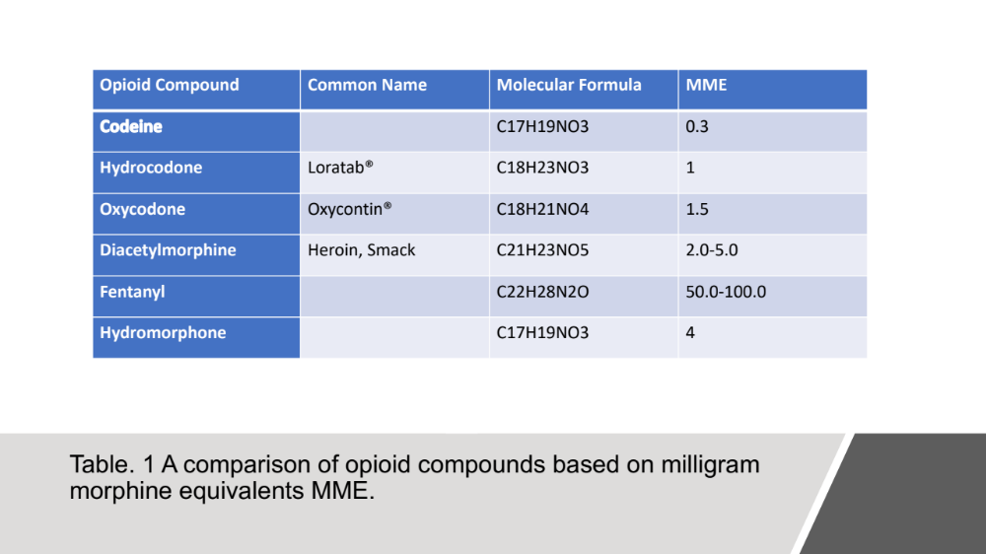

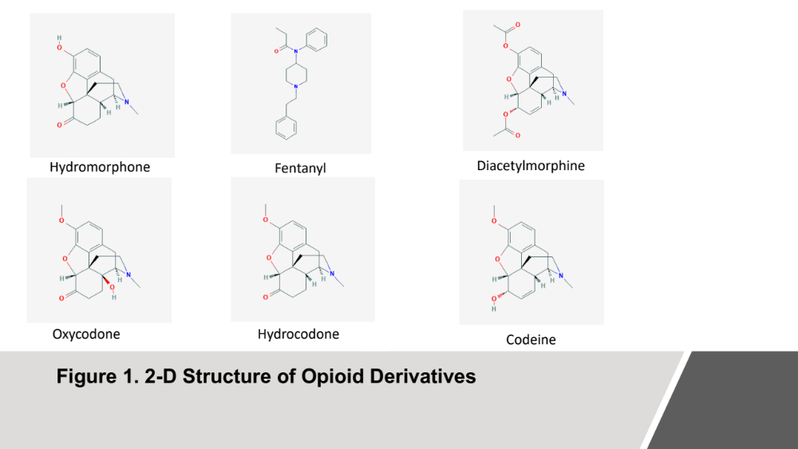

For instance, the conversion factor for oxycodone, which is of 1.5, means that every 1 mg of oxycodone a person takes is the equivalent in the body of 1.5 mg of morphine. Importantly, the potency of an opioid is correlated with its addictive potential. Increased potency is further linked to elevated risk from taking drugs like heroin, which is three times stronger than morphine.

Section One: A Biological Perspective
The biological factors behind opioid addiction are fundamental to our understanding of the psychology behind addiction and which treatment methods will be the most effective. The way opioids affect the brain and cause not only chemical, but also structural changes are what contributes heavily to its addictive nature. Furthermore, understanding these physiological changes is very pertinent to understanding the motivational psychology of an addicted individual, especially in regards towards homeostasis. Effective treatment methods must consider the interplay between biology and psychology. This section will address how drugs use affects biology in light of the three stages of the addictions cycle.
There are three stages in the addiction cycle, and each has its own neuroendocrine substrates. The first begins with the binge/intoxication stage that affects the release of dopamine primarily in the limbic system. The second stage is the withdrawal/negative effect stage that is caused by the reduction of dopamine and an activation of the body’s stress response. The last stage is the preoccupation and anticipation stage that is characterized by changes in the structure of the brain that prime a once addicted individual for relapse. Each of these stages functions on a biochemical level to create and maintain addiction (Koob, 2011).
The first stage of binge/intoxication begins with opioids targeting G-protein coupled receptors as well as potassium and calcium channels in the brain. The interaction between opiates and the G-protein coupled receptors reduces the amount of cyclic adenosine monophosphate (cyclic AMP) present, which serves to reduce the amount of existing opiate precursors. The potassium and calcium channels targeted by opiates have a more immediate effect. These channels are located on gamma-aminobutyric acid (GABA) neurons and opiates acting on these channels cause hyperpolarization. The hyperpolarization of this neuron prevents release of GABA, which is an inhibitory neurotransmitter. The reduction of GABA excites dopaminergic neurons in the brain, as without inhibition they are free to release more dopamine. Essentially, opiates indirectly increase dopamine in the brain by decreasing the release of GABA (Di Chiara and North, 1992). The specific areas in which this occurs are the nucleus accumbens (NAc) and the ventral tegmental area (VTA). In the VTA the reduction of GABA excites dopamine neurons, which directly interacts with the NAc (Koob and Franz, 2004). However, opiates affect more than just these areas of the brain (VTA and NAc), which encompass the mesolimbic dopamine or “reward” pathway. They also affect areas including the frontal cortex and brain stem such that opiate receptors located in a particular part of the brain stem called the medulla, which regulates cardiac and lung functions, have a potential to depress these bodily functions with fatal consequences. Opiates can depress the respiratory system to the point of hypoxia, which leads to death. Indeed, most opiate overdose death are attributed to a depression of the respiratory system. Tolerance can play a role in drug overdose deaths, as the more exposure to opiates an individual obtains, the more processes the body will have put in place to counteract the effect of the opiate. Although the precise lethal dose of opiates can vary from person to person, the mechanism behind overdose has no real implication in the psychoactive effects or high associated with opiate use. This is due to the fact that opioid overdose relies on a depression of the respiratory system from decreased activation of the Central Nervous System (White and Irvine, 1999). The psychoactive effect relies on an increased output of dopamine.
Continuous opiate use changes the normal threshold of stimulation that the brain is used to and spurs the addicted individual to develop a craving and preference for the drug to achieve the brains newly desired level of stimulation. This is the basis of the drug withdrawal/negative affect stage. Abusing opiates spurs neuroadaptation of the brain. Essentially, through various counter offensive measures, the brain manages to reduce the effects of repeated stimulation by increased dopamine (Koob and Franz, 2004). Consequently, the addicted individual can develop drug tolerance and eventually desire more and more of the same drug to experience similar effects. Drug tolerance can be partially explained by opponent process theory as the a-process is associated with positive hedonic effects from the use of a drug while the b-process is the negative hedonic effects. Over time, the pleasure from the a-process decreases while the negative effects of the b-process increase. This leads to increased consumption of the drugs to acquire desired effects. This decrease in original pleasure is the function of tolerance (Solomon, 1980). When someone who has abused opiates long-term suddenly has to go without opiates, the level of dopamine drops radically. The brain’s threshold for stimulation is set very high, due to combination of increased drug tolerance with a decreased production of endogenous opioids and dopamine. This leads to all the common flu-like symptoms associated with drug withdrawal, which can sometimes be referred to as hedonic homeostatic dysregulation. The human body strives to maintain a level of homeostasis, consequently adapting to the increased level of stimulation, even when ensuing adjustments depress stimulation to a level that is significantly below the original threshold from drug abstinence. A way this may occur is through the overproduction of opioid peptide dynorphin. Dynorphin increases in the NAc as a response to increased dopaminergic activity; however increased levels of dynorphin serve to decrease dopaminergic activity. Increases in dynorphin in the absence of opiates to increase dopamine, results in a loss of dopamine that disrupts homeostatic balance. Additionally, this loss of dopamine can also be attributed to lack of dopamine transporter in the NAc (Koob and Moal, 1997) as part of the brains counter offensive to abnormally increased levels of stimulation.
The preoccupation/anticipation stage of addiction is based on the long-term, lasting impact opioid use has on the brain. The first of which is adaptions in the brain’s hypothalamic pituitary adrenal axis (HPA) or stress systems are also involved with the preoccupation/ anticipation stage of addiction. Adrenocorticotropic (ACTH), corticosterone, and corticotrophin releasing factor (CRF) are elevated by drug withdrawals (Koob and Moal, 2001). The elevation of these factors outside of the normal drug reward system supports the modification of brain stress systems during the development of drug dependence. Drug dependence refers the physical dependence a drug causes that is often associated with withdrawal when the drug is removed. Increased levels of stress hormones may contribute to the feelings of anxiety that are associated with drug withdrawal (Koob and Moal, 2001). In a preoccupation/anticipation stage of the addiction cycle often blamed for addiction relapse, the prefrontal cortex (PFC), which is otherwise responsible for decision making and impulse control, becomes overwhelmed by drug associated environmental cues. This triggering by environmental cues for drug use develops through a process of conditioning where places, persons and situations connected to drug use stimulate craving and often culminates in addiction relapse (Koob, 2011). It is further theorized that the 5-hydroxytryyptaminergic pathway plays a role in decreased ability for impulse control and decision making by the PFC and thus that opiate addiction effects serotonin pathways as well as dopaminergic ones (Lee and Pau, 2002). Opiate addiction is neither simple nor isolated to specific parts of the brain --but rather involves multiple pathways and structures --making it both complex to understand and experimentally investigate.
Also, the preoccupation/anticipation stage of addiction come into play as the opioids affect brain areas involved with the regulation of emotions, specifically the limbic system. Morphine use is directly correlated with atrophy in the amygdala, a part of the limbic system that is important for the experience of fear. Here a significant loss of gray matter, which can occur with as little of one month of continued exposure to drug stimuli, can effect long term behavior (Younger et al. 2011) Besides physically altering the amygdala, opiate abuse decreases the complexity of dendritic spines in the NAc and decreases the soma size of dopaminergic neurons in the VTA (Russo et al. 2010). Dopamine transporters and dopaminergic activity are both decreased in response to opiates, and this may explain the changes in structure of the limbic system observed in these studies (Kish et al. 2001). These structural changes come into play when discussing the first and second stages of the addiction cycle, binge/intoxication and withdrawal/negative effect. As the first step begins and continues, structural changes occur in the amygdala, VTA, and NAc due to the hyperactive dopaminergic neurons (DA). Withdrawal then occurs as these changed structures now operate differently than before opiate exposure and grow accustomed to the effects the opiates previously had. The addicted brain functions differently than someone that has never used opiates, and that piece of information becomes of the upmost importance when understanding opiates effect on the brain.
When discussing changes in the brain due to opiate use the effects of long-term potentiation and long-term depression must also be referenced in regard to synaptic plasticity. Synaptic plasticity refers to the strength of connection in neural synapses, which is another key part to understanding the effects of opiates on the mind. Long-term potentiation is how recent patterns of activity produce lasting effects in neural synapses. Continued excitatory signaling with the dopaminergic neuron creates a long-lasting strengthening of signaling that produces a strong connection between dopamine release and the NAc. Long-term depression is the opposite of this process. Continued inhibitory signaling acting upon the neuron releasing GABA by opiates can have the long-term effect of depressing release of GABA for that neuron. Neural synapses can be changed by the repeated conditions they are subject to on a day-to-day basis (Luscher and Malenka, 2011).
Structural change is not limited to the limbic system in the opiate affected brain; but is also present in structures of the frontal cortex. Functional Magnetic Resonance Imaging (fMRI)studies have demonstrated that long-term opioid abuse impairs the prefrontal cortex (Lee et al. 2005). This has long been assumed to be true, as other studies have shown that heroin addicts struggle with impulse control, which is usually attributed to the PFC. Specifically, individuals addicted heroin show decreased cortical thickness in the PFC. The change in cortical thickness is most likely attributed to habituation and opponent processes involved with drug use (Li et al. 2014). Also, like the dendritic spines of the NAc, the dendritic spines of the PFC also suffer decreasing complexity. These structural changes are particularly interesting as these structures are not part of the usual drug reward pathway in the limbic system; rather these structures are more closely associated with decision-making and not emotion. As discussed earlier, the preoccupation/anticipation stage of addiction can be better understood by these structural changes. Changes in the frontal cortex impair the ability of patients recovering from addiction to control their impulses thus helping explain why this stage of addiction is deemed where relapse most often occurs. The mental processes of this stage rely on parts of the frontal cortex that have most likely been damaged through opiate abuse. Studies have shown that patients who have struggled with opiate abuse during certain experiments almost always answer complex question with much greater rates of error than the control group (Lee and Pau, 2002). This is an important fact to keep in mind as impulse control plays a pivotal role in people who struggle with opiate addiction.
Genetics must also be considered when discussing opiates. The receptor MOP-r gene (OPRM1) plays a crucial role in prediction of addiction. The MOP-r receptor is the main receptor targeted by opiates. A variant of this gene, 118A>G, greatly increases the binding affinity of this receptor for opiates which compound the effects. People with this variant of OPRM1 have a much higher risk for opiate addiction, as the effects of opiates are more intense because of the increase in substrate affinity. Asian populations show forty to fifty percent prevalence for this mutation while European population only show fifteen to thirty percent prevalence, and African populations have an almost negligible prevalence of this gene. Genetics also play a role as opiate use can alter the regulation of gene expression. Opiate use has been shown to cause long-term regulatory changes at the mRNA, protein, and polypeptide level. An example of this would be the up regulation of the kappa opioid receptor (KOP-r), which is involved in the dynorphin system discussed earlier. Another effect of on gene transcription for opiate use is the activation of cyclic adenosine monophosphate response-element binding protein (CREB). Activation of this protein is believed to cause the expression of dynorphin. The up-regulation of both the KOP-r receptor and dynorphin is how genetics plays a factor in the withdrawal/ negative affect stage of opiate addiction. Transcription factor delta-FosB is also increased by continued opiate abuse and plays a role in dendritic spine density. This is hypothesized to increase the reward experience by taking opiates (Kreek et al. 2012). The genetics of drug addiction show side of both nature and nurture. The nature aspect can be seen in how there are certain mutations expressed to begin with create susceptibility to opiates while environment can cultivate genes specifically related to opiate abuse. The complexity of the effects of opiate use on the body increases even further when considering the effects of gene and transcription factors.
The way in which opiates affect the brain, cause structural changes, and manipulate genetics all come together in how they cause and perpetuate addiction. The effect on the brain from increased stimulation due to excess dopamine serves to create the addictive euphoria addicts so desperately crave. However, the excess opiate and dopamine substrates serve to decrease production of naturally occurring opioid ligands and dopamine as your body attempts to return to homeostasis. This attempt to return to homeostasis has the duel effect of changing gene transcription and inducing structural changes in the brain. The brain adapts to deal with the excess chemicals and all is well and good until that drug is removed from the system. Because of the adaption taken place for opiates, the brain cannot function normally as before. The changes in the limbic system affect mood and overall states of happiness. Instead of homeostatic balancing trying to correct for too much dopamine, it must now correct for not enough as gene transcription has produced factors to directly inhibit natural production of the dopamine. This results in a chemically induced reduction of feelings of happiness. On top of this, the frontal cortex has also undergone changes due to opiate use and now the brain cannot properly exert impulse control and rational decision-making. The new understanding modern science has given us of how opiate addiction works on a neurobiological level should change the way in which people understand opiate addiction. People who become addicted to various forms of opiates undergo significant changes in how their brain functions that cannot be understood by people who have not experienced the same thing. Strength of will cannot revert the structure of the pre-frontal cortex back to its original function or reset the changes caused by excess dopamine in the limbic system. Addiction to opiates is complex biologically so it would only seem reasonable that recovery from addiction to opiates is equally as complex.

Section Two: A Psychological Perspective

An understanding of a sociological and biological perspectives on the opioid crisis is absolutely crucial in grasping the psychological perspective of the opioid crisis. Understanding who has been affected by the opioid crisis allows for a psychological understanding of what drives people towards addiction, and a biological perspective allows an understanding of why opioid addiction is very difficult to recover from. It is important to understand how psychology in the Unites States emphasizes pain elimination and then how addiction is perpetuated from a psychological standpoint. This section will cover the psychological construction of pain, how this outlook affects opioid use, the psychology of addiction, and how adverse childhood events creates risk for drug use.
Pain is in many ways a social and cultural construct. In western medicine, pain has been viewed as something to be eliminated. Any amount of pain is often considered unacceptable and doctors face significant pressure to eliminate this pain to receive good reviews. This outlook can partially be attributed to the addition of pain as a fifth vital sign. This addition places significant pressure on doctors to eliminate pain. This outlook can be problematic as this encourages doctors to prescribe opioids as they are the most effective and quickest means of pain elimination as it can be directly reflected in how they are rated (Caudill-Slosberg et al. 2004). This view of pain differs greatly from a more traditional view of pain. Other cultures that have avoided the opioid crisis that is plaguing the United States often have different social or cultural constructs regarding pain. Pain is often viewed as something to be dealt with and managed not eliminated. These cultures focus on learning to adjust their day to day lives to eventually remove or lessen pain. This can be directly seen in how practitioners of Zen meditation deal with pain. Those who practice Zen meditation demonstrate higher levels of pain tolerance. This can be partially attributed to how this practice focuses upon management rather than elimination (Grant and Rainville, 2009). This approach takes time and does not offer a quick fix. This is another way in which an American point of view can have dangerous implications with opioids. The combination of the consumer outlook in America wanting the quick fix, and the idea that any pain is unacceptable creates an atmosphere in which rampant pill prescription is the most logical fix. Furthermore, the consumer outlook emphasizes pleasure as the highest end to achieve. This can also be a dangerous manner of thinking when it comes to pain and drug use (O’Malley and Valverde, 2004). It is very imperative that this outlook on pain be corrected, and patients begin learning how to manage pain versus simply eliminating it.
This approach to chronic pain may also help explain why prescription opioid abuse is higher in rural areas. As discussed earlier, people who live in rural areas are more likely to experience both economic stressors and engage in hard physical labor. This can result in both physical injury or dissatisfaction in status. The quick fix to both these problems can be opioid use. Opioids can fix the pain from a physical injury and allow a worker to get back to the job faster than alternative forms of pain management such as physical therapy. Furthermore, it also provides immediately relief from the pain associated with economic stressors that result in a reduction in the quality of life of the individual. In both senses, the opioid is able to provide immediate relief from large amounts of cognitive dissonance experienced by the patient. While the problems will compound, the temporary relief seems to be a good enough fix to encourage continued opioid use. Once, again the cultural outlook that emphasized quick fixes and elimination of pain, emotional and physical, has contributed to opioid abuse increasing in recent years.
Psychological outlook also affects the difficulty patients have in overcoming addiction. There are two main way in which a patient’s psychological outlook can propel their addiction. The first was touched on slightly in the previous paragraph but has to do with the homeostatic dysregulation faced by opioid addicts. Opioid addicts when attempting to recover from addiction suffer a severe disruption in their dopamine production. The direct consequence of this is intense feelings of despair and depression. This psychological pain accompanied by the physical pain of withdrawal is a very intense thing for the patient to deal with in combination. The “low” being experienced is much more painful than any previous poor experience as their mind is not properly equipped with the normal chemical balance to deal with the stress from withdrawal (Koob and Moal, 1997). This can make avoiding relapse very difficult, but even more difficult when impulse control is taken into account. Chronic opioid use has also been shown to affect the pre-frontal cortex and thus have a negative effect on decision making skills, especially impulse control. Therefore, an addicted individual is not only mentally dealing with more pain and depression, but also an impaired form of decision making (Yücel et al. 2007). These two processes affect a patient’s decision making in a such a way that makes relapse to opioid use all the more likely.
Another pertinent topic in discussing the psychology of addiction is how adverse childhood events (ACEs) may influence the development opioid use disorders. Adverse childhood events are measured by an ACE questionnaire that usually has ten items that reflect a less than ideal situation for growing up. There is a consistent correlation between a high ACE score and the likelihood of developing an opioid use problem. One study found that each adverse event selected contributed to the overall likelihood of experiencing an opioid overdose increasing by a factor of 1.1. This trend seen with ACEs and opioid drug use can be explained by a variety of factors. Parental drug use can show both a genetic susceptibility to drug use but also more importantly a poor model for healthy coping behavior. A child without a proper model for healthy drug use will be more psychologically primed to use the same coping method as their parents, and in this case that is opioid use. Opioid use can furthermore impair cognitive function in children causing problems in decision making and rational thought process (Stein et al. 2017). ACEs provide a very clear insight into who may be at risk for developing opioid use problems and how poor life circumstances can be direct influencers of illicit drug use.

Section Three: A sociological perspective (Who is to blame, who has been affected)
While the causes of this crisis are complex, a sociological standpoint can serve to answer two very important questions on the opioid crisis, “Who is to blame?” and “Who has been affected?” Several entities have contributed to the beginnings and perpetuation of this crisis, often at the cost and exploitation of marginalized people. Pharmaceutical companies, prescribers, and law enforcement agencies have played a role in either causing, perpetuating or failing to stop the epidemic. Not one holds sole blame or all equal blame, but they all three have worked together to propel us towards this opioid crisis seen today. Furthermore, certain population groups have been more heavily affected by this crisis than others.
In particular, pharmaceutical companies, have been directly linked to shaping the current crisis through their marketing and dealing with prescribers. The most notable example of this comes from Purdue Pharma L.P.’s marketing of OxyContin®, which is their patented version of oxycodone in an extended release form. Essentially, it is oxycodone covered in a waxy substance to allow slow absorption of the otherwise potent opioid. Originally, the drug was marketed as a non-addictive alternative to opioids. However, these claims were unsubstantiated and simply wrong. Upon research determining OxyContin® was in fact addictive, Purdue Pharma continued to downplay its addictiveness and potential for abuse when marketing their product to doctors. These unethical dealings have recently resulted in a both criminal prosecutions and civil lawsuits against Purdue Pharma, which was recently fined $634.5 million (Raymond, 2019). Several other lawsuits are still pending.
Another questionable tactic implemented by pharmaceutical companies is how they often compensate doctors for prescribing their medications. From free drug samples, to speaking fees, to direct monetary compensation, pharmaceutical companies have historically given doctors and other prescribing clinicians financial rewards for prescribing certain drugs (Macy, 2018). According to Hadland et al., whose work studied the marketing of opioids towards physicians from 2013 to 2015, there were 434, 574 payments to 504 physicians totaling $39.7 million (2019). This same study also showed that prescribing rates not only increased with this marketing but that there was a subsequently correlated increase in overdoses in the same areas where doctors received money for prescribing opioids. Included in this study is a map highlighting where the highest mortality rates exist for opioids in comparison to where the most money is being spent on opioid marketing. This shows a significant positive relationship between the two factors (i.e., where more money is being sent by pharmaceutical companies and where overdoses occur due to prescription opioid use) (Hadland et al. 2019). The data importantly show that a direct line can be drawn between the flow of money and death rates. It underscores the culpability of prescribers because of the fact the death records examined represented overdoses on prescription and not illegal opioids. Arguably, until very recently, people were overdosing on prescription medicines received from their doctors and not necessarily drugs bought on the street. However, it is important to note that this is only a correlation, and not proof of a direct causation that prescribers receiving opioid marketing are the sole cause of these overdose rates.
While pharmaceutical companies have greatly profited from their marketing and distribution of opioids, other entities may have affected their proliferation in the United States. Physicians and prescribers are a necessary step in the chain between opioid production and their distribution. A 2019 study showed that on average, doctors who receive opioid related payments prescribe 8784 more daily doses than prescribers who do not receive such payment (Nguyen et al 2019). Oxycodone and hydrocodone are typically the drugs prescribed in conjunction with these payments (Nguyen et al., 2019). This statistic is concerning for multiple reasons, including that it implies doctors receiving drug company payments may be unconsciously favoring the prescription of opioids --or worse yet, prescribe opioids because of the money earned in return. Either way, this data reveals a trend that cannot be ignored --especially in light of the fact that the drugs being prescribed more often (i.e., oxycodone and hydrocodone), are the most common opioids to which patients become addicted. However, this is most likely attributed to the fact that these drugs proliferate more due to increased prescription rates which increase their accessibility rather than simply their addictive nature.
Around the dawn of synthetic opioids, the American Medical Association identified pain as the fifth vital sign. This had terrible ramifications because it places a greater pressure on physicians to eliminate pain. Physicians who do not eliminate a patient’s pain could receive poor performance ratings. This relates to opioids as the easiest way to immediately eliminate pain is the prescription of an opioid. Thus, with the introduction of pain as the fifth vital sign, more incentive was created to prescribe opioids even for pain that was non-significant (Macy, 2018). While sometimes these opioid prescriptions may be necessary for pain, often times they are not.
Needless to say, physicians and other healthcare practitioners should be responsible for adequately educating patients of the dangers of all the medications they prescribe. Often, patients receive these medications with little advice or warning on the dangers of addiction. Both pharmaceutical companies and physicians may have played a role in not only beginning the crisis, but also currently in its perpetuation and growth. While pharmaceutical companies historically misled physicians on the addictive nature of certain medications, medical professionals could have been more cognizant of the addictive potential of opioid medications.
Outside of the pharmaceuticals and physicians, both government policies and agencies have failed the general public in preventing and mediating the opioid crisis as well. The drug control policy implemented by the United States has been not only ineffective, but in some respects resulted in more harm than benefit to society. Drug policy in the United States has functioned under the ideology that harm is caused by drug abuse, the use of prescription drugs outside of their intended use or the taking of illegal drugs, and thus all policies served to prevent use of drugs. This ignores harm cause by the creation of black markets for illegal trafficking of banned substances, the result of which is a tendency to paint drug users as the wrong-doers deserving of punishment rather than as victims in need of medical treatment or therapeutic assistance. By extension, the criminal justice system is ill equipped with resources for criminal detainees and prison inmates who are dealing with SUD and OUD. In fact, most law enforcement departments do not adequately screen for these disorders and very few offer any type of medicated assisted therapy (Brinkley-Rubinstein et al., 2018). Shockingly, the stringent policies and laws towards drug use in the United States means that the criminal justice system interacts with a very high number of people at risk for SUD and OUD. The lack of help offered to this population can create an endless cycle of release and re-arrest for many addicts. Intervention by the criminal justice system could effectively help a large number of individuals recover from addiction. A main barrier in their ability to help individual likely does not fall in the fact that the criminal justice system is unwilling but rather both funding and the difficulty of treating addiction. In order provide services for SUD and OUD, funding is needed to provide programs and furthermore treating addiction is a very complex and tough matter.
Besides criminal justice departments, the drug enforcement agency was unaware of unethical practices that were contributing to the beginning stages of the opioid crisis. Essentially at the beginning of the crisis, the DEA did not pay attention to the massive production and distribution of opioids as they were focused on other drug crises occurring in the Unites States.. One example of this comes from West Virginia. One pharmacy in Kermit was receiving shipments of 9, 650 hydrocodone pills per day from McKeeson. Not only is this thirty-six times higher than the amount the company was supposed to be shipping, the town of Kermit only has a population of 400 people. This occurred without being flagged because the DEA at that point in time was not reviewing the usage data surrounding opioids so as to combat their proliferation in illegal markets (Raby, 2018). West Virginia has the highest death rate from use of prescription drugs, and this oversight likely played a large part. While this does seem fairly condemning toward the DEA, it is also important to understand that at this point in time, opioids were not a major point of concern nor had their full addictive potential be realized.
Outside of entities that have helped this crisis take root, is also important to understand the sociological and psychological factors of those most affected by the crisis. In looking at the opioid crisis there are several sociological factors that seem to go hand in hand with addiction. Poverty, rurality, and hard physical labor are becoming very effective markers of where the opioid crisis is the worst.
Poverty is related to opioid use namely in two ways. Poverty first increases vulnerability to addiction from economic deprivation and then a limits access to treatments once addicted. People living below the poverty line face much higher levels of stress on a day to basis. This drastically increases the likelihood of turning to illicit self-medication with drugs. This can also be seen as a function of general unhappiness or disappointment at the status of their life. High levels of stress accompanied with general unhappiness not only puts this group at a high level of risk for mental disorders, but also at a high risk of addiction. People facing these challenges are more likely to turn to temporary forms relaxation and happiness that drug use often offers, albeit with hefty consequences. The socioeconomic status of people often affects their psychological status, and this can increase risks of addiction (Bruce et al., 1991).
Another group of people who are at high risk of addiction is those whose profession involves hard physical labor. People who do hard physical labor for work are much more likely to experience on the job injuries necessitating opioid painkiller prescriptions (Macy, 2018). These painkillers allow workers often to work through injuries but can exacerbate the underlying condition and cause long term chronic pain which is often treated with a long-term opioid prescription. Those working in hard labor are from lower socioeconomic status and face greater challenges than other populations. This puts them also at a higher risk of addiction. This coupled with the fact that these workers are often very likely to receive an opioid prescription at some point in their life places them at a very high risk for developing an opioid use disorder (Robertson and Donermeyer, 1997). The worker while taking the pain medication may find that opioids in combination with numbing physical pain, they can also numb emotional pain, and this is where these drugs find their real addictive potential. A tangible example of physical labor’s correlation to opioid abuse can be seen in the State of Tennessee as well. In Tennessee an injured worked has a 31.8% chance of receiving an opioid prescription within six months of being injured on the job. Workers will often not report their injuries and use opioids to deal with the pain so that they can maintain their normal work schedule (Durand, 2019). The socioeconomic status coupled with the physical demands of the job places this people group at a higher risk of developing an opioid use disorder.
Rurality has become a major predictor of opioid abuse mainly because it often combines the first two subgroups mentioned in the previous paragraph. Those living in rural setting are more likely to not only be below the poverty line, but also work in manual labor types of jobs. Specifically, there are four factors that proliferate opioid use in rural areas: greater availability, social and kinship network connections, out migration of young adults, and economic stressors. The greater availability stems from the fact that rural areas are receiving a much higher rate of prescription of opioid medications. A higher rate of prescription facilitates the excess number of pills that exist in rural areas. With this, social and kinship network connections create an easy way to obtain and share pain medications. People in rural areas are more likely to receive and take unprescribed opioids as they can receive them from family while in general just have an easier time finding opioids as rural areas often have more extensive social networks. The high prescription rate coupled with this not only creates an excess of the drug for an illicit market, but also makes it very easy to obtain. Rural areas also see a very large out migration of young adults. The outmigration of young adults serves to increase the poverty of an area. In addition, rural areas face greater economic stressors in general. As stated earlier, poverty is a significant predictor of opioid abuse and can serve to place people at risk for developing substance use disorders in general. The interplay between these four factors serves to create the trend of rural areas being affected the most by the opioid crisis (Keyes et al., 2014). A tangible example of this can be seen from a study done in North Carolina analyzing opioid mortality rates. The study showed that rural counties, especially in the Appalachia area, had higher rates of overdose due to prescription opioids (Cordes, 2018). Rural areas have found themselves suffering greatest at the hands of this crisis because of their unique intersection between both poverty and opioid availability.
Fourth section: Efficacy of treatments
Due to changes in structure and chemical imbalance, opioid addicts face special challenges in regard to recovering from addiction. Withdrawals from opioids can be severe and even life threatening so most recovery treatment programs use medically assisted therapies or MAT. These therapies use several types of medication to wean addicts off of the opioid drug of choice. The three most commonly used drugs for MAT are methadone, naltrexone, and buprenorphine. Each has their own respective risks and effectiveness based on individual patient differences. These drugs are prescribed for many substance use disorders (SUD); however, this section will focus on their efficacy for opioid use disorders (OUD). The U.S. National Library of Medicine refers to a SUD as the misuse of alcohol or another substance that leads to health issues or problems at school, work, or home. OUD is when opioid is the misused drug of choice (2018).Table 2 and Figure 2 show the data from a combination of information by the United States Center for Disease Control (CDC, www.cdc.gov) and U.S. National Library of Medicine National Center for Biotechnology Information (PubChem, https://pubchem.ncbi.nlm.nih.gov/compound/) that give information on medication used for MATs.
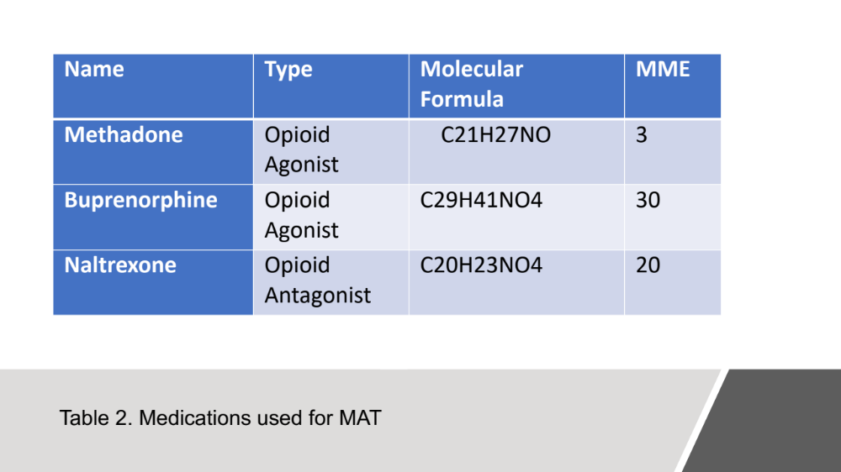

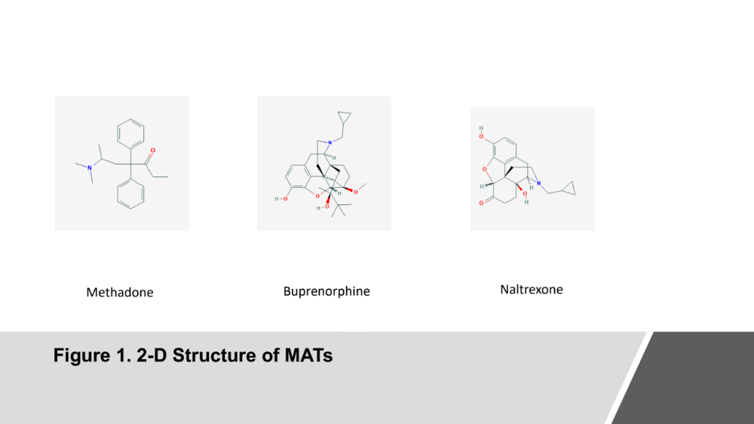

Methadone hydrochloride is a long acting opioid agonist that serves to prevent withdrawal in patient recovering form opioid addiction. Methadone has been in use for a long time, especially regarding recovery from heroin addiction. A meta-analysis done in 2009, highlights that methadone is in fact a more effective treatment for heroin addiction than no medication given at all. Data collected from studies done after 200 show 154 per 1000 patients demonstrated treatment retention without any medication assistance while 684 per 1000 patients demonstrated treatment retention while using methadone-based therapies. It is important to note however that treatment retention does not signify an absolute cure from addiction but rather just whether the patient went through the entire treatment regime. It also does not indicate how many patients may have relapsed upon finishing treatment. Furthermore, while 684 is vastly greater than 154 per 1000, it still reflects only a 68.4% completion rate for treatment. Methadone can be more effective than non-MAT therapy, however, it would be better to see a higher completion rate as methadone has its own inherent dangers (Mattick et al. 2009). Methadone, since it is a long-term opioid agonist, can be highly addictive as well and poses the same health risks as other opioids.
Naltrexone works as an opioid antagonist as it blocks opioid receptors. Essentially, it is used to prevent the rewarding effects of using opioids. Naltrexone has shown to be relatively inefficient as a MAT therapy. Most meta-analyses on the effective use of naltrexone for opioid use disorder have concluded that there is no significant difference between naltrexone use and placebo use. However, it has shown to be effective for population group that are more highly motivated. An example of this would be people attempting to avoid prison. Dropout rates for people in naltrexone programs is extremely high between induction into the program and when drug administration begins (Roozen et al. 2006). This is probably due to the fact that Naltrexone requires the patient to be sober for several days before initial administration or the patient will go through sever withdrawals as the opioid receptors become blocked. This poses a potential problem when dealing with opioid addicts as many are unable to go that amount of time without using. Naltrexone may have use in preventing relapse for patient who have undergone successfully some other program recovery however current data does not suggest that it is the best option for patients suffering currently from opioid use disorder.
Lastly, buprenorphine is considered useful and often reflects the same level of efficacy as methadone. Patients receiving 7mg of buprenorphine have been shown to have a 70% retention rate compared to 40% in placebo groups and patients receiving at least 16 mg have a retention rate of 73%. However, these same placebo studies also showed that buprenorphine was only mildly effective when compared to a placebo at the 16mg dose in preventing illicit opioid use which calls into question its effectiveness. However, studies have shown that both buprenorphine and methadone have the same level of opioid use suppression when given in medium to high doses. The only real difference is some studies show a slightly higher rate of retention in methadone than buprenorphine, but this is hotly contested. However, there is one positive difference with buprenorphine. Patients using buprenorphine often express lower levels of sedation than those using methadone. 58% of participants reported feeling more sedated with methadone and only 26% with buprenorphine (Salisbury-Afshar, 2015). This statistic could be important in understating how MAT for opioid use disorder relates to helping people adjust back to normal lives.
Essentially, these three different therapies have had moderate amounts of success and our often better than placebo or abstinence-based therapy alone. However, research must be done to find more effective forms of therapy. The low level of suppression of illicit opioid use is a serious problem of these three medications. Retention rates are beneficial to increase, however, the real reason people participate in these programs is to prevent their use of illicit opioids. The last section of this thesis will address several new avenues for treatment that promise better efficacy than current medically assisted therapies.

Section Five: New Potential Solutions

There are also several developing areas that are showing great promise when it comes to the treatment of Opioid addiction. These new developing areas involve both the study of new drugs, new intervention methods, and alternative forms of pain management. The study of new drugs involve schedule one drugs that are becoming de-stigmatized, researched, and in some cases legalized. Of course, the main drugs in question is marijuana in both its THC (tetrahydrocannabinol) and CBD (cannabidiol) components but also hallucinogenic such as LSD (lysergic acid diethylamide) and psilocybin (commonly referred to as magic mushrooms). Also, two new methods of interventions are being implemented. The first being interventions at the pharmacist level, and the second is using peer-based intervention groups in combination with other medically assisted therapies. Lastly, research has begun on the efficacy of alternative forms of pain management that do not use drugs but rather forms of pain management that take root in alternative and traditional medicine.
The appeal of marijuana as being a potential answer to the opioid crisis can first be seen in the trends that arise in areas that have either legal medical or recreational cannabis for sale. The trends seen in Canada, Colorado, Michigan and other legal states are a template that could be applied to any state that legalized marijuana on either a medical or recreational level. The legalization of marijuana is directly correlated with lower opioid use in chronic, high, average, and lows users based on a self-report study (Shah et al., 2019). This suggests marijuana could be a tool in preventing people from engaging in risky opioid use. Another survey found, that 69.1% of respondents had chosen to use medical marijuana to replace their opioid prescription and another 22.6% of respondents use opioids to replace illicit opioid use. The main belief to the respondents is that marijuana is a safer alternative to opioid use, and to an extent they are correct (Lucas et al., 2019). The risk of physical dependence upon marijuana is almost negligible and the chances of addiction are also much lower than that of opioid use. Furthermore, the side effects of marijuana use are fewer and less severe than the side effects of daily opioid use. Furthermore, there is no risk of lethality when using cannabis. It is currently the only known drug that can effectively manage pain that has no risk of lethality if too large of a dose is taken. The active ingredients in marijuana, the THC and CBD, affect similar areas of the brain as opioids when it comes to pain management however the lack of lethality come in where the cannabinoid receptors are found, and opioid receptors are not. Cannabinoid receptors can be found in the brain stem and other areas of the brain however they are not found in the respiratory system. Most overdoses on opioids come from an over depression of the respiratory system, which causes decreased breathing and eventually suffocation. Cannabinoids only function to decrease the travel of pain signals in the brain stem without affecting the nerve signaling of the respiratory system as the respiratory system cannot recognize or use cannabinoids due to a lack of the CB1 receptor (Pertwee, 2008).
Cannabis has value not just in its ability to be a potential replacement of opioids but also it could have the ability to be a better medically assisted therapy for treating opioid withdrawal and helping patients beat opioid addiction. Opioid withdrawal can be the cause of aggressive flu-like symptoms that include: nausea, vomiting, diarrhea, abdominal cramping, muscle spasms, anxiety, agitation, restlessness, insomnia, runny nose, and sweating. However, while they are labeled flu-like symptoms, these withdrawal side effects are amplified intensely and can even cause death in severe cases. The traditional pharmaceutical method of treating these symptoms is a cocktail of four different drugs: a muscle relaxant, anti-hypertensive agent, anti-diarrhea agent, and an anti-nausea agent. The use of four different synthetic pharmaceutical for this comes with more side effects and potential drug risks (Sulak, 2016). However, cannabis has been shown to effectively reduce these symptoms with much lower side effects. However, to be fair, chronic marijuana use can have withdrawal symptoms as well. The stoppage of chronic use can cause anxiety, irritability, nervousness, anger, weight loss, sleep difficulty, restlessness, and strange dreams. The difference of these side effects however lies in their severity. Users who report experiencing these side effects report them as very mild and no worse than caffeine withdrawal which is a drastic step down from opioid withdrawal. Cannabis use can also be beneficial being used as a therapy drug in and of itself or in combination with other medically assisted therapy drugs. If cannabis in and of itself is not potent or effective enough for weaning an addicted individual off of opioids, then its use in combination with opioid based antagonists shows promise as well. Cannabis increases the therapeutic index of drugs used in opioid therapy (Abrams et al., 2011). The therapeutic index refers to the amount of drug needed to be administered to cause an analgesic effect. This happens as the active compounds in cannabis work in combination on similar receptors to the opioids which decreases the amount of opioid needed to cause an effect. This is obviously beneficial as any time the effective dose of an opioid is lowered, the side effects and addiction potential are also vastly reduced.
Hallucinogens while not researched as much in this context as marijuana has been in past years do also show some merit in the treatment of addictive disorders. A meta-analysis from 2012 researched and discussed the role of LSD in relation to alcohol addiction. The study found 59% of the LSD patients showed significant improvement over the 38% significant improvement in control participants (Krebs and Johansen, 2012). The exact reason why this result happened is not entirely understood but is attributed to either persisting structural changes in the brain or persisting psychological effects. No studies have been able to prove persisting structural changes, however persisting psychological effects seems to be plausible. The use of LSD may allow for a reevaluation of self or a “mystical experience” that causes positive behavioral change. Essentially, it is theorized that hallucinogens can cause an intense experience that causes an addicted individual to desire more intensely to want to change his current state of being. More research should be done upon this, but if this is in fact the case hallucinogens could serve as a useful tool in causing opioid addicts to seek treatment and be more committed toward sobriety and getting clean. However, as LSD and psilocybin remain schedule one drugs they are incredibly difficult to study which is why research surrounding their clinical efficacy is limited.
Outside of new research on drugs, new intervention plans may be beneficial in fighting the current crisis. Pharmacists intervention plans could be a unique and new way of combatting bad prescriptions and prescription abuse by patients. Pharmacists act as an intermediary between prescribers and patients giving them a unique role and responsibility regarding this current epidemic. Pharmacists can watch for bad and suspicious prescriptions from prescribers while also seeking to note signs of opioid abuse in patients coming in to fill prescriptions. Most pharmacists agree that the opioid crisis is in fact a problem especially in Tennessee. One study found that 87.5% of pharmacists in Tennessee view the opioid crisis as a problem. Furthermore, 71.2% agree that improving prescriber-pharmacists relationship would help combat opioid misuse. However, there are two much more concerning statistics found by this study, only 16.7% of pharmacists believe they had received proper opioid abuse training in school, and a shocking only 6% believe that prescriber adequately educate patients on opioid risk (Hagemeier et al., 2014). This study serves to highlight the intense amount of miscommunication or rather lack of communication that is occurring around opioids prescriptions. Adding an extra level of safety in training pharmacists to intervene in prescription misuse and suspicious prescriptions could help prevent opioid use at the prescription level. However, certain protections for pharmacists would have to be set in place. Pharmacists who call into question the prescription of a doctor could face backlash and loss of business. In fact, 80% of pharmacists think the biggest hold up of a discussion between pharmacists and prescribers centering around opioid abuse would be doctor backlash. If policies were set in place to prevent negative consequences for pharmacists, a new highly effect system of monitoring abuse could be put into play while also increasing the ease at which “pill-mills” and unethical prescribing operations could be found and consequently shut down. This would do a great deal of good in addressing one of the root causes that perpetuates the crisis not only on a national level but specifically in Tennessee.
Another form of intervention that focuses on the patient is peer-based recovery programs. These programs are proving to be effective especially in rural areas. Peer based recovery programs function under the assumption that other addicts are uniquely equipped to help current addicts recover from addiction and thus assign people who enter a hospital for an overdose or enroll in general substance use disorder therapy a peer mentor who was once an addict. People who were once addicts understand the challenges and pain faced by addicts struggling to recover. On top of this, the recovering addicts who are assigned a peer are given a positive social support system in the form a peer who understands them. A positive social support system is incredibly beneficial in increasing the likelihood of long-term recovery. Furthermore, this type of program is exceptionally beneficial in rural setting as addicts are less likely to have access to effective SUD treatment and often do not receive much recognition or treatment in the emergency room. The combination of both clinical treatment in accompaniment with peer-based programs shows higher rates of successful treatment over simply using basic medically assisted therapies alone (Ashford et al., 2019). This fact also highlights the importance that social setting has upon health outcomes. Like all patients, addicts have better long-term outcomes when they have social support and can rely on others and not only themselves.
Alternative methods of pain management have also been gaining traction and credibility. Mindfulness and meditation are being proven as an effective way of managing pain. To understand how this works it is first important to define these terms. Mindfulness has been described as a “non-elaborative, non-judgmental awareness” (Kabat-Zinn, 1982). Mindfulness can be developed and practiced through meditation; however, two aspects of mindfulness have proven the most significant in regard to dealing with pain: focused attention and open monitoring (Lutz, 2008). Focused attention is the skill of learning cognitive control over sensory, emotional, and cognitive events. Most commonly, this is taught and practiced by focusing on the sensations of one’s own breath and as one’s attention drifts away from their breath they continuously bring their focus back. Essentially focused attention is just training the ability stabilize attention on a singular event. Open monitoring is less specific and refers to the ability of meditation on all perceived thoughts and emotions. Open monitoring is only achieved through a mastery of focused attention (Wallace, 2006). Higher levels of mindfulness have been shown to relate directly to lower pain sensitivity. One study showed that patients who have previous experience with mindfulness almost always report lower levels of experienced pain when exposed to noxious stimuli than patients with no mindfulness experience. The mechanism by which this works cognitively has been postulated by Buddhist monks for many years. It is best understood through the “Arrow” metaphor. The arrow metaphor discusses how pain has two arrows, one that pierces the body and one that pierces the mind. This refers to the sensory reception of pain and then the cognitive evaluation of pain. Buddhist monks have said that an expert practitioner of meditation is pierced by the first arrow, the sensory aspect of pain, but remains unharmed by the second arrow, the mental aspect of pain. Essentially, the sensation of pain is dissociated from the cognitive appraisal of pain. This is significant as Nepalese porters who are experienced in mediation where proved to have significantly higher pain thresholds (Clark and Clark, 1980). The mechanism through which this occurs is outside the endogenous opioid system. Mindfulness and meditation create lower activation of nociceptive processing. There is both higher activation of sensory processing regions of the brain and a decrease in activation of the areas that process the evaluation of pain in the brain for those practicing mediation. Mental training and mindfulness work to prevent nociceptive information from being transmitted thus reducing the perception of pain (Grant et al., 2001) (Zeiden and Vago, 2016). The efficacy of mindfulness and meditation in dealing with pain is significant as it provides a safe, long term remedy for dealing with chronic pain. The current literature shows this method of pain management as safer and just as effective, if not more effective way of managing pain.
While new interventions may prove useful, the most promising avenue is still the use of medical marijuana as not only a new therapy drug for addiction but also a potential new drug for dealing with chronic pain. As marijuana has been labeled a schedule one drug on the federal level, it is still very difficult to obtain federal money to research and understand its medical potential. However, this is incredibly ironic as a schedule one drug infers that the drug itself has no medical use or significance. This viewpoint is quite outdated as studies show almost irrefutably that marijuana has potential to be used for medicinal purposes. The first challenge in implementing and determining the usefulness of marijuana will be simply gaining the ability and funds to conduct research upon it. As this crisis worsens, we should be looking to more and more alternatives not ruling out any potential remedy.

Conclusion
The opioid crisis facing our country is truly a complex, multi-faceted problem. As this work has tried to show a single disciplinary approach is not sufficient in understanding this problem or in finding a remedy. Rather, to have a full grasp it is pertinent to understand the interdisciplinary nature of the crisis. A true understanding of the sociological, psychological, and biological aspects is also fundamental to create any potential remedies. This works has discussed many remedies or ways to address this crisis from current therapies to potential new forms of alternative pain management however this discussion only addressed the symptoms of the crisis. It addresses ways to help people addicted to drugs and ways to help them stay away from drugs but does not address the underlying problem of why people seek out drugs or are so easily susceptible to addiction. Further research must be done in understanding the underlying causes of what drives people towards addiction whether it be general unhappiness or something much deeper and more complex. Until the underlying causes are addressed, the symptoms will persist. New treatment methods and alternative forms of pain management seem very promising and may in fact help a large number of people, however, hopefully in the future we can find an ultimate cure to this problem rather than mediating the symptoms of addiction.

Acknowledgements

I am thankful towards everyone who has helped on this work including helpful feedback from both Dr. James Choo and Dr. Marcus Delatte. I would also like to give a significant thanks to Dr. Sally Seraphin who has provided advice, criticism, and feedback crucial towards the completion of this Thesis.

References
Abrams, D. I., Couey, P., Shade, S. B., Kelly, M. E., & Benowitz, N. L. (2011). Cannabinoid–opioid interaction in chronic pain. Clinical Pharmacology & Therapeutics, 90(6), 844-851.
Ashford, R. D., Meeks, M., Curtis, B., & Brown, A. M. (2019). Utilization of peer-based substance use disorder and recovery interventions in rural emergency departments: Patient characteristics and exploratory analysis. Journal of Rural Mental Health, 43(1), 17-29. doi:http://dx.doi.org.proxy.lib.utk.edu:90/10.1037/rmh0000106
Brinkley-Rubinstein, L., Zaller, N., Martino, S., Cloud, D. H., McCauley, E., Heise, A., & Seal, D. (2018). Criminal justice continuum for opioid users at risk of overdose. Addictive Behaviors, 86, 104-110. doi:http://dx.doi.org.proxy.lib.utk.edu:90/10.1016/j.addbeh.2018.02.024
Bruce ML, Takeuchi DT, Leaf PJ. (1991). Poverty and Psychiatric Status: Longitudinal Evidence From the New Haven Epidemiologic Catchment Area Study. Arch Gen Psychiatry. 1991;48(5):470–474. doi:10.1001/archpsyc.1991.01810290082015
Caudill-Slosberg, M. A., Schwartz, L. M., & Woloshin, S. (2004). Office visits and analgesic prescriptions for musculoskeletal pain in US: 1980 vs. 2000. Pain, 109(3), 514-519.
Chen Q, Larochelle MR, Weaver DT, et al. Prevention of Prescription Opioid Misuse and Projected Overdose Deaths in the United States. JAMA Netw Open. 2019;2(2):e187621. doi:10.1001/jamanetworkopen.2018.762
Clark WC, Clark SB. (1980). Pain responses in Nepalese porters. Science. 1980;209:410–412.
Cordes, J. (2018). Spatial trends in opioid overdose mortality in north carolina: 1999–2015. Southeastern Geographer, 58(2), 193-211. doi:http://dx.doi.org.proxy.lib.utk.edu:90/10.1353/sgo.2018.0022
Di Chiara, G., & North, R. A. (1992). Neurobiology of opiate abuse. Trends in pharmacological sciences, 13, 185-193.
Durand, Z. (2019). Prevalence, patterns, and outcomes of opioid use by injured workers in tennessee (Order No. AAI10992799). Available from PsycINFO. (2137578408; 2018-52510-113).
Grant JA, Courtemanche J, Rainville P. (2011). A non-elaborative mental stance and decoupling of executive and pain-related cortices predicts low pain sensitivity in Zen meditators. Pain. 2011;152:150–156.
Grant JA, Rainville P. (2009). Pain sensitivity and analgesic effects of mindful states in Zen meditators: a cross-sectional study. Psychosomatic medicine;71:106–114.
Hadland SE, Rivera-Aguirre A, Marshall BDL, Cerdá M. (2019).Association of Pharmaceutical Industry Marketing of Opioid Products With Mortality From Opioid-Related Overdoses. JAMA Netw Open. 2019;2(1):e186007. doi:10.1001/jamanetworkopen.2018.6007
Hagemeier, N. E., Murawski, M. M., Lopez, N. C., Alamian, A., & Pack, R. P. (2014). Theoretical exploration of tennessee community pharmacists' perceptions regarding opioid pain reliever abuse communication. Research in Social & Administrative Pharmacy, 10(3), 562-575. doi:http://dx.doi.org.proxy.lib.utk.edu:90/10.1016/j.sapharm.2013.07.004
Kabat-Zinn J.(1982) An outpatient program in behavioral medicine for chronic pain patients based on the practice of mindfulness meditation: theoretical considerations and preliminary results. General hospital psychiatry. 1982;4:33–47.
Katherine M. Keyes, Magdalena Cerdá, Joanne E. Brady, Jennifer R.Havens, Sandro Galea, (2014). “Understanding the Rural–Urban Differences in Nonmedical Prescription Opioid Use and Abuse in the United States”, American Journal of Public Health 104, no. 2 (February 1, 2014): pp. e52-e59.
Kish, S. J., Kalasinsky, K. S., Derkach, P., Schmunk, G. A., Guttman, M., Ang, L., ... & Haycock, J. W. (2001). Striatal dopaminergic and serotonergic markers in human heroin users. Neuropsychopharmacology, 24(5), 561.
Koob, G. F. (2011). Neurobiology of addiction. Focus, 9(1), 55-65.
Koob, G. F., & Franz, K. J. (2004). The neurobiology of addiction. In Addiction Counseling Review (pp. 57-82). Routledge.
Koob, G. F., & Le Moal, M. (2001). Drug addiction, dysregulation of reward, and allostasis. Neuropsychopharmacology, 24(2), 97.
Koob, G. F., & Le Moal, M. (1997). Drug abuse: hedonic homeostatic dysregulation. Science, 278(5335), 52-58.
Krebs, T. S., & Johansen, P. Ø. (2012). Lysergic acid diethylamide (LSD) for alcoholism: meta-analysis of randomized controlled trials. Journal of Psychopharmacology, 26(7), 994-1002.
Kreek, M. J., Levran, O., Reed, B., Schlussman, S. D., Zhou, Y., & Butelman, E. R. (2012). Opiate addiction and cocaine addiction: underlying molecular neurobiology and genetics. The Journal of clinical investigation, 122(10), 3387-3393.
Lee, T. M., & Pau, C. W. (2002). Impulse control differences between abstinent heroin users and matched controls. Brain Injury, 16(10), 885-889.
Lee, T. M., Zhou, W. H., Luo, X. J., Yuen, K. S., Ruan, X. Z., & Weng, X. C. (2005). Neural activity associated with cognitive regulation in heroin users: a fMRI study. Neuroscience letters, 382(3), 211-216.
Li, M., Tian, J., Zhang, R., Qiu, Y., Wen, X., Ma, X., ... & Huang, R. (2014). Abnormal cortical thickness in heroin-dependent individuals. Neuroimage, 88, 295-307.
Lucas, P., Baron, E. P., & Jikomes, N. (2019). Medical cannabis patterns of use and substitution for opioids & other pharmaceutical drugs, alcohol, tobacco, and illicit substances; results from a cross-sectional survey of authorized patients.Harm Reduction Journal, 16doi:http://dx.doi.org.proxy.lib.utk.edu:90/10.1186/s12954-019-0278-6
Lüscher, C., & Malenka, R. C. (2011). Drug-evoked synaptic plasticity in addiction: from molecular changes to circuit remodeling. Neuron, 69(4), 650-663.
Lutz, A. (2008). Attention regulation and monitoring in meditation. Trends in cognitive sciences. 2008;12:163–169.
Macy, B. (2018). Dopesick: Dealers, Doctors and the Drug Company that Addicted America. Head of Zeus Ltd.
Mattick RP, Breen C, Kimber J, Davoli M. (2009). Methadone maintenance therapy versus no opioid replacement therapy for opioid dependence. Cochrane Database of Systematic Reviews 2009, Issue 3. Art. No.: CD002209. DOI: 10.1002/14651858.CD002209.pub2.
National Institute on Drug Abuse. June 2018. retrieved from https://www.drugabuse.gov/publications/drugfacts/prescription-opioids
National Center for Biotechnology Information. PubChem Database. Codeine, Hydrocodone, Oxycodone, Diacetylmorphine, Fentanyl, Hydromorphone CID=5284371, https://pubchem.ncbi.nlm.nih.gov/compound/5284371 (accessed on Apr. 30, 2019)

Nguyen, T. D., Bradford, W. D., & Simon, K. I. (2019). Pharmaceutical payments to physicians may increase prescribing for opioids. Addiction, doi:http://dx.doi.org.proxy.lib.utk.edu:90/10.1111/add.14509
O’Malley, P., & Valverde, M. (2004). Pleasure, freedom and drugs: The uses of ‘pleasure’in liberal governance of drug and alcohol consumption. Sociology, 38(1), 25-42.
Parkeh, Ranna. (2019) What Is Addiction?, www.psychiatry.org/patients-families/addiction/what-is-addiction. Accessed 5 May 2019.
Pertwee, R. G. (2008). The diverse CB1 and CB2 receptor pharmacology of three plant cannabinoids: Δ9‐tetrahydrocannabinol, cannabidiol and Δ9‐tetrahydrocannabivarin. British journal of pharmacology, 153(2), 199-215.
Raymond, N. (2019, Jan 16). Family behind purdue pharma pushed opioid marketing, massachusetts says. The Epoch Times Retrieved from https://login.proxy.lib.utk.edu:443/login?url=https://search-proquest-com.proxy.lib.utk.edu/docview/2169222530?accountid=14766
Robertson EB, Donnermeyer JF. (1997). Illegal drug use among rural adults: Mental health consequences and treatment utilization. Am J Drug Alcohol Abuse 1997; 23(3):467–484.
Roozen, H. G., de Waart, R., van der Windt, D. A., van den Brink, W., de Jong, C. A., & Kerkhof, A. J. (2006). A systematic review of the effectiveness of naltrexone in the maintenance treatment of opioid and alcohol dependence. European Neuropsychopharmacology, 16(5), 311-323.
Raby, J. (2018, Dec 21). Distributors, DEA failed to abate US opioid crisis. The Epoch Times Retrieved from https://login.proxy.lib.utk.edu:443/login?url=https://search-proquest-com.proxy.lib.utk.edu/docview/2164085394?accountid=14766

Russo, S. J., Dietz, D. M., Dumitriu, D., Morrison, J. H., Malenka, R. C., & Nestler, E. J. (2010). The addicted synapse: mechanisms of synaptic and structural plasticity in nucleus accumbens. Trends in neurosciences, 33(6), 267-276.
Salisbury-Afshar, E. (2015). Buprenorphine Maintenance vs. Methadone Maintenance or Placebo for Opioid Use Disorder. American family physician, 91(3), 165-166.
Shah, A., Hayes, C. J., Lakkad, M., & Martin, B. C. (2019). Impact of medical marijuana legalization on opioid use, chronic opioid use, and high-risk opioid use. Journal of General Internal Medicine, , 1-8. doi:http://dx.doi.org.proxy.lib.utk.edu:90/10.1007/s11606-018-4782-2
Solomon, R.L. (1980). The Opponent-Process Theory of Acquired Motivation: The Costs of Pleasure and the Benefits of Pain. American Psychologist, 35, 8, pp. 691–712.
Stein, M. D., Conti, M. T., Kenney, S., Anderson, B. J., Flori, J. N., Risi, M. M., & Bailey, G. L. (2017). Adverse childhood experience effects on opioid use initiation, injection drug use, and overdose among persons with opioid use disorder. Drug and alcohol dependence, 179, 325
Sulak, Dustin. (2016).“America's Opiate Addiction Crisis and How Medical Cannabis Can Help.” ProjectCBD, Project CBD, Aug. 2016, www.projectcbd.org/sites/projectcbd/files/downloads/handout_sulak_1.pdf.
Tennessee Department of Health. (n.d.) retrieved from https://www.tn.gov/health/health-program-areas/pdo/pdo/data-dashboard.html
United States National Library of Medicine. (2018). Substance Use Disorders. https://medlineplus.gov/ency/article/001522.htm

Wallace, BA. (2006).The Attention Revolution: Unlocking the Power of the Focused Mind. Wisdom Publications; Somerville: 2006.
White, J. M., & Irvine, R. J. (1999). Mechanisms of fatal opioid overdose. Addiction, 94(7), 961-972.
Younger, J. W., Chu, L. F., D’arcy, N. T., Trott, K. E., Jastrzab, L. E., & Mackey, S. C. (2011). Prescription opioid analgesics rapidly change the human brain. PAIN®, 152(8), 1803-1810.
Yücel, M., Lubman, D. I., Solowij, N., & Brewer, W. J. (2007). Understanding Drug Addiction: A Neuropsychological Perspective. Australian & New Zealand Journal of Psychiatry, 41(12), 957–968. https://doi.org/10.1080/00048670701689444
Zeidan F, Vago DR. (2016). Mindfulness meditation-based pain relief: a mechanistic account. Ann N Y Acad Sci. 2016;1373(1):114–127. doi:10.1111/nyas.13153

