Man’s Best Friend is Trending Toward Women
  - Why Aren’t Men Entering the Veterinary Profession?
The number of women graduating from veterinary colleges across the nation every year. 100 years ago the profession was exclusively male. Why have men started to disappear from the veterinary profession?
By Courtney M. Miller

Abstract
Over the past few decades, veterinary medicine has experienced a tremendous shift in both the gender of veterinarians entering the field and the particular field of interest for those veterinarians. Veterinary colleges across the nation are graduating classes that are greater than 75% female. This paper is meant to explore the reasons for the new trends in veterinary medicine. It is thought that more women are choosing to enter the field due to the social movement in the 1970’s, better availability of hours and an increase in demand for small animal veterinarians. Both male and female veterinarians are trending toward small animal services due to higher wages, better hours, and higher demand for specialization such as cardiologists, dentists, allergists, etc.

Acknowledgement
The information provided in this paper is the culmination of extensive research, analysis of surveys in the studied areas, and cooperation from many individuals. I would like to extend my appreciation to the admissions faculty and dean of admissions for the veterinary colleges at the University of Tennessee, Auburn University, Cornell University, and Louisiana State University. I would also like to thank the administrative faculty at the College of Agriculture and Natural Resources and the Department of Animal Science at the University of Tennessee. I would also like to give thanks to my advisor, Dr. Richard Heitmann, who provided direction and guidance throughout this project as well as through my entire career at the university.

“Man’s Best Friend is Trending Toward Women”
By Courtney Michelle Miller
Honor’s Thesis
Spring 2012

Congratulations! You have been accepted to the University of Tennessee College of Veterinary Medicine for the class of 2015.These may be the best words that a select number of students will hear in their college career. With only 28 veterinary schools in the United States, the competition is cut throat and the selection process is quite brutal. In the fall of 2011, 95 lucky students read that life changing sentence. Comprising the class of 2015, 77 women and 18 men were accepted into the University of Tennessee College of Veterinary Medicine (UTCVM). That means that only 18.9% of the graduating class of 2015 are males (Brace). The percentage of males entering the veterinary field has taken a sharp decrease over the last century. The class of 1915 at Cornell University College of Veterinary Medicine was 100% male, all of whom wished to pursue a practice primarily with large, production animals (“College Summary”).
The veterinary profession has seen quite a shift in trends over the last few decades. Formal education in veterinary medicine began in 1894 at Cornell University’s College of Veterinary Medicine. The college granted the very first Doctor of Veterinary Medicine (DVM) degree in 1876 to a man, Daniel Salmon (“College Summary”). It was not until 1910 that the first woman in the United States, Florence Kimball, received a DVM from Cornell University. At that time, she was one of twenty-two students, all of which were male except for Kimball (“Legacy of Women Kimball”). The percentage of males entering veterinary schools has significantly decreased while the percentage of women entering the profession has sky rocketed. Veterinarians who wish to practice large or production animal medicine is unheard of while companion animal doctors are becoming a dime a dozen. These trends are seen throughout the 29 veterinary colleges across the United States and seem to only be growing in popularity.
“I started my work at Cornell in 1973. That year the vet school had only one female student graduating. When I left Cornell in 1979, the graduating class from the vet school was 50% female. That’s how quickly it changed, just six years,” said Dr. Richard Heitmann, undergraduate coordinator of animal science at the University of Tennessee. Current Director of Admissions, Jennifer Mailey, at Cornell’s Veterinary College supports Heitmann’s statement by saying, “There has been a bit of research about the gender moving from male to female, but this has been going on since the 1970’s.” Cornell University was not the only school that experienced the change in genders during the 1970’s. Directors of Admissions at the University of Tennessee, Auburn University, and Louisiana State University have all commented on the trend being seen in their schools. “When I graduated from the University of California, Davis in 1971, there were only five women in my class. The rest of my class was men,” said Dr. James Brace, Associate Dean of Admissions at UTCVM.
Following the same trending thought that changes began during the 1970’s, program coordinator for Ohio State University’s (OSU) College of Veterinary Medicine, Clair Allen, states that “During the 1970’s, there were a lot of social and political changes that gave women access to all of the professions (“Women Dominate OSU’s”).” Dr. James Brace echoed Allen’s thought, commenting, “In the 1970’s there was legislation that was passed that allowed women to be empowered. Before this time, they were not granted equal consideration when applying for things such as medical school or veterinary school. The common thought was that women would give up their career or studies, get married and have babies. For this reason they were looked down upon. Frankly, they were thought of as a waste of an education and a shame that they were taking the spot of a capable male in the class. That was just the mindset of the time. But it all began to change with new legislation.”
The legislation that Dr. Brace is referencing to is known as Title IX. Title IX states,
{“Prohibition against discrimination. No person in the United States shall, on the basis of sex, be excluded from participation in, be denied the benefits of, or be subjected to discrimination under any education program or activity receiving Federal financial assistance.”}
This law was passed in 1972 and was considered the basis for equality for education institutions across the United States (“Title IX, Education Amendments of 1972”). Many researchers accredit this law with the transition of veterinary medicine from predominantly men to predominantly women. This law certainly opened the door for women to be allowed equal consideration against men when being considered for acceptance to veterinary schools; but what allowed for the impressive increase in numbers that has entirely shifted the scales to a woman-dominated profession.
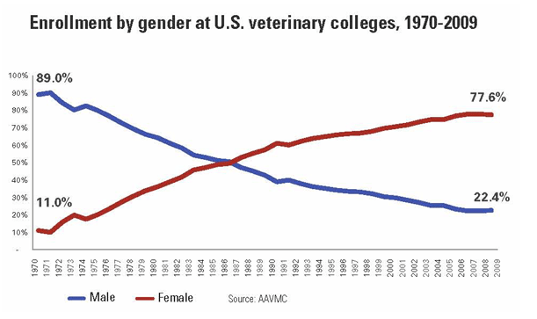
Chart Source: http://www.avma.org/onlnews/javma/feb10/100215g.asp
“The applicant pool is over 80% female nationally. Veterinary schools across the nation are graduating classes that reflect this percentage as well. The classes here at UT have been over 75% female for several years now,” explained Dr. James Brace when asked about the ratio of male to female students graduating from UTCVM. Dr. Joseph Taboada, Associate Dean for Students and Academic Affairs at Louisiana State University (LSU), mirrored Dr. Brace’s comment, saying, “The average percentages have been about 75% women and 25% men for the last 10 years. Those numbers have been pretty consistent from year to year and exactly reflect the percentages in our applicant pools.” When asked their thoughts on why males have begun to leave the veterinary profession, Dr. Brace and Dr. Toboada had differing answers. Dr. Toboada expressed that, “It would be a mistake to say that males have left the profession. What has happened is that women have been attracted to the profession in higher numbers than men over the past 35 years. Prior to that time, men made up most of the veterinarians because professions that required advanced degrees were not seen as appropriate avenues for women to pursue. As society changed and it was accepted that women could and should pursue careers in any area that they wished, professions like the veterinary profession opened up quickly. Men tended to go into other more technical (and some would contend, more lucrative) careers or into careers that were actively recruiting men.”
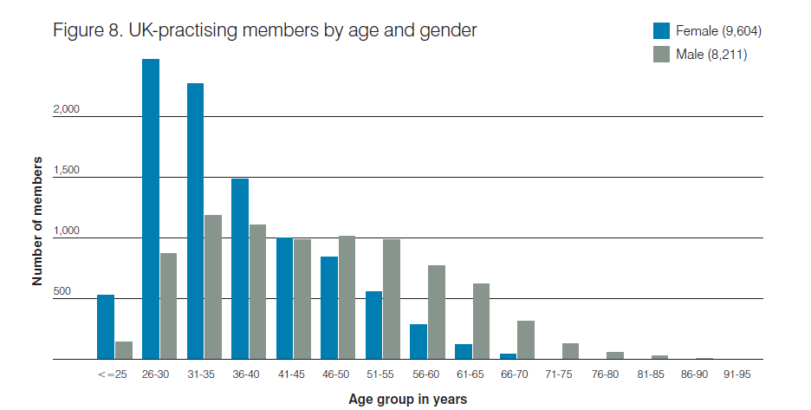
Chart Source: http://www.rcvs.org.uk/publications/rcvs-facts-2011/

The drastically low ratio of men to women veterinarians isn’t limited to the profession in the United States. Europe’s colleges of veterinary medicine have experienced the same trend. The above chart exhibits a trend that is seen throughout Europe and the United States. The percentage of practicing veterinarians that are 45 years of age or older is predominantly male. This statistic aligns with the social trends that began to occur worldwide in the 1970’s, when women were being granted equality in education and the work force. As the age of practicing veterinarians decrease the percentage of women becomes the overwhelming majority. The United Kingdom’s Royal College of Veterinary Medicine reported that 23% of their veterinary students were male in 2010 and that this percentage had been fairly static over the last decade (“RCVS Facts 2011”). These statics mirror the percentages that are being reported in the United States. The influx of women and the declining number of enrolling men in veterinary colleges is becoming a world-wide trend in veterinary medicine that is yet to be understood.
If men are being drawn off into other careers, what specifically is enticing women to enter a career in veterinary medicine? One theory suggests that as the veterinary field is evolving away from large or production animal medicine to one that is focused more on companion animal medicine, more females are drawn into a veterinary career. According to the 2010 census, 82% of the United States population lives in the suburbs (“World Fact Book”). As the population moves away from a rural society and toward one that is more focused on suburban life, the need for large animal veterinarians has declined in many areas where they have previously thrived. Although agriculture continues to be a large sect of the United States Economy, food and production animal private practices have declined. “There is a larger demand for small animal veterinarians across the country. More people own dogs and cats instead of raising large animals to earn a living. This provides a greater opportunity for veterinarians to go into small animal medicine and practice in whatever part of the country they like. Although we still have a number of students who wish to practice large animal medicine, the majority of our students are choosing to go into small animal practice,” said Dr. Brace.
The evolution toward small animal medicine puts a larger emphasis on the veterinarian being able to communicate and empathize with a client. Emotion is more often removed from large or production animal medicine because owning and managing livestock is a business, not an emotional attachment to a family pet. Many researchers believe that women are thought to be better at communicating feelings and, therefore, are drawn into a career that requires them to use this skill (Schweitzer). “I think women connect well with the emotional needs of the client in companion animal medicine. But I do want to add that I think some men are perfectly capable of having and showing the same emotions,” commented Dr. Brace.
Other theories point to veterinary medicine providing women with a career that has a lower “career cost of family.” The career cost of family is a term being used by Harvard University professor, Claudia Goldin. She describes the career cost of family as the way in which a woman’s career takes away from her family, particularly in the time she gets to spend with them. Goldin states, “High-paying careers that offer more help in balancing work and family are the ones that end up luring the largest number of women (Shellenbarger).” Although veterinary medicine has seen the largest increase in the number of women entering the profession, all medical professions, including pharmacy, dentistry, and medical school, have experienced an influx of women into the profession. Kasey Storey, Coordinator of Admissions at Auburn University agrees with Goldin, commenting, “Women realized that they could have good careers and still have a family life.”
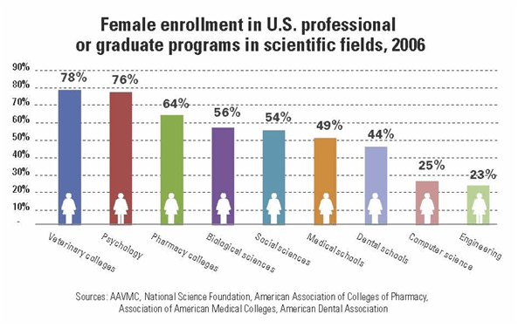
Chart Source: http://www.avma.org/onlnews/javma/feb10/100215g.asp
Sheila Allen, associate dean of the College of Veterinary Medicine at the University of Georgia, credits flexible hours for attracting a higher number of females to the profession. “Women who practice together can balance off of one another for time with their families. They can work it out to where they only work a few days of the week or plan maternity time around one another. It seems to make the overall practice run very smoothly for them and allows them adequate time to be a mother and wife to their families,” said Allen (“Vet Jobs Attract More Females”).
Allen, however, is only referring to small animal practices. Large animal practices still remain primarily male. Dr. Brace notes that large animal veterinarians are still expected to be on call throughout the night and almost every day of the week. “Being a large animal veterinarian is more time intensive. You might have to get up in the middle of the night to help a cow with dystocia, and you can’t say ‘no’ because you are often the only large animal veterinarian around. It is also more physically straining. The animals are harder to handle and are very dangerous at times. Although there are several women that graduate from here [UTCVM], I think that these aspects turn women away from large animal practices and toward small animal practices,” he commented.
The American Veterinary Medical Association (AVMA) data concurs with Dr. Brace’s statement. In 2011, the AVMA has a recorded number of 92,547 practicing veterinarians in the United States. Of these, 43,194 were male and 49,353 were female. The AVMA then breaks the veterinarians down by private clinical practices. Clinics that operated solely by caring for production/food animals were 81% male and 19% female, while clinics that operated entirely by treating companion animals were 43% male and 57% female (“Market Research Statistics). Although the percentage of males that are in companion animal private clinical practice is fairly high, it will begin to decline as male veterinarians reach retirement. Male veterinarians that graduated with their DVM prior to the 1970’s will begin to reach the age of retirement and will be replaced by female veterinarians that are entering the profession (Schweitzer). 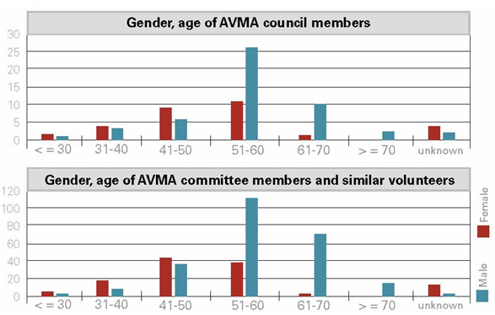
Chart Source: http://www.avma.org/onlnews/javma/jan09/090101aa.asp
The chart above illustrates the number of veterinarians that serve on the American Veterinary Medical Association council. These statistics are a very good representation of the total population of practicing veterinarians in the United States (“Just the Stats”).
Dr. Brace diverged in a different direct when responding to why males have lost their desire to enter the profession, stating, “Where have all the men gone? Recent studies show that fewer males are coming to college. Each year, fewer males than females seek higher education. And fewer males that get a bachelor’s degree are moving on to get a masters or a PhD. Where are they going?” Auburn University’s, Kasey Storey, responded similarly saying, “National studies report that for every three females enrolling in college, there is only one male.” The National Bureau of Labor Statistics reported that in 2009-2010, 28% of women under the age of 24 had received their bachelor’s degree, while only 19% of men had done the same (“U.S. Bureau of Labor Statistics”).
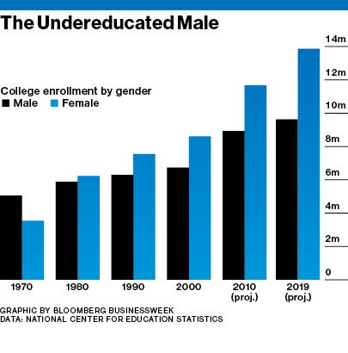
Chart Source: nces.ed.gov/
The number of males continuing on to post-graduate studies is also declining. According to the National Center for Education statistics, the number of male students that enrolled in post-graduate programs increased by 36 percent between 1999 and 2009, however, the number of female students entering post graduate programs rose by 63 percent during the same time period (“National Center for Education Statistics”). Although there are fewer males than females attending college nationally, there are still a number of male students who aspire to become veterinarians. What is keeping these male students from entering a veterinary college?
At the University of Tennessee’s College of Agricultural Sciences and Natural Resources, there are 77 males enrolled in the Animal Science, Pre-Veterinary Concentration. In the graduating class of 2011 there were ten male students that received degrees in anima science. Of these ten, only four of them applied and were accepted to a veterinary college. This number has been fairly consistent over the past decade. “Our Animal Science Department usually has a great acceptance percentage to UTCVM. We only have a few young men that apply each year and they typically get accepted. The number that applies is never very high; it is always in the single digits,” commented Dr. Richard Heitmann.
Many males enter an undergraduate institution with every intention to go to a veterinary college; however, somewhere along the way they diverge from their path. In a poll given to the 77 males in the animal science department at the University Tennessee, 45% said that they had come to college with the intention of going on to a veterinary college. A separate poll was given to the ten males that are graduating in the spring of 2012. The results indicated that 85% of them had either given up their original intention of going to veterinary school or had been offered a position with a company that was too good for them to turn away. Only four males, of the graduating class of 2012 in the animal science department applied to vet school. Of these four, three were accepted to and plan on attending a veterinary college. If only 15% of the males were applying to veterinary schools, why did the other 85% decide to take a different path for their future?
When asked why the males decided to pursue a different path, 65% of them indicated that they felt that they fell short of the academic requirements for admittance to veterinary colleges; because of this, they did not apply to any veterinary schools. Out of this group, 43% of them responded that after two years of undergraduate studies they had decided that they were not going to apply because of their academic status. The other 57% replied that they had decided to pursue another career after three years of undergraduate studies. The males from the spring graduating class of 2012 who entered college with the plan to pursue veterinary medicine were asked which professions they were now pursuing; 12% of them responded that they planned to join the military and pursue a medical career of some type afterwards, 8% planned to attend a medical professional school, 19% planned to attend graduate school in various areas of study, 4% planned to attend law school, 36% planned to enter a job in animal industries, 12% planned on taking governmental positions with the USDA, 3% planned on continuing undergraduate studies in a different area of study and the remaining 6% indicated that they had ‘other’ plans.
Graduating senior, Matthew Lane commented, “There are two reasons why I have chosen not to go to vet school right now. The first being I am just not ready for it. I feel I have plenty of experience and my grades are sufficient, but I know my own limitations and I know I’m just not ready to handle the work and stress that comes with vet school. Being a vet has always been a dream of mine but I want to make sure I’m ready in the future if I still choose to make that commitment. So I will take the time after graduation and decide what I really want to invest my future in.”
Chart Source: Data from poll given to graduating seniors at the University of Tennessee in the spring of 2012

The figures are similar at other undergraduate institutions across the nation. The University of Georgia’s Department of Animal Science reported that they had 75 female students enrolled in their program in 2005. By 2009, that number had spiked to 214 while the number of males enrolling in the department continues to decline (“Vet Jobs Attract More Females”).
The poll also reviled that a high percentage of males were choosing to enter fields in which they thought they would make a higher annual income. Dr.Toboada from LSU agreed with these findings, saying, “It has also been speculated that since veterinary medicine is not as lucrative that men tend to look to other professions.” When asked if the amount of debt required for vet school was a large component of their decision of whether or not to enter the industry, 100% of the students responded yes. The chart below compares the average student debt for students entering medical school versus veterinary school over a ten year span.

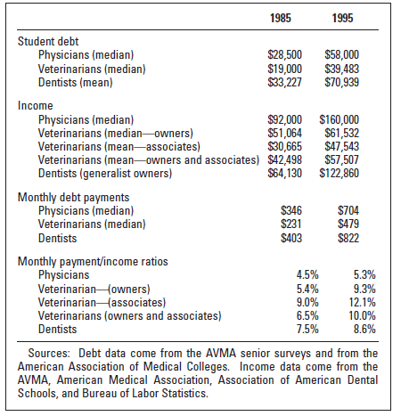
Chart Source: http://www.avma.org/reference/mega715c.pdf

Nathan Settlemyer, a senior studying animal science with a concentration in pre-veterinary medicine commented, “I came to school to be a veterinarian and I have worked in a clinic since I was in high school but I just don’t want to do it anymore. The admissions process is incredibly selective and I’m afraid that I won’t meet their standards. I’m planning on joining the military and then going to med school. Human doctors make a lot more than veterinarians do and I think it will be less stressful. Plus, vet school is extremely expensive and you don’t make the debt back nearly as fast. It’s almost not worth it.”
In order to be more attractive to students like Settlemyer and Lane, some veterinary colleges are beginning to look into ways to recruit more male students for their schools. “The nursing profession is an example of one like veterinary medicine that tends to attract more women than men but the nursing profession has preferentially recruited men for many years and that has resulted in a higher number of men going into nursing than might otherwise do so. The veterinary profession has not preferentially recruited men the way the nursing profession has. There has been active discussion within the profession recently about preferential recruiting to try to increase the number of men going into the field,” explained Dr. Taboada from Louisiana State University.
Some universities are utilizing their alumni network in order to reach out to young men in the communities where their graduates practice. “We are reaching out to alumni to mentor more young, talented boys in the veterinary fields,” said Sheila Allen from the University of Georgia. “We would like to see a more balanced applicant pool to reflect society in all aspects,” she continued (“Vet Jobs Attract More Females”). Colleges are also using marketing techniques in order to capture the attention of young, qualified males. Ontario Veterinary College, in Ontario, Canada, has started purposely putting male pictures in the recruitment materials that they use. The school is also making certain that they send male students to represent their college at college fairs and information sessions (“Male Sudents on the Decline”).
Due to the fact that male students continue to make up an overwhelming majority of large and food animal veterinarians, some universities that have a larger focus on food animal medicine, such as Kansas State University (KSU), are putting a greater effort on luring more male students into their program. Ralph C. Richardson, Dean of the College of Veterinary Medicine at KSU, explained that when they have to pull students from their alternate list in order to fill a class, they will send acceptance letters to men and minorities first, putting a particular focus on those interested in practicing food animal medicine. He finished his statement with “We believe that we need to have a student body that approximates society as best as possible (“At Veterinary Colleges”).”
There is concern that as men leave the industry, certain aspects of veterinary medicine will decline or disappear completely. As women continue trending toward small animal practices, some fear that large animal practices will disappear and the number of veterinarians that are specialized in certain fields will drastically decline (Slater). There is also a worry that as the number of females in the industry and in veterinary school classes continues to increase, it will deter men from entering the profession. Educators feel that men may view the profession as feminized or as “women’s work” which will divert them from pursuing a career in veterinary medicine (Schweitzer).
“Having a gender majority is fine, so long as all feel welcome,” said associate dean, Corinne Sweeney, at the University of Pennsylvania College of Veterinary Medicine (Schweitzer). Although the decline in the number of males attending veterinary colleges is still an issue without a clear resolution, veterinary colleges are focusing on continued efforts to recruit more men and on the overall effort of training students to be excellent veterinarians. “[This] is not a new issue and as we move forward we look for good people to become veterinarians,” said Jennifer Mailey from Cornell University.
All veterinarians and veterinary colleges would concur with Mailey’s statement. Above all other factors, it is important that schools continue to accept and graduate people who are intelligent, compassionate and capable of practicing responsible and effective veterinary medicine. As the field continues to evolve and change with society, this central focus of veterinary medicine will remain a standard, no matter the proportion of male or female. The proportion of good people will always be one hundred percent.

Works Cited
"At Veterinary Colleges, Male Students Are in the Minority." At Veterinary Colleges, Male Students Are in the Minority. American Veterinary Medical Association. Web. 06 May 2012. <http://www.avma.org/onlnews/javma/feb10/100215g.asp>.
Berry, Angie. "Animal Science Statistics." College Information. Print.
Brace, Dr. James. Personal interview. 3 May 2012.
"College Summary." Fastfacts.cfm. Cornell University. Web. 06 May 2012. <http://www.vet.cornell.edu/about/fastfacts.cfm>.
"Gender and Veterinary Medicine." The Canadian Veterinary Journal. CYMA. Web. <http://www.ncbi.nlm.nih.gov/pmc/articles/PMC340187/>.
Heitmann, Dr. Richard. Personal interview. 27 Apr. 2012.
"Just the Stats - January 1, 2009." Just the Stats - January 1, 2009. American Veterinary Medical Association. Web. 06 May 2012. <http://www.avma.org/onlnews/javma/jan09/090101aa.asp>.
"Legacy of Women Kimball." Legacy of Women Kimball. Cornell University. Web. 06 May 2012. <http://www.vet.cornell.edu/library/women/1kimball.htm>.
Mailey, Jennifer. E-mail interview. 24 Apr. 2012.
"Male Students on the Decline at Ontario Veterinary College - Veterinary Economics." Male Students on the Decline at Ontario Veterinary College - Veterinary Economics. Web. 06 May 2012. <http://veterinarybusiness.dvm360.com/vetec/Veterinary news/Male-students-on-the-decline-at-Ontario-Veterinary/ArticleStandard/Article/detail/698936?contextCategoryId=44874>.
"Market Research Statistics - U.S. Veterinarians." Market Research Statistics - U.S. Veterinarians. American Veterinary Medical Association. Web. 06 May 2012. <http://www.avma.org/reference/marketstats/usvets.asp>.
"National Center for Education Statistics (NCES) Home Page, a Part of the U.S. Department of Education." National Center for Education Statistics (NCES) Home Page, a Part of the U.S. Department of Education. Web. 06 May 2012. <http://nces.ed.gov/>.
"RCVS Facts 2011." - RCVS. Web. 06 May 2012. <http://www.rcvs.org.uk/publications/rcvs-facts-2011/>.
Schweitzer, Sarah. "Veterinary Schools Turn Increasingly Female." Boston.com. Globe Newspaper Company, 2007. Web. 6 May 2012. <5. http://www.boston.com/news/education/higher/articles/2007/08/22/veterinary_schools_turn_increasingly_female/?page=full>.
Shellenbarger, Sue. "Women Doctors Flock to Surprising Specialty." WSJ.com. The Wall Street Journal. Web. 06 May 2012. <http://blogs.wsj.com/juggle/2010/12/01/women-doctors-flock-to-surprising-specialty/>.
Slater, Margaret, and Miriam Slater. "Women in Veterinary Medicine." JAVMA 217.4 (200): 472-76. JAVMA. Web. 6 May 2012. <http://http://avmajournals.avma.org/doi/pdf/10.2460/javma.2000.217.472>.
Storey, Kasey. Online interview. 24 Apr. 2012.
"Title IX, Education Amendments of 1972." Title IX, Education Amendments of 1972. United States Department of Labor. Web. 06 May 2012. <http://www.dol.gov/oasam/regs/statutes/titleix.htm>.
Toboada, Dr. Joseph. E-mail interview. 24 Apr. 2012.

Tremayne, Jessica. "Women in Veterinary Medicine." Women in Veterinary Medicine. Vet Channel. Web. 06 May 2012. <http://www.veterinarypracticenews.com/vet-cover-stories/women-in-veterinary-medicine.aspx>.
"U.S. Bureau of Labor Statistics." U.S. Bureau of Labor Statistics. U.S. Bureau of Labor Statistics. Web. 06 May 2012. <http://www.bls.gov/>.
"Vet Jobs Attract More Females: Flexible Hours Draw Women | The Red and Black." Vet Jobs Attract More Females: Flexible Hours Draw Women | The Red and Black. Web. 06 May 2012. <http://redandblack.com/2010/02/25/vet-jobs-attract-more-females-flexible-hours-draw-women/%20>.
"Women Dominate OSU's College of Veterinary Medicine, but Few Specialize in Large-animal Care." The Columbus Dispatch. Web. 06 May 2012. <http://www.dispatch.com/content/stories/business/2011/02/04/callof-the-livestock.html>.
"World Fact Book." Www.cia.gov. Central Intelligence Agency. Web. 6 May 2012. <https://www.cia.gov/library/publications/the-world-factbook/fields/2212.html>.

