INVESTIGATION OF FINITE ELEMENT ANALYSIS TECHNIQUES FOR DIRECT ENERGY DEPOSITION ADDITIVE MANUFACTURING

A Thesis Presented for the
Master of Science
Degree
The University of Tennessee, Knoxville

Brandon T. Solsbee
December 2024

Copyright © 2024 by Brandon T. Solsbee
All rights reserved.

ACKNOWLEDGEMENTS

I would like to thank my committee of Dr. Suresh Babu, Dr. Bradley Jared, and Dr. Reza Abedi for their support and feedback during my time as a graduate student. Suresh, thank you for the invaluable mentorship over the last two years. You have taught me to dig deeper and ask the "Why?" that is often overlooked to avoid difficulty.
Thank you to each and every student on Suresh's graduate team for making the space for collaboration and hours-long whiteboard conversations that left me brimming with new ideas and directions to explore. In particular I would like to show my appreciation for some of those who were there for me when I first began my research — Vanshika Singh, Kevin Cisco, and Lauren Miller — for the insight and perspective you shared with me in every discussion we had.
Thank you to my peers at the Oak Ridge Manufacturing and Demonstration Facility, Yousub Lee, Bryan Lim, Ritin Mathews, and James Haley. Yousub, thank you for being my guide and teacher in Abaqus, and for your patience with my constant questions. Bryan, thank you for the support and friendship from the moment you arrived. Thank you to Ritin for the mentorship in learning Abaqus. James, thank you for providing me with a background in digital image correlation monitoring of additive manufacturing and experimental data to support my models, even from the other side of the globe.
Thank you to my parents, for continued support throughout my academic career, and endless love in spite of my imperfections. Thank you to my little brother Connor, who has continued to have my back as we’ve grown up. And lastly, thank you to my partner Hannah, who has never failed to love and uplift me in my lowest moments.
ABSTRACT

Two of the biggest problems faced by additive manufacturing (AM) are high residual stresses and part distortion. Due to the high temperature gradients generated during the process, large residual stresses are generated. These stresses can cause a part to distort out of spec or worsen fatigue properties, creating points of failure in service. To determine the impact of process inputs on residual stresses, modeling can offer an alternative to expensive and time-consuming trial and error and measurement techniques. This thesis explores the two most common finite element analysis (FEA) approaches to modeling AM: the weakly-coupled thermo-mechanical method and the inherent strain method. There is a lack of literature on thermo-mechanical AM models at a large part scale (> .5 m build height), with most large-scale works only considering steady state, symmetrical, long geometries. As the scale of parts modeled increases, the typical resolution assumptions become computationally infeasible. This thesis aims to address the overall need to verify the impact of resolution on FEA results (temperature, residual stress, distortion) by comparing the outputs of the same analysis as mesh and increment size are varied. The other main component of the thesis is to investigate the ability to utilize digital image correlation (DIC) data to inform the computationally inexpensive inherent strain method of FEA, which could open up the possibility of rapid in-situ modeling techniques for distortion correction in the future. Final part displacement measured using DIC is compared to inherent strain method results and further recommendations for building the approach are made.
Table of Contents
CHAPTER ONE INTRODUCTION AND BACKGROUND 1
The State of Manufacturing 1
Potential of Additive Manufacturing 1
Limitations of AM 5
Influence of Process Parameters in AM 5
Approaches to Finding Residual Stress 6
Modeling the AM process 7
Thermo-Mechanical Method 7
Inherent Strain Method 8
CHAPTER TWO RESIDUAL STRESS 9
Background 9
Three-Bar Model of Residual Stress 11
FEA of the Three-Bar Model 13
Model Setup 13
Results 15
Extension to Additive Manufacturing 15
CHAPTER THREE THERMO-MECHANICAL ANALYSIS OF CURVED WALL GEOMETRY 20
Literature Review 20
Background: Thermo-Mechanical FEA of Additive Manufacturing 22
Thermal Analysis 22
Mechanical Analysis 24
Manufacturing/Model Parameters 26
Computational Details 26
Experimental Details 28
Role of Mesh and Time Resolution 28
Results/Discussion 31
Temperature 33
Displacement 33
Comparison to Geometry 40
Residual Stress 40
Computational Speed 40
Directional Meshing Scheme 42
Discussion 42
Conclusions 45
CHAPTER FOUR INHERENT STRAIN MODEL USING DIGITAL IMAGE CORRELATION 47
Background/Literature Review 47
Inherent Strain Modeling 47
Extension to Additive Manufacturing 48
Digital Image Correlation 51
Experimental Setup 53
Process Parameters 53
Modeling Parameters 54
Results and Discussion 57
DIC Displacement 57
Inherent Strain Results 60
Limitations 66
Conclusions 66
CHAPTER FIVE CONCLUSIONS AND FUTURE WORK 67
Curved Wall Thermo-Mechanical Analysis 67
Inherent Strain Method Using DIC Data 69
REFERENCES 71
APPENDIX 76
VITA 78

LIST OF TABLES

Table 3.1 Summary of Published Research Related to Finite Element Analysis of Additive Manufacturing 23
Table 3.2. Double ellipsoid parameters used in analysis. 25
Table 3.3 Event series excerpt for first ~58 seconds. 27
Table 3.4 Resolution parameters modeled 32
Table 3.5 Max temperatures across part for all time at each (a) increment size and (b) element size. 35
Table 3.6. Mean and max difference between midlines calculated from analysis and measurements. 39
Table 4.1 Inherent strains loaded into each region for each approach. 59
Table A.1 Thermo-mechanical properties of SS316L used in three-bar model 76
Table A.2 Temperature dependent stress-strain response of SS316L used in analysis [48] 77
Table A.3 Temperature dependent stress-strain response of SS316L used in analysis [48]
77

LIST OF FIGURES

Figure 1.1 Number of U.S metalcasting facilities since 1995 [1] 2
Figure 1.2 Single-step metal AM processes based on inputs [6] 4
Figure 2.1 Residual stress visualization cartoon. 10
Figure 2.2 Effect of heating an (a) minimally constrained and (b) constrained body. 10
Figure 2.3 Stress-temperature in the middle bar of the three-bar model [19]. 12
Figure 2.4 (a) Three-bar FEA geometry. (b) Applied temperature field. 14
Figure 2.5 Elastic strain, plastic strain, and stress in the y direction at the fully heated (t₁) and cooled (t₂) states. 16
Figure 2.6 Stress and elastic and plastic strain in the Z direction across model time. 16
Figure 2.7 Stress and elastic and plastic strain components as a function of temperature 17
Figure 2.8 Adaptation of three-bar model to AM deposition [20]. 19
Figure 2.9 (a) Three-bar model. (b) Temperature history of single layer applied to model. (c) Stress and (d) strain with respect to temperature [21]. 19
Figure 3.1. Double ellipsoid heat source parameters [34, 47]. 25
Figure 3.2 Dimensions of build geometry (a) front (b) top and (c) isometric view 29
Figure 3.3 Temperature distribution of a transient heat source on a mild steel geometry for a 1 second increment compared to a 25 second increment. 29
Figure 3.4 Tool path for (a) odd layers and (b) even layers. 30
Figure 3.5. Profiles and nodes extracted for data analysis 32
Figure 3.6. Temperature history following deposition at nodes A, B, C for (a) each length of Δt and (b) for each size of ℓ. 34
Figure 3.7. Enlarged view of Figure 3.5(a) 35
Figure 3.8 Difference in predicted temperatures with reference to initial ℓ=8 mm, 35
Figure 3.9. Magnitude of displacement (mm) across face for (a) 400s, (b) 100s, (c) 25s increment. 36
Figure 3.10. Magnitude of displacement (mm) across face for (a) 8mm, (b) 4mm, (c) 2mm element size. 36
Figure 3.11. Components of displacement along sample line for the 8mm 400s analysis. 36
Figure 3.12. Displacement in x direction for (a) each time increment along center profile and (b) for each element size along center profile. 37
Figure 3.13 Calculated x-z midlines for (a) 400s, (b) 100s, (c) 25s increment size. 38
Figure 3.14. Calculated x-z midlines for (a) 8mm, (b) 4mm, (c) 2mm element size. 38
Figure 3.15. Von Mises stresses (MPa) across face for (a) 400s, (b) 100s, (c) 25s increment. 41
Figure 3.16. Von Mises stresses (MPa) across face for (a) 8mm, (b) 4mm, (c) 2mm element size. 41
Figure 3.17. x component of stress along profile line for (a) each increment size and (b) each element size. 41
Figure 3.18. Wall-clock solution time as function of resolution factors. 43
Figure 3.19. Directional meshing strategies "2mmX" and "2mmZ". 43
Figure 3.20. Von Mises stresses (MPa) across face for (a) 2mmX and (b) 2mmZ meshes. 43
Figure 3.21. (a) Displacement and (b) stress in x direction for the 2mm, 8mm, and directional mesh sizes. 44
Figure 4.1 Two-layer example of material activation in the ISM [55] 49
Figure 4.2 Example of the class 2 approach to inherent strain modeling [64]. 52
Figure 4.3 Dimensions of experiment geometry. 55
Figure 4.4 Scan strategy used for a layer, that rotated 180° each layer. 55
Figure 4.5 Locations of the horizontal (blue) and vertical (red) virtual extensometers used to collect strains. 56
Figure 4.6 Locations of the nine designated inherent strain regions. 58
Figure 4.7 Total strain outputs for each horizontal extensometer over time. 59
Figure 4.8 Displacement in the x direction at different points in time during deposition. 61
Figure 4.9 Displacement in the y direction at different points in time during deposition. 61
Figure 4.10 Overall direction of displacement in part and sustrate during manufacturing. 62
Figure 4.11 x Component of displacement for (a) final inherent strain approach (b) intermediate strain approach 63
Figure 4.12 y Component of displacement for (a) final inherent strain approach (b) intermediate strain approach 63
Figure 4.13 Points sampled for final x and y displacements. 64
Figure 4.14 Comparison of ISM and DIC displacements in (a) part and (b) substrate. 65
Figure 5.1 Sliced tool path for a cruciform geometry. 68
Figure 5.2 Distance covered for a (a) 50 sec and (b) 200 sec interval. 68
Figure 5.3 Graphic explanation of proposed future displacement compensation approach. 70
Figure 5.4 Flowchart outline of proposed displacement compensation approach. 70

Introduction and Background

The State of Manufacturing
Casting has been the standard approach to fabricating geometrically complex metal parts with complex geometries. While most commonly used in the automotive sector, castings are prevalent across most industries, with 90% of durable goods containing a metal casted component [1]. Movement of manufacturing overseas, a decline in available skilled workers, and material shortages due to the recent pandemic have impeded domestic ability to make parts. In 2022, the Department of Defense identified casting and forgings as one of four areas “in which critical vulnerabilities pose the most pressing threat to national security” [2]. As seen in Figure 1.1, the number of casting facilities has declined from 6,150 in 1955 to 1,770 in 2022, with the majority of plants being small-scale operations consisting of less than 100 employees, which are ill-suited to taking on government contracts [1]. The decline in manufacturing power domestically has resulted in drastically increased lead times. Additionally, the cost of raw material continues to rise, and traditional approaches such as casting have an average yield rate of 53.3%, which means that only around half of the melted material ends up in the final part [3]. Therefore, there is a pressing need for novel fabrication approaches in order to supplement the existing manufacturing pipeline of metal components. Additive manufacturing (AM) offers one potential solution to the problem, while offering several advantages such as ability to produce increasingly complex geometries, less material waste, and lower lead times for low-volume parts [4, 5].

Potential of Additive Manufacturing
Broadly speaking, additive manufacturing is an approach to building parts through layer-by-layer deposition or sintering of material. As a result, parts with high degrees of complexity are able to be manufactured with fewer constraints than subtractive methods. Typically for any AM process, a model of the desired geometry is “sliced”, or divided into layers, and a tool path is generated to provide a machine with the path required to create each layer.

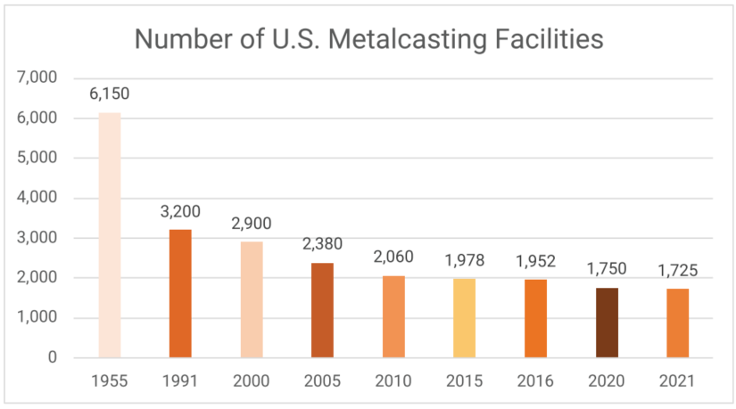
Figure 1.1 Number of U.S metalcasting facilities since 1995 [1]

While AM techniques have been developed for non-metals such as polymers and ceramics, the focus of this thesis will be on metal additive techniques. Per ASTM, single-step AM processes fall under two main categorizations: solid-state and melted-state (highlighted in Figure 1.2) [6]. Solid-state AM processes operate by joining together layers of material without inputting enough energy to melt the metal. Examples of solid-state AM include sheet lamination, where layers are cut out of sheets then fused ultrasonically and additive friction stir deposition, which directly deposits metal feedstock through a spinning tool that plasticizes it, enabling a bead to form.
Melted-state techniques use focused thermal energy to melt metal feedstock, fusing layers together. They fall under two main categories: powder bed fusion (PBF) and direct energy deposition (DED). PBF processes are the most widely adopted metal additive process [7], and consist of spreading a layer of metal powder across a substrate and selectively melting regions according the layer slice geometry. After a layer is completed, another layer of powder is spread across the surface and melted accordingly. The source of fusion to melt the metal powder can be a laser or electron beam. Due to the size of metal powder, the layer height in these processes are on the scale of microns. As a result, PBF is able to achieve a feature resolution of >1 mm and to produce parts that need little to no post-processing, however scale and deposition rate are limited [7]. PBF build heights are less than a meter, with the maximum height ranging from 200-350 mm across different machines [8].
DED techniques deposit material directly by melting wire or powder feedstock using a focused energy source. A larger melt pool is formed, resulting in higher deposition rates but lower detail resolution than PBF. As a result of the larger bead size, parts manufactured using DED are more limited in part complexity and generally need post-processing to achieved the desired part geometry. One such DED process is wire arc direct energy deposition, also known as wire arc additive manufacturing (WAAM). This approach builds on existing welding processes by using wire feedstock and an arc to create layers using beads of metal. A typical WAAM system consists of a welding torch affixed to a 5-axis robot. When compared to other AM processes, WAAM offers larger, more flexible build volumes, higher deposition rates, and lower feedstock costs. For example, Oak Ridge National Lab’s MedUSA system can achieve builds up to 2 meters tall and can deposit material at a rate of 52 kg/hr across three robots [9]. The experiments modeled in this thesis are both examples of DED additive manufacturing, however other approaches will be referenced.

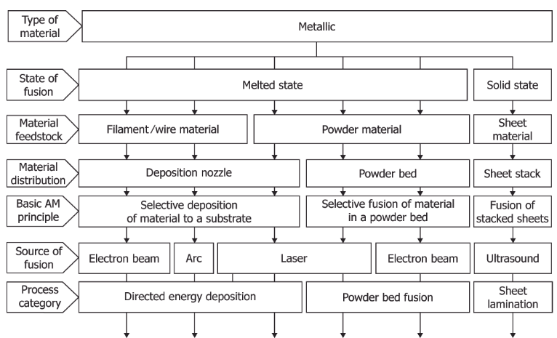
Figure 1.2 Single-step metal AM processes based on inputs [6]

Limitations of AM
Rather than superseding the traditional manufacturing pipeline entirely, additive manufacturing is better positioned supplemental solution to the manufacturing problem. This is because while AM does offer a novel manufacturing approach, it is not well suited for mass manufacturing of a single part geometry. There are several problems inhibiting the adoption of AM at a large scale, including defects, distortion, residual stress management, and consistent part performance. In AM, the deposition of molten material generates sharp thermal gradients, which lead to uneven thermal expansion, and as a result, residual stresses can form. Residual stresses remain in the part when it reaches an equilibrium state, and can often approach the material’s yield stress. In order to accommodate for this residual stress state, parts will distort out of shape. Distortion can result in parts being out of spec or, in extreme cases, can result in manufacturing failure entirely. Additionally, the residual stresses present in a part will impact a part’s performance and fatigue strength when in service [10]. Post-processing measures such as machining and heat treatment will relieve and redistribute residual stresses, further influencing distortion in the part. Therefore, there is a need to produce parts that are as close to the desired geometry as possible, or near net shape, in order to minimize the amount of post processing necessary to complete the part. The nature of residual stresses in AM will be further expanded on in Chapter 2.

Influence of Process Parameters in AM
Residual stress in AM is a function of thermal condition and mechanical constraints; therefore, it is influenced by the majority of process inputs, such as: scan speed, input power, tool path, material preheat, inter-layer dwell time, as well as manufacturing conditions, i.e. part geometry, support structure, and substrate geometry. The relationship between input parameters and resulting residual stresses and distortion have been explored throughout the literature.
In [11], the authors aimed to minimize the residual stresses induced during direct energy deposition (DED) of Ti-6Al-4V by modifying the substrate geometry. In doing this, an inverse relationship between thermal deformation and residual stresses with respect to substrate thickness is established; a large substrate has a higher stiffness, reducing thermal deformation. However, since the substrate doesn't comply with the stress state, higher residual stresses form. Ultimately, by reducing substrate width to eliminate stress concentrations formed at the corner between part/substrate and by implementing a "hollow" substrate strategy, the authors were able to achieve a reduction of 62% in maximum tensile residual stresses.
Denlinger et al. [12] measured in-situ distortion during laser DED of Ti–6Al–4V and Inconel 625 three bead wide, single-wall geometries to understand impact of inter-layer dwell time (the time between the end of a layer and beginning of the next layer). The dwell time was varied from 0s to 40s while all other parameters were held constant. In-situ deflection of the substrate measured with a laser displacement sensor, and in-situ temperature was measured with thermocouples on the substrate. Post manufacturing, the substrate profiles were obtained using coordinate-measurement machine, and residual stress at a point in each substrate was obtained using the hole-drilling method. In this experiment, the materials showed opposite responses; the Ti-6Al-4V samples had higher distortion and residual stress as the dwell time increased, while the magnitude of the same measurements in the Inconel 625 samples decreased with respect to dwell time. Additionally, the Inconel 625 samples had higher final distortion and residual stress than the Ti-6Al-4V samples. This work shows the impact of both material choice and inter-layer dwell time on the distortion and residual stress in AM parts.
The relationship between process inputs in AM and the resulting part quality is nonlinear, making it difficult to generate a one-size fits all solution to minimizing distortion and controlling residual stresses. For a given part geometry, machine, desired properties and material, there is a need to establish what parameters should be used. These can be selected using a “trial and error” experimental approach, or models can be established to aid in parameter selection.

Approaches to Finding Residual Stress
A purely experimental “trial and error” approach to optimizing manufacturing of an AM part can be both expensive and time-consuming, and generates wasted material if the part in question is deemed unusable. In addition to the costs and time that are required to manufacture and post-process a part, further time is required to measure the residual stress state. Residual stress measurement falls under two main categories, destructive and non-destructive evaluation. Destructive approaches, such as the hole drilling and contour methods, use the relaxation resulting from material removal to back-solve for the residual stress state but compromise the part in the process.
Alternatively, non-destructive techniques such as x-ray or neutron diffraction enable residual stress measurement while preserving the measured part. Diffraction approaches work by measuring the lattice spacing, d, in a region, which can then be compared to the lattice spacing in an unstressed portion of the same material, d₀ [10]. X-ray diffraction is only able to penetrate on the order of microns, limiting stress measurements to the surface of a part. While neutron diffraction is able to get volumetric data deeper within a part, there are only five neutron sources in North America, resulting in highly limited access and measurement time [13].
Many experiments deploy modeling approaches to narrow down the process parameters that will yield preferable residual stresses and distortion. The primary downside of this approach is that modeling the AM process can have an extreme computational cost, with more detailed models taking far longer to solve than the manufacturing time itself [14].
However, models are able to generate data that is both transient and full-field, giving insight to the material response during manufacturing at more locations than possible with measurement. Another benefit is once a model has been calibrated and validated against experimental data, it is much easier to iterate the model using varied input parameters than to repeat the manufacturing and measurement process.

Modeling the AM process
Due to the highly transient nature of additive manufacturing processes, there are a large variety of modeling approaches taken to understand specific components, such as computational fluid dynamics to model the movement of material in the melt pool, or analytical approaches to model simplified heat transfer or stress distributions. The nature of models that this thesis will focus on look at the macro-scale residual stress and distortion response during additive manufacturing, neglecting micro-scale factors such as phase transformation and melt pool dynamics. Finite element analysis (FEA) is the most prevalent approach to modeling AM at the part scale. FEA divides the part domain into discrete nodes and elements with designated properties and solves governing partial differential equations based the applied loads and boundary conditions. Depending on the type of analysis considered (heat transfer, static, dynamic, etc.) the specific loads, boundary conditions and governing equations will be different. The most common FEA approaches to modeling the AM process are weakly coupled thermo-mechanical FEA and inherent strain FEA.

Thermo-Mechanical Method
The most prevalent modeling approach taken when modeling the AM process is coupled thermo-mechanical analysis, or the thermo-mechanical method (TMM). The approach consists of a transient heat transfer analysis followed by a quasi-static analysis considering the generated thermal strains [15]. To mimic the deposition of material in AM, a technique called element activation is implemented. At the beginning of the analysis time frame, all elements within the part are in a deactivated state. As the heat source passes through a deactivated element, the element is activated, which updates the solution domain. In the thermal component of the TMM, a heat source representative of the actual applied heat in an AM process is applied along a path according to the speed and movement of the real tool. In AM, the primary mode of heat transfer from molten material comes from convection at the melt pool boundary, but this heat transfer is represented as a surface or volumetric heat flux in thermal FEA. Based on the load, convection through deposited material, and the designated thermal boundary conditions such as convective and radiative heat loss to the surroundings, a thermal history of every node at each point in time is obtained. This data is then used as an input in the quasi-static mechanical step, where the changes in temperature across the manufacturing process are used to apply thermal strains to the geometry. As a result, the evolution of residual stresses and displacement across manufacturing time can be extracted.

Inherent Strain Method
In the inherent strain method (ISM), the thermal analysis step is forgone and only a mechanical analysis is conducted. A specified distribution of inelastic or “inherent” strains are applied directly as a load to newly activated layer of material, which will deform in order to accommodate them. As a result, elastic strains are generated as residual stress can be found. Compared to the TSM, this method is much more approximative, and is generally used to observe the impact of weld sequence in large welded structures. However, since the ISM consists of a single mechanical analysis step with fewer increments, inherent strain models can often solve in an order of minutes rather than hours, enabling rapid model iteration. To use the ISM, the inherent strains for a system must be predicted or calculated separately, which adds to the computational time.

Residual Stress

Background
Residual stresses are the stresses that remain in a body at an equilibrium state due to locked-in elastic strains that cannot be unloaded due to some distribution of incompatible plastic strains. To visualize this phenomenon, a common example is the one shown in Figure 2.1, where a cubic unit volume is removed from a body. Once the cube undergoes some sort of physical deformation, the entire section will have a plastic strain with reference to the initial state. In order to fit the section back into the hole in the body, some elastic strain will need to applied in order to force the section into its original shape. After the unit volume has been added back into its original location within the body, it will apply reaction forces along its boundary to try to return to its deformed state. These are the source of residual stresses. As the scale of the unit volume increases, these residual stresses can result in deformation of the entire body in order to reach a static equilibrium. The primary mode of straining during additive manufacturing is thermal strain. Figure 2.2 (a) demonstrates that in a minimally constrained body, the material will freely expand as it is heated, according to Equation (1):
 | $$∆L= αL_{0}∆T$$ | (1)
Where $∆L$ is the change in length, $L_{0}$ is the initial length, α is the coefficient of thermal expansion, and$∆T$ is the change in temperature. As a result, there are no forces acting on the body, and therefore no thermal strain is present, and the body will return to its original shape upon cooling. However, when a body is constrained from expanding, as shown in Figure 2.2(b), a resultant force F is generated by the boundary, thus generating strains. If these strains exceed the material’s yield limit, plastic strains accumulate, resulting in permanent deformation and preventing the body from returning to its original shape. In this case, strains will remain present after the body returns to room temperature and thermal strain is gone. Therefore, there will be a resulting residual stress state.
In the real-world case of welding, the thermally cycled material along the weld path is constrained by a relatively large volume of cooler material on either side, resulting in strains that exceed the material’s yield strain. Additionally, the high variance in temperature is coupled with a moving heat source, resulting in a transient problem. Rapid heating of material as a heat source moves over it will result in local thermal expansion as the temperature increases and contraction as it decreases. As a result of these extreme processing conditions, residual stresses will always be generated, and in the case of a typical butt weld, the residual stresses will often reach the material’s yield stress [16, 17].
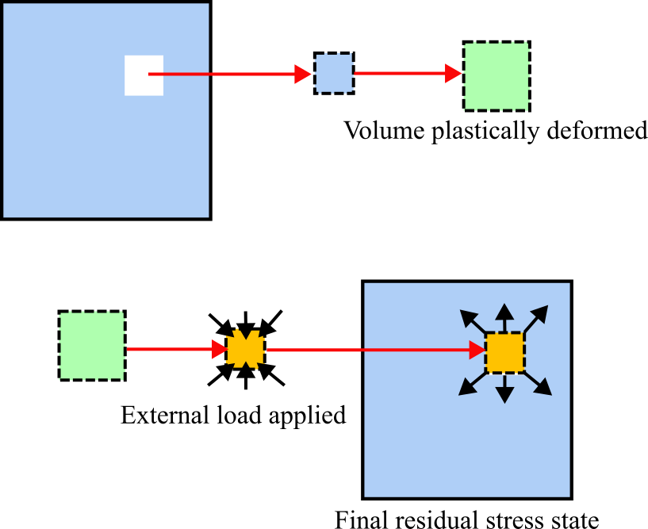
Figure 2.1 Residual stress visualization cartoon.

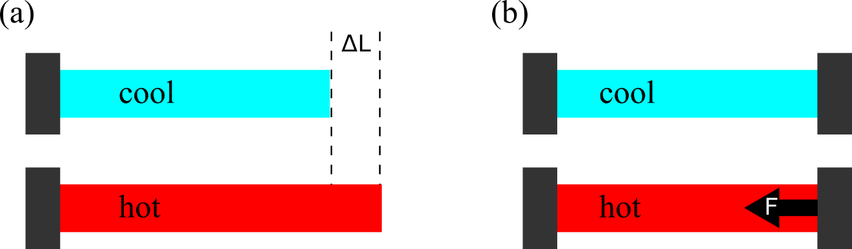
Figure 2.2 Effect of heating an (a) minimally constrained and (b) constrained body.

As mentioned previously, in addition to causing deformation, residual stresses in a welded part can result in points of failure in service, such as brittle fracture due to tensile residual stress or reduced buckling strength due to compressive residual stresses [17]. Additive manufacturing processes are subject to similar thermal conditions as welding, however more complex heating paths and repeated thermal cycling due to subsequent layer deposition make it more difficult to empirically predict the stress and deformation distributions a-priori.

Three-Bar Model of Residual Stress
One classic idealized model to demonstrate and model the development of residual stresses in a butt weld is the three-bar model, which consists of three bars constrained to two perpendicular rigid bars as seen at the top of Figure 2.3. In the general form of the three-bar model, one rigid cross-bar is fixed, while the other is able to move. In this sense, the three-bar model is also sometimes represented as a bar-and-spring model, where the relative stiffness of the side bars is incorporated into the stiffness coefficient of the spring [18]. The center bar represents the high-temperature region including and surrounding the deposited metal, while the side bars represent the high volume, low temperature surrounding regions. This assumes that the temperature is uniform along the length of the weld region. The assumption is made since a moving heat source generates sharp thermal gradients in all directions except behind it, where the gradient would be relatively gentle.
Figure 2.3 Plots the stress in the direction of thermal loading with respect to temperature for a classical three-bar model of carbon steel. In this example, the thermal history of the bar is indicated by ABCDE, where the middle bar begins at 0⁰F, is heated to 1100⁰F, and cools back down to 0⁰F. At point A, the bar begins in a stress-free state. From A to B, elastic compressive stress develops, as the thermal expansion of the middle bar is restrained by the side bars. From point B to C, the bar is stressed passed its yield stress, and permanent deformation occurs, limiting the additional stress accumulated, since yield stress decreases as temperature increases. At the onset of cooling, the middle bar unloads elastically until it reaches its tensile yield limit (C to D). Finally, from point D to E, the bar continues to accumulate tensile stress at a reduced rate as the material yields until the system returns to 0⁰F. Point B’ indicates the minimum temperature needed in order to develop the tensile residual stress at point E. In other words, as long as the model is heated beyond 600⁰F, the same final residual stress state will be achieved [19]. Additionally, to maintain equilibrium, the side bars will have a compressive residual stress state with half the magnitude of point E.
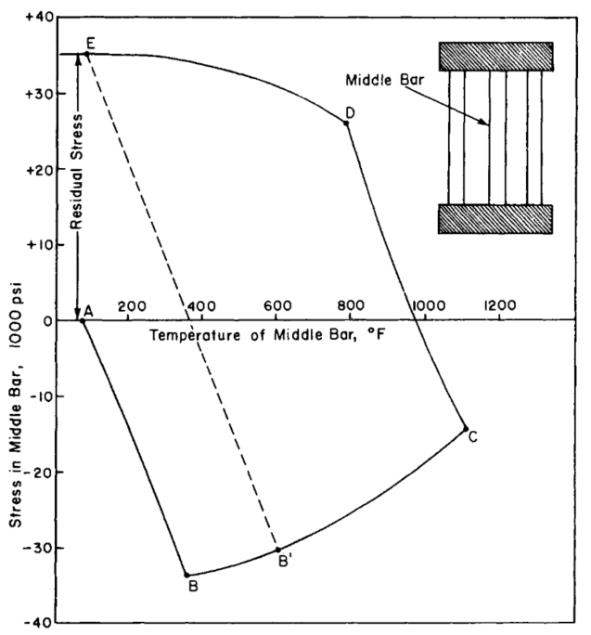
Figure 2.3 Stress-temperature in the middle bar of the three-bar model [19].

FEA of the Three-Bar Model

Model Setup
In order to supplement the classical three-bar model of residual stress, a FEA model of the problem was generated using Abaqus 2023 software. The geometry consists of three 15x80x15 mm vertical bars and two 75x10x15 mm horizontal bars; the assembly and dimensions can be seen in Figure 2.4(a). The horizontal bars act as hollow, rigid shell geometries in this model. As in the classic general-case model, the bottom horizontal bar is fully constrained and fixed to the bottom surfaces of the vertical bars, while the top horizontal bar is constrained to the top surfaces of the vertical bars only. The vertical bars are assigned the temperature-dependent material properties of stainless steel 316 (SS316). The properties defined were temperature dependent elastic/plastic properties and thermal expansion coefficients, as listed in Table A.1.
Thermal expansion was specified as one-dimensional in the y direction only. The vertical bars were meshed using 3.75x4x3.75 mm C3D8R elements. To load the model, a uniform thermal history field was assigned to the middle bar. The temperature was raised to 500⁰C over 10 seconds in the “heating” and decreased back to 0⁰C over 10 seconds in the “cooling” step, as plotted in Figure 2.4(b). While the steps will be referred to as “heating” and “cooling”, it is important to note that no actual heat transfer is considered in this model. According to the formula derived in [16], the yield temperature, $T_{Y}$, in a given weld can be derived as:
 | $$T_{Y}=\left(\frac{A+A_{0}}{A_{0}}\right)\frac{σ_{Y}}{Eα}$$ | (2)
Where $A$ is the cross sectional-area of the middle bar, $A_{0}$ is the combined cross-sectional area of the side bars, and $σ_{Y}$ is the material yield stress. ($A+A_{0}$)/$A_{0}$ indicates the degree of restraint on the middle bar due to the side bars. As this value approaches one, the three-bar problem can be described by fixing both horizontal rigid bars. Provided the room-temperature values in the material properties used in this model, the yield temperature solves to be around 125⁰C, which indicates the applied value of 500⁰C will be sufficient to demonstrate the accumulation of residual stresses in the model. Additionally, since this model considers the effects of temperature on material response, the actual yield temperature will be lower than calculated.
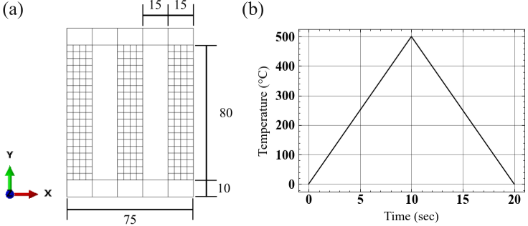
Figure 2.4 (a) Three-bar FEA geometry. (b) Applied temperature field.

Results
Figure 2.5 shows the stress and strains in the y direction throughout the three bars at the end of both steps in heating during the model. At t=0 sec, the geometry begins in stress-free state. At t=10 sec, the temperature in the middle bar is at the maximum value of 500⁰C. As a result, the bar is in its most expanded state, inducing compressive stress in itself and a reactive tensive stress in the side bars. Since the middle bar has plastically deformed at this point, returning to the original state will induce a tensile stress state, which can be seen at t=20 sec in the figure. To balance the state of tension in the middle bar, the side bars are forced into compression, with the compressive stress in each being equal to ½ the magnitude of the tensile stress in the middle. These results mimic the behavior of the original mathematical model.
Figure 2.6 illustrates the stress/strain response in the y direction in the element at the center of the middle bar. During the first ~2 seconds of the heating phase, compressive elastic strain is induced in the middle bar until the material begins to yield, indicated by the onset of compressive plastic strains, which accumulate up to the end of the heating step. Then, as the temperature in the middle bar is decreased, the material unloads elastically until the tensile yield strain is reached, at around 13 seconds. At this point, the compressive plastic strain starts to become more tensile until the cooling is completed, while remaining net compressive. Note that if T_{max} were to be increased sufficiently, then the final value of Ɛ_{p} can become tensile, which is referred to as “reverse tensile yielding” [18]. Looking at the stress response, note that the sign of residual stress corresponds to the sign of the elastic strain, as residual stress is caused by unrelieved elastic strains. Figure 2.7 plots the stress/strain response as a function of temperature, which is more directly comparable to the example from Figure 2.3.

Extension to Additive Manufacturing
In [20], the formula of yield temperature ($T_{Y}$) established in Equation (2) is used to develop an approach to mitigating substrate residual stresses in direct energy deposition of Ti-6Al-4V. By treating the deposited material as the middle bar and the surrounding substrate as the side bar constraint (shown in Figure 2.8), the substrate was modified in order to increase the degree of restraint. These modifications were done with the intent of raising$T_{Y}$ in order to prevent the initiation of residual stresses. The resulting modified substrate designs resulted in a demonstrable reduction of residual stress at the part/substrate interface.

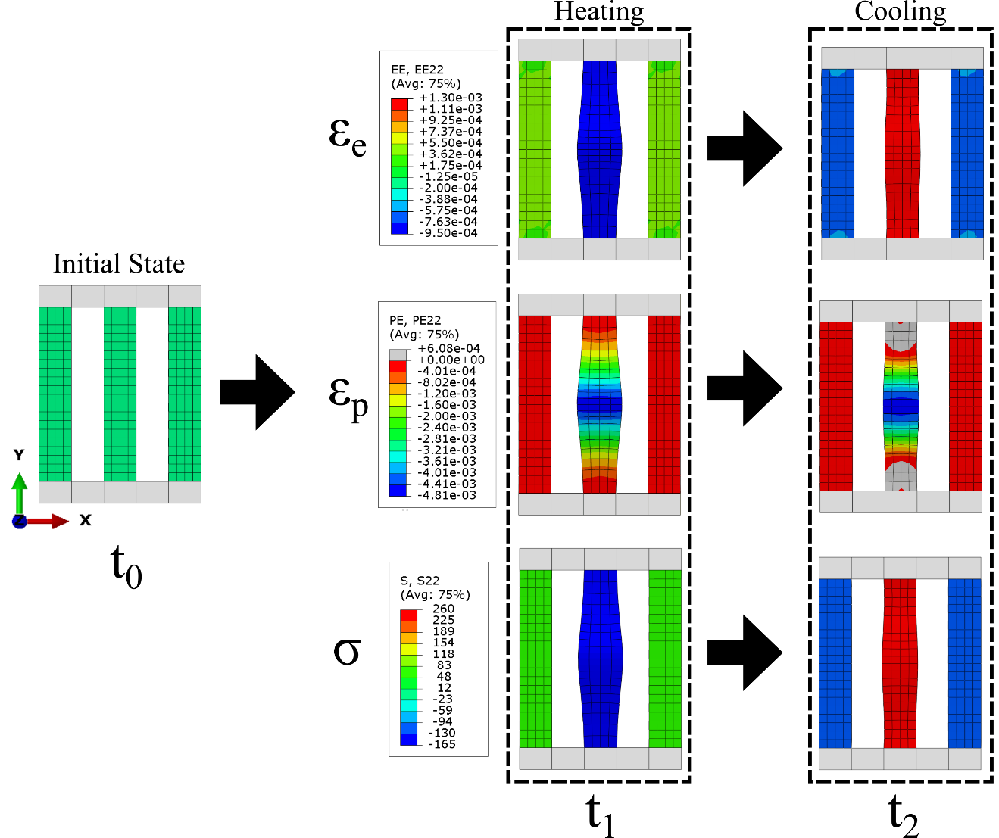
Figure 2.5 Elastic strain, plastic strain, and stress in the y direction at the fully heated (t₁) and cooled (t₂) states.
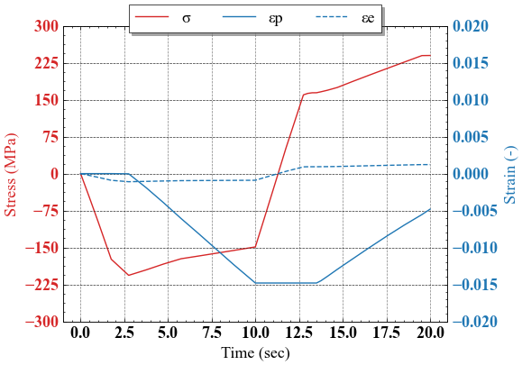
Figure 2.6 Stress and elastic and plastic strain in the Z direction across model time.
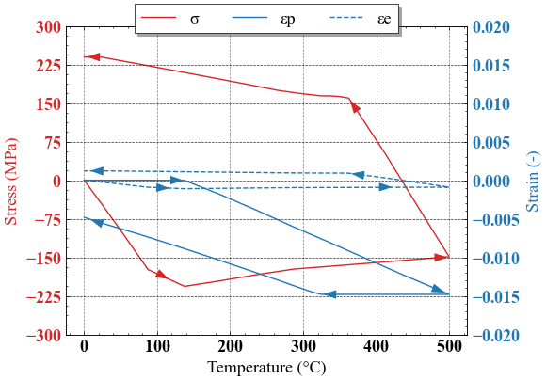
Figure 2.7 Stress and elastic and plastic strain components as a function of temperature

Another extension of the three-bar model to additive processes was explored by [21], which considered stress relaxation due to the high-temperature thermal cycling typical of AM. In this case, DED of Ti-6Al-4V was investigated. Relaxation behavior was described by the authors using a Norton-bailey model:
 | $${\dot{ε}}_{re}=Aσ^{n}$$ | (3)
Where ${\dot{ε}}_{re}$ is the relaxation strain rate, σ is the deviatoric stress, and both A and n are material constants gathered via stress relaxation tests at elevated temperatures. The intent behind incorporating relaxation behavior was to account for the recovery of inelastic strain that occurs as a layer is repeatedly cycled thermally. In this study, measurements were taken at 600⁰C, 700⁰C, 800⁰C on additively manufactured samples. By implementing relaxation into the material response, the authors were able to greatly reduce the error in the prediction of transient substrate displacement. In addition to full-scale models of the subject geometry, the three-bar model was used to illustrate the effect of considering stress relaxation in thermal cycling. Shown in Figure 2.9a & b, the thermal history for a single layer was applied to the middle bar, and the side bars were considered as rigid constraints. The resulting stress and strain temperature relationships are shown in Figure 2.6c & d. During the majority of the thermal cycle, it can be seen that the relaxation model doesn’t have a noticeable impact on the stress/strain development in the middle bar due to the rapid change in thermal history. Upon cooling into the ~600⁰C range, as indicated by the black boxes, the magnitude of the tensile residual stress and compressive inelastic strain are reduced as they are recovered. While the impact on the three-bar model is relatively small, in an actual region of additively manufacturing material, as thermal cycling continues the relaxation effect illustrated in this model would accumulate, resulting in a reduction in stress and strain, as well as substrate curvature.
While the three-bar model is a simplification of the actual thermo-mechanical process of residual stress development in the welding process, it still serves to provide valuable insight into the development and modeling of residual stress in additive manufacturing.

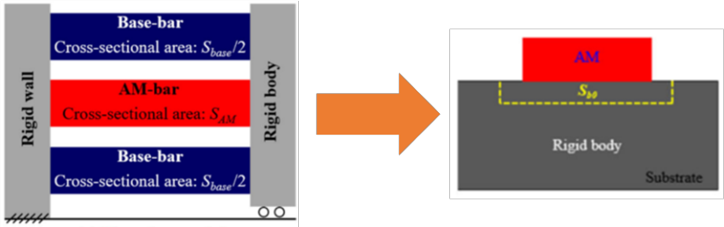
Figure 2.8 Adaptation of three-bar model to AM deposition [20].

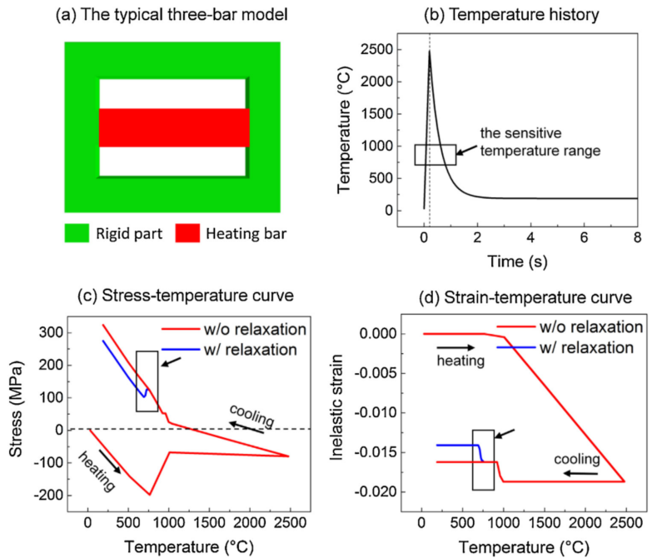
Figure 2.9 (a) Three-bar model. (b) Temperature history of single layer applied to model. (c) Stress and (d) strain with respect to temperature [21].

Thermo-Mechanical Analysis of Curved Wall Geometry
This experiment is a continuation of the findings and modeling from Lee et al. in [22] which investigated the mode of deformation for a large scale, curved wall geometry with consideration of variable time stops due to manufacturing conditions using sequentially coupled TMM FEA in conjunction with laser scanning measurements and DIC analysis. The results will help to provide pragmatic guidelines for simplifications that can be made to decrease computational cost while still successfully predicting the geometry’s deformation with reasonable accuracy relevant for industrial adaptation. A series of finite element analyses on the same geometry was conducted while varying element size and time increment length. ABAQUS Standard 2022 software was used to conduct the study. From the analyses, nodal displacement, residual stress, and thermal history were extracted and compared between each run. Additionally, the deformed analysis output geometries were compared to a point cloud of the physical geometry manufactured by WAAM using visual data.

Literature Review
It is common practice in FEA of WAAM to use an element size less than or equal to the width and height of the deposition cross section for accurately representing the physical response to metal deposition [23-26]. A frequent approach to selecting element size in a FEA model is to conduct a mesh-convergence analysis, where a representative domain is used to find an acceptable balance of percent error and computational time. In the case of WAAM, the representative geometry consists of several beads or layers. For example, when modeling WAAM deposition of Aluminum Ally 5183, Zhao et al. conducted a mesh convergence study using mesh sizes of one, two, and three elements across the height and width of the deposition cross section by analyzing ~2.25 beads from the full part. Based on the study, the 2×2 element approach was justified by its 0.49% relative error while arriving at a solution 61.4 hours faster [23]. Because of the challenges associated with computational costs, it is not common to report the impact of mesh size on the results of a full WAAM geometry at a larger scale in open publications. One example is seen in the work of Yang, et al. wherein a computationally efficient semi-analytical thermal model analysis was coupled with a mechanical analysis to model the deposition of a 4-layer thin wall structure [27]. When investigating the thermal results, it was found that a finer mesh (5 mm × 0.3125 mm × 2 mm) yielded nearly identical temperature history as coarser mesh (5 mm × 1.25 mm × 2 mm), which was then used in the mechanical analysis [27]. Further investigations of resolution can be seen in modeling of other AM processes.
Cattenone et al. investigated the effects of temporal and spatial resolution on the results of a complete part geometry in TM analysis of fused deposition modelling of thermoplastics, implementing elements ranging from ½ the bead width and height to ×4 the bead width while maintaining a z height consistent with deposited layer height [28]. The authors report that time step has large influence on local temperature development, while having a minimal impact on mechanical results, and that a coarser meshing strategy can fail to capture local stress concentrations, demonstrating a need to further explore the impact of resolution on complete parts [28].
In order to investigate an approach to speed up TM FEA, Lu et al. implemented a 4-layer activation scheme in modeling powder-based direct energy deposition (DED) of Ti-6Al-4V [29]. By adjusting the time step such that 4 layers are activated at a time. From the experiment, it was observed that a larger time step generates excessive oscillations in the temperature history, while the average temperature values are in line with measured data. Additionally, due to inability to fully capture thermal gradients across the substrate in the first 4-layer group, > 1mm mismatch of displacements were found. However, as the process approached a steady state, the numerical analysis showed good agreement with measured displacement. Overall, this approach was able to reduce computation time by 77% [29].
In [30], Nycz et al. explored the relationship between time increment size and residual stress predictions for a single-bead, mild steel wall geometry produced using WAAM. A 20 sec time increment was able to capture substrate distortion and showed consistent residual stresses with a 10 sec time increment. However, neutron diffraction (ND) measurements revealed tensile longitudinal residual stresses near the surface of the substrate that weren’t captured by the larger increment sizes. To remedy this, an increment size of 1s was used for the first 3 layers, followed by 20 sec for the remaining layers to better capture the stress accumulation caused by interaction between the initial layers and the substrate while maintaining computational efficiency.
Deering investigated the impact of various user inputs on the results using the TMM in powder bed fusion of stainless steel 316, including increment and mesh resolution [31]. The findings indicated that average temperature increases with higher resolution in both increment size and mesh, however in the study a range of only 2.33℃ was reported. Additionally, it was observed that larger elements predicted higher residual stresses, and both larger element and increment size resulted in less displacement. The work concluded that the impact of mesh density and increment size are independent, and an increment size encapsulating 2-4 physical layers was recommended to balance accuracy and runtime when modeling the powder bed fusion process [31].Lee et al. implemented and modeled wire-based hybrid manufacturing to build a 3-bead thick wall, and measured residual strains from the final part using ND [32]. The process was modeled by combining the traditional sequentially-coupled TM FEA to model WAAM deposition with element removal to capture the machining process. In the initial analysis, element size in the part was 1.5 mm and solution time was 335 min (~5.5 hr). In order to better match the resolution of ND, a model using 5 mm elements was created, which was able to generate a residual strain distribution with a strong correlation (quantified using the Pearson and Spearman coefficient) in the build and longitudinal direction and moderate in the transversal direction, while solving in 15 minutes. This approach could be used to validate the model against measured data prior to higher resolution FEA.
Although, the critical need to understand the sensitivity of modeling parameters on residual stress and distortion prediction was stressed by the AWS and ANSI guide for verification and validation in computation weld mechanics had been published [33], computational modeling literature (Table 3.1) with reference to large-scale WAAM appears to be ignoring this aspect.

Background: Thermo-Mechanical FEA of Additive Manufacturing

Thermal Analysis
The governing heat transfer equation is defined in Equation (4):
 | $$ρc\frac{∂T}{∂t}=-∇∙q+Q$$ | (4)
Where ρ is mass density, c is specific heat, T is temperature, t is time, ∇ is the nabla operator, q is the heat flux, and Q is the body heat source. Heat conduction through the part can be calculated using Fourier’s equation (Equation (5)).
 | $$q= -k∇T$$ | (5)
Where k is thermal conductivity of the material. Heat flux out was defined by convection and radiation, $q_{c}$ and $q_{r}$, which are defined in Equation (6) and Equation (7), respectively.
 | $$q_{c}=h\left(T-T_{0}\right)$$ | (6)
 | $$q_{r}=εσ\left(T^{4}-T_{0}^{4}\right)$$ | (7)

Table 3.1 Summary of Published Research Related to Finite Element Analysis of Additive Manufacturing
Topic | Research Directions and Findings | References
Heat Source Model | Approaches to representing welding heat source as input flux; use of faster, simplified heat source | [11, 29, 34-37]
Extension to Large Scale | Investigation of more efficient, multi-scale approaches such as inherent strain, dynamic remeshing, and steady-state models | [29, 38-41]
Activation Strategy | Impact of element activation approach on computational cost and model accuracy | [42, 43]
Constitutive Models | Inclusion of additional modes of material behavior, i.e. hardening, viscous response | [25, 26, 44]
Model Validation | Approaches to validating results of thermal and static components of model | [22, 23, 35, 36, 38, 39]
Impact of Weld Sequence | Works investigating the relationship between weld order and residual stresses/distortion using FEA | [23-25, 36]
Impact of Substrate Design | Models investigating impact of substrate geometry on final residual stress state and distortion | [11, 36]
Spatial/Temporal Resolution | Selection of element size and time step based on relative error and CPU time | [23, 27-32, 37]

Where h is the heat transfer coefficient, $T_{0}$ is the surface temperature, and ε is the emissivity of the material. Heat loss was considered at all free surfaces other than the substrate bottom, and the free surface boundary was continuously updated as elements were activated. A Goldak double ellipsoid heat source was used to model the heat distribution generated by the welder in the WAAM process [34]. The energy distribution for a double ellipsoid can be represented using Equation (8).
 | $$q= q_{f} when x≥0$$  $$= q_{r} when x<0$$  $$q_{f/r}= \frac{6\sqrt{3}f_{f/r}Q}{abc_{f/r}π\sqrt{π}}e^{(\frac{-3x^{2}}{{c^{2}}_{f/r}})}e^{(\frac{-3y^{2}}{a^{2}})}e^{(\frac{-3z^{2}}{b^{2}})}$$ | (8)
The subscript f denotes the front quadrant of the volume, while r denotes the rear, and $f$ is the fraction of the heat deposited, where $f_{f}+f_{r}=2$. The variables a, b, and c are geometric parameters, illustrated in Figure 3.1.
The initial temperature as material was deposited was assumed to be 325°C, and the bottom of the substrate was held at 25°C. To observe the effects of changing increment size, the 8mm mesh case was repeated while only changing the increment size.

Mechanical Analysis
Following the thermal analysis, a temperature history at each node for each time increment is used to solve for static equilibrium in a mechanical analysis, which consists of a series of static solutions at each increment.
 | $$∇∙σ=0$$ | (9)
Equation 4 define equilibrium, where σ is stress. Stress is defined by Hook’s Law, where:
 | $$σ=Cε_{e}$$ | (10)
C is the fourth order stiffness matrix, defined by the Young’s Modulus of a given material. Total strain, $ε_{T}$, is defined as:
 | $$ε_{T}= ε_{e}+ε_{p}+ε_{th}+ε_{ph}$$ | (11)
Where $ε_{e}$ is elastic strain, $ε_{p}$ is plastic strain, $ε_{th}$ is thermal strain, and $ε_{ph}$ is strain due to phase change. In low alloy steels, the effects of creep strain and phase change on the stress can be neglected [45, 46], resulting in a simplified strain definition of:
 | $$ε_{T}= ε_{e}+ ε_{p}+ ε_{th}$$ | (12)
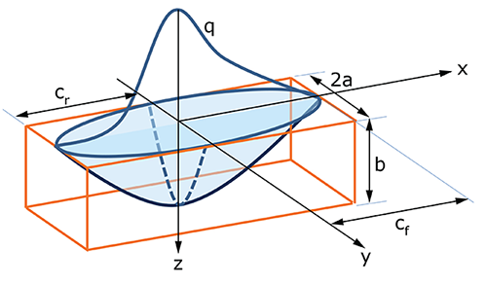
Figure 3.1. Double ellipsoid heat source parameters [34, 47].

Table 3.2. Double ellipsoid parameters used in analysis.
a | b | $$c_{f/r}$$ | $$f_{f}$$ | $$f_{r}$$
4.6 mm | 2.0 mm | 4.6 mm | 1.6 | 0.4

Thermal strain is defined as:
 | $$ε_{th}= {(T-T}_{ref}) αj$$ | (13)
 | $$j={[1 1 1 0 0 0]}^{T}$$ | (14)
where α is the coefficient of thermal expansion and $T_{ref}$ is the reference temperature.
Elastic-plastic behavior was modeled using Von Mises yield criterion, where Mises stress is defined as:
 | $$σ_{m}= \sqrt{\frac{{(σ_{1}-σ_{2})}^{2}+{(σ_{2}-σ_{3})}^{2}+{(σ_{3}-σ_{1})}^{2}}{2}}$$ | (15)
$σ_{1}$, $σ_{2}$, and $σ_{3}$ are the principal stresses, and material is considered to be yielding when
 | $$σ_{m} ≥σ_{y}$$ | (16)
Where $σ_{y}$ is the yield stress at the given material temperature.

Manufacturing/Model Parameters

Computational Details
The temperature dependent thermal- and mechanical- properties from the literature were assigned for each material. This data is summarized in Table A.2 and Table A.3 [48, 49]. All models used in the experiment were generated using ABAQUS 2022 software, running on 12 cores of an Intel Xeon CPU E5-26300 Processor.
The machine tool path was converted from machine G-code into the ABAQUS event series format, which includes x, y, z coordinates and time-stamps over the history of the manufacturing process in a .csv file. An excerpt from the event series is shown in Table 3.1 to provide insight to the format. To fully capture the manufacturing process, this series included pauses for machine maintenance and adjustments, which were not predicted prior to deposition. The event series was used to prescribe the time-dependent input for the input heat flux and element activation. The widely accepted double ellipsoid heat source was used in this work, however it generally does not need to be considered at this scale, where cuboid or concentrated heat sources have shown to produce sufficient thermal results [23, 30].
Progressive element activation was implemented for the analysis, which updated the domain for each increment by activating elements along the toolpath to simulate material deposition. Prior to activation, elements do not participate in the analysis solution.
Table 3.3 Event series excerpt for first ~58 seconds.
t (sec) | x (mm) | y (mm) | z (mm) | Power (mW)
0 | 1.132 | -253.907 | 0 | 5.83E+06
2.4566 | -9.6 | -213.725 | 0 | 5.83E+06
5.2754 | -19.454 | -167.031 | 0 | 5.83E+06
8.1194 | -26.892 | -119.461 | 0 | 5.83E+06
10.9446 | -31.775 | -71.88 | 0 | 5.83E+06
13.7669 | -34.133 | -24.157 | 0 | 5.83E+06
16.6085 | -33.961 | 23.952 | 0 | 5.83E+06
19.4294 | -31.266 | 71.634 | 0 | 5.83E+06
22.2709 | -26.007 | 119.452 | 0 | 5.83E+06
25.0953 | -18.283 | 166.641 | 0 | 5.83E+06
27.9339 | -8.018 | 213.589 | 0 | 5.83E+06
30.4076 | 3.083 | 253.971 | 0 | 5.83E+06
30.6606 | -0.916 | 255.506 | 0 | 5.83E+06
33.097 | -11.897 | 215.746 | 0 | 5.83E+06
35.9544 | -22.293 | 168.501 | 0 | 5.83E+06
38.807 | -30.145 | 120.849 | 0 | 5.83E+06
41.6566 | -35.457 | 72.899 | 0 | 5.83E+06
44.504 | -38.222 | 24.771 | 0 | 5.83E+06
47.3583 | -38.431 | -23.551 | 0 | 5.83E+06
50.2118 | -36.08 | -71.803 | 0 | 5.83E+06
53.0598 | -31.18 | -119.77 | 0 | 5.83E+06
55.9093 | -23.733 | -167.434 | 0 | 5.83E+06
58.7649 | -13.763 | -214.74 | 0 | 5.83E+06

As elements were activated, the thermal boundary conditions were automatically updated to account for the change in free surface.

Experimental Details
The computationally modeled part geometry, shown in Figure 3.2, consisted of 248 Layers, each approximately 2 mm thick. The total part height was 495.3 mm and took 11 hours to manufacture (including cool down) using a standard WAAM robotic cell. Each layer consisted of 4 passes, alternating between the scan pattern seen in Figure 3.4(a) for odd layers and (b) for even layers, at a speed of 16.93 mm/s. The substrate consisted of AISI 1080 steel, and the part material was 316L stainless steel. Arc power was 5.83 kW and a mixture of 98% Ar and 2% CO2 was used as a shielding gas. The welding wires were changed 3 times during manufacturing (at layer 74, 160, and 213), resulting in a 10 minute pause each time. Additionally, there were 7 tip changes (~2 min each) and a 3-minute print stop, adding to a total of 47 minutes of pauses.
As mentioned, these pauses were included in the model but were not predicted prior to fabrication. After manufacturing was completed, the baseplate constraints were removed to evaluate the elastic spring-back, and a 3D laser scan was conducted to track part distortion.

Role of Mesh and Time Resolution
The effect of two resolution factors, time increment and element size, was investigated. A decrease in time increment and element size correlates with an increase in spatial and temporal resolution, respectively. The length of the time increment, Δt, influences how often the analysis updates the solution with respect to time.
In FEA of an AM process, a smaller time increment results in a higher max temperature with a higher thermal gradient, while a larger time increment will result in a more integrated heat source with a lower maximum temperature. An example of this effect is shown in Figure 3.3.While the time increment was set for each analysis, and remained constant in each thermal model, the mechanical solution was allowed to iterate to convergence.
The element size influences the number of points in the domain of an analysis. For each mesh, element length was approximately the same in all directions, therefore element length, ℓ, and element size will be used interchangeably. Traditionally, when modelling an AM process, element size in the build direction is equal to or less than the deposition layer height in order to capture the inter-layer physics. When modeling large parts, the number of layers is often in the hundreds.
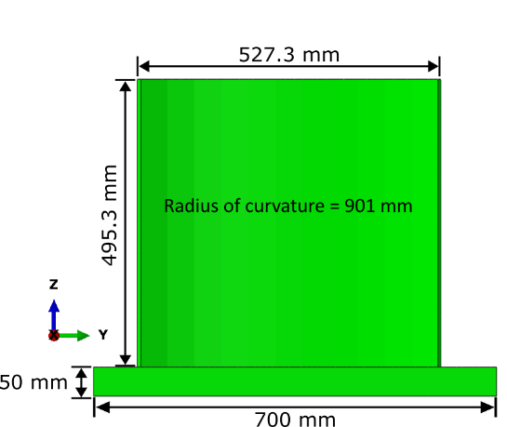 | 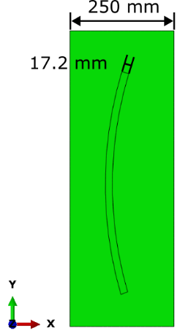 | 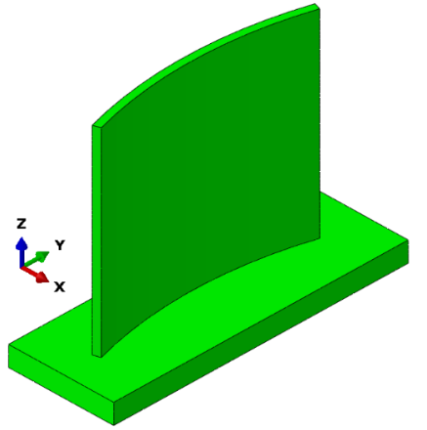
Figure 3.2 Dimensions of build geometry (a) front (b) top and (c) isometric view
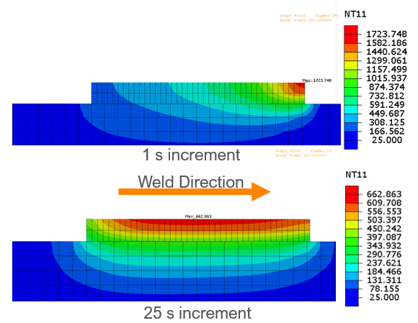
Figure 3.3 Temperature distribution of a transient heat source on a mild steel geometry for a 1 second increment compared to a 25 second increment.

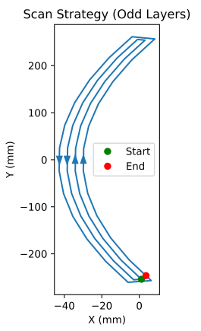 | 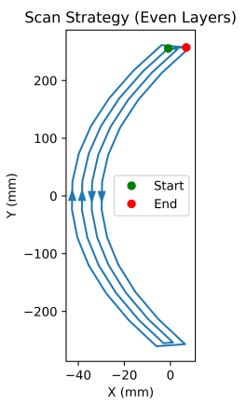
Figure 3.4 Tool path for (a) odd layers and (b) even layers.

In order to reduce computational cost, Dassault Systèmes recommends a coarser meshing strategy with elements a few times larger than the layer height [47]. 8 mm, 4 mm, and 2 mm element sizes, equivalent to 4, 2, and 1 layer(s) in the z direction, were investigated with a 400 sec time increment.
Element size and time increment were varied across 5 analyses as listed in Table 3.4, with the 8mm 400s analysis serving as the lowest resolution case in both time increment and element size output comparisons The approximate deposition cross section was 8.6 mm wide x 2 mm high.

Results/Discussion
Detailed description of the computational FEA mesh and profiles are outlined so that other researchers can use the same approach to perform verification and validation (V&V) of their own modeling scheme. Figure 3.5 shows the sample regions for temperature, displacement, and stress extraction on the part geometry. Temperature history was plotted at three nodes (A, B, & C). These nodes were selected get an overview of temperature signatures at different times during the WAAM process. Additionally, nodes were chosen to investigate change in temperature during deposition at the front face, back face, and at the center of the part. When selecting nodes to extract computational results, a node was selected on the 8mm mesh, then a nearest node formula was used to get the closest node on the other meshes. Additionally, displacement and stress profiles were sampled along the front face of the part as indicated in Figure 3.5. The profiles were selected to cross the highest value region(s) for each investigated output variable.

Table 3.4 Resolution parameters modeled
Simulation # | Element Size (ℓ) / mm | Time Increment (Δt) / seconds
1 | 8 | 400
2 | 8 | 100
3 | 8 | 25
4 | 4 | 400
5 | 2 | 400

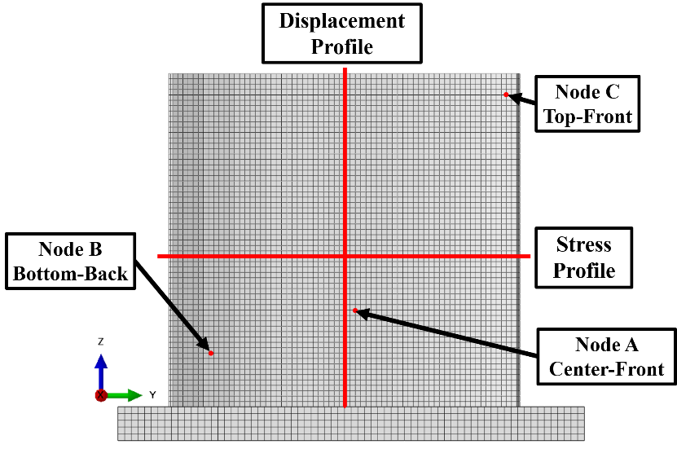
Figure 3.5. Profiles and nodes extracted for data analysis

Temperature
Figure 3.6 shows the temperature over time for nodes A, B, and C following the heat source crossing over the node. The plots indicate that increment size had a larger effect on predicted temperatures, but regardless of resolution, the temperature history of all analyses converged at the sampled node during cooling. The values in Table 3 were collected across all points for each analysis, and also indicate temporal resolution having a more significant impact on the results of the heat transfer analysis. In the absence of temperature data during the part’s deposition, it can be assumed that the 25s analysis generated maximum temperatures closest to actual values during manufacturing, while still under-predicting the maximum. Since metal begins in a liquid state, temperatures are expected to exceed the material’s liquidus, as reported in finer resolution models of SS316 [26]. This data confirms the expected behavior that longer increment sizes are unable to fully represent the temperature history of the process. Additionally, the shorter increment size analyses exhibited greater oscillation in temperature than the 400s cases; this effect is better portrayed in Figure 3.7, which provides a closer look at the peak temperature region of the previous plot for Node A. The oscillating behavior is likely an effect of the multi-pass scan strategy, which is largely averaged out for an increment size of 400s, which encompasses several layers. Figure 3.8 further illustrates this effect, showing the difference in temperature of simulations 2-5 from the 8mm, 400s model over the same range of time.

Displacement
When looking at the displacement magnitudes, U, across analyses (Figure 3.9 & Figure 3.10) the same distribution of maximum displacement at the center of the face of the wall that decreases towards the edges can be seen. The range of maximum displacement across all analyses was 0.124 mm. Breaking U into components along the height of the part as shown in Figure 3.11 reveals that the largest component is in the x direction, where the face is shifting in the x+ direction. In the x direction, there is a range of 0.096 mm between maximum displacement values across each analysis. There is a noticeable local minimum in displacement at the z height of each wire change. The three low-displacement regions due to a longer interstitial layer time from wire changing can be seen in Figure 3.12. These regions are not at the same z height as the mesh size changes, with the largest difference in z height between the local minimums being ~12 mm. This can be attributed to the "lumping" of layers that occurs with a larger element size.

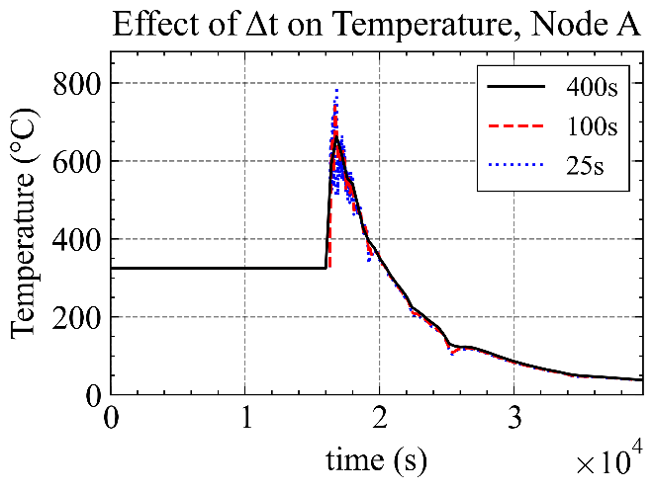 | 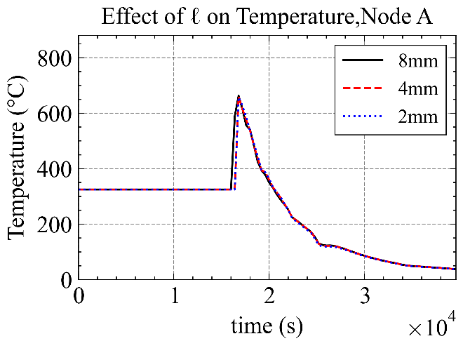
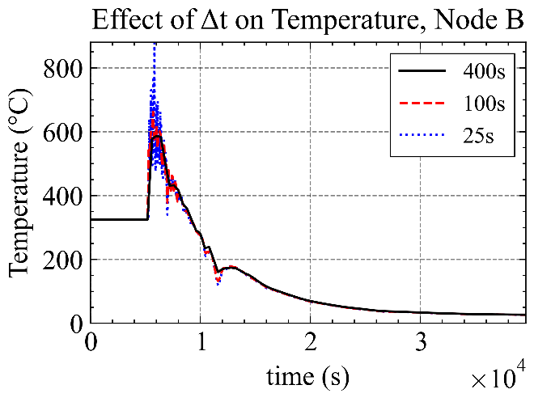 | 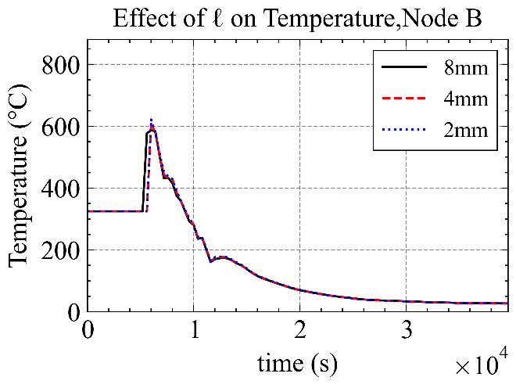
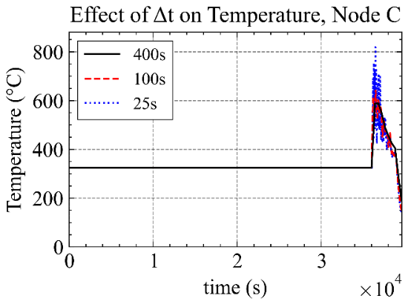 | 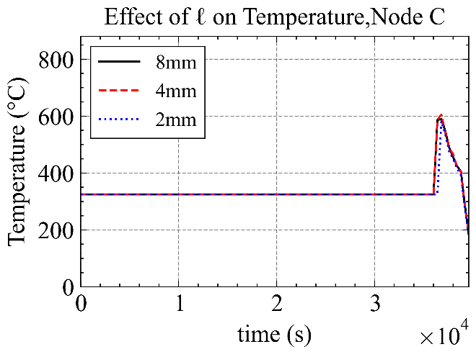
Figure 3.6. Temperature history following deposition at nodes A, B, C for (a) each length of Δt and (b) for each size of ℓ.

Table 3.5 Max temperatures across part for all time at each (a) increment size and (b) element size.
Increment Size | 400s | 100s | 25s
Max Temperature (℃) | 698.4 | 784.5 | 971.6
Element Size | 8mm | 4mm | 2mm
Max Temperature (℃) | 698.4 | 683.3 | 682.8

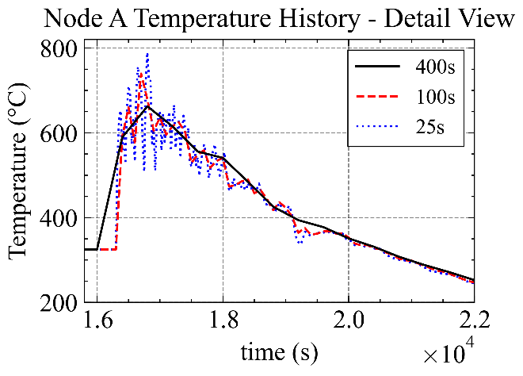
Figure 3.7. Enlarged view of Figure 3.5(a)
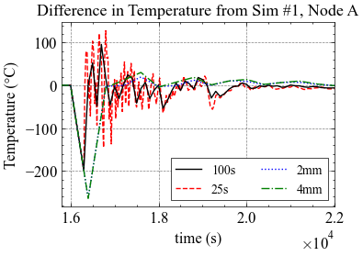
Figure 3.8 Difference in predicted temperatures with reference to initial ℓ=8 mm,
Δt=400 s simulation.

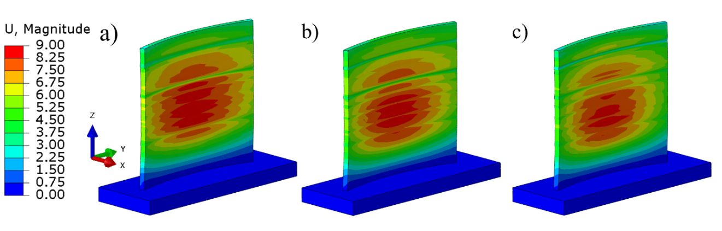Figure 3.9. Magnitude of displacement (mm) across face for (a) 400s, (b) 100s, (c) 25s increment.

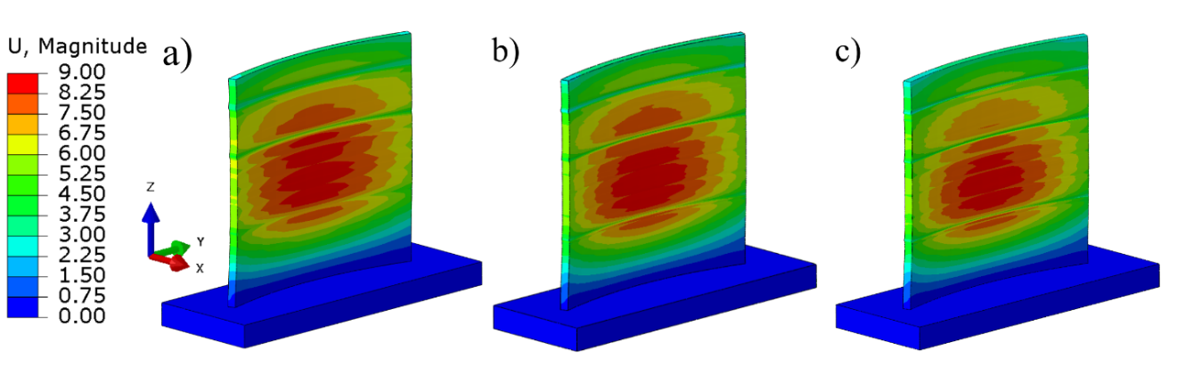
Figure 3.10. Magnitude of displacement (mm) across face for (a) 8mm, (b) 4mm, (c) 2mm element size.

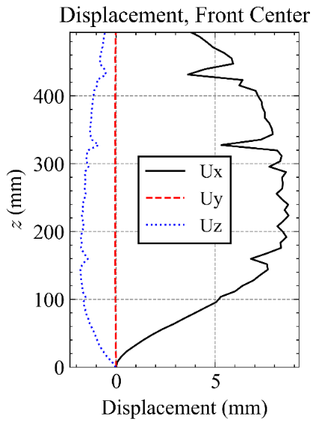
Figure 3.11. Components of displacement along sample line for the 8mm 400s analysis.
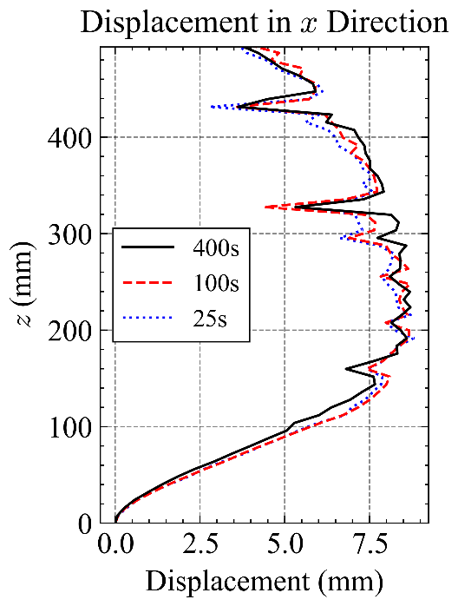 | 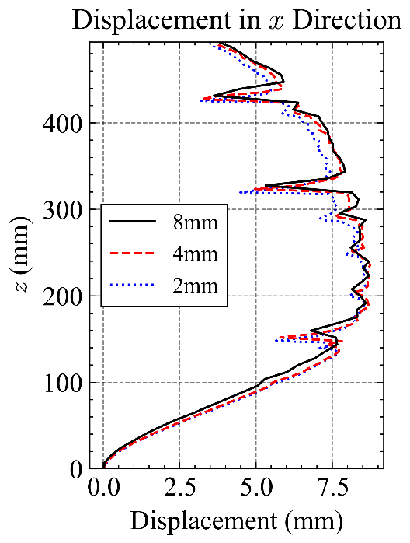
Figure 3.12. Displacement in x direction for (a) each time increment along center profile and (b) for each element size along center profile.

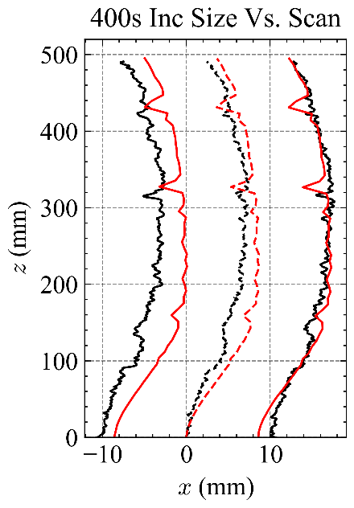 | 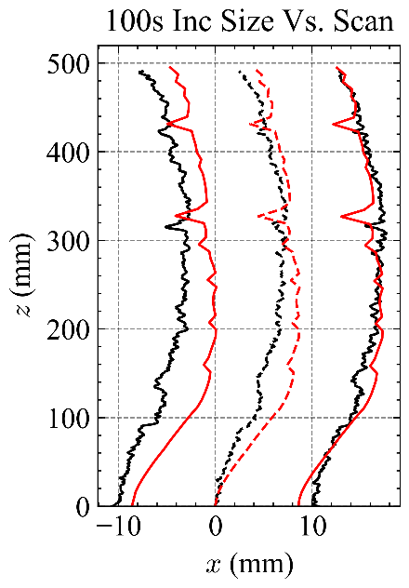 | 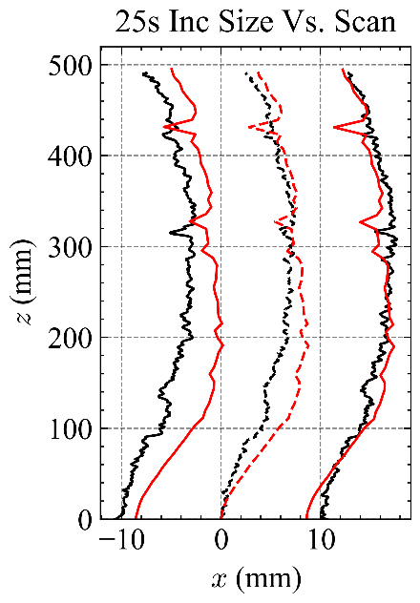
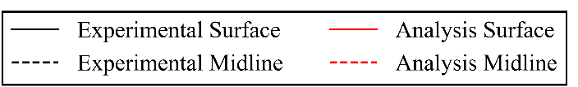
Figure 3.13 Calculated x-z midlines for (a) 400s, (b) 100s, (c) 25s increment size.

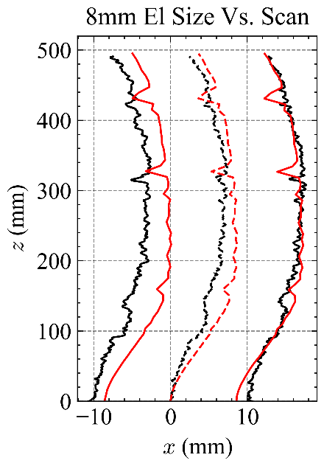 | 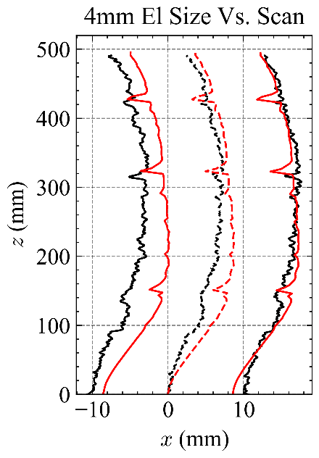 | 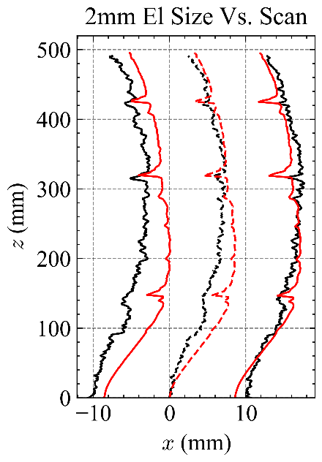
Figure 3.14. Calculated x-z midlines for (a) 8mm, (b) 4mm, (c) 2mm element size.

Table 3.6. Mean and max difference between midlines calculated from analysis and measurements.
Increment Size | 400s | 100s | 25s
Mean Diff(mm) | 1.359 | 1.435 | 1.290
Max Diff(mm) | 3.379 | 3.789 | 3.611
Element Size | 8mm | 4mm | 2mm
Mean Diff(mm) | 1.359 | 1.425 | 1.253
Max Diff(mm) | 3.379 | 3.563 | 3.330

Comparison to Geometry
Comparing the analysis to the measured data reveals that while both FEA and the actual part form “kink” deformations (locally negative) at the layers where wire was changed, the FEA overpredicts the magnitude of this effect at layers 74 and 213. Additionally, as a byproduct of low spatial resolution, the location of these deformations in FEA are offset in the z direction when compared to the data, with the 2mm being the closest. The plotted midlines also show a greater divergence of the analyses from the dataset in the lower half (z < 250 mm) than the upper half (z > 250mm). The maximum errors between analyses and measurements were located in this lower region. The highest resolution models in increment and mesh size (25s and 2mm) had the lowest calculated absolute mean differences with respect to the measured surfaces, and the overall range of mean differences across analyses was 0.172 mm or 12%. With respect to the part height, this range is relatively small.

Residual Stress
When looking at the von Mises stress distributions (Figure 3.15 & Figure 3.16), it can be observed that spatial resolution has a larger apparent effect than time resolution. For the larger element size analysis, the maximum stresses are located in two vertical bands on the face of the wall, compared to smaller element size analysis, which has its maximum stresses concentrated at the corners attached to the substrate. Increment size did have an impact on the width of these regions; however, they still have the largest Von Mises stresses on the face of the wall. A profile of the x component of stress was extracted across the boundary of the 108th layer, where the maximum stress in the 8mm analyses was located. Figure 3.17 plots σ_{xx} across the line shown in Figure 3.5, which supplements the visual observations of the von Mises stresses, illustrating a large variation in trends as a result of change in element size. Stresses across time increments appear to come closest at the center of the wall and at the peaks of the high stress regions to the side, with the greatest differences at the edges of the wall. In the absence of residual stress data measurements for the manufactured part, it is assumed that the highest resolution mesh generates the most realistic stress state, and the peaks seen in the 8mm analyses are an artifact of the low mesh resolution.

Computational Speed
Decreasing the element size from 8 mm to 2 mm resulted in a ~49.6 hour increase in solver time, while decreasing the time increment from 400s to 25s resulted in a ~0.8 hour increase. The solver time behaved as expected; adding more increments to solve is less computationally expensive and more linear than increasing the time to solve per increment.
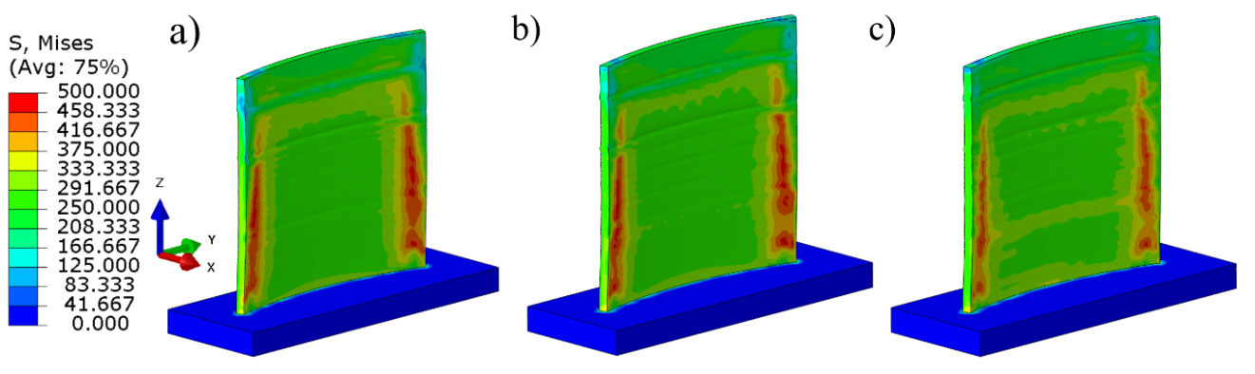
Figure 3.15. Von Mises stresses (MPa) across face for (a) 400s, (b) 100s, (c) 25s increment.

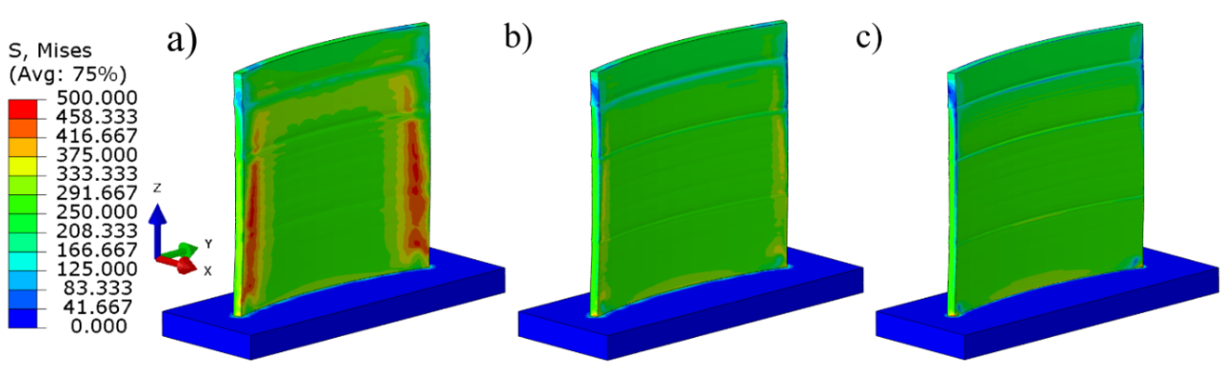
Figure 3.16. Von Mises stresses (MPa) across face for (a) 8mm, (b) 4mm, (c) 2mm element size.

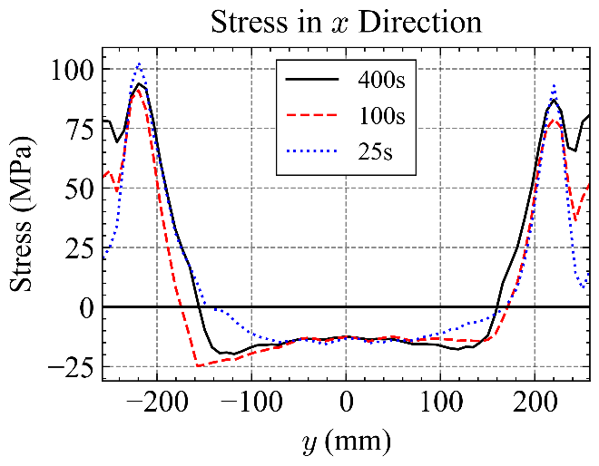 | 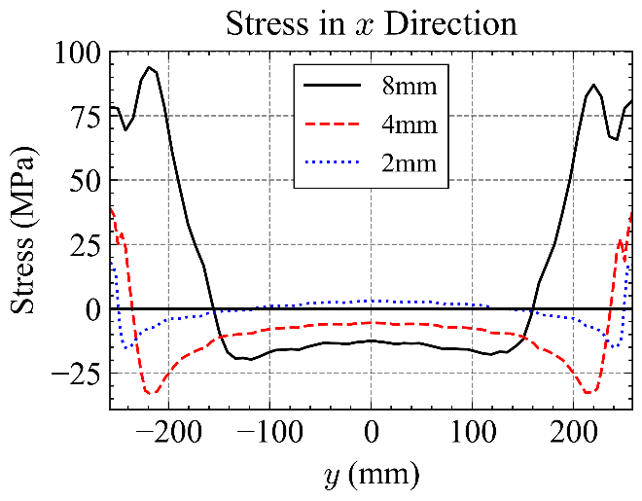
Figure 3.17. x component of stress along profile line for (a) each increment size and (b) each element size.

Directional Meshing Scheme
To further investigate the impact of element size on the analysis results, two additional meshes with directionally higher resolutions were created. Each approach uses elements ~8 mm in two directions and ~2 mm in the third. Mesh “2mmX” is 2mm perpendicular to the weld direction, while “2mmZ” has a higher resolution in the direction of the build height. Each meshing strategy is shown in Figure 3.19. The 2mmZ meshing strategy generated a mesh closer to some approaches seen in the literature, which respect the layer-wise deposition of the AM process by using an element height equal to the layer height. Since the 8mm mesh consisted of only two elements in through-thickness, the 2mmX strategy was deployed to improve the transversal resolution of the model, as σ_{xx} showed the greatest discrepancy in distribution and magnitude with respect to element size in the previous experiment.
Comparing the von Mises stress states in Figure 3.20, the 2mmX mesh generated results closer to the initial case with a 2 mm element size, while the 2mmZ mesh generated a stress state closer to the 8 mm analysis. Figure 3.21 plots the distribution of displacement and stress in the x direction across the profiles originally highlighted in Figure 3.5. Looking at the nodal displacement, both additional analyses followed the expected trend established by the earlier models, with the 2mmZ mesh having higher displacement than the rest towards the top of the part. The surveyed stress distributions further support that the 2mmX mesh generated a closer stress state to the initial 2mm element size mesh. Solver time for the new meshes is compared in Figure 3.18, which displays the computation time of each model normalized by the initial 400 second, 8 mm case. The 2mmX case generated similar stress results to the highest spatial resolution case with a 91.3% reduction in solver time.

Discussion
Increasing the time increment had a large impact on the thermal history, with a higher time resolution resulting in a higher max temperature and thermal gradient, as expected. In this study, time increment had a much larger impact on thermal than element size. In order to see melting temperatures in a thermal simulation, a much smaller time increment than those used in these experiments is necessary. But, since the primary mode of deformation in large scale, FEA models of WAAM can be attributed to the cooling of solid material, the time step can be increased with a small effect on the mechanical output. The primary need for accurate temperature history in TM FEA is for calibration of material properties and validation against real data. In a purely predictive environment, the sacrifice in resolution could be a more acceptable way to cut down solver time.
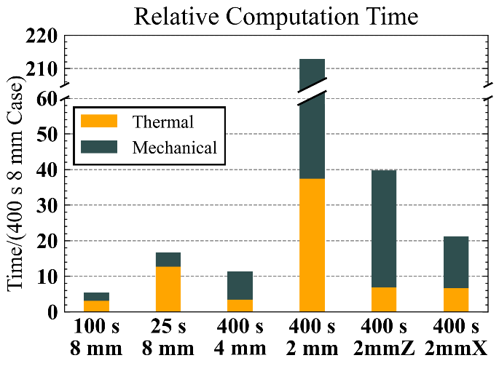
Figure 3.18. Wall-clock solution time as function of resolution factors.

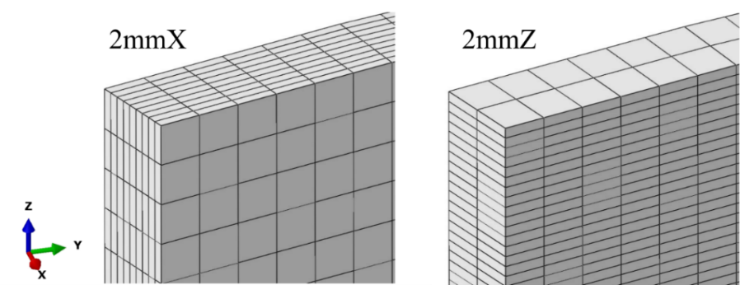
Figure 3.19. Directional meshing strategies "2mmX" and "2mmZ".

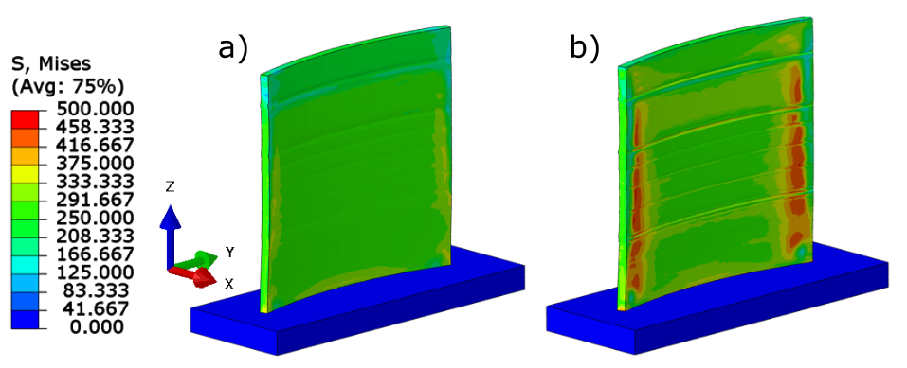
Figure 3.20. Von Mises stresses (MPa) across face for (a) 2mmX and (b) 2mmZ meshes.

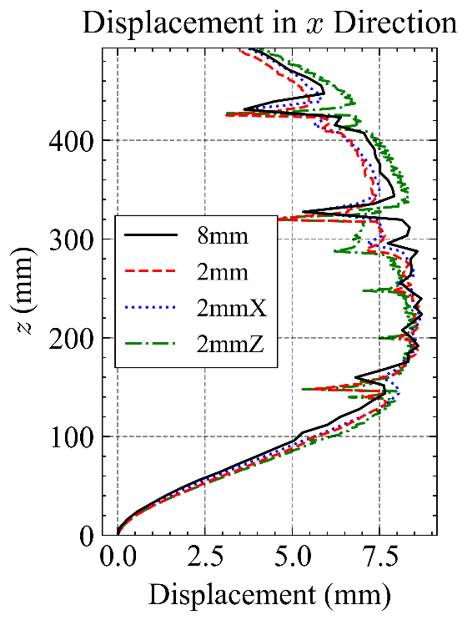 | 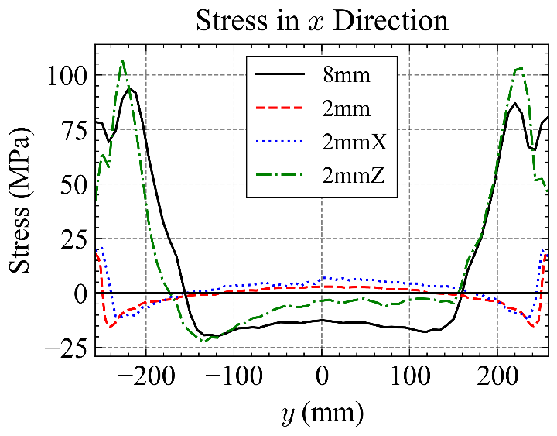
Figure 3.21. (a) Displacement and (b) stress in x direction for the 2mm, 8mm, and directional mesh sizes.

Both increment and element size were increased with relatively low impact on the predicted distortion, and increase in element size came with a large reduction (up to ~50 hours) in computational cost. Across all cases, nodal displacement yielded consistent results; similar patterns of displacement were present across solutions, and the largest difference between predicted max displacement in any direction was less than .2 mm. Further investigation compared nodal displacements to measured surfaces had a mean difference range of 0.182 mm, and had an error of 1.35 mm on average. Additionally, the location of specific process defects became shifted away from the measured locations due to low spatial resolution.
The differences in distribution of stress results could be attributed to the very low spatial resolution perpendicular to the weld path. The 8mm analyses, which have their largest stress regions across the front surface, had a resolution of only 2 elements perpendicular to the weld direction, which averaged out the thermal gradients present across the top of the layer as the heat source was applied. The directionally biased meshes created to investigate this theory showed that an increase in resolution perpendicular to the weld path generated residual stresses closer to the high-resolution cases, while increasing resolution in the build direction did not show much improvement. In order to investigate the most crucial dimension to increase mesh resolution, further experimentation in conjunction with residual stress measurements should be conducted at a part scale.
When deploying FEA with the intent of understanding the relationship between geometry on bulk deformation behavior in a part, lower resolution models can offer a path to rapid prediction and iteration due to the extreme computational savings. This approach could also be used to get an approximation of whether the maximum distortion of a geometry will be within a provided tolerance. The caveat that must be considered is a decrease in
mesh and increment fidelity will not necessarily provide a physically accurate look into the thermal history and residual stress development from the WAAM process.

Conclusions
The effect of time increment and element size on distortion and residual stresses has been investigated on the curved-wall geometry with dimensions of approximately 500 mm tall x 500 mm wide. Key findings from this research are summarized below:
- Time step length had a greater impact on the thermal history across analyses; as time step was decreased, peak temperature increased, resulting in a variation of around 273ºC between the highest and lowest resolution cases. Additionally, while the trends in temperature were consistent across time resolutions, larger time steps were unable to capture the thermal cycling typical of AM in a given node.
- Element size had a greater apparent impact on residual stress prediction, resulting in regions of high von Mises residual stress across the surface of the wall. The 8 mm element size produced two regions of tensile, traversal residual stresses in the range of 100 MPa along the front surface of the geometry which were not present; as element size was decreased the maximum value decreased and shifted towards the edge of the part.
- As noted in the previous work, the main component of displacement was perpendicular to the wall face, with the region highest displacement located in the center of the part face and decreasing toward the edges. Consistent distortion results across resolution factors indicate that the predicted distortion state was more influenced by part geometry and cooling rate rather than maximum predicted temperatures.
- By increasing the resolution in the direction perpendicular to the weld only, a similar residual stress state to the high-resolution mesh was generated while saving ~45 hours of computation time.
Future work will be explored in Chapter 5.

Inherent Strain Model UsIng Digital Image Correlation
The work in this section focuses on developing an approach to modeling powder-based DED using the inherent strain method. The main difference from other classes of solutions is that the inherent strain tensors are extracted from a digital image correlation dataset. As measurement and modeling techniques advance, this would enable the ability to leverage rapid solutions of ISM models to generate models that run during the manufacturing process. Then, it could be possible to iteratively identify the inherent strains needed in a section of deposited material to mitigate distortion in the previous section.

Background/Literature Review
Inherent strains, also called “incompatible strains” [17] or “eigenstrains” [50] are a term used to describe the permanent strains in a body responsible for creating the residual stress state. As mentioned in Chapter 1 and 2, these inherent strains prevent the relief of elastic strains, which generate residual stress. While residual stresses can be relieved and redistributed through mechanical operations, inherent strains cannot [51].
Generally speaking, inherent strains are defined as:
 | $$ε_{tot}= ε_{p}+ ε_{e}$$ | (17)

 | $$ε^{*}= ε_{p}= ε_{tot}- ε_{e}$$ | (18)
Where $ε^{*}$ is the inherent strain tensor.

Inherent Strain Modeling
The inherent strain method (ISM) forgoes the first two steps of residual stress analysis mentioned in [17] by directly providing the non-elastic strains in a body rather than conducting a transient thermo-mechanical analysis to find the thermally induced non-elastic strain state and provides a more approximative approach to prediction. In the case of modelling the welding process, this approach provides the advantage of solving in one or a few elastic analyses compared to the previously discussed computationally costly TMM. To implement this, the strains are specified directly along the heat affected zone (HAZ), either as a strain or equivalent load.
Works such as [52] and [53] compare the predictivity of transient thermo-mechanical analysis and elastic inherent strain analysis in single-path welds. Wang et al. modeled welding along an 800 mm long, thin-walled beam made of sheet metal and determined that both the TSM and ISM were able to effectively predict beam deflection [52]. Luo et al. investigated a 200 mm long bead on plate weld and concluded that the ISM was able to predict residual stress perpendicular to the weld consistent with thermo-mechanical analysis and predicted transverse shrinkage and angular distortion with acceptable accuracy compared to experimental measurements [53]. It is worth noting while there would be a large reduction in computation time between elastic inherent strain models and transient, elastic-plastic thermo-mechanical models, neither work explicitly mentions the difference in computation time.
An example that provides insight into the computational difference between the ISM and TMM can be seen in the work of Kim et al., which investigated the impact of weld sequence on deformation in large, 800x1200 mm curved plates experimentally and using both ISM and TMM analysis [54]. After solving for the inherent strains in the process, equivalent loads consisting of transverse and longitudinal shrinkage forces and bending moments were formulated and applied to each bead in sequence. The ISM was able to consistently predict the deformation profile against experimental data, and even outperformed the TMM in several cases. The inherent strain equivalent load models were able to solve in 3~4 minutes, compared to 1.5~2 days for the thermo-mechanical models, or ranging from 540x~960x faster.
The efficiency reflected in this example reflects the main draw of the ISM, which enables the prediction of deformation in large-scale structures quickly in order to find an optimal weld sequence to minimize it. This is also why much work has been dedicated to taking steps to extend the approach to model the additive manufacturing process.

Extension to Additive Manufacturing
As with thermo-mechanical modeling, one of the key modifications from welding FEA is the inclusion of progressive element activation to model the deposition process. In the ISM, activation is typically done layer-wise, activating one or several layers at a time [55]. Layer lumping is particularly common in modeling powder-based AM processes, which have a layer height >1mm. As layers are activated, given strain tensor(s) is/are applied and a static solution is reached. A simplified illustration of this process is shown in Figure 4.1 [55]. For all of the model layers, the same steps are taken. 1)The layer is activated 2) inherent strain is applied 3) a static solution is reached. Therefore, the number of steps needed to reach a solution in an ISM model will be equal to the total number of layers divided by the number of layers activated per step.
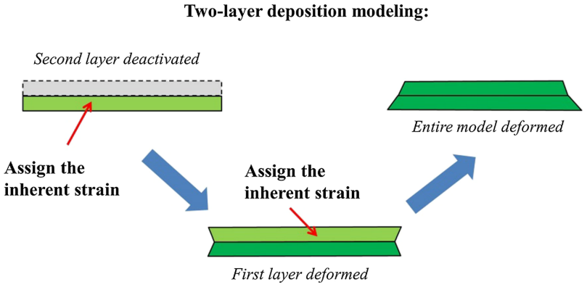
Figure 4.1 Two-layer example of material activation in the ISM [55]

There have been a variety of approaches taken to modify the ISM to accommodate for the differences between traditional welding and AM. However, as further background models or modes of physics are considered, the computational savings of the ISM are reduced. A common change is the inclusion of non-linear elastic plastic analysis [56, 57]. This is because the continuous addition of inherent strains results in overpredicted residual stresses in a purely linear analysis. Some authors will progressively ramp up the inherent strain in a given layer as further layers are activated, since a layer deposited in AM will not reach its final strain as soon as it is deposited due to remelting/reheating as further layers are deposited [58, 59]. Dong et al. aimed to accommodate for the heat accumulation in WAAM by incorporating a two-step equilibrium for each layer, where the static solution was first reached using high-temperature material properties, followed by a room temperature step [41]. However, computational time is increased due to a need for 5 representative models and full-part flash heating sim to get temperature history.
The main point to consider when using the ISM to model additive processes is the identification of the inherent strain tensor(s) to apply to activated layers. Bellet et al. [57], separates approaches taken to finding ε* into 3 classes:
Class 0 approaches determine ε* through the use of formulas based on material properties, expected temperatures, and the heated zone's degree of restraint. These often use the three-bar/bar-and-spring model of residual stress to derive inherent strains [16]. This approach is most common in traditional inherent strain modeling of welding problems, encompassing the previously mentioned welding examples [52]. The highly transient domain and varied mechanical boundary conditions present in additive manufacturing makes this approach more difficult to take, but some works have been able to extend this class of ISM solutions to AM [60].
Class 1 describes approaches that iteratively and inversely solve for ε* by minimizing the difference in displacements between an ISM model and a sample geometry. The sample geometry is representative of the manufacturing conditions of the larger part of interest. The sample can either physically manufactured [61] or modeled thermo-mechanically to obtain expected displacement [62]. Then, an optimization function such as Equation (19) is used to obtain solutions to ε*:
 | $$f\left(x\right)=min\sum_{i=1}^{n}{(\frac{u_{exp}-u_{sim}}{u_{sim}})}$$ | (19)
Where n is the number of sampled points, u_{exp} is the expected displacement, either measured experimentally or from a detailed model, and u_{sim} is the ISM displacement predicted for given set of inherent strain values. Once the optimized inherent strain tensor is found, it is applied to larger parts with the same manufacturing conditions.
Class 2 describes multi-scale modeling approaches that extract strain tensors directly from a representative, small-scale thermo-mechanical model. This class of approach is frequently used to model AM in the literature [14, 41, 56, 57]. The representative model is subject to the same processing parameters (scan speed and strategy, input power, boundary conditions, etc.) as the full part and can be a simple geometry, illustrated in Figure 4.2, several deposited beads, or the initial layers of the full part [57].

Digital Image Correlation
Digital image correlation (DIC) is a non-contact optical measuring approach that divides a target domain into subsets and tracks their movement across time from a reference state to a deformed state. Generally, displacement, deformation, and strain can be extracted from this data. In order to establish correspondence between states, the measured surface is painted using a speckle pattern to create unique points. Once a surface has been speckled, images are captured as the surface is deformed to its next state. The ability to non-destructively track deformation over time across a surface makes DIC the most prominent in-situ optimal measurement technique [63] and an appealing option to capture the development of thermal strains during additive manufacturing.
There are several barriers to extending DIC techniques to AM. The primary issues include the application of a speckled pattern and tracking the growing region of interest (ROI) from material deposition, which makes it impossible to have an initial reference state. Some researchers have used the surface texture of deposited material in lieu of applying speckled paint.
Spencer et al. [65] compared DIC tracking of a speckled and non-speckled polymer DED sample in a linear translation experiment and found both samples to provide acceptable results following DIC evaluation; the speckled surface sample had an average percent error of 3.05% while the printed surface sample’s was 3.57%. Haley et al. [66] used the surface texture of deposited metal to track deformation during DED manufacturing of a cylinder geometry. On the other hand, some work applies the traditional speckle technique to the AM process. While using DED of Ti-6Al-4V to manufacture a thin-walled structure Xie et al. [67] paused manufacturing after 20 layers, to apply speckled paint to the existing region of the part. Subsequently, 3 additional layers were deposited, and their influence on strain in the initial ROI was observed.

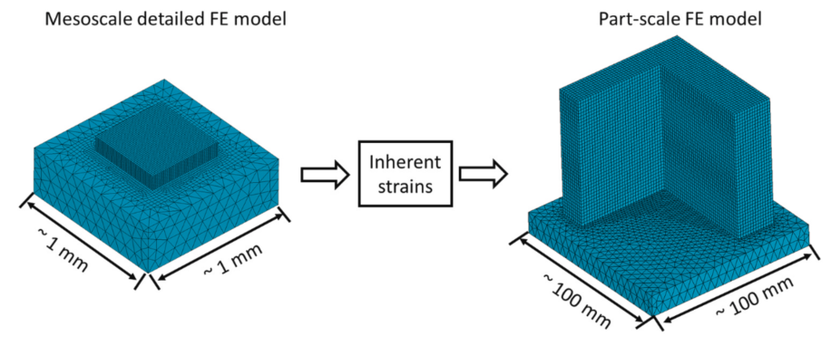
Figure 4.2 Example of the class 2 approach to inherent strain modeling [64].

Additionally, there is a problem in that an additively manufactured geometry does not have an initial strain-free reference state to track, and the ROI will expand as the part is built. The previously mentioned work [67] was able to maintain a forward correlation by using an ROI of deposited material only and maintaining that limited ROI as further material was added. Some researchers have implemented a reverse correlation technique wherein the order of images gathered during DIC are reversed, using the final completed part as a the “undeformed” reference state. Spencer et al. [65] took this approach to monitor the distortion of a 38 cm tall wall manufactured using polymer extrusion. In doing so, the vertical and horizonal in-plane displacement were captured throughout the build history and the nature of the part’s warpage was observed. However, the study was not able to gather valuable strain results due to the visual noise inherent to AM. Haley et al. [66] similarly implemented backwards correlation in powder-based DED of a cylinder using SS316L to track the total displacement along one of its surfaces. It is explained that in this approach, new material will appear to be deposited with high displacement that will reduce until there is no displacement when the part is completed, and therefore the data should be inverted to account for the backwards reference. While it does provide insight across the deposition history, backwards correlation still needs the final state as a strain-free reference, so it is not truly “in-situ”. However, a system could be set up to conduct backwards correlated DIC analysis at several different stops along the printing process.

Experimental Setup

Process Parameters
Using powder DED AM, a 25x2x50 mm wall was produced at the Oak Ridge Manufacturing and Demonstration Facility using Inconel 718 (IN718) The dimensions and geometry are shown in Figure 4.3. The substrate dimensions were 51x13x2.25 mm, and it was clamped on one end. The final geometry was 150 layers high, with a set layer height of 0.333 mm. Laser power was set to 360 W and speed was set to 21.66 mm/s. The tool scan path, shown in Figure 4.4, rotated by 180° each layer. The overall manufacturing time was 14.3 minutes, and the part was allowed to cool for 5.1 minutes. Two cameras were used to monitor the deformation of the substrate and deposited material during printing. Time resolution was low, with the cameras capturing an image at every 2 seconds or 0.5 Hz. Spatially, the images had measurement resolution of ~40 pixel/mm. To process the data, VIC3D DIC software was used with a subset size of 65 and a step size of 7. As introduced in the background section, the backwards correlation approach was used, wherein the final state of the part was used as the undeformed reference. Additionally, the as-deposited surface of the material was used for tracking.

Modeling Parameters
The inherent strain approach was used within the Abaqus 2023 AM Module. This will assign as the designated inherent strain tensors as a load within the most recently deposited layer(s) of material. Since the primary objective of this modeling experiment was to predict distortion, a linear elastic solution was conducted. In this model, 6 element layers were activated in each time step. An element size of ~0.333 mm in each direction (equivalent to layer height) was used in the part and 1 mm in each direction was used in the substrate and clamp. The back surface of the clamp was fixed as a boundary condition, and the inside surfaces of the clamp were attached to the substrate using a surface tie. The room temperature mechanical properties of IN718 were used, which are an elastic modulus of 200E+3 MPa and a Poisson’s ratio of 0.29. In order to extract inherent strains from the data, so-called “virtual extensometers” were used within VIC3D to track change in length, which measures strain along a line using the basic definition of strain described in Equation (20):
 | $$ε= \frac{∆L}{L_{0}}$$ | (20)
It should be noted that from DIC surface measurements, elastic and plastic strains cannot be separated, so the assumption must be made that in measured total strain, the magnitude of plastic strain is much greater than elastic strain. Referring back to residual stress and strain development in the three-bar model (Figure 2.7) supports this assumption, as plastic strain is an order of magnitude greater than elastic strain in the middle bar. Additionally, due to the planar nature of the DIC dataset, only the x and y components of inherent strain, $ε_{x}^{*}$, and $ε_{y}^{*}$, were used in this model.
A common assumption in ISM modeling of AM is that the shear components are also equal to zero [41, 59]. Therefore, the inherent strains applied in this experiment will only have 2 components.
Figure 4.5 shows the location of the three virtual extensometers set up in the x direction and nine in the y direction at different heights along the build. The purpose of this is to capture the three main boundary conditions experienced during deposition: near the substrate, steady state, and in the final layers. Layers near the substrate are subject to faster cooling rate due to conduction through it, and layers near the top are less thermally cycled than the other layers. The y extensometers were set roughly equal to the layer height and distributed in sets of 3 at the middle and either end of the layer.

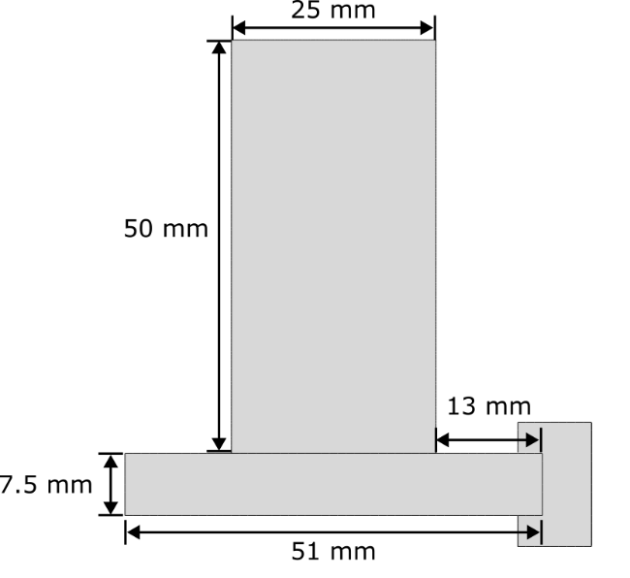
Figure 4.3 Dimensions of experiment geometry.
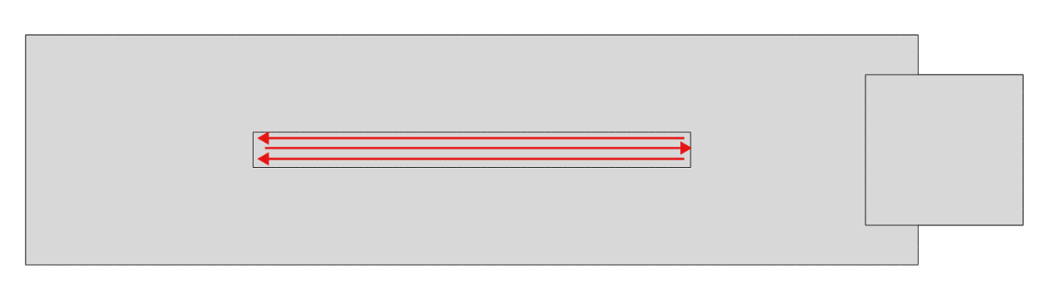
Figure 4.4 Scan strategy used for a layer, that rotated 180° each layer.

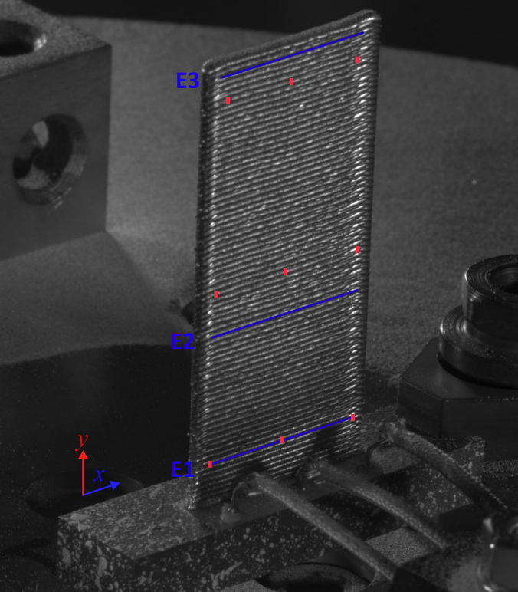
Figure 4.5 Locations of the horizontal (blue) and vertical (red) virtual extensometers used to collect strains.

Based on the locations of the virtual extensometers, the model was subdivided into 9 different "strain regions”, Figure 4.6, where the elements in a given region were assigned with that region's designated strain tensor upon activation. Two sets of extensometer data were collected and used as the “final” and “intermediate” approaches. The “final” approach uses the extensometer data collected after all deposition is completed and the part is fully cooled. The “intermediate” approach collects data n frames after the material is added and tracked by DIC. The best fit value for n was experimentally determined to be 60 frames, or around 120 seconds after the deposition is picked up by the DIC software. The strain tensors used for each approach are listed in Table 4.1.
The transformed outputs of the x direction extensometers are plotted with respect to time in Figure 4.7. To transform each dataset from its backwards correlated state, the initial value with respect to time (or final deformed frame with respect to cooled initial reference state) was subtracted from every value. This results in an initial tracked value of 0 as soon as the DIC analysis interprets the deposited region.
The strain data in Figure 4.7 reflects a contraction in the x direction for each of the layers measured, which makes physical sense due to the material cooling down from a melted state. All extensometers converged in the -0.010 to -0.015 compressive range, with the highest extensometer (E3) converging the quickest due to entering the cooling phase faster relative to the other layers.
Extensometer E2 has region of expansion for ~100s following deposition. While this could indicate expansion due to reheating as material is deposited on top of the layer, this could also be due to noise in the measurements interfering with the transformation calculation.

Results and Discussion

DIC Displacement
The x and y displacement at four points during manufacturing history are displayed in Figure 4.8 and Figure 4.9, respectively. The exact magnitudes of displacement cannot be extracted from these figures due to the final reference state, however the direction of displacement can be observed using the reversed scale in the figures. The x displacement corroborates the extensometer data in Figure 4.7, as it shows the outer edges of the wall contracting towards the center. It also shows that the substrate is moving in the +x direction, towards the part. In the y direction, it can be seen that the highest negative displacements were located under the path of deposition and radiated out down the wall. This can be attributed to the expansion of the upper layers due to molten deposition compressing the material below it. Additionally, upward deflection of the substrate is

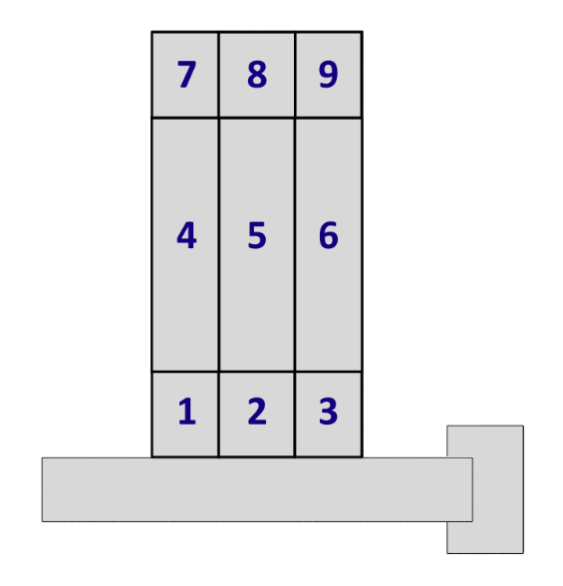
Figure 4.6 Locations of the nine designated inherent strain regions.

Table 4.1 Inherent strains loaded into each region for each approach.
Final Strains |  |  |  | Intermediate Strains
# | Ɛx | Ɛy |  | # | Ɛx | Ɛy
1 | -0.014 | -0.006 |  | 1 | -0.0043 | -0.0023
2 | -0.014 | -0.0002 |  | 2 | -0.0043 | 0.005
3 | -0.014 | -0.013 |  | 3 | -0.0043 | -0.0148
4 | -0.012 | -0.017 |  | 4 | -0.0068 | -0.0097
5 | -0.012 | -0.013 |  | 5 | -0.0068 | -0.0029
6 | -0.012 | -0.022 |  | 6 | -0.0068 | -0.0203
7 | -0.013 | -0.005 |  | 7 | -0.0104 | -0.0032
8 | -0.013 | 0.0018 |  | 8 | -0.0104 | 0.0023
9 | -0.013 | -0.0077 |  | 9 | -0.0104 | -0.0061

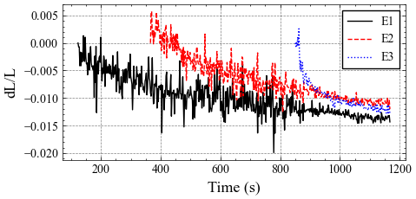
Figure 4.7 Total strain outputs for each horizontal extensometer over time.

visible in most of the frames. Additionally, frames show that the layer isn’t immediately tracked upon deposition. These figures also highlight that the DIC software isn’t able to immediately recognize material as it is deposited, as shown in the regions with no scale value. The overall observed pattern of deformation is illustrated in Figure 4.10.

Inherent Strain Results
The full-field x and y displacements in the ISM models are shown in Figure 4.11 and Figure 4.12. Overall, similar behaviors were present in both models, but the “final” approach showed larger maximum and minimum magnitudes. Both the final (a) and intermediate (b) models exhibit similar patterns of displacement in the x direction: the left regions of the walls have moved towards the clamp due to contraction in the material and substrate. The bottom right corners of each model have a negative x displacement, which corresponds to the contraction of the right side. The top right region, however, is positive (towards the substrate), which is likely due to the rotational motion of the cantilever substrate curling up. Investigation of displacement in the y direction indicates that the maximum regions of negative displacement/downward movement are at the top right region of the part. Again, this distribution can be attributed to the cantilever motion of the substrate; since the left region of the part is on the free end of the beam, the upwards motion exceeds the downward contraction of the part.
To compare the ISM results to the DIC dataset, sample points were selected along the build height at the middle of the part and models to extract the x and y components of displacement. Additionally, three points along the substrate thickness, 3 mm from its outer edge, were selected to compare displacement components.
The location of the sample points can be seen in Figure 4.13 (Note: Color scale on this figure only indicates height in the y direction). Figure 4.14 plots the x (dashed lines) and y (solid lines) components of displacement in the part (a) and substrate (b). In the part, both inherent strain approaches over-predicted the x displacement of the center region, which overall had little movement in the x direction. Looking at the y component of displacement in the part, the “final” ISM approach showed good agreement up to 20 mm along the build height, where it then began to diverge to a larger displacement in the negative direction. For the same component, the “intermediate” ISM approach showed very close agreement to the measured values at any given height. Comparing the displacement components of the ISM and DIC datasets in the substrate shows a closer match. The y component in the “intermediate” approach matches the sampled points almost exactly, and the displacement trend of the x component matches the sampled points, however the direction of displacement does become positive in the top half, while remaining fully negative in the measured data.
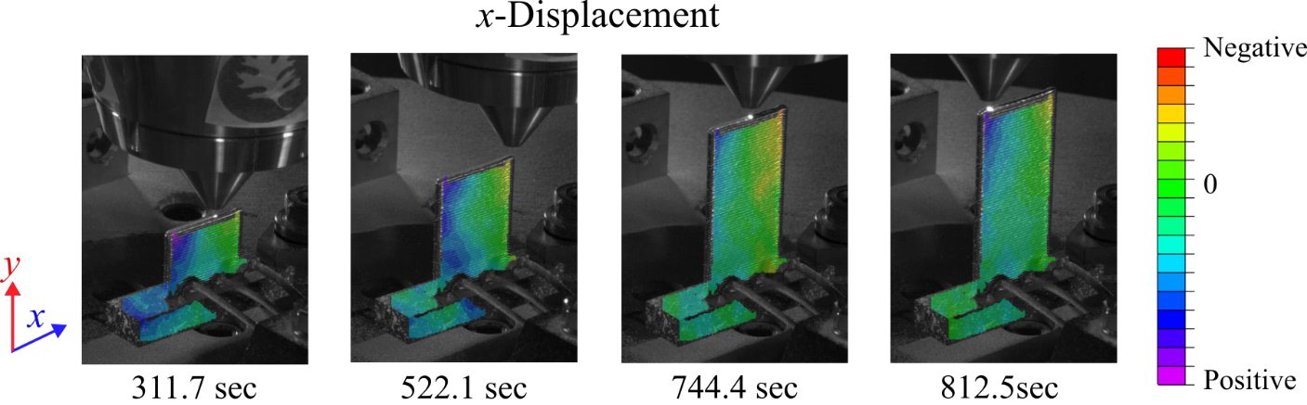
Figure 4.8 Displacement in the x direction at different points in time during deposition.

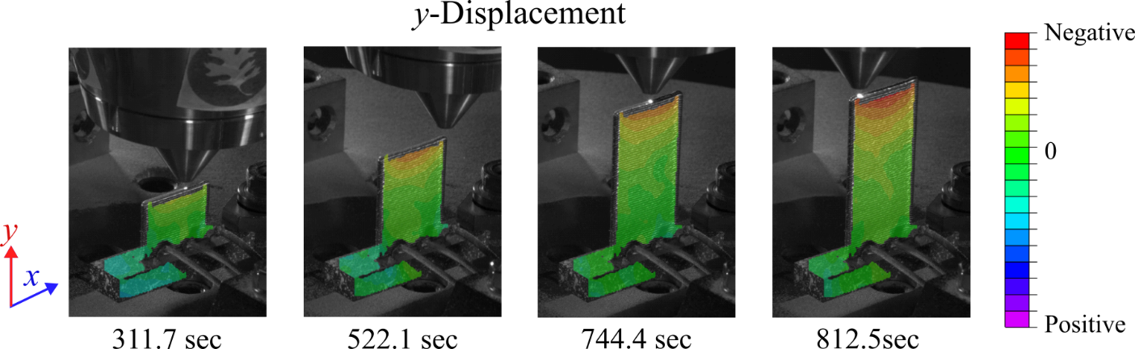
Figure 4.9 Displacement in the y direction at different points in time during deposition.

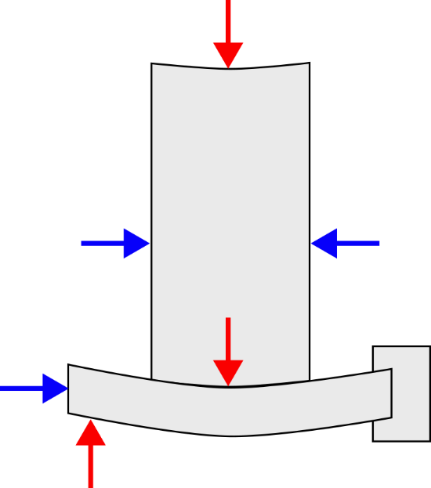
Figure 4.10 Overall direction of displacement in part and sustrate during manufacturing.

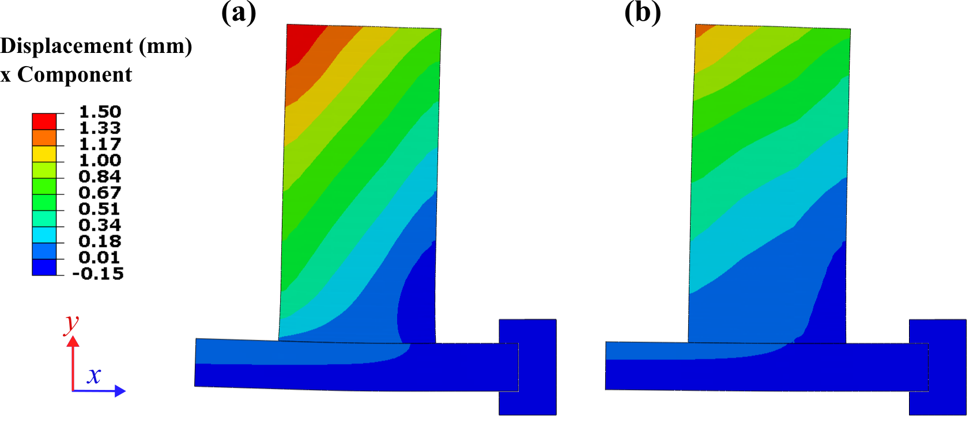
Figure 4.11 x Component of displacement for (a) final inherent strain approach (b) intermediate strain approach

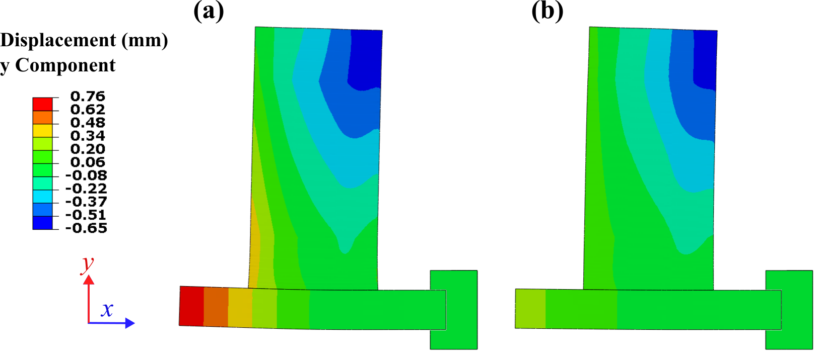
Figure 4.12 y Component of displacement for (a) final inherent strain approach (b) intermediate strain approach

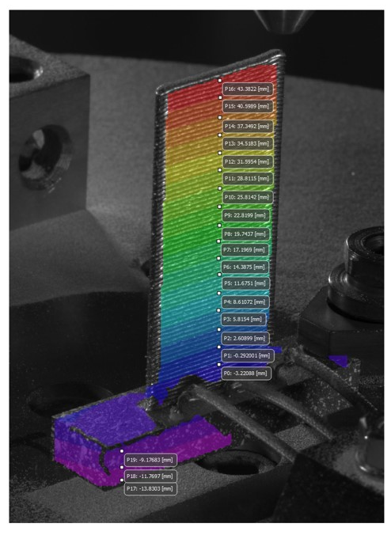
Figure 4.13 Points sampled for final x and y displacements.

(a)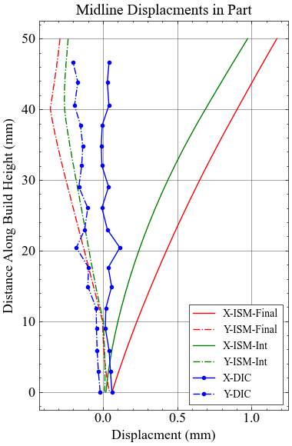 | (b)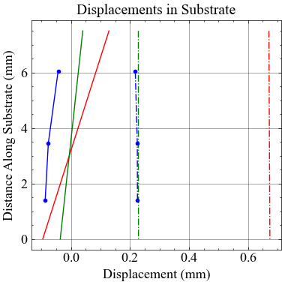
Figure 4.14 Comparison of ISM and DIC displacements in (a) part and (b) substrate.

Limitations
Because the modeling experiment was based on pre-existing experimental data rather than an experiment designed from the ground up with inherent strain in mind, there are a number of limiting factors present. Additionally, as seen in the figures containing DIC data, thermocouples were present on the substrate to measure temperature development in the substrate. This resulted in blocking the view of the majority of the substrate from view, which prevents comparison along the full horizontal profile. The experiment also had an overall low sample rate of only 0.5 Hz, which could potentially fail to capture the immediate strain development that occurs when material is deposited. Additionally, the bright light that is generated from melting material can interfere with the reflection of the material surface, which is the likely reason that layers weren’t able to be tracked immediately after deposition.
As is, this technique is only possible on thin-walled, two-dimensional geometries, where strain can be extracted from the observable surface. This could potentially be expanded to more complex thin-walled geometries using three-dimensional DIC techniques like those introduced by Haley et al. [66]. Another limiting factor is that typical inherent strain models, as used in this experiment, innately cannot provide transient data, as they are static models that do not consider the full loading cycle of the material.

Conclusions
In this experiment, DIC was used to capture the displacement development in an Inconel 718 wall built using DED. To model this process, the inherent strain process was used with two different sets of strain tensors, which were gathered from the DIC data. During manufacturing, the main modes of deformation within the part were horizontal contraction at the edges of each layer and downward movement in the region underneath the tool path.
The intermediate ISM approach, which gathered strains ~120 seconds after deposition showed overall agreement with the experimental measured final displacement in the sampled regions for the x and y components of the substrate and the y component of the part, with the y component of displacement matching particularly well to DIC measurements. However, the x component of displacement of the part was greatly over-predicted in this model.
Both models solved in under 9 minutes, with room for a further increase in speed through mesh coarsening in the part region. This could open up rapid iteration of solutions in the future if the approach is incorporated into distortion mitigation scheme. Additional recommendations for future work are outlined in Chapter 5.

Conclusions and Future Work

Curved Wall Thermo-Mechanical Analysis
This work verified the impact of resolution on a large-scale, curved wall geometry. Displacement predictions were consistent across all mesh and increment sizes, while computation time varied up to over 212x the lowest resolution case. Time increment size had a large impact on thermal history; smaller time steps predicted higher maximum temperatures and captured the thermal cycling seen in additive manufacturing. Element size influenced the predicted residual stresses, with the coarser mesh developing maximum stress regions along the part face. Additional directionally biased meshing strategies were developed to predict similar residual stresses faster.
The results call for further verification of resolution in large scale WAAM parts, which is the primary path for future work to explore. Further modeling should be done to understand if similar patterns are present for other large-scale geometries with further degrees of complexity (i.e. no axes of symmetry). Different geometries could potentially benefit from different mesh bias directions than the directional mesh used for the curved wall.
Additionally, further work could focus validation in addition to verification, modeling large-scale parts with measured residual stress distributions. As mentioned in Chapter 2, the ability to measure full-field residual stresses is limited and therefore the amount of available data on full field residual stress distributions in large-scale WAAM parts is limited. Further work would include designing an experiment from the ground up with residual stress measurement in mind, which would enable validation of the modeled residual stresses. By providing a ground truth for the present residual stresses, the need to assume that the highest resolution model is the most correct could be forgone.
Additionally, work needs to be done in non-thin walled structures. For example, the toolpath for WAAM deposition of a cruciform geometry typically used in fatigue testing is shown in Figure 5.1. In dense parts such as this with complicated infill strategies, large timesteps will have an influence on if the heat source is separate or across an area. This is illustrated in Figure 5.2 (b), where a time step of 200 seconds divides the heat source across separate sides of a layer at a given increment, compared to the single bead path covered by a 50 second time step in Figure 5.2 (a). In cases such as these, a more intentional approach to increasing increment size may need to be implemented in order to prevent errors in thermal history.
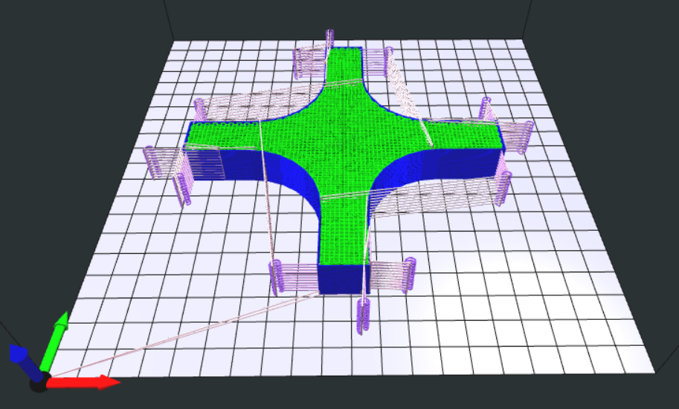
Figure 5.1 Sliced tool path for a cruciform geometry.

(a)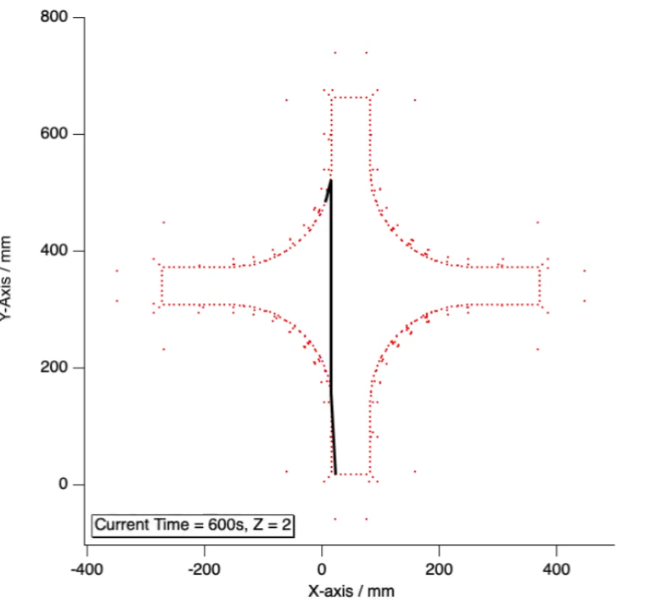 | (b)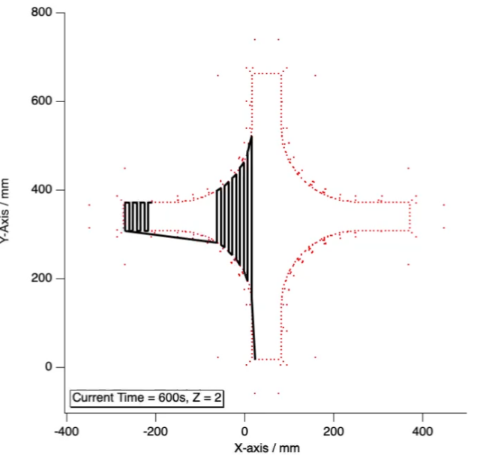
Figure 5.2 Distance covered for a (a) 50 sec and (b) 200 sec interval.

Inherent Strain Method Using DIC Data
This work developed an ISM approach to model deformation using data collected from DIC measurements for a wall manufactured using DED. Considering the approximative nature of inherent strain modeling, the “intermediate” approach was able to generate acceptable agreement in x and y displacement of sampled points in the substrate and y displacement of the part, while unable to replicate part motion in the x direction.
Future work for this experiment would involve better tailoring a DIC experiment from the ground-up with high-resolution strain data in mind. This would necessitate a higher pixel resolution and sample rate to fully capture the process. The experiment could also include full view of the substrate in order to compare the full distortion profile of the DIC dataset and the FEA Additionally, coupled IR measurements could provide insight into the physical significance of the length of time of the delay used in the intermediate ISM approach by comparing the delay to the layer’s thermal history.
The end goal of this approach is to develop a closed loop displacement correction strategy utilizing the rapid solution time of the ISM to collect the inherent strain tensor needed to correct for distortion in previous sections of the part, then inversely identify the process parameters needed to apply these strains. However, in order to accomplish this, further work needs to be done on modifying the inherent strain approach to predict AM deformation in all measured directions.

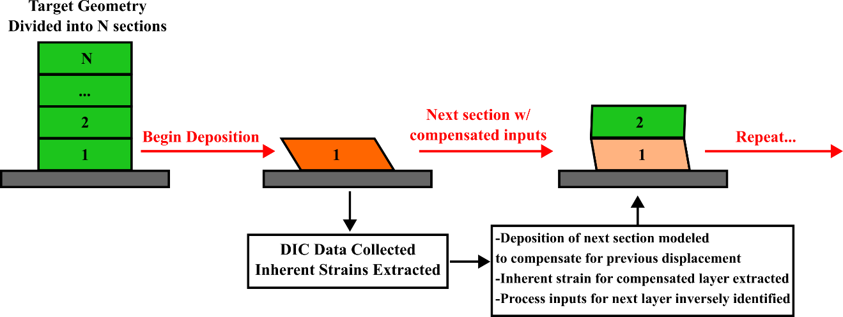
Figure 5.3 Graphic explanation of proposed future displacement compensation approach.

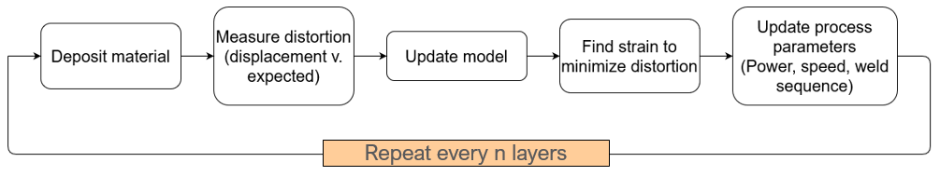
Figure 5.4 Flowchart outline of proposed displacement compensation approach.

References
[1] DAWNBREAKER, 2022, "DOE MARKET RESEARCH STUDY DOMESTIC CASTING INDUSTRY," Rochester, NY.
[2] 2022, "Securing Defense-Critical Supply Chains: An action plan developed in response to President Biden's Executive Order 14017," U.S. Department of Defense.
[3] Technologies, O. o. I., "Metal Casting Project Fact Sheet: Unconventional Methods for Yield Improvement," Energy, ed.
[4] Derekar, K. S., 2018, "A review of wire arc additive manufacturing and advances in wire arc additive manufacturing of aluminium," Materials Science and Technology, 34(8), pp. 895-916.
[5] Ford, S., and Despeisse, M., 2016, "Additive manufacturing and sustainability: an exploratory study of the advantages and challenges," Journal of Cleaner Production, 137, pp. 1573-1587.
[6] ASTM, 2022, "ISO/ASTM 52900:2021(E): Additive manufacturing — General principles — Fundamentals and vocabulary."
[7] Jared, B. H., Aguilo, M. A., Beghini, L. L., Boyce, B. L., Clark, B. W., Cook, A., Kaehr, B. J., and Robbins, J., 2017, "Additive manufacturing: Toward holistic design," Scripta Materialia, 135, pp. 141-147.
[8] Tofail, S. A. M., Koumoulos, E. P., Bandyopadhyay, A., Bose, S., O’Donoghue, L., and Charitidis, C., 2018, "Additive manufacturing: scientific and technological challenges, market uptake and opportunities," Materials Today, 21(1), pp. 22-37.
[9] Love, L. J., Dehoff, R., Chesser, P., and Jordan, B., 2019, "Application of Directed Energy Deposition for Transformational Challenge Reactor Core."
[10] Withers, P. J., and Bhadeshia, H. K. D. H., 2001, "Residual stress part 1 - Measurement techniques," Materials Science and Technology, 17, pp. 355-365.
[11] Lu, X., Chiumenti, M., Cervera, M., Li, J., Lin, X., Ma, L., Zhang, G., and Liang, E., 2021, "Substrate design to minimize residual stresses in Directed Energy Deposition AM processes," Materials and Design, 202.
[12] Denlinger, E. R., Heigel, J. C., Michaleris, P., and Palmer, T. A., 2015, "Effect of inter-layer dwell time on distortion and residual stress in additive manufacturing of titanium and nickel alloys," Elsevier Ltd, pp. 123-131.
[13] Technology, N. I. o. S. a., 2019, "NIST Center for Neutron Research: Neutron Sources," https://www.ncnr.nist.gov/nsources.html.
[14] Keller, N., and Ploshikhin, V., 2014, "NEW METHOD FOR FAST PREDICTIONS OF RESIDUAL STRESS AND DISTORTION OF AM PARTS," Solid Freeform Fabrication Symposium, 25.
[15] Gouge, M., Michaleris, P., Denlinger, E., and Irwin, J., 2017, "The Finite Element Method for the Thermo-Mechanical Modeling of Additive Manufacturing Processes," Thermo-Mechanical Modeling of Additive Manufacturing, Elsevier, pp. 19-38.
[16] Ma, N., and Ueda, Y., 2012, "Chapter 1: Introduction to welding mechanics," Welding deformation and residual stress prevention, Elsevier Science & Technology.
[17] Masubuchi, K., "Residual Stresses and Distortion in Weldments: A Review of the Present State-of-the-Art," Proc. Sagamore Army Materials Research Conference Proceedings, E. Kula, and V. Weiss, eds., Springer.
[18] Tsai, C. L., and Kim, D. S., 2005, "Understanding residual stress and distortion in welds: an overview," Processes and Mechanisms of Welding Residual Stress and Distortion, Woodhead Publishing, pp. 3-31.
[19] Masubuchi, K., 1980, Analysis of Welded Structures : Residual Stresses, Distortion, and Their Consequences, Pergamon Press, Oxford, New York.
[20] Lu, X., Cervera, M., Chiumenti, M., and Lin, X., 2021, "Residual Stresses Control in Additive Manufacturing," Journal of Manufacturing and Materials Processing, 5(4).
[21] Xie, R., Shi, Q., and Chen, G., 2020, "Improved distortion prediction in additive manufacturing using an experimental-based stress relaxation model," Journal of Materials Science & Technology, 59, pp. 83-91.
[22] Lee, Y., Nycz, A., Simunovic, S., Meyer, L., Vaughan, D., Carter, W., Babu, S. S., Vaughan, J., and Love, L., 2023, "Prediction and understanding of non-linear distortion on large curved wall manufactured by wire-arc direct energy deposition," Additive Manufacturing Letters, 7, p. 100173.
[23] Zhao, X. F., Wimmer, A., and Zaeh, M. F., 2023, "Experimental and simulative investigation of welding sequences on thermally induced distortions in wire arc additive manufacturing," Rapid Prototyping Journal, 29(11), pp. 53-63.
[24] Ali, M. H., and Han, Y. S., 2023, "A Finite Element Analysis on the Effect of Scanning Pattern and Energy on Residual Stress and Deformation in Wire Arc Additive Manufacturing of EH36 Steel," Materials, 16(13).
[25] Israr, R., Buhl, J., Elze, L., and Bambach, M., 2018, "Simulation of different path strategies for wire-arc additive manufacturing with Lagrangian finite element methods," LS-DYNA Forum.
[26] Ahmad, S. N., Manurung, Y. H., Adenan, M. S., Yusof, F., Mat, M. F., Prajadhiana, K. P., Minggu, Z., Leitner, M., and Saidin, S., 2022, "Experimental validation of numerical simulation on deformation behaviour induced by wire arc additive manufacturing with feedstock SS316L on substrate S235," The International Journal of Advanced Manufacturing Technology, 119, pp. 1951-1964.
[27] Yang, Y., Zhou, X., Li, Q., and Ayas, C., 2021, "A computationally efficient thermo-mechanical model for wire arc additive manufacturing," Additive Manufacturing, 46.
[28] Cattenone, A., Morganti, S., Alaimo, G., and Auricchio, F., 2019, "Finite element analysis of additive manufacturing based on fused deposition modeling: Distortions prediction and comparison with experimental data," Journal of Manufacturing Science and Engineering, 141.
[29] Lu, X., Lin, X., Chiumenti, M., Cervera, M., Hu, Y., Ji, X., Ma, L., Yang, H., and Huang, W., 2019, "Residual stress and distortion of rectangular and S-shaped Ti-6Al-4V parts by Directed Energy Deposition: Modelling and experimental calibration," Additive Manufacturing, 26, pp. 166-179.
[30] Nycz, A., Lee, Y., Noakes, M., Ankit, D., Masuo, C., Simunovic, S., Bunn, J., Love, L., Oancea, V., Payzant, A., and Fancher, C. M., 2021, "Effective residual stress prediction validated with neutron diffraction method for metal large-scale additive manufacturing," Materials & Design, 205.
[31] Deering, R. A., 2018, "Additive Manufacturing Part Level Distortion Sensitivity Analysis within Abaqus on a Thin-walled, Tubular Structure."
[32] Lee, Y., Feldhausen, T., Fancher, C. M., Nandwana, P., Babu, S. S., Simunovic, S., and Love, L. J., 2024, "Prediction of residual strain/stress validated with neutron diffraction method for wire-feed hybrid additive/subtractive manufacturing," Additive Manufacturing, 79.
[33] Society, A. W., 2012, "AWS A9.5:2013 Guide for Verification and Validation in Computational Weld Mechanics, 1st Edition."
[34] Goldak, J., Chakravarti, A., and Bibby, M., 1984, "A new finite element model for welding heat sources," METALLURGICAL TRANSACTIONS B, 15, pp. 299-305.
[35] Montevecchi, F., Venturini, G., Scippa, A., and Campatelli, G., 2016, "Finite Element Modelling of Wire-arc-additive-manufacturing Process," 5th CIRP Global Web Conference Research and Innovation for Future Production, Elsevier B.V., pp. 109-114.
[36] Zhao, X. F., Zapata, A., Bernauer, C., Baehr, S., and Zaeh, M. F., 2023, "Simulation of Wire Arc Additive Manufacturing in the Reinforcement of a Half-Cylinder Shell Geometry," Materials, 16(13).
[37] Bayat, M., Klingaa, C. G., Mohanty, S., De Baere, D., Thorborg, J., Tiedje, N. S., and Hattel, J. H., 2020, "Part-scale thermo-mechanical modelling of distortions in Laser Powder Bed Fusion – Analysis of the sequential flash heating method with experimental validation," Additive Manufacturing, 36.
[38] Ding, J., Colegrove, P., Mehnen, J., Williams, S., Wang, F., and Almeida, P. S., 2014, "A computationally efficient finite element model of wire and arc additive manufacture," The International Journal of Advanced Manufacturing Technology, 70(1-4), pp. 227-236.
[39] Ding, J., Colegrove, P., Mehnen, J., Ganguly, S., Almeida, P. M. S., Wang, F., and Williams, S., 2011, "Thermo-mechanical analysis of Wire and Arc Additive Layer Manufacturing process on large multi-layer parts," Computational Materials Science, 50(12), pp. 3315-3322.
[40] Abarca, M. J., Darabi, R., Sa, J. C. d., Parente, M., and Reis, A., 2023, "Multi-scale modeling for prediction of residual stress and distortion in Ti-6Al-4V semi-circular thin-walled parts additively manufactured by laser powder bed fusion (LPBF)," Thin-Walled Structures.
[41] Dong, W., Jimenez, X. A., and To, A. C., 2023, "Temperature-dependent modified inherent strain method for predicting residual stress and distortion of Ti6Al4V walls manufactured by wire-arc directed energy deposition," Additive Manufacturing, 62.
[42] Michaleris, P., 2014, "Modeling metal deposition in heat transfer analyses of additive manufacturing processes," Finite Elements in Analysis and Design, 86, pp. 51-60.
[43] Battista, F. R., Rodriguez, D. I., Gagliardi, F., Ambrogio, G., and Filice, L., 2023, "Trade-off Analysis of Alternative Numerical Modelling Approaches for Distortion and Stress Field Prediction in Submerged Arc Welding Process," Proceedings of the 14th International Conference on the Technology of Plasticity - Current Trends in the Technology of Plasticity, pp. 181-189.
[44] Chiumenti, M., Cervera, M., Salmi, A., Agelet de Saracibar, C., Dialami, N., and Matsui, K., 2010, "Finite element modeling of multi-pass welding and shaped metal deposition processes," Computer Methods in Applied Mechanics and Engineering, 199(37-40), pp. 2343-2359.
[45] Weisz-Patrault, D., Margerit, P., and Constantinescu, A., 2022, "Residual stresses in thin walled-structures manufactured by directed energy deposition: In-situ measurements, fast thermo-mechanical simulation and buckling," Additive Manufacturing, 56.
[46] Feng, G., Wang, H., Wang, Y., Deng, D., and Zhang, J., 2022, "Numerical Simulation of Residual Stress and Deformation in Wire Arc Additive Manufacturing," The International Journal of Advanced Manufacturing Technology, 121, pp. 1123-1134.
[47] Systemes, D., 2022, "Thermomechanical Simulation of Additive Manufacturing Processes."
[48] Özcan, A., Kollmannsberger, S., Jomo, J., and Rank, E., 2019, "Residual stresses in metal deposition modeling: Discretizations of higher order," Computers and Mathematics with Applications, 78, pp. 2247-2266.
[49] Outinen, J., and Mäkeläinen, P., 2004, "Mechanical properties of structural steel at elevated temperatures and after cooling down," FIRE AND MATERIALS, 28, pp. 237-251.
[50] Jun, T. S., and Korsunsky, A. M., 2010, "Evaluation of residual stresses and strains using the Eigenstrain Reconstruction Method," International Journal of Solids and Structures, 47, pp. 1678-1686.
[51] Ueda, Y. F., Keiji; Tanigawa, Masayuki, 1979, "New Measuring Method of Three Dimensional Residual Stresses Based on Theory of Inherent Strain(Welding Mechanics, Strength & Design)," Transactions of JWRI(12), pp. 249-256.
[52] Wang, Y.-X., Zhang, P., Hou, Z.-G., and Li, C.-Z., 2008, "INHERENT STRAIN METHOD AND THERMAL ELASTIC-PLASTIC ANALYSIS OF WELDING DEFORMATION OF A THIN-WALL BEAM," Journal of Mechanics,, 24(4).
[53] Luo, Y., Murakawa, H., and Ueda, Y., 1997, "Prediction of Welding Deformation and Residual Stress by Elastic FEM Based on Inherent Strain (Report I) : Mechanism of Inherent Strain Production(Mechanics, Strength & Structure Design)," Transactions of JWRI, 26(2), pp. 49-57.
[54] Kim, Y. T., Kim, T. J., Park, T. Y., and Jang, C. D., 2012, "Welding distortion analysis of hull blocks using equivalent load method based on inherent strain," Journal of Ship Research, 56(2), pp. 63-70.
[55] Liang, X., Chen, Q., Cheng, L., Hayduke, D., and To, A. C., 2019, "Modified inherent strain method for efficient prediction of residual deformation in direct metal laser sintered components," Springer Verlag, pp. 1719-1733.
[56] Liang, X., Cheng, L., Chen, Q., Yang, Q., and To, A. C., 2018, "A modified method for estimating inherent strains from detailed process simulation for fast residual distortion prediction of single-walled structures fabricated by directed energy deposition," Additive Manufacturing, 23, pp. 471-486.
[57] Bellet, M., Keumo Tematio, J., and Zhang, Y., 2023, "The inherent strain method for simulation of additive manufacturing–A critical assessment based on a new variant of the method," International Journal for Numerical Methods in Engineering, 125(2).
[58] Du, T., Yan, P., Liu, Q., and Dong, L., 2023, "A process-based inherent strain method for prediction of deformation
and residual stress for wire-arc directed energy deposition," Computational Mechanics.
[59] Behrens, C., Neubert, S., Siewert, M., Mohebbi, M. S., and Ploshikhin, V., 2023, "Integration of annealing into the inherent strain simulation of wire arc additive manufacturing," Additive Manufacturing Letters, 4(100115).
[60] Park, H.-S., Shin, H. S., and Tran, N.-H., 2022, "A new approach for calculating inherent strain and distortion in additive manufacturing of metal parts," The International Journal of Advanced Manufacturing Technology, 121(9-10), pp. 6507-6521.
[61] Chen, Y., Xu, Y., Hou, L., Shao, W., Jing, X., Li, Y., and Chen, S., 2023, "Fast distortion prediction in directed energy deposition using inversely-identified inherent strains," Journal of Engineering Design, 34(4), pp. 294-312.
[62] Taufek, T., Manurung, Y. H. P., Adenan, M. S., Akma, S., Choo, H. L., Louhichi, B., Bednardz, M., and Aziz, I., 2023, "Modeling and Simulation of Additively Manufactured Cylindrical Component Using Combined Thermomechanical and Inherent Strain Method with Nelder–Mead Optimization," Mary Ann Liebert Inc, pp. 156-169.
[63] Cunha, F. G., Santos, T. G., and Xavier, J., 2021, "In situ monitoring of additive manufacturing using digital image correlation: A review," MDPI AG.
[64] Dong, W., Liang, X., Chen, Q., Hinnebusch, S., Zhou, Z., and To, A. C., 2021, "A new procedure for implementing the modified inherent strain method with improved accuracy in predicting both residual stress and deformation for laser powder bed fusion," Elsevier B.V.
[65] Spencer, R., Hassen, A. A., Baba, J., Lindahl, J., Love, L., Kunc, V., Babu, S., and Vaidya, U., 2021, "An innovative digital image correlation technique for in-situ process monitoring of composite structures in large scale additive manufacturing," Composite Structures, 276.
[66] Haley, J., Leach, C., Jordan, B., Dehoff, R., and Paquit, V., 2021, "In-situ digital image correlation and thermal monitoring in directed energy deposition additive manufacturing," Optics Express, 29(9927).
[67] Xie, R., Chen, G., Zhao, Y., Zhang, S., Yan, W., Lin, X., and Shi, Q., 2019, "In-situ observation and numerical simulation on the transient strain and distortion prediction during additive manufacturing," Journal of Manufacturing Processes, 38, pp. 494-501.

Appendix
Table A.1 Thermo-mechanical properties of SS316L used in three-bar model.
Temp (°C) | Elastic Modulus (GPa) | Poisson's Ratio | Thermal Expansion in Y dir  (/°C $× {10}^{-6}$ ) | Temp (°C) | Yield Stress
20 | 195600 | 0.29 | 1.46E-05 | 23 | 238
100 | 191200 | 0.29 | 1.54E-05 | 275 | 173
200 | 185400 | 0.29 | 1.62E-05 | 550 | 142
300 | 179600 | 0.29 | 1.69E-05
400 | 172600 | 0.29 | 1.74E-05
500 | 164500 | 0.29 | 1.78E-05

Table A.2 Thermo-mechanical properties of SS316L used in analysis [48].
Temp. (°C) | Density (kg/ m³) | Thermal Conductivity (W/m- °C) | Thermal Expansion (/°C $× {10}^{-6}$ ) | Specific Heat (J/Kg- C) | Elastic Modulus (GPa)
20 | 7950 | 14.1 | 14.5 | 490 | 195.6
100 | - | 15.2 | 15.4 | 502 | 191.2
200 | - | 16.7 | 16.2 | 514 | 185.4
300 | - | 18.1 | 16.8 | 526 | 179.6
400 | - | 19.5 | 17.3 | 538 | 172.6
500 | - | 20.9 | 17.7 | 550 | 164.5
600 | - | 22.3 | 18.1 | 562 | 155.0
700 | - | 23.8 | 18.4 | 575 | 144.1
800 | - | 25.2 | 18.7 | 587 | 131.4
900 | - | 26.6 | 18.9 | 599 | 116.8
1000 | - | 28.0 | 19.2 | 611 | 100.0
1100 | - | 29.5 | 19.5 | 623 | 80.0
1200 | - | 30.9 | 19.7 | 635 | 57.0
1300 | - | 32.3 | 20.0 | 647 | 30.0
1327 | 7310 | - | - | - | -
1400 | - | 33.7 | 20.2 | 659 | 20.0

Table A.3 Temperature dependent stress-strain response of SS316L used in analysis [48].
Temp. (°C) | Plastic Strain (-) | True Stress (MPa)
20 | 0.0 | 238
 | 0.074 | 451
 | 0.208 | 666
 | 0.392 | 880
275 | 0.0 | 173
 | 0.038 | 307
 | 0.100 | 442
 | 0.293 | 575
550 | 0.0 | 142
 | 0.034 | 261
 | 0.0947 | 380
 | 0.293 | 500
750 | 0.0 | 114
 | 0.010 | 154
 | 0.047 | 195
 | 0.295 | 236
880 | 0.0 | 112
 | 0.025 | 135
 | 0.072 | 160
 | 0.196 | 183
900 | 0.0 | 70
 | 0.028 | 74
 | 0.035 | 74
 | 0.097 | 81

VITA
Brandon Solsbee was in Montgomery, Alabama and raised in East Tennessee. After high school, he got his attended the University of Tennessee Knoxville to get his bachelor’s degree in Mechanical Engineering. While studying there, he took an interest in additive manufacturing through extra-curricular engineering groups, eventually acting as head of 3D-Printing production for the Life Without Limits Organization. Wanting to extend his experience in additive manufacturing to metal processes, he entered the master’s program under the guidance of Dr. Suresh Babu. He is grateful for all the support he has received along the way and looks forward to the next steps in his career as an engineer.

