The Health Monitoring of Naïve, Immunocompromised Sows in a Seasoned Facility
Chancellor’s Honors Program Senior Thesis
Sara Nash
10/21/2013

Abstract

The Animal Science 483 “Swine Management” course at the University of Tennessee directly worked with a group of swine from the final few weeks of pregnancy through the rebreeding process. As the university used a different provider of pregnant sows this year than in the past years, it was questionable as to how the naïve, currently unvaccinated sows would react to the very seasoned facility, “JARTU” (Johnson Animal Research and Teaching Unit). The sows came from the University of Kentucky and arrived on September 3, 2013. They stayed on site for seven weeks, and they were scheduled to farrow September 18-20 but actually farrowed September 19-21. Because of the health concerns regarding stress and possible contraction of ailment from the sows’ new environment, Sara Nash and Rebecca Kocak daily (with the exception of a few days) monitored the health of the sows from the day they arrived in their new facility. The following measurements were taken: rectal temperature, heart rate, and respiratory sounds (also known as lung scores). The respiratory sounds were monitored with an electronic veterinary stethoscope, “Whisper”, and its ability to identify respiratory issues was assessed throughout its use in the study. The purpose of this study was to not only learn the effects of stress from the new environment on the sows; but it was to also recognize and prevent disease in early stages with veterinary care, if necessary.

Introduction

For an animal to be given its best chance of survival in a production setting, its health must be maintained by close monitoring, preventative care, and quick treatment of any type of ailment. This is done by successful management and prevention of emerging diseases in one’s herd (Connor 36). Prevention and early detection with treatment are always the best options regarding herd health, so close monitoring of the health of one’s herd is very important. In swine production, herd diseases are quite common, and many of the infectious diseases are respiratory (Harms, Halbur, and Sorden). Because of this, it is wise management to closely monitor the health of pigs through vital signs and any other available observations. A sow’s temperature varies throughout gestation, farrowing, and lactation (Soza). Any anomaly of that can be a sign that something else could be wrong. It was also found that auscultatory examinations can determine early pathological changes in the lungs, usually meaning there is a precursor to a respiratory disease (Sewall). The “Whisper” electronic veterinary stethoscope is claimed to be able to monitor such pathological changes on an algorithmic scale of lung scores ranging from 1 (Acute) to 5 (Chronic). Examples of each lung score are available in the attached Appendix 1. The efficacy of this technology will be determined within this study. Also in this study, the rectal temperatures, heart rates, and lung scores of eight naïve, immunocompromised sows for the University of Tennessee’s Animal Science 483 “Swine Management” course will be monitored for a seven-week period. The sows will be monitored pre-farrowing through rebreeding in order to recognize and prevent disease throughout the course.

Methods

Eight naïve, unvaccinated sows arrived from the University of Kentucky to the University of Tennessee’s facility, “JARTU” (Johnson Animal Research Teaching Unit) on September 3, 2013. The sows stayed in the JARTU farrowing room for a seven-week period, and they farrowed September 19-21. With only a few days as exceptions because of issues with scheduling or facility accessibility, Sara Nash and Rebecca Kocak monitored the health of the sows daily from their day of arrival until the day they were rebred post-weaning (October 21, 2013). This included daily rectal temperature readings, along with heart rate and lung score readings every day during the week (Monday through Friday). Rectal temperatures were taken with a common electronic thermometer (cleaned with alcohol wipes in between sows), and heart rates were taken with a stethoscope and a stopwatch. Lung scores were taken by monitoring the respiratory sounds of the sows with the “Whisper” electronic veterinary stethoscope. The farrowing room was kept at a comfortable 72ºF for the sows, and heating pads were provided for the piglets when they were born. Litter size was recorded at the time of farrowing for each sow. The sows were fed 6 pounds of feed per day (3 lbs at morning/3 lbs at evening) prior to farrowing to prevent fat buildup and constipation, causing dystocia and less milk production; and they were fed ad libitum post-farrowing. They were also provided water ad libitum. Any minor cuts and abrasions were treated with iodine and then “Alu-shield”, if they were more persistent. Cases of metritus post-farrowing were treated or prevented with an 8 mL injection of the antibiotic “Excede”.

Data were analyzed by ANOVA using Statview (SAS, Cary, NC) with interval as the main effect. Correlation analysis was performed between all variables.

Results

Figures 1 through 7 denote the results of the 49-day results collected from the eight sows. The daily readings from the sows were analyzed by “interval” as follows: Prefarrow (9/3-9/18); Farrow (9/19-9/21); and Postfarrow (9/22-10/21). The average rectal temperatures were 100.8 +/- 0.086 ºF before and during farrowing, and they increased to an average of 101.3 +/- 0.068 ºF in their increased metabolic states (Figure 1). Rectal temperatures in the farrowing and post-farrow intervals were greater than those pre-farrow (P < 0.0001) (Figure 2). There was no difference in the average heart rates between the intervals (P > 0.05)(Figure 3). Average lung scores ranged from 1 (acute) to 2 (mild acute), with only one instance of a 3 (Moderate Acute) for the entirety of the study (Figure 4). Lung scores were greater in the post-farrow interval (P = 0.048) (Figure 5). Figure 6 illustrates average lung scores throughout the three intervals. Farrowing information was also collected (Figure 7), and correlations were run between rectal temperature, heart rate, lung score, and live born in all three intervals. A trend toward a positive relationship between postfarrow rectal temperature and live born was observed (R = 0.642, P = 0.08). No other relationships were found.

Discussion

As expected from research done previously this year (Williams et al), the rectal temperatures peaked right in the middle of farrowing and weaning because that was when the sows were the most metabolically active because of their feed intake and milk production. However, there were a few cases of metritus that were caught early and treated because of the daily rectal temperature readings. Sow 4 was given 8 mL of Excede on October 23rd to treat her metritus, and all of the other sows got the same treatment on October 26th. Some were showing potential signs of metritus, so all were treated as an act of preventative care. There was not an apparent change in heart rate even during cases of metritus. It is difficult to determine any accurate conclusions from lung scores. The “Whisper” technology has the potential to monitor respiratory problems in animals, but it was observed to be too affected by the stress of the animals to be considered accurate. For example, these respiratory-healthy sows could display a lung score of 1 (acute) when they were napping or lying down, while they could possibly display a lung score of 2 (mild acute) while they were up eating or being vocal (Figure 7). The positive relationship trend between postfarrow rectal temperature and live born is logically explained, as the more piglets that are produced will cause the sows to increase milk production, thus increasing the body temperature because of a harder work output. The correlation would have been closer (and likely significant) if pre-wean mortality had also been taken into account through lactation. Ultimately, the most important finding from this study was the usefulness of daily rectal temperature readings in detecting early cases of metritus in the sows. Because of this, the supervisor of this study, Dr. Cheryl J. Kojima, has decided to make daily rectal temperature readings a part of the daily sow care for her Animal Science 483 “Swine Management” class.

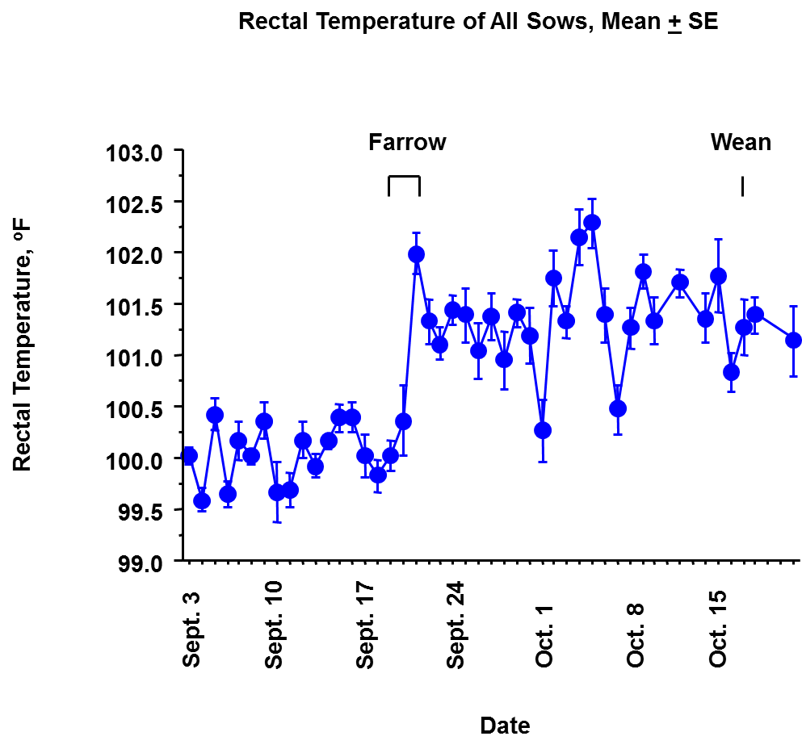
Figure 1. Mean (with Standard Error) of All Eight Sows’ Rectal Temperatures by Date

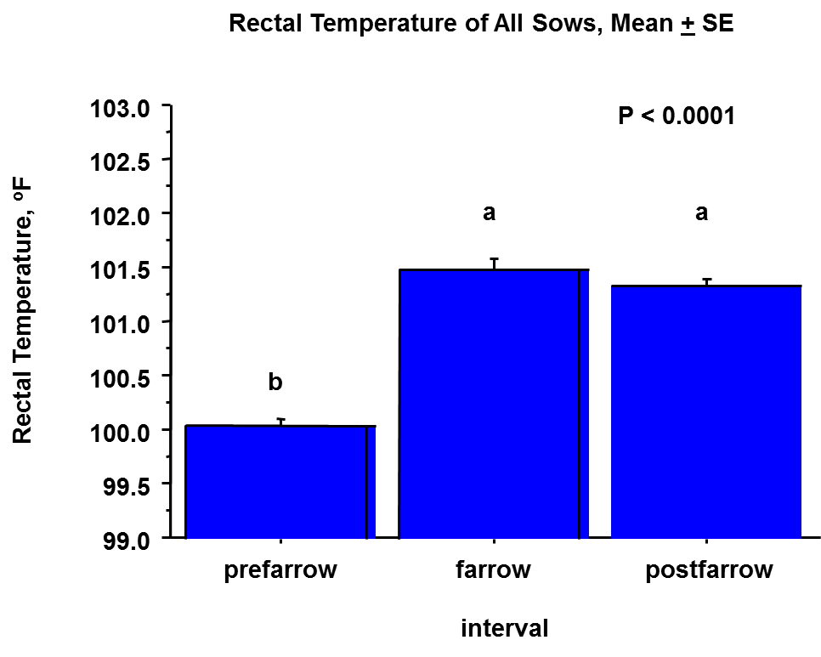

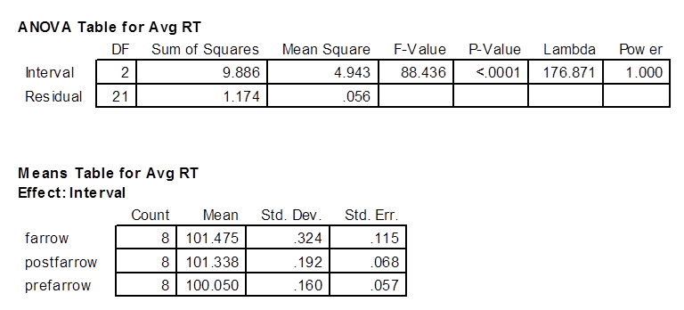

Figure 2. Mean (with Standard Error) of All Eight Sows’ Rectal Temperatures by Interval

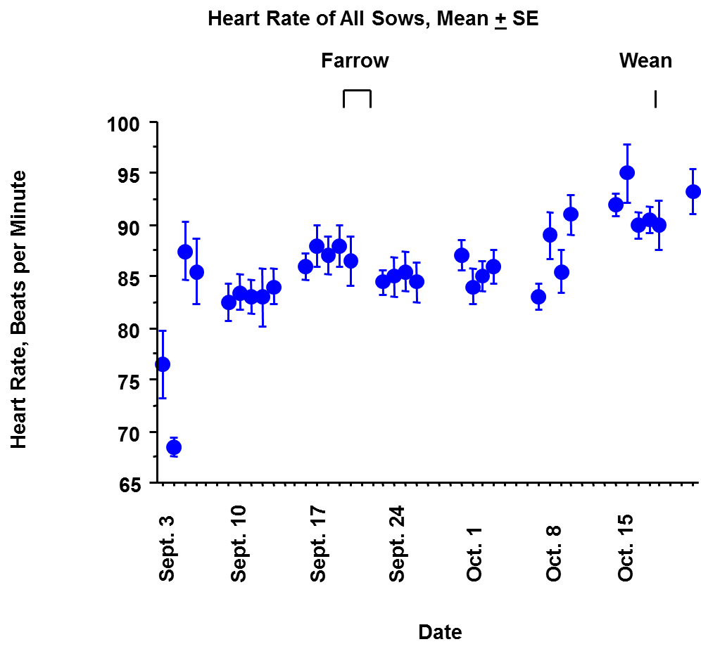
Heart Rate
P > 0.05
no difference in HR between intervals

Figure 3. Mean (with Standard Error) of All Eight Sows’ Heart Rates by Date and Interval

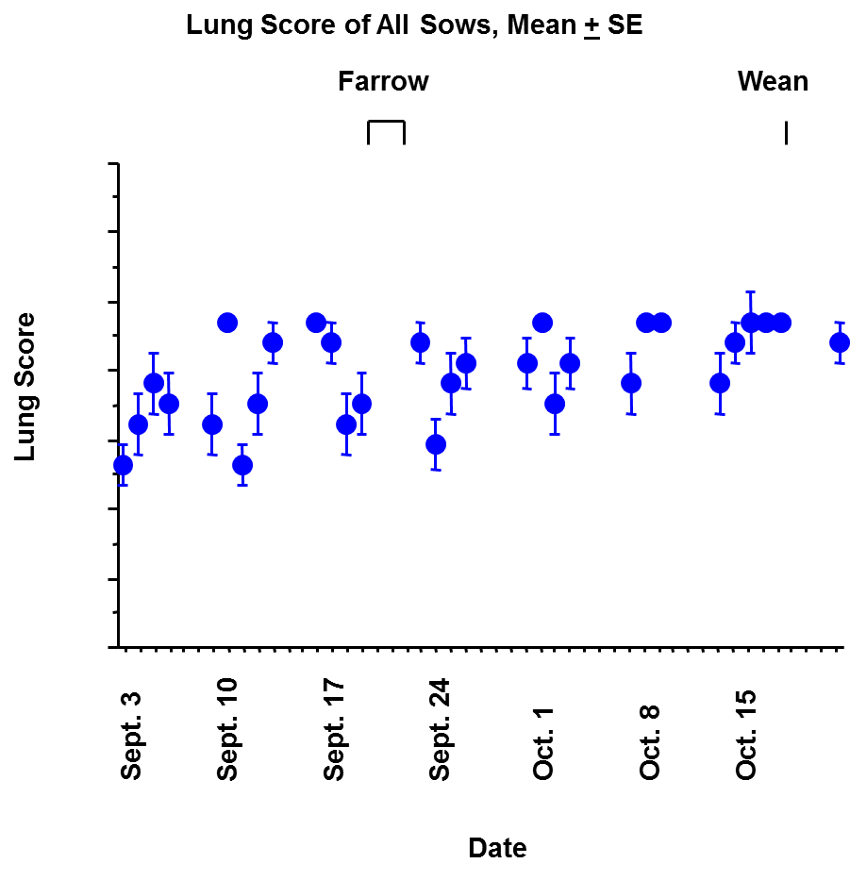

Figure 4. Mean (with Standard Error) of All Eight Sows’ Lung Scores by Date
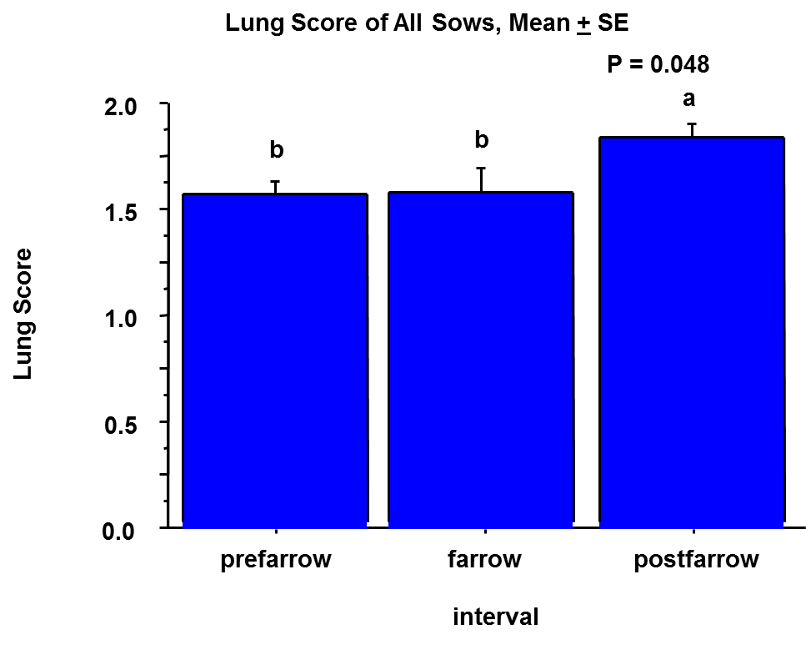

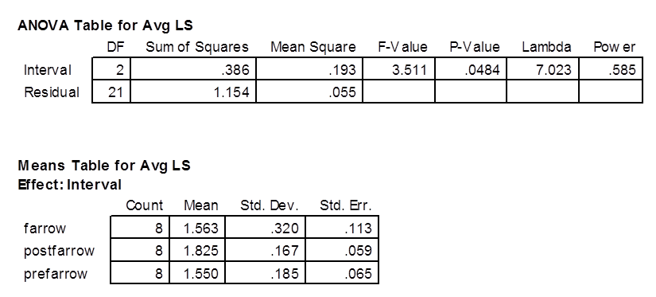

Figure 5. Mean (with Standard Error) of All Eight Sows’ Lung Scores by Interval

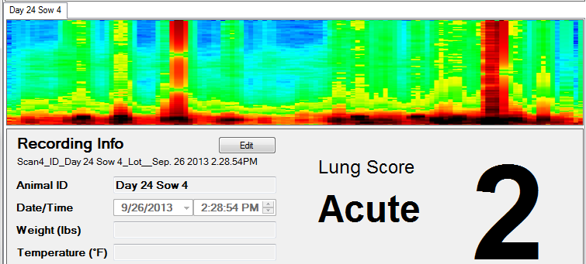
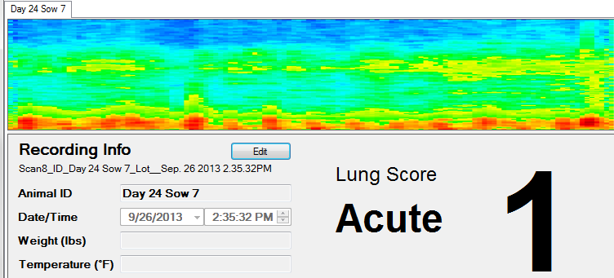

Figure 6. Example Average Lung Score Readings During Entirety of Study

Sow # | Date of Farrowing | # Piglets Born Alive | # Piglets Born Dead | # Piglets Born as Mummies
1 | 9/21 | 13 | 0 | 0
2 | 9/21 | 12 | 0 | 0
3 | 9/19 | 11 | 0 | 1
4 | 9/19 | 11 | 0 | 2
5 | 9/21 | 10 | 0 | 0
6 | 9/20 | 14 | 0 | 0
7 | 9/21 | 15 | 0 | 1
8 | 9/19 | 10 | 1 | 1

Figure 7. Farrowing Information for All Eight Sows

Appendix 1: Examples of Average Lung Scores using the “Whisper” Electronic Veterinary Stethoscope
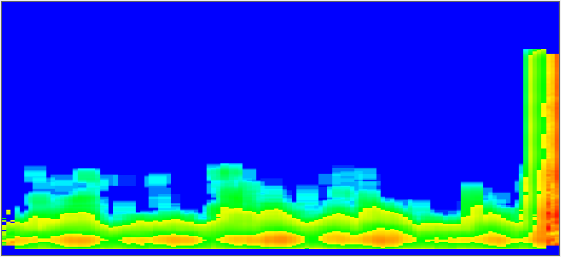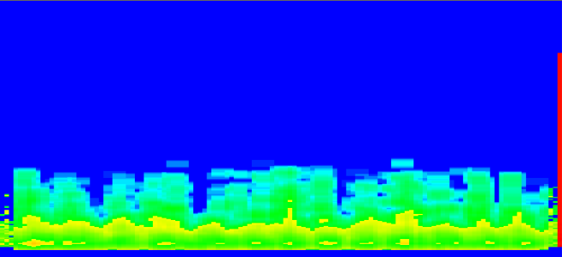

Lung Score = 1
(Normal)

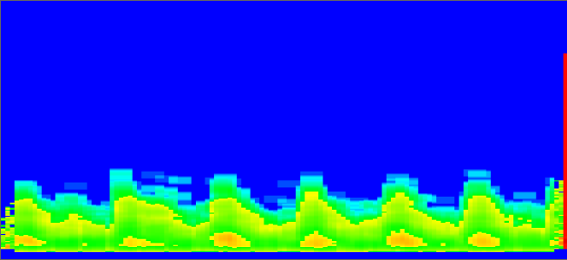

Lung Score = 2
(Mild Acute)

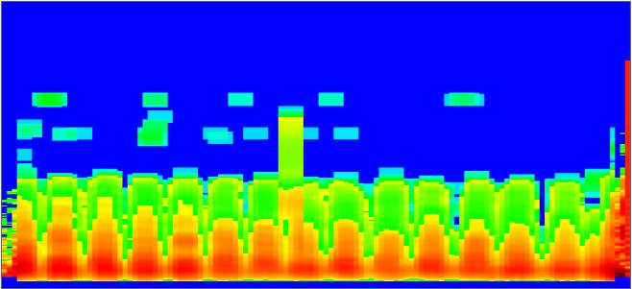

Lung Score = 3
(Moderate Acute)

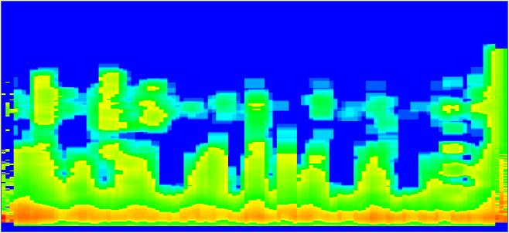

Lung Score = 4
(Severe Acute)

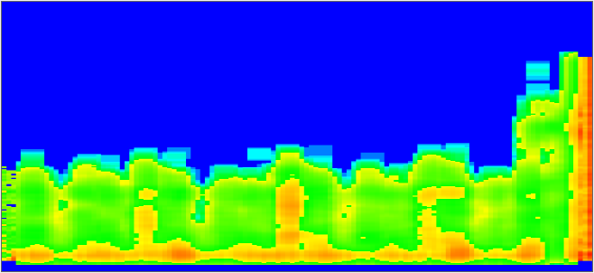

Lung Score = 5
(Chronic)
References

Brattain, Kurt. “Histopathology Whisper® Proof-Of-Concept Study.” Geissler Corporation. 2013. Web. 26 Aug 2013. <http://geisslercorp.com/~geissler/whisper%20papers/ Whisper%20White%20Paper%20Report%20V2.pdf>

Connor, Joseph F. “Practitioner's View of How Veterinarians and the Industry Can Better Manage Emerging Diseases.” 21st Annual Swine Disease Conference for Swine Practitioners. (2013): 36-41. Print.

Harms, PA, Halbur, PG, and SD Sorden. “Three cases of porcine respiratory disease complex associated with porcine circovirus type 2 infection.” J Swine Health Prod. 2002;10(1): 27-30. Web. 3 Dec 2013. <https://aasv.org/shap/issues/v10n1/ v10n1p27.html>

Sewell, Henry. “On the Auscultatory Determination of Early Pathological Changes in the Lungs. 14-25. Web. 19 Nov 2013. <http://www.ncbi.nlm.nih.gov/pmc/articles/ PMC2307412/pdf/tacca200011-0048.pdf>

Soza, Erick. “Important Issues In Our Farrowing Department.” Proceedings of the North Carolina Healthy Hogs Seminar. (2003). Web. 26 Sep 2013. <http://www.ncsu.edu/ project/swine_extension/healthyhogs/book2003/soza.htm>

Williams, AM, Safranski, TJ, Spiers, DE, Eichen, PA, Coate, EA, and MC Lucy. “Effects of a controlled heat stress during late gestation, lactation, and after weaning on thermoregulation, metabolism, and reproduction of primiparious sows.” Journal of Animal Science. (Jun 2013):2700-2714. Web. 8 Dec 2013. <http://www.ncbi.nlm. nih.gov/pubmed/23508026>

