The crowding effects of RmlC on R67 and chromosomal dihydrofolate reductase enzymes
Michael Craig, Dr. Mike Duff, Dr. Elizabeth Howell
BCMB 452, The University of Tennessee Knoxville
April 28, 2017

Background:
The interior of a cell is an incredibly complicated environment; approximately 30% of the bacterial cell volume consists of macromolecules (1). That said, within the lab setting, in vitro enzymatic studies have typically used only the enzyme of interest and its substrate, without much regard for the inherent complexity within the cytoplasm (2). It is possible that weak interactions of these random molecules within the cell have an effect on the rate at which an enzyme performs its reaction (3). The Howell lab is attempting to classify these weak interactions of macromolecules called “crowders” in order to better discern what’s really happening in the in vivo cellular environment. A crowder can be any large molecule within the cell that alters the kinetics or thermodynamics of an enzymatic reaction. Consider a few people trying to leave a room at the same time. Now consider ten times as many people trying to leave the same room; furthermore, imagine a third scenario in which everyone trying to leave the room is wearing Velcro. The interactions would completely change in each scenario. In the crowded environment of the cell, these “Velcro effects,” or weak, non-specific interactions between ligand and/or enzyme and the crowders can alter binding of the ligand to its target enzyme (4). This hypothesis is depicted in Figure 1 (5), and shows the potential interaction of osmolytes (molecules found within the cell, but that are smaller than crowders) with the enzyme and ligand, decreasing the binding affinity (5).
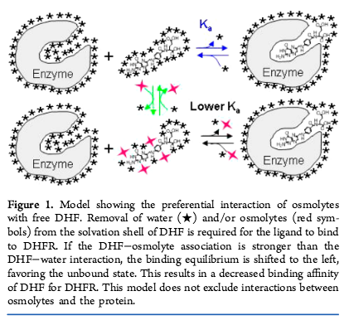
Past experiments have shown that increasing osmolyte concentration weakens the binding affinity of DHF to the NADP⁺/EcDHFR complex, but increases the binding affinity of NADP⁺ to the apo EcDHFR. The osmolytes most likely do not interact with NADP⁺, they just remove solvation waters from the surface of the ligand (and protein), and therefore require energy to remove prior to ligand binding, strengthening the binding affinity of NADP⁺ to DHFR (4). On the other hand, osmolytes do interact with DHF, weakening binding affinity. The osmolytes studied such as DMSO, glycerol, sucrose and ethylene glycol, have similar functional groups as macromolecular protein crowders, such as hydrophilic hydroxyl or carboxyl groups, as well as hydrophobic aliphatic chains. This leads us to believe that protein crowders will also have effects on binding affinity in vivo.
When a ligand preferentially interacts with an osmolyte, as seen in Figure 1, ligand will associate more strongly with the osmolyte, excluding water from the surface of the molecule. Then, the osmolyte must be removed from the surface of the ligand, requiring energy that would otherwise go towards the bound-enzyme complex, reducing the binding affinity. DHF preferentially interacts with the osmolytes (4). To preferentially exclude an osmolyte is the exact opposite situation. The surface of NADP⁺ excludes the osmolytes used in past experiments, preferring to interact with water instead. However, because the molarity of water in the cell solution is lower due to increased osmolyte concentration, fewer H₂O molecules are available to hydrate the ligand. Because the H₂O must be removed as the binding complex forms as compared to the original buffer, binding affinity of NADP⁺ to DHFR increases.
Due to its importance and prevalence in the cell, dihydrofolate reductase (DHFR) was used as the model enzyme for the crowding hypothesis. DHFR is an enzyme found in all living organisms that is essential in the pathway of synthesizing DNA, known as the blueprint of life. Specifically, it converts dihydrofolate to tetrahydrofolate using NADPH as a cofactor, which is an essential cofactor in the 1-carbon cycle of de novo purine biosynthesis. Without sufficient DHFR activity, the cell is incapable of replicating its DNA, and thus is unable to divide and replicate. For this reason, methotrexate, a competitive inhibitor of DHFR, is commonly used as an anticancer drug (while all human cells are affected by the drug, the fastest growing cells in the body suffer the most dramatic effects). In addition, trimethoprim, another DHFR inhibitor, has been used as an antibiotic due to the fact that it binds to the DHFR enzymes found within bacteria much more tightly than those found within humans. However, since the discovery of trimethoprim, bacteria quickly developed resistance by producing a novel enzyme that is no longer inhibited by trimethoprim (6). This novel enzyme, called “R67 DHFR”, is a plasmid-encoded tetramer (while the chromosomal version is a monomer) with a completely different structure and sequence compared to its chromosomal version (Figure 2) (7).
Figure 2. A. The structure of EcDHFR, a monomer, in which the beta-pleated sheets are represented in yellow, alpha-helices in red, the NADP⁺ molecule in green, and the DHF molecule in purple. (PDB ID 1RX2) (11). B. The structure of RmlC, with each of the 2 subunits depicted in a different color (PDB ID 1EP0) (12). C. Structure of R67 DHFR, with each of the 4 subunits depicted in a different color, the NADP⁺ molecule in green, and the DHF molecule in purple. Both ligands are in the center of the tetramer (PDB ID 2RK1) (8). D. Structure of folate. E. Structure of NADP⁺.
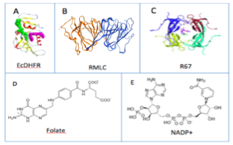

With a solid understanding of the difference between crowding effects on E. coli chromosomal DHFR (EcDHFR) and R67 DHFR, we can potentially determine whether the effects are due to weak interactions between the substrate and the crowder or the enzyme and the crowder. For the thesis, RmlC was used as a crowder in varying concentrations and the binding affinities of ligands to DHFR were determined by isothermal titration calorimetry (ITC). The reaction catalyzed by the enzyme RmlC, or dTDP-4-dehydrorhamnose 3,5-epimerase, does not pertain to the reaction catalyzed by DHFR; rather, it simply acts as a crowder to replicate in vivo conditions during ITC, taking up space and potentially altering the binding affinity of DHF or NADP⁺ to DHFR, similar to the hypothetical Velcro situation. RmlC was selected because it was easily expressed, highly soluble, and had a known crystal structure (8); also, preliminary activity assays suggested that RmlC had little crowding effect on the catalytic activity of both the chromosomal and R67 DHFRs, but more research was needed (9). In the cell, the high concentration of diverse macromolecules could bind to the ligands and/or enzymes in this reaction, decreasing the binding affinity between DHFR and the ligand. The understanding of crowding effects on enzyme thermodynamics will hopefully generate a better understanding of what is actually occurring during enzymatic reactions within the cell.
Past data of other crowders depict similar results; in general, as crowder concentration increases, binding affinities of DHF to EcDHFR (Figure 3) and R67 DHFRs (Figure 4) decrease. NADP⁺ binding also decreases as crowder concentrations increase. However, if one pays special attention to the NADP⁺ to the apo-EcDHFR, one notices that only the protein crowders casein, lysozyme, and ovalbumin decrease binding affinity (9). The polymer crowders did not show much effect. In past experiments in the Howell lab, RmlC was used as a crowder in kinetic experiments studying the crowding effects on EcDHFR; the results were unexpected, as RmlC did not have an effect on the binding affinity of NADP⁺ to EcDHFR. This new finding provided an opportunity for further research to understand how the crowders are working. Does folate bind weakly to lysozyme or ovalbumin and not to RmlC? Or are the surfaces of these 3 proteins sufficiently different that RmlC has a smaller effect on DHFR kinetics?

Figure 3. The effects of various protein crowders on the affinities of ligands binding to EcDHFR, as determined by ITC. Panel A. Binary complex with NADP⁺ titrated into apo EcDHFR. As casein and lysozyme osmolalities increase, the binding affinity (plotted as ln(K_{a})) decreases; however, for the other proteins and crowders (dextran, ovalbumin, polyethylene glycol (PEG), and polyvinylpyrrolidone (PVP)) tested, little effect on binding affinity was seen. Panel B. Ternary complex with DHF titrated into EcDHFR/ NADP⁺ complex. For all proteins and crowders tested using the ternary model in which DHF was titrated into the NADP⁺/EcDHFR complex, binding affinity was weakened.
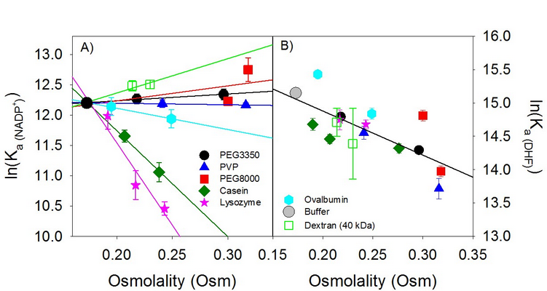

Figure 4. The effects of various protein crowders on the binding affinities of R67 DHFR, as determined by ITC. Panel A. When NADP⁺ was titrated into R67 DHFR, decreased binding affinity was seen when the osmolality of the crowder protein increased (with the exception of PEG3350). Panel B. Ternary complex with DHF titrated into R67/NADP⁺ complex. For the ternary model, increasing the osmolality of each crowder decreased binding affinity. 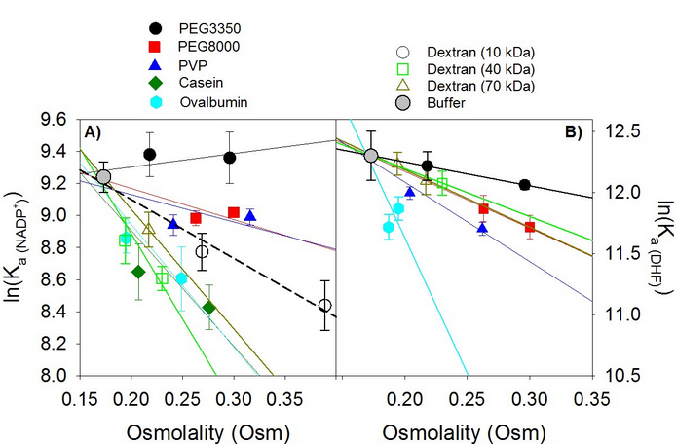

Methods:
Protein preparations:
RmlC: The gene for RmlC from Methanobacterium thermoautotrophicum in a pet15b vector was a kind gift of D. Christendat (Ontario Cancer Institute, Toronto, ON) (8). RmlC was purified according to the literature protocols as follows (8,9). Three starter cultures in YT media were prepared using BL21 (Codon plus) E. coli cell stock containing a plasmid with the wt RmlC gene and 200 µg/mL ampicillin. The starter cultures were allowed to incubate at 37˚C approximately 24 hours before 5 mL of each starter culture were added to 1 L of “Terrific Broth” (TB) media (12 g/L bacto tryptone, 24 g/L bacto yeast extract, 4 mL/L glycerol, 2.3 g/L KH₂PO₄, 12.54 g/L KH₂PO₄, 2 g/L NaCl). The TB media flasks were then incubated until an absorbance of 0.6 A at 600 nm was reached; 1 mL of 1 M isopropyl β-D-1-thiogalactopyranoside (IPTG) was added to each flask. The cultures continued to incubate for approximately 44 hours at 37˚C. The cell cultures were centrifuged, supernatant was poured off, and cells were resuspended in approximately 100 mL of buffer (50 mM TrisHCl, 500 mM NaCl, 30 mM imidazole, 5% glycerol (v/v) pH 7.5). The cells were sonicated, centrifuged, and run on a nickel NTA column washing with the same buffer until the eluent reached an absorbance of 0.1 A or below at 280 nm. This typically required approximately 300 mL of buffer. The protein was eluted from the nickel NTA column using a gradient from 30 mM to 500 mM imidazole. A fraction collector was used to isolate the protein from the rest of the imidazole gradient. Each fraction contained 6 mL, and the absorbance of each fraction was measured at 280 nm to determine which fractions contained RmlC. An SDS-PAGE gel was also run using fractions with an absorbance above 0.4 to ensure the expression of RmlC and determine the purity of the prep. Eluted protein was then dialyzed in 7000 daltons MW cut off tubing in 4L of deionized water at pH 8, exchanged every 4 hours, 4 times. The absorbance of the protein was measured at 280 nm, and multiplied by the volume to determine the total absorbance associated with the protein preparation. The bicinchoninic acid assay (Pierce) was performed according to the manufacturer’s protocol to measure the protein concentration in mg/mL. Comparing this to the A280 value provided an extinction coefficient for RmlC of approximately 1.4 mL/mg. Protein was lyophilized for later ITC experiments.
E. coli chromosomal DHFR: Frozen cells were inoculated in 10 mL YT media with 200 µg of ampicillin per mL and 20 µg of trimethoprim per mL. The frozen cells were E. coli carrying an EcDHFR clone (with a mutant up promoter) in a high copy plasmid. To add a histag, a pJET vector was used. The cells in YT media were grown overnight. To inoculate each of 6 liters of TB media, 200 µL of overnight culture, and 200 µg of ampicillin per mL were grown for 25 hours at 37˚C with 250 rpm. Cells were centrifuged and frozen at -80˚C. The cell pellet was resuspended in 100 mL of buffer (50 mM KH₂PO₄, 10 mM Imidazole, 0.3 M NaCl, 5 mM BME, pH 8). The cells were lysed via sonication. The lysed cells were centrifuged and supernatant was retained. The pellet was resuspended, resonicated, and respun. The supernatant was loaded on Ni-NTA column, and rinsed with the previously mentioned buffer until the absorbance at 280 nm was less than 0.1. A 10-250 mM imidazole gradient was used to elute the column using a 50 mM KH₂PO₄, 0.3 M NaCl, 5 mM BME, pH 8 buffer. The eluent was dialyzed in 4 L deionized water with 10 mM Tris, 1 mM EDTA, 1 mM BME, pH 8, three times to lower salt concentration. A DEAE-fractogel column was equilibrated in 10 mM Tris, 1 mM EDTA, 1 mM BME, pH 8 to remove exogenous bound ligands. The column was washed and eluted with a 0-0.4 M NaCl gradient (200 mL in each side). The purity was checked via SDS-PAGE. NaCl was dialyzed out using distilled H₂O with 1 mM BME added. Protein was lyophilized for storage.
R67 DHFR: 6 L (200 mg/L ampicillin, 20 mg/L trimethoprim) of TB media was inoculated at 37˚C with 1 mL of an overnight culture of DH5α cells containing the R67 DHFR in the pJet3.1 vector (a natural up-promoter). The cultures were incubated and shaken at 200 rpm for 48 hours. Cells were harvested by centrifugation of 5000 rpm for 10 minutes at 4˚C. The supernatant was poured off and the cell pellet was kept. The cell pellets were stored at -80˚C until purification. The cells were suspended in 50 mM NaH₂PO₄, 1 mM EDTA, pH 8 buffer in a 1 L plastic beaker. The cells were lysed by adjusting the pH of the suspension to pH 12 via drop wise addition of 1 M NaOH. The suspension was centrifuged at 5000 rpm for 10 minutes at 4˚C to remove debris. The supernatant was poured into a fresh 1 L plastic beaker, and adjusted to pH 2 via drop wise addition of 1 M HCl. The suspension was centrifuged at 5000 rpm for 10 minutes at 4˚C. The supernatant was poured into a fresh 1 L plastic beaker, and the pH was adjusted to 7, and recentrifuged. The supernatant volume was measured, and ammonium sulfate was added to a final concentration of 319 g/L, added slowly while stirring in the cold room for an additional 30 minutes, and then centrifuged for 10 minutes at 10000 rpm. The ammonium sulfate pellet was resuspended in 50 mM NaH₂PO₄, 1 mM EDTA, pH 8 buffer and dialyzed against 4 L of 50 mM NaH₂PO₄, 1 mM EDTA, pH 8 buffer in the cold room, using a 7000 MWCO membrane in 3 cycles of at least 4 hours. The dialyzed protein solution was loaded onto a DEAE-fractogel column and the protein was eluted. The fractions containing R67 DHFR were pooled and dialyzed against 4 L of 10mM TrisHCl, 1 mM EDTA, pH 8.0 in the cold room three times (once over night, and twice for 4 hours). The dialyzed protein solution was loaded onto a DEAE Sephacel column, and was eluted via a 0-0.4 NaCl gradient. The fractions containing R67 DHFR were dialyzed against 4 L of deionized water in the cold room, and repeated 3 times. Protein was then lyophilized.

Isothermal Titration Calorimetry:
ITC was used to measure the binding affinity (K_{a}) of DHF or NADP⁺ to chromosomal DHFR. The ternary and binary models of binding were used; NADP⁺ and DHF were present in the ternary complex, but only NADP⁺ was used for the binary model (the typical cofactor is NADPH, but the reaction would proceed completely, producing a heat signal interfering with the binding measurement if NADPH were used when studying DHF binding). The enthalpy (∆H) signal for each injection was measured by the MicroCal VP-ITC. Equation 1 was used to calculate the Gibbs free energy (∆G) and entropy (∆S) of the reaction.
(eq. 1) ∆G = -RTlnK_{a} = ∆H-T∆S
For each ITC experiment, the buffer was 100 mM Tris, 50 mM MES, 50 mM acetic acid, 5 mM BME, and 1 mM EDTA pH 7. The total sample cell volume was 2.2 mL and included the DHFR protein when NADP⁺ was used as the ligand, and the DHFR/ NADP⁺ complex when DHF was used as the ligand. The concentrations of protein and ligand varied depending on the binding model (Table 1). The syringe solution of either DHF or NADP⁺ was injected 75 times in 3 µL increments. Other parameters were a temperature of 25˚C and a stirring speed of 199 rpm, with a reference power of 10 µcal/second. Both cell and syringe solutions were adjusted to pH 7. As ligand was added, the heat changes were monitored and recorded, providing the ∆H values. Raw ITC data were entered into the NitPic program to integrate the heat signals versus time and obtain the area under the peaks of the raw ITC data (10). The resulting data were analyzed by SEDPHAT to obtain the K_{d} and ∆H values. Several datasets were globally fit, which is a combined plot of two or more ITC experiments held to a single set of binding parameters. The global fit provides better errors as well as a more precise and accurate measurement of the K_{d} and ∆H (11). Excel was used to calculate ∆G, ∆S, K_{a} and ln (K_{a}) values.
To test the crowding effects in vitro, either 10 or 25 mg/mL of RmlC were added (weighed as a powder on a scale) to the cell solution containing DHFR.

Table 1. The concentrations of each ligand and protein for each complex and DHFR protein.
Protein | Complex | [DHFR] (µM) | [NADP⁺] (µM) | [DHF] (µM)
EcDHFR | Binary | 10-12 (cell) | 700-850 (syringe) | N/A
EcDHFR | Ternary | 10-12 (cell) | 600 (cell) | 250-350 (syringe)
R67 DHFR | Binary | 150 (cell) |  | N/A
R67 DHFR | Ternary | 150 (cell)
Vapor Pressure Osmometry:
The lyophilized RmlC powder was weighed on a scale and dissolved in buffer to reach the desired concentration in mg/mL. A Wescor vapor pressure osmometer was used to measure the osmolality of the solution.

Results:
A typical protein purification of RmlC yielded ~40 mg per liter of culture. SDS-PAGE gels were run to ensure that RmlC was produced and isolated by the Nickel NTA column (example found in Figure 5). Clearly a strong band appears in each fraction as opposed to the sonicated E. coli lysate, indicating the RmlC protein was isolated by the Nickel NTA column.

Figure 5: A sample gel showing that the RmlC was effectively isolated via the Nickel NTA column elution, and also confirmed which fractions included RmlC.
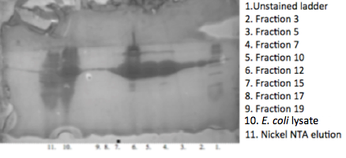

Also, BCA assays were performed to determine the extinction coefficient of each protein preparation (Fig S1). For the RmlC preps, the results of the BCA assay gave the extinction coefficient, a variable for an individual protein. The BCA assay helped guarantee the purity of the protein prep. For example, RmlC has a coefficient around 1.4 mL/mg; if the extinction coefficient as determined by the BCA assay varied greatly from this value, something undesirable occurred during the prep, and the enzyme would be unusable for ITC experiments.
As previously mentioned, in an ITC experiment to test the binding affinity of the binary complex, ligand (NADP⁺) was titrated into the cell containing the apo protein. When NADP⁺ was titrated into EcDHFR, an exothermic reaction occurred, as evidenced by the negative peaks; saturation of the EcDHFR enzyme was reached quickly as more NADP⁺ was continually titrated into the cell with each injection (Figure 6).

Figure 6. ITC of 376.8 µM NADP⁺ titrated into 16.55 µM EcDHFR with 0 mg/mL of RmlC at 25˚C in MTA buffer, 1 mM EDTA, 5 mM BME pH 7 showed the reaction was exothermic and reached saturation (the point at which all EcDHFR enzymes had bound to NADP⁺) around 250 minutes.
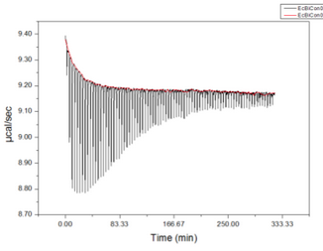

The raw ITC data were exported into SEDPHAT to produce the following graph (Figure 7), giving a measurement of the K_{d} and ∆H.

Figure 7. The raw ITC data from Figure 6 were analyzed in SEDPHAT. The K_{d} of this titration was 4.62 µM and ∆H was -13.39 kcal/mol. The stoichiometry was the expected 1:1 ratio, as represented by the incompetent B fraction of 0.001. 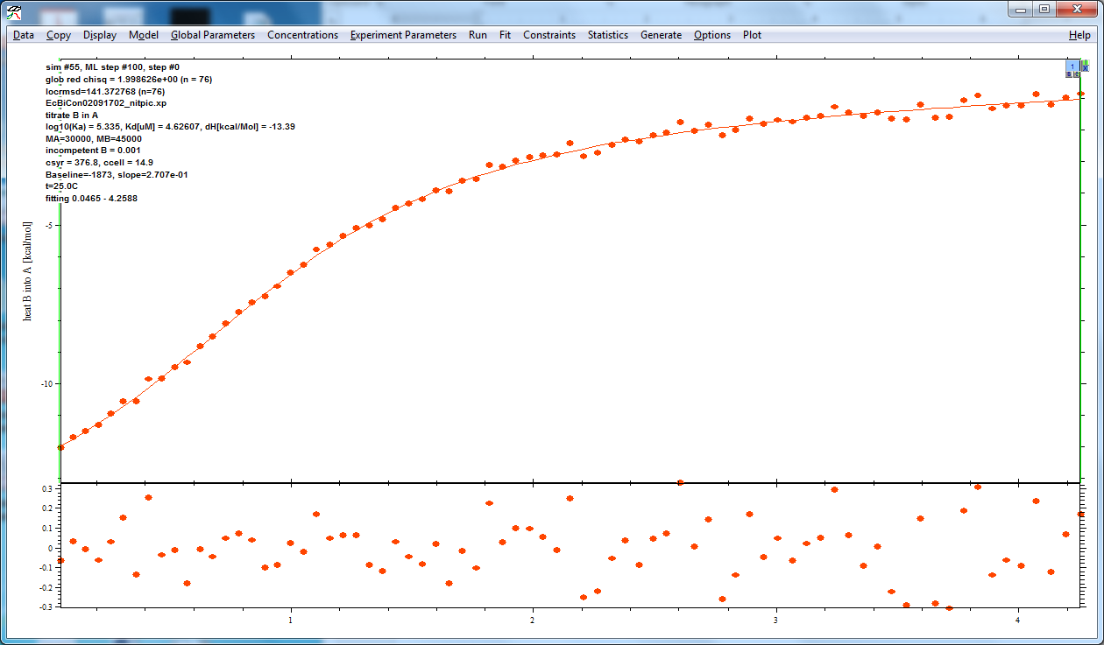

Each specific ITC experiment was performed at least twice in order to create a global fit (Figure 8). The global fit was used to provide better errors.
Figure 8. The SEDPHAT fit from Figure 7 was fit globally with a second titration using the experiment parameters established in Figure 6.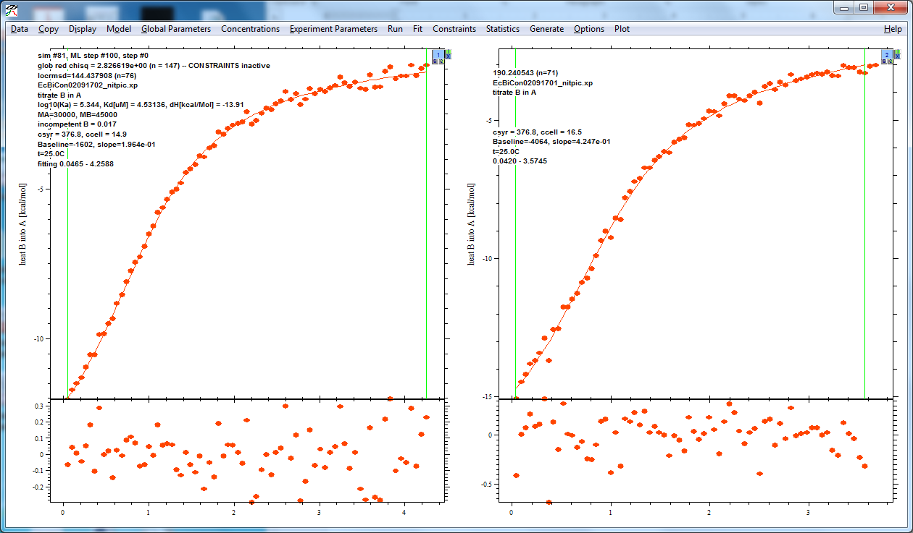
The fit parameters for the binary control experiment can be found below in table 2. The produced data vary somewhat from previous experiments, in which the K_{d} of the control data point was 3.09 µM ± 0.1, and the ∆H was -20.7 ± 0.3 (4). However, as long as all data points are collected from the same protein prep, they will be internally consistent.
Table 2. Data produced when NADP⁺ was titrated into E. coli DHFR in MTA, 1 mM EDTA, 5 mM BME pH 7 buffer at 25˚C.
Concentration of RmlC used | Osm | K_{d} (µM) | ∆H (kcal/mol)
0 mg/mL | 175 | 4.53±1.0 | -13.9±1.9
10 mg/mL | 182 | 4.69±1.7 | -14.2±3.3
25 mg/mL | 185 | 4.00±1.6 | -7.17±1.5

The same process was used to determine the binding affinity of the ternary complex when DHF was titrated into the cell containing the binary DHFR/NADP⁺ complex solution (Table 3). These data vary from previous experiments, in which the K_{d} of the control data point was 0.177 µM ± 0.013, with a ∆H of -8.5 kcal/mol ± 0.08. My results produced ~ 2 fold weaker binding than the literature, despite 5 titrations over several days. This protein prep is behaving slightly different, most likely due to additional purification steps.

Table 3. Data produced when DHF was titrated into the E. coli DHFR/NADP⁺ complex in MTA, 1 mM EDTA, 5 mM BME pH 7 buffer at 25˚C.
Concentration of RmlC used | Osm | K_{d} | ∆H
0 mg/mL | 175 | 0.493±0.106 | -12.7±0.4
10 mg/mL | 182 | 0.323±0.072 | -12.1±0.4
25 mg/mL | 185 | 0.591±0.117 | -17.9±0.3

With adequate reproduction of the thermodynamics of ligand binding to EcDHFR in the absence of RmlC, we turned to studying the effects of RmlC on ligand binding to EcDHFR. To test potential in vivo conditions, 10 mg/mL and 25 mg/mL concentrations of RmlC were added to the cell solution. The ln(K_{a}) and K_{d} of the titrations with high concentrations of RmlC are within the error measurements as produced by SEDPHAT. It does not appear that an increasing concentration of RmlC has much effect on the binding of NADP⁺ to EcDHFR (Figure 9) (Table 2). This replicates our lab’s preliminary results and provides a different result than seen in Figure 4.
Figure 9. No change in binding affinity was observed as RmlC concentration increased when NADP⁺ was titrated into EcDHFR

The same procedure was repeated using the same concentrations of RmlC to test the binding affinity of the ternary complex when DHF was titrated into the EcDHFR/NADP⁺ complex. Based upon the slope of the graph, no change in binding affinity was observed as the RmlC concentration increased from 0 mg/mL to 10 mg/mL to 25 mg/mL. However, this will be discussed further in the discussion section because K_{d} decreased when 10 mg/mL of RmlC were added, but then increased to have a higher value than the control when 25 mg/mL of RmlC were added (Table 3).

Figure 10. No change in binding affinity was observed in the slope as RmlC concentration increased when DHF was titrated into the EcDHFR/NADP⁺ complex.

Discussion:
According to my results, an increasing concentration of RmlC did not have an effect on the binding affinity of the binary or ternary complex. The results of increased RmlC concentration on binding affinity from figures (9 and 10) were compiled with the past crowding experiments of EcDHFR as depicted in Figure 3 (Figure 11). However, several factors must be discussed and analyzed before taking Figure 11 at face value.
Figure 11. A combination of past crowding experiments using various proteins as listed in the key. RmlC is represented by the white diamond. 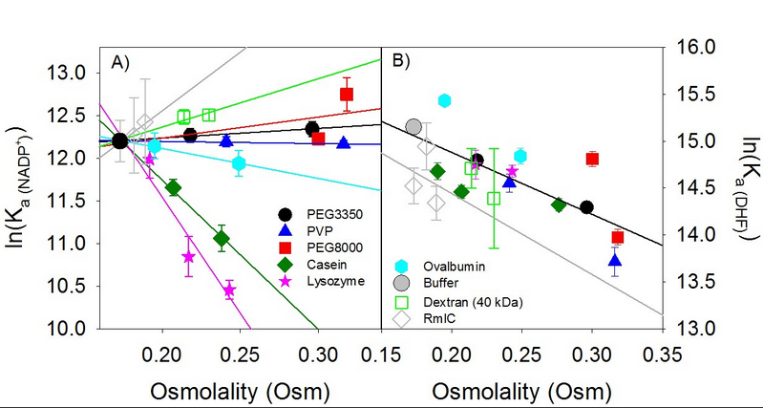

For the binary complex, the effects of RmlC appear more positive than the other crowder proteins, suggesting that it does not have as large an effect on the binding of NADP⁺ to EcDHFR. However, one should note the comparatively large errors of RmlC to the errors of the other crowder concentrations. The data should be reproduced to obtain smaller error bars before the effects of RmlC on NADP⁺ binding to EcDHFR are compared officially.
For the ternary complex, the errors are similar to the errors of the other crowders. However, the binding affinity as represented by K_{d} for the 0 mg/mL data point is substantially higher than expected based on historical data; in past studies, the K_{d} should be 0.177 µM, but instead was 0.493 µM (4) (9). If this single data point were measured at the expected value as defined in the literature, the R² value would change from 0.005 (Figure 10) to 0.94, and would be linear, as well as producing the same K_{d} values (Table 3) as other crowder proteins, as represented in mg/mL. A variety of factors could have caused this discrepancy between expected and actual data. There are natural variations in activity between protein preps. It’s also possible that the concentration measurements for the ligands or DHFR were incorrect. There was insufficient time to perform more experiments that could elucidate the cause of the problem.
A third problem involves the osmolality values of the X-axis (Table 2, 3). To determine osmolality of the cell solution, the VPO was used. The osmolality value allows the effect of one crowder protein on binding affinity to be more readily compared to other crowders and osmolytes, as mentioned in the introduction. Historically, the osmometer has worked well in helping to compare the effects of small osmolytes such as glycerol and ethylene glycol. However, larger molecules like the RmlC protein contaminate the thermocouple of the osmometer after a few uses so that accurate data cannot be produced within a single sitting; instead, the a couple of measurements can be taken, but then the thermocouple must be cleaned before the next use. The osmolality measurements required more time than expected. The data produced for RmlC by the osmometer suggest that the osmoles for 0, 10, and 25 mg/mL of RmlC are 175, 182, and 185 osmoles, respectively. These data points are substantially smaller and closer to each other than expected, due to the contamination of the thermocouple (9). Based on past data for other protein crowders using the same mass of protein, the osmolality of each concentration of RmlC should be closer to 185, 205, and 270 osmoles, respectively (Figure 11) (9).
If we were to use these osmolality values and the probable error in the control point of E. coli DHFR, the slope of RmlC’s effect on binding affinity of the ternary complex fits identically with past crowder data. The slope of the binary complex would be most similar to the slope of dextran (Figure 11a), even with the large error values. To summarize the discussion of EcDHFR, before publication in a manuscript, 3 variables must be more carefully assessed to produce the most precise result: the control data point of EcDHFR ternary binding must be redone; the error values for the binary complex must be reduced; and the osmolality values should be retested in a manner to avoid contamination of the thermocouple.
Although R67 has been discussed at length in introduction and methods sections of this thesis, several problematic factors arose during the 2 years of research. The most obvious was time constraint; much time was spent learning the basic techniques of biochemical research, performing three different protein preparations, and perfecting the art of isothermal titration calorimetry, allowing insufficient time to perform ITC experiments using R67. A couple of months before the due date of the thesis, it was decided that there was not enough time to produce conclusive data for both EcDHFR and R67 DHFR; most of the reproducible data at that point belonged to EcDHFR experiments. Secondly, various problems arose that prevented acceptable protein preparations of R67 DHFR; ammonium sulfate that was used during the prep for several months was contaminated, producing pink protein (as opposed to the expected white color). ITC experiments could not be run using the contaminated protein because the data would not be reproducible, nor representative of the actual R67 binding thermodynamics.

Conclusion and future directions:
Despite the number of problems with the results, the effects of RmlC on the binding affinity of EcDHFR and its ligands seem to represent the past trends of other proteins (after correcting the errors mentioned in the discussion). Many steps need to be taken before this research is publication ready. Once these errors are fixed, the data on the effects of RmlC on binding affinities of both the binary and ternary models of EcDHFR can be compared to other crowding proteins or osmolytes. Perhaps trends can be discovered and crowding effects can be characterized among protein crowders by size, charge, or structure. An initial part of the thesis was to compare the crowding effects on R67, but time ran out; with this information, the differences between the two enzymes will be more apparent; R67 and its evolution, function, and mechanism could be better understood by comparing how its thermodynamic characteristics vary from its functional counterpart in vivo. Perhaps clinical applications can be derived from a better understanding of true intracellular conditions. With a better understanding of crowding effects, future experiments on kinetics and thermodynamics can be better designed to mimic the in vivo environment of a living cell in the lab.

Sources:
- Pielak, Gary J., and Andrew C. Miklos. "Crowding And Function Reunite". Proceedings of the National Academy of Sciences 107.41 (2010): 17457-17458. Web.
- Zhou, Huan-Xiang, Germán Rivas, and Allen P. Minton. "Macromolecular Crowding And Confinement: Biochemical, Biophysical, And Potential Physiological Consequences". Annual Review of Biophysics 37.1 (2008): 375-397. Web.
- Aumiller, William M. et al. "Interactions Of Macromolecular Crowding Agents And Cosolutes With Small-Molecule Substrates: Effect On Horseradish Peroxidase Activity With Two Different Substrates". The Journal of Physical Chemistry B 118.36 (2014): 10624-10632.
- Grubbs, Jordan et al. "Thermodynamics And Solvent Effects On Substrate And Cofactor Binding Inescherichia Colichromosomal Dihydrofolate Reductase". Biochemistry 50.18 (2011): 3673-3685.
- Duff, Jr., M.R., Grubbs, J., Serpersu, E.H., and Howell, E.E. (2012) “Weak Interactions between Folate and Osmolytes in Solution,” Biochemistry 51, 2309−2318.
- Narayana N, Matthews DA, Howell EE, Nguyen-huu X (November 1995). "A plasmid-encoded dihydrofolate reductase from trimethoprim-resistant bacteria has a novel D2-symmetric active site". Nat. Struct. Biol. 2 (11): 1018–25.
- Jackson, Michael. Chopra, Shaileja. Smiley, RD. Maynord, PO. Rosowsky, A. London, RE. Levy, L. Kalman, TI. Howell, EE. (2005). “Calorimetric Studies of Ligand Binding in R67 Dihydrofolate Reductase”. Biochemistry 44, 12420 – 12433.
- Christendat, D., Saridakis, V., Dharamsi, A., Bochkarev, A., Pai, E. F., Arrowsmith, C. H., and Edwards, A. M. (2000) Crystal structure of dTDP-4-keto-6-deoxy-D-hexulose 3,5-epimerase from Methano-bacterium thermoautotrophicum complexed with dTDP. J. Biol. Chem. 275, 24608−24612.
- Personal communication with Mike Duff, PhD.
- Keller, S. Vargas, C. Zhao, H. Piszczek, G. Brautigam, C. A. Schuck, P. 2012 "High-precision isothermal titration calorimetry with automated peak-shape analysis" Anal. Chem. 84 5066-5073.
- Sawaya, M.R., Kraut, J. “Loop and subdomain movements in the mechanism of Escherichia coli dihydrofolate reductase: crystallographic evidence. “ Biochemistry, 1997, 36, 586-603.
- Krahn, J.M., Jackson, M.R., DeRose, E.F., Howell, E.E., London, R.E. “Crystal structure of a type II dihydrofolate reductase catalytic ternary complex.” Biochemistry 2007, 46, 14878-14888.
- J.C. Houtman, P.H. Brown, B. Bowden, H. Yamaguchi, E. Appella, L.E. Samelson, P. Schuck. Studying multisite binary and ternary protein interactions by global analysis of isothermal titration calorimetry data in SEDPHAT: application to adaptor protein complexes in cell signaling. Protein Sci. 16 (2007) 30–42.

Appendices and additional info:
Figure S1. The RmlC prep from November 2016 showed the expected extinction coefficient of 1.35.
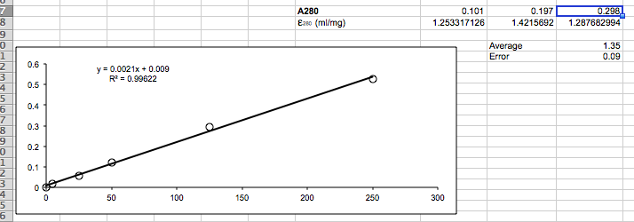

Figure S2. The EcDHFR prep from November 2016 showed the expected extinction coefficient of 2.86 and an error of 0.02.
