
University of Tennessee, Knoxville
TRACE: Tennessee Research and Creative

Exchange

Masters Theses Graduate School

5-2021

The Chamber of Prayer: Oratorio Without Words

Hyowon Bong

Follow this and additional works at: https://trace.tennessee.edu/utk_gradthes

 Part of the Composition Commons

To the Graduate Council:

I am submitting herewith a thesis written by Hyowon Bong entitled “The Chamber of Prayer: Oratorio Without Words.” I have examined the final electronic copy of this thesis for form and content and recommend that it be accepted in partial fulfillment of the requirements for the degree of Master of Music, with a major in Music.

Dr. Andrew Sigler, Major Professor

We have read this thesis and recommend its acceptance: Dr. Barbara Murphy, Dr. Rachel May Golden
Accepted for the Council: Dixie L. Thompson

Vice Provost and Dean of the Graduate School

(Original signatures are on file with official student records.)

The Chamber of Prayer: Oratorio Without Words

A Thesis Presented for the
Master of Music
Degree
The University of Tennessee, Knoxville

Hyowon Bong
August 2021

Copyright © 2021 by Hyowon Bong
All rights reserved.

DEDICATION
To Jun, my love, my best friend, to my dearest family in Korea who always support me, and in memory of Kathy Mayer, who became my first friend in this foreign land, a lovely human and beautiful poet who now speaks through her words but with everlasting cheerful mind, and who will be the one immensely pleased with my growth.

ACKNOWLEDGEMENT
I would like to express gratitude to my committee members, Dr. Barbara Murphy, Dr. Rachel Golden, and Dr. Brendan McConville, for their sincere assistance in awarding me the Graduate Assistantship and giving me wonderful opportunities to broaden my knowledge and experiences. I also appreciate Dr. Jorge Variego, Dr. David Brunell, and Dr. Geoffrey Herd, who motivated me with the art of computer music and instrument performance. Each week of learning analysis, pedagogy and teaching philosophy, cultural/social context, and piano/violin performance (mostly I was intrigued with Drs. Brunell and Herd’s performances instead of developing mine) made me think with broader scope. However, the most important lesson I learned was your ardent love for students and your sincere hearts to aid all of us, especially me. I will never forget this and will share this experience in my future, wherever I am.
I want to thank my dearest friends Dominique, Sara, and Laurie, who genuinely aided and supported me to find my voice so that I can complete this thesis in proper English. I also would like to acknowledge the Thomas family and, their generous donation to The College of Arts & Sciences that helped to fund the fellowship for this project.
Finally, I would like to express my deepest and, most earnest thanks to Dr. Andrew Sigler who made every single moment of our lessons meaningful and sparkling. Your sincere care, critical advice, and incredible insight shifted my attitude toward composition from discounting to confronting my process of creating. Every moment we shared ideas was always beyond exciting and I hugely appreciate you always listening carefully to help me complete my compositional goals and challenge me to mature as a critical musician. I will miss your humor. The time we spent together here at UTK will be the cornerstone that I can firmly build on in my future career as a teacher and composer.
ABSTRACT
The Chamber of Prayer: Oratorio Without Words is a piece in eight movements with additional opening and closing movements (prologue and epilogue). It is written for choir (soprano/alto/contralto/bass), string ensemble (violins I/II, viola, cello, and double bass), and two percussionists. Its duration is approximately forty minutes.
Traditionally, an oratorio employs texts to convey a dramatic narrative and is based on scripture; thus, the word-music relationship plays a central role in this genre. However, this experimental piece deconstructs the traditional oratorio structure to explore whether the music alone can deliver the substantive content that is usually provided by the text. Toward this aim, The Chamber of Prayer reframes liturgical hymns in a contemporary manner, while evoking Gregorian Chant and using church modes and psalm and antiphon structures from the Office. Instead of words, the singers use an artificial language consisting of sounds, thereby re-positioning the text-music relationship of the traditional oratorio so that the music itself delivers the narrative. This composition follows a liturgical structure based on the canonical hours: I. Matins; II. Lauds; III. Prime; IV. Terce; V. Sext; VI. None; VII. Vespers; and VIII. Compline. The piece can be performed whole, or each movement can be performed separately as a liturgy for each prayer hour’s specific time. In addition to the artificial language, each movement and includes descriptive musical elements, such as the stylized sounds of the dawning or darkening sky, falling rain, emerging beams of light, streaming sun, or footsteps in snow. By using musical language that includes an artificial language rather than text to drive the oratorio’s narrative, I intend to create a sacred space, a chamber of prayer, where both performers and audiences can engage in a common spiritual experience beyond text and creed.

TABLE OF CONTENTS
Introduction .............................................................................................................1
Chapter 1: Background.............................................................................................4
Chapter 2: Basic Operational Systems and Logistics for Composition...................9
Chapter 3: Analysis of Each Movement
3.1 Prologue...............................................................................................17
3.2 I. Matins: Let this Darkness Be a Bell Tower and You the Bell..........19
3.3 II. Lauds: Before Sunrise.....................................................................27
3.4 III. Prime: Mourning Morning: Who-who, Who-who.........................30
3.5 IV. Terce: Down to the Dark...............................................................34
V. Sext: Lead Us Not into Temptation
VI. None: Last Things
3.6 VII. Vespers: White as Snow...............................................................43
3.7 VIII. Compline- Epilogue: Homeland - To Where We Belong............46

Conclusion............................................................................................................59
Bibliography ........................................................................................................62
Appendix .............................................................................................................64
Vita.....................................................................................................................159

LIST OF FIGURES
Figure 1.1 The Office...............................................................................................5
Figure 1.2 Phonetic palette for Matins…..................................................................6
Figure 1.3 Correlation between phonetic combinations and music.........................7
Figure 2.1 The first psalm tone – mode 1................................................................9
Figure 2.2 Psalm tone structure in theme................................................................11
Figure 2.3 Tone-color melody (timbral theme).....................................................10
Figure 2.4 Timbral theme (glissando)....................................................................13
Figure 2.5 General outline for each movement.....................................................14
Figure 2.6 Cycle of pitch centricity.......................................................................16
Figure 3.1 Thematic rhythmic pattern..............…...................................................17
Figure 3.2 A fixed rhythmic pattern developed in Compline-Epilogue...................18
Figure 3.3 Two thematic melodies used in Matins..................................................20
Figure 3.4 Rhythmic reduction of fixed rhythmic patterns...................................22
Figure 3.5 Phonetic combination to drive dynamics.............................................25
Figure 3.6 Pitch operation system..........................................................................26
Figure 3.7 Pitch materials for Lauds.......................................................................27
Figure 3.8 Formal design of Lauds.........................................................................29
Figure 3.9 Pitch bending technique and its application.........................................32
Figure 3.10 Extended techniques for mimicking a “wing whistle”........................32
Figure 3.11 Phonetic palette for Prime...................................................................33
Figure 3.12 Hymn used as a theme for three of the little hours: Terce, Sext, and None....................................................................................................34
Figure 3.13 Phonetic palette for Terce.............................................................37
Figure 3.14 Timbral themes...................................................................................38
Figure 3.15 Pitch materials for three of the little hours (1): Trinity harmony..........39
Figure 3.16 Pitch materials for three of the little hours (2): Pitch axis, Trinity harmony, and Cross harmony.............................................................40
Figure 3.17 Pitch materials for three of the little hours (3): Hymn..........................41
Figure 3.18 The use of percussions in Terce and Sext.............................................42
Figure 3.19 Hymn from Sunday at Vespers...........................................................43
Figure 3.20 Transposition of Hymn from Sunday Vespers...................................44
Figure 3.21 Harmonic operation – pendulum (1)..................................................45
Figure 3.22 Harmonic operation – pendulum (2)..................................................45
Figure 3.23 Rhythmic reduction of opening..........................................................47
Figure 3.24 Tone of the Hymn at Compline and its transposition...........................48
Figure 3.25 Performer’s free choice of realizations for musical gestures……...…50
Figure 3.26 Phonetic palette for Compline-Epilogue..............................................51

INTRODUCTION
When I began my Master’s program at UTK in Fall 2019, I composed a piece titled sleep(fake) for contralto and piano as a vocal studio-composition studio collaboration project. This piece was based on a poem written by vocalist Sarah Beegle. Beegle’s approach to poetry writing — considering sounds, phrases, and rhymes, and making design decisions such as choosing between uppercase and lowercase letters — broadened my perspectives on language and its relations to music. My mother tongue, Korean, has almost nothing in common with English in sentence structures, grammar, phonetics, and even characters, so this view of writing poetry sparked my interest in integrating music with words and became my motivation for composing The Chamber of Prayer: Oratorio Without Words.
Traditionally the function of an oratorio is to bring the audience and performers together in religious communion. Text sung by vocalists plays an important role as a deliverer of the message. If I were to say the instrumental music is the vehicle in oratorio, the song text would be the driver who steers us to the musical goal of spiritual reflection. However, if the car is driverless (i.e., if there is no linguistically recognizable text), what has been delivered? To explore this question, The Chamber of Prayer minimizes the oratorio’s use of vocalists to deliver text, and instead, treats the vocalists as instruments, foregrounding the ability of the human voice to deliver musical elements such as timbre, gesture, and intonations. To maximize the instrumental qualities of the human voice, the vocal parts are sung in an artificial language, one using specific phonetic combinations designed for each movement, crafted to express themes and timbral factors. In this composition, each voice of the choir (soprano/mezzo-soprano/contralto/bass) can be regarded as an instrument in its own right that has a distinctive color. By testing this theory in this work, I aim to create a sacred experience comparable to the dramatic narrative of a traditional oratorio, but without words; thus, I to invite audiences into what the French philosopher Jean-Jacques Rousseau (c.1712-1778) describes as “an absolute state of nature in music.”
What can be gained by removing traditional language from the oratorio form? To answer this, we can turn to philosophers who have reflected on the value of purely instrumental music. Rousseau argued that “purely instrumental music (abstract music)” is unnatural, so it cannot invite listeners to the “absolute state of nature.” Rousseau’s idea of the word-music connection shaped his perspective that “pure instrumental music is meaningless” since it does not express words. However, others offer an intriguing challenge to Rousseau’s view, as well as to historical forms of music that treat language as primary. The German philosopher and composer Johann Mattheson (c.1681-1764) once said that “instrumental melodies” by themselves can and should stand for specific emotions. He theorized a connection between affective purpose (Doctrine of Affections) and certain intervals and rhythmic patterns. Mattheson’s view that pure musical symbols can express specific emotions independently and unmediated by language can shift our understanding of the boundaries between vocal and instrumental music.
Another challenge to the primacy of melody and words comes from Idealist philosopher-authors in the early Romantic period, who portrayed “music as the reflection of a higher, spiritual realm.” Karl Schlegel (1772-1829) in particular considered instrumental music a “vehicle of philosophy.” Likewise, Johann Ludwig Tieck (1773-1853) declared that instrumental music itself was a “drama” without characters depending on no laws of probability and referring to no story. This Idealist aesthetic of instrumental music motivates my current work. Can the dramatic force of the traditional oratorio genre be preserved if we replace natural language and story-telling with an artificial language, which treats voice as an instrument? Can this approach constitute an alternative musical narrative, in the sense that Schlegel and Tieck envisioned? My goal is to let go of the old debates about how instruments and lyrics connect, and instead explore the sonic potentialities of the voice and instrument together for creating systems of meaning that have the feel of narrative and give listeners the experience of a drama without the necessity of story.
My quest to create this alternative to the traditional oratorio led me through a wide range of music history, styles, and resources, including ars antiqua motets, medieval Christian music, Roman Catholic liturgy (Mass and Office) and standard settings of oratorio relating to Christ’s passion. For example, one resource that I used is the Liber Usualis, a book of frequently used Gregorian chants and hymns for Offices and Masses. The temporal and sanctoral cycles of the Roman Catholic Church, which this book follows, helped me change my perception of time, or Chronos, into God’s perception of time, or Kairos. This concept motivated me to create a sonic space where audiences can engage with the spiritual moment when God intervenes (Kairos) and to make a pitch plan to include various concepts of time in my composition. In these eight movements of abstract music oratorio, I wanted to contain a lunar cycle (lunar day), solar cycle (year, seasons, or church year), and God’s cycle (permanent) in the music. The title of each movement corresponds with the name of its respective Office, and the nature of each movement is conveyed through descriptive musical elements reflecting natural seasons and events that, to me, evoke the canonical hours and the Christian calendar. Each movement has its own pitch centricity, but if we look more broadly, the entire composition is cyclical. The cycle of pitch centricity shows metaphorically how the spiritual journey begins from the pitch center A in the Prologue and returns to the same pitch center in the last movement, Compline-Epilogue.
These findings from history provided a framework for my composition; I then began to seek my musical language by combining these discoveries with contemporary concepts and styles from various composers, theorists, philosophers, and even painters. My exploration was guided by the desire to find my own musical language, one that would be suitable for a contemporary abstract oratorio. For example, the twentieth-century composer Paul Hindemith’s interpretation of traditional psalmody helped me to broaden my vision of psalmody as a formal structure. I applied Hindemith’s idea of psalmody in the first movement, Matins. Arnold Schoenberg’s exploration of timbral possibilities led me to explore timbre as an independent thematic idea that I developed in Lauds, Prime, and Vespers through delicate management of instrumental techniques. I also applied more recent compositional techniques inspired by György Ligeti’s ‘String Quartet No. 1, “Métamorphoses Nocturnes” (1953-1954) to devise a pitch operation system which allowed me to have pitch-metamorphoses which I explored in the seventh movement Vespers.
As a thematic idea, nature became an important subject throughout the entire composition since I wanted my oratorio to include programmatic musical features that would, in a sense, follow the canonical hours. Particular scenes from nature were selected to illustrate specific hours of the Office. Also, these scenes reflect my personal experience of feeling the magnitude of nature’s vastness and power. In this way, I somehow felt God’s presence and I found some connections with philosophers Immanuel Kant and Theodor Adorno who have explored relationships between nature and spirit. Another important theme guiding my composition is Christ’s Passion, which I tried to musically illustrate in three movements in succession: Terce, Sext, and None. My version of the Passion setting refers to the earlier Christian traditions in terms of subject and musical materials, such as adapting the hymn “Nunc, Sancte, nobis, Spiritus,” adopted from Ordinary Sunday at Terce.
I also found inspiration in recent research about music theory and musical gestures. For example, Mark Bond’s theoretical concept of formal design, which sees music as a spatial structure that has multiple dimensions, suggested to me a different angle to perceive music as a spatial construct that is nested within linear time. The exploration of perceiving music as a spatial structure has culminated in this composition – a multi-layered structure sculpted in time, out of melody, rhythm, gesture, and timbre, creating a sonic space, a “Chamber of Prayer.”
My compositional quest to create such a sonic space is reflected in the title of my piece which indicates both my motivation to create a new genre, an “Oratorio Without Words,” and provide what I hope will serve for audiences as “The Chamber of Prayer.” In this composition, I strive not only to present a concept of music as a communicating device, but also to explore what kinds of musical features (e.g., the use of phonetic combinations, voices, instruments, gestures, timbre, or harmonic and rhythmic structures) effectively evoke the emotional reactions that are pivotal to the sacred scenes typically found in oratorios. I also aim to dissolve the traditional music-text association and instead use an imagined language that (among other things) imitates sounds of nature (e.g., a mourning dove’s cooing sound, tranquil wind, or glittering snowflake) and supports the musical narrative to create an absolute music oratorio. For example, the phonetic palette used in the first movement Matins consists of fricative consonants that incorporate the natural exhaling process that people usually make during sleep, a nod to the specific hour when this morning service is sung, 2:00 a.m.
CHAPTER ONE
Background
The roots of the oratorio date from seventeenth-century Rome, where a new genre of religious dramatic music that combined narrative, dialogue, and commentary emerged. The word oratorio comes from the Italian word “prayer hall,” and the Latin words orare, “to pray”, and oratio, “prayer.” This new genre of music used recitatives, arias, duets, and instrumental movements similar to opera, but differed from opera in several ways. The oratorio often included a narrator and chorus, was rarely staged, and most importantly within the context of the current work, was based on a religious subject rather than a secular narrative.
The historical roots for this new genre come from the Mass, the main liturgical service of the Roman Catholic Church. Margot Fassler, the American music and Christianity historian, observes that the idea of the Mass as a drama (an idea fundamental to the concept of the oratorio) originated in the Middle Ages, when composer Amalar of Metz (c. 780-850) began to treat the Mass as an allegory:
[...] this narrative was constant, but inflected by the feast or festival for which the Mass was composed, the texts forming a libretto for the story of redemption. In this sense, the Mass was the first oratorio, or large-scale sung dramatic work, with a cast of main characters garbed in vestments that represented their offices, and soloist, a chorus, and a congregation that responded to and commented on the action and its progression through ritual time.

The Chamber of Prayer: Oratorio Without Words challenges this tradition since it does not tell any particular Biblical story. In my composition, musical elements such as pitch, harmonic, or timbral materials metaphorically signify Biblical themes or characters from the Bible to deliver musical narrative. This piece strips away the historical conventions and instead uses the formal design of the Liturgy of the Hours as its religious subject.
The Roman rite of the Catholic church divides the day into eight times of prayer to have private or public gatherings following the Office (canonical hours) codified in the Rule of St. Benedict (c. 530). In the Office, music played an important role to carry the texts, accompany the rituals, and encourage the faithful. My composition follows this tradition of encouraging the faithful to join a prayer time through music; my contemporary musical sound combines traditional musical features from the Roman liturgy with contemporary instrumental and vocal techniques. Following the conventions of program music, each movement portrays a scene from nature or from the Bible. These scenes have been selected to illustrate specific hours in the canonical cycle: Matins for early morning, Lauds for daybreak, then Prime, Terce, Sext, and None for daytime prayer, and finally Vespers and Compline for evening prayer (see Figure 1.1).
The Office provides thematic ideas for each movement based on when the specific hours occur. To support the musical narrative, the lyrics for this composition are comprised of an artificial language inspired by a Biblical moment in Genesis – my imagined version of an aural vision of the origins of human language. The text is derived from the idea of onomatopoeic theory that says the first human language originated when humans began to mimic natural sound. According to this theory, language, music, and dance share ancestors in an ancient system of onomatopoeic cries and gestures. As an example of my text, Figure 1.2 shows that I have

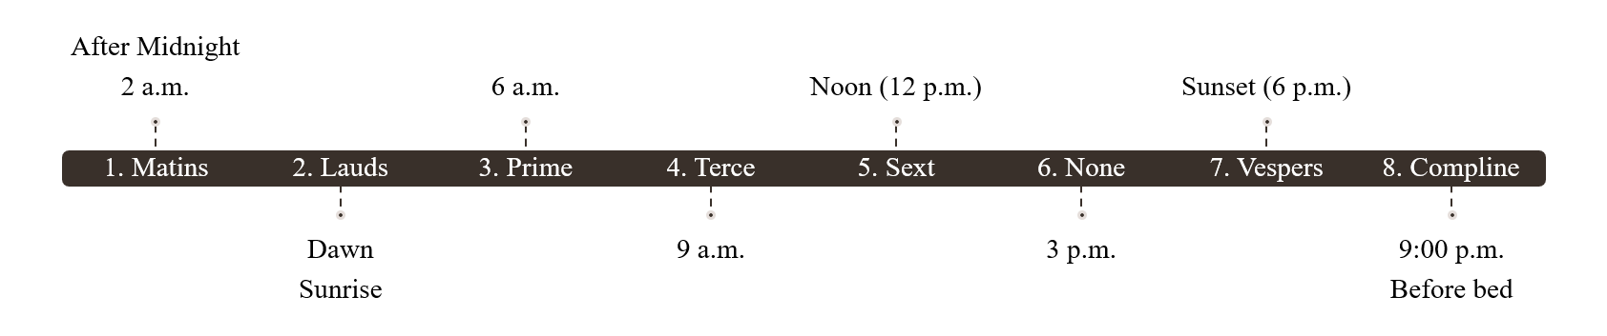
Figure 1.1 The Office.

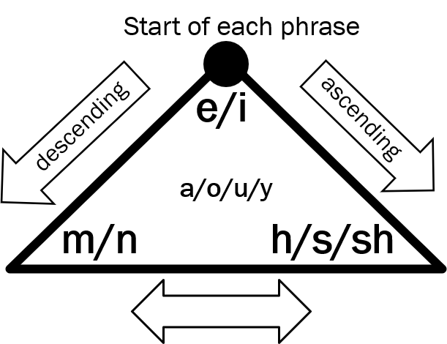

Figure 1.2 Phonetic palette for Matins.

taken these concepts related to language and music, and used them in my work. A phonetic palette of an abstract language that is used in the first movement, Matins: Let this Darkness Be a Bell Tower and You the Bell, sonically illustrates a somniloquist (someone who talks while asleep) since Matins is an early morning service. The phonetic combination (or “phonetic palette”) of vowels and consonants was designed in order to support the melodic fluency in this movement.
For Matins, I chose a phonetic combination that could illustrate a sound of deep breathing that people normally make during sleep. For example, two vowels “e” or “I,” both naturally processed sounds, start a phrase in the music. If the next pitch drops or the contour
descends, the vowels proceed to “m” or “n” – a nasal sound; contrariwise, if the melodic contour ascends, vowels proceed to “h”, “s,” or “sh” sound which cause a natural exhaling process, or voiceless fricative. The vowels in general are slightly nasalized in anticipation of the following nasal consonant “mm,” which was applied to the music in order to support the use of glissando effectively in the vocals and first violin as shown in Figure 1.3.

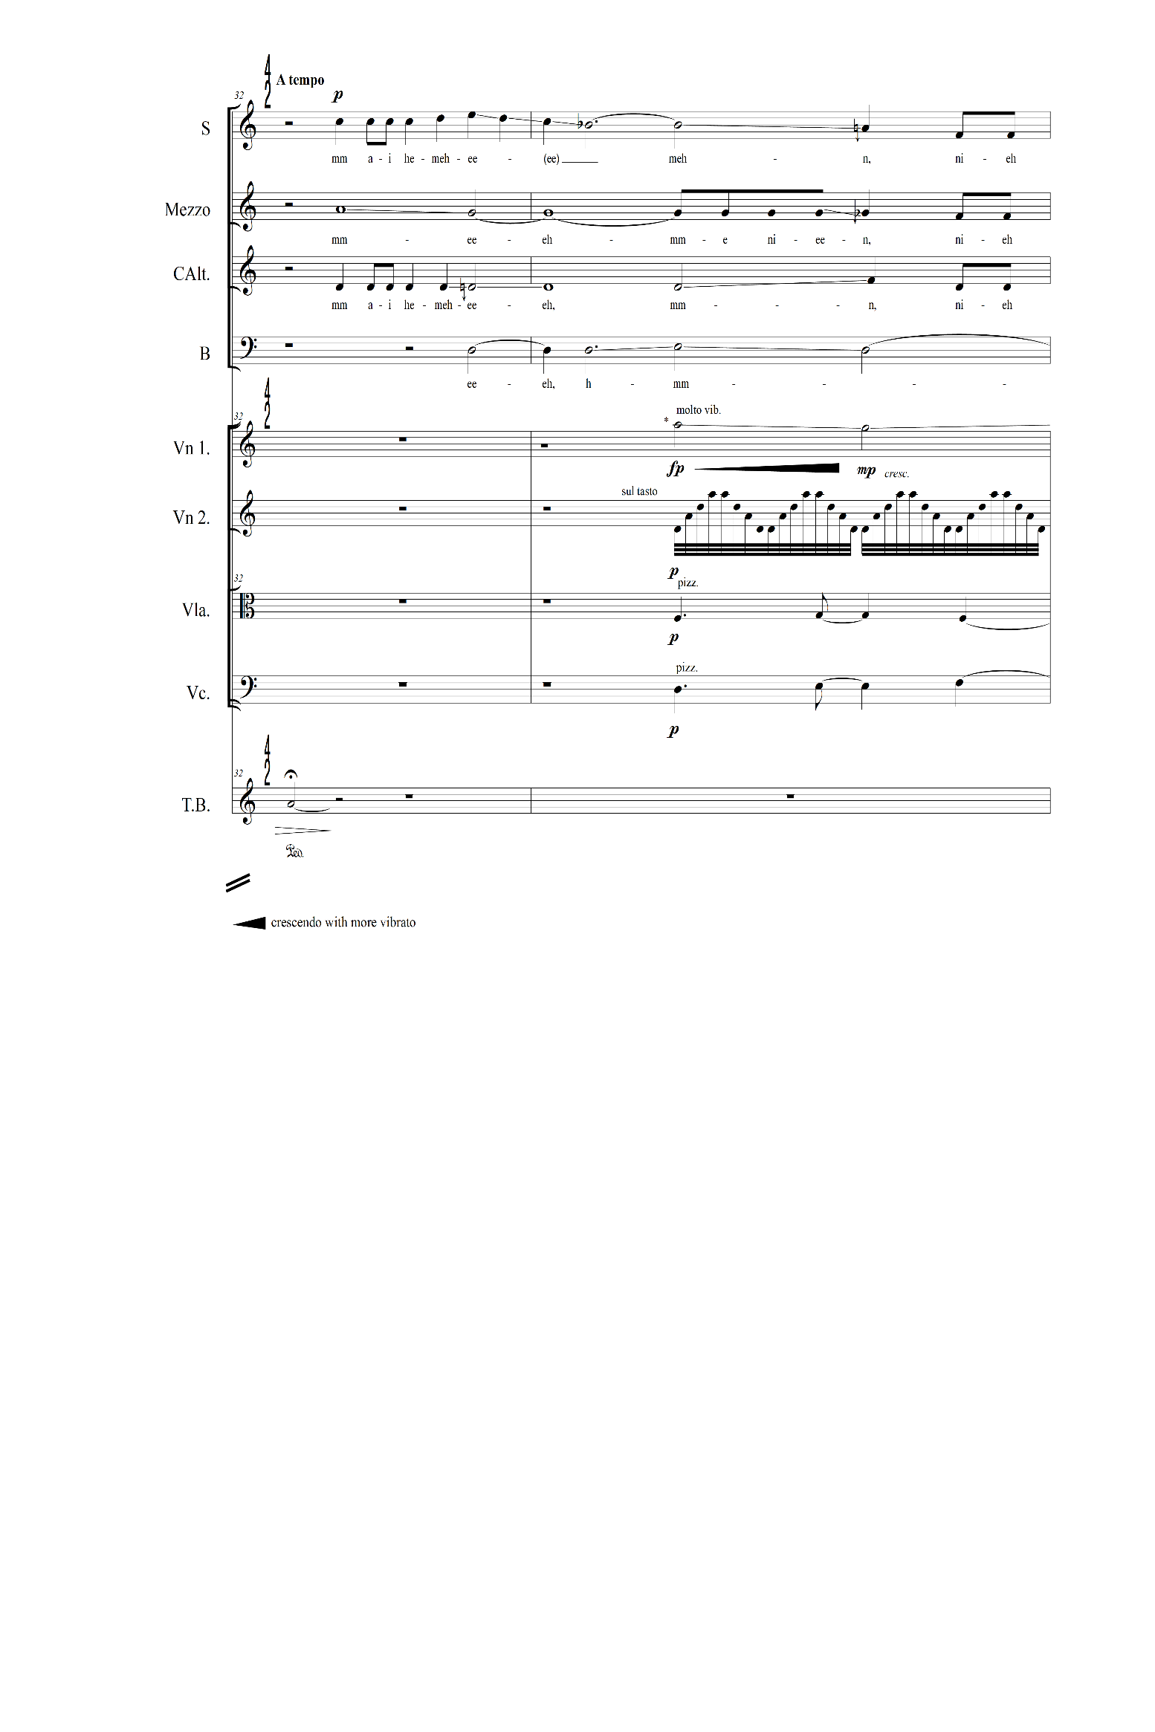

Figure 1.3 Correlation between phonetic combinations and music, mvt.1, Matins, mm. 32-33.

The phonetic system of Matins is strongly tied to melodic contour or instrumental gestures by involving a natural inherent orientation: the “e-mm” or “i-mm” combination suggests a naturally descending direction of pitch when spoken aloud; conversely, the “ee-sh”
sound involves an ascending movement of air when pronounced. The suffix of “-mm” or “-nn” helps to create a correlation with laziness and the elongation of vowels as being “lazy” variants of the preceding vowels. I create the effect of being lazy to illustrate people who are dragging their heels before the early morning prayer time. In this consideration of phonetics and its metaphoric usage, I have devised a phonetic (timbral) palette that establishes a range of sonic choices for Matins. I then choose “colors” from the palette that sonically capture the scene.
CHAPTER TWO
Basic Operational Systems and Logistics for Composition
While this work has an exterior structure based on the canonical hours, the content of each movement has an interior structure that includes various musical adaptations of form from the Office liturgy including hymns, psalm tones, psalm tone formulae, and recitation formulae. These genres were originally utilized by priests for intoning prayers and Bible readings with occasional responses from the congregation.
A hymn is from the Greek word hymnos, “a song for a god.” From the medieval Latin tradition, hymns were sung throughout the hours of the Office. I have adopted some hymns form the Liber Usualis to use as a thematic element for my composition.
Psalm tones are melodic formulae for reciting Psalms verses that are designed to be adapted to any psalm. I explored psalm tone and psalm tone structure as the main elements in the first movement Matins.
A psalm tone formula — a formula for singing psalms of the liturgy — includes several components: 1) Opening (intonation), 2) Midpoint (mediant), 3) Reciting pitch (tenor), 4) Variations of the tenor (flex), and 5) Ending (termination). Psalm singing also includes singing a thematic phrase consisting of antiphons and responses in a similar style to how psalms are sung during Mass or the Office. The Office psalms are varied (from a cycle of 150 psalms), and each psalm is framed by different antiphons during the year based on the church calendar. Figure 2.1 shows the first psalm tone among eight modes; each of which has an associated psalm tone. When I apply this formula to my composition, once an antiphon is introduced, other voices or instruments imitate the inflections of speech (texts) subsequently before the audience forgets the voice which was introduced earlier. The antiphon can be sung or performed by soloists from the choir or by instrumental groups as in recitation formulae used for Bible readings and intoning prayers. An antiphon in a recitation formulae begins with a reciting note or with a rise to the reciting note, sung by the priest or an assistant, and ends with occasional responses from the choir or congregation.
The role of the soloists who begin each movement, whether instrumental or vocal, reminds us of the medieval cantor, the leader of the choir. The lead singer sets the pitch and tone for the opening words of the antiphon, and then the choir joins together for the reprise of the antiphon. Figure 2.2 shows how I use a psalm tone in the first movement, Matins, in particular how the contralto begins the phrase as the cantor and how the other voices respond. I take a flexible approach to interpret the traditional psalm tone formula to use as a formal design for my oratorio by considering other composers’ perspectives such as Olivier Messiaen’s (1908-1992) interpretation of psalmody:
We may occasionally adopt a certain system of declamation more easily applicable if we ourselves write the poems of our vocal works: first, all that seems to belong to the domain of the recitative is psalmody (the words uttered at a very rapid pace on a repeated note); second, any word especially important, moving, rich in meaning, is adorned with a long or even very long vocalise.

Therefore, I often accentuate a word or melodic fragment by repeating or sustaining a certain

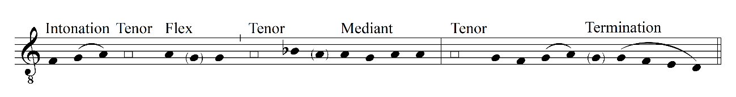
Figure 2.1 The first psalm tone – mode 1.

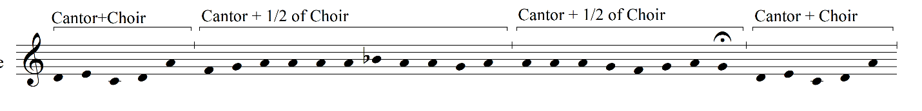
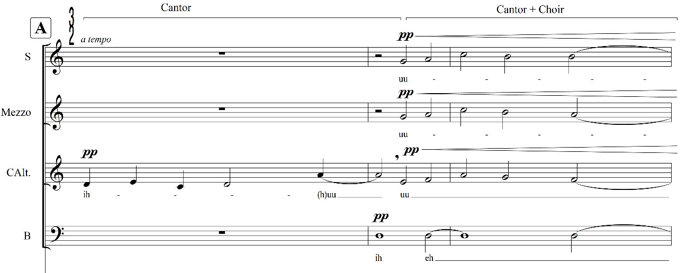
Figure 2.2 Psalm tone structure in theme, mvt.1, Matins, mm. 22-23.

note when I consider it to be a thematic element. This thematic element used in Matins is also reinforced through a recitation formula that is suitable to recite texts and Bible readings, employing a strict syllabic style, and useful in creating simple melodies in limited ranges for intoning prayers.
To achieve a strong musical narrative, I focused on timbral development instead of relying on the Biblical story or a drama. Certain themes have the inherent limitation of relying solely on a simple melody – the psalm tone. Thus, timbral management provides musical variety despite this limitation. For example, the second movement Lauds: Before Sunrise starts with a solo viola’s successive non legato/non vibrato quarter notes. This movement is written for string quartet, so it was even more challenging to find a way to deliver the musical narrative with only four stringed instruments. Thus, for Lauds, I needed to choose a more direct version of interpreting the traditional formulae to evoke the religious feeling of the oratorio. This direct interpretation included a clear presentation of antiphons and refrains, combined with delicate management of timbre and tone of stringed instruments. For example, Figure 2.3 shows the successive quarter notes that imitate the syllabic style of an Office antiphon. The violist becomes the cantor in the opening section setting the tone color and pitch. The way the violist interprets this movement will decide their style of bow strokes possibly between detaché (separate bow, but not staccato) or martelé (literally “hammered,” a sharp/biting attack with a rest between strokes).
My use of timbre adds a new layer to this composition. This timbral treatment reflects Schoenberg’s theoretical concept of Klangfarbenmelodie, or tone-color melody.
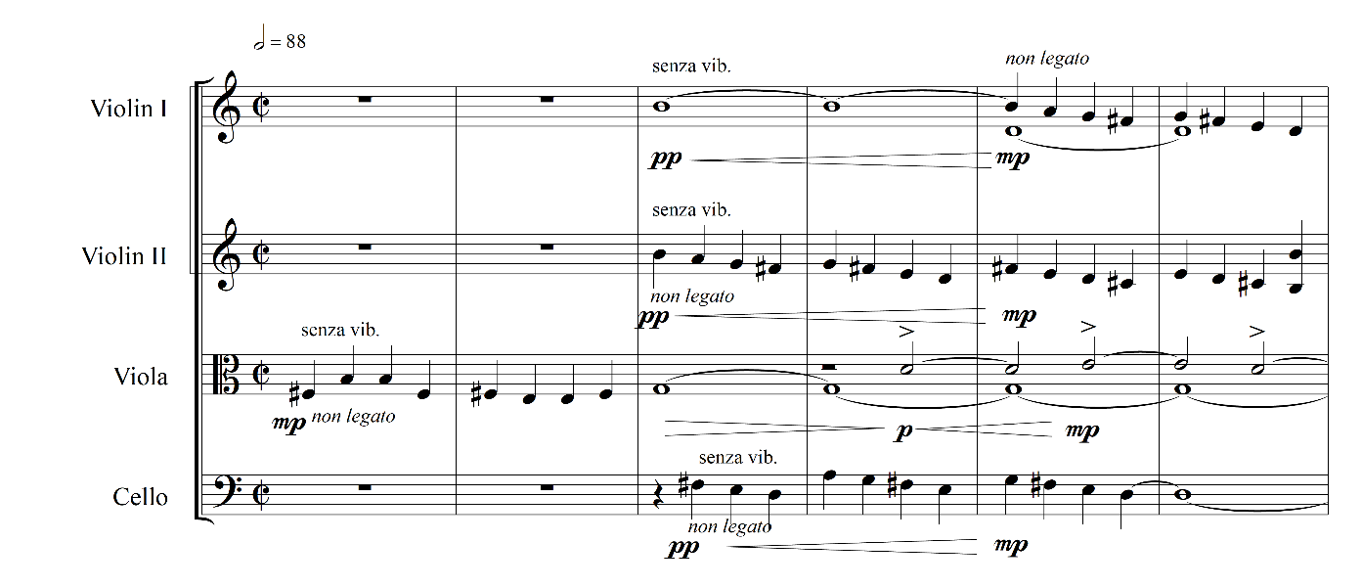
Figure 2.3 Tone-color melody (timbral theme), mvt.2, Lauds, mm. 1-4.

This concept introduces the possibility of composing tone-color melodies by considering timbre as an independent central element:
In a musical sound, three characteristics are recognized: its pitch, color [timbre], and volume. I think the tone becomes perceptible by virtue of tone color, of which one dimension is pitch. Tone color is, thus, the main topic, pitch a subdivision. Pitch is nothing else but tone color measured in one direction. Now, if it is possible to create patterns out of tone colors that are differentiated according to pitch patterns we call melodies, progressions, whose coherence evokes an effect analogous to thought processes, then it must also be possible to make such progressions out of the tone colors of the other dimension, out of that which we call simply “tone color,” progressions whose relations with one another work with a kind of logic entirely equivalent to that logic which satisfies us in the melody of pitches…Tone-color melodies! How acute the senses that would be able to perceive them! How high the development of spirit that could find pleasure in such subtle things!

I use Schoenberg’s view in my timbral operations by considering timbre as a thematic idea, one that I can keep expanding until it is exhausted. This approach helped me to overcome the limitation of my thematic source, a “plain tune” or “one-dimensional (melodic) theme” as Schoenberg stated above. For example, Figure 2.4 shows the use of glissando that is prominent both in the choir and the instrumental group as apparent in the opening of Matins. The cello uses glissandos and moves around D2 using microtones without any tuneful melody. Using successive microtones is my attempt to realize tone-color melody (or “timbral theme”) as Schoenberg discussed. This timbral characteristic is placed in the foreground to penetrate the listener’s perception effectively, so that it will be interpreted as a thematic element.
The pitch materials are primarily derived from church modes but are employed in a flexible way by including contemporary theoretical concepts of pitch system such as pitch axis, symmetry, and centricity, as shown in Figure 2.5. Each movement variously relies on a drone
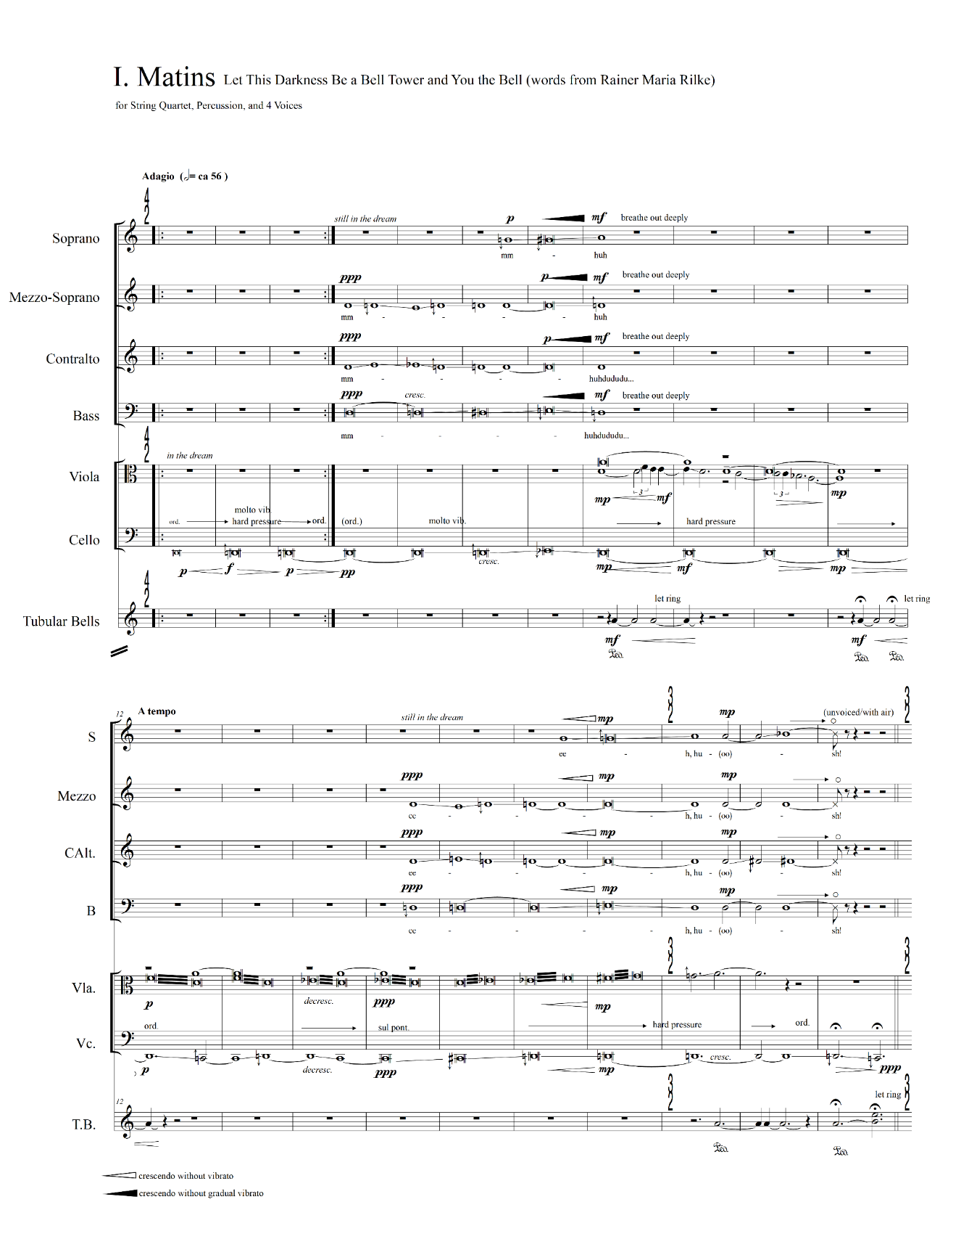
Figure 2.4 Timbral theme (glissando), mvt.1, Matins, mm. 1-11.

The Canonical Hours | Title | Pitch Materials | Instrumentation
Prologue |  | A (Drone) | Vns. I/II
I. Matins | Let this Darkness Be a Bell Tower and You the Bell | D Dorian  D Hypodorian | Choir, String quartet, Tubular bells
II. Lauds | Before Sunrise | B Aeolian  B Dorian | String quartet
III. Prime | Mourning Morning: Who-who, Who-who. | B | ½ Choir, String quartet, Vibraphone
IV. Terce | Down to the Dark | F/G#(Ab)  F Aeolian  F Dorian | String quartet, Marimbas I/II
V. Sext | Lead Us Not into Temptation | G-G#  Trinity harmonies  Cross harmonies | String quintet (Double bass), Marimbas I/II, Tubular bells
VI. None | Last Things | G#  Trinity harmonies  Cross harmonies | String quintet (Double bass), Glockenspiel, Marimba, Bass drum, Tubular bells
VII. Vespers | White as Snow | B | Choir, String quartet,
VIII. Compline-Epilogue | Homeland - To Where We Belong | D Hypodorian | Choir, Vns. I/II
VIII. Compline-Epilogue |  | A (Drone)

Figure 2.5 General outline for each movement.
note, a pitch axis, and pitch centricity, or characteristic harmonic materials instead of being strictly adapted from the liturgy.
The instrumentation for the entire oratorio includes choir (soprano, alto, contralto – can be replaced by tenor – and bass), string ensemble (violins I/II, viola, cello, double bass), and two percussionists (tubular bells, vibraphone, marimba, glockenspiel); these performers are used collectively or partially depending on the movement. As I discuss later in this paper, instruments come in and out based on the theme, and in connection with specific hours of the day or contents. For example, Prologue begins with two violins, which serve as a cantor for the Introit, the opening of the liturgical celebration of a Mass. Even though there is no introit in the Office, I included the Introit from the Mass liturgy to open this piece and to celebrate the entrance of the cantor as I would like this composition to be considered as one liturgical ceremony. In the first movement (Matins), the choir is introduced with tubular bells; these serve as alarms meant to startle listeners’ sleeping bodies into wakefulness. Gradually other percussion instruments are added until the sixth movement, None, and then fade out toward the last movement.
A subject of “nature” underlies the entire piece; this idea originates with the scattered images of natural beauty I have seen since coming to America and reflect various elements of nature I have seen living in Indiana and Tennessee. This subject of nature is applied to the melodic, rhythmic, and timbral components throughout the entire composition. The sublimity and spirituality of Mother Nature struck me especially given the size difference between South Korea and the United States: South Korea in its entirety equals just 1.01% the land area of the US, and Tennessee is 7.1% larger than South Korea. Furthermore, I felt a sense of spirituality, awe, respect, and the existence of God through nature. While this is my personal feeling, Peter Hohendahl also captures the insights of two German philosophers regarding the aesthetic, and in a sense spiritual, power of nature:
Kant commented about nature as an aesthetic object and an immediate interest in the beauty of nature is an index of a good soul (guten Seele) and that one could discern a moral feeling. [...] Adorno underscores the link between natural beauty and the experience of potential reconciliation. Adorno’s strong interest in the sublime demonstrates this dissolution of the boundary between art and nature.

While Kant treats nature as the primary phenomenon to which art is related, Adorno argues that the aesthetic experience of nature may be secondary, historically a late experience. The aesthetic experience of nature presupposes that mankind has lost its primal fear of nature. [...] This supposed impact of aesthetic experience on the experience of nature requires an unorthodox rereading of Kant’s concept of the sublime, especially the dynamic-sublime.

If I examine the subject matter of my composition through Hohendahl’s perspective, I may say this auditory experience of nature would offer a temporal-spatial space that would evoke mankind’s fear of the loss of nature and of God (as suggested by Kant). In this sonic space, listeners can reconcile with nature, seeing themselves as a small unit against it, and at the same time, a part of it. Additionally, this work pays homage to Michel Tournier’s belief that music can be the restoration of mankind’s lost paradise which occurred when the great symphony of the heavenly spheres ceased into the eternal silence of infinite space, when Adam and Eve were expelled from Eden.
The overall outline for pitch centricity of the entire composition parallels this subject: where we belong, where we come from, where we are now, and where we are going. Figure 2.6 shows the cycle of pitch centricity demonstrating how this journey begins and returns as it goes through each movement. The pitch cycle parallels the subject of spiritual journey, while the

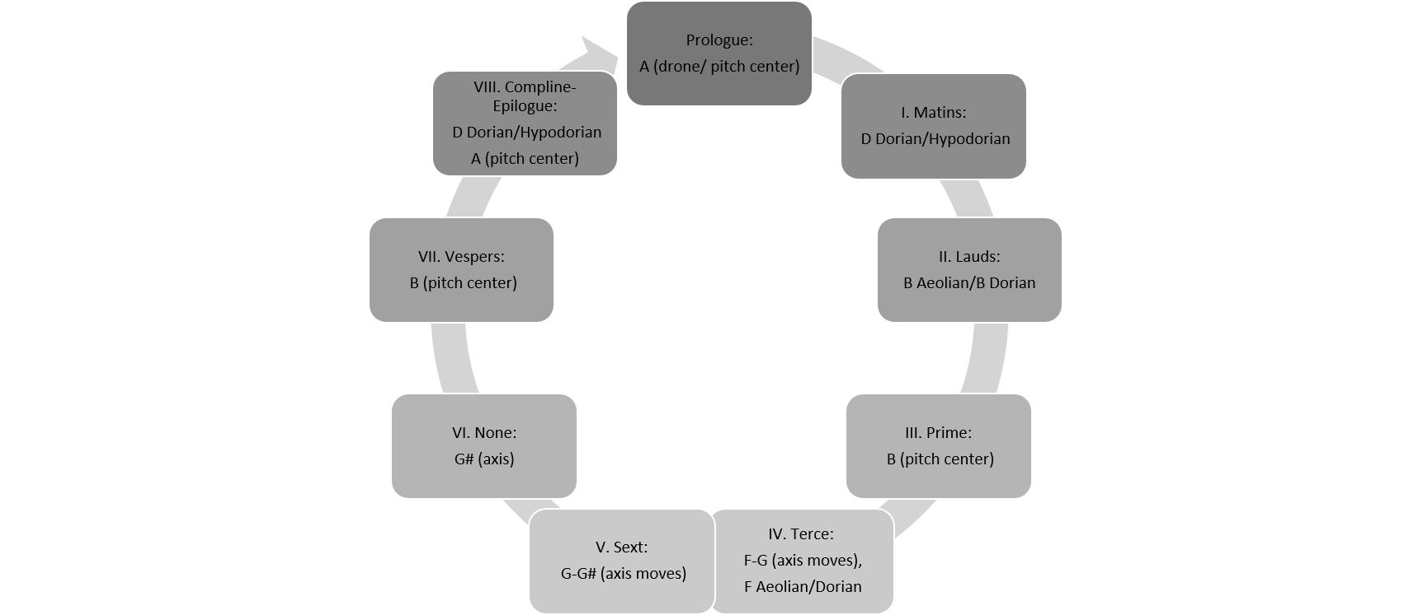
Figure 2.6. Cycle of pitch centricity.

subtitle of each movement reflects the theme, the topic of spirituality, the cycle of life, and nature. For example, the subtitle of last movement VIII. Compline: “Homeland – To Where We Belong” also refers to the relationship between nature and art as a container of natural beauty. In my imagery of heaven, the use of liquid consonants in my phonetic palette sounds like God calling us home: “homeland” is where the river flows, as in God’s domain (as described in Revelation 22:1, “Then the angel showed me the river of the water of life, as clear as crystal, flowing from the throne of God and of the Lamb.).”
CHAPTER THREE
Analysis of Each Movement
Prologue
Even though the Office, unlike the Mass, includes no Introit, I decided to open this abstract-music oratorio with an instrumental piece that functions much like an Introit. Two violins play the role of cantor in turn: the second violin enters one measure earlier than the first violin to set the basic pulse by providing a consistent rhythmic pattern (short-long-short-long) for the entrance of the cantor (first violin) as shown in Figure 3.1.
After the second violin sets the pulse, the first violin introduces a lyric melody starting on E6 and progressing to A5. This thematic melody is presented twice, once by the first violin and later by the second violin; each uses different church modes – Dorian and Aeolian – and their plagal modes with embellishments. The decorative nature of the melody reflects the convention that Introits include slightly more elaborated tones. Also, the thematic melodies incorporate a number of reciting notes that recall the use of a tenor (reciting pitch) based on the psalm tone formula.
The constant repetitive short-long-short-long patterns are my aural interpretation
of fireflies’ flash patterns in consideration of the hour (preceding Matins, 2 a.m.) of the summer season. The rhythmic fireflies will be developed again in the last movement, Compline and Epilogue, which is another active hour of fireflies (7:30 p.m.). The idea of a fixed rhythmic pattern (also called rhythmic ostinato or isorhythm) is derived from a device that is usually found in fourteenth century motets, a talea. Figure 3.2 shows an example of the fixed rhythmic

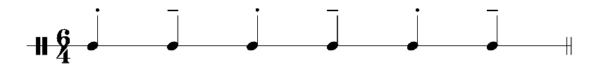
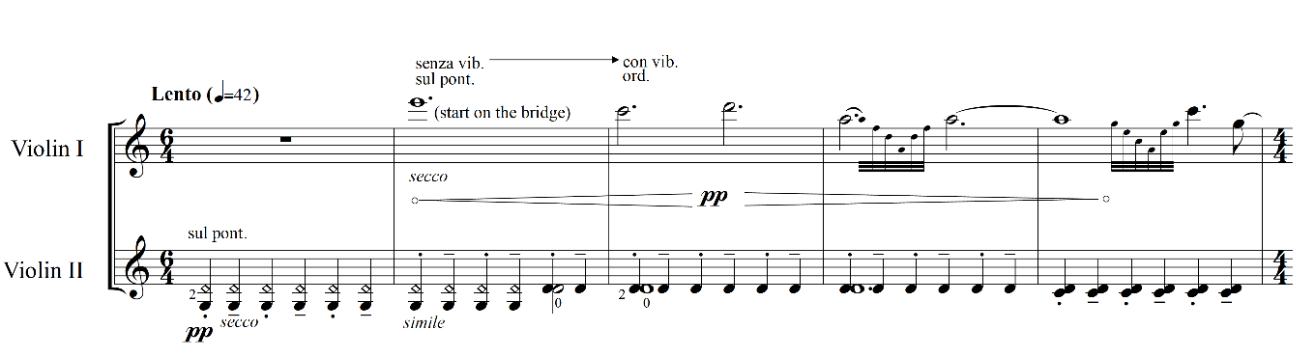

Figure 3.1 Thematic rhythmic pattern, Prologue, mm.1-5.

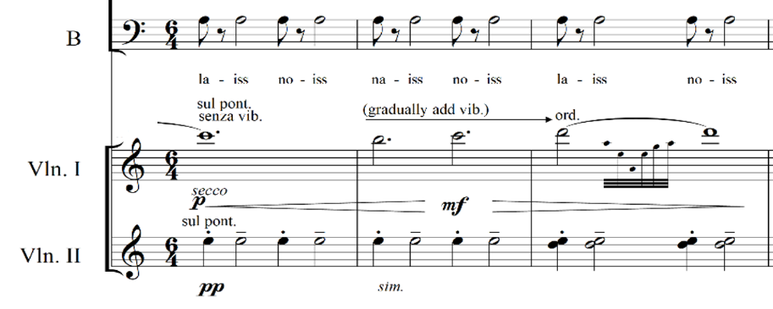

Figure 3.2 A fixed rhythmic pattern developed in Compline-Epilogue, mvt.8, mm. 73-75.

pattern being applied in the last movement in the strings and also in the choir, especially in the bass voice.
Prologue is placed before Matins (a prayer time before dawn) so the timbral and dynamic choices reflect this hour. Here, I present a subtle sound to guide the audience to a quiet place for prayer. A limited range of dynamics are used: pianissimo to mezzo forte. The first violin begins the lyrical phrase and continues with sul ponticello (near or on the bridge), dal niente (from nothing), and crescendo. The dynamic of the first violin increases gradually from silence. The phrase ends with decrescendo and al niente (to nothing), indicating that the dynamics should fade out to nothing.
I. Matins: Let this Darkness Be a Bell Tower and You the Bell
Matins: Let this Darkness Be a Bell Tower and You the Bell sets the overall framework for the entire piece. Matins, the first movement in this composition, was the first Office hour originally observed in the early morning before dawn. The subtitle Let this Darkness Be a Bell Tower and You the Bell is borrowed from the twentieth-century German poet Rainer Maria Rilke (1875-1926), who once claimed to be a “religious poet.” Let this Darkness Be a Bell Tower and You the Bell is one poem from his 1923 collection Die Sonette an Orpheus II (Sonnets to Orpheus Vol. II, Number 29). I chose this poem solely because of the sonic potentialities of the words (e.g., a bell tower, the silent earth, or rushing water) and the lyrical prose rather than because of the writer’s religious background. The poem, as translated by Anita Barrow and Joanna Macy, reads:
Quiet friend who has come so far,
feel how your breathing makes more space around you.
Let this darkness be a bell tower
and you the bell. As you ring,

what batters you becomes your strength.
Move back and forth into the change.
What is it like, such intensity of pain?
If the drink is bitter, turn yourself to wine.

In this uncontainable night,
be the mystery at the crossroads of your senses,
the meaning discovered there.

And if the world has ceased to hear you,
say to the silent earth: I flow.
To the rushing water, speak: I am.

Rilke’s struggle to seek truth, belief, and God parallels the general context of my composition. As Wolfram K. Legner describes, the architecture of the Roman Catholic faith is transmuted into Rilke’s “poetical imagery” and religious challenges underlie his works as my personal religious challenges underlie my composition.
Matins includes two melodic themes that share D as a pitch center: one is composed with the indication of a psalm tone and the other is an oral transmission of the traditional Korean children’s folk song, “Dal-ah Dal-ah” (also called “Lunar song”), shown in Figure. 3.3. “Dal” means the moon, “-ah/-ya” is a suffix for calling someone to attention, similar to the English usage of “Hey, you!”.
“Dal-ah Dal-ah” has another title, “Sae-ya Sae-ya” (Sae means “the bird”), so the tune is also called the “Bluebird song.” This tune has been passed down through generations and has merged into Koreans’ daily life, especially used as a lullaby. This folk song has become more
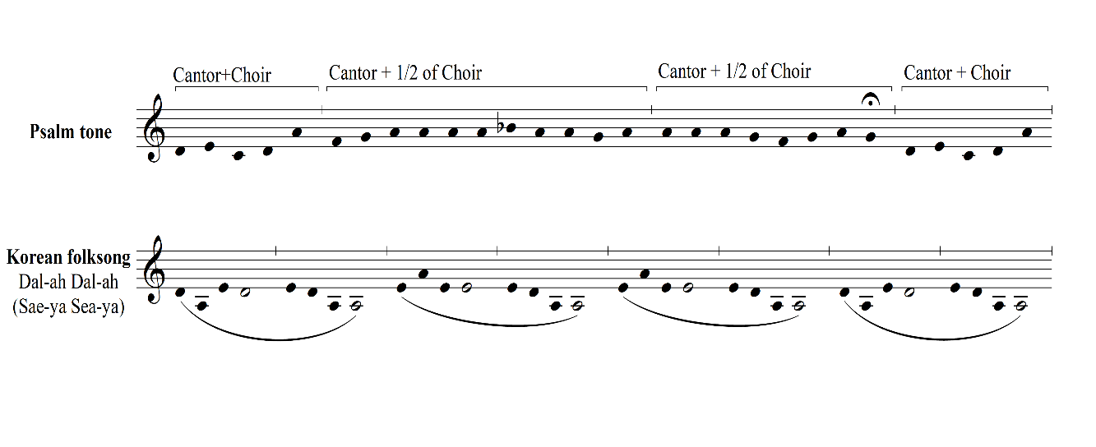
Figure 3.3 Two thematic melodies used in Matins.

widely known since Krzysztof Penderecki utilized it in his Symphony No. 5, “Korea” (1992).
“Sae-ya Sae-ya” is also associated with a Korean social reform movement called the Tonghak (“Eastern Learning”) Peasant Revolution that occurred in 1860 and resulted in the deaths of over 400,000 people. Hence, the lyrics reflect the emotions of despair experienced by the surviving peasants:
Oh bird, oh bird, oh blue bird
Do not sit in the green bean fields
For when the green bean flower falls
The green jelly seller weeps.

The lyrics contain metaphoric usages related to certain words: blue bird, green bean field, and falling flower. These lyrics are a warning message to a bluebird (peasant) not to sit in the field (not to be involved in the revolution anymore); in this movement, this tune is used to awaken or warn the sleeping body or sleeping souls of a prayer time. Tubular bells play a central role in generating the alarm sound to wake up and beckon the listeners with an increasing rate of recurrence (eventually arriving at stretto), from sporadic to consistent toward the end of the piece.
Regarding rhythm, the general system can be understood as a mixture of fixed rhythm and free rhythm. Once fixed rhythmic patterns are suggested, they can be used in different registrations. Fixed rhythms do not stay in the same voice/instrument throughout, but travel between voices, instruments, or even voice and instrument, as shown in Figure 3.4. For example, in measure 22, each voice has its own fixed rhythmic pattern that shakes the audience’s
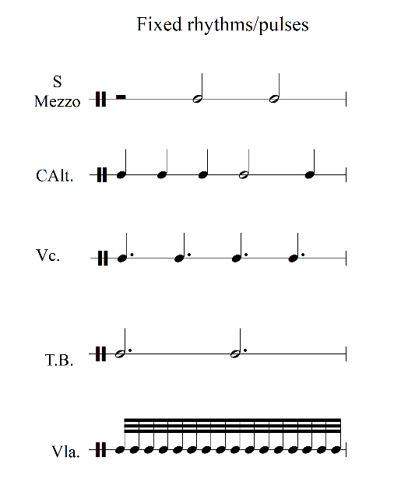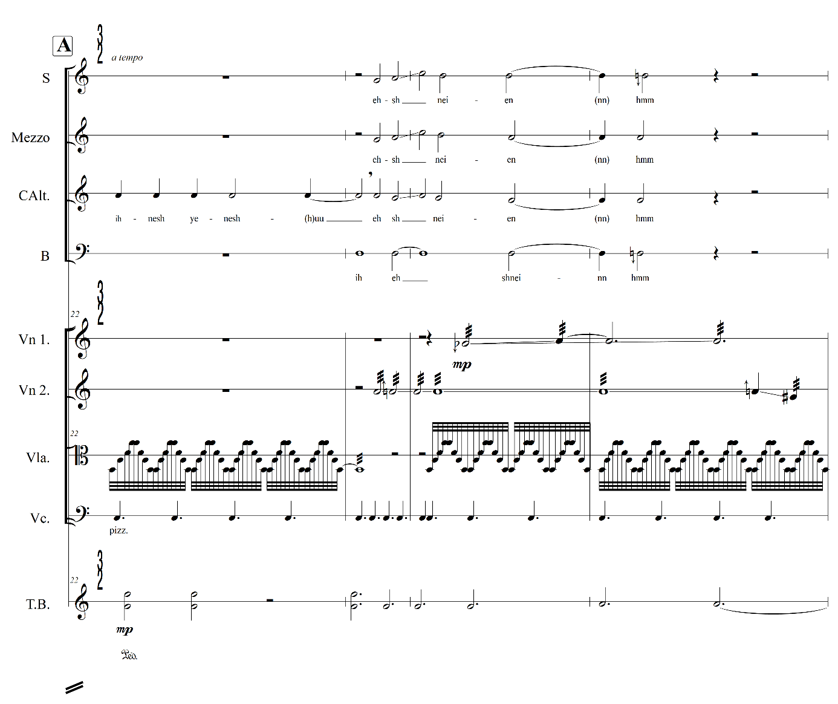

Figure 3.4 Rhythmic reduction of fixed rhythmic patterns, mvt.1, mm. 22-24.

perception of the basic pulse: quarter notes assigned to the contralto, dotted quarter notes to the cello, and dotted half notes to tubular bells. The tactic of assigning different pulses to each layer of the texture serves to create rhythmic fluency or ambiguity. The procedure of assigning different types of rhythmic movement to different layers or strata echoes the hierarchical rhythmic characteristics found in ars antiqua motets. Returning to the subject underlying Matins, this tactic helps to reinforce rhythmic ambiguity to eventually portray the unconscious human being, almost dead with sleep.
The technique of using fixed rhythm loosely reflects Guillaume de Machaut’s (c.1300-1377) use of talea, an isorhythmic technique that follows strict rules that Machaut himself often broke to achieve a successful counterpoint and allowing him to find the best progressions. In my composition, however, the fixed patterns are used to establish rhythmic ambiguity that illustrate the unconscious state of sleeping souls. The display of different basic pulses for each voice at the same time (polyrhythms) layers another dimension (space) onto the melody, which follows linear time.
This may be a good point in my analysis to remind readers of what motivated this project. I wanted to create a space where listeners can engage in a spiritual experience through musical language. The rhythmic operations employed in this movement are one way of achieving this goal. The juxtaposed rhythmic layers add dimensionality to the linear experience of music, melody. If we can say a melody is linear since it relies on time – which may be considered to unfold in one direction – when the melody is combined with multiple rhythmic and harmonic layers, then layering may open another dimension to the listener’s experience of music, a new time-space dimension. For example, when polyrhythmic layers are presented, each listener may follow their own choice of rhythmic layer(s). Consequently, the sense of time that each listener experiences will be relative; one listener may follow successive quarter-note pulses, meaning time will seem faster than for another listener who may follow successive dotted-quarter-note pulses. Other listeners may move back and forth if they follow other dimensions, such as harmonic rhythm. If my attempt to create a rhythmic fluency is successful, the apparent disorder of the whole entity may open new realms of spiritual exploration for listeners – the state of a strictly-ordered total disorder (chaos).
My technique of using repeated juxtapositions of fixed rhythms may initially seem disordered and disharmonious, but it is indeed ordered and harmonious. My process is thus in keeping with the aspirations of other modern artists who, like me, seek for their own system to ‘appear’ other than merely arbitrary, similar to Florman’s description of the first modern abstract painter Kandinsky’s (1866-1944) “color wheel” device as “wholly unnatural, and so answerable only to spirit.” Kandinsky’s color wheel was for systematically operating colors just as Schoenberg’s new dodecaphonic idiom was used for systematically controlling pitches and harmonies; and also used for consciously avoiding “naturalness,” and perhaps even for embracing “unnaturalness” as a new possibility that “appears responsive to the demands of Spirit alone.”
The technique of using fixed rhythmic patterns is combined with fixed phonetic
combinations that may seem to be arbitrary but are in fact systematically controlled. Figure 3.5 shows the word-choices I made and how I assigned a word to the start of each phrase to make it recognizable by combining it with melodic segments. In some cases, these fixed phonetic patterns are altered (as Machaut broke his rules to achieve the best melody) to force a particular dynamic. For example, I assigned “hsh, he-eh mi-eh” for the reciting notes (‘A4’) in measure 60, and to drive dynamic changes, I added more unvoiced fricative consonants such as “h, hh, sh, ss” for the start of the following phrases. By doing so, at the end of this movement, where the choir arrives at ff in measure 64, the music gradually moves forward without losing momentum at the end of the movement.
Lastly, with regard to the form, the formal design can be described as ternary (A-B-A’) and is naturally built upon the psalm tone structure, which includes three divisions – openings (intonation), midpoints (mediant) and endings (termination).
We can also reconsider the form as an abstraction, through different lenses, including temporal (form-as-process), and spatial (form-as-structure), as Mark Evan Bonds has suggested since the formal design of this movement meets with Bonds’ spatial concept:
The temporal perspective conceives form as a diachronic succession of events that unfold through time, whereas the spatial perspective conceives it as a synchronous entity. Representations of form as a temporal construct unfold through time by describing a series of events, a sequential description of what happens first, second, third, and so on. This approach tends to treat form as process. Representations of form as a spatial construct, by contrast, tend to treat form as a structure, typically relying on synoptic two-dimensional diagrams that make the relationship of the individual parts to the whole apparent in a single image.

Bonds’ perception that “form is both a process and a structure” can provide an overall

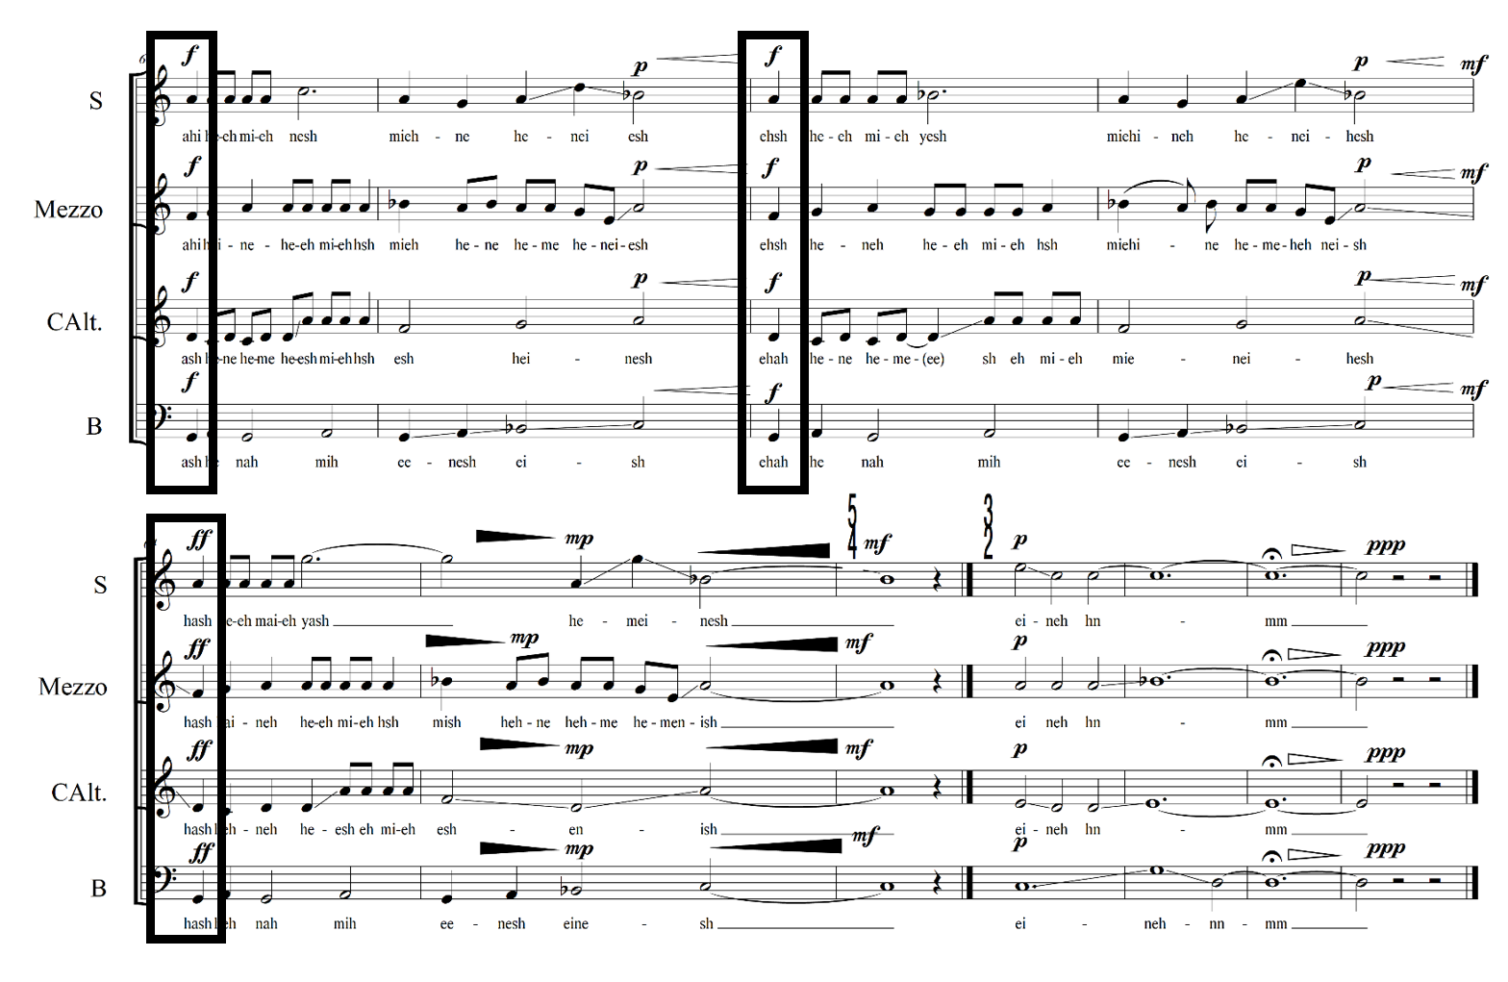
Figure 3.5 Phonetic combination to drive dynamics, mvt.1, mm. 60-70.

framework to understand the formal design of this movement as a musical narrative of a sequence of events that rely on both time and space. More specifically, his “reductive concept” of seeing musical form as “different manifestations of the single image” has been adopted and expanded in my pitch operation system. Once a single note (pivot note) is introduced, a pendulum swings from this fixed point to neighboring tones. The harmonies constantly swing based on a pivot note; such a successive harmonic progression is only derived from a single note as seen in Figure 3.6. For example, once the finalis of two melodic themes (d) is introduced, this becomes a fixed point and starts merging with other notes (f or a) creating an interval (d+f = 3rd) or a chord (d+f+a = triad/trichord, or it can be expanded to quarter/quintal and so on) and progresses sideways (f# or a#). All of these events can be reduced to a basic element – “one single image.” In the perspective of linear time, the formal design of Matins is a simple ternary, as presented A-B-A’. However, diverse dimensions that are achieved from multiple layers of rhythm, melody, and timbre demand a different perspective of seeing form in a spatial concept, rather than seeing as a diachronic succession of events that unfold through time. When we focus on the relationships between individual parts and the entire movement of Matins, we can perceive this movement as a spatial construct that makes the relationship of the individual parts to the whole apparent in a single image.
II. Lauds: Before Sunrise
The second movement, Lauds: Before Sunrise, also one of the morning services of the Divine Office, is written for string quartet and can be performed as a liturgy determined by a given time of day (dawn). This movement serves to evoke morning calmness for the listener.
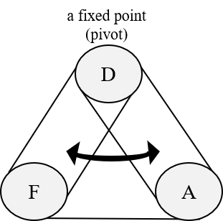

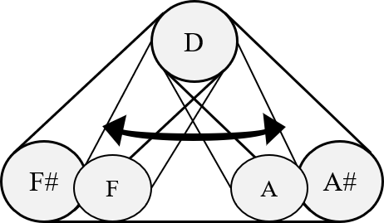
Figure 3.6 Pitch operation system for Matins.

Lauds is also conceived as an answer to the theoretical question that motivates the work as a whole: can absolute music be a sacred music without words? To answer this question, the pitch materials and the structure and style have been considered: the pitch materials are reminiscent of the church modes (see Figure 3.7) and the bow strokes mainly represent a syllabic setting of text (note:bow = 1:1) to reflect a style found in Gregorian chant. The structure of the movement has various types of refrains (answers to each antiphons) representing a scattered mind: for example, refrains are differentiated in rhythmic features reflecting a personal mindset of agreement (homorhythmic or consonant) or disagreement (polyrhythmic or dissonant) to the antiphons. The main theme (see Figure 3.7) can be divided into two subsets; 1) the first consisting of four notes F#-B-B-F# and 2) the second subset consisting of F#-E-E-F#. Those four-note groups are mirrored by the axis of B and by the axis of E respectively; this mirroring idea becomes one factor of the operation system of this movement as shown in Figure 3.8. These figures demonstrate the utilization of the theme (phrase A) and its developments in how the thematic phrases are applied in the entire piece by extending, subtracting, altering, or mirroring the entire thematic phrase or its segments.
Lauds begins with an introductory section (mm. 1-10) that is full of closely stacked notes. These clusters make it difficult for the audience to determine the quality of harmonies and to anticipate where they might go. It is also challenging to determine the pulses because of fermatas that are given before basic pulses are perceived (mm.1-2). These stacked notes with fermatas reflect the dark and cloudy sky at dawn. They also illustrate chaos, within the worshipper’s mind. I wanted to find a way of connecting the nature scene at dawn with musical elements such as harmony, rhythm, timbre, or still gestures to illustrate people who prepare their distracted minds for participation in the early morning service.
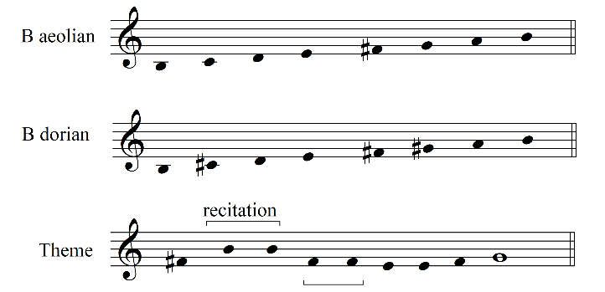
Figure 3.7 Pitch materials for Lauds.

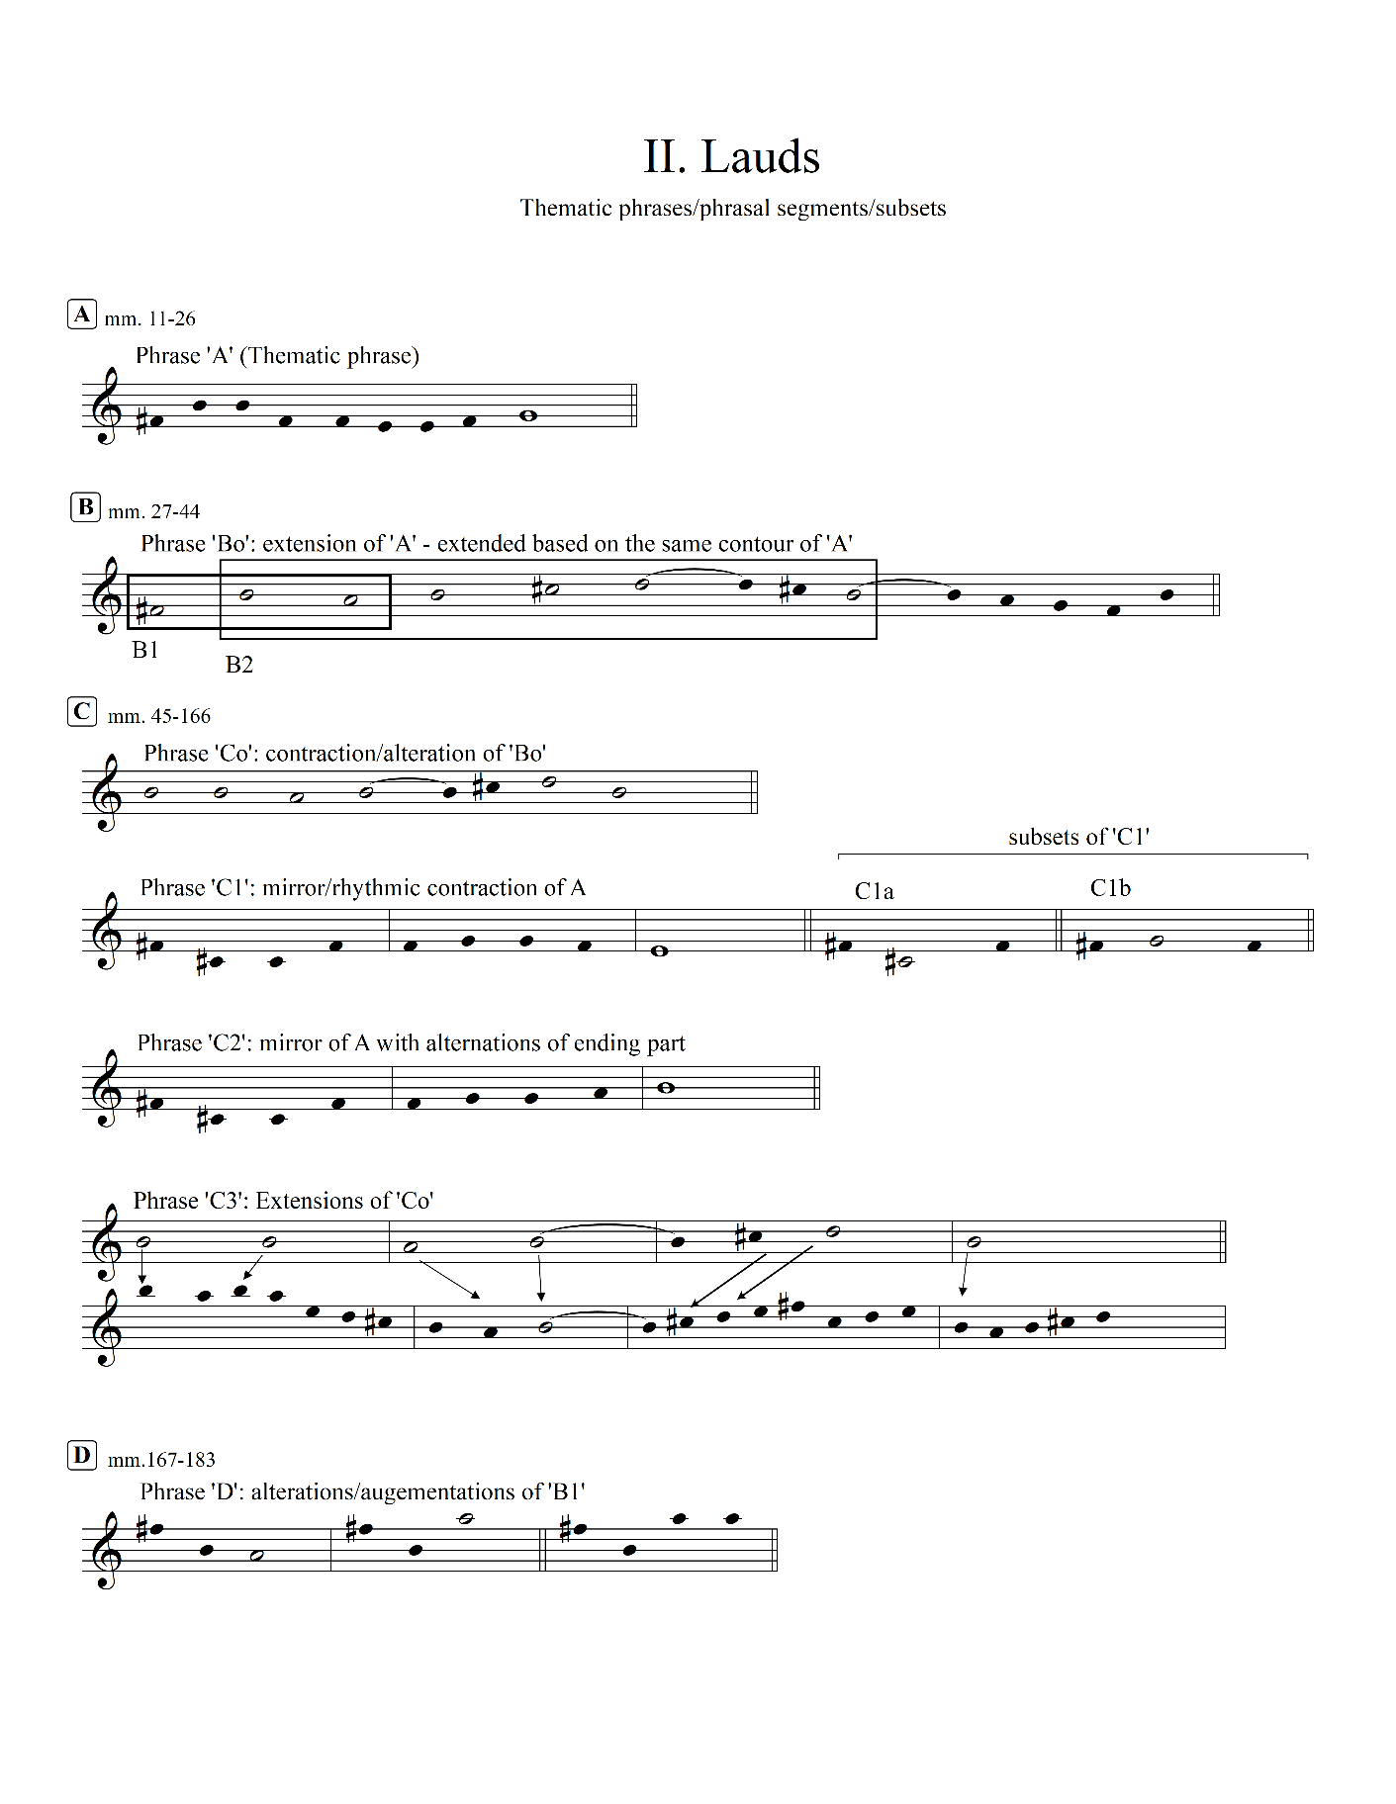
Figure 3.8 Formal design of Lauds.
After the opening section, the thematic phrase A is presented by violist (mm. 11-12). The violist becomes the cantor for section A (mm. 10-20) by leading an antiphon (phrase A). This antiphon is considered as a superset that is developed in subsequent sections by its contractions, extensions, augmentations, or alterations. Section A ends with the homorhythmic refrain (mm. 24-26). This homorhythmic refrain, which evokes an image of a congregation trying to adjust their mind to God.
Each section starts with an antiphon and ends with various types of refrains. Since refrains illustrate the answers from the congregation, these may be varied to portray various mindsets of people. For example, I might sometimes agree with the message from the priest but sometimes I might not. The agreement is expressed in music with homorhythms or consonances while the disagreement is expressed with polyrhythms or dissonances. Double bar lines and the finalis with fermatas in the score help us to recognize the distinctions between antiphons, refrains, and sections.
Section B starts with a new cantor, cello, with the phrase B⁰ (mm. 27-30). The phrase B⁰ is an extension of phrase A and ends with a refrain that eventually arrives at the homorhythmic passage (mm. 40-44). The expressive text ‘questioning of suspicious minds’ in this refrain (m. 40) explains why the refrains slowly but eventually align rhythmically. This text illustrates that some people in the congregation who may not initially agree with the message of the sermon and keep questioning themselves to seek the truth; as such, they are delayed in responding to the antiphon.
Section C starts in measure 45 with phrase C⁰ which is a contraction of phrase B⁰ presented by the first violin. This section also uses mirrored figures of the superset that are sometimes contracted, extended, or altered as shown in phrases C¹, C², and C³. The superset is modified by subtracting or augmenting its note values or phrase lengths as shown in subsets C^{1a} and C^{1b}. This section portrays the moment of dawn by increasing the tension through polyrhythmic movements of strings and ends on measure 136.
Section D begins with the entire string quartet presenting phrase D, an alteration of B¹. Bartok pizzicato is used for the first time to sonically illustrate sunlight projecting through the dark and cloudy sky. This section is seamlessly connected to the last refrain in measure 181 where the expressive text “morning sun rises” is included and the last chord resolves the stacked tension.
The pitch materials basically employ church modes (B aeolian and B dorian), so vertical sonorities rely on the horizontal and contrapuntal movements of each layer. These melodic fragments generate the modal harmony. A second operational system related to the harmonic structure relies on extended quintal or quartal harmonies based on the pitch center B that makes a heterogeneous sonority; it is closed to extended tonality, and thus has a different nature than modality.
The formal design is basically divided into four sections (A-B-C-D, see Fig.3.8); however, all four sections are originally derived from one section, a superset. Thus, the overall structure could also be considered simply, A-A¹-A²- A³: this structure conforms with Bonds’ perception of form that “rests on a growing sense of linear time in music,” a concept he applied to interpreting Mattheson’s work:
Mattheson ignores the text entirely and focuses solely on the music, with special attention to the disposition – the ordering – of the musical ideas; the reductive concept of form as a series of more or less predictable events – that is noteworthy [...] Mattheson’s account of the structure of an aria [...] describes a series of moves comparable to a set of directions one might give a traveler moving from a starting point to a destination.[...] This descriptive, directional method of representing musical form, as we will see, would predominate throughout the nineteenth century and into the early twentieth.

Bonds’ understanding of how we perceive a form as a growing entity can even be applied to contemporary pieces such as minimal music that implements reiteration of smaller units of musical phrases, or such as Arvo Pärt’s music, specifically in Tabula Rasa (1977), which gradually expands one simple element. Bond’s conceptualization of form as a series of events is a useful analytic frame for understating Lauds’ formal design.
III. Prime: Mourning Morning: Who- who, Who- who.
Prime is the third service (6 a.m.) of the daily Office, primarily focusing on preparation for a new day’s work, at which believers thank God for giving them safety during the night and praise Him before starting the day. Thus, this movement, through its instrumentation, is designed to represent a sonic relation to God and also a sonic reflection during the early morning. In this movement, the vibraphone plays a metaphorical role using a pitch-bending technique that represents the cooing sound of a dove – the symbol of the Holy Spirit. This movement includes a personal meditation process as its content. The first part of the subtitle “Mourning Morning” captures a scene from my window in the early morning when a mourning dove came and mourned (cooed); the second part “Who- who, Who- who” is my translation of a dove’s calling. These words are a double question: me asking myself, “who are you? are you a trustful disciple?” and Jesus asking me, “who are you? – I don’t know you” from the parable of the wise and foolish virgins in the book of Matthew, Chapter 25:
1. At that time the kingdom of heaven will be like ten virgins who took their lamps and went out to meet the bridegroom.
2. Five of them were foolish and five were wise.
3. The foolish ones took their lamps but did not take any oil with them.
4. The wise, however, took oil in jars along with their lamps.
5. The bridegroom was a long time in coming, and they all became drowsy and fell asleep.
6. At midnight the cry rang out: “Here’s the bridegroom! Come out to meet him!”
7. Then all the virgins woke up and trimmed their lamps.
8. The foolish ones said to the wise, “Give us some of your oil; our lamps are going out.”
9. “No,” they replied, ‘there may not be enough for both us and you. Instead, go to those who sell oil and buy some for yourselves.’
10. But while they were on their way to buy the oil, the bridegroom arrived. The virgins who were ready went in with him to the wedding banquet. And the door was shut.
11. Later the others also came. “Sir! Sir!” they said. “Open the door for us!”
12. But he replied, “I tell you the truth, I don’t know you.”

The last verse “I tell you the truth, I don’t know you” kept echoing in my mind; therefore, I chose to meditate on this verse through my composition process.
This movement is written for the two voices (Soprano and Contralto), string quartet, and one percussionist (vibraphone). The vibraphone is the cantor who opens this movement with a characteristic pitch bending sound described below. There are several extended techniques applied to illustrate the dove’s coo: pitch bending, bowing, and bowing harmonics. Figure 3.9 exemplifies how to bend the pitch by stroking the bar with a yarn-wrapped mallet in the opening section of Prime (mm.1-5). Pitch bending becomes a timbral theme that is used throughout the entire movement. Another timbral theme can be found in the strings, especially in the use of extended techniques of the cello. To effectively illustrate the mourning dove’s non-vocal signal, the rapid flapping action of dove’s wings that is known as “wing whistle (see Figure 3.10),” I

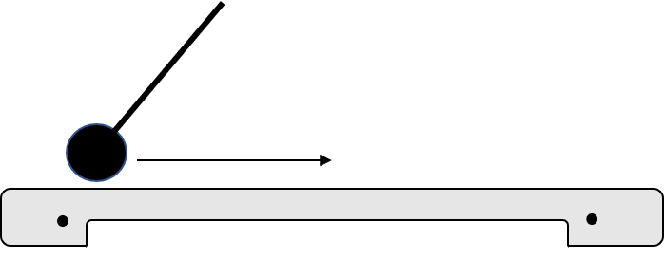
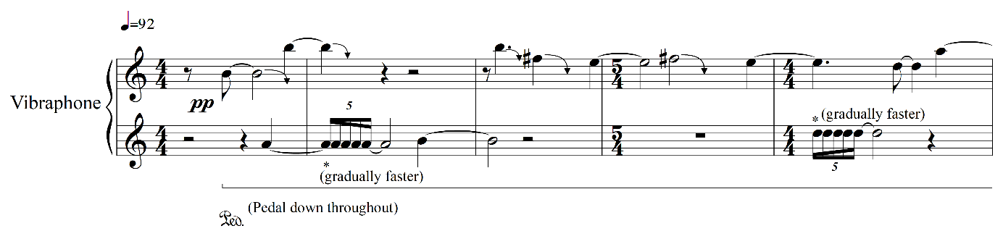
Figure 3.9 Pitch bending technique and its application, mvt.3, mm.1-5.

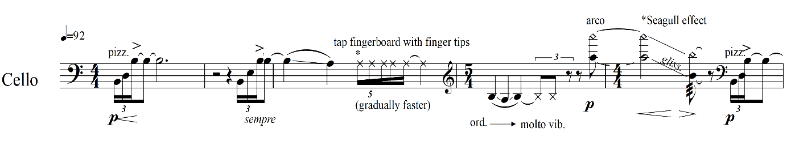

Figure 3.10. Extended techniques for mimicking a “wing whistle”

combined extended string techniques with rhythms that gradually go faster: the artificial harmonics with rapid glissando (representing a seagull effect) and finger tapping are also used to mimic the mourning dove’s screeching noise, as when it flaps its wings while landing or taking off.
The phonetic combination for Prime is more complex than in the other movements in
terms of the subtle differences between consonants since this movement relies on timbral themes. For example, I start each phrase with either “d/t” or “g/k” and progress to “b/v” or “n/m” respectively regardless of the direction. The starting sounds, both “d/t” and “g/k,” are stop consonants, i.e., the sound is produced by blocking the air flow and releasing it. The sounds “d” and “g” are used for the phrases combined with soft dynamics and are referred to as “voiced stop.” The sounds “t” and “k” are allocated in the louder phrases; these sounds are referred to as “voiceless stops” since they include more tension (see Figure 3.11). The timbral possibilities of these phonetic choices are reinforced by the contemporary instrumental techniques (e.g., pitch bending) being combined with other musical elements such as dynamics, rhythms, and vocal techniques.
IV. Terce: Down to the Dark, V. Sext: Lead Us Not into Temptation, and VI. None: Last Things
Prime, Terce, Sext, and None are known as the “little hours” and originally had identical structures, including musical elements such as a hymn, versicle (a short verse sung by the church leader), response, and psalms with an antiphon followed by a short responsory (a responsorial meditation chant). Terce is associated with the Holy Spirit, which “will deign to fill out hearts

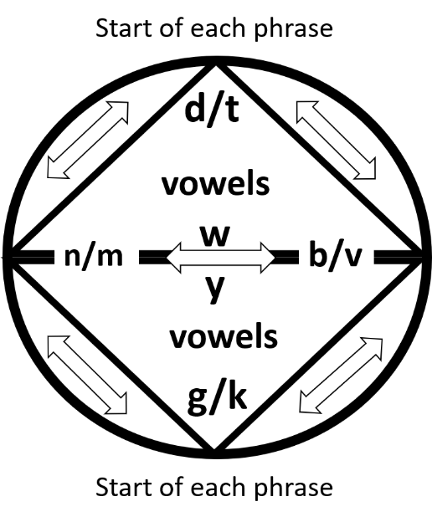

Figure 3.11. Phonetic palette for Prime.

at the same hour by virtue of Christ’ crucifixion;” thus the subtitle Down to the Dark indicates the descent of Jesus and the Holy Spirit to the (dark and sinful) world. In my composition, III. Prime ends with a single note, f, and this finalis becomes a pitch center for the following three movements: Terce, Sext, and None. These three movements are performed in succession (attacca), sharing identical pitch material based upon a hymn “Nunc, Sancte, nobis, Spiritus,” which was used for Ordinary Sunday at Terce. I have adopted the melody from the Liber Usualis (see Figure 3.12).
The Liber Usualis (LU) includes Offices, hours of prayer, as well as the chants for Masses and for major feast days of the temporal and sanctoral cycles in the Roman Catholic Church. The LU provides bountiful musical sources, from the phrase structures – such as psalm tone formulae, recitation formulae, tones for the psalms, and hymns – to liturgical structures following hourly, daily, and yearly cycles.
The cycle of liturgy found in the LU transformed my perspective from seeing ‘my time’ into ‘God’s time’: ‘Chronos’ to ‘Kairos’. We live in a sequential and chronological time (Chronos) and the music, in general, follows linear time. However, I wanted to involve a spiritual and surrealistic moment by containing several perceptions of time at once: a lunar cycle (day), solar cycle (year/seasons/Christian year), my time (moment), and God’s time (permanent).
For example, each movement can be performed separately as a liturgy following the canonical hour (day). In the case of three movements in succession, Terce, Sext, and None can be performed as a separate liturgy as a morning Office, but these three movements should be

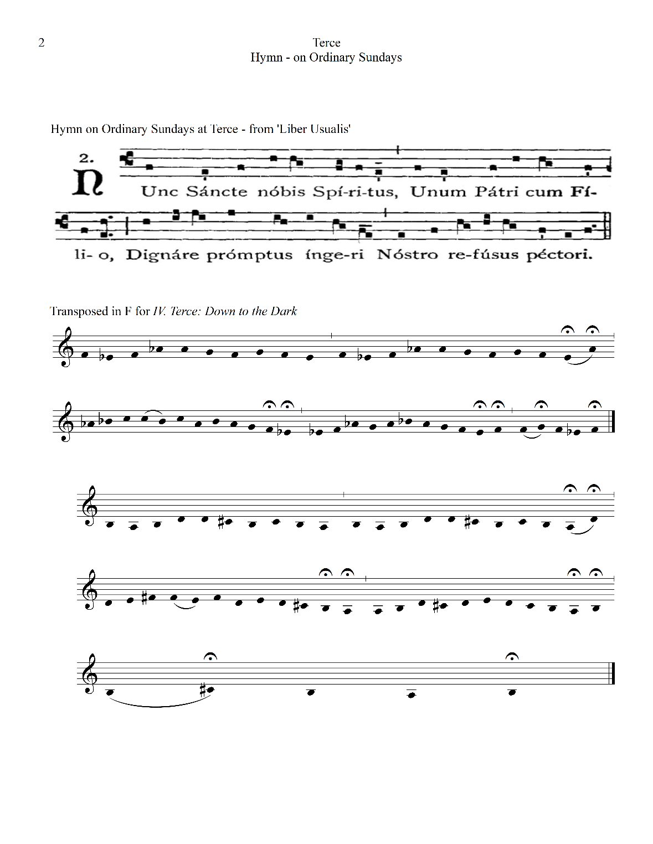
Figure 3.12. Hymn used as a theme for three of the little hours; Terce, Sext, and None.

performed as one since they belong together (attacca). At the morning Office, especially at Terce, we meditate on Christ’s crucifixion since Jesus was sentenced to death at the same hour according to Mark (Mark 15:25, NIV). This theme parallels that of a Passion in Christian music. Liturgically, a Passion is a musical setting of the story of Jesus that was intended to be performed during Holy Week (the week before Easter in the Christian year) as a part of church services. Thus, the theme includes both a specific event in the Christian calendar as well as a daily reflection on that event. This theme is musically translated through the use of instrumentation, phonetic palette, pitch plan, instrumental techniques, and textures.
Ironically, the instrumentation of these “little hours” includes the maximum number of performers: a choir (soprano/alto/contralto/bass), string ensemble (violins I/II, viola, cello, and double bass), and two percussionists (marimba, tubular bells, glockenspiel, and bass drum) – for a total of 11 performers. This change in number of performers correlates to Bible passages that become more tense and arduous during these three hours: Terce is the hour of prayers to God about Jesus’ suffering, because according to Mark, “It was nine in the morning when they crucified him,” (Mark 15:25, NIV). He was sentenced to death and then beaten and tied to a column by Pilate. The next office hour, Sext (12 noon), also corresponds with the particular time that Christ was persecuted. William Durand (c. 1230-1296), the most renowned French liturgical scholar of the later Middle Ages explains:
At the hour of Sext, Christ was pierced with nails and crucified for us, which is why darkness fell over the whole world, so that the sun, in mourning the death of its Lord, could conceal itself, as if wearing black vestments, so that those who crucified Him would not be given its light. Also, at this hour, on the day of the Ascension, He reclined at table with the disciples. Therefore, the Church fittingly delivers praises to God, giving thanks to Him.

Based on Durand’s description, the fifth movement, Sext, has the subtitle “Lead Us Not Into Temptation,” a verse from the Lord’s prayer: “Lead us not into temptation, but deliver us
from the evil one” (Matthew 6:13). I was thinking of His sacrifice and imagining the scene full of the cries from the “faithful people,” according to Matthew, the Jews who led Jesus to his death sentence. The imagined sonic expression of the shouts of the Jews, the repressed wails of the disciples, the rowdy crowd, and the silenced pain of Jesus are reflected in the phonetic combinations. For these sounds, I compared the sound of curse words between English and Korean. Most cursing is accomplished with very short words that show anger, dissatisfaction, frustration, or, to the contrary, great pleasure. The writer Rob Chirico, who observed the use of swearing in literature, music, and our daily lives, said: “even where used, such displays are autocathartic: the (unconscious) intention is to display a particular attitude or degree of feeling to oneself and anyone who happens to be in earshot.” Thus, I tried to find adequate phonetic combinations to demonstrate the people in the scene Matthew describes – an excited mob, the angry Jews. I selected short words that consist of one to two syllables, that include explosive consonants (stop consonants) and build up pressure by blocking air as it flows from the mouth. I separated the phonetic palettes into four divisions (see Figure 3.13) so that each palette consists of different phonetic combinations.
The Jews/Crowds’ palette includes unvoiced fricative consonant sounds while
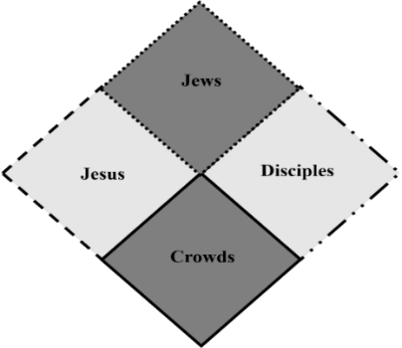
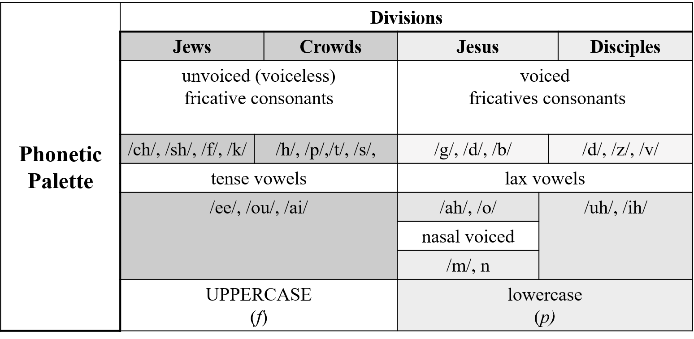
Figure 3.13. Phonetic palette for IV. Terce.

Jesus/Disciples’ palette relies on lax vowels. Lax vowels are produced with less tongue tension or relatively little constriction of the vocal tract. These vowels illustrate the lack of energy that is left in His body to make any sound. I divided phonetic combinations into four divisions by the characters; however, each pair of two groups shares the phonetic combinations based upon the
characteristics: Jews/Crowds versus Jesus/Disciples.
By separating Jews and Crowds in one division and Jesus and Disciples in another, each palette creates a characteristic sound (timbral theme), and the rhythmic elements and instrumentation propel the musical narrative forward. For example, in the opening section of Terce, the bowed marimba begins with a soft dynamic (pp), and the glissando clusters from the string quartet provide a timbral theme that has no specified pitch (see Figure 3.14).
The words used in the first phrase, “va-ih” and “vai-h” are the combination of voiced fricatives and lax vowels and come from the palette of Jesus and Disciples. This phrase immediately finds opposition in the rhythmical second phrase, starting at forte in measure 12, that consists of unvoiced fricative consonants, the palette of the Jews and Crowds. I also assigned uppercase letters for the Jews/Crowds group and lowercase letters to Jesus and his disciples to further visually express dynamics, treating the characters as musical symbols that have a degree of loudness and softness. Since the use of only two dynamic degrees by way of distinction is by its nature limiting, I added hairpins for subtle control.
While the musical narrative is developed through instrumentation and dynamics, pitch centricity (pitch axis) slowly moves from F and, G, and finally arrives at G# at the end of the Sext movement. Here, new harmonic materials are introduced, which I have named “Trinity

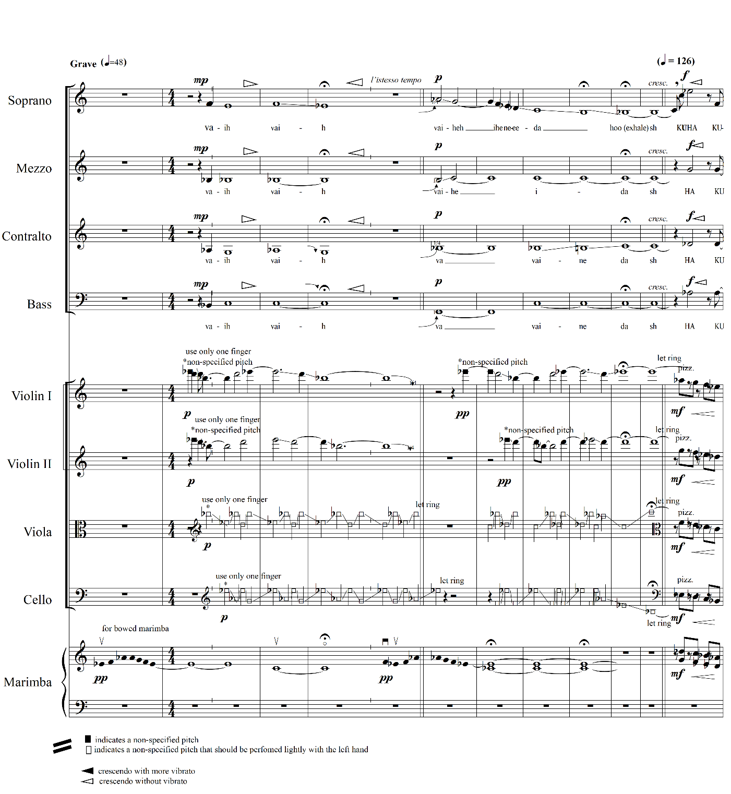

Figure 3.14. Timbral themes, mvt 4., mm.1-13.

harmonies.” Since these symmetrical chords divide an octave equally in three, they are used as a symbol of the Holy Trinity, three in one. Trinity harmonies are constructed using a G melodic minor scale (see Figure 3.15) and result in another scale, B melodic minor. Thus, pitch materials
become bountiful: G and B melodic minor scales, as well as two church modes, B aeolian and B dorian. The other harmonic materials introduced I refer to as “Cross harmonies,” since these literally mold the cross figure seen in Figure 3.16.
The harmonic possibilities rely on the cross figure, specifically two resulting rectangles (harmonic cells): A#-F#-E-C and D#-G-A-C#. These two sets of chords, a vertical construction, also can be utilized as horizontal structure, a melody of melodic cells.
The last Office of the little hours, None (3 p.m.), Christ gave up His spirit (Matthew 27:46) and wished to die for us. As Durand explains:
For He wished to die for us at the very hour when man was expelled from Paradise [...] At the same hour, the soldier pierced the side of Christ, from which flowed the two sacraments which the soldier drew for us for our salvation: namely, the water of Baptism and the Blood of our redemption.

The subtitle Last Things captures the last moment of Jesus on the cross; thus, in this movement, cross harmonies gradually become dominant. This movement still employs the same thematic hymn as used in Terce, “Nunc, Sancte, nobis, Spiritus,” (see Fig.3.12), but in transposition, G# aeolian, as the pitch axis shifts from F to G# (see Figure 3.17).
None includes the most percussion instruments including glockenspiel, bass drum, marimba, and tubular bells. The instrumentation is symbolic. For example, the marimba symbolizes both crowds and disciples by alternating between bow and yarn mallet. The strings illustrate the soldier who pierces Jesus and Jesus himself being pierced by means of alternating

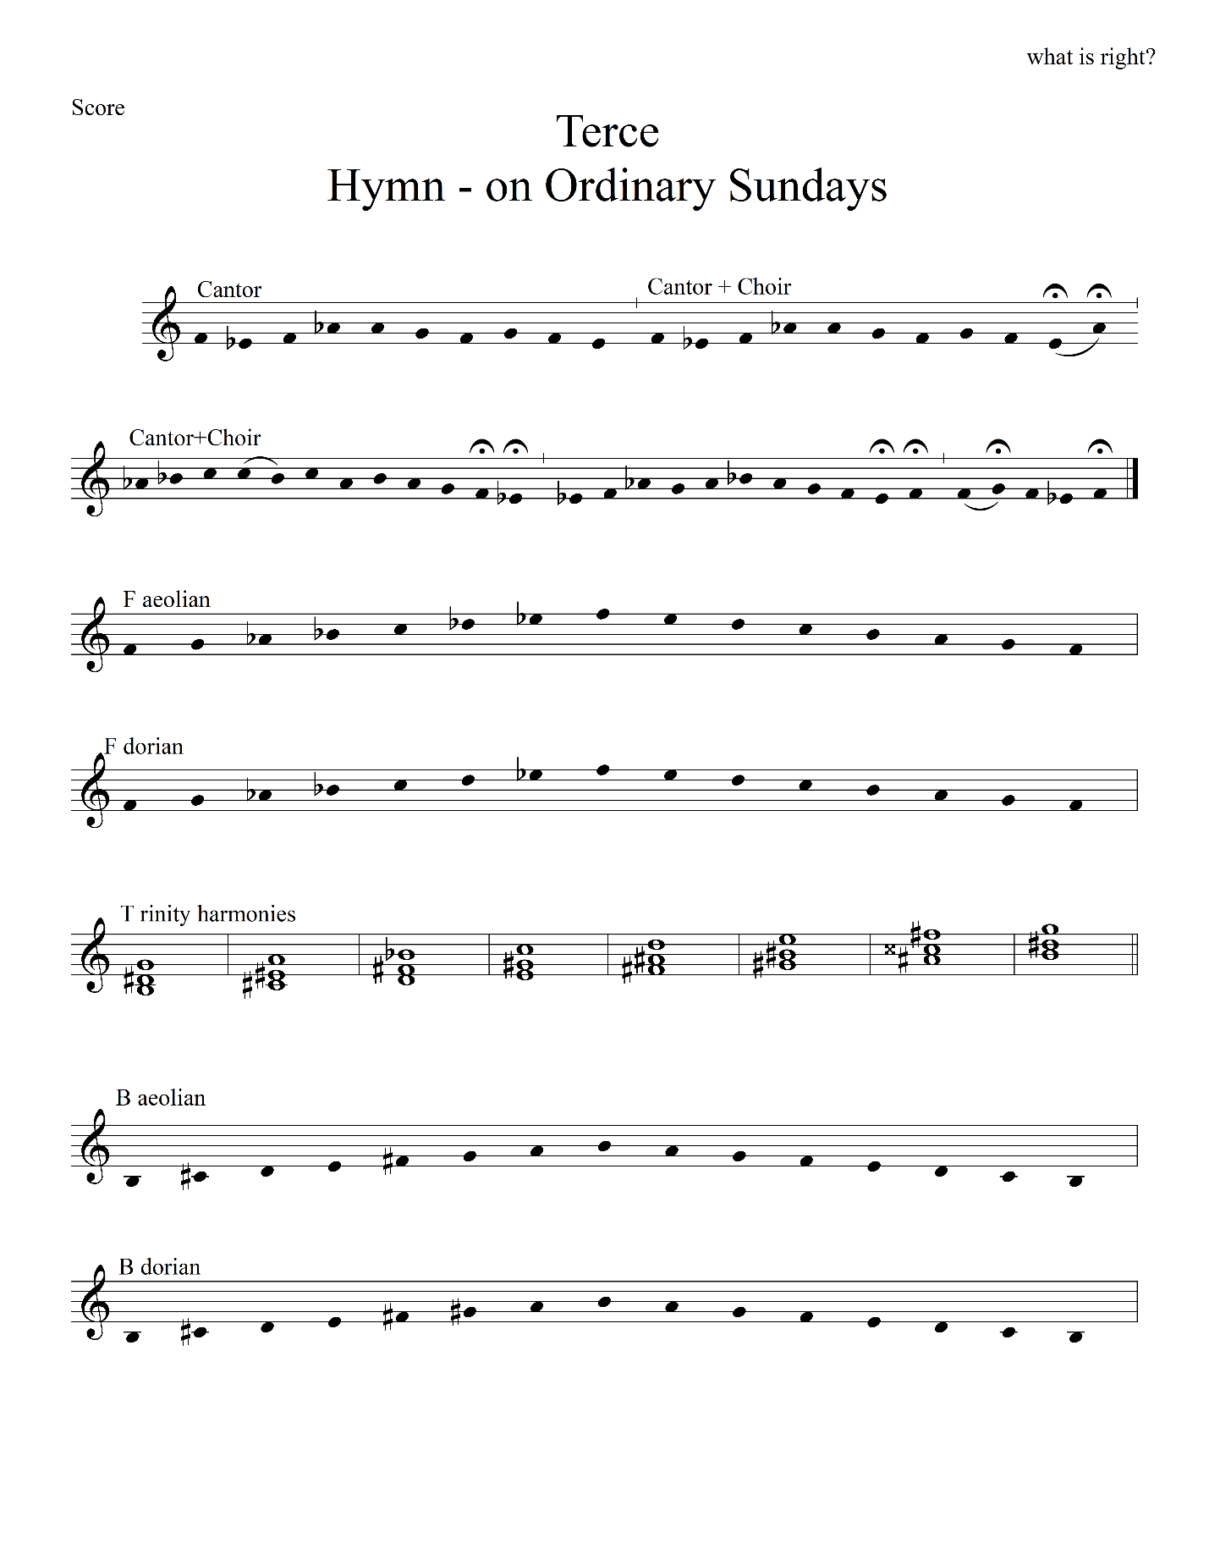

Figure 3.15. Pitch materials for three little hours (1): Trinity harmony.
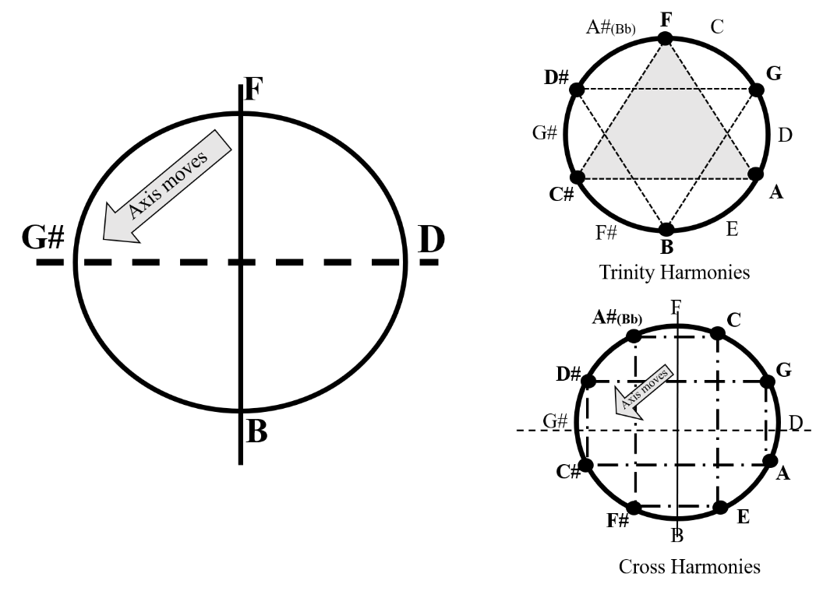

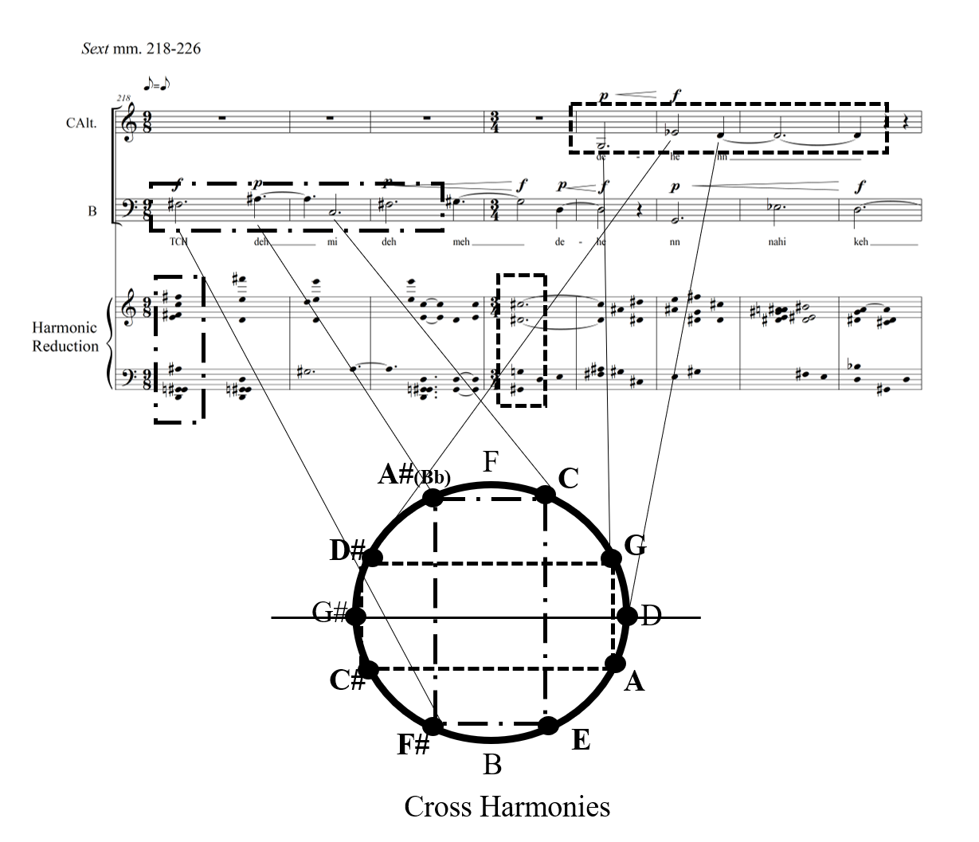

Figure 3.16. Pitch materials for three little hours (2): Pitch axis, Trinity harmony, and Cross harmony.

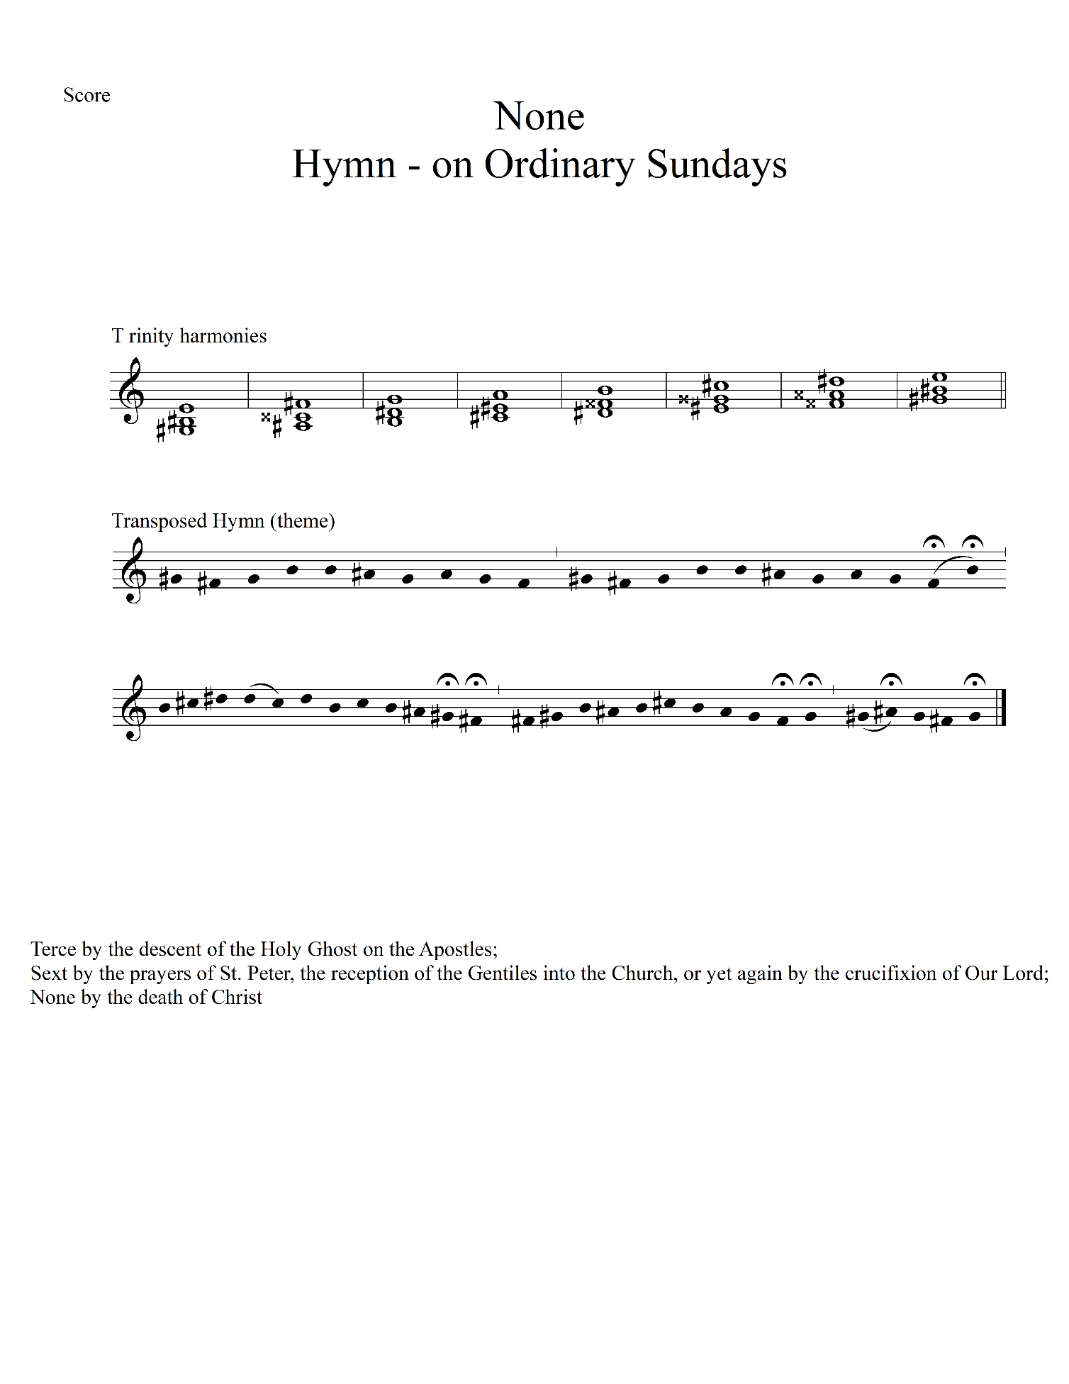

Figure 3.17. Pitch materials for three of the little hours (3): Hymn

string techniques between marcato (Ital. ‘marked,’ forcefully) and flautando (Ital. ‘flute-like,’ lightly). The glockenspiel is used as a sonic symbol for scattering the blood of Jesus. The bass drum is used for depicting the crucifixion scene when the earth shook, and the rocks split (Matthew 27:51), by both its sound and the physical vibration that occurs when it is played.
Another notable use of percussion used in Terce, Sext, and None is that of the marimba and tubular bells. For example, the marimba mainly provides rhythmic drive and helps illustrate the people in the dark (“dark” as it refers to the subtitle Down to the Dark) and their darkened souls and blackened eyes so as ‘they do not know what they are doing’ (Luke 23:34) as seen in Figure 3.18. The tubular bells literally signal the time that the Office starts: they play twelve attacks for noon (see the rhythmic reduction in Figure. 3.18). The interval between these attacks increases, leading to tension in the music and in the listeners as they realize and anticipate that a final bell will be tolled.
The use of texture is also symbolic in this movement. None, the hour of “crying out,” includes a vocal ensemble that is mostly divided into two groups to demonstrate the communal emotional state of crowds, the fear of followers and the fear of the Jews – the fear that drives an innocent one to the death. Both of the parties cry out together which is depicted in the music through homophonic and homorhythmic texture.
VII. Vespers: White as Snow
At the hour of Vespers (sunset), Christ was lowered from the cross. Also, this hour is the same hour, the supper hour, when He had washed His disciples’ feet and administered the first communion, the sacrament of His Body and Blood (Matthew 26:26-29). Therefore, the Church

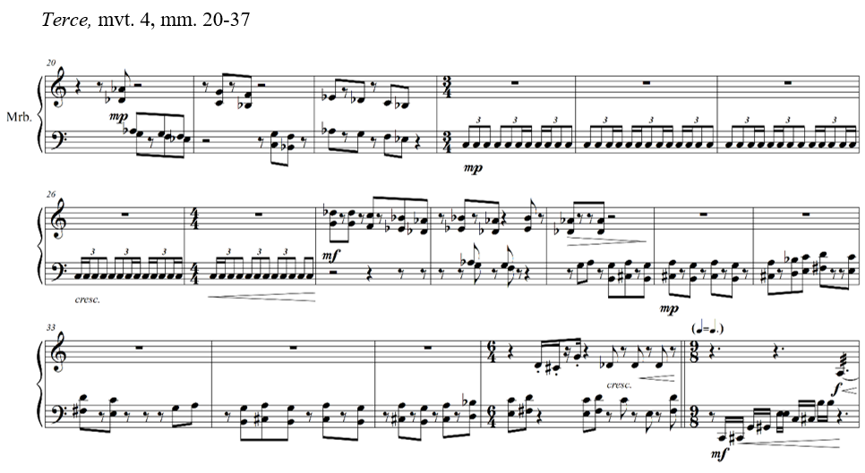
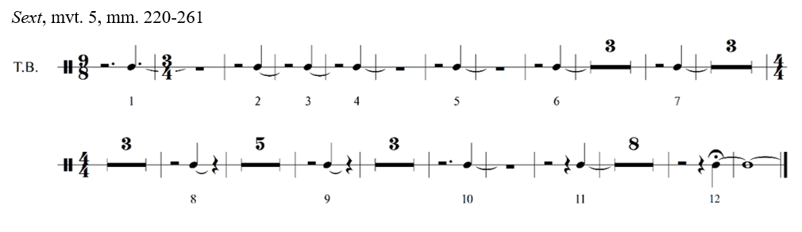
Figure 3.18. The use of percussions for Terce, mvt. 4, mm. 20-37, and Sext, mvt. 5, mm. 220-261.

gives thanks to Christ at this hour. The seventh movement Vespers: White as Snow accordingly involves this gratitude. This movement relies on three thematic elements to deliver the musical narrative: 1) a hymn used for Sunday Vespers adopted from LU (see Figure 3.19) transposed to B mixolydian (see Figure 3.20), 2) a harmonic operation that sonically describes glittering snowflakes under the moonlight, and 3) a rhythmic operation that illustrates perpetual motion. The perpetual motion has a double meaning – a symbol of God’s eternal grace and a depiction of the scenery on a snowy night, specifically the night view from my window while I was working on this piece during Christmas of 2020.
This movement utilizes the string quartet and full choir and maximizes the elements of “program music” that illuminate the spirit of this evening hour at Christmas: sonic interpretation of Mother Nature (fluttering snow, tranquil wind, and sluggish clouds), colors (glittering moon, orange sky, and the glow of the streetlamp), and the imitation of sounds such as footsteps and exclamations to the wonder of nature.
To illustrate these events, I devised a pitch operation system that allows me to have pitch-metamorphoses not unlike those found in György Ligeti’s ‘String Quartet No. 1, “Métamorphoses Nocturnes” (1953-1954) which expands on the chromatic scale and constantly transforms it. My system starts with a fixed note. Figure 3.21 shows the first four measures of Vespers in which the second violin presents B-D-B and B-D#B in succession. The two diagrams in Figure 3.21 show how these first suggested pitch materials can expand from the axis and Figure 3.22 shows the modifications of this system. The pivot note can move as a single note or by groupings of two or more notes. In this pitch operation system, the more a pendulum swings, the more possibilities of harmonic expansion can be achieved, and this is reflected in the form. The formal design itself is the trajectory of the pendulum. Once the fixed note is presented, it

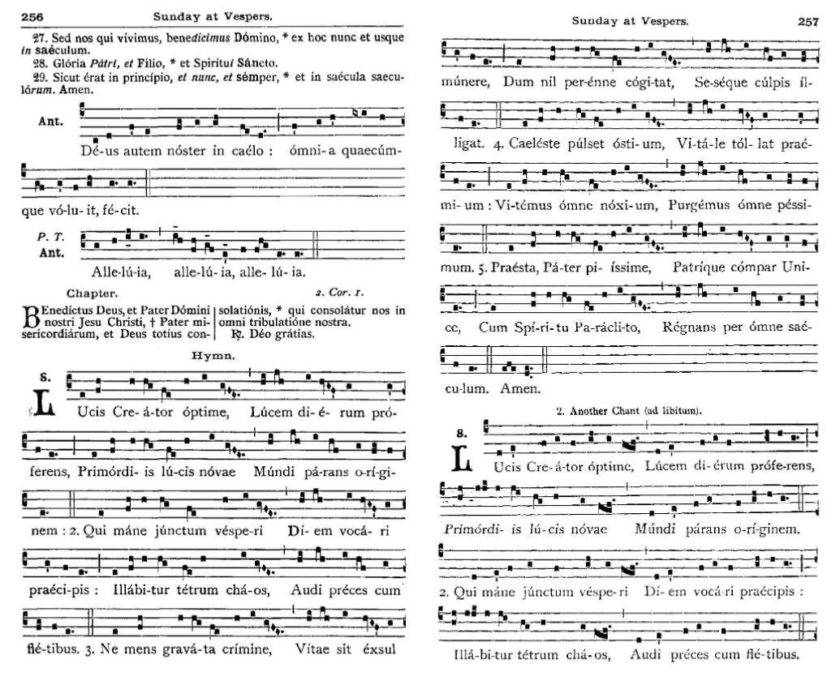

Figure 3.19 Hymn from Sunday at Vespers

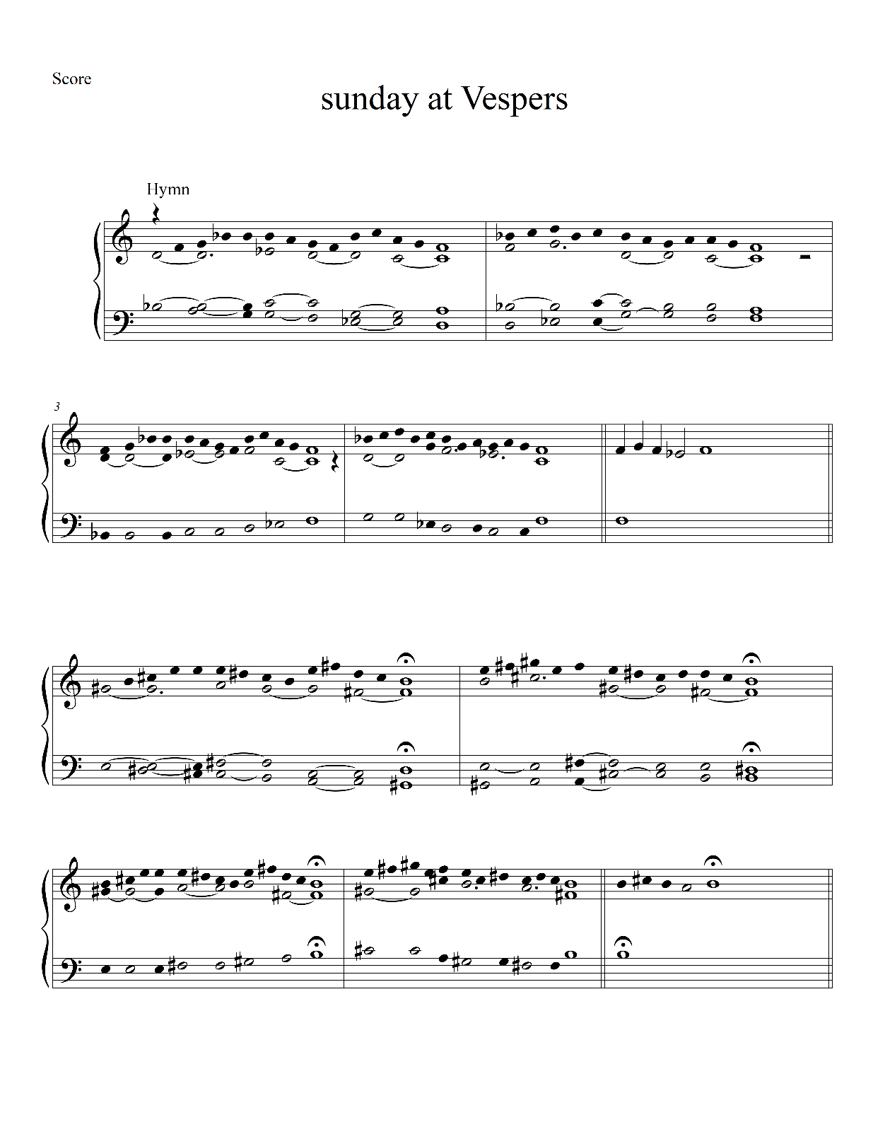
Figure 3.20 Transposition of Hymn from Sunday Vespers

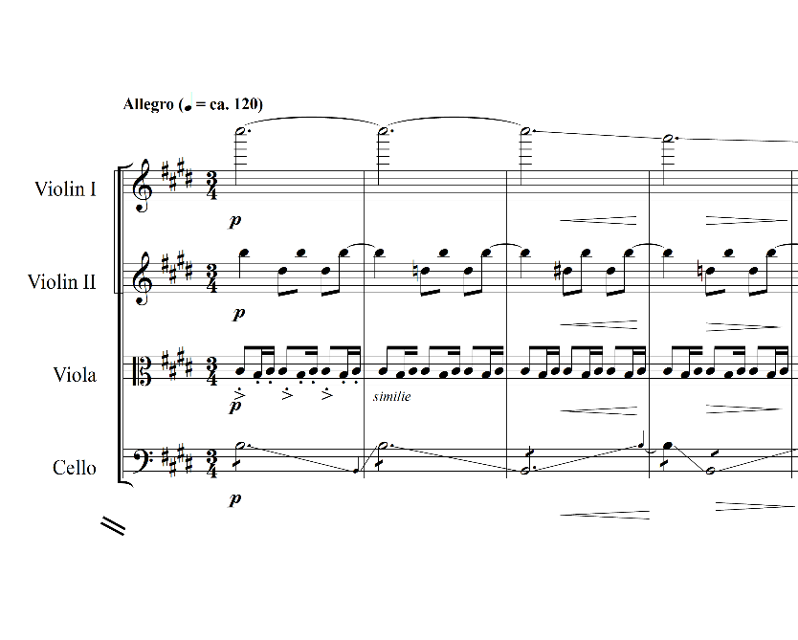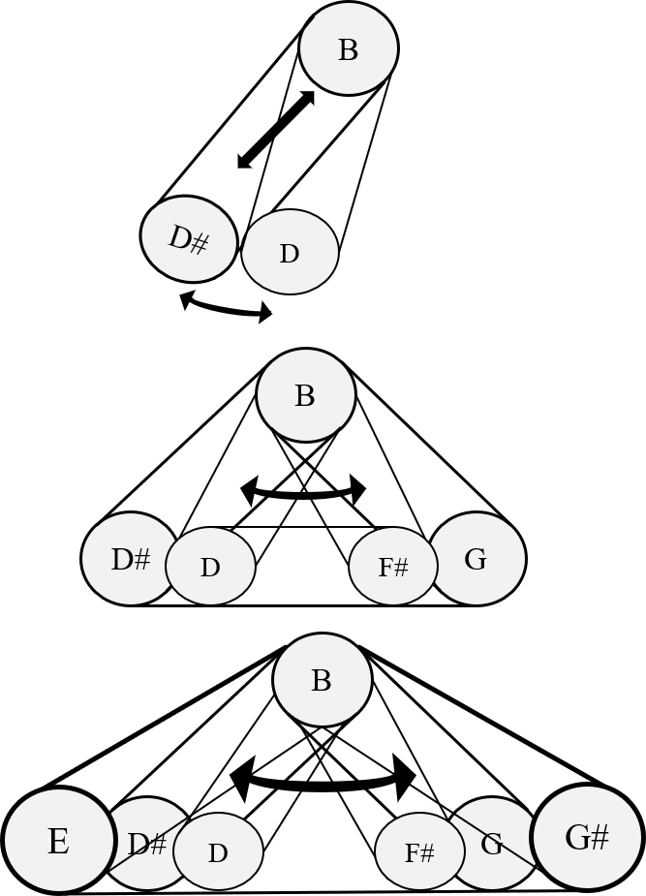
Figure 3.21 Harmonic operation – pendulum (1)

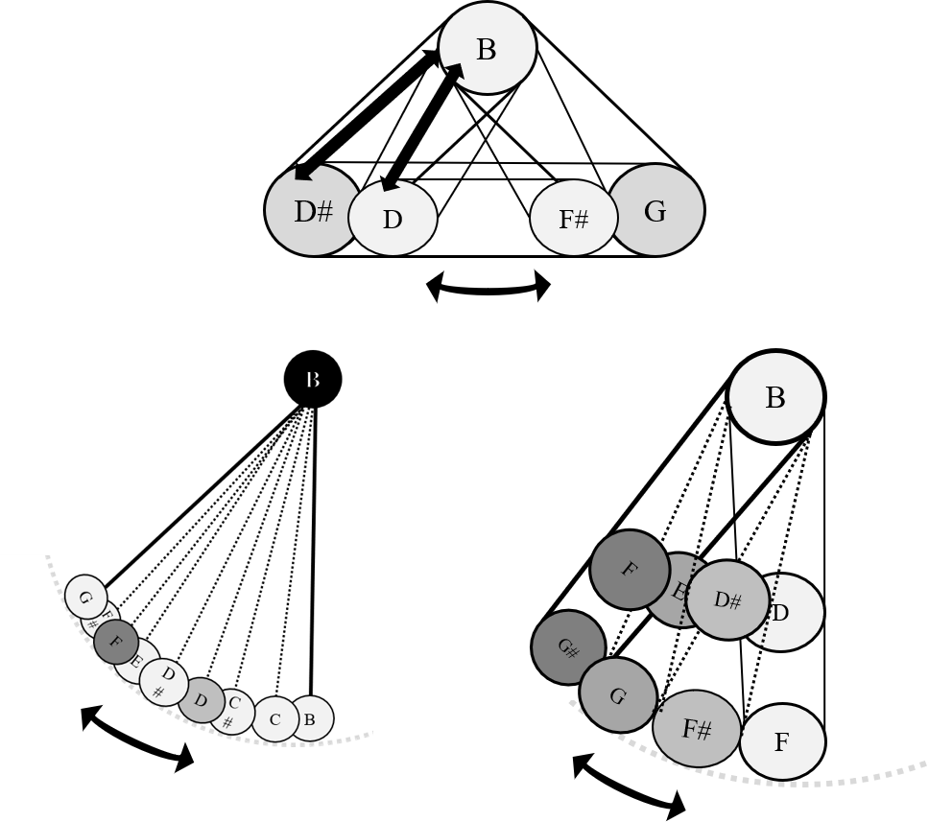
Figure 3.22 Harmonic operation – pendulum (2)
continues to develop and becomes phrases, sections, and the ultimately entire piece. The form itself is an extension of one single note.
The registral and rhythmic operations in this movement include metaphoric images of a scene of a snowy night. For example, the first violin opens Vespers on C7. The high tessitura of this note is illustrative of being very high in the sky where the snow starts its journey. The viola is situated between C3 and C4, which calls to mind the sound of snow piling up on the ground. The second violin, played in the range between C5 and C6, represents the glittering snowflakes from the sky; they are still high but are close enough for one to see them. Finally, the cello explores the register between B2 and B4 and shifts octaves through continual glissando. This perpetual glissando adds timbral continuity and sonically reflects shooting stars. This concept of continuity is one that evokes God’s endless love and grace upon us and this subject is reflected in the formal design. If the listener can capture only one moment of Vespers, that moment is still
presenting the same image of the entire movement. Since the form is nested in cyclical time, one single image creates an entire unity – the whole is the sum of every moment.
VIII. Compline-Epilogue: Homeland – To Where We Belong
Compline is the evening prayer, the final service of the Office. It celebrates, “in memory of eternal joy,” the end of the day and signifies the end of this present life. This subject of “eternity” is illustrated in the last movement, Homeland – To Where We Belong, especially in the operation systems of words, rhythm, pulse, and harmony.
In consideration of the hour (approximately 7 p.m.), the thematic ‘short-long-short-long’ rhythmic pattern, which represented fireflies and was used in the Prologue, returns and is developed by being positioned in the foreground. Two violins clearly present this thematic rhythmic pattern. My observation of fireflies which are active in early night serves as the inspiration for the rhythmic content in this piece. The fact that fireflies are active in early evening is supported by David Hall’s research on fireflies’ light emission. A firefly emits different amounts of light and diversity of colors according to the time of day; high contrast shows that fireflies are active early in the evening. Thus, my rhythmic fireflies in Compline-Epilogue (7 p.m.) are more active and dominant than in the Prologue (preceding 2 a.m.). Another scene that I tried to portray rhythmically is that of synchronous fireflies, a unique species that exists only in a few limited places, of which The Great Smoky Mountains National Park is one. I used rhythmic and syllabic patterns as models for this movement. For example, the two syllables “le” and “ieh,” generate a natural short-long pattern. As a result, each syllable is assigned an eighth note (bass and contralto) or a quarter note (alto) respectively as shown in Figure 3.23. The bass begins this piece with “le,” a part of the first word “le-ieh-(eh)” and the entire word is completed as the layers move across the choir: the contralto and bass are in charge of a short pattern, the soprano and alto are responsible for a long pattern, and both together create one single image of the rhythmic fireflies. The soprano’s “eh,” assigned a tied sixteenth-quarter note value, is an echo of the whole words “le-ieh,” so the performers should produce this echo with no attack. The glissando tail (“eh-sh” in measure 2, see Figure 3.23, soprano), represents the afterimage of the previous attack, similar to the latent image of fireflies’ light emission. The glissando tail can be understood as a sonic representation of this as well. At the end of this

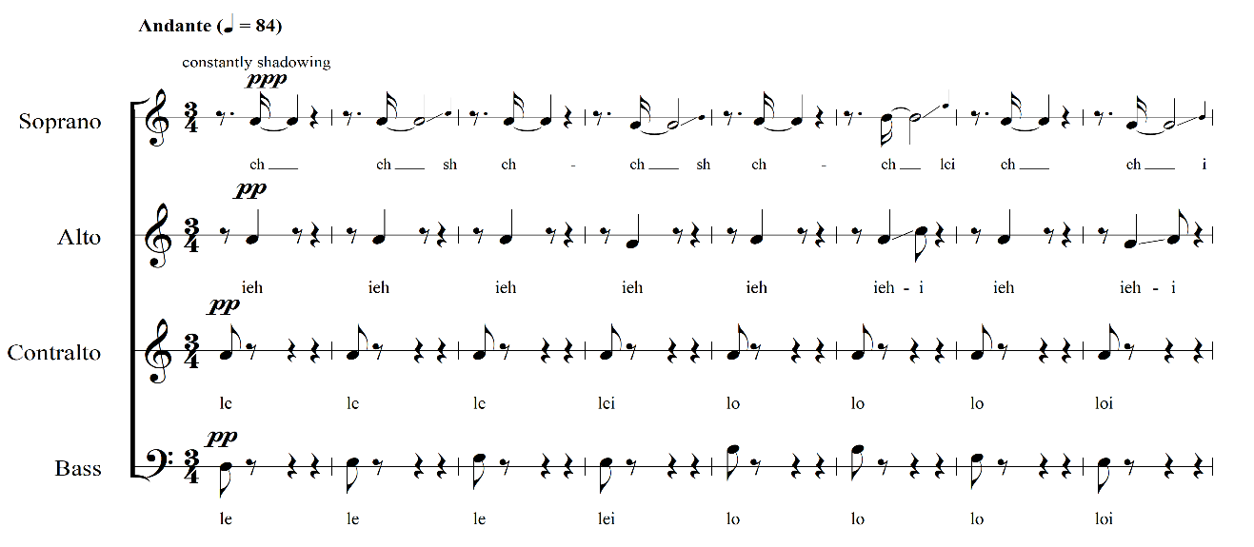

Figure 3.23 Rhythmic reduction of opening, mvt.8., mm 1-8.

movement, these flashes arrive at rhythmic synchronization, when finally, the synchronous fireflies are in full action. This synchronization combines with the harmonic progression, featuring the plagal cadence, which is comparable to the ‘Amen’ refrain in the original LU, sung at Compline (see Figure 3.24). The melodic theme, a transposition of the Hymn from LU, however, is barely recognizable as timbral and rhythmic variations intervene.
The glissando tail that characterizes this movement constitutes a use of gesture. Here, a musical gesture is “sound-related” rather than referencing a physical movement of the performer. Godøy suggests a distinction between “body-related gestures” and “sound-related gestures”:
Body gestures can be described from different perspectives, such as the biomechanical constraints of the human body, control movements like conducting movement, or sound-producing movements [...] Sound-related gestures, on the other hand, can be understood as movements in sound, such as pitches going up, rhythms that have a galloping character [...] To conceptualize most (if not all) features of musical sound in relation to their gestural affordance, we can think of these features as trajectory shapes in time and space. The term “space” is here used not only in the usual sense of three-dimensional Euclidean space for body movement, but also in a metaphorical sense to denote different feature dimensions. Such is the case with the use of pitch-space as a conceptual scheme for ordering differences in pitch, but also as something that may be mapped onto the “real” space of the keyboard with the keys arranged on a horizontal plane, left to right, from the lowest to the highest.

Godøy’s metaphorical concepts of sound in terms of spatial gestures offers a new perspective on the musical elements (e.g., texture, dynamics, and contemporary vocal/instrumental techniques) used in my composition. The glissando tails especially are seemingly quite independent from other thematic elements, but gradually add a new characteristic to the music as they progressively move from background to foreground until they dominate the entire movement.
In using gesture as a thematic element, I leave this piece open to interpretation, to a

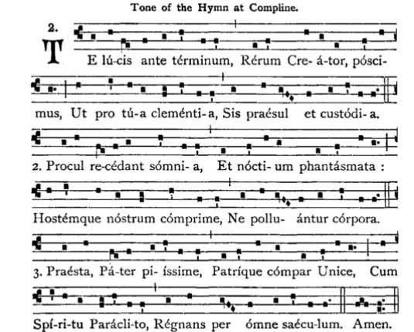

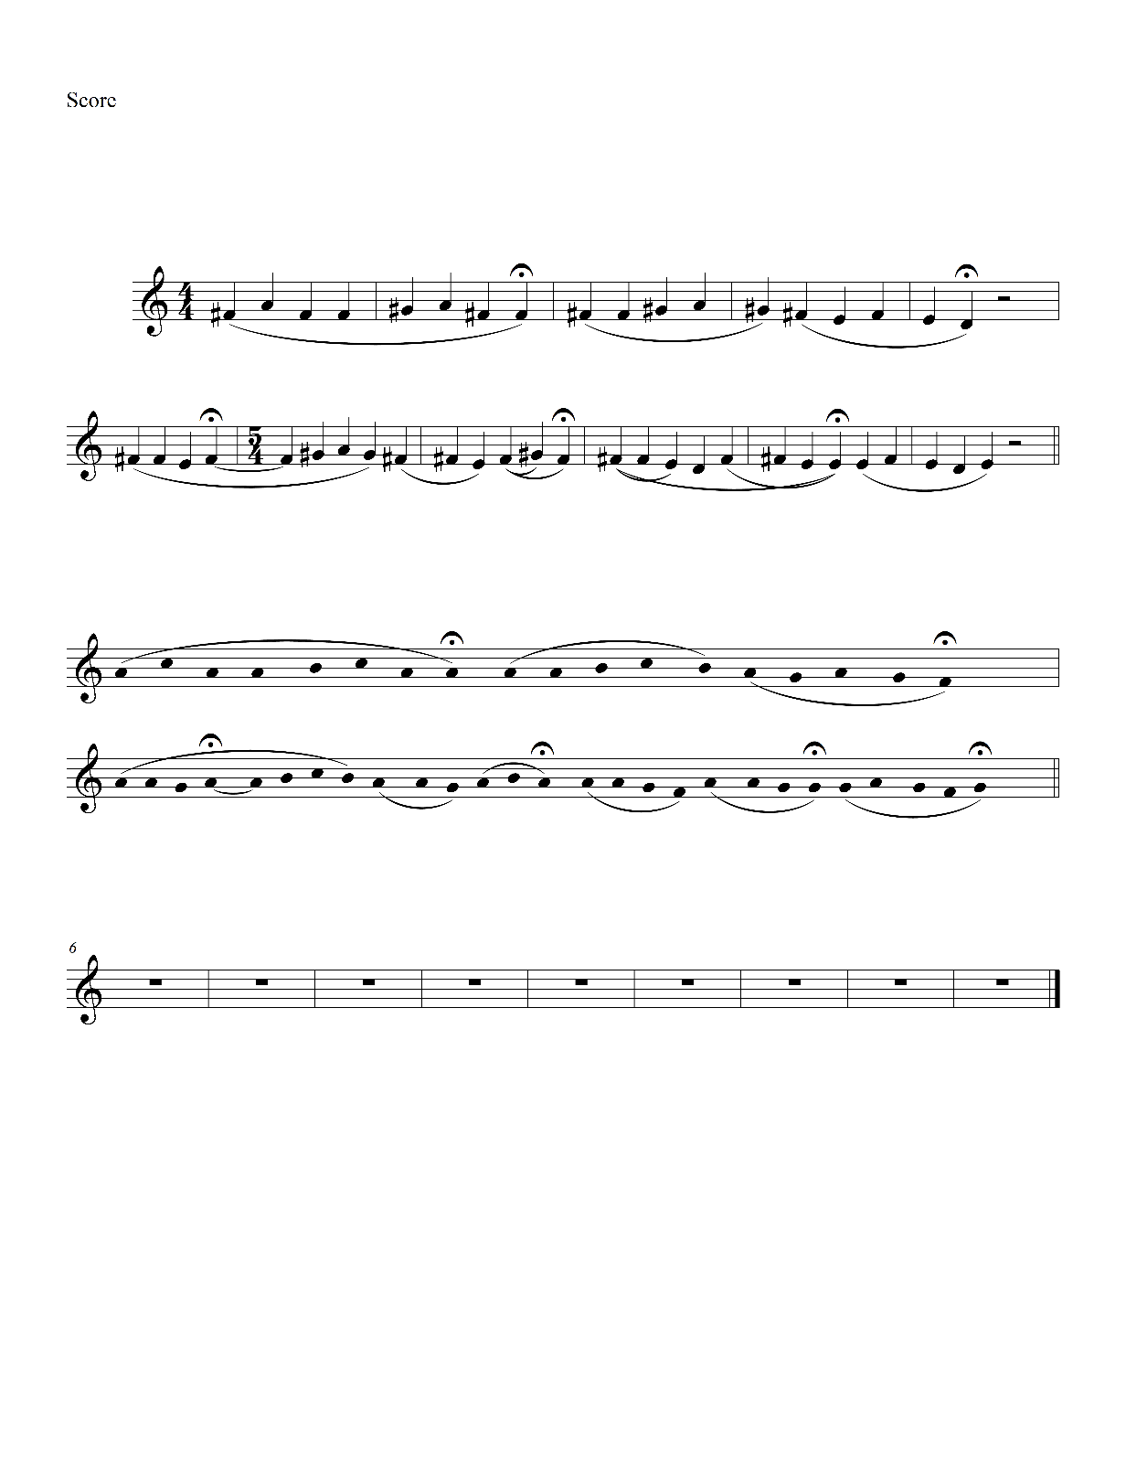
Figure 3.24 Tone of the Hymn at Compline and its transposition

certain degree, by performers. For example, when a vocalist sings the glissando tails used in Vespers, they may apply the vocal technique employed in the previous movement Terce (see Figure 3.25-1, mm. 14-18), where performers freely decide on the arrival pitch or they can come up with their own-version. The performer can decide which characteristic gestures are the best fit in terms of the speed of glissando or intonation (see Figure 3.25-2, mm. 222-229).
This is where room is created for not only for performers but also for audiences, both of whom shape (encode or externalize) and reshape (decode or internalize) the sound. Each performer and listener will interpret the music in their own way based on their experiences. A composer frames the story by posing a sequence of musical events, and a performer sets the narrative by presenting or displaying the events deliberately with their own techniques to communicate the music to the listeners. However, the music and musical narrative exist for an ultimate target: the audience. As Kendall Walton states in his article, “abstraction, in one sense, is generality.” Abstract works such as music may speak generally to the general audience by stripping away the specifics of language and cultural pattern, which may stand in the way of a direct emotional connection. This “open work,” thus, provides a flexible space where both performers and audiences can engage in a common experience through musical language.
The instrumentation of this movement includes the full choir and two violins. The violins evoke similar gestures from the Prologue to help bring the work full circle. To achieve this cycle structure, the violins are in a similar range, employ cyclical rhythmic patterns to represent the fireflies, and feature textural patterns that imply fast back and forth motion using articulations such as glissando or vibrato.

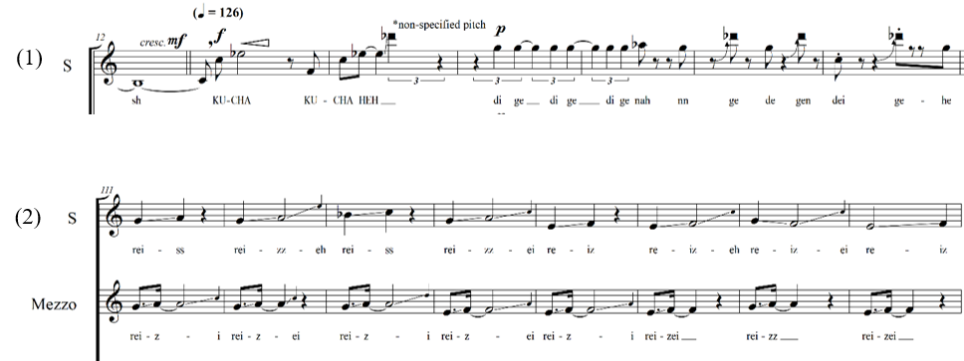

Figure 3.25. Performer’s free choice of realizations for musical gestures, (1) Terce, mvt.4, mm 14-18, (2) Compline-Epilogue, mvt.8, mm 222-229.

The phonetic palette (see Figure 3.26) in Compline-Epilogue is based upon a sonic representation of both segmentation and continuation of the light emissions; “l/r” is a sonorant consonant that is produced with continuous and non-turbulent airflow in the vocal tract. It symbolizes the river of life flowing from the throne of God and of the Lamb (Rev. 22), and Jesus, the living water, as expressed in John 4:10: “If you knew the gift of God, and who it is that is saying to you, ‘Give me a drink,’ you would have asked him, and he would have given you living water.”

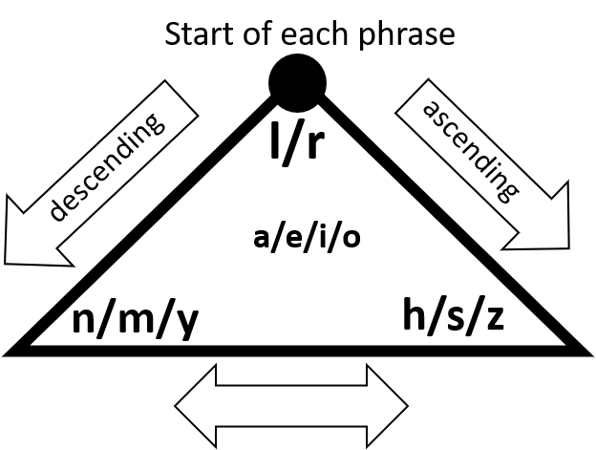
Figure 3.26. Phonetic palette for Compline-Epilogue

CONCLUSION
“The Chamber of Prayer: Oratorio Without Words” is an experimental composition that challenges the traditional oratorio form by deconstructing pre-existing formal structures among choir, text, and music-text relationships. My attempt to deconstruct the tradition is akin to the example that Felix Mendelssohn developed when he composed his lyrical piano collection Songs Without Words (1830). In his work, Mendelssohn showed that instrumental music may illustrate a narrative just as effectively as songs with words, and may have an advantage in that the listener may have an even more personalized experience than might occur when the text drives the narrative. Just as Mendelssohn needed a vehicle for his new technique, The Chamber of Prayer serves as a vehicle for my effort to determine if abstract music can communicate as an independent language and serve as a sacred tool to facilitate a “sonic-illusionary space”: a “chamber of prayer.”
If the composer is the architect of this sonic-spatial chamber and the performers are the builder, it is the listener who is invited to enter the space and enjoy the private room built for them. Each listener will react differently based on what they choose to follow among various musical stimuli. While it can be argued that each listener may react differently to the variety of styles and forms in the music, in The Chamber of Prayer the invitation to experience self-reflection is made clear through the sacred context.
Musical elements act as guides that welcome the invitees by occupying each moment of the listeners’ time as the music unfolds. Harmonic development, temporal shifting, timbral shading, and musical gestures are the frames and interior features that add a variety of colors and layers to contribute to the listener’s experience. The fusion of these elements reveals an abstract spatial structure. When the door is open, the listeners are invited to enter. This idea of an “open door” demonstrates my desire for the composition to ultimately find completion in the audience’s engagement. It is my hope that at least one single note penetrates time and the listeners’ heart to bring them back to one point of orbit (Chronos), and one moment of eternity (Kairos), the time when God intervenes. When each listener opens the door by engaging in music through their own internalization, the chamber of prayer will open and function accordingly.
I still wonder, however, whether this abstract music will truly communicate with the audience and if it participates in its sacred role as I planned. Walton proposes one perspective in which music is seen as an “informative or illuminating abstract work” that proves a certain subject. In this case that subject is God, as explored via Aldous Huxley’s character Spandrell in the novel Point Counter Point. In this novel, Spandrell fervently claims the third movement of Beethoven’s String Quartet No.15, “Heiliger Dankgesang eines Genesenen an die Gottheit, in der lydischen Tonart” (“Song of Thanksgiving to the Deity from a Convalescent in the Lydian Mode”) is “the only real proof of the existence of God, the soul, goodness.” Even though there are some readers who might not agree with the idea of seeing God through music, there will be others who may agree that abstract music can communicate with humans by directly speaking to the spirit, emotion, and minds. Conversely, I may “meet strong resistance, even derision,” as Walton described. So, my closing question is this: Does this music speak and communicate with the listener? In my composition, I tried to make the music represents nature, characters and themes in the Bible, and to convey aspects of God and the Holy Spirit metaphorically. However, I do not control how listeners will perceive these sonic representations or how they relate to what the music depicts. I only know my own intention – to provide a new way to hear and experience music. I hope to provide the space and guidance for self-reflection and a sacred experience by using the basic building blocks of human languages and speech, combined with suggestive musical elements as outlined above.
The pursuit of my compositional assertion that abstract music can serve a sacred role without words, led to several discoveries. These include: 1) expanding the possibilities of the oratorio genre while embracing its tradition through adaptations from the liturgy to find my own personal musical language; 2) developing an innovative formal structure that is perceived as a finite directional conceptualization of form that only exists during performance time, as well as an infinite spatial representation of form that nests in space; and finally 3) deconstructing the conventional music-word relationship by providing a new perspective on hearing music as a “two-sided language” that communicates between music and the listener simultaneously. I hope my attempt at finding a new container for the oratorio can suggest an independent formal design with which composers can expand musical possibilities, performers can realize musical events and narrative, audiences can explore their minds and inner worlds, and, where music can speak directly to emotions, evoking internal reflections through its own language.

BIBLIOGRAPHY
Adler, Samuel. The Study of Orchestration. New York: W.W. Norton, 2002.

Bonds, Mark Evan. “Idealism and the Aesthetics of Instrumental Music at the Turn of the Nineteenth Century.” Journal of the American Musicological Society 50, no. 2/3 (1997): 387-420.

Bonds, Mark Evan. “The Spatial Representation of Musical Form.” The Journal of Musicology 27, no. 3 (2010): 265-303.

Burkholder, J. Peter, Donald Jay Grout, and Claude V. Palisca. A History of Western Music. New York: London W.W. Norton, 2019.

Brown, Keith, and Jim Miller. The Cambridge Dictionary of Linguistics. Cambridge: Cambridge University Press, 2013. doi:10.1017/CBO9781139049412.

Catholic Church, The Liber Usualis: With Introduction and Rubrics in English. Tournai: Desclee, 1961.

Chirico, Rob. Damn!: A Cultural History of Swearing in Modern America. Chicago: Pitchstone Publishing, 2014.

Chomsky, Noam and Morris Halle. The Sound Pattern of English, Vol. 1st pbk. ed. Studies in Language. Cambridge, Mass: The MIT Press, 1968. https://search-ebscohost-com.proxy.lib.utk.edu/login.aspx?direct=true&db=nlebk&AN=48792&site=ehost-live&scope=site.

Durand, William. Rationale V, Commentary on the Divine Office. Turnhout: Brepols, 2015.

Fassler, Margot E. Music in the Medieval West. New York: W.W. Norton, 2014.

Florman, Lisa C. Concerning the Spiritual and the Concrete in Kandinsky’s Art. Redwood City: Stanford University Press, 2014.

Godøy, Rolf Inge and Marc Leman. Musical Gestures: Sound, Movement, and Meaning. New York: Taylor and Francis, 2010. https://doi.org/10.4324/9780203863411

Hall, David W., Sarah E. Sander, Jennifer C. Pallansch, and Kathrin F Stranger-Hall. “The Evolution of Adult Light Emission Color in North American Fireflies.” Evolution 70, no. 9 (2016): 2033-48.

Mae Hingee, and Robert D. Magrath. “Flights of Fear: A Mechanical Wing Whistle Sounds the Alarm in a Flocking Bird.” Biological Sciences 276, no. 1676 (2009): 4173-79.

Huxley, Aldous. Point Counter Point. New York: Modern Library, 1928.
Hohendahl, Peter Uwe. “Nature and the Autonomy of Art: Adorno as a reader of Kant.” The Philosophical Forum 43, no. 3 (2012): 247-57.

Kertz-Welzel, Alexandra. “The Magic of Music: Archaic Dreams in Romantic Aesthetics and an Education in Aesthetics.” Philosophy of Music Education Review 13, no. 1 (2005): 77-94.

Leech-Wilkinson, Daniel. Machaut’s Mass: An Introduction. Oxford: Clarendon, 1990.

Legner, Wolfram K. “The Religion of Rainer Maria Rilke before His Visits to Russia.” Monatshefte für Deutschen Unterricht 30, no. 8 (1938): 440-53.

Lenneberg, Hans. “Johann Mattheson on Affect and Rhetoric in Music (I).” Journal of Music Theory 2, no. 1 (1958): 47-84.

MacKen, Mary M. “Rainer Maria Rilke.” Studies: An Irish Quarterly Review 30, no. 118 (1941): 287-93.

Messiaen, Olivier. The Technique of My Musical Language. Paris: Alphonse Leduc, 1956.

Oh, Hee Sook. “Intercultural Aesthetics in the Contemporary Korean Compositions of Hae-Sung Lee.” The World of Music, New Series, 6, no. 1 (2017): 103-22.

Rilke, Rainer Maria. In Praise of Mortality: Selections from Rilke’s Duino Elegies and Sonnets to Orpheus. Translated and edited by Anita Barrows and Joanna Macy. New York: Riverhead Books, 2005.

Rousseau, Jean-Jacques. Essay on the Origin of Languages and Writings Related to Music. Translated by John T. Scott. Hanover: Dartmouth College Press, 2000.

Schoenberg, Arnold. Theory of Harmony. Berkeley: University of California Press, 1978.

Smither, Howard E. “Oratorio.” Grove Music Online. 2001; Accessed 5 May. 2021. https://www-oxfordmusiconline com.proxy.lib.utk.edu/grovemusic/view/10.1093/gmo/9781561592630.001.0001/omo-9781561592630-e-0000020397.

Taylor, Eric. “Rousseau’s Conception of Music.” Music & Letters 30, no. 3 (1949): 242-43.

Tischler, Hans, and Louise H. Tischler. “Mendelssohn’s “Songs Without Words”.” The Musical Quarterly 33, no. 1 (1947): 1-16.

Tournier, Michel. Le médianoche amoureux. Paris: Gallimard, 1989.

Walker, James. “Extended techniques for vibraphone.” Extended techniques for vibraphone. 2001; Accessed March 9, 2021. http://www.malletjazz.com/lessons/ext_tech.html.
Walton, Kendall L. “What Is Abstract about the Art of Music?” The Journal of Aesthetics and Art Criticism 46, no. 3 (1988): 351-64.

APPENDIX

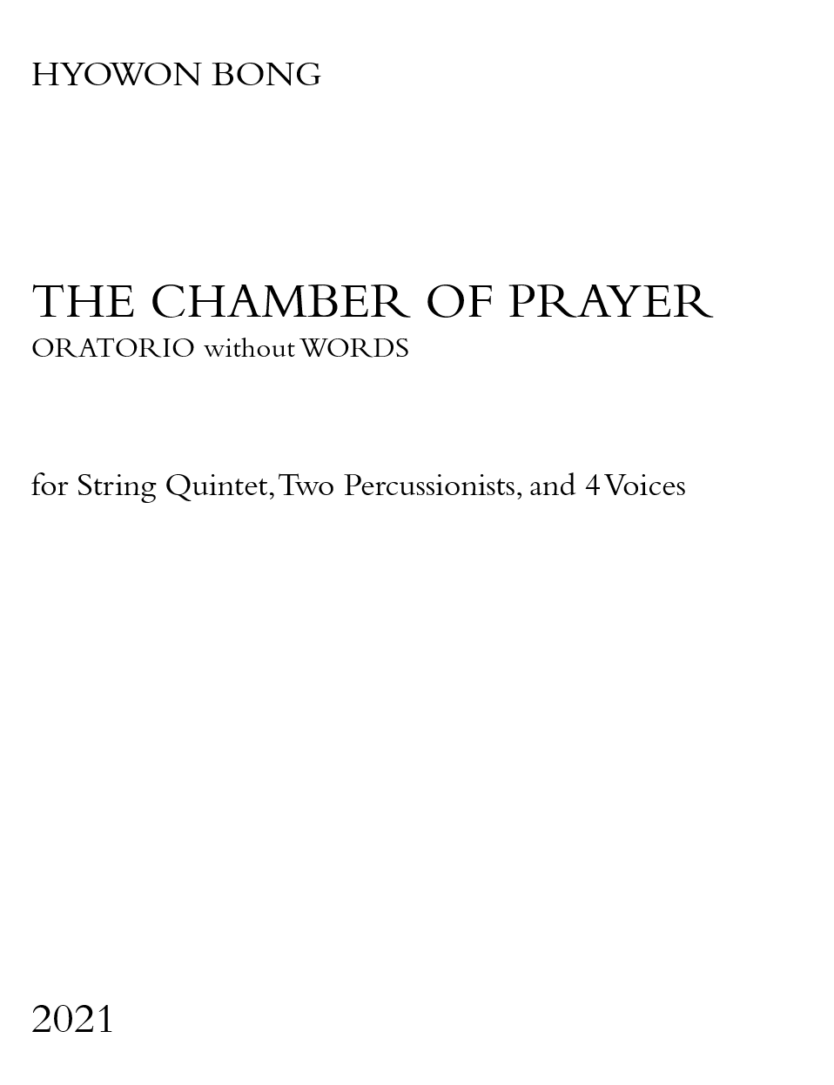

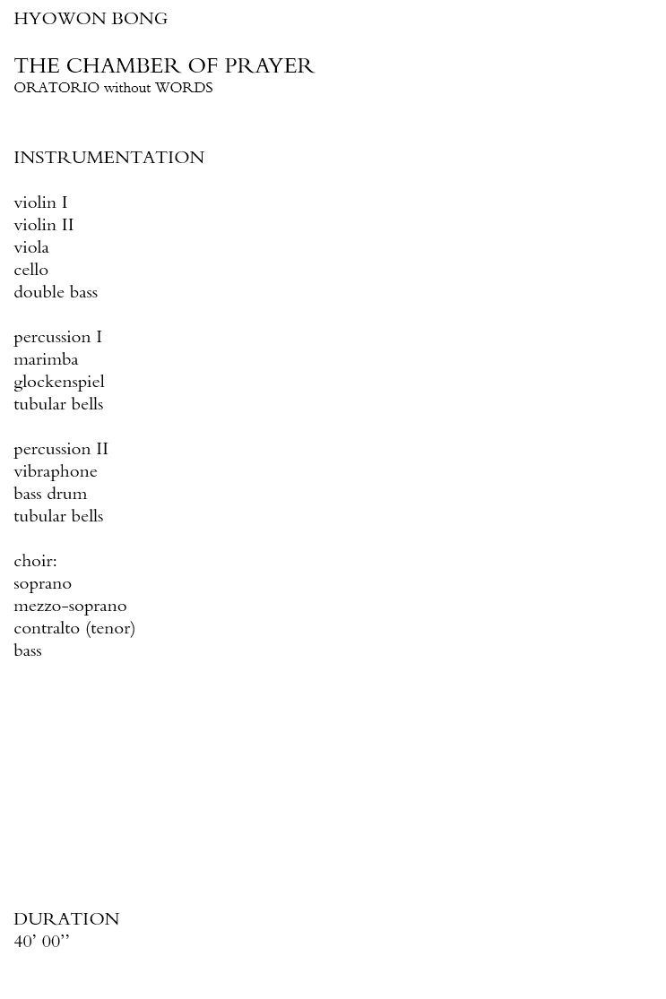

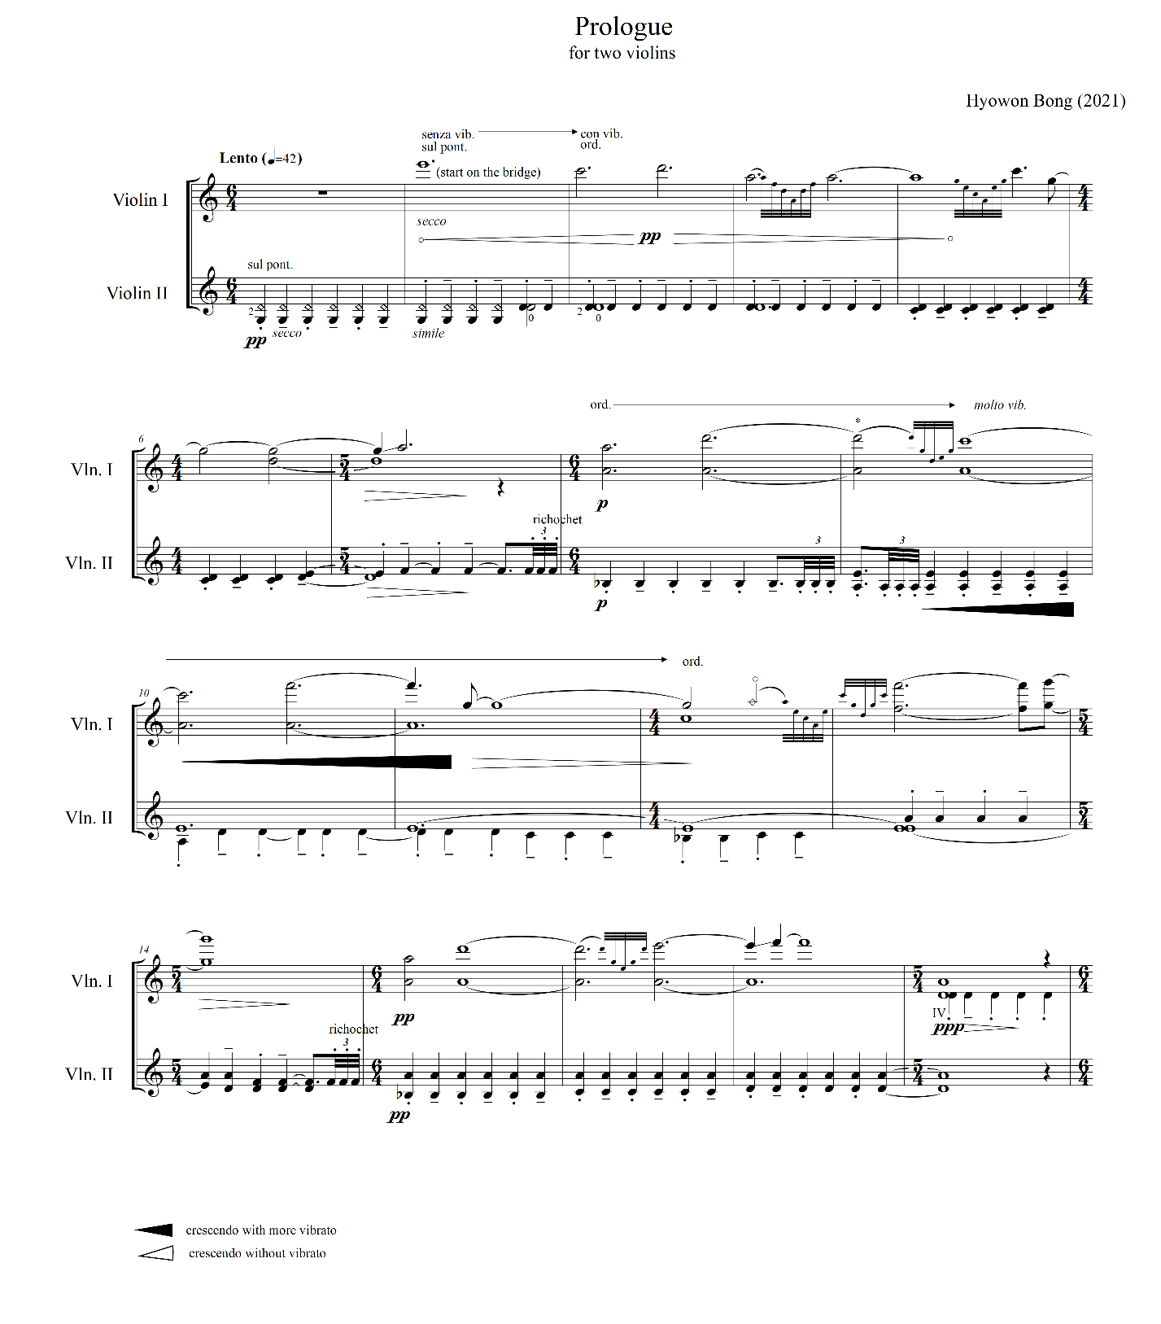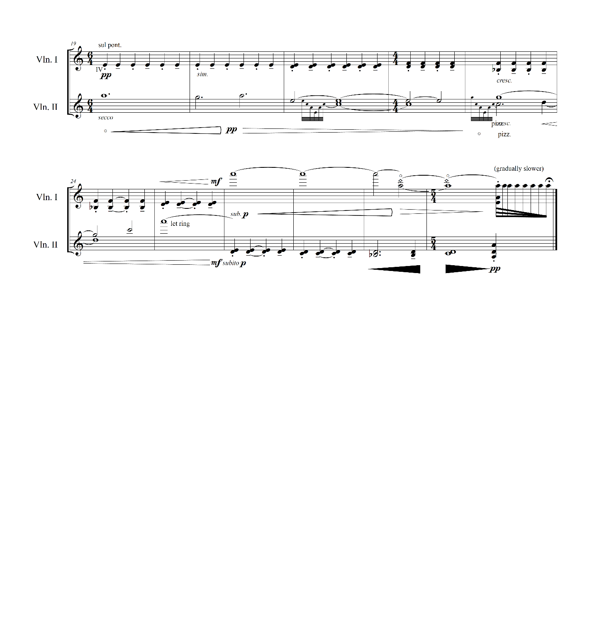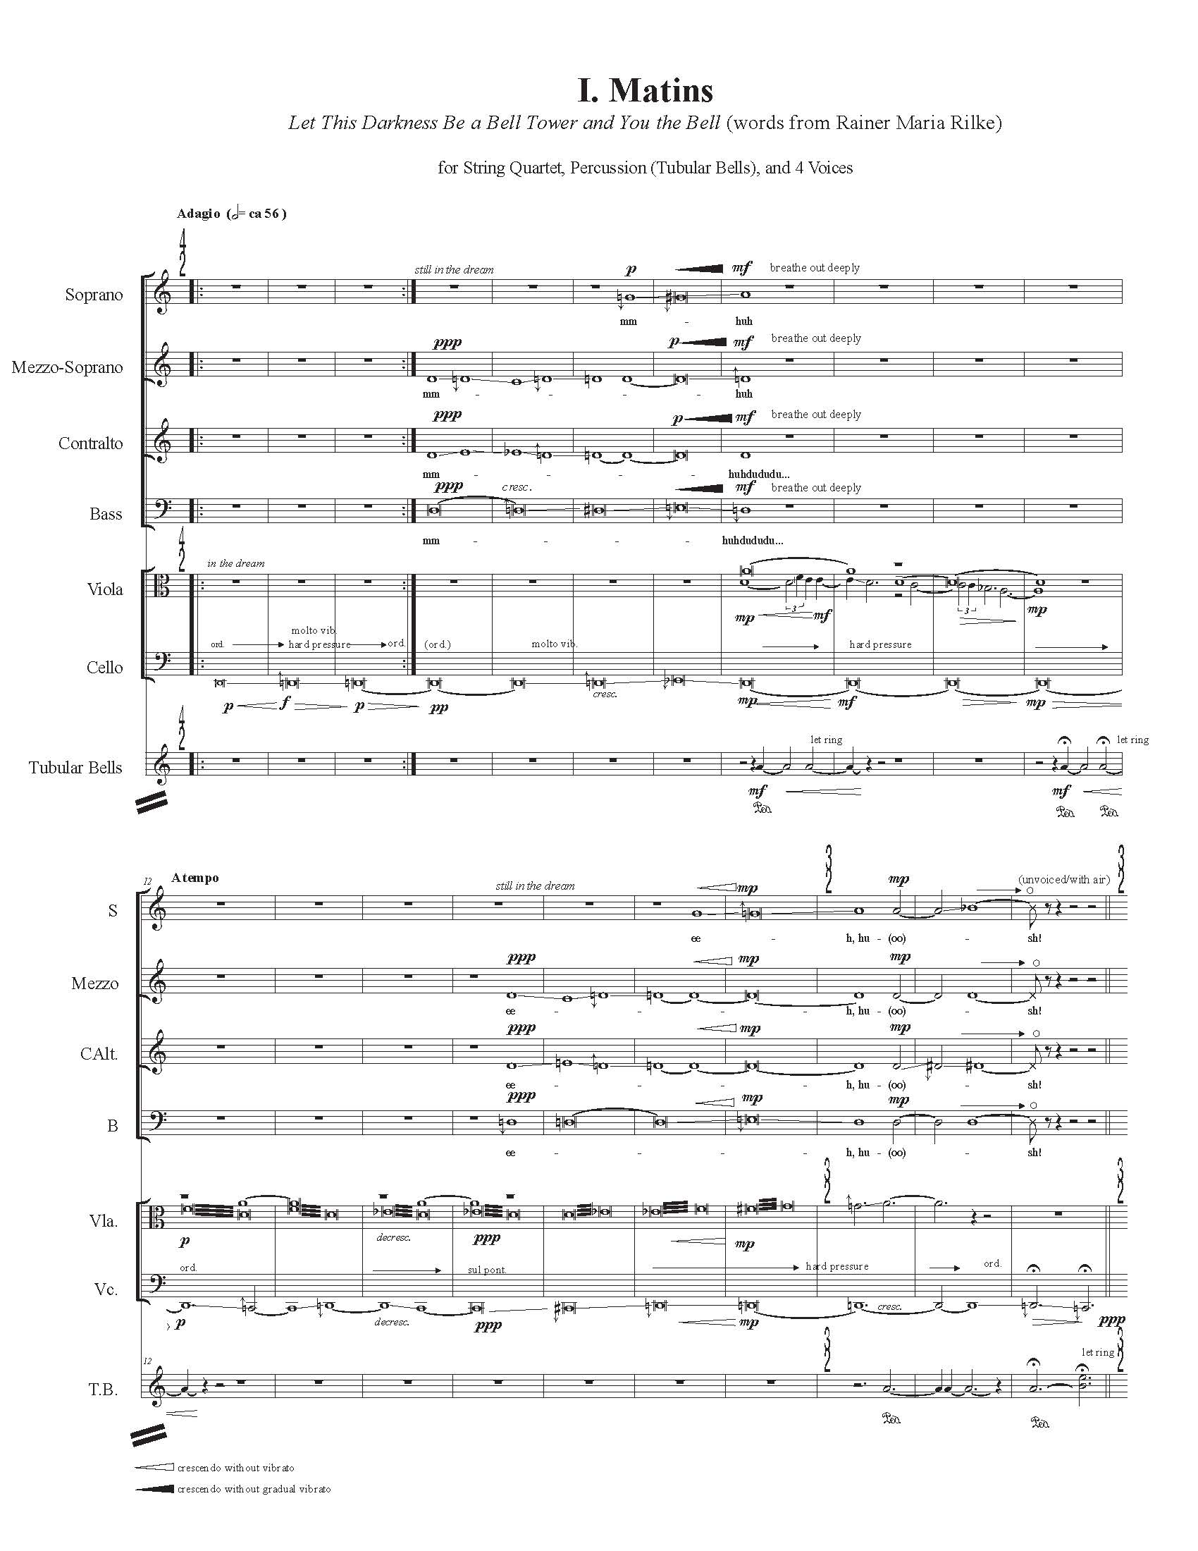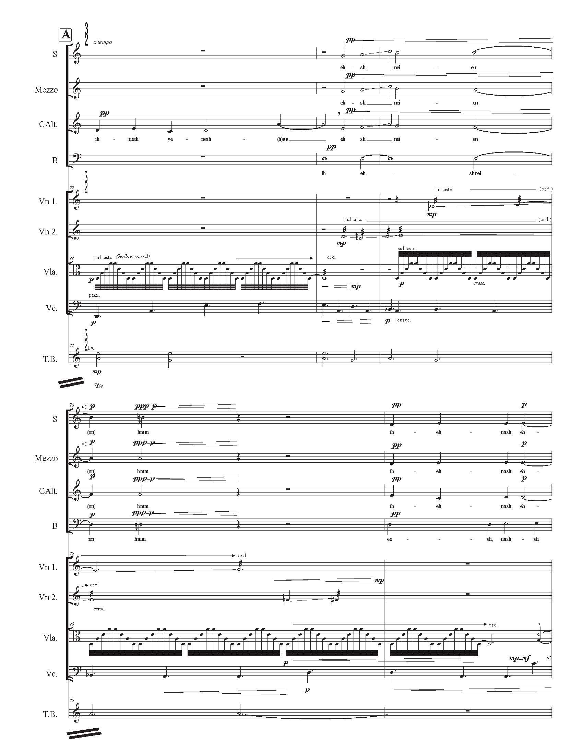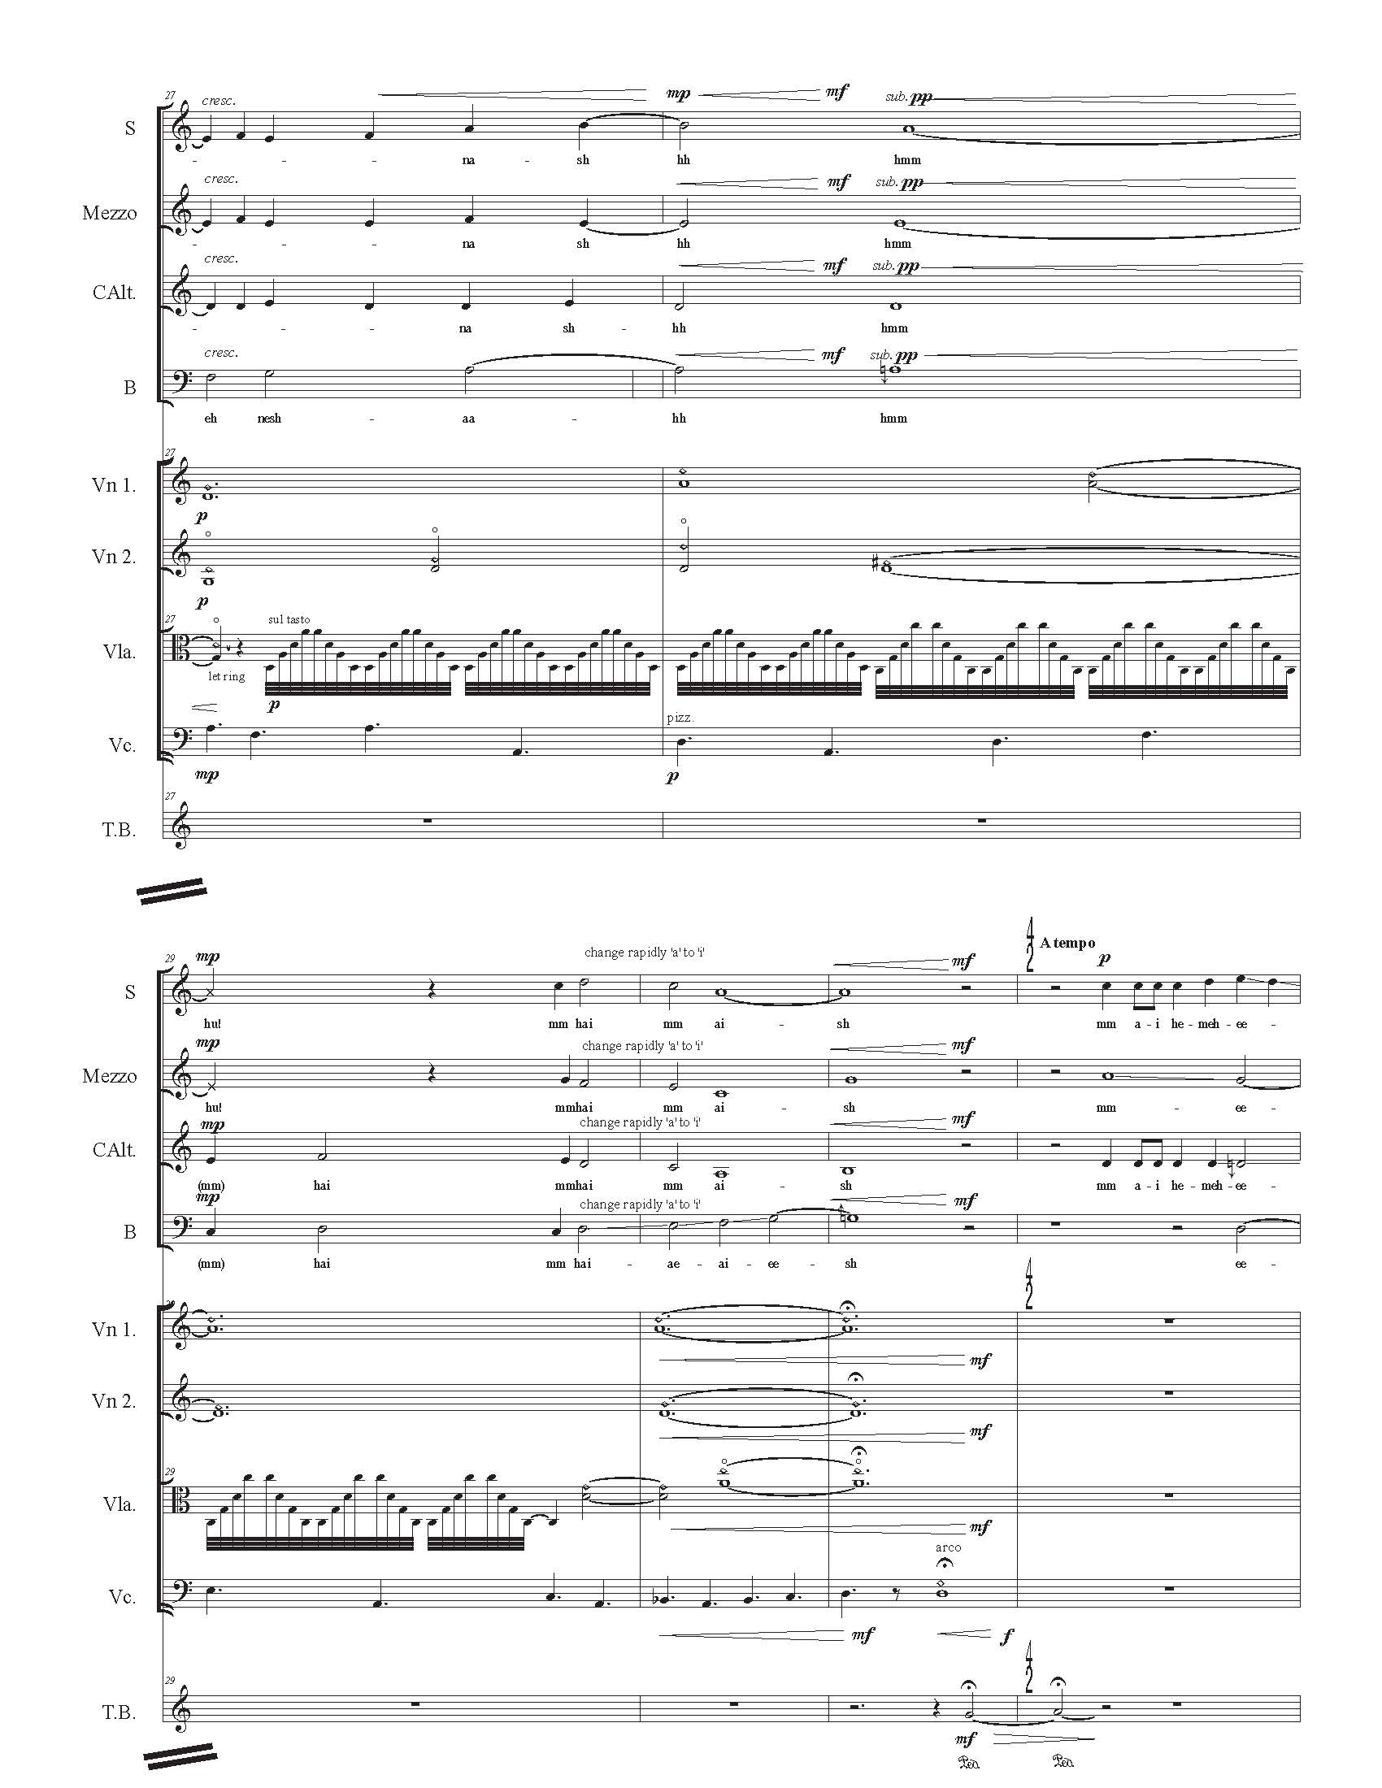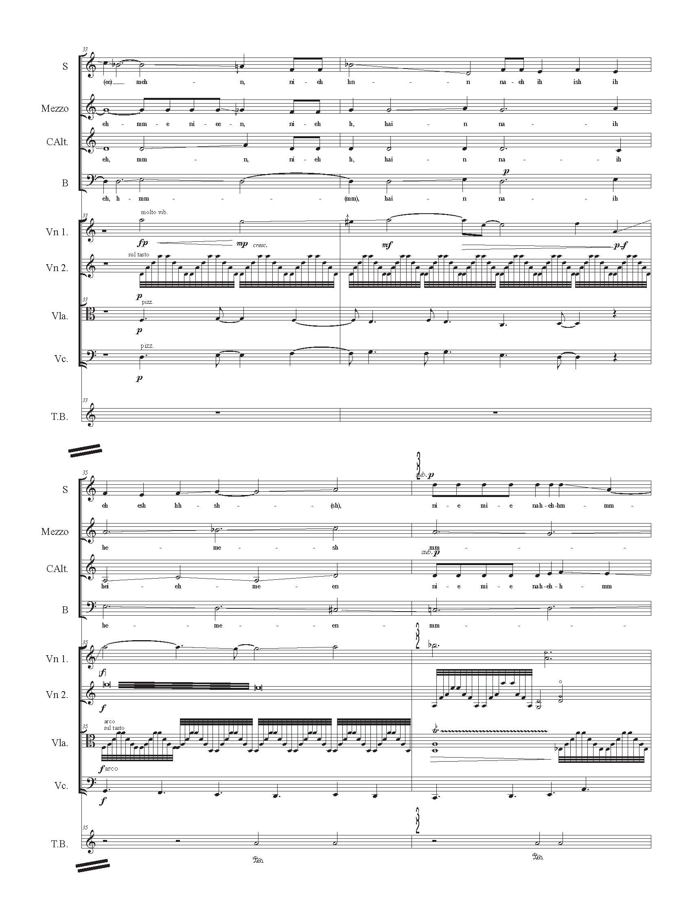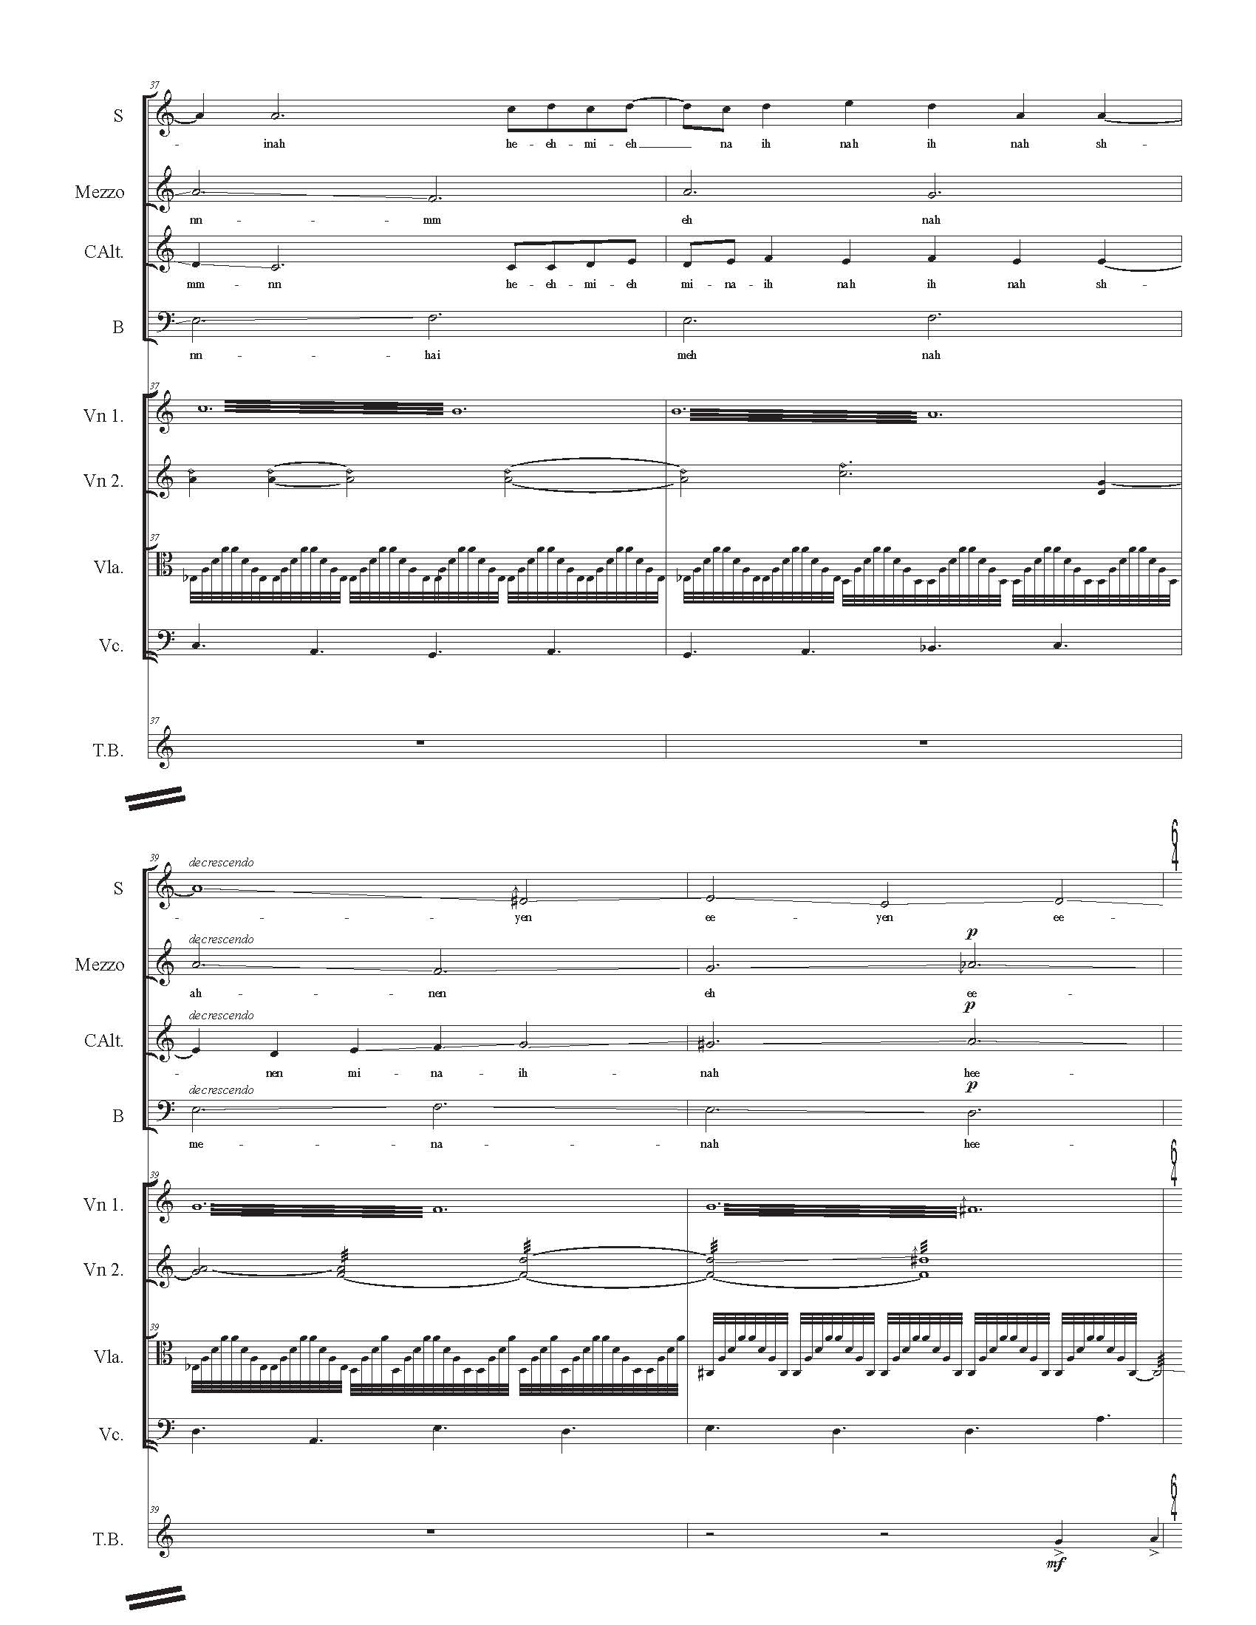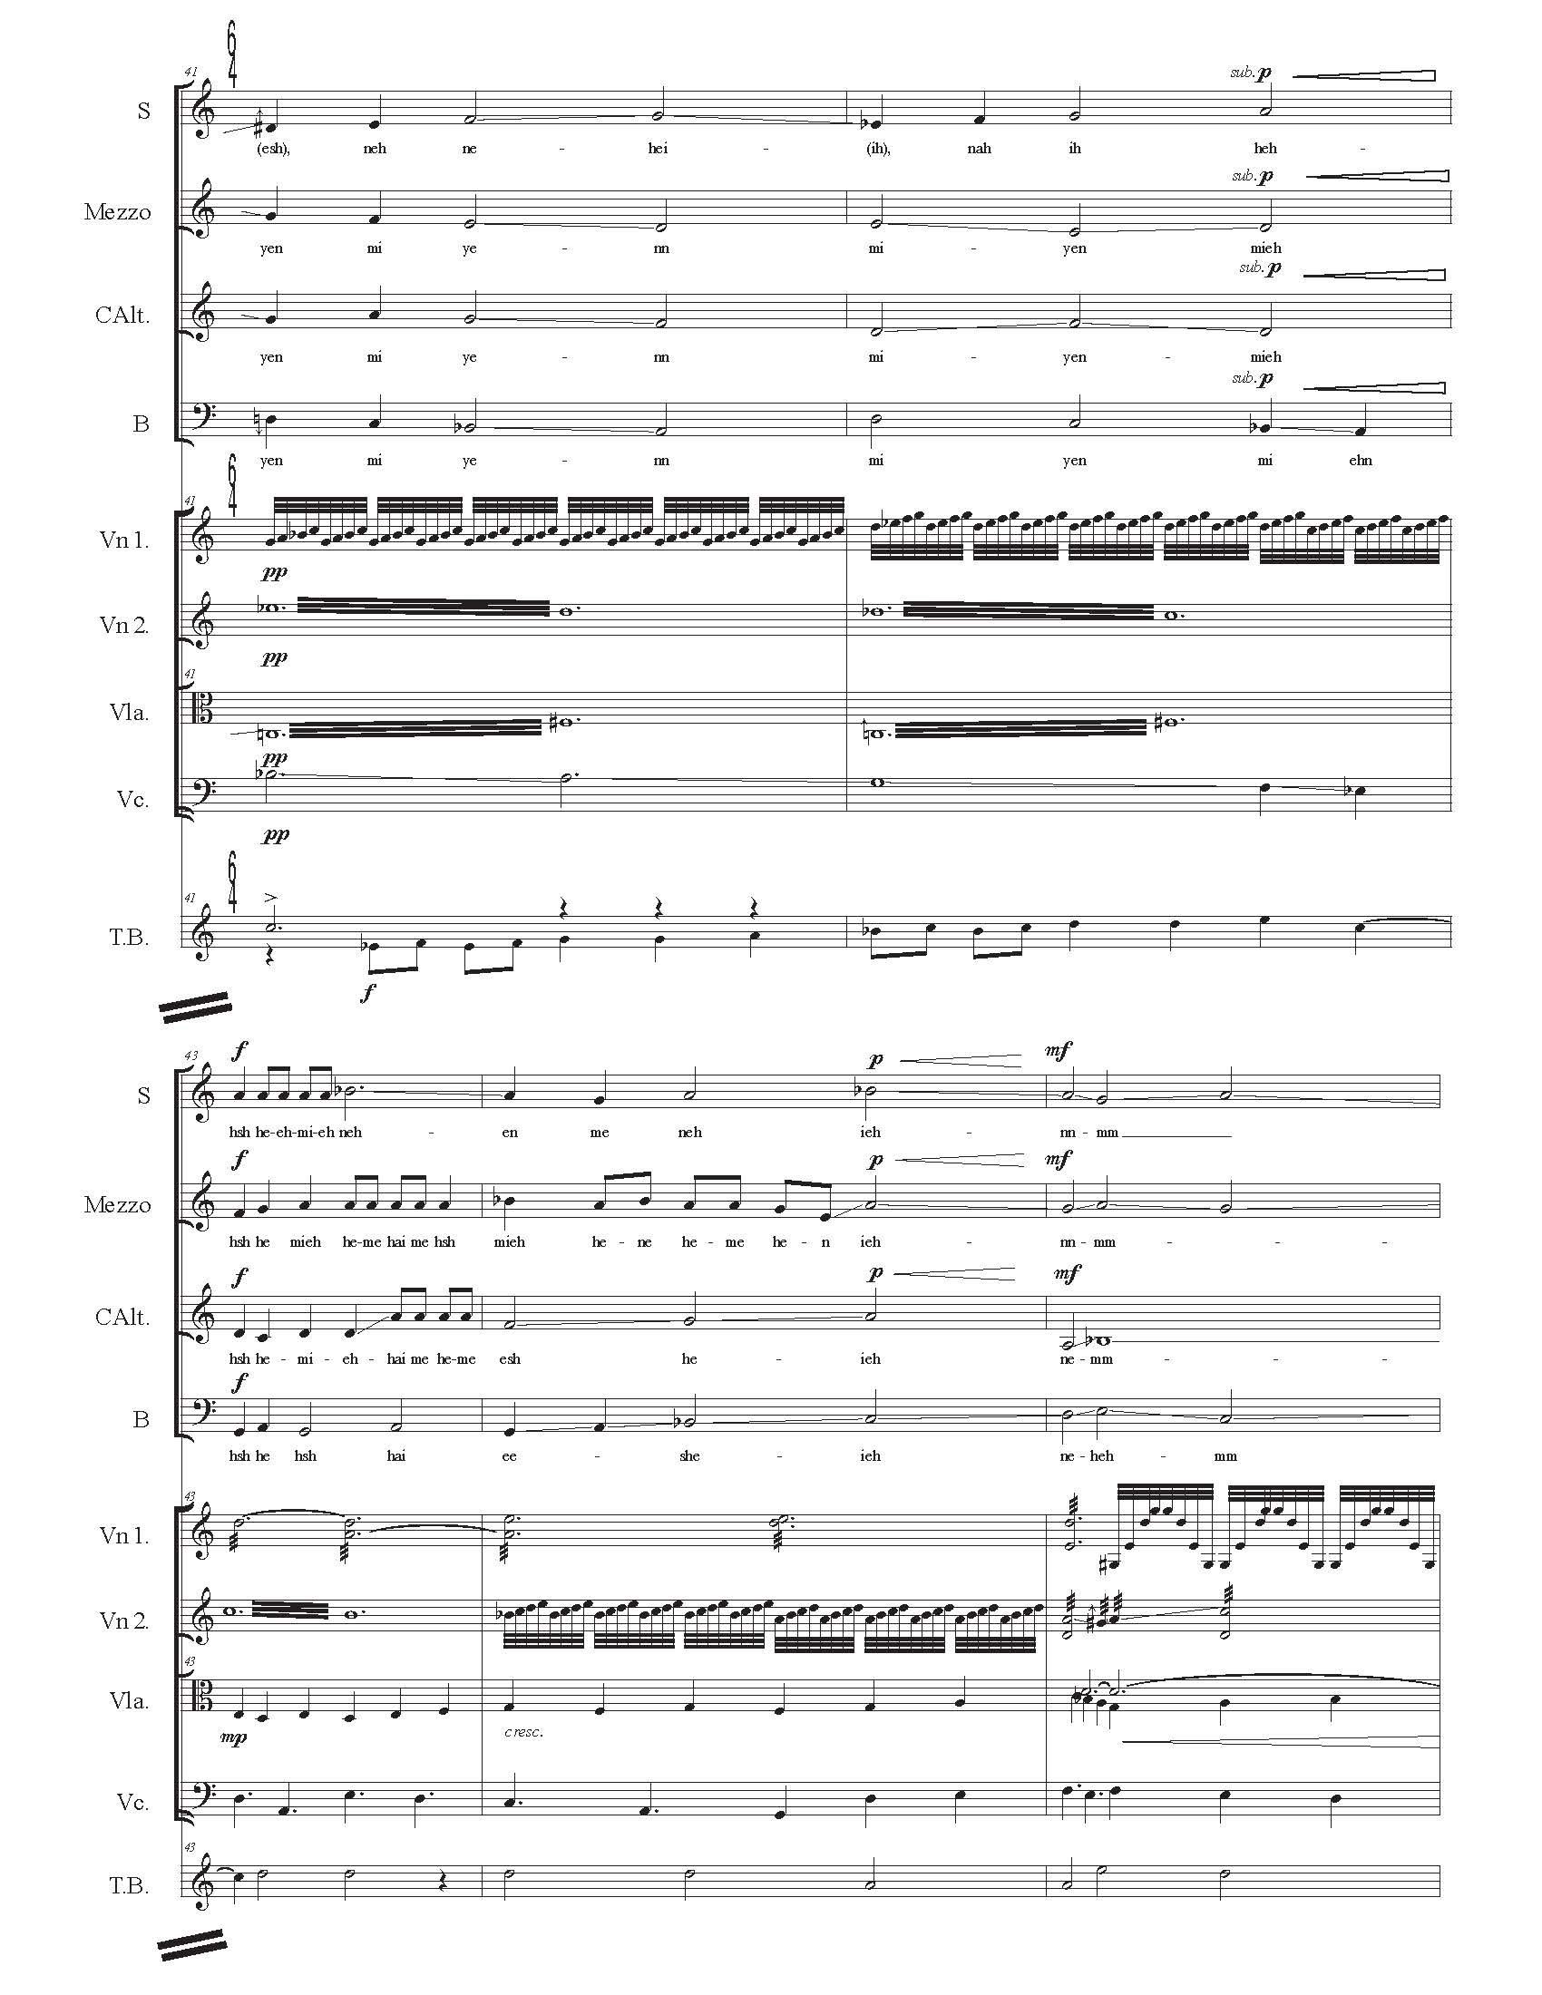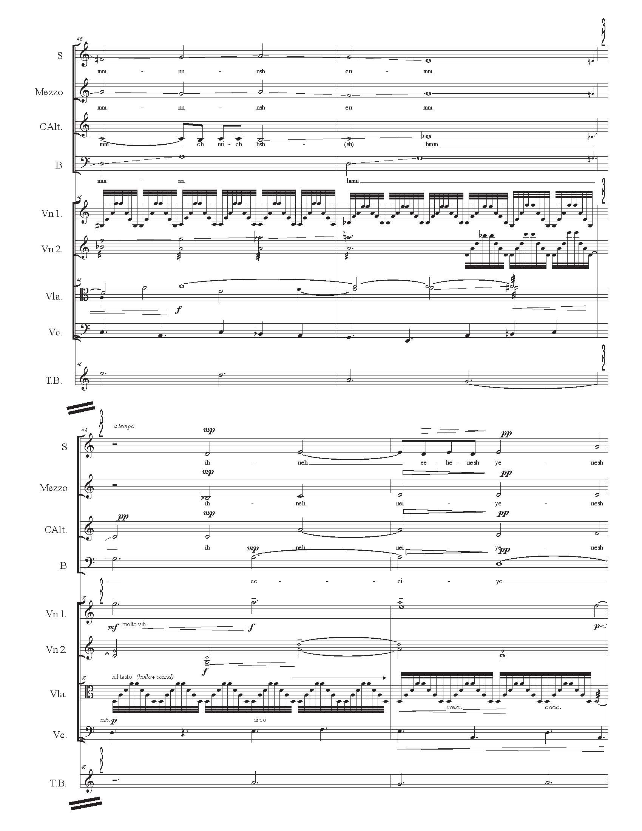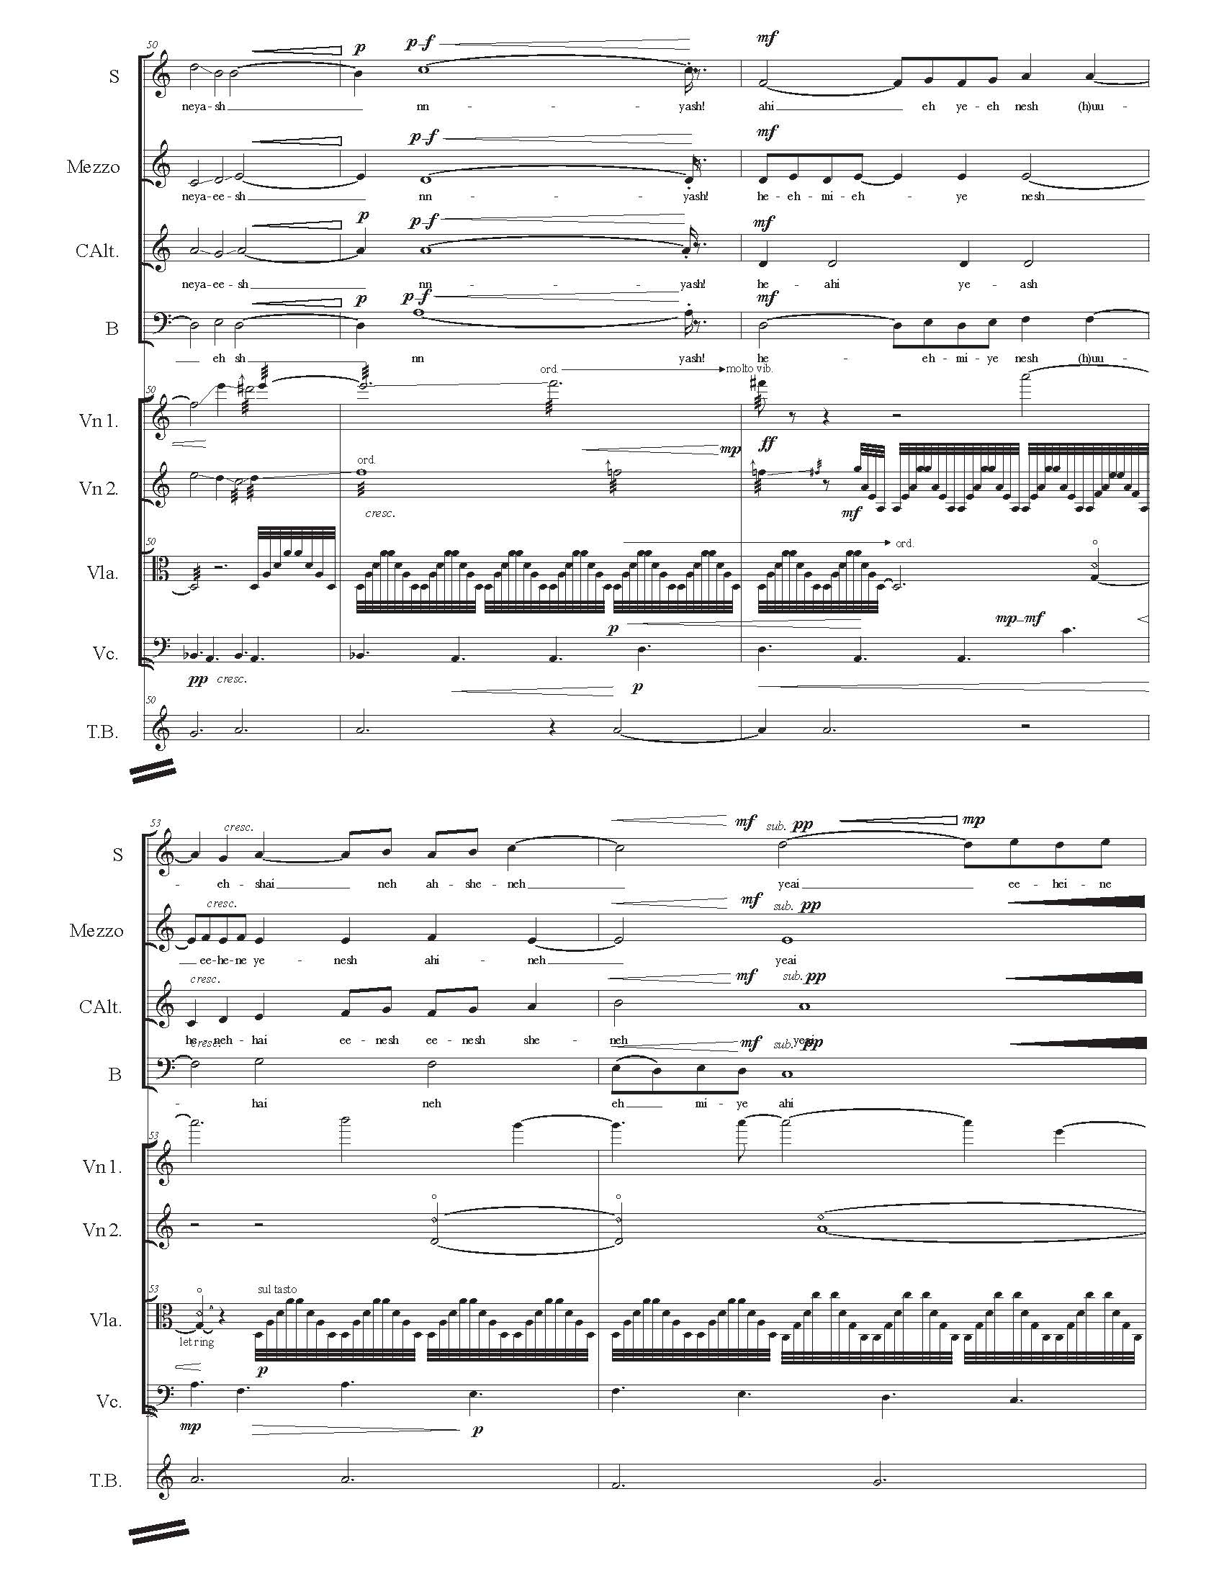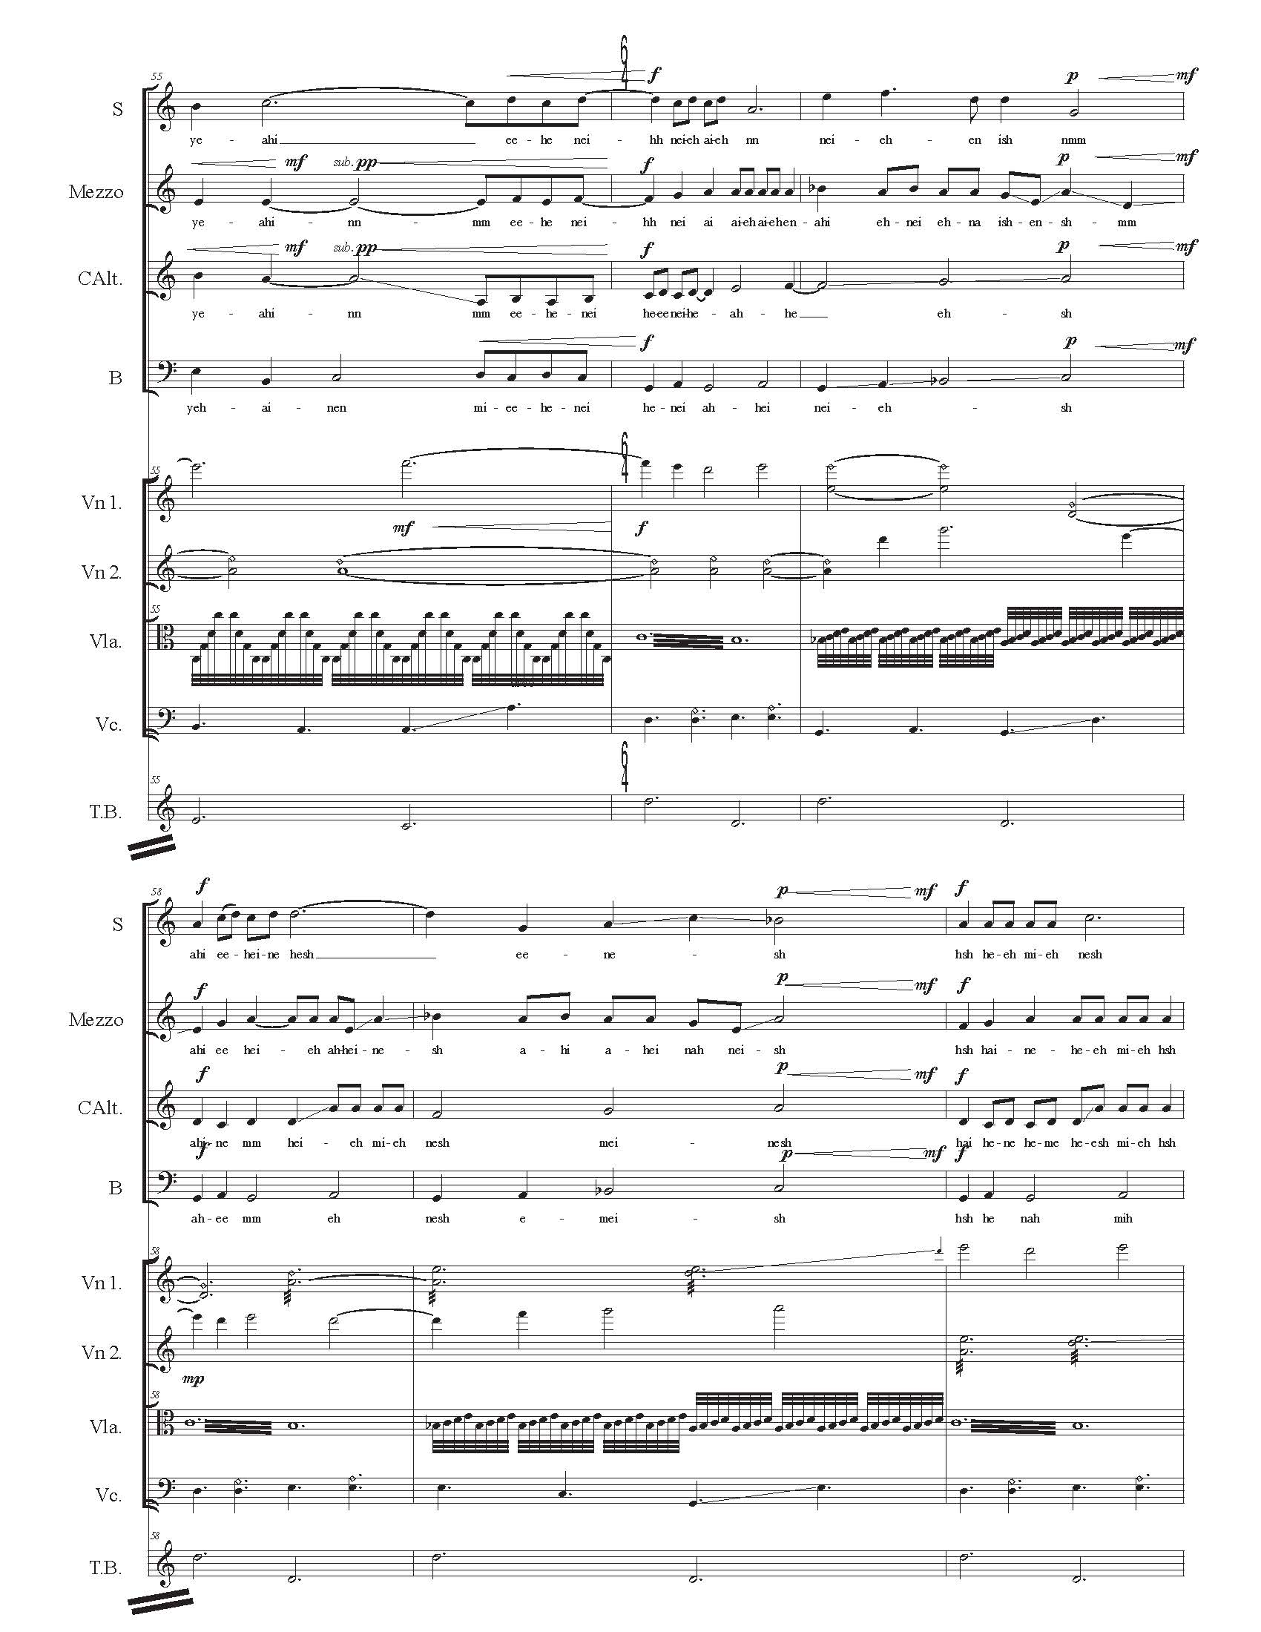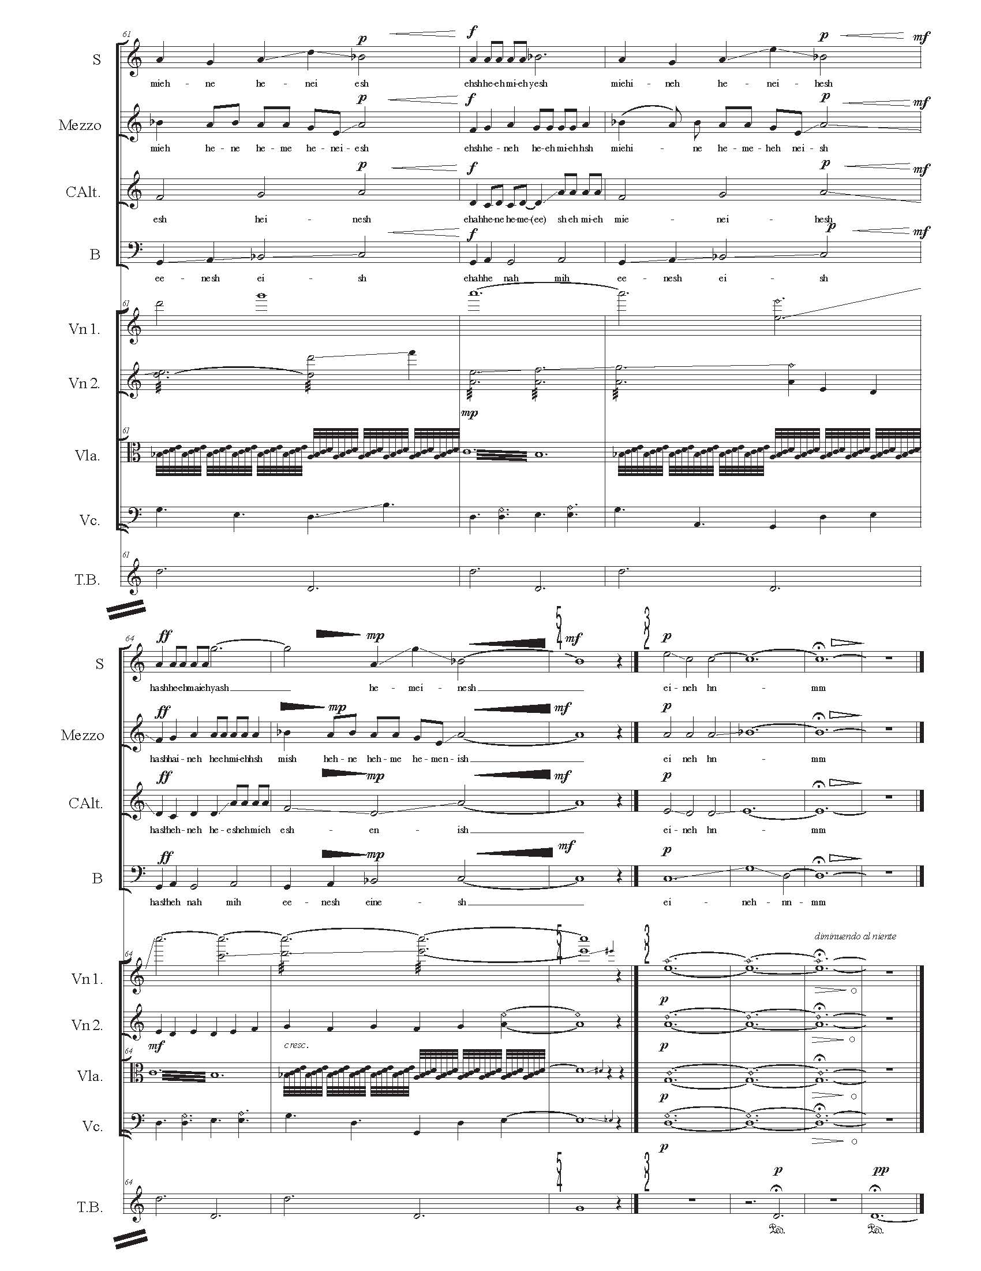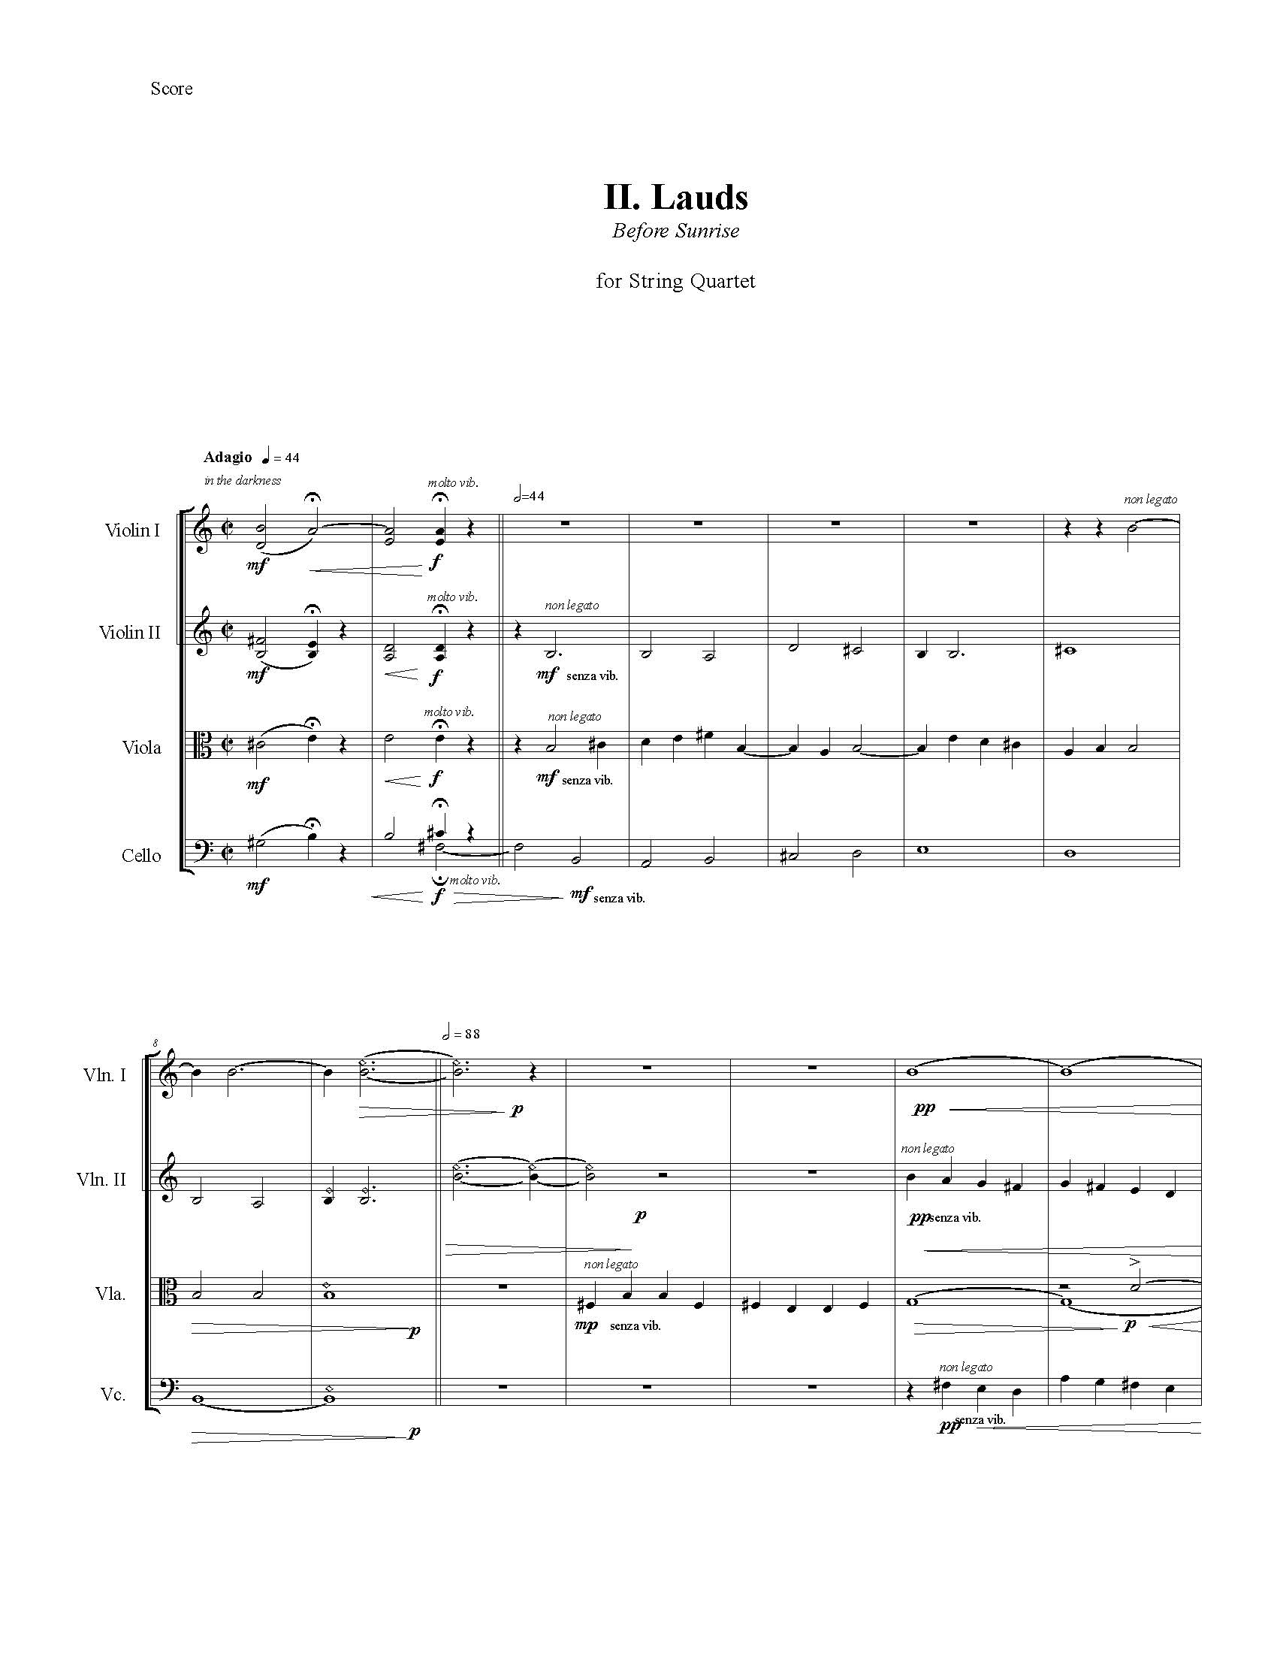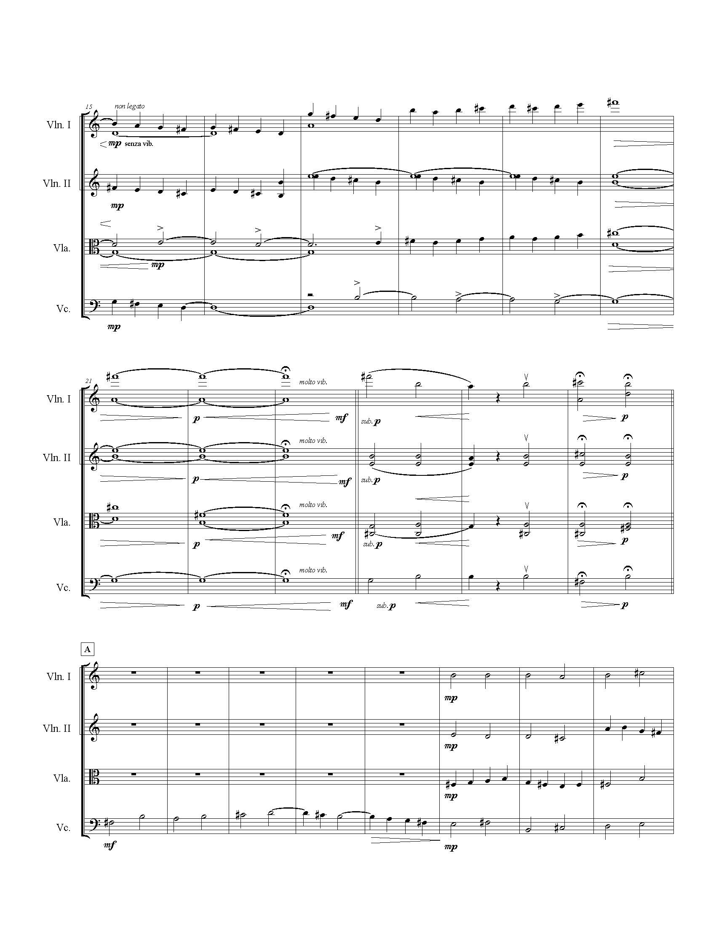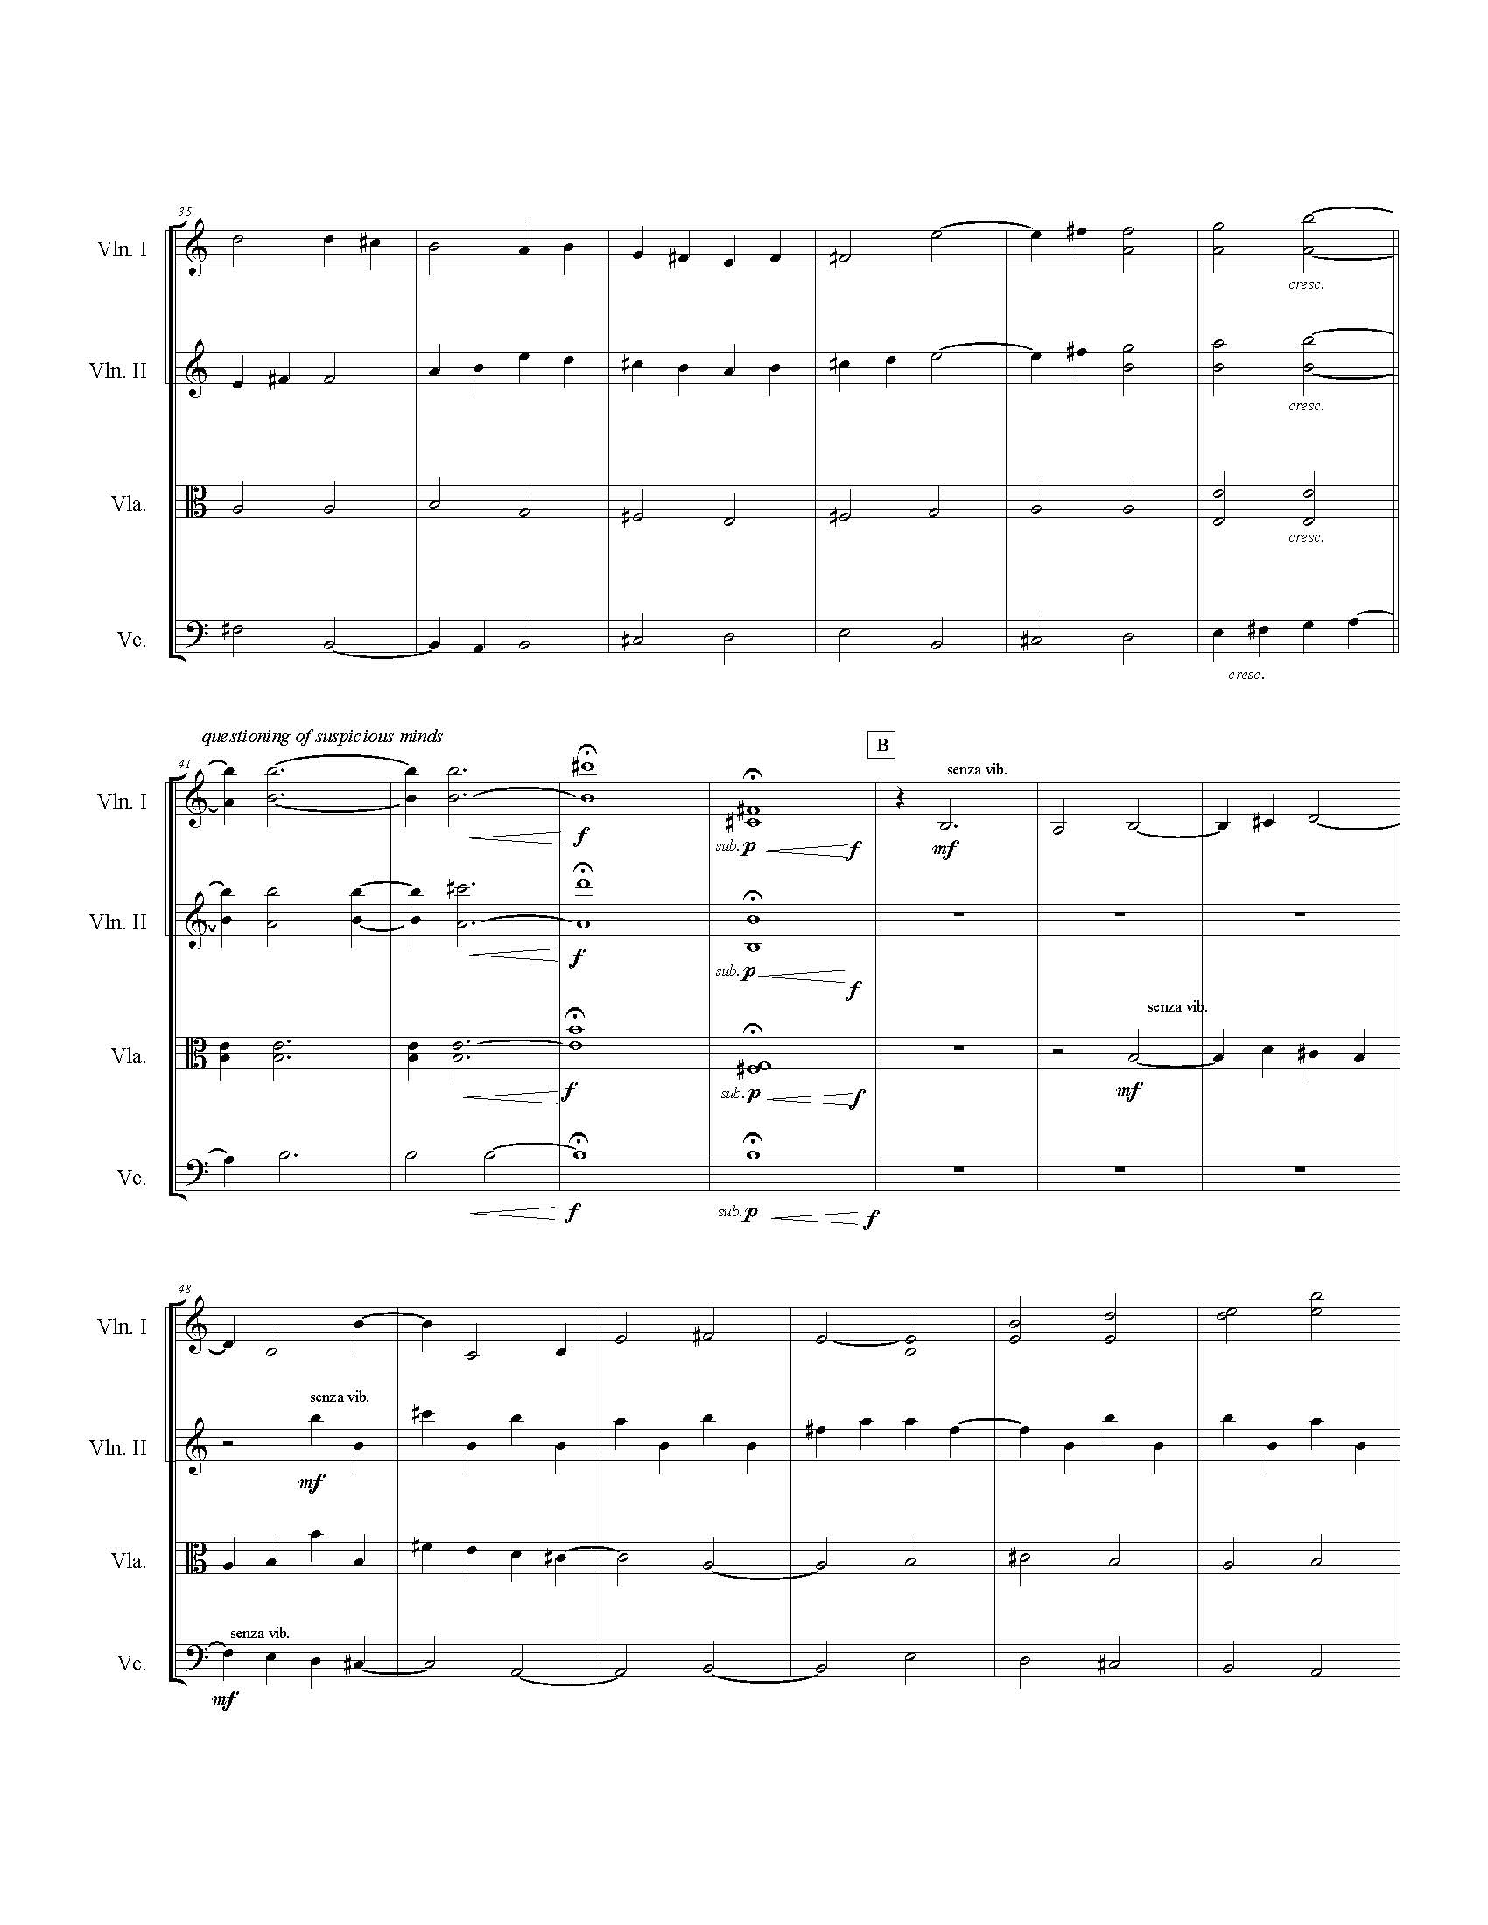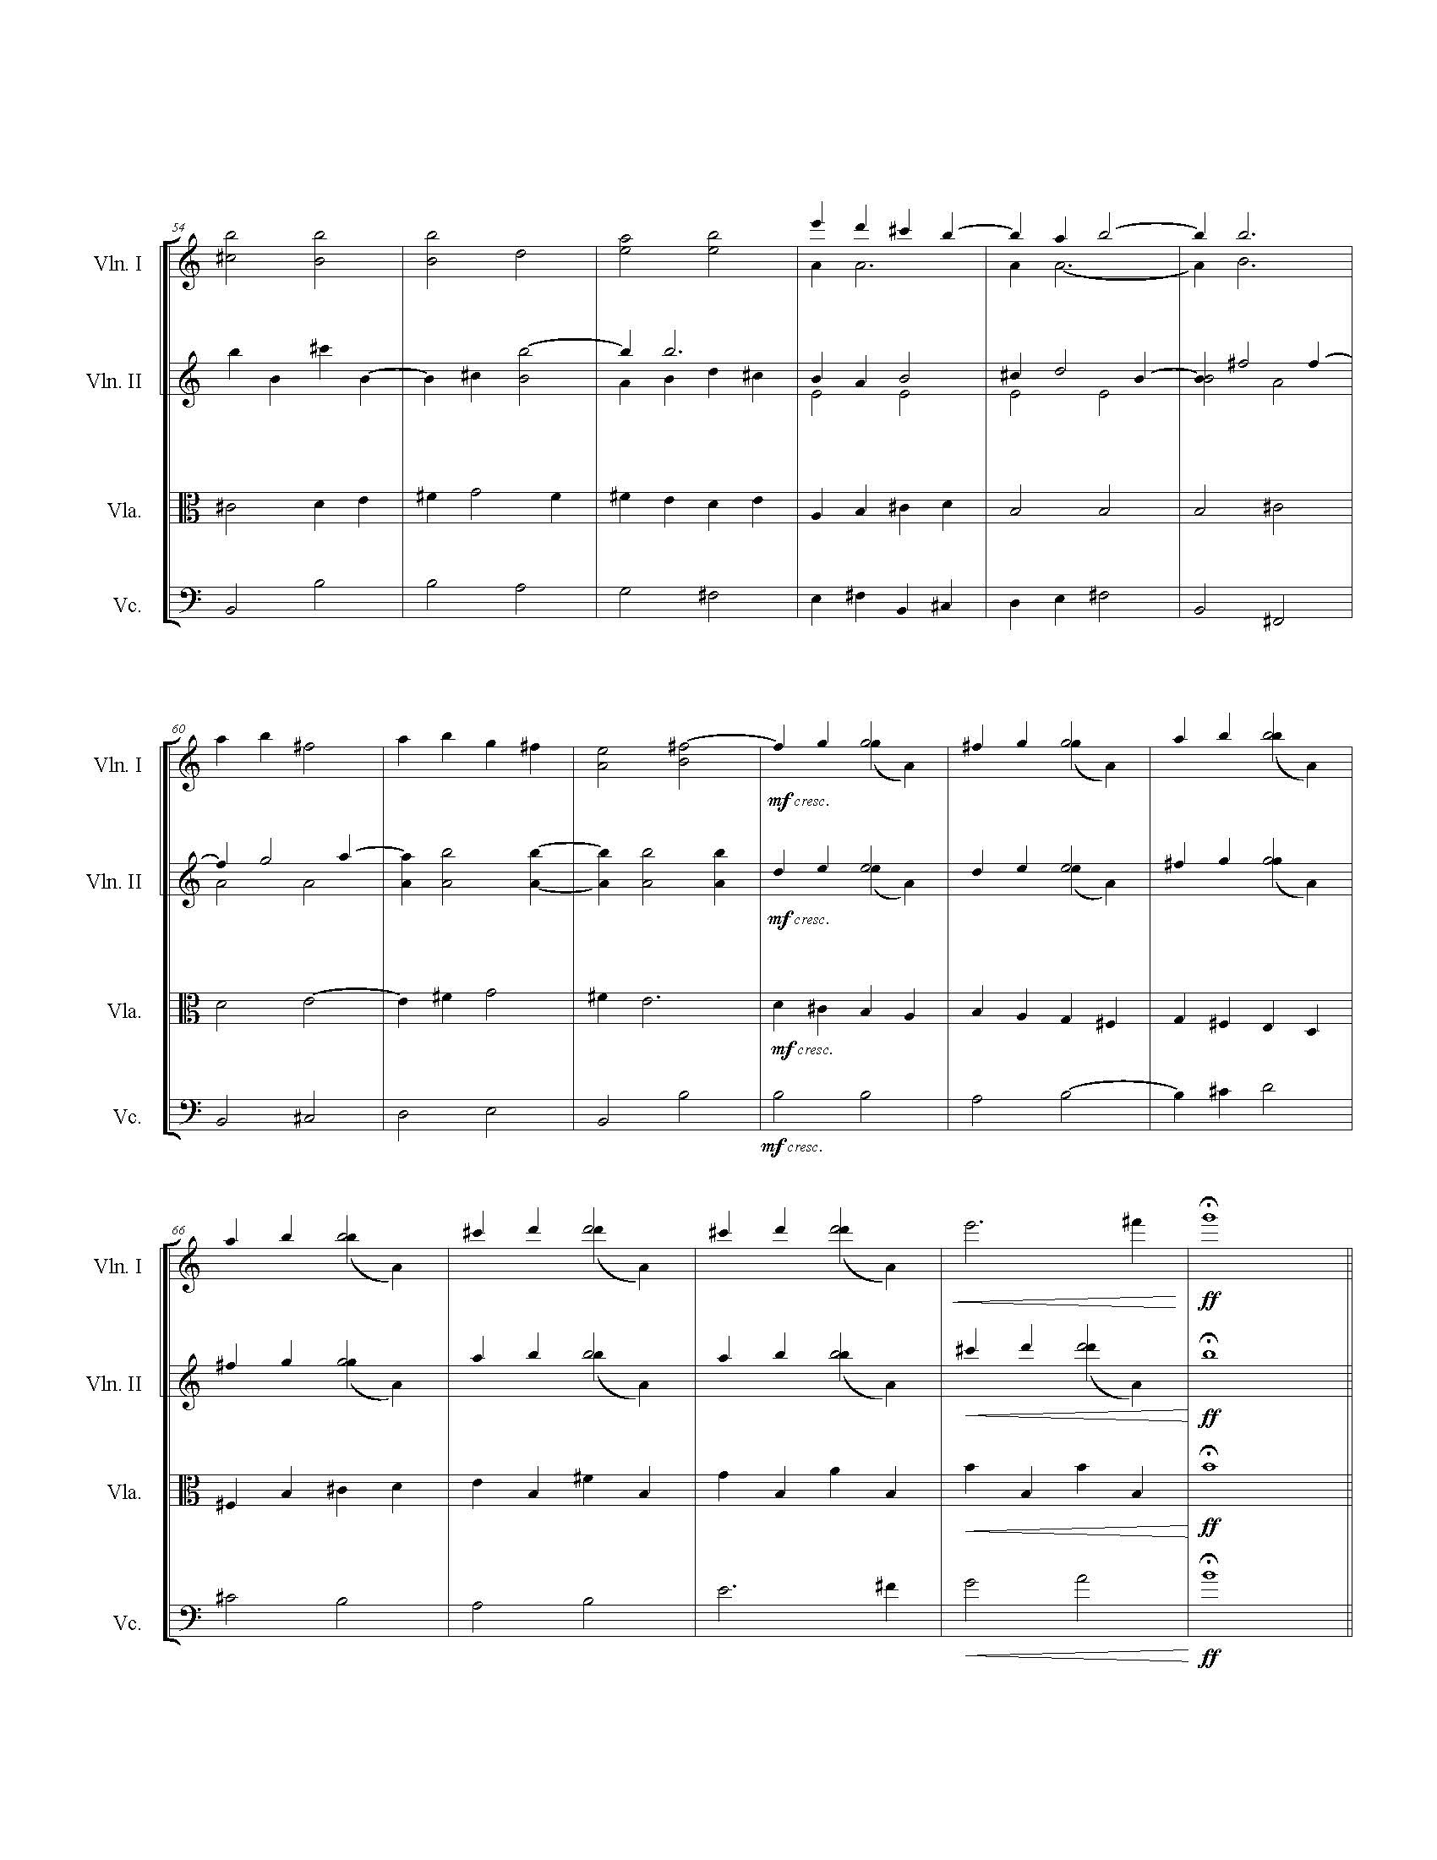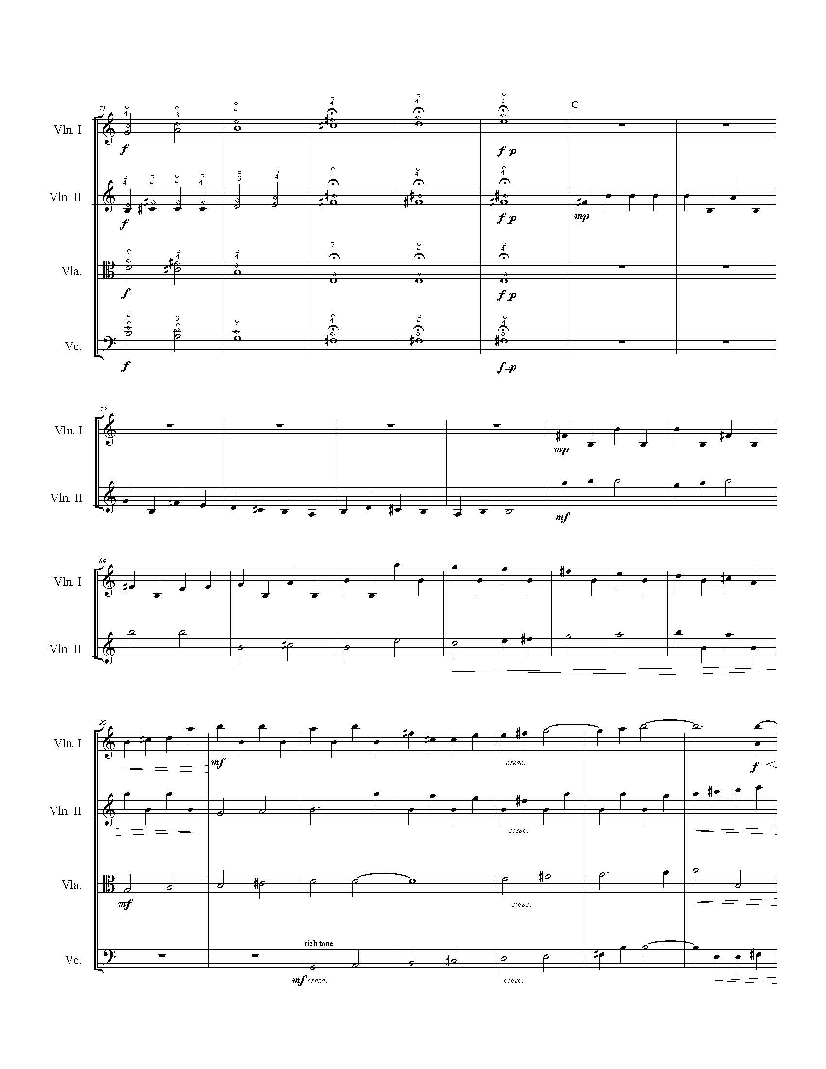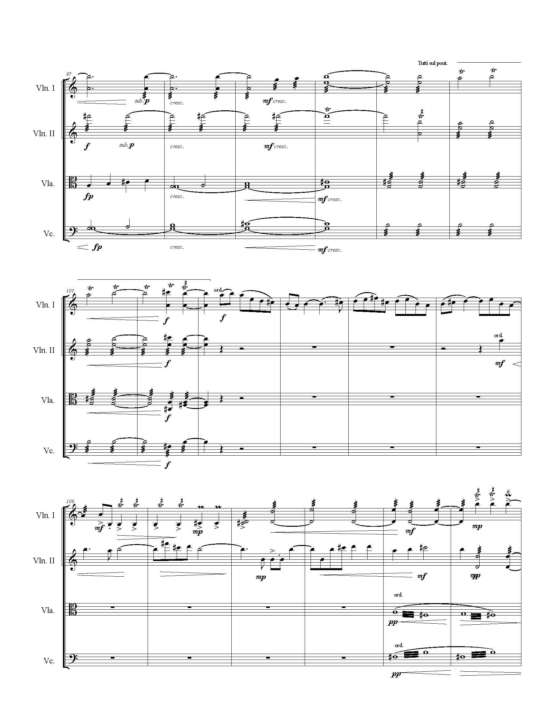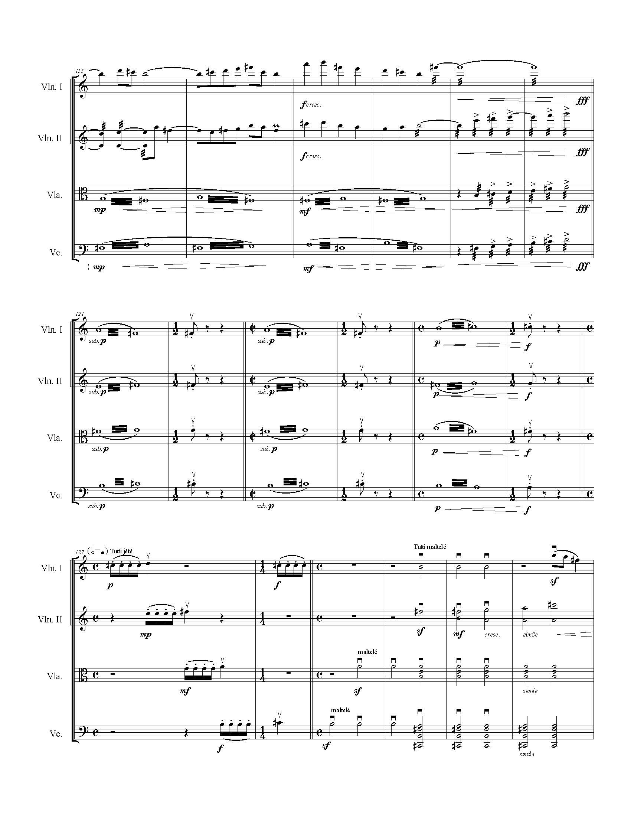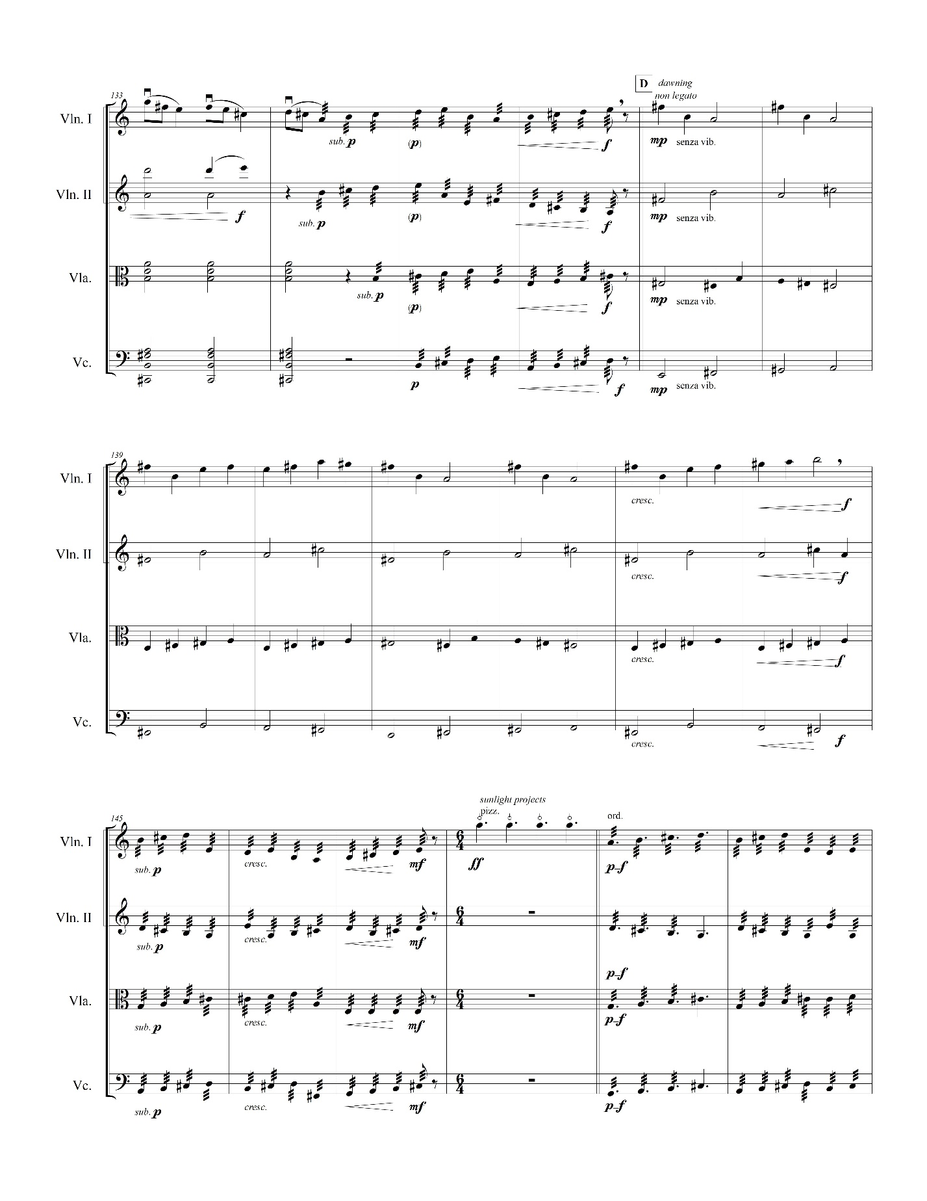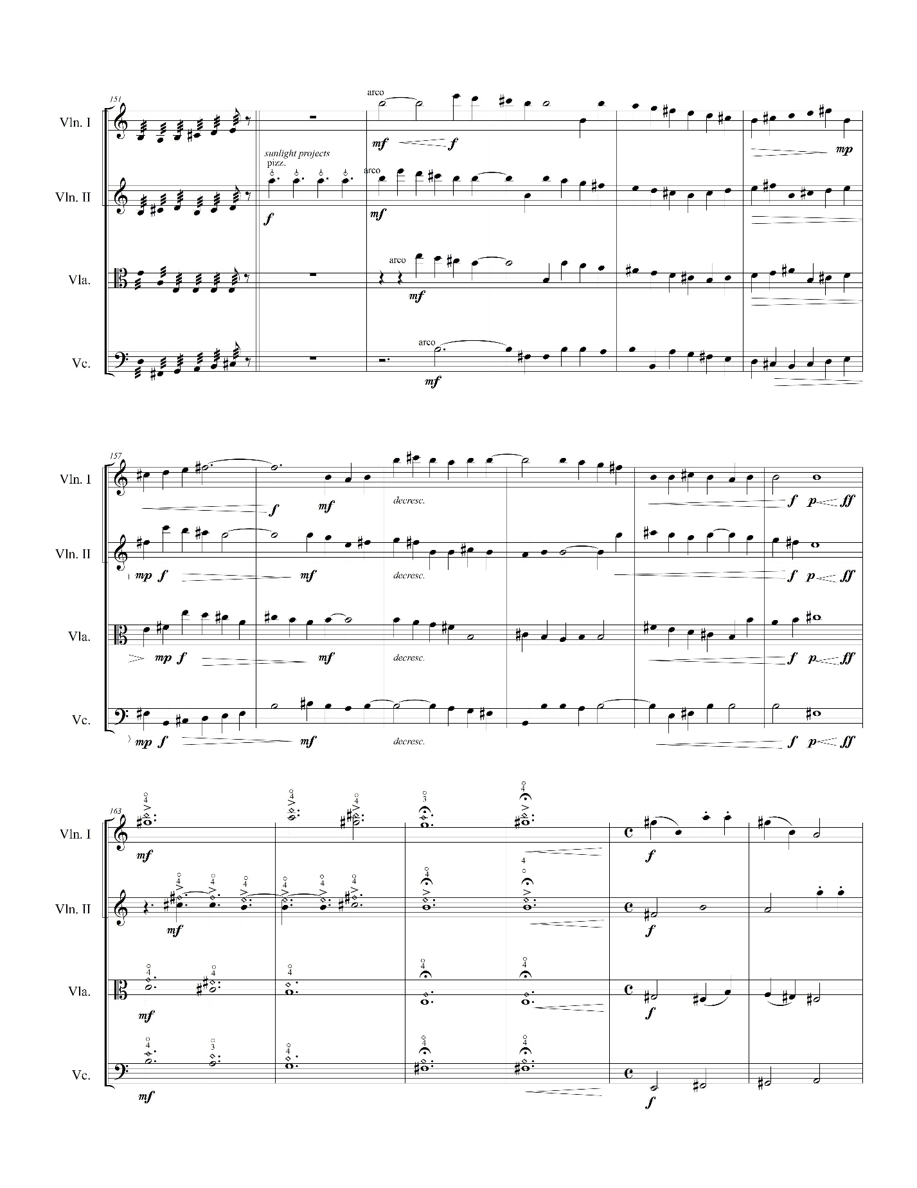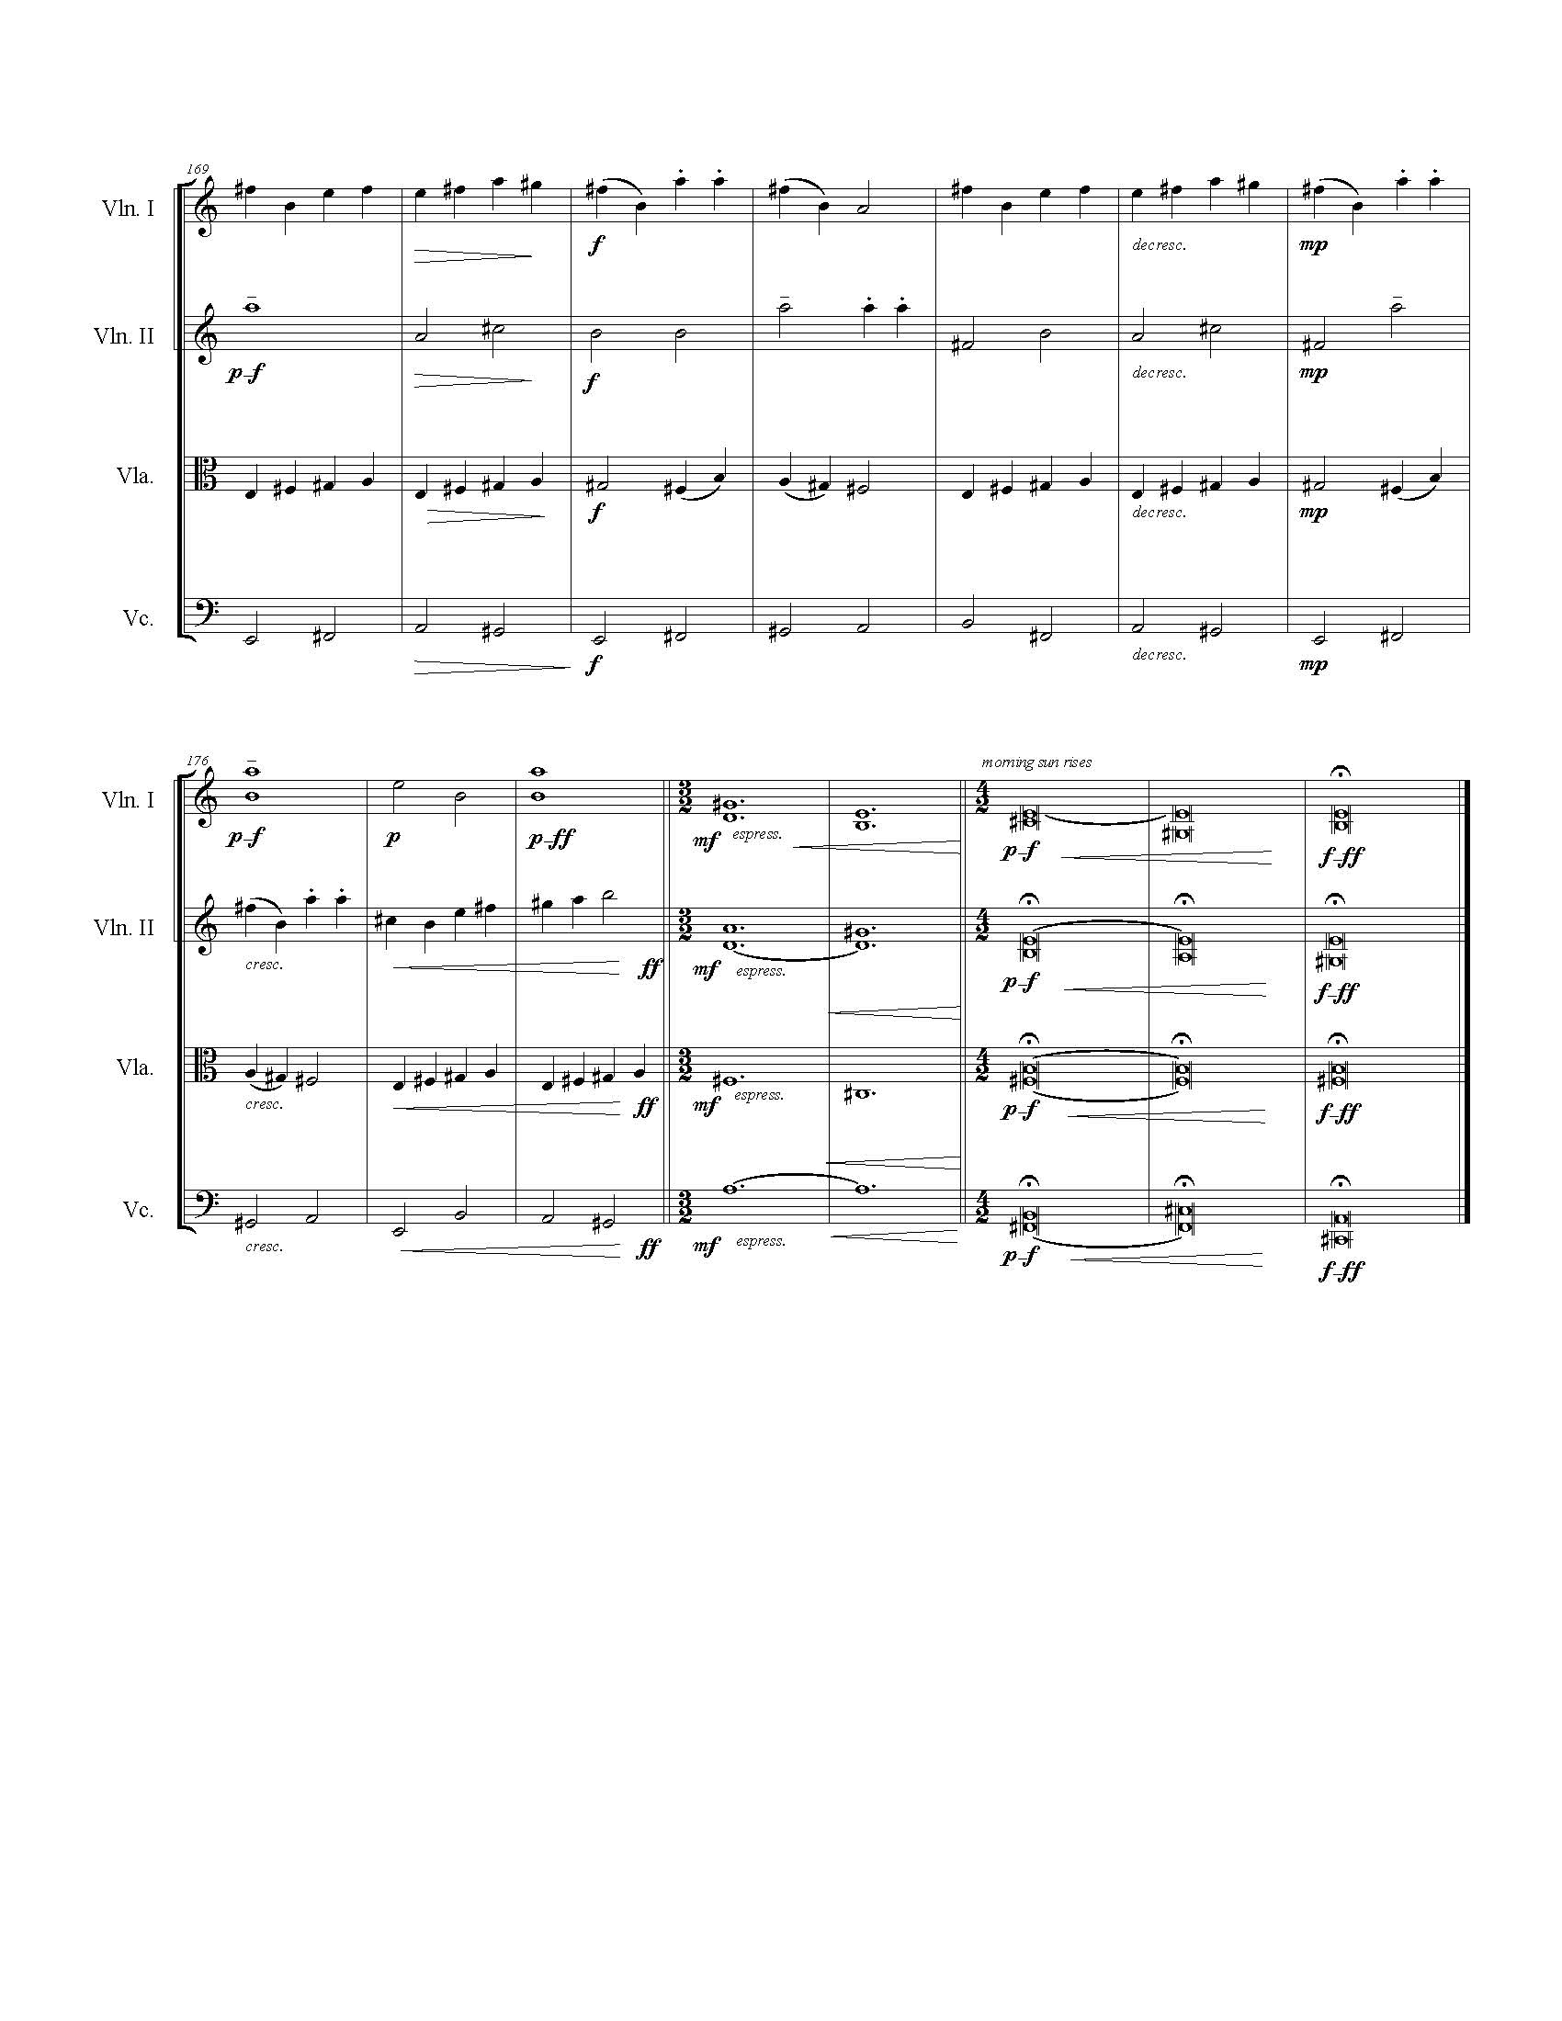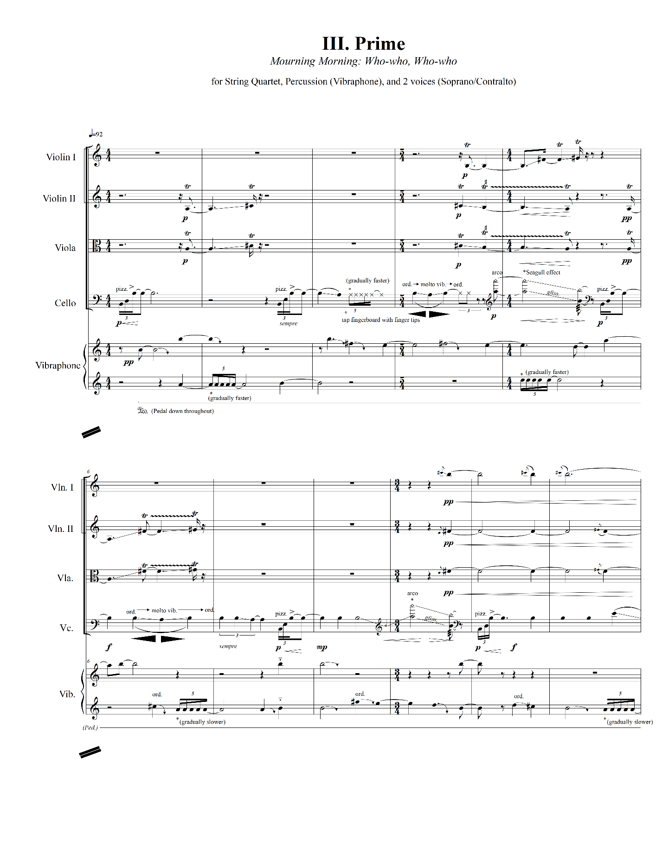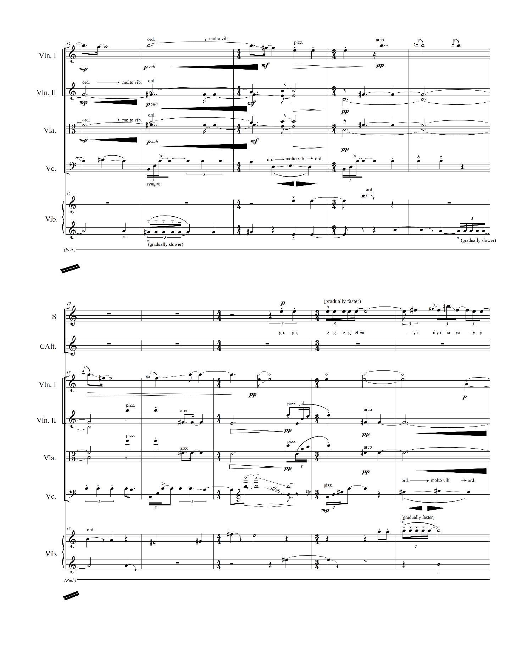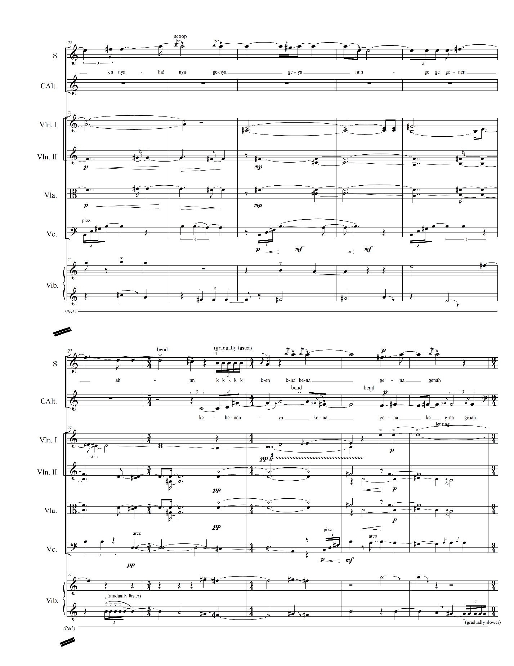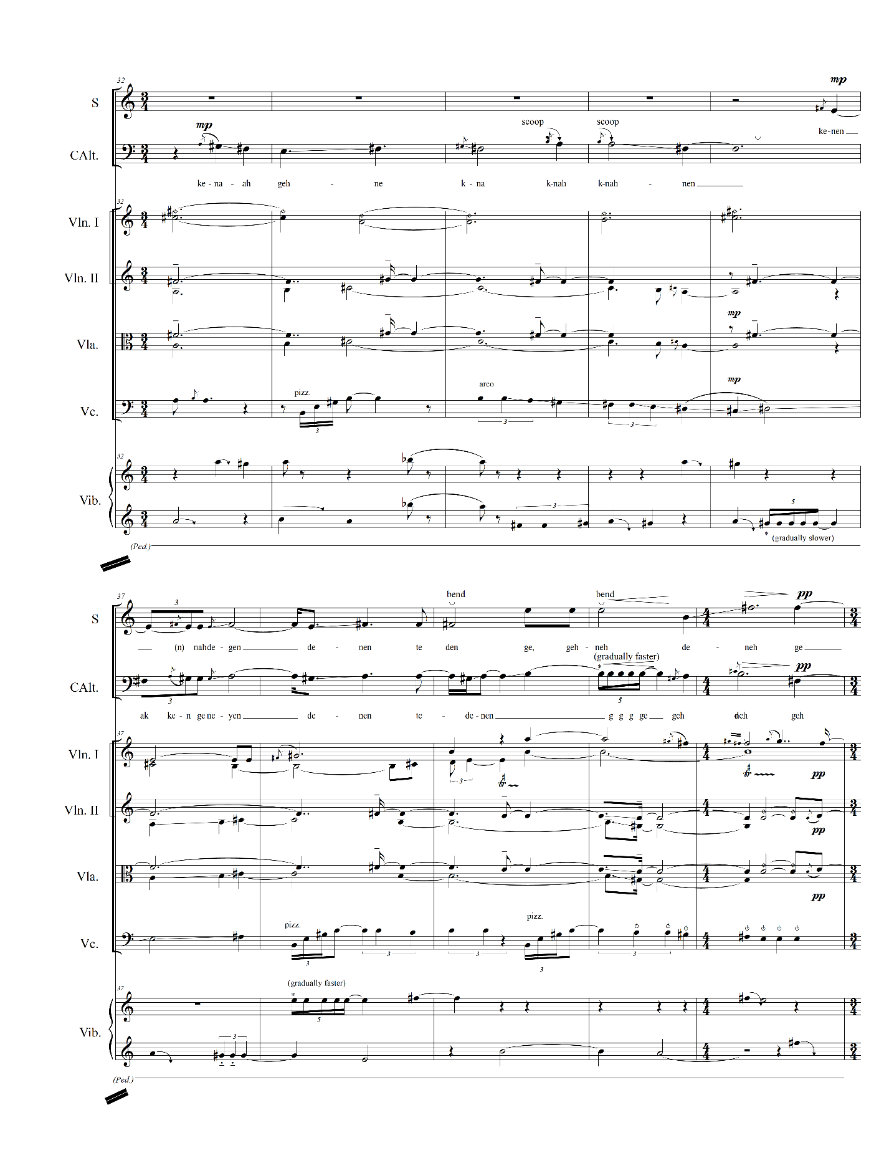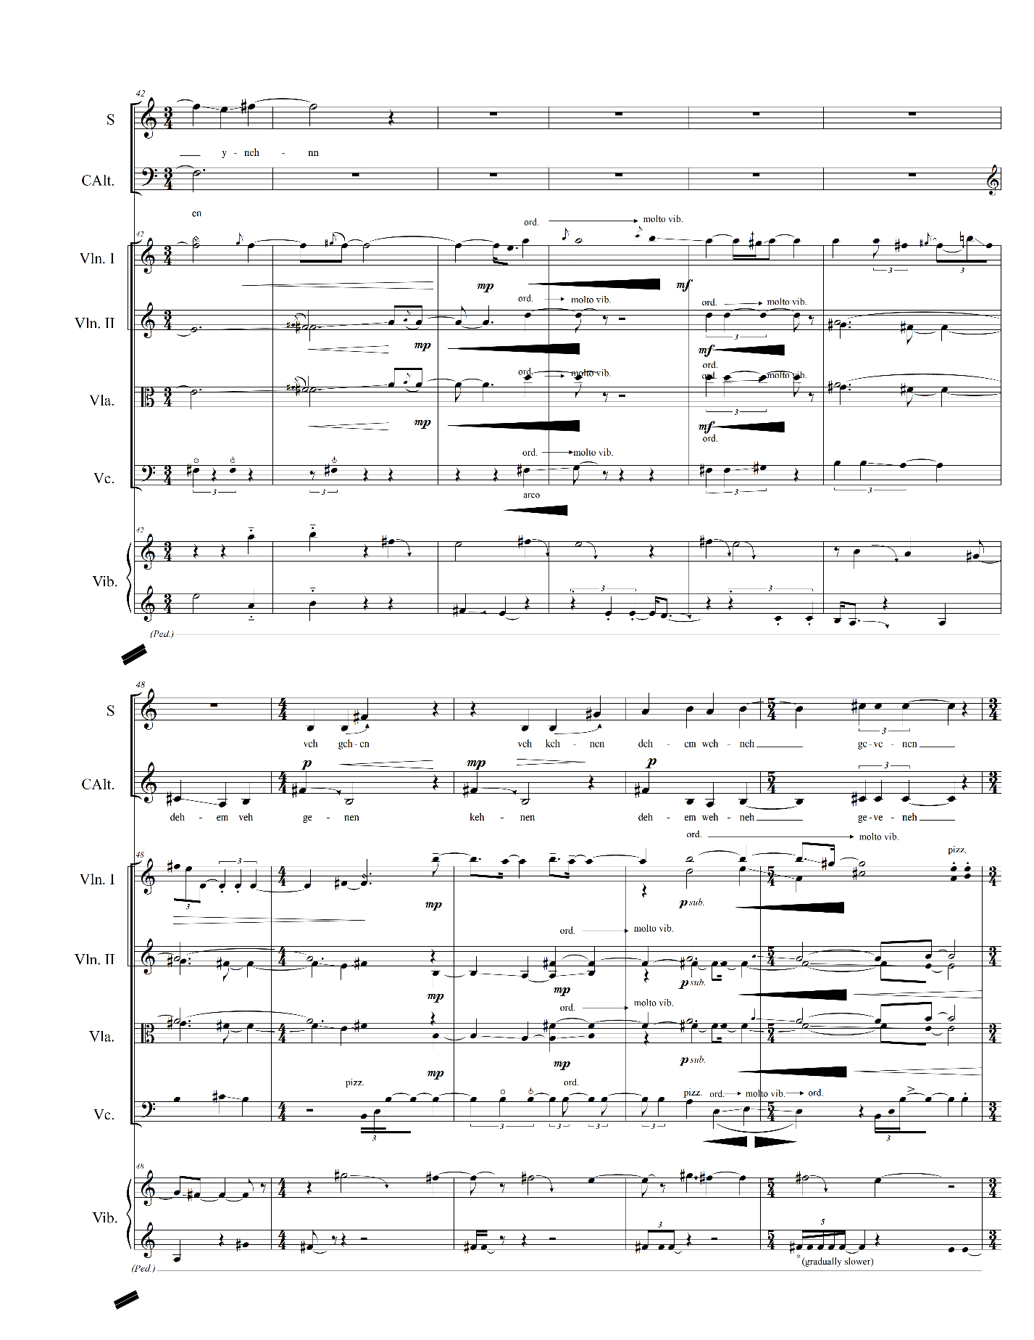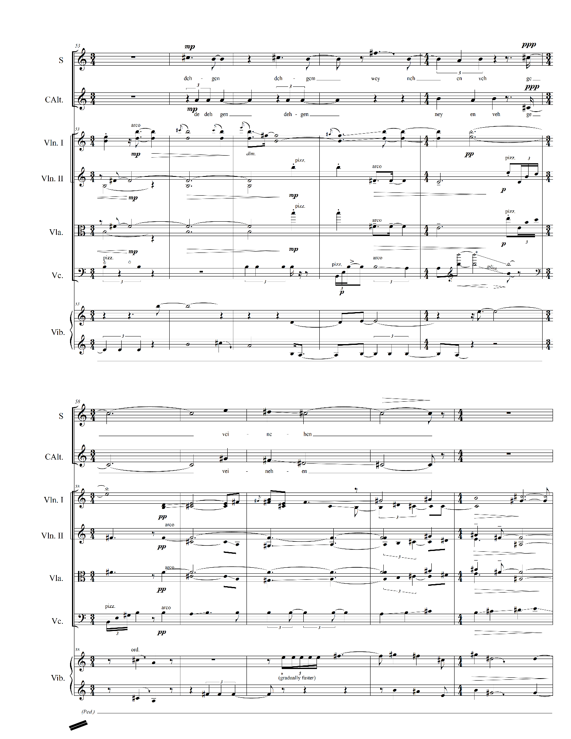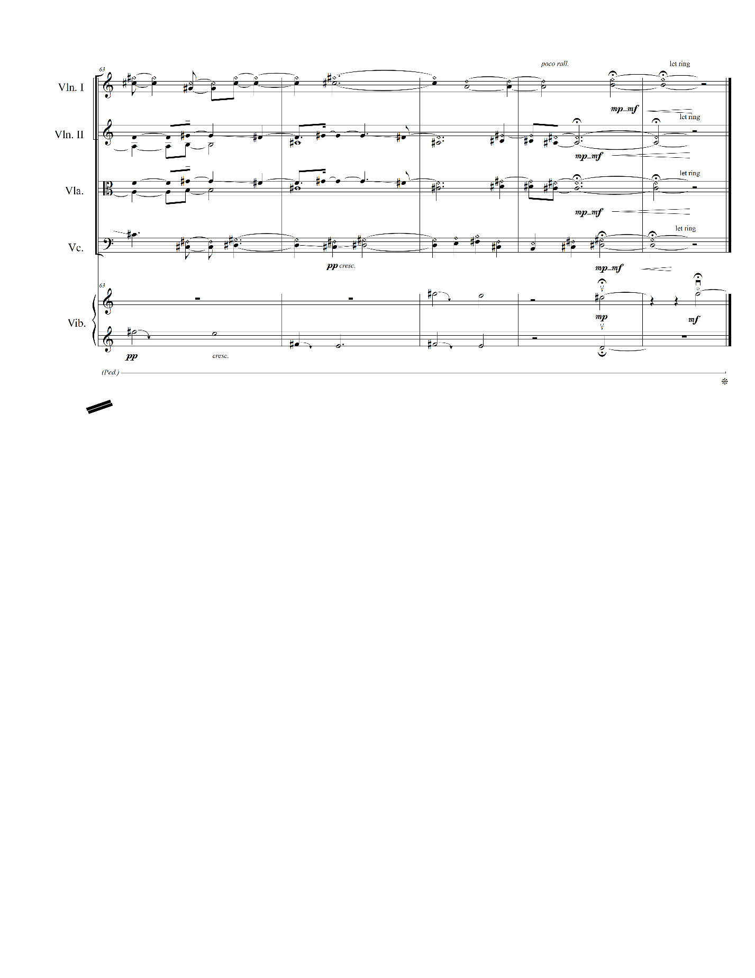
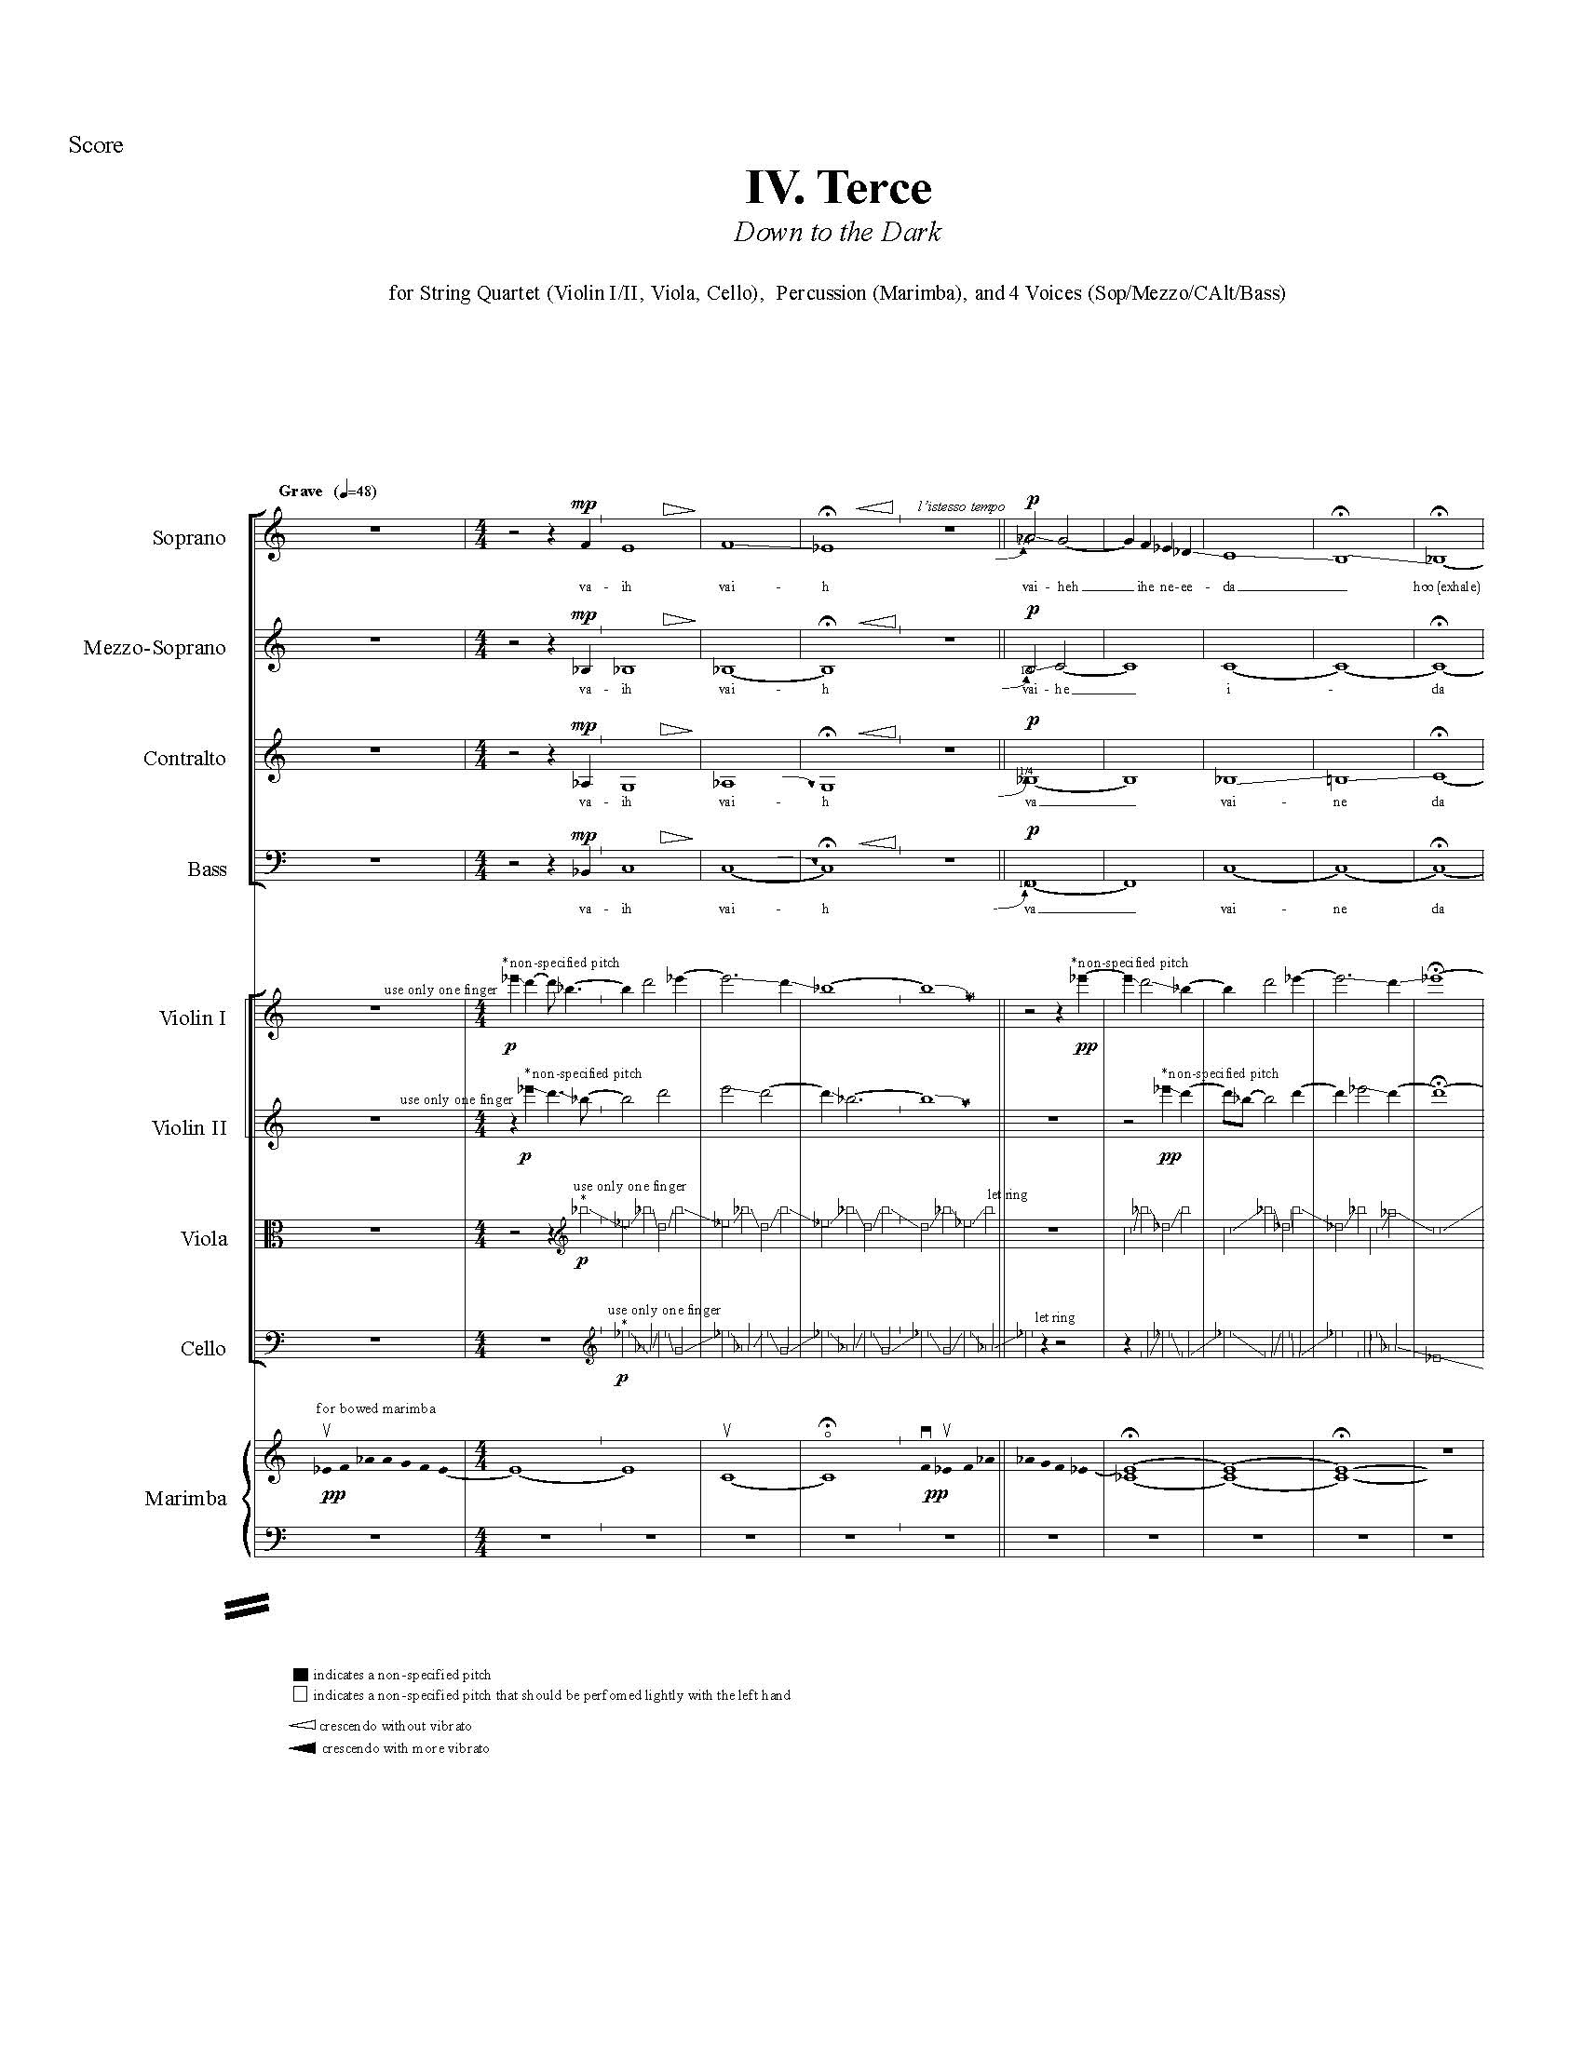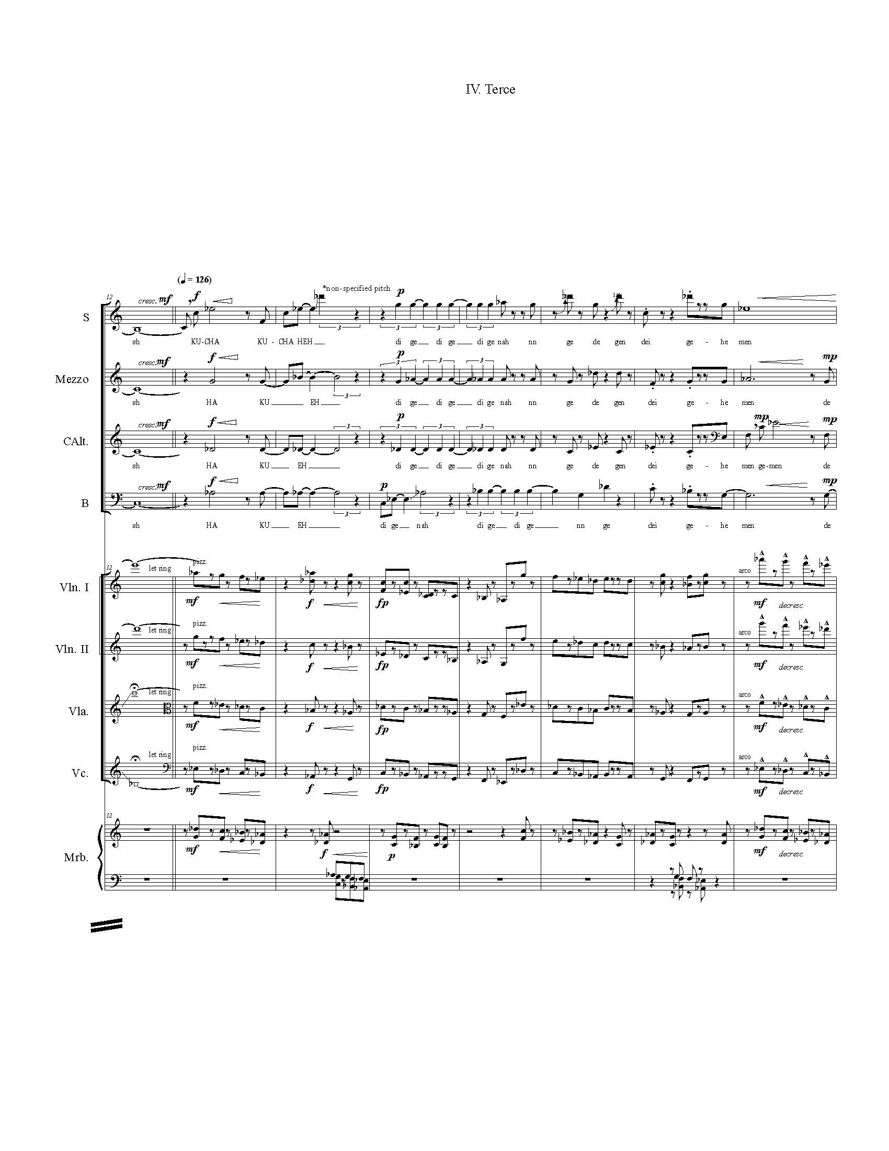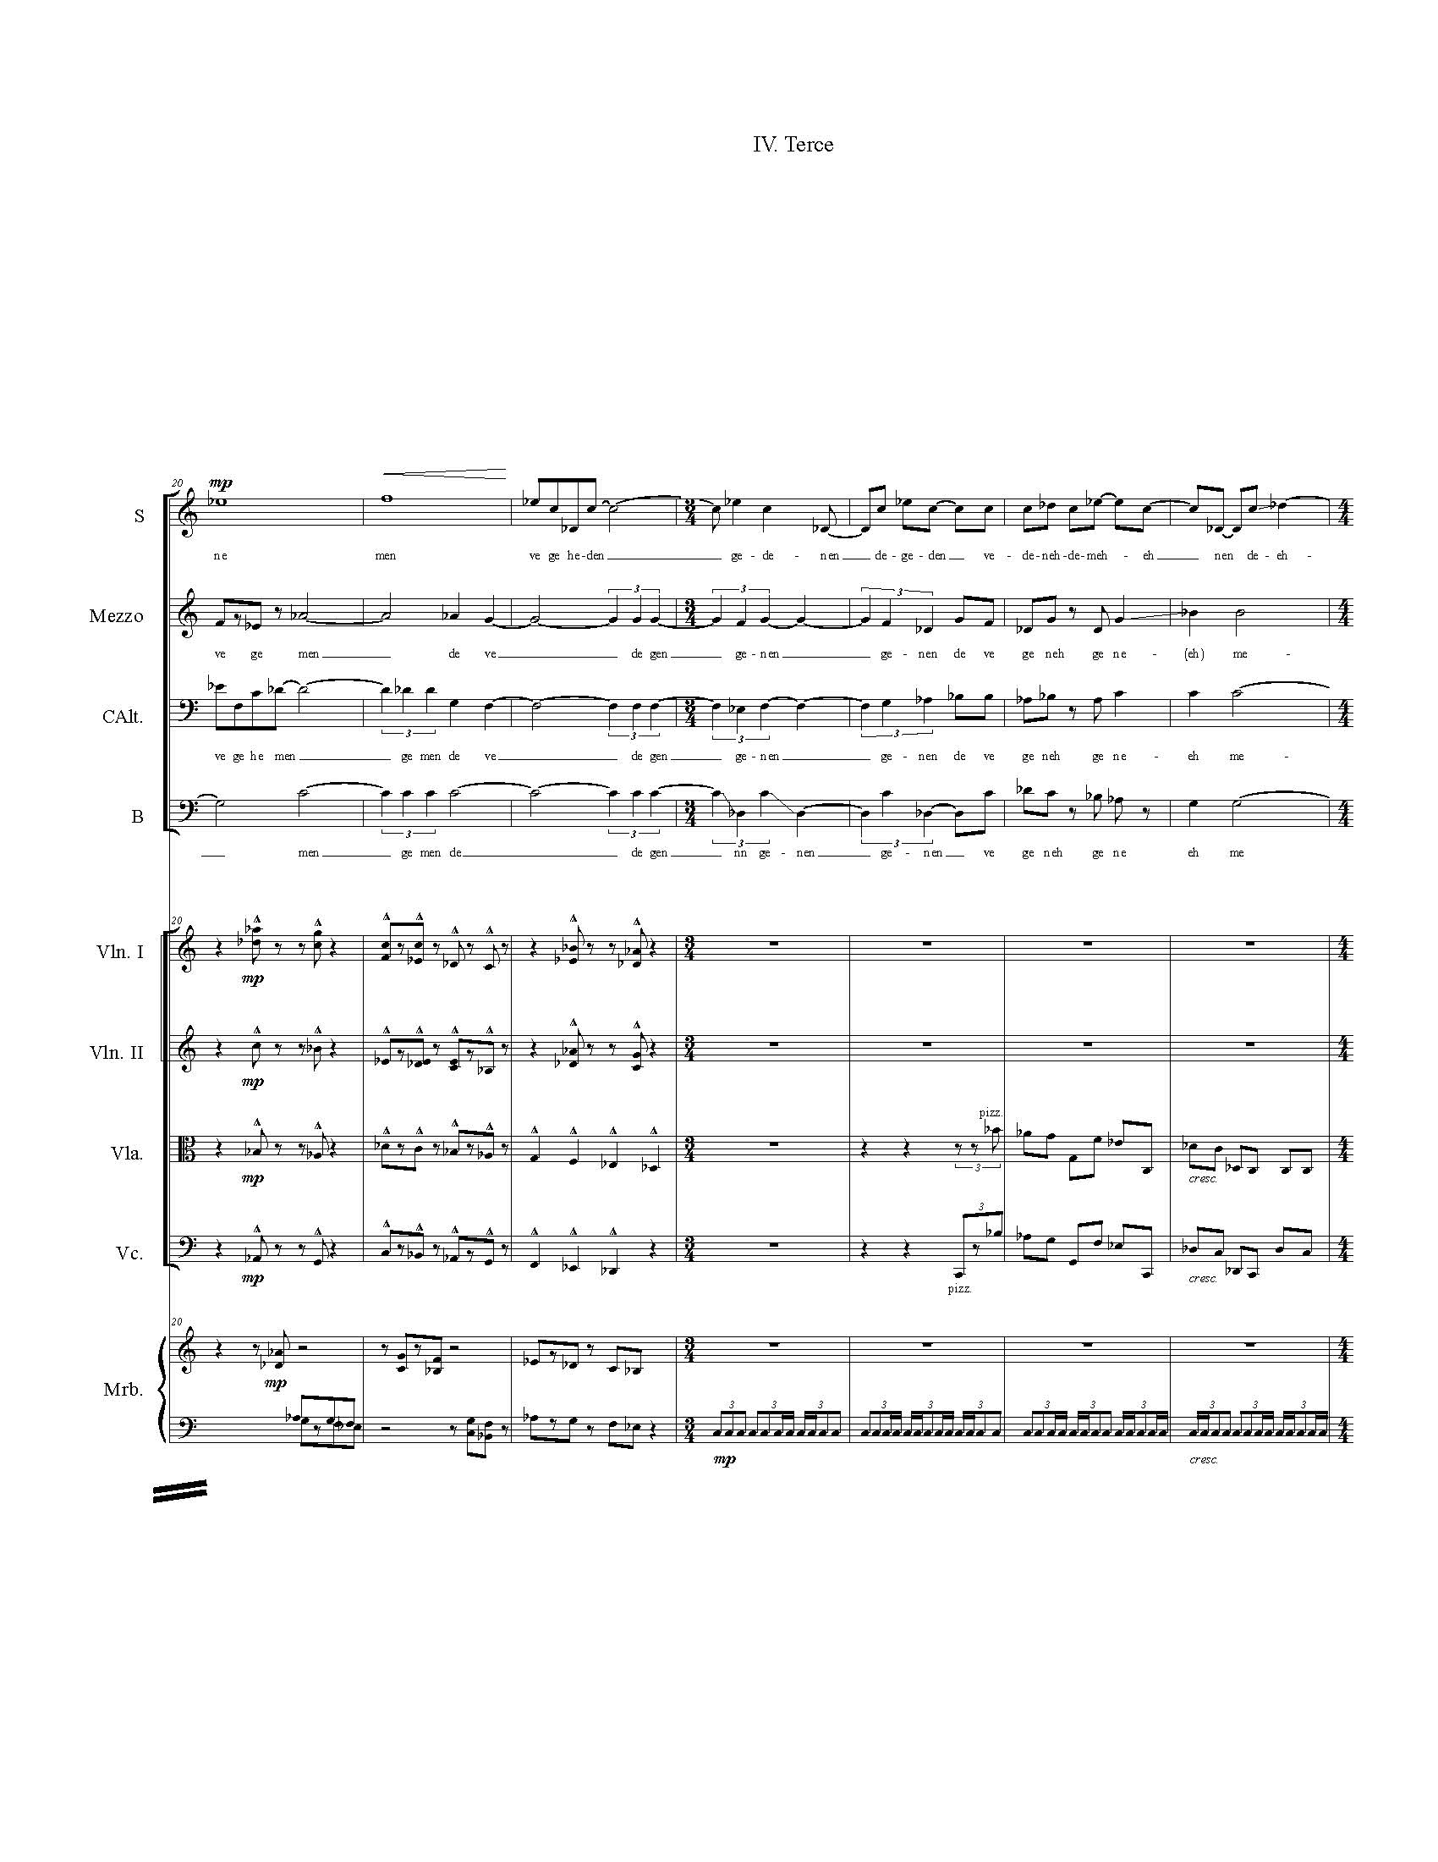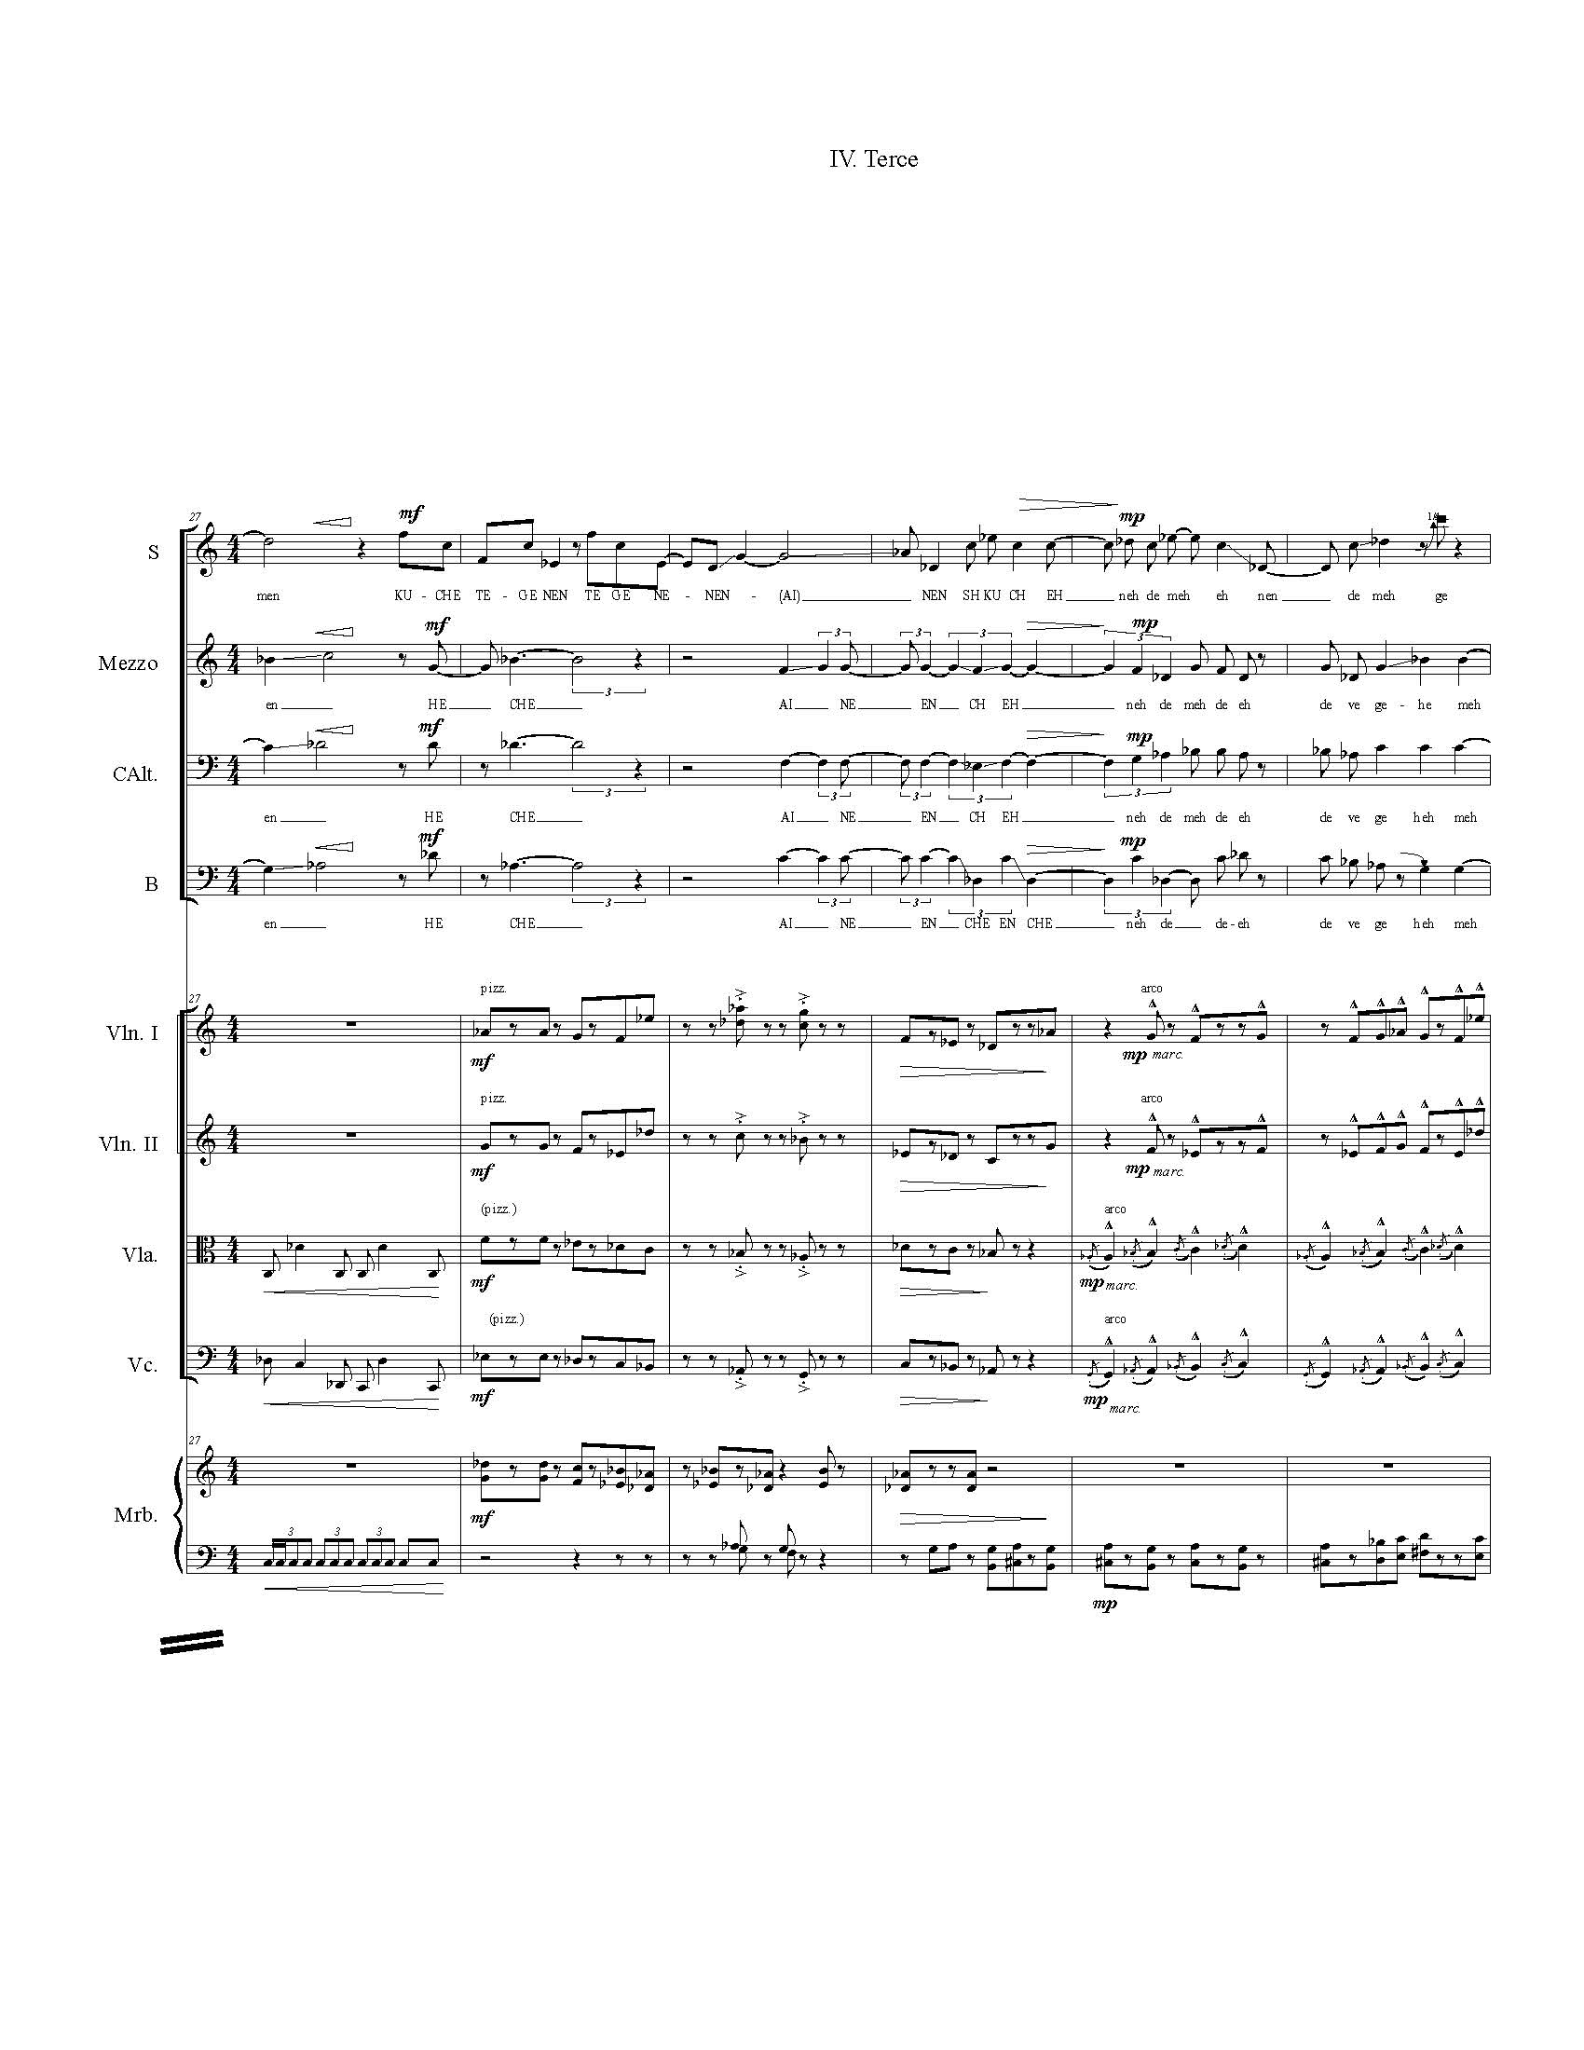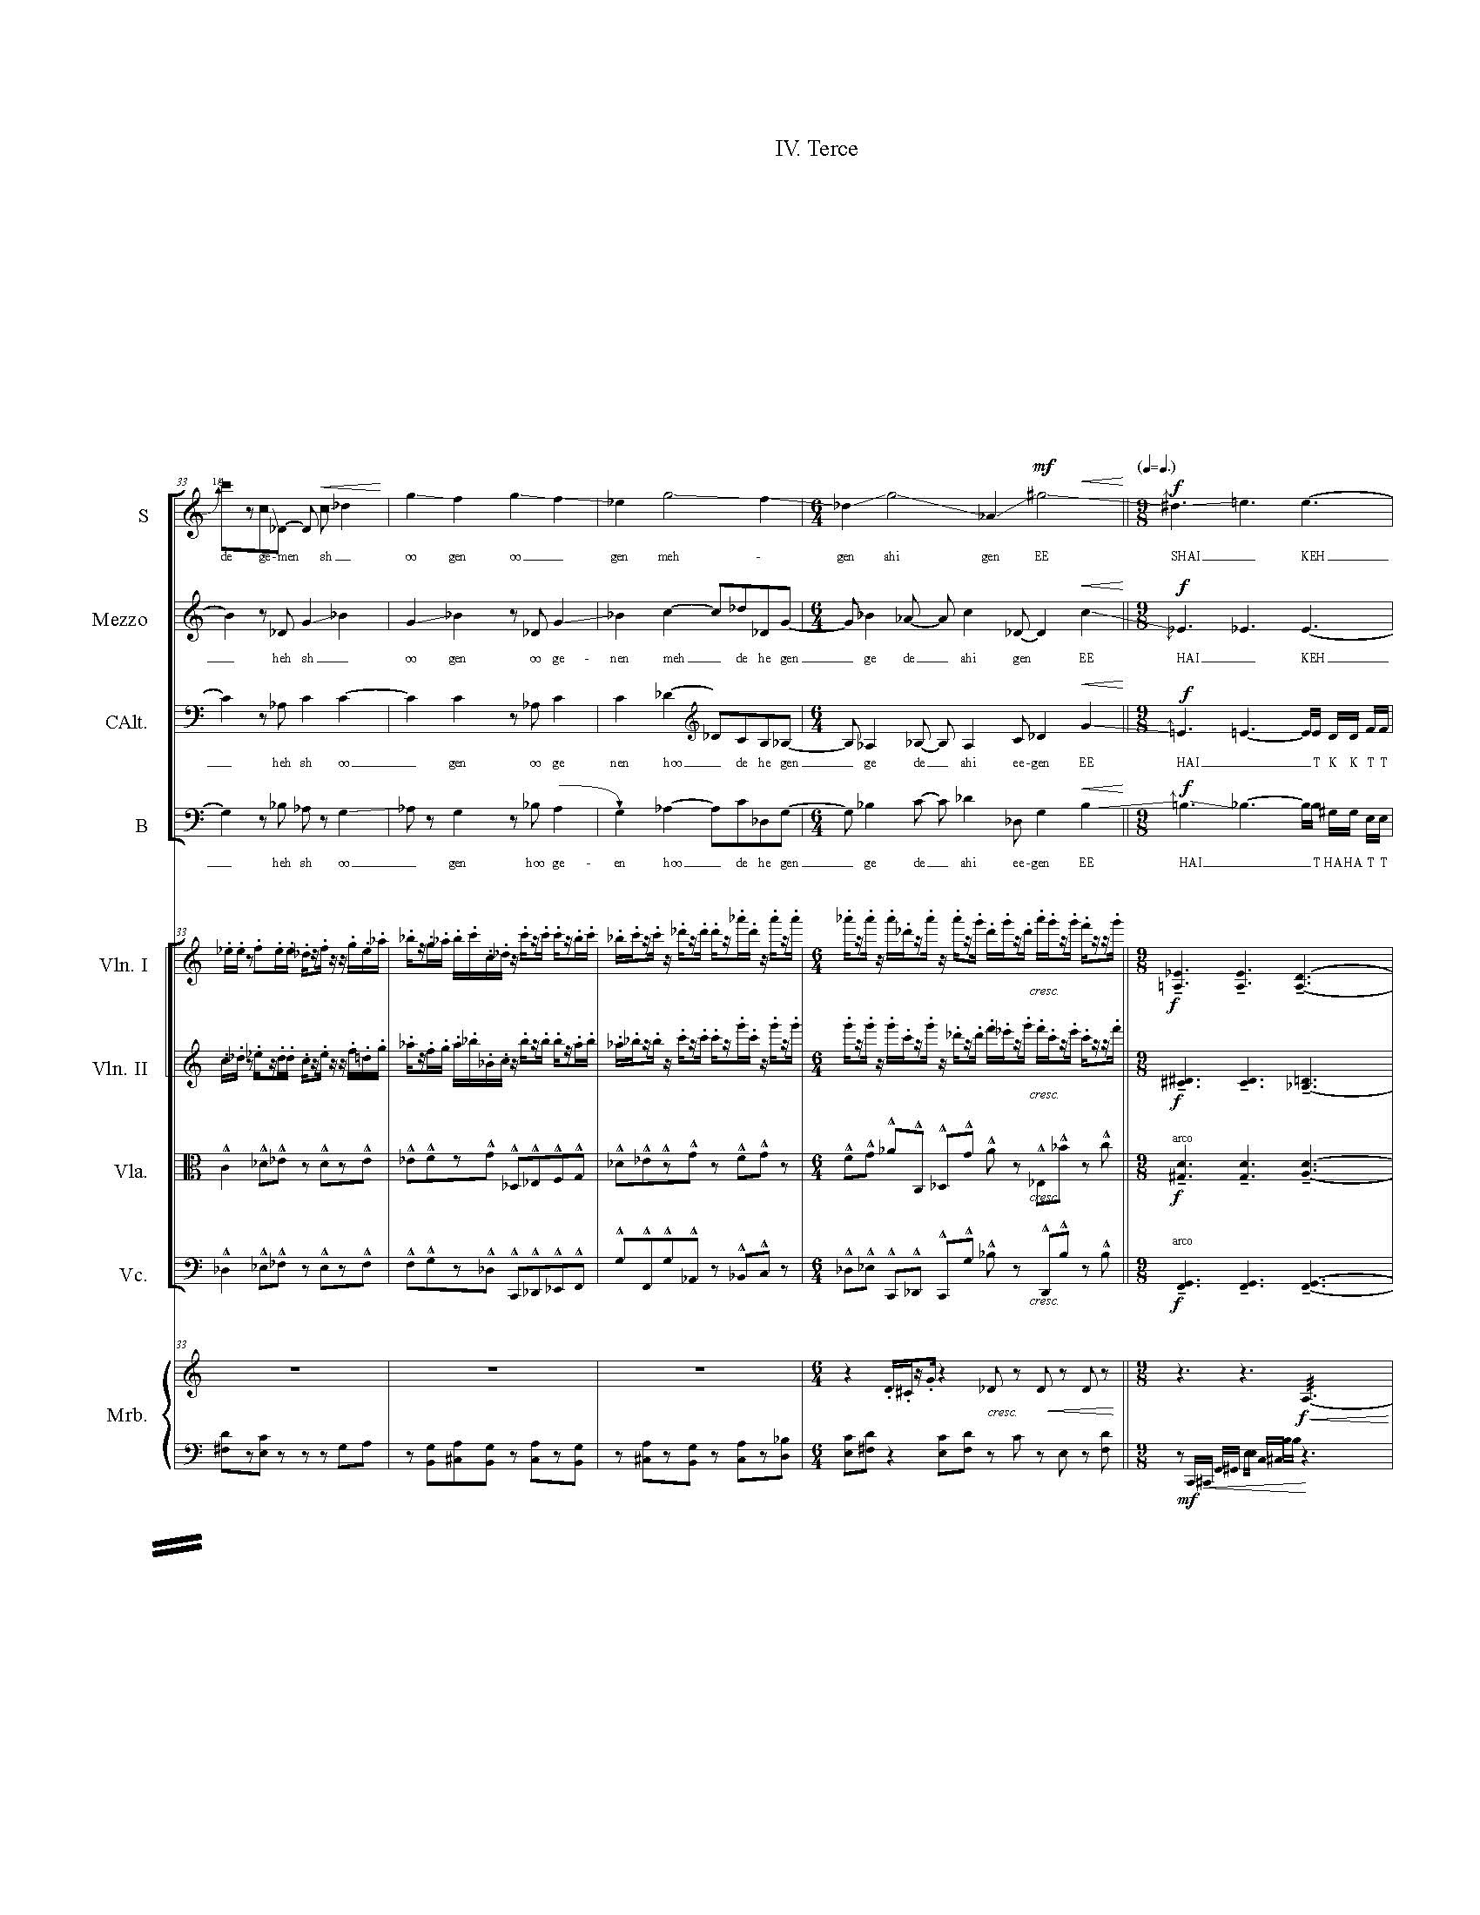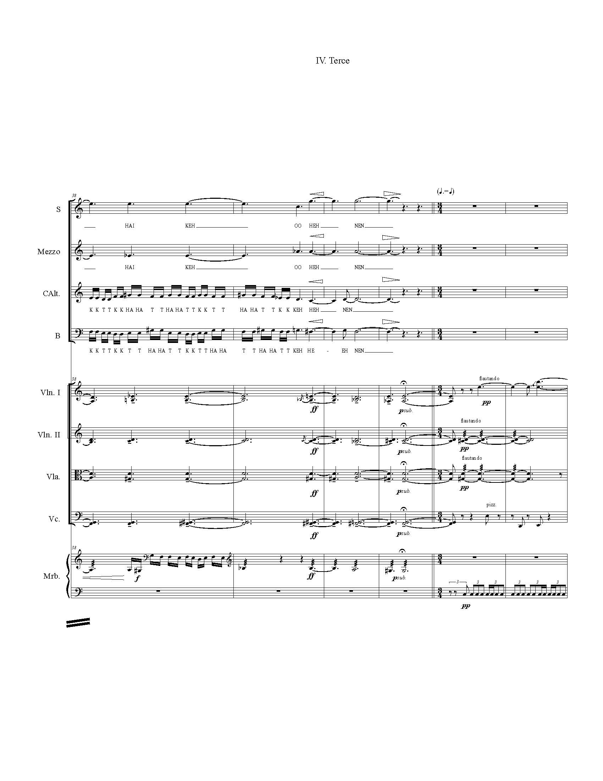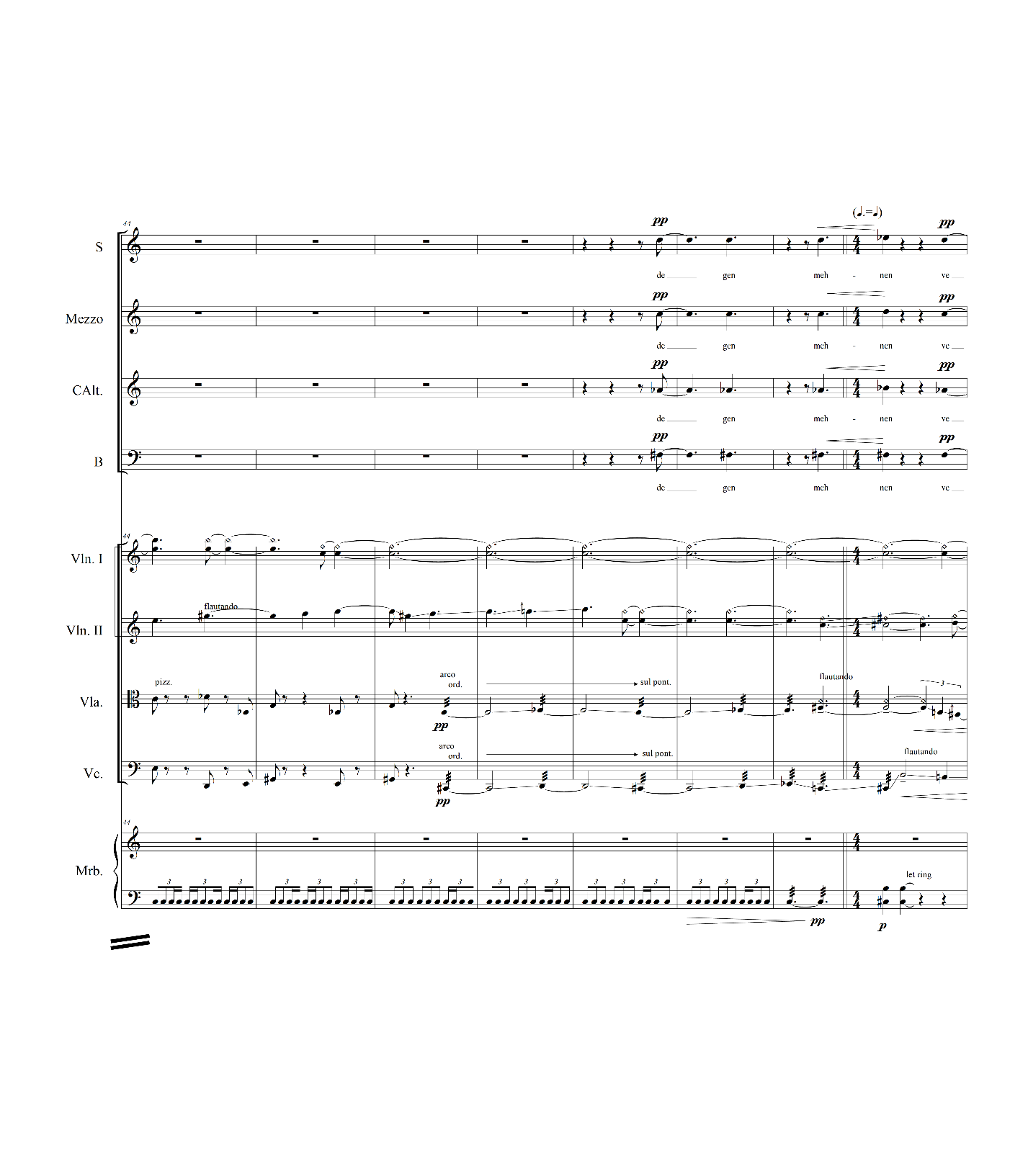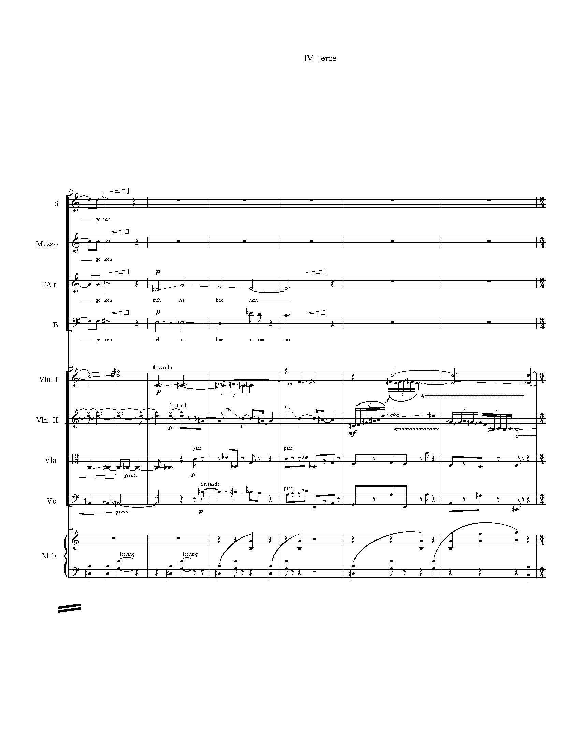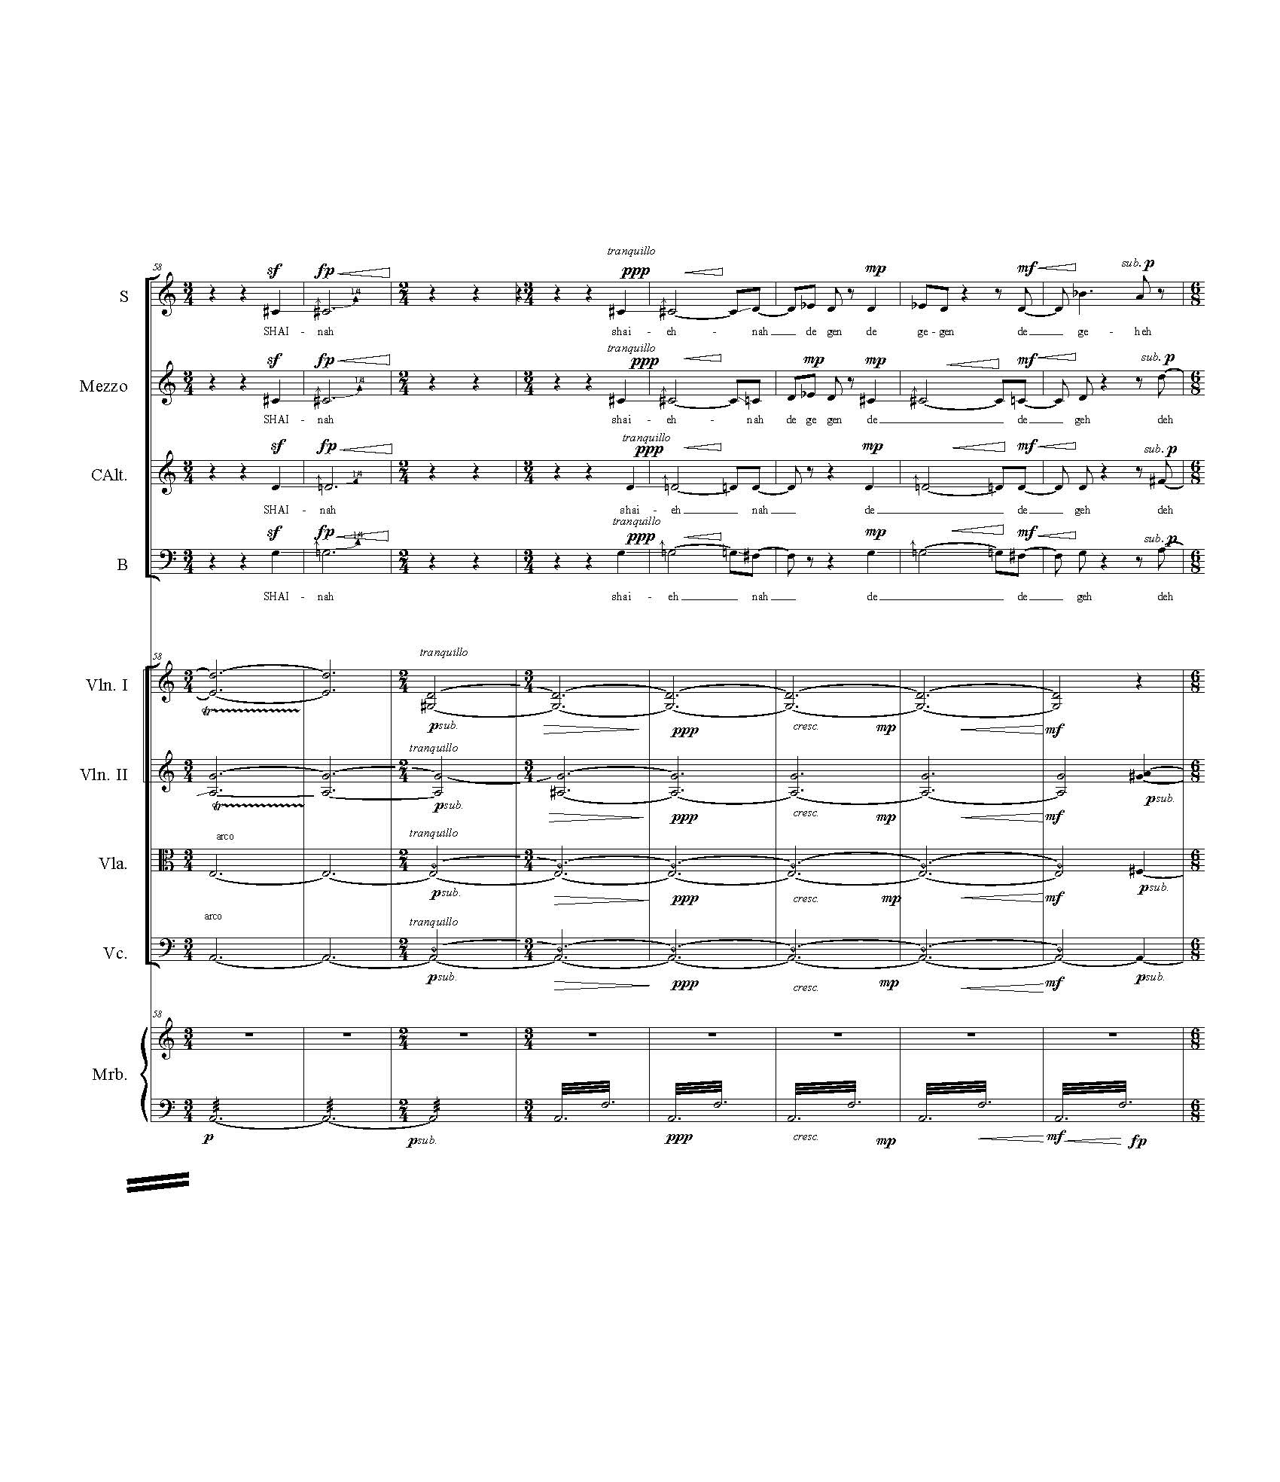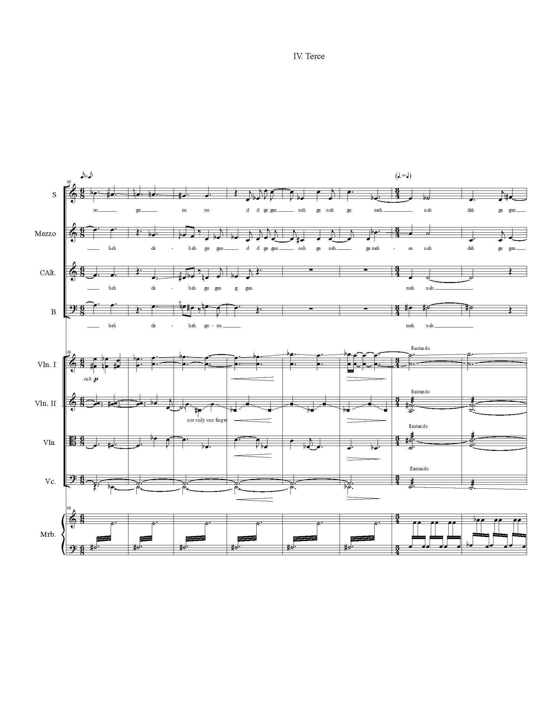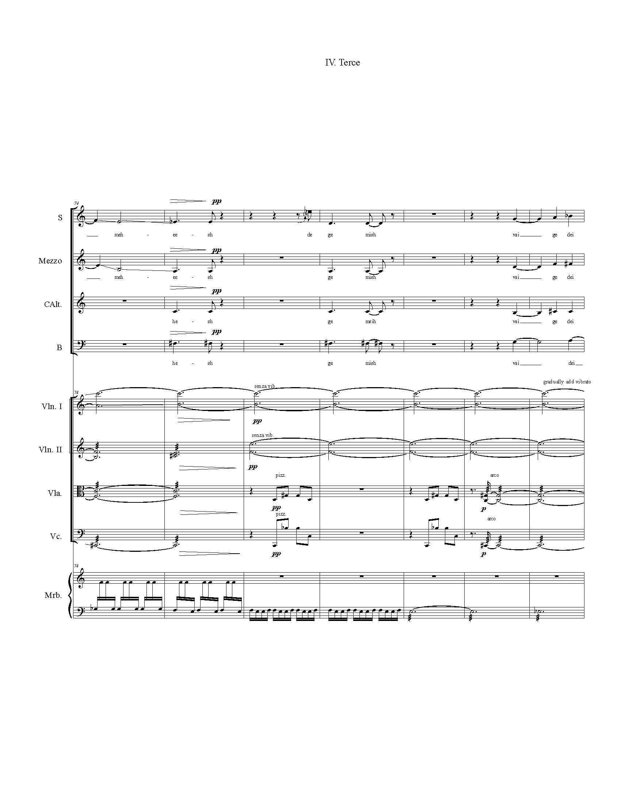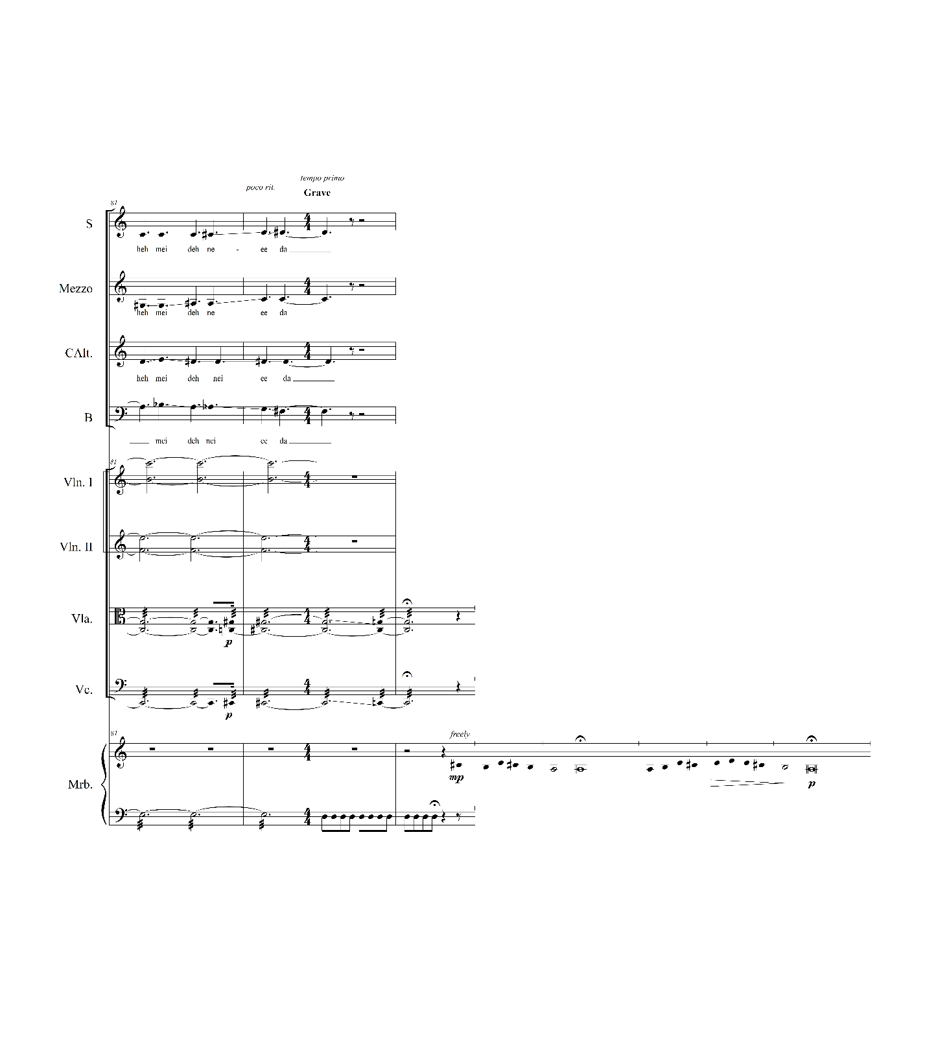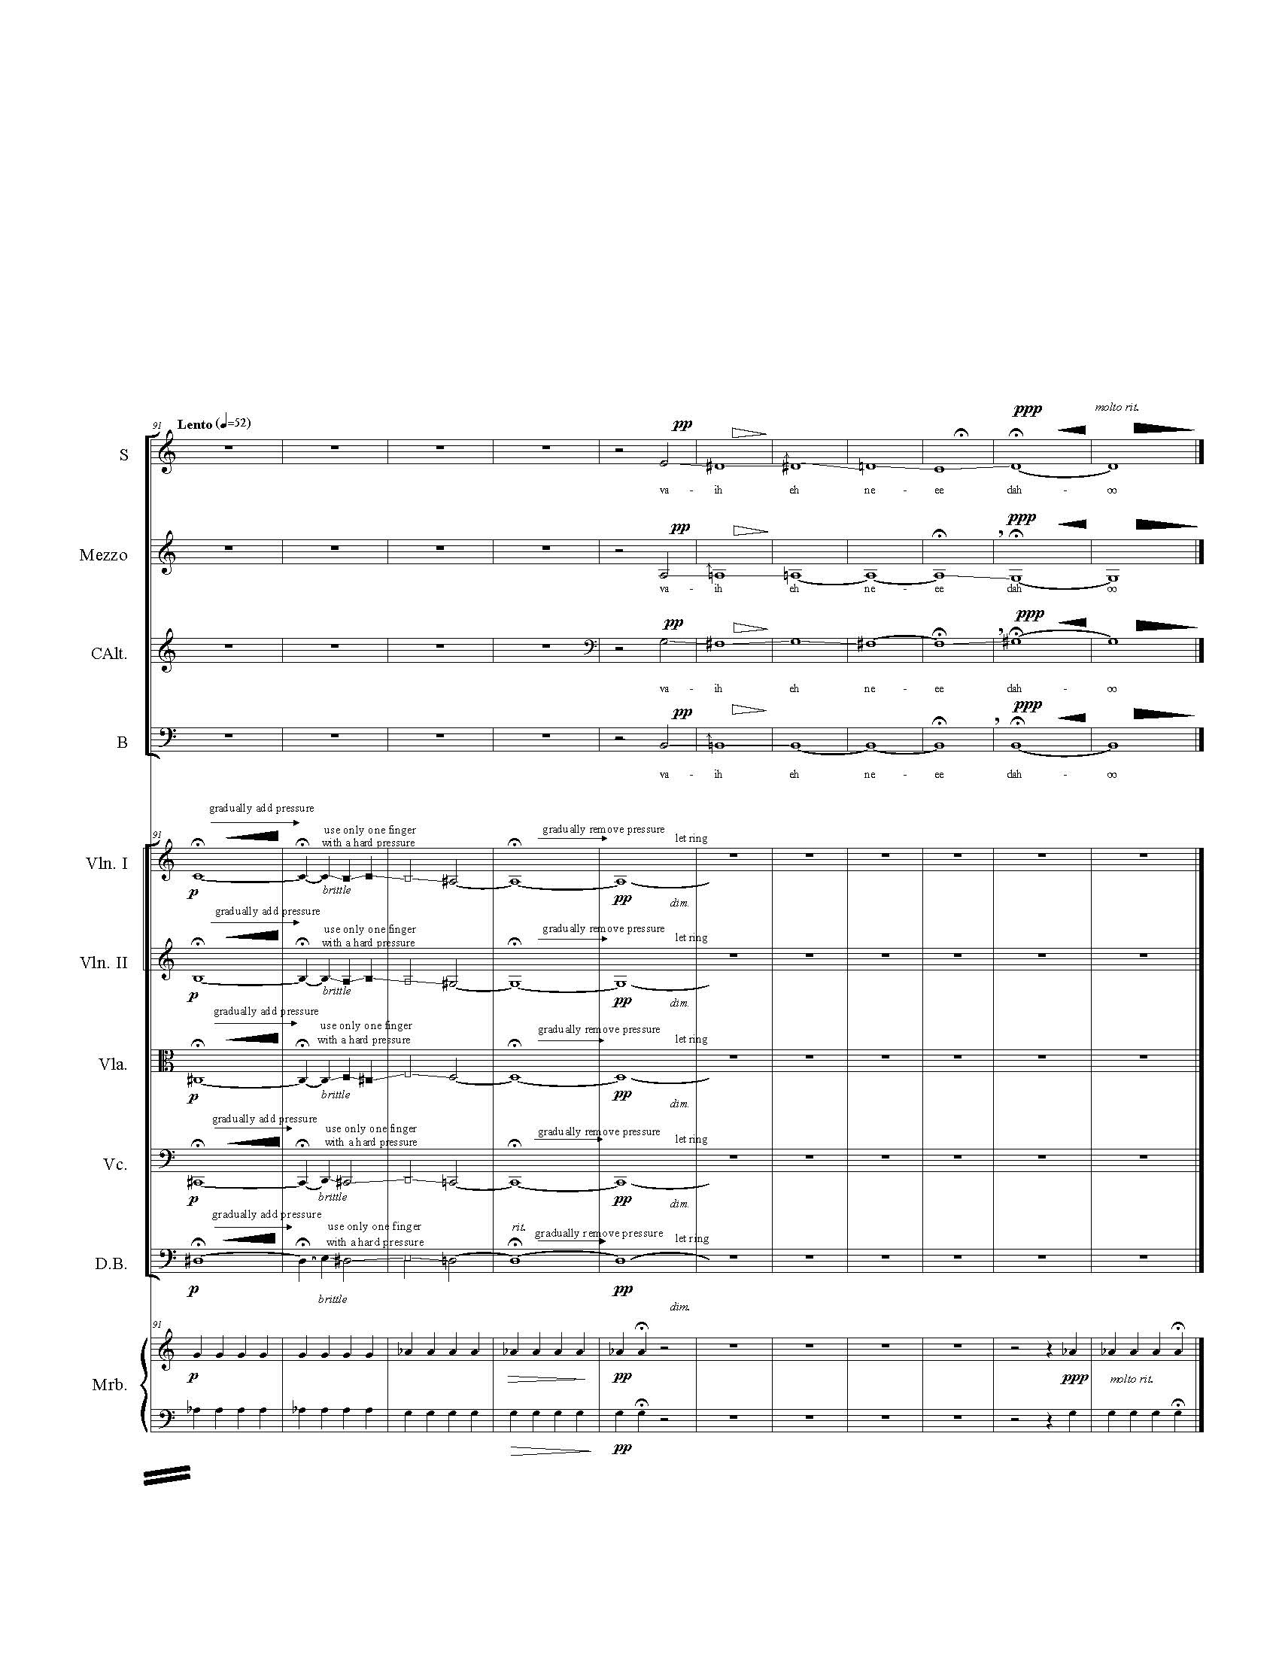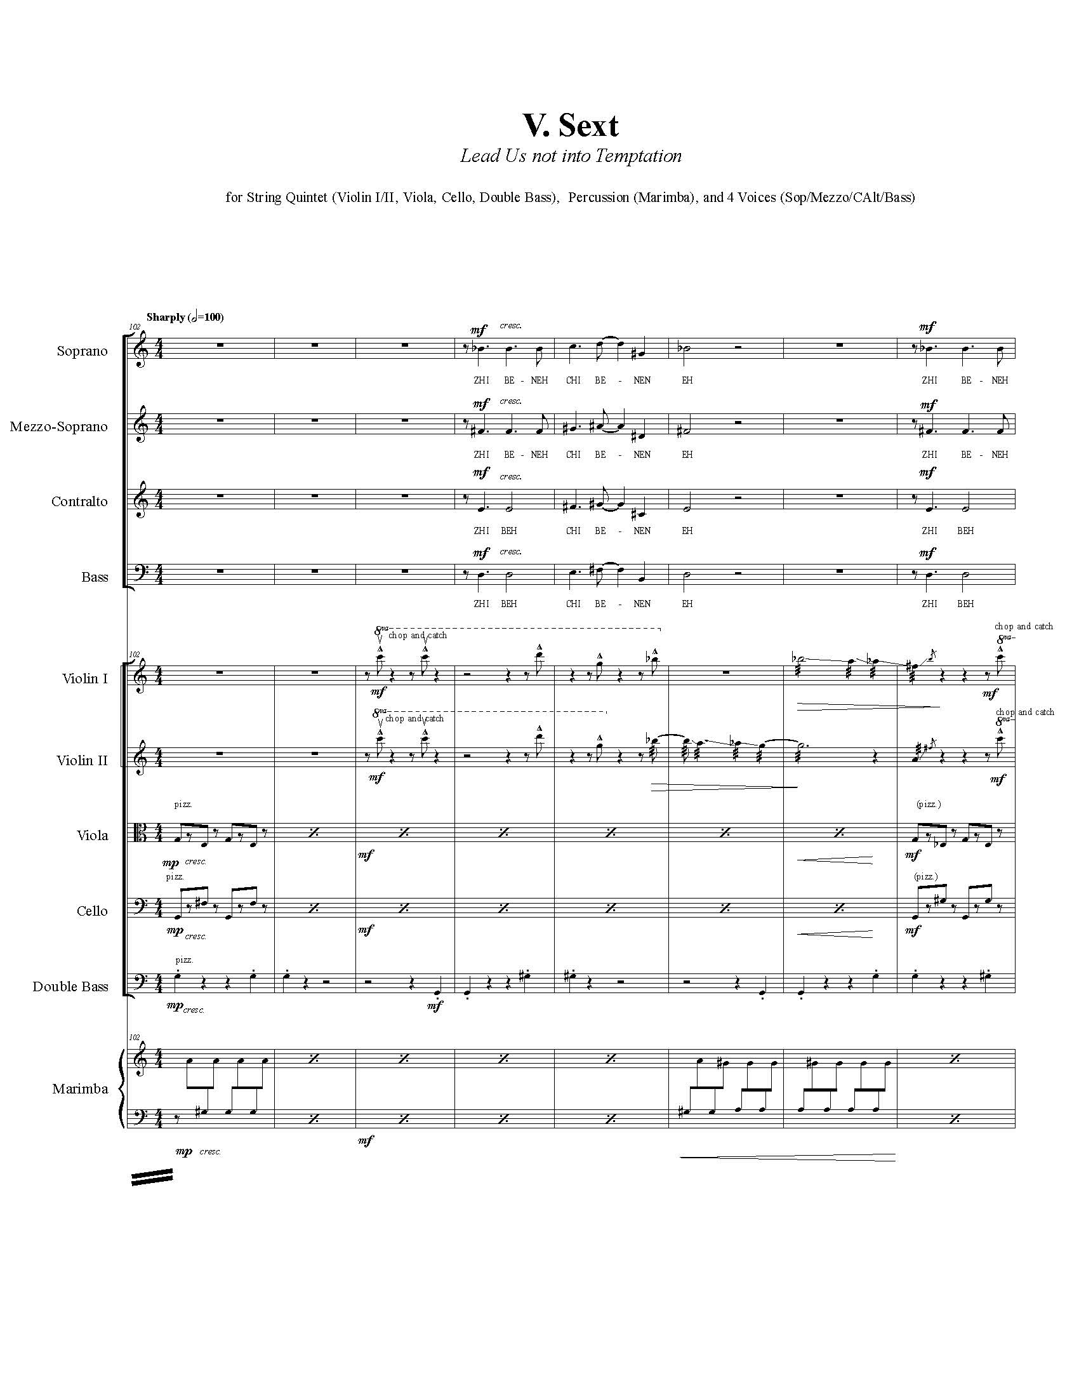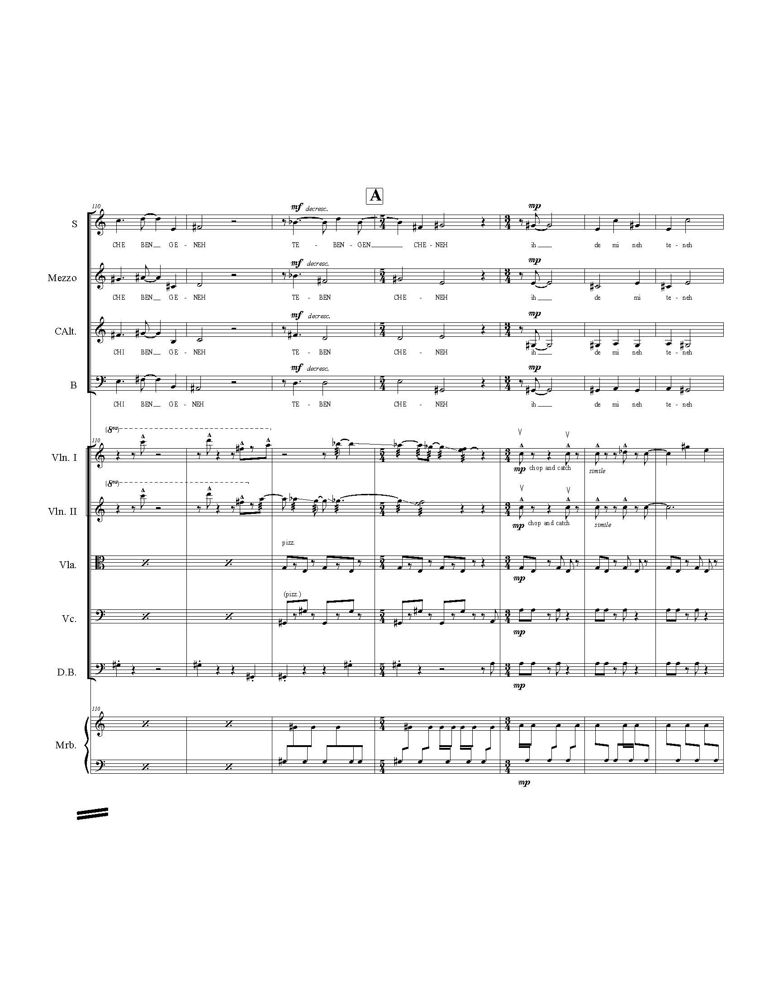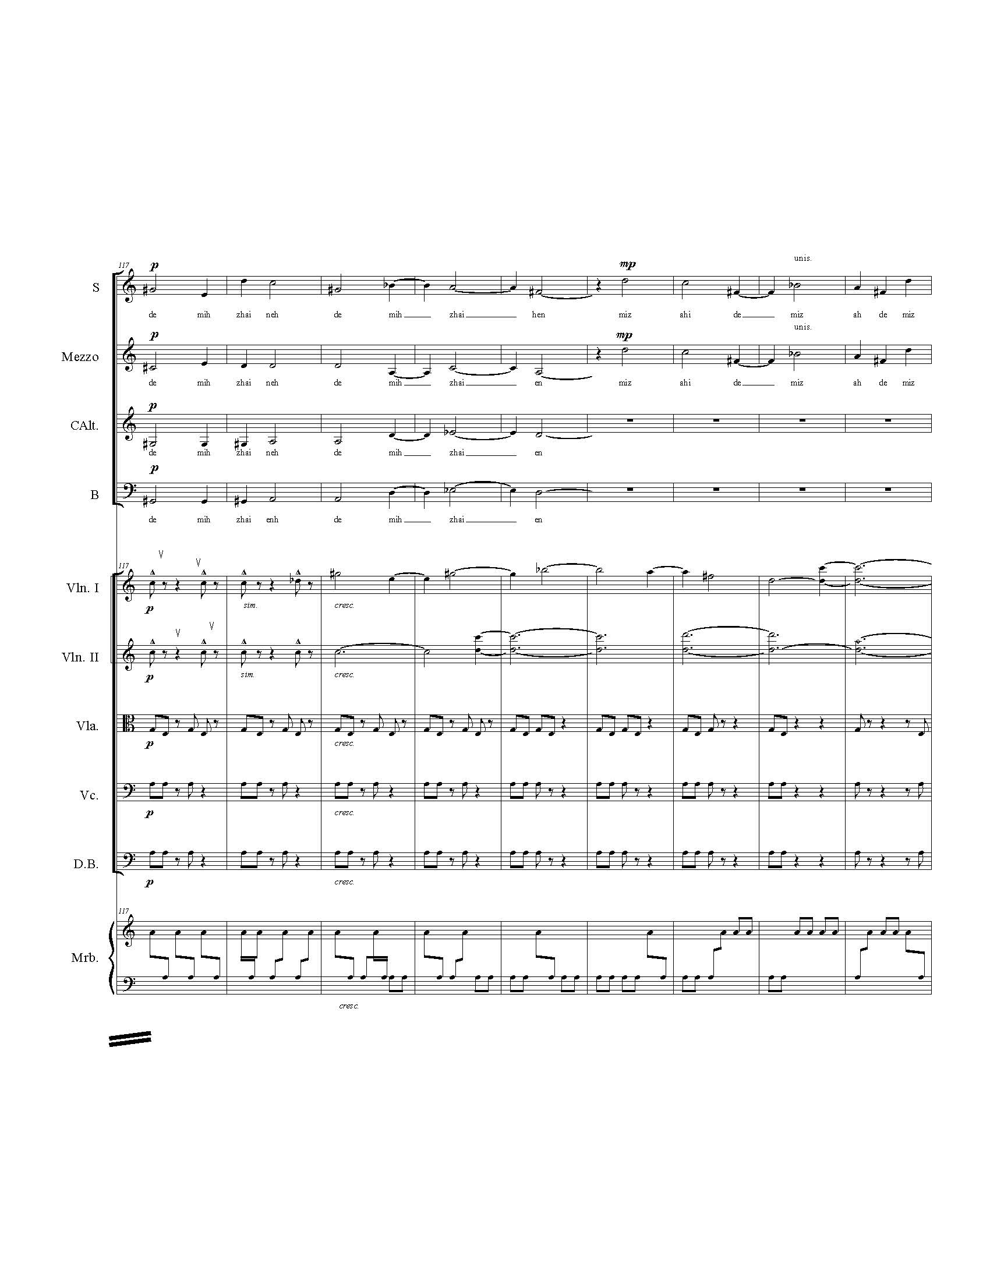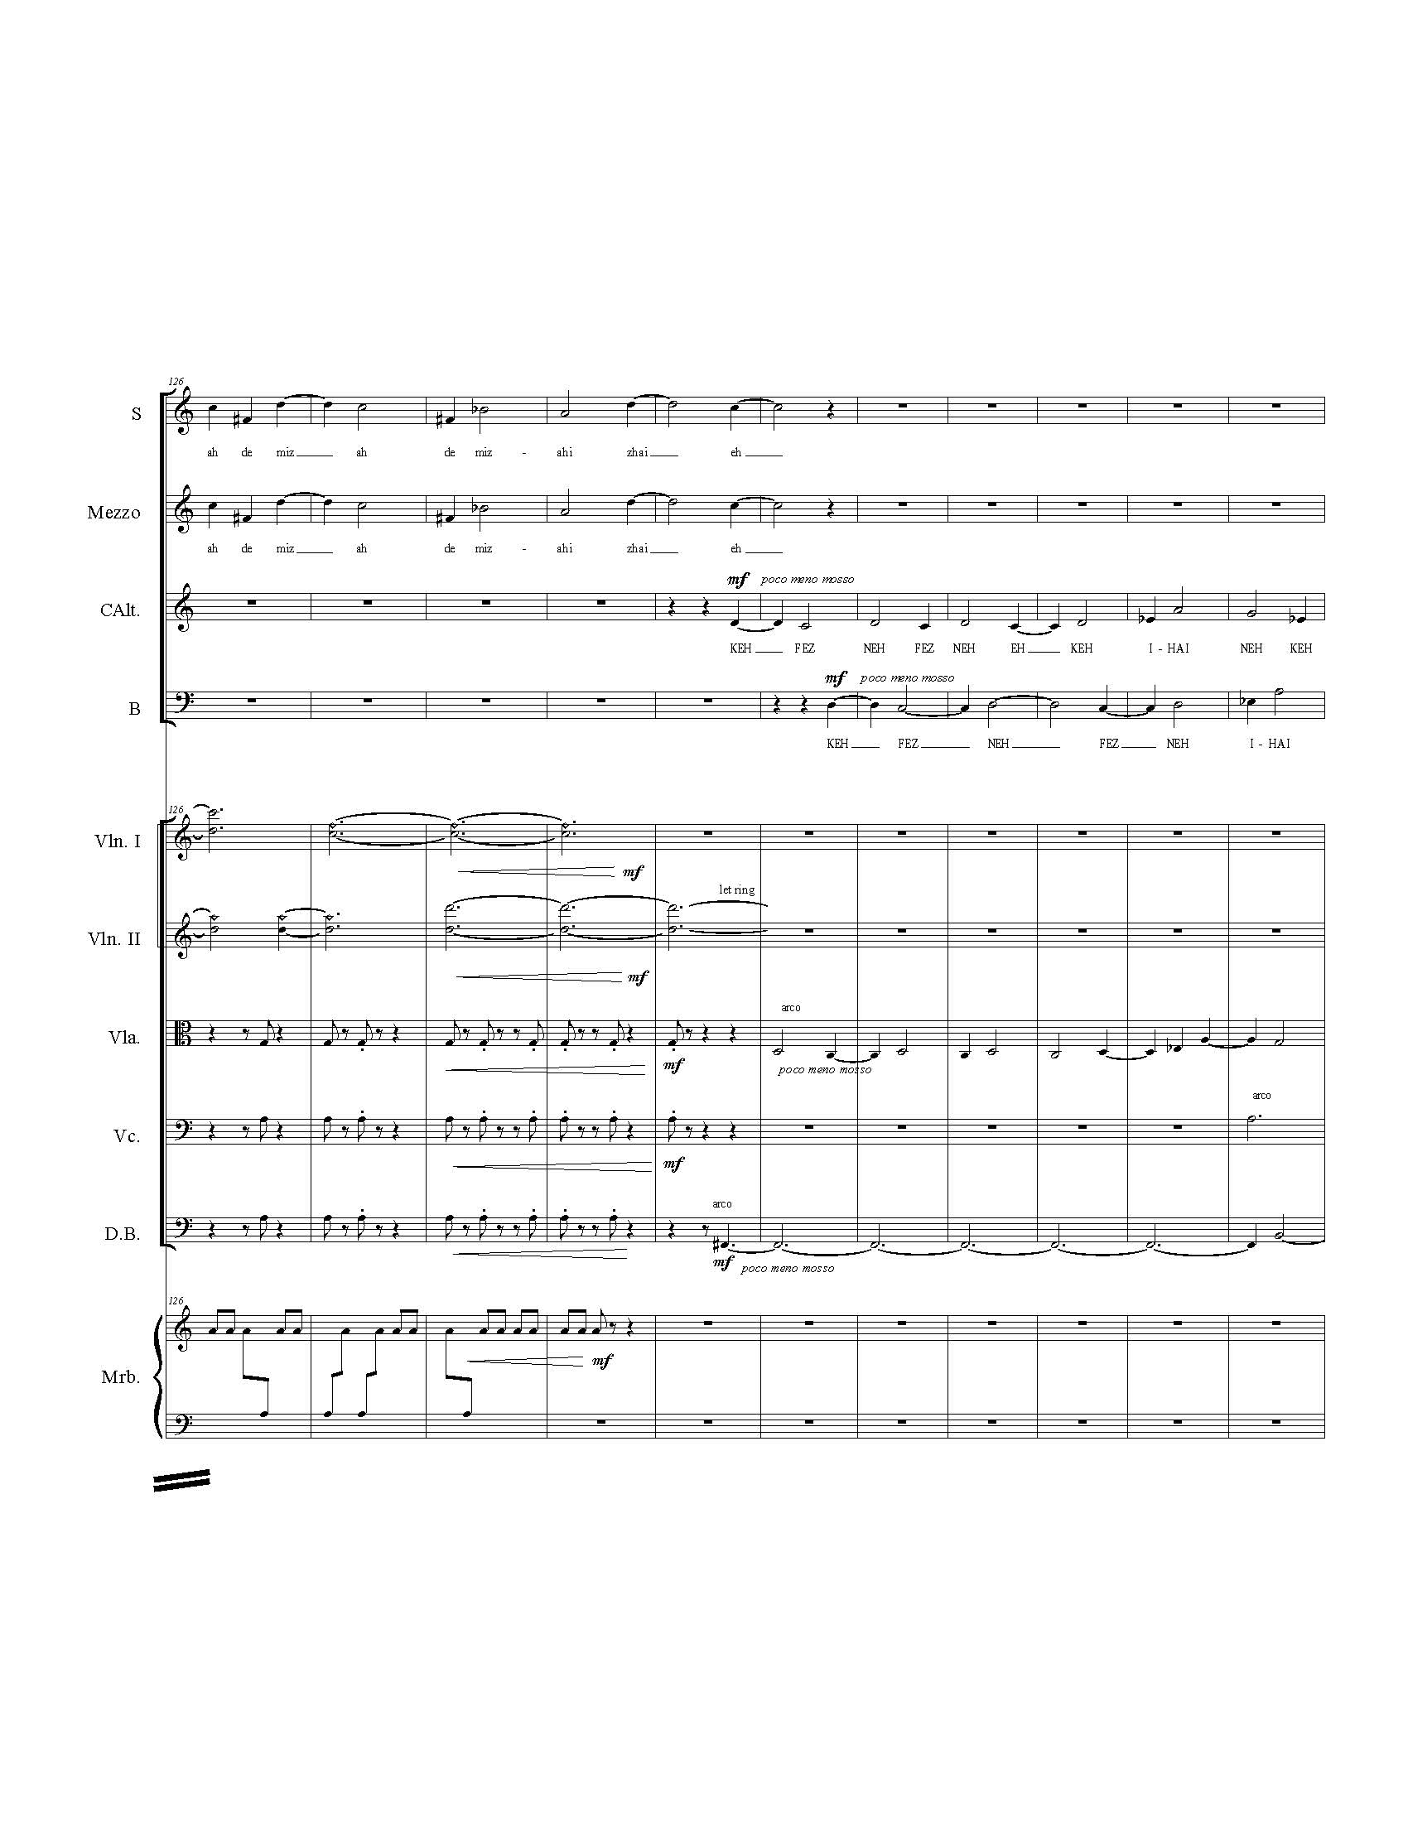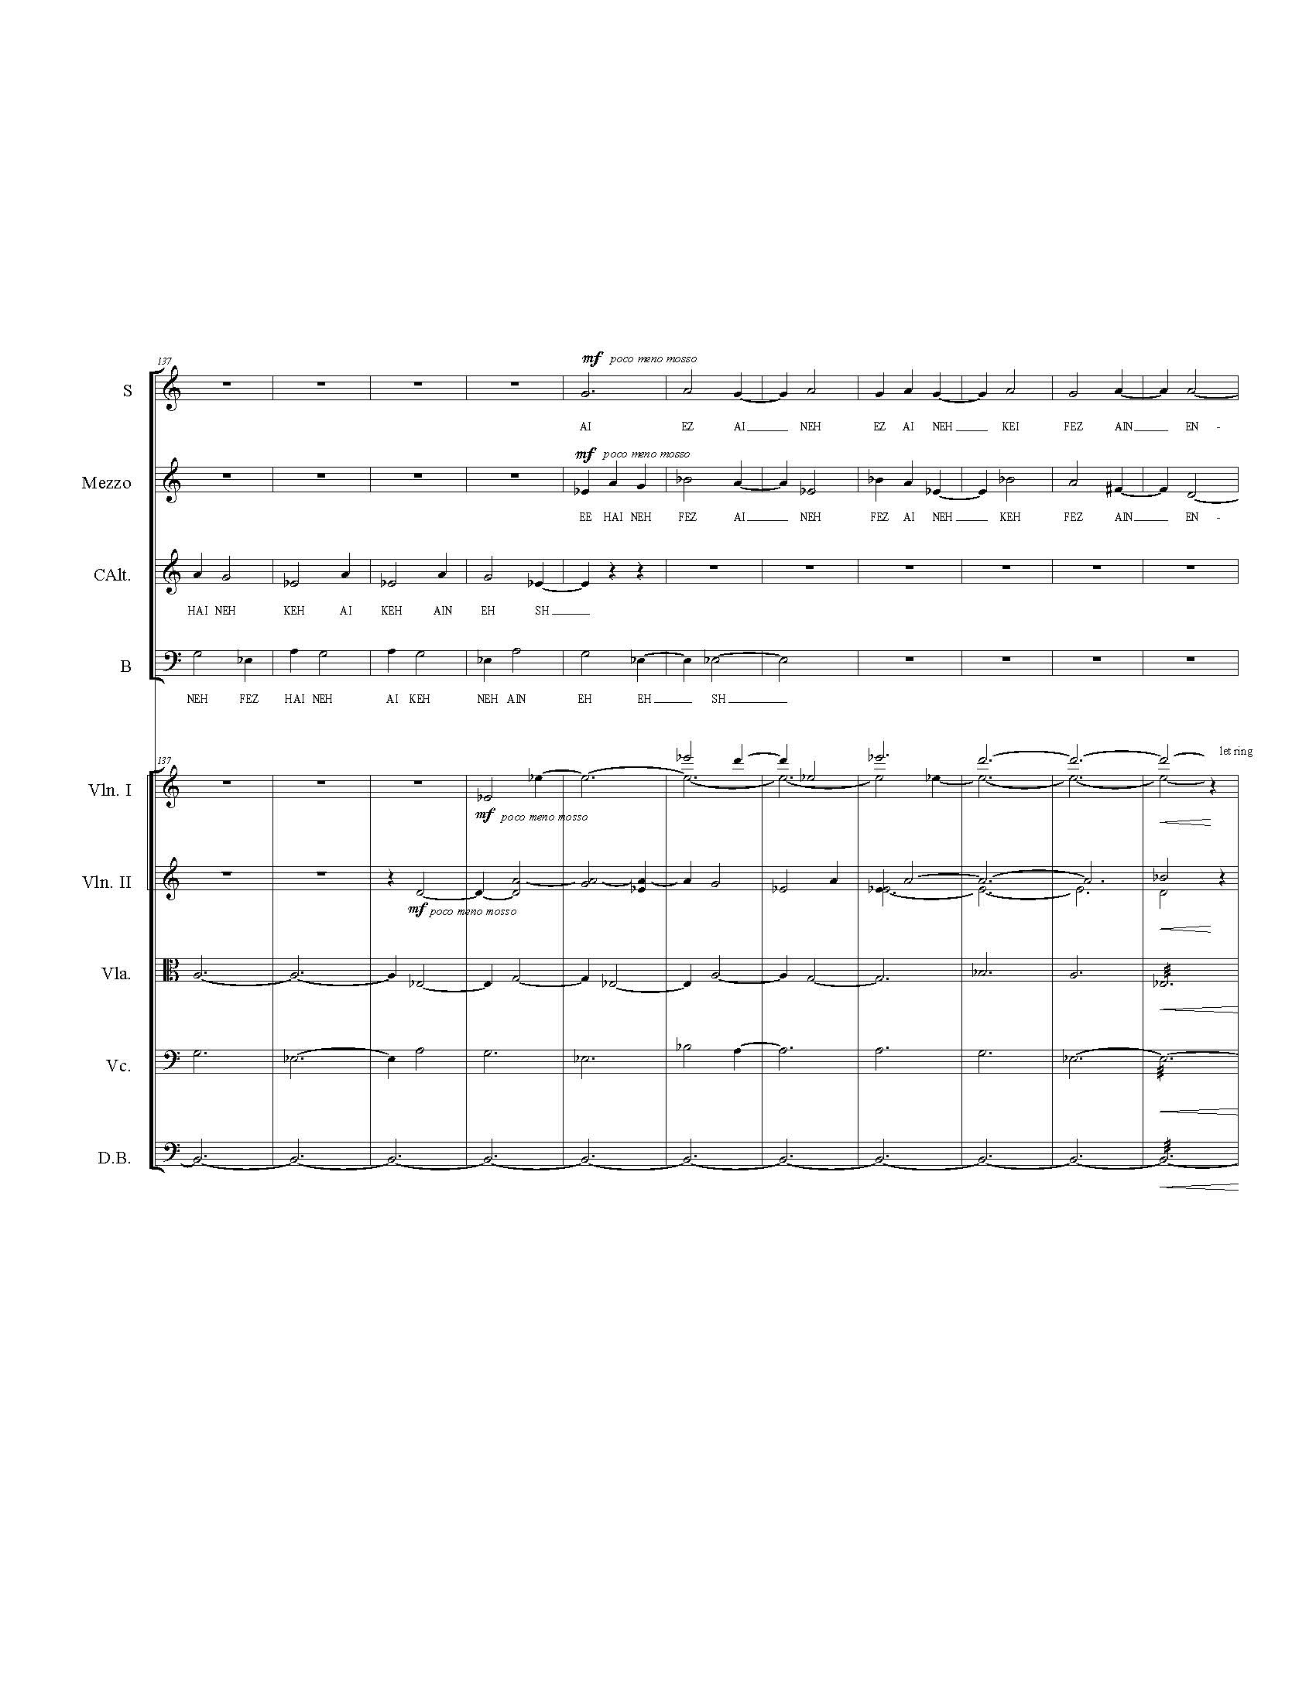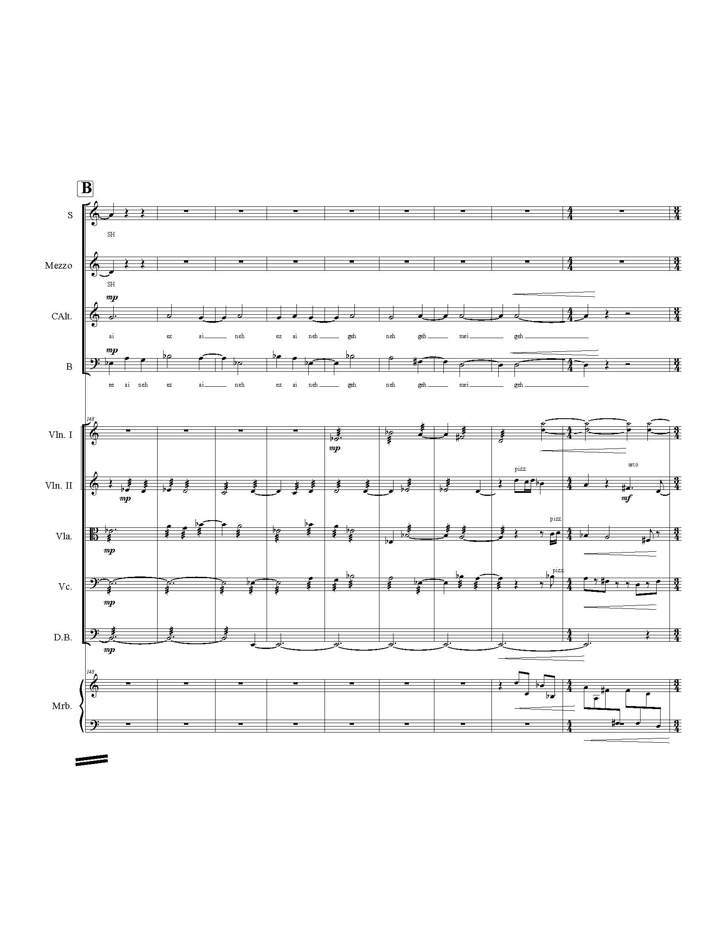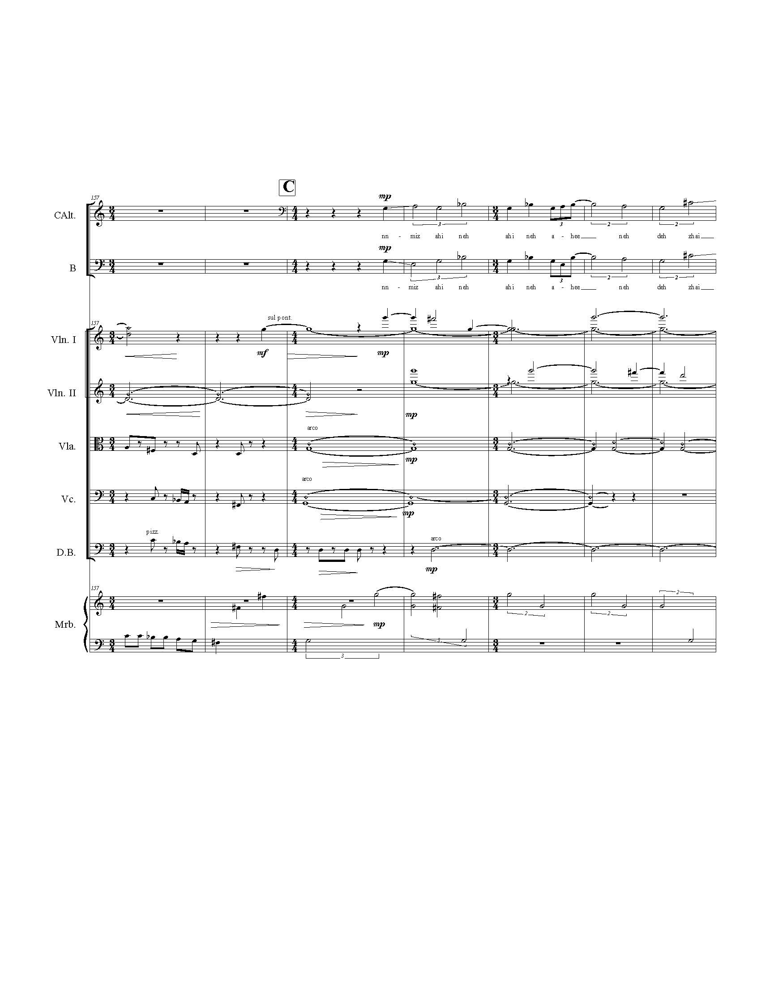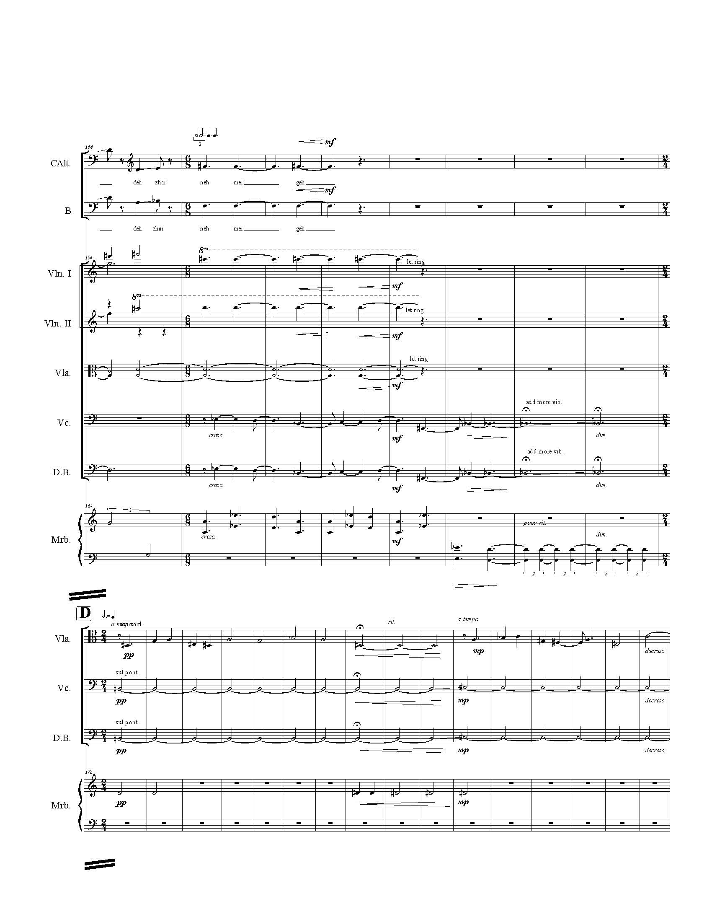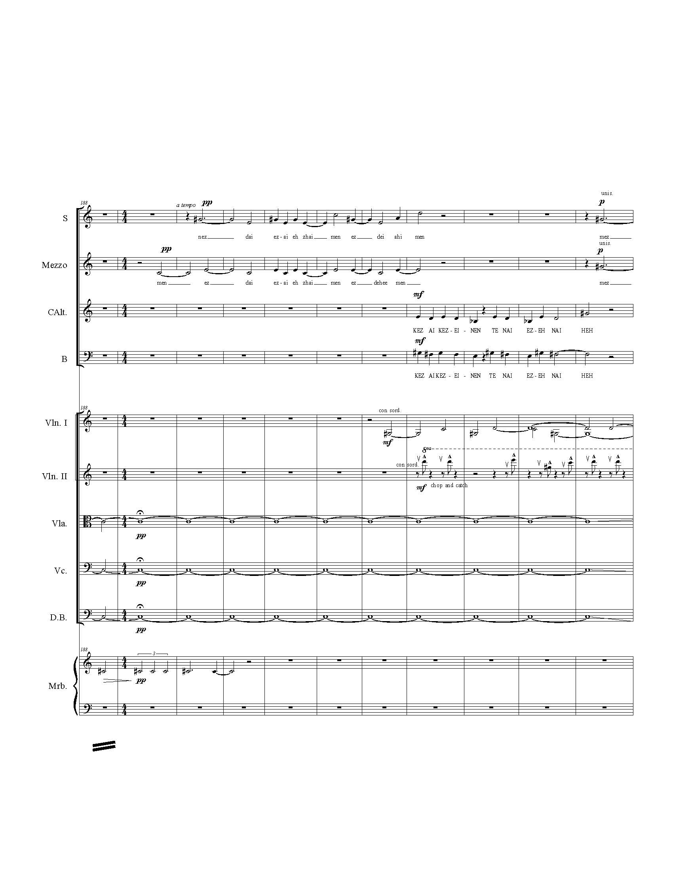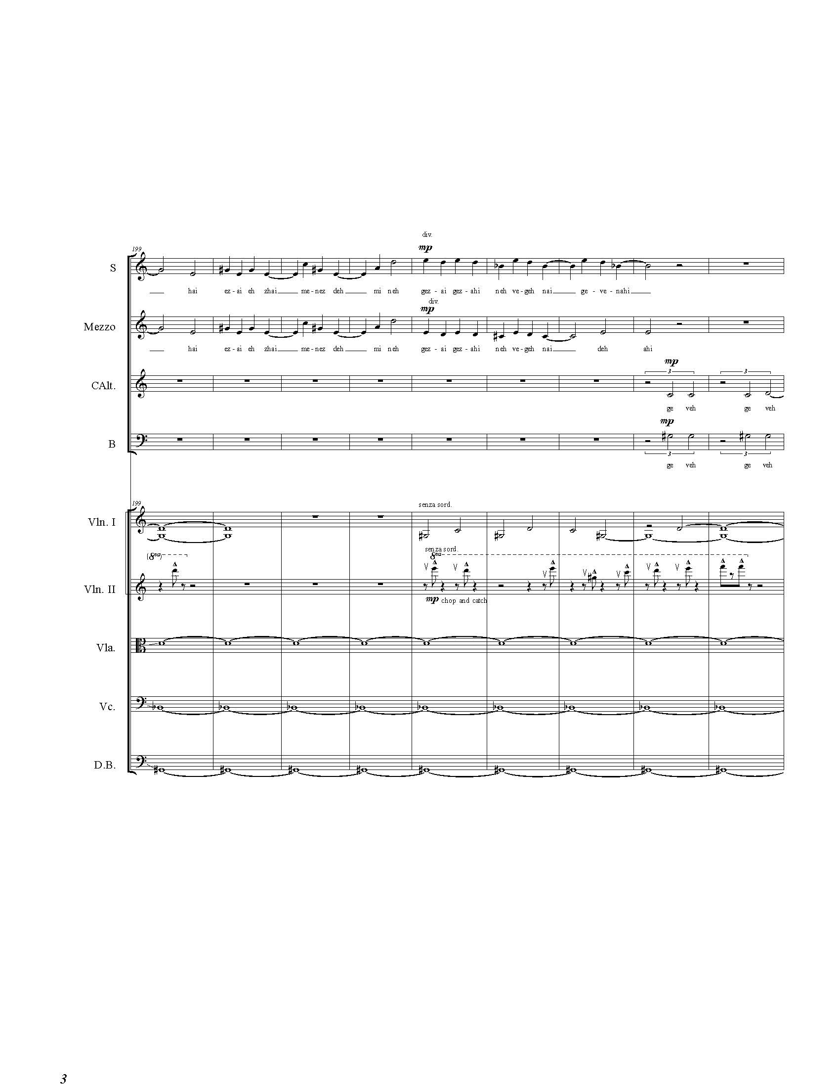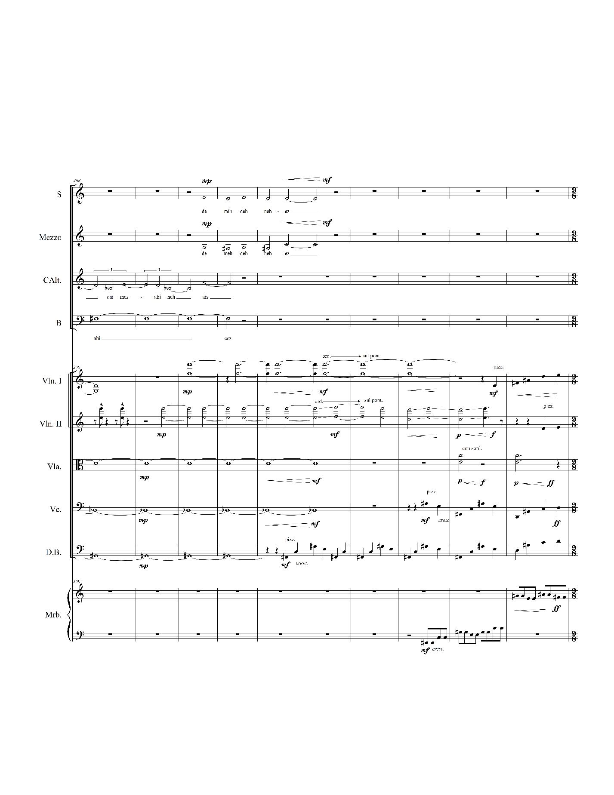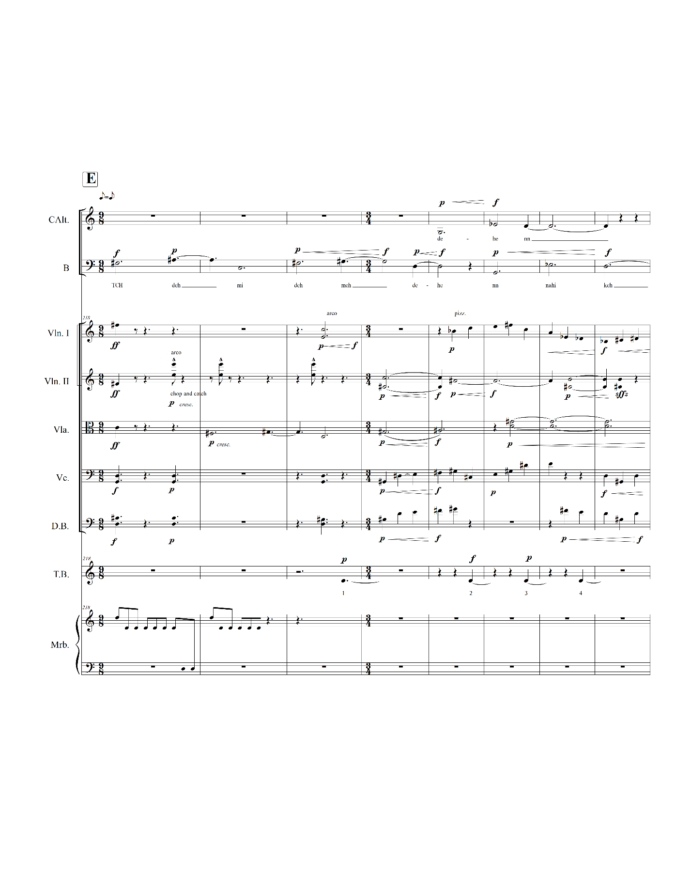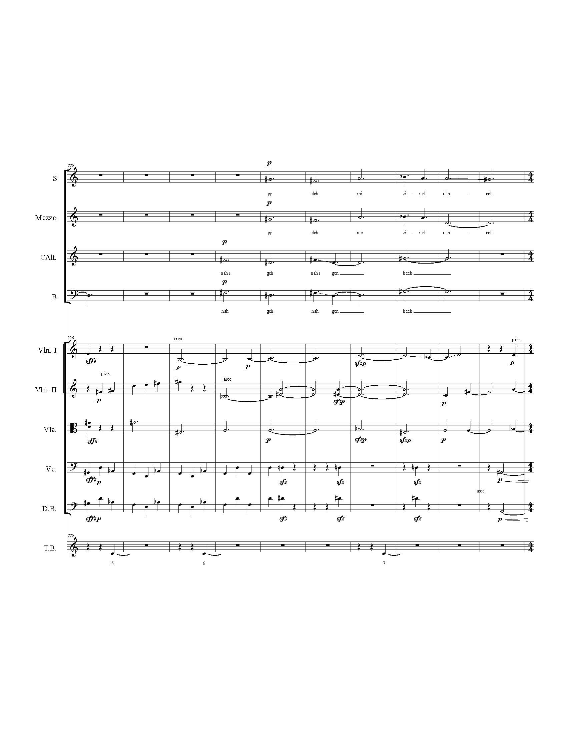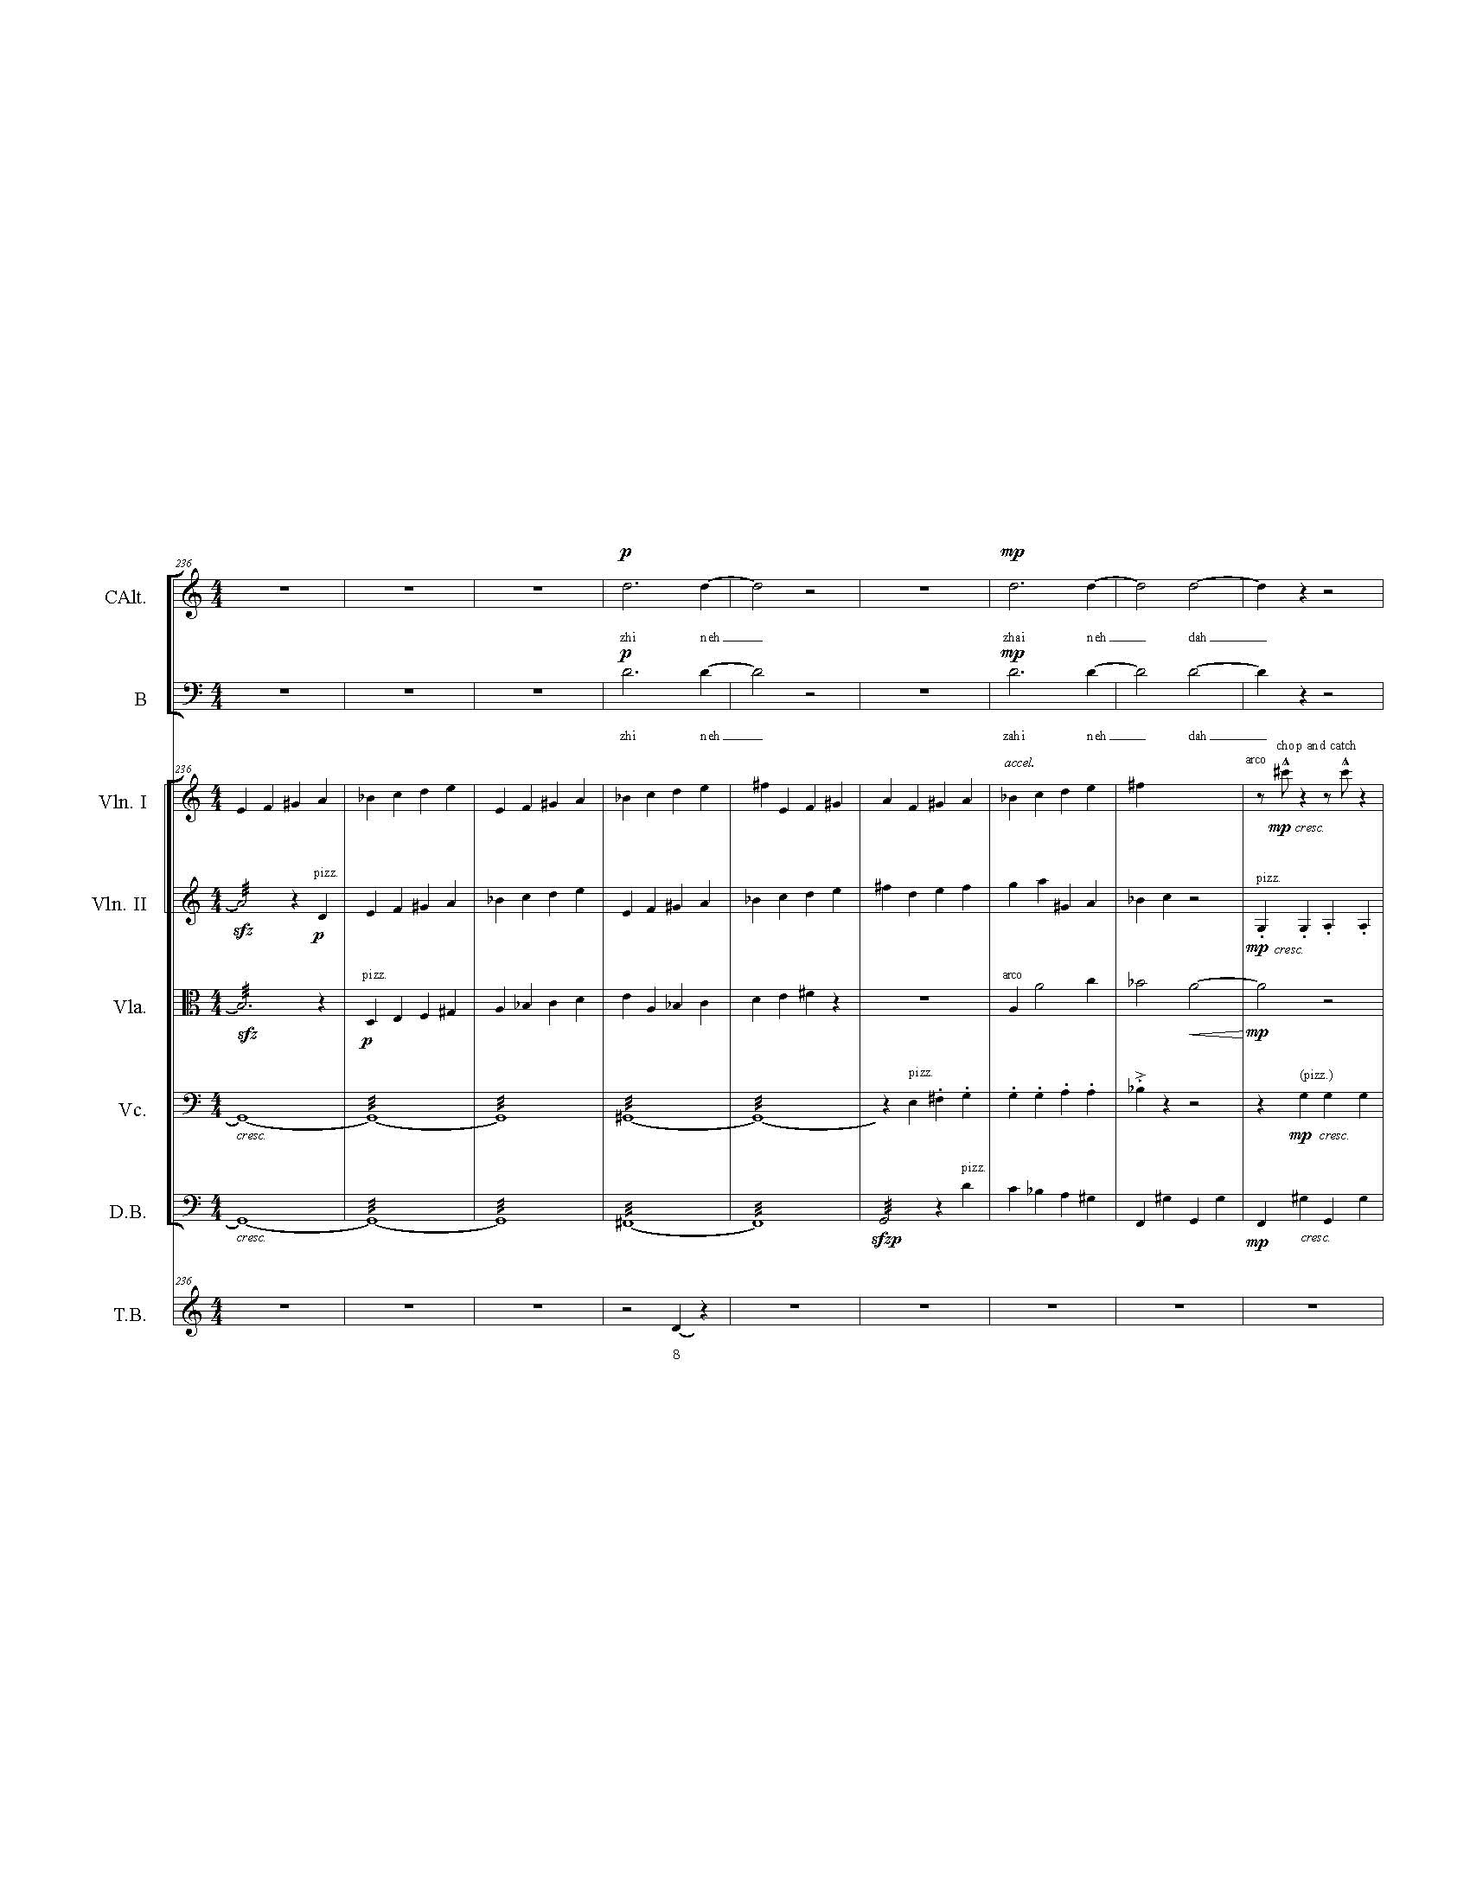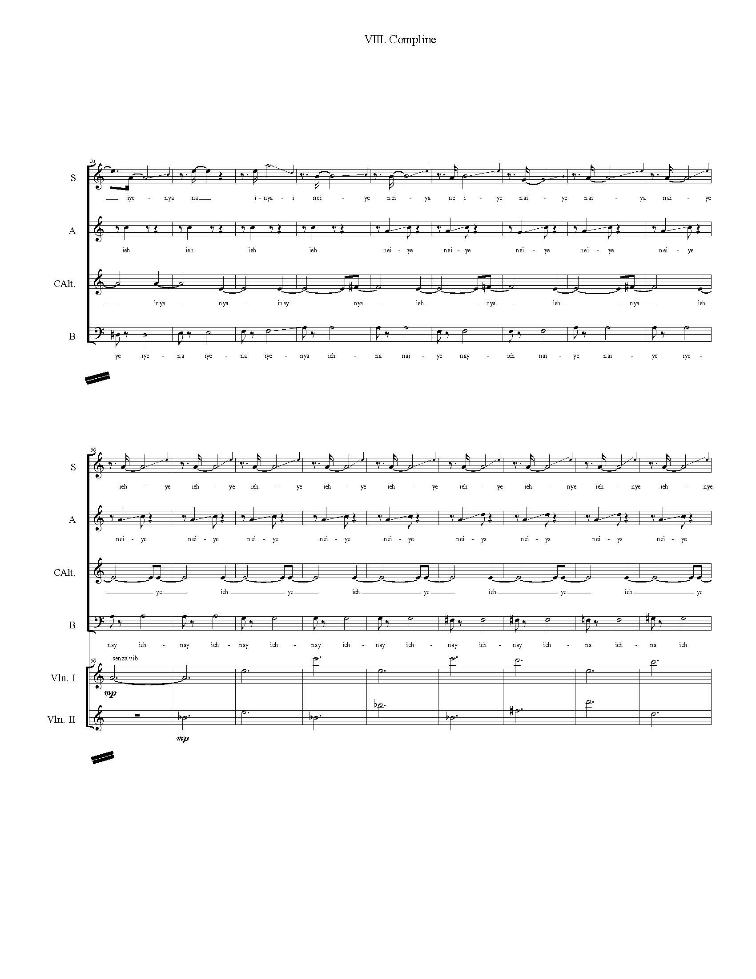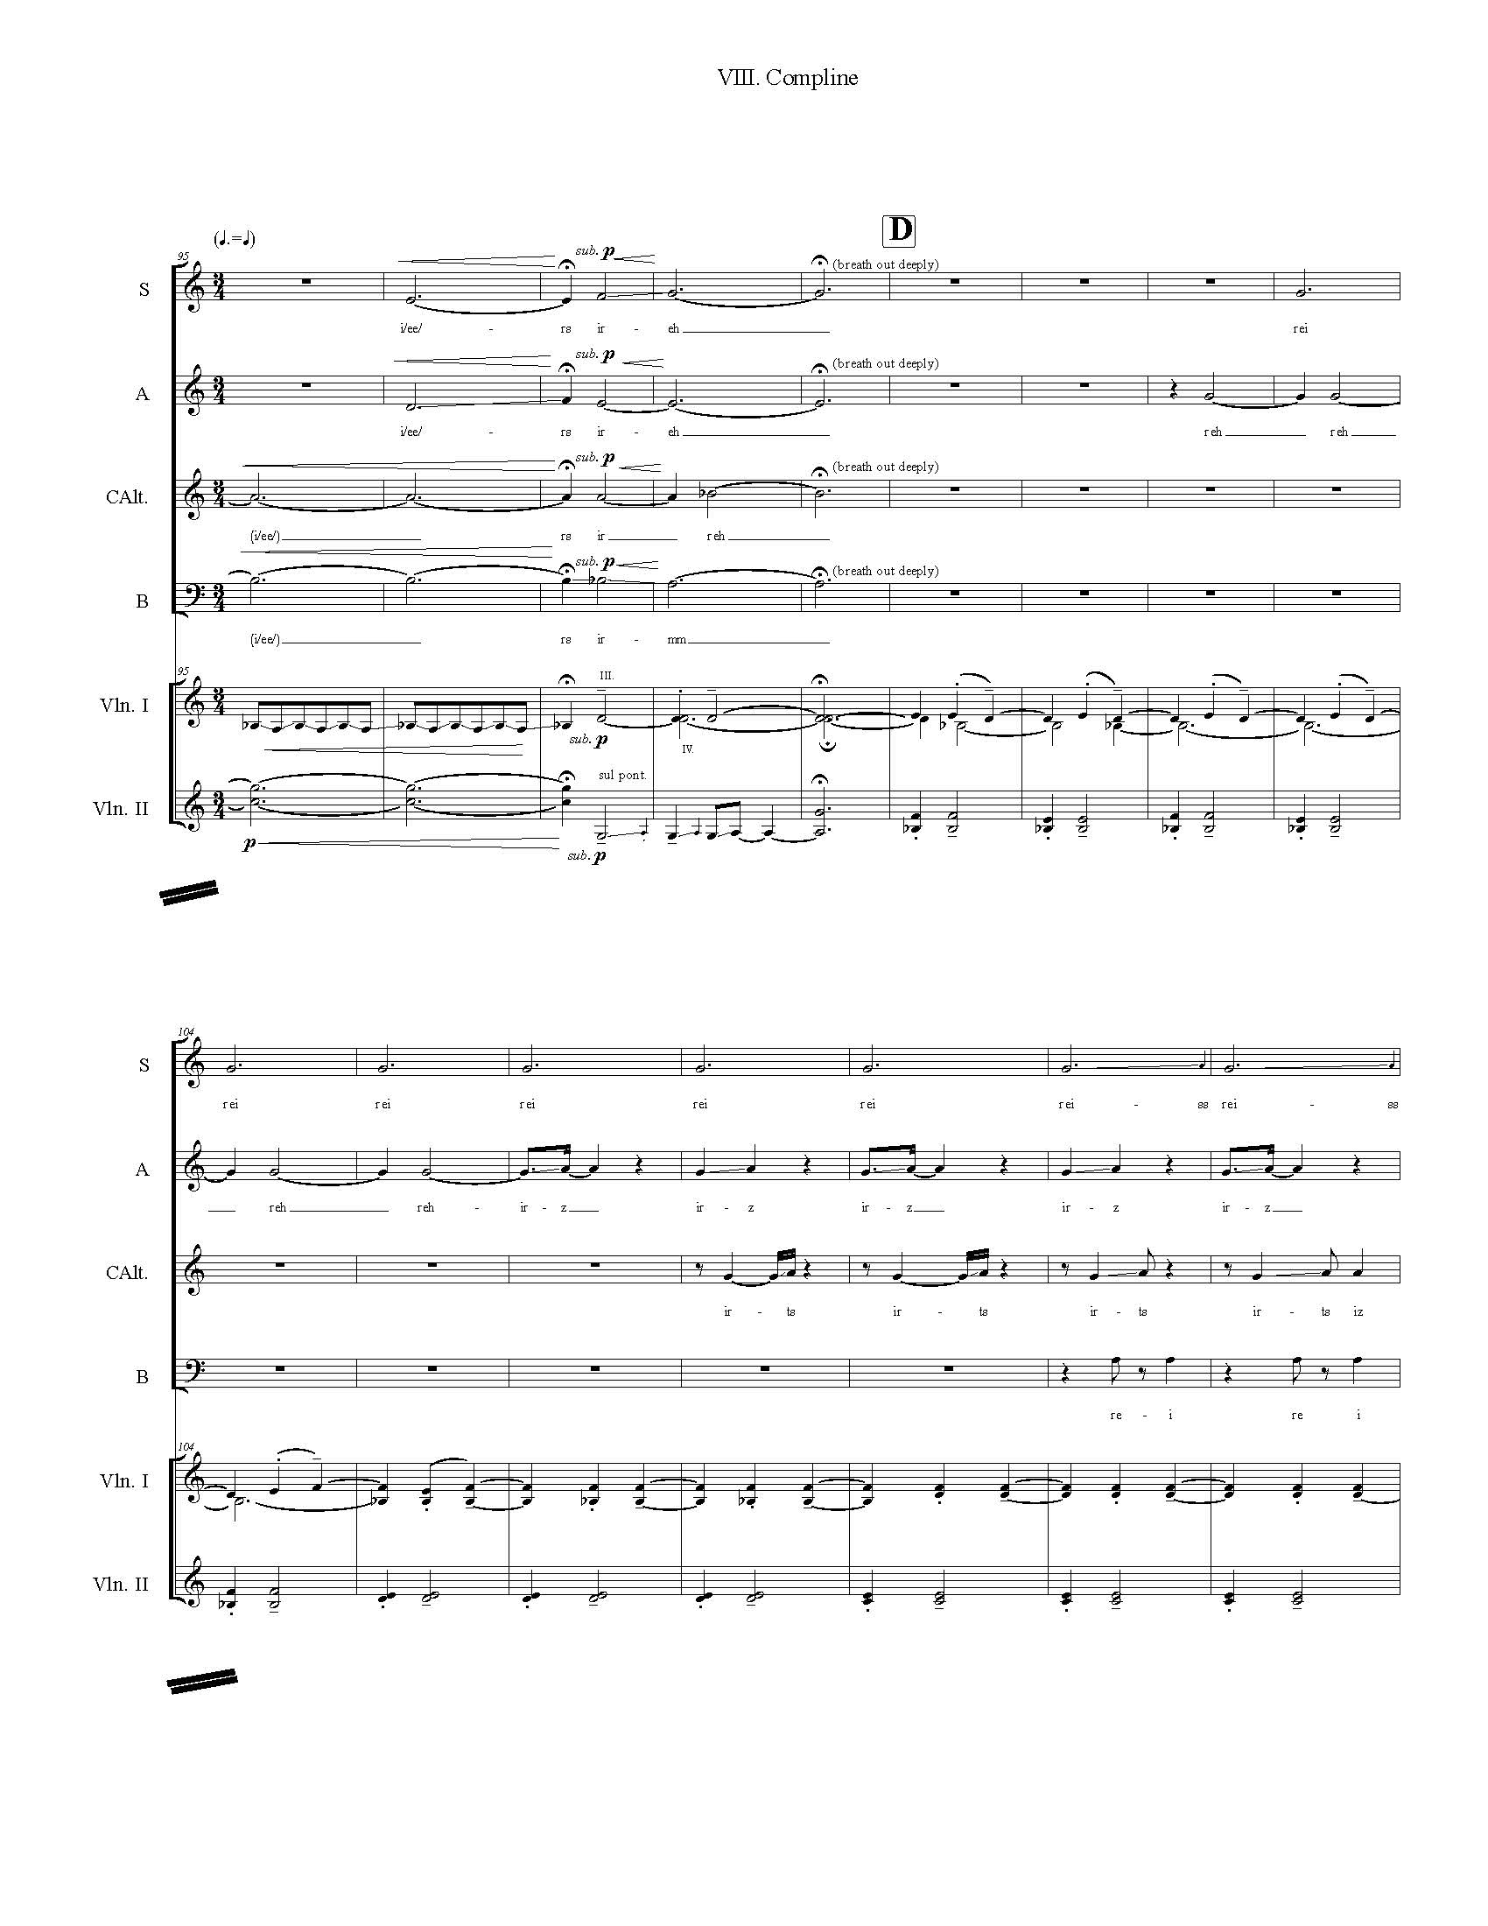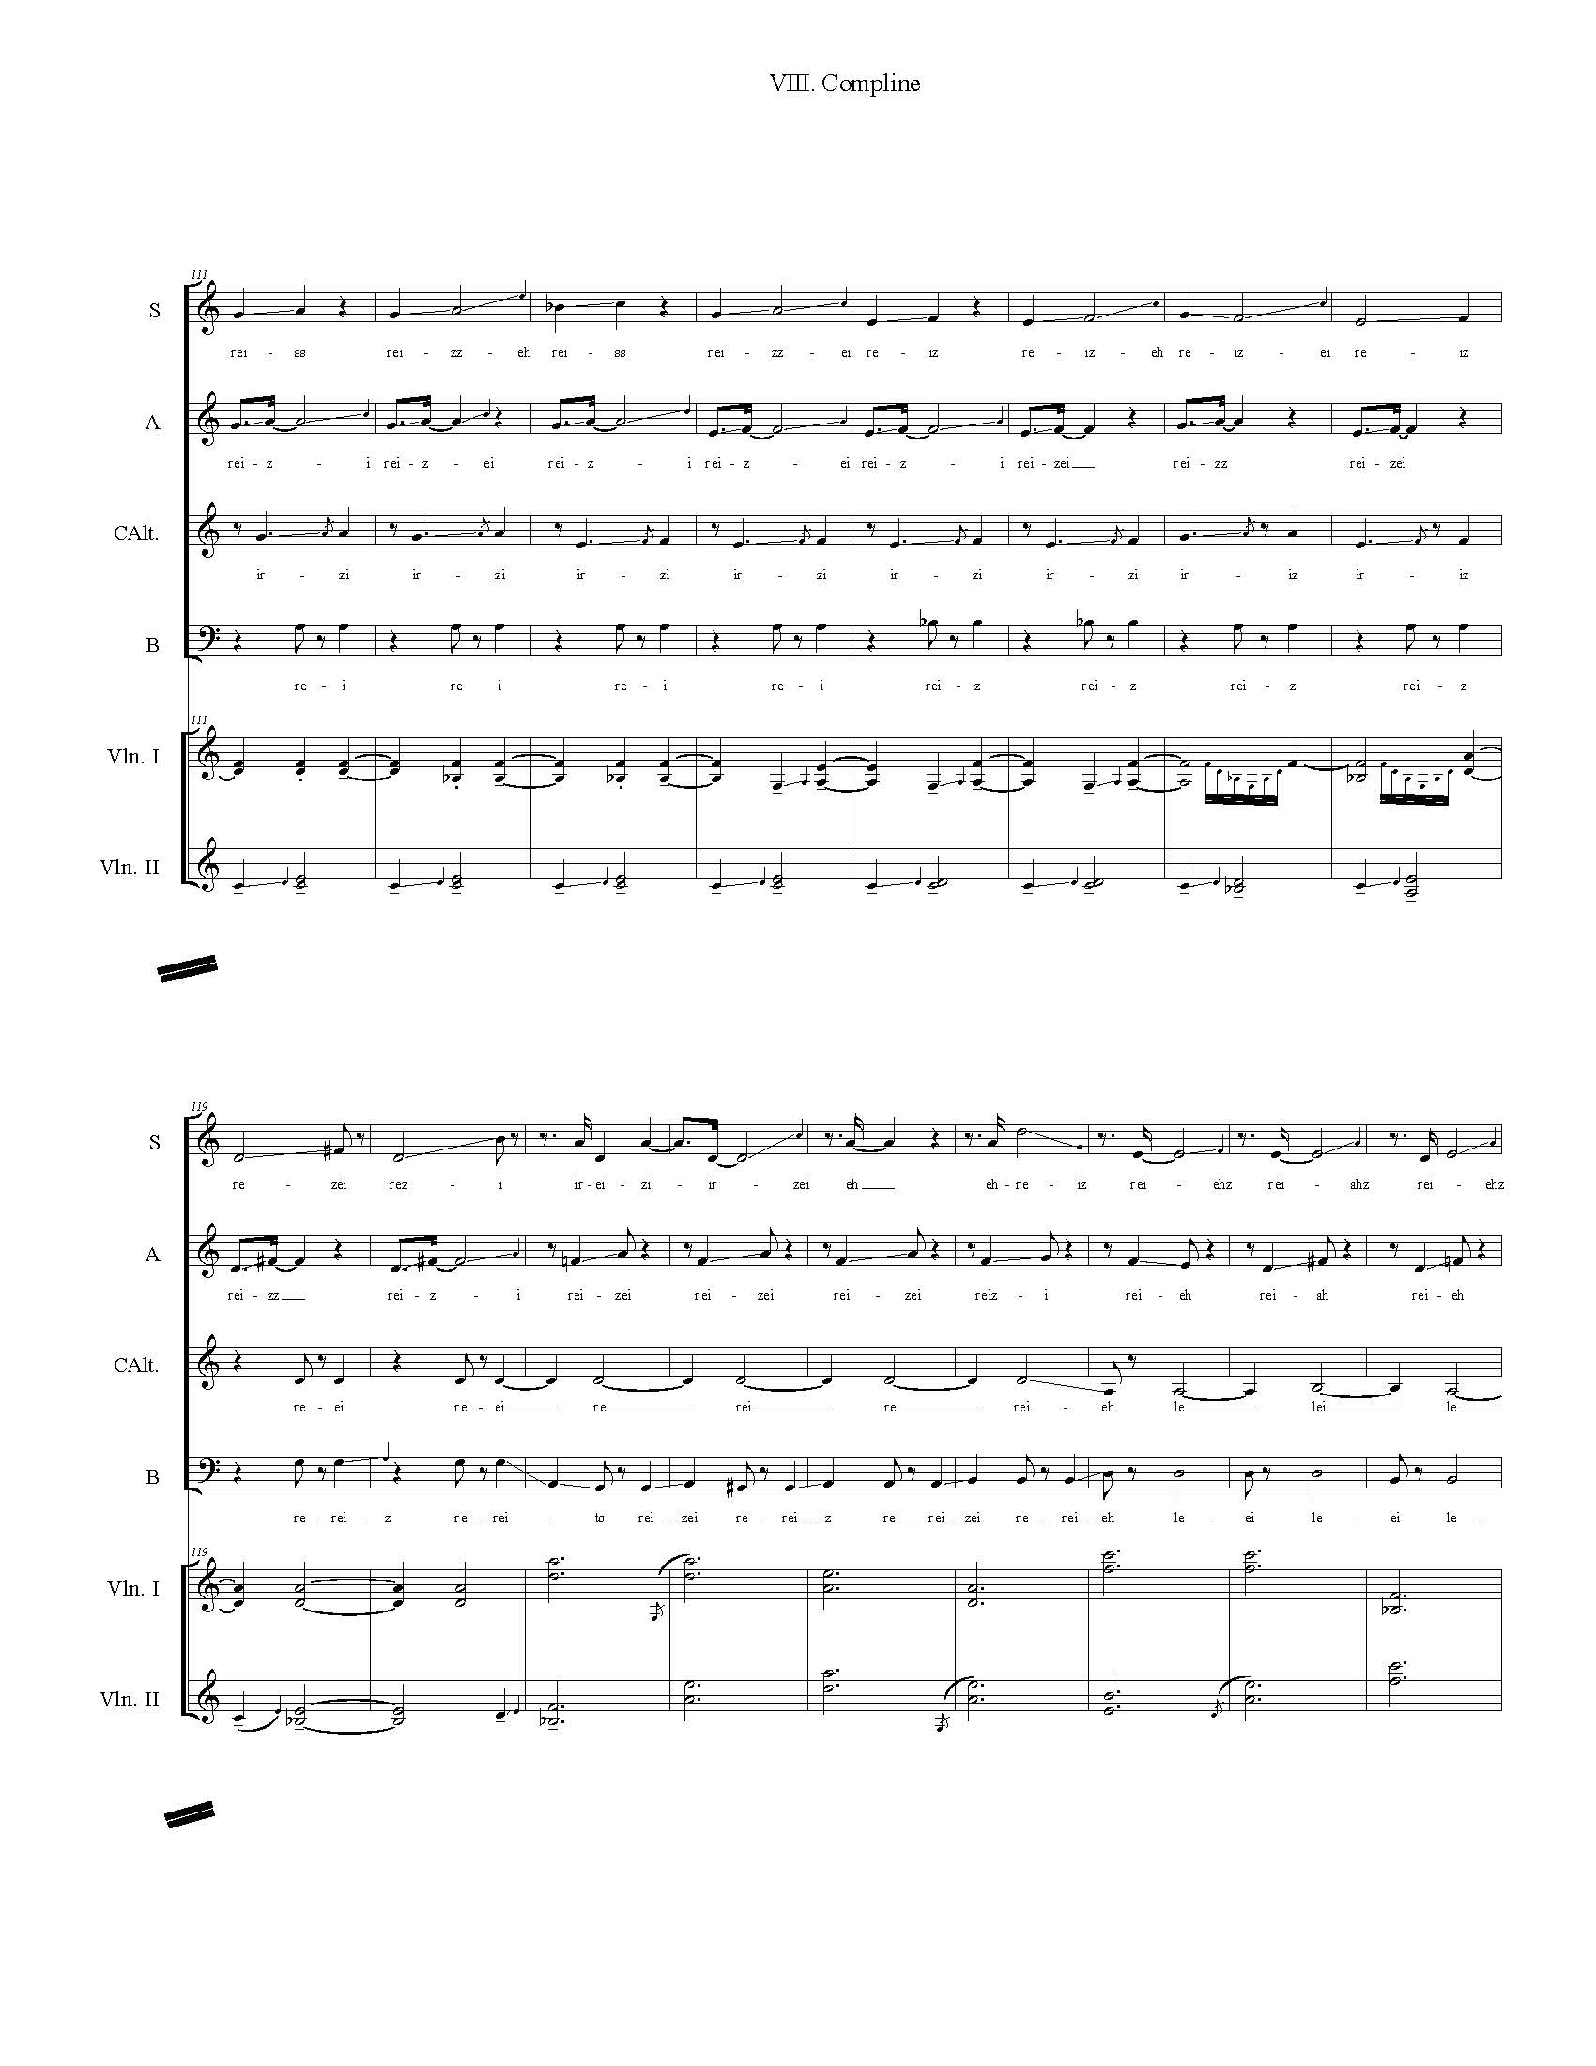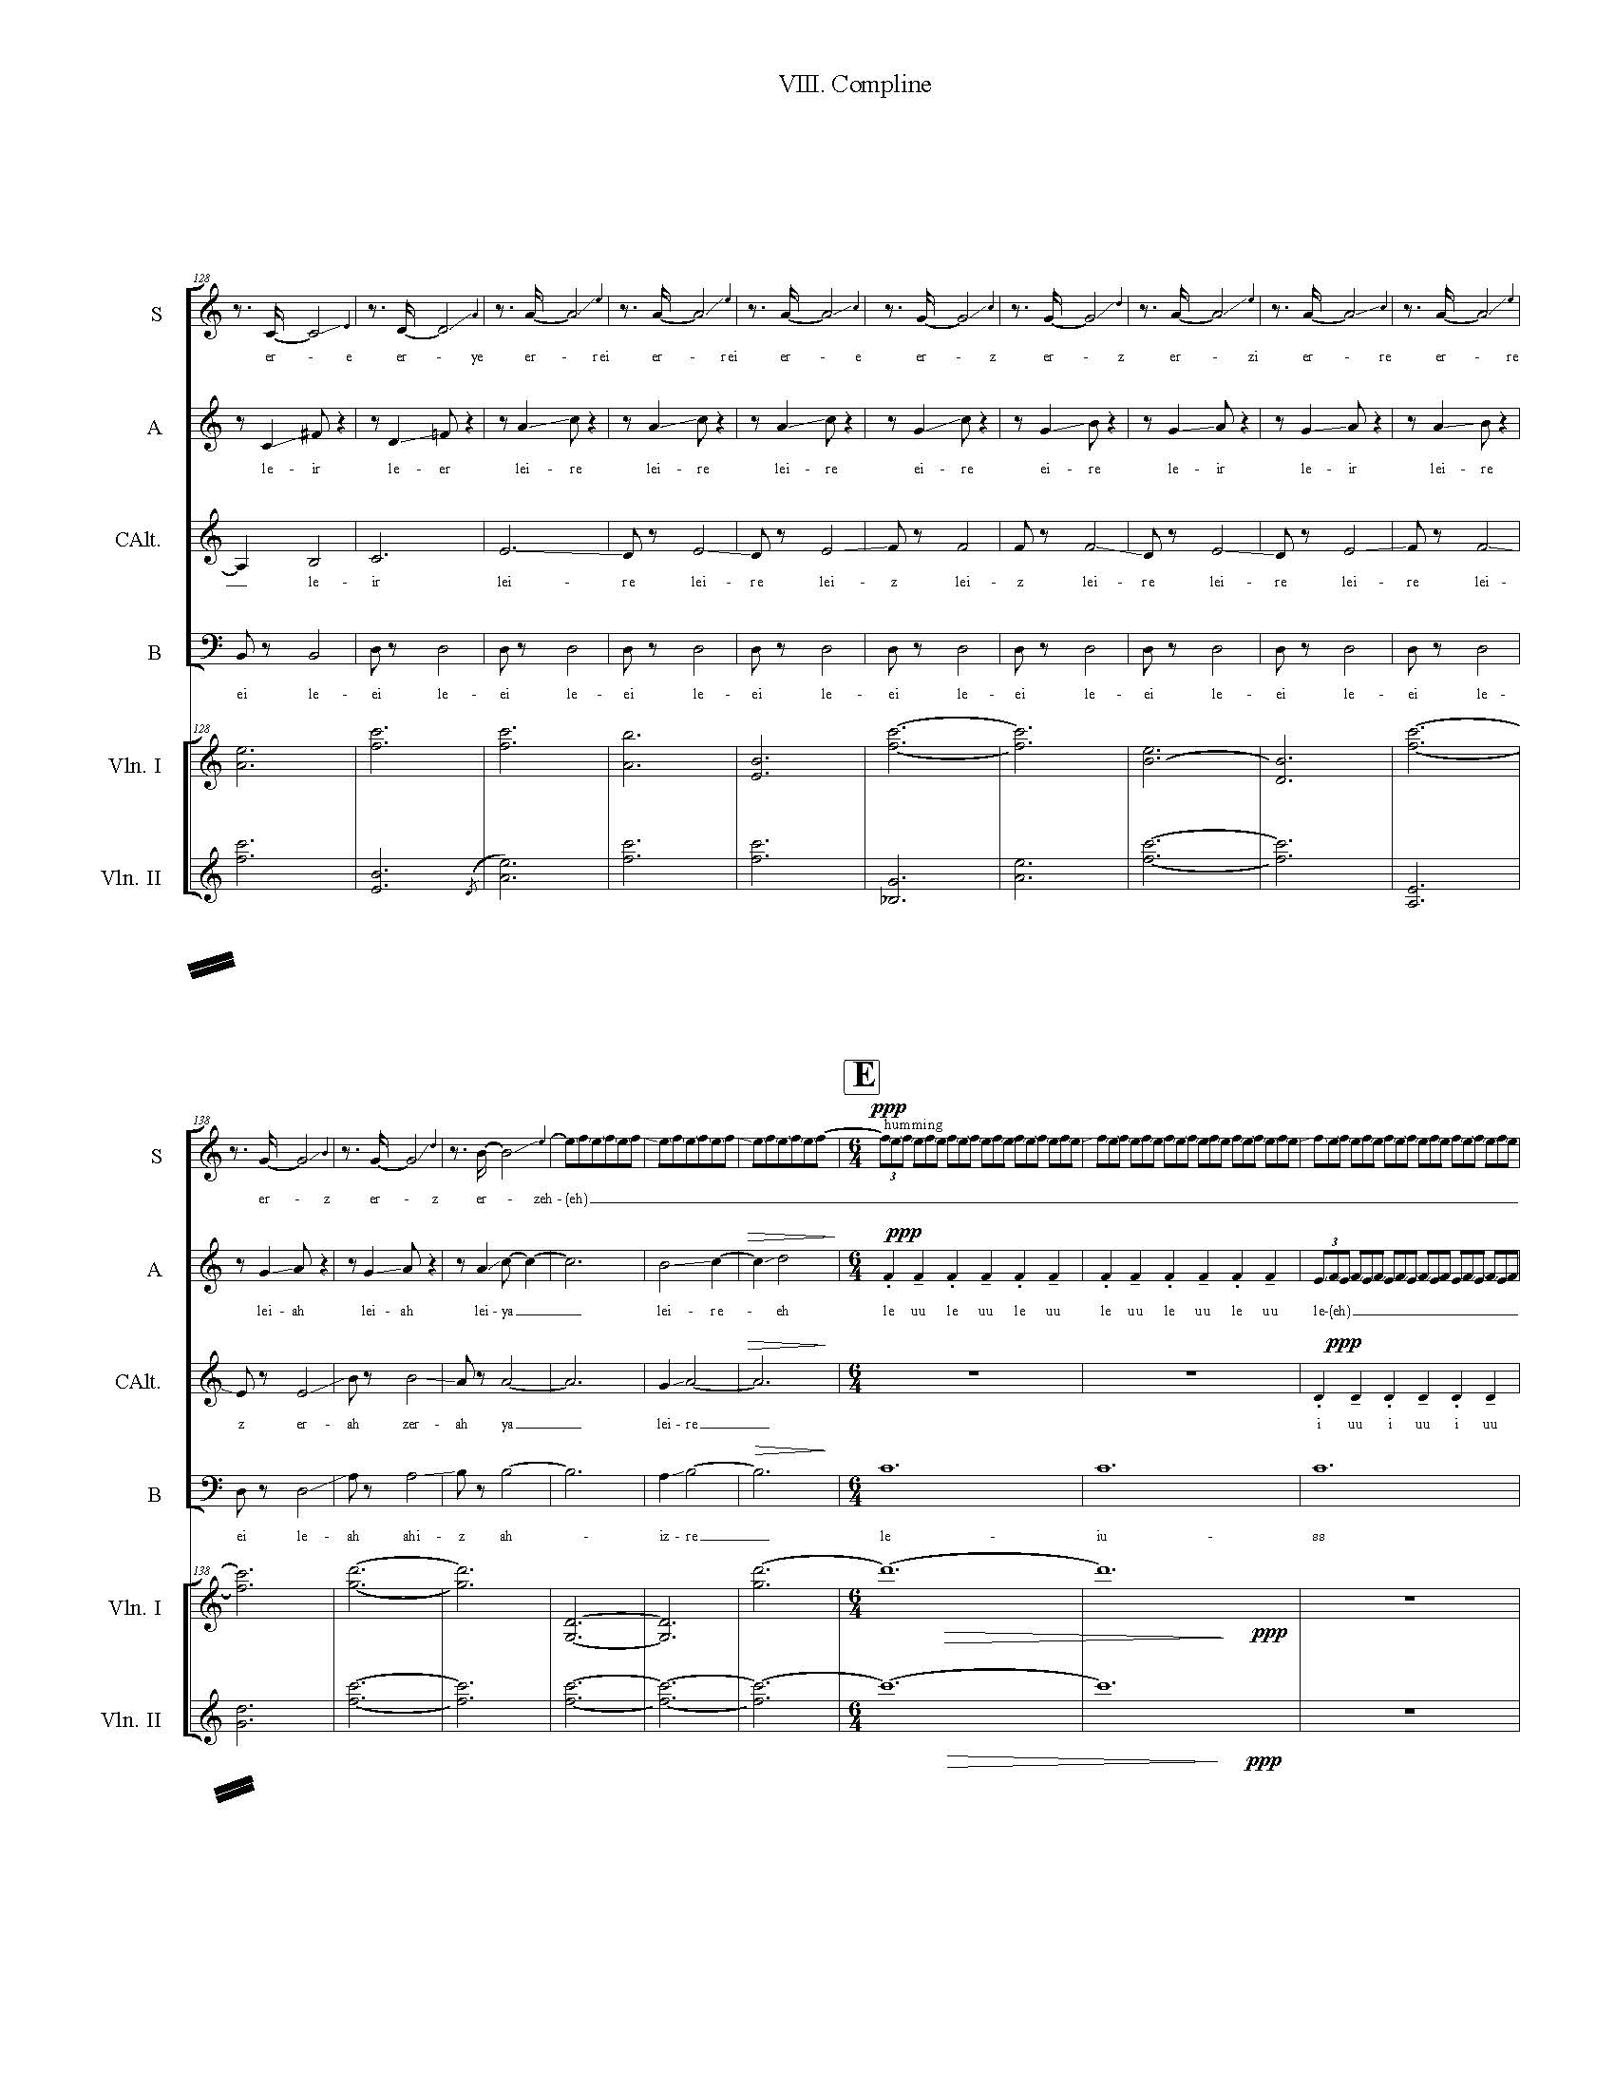
Phonetic Palettes
- I. Matins: Let this Darkness Be a Bell Tower and You the Bell
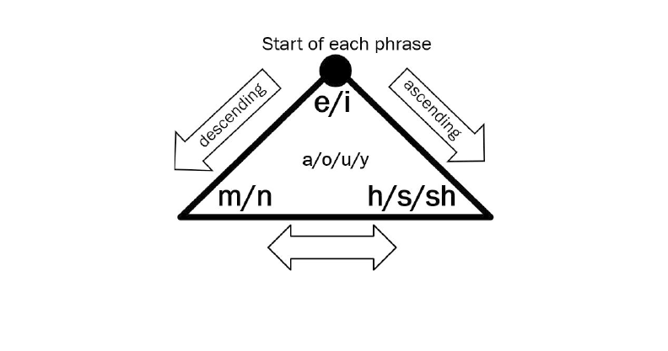
- III. Prime: Mourning Morning: Who-who, Who-who
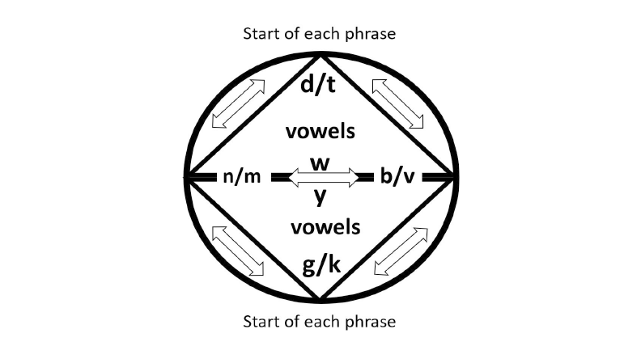

- Three little hours: IV. Terce: Down to the Dark, V. Sext: Lead Us Not into Temptation, VI. None: Last Things
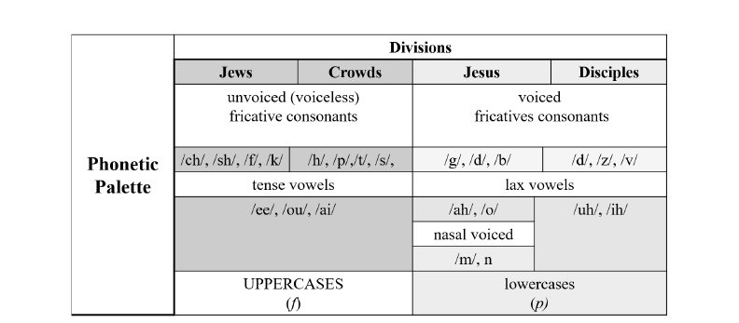

- VII. Vespers: White as Snow 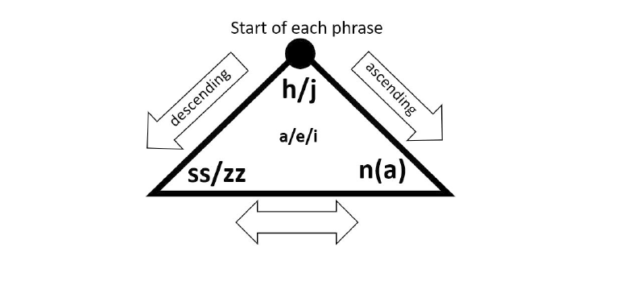
- VIII. Compline- Epilogue: Homeland - To Where We Belong

VITA

Hyowon Bong, originally from Seoul, South Korea, studied Music Composition at Seoul National University (B.A., 2010). She did her M.M. in Composition and the Certificate Program in Music Theory Pedagogy at the University of Tennessee, where she was awarded a Graduate Assistantship. A fascination with other art forms led her to develop a non-profit, Doing Art Project (D.A.P.), which led to her time as an Artist-in-Residence at Seongbuk Art Creativity Center. As an ardent music educator, she presented the Late Night Concert Series in which young composers had the opportunity to share their music with financially disadvantaged children. Also, as a director of D.A.P. Education Lab, she developed curricula that integrated various genres of arts for children, teens, and adults from diverse cultural background; this effort was funded by the Seoul Foundation for Arts and Culture. Through this endeavor, she was chosen to be a master teaching artist of El Sistema Korea, Orchestra of Dream, and sent to the Miami Music Project Orchestral Academy (MMPOA) to learn how the local population embrace immigrants by providing a quality music education program. All these experiences deepened her understanding of music as a social action. Her works have been performed at Seoul National University, The University of Tennessee, Knoxville, Vanderbilt University, and the 2020 (41st) and 2021 College Music Society Southern Regional Conferences (where she received the Dennis Kam Student Composition Award (42nd)). Bong’s current compositional interest is to explore the wide possibilities of conventional compositional techniques, and to interpret these in a contemporary way to expand her musical language.

Eric Taylor, “Rousseau’s Conception of Music” Music & Letters 30, no. 3 (1949): 242, Accessed February 21, 2021, http://www.jstor.org/stable/731007.
Taylor, “Rousseau’s Conception of Music” 24. Italics added.
Ibid., 237.
Hans Lenneberg, “Johann Mattheson on Affect and Rhetoric in Music (I)” Journal of Music Theory 2, no. 1 (1958): 47-84.
Mark Evan Bonds, “Idealism and the Aesthetics of Instrumental Music at the Turn of the Nineteenth Century” Journal of the American Musicological Society 50, no. 2/3 (1997): 390.
Ibid., 406.
Ibid., summarized from 405-408.
Margot Fassler, Music in the Medieval West (New York : W.W. Norton and Company, 2014), A4.
Howard E Smither, “Oratorio,” Grove Music Online. 2001; Accessed 22 Mar. 2021. https://www-oxfordmusiconline-com.proxy.lib.utk.edu/grovemusic/view/10.1093/gmo/9781561592630.001.0001/omo-9781561592630-e-0000020397. Burkholder, A History of Western Music, 337.
Ibid., 337.
Fassler, Music in the Medieval West, 42. Italics added.
Ibid., 51.
Jean-Jacque Rousseau, Essai sur l’origine des langues où il est parlé de la mélodie et de l’imitation musicale, translated by John T. Scott, Essay on the Origin of Languages and Writings Related to Music (Hanover: Dartmouth College Press, 2000), introduction xxvi-vii.
This figure appears in both Fassler, Music in the Medieval West, 60 and Burkholder, A History of Western Music, 54.
Noam Chomsky and Morris Halle, The Sound Pattern of English, Vol. 1st, ed. Studies in Language (Cambridge, Mass: The MIT Press, 1991), https://search-ebscohost-com.proxy.lib.utk.edu/login.aspx?direct=true& db=nlebk&AN=48792&site=ehost-live&scope=site, 302.
Chomsky, The Sound Pattern of English, 69.
Fassler, Music in the Medieval West, A37.
Burkholder, A History of Western Music, 58.
Ibid., 58.
Ibid., 57-61.
Ibid., 57.
Olivier Messiaen, The Technique of My Musical Language (Paris: Alphonse Leduc, 1956), 44.
Fassler, Music in the Medieval West, A22.
Burkholder, A History of Western Music, 57.
Samuel Adler, The Study of Orchestration, (New York: W.W. Norton, 2002), 21-25.
Arnold Schoenberg, Theory of Harmony, translated by Roy Everett. Carter (Berkeley: University of California Press, 1978), 421-422. Italics added.
Comparea.org/KOR+US_TN, Accessed March 19, 2021.
Peter Uwe Hohendahl, “Nature and the Autonomy of Art: Adorno as a Reader of Kant”, The Philosophical Forum 43, no. 3 (2012): 250-251.
Michel Tournier, Le médianoche amoureux (Paris: Gallimard, 1989), 283-86.
NIV. Italics added.
Fassler, Music in the Medieval West, A22.
Ibid., A37.
Mary M. MacKen, “Rainer Maria Rilke” Studies: An Irish Quarterly Review 30, no. 118 (1941): 288
Rainer Maria Rilke, In Praise of Mortality: Selections from Rilke's Duino Elegies and Sonnets to Orpheus, translated by Anita Barrows and Joanna Macy (New York: Riverhead Books, 2005), 135.
Wolfram K. Legner, “The Religion of Rainer Maria Rilke before His Visits to Russia” Monatshefte für Deutschen Unterricht 30, no. 8 (1938): 440, 453.
Hee Sook Oh, “Intercultural Aesthetics in the Contemporary Korean Compositions of Hae-Sung Lee” The World of Music, New Series, 6, no. 1 (2017): 116.
Ibid., 116.
Daniel Leech-Wilkinson, Machaut’s Mass: An Introduction (Oxford: Clarendon Press, 1990) 22-24.
Lisa Florman, Concerning the Spiritual and the Concrete in Kandinsky's Art (Redwood City: Stanford University Press, 2014), Accessed March 12, 2021, ProQuest Ebook Central, 27.
Florman, Concerning the Spiritual and the Concrete in Kandinsky's Art, 30. Italics added.
Ibid., summarized from 27-32; quote at 32. Italics added.
Mark Evan Bonds, “The Spatial Representation of Musical Form” The Journal of Musicology 27, no. 3 (2010): 265-266. Italics added.
Ibid., 270.
Ibid., 265
Ibid., 266
Bonds, “The Spatial Representation of Musical Form” 273.
Ibid, 273-274. Italics added.
William Durand, Rationale V Commentary on the Divine Office, translated by Timothy Thibodeau (Turnhout: Brepols, 2015), 165.
Holy Bible: New International Version (NIV), Matthew 25:1-12. Italics added.
Mae Hingee and Robert D. Magrath, “Flights of Fear: A Mechanical Wing Whistle Sounds the Alarm in a Flocking Bird” Proceedings: Biological Sciences 276, no. 1676 (2009): 4173-79.
James Walker, “Extended Techniques for Vibraphone” (Feb. 2001), http://www.malletjazz.com/lessons/ ext_tech.html, Accessed March 9, 2021.
Chomsky, The Sound Pattern of English, 326-27.
Fassler, Music in the Medieval West, A31, A41.
Durand, Rationale V., 181.
Catholic Church, The Liber Usualis: With Introduction and Rubrics in English (Tournai: Desclee, 1961), 235.
Fassler, Music in the Medieval West, A4.
Burkholder, A History of Western Music, 342.
Durand, Rationale V., 181-182.
Ibid., 184.
Rob Chirico, Damn!: A Cultural History of Swearing in Modern America (Chicago: Pitchstone Publishing, 2014), 10.
Chomsky, The Sound Pattern of English, 236.
Durand, Rationale V., 187.
Ibid., 187.
Ibid., 191.
Liber Usualis, 256.
Durand, Rationale V., 200-01.
David W. Hall, Sarah E. Sander, Jennifer C. Pallansch, and Kathrin F. Stanger-Hall, “The Evolution of Adult Light Emission Color in North American Fireflies” Evolution 70, no. 9 (2016): 2033-46.
Firefly Conservations & Research, ‘Finding Synchronous Fireflies,’ https://www.firefly.org/synchronous -fireflies.html, Accessed March 15, 2021.
Rolf Inge Godøy and Marc Leman, Musical Gestures: Sound, Movement, and Meaning (New York: Taylor and Francis Group, 2010), 113, https://doi.org/10.4324/9780203863411.
Liber Usualis, 540.
Kendall L. Walton, “What is Abstract about the Art of Music?” The Journal of Aesthetics and Art Criticism 46, no. 3 (1988): 351-64.
Keith Brown and Jim Miller, The Cambridge Dictionary of Linguistics (Cambridge: Cambridge University Press, 2013), doi:10.1017/CBO9781139049412, 409.
Hans Tischler and Louise H. Tischler, “Mendelssohn’s “Songs Without Words”.” The Musical Quarterly 33, no. 1 (1947): 6-11.
Walton, “What is Abstract about the Art of Music?” 353.
Aldous Huxley, Point Counter Point (New York : The Modern Library, 1928), 591.
This paragraph relies on Walton, “What is Abstract about the Art of Music?” 354-62.

