ENVIRONMENTAL CONTROLS ON MICROBE-METHANE DYNAMICS IN THE TERREBONNE-TIMBALIER ESTUARY, LOUISIANA

A Thesis Presented for the
Master of Science
Degree
The University of Tennessee, Knoxville

Kayla Renee Summerlot
August 2025

ACKNOWLEDGEMENTS
Throughout my time at the University of Tennessee, Knoxville (UT), I have been fortunate to receive a generous amount of support from the Engel Lab group, Coastal Investigations about Methane team, the Department of Earth, Environmental, and Planetary Sciences student and faculty members, family, and friends. I would like to extend a special thank you to Dr. Annette Engel for her excellent mentorship and support as my academic advisor. I would also like to thank our lab manager, Audrey Paterson, for sharing her time and wealth of knowledge about proper lab, data analysis, and instrumentation techniques throughout the research process. I would also like to thank my committee members, Dr. Steven Wilhelm and Dr. Terry Hazen, for their time, advice, and shared expertise. This research was made possible with funding from the National Science Foundation for the project, “EAR-Climate-Collaborative Research: Methane Dynamics Across Microbe-to-Landscape Scales in Coastal Wetlands” (award #2218621 to Dr. Engel). I was also funded by a UT–Oak Ridge Innovation Institute (UT-ORII) Energy Efficiency and Renewable Energy (EERE) Graduate Fellowship. I am filled with gratitude for the opportunity this funding provided me to grow as a student and researcher. Furthermore, I would like to express my appreciation to members of my lab group, Gabrielle Boggs, Maya Wilson, Maya Robles, Hannah Rigoni, and Gabriel Carpenter for their help with field work preparations, sample processing, data management, and general support. I also thank the following people for their assistance doing fieldwork in 2023 and 2024, and for providing data that I used in this thesis: from the Louisiana Universities Marine Consortium (LUMCON); Dr. Brian Robert, Dr. Marshall Bowles, Wendy Morrison, Sarah Smith, Stephanie Plaisance, Bryce King, Caroline Combs, Kathlene Harris, James Faxel, Justin Pitre; from UT, Dr. Susan Pfiffner, Dr. Tommy Phelps, Scott Engel; from Old Dominion University (formerly from the University of Kentucky), Dr. Kevin Yeager, Kimberly Schindler, Samuel Whitehead, John Dilworth, and Regan Reed. I am also lucky to have had a solid, personal support system, including my mom, sister, and best friend. Lastly, I am eternally grateful for the unwavering support and encouragement of my husband, Nicholas Summerlot, throughout the entire research process.

ABSTRACT
Current estimates of methane (CH₄) emissions from coastal salt marshes are underrepresented in global carbon budgets and climate models. Limited representation results from difficulty gathering belowground CH₄ measurements, with associated soil and microbial constraints. The Terrebonne-Timbalier Estuary of Louisiana (USA) is an ideal setting to study landscape controls on microbial CH₄ dynamics. A Wardenaar Peat Profile Sampler was used to extract intact soil monoliths, from up to 1 m soil depth, from locations along ~63 km of coastline. The monoliths provided large sample volumes for up to 26 different yet coordinating analyses from the same depth increments. Analyses spanned from in situ soil physicochemistry to dissolved gas measurements and Rhizon-extracted porewater, as well as microbial community characterization from 16S rRNA gene sequence profiling. Sites with higher porewater salinity had higher sulfate concentrations that also inversely and non-linearly correlated to porewater CH₄ concentrations. Significant correlations between porewater CH₄ and porewater total nitrogen, ammonium, and acetate concentrations suggested a strong link between microbial CH₄ and N cycling. The total abundance of archaea ranged from 10^{6.8} to 10^{8.1} per gram of soil, with copies of the mcrA gene used to estimate the abundance of putative methanogens, which ranged from 10^{4.9} to 10^{7.3} per gram of soil. Salinity also significantly correlated to the relative abundances of the top five putative methanogenic operational taxonomic units (OTUs). Methylotrophic methanogenesis may be contributing to CH₄ cycling in the soils because Methanofastidiosales and Methanomassiliicoccales were the most abundant and shared OTUs from multiple locations and soil depths, regardless of salinity or sulfate concentrations. These results challenge several paradigms, including that high sulfate concentrations suppress methanogenesis and that CH₄ in tidal marsh soils is predominately generated through acetoclastic methanogenesis. This study adds important new taxonomic information about archaeal diversity from tidal marsh soils. The combined porewater chemistry, soil characteristics, and microbiome data improve our understanding of “bottom-up” processes and interactions that control CH₄ inventories and cycling. The results should also provide robust data at the microbial scale for climate models used to predict changes in CH₄ emissions over time from coastal salt marshes.

Table of Contents
SECTION 1. INTRODUCTION 1
1.1 Problem Statement 1
1.2 Background 2
1.2.1 Methane Cycle 2
1.2.2 Methane Flux from Coastal Wetlands 3
1.2.3 Coastal Wetlands of the Terrebonne-Timbalier Estuary, Louisiana, and CH₄ Cycling 6
1.3 Thesis Goals 8
1.4 Thesis Questions, Hypotheses, and Objectives 9
SECTION 2. MATERIALS AND METHODS 11
2.1 Soil Collection from Wardenaar Peat Cores 11
2.2 Soil pH Measurements 15
2.3 Soil Characterization 15
2.4 Soil Porewater CH₄ Analyses 16
2.5 Soil Porewater Collection and Analyses 16
2.6 Nucleic Acids Extraction and 16S rRNA Gene Sequencing 17
2.8 Sequence Data Submission 20
2.9 Gene Quantification using qPCR 20
2.10 Statistical Analyses 21
SECTION 3. RESULTS 24
3.1 Soil Characteristics and Porewater Geochemistry 24
3.2 Microbial Diversity 32
3.2.1 Taxonomic Overview 32
3.2.2 Diversity Indices 32
3.2.3 Archaeal Diversity 36
3.2.4 Bacterial Diversity 41
3.2.5 Quantifying Microbial Abundances 46
3.2.6 Shared Operational Taxonomic Units 49
SECTION 4. DISCUSSION 54
4.1 Novelty of Tidal Marsh Soil Microbial Diversity 54
4.2 Spatial Heterogeneity in Soil Methane 57
SECTION 5. CONCLUSIONS AND FUTURE WORK 60
REFERENCES 61
APPENDICES 74
Appendix A 74
VITA 92

LIST OF TABLES
Table 1.1. List of microbial reaction pathways and reactions associated with biogeochemical cycling in tidal marshes, based on a literature review (Al-Raei et al., 2009; Schoepfer et al., 2014; Upreti et al., 2021; Sulman et al., 2022; Wang et al., 2024). DOM = dissolved organic matter. 4
Table 2.1. Thermal cycler conditions for qPCR gene quantifications. 23
Table 3.1. Summary of alpha-diversity indices at the order level. Sample identifiers (ID) do not include the prefix “TTE.23.” 35
Table 3.2 Putative methanogenic groups with relative abundances > 1% based on thorough evaluation of the literature. 38
Table 3.3. Relative abundances of order-level Archaea based on the total number of reads in the dataset and at greater than 1%. Uncl. = unclassified. 39
Table A.1. Soil properties up to 90-cm depth. Sample ID indicates the location (Terrebonne-Timbalier Estuary, TTE), year (2023), site location (M or L for Marsh location or LUMCON, respectively), and depth (WD.X, where X is depth in cm). NM = not measured. 74
Table A.2. Physiochemical (field-collected temperature) and geochemical parameters from porewater extracted from soil monoliths up to 90 cm depth. Sample ID indicates the location (Terrebonne-Timbalier Estuary, TTE), year (2023), site location (M or L for Marsh location or LUMCON, respectively), and depth (WD.X, where X is depth in cm). Units for CH₃COO⁻ are in µM, for dissolved CH₄ are in mM, for NPOC and DIC in mg C/L, and TN and NOx in mg N/L. NM = not measured. 80
Table. A.3. Major anion and cation concentrations from extracted porewater of Terrebonne Timbalier Estuary soil monoliths. Sample ID indicates the location (TTE), year (23), site location (M or L), and core depth (WD.X where the number indicates depth in cm). Units fare mg/L. NM = not measured. BDL = below detection limit. 86

LIST OF FIGURES
Figure 1.1. Mississippi River Delta complexes over time, where BP = years before present. This map was modeled after an interpretation made by Day et al. (Day et al., 2007). 7
Figure 2.1. Map of sample locations in Terrebonne-Timbalier Estuary. The base map uses Esri, DeLorme, HERE, MapmyIndia data, and was plotted using ArcGIS Online. 13
Figure 2.2. A photograph immediately following core extraction using the Wardenaar Peat Profile Sampler. 14
Figure 2.3. Cores were split in half for soil analyses and separate porewater and microbial characterization, which amounted to 26 different and coordinating analyses from each depth increment. For soil analyses, cores were sectioned every 1 cm until 50-cm depth, then every 2 cm up to 90+-cm depth. For porewater and microbial analyses, cores were sectioned every 2 cm up to 50-cm depth, then every 4 cm up to 90+-cm depth. 15
Figure 2.4. Porewater extraction from soil in a Whirl-Pak bag with an attached Rhizon, needle, and Vacuette vial after samples were transported from the field to the laboratory. 18
Figure 3.1. Grain size percentage distributions and bulk density (g cm⁻³) for each soil profile at each marsh location. 26
Figure 3.2. Porewater geochemistry from each marsh location. The legend is in the order of least saline (L1) to most saline (M1) location, plotted on the basemap (legend at far right). 28
Figure 3.3. (A) Porewater methane and sulfate (SO₄²⁻) concentrations and (B) porewater methane and non-purgeable organic carbon (NPOC) concentrations. The legend is in the order of
Figure 3.4. (A) Porewater acetate (CH₃COO⁻) concentrations at each marsh location by depth, and (B) porewater methane and CH₃COO⁻ concentrations. The legend is in the order of least saline (L1) to most saline (M1) core location, plotted on the basemap. 32
Figure 3.5. Relative abundances of 16S rRNA gene reads assigned to the domains Archaea and Bacteria. 34
Figure 3.6. (A) Simpson’s Index values from all locations grouped by core depth. (B) Shannon Index values from all sample locations grouped by core depths. 35
Figure 3.7. Relative abundances of archaeal classes that represented >1% of the total archaeal sequence reads (i.e., not including Bacteria), grouped for each core location from left to right with decreasing sample depth and from left to right overall in the order of decreasing salinity (from M01 to L1). 38
Figure 3.8. Relative abundances of prevalent bacterial classes that represented >1% of the total sequence reads, grouped for each core location from left to right with decreasing sample depth and from left to right overall in the order of decreasing salinity. 43
Figure 3.9. Comparisons of relative abundances between putative methanogenic and methanotrophic at each location and based on the total 16S rRNA gene sequences. 44
Figure 3.10. Putative sulfate-reducers at each location. Relative abundances were calculated at the order level groups and based on the total sequences. 45
Figure 3.11. Numbers of gene copies per 1 g of soil for 16S rRNA genes for Bacteria and Archaea, grouped for each core location from left to right with decreasing sample depth and from left to right overall in the order of decreasing salinity. 48
Figure 3.12. Log numbers of gene copies per 1 g of soil for the mcrA and pmoA genes, grouped for each core location from left to right with decreasing sample depth and from left to right overall in the order of decreasing salinity. 50
Figure 3.13. Heat maps of ranked OTU relative abundances (beginning at the top row, upper-left) at the order level and associated with methanogenesis, organized by core depth (y-axis) and location (x-axis) for each OTU. 52
Figure 3.14. Canonical correspondence analysis of the top 20 putative methanogenic groups and major geochemical and environmental parameters. Red points indicate OTUs and black points represents individual samples. Clustered OTUs and sample sites are defined in text boxes. 53

SECTION 1. INTRODUCTION

1.1 Problem Statement
Methane (CH₄) is the second most abundant greenhouse gas that contributes to global climate change, after carbon dioxide (CO₂). The tetrahedral molecular structure of CH₄ effectively absorbs infrared radiation, which results in a global warming potential of 28–32 times more potency compared to CO₂ over a 100-year period (Nisbet et al., 2020; IPCC, 2023). This high global warming potential, combined with a short atmospheric lifetime of ~12 years, make CH₄ a prominent target for short-term greenhouse gas mitigation (Nisbet et al., 2020). But, since 2007, the atmospheric concentration of CH₄ has increased at a rate of 10 ppb per year to reach a record high during the 2020–2022 National Oceanic and Atmospheric Administration’s observation period (Nisbet et al., 2020; Michel et al., 2024). As of January 2025, the atmospheric CH₄ concentration was 1,935 ppb, which represents a 20% increase since the start of the century (Lan, 2025). Measurements of the carbon isotope values of CH₄ (δ¹³C_{CH4}), used to trace atmospheric CH₄ sources, indicate that the 2020–2022 spike in CH₄ emissions had lower δ¹³C_{CH4} than would be caused by fossil fuel sources and was instead primarily driven by biogenic methanogenesis or CH₄ methane production performed by specialized Archaea called methanogens (Zhang et al., 2023; Michel et al., 2024). As such, large international scientific organizations and the Intergovernmental Panel on Climate Change (IPCC) have emphasized a need to increase our understanding of CH₄ emissions and feedback mechanisms from natural sources, as opposed to anthropogenic sources (e.g., energy, agriculture, waste disposal) (IPCC, 2023), because changes to climate through time have the potential to amplify natural CH₄ emissions (Zhang et al., 2023).
Globally, wetlands are the largest natural source of biogenic CH₄ emissions and account for roughly one-third of the total CH₄ emissions (Zhang et al., 2017). Coastal wetlands or tidal salt marshes are complex, dynamic landscapes. The accumulation and decomposition of vegetation leads to organic-rich soils that experience anoxia due to tidal flooding. This is an ideal setting for methanogenic activity (Wen et al., 2019). However, there are many uncertainties regarding the biogeochemical processes that control CH₄ emissions from tidal salt marshes. Belowground CH₄ measurements are difficult to obtain, which has resulted in an underrepresentation of CH₄ emissions from tidal salt marshes in global carbon (C) cycle budgets and climate models (Zhang et al., 2023). More research is needed to uncover the microbial diversity and interactions among methanogens and other microbes, such as methanotrophs or methane-oxidizers, as well as of the processes that contribute to and regulate abiotic controls on CH₄ emissions, like marsh water geochemistry and soil properties (Wang et al., 2022; Hartman et al., 2024). Moreover, because tidal systems are directly impacted by rising temperatures and water level variability due to climate change, more research is needed to understand the effects of increasing salinity due to relative sea-level rise on microbial activities and interactions that affect CH₄ production (Zhang et al., 2020; Hartman et al., 2024) and which environmental changes impact CH₄ production the most (Luo et al., 2019; Wallenius et al., 2021).
To fill knowledge gaps about tidal marsh microbial communities and environmental conditions that control CH₄ production and potential emissions, the primary goal for this thesis research was to analyze patterns in marsh soil microbial diversity in the context of environmental variables like salinity that could affect methanogen and methanotroph presence and distribution. Soils were collected along a natural salinity gradient from a brackish tidal marsh system in southern Louisiana. The microbial-scale results can be used to improve climate models that will help future CH₄ emission policy and mitigation strategies.

1.2 Background

1.2.1 Methane Cycle
Methanogens use a range of macromolecules from the breakdown of organic matter with the enzyme complex methyl-coenzyme M reductase (MCR) to produce CH₄ (Luo et al., 2019; Wallenius et al., 2021; Bueno de Mesquita et al., 2023; Zhang et al., 2023). The mcrA gene encodes for the MCR alpha-subunit and is used as a functional marker to quantify the abundance of methanogenic Archaea (Keneally et al., 2024). Substrates used by methanogens include acetate, formate, molecular hydrogen (H₂), or methylated compounds, with hydrogenotrophic methanogenesis being the most environmentally widespread (Wallenius et al., 2021). Research about methanogenesis has largely focused on hydrogenotrophic and acetoclastic pathways, but there is growing evidence that methylotrophic methanogenesis plays a larger role in biogenic CH₄ production than previously thought (Bueno de Mesquita et al., 2023). Methylotrophic methanogens produce CH₄ from methanol, methyl sulfides, and methylamines (Seyfferth et al., 2020).
Conversely, methanotrophs oxidize CH₄ under oxic and anoxic conditions (Danilova et al., 2016). Methanotrophs catalyze CH₄ oxidation using two forms of the methane monooxygenase (MMO) enzyme, particulate MMO (pMMO) and soluble MMO (sMMO), with pMMO being the most ubiquitous (Danilova et al., 2016). Because the pmoA gene is linked with pMMO, it is generally used as a functional gene marker to identify and quantify methanotrophic abundance (Danilova et al., 2016). Methanotrophs were previously considered dependent on the availability of oxygen, but recent research has demonstrated that both bacterial and archaeal methanotrophs can use other electron acceptors to harness energy, including nitrite (NO₂⁻), manganese (Mn), sulfate (SO₄²⁻), nitrate (NO₃⁻), and iron (Fe) (Guerrero-Cruz et al., 2021). Some aerobic methanotrophs can also fix nitrogen and oxidize ammonium (NH₄⁺) into NO₂⁻ (Danilova et al., 2016; Cui et al., 2022).
Although there is a syntropic relationship among methanogens and methanotrophs, uncertainties remain about how these communities cycle CH₄ under changing spatial and temporal conditions, as well as when competing for thermodynamically favorable substrates against other microbial communities that cycle nitrogen (N), Fe, and sulfur (S) (Table 1.1) (Wallenius et al., 2021; Wang et al., 2024). For example, because N is a necessary nutrient for methanogens, they gain it through competition for NO₃⁻ and NH₄⁺, or by N₂ fixation (Bodelier and Steenbergh, 2014), but denitrifiers can also outcompete methanogens and inhibit methanogenesis based on the availability the NO₂⁻ and NO₃⁻ (Bodelier and Steenbergh, 2014). Methanotrophy is also influenced by the presence of N (Bodelier and Steenbergh, 2014). Methane production can also be reduced if SO₄²⁻ concentrations are high enough to support methane oxidation by anaerobic methanotrophic archaea and sulfate-reducing bacteria (Hartman et al., 2024). Methanotrophs can also use ferric iron (Fe³⁺) to oxidize CH₄ (Ettwig et al., 2016).

1.2.2 Methane Flux from Coastal Wetlands
Coastal wetlands or tidal salt marshes, where freshwater and saltwater meet, play a critical role in the global carbon (C) budget, as one of the largest reservoirs of soil C that captures 100–300 g C m⁻² y⁻¹ (Wen et al., 2019) and being one of the most important ecosystems for C sequestration and sources of natural CH₄ and CO₂ emissions (Hartman et al., 2024). Yet, global climate models generally do not consider these systems (Zhang et al., 2023). Part of the difficulty in modeling CH₄ emissions from coastal marshes is that they are spatially and temporally complex systems. Temperature, pH, salinity, inundation water depth, nutrient concentrations, primary productivity, and sedimentation rates are highly variable across the landscape (Luo et al., 2019; Wallenius et al., 2021) and differentially influence the distribution and activity of
Table 1.1. List of microbial reaction pathways and reactions associated with biogeochemical cycling in tidal marshes, based on a literature review (Al-Raei et al., 2009; Schoepfer et al., 2014; Upreti et al., 2021; Sulman et al., 2022; Wang et al., 2024). DOM = dissolved organic matter.
Microbial Reaction Pathway | Reaction
Fermentation | DOM-C CH₃COO⁻ + 0.33HCO₃⁻ + 0.67H⁺ + 1.3H₂
Aerobic Respiration | DOM-C + O₂ HCO₃⁻ + H⁺
Sulfate Reduction | CH₃COO⁻ + SO₄²⁻ HCO₃⁻ + HS⁻
Acetoclastic Methanogenesis | CH₃COO⁻ + H₂O CH₄ + HCO₃⁻
Hydrogenotrophic Methanogenesis | H₂ + HCO₃⁻ + H⁺ CH₄ + 3H₂O
Methane Oxidation using O₂ | CH₄ + 2O₂ HCO₃⁻ + H⁺ + H₂O
Methane Oxidation using NO₃⁻ | 5CH₄ + 8NO₃⁻ + 8H⁺ 5CO₂ + 4N₂ + 14H₂
Methane Oxidation using Fe³⁺ | CH₄ + 8Fe³⁺ + 3H₂O HCO₃⁻ + 8Fe²⁺ + 9H⁺
Methane Oxidation using SO₄²⁻ | CH₄ + SO₄²⁻ HCO₃⁻ + HS⁻ + H₂O
Fe (III) Reduction | CH₃COO⁻ + 8Fe³⁺ 2HCO₃⁻ + 8Fe²⁺ + 9H⁺
Fe (II) Oxidation | CH₃COO⁻ + 8Fe³⁺ H + Fe³⁺ +5H₂O
Nitrification | 2NH₄⁺ + 4O₂ 2H₂O + 4H⁺
Denitrification | CH₃COO⁻ + 2NO₃⁻ + H⁺ 2HCO₃⁻ + N₂O + H₂O

microbial communities (i.e., methanogens, methanotrophs, sulfate-reducing bacteria, etc.) (Wen et al., 2019; Al-Haj and Fulweiler, 2020)
Methane emissions have been estimated using either “top-down” or “bottom-up” approaches (IEA, 2023). Top-down estimates are determined at a regional scale from measuring atmospheric CH₄ with satellite sensors. These estimates are better suited for anthropogenic CH₄ sources within controlled systems (IEA, 2022). Bottom-up estimates are derived from quantifying biotic and abiotic processes that result in CH₄ production and then multiplying the results by the number or extent of operations or size of source (IEA, 2022). Despite significant advances in CH₄ data collection and monitoring technology, top-down estimates are used more often because bottom-up measurements are more difficult to determine due to the complexity of microbial and plant community regulations and spatiotemporal variability in CH₄ emissions (Yvon-Durocher et al., 2014; Saunois et al., 2016; Dean et al., 2018; Wang et al., 2024). Nevertheless, applying a bottom-up approach allows for a more robust understanding of CH₄ cycling hotspots in the landscape and can improve climate models and mitigation strategies.
Rivers, tides, wind, and waves shape the coastal landscape. The occurrence of coastal wetlands is defined by their relationship with mean sea level (MSL), where the water table is at or near the land surface and freshwater mixes with tidal seawater input. As such, one of the most significant threats to coastal wetlands is relative sea-level rise (RSLR). Rising seas can alter the rate and duration of inundation and salinity, which then influence vegetation growing in waterlogged soils and soil microbial communities that cycle C (Luo et al., 2019; Wen et al., 2019; Hartman et al., 2024). High salinity is typically accompanied by high sulfate concentrations that support sulfate reduction and competition against methanogens for substrates, like low molecular weight organic acids and H₂ (Luo et al., 2019; Al-Haj and Fulweiler, 2020; Seyfferth et al., 2020). Under this scenario, higher salinity can lead to lower CH₄ emissions. However, there is emerging evidence that the salinity and CH₄ emission relationship is not straightforward (Koontz et al., 2024), as anoxic microenvironments in heterogenous marsh soils can provide optimal conditions for methanogenesis even at higher salinity (Bethke et al., 2011). Moreover, methylotrophic methanogens can produce CH₄ when SO₄²⁻ concentrations are high, thereby contradicting the narrative that SO₄²⁻ mitigates CH₄ production (Seyfferth et al., 2020).
Another major threat to coastal wetlands that can impact CH₄ emissions is land loss and landward water migration. Salt marshes are effectively landscapes that change from being C sinks to CH₄ sources through time. To avoid permanent inundation, vertical accretion of organic matter within a marsh system, supported by mineral sediment input, must keep pace with RSLR (Törnqvist et al., 2020). Inundation cycles and tropical storm frequency can increase sediment deposition, as well as plant productivity and organic matter accretion (Jankowski et al., 2017). The changes in soil composition accompanied by increased sediment deposition can alter nutrient and substrate availability for methanogens, methanotrophs, and other microbial communities interconnected with net CH₄ flux. Higher rates of organic C burial should contribute to higher CH₄ emissions (Wallenius et al., 2021). However, coastal marshes in fluvio-deltaic systems that are separated from direct riverine inputs, like those in southern Louisiana, have reduced mineral sediment supply (Twilley et al., 2016). As more marsh is converted into open water through time due to RSLR, the remining marshland is impacted by subsidence and exposed to tidal, wind- and wave-induced erosion (Törnqvist et al., 2020). Under this scenario, land loss could lead to lower CH₄ emissions.

1.2.3 Coastal Wetlands of the Terrebonne-Timbalier Estuary, Louisiana, and CH₄ Cycling
Coastal wetlands located on the southeastern Gulf Coast of Louisiana cover an area of roughly 36,000 km² and represent 40% of all wetlands in the United States (U.S.) (Bourne, 2000; Jankowski et al., 2017). Moreover, with the Mississippi River Delta (MRD) being the fourth largest drainage complex in the world, the Mississippi River is of national economic importance because it connects coastal Louisiana to about 41% of the lower 48 states (Twilley et al., 2016). The wetlands of the large Atchafalaya and Mississippi fluvio-deltaic systems have well-studied geological and sedimentological histories, and the MRD has been monitored since 1990 by the Coastal Reference Monitoring System (CRMS) as part of the Coastal Wetlands Planning, Protection, and Restoration Act (Steyer et al., 2003). As a result, the publicly available CRMS repository provides a log of decadal land change, vegetation, soil, and hydrology data.
The Terrebonne-Timbalier Estuary (TTE) is an abandoned MRD delta complex built as the Teche and Lafourche delta lobes (Figure 1.1). Sediments in the Teche deltaic lobe were deposited 3,500–2,800 years before present and those of the Lafourche lobe 1,000–300 years before present (Day et al., 2007). During that time, the Mississippi River was the primary source of freshwater, mineral sediment, and nutrients to the TTE (Day et al., 2007; Marton and Roberts, 2014). Today, the TTE is a shallow estuary characterized by inlets, bayous, and marshland. In general, TTE marsh inundation is diurnal, microtidal, and primarily wind-driven and the short-

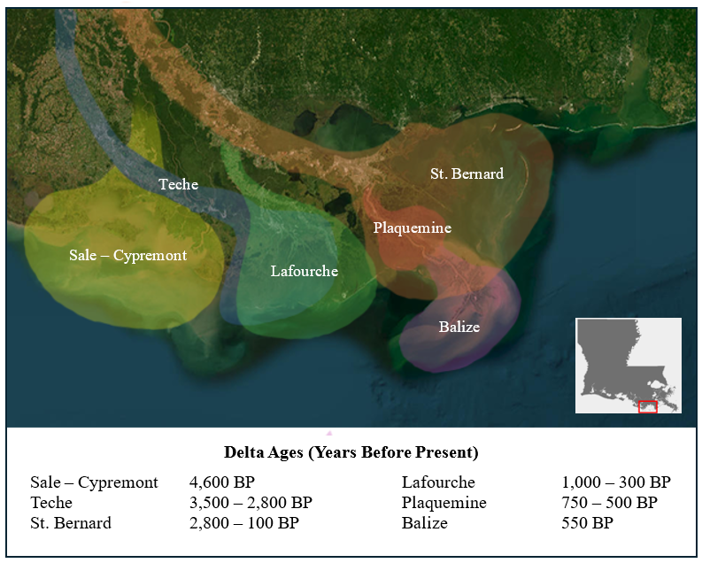

Figure 1.1. Mississippi River Delta complexes over time, where BP = years before present. This map was modeled after an interpretation made by Day et al. (Day et al., 2007).

and long-term effects can vary based on marshland elevation and frequency and duration of inundation (Wiseman and Kelly, 1994; Bianchi et al., 2009). Although there are no direct riverine inputs into the TTE, some Mississippi River freshwater reaches the estuary from the westward flow of the Louisiana Coastal Current (Wiseman et al., 1986; Wiseman and Kelly, 1994). The Gulf Intracoastal Waterway, Houma Navigation Channel, and regional land drainage also contribute some freshwater, but the levee systems have somewhat restricted freshwater input (Bianchi et al., 2009; Twilley et al., 2016) and the large channels have caused saltwater to migrate inland and establish a stronger salinity gradient than would have existed naturally (Bianchi et al., 2009).
Changes in MRD wetland aerial distribution through time, and potential explanations for current land loss, are well known (Day et al., 2007). Statewide, roughly 4,900 km² of coastal wetlands have become permanently inundated between 1932 and 2016, with another 15,000 km² estimated to disappear in the next 50 years (Jankowski et al., 2017; Törnqvist et al., 2020). The region has some of the highest land loss rates in the world (12 ± 8 mm per year) due to sediment compaction caused by anthropogenic land modifications, such as leveeing, damming, and dredging (Bianchi et al., 2009; Jankowski et al., 2017), and land subsidence (Törnqvist et al., 2020). Specifically, river diversions have disconnected freshwater and sediment supplies, such that in only decades, diminished vertical mineral sediment and organic C accretion rates have not kept up with RSLR. This has led to reduced soil bulk density, faster erosion rates, and low nutrient availability (Day et al., 2007). Vegetation cannot grow at progressively higher salinity, with dead or dying roots also causing lower bulk soil density (Bianchi et al., 2009). As a consequence, MRD marshes are experiencing longer and more frequent periods of inundation and more intense wave-induced erosion (Bianchi et al., 2009). Prolonged periods of wind-driven tidal inundation can also last from days to weeks, which also floods marshes with higher salinity water that is harmful to vegetation (Baustian et al., 2021; He et al., 2023). Lastly, although tropical storms cause coastal erosion, they can also play an important role in offsetting lower sediment supplies by resuspending offshore sediments and organic matter and depositing them instantaneously onto marsh platforms (Day et al., 2007). The impacts of storm deposits on salt marsh soil microbial communities and changes to CH₄ emissions have not been established.
Consequently, the TTE is an ideal setting to study bottom-up processes and landscape controls associated with CH₄ dynamics in coastal wetlands. Previous research has suggested that the age and organic matter quality and lability can affect the total flux of CH₄ from salt marshes, such that CH₄ flux was higher in newer marshes with lower soil C concentrations (He et al., 2023). Moreover, from several field studies and mesocosm experiments (Bueno de Mesquita et al., 2024; Koontz et al., 2024), higher salinity correlates to lower CH₄ production because higher sulfate concentrations in saline water allow sulfate-reducers to outcompete methanogens for substrates and nutrients (Luo et al., 2019; Al-Haj and Fulweiler, 2020; Hartman et al., 2024; Koontz et al., 2024). These recent studies support the findings of Poffenbarger et al. (2011) who found that CH₄ production is nearly eliminated at 8 mM sulfate and above 15 practical salinity units (PSU). However, other studies reveal that methylotrophic methanogens can ferment methylated compounds to produce CH₄ under high concentration of sulfate, and more research suggests that CH₄ production non-linearly responds to changes in salinity (Bueno de Mesquita et al., 2024), which may be due to differences in soil properties that would affect methanogenic activity (He et al., 2023; Koontz et al., 2024). Therefore, in the TTE, changes in land distribution caused by RSLR and erosion have the potential to alter the distribution and exposure of organic matter and soil of different ages and properties (e.g., total organic C content, dissolved nutrients like N, bulk density, and grain size distribution) that could influence variable CH₄ production across the landscape. As such, the accelerated RSLR in the TTE provides an opportunity to evaluate the impact of the actively changing landscape controls on CH₄ emissions.
St. Bernard

1.3 Thesis Goals
The overarching goal of my thesis research was to evaluate present-day controls of coastal wetland CH₄ emissions by characterizing soil microbial communities, habitat geochemistry, and soil properties from different locations within the TTE. Although there has been previous research on this topic (Luo et al., 2019; Zhang et al., 2021; Keneally et al., 2024), there is a lack of data in coastal deltaic regions, such as in Louisiana (He et al., 2023). My research was done as part of a larger collaborative project, Coastal Landscape Investigations about Methane (CLIM), led by interdisciplinary scientists from University of Tennessee, Knoxville (UTK), Old Dominion University (ODU) (formerly from the University of Kentucky, UKY), Louisiana Universities Marine Consortium (LUMCON), Louisiana State University, and Rowan University. The CLIM project aims to create a more comprehensive inventory of CH₄ hotspots from microbial-to-landscape scales. The clarity gained from connecting microbial, geochemical, and sedimentological processes in TTE coastal wetlands will be used to improve models that can predict future CH₄ emissions from a changing landscape caused by land loss due to RSLR and subsidence. With this information, the CLIM team hopes to improve upon society’s understanding of CH₄ emissions and feedback processes from natural coastal wetlands.

1.4 Thesis Questions, Hypotheses, and Objectives
My thesis aims to answer the following questions:
- What is the microbial community composition from TTE soil core profiles?
- What are the relationships among the relative and absolute abundances of soil microbial community members and habitat geochemical and soil properties (e.g., organic C, grain size, bulk density)?
- How do geochemical and soil properties correspond to the relative and absolute abundances of putative methanogens?
- How do porewater CH₄ concentrations correlate to relative abundances of putative methanogens and substrate competitors, such as methane-oxidizers and sulfate-reducers?
- Do the abundances of different putative methanogenic groups vary in soil samples with high levels of porewater sulfate?

The following hypotheses were tested:
H1) Sulfate and porewater CH₄ concentrations will follow the previously observed paradigm that porewater CH₄ concentrations increase when porewater sulfate concentrations decrease.
H2) Methanogenic populations will have higher biomass and relative abundances from soils with higher soil organic C content and lower bulk density.
H3) Methylotrophic methanogenesis will allow for CH₄ production to persist in areas with high sulfate concentrations or otherwise non-ideal conditions for other methanogenic pathways.

There were five main objectives for this research:
- From soil cores, characterize the microbial diversity by using 16S rRNA gene surveys at different core depths and across spatial scales and geochemical gradients.
- Analyze the absolute abundances of Archaea, Bacteria, and putative methanogens using quantitative PCR.
- Evaluate the relationships among microbial communities, soil composition (e.g., bulk density, grain size, inorganic and organic C content), porewater composition (i.e., dissolved inorganic and organic C content, ion concentrations, pH, salinity), and dissolved gas concentrations.
- Compare spatial inventories of porewater CH₄ to microbial community diversity associated with the CH₄ cycle to establish the environmental conditions of CH₄ hotspots.
- Determine whether there is a role for methylotrophic methanogenesis in TTE porewater CH₄ concentrations.

SECTION 2. MATERIALS AND METHODS

2.1 Soil Collection from Wardenaar Peat Cores
Field campaigns in the TTE were conducted in July 2023 and May-June 2024 by CLIM team members from UTK, UKY/ODU, and LUMCON. This thesis focuses on 2023 samples only. Locations were selected along a natural salinity gradient that covered 40 km of coastline (Figure 2.1). Each location was dominated by Spartina alterniflora, although minor other vegetation was noted. To overcome sampling challenges due to thick, fibrous roots and water-saturated soils, and to obtain sufficient soil and soil water materials for a wide range of in-depth geochemical and sedimentological analyses, a Wardenaar Peat Profile Sampler (Eijkelkamp North America, Wilmington, NC) was used to extract intact soil monoliths up to 1 m depth.
Wardenaar coring devices (Figure 2.2) are hollow, rectangular boxes made of stainless steel (Wardenaar, 1987) that cause minimal disturbance to both the soil sample and the marsh. The very sharp cutting edges at the base of the sampler are vertically inserted into the marsh by a single person, then pushed further into the ground by alternating the hinged handgrip position from side to side until the corer reaches the full depth. A small tube reduces suction by introducing airflow. A clamp mechanism grips the sample to the device as the soil profile is extracted to reduce sloughing. All cores were extracted by UKY/ODU at least 10 m away from the marsh edges to avoid edge effects caused by erosion or heterogeneous deposition. Extracted cores were photographed in the field then immediately divided vertically into two halves (Figure 2.3). One half was separated by UKY/ODU for physical soil characterization and radiochemistry into 1-cm increments to 50 cm depth, then 2-cm increments to 1 m depth (Figure 2.3).
The cores provided sufficient material for coordinating physiochemistry (e.g., porewater specific conductance) and soil properties (e.g., grain size percentages, water fraction, bulk density, organic C content), as well as radiochemical and isotopic analyses (results not included in this thesis) that originated from the same depth increments. Belowground plant biomass properties, soil C and N content, and microbial community characterization were also determined from soil samples. Porewater extraction was done from soil increments using Rhizons (Seeberg-Elverfeldt et al., 2005), from which total C and N content, and anion and cation concentrations were measured. Porewater CH₄ concentrations were measured from soil plugs. Each method was modified to use the smallest sample volumes necessary, ranging from a few grams of soil to a few milliliters of porewater. Detailed descriptions for each of the methods are provided below.

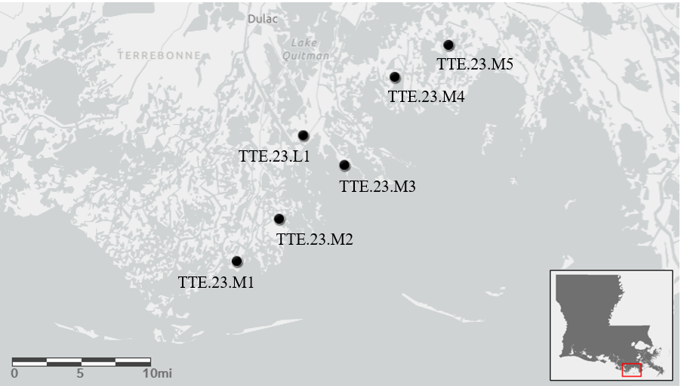



Figure 2.1. Map of sample locations in Terrebonne-Timbalier Estuary. The base map uses Esri, DeLorme, HERE, MapmyIndia data, and was plotted using ArcGIS Online.

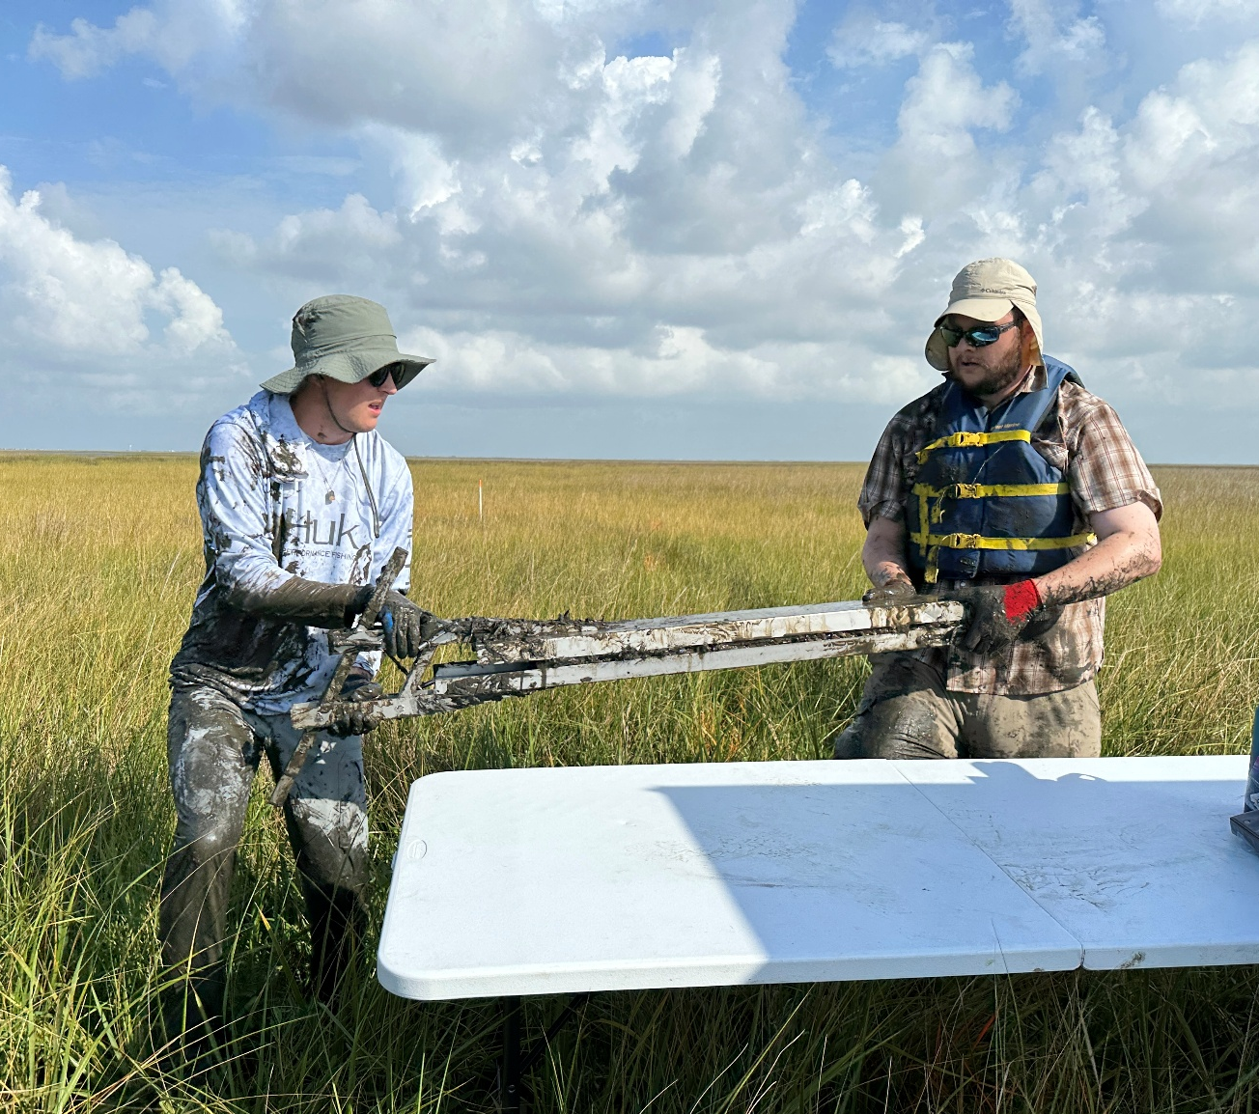

Figure 2.2. A photograph immediately following core extraction using the Wardenaar Peat Profile Sampler.

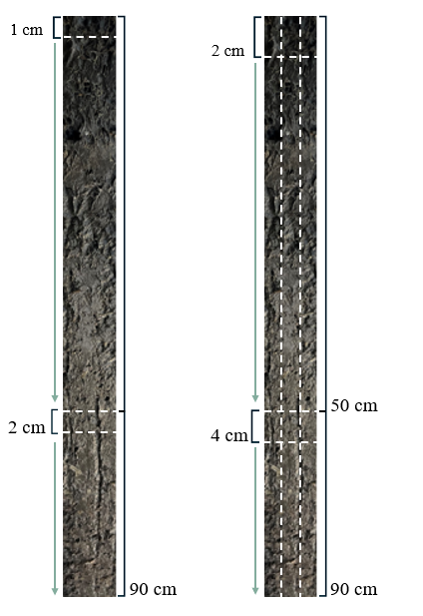
Porewater & Molecular
Sedimentology

Figure 2.3. Cores were split in half for soil analyses and separate porewater and microbial characterization, which amounted to 26 different and coordinating analyses from each depth increment. For soil analyses, cores were sectioned every 1 cm until 50-cm depth, then every 2 cm up to 90+-cm depth. For porewater and microbial analyses, cores were sectioned every 2 cm up to 50-cm depth, then every 4 cm up to 90+-cm depth.

The second half of the core was used by UTK to measure soil porewater specific conductance and temperature using a Spectrum FieldScout Direct Soil EC meter and probe (Spectrum Technologies, Inc., Aurora, IL) at 2-cm increments up to 50-cm depth then at 4-cm increments for the remainder of the core. Soil plugs (from 1 to 3 cm³) were collected for porewater CH₄ analyses (described below) using syringes. Approximately half of each depth increment was placed into a sterile Whirl-Pak bag for porewater extraction (described below). Microbial samples for DNA extraction and archives were divided into separate Whirl-Pak bags then placed on ice or dry ice in the field and stored at -80°C until they were analyzed at UTK.

2.2 Soil pH Measurements
Soil pH was measured at UTK using a modified version of the U.S. EPA Method 9045D from soil with a total volume of <20% water (EPA, 2004). Marsh soil was divided into 5-g aliquots and dried at 50 ºC for 24 to 48 hours until completely dried. Rehydration to a 1:2 soil to water mix was calculated from dry weights. Sterile, reagent grade deionized and distilled water (ddH₂O) was added to dried soil and homogenized. After homogenization, the mixture was centrifuged at 10,000 x g for 2 minutes to create headspace for the pH probe. To more closely match field conditions, the temperatures of the samples were brought to 29 ºC (the average temperature for all cores, as measured by the FieldScout Direct Soil EC meter and probe) by placing tubes in a hot water bath for 10 minutes. Measurements of pH and temperature were done by using a benchtop pH meter (Denver Instrument, UB-20).

2.3 Soil Characterization
In the field, 1-mL bulk density plugs were taken with open-barrel plastic syringes from every depth increment and placed in Whirl-Pak bags and stored on ice until they could be stored at 4 °C until analyses. The average grain size distribution, as the percentages of sand (63-2,000 µm), silt (4-63 µm), and clay (<4 µm), were determined from triplicate analyses of 1- to 3-g aliquots. Soil samples were placed into 250 mL beakers for disaggregation using 10 mL sodium hexametaphosphate, and organic matter was removed by adding 5 mL at a time of H₂O₂ heated to 100 °C until no reaction. Samples were transferred to 50 mL centrifuge tubes with deionized (DI) water and centrifuged at 3,500 rpm for 10 minutes. Three repeat cycles of rinsing by centrifugation were generally needed to remove all H₂O₂. Grain sizes were analyzed using a Malvern Mastersizer 3000+ optical particle size sorter (Malvern, England) equipped with a Hydro EV unit and having a measurable range of 0.02 to 3,500 µm.
Bulk density was calculated from 1-cm³ samples that were weighed wet, then dried and weighed again, by using the equation (Blum, 1997):
$$Bulk Density=\frac{Wet Sed. Weight \left(g\right)-Dry Sed. Weight (g)}{Measured Syringe Volume (\sim 1mL or cm3)}$$
Water fraction was calculated by wet and dry weights, by using the following equation (Blum, 1997):
$$Fraction water=\frac{Wet Sed. Weight \left(g\right)-Dry Sed. Weight (g)}{Wet Sed. Weight (g)}$$

2.4 Soil Porewater CH₄ Analyses
In the field, 1- to 3-cm³ soil plugs were collected from every depth increment using open-barrel plastic syringes to transfer samples from the core to a 20-mL serum bottle pre-filled with 3 mL of 2M sodium hydroxide to preserve the samples. Serum bottles were topped with butyl rubber stoppers and Al crimp-seals in the field. To measure porewater CH₄, headspace in the serum bottle was measured using gas chromatography (SRI 310C Gas Chromatograph, Torrance, CA) equipped with a flame ionization detector (FID) with methanizer.

2.5 Soil Porewater Collection and Analyses
Porewater extractions were started in the field by making a small incision into each Whirl-Pak bag then inserting a 10-cm long Rhizon (MOM 19.21.21 type) soil moisture sampler (Rhizosphere Research Product, Wageningen, The Netherlands) (Seeberg-Elverfeldt et al., 2005) (Figure 2.4). The Rhizon samplers had a 0.15 mm-pore size membrane, were reinforced with glass fiber wires, and had 12-cm PVC/PE tubing with male luer fittings. For each soil depth, a needle was attached to the Rhizon sampler tubing and then inserted into an untreated, sterile 6-ml Greiner Bio-One Vacuette® liquid collection tube (Greiner Bio-One North America Inc., Monroe, NC). Fresh tubes were swapped through time to obtain a total of at least 12 ml of fluid from each depth, which would take from less than an hour to over 24 hours, depending on soil moisture.
Porewater was divided for separate LUMCON and UTK analyses from filtered porewater using 25-mm 0.2-µm PES filters (LUMCON) or 13-mm 0.2-µm PTFE syringe filters (UTK). After filtration, water samples to measure chloride and sulfate were preserved with concentrated nitric acid (10 μl acid/1 mL) prior to analysis by ion chromatography using a Dionex ICS-1000 with an AS9 analytical column. Samples for NH₄⁺ were immediately preserved after filtration

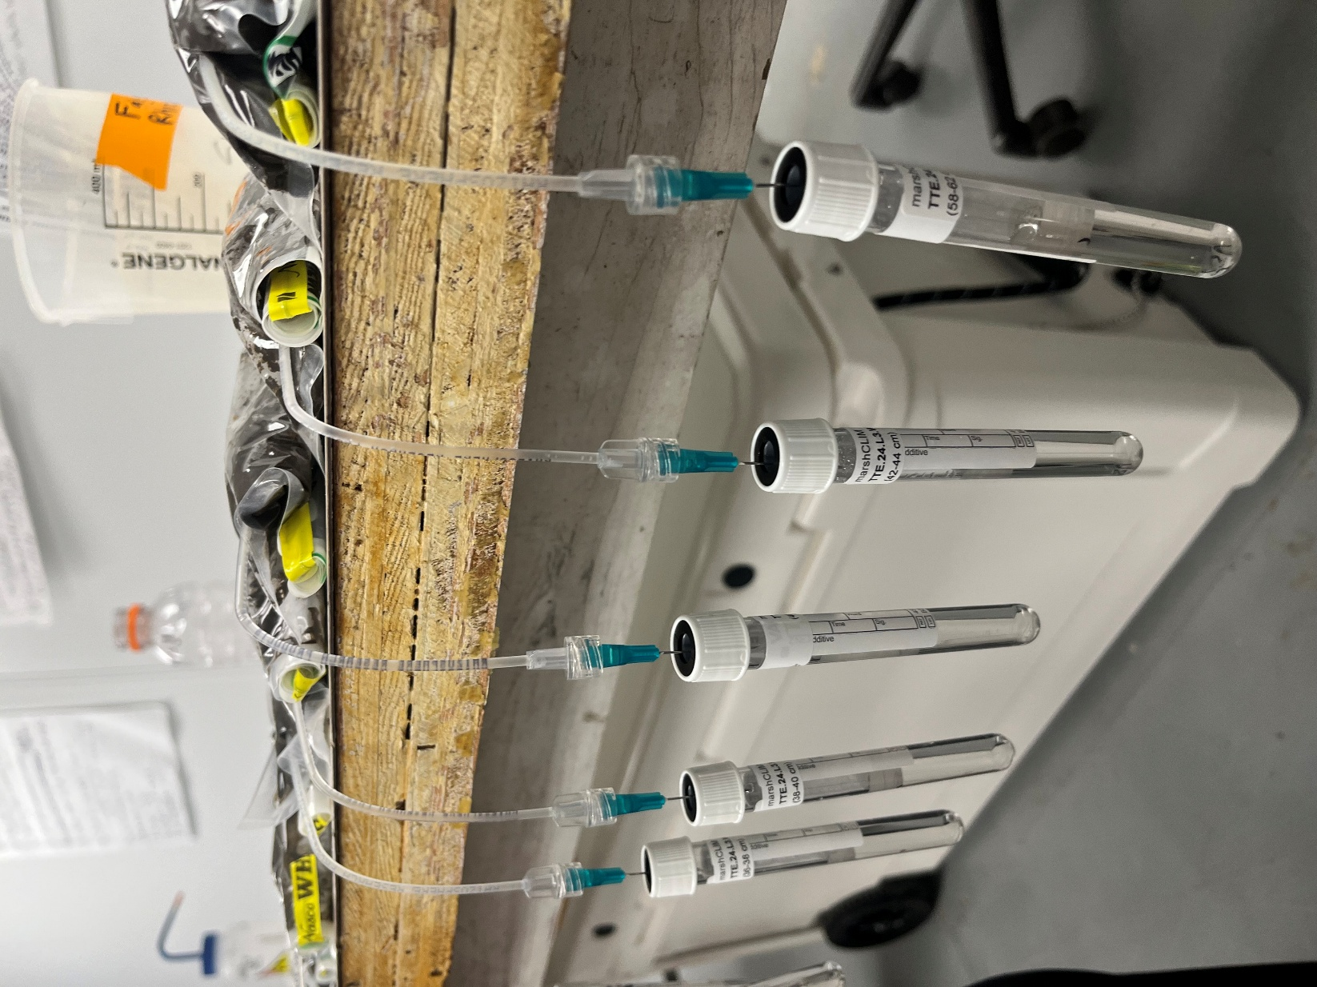

Figure 2.4. Porewater extraction from soil in a Whirl-Pak bag with an attached Rhizon, needle, and Vacuette vial after samples were transported from the field to the laboratory.

with a zinc acetate solution for colorimetric measurements (Solórzano, 1969). Water samples to measure NOx concentrations were immediately preserved with zinc chloride, and a chemical reduction of nitrate to nitrite was performed (Schnetger and Lehners, 2014).
Analyses performed by UTK included preserving up to 2 mL of each filtered porewater sample with nitric acid prior to cation (sodium, ammonium, potassium, magnesium, and calcium) measurements by ion chromatography using a Thermo Dionex ICS-2100 with CS16 analytical column. Samples for dissolved inorganic carbon (DIC) were acidified with 10% (v/v) phosphoric acid. Non-purgeable organic carbon (NPOC) and total nitrogen (TN) were measured with a Shimadzu TOC-L and TNM-L, respectively. The TOC-L analyzer combusted samples at 680 °C using a catalytic oxidation method. To deal with the high salt content, the TOC-L analyzer was equipped with an automatic dilution function to reduce salinity for prolonged function of catalysts and combustion tubes. To measure TN, a Shimadzu TNM-L combusted samples at 720 °C using catalytic thermal decomposition methods that did not interfere with metallic ions or bromine present in water samples.

2.6 Nucleic Acids Extraction and 16S rRNA Gene Sequencing
To characterize soil microbial diversity, 16S rRNA gene sequences were obtained from DNA. DNA extractions were every 10 cm apart until 50 cm depth and then every 20 cm apart until 90 cm depth, for a total of eight increments per core. Total nucleic acid extractions were done following a modified approach outlined in the literature (Somerville et al., 1989; Zhou et al., 1996; Mitchell and Takacs-Vesbach, 2008). Briefly, 5-g aliquots of soil were incubated in a sucrose lysis buffer with lysozyme (1 mg/ml) for 60 to 90 minutes in a 37°C water bath, followed by the addition of 1.5 mL of a Proteinase K/CTAB/SDS solution prior to incubating at 55°C for 16 hours. After incubation, unreacted cell debris and humic materials were removed from the solution by centrifugation at 1,000 x g and 10°C for one minute, and 3 mL of the supernatant was transferred to 5-mL microcentrifuge tubes containing 1.5 µL of 10 M ammonium acetate for protein precipitation. There was one control that was subjected to the same protocol for each round of DNA extractions, where the 3 mL of supernatant was replaced with sterilized Milli-Q water. The solution was centrifuged for 5 minutes at 10,000 x g before 2 mL of the supernatant was added to a new 5-mL microcentrifuge tube containing 1.5 mL isopropanol. The solutions were gently mixed by inversion and stored at -20°C for 24 hours for DNA precipitation. To remove the isopropanol solution after DNA precipitation, tubes were
centrifuged at 10,000 x g for 10 minutes then decanted to leave only the pellet. Pellets were washed twice with 1 mL of 100% ethanol and dried for 1 to 2 hours, then resuspended in 200 μL of Tris-EDTA buffer and stored at -20°C until use.
Each extraction was cleaned with a QIAGEN DNeasy PowerClean Kit (Hilden, Germany) using manufacturer instructions with modified volumes to reduce the amount of sample needed. DNA concentrations (ng/L) were estimated using a NanoDrop UV-Vis Spectrophotometer. Cleaned duplicate extractions for each depth were sent to Molecular Research LP (MrDNA, Shallowater, Texas) for sequencing of the V4 region of the 16S rRNA gene sequence using pair-end Illumina MiSeq sequencing and 515F (5’-GTGYCAGCMGCCGCGGTAA-3’) (Parada et al., 2016) and 806RB (5’-GGACTACNVGGGTWTCTAAT-3’) (Apprill et al., 2015) primers optimized to capture more target groups within the bacterial and archaeal domains (Walters et al., 2016).
2.7 Sequence Processing and Analysis
Samples were multiplexed, pooled together, and purified using calibrated Ampure XP beads in to prepare an Illumina DNA library. After demultiplexing and removal of barcodes and primers from the sequence reads using the MrDNA FASTQ processor software, the forward and reverse reads were merged using the MOTHUR (V.1.48.2) pipeline (Schloss et al., 2009), following the MiSeq standard operating procedure and the make.contigs command. The rename.file command was used to rename the files. For easier tracking, summary.seqs was run after each command to review changes to the output files. The make.count command converted the FASTA files to a count file. Using the count file, the screeen.seqs command removed ambiguous reads and overlapping regions, and sequences that did not assemble or were the incorrect length were removed. The unique.seqs command merged any duplicate sequences. The pcr.seqs command created a customized database for the region of interest and start and end positions of the sequences were specified at 14000 – 23000 for trimming, then the sequences were aligned to the SILVA (version.138.2) reference database (Quast et al., 2013) using the align.seqs command. After alignment, any bases that did not overlap within the target region were removed, screen.seqs was run, then overhangs in sequences were removed with filter.seqs. The pre.cluster command denoised the sequences, allowing up to two differences between base pairs. Chimera were removed using the chimera.vsearch and remove.seqs commands. Taxonomy based on the SILVA reference was assigned using classify.seqs. Reads that were classified as chloroplasts, mitochondria, and Eukaryota were removed with the remove.lineage command.
The MOTHUR MiSeq pipeline was also followed to assign operational taxonomic units (OTUs) based on pairwise distances between aligned sequences using the SILVA reference file and a 0.03 cutoff (97% sequence identity) with the dist.seqs and cluster commands. The number of sequences in each OTU was calculated with the make.shared command, and taxonomy was assigned using the classify.otu command. OTUs were used to calculate diversity indices with MOTHUR. The Simpson’s Index (D) was used to determine species evenness and Shannon diversity index (H’) was used to determine species richness (Schloss et al., 2009). OTUs specific to Archaea and putative methanogenic lineages were each extracted from the total OTU dataset using the get.lineage command. If a taxonomic class and order had a total relative abundance >1%, then putative metabolism was conservatively assigned based on literature review and cross-referenced in the National Center for Biotechnology Information (NCBI) database.

2.8 Sequence Data Submission
Raw sequence files for each sample were submitted to the NCBI Sequence Read Archive under the BioProject PRJNA1285862, http://www.ncbi.nlm.nih.gov/bioproject/1285862.

2.9 Gene Quantification using qPCR
The total abundances of 16S rRNA genes for Bacteria and Archaea were determined, as well as of the mcrA and pmoA functional genes for putative methanogens and methanotrophs, respectively, were determined by real-time or quantitative PCR (qPCR) using a BioRad CFX96 Real-Time system (BioRad, Hercules, CA). Bacteria 16S rRNA gene copies were detected using the primer pair of 515F (5’-GTGYCAGCMGCCGCGGTAA-3’) (Parada et al., 2016) and 806RB (5’-GGACTACNVGGGTWTCTAAT-3’) (Apprill et al., 2015), which matched the sequencing primers. Archaea 16S rRNA gene copies were detected using the primer pair of ARC915F (AGGAATTGGCGGGGGAGCAC) and ARC1059F (GCCATGCACCWCCTCT) (Yu et al., 2005). The primer pair used to measure the copies of the mcrA gene was ML-F(mcrA) (GGTGGTGTM GGATTCACACARTAYGCWACAGC) and MF-R(mcrA) (TTCATTGCRTAGTTWGGRTAGTT) (Luton et al., 2002) and of the pmoA gene was A189F (GGNGACTGGGACTTCTGG) and mb661R (CCGGMCGAACGTCYTTACC).
Reactions for qPCR were done in 96-well plates. Each reaction was comprised of 5 μL iTAQ Universal SYBR® Green Supermix (BioRad, Hercules, CA), 0.15 μL 20 mg mL⁻¹ bovine serum albumin (BSA), 0.25 μL 20 μM of each primer, 3.85 μL sterilized Milli-Q water, and 0.5 μL DNA template, modified from Han et al. (2023). Thermal cycler conditions for each gene are described in Table 2.1. Each 96-well plate was run with triplicates of the respective gene standard dilution series, a negative control, and triplicates of each sample.
To create corresponding standard curves for each gene target, a 1:100 mixture of each standard and sterilized Milli-Q water was used to make serial dilutions that ranged from 10² to 10⁸ gene copies μL⁻¹ for Bacteria, 10³ to 10⁸ gene copies μL⁻¹ for Archaea, and 10⁴ to 10⁸ gene copies μL⁻¹ for mcrA. Following the Minimum Information for Publication of Quantitative Real-Time PCR Experiments (MIQE) guidelines (Bustin et al., 2009), the standards for Bacteria, Archaea, mcrA, and pmoA were each artificially synthetized as double-stranded gBlocks® gene fragments in 500 ng quantities by IDT (Integrated DNA Technologies, Inc., Coralville, IA). The “universal” Bacteria 16S rRNA, mcrA, and pmoA gene standards were designed from E. coli, Methanococcus spp., and Methylococcus capsulatus sequences, respectively, and used by Han et al. (2023). The Archaea 16S rRNA gene standard was designed from Nitrosopumilus maritimus (Watanabe et al., 2004). The standard curve of each had an R² value of 0.95 or greater. The extraction efficiency values were 99%, 69%, 62%, and 105% for Bacteria, Archaea, mcrA, and pmoA, respectively.
Gene copies per μL for each standard were calculated using the equation below,
$$Gene Copies {µL}^{-1}=\frac{DNA concentration \left(\frac{ng}{µL}\right)×{10}^{-9}×6.022×{10}^{23}}{\left(fragment size base pairs\right)×660g/mol}$$
To correct for gene multiplicity and provide a more accurate representation of 16S rRNA, mcrA, and pmoA gene total abundances, total copy numbers of each were divided by an average number of gene copies per genome. Gene copy numbers of the 16S rRNA gene can vary from 3 to 24 copies per genome for Bacteria and Archaea based on phylogeny and lifestyle (Lauro et al., 2009; Buongiorno et al., 2017). To account for multiple copies of 16S rRNA gene copies per cell, the gene copy numbers for Bacteria and Archaea were divided by 4 (Zarraz et al., 2009). There are 1–2 copies of pmoA (Chiri et al., 2020) and mcrA (Marques et al., 2020) genes per genome. The number of copies per genome for both mcrA and pmoA was set at 1.5.

2.10 Statistical Analyses
Environmental and microbial sequence data were processed in R (R Core Team, 2021). All microbial data were normalized by dividing individual sample observations by the maximum
Table 2.1. Thermal cycler conditions for qPCR gene quantifications.
 | 16S rRNA gene Bacteria | 16S rRNA gene Archaea | mcrA | pmoA
Stage 1: 1 cycle (denaturation) | 2 min (95°C)
 | 95°C (40 sec) | 95°C (40 sec) | 95°C (45 sec) | 95°C (45 sec)
Stage 2: 40 cycles (amplification) | 53°C (40 sec) | 60°C (30 sec) | 50°C (45 sec) | 56°C (45 sec)
 | 72°C (60 sec) | 72°C (30 sec) | 72°C (45 sec) | 72°C (45 sec)
Step 3: 1 cycle (melting curve) | 95°C (15 sec) |  | 95°C (15 sec) | 95°C (15 sec)
 | 60°C (15 sec) | 72°C (5 min) | 50°C (15 sec) | 60°C (15 sec)
 | 95°C (15 sec) |  | 95°C (15 sec) | 95°C (15 sec)
Stage 4: cooling | 4°C | 4°C | 4°C | 4°C

value of the dataset to create a scale between 0 and 1. To correct measurements that were missed or outside of detection limits, a constant value of 1 was added to each data field before log transformation in R using the ‘log’ function. Significance, strengths, and directions of relationships between environmental variables were determined by R² values in Excel and with Spearman’s significance (p-value) and correlation coefficients (ρ) using the ‘cor()’ function in R and the statistical significance level (alpha) was set at 0.05. Spearman’s Rank Correlations were also used to determine significant relationships between environmental data and both D and H’ values. Single and segmented linear regression analyses were done in Excel to establish the significance of relationships between environmental covariates using R² values. A canonical correspondence analysis (CCA) of normalized relative abundances for the top 20 methanogenic archaeal OTUs and major environmental parameters was used to further assess significant environmental drivers of putative methanogen presence. Prior to plotting the CCA, the ‘ordistep()’ function was used in R for stepwise model selection with the default settings for direction and permutations to evaluate significant environmental correlations for the top 20 putative archaeal methanogenic OTUs (R Core Team, 2021).

SECTION 3. RESULTS

3.1 Soil Characteristics and Porewater Geochemistry
One goal of this study was to understand how geochemical and sedimentological properties correspond with microbial community compositions throughout soil profiles in the TTE. Geochemical and sedimentological properties can affect redox conditions and substrate availability for soil microbial communities that dictate C cycling in marsh sediments. The soil cores from each marsh location were dominated by silt-sized grains, followed by clay (Figure 3.1, Table A.1). Bulk density ranged from 0.10 to 1.45 g cm⁻³ for all sites and depths and had a mean of 0.39 g cm⁻³ (Figure 3.1). The maximum sand contribution was 36%, except for soil at the northernmost site, TTE.23.M5, which had higher percentages of sand and a maximum of 62% at 10 cm depth. Organic C content ranged from 0.91% to 32.5% (Table A.1) and concentrations significantly decreased with depth, although the significance was not strong based on a Spearman’s Rank Correlation analysis (ρ = -0.159, p-value = <0.07). Organic C content was not significantly correlated with site location (p-value = 0.52).
Salinity plays a vital role in C cycling in brackish marshes because increased salinity and extended periods of inundation can influence the rate of organic C mineralization and decrease oxygen availability (Luo et al., 2019). Previous studies have observed the influence of salinity on marsh soil microbial community composition (Zhang et al., 2019; Liu et al., 2022; Capooci et al., 2024), but we only found one study observing depths down to 1 m (Xu et al., 2021). Soil porewater Cl⁻ concentrations were used to estimate salinity by multiplying the ppt concentration by 1.80665. Salinity at each location significantly differed from the other locations (p-value = <0.001) and reflected the natural salinity gradient from south to north (Table A.1). The southernmost locations, TTE.23.M1 and TTE.23.M2, had generally the highest average Cl⁻ concentrations, around 450–460 mM (corresponding to about 29 PSU), and the westernmost and northern location TTE.23.L1 had the lowest average Cl⁻ concentration, at 210 mM (corresponding to about 13 PSU) (Figure 3.2, Table A.2). Concentrations of SO₄²⁻ increased with salinity, and the southernmost locations had the highest concentrations (Table A.3), which were positively correlated with Cl⁻ (ρ = 0.48, p-value = <0.0001). Overall, SO₄²⁻ porewater concentrations ranged from 390 to 38,380 µM and were significantly and negatively correlated with depth (ρ = -0.70, p-value = <0.0001) (Table A.3).

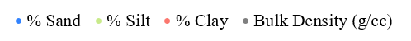
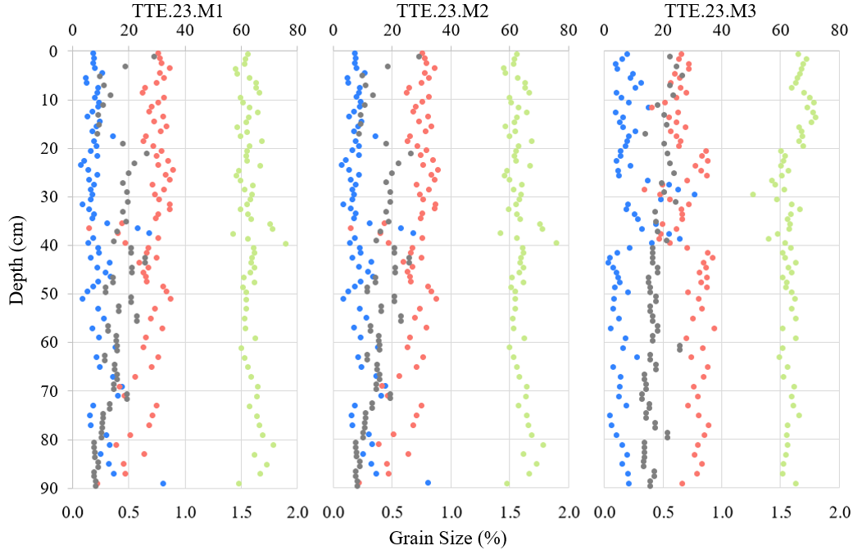
Figure 3.1. Grain size percentage distributions and bulk density (g cm⁻³) for each soil profile at each marsh location.
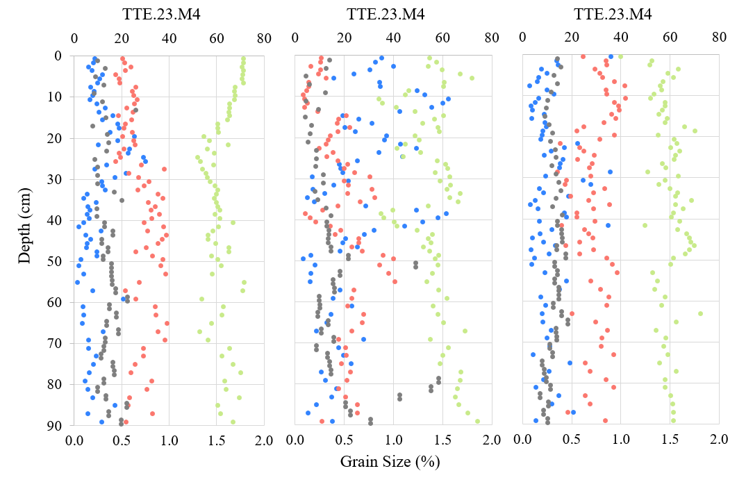

Figure 3.1, continued. Grain size percentage distributions and bulk density (g cm⁻³) for each soil profile at each marsh location.
Figure 3.1. Continued.
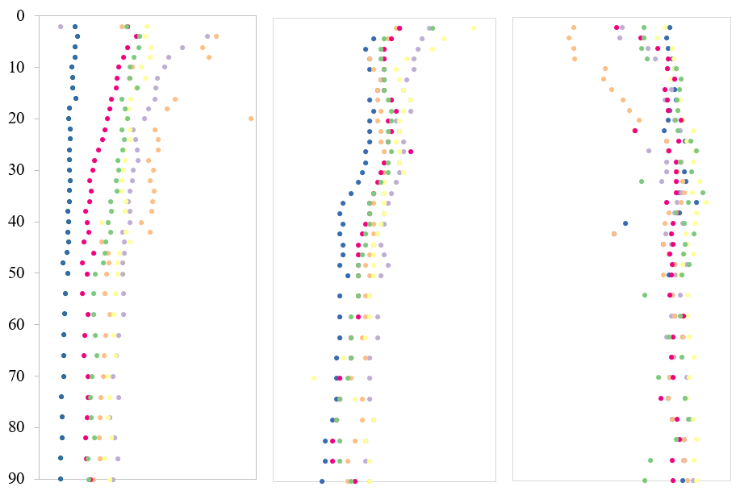
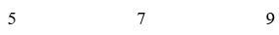
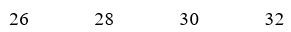
pH
Temperature (°C)
Cl- (mM)
Depth (cm)

Legend
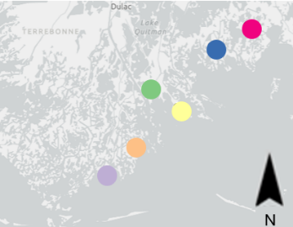
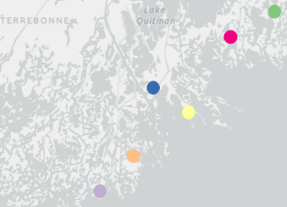
L1
M4
M5
M3
M2
M1
Salinity
M4
M5
M3
M2
M1

Figure 3.2. Porewater geochemistry from each marsh location. The legend is in the order of least saline (L1) to most saline (M1) location, plotted on the basemap (legend at far right).
High levels of SO₄²⁻ that are associated with saline water can suppress CH₄ production (Koontz et al., 2024). However, previous studies have emphasized the need for co-located measurements of porewater CH₄ along salinity gradients to better understand drivers of CH₄ production on a broader scale (Al-Haj and Fulweiler, 2020). Porewater CH₄ ranged from between 2.8 μM and 3,109.4 μM (Table A.2). One question this study aimed to answer was what relationship exists between porewater sulfate and CH₄ concentrations from the marsh soils. Based on prior work, it was hypothesized that porewater CH₄ would be negatively correlated with porewater SO₄²⁻, and Spearman’s Rank Correlation supported the hypothesis because porewater CH₄ had strong and significantly negative correlations with Cl⁻ (ρ = -0.57, p-value = <0.0001) and a positive correlation with depth (ρ = 0.56, p-value = <0.0001). Previously, based on measured SO₄²⁻ and CH₄ porewater concentrations from a number of different coastal settings, an inflection point was recognized when CH₄ concentrations remain relatively high when porewater SO₄²⁻ availability is limited, but there is a sharp decline in CH₄ concentrations as SO₄²⁻ concentrations exceed 10 mM (Koontz et al., 2024). A segmented linear regression from the TTE dataset revealed an inflection at 11 mM (Figure 3.3A). Compared to the single linear regression for the whole dataset (R² = 0.57), a segmented linear regression had stronger explanatory power after the inflection (R² = 0.65), which emphasizes that the relationship between SO₄²⁻ and CH₄ is non-linear.
Microbial community composition is directly related to pH level in all environments, as individual microorganisms have pH ranges in which they function optimally. Broadly, soil porewater had similar geochemical patterns for pH, which ranged from 5.77 to 7.26, (Figure 3.2, Table A.2). The more saline sites had the lowest pH values at the surface but were more variable down-core, although not by more than 0.5 log units. Temperature, which ranged from 27.1 to 31.4˚C, generally decreased down-core. According to Spearman’s Rank Correlation, pH and temperature significantly and negatively correlated with depth (p-value = <0.001) (Figure 3.2).
Measurements of porewater NPOC and TN concentrations can be used as indicators of C cycling, including CH₄ production, as NPOC and TN are essential for many microbial metabolic processes. Additionally, the presence of reactive N species could interact with the relationship of SO₄²⁻ and CH_{4,} as species like nitrite and nitrate serve as electron acceptors that can catalyze CH₄ oxidation (Koontz et al., 2024). NPOC concentrations ranged from 8.4 to 74.9 mg C L⁻¹ (Table A.2) and were not significantly correlated to site location or depth. NPOC concentrations at the

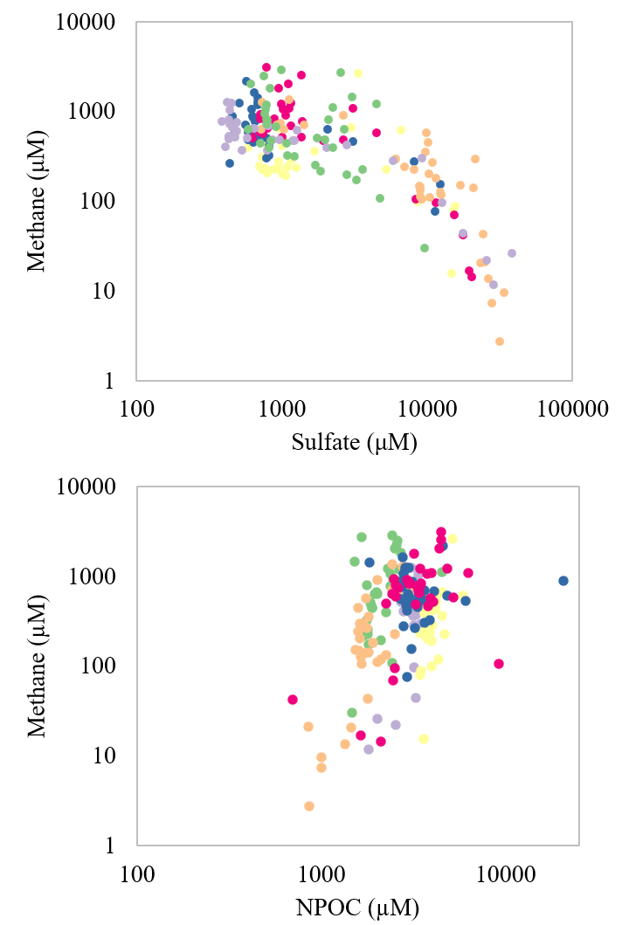

Legend
L1
M4
M5
M3
M2
M1
Salinity
M4
M5
M3
M2
M1

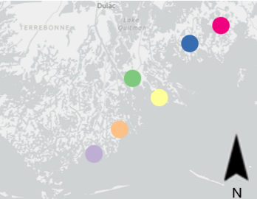

Figure 3.3. (A) Porewater methane and sulfate (SO₄²⁻) concentrations and (B) porewater methane and non-purgeable organic carbon (NPOC) concentrations. The legend is in the order of least saline (L1) to most saline (M1) core location, plotted on the basemap (legend at far right).

northern locations were generally higher than southern locations. Based on Spearman’s Rank Correlation, porewater CH₄ significantly and positively correlated with NPOC (ρ = 0.23, p-value = 0.002), although explanatory power was not strong (R² = 0.57) (Figure 3.3B).
Nitrogen plays an important role in microbial processes that affect CH₄ (Wang et al., 2022). For example, some methanotrophs are capable of CH₄-dependent atmospheric N fixation that produce NH₄⁺, which can increase plant productivity that supports higher rates of methanogenesis (Koontz et al., 2024). Concentrations of TN ranged from 0.04 to 2.34 mg N L⁻¹ (Table A.2) and significantly and positively correlated with depth (ρ = 0.79, p-value = < 0.0001). TN also negatively correlated with Cl⁻ (ρ = -0.35, p-value = < 0.0001) and positively correlated with porewater CH₄ (ρ = 0.61, p-value = < 0.0001). There were significant relationships between NH₄⁺ concentration (Table A.3) and depth (ρ = 0.82), Cl⁻ (ρ = -0.33), SO₄²⁻ (ρ = -0.76), and CH₄ (ρ = 0.57) concentrations, each having a Spearman’s p-value of <0.001. From half of the locations (TTE.23.L1, TTE.23.M4, TTE.23.M5), there was a shift at around 50 to 70 cm depth where NH₄⁺ concentrations either stabilized or decreased (Table A.3). Additionally, tidal marshes produce nitrogen oxides (NOx), reduced nitrate plus nitrite, which can be used to determine the concentrations nitrite through the reduction of nitrate (Schnetger and Lehners, 2014). Measured porewater NOx values ranged from 1.0 to 59.0 μM (Table A.2) and were negatively correlated to porewater CH₄ concentrations (ρ = -0.13, p-value = 0.05).
Microorganisms utilize base cations to maintain their cellular structure and function, as nutrition, and as catalysts to carry out their metabolic processes (Sriwiriyarat and Kuhakaew, 2021). Therefore, porewater concentrations of cations can influence the composition and activity of microbial communities. Concentrations of K⁺ ranged from 0.012 – 0.006 mol L⁻¹, Mg²⁺ from 0.018 – 0.074 mol L⁻¹, and Ca²⁺ from 0.005 – 0.015 mol L⁻¹, with higher concentrations near the surface that uniformly decreased with depth. Each also significantly and negatively correlated with depth based on Spearman’s Rank Correlation (Table A.3). There were strongly significant correlations among salinity and cation concentrations, as well as negatively with CH₄, each with a p-value of <0.00001.
The concentration of porewater acetate (CH₃COO⁻) is an important substrate for methanogenesis and sulfate reduction. Porewater CH₃COO⁻ ranged from 9.8 – 219.9 µM (Figure 3.4A, Table A2). After removing two high-concentration outliers (from depths TTE.23.L1.20 and TTE.23.M4.20), then the concentration range was 9.8 – 49.8 µM. Porewater CH₃COO⁻ also
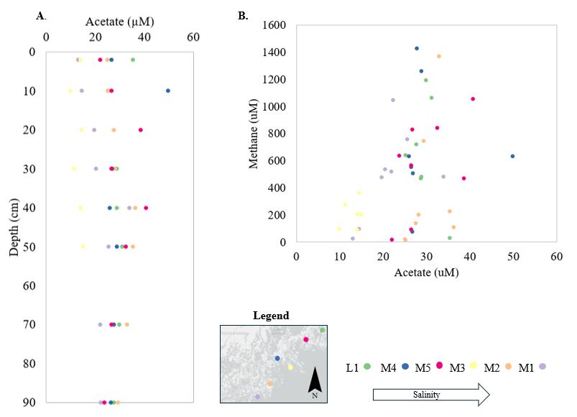

Figure 3.4. (A) Porewater acetate (CH₃COO⁻) concentrations at each marsh location by depth, and (B) porewater methane and CH₃COO⁻ concentrations. The legend is in the order of least saline (L1) to most saline (M1) core location, plotted on the basemap.

generally correlated with porewater CH₄ concentrations (p-value = 0.001) (Figure 3.4B). A Spearman’s Rank Correlation also showed porewater concentrations of CH₃COO⁻ were negatively correlated with salinity (ρ = -0.41, p-value = 0.003). The dominant vegetation of the sampled marshes, Spartina alterniflora, increases porewater CH₃COO⁻ concentrations and its root surfaces are generally associated with a high abundance of sulfate-reducing bacteria (Tong et al., 2018). Although there was not a significant correlation between porewater CH₃COO⁻ and depth, or between CH₃COO⁻ and SO₄²⁻, variable rooting zones were observed in several cores, from about 20 to 30 cm depth, that could have influenced CH₃COO⁻ variability with depth (Figure 3.4A).

3.2 Microbial Diversity

3.2.1 Taxonomic Overview
Eight depth intervals per core were selected to evaluate microbial diversity from the marsh soils in the TTE. From the 28 samples, a total of 4,893,395 curated and classified bacterial and archaeal 16S rRNA gene sequence reads were retrieved (Figure 3.5). From all depths and cores, Bacteria represented an average of 91.2% of the total reads compared to an average of 8.8% for archaeal reads. Overall, the trend was for lower relative abundances for Archaea at the surface of all cores and higher relative abundances from 40 to 70 cm depth. The highest average relative abundance for Archaea was 22%. The relative abundance of Archaea significantly correlated with depth (p-value = 0.002) and porewater CH₄ (p-value = 0.02), but not with sample site or Cl⁻.

3.2.2 Diversity Indices
The Simpson’s Index (D) and Shannon Diversity (H’) alpha-diversity indices were calculated from OTUs classified at the order level (Table 3.1). The D index ranges from 0 to 1, whereby a value closer to 0 means the more diverse the community and a value closer to 1 indicates dominance of few groups (Bo-Ra et al., 2017). The TTE soil communities D values ranged from 0.001 to 0.016, indicating highly diverse communities (Figure 3.6A). This was also reflected in the H’ values, with higher numbers suggesting greater diversity and an even distribution of OTUs within a community. Values ranged from 6.63 to 8.62 and generally decreased with depth at all locations (Figure 3.6B). When compared to environmental data using Spearman’s Rank Correlation, D values significantly correlated with bulk density (p-value = 0.097), but H’ values did not. Salinity significantly and positively correlated with D and H’ values (p-values = 0.03 and 0.012, respectively), which suggests high diversity from more southern locations.

Relative Abundance (%)

Sample Location Depth (cm)

Figure 3.5. Relative abundances of 16S rRNA gene reads assigned to the domains Archaea and Bacteria.

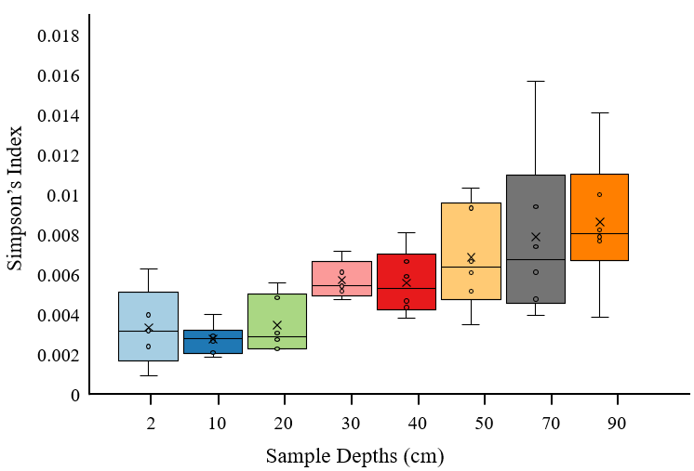
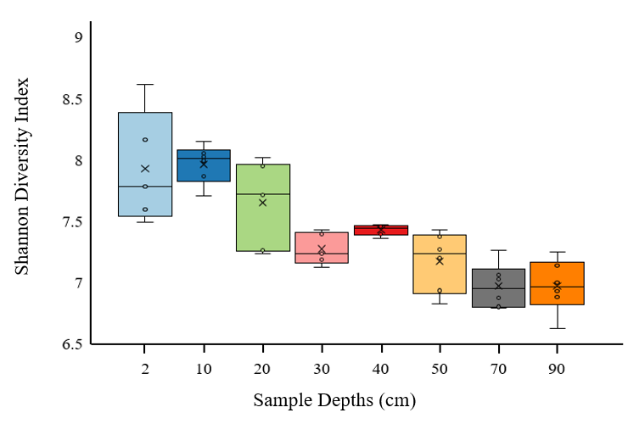
A.
B.

Figure 3.6. (A) Simpson’s Index values from all locations grouped by core depth. (B) Shannon Index values from all sample locations grouped by core depths.
Sample ID | Simpson | Shannon Diversity |  | Sample ID | Simpson | Shannon Diversity
M1.WD.02 | 0.002 | 8.16 |  | M4.WD.02 | 0.006 | 7.60
M1.WD.10 | 0.002 | 8.06 |  | M4.WD.10 | 0.004 | 7.87
M1.WD.20 | 0.003 | 7.71 |  | M4.WD.20 | 0.005 | 7.24
M1.WD.30 | 0.005 | 7.43 |  | M4.WD.30 | 0.006 | 7.24
M1.WD.40 | 0.004 | 7.47 |  | M4.WD.40 | 0.005 | 7.40
M1.WD.50 | 0.005 | 7.37 |  | M4.WD.50 | 0.003 | 7.43
M1.WD.70 | 0.006 | 6.80 |  | M4.WD.70 | 0.016 | 6.80
M1.WD.90 | 0.010 | 6.89 |  | M4.WD.90 | 0.014 | 6.63
M2.WD.10 | 0.001 | 8.62 |  | M5.WD.02 | 0.004 | 7.78
M2.WD.20 | 0.002 | 8.15 |  | M5.WD.10 | 0.003 | 8.02
M2.WD.30 | 0.002 | 8.02 |  | M5.WD.20 | 0.002 | 7.95
M2.WD.40 | 0.007 | 7.13 |  | M5.WD.30 | 0.005 | 7.40
M2.WD.50 | 0.007 | 7.46 |  | M5.WD.40 | 0.008 | 7.36
M2.WD.70 | 0.009 | 6.94 |  | M5.WD.50 | 0.010 | 6.83
M2.WD.90 | 0.007 | 7.03 |  | M5.WD.70 | 0.004 | 7.26
 |  |  |  | M5.WD.90 | 0.008 | 6.93
M3.WD.02 | 0.008 | 7.14
M3.WD.10 | 0.003 | 8.00 |  | L1.WD.02 | 0.003 | 7.50
M3.WD.20 | 0.003 | 7.73 |  | L1.WD.10 | 0.003 | 7.71
M3.WD.30 | 0.005 | 7.19 |  | L1.WD.20 | 0.006 | 7.26
M3.WD.40 | 0.004 | 7.46 |  | L1.WD.30 | 0.005 | 7.35
M3.WD.50 | 0.006 | 7.27 |  | L1.WD.40 | 0.006 | 7.43
M3.WD.70 | 0.009 | 6.88 |  | L1.WD.50 | 0.007 | 7.20
M3.WD.90 | 0.008 | 7.00 |  | L1.WD.70 | 0.005 | 7.06
 |  |  |  | L1.WD.90 | 0.004 | 7.25
Table 3.1. Summary of alpha-diversity indices at the order level. Sample identifiers (ID) do not include the prefix “TTE.23.”

3.2.3 Archaeal Diversity
Thirteen different archaeal phyla were represented, which separated into 31 taxonomically-assigned classes. However, only five classes had total relative abundances greater than 1% for the overall community (i.e., including Bacteria): Thermoplasmata, Bathyarchaeia (formerly Bathyarchaeota), Aenigmarchaeia (formerly Aenigmarchaeota), Thermococci, and unclassified Thermoplasmatota (Figure 3.7). All other archaeal classes with relative abundances less than 1% were summed and binned into the “other” category. Sequence reads that could not be assigned to a class were listed as Unclassified Archaea (Figure 3.7). This group had higher relative abundances generally from shallow core depths in most cores, and their presence may indicate novel taxonomic representation.
Because 16S rRNA gene sequences provide phylogenetic information, metabolism can be inferred when function is conserved for taxonomic groups related to known and previously characterized groups (Zhang et al., 2020; Zou et al., 2025). Moreover, 16S rRNA diversity is conserved for methanogens and other microbial groups, like sulfate-reducers. Therefore, based on thorough evaluation of the literature (Table 3.2), classes with putative methanogenic groups and with relative abundances greater than 1% included Thermoplasmata, Bathyarchaeia, and Thermococci, which accounted for 75%, 8%, and 3%, respectively, of the total identified archaeal sequence reads (Figure 3.7, Table 3.3). Collectively, however, the number of reads classified as putative methanogens represented 1.74% of all archaeal sequences in the study.
Several orders within the Thermoplasmata were notable because of their higher relative abundances. Only one order had putative methanogens, Methanomassiliicoccales (formerly Rice or Rumen Cluster C), and consistently higher relative abundances at depth and from lower pH conditions (Borrel et al., 2014; Zou et al., 2025). However, this group comprised an average of 0.43% of the total archaeal sequences and 0.04% of sequences overall. Another order, the Thermoprofundales (formerly referred to as Marine Benthic Group D (MBG-D), Deep-Sea Hydrothermal Vent Euryarchaeota Group 1 (DHVEG-1), or Izemarchaea) (Zhou et al., 2019; Zhang et al., 2022), had higher average relative abundances, ranging up to 71%. This group cohabitates with anaerobic methanotrophic archaea (Inagaki et al., 2006) and may provide small molecular compounds, like acetate and ethanol, for some methanogenic groups (Zhou et al., 2019).
Lastly, the class Bathyarchaeia had higher relative abundances at the surface (Figure 3.7). Of
Relative Abundance (%)
Sample Site by Depth (cm)

Figure 3.7. Relative abundances of archaeal classes that represented >1% of the total archaeal sequence reads (i.e., not including Bacteria), grouped for each core location from left to right with decreasing sample depth and from left to right overall in the order of decreasing salinity (from M01 to L1).
Table 3.2 Putative methanogenic groups with relative abundances > 1% based on thorough evaluation of the literature.

Methanogens | Supporting  Citations | Methanotrophs | Supporting Citations | Sulfate-reducers | Supporting Citations
Methanomassiliicoccales | Borrel et al., 2014;  Zou et al., 2025 | Methylococcales | Orata et al., 2018 | Desulfitobacteriales | Cuevas et al., 2024
Methanocellales | Wang et al., 2022;  Guerrero-Cruz et al., 2021 | Methylacidiphilales | Keneally et al., 2024 | Desulfotomaculales | Aullo et al., 2013
Methanomicrobiales | Keneally et al., 2024 | Methylomirabilales | Keneally et al., 2024 | Desulfotomaculia Uncl. | Aullo et al., 2013
Methanosarcinales | Bueno de Mesquita et al., 2024 |  |  | Thermodesulfovibrionales | Frank et al., 2016
Methanobacteriales | Capocci et al., 2023; Zhang et al., 2020 |  |  | Thermodesulfovibrionia | Singh et al., 2023
Methanobacteriota Uncl. | Dridi et al., 2012 |  |  | Thermodesulfovibrionia Uncl. | Singh et al., 2023
 |  |  |  | Desulfarculales | Keneally et al., 2024
 |  |  |  | Thermodesulfobacteriales | Mori et al., 2014
 |  |  |  | Thermodesulfobacteriota | Hatchikian et al., 2015
 |  |  |  | Thermodesulfobacteriota Uncl. | Hatchikian et al., 2015
 |  |  |  | Desulfobaccales | Waite et al., 2020  Rodrigues-Cruz et al., 2024
 |  |  |  | Desulfatiglandales | Langwig et al., 2021
 |  |  |  | Desulfobacterales | Rolando et al., 2022
 |  |  |  | Desulfobacteria Uncl. | Rolando et al., 2022
 |  |  |  | Desulfobulbales | Ward et al., 2021
 |  |  |  | Desulfomonilales | Waite et al., 2020
 |  |  |  | Desulfovibrionales | Kuever J et al., 2005
 |  |  |  | Desulfuromonadales | Keneally et al., 2024
 |  |  |  | Desulfuromonadia IS | Soares et al., 2024
 |  |  |  | Desulfuromonadia Uncl. | Soares et al., 2024
Table 3.3. Relative abundances of order-level Archaea based on the total number of reads in the dataset and at greater than 1%. Uncl. = unclassified.

Phylum | Class | Order | Total Number of Sequence Reads | Relative Abundances [%]
Thermoplasmatota | Thermoplasmata | Marine Benthic Group D & DHVEG-1 (formerly Thermoprofundales) | 332,163 | 71.2%
Thermoproteota | Bathyarchaeia | Bathyarchaeia IS | 33,604 | 10.2%
Archaea Uncl. | Archaea Uncl. | Archaea Uncl. | 12,772 | 3.7%
Thermoplasmatota | Thermoplasmata | Thermoplasmata IS | 11,582 | 3.3%
Aenigmarchaeota | Aenigmarchaeia | Aenigmarchaeales | 11,180 | 3.2%
Thermoplasmatota | Thermoplasmata | Marine_Group_III | 13,222 | 2.6%
Methanobacteriota | Thermococci | Methanofastidiosales | 4,869 | 1.3%
Thermoplasmatota | Thermoplasmatota Uncl. | Thermoplasmatota Uncl. | 2,996 | 1.0%

all the core depth samples, Bathyarchaeia had the highest relative abundance (38%) at the surface of TTE.23.M1, the most saline core location with the highest SO₄²⁻ concentration (Table A.3). The relative abundance of Bathyarchaeaia significantly and negatively correlated with SO₄²⁻ (ρ = -0.70, p-value = 2.041e-07) across all sites. Bathyarchaeia are common inhabitants of surface soils and are metabolically diverse, though metagenomic work is still being done to fully understand their metabolic preferences (Pavia et al., 2024). Within the broad range of possible metabolic capabilities, there is evidence that Bathyarchaeia possess the nifH gene used during nitrogen fixation (Rasmussen et al., 2024; Zou et al., 2025). Other members of the Bathyarchaeia possess mcrA or “mcrA-like” genes that could be used to gain energy through methanogenesis (Zhang et al., 2020; Rasmussen et al., 2024), as well as genes for anaerobic methane oxidation, acetogenesis, and sulfate reduction (Pavia et al., 2024). There is evidence that Bathyarchaeaia could be drivers of methanogenesis in the TTE, as their relative abundance was significantly linked to porewater CH₄ concentrations (p-value = 0.002) and salinity (p-value = 0.0002).
The Thermococci class also had high relative abundances overall, with the order Methanofastidiosales representing 1.3% of the total archaeal sequence reads. Members of this order are capable of methylotrophic methanogenesis based on a recent genomic study that showed they can harbor genes that restrict them to reducing methylated compounds (Zhang et al., 2020). Several other orders also had methanogenic members, but Methanofastidiosales was the only one with relative abundances >1%.
Additionally, although having <1% relative abundances, Methanosarcina was the only archaeal order detected that is capable of acetoclastic methanogenesis (Bueno de Mesquita et al., 2024; Hartman et al., 2024), as well as methylotrophic and hydrogenotrophic metabolisms (De Vrieze et al., 2012).
Compiling the total relative abundances of archaeal orders with putative methanogens, including Methanomassiliicoccales, Methanosarcinales, Methanofastidiosales, and Bathyarchaeia Incertae Sedis (i.e., reads assigned to the order but otherwise having unknown or undefined taxonomic relationships), indicated that the highest relative abundances for these groups were consistently from 70 to 90 cm soil depth (Figure 3.7) and significantly correlated with depth (p-values < 0.001). However, the highest relative abundances for putative methanogens did not align with higher porewater CH₄ concentrations.

3.2.4 Bacterial Diversity
Overall, 86 bacterial phyla were retrieved and assigned to 231 different classes. Fourteen classes had relative abundances greater than 1% (Figure 3.8, Table 3.4). Anaerolineae had the highest average relative abundances, representing about 20% of all sequences from all samples, followed by Gammaproteobacteria (12%). Dehalococcoidia, Unclassified Bacteria, and Desulfobacteria each represented about 10% relative abundances. Other prevalent bacterial classes included Bacteroidia (5%), Phycisphaerae (4%), and Calditrichia (3%). Alphaproteobacteria, Campylobacteria, WCHB1-81, Planctomycetes, Spirochaetia, and Desulfobulbia each had average relative abundances of 2%. All bacterial classes with a relative abundance less than 1% were summed and binned into “Other”, which represented a total of 20% of all reads (Figure 3.8). Conservative assignments of metabolic potential to 16S rRNA gene reads were done based on the literature to evaluate potential contributions of putative methanotrophs and sulfate-reducers at the order level.
Overall, reads classified as putative methanotrophs represented 0.16% of all reads. The Gammaproteobacteria class contained the putative methanotrophic order Methylococcales (Danilova et al., 2016; Orata et al., 2018), which had an average of 0.1% relative abundances. Although reads affiliated with the Alphaproteobacteria comprised up 2% of the total relative abundance, the methanotrophic orders Methylocystaceae and Beijerinckiaceae (Danilova et al., 2016; Orata et al., 2018) were not detected. Depending on the soil depth, Verrucomicrobia could have >1% relative abundance, although the average was 0.4%, and orders associated with aerobic methanotrophy (Keneally et al., 2024) were detected. Relative abundances of the putative methanotrophs were highest near the surface of the cores and decreased with depth, which also negatively correlated with putative methanogen relative abundances (Figure 3.9). This methanotroph–methanogen relationship was significant (p-value < 0.001). Furthermore, at locations TTE.23.M2, TTE.23.M3, and TTE.23.L1, the relative abundances of putative methanotrophs surpassed putative methanogens at the surface. These depths also corresponded to very low CH₄ concentrations.
Of the top 14 classes in the dataset, there were four associated with sulfate reduction, including Dehalococcoidia, Desulfobacteria, Desulfobulbia, and Desulfobaccia (Tang et al., 2020; Rolando et al., 2024; Lindsay et al., 2025). Their relative abundances differed with depth and core salinity (Figure 3.10). Regardless of core location, Dehalococcoidia had lower relative
Figure 3.8. Relative abundances of prevalent bacterial classes that represented >1% of the total sequence reads, grouped for each core location from left to right with decreasing sample depth and from left to right overall in the order of decreasing salinity.
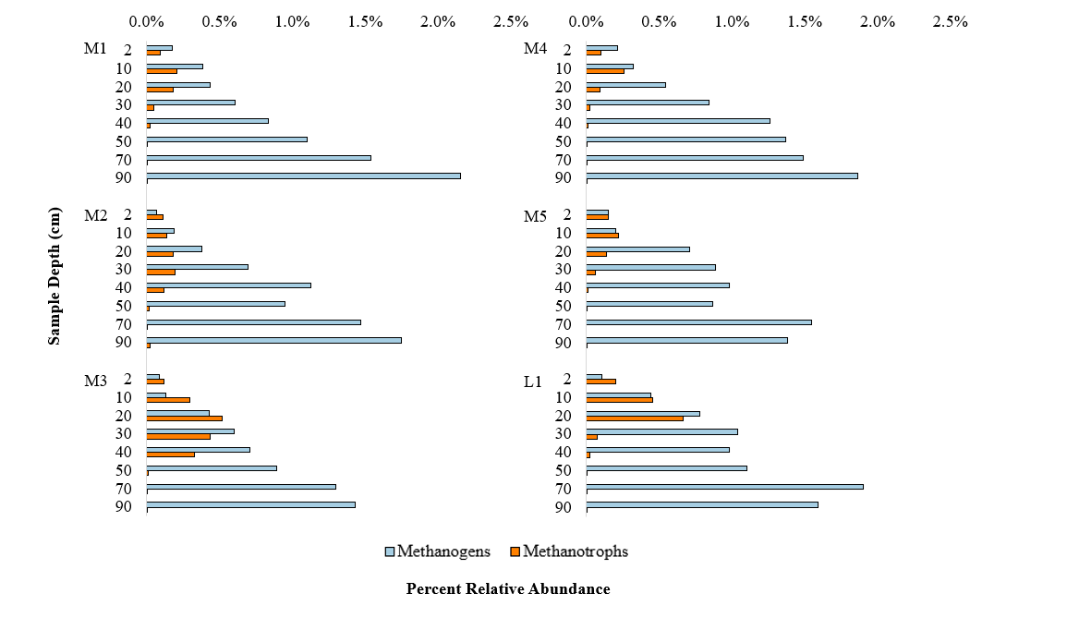
Figure 3.9. Comparisons of relative abundances between putative methanogenic and methanotrophic at each location and based on the total 16S rRNA gene sequences.
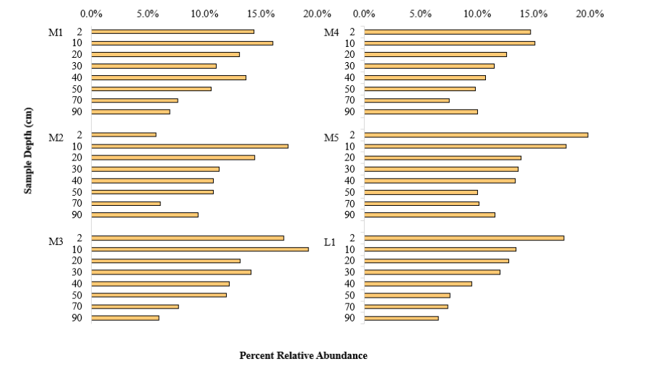
Figure 3.10. Putative sulfate-reducers at each location. Relative abundances were calculated at the order level groups and based on the total sequences.
Table 3.4. Relative abundances of order-level Bacteria based on the total number of Bacteria reads in the dataset and at greater than 1%. Uncl. = unclassified. IS = Incertae Sedis.
Phylum | Class | Order | Total Number of Sequence Reads | Relative Abundance [%]
Bacteria IS | Bacteria IS | Bacteria Uncl. | 414,913 | 9.5%
Chloroflexota | Anaerolineae | Anaerolineae IS | 315,744 | 7.4%
Thermodesulfobacteriota | Desulfobaccia | Desulfatiglandales | 253,160 | 5.9%
Chloroflexota | Anaerolineae | Anaerolineales | 230,376 | 5.1%
Pseudomonadota | Gammaproteobacteria | Gammaproteobacteria Uncl. | 241,747 | 5.0%
Chloroflexota | Anaerolineae | Aggregatilineales | 177,220 | 4.2%
Bacteria Uncl. | Bacteria Uncl. | Bacteroidales | 149,969 | 3.3%
Abditibacteriota | Abditibacteriia | Campylobacterales | 141,241 | 2.9%
Chloroflexota | Dehalococcoidia | Dehalococcoidia Uncl. | 113,072 | 2.8%
Thermodesulfobacteriota | Desulfobacteria | Desulfobacterales | 135,581 | 2.8%
Chloroflexota | Dehalococcoidia | GIF9 | 105,580 | 2.7%
Patescibacteria | MD2896-B216 | MSBL9 | 110,849 | 2.7%
Chloroflexota | Anaerolineae | Anaerolineae Uncl. | 95,894 | 2.3%
Patescibacteria | Patescibacteria Uncl. | Pirellulales | 99,972 | 2.2%
Spirochaetota | Brachyspirae | Spirochaetales | 90,952 | 2.1%
Thermodesulfobacteriota | Desulfobacteria | Desulfobulbales | 91,053 | 1.8%
Caldisericota | Caldisericia | Calditrichales | 73,843 | 1.7%
Actinomycetota | Thermoleophilia | WCHB1-81 IS | 66,352 | 1.6%
Chloroflexota | Dehalococcoidia | GIF3 | 57,650 | 1.4%
Pseudomonadota | Gammaproteobacteria | Steroidobacterales | 60,034 | 1.2%
Pseudomonadota | Gammaproteobacteria | Pseudomonadales | 59,111 | 1.2%
Thermodesulfobacteriota | Thermodesulfobacteriota Uncl. | Desulfobaccales | 51,108 | 1.2%

abundances at the surface but higher abundances with soil depth. Dehalococcoidia are most often associated with dehalogenation, whereby they utilize natural organochlorines as electron acceptors through the use of reductive dehalogenase genes (Yang et al., 2020), but they have also
been from marsh soils and linked to sulfur metabolism (Engel et al., 2017) by having dissimilatory sulfite reductase genes (Zheng et al., 2024). Dehalococcoidia can also positively correlate with soil CH₄ fluxes (Hartman et al., 2024), but the explanations for this are limited.
In total, for all soil depths and all cores, 16S rRNA gene reads classified to putative sulfate-reducers represented about 13% of the total sequences (Figure 3.10). They had higher relative abundance at the surface and their abundances significantly correlated with depth (p-values < 0.001) and salinity (p-value < 0.001). The highest relative abundances, which ranged between 15.1% and 19.8%, corresponded to fresher locations. Specific orders included the Desulfobacteria, where relative abundances were generally higher between 10 and 70 cm, the Desulfobulbia, which were more abundant at the surface, and the Desulfobaccia, with higher relative abundances between 10 to 20 cm depth.
Lastly, one bacterial class, Planctomycetes, was present in all of the soil samples at all depths, with the highest relative abundances at about 2 cm (Figure 3.8). Members of this class are metabolically diverse and primarily aerobic organisms, aside from a particular group, the order Brocadiae, that are anaerobic ammonium oxidizers (Lage and Bondoso, 2014). But this order accounted for <1% of all sequence reads.

3.2.5 Quantifying Microbial Abundances
The biomass of specific microbial groups capable of cycling CH₄ from the marsh soils was determined by using qPCR, as opposed to relying solely on relative abundances determined from 16S rRNA gene sequencing. All sites had the highest total abundance of bacterial gene copies at the surface and decreased with depth (Figure 3.11). The total abundance of archaeal gene copies ranged from 10^{6.8} to 10^{8.1} per gram of soil. There were fewer overall archaeal gene copies from the southernmost sites that also had higher salinity. The total abundance of Archaea was significantly correlated with porewater CH₄ (p-value = 0.01) and salinity (p-value = 0.001).
One of the major questions asked for this research was how geochemical and soil properties correspond to putative methanogen abundances. The mcrA gene has been a functional marker to quantify methanogenic archaea (Keneally et al., 2024), although other studies note that the primers may not target all groups, specifically relatively novel taxa like the Methanofastidiosales

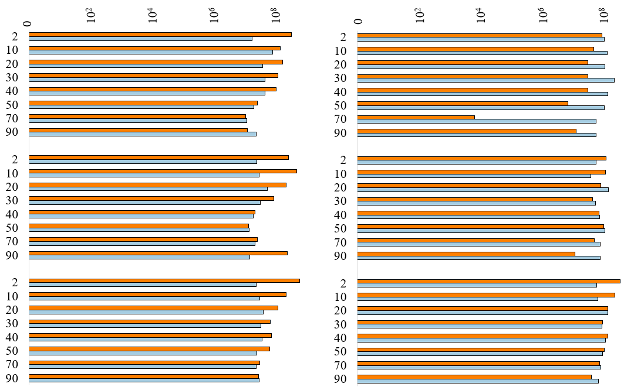
M4
M1

M5
M2

Depth (cm)

L1
M3

Log Gene Copies g⁻¹ Soil

Figure 3.11. Numbers of gene copies per 1 g of soil for 16S rRNA genes for Bacteria and Archaea, grouped for each core location from left to right with decreasing sample depth and from left to right overall in the order of decreasing salinity.
or Methanomassiliicoccales (Zhang et al., 2020). One of the primary objectives of this thesis was to use qPCR to quantify methanogen abundance with depth and across spatial scales and geochemical gradients throughout the TTE. Copies of the mcrA gene ranged from 10^{4.9} to 10^{7.3} per gram of soil (Figure 3.12). The number of mcrA gene copies was significantly (p-value = 0.02) correlated with porewater CH₄ and with salinity (p-value = 0.001), with the highest copy numbers measured at the least saline site, TTE.23.L1, and the lowest copy numbers from the most saline site, TTE.23.M1. As such, the mcrA gene copy numbers strongly correlated to salinity, more so than for 16S rRNA relative abundances. The relationship between mcrA copies and SO₄²⁻ was negative, but not significant. Peak mcrA gene copy numbers were generally higher between 20 and 50 cm.
This research also sought to analyze how geochemical and soil properties correspond to putative methanotroph abundances, which balance CH₄ production through CH₄ oxidation. The pmoA gene has been a functional marker to quantify methanotrophic bacteria and archaea. Copies of the pmoA gene ranged from 10^{9.8} to 10^{11.8} per gram of soil (Figure 3.12). However, it should be noted that during pmoA amplification, the samples exceeded the highest standard, meaning this is a cautious estimate for methanotrophic biomass. The highest number of pmoA gene copies was measured at the most saline site, TTE.23.M1, at 2 cm depth and the lowest was at TTE.23.M1 at 90 cm depth. All sites had the highest abundance of pmoA gene copies in the top 20 cm and steadily declined with depth.

3.2.6 Shared Operational Taxonomic Units
Although OTUs do not reflect true functional and biological diversity, grouping genetically similar sequences can provide useful insight about how taxonomic groups correlate with environmental variables. From all locations and soil depths, there were 407,677 shared OTUs. Of the top ten shared OTUs, nine were from the bacterial domain and one was from the archaeal domain. After removing singleton OTUs, 131,056 OTUs remained, of which 7,487 OTUs remained for Archaea. There were 20 archaeal OTUs with relative abundances >1%, which represented about 65% of all the archaeal reads. The top 16 archaeal OTUs were from the Thermoplasmata, and all were classified to the Thermoprofundales order (MBG-D or DHVEG-1 Incertae Sedis). The top three shared archaeal OTUs, each being affiliated with the Thermoprofundales, were present in every sample. These OTUs had higher relative abundances from soil core surfaces.

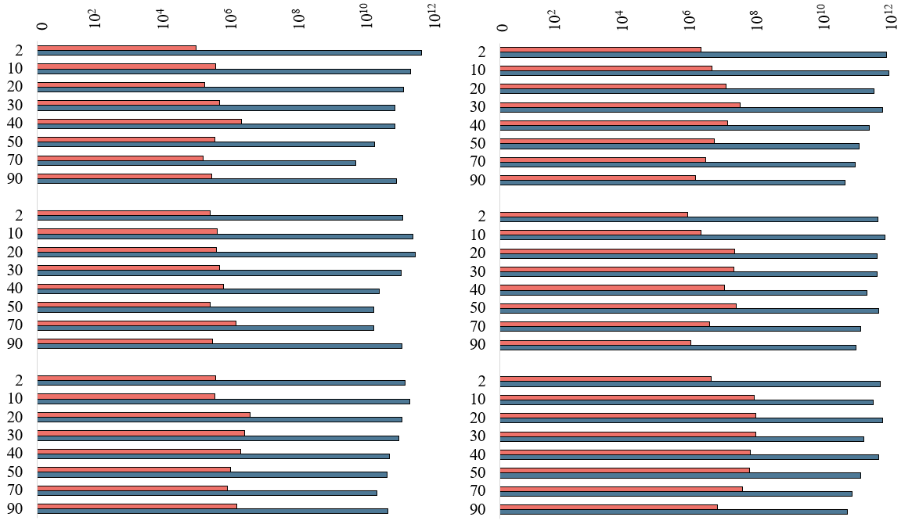
M2
M4

M2
M5

Depth (cm)

M3
L1

Log Gene Copies g⁻¹ Soil
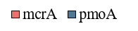

Figure 3.12. Log numbers of gene copies per 1 g of soil for the mcrA and pmoA genes, grouped for each core location from left to right with decreasing sample depth and from left to right overall in the order of decreasing salinity.

The relative abundances of only the shared putative methanogens at the genus level were extracted using the get.lineage function in MOTHUR (Figure 3.13) and yielded 101 total shared OTUs from 14,214 total sequence reads. The top 20 most abundant OTUs for putative methanogens represented 92% of the total sequenced methanogenic groups and were all from the Methanofastidiosales (Methanobacteriota phylum, Thermococci class) and Methanomassiliicoccales orders (Thermoplasmatota phylum, Thermoplasmata class) (Seyfferth et al., 2020; Capooci et al., 2024; Chen et al., 2024; Keneally et al., 2024). There was not a distinct distribution of shared putative methanogenic OTUs with core location or depth, but some OTUs classified as putative methylotrophic methanogens significantly correlated with depth, including Otu00028 (Methanobacteriota phylum, Thermococci class, Methanofastidiosales order), Otu00015 (Methanobacteriota phylum, Thermococci class, Methanofastidiosales order) (p-value = 0.027), as well as Otu00096 (Thermoplasmatota phylum, Thermoplasmata class, Methanomassiliicoccales order) (p-value = 0.083) (Figure 3.13). The top 5 OTUs for putative methanogens also significantly correlated with salinity, whereas only Otu00028 (Methanobacteriota phylum, Thermococci class, Methanofastidiosales order) and Otu00096 (Thermoplasmatota phylum, Thermoplasmata class, Methanomassiliicoccales order) significantly correlated with porewater sulfate concentrations. Otu00045 (Thermoplasmatota phylum, Thermoplasmata class, Methanomassiliicoccales order) and Otu00113 (Methanobacteriota phylum, Thermococci class, Methanofastidiosales order) had their highest relative abundances between 20 and 40 cm depth, which corresponded to the rooting depth of Spartina alterniflora.
The distribution of OTUs by depth and according to water and soil properties was evaluated using a CCA (Figure 3.14). Based on the CCA results, OTU distribution could be explained by 28.8% variance by the first two axes. There were patterns of clustering between the sample site TTE.23.L1 with environmental controls. All TTE.23.L1 sample depths, except the 70 cm and 90 cm depths, exhibited higher scores for CCA1 and CCA2 and were associated with higher ammonium values. Similarly, OTU00844, OTU00291, OTU00096, and OTU00439 (Thermoplasmatota phylum, Thermoplasmata class, Methanomassiliicoccales order) clustered along with OTU00523, OTU00342, OTU00334 (Methanobacteriota phylum, Thermococci class, Methanofastidiosales order) that were clustered with higher scores for CCA1 and CCA2 and associated with higher ammonium values. OTU00100 (Thermoplasmatota phylum,
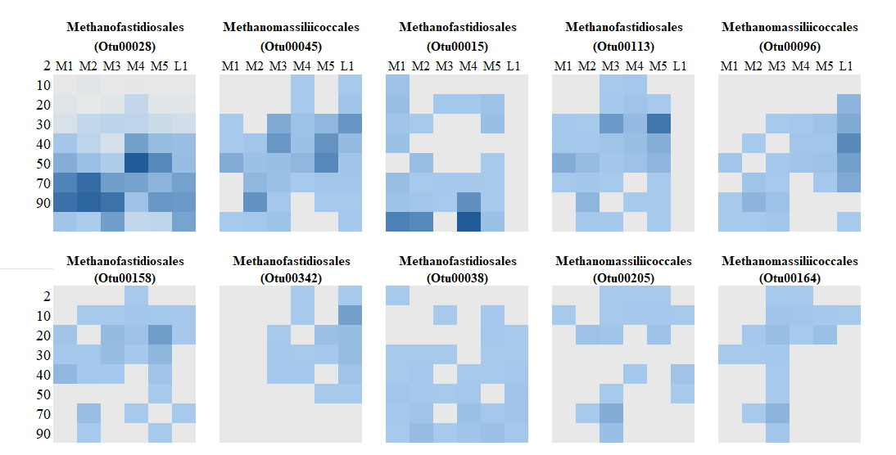
Figure 3.13. Heat maps of ranked OTU relative abundances (beginning at the top row, upper-left) at the order level and associated with methanogenesis, organized by core depth (y-axis) and location (x-axis) for each OTU.
Depth (cm)

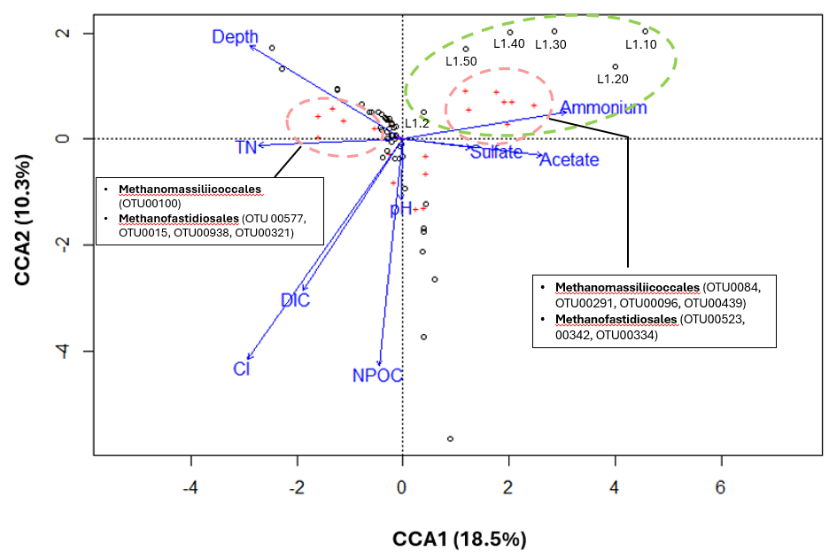
Figure 3.14. Canonical correspondence analysis of the top 20 putative methanogenic groups and major geochemical and environmental parameters. Red points indicate OTUs and black points represents individual samples. Clustered OTUs and sample sites are defined in text boxes.
Thermoplasmata class, Methanomassiliicoccales order) and OTU00577, OTU0015, OTU00938 and OTU00321 (Methanobacteriota phylum, Thermococci class, Methanofastidiosales order) were associated with higher CCA2 scores, but lower CCA1 scores. Of the environmental parameters, ammonium had the highest CCA1 scores, and depth had the highest CCA2 scores.

SECTION 4. DISCUSSION
Although wetlands are the largest natural source of biogenic CH₄ emissions globally (Zhang et al., 2017), these environments are underrepresented in global C cycle budgets and climate models despite decades of research (Zhang et al., 2023). The main reason for the gap is because there are many uncertainties regarding how biogeochemical and microbial processes influence CH₄ production and ultimately control CH₄ emissions. More research has been needed to uncover the microbial diversity of coastal marsh soils and to understand the interactions and processes that contribute to and regulate CH₄ production (Wang et al., 2022; Hartman et al., 2024). Lastly, because coastal systems are also being directly impacted by rising temperatures and water level variability due to climate change, more research is needed to understand the effects of RSLR on changing soil salinity that is known to influence CH₄ production (Zhang et al., 2020; Hartman et al., 2024). To fill these knowledge gaps, the primary goal for this thesis research was to analyze patterns in marsh soil microbial diversity in the context of environmental variables that could affect methanogen and methanotroph presence and distribution.

4.1 Novelty of Tidal Marsh Soil Microbial Diversity
One of the main objectives for this study was to address the question of which microbial groups, and especially Archaea, were present in the soil microbial communities. Another objective was to evaluate if and how microbial diversity (as measured by alpha diversity indices) changed with soil depth. Previous research from coastal salt marsh soils has largely focused on the diversity of Bacteria. For example, the major classes of the Pseudomonadota (formerly Proteobacteria) phylum found in wetland sediments include Betaproteobacteria, Deltaproteobacteria, and Gammaproteobacteria (Huang et al., 2019). Within the Pseudomonadota found in tidal marshes, specific genera include nitrate-reducers (Nitrospira), ammonium-oxidizers (Nitrosomonas), and sulfate-reducers (Desulfovibrio) (Khandeparker et al., 2017; Mustafa et al., 2024). Gammaproteobacteria are also common in tidal marshes and the orders Chromatiales and Thiotrichales have been found to oxidize sulfur in salt marshes dominated by Spartina alterniflora (Thomas et al., 2014). In general, the diversity of Archaea and specifically of methanogenic communities has been underrepresented in the literature and unresolved for many habitats, including salt marshes (Engel et al., 2017; Henson and Thrash, 2024). Thermoproteota (formerly Crenarchaeota) are widespread in salt marsh environments (Khandeparker et al., 2017) and play an important role in the N cycle because of ammonium oxidation via the amoA gene (Khandeparker et al., 2017). Orders of methanogens previously associated with porewater CH₄ in tidal marshes include Methanofastidiosales, Methanomasiliicoccales, Methermicoccaceae, and Methanococcoides (Keneally et al., 2024). The copy numbers of the mcrA gene per gram of soil detected in this study was 10^{4.9} to 10^{7.3}, which aligns with quantities detected in studies of mcrA in other marsh environments (Zhang et al., 2020; Yao et al., 2024). Further characterization of microbial community compositions can help to refine our understanding of the importance of various intertwined microbial pathways resulting in CH₄ emissions from tidal marsh soils.
Overall, microbial diversity decreased with TTE soil depth, likely due to reduced substrate availability, such as soil C content, and changing environmental conditions. Moreover, alpha diversity indices significantly correlated with salinity. Salinity is a well-understood driver of microbial diversity in aquatic environments (Henson and Thrash, 2024). Natural tide cycles periodically flood marsh surfaces, but wind also pushes water levels higher than would be expected from tidal activity alone. Marsh inundation dictates geochemical parameters that support microbial activities. Therefore, it was not surprising that the TTE soil microbial diversity indices correlated with salinity, as the tidal marshes experience fluctuating salinity levels due to differing inputs of fresh water mixing with open marine water. These different water bodies can also introduce distinct microbial groups into the marsh soils waters seasonally and at different times of the year (Henson and Thrash, 2024). Future work should investigate how temporal changes in water input may have impacted soil microbial community diversity and interactions.
The TTE soils generally had about 10% or less abundances of Archaea, yet members of the Thermoplasmata, Bathyarchaeia, Aenigmarchaeia, Thermococci, and unclassified Thermoplasmatota, as well as Unclassified Archaea, expand previously known occurrences for some taxa to salt marsh soils. Of note were the most abundant and shared OTUs from multiple locations and soil depths of putative methanogens from the orders Methanofastidiosales (Methanobacteriota phylum, Thermococci class) and Methanomassiliicoccales (Thermoplasmatota phylum, Thermoplasmata class) (Seyfferth et al., 2020; Capooci et al., 2024; Chen et al., 2024; Keneally et al., 2024). In addition to methylotrophic methanogenesis, Methanofastidiosales can also reduce methylated thiol (i.e., methanethiol) to produce CH₄ (Nobu et al., 2016), and Methanomassiliicoccales are also methylotrophic methanogens that use H₂ as the electron donor and methyl compounds (like methanol or methylamine, CH₃NH₂) to produce CH₄. Sequence similarities of these OTUs to previously characterized genera were low, however, which suggests there is potential for novel species to be uncovered from the soils. Moreover, these metabolisms suggest an important link between methanogen abundances, CH₄ production, and S and N cycling in the marsh soils. Also, this study provides additional evidence that methylotrophic methanogens may be significantly contributing to CH₄ cycling in tidal marsh soils, a point made recently by others (Seyfferth et al., 2020; Capooci et al., 2024).
This study also adds important new taxonomic information about archaeal diversity from tidal marsh soils and provides a rich dataset to explore in more detail in the future, such as by using ‘omics approaches to link microbial taxonomy to functional capabilities more directly. This is relevant because the diversity of methanogens in many habitats is now considered greater than previously thought (Welte, 2018). In the last five years, new methanogenic groups include the Asgardarchaeota (Valentin-Alvarado et al., 2024), and Methanococcus aeolicus, Methylobacterium phyllosphaerae, Methanomethylophilus alvi, and Methylocella silvestris (Kumar et al., 2021), to name a few. This study also encountered Unclassified Archaea, which had the third highest relative abundance of all archaeal 16S rRNA sequences retrieved from the soils. These sequences could indicate the presence of novel taxa but may also be a consequence of the reference database (SILVA version.138.2) used for this study not containing recently described taxa. Future curation and addition of new sequences into the reference database may improve the taxonomic assignments for these unclassified sequences. The potential novelty among taxonomic groups may also bias the biomass estimates by using qPCR of the mcrA gene, as the primers used may not have targeted all groups and therefore underrepresent total abundances for putative methanogens in the soils (Vaksmaa et al., 2017; Zhang et al., 2020).
Because between ~50% to as much as 90% of CH₄ can be consumed by microbial oxidation (Hanson and Hanson, 1996; Knief and Dunfield, 2005; Aronson et al., 2013; Segarra et al., 2015), the diversity of microbes capable of CH₄ oxidation should be evaluated alongside the groups capable of CH₄ production. For this study, the presence of putative methanotrophs was hypothesized to correlate to lower porewater CH₄ concentrations. Generally, there was a significant relationship between putative methanogen and methanotroph presence. The relative and absolute abundances of putative methanotrophs, based on 16S rRNA gene profiles and qPCR of pmoA gene copies, were higher at shallower soil depths, which could contribute to the lower porewater CH₄ concentrations at those depths. Although pmoA gene abundances should be interpreted cautiously because of amplification issues, pmoA gene copy profiles supported 16S rRNA gene profiles with similar patterns. Similar to the caveats described for characterizing methanogen diversity and abundances, the diversity of methanotrophs retrieved for this study may also be affected by the reference database not containing all potential methanotrophic groups and the pmoA primers might not have targeted all putative methanotrophic groups. The count of pmoA gene copy numbers should be analyzed further in future work to ensure accuracy, as the biomass estimates from pmoA copy numbers exceeded the counts for total bacteria.

4.2 Spatial Heterogeneity in Soil Methane
After establishing what the diversity of microbial groups was from the soils, especially those capable of producing CH₄ in coastal marshes, understanding the controls on CH₄ production continues to be an important challenge. One of this study’s guiding questions focused on the relationship between soil porewater SO₄²⁻ and CH₄ concentrations. Generally, this is because of the widely recognized paradigm that high concentrations of SO₄²⁻, which are also directly correlated to salinity, suppress methanogenesis because sulfate-reducing bacteria outcompete methanogens (Poffenbarger et al., 2011; Bridgham et al., 2013; Tong et al., 2018; Al-Haj and Fulweiler, 2020; Koontz et al., 2024). Therefore, porewater SO₄²⁻ and CH₄ concentrations were hypothesized to inversely correlate. As expected, SO₄²⁻ concentrations were higher from more saline locations, and SO₄²⁻ concentrations inversely and non-linearly correlated to porewater CH₄ concentrations, hence supporting the hypothesis. Moreover, the TTE soil core results verified the relationship between porewater SO₄²⁻ and CH₄ concentrations, as well as between salinity and CH₄, noted by Koontz et al. (2024) from across different wetland habitats and landscapes. Although the range in TTE porewater CH₄ concentrations matched their measured, four-orders of magnitude, the highest concentrations in the TTE, at over 3,000 μM, exceeded the highest CH₄ measured by Koontz et al., at only 852.9 μM, but were well below measurements made by Capooci et al. (2024) that were as high as 145,000 μM. In contrast to Koontz et al. (2024) who found that porewater CH₄ concentrations did not correlate significantly to NH₄⁺ or other environmental variables, this study found that porewater CH₄ positively correlated to TN (ρ = 0.61, p-value = 0.0001), CH₃COO⁻ (p-value = 0.001), NH₄⁺ concentration (ρ = 0.57, p-value = 0.001), which suggests that variability in porewater CH₄ is likely regulated by microbial processes tied to the N cycle, and could explain the shared and widely distributed presence of Methanomassiliicoccales who may also be N-fixers.
Despite the strong control that salinity generally has on CH₄ production, there is emerging evidence that the relationship is not always straightforward (Koontz et al., 2024) and can result in variable CH₄ concentrations. From the tidally flooded TTE marsh soils, methanogenesis appears to occur even at higher salinity (Bethke et al., 2011) and where sulfate-reducers are also in high relative abundances. Methylotrophic methanogens are not inhibited by high SO₄²⁻ conditions like other methanogenic pathways (Seyfferth et al., 2020), and was one of the hypotheses posed for this study. Specifically, soil depths with high CH₄ concentrations and where SO₄²⁻ levels were also high would have higher relative abundances of putative methylotrophic methanogens. The hypothesis was supported by the high numbers of OTUs of methylotrophic methanogens, as well as absolute abundances based on mcrA gene copy numbers and positive correlation between porewater CH₄ at variable SO₄²⁻ concentrations. Methylotrophic methanogenesis appears to play an important role CH₄ production in the TTE soils, and more research is needed to understand their abundances and the availability and concentrations of substrates used by these microbes. For instance, future research should attempt to quantify methylotrophic methanogens directly, such as by using primers for the genes mtaB (encoding methanol-5-hydroxybenzimidazolylcobamide Co-methyltransferase), which is used to convert methanol to methyl-CoM, and mtbA (encoding methylated:coenzyme M methyltransferase), which converts methylated amines into methyl-CoM (Dziewit et al., 2015). Moreover, the concentrations of methylamines (e.g., monomethylamine, dimethylamine, and trimethylamine) could be measured to understand their availability and potential use by methylotrophic methanogens.
Previous research indicates that methanogen abundances also positively correlate to the presence of S. alterniflora, which is likely linked to metabolite (i.e. acetate) production and use (Capooci et al., 2024). Decaying S. alterniflora can also release methylamines (Wang and Lee, 1994) and precursor compounds used for methylotrophic methanogenesis (Capooci et al., 2024) that are not used competitively by sulfate-reducers. Because all of the marshes sampled in this study were from S. alterniflora locations, it was not possible to evaluate whether or not methanogen abundances would differ in other vegetation types. However, belowground biomass tied to S. alterniflora was determined as part of the larger CLIM project and was not included in this thesis. Therefore, future research could evaluate whether there is a link between methanogen abundance, and specifically of methylotrophic methanogens, and belowground biomass that could be a source of amine compounds.
Lastly, heterogeneity in CH₄ production and transport is influenced by soil properties. The TEE is currently experiencing challenges associated with RSLR and high rate of land loss. The inability of TTE coastal wetlands to keep pace with RSLR means that marshes experience longer and more frequent periods of inundation. The lack of freshwater sediment deposition, along with prolonged inundation, can alter sediment properties, like grain size distribution, bulk density, and soil C content. Zones of higher bulk density at depth could indicate times when sediment and C accretion rates were higher, perhaps due to events like hurricanes, and could explain variability in bulk density and sand occurrence from the soil cores. Similarly, soil with higher bulk density also correlated to lower porosity, which could sustain anoxic microenvironments between inundation. Higher bulk density was hypothesized to correlate with higher porewater CH₄ concentrations, which would support higher methanogen abundances. However, Spearman’s Rank Correlation indicated that the relationship between bulk density and porewater CH₄ was only weakly significant (p-value = 0.19). An important consideration that was not explored in this study was the effect of soil properties and vegetation on CH₄ transport, and future work should evaluate transport mechanisms when considering if and how much CH₄ is emitted from the marshes.

SECTION 5. CONCLUSIONS AND FUTURE WORK
The atmospheric concentration of CH₄ is currently about 2.5x greater than pre-industrial levels, and levels are continuing to rise at an accelerated rate (IEA, 2022). Roughly 40% of CH₄ is emitted from natural biotic processes in wetlands and there are increasing concerns that climate change perturbations will result in increased emissions from natural sources (Bridgham et al., 2013; IEA, 2023; Michel et al., 2024). Despite the widely understood significant role of microbes in tidal marsh CH₄ production, there are still many knowledge gaps regarding distribution of CH₄ fluxes, in part because of the multiple complex and interconnected pathways of production and fate. There is a general lack of data regarding microbial community compositions and distributions in tidal marsh environments (Engel et al., 2017). My thesis directly filled this gap by generating an in-depth, high-resolution microbial and geochemical dataset for marsh soil up to 1 m depth that can be used to better understand drivers of tidal marsh CH₄ production. There have been a limited number of previous studies of soil to 1 m depth, or that combined many types of analyses. A major goal for this project is for the microbial and geochemical to be integrated into landscape-scale CH₄ models by collaborators to establish better estimates of CH₄ emissions in the TTE and considering RSLR scenarios. Tidal marshes play a vitally important role as major C reservoirs. Better understanding of the driving processes of CH₄ dynamic can allow for more resilience against climate change through the development of successful greenhouse gas mitigation strategies and more accurate forecasting for the future.

REFERENCES
Al-Haj, A. N., and Fulweiler, R. W., 2020, A synthesis of methane emissions from shallow vegetated coastal ecosystems: Global Change Biology, v. 26, no. 5, p. 2988-3005.
Al-Raei, A. M., Bosselmann, K., Böttcher, M. E., Hespenheide, B., and Tauber, F., 2009, Seasonal dynamics of microbial sulfate reduction in temperate intertidal surface sediments: controls by temperature and organic matter: Ocean Dynamics, v. 59, no. 2, p. 351-370.
Apprill, A., McNally, S., Parsons, R., and Weber, L., 2015, Minor revision to V4 region SSU rRNA 806R gene primer greatly increases detection of SAR11 bacterioplankton: Aquatic Microbial Ecology, v. 75, no. 2, p. 129-137.
Bartoš, O., Chmel, M., and Swierczková, I., 2024, The overlooked evolutionary dynamics of 16S rRNA revises its role as the “gold standard” for bacterial species identification: Scientific Reports, v. 14, no. 1, p. 9067.
Aronson, E., Allison, S., and Helliker, B. R., 2013, Environmental impacts on the diversity of methane-cycling microbes and their resultant function: Frontiers in Microbiology, v. 4, https://doi.org/10.3389/fmicb.2013.00225.
Baustian, M. M., Stagg, C. L., Perry, C. L., Moss, L. C., and Carruthers, T. J. B., 2021, Long-term carbon sinks in marsh soils of coastal Louisiana are at risk to wetland loss: Journal of Geophysical Research: Biogeosciences, v. 126, no. 3, p. e2020JG005832.
Bethke, C. M., Sanford, R. A., Kirk, M. F., Jin, Q., and Flynn, T. M., 2011, The thermodynamic ladder in geomicrobiology: American Journal of Science, v. 311, p. 183-210.
Bianchi, T. S., DiMarco, S. F., Smith, R. W., and Schreiner, K. M., 2009, A gradient of dissolved organic carbon and lignin from Terrebonne–Timbalier Bay estuary to the Louisiana shelf (USA): Marine Chemistry, v. 117, no. 1, p. 32-41.
Blum, P., 1997, Moisture and Density (by Mass and Volume), in Physical Properties Handbook: A Guide to the Shipboard Measurement of Physical Properties of Deep-Sea Cores., ODP Technical Notes.
Bo-Ra, K., Jiwon, S., Robin, B. G., Jun Hyung, L., Doo Wan, K., Kuk-Hwan, S., Ju-Hoon, L., and Hyeun Bum, K., 2017, Deciphering diversity indices for a better understanding of microbial communities: Journal of Microbiology and Biotechnology, v. 27, no. 12, p. 2089-2093.
Bodelier, P. L. E., and Steenbergh, A. K., 2014, Interactions between methane and the nitrogen cycle in light of climate change: Current Opinion in Environmental Sustainability, v. 9-10, p. 26-36.
Borrel, G., Parisot, N., Harris, H. M. B., Peyretaillade, E., Gaci, N., Tottey, W., Bardot, O., Raymann, K., Gribaldo, S., Peyret, P., O’Toole, P. W., and Brugère, J.-F., 2014, Comparative genomics highlights the unique biology of Methanomassiliicoccales, a Thermoplasmatales-related seventh order of methanogenic archaea that encodes pyrrolysine: BMC Genomics, v. 15, no. 1, p. 679.
Bourne, J., 2000, Louisiana's vanishing wetlands: Going, going: Science, v. 289, no. 5486, p. 1860-1863.
Bridgham, S. D., Cadillo-Quiroz, H., Keller, J. K., and Zhuang, Q., 2013, Methane emissions from wetlands: biogeochemical, microbial, and modeling perspectives from local to global scales: Global Change Biology, v. 19, no. 5, p. 1325-1346.
Bueno de Mesquita, C. P., Hartman, W. H., Ardón, M., Bernhardt, E. S., Neubauer, S. C., Weston, N. B., and Tringe, S. G., 2024, Microbial ecology and site characteristics underlie differences in salinity-methane relationships in coastal wetlands: Journal of Geophysical Research: Biogeosciences, v. 129, no. 6, p. e2024JG008133.
Bueno de Mesquita, C. P., Wu, D., and G. Tringe, S., 2023, Methyl-based methanogenesis: An ecological and genomic review: Microbiology and Molecular Biology Reviews, v. 87, no. 1, p. e00024-00022.
Buongiorno, J., Turner, S., Webster, G., Asai, M., Shumaker, A. K., Roy, T., Weightman, A., Schippers, A., and Lloyd, K. G., 2017, Interlaboratory quantification of Bacteria and Archaea in deeply buried sediments of the Baltic Sea (IODP Expedition 347): FEMS Microbiology Ecology, v. 93, no. 3. p. fix007
Bustin, S. A., Benes, V., Garson, J. A., Hellemans, J., Huggett, J., Kubista, M., Mueller, R., Nolan, T., Pfaffl, M. W., Shipley, G. L., Vandesompele, J., and Wittwer, C. T., 2009, The MIQE guidelines: minimum information for publication of quantitative real-time PCR experiments: Clinical Chemistry, v. 55, no. 4, p. 611-622
Capooci, M., Seyfferth, A. L., Tobias, C., Wozniak, A. S., Hedgpeth, A., Bowen, M., Biddle, J. F., McFarlane, K. J., and Vargas, R., 2024, High methane concentrations in tidal salt marsh soils: Where does the methane go?: Global Change Biology, v. 30, no. 1, p. e17050.
Chen, Y., Dong, X., Sun, Z., Xu, C., Zhang, X., Qin, S., Geng, W., Cao, H., Zhai, B., Li, X., and Wu, N., 2024, Potential coupling of microbial methane, nitrogen, and sulphur cycling in the Okinawa Trough cold seep sediments: Microbiology Spectrum, v. 12, no. 6, p. e0349023.
Chiri, E., Greening, C., Lappan, R., Waite, D. W., Jirapanjawat, T., Dong, X., Arndt, S. K., and Nauer, P. A., 2020, Termite mounds contain soil-derived methanotroph communities kinetically adapted to elevated methane concentrations: The ISME Journal, v. 14, no. 11, p. 2715-2731.
Cui, J., Zhang, M., Chen, L., Zhang, S., Luo, Y., Cao, W., Zhao, J., Wang, L., Jia, Z., and Bao, Z., 2022, Methanotrophs contribute to nitrogen fixation in emergent macrophytes: Frontiers in Microbiology, v. 13 - 2022. p. 13:851424
Danilova, O. V., Suzina, N. E., Van De Kamp, J., Svenning, M. M., Bodrossy, L., and Dedysh, S. N., 2016, A new cell morphotype among methane oxidizers: a spiral-shaped obligately microaerophilic methanotroph from northern low-oxygen environments: The ISME Journal, v. 10, no. 11, p. 2734-2743.
Day, J. W., Jr., Boesch, D. F., Clairain, E. J., Kemp, G. P., Laska, S. B., Mitsch, W. J., Orth, K., Mashriqui, H., Reed, D. J., Shabman, L., Simenstad, C. A., Streever, B. J., Twilley, R. R., Watson, C. C., Wells, J. T., and Whigham, D. F., 2007, Restoration of the Mississippi Delta: Lessons from Hurricanes Katrina and Rita: Science, v. 315, no. 5819, p. 1679-1684.
De Vrieze, J., Hennebel, T., Boon, N., and Verstraete, W., 2012, Methanosarcina: The rediscovered methanogen for heavy duty biomethanation: Bioresource Technology, v. 112, p. 1-9.
Dean, J. F., Middelburg, J. J., Röckmann, T., Aerts, R., Blauw, L. G., Egger, M., Jetten, M. S. M., de Jong, A. E. E., Meisel, O. H., Rasigraf, O., Slomp, C. P., in't Zandt, M. H., and Dolman, A. J., 2018, Methane feedbacks to the global climate system in a warmer world: Reviews of Geophysics, v. 56, no. 1, p. 207-250.
Engel, A. S., Liu, C., Paterson, A. T., Anderson, L. C., Turner, R. E., and Overton, E. B., 2017, Salt marsh bacterial communities before and after the Deepwater Horizon oil spill: Applied and Environmental Microbiology, v. 83, no. 20, p. e00784-00717.
Environmental Protection Agency, 1998, Test methods for evaluating solid waste physical/chemical methods: Update 3A (SW-846), third edition.
Ettwig, K. F., Zhu, B., Speth, D., Keltjens, J. T., Jetten, M. S. M., and Kartal, B., 2016, Archaea catalyze iron-dependent anaerobic oxidation of methane: Proceedings of the National Academy of Sciences, v. 113, no. 45, p. 12792-12796.
Guerrero-Cruz, S., Vaksmaa, A., Horn, M. A., Niemann, H., Pijuan, M., and Ho, A., 2021, Methanotrophs: Discoveries, environmental relevance, and a perspective on current and future applications: Frontiers in Microbiology, v. 12, p. 678057.
Han, X., Beck, K., Bürgmann, H., Frey, B., Stierli, B., and Frossard, A., 2023, Synthetic oligonucleotides as quantitative PCR standards for quantifying microbial genes: Frontiers in Microbiology, v. 14, https://doi.org/10.3389/fmicb.2023.1279041.
Hartman, W. H., Bueno de Mesquita, C. P., Theroux, S. M., Morgan-Lang, C., Baldocchi, D. D., and Tringe, S. G., 2024, Multiple microbial guilds mediate soil methane cycling along a wetland salinity gradient: mSystems, v. 9, no. 1, p. e0093623.
He, S., Maiti, K., Ghaisas, N., Upreti, K., and Rivera-Monroy, V. H., 2023, Potential methane production in oligohaline wetlands undergoing erosion and accretion in the Mississippi River Delta Plain, Louisiana, USA: Science of The Total Environment, v. 875, p. 162685.
Henson, R. S., and Hanson, T. E., 1996, Methanotrophic bacteria: Microbiology Reviews, v. 60, no. 2, p. 439-471.
Henson, M. W., and Thrash, J. C., 2024, Microbial ecology of northern Gulf of Mexico estuarine waters: mSystems, v. 9, no. 8, p. e01318-01323.
IEA (2022), Global Methane Tracker 2022, IEA, Paris https://www.iea.org/reports/global-methane-tracker-2022, Licence: CC BY 4.0
IEA (2023), World Energy Outlook 2023, IEA, Paris https://www.iea.org/reports/world-energy-outlook-2023, Licence: CC BY 4.0 (report); CC BY NC SA 4.0 (Annex A).
Inagaki, F., Kuypers, M. M. M., Tsunogai, U., Ishibashi, J., Nakamura, K., Treude, T., Ohkubo, S., Nakaseama, M., Gena, K., Chiba, H., Hirayama, H., Nunoura, T., Takai, K., Jørgensen, B. B., Horikoshi, K., and Boetius, A., 2006, Microbial community in a sediment-hosted CO₂ lake of the southern Okinawa Trough hydrothermal system: Proceedings of the National Academy of Sciences, v. 103, no. 38, p. 14164-14169.
IPCC, Intergovernmental Panel on Climate Change, 2023, Climate Change 2022 – Impacts, Adaptation and Vulnerability: Working Group II Contribution to the Sixth Assessment Report of the Intergovernmental Panel on Climate Change, Cambridge, Cambridge University Press.
Jankowski, K. L., Törnqvist, T. E., and Fernandes, A. M., 2017, Vulnerability of Louisiana’s coastal wetlands to present-day rates of relative sea-level rise: Nature Communications, v. 8, no. 1, p. 14792.
Keneally, C., Southgate, M., Chilton, D., Gaget, V., Welsh, D. T., Mosley, L., Erler, D. V., Kidd, S. P., and Brookes, J., 2024, Organic matter accumulation drives methylotrophic methanogenesis and microbial ecology in a hypersaline coastal lagoon: Limnology and Oceanography, v. 69, no. 9, p. 1970-1983.
Khandeparker, L., Kuchi, N., Kale, D., and Anil, A. C., 2017, Microbial community structure of surface sediments from a tropical estuarine environment using next generation sequencing: Ecological Indicators, v. 74, p. 172-181.
Knief, C., and Dunfield, P. F., 2005, Response and adaptation of different methanotrophic bacteria to low methane mixing ratios: Environmental Microbiology, v. 7, no. 9, p. 1307-1317.
Koontz, E. L., Parker, S. M., Stearns, A. E., Roberts, B. J., Young, C. M., Windham-Myers, L., Oikawa, P. Y., Megonigal, J. P., Noyce, G. L., Buskey, E. J., Derby, R. K., Dunn, R. P., Ferner, M. C., Krask, J. L., Marconi, C. M., Savage, K. B., Shahan, J., Spivak, A. C., St. Laurent, K. A., Argueta, J. M., Baird, S. J., Beheshti, K. M., Crane, L. C., Cressman, K. A., Crooks, J. A., Fernald, S. H., Garwood, J. A., Goldstein, J. S., Grothues, T. M., Habeck, A., Lerberg, S. B., Lucas, S. B., Marcum, P., Peter, C. R., Phipps, S. W., Raposa, K. B., Rovai, A. S., Schooler, S. S., Twilley, R. R., Tyrrell, M. C., Uyeda, K. A., Wulfing, S. H., Aman, J. T., Giacchetti, A., Cross-Johnson, S. N., and Holmquist, J. R., 2024, Controls on spatial variation in porewater methane concentrations across United States tidal wetlands: Science of The Total Environment, v. 957, p. 177290.
Kuever, J., Rainey, F.A., and Widdel, F. "Order II. Desulfovibrionales ord. nov." In: D.J. Brenner,, N.R. Krieg, J.T. Staley, and G.M. Garrity (eds), Bergey's Manual of Systematic Bacteriology, second edition, vol. 2 (The Proteobacteria), part C (The Alpha-, Beta-, Delta-, and Epsilonproteobacteria), Springer, New York, 2005, pp. 925-926.
Kumar, M., Yadav, A. N., Saxena, R., Rai, P. K., Paul, D., and Tomar, R. S., 2021, Novel methanotrophic and methanogenic bacterial communities from diverse ecosystems and their impact on environment: Biocatalysis and Agricultural Biotechnology, v. 33, p. 102005.
Lage, O. M., and Bondoso, J., 2014, Planctomycetes and macroalgae, a striking association: Frontiers in Microbiology, v. 5, p. 267.
Lan, X., Thoning, K.W., and Dlugokencky, E. J., 2022, Trends in globally-averaged CH₄, N₂O, and SF₆ determined from NOAA Global Monitoring Laboratory measurements. Version 2025-06, https://doi.org/10.15138/P8XG-AA10.
Lauro, F. M., McDougald, D., Thomas, T., Williams, T. J., Egan, S., Rice, S., DeMaere, M. Z., Ting, L., Ertan, H., and Johnson, J., 2009, The genomic basis of trophic strategy in marine bacteria: Proceedings of the National Academy of Sciences, v. 106, no. 37, p. 15527-15533.
Lindsay, M. R., D’Angelo, T., Goodell, E., Munson-McGee, J. H., Herring, M., Budner, M., Brown, J. M., Gavelis, G. S., Mascena, C., Lubelczyk, L. C., Poulton, N. J., Stepanauskas, R., Orcutt, B. N., and Emerson, D., 2025, Laminarin stimulates single cell rates of sulfate reduction whereas oxygen inhibits transcriptomic activity in coastal marine sediment: The ISME Journal, v. 19, no. 1. p. wraf042
Liu, J.-q., Wang, W.-q., Shen, L.-d., Yang, Y.-l., Xu, J.-b., Tian, M.-h., Liu, X., Yang, W.-t., Jin, J.-h., and Wu, H.-s., 2022, Response of methanotrophic activity and community structure to plant invasion in China’s coastal wetlands: Geoderma, v. 407, p. 115569.
Luo, M., Huang, J.-F., Zhu, W.-F., and Tong, C., 2019, Impacts of increasing salinity and inundation on rates and pathways of organic carbon mineralization in tidal wetlands: a review: Hydrobiologia, v. 827, no. 1, p. 31-49.
Luton, P. E., Wayne, J. M., Sharp, R. J., and Riley, P. W., 2002, The mcrA gene as an alternative to 16S rRNA in the phylogenetic analysis of methanogen populations in landfill: Microbiology, v. 148, p. 3521-3530, doi: 10.1099/00221287-148-11-3521.
Marton, J. M., and Roberts, B. J., 2014, Spatial variability of phosphorus sorption dynamics in Louisiana salt marshes: Journal of Geophysical Research: Biogeosciences, v. 119, no. 3, p. 451-465.
Michel, S. E., Lan, X., Miller, J., Tans, P., Clark, J. R., Schaefer, H., Sperlich, P., Brailsford, G., Morimoto, S., Moossen, H., and Li, J., 2024, Rapid shift in methane carbon isotopes suggests microbial emissions drove record high atmospheric methane growth in 2020–2022: Proceedings of the National Academy of Sciences, v. 121, no. 44, p. e2411212121.
Mitchell, K. R., and Takacs-Vesbach, C. D., 2008, A comparison of methods for total community DNA preservation and extraction from various thermal environments: Journal of Industrial Microbiology Biotechnology, v. 35, no. 10, p. 1139-1147.
Mustafa, G., Hussain, S., Liu, Y., Ali, I., Liu, J., and Bano, H., 2024, Microbiology of wetlands and the carbon cycle in coastal wetland mediated by microorganisms: Science of The Total Environment, v. 954, p. 175734.
Nisbet, E. G., Fisher, R. E., Lowry, D., France, J. L., Allen, G., Bakkaloglu, S., Broderick, T. J., Cain, M., Coleman, M., Fernandez, J., Forster, G., Griffiths, P. T., Iverach, C. P., Kelly, B. F. J., Manning, M. R., Nisbet-Jones, P. B. R., Pyle, J. A., Townsend-Small, A., al-Shalaan, A., Warwick, N., and Zazzeri, G., 2020, Methane mitigation: Methods to reduce emissions, on the path to the Paris Agreement: Reviews of Geophysics, v. 58, no. 1, p. e2019RG000675.
Nobu, M. K., Narihiro, T., Kuroda, K., Mei, R., and Liu, W.-T., 2016, Chasing the elusive Euryarchaeota class WSA2: genomes reveal a uniquely fastidious methyl-reducing methanogen: The ISME Journal, v. 10, no. 10, p. 2478-2487.
Orata, F. D., Meier-Kolthoff, J. P., Sauvageau, D., and Stein, L. Y., 2018, Phylogenomic analysis of the gammaproteobacterial methanotrophs (Order Methylococcales) calls for the reclassification of members at the genus and species levels: Frontiers in Microbiology, v. 9, p. 3162.
Parada, A. E., Needham, D. M., and Fuhrman, J. A., 2016, Every base matters: assessing small subunit rRNA primers for marine microbiomes with mock communities, time series and global field samples: Environmental Microbiology, v. 18, no. 5, p. 1403-1414.
Pavia, M. J., Garber, A. I., Avalle, S., Macedo-Tafur, F., Tello-Espinoza, R., and Cadillo-Quiroz, H., 2024, Functional insights of novel Bathyarchaeia reveal metabolic versatility in their role in peatlands of the Peruvian Amazon: Microbiology Spectrum, v. 12, no. 12, p. e00387-00324.
Poffenbarger, H. J., Needelman, B. A., and Megonigal, J. P., 2011, Salinity influence on methane emissions from tidal marshes: Wetlands, v. 31, no. 5, p. 831-842.
Quast, C., Pruesse, E., Yilmaz, P., Gerken, J., Schweer, T., Yarza, P., Peplies, J., and Glockner, F. O., 2013, The SILVA ribosomal RNA gene database project: improved data processing and web-based tools: Nucleic Acids Res, v. 41, p. D590-596.
Rasmussen, A. N., Tolar, B. B., Bargar, J. R., Boye, K., and Francis, C. A., 2024, Diverse and unconventional methanogens, methanotrophs, and methylotrophs in metagenome-assembled genomes from subsurface sediments of the Slate River floodplain, Crested Butte, CO, USA: mSystems, v. 9, no. 7, p. e00314-00324.
Rolando, J. L., Kolton, M., Song, T., Liu, Y., Pinamang, P., Conrad, R., Morris, J. T., Konstantinidis, K. T., and Kostka, J. E., 2024, Sulfur oxidation and reduction are coupled to nitrogen fixation in the roots of the salt marsh foundation plant Spartina alterniflora: Nature Communications, v. 15, no. 1, p. 3607.
Saunois, M., Jackson, R. B., Bousquet, P., Poulter, B., and Canadell, J. G., 2016, The growing role of methane in anthropogenic climate change: Environmental Research Letters, v. 11, no. 12. p. 120207
Schloss, P. D., Westcott, S. L., Ryabin, T., Hall, J. R., Hartmann, M., Hollister, E. B., Lesniewski, R. A., Oakley, B. B., Parks, D. H., Robinson, C. J., Sahl, J. W., Stres, B., Thallinger, G. G., Horn, D. J. V., and Weber, C. F., 2009, Introducing mothur: Open-source, platform-independent, community-supported software for describing and comparing microbial communities: Applied and Environmental Microbiology, v. 75, no. 23, p. 7537-7541.
Schnetger, B., and Lehners, C., 2014, Determination of nitrate plus nitrite in small volume marine water samples using vanadium(III)chloride as a reduction agent: Marine Chemistry, v. 160, p. 91-98.
Schoepfer, V. A., Bernhardt, E. S., and Burgin, A. J., 2014, Iron clad wetlands: Soil iron-sulfur buffering determines coastal wetland response to saltwater incursion: Journal of Geophysical Research: Biogeosciences, v. 119, no. 12, p. 2209-2219.
Seeberg-Elverfeldt, J., Schlüter, M., Feseker, T., and Kölling, M., 2005, Rhizon sampling of porewaters near the sediment-water interface of aquatic systems: Limnology and Oceanography: Methods, v. 3, no. 8, p. 361-371.
Segarra, K. E. A., Schubotz, F., Samarkin, V., Yoshinaga, M. Y., Hinrichs, K. U., and Joye, S. B., 2015, High rates of anaerobic methane oxidation in freshwater wetlands reduce potential atmospheric methane emissions: Nature Communications, v. 6, no. 1, p. 7477
Seyfferth, A. L., Bothfeld, F., Vargas, R., Stuckey, J. W., Wang, J., Kearns, K., Michael, H. A., Guimond, J., Yu, X., and Sparks, D. L., 2020, Spatial and temporal heterogeneity of geochemical controls on carbon cycling in a tidal salt marsh: Geochimica et Cosmochimica Acta, v. 282, p. 1-18.
Solórzano, L., 1969, Determination of ammonia in natural waters by the pehnolhypochlorite method: Limnology and Oceanography, v. 14, no. 5, p. 799-801.
Somerville, C. C., Knight, I. T., Straube, W. L., and Colwell, R. R., 1989, Simple, rapid method for direct isolation of nucleic acids from aquatic environments: Applied and Environmental Microbiology, v. 55, no. 3, p. 548-554.
Sriwiriyarat, T., and Kuhakaew, S., 2021, Effects of cations on biofilm formation and characteristics in integrated fixed film activated sludge process at different carbon and nitrogen loadings: Chemosphere, v. 275, p. 130002.
Steyer, G., Sasser, C., Visser, J., Swensen, E., Nyman, J., and Raynie, R., 2003, A proposed coast-wide reference monitoring system for evaluating wetland restoration trajectories in Louisiana: Environmental Monitoring and Assessment, v. 81, p. 107–117.
Sulman, B. N., Yuan, F., O’Meara, T., Gu, B., Herndon, E. M., Zheng, J., Thornton, P. E., and Graham, D. E., 2022, Simulated hydrological dynamics and coupled iron redox cycling impact methane production in an Arctic Soil: Journal of Geophysical Research: Biogeosciences, v. 127, no. 10, p. e2021JG006662.
Tang, S., Liao, Y., Xu, Y., Dang, Z., Zhu, X., and Ji, G., 2020, Microbial coupling mechanisms of nitrogen removal in constructed wetlands: A review: Bioresource Technology, v. 314, p. 123759.
Thomas, F., Giblin, A. E., Cardon, Z. G., and Sievert, S. M., 2014, Rhizosphere heterogeneity shapes abundance and activity of sulfur-oxidizing bacteria in vegetated salt marsh sediments: Frontiers in Microbiology, v. 5, https://doi.org/10.3389/fmicb.2014.00309.
Tong, C., Morris, J. T., Huang, J., Xu, H., and Wan, S., 2018, Changes in pore-water chemistry and methane emission following the invasion of Spartina alterniflora into an oliogohaline marsh: Limnology and Oceanography, v. 63, no. 1, p. 384-396.
Törnqvist, T. E., Jankowski, K. L., Li, Y. X., and González, J. L., 2020, Tipping points of Mississippi Delta marshes due to accelerated sea-level rise: Science Advances, v. 6, no. 21, p. eaaz5512.
Twilley, R. R., Bentley, S. J., Chen, Q., Edmonds, D. A., Hagen, S. C., Lam, N. S. N., Willson, C. S., Xu, K., Braud, D., Hampton Peele, R., and McCall, A., 2016, Co-evolution of wetland landscapes, flooding, and human settlement in the Mississippi River Delta Plain: Sustainability Science, v. 11, no. 4, p. 711-731.
Upreti, K., Rivera-Monroy, V. H., Maiti, K., Giblin, A., and Geaghan, J. P., 2021, Emerging wetlands from river diversions can sustain high denitrification rates in a coastal delta: Journal of Geophysical Research: Biogeosciences, v. 126, no. 5, p. e2020JG006217.
Vaksmaa, A., Jetten, M. S., Ettwig, K. F., and Lüke, C., 2017, McrA primers for the detection and quantification of the anaerobic archaeal methanotroph 'Candidatus Methanoperedens nitroreducens': Applied Microbiology and Biotechnology, v. 101, no. 4, p. 1631-1641.
Valentin-Alvarado, L. E., Appler, K. E., De Anda, V., Schoelmerich, M. C., West-Roberts, J., Kivenson, V., Crits-Christoph, A., Ly, L., Sachdeva, R., Greening, C., Savage, D. F., Baker, B. J., and Banfield, J. F., 2024, Asgard archaea modulate potential methanogenesis substrates in wetland soil: Nature Communications, v. 15, no. 1, p. 6384.
Wallenius, A. J., Dalcin Martins, P., Slomp, C. P., and Jetten, M. S. M., 2021, Anthropogenic and environmental constraints on the microbial methane cycle in coastal sediments: Frontiers in Microbiology, v. 12, https://doi.org/10.3389/fmicb.2021.631621.
Walters, W., Hyde, E. R., Berg-Lyons, D., Ackermann, G., Humphrey, G., Parada, A., Gilbert, J. A., Jansson, J. K., Caporaso, J. G., Fuhrman, J. A., Apprill, A., and Knight, R., 2016, Improved bacterial 16S rRNA gene (V4 and V4-5) and fungal internal transcribed spacer marker gene primers for microbial community surveys: mSystems, v. 1, no. 1. p. 9 – 15
Wang, J., O'Meara, T., LaFond-Hudson, S., He, S., Maiti, K., Ward, E. J., and Sulman, B. N., 2024, Subsurface redox interactions regulate ebullitive methane flux in heterogeneous Mississippi River deltaic wetland: Journal of Advances in Modeling Earth Systems, v. 16, no. 1, p. e2023MS003762.
Wang, L., Ge, J., Feng, L., Liu, Y., Li, Y., Wang, J., Xiao, X., and Zhang, Z., 2022, The synergism between methanogens and methanotrophs and the nature of their contributions to the seasonal variation of methane fluxes in a wetland: The case of Dajiuhu subalpine peatland: Advances in Atmospheric Sciences, v. 39, no. 8, p. 1375-1385.
Wang, X.-C., and Lee, C., 1994, Sources and distribution of aliphatic amines in salt marsh sediment: Organic Geochemistry, v. 22, no. 6, p. 1005-1021.
Wardenaar, E. C. P., 1987, A new hand tool for cutting peat profiles: Canadian Journal of Botany-Revue Canadienne De Botanique, v. 65, no. 8, p. 1772-1773.
Watanabe, T., Asakawa, S., Nakamura, A., Nagaoka, K., and Kimura, M., 2004, DGGE method for analyzing 16S rDNA of methanogenic archaeal community in paddy field soil. FEMS Microbiology Letters, v. 232, p. 153-163.
Welte, C. U., 2018, Revival of archaeal methane microbiology: mSystems, v. 3, no. 2, p. 10.1128/msystems.00181-00117.
Wen, Y., Bernhardt, E. S., Deng, W., Liu, W., Yan, J., Baruch, E. M., and Bergemann, C. M., 2019, Salt effects on carbon mineralization in southeastern coastal wetland soils of the United States: Geoderma, v. 339, p. 31-39.
Wiseman, W. J., and Kelly, F., 1994, Salinity variability within the Louisiana coastal current during the 1982 flood season: Estuaries, v. 17, p. 732-739.
Wiseman, W. J., Turner, R., Kelly, F., Rouse, L., and Shaw, R., 1986, Analysis of biological and chemical associations near a turbid coastal front during winter 1982: Contributions in Marine Science, v. 29, p. 141-151.
Xavier, K. V. M., Silva e Souza, E., Santos, E. de A., and Diniz, M. C., 2020, Genetic diversity of 16S rRNA and mcrA genes from methanogenic archaea: Acta Scientiarum. Biological Sciences, v. 42, no. 1, doi: 10.4025/actascibiolsci.v42i1.49877
Xu, J., Gao, W., Zhao, B., Chen, M., Ma, L., Jia, Z., and Zhang, J., 2021, Bacterial community composition and assembly along a natural sodicity/salinity gradient in surface and subsurface soils: Applied Soil Ecology, v. 157, p. 103731.
Yang, Y., Sanford, R., Yan, J., Chen, G., Cápiro, N. L., Li, X., and Löffler, F. E., 2020, Roles of organohalide-respiring Dehalococcoidia in carbon cycling: mSystems, v. 5, no. 3. p. 10.1128/msystems.00757-19
Yu, Y., Lee, C., and Hwang, S., 2005, Analysis of community structures in anaerobic processes using quantitative real-time PCR method: Water science and Technology: A Journal of the International Association on Water Pollution Research, v. 52, p. 85-91.
Yvon-Durocher, G., Allen, A. P., Bastviken, D., Conrad, R., Gudasz, C., St-Pierre, A., Thanh-Duc, N., and del Giorgio, P. A., 2014, Methane fluxes show consistent temperature dependence across microbial to ecosystem scales: Nature, v. 507, no. 7493, p. 488-491.
Zarraz M.-P. L., Bussema, C., and Schmidt, T. M., 2009, rrnDB: documenting the number of rRNA and tRNA genes in bacteria and archaea: Nucleic Acids Research, v. 37p. D489-D493.
Zhang, C.-J., Pan, J., Liu, Y., Duan, C.-H., and Li, M., 2020, Genomic and transcriptomic insights into methanogenesis potential of novel methanogens from mangrove sediments: Microbiome, v. 8, no. 1, p. 94.
Zhang, G., Bai, J., Tebbe, C. C., Zhao, Q., Jia, J., Wang, W., Wang, X., and Yu, L., 2021, Salinity controls soil microbial community structure and function in coastal estuarine wetlands: Environmental Microbiology, v. 23, no. 2, p. 1020-1037.
Zhang, X., Huang, Y., Liu, Y., Xu, W., Pan, J., Zheng, X., Du, H., Zhang, C., Lu, Z., Zou, D., Liu, Z., Cai, M., Xiong, J., Zhu, Y., Dong, Z., Jiang, H., Dong, H., Jiang, J., Luo, Z., Huang, L., and Li, M., 2022, An ancient respiratory system in the widespread sedimentary Archaea Thermoprofundales: Molecular Biology and Evolution, v. 39, no. 10. p. msac213
Zhang, Z., Poulter, B., Feldman, A. F., Ying, Q., Ciais, P., Peng, S., and Li, X., 2023, Recent intensification of wetland methane feedback: Nature Climate Change, v. 13, no. 5, p. 430-433.
Zhang, Z., Zimmermann, N. E., Stenke, A., Li, X., Hodson, E. L., Zhu, G., Huang, C., and Poulter, B., 2017, Emerging role of wetland methane emissions in driving 21st century climate change: Proceedings of the National Academy of Sciences, v. 114, no. 36, p. 9647-9652.
Zheng, R., Wang, C., and Sun, C., 2024, Deep-sea in situ and laboratory multi-omics provide insights into the sulfur assimilation of a deep-sea Chloroflexota bacterium: mBio, v. 15, no. 4, p. e0000424.
Zhou, J., Bruns, M. A., and Tiedje, J. M., 1996, DNA recovery from soils of diverse composition: Applied and Environmental Microbiology, v. 62, no. 2, p. 316-322.
Zhou, Z., Liu, Y., Lloyd, K. G., Pan, J., Yang, Y., Gu, J.-D., and Li, M., 2019, Genomic and transcriptomic insights into the ecology and metabolism of benthic archaeal cosmopolitan, Thermoprofundales (MBG-D archaea): The ISME Journal, v. 13, no. 4, p. 885-901.
Zou, D., Qi, Y., Zhou, J., Liu, Y., and Li, M., 2025, Unveiling the life of archaea in sediments: Diversity, metabolic potentials, and ecological roles: iMetaOmics, v. 2, no. 1, p. e56.

APPENDICES

Appendix A
Table A.1. Soil properties up to 90-cm depth. Sample ID indicates the location (Terrebonne-Timbalier Estuary, TTE), year (2023), site location (M or L for Marsh location or LUMCON, respectively), and depth (WD.X, where X is depth in cm). NM = not measured.
Sample ID | % Sand | % Silt | % Clay | Bulk Density  (g cm⁻³) | Water Fraction (g) | % Org. C
TTE.23.M1.WD.2 | 10.88 | 59.03 | 30.09 | 0.238 | 0.72 | 13.43
TTE.23.M1.WD.4 | 26.77 | 57.26 | 15.97 | 0.372 | 0.83 | 11.37
TTE.23.M1.WD.6 | 5.00 | 63.75 | 31.25 | 0.318 | 0.74 | 17.30
TTE.23.M1.WD.8 | 4.43 | 64.36 | 31.21 | 0.183 | 0.76 | 18.35
TTE.23.M1.WD.10 | 3.56 | 61.10 | 35.34 | 0.188 | 0.78 | 18.26
TTE.23.M1.WD.12 | 5.53 | 60.41 | 34.06 | 0.225 | 0.77 | 15.86
TTE.23.M1.WD.14 | 5.81 | 66.44 | 27.75 | 0.103 | 0.79 | 17.83
TTE.23.M1.WD.16 | 7.08 | 67.13 | 25.79 | 0.264 | 0.71 | 9.69
TTE.23.M1.WD.18 | 4.01 | 67.53 | 28.46 | 0.339 | 0.68 | 7.41
TTE.23.M1.WD.20 | 4.59 | 66.36 | 29.05 | 0.454 | 0.66 | 5.91
TTE.23.M1.WD.22 | 4.74 | 65.91 | 29.35 | 0.365 | 0.68 | 7.22
TTE.23.M1.WD.24 | 5.10 | 63.82 | 31.08 | 0.312 | 0.73 | 11.89
TTE.23.M1.WD.26 | 2.09 | 65.41 | 32.50 | 0.428 | 0.67 | 6.68
TTE.23.M1.WD.28 | 2.25 | 66.08 | 31.67 | 0.411 | 0.67 | 6.77
TTE.23.M1.WD.30 | 12.53 | 64.99 | 22.48 | 0.399 | 0.70 | 11.05
TTE.23.M1.WD.32 | 3.84 | 66.30 | 29.86 | 0.373 | 0.70 | NM
TTE.23.M1.WD.34 | 4.67 | 65.46 | 29.87 | 0.370 | 0.67 | NM
TTE.23.M1.WD.36 | 3.10 | 62.69 | 34.21 | 0.376 | 0.67 | NM
TTE.23.M1.WD.38 | 2.10 | 60.78 | 37.12 | 0.449 | 0.63 | NM
TTE.23.M1.WD.40 | 2.94 | 59.71 | 37.35 | 0.456 | 0.65 | 4.87
TTE.23.M1.WD.42 | 3.51 | 60.07 | 36.42 | 0.469 | 0.64 | NM
TTE.23.M1.WD.44 | 5.44 | 60.90 | 33.66 | 0.513 | 0.62 | NM
TTE.23.M1.WD.46 | 4.32 | 61.08 | 34.60 | 0.499 | 0.62 | NM
TTE.23.M1.WD.48 | 3.22 | 61.26 | 35.52 | 0.519 | 0.62 | NM
TTE.23.M1.WD.50 | 8.25 | 62.56 | 29.19 | 0.461 | 0.63 | 5.09
TTE.23.M1.WD.54 | 4.03 | 64.00 | 31.97 | 0.578 | 0.62 | NM
TTE.23.M1.WD.58 | 7.95 | 61.06 | 30.99 | 0.468 | 0.60 | NM
TTE.23.M1.WD.62 | 16.57 | 59.90 | 23.53 | 0.773 | 0.54 | NM
TTE.23.M1.WD.66 | 7.63 | 60.65 | 31.72 | 0.574 | 0.60 | 4.56
TTE.23.M1.WD.70 | 10.25 | 60.12 | 29.63 | 0.528 | 0.61 | 3.91
TTE.23.M1.WD.74 | 5.03 | 61.95 | 33.02 | 0.516 | 0.58 | NM
TTE.23.M1.WD.78 | 4.75 | 61.37 | 33.88 | 0.572 | 0.57 | NM
TTE.23.M1.WD.82 | 5.83 | 61.90 | 32.27 | 0.380 | 0.65 | NM
TTE.23.M1.WD.86 | 9.80 | 62.91 | 27.29 | 0.530 | 0.63 | 5.88
TTE.23.M1.WD.90 | 18.68 | 60.26 | 21.06 | 0.562 | 0.60 | 3.74
Table A.1 Continued
Sample ID | % Sand | % Silt | % Clay | Bulk Density  (g cm⁻³) | Water Fraction (g) | % Org. C
TTE.23.M2.WD.2 | 7.66 | 61.36 | 30.98 | 0.198 | 0.82 | 22.15
TTE.23.M2.WD.4 | 7.84 | 57.69 | 34.47 | 0.188 | 0.80 | 20.27
TTE.23.M2.WD.6 | 4.78 | 62.72 | 32.50 | 0.220 | 0.81 | 20.06
TTE.23.M2.WD.8 | 9.08 | 65.11 | 25.81 | 0.196 | 0.80 | 19.93
TTE.23.M2.WD.10 | 7.82 | 59.69 | 32.49 | 0.185 | 0.77 | 17.15
TTE.23.M2.WD.12 | 9.07 | 62.87 | 28.06 | 0.252 | 0.77 | 14.92
TTE.23.M2.WD.14 | 5.31 | 62.44 | 32.25 | 0.262 | 0.77 | 12.78
TTE.23.M2.WD.16 | 8.36 | 58.29 | 33.35 | 0.270 | 0.73 | 9.77
TTE.23.M2.WD.18 | 14.27 | 59.65 | 26.08 | 0.324 | 0.72 | 7.55
TTE.23.M2.WD.20 | 8.59 | 62.81 | 28.60 | 0.482 | 0.67 | 4.24
TTE.23.M2.WD.22 | 8.68 | 61.60 | 29.72 | 0.362 | 0.70 | 6.12
TTE.23.M2.WD.24 | 2.81 | 66.70 | 30.49 | 0.389 | 0.69 | 6.39
TTE.23.M2.WD.26 | 8.66 | 58.15 | 33.19 | 0.371 | 0.69 | 6.83
TTE.23.M2.WD.28 | 7.64 | 64.03 | 28.33 | 0.282 | 0.69 | 5.58
TTE.23.M2.WD.30 | 7.11 | 63.57 | 29.32 | 0.392 | 0.71 | 5.53
TTE.23.M2.WD.32 | 3.46 | 61.95 | 34.59 | 0.384 | 0.70 | NM
TTE.23.M2.WD.34 | 7.52 | 62.18 | 30.30 | 0.311 | 0.67 | NM
TTE.23.M2.WD.36 | 12.36 | 70.14 | 17.50 | 0.569 | 0.56 | 4.51
TTE.23.M2.WD.38 | 27.18 | 56.78 | 16.04 | 0.404 | 0.54 | NM
TTE.23.M2.WD.40 | 5.52 | 75.63 | 18.85 | 0.513 | 0.66 | NM
TTE.23.M2.WD.42 | 9.31 | 64.41 | 26.28 | 0.285 | 0.65 | NM
TTE.23.M2.WD.44 | 13.01 | 63.29 | 23.70 | 0.353 | 0.65 | NM
TTE.23.M2.WD.46 | 11.71 | 63.20 | 25.09 | 0.524 | 0.63 | 3.67
TTE.23.M2.WD.48 | 9.18 | 64.60 | 26.22 | 0.639 | 0.62 | NM
TTE.23.M2.WD.50 | 5.14 | 61.64 | 33.22 | 0.514 | 0.64 | NM
TTE.23.M2.WD.54 | 8.98 | 61.69 | 29.33 | 0.394 | 0.65 | NM
TTE.23.M2.WD.58 | 7.04 | 61.21 | 31.75 | 0.443 | 0.65 | 4.28
TTE.23.M2.WD.62 | 15.07 | 59.84 | 25.09 | 0.477 | 0.57 | 5.29
TTE.23.M2.WD.66 | 9.55 | 62.27 | 28.18 | 0.497 | 0.60 | NM
TTE.23.M2.WD.70 | 17.66 | 65.72 | 16.62 | 0.653 | 0.55 | NM
TTE.23.M2.WD.74 | 7.35 | 62.75 | 29.90 | 0.212 | 0.83 | NM
TTE.23.M2.WD.78 | 6.54 | 66.28 | 27.18 | 0.226 | 0.82 | 12.91
TTE.23.M2.WD.82 | 13.07 | 71.39 | 15.54 | 0.330 | 0.74 | 20.48
TTE.23.M2.WD.86 | 12.87 | 68.95 | 18.18 | 0.239 | 0.81 | NM
TTE.23.M2.WD.90 | 32.19 | 59.08 | 8.73 | 0.723 | 0.54 | NM
Table A.1 Continued
Sample ID | % Sand | % Silt | % Clay | Bulk Density  (g cm⁻³) | Water Fraction (g) | % Org. C
TTE.23.M3.WD.2 | 6.01 | 68.67 | 25.32 | 0.387 | 0.68 | 7.56
TTE.23.M3.WD.4 | 4.18 | 67.16 | 28.66 | 0.423 | 0.69 | 8.13
TTE.23.M3.WD.6 | 8.83 | 65.70 | 25.47 | 0.335 | 0.69 | 7.86
TTE.23.M3.WD.8 | 10.38 | 63.63 | 25.99 | 0.337 | 0.70 | 7.21
TTE.23.M3.WD.10 | 5.66 | 69.91 | 24.43 | 0.337 | 0.71 | 6.70
TTE.23.M3.WD.12 | 14.86 | 68.95 | 16.19 | 0.532 | 0.63 | 4.58
TTE.23.M3.WD.14 | 6.37 | 71.68 | 21.95 | 0.427 | 0.69 | 5.21
TTE.23.M3.WD.16 | 6.33 | 66.25 | 27.42 | 0.354 | 0.73 | 7.45
TTE.23.M3.WD.18 | 8.12 | 67.40 | 24.48 | 0.383 | 0.72 | 7.69
TTE.23.M3.WD.20 | 7.08 | 67.66 | 25.26 | 0.316 | 0.73 | 7.32
TTE.23.M3.WD.22 | 5.57 | 61.31 | 33.12 | 0.356 | 0.73 | 8.15
TTE.23.M3.WD.24 | 8.93 | 60.14 | 30.93 | 0.339 | 0.70 | 7.34
TTE.23.M3.WD.26 | 4.84 | 60.44 | 34.72 | 0.436 | 0.67 | 6.35
TTE.23.M3.WD.28 | 22.02 | 58.15 | 19.83 | 0.385 | 0.67 | 7.36
TTE.23.M3.WD.30 | 30.64 | 50.43 | 18.93 | 0.642 | 0.64 | 6.39
TTE.23.M3.WD.32 | 7.88 | 63.55 | 28.57 | 0.406 | 0.69 | NM
TTE.23.M3.WD.34 | 10.14 | 63.40 | 26.46 | 0.448 | 0.70 | NM
TTE.23.M3.WD.36 | 17.34 | 63.04 | 19.62 | 0.408 | 0.71 | NM
TTE.23.M3.WD.38 | 22.00 | 58.97 | 19.03 | 0.389 | 0.69 | NM
TTE.23.M3.WD.40 | 16.21 | 61.54 | 22.25 | 0.435 | 0.66 | NM
TTE.23.M3.WD.42 | 4.32 | 60.56 | 35.12 | 0.386 | 0.72 | NM
TTE.23.M3.WD.44 | 1.28 | 65.03 | 33.69 | 0.374 | 0.70 | NM
TTE.23.M3.WD.46 | 4.01 | 63.66 | 32.33 | 0.450 | 0.69 | NM
TTE.23.M3.WD.48 | 5.12 | 61.94 | 32.94 | 0.409 | 0.67 | NM
TTE.23.M3.WD.50 | 7.95 | 63.61 | 28.44 | 0.407 | 0.64 | 6.89
TTE.23.M3.WD.54 | 3.04 | 63.77 | 33.19 | 0.451 | 0.68 | NM
TTE.23.M3.WD.58 | 1.97 | 60.54 | 37.49 | 0.429 | 0.68 | NM
TTE.23.M3.WD.62 | 6.21 | 60.48 | 33.31 | 0.504 | 0.64 | NM
TTE.23.M3.WD.66 | 2.79 | 62.14 | 35.07 | 0.591 | 0.61 | 4.42
TTE.23.M3.WD.70 | 5.16 | 64.38 | 30.46 | 0.533 | 0.62 | 3.95
TTE.23.M3.WD.74 | 7.32 | 64.15 | 28.53 | 0.348 | 0.66 | NM
TTE.23.M3.WD.78 | 2.37 | 62.13 | 35.50 | 0.507 | 0.64 | NM
TTE.23.M3.WD.82 | 6.10 | 62.27 | 31.63 | 0.586 | 0.62 | NM
TTE.23.M3.WD.86 | 5.93 | 60.90 | 33.17 | 0.659 | 0.60 | 3.71
TTE.23.M3.WD.90 | 8.34 | 65.19 | 26.47 | 0.554 | 0.58 | 3.84
Table A.1 Continued
Sample ID | % Sand | % Silt | % Clay | Bulk Density  (g cm⁻³) | Water Fraction (g) | % Org. C
TTE.23.M4.WD.2 | 7.98 | 71.06 | 20.96 | 0.489 | 0.69 | 6.41
TTE.23.M4.WD.4 | 7.38 | 71.14 | 21.48 | 0.357 | 0.67 | 7.16
TTE.23.M4.WD.6 | 10.61 | 70.73 | 18.66 | 0.551 | 0.60 | 5.55
TTE.23.M4.WD.8 | 6.69 | 67.55 | 25.76 | 0.332 | 0.72 | 9.36
TTE.23.M4.WD.10 | 7.50 | 67.71 | 24.79 | 0.243 | 0.76 | 13.55
TTE.23.M4.WD.12 | 9.52 | 65.39 | 25.09 | 0.310 | 0.76 | 12.61
TTE.23.M4.WD.14 | 10.12 | 65.16 | 24.72 | 0.419 | 0.73 | 6.32
TTE.23.M4.WD.16 | 11.67 | 64.40 | 23.93 | 0.405 | 0.70 | 6.65
TTE.23.M4.WD.18 | 18.77 | 60.44 | 20.79 | 0.281 | 0.69 | 5.98
TTE.23.M4.WD.20 | 25.33 | 54.45 | 20.22 | 0.310 | 0.69 | 6.02
TTE.23.M4.WD.22 | 9.93 | 64.67 | 25.40 | 0.322 | 0.71 | 5.95
TTE.23.M4.WD.24 | 22.48 | 58.80 | 18.72 | 0.463 | 0.67 | 4.52
TTE.23.M4.WD.26 | 29.85 | 52.97 | 17.18 | 0.338 | 0.60 | 0.91
TTE.23.M4.WD.28 | 8.41 | 53.78 | 37.81 | 0.436 | 0.70 | 5.17
TTE.23.M4.WD.30 | 17.08 | 55.89 | 27.03 | 0.365 | 0.71 | 9.31
TTE.23.M4.WD.32 | 11.67 | 59.10 | 29.23 | 0.560 | 0.69 | NM
TTE.23.M4.WD.34 | 5.14 | 59.72 | 35.14 | 0.432 | 0.73 | NM
TTE.23.M4.WD.36 | 9.08 | 59.74 | 31.18 | 0.393 | 0.73 | NM
TTE.23.M4.WD.38 | 6.35 | 61.31 | 32.34 | 0.391 | 0.73 | NM
TTE.23.M4.WD.40 | 6.12 | 61.30 | 32.58 | 0.385 | 0.73 | 8.79
TTE.23.M4.WD.42 | 1.68 | 60.72 | 37.60 | 0.297 | 0.76 | NM
TTE.23.M4.WD.44 | 4.81 | 56.38 | 38.81 | 0.352 | 0.78 | NM
TTE.23.M4.WD.46 | 5.31 | 59.47 | 35.22 | 0.287 | 0.78 | NM
TTE.23.M4.WD.48 | 9.30 | 65.05 | 25.65 | 0.401 | 0.74 | NM
TTE.23.M4.WD.50 | 2.68 | 60.23 | 37.09 | 0.316 | 0.81 | 12.30
TTE.23.M4.WD.54 | 3.72 | 57.85 | 38.43 | 0.237 | 0.79 | NM
TTE.23.M4.WD.58 | 7.73 | 70.83 | 21.44 | 0.418 | 0.69 | NM
TTE.23.M4.WD.62 | 3.52 | 62.55 | 33.93 | 0.239 | 0.81 | NM
TTE.23.M4.WD.66 | 3.31 | 57.83 | 38.86 | 0.212 | 0.82 | 19.50
TTE.23.M4.WD.70 | 5.76 | 56.21 | 38.03 | 0.361 | 0.81 | 16.22
TTE.23.M4.WD.74 | 9.04 | 62.01 | 28.95 | 0.190 | 0.83 | NM
TTE.23.M4.WD.78 | 6.28 | 69.92 | 23.80 | 0.644 | 0.63 | NM
TTE.23.M4.WD.82 | 5.67 | 63.84 | 30.49 | 0.206 | 0.80 | NM
TTE.23.M4.WD.86 | 16.98 | 60.45 | 22.57 | 0.218 | 0.79 | 11.82
TTE.23.M4.WD.90 | 11.51 | 66.74 | 21.75 | 0.245 | 0.81 | 18.24
Table A.1 Continued
Sample ID | % Sand | % Silt | % Clay | Bulk Density  (g cm⁻³) | Water Fraction (g) | % Org. C
TTE.23.M5.WD.2 | 32.53 | 57.29 | 10.18 | 0.765 | 0.51 | 4.65
TTE.23.M5.WD.4 | 30.35 | 59.55 | 10.10 | 0.556 | 0.67 | 10.73
TTE.23.M5.WD.6 | 15.58 | 71.90 | 12.52 | 0.506 | 0.68 | 5.72
TTE.23.M5.WD.8 | 34.55 | 60.20 | 5.25 | 1.063 | 0.49 | 2.38
TTE.23.M5.WD.10 | 52.44 | 44.57 | 2.99 | 1.380 | 0.29 | 1.18
TTE.23.M5.WD.12 | 59.96 | 35.36 | 4.68 | 1.454 | 0.27 | 1.60
TTE.23.M5.WD.14 | 42.51 | 48.55 | 8.94 | 0.360 | 0.73 | 5.71
TTE.23.M5.WD.16 | 25.74 | 56.65 | 17.61 | 0.344 | 0.72 | 8.99
TTE.23.M5.WD.18 | 20.00 | 57.97 | 22.03 | 0.322 | 0.73 | 9.62
TTE.23.M5.WD.20 | 37.08 | 48.73 | 14.19 | 0.215 | 0.79 | 18.17
TTE.23.M5.WD.22 | 42.80 | 44.65 | 12.55 | 0.391 | 0.69 | 7.20
TTE.23.M5.WD.24 | 33.90 | 50.85 | 15.25 | 0.262 | 0.75 | 11.73
TTE.23.M5.WD.26 | 25.25 | 57.55 | 17.20 | 0.332 | 0.76 | 11.69
TTE.23.M5.WD.28 | 18.27 | 61.85 | 19.88 | 0.227 | 0.77 | 12.82
TTE.23.M5.WD.30 | 6.89 | 62.81 | 30.30 | 0.245 | 0.74 | 12.22
TTE.23.M5.WD.32 | 15.54 | 62.91 | 21.55 | 0.240 | 0.78 | NM
TTE.23.M5.WD.34 | 11.95 | 66.92 | 21.13 | 0.395 | 0.71 | NM
TTE.23.M5.WD.36 | 7.59 | 66.02 | 26.39 | 0.384 | 0.71 | NM
TTE.23.M5.WD.38 | 49.29 | 39.60 | 11.11 | 0.454 | 0.68 | NM
TTE.23.M5.WD.40 | 58.03 | 35.96 | 6.01 | 1.223 | 0.34 | 2.14
TTE.23.M5.WD.42 | 44.46 | 41.39 | 14.15 | 0.536 | 0.60 | NM
TTE.23.M5.WD.44 | 28.05 | 55.81 | 16.14 | 0.360 | 0.72 | NM
TTE.23.M5.WD.46 | 19.17 | 55.10 | 25.73 | 0.332 | 0.74 | NM
TTE.23.M5.WD.48 | 18.24 | 54.55 | 27.21 | 0.336 | 0.74 | NM
TTE.23.M5.WD.50 | 3.26 | 56.80 | 39.94 | 0.321 | 0.74 | 10.52
TTE.23.M5.WD.54 | 6.36 | 55.66 | 37.98 | 0.313 | 0.74 | NM
TTE.23.M5.WD.58 | 18.00 | 58.23 | 23.77 | 0.196 | 0.82 | NM
TTE.23.M5.WD.62 | 22.87 | 56.04 | 21.09 | 0.280 | 0.79 | NM
TTE.23.M5.WD.66 | 12.66 | 60.27 | 27.07 | 0.215 | 0.82 | 15.45
TTE.23.M5.WD.70 | 27.69 | 54.91 | 17.40 | 0.125 | 0.88 | 32.47
TTE.23.M5.WD.74 | 19.44 | 60.02 | 20.54 | 0.161 | 0.90 | NM
TTE.23.M5.WD.78 | 10.35 | 67.22 | 22.43 | 0.234 | 0.85 | NM
TTE.23.M5.WD.82 | 16.61 | 65.93 | 17.46 | 0.306 | 0.78 | NM
TTE.23.M5.WD.86 | 8.58 | 66.32 | 25.10 | 0.105 | 0.91 | 25.21
TTE.23.M5.WD.90 | 15.08 | 74.03 | 10.89 | 0.350 | 0.72 | 9.08
Table A.1 Continued
Sample ID | % Sand | % Silt | % Clay | Bulk Density  (g cm⁻³) | Water Fraction (g) | % Org. C
TTE.23.L1.WD.2 | 13.79 | 52.37 | 33.84 | 0.253 | 0.79 | 10.92
TTE.23.L1.WD.4 | 7.41 | 63.24 | 29.35 | 0.208 | 0.80 | 8.68
TTE.23.L1.WD.6 | 6.30 | 61.34 | 32.36 | 0.257 | 0.79 | 10.99
TTE.23.L1.WD.8 | 2.82 | 55.79 | 41.39 | 0.171 | 0.83 | 9.18
TTE.23.L1.WD.10 | 12.63 | 53.34 | 34.03 | 0.283 | 0.84 | 12.11
TTE.23.L1.WD.12 | 5.08 | 57.82 | 37.10 | 0.237 | 0.82 | 10.58
TTE.23.L1.WD.14 | 3.98 | 56.72 | 39.30 | 0.217 | 0.83 | 9.70
TTE.23.L1.WD.16 | 3.71 | 58.62 | 37.67 | 0.193 | 0.81 | 10.69
TTE.23.L1.WD.18 | 9.55 | 65.62 | 24.83 | 0.302 | 0.77 | 8.43
TTE.23.L1.WD.20 | 7.72 | 55.07 | 37.21 | 0.271 | 0.78 | 8.30
TTE.23.L1.WD.22 | 22.10 | 62.69 | 15.21 | 0.344 | 0.76 | 7.26
TTE.23.L1.WD.24 | 11.46 | 63.65 | 24.89 | 0.337 | 0.76 | 7.25
TTE.23.L1.WD.26 | 16.18 | 61.46 | 22.36 | 0.453 | 0.71 | 4.84
TTE.23.L1.WD.28 | 15.00 | 58.07 | 26.93 | 0.391 | 0.74 | 6.58
TTE.23.L1.WD.30 | 9.19 | 63.12 | 27.69 | 0.306 | 0.76 | NM
TTE.23.L1.WD.32 | 27.54 | 55.28 | 17.18 | 0.364 | 0.74 | NM
TTE.23.L1.WD.34 | 8.32 | 62.98 | 28.70 | 0.365 | 0.74 | NM
TTE.23.L1.WD.36 | 4.85 | 68.50 | 26.65 | 0.325 | 0.76 | NM
TTE.23.L1.WD.38 | 6.18 | 65.20 | 28.62 | 0.348 | 0.75 | NM
TTE.23.L1.WD.40 | 17.58 | 60.39 | 22.03 | 0.326 | 0.73 | 6.43
TTE.23.L1.WD.42 | 34.72 | 49.62 | 15.66 | 0.434 | 0.71 | NM
TTE.23.L1.WD.44 | 6.84 | 66.54 | 26.62 | 0.346 | 0.73 | NM
TTE.23.L1.WD.46 | 8.51 | 68.33 | 23.16 | 0.402 | 0.72 | NM
TTE.23.L1.WD.48 | 3.37 | 67.86 | 28.77 | 0.391 | 0.72 | NM
TTE.23.L1.WD.50 | 4.84 | 61.18 | 33.98 | 0.347 | 0.76 | 5.70
TTE.23.L1.WD.54 | 8.98 | 52.62 | 38.40 | 0.299 | 0.72 | NM
TTE.23.L1.WD.58 | 14.84 | 53.58 | 31.58 | 0.386 | 0.72 | NM
TTE.23.L1.WD.62 | 9.33 | 56.52 | 34.15 | 0.340 | 0.73 | NM
TTE.23.L1.WD.66 | 8.20 | 62.24 | 29.56 | 0.334 | 0.76 | 8.53
TTE.23.L1.WD.70 | 9.66 | 58.22 | 32.12 | 0.280 | 0.80 | 19.36
TTE.23.L1.WD.74 | 4.04 | 58.91 | 37.05 | 0.264 | 0.81 | NM
TTE.23.L1.WD.78 | 10.55 | 62.28 | 27.17 | 0.240 | 0.79 | NM
TTE.23.L1.WD.82 | 5.22 | 57.96 | 36.82 | 0.290 | 0.76 | NM
TTE.23.L1.WD.86 | 11.79 | 60.98 | 27.23 | 0.316 | 0.74 | 13.21
TTE.23.L1.WD.90 | 5.35 | 61.11 | 33.54 | 0.351 | 0.68 | 9.86

Table A.2. Physiochemical (field-collected temperature) and geochemical parameters from porewater extracted from soil monoliths up to 90 cm depth. Sample ID indicates the location (Terrebonne-Timbalier Estuary, TTE), year (2023), site location (M or L for Marsh location or LUMCON, respectively), and depth (WD.X, where X is depth in cm). Units for CH₃COO⁻ are in µM, for dissolved CH₄ are in mM, for NPOC and DIC in mg C L⁻¹, and TN and NOx in mg N L⁻¹. NM = not measured.
Sample ID | pH | Temp (˚C) | CH₃COO⁻ | NPOC | DIC | TN | CH₄ | NOx
TTE.23.M1.WD.2 | 7.00 | 30.2 | 13 | 2.02 | 5.7 | 0.17 | 0.03 | 3.4
TTE.23.M1.WD.4 | 6.98 | 30.0 | NM | 1.82 | 10.8 | 0.19 | 0.01 | 1.9
TTE.23.M1.WD.6 | 7.48 | 29.9 | NM | 2.52 | 12.2 | 0.20 | 0.02 | 7.6
TTE.23.M1.WD.8 | 7.62 | 29.8 | NM | 3.25 | 16.6 | 0.37 | 0.04 | 2
TTE.23.M1.WD.10 | 7.85 | 29.8 | 14.4 | 3.19 | 28.1 | 0.53 | 0.10 | 1.5
TTE.23.M1.WD.12 | 7.96 | 29.6 | NM | 3.47 | 23.3 | 0.70 | 0.30 | 2.6
TTE.23.M1.WD.14 | 7.91 | 29.5 | NM | 3.20 | 20.5 | 0.85 | 0.29 | 3.2
TTE.23.M1.WD.16 | 7.80 | 29.7 | NM | 3.20 | 24.2 | 0.95 | 0.42 | 1.7
TTE.23.M1.WD.18 | 7.87 | 29.7 | NM | 3.27 | 24.9 | 1.06 | 0.39 | 6.6
TTE.23.M1.WD.20 | 7.98 | 29.3 | 19.6 | 3.20 | 29.2 | 1.13 | 0.48 | 2.3
TTE.23.M1.WD.22 | 8.08 | 29.4 | NM | 3.34 | 22.4 | 1.21 | 0.62 | 2.1
TTE.23.M1.WD.24 | 7.84 | 29.5 | NM | 3.20 | 23.7 | 1.27 | 0.47 | 1.9
TTE.23.M1.WD.26 | 7.50 | 29.5 | NM | 3.24 | 27.6 | 1.27 | 0.37 | 2.5
TTE.23.M1.WD.28 | 7.83 | 29.4 | NM | 3.15 | 21.8 | 1.38 | 0.37 | 2.6
TTE.23.M1.WD.30 | 7.84 | 29.4 | 20.4 | 3.13 | 22.1 | 1.44 | 0.54 | 2.4
TTE.23.M1.WD.32 | 7.75 | 29.3 | NM | 3.63 | 24.9 | 1.53 | 0.54 | 2.4
TTE.23.M1.WD.34 | 8.09 | 29.2 | NM | 3.19 | 23.0 | 1.53 | 0.49 | 2.1
TTE.23.M1.WD.36 | 8.02 | 29.1 | NM | 3.19 | 25.3 | 1.62 | 0.61 | 2.3
TTE.23.M1.WD.38 | 7.98 | 29.0 | NM | 2.91 | 30.1 | 1.51 | 0.65 | 2.1
TTE.23.M1.WD.40 | 8.12 | 29.0 | 33.9 | 1.66 | 23.5 | 0.94 | 0.48 | 2.3
TTE.23.M1.WD.42 | 7.82 | 28.8 | NM | 2.43 | 23.0 | 1.33 | 0.48 | 2
TTE.23.M1.WD.44 | 7.91 | 28.9 | NM | 2.19 | 23.2 | 1.29 | 0.69 | 2.3
TTE.23.M1.WD.46 | 7.88 | 29.0 | NM | 1.30 | 23.5 | 0.86 | 0.51 | 2.1
TTE.23.M1.WD.48 | 8.20 | 29.1 | NM | 1.64 | 25.4 | 1.11 | 0.51 | 2.3
TTE.23.M1.WD.50 | 7.99 | 28.9 | 25.5 | 2.84 | 25.1 | 1.84 | 0.76 | 1.9
TTE.23.M1.WD.54 | 8.08 | 28.6 | NM | 2.61 | 21.7 | 1.82 | 0.67 | 2.3
TTE.23.M1.WD.58 | 7.91 | 28.8 | NM | 2.78 | 22.2 | 1.98 | 0.41 | 2.1
TTE.23.M1.WD.62 | 7.84 | 28.8 | NM | 2.86 | 24.2 | 1.99 | 1.27 | 1.8
TTE.23.M1.WD.66 | 7.96 | 28.6 | NM | 39.1 | 25.2 | 2.18 | 0.53 | 2.1
TTE.23.M1.WD.70 | 8.20 | 28.6 | 21.9 | 2.71 | 18.9 | 2.00 | 0.52 | 2.1
TTE.23.M1.WD.74 | 8.18 | 28.6 | NM | 2.88 | 22.9 | 2.10 | 0.72 | 2
TTE.23.M1.WD.78 | 8.27 | 28.7 | NM | 3.08 | 24.7 | 2.17 | 1.25 | 1.9
TTE.23.M1.WD.82 | 8.14 | 28.5 | NM | 3.02 | 20.3 | 2.21 | 0.82 | 1.9
TTE.23.M1.WD.86 | 8.14 | 28.5 | NM | 2.97 | 22.6 | 2.17 | 0.78 | 1.9
TTE.23.M1.WD.90 | 8.33 | 28.6 | 22.3 | 3.36 | 33.0 | 2.34 | 1.05 | 2
Table A.2 Continued
Sample ID | pH | Temp (˚C) | CH3COO- | NPOC | DIC | TN | CH₄ | NOx
TTE.23.M2.WD.2 | 6.11 | 29.3 | 25 | 0.85 | 8.4 | 0.11 | 0.02 | 1.9
TTE.23.M2.WD.4 | 6.04 | 29.1 | NM | 1.01 | 2.9 | 0.06 | 0.01 | 1.6
TTE.23.M2.WD.6 | 6.11 | 29.0 | NM | 0.86 | 5.0 | 0.04 | 0.00 | 1.9
TTE.23.M2.WD.8 | 6.14 | 28.6 | NM | 1.01 | 9.3 | 0.05 | 0.01 | 1.7
TTE.23.M2.WD.10 | 6.70 | 28.7 | 25.2 | 1.34 | 8.8 | 0.12 | 0.01 | 1.5
TTE.23.M2.WD.12 | 6.67 | 28.9 | NM | 1.44 | 8.0 | 0.07 | 0.02 | 1.6
TTE.23.M2.WD.14 | 6.82 | 28.8 | NM | 1.78 | 8.6 | 0.07 | 0.04 | 1.7
TTE.23.M2.WD.16 | 7.02 | 28.8 | NM | 1.69 | 8.2 | 0.22 | 0.30 | 1.8
TTE.23.M2.WD.18 | 7.14 | 28.9 | NM | 1.54 | 11.9 | 0.35 | 0.15 | 1.3
TTE.23.M2.WD.20 | 7.33 | 28.8 | 27.5 | 1.72 | 11.4 | 0.37 | 0.14 | 1.5
TTE.23.M2.WD.22 | 7.24 | 28.9 | NM | 2.12 | 15.6 | 0.46 | 0.12 | 1
TTE.23.M2.WD.24 | 7.83 | 28.9 | NM | 1.64 | 19.1 | 0.52 | 0.13 | 1.7
TTE.23.M2.WD.26 | 7.87 | 29.0 | NM | 1.90 | 18.3 | 0.56 | 0.18 | 1.2
TTE.23.M2.WD.28 | 8.10 | 29.0 | NM | 4.82 | 16.0 | 0.68 | 0.11 | 1.8
TTE.23.M2.WD.30 | 8.04 | 29.0 | 28.1 | 1.62 | 17.1 | 0.65 | 0.20 | 2.1
TTE.23.M2.WD.32 | 8.13 | 28.9 | NM | 1.78 | 21.5 | 0.67 | 0.27 | 2.5
TTE.23.M2.WD.34 | 8.15 | 28.7 | NM | 1.58 | 24.7 | 0.68 | 0.45 | 1.8
TTE.23.M2.WD.36 | 8.10 | 28.7 | NM | 1.75 | 20.2 | 0.75 | 0.58 | 2.2
TTE.23.M2.WD.38 | 7.88 | 28.6 | NM | 1.80 | 19.7 | 0.77 | 0.36 | 2.2
TTE.23.M2.WD.40 | 7.80 | 28.7 | 36.3 | 2.02 | 16.0 | 0.82 | 0.11 | 3.3
TTE.23.M2.WD.42 | 6.87 | 28.7 | NM | 1.66 | 17.0 | 0.82 | 0.11 | 3.1
TTE.23.M2.WD.44 | 7.78 | 28.7 | NM | 1.81 | 21.0 | 0.88 | 0.14 | 3.6
TTE.23.M2.WD.46 | 7.88 | 28.6 | NM | 1.60 | 17.2 | 0.90 | 0.15 | 4
TTE.23.M2.WD.48 | 7.98 | 28.5 | NM | 2.25 | 17.5 | 0.97 | 0.13 | 3.8
TTE.23.M2.WD.50 | 7.78 | 28.6 | 35.3 | 2.50 | 16.1 | 1.11 | 0.23 | 3.5
TTE.23.M2.WD.54 | 7.92 | 28.5 | NM | 1.58 | 22.0 | 1.06 | 0.24 | 3.7
TTE.23.M2.WD.58 | 7.97 | 28.5 | NM | 1.61 | 25.1 | 1.14 | 0.30 | 4
TTE.23.M2.WD.62 | 8.12 | 28.4 | NM | 2.01 | 20.3 | 1.47 | 0.91 | 4.3
TTE.23.M2.WD.66 | 7.93 | 28.5 | NM | 2.43 | 24.0 | 1.63 | 0.71 | 4.2
TTE.23.M2.WD.70 | 7.90 | 28.1 | 32.9 | 2.41 | 20.3 | 1.68 | 1.37 | 3.9
TTE.23.M2.WD.74 | 7.87 | 28.4 | NM | 2.65 | 34.0 | 1.80 | 0.71 | 3.3
TTE.23.M2.WD.78 | 7.92 | 28.4 | NM | 2.76 | 32.9 | 1.77 | 1.28 | 3.8
TTE.23.M2.WD.82 | 8.16 | 28.2 | NM | 2.93 | 29.1 | 1.94 | 0.63 | 3.5
TTE.23.M2.WD.86 | 8.16 | 28.0 | NM | 2.98 | 29.2 | 1.90 | 0.63 | 2.4
TTE.23.M2.WD.90 | 8.23 | 28.0 | 29.3 | 3.03 | 31.7 | 1.92 | 0.75 | 2.6
Table A.2 Continued.
Sample ID | pH | Temp (˚C) | CH3COO- | NPOC | DIC | TN | CH₄ | NOx
TTE.23.M3.WD.2 | 7.80 | 31.4 | 14 | 3.48 | 10.4 | 0.58 | 0.09 | 5.5
TTE.23.M3.WD.4 | 7.66 | 30.6 | NM | 3.42 | 9.50 | 0.47 | 0.08 | 2.6
TTE.23.M3.WD.6 | 7.93 | 30.3 | NM | 3.58 | 8.50 | 0.23 | 0.02 | 59.7
TTE.23.M3.WD.8 | 7.96 | 29.6 | NM | 4.34 | 11.1 | 0.24 | 0.12 | 11.6
TTE.23.M3.WD.10 | 7.98 | 29.3 | 9.8 | 3.98 | 12.1 | 0.27 | 0.10 | 2.8
TTE.23.M3.WD.12 | 7.91 | 29.4 | NM | 5.85 | 17.6 | 0.44 | 0.62 | 1.3
TTE.23.M3.WD.14 | 8.07 | 29.5 | NM | 3.62 | 18.3 | 0.56 | 0.23 | 1.6
TTE.23.M3.WD.16 | 8.08 | 29.7 | NM | 5.16 | 18.3 | 0.68 | 2.64 | 1.3
TTE.23.M3.WD.18 | 8.03 | 29.5 | NM | 4.52 | 16.3 | 0.66 | 0.67 | 1.7
TTE.23.M3.WD.20 | 8.13 | 29.4 | 14.4 | 4.52 | 18.7 | 0.73 | 0.37 | 1.9
TTE.23.M3.WD.22 | 8.33 | 29.4 | NM | 4.69 | 21.7 | 0.73 | 0.23 | 1.7
TTE.23.M3.WD.24 | 8.21 | 29.3 | NM | 4.01 | 21.7 | 0.77 | 0.29 | 1.6
TTE.23.M3.WD.26 | 8.35 | 29.4 | NM | 3.72 | 27.2 | 0.75 | 0.42 | 2.4
TTE.23.M3.WD.28 | 8.32 | 29.4 | NM | 3.59 | 22.4 | 0.76 | 0.48 | 4.3
TTE.23.M3.WD.30 | 8.03 | 29.5 | 11.3 | 3.8 | 21.4 | 0.78 | 0.28 | 2.4
TTE.23.M3.WD.32 | 8.43 | 29.0 | NM | 4.41 | 23.1 | 0.82 | 0.65 | 2.2
TTE.23.M3.WD.34 | 8.31 | 29.0 | NM | 3.89 | 22.5 | 0.85 | 0.23 | 2
TTE.23.M3.WD.36 | 8.55 | 29.0 | NM | 3.80 | 23.6 | 0.84 | 0.31 | 3.8
TTE.23.M3.WD.38 | 8.38 | 29.0 | NM | 3.76 | 23.3 | 0.87 | 0.23 | 2.3
TTE.23.M3.WD.40 | 8.36 | 28.9 | 14.1 | 3.73 | 22.5 | 0.92 | 0.21 | 2
TTE.23.M3.WD.42 | 8.19 | 28.8 | NM | 3.59 | 20.0 | 0.87 | 0.24 | 2
TTE.23.M3.WD.44 | 8.21 | 28.7 | NM | 3.96 | 21.3 | 0.93 | 0.19 | 2.7
TTE.23.M3.WD.46 | 8.33 | 28.7 | NM | 3.67 | 24.1 | 0.98 | 0.23 | 1.7
TTE.23.M3.WD.48 | 8.13 | 28.7 | NM | 3.62 | 24.0 | 1.04 | 0.24 | 2
TTE.23.M3.WD.50 | 8.06 | 28.7 | 15 | 3.75 | 24.3 | 1.08 | 0.20 | 2.5
TTE.23.M3.WD.54 | 8.22 | 28.6 | NM | 3.44 | 22.4 | 1.05 | 0.23 | 3.7
TTE.23.M3.WD.58 | 8.20 | 28.6 | NM | 1.97 | 20.2 | 0.80 | 0.23 | 3
TTE.23.M3.WD.62 | 8.25 | 28.5 | NM | 3.61 | 22.2 | 1.42 | 0.39 | 3.8
TTE.23.M3.WD.66 | 8.34 | 27.9 | NM | 4.00 | 22.1 | 1.51 | 0.42 | 2.7
TTE.23.M3.WD.70 | 8.25 | 27.1 | 15.9 | 3.67 | 22.7 | 1.49 | 0.42 | 1.9
TTE.23.M3.WD.74 | 8.20 | 28.2 | NM | 4.05 | 22.8 | 1.76 | 0.50 | 5.7
TTE.23.M3.WD.78 | 8.32 | 28.7 | NM | 4.01 | 20.1 | 1.86 | 0.60 | 1.9
TTE.23.M3.WD.82 | 8.37 | 28.5 | NM | 4.18 | 22.7 | 1.92 | 0.52 | 2.5
TTE.23.M3.WD.86 | 8.34 | 28.6 | NM | 4.14 | 21.9 | 1.89 | 0.43 | 1.3
TTE.23.M3.WD.90 | 8.37 | 28.6 | 27 | 4.15 | 22.3 | 1.91 | 0.45 | 2.5
Table A.2 Continued.
Sample ID | pH | Temp (˚C) | CH3COO- | NPOC | DIC | TN | CH₄ | NOx
TTE.23.M4.WD.2 | 6.92 | 29.4 | 26.7 | 2.90 | 11.4 | 0.35 | 0.08 | 8
TTE.23.M4.WD.4 | 7.36 | 29.2 | NM | 3.09 | 12.0 | 0.20 | 0.15 | 3.9
TTE.23.M4.WD.6 | 7.67 | 29.0 | NM | 2.80 | 14.9 | 0.33 | 0.28 | 1.9
TTE.23.M4.WD.8 | 7.87 | 29.0 | NM | 3.34 | 15.8 | 0.47 | 0.46 | 1.4
TTE.23.M4.WD.10 | 7.85 | 29.0 | 49.8 | 3.40 | 17.1 | 0.56 | 0.63 | 2
TTE.23.M4.WD.12 | 7.97 | 29.0 | NM | 3.88 | 25.9 | 0.60 | 0.33 | 6.3
TTE.23.M4.WD.14 | 7.80 | 29.0 | NM | 3.63 | 25.4 | 0.63 | 0.30 | 2.2
TTE.23.M4.WD.16 | 7.85 | 29.2 | NM | 6.07 | 24.0 | 0.73 | 0.53 | 2.5
TTE.23.M4.WD.18 | 7.86 | 29.3 | NM | 4.11 | 30.6 | 0.75 | 0.69 | 5.2
TTE.23.M4.WD.20 | 8.10 | 29.1 | 120.9 | 4.55 | 24.8 | 0.82 | 2.20 | 2
TTE.23.M4.WD.22 | 7.25 | 29.2 | NM | 3.63 | 19.4 | 0.95 | 0.70 | 4.4
TTE.23.M4.WD.24 | 8.05 | 29.1 | NM | 4.82 | 25.0 | 0.93 | 0.61 | 5.4
TTE.23.M4.WD.26 | 7.88 | 29.7 | NM | 3.21 | 16.0 | 1.06 | 0.27 | 2.9
TTE.23.M4.WD.28 | 8.00 | 29.0 | NM | 3.63 | 15.5 | 1.14 | 0.54 | 2.5
TTE.23.M4.WD.30 | 8.00 | 28.9 | 26.8 | 3.16 | 12.1 | 1.22 | 0.51 | 3.6
TTE.23.M4.WD.32 | 8.00 | 28.8 | NM | 3.00 | 18.5 | 1.22 | 0.59 | 3.7
TTE.23.M4.WD.34 | 8.00 | 28.7 | NM | 3.37 | 23.7 | 1.24 | 0.60 | 4
TTE.23.M4.WD.36 | 7.84 | 28.6 | NM | 2.89 | 26.8 | 1.23 | 0.48 | 3.8
TTE.23.M4.WD.38 | 8.02 | 28.6 | NM | 3.36 | 24.9 | 1.32 | 0.51 | 5.1
TTE.23.M4.WD.40 | 7.94 | 28.5 | 25.9 | 2.96 | 22.1 | 1.31 | 0.63 | 3.5
TTE.23.M4.WD.42 | 7.91 | 28.4 | NM | 2.90 | 15.8 | 1.27 | 0.42 | 2
TTE.23.M4.WD.44 | 7.95 | 28.3 | NM | 2.92 | 21.6 | 1.28 | 0.46 | 3.5
TTE.23.M4.WD.46 | 7.89 | 28.3 | NM | 0.89 | 25.0 | 0.42 | 0.72 | 4
TTE.23.M4.WD.48 | 7.92 | 28.3 | NM | 2.85 | 24.8 | 1.23 | 1.19 | 9.9
TTE.23.M4.WD.50 | 7.91 | 28.3 | 28.8 | 2.98 | 20.2 | 1.28 | 1.26 | 4.5
TTE.23.M4.WD.54 | 7.90 | 28.3 | NM | 3.11 | 19.9 | 1.30 | 0.88 | 2.9
TTE.23.M4.WD.58 | 8.14 | 28.3 | NM | 20.65 | 25.7 | 1.43 | 0.89 | 4.1
TTE.23.M4.WD.62 | 7.95 | 28.1 | NM | 2.97 | 21.9 | 1.36 | 0.85 | 2.6
TTE.23.M4.WD.66 | 7.91 | 28.1 | NM | 2.81 | 24.5 | 1.29 | 1.06 | 3.9
TTE.23.M4.WD.70 | 7.94 | 27.8 | 27.7 | 1.83 | 2.1 | 1.30 | 1.43 | 3
TTE.23.M4.WD.74 | 7.73 | 27.8 | NM | 2.75 | 19.1 | 1.30 | 1.63 | 8
TTE.23.M4.WD.78 | 8.02 | 27.7 | NM | 2.84 | 21.1 | 1.27 | 1.25 | 4.9
TTE.23.M4.WD.82 | 8.06 | 27.6 | NM | 2.68 | 23.8 | 1.25 | 0.87 | 3.4
TTE.23.M4.WD.86 | 7.93 | 27.6 | NM | 2.74 | 25.3 | 1.20 | 0.77 | 5.1
TTE.23.M4.WD.90 | 7.94 | 28.2 | 26.4 | 2.7 | 30.1 | 1.26 | 0.56 | 4.3
Table A.2 Continued.
Sample ID | pH | Temp (˚C) | CH3COO- | NPOC | DIC | TN | CH₄ | NOx
TTE.23.M5.WD.2 | 7.42 | 30.3 | 22 | 1.64 | 4.9 | 0.14 | 0.02 | 3
TTE.23.M5.WD.4 | 7.42 | 29.0 | NM | 2.11 | 8.0 | 0.10 | 0.01 | 16
TTE.23.M5.WD.6 | 7.38 | 28.9 | NM | 0.70 | 6.9 | 0.04 | 0.04 | 3.3
TTE.23.M5.WD.8 | 7.47 | 28.9 | NM | 2.46 | 9.9 | 0.17 | 0.07 | 11.7
TTE.23.M5.WD.10 | 8.01 | 29.0 | 26.5 | 2.51 | 14.0 | 0.23 | 0.10 | 12.9
TTE.23.M5.WD.12 | 8.10 | 29.0 | NM | 9.15 | 12.9 | 0.51 | 0.11 | 2.2
TTE.23.M5.WD.14 | 8.06 | 29.0 | NM | 5.21 | 21.2 | 0.72 | 0.58 | 1.8
TTE.23.M5.WD.16 | 8.02 | 29.1 | NM | 6.23 | 23.3 | 0.85 | 1.09 | 3.5
TTE.23.M5.WD.18 | 8.03 | 29.2 | NM | 3.27 | 21.1 | 0.79 | 0.49 | 7
TTE.23.M5.WD.20 | 7.99 | 29.2 | 38.6 | 3.80 | 21.0 | 0.84 | 0.47 | 1
TTE.23.M5.WD.22 | 8.04 | 29.1 | NM | 3.44 | 18.0 | 0.92 | 1.22 | 1.2
TTE.23.M5.WD.24 | 8.28 | 29.1 | NM | 4.85 | 22.9 | 0.92 | 1.23 | 1.4
TTE.23.M5.WD.26 | 8.38 | 29.2 | NM | 4.07 | 25.6 | 1.08 | 0.52 | 2.1
TTE.23.M5.WD.28 | 8.08 | 29.1 | NM | 3.38 | 26.1 | 1.08 | 0.70 | 2.9
TTE.23.M5.WD.30 | 8.30 | 29.1 | 26.5 | 3.94 | 26.4 | 1.26 | 0.57
TTE.23.M5.WD.32 | 7.37 | 28.9 | NM | 4.45 | 25.6 | 1.37 | 3.11 | 1.1
TTE.23.M5.WD.34 | 8.49 | 28.7 | NM | 4.46 | 23.4 | 1.28 | 2.55 | 1.5
TTE.23.M5.WD.36 | 8.24 | 28.6 | NM | 3.96 | 30.0 | 1.32 | 1.10 | 1.4
TTE.23.M5.WD.38 | 8.00 | 28.6 | NM | 3.97 | 30.5 | 1.36 | 0.52 | 1.8
TTE.23.M5.WD.40 | 8.16 | 28.6 | 40.7 | 3.76 | 28.3 | 1.31 | 1.06 | 1.7
TTE.23.M5.WD.42 | 8.34 | 28.5 | NM | 4.36 | 28.8 | 1.63 | 2.05 | 2.3
TTE.23.M5.WD.44 | 8.18 | 28.5 | NM | 3.34 | 27.7 | 1.28 | 0.77 | 1.7
TTE.23.M5.WD.46 | 8.14 | 28.4 | NM | 3.39 | 29.7 | 1.23 | 0.65 | 1.6
TTE.23.M5.WD.48 | 8.25 | 28.3 | NM | 3.44 | 27.2 | 1.21 | 0.78 | 9
TTE.23.M5.WD.50 | 8.11 | 28.3 | 32.4 | 3.46 | 33.0 | 1.35 | 0.84 | 1.4
TTE.23.M5.WD.54 | 7.43 | 28.3 | NM | 3.06 | 15.1 | 1.16 | 0.83 | 1.5
TTE.23.M5.WD.58 | 8.08 | 28.1 | NM | 2.61 | 27.7 | 1.00 | 0.75 | 1.7
TTE.23.M5.WD.62 | 7.88 | 28.1 | NM | 2.9 | 23.8 | 1.04 | 0.92 | 1.5
TTE.23.M5.WD.66 | 8.11 | 28.1 | NM | 3.17 | 24.6 | 1.11 | 1.81 | 1.8
TTE.23.M5.WD.70 | 7.68 | 28.0 | 26.7 | 2.99 | 27.0 | 1.09 | 0.83 | 2.1
TTE.23.M5.WD.74 | 8.18 | 27.8 | NM | 2.52 | 23.5 | 0.96 | 0.79 | 1.9
TTE.23.M5.WD.78 | 8.23 | 27.7 | NM | 2.48 | 24.4 | 0.95 | 0.93 | 1.8
TTE.23.M5.WD.82 | 8.00 | 27.8 | NM | 2.54 | 19.3 | 0.92 | 0.60 | 4.3
TTE.23.M5.WD.86 | 7.53 | 27.8 | NM | 2.24 | 18.9 | 0.87 | 0.50 | 2.1
TTE.23.M5.WD.90 | 7.43 | 28.1 | 23.7 | 2.42 | 23.0 | 0.87 | 0.64 | 3.9
Table A.2 Continued.
Sample ID | pH | Temp (˚C) | CH3COO- | NPOC | DIC | TN | CH₄ | NOx
TTE.23.L1.WD.2 | 7.90 | 29.4 | 35.3 | 1.47 | 4.2 | 0.16 | 0.03 | 2.6
TTE.23.L1.WD.4 | 7.83 | 28.7 | NM | 2.41 | 13.5 | 0.38 | 0.11 | 1.4
TTE.23.L1.WD.6 | 7.86 | 28.5 | NM | 1.80 | 19.3 | 0.41 | 0.17 | 1.5
TTE.23.L1.WD.8 | 7.92 | 28.6 | NM | 1.51 | 16.7 | 0.40 | 1.45 | 2
TTE.23.L1.WD.10 | 7.97 | 28.6 | 25.1 | 1.96 | 19.6 | 0.46 | 0.64 | 2
TTE.23.L1.WD.12 | 7.93 | 28.9 | NM | 2.10 | 11.1 | 0.60 | 0.20 | 1.4
TTE.23.L1.WD.14 | 7.98 | 28.8 | NM | 1.79 | 11.4 | 0.53 | 0.23 | 1.1
TTE.23.L1.WD.16 | 8.00 | 28.6 | NM | 2.31 | 10.7 | 0.54 | 1.22 | 1
TTE.23.L1.WD.18 | 7.89 | 28.7 | NM | 1.65 | 16.8 | 0.54 | 2.71 | 1.4
TTE.23.L1.WD.20 | 7.87 | 28.6 | 219.9 | 4.53 | 19.0 | 0.59 | 1.12 | 1.5
TTE.23.L1.WD.22 | 7.79 | 28.6 | NM | 3.06 | 20.9 | 0.61 | 0.40 | 1.8
TTE.23.L1.WD.24 | 8.17 | 28.6 | NM | 1.76 | 25.8 | 0.58 | 0.80 | 1.8
TTE.23.L1.WD.26 | 7.87 | 28.5 | NM | 1.78 | 26.9 | 0.63 | 0.25 | 1.7
TTE.23.L1.WD.28 | 8.10 | 28.5 | NM | 1.69 | 25.0 | 0.61 | 0.22 | 2.3
TTE.23.L1.WD.30 | 8.15 | 28.4 | 28.8 | 1.53 | 25.1 | 0.46 | 0.48 | 1.8
TTE.23.L1.WD.32 | 8.19 | 28.3 | NM | 1.84 | 20.2 | 0.69 | 0.51 | 1.4
TTE.23.L1.WD.34 | 8.07 | 28.1 | NM | 1.60 | 17.6 | 0.61 | 0.32 | 3.9
TTE.23.L1.WD.36 | 8.37 | 27.9 | NM | NM | 20.1 | 0.73 | 0.33 | 1.8
TTE.23.L1.WD.38 | 8.07 | 27.8 | NM | 1.88 | 20.7 | 0.80 | 0.44 | 2.1
TTE.23.L1.WD.40 | 7.07 | 27.9 | 28.7 | 1.87 | 20.8 | 0.83 | 0.47 | 2.2
TTE.23.L1.WD.42 | 6.87 | 27.8 | NM | 2.00 | 21.5 | 0.92 | 0.67 | 1.8
TTE.23.L1.WD.44 | 7.78 | 27.9 | NM | 1.89 | 18.8 | 0.92 | 0.45 | 1.3
TTE.23.L1.WD.46 | 7.88 | 27.9 | NM | 2.24 | 17.9 | 1.06 | 0.40 | 2.3
TTE.23.L1.WD.48 | 7.98 | 27.8 | NM | 2.02 | 15.7 | 1.03 | 0.63 | 1.5
TTE.23.L1.WD.50 | 7.88 | 28.0 | 31.1 | 2.37 | 12.1 | 1.08 | 1.07 | 2.2
TTE.23.L1.WD.54 | 7.92 | 27.8 | NM | 2.36 | 16.3 | 1.18 | 0.79 | 1.5
TTE.23.L1.WD.58 | 7.97 | 27.8 | NM | 2.58 | 19.7 | 1.23 | 2.48 | 1.4
TTE.23.L1.WD.62 | 8.12 | 27.8 | NM | 2.44 | 20.2 | 1.28 | 0.94 | 1.3
TTE.23.L1.WD.66 | 7.93 | 27.7 | NM | 2.42 | 23.9 | 1.23 | 2.89 | 1.7
TTE.23.L1.WD.70 | 7.90 | 27.7 | 29.8 | 2.66 | 27.2 | 1.23 | 1.19 | 1.3
TTE.23.L1.WD.74 | 7.87 | 27.7 | NM | 2.52 | 25.3 | 1.27 | 2.04 | 1.8
TTE.23.L1.WD.78 | 7.92 | 27.6 | NM | 2.71 | 25.7 | 1.26 | 1.83 | 1.5
TTE.23.L1.WD.82 | 8.16 | 27.4 | NM | 2.47 | 22.5 | 1.15 | 0.82 | 1.6
TTE.23.L1.WD.86 | 8.16 | 27.4 | NM | 2.56 | 31.8 | 1.23 | 2.26 | 1.3
TTE.23.L1.WD.90 | 8.12 | 27.3 | 27.6 | 2.99 | 27.2 | 1.29 | 0.72 | 1.5

Table. A.3. Major anion and cation concentrations from extracted porewater of Terrebonne Timbalier Estuary soil monoliths. Sample ID indicates the location (TTE), year (23), site location (M or L), and core depth (WD.X where the number indicates depth in cm). Units fare mg L⁻¹. NM = not measured. BDL = below detection limit.
Sample ID | NH₄⁺ | K⁺ | Mg²⁺ | Ca²⁺ | Na⁺ | Cl⁻ | SO₄²⁻
TTE.23.M1.WD.2 | 1.0 | 450.6 | 1793.1 | 588.2 | 14974 | 178.6 | 38.38
TTE.23.M1.WD.4 | 1.7 | 403.6 | 1473.7 | 491.5 | 12602 | 722.5 | 28.68
TTE.23.M1.WD.6 | 1.1 | 362.7 | 1439.2 | 471.3 | 12419 | 629.8 | 25.65
TTE.23.M1.WD.8 | 3.2 | 357.0 | 1378.2 | 452.8 | 11212 | 581.0 | 17.71
TTE.23.M1.WD.10 | 5.6 | 329.8 | 1284.9 | 429.6 | 11599 | 564.6 | 12.63
TTE.23.M1.WD.12 | 8.2 | 316.4 | 1246.7 | 422.9 | 11445 | 537.5 | 9.19
TTE.23.M1.WD.14 | 9.7 | 315.1 | 1213.9 | 412.0 | 10760 | 530.7 | 5.87
TTE.23.M1.WD.16 | 11.7 | 295.0 | 1179.6 | 403.6 | 10309 | 526.4 | 2.81
TTE.23.M1.WD.18 | 14.5 | 294.7 | 1171.7 | 401.5 | 10100 | 503.7 | 2.05
TTE.23.M1.WD.20 | 16.6 | 279.2 | 1154.6 | 398.0 | 9771 | 489.4 | 1.19
TTE.23.M1.WD.22 | 19.5 | 300.6 | 1186.5 | 407.8 | 9733 | 447.6 | 1.28
TTE.23.M1.WD.24 | 19.9 | 294.0 | 1125.6 | 387.5 | 9628 | 458.2 | 1.23
TTE.23.M1.WD.26 | 20.9 | 281.8 | 1130.0 | 392.4 | 9656 | 463.7 | 0.80
TTE.23.M1.WD.28 | 27.6 | 353.7 | 1393.4 | 489.8 | 12428 | 467.0 | 0.53
TTE.23.M1.WD.30 | 22.5 | 274.5 | 1066.6 | 374.1 | 9584 | 448.8 | 0.43
TTE.23.M1.WD.32 | 24.3 | 275.3 | 1053.1 | 369.0 | 9547 | 443.6 | 0.47
TTE.23.M1.WD.34 | 24.7 | 261.6 | 1070.8 | 375.3 | 9249 | 436.5 | 0.43
TTE.23.M1.WD.36 | 26.2 | 271.9 | 1062.1 | 377.5 | 9321 | 428.3 | 0.49
TTE.23.M1.WD.38 | 25.5 | 275.3 | 1041.2 | 367.3 | 9474 | 435.5 | 0.65
TTE.23.M1.WD.40 | 25.7 | 268.0 | 1019.0 | 354.7 | 9125 | 435.3 | 0.96
TTE.23.M1.WD.42 | 27.1 | 292.1 | 1010.5 | 354.6 | 9134 | 407.0 | 0.87
TTE.23.M1.WD.44 | 27.0 | 272.6 | 1022.6 | 357.9 | 9392 | 413.1 | 0.81
TTE.23.M1.WD.46 | 28.9 | 262.1 | 985.6 | 346.2 | 8695 | 414.1 | 0.58
TTE.23.M1.WD.48 | 30.4 | 262.7 | 959.4 | 338.3 | 8639 | 409.0 | 0.48
TTE.23.M1.WD.50 | 28.1 | 252.1 | 950.8 | 333.2 | 8450 | 408.0 | 0.49
TTE.23.M1.WD.54 | NM | NM | NM | NM | NM | 409.6 | 0.46
TTE.23.M1.WD.58 | 31.9 | 252.4 | 927.1 | 325.5 | 8556 | 412.2 | 0.41
TTE.23.M1.WD.62 | 31.6 | 265.5 | 948.9 | 330.1 | 8474 | 396.4 | 0.42
TTE.23.M1.WD.66 | 32.3 | 259.5 | 940.4 | 328.8 | 8082 | 385.1 | 0.45
TTE.23.M1.WD.70 | 29.9 | 226.4 | 932.1 | 317.8 | 7961 | 375.3 | 0.43
TTE.23.M1.WD.74 | 34.0 | 239.2 | 906.8 | 315.7 | 7894 | 397.2 | 0.44
TTE.23.M1.WD.78 | 34.2 | 251.9 | 899.9 | 312.9 | 8012 | 361.8 | 0.45
TTE.23.M1.WD.82 | 35.5 | 245.2 | 892.4 | 311.3 | 13630 | 380.3 | 0.43
TTE.23.M1.WD.86 | 37.8 | 249.5 | 899.8 | 314.0 | 7849 | 394.1 | 0.39
TTE.23.M1.WD.90 | 36.3 | 243.6 | 886.8 | 309.9 | 8308 | 373.4 | 0.44

TableA.3 Continued.
Sample ID | NH₄⁺ | K⁺ | Mg²⁺ | Ca²⁺ | Na⁺ | Cl⁻ | SO₄²⁻
TTE.23.M2.WD.2 | 0.9 | 290.0 | 990.1 | 340.6 | 8938 | 404.0 | 25.08
TTE.23.M2.WD.4 | BDL | 316.4 | 1111.5 | 383.7 | 9377 | 754.8 | 33.77
TTE.23.M2.WD.6 | BDL | 320.4 | 1179.3 | 405.8 | 9988 | 703.9 | 31.59
TTE.23.M2.WD.8 | BDL | 306.3 | 1134.4 | 392.1 | 9761 | 725.9 | 27.92
TTE.23.M2.WD.10 | 0.4 | 305.4 | 1109.5 | 382.0 | 9657 | 444.0 | 26.47
TTE.23.M2.WD.12 | BDL | 320.0 | 1057.7 | 362.4 | 9329 | 431.0 | 23.48
TTE.23.M2.WD.14 | BDL | 291.6 | 1056.3 | 363.3 | 9566 | 461.6 | 24.18
TTE.23.M2.WD.16 | 2.6 | 282.7 | 999.9 | 353.0 | 9034 | 601.0 | 21.49
TTE.23.M2.WD.18 | 4.7 | 264.7 | 966.6 | 349.1 | 8707 | 575.1 | 16.94
TTE.23.M2.WD.20 | 4.8 | 262.1 | 911.8 | 321.2 | 8383 | 881.7 | 20.83
TTE.23.M2.WD.22 | 6.1 | 248.2 | 896.2 | 313.2 | 8147 | 526.3 | 12.48
TTE.23.M2.WD.24 | 6.9 | 250.5 | 881.0 | 306.4 | 7960 | 538.8 | 12.33
TTE.23.M2.WD.26 | 7.3 | 252.1 | 868.5 | 300.9 | 8042 | 538.4 | 11.55
TTE.23.M2.WD.28 | 8.7 | 235.3 | 841.5 | 292.6 | 11051 | 504.0 | 10.42
TTE.23.M2.WD.30 | 8.8 | 244.6 | 841.7 | 294.2 | 7648 | 520.4 | 10.37
TTE.23.M2.WD.32 | 8.9 | 244.5 | 846.3 | 293.6 | 7721 | 508.3 | 10.89
TTE.23.M2.WD.34 | 9.5 | 244.5 | 833.8 | 291.8 | 7790 | 523.2 | 10.21
TTE.23.M2.WD.36 | 10.0 | 248.9 | 827.9 | 290.8 | 8251 | 518.2 | 9.84
TTE.23.M2.WD.38 | 10.4 | 246.2 | 819.3 | 286.4 | 7646 | 516.4 | 9.81
TTE.23.M2.WD.40 | 11.5 | 254.7 | 835.1 | 292.9 | 8048 | 479.1 | 9.01
TTE.23.M2.WD.42 | 12.1 | 242.0 | 829.9 | 291.7 | 7555 | 507.8 | 9.28
TTE.23.M2.WD.44 | 12.9 | 245.1 | 831.6 | 291.6 | 7987 | 332.1 | 8.98
TTE.23.M2.WD.46 | 13.7 | 234.7 | 822.4 | 290.5 | 7492 | 357.2 | 8.81
TTE.23.M2.WD.48 | 14.8 | 221.3 | 820.6 | 285.8 | 7522 | 358.9 | 8.95
TTE.23.M2.WD.50 | 17.6 | 260.0 | 826.9 | 291.5 | 7779 | 350.0 | 8.15
TTE.23.M2.WD.54 | 19.6 | 233.6 | 842.8 | 300.2 | NM | 342.0 | 7.00
TTE.23.M2.WD.58 | 21.7 | 230.4 | 828.8 | 296.2 | NM | 360.4 | 6.06
TTE.23.M2.WD.62 | 25.7 | 232.6 | 813.6 | 293.7 | NM | 347.8 | 2.66
TTE.23.M2.WD.66 | 28.9 | 225.1 | 785.9 | 284.5 | NM | 341.6 | 1.43
TTE.23.M2.WD.70 | 30.1 | 226.7 | 778.0 | 282.0 | 7231 | 336.8 | 1.12
TTE.23.M2.WD.74 | 35.0 | 222.7 | 753.4 | 274.1 | 7239 | 327.7 | 0.93
TTE.23.M2.WD.78 | 31.8 | 219.8 | 745.7 | 271.4 | 6681 | 324.0 | 0.73
TTE.23.M2.WD.82 | 33.9 | 211.0 | 732.7 | 267.6 | 6608 | 322.1 | 0.72
TTE.23.M2.WD.86 | 33.4 | 212.2 | 732.6 | 266.7 | 6638 | 324.5 | 1.03
TTE.23.M2.WD.90 | 34.6 | 214.9 | 741.7 | 270.3 | 6588 | 303.9 | 0.98

Table A.3 Continued.
Sample ID | NH₄⁺ | K⁺ | Mg²⁺ | Ca²⁺ | Na⁺ | Cl⁻ | SO₄²⁻
TTE.23.M3.WD.2 | 6.6 | 290.6 | 1270.7 | 448.2 | 10693 | 496.2 | 15.57
TTE.23.M3.WD.4 | 4.4 | 269.1 | 1233.3 | 413.3 | 10080 | 493.7 | 15.16
TTE.23.M3.WD.6 | 0.8 | 272.6 | 1263.1 | 429.8 | 10264 | 513.0 | 14.79
TTE.23.M3.WD.8 | 0.7 | 267.2 | 1233.0 | 427.1 | 10240 | 509.2 | 12.47
TTE.23.M3.WD.10 | 1.2 | 260.4 | 1197.9 | 418.5 | 9709 | 477.5 | 8.56
TTE.23.M3.WD.12 | 4.0 | 257.8 | 1146.8 | 400.5 | 9350 | 492.5 | 6.66
TTE.23.M3.WD.14 | 6.2 | 251.6 | 1127.4 | 396.9 | 9561 | 460.6 | 5.25
TTE.23.M3.WD.16 | 7.3 | 252.1 | 1086.5 | 386.2 | 8754 | 439.2 | 3.36
TTE.23.M3.WD.18 | 7.3 | 268.7 | 1087.9 | 369.9 | 9053 | 428.5 | 3.00
TTE.23.M3.WD.20 | 7.9 | 236.6 | 1030.0 | 368.5 | 8015 | 424.3 | 1.67
TTE.23.M3.WD.22 | 7.7 | 235.6 | 1064.3 | 376.9 | 8380 | 435.6 | 0.88
TTE.23.M3.WD.24 | 8.4 | 242.8 | 1052.7 | 362.0 | 8435 | 436.4 | 1.15
TTE.23.M3.WD.26 | 8.9 | 224.6 | 1071.7 | 392.8 | 8266 | 413.0 | 1.01
TTE.23.M3.WD.28 | 9.0 | 228.2 | 1033.1 | 379.2 | 7739 | 418.3 | 0.96
TTE.23.M3.WD.30 | 9.3 | 219.8 | 1029.2 | 377.9 | 7799 | 408.7 | 0.95
TTE.23.M3.WD.32 | 9.7 | 223.9 | 1018.6 | 378.3 | 8304 | 406.2 | 0.95
TTE.23.M3.WD.34 | 9.9 | 223.1 | 1013.1 | 375.7 | 8091 | 404.9 | 0.95
TTE.23.M3.WD.36 | 9.8 | 222.1 | 1029.1 | 382.8 | 8163 | 421.2 | 0.73
TTE.23.M3.WD.38 | 10.0 | 226.6 | 1017.8 | 379.4 | 8501 | 416.6 | 1.25
TTE.23.M3.WD.40 | 11.9 | 214.0 | 999.6 | 374.3 | 8015 | 331.1 | 0.80
TTE.23.M3.WD.42 | 12.7 | 227.7 | 1058.0 | 396.9 | 8572 | 421.2 | 1.10
TTE.23.M3.WD.44 | 12.3 | 224.1 | 1052.5 | 396.7 | 8170 | 437.1 | 1.06
TTE.23.M3.WD.46 | 13.3 | 209.4 | 1001.9 | 379.9 | 7793 | 398.3 | 0.73
TTE.23.M3.WD.48 | 14.9 | 203.5 | 975.9 | 372.1 | 7638 | 392.5 | 0.70
TTE.23.M3.WD.50 | 15.2 | 207.9 | 1005.8 | 385.9 | 7771 | 391.2 | 1.01
TTE.23.M3.WD.54 | 17.6 | 206.6 | 987.4 | 380.8 | 7580 | 383.7 | 0.92
TTE.23.M3.WD.58 | 20.4 | 203.8 | 967.9 | 376.6 | 7622 | 378.2 | 0.77
TTE.23.M3.WD.62 | 22.4 | 193.8 | 952.1 | 370.4 | 7465 | 377.3 | 0.59
TTE.23.M3.WD.66 | 22.8 | 202.6 | 944.6 | 367.6 | 7517 | 384.0 | 0.80
TTE.23.M3.WD.70 | 24.2 | 179.6 | 947.1 | 366.9 | 7345 | 354.6 | NM
TTE.23.M3.WD.74 | 27.8 | 190.6 | 897.6 | 355.7 | 7108 | 363.0 | NM
TTE.23.M3.WD.78 | 29.1 | 186.8 | 869.5 | 349.1 | 7077 | 357.2 | NM
TTE.23.M3.WD.82 | 30.7 | 189.3 | 861.6 | 351.2 | 7004 | 366.8 | NM
TTE.23.M3.WD.86 | 30.1 | 166.4 | 858.1 | 349.5 | 6871 | 344.4 | NM
TTE.23.M3.WD.90 | 31.1 | 171.1 | 866.2 | 358.0 | 7102 | 363.1 | NM

Table A.3 Continued.
Sample ID | NH₄⁺ | K⁺ | Mg²⁺ | Ca²⁺ | Na⁺ | Cl⁻ | SO₄²⁻
TTE.23.M4.WD.2 | 3.5 | 257.2 | 1059.1 | 366.8 | 8153 | 425.8 | 11.36
TTE.23.M4.WD.4 | 0.5 | 259.6 | 1175.7 | 403.9 | 8510 | 461.6 | 12.37
TTE.23.M4.WD.6 | 3.4 | 266.4 | 1157.4 | 394.5 | 8381 | 426.6 | 8.17
TTE.23.M4.WD.8 | 5.4 | 370.6 | 986.7 | 350.9 | 8232 | 412.1 | 3.08
TTE.23.M4.WD.10 | 6.1 | 346.5 | 960.9 | 342.1 | 4798 | 396.2 | 2.07
TTE.23.M4.WD.12 | 7.1 | 400.4 | 915.0 | 333.3 | 7457 | 388.7 | 0.82
TTE.23.M4.WD.14 | 7.3 | 325.0 | 912.8 | 337.6 | 7284 | 385.6 | 0.78
TTE.23.M4.WD.16 | 9.8 | 287.3 | 1114.0 | 414.8 | 7089 | 367.7 | 0.69
TTE.23.M4.WD.18 | 9.2 | 218.1 | 853.9 | 318.7 | 6753 | 360.9 | 0.90
TTE.23.M4.WD.20 | 9.7 | 215.5 | 852.0 | 312.9 | 6026 | 351.2 | 0.57
TTE.23.M4.WD.22 | 12.1 | 230.2 | 813.0 | 299.3 | 6599 | 342.5 | 0.56
TTE.23.M4.WD.24 | 11.8 | 205.2 | 817.1 | 300.0 | 6479 | 334.4 | 0.48
TTE.23.M4.WD.26 | 15.2 | 206.0 | 792.7 | 299.0 | 6153 | 317.5 | 0.44
TTE.23.M4.WD.28 | 16.2 | 204.2 | 769.2 | 284.0 | 6188 | 307.7 | 0.68
TTE.23.M4.WD.30 | 18.0 | 210.3 | 759.0 | 278.0 | 6111 | 301.2 | 0.66
TTE.23.M4.WD.32 | 17.7 | 206.3 | 765.8 | 279.8 | 6132 | 288.4 | 0.59
TTE.23.M4.WD.34 | 17.6 | 192.0 | 743.2 | 271.7 | 5986 | 294.4 | 0.48
TTE.23.M4.WD.36 | 17.7 | 197.4 | 742.1 | 272.5 | 5843 | 288.7 | 0.59
TTE.23.M4.WD.38 | 20.0 | 205.3 | 703.5 | 258.8 | 5764 | 273.4 | 0.79
TTE.23.M4.WD.40 | 19.4 | 207.9 | 707.5 | 253.9 | 5974 | 278.7 | 0.63
TTE.23.M4.WD.42 | 19.7 | 199.9 | 716.3 | 261.0 | 6038 | 286.5 | 0.82
TTE.23.M4.WD.44 | 21.3 | 211.3 | 662.4 | 249.0 | 5272 | 265.3 | 0.64
TTE.23.M4.WD.46 | 20.1 | 223.9 | 700.0 | 257.0 | 5645 | 303.2 | 0.96
TTE.23.M4.WD.48 | 21.0 | 211.8 | 681.0 | 251.9 | 5490 | 260.1 | 0.68
TTE.23.M4.WD.50 | 20.8 | 200.8 | 707.3 | 265.2 | 5678 | 278.3 | 0.68
TTE.23.M4.WD.54 | 20.1 | 191.2 | 683.7 | 259.6 | 5086 | 260.7 | 0.46
TTE.23.M4.WD.58 | 20.3 | 199.9 | 687.7 | 257.3 | 5529 | 281.6 | 0.63
TTE.23.M4.WD.62 | 20.3 | 200.9 | 676.7 | 256.3 | 5501 | 270.6 | 0.64
TTE.23.M4.WD.66 | 20.0 | 193.8 | 665.0 | 254.2 | 5634 | 267.6 | 0.62
TTE.23.M4.WD.70 | 19.7 | 194.5 | 675.6 | 258.2 | 5634 | 282 | 0.68
TTE.23.M4.WD.74 | 20.1 | 198.6 | 693.1 | 264.7 | 5464 | 283.5 | 0.65
TTE.23.M4.WD.78 | 20.6 | 205.8 | 724.3 | 277.0 | 5582 | 277.9 | 0.51
TTE.23.M4.WD.82 | 19.6 | 193.3 | 698.0 | 268.7 | 5592 | 271.7 | 0.46
TTE.23.M4.WD.86 | 18.4 | 198.7 | 707.6 | 271.0 | 5904 | 275.4 | 0.66
TTE.23.M4.WD.90 | 20.6 | 212.3 | 737.4 | 280.4 | 5862 | 290.4 | 0.64

Table A.3 Continued.
Sample ID | NH₄⁺ | K⁺ | Mg²⁺ | Ca²⁺ | Na⁺ | Cl⁻ | SO₄²⁻
TTE.23.M5.WD.2 | 0.7 | 273.3 | 1062.6 | 357.6 | 8417 | 424.2 | 19.55
TTE.23.M5.WD.4 | bdl | 277.2 | 1107.5 | 383.8 | 8741 | 471.5 | 20.32
TTE.23.M5.WD.6 | 0.2 | 265.2 | 1082.0 | 378.6 | 8350 | 469.0 | 17.79
TTE.23.M5.WD.8 | 0.8 | 257.9 | 1067.8 | 382.3 | 8365 | 451.2 | 15.48
TTE.23.M5.WD.10 | 0.9 | 311.6 | 1112.7 | 402.2 | 8582 | 434.8 | 11.52
TTE.23.M5.WD.12 | 5.7 | 319.2 | 1057.5 | 339.9 | 7885 | 434.2 | 8.43
TTE.23.M5.WD.14 | 9.0 | 263.1 | 1023.0 | 388.7 | 7869 | 461.8 | 4.50
TTE.23.M5.WD.16 | 10.5 | 252.8 | 983.5 | 373.6 | 7019 | 406.0 | 3.11
TTE.23.M5.WD.18 | 11.2 | 248.5 | 960.8 | 363.7 | 5242 | 416.2 | 2.66
TTE.23.M5.WD.20 | 12.5 | 254.0 | 966.2 | 367.9 | 6916 | 426.1 | 1.93
TTE.23.M5.WD.22 | 14.0 | 229.8 | 948.3 | 368.8 | 7308 | 405.4 | 0.99
TTE.23.M5.WD.24 | 15.1 | 239.3 | 980.1 | 379.8 | 7049 | 413.5 | 1.16
TTE.23.M5.WD.26 | 15.0 | 213.4 | 938.8 | 366.1 | 6767 | 407.1 | 1.37
TTE.23.M5.WD.28 | 15.1 | 209.9 | 985.8 | 360.7 | 7217 | 394.1 | 1.16
TTE.23.M5.WD.30 | 19.6 | 224.9 | 945.6 | 361.0 | 6987 | 395.7 | 0.74
TTE.23.M5.WD.32 | 20.1 | 243.6 | 905.5 | 340.9 | 6644 | 385.2 | 0.78
TTE.23.M5.WD.34 | 19.9 | 214.6 | 911.9 | 338.6 | 6650 | 388.1 | 1.37
TTE.23.M5.WD.36 | 20.0 | 212.2 | 856.6 | 319.9 | 6259 | 364.7 | 1.13
TTE.23.M5.WD.38 | 20.1 | 225.4 | 875.3 | 326.8 | 6354 | 369.1 | 1.01
TTE.23.M5.WD.40 | 19.2 | 192.0 | 834.0 | 303.9 | 6133 | 354.8 | 1.02
TTE.23.M5.WD.42 | 24.3 | 292.0 | 880.8 | 311.9 | 6099 | 365.4 | 1.11
TTE.23.M5.WD.44 | 20.3 | 195.4 | 812.2 | 295.9 | 6065 | 348.0 | 0.82
TTE.23.M5.WD.46 | 19.3 | 188.4 | 788.8 | 283.5 | 6052 | 343.8 | 0.80
TTE.23.M5.WD.48 | 17.8 | 198.5 | 770.2 | 277.3 | 5947 | 338 | 1.39
TTE.23.M5.WD.50 | 19.2 | 195.3 | 757.0 | 273.2 | 5563 | 310.4 | 0.75
TTE.23.M5.WD.54 | 19.0 | 187.7 | 734.2 | 266.3 | 5867 | 304.6 | 0.89
TTE.23.M5.WD.58 | 17.8 | 184.2 | 714.5 | 257.1 | 5143 | 304.3 | 0.82
TTE.23.M5.WD.62 | 17.3 | 192.6 | 738.4 | 266.1 | 5650 | 309.2 | 1.06
TTE.23.M5.WD.66 | 15.5 | 184.4 | 690.8 | 247.8 | 5459 | 314.2 | 0.95
TTE.23.M5.WD.70 | 15.5 | 178.1 | 678.3 | 245.0 | 5346 | 298.5 | 0.71
TTE.23.M5.WD.74 | 13.9 | 185.8 | 670.1 | 237.5 | 5414 | 290.3 | 0.80
TTE.23.M5.WD.78 | 14.0 | 183.3 | 662.0 | 238.5 | 5415 | 293.0 | 0.71
TTE.23.M5.WD.82 | 13.0 | 183.0 | 666.4 | 240.5 | 5552 | 306.6 | 0.70
TTE.23.M5.WD.86 | 12.6 | 179.6 | 653.3 | 235.9 | 5457 | 282.0 | 0.63
TTE.23.M5.WD.90 | 12.0 | 181.1 | 661.9 | 238.8 | 5350 | 283.7 | 0.65

Table A.3 Continued.
Sample ID | NH₄⁺ | K⁺ | Mg²⁺ | Ca²⁺ | Na⁺ | Cl⁻ | SO₄²⁻
TTE.23.L1.WD.2 | 1.5 | 155.3 | 582.0 | 211.4 | 5197 | 233.4 | 9.66
TTE.23.L1.WD.4 | 4.4 | 157.5 | 558.2 | 213.3 | 5251 | 244.2 | 4.74
TTE.23.L1.WD.6 | 5.3 | 162.8 | 561.7 | 217.2 | 5092 | 234.9 | 3.27
TTE.23.L1.WD.8 | 5.7 | 150.5 | 549.0 | 213.5 | 4954 | 233.8 | 3.03
TTE.23.L1.WD.10 | 6.0 | 152.9 | 539.8 | 209.1 | 5002 | 221.1 | 2.68
TTE.23.L1.WD.12 | 7.1 | 153.2 | 525.2 | 205.0 | 4928 | 226.1 | 2.80
TTE.23.L1.WD.14 | 6.8 | 149.9 | 518.5 | 200.9 | 4812 | 226.8 | 3.60
TTE.23.L1.WD.16 | 6.7 | 166.0 | 521.6 | 197.9 | 5853 | 237.0 | 4.49
TTE.23.L1.WD.18 | 7.0 | 146.4 | 495.3 | 194.7 | 4617 | 215.7 | 2.53
TTE.23.L1.WD.20 | 7.3 | 147.0 | 484.8 | 191.8 | 4673 | 213.9 | 2.25
TTE.23.L1.WD.22 | 7.5 | 153.8 | 506.9 | 203.1 | 4845 | 218.2 | 2.24
TTE.23.L1.WD.24 | 7.7 | 145.9 | 500.5 | 202.6 | 4764 | 218.7 | 2.11
TTE.23.L1.WD.26 | 8.0 | 146.8 | 502.3 | 205.1 | 4689 | 214.8 | 1.70
TTE.23.L1.WD.28 | 8.2 | 145.8 | 496.1 | 204.1 | 4620 | 216.3 | 1.84
TTE.23.L1.WD.30 | 8.7 | 145.5 | 495.7 | 205.2 | 4610 | 216.5 | 1.98
TTE.23.L1.WD.32 | 9.1 | 147.7 | 494.5 | 206.2 | 4623 | 219.4 | 1.76
TTE.23.L1.WD.34 | 9.5 | 146.4 | 488.9 | 205.1 | 4629 | 214.7 | 1.23
TTE.23.L1.WD.36 | 9.9 | 145.3 | 488.8 | 205.9 | 4587 | 215.7 | 1.09
TTE.23.L1.WD.38 | 11.6 | 146.6 | 484.5 | 204.8 | 4570 | 210.6 | 1.08
TTE.23.L1.WD.40 | 12.3 | 145.0 | 489.2 | 208.4 | 4533 | 212.1 | 0.84
TTE.23.L1.WD.42 | 13.9 | 149.1 | 489.1 | 208.3 | 4576 | 210.7 | 0.91
TTE.23.L1.WD.44 | 14.3 | 147.1 | 494.4 | 210.8 | 4607 | 212.6 | 0.71
TTE.23.L1.WD.46 | 15.7 | 144.1 | 473.0 | 201.7 | 4471 | 207.5 | 0.82
TTE.23.L1.WD.48 | 16.3 | 141.7 | 477.4 | 204.6 | 4442 | 190.4 | 0.59
TTE.23.L1.WD.50 | 16.7 | 144.4 | 478.6 | 205.0 | 4531 | 209.1 | 0.77
TTE.23.L1.WD.54 | 18.6 | 140.0 | 478.5 | 206.1 | 4530 | 201.0 | 0.80
TTE.23.L1.WD.58 | 20.1 | 140.0 | 472.8 | 204.1 | 4414 | 197.1 | 0.75
TTE.23.L1.WD.62 | 20.3 | 133.3 | 464.1 | 200.6 | 4319 | 195.2 | 0.76
TTE.23.L1.WD.66 | 20.3 | 132.7 | 459.1 | 197.6 | 4278 | 195.2 | 0.99
TTE.23.L1.WD.70 | 20.1 | 132.9 | 455.9 | 195.7 | 4260 | 193.6 | 0.79
TTE.23.L1.WD.74 | 20.8 | 132.1 | 445.8 | 192.1 | 4214 | 185.9 | 0.61
TTE.23.L1.WD.78 | 20.9 | 138.4 | 434.3 | 185.4 | 4143 | 189.6 | 0.83
TTE.23.L1.WD.82 | 20.1 | 131.4 | 447.5 | 193.8 | 4237 | 188.4 | 0.78
TTE.23.L1.WD.86 | 20.7 | 128.2 | 434.7 | 189.3 | 4094 | 181.6 | NM
TTE.23.L1.WD.90 | 20.5 | 131.8 | 436.0 | 189.3 | 3975 | 178.6 | 0.79

VITA
Kayla Summerlot was born April 1, 1992, in Greencastle, Indiana. Kayla earned a Bachelor of Fine Arts degree in Painting with a minor in art history, graduating Cum Laude at Indiana University in 2015 and a Bachelor of Science in Environmental Studies, graduating Summa Cum Laude at the University of Tennessee in Spring 2023. During her undergraduate studies at Indiana University, Kayla received Grunwald Gallery’s Best in Show award for her thesis exhibition in Spring 2015. After receiving her degree in environmental studies, Kayla began her Master of Science degree in geology at the University of Tennessee, in the Department of Earth, Environmental and Planetary Sciences. Kayla’s graduate studies were funded by The Department of Energy’s prestigious Energy Efficiency & Renewable Energy Fellowship. She received the Outstanding Graduate Award in Spring 2023 from the department and won the Geology Colloquium Presentation Award in 2025 for presenting her thesis research to the department. Kayla expects to graduate in August 2025 and plans to use the knowledge and experience she gained from her time at the University of Tennessee in a career focused on environmental conservation and protection.

