LEADING SAFETY INDICATORS IN THE CONSTRUCTION INDUSTRY: THE CASE OF TENNESSEE

A Thesis Presented for the
Master of Science
Degree
The University of Tennessee, Knoxville

Noor Akroush
May 2017

DEDICATION
To my parents, Suheil and Faten, for rebelling against all that is traditional and limiting, to push me from one success to the next. I dedicate this thesis to you. Thank you for your unlimited support and unconditional love.

ACKNOWLEDGEMENTS
First and foremost I would like to express my gratitude to my advisor, Dr. Islam El Adaway for his constant support and motivation. Dr. El Adaway’s guidance, patience and expertise has helped me greatly through my research and writing of this thesis. I would also like to thank my thesis committee members, Dr. Russel Zaretzki, Dr. and Dr. John Michael Hathaway and Dr. Qiang He, whose insightful comments and questions had widened my horizons and guided me to look at this research from various perspectives. I would also like to appreciate the support received from the Construction Industry Research and Policy Center and its personnel namely the Executive Director, Mr. Edward Taylor.

ABSTRACT
The construction industry has historically suffered from high frequency and severity of accidents, making safety a major concern for all associated stakeholders. To improve safety performance, leading safety indicators have emerged as a more effective alternative to the traditional lagging indicators measured after the occurrence of an incident or accident. These are ex ante assessment of construction behaviors and processes to proactively predict safety breaches.
Prior research has defined and assessed leading safety indicators, but has not yet sufficiently understood their actual current application either at the local and/or regional levels. To this end, this research aims to study, define, evaluate and provide guidance in relation to utilizing leading safety indicators in Tennessee. The research utilizes an interdependent research methodology. Based on a comprehensive literature review, an industry questionnaire was developed targeting construction professionals in Middle and East Tennessee. The results of the questionnaires were analyzed through different statistical analysis techniques including reliability measures, measures of central tendency and variability, correlations, normality, and comparisons of means.
The results of the survey, received from professionals with collective experience of over 600 years, showed that 66.7% of the firms investigated had an instituted system of leading indicators. Firms with no use or awareness of an instituted system still applied concepts similar to leading indicators. Also, it was revealed that among the 78 indicators of the survey, only 48 were highly utilized by the responding firms. The most popular indicators - used by over 80% of respondents - were related to Housekeeping, use of Personal Protective Equipment (PPEs), and Substance Abuse Programs. On the other hand, the least popular indicators were associated with contractual safety obligations, feedback stemming from safety meetings, and perceptions and evaluations of reporting systems. Larger companies were more likely to use passive leading indicators related to policymaking and strategic programs compared to smaller companies. Pursuant to the findings of this research, it is advisable to repeat similar studies at other local and regional areas across the nation to assess similarities and differences in implementation. This will help in developing effective and efficient proactive strategies for a zero-accident construction industry.
TABLE OF CONTENTS
Chapter One Introduction and Background Information 1
1.1 Safety and the Construction Industry 1
1.2 Safety Performance Indicators 2
1.3 Construction and Safety in the Case of Tennessee 3
1.4 Research Goal and Objectives 5
1.4.1 Research Goal 5
1.4.2 Research Objectives 5
Chapter Two Literature Review 6
2.1. Safety Management 6
2.2. Traditional Methods of Safety Measurement 6
2.3. The Move to the Use of Leading Indicators 8
2.3.1. Definitions of Leading Indicators in the Literature 9
2.3.2. Difference between Leading and Lagging Indicators 10
2.3.3. Active and Passive Leading Indicators 11
2.3.4. Current Difficulties and Obstacles to Use of Leading Indicators 12
2.3.5. Selection of the Right Leading Indicator 13
2.3.6. Characteristics of an Effective Leading Indicator 14
2.3.7. Correlating Leading Indicators to Safety Performance 16
2.4. Leading Indicators in Construction and Other Industries 17
2.4.1. Research Methods (Literature Identifying Leading Indicators) 17
2.4.2. Leading indicators in Construction 18
2.4.3. The Debate on Near-miss Indicators 22
2.4.4. Leading Indicators in Other Industries 23
2.5. Summary of Literature Review 23
Chapter Three Methodology 29
3.1. General Methodology Procedure 29
3.2. Industry Survey 30
3.2.1. Data collection tool: The Questionnaire 31
3.2.2. Sampling of Respondents 37
3.2.3. Administering the Questionnaire 39
3.2.4. Received Responses and Data Cleaning 39
3.2.5. Data Processing and Statistical Analyses 40
Chapter Four Results and Data Analysis 45
4.1. The Database of Respondents 45
4.1.1. Sampling and Sample Size 45
4.1.2. Comparable Response Rates and Sample Sizes in the Literature 47
4.2. Reliability Measures 48
4.3. Descriptive Data Analyses 49
4.3.1. Section I: Demographics 49
4.3.2. Section II: Safety Indicators 60
4.3.3. Summary of Descriptive Statistics 92
4.4. Estimates in Difference of Proportions: Mean Differences for Indicators in Different Respondent Groups 97
4.4.1. Difference of Means between Size Groups by Annual Revenue 97
4.4.2. Difference of Means between Size Groups by Number of Employees 99
4.4.3. Difference of Means between Company Service Category Groups 100
4.5. Correlations and Associations 101
4.6. Summary of Findings 109
4.6.1. Findings of Descriptive Statistics 109
4.6.1. Findings of Comparisons of Means 110
4.6.2. Findings of Correlations 112
Chapter Five Conclusions and Future Recommendations 114
5.1. Conclusions 114
5.2. Future Recommendations 116
5.2.1 The Scope of Work and Limitations 116
5.2.3 Utilizing the Findings in the Industry 117
List of References 119
Appendices 130
Appendix 1: The Industry Questionnaire 131
Appendix 2: Data Analysis Using SPSS 142
Vita 177

LIST OF TABLES
Table 1 Fatality Rates in Tennessee and U.S. 2008 to 2012 4
Table 2: Summary of Leading Indicators in the Literature. 24
Table 3: Description of Questionnaire's Section 2 Categories 36
Table 4: Questions Related to Active and Passive Leading Indicators 36
Table 5: Acceptable Sample Sizes for Different Margins of Error 47
Table 6: Reliability Measure for Entire Survey 48
Table 7: Reliability Measures for Survey's 11 Categories 49
Table 8: Frequencies of Respondents by Job Position 50
Table 9: Company Service Category Frequencies 51
Table 10: Company Service Frequencies after Adjustment 51
Table 11: Company Projects Sector Frequencies 52
Table 12: Projects Sector Frequencies after Adjustment 52
Table 13: Company Size by Revenue Divisions and Frequencies 53
Table 14: Company Size by Number of Employees Divisions and Frequencies 53
Table 15: OSHA TRIR Frequencies 54
Table 16: OSHA DART Frequencies 56
Table 17: Project Delivery Methods Frequencies 58
Table 18: Project Contract Type Frequencies 58
Table 19: Descriptive Statistics of Project Contract Value 59
Table 20: Project Status (by Schedule and Budget) Frequencies 60
Table 21: Category A Responses Frequencies and Descriptive Statistics 61
Table 22: Descriptive Statistics of Composite Variable A 63
Table 23: Shapiro Wilk Test for Normality for Category A 63
Table 24: Safety Budget Responses and Descriptive Statistics 63
Table 25: Management OSHA Certification Responses and Frequencies 64
Table 26: Field Workers’ OSHA Certification Responses and Frequencies 64
Table 27: Category B Responses Frequencies and Descriptive Statistics 66
Table 28: Composite Variable B Descriptive Statistics 68
Table 29: Shapiro-Wilk Test For Normality for Category B 69
Table 30: Category C Responses Frequencies and Descriptive Statistics 69
Table 31: Composite Variable C Descriptive Statistics 70
Table 32: Shapiro Wilk Test of Normality for Category C 71
Table 33: Question C.1.5. Descriptive Statistics 71
Table 34: Category D Responses Frequencies and Descriptive Statistics 72
Table 35: Composite Variable D Descriptive Statistics 72
Table 36: Shapiro Wilk Test for Normality for Category D 73
Table 37: Category E Responses Frequencies and Descriptive Statistics 73
Table 38: Composite Variable E Descriptive Statistics 74
Table 39: Shapiro Wilk Test of Normality for Category E 76
Table 40: Open Question E.2.4 Responses and Frequencies 77
Table 41: Open Question E.3.4 Responses and Frequencies 77
Table 42: Open Question E.3.5 Responses and Frequencies 78
Table 43: Open Question E.4.5 Responses. 78
Table 44: Open Question E.5.3 Responses. 79
Table 45: Category F Responses Frequencies and Descriptive Statistics 79
Table 46: Composite Variable F Descriptive Statistics 81
Table 47: Shapiro Wilk Test for Normality for Category F 81
Table 48: Open Question F.1.2 Responses 81
Table 49: Question F.1.2 - Number of Safety Meetings per Month Frequencies 82
Table 50: Open Question F.1.3 Responses and Frequencies 82
Table 51: Category G Responses Frequencies and Descriptive Statistics 82
Table 52: Composite Variable G Descriptive Statistics 85
Table 53: Shapiro Wilk Test for Normality for Category G 85
Table 54: Category H Responses Frequencies and Descriptive Statistics 86
Table 55: Composite Variable H Descriptive Statistics 86
Table 56: Shapiro Wilk Test for Normality for Category H 87
Table 57: Category I Responses Frequencies and Descriptive Statistics 87
Table 58: Composite Variable I Descriptive Statistics 88
Table 59: Shapiro Wilk Test for Normality for Category I 88
Table 60: Category J Responses Frequencies and Descriptive Statistics 89
Table 61: Composite Variable J Descriptive Statistics 90
Table 62: Shapiro Wilk Test for Normality for Category J 90
Table 63: Category K Responses Frequencies and Descriptive Statistics 90
Table 64: Composite Variable K Descriptive Statistics 91
Table 65: Shapiro Wilk Test of Normality for Category K 92
Table 66: Indicators with Lowest Average Scaled Response 92
Table 67: Indicators with Mid-Range Average Scaled Response 93
Table 68: Indicators with High Average Scaled Response 93
Table 69: Composite Category Variables, Sorted by Ascending Mean Order 96
Table 70: Indicators with Significant Difference in Means along Different Revenue Groups 98
Table 71: Indicators with Significant Difference in Means along Different Employee Size Groups 99
Table 72: Indicators with Significant Difference in Means along Different Company Service Groups 100
Table 73: Respondents Answers to Question A.1.1. Vs. Their Cumulative Answer to All other Indicators 102
Table 74: Kendall Tau Correlation Test Category A Variables with A.1.1 103
Table 75: Kendall Tau Correlation Test Category B Variables with A.1.1 104
Table 76: Kendall Tau Correlation Test Category C Variables with A.1.1 105
Table 77: Kendall Tau Correlation Test Category D Variables with A.1.1 105
Table 78: Kendall Tau Correlation Test Category E Variables with A.1.1 105
Table 79: Kendall Tau Correlation Test Category F Variables with A.1.1 106
Table 80: Kendall Tau Correlation Test Category G Variables with A.1.1 106
Table 81: Kendall Tau Correlation Test Category H Variables with A.1.1 107
Table 82: Kendall Tau Correlation Test Category I Variables with A.1.1 107
Table 83 Kendall Tau Correlation Test Category J Variables with A.1.1 107
Table 84: Kendall Tau Correlation Test Category K variables with A.1.1 107
Table 85: Summary of Indicators with Correlation to Question A.1.1 109
Table 86: Indicators with Significant Mean Difference with Different Company Size Groups (by Number of Employees) 111
Table 87: Indicators with Significant Mean Difference with Different Company Service Groups 112

LIST OF FIGURES
Figure 1 Greatest number of fatal occupational injuries by Major Occupational Group in Tennessee 4
Figure 2 : Implementation Flowchart of Active Leading Indicators 16
Figure 3: Research Methodology Diagram 30
Figure 4: OSHA TRIR Box-plot 55
Figure 5: OSHA TRIR Histogram 55
Figure 6: OSHA DART Box-Plot 56
Figure 7 OSHA DART Histogram 57
Figure 8: Project Sector Histogram. 58
Figure 9: Category A Indicators Averages Bar Graph 62
Figure 10: Category B Indicator Averages Bar Graph 67
Figure 11: Category C Indicator Averages Bar Graph 70
Figure 12: Category D Indicator Averages Bar Graph 72
Figure 13: Category E Indicator Averages Bar Graph 76
Figure 14: Percent of Accidents for which Root Cause Analysis is Conducted 77
Figure 15: Category F Indicator Averages Bar Graph 80
Figure 16: Category G Indicator Averages Bar Graph 84
Figure 17: Category H Indicator Averages Bar Graph 86
Figure 18: Category I Indicator Averages Bar Graph 88
Figure 19: Category J Indicator Averages Bar Graph 89
Figure 20: Category K Indicator Averages Bar Graph 91
Figure 21: Kruskal Wallis Test Result 97
Figure 22: Pairwise Comparison in SPSS 98
Figure 23: Indicators with Significant Difference in Means along Different Revenue Groups 98
Figure 24: Indicators with significant mean difference with Number of Employees 99
Figure 25: Indicators with Significant Difference in Means along Different Company Service Groups 101

Introduction and Background Information

Safety and the Construction Industry
The construction industry is one of the integral components of the United States’ Economy. According to the Center for Construction Research and Training (2013), the construction industry had a 3.5% contribution to the total GDP of the US in 2010 and this contribution continues to grow with the diminishing effects of the economic recession. In 2014, the total country GDP was a total of $17.3 trillion of which the construction industry contributed to 3.8% (AGC 2015). Furthermore, according to the United States Bureau of Labor Statistics (2015) the construction industry employed around 7.8 million construction workers in 2014 or 5.6% of all domestic workers.
With this great contribution to the economy and employment of the country, the construction industry has consistently ranked amongst the highest industries in frequency and severity of injuries compared. The updated statistics of the Occupational Safety and Health Administration (2015), as well as the National Census of Fatal Occupational Injuries in 2014 by Bureau of Labor Statistics (BLS 2015), state that in 2014 the fatalities in the construction industry made up 20.5% of all fatalities in the private industry, mainly caused by falls, electrocutions, and being struck by objects. In addition to the obvious and very important aspect of workers’ suffering due to these fatal and nonfatal injuries, such injuries could add significant direct and indirect costs that can reduce projects’ revenues. Injury incidents elevate the costs of insurance, cause delays in the project, increase turnover, and result in loss of productivity due to decreased workers’ morale (CII 2012). In 2002, the direct and indirect costs of work related injuries (both fatal and non-fatal) in the construction industry reached up of $27,000 per case. This is almost double the cost for any other industry. These costs totaled $11.5 billion (Waehrer et al. 2007).
Since the passage of the Occupational Safety and Health Act (OSHA) of 1970 improvements on safety has been notably greater. Specifically, in the first 20 years of its institution, the fatality rates decreased by more than 50% from a rate of 38 worker deaths per day in 1970 12 fatalities per day in 2014. Nevertheless, the improvement on these fatality and injury rates, though continuing, has slowed down and is expected to diminish further (CII 2012). Therefore, the industry needs updated and new methods of tackling safety issues to continue reducing the fatality and injury rates of workers.

Safety Performance Indicators
To develop intervention strategies that aim to reduce future workplace injuries and fatalities, it is important that safety is measured. Traditionally safety performance has been measured by lagging safety indicators, or “after the loss” measurements (Grabowski 2007). Lagging indicators are measurable only after the injury or accident has occurred; they are dependent on past performance and are related to the outcomes of events (CII 2012). Lagging indicators traditionally used include Occupational Safety and Health Administration (OSHA) Recordable Injury Rate (RIR); Days Away, Restricted Work, or Transfer (DART) injury rate; and the Experience Modification Rating (EMR) for workers’ compensation (Hinze 2012). Though these indicators serve as good predictors of the long-term performance of a project, and allow comparison to the industry averages, they are only measurable after the accident has occurred, and they do not allow for proactive measures to reduce such accidents. Lagging indicators are now being questioned by many regarding their usability and value in foreseeing safety performance at the worksite.
The construction industry is now moving towards other metrics to measure safety, and these are the leading safety indicators. Leading indicators are not necessarily historical in nature and are linked to current actions allowing for proactive responses in order to prevent accidents (Toellner 2001). They can be a combination of events or measures prior to any incident serving to predict any future incident and accordingly devise action plans (Grabowski 2007). Hinze et al. (2012) makes a distinction between two types of leading indicators: passive and active leading indicators. Passive leading Indicators are some set of strategies and actions that are set up prior to the initiation of the project. These indicators attempt to serve as predictors to the project’s safety performance, while not being alterable after the beginning of the project. On the other hand, active leading Indicators are measured and adjusted during the construction phase, and positive responses can be accordingly devised in order to improve safety and monitor it. Measuring these active and passive leading indicators is important in order to define some sort of threshold value of metrics below which a corrective action is triggered. The measurements should provide some form of guidance on how to intervene in order to restore the performance above the level of expectation.

Knowledge Gap
Existing research on safety leading indicators aimed initially to define these indicators, and then later moved to assess their effectiveness and correlation to safety performance. Such efforts have compiled comprehensive lists of leading indicators from experts’ perspective, and assessed how these are used over national and international scales. Despite these prior research efforts, there is still little understanding of how local companies have reacted to the emergence of this concept in the construction field. There is also yet to be an effort to understand the differences in safety culture from one location to another. This research aims to address this knowledge gap, and understand safety performance in a location-specific manner and identify metrics of safety on regional and local basis, rather than generic basis. In order to do so, the paper tackles the case of construction companies in Tennessee to develop a complete understanding of how leading indicators are actually penetrating the local construction markets.

Construction and Safety in the Case of Tennessee
The Construction Industry in Tennessee does not differ much from the national case in terms of contribution to the economy and employment in the state. Tennessee has a continually growing number of construction projects and employment rates. In 2015, the construction industry generated $11B in revenue contributing to 3.5% of the state’s GDP (Ansley et al. 2015), compared to 3.8% GDP contribution on the national level (AGC 2015-e). Tennessee’s construction industry employed 113,300 of the total 7.8 million construction workers in the US (AGC 2015-a). As for the fatality rates, Tennessee had a rate of 3.7 per 100,000 full time equivalent workers in 2015, compared to the national rate of 3.38 per 100,000 full time equivalent workers (BLS 2015). Similar to the national statistics, fatal injuries in Tennessee’s construction industry is alarmingly high, amounting to 17.2% of all fatal injuries in the workplace, and ranking second after transportation and material moving occupations in total fatalities (Tennessee Department of Labor and Workforce Development 2014). The rate is still however lower than the national average of 20.4% (BLS 2015). In 2013, the workplace fatalities in Tennessee were divided as shown in Figure 1 below.
Figure 1 Greatest number of fatal occupational injuries by Major Occupational Group in Tennessee, (Tennessee Department of Labor and Workforce Development 2013)

Ansley et al. (2015) also investigated the comparison of Tennessee fatality rates as compared to national rates. Table 1 below shows this difference and highlights that Tennessee has been experiencing a consistently higher fatality rate than the national average, with the maximum difference occurring in 2010

Table 1 Fatality Rates in Tennessee and U.S. 2008 to 2012 (Ansley et al. 2015)
Year | Total Fatalities | Tennessee Rate | National Rate | Tennessee above National Average
2012 | 101 | 3.8 | 3.4 | 12%
2011 | 120 | 4.5 | 3.5 | 29%
2010 | 138 | 5.4 | 3.6 | 50%
2009 | 111 | 4.5 | 3.5 | 29%
2008 | 135 | 5.1 | 3.7 | 38%

This difference from the national average shows that safety culture differs widely from one location to another, and implementing the same safety standards does not necessarily mean that the same safety culture will exist and the performance will be the same. Consequently, it is important to study safety performance and measures in construction organization to be location specific, and to identify metrics of safety on a regional and local basis, rather than broadly.

Research Goal and Objectives

Research Goal
The goal of this research is to explore the utilization of leading safety indicators in the local construction industry in Tennessee. The research seeks to understand how the knowledge being developed in the academic field, and implemented in large scale national companies, is being adopted in smaller scale local companies. While the attributes of safety performance could vary from one local case to the other depending on the state, the region, or other factors, this research takes Tennessee as a starting point. By developing a clear knowledge of the penetration of leading indicators in local cases, we can identify which of these indicators do local companies of smaller sizes, budgets and experience, find most approachable and easy to implement. We expect that those are just a subset of the leading indicators that the literature defines, and those implemented nationally. The research also aims to identify the knowledge gap in leading indicators, and the common misunderstandings and the lack of full proper utilization.

Research Objectives
To achieve the goal of this research, the research objectives are broken down as follows:
  - Study whether the concept and the system of leading indicators are actually used in the construction industry in Tennessee ;
  - Defining which indicators are most commonly used in the local case and how these vary with company size and type of service;
  - Evaluating the knowledge of professionals and stakeholders of the construction industry as it pertains to leading indicators in the local case in order to effectively target areas where knowledge is lacking.
  - Provide some guidelines for better utilization of leading indicators, within the same region or across the entire nation.
These objectives will be achieved using a survey tool that will be distributed to local construction firms’ representatives to record their experience as further explained in the methodology section of this research (Chapter 3).

Literature Review

Safety Management
The construction industry has witnessed a significant advancement in safety management techniques since the passing of the Occupational Safety and Health Act (OSHA) in 1970. According to Hinze et al. (2013), the improvements in OSHA injury rates were dramatic immediately after the passing of the act, nevertheless these improvement rates have greatly declined since then. It is also argued that these will continue to decline and will eventually become non-existent. The OSHA rates, such as Total Recordable Injury Rate (TRIR); Days Away from Work, Restricted Work or Transfer rates (DART), are examples of lagging indicators which are traditionally used to assess safety. These are used widely in the construction industry. However, because the construction industry is dynamic and transient in nature, safety indicators must be continually and frequently adjusted to meet the unique needs of the industry (Hallowell and Gambatese 2009). Therefore, the effectiveness of lagging indicators in measuring safety performance is becoming questionable. Safety performance indicators need to be metrics that are capable of validly and accurately measuring an organization’s ability to control the risk of accidents (Kjellén, 2009). This is vital for valid decision-making and assessment of safety systems (Toellner 2001). In attempts to enhance safety systems, prevent accident and predict future safety performance, scholars and industry officials have realized the need to move to the use of leading indicators along with lagging indicators for more effective assessment of safety.

Traditional Methods of Safety Measurement
The traditional method of measuring safety performance has been using outcome or ‘after the loss’ measurements which are measured and monitored after the occurrence of an accident, injury or a monetary cost. These kinds of measurements are referred to as lagging safety indicators. Grabowski et al. (2007-a) defines lagging indicators as measurements of safety performance after the accident has occurred, or the worker has been injured. Toellner (2001) calls them ‘Trailing’ indicators, defining them as safety metrics related to the outcome of accidents. The most traditionally used lagging indicators are OSHA TRIR, lost time frequency and severity, number of days restricted, compensation for losses for workers, and near hit reporting (Toellner 2001; Grabowski et al. 2007-a).
There is a continually growing debate in the literature and among working professionals about the effectiveness of lagging indicators in assessing safety performance and predicting future safety for the work place. (Hinze et al. 2013, Grabowski et al. 2007-a). Researchers believe that past safety performance is unlikely to accurately predict future results (Mengolini and Debarberis 2007; Manuele 2009). Furthermore, these indicators fail to reflect whether or not the system of safety in the company is functioning properly (Peterson 1998; Stricoff 2000). They also equally fail to diagnose any aspect of the system that is becoming out of control. This makes scholars like Peterson (1998) believe that lagging indicators are merely the measure of luck or lack of it. To emphasize this, Stricoff (2000) discusses how measures of lagging indicators, for example injury rates, could change from one month to the other without real change in the safety system of the company. The company could inflict no change to its safety emphasis and policies yet still achieve lower rates in one month compared to the previous one. This further confirms that these indicators fail to precisely reflect safety performance.
Another important reason why lagging indicators are believed to be ineffective is the modern understanding of the complexity of the safety and hazard systems. Analyses of accidents almost always show that accidents do not result from a single reason or cause, but rather an interaction between many interrelated elements, and a combination of deficiencies in the performance (Reiman and Pietikainen, 2012; Grabowski et al. 2007-a). Consequently, lagging indicators, which only measure outcomes, fail to combine the different aspects of the current organizational safety system that interact in a complex manner resulting in an accident. All of this has led to a consensus that focusing too much on such lagging indicators only wastes efforts and resources on unduly trusted metrics, which in turn hinders the process of actually proactively managing safety
In addition to the doubt in lagging indicators’ ability to reflect safety performance, some scholars also question the validity of the traditional indicators in terms of measurement, recordability and assigning weights to different incidents. Kjellen (2009) criticizes the lost-time injury frequency rate (LTI-rate) for failing to discriminate between injuries based on the severity of their consequences. Assigning the same weight to injuries with different severities indicates a lack of reliability of this measure. It is also argued that measures of lagging indicators can be easily manipulated, which in turn reflects on the usefulness of the feedback they give about the safety system. As for the reliability of interpretation and recordability, Toellner (2001) notes that the main issue with these measures lies in the lack of consistency when interpreting the indicators, making the interpretation misleading. This inconsistency in interpretation and recordability is attributed to the different perspectives of workers and management of what needs to be recorded. Despite OSHA’s effort to create clear guidelines on what to record, many companies still follow the policy of not reporting unless they absolutely have to, which gives a skewed image for safety performance. Furthermore, both Toellner (2001) and Hinze et al. (2013) discuss how the negative connotation related to lagging indicators has an impact on their recordability and effectiveness. The fact that measuring these indicators is done after the occurrence of the accident makes them inherently linked to negative connotations. This will inevitably create bias on how much of the incidents and near misses are recorded, especially if the indicators are linked to performance evaluations or bonus systems.
Despite this growing debate and questioning of lagging indicators, it can be observed that these indicators are still very widely popular in the construction industry as well as other industries. There are several reasons why these indicators are still used. These are related to the advantages of the indicators themselves, their ease of use, and the obstacles of using leading indicators. The popularity of lagging indicators stems from the fact that they are still the sole measure to define compliance of different companies to governmental procedures, insurance policies and rating systems of bureaus. They are also the number one means of comparing safety effectiveness between different companies (Petersen 1998; Reiman and Pietikainen 2012; Mengolini and Debarberis 2007). Other advantages discussed by Tomlinson et al. (2011) include the usefulness of these indicators to identify trends in past performance and compare them from year to year. Moreover, their long history of use in the industry makes them widely accepted standards, and the ease of analyzing and identifying them contributes to their popularity.

The Move to the Use of Leading Indicators
The history of accidents and catastrophes has shown that previously missed indicators and signals are commonly found, and if those have been recognized before the occurrence of the adverse event, and were properly managed, then it is highly likely that these events could have been avoided (Grabowski et al. 2007-b). Due to this fact, and many recognized shortages of the effectiveness of lagging indicators, there is now a need to move to unbiased, objective and effective indicators that allow for proactive management and evaluation of safety (Mengolini and Debarberis 2007; Reiman and Pietikainen, 2012). Hale (2009) argues that relying on lagging indicators, or as he calls them reactive indicators, is only the ‘fix and fly’ approach and cannot be sufficiently used to predict future performance. Similarly, Rajendran and Gambatese (2009) support the need to move safety management to upstream (leading) indicators that allow for proactive management with positive effects on performance. Hinze and Hallowell (2013) admit that many comprehensive studies need to be conducted in order to develop a leading indicator driven safety system, however they view that it is the only way to effectively manage and evaluate safety in a company.

Definitions of Leading Indicators in the Literature
One of the main obstacles that professionals in the field of construction face, when attempting to embark on a leading indicator program, is actually defining such indicators. Several aspects of the definition are emphasized in different literature sources. Hinze et al. (2013) provides a definition that encompasses all of such aspects. This definition states that leading indicators are the building blocks of the safety culture of a company. Identifying weaknesses in the safety process through measuring these indicators will in turn allow for prediction of accidents and a proactive development of interventions and corrective actions to impact the safety process positively. Other literature sources provides several definitions of leading indicators that are categorized by the following:
- Definitions Based on Time Frame
Leading indicators should be metrics that measure events, activities, behaviors or processes that precede the occurrence of an incident, accident or injury. Grabowski et al. (2007-a) defines leading indicators as accident precursors, conditions, events or measures that lead (precede in time) an undesirable event. Others, like Kjellen (2009) define a leading indicator as measure that is altered before the risk level in an organization is changed. Additionally, The National Academy of Engineering defines leading indicators as “conditions, events, and sequences that precede and lead up to accidents.”
- Definitions Based on Predictive Value
Leading indicators should be able to predict the change in risk levels or the occurrence of accidents (Tomlinson 2011). According to Grabowski et al. (2007-a) leading indicators should add value to the prediction of the event (accident, incident, near miss, or undesirable safety state) occurrence, and therefore should be related to proactive activities that identify hazards and assess, eliminate, minimize and control risk. This proactive aspect of leading indicators is also emphasized in the definition of Reiman and Pietikainen (2012). In this definition, they focus on the importance of the ability of the leading indicator to identify and incorporate practices and processes of the organization that precede any alterations to the safety performance in the company.
- Definitions Based on Proactivity
Leading indicators should be proactive in nature. They must be associated with proactive activities, interventions and corrective actions once a shortage in the safety system is identified (Tomlinson 2011). Hallowell et al. (2013) defines leading indicators as safety-related practices or observations that can be measured during the construction phase, which can trigger positive responses. These can be measured and updated with the progress of the project, in order to dynamically monitor and consequently enhance safety performance.
- Definitions Based on Measurability
Leading indicators must be set in a measurable frame for which benchmarks are defined and monitoring is done to evaluate the safety performance. Toellner’s (2001) definition focuses on the aspect of measurability of the indicators. This definition views indicators as metrics associated with measurable system or individual behaviors, which directly relate to preventing accidents.

Difference between Leading and Lagging Indicators
From the definitions above it can be concluded that leading and lagging indicators differ in terms of whether they precede (lead) or follow (lag) an accident (Hale 2009). Leading indicators have the ability, if selected properly, to predict the arrival of accidents or the change in the organization’s risk level, while lagging indicators merely provide statistics of the past performance, which usually poorly predict future performance. Furthermore, leading and lagging indicators differ in their focus levels. Lagging indicators have much less focus on the individual performance when compared to the focus of leading indicators; they often have a broader scope and focus on organizational level performance and measures (Grabowski et al. 2007-a). Leading and lagging indicators also differ in the original purpose of their design. Leading indicators were originally designed in the purpose of monitoring the safety processes and highlighting any shortfalls as to initiate intervention or corrective actions. This is not the case of lagging indicators, which merely reflect results of past performance in terms of accident rates and near misses (Hinze et al. 2012). Based on these differences, and as outlined by Wehle and Hinze (2009), there are several reasons why a leading indicator program needs to be used in preference (yet in combination with) to a lagging indicator system. These include the limited information that lagging data provides, the need for new tools to focus on safety performance, and the need to create a safety program that adjusts to changes as the project progresses.

Active and Passive Leading Indicators
Some literature sources classify leading indicators into two categories: passive and active indicators. The Construction Industry Institute (CII) Research Summary 284-1 (2012-b) of Measuring Safety Performance with Active Safety Leading Indicators and the Research on Implementing Active Leading Indicators make a clear distinction between these two types. Reiman and Pietikainen (2012) also make this distinction between the two types of leading indicators. For them, monitor indicators (i.e. passive indicators) indicate the potential of the organization to achieve safety; these are short term and are unlikely to change as the project progresses. On the other hand, drive safety indicators (i.e. active indicators) relate to activities aiming at enhancing safety. Drive indicators should be associated with actions that influence the safety system, and should be open to alterations throughout the project duration. More definitions and examples of the two types are discussed below.

- Passive Leading Indicators
Passive leading indicators are defined as “safety strategies that should be implemented before the construction phase begins to set the project up for success” (CII 2012-b). Typically, these practices (e.g., contractual language and staffing) are not adjusted once the project begins, but serve as predictors of safety performance during construction. Some examples of passive leading indicators are the percentage of management personnel or field employees that are OSHA certified, or the percentage of subcontractors that are selected based on a pre-defined safety criteria. These are examples of indicators that usually do not change once the construction is initiated. Passive leading indicators are a good start to predict the safety of the project, but they offer very little information about the daily progression of safety and related activities on the site; making them more useful for a broader and bigger picture prediction of long term safety performance.
- Active Leading Indicators
Leading indicators are defined as safety-related practices or observations that can be measured during the construction phase and that can trigger positive responses (CII 2012-b). Active leading indicators can be measured and adjusted as the project progresses to dynamically monitor and improve safety performance. While passive leading indicators generally have “yes” or “no” as an answer to whether a practice or program is implemented, active leading indicators, on the other hand, generate a score or numeric value by which the practice or program can be assessed. Some examples of active leading indicators are the percentage of pre-task planning meetings attended by management and the results of random drug testing. Others include promotion of safety by owner or management and the use of a worker observation program. Unlike passive indicators, these are more likely to be subject to changes in the short term with the change of daily activities and behaviors on the site.

Current Difficulties and Obstacles to Use of Leading Indicators
According to Manuele et al. (2009), the main obstacle against the use of leading indicators is the difficulty in determining an accurate forecast of accidents due to the abundance of variables in the safety systems. Many factors come into play such as management commitment, financial aspects, training of employees, safe behaviors and many more, therefore making the prediction a complex process. Another very important obstacle is the lack of well-supported evidence of mathematical and measurable correlation between these indicators and the prevention of incidents. To further understand the obstacles in the face of using leading indicators, Hinze et al. (2013) and Wehle and Hinze (2009) provided interview questionnaires to members of the industry. The questionnaire requested them to provide information on whether or not they apply a leading indicator program, and if they do not and are willing to do so in the future what are the main obstacles that face them. These sources highlight the problems of defining, using, and establishing quantitative measures of leading indicators. Hinze et al. (2013) specifically highlights the complexity of the leading indicator methodology in addition to the absence of well-established industry parameters. In order to overcome these obstacles, companies have to direct personnel and resources to cover the needs of developing site specific or organization specific indicators, which on its own is an obstacle for companies, especially those with limited resources. According to the questionnaire results of Wehle and Hinze (2009), the most commonly perceived obstacles of applying a leading indicator program are as follows:
- Confusion in defining leading indicators
- Managerial Support and employees buy-in (due to perceived additional workload, labor requirements, training costs)
- Lack of Familiarity and newness of leading indicators
- Lack of understanding of the benefits of leading indicators.

Selection of the Right Leading Indicator
Due to the obstacles discussed above, and the complexity of adopting a leading indicator system, it is important to understand the steps for selecting the right leading indicator for each organization. According to Wehle and Hinze (2009) an organization needs to ensure that a certain criterion is satisfied before considering a leading indicator approach. The company has to have a genuine interest in accident and injury prevention that does not only stem from compliance to laws and regulations. This is needed because of the complexity and interconnected nature of the selection process of leading indicators (Mauele 2009). In order to identify the best leading indicators for the organization, there needs to be a clear definition of goals set forth by management that shows commitment to this approach (Mengolini and Debarberis 2007).
A successful selection of leading indicators requires two main factors to be taken into consideration. First, leading indicators need to be tailored to the organization or the site. The correlations to safety performance should be demonstrated site-by-site in order to ensure validity (Stricoff, 2000). Leading indicators differ from one organization to the next the same way that hazards, safety system design, the organization structure and the risk levels differ (Leveson 2014). Therefore, indicators should not be adopted randomly from the literature, but should rather be based on the model of safety that is specific to the organization and its projects. Second, it is important to realize that almost never would one single indicator be sufficient to provide information reflecting input from all the aspects of the safety programs. Attempting to use single indicators will be insufficient and misleading. A combination of quantitatively and qualitatively valid indicators, selected to be organization-specific, is the best way to go (Hinze et al. 2013). Such combination should also avoid using too many leading indicators. Toellner (2001) believes that a combination of 4 or 5 indicators is ideal to avoid elevated complexity and miscommunication.

Characteristics of an Effective Leading Indicator
The literature defines the characteristics of an effective leading indicator as follows:
        - Easily Measured
The leading indicator must be easily set on a numeric scale so that benchmarking is possible against which shortfall of performance is assessed (Biggs et al. 2009; Leveson 2014; CII 2012-a). The measurement should also be accompanied with benchmarking, which allows for assessing of performance that is falling short, by comparing some metric values to this benchmark or threshold. This is very important for decision-making (Stricoff, 2000).
        - Simple to Implement and Cost Effective
Leading indicators should not burden financial and human resources or be too time consuming (Biggs et al. 2009). Moreover, selecting the leading indicator, and collecting data to measure and trace should be of feasible cost, especially as compared to the cost that would be lost if this indicator is not put in place (Hale 2009).
        - Unbiased
Leading indicators should not be open to manipulation in order to reflect better scores than reality (Leveson 2014; Hale 2009; Guo and Yiu, 2015). One example is designing workers’ observation programs in a way to eliminate bias of unrealistic behavioral improvements due to being observed.
        - Complete, Consistent, and Reliable
Leading indicators should have sufficient coverage of critical assumptions of risk levels and safety, the consistency in these assumptions, and their reliability in giving consistent results when used by different people (Leveson 2014; Hale 2009). For instance, a leading indicator related to PPE’s should assess all influential assumptions related to this behavior. These could be the availability of PPE on site, the nature of the executed work, received training, supervision, and many others.
        - Have Valid Correlation to Safety Performance
Leading indicators should have valid correlations to safety performance (Salas and Hallowell 2016). This is one of the most important aspects of a good safety indicator since it is the sole purpose of these indicators to predict safety performance and assess it to prevent accidents. Therefore, if the indicator fails to have strong correlation to safety performance then it loses purpose (Hale 2009). To ensure that leading indicators do correlate to the safety performance, organizations need to thoroughly understand the root causes of accidents, how these accidents could be prevented, and how to convert these prevention steps into quantifiable and measurable metrics. (Toellner 2001). This aspect is covered more extensively in the section 3.3.7.
        - Continually Improving and Adjusting
Leading indicators should be continually monitored and open to adjustments and improvements. This requires a diligent understanding of whether or not the chosen indicator has had the intended effect, and if not how it could be adjusted accordingly (Hinze and Hallowell 2013; Leveson 2014; Guo and Yiu, 2015)
        - Site Specific and Tailored to the Organization
A good leading indicator is not adopted from the literature and applied to the site or the organization haphazardly (Reiman and Pietikainen, 2012). The correlation to safety performance should be demonstrated on a site-by-site basis (Stricoff, 2000), and similar indicators can be moved from site to site or adopted from different organizations only if the hazards, safety systems and control structures are comparably similar (Leveson, 2014).
Hinze and Hallowell (2013) and CII Resarch report (2012-a), cover all these characteristics in their suggestion for a framework for implementing an active leading indicator program as shown in the flowchart in Figure 2. A vital step in this flowchart is the analysis of information. This analysis will lead to an evaluation of the effectiveness for which the need for continuous improvement and adjustment of indicators is concluded.
Figure 2 : Implementation Flowchart of Active Leading Indicators
(Adapted From Hinze and Hallowell 2013)
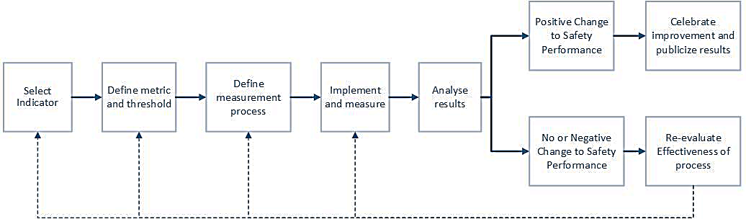

Correlating Leading Indicators to Safety Performance
As discussed above, one of the most crucial characteristics of a leading safety indicator is its strong correlation to safety performance. To ensure such correlation, Grabowski et al. (2007 -b) emphasized the need to identify relevant safety factors as a first step to identifying any leading indicator and accordingly identify the suitable metrics that will therefore correlate with these safety factors. This is reiterated by other researchers such Leveson (2014) and Manuele (2009), in which it is emphasized that the selection of leading indicators must relate directly to assumptions of the reasons for accident occurrence. Leading indicators must also be capable of monitoring aspects of the control system that are most critical to the safety performance. This will ensure that the effective leading indicator is directly relevant to any opportunity for the organization to reduce risk and improve safety performance. To achieve this, Tomlinson (2011) suggests that the method of correlating safety performance to the indictors should be done undertaking the following steps:
- Choose a safety leading indicator or metric – from literature or as tailored to the site
- Collect safety performance data over a period of time – (this is usually represented by lagging indicators)
- Normalize the data
- Perform statistical analysis to investigate whether or not any significant correlation exists between the selected metrics and the organization’s safety performance.
Such steps by Tomlinson (2011), and other sources of the literature, confirm that a leading indicator can only be effective if a strong correlation to safety performance can be established. The most common way to reflect such correlation is through the effect of the leading indicator on the value of outcome or lagging indicators (Stricoff 2000; Manuele 2009). Once leading indicators are selected, their added value and validity can only be verified by conducting statistical analyses to establish a relationship or correlation to the organization’s lagging indicators over time (Rajendran 2013; Tomlinson 2011). Reiman and Pietikainen (2012) also emphasize the significance of having a system of leading and lagging indicators set in place together. They believe that monitoring lagging indicators and observing changes in them could be the motive for the organization to inspect their leading indicator approach, and consequently make changes in the organizational safety system. Dyreborg (2009) discusses the decisions induced by finding these correlations to safety performance. So, if the existing risk level or outcome indicators of an organization change with time, as the leading metrics are being altered, this would result in verifying the leading indicator, identifying faults and flaws and working towards improving the current safety control system. On the other hand, if the performance levels change with no correlation or change in leading indicators, this means that the organization needs to revise its selection of leading indicators because a causal relationship with the performance could not be established.

Leading Indicators in Construction and Other Industries

Research Methods (Literature Identifying Leading Indicators)
To summarize, an effective leading indicator must precede the accident, it must have the ability to predict future performance, and must strongly correlate to safety performance, so that if changed proactively this would reflect on organizational safety levels. In order to materialize these aspects of the definition, the literature has found that leading indicators must be relevant to organizational strategies, procedures, and processes. They also need to relate to workers on site behaviors, as well as the relationship between top management and employees. In the literature studied, researchers have used the following research methods to identify leading indicators:
- Questionnaires, interviews, accident investigations and focus groups (Mengolini and Debarberis 2007);
- Safety Audits: audits built by the organization to monitor and measure safety performance factors upon which leading indicators will be built;
- Perception surveys: these ask the employees, supervisors and top management of their perceptions about the corporate and safety climate in the organization, to conclude any gaps or differences in the perception (Petersen, 1998);
- Safe behavior observation: according to Toellner (2001) most accidents can be traced back to unsafe behaviors. So observing such behaviors will mean that safer attitudes are promoted and training could be provided. Behavioral observations allow for identifying and reporting leading indicators pinpointing the extent of hazard exposure (Stricoff, 2000);
- Case studies, brainstorming sessions of research teams and experts of the field and content analysis from award winning projects. (Hallowell et al. 2013; Hinze and Hallowell 2013);
- Delphi method (Hallowell and Gambatese 2013; Rajendran and Gambatese 2009).

Leading indicators in Construction
In their research, Rajendran and Gambatese (2009) concluded that the construction industry utilizes more than 300 different injury prevention strategies. These include the availability of an organizational safety plan, conducting safety audits, hazard and accident root-cause analyses, emergency preparedness and others. The Construction Industry Institute (CII) funded research– CII Research Report 284-11 (Hinze and Hallowell 2013) identified the essential components of an effective construction safety program that would help make zero injury a reality. The same components are also referenced in other sources such as Rajendran and Gambatese (2009) and Rajedran (2013). These are as follows:
            - Demonstrated management commitment;
            - Staffing for safety;
            - Pre-project and pre-task planning;
            - Safety education and training;
            - Employee involvement;
            - Safety recognition and rewards;
            - Accident/incident investigations;
            - Substance abuse programs; and
            - Subcontractor management.
The research also identified 50 potential leading indicators and through work of the focus research team, these were narrowed down to the most effective indicators. Effectiveness was assessed in regards to ability to predict future safety performance, the measurability of the indicators, and the diversity in covering strategies of management, workers and vendors to the contractor. These most effective active leading indicators are as follows:
- Near miss reporting
- Project management team safety process involvement (Example off measurement method: Frequency of participation of project management
- team members in field safety activities)
- Worker observation process
- Stop work authority (measure: The number of times that the stop work authority is exercised per 200,000 worker-hours.)
- Auditing program
- Pre-task planning
- Housekeeping program
- Owner’s participation in worker orientation sessions
- Foremen discussions and feedback meetings with the Owner’s PM
- Owner safety walkthroughs
- Pre-task planning for vendor Activities
- Vendor safety audits
- Vendor exit debrief
A related study by the CII, CII Research Summary 284-1 (CII 2012-b) Measuring Safety Performance with Active Safety Leading Indicators identified examples of passive leading indicators. The study did this through a thorough literature review, a brainstorming session with experts, then developed interview questionnaire with nearly 100 questions, comparative studies, site visits and collection of documentation. The most prominent passive leading indicators that were concluded from all these techniques were as follows:
- Owner review and approval of safety plan
- Participation of all contractors and subcontractors in safety meetings
- Site-specific safety orientation for all managers
- 100% steel-toed boots policy
- Medical facilities on-site
- First aid log is maintained
- Minimum ratio of safety professionals to workers
- Worker-to-worker observation program
- Workers’ involvement in perception surveys
- Contract sets minimum ratio of safety supervisors to workers
- Contract imposes work hour restrictions for workers
- Safety considered during the design phase
- Formal safety review team determines disciplinary actions
Hallowell and Gambatese (2009) used the Delphi method to collect opinions of experts from which they concluded the essentials of a safety program. Their expert based survey asked experts to comment on the effectiveness of different elements of safety programs. They did so by recording their opinions on how using a certain indicator would reduce the severity and/or impact of one of their defined safety hazards ranging from slight discomfort, persistent discomfort to permanent disability and fatality. The results of this Delphi survey were similar to the results discussed above in areas such as engagement of upper management, accident investigation and analysis, training, management of subcontractors and vendors.
Research such as that by Rajendran and Gambatese (2009) also used the Delphi method to gain feedback of carefully selected experts. For this case the research investigated 25 projects around geographically dispersed areas in 13 different states. It used 3 rounds of surveying and eliminating to find 50 elements of safety that are ranked and then statistically analyzed by computing correlation with OSHA TRIR for validation. This study concluded that the most important elements on which the leading indicator programs need to be built are:
- Clear project safety authority, responsibility, and accountability;
- Employee empowerment to stop work authority; and
- Contractor selection based on safety.
Another study by Rajendran (2013) investigates three types of leading indicators: Pre-Task Planning (PTP) review, Worker Safe Behavior Observation (WSBO), and Site Safety Audits (SSAs). The aim of this study was to make sure that these indicators correlate strongly to safety performance in the selected project. The effectiveness of leading indicators was evaluated using four lagging indicators: Near Miss Incident Rates (NMRs), First Aid Injury Rates (FAs), OSHA TRIRs, and Total Incident/Injury Rates (TIs). The study expected that if the leading indicators accurately represent the safety performance, then these lagging indicator or incident rate values should decrease with the increase of the leading metrics. Results showed that safety audits show poor correlation, while WSBO and PTP show strong correlations and are therefore good predictors of safety. Other work includes the studies conducted by Tomlinson (2011) that suggests examples of metrics that could be leading indicators, including:
- The size of the safety budget
- Safety audit scores
- Number of safety inspections
- Number of safety meetings involving management,
- Percentage of incident reports on which root-cause analysis was undertaken
The study also conducted statistical correlation analysis between these leading indicators and safety performance measured by lagging indicators. For example, the number of safety inspections was studied against restricted work accident frequency and was found significantly indicative, which means it is an effective leading indicator.
Biggs et al. (2009) used two questionnaires, one for management and one for workers, and those were administered in construction projects in different regions. The study’s main goal was to attempt to standardize and customize the safety indicators and their measurements and offer user-friendly tools to do so. The results of the study show the following identified leading indicators:
- Regular site walk-arounds by senior management and/ or board members
- All management regularly seen on site (wearing the correct PPE)
- Work done collaboratively (based on consultation)
- Listening to each other
- The need to treat people as people and to have respect for the individual
- Commitment from workers and from management built on mutual trust
- Explanations given of why actions suggested at toolbox talks/ pre-start meetings were undertaken or not
It is worth mentioning that several of the above-discussed sources, as well as others have utilized Factor Analysis and Principle Component Analysis techniques to group and classify leading indicators into some major factors that represent a bigger set of behaviors, processes and strategies that constitute as leading inidcators. For instance, Categories Aksorn and Hadikusumo (2008) identified factors like company’s strategy for safety management, and management commitment, and workers’ authorities, as significant factors. There represent various other indicators like the existence of a health and safety plan, obvious safety promotion by management, attendance of management of safety meetings and several others. Similarly, Zohar (1980), Sawacha et al. (1999) and Findley et al. (2004) identified factors like safety training and orientation, site investigations, safety meetings and housekeeping in their factor analysis process. Other scholars used PCA to identify similar factors such as in the work of Guldenmund (2007) and Salas and Hallowell (2016).

The Debate on Near-miss Indicators
Near miss has been identified in several of the sources discussed above as a leading indicator. There is, however, an ongoing debate on whether or not these near misses can be considered leading indicators. Toellner (2001) is one of the believers that near miss reporting is a lagging indicator arguing that “the only difference between a near hit and an actual accident is sheer luck” and if an actual hit is classified as a trailing (lagging) indicator then it should not be any different for a near hit. This is backed up by the fact that improving safety through leading indicators can lead to reduced rates for both incidents and near hit, again reiterating their nature as lagging indicators. Manuele (2009) also had a similar view, believing that the near miss can only be considered a lagging indicator since it is no different from an actual incident except for slightly different circumstances that prevented the happening of harm or accident. On the other hand, Hinze et al. (2013) acknowledged this nature of near miss that makes it easily considered a lagging indicator. However, he discusses that the measuring and use of this indicator determines its nature as either leading or lagging. He argues that although typically near miss events are measured as lagging indicators, however utilizing this information differently could make it predictive and proactive in nature, thus turning them to leading indicators. It is useful to make use of the information collected about near misses, especially when distanced from negative connotations, which could affect reporting. Real time information provided by the near misses could give the organization greater chance to intervene, and analyze the current problems, and therefore decide on corrective actions.

Leading Indicators in Other Industries
The use of leading indicators is not an exclusive practice for the construction industry. Contrarily, many industries have been using leading indicators and research has been conducted to support this practice. Examples of leading indicators in different industries are shown below:
- Petrochemical industries: quality and backlog of maintenance; minor incidents such as leaks or spills; equipment failure rates (Grabowski et al. 2007-a)
- Medical fields: near hit reporting in anesthesia management
- Nuclear safety: accident precursor assessments (Grabowski et al 2007-a)
- Offshore oil and gas and chemical and process industries: hazard identification and analyses (Tomlinson 2011)

Summary of Literature Review
Traditional safety measurement techniques and safety performance evaluation are continually losing popularity due to their questionable effectiveness. The move towards more proactive and indicative measures has made its way in the construction industry as well as other industries, and that is by adopting leading indicators based safety systems. Leading indicators can be either active or passive, and should be metrics that measure events, activities, behaviors or processes that precede the occurrence of an incident. Many leading indicators have been identified by different sources of the literature. Table 2 summarizes the leading indicators in the sources studied for the purpose of this research and makes a differentiation of their nature as passive or active.

Table 2: Summary of Leading Indicators in the Literature.
 | Category | Indicator | Passive /Active | Source from Literature
 | Contract and Design | Contract sets minimum ratio of safety supervisors to workers | P | CII (2012-b); CII (2012-a).
 | Contract and Design | Contract imposes work hour restrictions for workers | P | CII (2012-b); CII (2012-a).
 | Contract and Design | Safety considered during the design phase | P | CII (2012-b); CII (2012-a).
 | Owner | Owner review and approval of safety plan | P | CII (2012-b); CII (2012-a).
 | Owner | Aggressive owner promotion of jobsite safety. | A | CII (2012-b); CII (2012-a).
 | Owner | Owner safety walkthroughs | A | Hinze and Hallowell (2013); Salas and Hallowell (2016)
 | Owner | Owner’s participation in worker orientation sessions | A | Hinze and Hallowell (2013); Salas and Hallowell (2016)
 | Contractor | Contractor selected based on safety | P | Hinze and Hallowell (2013).
 | Contractor | Utilization of contractor safety performance record in decision making concerning contracts | P | Reiman and Pietikainen (2012); Guo and Yiu, 2015
 | Contractor | Contractors are trained on safety culture issues and work practices | P | Reiman and Pietikainen (2012); Guo and Yiu, 2015
 | Contractor | Participation of all contractors in safety meetings | A | Hinze and Hallowell (2013).
Sub-contractors |  | Number (or %) of subcontractors selected on the basis of satisfying specific safety criteria prior to being awarded the subcontract. | P | CII (2012-b); CII (2012-a).
 |  | Participation of all subcontractors in safety meetings | A | Hinze and Hallowell (2013); Salas and Hallowell (2016)
 |  | Subcontractor management | A | Hallowell and Gambatese (2013); Hallowell et al. (2013); Rajendran and Gambatese (2009).
Vendors  /Suppliers |  | Vendor safety orientation | P | Hinze and Hallowell (2013)
Staffing |  | Staffing for safety | P | Rajendran and Gambatese (2009).
 |  | Number or percent of management personnel with 10-h (or 30-h) OSHA certification cards. | P | CII (2012-b); CII (2012-a); Aksorn and Hadikusumo (2008)
 |  | Number or percent of field employees with 10-h (or 30-h) OSHA certification cards. | P | CII (2012-b); CII (2012-a); Aksorn and Hadikusumo (2008)

Table 2 (continued)
Category |  | Indicator | Passive /Active | Source from Literature
 | Category | Indicator | Passive /Active | Source from Literature
 | Substance Abuse Program | Substance abuse program set in place and advertised to workers | P | Rajendran and Gambatese (2009).
 | Substance Abuse Program | Percent of negative test results on random drug tests. | A | CII (2012-b); CII (2012-a).
 | Strategic Safety Management | Written and comprehensive safety and health plan | P | Hallowell and Gambatese (2013); Hallowell et al. (2013); Aksorn and Hadikusumo (2008).
 | Strategic Safety Management | Safety is visibly and systematically considered in the organization’s ofﬁcial plans and strategy documents | P | Reiman and Pietikainen (2012); Guo and Yiu, (2015)
 | Strategic Safety Management | Safety policy conveyed to all relevant stakeholders | P | Mengolini and Debarberis (2007).
 | Strategic Safety Management | On-site plan based on a thorough identiﬁcation of possible accident scenarios | P | Mengolini and Debarberis (2007).
 | Strategic Safety Management | The size of the safety budget | P | Toellner (2001).
 | Strategic Safety Management | Clear project safety authority, responsibility, and accountability; | P | Rajendran and Gambatese (2009).
Safety Training |  | Safety and health orientation and training | A | Hallowell and Gambatese (2013); Hallowell et al. (2013); Rajendran and Gambatese (2009); Guldenmund (2007); Salas and Hallowell (2016)
 |  | Regular training on emergencies on-site | A | Reiman and Pietikainen (2012).
 |  | Hours of safety training | A | Wehle and Hinze (2009); Zohar (1980), Sawacha et al. (1999); Findley et al. (2004); Salas and Hallowell (2016)
 |  | Supervisor training hours | A
 |  | Number of safety training sessions completed vs. scheduled (%) | A
 |  | Number of people trained | A
 |  | Management/supervisor attendance at training meetings | A
 |  | Number of safety trained supervisors | A
 |  | Project-speciﬁc training and regular safety meetings | A | Hallowell and Gambatese (2013); Hallowell et al. (2013); Salas and Hallowell (2016)
 |  | Site-specific safety orientation for all managers | A | CII (2012-b) ; CII (2012-a).

 |  | Table 2 (continued)
 |  | Category | Indicator | Passive /Active | Source from Literature
 | Management and Supervision |  | Management is actively committed to involved in safety activities | A | Mengolini and Debarberis (2007); Reiman and Pietikainen (2012); Rajendran and Gambatese (2009); Toellner (2001).
 |  |  | Number of management walk arounds per month, | A | Toellner (2001); Reiman and Pietikainen (2012); Hinze and Hallowell (2013).
 |  |  | Number of times safety is a topic in the management meetings | A | Reiman and Pietikainen (2012); Aksorn and Hadikusumo (2008).
 |  |  | Superior provides positive feedback on safety-conscious behavior of the personnel | A | Reiman and Pietikainen (2012); Aksorn and Hadikusumo (2008).
Safety Meetings |  |  | Toolbox safety meetings are conducted | A | Toellner (2001)
 |  |  | Number of toolbox meetings | A | Wehle and Hinze (2009).
 |  |  | Percent of jobsite toolbox meetings attended by jobsite supervisors/ managers. | A | CII (2012-b); CII (2012-a); Wehle and Hinze (2009).
 |  |  | Quality of participation in toolbox meetings | A | Wehle and Hinze (2009).
 |  |  | Pre-task planning meetings conducted | A | CII (2012-b); CII (2012-a); Rajendran (2013).
Safety Meetings (Continued) |  |  | Number of pre-task planning meetings | A | Wehle and Hinze (2009).
 |  |  | Attendance at safety meeting | A | Wehle and Hinze (2009).
 |  |  | Explanations given of why actions suggested at toolbox talks/ pre-start meetings were undertaken or not | A | Biggs et al. (2009).
 |  |  | Employees’ satisfaction with the feedback on the outcome of safety meetings | A | Grabowski et al. (2007-b).
 |  |  | Percent of jobsite pre-task planning meetings attended by jobsite supervisors/managers. | A | CII (2012-b); CII (2012-a); Rajendran and Gambatese (2009); Rajendran (2013);Wehle and Hinze (2009).
Emergency Response Planning |  |  | Adequate on-site emergency preparedness plan | P | Hallowell and Gambatese (2013); Hallowell et al. (2013); Reiman and Pietikainen (2012).

 | Table 2 (continued)
 | Category | Indicator | Passive /Active | Source from Literature
Hazard Identification and Corrective Actions |  | Hazard identiﬁcation and risk assessments are used to develop policies, procedures and practices | P | Reiman and Pietikainen (2012).
 |  | A systematic corrective action program is in place to deal with deviations | A | Grabowski et al. (2007-b).
 |  | Adequate barriers are set against the identiﬁed hazards | A | Grabowski et al. (2007-b).
 |  | Employees’ perceptions of the presence of rules that make it easy for employees to identify procedures that are not safe | A | Grabowski et al. (2007-b).
Accident Investigation and Follow up |  | Accident/incident investigations conducted with procedure for investigation identified | A | Rajendran and Gambatese (2009); Mengolini and Debarberis (2007).
 |  | Percentage of incident reports on which root cause analysis was undertaken | A | Tomlinson (2011).
 |  | System for follow-up of incident investigations and related recommendations exists | A | Mengolini and Debarberis (2007).
 |  | Employees’ satisfaction with regard to follow up and measures taken after accidents, injuries and near losses | A | Grabowski et al. (2007-b)
Reporting |  | A clear procedure for reporting, with well-deﬁned roles and responsibilities exists | P | Mengolini and Debarberis (2007).
 |  | Willingness to report broken safety regulations | A | Grabowski et al. (2007-b).
 |  | Anonymous reporting | P | Grabowski et al. (2007-b).
 |  | Workers’ perceptions of the effectiveness of the anonymous reporting system | A | Grabowski et al. (2007-b).
 |  | Workers’ perceptions of the presence of a ‘no–blame’ culture in the organization | A | Grabowski et al. (2007-b).
 |  | Positive incentive to report potential hazards | A | Wehle and Hinze (2009).
Near Miss |  | There is a system for analyzing near miss events in the organization | P | CII (2012-b); CII (2012-a); Hinze and Hallowell (2013); Wehle and Hinze (2009).
 |  | Number of close calls (near misses) reported per 200,000 h of worker exposure | A | Reiman and Pietikainen (2012).
 |  | Employees’ satisfaction with the feedback given near losses that occur | A | Grabowski et al. (2007-b).

 | Table 2 (continued)
 | Category | Indicator | Passive /Active |  | Source from Literature
Safety Audits |  | Auditing program set in place |  | P |  | Hinze and Hallowell (2013).
 |  | Safety audit score calculated and monitored |  | A |  | Tomlinson (2011).
 |  | Management/Supervisor safety audits |  | A |  | Wehle and Hinze (2009).
 |  | Number of Audits completed vs. scheduled (%) |  | A |  | Wehle and Hinze (2009).
 |  | Percent of safety compliance on jobsite safety audits (inspections). |  | A |  | CII (2012-b); CII (2012-a).
 |  | A procedure to communicate the results of audits, inspections and similar activities to the employees |  | P |  | Mengolini and Debarberis (2007).
When adopting any of the leading indicators summarized in Table 2, the company should make sure that the indicators are tailored and customized locally and more specifically to the organization. Leading indicators differ from one organization to the next the same way that hazards, safety system design, the organization structure and the risk levels differ. Selecting indicators randomly from literature to apply in local organizations might not be effective. Therefore, this study aims to focus on the on attributes of the construction industry as they pertain to the local case of Tennessee. Furthermore, applying these indicators without proper procedures to guarantee their success would prove ineffective and would not reflect on safety performance optimally. In order to successfully implement such indicators, the company needs to guarantee measurability, valid correlation to safety performance, ease of implementation, freedom from bias, consistency and reliability, cost effectiveness, and openness to improvement and adjustment.

Methodology

General Methodology Procedure
This study aims to define and identify potential passive and active leading indicators of safety performance, especially as they pertain to the construction industry and local attributes of Tennessee. To do this, the research started with a comprehensive and thorough literature review of leading indicators in previous research. This was mainly focused on metrics in the construction industry, however other industries such as the manufacturing, mining and petrochemical industries were also investigated, and similarities to the construction industry were drawn. Using the literature review, as summarized in Table 2, and by combining indicators from different sources, 22 categories for the different leading indicators were deduced. These have 88 indicators in total. Some of these indicators were divided into passive and active within their respective sources and others where only defined as leading indicators, and thus differentiated in this study to passive or active based on the definitions of such indicators. These indicators apply to general national and international cases, and in some cases to industries besides the construction industry. The indicators where used as guidelines to create the questions of the industry questionnaire. The questionnaire was directed to local construction engineers, safety directors, or members of top management in the Tennessee construction industry, to record their personal views and perceptions on leading indicators and the utilization of these indictors in their respective organizations.
Acknowledging the exploratory nature of the research and since most data collected will be descriptive, a judgement-based case study research will be conducted. The case study research helps understand the dynamics present in a single organization. The methodology for doing such research followed six major steps starting with the creation of the industry questionnaire and ending with conclusions and future recommendations. These are described in Figure 3.

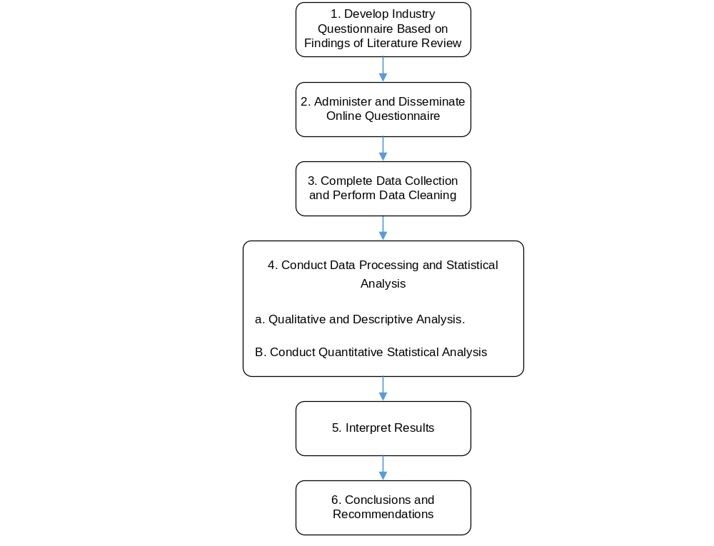Figure 3: Research Methodology Diagram

Industry Survey
Survey research is a systematic set of methods used to gather information to generate knowledge and to help make decisions (Lavrakas 2008). According to Fowler (1984) surveys are one of the oldest tools that serve the purpose of producing quantitative and qualitative descriptions of a certain area of investigation by asking the right population. Surveys can have different forms such as telephone, face-to-face, mail, or internet-based surveys. This survey was conducted using an on-line questionnaire to simplify data aggregation.
This survey is classified under case study research in order to investigate the specific case of Tennessee. The analysis of results under such type of research aims to capture the experience of respondents to the survey in theoretical terms (Gioia 2013). The use of semi-structured interviews under this method means that data from multiple sources is used to obtain retrospective as well as real-time information about the case study under investigation. Guided by this method the data collected is categorized into similar categories to help find a structure for the data and consequently conclude emerging themes or explain the phenomenon at hand. Case study research also guides the building of theories from multiple case studies by investigating patterns within a single case study as well as cross-case patterns (Eisendhardt 1989). This methodology is particularly suitable for research in which current perspectives are insufficient or they have little empirical evidence to back them up; which is the case of data of this research. In this case, case-study research is very suitable since it does not depend on previous empirical evidence or research. Under this method, it is essential that after findings are drawn from the data collected, the existing literature is examined for agreeing or conflicting theories. Once data is analyzed, similarities are drawn to the literature and differences are investigated to increase confidence in the data as well as increase the internal validity of the concluded findings.

Data collection tool: The Questionnaire
Survey questionnaires have been widely used in safety management related studies both in construction and other industries (Mengolini and Debarberis 2007; Hinze and Hallowell 2013; Mearns et al. 2003; Choudhry & Zahoor 2016; McDonald et al. 2000). For this study, a questionnaire was developed in order to acquire perceptions and ideas of respondents about the used leading safety indicators in their companies. The questionnaire is based on 84 leading indicators for which representatives of the industry provide their judgement on the utilization of these indictors.
The questionnaire was administered using Qualtrics®, a surveying tool that allowed online collection of responses. The survey was distributed to representatives of 286 companies in Middle and East Tennessee classified as contractors, consultants, specialty contractors and suppliers. These are members of the Associated General Contractors of Tennessee. All representatives were senior local construction engineers, safety directors, or members of top management of their respective firms. In order to improve the external validity of the study, different types of organizations and projects were investigated, with the companies varying in terms of their types of services, project sectors, and size (by revenue and number of employees). The projects targeted are both completed and ongoing, and included commercial, residential, infrastructure, heavy industrial and other sectors projects.
The development of the questionnaire followed a process described by Brancato et al. (2006) who suggests that a questionnaire development process must undergo a conceptualization stage before the design of the questionnaire in order to ensure reliability and validity or the data collection tool. These stages are described in the sections below.

Conceptualization
The conceptual design of the questionnaire, according to Brancato et al (2006), needs to start with the integrating of information from a thorough literature review and comparable surveys. Accordingly, this questionnaire was developed with guidance from leading indicators identified in the literature review. This phase also involves choosing the target respondent groups appropriate to the investigation. The survey was distributed to representatives of 286 companies and all representatives were senior local construction engineers, safety directors, or members of top management to ensure familiarity with the project being studied.
In order to improve the external validity of the study, different types of organizations and projects were investigated, with the companies varying in terms of their types of services, project sectors, and size (according to revenue and number of employees). In particular, for company size, and due to significant variations between different respondents, categories are made as to allow valid comparisons. The projects targeted are both completed and ongoing. They employed between 5 and 220 workers, and included commercial, residential, infrastructure, heavy industrial and other sectors. The contract types and the delivery methods for the projects also varied between Re-measured, Lump Sum and Cost-Plus for the former, and Traditional (Design-Bid-Build), Design Build, Turn-key, Construction Management for the latter.

Developing the Questionnaire
Alwin (1987) defines a questionnaire to be a method for the elicitation, recording, and collecting of information from group of respondents. This information is gathered using different types of questions. According Brancato et al. (2006) survey questions can be divided into four main types: factual, behavioral, opinion and hypothetical questions. Factual Questions are fact-based questions that require the respondent to provide facts rather than an opinion. These include demographic questions and knowledge questions. As for behavioral questions, these require information about the activity or behaviors and attitudes of the respondent. The third type, which is opinion-based questions, are questions that seek to measure subjective opinions. Finally hypothetical questions, which ask the respondents to assume the occurrence of a certain situation and answer a “what would you do if?” kind of questions. In this research, factual questions were used mainly in the industry survey; demographic factual questions were used to collect background information about the respondent and the organization, and knowledge questions were used to collect facts about the strategies, activities and policies of safety practices in the company.

Questionnaire Design
The questionnaire was designed to include an introductory section and two main sections. These sections are described below. The questionnaire is provided in appendix 1.
- Introductory section
Pursuant to sources such as Brace (2008), an introductory session (or a cover letter) was added to the questionnaire to explain the background of the research and instructions. The introductory section covered background information about the research topic and the reason for its significance. It also requested the response to the survey highlighting the valuable input of the respondents to the goals of the research. Finally, the section discusses the confidentiality of the information provided and gives the respondents a chance to receive the results of the study to encourage involvement in the research. According to Odom (1979), identifying the authority of the organization conducting the research and insuring confidentiality is very important to improve response rates.
- Section 1: Background Information
This section covered background information about the respondent, organization and the project in which the respondent is working. The section included three sub-sections: Respondent Data, Company Profile and Project Profile.

- Respondent Data
Respondent background information included name, position and years of experience among others. Questions (I.4) and (I.6) cover the position and years of experience of the respondent, respectively. These were used to ensure that the respondent matches the selection criteria. The respondent had to be a senior construction representative, and it was assumed that a minimum of 5 years of experience is reasonable for reliable perspective and responses to the survey. The position of responsibility of these representatives was important to ensure familiarity with the project being studied.
- Company Profile
As for the company profile, question (II.1) covered information about the service category of the company (owner, contractor, consultant…). This was to conclude different safety strategies and activities followed by the different stakeholders in a construction project. In addition, several questions covered the size of the company such as revenue (II.3) and number of workers (II.4 and II.5). Getting feedback on the size of the company was important in order to control variation due to size differences to ensure validity, as well as investigate any differences in implementation of leading indicators with size. This survey also asked for lagging indicators data used by the organization to assess safety performance. Two OSHA rates are collected: TRIR and DART. Collecting this information was important to understand the safety performance of the companies, and whether or not their implementation of leading indicators has affected their safety performance.
- Project Profile
Finally, the Project Profile section covered the sector, delivery method, and contract type of the project. It also asked for information such as the contract price, status as it pertains to budget and schedule and number of workers. The external validity of the survey was ensured by seeking a sample of a variety of project types.
- Section 2: Safety Indicators
Section 2 of the questionnaire was developed in order to collect information on the potential leading indicators that are utilized in the respondents’ companies. According to Dillman (2006) a well-designed questionnaire arranges questions of the same topic together, therefore the questions in this questionnaire were divided into 11 major categories: A, B, C, D, E, F, G, H, I, J, and K as described in Table 3.
The 11-factor classification was not only based on conceptual grouping, but was also guided by consensus and repetition of these categories as the most influential in the industry in over 20 related studies (covered in the summary to literature review section 2.5). These categories were also the results of Factor Analysis (FA) and Principal Component Analysis (PCA) in previous research. For instance, Categories A,C and G appeared significant in the FA results of Aksorn and Hadikusumo (2008). Categories D,E,F,I and J were major factors in Zohar (1980), Sawacha et al. (1999) and Findley et al. (2004). In addition, PCA in Guldenmund (2007), Salas, and Hallowell (2016) verified very similar factors. Consequently, these factors were adopted in this study and the selected grouping was checked with consistency and reliability testing as shown in the forthcoming sections of this paper.
These categories were grouped to cover all 22 sub-categories concluded from the literature review (summarized in Table 2). The questions of this section were mostly 5-point Likert scale questions (with options Strongly Agree’, ‘Somewhat Agree’, ‘Do not Know/No Opinion’, ‘Somewhat Disagree’ and ‘Strongly Disagree’), developed based on the most repeated indicators in the comprehensive literature review. The investigation identified 84 different leading indicators (31 passive and 53 active indicators), all of which have many of the required characteristics described in the literature for an effective indicator.
It is worth noting that researchers have debated whether adding a ‘Do not Know’ option serves better collection of data. For the purpose of this research, choosing to add this option comes from persuasion that adding such option encourages respondents without information to admit it (Schuman & Presser, 1981). Moreover, a few sections had follow-up questions asking for numbers and statistics. These are numeric open-ended questions (Trochim, 2000), which required the respondent to provide an open numerical answer. Examples of these open-ended questions are found in questions A.2.3 or A.2.4 among others.

Table 3: Description of Questionnaire's Section 2 Categories
Category | Title | Sub-categories and Questions
A | Company’s Strategy for Safety Management | 2 sub-categories  Total of 10 questions
B | Safety in Contract Documents and Stakeholders Responsibilities | 4 sub-categories  Total of 18 questions
C | Management and Supervision Commitment | No sub-categories  Total of 6 questions
D | Safety Training and Orientation | No sub-categories  Total of 6 questions
E | Site Investigations | 5 sub-categories  Total of 21 questions
F | Safety Meetings | No sub-categories  Total of 8 questions
G | Workers' Authorities | 2 sub-categories  Total of 6 questions
H | Substance Abuse Program | No sub-categories  Total of 3 questions
I | Housekeeping | No sub-categories  Total of 4 questions
J | Personal Protective Equipment (PPE) | No sub-categories  Total of 2 questions
K | Record Keeping | No sub-categories  Total of 2 questions
The questionnaire aims to identify both passive and active leading indicators. The questions built from the literature review covered 31 passive leading indicators and 53 active leading indicators. The questions relate to passive or active indicators as shown in Table 4.
Table 4: Questions Related to Active and Passive Leading Indicators
Category Questions | Passive Indicators | Active Indicators
Category A | A.1.1., A.1.2., A.1.3., A.1.4., A.1.5., A.1.6., A.2.1., A.2.2., A.2.3.,  A.2.4
Category B | B.1.1., B.1.2., B.1.3., B.1.4., B.1.5., B.1.6., B.1.7., B.1.8., B.2.1., B.3.1., B.3.2., B.4.1., B.4.2., B.5.1., B.5.2 | B.2.2., B.2.3., B.3.3., B.4.3.
Category C | C.1.1., C.1.2., C.1.3., C.1.4., C.1.5
Category D |  | D.1.1., D.1.2. , D.1.3. , D.1.4., D.1.5., D.1.6.
Category E | E.3.1., E.5.1., E.5.2 | E.1.1., E.1.2., E.1.3., E.1.4., E.2.1., E.2.2., E.2.3., E.2.4. , E.3.2. , E.3.3., E.3.4. , E.3.5. , E.4.1. , E.4.2. , E.4.3. , E.4.4. , E.4.5., E.5.3.
Category F |  | F.1.1., F.1.2. , F.1.3., F.1.4., F.1.5., F.1.6., F.1.7., F.1.8
Category G | G.1.1., G.1.2 | G.1.3., G.1.4. , G.1.5., G.2.1.
Category H | H.1.1. | H.1.2., H.1.3.
Category I | I.1.1. | I.1.2., I.1.3. , I.1.4
Category J | J.1.1 | J.1.2.
Category K |  | K.1.1, K.1.2.

Sampling of Respondents
According to Ledy and Lemeshow (1999) developing a sampling plan for the survey is a vital step to survey design. This plan is the methodology that will be used to select the sample from the population. It describes how the sample will be selected, how the sample size will be determined and what media will be used to administer the survey.

Sampling Method
As summarized in Mugo (2002) Sampling in Research Web Tutorial, sampling types vary between simple random sampling, systematic sampling, stratified sampling, cluster sampling, convenience sampling, judgement sampling, and purposeful sampling which include snowball or chain sampling and intensity sampling amongst several others. For the purpose of this research, stratified sampling was used. In a stratified sample, the population can be grouped into different strata according to certain characteristics or variables. In this type of sampling, the strata share at least one common characteristic on which the probability sample is selected with simple random sampling (Stopher and Meyburg 1979). In the case of this questionnaire, attempts were made to divide respondents into different categories to represent all sectors of the construction industry. The initial list of the population divided the respondents according to service provided (contracting, consulting, others). To ensure sufficient representation of the different strata, it was confirmed the number of respondents in each strata in the received sample size represents at least 10% of the strata’s corresponding members in the original pool. For the 286 firms of the AGC members’ directory; the selection included 89 general contractors, 42 consultants and engineers, and 155 others varying between suppliers, specialty contractors and owners.

Sample Size
The literature defines several methods to select the most suitable sample size and ensure that it is representative. Salant and Dillman (1994) define the selection of sample size through identifying desired response rates, and level of accuracy for the survey. Other sources suggest a range of sample sizes such as Fowler (1995) who suggests a sample size of 15–35, and Sudman (1983) with a range to 20 to 50 respondents. Others also support the acceptability of the smaller ends of sample sizes for questionnaire-based research and descriptive analysis. For instance Sheatsley (1983) suggests that a 10–25 sample size is acceptable, while Converse and Presser (1986) support a range of 25 to 75 persons. Furthermore many scholars agree on a rule of thumb of 10% of the investigated poplulation to be a representative sample size. Alreck & Settle (1995) state that it is rarely necessary to sample more than 10% of the target population, while Gay & Diehl (1992), also agree that for descriptive, correlational or experimental studies 10% is sufficient.
For the purpose of this industry survey, the questionnaire targeted a known population defined as the representatives of the construction industry in Middle and East Tennessee. The population size is 286 organizations, as taken from the directory Association of General Contractors of Tennessee (AGC). From the literature above, a sample size exceeding 10% of the data is 29 respondents, and falls within acceptable ranges discussed above will be accepted. Further, to have more confidence in our sample size, the equation for finding sample size for estimating the population mean when the variance (σ ² ) is known, using the z-statistic score will be used once the data is obtained to find the sample size. The equation below is used to obtain the sample size to estimate population mean. This is for normally distributed data or for small sample sizes of 30 or less (Ott and Longnecker 2001).

$$n=\frac{z^{2}s^{2}}{d^{2}}$$
$$where, s=s'\sqrt{ (\frac{n^{'}}{n^{'}-1})}$$
Where,
n: minimum sample size
z: standard normal deviation (at 95% confidence level, z = 1.96)
d: acceptable standard error of mean
s: population standard deviation
s’: sample standard deviation (Standard deviation for each question)
n’: available sample size (in this case available population= 286)
It is important to note that using the equation above is conditional upon having normally distributed data. However, even if data is not normally distributed, assumptions of normality usually yield a larger sample size and thus are more conservative (Ott and Longnecker 2001), therefore this equation will be used with the data regardless of the distribution to give conservative sample sizes. This will be revisited in the data analysis section (in section 4.1.1).
Further confirmation of the sufficiency of the sample size will be done following the reasoning of Saaty (1980) and Salman et al. (2007). This follows the Chebyshev’s theorem, which determines the acceptability of a data set. In order to be acceptable, at least 75% of the data set must lie within the range of (mean ±2*standard deviations), and at least 89% must lie within (mean ±3*standard deviations). The responses received were checked for this criterion.

Administering the Questionnaire
According to Dillman (2006), administering the survey should involve:
      - Sending out the questionnaire through the chosen media.
      - Follow-up emails should be sent for potential respondents who have not yet provided a response.
For this research, the questionnaire was sent by email as a link -created by Qualtrics®- to the representatives of the construction members of the AGC as provided in the directory. Follow-up emails where initially conducted, then later complemented with follow-up calls, with a one-week gap between the follow-ups to encourage greater participation.

Received Responses and Data Cleaning
According to Cole (2008) on how to deal with missing data and Dasu, T., & Johnson, T. (2003) on exploratory data mining and cleaning, eliminating cases or participants from the survey should be a careful and deliberate process. Listwise deletion is when a response that has any data that is missing is deleted, only responses with all questions answered are used, this is a very conservative approach. On the other hand, pairwise deletion is when a response is deleted if the data missing is for a variable in the analysis of interest, so the response is kept in the data set and for the variables where the data is missing, that response is eliminated and the sample size is reduced by the number of responses removed. For this case study the data was cleaned according to completeness of the survey, and whether or not sufficient questions have been answered. Pairwise deletion was used in cases where surveys were sufficiently completed but are missing responses to some questions. The response with missing data was eliminated in the analysis of the variable for which the response is missing.

Data Processing and Statistical Analyses
In order to analyze the results of the survey, both qualitative and quantitative analysis should be employed. Both types of analyses are important to investigate the research objective and answer its questions. Qualitative data analysis is concerned with the meanings of the responses and processes; the analysis in this case is aims to understand the respondents’ perspective and is done by themes, grouping and inferences about the respondents’ input. Quantitative analysis on the other hand, involves numerical comparisons and statistical inferences with emphasis on correlations and causal relationships (Israel 1992). Qualitative and quantitative data analysis should be used together to complement each other and understand the research question more fully (Prake 2012).
Since the data collected was mostly numerical, with little open-ended or text questions, the analysis was heavily quantitative and mainly focused on descriptive statistics of such quantitative data. Qualitative description of data was utilized for cases of non-scaled questions and demographic information. Statistical analysis was performed using a program called Statistical Package for the Social Sciences (SPSS®) for Windows. Figure 4 shows the sequence of data analysis that was taken for this research.
The survey included 74 Likert scale questions. Clason and Dormody (1994) described the difference between Likert-type items and Likert scales. Likert-type items are identified as single questions that use some variation of the Likert response options in this form, the researcher has no intention to combine the responses from the items to a combined scale. Contrarily, Likert scale has more than one Likert scale item with the purpose of combining them to composite variables when doing the data analysis. It is then noted that the questions used in this survey are Likert scale questions, which means that descriptive statistics used for this type of questions include using the mean for central tendency and standard deviation for variability.
When making conclusions and statements from the analysis of Likert scale data, awareness is maintained of the debate on treating Likert scales as continuous data. Despite the longstanding disagreement amongst scholars on how to treat such data, many sources support the careful analysis of Likert scales as continuous/interval data (Norman 2010; Baker et al. 1966; Marcus-Roberts and Roberts 1987; Suppes 1959). The main argument against treating Likert scale results as continuous comes from the lack of known and equal spacing between the options. Scholars have always frowned upon taking averages of such results, as Kuzon et al. (1996) puts it, one cannot express the mean of a Likert-response item as “Strongly Agree and a half”. Accordingly, and keeping the above in mind, any conclusions and trends from means in this research did not make such statements, but were rather targeted at comparisons. This approach follows the recommendations of researchers like Marcus-Roberts and Roberts (1987) and Suppes (1959). Both of these sources state that calculating the means and variances is always appropriate for scales, but the conclusions and statements made from these values determine their appropriateness. They assert that statements like "the. mean for Group I on Variable X is greater, than the mean for Group II on Variable X" are appropriate and useful, while other statements such as “the average for this group is an agree average”, is not appropriate.
Other statistical analyses that could be used are Pearson’s associations, analysis of variance (ANOVA) and t-tests for correlations. The type of the statistical analysis will also depend on the distribution of the data. If data is not normally distributed, some sort of non-parametric alternatives will need to be used.
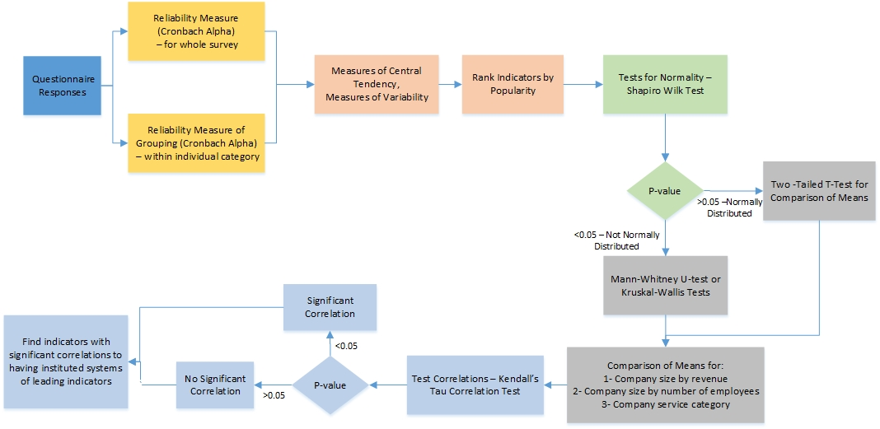
Figure 4 Research Data Analysis Flow

Reliability Measures
Reliability measures are used to assess the internal validity and consistency of the survey questions. The reliability is usually expressed in terms of Cronbach’s Alpha which ranges between 0 and 1. Most sources agree that a Cronbach’s Alpha of 0.7 or higher indicates high reliability (Van den Broeck et al 2005). Other sources such as Alwin (1987) suggest that the reliability within the sections of the survey should be 0.6 or higher, and for the whole survey 0.8 or higher.
The Cronbach’s alpha was found for the whole survey, and within the categories of section 2. This measure is important in order to realize whether or not the theoretical grouping of the variables together based on the literature and the understanding of these variables, is in fact consistent numerically. Cronbach’s alpha was also used to decide whether or not the different questions in each category can be combined into a single variable. For example, for category A describing “Company Strategies for Safety Management”, if all questions show a reliability measure of 0.6 or higher, a new composite variable called Group A is created, representing the mean of all 10 questions in category A. If the reliability measure is not sufficient, questions affecting the reliability may be eliminated if that could be reasonably justified. Combining each category into a single variable, and assuming all categories achieve sufficient internal consistency, will result in having a total of 11 composite variables that describe safety practices of each respondent. These will later be used for further analysis.

Descriptive Data Analysis
Descriptive analysis is important to describe data and allow for easier interpretation. Descriptive Statistics to be included in the analysis are: measures of central tendency (mean, median, and mode), measures of variability (variance and standard deviation), distribution of the data and indices for normality (tests for normality, skewness and kurtosis measures). Indices of normality are not only important for better understanding patterns in data, they are also deciding factors on the types of tests to be used for difference in proportions/means and analysis of variance as well as correlations between any two variables. The skewness and kurtosis are examined for each of the variables, the acceptable range for skewness or kurtosis .-1.5 to 1.5 to safely assume normality (Tabachnick & Fidell, 2013). The test for normality is confirmed more reliably using the Shapiro-Wilk Test for Normality (Shapiro and Wilk 1965). This test calculates a statistic that tests whether a random sample follows a normal distribution. Small values of this statistic are evidence that the distribution is not normal. SPSS® will be used to find the significance level of this test to determine whether the data is normally distributed or not.

Estimates of Difference in Proportions
After conducting the Shapiro-Wilk test of normality, the method to compare the data means can be determined. For normally distributed data, two sample t-tests can be conducted. Alternatively, if the data is not normally distributed, a nonparametric alternative for two-sample t test needs to be used. The Wilcoxon rank sum test, and its equivalent Mann-Whitney tests are used in cases where the conditions of normality and equal variances are not valid, and the sample size is small so that the t-test would not produce accurate results (Ott and Longnecker 2001). The Mann-Whitney test was used in this research, as an alternative test to the independent sample t-test, for comparisons of answers for the different safety practices amongst the different respondent groups. An equivalent test called Kruskal Wallis Test performs the same function as Mann-Whitney test for comparison of more than 2 independent samples. This was used to compare means amongst different size groups of the respondents. The size of the company was investigated by number of employees and by annual revenue; these were grouped into 3 different size categories. Comparison was also done for results of respondents in different service groups (contractors, owners, consultants, etc.) The comparison in terms of service category can only be conducted on respondents who did not provide multiple answers for these questions to abide by the assumption of independence for this test.

Correlations
Correlations aim to find the strength of relationships between two variables. The most common correlation method is Pearson’s Correlation, which assumes that there is a linear relationship between the variables and the underlying normal distribution for the data. If data is not normally distributed, an alternative to Pearson’s Correlation needs to be used. Kendall’s Correlation produces a coefficient value between -1 and 1 to indicate the strength of the relationship between the variables. A zero value of the coefficient shows no relationship between the variables (Kendall 1990). SPSS® is used to find these correlation coefficients and the significance for this test. A significance level of 0.05 is used in this research to determine whether or not a correlation is significant.
The main aim for using correlations was to find out if there is a gap in understanding of systems of leading indicators in safety. This was done by investigating whether or not there is correlation between question A.1.1 of the survey (asking whether the respondent’s company implements leading indicators) and the rest of the practices. From the literature review, leading indicators are surrounded by lack of knowledge and confusion, therefore it was expected that the use of some leading indicators would not correlate with whether or not a company implements a leading indicator system. A lack of correlation would indicate that an insufficient number of respondents have compatible answers to question A.1.1 compared to the investigated indicator (i.e. If answered Yes to A.1.1 they would answer the same to using the investigated practice, or vice versa). A company could be using a practice without prior knowledge that it constitutes a leading indicator or a company could be using leading indicators but not implementing those practices. The correlation analysis will aim to highlight these discrepancies.

Results and Data Analysis
The purpose of this chapter is to outline the results of the survey and analyze the received responses as per the methodology order described in chapter 3. The results were investigated in order to fulfill the different objectives of this research by following the chronological order of methodology phases described in Figure 3 and Figure 4.

The Database of Respondents
The total number of responses received for the survey was 53. This corresponds to a response rate of 18.5%. After data cleaning, it was found that 20 of these 53 responses only answered section 1 which is the demographics and background section. Three other responses answered very few questions from section 2 covering only sub-sections A and B in section 2, with several missing responses in the demographics section. It was chosen to eliminate these 23 responses, because they have completed less than 30 percent of the whole survey. The net surveyed sample used in the data analysis and interpretation was 30 responses. The counted 30 responses varied in level of completeness but all have completed over 80 percent of the survey. Pairwise deletion was used in this case, where the response with missing data is eliminated in the analysis of the variable for which the response is missing. After data cleaning, the effective response rate of 10.5%.

Sampling and Sample Size
As described in the methodology, stratified random sampling was used. In this case the sample is stratified since it had respondents that fell under different categories of service. The 30 usable surveys were received from respondents who are representatives of the AGC classified as contractors, consultants, specialty contractors and suppliers.
The survey targeted local companies in East and Middle Tennessee, and 19 responses were received from East Tennessee, while the remaining 11 were from Middle Tennessee. The respondents varied between owners, general contractors, consultants and other trades such as MEP subcontractors. These worked in various project sectors, mostly commercial and infrastrucure, but also included residential and heavy industry. The companies ranged in size by annual revenue between $500K and $12B, and they employed a range of 2 to 25,000 emloyees. The projects ranged in contract value between $230K, and $184M. At the time of the survey the mean percentage of completion for all projects was 53%, with some projects just starting at 2% completion and some already completed fully. Those that were just starting were expected to be completed before the fourth quarter of 2019. The majority of the projects were on schedule and on budget, 2 projects suffered from delays, and only 2 were over budget. As for contactual arrangements, 20 of the 30 projects were Lump Sum projects while the rest were equally divided between Cost Plus and Re-measured. Also the projects show an equal divide between two major delivery methods, those being traditional delivery method (Design-Bid-Build) and Contrsuction Management, with a few Design Build and Turnkey projects.
The 30 responses received, combine responses from representatives of the field with 606 years of collective experience. All respondents held senior positions in their companies, and 82% of them had over 15 years of experience in construction. It is worth noting that a recent study by O’Connor and Woo (2017) used a sample size of 36 for one of its questionnaires for a national study, with collective years of experience for respondents being 546 years. This gives confidence in the quality of the responses received.
Verifying the adequacy of the received responses as a representative sample size is an important aspect to the survey. According to the literature sources cited in the methodology section (section 3.3.3.2), the sample size collected of 30 respondents lies within acceptable ranges and follows the rule of thumb being greater than 10% of the targeted population (Sudman 1983; Sheatsley 1983; Gay & Diehl 1992; Fowler 1995; Alreck & Settle 1995). Additionally, to ensure sufficient representation of the original population’s strata, it was confirmed that the 30 received responses of 6 consultants, 16 general contractors and 15 others, with some respondents falling in more than one category, represent more than 10% of the original population strata as described in section 3.2.2.1.
Furthermore, a confirmation of the adequacy of the sample size is done using the equation for finding sample size for estimating the population mean when the variance (σ ² ) is known, using the z-statistic score. If the total population were to answer the 74 scale questions, each of the questions could have a different standard deviation. Therefore, it is assumed that the sample standard deviation is equal to the population standard deviation. In this case, the equation is applied to every question in the survey (each having its own standard deviation) and the minimum number of respondents required to answer each question was obtained. The equation was applied to several values of acceptable standard error of mean and the results are shown in Table 5. Accordingly, if our desired margin of error is around 10% (between 10% and 12.5%) or more, the current number of respondents represents a good sample size.

Table 5: Acceptable Sample Sizes for Different Margins of Error
Margin of Error in Percent | Acceptable standard error of Mean | Range of Number of Required Responses | Average
12.50% | 0.5 | from 3 to 41 | 20
10.00% | 0.4 | from 5 to 65 | 31
7.50% | 0.3 | from 10 to 115 | 56
6.25% | 0.25 | from 14 to 166 | 80
5.00% | 0.2 | from 21 to 259 | 126

Moreover, the means of the responses were investigated for acceptability following the reasoning of Saaty (1980) and Salman et al. (2007). This follows the Chebyshev’s theorem, which determines the acceptability of a data set. In order to be acceptable, at least 75% of the data set must lie within the range of (mean ±2*standard deviations), and at least 89% must lie within (mean ±3*standard deviations). On average, 92.2% of the data received for all the questions in section 2 of the survey lied within 2 standard deviations from the mean, and over 96.2% lied within thrice the standard deviation from the mean.

Comparable Response Rates and Sample Sizes in the Literature
The response rate for this questionnaire is comparable to the rate other studies on safety culture and management, as well as other construction management studies (ex: 8% and 9% in Salman (2007), 8.75% in Hanna (2017), 8% in AlQady and Kandil (2013), 9.37% in Price and Shawa (1997), 11.4%, 12% inLi et al. (2005) Jin and Zhang (2011), 13.02% Yuan et al. 2009; 13.3% in Jaselskis et al. 1996).
Furthermore, leading safety researchers have used comparable sample sizes for exploratory studies of this nature done on a national and international scale. For instance CII led research Measuring Safety Performance with Active Leading Indicators (2012-b) used responses from 57 construction projects representatives from across the United States. Similarly, Hinze and Hallowel (2013) based their work on the aforementioned CII research and further reduced the sample size to 28 responses. Marks et al. (2014) used a sample size of 75 for their interview-based study on near miss reporting for a target population of over 700, 000 people. Further, Jaselskis et al. (1996) used 60 survey responses for a 400 target population in order to study most effective strategies in construction safety performance. When realizing that the response rates and sample sizes for the aforementioned studies were attempting to generate conclusions about the industry on national levels, this provides confidence that the response the received sample is sufficient for a state based study.

Reliability Measures
As described in chapter 3 (section 3.3.5.1), the reliability measures of Cronbach’s alpha are measured and assessed for the entire survey to check for internal consistency, for the questions within each category to verify that the grouping is valid and consistent, and to create new composite variables for the categories with sufficient validity, that will be later used in further analysis.
Cronbach’s Alpha for the Whole Survey
The reliability measure is assessed for the entire survey. The survey included 74 scale-type questions, for which Cronbach’s alpha is calculated using SPSS® as shown in Table 6 below.

Table 6: Reliability Measure for Entire Survey
Cronbach's Alpha | N of Items
.982 | 74

Since Cronbach’s alpha is greater than 0.8 then the internal consistency and reliability of the whole survey is sufficient.
Cronbach’s Alpha within Each Category
The reliability measures of the questions within categories of the survey shown in Table 7 indicate that the internal consistency is acceptable, and the grouping/categorization chosen during the literature review and devising the survey phase is reliable; Cronbach’s alpha turned out to be greater than 0.6 within each category. After confirming the reliability, further statistical analysis can be made on the data as done in the following sections.

Table 7: Reliability Measures for Survey's 11 Categories
Category | Title | Description | Cronbach’s Alpha
A | Company’s Strategy  for Safety Management | 2 sub-categories: A.1. Strategies and Policies, and A.2. Staffing for Safety. The category had a total of 10 questions, 7 of which were closed scale type questions | 0.897
B | Safety in Contract Documents and Stakeholders  Responsibilities | 5 sub-categories: B.1 Contract and Design, B.2.Owner, B.3. Contractors, B.4. Sub-Contractors, B.5. Vendors/Suppliers. The category had a total of 19 questions all of which are scale questions. | 0.931
C | Management and Supervision  Commitment | No subcategories and a total of 5 questions, 4 of which were scale questions. | 0.828
D | Safety Training  and Orientation | no subcategories and a total of 6 questions all of which were scale questions | 0.892
E | Site Investigations | 5 sub-categories: E.1. Hazard Identification and Corrective Actions E.3. Safety Audits, E.2. Accident Investigation and Follow up, E.4. Workers' Observation, and E.5. Near Miss Investigation. The category included 21 questions, 16 of which were scale type questions. | 0.949
F | Safety Meetings | No subcategories and a total of 8 questions. | 0.89
G | Worker’s Authority | 2 sub-categories: G.1. Reporting of incidents, accidents or potential hazards, G.2. Stop Work Authority. A total of 6 questions. | 0.69
H | Substance Abuse  Program | No subcategories and a total of 3 questions. 2 of which were scale questions | 0.715
I | Housekeeping | No subcategories and a total of 4 questions, all of which were scale questions | 0.714
J | Personal Protective Equipment | No subcategories and a total of 2 questions, both being scale questions | 0.743
K | Record Keeping | No subcategories and a total of 2 questions, both being scale questions | 0.885

Descriptive Data Analyses

Section I: Demographics
The survey was answered sufficiently by 30 respondents. The respondents were from different geographic locations, different job positions and years of experience. The respondents also represented companies in different service sectors, different project types and different sizes. These divisions and variations are described in the sections below.

Respondents Background
- Geographical Location
All respondents had companies based in Middle or East Tennessee. The companies did not necessarily work on projects exclusively in Tennessee, but they were considered local, for the purpose of this research, based on the location of the contacted office. Of the 30 respondents, 19 were based in East Tennessee while the remaining 11 were in Middle Tennessee.
- Job Position
All respondents carried senior positions in the companies they represent. This was important to ensure that the respondent has sufficient information about the project and the company policies to give an accurate view on safety practices in their companies. The division amongst the job positions and the frequencies are shown in Table 8.

Table 8: Frequencies of Respondents by Job Position
Number | Job Position | Responses | Percent
1 | Safety Director/Manager/Admin | 12 | 40%
2 | President/CEO/Vice President/Owner/Partner | 9 | 30%
3 | Project Manager/Executive/Senior Site Eng. | 9 | 30%
Total |  | 30 | 100%

- Years of experience
The years of experience of the respondent was important to ensure the familiarity of the respondent with the safety system of the company and knowledge about its policies and strategies. The minimum experience obtained was 3 years, while the maximum was 45, with an average of 20.2 years of experience for all respondents. 82.1% of all respondents had 15 or more years of experience. The collective experience was 606 years.

Company Profile
- Service Category
Respondents represented companies of different services that fall into one of the six categories provided in the survey. The categories are: Owner, Consultant, General Contractor/Construction Management, MEP Trade, Suppliers and Other trades. The respondents could select more than one category, as it is common that a company can provide more than one of these services. The frequencies amongst these categories are shown in Table 9 below.

Table 9: Company Service Category Frequencies
Number | Service Category | Responses | Percent
1 | Owner | 8 | 26.67%
2 | Consultant | 6 | 20.00%
3 | GM/CM | 16 | 53.33%
4 | MEP Trades | 1 | 3.33%
5 | Supplier | 1 | 3.33%
6 | Other trade* | 5 | 16.67%
 | Total | 37 | 123.30%*
*Other trades included services such as traffic control, and subcontractors.
*Note: The percent of cases do not add to a 100% because this is a multiple answer question

The respondents were mostly general contractors, with 2 respondents falling under both the owner and contractor categories. Of the 8 owners, 3 were also consultants. For the purpose of simplicity of analysis, the number of categories was reduced to 4 instead of 6, and those under MEP trades and suppliers were combined to other trades. The new division is shown in Table 10. These were the categories that were used for comparison of means.

Table 10: Company Service Frequencies after Adjustment
Number | Service Category | Responses | Percent
1 | Owner | 8 | 26.70%
2 | Consultant | 6 | 20.00%
3 | GM/CM | 16 | 53.30%
4 | Other Service | 7 | 23.30%
Total |  | 37 | 123.3%*
*Note: The percent of cases do not add to a 100% because this is a multiple answer question

- Company Project Sectors
Respondents represented companies that had projects in different sectors of the construction industry, these fall into one of the 5 categories that were provided in the survey for them to choose form. The 5 sector categories are: Residential, Commercial, Infrastructure, Heavy Industrial and Other trades. The respondents could select more than one category, as it is common that a company can have projects in more than one sector. The frequencies amongst these categories are shown in Table 11.

Table 11: Company Projects Sector Frequencies
Number | Sector Category | Responses | Percent
1 | Residential | 5 | 16.67%
2 | Commercial | 22 | 73.33%
3 | Infrastructure | 12 | 40.00%
4 | Heavy industrial | 3 | 10.00%
5 | Other Sector | 3 | 10.00%
Total |  | 37 | 155.20%
* Other sectors included Utilities, Water & Wastewater and Solar energy installation
Note: The percent of cases do not add to a 100% because this is a multiple answer question

The respondents’ companies were mainly involved in commercial projects, followed by infrastructure and then industrial projects. Of the 22 respondents who were involved in commercial projects, 19 were involved in other projects such as infrastructure or residential. Also for the purpose simplicity in comparisons, the categories heavy industrial and other sectors are combined into a single category of other sector, and the adjustment of division and frequencies amongst the sectors is shown in Table 12. These categories were used for comparison of means.

Table 12: Projects Sector Frequencies after Adjustment
Number | Project Sector | Responses | Percent
1 | Residential | 5 | 17.20%
2 | Commercial | 22 | 75.90%
3 | Infrastructure | 12 | 41.40%
4 | Other Sector | 6 | 20.70%
Total |  | 45 | 155.20%*
*Note: The percent of cases do not add to a 100% because this is a multiple answer question

- Company Size
It is important to ask about the size of the company for two purposes: first for the fair and valid comparison between the different respondents. Comparing companies within a reasonable size difference improved the internal validity of the statistical inferences made from the data. Second, this will answer an important aspect to the research, and that is whether the size of the company affects its approach to safety performance, and changes its safety practices. For this purpose, the respondents were asked to return the company’s annual revenue as well as the size of the employee pool. The grouping for the different sizes is done as follows:
- Size by Revenue
All respondents answered this question. The maximum revenue was $12B, while the minimum revenue was $500K. The average revenue amongst all 30 was $885,453,333. It was decided to group the companies by revenue into three different size categories, small, medium and large size. Based on these divisions the respondents fell under these categories as shown in the frequency Table 13.

Table 13: Company Size by Revenue Divisions and Frequencies
Firm Size Category | Revenue Range ($) | Responses | Percent
Small | <$36.5M | 13 | 43%
Medium | Over $36.5M to $1B | 14 | 47%
Large | Over $1B | 3 | 10%
Total |  | 30 | 100%

These revenue size divisions are based on Table of Small Business Size Standards of the US Small Business Administration (2016), for construction industry in residential, infrastructure and commercial projects (which accounts for most of the responses in this research). In this table, the upper limit for small size businesses is set for $36.5M. The definition for medium size business is based on Ohio State University's National Center for the Middle Market’s Annual Report (2014) definition, which identifies a mid-size company as one with average annual revenue between $10M and $1B.
- Size by Number of Employees
All respondents answered this question,. The maximum number of employees was 25,000 while the minimum was 3. This shows a great variation in the sizes of the respondents’ companies, and therefore again it was decided to group the companies into 3 different size categories. Category 1 includes companies with 1-49 employees, category 2 includes companies with 50 to 499 employees, and category 3 includes companies with 500 to 10,000 employees. Table 14 shows the frequency table for the different size categories.

Table 14: Company Size by Number of Employees Divisions and Frequencies
Category | Number of Employees Range | Responses | Percent
1 | 1 to 49 | 9 | 30%
2 | 50 to 499 | 13 | 43%
3 | 500 to 1000 | 8 | 27%
Total |  | 30 | 100%
These divisions are based on the categories defined in the Automatic Data Processing (ADP) Employment Report developed by the Macroeconomic Advisors, which is based on a sample of roughly 500,000 U.S. business clients (Groen and Mason 2012). This is similar to the more commonly used size class developed by The Office of Management and Budget (OMB) of the Bureau of Labor Statistics, however it combines some of these size classes into fewer categories, which is more suitable for this research due to the small sample size.
While the division of size by revenue has shown only 3 companies as large, and almost an equal split amongst small size and large size companies, the division by employee size had some differences. The majority fell in the middle size category (category 2) with almost an equal split between the small and large sizes.
- OSHA Scores
In order to understand the effect of the different indicators on the safety performance of each company it is important to assess the performance in terms of lagging or output indicators. For the purpose of this research, the lagging indicators used in the analysis are the OSHA TRIR and DART. A lower rate on both of these scores indicates a better safety performance. It is interesting to note that the average TRIR and DART scores for the respondents are lower than the industry average for Tennessee construction companies, for which the average TRIR is 3.9 and average DART is 1.7 (Tennessee Department of Labor and Workforce Development 2014). The detailed results are outlined below.
OSHA TRIR
The number of respondents who answered this question was 25. Out of the 25, 2 respondents answered with “unknown”, while the rest provided the numerical score from the latest recorded year. The maximum TRIR provided by one respondent was 8, and the minimum was zero while the average rate for all respondents (23 respondents) was 2.38. The trends in the TRIR values are shown in Table 15.

Table 15: OSHA TRIR Frequencies
Number | Answer | Responses | Percent
1 | TRIR= 0 | 6 | 26.09%
2 | 0<TRIR<2 | 6 | 26.09%
3 | 2≤TRIR<5 | 7 | 30.43%
4 | TRIR≥ 5 | 4 | 17.39%
Total |  | 23 | 100%
Figures 5 and 6 show the box-plot and histogram (respectively) of the TRIR scores of the 22 respondents for this question. The box-plot shows the full range of variation the OSHA TRIR data. It displays maximum and minimum values, quartiles (including the median) and any outliers, these elements are labeled in Figure 5. Both the boxplot and the histogram show that The distribution of the TRIR scores is right-skewed, and shows some upper mild outliers. The median is less than 1.65, while the mean is 2.31. The difference between the mean and median shows some mild outliers in the data.

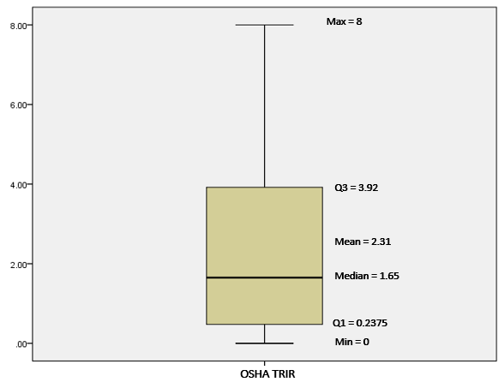
Figure 5: OSHA TRIR Box-plot

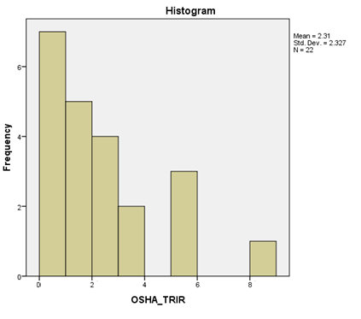
Figure 6: OSHA TRIR Histogram

OSHA DART
Of the 30 respondents, 24 replied to this question, while 6 had missing answers. The maximum DART recorded was 6, while the minimum was 0. The average score for the 24 responses was 1.084. Table 16 shows the frequencies of the DART scores.

Table 16: OSHA DART Frequencies
Number | Answer | Responses | Percent
1 | DART= 0 | 12 | 50.00%
2 | 0< DART <2 | 8 | 33.33%
3 | 2≤ DART <5 | 3 | 12.50%
4 | DART≥ 5 | 1 | 4.17%
Total |  | 24 | 100.00%

Figures 7 and 8 show the box-plot and histogram (respectively) of the OSHA DART scores of the 24 respondents for this question. The box-plot shows the full range of variation the OSHA DART data. It displays maximum and minimum values, quartiles (including the median) and any outliers, these elements are labeled in Figure 7. Both the boxplot and the histogram show that the distribution of the DART scores is right-skewed, and shows some one upper mild outliers with a DART score of 6. The median is 0.16, while the mean is 1.08. The difference between the mean and median shows some mild outliers in the data.

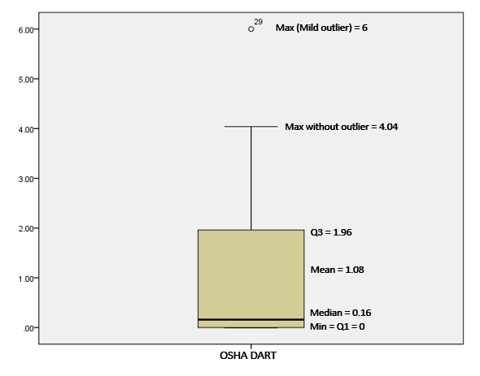
Figure 7: OSHA DART Box-Plot

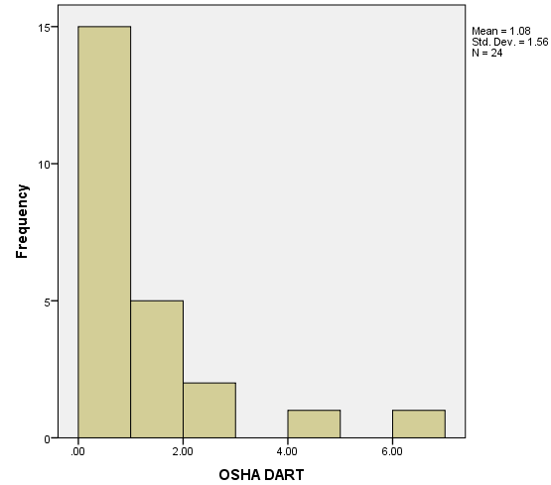
Figure 8 OSHA DART Histogram

Project Profile
- Project Sector
This differs from the company’s project sector in the previous section. It is the sector of the project for which the respondent bases his/her answers to the survey, as opposed to all sectors of company work. Again, the projects fell in different sectors of the construction industry. Five categories were provided in the survey, those being residential, commercial, infrastructure, heavy industrial and other trades. The respondents could select more than one category since a project could fall under 2 categories depending on the judgement of the respondent. For the 29 responses received, the project sector distribution was similar to that of the company. The projects were mainly commercial projects, followed by infrastructure and then heavy industrial projects as shown in the frequency histogram in Figure 9.

Figure 9: Project Sector Histogram.

- Project Delivery Method
When designing the survey questions, we wanted to see if the different type of delivery methods of the project would affect practices of safety in that project. Respondents chose between 4 types of delivery methods (see Table 17). For the 28 respondents who answered the question, the division of responses is shown in Table 17. Half of all the projects were traditional delivery methods, followed by Construction Management at 35.71% and an equal split between Design Build and Turnkey.

Table 17: Project Delivery Methods Frequencies
Number | Delivery Method | Count |  | %
1 | Traditional (Design-Bid-Build) | 14 |  | 50.00%
2 | Design Build | 2 |  | 7.14%
3 | Turn-key | 2 |  | 7.14%
4 | Construction Management | 10 |  | 35.71%
Total |  | 28 | 100%

- Project Contract Type
Respondents chose between 3 types of contracts (see Table 18). For the 28 respondents who answered the question, the majority of the projects were Lump-Sum projects at 53.57%, followed by Re-measured, and then Cost Plus.

Table 18: Project Contract Type Frequencies
Number | Contract Type | Count | %
1 | Re-measured (unit price) | 7 | 25.00%
2 | Lump-sum | 15 | 53.57%
3 | Cost Plus | 6 | 21.43%
Total |  | 30 | 100%
- Project Size
Another way to ensure that the sample is representative projects of different sizes are investigated. The project size was determined by the contract value. Of the 30 respondents, 3 had missing answers. Two respondents replied with “varies” as they were referring to the companies’ projects as a whole and not to a specific project. The range and average project size for the received responses are shown in Table 19.

Table 19: Descriptive Statistics of Project Contract Value
Item description | Value
Max Contract Price | $184,000,000
Min Contract Price | $230,000
Average Contract Price | $36,395,795

Table 19 shows that the contract price varies greatly between the different respondents. Five respondents had contract value of less than $1M, 5 responses between $1M and $10M, 14 respondents between the $10M and $100M contract value, while the remaining respondent was over the $100M contract value.
- Approximate Percentage of Project Completion
This question aimed to understand if the projects under investigation were completed, at advanced stages or just starting. Twenty-seven respondents answered this question. Two respondents replied with “varies” as they were referring to the companies’ projects as a whole and not to a specific project. There were 4 projects completed, 10 that were less than 50% completed and 11 that were more than 50% completed but not fully completed.
- Project Status in Terms of Budget and Schedule
The purpose of this question is to understand whether the projects investigated were on schedule, behind schedule, or ahead of schedule, and whether they are over budget, under budget or on budget. Twenty-six respondents answered this question while 4 had missing answers. Three respondents replied with “varies” as they were referring to the companies’ projects as a whole and not to a specific project. Table 20 describes the division of the projects amongst the 23 projects that did provide a specific budget and schedule status.

Table 20: Project Status (by Schedule and Budget) Frequencies
Below Budget
Ahead of Schedule | 11.54% | 3
Behind Schedule | 0.00% | 0
On Schedule | 11.54% | 3
Over Budget
Ahead of Schedule | 3.85% | 1
Behind Schedule | 0.00% | 0
On Schedule | 3.85% | 1
On Budget
Ahead of Schedule | 11.54% | 3
Behind Schedule | 7.69% | 2
On Schedule | 38.46% | 10
Total
Ahead of Schedule | 30.4% | 7
Behind Schedule | 8.7% | 2
On Schedule | 60.9% | 14

Of the 14 projects that were on schedule, 10 were also on budget. Seven projects were ahead of schedule, 3 of which were below budget, 3 on budget and 1 over budget. And the 2 projects that are behind of schedule were on budget.
- Number of Safety Managers in the Project
The number of safety managers and the ratio to the number of field workers could be an important indicator of safety practices implemented on site. Respondents were asked the number of safety managers on site and the number of field workers, and the ratio was then calculated. The number of respondents who answered this question was 27. The maximum number of safety managers was 5 while the minimum was 0, and the average was 1 safety manager.
The number of sites with zero safety managers was 9 (33% of obtained responses. This figure could be alarming and will trigger further investigation. The ratio of safety managers to number of field workers might be a more accurate measure considering the variation in the size of projects and employees involved. The maximum ratio was 0.667, so 2 managers for every 3 workers, which seems very high. The lower end for those who had more than zero safety managers included ratios as low as 0.0045, so less than one manager per 100 workers, and 0.167.

Section II: Safety Indicators
This section aims to find trends in descriptive data, means and variations in the different parts of section 2 of the survey. The section mostly consists of Likert scale questions with a scale of 1 for ‘Strongly Disagree’ to 5 for ‘Strongly Agree’. The mean and standard deviation were used to describe central tendency and variability respectively.

Category A: Company’s Strategy for Safety Management
The questions of category A reflect different aspects of the strategy of the company for safety management. Questions A.1.1 and A.1.2 indicate the familiarity of the respondent with leading indicators. Though some respondents might have answered that their company does employ leading indicators, this could be contradicted in the rest of the questions thereby showing a poor understanding of leading indicators. On the other hand, if one respondent replied that the company does not employ leading indicators, this could reflect poor knowledge of the concept if the rest of the survey questions showed that the company does in fact use leading indicators. The rest of section A covers safety strategies, policies, as well as staffing techniques. It is important to note that all questions in this section are passive leading indicators.
Results for Scale Questions in Category A
The results of the scale questions are summarized in Table 21. Figure 10 is a bar graph of the category question averages. Table 21 and Figure 10 show important trends regarding Category A indicators.
- In question A.1.1 respondents were required to state if their companies employ the concept of leading indicators:
  - In total 69% agree or strongly agree that their companies use leading indicators;
  - 13.8% say they do not know;
  - A total of 17.2% disagree or strongly disagree to the use of these indicators.
- Question A.1.2 assesses respondents’ familiarity with the concept of leading indicators and 20.6% of the respondents disagreed or strongly disagreed that they are familiar with the concept. Another 10.3% said they do not know while 69% agreed with familiarity. It is important to note that the answer ‘Do Not Know/No Opinion’ in this case can be considered an indication to lack of familiarity with the concept, which means over 30% of the respondents did not know what leading indicators are.
- For the rest of the scale questions the answers are highly consistent. This agreement is indicated in section 4.1.1 in the reliability measures. Questions A.1.3 through A.2.2 scored a mean of over 4 for all the respondents. This indicates that on average the respondents agree that they employ leading indicators related to safety strategies and staffing.
Table 21: Category A Responses Frequencies and Descriptive Statistics
Sub-Category | Question | Count | Answer | 1 | 2 | 3 | 4 | 5 | Mean | St. Dev.
A.1. Strategies and Policies | A.1.1. | 29 | Count | 3 | 2 | 4 | 6 | 14 | 3.897 | 1.348
A.1. Strategies and Policies |  |  | % | 10.3% | 6.9% | 13.8% | 20.7% | 48.3%
A.1. Strategies and Policies | A.1.2. | 29 | Count | 5 | 1 | 3 | 4 | 16 | 3.862 | 1.525
A.1. Strategies and Policies |  |  | % | 17.2% | 3.4% | 10.3% | 13.8% | 55.2%
A.1. Strategies and Policies | A.1.3. | 30 | Count | 1 | 1 | 0 | 1 | 27 | 4.733 | 0.892
A.1. Strategies and Policies |  |  | % | 3.3% | 3.3% | 0.0% | 3.3% | 90.0%
A.1. Strategies and Policies | A.1.4. | 30 | Count | 0 | 3 | 1 | 3 | 23 | 4.533 | 0.957
A.1. Strategies and Policies |  |  | % | 0.0% | 10.0% | 3.3% | 10.0% | 76.7%
A.1. Strategies and Policies | A.1.5. | 30 | Count | 0 | 0 | 2 | 5 | 23 | 4.700 | 0.586
A.1. Strategies and Policies |  |  | % | 0.0% | 0.0% | 6.7% | 16.7% | 76.7%
A.2. Staffing for Safety | A.2.1. | 30 | Count | 0 | 3 | 1 | 6 | 20 | 4.433 | 0.955
A.2. Staffing for Safety |  |  | % | 0.0% | 10.0% | 3.3% | 20.0% | 66.7%
A.2. Staffing for Safety | A.2.2. | 30 | Count | 6 | 0 | 0 | 2 | 22 | 4.133 | 1.586
A.2. Staffing for Safety |  |  | % | 20.0% | 0.0% | 0.0% | 6.7% | 73.3%

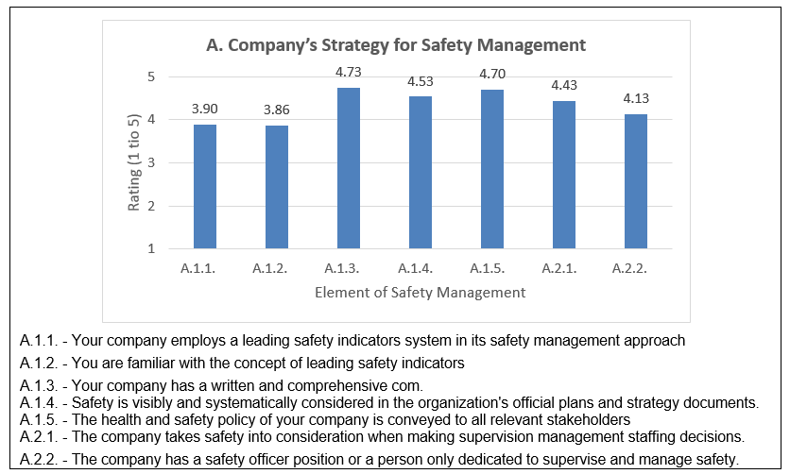
Figure 10: Category A Indicators Averages Bar Graph

Composite variable A is computed into a single variable by calculating the mean for the 7 questions scale questions above, as shown in Table 22. The composite variable ‘Group A’ represents Company’s Strategy for Safety Management. Since the category had a mean of 4.34. This shows that most respondents do have strategic safety management and implement leading indicators that fall under this category.
Table 22: Descriptive Statistics of Composite Variable A
 |  |  | Statistic | Comments
 | Mean |  | 4.3362 | The average indicates higher percent of respondents having agree/strongly agree answers as compared to the negative side of the scale
 | 95% Confidence Interval for Mean | Lower Bound | 3.9879
 | 95% Confidence Interval for Mean | Upper Bound | 4.6845
 | Median |  | 4.8286 | Half of the responses are around the strongly agree
 | Std. Deviation |  | .93272 | Responses show variation under 1 within the scale
 | Skewness |  | -1.507 | Indicators of non-normality, confirmed with Shapiro Wilk Normality Tests
 | Kurtosis |  | 1.298

Test for Normality for Scale Questions of Section A
In order to do further statistical analysis such as comparison of proportions (using t-test or other non-parametric tests), the normality of the data needs to be tested. This is done using the Shapiro-Wilk test as shown in Table 23.

Table 23: Shapiro Wilk Test for Normality for Category A
 | Shapiro-Wilk
 | Statistic | df | Sig.
A.1.1. | .779 | 29 | .000
A.1.2. | .718 | 29 | .000
A.1.3. | .340 | 29 | .000
A.1.4. | .544 | 29 | .000
A.1.5. | .567 | 29 | .000
A.2.1. | .610 | 29 | .000
A.2.2. | .553 | 29 | .000

The significance of the Shapiro-Wilk test was very small in all questions (σ < 0.05) which shows that the responses for all these questions are not normally distributed.
Results for the Open Questions of Category A
This category had 3 open (non-scale) questions that aimed to understand the incorporation of certain indicators in the company’s safety strategies and management. Descriptive statistics for these questions are shown in Tables 24, 25 and 26.

Table 24: Safety Budget Responses and Descriptive Statistics
A.1.6. - Is there a safety budget in your company? If yes how much?
Number of Responses | 22
Responses with "zero safety budget" | 7
Responses with "unknown safety budget" | 7
Maximum Budget | $1,900,000.00
Minimum Budget | $0
Mean | $190,769.23
Mean for respondents with non-zero budget | $ 413,333.33

The maximum safety budget was $1,900,000, while the minimum was zero. Seven responses were unknown. For those who provided non-zero budgets for safety, the budgets ranged between $15,000 and $1.9M, with an average of around $413,000.
For Sub-category A.2: Staffing for safety, the open type questions were concerned with the certification of the personnel for safety. Questions A.2.3 and A.2.4 required the respondent to provide a percentage of management personnel and field workers respectively that had OSHA certification. The distribution was as shown in Table 25.

Table 25: Management OSHA Certification Responses and Frequencies
A.2.3. -What is the number (or percent) of management personnel with OSHA certification cards?
Number of responses | 29
Response | Number | Percent
0% of Management with OSHA certification | 2 | 6.90%
Over 0% and under 50% of personnel have OSHA certification cards | 9 | 31.03%
50% to under 100% of personnel have OSHA certification cards | 12 | 41.38%
100% of management personnel have OSHA certification cards | 6 | 20.69%

The majority of all respondents have more than half of their management personnel certified with OSHA cards, and 31.03% have 50% or less of their personnel certified, and 6.9% of had none of their management personnel OSHA certified. The same question is asked about the certification of field workers in Question A.2.4. The response divisions and frequencies are shown in Table 26.

Table 26: Field Workers’ OSHA Certification Responses and Frequencies
A.2.4. - What is the number or percent of field workers with OSHA certification cards?
Number of Responses | 28
Response | Number | Percent
Unknown | 2 | 7.14%
Field workers with OSHA certification cards = 0 | 3 | 10.71%
Over 0% and under 50% of field workers have OSHA certification cards | 10 | 35.71%
50% to under 100% of field workers have OSHA certification cards | 9 | 32.14%
100% of field workers have OSHA certification cards | 4 | 14.29%

The results for this question show that 46.3% of the responses indicated that 50% or more of the field workers had OSHA cards, while an equal percent indicated that less than 50% had the certification (of which 10.7% of the respondents had none of their field workers OSHA certified).

Category B. Safety in Contract Documents and Stakeholders’ Responsibilities
Category B includes 5 sub-categories that describe how the contract and the definitions of stakeholders’ responsibilities play a role in safety. All questions of sub-category B.1, on design and contracts, relate to passive leading indicators. Subcategory B.2, on owner’s involvement, includes one passive leading indicator which is the owner’s review of the safety plan (B.2.1), while the 2 other questions relate to active leading indicators. Sub-categories B.3 and B.4 are related to the contractor and subcontractor safety management respectively. These also have a combination of active and passive leading indicators. Suppliers’ safety management covered in sub-category B.5 includes 2 passive leading indicators. In total, category B has 15 passive indicators and 3 active indicators. The responses to the questions in category B followed the distributions shown in Table 27 and Figure 11. Category B shows greater variation in responses between questions when compared to A; however, the reliability measure shows the grouping is still consistent.

Table 27: Category B Responses Frequencies and Descriptive Statistics
Sub-Category | Question | Count | Answer | 1 | 2 | 3 | 4 | 5 | Mean | St. Dev.
B.1 Contract and Design | B.1.1. | 29 | Count | 9 | 3 | 9 | 6 | 2 | 2.62 | 1.30
B.1 Contract and Design |  |  | % | 31.03% | 10.34% | 31.03% | 20.69% | 6.90%
B.1 Contract and Design | B.1.2. | 30 | Count | 7 | 3 | 11 | 7 | 2 | 2.80 | 1.22
B.1 Contract and Design |  |  | % | 23.33% | 10.00% | 36.67% | 23.33% | 6.67%
B.1 Contract and Design | B.1.3. | 30 | Count | 2 | 1 | 4 | 3 | 20 | 4.27 | 1.21
B.1 Contract and Design |  |  | % | 6.67% | 3.33% | 13.33% | 10.00% | 66.67%
B.1 Contract and Design | B.1.4. | 29 | Count | 1 | 5 | 6 | 5 | 12 | 3.76 | 1.25
B.1 Contract and Design |  |  | % | 3.45% | 17.24% | 20.69% | 17.24% | 41.38%
B.1 Contract and Design | B.1.5. | 30 | Count | 1 | 3 | 1 | 6 | 19 | 4.30 | 1.13
B.1 Contract and Design |  |  | % | 3.33% | 10.00% | 3.33% | 20.00% | 63.33%
B.1 Contract and Design | B.1.6. | 30 | Count | 0 | 2 | 1 | 6 | 20 | 4.52 | 0.88
B.1 Contract and Design |  |  | % | 0.00% | 6.67% | 3.33% | 20.00% | 68.97%
B.1 Contract and Design | B.1.7. | 29 | Count | 0 | 1 | 1 | 4 | 23 | 4.69 | 0.70
B.1 Contract and Design |  |  | % | 0.00% | 3.33% | 3.33% | 13.33% | 79.31%
B.1 Contract and Design | B.1.8. | 30 | Count | 1 | 2 | 2 | 6 | 18 | 4.31 | 1.09
B.1 Contract and Design |  |  | % | 3.33% | 6.67% | 6.67% | 20.00% | 62.07%
B.2.Owner | B.2.1. | 30 | Count | 3 | 2 | 8 | 9 | 8 | 3.57 | 1.23
B.2.Owner |  |  | % | 10.00% | 6.67% | 26.67% | 30.00% | 26.67%
B.2.Owner | B.2.2. | 30 | Count | 2 | 3 | 3 | 9 | 13 | 3.93 | 1.24
B.2.Owner |  |  | % | 6.90% | 10.00% | 10.00% | 30.00% | 43.33%
B.2.Owner | B.2.3. | 30 | Count | 4 | 4 | 6 | 6 | 10 | 3.47 | 1.41
B.2.Owner |  |  | % | 13.33% | 13.33% | 20.00% | 20.00% | 33.33%
B.3. Contractors | B.3.1. | 29 | Count | 2 | 1 | 4 | 7 | 15 | 4.10 | 1.18
B.3. Contractors |  |  | % | 6.90% | 3.45% | 13.79% | 24.14% | 51.72%
B.3. Contractors | B.3.2. | 29 | Count | 0 | 0 | 3 | 9 | 17 | 4.48 | 0.68
B.3. Contractors |  |  | % | 0.00% | 0.00% | 10.34% | 31.03% | 58.62%
B.3. Contractors | B.3.3. | 29 | Count | 0 | 0 | 2 | 4 | 23 | 4.72 | 0.58
B.3. Contractors |  |  | % | 0.00% | 0.00% | 6.90% | 13.79% | 79.31%
B.4. Sub-Contractors | B.4.1. | 29 | Count | 2 | 1 | 2 | 9 | 14 | 4.14 | 1.16
B.4. Sub-Contractors |  |  | % | 7.14% | 3.57% | 7.14% | 32.14% | 50.00%
B.4. Sub-Contractors | B.4.2. | 29 | Count | 0 | 1 | 3 | 10 | 14 | 4.32 | 0.83
B.4. Sub-Contractors |  |  | % | 0.00% | 3.57% | 10.71% | 35.71% | 50.00%
B.4. Sub-Contractors | B.4.3. | 29 | Count | 0 | 1 | 3 | 4 | 20 | 4.54 | 0.86
B.4. Sub-Contractors |  |  | % | 0.00% | 3.57% | 10.71% | 14.29% | 71.43%
B.5. Vendors/  Suppliers | B.5.1. | 29 | Count | 2 | 5 | 4 | 7 | 10 | 3.64 | 1.30
B.5. Vendors/  Suppliers |  |  | % | 7.14% | 17.86% | 14.29% | 25.00% | 35.71%
B.5. Vendors/  Suppliers | B.5.2. | 29 | Count | 7 | 2 | 3 | 9 | 7 | 3.25 | 1.50
B.5. Vendors/  Suppliers |  |  | % | 25.00% | 7.14% | 10.71% | 32.14% | 25.00%

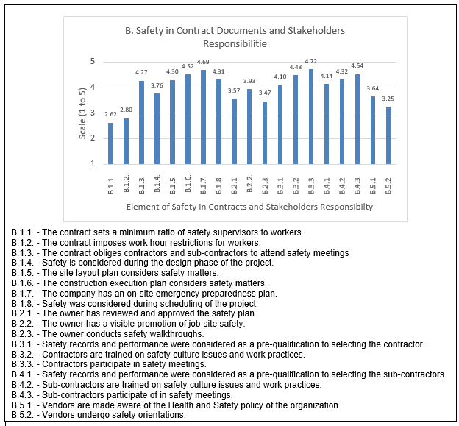
Figure 11: Category B Indicator Averages Bar Graph

For questions B.1.1 and B.1.2 the average values where 2.62 and 2.68, which means, on average, the respondents mostly disagreed or were not sure what kind of limits are set in the contract on number of supervisors to workers, or hour restrictions for workers. Question B.1.4, on the considerations of safety during the design phase, had an average of 3.64, which does not show strong evidence of majority incorporation of this passive leading indicators in the respondents’ safety management systems. Respondents answing with strongly agree for this question were 41.3% of all respondents, but sufficiently lower scale responses balanced out the mean. The rest of questions in this sub-category had average over 4, showing general agreement for the use of these passive leading indicators.
Sub-category B.2 questions consistently showed averages less than 4. For question B.2.1, related to the owner’s review and approval of the safety plan, 16.7% disagreed that the owner was involved in this process while 26.67% said they did not know. Since all the respondents were safety directors or personnel in executive positions, the answers to this sub-category indicate poor communication with the owner. Question B.2.2, related to owner’s promotion of safety, shows higher agreement on the presence of this active leading indicator compared to the other questions of this sub-category. The last question also reflects a problem with communication; in fact, the ‘Do not Know/ No Opinion’ answer makes up 20% of all responses, which might also be considered a disagreement. This goes back to the nature of the job positions held by the respondents, their lack of awareness of any owner walk-throughs could be highly indicative of their non-existence.
Sub-category B.3 questions consistently showed averages higher than 4 indicating a general agreement that contractor safety management is employed in the respondents’ companies. The same applies for sub-contractors in sub-category B.4. This trend is not the same for supplier safety management in sub-category B.5, where the questions consistently showed averages lower than 4 but higher than 3. When examined both questions have a slight majority (around 60%) of respondents agreeing that supplier safety management policies are incorporated in their companies, while the rest are dispersed with disagreement and no opinion answers.
Composite variable ‘Group B’, calculated from averaging all questions in the category, has the statistics shown in Table 28.

Table 28: Composite Variable B Descriptive Statistics
 |  |  | Statistic | Comments
 | Mean |  | 3.9451 | The average indicates more responses towards the positive side of the scale. Variablity exists
 | 95% Confidence Interval for Mean | Lower Bound | 3.6623
 | 95% Confidence Interval for Mean | Upper Bound | 4.2279
 | Median |  | 4.1345 | 2 halves of the data is around the median Agree
 | Std. Deviation |  | .75731 | The variation is not very high amongst different respondents
 | Skewness |  | -.889 | Indicators of some skewness, not sufficient to judge normality, confirmed with Shapiro Wilk Test
 | Kurtosis |  | -.165

Variable ‘Group B’ represents safety in contracts and stakeholders responsibility. Since the category had a mean of 3.94. On average, the indicators of this category are commonly used by the respondents, while variation exists.
Test for Normality for Category B
The test for normality of variables in Category B is done with Shapiro Wilk Test as shown in Table 29. The significance of the Shapiro-Wilk test was very small in all questions (σ < 0.05) indicating a non-normal distribution of the responses.

Table 29: Shapiro-Wilk Test For Normality for Category B
 | Shapiro-Wilk
 | Statistic | df | Sig.
B.1.1. | .867 | 27 | .003
B.1.2. | .891 | 27 | .008
B.1.3. | .605 | 27 | .000
B.1.4. | .842 | 27 | .001
B.1.5. | .671 | 27 | .000
B.1.6. | .650 | 27 | .000
B.1.7. | .529 | 27 | .000
B.1.8. | .718 | 27 | .000
B.2.1 | .881 | 27 | .005
B.2.2. | .816 | 27 | .000
B.2.3. | .872 | 27 | .003
B.3.1. | .741 | 27 | .000
B.3.2. | .733 | 27 | .000
B.3.3. | .544 | 27 | .000
B.4.1. | .757 | 27 | .000
B.4.2. | .792 | 27 | .000
B.4.3. | .631 | 27 | .000
B.5.1. | .863 | 27 | .002
B.5.2. | .832 | 27 | .001

Category C: Management and Supervision Commitment
Category C investigates the engagement and commitment of management and supervision to developing and encouraging a safety culture. This category has no sub-categories and consists of 4 scale questions and 1 open questions. All questions in this category relate to active leaing indicators.
Results for the Scale Questions of Category C
The answer distribution and frequency for the category are shown in Table 30 while the averages for the different questions are described in the bar graph in Figure 12.

Table 30: Category C Responses Frequencies and Descriptive Statistics
Question | Count | Answer | 1 | 2 | 3 | 4 | 5 | Mean | St. Dev.
C.1.1. | 28 | Count | 1 | 1 | 0 | 5 | 21 | 4.571 | 0.942
 |  | % | 3.57% | 3.57% | 0.00% | 17.86% | 75.00%
C.1.2. | 29 | Count | 1 | 1 | 0 | 11 | 15 | 4.357 | 0.934
 |  | % | 3.57% | 3.57% | 0.00% | 39.29% | 53.57%
C.1.3. | 29 | Count | 4 | 6 | 0 | 3 | 16 | 3.724 | 1.595
 |  | % | 13.79% | 20.69% | 0.00% | 10.34% | 55.17%
C.1.4. | 29 | Count | 1 | 0 | 1 | 5 | 21 | 4.607 | 0.969
 |  | % | 3.57% | 0.00% | 3.57% | 17.86% | 75.00%

Only question C.1.3 has an average below 4. For this question, related to management reward system to safe bahavior, there seems to be less agreement compared to other management involvement indicators. Respondents who agreed or highly agreed to the use of an award system made up 65.5%, while 34.5% disagree or strongly disagreed that this indicator is adopted. The other questions in this category show a high majority agreeing or strongly agreeing to the adoption of the respective leading indicators.
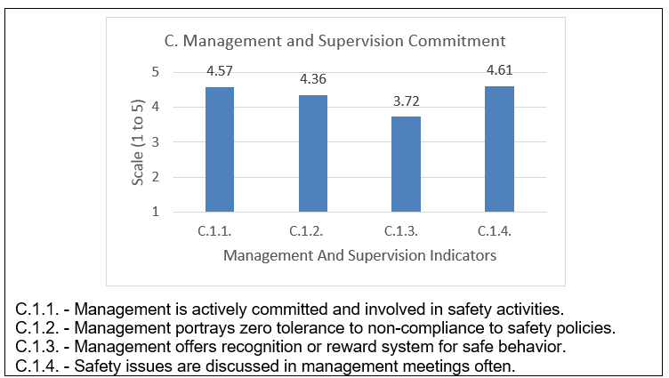
Figure 12: Category C Indicator Averages Bar Graph

The composite variable ‘Group C’, calculated from averaging all questions in the category, has the following statistics shown in Table 31.

Table 31: Composite Variable C Descriptive Statistics
 |  |  | Statistic | Comments
 | Mean |  | 4.2816 | The average shows tendency of respondents towards the positive (agree/strongly agree) side of the scale
 | 95% Confidence Interval for Mean | Lower Bound | 3.9229
 | 95% Confidence Interval for Mean | Upper Bound | 4.6403
 | Median |  | 4.7500 | 2 halves of the data is around a score closer to strongly Agree
 | Std. Deviation |  | .94292 | Variation amongst responses small
 | Skewness |  | -1.858 | Indicators of some skewness, not sufficient to judge normality, confirmed with Shapiro Wilk Test
 | Kurtosis |  | 4.038

Variable ‘Group C’ represents management and supervision commitment. Since the category had a mean of 4.28. On average, the companies’ management is committed to promoting and maintaining safety.
Test for Normality for Category C
The test for normality of variables in category D is done with Shapiro Wilk Test as shown in Table 32. The significance of the Shapiro-Wilk test was very small in all questions (σ < 0.05) which shows that the responses for all these questions are not normally distributed.

Table 32: Shapiro Wilk Test of Normality for Category C
 | Shapiro-Wilk
 | Statistic | df | Sig.
C.1.1 | .513 | 28 | .000
C.1.2 | .690 | 28 | .000
C.1.3 | .731 | 28 | .000
C.1.4 | .575 | 28 | .000

Results for the Open Questions of Category C
The open question (C.1.5) in this section aims to find the number of monthly management walk-throughs in project sites, this is another indication of the management involvement. Table 33 describes the responses for this question.

Table 33: Question C.1.5. Descriptive Statistics
C.1.5. - What is the number of monthly management walkthroughs?
 |  | Number of responses | 22
 |  | Average Monthly walk-throughs | 10
 |  | Maximum No. of walk-throughs | 50
 |  | Minimum No. of walk-throughs | 0
 | Number of Monthly Walk-throughs |  | Responses | Percent
 | 0 |  | 1 | 4.55%
 | 0 < Monthly Walk-throughs ≤ 10 |  | 15 | 68.18%
 | 10 < Monthly Walk-throughs ≤ 25 |  | 3 | 13.64%
 | Daily |  | 2 | 9.09%
 | More than Daily |  | 1 | 4.55%

The results show that 68.2% of all respondents indicated that management conducts somewhere between 1 and 10 walk-throughs each month. Only 1 company had zero walk-throughs and 3 companies had daily or more walkthroughs.

Category D: Safety Training and Orientation
Category D investigates leading indicators related to training and orientation on safety matters, the involvement of management and supervision in the training process and how well it is customized to the company and site. This category has no sub-categories and consists of 6 scale questions. All questions in this category are active leaing indicators. The answer distribtuion and frequency for the category are shown in Table 34, while the averages for the different questions are described in the bar graph in Figure 13.

Table 34: Category D Responses Frequencies and Descriptive Statistics
Question | Count | Answer | 1 | 2 | 3 | 4 | 5 | Mean | St. Dev.
D.1.1. | 30 | Count | 1 | 1 | 1 | 7 | 20 | 4.47 | 0.957
 |  | % | 3.33% | 3.33% | 3.33% | 23.33% | 66.67%
D.1.2. | 30 | Count | 3 | 3 | 4 | 10 | 10 | 3.70 | 1.295
 |  | % | 10.00% | 10.00% | 13.33% | 33.33% | 33.33%
D.1.3. | 30 | Count | 1 | 1 | 2 | 3 | 23 | 4.53 | 0.991
 |  | % | 3.33% | 3.33% | 6.67% | 10.00% | 76.67%
D.1.4. | 29 | Count | 5 | 2 | 1 | 7 | 14 | 3.79 | 1.517
 |  | % | 17.24% | 6.90% | 3.45% | 24.14% | 48.28%
D.1.5. | 30 | Count | 1 | 4 | 3 | 8 | 14 | 4.00 | 1.183
 |  | % | 3.33% | 13.33% | 10.00% | 26.67% | 46.67%
D.1.6. | 30 | Count | 3 | 4 | 4 | 5 | 14 | 3.77 | 1.407
 |  | % | 10.00% | 13.33% | 13.33% | 16.67% | 46.67%

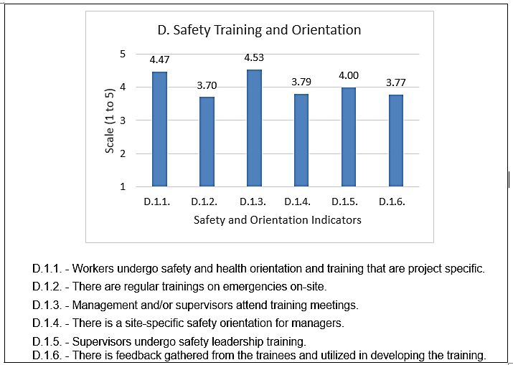
Figure 13: Category D Indicator Averages Bar Graph
Composite variable ‘Group D’ calculated from averaging all questions in the category, has the following statistics shown in Table 35. Variable ‘Group D’ represents safety training and orientation. Since the category had a mean of 4.04. On average, the companies conduct training and orientation for their workers

Table 35: Composite Variable D Descriptive Statistics
 |  |  | Statistic | Std. Error
 | Mean |  | 4.0489 | The average indicates high percentage of the responses agreeing to using this indicator
 | 95% Confidence Interval for Mean | Lower Bound | 3.6687
 | 95% Confidence Interval for Mean | Upper Bound | 4.2935
 | Median |  | 4.3333 | 2 halves of the data is around a score closer to strongly Agree
 | Std. Deviation |  | 1.01825 | Variation amongst responses small
 | Skewness |  | -.954 | Indicators of some skewness, not sufficient to judge normality, confirmed with Shapiro Wilk Test
 | Kurtosis |  | -.244
Test for Normality for Category D
The test for normality of variables in category D is done with Shapiro Wilk Test as shown in Table 36.

Table 36: Shapiro Wilk Test for Normality for Category D
 | Shapiro-Wilk
 | Statistic | df | Sig.
D.1.1 | .621 | 29 | .000
D.1.2 | .846 | 29 | .001
D.1.3 | .552 | 29 | .000
D.1.4 | .737 | 29 | .000
D.1.5 | .803 | 29 | .000
D.1.6 | .793 | 29 | .000
The significance of the Shapiro-Wilk test was very small in all questions (σ < 0.05) which shows that the responses for all these questions are not normally distributed.

Category E: Site Investigation
This category assesses indicators related to site investigations. It consists of 5 sub-categories for which the questions related to active leading indicators with exception to questions E.3.1, E.5.1, E.5.2. Those questions relating to passive indicators covered practices such as safety auditing, definitions of near miss events, and the analysis of near miss events. The category has 16 scale questions and 5 open questions in total.
Results for scale questions of Category E:
The responses to the scale questions are described in Table 37 and a bar graph of question averages is presented in Figure 14.
Sub-category E.1, related to hazard identification and corrective actions, shows high consistency in the results, with the average values all being higher than 4.5, indicating a high agreement to the use of hazard identification system, corrective actions, and clear rules for dealing with hazards. All four questions of this section had only 2 respondents who answered disagree or strongly disagree.
Sub-category E.2, related to accident investigation and follow-up, shows general agreement with averages of 4.52, 4.34 and 4.21 for questions 1 2 and 3 of this sub-category respectively. All three questions had 80% or more of the respondents answer agree or strongly agree, showing popularity of accident investigation and follow-up indicators. The question regarding the root-cause analysis of the accidents (E.2.3) had more disagreement with almost 14% of the respondents believing that their companies do not conduct this analysis.
Sub-category E.3, related to safety audits, seem to shows less consistency amongst its 3 questions. While question E.3.1, related to the existence of safety audit system, has an average of 4.04 and 75% with agree or strongly agree answers. The other two questions show lower averages at around 51% of the respondents using safety score indicators and 57% having contractors participate in safety audits. Greater number of respondents appear on the lower end of the scale and at the ‘Do not know/No opinion’ for these two questions.
Sub-category E.4, related to workers’ observations, had 4 questions showing consistency at an average higher than 4, with the exception of indicator E.4.2. This question is related to the recording and evaluation of workers’ observations, and it had an average score of 3.3 with 51% of the respondents at the higher end of the scale, 20.1% answering ‘Do not know/No Opinion’ and over 17% disagreeing.
Sub-category E.5 assesses the use of near miss events amongst the respondents. Following the literature, the agreement is split on the use of near miss indicators as part of the safety program of the company. This is reflected with lower averages than the rest of this category, and a smaller majority agreeing to the use of indicators related to near miss events.
The composite variable ‘Groupe E’ was calculated from averaging all questions in the category, and has the following statistics shown in Table 38.

Table 38: Composite Variable E Descriptive Statistics
 |  |  | Statistic | Comments
 | Mean |  | 4.0909 | The average indicates high percentage of the responses agreeing to using this indicator
 | 95% Confidence Interval for Mean | Lower Bound | 3.7494
 | 95% Confidence Interval for Mean | Upper Bound | 4.4323
 | Median |  | 4.3333 | 2 halves of the data is around a score closer to Agree
 | Std. Deviation |  | .89772 | Variation amongst responses small
 | Skewness |  | -1.461 | Indicators of some skewness, not sufficient to judge normality, confirmed with Shapiro Wilk Test
 | Kurtosis |  | 1.855
Variable ‘Group E’ represents Site Investigation. Since the category had a mean of 4.09. On average, the companies conduct site investigations and use such related indicators.

Table 37: Category E Responses Frequencies and Descriptive Statistics
Sub-Category | Question | Count | Answer | 1 | 2 | 3 | 4 | 5 | Mean | St. Dev.
E.1. Hazard Identification and Corrective Actions | E.1.1. | 29 | Count | 1 | 1 | 0 | 4 | 23 | 4.621 | 0.925
E.1. Hazard Identification and Corrective Actions |  |  | % | 3.45% | 3.45% | 0.00% | 13.79% | 79.31%
E.1. Hazard Identification and Corrective Actions | E.1.2. | 29 | Count | 1 | 1 | 0 | 4 | 23 | 4.621 | 0.925
E.1. Hazard Identification and Corrective Actions |  |  | % | 3.45% | 3.45% | 0.00% | 13.79% | 79.31%
E.1. Hazard Identification and Corrective Actions | E.1.3. | 29 | Count | 1 | 1 | 0 | 6 | 21 | 4.552 | 0.932
E.1. Hazard Identification and Corrective Actions |  |  | % | 3.45% | 3.45% | 0.00% | 20.69% | 72.41%
E.1. Hazard Identification and Corrective Actions | E.1.4. | 28 | Count | 1 | 1 | 0 | 6 | 20 | 4.536 | 0.944
E.1. Hazard Identification and Corrective Actions |  |  | % | 3.57% | 3.57% | 0.00% | 21.43% | 71.43%
E.2. Accident Investigation and Follow up | E.2.1. | 29 | Count | 0 | 1 | 2 | 7 | 19 | 4.517 | 0.771
E.2. Accident Investigation and Follow up |  |  | % | 0.00% | 3.45% | 6.90% | 24.14% | 65.52%
E.2. Accident Investigation and Follow up | E.2.2. | 29 | Count | 1 | 1 | 2 | 8 | 17 | 4.345 | 0.992
E.2. Accident Investigation and Follow up |  |  | % | 3.45% | 3.45% | 6.90% | 27.59% | 58.62%
E.2. Accident Investigation and Follow up | E.2.3. | 29 | Count | 1 | 3 | 2 | 6 | 17 | 4.207 | 1.156
E.2. Accident Investigation and Follow up |  |  | % | 3.45% | 10.34% | 6.90% | 20.69% | 58.62%
E.3. Safety Audits | E.3.1. | 28 | Count | 2 | 4 | 1 | 5 | 16 | 4.036 | 1.349
E.3. Safety Audits |  |  | % | 7.14% | 14.29% | 3.57% | 17.86% | 57.14%
E.3. Safety Audits | E.3.2. | 29 | Count | 4 | 5 | 5 | 5 | 10 | 3.414 | 1.451
E.3. Safety Audits |  |  | % | 13.79% | 17.24% | 17.24% | 17.24% | 34.48%
E.3. Safety Audits | E.3.3. | 28 | Count | 3 | 5 | 4 | 4 | 12 | 3.607 | 1.448
E.3. Safety Audits |  |  | % | 10.71% | 17.86% | 14.29% | 14.29% | 42.86%
E.4. Workers' Observation | E.4.1. | 29 | Count | 2 | 0 | 2 | 9 | 16 | 4.276 | 1.079
E.4. Workers' Observation |  |  | % | 6.90% | 0.00% | 6.90% | 31.03% | 55.17%
E.4. Workers' Observation | E.4.2. | 29 | Count | 4 | 4 | 6 | 9 | 6 | 3.310 | 1.316
E.4. Workers' Observation |  |  | % | 13.79% | 13.79% | 20.69% | 31.03% | 20.69%
E.4. Workers' Observation | E.4.3. | 28 | Count | 1 | 1 | 2 | 10 | 14 | 4.250 | 0.987
E.4. Workers' Observation |  |  | % | 3.57% | 3.57% | 7.14% | 35.71% | 50.00%
E.4. Workers' Observation | E.4.4. | 29 | Count | 3 | 1 | 3 | 7 | 15 | 4.034 | 1.299
E.4. Workers' Observation |  |  | % | 10.71% | 3.57% | 10.71% | 25.00% | 53.57%
E.5. Near Miss Investigation | E.5.1. | 29 | Count | 6 | 3 | 1 | 6 | 13 | 3.586 | 1.609
E.5. Near Miss Investigation |  |  | % | 20.69% | 10.34% | 3.45% | 20.69% | 44.83%
E.5. Near Miss Investigation | E.5.2. | 28 | Count | 6 | 4 | 1 | 5 | 12 | 3.464 | 1.636
E.5. Near Miss Investigation |  |  | % | 21.43% | 14.29% | 3.57% | 17.86% | 42.86%

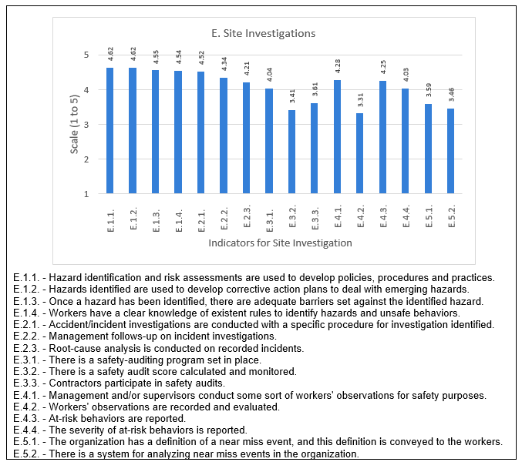
Figure 14: Category E Indicator Averages Bar Graph

Test for Normality for Category E
The test for normality of variables in category E is done with Shapiro Wilk Test as shown in Table 39. The significance of the Shapiro-Wilk test was very small in all questions (σ < 0.05) which shows that the responses are not normally distributed.

Table 39: Shapiro Wilk Test of Normality for Category E
 | Shapiro-Wilk
 | Statistic | df | Sig.
E.1.1 | .468 | 25 | .000
E.1.2 | .468 | 25 | .000
E.1.3 | .545 | 25 | .000
E.1.4 | .577 | 25 | .000
E.2.1 | .680 | 25 | .000
E.2.2 | .714 | 25 | .000
E.2.3 | .738 | 25 | .000
E.3.1 | .712 | 25 | .000
E.3.2 | .861 | 25 | .003
E.3.3 | .835 | 25 | .001
E.4.1 | .687 | 25 | .000
E.4.2 | .880 | 25 | .007
E.4.3 | .749 | 25 | .000
E.4.4 | .747 | 25 | .000
E.5.1 | .760 | 25 | .000
E.5.2 | .769 | 25 | .000
Results for the Open Questions of Category E
The open questions of this section are all related to active leading indicators. It is important to note that the number of responses for these questions was low (13 or less), with the exception of E.2.4, which received 20 responses. The responses and descriptive statistics for these questions are shown in Tables 40, 41, 42 and 43 as well as Figure 15.
Question E.2.4 asked for the percentage of incident reports on which root cause analysis is conducted. The results shown in Table 40 and Figure 15 show that 50% of the 20 respondents who answered this question said that their company conducted root cause analysis on 100% of the accidents that occur. One respondent replied with non-applicable, while the rest were equally divided between not conducting root-cause analysis, conducting it on less than 50% of the accidents, and conducting it to 50% or more but less than 100% of all accidents.

Table 40: Open Question E.2.4 Responses and Frequencies
E.2.4. - What is the percentage of incident reports on which root cause analysis was undertaken?
 | Number of responses | 20
 | % of incidents on which root analysis is conducted | Responses | Percent
 | NA | 1 | 5%
 | Percentage = 0% | 3 | 15%
 | 0 < Percentage < 50% | 3 | 15%
 | 0 ≤ Percentage < 100% | 3 | 15%
 | Percentage = 100% | 10 | 50%

Figure 15: Percent of Accidents for which Root Cause Analysis is Conducted

Question E.3.4. asked about the percentage of completed safety audits relative to the scheduled audits. Only 12 of the 30 respondents answered this question. Table 41 shows that 6 respondents conducted 100% of all scheduled audits, while 3 completed over 50% but not all the scheduled audits.

Table 41: Open Question E.3.4 Responses and Frequencies
E.3.4. - What is the percentage of audits completed as a percent of scheduled audits?
 | Number of responses | 12
 | % of audits completed as a percent of scheduled audits | Responses | Percent
 | NA | 1 | 8%
 | Percentage = 0% | 1 | 8%
 | 0 < Percentage < 50% | 1 | 8%
 | 0 ≤ Percentage < 100% | 3 | 25%
 | Percentage = 100% | 6 | 50%

Question E.3.5 asked about compliance to safety audits. Only 13 of the 30 respondents answered this question. Table 42 shows that 8 out of the 13 respondents complied to more than 50% but not to all safety audits conducted while 3 respondents had 100% safety compliance.

Table 42: Open Question E.3.5 Responses and Frequencies
E.3.5. What is the percent of safety compliance on safety audits?
 | No Responses | 13
 | % of safety compliance on audits | Responses | Percent
 | NA | 1 | 7.69%
 | 0% | 1 | 7.69%
 | Over 0% to under 50% | 0 | 0.00%
 | 50% to under a 100% | 8 | 61.54%
 | 100% | 3 | 23.08%

As for question E.4.5, related to the number of monthly workers’ observations, Table 43 shows that for the 13 respondents for this question, the average number of monthly worker observations was 55, with a maximum of 200 monthly observations and a minimum of zero.

Table 43: Open Question E.4.5 Responses.
E.4.5. - If there is a worker observation program, what is the monthly number of Workers observations conducted?
 | Number of Responses | 13
 | Item Description | Value
 | No. of responses with zero monthly workers observations | 2
 | No. of responses who answered Non-Applicable | 2
 | Maximum No. of monthly workers observations | 200
 | Min No. of monthly workers observations | 0
 | Average monthly number of Workers observations | 55.3

Question E.5.3, related to reporting of near misses, had the lowest response rate with only 9 responses. Although answers in sub-category E.5.3 showed that 17 respondents used some system to analyze near miss events, only 9 respondents answered this question. Table 44 describes the responses received for this question.

Table 44: Open Question E.5.3 Responses.
E.5.3. What is the number of near Misses reported per 200,000 h of worker exposure.
 | No. of Responses | 9
 | Item Description | Value
 | No. of responses with zero reported near misses | 3
 | No. of responses who answered Non-Applicable | 1
 | Average near misses reported | 1.5
 | Maximum number of near misses | 4

Category F: Safety Meetings
This category investigates the leading indicators related to safety meetings, their regularity, their attendance, the evaluation of their effectiveness and management involvement in them. The section included 6 scale questions and 2 open questions all of which related to active leading indicators.
Results for Scale Questions of Category F
The responses to the scale questions are described in Table 45 and the bar graph of question averages in Figure 16.

Table 45: Category F Responses Frequencies and Descriptive Statistics
Question | Count | Answer | 1 | 2 | 3 | 4 | 5 | Mean | St. Dev.
F.1.1. | 29 | Count | 0 | 1 | 1 | 2 | 25 | 4.759 | 0.677
 |  | % | 0.00% | 3.45% | 3.45% | 6.90% | 86.21%
F.1.4. | 30 | Count | 2 | 2 | 1 | 8 | 17 | 4.200 | 1.194
 |  | % | 6.67% | 6.67% | 3.33% | 26.67% | 56.67%
F.1.5. | 29 | Count | 5 | 4 | 5 | 5 | 10 | 3.379 | 1.495
 |  | % | 17.24% | 13.79% | 17.24% | 17.24% | 34.48%
F.1.6. | 29 | Count | 5 | 4 | 9 | 6 | 5 | 3.069 | 1.311
 |  | % | 17.24% | 13.79% | 31.03% | 20.69% | 17.24%
F.1.7. | 29 | Count | 4 | 5 | 7 | 4 | 9 | 3.310 | 1.417
 |  | % | 13.79% | 17.24% | 24.14% | 13.79% | 31.03%
F.1.8. | 30 | Count | 4 | 2 | 3 | 7 | 14 | 3.833 | 1.416
 |  | % | 13.79% | 6.90% | 10.34% | 24.14% | 48.28%

Questions in this category show some variability. F.1.1 has a high mean value of 4.76, with 93.1% of the respondents answering agree or strongly agree to the conducting regular safety meetings. As for keeping track of the attendance for these meetings (F.1.4), 25 of the 30 respondents agreed or strongly agreed that their companies employ this practice, while 1 did not know if this indicator is used, and 4 disagreed that it is used.

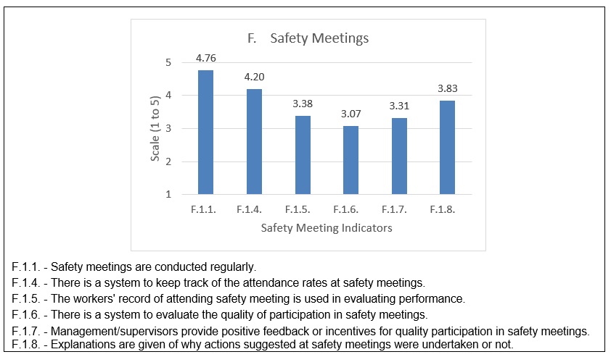
Figure 16: Category F Indicator Averages Bar Graph

The rest of the questions in this category show lower agreement on the use of the given indicators are used. F.1.5 had almost 50% of the respondents agreeing that their companies use the attendance of safety meetings to evaluate workers, while the other 50% were divided almost equally between the 3 lower ends of the scale. Question F.1.6 had a high percentage of respondents who did not know if there is an evaluation system for participation in safety meetings, these were 31% of all the respondents, while another 31% disagreed that there is such a system. Eleven of the 29 respondents for this question however did agree that this indicator is used in their companies. Question F.1.7, related to management incentives for quality participation in safety meetings, also had greater percentage of respondents on the lower end of the scale, with 21% at the ‘Do not know/No Opinion’ response, and 31% disagreeing that their companies use this indicator. F.1.8 did show a majority answering agree or strongly agree that explanations are given about the results of safety meetings, 3 respondents answered as do not know, and a total of 6 where on the disagree part of the scale.
The composite variable ‘Group F’ calculated from averaging all questions in the category, has the following statistics shown in Table 46. Variable ‘Group F’ represents safety meetings. Since the category had a mean of 3.78. This average does not show a strong direction towards the positive or negative side of the scale. On average the respondents range between those who do not know whether indicators related to safety meetings are implemented, and those who do implement it.
Table 46: Composite Variable F Descriptive Statistics
 |  |  | Statistic | Comments
 | Mean |  | 3.7783 | This average does not show a strong direction towards the positive or negative side of the scale
 | 95% Confidence Interval for Mean | Lower Bound | 3.3842
 | 95% Confidence Interval for Mean | Upper Bound | 4.1724
 | Median |  | 3.8333 | 2 halves of the data is around a score closer to Agree
 | Std. Deviation |  | 1.05543 | Variation amongst responses small
 | Skewness |  | -.970 | Indicators of some skewness, not sufficient to judge normality, confirmed with Shapiro Wilk Test
 | Kurtosis |  | .470

Test for Normality for Category F
The test for normality of variables in category F is done with Shapiro Wilk Test as shown in Table 47. The significance of the Shapiro-Wilk test was very small in all questions (σ < 0.05) which shows that the responses for all these questions are not normally distributed.

Table 47: Shapiro Wilk Test for Normality for Category F
 | Shapiro-Wilk
 | Statistic | df | Sig.
F.1.1 | .428 | 27 | .000
F.1.4 | .720 | 27 | .000
F.1.5 | .848 | 27 | .001
F.1.6 | .907 | 27 | .019
F.1.7 | .877 | 27 | .004
F.1.8 | .771 | 27 | .000

Results for the Open Questions of Category F
This category includes two open questions: F.1.2 related to the number of monthly safety meetings and F.1.3 related to the percentage of the meetings attended by management. The responses and descriptive statistics for these questions are shown in Tables 48, 49 and 50.
For question F.1.2 the average number of monthly meetings was 9.5, while the maximum was 40 meetings (that is twice a day). This is shown in Table 48.

Table 48: Open Question F.1.2 Responses
F.1.2. - What is the number of safety meetings conducted monthly?
 | Number of response | 29
 | Item Description | Value
 | Average monthly number of safety meetings | 9.5
 | Maximum No. of monthly safety meetings | 40
 | Minimum No. of monthly safety meetings | 0

As shown in Table 49, 4 respondents said they had zero safety meeting per month, while 17 respondents conducted between 1 and 10 monthly meetings, and the remaining 8 respondents conducted more than 10 monthly meetings. The number of safety meetings in this group ranged between 16 and 40.

Table 49: Question F.1.2 - Number of Safety Meetings per Month Frequencies
Number of safety meetings per month | Responses | Percent
Monthly safety meetings = 0 | 4 | 13.79%
0 < Monthly safety meetings < 10 | 17 | 58.62%
Monthly safety meetings ≥ 10 | 8 | 27.59%

For question F.1.3, related to the percent of safety meetings attended by supervisors, Table 36 shows that the majority (71%) of the respondents had all safety meetings attended by managers or supervisors, and only 2 responded with none of the meetings are attended by management.

Table 50: Open Question F.1.3 Responses and Frequencies
F.1.3. - What percent of safety meetings are attended by supervisors/ managers?
 | Number of responses | 28
 | % of all safety meetings attended by management | Responses | Percent
 | NA | 1 | 3.57%
 | Percentage = 0% | 2 | 7.14%
 | 0 < Percentage < 50% | 1 | 3.57%
 | 50% ≤ Percentage < 100% | 4 | 14.29%
 | Percentage = 100% | 20 | 71.43%

Category G: Worker’s Authorities
This category is related to authorities of workers in regards to safety. It has two sub-categories for which all questions are scale questions with distributions shown in Table 51 and the bar graph of question averages in Figure 17.

Table 51: Category G Responses Frequencies and Descriptive Statistics
Sub-Category | Question | Count | Answer | 1 | 2 | 3 | 4 | 5 | Mean | St. Dev.
G.1. Reporting of Incidents,  Accidents or Potential Hazards | G.1.1. | 30 | Count | 1 | 1 | 2 | 2 | 24 | 4.567 | 0.989
G.1. Reporting of Incidents,  Accidents or Potential Hazards |  |  | % | 3.33% | 3.33% | 6.67% | 6.67% | 80.00%
G.1. Reporting of Incidents,  Accidents or Potential Hazards | G.1.2. | 30 | Count | 2 | 2 | 9 | 11 | 6 | 3.567 | 1.086
G.1. Reporting of Incidents,  Accidents or Potential Hazards |  |  | % | 6.67% | 6.67% | 30.00% | 36.67% | 20.00%
G.1. Reporting of Incidents,  Accidents or Potential Hazards | G.1.3. | 30 | Count | 3 | 3 | 16 | 7 | 1 | 3.000 | 0.931
G.1. Reporting of Incidents,  Accidents or Potential Hazards |  |  | % | 10.00% | 10.00% | 53.33% | 23.33% | 3.33%
G.1. Reporting of Incidents,  Accidents or Potential Hazards | G.1.4. | 30 | Count | 3 | 3 | 7 | 6 | 11 | 3.633 | 1.329
G.1. Reporting of Incidents,  Accidents or Potential Hazards |  |  | % | 10.00% | 10.00% | 23.33% | 20.00% | 36.67%
G.1. Reporting of Incidents,  Accidents or Potential Hazards | G.1.5. | 30 | Count | 1 | 0 | 5 | 8 | 16 | 4.267 | 0.964
G.1. Reporting of Incidents,  Accidents or Potential Hazards |  |  | % | 3.33% | 0.00% | 16.67% | 26.67% | 53.33%
G.2. Stop Work Authority | G.2.1. | 30 | Count | 1 | 2 | 2 | 6 | 19 | 4.333 | 1.075
G.2. Stop Work Authority |  |  | % | 3.33% | 6.67% | 6.67% | 20.00% | 63.33%

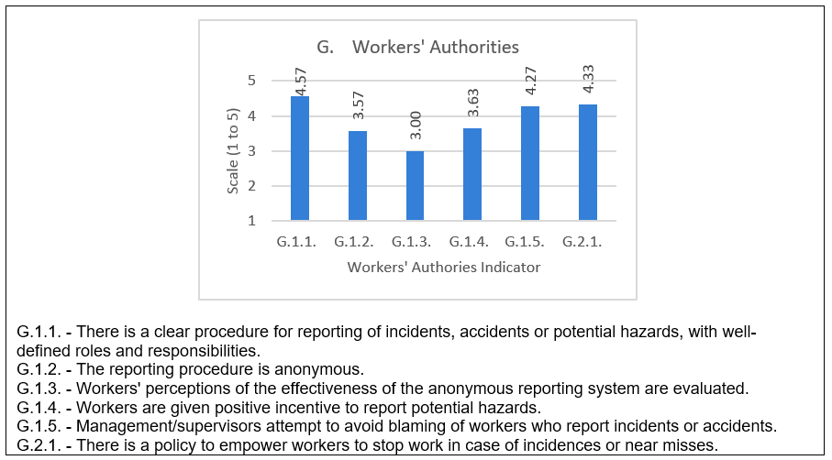
Figure 17: Category G Indicator Averages Bar Graph

Question G.1.1, which relates to a passive leading indicator, had the highest mean score compared to the rest of the questions in this category, with 86.7% of all respondents providing clear procedures to report any safety hazards, and only 2 respondents (6.67%) disagreeing to the use of this practice, and the rest answering with no opinion. Question G.1.2 was also a passive leading indicator, and had a relatively high percentage (30%) of respondents answering with no opinion on the anonymity of the reporting system. Four respondents disagreed or strongly disagreed that the reporting is anonymous. Still over 50% of the respondents either agreed or strongly agreed that the reporting in their respective companies is anonymous. Question G.1.3 is an active leading indicator with the lowest mean score of the category. A majority of 53.3% of all respondents did not know if the workers’ perception on the effectiveness of an anonymous system are evaluated, while 20% fell under the lower categories of the scale. Furthermore, question G.1.4, also an active leading indicator, shows some variability in the answers, with a majority of 56.7% agreeing or strongly agreeing that workers are given positive incentive to report hazards, but also a relatively high percentage (23%) with no opinion on the matter, while the rest said these incentives do not exist. Questions 5 and 6 of this sub-category had high mean scores, showing a majority agreement that management avoids blaming of workers who report incidents and empowers workers to stop work in cases of incidents. For question G.1.5, only 1 respondent disagreed that their company uses this indicator, while 5 respondents had no opinion on the matter. As for question G.1.6, 10% disagreed that they empower workers to stop work in case of incidents while 6.7% had no opinion on the matter.
The composite variable ‘Group G’, calculated from averaging all questions in the category, has the following statistics shown in Table 52.

Table 52: Composite Variable G Descriptive Statistics
 |  |  | Statistic | Comments
 | Mean |  | 4.2000 | The average indicates high percentage of the responses agreeing to using this indicator.
 | 95% Confidence Interval for Mean | Lower Bound | 3.8857
 | 95% Confidence Interval for Mean | Upper Bound | 4.5143
 | Median |  | 4.5000 | 2 halves of the data is around a score between Agree and Strongly Agree
 | Std. Deviation |  | .84180 | Variation amongst responses small
 | Skewness |  | -1.255 | Indicators of some skewness, not sufficient to judge normality, confirmed with Shapiro Wilk Test
 | Kurtosis |  | .973

The composite variable ‘Group G’ represents worker’s authority. Since the category had a mean of 4.2. On average the respondents implement indicators related to worker’s authority in safety matters.
Test for Normality for Category G
The test for normality of variables in category G is done with Shapiro Wilk Test as shown in Table 53.

Table 53: Shapiro Wilk Test for Normality for Category G
 | Shapiro-Wilk
 | Statistic | df | Sig.
G.1.1 | .506 | 30 | .000
G.1.2 | .885 | 30 | .004
G.1.3 | .858 | 30 | .001
G.1.4 | .854 | 30 | .001
G.1.5 | .743 | 30 | .000
G.2.1 | .671 | 30 | .000

The significance of the Shapiro-Wilk test was very small in all questions (σ < 0.05) which shows that the responses for all these questions are not normally distributed.

Category H: Substance Abuse Program
This category consists of 2 scale questions and one open question. H.1.1 is a passive leading indicator related to the existence of a substance abuse program in the company.
Results for Scale Questions of Category H:
The descriptive analysis of these questions is shown in Table 54, and the bar graph of question averages is shown in Figure 18.
Table 54: Category H Responses Frequencies and Descriptive Statistics
Question | Count | Answer | 1 | 2 | 3 | 4 | 5 | Mean | St. Dev.
H.1.1. | 30 | Count | 1 | 0 | 1 | 3 | 25 | 4.70 | 0.82
 |  | % | 3.33% | 0.00% | 3.33% | 10.00% | 83.33%
H.1.2. | 28 | Count | 4 | 1 | 1 | 5 | 19 | 4.13 | 1.36
 |  | % | 13.33% | 3.33% | 3.33% | 16.67% | 63.33%

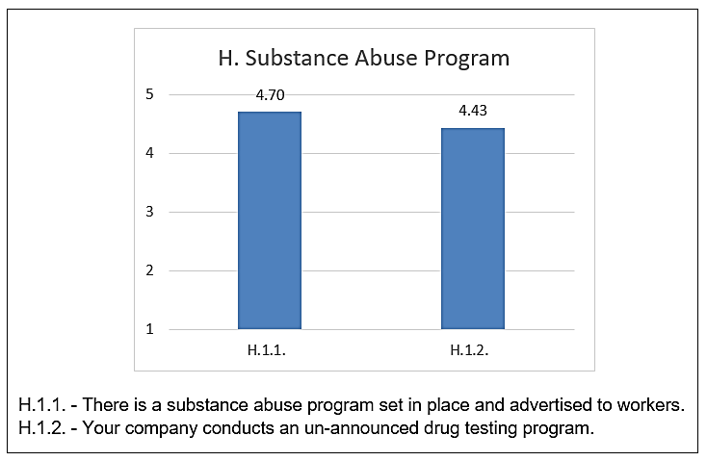
Figure 18: Category H Indicator Averages Bar Graph

Both questions (H.1.1 and H.1.2) have an average score more than 4, with H.1.1 showing less variability and a great majority of 93.3% of all respondents saying their companies have in place a substance abuse program. H.1.2 had more disagreement in relation to conducting un-announced drug testing; the question still shows a majority of respondents agreeing that their companies use this indicator.
The composite variable ‘Group H’, calculated from averaging all questions in the category, has the following statistics shown in Table 55.

Table 55: Composite Variable H Descriptive Statistics
 |  |  | Statistic | Comments
 | Mean |  | 4.5357 | The average is between Agree and Strongly Agree.
 | 95% Confidence Interval for Mean | Lower Bound | 4.2107 | The average is between Agree and Strongly Agree.
 | 95% Confidence Interval for Mean | Upper Bound | 4.8607 | The average is between Agree and Strongly Agree.
 | Median |  | 5.0000 | 2 halves of the data is around Strongly Agree
 | Std. Deviation |  | .83808 | Variation amongst responses small
 | Skewness |  | -1.950 | Indicators of high skewness and kurtosis, confirm normality test with Shapiro Wilk Test
 | Kurtosis |  | 2.939

Variable ‘Group H’ represents Substance Abuse Program. Since the category had a mean of 4.5. This indicates a strong tendency of responses towards the positive side of the scale (agree and strongly agree), then on average the respondents do implement indicators related to substance abuse.
Test for Normality for Category H
The test for normality of variables in category H is done with Shapiro Wilk Test as shown in Table 56.

Table 56: Shapiro Wilk Test for Normality for Category H
 | Shapiro-Wilk
 | Statistic | df | Sig.
H.1.1 | .421 | 30 | .000
H.1.2 | .638 | 30 | .000
The significance of the Shapiro-Wilk test was very small in all questions (σ < 0.05) which shows that the responses for all these questions are not normally distributed.
Results for the Open Question of Category H
The open question H.1.3 asked for percent of workers who have negative drug test results. There were 10 missing answers for this question. Of the 20 responses received, 3 were answered as non-applicable. All 17 responses that provided a percent for the negative drug tests showed a percentage greater than 90%, 8 of which were between 98% and 100% negative drug tests.

Category I: Housekeeping
This category investigates leading indicators related to housekeeping practices. Question I.1.1 relates to a passive leading indicator while the rest of the questions are active indicators. The responses and frequencies of the questions are shown in Table 57 and the bar graph of question averages in Figure 19.

Table 57: Category I Responses Frequencies and Descriptive Statistics
Question | Count | Answer | 1 | 2 | 3 | 4 | 5 | Mean | St. Dev.
I.1.1. | 28 | Count | 1 | 1 | 3 | 5 | 18 | 4.357 | 1.042
 |  | % | 3.57% | 3.57% | 10.71% | 17.86% | 64.29% | 4.357
I.1.2. | 27 | Count | 0 | 0 | 0 | 8 | 19 | 4.704 | 0.457
 |  | % | 0.00% | 0.00% | 0.00% | 29.63% | 70.37% | 4.704
I.1.3. | 27 | Count | 0 | 0 | 1 | 5 | 21 | 4.741 | 0.516
 |  | % | 0.00% | 0.00% | 3.70% | 18.52% | 77.78% | 4.741
I.1.4. | 28 | Count | 0 | 0 | 2 | 3 | 23 | 4.750 | 0.575
 |  | % | 0.00% | 0.00% | 7.14% | 10.71% | 82.14% | 4.750

All questions in this category show a high average score above 4. Question I.1.1 has greater variability (higher standard deviation than the rest of the questions) due to 2 responses at the disagree section of the scale and 3 respondents replying with no opinion. The rest of the questions had a great majority agreeing that they use the said indicators, all scoring at average greater than 4.7.
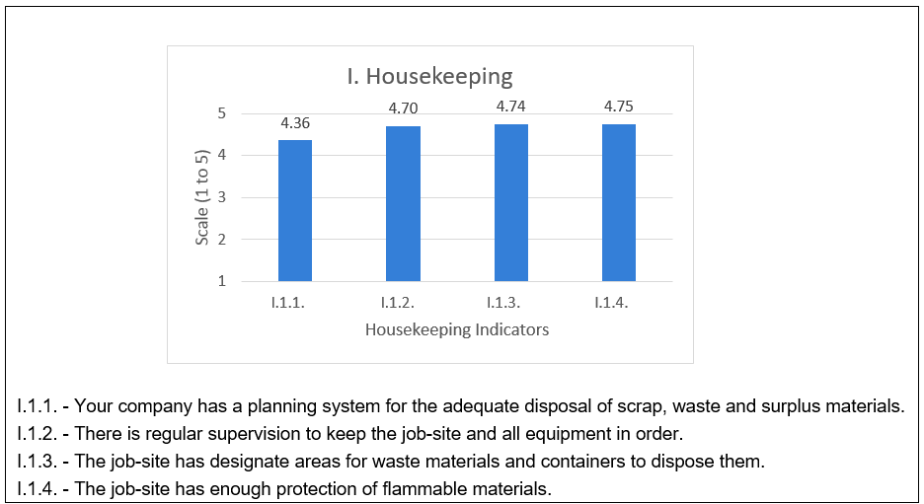
Figure 19: Category I Indicator Averages Bar Graph

The composite variable ‘Group I’, calculated from averaging all questions in the category, has the following statistics shown in Table 58.

Table 58: Composite Variable I Descriptive Statistics
 |  |  | Statistic | Comments
 | Mean |  | 4.6429 | The average indicates very high percentage of the responses agreeing to using this indicator.
 | 95% Confidence Interval for Mean | Lower Bound | 4.4429
 | 95% Confidence Interval for Mean | Upper Bound | 4.8428
 | Median |  | 5.0000 | 2 halves of the data is around Strongly Agree
 | Std. Deviation |  | .51563 | Variation amongst responses small
 | Skewness |  | -1.310 | Indicators of high skewness and some kurtosis, confirm normality test with Shapiro Wilk Test
 | Kurtosis |  | .661

The composite variable ‘Group I’ represents housekeeping on site. Since the category had a mean of 4.64. This indicates a strong tendency of responses towards the positive side of the scale (agree and strongly agree), then on average the respondents do implement indicators related to housekeeping of jobsite.
Test for Normality for Category I
The test for normality of variables in category I is done with Shapiro Wilk Test as shown in Table 59.

Table 59: Shapiro Wilk Test for Normality for Category I
 | Shapiro-Wilk
 | Statistic | df | Sig.
I.1.1 | .695 | 26 | .000
I.1.2 | .583 | 26 | .000
I.1.3 | .558 | 26 | .000
I.1.4 | .504 | 26 | .000
The significance of the Shapiro-Wilk test was very small in all questions (σ < 0.05) which shows that the responses for all these questions are not normally distributed.

Category J: Personal Protective Equipment (PPE)
This category has 2 questions one of which represents a passive leading indicator and the other an active indicator. The responses and frequencies of questions of this category are shown in Table 60 and the bar graph of question averages in Figure 20.

Table 60: Category J Responses Frequencies and Descriptive Statistics
Question | Count | Answer | 1 | 2 | 3 | 4 | 5 | Mean | St. Dev.
J.1.1. | 28 | Count | 2 | 0 | 0 | 10 | 17 | 4.379 | 1.031
 |  | % | 6.90% | 0.00% | 0.00% | 34.48% | 58.62%
J.1.2. | 27 | Count | 0 | 0 | 2 | 4 | 22 | 4.714 | 0.589
 |  | % | 0.00% | 0.00% | 7.14% | 14.29% | 78.57%

Both questions show averages greater than 4. For J.1.1, only 2 respondents said their companies do not have PPE inspection and maintenance policy, while the remaining 27 respondents agreed or strongly agreed to the existence of this policy. J.1.2 asked respondents whether management wear PPEs on site. There was high agreeability on this question with 26 respondents agreeing and only 2 having no opinion on the matter.

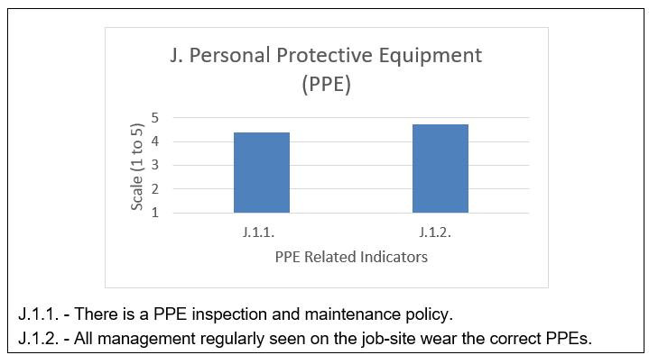
Figure 20: Category J Indicator Averages Bar Graph

The composite variable ‘Group J’, calculated from averaging all questions in the category, has the following statistics shown in Table 61. Variable ‘Group J’ represents PPE related indicators. Since the category had a mean of 4.57. This indicates a strong tendency of responses towards the positive side of the scale (agree and strongly agree), then on average the respondents do implement indicators related to PPEs.

Table 61: Composite Variable J Descriptive Statistics
 |  | Statistic | Comments
Mean |  | 4.5714 | The average indicates very high percentage of the responses agreeing to using this indicator.
95% Confidence Interval for Mean | Lower Bound | 4.2743
95% Confidence Interval for Mean | Upper Bound | 4.8686
Median |  | 5.0000 | 2 halves of the data is around Strongly Agree
Std. Deviation |  | .76636 | Variation amongst responses small
Skewness |  | -2.318 | Indicators of high skewness and kurtosis, confirm normality test with Shapiro Wilk Test
Kurtosis |  | 5.252

Test for Norrmality for Category J
The test for normality of variables in category J is done with Shapiro Wilk Test as shown in Table 62.

Table 62: Shapiro Wilk Test for Normality for Category J
 | Shapiro-Wilk
 | Statistic | df | Sig.
J.1.1 | .600 | 28 | .000
J.1.2 | .534 | 28 | .000
The significance of the Shapiro-Wilk test was very small in all questions (σ < 0.05) which shows that the responses for all these questions are not normally distributed.

Category K: Record Keeping
This category covers active leading indicators related to record keeping practices of the company. The responses and frequencies of questions of this category are shown in Table 63. The bar graph of question averages is shown in Figure 21.

Table 63: Category K Responses Frequencies and Descriptive Statistics
Question | Count | Answer | 1 | 2 | 3 | 4 | 5 | Mean | St. Dev.
K.1.1. | 29 | Count | 2 | 0 | 3 | 9 | 15 | 4.207 | 1.095
 |  | % | 6.90% | 0.00% | 10.34% | 31.03% | 51.72%
K.1.2. | 28 | Count | 2 | 1 | 5 | 6 | 14 | 4.036 | 1.210
 |  | % | 7.14% | 3.57% | 17.86% | 21.43% | 50.00%

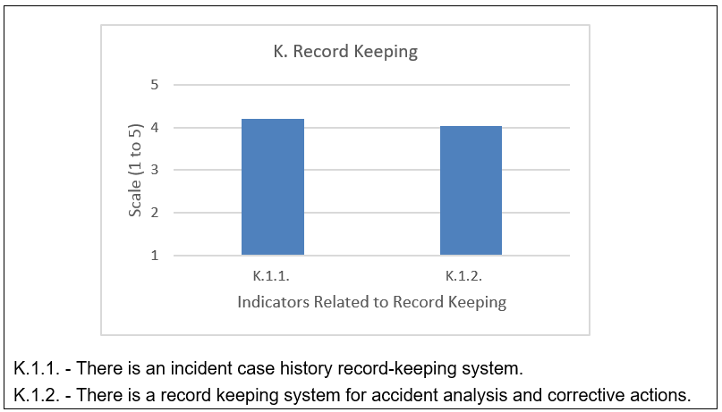
Figure 21: Category K Indicator Averages Bar Graph

Only 2 respondents strongly disagreed that their companies had incident case history record-keeping systems, 3 did not have an opinion, and a majority of 24 respondents either agreed or strongly agreed that such system exists. Accident analysis and corrective actions record keeping had slightly more variations, with 3 respondents disagreeing or strongly disagreeing that their companies use this practice, 5 respondents with no opinion on the matter, and 20 respondents thought employing this indicator.
The composite variable ‘Group K’, calculated from averaging all questions in the category, has the following statistics shown in Table 64.

Table 64: Composite Variable K Descriptive Statistics
 |  | Statistic | Comments
Mean |  | 4.1250 | The average indicates high percentage of the responses agreeing to using this indicator
95% Confidence Interval for Mean | Lower Bound | 3.6879
95% Confidence Interval for Mean | Upper Bound | 4.5621
Median |  | 4.5000 | 2 halves of the data are around a score between Agree and Strongly Agree
Std. Deviation |  | 1.12731 | Some variation amongst the respondents in the score
Skewness |  | -1.567 | Some skewness and kurtosis, non-normality confirmed with Shapiro-Wilk test.
Kurtosis |  | 2.433

Variable ‘Group K’ represents housekeeping related indicators. Since the category had a mean of 4.12. This indicates that on average the respondents do implement indicators related to PPEs.

Test for normality for Category K
The test for normality of variables in category K is done with Shapiro Wilk Test as shown in Table 65.

Table 65: Shapiro Wilk Test of Normality for Category K
 | Shapiro-Wilk
 | Statistic | df | Sig.
K.1.1 | .722 | 28 | .000
K.1.2 | .774 | 28 | .000

The significance of the Shapiro-Wilk test was very small in all questions (σ < 0.05) which shows that the responses for all these questions are not normally distributed.

Summary of Descriptive Statistics
Summary of All Indicators Descriptive Statistics
A summary of averages and standard deviations for all variables representing leading indicators in the survey is shown in Tables 66, 67 and 68. The variables that had lowest averages, thus greatest number of respondents answering ‘Disagree’ or ‘Strongly Disagree’, showing least used indicators amongst the respondents as summarized in Table 66. From this table it can be concluded that contractual safety obligations are not commonly used as safety indicators amongst the respondents. Workers’ perception of the anonymity of the safety reporting system as well as evaluation of workers’ participation in safety meetings are also uncommon leading indicators amongst respondents.

Table 66: Indicators with Lowest Average Scaled Response
Question | Indicator | N | Mean | Std. Dev.
B.1.1. | The contract sets a minimum ratio of safety supervisors to workers. | 29 | 2.62 | 1.321
B.1.2. | The contract imposes work hour restrictions for workers. | 30 | 2.8 | 1.243
G.1.3 | Workers' perceptions of the effectiveness of the anonymous reporting system are evaluated. | 30 | 3 | 0.947
F.1.6 | There is a system to evaluate the quality of participation in safety meetings. | 29 | 3.07 | 1.334

Some variables had averages that do not reflect strong evidence of common use of the indicators. These variables either exhibited almost an equal split between those who do use the indicators and those who do not, or the variables had the majority of respondents who did not know or had no opinion about the use of the indicator. These had an average score around 3 as shown in Table 67.
The variables with the lowest averages in this group come from different categories. Indicator B.5.2 related to vendor safety orientation has a low average of 3.24 and a high variability, this question had almost an equal split between respondents at the ‘Agree/Strongly Agree’ side of the sale on the one side, and the ‘Disagree/Strongly Disagree’ and ‘Do not Know/No Opinion’ options combined on the other. This shows that this indicator is not as common as other indicators amongst respondents. Other indicators in Table 43 have similar trends, with increasing averages. For instance indicator B.2.2, related to owner’s visible promotion of safety, has over 70% respondents employing this practice.

Table 67: Indicators with Mid-Range Average Scaled Response
Question Indicator | N | Mean | Std. Dev.
B.5.2. Vendors undergo safety orientations. | 29 | 3.24 | 1.527
E.4.2. Workers' observations are recorded and evaluated. | 29 | 3.31 | 1.339
F.1.7. Management/supervisors provide positive feedback or incentives for quality participation in safety meetings. | 29 | 3.31 | 1.442
F.1.5. The workers' record of attending safety meeting is used in evaluating performance. | 29 | 3.38 | 1.522
E.3.2. There is a safety audit score calculated and monitored. | 29 | 3.41 | 1.476
E.5.2. There is a system for analysing near miss events in the organization. | 28 | 3.46 | 1.666
B.2.3. The owner conducts safety walkthroughs. | 30 | 3.47 | 1.432
G.1.2. The reporting procedure is anonymous. | 30 | 3.57 | 1.251
B.2.1. The owner has reviewed and approved the safety plan. | 30 | 3.57 | 1.104
E.5.1. The organization has a definition of a near miss event, and this definition is conveyed to the workers. | 29 | 3.59 | 1.637
E.3.3. Contractors participate in safety audits. | 28 | 3.61 | 1.474
B.5.1. Vendors are made aware of the Health and Safety policy of the organization. | 29 | 3.62 | 1.321
G.1.4. Workers are given positive incentive to report potential hazards. | 30 | 3.63 | 1.351
D.1.2. There are regular trainings on emergencies on-site. | 30 | 3.7 | 1.317
C.1.3. Management offers recognition or reward system for safe behaviour. | 29 | 3.72 | 1.623
B.1.4. Safety is considered during the design phase of the project. | 29 | 3.76 | 1.272
D.1.6. There is feedback gathered from the trainees and utilized in developing the training programs | 30 | 3.77 | 1.431
D.1.4. There is a site-specific safety orientation for managers. | 29 | 3.79 | 1.544
F.1.8. Explanations are given of why actions suggested at safety meetings were undertaken or not. | 30 | 3.83 | 1.44
A.1.2. You are familiar with the concept of Leading Safety Indicators | 29 | 3.86 | 1.552
A.1.1. Your company employs a Leading Safety Indicators System in its safety management Approach | 29 | 3.9 | 1.372
B.2.2. The owner has a visible promotion of job-site safety. | 30 | 3.93 | 1.258

The variables that had an average of 4 or more are considered widely popular practices amongst all respondents. All 48 indicators presented Table 68 have high averages showing they are widely common amongst the respondents. Indicators at the lower end of the group like D.1.5 regarding supervisors safety leadership training or E.4.4 on reporting severity of at-risk behaviors, have an average around and over 70% majority agreeing or strongly agreeing that their companies employ the respective practices. Towards the higher end of the group, questions such as F.1.1 had over 90% of respondents employing that practice.
It is worthy to note that the trends of popularity of the indicators such as safety meetings, the use of PPE’s, good housekeeping, and management commitment, is expected considering the industry’s wide focus on safety, and commitment of most firms to the OSHA Act and its obligations. However, the fact that such indicators exist as part of the company’s practices and policies does not mean they are being used in the correct manner to dynamically predict and change safety performance. On the contrary, many of these indicators could be used without the familiarity of the company with the concept of leading indicators.

Table 68: Indicators with High Average Scaled Response
Indicator | N | Mean | Std. Dev
D.1.5. Supervisors undergo safety leadership training. | 30 | 4 | 1.20
E.4.4. The severity of at-risk behaviours is reported. | 29 | 4.03 | 1.32
E.3.1. There is a safety auditing program set in place. | 28 | 4.04 | 1.37
K.1.2. There is a record keeping system for accident analysis and corrective actions. | 28 | 4.04 | 1.23
B.3.1. Safety records and performance were considered as a pre-qualification to selecting the contractor. | 29 | 4.1 | 1.21
B.4.1. Safety records and performance were considered as a pre-qualification to selecting sub-contractor. | 29 | 4.1 | 1.18
A.2.2. The company has a safety officer position or a person only dedicated to supervise and manage safety. | 30 | 4.13 | 1.61
H.1.2. Your company conducts an un-announced drug-testing program. | 30 | 4.13 | 1.43
F.1.4. There is a system to keep track of the attendance rates at safety meetings. | 30 | 4.2 | 1.22
E.2.3. Root-cause analysis is conducted on recorded incidents. | 29 | 4.21 | 1.18
K.1.1. There is an incident case history record-keeping system. | 29 | 4.21 | 1.11
E.4.3. At-risk behaviours are reported. | 28 | 4.25 | 1.01
B.1.3. The contract obliges contractors and sub-contractors to attend safety meetings. | 30 | 4.27 | 1.23
B.1.8. Safety was considered during scheduling of the project. | 30 | 4.27 | 1.11
G.1.5. Management/supervisors attempt to avoid blaming of workers who report incidents or accidents. | 30 | 4.27 | 0.98
B.4.2. Sub-contractors are trained on safety culture issues and work practices. | 29 | 4.28 | 0.84
E.4.1. Management and/or supervisors conduct some sort of workers' observations for safety purposes. | 29 | 4.28 | 1.10
B.1.5. The site layout plan considers safety matters. | 30 | 4.3 | 1.15
C.1.2. Management portrays zero tolerance to non-compliance to safety policies. | 29 | 4.31 | 0.97
G.2.1. There is a policy to empower workers to stop work in case of incidences or near misses. | 30 | 4.33 | 1.09
E.2.2. Management follows-up on incident investigations. | 29 | 4.34 | 1.01
I.1.1. Your company has a planning system for the adequate disposal of scrap, waste and surplus materials. | 28 | 4.36 | 1.06
J.1.1. There is a PPE inspection and maintenance policy. | 29 | 4.38 | 1.05
A.2.1. Safety taken into consideration when making management staffing decisions. | 30 | 4.43 | 0.97
B.1.6. The construction execution plan considers safety matters. | 30 | 4.47 | 0.90
D.1.1. Workers undergo safety and health orientation and training that are project specific. | 30 | 4.47 | 0.97
B.3.2. Contractors are trained on safety culture issues and work practices. | 29 | 4.48 | 0.69
B.4.3. Sub-contractors participate of in safety meetings. | 29 | 4.48 | 0.87
C.1.4. Safety issues are discussed in management meetings often. | 29 | 4.52 | 0.99
E.2.1. Accident/incident investigations are conducted with a specific procedure for investigation identified. | 29 | 4.52 | 0.79
A.1.4. Safety is visibly/systematically considered in the organization's official plans | 30 | 4.53 | 0.97
D.1.3. Management and/or supervisors attend training meetings. | 30 | 4.53 | 1.01
E.1.4. Workers have a clear knowledge of existent rules to identify hazards and unsafe behaviours. | 28 | 4.54 | 0.96
E.1.3. Once a hazard has been identified, there are adequate barriers set against the identified hazard. | 29 | 4.55 | 0.95
C.1.1. Management is actively committed and involved in safety activities. | 28 | 4.57 | 0.96
G.1.1. There is a clear procedure for reporting of incidents, accidents or potential hazards, with well-defined roles and responsibilities. | 30 | 4.57 | 1.01
E.1.1. Hazard identification and risk assessments are used to develop policies, procedures and practices. | 29 | 4.62 | 0.94
E.1.2. Hazards identified are used to develop corrective action plans. | 29 | 4.62 | 0.94
B.1.7. The company has an on-site emergency preparedness plan. | 29 | 4.69 | 0.71
A.1.5. The Health and Safety policy is conveyed to all relevant stakeholders | 30 | 4.7 | 0.60
H.1.1. There is a substance abuse program set in place and advertised to workers. | 30 | 4.7 | 0.84
I.1.2. There is regular supervision to keep the job-site and all equipment in order. | 27 | 4.7 | 0.47
J.1.2. All management regularly seen on the job-site wear the correct PPEs. | 28 | 4.71 | 0.60
B.3.3. Contractors participate in safety meetings. | 29 | 4.72 | 0.59
A.1.3. Your company has a written and comprehensive Health and Safety Policy. | 30 | 4.73 | 0.91
I.1.3. The job-site has designate areas for waste materials and containers. | 27 | 4.74 | 0.53
I.1.4. The job-site has enough protection of flammable materials. | 28 | 4.75 | 0.59
F.1.1. Safety meetings are conducted regularly. | 29 | 4.76 | 0.69
Category Target/Composite Variables Descriptive Statistics
Table 69 summarizes the composite variables for each category and sorts them from lowest means to highest giving an indicator of which composite variable on average is most commonly used amongst the respondents and which had the most variability in responses.

Table 69: Composite Category Variables, Sorted by Ascending Mean Order
Category Variable | N | Mean | Std. Dev.
F. Safety Meetings | 30 | 3.78 | 1.055
B. Safety in Contract Documents and Stakeholders Responsibilities | 30 | 3.95 | 0.757
D. Safety Training and Orientation | 30 | 4.05 | 1.018
E. Site Investigations | 29 | 4.09 | 0.898
K. Record Keeping | 29 | 4.14 | 1.109
G. Workers' Authorities | 30 | 4.20 | 0.842
C. Management and Supervision Commitment | 29 | 4.28 | 0.943
A. Company’s Strategy for Safety Management | 30 | 4.34 | 0.933
H. Substance Abuse Program | 30 | 4.42 | 1.0346
J. Personal Protective Equipment (PPE) | 29 | 4.55 | 0.760
I. Housekeeping | 28 | 4.64 | 0.516

Indicators related to housekeeping and Personal Protective Equipment (PPE) seemed to score higher averages than the rest of the categories, followed by substance abuse programs. These three are expected to be highly popular because they are common practices in the industry and are often enforced by the law, and will be penalized if missing. Their existence could still be used to improve safety performance by altering how they are measured, observed and acted upon.
Safety meetings and contractual obligations of safety scored a lower average than the rest of the categories. In the case of category F, an interesting phenomenon is observed. While indicator F.1.1, which asks whether safety meetings are conducted regularly, scored the highest average amongst all indicators, with 93% majority saying they employ this practice, the rest of the category indicators score low. This gives an indication that while some indicators are present by nature of maturity of the safety culture in the field, they could be of no value as leading indicators if not combined with other indicators. In the case of category F, if employees participation, evaluations of feedback or involvement of management are not employed alongside of the safety meetings, the indicator could be of little value standing alone. As for category B, it seems that the companies in the local case are still lagging behind in the use of passive leading indicators in which safety is managed from the on-set of the project through contractual documents and project planning.

Estimates in Difference of Proportions: Mean Differences for Indicators in Different Respondent Groups
The comparison of means in this study aims to find any significant variations among groups of respondents. After testing for normality of all question, it was found that the data was not normally distributed and therefore an alternative to the independent sample t-test was used to investigate mean differences. The results of the tests for normality are shown in Appendix 4. The analysis was done in SPSS using Kruskal Wallis Test is a non-parametric test that shows if there is significant difference amongst the groups. SPSS also allows conducting post-hoc pairwise comparison to see if this variation is significant among certain groups and not the others. The estimates of differences are done for the company size by revenue and number of employee, in order to observe whether the size of the firm has an impact on the use of a certain leading indicator. The mean differences are also estimated for different company service categories such as owners and contractors. The analysis gave the following results:

Difference of Means between Size Groups by Annual Revenue
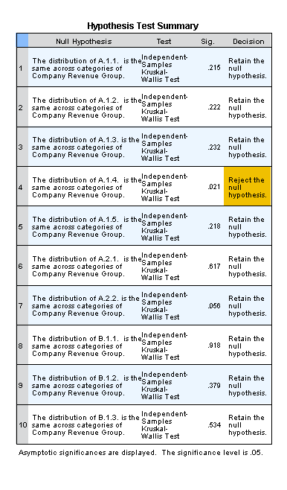
A sample of the analysis using SPSS is shown in Figures 22 and 23. This describes how significant difference between the means of different group sizes are found. Complete data analysis set is found in Appendix2.
Figure 22: Kruskal Wallis Test Result

.

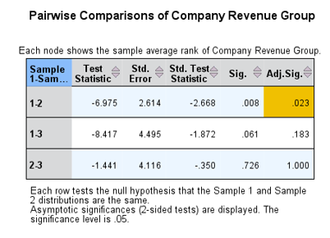
Figure 23: Pairwise Comparison in SPSS

Table 70 shows indicators with significant variation among different company revenue groups and highlights the categories for which this variation becomes significant.

Table 70: Indicators with Significant Difference in Means along Different Revenue Groups
Indicator | Description | Revenue Groups with significant difference
A.1.4 | Safety is visibly and systematically considered in the organization's official plans | Small and Medium
E.2.1 | Accident/incident investigations are conducted with a specific procedure for investigation identified. | Small and Medium
G.1.1 | There is a clear procedure for reporting of incidents, accidents or potential hazards, with well-defined roles and responsibilities. | Small and Medium
H.1.1 | There is a substance abuse program set in place and advertised to workers. | Small and Medium
H.1.2 | Your company conducts an un-announced drug-testing program. | Small and Medium

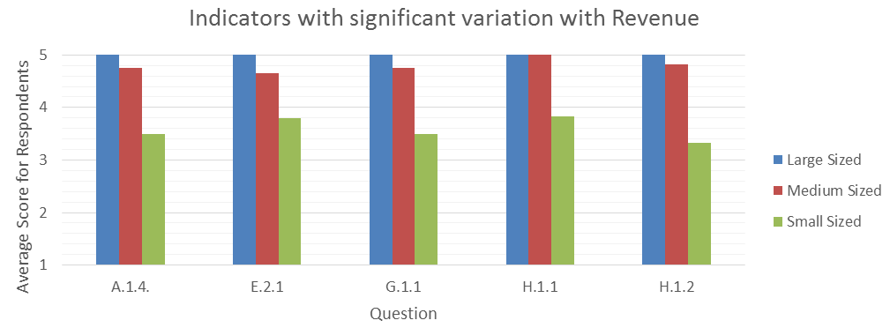
The graph in Figure 24 shows the difference in means between the different revenue groups for each of the significant indicators in Table 70. All of the significant indicators show a significant difference between small size and medium size firms. This indicates that the variation is notable when moving from small to medium size companies, but not so much when going to large sized companies

Figure 24: Indicators with Significant Difference in Means along Different Revenue Groups

Difference of Means between Size Groups by Number of Employees
Table 71 shows indicators with significant variation among different company size groups by number of employees and highlights the categories for which this variation becomes significant. The graph in Figure 25 shows the difference in means between the different employee size groups for each of the significant indicators in Table 71.

Table 71: Indicators with Significant Difference in Means along Different Employee Size Groups
Figure 25: Indicators with significant mean difference with Number of Employees
Indicator | Description | Employee Size Groups with significant difference
A.2.1 | The company takes safety into consideration when making supervision management staffing decisions. | 2 and 3
A.2.2 | The company has a safety officer position or a person only dedicated to supervise and manage safety. | 1 and 3
B.1.8 | Safety was considered during scheduling of the project. | 2 and 3
D.1.4 | There is a site-specific safety orientation for managers. | 2 and 3
E.2.2 | Management follows-up on incident investigations. | 2 and 3
E.4.1 | Management and/or supervisors conduct some sort of workers' observations for safety purposes. | 1 and 2
E.4.2 | Workers' observations are recorded and evaluated. | (1 and 3) +(2 and 3)
E.5.1 | The organization has a definition of a near miss event, and this definition is conveyed to the workers. | (1 and 3) +(2 and 3)
E.5.2 | There is a system for analyzing near miss events in the organization. | (1 and 3) +(2 and 3)
F.1.5 | The workers' record of attending safety meeting is used in evaluating performance. | 1 and 3
F.1.6 | There is a system to evaluate the quality of participation in safety meetings. | 2 and 3
F.1.8 | Explanations are given of why actions suggested at safety meetings were undertaken or not. | 2 and 3
H.1.1 | There is a substance abuse program set in place and advertised to workers. | 1 and 3
H.1.3 | Your company conducts an un-announced drug testing program. | 1 and 3
J.1.1 | There is a PPE inspection and maintenance policy. | 2 and 3

The results above show that 10 out of 14 significant indicators have significant differences between group 2 companies (50 to 49 employees) and group 3 (500-10000 employees), with larger companies scoring higher means than the medium size companies. Indicators A.2.2, H.1.1 and H.1.3 show significant difference between small companies and large companies, with significantly higher means for larger companies. E.5.1 and E.5.2 show significant difference between both small and large companies and medium and large companies. This is illustrated in the bar graph in Figure 25, where the mean for category 3 is much higher than the other two categories.

Difference of Means between Company Service Category Groups
Here the comparison is done between the responses of those in different service categories such as owners, consultants and contractors. The comparison had to be done only for those respondents who fell under one category only in order to maintain the assumption of independence for the sample tests. For this purpose, 6 responses with multiple answers were eliminated from the analysis. Similar analysis was attempted on company project sectors (residential, commercial, infrastructure, etc.), but eliminating responses with multiple answers left only few responses making independent sample mean comparisons not possible.
Table 72 shows indicators with significant variation among different company service and highlights the categories for which this variation becomes significant. The graph in Figure 26 shows the difference in means between the service groups for each of the significant indicators in Table 72.

Table 72: Indicators with Significant Difference in Means along Different Company Service Groups
Indicator | Description | Service Type Groups with significant difference
A.1.3 | Your company has a written and comprehensive Health and Safety Policy. | Consultants and (Owners + GC/GM + Others)
A.1.4 | Safety is visibly and systematically considered in the organization's official Plans | Consultants and (Owners + GC/GM + Others)
A.1.5 | The Health and Safety policy of your company is conveyed to all relevant stakeholders | Consultants and (Owners + GC/GM)
A.2.1 | The company takes safety into consideration when making supervision management staffing decisions. | Consultants and (Owners + GC/GM + Others)
A.2.2 | The company has a safety officer position or a person only dedicated to supervise and manage safety. | Consultants and (GC/GM + Others)
B.4.1 | Safety records and performance were considered as a pre-qualification to selecting sub-contractor. | Owner and others + GC/GM and Other
E.1.4 | Workers have a clear knowledge of existent rules to identify hazards and unsafe behaviors. | Owner and Consultant + GC/GM and Other + Owners and Others
E.3.1 | There is a safety auditing program set in place. | Owner and Consultant + GC/GM and Other + Owners and Others
G.1.1 | There is a clear procedure for reporting of incidents, accidents or potential hazards, with well-defined roles and responsibilities. | Consultants and (Owners + GC/GM + Others)

Figure 26: Indicators with Significant Difference in Means along Different Company Service Groups

The above results show that questions A.1.3, A.1.4, A.2.1, A.2.2, B.1.7, E.1.4, and E.3.1 have significantly lower mean scores for consultants compared to the rest of the groups. Consultants contribute to the mean differences in the rest of the questions scoring lower than one or more of the groups, for instance they scored significantly lower than owners and GC/GM, but close to other service groups in B.1.7.

Correlations and Associations
In this section, correlations are used in attempt to uncover any misconceptions or contradictions in the respondents’ understanding of leading indicators. In order to do so, the relationship between the belief of the respondent that the company implements an instituted system of leading indicators and the percent of all indicators that the company uses is examined. The first question in section 2 of the survey, A.1.1, asked the respondents if their companies implemented leading indicators, while the 73 other scale questions asked whether they implement certain practices identified in the literature review as leading safety indicators. Table 73 combines answers by the respondents that were ‘Agree’ and ‘Strongly Agree’ as a combined answer ‘Yes’, while the ‘Strongly Disagree’ and ‘Disagree’ were combined as one answer ‘No’. The Do ‘not Know/No Opinion’ option is kept unchanged. The percentages calculated in this table are the percent of the indicators that the respondent answered ‘Yes’ to as a percent from all the questions that the respondent answered. Similarly, the percentages for the ‘No’ and ‘Do not Know/No Opinion’ options are calculated.

Table 73: Respondents Answers to Question A.1.1. Vs. Cumulative Answer to All other Indicators
Respondent ID | A.1.1. | Yes | No | Do not Know/No Opinion
7 | Do not Know/No Opinion | 67.12% | 22.12% | 10.99%
12 | Do not Know/No Opinion | 84.93% | 11.09% | 4.12%
14 | Do not Know/No Opinion | 95.89% | 2.78% | 1.37%
16 | Do not Know/No Opinion | 76.71% | 8.31% | 15.09%
17 | Do not Know/No Opinion | 55.56% | 40.03% | 4.13%
1 | No | 23.29% | 53.60% | 23.46%
4 | No | 58.90% | 26.24% | 15.12%
5 | No | 32.50% | 11.01% | 26.07%
8 | No | 63.01% | 30.40% | 6.88%
21 | No | 5.48% | 57.58% | 37.28%
2 | Yes | 59.72% | 37.29% | 2.75%
3 | Yes | 90.41% | 0.00% | 9.59%
6 | Yes | 83.56% | 5.54% | 10.97%
9 | Yes | 78.08% | 2.77% | 19.19%
10 | Yes | 62.50% | 20.73% | 16.49%
11 | Yes | 93.15% | 0.00% | 6.85%
13 | Yes | 89.04% | 9.71% | 1.37%
15 | Yes | 78.57% | 0.00% | 20.55%
18 | Yes | 90.41% | 0.00% | 9.59%
19 | Yes | 98.63% | 0.00% | 1.37%
20 | Yes | 95.71% | 4.16% | 0.00%
22 | Yes | 65.75% | 24.88% | 9.62%
23 | Yes | 97.18% | 0.00% | 2.74%
24 | Yes | 87.67% | 11.09% | 1.37%
25 | Yes | 94.29% | 4.16% | 1.37%
26 | Yes | 78.08% | 4.15% | 17.82%
27 | Yes | 73.24% | 12.45% | 13.72%
28 | Yes | 92.19% | 6.94% | 0.00%
29 | Yes | 90.41% | 0.00% | 9.59%
30 | Yes | 91.67% | 1.39% | 6.85%

The important trends observed in Table 73 are as follows:
- All the respondents who answered ‘Do not Know/No Opinion’ to question A.1.1 used a high percentage of all the other indicators, with exception to respondent 17, whose company used a moderate number of the indicators (55.56% of them). Respondent 14 in particular shows an interesting figure of implementing 95.9% of all the indicators (respondent 14 answered all 73 questions with no missing data).
- Amongst the respondents who answered ‘No’ to implementing a system of leading indicators, one used a very low percentage (5.48%) of all indicators, which complies with their answer to A.1.1. Another two respondents’ answers also show relatively low percentages on the ‘Yes’ side (respondent 1 with 23% indicators used, and respondent 5 with 32% indicators used), which also complies with their answer to A.1.1. Conversely, two respondents (4 and 8) do give relatively high percentages of the indicators being used in their companies (58.90% and 63.01% respectively). Thus, despite the lack of an instituted system of leading indicators for these 2 respondents, they still used a large percent of those leading indicators.
The analysis above gives an indication that some indicators are used in companies regardless of their understanding or their official adoption of a system of leading indicators. For the purpose of further investigation, a correlation is tested between the first variable (A.1.1) relating to the company’s formal use of a system of leading indicators, and the rest of the survey questions which represent all the safety practices identified in the literature as safety indicators. In order to do so, the questions are re-coded into a 3 point scale of Yes, No and Do not Know (DK=0, N=1, and Y=2). The ‘Yes’ answers combined those who answered ‘Agree’ and ‘Strongly Agree’, and ‘No’ combined those who answered ‘Disagree’ and ‘Strongly Disagree’, while the ‘Do not Know/No Opinion’ answer was kept unchanged. This was done because we are concerned with a correlation between those who believe they do use leading indicators and implement the practices, versus those who do not; the degree of their agreement adds little to this information.
Category A: Company’s Strategy for Safety Management
The Kendall Tau Correlation test conducted for Category A variables to test correlation with Question A.1.1 is shown in Table 74.

Table 74: Kendall Tau Correlation Test Category A Variables with A.1.1
Indicator/Safety Practice | A.1.2. | A.1.3. | A.1.4. | A.1.5. | A.2.1. | A.2.2.
Correlation Coefficient | .821* | .209 | .303 | .245 | .385* | .415*
Sig. (2-tailed) | .000 | .248 | .090 | .166 | .031 | .022
N | 29 | 29 | 29 | 29 | 29 | 29
*Significant correlation

Indicator A.1.2 is highly correlated to A.1.1, which is expected because A.1.2 asks the respondents if they are familiar with the concept of leading indicators. This means the familiarity of the respondent is highly correlated to whether or not the company implements a system of leading indicator. Moreover, Indicator A.2.1, which relates to staffing of supervision, has significant correlation to A.1.1 which indicates that the implementation of a system of leading indicators is significantly related to whether or not staffing decisions take safety into consideration. The same applies for A.2.2 on staffing safety directors or personnel, which is also correlated to A.1.1.
Indicator A.1.3 has no significant correlation to A.1.1, which shows that having an instituted system of leading indicators does not correlate to having a comprehensive written health and safety policy. Moreover, A.1.4 relating to the systematic and visible use of safety in planning, and A.1.5, which is communicating this policy to relevant stakeholders, seemed to lack correlation to having a system of leading indicators.
Category B: Safety in Contract Documents and Stakeholders Responsibilities
The Kendall Tau Correlation test conducted for Category B variables to test correlation with Question A.1.1 is shown in Table 75.

Table 75: Kendall Tau Correlation Test Category B Variables with A.1.1
Indicator/Safety Practice | B.1.1. | B.1.2. | B.1.3. | B.1.4. | B.1.5. | B.1.6. | B.1.7. | B.1.8.
Correlation Coefficient | -.086 | -.363* | 0.000 | .061 | .243 | .453* | .199 | .357*
Sig. (2-tailed) | .624 | .035 | 1.000 | .729 | .174 | .010 | .273 | .042
N | 28 | 29 | 29 | 28 | 29 | 29 | 28 | 29
Indicator/Safety Practice | B.2.1 | B.2.2. | B.2.3. | B.3.1. | B.3.2. | B.3.3.
Correlation Coefficient | -.035 | .091 | -.268 | -.132 | .258 | .089
Sig. (2-tailed) | .839 | .601 | .119 | .455 | .147 | .621
N | 29 | 29 | 29 | 28 | 28 | 28
Indicator/Safety Practice | B.4.1. | B.4.2. | B.4.3. | B.5.1. | B.5.2.
Correlation Coefficient | .254 | .475* | .327 | .178 | .152
Sig. (2-tailed) | .152 | .007 | .066 | .310 | .390
N | 28 | 28 | 28 | 28 | 28
*Significant correlation

The significant correlations in this category were mixed between positive and negative correlations. B.1.2 (The contract imposes work hour restrictions for workers.) is negatively correlated to A.1.1, this means that those who implemented a system of safety indicators, did not use this practice, while those who had no system in place used the practice. While this is counterintuitive, it is not the case for all respondents, and it only shows an expected confusion and misconception around leading indicators. Indicator B.1.6 (The construction execution plan considers safety matters.) is positively correlated to A.1.1, which means that those who implemented a system of safety indicators used this practice, while those who had no system in place did not use this practice. B.1.8 (Safety was considered during scheduling of the project.) also has a significant positive correlation. This trend is also found in B.4.2 (Sub-contractors are trained on safety culture issues and work practices) with a positive correlation to A.1.1.
Category C: Management and Supervision Commitment
The Kendall Tau Correlation test conducted for Category C variables to test correlation with Question A.1.1 is shown in Table 76. All indicators related to this category show no significant correlation to A.1.1. This means that the use of such indicators is not related to whether or not a system of leading indicators is set in place for the company.
Table 76: Kendall Tau Correlation Test Category C Variables with A.1.1
Indicator/Safety Practice | C.1.1 | C.1.2 | C.1.3 | C.1.4
Correlation Coefficient | .174 | .023 | .178 | .112
Sig. (2-tailed) | .353 | .900 | .335 | .536
N | 27 | 28 | 28 | 28
Category D: Safety Training and Orientation
The Kendall Tau Correlation test conducted for Category D variables to test correlation with Question A.1.1 is shown in Table 77.

Table 77: Kendall Tau Correlation Test Category D Variables with A.1.1
Indicator/Safety Practice | D.1.1 | D.1.2 | D.1.3 | D.1.4 | D.1.5 | D.1.6
Correlation Coefficient | .336 | .080 | .251 | .356* | .185 | .092
Sig. (2-tailed) | .060 | .644 | .158 | .050 | .289 | .598
N | 29 | 29 | 29 | 28 | 29 | 29
*Significant correlation

Only indicator D.1.4 (site-specific orientations) seems to be significantly correlated with A.1.1. While the rest of the indicators in this category such as D.1.1 (workers’ health and safety orientation), D.1.2 (Regular emergency training), D.1.3 (management attending safety meetings) D.1.5 (Supervisors safety leadership training) and D.1.6 (feedback of trainings utilized) do not seem to be correlated. This means that employing such indicators is only related to the existence of a formal leading indicator system by mere chance.
Category E: Site Investigations
The Kendall Tau Correlation test conducted for Category E variables to test correlation with Question A.1.1 is shown in Table 78.

Table 78: Kendall Tau Correlation Test Category E Variables with A.1.1
Indicator/Safety Practice | E.1.1 | E.1.2 | E.1.3 | E.1.4 | E.2.1 | E.2.2 | E.2.3 | E.3.1 | E.3.2 | E.3.3
Correlation Coefficient | .190 | .190 | .228 | .163 | .386* | .414* | .331 | .327 | .069 | .029
Sig. (2-tailed) | .302 | .302 | .216 | .385 | .032 | .021 | .065 | .077 | .696 | .871
N | 28 | 28 | 28 | 27 | 28 | 28 | 28 | 27 | 28 | 27
Indicator/Safety Practice | E.4.1 | E.4.2 | E.4.3 | E.4.4 | E.5.1 | E.5.2
Correlation Coefficient | .154 | -.012 | -.043 | -.027 | .720** | .665**
Sig. (2-tailed) | .391 | .943 | .815 | .881 | .000 | .000
N | 28 | 28 | 27 | 28 | 28 | 27
*Significant correlation

Indicators that showed significant correlation with A.1.1 were:
- E.2.1 (Accident/incident investigations are conducted with a specific procedure for investigation identified.) and E.2.2 (Management follows-up on incident investigations.)
- E.5.1 (having a definition of a near miss event, and this definition is conveyed to the workers) and E.5.2. (There is a system for analyzing near miss events in the organization).
The rest of the indicators in this category do not show correlation with having a system of leading indicators in the company.
Category F: Safety Meetings
The Kendall Tau Correlation test conducted for Category F variables to test correlation with Question A.1.1 is shown in Table 79.

Table 79: Kendall Tau Correlation Test Category F Variables with A.1.1
Indicator/Safety Practice | F.1.1 | F.1.4 | F.1.5 | F.1.6 | F.1.7 | F.1.8
Correlation Coefficient | .274 | .064 | .038 | .240 | .055 | .025
Sig. (2-tailed) | .133 | .722 | .828 | .167 | .755 | .887
N | 28 | 29 | 28 | 28 | 28 | 29

All indicators related to this category show no significant correlation to A.1.1. This means that the use of such indicators is not related to whether or not a formal system of leading indicators is set in place for the company.
Category G: Worker’s Authority
The Kendall Tau Correlation test conducted for Category G variables to test correlation with Question A.1.1 is shown in Table 80.

Table 80: Kendall Tau Correlation Test Category G Variables with A.1.1
Indicator/Safety Practice | G.1.1 | G.1.2 | G.1.3 | G.1.4 | G.1.5 | G.2.1
Correlation Coefficient | -.080 | -.004 | .206 | -.165 | .108 | .315
Sig. (2-tailed) | .653 | .982 | .234 | .337 | .531 | .075
N | 29 | 29 | 29 | 29 | 29 | 29

All indicators related to this category show no significant correlation to A.1.1. This means that the use of such indicators is not related to whether or not a system of leading indicators is set in place for the company.
Category H: Substance Abuse Program
The Kendall Tau Correlation test conducted for Category H variables to test correlation with Question A.1.1 is shown in Table 81.

Table 81: Kendall Tau Correlation Test Category H Variables with A.1.1
Indicator/Safety Practice | H.1.1 | H.1.2
Correlation Coefficient | -.069 | .218
Sig. (2-tailed) | .699 | .222
N | 29 | 29
The results show that the existence of a substance abuse program (H.1.1) and conducting un-announced drug testing (H.1.2) are very uncorrelated to the company’s use of a system of leading indicators (A.1.1).
Category I: Housekeeping
The Kendall Tau Correlation test conducted for Category I variables to test correlation with Question A.1.1 is shown in Table 82.

Table 82: Kendall Tau Correlation Test Category I Variables with A.1.1
Indicator/Safety Practice | I.1.1 | I.1.2 | I.1.3 | I.1.4
Correlation Coefficient | .200 | -.047 | -.019 | -.083
Sig. (2-tailed) | .271 | .805 | .920 | .652
N | 27 | 26 | 26 | 27

Indicators of this category also show no significant correlation with A.1.1 indicating that housekeeping practices are not correlated to employing a defined system of leading indicators.
Category J: Personal Protective Equipment
The Kendall Tau Correlation test conducted for Category J variables to test correlation with Question A.1.1 is shown in Table 83.

Table 83 Kendall Tau Correlation Test Category J Variables with A.1.1
Indicator/Safety Practice | J.1.1 | J.1.2
Correlation Coefficient | .352 | .018
Sig. (2-tailed) | .056 | .923
N | 28 | 27

The same applies to this category, whether or not the company employs a system of leading indicators is irrelevant to the use of PPE related practices
Category K: Record Keeping
The Kendall Tau Correlation test conducted for Category K variables to test correlation with Question A.1.1 is shown in Table 84.

Table 84: Kendall Tau Correlation Test Category K variables with A.1.1
Indicator/Safety Practice | K.1.1 | K.1.2
Correlation Coefficient | .397* | .258
Sig. (2-tailed) | .025 | .149
N | 28 | 27

Indicator K.1.1 (There is an incident case history record-keeping system) is correlated to A.1.1, showing that using record keeping leading indicators is significantly correlated to the existence of a formal leading indicators system in the company. The same does not apply to the other indicator of this category.
Summary of Significant Correlations
From the above analysis, it can be concluded that out of the 74 indicators represented by scale questions of the survey, only 13 variables had significant correlations to A.1.1. This is an interesting observation because it shows that there is a general state of random application of practices considered as leading indicators, without necessarily having a formal system of leading indicators set in place in the company. This lack of correlation shows that that while some companies that implement leading indicator practices have an instituted system of leading indicators, the same is not true for an equivalent number of other companies. This is consistent with the descriptive analysis discussed at the beginning of this section in Table 72.
The 13 indicators with significant correlation to A.1.1 are summarized in Table 85. Indicators that have a high positive correlation to A.1.1 show that respondents who use a formal system of leading indicators also use this practice, and vice versa, with little contradiction between the two. Indicators that had moderate positive correlation, show that on average those who have a formal system of leading indicators use this practice, and vice versa, but there exists some contradiction between the two. As for the one indicator with high negative correlation, this means that respondents who have a formal system leading indicators do not use this practice, or vice versa, and there is high contradiction between answers to A.1.1 and answer to this indicator.

Table 85: Summary of Indicators with Correlation to Question A.1.1
Indicator | % Agreement with A.1.1 | Correlation
A.1.2. - You are familiar with the concept of Leading Safety Indicators | 89.70% | High Positive Correlation
A.2.1. - The company takes safety into consideration when making supervision management staffing decisions. | 58.60% | Moderate Positive Correlation
A.2.2. - The company has a safety officer position or a person only dedicated to supervise and manage safety. | 72.40% | High Positive Correlation
B.1.2. - The contract imposes work hour restrictions for workers. | 34.50% | High Negative Correlation
B.1.6. - The construction execution plan considers safety matters. | 62.10% | Moderate Positive Correlation
B.1.8. - Safety was considered during scheduling of the project. | 58.60% | Moderate Positive Correlation
B.4.2. - Sub-contractors are trained on safety culture issues and work practices. | 55.20% | Moderate Positive Correlation
D.1.4. - There is a site-specific safety orientation for managers. | 65.50% | Moderate Positive Correlation
E.2.1. - Accident/incident investigations are conducted with a specific procedure for investigation identified. | 62.10% | Moderate Positive Correlation
E.2.2. - Management follows-up on incident investigations. | 58.60% | Moderate Positive Correlation
E.5.1. - The organization has a definition of a near miss event, and this definition is conveyed to the workers. | 79.30% | High Positive Correlation
E.5.2. - There is a system for analysing near miss events in the organization. | 75.00% | High Positive Correlation
K.1.1. - There is an incident case history record-keeping system. | 48.30% | Moderate Positive Correlation

Summary of Findings
Findings of this research based on the descriptive statistics, the difference in means analysis and the correlation analysis are summarized below.

Findings of Descriptive Statistics
- From the summary of all indicators’ descriptive data, it was found that 67% of respondents used some form of an instituted leading indicator system in their companies.
- Indicators related to contractual safety obligations (represented by Category B) were not commonly used indicators amongst the firms participating in the survey.
- Another indicators group that had high variability and low average score was category F, related to safety meetings. While indicator F.1.1, relating to conducting regular safety meetings, scored the highest average among all indicators, with 93% of the respondents using this practice, the rest of the category indicators scored low. This gives an indication that while some indicators are present by nature of maturity of the safety culture in the field, they could be of no value as leading indicators if not combined with other indicators. In the case of this category F, if employees participation, evaluations of feedback or involvement of management are not employed alongside of the safety meetings, the indicator could be of little value standing alone.
- Over 48 of the indicators scored averages above 4, showing high popularity amongst the respondents, while many others had averages around 3, showing equal splits in popularity, or indicating lack of knowledge regarding those indicators.
- On average the categories that scored highest scores, with great majority (over 80%) of respondents using the related indicators were housekeeping (Category I), PPEs (Category J) and substance abuse programs (Category H). These three practices are expected to be popular because they are common practices in the industry and are often enforced by the law. Their existence could still be used to improve safety performance by altering how they are measured, observed and handled.
- Other categories [A. Company’s Strategy for Safety Management, C. Management and Supervision Commitment, G. Workers' Authorities, K. Record Keeping, E. Site investigation and D. Safety Training and orientation] have overall averages greater than 4, which indicates that the majority of respondents implement practices described by these categories. Some exceptions of individual variables occur, such as G.1.3 representing the evaluation of workers' perceptions of the effectiveness of the anonymous reporting system, which had one of the lowest averages among the indicators. Therefore, it is important to look at the individual indicators as well as the composite categories.

Findings of Comparisons of Means
The comparison of means in this study aimed to find any significant variations among groups of respondents. The estimates of differences were done for the company size by revenue and number of employee, in order to examine whether the size of the firm has an impact the use of a certain leading indicator. The analysis gave the following results:
- Difference of Means between Size Groups By Annual Revenue
According to the findings discussed in section 4.4.1, only few of the indicators showed statistically significant difference in means between small sized and medium sized companies. The difference in means stops being significant when moving to large size companies. The indicators that varied significantly with company revenue were:
- A.1.4: Safety is visibly and systematically considered in the organization's official plans
- E.2.1: Accident/incident investigations are conducted with a specific procedure for investigation identified
- G.1.1 There is a clear procedure for reporting of incidents, accidents or potential hazards, with well-defined roles and responsibilities.
- H.1.1 There is a substance abuse program set in place and advertised to workers
- H.1.2 Your company has an un-announced drug testing program.
It is worthy to note that the 5 variables that vary significantly with company size by revenue are all related to passive leading indicators, which involve the company setting safety policies, programs and clear procedures for handling safety issue. In addition, the difference in means for the 5 variables was significant between small and medium size companies, but not between medium and large size companies. This could be attributed to the fact that setting up such policies, programs and procedures is a costly process. Small sized companies are less likely to have set aside a safety budget specifically invested to develop such policies.
- Difference of Means between Size Groups by Number of Employees
According to the findings discussed in section 4.4.2, more indicators had significant difference in means amongst company size groups when the division is done based on number of employees as opposed to division by revenue. Table 86 shows indicators with statistically significant differences in means with different size groups.

Table 86: Indicators with Significant Mean Difference with Different Company Size Groups (by Number of Employees)
Indicator | Description
A.2.1 | The company takes safety into consideration when making supervision management staffing decisions.
A.2.2 | The company has a safety officer position or a person only dedicated to supervise and manage safety.
B.1.8 | Safety was considered during scheduling of the project.
D.1.4 | There is a site-specific safety orientation for managers.
E.2.2 | Management follows-up on incident investigations.
E.4.1 | Management and/or supervisors conduct some sort of workers' observations for safety purposes.
E.4.2 | Workers' observations are recorded and evaluated.
E.5.1 | The organization has a definition of a near miss event, and this definition is conveyed to the workers.
E.5.2 | There is a system for analyzing near miss events in the organization.
F.1.5 | The workers' record of attending safety meeting is used in evaluating performance.
F.1.6 | There is a system to evaluate the quality of participation in safety meetings.
F.1.8 | Explanations are given of why actions suggested at safety meetings were undertaken or not.
H.1.1 | There is a substance abuse program set in place and advertised to workers.
H.1.3 | Your company conducts an un-announced drug testing program.
J.1.1 | There is a PPE inspection and maintenance policy.
In 10 out of the 14 indicators shown above, the significance in difference of means only becomes evident between group 2 companies (medium size with 50 to 499 employees), with group 3 companies (large size company with 500-10000 employees) with higher means observed for companies in the large size category. The difference is not statically significant between small size and medium size groups however.
- Difference of Means between Company Service Category
Here the comparison was done between respondents in different service groups such as owners, consultants and contractors. Table 87 shows indicators with significant variation amongst different company service groups. Indicators A.1.3, A.1.4, A.2.1, A.2.2, E.1.4, and E.3.1 have significantly lower mean scores for consultants compared to the rest of the groups. Consultants also show most of the trends in the rest of the questions scoring lower than one or more of the groups, for instance they scored significantly lower than owners and GC/GM, but close to other service groups in B.1.7.

Table 87: Indicators with Significant Mean Difference with Different Company Service Groups
Indicator | Description
A.1.3 | Your company has a written and comprehensive Health and Safety Policy.
A.1.4 | Safety is visibly and systematically considered in the organization's official Plans
A.1.5 | The Health and Safety policy of your company is conveyed to all relevant stakeholders
A.2.1 | The company takes safety into consideration when making supervision management staffing decisions.
A.2.2 | The company has a safety officer position or a person only dedicated to supervise and manage safety.
B.4.1 | Safety records and performance were considered as a pre-qualification to se...
E.1.4 | Workers have a clear knowledge of existent rules to identify hazards and unsafe behaviors.
E.3.1 | There is a safety auditing program set in place.
G.1.1 | There is a clear procedure for reporting of incidents, accidents or potential hazards, with well-defined roles and responsibilities.

Findings of Correlations
One important assumption that this research started with is that the concept of leading indicators is not widely understood amongst members of the construction industry. As supported by the literature, there is high confusion around the definitions of leading indicators and their use to predict and improve safety performance. It was hypothesized that, considering the known confusion around the concept, some companies might believe they employ leading indicators well while the reality of their practices reflect otherwise. On the other hand, many companies could be using practices and policies that are identified by experts as leading indicators, but due to lack of knowledge, they believe that their companies do not use such indicators. These discrepancies were highlighted by testing correlations between the existence of a formal leading indicator system in the company (represented by question A.1.1) and the use of the rest of the indicators. The analysis highlighted the following observations:
            - Respondents who were unaware of or did not use a formal system of leading indicators were not necessarily falling short in the use of practices classified as leading indicators. In fact, most of these respondents used somewhere between 58% and 80% of all indicators in the survey.
            - Correlations tested between the first variable A.1.1 and the rest of the survey showed that 61 out of the 74 leading indicators are being used with no significant correlation with whether or not the company uses a formal system of leading indicators.
The above findings confirm that there is lack of familiarity with the concept of leading indicators. Companies that use leading indicators are using them haphazardly and with no clear knowledge of how to set them up in a system in order to maximize their benefits in improving safety performance. Furthermore, these result shows that the amount of effort than needs to be exerted to introduce systems of leading indicators to unfamiliar companies should be directed towards managing existing practices. Companies need to be made aware that the system is already partly built in their companies, and only interpretations and evaluations should be introduced in a way to make these practices effective leading indicators.

Conclusions and Future Recommendations

Conclusions
The construction industry continues to witness significant advancements in commonly practiced safety management techniques. It seems that more and more companies on the national level are implementing a wide range of safety leading indicators. Existing research in the area of leading indicators in construction has mainly two purposes. First, the research is aimed at identifying leading indicators through extensive literature reviews, expert brainstorming sessions and expert based surveys, such as the work of Hallowell and Gambatese (2009). This research has created a database of all safety practices, strategies, and management techniques that experts believe would serve as dynamic predictors of future safety hazards that can be adjusted to improve safety performance. The other arm of the research aims to find out which of these leading indicators are most effective in predicting safety performance. The work of scholars such as Leveson (2014) and Hale (2009) aims to investigate what characteristics make a leading indicator the most effective. Other research such as Tomlison (2011), Rajerdan (2013) and Hinze (2009) studied national scale projects using case studies, interviews and industry surveys in attempt to correlate leading indicators to safety performance. This has resulted in rankings and thresholds defined to the most used leading indicators in the industry.
While the efforts in the academic field are extensive in defining the most effective leading indicators, trends of penetration of such practices in the local industries of the United States is still not greatly investigated. Furthermore, and as admitted by many experts in the field, there is still great confusion around definitions of leading indicators. There is lack of understanding and familiarity of what exactly these practices entail and how to optimize their use to best improve safety.
This research aimed to understand the usage trends of leading indicators in local construction firms in East and Middle Tennessee. The purpose was to investigate whether or not leading indicators are being implemented, are they well understood, and is there a trend that can be observed along different types of companies in terms of size or services.
The findings of the survey show that 66.7% of the firms investigated had an instituted system of safety indicators. Amongst these firms, 50% used over 90% of all indicators found in the survey. On the other hand, the firms that did not use or were not aware of an instituted system of leading indicators, still greatly used many of the practices. Only one firm actually used very few indicators, while the rest used over 25% of all indicators, with some respondents using as high as 75% of all indicators. This indicates, that despite being unaware of an instituted system of leading indicators, most of the firms used a significant amount of indicators. These findings confirmed that there is a significant lack of familiarity with the concept of leading in the local industry. Many of the companies that use practices defined as leading indicators seem to be using them haphazardly and with no clear knowledge of how to set them up in a system in order to maximize their benefits in improving safety performance.
From the 78 investigated indicators, 48 were popularly used by over 50% of the respondents. Twenty five indicators were used by over 80% of all respondents. The indicator categories most popular, with a majority of over 80% of respondents using them were housekeeping, use of PPE’s and substance abuse programs. On the other hands, the least popular indicators, with less than 30% of the respondents using them, were contractual safety obligations, feedback and perceptions of safety meetings, in addition to evaluations of reporting systems. From such information, it is concluded that safety indicators requiring the most focus and development are: (1) indicators related to contractual safety management and how it reflects on stakeholders and (2) indicators that use evaluations and feedback from other practices, for instance, evaluation of quality of safety meetings, or the evaluation of worker’s perception of the anonymity of the reporting system.
Furthermore, the findings of the research also show that passive leading indicators, which involve the company’s safety policies, setting in place programs and creating clear procedures for handling safety issues, were the ones that greatly varied amongst respondents with different company sizes. Larger companies seemed to have more means to invest in safety budgets and to set up such policies, programs and procedures. Smaller companies seemed to lack the use of more complex strategy and policy based indicators, but instead used straightforward and popular indicators such as use of PPEs on site and proper housekeeping. This could be attributed to the greater investment in safety budgets to set up such policies, programs and procedures. This difference implies that smaller companies who lack the means to set up safety policies and strategies should not necessarily be discouraged to embark on a system of leading indicators. Since they proved to be using many other indicators, developing those into systems that are more effective should be sufficiently beneficial. Moreover, the findings show no significant difference in practices amongst owners and contractors, but do spot differences in the practices of consultants. Consultants scored lower on indicators related to safety management and planning than other service categories, they also scored lower on indicators related to site investigation. This is another area that should be investigated in future research.

Future Recommendations
The use of safety leading indicators has been receiving growing attention and it is important to understand how the knowledge being developed in the academic field, and implemented in large scale national companies, is being adopted in smaller scale local companies. Following the efforts of this research to understand the penetration of leading indicators in local cases represented by the state of Tennessee, the following recommendations are given from the findings and limitations of this research:

5.2.1 The Scope of Work and Limitations
This research took Tennessee as a case study for local companies in the construction industry. Generalizing the survey results could be possibly done for states of similar nature, culture and industry safety performance, however this needs to be done carefully and not extended to states with less commonalities. Therefore, it is recommended that further research be done to investigate similar local and regional scales, due to the expected variations in patterns of safety culture with local industry characteristics, state economy, or other factors such as weather. Furthermore, the scope of the research was limited to the investigation of the trends of usage of leading indicators but did not study the effectiveness of the used indicators in improving safety. Thus, it is advisable for research to combine the understanding of local penetration with rankings of indicators based on effectiveness to create a database of approachable, effective, and easy to implement indicators. It is also important to note that there are several confounding factors affecting the introduction of leading indicators to any company. These can be the characteristics of the employee pool, management buy in, company’s safety records, and nature of projects (Wehle and Hinze 2009). While company size could be indicative of many of these confounding factors, future research should look into each of these factors separately and correlate them with trends of indicators use.

5.2.3 Utilizing the Findings in the Industry
The findings of this research highlighted that most local firms already use some sort of leading indicator practices regardless of having a formal awareness about the concept. Consequently, it is recommended that managers of companies and leaders of the industry utilize such findings to direct the industry to develop already popular indicators. The findings will provide safety practitioners with practical knowledge to focus their attention on safety practices they already employ in some form in their companies. Emphasis should be made on how instituted systems can be utilized without introducing radical changes to the company, so that the effort, investment and time needed to introduce such systems and policies become less intimidating. Instead of tackling leading indicators that are new, complicated and unfamiliar, local firms could introduce few changes to their currently used practices, in terms of measurement, monitoring, follow-up and evaluation to take them from routine practices to vital components of a leading indicator system.
While this research was implemented in Tennessee, its results could be applied and transferred to other neighboring states that share some commonalities in the southeast. The southeastern states share cultural influences, weather conditions, and economic size of the construction industry. Therefore, it is possible that the results can be effectively generalized to Southeastern states with similar industry characteristics. For instance, the construction industry in North Carolina has 3.5% contribution to the state’s GDP and employs 197,000 employees (AGC 2015-d), both figures being very similar to those of Tennessee relative to the population. The state had also a slightly lower but comparable rate of fatality in construction of 3.4 per 100,000 full time equivalent workers (BLS 2015). Statistics for GDP contribution, employment rates and fatality rates are also comparable in Georgia (AGC 2015-c; BLS 2015) and Alabama (AGC 2015-b; BLS 2015). Consequently, it is would be worthwhile to further investigate how similar or different the utilization of leading indicators are in these states.
Moving from the regional level, it would be worthwhile to investigate how safety practices vary in other regions of different characteristics. Providing guidelines on safety indicators’ implementation should be location specific. Hence, comparing and contrasting safety practices in other regions, such as the Northeast and Midwest, would be necessary. Such comparison would uncover latent factors affecting safety such as cultural influences, geography, weather, and nature of construction. For instance, the construction industry in New Jersey generates $22 billion of economic contribution (AGC 2016), that is twice what the industry generates in Tennessee (while employing same number of employees relative to population). New Jersey has an injury rate of 2.3 compared to Tennessee’s 3.4 (BLS 2015). There is clearly difficulty in generalizing safety culture amongst the two, which in turn drives investigation towards finding regional trends, which could be beneficial for the industry as a whole.

List of References

Aksorn, T., Hadikusumo, B.H.W. (2008). Critical success factors influencing safety program performance in Thai construction projects. Safety Science, 46(4), 709-727.
Alreck, P., & Settle, Robert B. (1995). The survey research handbook : Guidelines and strategies for conducting a survey (2nd ed.). New York: McGraw-Hill.
Al Qady, Mohammed, & Kandil, Amr. (2013). Document management in construction: Practices and opinions.(Author abstract). Journal of Construction Engineering and Management, 139(10), Journal of Construction Engineering and Management, Oct, 2013, Vol.139(10).
Ansley, F., Donaho, T., Ferraris, G., & Linge, D. Tennessee Workers: Dying for a Job. A Report on Worker Fatalities in Tennessee 2013 & 2014. Knox Area Workers’ Memorial Day Committee. Knoxville, TN.
Associated Builders and Contractors (2016). ABC 2016 Safety Performance Report:
Understanding the Impact of Step Participation on Overall Safety Performance. Washington, DC
Baker, B. O., Hardyck, C. D., & Petrinovich, L. F. (1966). Weak measurements vs. strong statistics: An empirical critique of S. S. stevens' proscriptions NN statistics. Educational and Psychological Measurement, 26(2), 291-309.
Biggs, H. C., Dinsdag, D., Kirk, P. J., & Cipolla, D. (2010). Safety culture research, lead indicators, and the development of safety effectiveness indicators in the construction sector. International Journal of Technology, Knowledge and Society, 6(3), 133-140.
Chen, Q., & Jin, R. (2013). Multilevel safety culture and climate survey for assessing new safety program. Journal of Construction Engineering and Management, 139(7), 805.

Chen, P. Y., & Popovich, P. M. (2002). Correlation: Parametric and nonparametric measures. Thousand Oaks, CA: Sage Publications
Choudhry, R. M., Fang, D., & Mohamed, S. (2007). The nature of safety culture: A survey of the state-of-the-art. Safety science, 45(10), 993-1012.
Choudhry, R., & Zahoor, H. (2016). Strengths and weaknesses of safety practices to improve safety performance in construction projects in Pakistan. Journal of Professional Issues in Engineering Education and Practice, 142(4), 401-601.

Clason, D. L., & Dormody, T. J. (1994) Analyzing data measured by individual Likert-type items. Journal of Agricultural Education, 35(4), 31- 35.
Cohen, J. (1988). Statistical power analysis for the behavioral sciences (2nd ed.). Hillsdale, NJ: Lawrence Erlbaum Associates.
Cole, J. C. (2008). How to deal with missing data. Best practices in quantitative methods, 214-238.
Construction Industry Institute (CII) (2011). Project Site Leadership Role in Improving Construction Safety 256-1. Austin, TX.
Construction Industry Institute (CII) (2012). Implementing Active Leading Indicators 284-2. Austin, TX.
Construction Industry Institute (CII) (2012). Measuring Safety Performance with Active Safety Leading Indicators 284-1. Austin, TX.
Construction Industry Institute (CII) (2014). Guidelines for Implementing a Near Miss Reporting Program 301-2. Austin, TX.
Construction Industry Institute (CII) (2014). Using Near Miss Reporting to Enhance Safety Performance 301-1. Austin, TX.
Construction Industry Institute (2015). 2012 Safety Report 2012-2. Austin, TX.
Cooper, M. D. (2000). Towards a model of safety culture. Safety Science., 36(2), 111–136.

Dasu, T., & Johnson, T. (2003). Exploratory data mining and data cleaning (Vol. 479). John Wiley & Sons.
Dillman, D. A. (1991). The design and administration of mail surveys. Annual review of sociology, 225-249.
Dingsdag, D. P., Biggs, H. C., & Sheahan, V. L. (2008). Understanding and defining OH&S competency for construction site positions: Worker perceptions. Safety Science, 46(4), 619-633. doi: 10.1061/9780784412329.155
El-Adaway, I. (2012) Sustainable Management of Infrastructure Projects: The Role of Workers' Satisfaction through Financial Loss Reduction. Construction Research Congress 2012: pp. 1540-1549.
Erdfelder, F. F., Lang, E., & Buchner, A. (2007). G*Power 3: A flexible statistical power analysis program for the social, behavioral, and biomedical sciences. Behavior Research Methods, 39, 175-191
Everett, J. G., & Jr, P. B. F. (1996). Costs of accidents and injuries to the construction industry. Journal of Construction Engineering and Management, 122(2), 158-164.
Findley, M., Smith, S., Kress, T., Petty, G., Enoch, K., (2004). Safety Program Elements in Construction. Professional Safety, 49(2), 14-21
Forest, J. J., & Kessler, K. (2013). Correlating process safety leading indicators with performance. Process Safety Progress, 32(2), 185-188.
Fowler, F. (1984). Survey research methods (Applied social research methods series v. 1). Beverly Hills: Sage Publications.
Fowler, F. (1995). Improving survey questions : Design and evaluation (Applied social research methods series ; v. 38). Thousand Oaks: Sage Publications.
Gay, L.R. & Diehl, P.L. (1992). Research Methods for Business and Management. New York: Macmillan.
Gillen, M., Goldenhar, L., Hecker, S., & Schneider, S. (2013), The Center for
Construction Research and Training. Safety Culture and Climate in Construction: Bridging the Gap Between Research and Practice. Washington DC.
Grabowski, M., Ayyalasomayajula, P., Merrick, J., & Mccafferty, D. (2007). Accident precursors and safety nets: leading indicators of tanker operations safety. Maritime Policy & Management, 34(5), 405-425.
Grabowski, M., Ayyalasomayajula, P., Merrick, J., Harrald, J. R., & Roberts, K. (2007). Leading indicators of safety in virtual organizations. Safety Science, 45(10), 1013-1043.
Guldenmund, F. (2007). The use of questionnaires in safety culture research – an evaluation. Safety Science, 45(6), 723-743.
Guo, B. and Yiu, T. (2015). Developing Leading Indicators to Monitor the Safety Conditions of Construction Projects. J. Manage. Eng., 10.1061/(ASCE)ME.1943-5479.0000376, 04015016.
Hair, J., Sarstedt, F., Ringle, M., & Mena, C. (2012). An assessment of the use of partial least squares structural equation modeling in marketing research. Journal of the Academy of Marketing Science, 40(3), 414-433.
Hale, A. (2009). Why safety performance indicators?. Safety Science, 47(4), 479-480.
Hallowell, M. R., & Gambatese, J. A. (2009). Construction safety risk mitigation. Journal of Construction Engineering and Management, 135(12), 1316-1323.
Hallowell, M., Hinze, J., Baud, K., and Wehle, A. (2013). Proactive Construction Safety Control: Measuring, Monitoring, and Responding to Safety Leading Indicators. Journal of Construction Engineering and Management 10.1061/(ASCE)CO.1943-7862.0000730, 04013010.
Hanna, Yeutter, Aoun, Love, Zhou, Matthews, Carey. (2016). State of practice of building information modeling in the electrical construction industry. 142(3), Journal of Construction Engineering and Management, 2016, 142(3).
Hill, R. (1998). What sample size is “enough” in internet survey research. Interpersonal Computing and Technology: An electronic journal for the 21st century, 6(3-4), 1-12.
Hinze, J., & Hallowell M. (2013). Construction Industry Institute . Going Beyond Zero Using Safety Leading Indicators 284-11. Austin, TX.
IBM Corp. Released 2013. IBM SPSS Statistics for Windows, Version 22.0. Armonk, NY: IBM Corp.
Institute for Work & Health (2011). Benchmarking organizational leading indicators for the prevention and management of injuries and illnesses. Toronto, Ontario.
Israel, G. D. (1992). Phases of data analysis. University of Florida Cooperative Extension Service, Institute of Food and Agriculture Sciences, EDIS.
Iyer, P. S., Haight, J. M., Del Castillo, E., Tink, B. W., & Hawkins, P. W. (2004). Intervention effectiveness research: Understanding and optimizing industrial safety programs using leading indicators. Chemical Health and Safety, 11(2), 9-19.
Jin, X. H., and Zhang, G. (2011). Modelling optimal risk allocation in PPP projects using artificial neural networks. International Journal of Project Management, 29(5), 591–603.
Kendall, M. G., & Gibbons, J. D. (1990). Rank Correlation Methods (5th ed.). London: Edward Arnold.
Kongsvik, T., Almklov, P., & Fenstad, J. (2010). Organisational safety indicators: some conceptual considerations and a supplementary qualitative approach. Safety Science, 48(10), 1402-1411.
Leveson, N. (2015). A systems approach to risk management through leading safety indicators. Reliability Engineering & System Safety, 136, 17-34.
Li, B., Akintoye, A., Edwards, P. J., and Hardcastle, C. (2005). Perceptions of positive and negative factors influencing the attractiveness of PPP/PFI procurement for construction projects in the UK: Findings from a questionnaire survey. Eng. Construct. Architect. Manage., 12(2), 125–148.
Lingard, H., Wakefield, R., & Blismas, N. (2013, May). If you cannot measure it, you cannot improve it: Measuring health and safety performance in the construction industry. In the 19th Triennial CIB World Building Congress, Queensland University of Technology,, Brisbane, Queensland, Australia.
Manuele, F. A. (2009). Leading & lagging indicators. Professional Safety, 54(12), 28.
Marcus-Roberts, H., & Roberts, F. (1987). Meaningless Statistics. Journal of Educational Statistics, 12(4), 383-394.
Marks, E., Cho, Y., & Hinze, J. (2014). Construction Industry Institute. Using Near Miss Reporting to Enhance Safety Performance 301-11. Austin, TX.
Marsden, P. V., & Wright, J. D. (2010). Handbook of survey research. Emerald Group Publishing.
McDonald, N., Corrigan, C Daly, & Cromie, S. (2000). Safety management systems and safety culture in aircraft maintenance organisations. Safety Science, 34(1), 151-176.
Mearns, K., Whitaker, S. M., & Flin, R. (2001). Benchmarking safety climate in hazardous environments: A longitudinal, interorganizational approach. Risk analysis, 21(4), 771-786.
Mearns, K., Whitaker, S. M., & Flin, R. (2003). Safety Climate, Safety Management Practice and Safety Performance in Offshore Environments. Safety Science, 41(8), 641-680.
Mengolini, A., & Debarberis, L. (2008). Effectiveness evaluation methodology for safety processes to enhance organisational culture in hazardous installations. Journal of hazardous materials, 155(1), 243-252.
Mugo, F. W. (2002). Sampling in research. Indiana University Bloomington, < http://indiana.edu/~educy520/sec5982/week_2/mugo02sampling.pdf> (Sept. 12, 2016)
Norman, G. (2010). Likert scales, levels of measurement and the “laws” of statistics. Advances in Health Sciences Education, 15(5), 625-632
O’Connor, J. T, Woo J. (2017). Proactive Approach to Engineering and Design Deliverables Quality Enhancement. Journal of Management in Engineering.
Øien, K., Utne, I. B., & Herrera, I. A. (2011). Building safety indicators: Part 1–theoretical foundation. Safety science, 49(2), 148-161.
Ott, Lyman, and Michael Longnecker. An Introduction to Statistical Methods and Data Analysis. 5th ed. North Scituate, MA: Duxbury. Print.
Ott, R. L., & Longnecker, M. T. (2015). An introduction to statistical methods and data analysis. Nelson Education.
Parke, C. S. (2012). Essential First Steps to Data Analysis: Scenario-based Examples Using SPSS. SAGE Publications, Incorporated.
Peterson, D. (1998). ‘What measures should we use and why?. Professional Safety, 42(10), 37-40.
Price, A.D.F., & Shawa, H. (1997). Survey of project related finance in United Arab Emirates. Journal of Construction Engineering and Management, 123(3), 223.
Qualtrics, L. L. C. (2016). Qualtrics [Computer Software]. Provo, Utah, USA. Available from http://www.qualtrics.com
Rajendran, S. (2012). Enhancing Construction Worker Safety Performance Using Leading Indicators. Practice Periodical on Structural Design and Construction, 18(1), 45-51.
Rajendran, S., & Gambatese, J. A. (2009). Development and initial validation of sustainable construction safety and health rating system. Journal of Construction Engineering and Management, 135(10), 1067-1075.
Reiman, T., & Pietikäinen, E. (2012). Leading indicators of system safety–monitoring and driving the organizational safety potential. Safety science, 50(10), 1993-2000.
Saaty, T. L. (1980). The analytical hierarchy process, McGraw-Hill, New York.
Salas, R. and Hallowell, M. (2016). Predictive Validity of Safety Leading Indicators: Empirical Assessment in the Oil and Gas Sector. Journal of Construction Engineering and Management, 142(10).
Salman, A., Skibniewski, M., and Basha, I. (2007). BOT Viability model for large scale infrastructure projects. International Journal of Project Management, 133(1), 50–63.
Sawacha, E., Naoum, S. and Fong, D., (1999). Factors affecting safety performance on construction sites. International Journal of Project Management, 17(5), 309-315.
Shapiro, S. S., & Wilk, M. B. (1965). An analysis of variance test for normality (complete samples). Biometrika, 52(3/4), 591-611.
Sheatsley, P. (1983). Questionnaire construction and item writing. In P. Rossi, J. D. Wright, & A. B. Anderson (Eds.), Handbook of survey research. New York: Academic Press
Sorrell, L. W. (1998). Safety and statistical process control: One practitioner's perspective. Professional Safety, 43(1), 37.
Stricoff, R. S. (2000). Safety performance measurement: Identifying prospective indicators with high validity. Professional Safety, 45(1), 36.
Suppes, P., Churchman, C. W., & Ratoosh, P. (Eds.) (1959). Measurement: Definitions and theories. New York: Wiley.
Tabachnick, Barbara G., and Linda S. Fidell. Using Multivariate Statistics. Boston: Pearson/Allyn & Bacon, 2007. Print.
Tennessee Department of Labor and Workforce Development (2013), Census of Fatal Occupational Injuries and the Occupational Injuries and Illnesses Survey. Nashville, TN.
The Associated General Contractors of America (AGC) (2015-a). State Construction Employment. Arlington, VA.
The Associated General Contractors of America (AGC) (2015-b). The Economic Impact of Construction in the United States and Alabama. Arlington, VA.
The Associated General Contractors of America (AGC) (2015-c). The Economic Impact of Construction in the United States and Georgia.. Arlington, VA.
The Associated General Contractors of America (AGC) (2015-d). The Economic Impact of Construction in the United States and North Carolina. Arlington, VA.
The Associated General Contractors of America (AGC) (2015-e). The Economic Impact of Construction in the United States and Tennessee. Arlington, VA.
The Associated General Contractors of America (AGC) (2016). The Economic Impact of Construction in the United States and New Jersey Arlington, VA.
The Center for Construction Research and Training (CPWR) (2013). The Construction Chart Book: The U.S. Construction Industry and its Workers. Silver Spring, Maryland.

The National Center for the Middle Market (2014). 2014 Annual Report: The Middle Market Focused on Growth. Columbus, OH
Toellner, J. (2001). Improving safety & health performance: identifying & measuring leading indicators. Professional Safety, 46(9), 42.
Tomlinson, C. M., Craig, B. N., & Meehan, M. J. (2011). Enhancing safety performance with a leading indicators program. Human Factor in Ship Design and Operation, 16-17.
U. S. Small Business Administration (2016). Table of Small Business Size Standards Matched to North American Industry Classification System Codes effective February 26, 2016. Washington, DC
U.S. Bureau of Labor Statistics (2015). National Census of Fatal Occupational Injuries in 2014 (Preliminary Results) USDL-15-1789. NE Washington, DC.
Udofia, U. I., & NKERUWEM, E. (1995). Sample size determination: a comparison of attribute and continuous variable methods. Annals of library science and documentation, 42(3), 96-100.
Van den Broeck, J., Cunningham, S. A., Eeckels, R. & Herbst, K. (2005). Data cleaning: detecting, diagnosing, and editing data abnormalities. PLoS Medicine, 2, (10), 0966-0970.
Wackerly, D., Mendenhall, W., & Scheaffer, R. L. (2007). Mathematical statistics with applications. Nelson Education.
Waehrer, G. M., Dong, X. S., Miller, T., Haile, E., & Men, Y. (2007). Costs of occupational injuries in construction in the United States. Accident Analysis & Prevention, 39(6), 1258-1266.
Wehle, H., & Hinze, J. (2009). A Survey of Leading Indicators among the Members of the CII Safety Community of Practice. Construction Industry Institute. Austin, TX.
Wachter, Jan K., Yorio, Patrick L. (2014). A system of safety management practices and worker engagement for reducing and preventing accidents: An empirical and theoretical investigation, Accident Analysis & Prevention, 68, 117-130
Yuan, J. F., Zeng, Y. J., Skibniewski, M. J., and Li, Q. M. (2009). Selection of performance objectives and key performance indicators in public private partnership projects to achieve value for money. Construction Managent and Economics, 27(3), 253–270.
Zohar, D., & Campbell, John A. (1980). Safety climate in industrial organizations: Theoretical and applied implications.Journal of Applied Psychology, 65(1), 96-102.

Appendices

Appendix 1: The Industry Questionnaire
Construction Safety Leading Indicators: The Case of the State of Tennessee

Background:
In 2014, the construction industry in the State of Tennessee generated $11 billion in revenue contributing to 3.5% of the State’s GDP; it has also employed a total of 113,300 employees and is continuing to grow. This growing rate is accompanied with a growing concern for safety in construction sites, especially that the total fatal injuries in Tennessee’s construction industry amounts to 17.2% of all fatal injuries in the workplace. The ultimate objective of this research is to promote and support a safer and healthier construction environment through studying an important approach to improving safety; and that is the use of leading safety indicators. For this purpose, this survey aims to collect information to quantify the use of such indicators on ongoing construction projects in Tennessee.
Leading indicators are metrics that measure events, activities, behaviors, or processes that precede the occurrence of an incident, accident, or injury
This survey is conducted for a research under the Department of Civil and Environmental Engineering in the University of Tennessee, Knoxville.
Survey Request and Privacy Statement:
You are kindly requested to complete this questionnaire based on your experience in the local construction industry of Tennessee, and following your work under a current and ongoing construction project. Your participation is really valued and important to complete the effort of understanding the leading safety indicators most applicable to our local case and most successful in predicting safety performance and improving it.
Please note that your name, company name and contact information will be removed from the survey data before its analysis to protect both your and your company's privacy. Also, a copy of the final survey results can be provided to you upon your request
Survey Organization
The Survey is divided into 2 sections as shown below. The sections have subsections that vary in length.
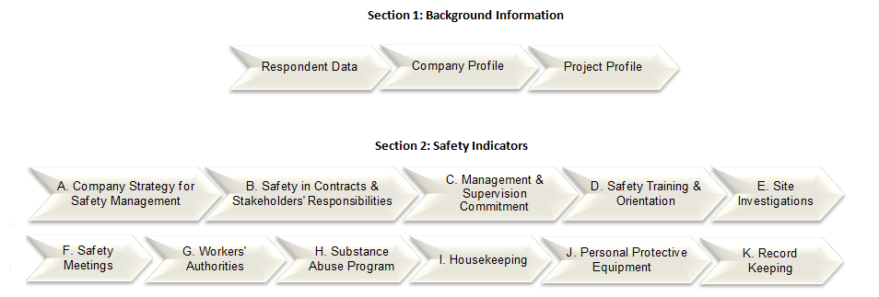

The survey will take 20-30 minutes to fill. We appreciate your patience. If you prefer a hard copy of the survey, or for further information and inquiries please contact Ms. Noor Akroush [nakroush@vols.utk.edu] or Dr. Islam El-Adaway [eladaway@utk.edu]. If you have questions about your rights as a research participant, please contact the University Of Tennessee Office Of Research Compliance at 865-974-7697 or utkirb@utk.edu.

Section 1: Background Information
- Respondent Data
I.1. Name: ___________________________________________________________
I.2. Company Name: ____________________________________________________
I.3. Company Address: __________________________________________________
I.4. Job Position: _______________________________________________________
I.5. E-mail Address: _____________________________________________________
I.6. Years of Experience in Construction: _____________________________________

II. Company Profile
II.1. Type of services of the company: (Check all that apply)
- Owner
- Consultant
- General Contracting Construction Management
- MEP Trades (Mechanical, Electrical, Plumbing)
- Supplier
- Other trade (specify): ____________________

II.2. Sector of the company's projects: (Check all that apply)
- Residential
- Commercial
- Infrastructure
- Heavy industrial
- Other Sector (specify): ____________________

- Company’s approximate annual revenue: ___________
- Number of employees: ___________
- Number of field workers: ___________
- Company's OSHA Total Recordable Injury Rate (TRIR) - Please provide latest statistic
- Company's OSHA Restricted Work or Transfer Rates (DART) - Please provide latest statistic

III. Project Profile
III.1. Project Sector:
- Residential
- Commercial
- Infrastructure
- Heavy industrial
- Other Sector (specify): ____________________

III.2. Project Location: ____________________
III.3. Project Delivery Method
- Traditional (Design-Bid-Build)
- Design Build
- Turn-key
- Construction Management

III.4. Contract type:
- Re-measured (unit price)
- Lump-sum
- Cost Plus

III.5. Project Value and Completion
Approximate Contract Value ($) _________________
Approximate Level of completion of the project in % _________________
Project Intended Completion Date _________________

III.8. Project Status: (Check what applies)
 | Below Budget | Over Budget | On Budget
Ahead of Schedule
Behind Schedule
On Schedule

III.9. Project Staff
Number of workers on site_________________
Number of supervisors on site _________________
Number of safety managers for the project _________________

Section 2: Safety Indicators
- Company’s Strategy for Safety Management
A.1. Strategies and Policies
A.1.1. Your company employs a Leading Safety Indicators System in its safety management approach
- Strongly Agree | - Somewhat Agree | - Don't Know/No Opinion | - Somewhat Disagree | - Strongly Disagree
A.1.2. You are familiar with the concept of Leading Safety Indicators
- Strongly Agree | - Somewhat Agree | - Don't Know/No Opinion | - Somewhat Disagree | - Strongly Disagree
A.1.3. Your company has a written and comprehensive Health and Safety Policy.
- Strongly Agree | - Somewhat Agree | - Don't Know/No Opinion | - Somewhat Disagree | - Strongly Disagree
A.1.4. Safety is visibly and systematically considered in the organization's official plans and strategy documents.
- Strongly Agree | - Somewhat Agree | - Don't Know/No Opinion | - Somewhat Disagree | - Strongly Disagree
A.1.5. The Health and Safety policy of your company is conveyed to all relevant stakeholders.
- Strongly Agree | - Somewhat Agree | - Don't Know/No Opinion | - Somewhat Disagree | - Strongly Disagree
A.1.6. Is there a safety budget in your company? If yes how much? ___________________

A.2. Staffing for Safety
A.2.1. The company takes safety into consideration when making supervision and management staffing decisions.
- Strongly Agree | - Somewhat Agree | - Don't Know/No Opinion | - Somewhat Disagree | - Strongly Disagree
A.2.2. The company has a safety officer position or a person only dedicated to supervise and manage safety.
- Strongly Agree | - Somewhat Agree | - Don't Know/No Opinion | - Somewhat Disagree | - Strongly Disagree
A.2.3. (If Applicable) What is the number (or percent) of management personnel with OSHA certification cards?_______________
A.2.4. (If Applicable) What is the number or percent of field workers with OSHA certification cards?____________________

- Safety in Contract Documents and Stakeholders Responsibilities
B.1. Contract and Design
B.1.1. The contract sets a minimum ratio of safety supervisors to workers.
- Strongly Agree | - Somewhat Agree | - Don't Know/No Opinion | - Somewhat Disagree | - Strongly Disagree
B.1.2. The contract imposes work hour restrictions for workers.
- Strongly Agree | - Somewhat Agree | - Don't Know/No Opinion | - Somewhat Disagree | - Strongly Disagree
B.1.3. The contract obliges contractors and sub-contractors to attend safety meetings.
- Strongly Agree | - Somewhat Agree | - Don't Know/No Opinion | - Somewhat Disagree | - Strongly Disagree
B.1.4. Safety is considered during the design phase of the project.
- Strongly Agree | - Somewhat Agree | - Don't Know/No Opinion | - Somewhat Disagree | - Strongly Disagree
B.1.5. The site layout plan considers safety matters.
- Strongly Agree | - Somewhat Agree | - Don't Know/No Opinion | - Somewhat Disagree | - Strongly Disagree
B.1.6. The construction execution plan considers safety matters.
- Strongly Agree | - Somewhat Agree | - Don't Know/No Opinion | - Somewhat Disagree | - Strongly Disagree
B.1.7. The company has an on-site emergency preparedness plan.
- Strongly Agree | - Somewhat Agree | - Don't Know/No Opinion | - Somewhat Disagree | - Strongly Disagree
B.1.8. Safety was considered during scheduling of the project.
- Strongly Agree | - Somewhat Agree | - Don't Know/No Opinion | - Somewhat Disagree | - Strongly Disagree

B.2. The Owner
B.2.1. The owner has reviewed and approved the safety plan.
- Strongly Agree | - Somewhat Agree | - Don't Know/No Opinion | - Somewhat Disagree | - Strongly Disagree
B.2.2. The owner has a visible promotion of job-site safety.
- Strongly Agree | - Somewhat Agree | - Don't Know/No Opinion | - Somewhat Disagree | - Strongly Disagree
B.2.3. The owner conducts safety walkthroughs.
- Strongly Agree | - Somewhat Agree | - Don't Know/No Opinion | - Somewhat Disagree | - Strongly Disagree

B.3. Contractors
B.3.1. Safety records and performance were considered as a pre-qualification to selecting the contractor.
- Strongly Agree | - Somewhat Agree | - Don't Know/No Opinion | - Somewhat Disagree | - Strongly Disagree
B.3.2. Contractors are trained on safety culture issues and work practices.
- Strongly Agree | - Somewhat Agree | - Don't Know/No Opinion | - Somewhat Disagree | - Strongly Disagree
B.3.3. Contractors participate in safety meetings.
- Strongly Agree | - Somewhat Agree | - Don't Know/No Opinion | - Somewhat Disagree | - Strongly Disagree

B.4. Sub-contractors
B.4.1. Safety records and performance were considered as a pre-qualification to selecting the sub-contractors.
- Strongly Agree | - Somewhat Agree | - Don't Know/No Opinion | - Somewhat Disagree | - Strongly Disagree
B.4.2. Sub-contractors are trained on safety culture issues and work practices.
- Strongly Agree | - Somewhat Agree | - Don't Know/No Opinion | - Somewhat Disagree | - Strongly Disagree
B.4.3. Sub-contractors participate of in safety meetings.
- Strongly Agree | - Somewhat Agree | - Don't Know/No Opinion | - Somewhat Disagree | - Strongly Disagree

B.5. Vendors/Suppliers
B.5.1. Vendors are made aware of the Health and Safety policy of the organization.
- Strongly Agree | - Somewhat Agree | - Don't Know/No Opinion | - Somewhat Disagree | - Strongly Disagree
B.5.2. Vendors undergo safety orientations.
- Strongly Agree | - Somewhat Agree | - Don't Know/No Opinion | - Somewhat Disagree | - Strongly Disagree

- Management and Supervision Commitment
C.1.1. Management is actively committed and involved in safety activities.
- Strongly Agree | - Somewhat Agree | - Don't Know/No Opinion | - Somewhat Disagree | - Strongly Disagree
C.1.2. Management portrays zero tolerance to non-compliance to safety policies.
- Strongly Agree | - Somewhat Agree | - Don't Know/No Opinion | - Somewhat Disagree | - Strongly Disagree
C.1.3. Management offers recognition or reward system for safe behavior.
- Strongly Agree | - Somewhat Agree | - Don't Know/No Opinion | - Somewhat Disagree | - Strongly Disagree

C.1.4. Safety issues are discussed in management meetings often.
- Strongly Agree | - Somewhat Agree | - Don't Know/No Opinion | - Somewhat Disagree | - Strongly Disagree
C.1.5. (If Applicable) What is the number of monthly management walkthroughs? ___________

- Safety Training and Orientation
D.1.1. Workers undergo safety and health orientation and training that are project specific.
- Strongly Agree | - Somewhat Agree | - Don't Know/No Opinion | - Somewhat Disagree | - Strongly Disagree
D.1.2. There are regular trainings on emergencies on-site.
- Strongly Agree | - Somewhat Agree | - Don't Know/No Opinion | - Somewhat Disagree | - Strongly Disagree
D.1.3. Management and/or supervisors attend training meetings.
- Strongly Agree | - Somewhat Agree | - Don't Know/No Opinion | - Somewhat Disagree | - Strongly Disagree
D.1.4. There is a site-specific safety orientation for managers.
- Strongly Agree | - Somewhat Agree | - Don't Know/No Opinion | - Somewhat Disagree | - Strongly Disagree
D.1.5. Supervisors undergo safety leadership training.
- Strongly Agree | - Somewhat Agree | - Don't Know/No Opinion | - Somewhat Disagree | - Strongly Disagree
D.1.6. There is feedback gathered from the trainees and utilized in developing the training program.
- Strongly Agree | - Somewhat Agree | - Don't Know/No Opinion | - Somewhat Disagree | - Strongly Disagree

- Site Investigations
E.1. Hazard Identification and Corrective Actions
E.1.1. Hazard identification and risk assessments are used to develop policies, procedures and practices.
- Strongly Agree | - Somewhat Agree | - Don't Know/No Opinion | - Somewhat Disagree | - Strongly Disagree
E.1.2. Hazards identified are used to develop corrective action plans to deal with emerging hazards.
- Strongly Agree | - Somewhat Agree | - Don't Know/No Opinion | - Somewhat Disagree | - Strongly Disagree
E.1.3. Once a hazard has been identified, there are adequate barriers set against the identified hazard.
- Strongly Agree | - Somewhat Agree | - Don't Know/No Opinion | - Somewhat Disagree | - Strongly Disagree

E.1.4. Workers have a clear knowledge of existent rules to identify hazards and unsafe behaviors.
- Strongly Agree | - Somewhat Agree | - Don't Know/No Opinion | - Somewhat Disagree | - Strongly Disagree

E.2. Accident Investigation and Follow up
E.2.1. Accident/incident investigations are conducted with a specific procedure for investigation identified.
- Strongly Agree | - Somewhat Agree | - Don't Know/No Opinion | - Somewhat Disagree | - Strongly Disagree

E.2.2. Management follows-up on incident investigations.
- Strongly Agree | - Somewhat Agree | - Don't Know/No Opinion | - Somewhat Disagree | - Strongly Disagree
E.2.3. Root-cause analysis is conducted on recorded incidents.
- Strongly Agree | - Somewhat Agree | - Don't Know/No Opinion | - Somewhat Disagree | - Strongly Disagree
E.2.4. (If Applicable) What is the percentage of incident reports on which root cause analysis was undertaken? __________________________

E.3. Safety Audits
E.3.1. There is a safety auditing program set in place.
- Strongly Agree | - Somewhat Agree | - Don't Know/No Opinion | - Somewhat Disagree | - Strongly Disagree
E.3.2. There is a safety audit score calculated and monitored.
- Strongly Agree | - Somewhat Agree | - Don't Know/No Opinion | - Somewhat Disagree | - Strongly Disagree
E.3.3. Contractors participate in safety audits.
- Strongly Agree | - Somewhat Agree | - Don't Know/No Opinion | - Somewhat Disagree | - Strongly Disagree
E.3.4. (If Applicable) What is the percentage of audits completed as a percent of scheduled audits? _____________
E.3.5. (If Applicable) What is the percent of safety compliance on safety audits?_______________

E.4. Workers' Observation
E.4.1. Management and/or supervisors conduct some sort of workers' observations for safety purposes.
- Strongly Agree | - Somewhat Agree | - Don't Know/No Opinion | - Somewhat Disagree | - Strongly Disagree
E.4.2. Workers' observations are recorded and evaluated.
- Strongly Agree | - Somewhat Agree | - Don't Know/No Opinion | - Somewhat Disagree | - Strongly Disagree
E.4.3. At-risk behaviors are reported.
- Strongly Agree | - Somewhat Agree | - Don't Know/No Opinion | - Somewhat Disagree | - Strongly Disagree

E.4.4. The severity of at-risk behaviors is reported.
- Strongly Agree | - Somewhat Agree | - Don't Know/No Opinion | - Somewhat Disagree | - Strongly Disagree
E.4.5. If there is a worker observation program, what is the monthly number of Workers observations conducted? __________________

E.5. Near Miss Investigation
E.5.1. The organization has a definition of a near miss event, and this definition is conveyed to the workers.
- Strongly Agree | - Somewhat Agree | - Don't Know/No Opinion | - Somewhat Disagree | - Strongly Disagree
E.5.2. There is a system for analyzing near miss events in the organization.
- Strongly Agree | - Somewhat Agree | - Don't Know/No Opinion | - Somewhat Disagree | - Strongly Disagree
E.5.3. (If applicable) what is the number of near Misses reported per 200,000 h of worker exposure? ________________

- Safety Meetings
F.1.1. Safety meetings are conducted regularly.
- Strongly Agree | - Somewhat Agree | - Don't Know/No Opinion | - Somewhat Disagree | - Strongly Disagree
F.1.2. What is the number of safety meetings conducted monthly? _________
F.1.3. What percent of safety meetings are attended by supervisors/ managers? __________
F.1.4. There is a system to keep track of the attendance rates at safety meetings.
- Strongly Agree | - Somewhat Agree | - Don't Know/No Opinion | - Somewhat Disagree | - Strongly Disagree
F.1.5. The workers' record of attending safety meeting is used in evaluating performance.
- Strongly Agree | - Somewhat Agree | - Don't Know/No Opinion | - Somewhat Disagree | - Strongly Disagree
F.1.6. There is a system to evaluate the quality of participation in safety meetings.
- Strongly Agree | - Somewhat Agree | - Don't Know/No Opinion | - Somewhat Disagree | - Strongly Disagree

F.1.7. Management/supervisors provide positive feedback or incentives for quality participation in safety meetings.
- Strongly Agree | - Somewhat Agree | - Don't Know/No Opinion | - Somewhat Disagree | - Strongly Disagree
F.1.8. Explanations are given of why actions suggested at safety meetings were undertaken or not.
- Strongly Agree | - Somewhat Agree | - Don't Know/No Opinion | - Somewhat Disagree | - Strongly Disagree

- Workers' Authorities
G.1. Reporting of incidents, accidents or potential hazards
G.1.1. There is a clear procedure for reporting of incidents, accidents or potential hazards, with well-defined roles and responsibilities.
- Strongly Agree | - Somewhat Agree | - Don't Know/No Opinion | - Somewhat Disagree | - Strongly Disagree
G.1.2. The reporting procedure is anonymous.
- Strongly Agree | - Somewhat Agree | - Don't Know/No Opinion | - Somewhat Disagree | - Strongly Disagree
G.1.3. Workers' perceptions of the effectiveness of the anonymous reporting system are evaluated.
- Strongly Agree | - Somewhat Agree | - Don't Know/No Opinion | - Somewhat Disagree | - Strongly Disagree
G.1.4. Workers are given positive incentive to report potential hazards.
- Strongly Agree | - Somewhat Agree | - Don't Know/No Opinion | - Somewhat Disagree | - Strongly Disagree
G.1.5. Management/supervisors attempt to avoid blaming of workers who report incidents or accidents.
- Strongly Agree | - Somewhat Agree | - Don't Know/No Opinion | - Somewhat Disagree | - Strongly Disagree

G.2. Stop Work Authority
G.2.1. There is a policy to empower workers to stop work in case of incidences or near misses.
- Strongly Agree | - Somewhat Agree | - Don't Know/No Opinion | - Somewhat Disagree | - Strongly Disagree

- Substance Abuse Program
H.1.1. There is a substance abuse program set in place and advertised to workers.
- Strongly Agree | - Somewhat Agree | - Don't Know/No Opinion | - Somewhat Disagree | - Strongly Disagree
H.1.2. Your company conducts an un-announced drug testing program.
- Strongly Agree | - Somewhat Agree | - Don't Know/No Opinion | - Somewhat Disagree | - Strongly Disagree
H.1.3. (If Applicable) what percent of random drug testing scored negative _________________

- Housekeeping
I.1.1. Your company has a planning system for the adequate disposal of scrap, waste and surplus materials.
- Strongly Agree | - Somewhat Agree | - Don't Know/No Opinion | - Somewhat Disagree | - Strongly Disagree
I.1.2. There is regular supervision to keep the job-site and all equipment in order.
- Strongly Agree | - Somewhat Agree | - Don't Know/No Opinion | - Somewhat Disagree | - Strongly Disagree
I.1.3. The job-site has designate areas for waste materials and containers to dispose them.
- Strongly Agree | - Somewhat Agree | - Don't Know/No Opinion | - Somewhat Disagree | - Strongly Disagree
I.1.4. The job-site has enough protection of flammable materials.
- Strongly Agree | - Somewhat Agree | - Don't Know/No Opinion | - Somewhat Disagree | - Strongly Disagree

- Personal Protective Equipment (PPE)
J.1.1. There is a PPE inspection and maintenance policy.
- Strongly Agree | - Somewhat Agree | - Don't Know/No Opinion | - Somewhat Disagree | - Strongly Disagree
J.1.2. All management regularly seen on the job-site wear the correct PPEs.
- Strongly Agree | - Somewhat Agree | - Don't Know/No Opinion | - Somewhat Disagree | - Strongly Disagree

- Record Keeping
K.1.1. There is an incident case history record-keeping system.
- Strongly Agree | - Somewhat Agree | - Don't Know/No Opinion | - Somewhat Disagree | - Strongly Disagree
K.1.2. There is a record keeping system for accident analysis and corrective actions.
- Strongly Agree | - Somewhat Agree | - Don't Know/No Opinion | - Somewhat Disagree | - Strongly Disagree

Appendix 2: Data Analysis Using SPSS

Comparison of Means by Revenue Group:
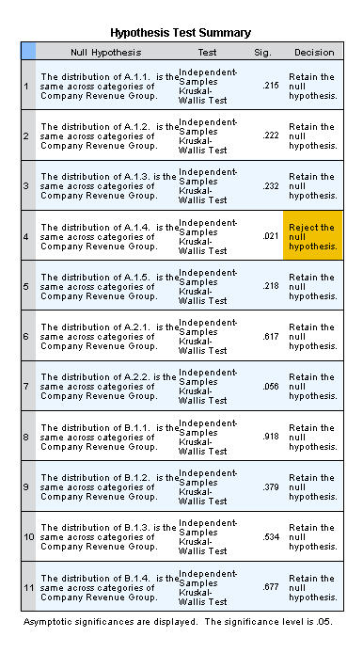

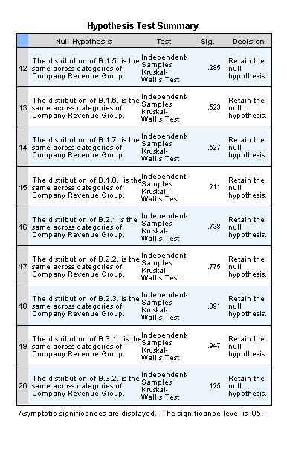

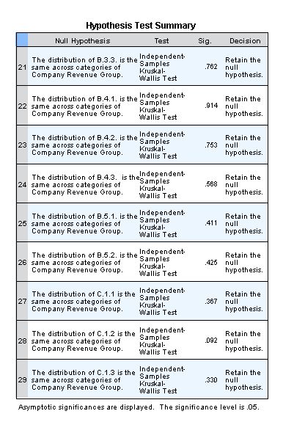

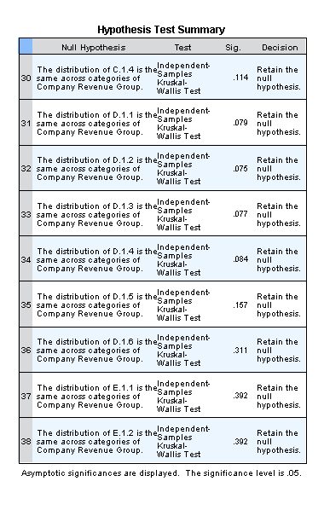

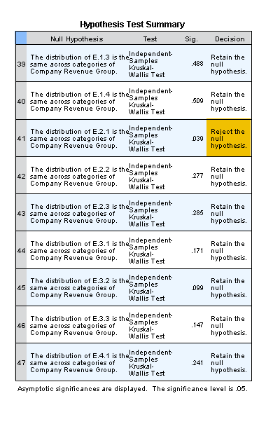

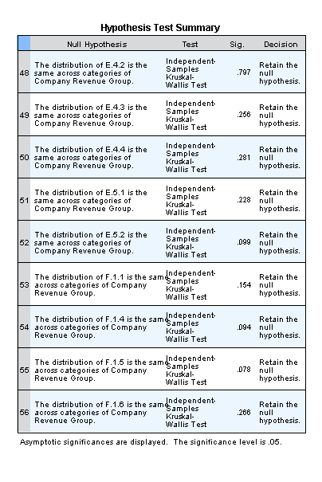

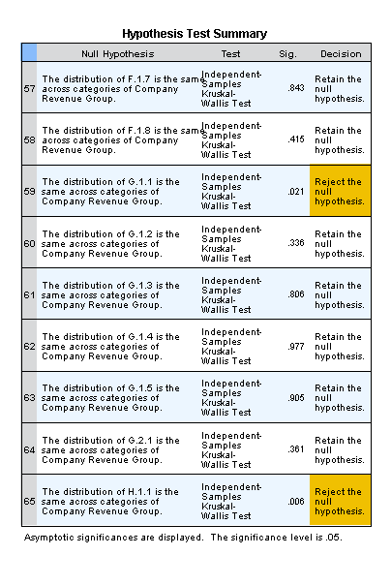

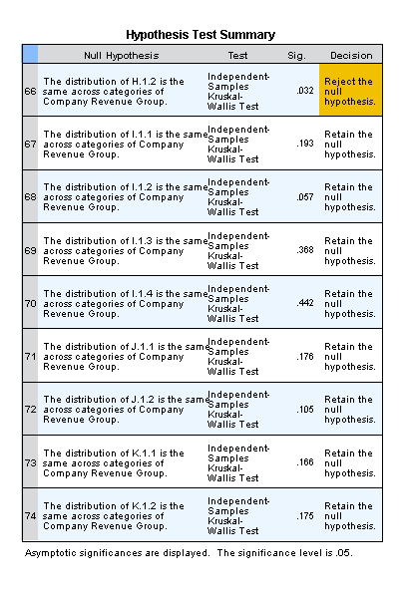

Pairwise Comparison by Revenue Group for A.1.4
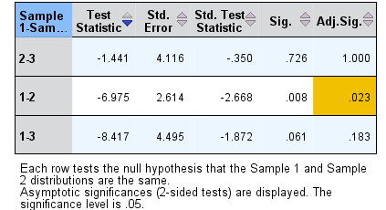

Pairwise Comparison by Revenue Group for E.2.1
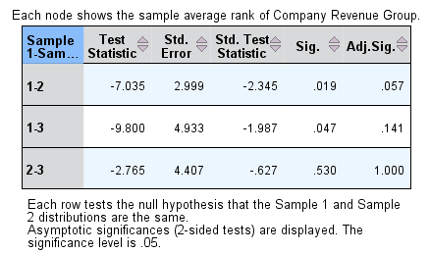

Pairwise Comparison by Revenue Group for G.1.1
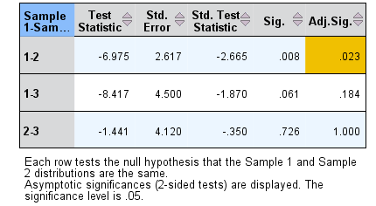
Pairwise Comparison by Revenue Group for H.1.1
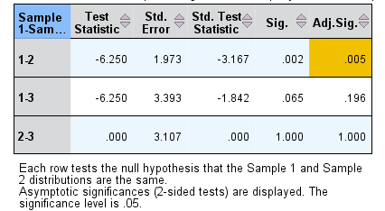

Pairwise Comparison by Revenue Group for H.1.2.
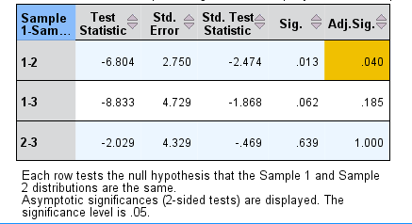

Comparison of Means by Number of Employee Group
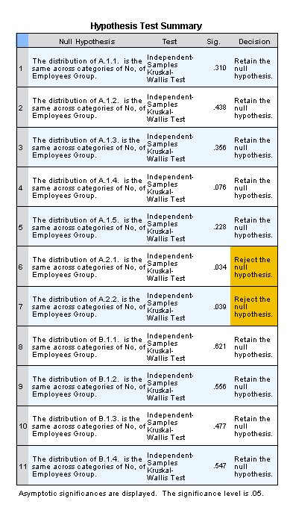

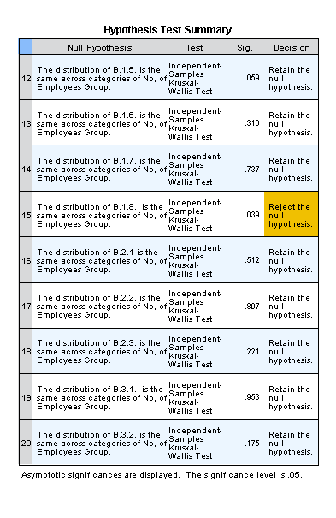

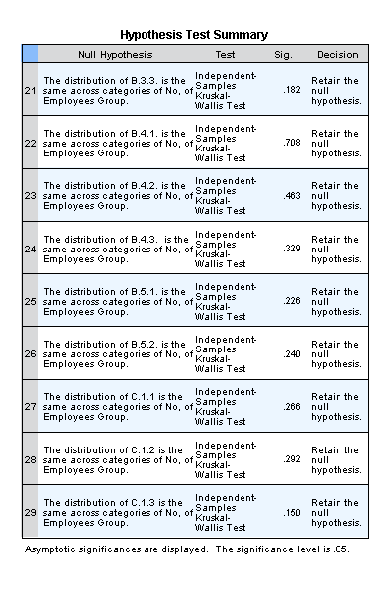

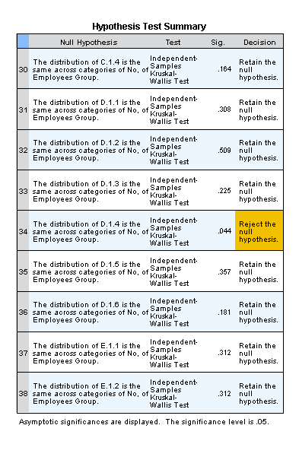

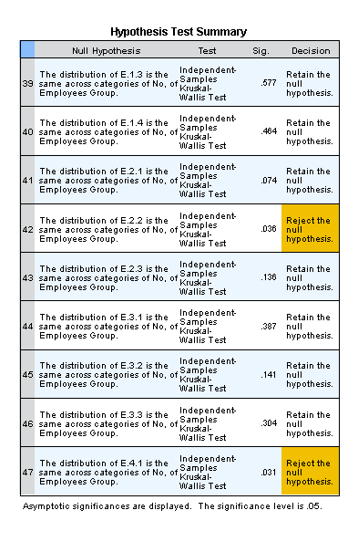

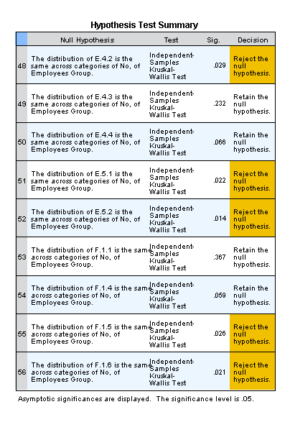

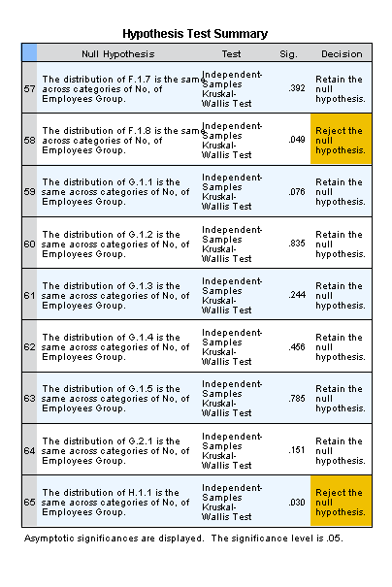

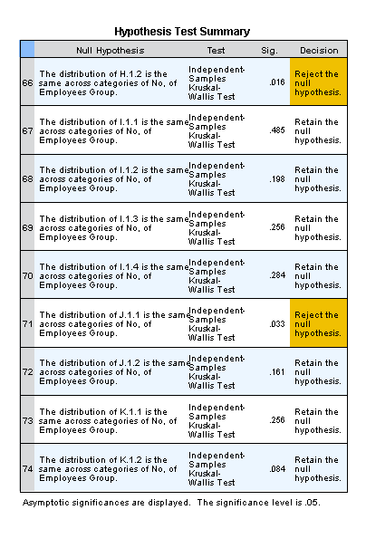

Pairwise Comparison by Number of Employees Group for A.2.1.
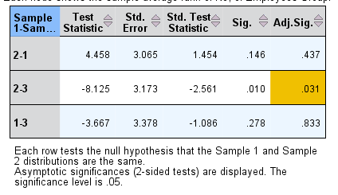

Pairwise Comparison by Number of Employees Group for A.2.2.
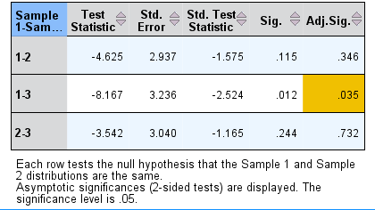

Pairwise Comparison by Number of Employees Group for B.1.8.
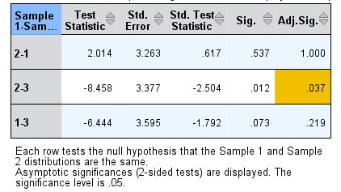

Pairwise Comparison by Number of Employees Group for D.1.4.
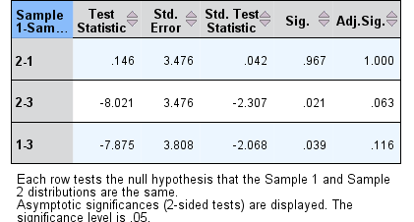

Pairwise Comparison by Number of Employees Group for E.2.2.
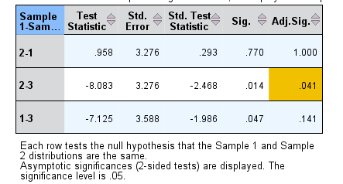

Pairwise Comparison by Number of Employees Group for E.4.1.
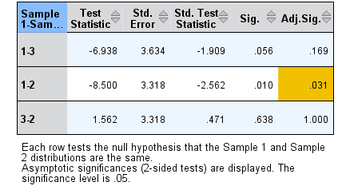

Pairwise Comparison by Number of Employees Group for E.4.2.
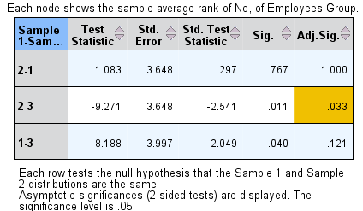

Pairwise Comparison by Number of Employees Group for E.5.1
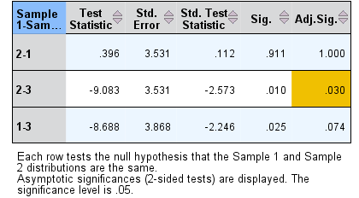

Pairwise Comparison by Number of Employees Group for E.5.2.
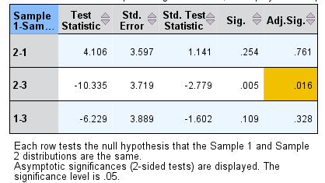

Pairwise Comparison by Number of Employees Group for F.1.8.
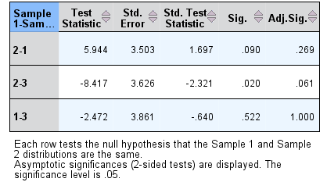
Pairwise Comparison by Number of Employees Group for H.1.1.
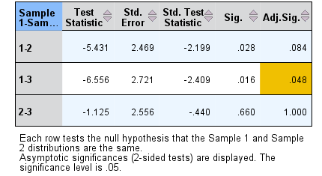

Pairwise Comparison by Number of Employees Group for H.1.2.
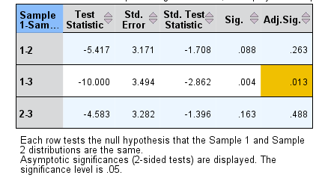

Comparison of Means by Company Service Category: 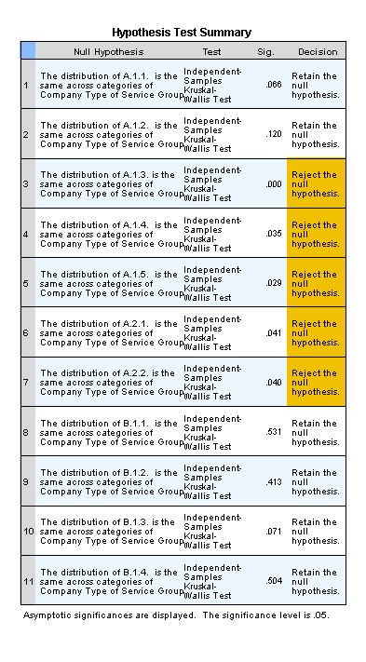

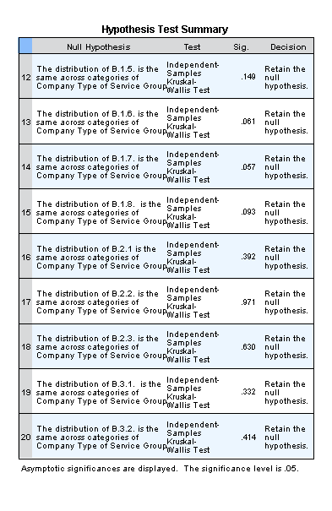

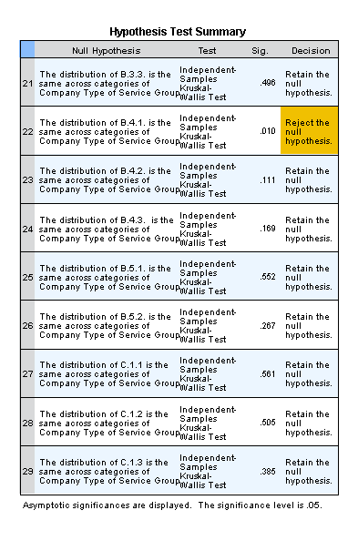

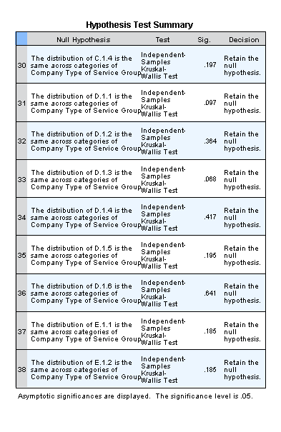

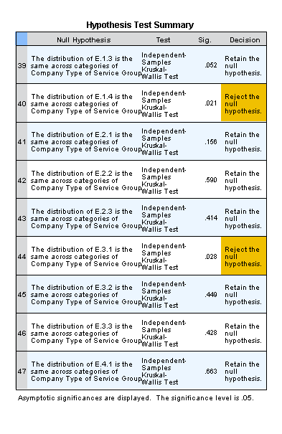

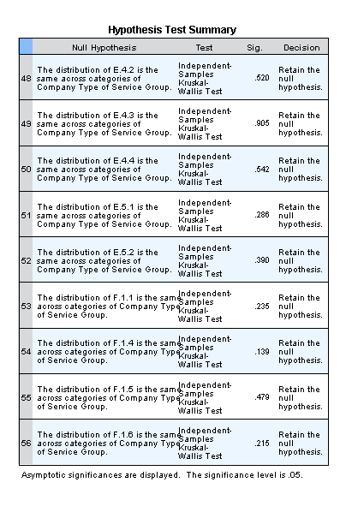

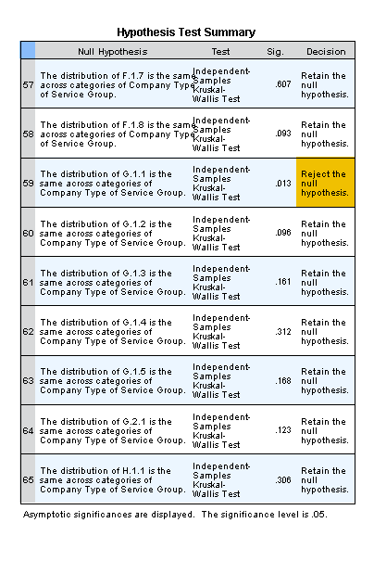

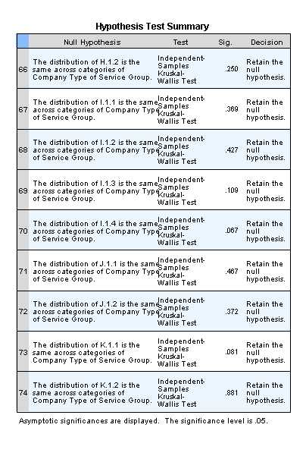

Pairwise Comparison by Company Service Group for A.1.3
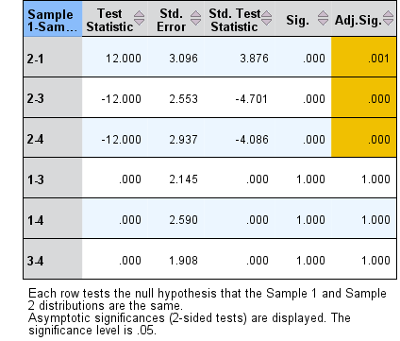

Pairwise Comparison by Company Service Group for A.1.4
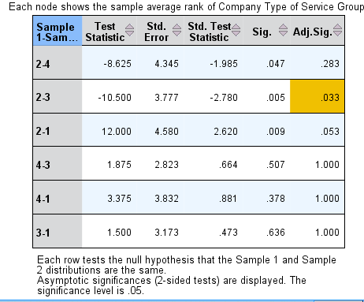

Pairwise Comparison by Company Service Group for A.1.5
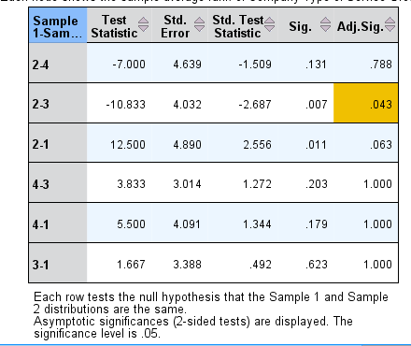

Pairwise Comparison by Company Service Group for A.2.1
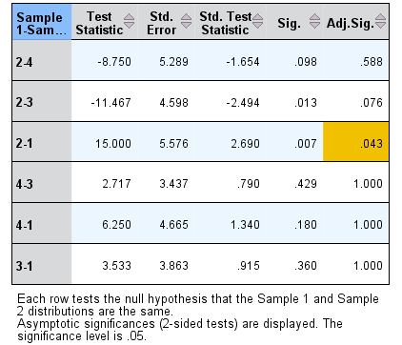

Pairwise Comparison by Company Service Group for A.2.2
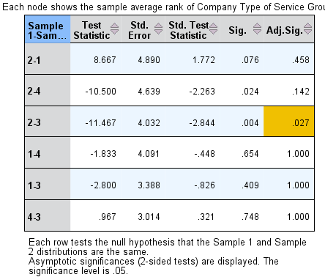

Pairwise Comparison by Company Service Group for B.1.4
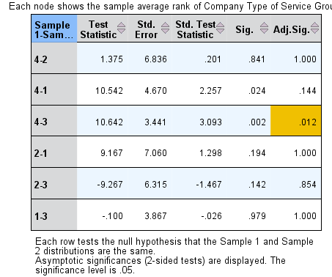

Pairwise Comparison by Company Service Group for E.1.4
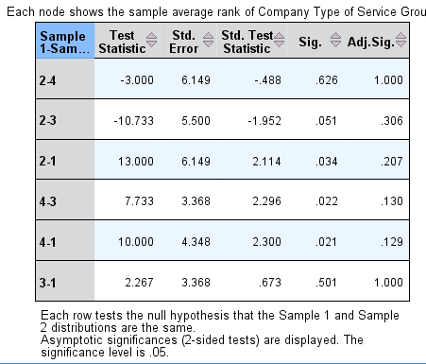

Pairwise Comparison by Company Service Group for E.3.1
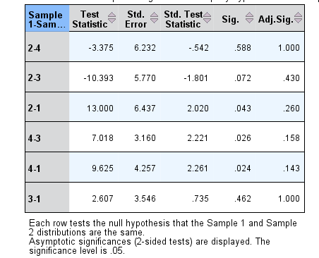

Pairwise Comparison by Company Service Group for G.1.1

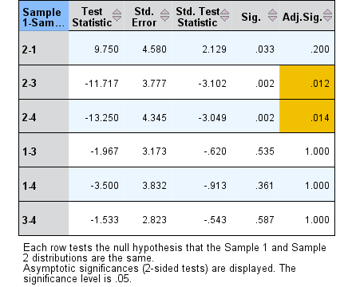

Vita
Noor Akroush was born in Amman, Jordan, on January 11, 1992. After graduating high school in 2010, she joined the American University in Cairo, and completed her Bachelor of Science in Construction Engineering with a concentration in Construction Management and Technology in 2015. She accepted a graduate research assistantship at The University of Tennessee in Knoxville, in the Construction Program of the Civil Engineering Department, and is continuing her education for PhD in the same department.

