Path Planning For Additive Manufacturing of Wire Arc Additive Manufacturing and Blue Light Fringe Projection Scanning

A Thesis Presented for the
Master of Science
Degree
The University of Tennessee, Knoxville

Tiffany Quigley
August 2022

Copyright © 2022 by Tiffany Quigley
All rights reserved.

Acknowledgements

I would like to thank Dr. Jared and Dr. Hamel for providing me with the opportunity to expand my knowledge in a hands on environment. I’ve truly learned more in the last year of working in the lab than I have in any classroom. Thank you to Devon Goodspeed for always being willing to stay late to help finish an experiment and reviewing countless presentations and papers. I’d also like to express my gratitude to Joshua Penney, for taking the time to teach me the skills required for this thesis to be successful. Thank you to my committee members for taking the time to review and advise this thesis.

Abstract

Current methods of manufacturing large scale parts take upwards of 6 months. The objective of the wire arc additive manufacturing hybrid cell is to significantly reduce lead time associated with large scale parts. The hybrid manufacturing cell consists of two 6 degree-of-freedom (DOF) robot manipulators in addition to a 3 degree-of-freedom part positioner. This process begins with wire arc additive manufacturing where a part is printed layer by layer onto a part positioner whilst keeping the welding torch gravity aligned where possible. After printing is complete, the part positioner translates parts into a suitable position for scanning. Translation is necessary due to available visibility of the scanner. Integrating metrology into this process allows for both additive and subtractive manufacturing to be completed iteratively to arrive at a final product. This combination can be critical due to access concerns for both the wire deposition torch, as well as the machine tools being utilized. Previous static scanning configurations require multiple hours and potentially hundreds of individual scans to arrive at a satisfactory result, therefore contributing considerably to overall cycle time and hindering progress toward automation. The premise of this thesis is to systematically analyze CAD models of desired part geometries for path planning of wire arc additive manufacturing as well as determination of ideal scanning configurations. A CAD model of a desired geometry is visually and analytically investigated in GOM software where problem areas are identified and used to determine a corresponding path plan for that specific geometry. Utilizing the 6 DOF robot manipulator considerably reduces scan time, increases quality of scans generated, and streamlines complete automation of the hybrid manufacturing cell.

Table of Contents

Chapter 1 1
Background 1
1.1 Wire Arc Additive Manufacturing (WAAM) 1
1.2 Hybrid Manufacturing 1
1.3 GOM Scanner Background 2
1.3.1 Blue light scanning 2
1.4 UT Hybrid Cell 3
Chapter 2 6
Multi-DOF Path Planning for Wire Arc Additive Manufacturing 6
2.1 Welding Parameter Development for Path Planning Process 6
2.1.1 Bead height 6
2.1.2 Wire diameter 6
2.1.3 Wait Time Between Layers 7
2.1.4 Contact Tip to Workpiece Distance 7
2.1.5 Geometry Complications 9
2.1.6 Starts and Stops 10
2.1.7 Overhangs 11
2.1.8 Heat 12
2.2 Path Planning 13
2.2.1 Slicing 13
2.2.2 Importing Contours into MATLAB 16
2.2.3 Importing Path into Octopuz 17
2.2.4 Path Plan on Robot 18
Chapter 3 19
Mounting of Scanner to Robot 19
3.1 Hardware Design 19
3.1.1 Obstruction from Geometry 20
3.1.2 Reduction in time to scan 20
3.2 Straight vs. 90 degree Configuration 20
3.2.1 Kinematics 20
Chapter 4 21
Path Planning for Scanning 21
4.1 Challenges 21
4.1.1 Too Much Motion 21
4.1.2 Transformation Error 21
4.1.3 Field of View, dimensions, resolution, etc. 21
4.2 Gage ball study 21
4.3 Manual Scanning 21
4.4 Generalized Scanning 21
4.5 CAD/Geometry based/specific scanning 21
4.6 Data Comparison/Results 21
Chapter 5 22
Conclusions And Recommendations 22
List of References 23
Appendix 24

List Of Tables

No table of figures entries found.

List Of Figures

Figure 1: ATOS Q Scanner 2
Figure 2: Blue Light Fringe Projection Scanning 3
Figure 3: Additive Manufacturing via KR50 and KL4000 4
Figure 4: Post Printing Scanning 5
Figure 5: Welded Contact Tip 8
Figure 6: Shielding Gas Effects on Hexagon Build 9
Figure 7: Warped Welds Around Turns 10
Figure 8: Graphical User Interface 11
Figure 9: Base Plate Deformation 12
Figure 10: WAAM Path Planning Structure 13
Figure 11: CAD of desired geometry 14
Figure 12: Cylinder Fitted, Creation of Slices 15
Figure 13: Slices Generated 15
Figure 14: MATLAB Path Script 16
Figure 15: Graphical User Interface 17

Background

Wire Arc Additive Manufacturing (WAAM)
Wire Arc Additive Manufacturing is direct energy deposition (DED) method of manufacturing in which metal inert gas (MIG) welding is used to deposit layers of material onto an initial substrate. MIG welding is the process of feeding wire into a molten weld pool. This process is done repetitively until a near net shape is created. Incorporating a robotic manipulator into this process allows for diminished manufacturing time, increased part complexity, and more maneuverability. The robotic manipulator used in this process utilizes a Gas Metal Arc Welding (GMAW) power supply with the MIG torch mounted to the end-effector. The part positioner is coupled to the robotic manipulator to easily maneuver the part to best keep the torch gravity aligned, or aligned vertically in relation to the part.

Hybrid Manufacturing
Hybrid manufacturing encompasses a combination of additive and subtractive manufacturing. The near net shape produce via wire arc additive manufacturing is refined via machining to produce the final product. Creation of a near net shape creates less waste than conventional subtractive machining by producing a geometry of similar shape and size of the desired result via additive manufacturing and then refining via machining. Integrating informed metrology via a 3D scanner into this process makes it possible to determine areas in need of machining or additional deposition. This process is accomplished by scanning the part after printing and comparing the scan generated to a CAD model of the intended geometry. The part is also scanned after machining and compared once more to the intended geometry for iterative refinement.

GOM Scanner Background
The GOM ATOS Q scanner (Figure 1) is used in this hybrid manufacturing cell to scan the part both post printing and post machining. This scanner is specifically tailored for the scanning of additively manufactured parts. The scanner has a working distance of 490 mm and measuring area range of 100mm x 70mm to 500mm x 370mm which permits reasonable visibility within the hybrid cell with proper manipulation. It operates off of 10 meters of fiber optic cable which accommodates maneuverability of the scanner into ideal scanning configurations.
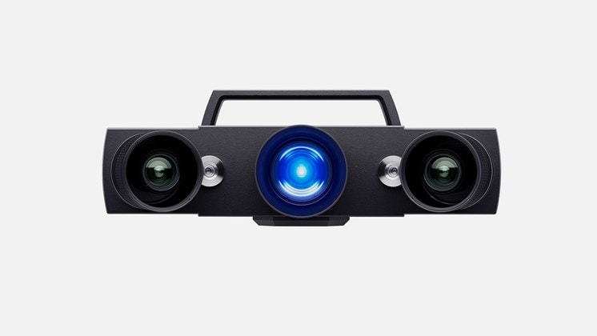
Figure 1: ATOS Q 3D Scanner

Blue light scanning
Blue light fringe projection scanning works by projecting narrow patterns of blue light along the surface of the subject of the scan and is captured by the two cameras. The projector and cameras are at known angles and distances to one another so the image captured can use the pattern of light to triangulate and create a point cloud. Each scan generates a point cloud that is stitched onto the one generated by the previous scan. This point cloud can be adapted into a CAD file type to represent the geometry of the image captured. Once enough scans are taken to generate an acceptable representation of the geometry, the part is polygonized. This is where the point cloud generated is transformed into a series of polygons that are stitched together to fully encompass the part scanned.
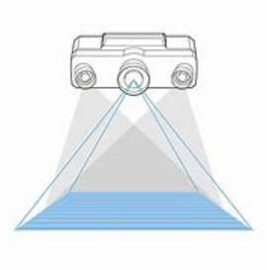
Figure 2: Blue Light Fringe Projection Scanning Depiction

UT Hybrid Cell
The hybrid manufacturing cell used for this project consists of two KUKA 6 DOF robotic manipulators, a KL4000 2 DOF part positioner mounted to a linear track, a HAAS 5 axis milling machine, and a GOM ATOS Q 3D scanner. The process begins with additive manufacturing via a KUKA KR50 6 DOF robotic manipulator with welding torch end effector which welds the imported path plan onto a hub or baseplate mounted to the coupled part positioner (Figure 3).
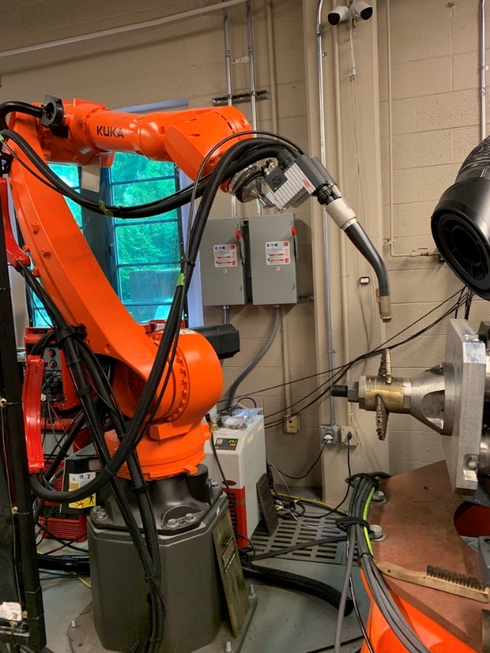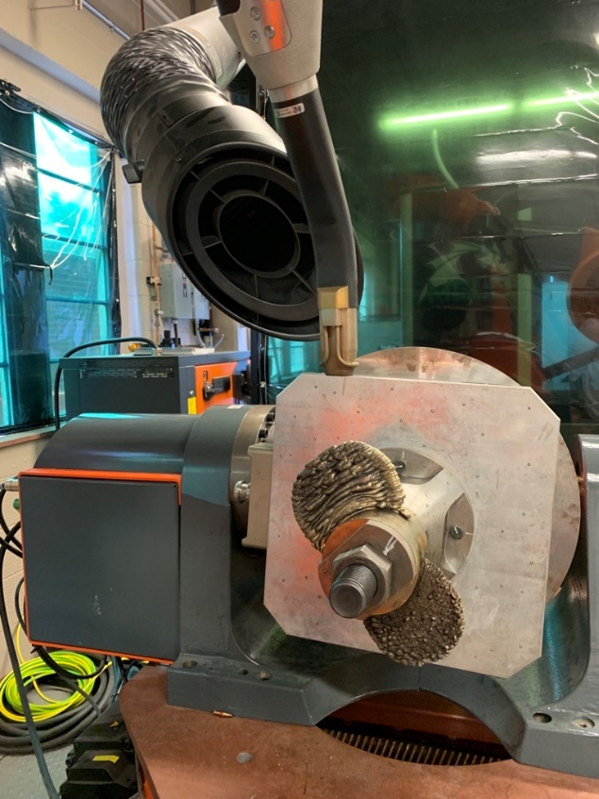
Figure 3: Additive Manufacturing via KR50(left) and KL4000(part positioner)
Post printing, the part is translated via the linear track into scanning configuration (Figure 4). Scans of the geometry post printing are compared to a CAD model of the desired product and used to inform the subtractive manufacturing process of areas of excess material in need of machining.
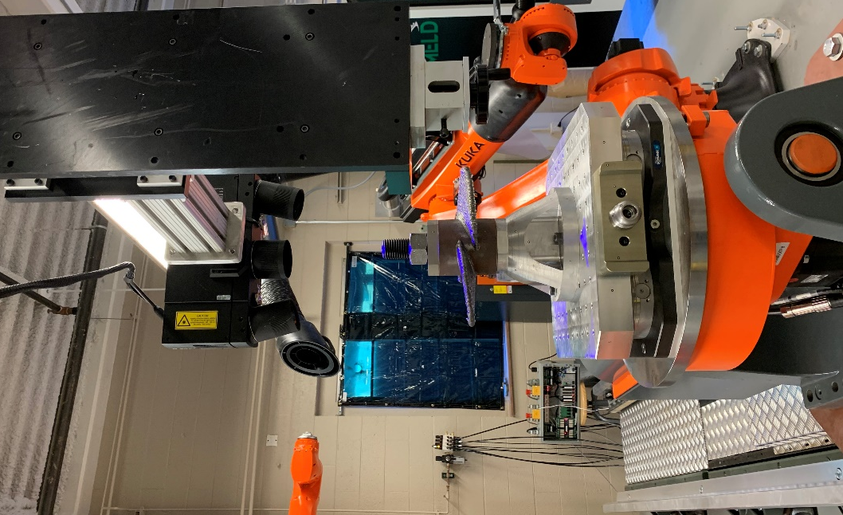
Figure 4: Post Printing Scanning
After scanning, the part is transported from the linear track robot into the milling machine via the 6 DOF KUKA KR250 robotic manipulator. After machining, the part is returned to the linear track for additional scanning which determines potential areas in need of additional deposition.

Multi-DOF Path Planning for Wire Arc Additive Manufacturing

Welding Parameter Development for Path Planning Process

Bead height
In traditional MIG welding applications, two parts are joined together via molten wire adhering to each piece and creating a bond. In the additive manufacturing process, the first layer adheres to the base plate or initial substrate. This initial layer reacts differently than the remaining layers that adhere to one another. When beads are printed in succession onto one another the cross-sectional area differs greatly than if they were to adhere to a base plate. The higher the beads are printed the more the bead expands leading to loss of height. Also in traditional MIG welding applications, the temperature is kept much higher. This is due to the difference between two ambient temperature pieces being fused together in comparison to multiple layers of freshly molten wire. After printing, heat remains in each layer and must be an appropriate temperature prior to deposition of the next layer. Reduced temperature in addition to pauses between layers may be necessary to prevent overheating.

Wire diameter
Diameter of the wire used to weld is directly related to the amount of current and heat generated. The larger the wire, the more current is generated. With greater current comes greater heat. Additional heat causes greater concern for risk of overheating due to each layer requiring more time to cool. Longer wait times may need to be implemented between layers as a result. The risk of overheating is also augmented depending on the type of material used, some are at higher risk of overheating than others. Difference in wire diameter also creates differences when it comes to the dexterity of the weld. Smaller wire diameters are easier to create intricate weld patterns, whereas larger wire diameters are more difficult to manipulate in a constrained manner.

Wait Time Between Layers
As previously mentioned, wait times may need to be implemented between layers of a print to account for heat distribution through the part. Each layer must cool to the proper interpass temperature prior to additional deposition in the next layer. This serves to reduce risk of overheating and potential damages associated. When it comes to path planning, wait functions must be implemented after each layer to allow for proper cooling. Active cooling may also be implemented to reduce the amount of wait time necessary. As the part increases in layers, wait times may need to be extended to account for heat distribution and conduction throughout the part. The more layers a part contains the more surface area heat is conducted through.

Contact Tip to Workpiece Distance
When creating a welding path plan, an important consideration is the distance between the contact tip of the welding torch and the workpiece the material is being deposited onto. A balance of how far the wire extends outward and the arc length of the torch is important for proper welding technique. Human welders are able to intuitively adjust and adapt this balance as they weld where robotic manipulators don’t have this sense of intuition. When this balance is disturbed, a number of errors may occur. If the torch is too close to the workpiece, the contact tip may begin to erode or may weld to the part or baseplate as seen in Figure 5. The contact tip is made of copper which has a low melting point usually mitigated by shielding gas.
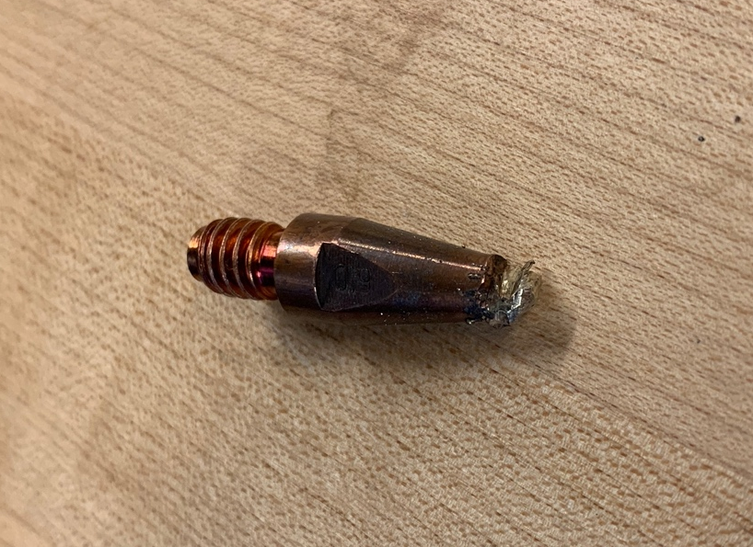
Figure 5: Welded Contact Tip
If the wire extends too far from the welding torch it can break off in sections and not deposit properly. Shielding gas coverage additionally diminishes with greater distance. The equipment used in this process is a dual wire system designed to provide shielding gas to two wires depositing at the same time. Since we only use a single wire for the additive manufacturing process, the part receives better shielding gas anteriorly as it cools.
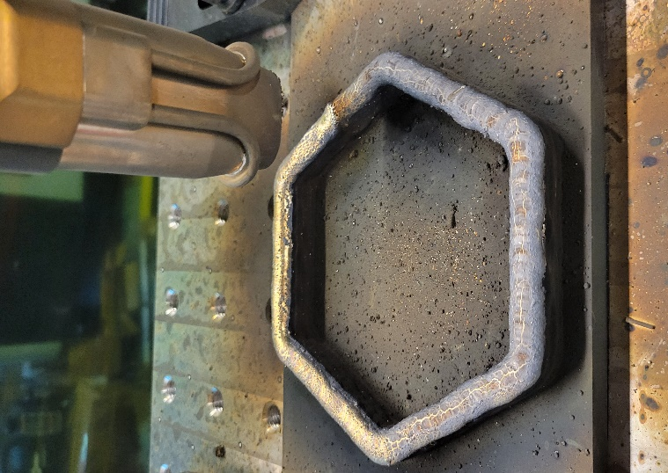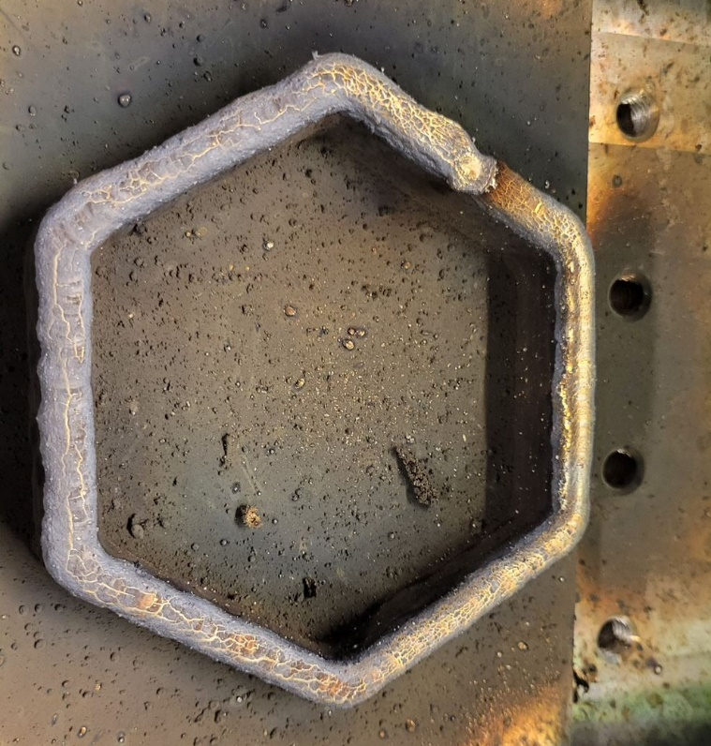
Figure 6: Shielding Gas Effects on Hexagon Build
In Figure 6 above, areas of better anterior shielding gas can be clearly seen due to the orientation of the torch along the part path. In darker areas the torch was aligned perpendicularly to the path which lessened shielding gas of material as it was deposited. For reference, the welding torch was moving in a counterclockwise path starting at the top of the image. Generally, the closer the torch is to the material being deposited results in better shielding gas. An alternative to maximize shielding gas if diminishing the distance is impractical, is to increase the shielding gas exuded. Although, this solution is constrained to an extent, for too much shielding gas will cause a vacuum to occur within the torch which pulls in excess oxygen which disturbs the weld deposited.

Geometry Complications
The geometry of a part may cause difficulties in printing for a number of reasons. Tight corners on a path plan causes for the welding torch to have to stop and turn around between segments. When the welding torch slows down to make this turn, additional deposition of material occurs. Overlap can occur depending on how acute the angle of the turn is. This causes an upslope of the part which changes the tool to workpiece distance as the torch welds each layer. Figure 7 below demonstrates this upslope effect of areas of additional deposition in the presence of a tight turn. Note the areas between the turns are significantly lower in height and suffered consequences of reduced shielding gas whereas the turns encountered areas of overlap and reduced tool to workpiece distance. 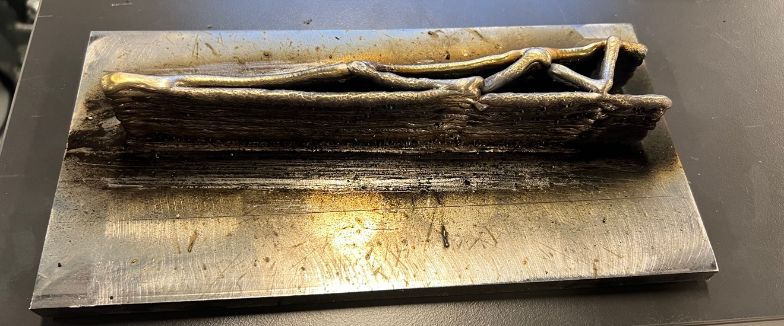
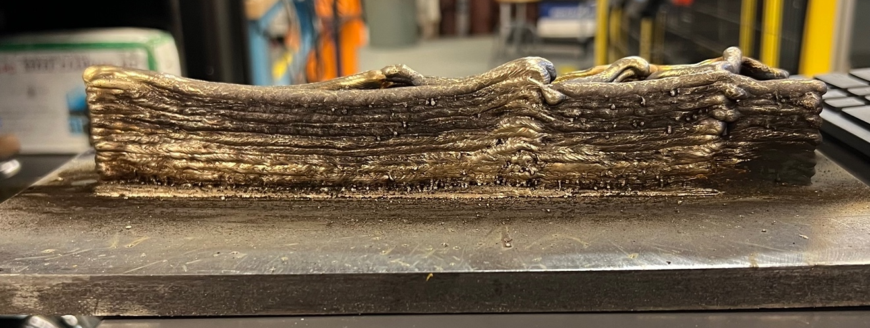
Figure 7: Warped Welds Around Turns

Starts and Stops
Starting a layer of a part must occur away from a corner due to the difficulty in determining the amount of material buildup that will occur. The phenomena created during a turn as previously explained, is accentuated in the instance of placing a start or stop in a corner or turn. To mitigate this, a MATLAB script is created to adjust where the path plan of each layer begins and ends. This script visually and analytically adjusts the path plan to prevent areas of variable deposition as the result of improper placement.
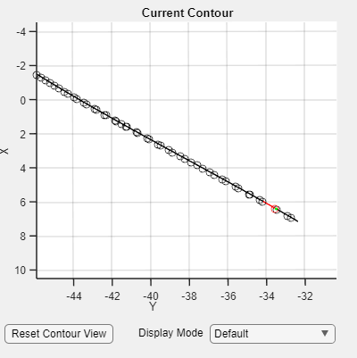
Figure 8: Graphical Depiction of Start and Stop Position
Figure 8 above demonstrates the element of the graphical user interface (GUI) used to visually analyze each contour. Each contour can be viewed and evaluated individually. This feature is necessary to determine proper placement of where the contour is to begin and end printing. The start of the build is symbolized by the green circle and the end of the build is symbolized by the red. This analysis is a crucial step to insure proper fabrication.

Overhangs
Overhangs of a part may cause deformation. The part positioner mitigates some of these affects by tilting the part to keep the welding torch gravity aligned. Although, access and size of the torch may limit this mitigation.

Heat
Distortion occurs as the part cools due to contraction of the metal. The base plate experiences deformation and warps. This issue was accentuated prior to firm clamping of the base plate. Although, once the firm clamping kit is removed the plate deforms. Note the upslope on the left side of the base plate below in Figure 9.

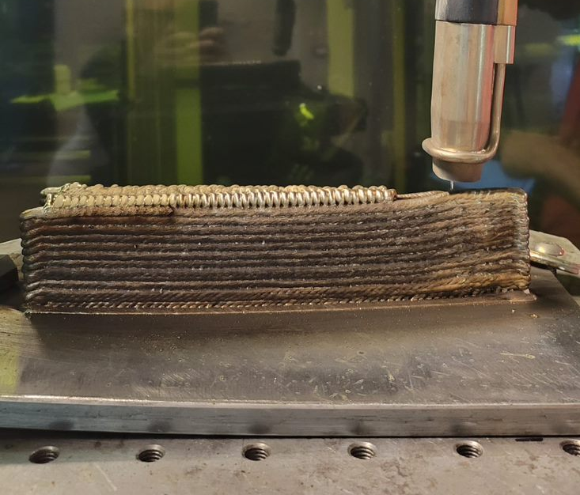
Figure 9: Base Plate Deformation
BACKGROUND----INPUTS OF WLDER:
- Wire feed speed & voltage
- Feed speed directly related to current

Path Planning
The process of path planning for wire arc additive manufacturing is to input a CAD model, cut it into slices to distinguish layers, export those slices through a MATLAB script to develop a path, and run a simulation of the path plan in Octopuz, a robotic simulation software.

Figure 10: WAAM Path Planning Structure

Slicing
The first step of the path planning process is to import the CAD model of the desired geometry into GOM software. The part is then divided into “slices” that correspond to the intended layer height of the print. If the part is to be printed on a base plate, the slices are generated based off of a linear plane. If the part is to be printed on a cylindrical hub, a digital cylinder is fitted to the hub and used to radially slice the part into contours. These contours are exported as a “.ascii” file to be exported into MATLAB.
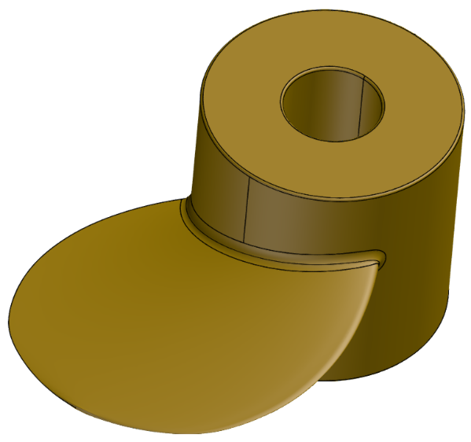
Figure 11: CAD Model Of Desired Geometry
The imported CAD model of the desired geometry is first broken into segments depending on the desired print order. In the case of Figure 11, a three-blade propeller is divided into three parts, one for each blade. By dividing the CAD into segments, each blade will be printed individually of one another instead of layer by layer of each blade in sequence.
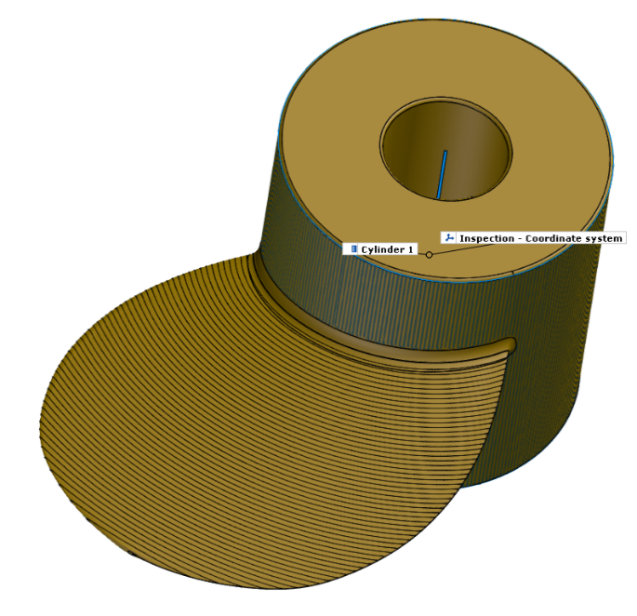
Figure 12: Cylinder Fitted, Creation of Slices
After the CAD model is broken into the desired segments, each segment is further divided into slices. This is accomplished by first fitting a baseline to where printing will commence. In this instance, each blade is going to be printed to a central cylindrical hub. A digital cylinder is fitted to the base and used to create contour slices. The distance between the slices corresponds to the desired layer height of the weld.
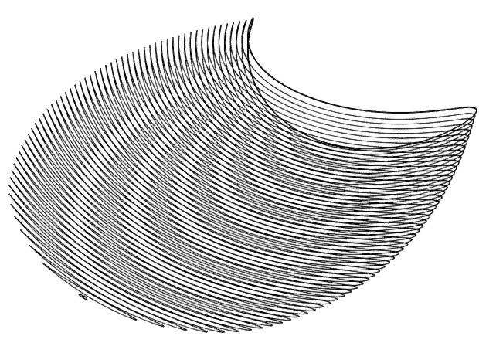
Figure 13: Slices Generated
The generated slices are exported in segments for each blade from the GOM software as “.ascii’ files.

Importing Contours into MATLAB
The “.ascii” file is then imported into MATLAB where it is processed through a script (Figure 14, line 2) tailor made to the intended geometry.
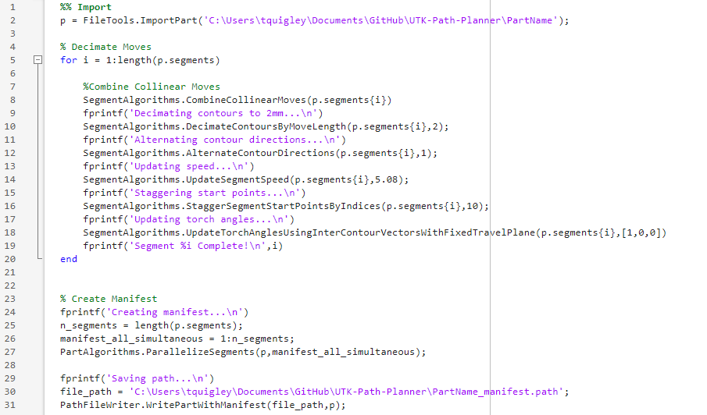
Figure 14: MATLAB Path Script
After importing, the first step of the script is to combine collinear moves (line 8) which means any consecutive points along the same path are reduced into one segment. The decimate by move length function sets the minimum move length for each contour. Direction in which the layers of the path are alternated between each layer to prevent any sloping of the part from starting continuously in one area. This also maximizes the amount of cooling time between each layer (Line 12). Segment speed is the linear speed at which the welding torch moves along each contour. This value is user defined for the specified part and material. Start points are staggered (line 16) to prevent areas of porosity and excess build up caused by starting a weld layer in the same direction for each layer. The torch angles are updated in line 18 to keep the torch properly aligned and oriented in reference to a fixed plane of travel.
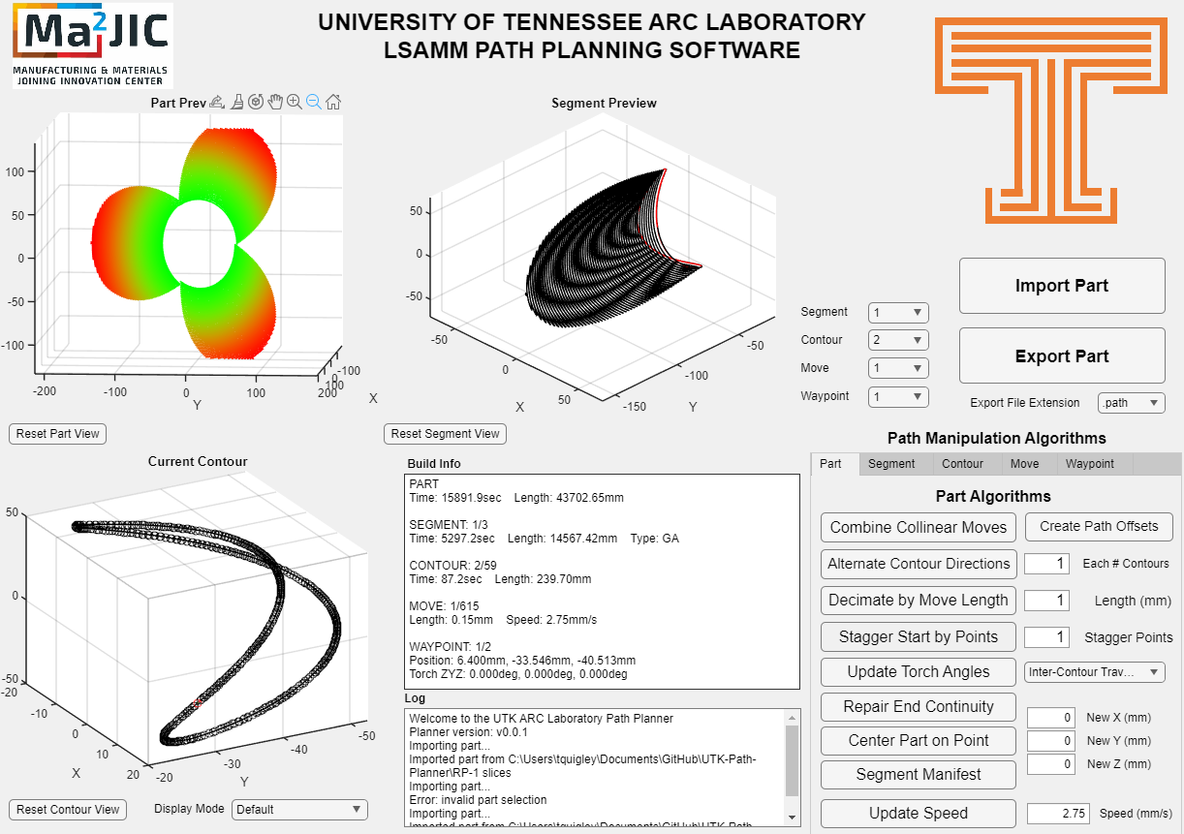
Figure 15: Graphical User Interface
After all the settings are properly maintained and adjusted, a manifest of the path is created and exported. All adjustments made in this script are also able to be seen visually in the form of the graphical user interface (Figure 15). The GUI is used to examine and verify contours are properly exhibited, starts and stops occur in proper position, and layers are in proper order. Once all variables are verified and corrected, the path is exported to Octopuz for simulation.

Importing Path into Octopuz
The path created in the previous step is then imported into Octopuz. A replication of the hybrid manufacturing cell was previously created in Octopuz to import paths into. A new base is created to properly align the path to the part positioner. The base defines an origin and axis of where the path is in space. Once the path is aligned, wait functions are implemented after each segment of the path to allow proper cooling of the part between layers. Welding parameters are also defined in Octopuz for each layer. The first layer of the build is set to different parameters than the remaining layers to accommodate for the different cross-sectional area of the base plate in comparison to welding to a previous layer. The kinematics of the robot are manipulated as necessary to keep the welding torch gravity aligned to the part. A simulation of the path is run in its entirety to evaluate and solved any discrepancies. Once the simulation is verified, the code is exported into Kuka Robot Language (KRL) to be read by the robotic manipulator in the hybrid cell.
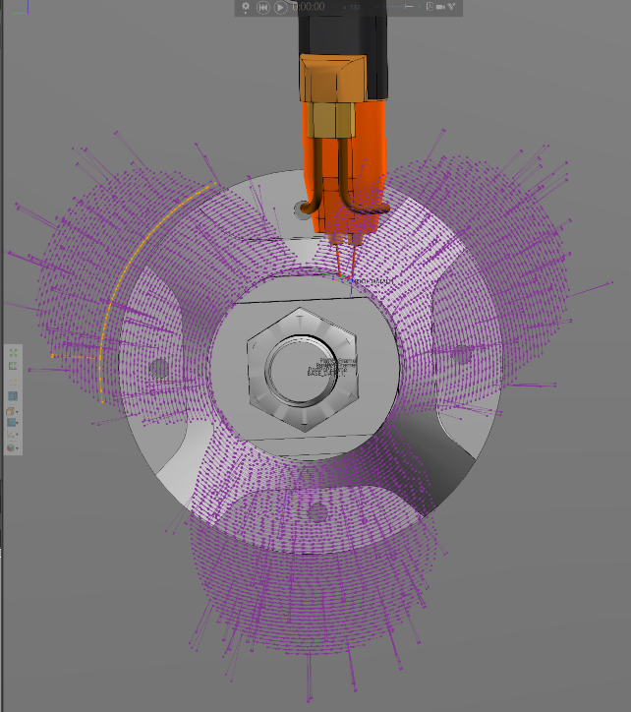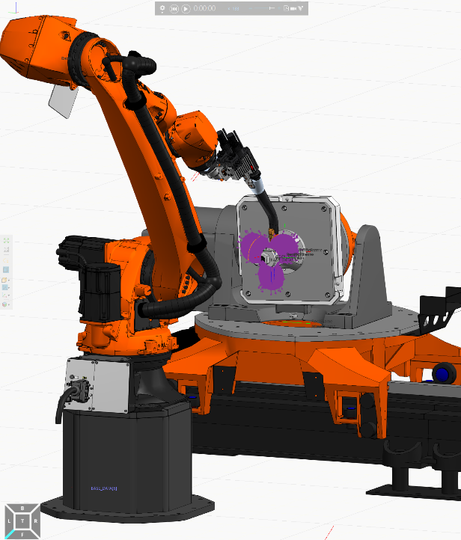

Path Plan on Robot
A new base is taught on the robot to correspond to the orientation defined in Octopuz. The KRL code generated is imported onto the robot and a dry run is administered with the torch and shielding gas off to verify the kinematics are within joint limits, workspace limits, as well as avoidance of collisions. After verification is complete, the torch and power supply are turned on and the code is set to run. The robot goes through and prints each layer as programmed. The program is closely monitored in the event that the part height gets too close to the weld torch. If the torch does come within close proximity of the part, layers may be omitted to accommodate.

Mounting of Scanner to Robot

Hardware Design
The mounting fixture created to secure the 3D scanner to the KR250 is comprised of Al6061-T6 aluminum for ease of manufacturing as well as cosmetic appeal. This material is easy to machine, readily accessible, and easily refined to a smooth finish. The Foba BALSA mounting bracket (Figure 16) is used to attach the scanner to this fixture. Four threads on the topside of the bracket permit direction versatility in which the camera can be mounted. 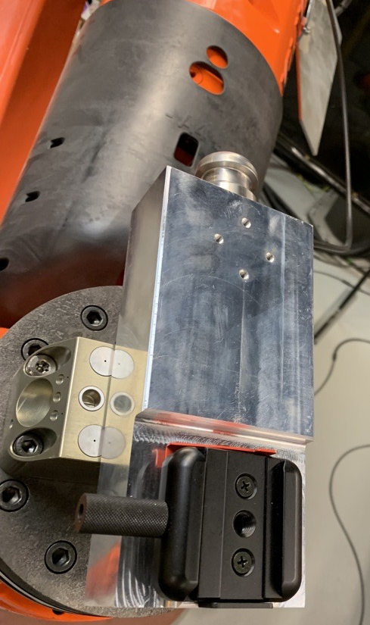
Figure 16: GOM Scanner Mounting Bracket

- Schunk (ask Aaron what they’re called) mounts allow to go out from wrist or 90 deg from wrist (can go on either side)
- Different compliance & error in location. This one chosen because they don’t have as much play/clamp
pic
- step machined all the way around to allow for that red lever to lock any direction
- Designed to be a test bed, able to be adjusted for what we decided to do. No need to make another part. Made during a time of discussion when we didn’t know which orientation would be best yet
- 1100 lb of omnidirectional clamping force
- Care must be taken to align perfectly squared up since it can clamp in any direction. Didn’t put the same squaring since we didn’t know which direction we were going to put it
- 3/8 hole on the bottom you could screw a bolt into for extra security, femmes unnecessary since camera only 8 lb
- I was focused on the concept “the way that this works is ______. Motivation for design features was _____”
has context menu

Straight vs. 90 degree Configuration

Kinematics
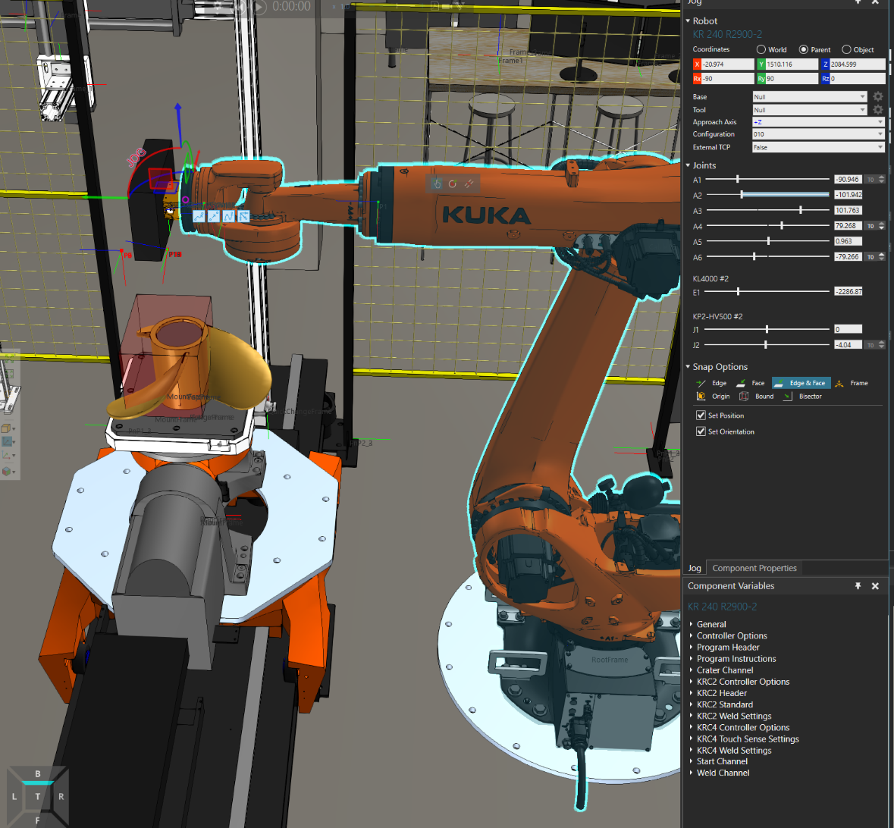
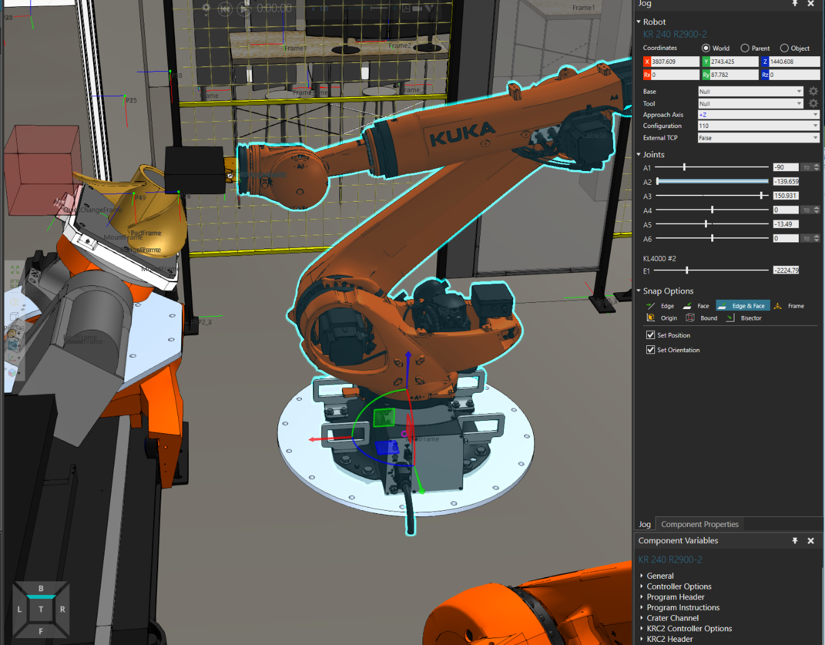
- joint access limits
- visibility
- collision with part much more likely with straight configuration

Path Planning for Scanning

Challenges

Too Much Motion

Transformation Error

Field of View, dimensions, resolution, etc.

Gage ball study

Manual Scanning

Generalized Scanning
The first step of automating the scanning process was to create a generalized path plan applicable to any geometry. In this path plan, simulation software is used to determine the position of the scanner in relation to a geometry. The best field of view volume is implemented as a visually depicted cube in the simulation and configured to best encompass the surface area of any part. After each segment, a wait function is implemented for the scan to be conducted.
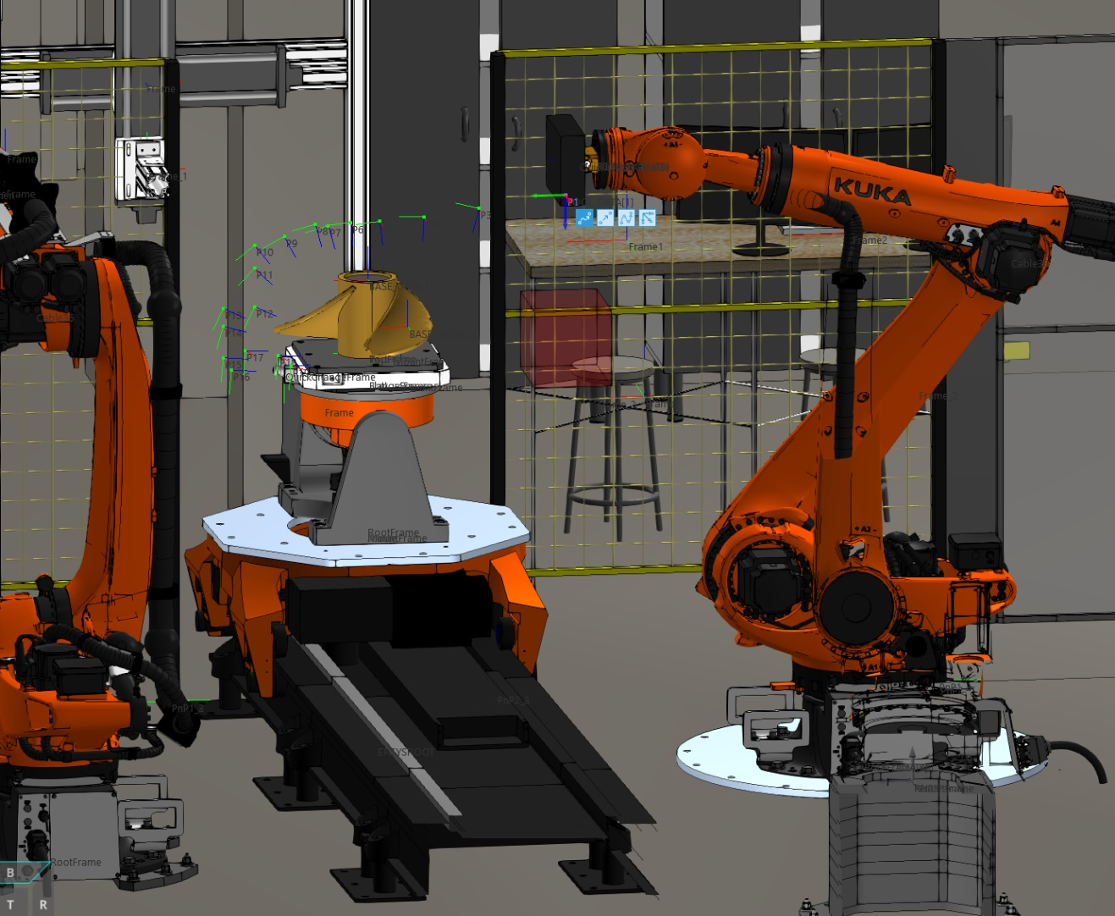

CAD/Geometry based/specific scanning
The field of view of the scanner was defined in Octopuz robotic simulation software as a tool center point. Similar to the welding process, the tool follows along the surface geometry with wait functions at each segment to conduct the scan. Data collection from the gage ball study is used to determine ideal scanning configurations.
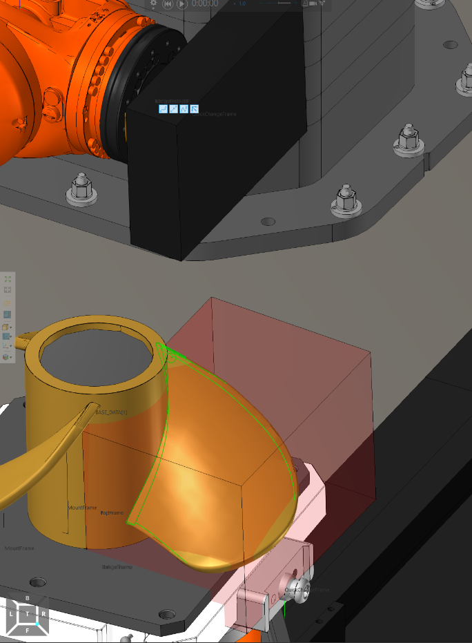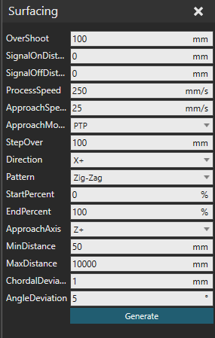
To begin, the surfacing function is used to define the geometry, parameters are defined for the respective camera orientation. Once desired parameters are defined, path functions are generated for the motion of camera along the surface of the geometry.
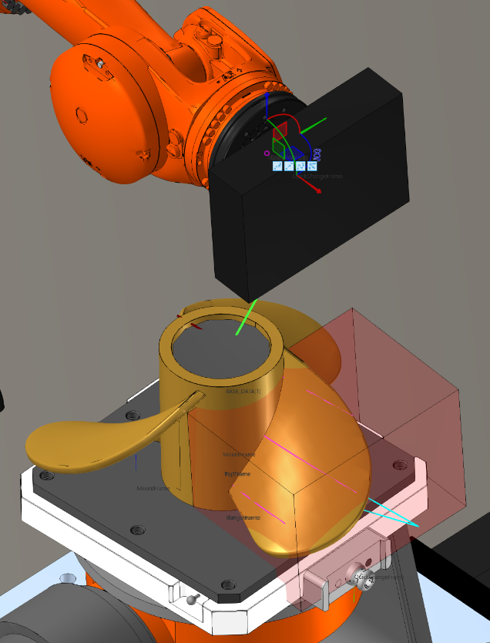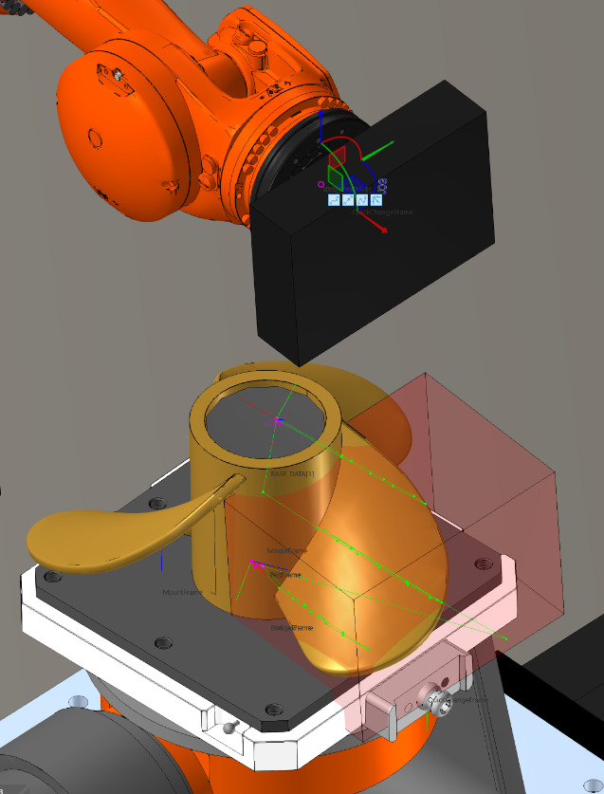
Figure 17: Surface Based Path Plan
After verification of the paths (left Figure 17) a path plan is generated for both the posterior and anterior faces of the geometry.

Data Comparison/Results

Comparison of scans taken from methods: 4.3, 4.4, 4.5

Conclusions And Recommendations

List of References

Appendix

