Studies on SOLO Working Mechanism in Drosophila Meiosis Cohesin Complex

ABSTRACT
In eukaryotes, sister chromatids are closely aligned due to cohesion, a process essential for chromosome pairing and segregation during both mitosis and meiosis. A conserved cohesin complex in a ring structure is composed of four subunits, including each of these four members or their homologs, SMC1, SMC3, SCC1/RAD21/REC8, and SCC3/SA. However, it is still unclear either the complex components or the working mechanism in the process of Drosophila meiosis cohesion. Sisters on the loose (SOLO) is a newly reported meiotic protein required for centromere cohesion, and cohesin complex localization in Drosophila meiosis. In addition, SOLO interacts with SMC1 physically in meiosis. In this study, we further analyzed of the working mechanism of SOLO and the SOLO-containing cohesion complex in Drosophila meiosis. SOLO C terminus conserved residues with SCC1/RAD21/REC8 are necessary for its localization, and accurate chromosome segregation during meiosis in both males and females. In addition, centromere pairing is disrupted in SOLO C terminus mutant flies in male meiosis. Furthermore, Yeast-Two-Hybrid identified direct interactions between SOLO, specifically N and C terminus domains, and cohesin proteins, SMC1 and SMC3. SOLO interacts with SMC1 with its C terminus domain while interacting with SMC3 by its N terminus domain, from yeast two hybrid. In addition, similar to Rad21, SOLO interacts with a protease dead cysteine protease separase from both yeast-two-hybrid and co-Immunoprecipitation. SOLO fragments are detected by western blotting. These results support that SOLO works as the SCC1/Rec8 homolog in Drosophila meiosis cohesin complex.

Chapter 1 Introduction
Meiosis
Meiosis, in all eukaryotes, is a specialized cell division in which one diploid eukaryotic cell divides into four haploid cells called gametes. Meiosis I and Meiosis II are similar to their analogous subphases in the mitotic cell cycle, both divide into prophase, metaphase, anaphase, and telophase. Meiosis I is a reductional division in which homologous chromosomes pair with each other, undergo recombination, and segregate to opposite poles¹⁻³. In this stage, homologs are connected in the form of chiasmata, which derives from crossovers between homologous chromatids and stabilized by sister chromatid arm cohesion^{1,2,4}. Sister centromeres adopt a side by side orientation and form a single functional kinetochore to ensure that the sister chromatids coorient⁵. In contrast, meiosis II is a mitosis-like equational division in which sister chromatids segregate to opposite poles. Sister chromatids are connected mainly by cohesion between sister centromeres. At the same time, sister centromeres orient back to back and establish separate kinetochores that attach to spindles respectively. It is worth noting that in meiosis I of some eukaryotes like Drosophila melanogaster males, homologues do not have chromosome exchange and chiasmata but they pair through a “conjunction complex”. Homologue connections are stabilized by the male meiosis-specific chromosomal proteins stromalin in meiosis (SNM) and mod (mdg4) in meiosis (MNM)^{6,7}.

Cohesion and Cohesin
In eukaryotes, sister chromatids are closely aligned from their establishment in prophase until anaphase (anaphase II in meiosis), due to cohesion, a process in charge of chromosome pairing and segregation during both mitosis and meiosis. In addition to its function in meiosis II, cohesion promote both homolog recombination, SC formation and stabilize chiasmata⁸ in meiosis I. A conserved cohesin complex plays a pivotal role in this process by helping the establishment of sister chromatid cohesion. Cohesin complex is composed of four subunits including Structural maintenance of chromosomes 1(Smc1), Structural maintenance of chromosomes 3 (Smc3), Scc1/Rad21/Rec8, and SA/Scc3. Cohesin has been proposed to form a closed ring structure. The linker regions of SMC1 and SMC3 interact specifically with each other to form V-shaped hetero-dimers and their globular heads interact with opposite ends of SCC1/RAD21, a member of the kleisin superfamily represented in all SMC-based complexes⁹⁻¹¹. The tripartite SMC1-SMC3-SCC1 ring is thought to be capable of surrounding and entrapping a pair of sister chromatids. Scc1/SA is not part of the ring but it interacts with Scc1 α-kleisin subunit, and it is essential for cohesion¹².
Many species have one or more meiosis-specific components to substitute the mitotic subunit of the cohesin ring.^{8,12} Rec8 replaces Rad21/Scc1 in most meiotic cohesins and essential for cohesin major functions. The working mechanism of Rec8 is unclear but Rad21/Scc1 ectopical expression failed to rescue the Rec8 mutant phenotype in budding or fission yeast. The importance of Rec8 is underlined by its widespread conservation, the phenotypic similarity of rec8 mutants in diverse model eukaryotes, and the requirement of Separase-mediated Rec8 cleavage for homolog segregation at anaphase I and sister chromatid segregation in anaphase II in many eukaryotes.^{8,12-18}
However, Rec8 is not universal since no Rec8 homolog has been identified in Drosophila meiosis. In female meiosis, C(2)M, although it is a klesin meiosis protein, is required only for recombination and SC formation, but not for cohesion.^{19,20} In addition, in contrast to other Drosophila mutations that disrupt meiotic cohesion, defects of meiosis II segregation are not severe in C(2)M females (ranging from 13.4% to 29.3%), and accurate chromosome segregation during male meiosis does not depend on C(2)M function.¹⁸ Moreover, female germ-line expression of a mutated C(2)M transgene in which putative separase cleavage sites were disrupted did not result in meiotic segregation defects¹⁹. Finally, localization of C(2)M protein in whole-mount preparations indicates that, like C(3)G protein, C(2)M is restricted to the subset of cells within each germ-line cyst that build synaptonemal complex (SC).¹⁸ In sum, these data suggest that C(2)M is not the Rec8 homolog in Drosophila.
On the other hand, Drosophila has three unique meiotic cohesion proteins, sisters on the loose (Solo), orientation disruptor (Ord), and sisters unbound (Sun), similar to Rec8. They are essential for cohesion and proper chromatid segregation both sexes and for recombination and SC stability in females. Solo, Ord, and Sun colocalize with cohesin subunit Smc1 and are required for its localization. ²⁰⁻²⁷ (Krishnan B., unpublished data)

SOLO
Sisters on the loose (SOLO) is a newly reported meiotic protein required for centromere cohesion, and cohesin complex localization in Drosophila meiosis²¹. It is a different splice isoform of VASA, a DEAD box (Asp-Glu-Ala-Asp) RNA helicase. SOLO and VASA share a same N terminus RGG repeat rich domain, but they have different middle and C terminus domains. SOLO is highly expressed at centromeres and chromosomal arms in females from pre-meiotic cells to metaphase II, after which stage sister chromatid cohesins are destabilized. It recruits SMC1 to chromosome. In addition, localization of SOLO and SMC1 on meiotic centromeres after metaphase I depends on cohesin protector shugoshin protein MEI-S332.^{21,27} Although SOLO lacks statistically significant similarity with any known cohesin proteins, it has similar functions as Rec8. Sequence alignment of SOLO homologs based on sequenced Drosophila genomes identified the C terminus as a conserved domain. SOLO C terminus conserved domain may have significant functional importance since truncation of SOLO 21 residues from its C-termins via a nonsense mutation (L1010) abolishes SOLO function.²¹ A further sequence alignment of SOLO C terminus with Rad21/Rec8 suggests that all but one of the 13 most-conserved residues in Rec8 alignment are conserved among Drosophila SOLO orthologs. This is unlikely to be coincidental as the average overall pairwise identity of the D. melanogaster, D. pseudoobscura and D. virilis homologs is less than 30%. Moreover, the residues (F528 and L532) of yeast SCC1 that correspond to two of those conserved C-terminal residues (Y1007* and L1011*) make close contacts with SMC1 in an SCC1-SMC1 co-crystal structure, and are required for the SMC1-SCC1 interaction.^{9,10,28}

Separase, a cysteine protease cleaving cohesin
In mitosis, cohesion is established during S phase. The majority of cohesin pool is released from chromosome arms at prophase while the rest at anaphase by two distinct mechanisms. In prophase, the prophase pathway removes cohesin from chromosome arms without cleavage.²⁹ However, Shugoshin-like 1 (Sgo1) protein from the shugoshin family protects centromere cohesin. In Drosophila, the Shugoshin family member Mei-S332 protects centromere cohesin from the prophase pathway. In anaphase, Anaphase Promoting Complex/cyclosome (APC/C) primes the degradation of securin, an inhibitor of separase. Separase is a cysteine protease that cleaves cohesin subunit Scc1 at consensus sites of D/ExxR. In anaphase, activated separase cleaves centromere cohesin Scc1 subunit to release sister chromatids.^{30,31} This proteolytic separase cleavage pathway is another mechanism besides the prophase pathway to remove cohesin.
Drosophila Separase (Sse) belongs to a complex that also includes the securin homolog Pimples (PIM) and an activating subunit, Three Rows (THR), and the entire complex, not just Sse, is required for separase activity and for sister centromere segregation beginning in embryogenesis.

Chapter 2. Investigate SOLO C terminal domain function.

In mammals and yeast, proteins containing klesin subunits, like SCC1, RAD21, and REC8 (meiosis specific) are found to connect SMC1 and SMC3 to form the ring. However, in Drosophila meiosis, there is no report of REC8 or its homolog in previous studies. In female meiosis, C(2)M, although it is a klesin meiosis protein(21), is not required for either SMC1 or SMC3 localization (22). In contrast to other Drosophila mutations that disrupt meiotic cohesion, defects of meiosis II segregation are not severe in C(2)M females (ranging from 13.4% to 29.3%), and accurate chromosome segregation during male meiosis does not depend on C(2)M function(23). Moreover, female germ-line expression of a mutated C(2)M transgene in which putative separase cleavage sites were disrupted did not result in meiotic segregation defects (21). Finally, localization of C(2)M protein in whole-mount preparations (23) indicates that, like C(3)G protein, C(2)M is restricted to the subset of cells within each germ-line cyst that build synaptonemal complex (SC).
Compared to C(2)M, SOLO behaves like a cohesin protein in every aspect. It localizes to chromosomes until metaphase II, after which stage sister chromatid cohesins are lost; SOLO recruits SMC1 to chromosomes, and it’s function requires the cohesin protector shugoshin protein MEI-S332. SOLO, although lacking crystal structure for a C terminal klesin subunit, is believed to have a functionally important C terminus since soloZ2-3534, which creates a stop codon at residue L1010, leads to total loss of function. This C terminus shares 12 of the 13 most conserved amino acids in REC8 and homologs. Interestingly, two of the corresponding conserved residues (F528 and L532 in SCC1) are demonstrated to be essential for SCC1-SMC1 interaction in yeast (20). Do these conserved residues contribute to SOLO function also? To address this question, we carried out a series of experiments.
- Role of SOLO C terminus conserved residues in accurate chromosome segregation.
Site-directed mutagenesis was carried out to study the function of these SOLO C terminus conserved residues. Five SOLO mutants (R1000E, Y1007R*, L1010R, L1011R*, and Y1007R*&L1011R*, residues labeled with * are counterparts essential for interaction to SMC1 in SCC1) are tagged with fluorescent protein Venus. solo mutant transgene flies were made from BestGene Inc. In order to test if these mutations interfere with accurate chromosome segregation, flies with genotype w/B^{s}Yy+ or w; 57-204/Df(2L)A267; solo^{mut}/nanos::GAL4-VP16 was used for sex chromosome non-disjunction assay (57-204 is a solo nonsense mutant; A267 is deficient for solo). Siblings with genotype w/B^{s}Yy+ or w; 57-204 or Df(2L)A267/SM6, Cy; solo^{mut}/nanos::GAL4-VP16, and w/B^{s}Yy+ or w; 57-204/Df(2L)A267; solo^{mut}/TM2 are used as wildtype control and mutant control, respectively. Consistent with the cytological data discussed earlier, mutants R1000E and Y1007R* show little effect on males, but mutants L1010R, L1011R*, and Y1007R*&L1011R* show significant non-disjunction rates (21.52%, 22.97%, and 54.10%) (Fig. 4a). It is worth noting that double mutant of Y1007R*&L1011R* cause a high non-disjunction rate of 54.10%, which is almost as high as solo null mutant (Fig. 4a). In females, all of these mutations effect on chromosome segregation, especially L1010R, L1011R*, and Y1007R*&L1011R* (58.23%, 52.89% and 57.14%)(Fig. 4b). Compared with males, female flies show a more severe phenotype. A mutant fly line with L1010R&L1011R* mutation is being tested.
a

 | R1000E | Y1007R* | L1010R | L1011R* | Y1007R*&L1011R*
wt ctrl | 0.23% | 0.47% | 0.27% | 0.66% | 1.00%
mut ctrl | 55.56% | 50.85% | 48.11% | 47.02% | 54.85%
NDJ | 0.63% | 3.41% | 21.52% | 22.97% | 54.10%

b

NDJ% | R1000E | Y1007R* | L1010R | L1011R* | Y1007R&L1011R*
wt ctrl | 1.09% | 2.33% | 3.03% | 3.26% | 5%
mut ctrl | 66.67% | 60% | 66.67% | 50.00% | 48.48%
NDJ | 13.44% | 27.52% | 58.23% | 52.89% | 57.14%
Fig. 4. SOLO mutants lead to sex chromosome non-disjunction in both sexes. a. Sex chromosome non-disjunction assay for males. b. Sex chromosome non-disjunction assay for females. *Labeled residues are reported to be essential in SCC1 for its interaction with SMC1.

- Role of SOLO C terminus conserved residues in its localization.
In order to test if these mutations interfere SOLO chromosome localization, transgene flies with the following genotype, w/y or w; 57-204/Df (2L) A267; solo^{mut}/nanos::GAL4-VP16, was used for the cytological study. w/y or w; 57-204/Df(2L)A267; Venus-solo/nanos::GAL4-VP16 flies are used as control. Nanos::GAL4 is a germline specific driver. DAPI staining was performed to detect Venus-SOLO localization within these mutants. R1000E, Y1007R*, and L1011R* do not significantly interfere its chromosomal localization at testes tips and germariums. However, mutants L1010R and Y1007R*&L1011R* cause a localization failure even at the beginning of meiosis in both sexes (Fig.5a, 5b). These results proved that residues Y1007*, L1010, and L1011* contribute to SOLO localization. A mutant fly line with L1010R*&L1011R* mutation is being tested.
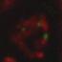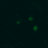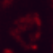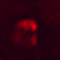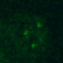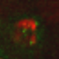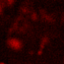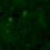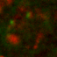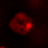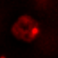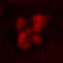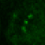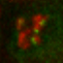
Venus-SOLO
Venus-SOLO^{R1000E}
Venus-SOLO^{Y1007R*}
Venus-SOLO^{L1010R}
Venus-SOLO^{L1011R*}
Venus-SOLO^{Y1007R*&L1011R*}
Merge Venus DAPI
a
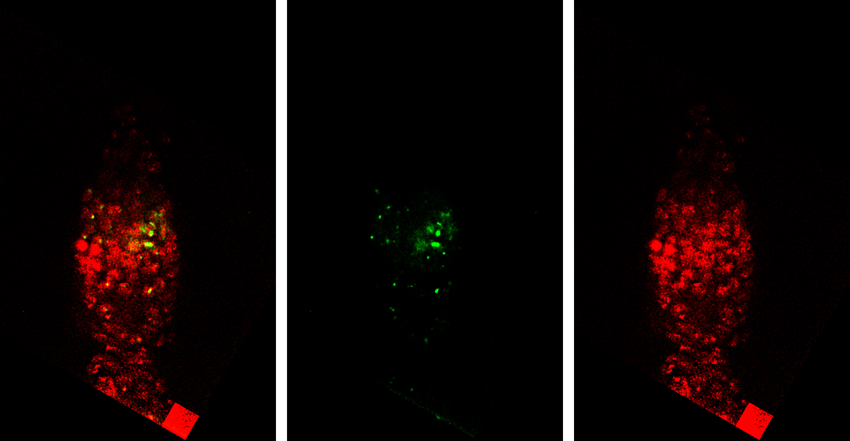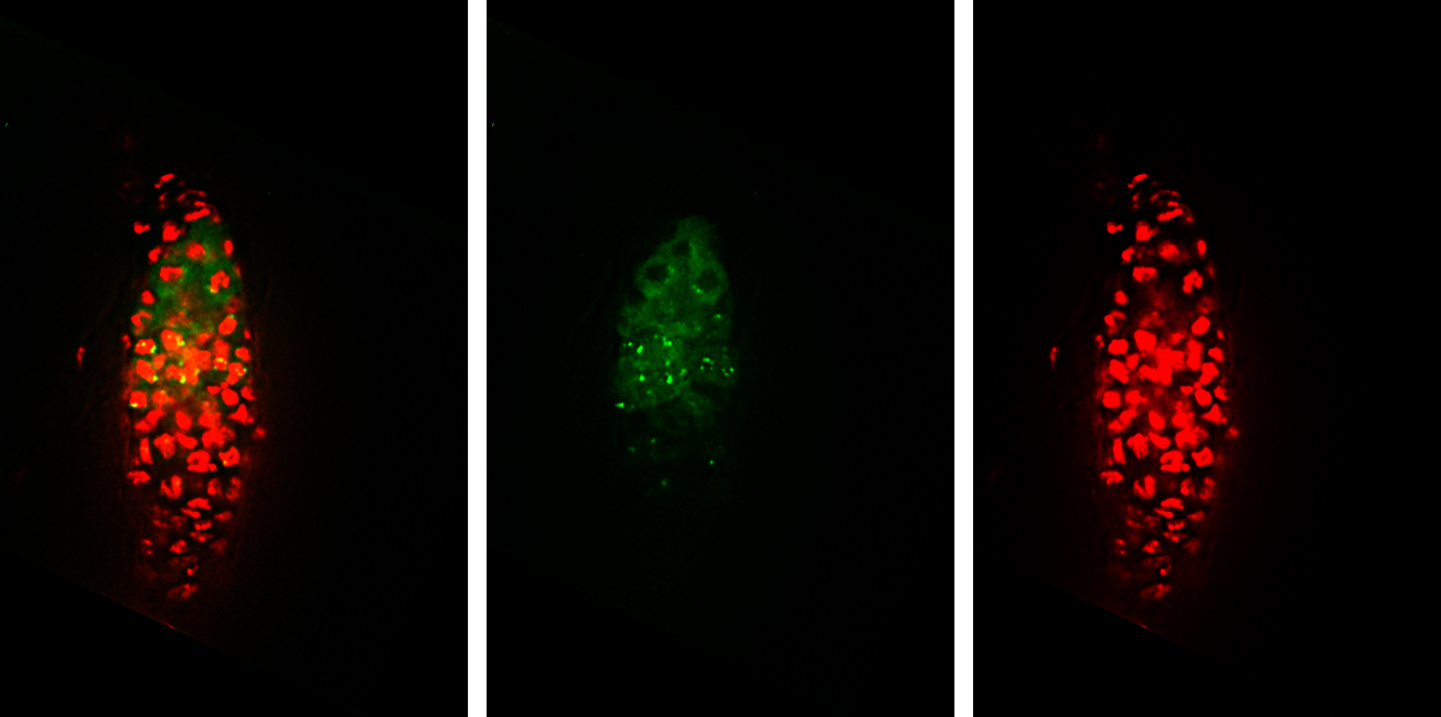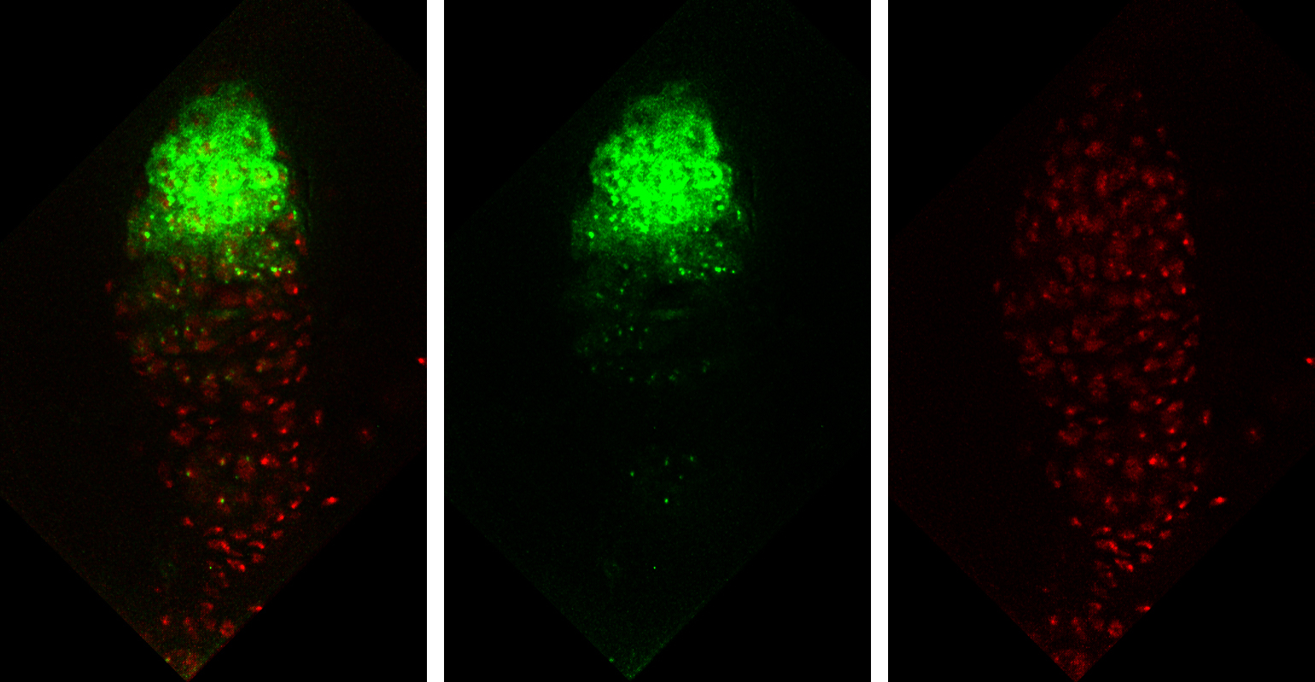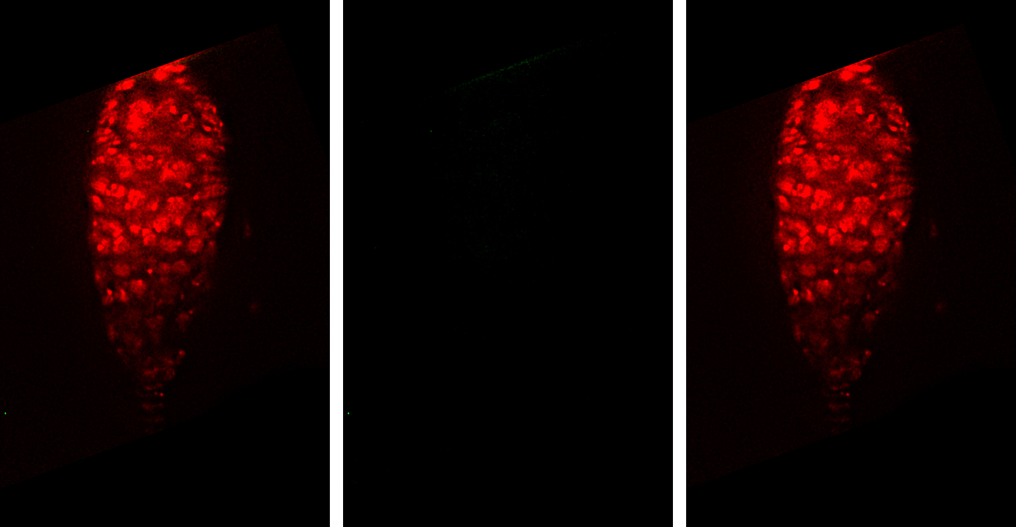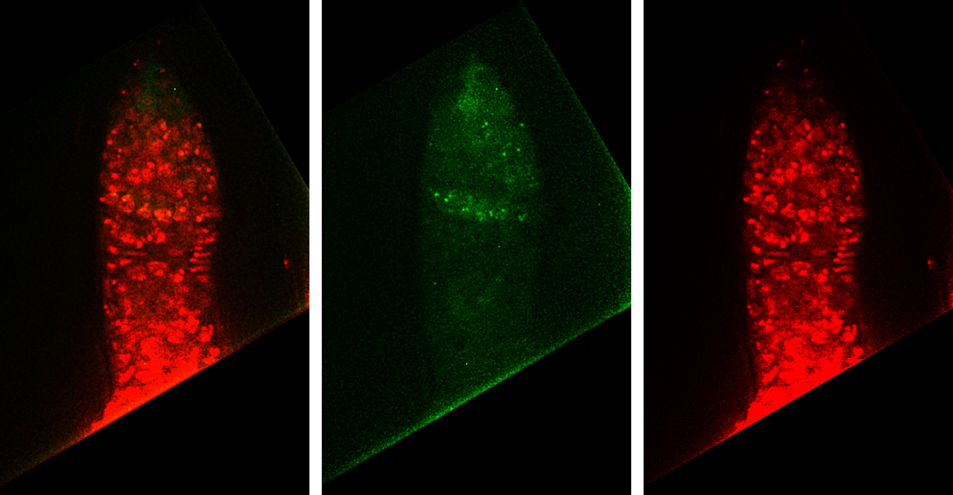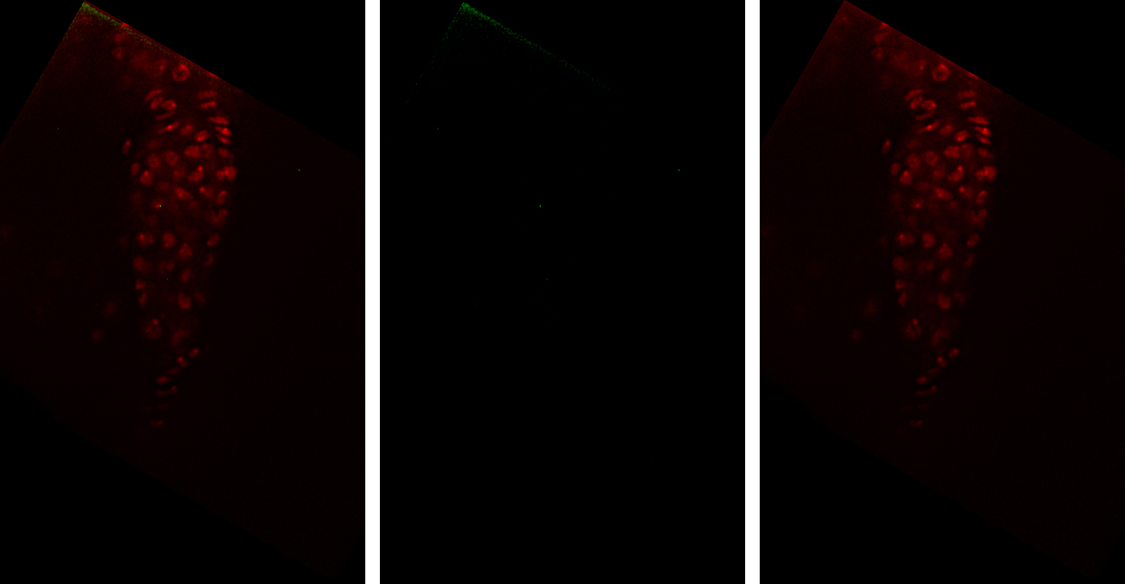
Venus-SOLO^{Y1007R*}
Venus-SOLO^{R1000E}
Venus-SOLO
Venus-SOLO^{Y1007R*&L1011R*}
Venus-SOLO^{L1011R*}
Venus-SOLO^{L1010R}
b
Merge Venus DAPI

- Explore role of SOLO C terminus conserved residues in centromere pairing.
Fig. 5. Mutant SOLO localization in meiosis cells. a. In males, R1000E, Y1007R*, and L1011R* mutant SOLO can localize to chromosomes; while in L1010R, Y1007R*&L1011R* mutants, SOLO fails to localize from early meiosis stages. Venus-SOLO is used as control. b. In females, R1000E, Y1007R* and L1011R* SOLO mutants can localize to chromosomes, but L1010R and Y1007R*&L1011R* SOLO mutants fail to localize to chromosomes.
In order to further study if these mutations have any effect on centromere pairing and segregation, CID, centromere identifier, is used to monitor centromere behaviors in solo mutant flies. Flies with genotype w/y; 57-204/Df(2L)A267; SOLO^{Y1007R*&L1011R*}/nanos::GAL4-VP16 are used in this study. w/y; 57-204/Df(2L)A267; Venus-solo/nanos::GAL4-VP16 flies are used as control. CID signal spots are counted at each meiotic stage. Since Drosophila has 4 pairs of chromosomes, and the forth one is usually small thus hard to detect, we should detect 3-4 spots at early prophase when sister chromatids and homologs are aligned. After that, 6-8 spots should be detected until metaphase I, when sister chromatids are paired but have not divided. After cell divides, we should detect 3-4 spots until metaphase II.

In both the wildtype SOLO and SOLO^{Y1007R*&L1011R*} mutant flies, sister chromatids and homologs are aligned at early prophase (S1-S2), so we detected 4 spots. From middle prophase (S3-S4), SOLO^{Y1007R*&L1011R*} mutant fly shows more than eight CID signals compared with less than eight signals in wildtype SOLO flies. In metaphase II, more than four spots are observed in mutant flies (Fig. 6). These data indicate that SOLO^{Y1007R*&L1011R*} mutation disrupt centromere pairing in male meiosis. Other SOLO mutant lines are still being tested.
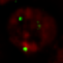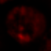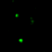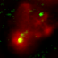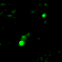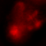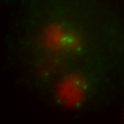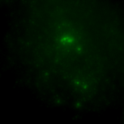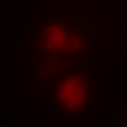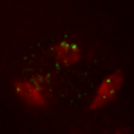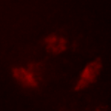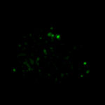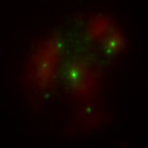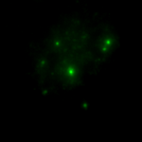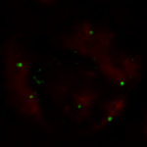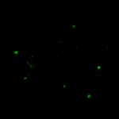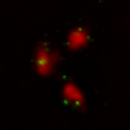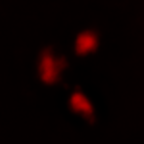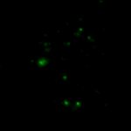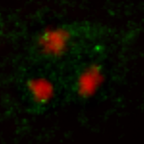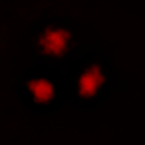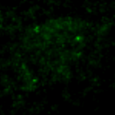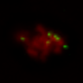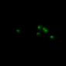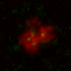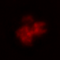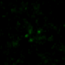
S1
S3
S5
PM I
M II
Merge CID DAPI Merge CID DAPI
WT
SOLO^{Y1007R*&L1011R*}
Fig. 6 Centromeres are not well paired in SOLO^{Y1007R*&L1011R*} mutant spermatocytes. The left half of cells are wildtype SOLO spermatocytes, the right half are SOLO^{Y1007R*&L1011R*} spermatocytes. In meiosis I, mutant cells have more than eight CID signals from stage S3, compared with 6-8 spots in wildtype cells. In meiosis II, mutant cells have more than four CID signals.

Chapter 3

Chapter 4

Reference:
1 McKee, B. D. Homologous pairing and chromosome dynamics in meiosis and mitosis. Biochim Biophys Acta 1677, 165-180, doi:10.1016/j.bbaexp.2003.11.017 (2004).
2 Page, S. L. & Hawley, R. S. Chromosome choreography: the meiotic ballet. Science 301, 785-789, doi:10.1126/science.1086605 (2003).
3 Roeder, G. S. Meiotic chromosomes: it takes two to tango. Genes Dev 11, 2600-2621 (1997).
4 Carpenter, A. T. Chiasma function. Cell 77, 957-962 (1994).
5 Hauf, S. & Watanabe, Y. Kinetochore orientation in mitosis and meiosis. Cell 119, 317-327, doi:10.1016/j.cell.2004.10.014 (2004).
6 McKee, B. D., Yan, R. & Tsai, J. H. Meiosis in male Drosophila. Spermatogenesis 2, 167-184, doi:10.4161/spmg.21800 (2012).
7 Thomas, S. E. et al. Identification of two proteins required for conjunction and regular segregation of achiasmate homologs in Drosophila male meiosis. Cell 123, 555-568, doi:10.1016/j.cell.2005.08.043 (2005).
8 Petronczki, M., Siomos, M. F. & Nasmyth, K. Un menage a quatre: the molecular biology of chromosome segregation in meiosis. Cell 112, 423-440 (2003).
9 Gruber, S., Haering, C. H. & Nasmyth, K. Chromosomal cohesin forms a ring. Cell 112, 765-777 (2003).
10 Haering, C. H., Lowe, J., Hochwagen, A. & Nasmyth, K. Molecular architecture of SMC proteins and the yeast cohesin complex. Mol Cell 9, 773-788 (2002).
11 Schleiffer, A. et al. Kleisins: a superfamily of bacterial and eukaryotic SMC protein partners. Mol Cell 11, 571-575 (2003).
12 Nasmyth, K. & Haering, C. H. Cohesin: its roles and mechanisms. Annu Rev Genet 43, 525-558, doi:10.1146/annurev-genet-102108-134233 (2009).
13 Klein, F. et al. A central role for cohesins in sister chromatid cohesion, formation of axial elements, and recombination during yeast meiosis. Cell 98, 91-103, doi:10.1016/S0092-8674(00)80609-1 (1999).
14 Buonomo, S. B. et al. Disjunction of homologous chromosomes in meiosis I depends on proteolytic cleavage of the meiotic cohesin Rec8 by separin. Cell 103, 387-398 (2000).
15 Siomos, M. F. et al. Separase is required for chromosome segregation during meiosis I in Caenorhabditis elegans. Curr Biol 11, 1825-1835 (2001).
16 Kitajima, T. S., Miyazaki, Y., Yamamoto, M. & Watanabe, Y. Rec8 cleavage by separase is required for meiotic nuclear divisions in fission yeast. EMBO J 22, 5643-5653, doi:10.1093/emboj/cdg527 (2003).
17 Kudo, N. R. et al. Role of cleavage by separase of the Rec8 kleisin subunit of cohesin during mammalian meiosis I. J Cell Sci 122, 2686-2698, doi:10.1242/jcs.035287 (2009).
18 Manheim, E. A. & McKim, K. S. The Synaptonemal complex component C(2)M regulates meiotic crossing over in Drosophila. Curr Biol 13, 276-285 (2003).
19 Heidmann, D. et al. The Drosophila meiotic kleisin C(2)M functions before the meiotic divisions. Chromosoma 113, 177-187, doi:10.1007/s00412-004-0305-5 (2004).
20 Khetani, R. S. & Bickel, S. E. Regulation of meiotic cohesion and chromosome core morphogenesis during pachytene in Drosophila oocytes. J Cell Sci 120, 3123-3137, doi:10.1242/jcs.009977 (2007).
21 Yan, R., Thomas, S. E., Tsai, J. H., Yamada, Y. & McKee, B. D. SOLO: a meiotic protein required for centromere cohesion, coorientation, and SMC1 localization in Drosophila melanogaster. J Cell Biol 188, 335-349, doi:10.1083/jcb.200904040 (2010).
22 Goldstein, L. S. Mechanisms of chromosome orientation revealed by two meiotic mutants in Drosophila melanogaster. Chromosoma 78, 79-111 (1980).
23 Bickel, S. E., Wyman, D. W. & Orr-Weaver, T. L. Mutational analysis of the Drosophila sister-chromatid cohesion protein ORD and its role in the maintenance of centromeric cohesion. Genetics 146, 1319-1331 (1997).
24 Bickel, S. E., Wyman, D. W., Miyazaki, W. Y., Moore, D. P. & Orr-Weaver, T. L. Identification of ORD, a Drosophila protein essential for sister chromatid cohesion. EMBO J 15, 1451-1459 (1996).
25 Balicky, E. M., Endres, M. W., Lai, C. & Bickel, S. E. Meiotic cohesion requires accumulation of ORD on chromosomes before condensation. Mol Biol Cell 13, 3890-3900, doi:10.1091/mbc.E02-06-0332 (2002).
26 Webber, H. A., Howard, L. & Bickel, S. E. The cohesion protein ORD is required for homologue bias during meiotic recombination. J Cell Biol 164, 819-829, doi:10.1083/jcb.200310077 (2004).
27 Yan, R. & McKee, B. D. The Cohesion Protein SOLO Associates with SMC1 and is Required for Synapsis,
Recombination, Homolog Bias and Cohesion and Pairing of Centromeres in Drosophila
Meiosis. PLOS Genetics (2013).
28 Haering, C. H. et al. Structure and stability of cohesin's Smc1-kleisin interaction. Mol Cell 15, 951-964, doi:10.1016/j.molcel.2004.08.030 (2004).
29 Alexandru, G., Uhlmann, F., Mechtler, K., Poupart, M. A. & Nasmyth, K. Phosphorylation of the cohesin subunit Scc1 by Polo/Cdc5 kinase regulates sister chromatid separation in yeast. Cell 105, 459-472 (2001).
30 Waizenegger, I. C., Hauf, S., Meinke, A. & Peters, J. M. Two distinct pathways remove mammalian cohesin from chromosome arms in prophase and from centromeres in anaphase. Cell 103, 399-410 (2000).
31 Sun, Y. et al. Separase is recruited to mitotic chromosomes to dissolve sister chromatid cohesion in a DNA-dependent manner. Cell 137, 123-132, doi:10.1016/j.cell.2009.01.040 (2009).

