Demand for Guided Tours on the Tennessee River.

A Thesis Presented for the
Master of Science
Degree
University of Tennessee, Knoxville

Gessika Lee Guerra
December 2023
Acknowledgements
I would like to thank my advisor, Dr. Neelam C. Poudyal, and my committee members, Dr. Don Hodges and Dr. Alicia Rihn, for all of their guidance, help, and support during my journey. Other professors I am so thankful for include Dr. Charles Simms of the Department of Economics, Dr. Kathy Braun of the College of Communications, and Dr. Kimberly Jensen, retired from the Department of Agricultural and Resource Economics. I extend that thanks to the Ijams Nature Center, Knoxville Parks and Recreation, the UTK School of Natural Resources, and to Heather Inman, who always found a way for me. I am grateful for the love and support of my parents, Phil & Holly Guerra. Last but not least, I wish I could thank Dr. Mark Fly. He was my friend, my teacher, and the person who believed I could do this when I did not think I could.

Abstract
Knoxville, TN is a major urban center in east Tennessee. Knoxville’s urban planners recognized the need for green space and have installed free greenways and parks within the downtown area over several decades. These attractions are immensely popular and promote urban ecotourism. There is an opportunity to begin or expand guided tour services. This research will analyze the demand and willingness to pay for guided river activities – kayaking and pontoon boating – on the Tennessee River in downtown Knoxville. Primary data were collected by 1000 on site flyers connected to an online survey platform. These data were uploaded into statistical software to create logit and tobit models to predict what features these tours should or should not have, demographics affected, and prices. Chi square comparisons were implemented to assess the relationship between interest in the activities and residency. Results concluded there are relationships between residency and the activity interest. Several variables had large effects on the logit and tobit model predictions with income being the most prevalent. Overall interest in a kayak tour was 83% and 65% for a pontoon boat tour. The accepted price per person for a kayak tour was $32.68 and $25.21 for a pontoon boat tour. The results of this research may provide an outline for future or current outdoor business to promote new river activities geared towards local history, industry, and conservation.

Table of Contents
Chapter 1. Introduction 1
Research Objectives 2
Hypotheses 3

Chapter 2. Literature Review 4
Urban Ecotourism 4
Demand 5
Willingness to Pay 7
Non-Market Valuation of Future Recreation Sites 9
Contingent Valuation Bid Types 11

Chapter 3. Methodology 14
Study Area 14
Preparations for Data Collection 14
Survey Design 15
Data Collection 16
Data Manipulation & Modeling 16

Chapter 4. Results 22
Characteristics of Survey Respondents 22
Chi Square Test Results 22
Logit Model Results 23
Tobit Model Results 25

Chapter 5. Discussion 28
Outcomes 28
Survey Design Constraints 30

Chapter 6. Conclusions 31

List of References 33
Appendices 36
Appendix A. Survey 36
Appendix B. STATA Outputs 41
Vita 53

List of Tables

Table 1. Descriptive Statistics of Variables 19
Table 2. Marginal Effects on Pontoon Boat and Kayak Tour Interest
Logit Models (n = 407) 24
Table 3. Marginal Effects on Pontoon Boat and Kayak Tour WTP
Truncated Tobit Models (Pontoon Boat n = 264; Kayak n = 336) 27
Chapter 1: Introduction
Outdoor recreation participation in the U.S. increased substantially between from 2017 and early 2020 (Outdoor Foundation 2021). In both years, the Outdoor Foundation conducted a survey of 18,000 American households who participated in at least one outdoor activity each calendar year. The survey revealed that participation in outdoor recreation increased from 49% to 52.9% over the three-year period. It was an increase of 14.6 million people from 146.1 M to 160.7 M (Outdoor Foundation 2021). This is the most dramatic change in outdoor recreation participation since the survey commenced in 2000. Following the onset of the Covid-19 Pandemic, outdoor recreation became an unheralded essential activity. Outdoor recreation in 2021 grew again by 2.2%, involving 164.2 million participants who conducted at least one outdoor activity (Outdoor Foundation 2022).
According to the Outdoor Foundation (2018), the most popular outdoor activities people try for the first time are running, bicycling, and watersports (2018). For beginners, some of these can require expensive equipment and training. It is common for first timers or infrequent users to borrow or rent equipment and learn from someone they know (Outdoor Foundation 2019). There is nothing wrong with this, but is the quality of instruction verified? Was the method given appropriate for the user? How well did the instructor know the environment? A possible solution is for people to opt for a guided tour. Guided tours not only offer a lesson on mechanics but allow for an inclusive and interpretive experience of the surrounding environment. With a guided tour, the visitor can learn about a variety of topics of interest, for instance: the cultural history and the ecological and geological characteristics of the area while becoming familiar with the recreational equipment being used.
There is potential to create outdoor experiences with professional instruction to bring in sales revenue, provide new job opportunities, and create a lattice of activities available to residents and tourists for a natural connection to the area. Knoxville, Tennessee is in a positive position to implement and market outdoor natural and cultural activities by offering guided tours in downtown Knoxville by pontoon boat and kayak. Current marinas and parks on the Tennessee River waterfront provide a framework and platform to host these educational tours. Of particular significance, just upstream from downtown Knoxville, is the confluence of the French Broad and Holston rivers which form the 652-mile-long Tennessee River. An interpretive program could present educational tour topics concerning the significance of the Tennessee River to Knoxville. Potential topics include discussions on animals and plants, river geology, conservation efforts, Native American history, pioneer history, Civil War effects, industrial significance, the 1982 World’s Fair, and the Tennessee Valley Authority.
Research Objectives
The research questions of this study are as follows:
- Are there significant differences in demand between Knox County residents and Knox County visitors for guided kayak and pontoon boat tours on the TN River?
- What demographic and personal characteristics predict the demand for these services?
- What educational content/theme are valuable among potential users of such services?
The research objectives of the study are:
1) Determine if there is statistical difference in demand for guided tours between Knox County residents and Knox County visitors.
2) Evaluate the influence of demographics and personal characteristics on demand for and willingness to pay for those services
Hypotheses
1. Demand for guided tours will not vary based on demographics.
2. Demand will be higher among visitors to Knox County than Knox County residents.
3. The demand for tours will be affected by the educational topic offered.

Chapter 2: Literature Review
Urban Ecotourism
Ecotourism is nature-based tourism that supports conservation of natural areas and benefits local economies (Higham and Luck 2002). Ecotourism is best described as a visitation to pristine environments. Its close relative, Urban Ecotourism, is ecotourism that occurs in areas that offer a sense of naturalness or cultural significance that are or have been substantially modified by human activity (Jegdic and Gradinac 2016). Urban ecotourism is rising in popularity because it “is perceived as one of the sustainable ways of travelling to urban areas.” Besides its sustainable perceptions, it is also gaining traction under the assumption that it is easier to reach cities versus remote locations. It is considered a “local” option for immediate area income and jobs (Joppe and Dodds 1998).
Ecotourism and Urban Ecotourism have an expansive range of prices, from free experiences to resorts and services that cater to the wealthy. Toronto, Ontario capitalized on this concept in the 1990s. Toronto urban planners heavily advertised its free green spaces – parks, greenways, walkways – as viable attractions alongside its tourist attractions. Toronto was promoted as a “green” city that cares about the wildlife refuge seen from the sidewalk as much as the hockey team. The promotion was quite successful, not only for tourists but for the local communities. They recorded increased walking, bicycling, and running at these sites from both locals and visitors following implementation (Joppe and Dodds 1998).
Urban ecotourism is not a new phenomenon. The public is increasingly seeking out wild places to visit and green sites in urban environments. However, the phrase “green sites” is conflicting. Cities seldom have original green spaces or pristine rivers; therefore, urban ecotourism is sometimes referred to as “gray tourism” due to its uncertain nature (Majumdar et al 2011). There is a big push across cities to “rewild” cityscapes to bring back nature to the city (Kaae 2009). New York City, for example, converted an elevated old train track to a park with a walking path, Highline. This park hosts nature programs and promotes sustainable practices (thehighline.org 2022). Whether this is a legitimate green space or manmade attraction is debatable. There are conflicts among researchers on whether industrial parks renovated into parks are “natural” areas and should be considered ecotourism. Others suggest an urban feature is part of urban tourism because the surroundings are not natural (Higham and Luck 2002). Finally, there is a suggestion that it is up to the visitors and residents to determine if a green space is “natural” and aesthetic enough to be advertised as an ecotourist site (Chirgwin and Hughes 1997).
Demand
Demand is an umbrella term encompassing the many differing factors influencing why and willingness of a consumer to purchase a good. Price is considered the most important factor, but demand is also affected by the number of consumers in the market for the good, consumer wealth, consumer tastes, and prices of other goods (Goolsbee 2015). Other goods do not have to be the exact same good as the one offered. Other goods can also be substitutes or complements. An assumption when studying demand is demand is solely based on price and assumes perfect markets. It would be difficult to account for factors such as consumer taste because that is an unobservable factor and is more a function of the participant’s utility.
Recreation demand focuses on the estimated number of people projected to participate in a particular recreation opportunity at a predetermined future time and location. Recreation demand is expressed as a numeric value of individuals or groups. The estimation can also describe an attribute of the visitors, such as visitors who need equipment, overnight versus day-use groups, or local versus travel groups (Haas et al 2007).
In prior studies, recreation demand focused on the participant’s primary recreational activity. However, there is a shift to recognize that asking only the primary activity or location may be too vague to create accurate results (Hass et al 2007). Often there is a combination or cluster of activities engaged in on a trip or during a recreational experience. Also, not all hiking, boating, or fishing is the same everywhere because of the variety of outdoor settings used to engage in those activities. The updates to recreation demand studies describe not only the recreation type and place but the setting, the experience, and subsequent opportunities and benefits. Note that setting does not just involve physical attributes, it can also involve emotional social attributes (Hass et al 2007).
Recreation demand assessment involves multiple steps including the study objectives, type of recreation offered, the population sample, and the geographic scale (Lupi et al 2020). However, these are still too narrow. Information from the private, non-profit, and public sectors at the local, regional, and national levels provide crucial information on whether a location will benefit economically from recreation (Hass et al 2007).
No demand plan or model is 100% correct. Recreation planning is becoming more complex as recreation grows in popularity, technology advances, and new ways to participate in activities emerge (Hass et al 2007). Despite this complexity, industries catering to outdoor recreation use demand models to project how much of the service to offer. There are many ways to predict the demand to plan for the supply of a service. One common method involves surveys to gauge the level of interest in an activity prior to or during implementation. Likewise, already established organizations and groups host events or promote special perks for activities.
Willingness to Pay
Placing a value on a market good is traditionally based on consumer behaviors observed in the marketplace. A consumer purchasing a product involves three of the factors of demand: consumer’s wealth, consumer preference, and the seller’s price (Goolsbee 2015). However, for natural resources and environmental goods, these traditional methods are difficult to implement because they are non-market goods (goods that do not have a market price) (Chen 2012).
A popular means of assessing the cost of non-market goods is through welfare theory. Welfare theory in economics is the measure of social gain or social loss due to a change in policy for a specific purpose (Klocek 2004). If someone lives near a water body, the price of clean up and maintenance may increase the local sales tax. The price is set by two basic measures of value used to assess the benefit of maintaining the water body. The first measure is the amount of income needed to be expended after the policy is implemented that would return utility to the status quo utility level (Flores 2003). In simpler terms, it is the amount of money needed for a price or an increase in price to make a consumer feel unaffected as they were before the price was implemented. This is called Compensating Variation, or CV (Tietenberg & Lewis 2018). The second measure is the amount of additional income needed to obtain the same utility after the policy is implemented (Flores 2003). It is a measure of how much the consumer was “hurt” by the price or price increase and is the amount of money needed to make the consumer indifferent to the price or price increase implemented. This is called the Equivalent Variation, or EV (Tietenberg & Lewis 2018). These two measures, CV and EV, can be translated as Willingness to Pay (WTP) and Willingness to Accept (WTA) for a policy (Klocek 2004).
Which of the two, WTP or WTA, is better? In theory, both can be used for measuring consumer welfare. WTP is used more because it presents fewer problems when describing a hypothetical transaction. The respondent knows their income and can assess if the offered payment is within means. WTA has the element of “selling” the public good in the form of asking what it would take to make the respondent feel indifferent. This is no longer an income problem because a respondent can choose overall there is no price at which they would sell the good (Klocek 2004).
If the compensating variation is greater than zero, then it represents someone’s WTP for the resource, in this example, maintenance of the water body. It is the numeric amount someone is willing to pay and remain indifferent to the cost. The cost of maintenance is greater than $0, but it does not affect other costs and can be afforded by the income.
However, the price reflects the value the consumer places on the resource. The total economic value on a resource or environmental feature is divided into three parts:
- Use Value – when the consumer directly uses the resource. The consumer has use value when fishing on the water body.
- Option Value – when the consumer plans to use the resource in the future. The consumer has option value when planning next year’s fishing trip (Tietenberg & Lewis 2018).
- Passive Use Value (or Existence Value) – when the consumer values the resource either for its current existence or its existence for future generations. A person may support wilderness in Alaska, but never plan to visit. This is Existence Value (Klocek 2004).
These values do not have a monetary value. They are based on the utility to the consumer, or the happiness/benefit derived from the product (Goolsbee 2019). Passive use has become increasingly important in determining non-market prices (Carson 2012).
Klocek (2004) identified another facet to consumer value on a resource independent of economic value, which is how familiar the respondent is to the resource. He studied how WTP changed with distance and its effects on establishing a national wildlife refuge in rural West Virginia. It was loosely understood that with distance from the site, WTP decreased. He found a contradictory study in Loomis et al (1996), where residents of Washington state vs the rest of United States were asked about programs to remove dams to protect salmon runs in Washington. Unlike the other studies Klocek used, Loomis et al (1996) suggested that because salmon and its habitat problems are fairly well known, familiarity with that resource may cause the lack of distance effect in their WTP study. This study was not conclusive but does suggest that there is a difference between “local public goods” and perceived “national public goods” (Loomis et al 1996). Familiarity may affect passive use value the most. When we think of places we must protect and sometimes donate to do so, one might think of Yellowstone National Park, or similar large well-known problems, such as the salmon runs. Immediately thinking of a rural destination in West Virginia may not be realistic.
Non-Market Valuation of Future Recreation Sites
The two predominant methods of determining non-market valuation are Travel Cost Method and Contingent Valuation Method. Travel Cost Method (TCM) is a revealed preference technique, which means researchers use variations in travel costs already incurred by the visitors originating from different locations to their destination. With the information coming from different distances from the destination, a demand curve and WTP can be drawn and calculated. (Parsons 2003).
There are two main assumptions needed to validate TCM data. The first assumption is the costs associated with visiting a site must be from a single visit. The second assumption is there is no utility, or enjoyment, from the travel time. All the costs and time are for visiting the site itself (Loomis 2014). Besides these, there is an underlying assumption that everyone surveyed has been to the site (Parsons 2003). Given these limitations, this is a challenging option for potential but currently unopened attractions.
Contingent Valuation Method (CVM) differs from TCM by not assuming everyone has been to the site. CVM is a direct approach to measuring benefit. A consumer is presented with a hypothetical market and asked how much they are willing to pay. The answer does not depend on the consumption of related goods (Klocek 2004). Its flexibility is ideal for determining willingness to pay for present and future interests. The method was first proposed in 1947 but was not applied to academic studies until 1963 when Davis used the method to estimate the value of big game hunting in Maine (Zhang 2019). Later, Hammack and Brown applied CVM to waterfowl hunting in 1974. Their study added validity to the new method because it showed that using CVM data to determine WTP was similar in magnitude to data provided by rival methods, including TCM (Boyle 2003). Despite criticism from academia, CVM became a dominant revealed preference method that could be easily applied to many non-market goods involving outdoor recreation, natural resources, cultural heritage, environmental risks, welfare, and changes due to new technology. CVM can accommodate this variety of applications because it allows for unobservable factors of demand, especially preferences to be estimated. Loomis used a utility function to hold CVM data in efforts to describe WTP in a dichotomous choice survey.
CVM uses a survey-based methodology that elicits the value a participant places on a good, service, or amenity. This methodology is useful in both present and future markets (Boyle 2003). In a survey, a hypothetical market is created and described where a good can be traded, purchased, or sold. Then the study asks questions about the monetary tradeoff each participant would make concerning the value of the good (Carson 2012). Due to this hypothetical nature, CVM is applicable to many non-market goods and is one of a few methodologies used to capture different values of a good or service (Atkinson et al 2018).
There are three parts to most CVM surveys. First is a question regarding attitude and behavior about the good being evaluated. Second, the participant is asked for their monetary evaluation. This question is where the good is hypothetically offered and respondents indicate their value of the good if presented with the opportunity to obtain the item or service. Finally, the survey closes with the third set of questions regarding socioeconomic and demographic characteristics of the participant. This information can be used to estimate how WTP changes by participant characteristics (Atkinson et al 2018).
Contingent Valuation Bid Types
In a CVM survey, WTP is offered to the participant in the form of a bid. There are two kinds of bid: open-ended and closed-ended (Klocek 2004). In an open-ended bid situation, the participant is asked to provide the value without any limitations provided (e.g., set range of prices). This choice of response has been criticized because the participant may not have enough innate knowledge of the policy or good offered to create a reasonable response. Also, this response type allows the participant to choose a zero value, or a “protest” value to avoid participation (Donaldson et al 1997).
There is a variety of closed-ended response types, also known as referendum questions (Klocek 2004). Dichotomous choice (DC) responses can be single or doubly bounded. A single bounded DC question offers a yes/no format. A single bounded DC question may be presented as: Would you pay $25 every year through an increase in sales tax to continue the annual stocking of rainbow trout? Similarly, a double bounded DC question would ask the exact same question again with another value based on the answer to the first question:
Would you pay $25, every year through an increase in sales tax, to continue the annual stocking of rainbow trout?
If no, would you pay $20?
If yes, would you pay $30?
Dichotomous choice (DC) questions are useful to determine a specific value. The participant only needs to indicate “Yes” or “No.” This style is reflective of current market transactions and yes/no scenarios, such as political voting (Klocek 2004). For instance, a person can choose immediately if a box of cereal is worth $4 or not. However, DC can be problematic when presenting high bids. There is a trend that participants are likely to agree with a high bid amount that exceeds their actual true values. There is also the issue of “Yea saying,” which is the tendency of participants to agree with any bid presented, invalidating the results (Boyle 2003).
The last response format is a Payment Card. In this response type, a listing of prices or price ranges are presented to the participant who selects their value for the product or service (Donalson et al 1997). An ideal payment card has a small number of bids (5-8 bids) in numerical order with the median bid in the center. Prior research shows listing the bids in ascending order is most effective (Boyle 2003). Payment card questions show more efficient statistical information by narrowing the intervals where the participant’s value lies. However, a payment card’s success is based on the bids set. Some researchers staunchly state the bids should cluster around the median prices and not show very high or very low prices (the tails of a bell curve) to further narrow down a sample mean WTP. Others believe those prices are necessary to reflect the welfare state and those who may not afford bids above the very low price (Boyle 2003). Examination by Ready et al (2001) of both payment cards and DC responses yielded payment card studies produced lower WTP prices, but respondents were surer of their response in the payment card than the DC response.
Unlike DC, the payment card method provides the opportunity for the participant to “shop” the prices (Donaldson 1997). It also gives general information on substitute goods (Boyle 2003). In today’s travel market, shopping the prices for activities is ideal for planning a trip. If a participant agrees they would like to do a kayak tour on the Tennessee River, the payment card allows them to see what the price ranges are and mentally weigh them against substitute goods they may want, such as visit to a museum or the entrance fee to a park.

Chapter 3: Methodology
Study Area
This study was conducted in the downtown area of Knoxville, TN. Three parks were designated as collection sites – Ijams Nature Center, Tyson Park, and World’s Fair Park. These sites are common outdoor recreation areas within Knox County. Ijams Nature Center is a nonprofit organization that offers educational programs, festivals, outdoor kindergarten and classrooms, quarry lakes, and numerous trails. Tyson and Worlds Fair parks are managed by Knoxville Parks and Recreation. Both are historic and accessible to downtown amenities. There are no admission fees to enter any of the sites. The three sites were selected for data collection because of their lack of admission fees, the large variety of residents and visitors that frequent them, and the large amount of free space that caters to multiple activities. Permission to collect from these sites was gained prior to data collection.
Preparations for Data Collection
Prior to data collection, price data were collected for tours and rental services for pontoon boat and kayak rentals and tours (if offered) throughout the Southeast states, including Tennessee, Georgia, Florida, Alabama, South Carolina, and Louisiana. Touring and rental companies were identified using Yelp, TripAdvisor, and Google Maps. For validity, only companies with websites were consulted. There are tours offered on social media platforms such as Facebook and Instagram, but these sources are labeled unreliable.
The rental and tour company websites were searched for prices and times. Every website was searched for the shortest tour or rental and the price listed. The time of two hours was the most popular. Pontoon boat tours are rare; therefore, the tour price was created by taking a rental price for 2 hours and dividing it by the number of participants, which was set to ten. Most tours included the cost of rental equipment. Once data were collected, prices and times were entered into Excel to identify potential price ranges. These average prices were used to set the baseline prices, or the first price offered, and the most expensive prices in the survey.
Survey Design
An electronic survey was devised as a means of data collection. The platform used was Qualtrics (Provo, UT). Qualtrics is an online survey software that can adapt questions based on how the participant responds using display and skip logic codes. Therefore, it was able to selectively display or skip questions based on the participant’s responses or completed questions.
The survey had a total of 18 questions divided among three sections. First were questions related to potential interest in different educational tour topics. This question allowed for multiple responses (i.e., select all that apply) or no response (none of the above). Following were the questions about interest and willingness to pay for guided pontoon boat and kayak tours. A modified Likert scale was offered and allowed the participant to choose “Not at All Interested, Somewhat Interested, and Very Interested.” If they opted for “Not Interested,” the survey uses skip logic to take the participant to the next tour or question.
If the participant indicated any level of interest in the kayak tour, they received a follow-up question displaying the payment card with bid prices for the kayak tour. This willingness to pay question also provided details about the guided tour, specifically that it included the price of rental equipment. The middle prices displayed on the bid card were the average rental prices for kayak equipment in the state of Tennessee (n=$31.90). The participant can choose only one bid which represents the participant’s willingness to pay for the tour. If the participant chose “Not Interested” they did not see any price options.
If participants indicated any level of interest in the guided kayak tour, they completed a series of follow-up questions regarding participants’ history with kayaking. These questions involved if the participant had kayaked before (1=yes, 0=otherwise), their level of confidence kayaking (1=+, +++), and if they owned a kayak (1=yes, 0=no).
The final section of the survey consisted of demographic questions. The questions addressed participants 2021 household income, gender, age, if there are children under 12 years of age in the household, zip code, highest level of completed education, and an additional comment section.
Data Collection
Data were collected by distributing a printed flyer to any adult encountered in the three designated locations. The flyers had brief descriptions of the survey’s content and a QR code for access to the survey. An email was provided for issues with the code or for general concerns. The survey was anonymous, and no electronic identifiers were attached to individual surveys. No personal identifiable information was collected. There was no incentive for participation. Of the 1000 flyers distributed, 413 were completed for a completion rate of 41.3%.
Data Manipulation & Modeling
The data stored in Qualtrics were downloaded into Windows Excel. The Excel file was then loaded into STATA 17.0 (College Station, TX), a statistical software program. Six entries had incomplete answers for two or more questions, and were discarded from the dataset, leaving 407 observations. The beginning quarter of the survey covered topics participants would be interested in learning about during a kayak or pontoon tour. In the survey, these topics were split into three groups – historical, industrial, and natural – all of which had three topics. In each group, there were three topics:
- Historical – Native American History, Pioneer and Revolutionary History, & Civil War
- Industrial – Tennessee Valley Authority (TVA), River Industries, & 1982 World’s Fair
- Natural – Plants and Animals, River Geology, & Conservation Efforts
Participants were allowed to choose all the topics they were interested in, allowing multiple answers in each category. To create individual entries and not group answers, these variables were split in STATA using binary nomenclature to isolate all nine topics. This action created Yes/No questions and were analyzed as binary variables (1=interested, 0=otherwise).
The questions regarding interest in kayak and pontoon boat tours offered three options: Not at All Interested, Somewhat Interested, and Very Interested. Dummy variables were created by grouping Somewhat Interested and Very Interested together and assigning them 1. Not at All Interested were assigned as 0. Willingness to Pay (WTP) offered participants individual prices in the survey where they selected their desired price, therefore, no data manipulation was necessary.
The end of the survey consisted of sociodemographic variables. The variables describing gender, participants with children under 12 years old, past kayaking experience, and ownership were Yes/No questions and were recorded as binary variables (1=yes, 0=no).
Zip codes of residence were entered manually by the participants. Knox County zip codes were grouped together in STATA and separated from non-Knox County zip codes. This created a binary variable named “knoxresident” (1=Knox Count Resident, 0=otherwise).
Age and Income were categorical and offered a selection of ranges for participants to choose from (ex: 25-36 years of age; $20,000-$30,000) for their response. The selected ranges were used to calculate the mean and then each response was assigned to the corresponding mean. For example, the mean of 25-36 years of age is 29.5, therefore all responses in that indicated they were in that age range of 25-36 were assigned 29.5 years.
Education offered six responses to choose from. To create a dummy variable, education was split into “high” and “low” education levels. Three levels – less than high school, high school diploma, and some college or technical school – were assigned as “low.” The remaining levels – 2-year degree, 4-year degree, and graduate/professional degree were assigned “high.” The response of 1 was assigned to high education, and 0 was assigned to low education.
Confidence while kayaking was also treated similarly to education. Participants were offered the options of No Confidence, Some Confidence, and Very Confident. No Confidence and Some
Confidence were grouped together as “low confidence” given that these individuals may need additional instruction and assistance. This created a dummy variable using low (0) and high confidence (1).
All of the variables were manipulated to be limited dependent variables, or LDV. LDV broadly defined is a variable whose range of values is restricted. Except for the WTP price questions, the variables presented are either binary or limited. Given that these variables are categorical and not continuous, it is appropriate to use a binary response model instead of a linear probability model. The binary response model is less likely to calculate probabilities less than zero or greater than one (Woolridge 2012).
A logistical regression model, or a logit model, was the binary response model used for determining the interest likelihoods for the pontoon and kayak tours. The logit model uses the function G, with is the logistical function that makes the probabilities between one and zero.
P (y=1|x) = G (β₀ + xβ) (1)
Where xβ = β₁x₁ + … +β_{k}x_{k} (independent variables) (2)
Empirically, the logit model is represented as interest being a function of the independent variables.

Table 1. Descriptive Statistics of Variables

Variable Variable STATA Name n Mean Std. Dev.
Native American History | native | 407 | 0.843 | 0.364
Pioneer History | pioneer | 407 | 0.732 | 0.443
Civil War History | civil | 407 | 0.455 | 0.497
Tennessee Valley Authority | tva | 407 | 0.779 | 0.416
TN River Industries | business | 407 | 0.494 | 0.501
1982 World’s Fair | worldfair | 407 | 0.162 | 0.369
TN River Animals & Plants | animal | 407 | 0.897 | 0.305
TN River Geology | rocks | 407 | 0.491 | 0.501
TN River Conservation Efforts | conserve | 407 | 0.437 | 0.497
Age | agemean | 406 | 42 | 15.732
Income | incomemean | 404 | 61720.3 | 22351.21
Education Level | higheduc | 407 | 0.462 | 0.499
Gender | male | 407 | 0.43 | 0.496
Zipcode (Resident or Visitor) | knoxresident | 407 | 0.324 | 0.469
Kids Under 12 | kidslt12 | 407 | 0.283 | 0.451
Past Kayak Experience | pastkayaked | 407 | 0.302 | 0.46
Confidence While Kayaking | lowconfidence | 407 | 0.705 | 0.493
Kayak Owner | owner | 407 | 0.705 | 0.457
Interest in Pontoon Boating | pontooninterest | 407 | 0.654 | 0.476
Pontoon WTP | pontoonwtp | 264 | 25.21 | 8.11
Interest in Kayaking | kayakinterest | 407 | 0.83 | 0.376
Kayak WTP | kayakwtp | 336 | 32.68 | 7.96

Interest in activity = f(historical topics, industrial topics, natural topics, level of interest, income, age, gender, residency, education level, household with children <12, (additional confidence question for kayaking))
To determine the WTP, another LDV was used. The WTP price question offered ten options and only allowed for one selection. The option to pay $0 was not available, but the people who chose no interest in the activity pay $0. These participants may have been genuinely disinterested or may have found the minimum price too high. The option to pay more than $60 and $65, respectively, was also absent, but there may have been participants willing to pay those prices. Without some form of limitations, a linear regression model will suffer from heteroskedasticity as those who chose $0 or more than $65 will skew the distribution.
The tobit model with truncation is designed to combat the issues the linear regression model cannot solve. It estimates linear relationships between variables when there is a censor, or a cap, on the ends of the dependent variable. This cap accounts for the ones who chose $0. Additional caps used in these tobit models limited, or truncated, the model to have a lower cap at $15 and $20, respectively, and an upper cap at $60 and $65, respectively. The tobit model can be expressed as:
y = β₀ + xβ + μ, μ|x, c ~ Normal(0,σ²) (where c is the censor function)
ω = min(y,c), ω=max(y,c)
Empirically, the WTP function can be modelled as:
WTP= f(historical topics, industrial topics, natural topics, price willing to pay, income, age, gender, residency, education level, household with children <12, (additional confidence question for kayaking))

Collinearity was tested using a regression collinearity diagnostic tool (coldiage and pwcorr in Stata) and Spearman’s Correlation. Once collinearity was addressed, model fit was determined using the Akaitie Information Criterion (AIC). Following the initial logit model, marginal effects were calculated to determine how the dependent variable (interest or WTP) changed when a specific independent variable changed, assuming the others are held constant. This calculation gives a sense of magnitude to the result instead of odd ratios. Marginal effects use model prediction for interpretation (Parraillon 2019).
In addition, chi square tests of independence were conducted between interest and knoxresident and between WTP and knoxresident. This is to determine if there is any significant association between the categorical variables interest and/or WTP and residency.

Chapter 4: Results
Characteristics of Survey Respondents
The survey participants were 43% male and averaged 42 years old. The average income was $61,700 with 46% having completed at least a 2-year degree. Twenty-eight percent of the participants had children under the age of 12. Knox County residents made up 32% of the participants. Of those interested in guided kayaking tours, 30% had kayaked previously, 59% had low confidence to kayak, and 15% were kayak owners. Overall, participant interest in guided pontoon boat tours was 65% of the sample. The mean WTP is $25.21. The interest in guided kayak tours was 83% of the sample with a mean WTP of $32.68.
Chi Square Test Results
Chi square tests were performed between tour interest and knoxresident and WTP and knoxresident to assess the relationship between these variable combinations. The alpha level is set to .01 for the small sample sizes.
- There was an insignificant relationship between pontooninterest and knoxresident, X²(2, n = 407) = 0.0036, p = 0.952.
- There was an insignificant relationship between pontoonwtp and knoxresident, X²(2, n = 264) = 7.448, p = 0.384.
- There is a significant relationship between kayakinterest and knoxresident, X²(2, n = 407) = 3.492, p = 0.062. Visitors were more likely to choose a kayak tour compared to Knox residents.
- There is a significant relationship between kayakwtp and knoxresident, X²(2, n = 336) = 37.317, p = 0.000. Visitors were more likely to pay more for a kayak tour compared to Knox residents.
Logit Model Results
The results of the logit models describing the interest in both pontoon boat tour and kayak tour are shown on Table 3. Marginal effects were applied to significant coefficients to give magnitude to the change in likelihood for those variables. Three alpha levels were applied. Several variables listed in Table 1 are not listed in any results due to using AIC to determine the best fit. Also, business and tva variables are collinear, therefore were omitted from their respectful regressions during the AIC fittings. However, since one model uses one and the other uses the other, dashed lines are used for their omissions.
Both models show age mean as a significant variable at the .01 alpha level but have a marginal effect of less than 1%. Therefore, even though age is a significant variable, the likelihood of change is tiny. For every jump in age group, participants were 0.6% more likely to be interested in a pontoon boat tour, and .9% less likely for a kayak tour.
In addition, gender had significance to both models, but not equal in level of significance or sign. In the pontoon boat tours, men were 12% less likely to choose a pontoon boat tour. Men were still significant in the kayak tours but at a lesser effect on interest. Men were 6.3% more likely to choose a kayak tour. Similarly, families with children under 12 years of age (kidslt12) showed a similar pattern as men. Both models have this variable as being significant, but at different significant levels . Families with small children were 12% more likely to choose a pontoon boat tour. In contrast, these families were 7% less likely to be interested in a kayak tour.
The Civil War educational topic had a positive relationship with both tour types and were significant. Compared to those uninterested in this topic, those who showed interest were 11% more likely to be interested in a pontoon boat tour and 6.5% in a kayak tour. In the pontoon boat

Table 2. Marginal Effects on Pontoon Boat and Kayak Tour Interest Logit Models (n=407)

Pontoon Boat
Variable Tour Interest Marginal Kayak Tour Interest Marginal
Coefficient Effects Coefficient Effects
Intercept | -1.09*  (.606) |  | 3.31***  (.938)
pioneer | -.599**  (.296) | -.122 | .216  (.414)
civil | .517*  (.267) | .106 | .693*  (.413) | .065
tva | .429  (.273) |  | ----------
business | ----------- | ---------- | -.172  (.355)
worldfair | -.018  (.326) |  | 1.08*  (.594)
animal | .256  (.375) |  | 1.42***  (.527) | .134
conserve | .077  (.249) |  | -.105  (.366)
age | .031***  (.008) | .006 | -.100***  (.015) | -.009
income | .000  (.007) |  | .024***  (.012) | .002
higheduc | .201  (.285) |  | .785*  (.426) | .074
knoxresident | .313  (.257) |  | -1.20***  (.376) | -.112
male | -.586***  (.225) | -.120 | .669*  (.347) | .063
kidslt12 | .597**  (.269) | .122 | -.741*  (.938) | -.070
σ | 40.67 |  | 112.33
N | 403 |  | 403
Log Likelihood | -239.93 |  | -123.52
Pseudo R Square | .078 |  | .3126
***,**, and * indicate p ≤ 0.01, p ≤ 0.05, and p ≤ 0.10, respectively

model, there was a significant but negative relationship with pioneer history. Those who showed interest in pioneer history were 12% less likely to be interested in a pontoon tour.
The kayak tour had more significant variables than its pontoon boat counterpart. Knox County residency had a significant and negative relationship with kayak tour interest. Knox County residents were 11% less likely to be interested in a kayak tour. Animal educational topics were significant and positive. Compared to those who were uninterested, participants interested in animals were 13% more likely to be interested in a kayak tour. Income also had a significant p-value and a positive relationship with kayak tour interest. Higher education is also significant. Those with completed tertiary education were 7.5% more likely to be interested in a kayak tour. There was no unacceptable level of collinearity between the income mean and higher education variables (compared using Pearson and VIF for precaution).
The marginal effect describes the impact the independent variable has over dependent variable. For the pontoon boat interest, the greatest marginal effects were focused on gender, families with young children, and the pioneer educational topic. Age mean was at the greatest significance level but had little effect. Likewise, residency and animal educational topics had the greatest effects on kayak tour interest. Income mean was significant at the 0.01 level, but its marginal effect is negligible.
Tobit Model Results
The use of the tobit model is necessary given not all of the 407 responses selected interest in one or both tours. In the pontoon boat tour data, 35% of participants recorded a $0 WTP by not answering. In the kayak tour data, 17% of participants recorded a $0 WTP. Similar to the logit model, AIC was the method in determining the variables for the model. Also, variables regarding participants’ experience kayaking were involved. Due to the extreme difference in response numbers – 336 responses versus 403 responses – they could not be utilized in the logit models.
These two tobit models were exhibited together in Table 3. The mean WTP price for pontoon boat tours is $25.21, and the mean WTP for kayak tours is $32.68. With the Tobit model, it can be suggested what variables would positively or negatively impact the mean price.
Income was a significant variable, had a positive relationship with both kayak and pontoon boat WTP. In the kayak WTP, residency, families with children less than 12, and low confidence were also significant variables at the .01 level and had large marginal effects. Knox residents would pay $3.85 less for a kayak tour. Families with small children also paid $2.62 less. However, those with high confidence in kayaking would pay $2.32 more for a kayak tour.
Pontoon boat WTP had more significant variables, but small marginal effect on money spent. Of the variables showing significance – most at the 0.1 level – the educational tour topics had the greatest marginal effect. Compared to those uninterested in these topics, those who were interested in animals would pay $3.10 less for a pontoon tour. In addition, those interested in learning about the 1982 Worlds’ Fair would pay $2.54 more, and those interested in the TVA would pay $2.06 less.

Table 3. Marginal Effects on Pontoon Boat and Kayak Tour WTP Truncated Tobit Models.
(Pontoon Boat n =264; Kayak n = 336)

Pontoon Boat
Variable Tour WTP Marginal Kayak Tour Marginal
Coefficient Effects WTP Coefficient Effects
pioneer | -1.99  (1.50) |  | -1.14  (1.20)
civil | 2.29*  (1.35) | 1.93 | 1.69  (1.05)
tva | -2.44*  (1.39) | -2.06 | ------------
business | ----------- |  | 1.62  (.987)
worldfair | 3.00*  (1.46) | 2.54 | 1.67  (1.35)
animal | -3.67*  (.2.00) | -3.10 | -1.08  (1.58)
conserve | -.713  (1.19) |  | -.586  (.966)
age | .077*  (.042) | .065 | --.031  (.035)
income | .141***  (.032) | .119 | .076***  (.026) | .070
higheduc | .129  (1.29) |  | 1.53  (1.07)
knoxresident | -.884  (1.21) |  | -4.18***  (1.02) | -3.85
male | 2.14*  (1.11) | 1.81 | .501  (.887)
kidslt12 | -1.64  (1.24) |  | -2.85***  (.989) | -2.62
Lowconfidence | ---------- |  | 2.52***  (.890) | 2.32
σ | 58.33 |  | 82.11
N | 261 |  | 336
Log Likelihood | -817.95 |  | -1082.85
Pseudo R Square | .034 |  | .037
***,**, and * indicate p ≤ 0.01, p ≤ 0.05, and p ≤ 0.10, respectively

Chapter 5: Discussions

Outcomes
The logit and tobit models and the chi square tests paint a picture of who would use these guided services. With the help of marginal effects, potential tour services can slim down the variables to those that are not only significant but have the most impact on tour success. It is not meant to be a perfect prediction, but a tool to assist in planning tours. Outcomes were affected by both demographics and educational tour topics.
With pontoon boats as an interest example, a tour service may want to consider a Civil War history tour geared towards families or maybe those with limited knowledge of that time period. This could generate a 10-person pontoon boat tour through the downtown area that discusses the general history of Civil War Knoxville. Does that mean only families with young children or Civil War enthusiasts will be the only attendees? Would the war be the only thing the guide talks about? No. Anyone would be welcome to take a pontoon boat tour, and it’s reasonable to expect the guide to talk about many things. However, based on the predictions of the logit model on pontoon boat interest, among several tours offered, this may be a popular choice.
The tobit models describe WTP. Using marginal effects, expectations for price can be set. For example, the average price for a kayak tour is $32.68. The kayak tobit model suggests that Knox County residents would pay $3.85 less than their visitor counterparts. Parents with young children would pay $2.62 less. Those with high confidence to kayak – does not mean they know how to kayak – would pay $2.32 more. Once more, this does not mean every potential buyer who fits into one of these categories would not pay that price.
The models and chi square tests support the hypothesis that demand will be higher among visitors than Knox County residents. However, it only applies to the kayak tours. There is more indifference towards the pontoon boat tour. Klocek (2004) and Loomis (1996) suspected that some projects get positive results because what they are surveying is nationally familiar. Kayaking has become one of the most popular recreational sports taken up (Outdoor Foundation 2021). It is an Olympic sport, and kayaks are sold in most sport equipment stores. Not everyone can afford a kayak, but many people are at least familiar with the term. Pontoon boating may not be as universal in recreational talk as kayaking. Pontoon boat industries are not as widespread across the United States. Prior to this study, information regarding pontoon boat rentals was gathered. It only occurred around large water bodies. The cost and physical constraints alienate pontoon boats from being familiar objects. Families can own them, but that does not make them open to the public to experience without invitation. Had a different, more universal motored vessel been chosen, the results might have been different.
The most peculiar finding was from the educational topics for the tours. The original intent was simple – to find out what participants would be most interested in. The outcome asked more questions than it answered. The topics were split into three groups – histories, industries, and natural attributes. The question was asked to select the topic(s) that the participant was interested in. None to all could be selected. An unusual pattern emerged during the multicollinearity checks. Native American history, Pioneer and Revolutionary history, and Civil War history were all offered. The checks showed that most who selected Native American history chose Pioneer history and did not select Civil War history. It was true vice versa with Civil War history being the only selected. This same pattern appeared in the other categories. The natural category had a strong correlation between TN River Geology and Conservation, but not Animals and Plants. It is safe to note that Animals and Plants had a 90% selection rate and was the most selected of all topics. It did not have the reverse effect that history had. The industry category had correlation between TVA and TN River Industries, but not 1982 World’s Fair.
Why this phenomenon occurred is not clear. The original questions were open-ended, but it is possible that participants still felt they needed to choose. In the final logit and tobit models, one topic in each pair that led to a lower AIC was discarded. The Civil war was in every model produced, and despite having the lowest percentage of interest (55%), the models showed that it was a significant variable.
Survey Design Constraints
The logit and tobit models of this study fulfilled their purpose of giving a description of who is interested in the guided tours and WTP. Unfortunately, very little of the survey allowed for personal or financial reasons for participants’ choices. In retrospect, more focus was needed on the refusals and comments. Participants giving a “not interested” response were given a zero in the binary Yes/No coding for STATA. Due to the positive nature of CVM, the zero still counts as a positive response. For the purpose of logit and tobit, this was all that was needed. The questions about why they chose their decision were never addressed, therefore critical information for future business ventures is absent.

Chapter 6: Conclusions
The idea projected to the public about ecotourism is that it is fun. It is fun to go out into nature. Ecotourist companies know this. Any brochure for an activity pictures people having fun. However, there are underlying ulterior motives to ecotourism, and those are education and business. The more people who partake in ecotourism and urban ecotourism, the more likely they will be to support endeavors to protect them or visit the site again. It also promotes the popularity of a business that conducts ecotourism, which in turn may protect the wild place of interest. This cycle of business and conservation involves long term goals and models such as the ones of this research to create profitable experiences.
The general public, as consumers, do not immediately think about the long-term goals. They weigh potential experiences with their other immediate needs. They think of the impact on them now, not whether or not a park will still be open in ten years. When offered a river tour survey, many potential participants questions were not what rare plants I will see, but how much is it? Can I bring my kids? How long is the ride? They wanted to know these things before even considering the survey. They weigh in their decision if they think the experience is worth all of those questions. It is a personal battle of supply and demand. It’s only after their immediate needs are satisfied do consumers consider the education aspect.
This survey conducted in Knoxville was meant to probe a sample of people about their thoughts on guided river tours by kayak and pontoon boats. Knoxville is in a good place to start such ventures after its success with greenways and paved belts. The research was a means of indirectly calculating how much the population valued learning about the Tennessee River environment and its surroundings. There is a lot of promise towards kayak tours on the river.
A survey is a great way to see decision making in action. A survey seems mundane, but the weight it carries in a project is incredible. Not asking the right questions or wording a question incorrectly can distort the message or result the surveyor wants. It is also imperative to ask not just the what, but the why. Without knowing why, it may be hard to understand the participant’s choices. The survey of this research had a lot of “right” questions, but it also missed some critical ones for why. That does not mean it is a failure or inconclusive, but it could be the other aspects of demand can be expounded upon in the future to explain more on consumer taste and expectations.

List of References

Atkinson, G., Braathen, N. A., Groom, B., and Mourato, S. (2018). Cost-benefit analysis and the environment: further developments and police use. OECD Publishing, Paris. https://doi-org.utk.idm.oclc.org/10.1787/9789264085169-en.

Boyle, K. J. (2003). Contingent valuation in practice. In P. A. Champ, K. J. Boyle & T. C. Brown (Eds.), A primer on nonmarket valuation (pp. 111–170). Kluwer Academic Publishers.

Carson, R. T. (2012). Contingent valuation: a practical alternative when prices aren’t available. Journal of Economic Perspectives 26(4), 27-42. doi:10.1257/jep.26.4.27.

Chen, W. Y, Liekens, I., & Broekx. (2017). Identifying societal preferences for river restoration in a densely populated urban environment: evidence from a discrete choice experiment in central Brussels. Environmental Management 60, 263-279. DOI 10.1007/s00267-017-0885-5.

Chen, W. Y., & Jim, C.Y. (2012) Contingent valuation of ecotourism development in country parks in the urban shadow. International Journal of Sustainable Development & World Ecology, 19(1), 44-53, doi: 10.1080/13504509.2011.588727.

Chirgwin, S. and K. Hughes. 1997. “Ecotourism: the participants’ perceptions.” Journal of Tourism Studies 8(20) 2-7.

Donaldson, C., Thomas, R, & Torgerson, D. J. (1997). Validity of open-ended and payment scale approaches to eliciting willingness to pay. Applied Economics 29, 79-84. doi: 10.1080/000368497327425.

Flores, N. E. (2003). Conceptual framework for nonmarket valuation. In P. A. Champ, K. J. Boyle & T. C. Brown (Eds.), A primer on nonmarket valuation (pp. 27–58). Kluwer Academic Publishers.

Goolsbee, A., Levitt, S., & Syverson, C. (2016). Microeconomics. (2nd ed). New York, NY: Worth Publishers

Haas, G.E., M.D. Wells, Lovejoy, V., & Welch, D. (2007). Estimating Future Recreation Demand: A Decision Guide for the Practitioner. United States Department of the Interior, Bureau of Reclamation, Office of Program and Policy Services, Denver Federal Center. Denver, Colorado.

Hance, M. (2020, May 22). Tennessee State Parks experience dramatic increase in visitors amid coronavirus pandemic. Tennessean. Retrieved from: https://www.tennessean.com/story/life/shopping/ms-cheap/2020/05/22/tennessee-state-parks-visitor-increase-social-distancing/5215409002/

Hoehn J.P., Lupi F., & Kaplowitz M.D. (2010) Stated choice experiments with complex ecosystem changes: The effect of information formats on estimated variances and choice parameters. Journal of Agricultural and Resource Economics 35(3):568-590

Kaae, Berit, Jesper Holm, Ole Hjorth Caspersen, and Natalie M. Gulsrud. 2019. “Nature Park Mamager – examining the transition from urban wasteland to a rewilded ecotourism destination.” Journal of Ecotourism. 18(4) 348-367. https://doi.org/10.1080/14724049.2019.1601729

Klocek, C. A. (2004). Estimating the economic value of Canaan Valley National Wildlife Refuge: A contingent valuation approach. [Unpublished doctoral dissertation]. West Virginia University.

Loomis, J.B. (1996). How large is the extent of the market for public goods: evidence from a nationwide contingent valuation survey. Applied Economics 28, 779-782.

Loomis, J. & McTernan, J. (2014). Economic value of instream flow for non-commercial whitewater boating using recreation demand and contingent valuation methods. Environmental Management 53, 510-519.

Lloyd-Smith, P., Zawjska, E, & Adamowicz, W. L. (2018, Aug 05). Is there really a difference between contingent valuation and choice experiments? Evidence from an induced-value experiment. 2018 Agricultural & Applied Economics Association Annual Meeting. Washington, D.C.

Lupi, F., Phaneuf, D. J., & von Haefen, R. H. (2020). Best practices for implementing recreation demand models. Review of Environmental Economics and Policy (14)2, 302-323. doi: 10.1093/reep/reaa007

Majumdar, S., Deng, J., Zhang, Y., & Pierskalla, C. (2011). Using contingent valuation to estimate the willingness of tourists to pay for urban forests: a study in Savannah Georgia. Urban Forestry & Urban Greening 10, 275-280.

National Park Service (NPS). (Jan 21, 2021). Recent Changes to the National Park System. Retrieved from nps.gov.

National Park Service (NPS). (Feb 25, 2021). National Parks Hosted 237 Million Visitors in 2020. Retrieved from nps.gov

Parsons, G. R. (2003). The Travel Cost Model. In P. A. Champ, K. J. Boyle & T. C. Brown (Eds.), A primer on nonmarket valuation (pp. 269–329). Kluwer Academic Publishers.

Perraillon, M.C. (2019, July). Interpreting model estimates: marginal effects. [PowerPoint Slides] Perraillon. https://clas.ucdenver.edu/marcelo-perraillon/sites/default/files/attached-files/perraillon_marginal_effects_lecture_lisbon.pdf

Ready, R.C., Navrud, S., & Dubourg, W.R. (2001). How do respondents with uncertain willingness to pay answer contingent valuation questions? Land Economics 77(3), 315-326.

The Highline. (2022). Retrieved from https://www.thehighline.org/#.

The Outdoor Foundation. (2019). 2019 Special report on paddle sports and safety. https://cdn.ymaws.com/www.americancanoe.org/resource/resmgr/sei-educational_resources/2019_Special_Report_on_Paddl.pdf.

The Outdoor Foundation (2021). 2021 Outdoor participation trends report. https://cdn.ymaws.com/www.americancanoe.org/resource/resmgr/sei-documents/2021-Outdoor-Participation-T.pdf

The Outdoor Foundation (2022). 2022 Outdoor participation trends report. https://cdn.ymaws.com/www.americancanoe.org/resource/resmgr/sei-documents/2022-Outdoor-Participation-T.pdf

The Outdoor Foundation (2018). 2018 Outdoor participation trends report. https://cdn.ymaws.com/www.americancanoe.org/resource/resmgr/sei-educational_resources/OIA_Participation_Report_201.pdf

Tietenberg, T. & Lewis, L. (2018). Environmental and Natural Resource Economics. (11ed). New York, NY: Routledge.

Wooldridge, J. M. (2012). Introductory Econometrics: A Modern Approach. (5th ed). Mason, OH: South-Wester Cengage Learning

Zhang, P. (2019). Tourism value evaluation of urban ancient architecture. Current Urban Studies, 7, 157-169. https://doi.org/10.4236/cus.2019.72007.

Appendices

Appendix A

Interest and Willingness to Pay for Educational and Recreational Tours
On the Tennessee River by Pontoon Boat and Kayak

Thank you for participating in this survey!
We are exploring the opportunity to have educational and recreational tours that center on the Tennessee River in Knoxville. These tours would be led by an experienced interpretive guide who will provide facts and stories about the Tennessee River as well as assuring the tours run smoothly and safely.
1. Are you interested in any of this historical topics for a tour? Select all that apply.

Native American History
Pioneer & Revolutionary History
Civil War History

1a. Are you interested in any of this modern topics for a tour? Select all that apply.

Floods, Dams, and the Tennessee Valley Authority
River Transportation and its Industries
The 1982 World’s Fair

1b. Are you interested in any of this natural topics for a tour? Select all that apply.

Animals & Plants of the Tennessee River
River Geology
Endangered Species and Conservation

Next, we would like to ask you about your interest in the tours we are planning.

The first one is a GUIDED PONTOON BOAT TOUR.

This 2-hour, round-trip tour would start in downtown Knoxville and travel to where the French Broad and Holston Rivers join to form the Tennessee River.

2. How interested are you in doing a guided pontoon boat tour?

Would you say you are . . .?

___ Not at all interested (Go to Q3)
___ Somewhat interested
___ Very interested

2a. This educational and recreational pontoon boat tour includes transportation to and from the marina, a life vest for each participant, and an experienced interpretive guide.

The most I would be willing to pay per person for this guided pontoon boat tour is:

___ $15 ___ $40
___ $20 ___ $45
___ $25 ___ $50
___ $30 ___ $55
___ $35 ___ $55+

Spending more on these tours would mean you have less money in your household budget to pay for other goods and services.

2b. Looking ahead, how many people, including yourself, would likely be in your party for this pontoon boat tour?

_____________

Now we would like to ask you about GUIDED KAYAKING tours.

This 2-hour, round trip tour would start where the French Broad and Holston Rivers join to form the Tennessee River and end near Downtown Knoxville.

3. How interested would you be in doing a guided kayak tour?

Would you say you are . . .?

___ Not at all interested (Go to Q4)
___ Somewhat interested
___ Very interested

3a. This kayak tour includes a kayak, paddle, life vest and safety equipment, and
an experienced interpretative guide. There will be a basic kayak safety lesson prior to this tour. The tour also includes transportation to and from the marina.

The most I would be willing to pay per person for this guided kayak tour is:

___ $20 ___ $45
___ $25 ___ $50
___ $30 ___ $55
___ $35 ___ $60
___ $40 ___ $60+

Spending more on these tours would mean you have less money in your household budget to pay for other goods and services.

3b. Looking ahead, how many people, including yourself, would be in your party for this kayaking tour?

______

3c. Have you ever been kayaking?
___ Yes
___ No (go to Q3e)

3d. Do you have confidence while kayaking?
____ None to very little. I will need help.
____ Somewhat confident.
____ Very confident.

3e. Do you own your own kayak?

___Yes
___No
Socio-Demographic Information

These last questions will help us understand who might use the tours. The survey is anonymous. We do not ask for your name or any other identifying information.

4. What is your zip code?

___________________

5. What is your gender?

____________________

6. What is your age?

___ 18-25
___ 26-35
___ 36-45
___ 46-55
___ 56-65
___ 65+

7. What is your highest level of education?

___ Less than a high school diploma or GED
___ High school diploma or GED
___ Some college or technical school
___ Undergraduate degree
___ Graduate or professional degree

8. What was your household income for 2021?

___ Under $15,000
___ $15,000 - $24,999
___ $25,000 - $34,999
___ $35,000 - $49,999
___ $50,000 - $74,999
___ $75,000 - $99,999
___ $100,000 - $149,999
___ $150,000 - $199,999
___ $200,000 or more

9. Please describe any concerns, comments, or suggestions you have about the tours or this survey.
_____________________________________________________________________________
_____________________________________________________________________________

Thank you for participating in our study!

Appendix B

Chi Square Test STATA Output

- Pontoon Interest vs Residency

. tab pontooninterest knox, col chi2

+-------------------+
| Key |
|-------------------|
| frequency |
| column percentage |
+-------------------+

pontoonint | knox
erest | 0 1 | Total
-----------+----------------------+----------
0 | 95 46 | 141
| 34.55 34.85 | 34.64
-----------+----------------------+----------
1 | 180 86 | 266
| 65.45 65.15 | 65.36
-----------+----------------------+----------
Total | 275 132 | 407
| 100.00 100.00 | 100.00

Pearson chi2(1) = 0.0036 Pr = 0.952
. tab kayakinterest knox, col chi2

- Kayak Interest vs Residency
+-------------------+
| Key |
|-------------------|
| frequency |
| column percentage |
+-------------------+

kayakinter | knox
est | 0 1 | Total
-----------+----------------------+----------
0 | 40 29 | 69
| 14.55 21.97 | 16.95
-----------+----------------------+----------
1 | 235 103 | 338
| 85.45 78.03 | 83.05
-----------+----------------------+----------
Total | 275 132 | 407
| 100.00 100.00 | 100.00

Pearson chi2(1) = 3.4917 Pr = 0.062

- Pontoon WTP vs Residency

. tab pontoonwtp knox, col chi2

+-------------------+
| Key |
|-------------------|
| frequency |
| column percentage |
+-------------------+

| knox
pontoonwtp | 0 1 | Total
-----------+----------------------+----------
15 | 25 17 | 42
| 14.04 19.77 | 15.91
-----------+----------------------+----------
20 | 49 29 | 78
| 27.53 33.72 | 29.55
-----------+----------------------+----------
25 | 39 21 | 60
| 21.91 24.42 | 22.73
-----------+----------------------+----------
30 | 22 8 | 30
| 12.36 9.30 | 11.36
-----------+----------------------+----------
35 | 25 5 | 30
| 14.04 5.81 | 11.36
-----------+----------------------+----------
40 | 12 3 | 15
| 6.74 3.49 | 5.68
-----------+----------------------+----------
45 | 5 2 | 7
| 2.81 2.33 | 2.65
-----------+----------------------+----------
50 | 1 1 | 2
| 0.56 1.16 | 0.76
-----------+----------------------+----------
Total | 178 86 | 264
| 100.00 100.00 | 100.00

Pearson chi2(7) = 7.4483 Pr = 0.384

- Kayak WTP vs Residency
. tab kayakwtp knox, col chi2

+-------------------+
| Key |
|-------------------|
| frequency |
| column percentage |
+-------------------+

| knox
kayakwtp | 0 1 | Total
-----------+----------------------+----------
20 | 10 24 | 34
| 4.27 23.53 | 10.12
-----------+----------------------+----------
25 | 39 25 | 64
| 16.67 24.51 | 19.05
-----------+----------------------+----------
30 | 58 21 | 79
| 24.79 20.59 | 23.51
-----------+----------------------+----------
35 | 45 13 | 58
| 19.23 12.75 | 17.26
-----------+----------------------+----------
40 | 48 12 | 60
| 20.51 11.76 | 17.86
-----------+----------------------+----------
45 | 26 5 | 31
| 11.11 4.90 | 9.23
-----------+----------------------+----------
50 | 7 2 | 9
| 2.99 1.96 | 2.68
-----------+----------------------+----------
55 | 1 0 | 1
| 0.43 0.00 | 0.30
-----------+----------------------+----------
Total | 234 102 | 336
| 100.00 100.00 | 100.00

Pearson chi2(7) = 37.3174 Pr = 0.000

TOBIT Test STATA Output

1.TOBIT Pontoon WTP with Truncation and Marginal Effects

. tobit pontoonwtp pioneer civil tva worldfair animal conserve agemean income hi
> gheduc knoxresident male kidslt12, ll(15) ul(60)

Refining starting values:

Grid node 0: Log likelihood = -823.83237

Fitting full model:

Iteration 0: Log likelihood = -823.83237
Iteration 1: Log likelihood = -818.09462
Iteration 2: Log likelihood = -817.95173
Iteration 3: Log likelihood = -817.95163
Iteration 4: Log likelihood = -817.95163

Tobit regression Number of obs = 261
Uncensored = 219
Limits: Lower = 15 Left-censored = 42
Upper = 60 Right-censored = 0

LR chi2(12) = 58.33
Prob > chi2 = 0.0000
Log likelihood = -817.95163 Pseudo R2 = 0.0344

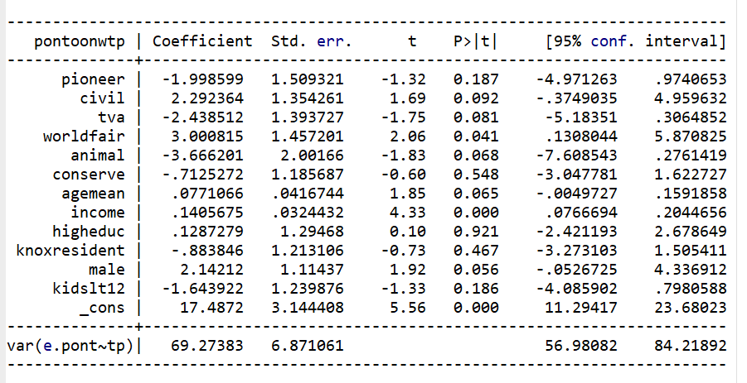-------------------------------------------------------------------------------
TOBIT PONTOON WTP WITH ME AND TRUNKATION
. . margins, dydx(*) predict (ystar(15,60))

Average marginal effects Number of obs = 261
Model VCE: OIM

Expression: E(pontoonwtp*|15<pontoonwtp<60), predict(ystar(15,60))
dy/dx wrt: pioneer civil tva worldfair animal conserve agemean income
higheduc knoxresident male kidslt12

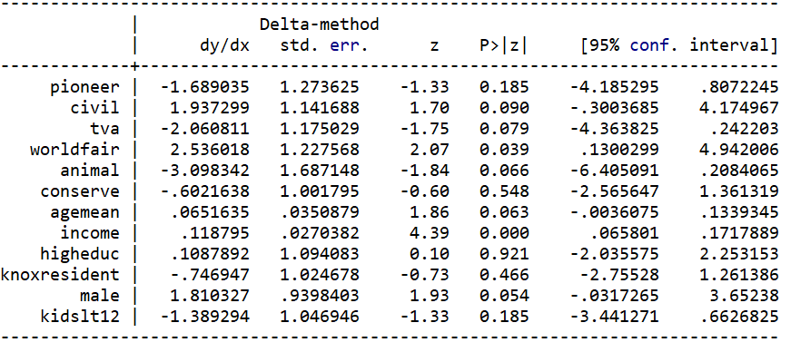

2. TOBIT KAYAK WTP WITH ME AND TRUNKATION

. tobit kayakwtp pioneer civil business worldfair animal conserve agemean income
> higheduc knoxresident male kidslt12 highconfidence, ll(20) ul(65)

Refining starting values:

Grid node 0: Log likelihood = -1086.2361

Fitting full model:

Iteration 0: Log likelihood = -1086.2361
Iteration 1: Log likelihood = -1082.8866
Iteration 2: Log likelihood = -1082.8538
Iteration 3: Log likelihood = -1082.8538

Tobit regression Number of obs = 336
Uncensored = 302
Limits: Lower = 20 Left-censored = 34
Upper = 65 Right-censored = 0

LR chi2(13) = 82.11
Prob > chi2 = 0.0000
Log likelihood = -1082.8538 Pseudo R2 = 0.0365

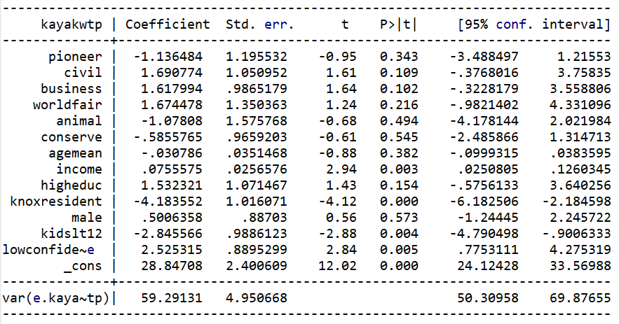
> ------

. margins, dydx(*) predict (ystar(20,65))

Average marginal effects Number of obs = 336
Model VCE: OIM

Expression: E(kayakwtp*|20<kayakwtp<65), predict(ystar(20,65))
dy/dx wrt: pioneer civil business worldfair animal conserve agemean income
higheduc knoxresident male kidslt12 highconfidence

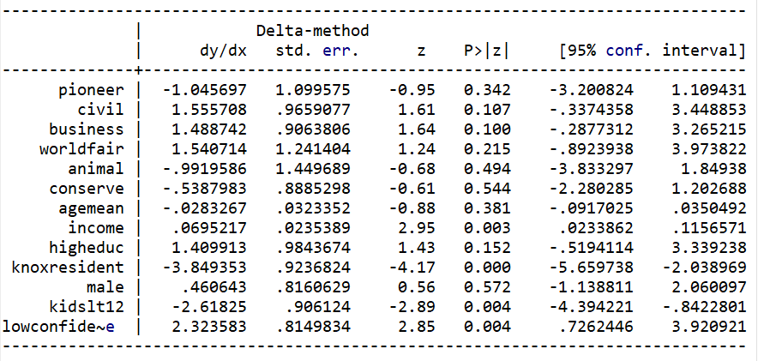

LOGIT Test STATA Output

- LOGIT Pontoon Boat Interest

. logit pontooninterest pioneer civil tva worldfair animal conserve agemean incomemean higheduc kn
> oxresident male kidslt12

Iteration 0: log likelihood = -260.26498
Iteration 1: log likelihood = -240.15592
Iteration 2: log likelihood = -239.92778
Iteration 3: log likelihood = -239.92758
Iteration 4: log likelihood = -239.92758

Logistic regression Number of obs = 403
LR chi2(12) = 40.67
Prob > chi2 = 0.0001
Log likelihood = -239.92758 Pseudo R2 = 0.0781

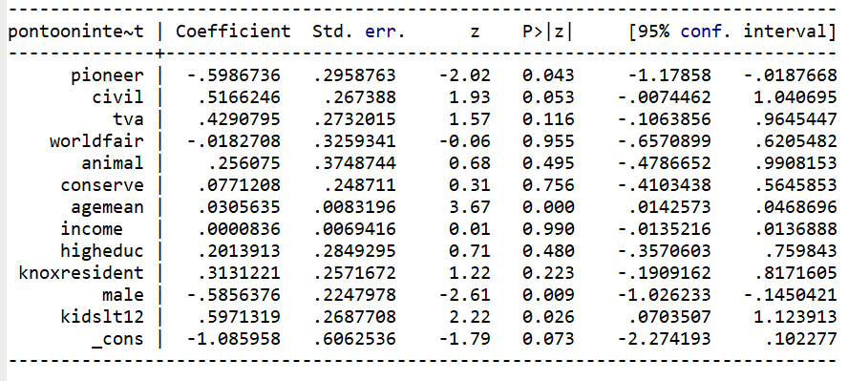

. margins, dydx(*)

Average marginal effects Number of obs = 403
Model VCE: OIM

Expression: Pr(pontooninterest), predict()
dy/dx wrt: pioneer civil tva worldfair animal conserve agemean incomemean higheduc knoxresident
male kidslt12
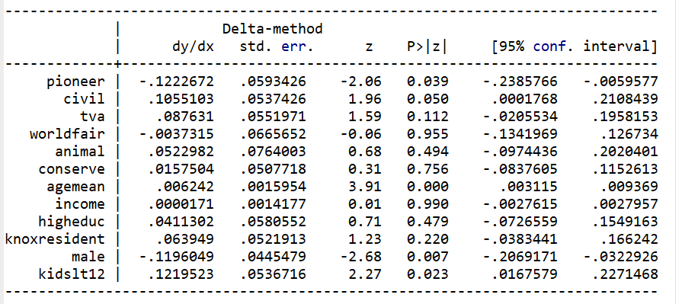

- LOGIT Kayak Interest

. logit kayakinterest pioneer civil business worldfair animal conserve agemean incomemean higheduc
> knoxresident male kidslt12

Iteration 0: log likelihood = -179.68627
Iteration 1: log likelihood = -132.92519
Iteration 2: log likelihood = -123.81543
Iteration 3: log likelihood = -123.5208
Iteration 4: log likelihood = -123.52056
Iteration 5: log likelihood = -123.52056

Logistic regression Number of obs = 403
LR chi2(12) = 112.33
Prob > chi2 = 0.0000
Log likelihood = -123.52056 Pseudo R2 = 0.3126

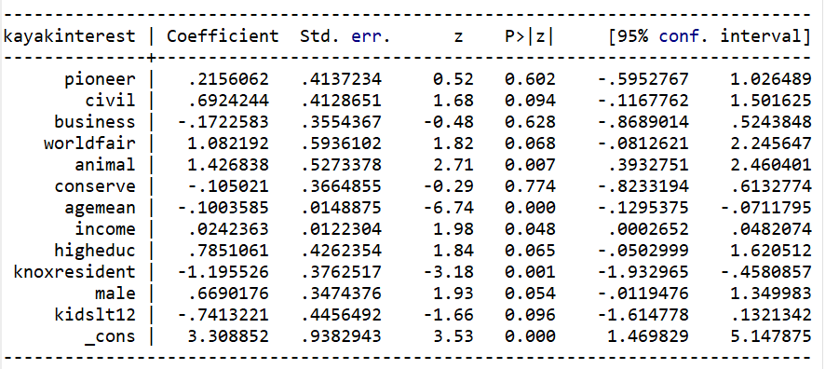

. margins, dydx(*)

Average marginal effects Number of obs = 403
Model VCE: OIM

Expression: Pr(kayakinterest), predict()
dy/dx wrt: pioneer civil business worldfair animal conserve agemean incomemean higheduc
knoxresident male kidslt12

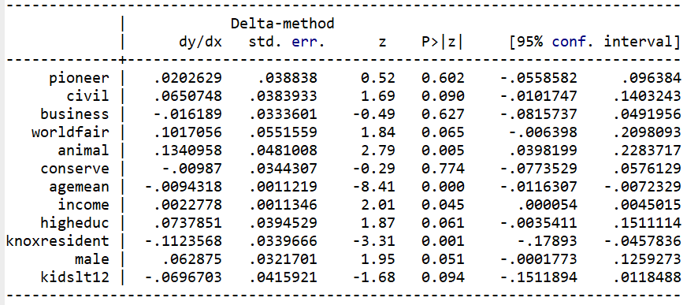

Vita

Gessika Lee Guerra is originally from Tampa, Florida. She graduated from Cumberland County High School in Crossville, TN in 2007 and University of Tennessee Knoxville in 2011 with a Bachelor of Science in Earth and Planetary Science. Immediately following graduation, she enlisted and served eight years in the United States Navy as a supply specialist on aircraft carriers. Upon an honorable discharge, she returned to the University of Tennessee Knoxville to pursue a Master of Science in Forestry with a specialty in Outdoor Recreation. Concurrently she is interning with the National Parks Conservation Association (NPCA) to create a veterans program in the Southeast. Both are set to be completed in December 2023.

