Displacement-based dynamometer for milling force measurement

A Thesis Presented for the
Master of Science
Degree
The University of Tennessee, Knoxville

Michael Fernando Gomez
May 2021

Copyright © 2021 by Michael Fernando Gomez
All rights reserved.

DEDICATION

To Caitlyn.

ACKNOWLEDGEMENTS

I would like to thank my committee, Dr. Tony Schmitz, Dr. Scott Smith, Dr. Brett Compton, and Dr. Bradley Jarred for their support and involvement with this project.

ABSTRACT

This project will study the design and testing of a low-cost dynamometer for milling dynamic force measurement. The monolithic design is based on constrained-motion/flexure-based kinematics, where force is inferred from displacement measured using a low-cost optical interrupter (i.e., a knife edge that partially interrupts the light beam in an emitter-detector pair). The time-dependent displacement of the dynamometer’s moving platform caused by the milling force is converted to the frequency domain, multiplied by the inverse of the dynamometer’s ideally single degree of freedom (SDOF) frequency response function (FRF), and converted back into the time-domain to obtain the time-dependent cutting force. The basic science to be examined is the process dynamics and vibration behavior of the innovative dynamometer design and the ability to measure dynamic cutting forces by applying a structural deconvolution technique. A vibration transducer with high resolution, signal-to-noise ratio, and linearity is therefore able to accurately deconvolve dynamic forces from the measured displacement using the dynamometer’s FRF. This dynamometer will enable accurate and repeatable static and dynamic force measurement for milling operations; however, this approach can be extended to turning, grinding, and drilling as well. A SDOF constrained-motion dynamometer will be designed, manufactured, and evaluated against a commercially available, piezoelectric dynamometer system to validate the displacement-based cutting force approach. A milling process model will be implemented through the solution of second-order, time-delay differential equations of motion that describe the milling behavior [1]. Experiments will be performed to identify the critical stability limit for the various dynamometer systems and mechanistic cutting force coefficients
The sensor selection, monolithic constrained-motion design, and companion structural deconvolution technique will provide an innovative, low-cost, high fidelity cutting force dynamometer for use in both production and research environments This approach offers the potential for reduced uncertainty cutting force measurement and significant advancement of metrology for machining operations including the in-process assessment of tool wear and the corresponding machining process health.

Table of Contents

Chapter One Introduction 1
Originality 2
Chapter Two Literature Review 4
Chapter Three Materials and Methods 10
Time-domain simulation implementation 10
Milling process model 10
Structural deconvolution description 15
Build, test, and validate the SDOF dynamometer 18
Dynamometer design 18
Chapter Four Results and Discussion 19
Heading 2 19
Chapter Five Conclusions and Recommendations 20
List of References 21
Appendix 23
Vita 25

LIST OF TABLES

Table 2.1. Comparison of different principles of measurements for cutting force realization. 5
Table 3.1. Modal parameters for the SDOF simulation. 17
Table 4.1. This is the second table. 19

LIST OF FIGURES

Figure 1.1.Top view (left) and bottom view (right) of the constrained-motion dynamometer. The material sample is attached to the moving platform which is supported by four leaf-type flexure elements. The platform displacement is measured by the KES and used to determine force. 3
Figure 2.1. Piezoelectric transducers typically incorporate a quartz element which is sensitive to either compressive (blue) or shear loads. The shear cut (red) is used for multi-component force and acceleration measuring transducers. Transverse cuts (purple) are used for alternate pressure transducers [13]. 6
Figure 2.2. Cutting force dynamometer design. 6
Figure 3.1. Cutting force geometry. The normal and tangential direction cutting forces, F_{t} and F_{n}, are identified. The fixed x and y directions, as well as the rotating normal direction, n, are shown. The angle, φ, defines the tooth angle. The tool feed is to the right for the clockwise tool rotation and the axial depth is in the z direction. 12
Figure 3.2. Linear magnitude (left) and phase (right) components of the FRF for the SDOF simulation. The natural frequency is 1000 Hz. 16

Introduction

With the development of computer numerically controlled (CNC) machine tools, the demand for higher quality, productivity, efficiency, and reliability of the manufacturing processes increased [1-5, 7]. The need for reliable and effective sensors for CNC machine tools to monitor and inspect the cutting process and condition of cutting tools has become necessary not only as a prognosis tool, but also as an embedded sensor for the cyber-physical manufacturing infrastructure. Among the variety of signals that may be measured for machining operation, cutting force is essential for understanding the fundamental physical mechanics and dynamics of machining processes [11-13]. Cutting force determines the power requirements for a machine tool’s spindle and feed drives; it also enables the calculation of deflections in the machine tool structure and workpiece/fixture. Depending on the operating parameters, the cutting force causes self-excited (chatter) or forced vibrations, which can reduce the machined workpiece quality [1-2]. While piezoelectric approaches may be implemented to yield acceptable measurement results, the inherent limitations including low reliability, high cost, and expertise to operate prevent the method from being widely applied across small to large machine shops [16].

Originality

This research builds upon concepts described in [14] to provide a low-cost, high fidelity dynamometer that will democratize cutting force measurement. It has been noted that the integration of measuring systems should be as close to the machining point as possible [5, 34]. This lowers the influence of the transmissibility behavior. Additionally, the integration of the measurement system should not restrict the working space of the machine tool and cutting parameters. Considering these requirements, flexure-based mechanisms were selected for the dynamometer design. The approach leverages prior research efforts focused on the development of the kinematics required to describe flexure mechanisms [45-51]. Advantages of flexure-based mechanism include monolithic design resulting in wear-free behavior, negligible backlash, smooth and continuous displacement characteristics, and a linear relationship between force and displacements [45-51].
The proposed force measurement system is distinguished from prior efforts because it couples a flexure-based constrained-motion mechanism with a low-cost optical displacement sensor (or knife edge sensor, KES); see Figure 1.1. The dynamometer’s SDOF structural dynamics are designed to achieve a high-resolution force response within a prescribed measurement bandwidth. The displacement-based, structural deconvolution approach provides a novel, low-cost milling force measurement system.
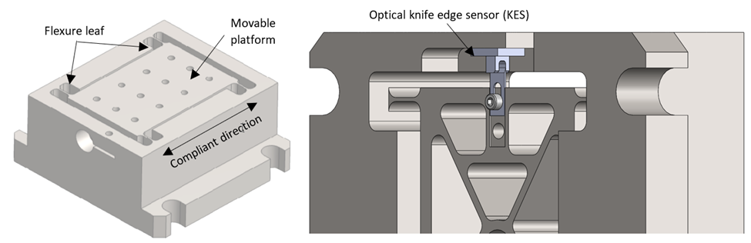
Figure 1.1.Top view (left) and bottom view (right) of the constrained-motion dynamometer. The material sample is attached to the moving platform which is supported by four leaf-type flexure elements. The platform displacement is measured by the KES and used to determine force.

Literature Review

In manufacturing research, metal cutting mechanics have been studied for more than a century [1-3]. Due to the complexity of material removal processes, the modeling of cutting mechanics remains an area of academic and industrial interest. In this context, the cutting force is a significant quantity. As a result of the high sensitivity and rapid response of the cutting force signal to changes in cutting condition [4-5, 7], the force signal can be processed for various tasks to optimize machine tool usage, such as: 1) adaptive feed rate control to keep the applied force at a predetermined level [1-4]; 2) tool wear evaluation from a comparative force level [8-10]; 3) force monitoring for the detection of chatter vibrations [1-2,4-10]; and 4) force monitoring for the detection of tool breakage in milling [8-10].
Force is a vector quantity which implies that a measuring system must have the capability to quantify amplitude and direction of the force of interest [11-12]. The measurand, in this case, force, must be transformed into a physical quantity with a known input-output relationship which is realized by at least one principle of measurement in the transducer; see Table 2.1. Cutting forces are always estimated by using indirect methods, i.e., by measuring the effects of cutting forces such as local deformations, displacements, or accelerations of mechanical elements composing the machining system [11-12]. In practice, multi-axis dynamometers based on piezoelectric sensors provide the most common solution for cutting force measurement. A typical dynamometer consists of three or four
Table 2.1. Comparison of different principles of measurements for cutting force realization.
Principle of measurement | Output response description | Output quantity unit
Piezoelectric | Generation of charge by deformation of piezoelectric material | C
Capacitive | Change in capacitance | F
Inductive | Change in electromagnetic induction | V
Piezoresistive | Change in resistance  (Semiconductor strain gauge) | Ω
Resistive | Change in resistance  (Wire/metal film strain gauge) | Ω
Drive Current | Change in current consumption by the driving motors of the machine tool | A
Compliance | Change in mechanical elastic deformation | m/N

piezoelectric transducers compressed under high preloads between two stiff plates [12]. The transducers consist of thin slabs of the piezoelectric material cut in a precise orientation to the crystal axes depending on the application [13]. The dynamic deflections of the dynamometer’s piezoelectric transducers during machining operations produce a charge which is converted into a voltage proportional to the force that caused the deformation [1-2, 11-13]. However, the dynamic properties of the dynamometer must be considered when operating at or near the dynamometer’s natural frequencies. At the natural frequencies there is an artificial amplification of force signals which lead to distorted force readings that do not accurately reflect the actual machining process [1-2, 4-5].
Given these measurement limitations, prior research efforts have addressed alternative force measuring dynamometer designs. Schmitz et al. [14] presented a high frequency (10-16 kHz) dynamometer based on two coupled, single degree-of-freedom (SDOF) flexures which interact to produce vibration modes that bracket the bandwidth of interest. Korkut [15] developed a dynamometer which used four octagonal rings placed between two plates. Strain gauges were mounted on the octagonal rings and the cutting force was inferred from the strain gauge measurements. Yaldiz et al. [16-17] described the development of a four-component dynamometer to measure static and dynamic cutting forces and torque using strain-gauge based sensors for milling and turning operations using similar octagonal rings. Transchel et al. [18] developed a high frequency (up to 5 kHz) dynamometer where sensitive piezoelectric sensors were
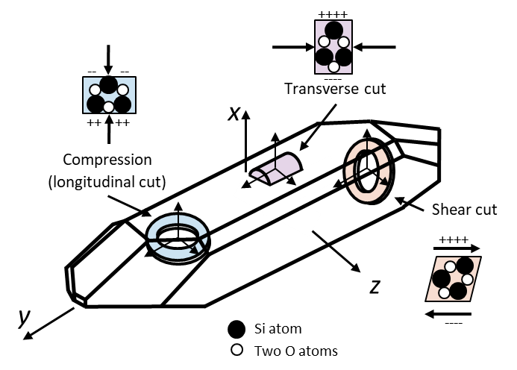
Figure 2.1. Piezoelectric transducers typically incorporate a quartz element which is sensitive to either compressive (blue) or shear loads. The shear cut (red) is used for multi-component force and acceleration measuring transducers. Transverse cuts (purple) are used for alternate pressure transducers [13].

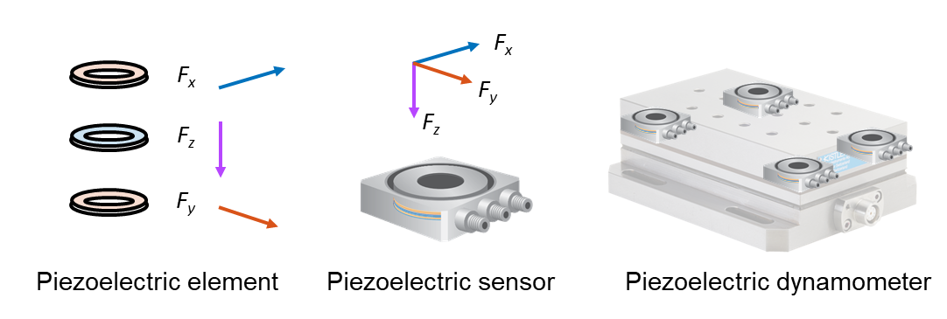
Figure 2.2. Cutting force dynamometer design.

pre-loaded with a common bolt resulting an improved dynamic stiffness. The mass of the workpiece holder plate was minimized by using a titanium alloy. Totis et al. [19-20] developed a plate-type dynamometer using three high-sensitivity tri-axial piezoelectric force sensors for milling and drilling applications. The novel sensor configuration provided higher natural frequencies and, therefore, increased bandwidth. Integration of force sensors into the machine spindle/tool have been explored comprehensively [21-24]. Smith et al. [25] developed a spindle-based torque dynamometer which was placed between the tool and holder on conventional tooling. The strain gauge-based sensor provided a bandwidth up to 2 kHz. Altintas and Park [26-27] developed a Spindle Integrated Force Sensor system where the cutting forces were measured from six piezoelectric sensors embedded in the spindle housing using a circular arrangement. A disturbance Kalman filter was designed to estimate the high frequency harmonics of the cutting forces applied at the tool tip. Aoyama and Ishii [28] utilized the Villari effect to determine cutting force components, cutting torque, and tool deflections. This was performed by detecting the intensity and direction of the magnetic field related to the material strain which was used to identify the applied force. Ettrichratz et al. [29] presented a novel cutting force measurement system using piezoceramic layers applied on a carbide sensor plate that was mounted next to a cutting insert. In doing so, the force measurement was moved closer to the cutting point of contact which resulted in a more accurate representation of the cutting process.

Alternative approaches for accurate cutting force measurement have included post-processing of measured force data to remove the structural dynamics of the dynamometer. Tlusty et al. [6] and Tounsi et al. [30-31] performed accelerometric compensation of distorted cutting forces by estimating inertial and damping errors. By adding the inertial and damping forces to the measured forces, a more accurate representation of the applied force was provided. Altintas and Park [26-27, 32-33] designed a disturbance Kalman filter to remove the structural dynamic influence of the spindle transfer functions in the Spindle Integrated Force Sensor system. Totis et al. [34] applied Kalman filtering to improve the achievable frequency bandwidth. Castro et al. [35] attenuated high frequency amplification due to “cross-talk” between the dynamometer’s component axes through the system’s transmissibility matrix. Korkmaz and Ozdoganlar et al. [36-39] compensated high frequency (25 kHz) dynamometer distortions through a 3x3 force-to-force frequency response function (FRF) inverse filter. Scippa et al. [40] designed two Kalman-like filters, “band-fitting” and “parallel elaboration”, to compensate for high frequency attenuation of cutting forces. Fundamental to these approaches is the use of the dynamometer’s frequency response function, either in an inverse compensation filter or Kalman filter approach [26-27, 32-44]. While previous efforts can provide consistent compensated forces, they lose correction accuracy if the multi-mode FRF cannot be accurately fitted [41-44]. Further, the inverse and Kalman filters require a relatively complex curve fitting procedure with a significant computational expense.

Materials and Methods

Time-domain simulation implementation

Milling process model
The forcing function in milling is defined by the periodic entry and exit of each tooth on the rotating cutter to/from the workpiece material [1-3]. This periodic forcing function occurs at the tooth passing frequency (i.e., the product of the spindle speed and the number of teeth) and excites the tool and/or workpiece dynamics. A time delay is introduced because the surface left by the previous tooth affects the chip thickness for the current tooth. Time-domain simulation includes the numerical solution of the time-delay, second-order differential equations of motion. The simulation implemented in this study is based on the “regenerative force, dynamic deflection” model described by Smith and Tlusty [1, 52]. The simulation provides both modeling and predictive capabilities which will enable a quantitative comparison between the cutting force dynamometers. Time-domain simulation is selected for this work to:
- enable the force/deflection amplitudes to be predicted and validated
- allows for a variety of tool geometries including an arbitrary number of cutting teeth, variable teeth spacing, variable helix angles, and cutter teeth runout
- discern signal quality between alternative dynamometer systems using the force/deflection frequency content.
The simulation proceeds as described by Schmitz and Smith [1]:
- the instantaneous chip thickness is determined using the vibration of the current and previous teeth at the selected tooth angle
- the cutting force components in the tangential (t) and normal (n) directions are calculated using:
$$F_{t}=k_{tc}bh(t)+k_{te}b$$ | (1)
$$F_{n}=k_{nc}bh(t)+k_{ne}b$$ | (2)
where b is the axial depth of cut, h(t) is the instantaneous chip thickness, and the cutting force coefficients are identified by the subscripts t or n for direction and c or e for cutting or edge effect.
- the force components are used to find the new displacements by numerical solution of the differential equations of motion in the x (feed) and y directions:
$$m_{x}\ddot{x}+c_{x}\dot{x}+k_{x}=F_{t}\cos\left(φ\right)+F_{n}\sin{(φ)}$$ | (3)
$$m_{y}\ddot{y}+c_{y}\dot{y}+k_{y}=F_{t}\sin\left(φ\right)-F_{n}\cos{(φ)}$$ | (4)
- the tooth angle is incremented, and the process is repeated. Modal parameters are used to describe the system dynamics in the x (feed) and y directions, where multiple degrees of freedom in each direction can be incorporated; see Fig. 3.1.
The instantaneous chip thickness depends on the nominal, tooth angle-dependent chip thickness, the current vibration in the direction normal to the surface, and the vibration of previous teeth at the same angle. The chip thickness can be expressed using the circular tool path approximation as:
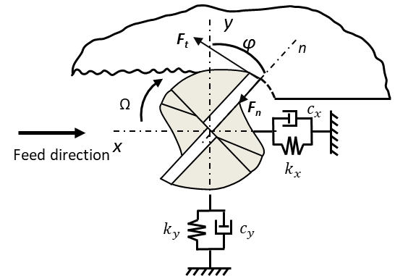
Figure 3.1. Cutting force geometry. The normal and tangential direction cutting forces, F_{t} and F_{n}, are identified. The fixed x and y directions, as well as the rotating normal direction, n, are shown. The angle, φ, defines the tooth angle. The tool feed is to the right for the clockwise tool rotation and the axial depth is in the z direction.

$$h\left(t\right)=f_{t}\sin{φ}+n\left(t-τ\right)-n(t)$$ | (5)
where f_{t} is the commanded peed per tooth, φ is the tooth angle, n is the normal direction, and τ is the tooth period. The tooth period is defined as: $τ=\frac{60}{Ω∙Nt}$ (sec), where Ω is the spindle speed in rpm and Nt is the number of teeth. The vibration in the surface normal direction for the current tooth depends on the x and y vibrations as well as the tooth angle according to:
$$n=x\sin{(φ)-y\cos{(φ)}}$$ | (6)
The simulation strategy is to divide the angle of the cut into a discrete number of steps. At each small-time step, dt, the cutter angle is incremented by the corresponding small angle, dφ. This approach enables convenient computation of the chip thickness for each simulation step because: 1) the possible teeth orientations are predefined; and 2) the surface created by the previous teeth at each angle may be stored.
- The cutter rotation increment depends on the selection of the number of steps per revolution, SR, specifically, $dφ= \frac{360}{SR}$ (deg).
- The corresponding time step is $dt= \frac{60}{Ω∙SR}$ (s), where Ω is the spindle speed in rpm.
- A vector of angles is defined to represent the potential orientation of the teeth as the cutter is rotated through one revolution of the circular tool path, $φ=[0,dφ,2dφ,3dφ,…\left(SR-1\right)dφ]$; the locations of the teeth in the cut are defined by referencing entries in this vector.
- The cut entry/exit angles are determined based on the radial depth and up or down milling conditions.
- The number of cutter revolutions, R, is specified for the simulation.
The simulation is completed using the following steps within a single loop with index, i, which is completed $SR∙N_{t}∙R$ times (once for each time step over the selected number of revolutions).
- If the current entry in h(i) is greater than zero, calculate the current vibration normal to the cut surface, $n\left(i\right)=x(i-1)\sin{(φ\left(i)\right)-y\left(i-1\right)\cos{(φ\left(i)\right)}}$ where i is the loop index and x/y are the cutter deflections from the previous time step. Using n(i), calculate the instantaneous chip thickness, $h\left(i\right)=f_{t}\sin{φ}+n\left(i-τ\right)-n(i)$, which depends on the normal vibration for both the current (i) and previous (i-τ) teeth.
- If h(i) is greater than zero, calculate the tangential and normal cutting force components using $F_{t}=k_{tc}bh(i)+k_{te}b$ and $F_{n}=k_{nc}bh(i)+k_{ne}b$, where b is the axial depth of cut and the k terms are the cutting force coefficients (the c subscripts denote cutting and the e subscripts represent edge, or rubbing, terms). Project these forces into the x and y directions via:
$$F_{x}\left(i\right)= F_{t}\cos{φ\left(i\right)}+F_{n}\sin{φ\left(i\right)}$$ | (7)
$$F_{y}\left(i\right)= F_{t}\sin{φ\left(i\right)}-F_{n}\cos{φ\left(i\right)}$$ | (8)
- If h(i) is less than or equal to zero, set the x and y forces to zero. Note that this step incorporates the nonlinearity which occurs when the vibration levels are large enough that a tooth leaves the cut (in this case, the chip thickness is negative).

- Given the current x and y forces, calculate the current acceleration in the x and y directions:
$$\ddot{x}\left(i\right)= \frac{F_{x}\left(i\right)-c_{x}\dot{x}\left(i-1\right)-k_{x}x(i-1)}{m_{x}}$$ | (9)
$$\ddot{y}\left(i\right)= \frac{F_{y}\left(i\right)-c_{y}\dot{y}\left(i-1\right)-k_{y}y(i-1)}{m_{y}}$$ | (10)
Where, m_{x/y}, c_{x/y}, and k_{x/y} are the modal mass, viscous damping, and stiffness values for the tool. Also, the single overdot identifies velocities. The current velocities are calculated using modified Euler integration. This fixed-step numerical scheme was selected because it is robust provided the time step is sufficiently small.
$$\dot{x}\left(i\right)=\dot{x}\left(i-1\right)+\ddot{x}\left(i\right)∙dt$$ | (11)
$$\dot{y}\left(i\right)=\dot{y}\left(i-1\right)+\ddot{y}\left(i\right)∙dt$$ | (12)
- The current displacements are calculated by:
$$x\left(i\right)=x\left(i-1\right)+\dot{x}\left(i\right)∙dt$$ | (13)
$$y\left(i\right)=y\left(i-1\right)+\dot{y}\left(i\right)∙dt$$ | (14)
The simulation can be extended to include:
- helix angle – the axial depth of cut is segmented into multiple slices with width db, where each slice is rotated relative to the next by the angle, $\frac{db∙\tan{γ}}{r}$, which depends on the helix angle, γ, and the tool radius, r,
- multiple tool modes – the x and y forces are used to calculate the acceleration, velocity, and displacement for each tool mode (represented by the modal parameters) and the results are summed in each direction,
- flexible workpiece – the x and y forces are also used to determine the workpiece deflections, again by numerical integration, and the relative tool-workpiece vibration is used to calculate the instantaneous chip thickness,
- runout of the cutter teeth – the chip thickness is updated by the runout of the current tooth,
- unequal teeth spacing – the tooth angle vector is modified to account for the actual tooth pitch.

Structural deconvolution description
Structural deconvolution is described in this section. To demonstrate the technique, a simulation was coded in MATLAB® to model the deconvolution of the structural dynamics for a SDOF system. The first step in performing the deconvolution is to measure the system’s FRF; see Figure 3.2. Using the flexure’s modal mass, damping, and stiffness, the solution to the differential equation of motion was obtained by numerical integration in the time domain; see (15), where m is the mass, c is the viscous damping coefficient, k is the stiffness, x is the displacement, the overdots indicate time derivatives, and F(t) is the externally applied force that is to be determined from the displacement signal, x [1, 52].
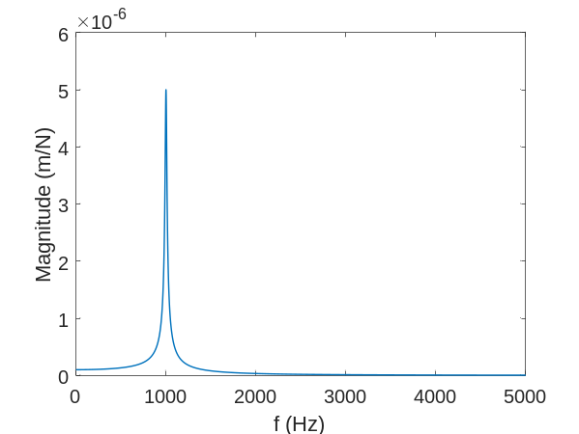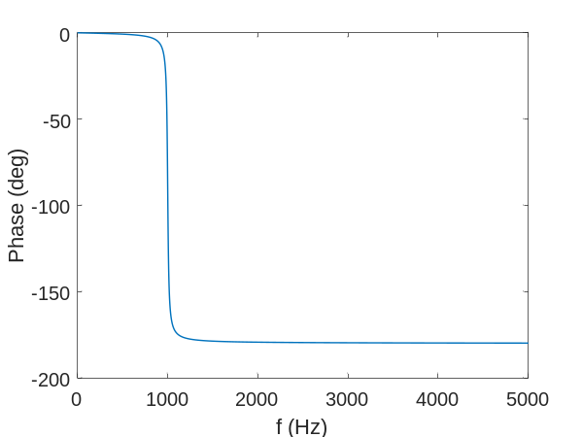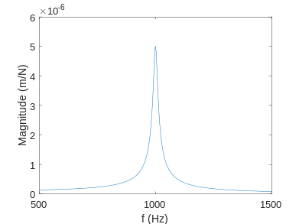
f_{n} = 1000 Hz
Figure 3.2. Linear magnitude (left) and phase (right) components of the FRF for the SDOF simulation. The natural frequency is 1000 Hz.

$$m\ddot{x}+c\dot{x}+k=F(t)$$ | (15)
The modal parameters used in the simulation are provided in Table 3.1. In most applications, flexure mechanisms will exhibit inherently low damping [45-50]. It is not uncommon to encounter viscous damping ratios from 0.01% to 1%. Partial radial immersion cutting forces resemble a train of periodic impulses as each tooth enters and exits the cut [1-2, 53]. Therefore, a half-wave rectified sine signal was selected to emulate the forces that may be encountered during milling operations. The piecewise description of the half-wave rectified sine signal consists of two portions when defined over exactly one period, T₀; see (16).
$$F\left(t\right)=\left\{\begin{matrix}A\sin{(ωt}) & for 0≤t<\frac{1}{2}T_{0} \\ 0 & otherwise\end{matrix}\right.$$ | (16)
Here, A is the amplitude, ω is the fundamental forcing frequency, and t is time. The externally applied force and corresponding displacement due to this force are shown in Figure 3.3. The known force, (16) was prescribed in (15) and the corresponding displacement was determined by numerical integration. It is seen that the total solution includes both the transient (homogenous) and steady-state (particular) solutions. The structural deconvolution proceeds by converting the displacement from Fig. 5 into the frequency domain using the discrete Fourier transform; see Fig. 6. The frequency spectrum of the reference force signal agrees with the Fourier series for a half-wave rectified sine wave.

Table 3.1. Modal parameters for the SDOF simulation.
Modal parameters
Direction | m (kg) | k (N/m) | c (N-s/m)
x | 0.25 | 1×10⁷ | 31.83

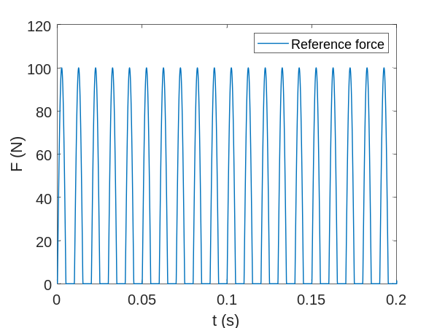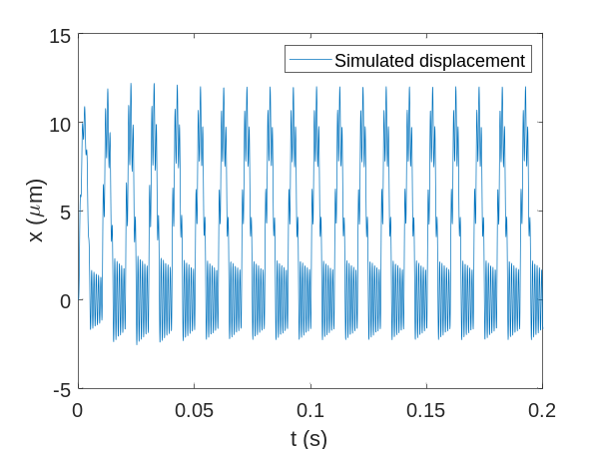
Figure 3.3. Reference half-wave rectified sine signal which represents the milling force (left). Time domain response of the SDOF system due to the milling force. The displacement was calculated using numerical integration.

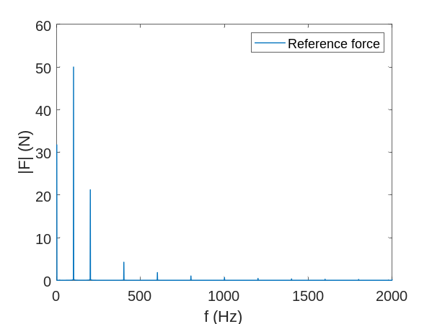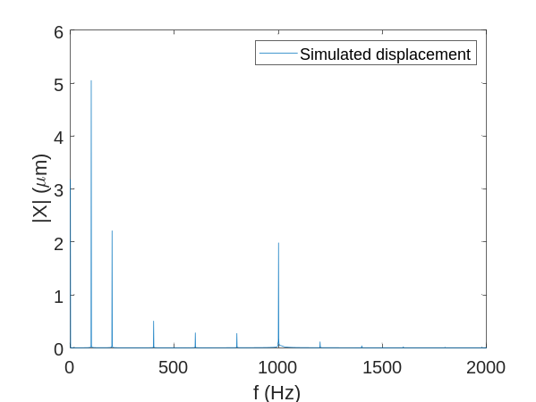
Figure 3.4. Frequency-domain response of the reference force (left) and simulated displacement (right); the spectra include content at the 100 Hz fundamental frequency and the even n-integer harmonics of the fundamental forcing frequency. Note that the displacement signal has amplified content at the SDOF natural frequency of 1000 Hz.

Build, test, and validate the SDOF dynamometer

Dynamometer design
A monolithic, constrained-motion dynamometer (CMD) is designed and constructed to measure milling forces. The design includes a moving platform for workpiece mounting and four leaf-type flexure elements in a symmetric dual four bar linkage arrangement; see Fig. 8. Simple parallel rectilinear springs exhibit sufficient linearity over a limited displacement range. In this design, the kinematic over-constraint is leveraged to provide elastic averaging of errors in bar lengths without introducing assembly errors. The strains along the flexure length is resisted by the frame [46-50]. Here, the flexure elements guide the moving platform in the compliant direction resulting in SDOF rectilinear motion. To avoid geometric nonlinearities which occur for doubly clamped flexure elements, such as stress stiffening, the deflections must not exceed half the flexure thickness, t. This is a critical design constraint that must be considered to avoid nonlinear stiffness behavior [45, 56].
The first step in the design procedure was to select a material for analysis; aluminum 6061-T6 was selected in this case. It was assumed that the material had an elastic modulus, E, of 69 GPa and yield strength, σ_{y}, of 276 MPa [45]. Next, the flexure leaf geometry was prescribed to estimate the mechanism stiffness. The flexure leaf dimensions described in Fig. 8 are provided in Table 3.

Results and Discussion

Another chapter, and I’ve run out of things to say. I hope that a template will help some of you. Remember that consistency is the most important thing. You may

Conclusions and Recommendations

List of References

- Schmitz, T.L., Smith, K.S., 2009, Machining Dynamics: Frequency Response to Improved Productivity, Springer, New York, NY.
- Altintas, Y., 2012, Manufacturing Automation: Metal Cutting Mechanics, Machine Tool Vibrations, and CNC Design, Cambridge University Press.
- Tlusty, J., 2000, Manufacturing Processes and Equipment, Prentice Hall, Upper Saddle River, NJ.
- Tlusty, J., Andrews, G. C., 1983, A Critical Review of Sensors for Unmanned Machining, CIRP Annals, 32: 563-572.
- Byrne, G., Dornfeld, D., Denkena, B., 2004, Advanced cutting technology, CIRP Annals, 52:483-507.
- Tlusty, J., Jang, D., Tarng, Y., 1987, Measurements of the milling force over a wide frequency range, Proceedings of the 15th NAMRC, 273-280.
- Teti, R., Jemielniak, K., O’Donnel, G., Dornfeld, D., 2010, Advanced monitoring of machining operations, CIRP Annals, 59:707-739.
- Altintas, Y., Yellowley, I., 1989, The process detection of tool failure in milling using cutting force models, ASME J. of Eng. For Industry, 111: 149-157.
- Altintas, Y., Yellowley, I., Tlusty, J., 1985, Detection of tool breakage in milling, Transactions of the ASME, 18:41-48.
- Altintas, Y., 1988, In process detection of tool breakage using time series monitoring of cutting forces, Int. J. Mach. Tools and Manuf., 28: 157-172.
- Gautschi, G.H., 2002, Piezoelectirc Sensorics, Springer Berlin Heidelberg, Berlin, Germany
- Gautschi, G.H., 1972, Cutting forces in machining and their routine measurement with multi-component piezo-electric force transducers, Proc. 12th Int. Mach. Tool design and research, 113-120.
- Kistler Instrumente AG, 2007, The Piezoelectric Effect, Theory, Design and Usage, Company White Paper.
- Burton, D., Duncan, G.S., Ziegert, J.C., Schmitz, T.L., 2004, High frequency, low force dynamometer for micro-milling force measurement, Proceedings of the 19th American Society for Precision Engineering Annual Meeting, 221-224.
- Korkut, I., 2003, A dynamometer design and its construction for milling operation, Materials and Design, 24: 631-637.
- Yalidz, S., Unsacar, F., 2006, A dynamometer design for measurement of cutting forces on turning, Measurement, 39: 80-89.
- Yaldiz, S., Unsacar, F., Haci, S., Isik, H., 2007, Design, development and testing of a four-component milling dynamometer for the measurement of cutting force and torque, Mechanical Systems and Signal Processing, 21, 1499-1511.
- Transchel, R. Stirnimann, J., Blattner, M., Bill, B., Thiel,R., Kuster, F., Wegener, K, 2012, Effective dynamometer for measuring high dynamic process force signals in micro machining operations, Procedia CIRP, 1, 558-562.
- Totis, G., Sortino, M., 2011, Development of a modular dynamometer for triaxial cutting force measurement in milling, Int. J. Mach. Tools Manuf., 51: 34-42.
- Totis, G., Adams, O., Sortino, M., Veselovac, D. Klocke, F., 2014, Development of an innovative plate dynamometer for advanced milling and drilling applications, Measurement, 49, 164-181.
- Totis, G., Wirtz, G., Sortino, M., Veselovac, Kuljanic, F., D. Klocke, F., 2010, Development of a dynamometer for measuring individual cutting edge forces in face milling, Mechanical Systems and Signal Processing,24/6: 1844-1857.
- Jun, M., Ozdoganlar, B., DeVor, R., Kapoor, S., Kirchheim, K., Schnaffer, G., 2002, Evolution of spindle-based force sensor for monitoring and fault diagnosis of machining operations, Int. J. of Mach. Tools and Manuf., 42: 741-751.
- O’Donnel, G.E., Kelly, K., Byrne, G., 2000, Use of a sensor integrated motor spindle for monitoring of a flexible machining center, 2nd CIRP Int. Sem. On ICME, 383-388.
- Byrne, G., O’Donnell, G.E., 2007, An integrated force sensor solution for process monitoring of drilling operations, CIRP Annals, 56: 59-62.
- Smith, D.A., Smith, S., Tlusty, J., 1988, High performance milling torque sensor, J. of Manuf. Sci. and Eng., 120: 504-514.
- Park, S.S., Altintas, Y., 2004, Dynamic compensation of spindle-integrated force sensors, CIRP Annals, 53/1: 305-308.
- Park, S.S., 2003 High frequency bandwidth cutting force measurements in milling using the spindle integrated force sensor system, Dept. of Mech. Eng., Univ. of British Columbia, PhD. Thesis.
- Aoyama, H., Ishii, T., 2004, Sensor to detect cutting force components, cutting torque, and cutting tool deflections, J. of Manufacture Processing, 6: 141-147.
- Ettrichrätz, M., Drossel, W., Gebhardt, S., Bucht, A., Kranz, B., Schneider, J., 2018, Performance of a new piezoceramic thick film sensor for measurement and control of cutting forces during milling, CIRP Annals, 67/1, 45-48.
- Tounsi, N., Otho, A., Dynamic cutting force measuring, 2000, Int J. Mach. Tools Manuf., 40: 1157-1170.
- Tounsi, N., Otho, A., Dynamometer performance modeling and experimental assessment, 2000, J. Dyn. Syst. Meas. Control, Transactions of the ASME, 122: 477-482.
- Park S.S., Chae, J., 2007, High frequency bandwidth measurements of micro cutting forces, Int. J. Mach. Tools Manuf., 47:1433–1441.
- Albrecht, A., Park, S.S., Altintas, Y., Pritschow, G., 2005, High frequency bandwidth cutting force measurement in milling using capacitance displacement sensors. Int. J. Mach. Tools Manuf.; 45:993–1008
- Totis, G., Dombovari, Z. Sortino, M., 2020, Upgraded Kalman filtering of cutting forces in milling, Sensors 20, 5398: 1-21
- Castro, L.R., Vieville, P., Lipinski, P., 2006, Correction of dynamic effects on force measurements made with piezoelectric dynamometers, Int. J. of Mach. Tools Manuf., 46: 1707-1715.
- Korkmaz, E., Bediz, B., Gozen, B.A., Ozdoganlar, O.B., 2014, Dynamic characterization of multi-axis dynamometers, Prec. Engineering, 38: 148-161.
- Ozdoganlar, O.B., Korkmaz, E., Gozen, B.A., Bediz, B., 2015, High-frequency compensation of dynamic distortions in micromachining force measurements, Procedia Manufacturing, 1: 534-545.
- Bediz, B., Korkomaz, E., Ozdoganlar, O.B., 2014, An impact excitation system for repeatable, high-bandwidth modal testing of miniature structures, J. of Sound and Vibration, 333: 2743-2761.
- Ozdoganlar, O.B., Hansche, B.D., Carne, T.G., 2005, Experimental modal analysis for microelectromechanical systems, Exp. Mechanics, 46: 498-506.
- Scippa, A., Sallese, L., Grossi, N., Campatelli, G., 2015, Improved dynamic compensation for accurate cutting force measurements in milling applications, Mech. Syst. and Sig. Processing, 54-55, 314-324.
- Chung, Y.L., Spiewak, S.A., 1994, A model of high performance dynamometer., J. of Eng. for Industry, 116:279-288.
- Spiewak, S.A., Di Corpo, J., 1991, Adaptive compensation of dynamic characteristics for in-process sensors. J. of Eng. for Industry, 113: 198-206.
- Mangnevall, M., Lundblad, M., Ahlin, K., Broman, G., 2012, High frequency measurements of cutting forces in milling by inverse filtering, Mach. Sci. and Technology, 16: 487-500.
- Wan, M., Yin, W., Zhang, W., Liu, H., 2017, Improved inverse filter for the correction of distorted measured cutting forces, Int. J. Mechanical Sciences, 120, 276-285.
- Smith, S.T., 2000, Flexures: Elements of Elastic Mechanisms, CRC Press, Boca Raton, FL.
- Smith, S.T., Chetwynd, D.G., 2005, Foundations of Ultraprecision Mechanism Design, CRC Press, Boca Raton, FL.
- Howell, L.L., 2001, Compliant Mechanisms, John Wiley & Sons, New York, NY.
- Slocum, A. H., 1995, Precision Machine Design, Society of Manufacturing Engineers, Dearborn, MI.
- Awtar, S., 1998, Synthesis and analysis of parallel kinematic XY flexure mechanisms, Dept. of Mech. Eng., Mass. Institute of Tech., PhD. Thesis.
- Awtar, S., Slocum, A.H., Sevincer, E., 2007, Characteristics of beam-based flexure modules, J. Mech. Des., 129(6): 625-639.
- Woody, S. C., Smith, S. T., Jiang, X., and Rehrig, P. W., 2005, Performance of single-crystal Pb(Mg1/3Nb2/3)-32%PbTiO3 stacked actuators with application to adaptive structures, Review of Scientific Instruments, 76/ 7, 075112.
- Smith, K.S., Tlusty, J., 1991, An overview of modeling and simulation of the milling process, ASME J. of Eng. for Industry, 113/2, 169-175.
- Schmitz, T.L., Smith, K.S., 2012, Mechanical Vibrations: Modeling and Measurement, Springer, New York, NY.
- Manal, K., Rose, W., 2007, A general solution for the time delay introduced by a low-pass Butterworth digital filter: An application to musculoskeletal modeling, Journal of Biomechanics 40(3): 678-681.
- Dalley, J.W., Riley, W.F., McConnell, K.G., 1993, Instrumentation for Engineering Measurements, John Wiley & Sons, New York, NY.
- Nishawala, V.V., 2011, A study of large deflection of beams and plates, Dept. Mech. And Aero. Eng., Rutgers University, M.S. Thesis.
- Boyer, R., Welsch, G., and Collings, E.W., 1994, Materials properties handbook: Titanium alloys, ASM International, Materials Park, OH.
- ASM Handbook Committee., 1990, Metals handbook: Properties and selection: Nonferrous alloys and special-purpose materials, Vol 2., ASM International, Materials Park, OH.
- ASM Handbook Committee., 1990, Metals handbook: Properties and selection: Stainless steels, tool materials, and special purpose metals, Vol 2., ASM International, Materials Park, OH.
- Holt, J.M, Ho, C.Y., 1996, Structural alloys handbook, Perdue University, Lafayette, IN.
- Gu, G., Shin, Y., Son, J., Kim, J., 2012, Design and characterization of a photo-sensor based force measuring unit (FMU), Sens. Actuators, A, 182: 49-56.
- Lee, C.B., Lee, S.K., Tarbutton, J.A., 2014, Novel design and sensitivity analysis of displacement measurement system utilizing knife edge diffraction for nanopositioning stages, Rev. Sci. Instrum., 85: 095113.
- Lee, C.B., Lee, S.K., Tarbutton, J.A., 2015, Positioning control effectiveness of optical knife edge displacement sensor-embedded monolithic precision stage, Sens. Actuators, A, 233: 290-296.
- Lee, C.B., Mahajan, S., Zhao, R., Jeon, S., 2016, A curved edge diffraction-utilized displacement sensor for spindle metrology, Rev. Sci. Instrum., 87: 075111-7.
- Gomez, M., Schmitz, T.L., 2018, Determination of cutting forces using a flexure-based dynamometer: deconvolution of structural dynamics using the frequency response function, Proceedings of the 33rd American Society for Prec. Engineering Annual Meeting.
- Gomez, M., Schmitz, T.L., 2019, Displacement-based dynamometer for milling force measurement, Procedia Manuf., 34: 867-875.
- Gomez, M., Schmitz, T.L., 2020, Low-cost, constrained-motion dynamometer for milling force measurement, Manuf. Letters, 25: 34-39.
- Rubeo, M.A., Schmitz, T.L., 2016, Mechanistic force model coefficients: A comparison of linear regression and nonlinear optimization, Prec. Engineering, 45, 311-321.
- Rubeo, M.A., Schmitz, T.L, 2016, Milling force modeling: A comparison of two approaches, Procedia Manuf., 5: 90-105.
- Gomez, M., Betters, E., Eichenberger, J., Delio, T.S., Schmitz, T.L., 2019, Laser doppler vibrometry for machining dynamics analysis, Proceedings of the 34th American Society for Prec. Engineering Annual Meeting.
- Smith, K.S., Delio, T., 1989, Sensor based control for chatter free milling by spindle speed selection, Transactions of the ASME, 18: 107-114.
- Delio, T., Tlusty, J., Smith, K.S., 1992, Use of audio signals for chatter detection and control, ASME J. of Eng. for Industry, 144: 146-157.
- Liang, Q., Zhang, D., Wu, W., Zou, K., 2016, Methods and research for multi-component cutting force sensing devices and approaches in milling, Sensors: 16(11), 1-17.
- Garzon, M., Adams, O., Vaselovac, D., Blattner, M., Thiel, R., Kirchheim, A., 2012, Procedia CIRP Vol 1: 609-613.
- Kuljanic, E., Totis, G., Sortino, M., Wirtz, G., 2009, Experimental identification of the dynamics of a new rotating dynamometer for face milling, Proceedings of the 9th A.I.Te.M Conference, Torino, Italy.
- Jeong Y.-H., Cho, D.-W, 2002, Estimating cutting force from rotating and stationary feed motor currents on a milling machine, Int, J. Machine Tools Manuf. 45: 993-1008.
- Auchet, S., Chevrier, P., Lacour, M., Lipinski, P., 2004, A new method of cutting force measurement based on command voltages of active electro-magnetic bearings, Int. J. Machine Tools Manuf. 44: 1441-1449.

Appendix
[Remove this note, but DO NOT REMOVE THIS PAGE, AND/OR DO NOT PUT APPENDIX MATERIAL ON THIS PAGE – you can change “Appendix” to “Appendices” if you would like, but this is the ONLY text that should be on this page. The actual appendix material should start at the top of the NEXT page. Please note that you should remove both this page and the next one if you are not including an appendix at all – “do not remove this page” refers only to students who ARE including an appendix]
You’ll put appendix material here. This section is optional. You can place tables and figures in the appendix if you like. If you choose this option, you should indicate that tables and figures are in the appendix after the first mention in the text. You can place some tables/figures in the text and others in the appendix, or all tables/figures in the appendix.

Vita

Originally from North Carolina, Michael Gomez grew up in Gastonia, North Carolina. After high school at Highland School of Technology, he attended the University of North Carolina at Charlotte earning a Bachelor of Science degree in Mechanical Engineering and a Bachelor of Science in Physics.

