SECULAR CHANGE IN CROATIAN MALE CRANIA: 1812-1973

A Thesis Presented for the
Master of Arts
Degree
The University of Tennessee, Knoxville

Ileana Ilas
December 2022

Copyright © 2022 by Ileana Ilas
All rights reserved.

For Germina,
Tudor, and Elena

ACKNOWLEDGEMENTS

First and foremost, this thesis would not exist without the continued support and encouragement from my mother, Dr. Germina Ilas. She believed in me even when I didn’t, and without her endless enthusiasm and optimism, this thesis would likely have languished in almost-finished purgatory for the rest of time. De ziua ta, mamico, in dar ti-am adus inima, si credema, mamico, un dar mai frumos nu se putea (dar teza este un numarul doi acceptabil).
This thesis would not be possible without the help and advice of my committee members. Thanks to Drs. Lee Jantz, Richard Jantz, and Ellen Lofaro for all their support over the years. Special thanks goes to Dr. Richard Jantz for sharing his cranial data with me and allowing me to work with it for this thesis. Another huge thank you is owed to everybody who collected the data I am using: Dr. R. Jantz, Dr. Mario Slaus, and Dr. Douglas Owsley and his students. And of course, thanks must be given to the individuals whose remains were included in this study, many of whom lived harsh lives and experienced traumatic deaths.
During my time in the graduate program at the University of Tennessee, I had the privilege of working at the Forensic Anthropology Center via an assistantship funded through the Forensic Data Bank, which provided me with the training and knowledge that informs much of this thesis. Nothing is better than hands-on experience and collecting metrics for the UTK Donated Skeletal Collection as part of the assistantship over three years gave me the hands-on training that is so necessary for understanding skeletal variation. Additional thanks extends to all the donors, living and deceased, whose generosity allowed me and so many of my fellow students to learn and grow and share our knowledge.
I would also like to thank the faculty and staff of the Anthropology Department for their continued support and help over the years. Another important part of the department was the Anthropology Graduate Student Association, which served to build community among the graduate students and allowed us to collectively communicate our issues and concerns with faculty and staff.
Perhaps the most important aspect of being a successful graduate student is having a community that will support and inspire you in your studies. As such, I would like to thank my starting cohort—Mark Babin, Christine Bailey, William Cawley, Haley Horbaly, Angela Mallard, and Samantha Upton—for being great friends and colleagues. In a similar vein, I would like to thank my roommates and fellow graduate students—Lindsey Cochran, Eric Schweickart, and Peggy Humes—for making it easy to be at home. And a special thank you to Meagan Dennison, for being a great friend and for reminding me about graduation deadlines.
And finally, all of my thanks and love forever to all the cats and dogs I’ve lived with throughout this process. Thank you to Lucy, Frankie, Hamm, Peaches, Slipper, and Sandal. You were and are a constant source of joy and love, a reminder of what it is to be carefree and happy.
ABSTRACT

The study of secular change is the study of changes that have taken place in the human body during recent centuries. Although changes that affect populations are generally understood to occur over many centuries and millennia, anthropological studies have shown that population changes have occurred in the last two centuries, over a relatively small time period comprising a mere two hundred years. Biological anthropologists in particular are interested in how the human skeleton has changed in recent history, whether in the limbs, the torso, or the cranium. Changes have been observed in all areas of the skeleton, and these changes to do not occur in all populations equally. To better understand not only what these changes are, but why and how they happen, anthropologists have studied secular change within populations. This thesis is a study of secular change in one population – ethnic Croatians – with an attempt to define the changes and contribute to the larger global study of the subject. In this thesis, I use craniometric data that was collected by other researchers but never analyzed. The study focuses on males, because of the lack of female data available in the sample, and because previous studies have already shown that secular change occurs differently between the sexes. I analyze cranial data of 147 male individuals whose birth dates span a range of 161 years. Using polynomial regression analysis, I look at ten craniometric measurements and three derived measurements in order to ascertain whether any change has occurred in the Croatian male population, what the changes are, and how they compare to other populations that have been studied. The results reveal that secular changes have occurred in that cranium in the Croatian population, although the location and magnitude of the changes differ slightly from other European or European-descended populations that have been previously studied.
TABLE OF contents
CHAPTER ONE INTRODUCTION 1
CHAPTER TWO BACKGROUND 3
CHAPTER THREE MATERIALS AND METHODS 13
CHAPTER FOUR RESULTS 23
CHAPTER FIVE DISCUSSION 42
CHAPTER SIX CONCLUSION 48
LIST OF REFERENCES 50
VITA 54

LIST OF TABLES

Table 1. Descriptions of the measurements used, based on Howells (1973). 16
Table 2. Number of individuals in each 25-year cohort. 21
Table 3. Probability of coefficients (p-values) and R-values for polynomial models. Significant p-values (p < 0.05) have been italicized. 24

LIST OF FIGURES

Figure 1. Frontal view of the skull showing approximations of of XCB, WFB, ZYB, MAB. 15
Figure 2. Side view of the skull showing approximations of GOL, BBH, BNL, and NPH. 16
Figure 3. Basilar view of the skull showing approximations of MAL, MAB, ZYB, and XCB. 17
Figure 4. Graph showing Loess regression for auricular breadth plotted over year of birth. 23
Figure 5. Graph showing Loess regression for basion-nasion length plotted over year of birth. 24
Figure 6. Graph showing Loess regression for palate breadth plotted over year of birth. 25
Figure 7. Graph showing Loess regression for palate length plotted over year of birth. 26
Figure 8. Graph showing Loess regression for vault size plotted over year of birth. 27
Figure 9. Graph showing Loess regression for max cranial breadth plotted over year of birth. 28
Figure 10. Graph showing Loess regression for bi-zygomatic breadth plotted over year of birth. 29
Figure 11. Plot of 25-year cohort averages for auricular breadth. 32
Figure 12. Plot of 25-year cohort averages for basion-bregma height. 33
Figure 13. Plot of 25-year cohort averages for basion-nasion length. 34
Figure 14. Plot of 25-year cohort averages for palate breadth. 35
Figure 15. Plot of 25-year cohort averages for palate length. 36
Figure 16. Plot of 25-year cohort averages for vault size. 37
Figure 17. Plot of 25-year cohort averages for maximum cranial breadth. 38
Figure 18. Plot of 25-year cohort averages for bi-zygomatic breadth. 39

Introduction

Biological anthropology has developed as a field in conjunction with the theory of evolution, which has informed anthropological theory since its inception. Anthropologists are uniquely positioned to examine humanity on a large evolutionary scale, while also identifying the short-term evolutionary processes that affect modern humans. Scientists have identified the main drivers of evolution as genetics and environment. Although genetic changes can happen within two generations on an individual level, it may take millennia for these changes to be expressed on a population level in humans. As such, the study of recent changes in human skeletons must focus more on environmental factors, including changes in diet, migration patterns, or disease.
Secular change – sometimes called secular trend – is the study of relatively rapid changes that occur in generations. In anthropology, much of the focus is on changes that have occurred within the last several centuries. An increasing number of studies have sought to understand this change in human populations, both through anthropometric data on living individuals and the study of skeletal human remains. These studies have focused on stature, limb proportion, or changes in shape and size of skeletal elements such as the skull. Existing collections of skeletal individuals offer an opportunity to delve deeper into history and look at changes over a larger period of time than living data can provide.
Secular change studies on skeletons have shown that there is indeed change occurring on a population level on the human skeleton. Looking at change in different populations can provide clues as to what environmental factors may play a role in secular trends. This study aims to add to the current understanding of secular change by examining crania of individuals of Croatian ethnicity, whose birth dates range from the early 19th to the late 20th century.
Recent changes in cranium shape and size have been recorded in various populations. This study examines this change in the Croatian population by looking at standard cranial measurements. Statistical analyses are used to show whether changes have taken place over time, and if so, whether such changes trend positively or negatively. This thesis examines ten standard measurements as well as three derived measurements to understand changes in the cranial vault and the face. Based on other studies on geographically close populations, this study hypothesizes that the Croatian skull will show changes in both the vault and the face, with the vault becoming longer and narrower, and the face becoming narrower over time. Polynomial regression analysis provides the tool to see these changes, and generational cohort means are used to show patterns of change. The data are discussed and possible interpretations of the environmental causes of this change are provided.

Background

Short term, recent skeletal changes have been observed on a populational level world-wide. Interest in the subject dates back to the early days of the field of physical anthropology, as shown by Franz Boas, one of the founding fathers of the field, who looked at the American-born descendants of immigrants of European origin (Boas 1912). Boas looked specifically at head measurements, including head length, head width, cephalic index (as calculated from head length and width), and face width. His findings that these American-born descendants differ from their foreign-born parents could ostensibly be called the first study on the topic of secular change. As the physical anthropology field grew and developed, so did the curiosity about how our human skeleton is changing in time. Boas (1912) attributed the changes he saw to the influence of the new American environment on immigrant families.
Since Boas’s research, other anthropologists, biologists, and sociologists have shown increased interest in changes in the human body that take place over a relatively short period of time. The recent centuries have seen many cultural changes worldwide, including industrialization, advancements in understanding biology, advancements in medicine and healthcare, as well as increased access to these resources. In addition, advancements in our understanding of evolution and genetics have led to questions of how these interplay with the environment, especially over such a relatively short period of time. Evolution generally acts on a population over a larger time scale, and it becomes difficult to definitively attribute changes that occur over mere decades to evolutionary mechanisms. The other major driver of change is environment, which as previously stated, can encompass a wide variety of factors, including diet, health, mortality rates, disease prevalence, and others. Anthropologists and other scientists are aware that changes are happening but are still attempting to understand the mechanisms and purpose of those changes, and which internal and external factors may play the biggest roles.

General Biological Secular Trends
Several aspects of human biology have undergone changes over the last two centuries. One of the most studied of these has been stature, with an increase in full adult stature being observed in various populations across the globe. In addition to final adult stature, scholars have also examined changes in childhood and adolescent stature, as these are more likely to reflect environmental conditions. Better environmental conditions—such as diet and nutrition—during childhood and early adolescence seem to result in higher stature of children at those growth phases. This phenomenon has been recorded throughout multiple studies of populations during the 20th and into the 21st century (Bielecki et al. 2012; Kleanthous et al. 2017; Meredith 1976; Sarajlic et al. 2014; Schönbeck et al. 2013).
In addition to stature, another biological aspect that has undergone secular change is age at menarche. Like stature, this is not limited to a single population, with a downward trend being seen once again across the globe (Hwang et al. 2003; Sławińska et al. 2012; Veček et al. 2011). Although exact causes are still unclear, the change does appear to correlate with societal changes, with periods of less societal stress or uncertainty seeing a larger decrease in age at menarche than those of political or social upheaval.
Although the cause of these secular changes cannot be fully determined, studies of a genetically stable population in Oaxaca, Mexico may provide some insight into which types of environmental changes can play a role in secular trends. In several Zapotec-speaking communities in the valley of Oaxaca, there were no observable or significant changes in age at menarche or adult stature over the eighty years studied (Malina et al. 1983). This lack of change may be attributed to the fact that these are rural communities with traditional agricultural practices and limited resources. Socioeconomically, little has changed for these communities, and so those factors that seem to affect change in stature or age at menarche, such as better health and nutritional status, are largely absent in this population. The lack of change seen here serves as a balance to studies of other populations where societal changes have been linked to increased stature and decreased age at menarche.

Cranium-Specific Secular Trends
The cranium has been a major focus of secular change studies (Cameron et al. 1990; Gyenis 1994; Jantz and Jantz 2000; Jantz and Wescott 2002; Jantz and Jantz 2016; Jonke et al. 2007; Kouchi 2004; Lanfear 2012; Little et al. 2006; Spradley et al. 2016; Weisensee and Jantz 2011). Studies have been performed on male and female individuals, adults and subadults, living individuals and skeletal materials, all from various global populations. Traditionally, many studies have focused on American and European individuals, which have a variety of available skeletal collections. Nevertheless, in recent decades, such studies have expanded to other populations, providing a more global view of secular change and its possible causes.
In the United States, studies have looked at groups based on ancestry, differentiating between changes that occur in the White (primarily European ancestry) population and the Black (primarily African ancestry) population (Angel 1976, Angel 1982, Jantz and Jantz 2000, Jantz and Jantz 2016; Jantz and Wescott 2002). Although both populations exhibit changes, they differ slightly from each other, as well as between males and females. Early studies on American individuals show an increase in skull size and vault height in Whites, as well as a linearization of the central face, while Blacks show a skull size increase except for the upper face, in addition to linearizing and lowering of the brain case, and changes in the central face (Angel 1976). These changes were observed over a period of time from colonial era to modern twentieth century populations. Angel (1982) also showed a secular change in skull base height, a factor that he associated with growth efficiency, since the skull base develops most extensively during early childhood. A more recent study (Jantz and Jantz 2000) has looked in more detail at some standard cranial measurements as well as general size. American Blacks and Whites of both sexes were studied, with dates of birth ranging from the 1840s to 1975. Jantz and Jantz (2000) showed that for all categories, vault height increased while vault breadth decreased. The face showed less change than the vault, although it still showed a significant narrowing and heightening. Further morphometric studies showed similar results in American Whites and Blacks, with secular change being especially concentrated in the base and posterior of the skull for all groups (Jantz and Wescott 2002).
Studies in other countries and populations have shown cranial secular trends as well. In rural Oaxaca, Mexico, where little gene flow had occurred, researchers attempted to determine what other factors might influence change by looking at the craniofacial complex in male and female school children from 1968, 1978, and 1999/2000 (Little et al. 2006). Their findings showed the following: a shortening of head length in both male and female children; a narrower midface in males and females, with a narrower face in males; a broader skull in females; and smaller mandible in both males and females. These changes were attributed to lowered masticatory stress, better nutrition, and lower mortality rates.
Few African studies exist that focus on secular change, although there is one study examining South African Blacks from 1880 – 1934 (Cameron et al. 1990). During this time period, researchers observed a statistically significant reduction in size for cranial base height (defined as the distance from porion to basion) as well as in cranial base index (defined as 100 * cranial base height / auricular breadth). Although no other cranial measurements in this population showed significant change, they did note a pattern of decrease in vault height.
European populations have had slightly more research along this avenue than others. Studies have been conducted on Portuguese (Weisensee and Jantz 2011), Hungarian (Gyenis 1994), Polish (Lanfear 2012), Austrian (Jonke et al. 2007), and German (Jellinghaus et al. 2018; Manthey et al. 2017) populations. The Portuguese study analyzed craniofacial morphological changes in individuals with birth years ranging from 1806 to 1954 (Weisensee and Jantz 2011). Results differed slightly based on sex. In females, the following were observed over this time period: the face was placed more anteriorly; the breadth of the palate increased; the cranial base was placed more inferiorly and anteriorly; and the cranial vault length decreased. Males showed some similar trends: the face was more anteriorly placed; the breadth of the palate increased; the zygomatic arch narrowed; the cranial base was placed more inferiorly and anteriorly; the cranial vault narrowed; and the medial fossa of the cranial base width also narrowed.
The Hungarian study (Gyenis 1994) was performed from 1976 to 1985 on living individuals who were either 19 or 20 years of age at the time of study. Males and females were examined. Males showed an increase in mean head length and morphological facial height, as well as a decrease in mean head breadth and byzigomatic diameter. Females showed an increase in morphological facial height and morphological facial index, and a decrease in head breadth and bizygomatic diameter.
Measurements of living individuals were also used in the Polish study, although access to existing anthropometric records allowed for a deeper time analysis (Lanfear 2012). The researcher examined records of male and female individuals born between 1851 and 1937. An overall increase in height was observed for both sexes. Cranial trends, however, differed: the cephalic index for both males and females showed an increase until 1901, then a plateau, and a decrease starting with those born in 1926 and later. As would be expected, cranial length and breadth also showed corresponding trends. Although not statistically significant, maximum cranial length exhibited a decrease, followed by an increasing trend. Cranial breadth, on the other hand, first increased, then decreased. These two measurements would account for the changes seen in cephalic index. In addition, bizygomatic breadth showed a decreasing trend in both sexes, although it was only significant in males.
Analysis of secular change in the Austrian population (Jonke et al. 2007) was performed using geometric morphometrics methods on cephalograms of two groups born roughly 150 years apart. Images of modern living members of the Austrian Army were compared to images of dry skulls of 19th century soldiers of the Hapsburg Army to investigate secular change and growth allometry in the craniofacial region. Although findings showed a clear, positive-trending secular change in height, the craniofacial region did not exhibit proportional trends. Larger full body size did not translate directly to larger facial size. Instead, morphological changes were observed around the coronoid process of the mandible and in the anterior maxilla, which were not correlated to the size changes.

Secular Change in Croatia
There has already been observable change within the Croatian population. Buretic-Tomljanovic and colleagues (2004; 2006) collected a number of measurements on medical students from the University of Rijeka. The study looked at two different age cohorts: those born between 1974 and 1976 and those born between 1982 and 1983. The researchers measured body height, maximum head breadth, and maximum head length. These last two were used to calculate a cephalic index equal to (max head breadth x 100) / max head length (Buretic-Tomljanovic et al. 2004). Results showed what the authors called a continuation in debrachycephalization, meaning that there is a trend of decreasing head breadth and increasing head length. This was found to be the case both in males and females. The study also showed some geographic differences in cephalic index, which the authors attributed to the difference in climate, with the southern Croatian region having a Mediterranean climate, while the eastern and central regions have a continental climate (Buretic-Tomljanovic et al. 2004). However, it is not yet clear how much of this secular trend can be attributed to climate and how much results from other environmental factors, such as nutrition or socioeconomic status.
Buretic-Tomljanovic et al. (2006) also looked at changes in craniofacial morphology in students at the University of Rijeka, School of Medicine, with birth years ranging from 1974 to 1986. In addition to head length, breadth, circumference, and height, they also collected information on face height and breadth. The results showed an overall increase in stature. In addition, head breadth and face height were shown to have significantly increased over the 13-year period of study. There was some variation between geographic regions, although all regions showed change. The authors also looked at how change in certain measurements correlated with other measurements in the cranium. This relationship is complex, and some factors, such as head breadth and face height, do not correlate. The authors hypothesize that facial morphology is not greatly correlated with neurocranial morphology due to their different development times. The basicranium reaches adult size early in life, while the face continues growing at the rate of the rest of the body (Buretic-Tomljanovic et al. 2006).
A recent study (Kushniarevich et al. 2015) on the genetic heritage of Balto-Slavic speaking populations – of which Croatians are a part – indicates that Croatians are most genetically similar to their South Slav neighbors: Bosnians, Bulgarians, Macedonians, Montenegrins, Serbians, and Slovenians. The strength of these genetic relationships varies somewhat based on the type of DNA being looked at – autosomal DNA, mitochondrial DNA (mtDNA), and Y-chromosome DNA. Nevertheless, the relationships within these Slavic groups are evident and there is a clear difference between Slavic groups and other European groups, for example, Western Europeans (such as English, German, or French) and Southern Europeans (such as Italian and Spanish). Outside of the Slavic group, Croatians appear to be genetically closest to Hungarians and Romanians. This is perhaps not so surprising considering the geographic proximity, although it is of interest that Croatians are further removed genetically from Italian populations, their immediate geographic neighbors.
Given this genetic relationship, it can be reasonably expected that the results of this study would most closely reflect those presented by Gyenis (1994) on the Hungarian population. Indeed, the results presented by Buretic-Tomljanovic et al (2004) mirror those presented by Gyenis (1994): although birth years for individuals studied in the former were roughly twenty years later than birth years for the later, both populations exhibited an increase in head length and a decrease in head breadth.
Of the previously mentioned studies, one can also expect to see similarities between Croatians and Poles (Lanfear 2012), who fall in the West Slav subgroup within the larger Slavic-speaking population. Birth years for the Polish study also more closely match those of this study and span a similar time period. If trends in the Croatian populations follow those seen in the Polish population, a significant change in the cephalic index would be observed. Likewise, one may expect to see a decrease in cranial breadth followed by an increase, and the opposite pattern in cranial length.

Summary
Secular changes have been observed in multiple populations across the globe and provide a rich area of study with the goal of understanding how sociocultural changes affect biology. An increasing and increasingly detailed body of data on various aspects of human biology as well as historical data that records social, political, cultural, and economic changes can provide a deeper understanding of these processes. Being able to compare the two allows us to better understand how culture affects biology. This question has long been of interest to anthropologists and has been reflected in the various studies conducted by them, including the relatively small sample listed above. The study presented in this thesis is one small part of a larger body of research. It hopes to add relevant data to the greater question about the interplay between biology and culture that affects all human populations.

Materials and Methods

Materials
The sample analyzed in this study consists of 159 crania of male individuals of known Croatian origin. Only male crania were used due to the small sample available for female crania (n = 47). The crania are part of two collections: the skeletal collection in the Natural History Museum in Vienna, Austria, and an anatomical collection at the University of Zagreb’s School of Medicine. The measurement data for these crania were collected by Dr. Richard Jantz and Dr. Mario Slaus, during a visit organized by Dr. Douglas Owsley, using both manual measurements and a Microscribe digitizer. For measurements that use a digitizer, the skull is placed on three clay stands such that it is secure and immovable. An attached stylus is then used to point to landmarks on the skull, which are then collected by 3Skull software (Ousley 2014). This software facilitates the capture of three-dimensional coordinates (x, y, and z) generated by the digitizer and calculates distances from these coordinates.
Exact birth years are known for 141 of the 159 considered individuals, whereas years of death are available for all. For those whose birth year is unknown, an age range was estimated by Doug Owsley (personal communication with Richard Jantz, September 27, 2017). The midpoint of this estimated age range and the available years of death were then used to derive the birth years of these unknowns. Overall, the years of birth range from 1812 to 1973. Other than birth year and death year, limited information is known for each individual, with some having no information other than cranial measurements. For those with additional details available, the information generally includes occupation, cause of death, and some pathological conditions such as tuberculosis. The available notes do not indicate any abnormalities that would affect cranial shape or size.

Methods
The current study aims to understand secular change in the cranial vault as well as the face. As such, measurements considered to be representative of these two regions of the skull were chosen, listed in Table 1. Approximate illustrations of these ten measurements are found in Figures 1, 2 and 3. In addition, changes in cranial vault and face taken as a whole were examined by calculating cranial vault size and face size (Jantz and Jantz 2000).
Cranial vault size is defined as VS = $\sqrt[3]{GOL×BBH×XCB}$. Face size is defined as FS = $\sqrt{NPL×ZYB}$. The notations used in these two definitions are described in Table 1. For a comparison to an existing study on the Croatian population, the cranial index was also calculated as CI = $\frac{XCB×100}{GOL}$ (formula adapted from Buretic-Tomljanovic et al. (2004)). Bureti-Tomljanovic et al (2004) use living individuals to test for secular change by calculating the cephalic index. There is a small difference between cephalic index calculated for living individuals and cranial index calculated from skulls due to the soft tissue factor. The soft tissue thickness is greater at glabella and opisthocranion than at euryon, which results in a lower values for cephalic index (Richard Jantz, personal communication). While acknowledging this difference, the cranial index was deemed the most appropriate measurement for use in the current study, and thus was included in the
Table 1. Descriptions of the measurements used, based on Howells (1973).
Measurement | Cranial Region | Description
Basion-bregma height (BBH) | Vault | the height of the cranium, from basion (anterior-most point of the foramen magnum) to bregma (intersection of the coronal and sagittal sutures)
Glabello-occipital length (GOL) | Vault | the maximum length of the cranium longitudinally, from the maximum projection of the glabella to the most posterior point on the occipital bone
Maximum cranial breadth (XCB) | Vault | the maximum cranial breadth laterally, from euryon to euryon; these points are generally found on the parietal or temporal bones
Basion-nasion length (BNL) | Vault | the length from the basion (anterior-most point on the foramen magnum) to the nasion (the point on the frontal bone where the two nasal bones meet)
Aauricular breadth (AUB) | Vault | the breadth of the cranium at auriculare (the root of the zygomatic process of the temporal bone)
Bizygomatic breadth (ZYB) | Face | the maximum breadth of the cranium across the zygomatic arches
Minimum frontal breadth (WFB) | Face | the minimum breadth of the frontal bone
Nasion-prosthion height (NPH) | Face | the facial height from nasion (the point on the frontal where the two nasal bones meet) to prosthion (the most anterior point on the maxillary alveolar region, where the two maxillae meet)
Palate breadth (MAB) | Face | the maximum palate breadth at the maxillary alveolar borders
Palate length (MAL) | Face | the length of the palate from prosthion to alveolon
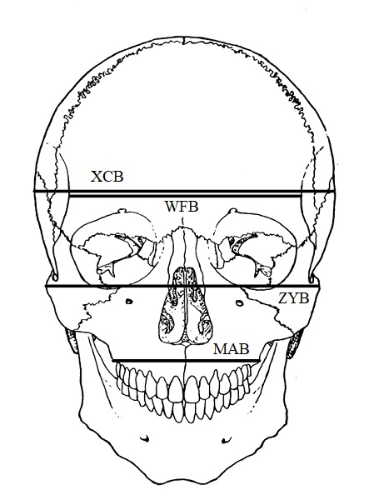
Figure 1. Frontal view of the skull showing approximations of XCB, WFB, ZYB, MAB.
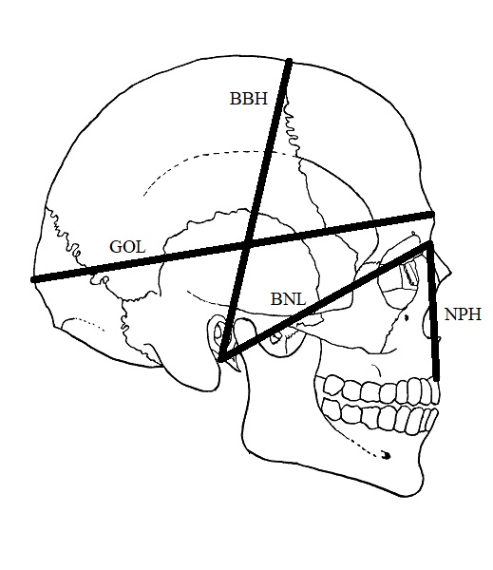
Figure 2. Side view of the skull showing approximations of GOL, BBH, BNL, and NPH.

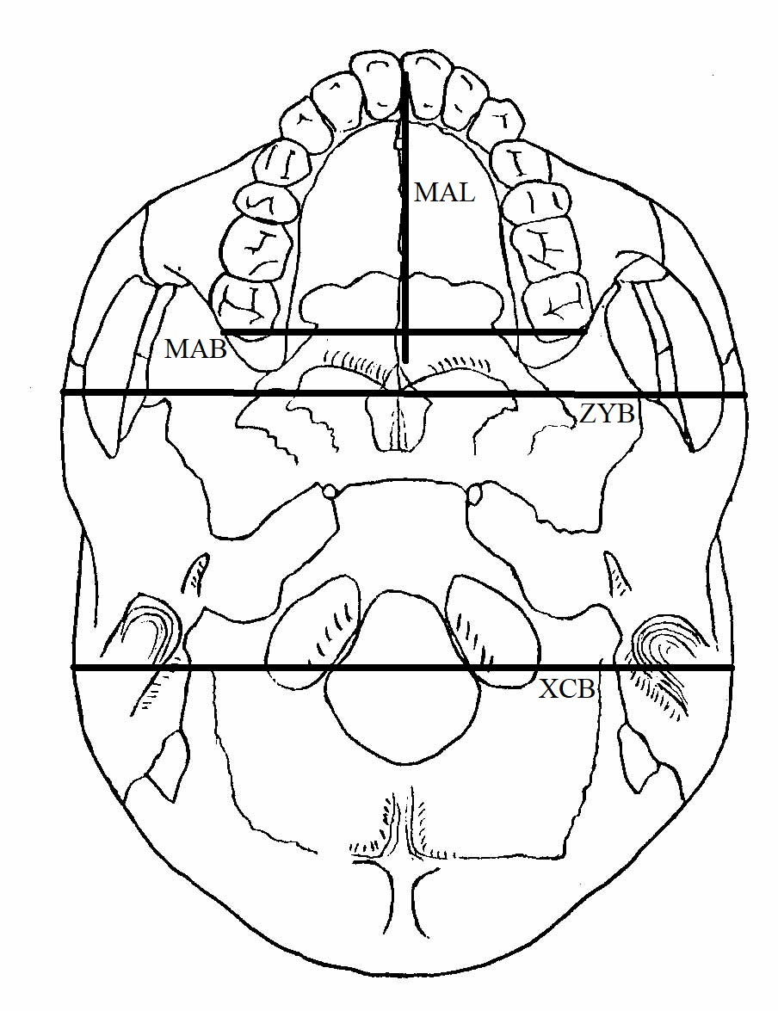
Figure 3. Basilar view of the skull showing approximations of MAL, MAB, ZYB, and XCB.
analysis. Therefore, a total of thirteen measurements were used for the current study – those described in Table 1, cranial vault size, face size, and cranial index.
All statistical analyses were performed using the R statistical package (R Core Team 2017). Third-degree polynomial models were created for each measurement, with each measurement plotted against the birth year (Jantz and Jantz 2000). These models are used to indicate the presence (or lack) of significant temporal change for each measurement and to calculate the degree of fit of the regression model. The residuals of each of these model were also tested for normality using the Shapiro-Wilk test.
To better understand localized temporal trends, a Loess (Local Polynomial Regression) curve was fitted to those measurements that showed a significant change through the polynomial models. This curve creates a local smoothing for the dependent variable, which is useful for understanding localized variation that a regression function for the entire dataset might not identify (Devlin and Cleveland 1988). It creates a structure that might not otherwise be seen with the naked eye in a scatterplot (Friedman 1984). The default span of 2/3 was assigned to each Loess curve. The span parameter designates the level of smoothness of the curve by choosing the size of the neighborhood. A span value of 1 results in the smoothest possible curve, while a span value close to 0 will result in a large variance due to insufficient data (Friedman 1984). A possible bias could be introduced by having differently sized neighborhoods over time due to what data is available. However, since the Loess curve is being used as a graphical exploratory tool, not a test of significance, this bias can be overlooked.
Sometimes group averages can be more informative than individual data points. As such, the data were also organized by generational cohorts, with a generation roughly expected to be 25 years (based on Weisensee and Jantz 2011). The first cohort consists of those individuals born in 1800-1824, followed by the second cohort of those born 1825-1849, and so on, with the last cohort comprising of those individuals born in 1950-1974, for a total of seven cohorts (Table 2). The number of individuals in six of these seven cohorts varies between sixteen and forty-eight. The size of the first cohort consists of only three individuals. Group averages graphs were produced in R (R Core Team 2017) for those measurements that showed significant temporal change.
Any data that is measured over time can be considered a time series. Because this study looks at different cranial measurements over a period of years, it can be considered a time series. To perform analyses on such series, three key concepts must be taken into account: trend, serial dependence, and stationarity (Crawley 2013). The goal of this study is to identify if there are significant trends, usually occurring in an upward or downward direction over time, although changes may not necessarily be linear. Another basic component of time series is serial dependence, which refers to the possible correlation between adjacent data points within the time series. To better understand the results, the data must be tested for autocorrelation. Each measurement in this study was tested using the Durbin-Watson test. If the data are autocorrelated, different tests of significance must be performed.

Table 2. Number of individuals in each 25-year cohort.
Cohort | Number of individuals
1800-1824 | 3
1825-1849 | 16
1850-1874 | 15
1875-1899 | 25
1900-1924 | 48
1925-1949 | 24
1950-1974 | 28

Results

Polynomial Models
Significance tests for secular trends on the crania were conducted using third-degree polynomial models. The results obtained with these models, including degree coefficient probabilities (i.e., p-values) as well as multiple and adjusted R-squared values, are shown in Table 3. The third degree polynomial coefficient is not statistically significant (p > 0.05) for any of the thirteen considered measurements. Five measurements show significance (p < 0.05) for a second degree polynomial model, meaning the results can be roughly plotted along a parabolic shape. These five measurements are: auricular breadth (AUB), basion-bregma height (BBH), basion-nasion length (BNL), bi-zygomatic breadth (ZYB), and vault size (VS). Of the remaining eight measurements, three show a linear trend, with the model showing significance at the first degree polynomial model. These are palate breadth (MAB), palate length (MAL), and maximum cranial breadth (XCB). In total, eight of the chosen measurements show a statistically significant temporal change, whether linear or quadratic. No significant temporal changes are seen in glabello-occipital length (GOL), minimum frontal breadth (WFB), nasion-prosthion height (NPH), cephalic index (CI), or face size (FS).
The residuals – the difference between the observed values and the predicted values – for each polynomial model were tested for normality using the Shapiro-Wilk test. All were deemed normal except for the residuals for the bi-zygomatic breadth model, with a p-value of 0.0342, which is below the accepted threshold for significance.
Table 3. Probability of coefficients (p-values) and R-values for polynomial models. Significant p-values (p < 0.05) have been italicized.
 | Third degree  p-value | Second degree p-value | First degree p-value | Multiple  R-squared | Adjusted  R-squared
AUB | 0.735 | 0.003 | 0.084 | 0.0890 | 0.0695
BBH | 0.807 | 0.040 | 0.001 | 0.0888 | 0.0704
BNL | 0.871 | 0.002 | 0.021 | 0.0911 | 0.0725
GOL | 0.314 | 0.180 | 0.224 | 0.0295 | 0.0094
MAB | 0.818 | 0.129 | 0.010 | 0.0650 | 0.0441
MAL | 0.467 | 0.281 | 0.000 | 0.0881 | 0.0037
NPH | 0.686 | 0.555 | 0.138 | 0.0196 | -0.0019
WFB | 0.227 | 0.151 | 0.365 | 0.0300 | 0.0100
XCB | 0.430 | 0.057 | 0.000 | 0.1122 | 0.0935
ZYB | 0.757 | 0.001 | 0.439 | 0.0723 | 0.0522
CI | 0.817 | 0.610 | 0.052 | 0.0291 | 0.0081
VS | 0.395 | 0.011 | 0.000 | 0.1417 | 0.1229
FS | 0.912 | 0.414 | 0.144 | 0.0212 | -0.0015

This lack of normality in the residuals indicates that the error in the model is not the same across all observed data. However, bi-zygomatic breadth was still assessed, as the lack of normality is not big enough to warrant different testing for this measurement.

Loess regressions over scatterplots
The eight measurements which showed significant change over time were plotted with a Loess line over the scatterplot, as shown in Figures 4-10. It should be noted that there might be some error at the boundaries due to the smoothing operator not having enough information (Friedman 1984). Additionally, the scatter of data points is not even across time, with fewer data points being available in the earliest years. Nevertheless, certain patterns can be seen in these graphs.
The curves for auricular breadth, basion-bregma height, basion-nasion length, bi-zygomatic breadth, and vault size tend to show a parabolic shape, in keeping with the polynomial model. The curves for palate breadth and length have no discernible shape, although they do imply a negative trend over time. The curve for maximum cranial breadth can look misleading, in that it seems to show a parabolic shape; however, this is not supported by the polynomial model, which showed significance only on a linear relationship. It is possible that this bias is caused by the inconsistent spread of data, with fewer data points being available for the earlier years.
Regardless of curve shape, the Loess plots indicated that changes in measurements are variable over time, with changes happening on a micro-scale that may not necessarily be reflected in the polynomial models. Of interest is a dip in length that
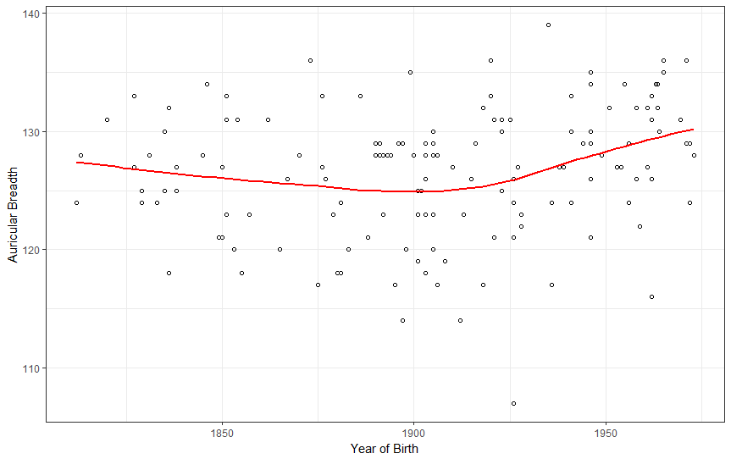
Figure 4. Graph showing Loess regression for auricular breadth (in millimeters) plotted over year of birth.

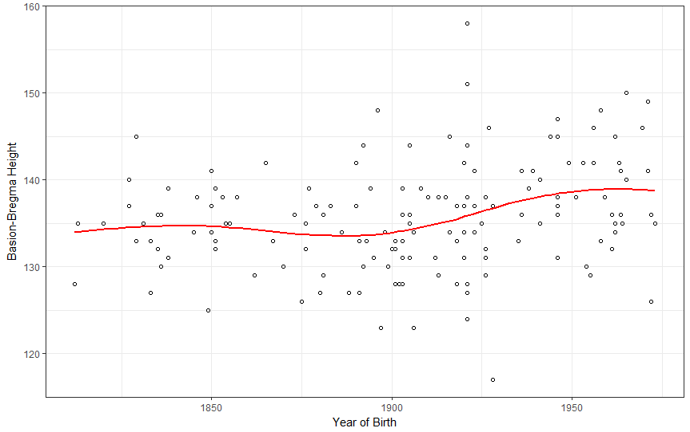
Figure 5. Graph showing Loess regression for basion-nasion length (in millimeters) plotted over year of birth.

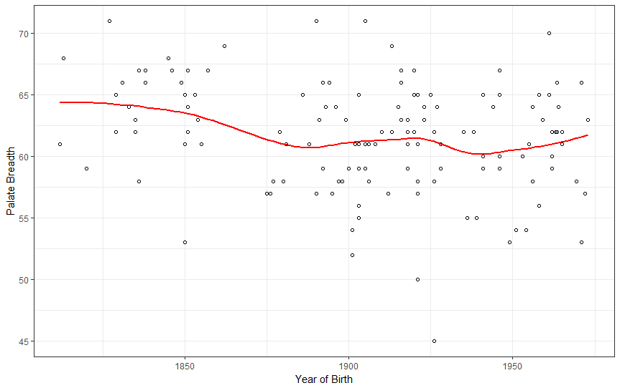
Figure 6. Graph showing Loess regression for palate breadth (in millimeters) plotted over year of birth.

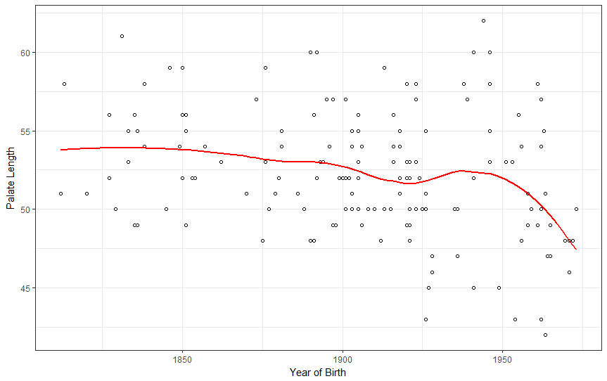
Figure 7. Graph showing Loess regression for palate length (in millimeters) plotted over year of birth.

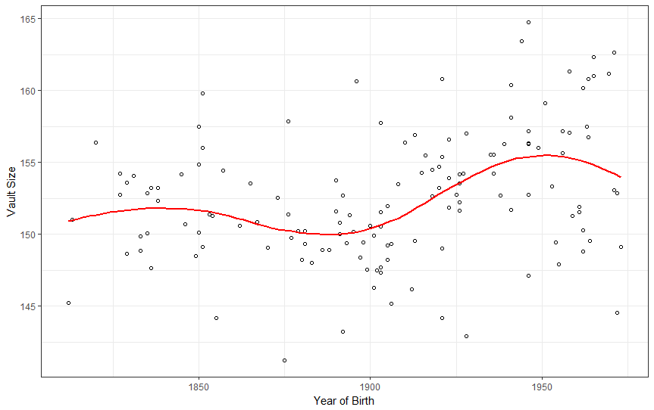
Figure 8. Graph showing Loess regression for vault size plotted over year of birth.

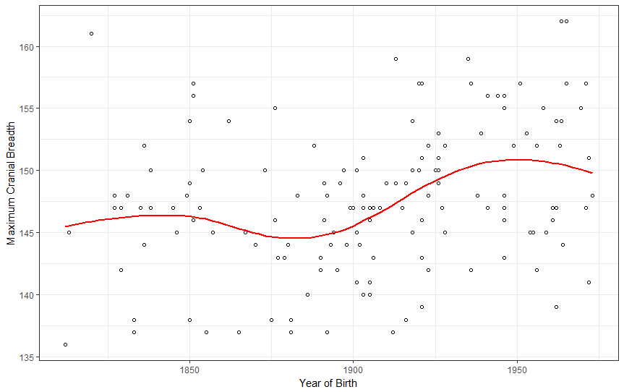
Figure 9. Graph showing Loess regression for max cranial breadth (in millimeters) plotted over year of birth.

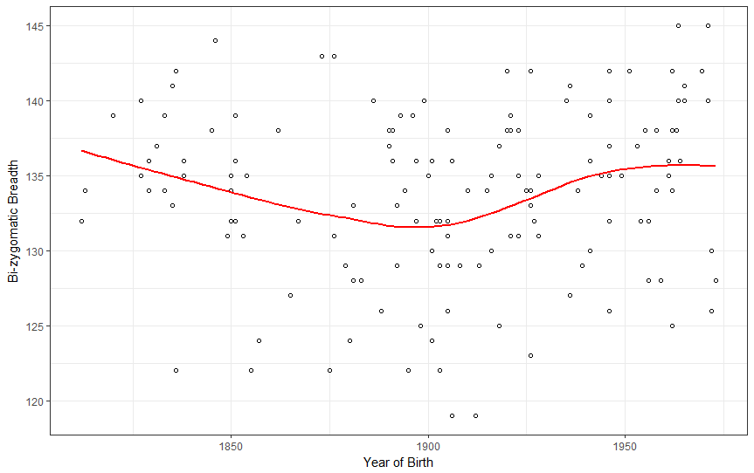
Figure 10. Graph showing Loess regression for bi-zygomatic breadth (in millimeters) plotted over year of birth.

occurs roughly around the year 1900 for auricular breadth, basion-bregma height, basion-nasion length, bi-zygomatic breadth, maximum cranial breadth, and vault size.

25-Year Cohort Averages
In addition to the Loess regressions, averages for each measurement were calculated based on 25-year cohorts. These are presented in Figures 11-18. The individual vault variables – basion-bregma height, maximum cranial breadth, basion-nasion length, and auricular breadth –all show a parabolic shape, trending negative at first then showing a positive trend. This turning point from negative to positive occurs at the 1875-1899 cohort for auricular breadth, basion-bregma height, and cranial breadth. Basion-nasion length offers a slightly different trend. If one takes the first cohort (n = 3) out of consideration, BNL trends positive, then negative, then positive again. The low point for BNL is the 1875-1899 cohort as well as 1900-1924 cohort, after which there is a very high positive trend. Unsurprisingly, vault size reflects those measurements from which it is derived in that it also shows a basic parabolic shape trending negative, then positive, with the turning point being the 1875-1899 cohort.
Three of the facial variables showed significant change; cohort average can show positive or negative trends. Of those that were used to calculate face size, only bi-zygomatic breadth (ZYB) showed a change similar to the cranial variables. ZYB also shows a parabolic shape, trending negatively, then positively, with the turning point being the 1900-1924 cohort. However, since nasion-prosthion height showed no significant secular change, face size was also not significantly affected over time. Perhaps
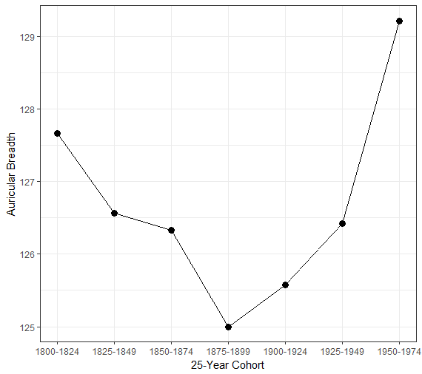
Figure 11. Plot of 25-year cohort averages (in millimeters) for auricular breadth.
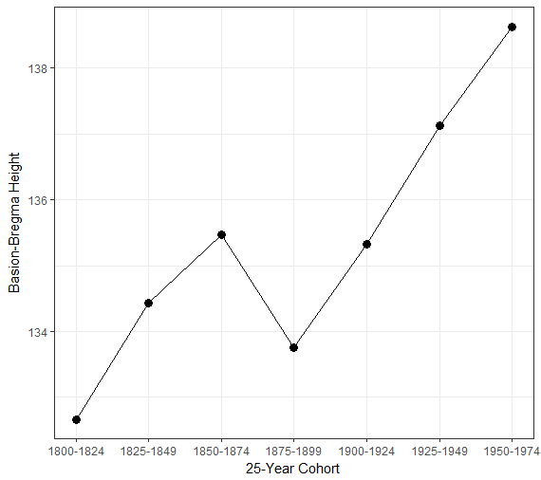
Figure 12. Plot of 25-year cohort averages (in millimeters) for basion-bregma height.
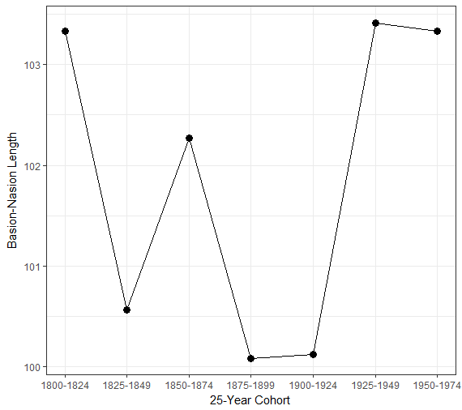
Figure 13. Plot of 25-year cohort averages (in millimeters) for basion-nasion length.
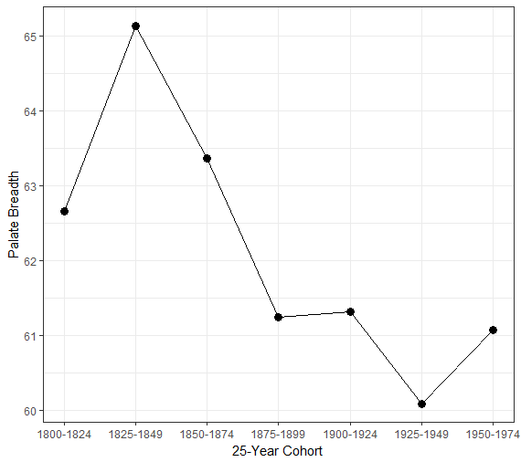
Figure 14. Plot of 25-year cohort averages (in millimeters) for palate breadth.
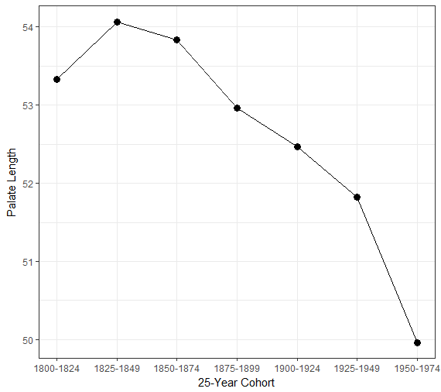
Figure 15. Plot of 25-year cohort averages (in millimeters) for palate length.
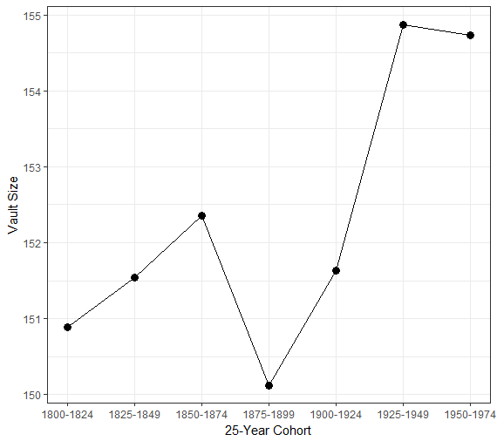
Figure 16. Plot of 25-year cohort averages for vault size.
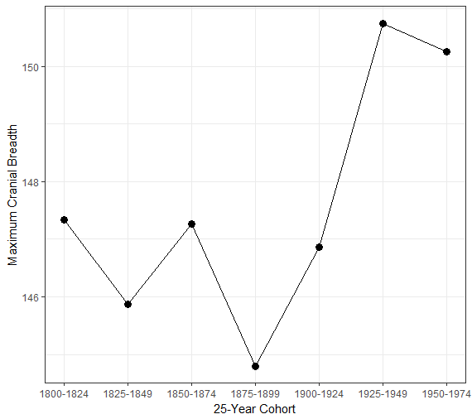
Figure 17. Plot of 25-year cohort averages (in millimeters) for maximum cranial breadth.
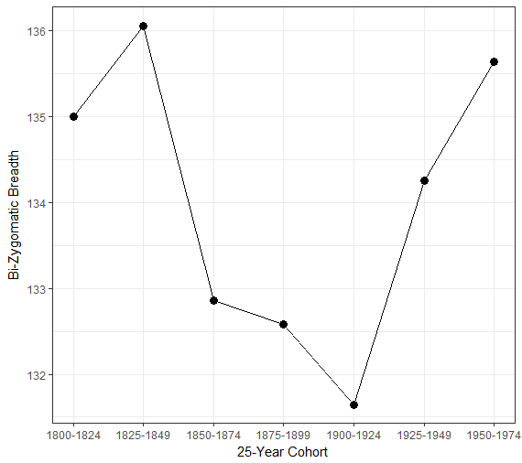
Figure 18. Plot of 25-year cohort averages (in millimeters) for bi-zygomatic breadth.

more interesting are the palate measurements of length and breadth, each of which show a negative linear trend over time. The 1800-1824 cohort might appear to disprove this assertion; however, it is important to remember that this cohort has only three data points and as such is not as reliably useful as other cohorts for explaining trends.

Discussion

The results presented above indicate that secular change has played a role in Croatian cranial morphology. Most of these changes have occurred in the vault, with very few significant changes occurring in the facial cranium. Many of the changes also exhibit a very similar pattern of change, meaning increases and decreases are happening in various cranial measurements around the same time.
Polynomial models were created to help explain the change occurring over the time period examined. These polynomial models were tested for significance to the third degree. None of the measurements examined showed any significance at the third degree, but several did show significance at either the second degree or the first degree. This indicates that these particular measurements have changed over the time period examined, whether in a parabolical trend or in a linear trend.
The Loess regressions on those eight measurements that showed significance in the polynomial model generally follow the trend seen in the polynomial coefficients. However, Loess curves are also able to examine micro-trends that would not necessarily be observed just from the polynomial model. For example, while palate breadth and length both fit a linear model of change, the Loess curve shows that it is not necessarily a strict negative trend. In fact, for palate breadth, there appears to be a positive trend at the latter end of the time period, i.e. after 1975, but due to lack of data after that year, the trend could be misleading. Conversely, palate length shows a general negative trend, but the slope of the curve increases greatly after 1950. Again, this could be due to lack of data required to create the Loess neighborhoods. Nevertheless, further data from individuals born after 1975 would confirm or deny these possible trends.
The measurements that fit a parabolic model are also illuminated somewhat by the Loess curve. The general trend appears to be a negative trend followed by a positive trend for all five measurements, although several do have the aforementioned end of curve problems – where not enough data is available at either end of the datasets to create a good predictive model at those points. These seem to mirror the secular trends seen in other populations, such as American Black and White males and females, although the magnitude of change is not as great (Jantz and Jantz 2000).
Cohort averages provide a useful tool for observing patterns of change. However, due to limited data, the first cohort, which comprises birth years from 1800 to 1824, contains only three individuals. As such, it may not be as indicative of the population trends as the other cohorts. This must be considered when looking at change patterns, especially when the first cohort differs greatly (more than two millimeters) from the second cohort for certain measurements, such as basion-nasion length. Nevertheless, even if the first cohort is left out, there are still clear patterns to be seen. Of interest is that auricular breadth, basion-bregma height, and cranial breadth all experience a low in the 1875-1899 cohort.

Other European Populations
Within the Croatian sample, many of the changes seen were expressed in the cranial vault, with four of the five vault measurements (excluding vault size) showing a statistically significant change over time. Auricular breadth, basion-bregma height, and basion-nasion length all exhibit a parabolic trend, while cranial breadth exhibits a positive linear trend over time.
Secular changes in the vault are not unusual, and indeed can be seen in practically all the European and Euro-descended populations that have been studied so far. Although not identical, there are some patterns that can be observed across populations. Among these populations, maximum cranial breadth appeared to be one aspect that exhibited some sort of change among Portuguese, Polish, German, and Euro-American populations. In the American, German, and Portuguese populations, cranial breadth was expressed as a negative linear trend over time, meaning that the cranial vault has narrowed in these populations over the past roughly two hundred years. In the Polish population, cranial breadth had a slightly different pattern, exhibiting an increase and then a decrease over time. Interestingly, the Croatian population showed the opposite trend. In Croatian males, cranial breadth exhibited a positive linear trend over time, which means that overall, the vault became wider. One would expect the Croatian population to show similar results to those populations that are closest to it geographically (and by proxy, genetically). Instead, the increase in cranial breadth has so far been seen in non-European populations such as the Japanese (Kouchi, 2004). The reason for this is unclear. It is possible that Croatia, located partially along the coast in southeastern Europe, saw more genetic admixture with non-European populations, although Croatians are genetically closer to other Europeans than to any other geographic group (Kushniarevich et al. 2015).
Other vault measurement changes in Croatians are more aligned with their European neighbors. For instance, changes in basion-bregma height were observed in German and Euro-American populations. Euro-Americans saw a positive linear trend over time, while Germans exhibited a similar pattern to Croatians, in that this measurement saw a parabolic trend; that is, over the time period studied, cranial height first decreased, then increased, with the overall average being higher in the twentieth century than in the nineteenth century. In addition, similar changes were seen in basion-nasion length in Germans as in Croatians, which again followed a parabolic trend of decreasing then increasing. Croatians appear so far to be the only population to show significant change in auricular breadth, though this is partly due to this particular measurement not being accounted for in other studies.
In the facial skeleton, the Croatian population exhibited secular change in three aspects: bizygomatic breadth (roughly equivalent to facial breadth), palate breadth, and palate length. Changes in facial breadth were also observed in Portuguese, American, and Polish populations, all three of which showed a negative linear trend over time, meaning the face became narrower. This is also the case for the Hungarian population, the closest to Croatians genetically and geographically, although the birth years included in that study are later than the ones used in this thesis. Croatians differ somewhat in this aspect. A negative trend can be seen in Croatians as well until around the turn of the century, after which facial breadth starts to increase. Palate measurements are not as often studied as other cranial measurements, and so a comparison to multiple populations will have to wait until that data become available. Within the Portuguese population, palate breadth exhibited a positive linear trend over time, which is the opposite of what is seen in the Croatian populations. Again, the reason for this difference between Croatians and geographically-close populations is unclear. If genes are not the main drivers of these changes, the answer must lie in examining the difference in sociocultural changes among these populations.

Croatian-Specific Studies
Unfortunately, it is difficult to compare the current study to those previously conducted on the Croatian population (Buretic-Tomljanovic 2004; Buretic-Tomljanovic 2006) for several reasons: the use of skeletal data as opposed to anthropometric data, the different statistical methods used for analysis (polynomial regression analysis versus ANOVA), and the different birth years of the subjects. The 2004 and 2006 studies represent the birth cohorts directly following those included in this thesis. Although this study found that no significant changes occurred in the cephalic index between the early 1800s and circa 1975, Buretic-Tomljanovic (2004) noted that by the 1980s, a change could be observed. Likewise, for head length (equivalent to GOL), this study found that no significant changes occurred, but Buretic-Tomljanovic (2004) noted an increase in their comparison of the two groups (individuals born 1974-1976 and those born 1982-1983). For head breadth and its skeletal equivalent, XCB, the two studies show opposing results: this study found a linear increase, while Buretic-Tomljanovic (2004) found that head breadth decreased during their period of study. A possible explanation may be found by looking at the Loess curve for XCB (Figure 9), which is not completely linear but instead depicts a relatively flat curve for birth years up to 1900, after which the slope of the curve increases. The curve also appears to take a turn around 1950, where the slope turns downwards, representing a decrease in XCB.
In the facial skeleton, previous studies showed a significant increase in face height in the two cohorts examined, with birth years in the early 1970s and the early 1980s (Buretic-Tomljanovic 2006). In the skeletal sample used for this thesis, no significant change was observed in face height (as represented by nasion-prosthion height). Again, it is possible that changes occurred in the latter quarter of the twentieth century, although further study is required to see if the change reported by Buretic-Tomljanovic (2006) applies only to the two cohorts or if it is representative of a larger temporal trend.

Correlation to Historical Events
During this time period, Croatia did not exist as a sovereign nation; instead, it was ruled by other kingdoms, and saw continued political changes (Goldstein, 1999). The 1800s saw the region that is modern-day Croatia ruled by the Austrian Hapsburgs and after 1867, become a part of the Austro-Hungarian empire (Goldstein, 1999). The empire dissolved at the end of World War I in 1918, and Croatia became part of a Kingdom of Yugoslavia during the inter-war period. The end of World War II in 1945 saw the creation of the Socialist Federal Republic of Yugoslavia, with Croatia being one republic among several. This version of Yugoslavia dissolved during the early 1990s, and Croatia became an independent republic in 1991, a status it has since retained (Goldstein, 1999). It is possible that this type of political upheaval might have had some socioeconomic effects on Croatian peoples, but the results of this study do not seem to have direct correlations to these political events. World War I, after which Austria-Hungary collapsed, did not seem to have a corresponding effect in cranial measurements. In fact, neither the World War I, the inter-war period, nor World War II and its outcome seem to have affected cranial morphology. One must look past major political events and dates to find potential causes for changes seen in the skeleton. For example, a major economic depression occurred between 1873 and 1896, which resulted in periods of famine in much of Croatia (Goldstein, 1999). This period of economic stress corresponds to the dips observed in cranial measurements of the 1875-1899 cohort included in this study. Since nutrition is considered to be one of the influences of these cranial changes, it is likely that this long period of famine had effect on skeletal morphology.
In addition, unlike some of its European brethren and the United States, Croatia was relatively slow to modernize (Goldstein, 1999). The region was largely agricultural until well into the 20th century, and urbanization – and its associated increased standard of living– only took off during the socialist period (Goldstein, 1999). Perhaps it is the comparatively late modernization that explains the differences in observed cranial changes between the Croatian population and others of European origin.

Study Limitations
The limitations of this study should be acknowledged. First, the study could only focus on the male population, as data for Croatian females was severely limited. Second, one cannot positively say that the sample included in this study is truly representative of the entire Croatian population of that time period. Although this was taken for granted for the purposes of this thesis, an increased sample size and more even distribution across time may provide different results. In addition, including data from individuals with more recent birth years could provide insight into the differences in results between this study and those conducted on later-born living individuals (Buretic-Tomljianovic, 2004; 2006). Lastly, a test of inter- or intra-observer error could not be performed, and it is possible that differences in data collection methods between the various individuals who collected the data could affect some of the results.

Summary
The data used in this study provided some surprising results. While secular change did occur, as was expected, the location and pattern of the changes was different from other European populations which have been previously studied. These differences may be attributed to sampling, although genetic differences and sociocultural events are more likely to be the causes and must be examined closely.

Conclusion

Observing and identifying secular changes in a population is relatively straightforward, as long as the skeletal sample exists. The complicated part is attempting to explain the causes of these changes, or determine which factors influence them most. To understand this, once must look at the social, economic, and political events that affected the population in question during the time period studied. The historical and political factors affecting Croatia at this time were also present in the rest of Europe and even across the ocean in the United States. The forces of change saw no political boundaries, although the implementation of these changes were influenced by national and local factors.
The results presented in this thesis show that secular change has occurred in the cranium in the Croatian male population. Although this was expected, given the results of past studies on genetically and geographically close populations, the trends depicted were somewhat unusual. The positive linear trend in XCB seen in the Croatian male population differs from other European and European-descended populations, which show the opposite (negative) trend. In addition, the negative to positive trend in ZYB seen in the Croatian male population differs from other European and European-descended populations, which exhibit a negative linear trend.
While this study may not be able to provide reasons for the secular changes, it nevertheless shows that changes did occur. To better understand these changes, more data must be acquired, not only of the time period in this study, but also outside of this study, especially of individuals born after 1975. Major changes in medicine and economics have occurred in that region of the world since, and it would be interesting to see if the trends seen in the current study continue to the modern era or if, once again, they take a turn.
Though this study is but one small addition to the larger field of study of secular change, it serves to confirm the trend seen globally: that in recent centuries, humans have undergone significant change in the body, and particularly in the cranium, that can most likely be attributed to social and cultural factors. To truly delve into the factors driving this change, future research must not only assess populations which have not been analyzed yet, but also perform comparisons between populations. Recent advances in the fields of genetics and DNA analysis as well as the application of different statistical methods will serve to improve results and provide better conclusions. Studies must not only focus on biological factors, but also bring in research from historians, sociologists, and cultural anthropologists (among others), for a more holistic view, which may lead to new and different interpretations.

List of References

Angel JL. 1976. Colonial to modern skeletal change in the U.S.A. American Journal of Physical Anthropology 45(3):723-735.
Angel JL. 1982. A new measure of growth efficiency: Skull base height. American Journal of Physical Anthropology 58(3):297-305.
Bielecki EM, Haas JD, and Hulanicka B. 2012. Secular changes in the height of Polish schoolboys from 1955 to 1988. Economics and Human Biology 10(3):310-317.
Boas F. 1912. CHANGES IN BODILY FORM OF DESCENDANTS OF IMMIGRANTS. American Anthropologist 42(2):183-189.
Buretic-Tomljanovic A, Ostojic S, and Kapovic M. 2006. Secular change of craniofacial measures in Croatian younger adults. American Journal of Human Biology 18(5):668-675.
Buretic-Tomljanovic A, Ristic S, Brajenovic-Milic B, Ostojic SA, Gombac E, and Kapovic M. 2004. Secular change in body height and cephalic index of Croatian medical students (University of Rijeka). American Journal of Physical Anthropology 123(1):91-96.
Cameron N, Tobias PV, Fraser WJ, and Nagdee M. 1990. SEARCH FOR SECULAR TRENDS IN CALVARIAL DIAMETERS, CRANIAL BASE HEIGHT, INDEXES, AND CAPACITY IN SOUTH-AFRICAN NEGRO CRANIA. American Journal of Human Biology 2(1):53-61.
Crawley MJ. 2013. The R book: Chichester, West Sussex : Wiley, A John Wiley & Sons Ltd., Publicaton.
Devlin SJ, and Cleveland WS. 1988. Locally weighted regression: an approach to regression analysis by local fitting. Journal of the American Statistical Association 83(403):596.
Friedman JH. 1984. A Variable Span Smoother. In: Stanford Univ Ca Lab For Computational S, editor.
Goldstein, I. 1999. Croatia: a History. Translated by N. Jovanovic. London: C. Hurst & Co. Ltd.
Gyenis G. 1994. Rapid change of head and face measurements in university students in Hungary. Anthropologischer Anzeiger 52(2):149-158.
Howells WW. 1973. Cranial variation in man; a study by multivariate analysis of patterns of difference among recent human populations. Cambridge, Mass.: Cambridge, Mass., Peabody Museum of Archaeology and Ethnology, Harvard University.
Hwang J-Y, Shin C, Frongillo EA, Shin KR, and Jo I. 2003. Secular trend in age at menarche for South Korean women born between 1920 and 1986: the Ansan Study. Annals of Human Biology, 2003, Vol30(4), p434-442 30(4):434-442.
Jantz, RL, and Jantz LM. 2016. The Remarkable Change in Euro-American Cranial Shape and Size. Human Biology 88(1):56-64.
Jantz RL, and Jantz LM. 2000. Secular change in craniofacial morphology. American Journal of Human Biology 12(3):327-338.
Jantz RL, and Wescott D. 2002. Assessing craniofacial secular change in American whites and blacks using geometric morphometry.(Abstract). American Journal of Physical Anthropology 117(4):90.
Jellinghaus K, Hoeland K, Hachmann C, Prescher A, Bohnert M, and Jantz R. 2018. Cranial secular change from the nineteenth to the twentieth century in modern German individuals compared to modern Euro-American individuals. International Journal of Legal Medicine 132(5):1477-1484.
Jonke E, Prossinger H, Bookstein FL, Schaefer K, Bernhard M, and Freudenthaler JW. 2007. Secular trends in the facial skull from the 19th century to the present, analyzed with geometric morphometrics. American Journal of Orthodontics & Dentofacial Orthopedics 132(1):63-70.
Kleanthous K, Dermitzaki E, Papadimitriou DT, Papaevangelou V, and Papadimitriou A. 2017. Secular changes in the final height of Greek girls are levelling off. Acta Paediatrica 106(2):341-343.
Kouchi M. 2004. Secular changes in the Japanese head form viewed from somatometric data. Anthropological Science 112(1):41-52.
Kushniarevich A, Utevska O., Chuhryaeva M., Agdzhoyan A., Dibirova K., Uktveryte I., Mols M., Mulahasanovic L., Pshenichnov A., Frolova S., Shanko A., Metspalu E., Reidla M., Tambets K., Tamm E., Koshel S., Zaporozhcheno V., Atramentova L., Kucinskas V., … Balanovsky O. 2015. Genetic Heritage of the Balto-Slavic Speaking Populations: A Synthesis of Autosomal, Mitochondrial, and Y-Chromosomal Data. PLoS ONE 10(9).
Lanfear AK. 2012. Records of the Institut fuer Deutsche Ostarbeit (1940-1943) : using anthropometrics of Polish populations to examine secular trends and region specific variation: Thesis (Ph. D.)--University of Tennessee, Knoxville, 2012.
Little BB, Buschang PH, Reyes MEP, Tan SK, and Malina RM. 2006. Craniofacial dimensions in children in rural Oaxaca, Southern Mexico: Secular change, 1968-2000. American Journal of Physical Anthropology 131(1):127-136.
Malina RM, Selby HA, Buschang PH, Aronson WL, and Wilkinson RG. 1983. Adult stature and age at menarche in Zapotec‐speaking communities in the Valley of Oaxaca, Mexico, in a secular perspective. American Journal of Physical Anthropology 60(4):437-449.
Manthey L, Jantz R, Bohnert M, and Jellinghaus K. 2017. Secular change of sexually dimorphic cranial variables in Euro-Americans and Germans. International Journal of Legal Medicine 131(4):1113-1118.
Meredith HV. 1976. Findings from Asia, Australia, Europe, and North America on secular change in mean height of children, youths, and young adults. American Journal of Physical Anthropology 44(2):315-325.
Ousley S. 2014. 3Skull. 1.76 ed.
R Core Team. 2017. R: A Language and Environment for Statistical Computing. Vienna, Austria: R Foundation for Statistical Computing.
Sarajlic N, Resic E, Gradascevic A, Salihbegovic A, Balazic J, and Zupanc T. 2014. Secular trends in body height in Balkan populations from 1945 to 1995.(Report). 14(4):209.
Schönbeck Y, Talma H, van Dommelen P, Bakker B, Buitendijk SE, Hirasing RA, and van Buuren S. 2013. The world's tallest nation has stopped growing taller: the height of Dutch children from 1955 to 2009. Pediatric research 73(3):371.
Sławińska T, Ignasiak Z, Little BB, and Malina RM. 2012. Short‐term secular variation in menarche and blood lead concentration in school girls in the copper basin of southwestern poland: 1995 and 2007. American Journal of Human Biology 24(5):587-594.
Spradley K, Stull K, and Hefner J. 2016. Craniofacial Secular Change in Recent Mexican Migrants. Human Biology 88(1):15-29.
Veček N, Veček A, Zajc Petranović M, Tomas Ž, Arch-Veček B, Škarić-Jurić T, and Miličić J. 2011. Secular trend of menarche in Zagreb (Croatia) adolescents. European Journal of Obstetrics and Gynecology 160(1).
Weisensee KE, and Jantz RL. 2011. Secular Changes in Craniofacial Morphology of the Portuguese Using Geometric Morphometrics. American Journal of Physical Anthropology 145(4):548-559.

Vita

Ileana Ilas was born some three and a half decades ago, in pre-revolution Romania. She immigrated with her family at the tender age of 8 to the United States, where she grew up mostly in Atlanta, GA, although her parents’ employment took them to several different states in the South. Ileana graduated from high school in 2006 and attended the University of Chicago, where she majored in anthropology with a focus on human rights. Although she ended up dropping out after several years, the instruction she received there would influence her approach to academics and life forever. She finally completed her undergraduate degree in 2013, after enrolling at the University of Tennessee, Knoxville, where she later also began graduate studies. Ileana currently works as an archaeologist, though she is still interested in bioanthropology and human rights and hopes to include concepts from these disciplines in her future work.

