ANALYZING BLENDED MATERIAL TRANSITIONS PRODUCED BY A DUAL-HOPPER LARGE FORMAT ADDITIVE MANUFACTURING SYSTEM

A Dissertation Presented for the
Doctor of Philosophy
Degree
The University of Tennessee, Knoxville

James Brackett
August 2023

Copyright © 2023 by James Brackett
All rights reserved.

Dedicated to my family, friends, and loved ones. Thank you equally for the support and, when needed, distractions.

ACKNOWLEDGEMENTS
This dissertation was sponsored in part by UT-Battelle, LLC under Contract No. DE-AC05-00OR22725 with the U.S. Department of Energy. I would also like to acknowledge funding from the State of Tennessee and Tennessee Higher Education Commission (THEC) through their support of the Center for Materials Processing. My thanks also go to the researchers at Oak Ridge National Laboratory and the Manufacturing Demonstration Facility for equipment access, training, and resources.

I want to acknowledge and thank the following, grouped roughly by association:
I want to thank my advisor, Dr. Chad Duty, for his guidance throughout my graduate career and bringing me into the additive manufacturing industry. The tangible growth he has encouraged in my presentation and research skills will be invaluable in my career. Additionally, I would like to thank my committee members: Dr. Vlastimil Kunc, Dr. Brett Compton, and Dr. Uday Vaidya, who I credit with kick-starting my research career as an undergraduate in his lab and IACMI. Another invaluable experience that has been crucial for my journey. Further thanks to Dr. Lee Riedinger and Suresh Babu for their contributions as director of the Bredesen Center for Interdisciplinary Research and Graduate Education and for passing on their enthusiasm for scientific progress. Critical thanks to Wanda Davis, Allie Burns, Rebecca Christ, and others in the Bredesen Center who keep the wheels turning and threads connected. Similarly, I want to express my appreciation for the routine assistance and support provided by MABE staff, especially Rhnea Reagan, Ruthann Moyers, Ashly Shine, and Nita Drozd.
My parents, Mike and Ann Brackett, for serving as excellent teachers and providing love and support at every opportunity as well as my sister Jenna Brackett for her unwavering belief that I’d be just fine. Further, I want to thank my grandparents, Levi and Jane Ann Odom and Goldia Brackett, for the memories, life lessons, and love throughout my life. To keep things short, thank you so much to the rest of my extended family for the advice, open arms, and keeping me grounded over the years.
My fellow group members with whom I have shared many late nights in the lab, pep talks, research ideas, and, when possible, Volunteer wins. For a time, Christine Ajinjeru, Vidya Kishore, and Dylan Hoskins. Now, Roo Walker, Brenin Bales, Tyler Corum, Jay Pike, Andrew Rhodes, and Chris O’Brien. I appreciate the joy and help you brought to a difficult journey, and I look forward to collaborating on future challenges.
Special thanks to Tyler Smith for his help with experimental planning, equipment training, and being a dependable and available resource at the MDF. Similarly, thank you Kristen Summey for keeping us connected and always being ready to help with whatever issues arose.
On a similar note, I need to thank a veritable army of undergraduate research assistants, without whom graduation would still be a far-off dream. Special thanks to Dakota Cauthen, Elijah Charles, Matthew Charles, Alex DeFilippis, Ethan Strickland, and Nina Bhat for their sustained contributions.
My many influences while I was working as an undergraduate research assistant, including Dr. Chris Wetteland, Dr. Uday Vaidya (again), Vanina Ghossein, and many others. Extensive thanks to Dr. Hicham Ghossein for bringing me into the fold when Dr. Vaidya and IACMI arrived at UTK and for his mentorship.
Thank you to all my loved ones. Megan Fetterolf for your endless patience and understanding of the hours this required. Knowing I could rely on you through trying times and celebrate the accomplishments meant more than I can express. Dylan Hoskins, Evan Lamb, Kendall Harville, Lauren Mullen, Jason Behrens, Jordan Dooley, Aaron Tipton, Janie Brackett, Kelly Brackett, and so many others for the tireless optimism, technical consultation, unwavering friendship, and all the other things that helped keep me sane through it all.

ABSTRACT
Additive Manufacturing (AM) has seen rapid growth in terms of popularity, capabilities, and methods in recent years, especially in multiple material (MM) printing vital to expanding the applications of AM beyond modelling and prototyping. While small-scale systems have successfully demonstrated MM printing capabilities, Large-Format Additive Manufacturing (LFAM) instruments have remained largely limited to single-material processing. This dissertation investigates a novel method for MM LFAM printing utilizing a novel dual-hopper configuration developed for the Big Area Additive Manufacturing (BAAM) system from Cincinnati Inc. The BAAM dual hopper produces blended material transitions in-situ by switching from one material to the next. The primary goal was to characterize the material transition process through analysis of processing parameter effects on transition rate, transition length, and mechanical properties. Initial work investigated compositional analysis methods and developed a novel technique for analyzing reinforcement content. A novel framework for comparing transitions printed with different conditions was developed through normalizing by a system-specific residual volume. Multiple material transitions were printed using different screw speeds and system configurations for both an acrylonitrile butadiene styrene (ABS) and carbon fiber-reinforced ABS (CFASB) material pair and a CFABS and thermoplastic polyurethane (TPU) material pair. The analysis framework indicated that screw speed had negligible influence, but transition direction, screw design, nozzle design, and material viscosity demonstrated significant relationships with transition behavior. A mathematical model was developed and verified these observations. This suggested the transition process could incorporate site-specific properties into printed LFAM structures. Complementary investigations characterized the internal morphology, cross-sectional homogeneity, and inter-bead strength of printed structures as a function of fiber content. The dual-hopper system demonstrated effective in-situ material switching that avoids discrete material boundaries typically found in MM-capable systems.
Table of Contents
Chapter 1: Introductions 1
1.1. Motivation 1
1.2. Recent Developments in Extrusion Deposition Additive Manufacturing 2
1.3. Additive Manufacturing of Multiple Materials 4
1.3.1. Stepwise Functionally Graded Materials 10
1.3.2. Continuous Functionally Graded Materials 13
1.4. A Multi-Material Big Area Additive Manufacturing System 15
1.4.1. Possible Influences on Dual-Hopper Transitions 16
1.4.2. Potential Impacts of Transition Behavior 20
Chapter 2: Material Flow and Mixing in Single Screw Extrusion 22
2.1. Analyzing Single Screw Extrusion of Thermoplastics 22
2.1.1. Material Conveying in Conventional SSE Systems 23
2.1.2. Material Flow in SSE 25
2.2. Material Mixing in SSE 26
2.3. Recent SSE Mixing Studies 26
Chapter 3: Fundamental Analysis of a Dual-Hopper Material Transition 28
3.1. Transition Zones and Terminology 28
3.2. Methods of Compositional Analysis 34
3.2.1. Carbonization in Nitrogen 37
3.2.2. In-Air Burn-off 39
3.2.3. Ultrasonic Assisted Digestion (UAD) 39
3.3. Experimental Conditions for Component Analysis of Material Transitions 42
3.3.1. Materials 42
3.3.2. System Settings and Extrusion Conditions 42
3.3.3. Sample Preparation 45
3.3.4. Constituent Content Analysis 45
3.3.5. Assessing Repeatability 48
3.3.6. Shape Curve Construction 48
3.4. Results and Discussion 49
3.4.1. Compositional Stability of the Material Transition 49
3.4.2. Material Transition Stability from Layer-to-Layer 52
3.4.3. Repeatability of the Dual-Hopper Printing Process 53
3.4.4. Preliminary Transition Curves 53
3.4.5. Assessing Compositional Analysis Techniques 57
3.5. Summary and Conclusions 60
Chapter 4: Modelling Material Transitions 63
4.1. Volumetric Determination of Sample Location 63
4.1.1. Calculating Extruded Volume, V_{E} 64
4.1.2. Normalized Volume Method 66
4.1.3. Determining Residual Volume 67
4.1.4. Material Specific Considerations 75
4.2. Mathematical Modeling of Material Transitions 78
4.2.1. Logistics and Sigmoid Functions 79
4.2.2. An Analytical Curve Fitting Solution 85
4.2.3. Least Squares Fitting 90
4.2.4. Adjusting Curve Position to Satisfy V₁ 91
Chapter 5: The influence of processing conditions and Material Properties on transition behavior 94
5.1. Background 94
5.2. Experimental Conditions 95
5.2.1. Materials and Transition Pairings 95
5.2.2. Standard Processing Conditions 96
5.2.3. Component Designs and Geometries 98
5.2.4. Screw Rotational Speed 100
5.2.5. Material Composition 100
5.2.6. Measuring Complex Viscosity 103
5.2.7. Material Densities 104
5.2.8. Volumetric Flow Rates 106
5.2.9. Analyzing Transition Behavior 106
5.3. Results and Discussion 107
5.3.1. Complex Viscosity Measurements 107
5.3.2. Effect of Normalized Volume 109
5.3.3. Extrusion Screw Rotational Speed 111
5.3.4. Extrusion Screw Design 114
5.3.5. Nozzle Design 120
5.3.6. Significantly Different Complex Viscosities 124
5.4. Summary and Conclusions 124
Chapter 6: In-Situ Mixing and Mechanical Characterization of Transitions 129
6.1. Background 129
6.2. Experimental 131
6.2.1. Materials 131
6.2.2. Nozzle Design 131
6.2.3. BAAM Extrusion Conditions 132
6.2.4. Print Path Design 133
6.2.5. Sample Extraction 136
6.2.6. Polishing Procedure 137
6.2.7. Microhardness Evaluation Procedures 140
6.2.8. Optical Imaging 142
6.2.9. Quantifying Mixing 142
6.2.10. Dynamic Mechanical Analysis 143
6.3. Results and Discussion 144
6.3.1. Microhardness Analysis 144
6.3.2. Optical Analysis of Mixing Performance 147
6.3.3. Dynamic Mechanical Analysis 150
6.4. Summary and Conclusions 153
Chapter 7: Conclusions and Future outlook 156
7.1. Summary of Research Work 156
7.1.1. Implementation of a novel analysis framework and model 156
7.1.2. Screw Speed, Transition Direction, and BAAM Configuration 157
7.1.3. Microstructural Analysis and Mechanical Performance 158
7.2. Future Investigations 159
7.3. List of Publications 160
References 162
Appendices 175
Vita 203

LIST OF TABLES
Table 3-1. Transition Zone Lengths. 56
Table 5-1. The four parameter sets with tested screw speeds. 99
Table 5-2. Material transitions printed for this study and their associated parameters. 101
Table 5-3. Measured material densities. 105
Table 5-4. The transition start and stop points and L_{T} showing the various zone lengths. 128

LIST OF FIGURES
Figure 1-1. Schematic examples of MMAM structures limited to changes between layers. The switch from the 4th to 5th layer from xz (A) and yz (B) perspectives. The bottom row illustrates a second possible design that could be used to create a banded structure, again from xz (C) and yz (D) orientations. 6
Figure 1-2. Examples of the two types of FGMs. A.) A stepwise gradient showing the region-by-region progression in composition from Material A to B. B.) A continuous gradient with no discrete boundaries. 11
Figure 1-3. A stepwise FGM with three intermediate regions, each implementing a continuous gradient between the discrete boundaries. 12
Figure 1-4. The BAAM dual hopper system with components labelled. 17
Figure 1-5. A theoretical representation of possible transition behavior showing the change in material composition as a function of transition length that compares a step-change to A) a linear gradient, B) a non-uniform gradient that increased the transition length, and C) a non-uniform gradient with a shortened length. 19
Figure 3-1. An example transition curve with purge, transition, and steady-state zones. 30
Figure 3-2. A schematic of a theoretical shape curve with the two boundaries, L_{P} and L_{S}, marked and L_{T} indicated. 31
Figure 3-3. An illustration of two layers printed using BAAM dual hopper to create two material transitions. An A B transition (orange) occurs in the first layer and a B A transition occurs in the second, as indicated. 33
Figure 3-4. TGA test results of a 20 weight % carbon fiber-reinforced ABS composite. Samples were taken from the same batch of pelletized feedstock. 36
Figure 3-5. A set of cross-sections left at rest in a solution of 99.9 % Dimethyl Sulfoxide (DMSO) after A) 1 day, B) 2 days, C) 6 days, and D) 10 days. 41
Figure 3-6. A diagram showing the print path followed by BAAM when printing the material transition rectangles. 44
Figure 3-7. The eight locations from where samples were extracted for the repeatability study (circled in red) and images of the sample location. 46
Figure 3-8. A) The average fiber content of the single material regions for both transition directions. B) The average fiber content of two locations within the transition zone from both transition directions. 50
Figure 3-9. A) The average fiber content of the four locations in the CF ABS transition from Figure 3-7 from the first and last layers printed. B) The second set of four locations from the ABS CF transition. 51
Figure 3-10. The average fiber content of all eight locations across printed structures. 54
Figure 3-11. Two transition curves obtained through CIN measurements as a function of length. 55
Figure 3-12. The CF ABS transition as measured by the three characterization techniques. 58
Figure 4-1. A comparison of cross-sectional areas of printed beads. A.) Three examples with differing compositions from the same transition. B.) and C.) Images taken using an optical microscope to measure the area of each sample. 65
Figure 4-2. (Left) BAAM dual hopper with the three component regions of V_{R} bounded by dashed white lines and labelled A, B, and C. (Right) Names and schematic representations of each region. 69
Figure 4-3. A diagram showing the change in material density as a function of position with the SSE barrel (blue), and a comparative analysis showing how the density influences the volume occupied by that material (orange). 72
Figure 4-4. A schematic showing the change in material density as it travels from the hopper switch to the nozzle exit (blue), and an analysis demonstrating how the available volume was related to material volume (orange). 76
Figure 4-5. The logistics function from Equation 19 fit to a standard material transition data set. 81
Figure 4-6. Four models fit to the same data set using MATLAB curveFitter software package. A) Equation 20, Von Bertalanffy, B) Equation 21 Gompertz, C) Equation 22, Generalized Logistics, and D) Newton’s cooling law. 82
Figure 4-7. GL-modeled shape curves for six material transitions printed at six different screw speeds. 84
Figure 4-8. A) The desired curve, F(x), in blue and an arbitrary linear function g(x) in red constrained as being equal to F(x) at X_{T}. B) The difference between the two functions plotted on a new x-axis (z) as the function h(z) in gray and a second linear function w(z) in yellow. Points showing transition initiation and completion were using X_{T} (z_{T}) and X_{S} (z_{S}), respectively. 86
Figure 4-9. A diagram illustrating the integrals in Equation 46. 92
Figure 5-1. A schematic showing one of three print paths used in this study. Hopper switches were initiated at the red dots (1A, 1C). 97
Figure 5-2. Frequency sweeps of CFABS, ABS, and TPU were conducted at 250 °C. 108
Figure 5-3.The AM configuration transitions as a function of A) travel distance and B) normalized volume. 110
Figure 5-4. Measured shape curves for the CM configuration. 112
Figure 5-5. ABSCFABS and CFABSABS showing the effect of transition direction. 113
Figure 5-6. The modeled shape curves for the AM configuration. 115
Figure 5-7. The instantaneous slope at 1 % completion of material transition, representing the “steepness” of each curve. 116
Figure 5-8. The modeled shape curves for the AX configuration. 117
Figure 5-9. The modeled shape curves for the CX configuration. 119
Figure 5-10. Brightened optical images of cross-sections with similar fiber content printed using different nozzle types: A) standard and B) static mixing. 121
Figure 5-11. The modeled shape curves for the A) SAM and B) SCM configuration. 123
Figure 5-12. The modeled shape curves for the A) TCM and B) CTM configuration. 125
Figure 6-1. A comparison of bead microstructures from two material transitions that differed only in nozzle design: standard (A, C, and E) and static mixing (B, D, and F). 130
Figure 6-2. A) A schematic of the block “U” print path. B) Completed U prints. 134
Figure 6-3. Schematic showing the altered U used for the C-SMN 135
Figure 6-4. A snapshot of an example transition indicating how the physical distances traveled, showing the need for small mechanical samples. 138
Figure 6-5. An image of printed, milled, and waterjet DMA bars showing that the travel distance for the marked x-direction samples was at sample center. 139
Figure 6-6. An optical image showing the ABS (blue) mixed (purple) and CFABS (red) heavy regions and identifying which type each indent was. 141
Figure 6-7. The average Vickers Hardness as a function of wt % CF. 145
Figure 6-8. Cross-sections with microhardness overlay from SAM (A/B), AM (C/D), and AX (E/F) configurations with 13 wt % CF in the right column and 3 wt % CF in A and E. 146
Figure 6-9. Cross-sections of similar fiber content (2-3 wt %) for A) AM and B) SAM. C) GSV distributions for both samples showing the discrepancies in peak behavior. 148
Figure 6-10. GSV distributions for A) AM, B) AX, C) SAM, and D) CX configurations. 149
Figure 6-11. Storage moduli recorded at low and high frequencies. 151
Figure 6-12. G’ as a percentage of overall increase in G’ and material composition as function of V_{N}. 152
Figure 6-13. x- and z-direction G’ curves as a function of V_{N}, and the composition curve. 154

Introductions

Motivation
Popularly known as 3D printing, Additive Manufacturing (AM) techniques utilize a characteristic layer-by-layer construction approach to produce complete parts from digital models. Although the instruments and material feedstock may vary, they share a defining feature: the ability to produce complex geometries incompatible with traditional manufacturing methods [1-4]. This advantage has driven significant investment in advancing system capabilities such as increased size, productions speed, and multi-functionality [5-7]. Since each AM technique is typically designed for use with a single material type, a variety of instruments compatible with metal [8-12], ceramic [13, 14], polymer [15-20], and their composites [21-24] have been developed for commercial and laboratory use. Further sub-division within a general material category is also commonplace. For example, polymer AM includes Direct Write (DW) [25-28], Material Jetting (MJ) [29-31], and Material Extrusion (ME) [17, 32-37] classifications, among others. However, AM parts still have a limited role as end-use parts outside of modeling and prototyping. Despite widespread popularity among hobbyists and occasional use in custom part production [38], there is a lack of AM instruments that can maintain production speeds required for larger industry applications, partially due to the typically small build chambers [39, 40]. Mechanical performance is heavily influenced by part geometry and print orientation [41-44], and typical single-material construction further limits the use of AM for producing structural parts. To address these limitations, the development of an industry-scale AM method capable of effectively including multiple materials while maintaining high throughput is of the utmost importance [38, 39].

Recent Developments in Extrusion Deposition Additive Manufacturing
While other techniques like laser sintering of powdered semi-crystalline polymers have been developed [45], most polymer-based AM instruments utilize some form of ME, or Extrusion Deposition Additive Manufacturing (EDAM). Currently, the substantial interest in EDAM research could be, and has been [38, 39], expanded to an individual chapter or review paper. Instead, this section identifies available reviews and recent studies to highlight three topics important to this work: expanded material options, scalability, and potential for industry adoption.
The most common variation for thermoplastics is Fused Filament Fabrication (FFF), which originated from the Fused Deposition Modeling (FDM) technique developed by Stratasys [46]. Due to the relatively low barrier of entry in both cost and skill, FFF systems are a popular choice for both researchers and consumers. Typically, FFF systems use common thermoplastics like acrylonitrile butadiene styrene (ABS) and polylactic acid (PLA), but advancements in hot end construction, filament creation, and extrusion methods have also enabled printing of higher-end engineering plastics, such as polyether ether ketone (PEEK), polyether imide (PEI) , and their Fiber-Reinforced Composite (FRC) blends [23, 27, 47-51]. While AM is well-suited for producing geometrically complex structures, hazardous environments can degrade or destabilize common thermoplastics, so advancements that enable processing of PEEK, PEI, and similar thermoplastics address a critical need within AM. For example, most aerospace applications require high-temperature materials [49, 51], so one study developed a PEEK-PEI blend conducive to FFF [52]. As in most fields, expanding the material portfolio for AM techniques unlocks new application areas and encourages further technological investment.
Although scaling these technologies to an industry-ready level poses challenges, a recent study suggests that FFF and similar EDAM techniques have inherent advantages that make them compatible with the sizes required to meet industry demands [39]. The development of these Large-Format Additive Manufacturing (LFAM) systems has been ongoing for at least the prior decade, with one of the first examples being the Big Area Additive Manufacturing (BAAM) system developed jointly by Oak Ridge National Laboratory and Cincinnati Inc. [53]. Interest has only continued to grow since 2015 [54], as evidenced by the development of other thermoplastic LFAM systems [19, 55-57], a thermoset-capable LFAM system [58], and numerous investigations into the properties of LFAM-printed parts [32, 59-61]. Furthermore, companies like Thermwood now offer systems with varied footprints and additional features that enable post-print machining without removing or re-mounting the printed part [55]. These advancements have addressed, at least partially, speed, size, and final part quality limitations that plagued initial AM systems.
To further encourage industry adoption of LFAM techniques, several studies have printed and characterized FRCs using common engineering plastics, discontinuous, and continuous fiber fillers to achieved printed part strengths comparable to traditionally manufactured thermosets [62-64]. Love et al. also identified the critical role of carbon fiber in improving dimensional accuracy by reducing after-deposition warping and residual stresses that would hinder implementation in industry processes [33]. In addition to these advancements in processing capabilities, systems like BAAM offer compatibility with traditional pelletized feedstock, reducing costs and expanding material options by avoiding specialized feedstock production. Despite advanced processing techniques and expanded material options, there is still a desire and need for systems capable of printing structures using more than one material to enable multi-functional parts. Although options exist, difficulties bonding dissimilar materials is a recurring them that has inhibited their wide-spread use, especially in end-use applications.

Additive Manufacturing of Multiple Materials
Although these advancements in AM processing techniques have led to increased interest and a broadened application range, Multi-Material (MM) printing offers a significant opportunity to further expand AM applicability, especially in production of end-use parts. In general, Multi-Material Additive Manufacturing (MMAM) processes do not rely on pre-mixing, pre-compositing, or post-processing steps to incorporate the additional material(s) [65]. This restrictive definition separates “true” MMAM systems from those that require additional steps or instrumentation that detracts from the innate advantages of AM techniques. Given the unique challenges of developing a true MMAM system, recent investigations have generated a variety of designs spanning multiple AM disciplines. These adapted systems have demonstrated MMAM functionality and, more importantly, user-specified material placement that could be used to tailor material properties of the final structure based on location [18, 29-31, 66, 67]. Through precise control of material placement, MMAM of complex geometries with site-specific properties would provide an invaluable tool for design and production of multi-functional components [68].
While MMAM can be achieved with a variety of processes, material type frequently guides the development of a given system. In early MMAM systems, changes in materials or composition were only possible between layers rather than at any point during the printing process. Figure 1-1 shows two possible structures from two different perspectives where the first implements a single material change and the second uses multiple changes to create a banded structure. One early MMAM system implemented a similar approach using a carousel of rotating vats containing different thermoset resins to change materials from one layer to the next [69, 70]. A more recent example is provided by Stratasys’s PolyJet (PJ) technology [71]. For example, Vu et al. utilized the Connex 350 model to investigate the influence of build orientation on the susceptibility of MM interfaces to delamination failure via T-Peel testing. Although the work demonstrated that placing material boundaries perpendicular to the build orientation improved fracture resistance, the MM specimens still failed most frequently at the material boundary [30]. Traditional metal-based AM systems have also been modified with complex powder deposition assemblies that enable MMAM. A Selective Laser Sintering (SLS) investigation utilized an advanced
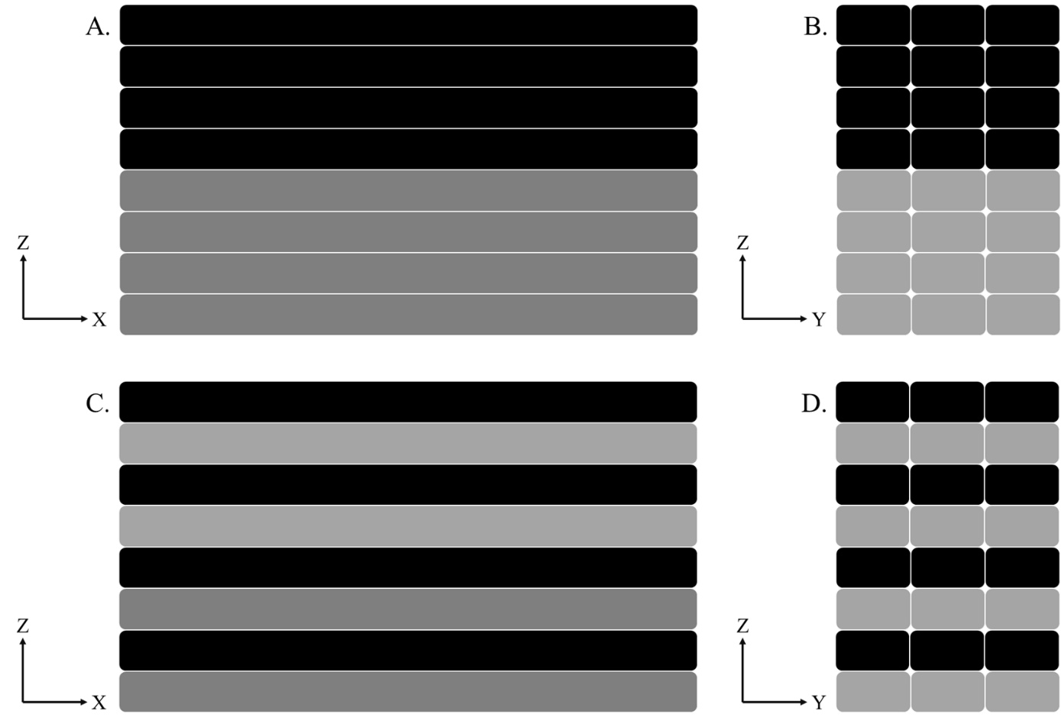
Figure 1-1. Schematic examples of MMAM structures limited to changes between layers. The switch from the 4th to 5th layer from xz (A) and yz (B) perspectives. The bottom row illustrates a second possible design that could be used to create a banded structure, again from xz (C) and yz (D) orientations.
levelling system and custom nozzle-based powder deposition to include MM in the same layer while limiting cross-contamination [72].
For FFF-style MMAM systems, installing multiple nozzles and/or hot ends has been the most popular approach. For example, a recent instrument utilized a customized hot end equipped with five nozzles to print multi-color and MM structures [73]. This often results in similar limitations found in the previous studies, namely the ability to switch materials only between layers. Since the most common FFF thermoplastics are ABS and PLA, investigations focused on MMAM of these two materials and their composites were plentiful. Using a ShareBot NG FFF system, one study investigated the flexural performance of sandwich panel structures printed using ABS and PLA and noted weak bonding at material interfaces. Despite successful sample production, the ABS-PLA interfaces that connected the sandwich panel core to the skins were consistently the origin of failure and under-performed a single-material PLA counterpart. Interestingly, the PLA sample printed with two extruders to mimic the MM printing approach was also weaker than the PLA sample printed using a single extruder, implicating excessive cooling caused by switching extruders as a contributing factor to the poor bonding at the material interface [66]. A more recent work by Lopes et al. separated the impact of switching extruders from the polymer compatibility on final part performance using PLA, Polyethylene Terephthalate (PET), and Thermoplastic Polyurethane (TPU). As in the previous study, PLA-PLA parts printed using a single nozzle exhibited higher mechanical properties compared to PLA-PLA structures printed with multiple nozzles, which was attributed to discontinuities caused by switching extruders. When compared to the MM PLA-TPU and PLA-PET structures, however, the PLA-PLA multi-nozzle structure exhibited an improved performance, illustrating the importance of chemical affinity when thermally bonding dissimilar polymers in MMAM interfaces [74]. In another interface-focused study, Kim et al. demonstrated that interface vulnerability to delamination was heavily influenced by orientation relative to the build direction. Like with the previous PJ study, the interfaces perpendicular to build directions had an increased tensile strength compared to those with interfaces in the print direction. Additional findings indicated that the number of interfaces had a negligible influence on performance, emphasizing the importance of structural arrangement in MMAM parts [75]. Similarly, another study investigated an advanced deposition method that created an inter-penetrating pattern of material interfaces intended to increase delamination resistance. Although this technique improved performance compared to samples with a single-plane interface, the MM specimens still exhibited a lower Ultimate Tensile Strength (UTS). This study also highlighted that materials with the same matrix that differed only in reinforcement content or color additives exhibited similar bonding issues [76]. While some specialized systems have demonstrated full in-situ material switching capabilities [67, 77-80], the solutions for improved control of material switching tended to be circumstantial. Despite these developments, discrete material boundaries between dissimilar materials remains a challenging problem and frequently results in structural weak points prone to delamination and fracture, limiting the applications for MMAM systems. Thus, seamless control of material composition that either limits the influence of these boundaries or avoids them entirely retains significant interest across AM.
As part of the push to broaden the functionality of MMAM systems, many studies have highlighted Functionally Graded Materials (FGMs) as an alternative to distinct MM construction. In general, an FGM is defined as having a defined variation in one or more spatial directions of density or composition that achieves a desired functional performance [81]. Whereas printing MM structures requires a MMAM system, FGMs have been produced using single-material AM instruments by grading density, as shown by an SLS investigation using High Density Polyethylene (HDPE) [82]. Importantly, this demonstrates that not all FGMs will be considered MM structures. Similarly, a MM structure does not qualify as a FGM unless it exhibits a clear and intentional gradient in one or more material properties or characteristics across the MM regions. While there are multiple methods for sub-dividing FGMs, the approach most relevant for this work categorizes FGM by gradient type. Formally, a stepwise FGM consists of three or more regions with differing compositions that are separated by discrete material boundaries, resulting in a multi-layered structure with interfaces between homogenous regions. Conversely, a continuous FGM exhibits a constant change in composition or microstructure with location and has no discernible interfaces or material boundaries [83]. Figure 1-2 provides a visual comparison of stepwise (1-2A) and continuous (1-2B) patterns. Since the gradient type is determined by the method of construction and controls the final form of the part, classifying FGMs in this way connects processing methods directly to final part performance.

Stepwise Functionally Graded Materials
As previously shown in Figure 1-2, a stepwise FGM consists of multiple regions that create a structural gradient in one or more material properties. Although these regions are typically homogeneous, additional gradients or structures may be present within each region so long as the overarching gradient is maintained. This concept is shown schematically in Figure 1-3 where the intermediate regions of the stepwise FGM exhibit continuous gradients.
Typically, MMAM systems have continued to utilize layers as inherent discrete boundaries to separate the regions of a stepwise FGM, relying on intermediate material compositions or types to facilitate improved bonding at the discrete boundaries compared to solely MM structures. An excellent study by Bartlett et al. implemented a stepwise approach using a PJ system to create a gradient in elastic modulus across the exterior shell of a small-scale printed robot. By stepping through ten materials with increasing stiffness from 1 MPa to 1 GPa, the exterior shell of the robot demonstrated a superior impact resistance compared to a stiff single-material variant and reduced elastic deformation compared to the flexible single-material variant [29]. In a continuation of their MM work discussed in Section 1.3 [30], Vu et al. conducted additional T-Peel testing that compared the performance of a single-material core to a stepwise FGM core where each region represented a 20 % change in material composition. Again, the stepwise core significantly
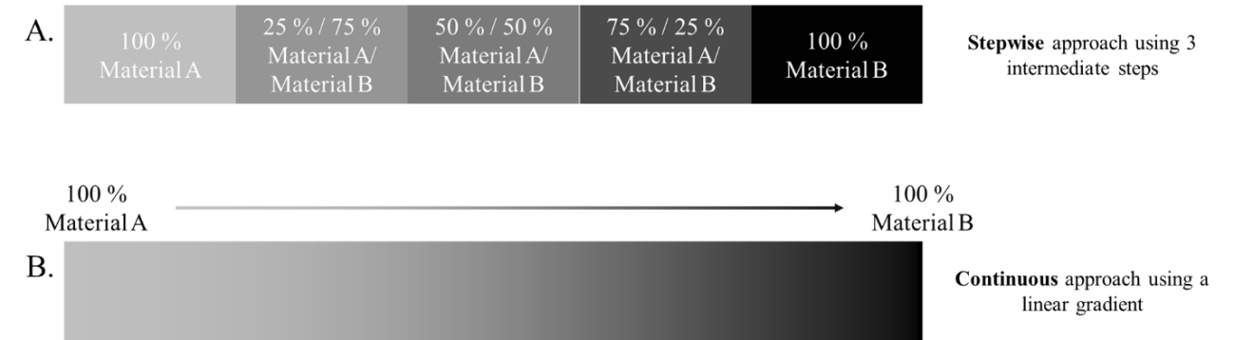
Figure 1-2. Examples of the two types of FGMs. A.) A stepwise gradient showing the region-by-region progression in composition from Material A to B. B.) A continuous gradient with no discrete boundaries.

Figure 1-3. A stepwise FGM with three intermediate regions, each implementing a continuous gradient between the discrete boundaries.
improved delamination resistance compared to a MM sample with a single-material core [31]. Unique software approaches have also been developed that enable MMAM within a given layer. Rather than using a typical boundary-representation approaches to material placement, a Stratasys-sponsored project developed a volumetric-representation approach that enabled stepwise FGM within and across layers through precise control of regional porosity and material deposition [67]. These techniques have also been successfully implemented in end-use products within the medical industry. Specifically, stepwise FGMs more closely imitate biology than single-material parts, resulting in significant interest and usage of stepwise FGMS in orthopedic and orthodontic implants [10, 84, 85]. Even outside of FFF and other EDAM systems, stepwise FGMs have been used to produce complex structures with unique properties [86-88]. Stepwise FGMs have even been utilized with LFAM systems, including one that used BAAM to print sandwich panel structures with graded cores to demonstrate the potential for cost and weight savings that FGM principles can provide [89]. In each case, the stepwise gradient functioned as intermediate stair-stepping method to disperse the transition between materials across multiple discrete boundaries, reducing their detrimental effects.

Continuous Functionally Graded Materials
As initially shown in Figure 1-2A, a continuous FGM lacks the discrete interfaces characteristic of stepwise variants and instead displays constant change throughout the defined gradient. This absence of discrete interfaces provides a significant advantage over stepwise methods by removing structural weak points rather than reducing interface vulnerability. This was most clearly demonstrated in a study that utilized voxel based IJP to directly compare the tensile properties of continuous FGMs to stepwise variants. A linear continuous FGM exhibited a substantial increase in elastic modulus and UTS at the cost of ductility and fracture resistance compared to a similar stepwise part, but altering the arrangement of the continuous pattern led to an increased fracture resistance, providing a critical demonstration site-specific properties through tunable continuous FGMs [85]. Another study demonstrated similar success applying sequential MMAM techniques to IJP of biopolymer materials to create continuous FGMs that ranged in size from millimeters to meters while maintaining location-specific material deposition, again highlighting the complementary nature of continuous FGMs with site-specific properties [90]. Innovative FFF solutions for reliable MMAM of continuous FGMs have also recently been made available. Utilizing a Cyclops hot-end to simultaneously extrude two different filaments through a single nozzle, Leoni et al. designed and printed a custom headphone with a continuous gradient from PLA to TPU providing the necessary rigid outer shell and cushioned interior [91]. A similar study by Alkunte et al. used a Zmorph FFF desktop printer to build tensile specimens with continuous FGMs. As expected, tensile performance and fatigue behavior were dependent on the relative ratios of the two materials, suggesting that the continuous pattern could be used to tune mechanical performance based on the desired application [77]. MMAM of FGMs, especially the continuous variants, provides an important pathway to production of complex geometries with site-specific properties. The adaptability of AM systems has led to the development of systems capable of continuous FGM production only recently, and most options exist only for small-scale systems. Since throughput has been identified as one of the primary hurdles in industry adoption of AM for end-use part production, the development of similar solutions for LFAM systems should be considered critical for the continued growth of the AM field.

A Multi-Material Big Area Additive Manufacturing System
The BAAM at Oak Ridge National Laboratory (ORNL) is a customized LFAM system for thermoplastic processing with similar components to injection molding and other Single-Screw Extrusion (SSE) processes. An automatically loaded hopper supplies pelletized feedstock to the entrance of a heated cylinder (barrel) equipped with a rotating extrusion screw, which conveys material to the only exit. During transport, thermal and mechanical energy from the rotating screw consolidates the pellets into a uniform polymer melt, enabling stable material extrusion through an attached nozzle or mold. When compared to FFF and FDM techniques that rely almost entirely on thermal energy to induce melting in pre-consolidated filamentized materials, SSE significantly increases material throughput and makes thermoplastic LFAM feasible. Although the extrusion mechanism differs, BAAM functions like small-scale counterparts: an xy-translating extrusion head deposits material onto a z-translating print bed to build parts one layer at a time, as specified by associated G-code. Like most AM systems, BAAM printing remains a function of multiple parameters, including thermal conditions, slicer settings, component design, and material properties. For the BAAM, material extrusion is a function of both thermal conditions and screw rotational speed in rotations per minute (RPM). While there are five temperature zones fine-tuned to achieve a steady melt and high-quality bead deposition, thermal conditions are typically simplified to the final melt temperature and bed temperature. As demonstrated by initial studies discussing and characterizing BAAM, this design increased build sizes, improved production speeds, and reduced costs [53].
Although other avenues to improve LFAM performance have been explored by incorporating additional sensors or capabilities [55-57, 92], the recent developments in MMAM emphasized the need for an LFAM system with similar MM capabilities like those discussed in Section 1.3. In pursuit of this goal, an ORNL-based team adapted the existing BAAM system with a dual-hopper configuration that enabled in-situ material switching. The dual-hopper design induces a discrete material change prior to the barrel connection and then utilizes SSE process to blend the material boundary into a bi-material transition region similar to a continuous FGM, which can be included within the printed structure [18]. Shown in Figure 1-4, this design avoids problematic discrete interfaces and print stoppages while also offering potential continuous FGM printing capabilities. Understanding the mechanics of and influences on this transition region provides a possible road to site-specific properties through an LFAM system, addressing a significant area of need within AM.

Possible Influences on Dual-Hopper Transitions
While the material transition produced by the dual hopper will clearly be influenced by material compatibility, the multitude of adjustable parameters in an AM system are also likely to play a role in transition behavior. Since BAAM thermal conditions are material
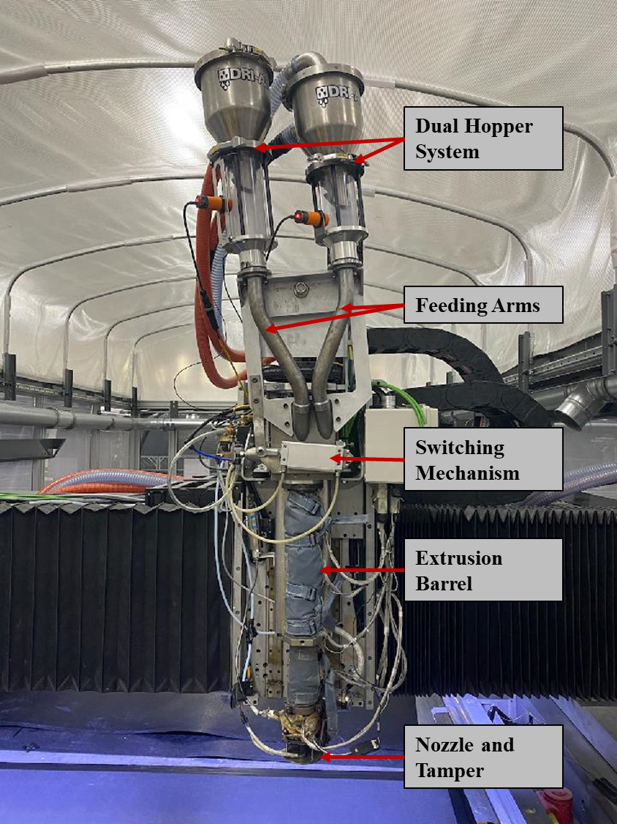
Figure 1-4. The BAAM dual hopper system with components labelled.
specific and difficult to rapidly adjust, it was necessary to investigate material pairings with compatible thermal processing conditions and melt temperatures to ensure viscous flow was maintained throughout deposition of the bi-material transition region without exceeding pressure limitations of the system [60]. While settings such as bead geometry affect how the material transition manifests, the most influential setting was expected to be the rotational speed of the screw. Since volumetric throughout in SSE is influenced by both material viscosity and screw speed (discussed in greater detail in Chapter 3), the blending behavior could reasonably be expected to change with screw speed and the relative material viscosities. Furthermore, the design of BAAM components will likely influence the mixing behavior within the bi-material region, which could alter the overall functional shape of the transition. Finally, material properties were also expected to influence the material transition, particularly the difference in material viscosity. These possible influences are most easily observed by analyzing the shape of the transition between materials, which is defined by the change in material composition as a function of physical deposition length or extruded volume. Figure 1-5 compares three possible transition curves to the “ideal” (red) transition that would occur if the step-change in material were not blended during extrusion. First, line A (green) represents a linear transition with constant slope. While not expected, a linear continuous gradient provides a beneficial comparison. Then, lines B (blue) and C (gray) represent transitions with two different parameter sets compared to A. The comparative changes in transition progression from A to B and A to C represent possible “shortening” or “lengthening” effects due to the changes in print conditions or
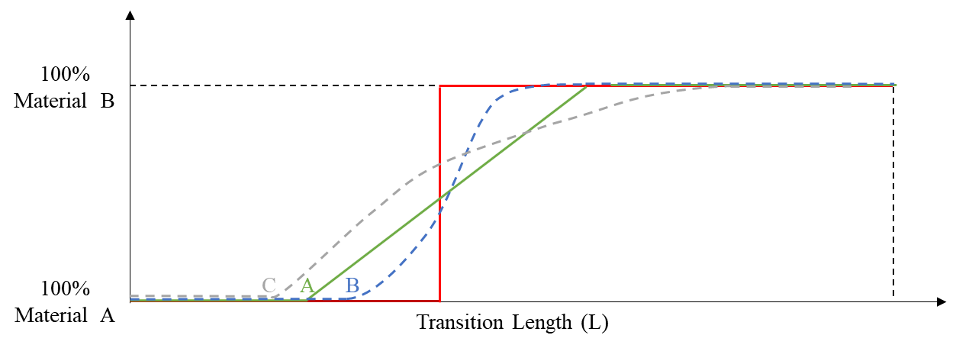
Figure 1-5. A theoretical representation of possible transition behavior showing the change in material composition as a function of transition length that compares a step-change to A) a linear gradient, B) a non-uniform gradient that increased the transition length, and C) a non-uniform gradient with a shortened length.
parameters. This theoretical understanding is expanded upon in Chapter 3, defined using both exact terms and experimental results, and converted into a tool for analyzing changes in material transition behavior.

Potential Impacts of Transition Behavior
Investigating which parameters influence the location and lengths of material transitions provides essential information about how incorporating material transitions into a printed structure will influence part design and performance. For example, a given material transition that requires a set length to reach steady-state extrusion of the second material may be incompatible with the desired design that lacks “room” for the transition to occur. In addition to characterizing transition boundaries, the transition zone may also influence structural properties of the print. Ideally, the blended region would exhibit mechanical properties as a function of material composition as defined by the rule of mixtures or similar. However, incomplete material blending within the transition zone could hinder performance through non-homogenous distribution of materials within the bead cross-section or reduced layer-to-layer bonding strengths due to changing bead surfaces. As such, a discussion of material mixing in SSE is provided in Chapter 2 for improved evaluation of transition behavior. Chapter 3 then utilizes this background to discuss the elements of a printed dual hopper transition and identifies the most relevant parameters for study. The influences of these parameters are then explored in Chapter 4, and a model for material transitions is presented and analyzed. Finally, the influence of component design on mixing in the transition region was explored in Chapter 5 and the resulting impact on mechanical properties is presented in Chapter 6.

Material Flow and Mixing in Single Screw Extrusion
Unlike most small-scale FFF and similar pressure-driven AM systems, BAAM utilizes a Single Screw Extrusion (SSE) system to aid in melting and conveying of material. This feature offers several inherent advantages, including expanded material compatibility and improvements in production size and speed. However, the SSE process also introduces an additional level of complexity to the AM process due to the multiple material states, conveying mechanisms, and competing flows involved. Since summarizing all aspects of SSE typically requires full textbooks, this chapter briefly introduces typical SSE terminology, components, and some theory relevant to material mixing during BAAM dual hopper transitions.

Analyzing Single Screw Extrusion of Thermoplastics
SSE systems have been utilized in industry for decades as part of injection molding instruments, plasticizing systems, and others. As the name indicates, a conventional SSE system uses a single extrusion screw mounted inside a heated cylinder, generally called the barrel, to convey material from the entrance to the exit. Material is typically supplied to the barrel entrance by a hopper and feed throat connection, but the exit can be a nozzle, mold, or other die arrangement. BAAM utilizes an extended feed throat connection that enables in-situ hopper switching and two-part nozzle assembly to form a stable thermoplastic bead for AM deposition. SSE analysis requires an understanding of the internal components, extrusion screw design, and how material is conveyed through the system. For example, location in the barrel is typically discussed as function of barrel diameters in the direction of material flow, i.e., 4 diameters (4D) down the barrel is equivalent to four times the barrel diameter from the entrance in the direction of material flow.

Material Conveying in Conventional SSE Systems
Material flow through SSE systems is well-documented and generally understood by separating it into two phases. The first stage is solids conveying, which describes the transport of loose, individual pieces of material, or particulates. This applies primarily to the movement of the feedstock material from the hopper, through the feed throat, and into the barrel of the SSE. Although many issues can arise when particulates have a high compressibility or very low bulk density, ρ_{b}, typical pelletized feedstock is well-suited to SSE and exhibits plug flow prior to melting. The plasticizing zone begins when the first melt film forms on the interior barrel surface. This zone continues until a full melt develops, at which point melt conveying behavior dominates [93].
Solids conveying is typically further separated into two stages based on the driving force. Gravity induced solids conveying drives the flow of feedstock form the feed hopper into the barrel, and while the practical applications and limitations are understood, theoretical predictions remain difficult due to uncertain relations between stress and strain rates of bulk materials [94]. Within the SSE, drag-induced solids conveying compacts the pellets into a solid bed that travels down the barrel under plug flow conditions [94]. During this mechanism, there is minimal internal movement of the material, so it was not given detailed focus in this work.
The plasticating zone defines the region where the solid bed is converted into a polymer melt and typically starts between 3D and 5D down the barrel. In traditional SSE, the plasticating zone will always begin prior to the compression zone of the screw. Conventionally, this process is described by the Tadmor melting model where the extrusion screw is treated as stationary and the barrel as rotating. Under this model, melting is assumed to occur at the interface between a thin polymer melt film between the solid bed and the barrel due to frictional heating and thermal energy from the barrel heaters. Being more susceptible to flow, the melted material occupies the leading side of the flight while the solid bed remains compacted against the trailing flank of the flight. As the melt pool grows, the cross-sectional area of the solid bed decreases such that the melt film remains relatively constant while the pressure from the melt continually compacts the solid bed, reducing its width. Most importantly, this model expects a circulating flow to be maintained in the melt pool [94]. For BAAM dual hopper transitions, this circular flow could play a role in how the feedstock interface is mixed during extrusion.
While the plasticating zone may contribute to material mixing, the melt conveying zone typically begins in the compression zone and includes the entire metering section of the screw. Melt conveying is primarily a function of material properties, the flight geometry of the extrusion screw, and the rotational speed of the screw.

Material Flow in SSE
As shown in Equation 1, the volumetric output, Q, can be expressed using the number of parallel flights, p, the channel depth, H, the channel width, W, the velocity down the barrel, v_{bz}, the pressure gradient down the barrel, g_{z}, the material melt viscosity, η, and the system-specific form factors F_{d} and F_{p} [94].
$$\begin{aligned}Q=\frac{1}{2}pWHv_{bz}F_{d}-\frac{pWH^{3}g_{z}}{12η}F_{p} \#\left( SEQ Equation \backslash * ARABIC 1\right)\end{aligned}$$
Here, the first term is the contribution of drag flow while the second is the contribution of back-pressure flow. For a given extrusion system and screw design, p, W, H, F_{d}, and F_{p} remain constant, and the material output is dependent upon the relationship between the down-barrel velocity induced by drag flow and the counter-acting pressure gradient influence where η is the only other independent variable. Although polymer melts do not experience turbulent flow, laminar mixing occurs during SSE as either distributive or dispersive mixing due to the significant cross-channel velocity experienced in the melt pool. Consequently, the mixing history varies across the extrudate since the last portions of the solid bed to melt undergo mixing for significantly less time than the particles that initiated the melt film [94]. Extensive investigation of mixing in SSE shows that non-uniform, poor mixing should be expected in the absence of any specialized mixing sections in the screw [94]. For what mixing does occur, material viscosity still plays a critical role. Considering that the changing viscosity will be a significant contributor to changes in pressure flow within BAAM when printing material transitions, the impact of viscosity on mixing will likely be greater than in single-material extrusion.

Material Mixing in SSE
Two types of mixing dominate SSE processes: distributive and dispersive. For thermoplastic composite processing, distributive mixing is generally less damaging to fibers since dispersive mixing intentionally separates agglomerate particles, which disproportionately affects fibers and fiber bundles [95]. However, recent studies have demonstrated that entangled fibers resist dispersion and can lead to relatively non-homogenous morphologies that may hinder part performance, LFAM-produced and otherwise [96]. Therefore, an ideal system would be capable of fiber separation through dispersive mixing and then distribution of the separated fibers throughout the printed bead or molded part that achieves a nearly homogeneous structure or morphology. Again, Inoue et. al demonstrated that innovative screw design can drastically improve dispersive and distributive mixing during extrusion [96]. This capability suggests that screw design will be extremely important for the BAAM-printed material transitions if a homogenous cross-section is desired.

Recent SSE Mixing Studies
Studies on SSE, especially those investigating mixing, are ongoing. For example, a recent work investigated the impact of screw speed and design on mixing in SSE using image analysis techniques. Temperature had minimal impact on the degree of homogeneity, and a higher screw speed led to an increased variance in homogeneity, indicating a decrease in mixing and dispersion of the reinforcement [97]. In a similar study, improved mixing was achieved by introducing a short extensional mixing zone into the compression region to improve dispersive mixing properties. The results demonstrated that SSE systems equipped with this new design achieved dispersive mixing similar to traditionally superior twin screw extrusion using similar screw designs. However, the twin screw systems still exhibited superior distributive mixing compared to the SSE counterpart [98]. Finally, extensive studies that conducted full screw-pulls to capture material state at every point in the SSE system have shown that the inclusion of mixing sections in screw designs influence the distributive mixing characteristics of the system as early as the beginning of the compression zone [99, 100].

Fundamental Analysis of a Dual-Hopper Material Transition
As presented in Section 1.4, the dual hopper attachment for BAAM enables printing of structures that incorporate continuous FGMs through in-situ material switching. Representing this continuous change in material composition as a function of location naturally produces a shape function, or transition curve. This transition curve describes the progression from Material A to Material B using the context of the deposition process, so the characteristic behavior of dual hopper transitions was expected to be a function of processing parameters, system design, and material properties. Visual observations of test prints during system development identified three component stages or zones present in a transition curve. Further analysis of this behavior first required an in-depth, repeatable procedure for measuring transition progression via material composition. After verifying the effectiveness of three possible compositional analysis techniques, the repeatability of a material transition printed using the BAAM dual hopper configuration was assessed. By comparing the material composition at identical locations across multiple iterations of the same print design and different layers within a given print, the transition process can be shown to be repeatable if the measured composition remains consistent across samples from different prints and layers.

Transition Zones and Terminology
As established in previously published work, the three component stages in a dual hopper material transition were identified as a function of material composition [101-103]. Depending on the degree of mixing that occurs during the extrusion process, the apparent change in extruded material will be delayed, so an analysis of transition behavior must begin at the point of feedstock change rather than at the first change in composition of the extrudate. Therefore, a printed material transition will include both an expected blended material region and a preceding single-material region that begins where the hopper switch was conducted. Figure 3-1 uses an example material transition to draw boundaries between regions based on the material composition of the deposited bead. The red Purge Zone, or Z_{P}, consists of the single-material region deposited immediately after initiating the feedstock change. The following region shaded yellow characterized by a continually changing material composition was termed the Transition Zone, or Z_{T}. Finally, the stable extrusion of 100 % Material B characterizes the third, green-shaded region, or Steady State Zone (Z_{S}). As indicated, Z_{P} and Z_{T} have boundaries clearly defined by the change in either feedstock or material composition whereas Z_{S} only has a clear beginning at the boundary shared with Z_{T}. Since the end point of Z_{S} depends on printed part design and any additional material switches, this analysis of transition behavior did not require identification of an end point.
As shown in Figure 3-2, the boundary separating Z_{P} and Z_{T} was named L_{P} while the boundary between Z_{T} and Z_{S} was given L_{S}. This nomenclature further defines L_{P} as the distance from the hopper switch to the end of Z_{P}, i.e. the length or size of Z_{P}. Similarly, L_{S} represents the distance from the hopper switch to the beginning of Z_{S}, measuring the length
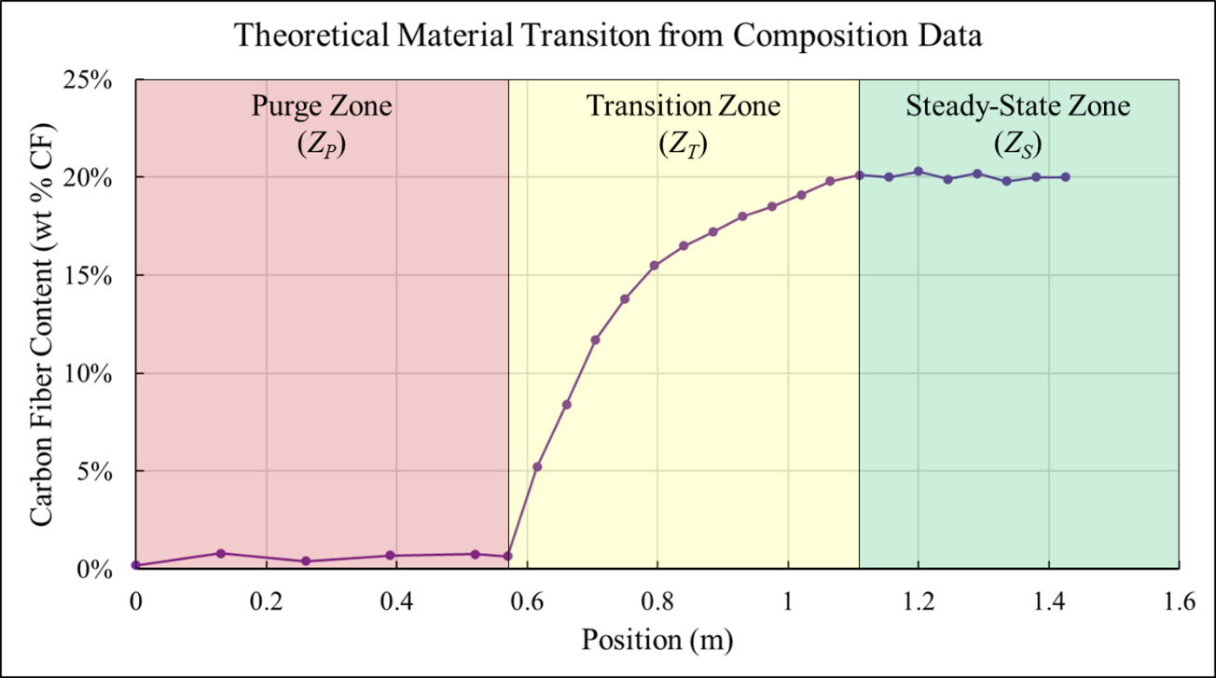
Figure 3-1. An example transition curve with purge, transition, and steady-state zones.
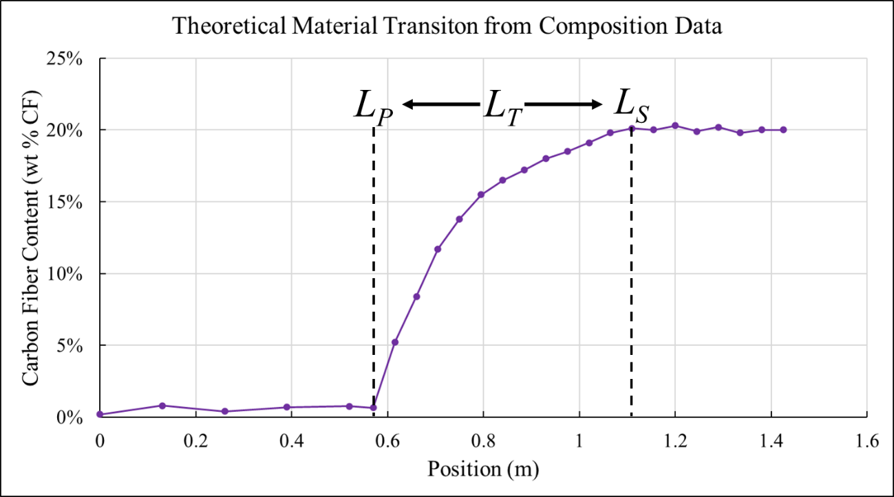
Figure 3-2. A schematic of a theoretical shape curve with the two boundaries, L_{P} and L_{S}, marked and L_{T} indicated.
or size of the full material transition. With these definitions, it must be true that the length or size of Z_{T}, or L_{T}, is the difference between L_{S} and L_{P}, as shown in Equation 2 below.
$$\begin{aligned}L_{T}=L_{S}-L_{P} \#\left( SEQ Equation \backslash * ARABIC 2\right)\end{aligned}$$
By comparing the relative sizes of L_{P}, L_{T}, and L_{S}, changes in transition behavior can be connected to changes in processing conditions. Since Chapter 2 suggests that the relative difference in material viscosities will influence extrusion mixing behavior, the direction of the material change was expected to influence transition behavior. Figure 3-3 provides a visual example of this possibility using two arbitrary materials, A (gray) and B (Black), and reversing material transition direction from the first (A B) to second (B A) layer, as indicated. The hopper switch, indicated by L₀, occurs the same distance from the start of each layer. Although Z_{T} remains centered within each layer, the change in transition affected zone lengths and created different compositional gradients. Thus, zone boundaries were marked with direction-specific subscripts such that L_{P-A} and L_{S-A} were the purge and steady state lengths, respectively, for the A B transition and L_{P-B} and L_{S-B} represented the same lengths for B A. For the case presented in Figure 3-3, L_{P-B} was greater than L_{P-A} and L_{S-B} was less than L_{S-A}, which necessarily reduced the size of Z_{T}. Thus, the B A transition exhibited a steeper compositional gradient, which can be quantified by showing that L_{T-B} was less than L_{T-A}. Given this potential behavior, the direction of material change was treated as studied variable in each portion of the analysis.
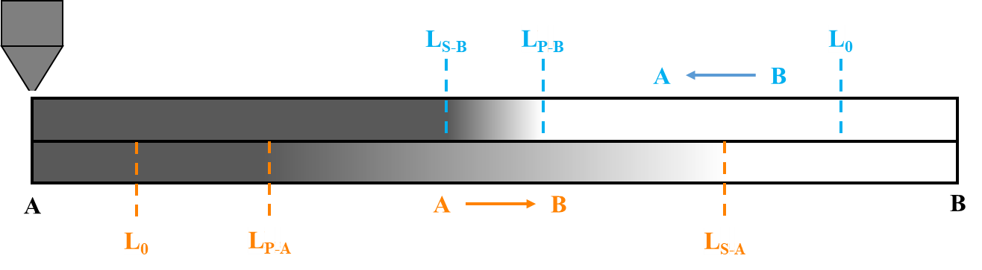
Figure 3-3. An illustration of two layers printed using BAAM dual hopper to create two material transitions. An A B transition (orange) occurs in the first layer and a B A transition occurs in the second, as indicated.

Methods of Compositional Analysis
In initial studies, the location within a transition was measured as being the relative distance traveled by the extrusion head since initiating the material change, so zone sizes were analyzed in terms of meters [101, 103]. However, as will be seen in Chapters 4 and 5, quantifying transition behavior using length was difficult and risked misleading conclusions, so current and future studies used improved methods for identifying sample location. In addition to determining sample location, tracking the change in material composition necessarily required a reliable method for determining the material composition of a relatively small sample. There are a variety of well-known compositional analysis techniques, including Electron Dispersive Spectroscopy (EDS) [104, 105], x-ray diffraction (XRD) [106], differential scanning calorimetry (DSC) [107], and thermogravimetric analysis (TGA) [64, 105, 108-110], but each of these proved incompatible with analysis of BAAM-printed samples.
EDS typically requires a significant time-investment to prepare a polished sample as well as (potentially costly) access to a Scanning Electron Microscope (SEM), which was not complementary to the number of test specimens. In addition, the prevalence of carbon and other elements with low atomic numbers in thermoplastic composites would likely have hindered SEM imaging and, in turn, increased the noise present in EDS results [105]. Although a polished sample is not necessary, XRD would encounter similar issues since the technique differentiates between materials based on crystal structure, which is lacking in amorphous polymers, and relative amounts of constituent elements, of which most thermoplastic composites will have very similar element fractions [111]. Further complications develop for both XRD and EDS when considering a material transition that changes only in reinforcement content (i.e. carbon fiber) while maintaining the same polymer matrix. In this case, the extreme sensitivity of each technique may hinder resolution by disguising a change in composition in the noise generated by high carbon content. These two techniques also analyze only the exposed cross-section or surface and assume a certain degree of homogeneity. While not typically a concern, relying on a given cross-section of undefined thickness to represent a meaningful volume of the surrounding bead was undesirable.
At the simplest level, DSC and TGA utilize temperature change to identify material composition. A DSC analyzes the change in heat absorption with changes in temperature, which is often useful for determining polymer properties like glass transition temperature [61]. For TGA, the change in temperature is compared to the change in mass to determine when the constituents present begin to decompose or combust [110, 112]. Both techniques thus offer the resolution necessary to capture changes in material composition for all but the most similar materials and detect changes in only constituent content. However, sample size was the limiting factor with ASTM standards recommending specimen size be less than 10 mg [113-115]. Once again, this raised representative concerns given the typical extrudate size of the BAAM and associated feedstock. This concern was investigated in Figure 3-4 showing the results of TGA decomposition testing. Each test run was limited to a single feedstock pellet due to mass constraints, and as a result, three tests of the same
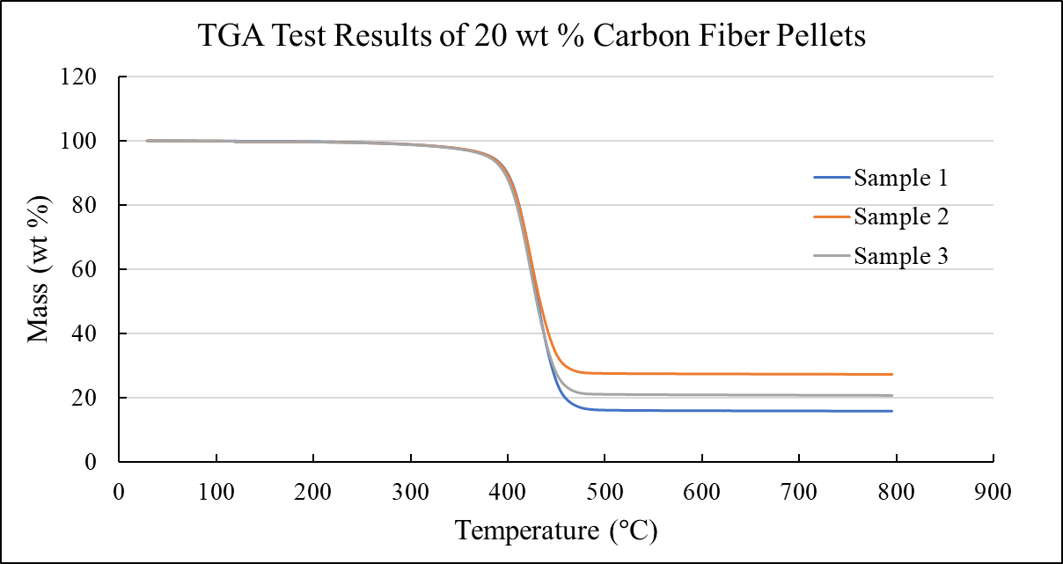
Figure 3-4. TGA test results of a 20 weight % carbon fiber-reinforced ABS composite. Samples were taken from the same batch of pelletized feedstock.
batch measured a 20 wt % carbon fiber-reinforced ABS feedstock as having 17, 22, and 27 wt % carbon fiber. This variation suggested that TGA was also a poor candidate for compositional analysis, especially given the likelihood of inhomogeneous cross-sections preventing collection of a representative sample within mass constraints.
Due to these issues, ASTM D3171 was consulted for larger-scale methods of determining constituent content, which provided solutions in Procedures G and H [113]. “Matrix Burnoff in a Muffle Furnace” and “Matrix Carbonization in a Nitrogen Purging Furnace” employ a decomposition method like TGA but at a scale large enough to accommodate BAAM-printed samples. However, there remained two issues: 1) the combustion or decomposition of polymer and reinforcement could begin at similar temperatures while in atmosphere, and 2) access to or purchase of an inert-atmosphere furnace required to analyze a large quantity of samples would be costly. This motivated the development of a third procedure as a customizable alternative. Detailed below, these three procedures were utilized in an initial study and compared to determine which method would serve as the primary compositional analysis tool.

Carbonization in Nitrogen
Abbreviated as Carbonization in Nitrogen (CIN), ASTM D3171 Procedure H “Matrix Carbonization in a Nitrogen Purging Furnace” utilizes an inert nitrogen atmosphere to protect the constituents present in the composite while inducing thermal decomposition of the matrix. For most composites, thermal decomposition of the matrix produces residue difficult to separate from the constituent materials targeted for measurement, so the procedure also specifies a method for correctly adjusting measurements. By measuring the residue remaining after decomposition of an un-reinforced sample, Procedure H calculates a carbonization ratio (CR) of residue mass to original mass. The residual composite mass is then multiplied by the CR to separate the un-disturbed constituents from matrix residue [113]. Equations 3 and 4 provide the equations necessary to calculate CR and reinforcement content, respectively. Here, m_{cr} is the measured mass of the crucible and residue after testing, m_{c} is the measured mass of the crucible, m_{i} is the dry mass of the neat specimen, M_{i} is the mass of the composite specimen, M_{cr} is the mass of the crucible and composite residue after testing, and M_{c} is the mass of the crucible.
$$\begin{aligned}CR=\frac{m_{cr}-m_{c}}{m_{i}}\#\left( SEQ Equation \backslash * ARABIC 3\right)\end{aligned}$$
$$\begin{aligned}Reinforcement \%=\left(\frac{M_{i}-\left(\frac{M_{i}-{(M_{cr}-M}_{c}}{1-CR}\right)}{M_{i}}\right)×100 \%\#\left( SEQ Equation \backslash * ARABIC 4\right)\end{aligned}$$
In a study using CIN to determine carbon fiber content of thermoset composites, the technique successfully measured control and test samples with a less than 1 wt % deviation in reinforcement content. It also validated the effectiveness of an inert nitrogen atmosphere in preserving the reinforcing fibers by showing that they retained 99 wt % of the original mass after 60 minutes at 600 °C [116], which is supported by recently published literature [102, 103].

In-Air Burn-off
ASTM D3171 Procedure G, “Matrix Burn-off in a Muffle Furnace,” was also considered for measuring material composition. Termed Carbonization in Air (CIA), this method has a nearly identical approach to CIN with the primary difference being the absence of an inert atmosphere. Like with CIN, combustion and carbonization of the polymer matrix leaves residue or ash mixed with the reinforcing materials, so CIA also requires a CR to correct measurements [113]. Since CIA is intended for analysis of reinforcing materials unaffected by the temperatures necessary for combustion of the matrix, the thermal degradation of carbon fiber in atmosphere was considered. Although specific temperature resistance depended on the type of carbon fiber, a general limit of 500 °C prevented damage or degradation of most carbon fibers beyond negligible levels [117]. As such, matrices that degraded or combusted at or below 450 °C were considered compatible with CIA, which held true for initial published studies conducted for this work [101, 102].

Ultrasonic Assisted Digestion (UAD)
Although CIN and CIA have both been proven as reliable techniques for determining constituent content of composite materials [101-103, 113, 116, 117], using either technique to track changes in material composition could still be problematic depending on material pairings. Using the various procedures in ASTM D3171 as inspiration, a custom technique for compositional analysis was developed that was intended provide greater flexibility than CIN and CIA. Rather than utilize thermal decomposition, this technique pursued chemical dissolution of the polymer matrix, which was intended to increase process flexibility. After outlining the procedure, a solvent compatible with the materials was chosen and could be switched as needed for targeted dissolution. While the procedures in ASTM D3171 frequently use hydrogen peroxide as an accelerant for the dissolution process [113], the interactions between some solvents and hydrogen peroxide were unstable and posed safety risks. Thus, an ultrasonic water bath was implemented to replace both the hydrogen peroxide and the standard hot plate with magnetic stir bar. Submerging vessels filled with sample solutions into a sonicated bath similarly increased reaction rates by agitating the mixture with ultrasonic waves at low levels of heat. The effect was most pronounced when comparing dissolution times of samples allowed to rest in solution to those that underwent the sonication process. Whereas sonication ensured complete dissolution within twenty hours, Figure 3-5 shows a sample set left to rest for one day (A), two days (B), six days (C), and ten days (D), demonstrating orders of magnitude faster dissolution.
Ultrasonic Assisted Digestion (UAD) first separates the reinforcing material from the polymer matrix using this sonication process. Then, vacuum filtration was utilized to capture free-floating reinforcement particles, i.e. fibers, and remove the polymer-solvent solution. By following the same mass measurement procedures outlined in CIN and CIA, UAD thus measures the original material composition of the specimen. To emulate the CR used in CIN and CIA, a dissolution ratio (DR) representing the trace amounts of dissolved material is calculated using un-reinforced control samples. As shown later in Section 3.4.5,
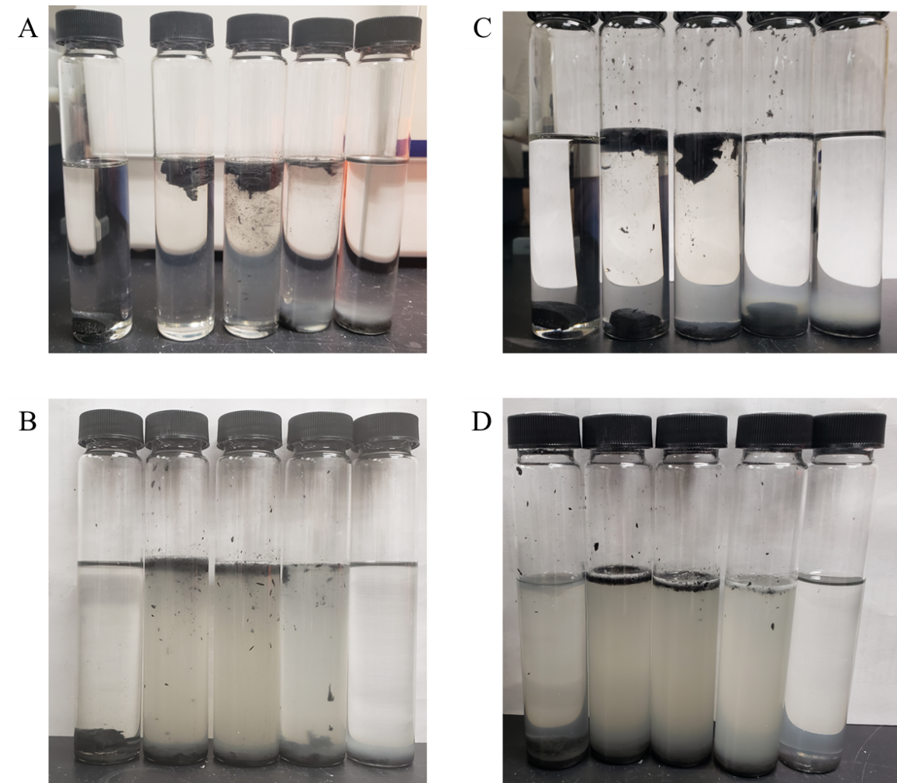
Figure 3-5. A set of cross-sections left at rest in a solution of 99.9 % Dimethyl Sulfoxide (DMSO) after A) 1 day, B) 2 days, C) 6 days, and D) 10 days.
UAD offers a low-cost, low-energy, and high-throughput alternative compositional analysis technique.

Experimental Conditions for Component Analysis of Material Transitions
The set of experiments in this chapter were designed to investigate the repeatability of material transitions printed using the dual-hopper BAAM configuration as well as conduct a comparative analysis of compositional analysis techniques.

Materials
Two thermoplastic materials were supplied by Techmer Engineered Solutions as pelletized feedstock under brand names HIFILL ABS 1000 3DP (ABS) and Electrafil J-1200/CF/20/ 3DP (20 wt % carbon fiber-reinforced ABS). For simplicity, the composite material is referred to as CFABS.

System Settings and Extrusion Conditions
All samples were printed using the dual hopper system installed on BAAM – B at ORNL’s Manufacturing Demonstration Facility. A single g-code file was used to print a single-walled rectangle three separate times. Feedstock was dried at 85°C prior to printing. The nozzle diameter was 10.16 mm (0.4 in). The programmed layer height, bead width, and screw speed were 6.35 mm (0.25 in), 15.24 mm (0.6 in), and 300 RPM, respectively using the standard BAAM screw geometry. The resulting travel speed was 106.7 mm/s (4.2 in/s). The prints maintained typical CFABS melt (245°C) and bed (100°C) temperatures. These conditions were maintained for all prints.
To ensure material transitions were completed within a single layer, a single-walled rectangle was printed with dimensions 3.50 m by 1.52 m (11.5 ft by 5 ft), as shown by the diagram in Figure 3-6. Guided by initial trials, step changes in material were placed at opposite corners (1 and 3) so that Z_{P} was primarily constrained to the short ends of the rectangle and Z_{T} was roughly centered along the long sides. Each sample set consisted of a three-step printing process where no material purge occurred between steps and the printed structure was removed from the bed. Initially, the first layer of the rectangle was deposited for compositional analysis. The full 20-layer rectangle (layer height of 6.4 mm and single-bead width of 15.2 mm) was then deposited to characterize the consistency of transitions across multiple layers. Finally, the first layer of the print was re-printed to act as the last layer in the print and assess any compounded effects of multiple transitions within a print. The first and “last” layers retrieved for compositional analysis were used to assess if any “drift” or other phenomenon resulted from repeated material switching throughout a print. This three-step printing process was conducted three times to analyze the repeatability of the hopper switch across identical structures and conditions. The material transitions were characterized using compositional analysis. Printing the same structure three times targeted the repeatability of dual hopper behavior from one print to another. Additionally, both transition directions, ABS to CFABS (A C) and CFABS to ABS (C A), were compared to investigate the reversibility of the process.
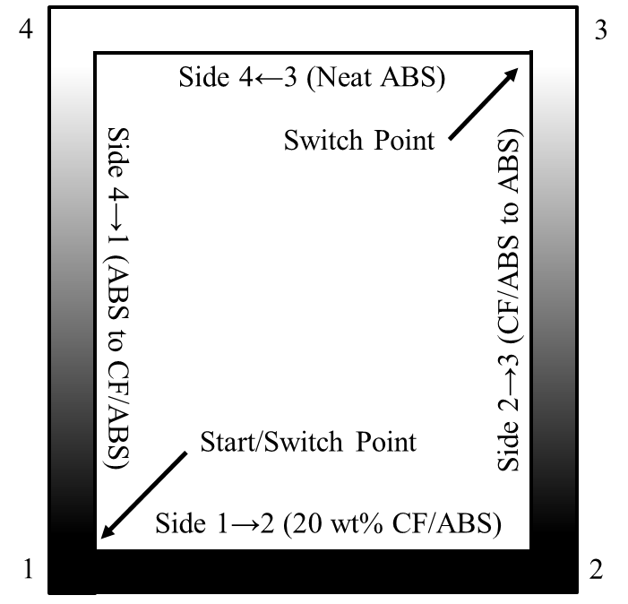
Figure 3-6. A diagram showing the print path followed by BAAM when printing the material transition rectangles.

Sample Preparation
Location within the print was preserved through an in-depth labelling system so that the location of each sample could be traced back to the original print. Printed structures were sectioned for storage, and samples were extracted from numerous locations for content analysis.
The procedure for obtaining samples from the printed rectangles was consistent across all measurement techniques. Using a bandsaw, each single-layer rectangle was sectioned into rods of length 152.4 mm (6 in) in the print direction and labelled to indicate the order and print direction. Individual, 8.4 mm long specimens were extracted from the rods using an Isomet 1000 Precision Saw. As discussed in Section 3.2.1, sample location was defined as the distance travelled from the most recent hopper switch, or d. Eight locations were selected to capture both single-material and transition regions in the repeatability analysis. Using the diagram from Figure 3-6, Figure 3-7 shows the location of samples relative to the printed structure. It should be noted that color was a poor indicator of the relative carbon fiber content, as even the samples that measured less than 1 wt % carbon fiber were slightly black in appearance.

Constituent Content Analysis
Material composition was determined using the three compositional analysis methods outlined in Section 3.3. The weight percent carbon fiber (wt % CF) was considered representative of the material composition. Although the reinforcement content listed for the CFABS was 20 wt % CF, some variance in measurements was expected due
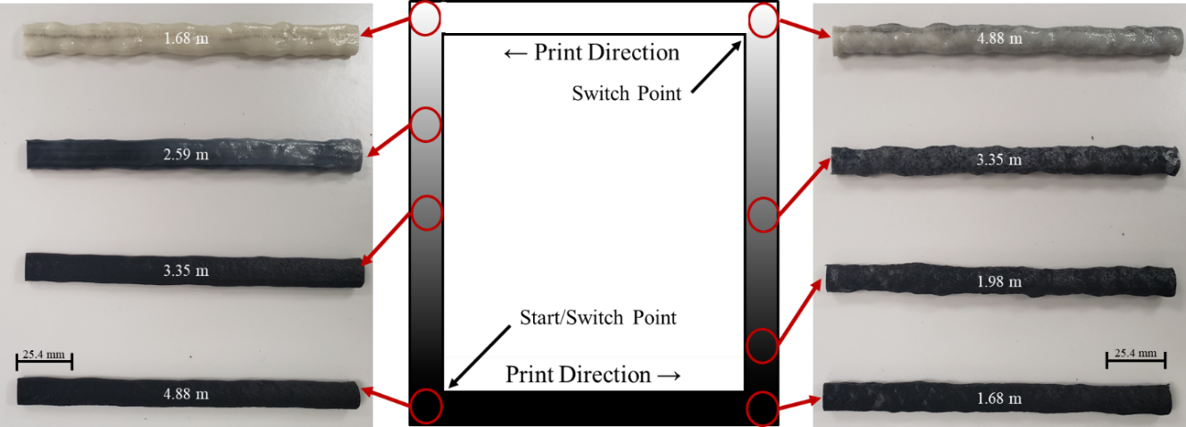
Figure 3-7. The eight locations from where samples were extracted for the repeatability study (circled in red) and images of the sample location.
to deviations in batches and accuracy of measurement techniques. To confirm CF content and obtain the CR and DR needed for Equations 3 and 4, three batches of both ABS and CF/ABS pellets were also characterized as-provided. Prior to and after testing, all compositional analysis samples were dried at 80 °C and their dry mass recorded. All mass measurements utilized a Mettler Toledo Balance, XS204 Deltarange with 0.1 mg accuracy.
The procedures outlined in Section 3.3 and ASTM D3171 were followed for CIN, CIA, and UAD measurements. CIN used a Lindberg Blue M nitrogen tube furnace held at 565°C for five hours while flowing nitrogen and was used as the primary characterization method used in this study due to its excellent reliability [116]. CIA used an MTI KSL-1100X-S-UL Compact Muffler Furnace at 450°C for four hours. A dwell time of four hours resulted in less than 1% of residual weight from a neat ABS sample, with negligible reduction over longer durations. In place of a crucible, UAD utilized aluminum weigh pans and Whatman Grade GF/A glass microfiber filters with a 47 mm diameter and 1.6 µm pores to capture the separated residue and reinforcements. For dissolution of the ABS matrix, specimens are placed in a borosilicate glass vial and submerged in HPLC Acetone of ≥ 99.5 % purity. These vials were placed in a CPX3800 Ultrasonic Bath for at least two hours before undergoing vacuum filtration. Since these techniques were originally intended for measuring reinforcement in composite samples, the less than 1 wt % deviation in measurements occasionally resulted in un-reinforced samples having slightly “negative” fiber contents, which were treated as equivalent to 0 wt % CF. Composition measurements taken using CIN were compared to those taken using CIA and UAD to assess their accuracy and identify the best process for future investigations based on compatibility, versatility, accuracy, ease of use, and time investment. Given comparable accuracy, ease of use and time investment were prioritized.

Assessing Repeatability
Technique repeatability was evaluated by measuring the consistency of the sampling technique for three consecutive (essentially identical) samples at each location in Figure 3-7. The goal of this analysis was twofold: an assessment of technique precision using the single-material samples and an assessment of compositional variance in the transition zone over a small, connected volume. Dual hopper system repeatability was measured by comparing the composition variance between layers and across prints from the locations identified in Figure 3-7. Layer-to-layer comparisons evaluated the effects of numerous hopper switches within a single print on transition behavior while comparing three identical prints analyzed inconsistencies in overall transition behavior of the dual hopper.

Shape Curve Construction
Following technique and system repeatability, the construction of initial material transitions, or shape curves, was investigated using CIN, CIA, and UAD. These curves were built using fiber content as a function of travel distance and provided further comparison points between compositional analysis techniques. To find d, the distance travelled by the extrusion system from the point where the material switch was initiated was recorded for each characterization sample. In addition, shape curves from both the CF ABS and the ABS CF directions were compared to illustrate the effect of switch direction on transition behavior. Finally, the normalized volume method from Section 3.2 was applied to these initial curves to discuss its impact. Gantry speed was pulled from the programmed g-code for each print, and the volumetric flow rate of both materials at each screw speed were experimentally measured in accordance with ASTM D1238 Procedure A using BAAM and sample print conditions in lieu of a capillary rheometer to better measure Q experienced during printing [118].

Results and Discussion

Compositional Stability of the Material Transition
Analysis of the as-received CF/ABS pellets using CIN determined a baseline average fiber content among five sample sets of 22.0 wt % with a standard deviation of 0.2 wt %. Since literature suggests that CIN typically shows a deviation ≤ 1 wt % CF [116], the carbon fiber content was considered to be between 20 and 22 wt %.
Figure 3-8 depicts the fiber content as measured by CIN of each of the eight locations shown in Figure 3-7. Three consecutive samples from location were measured to obtain averages and standard deviations. The residual mass for neat samples varied such that two samples exhibited negative wt % CF due to slight degradation differences between specimens and the control, which were treated as 0 wt % fiber loading. These instances had a standard deviation of less than 0.5 wt % CF. As shown in 3-9A, each set of samples in the single-material region exhibited a low standard deviation, indicating accuracy expected of CIN. Similarly, the transition specimens in 3-9B also exhibited low standard deviations.
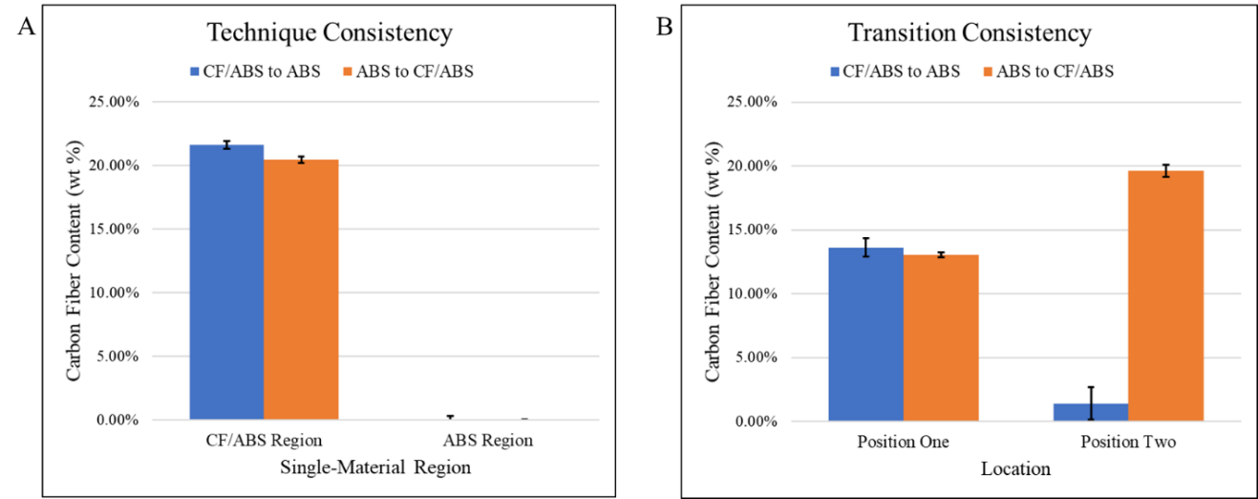
Figure 3-8. A) The average fiber content of the single material regions for both transition directions. B) The average fiber content of two locations within the transition zone from both transition directions.
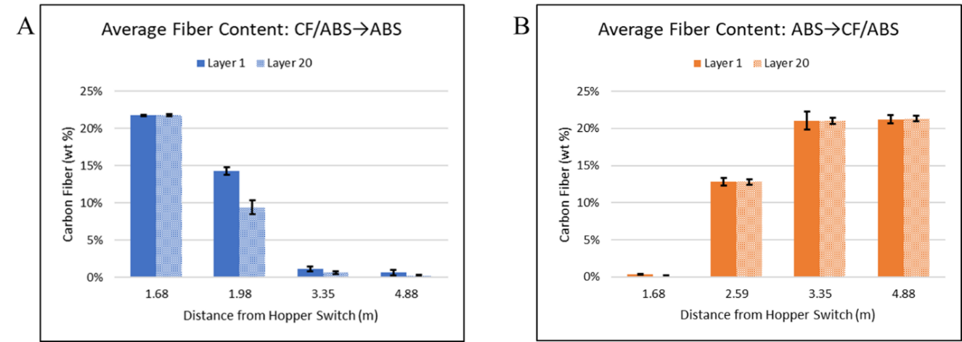
Figure 3-9. A) The average fiber content of the four locations in the CF ABS transition from Figure 3-7 from the first and last layers printed. B) The second set of four locations from the ABS CF transition.
These results suggest that the material transition exhibited the expected continuous behavior with minimal noise. For future testing, this supported treatment of a single 8.4 mm long sample as representative of the 25.4 mm long surrounding area. In addition to demonstrating a reliable progression of the material transition, Figure 3-8B highlighted that the geometric middle (Position Two) was not an equivalent point in the material transition across directions. Further, obtaining samples with similar wt % CF across transition directions required testing of samples from different locations, suggesting that the material transitions were not reversible.

Material Transition Stability from Layer-to-Layer
Using CIN, the average wt % CF was measured at each location in layers one and twenty across three prints. Figure 3-9 shows these averages and associated standard deviations, grouped by location. Transition samples were at different locations (1.98 m vs 2.59 m) for each direction due to the observed differences in the transition behavior. Both 3-11A and B show consistent measurements with minimal deviation outside of the transition regions. Unlike 3-11B, 3-11A exhibited a significant discrepancy in the transition region. Lower fiber loading at later layers in that transition indicated a quicker transition and, thus, an overall shift in the initially defined mixed composition region. As such, the transition direction appears to have a significant impact on the transition region after multiple hopper switches were made during a single print with fiber reinforcements in one material. This could be explained by the build-up of residual fibers within the barrel of the extruder that aid in expediting the transition. Similarly, later results showed that even after fiber content drops below 1.5 % and reaches steady-state behavior, the neat ABS regions still had a visually observable fiber presence. While this could be caused by residual fibers, the exact mechanism responsible for this behavior was not clear.

Repeatability of the Dual-Hopper Printing Process
Figure 3-10 compares the average wt % CF content across prints at the studied locations using one sample from each print. Again, there was minimal variation in fiber content for either transition direction with standard deviations all less than 0.7 wt %. The highest observed deviation was in the transition zone samples, with 0.59 wt % CF for the ABS CF direction and 0.63 wt % CF for the CF to ABS direction. Thus, the dual hopper appeared to produce repeatable material transitions across multiple prints of the same structure, which suggests that a single printed transition could be used to characterize a print.

Preliminary Transition Curves
Material composition was first plotted as a function of transition direction in Figure 3-11 to obtain reliable shape curves that described the material transitions for both directions. The differences in transition behavior were clearly shown by early onset of Z_{T} for the CF ABS direction. Considering this difference, the CFABS and ABS material does not exhibit reversible transition behavior, which supported the chosen approach of treating the transition direction as a parameter of interest when evaluating transition behavior. Table 3-1 displays the zone lengths for each transition from Figure 3-11. Two different criteria quantified identification of L_{S}. For CFABS regions, Z_{S} began at the point
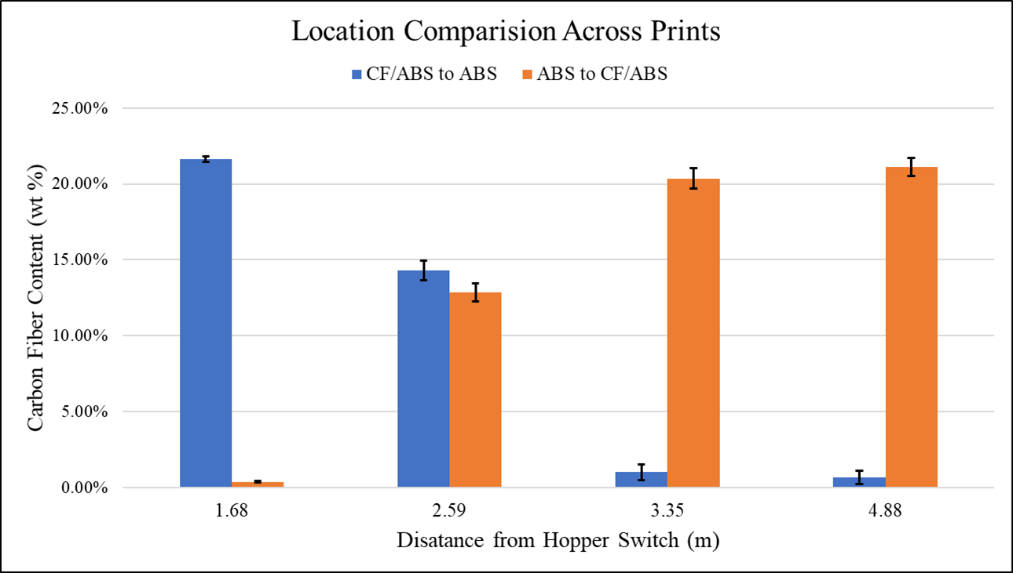
Figure 3-10. The average fiber content of all eight locations across printed structures.
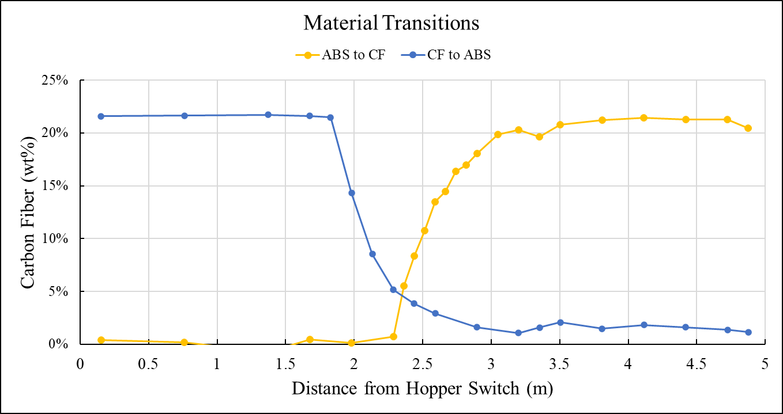
Figure 3-11. Two transition curves obtained through CIN measurements as a function of length.
Table 3-1. Transition Zone Lengths.
Direction | L_{p} (m) | L_{T} (m) | L_{s} (m)
CF ABS | 1.83 | 1.37 | 3.20
ABS CF | 2.29 | 1.22 | 3.51
where both L_{S} and the following point exhibited wt % CF above 20 wt %. For neat ABS, Z_{S} began when carbon fiber content fell below 1.5 wt %. As shown by L_{S}, the CF ABS direction had an overall shorter transition length. However, L_{T} showed that the CF ABS direction exhibited a longer Z_{T} than the ABS CF transition, showing that the difference in L_{P} drove the difference in overall transition length.

Assessing Compositional Analysis Techniques
While CIN has been previously validated as a reliable technique [113, 116], additional characterization options were investigated to determine as possible alternatives for characterizing material transitions. Using samples adjacent to the CIN samples shown in Figure 3-11, CIA and UAD composition measurements were used to construct shape curves using. Figure 3-12 shows these three shape curves for the CF ABS transition. The ABS CF transition curves in Appendix A-1 provide an additional comparison for the CIN and CIA techniques. At all comparison points, the three techniques measured a similar carbon fiber content, resulting in transition curves with similar overall shapes. On average, CIA returned carbon fiber content 1.1 wt % lower than the associated CIN measurement. Since this effect was highest in neat ABS regions, it was attributed to the combustion of ABS also degrading the carbon fibers, which was prevented in CIN by the inert nitrogen atmosphere. As intended, UAD measurements were consistently between the two carbonization techniques, confirming the veracity of the newly developed technique. Despite the slight differences, each technique demonstrated the ability to measure material composition with the accuracy necessary to capture the dual hopper transition curves.
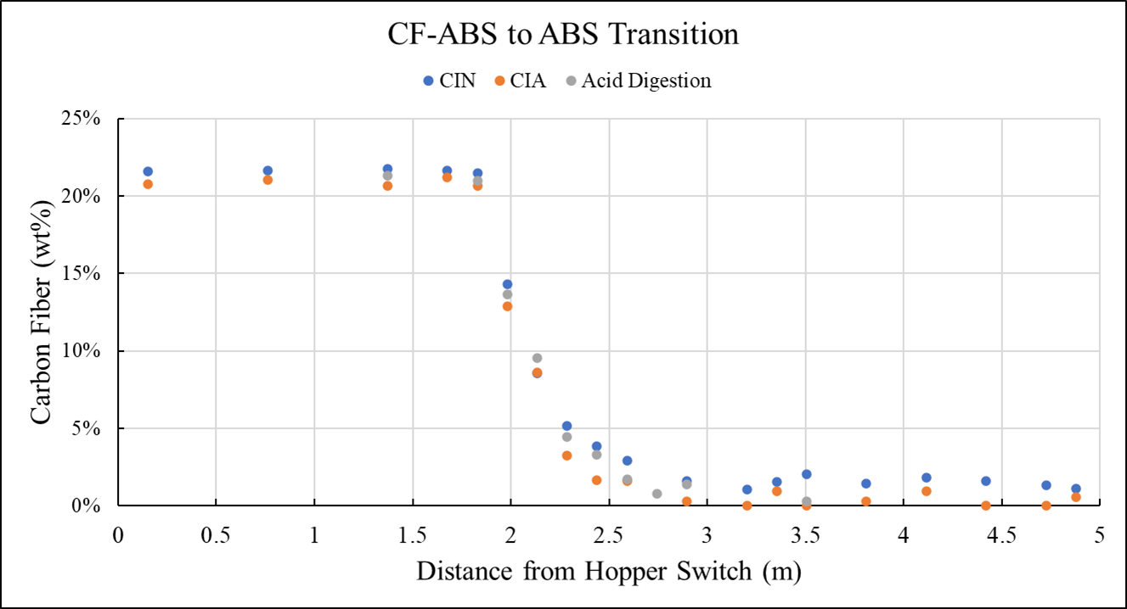
Figure 3-12. The CF ABS transition as measured by the three characterization techniques.
Therefore, technique selection was dependent upon other factors such as cost, energy consumption, material compatibility, and sample throughput.
When constructing material transition curves, the initial steps required to produce, label, and extract samples represented a significant time investment that was identical for all three techniques. Similarly, drying and weighing the specimens also remained the same regardless of approach. As such, any differences between CIN, CIA, and UAD were limited to the fiber extraction process. The relative cost of CIN compared to CIA using similar furnaces will always show that CIN was more expensive due to the introduction of the inert nitrogen atmosphere, which also leads to a higher rate of energy consumption for CIN. For UAD, a direct comparison would require a detailed analysis of system cost (sonicator vs furnace) as well as the time and energy required per specimen. In general, the equipment costs increase more quickly with instrument size for furnaces than sonicators. Further, maintaining a high temperature environment presents a significant energy demand compared to sonication. When considering possible future work, any investigation of higher-temperature thermoplastics would require CIN vs CIA to prevent degradation of reinforcing carbon fibers, so CIA was not selected to avoid limiting material selection. Finally, sample throughput will be a direct function of chamber size and process time. These initial studies showed a significantly faster process time for UAD compared to a significantly more expensive nitrogen-furnace used for CIN measurements. Overall, UAD appeared to be the most appropriate technique for future characterization work.

Summary and Conclusions
The in-situ material switching capabilities of BAAM dual hopper were investigated by comparing material composition at identical locations across multiple prints, and three techniques for determining material composition were compared to identify the most suitable method for future work. The material transitions produced by dual hopper material switches exhibited minimal compositional variance at identical xy locations from layer-to-layer and print-to-print. Thus, the material transition process demonstrated repeatable behavior suitable for part design and process planning. Given this repeatability, dual hopper transitions should also be predictable and a function of underlying instrumental, environmental, and material characteristics. Understanding the influential parameters will lead to predictable behavior, providing a path toward site-specific properties within LFAM structures.
Plotting material transitions as a function of composition and location created descriptive shape curves for each direction, ABS CF and CF ABS. Following the outlined analysis method, three distinct zones were observed and measured in the printed material transitions: the Purge, Transition, and Steady-State Zones (Z_{P}, Z_{T}, Z_{S}). The zone lengths quantified the visually observed changes in transition behavior, providing a fundamental tool for comparing material transitions printed in different directions or at different conditions. A notable difference in zone lengths occurred when changing the direction of the material transition, indicating that transition direction should be investigated as an influential parameter that must be understood to accurately implement multiple transitions in MM part design for the BAAM dual hopper.
Three compositional analysis techniques (CIN, CIA, and UAD) were utilized to measure the wt % CF of samples from the printed material transitions. Each technique produced comparable fiber content measurements and similar shape curves. Given this similar accuracy, comparing the differences in cost, process time, and flexibility clearly indicated UAD offered significant advantages over both CIN and CIA. First, CIA limits possible material pairs due to the vulnerability of carbon fiber to degradation in standard atmospheric conditions while the solvent in UAD can be chosen to specifically target constituent materials as needed. Since future projects had shown interest in high-temperature thermoplastic composites, CIA was a poor choice. Compared to CIN, UAD had a faster cycle time for a similar number of samples per cycle using equipment that was significantly less expensive. However, the filtration process required for UAD led to an increase in hands-on labor compared to CIN, which suggested that CIN may be preferred for large sample quantities where time and cost were not substantial barriers. Therefore, the choice was determined by equipment access and cost. Even though hundreds of composition measurements were needed, UAD was chosen as the characterization technique for this work due to the ability to acquire a sonicator, allowing in-house testing at a cost-effective rate with full experimental oversight. The influence of material properties and processing parameters on dual hopper transitions was thus investigated using UAD to inform the design and process planning of FGM components made using LFAM.

Modelling Material Transitions
The initial studies in Chapter 3 demonstrated the repeatable nature of material transitions printed using BAAM dual hopper, so complementary experiments were designed to characterize the influence of processing and material parameters on transition behavior. To better understand these experimental results, a mathematical model was developed as a curve-fitting tool with parameters corresponding to the shape and length of the transition zone as a means of quantifying and comparing material transitions. As part of this endeavor, a means for measuring sample location that ensured shape curves were compared at the same representative scale was needed. Therefore, the first step toward model development was the conversion of sample location from a length scale to a volumetric scale so that deviations in extrudate geometry and material quantity were accurately represented. By assessing material transitions as a function of extrudate volume, changes arising solely from differences in printing conditions were removed, leaving only the impact of these changes on transition behavior. From there, the developed constitutive model provided a tool for objective analysis of transition behavior that would inform designer choices and options for implementing material transitions in printed parts.

Volumetric Determination of Sample Location
In initial studies, the location within a transition was measured as being the relative distance traveled by the extrusion head since initiating the material change, so zone sizes were discussed in terms of meters [101, 103]. As will be seen in Section 3.5.5, quantifying transition behavior using only length was difficult and risked misleading conclusions. Therefore, a more comprehensive method for tracking the progression of a material transition was developed. Using extrudate volume to measure transition progress ensured that changes in screw speed, travel speed, and any deviation from input bead geometries were included in the analysis and enabled meaningful comparisons of transitions printed under different conditions or with different components. Furthermore, this volumetric approach implemented a normalization procedure intended to provide useful context for the measurements. This also necessitated consideration of the material and condition dependency of the normalization process.

Calculating Extruded Volume, V_{E}
While initial analyses utilized travel distance to plot a material transition, comparing the cross-sectional area of printed beads from different points within a print as well as different printed conditions showed significantly different shapes and overall areas. Figure 4-1A provides an example of these inconsistencies by placing three cross-sections of different composition side-by-side to illustrate changes in shape despite being from the same printed transition. Shown in Figure 4-1B and C, optical microscopy measurements found a reduction in cross-sectional area of up to 10 %. Detailed measurements are available in the Appendix in Table B - 1 Figure A - 2. These initial findings motivated the development of a volumetric method for determining sample location within a printed material transition.
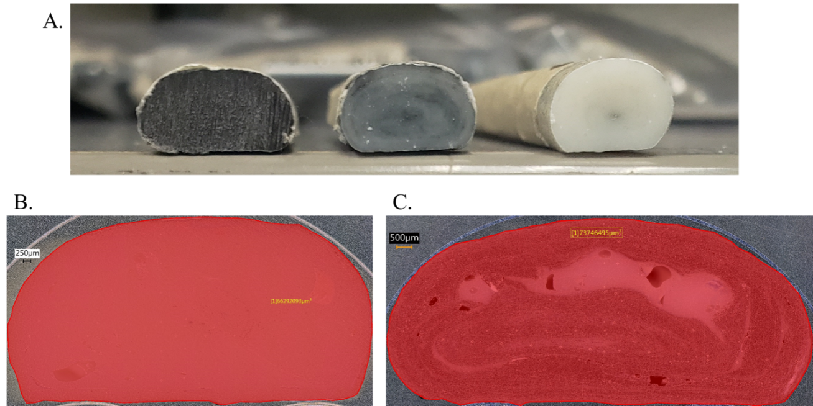
Figure 4-1. A comparison of cross-sectional areas of printed beads. A.) Three examples with differing compositions from the same transition. B.) and C.) Images taken using an optical microscope to measure the area of each sample.
The developed approach calculates the cumulative volume of material deposited since the change in feedstock up to the point of interest. Rather than performing extensive measurements to estimate the changing cross-sectional area of the deposited bead at a multitude of print conditions, Equation 5 presents an alternative method for calculating this extruded volume, V_{E}, using the travel distance, d, the travel speed, v, and the volumetric flow rate of the extrudate, Q.
$$\begin{aligned}V_{E}=\frac{Qd}{v} \#\left( SEQ Equation \backslash * ARABIC 5\right)\end{aligned}$$
Incorporating travel distance tied an easily measured position into transition progress, travel speed was a constant specified by the g-code, and the volumetric flow rate could be experimentally measured for a given material at set print conditions. Using this relationship, V_{E} could be calculated for any sample extracted from the printed material transitions.

Normalized Volume Method
Although tracking material transitions as a function of V_{E} improved measurement accuracy, extracting meaningful comparisons between samples printed with different component geometries remained difficult. To aid in these discussions, V_{E} was normalized by a tangible feature of the BAAM dual hopper. As shown in Equation 6, the normalized volume, V_{N}, was obtained by dividing V_{E} by V_{R}, the remaining volume of material in the system. This remaining material, considered a “residual volume” of material, was a consistent, measurable property of the dual-hopper system dependent upon material properties, system geometry, and print conditions.
$$\begin{aligned}V_{N}=\frac{V_{E}}{V_{R}} \#\left( SEQ Equation \backslash * ARABIC 6\right)\end{aligned}$$
Through normalizing V_{E} by V_{R}, material transitions were connected to important physical limitations imposed by the dual hopper construction. In a theoretical material transition where the discrete boundary between pelletized feedstocks is maintained throughout the extrusion process, the entire volume of Material A will complete extrusion exactly when V_{N} equals one. This boundary, termed V₁, suggests that every material transition printed using BAAM dual hopper must begin the transition zone prior to V₁ to comply with the conservation of mass in a closed system like BAAM. Thus, the normalized volume framework enables a more informative analysis, which requires determination of V_{R} as an essential component of transition analysis. However, this required both an in-depth investigation of BAAM internal structure as well as an estimation of material form and flow through the extrusion system.

Determining Residual Volume
As defined in the previous section, V_{R} is the residual volume of material remaining in the system at the instant when the hopper switch occurs. Descriptions, symbols, and units for preceding and future variables are listed in Table B-2 for easy reference. To capture all remaining material in the analysis, the two boundaries for $V_{R}$ were defined as the connection point where material switching occurs and the exit of the nozzle. Although switching from a full hopper to an empty one was considered for directly measuring V_{R}, starve-feeding the extruder would likely leave significant amounts of material, especially fiber reinforcements, stuck to internal geometries and inside the nozzle assembly. Instead, this study calculates the unoccupied volume within the system and then uses material density measurements to approximate the equivalent volume of extrudate. Figure 4-2 illustrates the three major divisions of V_{R} used in this analysis as they relate to an actual image of the gantry (left) and a representative sketch of these divisions (right). The left image overlays the boundaries of each region on the physical design while the right provides the corresponding names and conceptual cartoons. Figure 4-2A, the Feed Throat, approximates the connection between the dual-hopper and the extruder as a simple cylinder. Figure 4-2B, the Barrel, is a schematic of the extrusion screw, representing the volume already occupied within this region. Figure 4-2C, the Nozzle Assembly, consists of the nozzle and endcap used to attach the nozzle to BAAM. Equation 7 establishes this relationship by setting V_{R} equal to the sum of V_{T}, V_{B}, and V_{A}, or the volume of material in the feed throat, volume of material in the barrel, and volume of material in the nozzle assembly, respectively.
$$\begin{aligned}V_{R}=V_{T}+V_{B}+V_{A} \#\left( SEQ Equation \backslash * ARABIC 7\right)\end{aligned}$$
While these bounded regions have a constant volume available for material to occupy, the material form changes throughout processing from feedstock to melt to extruded bead. Given that the materials do not perfectly fill V_{R} as pelletized feedstock nor maintain constant densities throughout the extrusion process, material volume calculations included the impact of environmental conditions and material state by implementing a density ratio, ρ_{r}. As shown in Equation 8, ρ_{r} was defined as the ratio of bulk density (ρ_{b}),
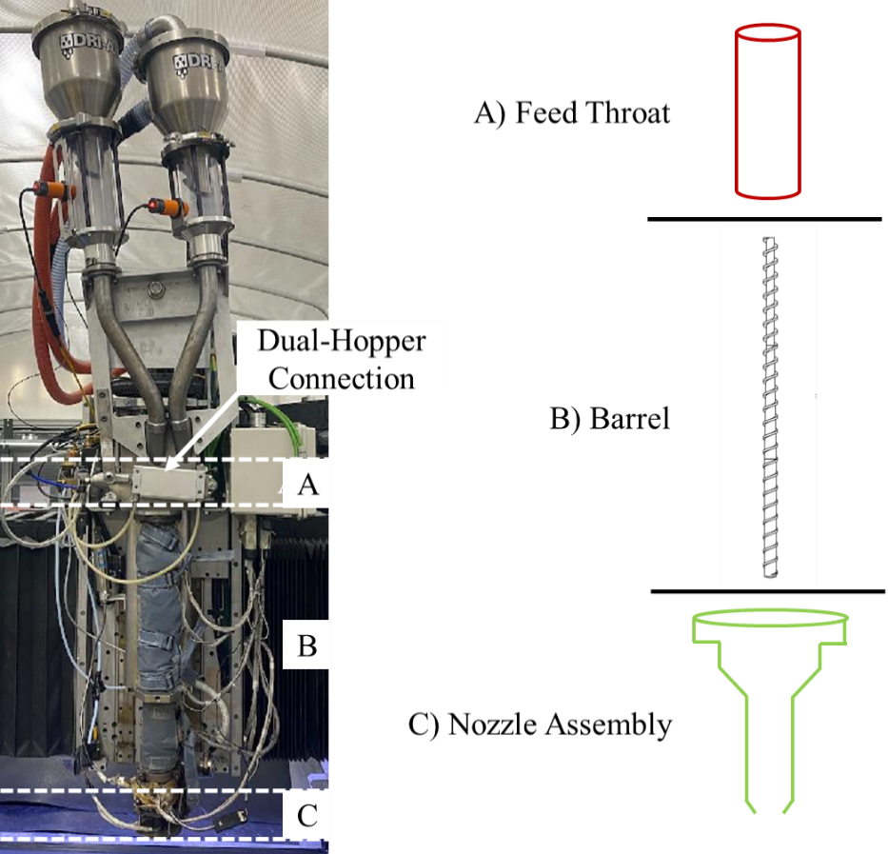
Figure 4-2. (Left) BAAM dual hopper with the three component regions of V_{R} bounded by dashed white lines and labelled A, B, and C. (Right) Names and schematic representations of each region.
compressed bulk density (ρ_{c}), bulk density (ρ_{b}), compressed bulk density (ρ_{c}), or melt density (ρ_{m}) to the extrudate density, ρ_{E}. Using this ratio converts calculated material volumes to the expected volume of extrudate, matching the material form of V_{E} measurements regardless of the material state in the system. Thus, multiplying a volume by the associated ρ_{r} addressed any change in density and material form, ensuring that volume calculations were not incorrectly assuming perfect fill of the internal geometry by extrudate with ρ_{E}.
$$\begin{aligned}ρ_{r}=\frac{ρ_{b}}{ρ_{E}}; or ρ_{r}=\frac{ρ_{c}}{ρ_{E}}; or ρ_{r}=\frac{ρ_{m}}{ρ_{E}}; \#\left( SEQ Equation \backslash * ARABIC 8\right)\end{aligned}$$
Stepping through the divisions, Figure 4-2A was approximated as a simple cylinder of length, l, and radius, r, and contained only the pelletized feedstock. Thus, Equation 9 calculates V_{T} using the volume of a cylinder and ρ_{b}.
$$\begin{aligned}V_{T}=πr^{2}l×\frac{ρ_{b}}{ρ_{E}}\#\left( SEQ Equation \backslash * ARABIC 9\right)\end{aligned}$$
While the barrel is also a simple cylinder, the extrusion screw occupies most of the internal volume, so proprietary drawings and models of the screw were consulted to generate a digital model of the unoccupied volume remaining within the barrel. Due to the melting process and changing flight geometries, this digital model was further sub-divided such that each division was the length of one screw flight. This allowed for each region to use the form of Equation 8 that most appropriately described the material state at that point in the extrusion process. For completely un-melted pellets, ρ_{c} was used to represent the bulk density of the pellets under pressure while a full polymer melt was represented using the third form of Equation 8 and ρ_{m}. Following typical assumptions for SSE, the melting process was considered to begin 3.6 times the barrel diameter down the length of the barrel (3.6D) and completing by 11.6D [94]. To capture the changing density, a stepwise gradient was implemented using a linear Rule of Mixtures (RoM) relationship, as shown in Equation 10, to calculate a representative density, ρ_{Ri}, where f_{i} was position of that region in the stepwise gradient.
$$\begin{aligned}ρ_{R_{i}}=\frac{ρ_{c}\left(1-\frac{f_{i}}{9}\right)+ρ_{m}(\frac{f_{i}}{9})}{ρ_{E}}\#\left( SEQ Equation \backslash * ARABIC 10\right)\end{aligned}$$
The changing density within the barrel is represented in Figure 4-3 as a piecewise function (blue) plotted against distance along the extrusion screw using a schematic of the screw as refence for how these changes correspond to both screw flights and the physical screw zones. The second y-axis in Figure 4-3 plots the cumulative available volume (orange dashed) and cumulative material volume (orange) in the barrel, V_{B}, as a function of barrel position to further illustrate the impact of the changing material density.
As also shown in Figure 4-3 and discussed in Chapter 2, the extrusion screw geometry consists of three distinct zones typical of SSE systems. First the feed zone has a constant, deep channel that conglomerates the pelletized feedstock and initiates melting. Second, the compression zone implements a shrinking channel to apply pressure and frictional heating, resulting in a completely melted polymer. Finally, the metering zone uses a shallow, constant channel to establish stable polymer flow and temperature for controlled extrusion. These zones provided natural boundaries for calculating the
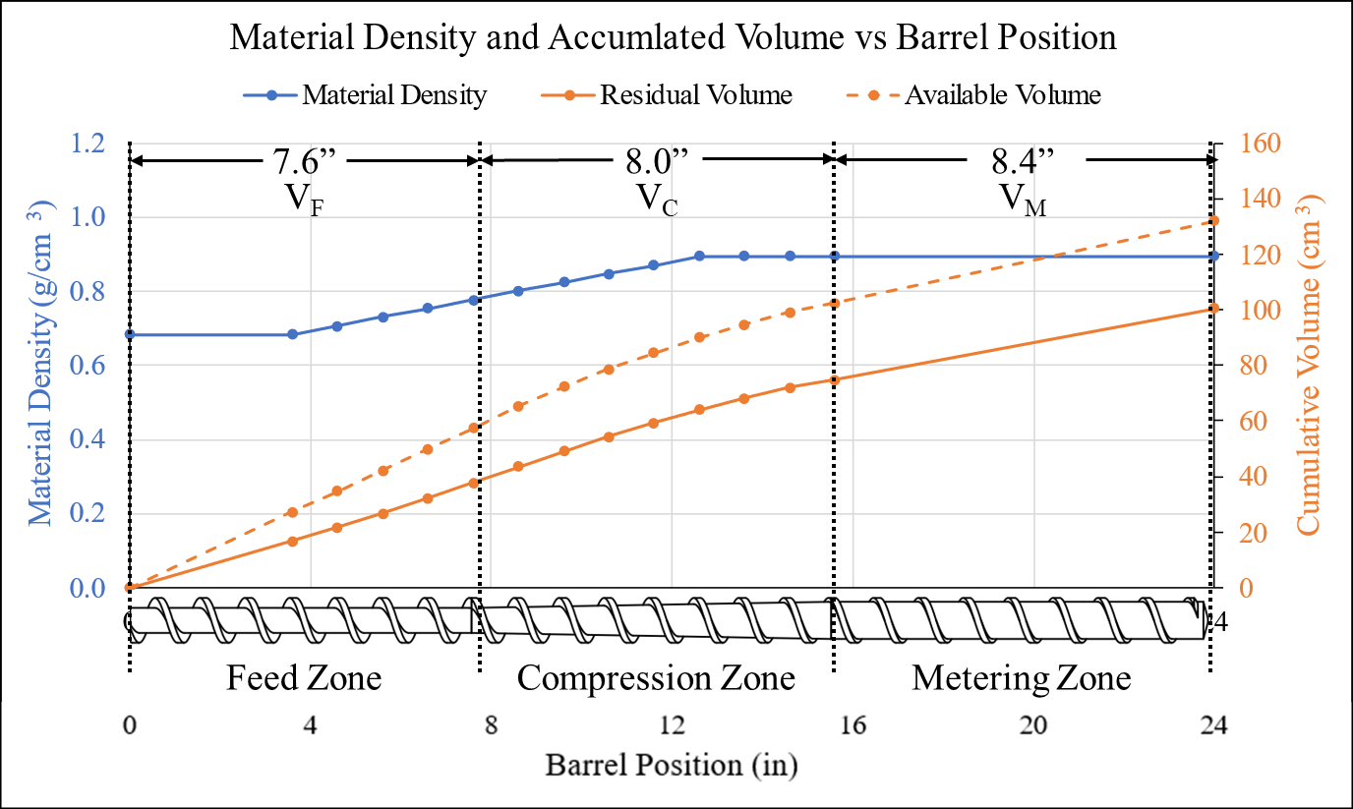
Figure 4-3. A diagram showing the change in material density as a function of position with the SSE barrel (blue), and a comparative analysis showing how the density influences the volume occupied by that material (orange).
component material volumes comprising V_{B}: material volume in the feed zone (V_{F}), material volume in the compression zone (V_{C}), and material volume in the metering zone (V_{M}). These component volumes were thus calculated using the established density relationships, though it should be noted that Equation 10 applied to portions of both V_{F} and V_{C} due to melting behavior.
Since the screw geometry remained constant throughout the feed zone, calculating V_{F} relied on the total available volume in this zone, F, obtained from the CAD model. F and other geometric constants are listed in Table B-3. As indicated, the barrel was sub-divided by screw flights to implement a stepwise gradient in material density, starting at 3.6D. Considering that the total length of the feed zone was 7.6D, Equation 11 uses fractional allocation of F and a summation to find the contributions of each flight to V_{F} while also including estimated changes in density. In this case, f_{i} represents the numbered flights in the stepwise density gradient, beginning with the one occupying 3.6D to 4.6D, such that the total distance down the screw equates to the feed zone length, 7.6D. As discussed, the initial ρ_{r} for this zone uses form 2 of Equation 4.
$$\begin{aligned}V_{F}=\frac{3.6}{7.6}F×\frac{ρ_{c}}{ρ_{E}}+\sum_{i=1}^{4}{\frac{ρ_{c}\left(1-\frac{f_{i}}{9}\right)+ρ_{m}(\frac{f_{i}}{9})}{ρ_{E}}}×\frac{F}{7.6}\#\left( SEQ Equation \backslash * ARABIC 11\right)\end{aligned}$$
The compression zone both induces a change in material density and exhibits a changing screw geometry, altering the available volume from one sub-divided region to the next. Therefore, Equation 12 utilizes the same f_{i} from Equation 11 and introduces a second summation that steps through the gradually reducing available volume, C_{j}, obtained individually for each 1D-length sub-division (Table B-4). Here, the flights numbered by position in the stepwise material gradient are still indicated by i while j indicates the flights numbered by position in the compression zone. In addition, a second summation with a constant density ratio is used to represent the flight by which full polymer melt is achieved (11D) while stepping through the final three flights in the compression zone.
$$\begin{aligned}V_{C}= \sum_{i=5, j=1}^{9,5}{\frac{ρ_{c}\left(1-\frac{f_{i}}{9}\right)+ρ_{m}(\frac{f_{i}}{9})}{ρ_{E}}×C_{j}}+\sum_{j=6}^{8}{\frac{ρ_{m}}{ρ_{E}}×C_{j}}\#\left( SEQ Equation \backslash * ARABIC 12\right)\end{aligned}$$
Finally, the contribution of the metering zone is straight-forward due to a complete material melt and consistent screw geometry. As shown in Equation 13, V_{M} was found by multiplying the third form of Equation 4 and the available volume in the metering zone, M, which was again obtained from the CAD model (Table B-3).
$$\begin{aligned}V_{M}=M×\frac{ρ_{m}}{ρ_{E}} \#\left( SEQ Equation \backslash * ARABIC 13\right)\end{aligned}$$
Having established these relationships, Equation 14 shows V_{B} in short form as the sum of each component zone. Equation 15 provides the expanded form of this equation built from Equations 11-13 to illustrate the properties required for this calculation.
$$\begin{aligned}V_{B}=V_{F}+V_{C}+V_{M} \#\left( SEQ Equation \backslash * ARABIC 14\right)\end{aligned}$$
$$\begin{aligned}V_{B}=\left(\frac{3.6}{7.6}F×\frac{ρ_{c}}{ρ_{E}}+\sum_{i=1}^{4}{\frac{ρ_{c}\left(1-\frac{f_{i}}{9}\right)+ρ_{m}\left(\frac{f_{i}}{9}\right)}{ρ_{E}}}×\frac{F}{7.6}\right)+… \\ \left(\sum_{i=5, j=1}^{9,5}{\frac{ρ_{c}\left(1-\frac{f_{i}}{9}\right)+ρ_{m}(\frac{f_{i}}{9})}{ρ_{E}}×C_{j}}+\sum_{j=6}^{8}{\frac{ρ_{m}}{ρ_{E}}×C_{j}}\right)+\left(V_{M}=M×\frac{ρ_{m}}{ρ_{E}}\right) \#\left( SEQ Equation \backslash * ARABIC 15\right)\end{aligned}$$
Finally, for the nozzle assembly major division, the material was considered to still be in the melted state, so the third form of Equation 8 was used. The internal volume of nozzle assembly, N, was retrieved from the associated CAD models (Table B-3). Since the assembly had no additional internal features, the polymer melt was assumed to completely fill the space. Therefore, V_{A} was simply N times the melt density ratio, as shown in Equation 16.
$$\begin{aligned}V_{A}=N×\frac{ρ_{m}}{ρ_{E}} \#\left( SEQ Equation \backslash * ARABIC 16\right)\end{aligned}$$
As shown previously in Equation 7, deconstructing the BAAM SSE system into divisions and sub-divisions enables direct calculation of the residual material volume. After substituting in Equations 9, 14, and 15, the relationship becomes that shown in Equation 17. Although this could be expanded further using Equation 15, this form is retained for brevity. Expanding Figure 4-3, Figure 4-4 shows the both the material density (left y-axis) and cumulative V_{R} (right y-axis) as a function of position in the SSE system. Position was measured only along the axis representing material flow through the system, and the component schematics were incorporated below the chart to connect density and V_{R} changes to physical features.
$$\begin{aligned}V_{R}=πr^{2}l×\frac{ρ_{b}}{ρ_{E}}+ V_{F}+V_{C}+V_{M}+N×\frac{ρ_{m}}{ρ_{E}}\#\left( SEQ Equation \backslash * ARABIC 17\right)\end{aligned}$$

Material Specific Considerations
Although the previous sections present the method for calculating V_{E}, V_{R}, and V_{N}, several variables were material properties or a function of those properties. Furthermore,
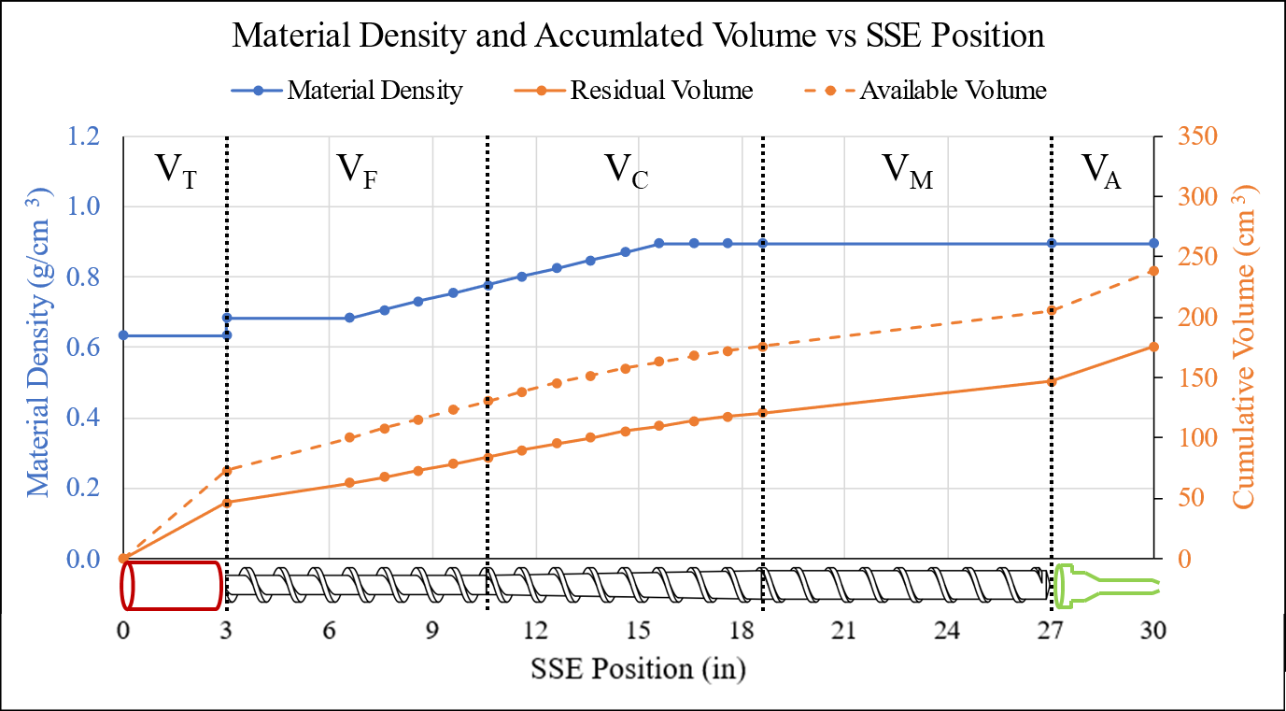
Figure 4-4. A schematic showing the change in material density as it travels from the hopper switch to the nozzle exit (blue), and an analysis demonstrating how the available volume was related to material volume (orange).
the transition zone will likely exhibit properties representative of the mixed composition. Therefore, a unique V_{R} was calculated for each material and a linear RoM approach was used to estimate the properties at any point in the material transition based on composition.
For each material studied, three different material densities were experimentally measured at the standard processing conditions. The apparent density, commonly referred to as bulk density bulk density (ρ_{b}), of each material was measured using a custom apparatus designed to follow ASTM D1895 [119]. The melt densities (ρ_{m}) were calculated using a Dynisco Laboratory Capillary Rheometer 7001 and ASTM D3835 [120]. The compressed bulk density (ρ_{c}) also utilized the capillary rheometer but relied upon a custom procedure where a continually increasing pressure was applied to the feedstock at room temperature. The known material mass and interior volume of the rheometer was then used to calculate the ρ_{c} at each pressure. However, experimental results indicated a negligible change in density with increasing pressure, which was supported by literature showing the bulk density of amorphous thermoplastics was relatively unaffected by pressure alone [121]. Thus, any change in pressure caused by the increasing screw speeds was not considered to influence ρ_{c}. The standard density obtained from the printed extrudate (ρ_{E}) was measured using helium pycnometry after consulting both ASTM D792 and ASTM D6226 [122, 123].
A function of both processing parameters and material properties, the volumetric flow rate Q was measured for the studied combinations of screw type, screw speed, nozzle type, and material. Shown in Equation 18, Q was obtained by collecting all material extruded over a time, t, and dividing the extrudate mass, m_{E}, by ρ_{E} and t. To accommodate the change in flow rate that occurs as the material transition progress, a RoM flow rate, Q_{R}, was calculated using Equation 19 where Q_{A} and Q_{B} are the flow rates of Materials A and B. F_{A} was the fraction of Material A present in a given sample or at a given point. As a result, Equation 1 for calculating V_{E} becomes Equation 20 to include the effects of the material transition on flow rate.
$$\begin{aligned}Q=\frac{m}{ρ_{E}×t} \#\left( SEQ Equation \backslash * ARABIC 18\right)\end{aligned}$$
$$\begin{aligned}Q_{R}=Q_{A}\left(F_{A}\right)+Q_{B}\left(1-F_{A}\right) \#\left( SEQ Equation \backslash * ARABIC 19\right)\end{aligned}$$
$$\begin{aligned}V_{E}=\frac{Q_{R}d}{v} \#\left( SEQ Equation \backslash * ARABIC 20\right)\end{aligned}$$
Due to the dependency on material densities, material transitions were also expected to influence the material-specific V_{R} values. Therefore, Equation 21 implements a linear RoM approach to estimate the mixed residual volume, V_{Rx,} in the transition zone and accurately normalize the data. Here, V_{R-A} and V_{R-B} are the residual material volumes for given Materials A and B.
$$\begin{aligned}V_{Rx}=V_{R-A}\left(F_{A}\right)+V_{R-B}\left(1-F_{A}\right) \#\left( SEQ Equation \backslash * ARABIC 21\right)\end{aligned}$$

Mathematical Modeling of Material Transitions
Predictive modeling tools are commonly implemented to identify trends and connect observations to specific parameters or variables. Some approaches utilize software such as ABACUS, ANSYS, or Solidworks to simulate expected behavior based on known boundary conditions and material properties. In other cases, established mathematical relationships that have been commonly observed in nature are applied to measured data sets and assessed for goodness of fit. Similarly, the known limitations of a study can provide boundary conditions and be used to develop new, application-specific mathematical models. Given the difficulties of simulating complex, turbulent flow and the varied state changes that occur during SSE, a mathematical approach for modeling transition behavior was investigated and developed.

Logistics and Sigmoid Functions
Material transitions typically exhibited shape curves with steep initial change that gradually decayed as material composition almost asymptotically approached 100 % Material B in Z_{P}. In general, the “S” shape was reminiscent of sigmoidal functions, as defined in [124, 125]. The un-altered sigmoid function is shown in Equation 22. Although the equation is typically altered, sigmoidal functions have consistently been used as a basis for modeling data containing a nonlinear region and one or more plateaus [126-128].
$$\begin{aligned}f\left(x\right)=\frac{1}{1+e^{-x}} \#\left( SEQ Equation \backslash * ARABIC 22\right)\end{aligned}$$
For this study, the basic logistics function form and several other variations were implemented in initial modeling attempts. This form was chosen due to the characteristic ability to identify upper and lower asymptotic boundaries, induce exponential growth and decay behavior, and implement a delay before initial growth, as seen in typical dual hopper shape curves. To find the best fit parameters for each model, the MATLAB software package curveFitter was given the associated equation through the custom fit option and instructed to find parameter values that minimizes the residuals and maximize R² using nonlinear least squares regression.
Using a representative data set from Chapter 3, the basic logistics model shown in Equation 23 was assessed for goodness of fit as an initial candidate. Again, material transitions were represented as function of normalized volume, but the y-axis was converted to percentage Material A or B rather than wt % CF to simplify modeling. As can be seen in Figure 4-5, this model generated the expected “S” shape and provided a generally good fit with an R² value of 0.987. However, the beginning of the curve showed a concerning disconnect from the data, modeling a gradual increase despite transition behavior typically exhibiting a much sharper initial change in composition.
$$\begin{aligned}f\left(x\right)=\frac{L}{\left(1+e^{-k\left(x-M\right)}\right)}\#\left( SEQ Equation \backslash * ARABIC 23\right)\end{aligned}$$
Further attempts used three other forms of logistics functions, as shown in Equations 24 (Von Bertalanffy), 25 (Gomperts), and 26 (Generalized Logistics). In addition, Newton’s law of Cooling (Equation 27) was applied to the data plotted as a function of normalized volume and Percent Material A to provide an additional perspective. Figure 4-6 shows the resulting model fit for each of these functions.
$$\begin{aligned}f\left(x\right)=L\left(1+e^{-k\left(x-M\right)}\right)\#\left( SEQ Equation \backslash * ARABIC 24\right)\end{aligned}$$
$$\begin{aligned}f\left(x\right)=ae^{-be^{-cx}}\#\left( SEQ Equation \backslash * ARABIC 25\right)\end{aligned}$$
$$\begin{aligned}f\left(x\right)=A+\frac{K-A}{{\left(1+Qe^{-B\left(x-M\right)}\right)}^{1/v}}\#\left( SEQ Equation \backslash * ARABIC 26\right)\end{aligned}$$

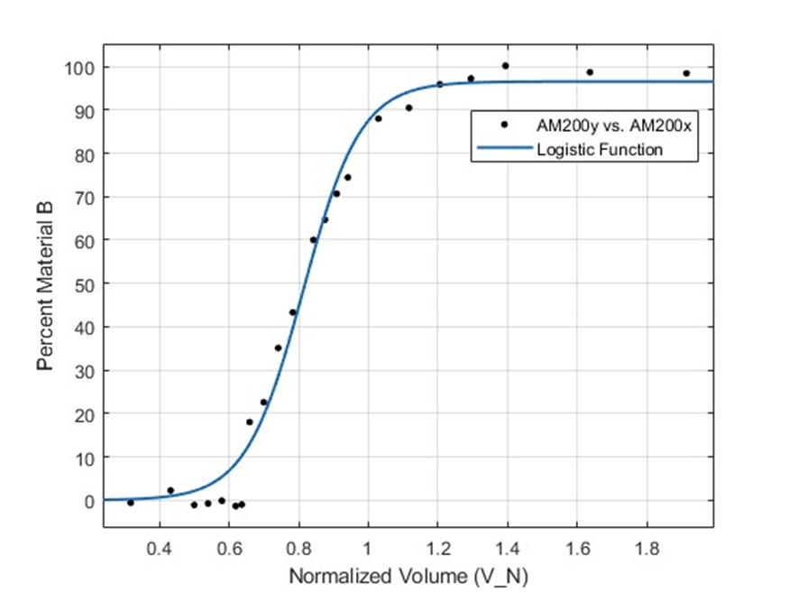
Figure 4-5. The logistics function from Equation 19 fit to a standard material transition data set.
$\begin{aligned}f\left(x\right)=b+\left(a+b\right)e^{-kx}\#\left( SEQ Equation \backslash * ARABIC 27\right)\end{aligned}$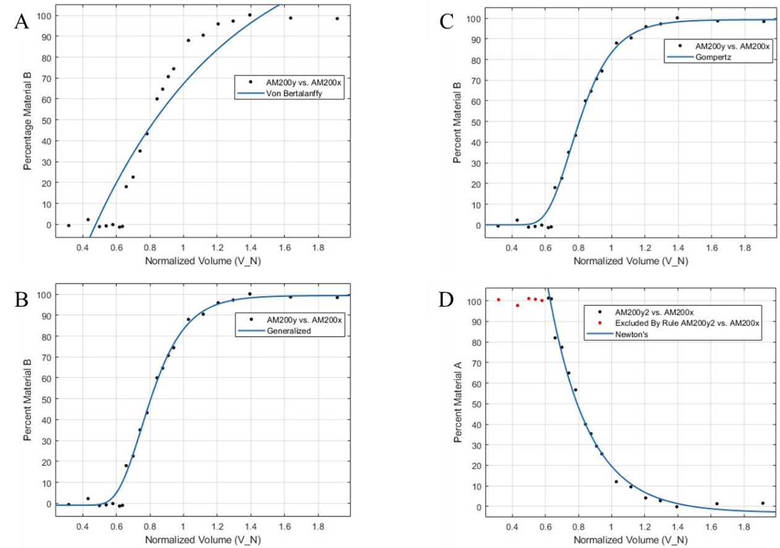
Figure 4-6. Four models fit to the same data set using MATLAB curveFitter software package. A) Equation 20, Von Bertalanffy, B) Equation 21 Gompertz, C) Equation 22, Generalized Logistics, and D) Newton’s cooling law.
Typically used in biology to study animal growth with undefined limits [129], the Von Bertalanffy (A) model was not expected to fit this data and clearly did not. However, both the Generalized and Gompertz (B and C, respectively) forms attained R² values greater than 0.99, indicating a very good fit with the provided data. The Gompertz model uses only three parameters, which could limit connections between the model and the physical changes in processing conditions. The Generalized Logistics (GL) form incorporates six (A, K, Q, B, M, and v) to find the best fit. M provides one of the most important functions by establishing where the initial exponential growth occurs. Similarly, Q, B, and v influence the rate of growth and near which asymptote maximum growth rate occurs. Finally, A and K set the asymptotic boundaries for f(x), which simply corresponded to Percent of Material B. Although these boundaries are known to be zero and one hundred they were left as variables in the model so that any deviation outside those bounds from errors in measurement were still included. Although an R² value greater than 0.99 was achieved using Newton’s law (D), this required manual exclusion of the non-exponential data points. Even so, this example indicated that an exponential function could be implemented to accurately model the transition zone.
Figure 4-7 presents the generated GL fits for a full sample set from one BAAM configuration where the studied transitions varied only in screw speed (discussed in detail in Chapter 5) to highlight two additional issues that motivated development of a custom model. Since the GL model defined the plateaus using A and K, the best fit values for those parameters routinely exhibited significant deviation from the known boundaries (0 and 100
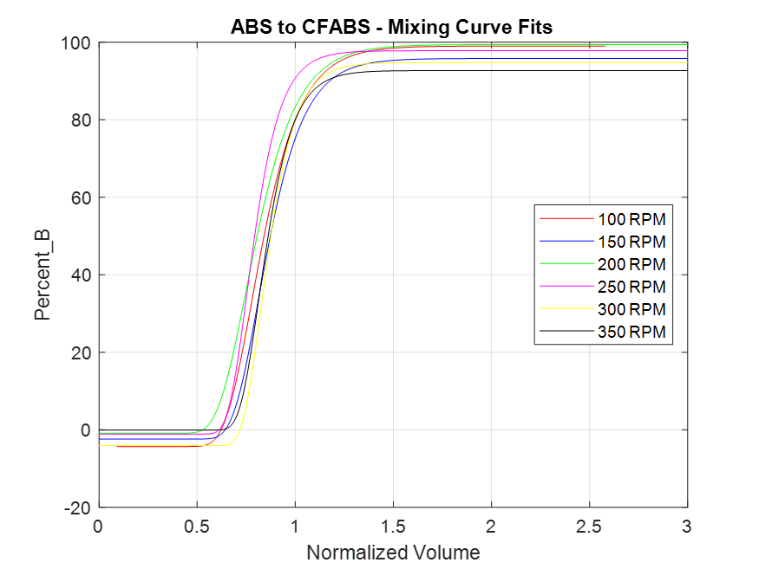
Figure 4-7. GL-modeled shape curves for six material transitions printed at six different screw speeds.
%). Second, while the GL model accurately captured the initial change in composition for some data sets (See Appendix A, Figure A-3), modeling other data sets with GL encountered the same inability to fit the steep slope at the start of the transition as seen with the basic logistics function. These incompatibilities led to the development of a custom mathematical model.

An Analytical Curve Fitting Solution
To develop a descriptive model for the observed material transitions, an analysis of boundary conditions and expected transition behavior was conducted. The y-axis bounds were set to zero and one, representing the fractional change in material composition. These bounds were enforced by a piecewise function, as shown in Equation 28, that reflected the three transition zones. Here, the parameter X_{T} is the x-value at which the transitions zone begins and X_{S} is the x-value at which the transition zone ends, and modeling-specific variables are listed in Table B-5 F(x) represents the equation describing the change in material composition throughout the transition zone, Z_{T}.
$$\begin{aligned}f\left(x\right)=\left\{\begin{aligned}0 \\ F(x) \\ 1\end{aligned} \right.\begin{matrix}x≤X_{T} \\ X_{T}<x≤X_{S} \\ x>X_{S}\end{matrix}\#\left( SEQ Equation \backslash * ARABIC 28\right)\end{aligned}$$
To solve for F(x), a second linear function was inserted and boundary conditions representing the known limits of dual hopper transitions were enforced. The diagrams in Figure 4-8 graphically demonstrate how the relationship between F(x) and the linear function g(x) with slope m₁ (Equation 29) were used to find a solution.
$$\begin{aligned}g\left(x\right)=m_{1}x+b_{1}\#\left( SEQ Equation \backslash * ARABIC 29\right)\end{aligned}$$
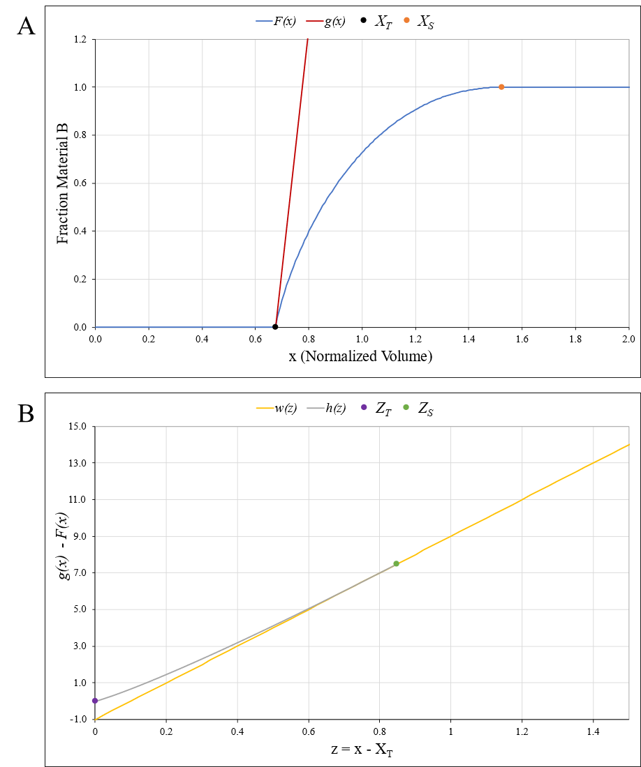
Figure 4-8. A) The desired curve, F(x), in blue and an arbitrary linear function g(x) in red constrained as being equal to F(x) at X_{T}. B) The difference between the two functions plotted on a new x-axis (z) as the function h(z) in gray and a second linear function w(z) in yellow. Points showing transition initiation and completion were using X_{T} (z_{T}) and X_{S} (z_{S}), respectively.
In Figure 4-8A, g(x) (red) was defined such that it intersected the desired function f(x) (blue) at X_{T}. To satisfy Equation 28, g(X_{T}) must be equal to zero and F(X_{S}) must be equal to one (Equations 30 and 31). Further, subtracting Equation 28 from Equation 29 creates Equation 32.
$$\begin{aligned}g(X_{T})=0\#\left( SEQ Equation \backslash * ARABIC 30\right)\end{aligned}$$
$$\begin{aligned}F(X_{S})=1\#\left( SEQ Equation \backslash * ARABIC 31\right)\end{aligned}$$
$$\begin{aligned}g\left(x\right)-f\left(x\right)=\left\{\begin{aligned}m_{1}x+b_{1} \\ m_{1}x+b_{1}-F(x) \\ m_{1}x+b_{1}-1\end{aligned} \right.\begin{matrix}x≤X_{T} \\ X_{T}<x≤X_{S} \\ x>X_{S}\end{matrix}\#\left( SEQ Equation \backslash * ARABIC 32\right)\end{aligned}$$
Figure 4-8B transforms the x-axis into a new z-axis by subtracting X_{T} from x (Equation 33) so that z equals zero at the re-defined transition start, z_{T} (Equation 34). Since the original y-axis was retained, Equation 34 shows that g(z_{T}) must equal g(X_{T}), which is equal to zero per Equation 30. Therefore, the g(z) y-intercept must also equal zero (Equation 35). Similarly, the end of the transition zone was indicated by z_{S} (Equation 36), which leads to Equation 37 stating that f(z) must still be equal to f(x) and 1 for all values greater than or equal to X_{S} and z_{S}, respectively. Finally, Equation 32 then becomes Equation 38 using Equations 33, 34 and 37, which then allows h(z) to be defined as the difference between g(z) and f(z) (Equation 39).
$$\begin{aligned}z=x-X_{T}\#\left( SEQ Equation \backslash * ARABIC 33\right)\end{aligned}$$
$$\begin{aligned}z_{T}=X_{T}-X_{T}=0\#\left( SEQ Equation \backslash * ARABIC 34\right)\end{aligned}$$
$$\begin{aligned}g\left(X_{T}\right)=g\left(z_{T}\right)=0 ∴g(z)=m_{1}z\#\left( SEQ Equation \backslash * ARABIC 35\right)\end{aligned}$$
$$\begin{aligned}z_{S}=X_{S}-X_{T} \#\left( SEQ Equation \backslash * ARABIC 36\right)\end{aligned}$$
$$\begin{aligned}f\left({x≥X}_{S}\right)=f\left(z≥z{}_{S}\right)=1 \#\left( SEQ Equation \backslash * ARABIC 37\right)\end{aligned}$$
$$\begin{aligned}g\left(z\right)-f\left(z\right)=\left\{\begin{aligned}m_{1}z-F(z) \\ m_{1}z-1\end{aligned}\right. \begin{matrix}0<z≤z_{S} \\ z>z_{S}\end{matrix} \#\left( SEQ Equation \backslash * ARABIC 38\right)\end{aligned}$$
$$\begin{aligned}h\left(z\right)=g\left(z\right)-f(z)\#\left( SEQ Equation \backslash * ARABIC 39\right)\end{aligned}$$
Within the region bounded by z_{T} and z_{S}, the piecewise Equation 40 re-defines the first leg of h(z) using a typical power law form where A was a multiplying coefficient and n was a power coefficient. However, for domains greater than z_{S}, h(z) was equal to g(z) minus one, per Equation 28.
$$\begin{aligned}h\left(z\right)=\left\{\begin{aligned}Az^{n} \\ g\left(z\right)-1\end{aligned}\right. \begin{matrix}0<z≤z_{S} \\ z>z_{S}\end{matrix}\#\left( SEQ Equation \backslash * ARABIC 40\right)\end{aligned}$$
A second linear function, w(z), was also plotted in Figure 4-8B as an extension of the second linear leg of h(z) that passes through z_{S} using Equation 41.
$$\begin{aligned}w\left(z\right)=m_{2}z+b_{2}=m_{1}z-1\#\left( SEQ Equation \backslash * ARABIC 41\right)\end{aligned}$$
Three relationships were established using these previous equations. For w(z) to be equal to h(z) in the domain greater than z_{S}, m₁ must equal m₂ regardless of y-intercept, resulting in a unified m (Equation 42). In turn, Equation 42 thus establishes that b₂ must be equal to negative one, as shown in Equation 43. Since w(z) also includes z_{S}, setting Equation 40 equal to Equation 41 at z_{S} produces Equation 44.
$$\begin{aligned}m_{1}=m_{2}=m\#\left( SEQ Equation \backslash * ARABIC 42\right)\end{aligned}$$
$$\begin{aligned}mz-1=mz+b_{2}∴b_{2}=-1\#\left( SEQ Equation \backslash * ARABIC 43\right)\end{aligned}$$
$$\begin{aligned}A{z_{S}}^{n}=mz_{S}-1\#\left( SEQ Equation \backslash * ARABIC 44\right)\end{aligned}$$
Finally, Equations 40 and 41 have an identical rate of change at z_{S}, so their derivatives were set equal in Equation 45.
$$\begin{aligned}An{z_{S}}^{n-1}=m\#\left( SEQ Equation \backslash * ARABIC 45\right)\end{aligned}$$
Solving for A in Equation 44 yields Equation 46, which was then substituted into Equation 45 to find Equation 47.
$$\begin{aligned}A=\frac{-1}{{\left(z_{S}\right)}^{n}(1-n)}\#\left( SEQ Equation \backslash * ARABIC 46\right)\end{aligned}$$
$$\begin{aligned}n=\frac{mz_{S}}{mz_{S}-1}\#\left( SEQ Equation \backslash * ARABIC 47\right)\end{aligned}$$
Having determined n in terms of m and z_{S} alone, Equation 47 was then substituted back into Equation 46 to find Equation 48, describing A in terms of X_{T}, X_{S}, and m.
$$\begin{aligned}A=\left(\frac{-1}{{\left(z_{S}\right)}^{\frac{mz_{S}}{mz_{S}-1}}\left(1-\frac{mz_{S}}{mz_{S}-1}\right)}\right)\#\left( SEQ Equation \backslash * ARABIC 48\right)\end{aligned}$$
By re-arranging Equation 39 and substituting Equations 40, 41, 46, and 47, Equation 49 was built to describe F(z).
$$\begin{aligned}F\left(z\right)=mz-\left(\frac{-1}{{\left(z_{S}\right)}^{\frac{mz_{S}}{mz_{S}-1}}\left(1-\frac{mz_{S}}{mz_{S}-1}\right)}\right)z^{\frac{mz_{S}}{mz_{S}-1}}\#\left( SEQ Equation \backslash * ARABIC 49\right)\end{aligned}$$
Converting Equation 49 into Equation 50 using Equation 33, F(x) defines the transition zone in terms representing measurable transition phenomena: the transition start (X_{T}), transition end (X_{S}), and instantaneous change in composition at the start of the material transition (m). This equation offers an alternative model for analyzing and predicting material transitions.
$$\begin{aligned}F\left(x\right)=m\left(x-X_{T}\right)+\left(\frac{{\left(x-X_{T}\right)}^{\frac{m\left(X_{S}-X_{T}\right)}{m\left(X_{S}-X_{T}\right)-1}}}{{\left(X_{S}-X_{T}\right)}^{\frac{m\left(X_{S}-X_{T}\right)}{m\left(X_{S}-X_{T}\right)-1}}\left(1-\frac{m\left(X_{S}-X_{T}\right)}{m\left(X_{S}-X_{T}\right)-1}\right)}\right)\#\left( SEQ Equation \backslash * ARABIC 50\right)\end{aligned}$$

Least Squares Fitting
To determine the model parameters for each set of data, a tunable nonlinear least squares regression method like those available in curve-fitting packages was implemented. X_{T}, X_{S}, and m were the user-defined, tunable parameters fed into the model from Equation 50, and the resulting values were compared to measured data from the matching points. The developed regression model automatically adjusted to include only those data points within the bounds of X_{T} and X_{S}. As shown in Equation 51, the first step calculates the sum of the square of each data point (y_{i}) minus the average ($\overline{y}$) to find the total sum of squares, S_{T}, where i was equal to the number of data points.
$$\begin{aligned}S_{T}=\sum_{i=1}^{i}{{\left(y_{i}-\overline{y}\right)}^{2}} \#\left( SEQ Equation \backslash * ARABIC 51\right)\end{aligned}$$
The regression step then calculates the sum of the squares of the difference between the function values (y_{f}) and y_{i} to find the sum of residuals S_{R}, as shown in Equation 52.
$$\begin{aligned}S_{R}=\sum_{i=1}^{i}{{\left(y_{i}-y_{f}\right)}^{2}} \#\left( SEQ Equation \backslash * ARABIC 52\right)\end{aligned}$$
With these values, Equation 53 was used to find the coefficient of determination, R², and assess the goodness of fit of the model for a given data set.
$$\begin{aligned}R^{2}=1-\frac{S_{R}}{S_{T}} \#\left( SEQ Equation \backslash * ARABIC 53\right)\end{aligned}$$
For each data set, the parameters were manually adjusted until achieving a best fit, which was quantified as having an R² value above 0.95.

Adjusting Curve Position to Satisfy V₁
As outlined in previous sections, a finite amount of the original material remains in the SSE system after performing a material switch, so the volume of original material extruded should then be equal to V_{R}. Directly measuring this volume would require compositional analysis of every portion of the transition region, which was not practical. Therefore, a graphical means for comparing the extruded amount of Material A to the expected V_{R} was developed to accompany the normalized volume method.
As mentioned in Section 4.1.2, any change in composition prior to V₁ must be equivalently reflected after V₁ to maintain the expected amount of original material. Essentially, the volume of material “missing” before V₁ should be “found” after V₁. While these two volumes must be equal, the distribution of Material A throughout the extrudate is not required to be equivalent. This offers an important clarification as no material transition has exhibited symmetry. Given this relationship, integration of the shape curve was utilized to graphically compare areas as an estimation of the relative volumes of material. Figure 4-9 shows how the defined transition and volume boundaries X_{T}, X_{S}, and
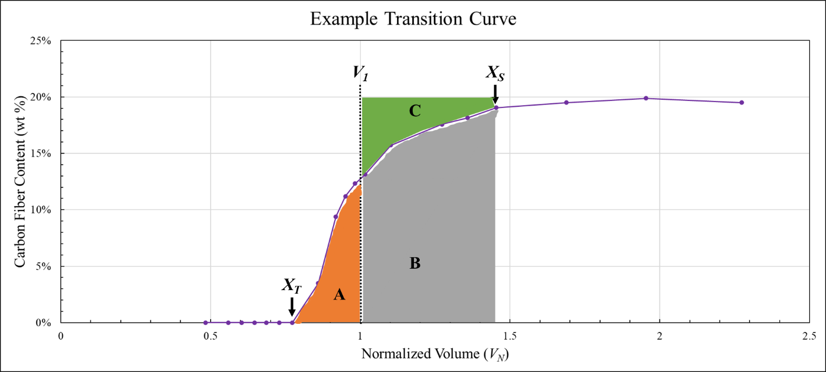
Figure 4-9. A diagram illustrating the integrals in Equation 46.
V₁ were separated into the areas of interest. Figure 4-9A represents the “missing” Material A, Figure 4-9B represents the area under the curve for the transition zone after V₁, and Figure 4-9C represents the “found” Material A that was blended into the V_{R} of Material B. This indirect method was implemented using Equation 54 where area A must be equal to area C, which was found by taking the difference of the integral of y equal to 1 and F(x) over the same distance.
$$\begin{aligned}\int_{X_{T}}^{V_{1}}{F\left(x\right) dx}=C=\int_{V_{1}}^{X_{S}}{1 dx}- \int_{V_{1}}^{X_{S}}{F\left(x\right) dx}\#\left( SEQ Equation \backslash * ARABIC 54\right)\end{aligned}$$
Equation 54 offered a useful analysis tool for determining how effective the normalized volume method was at creating an objective viewpoint from which to compare material transitions printed under different conditions. Although some material transitions closely followed this rule, others demonstrated significant deviation from expected behavior. Therefore, an additional step was added to the normalization process. Using a MATLAB script, both X_{T} and X_{S} were simultaneously shifted incrementally along the x-axis, and the size of areas and A and C were calculated after each shift. When the relative sizes were within 0.1 %, the required translation across the x-axis was recorded as the shift parameter, V_{shift}. Unless otherwise noted, all shape curves presented were constructed by applying V_{shift} to the measured X_{T} and X_{S} to isolate the effects of print parameters on transition behavior. Using this constitutive model, comparisons of material transition behavior provided more meaningful information for print design than occasionally noisy transition curves constructed from only raw data.

The influence of processing conditions and Material Properties on transition behavior

Background
Previous chapters have identified influential material and processing parameters, presented preliminary results, constructed an improved framework for comparing material transitions, and presented an effective model for predicting material transitions. This chapter compiles information from several published works [101-103, 130-132] with recent data to provide a comprehensive analysis of transition behavior. First, the effect of V_{N} on apparent trends in transition behavior was discussed. The following sections then investigate the influence of processing conditions, component design, and material viscosity on transition behavior. Since Chapter 2 illustrated the importance of screw and nozzle design, two different screw geometries and nozzle designs were used to create three BAAM configurations and study the impact of changes intended to improve mixing on transition behavior. Specifically, the quality of mixing within and length of Z_{T} were expected to be heavily influenced by changes in configuration. Further screw rotational speed was also identified as an influential factor for material mixing and melt behavior in SSE, so each configuration was used to print transitions at multiple screw speeds with expectations of capturing trends in X_{T}, and X_{S} with screw speed. Although multiple material characteristics can influence SSE, material viscosity was identified in Chapter 2 as the most influential material property. Since introducing reinforcing fillers directly impacts viscoelastic properties, material viscosity was expected to primarily influence the difference in transition behavior seen when reversing transition direction. Using the model presented in Chapter 4 to find the best fit parameters for the collected data sets, representative shape curves were generated for all printed transitions to better isolate any changes in behavior and measure zone lengths.

Experimental Conditions
MM structures and continuous FGM material transitions were printed using the BAAM dual hopper system located at Oak Ridge National Laboratory. Since this study includes work from multiple experimental plans, material transitions were printed under numerous different processing conditions using different combinations of extrusion screw designs, nozzle designs, and material pairings. Other than the intentional changes made for the study, the print conditions were kept identical between experiments where possible to ensure experimental results remained comparable.

Materials and Transition Pairings
ABS and a 20 wt % carbon fiber-reinforced ABS (CFABS) provided by Techmer Engineering Solutions. The ABS feedstock was acquired under brand names HIFILL ABS 1000 3DP and HIFILL ABS 1512 3DP, and the CFABS feedstock was acquired under brand names ELECTRAFIL J-1200/CF/20/3DP and ELECTRAFIL ABS 1501 3DP. In both cases, the change in name was for branding only and did not reflect any change in feedstock production. Experiments were carried out over multiple years, but efforts were made to utilize the material from the same batch and lot number where possible. For one experiment, this study also utilized a TPU pelletized feedstock (RESMART Ultra TPU 70A). Material transitions were printed using ABS-CFABS and TPU-CFABS pairings to study the effects of processing parameters and differences in viscosity.

Standard Processing Conditions
Several processing parameters were held constant throughout all printing procedures. The heat zones were set to match standard CFABS conditions [102] and maintain a stable melt temperature of 250 °C. The print bed was equipped with ABS build sheets and heated to 100 °C. The bead width and layer height were set to 1.4 cm (0.55 in) and 0.51 cm (0.2 in), respectively. While typically in use with BAAM, the tamper was not attached for any printed transitions. Feedstock materials were dried at 80 °C for at least four hours prior to printing of material transitions, flow rate measurements, and any other samples. Material transitions samples intended for compositional analysis were printed as a single-layer, continuous bead for each transition direction. The reverse directions of each material transition were deposited as a separate continuous bead immediately after deposition of the first direction. The schematic in Figure 5-1 shows one of three print paths used to print material transitions in both directions with transition start indicated by the red dots and sample ends indicated by the green dots. This approach ensured the material transitions were printed as separate samples by pausing extrusion while translating from 1B to 1C. The other two print paths were developed for experiments requiring a longer continuous bead and are shown in Appendix A, Figures A-4 and A-5. Representative samples of each print path were imaged and presented in Figures A-6, A-7, and A-8 provide images of representative samples printed using each schematic. While the print path
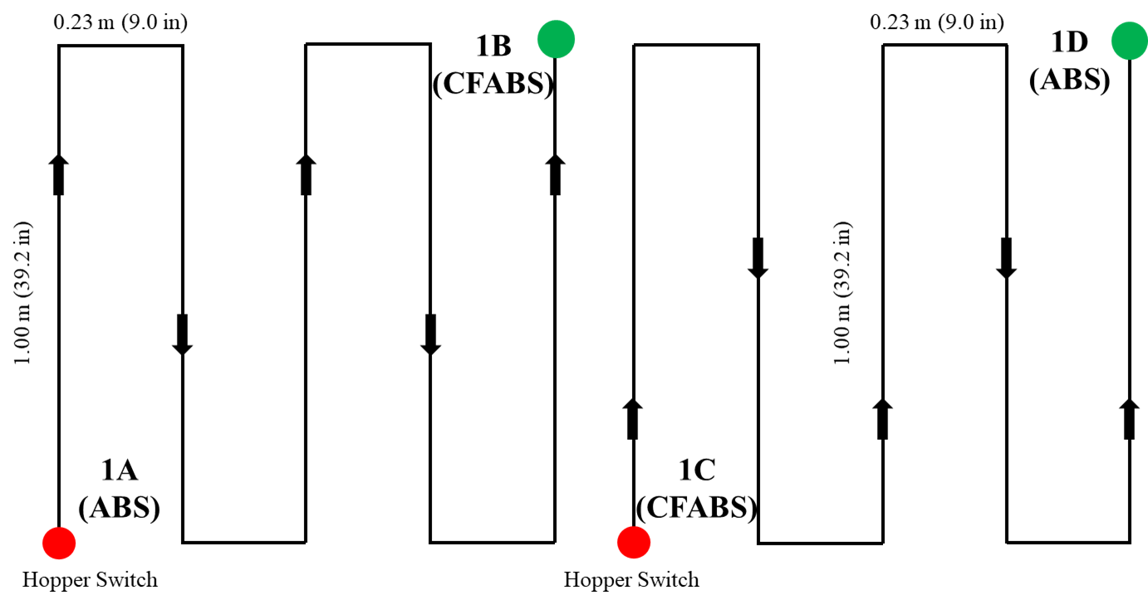
Figure 5-1. A schematic showing one of three print paths used in this study. Hopper switches were initiated at the red dots (1A, 1C).
dimensions and total travel lengths differed, the printing process and assigned bead geometry was consistent across experiments and considered a standard processing condition. Detailed labels were applied to all printed transitions to track location and direction before being sectioned using a bandsaw to facilitate storage and sampling.

Component Designs and Geometries
The effect of screw design on transition behavior investigated by printing ABS-CFABS transitions with both the standard BAAM extrusion screw and a specialized “mixing” screw. Further work investigated the impact of nozzle design on the printed material transitions by comparing a standard BAAM nozzle to a custom static mixing nozzle (SMN) design, which featured internal obstructions intended to re-direct material flow and improve mixing within the melt. The proprietary pattern of alternating slotted openings required a heating sleeve set to 255 ºC to maintain material flow and resulted in a nozzle length roughly 35 mm longer than the standard. Even though outer and inner diameters remained the same, this led to SMN-specific volumes for N_{S} (Table B-3), V_{A-S}, and V_{R} (Table B-6). The standard nozzle had a diameter of 10.0 mm (0.4 in) while the SMN had a diameter of 12.7mm (0.5 in). The standard screw and nozzle combination were only used to print ABS-CFABS transitions whereas the mixing screw and standard nozzle configuration was used to print both ABS-CFABS and TPU-CFABS transitions. The mixing nozzle was only used with the mixing screw, and this configuration was only used when printing ASB-CFABS transitions. Table 5-1 shows the four over-arching sample sets studied using a vertical border to separate each parameter. Combined, the first two columns
Table 5-1. The four parameter sets with tested screw speeds.
Screw Geometry | Nozzle Geometry | Material Pair | Screw Speed (RPM)
Standard | Standard | ABS-CFABS | 100 | 150 | 200 | 250 | 300 | 350
Mixing | Standard | ABS-CFABS | 100 | 150 | 200 | 250 | 300 | 350
Mixing | Mixing | ABS-CFABS | 100 | — | 200 | — | 300 | —
Mixing | Standard | TPU-CFABS | 100 | — | 200 | — | 300 | —
were considered a “configuration,” as previously discussed. Material transitions were printed using each configuration at the specified screw speeds in both A B and B A transition directions.

Screw Rotational Speed
Material transitions for both ABS-CFABS and TPU-CFABS were printed at multiple screw rotational speeds. As shown in Table 5-2, the ABS-CFABS transitions using the standard screw and nozzle were printed at 100, 150, 200, 250, 300, and 350 RPM. For discussion purposes, an abbreviated naming convention uses two or three letters represent nozzle type, material pair, transition direction, and screw type while the following three numbers indicated the screw speed. The SMN design was indicated by “S” whereas the absence of a letter indicated the standard nozzle. ABS-CFABS transitions used “A” to signify an ABS to CFABS direction and “C” to signify a CFABS to ABS direction. Similarly, “CT” indicated a CFABS to TPU transition while “TC” signified the opposite. The final letter always indicated screw design where “X” was the standard screw and “M” was the mixing screw. For example, CM250 was a CFABS to ABS material transition printed at 250 RPM using the standard nozzle with mixing screw. Table 5-2 also lists the printed transitions with associated abbreviations.

Material Composition
All samples for compositional analysis were extracted using an Isomet 1000 Precision Saw. Chapter 3 and previous work [102] demonstrated that samples 8.4 mm long in the print direction consistently represented the composition of the surrounding area, so
Table 5-2. Material transitions printed for this study and their associated parameters.
Abbreviation | Parameter Description
AM100 | ABS to CFABS – | Standard Nozzle – | Mixing Screw – | 100 RPM
AM150 | ABS to CFABS – | Standard Nozzle – | Mixing Screw – | 150 RPM
AM200 | ABS to CFABS – | Standard Nozzle – | Mixing Screw – | 200 RPM
AM250 | ABS to CFABS – | Standard Nozzle – | Mixing Screw – | 250 RPM
AM300 | ABS to CFABS – | Standard Nozzle – | Mixing Screw – | 300 RPM
AM350 | ABS to CFABS – | Standard Nozzle – | Mixing Screw – | 350 RPM
AX100 | ABS to CFABS – | Standard Nozzle – | Standard Screw – | 100 RPM
AX150 | ABS to CFABS – | Standard Nozzle – | Standard Screw – | 150 RPM
AX200 | ABS to CFABS – | Standard Nozzle – | Standard Screw – | 200 RPM
AX250 | ABS to CFABS – | Standard Nozzle – | Standard Screw – | 250 RPM
AX300 | ABS to CFABS – | Standard Nozzle – | Standard Screw – | 300 RPM
AX350 | ABS to CFABS – | Standard Nozzle – | Standard Screw – | 350 RPM
CM100 | CFABS to ABS – | Standard Nozzle – | Mixing Screw – | 100 RPM
CM150 | CFABS to ABS – | Standard Nozzle – | Mixing Screw – | 150 RPM
CM200 | CFABS to ABS – | Standard Nozzle – | Mixing Screw – | 200 RPM
CM250 | CFABS to ABS – | Standard Nozzle – | Mixing Screw – | 250 RPM
CM300 | CFABS to ABS – | Standard Nozzle – | Mixing Screw – | 300 RPM
CM350 | CFABS to ABS – | Standard Nozzle – | Mixing Screw – | 350 RPM
CX100 | CFABS to ABS – | Standard Nozzle – | Standard Screw – | 100 RPM
CX150 | CFABS to ABS – | Standard Nozzle – | Standard Screw – | 150 RPM
CX200 | CFABS to ABS – | Standard Nozzle – | Standard Screw – | 200 RPM
CX250 | CFABS to ABS – | Standard Nozzle – | Standard Screw – | 250 RPM
CX300 | CFABS to ABS – | Standard Nozzle – | Standard Screw – | 300 RPM
CX350 | CFABS to ABS – | Standard Nozzle – | Standard Screw – | 350 RPM
SAM100 | ABS to CFABS – | Mixing Nozzle – | Mixing Screw – | 100 RPM
SAM200 | ABS to CFABS – | Mixing Nozzle – | Mixing Screw – | 200 RPM
SAM300 | ABS to CFABS – | Mixing Nozzle – | Mixing Screw – | 300 RPM
SCM100 | CFABS to ABS – | Mixing Nozzle – | Mixing Screw – | 100 RPM
SCM200 | CFABS to ABS – | Mixing Nozzle – | Mixing Screw – | 200 RPM
SCM300 | CFABS to ABS – | Mixing Nozzle – | Mixing Screw – | 300 RPM

Table 5-2 Continued

Abbreviation | Parameter Description
TCM100 | TPU to CFABS – | Standard Nozzle – | Mixing Screw – | 100 RPM
TCM200 | TPU to CFABS – | Standard Nozzle – | Mixing Screw – | 200 RPM
TCM300 | TPU to CFABS – | Standard Nozzle – | Mixing Screw – | 300 RPM
CTM100 | CFABS to TPU – | Standard Nozzle – | Mixing Screw – | 100 RPM
CTM200 | CFABS to TPU – | Standard Nozzle – | Mixing Screw – | 200 RPM
CTM300 | CFABS to TPU – | Standard Nozzle – | Mixing Screw – | 300 RPM
specimens were cut to be between 8.4 mm and 10.0 mm. Selecting locations for composition testing was a recursive process. Initially, testing sites were selected visually based on color and expected transition behavior. Thereafter, the measured compositions were consulted to identify where greater resolution in the shape curve was needed.
Following the procedure presented in Chapter 3.2, material composition was determined using UAD to measure the wt % CF in each specimen. The ABS-CFABS transitions utilized 50 mL of acetone as a solvent to separate matrix and fibers. Since TPU exhibited a significant chemical resistance to acetone, TPU-CFABS samples were submerged in 60 mL of dimethyl sulfoxide (DMSO) [133]. All solutions were contained in sealed borosilicate glass test tubes and suspended in a CPX3800 Ultrasonic Bath heated to 50 °C to increase the reaction rate. The time required for complete dissolution varied from 2 hr for ABS-CFABS transition specimens in acetone to 15 hr for TPU-CFABS samples using DMSO. Despite the slow dissolution process, DMSO was preferred in later studies due to an improved accuracy at low fiber weightings. Fibers were separated through vacuum filtration using Whatman Grade GF/A glass microfiber filters (47 mm diameter with 1.6-micron pores). Samples were dried at 80 °C for four hours prior to UAD and after vacuum filtration to obtain the dry mass of both the initial composite and residual fibers using a RADWAG AS 220.R2 with 0.1 mg accuracy.

Measuring Complex Viscosity
Viscoelastic properties were anticipated to influence transition behavior, specifically the difference in material viscosity as outlined in Chapter 2. Initial curves presented in Chapter 3 illustrated this expected effect by showing the difference caused by reversing transition direction. The complex viscosity, η*, of ABS, CFABS, and TPU were determined using TA Instruments Discovery Hybrid Rheometer-2 (DHR2) and 25 mm parallel plate geometry by performing oscillatory frequency sweeps between 628 rad/s and 0.1 rad/s with an applied strain of 0.1 % [60, 134]. Although TPU is typically processed at lower temperatures, the tests were conducted at 250 °C to simulate the printing environment. Complex viscosities were recorded and compared to illustrate the difference in viscoelastic behavior and material flow under the applied processing conditions.

Material Densities
The density of each material was measured for four different material states. The bulk densities (ρ_{b}) of the pelletized feedstock were measured five times and averaged in accordance with ASTM D1895 using a custom apparatus constructed with the specified materials and dimensions [119]. The melt density (ρ_{m}) at 250 °C was measured using a Dynisco Laboratory Capillary Rheometer 7001 (LCR) as instructed by ASTM D3835 [120]. The LCR was also used to find the compressed bulk density (ρ_{c}) by applying pressure to feedstock of a known mass at room temperature then calculating the density using the known chamber dimensions and plunger position. Changes in ρ_{c} due to increased pressures at higher screw speeds were considered negligible due to documented evidence showing that ABS and other amorphous thermoplastics exhibited minimal relationship between density and pressure [121]. These constant densities were reported in Table 5-3. The densities of the printed extrudates (ρ_{E}) were measured using a Quantachrome Helium
Table 5-3. Measured material densities.
Material | Bulk Density, ρ_{b} (g/cm³) | Compressed Bulk Density, ρ_{c} (g/cm³) | Melt Density, ρ_{m} (g/cm³)
ABS | 0.664 | 0.653 | 0.916
CFABS | 0.633 | 0.6683 | 0.894
TPU | 0.715 | 0.715 | 0.876
Pycnometer and standard deviation goal of 0.0005 g/cm³, following ASTM D792 and ASTM D6226 when possible [122, 123]. The ρ_{E} measured for each condition was reported in Appendix B, Table B-7.

Volumetric Flow Rates
Since multiple BAAM configurations and screw speeds were used in these experiments, Q was measured for each combination indicated in Table 5-2Error! Reference source not found. to obtain accurate flow rate measurements for all print conditions. For all measurements, a timed extrusion using BAAM dual hopper was conducted, and Q was calculated from the dry mass of the extrudate, elapsed time, and ρ_{E}, per Equation 4-14 and ASTM D1238 Procedure A [118]. The measured flow rates were also reported in Table B-7.

Analyzing Transition Behavior
Initial transition curves were plotted as a function of length and V_{N} to illustrate the importance of normalization. Transition analysis was conducted using the normalized volume framework to plot material composition as a function of V_{N} detailed in the previous chapter. The V_{R} for each system configuration was calculated using measured material properties and component volumes obtained from 3D models and reported in Table B-6. Gantry travel speeds were pulled from the g-code generated for each print, and the travel distance was measured along the center of the bead to match the movement specified by the g-code. The travel speeds for each print path schematic at each screw speed are reported in Appendix B, Table B-8. The zone lengths for each transition were measured, and the model presented in Chapter 4 was implemented to quantify transition behavior as a function of transition start (X_{T}), stop (X_{S}), and initial slope. Initial slope was defined as the derivative of the model at 1 % of the material transition. These parameters were used to compare transition behavior across print conditions. Finally, to satisfy the physical conditions imposed by V₁, the modeled curves were translated by V_{shift}.

Results and Discussion
Material transition shape curves were created using the normalized volume method and UAD to plot material composition as a function of V_{N}. The curves generated were fit to the transition curve model. The modeled curves were shifted to satisfy the conditions for V₁ using V_{shift}. In each section, the raw shape curves were discussed first and the modeled curves after applying V_{shift} second.

Complex Viscosity Measurements
Figure 5-2 shows the complex viscosity (η*) across the measured frequency range for ABS, CFABS, and TPU pellets. As expected, ABS and CFABS exhibited shear-thinning behavior throughout the tested frequency range [108, 134]. The difference in η* was approximately an order of magnitude, concurring with literature expectations that the addition of fibers to a polymer matrix will significantly increase viscosity due to fiber-fiber interactions [135]. During testing of TPU pellets, material loss and discoloration that suggested matrix degradation was observed and led to minimal material remaining between the parallel plate assembly, forming TPU tendrils connecting the parallel plates indicative
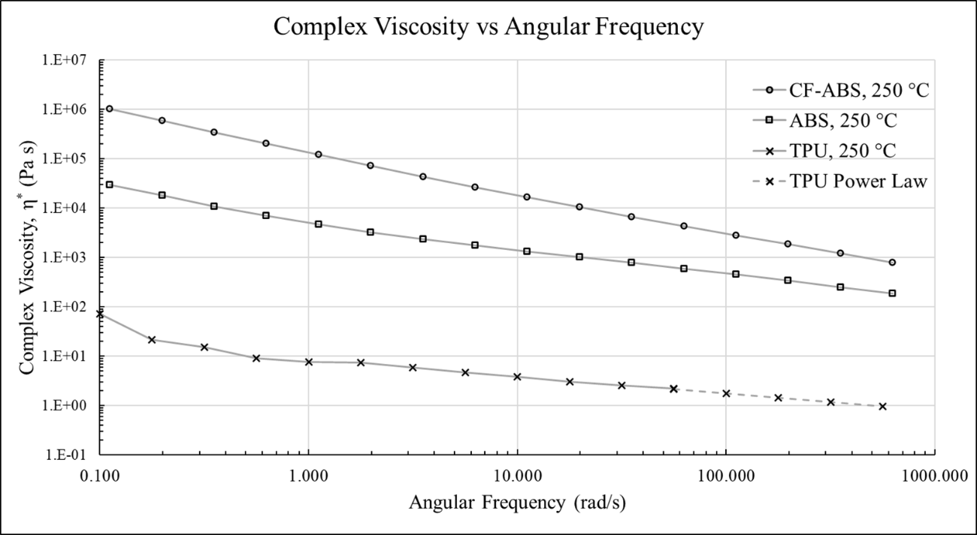
Figure 5-2. Frequency sweeps of CFABS, ABS, and TPU were conducted at 250 °C.
of viscous fingering. Consequently, the latter data points in a TPU sweep exhibited significant noise, regardless of sweep direction. Typical processing conditions for TPU utilize significantly lower temperatures than those required for CFABS [93], so this behavior was attributed to the elevated testing temperatures As can be seen in Figure 5-2, valid data was still obtained at lower frequencies, but even limiting tests to a single frequency did not prevent material loss at higher frequencies. Literature indicated that TPU remains shear-thinning at high frequencies, so a power law fit was applied to the TPU data and used to predict η* for the unobtainable high frequencies [136, 137]. Since BAAM processing induces high shear rates near 100 s⁻¹ [60, 138], the η* at 628 rad/s provided the most informative comparison of material viscosity during printing. Therefore, CFABS was expected to exhibit η* nearly an order of magnitude greater than ABS and three orders of magnitude greater than TPU during printing of material transitions.

Effect of Normalized Volume
While covered briefly in previous chapters, the effect of the normalized volume method can significantly change how the influence of a parameter or property was interpreted. Figure 5-3 presents one such case using the full set of AM100, 150, 200, 250, 300, and 350 printed transitions plotted as a function of travel distance (A) and V_{N} (B). Although analyzing the transition behavior across travel distance indicated that an increasing screw speed significantly shifted transition behavior, assessing the same data as a function of V_{N} suggested that there was minimal correlation. This illustrates the importance of using a volumetric approach that reflected actual material deposition rather
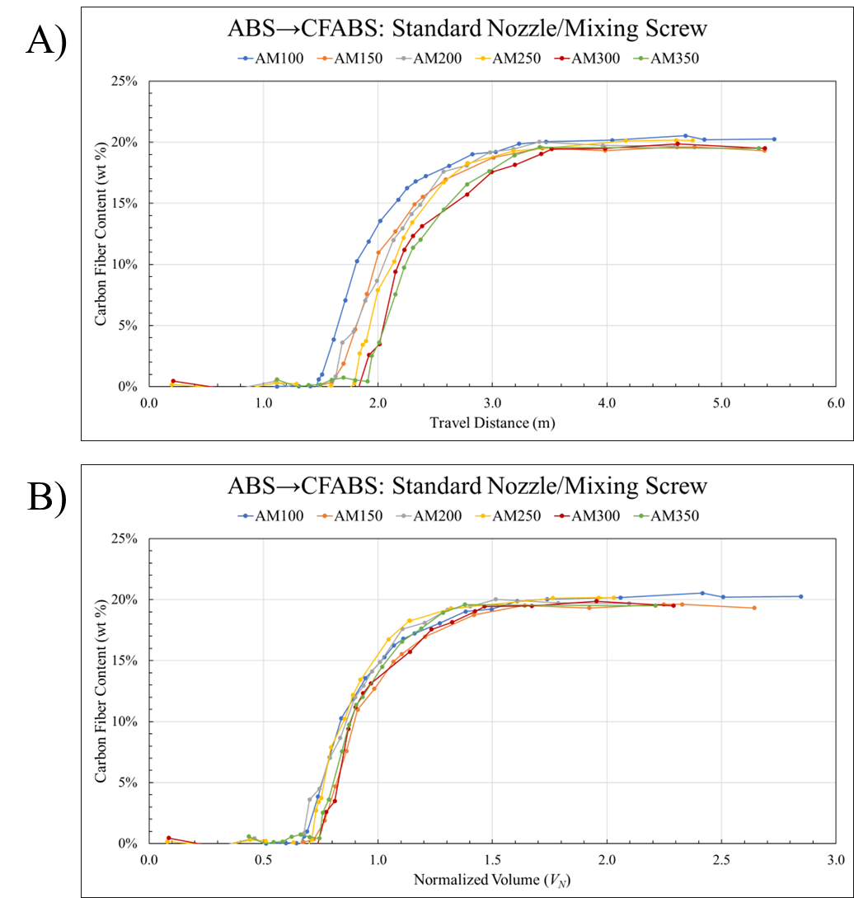
Figure 5-3.The AM configuration transitions as a function of A) travel distance and B) normalized volume.
than relying on expectations that the same volume of material would be deposited for every transition despite the change in material and processing conditions.

Extrusion Screw Rotational Speed
First, the influence of screw rotational speed was investigated. Figure 5-3 indicates that, after placing the shape curves on an appropriate scale for comparative analysis, there was negligible difference in transition behavior due to screw speed. Although contrary to expectations, the changes in SSE associated with screw speed could be obscured by the noise of transition curve measurements. Table B-9 shows that even an exaggerated shifting of the melt location by 4D to the end of the feed zone of the screw led to a less than 5 % reduction in V_{R} from 100 RPM to 300 RPM, suggesting that screw speed effects on zone lengths and locations should be negligible. Figure 5-4 provides the shape curves generated for CM100, 150, 200, 250, 300, and 350. Although there appeared to be some indication that higher screw speeds led to a slightly shorter Z_{P}, the difference was not significant enough to rule out the effect as noise. Therefore, the location and shape of the transition was considered uninfluenced by screw speed.
Figure 5-5 compares the 100 RPM and 300 RPM transitions for both directions using the standard nozzle and mixing screw. The significant overlap once again suggests that screw speed was not an influential parameter for transition behavior, which remained true as additional shape curves from other parameter combinations were constructed. More importantly, the disparity in curve onsets with transition direction suggested that even less than an order of magnitude difference in viscosity could impact transition behavior.
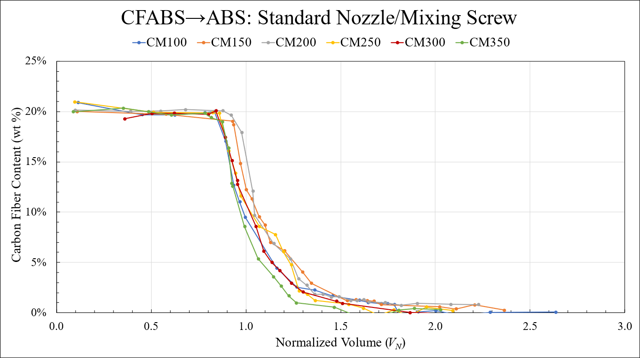
Figure 5-4. Measured shape curves for the CM configuration.
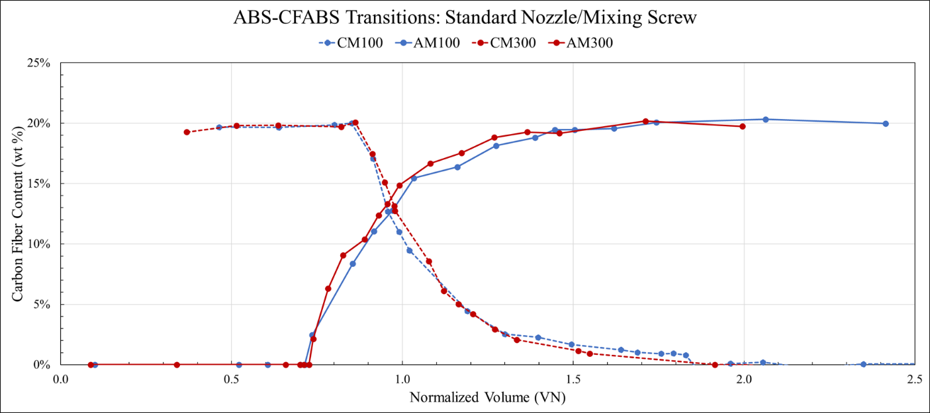
Figure 5-5. ABSCFABS and CFABSABS showing the effect of transition direction.
Figure 5-6 shows the fit and shifted models for each of the six material transitions. Here, the 100, 150, and 200 RPM curves were nearly identical while the 250, 300, and 350 RPM curves exhibited no trend related to screw speed. However, applying V_{shift} did show that the closer X_{T} was to 1, the shorter the resulting transition zone. This effect was an expected consequence of the physical limitations imposed by V_{R}. Figure 5-7 quantified this behavior for both the AM (blue) and CM (gray) (Appendix A, Figure A-9) sample sets by taking the derivative of the model to measure the instantaneous slope where the transition was 1 % complete. In all but the 250 RPM transitions, the derivative was higher for CM than AM, suggesting that the change in composition was occurring faster for CFABSABS transitions than ABSCFABS. This trend supports the observations from Figure 5-5 that changing transition direction directly affected X_{T} and quantifies the “steeper” gradients seen in the CM curves with shorter Z_{T}.

Extrusion Screw Design
Using the previous figures, the influence of screw design (mixing vs standard) was investigated by comparing material transitions printed under the same specified conditions using a standard screw design instead of the custom mixing design developed for BAAM. While the measured shape curves for the ABS to CFABS direction with standard screw and nozzle (AX) configuration (Appendix A, Figure A-10) exhibited significant overlapping behavior similar to Figure 5-4, the model results shown in Figure 5-8 had noticeably different shapes. Since there was once again no correlation to screw speed, the average X_{T} and X_{S} were taken for all six screw speeds to act as representative of transition
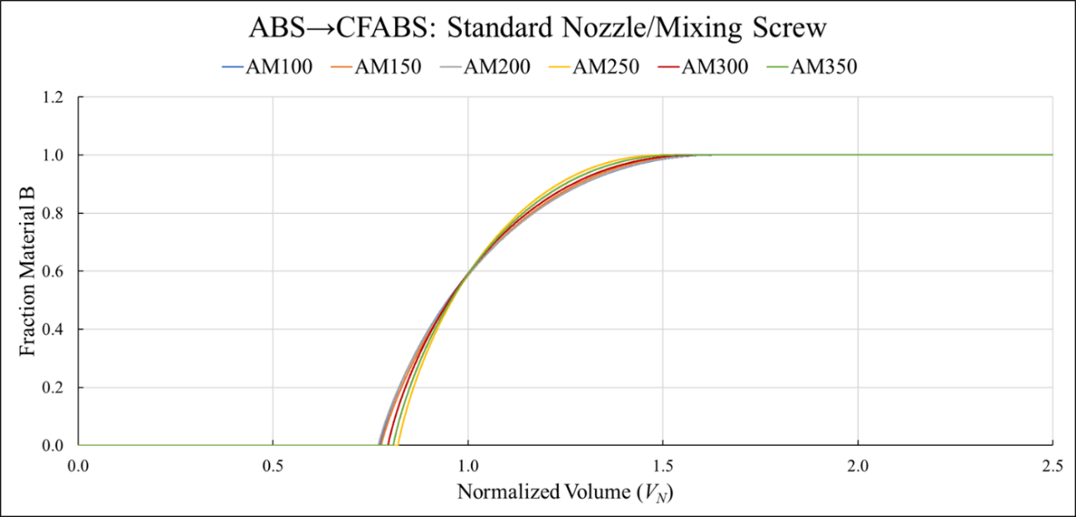
Figure 5-6. The modeled shape curves for the AM configuration.
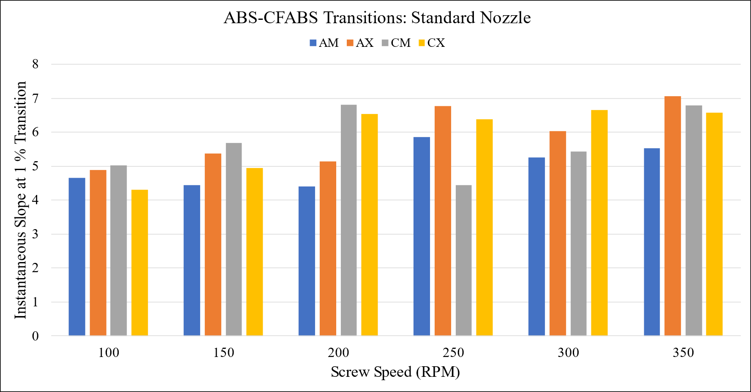
Figure 5-7. The instantaneous slope at 1 % completion of material transition, representing the “steepness” of each curve.
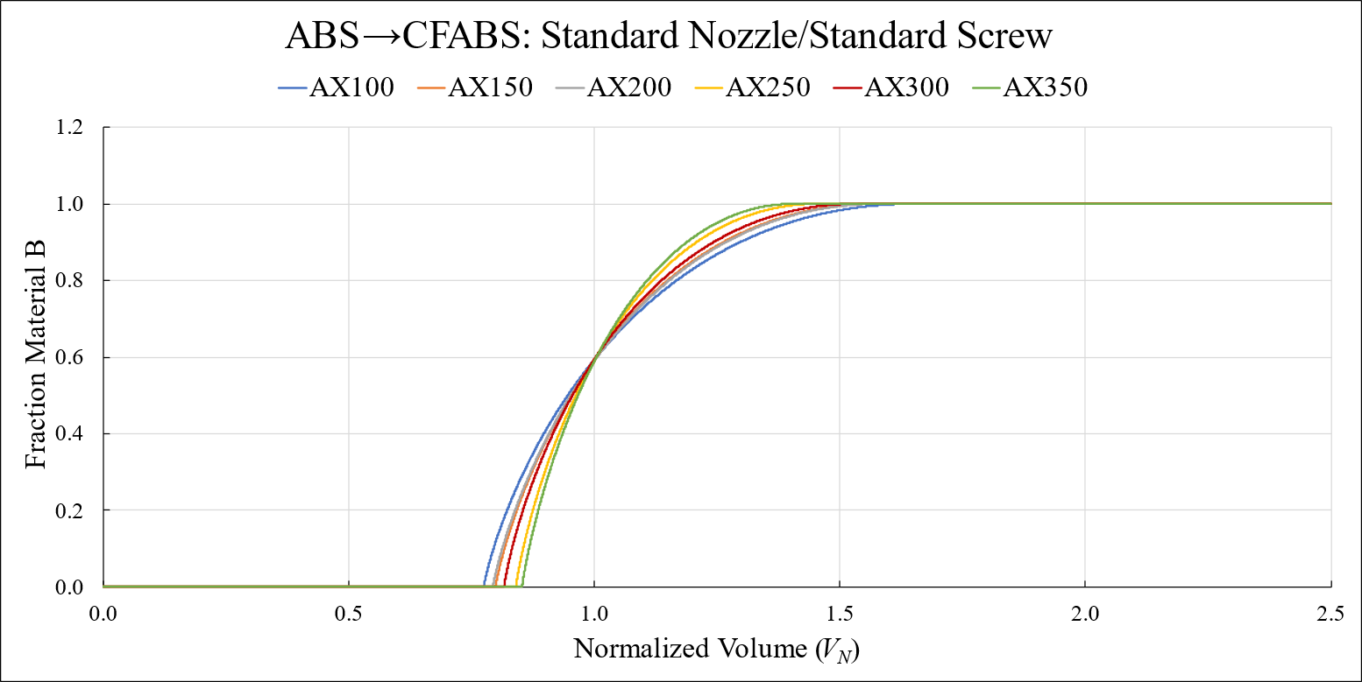
Figure 5-8. The modeled shape curves for the AX configuration.
behavior using this configuration. When comparing the average values, the AX configuration had a longer Z_{P}, shorter Z_{T}, and smaller L_{S} than the AM configuration, indicating a shorter overall material transition. Although the differences were small, these findings suggest that the mixing screw design increased mixing during extrusion such that the discrete feedstock boundary was extended over a greater material volume than when using the standard design.
For the opposite direction, the effect of geometry was unclear. The CFABS to ABS transitions with standard screw and nozzle (CX) printed at 100 RPM (CX100) and 150 RPM (CX150) transitions were outliers both in the measured shape curves (Appendix A, Figure A-11) and in the modeled shape curves shown in Figure 5-9. Interestingly, the separation between the two outlier transitions and the other four increased after modeling. For the CX configuration, the average X_{T} and X_{S} were 0.81 and 1.52, respectively. Comparing the average X_{T} (0.81) and X_{S} (1.54) for the CFABS to ABS direction with mixing screw and standard nozzle (CM) configuration shows a nearly exact match. However, if CX100 and CX150 were not considered representative of the other CX transitions, X_{T} increased (0.84) and X_{S} decreased (1.45), matching the trends seen for the opposite direction transitions. Overall, this suggests that the increase in mixing during extrusion caused by the mixing screw design led to increased blending of the discrete boundary, elongating the material transition.
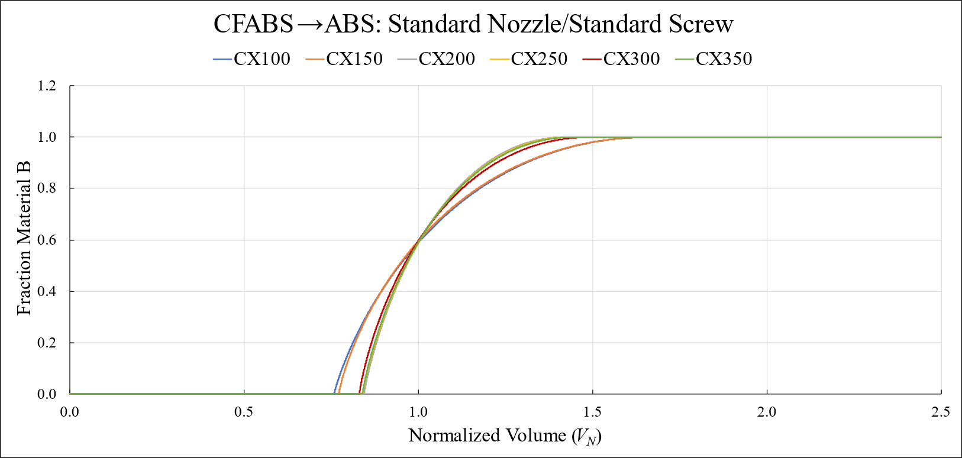
Figure 5-9. The modeled shape curves for the CX configuration.

Nozzle Design
While investigating the influence of nozzle design on transition behavior, a distinct difference in the extrudate was observed. As shown by images in Figure 5-10 from previously published work [130], there was a significant difference in cross-section geometry when comparing transitions printed using the standard nozzle (A) to the SMN (B). As a result, the cross-sectional area of the beads decreased despite maintaining print conditions and dimensions. Furthermore, artificially brightening each image equally illustrated a morphology change where the SMN sample contained fewer instances of discrete regions, suggesting improved mixing. As can be seen in Tables B-7 and B-8, increasing screw speeds caused greater increases in Q for the standard nozzle than the mixing nozzle, and the travel speed for the mixing prints was slightly faster for the mixing nozzle than the standard. Due to these differences, the SMN was effectively depositing a smaller bead throughout the print, explaining the discrepancy in shape and area. This unexpected change in behavior again demonstrated the effectiveness of the normalized volume method, which inherently included the changes in deposition when calculating sample location and transition progression.
In relation to transition behavior, the reduced Q measured for the SMN transitions was likely due to the complex internal geometry inhibiting material flow, as intended by the design. If the flow was inhibited, an equivalent increase in back-pressure flow would be expected. In turn, the interactions between the drag flow and back-pressure flow during SSE should increase, which typically leads to increased mixing of the polymer melt [139].
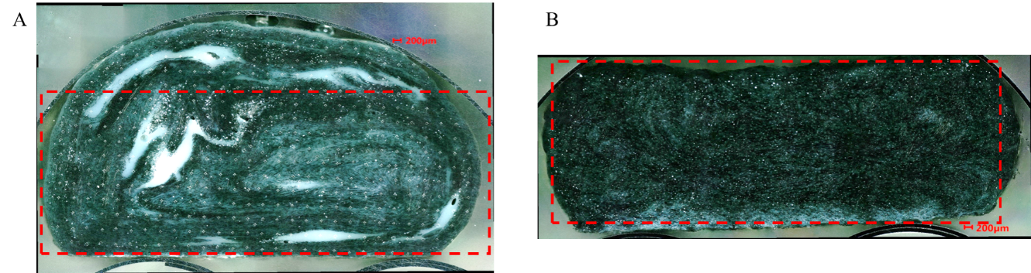
Figure 5-10. Brightened optical images of cross-sections with similar fiber content printed using different nozzle types: A) standard and B) static mixing.
Therefore, if the observations in the previous section hold true, transitions printed with both the mixing screw and SMN were expected to show signs of increased mixing, such as a shortened Z_{P} and larger L_{S}. The top and bottom of Figure 5-11 show the modeled shape curves for the ABS to CFABS direction with mixing nozzle and screw (SAM) and CFABS to ABS direction with mixing nozzle and screw (SCM) configurations as A) and B), respectively. The original measured shape curves were included in Appendix A, Figure A-12. For the SAM configuration, average values of X_{T} (0.71) and X_{S} (1.83) were significantly different from the previous configurations, matching expectations of increased mixing. Notably, the increase in L_{S} was much greater than the reduction in L_{P}, but the material composition at V₁ continued to be approximately 60 % material B. As with previous configurations, transitioning from high viscosity to low viscosity reduced the mixing behavior, leading to a comparatively longer Z_{P} and shorter Z_{T}. Including all three transitions, the mixing nozzle exhibited minimal influence on transition behavior in the CFABS ABS direction when comparing SCM X_{T} (0.81) and X_{S} (1.55) to the CM configuration. However, discarding SCM100 as an outlier increases X_{T} (0.82) and decreases X_{S} (1.50) to values between CX and CM configurations. This suggests the possibility that the increased back-pressure flow increases mixing within the CFABS, but the change was negligible compared to the ASB CFABS direction due to the much higher viscosity of CFABS.
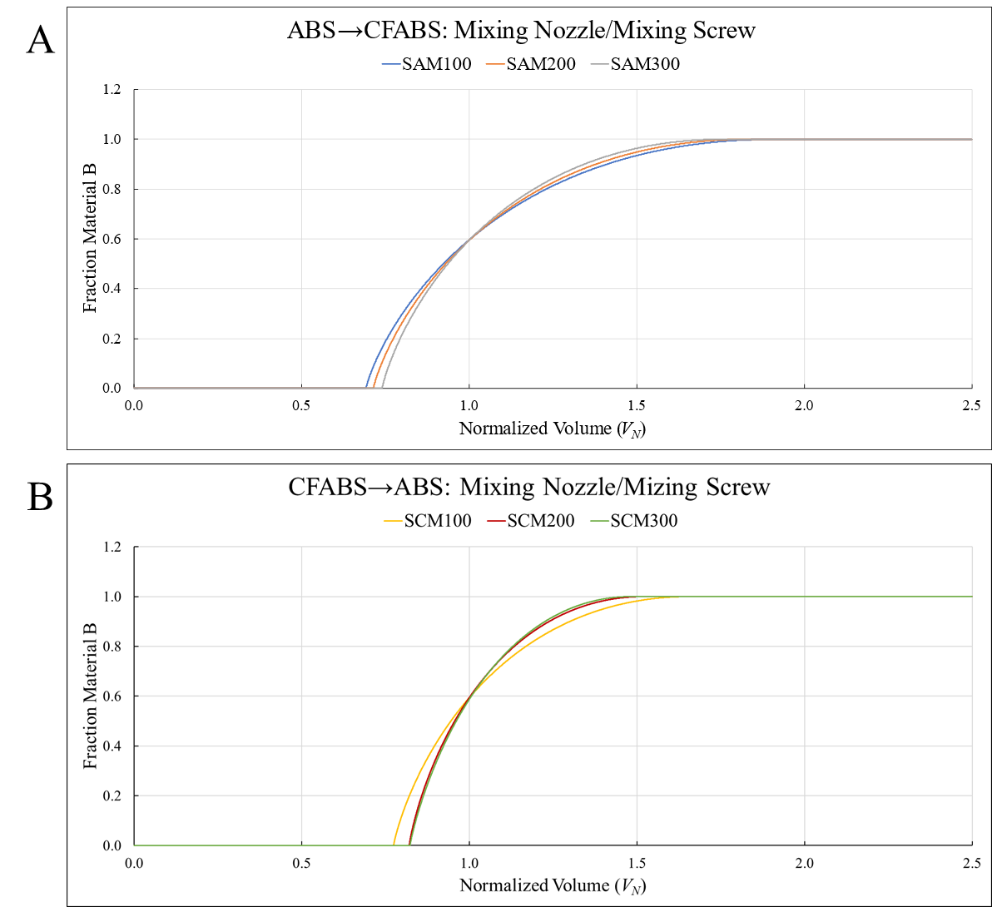
Figure 5-11. The modeled shape curves for the A) SAM and B) SCM configuration.

Significantly Different Complex Viscosities
A second material pair was investigated to further study the influence of transition direction and the role of the difference in viscosity. Figure 5-12 shows the modeled shape curves for the TPU to CFABS direction with mixing screw and standard nozzle (TCM) (A) and CFABS to TPU with mixing screw and standard nozzle (CTM) (B) configurations. As before, the material transitions were not affected by changes in screw speed, leading to nearly overlapping shape curves. The TCM configuration had an average X_{T} of 0.74 and X_{S} of 1.71 while the CTM configuration had an average X_{T} of 0.78 and X_{S} of 1.63. Again, transitioning from high viscosity to low viscosity produced a comparatively shorter Z_{T}. In addition, the increased difference in viscosity for the TPU and CFABS compared to ABS and CFABS led to relative increases in Z_{T} for both transition directions. The CTM configuration L_{T} was larger than the other three transitions starting with CFABS, but the TCM configuration L_{T} was only larger than the AM and AX configurations.

Summary and Conclusions
The complex viscosities of the three materials studied were found using parallel plate rheology. η* for CFABS was nearly an order of magnitude larger than for ABS and three orders of magnitude larger than for TPU at typical BAAM processing conditions for CFABS. Two examples were provided that demonstrated the importance of the normalized volume method for analyzing material transitions. Comparing V_{N} to travel distance showed that measuring transition location by travel distance alone failed to consider changes in volumetric throughput, and comparing bead cross sections printed using different nozzle
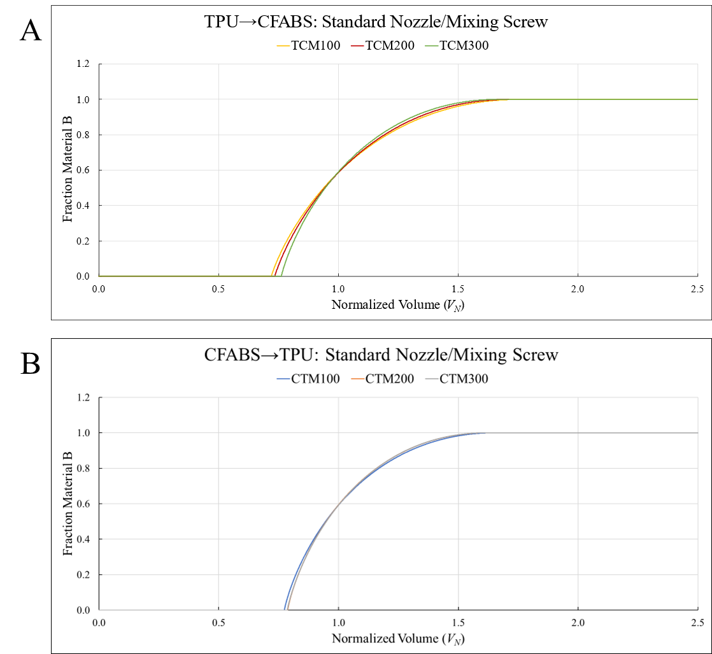
Figure 5-12. The modeled shape curves for the A) TCM and B) CTM configuration.
designs illustrated the need for a method that included print deviation from the programmed g-code in the analysis steps to avoid inaccurately representing material transitions.
The influence of screw speed on transition behavior was negligible across all studies, so transitions printed at different screw speeds using the same configurations were treated as similar samples within a set. An average transition curve for a given configuration was then determined by averaging X_{T} and X_{S}. Table 5-4 summarizes the resulting values and includes the average X_{P} to compare the impact of component design and material viscosity on the behavior of dual hopper material transitions. Clearly, the addition of mixing designs led to reduced purge lengths (smaller X_{T}) and increased transition lengths (L_{T}), indicating that the material boundary was distributed across a greater volume of material due to the increased mixing during SSE. Although the decreasing X_{T} contributed to the extension of L_{T} with the addition of mixing designs, an increasing X_{S} provided a greater fraction of the increase in L_{T}. For the studied components, the SMN exhibited a greater impact than the mixing screw. While this held true for both ABS to CFABS and CFABS to ABS transition directions, the effect was significantly greater in the former. Investigating the effect of viscosity on transition direction differences was best illustrated by comparing the TPU-CFABS transitions to the ABS-CFABS transitions printed with the same configurations. As expected, increasing the difference in complex viscosities between the constituent materials led to an extended transition zone, as indicated by the differences in L_{T}. Again, this was indicative of an increase in mixing during SSE. Therefore, both component design and the difference in material viscosities were both shown to influence the length of the transition zone. For BAAM dual hopper, transition direction determined which of the two factors had the greatest influence. When increasing in viscosity, the material transitions were more sensitive to component design while transitions decreasing in viscosity were more sensitive to the difference in viscosity of the two material viscosities. Although absolute limits exist due to material switching mechanism, these results suggest that transitions could be tuned by adjusting component design or including viscosity modifiers in the desired materials, enabling intentional design of the continuous FGM produced by BAAM dual hopper material transitions. For example, introducing a mixing nozzle to the TPU-CFABS transitions would be expected to further reduce X_{T} and increase X_{S} past those measured for the ABS-CFABS transitions printed using the mixing nozzle.
Table 5-4. The transition start and stop points and L_{T} showing the various zone lengths.
Transition Direction | ABS to CFABS |  |  | TPU to CFABS | CFABS to ABS |  | CFABS to TPU
Screw Design | Standard | Mixing | Mixing | Mixing | Standard | Mixing | Mixing | Mixing
Nozzle Design | Standard | Standard | Mixing | Standard | Standard | Standard | Mixing | Standard
X_{T} (Transition Start) | 0.81 | 0.79 | 0.72 | 0.74 | 0.84 | 0.81 | 0.81 | 0.78
X_{S} (Transition End) | 1.53 | 1.58 | 1.83 | 1.71 | 1.45 | 1.54 | 1.56 | 1.63
L_{T} (Transition Length) | 0.72 | 0.77 | 1.12 | 0.97 | 0.71 | 0.73 | 0.75 | 0.85

In-Situ Mixing and Mechanical Characterization of Transitions

Background
Mechanical performance of the transition region is paramount for design of printed structures, and the microstructure of the base material largely determines the properties of the structure. For LFAM, the interaction is exacerbated by two different levels of microstructure: the constituent beads and the internal microstructure of each bead. As such, the internal microstructure and inter-bead adhesion both contribute to overall mechanical performance and may also be impacted by a material transition. Previous studies have documented inhomogeneous microstructures when using standard BAAM dual-hopper equipment {Brackett, 2022 #493}, and more examples are provided in Figure 6-1. These observations of inhomogeneous morphologies and regional microstructures motivated initial attempts to improve mixing during extrusion. A custom technique was used to roughly quantify how “mixed” the cross-section of the bead was, and then a series of microhardness indentations were conducted. To complement this microstructural evaluation, DMA and tensile testing were conducted on multi-layer, printed structures, and the resulting storage moduli were plotted as a function of material composition. Then, the initial print was compared to structures printed with differing nozzle designs to determine if improvements in mixing affected full-structure properties.
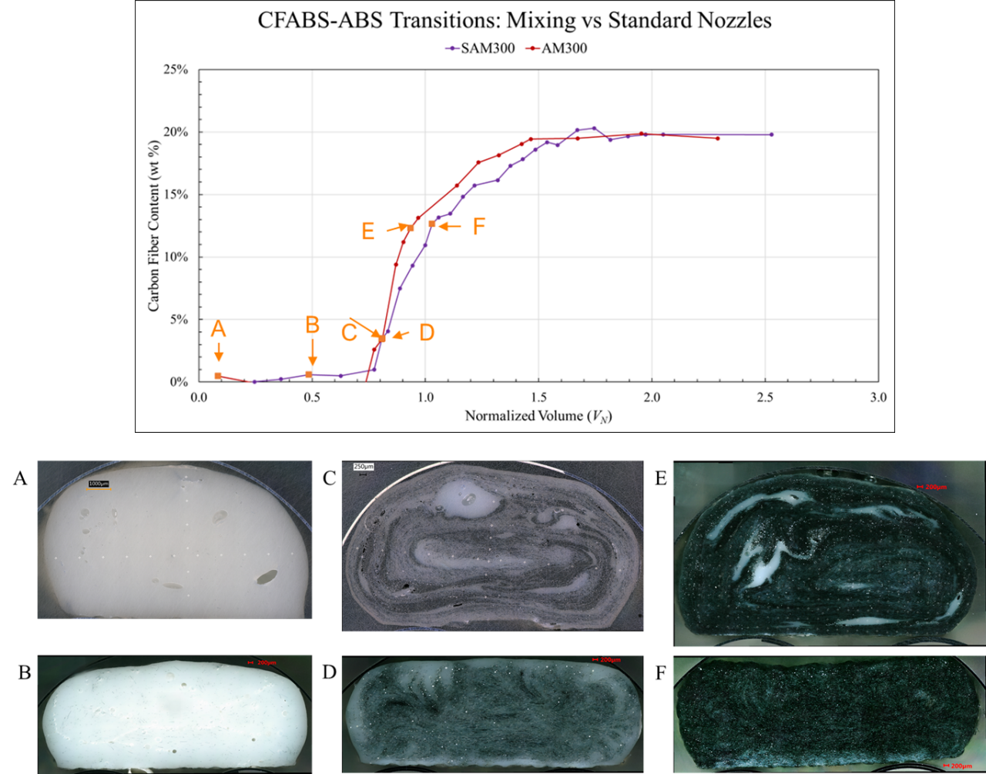
Figure 6-1. A comparison of bead microstructures from two material transitions that differed only in nozzle design: standard (A, C, and E) and static mixing (B, D, and F).

Experimental
Unless otherwise listed, experimental conditions were kept identical to those in Chapter 5. Samples were printed using BAAM dual hopper. Microhardness and optical imaging cross-sections were taken directly from printed transitions described in Chapter 5. Mechanical specimens were obtained from single-walled prints that allowed the transition to start at the same place and significant time to end before moving to the next transition sample. Three nozzle designs were utilized with the mixing screw to create three configurations for each transition direction. Dynamic Mechanical Analysis (DMA) and UAD were used to obtain storage moduli and material compositions, respectively. These two properties were then plotted as a function of a normalized extruded volume to assess mechanical response as a function of material composition within the transition region.

Materials
Two materials provided by Techmer PM were used for all prints: HIFILL ABS 1512 3DP (ABS) and ELECTRAFIL ABS 1501 3DP (CFABS). Prior to printing and mass measurements, feedstock, printed samples, and UAD residue were dried at 80 °C for at least four hours.

Nozzle Design
Three different nozzle designs were used to print material transition “U’s”. In addition to the standard and SMN designs studied in Chapter 5, a second iteration of the SMN design was used that employed a compression zone that added roughly 15 mm of length compared to the original design (50 mm compared to the standard nozzle). This new compression static mixing nozzle (C-SMN) was used solely for mechanical sample prints and differed internally from the SMN design only by the addition of a tapered internal diameter after the static mixing geometries. Again, unique nozzle assembly and residual volumes were calculated using C-SMN models (Tables B-3 and B-6). The diameters of the standard, SMN, and C-SMN were 1.02 cm (0.4 in), 1.27 cm (0.5 in), and 0.76 cm (0.3 in), respectively.

BAAM Extrusion Conditions
Thermal conditions were kept constant using a 250 ºC melt temperature, a 100 ºC bed temperature, and a 255 ºC nozzle temperature for each set of print conditions. Each print was deposited onto ABS build sheets that were attached to the build platform. The mixing screw design was used for all prints unless otherwise specified when discussing a cross-section from Chapter 5. Bead width and height were set to 1.40 cm (0.55 in) wide and 0.51 cm (0.20 in) tall for the standard and SMN. The C-SMN prints used 1.02 cm (0.4 in) and 0.38 cm (0.15 in) to accommodate the smaller nozzle diameter. Standard and SMN prints were 35 layers tall while the C-SMN prints were 47 layers tall to achieve approximately a height of 17.8 cm (7.0 in). Due to the extended length and heating attachment required for the mixing nozzles, the tamper typically included in BAAM prints to improve layer bonding was not used. The rotational speed of the extrusion screw was held constant at 300 RPM for all new prints, and all cross-sections investigated were extracted from transitions printed at 300 RPM. The travel speeds were 9.90 cm/s (3.8976 in /s), 9.90 cm/s (3.8976 in/s), and 20.30 cm/s (7.9921 in/s) for the standard, SMN, and C-SMN prints, respectively. The layer times were 137 s for standard and SMN prints and 160 s for the C-SMN printed structures.

Print Path Design
Cross-sections for optical imaging, grayscale analysis, and microhardness indentation were extracted from already-printed material transitions discussed in Chapter 5. They were identified using the previous nomenclature (Table 5-2), i.e. SAM200 indicates a static mixing nozzle with mixing screw printed a transition in the ABS CFABS direction at 200 RPM.
Two new print path designs developed to accommodate mechanical samples were utilized in this chapter. The first new design shown in Figure 6-2A was used for standard and static mixing nozzle (SMN) prints. An example print is shown in Figure 6-2B. The zero-infill, block “U” shape was intended to minimize the number of corners while also limiting the number of walls too small for sample extraction. The printed parts were 27 layers tall, approximately 14 mm.
The second new print design is shown in Figure 6-3. The C-SMN was expected to require a significantly longer travel distance to complete the material transition due to a significantly reduced flow rate at the specified conditions. Therefore, additional “legs” were added to the original block “U” to add in more straight walls while still limiting the material printed into un-usable corners.

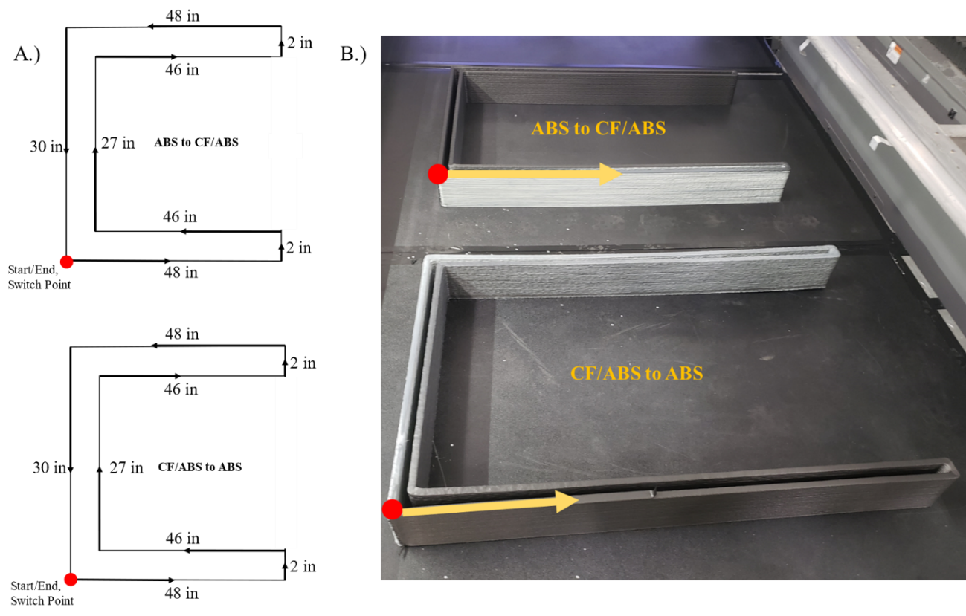
Figure 6-2. A) A schematic of the block “U” print path. B) Completed U prints.
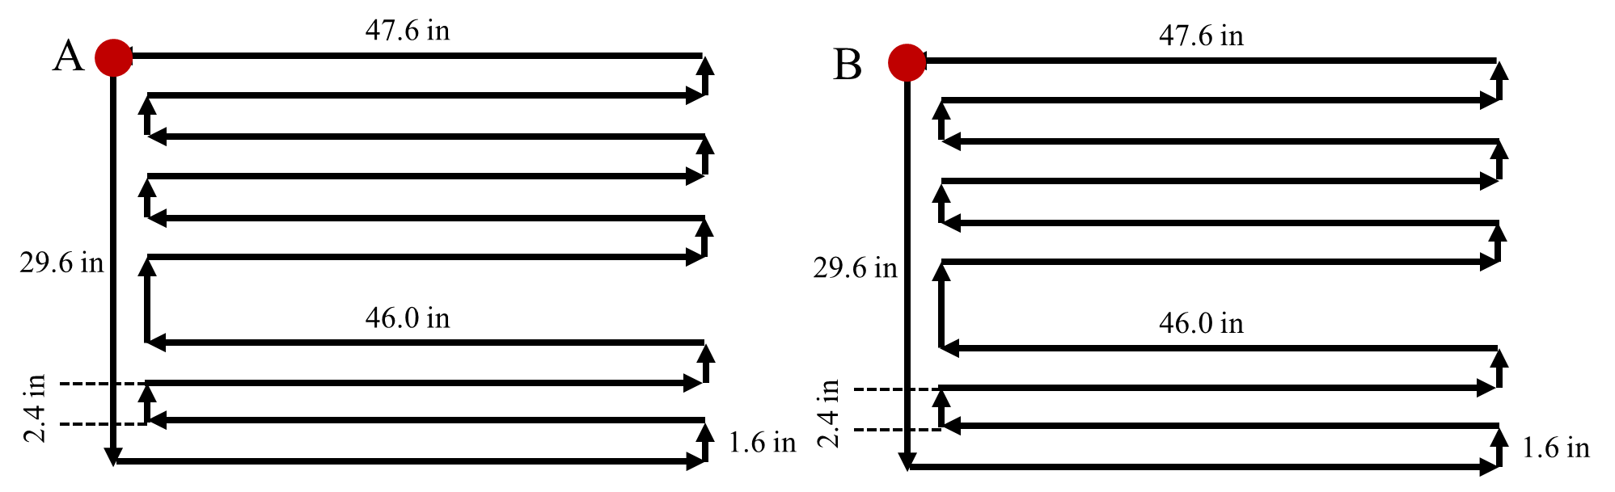
Figure 6-3. Schematic showing the altered U used for the C-SMN

Sample Extraction
Two types of samples were obtained from the printed structures and so required two different sampling approaches.

Micro-Scale Analysis Samples
Cross-sections were extracted from material transitions discussed in Chapter 5 for either microhardness indentation or mixing analysis via optical imaging and grayscale analysis. Sample selection was based on previous compositional measurements to obtain samples of similar wt % CF. Mimicking the compositional analysis extraction method, an Isomet 1000 Precision saw was used to retrieve a sample 8.4 mm long in the print direction from a rod previously sectioned with a band saw. Extensive labelling conventions ensured samples were traceable to the original location within the transition. The naming convention outlined in Chapter 5 was continued here for simplicity, but with one addition. Following the full sample set name, an identifier was given to each cross-section in the form of “-J4-B” where the number and second letter changed based on location within the transition.

Mechanical Specimens
Due to the rapid change in composition in BAAM dual hopper material transitions, especially near X_{T} [140], mechanical characterization of a printed structure had a narrow window for acceptable testing within the constraints. If a specimen were intended to be representative of a specific composition or point within Z_{T}, then any x-direction specimen must be suitably short. Compositional testing suggested that significant changes in composition can occur within distances as small as 7 cm, as shown by Figure 6-4. However, to test the properties of the structure rather than a single interface or bead, samples should still span multiple beads. Due to these constraints, oscillatory 3 pt bend testing by DMA was chosen as a representative analysis tool instead of traditional flexural testing so that a smaller sample size could be utilized. In accordance with ASTM D5023, printed specimens were milled to approximately 2.6 mm thick to match the span length of 40 mm [141]. Following machining, DMA bars 6.35 cm x 1.27 cm (2.5 in x 0.5 in) were cut from appropriately thick plate using an OMAX waterjet system in both the x- and z-directions. The locations of these DMA samples were tracked as before with the center of the bars being considered the location of that sample. Figure 6-5 provides a visual example.

Polishing Procedure
Before imaging or indenting sample cross-sections, the specimens were mounted in an EpoxiCure 2 puck and allowed to cure overnight in preparation for polishing. The edges on the back side were ground first to provide a flat contact area for the polishing system to apply force to the puck during polishing. Next, the face containing the sample was ground using a six-slot AutoMet 250 autopolisher to ensure sample faces were fully visible and not covered by epoxy. A contra-rotating orientation with platen at 90 RPM and head at 60 RPM and 2 lbs force was used to grind the sample for 1 minute each at 180, 240, 320, 400, 600, and 800 grit SiC paper. The mount was cleaned between each grinding and polishing step to minimize scratches caused by debris. For the polishing steps, a complimentary rotation with both head and platen speeds set to 60 RPM with 3 lbs force.
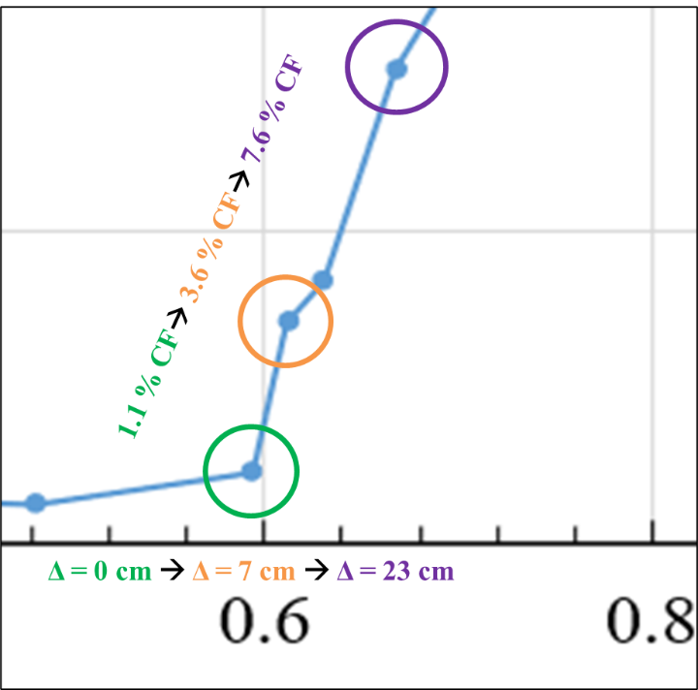
Figure 6-4. A snapshot of an example transition indicating how the physical distances traveled, showing the need for small mechanical samples.
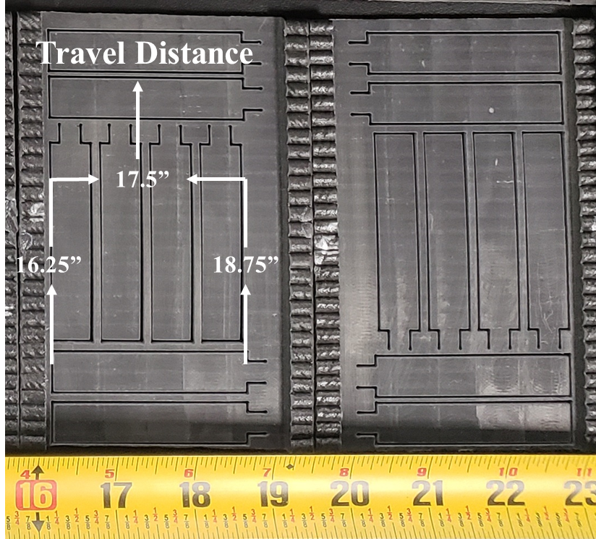
Figure 6-5. An image of printed, milled, and waterjet DMA bars showing that the travel distance for the marked x-direction samples was at sample center.
The required surface finish was attained by polishing for 20 minutes with a 6 µm diamond suspensions followed by 10 minutes with a 3 µm diamond suspension and finished using a colloidal silica for 25 minutes. For each of these three steps, periodic adding of more solution was required approximately every 45 second.

Microhardness Evaluation Procedures
Vickers Hardness (HV) was measured using micro indentation in two stages. Initial testing used a manual Wilson VH1202 Micro Hardness Tester to characterize a cross pattern centered on the center of the bead, as shown in Figure 6-6. Following verification that the visibly different regions (circled in Figure 6-6) exhibited differences in HV, a LECO LM-110AT autoindenter was used for an in-depth grid indentation investigation. Testing parameters were set to 100 gf to ensure indents were significantly larger than the constituent carbon fibers, and a 15 s dwell provided good indentation marks with no visible fracture. These findings agree with relevant literature [142, 143]. Based on initial testing in both ASB and CFABS regions, a spacing of 400 µm center-to-center between indents was required for testing to be valid per ASTM E384 [144]. If indentations were made too close to the edges of the sample or surface defects, the measurements were discarded. Average HV was plotted as a function of fiber content. To better understand how the hardness varied by region, a heat map was overlaid on optical images of the tested cross sections.
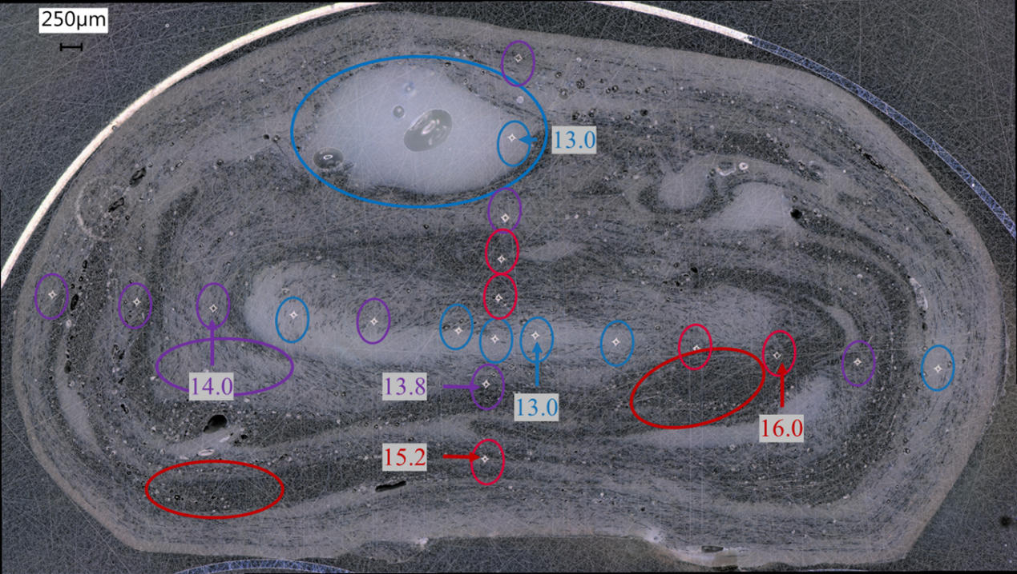
Figure 6-6. An optical image showing the ABS (blue) mixed (purple) and CFABS (red) heavy regions and identifying which type each indent was.

Optical Imaging
Following micro indentation of the selected cross-sections, the polished and indented samples were imaged using a Keyence VHX-5000 digital microscope. Included 2-D stitching software to create an image of the full sample at 200x magnification. To avoid any effects caused by changes in lighting or environmental conditions, images were taken sequentially in the same day without adjusting any lighting options on the system. While this left some of the samples difficult to see, this was done intentionally to enable unbiased comparisons of pixel color in Section 6.2.9. The stitched images were saved and used as a base layer for the microhardness overlay and as source images for the mixing analysis. In addition, these images allowed manual inspection of each indent that was difficult on the autoindenter, ensuring only valid indents were included in the analysis.

Quantifying Mixing
In an alternative approach to the microhardness overlay, an image processing technique was implemented to quantify how “mixed” a given cross-section was in relation to other samples with a similar material composition. First, the images obtained in 6.2.8 were converted from color to grayscale using the ImageJ image processing software. Still in ImageJ, a region of the image matching the bead cross-section was identified for measurement, and the software then exported the pixel count within that region for each grayscale value (GSV) 0 - 255. The pixel count was plotted as a function of GSV, and the resulting curve was compared to 1) other samples from the same material transition and 2) samples with a similar material composition. This Grayscale Analysis (GA) was intended to quantify the mixed condition of each sample relative to similar samples, but it did not provide an absolute measurement of how “mixed” or homogenous a sample was.

Dynamic Mechanical Analysis
Mechanical testing was conducted using a TA Instruments Discovery Hybrid Rheometer (DHR) in “Three-Point Bend DMA” mode to find the storage modulus, G’, through oscillatory DMA testing of five samples with identical composition. The selected testing procedure ran a logarithmic frequency sweep over a standard range of 0.1 Hz to 10 Hz at room temperature, collecting four points per decade. In accordance with ASTM D5023, the strain amplitude was set to 0.01 % and the initial static force was 1 N [141]. As mentioned in 6.2.5, the DHR was equipped with a span of 40 mm, so specimens were made thinner than suggested by ASTM D5023 to remain well within tolerances. The average width and thickness of each specimen were recorded and provided to the testing software. Both x-direction and z-direction samples were tested to investigate the effect of the transition zone on both bead and interface strengths. Although DMA testing provides many other important properties, this study focused on trends in G’ and compared them to associated shape curves. The standard deviation in G’ was compared across nozzle designs with the expectation that an improvement in mixing would lead to a reduced deviation in properties.

Results and Discussion

Microhardness Analysis
Figure 6-7 plots the average microhardness and standard deviations for the grid indentation procedure as a function of fiber content. Although there was a clear increase in average hardness with increasing fiber content for all print configurations, there was negligible difference between samples of similar composition. This was largely due to the significant increases in standard deviation observed with increasing fiber content. Further, AM300 had one sample that did not fit into the observed trends in any way, so it was chosen as part of the overlay investigation.
Figure 6-8 shows six indentation samples overlaid with a heat map of dots representing the relative hardness values where red and blue were the extremes and white represented the middle. Figure 6-7A and B were from the SAM configuration, C and D were from the AM configuration, and E and F were from the AX configuration. The right-hand images were all measured to be between 12 and 13 wt % CF. The left-hand images were measured as being 9 wt % CF (A and E) and 3 wt % CF (C). Image C shows the outlier sample from Figure 6-7, which does seem to show a consistently high hardness throughout the cross section. Interestingly, the most likely regions to be soft were also those with bad indents, which could have led to an un-representative average value. More importantly, a visual comparison of the color distribution indicates a relative increase in homogeneity with increased focus on mixing. Specifically, image B shows how the SMN appears to have reduced the heterogenous structure seen in images D and F. While D and
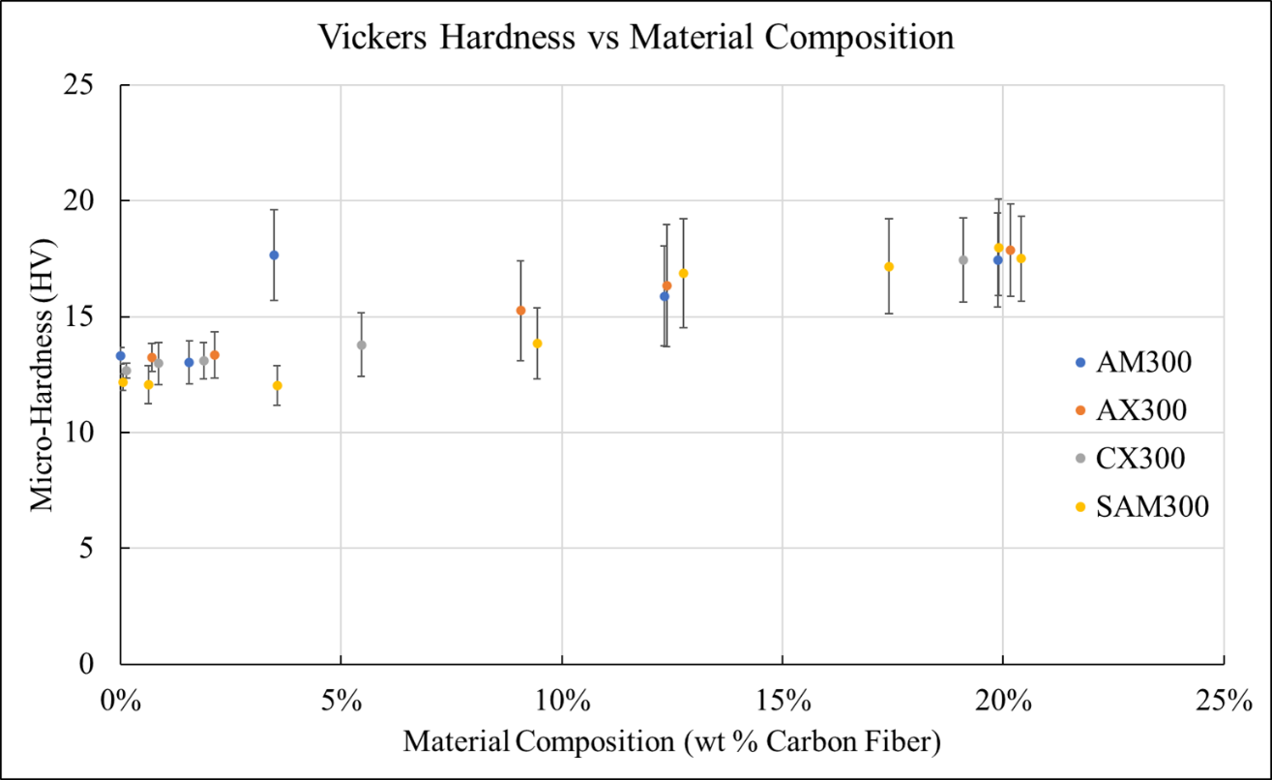
Figure 6-7. The average Vickers Hardness as a function of wt % CF.
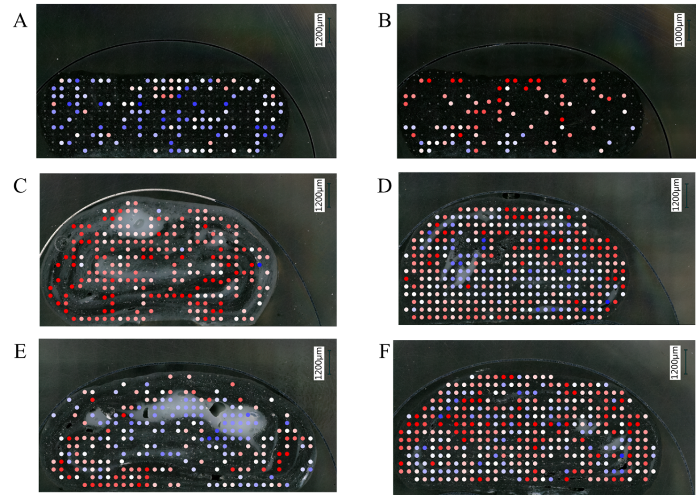
Figure 6-8. Cross-sections with microhardness overlay from SAM (A/B), AM (C/D), and AX (E/F) configurations with 13 wt % CF in the right column and 3 wt % CF in A and E.
F have numerous instances of extreme values (dark blue and dark red), image B had no soft (dark blue) regions and limited lighter blue regions. While not easily quantified, color-coding hardness into a visual overlay appeared to confirm the that the distinct regionality seen in standard nozzle samples led to an increased variation in resistance to deformation whereas the SMN produced a more homogeneous cross-section.

Optical Analysis of Mixing Performance
Figure 6-9 provides images that were processed using GA as well as the resulting GSV distribution. Appendix C provides unaltered images of all twenty-three cross sections investigated, grouped by configuration. Figure 6-9A was printed with the AM configuration and had 3 wt % CF, and Figure 6-9B shows the grayscale image of a 4 wt % CF sample printed with the SAM configuration. Clearly, there appears to be a more even distribution of color throughout SAM image than the AM image. This was reflected in Figure 6-9C by the distinct difference in GSV distribution. The SAM sample had a much narrower peak than the AM sample. While image B had an average GSV of 60.9 and standard deviation of 26.8, image A had an average GSV of 114.6 with standard deviation 35.6. Considering the agreement between these calculations and visual observations, the GA method was applied to all cross-sectional images.
Figure 6-10 provides the GSV distributions for all data sets. When comparing samples printed with the mixing nozzle to any of the other data sets, there was a significant decrease in standard deviation and a narrower peak.

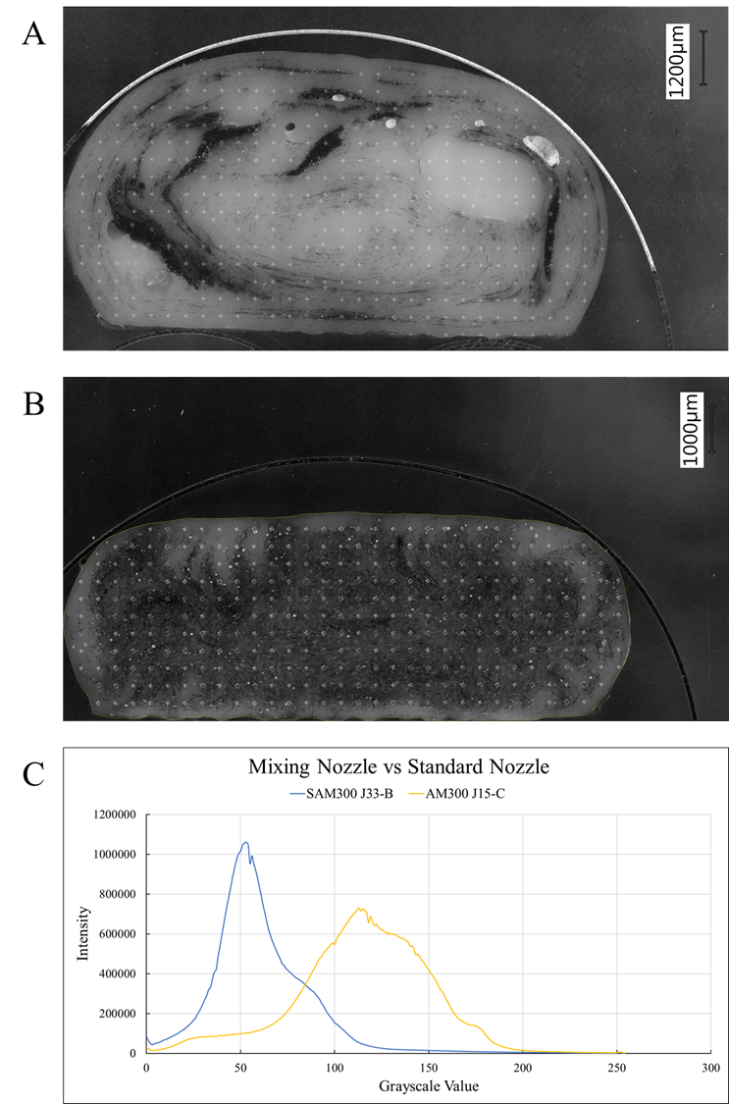
Figure 6-9. Cross-sections of similar fiber content (2-3 wt %) for A) AM and B) SAM. C) GSV distributions for both samples showing the discrepancies in peak behavior.
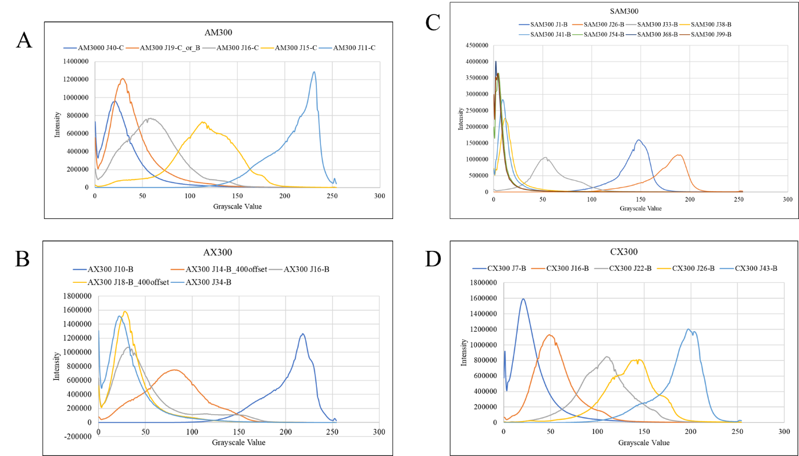
Figure 6-10. GSV distributions for A) AM, B) AX, C) SAM, and D) CX configurations.

Dynamic Mechanical Analysis
Three-point bend DMA data was collected for four distinct experimental groups: x- and z-directions for both ABS to CF and CF to ABS transitions. Since the programmed frequency sweep calculates G’ at each frequency studied, there was a need to verify that using data from a single frequency would not compromise analysis. Thus, the storage moduli calculated at a high (5.62 Hz) and a low frequency (0.18 Hz) relative to the range covered by the frequency sweep were plotted as two separate trends in Figure 6-11. The average G’ and standard deviation of ABS to CF x-direction samples for each frequency can be seen in Figure 4 as a function of normalized volume. While the difference between high and low frequency G’ increased in the CF/ABS region, the differences were minimal, and values remained well within the standard deviation. More importantly, the same trend can be seen for both data sets: a plateau in the ABS region followed by a gradual increase during the material change that culminates in a second plateau in the CF/ABS region. This behavior was consistent for the three remaining experimental conditions, validating expectations that data from a single frequency within the LVR could be representative of general trends in mechanical response.
To more closely mimic traditional flexural testing, Figure 6-12 shows both G’ and material composition against the normalized volume. As expected, both curves begin prior to and end after V₁, and G’ measurements exhibited a lower-value plateau in the ABS region (purge zone) and a higher-value plateau in the CF/ABS region (steady-state zone). In the transition zone, G’ increased with increasing fiber content. Specifically, any change
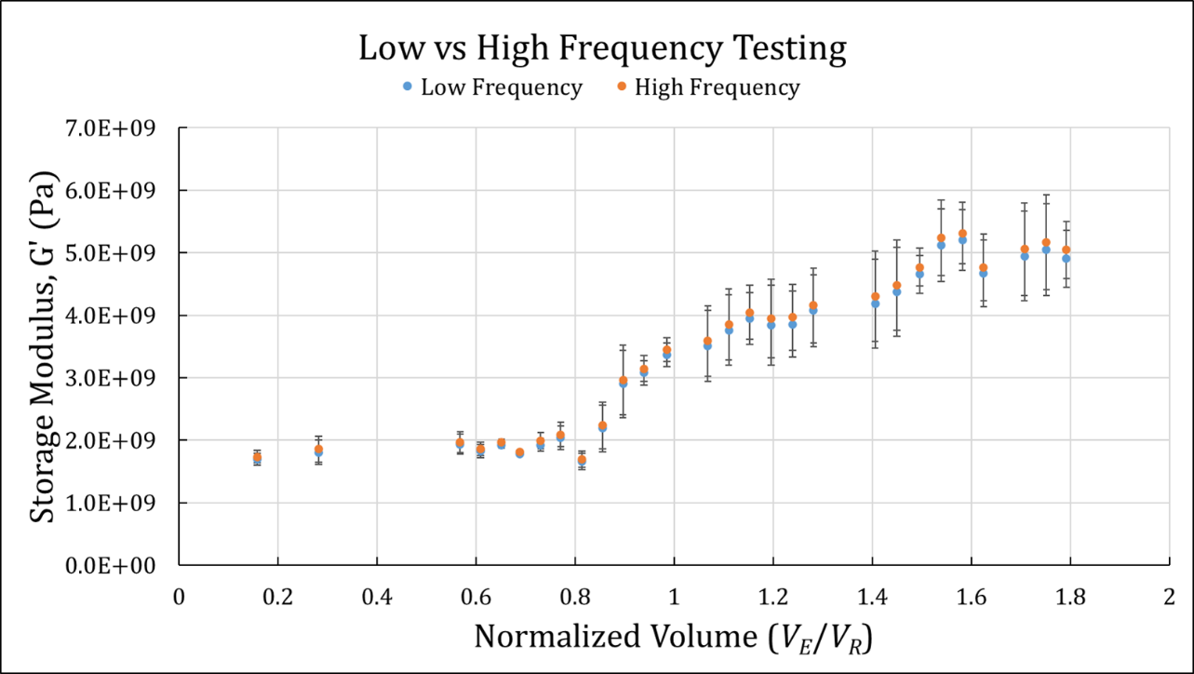
Figure 6-11. Storage moduli recorded at low and high frequencies.
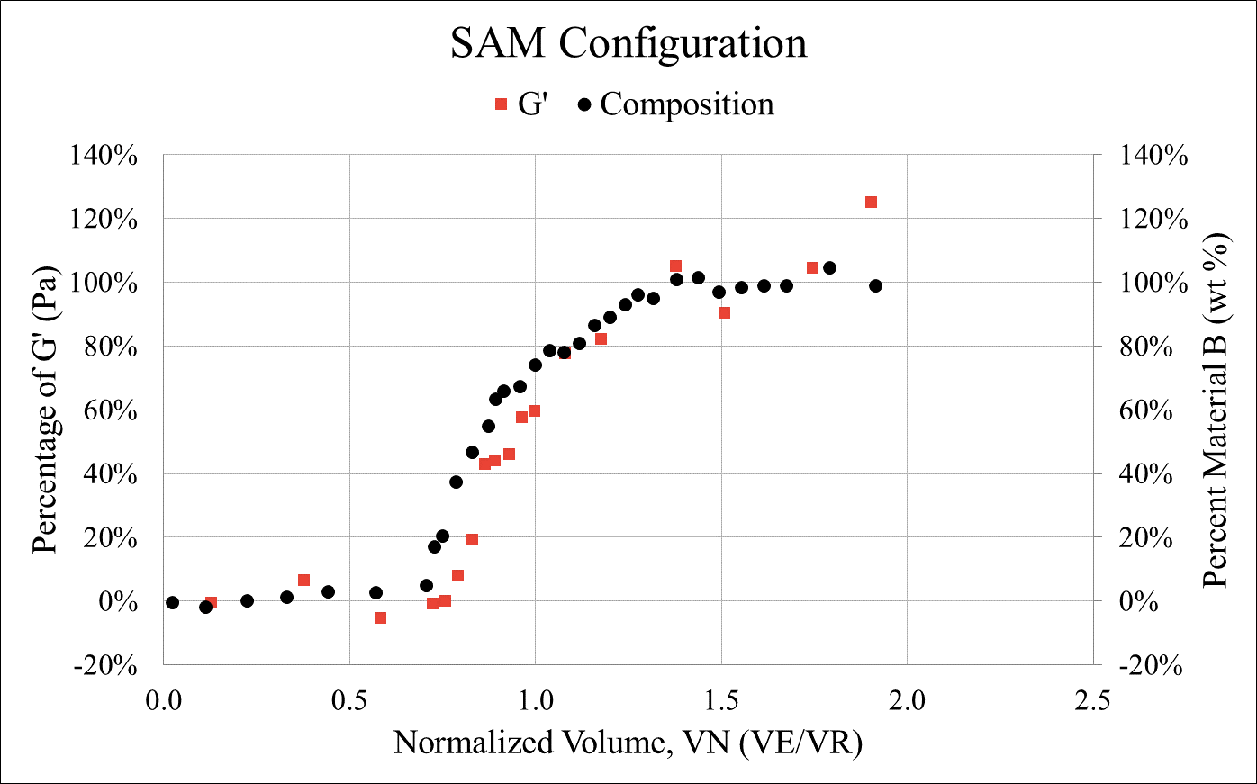
Figure 6-12. G’ as a percentage of overall increase in G’ and material composition as function of V_{N}.
in material composition had an immediate effect on the calculated storage modulus rather than being a lagging or forward indicator. The increase in G’ as composition changed across the transition zone would be expected from a mixed material region, indicating that mixing during extrusion was sufficient to prevent degraded material properties. Further, the lack of any visible stair-stepping effect suggests that there were no thresholds in material composition that need to be overcome to see a change in mechanical behavior.
As can be seen in Figure 6-13, z-direction samples exhibited similar behavior as the x-direction samples. This consistent behavior suggests that the transition zone storage modulus can therefore be approximated using a simple rule of mixtures approach based on material composition. Figure 6-13 also indicated that standard deviation was influenced by two separate phenomena: carbon fiber content and zone changes. For each data set, increasing carbon fiber content led to an increase in standard deviation, and both the onset and end of the transition zone caused spikes in standard deviation. While wt % CF could cause variance through inconsistencies in dispersion and orientation, the spikes when switching zones are most likely due to poor mixing caused by the change in feedstock type and shape.

Summary and Conclusions
Microhardness testing exhibited a strong correlation with fiber content, but the relatively low hardness values and high standard deviation limited the usefulness of comparing average Vickers’ Hardness. However, applying a color map to the measured hardness values and overlaying the generated map on an optical image revealed that the
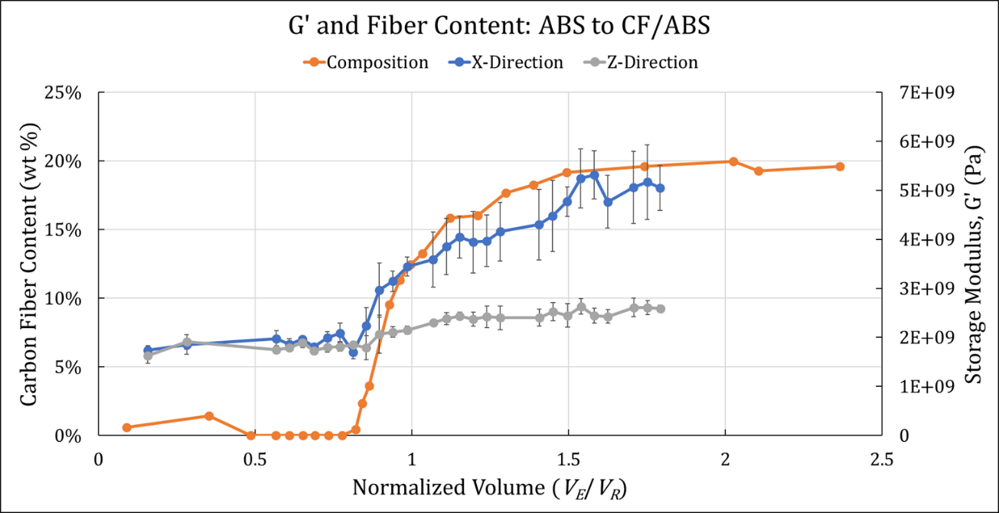
Figure 6-13. x- and z-direction G’ curves as a function of V_{N}, and the composition curve.
presence of a mixing nozzle removed the extreme values seen in other sample sets.
DMA testing enabled a comparative analysis of the macro-scale properties in BAAM dual hopper material transitions. For the studied transitions, the storage moduli changed with material composition and did not suffer any lag or stair-stepping effect. The SAM transition further reinforced this behavior, demonstrating a nearly identical G’ curve compared to a material composition curve. Although the SMN did not reduce deviation as expected, the C-SMN demonstrated a greater G’ in CFABS regions that correlated with a subjective reduction in porosity observed in optical images. In general, non-destructive testing indicated that parts printed using the dual hopper could rely on the transition zone to exhibit mechanical properties as function of material composition, enabling design approaches to treat the material transition as an inserted continuous FGM.
Grayscale analysis techniques were implemented as a tool for qualitatively comparing how mixed or homogenous a sample was compared to those of similar composition. Plotting the GSV distributions of the imaged cross-sections showed that the SMN consistently reduced the deviation observed in the distributions by creating a narrower peak and limiting tail formation. This work shows promise as a quick analysis tool for determining the homogeneity of MM cross-sections whose constituents differ in color or other structure. Although the degree of mixing did not have an apparent impact on the mechanical properties of the meso-structure, the change homogeneity presents opportunities for tailored design and properties with other configurations or material pairs.

Conclusions and Future outlook

Summary of Research Work
Extensive work was performed to characterize the many influences on BAAM dual hopper material transitions. A model was developed to describe the change in material composition across the blended transition region that can be used as a predictive or analytical tool. The influential print parameters were identified as screw and nozzle design, and the material viscosity was demonstrated to have a significant impact on material transitions. Multiple structures were printed using three different configurations to characterize the mechanical performance of material transitions incorporated into a printed part, and cross-sectional analysis of beads from the printed transition were examined to assess mixing and microhardness.

Implementation of a novel analysis framework and model
The normalized volume framework and constitutive model developed in Chapters 3 and 4 provide a versatile tool for analyzing material transitions printed using the BAAM dual hopper. Considering material transitions as a function of volume prevented misleading conclusions when assessing transition behavior, and incorporating conservation of mass using residual material calculations demonstrated that part design and printing should include the practical limitations of transitions over a certain travel distance in relation to the deposited material volume. Through the normalized volume framework, material transitions printed at a variety of conditions and configurations were compared and illustrated the impact of component design and mixing on transition behavior and microstructure. This process is applicable not just to the BAAM dual hopper but could also be applied to other SSE systems to objectively assess the effect of system design and parameter choice on the transition behavior on that system and, possibly, between systems.

Screw Speed, Transition Direction, and BAAM Configuration
Material transitions were printed using six different configurations: AM, AX, CM, CX, CTM-TCM, and SAM-SCM. These configurations enabled investigation of screw speed, screw design, nozzle design, and viscosity (transition direction) as influential parameters in material transitions. In all cases, the screw speed exhibited a negligible impact. Instead, transitions printed using the same configuration but at a different speed provided a useful means of obtaining average X_{T} and X_{S} values, which were then compared to the average values in other configurations. These comparisons demonstrated that 1) transitioning from a high viscosity material to a low viscosity material was always less affected by configuration changes than in the opposite direction. 2) the difference in viscosity between the constituent materials appeared to have a greater influence on high to low viscosity transitions than the addition of mixing zones. 3) Low to high viscosity transitions were more sensitive to the addition of mixing components than changes in material viscosity, which suggests that mixing during low to high transitions may be driven by back pressure flow instead of increased laminar mixing caused by the changing screw and nozzle geometries. 4) A longer Z_{P} will always lead to a shorter Z_{T} and sharper initial slope, agreeing with established expectations for conservation of mass in the residual volume. Together, the demonstrated sensitivity of the material transition process suggests that transition length and shape can be controlled through tuning component design and the difference in material viscosity, providing a critical tool for designing printed parts with material transitions.

Microstructural Analysis and Mechanical Performance
The mechanical properties of the material transitions were assessed using DMA and microhardness. Microhardness results indicated an increasing resistance to deformation with increasing fiber content, as expected. Creating a color-coded overlay for images of the microhardness indentations illustrated the benefits of the static mixing nozzle. Compared to the standard nozzle samples, the SMN samples had fewer extreme values and a more consistent color throughout the cross-section. DMA results showed a consistent performance throughout the transition region as a function of material composition. This held true even when changing the configuration used to print the transition. Furthermore, both the x-direction and z-direction samples indicated the transition zone would act as a bridge for mechanical performance, as intended. Finally, the effect of increased mixing on the homogeneity of the printed transition was assessed using a custom grayscale analysis technique. Comparisons of the grayscale distributions helped to qualify visual observations by showing that samples printed using the SMN had a narrow GSV peak as well as a reduced standard deviation compared to those that used the standard nozzle. Despite GSA demonstrating the non-homogeneous morphology of samples printed with a standard nozzle, there was minimal difference in meso-structural properties. Still, the opportunity remains to utilize the change in morphology to further tune printed part properties with different material pairings or designs that further improve mixing.

Future Investigations
Future investigations will compile Chapters 4, 5, and 6 into three distinct journal articles: 1) A publication presenting the model for material transitions and demonstrating its usage to identify the influential processing parameters. 2) An in-depth macro-scale mechanical performance paper that compares the SMN to the C-SMN and standard nozzles and includes additional tensile testing planned for the near future. 3) A micro-scale mechanical performance paper presenting the micro hardness overlays with quantifiable measurements that ties in the GA technique, which will be improved by normalizing the data to obtain a true distribution instead of a simple intensity plot.
Additional work remains possible, especially in the realm of screw design. As shown by Inoue et. al, innovative applications of existing screw design in the compression zone can improve both the dispersive and distributive mixing in SSE with minimal reduction in fiber length. Applying similar designs to LFAM could maintain the critically important composite properties provided by the reinforcing properties while generating a homogenous cross-section, which could lead to reduced deviation in properties of printed parts. Furthermore, results indicate a possibility that the transitions printed at the highest and lowest screw speeds may have acted as bounds within which all other material transitions fell, so further investigation could better clarify any relationship.
Material transitions produced using SSE also provide significant opportunities for further characterization. The effect of filler aspect ratio on cross-section homogeneity as well as material transition behavior was not investigated in this work, and while the influence of viscosity will at least partially consider a changing aspect ratio, an additional influence on transition behavior is possible. Another possible avenue for improving the understanding of material transitions would be the study of a transition between two materials with identical material viscosities could better isolate the contributions of component design and provide a more fundamental understanding of the process. However, such an investigation has limited application to industry needs and could be difficult to motivate.
Finally, modeling of material transitions was effective but relied on custom derivations. Initial results indicate that a Weibull cumulative distribution function may provide a more well-known fit equation for the transition region (F(x)) and possibly improve the fit with the data. However, determining the “true” start point of the transition would still require significant incremental compositional analysis, so a combination of the two techniques to first find the beginning then fit the Weibull CDF may provide the best path forward.

List of Publications
Two published journal articles, three peer-reviewed conference papers, four conference proceedings, and three journal articles in progress (editing).
J. Brackett et al., “Characterizing Material Transitions in Large-Scale Additive Manufacturing,” Addit. Manuf., vol. 38, p. 101750, 2021. DOI: https://doi.org/10.1016/j.addma.2020.101750.
J. Brackett et al., “The Impact of Infill Percentage and Layer Height in Small-Scale Material Extrusion on Porosity and Tensile Properties,” Addit. Manuf., vol. 58, p. 103063, 2022. DOI: https://doi.org/10.1016/j.addma.2022.103063.
J. C. Brackett, E. P. Charles, M. B. Charles, T. C. Smith, V. Kunc, and C. E. Duty, “The Impact of Viscosity on Material Transitions in Large Format Additive Manufacturing of Polymer Composites,” in SAMPE 2023, Seattle, WA. April 17-20, 2023. Society for the Advancement of Material and Process Engineering – North America, pp. 1046-1060, DOI: 10.33599/nasampe/s.23.0166.
J. C. Brackett, E. P. Charles, T. C. Smith, A. A. Hassen, V. Kunc, and C. E. Duty, “The Impact of a Static Mixing Nozzle on Uniformity in Material Extrustion Large-Scale Additive Manufacturing,” in SAMPE 2022, Charlotte, NC. May 23-26, 2022. Society for the Advancement of Material and Process Engineering – North America, p. 15, DOI: 10.33599/nasampe/s.22.0798.
J. Brackett, D. Cauthen, T. Smith, V. Kunc, and C. Duty, “The Influence of Processing Parameters on the Transition Zone for Blended Material 3d Printing,” SAMPE 2020 Virtual Series | Additive Manufacturing, Seattle, WA, June 1, 2020. 10.33599/nasampe/s.20.0249 DOI.
J. Brackett et al., “Characterizing the Internal Morphology of Transition Regions in Large-Scale Extrusion Deposition Additive Manufacturing,” in Solid Freeform Fabrication Symposium, Austin, TX. December 1, 2021. Pp. 761-770, DOI: http://dx.doi.org/10.26153/tsw/17600.
J. Brackett, A. DeFilippis, T. Smith, A. A. Hassen, V. Kunc, and E. Duty Chad, “Evaluating the Mechanical Properties within the Transition Region of Multi-Material Large-Format Extrusion Additive Manufacturing,” in Solid Freeform Fabrication Symposium, Austin, TX. November 4, 2022. Pp. 1210-1222, DOI: 10.26153/tsw/44597.
J. Brackett et al., “Development of Functionally Graded Material Capabilities in Large-Scale Extrusion Deposition Additive Manufacturing,” in Solid Freeform Fabrication Symposium, Austin, TX. 2019. Pp. 1793-1803, DOI: http://dx.doi.org/10.26153/tsw/17437.
J. Brackett et al., “Characterizing the Influence of Print Parameters on Porosity and Resulting Density,” in Solid Freeform Fabrication Symposium, Austin, TX. 2019. Pp. 766-778, DOI: http://dx.doi.org/10.26153/tsw/17313

References
[1] M. Attaran, "The Rise of 3-D Printing: The Advantages of Additive Manufacturing over Traditional Manufacturing," Bus. Horiz., vol. 60, no. 5, pp. 677-688, 2017. DOI: 10.1016/j.bushor.2017.05.011.
[2] B. Berman, "3-D Printing: The New Industrial Revolution," Bus. Horiz., vol. 55, no. 2, pp. 155-162, 2012. DOI: 10.1016/j.bushor.2011.11.003.
[3] J. Jiang, "A Novel Fabrication Strategy for Additive Manufacturing Processes," Journal of Cleaner Production, vol. 272, p. 122916, 2020. DOI: 10.1016/j.jclepro.2020.122916.
[4] J. Jiang, X. Xu, and J. Stringer, "Support Structures for Additive Manufacturing: A Review," Journal of Manufacturing and Materials Processing, vol. 2, no. 4, p. 64, 2018. DOI: 10.3390/jmmp2040064.
[5] Y. Huang, M. C. Leu, J. Mazumder, and A. Donmez, "Additive Manufacturing: Current State, Future Potential, Gaps and Needs, and Recommendations," Journal of Manufacturing Science and Engineering, vol. 137, no. 1, 2015. DOI: 10.1115/1.4028725.
[6] W. Bettina, R. Dominik, K. Florian, F. Robert, H. Gerrit, and S. Ernst, "Additive Processing of Polymers," Macromol. Mater. Eng., vol. 293, no. 10, pp. 799-809, 2008. DOI: 10.1002/mame.200800121.
[7] A. Alammar, J. C. Kois, M. Revilla-León, and W. Att, "Additive Manufacturing Technologies: Current Status and Future Perspectives," Journal of Prosthodontics, vol. 31, no. S1, pp. 4-12, 2022. DOI: 10.1111/jopr.13477.
[8] J. Yan, I. Battiato, and G. M. Fadel, "A Mathematical Model-Based Optimization Method for Direct Metal Deposition of Multimaterials," Journal of Manufacturing Science and Engineering, vol. 139, no. 8, 2017. DOI: 10.1115/1.4036424.
[9] J. Yan, I. Battiato, and G. M. Fadel, "Planning the Process Parameters for the Direct Metal Deposition of Functionally Graded Parts Based on Mathematical Models," J Manuf Process, vol. 31, pp. 56-71, 2018. DOI: 10.1016/j.jmapro.2017.11.001.
[10] P. Heinl, L. Muller, C. Korner, R. F. Singer, and F. A. Muller, "Cellular Ti-6al-4v Structures with Interconnected Macro Porosity for Bone Implants Fabricated by Selective Electron Beam Melting," Acta Biomater., vol. 4, no. 5, pp. 1536-1544, 2008. DOI: 10.1016/j.actbio.2008.03.013.
[11] C. Greer et al., "Introduction to the Design Rules for Metal Big Area Additive Manufacturing," Addit. Manuf., vol. 27, pp. 159-166, 2019. DOI: 10.1016/j.addma.2019.02.016.
[12] A. Paolini, S. Kollmannsberger, and E. Rank, "Additive Manufacturing in Construction: A Review on Processes, Applications, and Digital Planning Methods," Addit. Manuf., vol. 30, p. 13, 2019. DOI: 10.1016/j.addma.2019.100894.
[13] Y. Lakhdar, C. Tuck, J. Binner, A. Terry, and R. Goodridge, "Additive Manufacturing of Advanced Ceramic Materials," Prog. Mater. Sci., vol. 116, p. 100736, 2021. DOI: 10.1016/j.pmatsci.2020.100736.
[14] F. Clemens, F. Sarraf, A. Borzì, A. Neels, and A. Hadian, "Material Extrusion Additive Manufacturing Of advanced Ceramics: Towards the Production of Large Components," Journal of the European Ceramic Society, 2022. DOI: j.jeurceramsoc.2022.10.019.
[15] A. Rodriguez-Panes, J. Claver, and A. M. Camacho, "The Influence of Manufacturing Parameters on the Mechanical Behaviour of Pla and Abs Pieces Manufactured by Fdm: A Comparative Analysis," Materials, vol. 11, no. 8, p. 21, 2018. DOI: 10.3390/ma11081333.
[16] P. Parandoush et al., "Additive Manufacturing of Continuous Carbon Fiber Reinforced Epoxy Composite with Graphene Enhanced Interlayer Bond toward Ultra-High Mechanical Properties," Polym Composite, vol. 43, pp. 934-945, 2021. DOI: 10.1002/pc.26423.
[17] F. Ning, W. Cong, J. Qiu, J. Wei, and S. Wang, "Additive Manufacturing of Carbon Fiber Reinforced Thermoplastic Composites Using Fused Deposition Modeling," Composites Part B: Engineering, vol. 80, pp. 369-378, 2015. DOI: 10.1016/j.compositesb.2015.06.013.
[18] T. Smith et al., "Dual Material System for Polymer Large Scale Additive Manufacturing," Society for the Advancement of Material and Process Engineering 2020, Seattle, WA, June 1, 2020. 10.33599/nasampe/s.20.0290 DOI.
[19] D. Moreno Nieto, V. Casal López, and S. I. Molina, "Large-Format Polymeric Pellet-Based Additive Manufacturing for the Naval Industry," Addit. Manuf., vol. 23, pp. 79-85, 2018. DOI: 10.1016/j.addma.2018.07.012.
[20] B. Cosson, A. C. Akué Asséko, L. Pelzer, and C. Hopmann, "Radiative Thermal Effects in Large Scale Additive Manufacturing of Polymers: Numerical and Experimental Investigations," Mater., vol. 15, no. 3, p. 1052, 2022. DOI: 10.3390/ma15031052.
[21] S. Q. Yan et al., "Multifunctional Metal Matrix Composites by Friction Stir Additive Manufacturing," Journal of Materials Engineering and Performance, vol. 31, no. 8, pp. 6183-6195, 2022. DOI: 10.1007/s11665-022-07114-7.
[22] N. van de Werken, H. Tekinalp, P. Khanbolouki, S. Ozcan, A. Williams, and M. Tehrani, "Additively Manufactured Carbon Fiber-Reinforced Composites: State of the Art and Perspective," Addit. Manuf., vol. 31, p. 19, 2020. DOI: 10.1016/j.addma.2019.100962.
[23] O. Adeniran, W. Cong, and A. Aremu, "Material Design Factors in the Additive Manufacturing of Carbon Fiber Reinforced Plastic Composites: A State-of-the-Art Review," Advances in Industrial and Manufacturing Engineering, vol. 5, p. 100100, 2022. DOI: 10.1016/j.aime.2022.100100.
[24] J. W. Kemp et al., "Direct Ink Writing of Zrb2-Sic Chopped Fiber Ceramic Composites," Addit. Manuf., vol. 44, p. 102049, 2021. DOI: 10.1016/j.addma.2021.102049.
[25] A. C. Taylor, S. Beirne, G. Alici, and G. G. Wallace, "System and Process Development for Coaxial Extrusion in Fused Deposition Modelling," Rapid Prototyp. J., vol. 23, no. 3, pp. 543-550, 2017. DOI: doi:10.1108/RPJ-10-2015-0141.
[26] P. Kumar, J. K. Santosa, E. Beck, and S. Das, "Direct-Write Deposition of Fine Powders through Miniature Hopper-Nozzles for Multi-Material Solid Freeform Fabrication," Rapid Prototyp. J., vol. 10, no. 1, pp. 14-23, 2004. DOI: 10.1108/13552540410512499.
[27] B. G. Compton and J. A. Lewis, "3d-Printing of Lightweight Cellular Composites," Adv. Mater., vol. 26, no. 34, pp. 5930-5935, 2014. DOI: 10.1002/adma.201401804.
[28] N. S. Hmeidat, D. S. Elkins, H. R. Peter, V. Kumar, and B. G. Compton, "Processing and Mechanical Characterization of Short Carbon Fiber-Reinforced Epoxy Composites for Material Extrusion Additive Manufacturing," Composites Part B: Engineering, vol. 223, p. 109122, 2021. DOI: 10.1016/j.compositesb.2021.109122.
[29] N. W. Bartlett et al., "A 3d-Printed, Functionally Graded Soft Robot Powered by Combustion," Science, vol. 349, no. 6244, pp. 161-165, 2015. DOI: 10.1126/science.aab0129.
[30] I. Vu, L. Bass, N. Meisel, B. Orler, C. B. Williams, and D. A. Dillard, "Characterization of Mutli-Material Interfaces in Polyjet Additive Manufacturing," in Solid Freeform Fabrication Symposium, Austin, TX. August, 2015. pp. 959-982. [Online]. Available: http://utw10945.utweb.utexas.edu/sites/default/files/2015/2015-79-Vu.pdf.
[31] I. Q. Vu, L. B. Bass, C. B. Williams, and D. A. Dillard, "Characterizing the Effect of Print Orientation on Interface Integrity of Multi-Material Jetting Additive Manufacturing," Addit. Manuf., vol. 22, pp. 447-461, 2018. DOI: 10.1016/j.addma.2018.05.036.
[32] C. E. Duty et al., "Structure and Mechanical Behavior of Big Area Additive Manufacturing (Baam) Materials," Rapid Prototyp. J., vol. 23, no. 1, pp. 181-189, 2017. DOI: 10.1108/RPJ-12-2015-0183.
[33] L. J. Love et al., "The Importance of Carbon Fiber to Polymer Additive Manufacturing," Journal of Materials Research, vol. 29, no. 17, pp. 1893-1898, 2014. DOI: 10.1557/jmr.2014.212.
[34] H. L. Tekinalp et al., "Highly Oriented Carbon Fiber-Polymer Composites Via Additive Manufacturing," Compos Sci Technol, vol. 105, pp. 144-150, 2014. DOI: 10.1016/j.compscitech.2014.10.009.
[35] J. Kotlinski, "Mechanical Properties of Commercial Rapid Prototyping Materials," Rapid Prototyp. J., vol. 20, no. 6, pp. 499-510, 2014. DOI: 10.1108/RPJ-06-2012-0052.
[36] F. Ning, W. Cong, Y. Hu, and H. Wang, "Additive Manufacturing of Carbon Fiber-Reinforced Plastic Composites Using Fused Deposition Modeling: Effects of Process Parameters on Tensile Properties," J. Compos. Mater., vol. 51, no. 4, pp. 451-462, 2017. DOI: 10.1177/0021998316646169.
[37] M. Khondoker and D. Sameoto, "Enhanced Bonding of Immiscible Polymers Via Intermixed Co-Extrusion in Fused Deposition Modelling," 41st Annual Meeting of the Adhesion Society, San Diego, CA, February, 2018.
[38] S. C. Altıparmak, V. A. Yardley, Z. Shi, and J. Lin, "Extrusion-Based Additive Manufacturing Technologies: State of the Art and Future Perspectives," J Manuf Process, vol. 83, pp. 607-636, 2022. DOI: 10.1016/j.jmapro.2022.09.032.
[39] C. M. S. Vicente, M. Sardinha, L. Reis, A. Ribeiro, and M. Leite, "Large-Format Additive Manufacturing of Polymer Extrusion-Based Deposition Systems: Review and Applications," Prog. Addit. Manuf., 2023. DOI: 10.1007/s40964-023-00397-9.
[40] A. Mahmood, T. Akram, H. Chen, and S. Chen, "On the Evolution of Additive Manufacturing (3d/4d Printing) Technologies: Materials, Applications, and Challenges," Polymers, vol. 14, no. 21, 2022. DOI: 10.3390/polym14214698.
[41] J.-R. Ai and B. D. Vogt, "Size and Print Path Effects on Mechanical Properties of Material Extrusion 3d Printed Plastics," Prog. Addit. Manuf., vol. 7, no. 5, pp. 1009-1021, 2022. DOI: 10.1007/s40964-022-00275-w.
[42] J. D. Kechagias, N. Vidakis, and M. Petousis, "Parameter Effects and Process Modeling of Fff-Tpu Mechanical Response," Mater. Manuf. Process., vol. 38, no. 3, pp. 341-351, 2023. DOI: 10.1080/10426914.2021.2001523.
[43] A. Balagopal, R. K. Mandal, P. K. Singh, and P. Jain, "Effects of Porosity on Mechanical Property and Specific Strength of Monolithic Carbon Fibre Reinforced Polylactic Acid and Acrylonitiril Butadiene Styrene Components Fabricated Using Additive Manufacturing Technique," Int. J. Sci. Res. Mech. Mater. Eng., vol. 4, no. 5, pp. 29-40, 2020. [Online]. Available: http://ijsrmme.com/IJSRMME20457
[44] A. Rodríguez-Panes, J. Claver, and A. M. Camacho, "The Influence of Manufacturing Parameters on the Mechanical Behaviour of Pla and Abs Pieces Manufactured by Fdm: A Comparative Analysis," Mater., vol. 11, no. 8, p. 1333, 2018. DOI: 10.3390/ma11081333.
[45] G. V. Salmoria, J. L. Leite, L. F. Vieira, A. T. N. Pires, and C. R. M. Roesler, "Mechanical Properties of Pa6/Pa12 Blend Specimens Prepared by Selective Laser Sintering," Polym. Test, vol. 31, no. 3, pp. 411-416, 2012. DOI: 10.1016/j.polymertesting.2011.12.006.
[46] J. P. Kruth, M. C. Leu, and T. Nakagawa, "Progress in Additive Manufacturing and Rapid Prototyping," CIRP Annals, vol. 47, no. 2, pp. 525-540, 1998. DOI: 10.1016/S0007-8506(07)63240-5.
[47] W. Wu, P. Geng, G. Li, D. Zhao, H. Zhang, and j. Zhao, "Influence of Layer Thickness and Raster Angle on the Mechanical Properties of 3d-Printed Peek and a Comparative Mechanical Study between Peek and Abs," Mater., vol. 8, no. 9, pp. 5834-5846, 2015. DOI: 10.3390/ma8095271.
[48] J.-W. Tseng et al., "Screw Extrusion-Based Additive Manufacturing of Peek," Mater Design, vol. 140, pp. 209-221, 2018. DOI: 10.1016/j.matdes.2017.11.032.
[49] Y. Abderrafai et al., "Additive Manufacturing and Characterization of High Temperature Thermoplastic Blends for Potential Aerospace Applications," Composites Science and Technology, vol. 231, p. 109839, 2023. DOI: 10.1016/j.compscitech.2022.109839.
[50] P. Parandoush and D. Lin, "A Review on Additive Manufacturing of Polymer-Fiber Composites," Composite Structures, vol. 182, pp. 36-53, 2017. DOI: 10.1016/j.compstruct.2017.08.088.
[51] V. S. Vakharia, H. Leonard, M. Singh, and M. C. Halbig, "Multi-Material Additive Manufacturing of High Temperature Polyetherimide (Pei)&Ndash;Based Polymer Systems for Lightweight Aerospace Applications," Polymers, vol. 15, no. 3, p. 561, 2023. DOI: 10.3390/polym15030561.
[52] A. El Magri, S. Vanaei, and S. Vaudreuil, "An Overview on the Influence of Process Parameters through the Characteristic of 3d-Printed Peek and Pei Parts," High Performance Polymers, vol. 33, no. 8, pp. 862-880, 2021. DOI: 10.1177/09540083211009961.
[53] C. E. Duty and L. J. Love, "Cincinnati Big Area Additive Manufacturing (Baam)," United States, 2015-03-04 2015. [Online]. Available: https://www.osti.gov/biblio/1210140
https://www.osti.gov/servlets/purl/1210140
[54] V. Kishore and A. A. Hassen, "Chapter 6 - Polymer and Composites Additive Manufacturing: Material Extrusion Processes," in Additive Manufacturing, J. Pou, A. Riveiro, and J. P. Davim Eds.: Elsevier, 2021, pp. 183-216.
[55] T. Corporation, "Lsam - Large Scale Additive Manufacturing," 2018. https://www.thermwood.com/lsam_home.htm [Accessed: April 23, 2023].
[56] F. Wang, F. Ju, K. Rowe, and N. Hofmann, "Real-Time Control for Large Scale Additive Manufacturing Using Thermal Images," in 2019 IEEE 15th International Conference on Automation Science and Engineering (CASE), August 22-26, 2019. pp. 36-41, DOI: 10.1109/COASE.2019.8843264.
[57] A. Wedgewood, P. Pibulchinda, E. B. Vaca, C. Hill, and M. J. Bogdanor, "Materials Development and Advanced Process Simulation for Additive Manufacturing with Fiber-Reinforced Thermoplastics," IACMI The Composite Institute, IACMI/R003-2020/7.07; Other: IACMI/R003-2020/7.07 United States 10.2172/1769016 Other: IACMI/R003-2020/7.07 GFO English, February 2020. [Online]. Available: https://www.osti.gov/servlets/purl/1769016
[58] S. K. Romberg et al., "Large-Scale Reactive Thermoset Printing: Complex Interactions between Temperature Evolution, Viscosity, and Cure Shrinkage," Int. J. Adv. Manuf. Technol., vol. 123, no. 9-10, pp. 3079-3094, 2022. DOI: 10.1007/s00170-022-10380-3.
[59] A. Rhodes, R. Walker, T. Smith, J. Lindahl, V. Kunc, and C. Duty, "Correlating Large-Format Am Print Parameters to Fiber Length and Mechanical Performance of Reinforced Polymer Composites," in Solid Freeform Fabrication Symposium, Austin, TX. November 1, 2021. pp. 771-779, DOI: 10.26153/tsw/17601.
[60] C. Duty et al., "What Makes a Material Printable? A Viscoelastic Model for Extrusion-Based 3d Printing of Polymers," J Manuf Process, vol. 35, pp. 526-537, 2018. DOI: 10.1016/j.jmapro.2018.08.008.
[61] C. Ajinjeru et al., "The Influence of Dynamic Rheological Properties on Carbon Fiber-Reinforced Polyetherimide for Large-Scale Extrusion-Based Additive Manufacturing," The International Journal of Advanced Manufacturing Technology, vol. 99, no. 1, pp. 411-418, 2018. DOI: 10.1007/s00170-018-2510-z.
[62] S. Yuan, S. Li, J. Zhu, and Y. Tang, "Additive Manufacturing of Polymeric Composites from Material Processing to Structural Design," Composites Part B: Engineering, vol. 219, p. 108903, 2021. DOI: 10.1016/j.compositesb.2021.108903.
[63] Y. Nakagawa, K.-i. Mori, and T. Maeno, "3d Printing of Carbon Fibre-Reinforced Plastic Parts," The International Journal of Advanced Manufacturing Technology, vol. 91, no. 5, pp. 2811-2817, 2017. DOI: 10.1007/s00170-016-9891-7.
[64] S.-S. Yao, F.-L. Jin, K. Y. Rhee, D. Hui, and S.-J. Park, "Recent Advances in Carbon-Fiber-Reinforced Thermoplastic Composites: A Review," Composites Part B: Engineering, vol. 142, pp. 241-250, 2018. DOI: 10.1016/j.compositesb.2017.12.007.
[65] M. Vaezi, S. Chianrabutra, B. Mellor, and S. Yang, "Multiple Material Additive Manufacturing – Part 1: A Review," Virtual & Physical Prototyping, vol. 8, no. 1, pp. 19-50, 2013. DOI: 10.1080/17452759.2013.778175.
[66] S. Brischetto, C. Ferro, R. Torre, and P. Maggiore, "3d Fdm Production and Mechanical Behavior of Polymeric Sandwich Specimens Embedding Classical and Honeycomb Cores," Curved and Layered Structures, vol. 5, pp. 80-94, 2018. DOI: 10.1515/cls-2018-0007.
[67] B. Ezair and G. Elber, "Fabricating Functionally Graded Material Objects Using Trimmed Trivariate Volumetric Representations," Fabrication and Sculpting Event, 2017.
[68] S. Hasanov et al., "Review on Additive Manufacturing of Multi-Material Parts: Progress and Challenges," Journal of Manufacturing and Materials Processing, vol. 6, no. 4, p. 32, 2022. DOI: 10.3390/jmmp6010004.
[69] H. Kim, J. W. Choi, and R. Wicker, "Scheduling and Process Planning for Multiple Material Stereolithography," Rapid Prototyp. J., vol. 16, no. 4, pp. 232-240, 2010. DOI: 10.1108/13552541011049243.
[70] J. W. Choi, H. C. Kim, and R. Wicker, "Multi-Material Stereolithography," Journal of Materials Processing Technology, vol. 211, no. 3, pp. 318-328, 2011. DOI: 10.1016/j.jmatprotec.2010.10.003.
[71] Stratasys, "Polyjet Technology for 3d Printing | Stratasys," 2018. Stratasys. [Online]. Available: http://www.stratasys.com/polyjet-technology [Accessed: 3 July, 2018].
[72] S. E. Snarr, A. Najera, J. B. Jr., and D. Haas, "Multiple-Material Powder Bed Fusion Machine Development: Reducing Cross-Contamination between Materials," in Solid Freeform Fabrication Symposium, Austin, TX. August, 2021. pp. 1583-1595, DOI: 10.26153/tsw/17669.
[73] H. Ali, N. Mir-Nasiri, and W. L. Ko, "Multi-Nozzle Extrusion System for 3d Printer and Its Control Mechanism," Int. J. Adv. Manuf. Technol., vol. 86, no. 1-4, pp. 999-1010, 2016. DOI: 10.1007/s00170-015-8205-9.
[74] L. R. Lopes, A. F. Silva, and O. S. Carneiro, "Multi-Material 3d Printing: The Relevance of Materials Affinity on the Boundary Interface Performance," Addit. Manuf., vol. 23, pp. 45-52, 2018. DOI: 10.1016/j.addma.2018.06.027.
[75] H. Kim, E. Park, S. Kim, B. Park, N. Kim, and S. Lee, "Experimental Study on Mechanical Properties of Single- and Dual-Material 3d Printed Products," Procedia Manufacturing, vol. 10, pp. 887-897, 2017. DOI: 10.1016/j.promfg.2017.07.076.
[76] F. Roger and P. Krawczak, "3d-Printing of Thermoplastic Structures by Fdm Using Heterogeneous Infill and Multi-Materials: An Integrated Design-Advanced Manufacturing Approach for Factories of the Future," 2015.
[77] S. Alkunte, I. Fidan, and S. Hasanov, "Experimental Analysis of Functionally Graded Materials Produced by Fused Filament Fabrication," in Solid Freeform Fabrication Symposium, Austin, TX. July, 2022. DOI: 10.26153/tsw/44144.
[78] S. Kim, T. Smith, J. Condon, A. Lambert, V. Kunc, and C. Duty, "Geometric Parameter Analysis of Vertically Extruded Pins for Strength Improvement in Additive Manufacturing with Fiber-Reinforced Thermoplastic," in SAMPE 2020 Virtual Series, 2020. Society for the Advancement of Material and Process Engineering – North America, p. 12, DOI: 10.33599/nasampe/s.20.0169.
[79] V. N. Thi Hai, S. N. Phu, T. Essomba, and J.-Y. Lai, "Development of a Multicolor 3d Printer Using a Novel Filament Shifting Mechanism," Inventions, vol. 7, no. 2, p. 12, 2022. DOI: 10.3390/inventions7020034.
[80] "Coprint Multi-Filament 3d Printing Module," 2022. CoPrint 3D Technologies. [Online]. Available: https://coprint3d.com/coprint/ [Accessed: May 15, 2023].
[81] G. H. Loh, E. Pei, D. Harrison, and M. D. Monzón, "An Overview of Functionally Graded Additive Manufacturing," Addit. Manuf., vol. 23, pp. 34-44, 2018. DOI: 10.1016/j.addma.2018.06.023.
[82] G. V. Salmoria, C. H. Ahrens, P. Klauss, R. A. Paggi, R. G. Oliveira, and A. Lago, "Rapid Manufacturing of Polyethylene Parts with Controlled Pore Size Gradients Using Selective Laser Sintering," Materials Research, vol. 10, no. 2, pp. 211-214, 2007. DOI: 10.1590/s1516-14392007000200019.
[83] G. Udupa, S. S. Rao, and K. V. Gangadharan, "Functionally Graded Composite Materials: An Overview," in International Conference on Advances in Manufacturing and Materials Engineering, vol. 5, S. Narendranath, M. R. Ramesh, D. Chakradhar, M. Doddamani, and S. Bontha Eds., (Procedia Materials Science. Amsterdam: Elsevier Science Bv, 2014, pp. 1291-1299.
[84] N. Kladovasilakis, K. Tsongas, and D. Tzetzis, "Finite Element Analysis of Orthopedic Hip Implant with Functionally Graded Bioinspired Lattice Structures," Biomimetics, vol. 5, no. 3, p. 16, 2020. DOI: 10.3390/biomimetics5030044.
[85] M. J. Mirzaali et al., "Mechanics of Bioinspired Functionally Graded Soft-Hard Composites Made by Multi-Material 3d Printing," Composite Structures, vol. 237, p. 111867, 2020. DOI: 10.1016/j.compstruct.2020.111867.
[86] M. Naebe and K. Shirvanimoghaddam, "Functionally Graded Materials: A Review of Fabrication and Properties," Appl. Mater. Today, vol. 5, pp. 223-245, 2016. DOI: 10.1016/j.apmt.2016.10.001.
[87] R. M. Mahamood and E. T. Akinlabi, "Types of Functionally Graded Materials and Their Areas of Application," in Functionally Graded Materials. Cham: Springer International Publishing, 2017, pp. 9-21.
[88] A. Bandyopadhyay and B. Heer, "Additive Manufacturing of Multi-Material Structures," Materials Science and Engineering: R: Reports, vol. 129, pp. 1-16, 2018. DOI: 10.1016/j.mser.2018.04.001.
[89] Z. Sudbury, C. Duty, and K. Vlastimil, "Expanding Material Property Space Maps with Functionally Graded Materials for Large Scale Additive Manufacturing," in Solid Freeform Fabrication Symposium, Austin, TX. August, 2017. pp. 459-484. [Online]. Available: https://hdl.handle.net/2152/89845.
[90] N. A. Lee et al., "Sequential Multimaterial Additive Manufacturing of Functionally Graded Biopolymer Composites," 3d Print Addit Manuf, vol. 7, no. 5, pp. 205-215, 2020. DOI: 10.1089/3dp.2020.0171.
[91] F. Leoni et al., "Functionally Graded Additive Manufacturing: Bridging the Gap between Design and Material Extrusion," Applied Sciences, vol. 13, no. 3, p. 1467, 2023. DOI: 10.3390/app13031467.
[92] C. B.V., "Combining 3d Printing and Cnc Milling for Complex Building Structures," 2021. https://ceadgroup.com/portfolio-items/tu-dresden-institute-of-building-construction/ [Accessed: April 20, 2023].
[93] C. Rauwendaal, "6 - Important Polymer Properties," in Polymer Extrusion (Fifth Edition), C. Rauwendaal Ed., 5th ed.: Hanser, 2014, ch. 6, pp. 191-253.
[94] C. Rauwendaal, "7 - Functional Process Analysis," in Polymer Extrusion (Fifth Edition), C. Rauwendaal Ed., 5th ed.: Hanser Publications, 2014, ch. 7, pp. 255-508.
[95] H. F. Giles, J. R. Wagner, and E. M. Mount, "4 - Plastic Behavior in the Extruder," in Extrusion, H. F. Giles, J. R. Wagner, and E. M. Mount Eds. Norwich, NY: William Andrew Publishing, 2005, pp. 35-52.
[96] A. Inoue, K. Morita, T. Tanaka, Y. Arao, and Y. Sawada, "Effect of Screw Design on Fiber Breakage and Dispersion in Injection-Molded Long Glass-Fiber-Reinforced Polypropylene," J. Compos. Mater., vol. 49, no. 1, pp. 75-84, 2015. DOI: 10.1177/0021998313514872.
[97] A. C.-Y. Wong, Y. Lam, and A. C. M. Wong, "Quantification of Dynamic Mixing Performance of Single Screws of Different Configurations by Visualization and Image Analysis," Advances in Polymer Technology, vol. 28, no. 1, pp. 1-15, 2009. DOI: 10.1002/adv.20142.
[98] V. Pandey, H. Chen, J. Ma, and J. M. Maia, "Extension-Dominated Improved Dispersive Mixing in Single-Screw Extrusion. Part 2: Comparative Analysis with Twin-Screw Extruder," J Appl. Polym. Sci., vol. 138, no. 5, p. 11, 2021. DOI: 10.1002/app.49765.
[99] S. A. Somers, M. A. Spalding, J. Dooley, and K. S. Hyun, "An Experimental Study of the Flows in an Energy Transfer Screw," in ANTEC 2002, San Francisco, CA. 2002. Society of Plastics Engineers, pp. 307-311. [Online]. Available: https://www.tib.eu/en/search/id/tema:TEMA20020606439/An-experimental-study-of-the-flows-in-an-energy?cHash=b1d094901061276fefbe108c36009eb1.
[100] C. Rauwendaal, T. A. Osswald, P. J. Gramann, and B. A. Davis, "Design of Dispersive Mixing Devices," International Polymer Processing, vol. 14, no. 1, pp. 28-34, 1999. [Online]. Available: https://www.tib.eu/de/suchen/id/tema:TEMAM99071661602/Design-of-dispersive-mixing-devices?cHash=4009abce5e0be117114b1923448026e7
[101] J. Brackett et al., "Development of Functionally Graded Material Capabilities in Large-Scale Extrusion Deposition Additive Manufacturing," in Solid Freeform Fabrication Symposium, Austin, TX. 2019. pp. 1793-1803, DOI: 10.26153/tsw/17437.
[102] J. Brackett et al., "Characterizing Material Transitions in Large-Scale Additive Manufacturing," Addit. Manuf., vol. 38, p. 101750, 2021. DOI: 10.1016/j.addma.2020.101750.
[103] J. Brackett, D. Cauthen, T. Smith, V. Kunc, and C. Duty, "The Influence of Processing Parameters on the Transition Zone for Blended Material 3d Printing," SAMPE 2020 Virtual Series | Additive Manufacturing, Seattle, WA, June 1, 2020. 10.33599/nasampe/s.20.0249 DOI.
[104] M. C. Leu, B. K. Deuser, L. Tang, R. G. Landers, G. E. Hilmas, and J. L. Watts, "Freeze-Form Extrusion Fabrication of Functionally Graded Materials," CIRP Ann-Manuf. Technol., vol. 61, no. 1, pp. 223-226, 2012. DOI: 10.1016/j.cirp.2012.03.050.
[105] H. P. Lee, D. Leong, and C. T. Heng, "Characterization of Kidney Stones Using Thermogravimetric Analysis with Electron Dispersive Spectroscopy," Urological Research, vol. 40, no. 3, pp. 197-204, 2012. DOI: 10.1007/s00240-011-0428-0.
[106] L. Yan, Y. Chen, and F. Liou, "Additive Manufacturing of Functionally Graded Metallic Materials Using Laser Metal Deposition," Addit. Manuf., vol. 31, p. 100901, 2020. DOI: 10.1016/j.addma.2019.100901.
[107] A. Lepoivre, A. Levy, N. Boyard, V. Gaudefroy, and V. Sobotka, "Coalescence in Fused Filament Fabrication Process: Thermo-Dependent Characterization of High-Performance Polymer Properties," Polym. Test, p. 107096, 2021. DOI: 10.1016/j.polymertesting.2021.107096.
[108] C. Ajinjeru, "Rheological Evaluation and Guidelines of High-Performance Amorphous Thermoplastics and Carbon Fiber Reinforced Composites for Additive Manufacturing," University of Tennessee, 2020.
[109] A. M. Peterson, "Review of Acrylonitrile Butadiene Styrene in Fused Filament Fabrication: A Plastics Engineering-Focused Perspective," Addit. Manuf., vol. 27, pp. 363-371, 2019. DOI: 10.1016/j.addma.2019.03.030.
[110] R. Mansa and S. Zou, "Thermogravimetric Analysis of Microplastics: A Mini Review," Environmental Advances, vol. 5, p. 100117, 2021. DOI: 10.1016/j.envadv.2021.100117.
[111] B. Wittbrodt and J. M. Pearce, "The Effects of Pla Color on Material Properties of 3-D Printed Components," Addit. Manuf., vol. 8, pp. 110-116, 2015. DOI: 10.1016/j.addma.2015.09.006.
[112] Z. Weng, J. Wang, T. Senthil, and L. Wu, "Mechanical and Thermal Properties of Abs/Montmorillonite Nanocomposites for Fused Deposition Modeling 3d Printing," Mater Design, vol. 102, pp. 276-283, 2016. DOI: 10.1016/j.matdes.2016.04.045.
[113] Standard Test Methods for Constituent Content of Composite Materials, ASTM Standard D3171-15, A. International, West Conshohocken, PA, 2015,DOI: 10.1520/D3171-15. [Online]. Available: https://www.astm.org/d3171-15.html
[114] Standard Test Method for Compositional Analysis by Thermogravimetry, ASTM Standard E1131-20, A. International, West Conshohocken, 2020,DOI: 10.1520/E1131-20.
[115] Standard Test Method for Transition Temperatures and Enthalpies of Fusion and Crystallization of Polymers by Differential Scanning Calorimetry, ASTM Standard D3418-21, A. International, West Conshohocken, 2021,DOI: 10.1520/D3418-21.
[116] Q. Wang, H. Ning, U. Vaidya, S. Pillay, and L.-A. Nolen, "Fiber Content Measurement for Carbon Fiber–Reinforced Thermoplastic Composites Using Carbonization-in-Nitrogen Method," Journal of Thermoplastic Composite Materials, vol. 31, no. 1, pp. 79-90, 2018. DOI: 10.1177/0892705716679481.
[117] G. Oliveux, L. O. Dandy, and G. A. Leeke, "Current Status of Recycling of Fibre Reinforced Polymers: Review of Technologies, Reuse and Resulting Properties," Prog. Mater. Sci., vol. 72, pp. 61-99, 2015. DOI: 10.1016/j.pmatsci.2015.01.004.
[118] Standard Test Method for Melt Flow Rates of Thermoplastics by Extrusion Plastometer, ASTM Standard D1238-20, A. International, West Conshohocken, 2020,DOI: 10.1520/D1238-20.
[119] Standard Test Methods for Apparent Density, Bulk Factor, and Pourability of Plastic Materials, ASTM Standard D1895-17, A. International, West Conshohocken, PA, 2017,DOI: 10.1520/D1895-17.
[120] Stnadard Test Method for Determination of Polymeric Materials by Means of a Capillary Rheometer, ASTM Standard D3835-16, A. International, West Conshohocken, PA, 2016,DOI: 10.1520/D3835-16.
[121] K. S. Hyun and M. A. Spalding, "Bulk Density of Solid Polymer Resins as a Function of Temperature and Pressure," Polymer Engineering & Science, vol. 30, no. 10, pp. 571-576, 1990. DOI: 10.1002/pen.760301003.
[122] Standard Test Methods for Density and Specific Gravity (Relative Density) of Plastics by Displacement, ASTM Standard D792-20, A. International, West Conshohocken, 2020,DOI: 10.1520/D0792-20.
[123] Standard Test Method for Open Cell Content of Rigid Cellualr Plastics, ASTM Standard D6226-21, A. International, West Conshohocken, PA, 2021,DOI: 10.1520/D6226-21.
[124] A. Menon, K. Mehrotra, C. K. Mohan, and S. Ranka, "Characterization of a Class of Sigmoid Functions with Applications to Neural Networks," Neural Networks, vol. 9, no. 5, pp. 819-835, 1996. DOI: 10.1016/0893-6080(95)00107-7.
[125] U. Godeau, C. Bouget, J. Piffady, T. Pozzi, and F. Gosselin, "Lack of Definition of Mathematical Terms in Ecology: The Case of the Sigmoid Class of Functions in Macro-Ecology," Ecology and Evolution, vol. 10, no. 24, pp. 14209-14220, 2020. DOI: 10.1002/ece3.7016.
[126] T. Saito and K. Shigemoto, "A Logistic Curve in the Sir Model and Its Application to Deaths by Covid-19 in Japan," medRxiv, 2020. DOI: 10.1101/2020.06.25.20139865.
[127] E. B. Postnikov, "Estimation of Covid-19 Dynamics “on a Back-of-Envelope”: Does the Simplest Sir Model Provide Quantitative Parameters and Predictions?," Chaos, Solitons & Fractals, vol. 135, p. 109841, 2020. DOI: 10.1016/j.chaos.2020.109841.
[128] A. Kocian, G. Carmassi, F. Cela, L. Incrocci, P. Milazzo, and S. Chessa, "Bayesian Sigmoid-Type Time Series Forecasting with Missing Data for Greenhouse Crops," Sensors (Basel), vol. 20, no. 11, 2020. DOI: 10.3390/s20113246.
[129] Manfred Drack, Wilfried Apfalter, and David Pouvreau, "On the Making of a System Theory of Life: Paul a Weiss and Ludwig Von Bertalanffy's Conceptual Connection," The Quarterly Review of Biology, vol. 82, no. 4, pp. 349-373, 2007. DOI: 10.1086/522810.
[130] J. C. Brackett, E. P. Charles, T. C. Smith, A. A. Hassen, V. Kunc, and C. E. Duty, "The Impact of a Static Mixing Nozzle on Uniformity in Material Extrustion Large-Scale Additive Manufacturing," in SAMPE 2022, Charlotte, NC. May 23-26, 2022. Society for the Advancement of Material and Process Engineering - North America, p. 15, DOI: 10.33599/nasampe/s.22.0798.
[131] J. Brackett et al., "The Impact of Processing Parameters on the Transition Behavior of Blended Material Large Format Additive Manufacturing," In Preparation, 2023.
[132] J. C. Brackett, E. P. Charles, M. B. Charles, T. C. Smith, V. Kunc, and C. E. Duty, "The Impact of Viscosity on Material Transitions in Large Format Additive Manufacturing of Polymer Composites," in SAMPE 2023, Seattle, WA. April 17-20, 2023. Society for the Advancement of Material and Process Engineering - North America, pp. 1046-1060, DOI: 10.33599/nasampe/s.23.0166.
[133] H.-Y. Mi, X. Jing, M. R. Salick, T. M. Cordie, and L.-S. Turng, "Carbon Nanotube (Cnt) and Nanofibrillated Cellulose (Nfc) Reinforcement Effect on Thermoplastic Polyurethane (Tpu) Scaffolds Fabricated Via Phase Separation Using Dimethyl Sulfoxide (Dmso) as Solvent," Journal of the Mechanical Behavior of Biomedical Materials, vol. 62, pp. 417-427, 2016. DOI: 10.1016/j.jmbbm.2016.05.026.
[134] R. Walker, C. Helton, V. Kunc, and C. Duty, "Rheological Evaluation of Printability for Recycled Carbon Fiber Acrylonitrile Butadiene Styrene," in SAMPE 2022, Charlotte. May 23-26, 2022. Society for the Advancement of Material and Process Engineering - North America, p. 10, DOI: 10.33599/nasampe/s.22.0777.
[135] R. Kotsilkova, "Dynamic Rheological Properties of Glass Fiber Suspensions," in Theoretical and Applied Rheology, P. MoldenaersR. Keunings Eds. Amsterdam: Elsevier, 1992, pp. 856-858.
[136] A. K. Barick and D. K. Tripathy, "Preparation, Characterization and Properties of Acid Functionalized Multi-Walled Carbon Nanotube Reinforced Thermoplastic Polyurethane Nanocomposites," Materials Science and Engineering: B, vol. 176, no. 18, pp. 1435-1447, 2011. DOI: 10.1016/j.mseb.2011.08.001.
[137] A. Farzaneh, A. Rostami, and H. Nazockdast, "Thermoplastic Polyurethane/Multiwalled Carbon Nanotubes Nanocomposites: Effect of Nanoparticle Content, Shear, and Thermal Processing," Polym Composite, vol. 42, no. 9, pp. 4804-4813, 2021. DOI: 10.1002/pc.26190.
[138] C. Ajinjeru et al., "The Influence of Rheology on Melt Processing Conditions of Amorphous Thermoplastics for Big Area Additive Manufacturing (Baam)," in Solid Freeform Fabrication Symposium, Austin, TX. November 1, 2016. pp. 754-761. [Online]. Available: https://hdl.handle.net/2152/89629
https://repositories.lib.utexas.edu/handle/2152/89629.
[139] C. Rauwendaal, "5 - Fundamental Principles," in Polymer Extrusion (Fifth Edition), C. Rauwendaal Ed., 5th ed.: Hanser, 2014, ch. 5, pp. 147-189.
[140] J. Brackett, A. DeFilippis, T. Smith, A. A. Hassen, V. Kunc, and E. Duty Chad, "Evaluating the Mechanical Properties within the Transition Region of Multi-Material Large-Format Extrusion Additive Manufacturing," in Solid Freeform Fabrication Symposium, Austin, TX. November 4, 2022. pp. 1210-1222, DOI: 10.26153/tsw/44597.
[141] Standard Test Method for Plastics: Dynamic Mechanical Properties: In Flexure (Three-Point Bending), ASTM Standard D5023-15, A. International, West Conshohocken, PA, 2015,DOI: 10.1520/D5023-15. [Online]. Available: https://www.astm.org/d5023-15.html
[142] T. Melo-Silva et al., "Evaluation of Load Parameters and Hold Time of a Vickers Ultra-Micro Hardness Tester for Measure of Hardness and Modulus of Elasticity of Dental Composites," Materials Science Forum, vol. 912, pp. 130-135, 2018. DOI: 10.4028/www.scientific.net/MSF.912.130.
[143] A. Turnbull and D. White, "Nanoindentation and Microindentation of Weathered Unplasticised Poly-Vinyl Chloride (Upvc)," J. Mater. Sci., vol. 31, no. 16, pp. 4189-4198, 1996. DOI: 10.1007/BF00356438.
[144] Standard Test Method for Microindentation Hardness of Materials, ASTM Standard E384-17, A. International, West Conshohocken, PA, 2017,DOI: 10.1520/E0384-17. [Online]. Available: http://www.astm.org/cgi-bin/resolver.cgi?E384-17

Appendices

Appendix A: Supplemental Figures
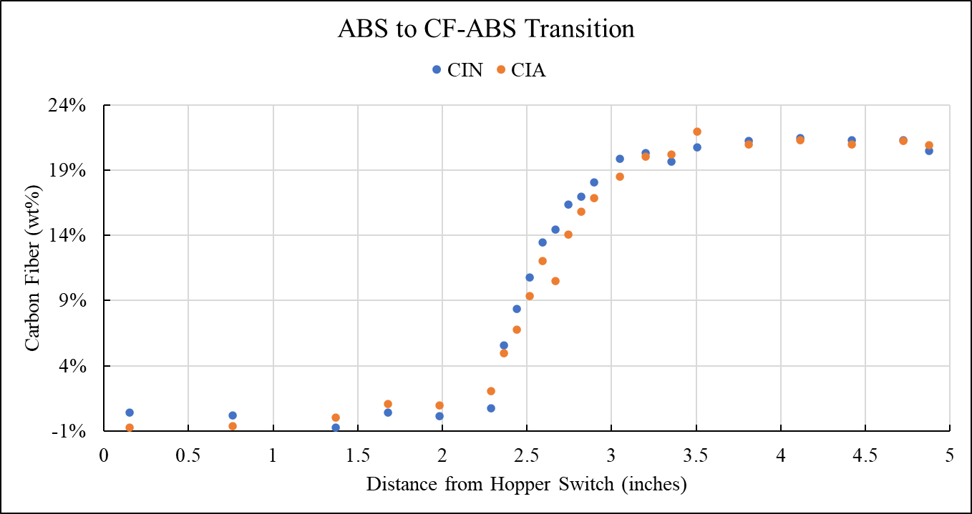
Figure A - 1. The composition shape curves for initial CIN and CIA comparisons.

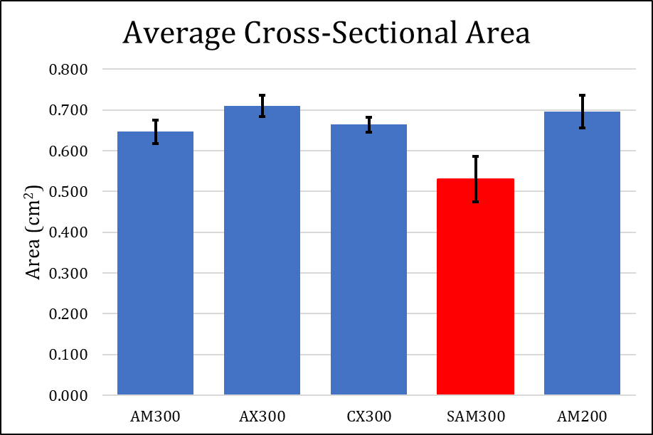
Figure A - 2. Average Cross-sectional area for several material transitions showing the significant decrease when using the SMN.

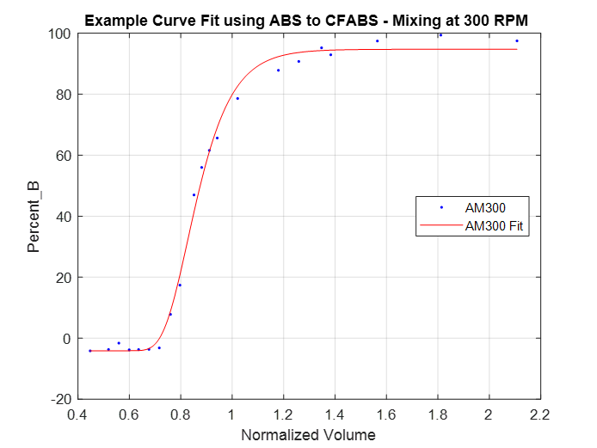
Figure A - 3. The best fit using generalized logistics functions, which still struggled to capture the transition start correctly.

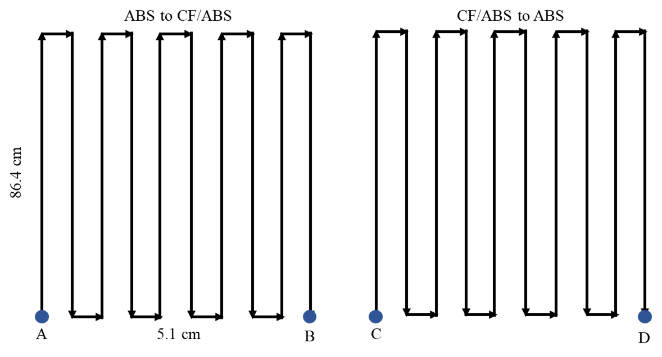
Figure A - 4. The schematic print path for all SMN prints.

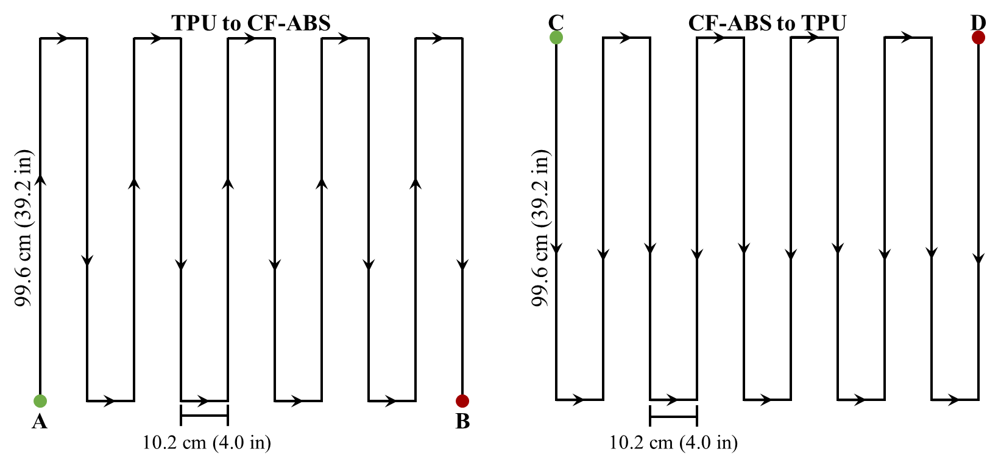
Figure A - 5. The schematic print path for all TPU-CFABS prints.

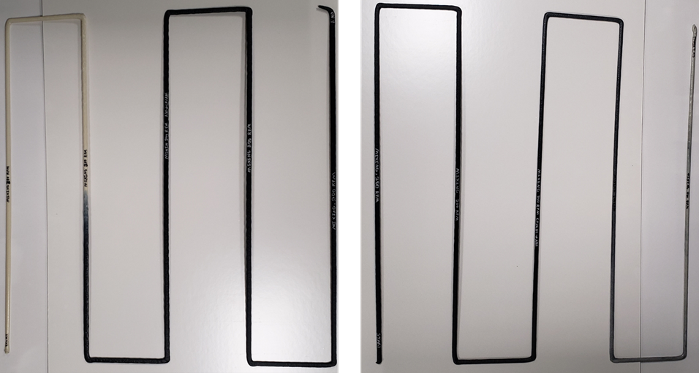
Figure A - 6. Example of an AM configuration transition sample.

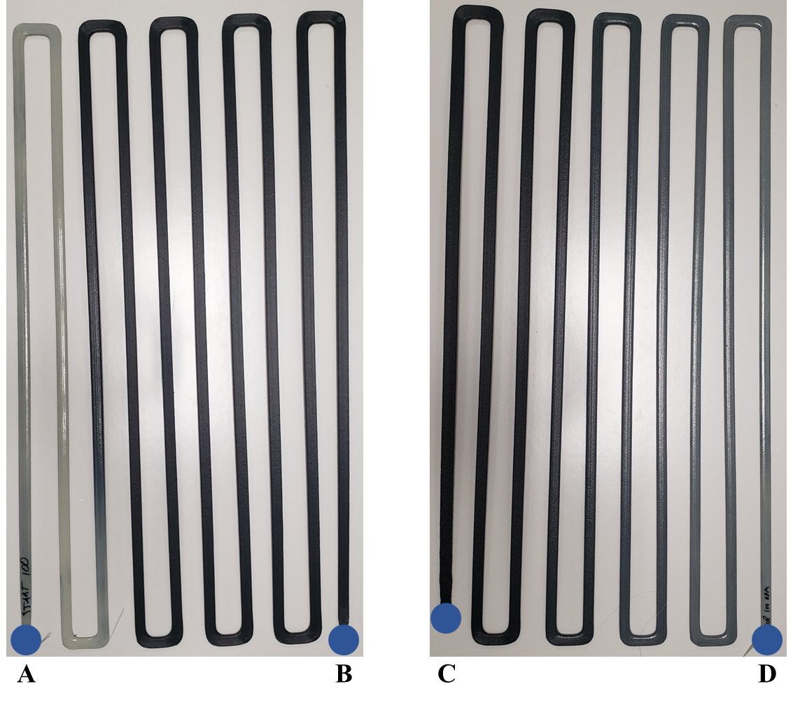
Figure A - 7. An example of a SMN transition printed using A-4.

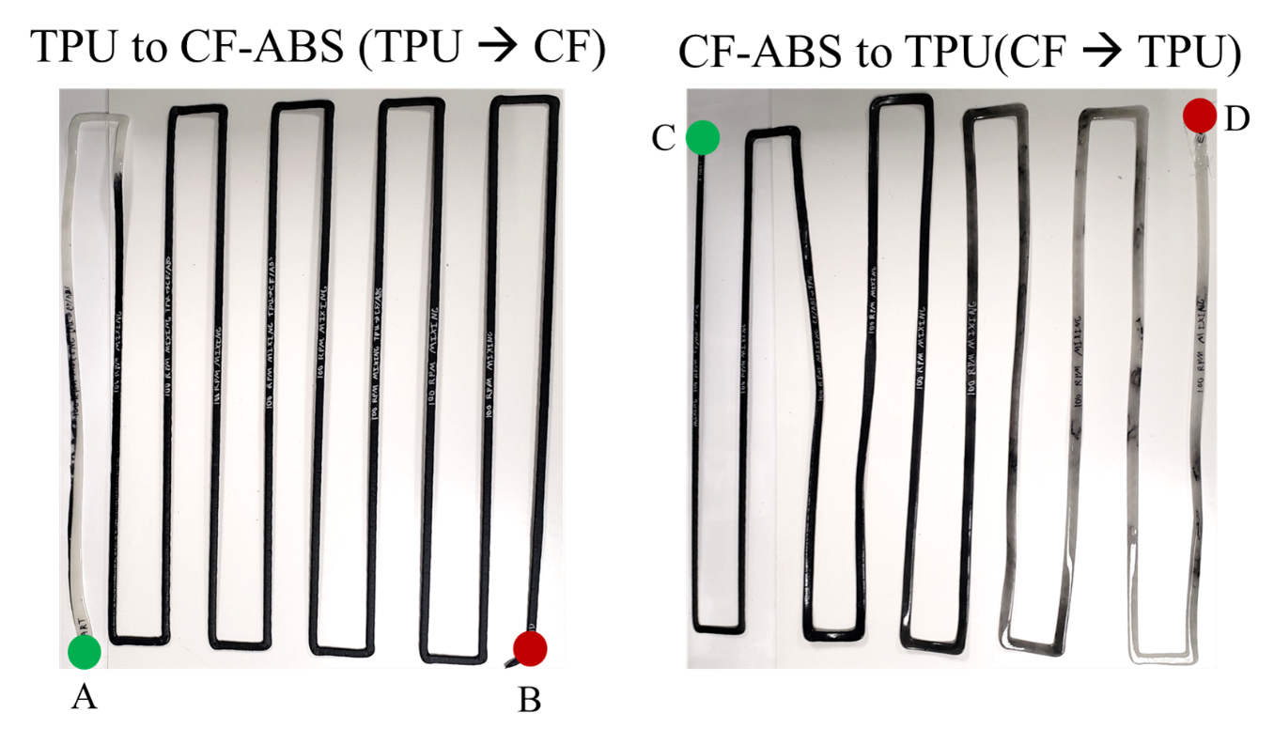
Figure A - 8. An example of a TPU-CFABS printed using A – 5.

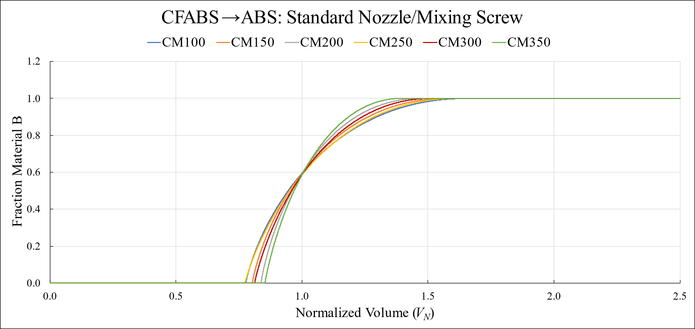
Figure A - 9. Modeled shape curves for the CM configuration.

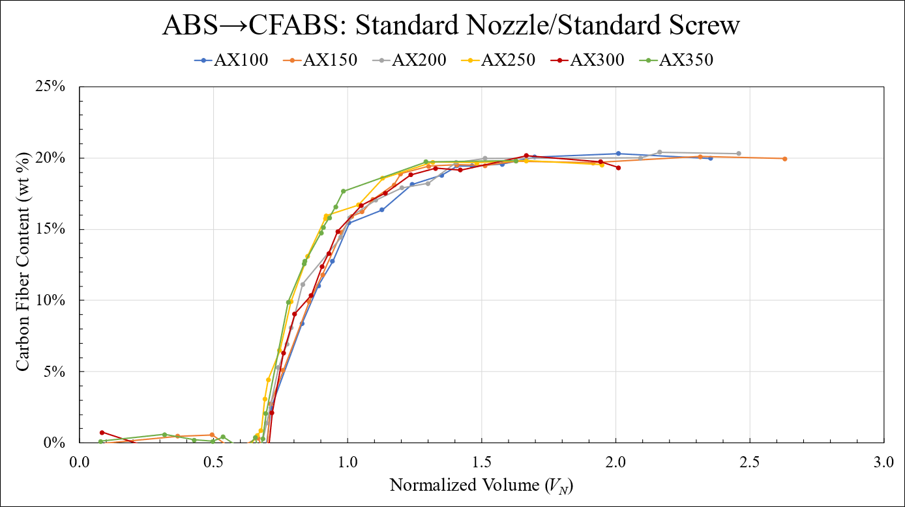
Figure A - 10. Measure shape curves for the AX configuration.

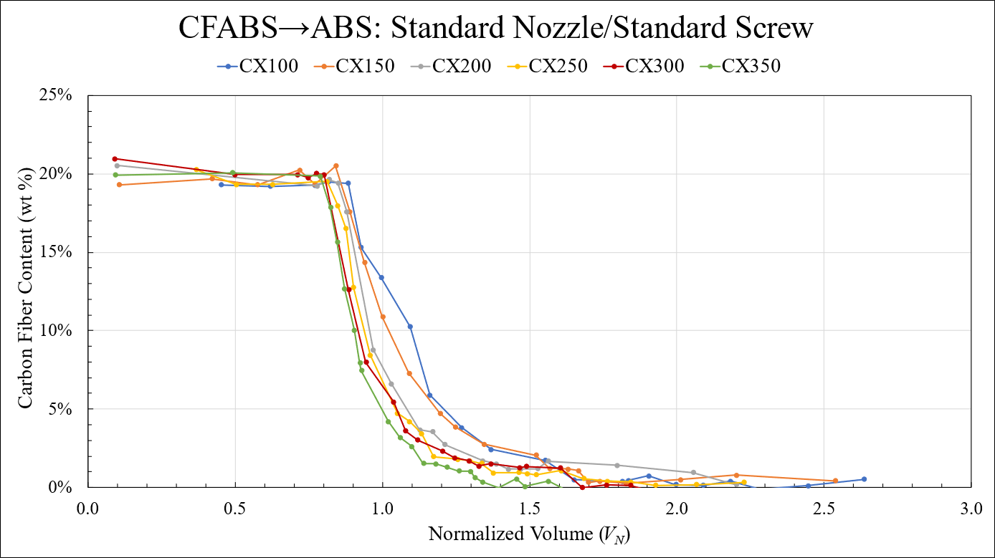
Figure A - 11. Measured shape curves for the CX configuration.

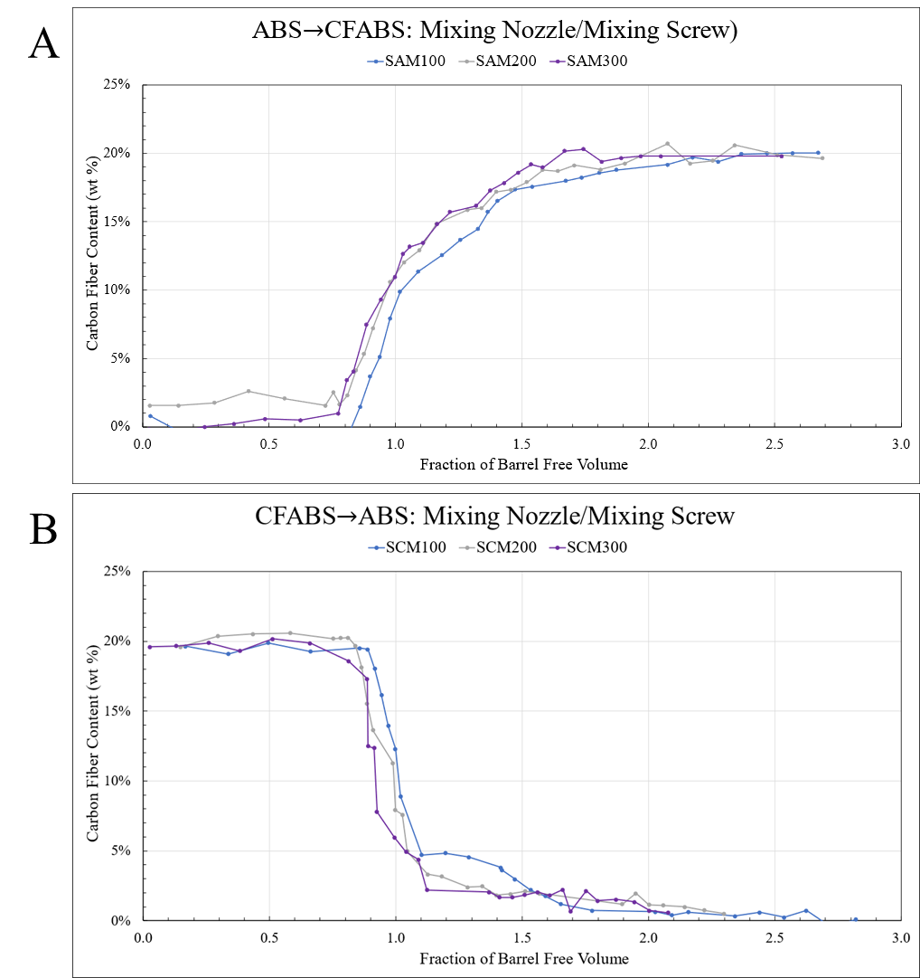
Figure A - 12. Measured shape curves for the A) SAM and B) SCM transitions.

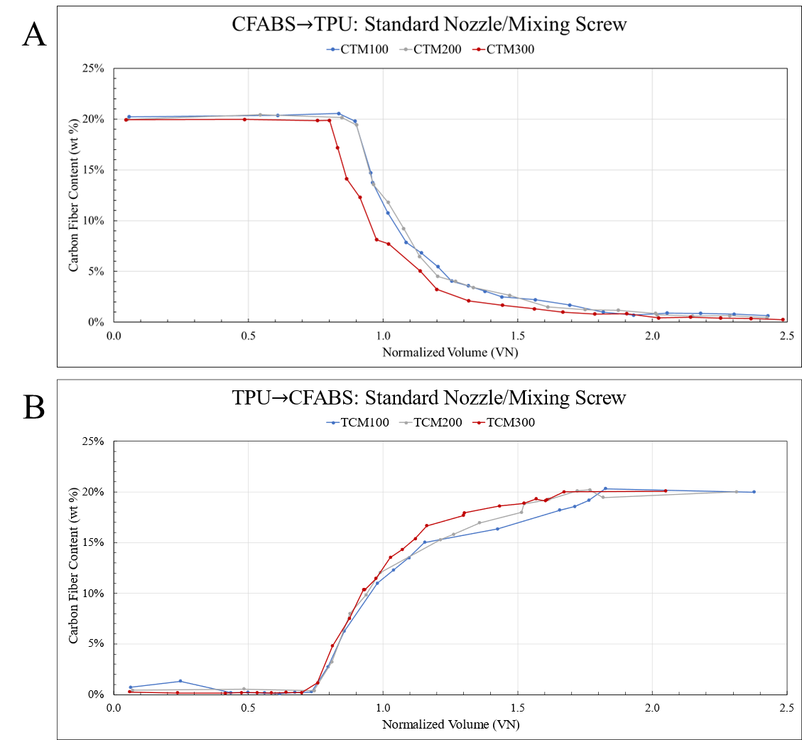
Figure A - 13. Measured shape curves for the A) CTM and B) TCM configurations.

Appendix B: Material Specifications, Variable Identifications, and Constants Tables
Table B - 1. Cross-sectional areas of samples from various configurations.
Group Description | Sample | CSA (μm²) | CSA (cm²) | wt % CF
RPM and Geo Study: ABS to CF/ABS at 300 RPM, Non-Mixing Screw | AX300-J10-B_2DStitch_CSA | 66292093 | 0.663 | 0.8%
 | AX300-J14-B_2DStitch_CSA | 72918417 | 0.729 | 2.3%
 | AX300-J16-B_2DStitch_CSA | 73746495 | 0.737 | 9.2%
 | AX300-J34-B_2DStitch_CSA | 70265644 | 0.703 | 20.3%
RPM and Geo Study: CF/ABS to CF ABS at 300 RPM, Non-Mixing Screw | CX300-J43-B_2DStitch_CSA | 67533422 | 0.675 | 18.9%
 | CX300-J26-B_2DStitch_CSA | 66456236 | 0.665 | 5.6%
 | CX300-J22-B_2DStitch_CSA | 66082690 | 0.661 | 1.8%
 | CX300-J16-B_2DStitch_CSA | 63472612 | 0.635 | 1.4%
 | CX300-J07-B_2DStitch_CSA | 68217086 | 0.682 | 0.9%
Static Mixing Nozzle, ABS to CF/ABS, Mixing Screw at 300 RPM | SAM300-J1-B-2D Stitch CSA | 65076399 | 0.651 | 0.1%
Static Mixing Nozzle, ABS to CF/ABS, Mixing Screw at 300 RPM | SAM300-J26-B-2D Stitch CSA | 56133614 | 0.561 | 0.6%
Static Mixing Nozzle, ABS to CF/ABS, Mixing Screw at 300 RPM | SAM300-J33-B-2D Stitch CSA | 55003616 | 0.550 | 3.6%
Static Mixing Nozzle, ABS to CF/ABS, Mixing Screw at 300 RPM | SAM300-J38-B-2D Stitch CSA | 50845451 | 0.508 | 9.4%
Static Mixing Nozzle, ABS to CF/ABS, Mixing Screw at 300 RPM | SAM300-J41-B-2D Stitch CSA | 50131971 | 0.501 | 12.8%
Static Mixing Nozzle, ABS to CF/ABS, Mixing Screw at 300 RPM | SAM300-J54-B-2D Stitch CSA | 49010929 | 0.490 | 17.4%
Static Mixing Nozzle, ABS to CF/ABS, Mixing Screw at 300 RPM | SAM300-J68-B-2D Stitch CSA | 49098965 | 0.491 | 20.4%
Static Mixing Nozzle, ABS to CF/ABS, Mixing Screw at 300 RPM | SAM300-J99-B-2D Stitch CSA | 48905921 | 0.489 | 19.9%

Table B - 2. A list and description of all variables with associated units.
Variable Name or Description | Symbol | Units
Volumetric flow rate | Q | m³/s
Number of parallel flights | p | Unitless
Channel depth | H | m
Channel width | W | m
Velocity down Barrel | v_{bz} | m
Pressure gradient down Barrel | g_{z} | Pa/m
Material viscosity | η | Pa s
Drag Flow form factor | F_{d} | Unitless
Pressure Flow form factor | F_{P} | Unitless
Purge Zone | Z_{P} | m, m³, or V_{N} as specified
Transition Zone | Z_{T} | m, m³, or V_{N} as specified
Steady-State Zone | Z_{S} | m, m³, or V_{N} as specified
Purge Zone length | L_{P} | m, m³, or V_{N} as specified
Steady-State Zone length | L_{S} | m, m³, or V_{N} as specified
Transition Zone length | L_{T} | m, m³, or V_{N} as specified
Zone Lengths for Material A to B transitions | L_{P-A} L_{S-A} L_{T-A} | m, m³, or V_{N} as specified
Zone Lengths for Material B to A transitions | L_{P-B} L_{S-B} L_{T-B} | m, m³, or V_{N} as specified
Crucible mass with residue of Neat specimen | M_{cr} | g
Empty neat crucible mass | m_{c} | g
Initial dry mass of neat specimen | m_{i} | g
Initial dry mass of composite specimen | M_{i} | g
Crucible mass with residue of composite specimen | M_{cr} | g

Table B – 2 Continued

Variable Name or Description | Symbol | Units
Empty composite crucible mass | M_{c} | g
Complex viscosity | η* | Pa s
Storage modulus | G’ | MPa
Gantry Travel Distance | d | m
Extruded Volume | V_{E} | m³
Travel Speed | v | m/s
Normalized Volume | V_{N} | Ratio of V_{E}/V_{R}
Residual Volume | V_{R} | m³
Extrudate Equivalent Volume in Feed Throat | V_{T} | m³
Extrudate Equivalent Volume in Barrel | V_{B} | m³
Extrudate Equivalent Volume in Nozzle Assembly | V_{A} | m³
Density Ratio | ρ_{r} | Ratio of either ρ_{b}, ρ_{c}, or ρ_{m} to ρ_{E}
Material Bulk Density | ρ_{b} | g/cm³
Material Compressed Bulk Density | ρ_{c} | g/cm³
Material Melt Density | ρ_{m} | g/cm³
Material Extrudate Density | ρ_{E} | g/cm³
Representative Density | ρ_{Ri} | g/cm³
Stepwise Gradient Position | f_{i} | Unitless
Extrudate Equivalent Volume in Feed Zone | V_{F} | m³
Extrudate Equivalent Volume in Compression Zone | V_{C} | m³
Extrudate Equivalent Volume in Metering Zone | V_{M} | m³
V_{N}=1 Boundary | V₁ | Ratio of V_{E}/V_{R}

Table B – 2 Continued

Variable Name or Description | Symbol | Units
Time | t | s
Extrudate Mass | m_{E} | g
Rule of Mixtures Volumetric Flow Rate | Q_{R} | m³/s
Volumetric Flow Rate of Material A | Q_{A} | m³/s
Volumetric Flow Rate of Material B | Q_{B} | m³/s
Fraction of Material A | F_{A} | Unitless
Rule of Mixtures Residual Volume | V_{Rx} | m³
Extrudate Equivalent Volume in SMN Assembly | V_{A-S} | m³
Extrudate Equivalent Volume in C-SMN Assembly | V_{A-C} | m³

Table B - 3. The volumes of the constant geometries in the dual-hopper system.
Description | Symbol | Value (x 10⁻⁵ m³)
Available Volume in Screw Feed Zone | F | 5.73 x 10⁻⁵
Available Volume in Screw Compression Zone | C | 4.50 x 10⁻⁵
Flight-by-Flight Volume in Compression Zone | C_{j} | Table B-4
Available Volume in Screw Metering Zone | M | 2.96 x 10⁻⁵
Available Volume in Nozzle Assembly | N | 3.36 x 10⁻⁵
Available Volume in Static Mixing Nozzle Assembly | N_{S} | 3.65 x 10⁻⁵
Available Volume in Compression Nozzle Assembly | N_{C} | 3.77 x 10⁻⁵

Table B - 4. The constant geometry available in the screw compression zone.
Compression Zone Sub-Divisions | Symbol | Volume (x 10⁻⁶ m³)
Flight 1 | C₁ | 7.9
Flight 2 | C₂ | 6.9
Flight 3 | C₃ | 6.4
Flight 4 | C₄ | 5.9
Flight 5 | C₅ | 5.4
Flight 6 | C₆ | 4.9
Flight 7 | C₇ | 4.3
Flight 8 | C₈ | 3.4

Table B - 5. Modeling variables and descriptions.
Variable Description | Symbol | Units
Transition start on original x-axis | X_{T} | V_{N}
Transition end on original x-axis | X_{S} | V_{N}
Transition start on transformed x-axis | z_{T} | V_{N}
Transition end on transformed x-axis | z_{S} | V_{N}
Multiplicative coefficient | A | Unitless
Exponential coefficient | n | Unitless
Conservation of mass shift on x-axis | V_{shift} | V_{N}

Table B - 6. Residual Volumes for each of the configurations used to print transitions.
Configuration | RPM | V_{R} (x 10⁻⁵ m³)
ABS to CFABS using:  Standard screw and standard nozzle  Mixing screw and standard nozzle | 100 | 17.58
 | 150 | 17.66
 | 200 | 17.74
 | 250 | 17.68
 | 300 | 17.62
 | 350 | 17.65
CFABS to ABS using:  Standard screw and standard nozzle  Mixing screw and standard nozzle | 100 | 16.21
 | 150 | 16.37
 | 200 | 16.53
 | 250 | 16.60
 | 300 | 16.67
 | 350 | 16.64
ABS to CFABS using:  Mixing screw and mixing nozzle | 100 | 17.89
ABS to CFABS using:  Mixing screw and mixing nozzle | 200 | 17.89
ABS to CFABS using:  Mixing screw and mixing nozzle | 300 | 17.89
CFABS to ABS using:  Mixing screw and mixing nozzle | 100 | 16.69
CFABS to ABS using:  Mixing screw and mixing nozzle | 200 | 16.69
CFABS to ABS using:  Mixing screw and mixing nozzle | 300 | 16.69
TPU to CFABS using:  Mixing screw and standard nozzle | 100 | 15.87
TPU to CFABS using:  Mixing screw and standard nozzle | 200 | 15.87
TPU to CFABS using:  Mixing screw and standard nozzle | 300 | 15.87
CFABS to TPU using:  Mixing screw and standard nozzle | 100 | 16.21
CFABS to TPU using:  Mixing screw and standard nozzle | 200 | 16.23
CFABS to TPU using:  Mixing screw and standard nozzle | 300 | 16.69
ABS-CFABS “U”, standard nozzle | 300 | 17.60
ABS-CFABS “U”, mixing nozzle | 300 | 17.89
ABS-CFABS “U”, compression nozzle | 300 | 18.01

Table B - 7. Measured volumetric flow rates and densities for each configuration.
Description | Nozzle Design | Density,  ρ_{E} (g/cm³) | Measured Volumetric Flow Rates, Q (x 10⁻⁶ m³/s)
ABS at 100 RPM | Standard | 1.0538 | 2.9
ABS at 150 RPM | Standard | 1.0492 | 4.3
ABS at 200 RPM | Standard | 1.0446 | 5.4
ABS at 250 RPM | Standard | 1.0482 | 6.4
ABS at 300 RPM | Standard | 1.0518 | 7.7
ABS at 350 RPM | Standard | 1.0500 | 8.7
CFABS at 100 RPM | Standard | 1.1245 | 3.2
CFABS at 150 RPM | Standard | 1.1134 | 4.6
CFABS at 200 RPM | Standard | 1.1024 | 5.9
CFABS at 250 RPM | Standard | 1.0979 | 6.8
CFABS at 300 RPM | Standard | 1.0934 | 8.1
CFABS at 350 RPM | Standard | 1.0956 | 9.2
ABS at 100 RPM | Mixing | 1.0356 | 2.9
ABS at 200 RPM | Mixing | 1.0356 | 5.1
ABS at 300 RPM | Mixing | 1.0356 | 6.6
CFABS at 100 RPM | Mixing | 1.0918 | 2.8
CFABS at 200 RPM | Mixing | 1.0918 | 4.9
CFABS at 300 RPM | Mixing | 1.0918 | 6.5
TPU at 100 RPM | Standard | 1.1844 | 3.5
TPU at 200 RPM | Standard | 1.1860 | 7.8
TPU at 300 RPM | Standard | 1.1829 | 10.1

Table B - 8. Travel speeds of all printed material transitions.
Configuration | Print Path or Schematic | RPM | Travel Speed, v (m/s)
ABS-CFABS using:  Standard screw and standard nozzle  Mixing screw and standard nozzle |  | 100 | 0.036
 |  | 150 | 0.054
 | Figure 5-1 | 200 | 0.073
 |  | 250 | 0.091
 |  | 300 | 0.109
 |  | 350 | 0.127
TPU-CFABS using:  Mixing screw and standard nozzle | Figure A-5 | 100 | 0.036
TPU-CFABS using:  Mixing screw and standard nozzle | Figure A-5 | 200 | 0.072
TPU-CFABS using:  Mixing screw and standard nozzle | Figure A-5 | 300 | 0.109
ABS-CFABS using:  Mixing screw and mixing nozzle | Figure A-4 | 100 | 0.038
ABS-CFABS using:  Mixing screw and mixing nozzle | Figure A-4 | 200 | 0.076
ABS-CFABS using:  Mixing screw and mixing nozzle | Figure A-4 | 300 | 0.114
ABS-CFABS “U”, standard nozzle | Figure 6-2 | 300 | 0.099
ABS-CFABS “U”, mixing nozzle | Figure 6-2 | 300 | 0.099
ABS-CFABS “U”, compression nozzle | Figure 6-3 | 300 | 0.183

Table B - 9. Residual volume calculated for a shifted melt zone as a result of changing screw speeds.
 | Sub-Divisions | Available Volume (in³) | Melt Fraction | Volume (in³) |  |  | Melt Fraction | Volume (in³) |  |  | Melt Fraction | Volume (in³) |  |  | Melt Fraction | Volume (in³) |  |  | Melt Fraction | Volume (in³)
Constants | - | 8.314 | - |  | 6.16 | 0 |  |  | 6.16 | 0 |  |  | 6.16 | 0 |  |  | 6.16 | 0 |  | 6.16
Barrel (Feed Zone) | 03.6 D | 1.657 | 0 |  | 1.03 | 0 |  |  | 1.31 | 0 |  |  | 1.60 | 0 |  |  | 1.89 | 0 |  | 2.17
Barrel (Feed Zone) | 3.64.6D | 0.460 | 1/9 |  | 0.30 | 0 |  |  | 1.31 | 0 |  |  | 1.60 | 0 |  |  | 1.89 | 0 |  | 2.17
Barrel (Feed Zone) | 4.65.6 D | 0.460 | 2/9 |  | 0.31 | 1/9 |  |  | 0.30 | 0 |  |  | 1.60 | 0 |  |  | 1.89 | 0 |  | 2.17
Barrel (Feed Zone) | 5.66.6 D | 0.460 | 3/9 |  | 0.32 | 2/9 |  |  | 0.31 | 1/9 |  |  | 0.30 | 0 |  |  | 1.89 | 0 |  | 2.17
Barrel (Feed Zone) | 6.67.6 D | 0.460 | 4/9 |  | 0.34 | 3/9 |  |  | 0.32 | 2/9 |  |  | 0.31 | 1/9 |  |  | 0.30 | 0 |  | 2.17
Barrel (Compression) | 7.68.6 D | 0.485 | 5/9 |  | 0.37 | 4/9 |  |  | 0.35 | 3/9 |  |  | 0.34 | 2/9 |  |  | 0.33 | 1/9 |  | 0.233
Barrel (Compression) | 8.69.6 D | 0.422 | 6/9 |  | 0.33 | 5/9 |  |  | 0.32 | 4/9 |  |  | 0.31 | 3/9 |  |  | 0.30 | 2/9 |  | 0.29
Barrel (Compression) | 9.610.6 D | 0.39 | 7/9 |  | 0.32 | 6/9 |  |  | 0.31 | 5/9 |  |  | 0.30 | 4/9 |  |  | 0.29 | 3/9 |  | 0.27
Barrel (Compression) | 10.611.6 D | 0.36 | 8/9 |  | 0.30 | 7/9 |  |  | 0.29 | 6/9 |  |  | 0.28 | 5/9 |  |  | 0.27 | 4/9 |  | 0.26
Barrel (Compression) | 11.612.6 D | 0.329 | 1 |  | 0.29 | 8/9 |  |  | 0.28 | 7/9 |  |  | 0.7 | 6/9 |  |  | 0.26 | 5/9 |  | 0.25
Barrel (Compression) | 12.613.6 D | 0.296 | 1 |  | 0.26 | 1 |  |  | 0.26 | 8/9 |  |  | 0.25 | 7/9 |  |  | 0.24 | 6/9 |  | 0.23
Barrel (Compression) | 13.614.6 D | 0.261 | 1 |  | 0.23 | 1 |  |  | 0.23 | 1 |  |  | 0.23 | 8/9 |  |  | 0.22 | 7/9 |  | 0.21
Barrel (Compression) | 14.615.6 D | 0.207 | 1 |  | 0.18 | 1 |  |  | 0.18 | 1 |  |  | 0.18 | 1 |  |  | 0.18 | 8/9 |  | 0.17
Total (V_{R}) | - | 14.56 | - |  | 10.73 | - |  |  | 10.62 | - |  |  | 10.52 | - |  |  | 10.42 | - |  | 10.25
% Decrease | - | - | - |  | - | - |  |  | 0.99 % | - |  |  | 1.93 % | - |  |  | 2.83 % | - |  | 4.41 %

Appendix C: Optical Images of Material Transition Cross-Sections
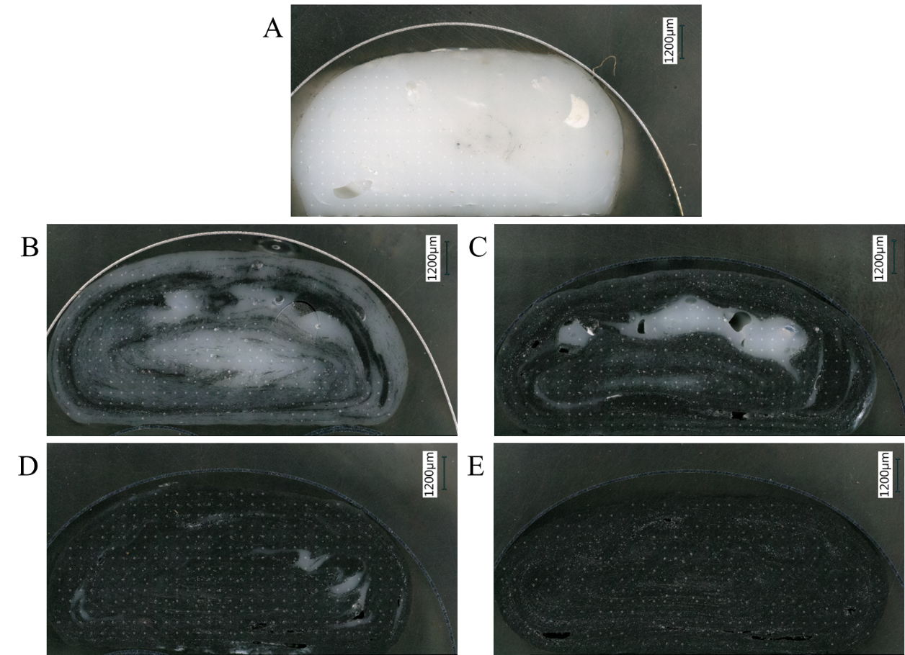
Figure C - 1. Optical images of cross-sections from the ABS to CFABS transition printed using the mixing screw and standard nozzle with carbon fiber contents of A) 0 wt %, B) 1.6 wt %, C) 3.5 wt %, D) 12.3 wt %, and E) 19.9 wt %.

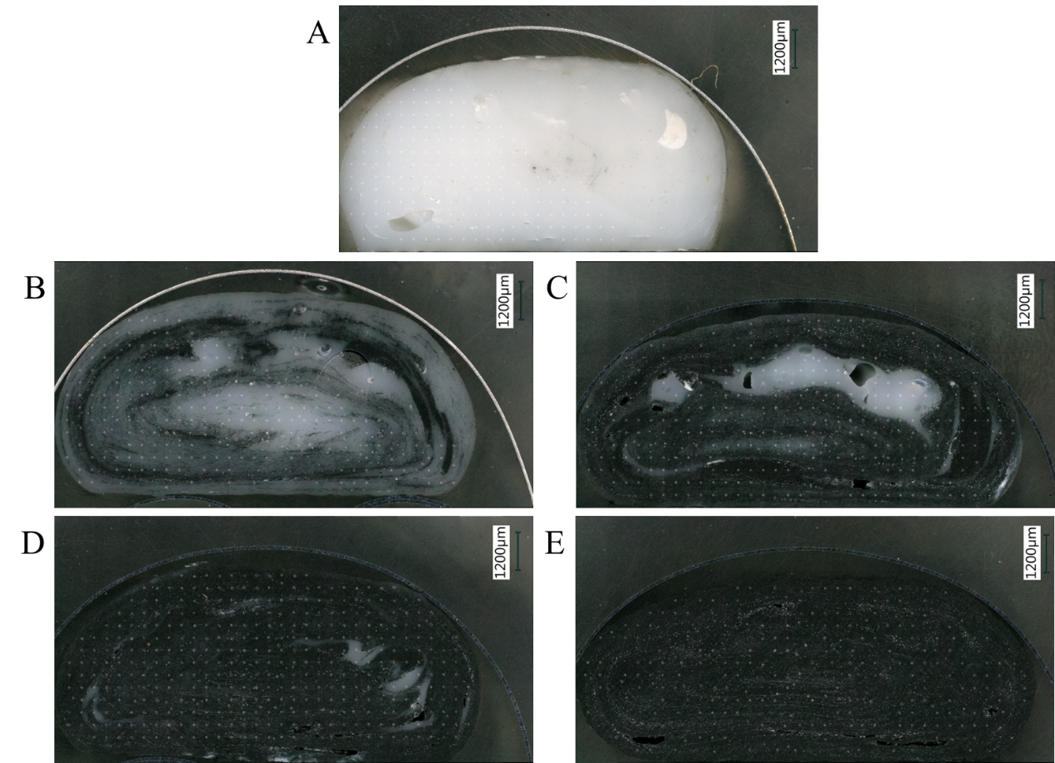
Figure C - 2. Optical images of cross-sections from the ABS to CFABS transition printed with standard screw and nozzle with carbon fiber contents of A) 0.7 wt %, B) 2.1 wt %, C) 9.1 wt %, D) 12.4 wt %, and E) 20.2 wt %.

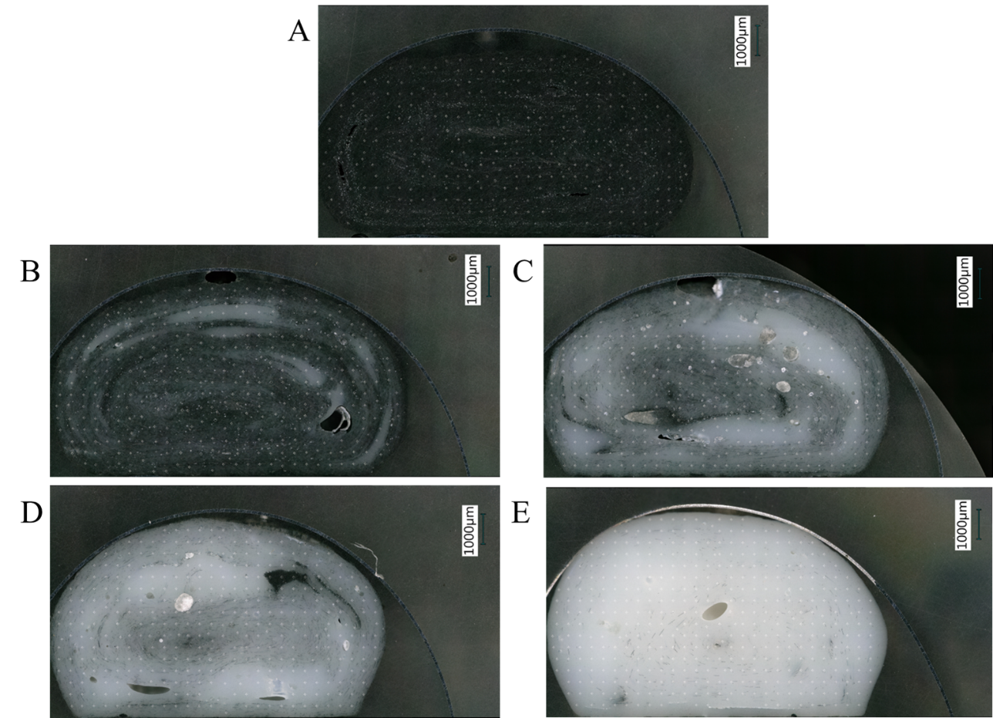
Figure C - 3. Optical images of cross-sections from the CFABS to ABS transition printed with standard screw and nozzle with carbon fiber contents of A) 19.1 wt %, B) 5.5 wt %, C) 1.9 wt %, D) 0.9 wt %, and E) 0.1 wt %.

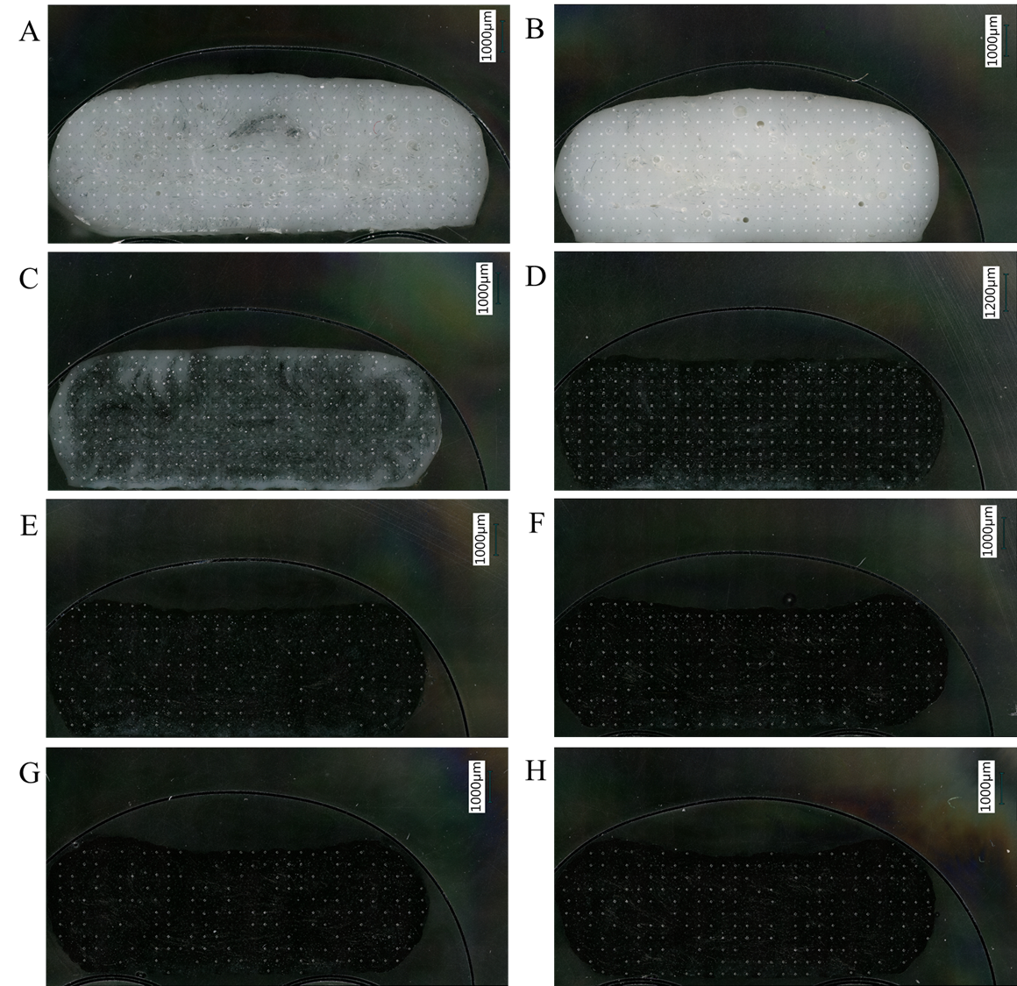
Figure C - 4. Optical images of cross-sections from the ABS to CFABS transition printed using the mixing screw and mixing nozzle with carbon fiber contents of A) 0.1 wt %, B) 0.6 wt %, C) 3.6 wt %, D) 9.4 wt %, E) 12.8 wt %, F) 17.4 wt %, G) 20.4 wt %, and H) 19.9 wt %.

Vita
James Brackett was born in Knoxville, TN, and remained in the area throughout high school. He attended the University of Tennessee – Knoxville and graduated in May 2017 with a B.S. in Materials Science and Engineering. He enrolled in the Energy Science and Engineering Doctor of Philosophy program at the same institution. After completing his graduate degree, James is excited to pursue a career in industry developing additive manufacturing technology and materials.

