Blending Issues of Hot and Warm Mix Asphalt containing Recycled Asphalt Pavement and Recycled Asphalt Shingle

A Dissertation Presented for the

Doctor of Philosophy

Degree

The University of Tennessee, Knoxville

Sheng Zhao

December 2014

Copyright © 2014 by Sheng Zhao
All rights reserved.

DEDICATION

This dissertation is dedicated to my dear wife, Ziyang (Kay) Wang, and my brothers and sisters in Knoxville.

ACKNOWLEDGEMENTS

I would like to express the highest level of gratitude to my advisor, Dr. Baoshan Huang, for his guidance, support, help and encouragement throughout my doctoral study.
I would also like to thank other professors in my doctoral committee, my co-advisor Dr. X. Philip Ye, Dr. Xiang Shu, Dr. Khalid Alshibli, Dr. Qiang He and my statistics advisor Dr. Russell Zaretzki who have given me advice and perspective as I have pursued my Ph.D. Their time and efforts are greatly appreciated.
Many thanks also go to my colleagues, coworkers and my friends in the chemistry department for their friendship and assistance over the last four and a half years.
Last and certainly not least, I would like to thank my wife, Ziyang (Kay) Wang, my family, my friends for their encouragement, love, and support throughout the pursuit of my degree.

ABSTRACT

The current tendency in paving industry is to increase the use of recycled asphalt pavement (RAP) and recycled asphalt shingle (RAS). However, one of the reasons that limit the high recycled amount is the unknown blending between virgin and RAP/RAS binders. A series of studies were conducted in this dissertation to address blending issues in warm mix asphalt (WMA) and hot mix asphalt (HMA) containing RAP and RAS, in terms of evaluation of recycled binder mobilization, binder homogeneity and WMA effects on blending.
Partial blending was observed in RAS mixtures and the most efficient blending occurred at approximately 5% RAS by weight. Increasing time led to a better RAS binder mobilization, while aggregate size and temperature in a certain range showed limited effects. A new parameter derived from gel permeation chromatography (GPC), large molecular size percentage [LMS(%)] related to binder molecular weight distribution, was developed to differentiate virgin and RAP/RAS binders as well as their blends, based on which a method was developed to quantify the recycled binder mobilization rate.
A two-layer model based on atomic force microscopy (AFM) scanning was developed to evaluate RAS and virgin binder blending. The two binders were found to be “mixing” but not “blending” in a mixing zone of 25 to 30 micrometer. Staged extraction method used to evaluate asphalt binder homogeneity was validated with trichloroethylene (TCE) as the most effective solvent. A non-equal-time staged extraction method was proposed, in conjunction with LMS(%), to quantify binder homogenization after mechanical mixing and diffusion. Different blending scenarios of RAP/RAS mixes were proposed and validated. It was found that diffusion could be accomplished within mixture storage time for both WMA and HMA containing RAP, while blending in RAS mix was limited.
WMA additives yielded mixes with higher blending ratios than control mix produced at 135ºC, but lower than hot mix produced at 165ºC. Laboratory foaming yielded a higher blending ratio, indicating foamed WMA may improve blending. Rutting might still be a concern for WMA-high RAP mixtures while fatigue concern may not exist. WMA-high RAP mixtures showed satisfactory moisture resistance. Blending effects on performance still need further investigation.

TABLE OF CONTENTS

CHAPTER I 1
RESEARCH BACKGROUND AND OBJECTIVES 1
1.1 Research Background 2
1.1.1 Recycled Asphalt Pavement 2
1.1.2 Recycled Asphalt Shingle 2
1.1.3 Warm Mix Asphalt 3
1.1.4 Use of High RAP/RAS 3
1.1.5 Concerns over Blending 4
1.1.6 Literature Review of Blending Research 5
1.2 Research Objectives 7
1.2.1 Problem Statement 7
1.2.2 Research Objectives 8
1.3 Structure of Dissertation 10
CHAPTER II 12
CHARACTERIZING RHEOLOGICAL PROPERTIES OF BINDER AND BLENDING EFFICIENCY OF ASPHALT PAVING MIXTURES CONTAINING RAS THROUGH GPC 12
2.1 Abstract 13
2.2 Introduction 14
2.2.1 RAS Blending Efficiency 14
2.2.2 Use of Gel Permeation Chromatography in Asphalt Research 16
2.3 Objectives and Scope 17
2.4 Laboratory Experiments 18
2.4.1 Estimation of Rheological Properties with GPC 18
2.4.2 Method of Examining Blending Efficiency 18
2.4.3 Materials 20
2.4.4 Blended Binder Sample Preparation 21
2.4.5 Mixture Sample Preparation 22
2.4.6 DSR Test 22
2.4.7 GPC Test 22
2.5 Results and Discussion 23
2.5.1 Blended Binder DSR and GPC Evaluation 23
2.5.2 Effect of Mixing Time on Mixture Binder 25
2.5.3 Effect of Aggregate Size on Mixture Binder 26
2.5.4 Effect RAS Content on Mixture Binder 27
2.6 Conclusions 29
2.7 Acknowledgment 30
CHAPTER III 31
Quantitative Characterization of Binder Blending: How Much RAP/RAS Binder Mobilized during Mixing 31
3.1 Abstract 32
3.2 Introduction 33
3.2.1 Use of High RAP/RAS 33
3.2.2 Concerns over RAP/RAS Binder Mobilization 34
3.2.3 Using GPC to Characterize Binder Blend 35
3.3 Objective 35
3.4 Methodology 36
3.5 Development of A GPC Parameter for Blending Research 39
3.5.1 Re-defined LMS(%) – Based on Molecular Weight Distribution 40
3.5.2 Determination of the Large Molecule Threshold (LMT) 41
3.6 Building “Blending Chart” with Newly Defined LMS(%) 44
3.6.1 Sample Preparation 44
3.6.2 Building “Blending Chart” 45
3.7 Determination of RAP/RAS Binder Mobilization Rate 46
3.7.1 Experimental Design 46
3.7.2 Results and Discussion 48
3.8 Summary and Conclusions 51
3.9 Limitations 52
3.10 Acknowledgement 52
CHAPTER IV 54
INVESTIGATION ON MICROSTRUCTURES OF RAS BINDER AND ITS BLENDING WITH VIRGIN BITUMEN 54
4.1 Abstract 55
4.2 Introduction 56
4.3 Objective 60
4.4 Materials and Experimental Design 61
4.4.1 Materials 61
4.4.2 Sample Preparation 63
4.4.3 AFM Instrumental Setting and Measurement Environment 64
4.4.4 Method 65
4.5 Results and Discussion 65
4.5.1 Using AFM to Characterize RAS Binder 65
4.5.2 Temperature Dependence of Microstructures in RAS Binder 70
4.5.3 Investigation on Blending Degree Between RAS and Virgin Binder 71
4.6 Discussion and Conclusions 77
4.6.1 Discussion 77
4.6.2 Conclusions 78
CHAPTER V 80
INVESTIGATION ON BINDER HOMOGENEITY OF RAP/RAS MIXTURES THROUGH STAGED EXTRACTION 80
5.1 Abstract 81
5.2 Introduction 81
5.3 Objectives and Scopes 82
5.4 Validation of Staged Extraction Method 82
5.4.1 Effect of Solvents 82
5.4.2 GPC Testing and Results 83
5.4.3 Selective Dissolution? 84
5.4.4 Solvent Selection 87
5.4.5 Validation with Steel Ball Model 88
5.4.6 Binder Homogeneity of RAP and RAS Particles 90
5.5 Evaluating Binder Homogeneity of Asphalt Mixture containing RAP And RAS 91
5.5.1 Experimental Design 91
5.5.2 Results and Discussion 94
5.6 Conclusions 96
CHAPTER VI 98
QUANTITATIVELY EVALUATING BLENDING AND DIFFUSION IN HIGH RAP AND RAS MIXTURES 98
6.1 Abstract 99
6.2 Introduction 99
6.2.1 Concerns for Binder Blending 100
6.2.2 Direct Observation of Binder Homogenization 101
6.2.3 Binder Diffusion 102
6.2.4 Staged Extraction 102
6.3 Objectives and Scopes 104
6.4 Methodology and Experimental Design 105
6.4.1 Quantitative Evaluation of Blending Process 105
6.4.2 Quantitative Evaluation of Diffusion Process 109
6.5 Results and Discussion 110
6.5.1 Results from 50% RAP Mixture 110
6.5.2 Results from 10% RAS Mixture 112
6.6 Diffusion Study Results 114
6.6.1 Results from 50% RAP Mixture 114
6.6.2 Results from 10% RAS Mixture 116
6.7 Conclusions 117
6.8 Acknowledgment 118
CHAPTER VII 119
Effects of WMA Technologies on Asphalt Binder Blending 119
7.1 Abstract 120
7.2 Introduction 120
7.2.1 WMA containing High RAP/RAS 120
7.2.2 Concerns over Blending 121
7.2.3 WMA Technologies 122
7.3 Objectives 123
7.4 Experimental Design and Materials 123
7.4.1 Methodology and Materials 123
7.4.2 Mix Design 125
7.4.3 Experimental Design 126
7.5 Results and Discussion 129
7.5.1 Viscosity Testing Results 129
7.5.2 Blending Results 131
7.6 Conclusions 138
CHAPTER VIII 140
COMPARATIVE EVALUATION OF WARM MIX ASPHALT CONTAINING HIGH PERCENTAGES OF RECLAIMED ASPHALT PAVEMENT 140
8.1 Abstract 141
8.2 Introduction 142
8.3 Objectives and Scope 144
8.4 Materials and Sample Preparation 146
8.4.1 Materials and Mix Design 146
8.4.2 Sample Preparation 146
8.5 Rutting Performance 147
8.5.1 APA Rutting Test 148
8.5.2 Hamburg Wheel-track Test 149
8.5.3 Flow Number Test 151
8.5.4 Rutting Performance Summary 152
8.6 Cracking and Fatigue Performance 153
8.6.1 Cracking and Fatigue Performance 153
8.6.2 Beam Fatigue Test 156
8.6.3 Cracking and Fatigue Resistance Summary 159
8.7 Moisture Susceptibility 160
8.7.1 TSR test 160
8.7.2 Resilient Modulus (MR) Ratio 162
8.7.3 Hamburg Wheel-track Test 163
8.7.4 Moisture Susceptibility Summary 165
8.8 Conclusions and Recommendations 165
8.9 Acknowledgment 167
CHAPTER IX 168
CONCLUSIONS AND RECOMMENDATIONS 168
9.1 Conclusions 169
9.2 Recommendations 171
REFERENCES 173
VITA 179

LIST OF TABLES

Table 1. 1 Binder selection guidelines for RAP and RAS mixtures according to AASHTO M 323 4
Table 1. 2 Three blending simulation adopted in NCHRP Project 9-12 6

Table 2. 1 Combinations of RAS binder and virgin binder 18
Table 2. 2 Differentiation between mixtures 1 through 7 19
Table 2. 3 The size distribution of the materials 21
Table 2. 4 Mix design for mixtures 1 through 7 (by weight of the total mixture) 21

Table 3. 1 Example of α_{M} calculation 38
Table 3. 2 Usage of recycled materials selected in this study 47
Table 3. 3 Properties of RAP, RAS and virgin aggregate 47

Table 4. 1 List of bitumen selected in this study 61
Table 4. 2 Asphalt binder properties of PG6422 62
Table 4. 3 Asphalt binder properties of PG5228 62
Table 4. 4 Properties of binders extracted from RAS 63

Table 5. 1 Mix design of the mixtures used in this study 93

Table 6. 1 Properties of materials selected in this study 106
Table 6. 2 Mix design and other properties of mixtures 107
Table 6. 3 Step-extraction procedure 108
Table 6. 4 Experimental plan for diffusion study 110

Table 7. 1 Properties of the materials used in this study 124
Table 7. 2 Properties of WMA additives 125
Table 7. 3 Mix design 126

Table 8. 1 Asphalt Mixtures evaluated in the study 145
Table 8. 2 Mixture production and compaction quality control data 147

LIST OF FIGURES

Figure 1. 1 Schematic of three mechanisms occurring during asphalt blending 9
Figure 1. 2 Flow chart of the proposed research 10

Figure 2. 1 Aggregates and RAS used in this study (size distribution in Table 2.3) 19
Figure 2. 2 Design parameters for mixture blending 20
Figure 2. 3 Relation between percentage of LMS and G* at 25˚C 24
Figure 2. 4 Relation between percentage of LMS and G* at 25˚C 25
Figure 2. 5 The relation between mixing time and percentage of LMS 26
Figure 2. 6 The comparison of small “carrier” aggregates to medium and large aggregates 27
Figure 2. 7 Relationship between the medium aggregate LMS and carrier (small aggregate) LMS when compared to RAS content 28
Figure 2. 8 Relationship between the large aggregate LMS and carrier (small aggregate) LMS when compared to RAS content 29

Figure 3. 1 Two possible blending scenarios 36
Figure 3. 2 Research flow chart of this study 39
Figure 3. 3 GPC working mechanism and chromatograms 40
Figure 3. 4 GPC Chromatograms Based on Molecular Weights 41
Figure 3. 5 Relation between LMT and LMS(%) Difference for RAP/RAS-Virgin Binders 43
Figure 3. 6 LMS(%) calculated with LMT of 3,000 Dalton for different binders 44
Figure 3. 7 “Blending Chart” generated with LMS(%) 46
Figure 3. 8 Round-shaped gravel used as tracking aggregate 47
Figure 3. 9 LMS(%) results 49
Figure 3. 10 Recycled binder (%) in the blend 49
Figure 3. 11 Calculated mobilization rates for mixes selected 51

Figure 4. 1 Appearance of commonly used virgin binder and extracted RAS binder 57
Figure 4. 2 Two possible binder interaction scenarios between RAS and virgin binder 58
Figure 4. 3 Topography and phase images of PG5228 and PG6422 virgin binder 67
Figure 4. 4 Topography and phase images of TM binder 68
Figure 4. 5 Topography and phase images of TT and VT binder 69
Figure 4. 6 Schematic of thermal conditioning of TT binder 70
Figure 4. 7 Topographic images of TT binder after temperature treatment 71
Figure 4. 8 Experimental Design of Observing the Blending Degree between RAS and Virgin Binder 72
Figure 4. 9 Comparison of Scanning Results on the Top of the Layered Sample 74
Figure 4. 10 Probing the interfacial zone 75
Figure 4. 11 Comparison of scanning results on the interfacial zone of the layered sample and detailed description of mixing zone 76
Figure 4. 12 Blending scenarios (adapted from Nahar et al. 2013b) 77
Figure 4. 13 Phase image of RAP-virgin binder blending (adapted from Nahar et al. 2013b) 78

Figure 5. 1 Solvent Effect on GPC Results 84
Figure 5. 2 Fractionation of Asphalt through Soxhlet Extraction Method 85
Figure 5. 3 GPC Results after Binder Fractionation 85
Figure 5. 4 GPC Results after Staged Extraction by Different Solvents 87
Figure 5. 5 Dissolving Rate of Different Solvents 88
Figure 5. 6 Composite Steel-Ball Sample Preparation 89
Figure 5. 7 Steel-Ball Testing Results 90
Figure 5. 8 GPC results of four-layer stripping of raw RAP and RAS 91
Figure 5. 9 Aggregate gradation 92
Figure 5. 10 Separated fine RAP and coarse virgin aggregates 93
Figure 5. 11 Layer weight distribution caused by different extraction methods 94
Figure 5. 12 GPC results of RAP samples 95
Figure 5. 13 GPC results of RAS samples 96

Figure 6. 1 Three different blending scenarios (adapted from Bowers 2013) 101
Figure 6. 2 The layered structure adapted from Huang et al. (2005) 103
Figure 6. 3 Possible blending scenario 105
Figure 6. 4 Separated coarse and fine particles for 50% RAP mixture 108
Figure 6. 5 LMS (%) calculation 109
Figure 6. 6 Temperature profile for mix production, storage, transportation and placement (adapted from Kriz et al. 2014) 110
Figure 6. 7 Results of staged extraction on coarse virgin aggregates in RAP mix 111
Figure 6. 8 Results of staged extraction on fine RAP aggregates 112
Figure 6. 9 Results of staged extraction on coarse virgin aggregates in RAS mix 113
Figure 6. 10 Results of staged extraction on fine RAS aggregates 113
Figure 6. 11 Different blending scenarios of RAP and RAS mixes 114
Figure 6. 12 Diffusion results of RAP mix 115
Figure 6. 13 Diffusion results of RAS mix 116

Figure 7. 1 The old binder mobilization during mixing 121
Figure 7. 2 Separated particles after mixing 127
Figure 7. 3 Determination of LMS (%) 128
Figure 7. 4 Flow chart of the experimental design 129
Figure 7. 5 Viscosity testing results 130
Figure 7. 6 Effect of WMA additive or short period heating on GPC results 132
Figure 7. 7 GPC results of coarse-medium RAP mix 133
Figure 7. 8 Blending ratio of coarse-medium RAP mix 134
Figure 7. 9 GPC results of non-foaming medium-fine RAP mix 135
Figure 7. 10 GPC results of foaming medium-fine RAP mix 135
Figure 7. 11 Blending ratio of non-foaming medium-fine RAP mix 136
Figure 7. 12 Blending ratio of foaming medium-fine RAP mix 137
Figure 7. 13 GPC results of medium-fine RAS mix 137
Figure 7. 14 Blending ratio of coarse-medium RAP mix 138

Figure 8. 1 Results from APA rutting test 149
Figure 8. 2 Rut Depths from Hamburg Wheel-track Test 150
Figure 8. 3 Results from flow number test 152
Figure 8. 4 Determination of Creep Strain Energy 154
Figure 8. 5 DCSEf from Superpave IDT test 155
Figure 8. 6 Failure Loading Cycles from Beam Fatigue Test 157
Figure 8. 7 Typical load cycles versus RDEC plot 158
Figure 8. 8 Plateau Values from beam fatigue test 159
Figure 8. 9 Results from TSR test 161
Figure 8. 10 Results from MR ratio test 163
Figure 8. 11 Stripping Inflection Points from Hamburg Wheel-track Test 164

LIST OF ACRONYMS

AASHTO: American Association of State Highway and Transportation Officials
AFM: Atomic Force Microscopy
CT: Computed Tomography
CV: Coefficient of Variation
DSR: Dynamic Shear Rheometer
EPA: Environmental Protection Agency
E*: Dynamic Modulus
FHWA: Federal Highway Administration
GPC: Gel Permeation Chromatography
G*: Complex Shear Modulus
HMA: Hot Mix Asphalt
LMS(%): Large Molecular Size Percentage
LMT: Large Molecule Threshold
NAPA: National Asphalt Pavement Association
NCHRP: National Cooperative Highway Research Program
nPB: n-Propyl Bromide
RAP: Recycled Asphalt Pavement
RAS: Recycled Asphalt Shingle
RI: Refractive Index
RTFO: Rolling Thin-Film Oven
TCE: Trichloroethylene
THF: Tetrahydrofuran
TDOT: Tennessee Department of Transportation
TFOT: Thin Film Oven Test
WMA: Warm Mix Asphalt

CHAPTER I

RESEARCH BACKGROUND AND OBJECTIVES

Research Background

Recycled Asphalt Pavement

Recycling hot mix asphalt (HMA) is an alternative to reuse the aggregate and asphalt binder in old asphalt pavement. The use of recycled asphalt pavement (RAP), which commonly contains 4 to 6% asphalt binder by weight, is a valuable approach for technical, economical and environmental reasons (Kennedy et al. 1998). As the America’s most recycled material (NAPA 2013), 60 million tons of RAP is annually reused directly into pavements with additional 40 million tons recycled into other pavement-related applications. It was estimated that using RAP provides a saving ranging between 14 and 34% if the RAP content varies from 20 to 50% (Kandhal and Mallick 1997).

Recycled Asphalt Shingle

Recycling asphalt shingles into pavement construction dates back to the late 1970s and early 1980s due to the quality and content of asphalt binder (20 to 35% by weight) in shingles (Krivit 2007). According to United States Environmental Protection Agency (EPA), a total of 11 million tons of asphalt shingles is recycled annually in the U.S., including 1 million tons of post-manufactured shingles and 10 million tons of post-consumer shingles (tear-offs) (FHWA and EPA 1993), which would, if recycled by the transportation and construction agencies, lead to an annual saving of $ 1.1 billion (Gevrenov 2008). Post-manufactured shingles come from shingle manufacturing process such as factory rejects and tab cut-outs, while tear-offs are roofing shingles after their service life due to severe damage (Williams et al. 2011). Since tear-offs account for more than 90% of the recycled asphalt shingle (RAS) resources (FHWA and EPA 1993), research efforts are trending towards the utilization of these post-consumer shingles (Williams et al. 2011).

Warm Mix Asphalt

Warm mix asphalt (WMA) is an emerging technology employed by asphalt industry to deal with concerns about global warming and energy consumption. The production of WMA allows mixing and compacting temperatures 10°C to 38°C lower than traditional hot mix asphalt (HMA) which are mixed at between 150°C and 155°C and compacted at between 145°C and 150°C (NAPA 2010). The reduction in temperature leads to less fuel needed during heating which will in turn lower energy costs in production. The decrease in fuel consumption will also lower fumes and greenhouse gas emissions produced by the asphalt industry, making it more environmental friendly (Shu et al. 2012). WMA may be produced by adding additives while mixing or by introducing water to produce foamed warm mix asphalt resulting in good workability at lower temperatures.

Use of High RAP/RAS

Due to the environmental pressure and economic benefit, state agencies and contractors have been seeking to increase the use of RAP (McDaniel and Anderson 2001; Al-Qadi et al. 2007; Zhao et al. 2012, 2013) and incorporate recycled asphalt shingle (RAS) in the paving industry (Cascione et al. 2011; Zhou et al. 2013).
However, there have been concerns over raising the RAP percentage. The increase of the stiff aged binder from RAP can cause pavement cracking failures (Zaumanis and Mallick 2014). The concern over RAS binder is even more critical since air-blown process has significantly stiffened the binder used to produce roofing shingle prior to the further aging during the service life (Zhao et al. 2014). Therefore, the final binder grade of asphalt mixtures containing RAP/RAS needs to be adjusted. The binder adjustment methods that are most commonly accepted by the paving industry include incorporating softer virgin binder and/or rejuvenating agents (Zaumanis and Mallick 2014). Currently, the binder selection guidelines for RAP mixtures are specified in AASHTO M 323, where blending chart is recommended for mixtures containing high RAP percentage (no less than 25%) (Table 1.1). The linear blending chart is also used for virgin-RAS binders and specified as the design consideration for RAS mixtures in AASHTO PP 53, with introduction of a shingle asphalt binder availability factor F.

Table 1. 1 Binder selection guidelines for RAP and RAS mixtures according to AASHTO M 323
Recommended Virgin Binder Grade | RAP Percentage (%)
No change | < 15
Select virgin binder one grade softer | > 15 to < 25
Follow blending charts recommendations | > 25

Concerns over Blending

Another limitation impeding the applicability of high RAS/RAP mixtures is the unknown blending between the virgin and recycled binders. In production process, RAP/RAS binder is expected to attain enough workability to blend with virgin binder so as to coat both the virgin and recycled aggregates as a homogeneous film. Several state agencies have followed this assumption and give full credit to the RAP/RAS binder in mix design, and then establish virgin binder content once the design binder content is determined (Johnson et al. 2010; Shirodkar et al. 2011; Zaumanis and Mallick 2014).
However, the full blending assumption has been questioned since binder from recycled materials, especially from RAS, is fairly stiffer than virgin binder thus requiring more energy to mobilize, which may be impossible to accomplish in a regular asphalt plant. It was found that very high temperature (over 200ºC) was needed to merely drain the binder extracted and recovered from RAS (Zhou et al. 2013; Zhao et al. 2014). Subsequent research has confirmed this doubt and shown that partial blending, rather than total blending, occurs in RAP/RAS mixes (McDaniel et al. 2001; Huang et al. 2005; Shirodkar et al. 2011; Bowers et al. 2014a; Zhao et al. 2014).
The assumption of full blending produces under-asphalted mixtures (Al-Qadi et al. 2007; Shirodkar et al. 2011) that have lower effective binder content but higher air voids, thus leading to cracking, raveling and pre-mature moisture damage of the pavement (Zaumanis and Mallick 2014). On the contrary, the theory of RAP/RAS acting like ‘black rock’ raised by some researchers or any conservative estimation of RAP/RAS binder contribution may lead to an assumption of no or low blending (Zaumanis and Mallick 2014), which will result in soft mixtures risking rutting problem, owing to excessive binder content (Al-Qadi et al. 2007). The tendency of using high RAP/RAS will make the above-mentioned concerns even more critical, therefore, there needs research to address the blending issues.

Literature Review of Blending Research

Blending was first discussed by Carpenter and Wolosick (1980) when rejuvenating agent was introduced in RAP mix. It was found that only a portion of the aged binder was affected immediately after the mixing, and the rejuvenating agent diffuses into the aged binder film eventually.
Blending of RAP and virgin binders was first addressed in NCHRP Project 9-12 (Mcdaniel and Anderson 2001) with the purpose of addressing whether RAP acts like a black rock or whether some blending does occur between the old and the new binders. Three types of mixture specimens were fabricated simulating actual practice, black rock and total blending (Table 1.2). On the basis of the results of Superpave shear tests and indirect tensile creep and strength tests, the authors concluded that RAP does not act like a black rock and partial blending apparently occurs to a significant extent, rather than total blending of the RAP binder and the virgin binder. A similar study was conducted by Soleymani et al. (2000) and found 50% of the actual mixtures didn’t perform similarly to either black rock or total blending mixtures, which indicates that the insufficient blending does affect the performance of mixtures containing high RAP.

Table 1. 2 Three blending simulation adopted in NCHRP Project 9-12
Mixture Type | Preparation Method
Actual Practice | Blending RAP, virgin aggregate and virgin binder, simulating actual practice
Black Rock | Removal of RAP binder, blending virgin binder with recovered RAP aggregate and virgin aggregate, simulating no blending
Total Blending | Removal of RAP binder, physically blending the extracted and recovered RAP binder into the virgin binder, then combining the blended binder into the virgin aggregate, simulating total blending

Another approach to determine the blending degree was proposed by Bonaquist (2007), which was named “Bonaquist Approach” and adopted by other researchers afterwards (Mcdaniel et al. 2012; Mogawer et al. 2012). The “Bonaquist Approach” used Hirsch Model to create an estimated dynamic modulus (E*) master curve by testing extracted binder and compared with the lab tested E*. The mixtures were considered to be 100% blended if the estimated E* matched the true E* tested in the lab. Based on the same approach, McDaniel et al. (2012) found only three out of twenty one mixtures containing RAP had poor blending and one had partial blending, while Mogawer et al. (2012) stated that blending efficiency seems to be impacted by the discharge temperature of the mixture from the silo. It should be noted that, however, the RAP binder contributes to the increase of dynamic modulus of asphalt mixtures (Shu and Huang 2008a) even without the presence of total blending, which may weaken the feasibility of the “Bonaquist Approach” in blending research.
The above-mentioned studies did discuss blending issues, however, most of them were limited to indirect evaluation with mixture testing. Three years ago, Shirodkar et al. (2011) presented a new approach to quantify the blending ratio and degree of partial blending by separating the virgin and RAP aggregates, and evaluating properties of binder on each type of aggregate. The following equation [Eq. (1.1)] was proposed:

$$Blending ratio= \frac{\left|A{\left(virgin_agg\right)}_{blend binder}-A{\left(RAP_agg\right)}_{blend binder}\right|}{\left|A_{blend binder}-A_{RAP virgin binder 0 blend}\right|} (1.1)$$

The authors used G*/sin(δ) as the indicator to conclude that the partial blending for 25% RAP mixture with PG 70-28 as the virgin binder was 70%, while that of 35% RAP with PG 58-28 was 96%. However, the method proposed by the researchers is highly dependent on the sensitivity of the parameter to blending and its variation, which were not addressed specifically in the study. In addition, the authors admitted the quantitative extraction for binder testing was time-consuming.
In order to avoid laborious extraction work, Zhao et al. (2014) and Bowers et al. (2014b) introduced gel permeation chromatography (GPC) to asphalt blending studies. Gap-graded mixtures were used in both studies to separate RAP/RAS and virgin aggregates after mixing, respectively. Large molecular size (LMS), which was defined as the percentage of the area of first 5 slices over the total 13 slices beneath the chromatogram, was used as the major parameter to differentiate binders extracted from RAP (Bowers et al. 2014b) or RAS (Zhao et al. 2014) and virgin aggregates. A term named blending ratio [Eq. (1.2)] was initiated to characterize the blending levels, which qualitatively indicated the mobilization level of the aged binder during mixing.
$$Blending ratio= \frac{Virgin Agg. LMS\%}{RAP/RAS Agg. LMS\%} (1.2)$$

Research Objectives

Problem Statement

The literature review shows that researchers have started to address blending issues in RAP/RAS mixtures, however, blending concerns still exist. Some of the methods previously adopted were questionable; the evaluated factors that affect blending efficiency were limited to mixing temperature and mixing time; none of the literature presented an entire evaluation of the blending process; blending in RAS mixtures was rarely mentioned. These limitations hinder the full implementation of recycled asphaltic materials used in paving industry.
Furthermore, if WMA technology is introduced, the lowered temperatures may make both the aged binder and virgin binder less workable thus leading to a decreased degree of blending. It was found that the insufficient blending significantly affect the performance of the asphalt mixtures containing high percentages of RAP (Soleymani et al. 2000). Therefore, it is valuable to understand WMA effects on blending as well as its further impacts on performance, in order to seek better utilization of all these sustainable paving technologies.

Research Objectives

The objectives of this dissertation are:
- to develop new methods to characterize blending process of asphalt paving mixtures containing RAP/RAS;
- to qualitatively and quantitatively evaluate the blending efficiency at different stages of blending;
- to quantify the effects of the factors that affect the blending process; and
- to investigate the effect of other sustainable technologies, such as WMA, on blending efficiency between the recycled and the new binders.

Blending between RAP binder and virgin binder can be evaluated as a function of RAP source, production temperature, properties of RAP and virgin binder, mixing time, storage and transportation time as well as plant type (Zaumanis and Mallick 2014). Since RAS is similar to RAP in terms of structure and composition, the same description and methodology suitable for RAP can be applied to RAS.
To cover the entire blending process, blending issues can be addressed by answering three questions as follows. First, how much aged binder can be mobilized and blended with the virgin binder other than behave like “black stone”? It can be seen in Figure 1.1a that the mobilization of aged binder may be owing to aged binder being activated by hot virgin binder thus becoming workable, and the “scrape-off” effect subject to mechanical force when RAP/RAS in contact with the virgin aggregate with asperities. Second, how well the aged binder blends with the virgin binder? Figure 1.1b shows the two possible scenarios for blending between the mobile aged binder and virgin binder, where either aged binder partially dissolves into the virgin binder, or a total blending is accomplished to create a homogeneous “new” material. Therefore, this question can be answered by investigating on homogeneity of the blended binder. Third, does the softer binder diffuse into the undissolved aged binder after long-term service? Figure 1.1c sketches the potential long-term diffusion that governs the homogenization between virgin and aged binders in years’ service.

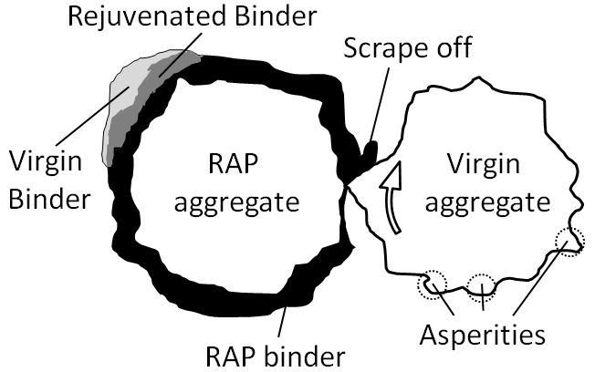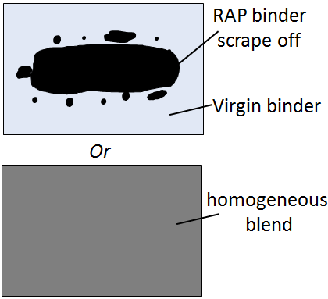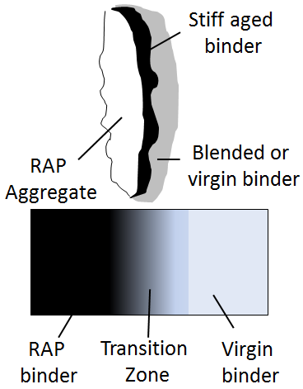
(a) Mobilization of the aged binder (b)Two scenarios for blending(c) Long term diffusion
Figure 1. 1 Schematic of three mechanisms occurring during asphalt blending

Figure 1.2 presents the research flow chart of this study. The fulfillment of the blending efficiency study will provide a deep insight of the blending mechanisms between the aged and new binders, fundamentally help with the mix design process with consideration of recycled materials (such as RAS/RAP) and promote the efficient and effective use of asphalt recycling technologies. Furthermore, the WMA high-RAP performance evaluation will be able to validate the WMA effects on the blending efficiency, while the role WMA plays in blending efficiency may account for the WMA impacts on performance of high RAP mixtures. All these ultimately contribute to a better utilization of sustainable technologies in asphalt industry.

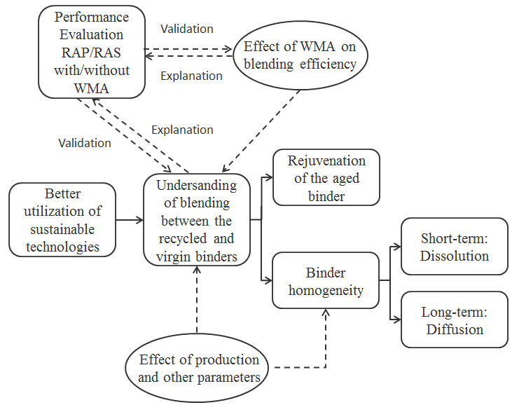 Figure 1. 2 Flow chart of the proposed research

Structure of Dissertation

This dissertation is divided into nine chapters. Chapter I provides background and literature support for the studies presented herein. Chapters II through VIII are published or potential journal articles. Chapter II develops a new method using gel permeation chromatography (GPC) to characterize blending efficiency in RAS mix. This characterization is based on qualitative analysis. Chapter III develops a new method to conduct quantitative evaluation of the old binder mobilization rate for RAP/RAS mixtures. Chapter IV uses atomic force microscopy (AFM) to directly observe the binder blending between virgin and RAS binders. Chapter V validates a very effective method, staged extraction, used to evaluate the binder homogeneity of the mixture after mixing is completed. Chapter VI conducts quantitative evaluation of binder blending level and diffusion process with the help of well-designed staged extraction method. Chapter VII evaluates the WMA effects on the blending. Chapter VIII characterizes the performance of WMA and HMA containing high percentages of RAP. The final chapter, chapter IX, presents an outline of the conclusions as well as the recommendations for future research.

CHAPTER II

CHARACTERIZING RHEOLOGICAL PROPERTIES OF BINDER AND BLENDING EFFICIENCY OF ASPHALT PAVING MIXTURES CONTAINING RAS THROUGH GPC

A version of this chapter was originally published by Sheng Zhao, Benjamin F. Bowers, Baoshan Huang and Xiang Shu:
Zhao, S., Bowers, F.B., Huang, B. and Shu, X. (2014). “Characterizing rheological properties of binder and blending efficiency of asphalt paving mixtures containing RAS through GPC.” Journal of Materials in Civil Engineering, Vol. 26, No. 5, pp. 941-946.

Sheng Zhao was the principle researcher and author of “Characterizing rheological properties of binder and blending efficiency of asphalt paving mixtures containing RAS through GPC.” Sheng Zhao’s contribution was collecting literature review, conducting experimental design, DSR testing and data analysis, and writing the most of the text presented in this paper. Dr. Benjamin Bowers conducted GPC testing and helped with data analysis. Dr. Baoshan Huang and Dr. Xiang Shu provided ideas, guidance and comments throughout the whole project and offered revision and editorial assistance for the text.

Abstract

Use of recycled asphalt shingles (RAS) into asphalt mixture has become more popular in asphalt paving industry due to dwindling natural resources and potential economic benefits. However, one critical question arises as to how much of aged asphalt binder in RAS can be effectively blended with virgin binder during mixing and construction. This paper presents a laboratory study in which gel permeation chromatography (GPC) was used to determine the blending efficiency of RAS. A correlation was first established between percentages of large molecules (LMS) obtained from GPC and rheological properties of RAS binders. Then the relationship was used to estimate the blending efficiency of RAS binders. The effects of aggregate size, RAS content, and mixing time on blending efficiency were evaluated. The test results show that the percentage of LMS was highly correlated with the complex shear modulus (G*) of asphalt binder. Increasing mixing time led to a better blending of RAS mixture. Aggregate size did not show a significant effect on blending efficiency. In this study, partial blending was achieved and the most efficient blending occurred at approximately 5% RAS by weight.

Introduction

With the increase in cost of construction materials and long-term depletion of natural sources, asphalt pavement engineers are looking for new methods that conserve energy, minimize materials cost, and can be beneficial to the environment. Among sustainable asphalt technologies such as inclusion of reclaimed asphalt pavement (Huang et al. 2011; Shu et al. 2008b; Zhao et al. 2012, 2013) and new warm mix asphalt technologies (Xiao et al. 2009, 2010; Shu et al. 2012), adding recycled asphalt shingles (RAS) to asphalt paving mixtures is beginning to gain widespread and considerable attention from the asphalt industry.

RAS Blending Efficiency

U.S. Environmental Protection Agency (EPA) estimates 11 million tons of RAS is generated annually in the United States, including 10 million tons of post-consumer shingles (tear-offs) and 1 million tons of post-manufactured in the landfills (FHWA and EPA 1993). Use of the asphalt binder, which accounts for 20–35% of tear-offs by weight, would lead to an annual saving of $1.1 billion if recycled by the transportation and construction agencies (Gevrenov, utilization of recycled asphalt shingles in hot-mix asphalt, presented at the Missouri Showcase 2008). Since the 1990s, numerous studies have been reported to evaluate the use of RAS in HMA and the performance of HMA mixtures containing RAS (Button et al. 1995; Gardiner et al. 1993; Grzybowski 1993; Sengoz and Topal 2005; Janisch and Turgeon 1996). The majority of previous research on RAS has focused on post-manufactured shingles and only 5% RAS by weight has been allowed in the pavement mixture due to limited experience and research on RAS inclusion (McGraw et al. 2007). With further development and advanced technologies, the utilization of valuable postconsumer shingles, which contain more asphalt binder, has become increasingly attractive, but there is no provision for the use of tear-offs in current specifications (Johnson et al. 2010). The current AASHTO MP 15 merely specifies that the blended binder should be further evaluated if the virgin binder content, a percentage of the total binder content of the new HMA, is less than 70%. However, before any further specification can be made to limit the amount of postconsumer shingles in HMA, one critical question should be answered: How much asphalt binder do recycled shingles contribute to the newly blended mixtures? Namely: How much asphalt in RAS can be blended with the virgin binder?
Williams et al. (2011) answered this question based on mix design stating approximately two-thirds of RAS binder behaves as liquid when heated and the other third behaves as an aggregate that is coated with asphalt. McGraw et al. (2007) mentioned in another study that RAS ground to a finer size passing a No. 4 sieve can be expected to effectively utilize as much as 95% of the total available asphalt. However, there is further limited evidence supporting the aforementioned statements regarding RAS binder contribution. Therefore, there is a pressing need to conduct research on RAS binder blending efficiency, which defines the degree to which the old RAS binder and newly added virgin binder are blended during mixing. An interesting study conducted by Huang et al. (2005) introduced a new method to evaluate the blending efficiency of RAP mixtures by which RAP aggregate and virgin aggregate were designed to be visually detected and manually separated after mixing in the laboratory. The asphalt binders extracted and recovered from virgin aggregate and RAP aggregate were tested respectively for rheological and viscoelastic properties, in order to evaluate the blending efficiency of the combination of RAP binder and virgin binder. Since RAS is similar to RAP in terms of structure but stiffer, the method aforementioned could be considered to evaluate the blending efficiency of RAS mixture. Production parameters, such as mixing time, size of aggregate, and RAS content by weight should be considered as factors that affect the blending efficiency.

Use of Gel Permeation Chromatography in Asphalt Research

Since extracting and recovering binder from RAS or RAS mixture is laborious and time-consuming, another method taken to estimate the rheological properties of asphalt binder is gaining popularity. This method uses gel permeation chromatography (GPC) to detect the delicate change of molecular size distribution within the asphalt binder (Kim et al. 2006). Asphalt research using GPC dates back to the 1960s. The principle of GPC is the separation of molecules in solution over time through a column packed with different bead sizes. This separation yields a chromatogram which visually displays the molecular weight distribution of the medium. In 1969, Snyder described GPC as a quick way to determine separations within asphalt binder. GPC also provides a method of determining the average molecular weight of asphalt binder, which Snyder reported as around 900 daltons (Snyder 1969). There are multiple benefits to characterize asphalt binders using GPC as compared to traditional recovery and rheological testing. GPC testing requires minimal sample recovery. Comparisons made by Kim et al. (2006) also found that accurate results can be attained by the GPC when relating to viscosity by simply soaking the sample in the elution solvent for 5 min rather than performing the traditional Abson recovery. The material testing can also be performed very quickly (∼15 min on some instruments) as compared to rheological testing.
GPC has also been used for a number of different studies of asphalt binder. McCann et al. (2008) utilized GPC to detect polymers within asphalt binders by examining the vast difference in the molecular weights of asphalt binder and common polymer additives such as SBS. Bowers et al. (2013) used the method as a way of detecting asphalt contaminant within fine aggregates. Crumb rubber modification of asphalt binders was studied by Lee et al. (2006). Churchill et al. (1995) statistically evaluated changes in the GPC profile of lab (RTFO) hardened AC20 asphalt from multiple sources. The researchers evaluated the absolute and kinematic viscosities as well as the TFOT weight loss and were able to correlate these properties to the changes in the chromatogram as well as penetration values. Jennings et al. (1980, 1985) published work that evaluated pavements in different states of wear (i.e., cracking). It was found that the more damage the pavement exhibited in the form of cracking the higher the percentage of large molecules (LMS) were present in the GPC chromatogram (Yapp et al. 1991). Lu and Isacsson (2002) determined that LMS, defined by the authors as Fractions I, increase at the expense of the smaller Fraction II molecules due to oxidation. Research conducted by Kim et al. (2006) used regression modeling to find that the absolute viscosity of a RAP binder can be predicted with good accuracy based on the percentage of LMS. The percentage of LMS was defined by dividing the area beneath the chromatogram into 13 slices and then taking the ratio of the first 5 slices by the total area. Since the change of binder blending efficiency can be detected by the change in rheological properties of the asphalt binder, the correlation between percentage of LMS obtained from GPC test and the binder’s rheological properties should also be investigated before the GPC test can be widely used in RAS research, although it has been proven that the rheological properties of virgin asphalt binder is highly correlated to the percentage of LMS.

Objectives and Scope

The objective of this paper is to investigate the correlation between rheological properties and percentage of LMS for different combinations of RAS binder and virgin binder. The dynamic shear rheometer (DSR) test is used to characterize complex shear modulus (G*) as the rheological property of the binder at medium and high service temperatures while the GPC test is run to obtain the percentage of LMS. After examining the correlation, GPC testing is used to study the blending efficiency of RAS mixtures under common laboratory production conditions and the effect of three different production parameters on blending efficiency including RAS content, mixing time and the size of the aggregate.
It should be noted that the discussion in this paper is applicable only to short-term aged mixtures, namely RAS mixtures shortly after production, which indicates that the long-term diffusion effect is not within the scope of this study.

Laboratory Experiments

Estimation of Rheological Properties with GPC

RAS binder was extracted and recovered by Centrifuge-Rotavapor Recovery Method (Zhou et al. 2012), and then blended with virgin PG 64-22 binder in different proportions and will be referred to throughout this manuscript as “blended binder”. To obtain a better understanding of the correlation between percentage of LMS and rheological properties of the blended binders, a wide range of the proportions was selected as shown in Table 2.1. All the blended binders were tested on DSR and GPC to evaluate the relationship between G* and the percentage of LMS.

Table 2. 1 Combinations of RAS binder and virgin binder
 | Percent by total weight (%)
RAS binder | 0 | 2.5 | 5 | 7.5 | 10 | 20 | 30 | 40 | 50 | 60 | 70 | 80 | 90 | 100
64-22  Binder | 100 | 97.5 | 95 | 92.5 | 90 | 80 | 70 | 60 | 50 | 40 | 30 | 20 | 10 | 0

Method of Examining Blending Efficiency

Aggregates of three different sizes that could be visually detected and separated were designed to be mixed with RAS and virgin binder to make mixtures (Figure 2.1). The small aggregates were pre-blended with RAS as mixing carriers that completely covered the RAS before blending, in order to avoid further binder loss to the mixing bucket. The change in percentages of LMS among the extracted and recovered binder from the different types of aggregates would give a better understanding of the blending efficiency. In addition, RAS content and mixing time were considered as two parameters that affect the binder blending efficiency and would be taken into consideration in this study. Figure 2.2 shows the design parameters for the mixtures studied in this research. Altogether, seven mixtures were made in the lab and twenty-one GPC samples were evaluated (Table 2.2). Each of these mixtures is referred to as mixing binder.

Table 2. 2 Differentiation between mixtures 1 through 7
 | Time | Temperature (°C) | RAS Content (%)
Mixture 1 | 2 min | 170 | 2.5
Mixture 2 | 2 min | 170 | 5
Mixture 3 | 2 min | 170 | 7.5
Mixture 4 | 2 min | 170 | 10
Mixture 5 | 30 s | 170 | 5
Mixture 6 | 1 min | 170 | 5
Mixture 7 | 3 min | 170 | 5

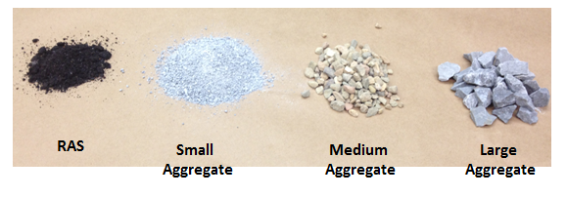
Figure 2. 1 Aggregates and RAS used in this study (size distribution in Table 2.3)

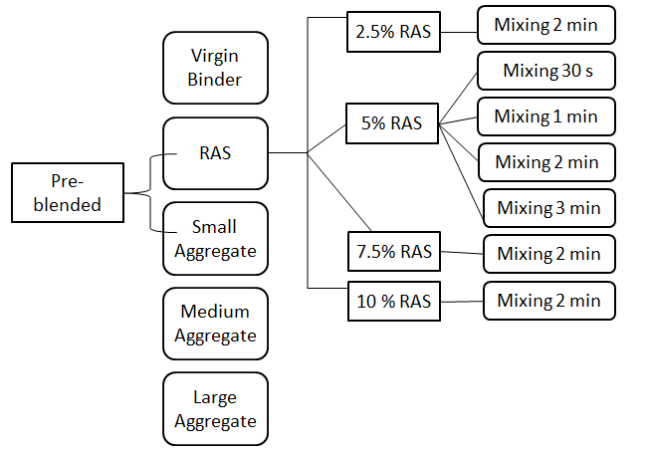
Figure 2. 2 Design parameters for mixture blending

Materials

The RAS used in this study came from tear-offs, which was plant screened and passed No. 4 sieve and had an asphalt content of 19%. The virgin binder is a typical PG 64-22 binder commonly used in the United States. The aggregates utilized in this study included natural sand (referred as small) that completely passed No. 4 sieve, intermediate limestone (referred as medium) that totally passed 19 mm (¾-in.) sieve but retained on No. 4 sieve, and coarse limestone (referred as large) that retained on 19 mm (¾-in.) sieve.
Table 2.3 summarized the size distribution for materials used in this study. Gradation was ignored but each component of the mixture was given specific portion by weight of total mix to make it close to a well-graded mixture (Table 2.4). Among all the mixtures, there were 10% large aggregates, 40% medium aggregates, and 36–42% small aggregates that vary with the change of RAS content. The 5.5% optimum asphalt content was selected for all the mixtures.

Table 2. 3 The size distribution of the materials
Materials | Size Distribution
RAS | Pass No.4 Sieve
Small Aggregates | Pass No.4 Sieve
Medium Aggregates | Pass 3/4 in Sieve, Retain on No.4 Sieve
Large Aggregates | Retain on 3/4 in Sieve

Table 2. 4 Mix design for mixtures 1 through 7 (by weight of the total mixture)
 | RAS  (%) | Large  Aggregate  (%) | Medium  Aggregate  (%) | Small  Aggregate  (%) | Virgin Binder  (%) | Total  (%)
Mixture 1 | 2.5 | 10 | 40 | 42.475 | 5.025 | 100
Mixture 2 | 5 | 10 | 40 | 40.45 | 4.55 | 100
Mixture 3 | 7.5 | 10 | 40 | 38.425 | 4.075 | 100
Mixture 4 | 10 | 10 | 40 | 36.4 | 3.6 | 100
Mixture 5 | 5 | 10 | 40 | 40.45 | 4.55 | 100
Mixture 6 | 5 | 10 | 40 | 40.45 | 4.55 | 100
Mixture 7 | 5 | 10 | 40 | 40.45 | 4.55 | 100

Blended Binder Sample Preparation

The RAS was extracted and recovered according to the centrifuge-rotavapor recovery method (Zhou et al. 2012). The recovered RAS binder was heated up to 240°C at which the binder was flowable enough to be blended, while the virgin binder was heated up to 154°C. Then the two binders were blended by a high-performance mixing gun at 180°C with a total weight of 100 g for 3 min. The newly blended binder was made into DSR standard samples with 8 mm diameter and GPC samples that weighed between 15 to 20 mg. The results were obtained based on the average of two duplicates.

Mixture Sample Preparation

The aggregates were heated to 180°C, 10°C higher than target mixing temperature of 170°C for more than 2 h before mixing. RAS samples were heated to 110°C for 2 h to avoid further aging. Virgin binder was heated to 170°C for 2 h. The small aggregates were pre-blended with RAS samples as RAS carriers 20 min before mixing with the larger aggregates to avoid further binder loss during mixing. The three different types of aggregates were separated immediately after mixing was complete, among which a representative (around 50 g) of each aggregate was selected to be extracted, recovered, and tested by GPC. The results were obtained based on the average of two duplicates.

DSR Test

DSR test was conducted on samples with 8 mm diameter following AASHTO TP5. The frequency selected was 10 rad/s. To characterize the binders at intermediate and high service temperatures, the DSR test in this study was conducted at 25˚C and 64˚C. G* for each mixture under different temperatures was obtained for laboratory evaluation in this study.

GPC Test

Between 15-20 mg of blended binder was removed and placed into a 20mL scintillation vial. The extracted mixture binders were recovered from solution in trichloroethylene using a rotoevaporator. After recovery, the vials with recovered asphalt were placed in a vacuum oven over night at 80°C to remove any remaining solvent which wasn’t removed by the rotoevaporation process. The binders weight of the recovered binder was then determined.
Before placing testing the blended and extracted binders they were mixed into solution with tetrahydrofuran (THF), the GPC’s elution solvent at a concentration of 1 mg of asphalt per 1 mL of solvent. The 1 mg/mL solutions were then injected into a TOSOH EcoSEC GPC with two 4.6 mm I.D. x 15 cm-multipore columns packed with 4µm polystyrene divinylbenzene copolymer. After the test was complete the data was exported to Microsoft Excel to be analyzed

Results and Discussion

Blended Binder DSR and GPC Evaluation

As previously stated, the blended binder samples were subjected to both DSR and GPC testing. The results can be found in Figures 2.3 and 2.4. The regression equations demonstrate that the percentage of LMS is highly correlated with complex modulus obtained from DSR test with a frequency of 10 rad/s at both selected temperatures. The R² value is 0.8681 and 0.9336 at 25°C and 64°C, respectively. This finding verified the feasibility of GPC application on combinations of RAS binder and virgin binder. The results of the DSR test better defines the relationship between increased LMS and an increase in the G*. This relationship then reflects the findings of Kim et al. (2006), which related the increase in percentage of LMS to the increase in absolute viscosity of the binder that is highly correlated to G*.
Although percentage of LMS was largely related to complex modulus at both 25˚C and 64˚C, the two relationships were different. According to the regression equations and trend lines in Figure 2.3 and Figure 2.4, the correlation at 25˚C tended to be linear while an exponential relation was found at 64˚C. Based on the regression equation there will be a 2,000,000 Pa increase in G* at 25˚C if there is a 1% increase in LMS, while the number is more variable at 64˚C.At 64˚C the change from 2% to 3% in LMS will lead to a difference of 7,499 Pa in complex modulus while up to 1,833,133 Pa variation will occur if the LMS is increased from 9% to 10%. This interesting finding showed that a very insubstantial change in percentage of LMS could result in a drastic difference in G* at high service temperature, especially when the original percentage of LMS is large.

Figure 2. 3 Relation between percentage of LMS and G* at 25˚C

Figure 2. 4 Relation between percentage of LMS and G* at 25˚C

Effect of Mixing Time on Mixture Binder

As previously stated in Table 2.2, binders of mixtures containing 5% RAS were selected to evaluate the effect of mixing time. It can be seen from Figure 2.5 that both the LMS (%) of binders on medium and large aggregates expressed upward trends with the increase in mixing time. Unlike binders on small aggregates, the medium and large ones had not been pre-blended with RAS prior to laboratory mixing. This means the increase in LMS levels of these two aggregates reflects an increase in blending with the RAS binder. The larger the percentage of LMS, the more RAS binder the carriers contributed to the blending. The small aggregates, on the contrary, didn’t show any apparent trend with the change of mixing time. As the RAS carrier, small aggregates hold a large amount of RAS binder, which made it difficult to detect the percentage change in LMS, even if the change in blending efficiency did occur.

Figure 2. 5 The relation between mixing time and percentage of LMS

Effect of Aggregate Size on Mixture Binder

The effect of aggregate size was evaluated using GPC to investigate the blending efficiency of the RAS binder within a mixture. Figure 2.6 represents seven mixtures, which have different RAS contents or mixing times. The differences between mixtures 1 through 7 were previously defined in Table 2.2 and Table 2.4. Though each mixing case was different, the small carrier aggregates always had a higher LMS content than that of the medium and large aggregates. Furthermore, the medium and large aggregates always maintained nearly the same percent LMS which indicates that they had a similar binder molecular weight distribution, which correlates to G* and further performance. The similar LMS result for the Medium and Large aggregates indicates that the size of the virgin aggregate does not alter the blending efficiency.
The difference in percentage of LMS for the larger aggregates (large and medium) as compared to the carrier aggregates (small) is an important finding. The increased RAS content shown in Mixes 1 through 4 resulted in an increase in percentage of LMS in both medium and large aggregates in all mixes, indicating that the RAS binder is in fact blending with the virgin binder when the mixing process is occurring. The difference of percentage of LMS between small carriers and larger aggregates indicates that a complete blend is not occurring between the small carrier aggregate binder and the larger aggregate binder. Thus it can be concluded that for this mixing case only partial blending commences.

Figure 2. 6 The comparison of small “carrier” aggregates to medium and large aggregates

Effect RAS Content on Mixture Binder

The small carrier aggregate binder contained a higher LMS and thus was believed to have a higher RAS content than the larger aggregates (large and medium). When evaluating the percentage of LMS for the larger aggregates and comparing it to the small carrier aggregates an interesting conclusion could be reached. Based on the limited data provided by the large and medium aggregate tests, the ratio of percentages of LMS of larger aggregates to small aggregates increased up to 5% RAS and then decreased, as shown in Figures 2.7 and 2.8. The increase in the ratio indicates that blending is occurring because the larger aggregate binder LMS percentage is moving closer to that of the small carrier aggregate binder. This finding is interesting when compared to past literature which states that a maximum recommended RAS content is 5% (McGraw et al. 2007)

Figure 2. 7 Relationship between the medium aggregate LMS and carrier (small aggregate) LMS when compared to RAS content

Figure 2. 8 Relationship between the large aggregate LMS and carrier (small aggregate) LMS when compared to RAS content

Conclusions

A comparison was made between the results of GPC and DSR tests to establish a correlation between the percentage of LMS and G* of a blended binder. Once the effects of LMS on binder characteristics was obtained, tests were conducted to evaluate the effects of RAS content, mixing time, and aggregate size on the blending efficiency of pavement mixtures containing RAS. The following conclusions were drawn:
- A strong correlation existed between the percentage of LMS and G* of asphalt binder based on the comparison of GPC and DSR test results.
- As mixing time increased there was an increase in the percentage of LMS of medium and large aggregate binder, indicating that more blending occurred.
- The size of virgin aggregate did not affect the blending efficiency of RAS in pavement mixtures.
- Increasing RAS content increased the percentage of LMS of binders on medium and large aggregates, indicating that aged binder in RAS was blended into virgin binder.
- For all mixing cases, the small carrier aggregates maintained a higher LMS than the medium and large aggregates, indicating that partial blending was achieved.
- The ratio of the percent LMS of binders on larger (medium and large) aggregates to that on small aggregates increased until approximately 5% RAS content but then decreased, indicating that the most efficient blending of RAS may occur at approximately 5% RAS content.

Acknowledgment

The authors would like to thank the Tennessee Department of Transportation (TDOT) for financially supporting this project. The contents of this study reflect the views of the authors only.

CHAPTER III

Quantitative Characterization of Binder Blending: How Much RAP/RAS Binder Mobilized during Mixing

A version of this chapter has been submitted for publication by Sheng Zhao, Baoshan Huang, Xiang Shu and Mark E. Woods:
Zhao, S., Huang, B., Shu, X. and Woods, M.E. “Quantitative Characterization of Binder Blending: How Much RAP/RAS Binder Is Mobilized during Mixing.” Submitted to Transportation Research Record: Journal of the Transportation Research Board.

Sheng Zhao was the principle researcher and author of “Quantitative Characterization of Binder Blending: How Much RAP/RAS Binder Is Mobilized during Mixing.” Sheng Zhao’s contribution was collecting literature review, conducting experimental design, GPC testing and data analysis, and writing the text presented in this paper. Dr. Baoshan Huang, Dr. Xiang Shu and Mr. Mark E. Woods provided ideas, guidance and comments throughout the whole project and offered revision and editorial assistance for the text.

Abstract

The current tendency in asphalt paving industry is to increase the use of recycled asphalt pavement (RAP) and recycled asphalt shingle (RAS). However, one major concern that limits the use of RAP/RAS is the uncertainty about how much of the aged binder in RAP/RAS can be blended into virgin binder. Previous studies have focused on the diffusion between old and new binders. However, little research has been conducted to determine how much recycled binder can be mobilized and made available to coat aggregates. This paper develops a laboratory procedure to quantify the rate at which aged binder is mobilized for recycled mixtures containing up to 80% RAP and 10% RAS. A new term, large molecular size percentage LMS(%), was derived from gel permeation chromatography (GPC) testing and used to differentiate between recycled and virgin binders as well as their blends. The “Blending Charts” were generated for virgin-aged binder blends containing 0-100% RAP/RAS binder in terms of LMS(%). The relationship was found to be linear between LMS(%) and RAP/RAS binder content. An experiment was conducted to validate the method for determining mobilization rate. Special aggregate particles with round and smooth surface were selected so that they can be retrieved after mixing to determine the content of mobilized RAP/RAS binder in binder blends. The results show that RAP binder mobilization rate decreased with the increase in RAP percentage in the mixture. The mobilization rate could go close to 100% at low RAP contents (10% and 20%), while it dropped from 73% to 24% when RAP percentage increased from 30% to 80%. For RAS mix, the mobilization rate reached a peak at 5% RAS content and then started to decrease with the increase in RAS content.

Introduction

Use of High RAP/RAS

Due to environmental pressure and economic benefit, state agencies and contractors have been seeking to increase the use of recycled asphalt pavement (RAP) (McDaniel et al. 2001; Al-Qadi et al. 2007; Zhao et al. 2012, 2013) and recycled asphalt shingle (RAS) in the paving industry (Cascione et al. 2011; Zhou et al. 2013).
However, there have been concerns over raising the RAP percentage. The increased incorporation of aged stiff binder from RAP can cause pavement cracking failures (Zaumanis and Mallick 2014). The concern over RAS binder is even more critical as air-blown process has significantly stiffened the binder used to produce roofing shingle, prior to further aging during the service life (Zhao et al. 2014). Therefore, the final binder grade of asphalt mixture containing RAP/RAS needs to be adjusted. The binder adjustment methods that are most commonly accepted by the paving industry include incorporating softer virgin binder and/or rejuvenating agents (Zaumanis and Mallick 2014).

Concerns over RAP/RAS Binder Mobilization

Another major concern impeding the applicability of high RAS/RAP mixtures is the uncertainty of how much recycled binder can be mobilized during mixing and made available to coat aggregates. In production process, RAP/RAS binder is expected to attain enough workability to be fully mobilized to blend with virgin binder so as to coat both the virgin and recycled aggregates as a homogeneous film. Several state agencies have followed this assumption and give full credit to RAP/RAS binder contribution in mix design, and then establish virgin binder content once the design binder content is determined (Johnson et al. 2010; Shirodkar et al. 2011; Zaumanis and Mallick 2014).
However, the full mobilization assumption has been questioned since binder from recycled materials, especially from RAS, is much stiffer than virgin binder thus requiring more energy to mobilize, which may be impossible to accomplish in a regular asphalt plant. It has been found that very high temperature (over 200ºC) is needed to merely drain the binder extracted and recovered from RAS (Zhou et al. 2013; Zhao et al. 2014). Subsequent research has confirmed this doubt and shown that partial mobilization, rather than total mobilization, occurs in RAP/RAS mixes (McDaniel and Anderson 2001; Huang et al. 2005; Shirodkar et al. 2011; Bowers et al. 2014b; Zhao et al. 2014).
In practical use, the assumption of full mobilization produces under-asphalted mixtures (Al-Qadi et al. 2007; Shirodkar et al. 2011) that have lower effective binder content but higher air voids, thus leading to cracking, raveling and pre-mature moisture damage of the pavement (Zaumanis and Mallick 2014). The tendency of using high RAP/RAS makes the above-mentioned concerns even more critical. Therefore, the recycled binder mobilization rate should be determined and considered in mix design process for RAP/RAS mixtures.

Using GPC to Characterize Binder Blend

To determine the mobilization rate, the mobilized recycled binder portion should be differentiated from the binder blend upon completion of mixing. Recently, gel permeation chromatography (GPC), a size exclusion chemistry technique that yields molecular weight distribution of the analytes on the basis of molecular size (Bowers et al. 2013), has been successfully introduced into the RAP/RAS blending study, because it is capable of differentiating aged binder from virgin binder due to the fact that aged binder has a higher portion of large molecule than virgin binder (Bowers et al. 2014b; Zhao et al. 2014). The previously successful application, along with requiring considerably reduced amount of sample as compared to traditional asphalt testing tools, have made GPC a promising technique to measure mobilized old binder content in the blend.
Currently, one of the most popular parameters derived from GPC is the large molecular size percentage (LMS%). Plenty of studies used the percentage of the area of first 5 slices over the total 13 slices beneath the chromatogram to quantify LMS%. This separation method has promised a LMS% correlated with binder’s absolute viscosity (Kim et al. 2006) and complex modulus (Zhao et al. 2014). However, the slice selection seems subjective if two types of binder (e.g. RAP binder and virgin binder) are involved. A more reasonable method, based on the range of molecular weight of the chromatogram fractions (Daly et al. 2013), needs to be discussed before GPC can be further used in blending studies or other multi-binder involved research.

Objective

The objectives of this present study are:
- to develop a new GPC parameter that is suitable for virgin-RAP/RAS binder blending or multi-binder involved studies, based on molecular weight distribution;
- to use the new GPC parameter to build the “blending chart” between virgin and RAP/RAS binders;
- using the newly defined GPC parameter and “blending chart”, to develop a new method to determine the recycled binder mobilization rate, and to apply the method to laboratory produced asphalt mixtures containing varying percentages of RAP/RAS, including up to 80% RAP and 10% RAS.

Methodology

Figure 3.1 illustrates two possible blending scenarios when recycled asphaltic material is used, where RAP represents both RAP and RAS hereinafter. The ideal case would be total mobilization of RAP binder and then full blending with virgin binder, which generates a homogeneous film coating both the virgin and RAP aggregates. In reality, however, part of the RAP binder remains inactive and cannot be mobilized during mixing, thus not contributing to further coating. On the other side, the mobilized RAP binder may highly interact with virgin binder, which yields a binder blend serving to coat both the virgin and RAP aggregates.

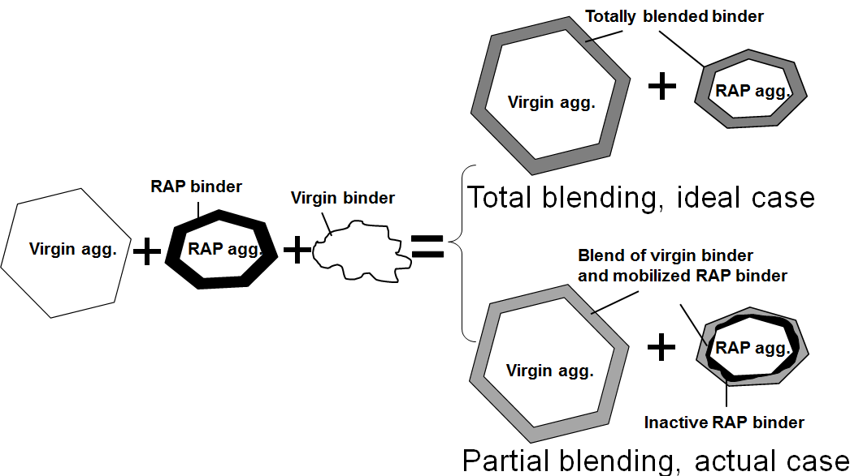
Figure 3. 1 Two possible blending scenarios

The mechanical “scrape-off” has been studied as a factor to address RAP binder mobilization by researchers through “dry blending”, which is a mixing process without virgin binder addition (Huang et al. 2005; Shirodkar et al. 2011). However, the authors admitted the impact of the presence of hot virgin binder cannot be captured by “dry blending”.
The actual blending process in the asphalt plant is complicated since RAP/RAS and virgin binders cannot be differentiated after mixing. According to Figure 3.1, however, the binder attached to the virgin aggregates can be evaluated in the representative of the binder blend of virgin binder and mobilized RAP binder. Therefore, the mobilized RAP binder contribution in the blend can be analyzed, if virgin aggregates can be separated after mixing. Assuming the relation between the RAP binder content and certain specific parameter is known, and this parameter of the binder blend can be measured through corresponding experiment, the RAP binder content in the blend can be quantitatively determined.
As illustrated in Figure 1, RAP binder content in the blend can be expressed as Eq. (3.1a):

$${RAP Binder \left(\%\right)}_{Blend}= \frac{W_{\left(Mobilized RAP Binder\right)}}{W_{\left(Mobilized RAP Binder\right)}+W_{\left(Virgin Binder\right)}} (3.1a)$$
RAP binder mobilization rate, denoted as α_{M}, is defined as

$${Mobilization Rate=α}_{M}= \frac{W_{\left(Mobilized RAP Binder\right)}}{W_{\left(Total RAP Binder\right)}} (3.2a)$$

Given percent RAP binder by total mixture as P_{(b, RAP)}, percent virgin binder by total mixture as P_{(b, Virgin)}, Eq. (3.1a) can be further written as

$${RAP Binder \left(\%\right)}_{Blend}= \frac{P_{\left(b, RAP\right)}∙ α_{M}}{P_{\left(b, RAP\right)}∙ α_{M}+P_{\left(b, Virgin\right)}} (3.1b)$$
Then α_{M} can be solved out as

$$α_{M}= \frac{P_{\left(b, Virgin\right)}∙ {RAP Binder \left(\%\right)}_{Blend}}{P_{\left(b, RAP\right)}∙(1-{RAP Binder \left(\%\right)}_{Blend})} (3.2b)$$

Table 3.1 presents an example of α_{M} calculation in a real case. Assuming RAP Binder (%) _{Blend} is determined in the lab as 20%, α_{M} can be calculated since the rest of the parameters are all given if one paving job is finalized. For this case, α_{M} is calculated as 75%, which means 75% of the RAP binder can be mobilized during mixing and contribute to coating the aggregates.

Table 3. 1 Example of α_{M} calculation
Parameters | Description | Calculation | Value
RAP (%) _{Mixture} | RAP (%) by total mix | Given | 30%
RAP Binder (%) _{RAP} | RAP binder (%) in RAP | Given | 5%
P_{b} | Optimum binder (%) by total mix | Given | 6%
P _{(b, RAP)} | RAP binder (%) by total mixture | [RAP (%) Mixture] ·  [RAP Binder (%) RAP] | 1.5%
P _{(b, Virgin)} | virgin binder (%) by total mixture | Pb − P (b, RAP) | 4.5%
RAP Binder (%) _{Blend} | RAP binder (%) by binder blend  (after mixing) | Determined in the lab | 20%
α_{M} | RAP binder mobilization rate | Eq. (3.2b) | 75%

According to the aforementioned case, the key point of αM calculation lies on determination of the RAP Binder (%) _{Blend}. A straightforward method to determine RAP Binder (%) _{Blend} is to build a “blending chart” with one certain parameter and interpolating the lab-testing result of the sample. As mentioned in “Introduction” section, a new parameter for blending research derived from GPC testing is to be developed in this study. Accordingly, this study follows the flow chart presented in Figure 3.2.

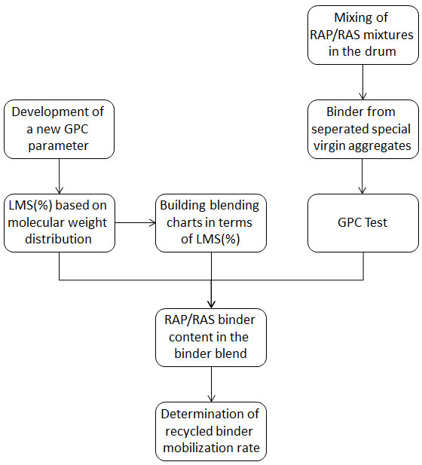
Figure 3. 2 Research flow chart of this study

Development of A GPC Parameter for Blending Research

When GPC works, analytes are dissolved in the solvent, commonly tetrahydrofuran (THF), then stirred and injected into the columns that are packed with different pore sizes. It can be seen in Figure 3.3(a), larger molecules escape from the pores while smaller ones enter the pores easily with increased retention time. A differential refractive index (RI) is used as the detector, since it is most commonly used for asphalt chromatography (Kim and Burati 1993). In order to obtain quantifiable parameters, the chromatogram is commonly divided into different equal sizes based on elution time, and the method of using first 5 slices over a total 13 slices representing large molecular size (LMS) fraction has been more frequently accepted (Kim et al. 2006; Bowers et al. 2014b; Zhao et al. 2014). Figure 3.3(b) presents typical chromatograms generated by solutions of virgin, RAP and RAS binders, as well as the LMS(%) calculation process for RAS binder. Since the starting point of the chromatogram varies among binders, especially the ones with different aging levels, the analysis of the binder blend based on the 5/13 separation method may be subjective and controversial.

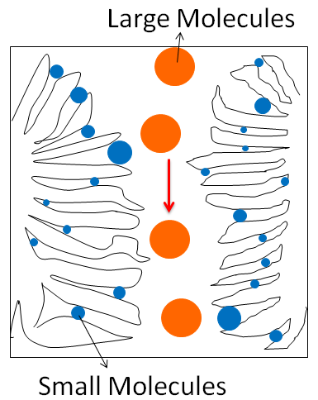 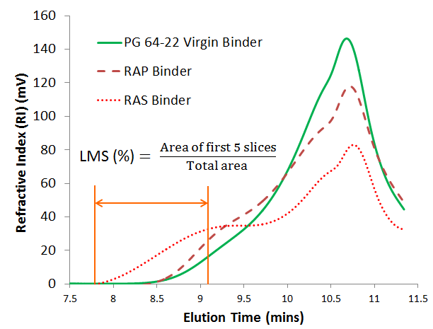 (a). GPC Working Mechanism (b). GPC Chromatograms and Calculation Method
Figure 3. 3 GPC working mechanism and chromatograms

Re-defined LMS(%) – Based on Molecular Weight Distribution

Since GPC columns need to be calibrated by standard solutions, mostly polystyrene for asphalt research, the retention times in the chromatogram can be converted to molecular weights using the calibration curve obtained using polystyrene standards (Daly et al. 2013). Figure 3.4 shows the same chromatogram presented in Figure 3.3(b) but re-arranged based on polystyrene molecular weights in Daltons. The fractions generated by components with molecular weights less than 200 Daltons have been removed due to the effects of solvent and air species (Daly et al. 2013). It can be found that both virgin and RAP binder components have molecular weights ranging from 20,000 to 200 Daltons, while those from RAS binder starting as high as 50,000 Daltons. Therefore, a more reasonable LMS fraction can be re-defined as the area under the curve with molecular weights higher than a specific threshold that is defined as large molecule threshold (LMT). Correspondingly, LMS(%) can be calculated using Eq. (3.3)..

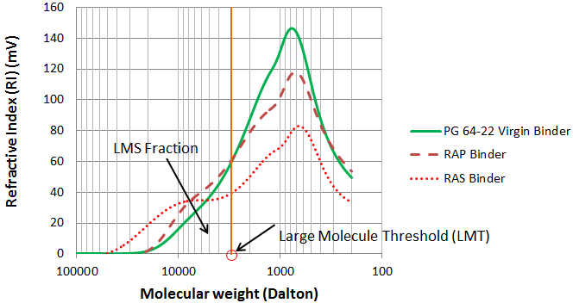
Figure 3. 4 GPC Chromatograms Based on Molecular Weights

$$Redefined LMS \left(\%\right)=\frac{Curve Area \left(Molecular Weights Larger than LMT\right)}{Total Curve Area \left(from Beginning to 200 Daltons\right)} (3.3)$$

Determination of the Large Molecule Threshold (LMT)

According to literature review, the only research (Daly et al. 2013) that has addressed the binder component fractions based on molecular weight distribution, has divided the curve into three fractions including polymers (molecular weight greater than 19,000), asphaltenes (molecular weight from 19,000 to 3,000), and maltenes (molecular weight less than 3000). Since the purpose is to clearly differentiate virgin-recycled binder blend with different blending levels, the threshold that yields the most significant difference in LMS(%) should be considered.
Figure 3.5 plots the relation between LMT ranging from 1,000 to 20,000 Dalton and LMS(%) differences between RAP/RAS and virgin binders based on the solution in concentration of 1 mg/mL. Three types of virgin binder, RAP and RAS from different sources were selected, respectively. The peak of LMS(%) difference is always found around 3,000 Dalton. This finding can be related to the above mentioned study (Daly et al. 2013) that divided the molecular weight range from 3,000 to 19,000 into asphaltenes fraction, which is usually considered as the large molecular components fraction for asphalt binder. Therefore, 3,000 was selected as LMT for calculation of the newly defined LMS(%).

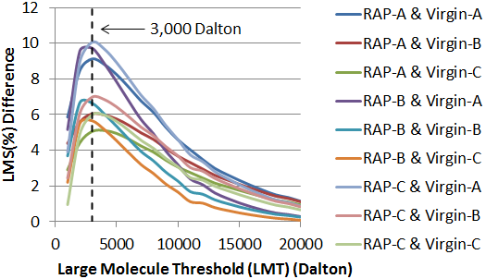
- RAP-Virgin Binders
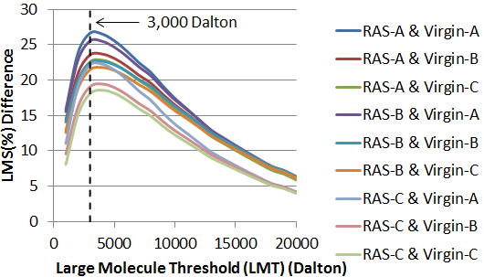
- RAS-Virgin Binders
Figure 3. 5 Relation between LMT and LMS(%) Difference for RAP/RAS-Virgin Binders

Figure 3.6 presents LMS(%) values calculated with 3,000 Dalton as LMT. It can be seen that LMS(%) values for virgin binders selected in this study range from 10.1% to 20.5%, while those for RAP binders lie in a clearly higher range from 23.8% to 27.1%. The RAS binders yield an even higher range from 36.3% to 43.5%. The variations among triplicates are small with maximum coefficient of variation (CV) of 2.34% obtained from Tennessee RAP B binders, which validates the repeatability of this LMS(%) determination method.

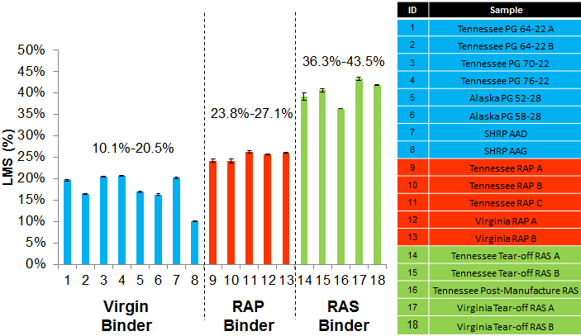
Figure 3. 6 LMS(%) calculated with LMT of 3,000 Dalton for different binders

Building “Blending Chart” with Newly Defined LMS(%)

Sample Preparation

A total of 11 points, with RAP/RAS binder content increasing from 0 to 100% in 10% interval, were selected to ensure accuracy. Duplicates were made for each point. Since only 10 to 15 mg of the sample is required for GPC test, sampling after traditional mechanical blending may cause high variations thus should be avoided. The virgin binder and recovered RAP/RAS binder were first dissolved into THF to make solutions in target concentration (1 mg/mL), then 10 mL solution of the binder blend was produced by adding solutions of different binders in proportion to a 20 mL scintillation vial (e.g. 8 mL virgin binder and 2 mL RAP/RAS binder solutions were added to produce a solution of binder blend containing 20% RAP/RAS binder). The solution was shaken in a solution shaker at high speed for 1 minute for complete dissolution, and then injected through a 0.2 μm filter to filter out the undissolved impurities. An auto-sampler was used to collect the prepared sample and then placed in the sample holder in EcoSEC GPC. 15 minutes were required for running one sample.

Building “Blending Chart”

Figure 3.7 presents the “blending charts” generated by blending one typical PG 64-22 binder with RAP binder or RAS binder. All three materials are typical materials and locally available in Tennessee. Linear correlations between recycled binder content and LMS(%) are revealed on both virgin-RAP blend and virgin-RAS blend with high “R²” values (both over 0.98). Accordingly, the following equations can be derived, for determination of RAP Binder (%) _{Blend} [Eq. (3.4)] and RAS Binder (%) _{Blend} [Eq. (3.5)], respectively.

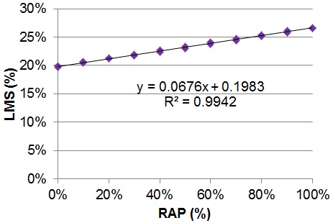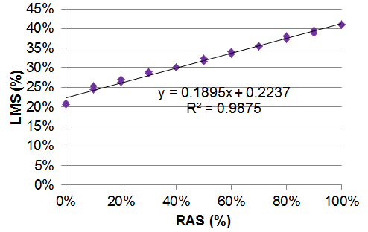
(a)RAP-Virgin Blend (b) RAS-Virgin Blend
Figure 3. 7 “Blending Chart” generated with LMS(%)

$${RAP Binder \left(\%\right)}_{Blend}=\frac{{LMS (\%)}_{Blend}-0.1983}{0.0676} (3.4)$$

$${RAS Binder \left(\%\right)}_{Blend}=\frac{{LMS (\%)}_{Blend}-0.2237}{0.1895} (3.5)$$

It should also be noted that the proposed idea of using LMS(%) to build the “blending charts” between recycled and virgin binders can be extended to other multi-binder involved studies. Its further application is not discussed in this paper, but can be valuable for future research.

Determination of RAP/RAS Binder Mobilization Rate

Experimental Design

As illustrated in Figure 3.1 and discussed in previous text, the binder blend can be analyzed only if the virgin aggregates can be separated after mixing. In this study, gravel with round and smooth surface passing 9.5 mm (3/8 in.) sieve and retained on 4.75 mm sieve (No. 4) was selected and added as part of the virgin aggregates in order for better separation. Figure 3.8 shows the round gravel separated before and after mixing.

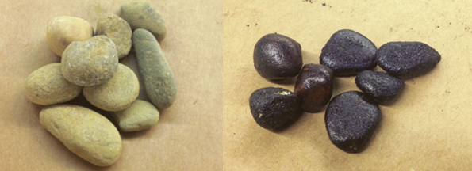
Figure 3. 8 Round-shaped gravel used as tracking aggregate

A total of 10 mixtures with 2,000 g for each batch, covering RAP percentage up to 80% and RAS up to 10% (Table 3.2), were prepared in the lab at 165 ºC with the mixing time set to 2 min. 100 g of round-shaped gravel was added as part of the virgin aggregate for each mix. The properties of RAP, RAS and virgin aggregate used in this study can be found in Table 3.3. The mix design recommended by the asphalt plant providing the materials was followed, with consideration of the total contribution of the recycled binder. The gradation and optimum asphalt content (5.7%) were hold constant for all the mixtures.

Table 3. 2 Usage of recycled materials selected in this study
Recycled Material | Percentage by Weight of the Total Mix
RAP | 10%, 20%, 30%, 40%, 50% and 80%
RAS | 2.5%, 5%, 7.5% and 10%

Table 3. 3 Properties of RAP, RAS and virgin aggregate
Properties |  |  | Mixture | Virgin Agg. | RAP | RAS
AC Content (%) |  |  | 5.7 | - | 476 | 20.85
Gradation | Sieve (in.) | Sieve (mm) | Passing (%)
Gradation | 5/8 | 16 | 100.0 | 100 | 100 | 100
Gradation | 1/2 | 12.5 | 96.0 | 92 | 100 | 100
Gradation | 3/8 | 9.5 | 85.5 | 71 | 92.4 | 100
Gradation | #4 | 4.75 | 59.3 | 23 | 61.5 | 99.2
Gradation | #8 | 2.36 | 41.3 | 15 | 44.5 | 97.4
Gradation | #30 | 0.6 | 19.3 | 9 | 26.7 | 60.2
Gradation | #50 | 0.3 | 11.0 | 6 | 18.3 | 53
Gradation | #100 | 0.15 | 6.6 | 4 | 13 | 44.9
Gradation | #200 | 0.075 | 4.4 | 2.5 | 8.7 | 34.6

After mixing, the round-shaped gravel was picked and eluted by n-propyl bromide (nPB) for 30 min in order for complete binder extraction. Then the binder was recovered in a 20 mL vial using a water bath at 70ºC in less than 15 min until solvent was non-visible, and then left in a vacuum oven at 85ºC overnight for complete removal of the solvent. The relatively lower temperatures and vacuum oven were selected to reduce the potential aging effect. The effects of mixing, nPB extraction and recovery were also checked and found to be limited or none on LMS(%). Once the binder sample was ready, the GPC test was carried out following the same procedure described in “blending chart” section.

Results and Discussion

Figure 3.9 presents the results of LMS(%) obtained from GPC. It can be seen, for both RAP and RAS, that LMS(%) of the binder blend increases with the increase of RAP/RAS content in the mixture.

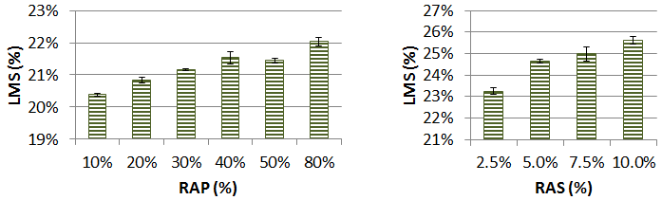
(a) LMS(%) for RAP mixes (b) LMS(%) for RAS mixes
Figure 3. 9 LMS(%) results

Figure 3.10 presents the RAP/RAS Binder (%) _{Blend} values calculated with [Eq. (3.4) and (3.5)]. As expected, the trend is consistent with that of LMS(%).The increase of recycled binder content in the blend can be attributed to the increase of potentially workable RAP binder in the mixture and less addition of virgin binder, when RAP/RAS percentage is increased.

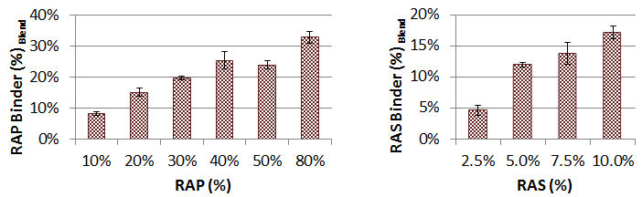
(a) RAP Binder (%) _{Blend} (b) RAS Binder (%) _{Blend}
Figure 3. 10 Recycled binder (%) in the blend

Figure 3.11 shows recycled binder mobilization rates calculated using Eq. (3.2b) for the mixtures selected in this study. It is found in Figure 3.11(a) that the mobilization rate decreases if more RAP is added, which indicates lower ratio of the available RAP binder by total will be incurred with increase of RAP addition. For low RAP mixtures (10% and 20%), the mobilization rates are fairly close to 100%, which indicates an approximately complete mobilization of the RAP binder during mixing. However, the mobilization rate drops from 73% to 24% with RAP percentage varying from 30% up to 80%. This finding may lead to an assumption that the fatigue and cracking resistance of HMA containing high RAP (30% or over) is reduced not just because the high stiffness of the recycled binder, but also due to its lower mobilization rate that may cause an under-asphalt mixture or heterogeneous blending. This assumption should be validated in future research.
Unlike RAP, the mobilization rates of RAS mixtures are comparatively low, even at low RAS content. This can be explained by the highly aged nature of RAS binder, which limits the RAS binder from being mobilized at normal mixing temperature. This is consistent with the previous finding that RAS binder starts to flow at extremely high temperatures (over 200ºC) (Zhao et al. 2013; Zhou et al. 2013). It can also be seen that the mobilization rates of low RAS mixtures (2.5% and 5%) stay around 50% to 60%, which are close to 66.7%, an engineering estimation that has been used by several state agencies as the RAS binder contribution factor. The mobilization rate for 10% RAS mixture can be as low as 36%, which may also account for the restriction of maximum usage of RAS to 3% to 5% in several states. The interesting finding is that the optimum mobilization rate is found on 5% RAS mixture. This may be explained by the assumption that RAS particles tend to be coated by virgin binder at a low RAS percentage (2.5%), thus could be limited from providing binder to coat virgin aggregate. Meanwhile, RAS particles tend to agglomerate with increased percentage (over 5%) thus leading to less exposure to the binder blend. In addition, the 5% optimum mobilization rate is consistent with the blending ratio results addressed in a previous study (Zhao et al. 2014).

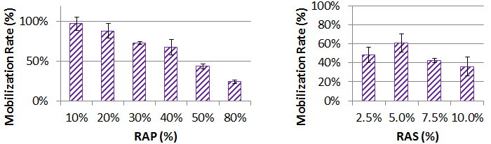
(a) Mobilization rates for RAP mixes (b) Mobilization rates for RAS mixes
Figure 3. 11 Calculated mobilization rates for mixes selected

Summary and Conclusions

In this study, a new parameter, LMS(%) based on binder molecular weight distribution, was developed and successfully used to differentiate between RAP/RAS and virgin binders as well as their blends. The “Blending Chart” between RAP/RAS binder content and LMS(%) was generated. Ultimately, a new method was proposed to quantitatively determine recycled binder mobilization rate, by conducting GPC analysis on binders extracted from virgin aggregates after the mixing process of RAP/RAS mixtures. On the basis of the results, the following can be summarized:

- LMS(%) based on molecular weight distribution could be used to characterize asphalt binders.
- The optimum large molecule threshold to calculate LMS(%) was found to be 3,000 Dalton.
- LMS(%) was capable of differentiating between virgin, RAP and RAS binders as well as their blends.
- “Blending Chart” could be built on RAP/RAS-virgin binder blends using LMS(%) and their relations were found to be linear.
- The RAP/RAS binder mobilization rate could be quantitatively determined by following the method proposed in the study.
- RAP binder mobilization rate decreased with the increase of the RAP percentage by total mixture. The mobilization rates were close to 100% at low RAP mixtures (10% and 20%), but dropped from 73% to 24% with RAP percentage varying from 30% up to 80%.
- RAS binder mobilization rate increased with the increase of RAS percentage from 2.5% to 5%, but decreased when RAS percentage passed 5%. The highest mobilization rate was around 61% and found on 5% RAS mixture. The mobilization rate of mixture containing 10% RAS could be as low as 36%.

Limitations

The limitations of the study are:
- This study was focused on developing a new method to determine the recycled binder mobilization rate. The results and findings presented in this paper only represent materials and conditions selected in this study. More complete research should be conducted to cover various materials and conditions.
- The binder extracted from round-shaped gravel used as tracking materials may not completely represent the binder blend during mixing. The shape, size and surface properties of the tracking materials could affect the analysis. Further research could be done to find more suitable tracking materials.

Acknowledgement

The research was funded by Tennessee Department of Transportation. The contents of this study reflect the views of the authors only. The authors also thank Dr. Mark Dadmun and Dr. Lesley Thompson who provided help with the sample preparation in Chemistry laboratory.

CHAPTER IV

INVESTIGATION ON MICROSTRUCTURES OF RAS BINDER AND ITS BLENDING WITH VIRGIN BITUMEN

Abstract

Recycling waste roofing shingles into pavement constructions has attracted more attention due to high content of usable asphalt. Waste roofing shingles has gone through air blown process during production and exposure to severe weather during several years’ service, which yields extremely aged asphalt binder. The difference in nature between virgin binder and binder from recycled asphalt shingle (RAS) has led to concerns over binder blending and compatibility of asphalt paving mixtures containing RAS. Therefore, usage of RAS has been commonly limited to a maximum of 3 to 5% incorporation. Currently, there is very little research that has addressed the RAS-virgin blending issues. This paper used atomic force microscopy (AFM) to characterize microstructural properties of the selected virgin, post-manufactured RAS and post-consumer RAS (tear-off) binders, as well as the temperature dependence of microstructures in one type of tear-off RAS binder. Meanwhile, the blending of virgin-RAS binder was first observed in this study. According to the observations, AFM proved to be capable of differentiating virgin binder from RAS binder in terms of microstructures. The microstructures of tear-off RAS binder was found to be temperature-dependent, but changed very little within the range from 60ºC to 180ºC. Virgin binders selected in this study could not blend through a RAS binder layer of 300 μm within 30 minutes at 180ºC. On the basis of observations on the interfacial zone, RAS binder was found to be “mixing” but not “blending” in a mixing zone of 25 to 30 μm.

Introduction

Recycling asphalt shingles into pavement construction dates back to the late 1970s and early 1980s due to the quality and content of asphalt binder in shingles (Krivit 2007). According to United States Environmental Protection Agency (EPA), a total of 11 million tons of asphalt shingles is recycled annually in the U.S., including 1 million tons of post-manufactured shingles and 10 million tons of post-consumer shingles (tear-offs) (FHWA 1993), which would, if recycled by the transportation and construction agencies, lead to an annual saving of $ 1.1 billion (Gevrenov 2008). Post-manufactured shingles come from shingle manufacturing process such as factory rejects and tab cut-outs, while tear-offs are roofing shingles reclaimed after their service life due to severe damage (Williams et al. 2011). Historically, post-manufactured recycled asphalt shingles (RAS) has been accepted by the government engineers and regulators because of better regulation (Krivit 2007), although merely 5% RAS by weight has been allowed for use by state agencies due to limited experience and research (McGraw et al. 2007). Since tear-offs account for more than 90% of the RAS resources (FHWA 1993), research efforts are trending towards the utilization of these post-consumer shingles (Williams et al. 2011). No provision, however, exists for the use of tear-offs in current specifications (Johnson et al. 2010).
Since RAS binder has been exposed to severe weather that leads to significant aging, part of the aged binder may not be workable enough to wet or coat the aggregates. Some state agencies takes into consideration of this premise by accounting for approximately two-thirds of RAS binder in the mix design and stating that the other one-third behaves as black aggregate (Williams et al. 2011). This operation may be adopted as an empirical mix design method, however, scientific research needs to be conducted to address the contribution of the RAS binder in the new asphalt mixture, which can be defined as how much asphalt in RAS can be blended with the virgin binder. A preliminary research conducted by the authors (Zhao et al. 2013) investigated RAS blending efficiency by mixing RAS with aggregates of different sizes. Aggregates were separated after mixing and binder on each type of aggregate was extracted, recovered and tested through gel permeation chromatography (GPC). It was found that partial blending occurred, and increasing mixing time increased blending efficiency while aggregate size and mixing temperature (150 ºC to 190 ºC) showed little effect. This preliminary research did investigate how much of the old RAS binder was mobile and workable in the mixing drum, but it could not tell whether RAS binder blended into the new binder to generate a new colloidal structure. Since the RAS binder are inherently stiffer than virgin or modified binders due to the air-blown process (Figure 4.1), they may show limited workability under normal mixing condition, and may be mixed in bulk rather than behave like liquid virgin binder. Therefore, two possible blending scenarios are hypothesized and sketched in Figure 4.2. The possibility of neither of the two scenarios can be ruled out in the preliminary research. Accordingly, the blending between RAS and virgin binder should be evaluated in two phases: mixing efficiency subject to the mechanical force in the drum and binder homogeneity, henceforth referred to as ‘blending degree’, during or after mixing. The first phase was discussed in previous research (Zhao et al. 2013) and this paper addressed the investigation on the second phase, namely the blending degree between RAS and virgin binder.

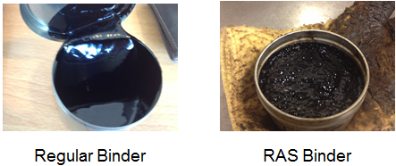
Figure 4. 1 Appearance of commonly used virgin binder and extracted RAS binder

Figure 4. 2 Two possible binder interaction scenarios between RAS and virgin binder

The two aforementioned possible scenarios in Figure 4.2 cannot be differentiated if blended binder is dissolved in solution, so the blending degree defined in this research needs to be studied in solid state without extraction. The direct detection can be achieved with the help of microscopy technology, but the bitumen has not gained much attention from microscopists due to its opacity and adhesive properties (Masson et al. 2006). Until the recent twenty years, the introduction of the atomic force microscopy (AFM) began to make possible the opaque, non-conductive surfaces could be imaged (Nahar et al. 2013a), by providing atomic and molecular resolution (Binnig et al. 1986; Mou et al. 1996).
Loeber’s group (1996, 1998) first investigated the bitumen film cast with heat using AFM, and observed the well-known “bee” shaped microsturctures with several micrometers in diameter and tens of nanometers. Several years later, Pauli et al. (2001) acquired the same bee-shaped microstructures and advanced to correlate the “bees” with the amount of asphaltenes in the binder by imaging solvent-cast film. Having found the same randomly distributed bee-shaped structures, Jäger et al. (2004) furthered the research and identified four phases in topographic images of the bitumen (hard-bee, soft bee, hard matrix and soft matrix), separating the higher and lower parts of the “bees” and the surrounding phase. Later on, a more extensive research including 13 bitumens was couduced by Masson et al. (2006) with phase-detection mode in AFM. The similar phases as identified in earlier research (Jäger et al. 2004) were observed but named differently, with one new salt-like phase found and termed sal-phase. The authors also classified bitumens in three groups: one that showed a fine dispersion (0.1 to 0.7 µm) in a homogenous matrix, one that showed domains of about 1 μm and one that showed up to all four phases mentioned in previous text. An interesting finding in this research was that poor correlation was reported between the asphaltene content and the bee-shaped structures. This finding was subsequently verified by Pauli et al. (2011), who first claimed the correlation between bee-shaped microstructures and asphaltene content. Pauli’s group found ‘bees’ in maltenes without any asphaltenes but no similar microstructure existing in de-waxed bitumen. This observation led to a corrected statement that the microstructuring in bitumen, including well-known bee-shaped microstructures, resulted from the interaction between the crystallizing paraffin waxes.
Besides chemical composition of bitumen, temperature was another factor found responsible for its microstructural change. Das et al. (2013) studied the influence of temperature on microstructures in bitumen by combining differential scanning calorimetry (DSC) and AFM. It was found that the appearance of microstructures is always in the crystallization temperature range of the same bitumen, while the dissolving of these microstructures is related with the melting temperature range. Another study addressing the similar issue was conducted by characterizing the microstructure for various thermal scenarios like cooling or heating in a fast or gradual manner (Nahar et al. 2013c). The major findings of this research can be summarized as: microstructure possessed memory of its previous thermodynamics state; elliptical domains (“bees”) showed the tendency to orient relative to each other with the change of temperature; the microstructural properties were found to depend on the maximum hold temperature of the bitumen.
Generally, these studies showed that AFM proved to be capable of fingerprinting bitumen from different sources under certain thermodynamic condition, although the mechanism of the development of microstructures still needs to be answered. This motivated applying AFM to other areas of asphalt research, such as aging (Wu et al. 2009) and moisture damage (Tarefder et al. 2010). These published AFM applications, together with current need of direct detection on the binder, which was previously discussed, incented using this powerful microscopical tool to research on binder blending. The authors of this paper recently evaluated the interaction and extent of blending between RAP-binder and virgin binder by studying the microstructures of the ‘blending zone’ through AFM (Nahar et al. 2013b). The blending zone was estimated to be about 50 µm. The blending zone can be considered to be a completely blended ‘new material’. A design formula was developed, which correlated the blending zone dimension to temperature and mixing time. Since RAS is similar to RAP in terms of structure but manufactured and aged differently, the successful application of AFM in RAP blending may be used in RAS blending investigation.

Objective

The objective of the study is to evaluate the blending degree between RAS and virgin binder through AFM. Prior to the fulfillment of the purpose, there exists a need to reveal the microstructural morphology of the RAS binder and virgin binders in terms of their microscopic properties because RAS binder was not characterized by AFM before. Since binder blending is inherently dependent on mixing temperature, the temperature effect on RAS binder was evaluated as well. Layered model was selected to investigate the blending issue rather than lateral contact mode used in previous research (Nahar et al. 2013b) because of the limited mobility of RAS and the intent to better simulate the real case. For each sample being scanned, topographic and phase-contrast AFM images were acquired at selected locations on the surface. Here it is assumed that the microstructural properties observed in this study are representative of the bulk material properties.

Materials and Experimental Design

Materials

Two virgin binders with different grades, PG 64-22 and PG52-28, one type of extracted post-manufactured RAS binder and two types of tear-offs were selected for this study (Table 4.1). The PG 64-22 binder is commonly used in the U.S. The PG 52-28 is selected to investigate whether a softer binder grade facilitates binder interaction. The binder extraction recovery was conducted according to AASHTO TP2. The performance related properties of the binders were listed in Table 4.2-4.4. It can be found that the binders extracted from the two tear-offs were close but considerably stiffer than virgin binders, while binder from post-manufactured RAS was in between.

Table 4. 1 List of bitumen selected in this study
Binder | Crude source | Type
PG64-22 | Tennessee | Virgin binder
PG52-28 | Alaska | Virgin binder
TM | Tennessee | Extracted from post-manufactured RAS
TT | Tennessee | Extracted from tear-offs
VT | Virginia | Extracted from tear-offs

Table 4. 2 Asphalt binder properties of PG6422
Binder status | Binder  test | Test  temperature | Test  results | Specification
Original binder | Rotational viscosity, Pa*s | 135 ºC | 0.408 | 3 Pa*s max
Original binder | DSR, G*/sin δ, kPa | 70 ºC | 0.62 | 1.00 kPa min
Original binder | DSR, G*/sin δ, kPa | 64 ºC | 1.19 | 1.00 kPa min
RTFO aged binder | DSR, G*/sin δ, kPa | 70 ºC | 1.38 | 2.20 kPa min
RTFO aged binder | DSR, G*/sin δ, kPa | 64 ºC | 2.93 | 2.20 kPa min
PAV aged binder | DSR, G*sin δ, kPa | 25 ºC | 2320 | 5000 kPa max
PAV aged binder | BBR creep stiffness, S, (MPa) | -12 ºC | 138 | 300.0 MPa max
PAV aged binder | BBR creep slope, m value | -12 ºC | 0.323 | 0.300 min
PG grading |  | 64-22

Table 4. 3 Asphalt binder properties of PG5228
Binder status | Binder  test | Test  temperature | Test  results | Specification
Original binder | Rotational viscosity, Pa*s | 135 ºC | 0.217 | 3 Pa*s max
Original binder | DSR, G*/sin δ, kPa | 58 ºC | 0.94 | 1.00 kPa min
Original binder | DSR, G*/sin δ, kPa | 52 ºC | 2.12 | 1.00 kPa min
RTFO aged binder | DSR, G*/sin δ, kPa | 58 ºC | 1.86 | 2.20 kPa min
RTFO aged binder | DSR, G*/sin δ, kPa | 52 ºC | 4.34 | 2.20 kPa min
PAV aged binder | DSR, G*sin δ, kPa | 16 ºC | 3100 | 5000 kPa max
PAV aged binder | BBR creep stiffness, S, (MPa) | -18 ºC | 261 | 300.0 MPa max
PAV aged binder | BBR creep slope, m value | -18 ºC | 0.304 | 0.300 min
PG grading |  | 52-28

Table 4. 4 Properties of binders extracted from RAS
Binder | Binder status | Binder  test | Test  temperature | Test  results | Specification
TT | Original binder | DSR, G*/sin δ, kPa | 82 ºC | 2222.33 | N/A
TT | Original binder | DSR, G*/sin δ, kPa | 76 ºC  70 ºC  64 ºC | 3833.69  6479.69  10685.1 | N/A
VT | Original binder | DSR, G*/sin δ, kPa | 82 ºC | 1719.23 | N/A
VT | Original binder | DSR, G*/sin δ, kPa | 76 ºC | 3023.55 | N/A
VT | Original binder | DSR, G*/sin δ, kPa | 70 ºC | 5092.52 | N/A
VT | Original binder | DSR, G*/sin δ, kPa | 64 ºC | 8393.21 | N/A
TM | Original binder | DSR, G*/sin δ, kPa | 82 ºC | 127.59 | N/A
TM | Original binder | DSR, G*/sin δ, kPa | 76 ºC | 230.10 | N/A
TM | Original binder | DSR, G*/sin δ, kPa | 70 ºC | 428.42 | N/A
TM | Original binder | DSR, G*/sin δ, kPa | 64 ºC | 785.69 | N/A

Sample Preparation

Binder specimens were prepared by applying 21±2 mg of material to commercially available AFM steel substrates (12 mm in diameter), two identical specimens per sample. The virgin binder and the extracted post-manufactured binder specimens were heated to 100 ºC for 40 s on a heater plate whereas the extracted tear-off binder specimens were heated to 200 ºC for 60 s. The temperature and allowed time were adequate for the specimens to create a smooth thin film of the material, suitable for AFM imaging. The specimens were then thermally conditioned at 100 ºC for an hour in convection oven, cooled down to ambient temperature and stored at room temperature for 24 h before AFM measurement.

A special sample preparation technique was used for preparing the two layer binder specimens. Firstly, a virgin binder layer is prepared on the steel substrate following the mentioned thermal conditioning step with a thickness of 180±50µm and termed as bottom layer. The extracted tear-off RAS binder was prepared on a silicon paper and then manually removed with care and placed onto the top of the virgin binder layer that was pre-cast on the steel substrate. The thicknesses of the top layer is found 270±50µm, while the sizes for virgin layer and RAS layer were approximately 12 mm and 8 mm in diameter, respectively.

AFM Instrumental Setting and Measurement Environment

“Multimode-V Atomic Force Microscope” from Bruker (Santa Barbara, USA) was employed to characterize the microstructural morphology of the binders. Tapping-mode in air was the choice of operating mode as it is suitable to measure a soft and sticky material like asphalt while the probe is intermittently in contact with the sample (Garcia et al. 2002; Eaton et al. 2010). During imaging, a cantilever with a sharp tip was oscillated at its resonant frequency and scanned across the surface of the sample. Commercially available RTESP silicon cantilevers from Bruker were used in this study with nominal dimensions of 120μm×35μm×4μm, drive frequency of 300 kHz and force constant of 40 N/m. The probe scan rate was 1.0 Hz (1 Line/s) and the images were captured in 30×30 μm² with a pixel resolution of 512×512. Zoomed in 10×10 μm² microstructural details from these scan locations were also obtained with the same pixel resolution and scan rate. Two major data channels, topography and the phase shift of the oscillating cantilever that originates from the heterogeneity in local mechanical properties of the material were recorded simultaneously. Gwyddion software package was used for both quantitative analysis and to correct the sample tilt and the surface curvature from the raw AFM data.

Method

The virgin and extracted post manufactured and tear-off binders were characterized by probing several locations of each sample in order to obtain the representative microstructural information. Besides, aforementioned specially prepared two-layer binder specimens were used to investigate the extent of interaction between RAS and virgin binder. The reason for such a specimen preparation and probing scheme was mainly to include the thickness parameter of the tear-off binder to the system and also to evaluate the effect of maximum heating temperature with varying time. It was treated with combinations of different temperatures and heating time, prior to imaging to evaluate the blending degree under certain conditions. The sample was heated in a step of 20 ºC from room temperature (25 ºC) up to 180 ºC. The specimen was held at each target temperature for 5 min for equilibration and then was cooled to 25 ºC with a capture of AFM image at that temperature. The probing location was in the first phase, the center of the tear-off RAS binder at the top layer and later in the second phase, the interface between the two binders.

Results and Discussion

Using AFM to Characterize RAS Binder

AFM imaging was conducted on previously prepared samples made from all the five binders at 25 ºC. The results are shown in Figure 3.3 to 3.5. According to the results of topography, the characteristic bee-shaped microstructures can be observed in both two virgin binders and are found in larger size in binder with lower PG grade. These bee-shaped microstructures are similar to those found in previous research (Nahar et al. 2013a; Nahar et al. 2013b; Nahar et al. 2013c). On the contrary, no “bees” are found existing in the two tear-off binders, VT and TT. Both of them show similar topographic images with domains with the size of 1 to 2 µm, which is largely different from the topography of virgin binder. From the perspective of profile, these domians look like plenty of round or elliptical “humps” dispersed onto the surface of a lower homogeneous matrix. It should also be brought into attention that the topography of binders extracted from tear-offs is significantly rougher than virgin ones. These observations validate the feasibility of using AFM to differentiate aged RAS binder and virgin binder through direct detection in solid state. The hump-shaped microstructures can be seen as the fingerprint of the RAS binder under AFM. These changes in topography can be attributed to either the polymer added during the shingle production or significant aging in the air-blown process or after years’ service life.
The interesting finding is the typical bee-shaped domains can also be observed in the topographic images of TM binder, which has gone through the air-blown process for production. Meanwhile, the roughness of TM binder is also found in between the tear-off binders and virgin ones. This indicates that post-manufactured RAS binder, in the microstructural view, behaves like a transition from virgin binder to further aged tear-off binder. This finding supports the assumption that the microstructural changes, for the most part, result from aging rather than interaction between polymer and asphalt binder.
Similar to the topography, the phase image of each binder selected in this study also shows its uniqueness. The phase change transforms from virgin binder to most aged tear-off binder in the order from simplicity to complexity. Only two apparent phases can be detected in softest PG5258 binder, which is similar to the image of AAN binder observed by Mason et al. (2006). A third phase is found in PG6422 binder, consisting of flake-like domains (Mason et al. 2006) separating the dark and light phases. The TM binder shows less comparable domains than virgin one, while the dark phase is almost invisible in morphological images in both two tear-off binders. The phase images, therefore, proved to provide an alternative to fingerprint the RAS and virgin binders.

Figure 4. 3 Topography and phase images of PG5228 and PG6422 virgin binder

Figure 4. 4 Topography and phase images of TM binder

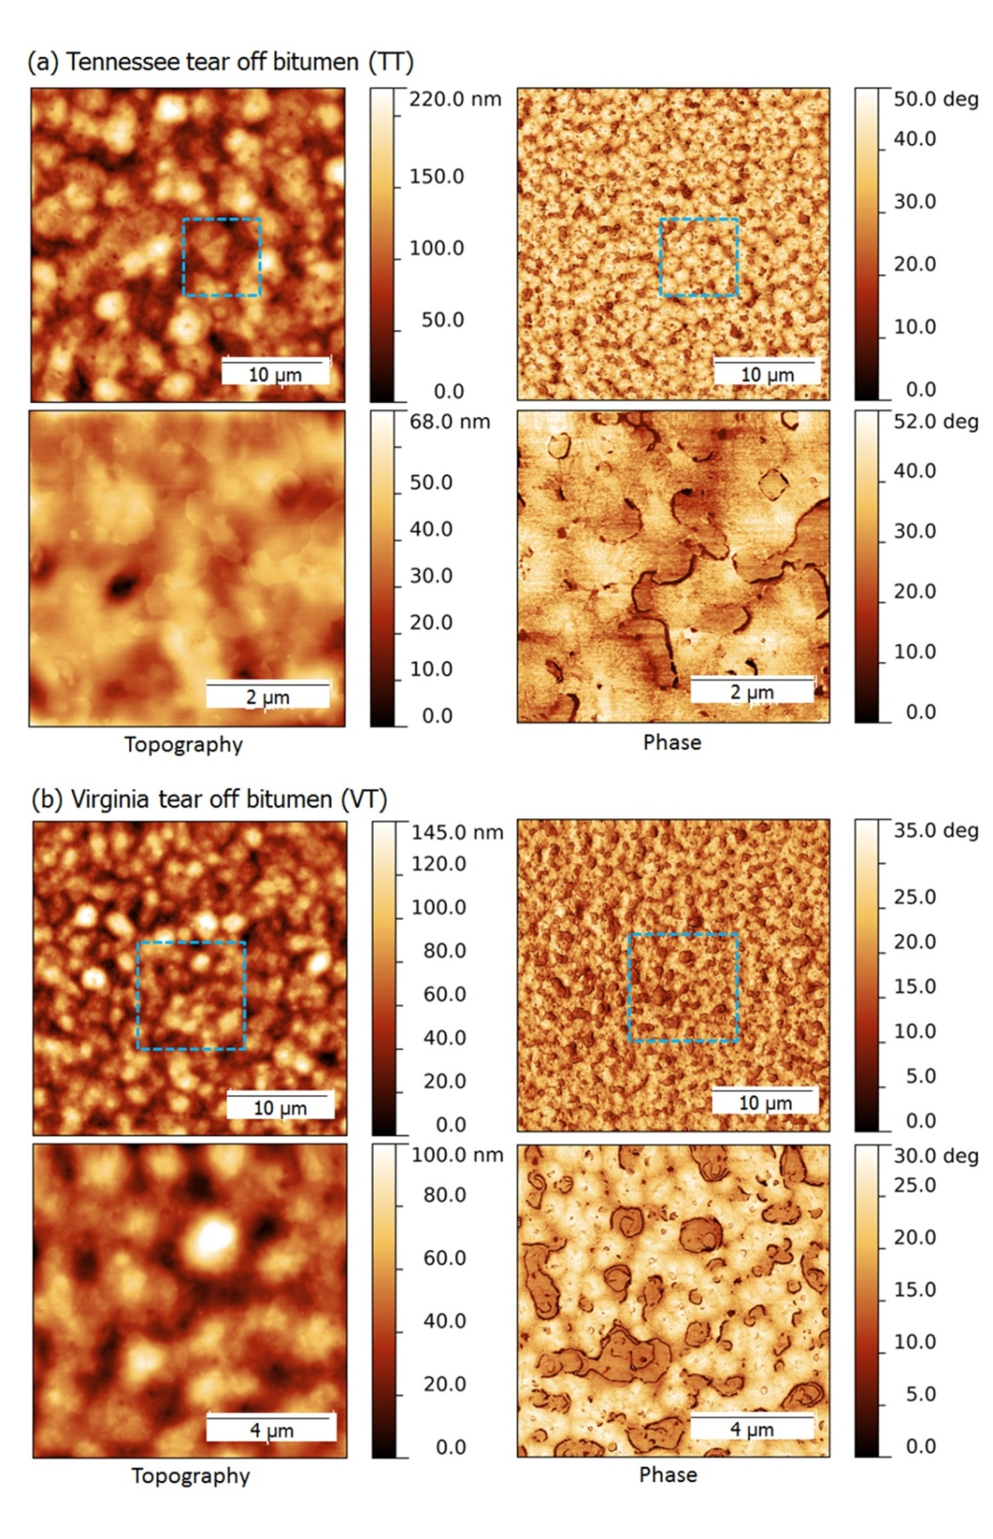
Figure 4. 5 Topography and phase images of TT and VT binder

Temperature Dependence of Microstructures in RAS Binder

One type of tear-off binder (TT) was made into samples and scanned through AFM after treatment in different temperature. As can be seen in Figure 4.6, the sample was heated to different target temperature in a 20ºC step, hold for 5 minutes, and then cooled to 25ºC for AFM imaging. The maximum temperature was set at 180ºC that is the highest temperature most asphalt plants can reach. The observations at 120ºC and 180ºC are reported only in this study for better analysis.

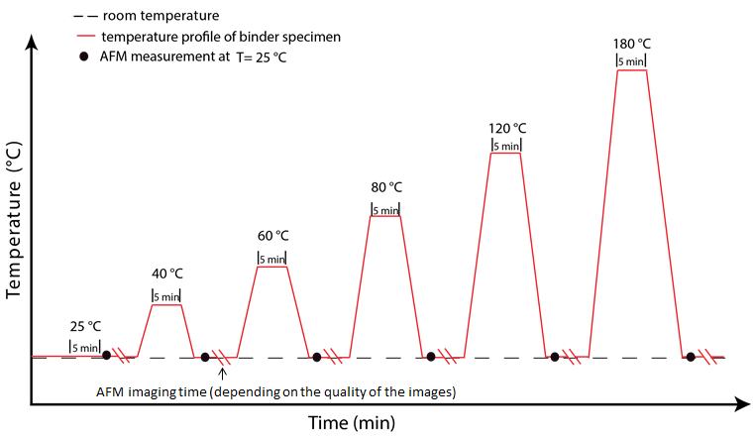
Figure 4. 6 Schematic of thermal conditioning of TT binder

Figure 4.7 demonstrates the topographic images of TT binder after treatment at selected temperatures. The bright bump-shaped microstructures diminish in size with the treating temperature increasing up to 80ºC. The most dramatic change occurs from 40ºC to 60ºC. The topography of this specific binder changes very little after the temperature exceeds 80ºC, where the hump-shaped microstructures are found to “melt” with small light nuclei still remaining dispersed in the melted phase. The images vary little from 80ºC to 180ºC. This fundamentally accounts for the finding in previous research (Zhao et al. 2013) that RAS binder contribution was very little affected by temperature in a range of 150 to 190ºC, which can be attributed to very limited microstructural movement occurring under this specific condition causing limited change in mobility of the binder.

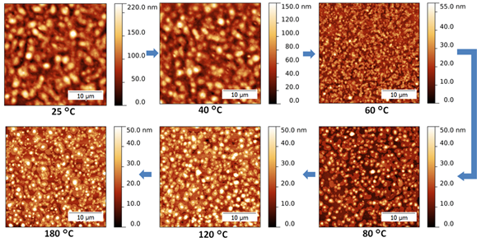
Figure 4. 7 Topographic images of TT binder after temperature treatment

Investigation on Blending Degree Between RAS and Virgin Binder

A two-layered sample sketched in Figure 4.8 was designed to evaluate the blending degree between RAS and virgin binder. AFM images acquired from locations on the top of the sample were used to investigate whether virgin binder from the bottom layer could blend through to the surface of the upper layer of RAS binder, after being treated under certain time and temperature correlated to plant production. The RAS layer was designed to be smaller in size to intentionally make an interfacial zone that was also scanned in this study, in order for better understanding on blending.

Scanning on the Top of the Layered Sample

Figure 4. 8 Experimental Design of Observing the Blending Degree between RAS and Virgin Binder

Figure 4.9 presents the representative topographic AFM images acquired from scanning on the top of the sample. The sample was treated at 180ºC for 5 minutes, which is theoretically long enough to ensure complete blending occurring. It can be seen that the topography on the surface of the layered sample is nothing different from the TT RAS binder, regardless of the binder grade of the bottom virgin layer. This indicates that the virgin binder selected in this study could not blend through to the surface of the tear-off RAS binder layer around 300 µm in thickness. Since blending between virgin and aged binder was found to be a function of treating temperature and time (Nahar 2013b), the observation of no-blending may be attributed to limited time. This assumption motivated increasing the treating time to a fairly long 30 minutes. The topography of the layered samples, however, changed very little. Accordingly, it seems of significance to detect what happens on the interfacial zone for a deeper understanding of blending between RAS and virgin binder.

Figure 4. 9 Comparison of Scanning Results on the Top of the Layered Sample
: (a) Top layer TT binder and bottom layer virgin bitumen PG6422; (b) Top layer TT binder and bottom layer virgin bitumen PG5228; (c) Control TT binder
Scanning on the Interfacial Zone

As can be seen in Figure 4.10, the TT-RAS layer was made smaller in diameter and spread onto the bottom virgin binder at ambient temperature. The probing was conducted alongside the interfacial zone that can be easily differentiated by the optical microscope installed in AFM.

Figure 4. 10 Probing the interfacial zone

In this paper, the AFM images acquired from scanning on the interfacial zone between TT RAS and PG 52-28 binder were reported to address the detailed observation on blending. As can be seen in Figure 4.11, both “bees” and “humps” can be found in topographic images of the interfacial zone, which are typical microstructures representing virgin binder and RAS binder, respectively. It seems the two binders were mixed but not blended into one ‘new’ material, indicating a poor compatibility between the virgin binder and significantly aged tear-off RAS binder. The mixing may be attributed to either upward or lateral movement of the virgin binder.
The mixing zone is found to be around 25 to 30 μm. However, the size of the mixing zone observed in this study does not indicate the real mixing scale occurring in the drum, since the film thickness on the edge of the top RAS layer was not precisely determined.

Figure 4. 11 Comparison of scanning results on the interfacial zone of the layered sample and detailed description of mixing zone

Discussion and Conclusions

Discussion

The co-authors of this paper recently published a study to address the RAP-virgin blending under AFM for the first time (Nahar et al. 2013b). Two blending scenarios were proposed in terms of microstructural properties (Figure 4.12). Scenario A refers to a merely mixing of two distinct colloidal fluids, according to which both the colloidal particles can be found in the mix. On the contrary, a complete blending that generates a new “colloidal” material is also possible and illustrated as scenario B.

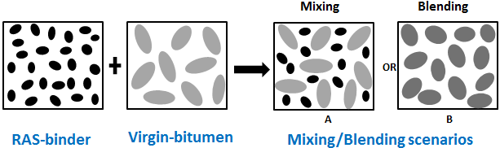
Figure 4. 12 Blending scenarios (adapted from Nahar et al. 2013b)

On the basis of the observation of RAP-virgin blending, as illustrated in Figure 4.13, the authors (Nahar et al. 2013b) concluded that “obviously scenario B is closest to the observations, hence one should speak about blending rather than mixing”.

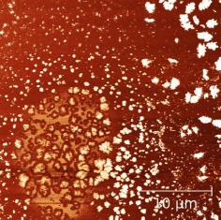
Figure 4. 13 Phase image of RAP-virgin binder blending (adapted from Nahar et al. 2013b)

The observations of RAS-virgin binder blending obtained in this study (Figure 4.11), interestingly, are more likely to correspond to scenario A, which is mixing rather than blending. This observation may lead to concerns over the binder segregation of RAS mixtures. Meanwhile, not all the characterizing tools used for RAP binder/mixture can be easily extended to RAS, due to the difference in nature between RAS-virgin blending and RAP-virgin blending.

Conclusions

This paper characterized several RAS binders as well as virgin binders through AFM. The blending between RAS-virgin binders was also investigated. According to the results and analysis, the following conclusions can be made:
- Exclusive microstructural properties can be observed on virgin, post-manufactured and post-consumer (tear-off) binders. AFM proved to be capable of differentiating virgin binders from RAS binders.
- The microstructures of RAS binder were found to be temperature-dependent. However, the microstructures changed very little within the range from 60ºC to 180ºC.
- Both PG 64-22 and PG 52-28 virgin binders could not blend through a tear-off RAS binder layer, approximately 300 μm in thickness, with a maximum treating time of 30 minutes at 180ºC.
- The RAS-virgin binder blending was first observed in terms of microstructures in this study. The “mixing” of microstructures from the two binders were more likely to happen, rather than “blending” into a “new” material.
- The mixing zone was found to be around 25 to 30 μm. However, the dimension of the mixing may not indicate the real mixing since the film thickness of the interfacial zone observed in this study is unknown.
- RAS-virgin blending was found to be different from RAP-virgin blending. The similar characterizing tools used for RAP binder/mixture may not be applicable to RAS.

CHAPTER V

INVESTIGATION ON BINDER HOMOGENEITY OF RAP/RAS MIXTURES THROUGH STAGED EXTRACTION

Abstract

The blending concern has been one of the major factors that limited the use of higher percentage of recycled asphalt pavement (RAP) and recycled asphalt shingle (RAS). So far, only a few studies have addressed the blending issues, among which a method called staged extraction, or progressive extraction, was used to extract asphalt binder from aggregates layer by layer and proved to yield relatively good results. However, this method is still controversial. This study validated the feasibility of staged extraction by addressing the concerns over solvent type, potential selective dissolution by the solvent, desirable solvent selection and binder homogeneity of raw RAP and RAS materials. It was found TCE was the most effective solvent used in the study for staged extraction that dissolved the asphalt binder without preferential dissolution. Meanwhile, TCE was found to have the highest dissolving rate. The binder coating on the raw RAP and RAS aggregates was proved to be homogeneous and the layer stripping did occur in a well-controlled composite binder system. Ultimately, a step-extraction method with progressive wash times was developed to replace equal-time extraction method, and was conducted on 50% RAP and 10% RAS mixtures, respectively. The new step-extraction method was found to be more effective than the equal-time extraction. Partial blending was observed within the coating of RAP particles, while the RAS-virgin blending on RAS aggregates should be further evaluated.

Introduction

The asphalt industry has been making attempts to incorporate higher percentage of recycled asphalt pavement (RAP) and recycled asphalt shingle (RAS) in the new pavement (Button et al. 1996; Foo et al. 1999; McDaniel & Anderson 2001; Shu et al. 2012; Zhao et al. 2012; Zhao et al. 2013). The blending, or binder homogeneity between recycled and virgin binders, is one of the major concerns that limit the use of high RAP/RAS. In order to evaluate the binder homogeneity, researchers have used a method called staged extraction (Huang et al. 2005; Bowers et al. 2014), or progressive extraction (Eddhahak-Ouni et al. 2012), that soaks the asphalt mixture in asphalt solvent for a certain period of time so that the binder can be extracted layer by layer from the aggregate after mixing.
The staged extraction method has yielded promising results, however, several questions still need to be answered before it can be widely used. Does the solvent affect the analysis? Do the light components in the binder tend to be extracted first, which may lead to a fake “layered structure”? Which is the best or most effective solvent? Is the RAP binder homogeneous after years’ service? This paper answered these questions by validating the staged extraction method and used it to further investigate the binder homogeneity of RAP-virgin blend. Since RAS is similar to RAP but stiffer, the same approach validated on RAP can be extended to RAS. The binder homogeneity research on RAS-virgin blend could be even more valuable, because air-blown process and long-term aging of RAS may result in a more difficult blending potential.

Objectives and Scopes

The objectives of this study are:
- To validate the feasibility of staged extraction method used for asphalt research.
- To evaluate the binder homogeneity of asphalt mixtures containing RAP and RAS.

Validation of Staged Extraction Method

Effect of Solvents

Trichloroethylene (TCE) has traditionally been used for asphalt extraction and identified by Strategic Highway Research Program (SHRP) as one of the best solvents. The health and environmental concerns, however, has limited the use of TCE and attracted asphalt researchers to a less toxic solvent, the combination of toluene and ethanol (T/E) (85:15 volumetric ratio), in the past few years. The toluene/ethanol blend, unfortunately, has still raised potential health concerns (McDaniel et al. 2001). Recently, the need to replace chlorinated solvents led state agencies to use alternative normal propyl bromide (nPB) solvents, and it was found that nPB solvents can be used as direct replacements for the chlorinated solvents (McDaniel et al. 2001; Stroup-Cardiner and Nelson 2000). Another solvent, decahydronaphthalene (decalin), was evaluated as asphalt solvent since it has similar solubility parameter and dissolution kinetics to toluene at 15 ºC (Bowers 2013).
Most of the staged extraction studies used TCE as the solvent (Zearly 1979; Noureldin and Wood 1987; Huang et al. 2005; Bowers et al. 2014), or the solvent type was not addressed (Eddhahak-Ouni et al. 2012). None of the research, however, mentioned the potential effect of the solvent on the results. In this paper, the effects of different solvents on the binder were evaluated in terms of the change in molecular weight distribution obtained by gel permeation chromatography (GPC) and chemical functional group detected by fourier transform infrared spectroscopy (FTIR). The selected solvents included TCE, nPB, T/E (85:15 volumetric ratio) and decalin, which are the ones mentioned in the literature review.

GPC Testing and Results

Figure 5.1 presents the GPC results in terms of large molecule size percentage [LMS (%)]. LMS (%) is defined as the percentage of large molecular fraction (molecules larger than 3,000 Dalton) over the total area of the chromatogram generated by GPC (Zhao et al. 2014). 100 g of one typical PG 64-22 binder was dissolved in solvents, recovered in a vacuum oven at 85ºC for overnight, then subject to GPC test. It can be found that LMS (%) values for the binders extracted and recovered by the solvents selected in this study are approximately the same, indicating that there is no or limited effect of the solvent on the molecular weight distribution of the binder.
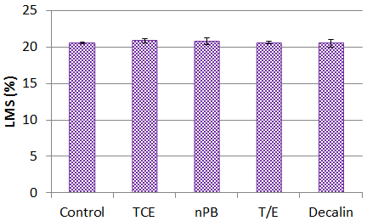
Figure 5. 1 Solvent Effect on GPC Results

Selective Dissolution?

Staged extraction method has been used on the basis of the assumption that all the components in the asphalt binder can be extracted layer by layer in the same proportion. However, this assumption has been questioned. Since outer layers extracted from RAP aggregate were found to be softer than inner layers in plenty of studies (Zearly 1979; Noureldin and Wood 1987; Huang et al. 2005; Bowers et al. 2014; Eddhahak-Ouni et al. 2012), one concern has been raised that lighter maltene fraction of the binder may wash out first, then the remaining asphaltene fraction will breakdown after successive washes (Bowers 2013). To address this concern, the same virgin binder was fractionated into maltene and asphaltene by soxhlet extraction, with iso-octane as the fractionation solvent (Figure 5.2).

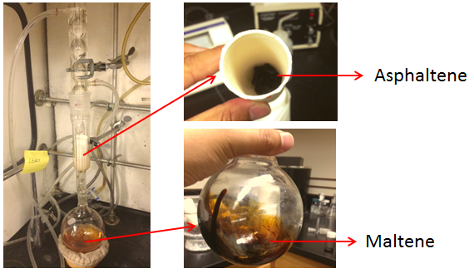
Figure 5. 2 Fractionation of Asphalt through Soxhlet Extraction Method

Figure 5.3 presents the GPC results of the asphaltene and maltene from soxhlet extraction, as well as the control virgin binder. It can be seen that asphaltene yielded significantly different chromatogram from corresponding virgin binder, while maltene followed the same shape but with smaller large molecule fraction. The quantified parameter LMS (%) can also be differentiable, with approximately 20, 50 and 11 for control binder, asphaltene and maltene, respectively. On the basis of this finding, a layered extraction design was brought up to evaluate if selective dissolution occurred.

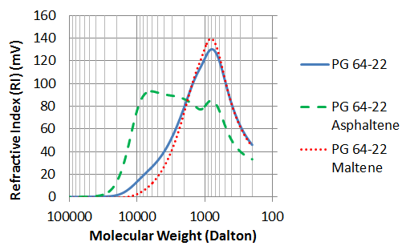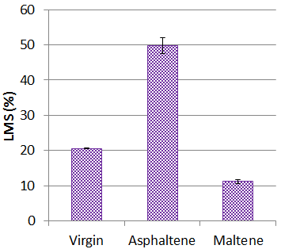
(a)Chromatograms (b) LMS (%)
Figure 5. 3 GPC Results after Binder Fractionation
Staged extraction by each solvent was conducted on a 500 mg sample of the same binder. The sample was rolled into the ball-shape prior to the extraction so as to avoid the potential effect of the sample geometry, and then washed by the solvent for 30 seconds for 7 times. Each washed layer was labeled as layer 1 to 7 outside in, with the remaining layer designated as layer 8. GPC test was conducted on each layer, and the results can be found in Figure 5.4. “Total” represents the binder totally dissolved in TCE and recovered afterwards, serving as the control sample. There was no appreciable difference in terms of LMS (%) observed on each layer extracted by TCE and the corresponding control sample. nPB did not yield much difference either, but the LMS (%) values of the first several layers were slightly lower than the layers extracted later and the control sample, which indicates that slight selective dissolution might occur. The average of LMS (%) of the layers extracted by toluene/ethanol (T/E) combination was found to be approximately equal to the control sample. However, the dissolution of the components seems unstable. This indicates that selective but non-sequential dissolution might occur when T/E combination is used as the asphalt solvent. The most significantly selective dissolution was found on samples extracted by decalin. This finding is consistent with the binder fractionation results from a previous study (Bowers 2013), and it can be concluded that the concern over decalin used as an asphalt solvent still stays.
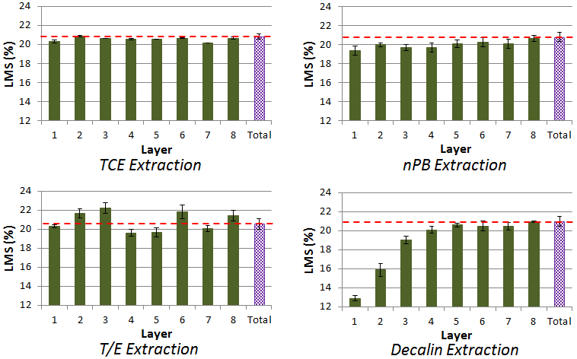
Figure 5. 4 GPC Results after Staged Extraction by Different Solvents

Solvent Selection

According to the selective dissolution results, TCE seems a better solvent that can be used in staged extraction research. The dissolving rate of each solvent, however, should also be checked since the more time the asphalt mixture was soaked in the solvent, the more uncertainties could be caused. The authors of this study also recorded the sample weight of each layer from the samples mentioned above. Figure 5 shows the plot of the change in percentage of accumulative extracted binder weight over the total binder with increase of dissolving time. It can be seen that TCE dissolved the asphalt binder faster than the rest of the solvents. nPB was ranked 2nd, while T/E and decalin may extract the binder layer with a similar rate. Accordingly, TCE was revealed by the dissolving rate finding as the most effective solvent that can be used with staged extraction method. nPB can the considered as the replacement if TCE is not accessible, but may slightly affect the analysis. Therefore, TCE was used as the solvent for the rest part of the paper. However, it should be noted that all the solvents evaluated in this study can still be used as asphalt solvent for total extraction purpose, which was confirmed by Figure 5.1.

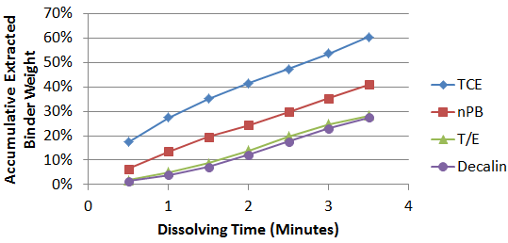
Figure 5. 5 Dissolving Rate of Different Solvents

Validation with Steel Ball Model

To further validate the staged extraction method with introduction of RAP binder, a steel ball model was tried in this study. The methodology was to create two layers with equal film thickness coating a steel ball, with the purpose of understanding how the binder was stripped by TCE in a well-controlled composite system. Figure 5.6 presents the sample preparation procedure. A steel ball, 9.5 mm in diameter, was first coated by binder extracted from one locally available RAP. Then the ball was coated by the same virgin binder in aforementioned experiments. The film thickness of both the two layers was controlled to approximately 500 μm. Since the virgin binder was heated to 60ºC only in order for better workability to coat the sample, it was assumed there was no blending between the two types of binder. The sample was then soaked in 20 mL TCE with an interval of 1 minute for 5 times, designated as layer 1 to 5, and the binder remaining on the steel ball was completely extracted and labeled as layer 6. Each layer was made into standardized sample and subject to GPC test, subsequently.

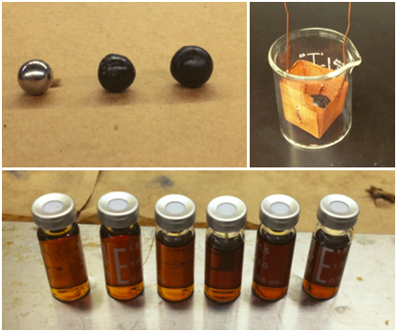
Figure 5. 6 Composite Steel-Ball Sample Preparation

Figure 5.7 shows the steel-ball testing results. It can be seen from Figure 5.7(a) that the percent weight of each layer was controlled within the range 13% to 18%. The 1 minute interval was determined by several trials. According to the GPC testing results [Figure 5.7(b)], it was found LMS (%) values of first two layers were approximately the same with that of virgin binder. The LMS (%) increased from layer 3 to inner layers, with LMS (%) of last layer close but not exceeding the level of RAP binder. This finding clearly shows that the composite binder film coating the steel ball was stripped by the solvent layer by layer. Although this is an ideal and well controlled composite system, the staged extraction method can be validated.

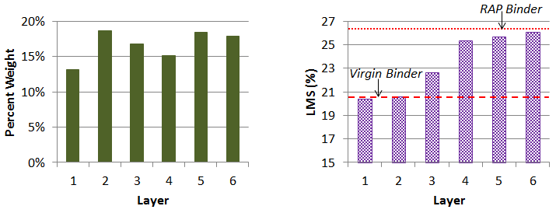
(a) Percent Weight of Each Layer (b) GPC Testing Results
Figure 5. 7 Steel-Ball Testing Results

Binder Homogeneity of RAP and RAS Particles

The homogeneity of the binder covering the RAP and RAS aggregates can affect the blending process. Prior to using the staged extraction method, the binder homogeneity of the RAP and RAS materials ready for mixing should be checked. In this study, the same RAP and a locally available RAS batch were checked for corresponding homogeneity.
Two identical samples of 50 g for each were selected for each material. Each sample was soaked in TCE for 1-minute wash of three consecutive times, and then left in the 4th beaker filled with TCE for 30 minutes for a complete dissolution. The sample of each layer was then prepared into standardized sample and tested in GPC.
Figure 5.8 presents the results. There is no difference among the layers that can be detected. In addition, the LMS (%) of each layer was found to be equal to that of the totally extracted control sample. The similar finding can be applied to both RAP and RAS selected in this study. This means the binder coating the RAP or RAS aggregate is homogeneous after long years’ service, which enables using the staged extraction method to investigate the recycled and virgin binder blending.

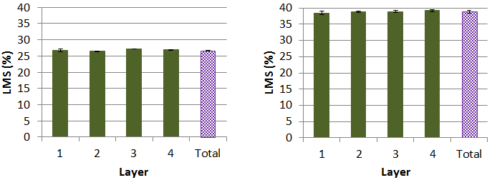
(a) Results of RAP (b) Results of RAS
Figure 5. 8 GPC results of four-layer stripping of raw RAP and RAS

Evaluating Binder Homogeneity of Asphalt Mixture containing RAP And RAS

According to the detailed validation of the staged extraction method, it proved to be a potential tool to characterize virgin and RAP/RAS binder homogeneity. In this study, a new procedure to conduct the staged extraction was proposed.

Experimental Design

Two mixtures, one containing 50% RAP and the other one containing 10% RAS, were prepared to fulfill the current tendency of incorporating high amount of the recycled materials. During the asphalt mixture production, the virgin binder may fully blend with the activated recycled binder and re-coat the virgin aggregates and recycled aggregates with inactive old binder still remaining. Therefore, the blending occurring on RAP/RAS aggregates are of higher significance. In order to visually and easily distinguish the RAP/RAS aggregates from the virgin ones, a gap-gradation was used to design the two mixtures.
The RAP and RAS used in this study were sieved prior to mixing, and only the materials passing No. 8 (2.36 mm) sieve were collected. The virgin aggregates were from a gravel batch that is locally available for surface mixture, and sieved for collecting the part retaining on sieve No. 4 (4.75 mm). The aggregate gradation of the mixture, as well as the job mix formula (JMF) from the same asphalt plant that provided all the materials, can be seen in Figure 9. The asphalt content of the recycled materials and the mix design are arranged in Table 1. 5.5% was provided by the asphalt plant as the optimum asphalt content (AC) for the mixture of which the job mix formula was also provided in Figure 5.9. The same optimum AC was selected for the 50% RAP mixture since its gradation was similar. 3.5% was selected for 10% RAS mixture based on trial and error, in order for a mixture with good coating by visual judgment.

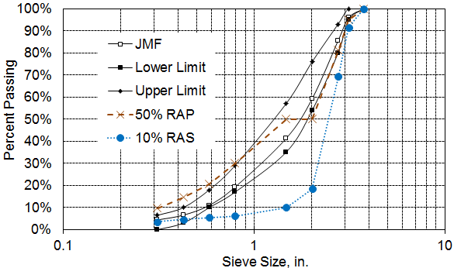
Figure 5. 9 Aggregate gradation

Table 5. 1 Mix design of the mixtures used in this study
Mixture | Total Weight  (g) | RAP/RAS (g) | RAP/RAS  AC  (%) | Optimum AC  (%) | Virgin Binder  (g) | Virgin Aggregate  (g)
50% RAP | 2000 | 1000 | 5.71 | 5.5 | 52.9 | 947.1
10% RAS | 2000 | 200 | 20.85 | 3.5 | 28.3 | 1771.7

The virgin aggregates were pre-heated at 175ºC two hours prior to the mixing, while the RAP and RAS were heated at 110ºC 30 minutes earlier to gain some workability. Note that the heating for RAP/RAS should be limited to maximum of 30 minutes to avoid further aging (Mcdaniel and Anderson 2001). The virgin binder was heated at 165ºC for a minimum of one hour with the cap tight. A Hobart Mixer model A-120 with wire whisk recommended by Asphalt Institute for laboratory mixing was used to make mixtures in this study. A 2-minute mixing was conducted to ensure a better coating. Upon completion of mixing, the coarse virgin and fine RAP/RAS aggregates were manually separated. Figure 5.10 presents fine RAP aggregates and coarse virgin aggregates separated after mixing.

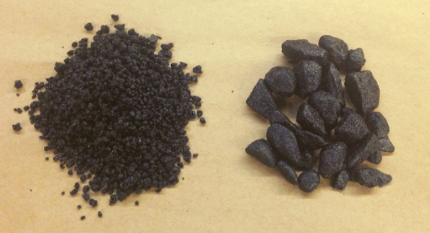
Figure 5. 10 Separated fine RAP and coarse virgin aggregates

The equal time interval was commonly used for staged extraction by researchers. 30 seconds, 1 minute (Bowers et al. 2014) and 3 minutes (Huang et al. 2005) were tried in different studies. However, based on the plenty of trials, the authors of this study found the binder layers extracted with equal-time extraction may not accurately represent the actual layers. According to trial and error, a new procedure, named as “Step-Extraction”, was used to strip the binder layers from RAP/RAS aggregates. The step-extraction included six TCE washes that yielded six layers for analysis. The time was 5, 10, 15, 20 and 120 seconds for the first 5 washes, respectively. The remaining binder was soaked in TCE for 30 minutes for complete dissolution, generating the 6th layer. Figure 5.11 shows the percent weight of each layer based on a1-minute equal extraction and re-designed step-extraction. It can be found that the percent weight of each layer can reach an approximately equal distribution. However, the 1-minute extraction was also conducted for the comparison purpose. A sample of 10 g was used so as to fit a 50 mL beaker. Upon completion of stripping the binder from RAP/RAS aggregates, each layer was made into standardized GPC sample as mentioned above.

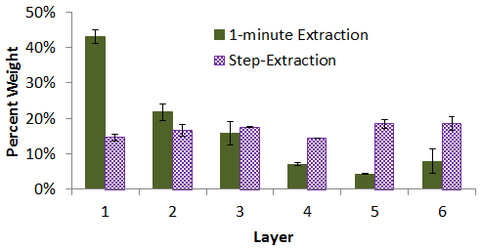
Figure 5. 11 Layer weight distribution caused by different extraction methods

Results and Discussion

Figure 5.12 presents the GPC results of 1-minute extraction and step-extraction described above on RAP particles. LMS (%) values of all the samples are found to be within the range generated by virgin binder and RAP binder, which follows the common sense that each layer is a combination of virgin and RAP binders. It can be seen that LMS (%) tends to increase from the outmost layer (layer 1) to the innermost layer (layer 6), regardless of the extraction methods. However, the variation among the layers generated by 1-minute extraction was relatively smaller, while the step-extraction yields a more differentiable LMS (%) distribution. In conjunction with the weight distribution presented in Figure 5.11, the step-extraction presented in this study seems to generate a more favorable evaluating system and should be used for further research.
According to the results of step-extraction, it can be found that the first layer is close to the virgin binder, while the last two layers are approaching the RAP binder. The LMS (%) values of layer 2, 3 and 4 stand in the middle, serving as the blending zone with unknown blending level.

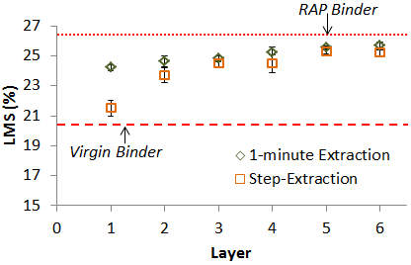
Figure 5. 12 GPC results of RAP samples

Figure 5.13 presents the GPC results obtained from extraction of RAS particles. The same finding was observed as that of RAP extraction. This means the step-extraction proposed in this study can also be extended to RAS blending research.
It is noted that the LMS (%) of the innermost layer is not very close to the RAS binder level. This does not mean the virgin binder could blend into the inner layer of RAS binder, since the fine particles passed No. 8 sieve were RAS particles only and a large amount of virgin binder might coat the RAS particles with a heavy film. The thick coating may have brought uncertainties to the system. Further research with more reasonable design should be conducted to validate this assumption.

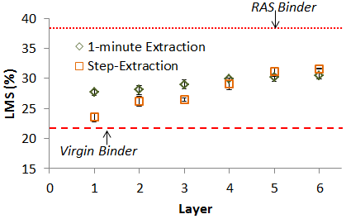
Figure 5. 13 GPC results of RAS samples

It should also be noted that, the blending of RAP binder and virgin binder can be qualified, to some extent, by the step-extraction method. However, the blending process cannot be completely revealed since binder coating is not perfectly equal and complexity may occur during the dissolution process.

Conclusions

This study validated the staged extraction method developed for virgin-recycled binder homogeneity research. Based on the results and analyses from the study, the following conclusions can be made:
- Solvents used in the study showed little effect on the molecular weight distribution of asphalt binder.
- According to molecular weight analysis and binder fractionation, it was found that maltene, asphaltene and corresponding virgin binder had different LMS percentage levels, which can be used to evaluate the selective dissolution of different solvents.
- TCE and nPB were found to less selectively dissolve the asphalt binder, while the dissolution of T/E and decalin seemed more selective.
- Among the solvents selected in this study, TCE dissolved the binder with the highest rate. nPB was ranked the 2rd while T/E and decalin were found to dissolve the binder with a relatively low rate. TCE was selected as the most effective asphalt solvent used for staged extraction.
- According to results from extraction of a composite binder system that was well-controlled to coat a steel ball, the layered stripping was proved to occur on a RAP-virgin binder combination.
- RAP and RAS aggregates were found to be coated with homogeneous asphalt binder.
- This study confirmed that the staged extraction was a valid method and useful tool for binder homogeneity research.
- A new step-extraction method was developed to replace the equal-time extraction for improvement in analysis results. This new method was validated using a 50% RAP and a 10% RAS mixture, and found to be more effective than the original equal-time extraction.
- Partial blending was observed within the coating of RAP particles. The blending between RAS and virgin binder on RAS particles was also observed, but needs further evaluation.

CHAPTER VI

QUANTITATIVELY EVALUATING BLENDING AND DIFFUSION IN HIGH RAP AND RAS MIXTURES

Abstract

The asphalt industry has made attempts to use higher amount of recycled asphalt pavement (RAP) and recycled asphalt shingle (RAS). Due to the aged nature of the recycled materials, the concerns over old-new binder blending during mixture production and subsequent diffusion process have been raised by asphalt practitioners and researchers. In this study, a well-designed staged extraction method was used to extract binder in approximately equal layers from separated virgin and RAP/RAS aggregates after mixing. Quantitative analysis was done on extracted binders with the use of a parameter, large molecule size percentage [LMS (%)] derived from gel permeation chromatography (GPC). Based on the testing results, it was found that, in RAP mix, binder film coating virgin aggregates was approximately homogeneous, while a non-homogeneous binder was generated on RAP aggregates. The model of binder blend coating the virgin and RAP aggregates with inactive RAP binder still attaching was validated in this study. A potential composite binder system was found coating the virgin aggregates in RAS mix. The diffusion study shows that within the mixture storage time, binder diffusion can be accomplished in both warm and hot mixes containing RAP, indicating old binder mobilization, rather than binder homogeneity, could be more critical in RAP mix. The binder diffusion in RAS mix was captured in a very slow rate. It was suggested that old binder activation and binder homogeneity can both be critical for RAS mix.

Introduction

The current tendency in asphalt industry is to increase the use of recycled asphalt pavement (RAP) and recycled asphalt shingle (RAS) due to environmental and economic benefits. Research on asphalt mixtures containing high RAP percentages (over 30%) has been reported in plenty of studies (McDaniel & Anderson 2001; Shu et al. 2012; Zhao et al. 2012; Zhao et al. 2013), and incorporating 100% RAP has been even tried (Mallick et al. 2010). Meanwhile, researchers have made attempts to add as high as 10% RAS in asphalt mixtures (Button et al. 1996; Foo et al. 1999), although RAS usage is allowed less than 3-5 % in most state agencies that have approved its utilization. More recently, combination of RAP and RAS has been implemented in order for better use of both the two valuable recycled asphaltic materials (Scholz 2010; McGraw 2010).

Concerns for Binder Blending

Although the high RAP/RAS incorporation looks promising, asphalt practitioners have been haunted by a critical question: Does the binder provided by the recycled materials blend with the virgin binder, or namely, what is the binder homogeneity like after mixing of the recycled materials, virgin binder and aggregates? So far, most of the studies collected by the authors that have mentioned blending issues have focused only on blending between RAP and virgin binder. Mcdaniel and Anderson (2001) first addressed the blending concern by producing three types of mixtures simulating actual practice, black rock and total blending. The three different blending scenarios were sketched in another study (Figure 6.1, Bowers 2013). Based on the performance testing results, it was concluded that partial blending apparently occurs to a significant extent, rather than total blending of the RAP binder and the virgin binder. The similar partial blending conclusion was reported in another performance based study (Soleymani et al. 2000), and the authors also stated that insufficient blending does affect the performance of mixtures containing high RAP. The performance-related evaluation, however, serves as an indirect method to address the blending process. The actual blending process is still unknown.

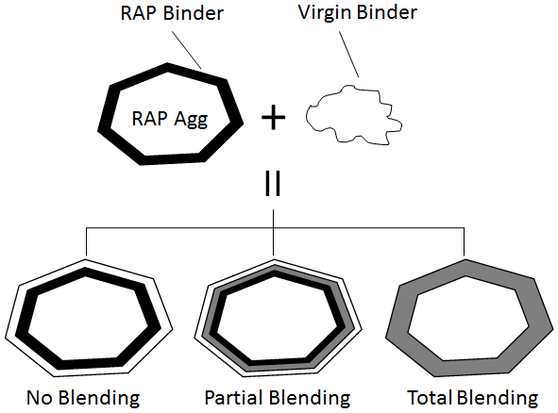
Figure 6. 1 Three different blending scenarios (adapted from Bowers 2013)

Direct Observation of Binder Homogenization

The binder blending process is actually the binder homogenization of recycled and virgin binders. In order to directly capture the homogenization process, Navaro et al. (2012) distinguished the clear-colored virgin binder from RAP binder by observing under white light and ultraviolet (UV). The disappearance of clusters of RAP binder and gradual homogenization of the RAP binder and virgin binder blend were found by the researchers. It was also concluded that production temperature parameter and mixing time were very influential on the homogenization process, with a 30ºC reduction in temperature equal to at least doubled or tripled mixing time for an identical degree of blending.
Recently, atomic force microscopy (AFM) was used by researchers to evaluate the interaction between the virgin and RAP binders (Nahar et al. 2013), by studying the microstructures of the “blending zone”. A completely blended “new material” that had an intermediate microstructural property of the two binders was observed with a blending zone of approximately 50 µm. The blending zone dimension was also reported to be correlated with the blending temperature and time.

Binder Diffusion

Some researchers also addressed the binder interaction by studying the diffusion of virgin binder into RAP binder. For the purpose of consistency, “blending” refers specifically to the binder interaction during mixing, while “diffusion” means binder homogenization after mixing process is completed without the effect of mechanical force.
The diffusion studies were first motivated to study the penetration of rejuvenators into the asphalt (Oliver 1974; Carpenter & Wolosick 1980; Noureldin & Wood 1987; Karlsson & Isacsson 2003). The virgin-RAP binder diffusion was brought to the attention of researchers in recent years due to the increased use of recycled materials. Plenty of studies have focused on a two-layer model conducted by dynamic shear rheometer (DSR) on the basis of Fick’s diffusion law (Karlsson et al. 2007; Rad 2013; Kriz et al. 2014). These studies have made fruitful achievements, however, the application of the DSR model may be limited since the practical conditions, such as aggregates and mechanical mixing, were not considered.

Staged Extraction

The above-mentioned studies did address the binder blending and diffusion process, however, were not directly revealing the actual binder interaction. A more reasonable approach to address the binder homogeneity process, called staged extraction (Huang et al. 2005; Bowers et al. 2014) or progressive extraction (Eddhahak-Ouni et al. 2012), has been tried by researchers to address the homogeneity of binder blend. The key point is to strip the asphalt binder by layers from RAP aggregates using asphalt solvent, on the assumption that a layered binder structure forms (Figure 6.2).

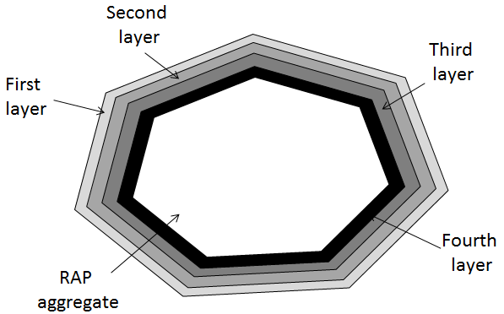
Figure 6. 2 The layered structure adapted from Huang et al. (2005)

Staged extraction was first tried on a recycled mixture by Zearly (1979) to look into whether the new asphalt actually blended with the old asphalt. Two washes by trichloroethylene (TCE) in designated time intervals were implemented to ensure removing one half of the asphalt from the mix per wash. It was found that the penetration values for both layers were close, and the inner layer in some cases showed higher numbers. This was attributed to the selective absorption of the lighter asphalt fractions by the large amounts of shale in the aggregates. To further validate the staged extraction method, the authors coated an aggregate with hard asphalt, had it age hardened and then coated it with a soft asphalt. Then the twice-coated sample was eluted by TCE for three times and a trend of decrease in penetration was found from the outmost layer to the innermost layer.
The staged extraction method was later validated by Huang et al. (2005) and Bowers et al. (2014). The researchers used TCE to wash and separate the blended binder on RAP aggregate into four layers after mixing, and used dynamic shear rheometer (DSR) (Huang et al. 2005), gel permeation chromatogram (GPC) and fourier transform infrared spectroscopy (FTIR) (Bowers et al. 2014) to characterize each binder layer. The results from different testing tools agreed on the finding that blending does occur within all layers of the pavement mixture, but the blending is not completely uniform.
Eddhahak-Ouni et al. (2012) conducted a study using the staged extraction method to develop an approach for quality control of the binder homogeneity. The virgin aggregate, virgin binder and RAP were mixed in a short time so the blended binder is not fully homogeneous. A three-layer extraction, with consideration of the extraction mass, was implemented on the mixture, and it was found that “the RAP binder was not well remobilized and thus is not mixed homogeneously with the virgin one”.
The studies mentioned above proved the feasibility of staged extraction used in blending research, however, were limited to the qualitative evaluation. In this study, the staged extraction method was used, in conjunction with other evaluating tools, to conduct quantitative evaluation of the binder blending and diffusion process.

Objectives and Scopes

An earlier research conducted by the authors has proposed a possible blending scenario (Figure 3). During the batch mixing, a blend of virgin binder and mobilized RAP binder re-coats the virgin aggregates and RAP aggregates with inactive RAP binder still attached. This hypothesis can be tested by doing staged extraction on both the virgin and RAP aggregates. In addition, the binder homogenization will continue occurring on RAP aggregates as a diffusion process during mixture storage, transport and placement, until a homogeneous film is reached. The similar diffusion may also happen if the binder blend coating virgin aggregate is not homogeneous. Likewise, the diffusion process can also be tracked using staged extraction method. RAS is similar to RAP but stiffer and contains higher amount of asphalt, so the staged extraction was also conducted on RAS in study.

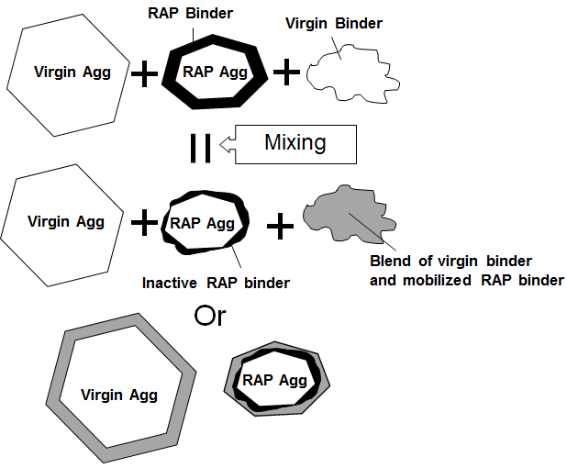
Figure 6. 3 Possible blending scenario

The objectives of this study are:
- To quantitatively investigate the blending process of asphalt mixtures containing RAP and RAS after mixing.
- To evaluate the diffusion process of asphalt mixtures containing RAP and RAS during mixture storage, transport, construction and service life.

Methodology and Experimental Design

Quantitative Evaluation of Blending Process

Materials

A locally available PG 64-22 binder was selected as virgin binder in this study. One gravel batch specified for surface mixture was used in this study as virgin aggregates. One type of locally available RAP and one RAS were selected as the recycled materials. As illustrated in Figure 6.3, the binder distribution on virgin aggregates and RAP/RAS aggregates may be highly different, so a better analysis can be achieved by evaluating the blending process on virgin and RAP/RAS aggregates, respectively. Thus, a gap-gradation was selected in this study in order to easily distinguish the RAP/RAS aggregates from the virgin ones upon completion of mixing. The virgin aggregates retained on No. 4 (4.75 mm) sieve and the recycled materials passing No. 8 (2.36 mm) sieve were collected for use in this study. The basic information of the raw and sieved materials can be found in Table 6.1.

Table 6. 1 Properties of materials selected in this study
Properties |  |  | Virgin Agg. | Virgin Agg.  (+ No.4) | RAP | RAP  (- No.8) | RAS | RAS  (- No.8)
AC (%) |  |  | - | - | 4.76 | 9.75 | 20.85 | 21.28
Gradation | Sieve (in.) | Sieve (mm) | Passing (%)
Gradation | 5/8 | 16 | 100 | 100 | 100 | 100 | 100 | 100
Gradation | 1/2 | 12.5 | 92 | 89.6 | 100 | 100 | 100 | 100
Gradation | 3/8 | 9.5 | 71 | 62.3 | 92.4 | 100 | 100 | 100
Gradation | #4 | 4.75 | 23 | 0 | 61.5 | 100 | 99.2 | 100
Gradation | #8 | 2.36 | 15 | 0 | 44.5 | 100 | 97.4 | 100
Gradation | #16 | 1.18 | 12 | 0 | 34.6 | 77.8 | 80.9 | 83.1
Gradation | #30 | 0.6 | 9 | 0 | 26.7 | 60 | 60.2 | 61.8
Gradation | #50 | 0.3 | 6 | 0 | 18.3 | 41.1 | 53 | 54.4
Gradation | #100 | 0.15 | 4 | 0 | 13 | 29.2 | 44.9 | 46.1
Gradation | #200 | 0.075 | 2.5 | 0 | 8.7 | 19.6 | 34.6 | 35.5

Mix Design

Two mixtures, one containing 50% RAP and one with 10% RAS, were prepared to meet the current tendency of using high amount of recycled materials. Mix design was adjusted to pursue mixtures with good coating based on visual judgment. The mix design parameters and other useful properties of mixtures are presented in Table 2.

Table 6. 2 Mix design and other properties of mixtures
Mix | Total Weight  (g) | RAP/RAS (g) | RAP/RAS AC  (%) | Mix AC  (%) | Virgin Binder  (g) | Virgin Aggregate  (g)
50% RAP | 2000 | 1000 | 9.75 | 6.66 | 35.7 | 964.3
10% RAS | 2000 | 200 | 21.28 | 3.29 | 23.2 | 1776.8

Experimental Procedures

The mixing was conducted at 165ºC for 2 minutes with a Hobart Mixer model A-120 with wire whisk recommended by Asphalt Institute for laboratory mixing. Upon completion, the coarse virgin and fine RAP aggregates were separated for staged extraction, respectively (Figure 6.4). Trichloroethylene (TCE) was used as the extraction solvent since it was found to be the most effective binder solvent used for staged extraction analysis. A step-extraction proposed in a previous research was selected to generate binder layers with similar thicknesses (Table 6.3). A total of four layers and six layers were obtained from coarse virgin aggregates and fine RAP/RAS aggregates, respectively. Samples of 25 g and 10 g were used for fine particles and coarse particles, respectively, to fit the dimension of a 50 mL beaker.

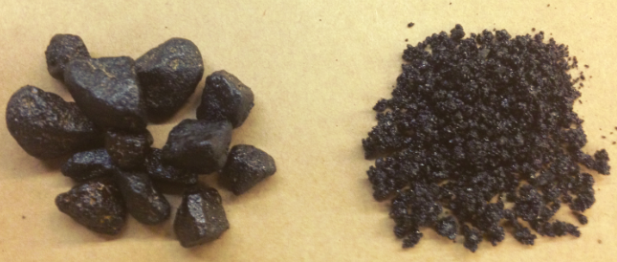
Figure 6. 4 Separated coarse and fine particles for 50% RAP mixture

Table 6. 3 Step-extraction procedure
Layer No. |  | 1 | 2 | 3 | 4 | 5 | 6
Wash Time | Coarse | 10 s | 20 s | 30 s | 30 minutes | - | -
Wash Time | Fine | 5 s | 10 s | 15 s | 20 s | 2 minutes | 30 minutes

Gel Permeation Chromatogram (GPC) Testing

Gel permeation chromatogram (GPC) was used as the analyzing tool for the blending and latter diffusion study, since it was proved to be capable of characterizing binder blend with various concentrations of recycled binder. The extracted binder was recovered in a 20 mL vial with a water bath of 70ºC in less than 15 min, and left in a vacuum oven at 85ºC overnight for complete removal of the solvent. Approximately 15 mg recovered binder was dissolved in tetrahydrofuran (THF) to make into the standardized GPC sample with a concentration of 1 mg/mL (Bowers et al. 2014; Zhao et al. 2014).
Large molecule size percentage [LMS (%)] derived from GPC testing was used for analysis in this study, which was defined as the percentage of large molecular fraction (molecules larger than 3,000 Dalton) over the total area of the chromatogram generated by GPC (Zhao et al. 2014) (Figure 6.5).

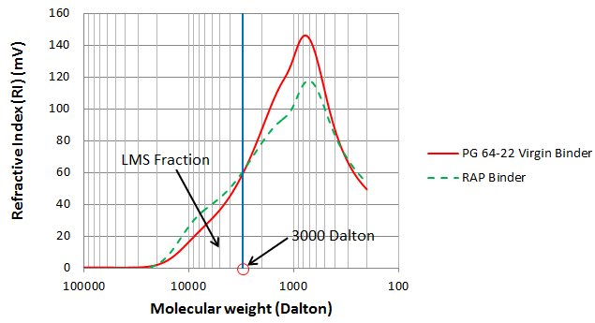
Figure 6. 5 LMS (%) calculation

Quantitative Evaluation of Diffusion Process

Figure 6.6 presents the temperature change of hot and warm mix from production to placement. Since diffusion is highly dependent on temperature (Karlsson et al. 2007; Rad 2013; Kriz et al. 2014), most of the diffusion may occur at the early stage at higher temperature after the mixture is produced. In order to evaluate the diffusion at this stage, the fine particles obtained in “blending” study were left in the vacuum oven for time and temperature treatment, and then were subjected to staged extraction and GPC testing. The vacuum oven was used to avoid the effect of aging. Since mixture storage time lasts long and a relatively high temperature is still maintained at this stage, the laboratory conditioning of the samples were mostly designed to simulate mixture storage. The experimental design was organized in Table 6.6.

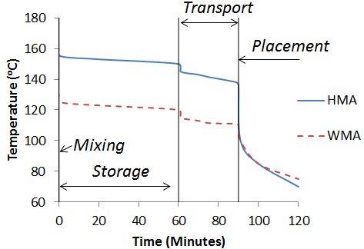
Figure 6. 6 Temperature profile for mix production, storage, transportation and placement (adapted from Kriz et al. 2014)

Table 6. 4 Experimental plan for diffusion study
ID | Materials | Treatment | Method
1 | Coarse particles from 50% RAP mix | 125ºC for 1 hr | 4-layer staged extraction
2 | Fine particles from 50% RAP mix | 125ºC for 1 hr | 6 layers staged extraction
3 | Fine particles from 50% RAP mix | 155ºC for 1 hr | 6 layers staged extraction
4 | Coarse particles from 10% RAS mix | 125ºC for 1 hr | 4-layer staged extraction
5 | Coarse particles from 10% RAS mix | 155ºC for 1 hr | 4-layer staged extraction
6 | Fine particles from 10% RAS mix | 125ºC for 1 hr | 6-layer staged extraction
7 | Fine particles from 10% RAS mix | 155ºC for 1 hr | 6-layer staged extraction

Results and Discussion

Results from 50% RAP Mixture

Figure 6.7 presents the staged extraction results of coarse aggregates separated from 50% RAP mixture. According to Figure 6.7(b), the weight of each stripped layer was similar, indicating the layers may be extracted in the similar film thickness. Figure 6.7(a) shows the LMS (%) of each layer. There is a slight decrease of LMS (%) from outmost layer (1st layer) to 2nd layer, and LMS (%) changes very little from 2nd to the innermost layer. This may suggest a well-blended film coating the virgin aggregates. A one-way ANOVA test was conducted on the data and a p-value of 0.184 was obtained with α of 0.5, which means no statistical difference was found within the 4 layers. It is reasonable that the outmost layer exhibited a slightly higher LMS (%) since it was exposed to RAP particles.

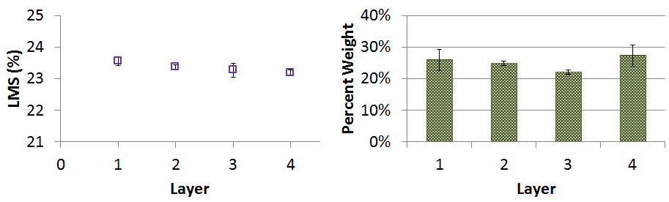
(a) GPC results in terms LMS (%) (b) Percent weight of each layer
Figure 6. 7 Results of staged extraction on coarse virgin aggregates in RAP mix

Figure 6.8 presents the results of fine particles separated from the RAP mix. It can be seen from Figure 6.8(b) that the extracted layer was well-controlled in similar film thickness. As expected, the LMS (%) of the binder layers increased from the outmost layer to the innermost layer, since the inactive old binder coating the RAP aggregate considerably contributed to inner layers. However, the interesting finding is that the first two layers exhibited similar LMS (%) values to those coating the virgin aggregates. One-way ANOVA test was conducted on the LMS (%) of the six layers, including two outmost layers coating RAP aggregates and all the four layers coating virgin aggregates. A p-value of 0.56 was obtained, which indicates no statistical differences among the six layers. This finding may support the blending scenario proposed in Figure 6.3. The virgin binder and mobilized RAP binder may blend during mixing and generate a relatively homogeneous film that subsequently coats the virgin aggregates or RAP aggregates with some inactive old binder still attaching. According to Figure 8(b), the approximately homogeneous blend film accounted for around 30% to 35% of the total binder coating the RAP aggregates.

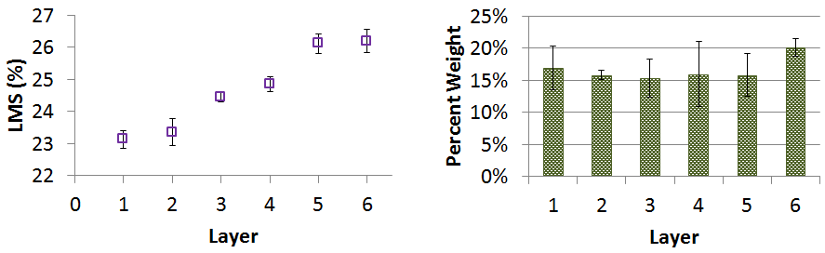
(a) GPC results in terms LMS (%) (b) Percent weight of each layer
Figure 6. 8 Results of staged extraction on fine RAP aggregates

Results from 10% RAS Mixture

Figure 6.9 shows the testing results of binders coating the virgin coarse aggregates. Unlike the RAP mixture, the binder on virgin aggregates was extracted in an uneven rate. This can be attributed to a thicker film coating virgin aggregate in RAS mixture due to less fine particles, thus the dissolution rate was changed a little. It was also found that LMS (%) of the outermost layer was a little higher than the other three that showed similar LMS (%) values. This may be because the mobilized RAS binder did not blend well with the virgin binder, thus attached onto the outmost layer of binder coating virgin aggregates.

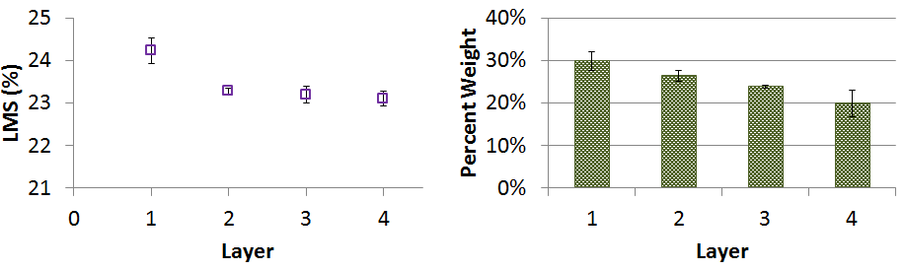
(a) GPC results in terms LMS (%) (b) Percent weight of each layer
Figure 6. 9 Results of staged extraction on coarse virgin aggregates in RAS mix

Figure 6.10 presents the results obtained from testing on fine RAS particles. The average LMS (%) of the outmost layer that accounts for approximately 20% of the binder was 24.35, close to the average LMS (%) of the outmost layer on virgin aggregates, 24.23. Starting from the second layer, the LMS (%) of the binder was significantly higher. This finding shows that the binder distribution in RAS mixture is different from the RAP mixture. The new blending scenario was proposed and illustrated in Figure 6.11.

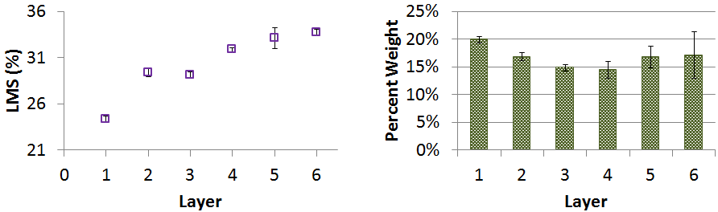
(a) GPC results in terms LMS (%) (b) Percent weight of each layer
Figure 6. 10 Results of staged extraction on fine RAS aggregates

Figure 6.11 illustrates different blending scenarios of RAP and RAS mixes. The blending scenario of RAP was validated, to some extent, by the staged extraction results of RAP mix. Unlike RAP, the staged extraction results on RAS mix suggested a composite structure of binder coating the virgin aggregates after mixing. The virgin aggregate was coated by virgin binder first, then the blend virgin binder and RAS binder mobilized during mixing re-coated the virgin and RAS aggregates. Due to the reduction in temperature or material difference between RAS and virgin binders, the binder blend could not enter through the virgin binder layer, thus developing a composite binder system on virgin aggregates. Since RAS was extremely aged during production process and service life, only a small portion of RAS binder could be mobilized, therefore a thick RAS binder layer was left remaining coating the RAS aggregates. The blending process does not stop when mixing is completed. As shown in Figure 6.6, the mixture is generally kept at relatively high temperature up to several hours. The blending happening at this stage was also evaluated in this study as the diffusion process.
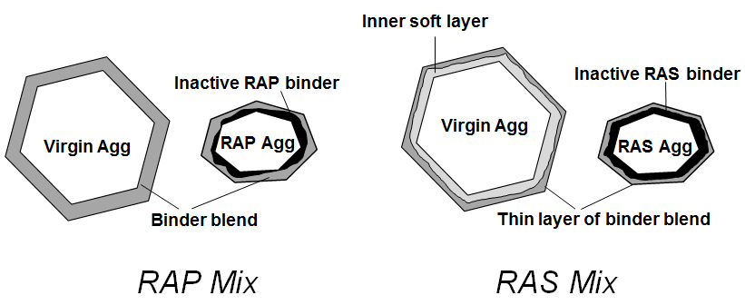
Figure 6. 11 Different blending scenarios of RAP and RAS mixes

Diffusion Study Results

Results from 50% RAP Mixture

The same materials used in blending study were also used in diffusion study for comparison purpose. According to description of sample 1 to 3 in Table 6.5, the coarse and fine particles from RAP mix were conditioned in a vacuum oven at 125ºC or 155ºC for 1 hr to simulate the storage temperature and time for WMA and HMA, respectively. The lab testing results showed statistically same results for various groups of layers. The authors of this study shortened the testing time to 15 minutes and the testing results were arranged in Figure 6.12. After conditioned at 125ºC for 15 minutes, the binder on virgin aggregate tended to be more homogeneous, with a p-value of 0.636 from one-way ANOVA test, compared to a p-value of 0.184 without diffusion.
On the RAP aggregates, a fairly homogeneous binder system was generated after conditioned at 155ºC for 15 minutes, with a one-way ANOVA p-value of 0.604. The binder exhibited a tendency of being more evenly distributed after treated at 125ºC for 15 minutes, although the p-value of 0.008 indicates that LMS (%) of all layers were not statistically the same. However, it should be noted, as mentioned previously, the RAP-virgin binder diffused into a homogeneous binder system after 1 hour conditioning even at 125ºC, which indicates that binder diffusion can be completed during the mixture storage time for both HMA and WMA mixes. The concern over blending for RAP mix should be focused on the old binder mobilization that could generate binders with different rheological properties coating the virgin and RAP aggregates, respectively. In this case, the homogenized binder on virgin aggregates exhibited a LMS (%) value of

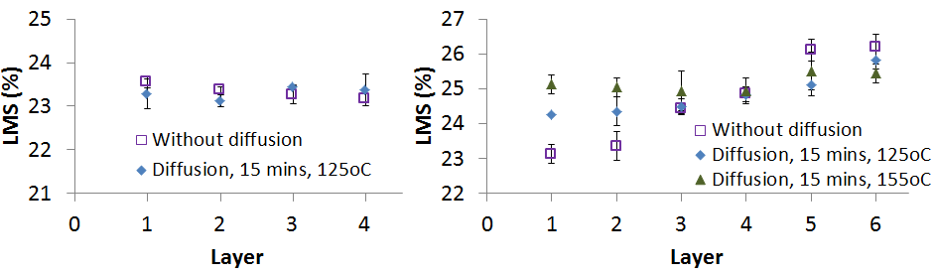(a) Staged extraction on coarse virgin aggregates (b) Staged extraction on fine RAP aggregates
Figure 6. 12 Diffusion results of RAP mix

Results from 10% RAS Mixture

Figure 6.13 presents the diffusion testing results from 10% RAS mix. On the virgin aggregates, it seems binder diffusion occurred in a not appreciable level. However, one-way ANOVA test results show that p-value increased from 0.0149 for sample without diffusion, up to 0.249 for 125ºC conditioning and 0.119 for 155ºC conditioning. This may indicate that diffusion occurred, but very slowly. Since the original differences between the layers were not significant, the binder on virgin aggregates may be considered as approximately homogeneous after storage diffusion.
The diffusion concern was noticed on RAS particles. According to the LMS (%) results, the homogenization of binder, especially at higher temperature, could be noticed. However, the variation between from the outmost layer to the inner most layer stayed at a high level. This finding confirmed the concern over binder homogeneity in RAS mixtures. Since diffusion is highly dependent on temperature, the long-term diffusion between the virgin and RAS binder at lowered temperature may not be promising. Therefore, the old RAS binder mobilization and its blending homogeneity with virgin binder can both cause problems that lead to pre-mature distresses of RAS mixtures.

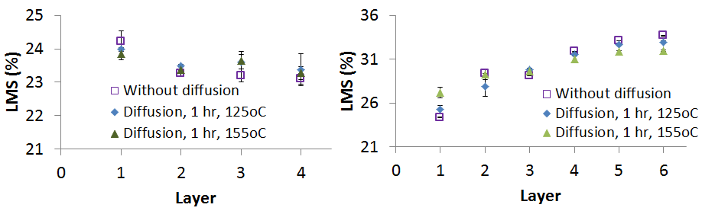
(a) Staged extraction on coarse virgin aggregates (b) Staged extraction on fine RAS aggregates
Figure 6. 13 Diffusion results of RAS mix

Conclusions

This study conducted quantitative analysis of binder blending and subsequent diffusion in RAP and RAS mixtures. The modified staged extraction method was used to extract binder in approximately equal layers from separated virgin and RAP/RAS aggregates after mixing. The extracted binder was submitted to GPC to obtain LMS (%) for analysis. Based on the testing results, the following conclusions can be made:
- In the 50% RAP mix, binder film coating virgin aggregates was approximately well blended, while LMS (%) of binder on RAP aggregates increased from outmost layer to the innermost layer.
- There is no statistical difference in terms of GPC results between the four layers on virgin aggregates and the two outer layers extracted from RAP aggregates. This finding validates the blending scenario proposed for RAP mixture, that binder blend of RAP binder mobilized during mixing and virgin binder re-coats the virgin and RAP aggregates with inactive binder still attaching.
- The outmost layer on virgin aggregates in RAS mix showed relatively higher LMS (%) than the inner three with similar LMS (%) values, indicating a non-homogeneous film coating. The LMS (%) of binder on RAS aggregates increased from outside to inside.
- The outmost layer on RAS aggregates showed similar LMS (%) to the first layer extracted from virgin aggregates, which leads to the development of a new blending scenario for RAS mix, which suggested a composite binder system generated on virgin aggregates in RAS mix.
- The diffusion study showed that a relatively complete diffusion process could be done at 155ºC within 15 minutes in RAP mix. When the temperature was lowered to 125ºC, the process could be done within an hour. This may indicate that old binder mobilization, rather than diffusion, is more critical for RAP mix.
- RAS-virgin binder diffusion would be captured in this study, but was found in a very slow rate. The virgin-RAS binder could not accomplish homogenization within the mixture storage time at 155ºC. The finding suggested that both binder homogeneity and old binder mobilization can raise concerns over the use of RAS mixtures.

Acknowledgment

The authors would like to thank the Tennessee Department of Transportation (TDOT) for financially supporting this project. The contents of this study reflect the views of the authors only.

CHAPTER VII

Effects of WMA Technologies on Asphalt Binder Blending

Abstract

Due to environmental and economical benefits, the asphalt industry has made attempts to incorporate recycled asphalt pavement or shingles (RAP/RAS) into warm mix asphalt (WMA). However, the low temperatures at which WMA is produced may affect the binder blending in RAP/RAS mixtures. In this study, a lab-testing procedure was developed to evaluate the effects of WMA technologies on binder blending. The results from the study show that WMA additives slightly decreased the viscosity of the asphalt binder at 135ºC. However, control binder tested at 165ºC showed significantly lower viscosity than WMA binders. This may raise the concern over workability of the WMA mix. WMA additives yielded higher blending ratio than control mix produced at 135ºC, but the temperature of 165ºC still produced the mix with the highest blending ratio value. This indicates that a concern still exists over asphalt blending even if WMA additives are used. Foaming technology yielded a higher blending ratio, indicating foamed WMA may yield a higher blending than regular HMA. It was also found that temperature rather than coating is more critical in RAS blending. Finally, the mix produced with coarse virgin aggregates and medium RAP may not be sensitive enough to test the effect of WMA additives on blending, while the mix with medium virgin aggregates and fine RAP was more effective.

Introduction

WMA containing High RAP/RAS

In recent years, asphalt researchers and practitioners have been trying to combine warm mix asphalt (WMA) with high percentage of recycled asphalt pavement (RAP) and/or recycled asphalt shingle (RAS), due to their environmental values (Shu et al. 2012; Zhao et al. 2012; Zhao et al. 2013). WMA-high RAP mixture may be beneficial in two ways: the viscosity reduction will aid in compaction, and the decreased aging of the binder as a result of the lower production temperatures may help compensate for the aged RAP binder, similar to using a softer binder grade (D’Angelo et al. 2007). Since RAS is similar to RAP in shape, the same advantages can be extended to WMA-high RAS mixture.

Concerns over Blending

Due to different production process or aging during service, the binder provided by RAP/RAS may be too stiff to gain enough mobility or workability at mixture production temperatures, which may affect its blending with the virgin binder. Thus the blending issues in RAP/RAS mixtures have been questioned in recent years (Huang et al. 2005; Bowers et al. 2014a; Zhao et al. 2014a). The need to incorporate higher amount of recycled materials have made the question even more critical.
The old binder from RAP/RAS contributes to the asphalt mixture in two ways. First, the heated virgin binder and aggregates mobilize the old binder, in conjunction with the mechanical force during mixing, thus the mobilized old binder blends with virgin binder and re-coats the aggregates (Figure 7.1). Then, the binder blend tends to develop into a homogeneous film on virgin aggregates, or diffuses into the inactive old binder remaining on RAP aggregates. This diffusion process happens during mixture storage, transport and placement at relatively high temperatures, and in long-term service life at ambient temperatures. Based on the authors’ previous research, the concerns over old binder mobilization may be more critical than binder diffusion, since it significantly affects mix design, coating and binder distribution in the new mix.

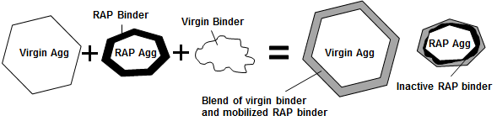
Figure 7. 1 The old binder mobilization during mixing

The combination of WMA with RAP/RAS may affect the old binder mobilization process. Since the viscosity of asphalt binder is highly dependent on temperature, the temperature reduction in mixing and delivery may limit the mobilization of the old binder, and decrease the coating ability of the virgin binder or binder blend. This will result in a bad coating, with very heavy film coating the fine particles but thin or limited coating of coarse particles, so the blending problem has been described as the primary concern about the use of RAP in WMA (Jamshidi et al. 2014). On the contrary, the use of additives or foaming technology to produce WMA mix may reduce the viscosity of the asphalt binder, thus compensate the negative effect of the temperature reduction. In addition, the potential chemical reaction between WMA additives and old binder may also help with the binder mobilization. Therefore, the effect of WMA on binder blending during mixing still remains as a question.

WMA Technologies

As mentioned above, the WMA can be produced with different technologies, which may lead to different effects on binder blending. Generally, two primary technologies have been used to produce WMA (Xiao et al. 2011). The first is to inject cold water into the hot binder to generate binder foam with enlarged volume, thus enhancing the coating and workability (Kheradmand et al. 2014). The second can be named as non-foaming technology, relative to foaming process, and it is accomplished by adding various additives, including organic or wax additives and chemical additives. A commonly used organic additive in the U.S. is Sasobit, of which the viscosity is decreased at temperatures higher than the melting point of waxes thus lowering the mix temperature (Rubio et al. 2012). Popular chemical additives include Rediset, Cecabase and Evotherm, blended with asphalt binder to improve coating, mixture workability and compaction as well as adhesion (Xiao et al. 2011; Kheradmand et al. 2014). The working mechanisms of different WMA technologies may affect the binder blending, which should be evaluated, respectively.

Objectives

The objective of this study is to evaluate how WMA technologies affect binder blending in RAP/RAS mixtures. This is to be accomplished by finding out how WMA technologies contribute to the old binder mobilization process. WMA technologies evaluated in this study consist of laboratory foaming and adding additives, including different types of Sasobit, Rediset, Cecabase and Evotherm.

Experimental Design and Materials

Methodology and Materials

It can be imagined that all the old binder will be active and blend with virgin binder, if complete mobilization happens. However, as can be seen in Figure 7.1, the composition of binder coating virgin aggregates is different from binder coating RAP/RAS aggregates with inactive old binder still attached. Thus, the mobilization degree can be determined if virgin and RAP/RAS aggregates can be separated after mixing, and the composition of binder coating each type of aggregate can be revealed through testing tools.
A gap-gradation was used to design mixtures in this study in order to easily distinguish the virgin aggregates from RAP particles after mixing. Two models, coarse-virgin with medium-RAP and medium-virgin with fine-RAP, were used to design RAP mixes. The medium-virgin with fine-RAS model was used for RAS mix only, since most of the processed RAS consists of fine particles passing No.4 sieve. A No.57 limestone batch was selected as the coarse virgin aggregate and the materials retained on 1/2 in. sieve were collected only. The medium-virgin aggregates were collected from a gravel batch retained on No.4 sieve. A locally available batch of RAP passing 5/8 in. but retained on No. 8 sieves was used as medium-RAP, while the same RAP and a local RAS batch passing No.8 were used as fine-RAP and fine RAS. Two types of models were selected for RAP mix in order for consideration of size effect. Three mixtures were design to cover 50% RAP and 10% RAS. Table 7.1 presents the properties for each batch of materials, including gradation, asphalt content and average film thickness calculated following the method proposed by Asphalt Institute (1993) (Kandhal et al. 1998; Shirodkar et al. 2011). A typical PG 64-22 binder was selected as the virgin binder.

Table 7. 1 Properties of the materials used in this study
Properties |  |  | Virgin Agg. (Coarse) | Virgin Agg. (Medium) | RAP (Medium) | RAP (Fine) | RAS (Fine)
AC (%) |  |  | - | - | 3.24 | 9.75 | 21.28
Film Thickness (μm) |  |  | - | - | -* | 6.17 | 10.42
Gradation | Sieve (in.) | Sieve (mm) | Passing (%)
Gradation | 1 | 25.4 | 100 | 100 | 100 | 100 | 100
Gradation | 3/4 | 19 | 64.6 | 100 | 100 | 100 | 100
Gradation | 5/8 | 16 | 43.1 | 100 | 100 | 100 | 100
Gradation | 1/2 | 12.7 | 0 | 89.6 | 100 | 100 | 100
Gradation | 3/8 | 9.5 | 0 | 62.3 | 86.3 | 100 | 100
Gradation | #4 | 4.75 | 0 | 0 | 30.6 | 100 | 100
Gradation | #8 | 2.36 | 0 | 0 | 0 | 100 | 100
Gradation | #16 | 1.18 | 0 | 0 | 0 | 77.8 | 83.1
Gradation | #30 | 0.6 | 0 | 0 | 0 | 60 | 61.8
Gradation | #50 | 0.3 | 0 | 0 | 0 | 41.1 | 54.4
Gradation | #100 | 0.15 | 0 | 0 | 0 | 29.2 | 46.1
Gradation | #200 | 0.075 | 0 | 0 | 0 | 19.6 | 35.5
*Only the film thickness of fine particles can be calculated using this method.

The non-foaming additives selected are presented in Table 7.2.

Table 7. 2 Properties of WMA additives
Company | Products | Code | Description
Mead Westvaco  (MWV) | Evotherm M1 | Ev-M1 | Chemical packages, liquid, fatty amine derivatives, 0.25 to 0.75% by weight of binder
Mead Westvaco  (MWV) | EvoFLEX CA | Ev-CA | Chemical packages, liquid, fatty acid derivatives, 1 to 5% by weight of binder
Akzo Nobel | Rediset LQ-1102C | Re1102 | Chemical packages, liquid, proprietary alkoxylated fatty polyamines, proprietary polyamine, Glycol. 0.5% to 1% by weight asphalt cement
Akzo Nobel | Rediset LQ-1106 | Re1106 | Chemical packages, liquid, surfactant blend, 0.5% to 1% by weight asphalt cement
CECA | Cecabase RT 945 | Ce | Chemical packages, liquid, fatty acid amines, 0.3% to 0.5% by weight asphalt cement
Sasol | Sasobit | Sa | Fischer-Tropsch wax, solid, solid saturated hydrocarbons, 1% to 1.5% by weight of the binder
Sasol | Sasobit LM | Sa-LM
Sasol | Sasobit GTRM570 | Sa-570 | Sasol wax Slack wax blend, solid, petroleum hydrocarbon, 1% to 1.5% by weight of the binder
Sasol | Sasobit GTRM850 | Sa-850

Mix Design

Since the aggregate batch is gap-graded, the mix design is conducted according to trial and error in order to obtain mixtures with good coating (Table 7.3).
Table 7. 3 Mix design
Mixture | RAP/RAS  (%) | Total Weight  (g) | RAP/RAS (g) | RAP/RAS  AC  (%) | Optimum AC  (%) | Virgin Binder  (g) | Virgin Aggregate  (g)
Coarse-Virgin  Medium-RAP | 50 | 2000 | 1000 | 3.24 | 3.00 | 27.6 | 972.4
Medium-Virgin  Fine-RAP | 50 | 2000 | 1000 | 9.75 | 6.66 | 35.7 | 964.3
Coarse-Virgin  Medium-RAS | 10 | 2000 | 200 | 21.28 | 3.29 | 23.2 | 1776.8

Experimental Design

The foamed binder was produced at 135ºC with Wirtgen model WLB 10S in the materials lab at Virginia Center for Transportation Innovation & Research (VCTIR), with water content of 2.5% and 5%, respectively. The non-foaming additives were added and blended with 100 g virgin binder in a metal container (76.2 mm (3 in.) diameter × 55.9 mm (2.2 in.) height) with a high shear-rate mixing gun at 135ºC for 3 min in materials lab at University of Tennessee, Knoxville (UTK). The additive dosages selected in this study were generally based on the recommendations by the suppliers. For some additives, the increased dosage was also used by the authors to extend the testing range.
The mechanism of most WMA technologies is to reduce the viscosity of asphalt binder so as to be workable at lowered temperature. Thus, viscosity of foamed binder and binder blended with selected additives was determined, respectively. Brookfield rotational viscometer was used in accordance with AASHTO T316 to test the viscosity of the control and WMA binders at 135ºC, and one control binder at 165ºC.
The binder produced with different WMA technologies were mixed with virgin aggregates and virgin binder at 135ºC following the mix design (Table 3). The control hot mix was produced at 135ºC and 165ºC, respectively. It should be noted that foamed WMA and corresponding control HMA were mixed with Troxler PMW high energy asphalt mixer at VCTIR, while non-foaming WMA mixes and control mixes were mixed at UTK with a Hobart Mixer model A-120 with wire whisk recommended by Asphalt Institute for laboratory mixing. Upon completion of mixing, the materials were separated into coarse and medium particles, or medium and fine particles, respectively (Figure 7.2). The separated particles were eluted with n-propyl bromide (nPB) for a complete extraction, then recovered in a 20 mL vial with a water bath of 70ºC in less than 15 min until solvent was non-visible.

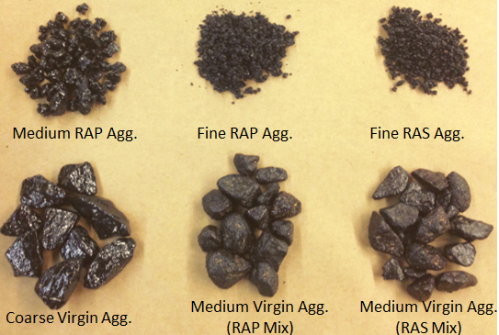
Figure 7. 2 Separated particles after mixing

The recovered binder was made into standardized sample and subjected to gel permeation chromatography (GPC). GPC was selected to characterize the binder because it has proved to be capable of quantitatively differentiating virgin binder from aged binder as well as their blends (Zhao et al. 2014b), in terms of molecular weight distribution. Large molecule size percentage [LMS (%)] derived from GPC testing was used for analysis in this study. LMS (%) was defined as the percentage of large molecular fraction (molecules larger than 3,000 Dalton) over the total area of the chromatogram generated by GPC (Zhao et al. 2014b) (Figure 7.3). A large LMS (%) indicates higher large molecular fraction in the binder. For blend of two specific virgin binder and RAP/RAS binder, higher LMS (%) means higher RAP/RAS binder concentration in the blend (Zhao et al. 2014b).

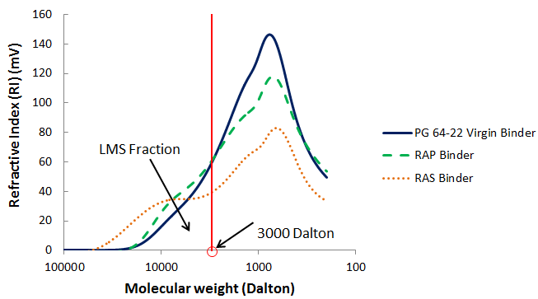
Figure 7. 3 Determination of LMS (%)

The whole experimental plan is illustrated in Figure 7.4.

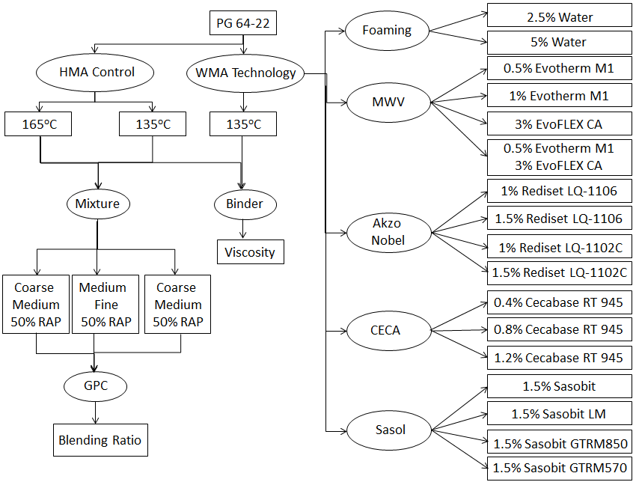
Figure 7. 4 Flow chart of the experimental design

Results and Discussion

Viscosity Testing Results

The viscosity of the asphalt binder is used to reveal its flow characteristics to ensure that the binder can be pumped and handled on site and also to determine the mixing and compacting temperature of the mixture (Xiao et al. 2012).
During viscosity testing for foamed asphalt, it was noticed that the reading was not stable even after 30 minutes, thus, the results cannot be used. This can be explained by the water trapped in the binder tending to evaporate at testing temperature of 135ºC, so the whole binder system was not in equilibrium. However, the workability of WMA produced with foamed asphalt was fairly good based on visual judgment.
Figure 7.5 presents the results of binder blended with additives and tested at 135ºC as well as control binder tested at 135ºC and 165ºC. As expected, the viscosity values of WMA binders slightly decreased with addition of additives, as compared to control binder tested at the same temperature (135ºC). This indicates that the WMA additives selected in this study can help reduce the mixing and compaction temperatures. However, it can also be found that all the viscosity values of WMA binders are significantly higher than that of control binder tested at regular mixing temperature for hot mix (165ºC). This means the WMA produced by adding additives may not be as workable as the regular HMA, although it may improve the workability of mixture produced at the same temperature without any additives. Therefore, the potential old binder mobilization could be limited if the WMA binders were used.

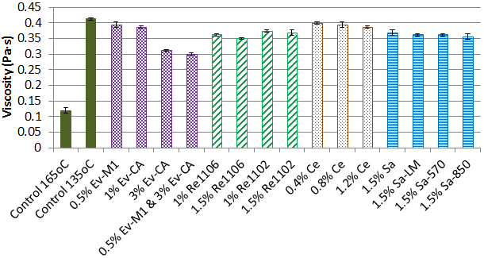
Figure 7. 5 Viscosity testing results

Among the additives, EvoFLEX CA seems more capable of reducing the binder viscosity and the lowest viscosity occurred to binder blended with the combination of 3% EvoFLEX CA and 0.5 % Evotherm M1. This dosage was recommended by the additive supplier as the most effective one used for high RAP/RAS mixtures. However, it should be noted that the EvoFLEX CA addition was 3%, comparatively higher than other additive addition dosage. The clear reduction in viscosity may be attributed to its high dosage rate.
Rediset and Sasobit yielded relatively low values of viscosity than Evotherm M1 and Cacebase regardless the product type, but this reduction was very limited. The different products of the same type of additive did not generate any differences. It was also noticed that increasing the additive dosage slightly decrease the viscosity level.

Blending Results

Since WMA additive was injected into the GPC system with the binder, the effect of additive on the GPC results were checked prior to the blending test. The heating effect was also checked. Figure 7.6 presents the GPC results of binders blended with several additives as well as the control binder heated at 135ºC and 165ºC with tight cap. It can be seen that GPC testing was not sensitive to the effect of additive or heating for a short period of time. A one-way ANOVA test was also conducted on the results and the p-value with α of 0.05 is 0.88. This indicates that no statistical difference can be found within this group of samples. The limited effect of additive may be attributed to the relatively low adding dosage.

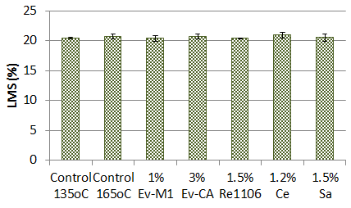
Figure 7. 6 Effect of WMA additive or short period heating on GPC results

GPC Results of Coarse-Medium RAP mixtures

Figure 7.7 shows the GPC results of binders extracted from coarse virgin aggregates and medium RAP aggregates. Control samples were prepared for both foaming and non-foaming mixtures since they were produced with different mixers at different labs. Only one representative of the same type of additive was reported for general analysis, since the difference within the same additives was very limited. As expected, LMS (%) values of binders extracted from coarse virgin aggregates were lower than those from medium RAP aggregates, indicating lower RAP binder concentration on virgin aggregates.

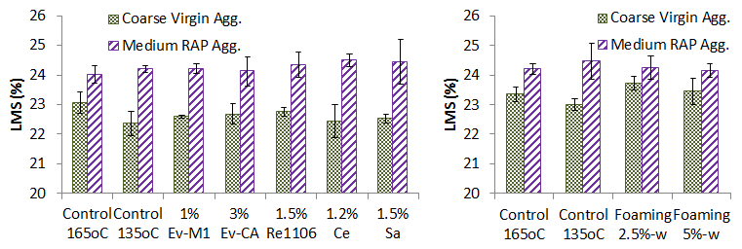
(a) GPC results of non-foaming mix (b) GPC results of foaming mix
Figure 7. 7 GPC results of coarse-medium RAP mix

According to previous research, a parameter called “blending ratio” was used to quantify the blending degree, defined as the LMS (%) ratio of the two binders (Bowers et al. 2014b; Zhao et al. 2014a) [Eq. (7.1)].

$$Blending Ratio= \frac{Coarse LMS (\%)}{Fine LMS (\%)} (7.1)$$

The blending ratio proved to be able to quantify the blending level, however, could be controversial. Imaging there is no blending, the binder coating the virgin aggregate should be totally from virgin binder. Then the blending ratio can be calculated as the ratio of LMS (%) of virgin binder over LMS (%) of blend of virgin and RAP binders coating the RAP aggregates. Therefore, the blending ratio is calculated as a non-zero number under no-blending case. If the similar idea is still used, a more reasonable calculation method should take out the LMS (%) of virgin on both sides, which is expressed as Eq. (7.2).

$$Blending Ratio= \frac{Coarse LMS (\%)-{LMS (\%)}_{virgin binder}}{Fine LMS \left(\%\right)-{LMS (\%)}_{virgin binder}} (7.2)$$

In this study, the LMS (%) for virgin binder was obtained as 20.337,thus Eq. (7.2) in this study can be written as Eq. (7.3).

$$Blending Ratio= \frac{Coarse LMS (\%)-20.337}{Fine LMS \left(\%\right)-20.337} (7.3)$$

Using Eq. (7.3), the blending ratio for the mixes reported in Figure 7.7 can be calculated and presented in Figure 7.8. Generally, the blending ratio of non-foaming WMA is slightly higher than control mix produced at 135ºC, but lower than the 165ºC mix. The foaming mix exhibited higher blending ratio than both control mixes. However, the difference is not appreciable, especially among WMA mixes.

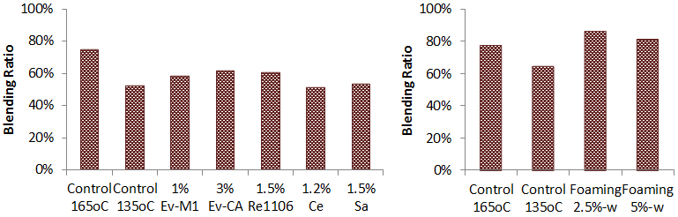
(a) GPC results of non-foaming mix (b) GPC results of foaming mix
Figure 7. 8 Blending ratio of coarse-medium RAP mix

GPC Results of Medium-Fine RAP mixtures

Figure 7.9 and Figure 7.10 present the GPC results of non-foaming and foaming WMA mix with medium-fine design. Using Eq. (7.3), blending ratio was calculated and presented in Figure 7.11 and Figure 7.12.

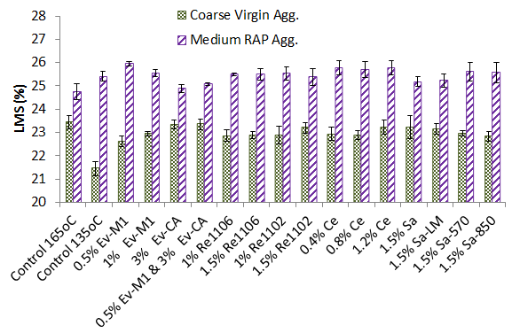
Figure 7. 9 GPC results of non-foaming medium-fine RAP mix

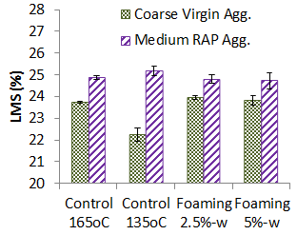
Figure 7. 10 GPC results of foaming medium-fine RAP mix

Figure 7.11 presents the blending ratio of non-foaming medium-fine RAP mix. The effect of the products within the same type of additive was observable, so the figure was processed with the additives of the same type in the same group. Generally, the WMA mixes yield blending ratios obviously higher than control mix produced at 135ºC, but still lower than control mix made at 165ºC. This finding is consistent with that obtained from the coarse-medium mixes.

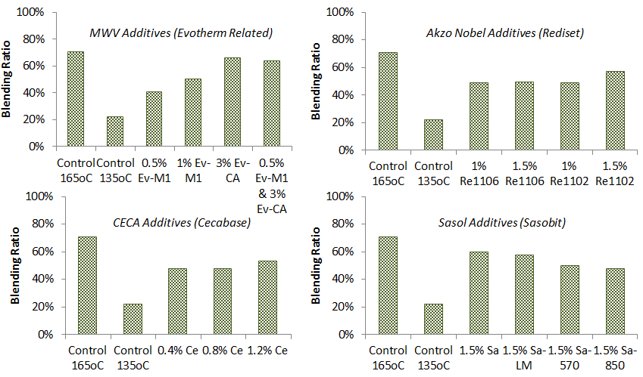
Figure 7. 11 Blending ratio of non-foaming medium-fine RAP mix

For MWV additives, adding 3% EvoFLEX CA with or without Evotherm yielded a blending ratio close to the 165ºC control mix. Blending ratio increased when adding higher dosage of Evotherm. Rediset 1102C mix exhibited a higher blending ratio than another product 1106 at a dosage of 1.5%. Cecabase with higher dosage rate also improved blending. Among the four sasobit additives, sasobit yielded the highest blending ratio. It seems the results from different type of additive agreed on a trend that increasing the WMA additive increased the blending ratio. Among various products from the same company, no appreciable difference can be found. All these findings mentioned above indicate that blending remains a critical question over non-foaming WMA.

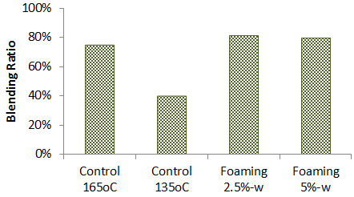
Figure 7. 12 Blending ratio of foaming medium-fine RAP mix

Unlike the non-foaming additives, the foaming technology was found to increase the blending ratio of the RAP mix (Figure 7.12). The water content seems have very little effect. This indicates that foaming WMA may improve the blending between the virgin and old binder in RAP mix.

GPC Results of Medium-Fine RAS mixtures

Figure 7.13 presents the GPC results of the binders extracted from medium-fine RAS mix. The blending ratio can be seen in Figure 7.14.

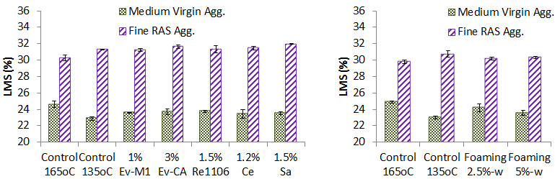
(a) GPC results of non-foaming mix (b) GPC results of foaming mix
Figure 7. 13 GPC results of medium-fine RAS mix

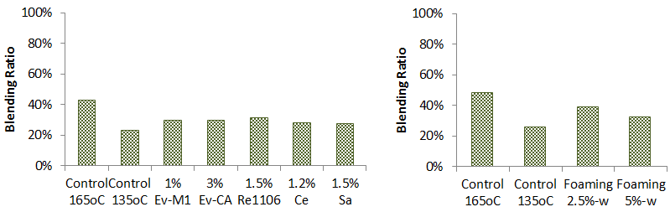
(a) GPC results of non-foaming mix (b) GPC results of foaming mix
Figure 7. 14 Blending ratio of coarse-medium RAP mix

When it comes to RAS, the highest blending ratio was found at 165ºC control mix, with a value merely over 40%. This supports the concern that RAS is very stiff at normal mixing temperatures and difficult to be mobilized. Only one additive of the same type was selected to report herein, since the results were fairly close. The mixtures produced with foaming technology showed lower blending ratios than the control mix, which is contradicting the finding obtained from RAP mix. This may indicate that temperature is more important than coating when RAS is used. 135ºC seems to be too low to handle the RAS materials. The blending in WMA-RAS mixtures should be further evaluated.

Conclusions

In this study, how WMA technologies affect the blending between virgin and old binders in RAP/RAS mixtures were evaluated. WMA technologies included laboratory foaming and different types of additives covering Evotherm, Rediset, Cecabase and Sasobit. Gap-gradation was used to distinguish virgin and recycled particles after mixing. The binders of separated particles were extracted, recovered and submitted to GPC for molecular weight distribution analysis in terms of LMS (%). The blending level was evaluated by a new parameter, blending ration, proposed in this study. Based on the testing results, the following conclusions can be made:
- The WMA additives slightly decreased the viscosity of the asphalt binder. However, control mix produced at 165ºC showed significantly lower viscosity than WMA additives. This indicates that the viscosity of WMA treated binder may not be as workable as regular hot mix asphalt.
- It was revealed in both coarse-medium and medium-fine RAP mixes that WMA additives yielded higher blending ratio than control mix produced at 135ºC, but 165ºC still showed the highest blending ratio value. This indicates that blending remains a concern over the use of WMA additives.
- Foaming technology yielded a higher blending ratio in RAP mix than control mix produced at increased temperature, which means foaming WMA may yield higher blending than regular HMA.
- Control RAS mix produced at 165ºC showed higher blending ratios than all the WMA mixes. This may indicate that temperature rather than coating is more critical in RAS blending research.
- Mix produced with coarse virgin aggregates and medium RAP may not be sensitive enough to test the effect of WMA additives on blending, while mix with medium virgin and fine RAP could be more effective.

CHAPTER VIII

COMPARATIVE EVALUATION OF WARM MIX ASPHALT CONTAINING HIGH PERCENTAGES OF RECLAIMED ASPHALT PAVEMENT

A version of this chapter was originally published by Sheng Zhao, Baoshan Huang, Xiang Shu and Mark Woods:
Zhao, S., Huang, B., Shu, X., & Woods, M. (2013). “Comparative evaluation of warm mix asphalt containing high percentages of reclaimed asphalt pavement.” Construction and Building Materials, 44, 92-100.

Sheng Zhao was the principle researcher and author of “Comparative evaluation of warm mix asphalt containing high percentages of reclaimed asphalt pavement.” Sheng Zhao’s contribution was collecting literature review, conducting experimental design, lab testing and data analysis, and writing the text presented in this paper. Dr. Baoshan Huang, Dr. Xiang Shu and Mr. Mark Woods provided ideas, guidance and comments throughout the whole project and offered revision and editorial assistance for the text.

Abstract

This paper compared rut resistance, fatigue resistance and moisture susceptibility of plant-produced asphalt mixtures paved in different structural layers, in which the combined effects of warm-mix asphalt (WMA) technologies and high percentages of reclaimed asphalt pavement (RAP) were evaluated through multiple laboratory performance tests. WMA technologies included foaming process and the addition of surfactant based Evotherm additive into asphalt binder. A total of fifteen WMA and control HMA mixtures were evaluated with RAP content ranging from 0 up to 40%. Laboratory performance tests included asphalt pavement analyzer (APA) rutting, Hamburg wheel-tracking, flow number, tensile strength ratio (TSR), resilient modulus (M_{R}) ratio, dissipated creep strain energy (DCSE_{f}) method from Superpave indirect tension (IDT) tests,50% stiffness reduction method and plateau value method from beam fatigue tests. The results showed that WMA-high RAP mixtures generally exhibited less rutting and moisture resistance than HMA-high RAP mixtures but better than WMA-low RAP. On the contrary, WMA-high RAP mixtures expressed better fatigue resistance than HMA-high RAP or HMA-low RAP regardless of WMA technology and pavement layer. In summary, rutting might still be a concern for WMA-high RAP mixtures while fatigue concern may not exist, and WMA-high RAP mixtures showed satisfactory moisture resistance with only one exception of foamed base WMA mixture.

Introduction

Warm mix asphalt (WMA) is an emerging technology employed by asphalt industry to deal with concerns about global warming and energy consumption. The production of WMA allows mixing and compacting temperatures 10°C to 38°C lower than traditional hot mix asphalt (HMA) which are mixed at between 150ºC and 155 ºC and compacted at between 145ºC and 150ºC (NAPA 2010). The reduction in temperature leads to less fuel needed during heating which will in turn lower energy costs in production. The decrease in fuel consumption will also lower fumes and greenhouse gas emissions produced by the asphalt industry, making it more environmental friendly (Shu et al. 2012). WMA may be produced by adding additives while mixing or by introducing water to produce foamed warm mix asphalt resulting in good workability at lower temperatures. The lower temperatures, however, could lead to a less oxidative hardening of the binder, which may contribute to loss of stability in hot weather and lead to increased rutting (Newcomb 2007). Studies conducted to address the rutting concern with WMA technologies indicate that WMA mixes exhibit a lower or similar rutting performance to HMA mixes (Hurley and Prowell 2005) Besides rutting, another issue raised with the use of WMA technologies is the potential moisture damage. For WMA technologies like foaming process, due to the potentially incomplete drying of the aggregate, trapping water in the coated aggregate gives it the capability to produce moisture damage, which may cause premature rutting and stripping of pavements. Researchers that have conducted studies on WMA moisture susceptibility showed that WMA additives tested at any dose increased the moisture susceptibility of the mixtures, some foamed WMA mixtures need a completely dry aggregate or additional treatments to satisfy the demand of performance associated with moisture damage and lowering the mixing and compaction temperatures resulted in increased moisture susceptibility of different WMA foam mixes. According to these studies, the moisture concern remained in WMA technologies, especially foamed asphalt.
Recycled asphalt pavement (RAP) is another increasingly popular alternative used by asphalt industry that is energy-saving and environmental-friendly. However, the use of high RAP contents can raise concerns with fatigue and cracking of asphalt mixtures in service due to the presence of aged binder which might cause a stiffening effect and lead to problems with compactability. With the lack of documented information on RAP use for special mixes and long-term performance of high RAP mixes that is commonly defined as containing 25% or more RAP, the maximum amount of RAP allowed in HMA is generally under 30% for surface courses and may increase for binder and base courses. Although the practical use of high RAP is limited, plenty of studies have been conducted by researchers and practitioners to seek ways to incorporate as high amount of RAP as possible for its environmental and economic benefits. Shu and Huang evaluated the fatigue characteristics of HMA mixtures containing up to 30% RAP using different testing methods, and indicated that inclusion of RAP may result in shorter fatigue life based on both Superpave IDT and beam fatigue tests. Mogawer et al. evaluated plant-produced HMA containing up to 40% RAP and found that the cracking resistance was reduced as the percentage of RAP increased. However, other studies found that properly designed high-RAP content mixes can be as resistant to fatigue as virgin mixes based on Long-Term Pavement Performance (LTPP) and higher percentages of RAP did not negatively affect the fatigue properties of a mix. The results of these studies indicate that it remains to be seen if HMA with high RAP content would cause more severe fatigue cracking problems than virgin HMA.
With years’ experience in WMA and high RAP application, it is natural for pavement practitioners to blend the two green technologies together to create a new construction practice seeking the use of both of their environmental and economic values, although there still exist the concerns with WMA and high RAP mixes respectively. WMA-high RAP mixture may be beneficial in two ways: the viscosity reduction will aid in compaction, and the decreased aging of the binder as a result of the lower production temperatures may help compensate for the aged RAP binder, similar to using a softer binder grade. Plenty of studies on the feasibility of application of WMA-high RAP have indicated WMA technologies could be used with 75% RAP, 90 to 100% RAP and 100% RAP with improved workability. Performance evaluation, however, needs to be conducted to investigate its capability to resist pavement distresses during its service life, while the WMA-high RAP mixture has been proved applicable to asphalt industry. Shu et al. evaluated moisture susceptibility of a common foamed base WMA containing RAP ranging from 0% to 50%, and found with the incorporation of RAP, foamed WMA is expected to perform as well as HMA in terms of moisture susceptibility. Zhao et al. (2013) investigated the rutting, moisture resistance and fatigue performance of WMA mixtures produced by foaming technology through multiple performance tests and indicated that WMA with high percentage of RAP exhibited higher rut resistance, better moisture damage resistance, and better fatigue performance.Willis et al. conducted a laboratory research on several plant-produced high RAP-WMA surface mixtures with different WMA technologies and suggested thatcombining WMA technology with mixtures containing RAP was a win-win.Although previous studies, as shown above, have evaluated the performance of WMA-high RAP mixes in different respects, there is a need to conduct a comprehensive study to evaluate the performance of WMA-high RAP mixtures covering different WMA technologies, plant-produced asphalt mixtures paved in different structural layers with different percentages of fractionated RAP from the same source. Rutting resistance and moisture susceptibility should be covered with the use of WMA, while cracking and fatigue should be evaluated for the presence of high RAP content.

Objectives and Scope

The objective of the study was to evaluate the performance of plant-produced WMA containing high percentages of RAP paved in different pavement layers using variable WMA technologies through laboratory performance tests. Rutting resistance, fatigue performance and moisture susceptibility were considered as the major concerns of interest covered in this study.
Ten WMA and five control HMA mixtures containing up to 40% RAP by weight produced from three asphalt plant in Tennessee were selected covering two WMA technologies, foamed asphalt and adding Evotherm as additive, and two pavement layers, base layer and surface layer(Table 8.1). APA rutting test, Hamburg wheel-track rutting test and flow number test were selected to evaluate the rutting resistance. 50% stiffness reduction method (AASHTO T 321) and plateau value method based on beam fatigue test, as well as DCSE_{f} method were used to evaluate the cracking and fatigue performance of the WMA-high RAP mixtures.Traditional AASHTO T 283 test method in terms of TSR and AASHTO T 324 in terms of stripping inflection point obtained from Hamburg wheel-track test were selected to characterize the moisture susceptibility. MR ratio obtained from Superpave indirect tension (IDT) tests proved to have the potential to characterize moisture susceptibility, and would also be used in this study.

Table 8. 1 Asphalt Mixtures evaluated in the study
WMA  Technology | Pavement  Layer | Mix | RAP Content  (%)
Foaming  Technology | Base | WMA | 0
Foaming  Technology | Base | WMA | 30
Foaming  Technology | Base | WMA | 35
Foaming  Technology | Base | HMA | 0
Foaming  Technology | Surface | WMA | 15
Foaming  Technology | Surface | WMA | 20
Foaming  Technology | Surface | WMA | 30
Foaming  Technology | Surface | WMA | 40
Foaming  Technology | Surface | HMA | 15
Foaming  Technology | Surface | HMA | 30
Evotherm | Surface | WMA | 15
Evotherm | Surface | WMA | 30
Evotherm | Surface | WMA | 40
Evotherm | Surface | HMA | 15
Evotherm | Surface | HMA | 30

Materials and Sample Preparation

Materials and Mix Design

Fifteen plant-produced mixtures were selected in this study including one base mixture (called “307-A” mixture in the state of Tennessee) and two surface mixtures (called “411-D” mixture in Tennessee). One commonly used asphalt binder in Tennessee specified with PG 64-22 was selected for all the three mixtures based on the local weather condition and the anticipated traffic level. The virgin aggregate in the base mixture consisted of No. 5 stone and No. 10 screenings while limestone rock (called “D rock” in Tennessee), No. 10 screenings and natural sand were used in the two surface mixtures. All the three types of mixtures include a combination of two fractionated RAP to keep the mixture gradations close to each other with the addition of RAP. Aggregate properties of all mixtures meet the specification of Tennessee Department of Transportation (TDOT).
The Marshall mix-design procedure was employed to design mixture since it is the standard mix-design method adopted by TDOT. The optimum asphalt contents that were expressed by percentages the weight of the mix, were 4.2% for base HMA and 5.3% for both the two surface HMA.Similar gradations were set to design warm mix and mixtures containing RAP. Two amine based liquid Anti-strip additives were added respectively to the base mixtures and surface mixtures with a dosage of 0.5% and 0.3% by weight of asphalt binder, which is determined based on TDOT construction experience.

Sample Preparation

Both WMA and control HMA mixtures were sampled during production at the plant. Cylindrical WMA performance testing samples were fabricated on site using Superpave gyratory compactor (SGC) in University of Tennessee (UT) mobile laboratory to avoid reheating and further loss of moisture. Control HMA mixtures were sampled on site and shipped to the asphalt laboratory in UT where cylindrical samples were compacted with SGC. Though reheating should not affect HMA properties, control HMA mixtures in this study were allowed to be re-heated only once to reduce the potential effect of overheating. The samples of both WMA and HMA for beam fatigue testing were fabricated in the laboratory with a vibratory compactor since it proved too cumbersome to compact beam samples for the mobile lab. Table 8.2 presents the mixture production and compaction quality control data. The mixing and compaction temperatures were determined based on the grade of the virgin binder and kept consistent for the same type of HMA or WMA containing different percentages of RAP. A total of 15 mixtures and total of 330 samples were compacted and tested in this study.

Table 8. 2 Mixture production and compaction quality control data
Mix |  | Mixing  Temp, °C | Compaction  Temp, °C | NMAS, mm | AC%
Foamed  Base | WMA | 120 | 115 | 19 | 4.2
Foamed  Base | HMA | 150 | 145 | 19 | 4.2
Foamed  Surface | WMA | 120 | 115 | 12.5 | 5.3
Foamed  Surface | HMA | 150 | 145 | 12.5 | 5.3
Evotherm  Surface | WMA | 130 | 125 | 12.5 | 5.3
Evotherm  Surface | HMA | 155 | 150 | 12.5 | 5.3

Rutting Performance

Rutting was raised as a big concern with the introduction of WMA technology due to the reduction of stiffness and potential loss of stability in WMA mixtures. The APA, Hamburg wheel-track and flow number tests were selected to evaluate rutting susceptibility of WMA-high RAP mixtures in this study。

APA Rutting Test

The APA rutting test was conducted on all the mixtures in accordance withthe AASHTO TP 63 procedures. The samples used for this testing were produced 150 mm in diameter and 75 mm in thickness with the target air void of 7 ± 0.5 percent. During the test, samples were loaded under a pneumatic hose by a 445 N steel wheel and tested at 64°C. Rut depths at 8,000 cycles were recorded for comparison in this study.
Figure 8.1 presents the rut depths after 8000 cycles from APA rutting test. As expected, all the five WMA mixtures experienced higher rut depths than those of the corresponding HMA mixtures containing the same percentages of RAP. This observation might indicate that WMA mixtures would generally show lower resistance to rutting regardless of WMA technology, RAP content and structural layer.
It can also been seen from Figure 8.1 that the rut depths of WMA showed a slight tendency to be smaller with the addition of RAP. Although the foamed surface WMA containing 15% RAP might be viewed as an exception, it can be found that the rut depths dropped from WMA containing 20%. The rut depths, however, were not reduced significantly even if the RAP content reached as high as 40%, and showed a slight reversion when more than 30% RAP was introduced (in foamed base and Evotherm surface mixtures), which indicates that effect of addition of RAP on WMA might be limited. Meanwhile, control HMA mixtures showed largely reduced rut depths, especially the HMA in Evotherm surface project.

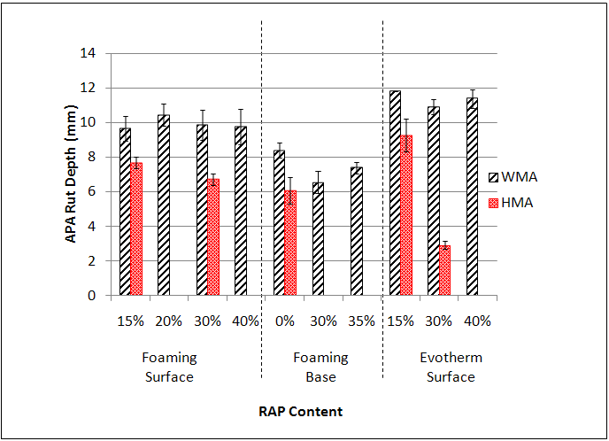
Figure 8. 1 Results from APA rutting test

Hamburg Wheel-track Test

The Hamburg Wheel-track test is described in AASHTO T 324 for evaluating stripping susceptibility of the asphalt mixtures. It can also be used to evaluate rutting susceptibility since the rut depths are captured during the test. The sample used for Hamburg Wheel-track test was prepared with the same size and air void level as the ones for APA test, but loaded under a 703 Nsteel wheel load for 10,000 cycles (20,000 passes) after submerged in the water bath controlled at 50 ±0.5 ºC for a minimum of 30 min.
As can be seen in Figure 8.2, the results from the Hamburg Wheel-track test were organized as the evolution of the rut depth rather than a chart of rut depths at 20,000th wheel pass since several WMA mixtures reached default failure rut depths prior to 20,000 passes. The rut depths of both the two surface HMA containing the same RAP content, as shown in Figure 8.2, were significantly reduced compared to the corresponding WMA, which is consistent with the results from APA test and even more apparent. The reduction in rut depth of foamed base HMA was very slight, which indicates WMA might perform as well as HMA in rutting when paved in base layer. This will not be further discussed since rutting is not a significant concern when it comes to base mixtures.
Figure 8.2 also presents the effect of increasing the addition of RAP in each project. Both WMA and control HMA from all the three projects were inclined to express lower rut depths with the increase of RAP. It is interesting to find that WMA mixtures from different project showed different development in rut depths when introduced more than 30% RAP, which are slightly higher (Evotherm surface), equal (foamed base) and slightly lower than those of WMA containing 30% RAP. Additional work should be conducted to determine the effect of addition of more than 30% RAP on WMA mixtures in term of Hamburg wheel-track test.

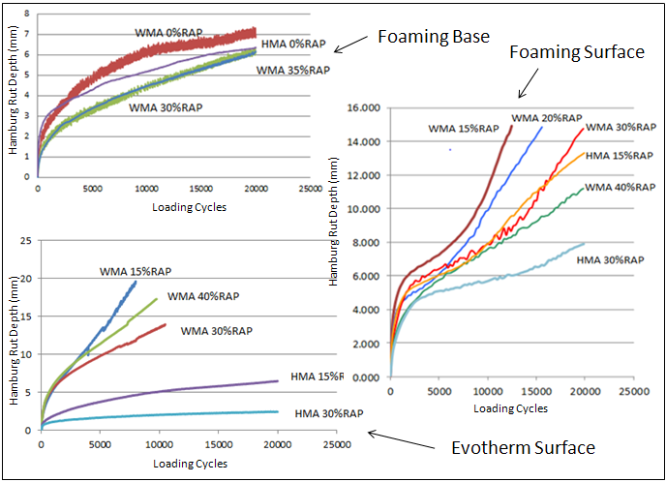Figure 8. 2 Rut Depths from Hamburg Wheel-track Test

Flow Number Test

The flow number test was conducted in accordance with the recommended procedures outlined in NCHRP 9-19. It is used to evaluate the creep characteristics of HMA as related to permanent deformation under repeated-load. Sample for flow number test was prepared to be 100 mm in diameter and 150 mm tall with a target air void of 7 ± 0.5 percent and tested at 54ºC that closely matches the average maximum effective pavement temperature of the state of Tennessee until a deformation of 50,000 micro-strains is reached.
Flow number test was only conducted on foamed surface and foamed base mixtures only. As can be seen from Figure 8.3, WMA showed similar flow number cycles to HMA when the addition of RAP stayed at lower levels (15% for foamed surface and 0% for foamed base) while the flow number cycle of WMA containing 30% RAP was significantly lower than the corresponding HMA. With the increase of RAP content, the flow number of foamed surface WMA slowly and slightly grew larger while the flow number cycles of foamed base mixtures increased significantly with RAP content varying from 0% to 30% and 35%. This observation indicates that the effect of RAP on increasing the rutting resistance of WMA might be greater in base mixtures. The high flow number values of foamed base mixtures containing 30% and 35% RAP might be resulted from the distribution influence of the large aggregate.

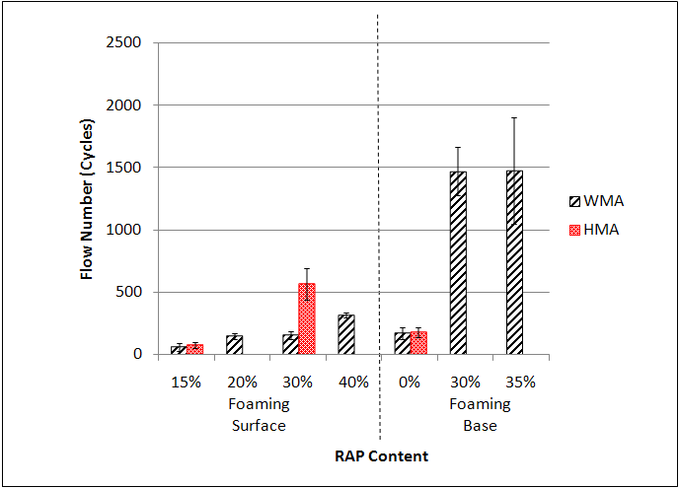
Figure 8. 3 Results from flow number test

Rutting Performance Summary

WMA mixtures might tend to have lower rutting resistance than corresponding HMA mixtures regardless of WMA technology, RAP content and structural layer based on APA rutting test and Hamburg Wheel-track test. However, results from flow number test showed similar rutting cycles of WMA and HMA containing lower contents of RAP. The results from the two rut depths tests would be more reliable since rutting performance was evaluated directly while rutting evaluation was conducted indirectly in flow number test.
All the three rutting tests discussed above showed gradually increased rutting resistance of both WMA and HMA with the increase of addition of RAP regardless of WMA technology and structural layer. The effect of RAP on HMA might be greater than that of corresponding WMA mixtures.
Based on the two rut depths tests, WMA containing high percentages of RAP (30% or higher) showed even larger rut depths than HMA without RAP or with low percentages of RAP in surface mixtures regardless of WMA technology, even though the RAP increased the rutting resistance. This observation indicates that rutting susceptibility might remain a big concern with the use of WMA high-RAP mixtures.

Cracking and Fatigue Performance

Cracking and Fatigue Performance

DCSE_{f} value obtained from Superpave IDT tests can be used to evaluate the cracking resistance of asphalt mixtures. The higher the value of DCSE_{f}, the higher energy restored in the mixture to resist cracking distress, namely the better fatigue resistance of the asphalt mixture. DCSE_{f} can be determined with the stress-strain response obtained from indirect tensile strength test, as shown in Figure 8.4, where εf is the failure strain, MR is the resilient modulus and St is the indirect tensile strength. The Superpave IDT test was conducted at 25 ºC on samples with the same size as the ones used in TSR test but with a target air void level of 4 ± 0.5 percent.

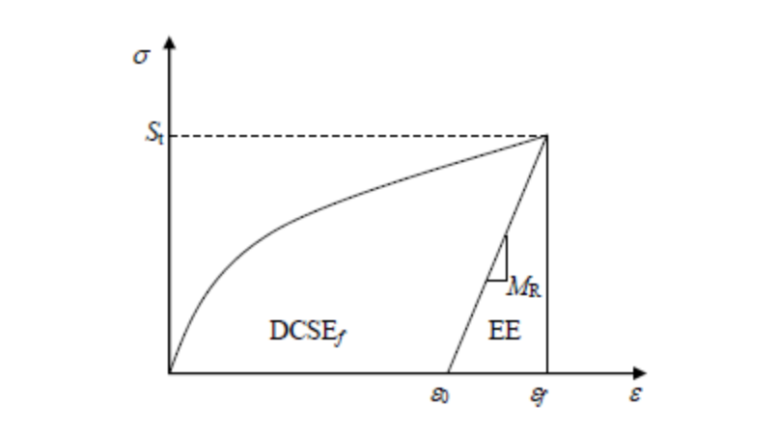
Figure 8. 4 Determination of Creep Strain Energy

Figure 8.5 presents DCSE_{f} values for all the mixtures in this study. As can be seen, both WMA and HMA containing lower percentages of RAP (0% and 15%) had similar DCSE_{f} values while WMA containing high percentages (30%) expressed higher DCSE_{f} values than corresponding HMA did. This observation indicates that WMA might perform as well as HMA in cracking resistance and even better when high percentages of RAP were introduced regardless of WMA technology.

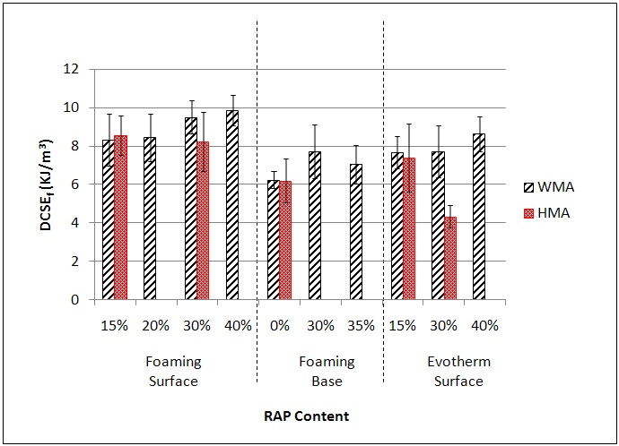
Figure 8. 5 DCSEf from Superpave IDT test

When it comes to RAP effect, the DCSE_{f} values of WMA mixtures showed an upward trend with the increase of RAP content while those of HMA mixes performed contrarily. HMA was expected to perform negatively in cracking resistance when introduced to blend with RAP since the aged binder in RAP would be more likely to be considerably stiff leading to cracking distress. It is interesting to find that WMA high-RAP mixtures performed better in cracking resistance than HMA high-RAP mixtures, even better than HMA without RAP, which implies that the mutual effect of WMA and RAP might play a positive role in the cracking resistance regardless of WMA technology and pavement layer

Beam Fatigue Test

Bending beam fatigue test was conducted in accordance with AASHTO T 321, with a selected test temperature of 7 ºC and a strain level of 300 micro-strains to ensure a minimum of 10,000 load cycles for each specimen. The sample was trimmed to the dimensions of 380± 6 mm in length, 63 ± 2 mm in width, and 50 ± 2 mm in height with an air void of 5 ± 0.5 percent to simulate the average air voids of the pavement after several years in service.
According to AASHTO T 321, the number of cycles corresponding to 50% reduction in initial stiffness (measured at the 50th cycle) is regarded as the fatigue life of asphalt mixture. Figure 8.6 presents the loading cycles representing the fatigue life for each mix. As can be seen, WMA showed apparently higher fatigue loading cycles than their corresponding HMA for foamed base mixtures and Evotherm surface mixtures, which is consistent with the results from DCSE_{f} discussed previously. As for foamed surface mixtures, it is interesting to see that HMA containing 15% RAP performed largely better than its corresponding WMA and both HMA and WMA containing 30% RAP showed similar fatigue resistance. This observation indicates that on one hand, foamed surface WMA with low percentages of RAP might be marked as the ones for which fatigue resistance should be further checked, and on the other hand, foamed surface WMA containing high RAP might perform as well as the corresponding HMA.

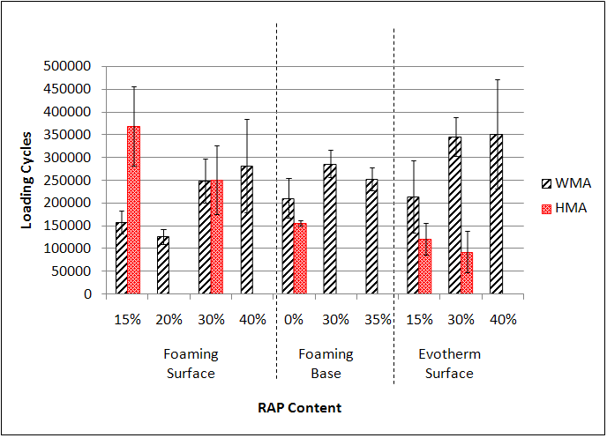
Figure 8. 6 Failure Loading Cycles from Beam Fatigue Test

The effect of the RAP expressed the same trend as it showed in DCSE_{f} results. RAP played a positive role in fatigue resistance when introduced to WMA and a negative role when incorporated into HMA regardless of WMA technology and pavement layer. The positive effect of RAP on WMA mixtures might be compromised when addition of RAP was more than 30%. As can be seen in Figure 8.6, fatigue resistance stayed at the same level (Evotherm surface) and started to drop (foamed base) when RAP percentages were more than 30%.
Another terms used to evaluate the fatigue life based on data from beam fatigue test are the ratio of dissipated energy change (RDEC) and the plateau value (PV). A typical RDEC versus load cycles plot is shown in Figure 8.7 where PV is obtained in zone II representing a period where a constant percent of input energy is turned into damage. The lower PV value, the less percent of input energy turned into damage and the longer fatigue life.

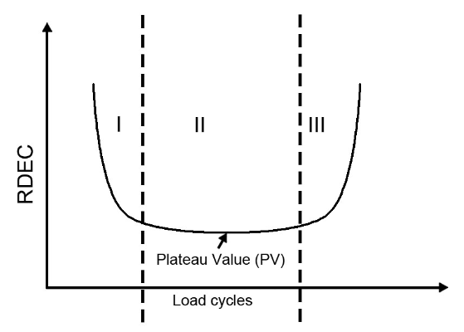
Figure 8. 7 Typical load cycles versus RDEC plot

Figure 8.8 presents the plateau values results obtained from beam fatigue test. The data didn’t show much difference between the plateau values obtained from WMA and corresponding HMA mixtures except for Evotherm surface mixtures containing 30% RAP where WMA showed significantly lower plateau value, namely considerably higher fatigue resistance than HMA did. This suggests Evotherm surface WMA might perform significantly better than HMA did with the addition of high percentages of RAP, which is consistent with the data shown in Figure 8.6.
When it comes to the effect of RAP, the results completely agreed with data in Figure 8.6. With the increase of RAP addition, the fatigue resistance of WMA increased while that of HMA decreased regardless WMA technology and pavement layer. The positive effect of adding RAP into WMA mixtures also showed a slight reversion when more than 30% RAP was added.

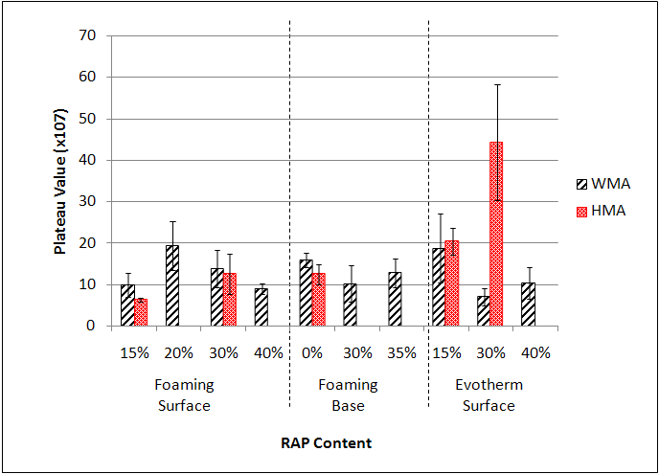
Figure 8. 8 Plateau Values from beam fatigue test

Cracking and Fatigue Resistance Summary

Both DCSE_{f} methods and beam fatigue test indicate that adding RAP may increase the cracking and fatigue resistance of WMA while decrease that of HMA regardless of WMA technology and pavement layer. Based on beam fatigue data analyzed through 50% stiffness reduction loading cycle method and plateau value method, the effect of RAP on WMA would be compromised when more than 30% RAP was added.
WMA mixtures evaluated in this study generally performed similarly or even better than corresponding HMA mixtures with one exception of foamed surface WMA containing 15% RAP. Additional work should be conducted to confirm the observation regarding foamed surface mixtures in fatigue resistance.

WMA containing 30% RAP generally performed similarly or significantly better than corresponding HMA, even better than HMA without RAP, in cracking and fatigue resistance. This phenomenon indicates that cracking and fatigue may not be a big concern with the application of WMA-high RAP.

Moisture Susceptibility

Moisture damage is a primary concern for WMA mixtures. In this study, TSR and MR ratio and Hamburg Wheel-track test were selected to evaluate the moisture susceptibility of WMA-high RAP mixtures.

TSR test

TSR test is conducted in accordance with AASHTO T 283. Specimens, 150 mm in diameter and 50 mm in height with a target air void of 7 ± 0.5 percent, were divided into two groups, unconditioned and freeze-thaw conditioned, to determine the tensile strength ratio. The indirect tensile strength test as related to TSR was conducted at 25 ºC. According to AASHTO M 320, a TSR value of 0.8 or above is recommended for mixtures viewed as resistant to moisture susceptibility.
Figure 8.9 presents the results from TSR test. It can be observed that most of the mixtures evaluated in this study met the minimum TSR threshold of 0.80 with only one exception that was foamed base WMA without RAP failing during the freeze-thaw condition following AASHTO T 283. With the addition of RAP to 30%, the foamed base WMA mixtures from the same source satisfied the TSR threshold suggested by AASHTO. This observation shows that there might remain a big moisture concern with the use of foamed WMA technology in base layer, but adding high percentages of RAP might be an alternative to reduce the moisture susceptibility.

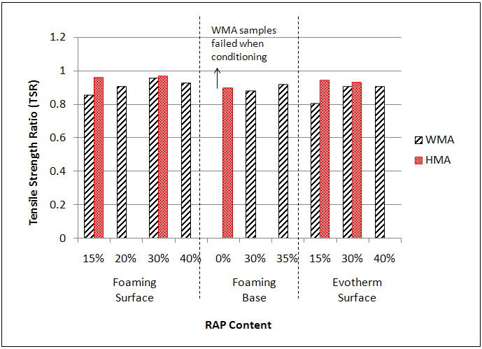
Figure 8. 9 Results from TSR test

It can also be found from Figure 8.9 that control HMA showed obviously higher TSR values than corresponding WMA containing low percentages of RAP (15% RAP for both surface mixtures and 0% for foamed base mixture), although most of them passed AASHTO TSR minimum threshold. On the other hand, when RAP contents increased to 30%, all the WMA mixtures evaluated expressed similar moisture susceptibility to that of corresponding HMA mixtures (TSR value of foamed base WMA grew to 0.88 even though there was no corresponding HMA with it). The TSR values of the WMA mixtures did not vary much when more than 30% RAP was added. This indicates that high percentages of RAP, say 30% or higher, might have the capability to effectively reduce the moisture susceptibility of WMA mixtures regardless of WMA technology and structural layer. The reason why RAP is beneficial in moisture resistance is that the aged asphalt and aggregate particles have a stronger bonding than virgin asphalt-aggregate system, which renders the whole mixture less susceptible to moisture damage.
It is interesting to find that WMA from Evotherm surface mixtures didn’t show better moisture resistance than those of from foamed surface mixtures, which implies that moisture susceptibility of asphalt mixtures might also be raised as a big concern with the use of WMA additives.

Resilient Modulus (MR) Ratio

MR Ratio is obtained with the similar methodology to TSR test but used to determine the ratio between resilient modulus of dry samples and wet samples instead of ratio of ITS of the two sets of samples. The samples and freeze-thaw conditioning procedures used in MR ratio determination were completely the same with those used in TSR test. During the test, the cylindrical samples were applied a repeated peak-load resulting in horizontal deformations within the range of 150-350 micro-strains. A 0.1-s load application followed by a 0.9-s rest period made one load cycle. The deformation and load were continuously recorded based on which the resilient modulus could be calculated as follows,

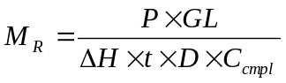 (1)

where, MR is resilient modulus, psi; P = maximum load; GL, Gage length, in; ΔH, horizontal deformation, in; t, thickness of sample, in; D, diameter of sample, in; Ccmpl, non-dimensional creep compliance factor, 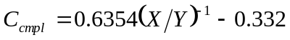 and (X/Y) is the ratio of horizontal to vertical deformation. The unit of MR was converted into MPa after calculation.
Figure 8.10 presents the results from MR ratio test. Unlike the results from TSR test, the data showed no significant difference of resilient modulus between WMA and the corresponding HMA regardless of WMA technology, RAP content and pavement layer (except for the foamed base WMA samples that failed during freeze-thaw condition). This finding indicates that WMA technology might not affect the moisture susceptibility of asphalt mixtures within elastic deformation range.

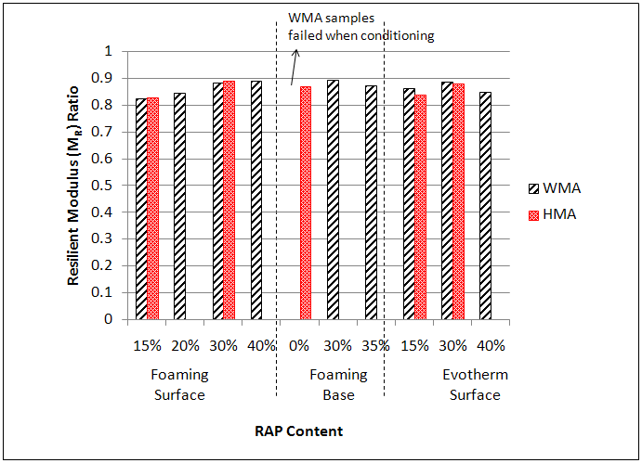
Figure 8. 10 Results from MR ratio test

Hamburg Wheel-track Test

As mentioned above, the Hamburg Wheel-track test can also be used for evaluating stripping susceptibility of the asphalt mixtures. The test was conducted based on procedures recommended by AASHTO T 324.
Fiigure 8.11 presents the stripping inflection points obtained from Hamburg Wheel-track test. Several mixtures that were found without experiencing stripping after 20,000 load passes were given the number 20,000 as the stripping inflection point for comparative purpose. Mixtures with stripping inflection points less than 5000 aretypically consideredsusceptible to stripping. According to Figure 8.11, all the mixtures evaluated in this study met the inflection point criterion, which means WMA technologies covered in this study were capable of making mixtures insusceptible to stripping.
It can be seen that control HMA had comparatively higher inflection points regardless of project, RAP content and pavement layer, which is consistent with the results from TSR test. It appears this phenomenon was significantly apparent in Evotherm Surface mixtures. Since Stripping is caused by the combination of rutting and moisture damage, it might be concluded WMA mixtures produced by adding Evotherm are susceptible to the mutual effect of rutting and moisture damage.
Figure 8.11 also shows an upward trend of inflection points in WMA mixtures with the addition of RAP regardless of WMA technology and pavement layer. This effect was also significant in foamed mixtures but very slight in Evotherm mixtures.

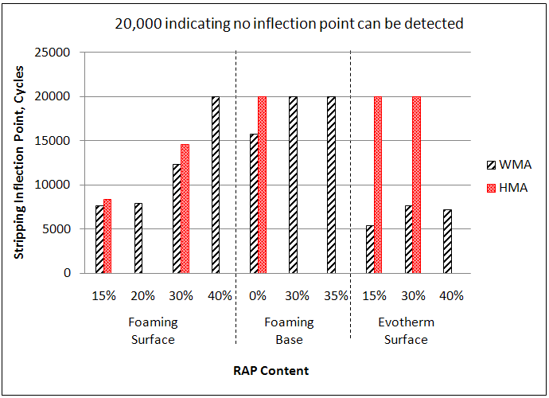Figure 8. 11 Stripping Inflection Points from Hamburg Wheel-track Test

Moisture Susceptibility Summary

Both WMA and control HMA mixtures evaluated in this study passed TSR minimum threshold and inflection point criteria (with exception of foamed base WMA failing during AASHTO T 283 freeze-thaw conditioning), which indicates WMA technologies evaluated in this study could produce WMA mixtures paved in surface layer insusceptible to moisture. Both TSR and MR ratio test suggest there remain a big moisture concern with the use of foamed WMA technology in base layer.
All the three tests agree with the statement that adding high percentages of RAP might be an alternative to reduce the moisture susceptibility of WMA mixtures regardless of WMA technology and pavement layer. The RAP effect was significant in terms of TSR and Hamburg wheel-track test results, but not obvious in MR test results. The TSR and MR test results also shows 30% of RAP might work best in moisture susceptibility reduction, and addition of more than 30% of RAP may cause a negative effect.
Foamed WMA can perform as well as additive based WMA in moisture resistance according to the three test results. The Evotherm based WMA might be more inclined to susceptible to stripping than foamed WMA.

Conclusions and Recommendations

Multiple laboratory performance tests were conducted to evaluate the rutting resistance, moisture susceptibility and fatigue resistance of WMA-high RAP mixtures that were produced with foamed asphalt and adding Evotherm, and paved in both surface and base layers. Based on the test results, conclusions can be summarized as follows:
- WMA showed lower rutting resistance than corresponding HMA mixtures regardless of WMA technology, RAP content and structural layer.
- With the addition of RAP, the rutting resistance of both WMA and HMA increased regardless of WMA technology and structural layer. The effect of RAP on HMA might be greater than that on corresponding WMA mixtures.
- WMA-high RAP surface mixtures showed even lower rutting resistance than HMA-low RAP mixtures regardless of WMA technology, which indicates there may still be concerns in regards to rutting potential of WMA high RAP mixtures.
- Adding RAP may increase the cracking and fatigue resistance of WMA while decrease that of HMA regardless of WMA technology and pavement layer.Meanwhile, the RAP effect might be compromised if more than 30% RAP is introduced.
- WMA-high RAP mixtures generally performed similarly or better in cracking and fatigue resistance than HMA-low RAP mixtures, which indicates that cracking and fatigue may not be a major concern when it comes to WMA-high RAP technology.
- WMA-high RAP surface mixtures proved insusceptible to moisture regardless of WMA technology, while the results of both TSR and MR ratio tests show moisture susceptibility still remained as a big concern in foamed WMA paved in base layer.
- Adding high percentages of RAP might be an alternative to reduce the moisture susceptibility of WMA mixtures regardless of WMA technology and pavement layer. Meanwhile, the RAP content should be no more than 30% based on both TSR and MR tests.
- Foamed WMA can perform as well as additive based WMA in moisture resistance when paved in surface layers. According to Hamburg Wheel-track testing, the Evotherm-based WMA might be more inclined to stripping than foamed WMA.
- The results presented in this paper were only the preliminary findings of a more complete study. Further studies would be needed before WMA-high RAP technology can be widely used

Acknowledgment

The authors would like to thank the Tennessee Department of Transportation (TDOT) for financially supporting this project.The authors would also like to thank Tyler Rutherford, Qiao Dong, Changjun Zhou, Ximiao Jiang and Ben Bowers who helped with the field and laboratory tests.

CHAPTER IX

CONCLUSIONS AND RECOMMENDATIONS

Conclusions

A series of studies were conducted to address the blending issues in warm and hot mix asphalt containing RAP and RAS. The blending was evaluated in terms of analysis on old binder mobilization, binder homogeneity and diffusion. Several new methods were developed to characterize the blending process. Based on the results obtained from the aforementioned studies, the following recommendations can be made:
- A strong correlation existed between the percentage of LMS and G* of asphalt binder based on the comparison of GPC and DSR test results. As mixing time increased, more blending occurred in the RAS mixture. The size of virgin aggregate did not affect the blending efficiency of RAS in pavement mixtures. Aged binder in RAS was blended into virgin binder. The most efficient blending of RAS may occur at approximately 5% RAS content.
- A new parameter, large molecular size percentage [LMS (%)] related to molecular weight distribution derived from gel permeation chromatography (GPC) analysis, was developed to differentiate the RAP/RAS and virgin binders as well as their blends. “Blending Charts” could be generated between the RAP/RAS binder content in the blend with the newly defined LMS (%) and the relations were found to be linear. The RAP/RAS binder mobilization rate defined in this study could be determined by LMS (%) analysis of binders extracted and recovered from the virgin aggregates after mixing in the laboratory, with the use of the “Blending Charts”. The results show that RAP binder mobilization rate decreased with the increase of the RAP percentage in the mixture with mobilization rates close to 100% at low RAP mixtures (10% and 20%), but dropping from 73% to 24% with RAP percentage varying from 30% up to 80%. RAS binder mobilization rate increased with RAS percentage growing from 2.5% to 5%, but decreased with RAS percentage passing 5%. The highest mobilization rate was around 61% and found on 5% RAS mixture while the mobilization rate of mixture containing 10% RAS could be as low as 36%.
- AFM could be used to characterize microstructural properties of the selected virgin, post-manufactured RAS and post-consumer RAS (tear-off) binders, as well as the temperature dependence of microstructures in one type of tear-off RAS binder. The blending of virgin-RAS binder was first observed in this study. According to the observations, AFM proved to be capable of differentiating virgin binder from RAS binder in terms of microstructures. The microstructures of tear-off RAS binder was found to be temperature-dependent, but changed very little within the range from 60ºC to 180ºC. Virgin binders selected in this study could not blend through a RAS binder layer of 300 μm within 30 minutes at 180ºC. On the basis of observations on the interfacial zone, RAS binder was found to be “mixing” but not “blending” in a mixing zone of 25 to 30 μm.
- The feasibility of using staged extraction was validated in this study. It was found TCE was the most effective solvent used in the study for staged extraction that dissolved the asphalt binder without preferential dissolution. Meanwhile, TCE was found to have the highest dissolving rate. The binder coating on the raw RAP and RAS aggregates was proved to be homogeneous and the layer stripping did occur in a well-controlled composite binder system. A well designed step-extraction method with progressive wash times could replace equal-time extraction method, and yielded better analysis. Partial blending was observed within the coating of RAP particles, while the RAS-virgin blending on RAS aggregates should be further evaluated.
- Based on well-designed staged extraction and GPC analysis, it was found that, in RAP mix, binder film coating virgin aggregates was approximately homogeneous, while a non-homogeneous binder was generated on RAP aggregates. The model of binder blend coating the virgin and RAP aggregates with inactive RAP binder still attaching was validated in this study. A potential composite binder system was found coating the virgin aggregates in RAS mix. The diffusion study shows that within the mixture storage time, binder diffusion can be accomplished in both warm and hot mixes containing RAP, indicating old binder mobilization, rather than binder homogeneity, could be more critical in RAP mix. The binder diffusion in RAS mix was captured in a very slow rate. It was suggested that old binder activation and binder homogeneity can both be critical for RAS mix.
- WMA additives slightly decreased the viscosity of the asphalt binder at 135ºC. However, Binder tested at 165ºC showed significantly lower viscosity than WMA binders. This may raise the concern over workability of the WMA mix. WMA additives yielded higher blending ratio than control mix produced at 135ºC, but the temperature of 165ºC still produced the mix with the highest blending ratio value. This indicates that a concern still exists over asphalt blending even if WMA additives are used. Foaming technology yielded a higher blending ratio, indicating foamed WMA may yield a higher blending than regular HMA. It was also found that temperature rather than coating is more critical in RAS blending. Finally, the mix produced with coarse virgin aggregates and medium RAP may not be sensitive enough to test the effect of WMA additives on blending, while the mix with medium virgin aggregates and fine RAP was more effective.
- The performance testing results showed that WMA-high RAP mixtures generally exhibited less rutting and moisture resistance than HMA-high RAP mixtures but better than WMA-low RAP. On the contrary, WMA-high RAP mixtures expressed better fatigue resistance than HMA-high RAP or HMA-low RAP regardless of WMA technology and pavement layer. In summary, rutting might still be a concern for WMA-high RAP mixtures while fatigue concern may not exist, and WMA-high RAP mixtures showed satisfactory moisture resistance with only one exception of foamed base WMA mixture.

Recommendations

On the basis of the conclusions obtained in this study, the following recommendations can be made:
- Better tracking materials, other than the round aggregate could be used for the quantitative evaluation of the old binder mobilization rate. The texture, size and other surface properties of the tracking materials could be considered as influence factors.
- It is recommended to develop new methods to quantify the binder homogeneity through AFM. Statistical methods could be used to track the numerical change of the domains. Layered system with well controlled binder film thickness is recommended to characterize the diffusion coefficient of the virgin binder through the old binder.
- Tools like computed tomography (CT) are recommended to use to characterize the cracking caused by incomplete blending of the binders. Potential less coating caused by binder segregation should also be evaluated.
- Neutron scattering are also recommended for use in blending research. Samples with different blending degrees may express different inner structural properties and might be revealed by neutron scattering detection. Additionally, neutron scattering samples will not go through any destructive damage during preparation and testing processes.

REFERENCES

Al-Qadi, I.L., Elseifi, M. and Carpenter, S.H. (2007). “Reclaimed asphalt pavement–a literature review.” Chicago.
Bonaquist, R. (2007). “Can I Run More RAP?” Hot Mix Asphalt Technology, Vol. 12, No. 5, pp. 11-12.
Bowers, B. F., Huang, B. and Shu, X. (2013). “New Method for Detecting Asphalt Contamination within Fine Aggregate Medium through Chemical Testing.” J. Mater. Civ. Eng., Vol. 25, No. 2, pp. 252–256
Bowers, B.F., Huang, B., Shu, X. and Miller, B.C. (2014a). “Investigation of Reclaimed Asphalt Pavement blending efficiency through GPC and FTIR.” Construction and Building Materials, Vol. 50, pp. 517-523.
Bowers, B.F., Moore, J., Huang, B. and Shu, X. (2014b). “Blending efficiency of Reclaimed Asphalt Pavement: An approach utilizing rheological properties and molecular weight distributions.” Fuel. DOI: 10.1016/j.fuel.2014.05.059.
Button, J.W., Williams, D. and Scherocman J.A. (1995). “Shingles and toner in asphalt pavements.” FHWA Report No. FHWA/TX-96/1344-2F, Texas Transportation Institute, College Station, TX.
Carpenter, S.H. and Wolosick, J.R. (1980). “Modifier influence in the characterization of hot-mix recycled material.” Transportation research record, 777.
Cascione, A.A., Williams, R.C., Buttlar, W.G., Ahmed, S., Hill, B., Haugen, D.S. and Gillen, S. (2011). “Laboratory evaluation of field produced hot mix asphalt containing post-consumer recycled asphalt shingles and fractionated recycled asphalt pavement.” Journal of the Association of Asphalt Paving Technologists, No.80, pp. 377-418.
Churchill, E.V., Amirkhanian, S.N. and Burati, J.L. (1995). “HP-GPC Characterization of Asphalt Aging and Selected Properties.” Journal of Materials in Civil Engineering, Vol. 7, No. 1, pp. 41-49.
Daly, W. H., Negulescu, I. and Balamurugan, S.S. (2013). “Implementation of GPC Characterization of Asphalt Binders at Louisiana Materials Laboratory.” No. FHWA/LA. 13/505.
Federal Highway Administration (FHWA) and Environmental Protection Agency (EPA). (1993). “Report to Congress, A study of the use of recycled paving material.” FHWA-RD-93-147, EPA/600/R-93/095, June 1993.
Gardiner, M., Newcomb, D. and Weikle, B. (1993). “Permanent deformation and low temperature behavior of roofing waste modified HMA.” Proc., Symposium for Recovery and Reuse of Discarded Materials and By-Products for Construction of Highway Facilities, University of Minnesota.
Gevrenov, J. (2008). “Utilization of recycled asphalt shingles in hot-mix asphalt.” Recycling Shingles into Roads, US EPA Perspective. Presentation Made at the Missouri Showcase.
Grzybowski, K.F. (1993). “Recycled asphalt roofing materials – A multifunctional low cost hot-mix asphalt pavement additive.” Use of Waste Materials in Hot-Mix Asphalt, ASTMSTP-1193, Philadelphia, 159-179.
Huang, B., Li, G., Vukosavljevic, D., Shu, X. and Egan, B.K. (2005). “Laboratory investigation of mixing hot-mix asphalt with reclaimed asphalt pavement.” Transportation research record: journal of the transportation research board, Vol. 1929, No. 1, pp. 37-45.
Huang, B., Shu, X. and Vukosavljevic, D. (2011). “Laboratory Investigation of Cracking Resistance of Hot-Mix Asphalt Field Mixtures Containing Screened Reclaimed Asphalt Pavement.” Journal of Materials in Civil Engineering, Vol. 23, No. 11, pp. 1535-1543.
Janisch, D. and Turgeon, C. (1996). “Minnesota’s Experience with Scrap Shingles in Bituminous Pavements.” Rep. No. MN/PR–96/34, Minnesota Department of Transportation, St. Paul, MN.
Jennings, P. W., Pribanic, J. A., Campbell, W., Dawson, K., Shane, S. and Taylor, R. (1980). “High Pressure Liquid Chromatography as A Method of Measuring Asphalt Composition.” FHWA Rep. No. FHWA-MT-79-30, Montana State University and Montana Department of Highways, MT.
Jennings, P.W., and Pribanic, J. A. (1985). “The Expanded Montana Asphalt Quality Study Using High Pressure Liquid Chromatography.” FHWA Rep. No. FHWA-MT-85-001, Montana State University, Montana State Highway Traffic Safety Division and Federal Highway Administration, MT.
Johnson, E., Johnson, G., Dai, S., Linell, D., McGraw, J. and Watson, M. (2010). “Incorporation of recycled asphalt shingles in hot mixed asphalt pavement mixtures.” Minnesota Department of Transportation, St. Paul, MN, 58-28.
Kandhal, P.S., and Mallick R.B. (1997) “Pavement Recycling Guidelines for State and Local Governments – Participant’s Reference Book.” Report No. FHWA-SA-98-042, National Center for Asphalt Technology, Auburn, AL.
Kennedy, T.W., Tam, W.O. and Solaimanian, M. (1998). “Optimizing Use of Reclaimed Asphalt Pavement with the SuperPave System.” Journal of the Association of Asphalt Paving Technologists, Vol. 67, pp. 311-333.
Kim, K.W. and Burati Jr, J.L. (1993). “Use of GPC chromatograms to characterize aged asphalt cements.” Journal of Materials in Civil Engineering, Vol. 5, No. 1, pp. 41-52.
Kim, K. W., Kim, K., Doh, Y. S. and Amirkhanian, S. N. (2006). “Estimation of RAP’s Binder Viscosity Using GPC without Binder Recovery.” Journal of Materials in Civil Engineering, Vol. 18, No. 4, pp. 561-567.
Krivit, D. (2007). “Recycling Tear-off Asphalt Shingles: Best Practices Guide.” Prepared for The Construction Materials Recycling Association (CMRA). October 2007.
Lee, S.J., Amirkhanian, S.N. and Shatanawi, K. (2006). “Effect of Reaction Time on Physical and Chemical Properties of Rubber-Modified Binders.” Clemson University.
Lu, X. and Isacsson, U. (2002). “Effect of aging on bitumen chemistry and rheology.” Construction and Building Materials, Vol. 16, pp. 15-22.
McCann, M., Rovani, J.F. and Thomas, K.P. (2008). “Instrumental Method Suitable for the Detection of Polymers in Asphalt Binders.” Transportation Research Board, Washington, D.C.
McDaniel, R. and Anderson, R.M. (2001). “Recommended use of reclaimed asphalt pavement in the Superpave mix design method: Technician's Manual.” NCHRP Report 452, Transportation Research Board, National Research Council,Washington, D.C.
McDaniel, R.S., Shah, A., Huber, G.A., and Copeland, A. (2012). “Effects of Reclaimed Asphalt Pavement Content and Virgin Binder Grade on Properties of Plant Produced Mixes.” Road Materials and Pavement Design, Vol. 13, pp. 161-182.
McGraw, J., Zofka, A., Krivit, D., Schroer, J., Olson, R. and Marasteanu, M. (2007). “Recycled asphalt shingle inhotmix asphalt”, Journal of Association of Asphalt Paving Technologists, Vol. 76, pp. 235 – 274.
Mogawer W., Bennert T., Daniel J.S., Bonaquist R., Austerman A. and Booshehrian A. (2012). “Performance characteristics of plant produced high RAP mixtures.” Road Material and Pavement Design. Vol. 13, S1, pp. 183-207.
National Asphalt Pavement Association (NAPA). (2010) “Warm Mix asphalt: The wave of the future?” http://www.warmmixasphalt.com, accessed July 15. 2010.
National Asphalt Pavement Association (NAPA). (2013). “Asphalt Pavement Overview.” Website. accessed Feb 11, 2013. http://www.asphaltpavement.org/index.php?option=com_content&view=article&id=14&Itemid=33
Sengoz, B. and Topal, A. (2005). “Use of asphalt roofing shingle waste in HMA.” Construction and Building Materials, Vol. 19, pp. 337-346.
Shirodkar, P., Mehta, Y., Nolan, A., Sonpal, K., Norton, A., Tomlinson, C., Dubois, E., Sullivan, P. and Sauber, R. (2011). “A study to determine the degree of partial blending of reclaimed asphalt pavement (RAP) binder for high RAP hot mix asphalt.” Construction and Building Materials, Vol. 25, No. 1, pp. 150-155.
Shu, X., and Huang, B. (2008a). “Dynamic Modulus Prediction of HMA Mixtures Based on the Viscoelastic Micromechanical Model,” Journal of Materials in Civil Engineering, Vol. 20, No. 8, pp. 530 – 538.
Shu, X., Huang, B. and Vukosavljevic D. (2008b). “Laboratory evaluation of fatigue characteristics of recycled asphalt mixture.” Construction and Building Materials, Vol. 22, pp. 1323-1320.
Shu, X., Huang, B., Shrum, E.D. and Jia, X. (2012). “Laboratory evaluation of moisture susceptibility of foamed warm mix asphalt containing high percentages of RAP.” Construction and Building Materials. Vol. 35, pp. 125–129.
Snyder, R.L. (1969). “Determination of Asphalt Molecular Weight Distributions by Gel Permeation Chromatography.” Analytical Chemistry, Vol. 41, No. 10, August 1969.
Soleymani, H.R., Anderson, M., McDaniel, R. and Abdelrahman, M. (2000). “Investigation of the Black Rock Issue for Recycled Asphalt Mixtures.” Journal of the Association of Asphalt Paving Technologists, Vol. 69, pp. 366-390.
Williams R.C., Cascione A., Haugen D.S., Buttlar W.G., Bentsen R.A. and Behnke J. (2011). “Characterization of Hot Mix Asphalt Containing Post-consumer Recycled Asphalt Shingles and Fractionated Reclaimed Asphalt Pavement.” Report to the Illinois State Toll Highway Authority. January 2011.
Xiao, F., Jordan J. and Amirkhanian S.N. (2009). “Laboratory Investigation of Moisture Damage in Warm-Mix Asphalt Containing Moist Aggregate.” Transportation Research Record: Journal of the Transportation Research Board, No. 2126, pp. 115–124.
Xiao, F., Amirkhanian S.N. and Putman B.J. (2010). “Evaluation of Rutting Resistance in Warm-Mix Asphalt Containing Moist Aggregate.” Transportation Research Record: Journal of the Transportation Research Board, No. 2180, pp. 75–84.
Yapp, M.T., Durrani, A.Z. and Finn, F.N. (1991). “HP-GPC and Asphalt Characterization Literature Review.” Strategic Highway Research Program, National Research Council, Washington, D.C.
Zaumanis, M. and Mallick, R.B. (2014). “Review of very high-content reclaimed asphalt use in plant produced pavements: state of the art.” International Journal of Pavement Engineering, DOI: 10.1080/10298436.2014.893331
Zhao, S., Huang, B., Shu, X., Jia, X. and Woods, M. (2012). “Laboratory performance evaluation of warm-mix asphalt containing high percentages of reclaimed asphalt pavement.” Transportation Research Record: Journal of the Transportation Research Board, Vol. 2294, No.1, pp. 98-105.
Zhao, S., Huang, B., Shu, X. and Woods, M. (2013). “Comparative evaluation of warm mix asphalt containing high percentages of reclaimed asphalt pavement.” Construction and Building Materials, No.44, pp. 92-100.
Zhao, S., Bowers, B., Huang, B., and Shu, X. (2014). ”Characterizing Rheological Properties of Binder and Blending Efficiency of Asphalt Paving Mixtures Containing RAS through GPC.” J. Mater. Civ. Eng., Vol. 26, No. 5, pp. 941–946.
Zhou, F., Button, J.W. and Epps, J. (2012). “Best Practice for Using RAS in HMA.” Report No. FHWA/TX-12/0-6614-1, Published April 2012.
Zhou, F., Li, H., Lee, R., Scullion, T. and Claros, G. (2013). “Recycled Asphalt Shingle Binder Characterization and Blending with Virgin Binders.” Transportation Research Record: Journal of the Transportation Research Board, Vol. 2370, No. 1, pp. 33-43.

VITA

Sheng Zhao was born in 1986 in Baoshan, China. He began his academic studies with a major in civil engineering at Tongji University in Shanghai, China, in 2004, where he attained his Bachelors of Science in Civil Engineering in 2008. He started his studies at the University of Tennessee, Knoxville as a Ph.D. student in January, 2010. He will attain his Doctorate of Philosophy in Civil Engineering with a focus in Geotechnical and Materials Engineering in December 2014. During his time in University of Tennessee, Koxville, he extended his research area into recycled paving materials, sustainable paving technologies and chemical testing techniques.

