Chemistry and Functionality of Plant Waxes:

Applications Toward Postharvest Coatings

A Dissertation Presented for the

Doctor of Philosophy

Degree

The University of Tennessee, Knoxville

Francisco Miguel Angel Leyva Gutierrez

May 2022

Copyright © 2022 by Francisco Miguel Angel Leyva Gutierrez
All rights reserved.

DEDICATION

I dedicate this work to The Plant Kingdom, truly Nature’s master chemists. My life’s accumulated knowledge will be infinitesimally small compared to all Nature can teach.

“I went to the woods because I wished to live deliberately, to front only the essential facts of life, and see if I could not learn what it had to teach, and not, when I came to die, discover that I had not lived.”

“Simplicity, simplicity, simplicity!"

- Henry David Thoreau, “Walden”

“Mehr Licht!”

- Johann Wolfgang von Goethe

“But man, there is no carbon in it!”

- Henry Gilman

ACKNOWLEDGEMENTS

I am thankful to my mother, who taught me the value of work, cleanliness, and organization. I am thankful to my former supervisor, botanist Daniel C. Henklein, for nurturing my love of plants and trees. I am thankful to my undergraduate professor and mentor, Dr. Michael F. Z. Page, for nurturing my love of organic chemistry. I am thankful to Dr. S. Michael Kilbey for introducing me to the world of polymer chemistry and for reminding me to always consider the role of Boltzmann’s constant (in some form or another). I am thankful to Dr. Vermont P. Dia and Dr. Tao Wu for their support, as well as cordial, casual, and helpful discussions. Lastly, I am thankful to my advisor, Dr. Tong Wang, for sculpting me into a disciplined lipid chemist and for providing me with a playground in which to explore my interests and practice my love of chemistry.

ABSTRACT

The cuticle of all higher-plants is covered in lipidic layers of amorphous and crystalline waxes. The chemical composition and structure of cuticular waxes impart numerous functional properties to the surfaces of plants. Moreover, plant waxes are valuable industrial products with myriad applications; the postharvest coating of agricultural commodities for preservation serves as a salient example. There is an unfulfilled need in the agricultural sector for alternative wax materials to reduce reliance on imported waxes of botanical origin. Plant waxes are inherently complex mixtures composed of n-alkanes, as well as aliphatic alcohols, aldehydes, fatty acids, ketones, esters, and derivatives thereof. As such, it is difficult to ascertain the individual and synergistic functions of constituent entities.
The overarching objective of the present work was to elucidate whether the functionality of a bulk wax mixture could be traced to specific constituent entities. The systematic study of the individual and synergistic functions of plant wax constituents is necessary for the design of alternative wax materials for postharvest coatings.
The first chapter presents the purpose for undertaking this work, an overview of the chemistry, structure, and functionality of plant waxes, postharvest coating technologies, knowledge gaps, and objectives. The second chapter details the synthesis, chemical modification, and physical characterization of structural analogues of hydrogenated castor oil. The third chapter details the synthesis and physical characterization of 12 distinct plant wax constituents and a systematic investigation of their individual and synergistic functions. The fourth chapter details the synthesis and physical characterization of aliphatic aldehydes as well as an analysis on the implications for wax crystal growth. The fifth chapter details the chemical characterization of Cannabis sativa processing by-products, the study of which was originally undertaken in order to identify uses for a wax-like by-product of no commercial value. The last chapter presents a summary of key findings and introduces ideas for future work.

TABLE OF CONTENTS

CHAPTER I. Introduction
1.1 Intent and Purpose 1
1.2 Plant Waxes: Chemistry, Structure, and Functionality 2
1.2.1 Structure of the Plant Cuticle 2
1.2.2 Alkanes 4
1.2.3 Aliphatic Alcohols 5
1.2.4 Aliphatic Aldehydes 7
1.2.5 Fatty Acids 8
1.2.6 Aliphatic Ketones 9
1.2.7 Aliphatic (Wax) Esters 10
1.2.8 Other Constituents 11
1.3 Postharvest Coating of Agricultural Commodities 12
1.3.1 Current Practices 12
1.3.2 Current Materials and Efficacy 13
1.4 Knowledge Gaps and Objectives 14
References 15
Appendix 19
CHAPTER II. Synthesis of Functionalized High-Oleic Soybean Oil Wax Coatings and Emulsions for Postharvest Treatment of Fresh Citrus Fruit
2.1 Abstract 24
2.2 Introduction 25
2.3 Materials and Methods 26
2.3.1 Materials 26
2.3.2 Syntheses 27
2.3.3 Wax Emulsion Formulations 31
2.3.4 Moisture Weight Loss of Citrus Fruit 31
2.3.5 Differential Scanning Calorimetry (DSC) 31
2.3.6 Hardness and Cohesiveness of Wax Materials 32
2.3.7 Polarized Light Microscopy (PLM) 32
2.4 Results and Discussion 33
2.4.1 Synthesis of Wax Coating Materials 33
2.4.2 Physical Characterization of Wax Coating Materials 35
2.4.3 Crystal Morphology 37
2.4.4 Citrus Coating Formulation and Performance 38
2.5 Conclusions 39
References 40
Appendix 43
CHAPTER III. Crystallinity and Water Vapor Permeability of n-Alkane, Alcohol, Aldehyde, and Fatty Acid Constituents of Natural Waxes
3.1 Abstract 59
3.2 Introduction 60
3.3 Materials and Methods 62
3.3.1 Materials 62
3.3.2 Syntheses 62
3.3.3 Preparation of Binary Mixtures 66
3.3.4 Differential Scanning Calorimetry (DSC) 66
3.3.5 Powder X-ray Diffraction (XRD) 67
3.3.6 Water Vapor Permeability (WVP) Determination 67
3.4 Results 68
3.4.1 Crystallinity of Pure Compounds 68
3.4.2 Crystallinity of Binary Mixtures 69
3.4.3 Water Vapor Permeability of Pure Compounds 71
3.4.4 Water Vapor Permeability of Binary Mixtures 72
3.5 Discussion 73
3.5.1 Synthesis of Model Compounds 73
3.5.2 Crystallinity of Pure Compounds and Binary Mixtures 74
3.5.3 Water Vapor Permeability of Pure Compounds and Binary Mixtures 76
3.5.4 Crystallinity and Water Vapor Permeability of Other Postharvest Coating Materials 79
3.5.5 Guidance for the Development of Wax-Based Postharvest Coatings 81
3.6 Conclusions 83
References 84
Appendix 89
CHAPTER IV. The Rotator Phases of Aliphatic Aldehydes and Implications for Wax Crystal Growth
4.1 Abstract 124
4.2 Introduction 125
4.3 Materials and Methods 126
4.3.1 Materials 126
4.3.2 Syntheses 127
4.3.3 Differential Scanning Calorimetry (DSC) 130
4.3.4 Powder X-ray Diffraction (XRD) 130
4.4 Results 130
4.4.1 Pure Aldehydes 130
4.4.2 Binary Mixtures 135
4.5 Discussion 135
4.6 Conclusions 137
References 138
Appendix 141
CHAPTER V. Characterization of By-Products from Commercial Cannabidiol Production
5.1 Abstract 166
5.2 Introduction 167
5.3 Materials and Methods 169
5.3.1 Standards and Reagents 169
5.3.2 By-Product Samples 170
5.3.3 Other Samples 170
5.3.4 Sample Preparation 170
5.3.5 Gas Chromatography-Mass Spectrometry (GC-MS) Qualitative Analysis 171
5.3.6 Gas Chromatography-Flame Ionization Detector (GC-FID) Quantitative Analysis 172
5.3.7 Isolation of Volatiles from Dried Unprocessed Inflorescences via High-Vacuum Distillation 172
5.4 Results and Discussion 173
5.4.1 Composition of Ethanol-Wax Suspension (WAX) By-Product 173
5.4.2 Composition of Terpenoid Distillate (DIST) By-Products 174
5.4.3 Composition of Tar-Like (TAR) By-Product 177
5.4.4 Composition of Red Resin (RES) By-Product 178
5.4.5 Identity of CBD Impurities 179
5.5 Conclusions 180
References 181
Appendix 184
CHAPTER VI. Conclusions
6.1 Summary and Key Findings 202
6.2 Future Work 203
6.2.1 Stereoselective Hydroboration-Oxidation of Monounsaturated Triacylglycerols 203
6.2.2 Antifungal Mode of Action of Hydroxy Fatty Acids 205
6.2.3 Structural and Thermodynamic Properties of ω-Hydroxy Wax Esters 207
References 209
Appendix 211
Vita 216

LIST OF TABLES

Table 1.1. Relative distribution of major wax constituents for representative plant species of commercial importance. 21
Table 2.1. Summary of key physical properties for wax materials 45
Table 3.1. Codes, names, and carbon chain lengths of compounds analyzed in this work 89
Table 3.2. Reported and tentative crystal structure assignments, degree of crystallinity and average water vapor permeability (WVP; 23°C, 100-0 RH% gradient) of model C₁₈₋₁₉, C₂₂₋₂₃, and C₂₆₋₂₇ pure compounds and binary mixtures 90
Table 3.3. Putative crystal structures, degree of crystallinity, and reported water vapor permeability (WVP) under specified conditions of natural waxes, resins, and edible films used or promoted for the postharvest coating of fruits 91
Table 3.4. Melting onset temperature (T_{m}) and purity of compounds 1-12. 99
Table 3.5. Reported unit cell volumes (Å³) of pure compounds 1-12. 100
Table 4.1. Liquid-to-rotator (T_{LR}) and rotator-to-solid transition temperatures (T_{RS}), as well as transition enthalpies (ΔH) and entropies (ΔS) on cooling for the C₂₂₋₃₂ aldehydes. 141
Table 5.1. Chemical class composition and relative concentrations of WAX by-product from batches A and B 184
Table 5.2. Chemical class composition and relative concentrations of DIST-A and DIST-B by-products from batches A and B 186
Table 5.3. Chemical class composition and relative concentrations of TAR by-product from batches A and B 188
Table 5.4. Chemical class composition and realtive concentrations of RES by-product from batches A and B 189
Table 5.5. Identity of impurities from five different commercial CBD isolate samples 190
Table 5.6. Key mass spectral data for impurities identified in commercial CBD isolate samples 191
Table 5.7. Experimentally determined and literature linear retention indices (RI) used for identification in non-derivatized samples 196

LIST OF FIGURES

Figure 1.1 Schematic diagram of three major regions of the plant cuticle. 19
Figure 1.2 Schematic diagram of the intracuticular wax region and its subdivisions 20
Figure 1.3 Chemical structure of representative constituents of plant waxes 22
Figure 2.1 Crystal morphology of selected materials cooled at ambient conditions, classified by structural similarity 46
Figure 2.2 Total moisture loss (wt%) of Valencia oranges coated with wax emulsions (0.5 mL per fruit) over a two week storage period at 22-23°C and 65-75% RH 47
Figure 2.3. Appearance of Valencia oranges coated with wax emulsions (0.5 mL per fruit) over a two week storage period at 22-23°C and 65-75% RH 48
Figure 2.4. ¹H NMR spectrum of high-oleic soybean oil (1). 49
Figure 2.5. ¹H NMR spectrum of mixture of mono- and diglycerides of regioisomeric hydroxyoctadecanoic acid (2) 50
Figure 2.6. ¹H NMR spectrum of triglyceride of regio- and stereoisomeric hydroxyoctadecanoic acid (3) . 51
Figure 2.7. ¹H NMR spectrum of mixture of 9-hydroxyoctadecanoic (4a) and 10-hydroxyoctadecanoic acid (4b) 52
Figure 2.8. ¹H NMR spectrum of hydrogenated castor oil (HCO; 5) 53
Figure 2.9. ¹H NMR spectrum of (R)-12-hydroxyoctadecanoic acid (HCOFFA; 6) 54
Figure 2.10. ¹H NMR spectrum of 12-oxooctadecanoic acid (7) 55
Figure 2.11. ¹H NMR spectrum of oxidized hydrogenated castor oil (propane-1,2,3-triyl tris(12-oxooctadecanoate)) (8) 56
Figure 2.12. ¹¹B NMR spectrum of HOSO monoalkylborane signals at δ 27.18 and 17.95 (excess BH₃-THF at δ -1.27) 57
Figure 3.1. XRD patterns for pure a) odd n-alkanes (1b, n-nonadecane; 5b, n-tricosane; 9b, n-heptacosane), b) alcohols (2, octadecan-1-ol; 6, docosan-1-ol; 10, hexacosan-1-ol), c) aldehydes (3, octadecanal; 7, docosanal; 11, hexacosanal), and d) fatty acids (4, octadecanoic acid; 8, docosanoic acid; 12, hexacosanoic acid) 94
Figure 3.2. Crystal structure representation for n-alkanes, alcohols, and fatty acids, projected down the b-axis 95
Figure 3.3. XRD patterns for a) C₁₈₋₁₉, b) C₂₂₋₂₃, and c) C₂₆₋₂₇ bulk binary mixtures (50:50) comprised of n-alkane:alcohol, n-alkane:aldehyde, n-alkane:fatty acid, alcohol:aldehyde, alcohol:fatty acid, aldehyde:fatty acid 96
Figure 3.4. DSC thermograms for a) C₁₈₋₁₉, b) C₂₂₋₂₃, and c) C₂₆₋₂₇ bulk binary mixtures (50:50) comprised of n-alkane:alcohol, n-alkane:aldehyde, n-alkane:fatty acid, alcohol:aldehyde, alcohol:fatty acid, aldehyde:fatty acid 97
Figure 3.5. a) DSC melting curve and b) XRD pattern recorded at 50°C for hexacosanal (11) indicating a solid-solid rotator transition 98
Figure 3.6. Experimental setup for water vapor permeability determination of wax films ………101
Figure 3.7. ¹H NMR spectrum of 11-iodoundecanoic acid (15) 102
Figure 3.8. ¹H NMR spectrum of methyl 11-iodoundecanoate (14) 103
Figure 3.9. ¹H NMR spectrum of methyl hexacosanoate (13) 104
Figure 3.10. ¹³C NMR spectrum of methyl hexacosanoate (13) 105
Figure 3.11. ¹H NMR spectrum of hexacosanoic acid (12) 106
Figure 3.12. ¹³C NMR spectrum of hexacosanoic acid (12) 107
Figure 3.13. ¹H NMR spectrum of hexacosanal (11) 108
Figure 3.14. ¹³C NMR spectrum of hexacosanal (11) 109
Figure 3.15. ¹H NMR spectrum of hexacosan-1-ol (10) 110
Figure 3.16. ¹³C NMR spectrum of hexacosan-1-ol (10) 111
Figure 3.17. ¹H NMR spectrum of n-heptacosane (9b) 112
Figure 3.18. ¹³C NMR spectrum of n-heptacosane (9b) 113
Figure 3.19. ¹H NMR spectrum of docosanal (7) 114
Figure 3.20. ¹³C NMR spectrum of docosanal (7) 115
Figure 3.21. ¹H NMR spectrum of octadecanal (3) 116
Figure 3.22. ¹³C NMR spectrum of octadecanal (3) 117
Figure 3.23. EI mass spectrum of methyl hexacosanoate (13) 118
Figure 3.24. EI mass spectrum of n-heptacosane (9b) 118
Figure 3.25. EI mass spectrum of n-triacontane (side product) 119
Figure 3.26. XRD patterns for pure n-octadecane (1a), n-docosane (3a), n-hexacosane (9a) 120
Figure 3.27. a) DSC cooling curve and b) XRD pattern recorded at 75°C for hexacosan-1-ol (10) indicating the rotator transition 121
Figure 3.28. XRD pattern for pure shellac resin indicating amorphous structure 121
Figure 3.29. XRD pattern for abietane rosin indicating amorphous structure 122
Figure 3.30. XRD pattern for dichloromethane-extracted sorghum wax (Sorghum bicolor) 122
Figure 4.1. a) DSC thermogram (1°C min⁻¹) and XRD patterns recorded at different temperatures for pure docosanal indicating a R_{II} type transition (tentative assignment) 142
Figure 4.2. a) DSC thermogram (1°C min⁻¹) and XRD patterns recorded at different temperatures for pure tetracosanal indicating a R_{II} type transition (tentative assignment) 143
Figure 4.3. a) DSC thermogram (1°C min⁻¹) and XRD patterns recorded at different temperatures for pure hexacosanal indicating a R_{II} type transition (tentative assignment) 144
Figure 4.4. a) DSC thermogram (1°C min⁻¹) and XRD patterns recorded at different temperatures for pure octacosanal indicating a R_{II} type transition (tentative assignment) 145
Figure 4.5. a) DSC thermogram (1°C min⁻¹) and XRD patterns recorded at different temperatures for pure triacontanal indicating a R_{IV} type transition (tentative assignment) 146
Figure 4.6. a) DSC thermogram (1°C min⁻¹) and XRD patterns recorded at different temperatures for pure dotriacontanal indicating a R_{II} type transition (tentative assignment) 147
Figure 4.7. a) a) DSC thermograms (1°C min⁻¹) for binary mixtures (25:75, 50:50, and 75:25) for triacontanal:n-nonacosane. 148
Figure 4.8. Liquid-to-rotator (T_{LR}) transition temperatures for the C₂₂₋₃₂ n-alkanes, alcohols, and aldehydes 149
Figure 4.9. XRD pattern for pure tetracosanal obtained from solvent evaporation indicating T symmetry 151
Figure 4.10. ¹H NMR spectrum of 2-((6-bromohexyl)oxy)tetrahydro-2H-pyran (1) 152
Figure 4.11. ¹³C NMR spectrum of 2-((6-bromohexyl)oxy)tetrahydro-2H-pyran (1) 153
Figure 4.12. ¹H NMR spectrum of 1-((tetrahydro-2H-pyran-2-yl)oxy)dotriacontan-7-ol (2) 154
Figure 4.13. ¹³C NMR spectrum of 1-((tetrahydro-2H-pyran-2-yl)oxy)dotriacontan-7-ol (2) 155
Figure 4.14. ¹H NMR spectrum of 1-((tetrahydro-2H-pyran-2-yl)oxy)dotriacontan-7-yl methanesulfonate (3) 156
Figure 4.15. ¹³C NMR spectrum of 1-((tetrahydro-2H-pyran-2-yl)oxy)dotriacontan-7-yl methanesulfonate (3) 157
Figure 4.16. ¹H NMR spectrum of 2-(dotriacontyloxy)tetrahydro-2H-pyran (4) 158
Figure 4.17. ¹³C NMR spectrum of 2-(dotriacontyloxy)tetrahydro-2H-pyran (4) 159
Figure 4.18. ¹H NMR spectrum of dotriacontan-1-ol (5) 160
Figure 4.19. ¹³C NMR spectrum of dotriacontan-1-ol (5) 161
Figure 4.20. ¹H NMR spectrum of dotriacontanal (6) 162
Figure 4.21. ¹³C NMR spectrum of dotriacontanal (6) 163
Figure 4.22. EI mass spectrum of dotriacontanal (6) 164
Figure 5.1. a) Simplified process flow diagram for commercial cannabidiol (CBD) production discussed in this study 192
Figure 5.2. Excerpt from qualitative chromatogram of terpenoid profile obtained from mild, high-vacuum solvent assisted distillation (top) of unprocessed dried hemp inflorescences (HEMP), and commercial terpenoid distillate by-product (DIST-A, batch B) after having undergone high-temperature distillation (bottom) 193
Figure 5.3. Trends of average concentrations (wt%) of alkane, terpenoid, and cannabinoid compound classes in ethanol-wax suspension (WAX), terpenoid distillate (DIST-A), tar-like residue (TAR) and red resin (RES) by-products for two batches (A and B) from commercial cannabidiol extraction 194
Figure 5.4. a) GC-FID chromatogram excerpt of five CBD isolate samples with identified impurities 195
Figure 5.5. Representative GPC chromatogram of TAR using dimethylformamide with 0.1 M LiBr as the eluent and calibration against a polyethylene oxide standard with RI and UV detectors 197
Figure 5.6. Representative DSC thermogram of TAR 197
Figure 5.7. EI mass spectrum of cannabidavarin-trimethylsilyl derivative (CBDV-TMS) impurity from samples 198
Figure 5.8. EI mass spectrum of cannabichromene-trimethylsilyl derivative (CBC-TMS) impurity from samples 198
Figure 5.9. EI mass spectrum of Δ⁸-tetrahydrocannabinol-trimethylsilyl derivative (Δ⁸-THC-TMS) impurity from samples 199
Figure 5.10. EI mass spectrum of Δ⁹-tetrahydrocannabinol-trimethylsilyl derivative (Δ⁹-THC-TMS) impurity from samples 199
Figure 5.11. EI mass spectrum of cannabigerol-trimethylsilyl derivative (CBG-TMS) impurity from samples 200
Figure 5.12. EI mass spectrum of cannabinol-trimethylsilyl derivative (CBN-TMS) impurity from samples 200
Figure 5.13. EI mass spectrum of unknown impurity 1 (after TMS derivatization) eluting before CBC-TMS. 201
Figure 5.14. EI mass spectrum of unknown impurity 2 (after TMS derivatization) eluting in between CBG-TMS and CBN-TMS 201
Figure 6.1. Schematic representation of borane addition to a monounsaturated triacylglycerol scaffold. 211
Figure 6.2. Proposed mode of action for hydroxy fatty acids. 212
Figure 6.3. Representation of the proposed crystal structure of ω-hydroxy wax esters projected down the b-axis. 214

LIST OF SCHEMES

Scheme 2.1. Summary of triacylglyerol modifications... 43
Scheme 2.2. Epoxide ring-opening of oleic acid (9) to afford vicinal diol (10) and mixture of hydroxyl and lactic acid dual functionalized isomers (12a, 12b)..... 44
Scheme 3.1. Preparation of methyl hexacosanoate (13) and n-heptacosane (9b) from the copper(I)-catalyzed alkylation of iodides with Grignard reagents... 92
Scheme 3.2. Preparation of hexacosanoic acid (12), hexacosanal (11), and hexacosan-1-ol (10) from methyl hexacosanoate (13). 93
Scheme 4.1. Preparation of aliphatic aldehydes 150
Scheme 6.1. Preparation of enantiomerically pure 6-hydroxy fatty acids 213
Scheme 6.2. Preparation of type A wax esters from 12-hydroxydodecanoic acid 215

CHAPTER I
Introduction

Intent and Purpose
The original intent of the present work was to expand upon the repertoire of synthetic transformations of plant oils in an effort to develop alternative wax-like materials for the postharvest coating of agricultural commodities. Scientific research, however, does not always follow a straight path. Throughout the course this work, the author identified a disconnect between the fundamental and applied science. For example, any synthetic transformation applicable to olefins, e.g., hydroboration (and subsequent transformations), epoxidation, aziridination, dihydroxylation, aminohydroxylation, ozonolysis, and polymerization, can be extended to plant oils. How then do we go about choosing a synthetic transformation to attain an appropriate set of target physical properties?
Faced with this question, the author turned to Nature for inspiration since plant waxes have served as functional materials since time immemorial. The work thus matured into an in-depth investigation of the chemistry and functionality of plant waxes with the aim of elucidating Nature’s closely guarded secrets. On the one hand, it is lamentable that the complexity of plant waxes has been largely overlooked by the scientific community. On the other hand, the study of plant waxes presents chemists, biochemists, crystallographers, material, plant, and food scientists with a multitude of formidable tasks and unanswered questions.
The purpose of this work was to advance our knowledge of the chemistry and functionality of plant waxes, with the goal of providing a fundamental basis for the design of postharvest coatings. The proceeding sections introduce the plant cuticle as model for our study and provide a survey of the chemistry, structure, and known functions of constituent entities. Following a brief discussion of current postharvest coating technologies, the knowledge gaps and objectives of the present work are laid out.
Food science is an inherently interdisciplinary field of study; in the true spirit of this discipline, the present work would not have been possible without the study of organic chemistry, polymer chemistry, crystallography, as well as the material and plant sciences. The author firmly believes that no discipline exists in a vacuum, and that science, much like plants, can benefit immensely from cross-pollination.

Plant Waxes: Chemistry, Structure and Functionality
    - Structure of the Plant Cuticle
The plant cuticle is a complex extracellular membrane composed of lipidic layers (i.e., waxes) whose primary function is to control the transport of substances across the plant-atmosphere interface.¹ This composite structure is indispensable for the life of all higher plants. Chiefly, the cuticle controls the rate of moisture loss (i.e., transpiration) under abiotic stress and when stomata are closed. In addition, the cuticle controls the transport of electrolytes, fertilizers, adjuvants, pesticides, as well as pollutants.¹
The cuticle can be roughly divided into three distinct regions - an amorphous biopolymer matrix region, a mixed amorphous and crystalline intracuticular region, and a crystalline epicuticular region (Figure 1.1).¹ Cutin, cutan, suberin, and lignin are representative biopolymers and take the form of crosslinked polyester, polyolefin, and polyaromatic structures.^{2, 3} Cutin (section 1.2.8) is most commonly encountered in the cuticle; however, and serves a matrix for the intracuticular waxes. The structure of intracuticular region is the most complex and will be developed in the proceeding section. Notably, mechanistic and kinetic studies have established that the intracuticular region is the transport-limiting barrier of the cuticle. In fact, intracuticular waxes account for approximately 90-99.9% of the total cuticular resistance to mass transfer.¹ The epicuticular region exists at the outermost interface of the cuticle and directly interacts with other organisms and the atmosphere. Epicuticular waxes are generally crystalline and exhibit diverse crystal morphologies.⁴ These exotic crystalline structures impart the surface of the plant with myriad functional properties extensively reviewed elsewhere.^{5, 6}
The structure and subdivisions of the intracuticular region are depicted in Figure 1.2. This model represents the culmination of extensive research throughout 1969-1993 by a select few set of workers and is an extension of the well-known Le Roux wax model.^{1, 7-9} The crystalline region, or Zone A, represents the assembly of polydisperse aliphatic chains that crystallize into an orthorhombic (O) lattice resembling that of the average chain length in the mixture.^{1, 10-13} These crystallites adopt a flake or platelet-like crystal habit and grow laterally, parallel to the outer surface. Crystalline lamellae may exist and have been observed by X-ray and electron diffraction studies.^{9, 11, 12} An increase in temperature gradually shifts the symmetry from O to hexagonal (H) – this phenomenon, which will be discussed in proceeding sections, represents an important theme of the present work. Since crystals are regarded as impermeable, Zone A is thus the most important subdivision with respect to the transport-limiting barrier of the cuticle.
The solid-amorphous region, or Zone B, represents the volume fraction of dangling chain-ends of crystallites in Zone A.¹ Functional groups such as hydroxyls, carbonyls, as well as methyl branches may be segregated in Zone B.^{1, 11-13} Solid-state nuclear magnetic resonance, Raman, and infrared spectroscopies have suggested that these dangling chain-ends possess a high degree of freedom¹⁴⁻¹⁷ relative to the crystallites of Zone A and experience entanglement by virtue of frequent trans-gauche transitions – this latter feature being commonly observed in semi-crystalline polymers. Note that Zones A and B are not discrete, rather they coexist and interpenetrate one another.
The mobile-amorphous region, or Zone D, represents the collection of compounds excluded from the crystallites of Zone A as a result of high mobilities (e.g., low-melting point aliphatics) or steric implications (e.g., trioxanes, estolides, terpenoids). Zone D may be solid-amorphous or liquid-amorphous at low or high temperatures, respectively.¹ Zone D may occupy the volume fraction corresponding to the voids of the cutin matrix or Zone B. Alternatively, discrete clusters of liquid-amorphous regions may exist in Zone D under certain conditions, chiefly high temperatures, concentration of excluded compounds, and volume fraction of Zone B.¹ There exists controversy, however, as to whether high-mobility entities are indeed present in Zone D. Crystallographic reports on Fischer-Tropsch waxes do not support their existence, although spectroscopy often does.⁹ Nevertheless, the plant cuticle is exceedingly complex and so the presence of high-mobility entities has not yet and cannot be ruled out.
The rigid-amorphous region, or Zone C, has been described for some paraffin and Fischer-Tropsch waxes and represents the collection of defects present in crystallites of Zone A. Specifically, these defects arise from internal branching and irregular staggering of aliphatic chains.^{7, 8} This region has not been observed in plant waxes, however.¹
Recalling that crystals are regarded as impermeable, the volume fraction occupied by Zone A is thus considered excluded volume for a diffusing permeant. Therefore, a permeant molecule must traverse the cuticle exclusively through Zones B and D.¹ Further, as a consequence of the platelet-like crystal habit of O crystallites, the tortuosity of a permeant’s migration path (and therefore the rate of diffusion) becomes increasingly difficult with increasing crystallinity.¹ Thus, one might hypothesize that the presence of O crystallites, or the ability to elicit crystallization into said symmetry, might be prove beneficial for controlling the transport of substances across the cuticle. Yet again, this phenomenon represents an important theme of the present work. The systematic investigation of the chemistry and structure of constituents of the afore mentioned regions is thus warranted. The proceeding sections present a survey of the chemistry, structure, and known functions of the most common classes of cuticular waxes.

1.2.2 Alkanes
Odd n-alkanes in the range of C₂₅-C₃₃ chain lengths are ubiquitous constituents of plant waxes (Table 1.1) with n-heptacosane, n-nonacosane, and n-hentriacontane representing the major homologues (Figure 1.3).¹⁸ Even n-alkanes in the range of C₂₂-C₃₂ chain lengths are trace constituents, except in rare examples. Methyl-branched alkanes (iso-, anteiso-) and olefins are trace constituents of plant waxes, typically found on organs such as leaves and petals. The methyl-branched alkanes are derived from valine and isoleucine fragments, thus the (S) enantiomers predominate.^{1, 19} It is noteworthy that various C₁₉-C₂₉ 1-chloroalkanes have been reported as part of the leaf wax for halophytes of the Chenopodiaceae subfamily.²⁰
n-Alkanes are crystalline and crystallize into either triclinic (T), monoclinic (M) or O lattices, with the aliphatic chains adopting an all-trans configuration. Odd n-alkanes from C₁₁-C₄₃ chain lengths crystallize into O lattices (space group Pbcm) with an orthorhombic perpendicular (O⊥) subcell.²¹ Even n-alkanes from C₁₂-C₂₆ chain lengths crystallize into lower symmetry T lattices (space group P-1) with a triclinic parallel (T ||) subcell.²¹ Notably, n-hexacosane can crystallize into either a T or a pseudo-M lattice. For even n-alkanes beyond n-hexacosane, M and O lattices become accessible. For example, two forms of n-hexatriacontane, one M (space group P2₁/a) and one O (space group Pbc2₁) are known.²²
Odd and even n-alkanes from C₉-C₃₆ chain lengths undergo complex phase transitions in the vicinity of their melting point.^{21, 23} On heating, the aliphatic chains attain a high degree of vibrational freedom and longitudinal motion. These features manifest as lattice modifications and lattice expansions into pseudo- and true H (space group R-3m) symmetries.^{23, 24} This phenomenon was first observed by Müeller in 1932, who coined the term “rotator” (R) phase.²¹ The R phases have been the subject of extensive study as these are involved in various crystallization phenomena in Nature.²⁵ Incidentally, studies of the R phases of n-alkanes have served as a foundation for much of our knowledge on the crystallization kinetics of polyethylenes (PE).^{26, 27}
The functions of n-alkanes may extend beyond serving as barriers to moisture loss. Previous studies have postulated on the involvement of mobile and dynamic entities in the amorphous zone of the cuticular waxes. Wax crystallites have been hypothesized to continuously “break and rearrange” by the action of temperature fluctuations and entities serving as crystallization “modifiers.”¹ Direct evidence for the possible involvement of R phases in wax crystal growth was reported by Koch and coworkers.²⁸ Based on atomic force microscopy of living plant tissue, the authors proposed two mechanisms for wax crystal growth that is consistent with the longitudinal motion of R phases, as analyzed by Cholakova and Denkov.²⁵

1.2.3 Aliphatic Alcohols
Primary aliphatic alcohols are major constituents of plant waxes (Table 1.1).¹⁸ Given the shared biosynthetic pathway with fatty acids, primary alcohols tend to be even and in the range of C₂₀-C₃₄ chain lengths (Figure 1.3).¹⁹ Typically, a single homologue predominates in different plants as is the case for octacosan-1-ol in wheat (Triticum spp.) and triacontan-1-ol in rice (Oryza sativa L.) leaves.^{18, 29} Although odd primary alcohols are rare, odd secondary alcohols in the range of C₂₅-C₃₃ chain lengths are common and enantiopure. (S)-Nonaconsan-10-ol, for example, represents 27-73% of the needle leaf wax for various members of the Pinaceae family.³⁰ Diols are rare and usually esterified in the form of esters, estolides, or cutin.^{18, 31}
Primary alcohols are crystalline and crystallize into either M or O lattices. The aliphatic chains adopt the all-trans configuration and the hydroxyl groups hydrogen-bond in a head-to-head configuration.²¹ Even alcohols from C₁₂-C₂₆ chain lengths crystallize into an M lattice (space group C2/c) with an O⊥ subcell, although an O lattice can be accessed by crystallization from solution. The crystal structures exhibit modifications characterized by the degree of tilt of the long axis with respect to the basal plane. The γ_{n} and β_{n} polymorphs denote the M and O forms, respectively, and differ in their degree of tilt. Nevertheless, crystallization from the melt affords the preferred M γ-form. The odd alcohols crystallize into O lattices only.²¹ The R phases, sometimes referred to as the α-phase, of primary alcohols from C₁₂-C₂₈ chain lengths have been reported. The R phases have been found to be stabilized by the presence of trace water; the R phase uptakes approximately one water molecule per two alcohols and, as a result, the melting temperature and range of stability are increased.³²
Secondary alcohols such as (S)-nonaconsan-10-ol are remarkable in their ability to crystallize into hollow tubes and ribbons.^{4, 33, 34} X-ray and electron diffraction studies of solvent-extracted and mechanically-isolated (S)-nonaconsan-10-ol tubes have suggested O and T symmetries, respectively.⁴ The tubular crystals of T symmetry are difficult or nearly impossible to grow from solution.³⁴ This suggests there exist exquisite control mechanisms in plants conducive to these exotic morphologies.
Notwithstanding their assumed contribution as barriers to moisture loss,³⁵ there are other functions ascribed to alcohols. For example, the accumulation of tetracosan-1-ol, hexacosan-1-ol, and octacosan-1-ol in tree tobacco (Nicotiana glauca) leaves deters caterpillar herbivory and thus the alcohols serve as a defense mechanism.³⁶ In contrast, for mulberry (Morus alba) leaves, hexacosan-1-ol and octacosan-1-ol have been reported to function as potent feeding stimulants for silkworm larvae.³⁷ Triacontan-1-ol serves as a wide spectrum plant growth regulator that increases the efficiency of photosynthesis, protein synthesis, enzymatic activity, and water uptake of various crops.^{37, 38} Docosan-1-ol has been reported to possess similar regulatory activity in oats (Avena sativa L.). Interestingly, nonan-1-ol, decan-1-ol, undecan-1-ol, and octacosan-1-ol, directly inhibit the growth processes of certain plants.³⁸ Notably, the foliar application of these alcohols in nano- and micromolar concentrations can elicit these responses. This suggests that the deposited crystals possess the ability to traverse the plant cuticle and enter cell membranes with relative ease. The mechanism for these processes remains unclear, but non-polar permeants can indeed diffuse through cuticular waxes to varying degrees. For example, the diffusion coefficients for hexadecan-1-ol and hexadecanoic acid (i.e., palmitic acid) in reconstituted barley (Hordeum vulgare) leaf waxes have been reported as 1.51 ×10⁻¹⁷ m² s⁻¹ and 0.38 ×10⁻¹⁷ m² s⁻¹, respectively.¹ It may be tempting to attribute these observations to the R phases of alcohols, especially since fatty acids do not undergo these transitions. However, n-dotriacontane possess an R phase yet its diffusion coefficient in the same set experiments was reported as 0.000041 ×10⁻¹⁷ m² s⁻¹.¹ Clearly, the functionality of these entities is inextricable from their chemistry.

1.2.4 Aliphatic Aldehydes
Early studies reported aliphatic aldehydes to be minor constituents of plant waxes, presumably because these are easily oxidized into the corresponding fatty acids in the presence of oxygen.¹⁸ Indeed, in our hands, we have observed aldehydes quickly degrade into fatty acids unless stored under an inert atmosphere. Advances in lipid analysis methodology later revealed aldehydes to be major constituents of plant waxes (Table 1.1). Once again, due to the shared biosynthetic pathway with fatty acids, aldehydes tend to be even and in the range of C₂₂-C₃₄ chain lengths.¹⁹ Hexacosanal, octacosanal, triacontanal, and dotriacontanal represent the major homologues. Trioxanes, cyclic trimers of aldehydes, as well as branched and hydroxyaldehydes (Figure 1.3) represent rare classes of wax found in sugarcane (Saccharum officinarum), on the petals of roses (Rosacea spp.) and in the needles of the common yew (Taxus baccata).^{18, 39, 40}
To the best of the author’s knowledge, the crystal structures of aliphatic aldehydes have not been reported. Notably, Small’s comprehensive treatise on the crystallography and physical chemistry of lipids contains no information on these enigmatic species.
Many functions have been ascribed to aldehydes, nonetheless. Grncarevic and Radler reported the aldehyde fractions of Sultana grape (Vitis vinifera) wax to be effective barriers to moisture loss on par with n-alkanes and alcohols.³⁵ Aldehydes serve as insect traps. Triacontanal crystals on the inner lining of carnivorous plants (up to 43% of the total wax) exist as a dense network of parallel platelets that adhere to the feet of insects. As the crystals detach from the plant’s surface the insects slip and fall into the digestive tract of the plant.^{41, 42} Aldehyde crystals have also been reported to interact selectively with fungal plant pathogens. Hexacosanal, a minor constituent of barley leaf waxes, has been shown to induce appressorium differentiation of Blumeria graminis.^{43, 44} That is, the fungal pathogen relies on the presence of hexacosanal to invade the host. Interestingly, this same pathogen does not respond in the same manner to other homologues found in cabbage. Similar observations have been made for other plant-fungal systems, although it remains unclear whether the aldehydes act as signaling molecules or by altering surface hydrophobicity of the host. Further, there exists a single report on the incorporation of octanal into postharvest coating formulations purporting to inhibit the growth of Penicillium digitatum.⁴⁵

1.2.5 Fatty Acids
Fatty acids are major constituents of plant waxes and almost exclusively saturated (Table 1.1). These are predominantly even and in the range of C₂₀-C₃₄ chain lengths (Figure 1.3). Odd fatty acids are rarely found in plant waxes. Shorter chain fatty acids in the range of C₁₄-C₁₈ are less common. However, hydroxy-functionalized C₁₄-C₁₈ fatty acids are common but found almost exclusively esterified in the form of esters, estolides, and cutin.¹⁸
Saturated fatty acids are crystalline and crystallize into either M or O lattices. For even fatty acids, the aliphatic chains adopt the all-trans configuration and the carboxyl groups form hydrogen-bonded centrosymmetric dimers in a head-to-head configuration.²¹ Even fatty acids from C₁₂-C₂₆ chain lengths can crystallize into either T or M lattices.²¹ Several polymorphs of even fatty acids are known, namely the A-, B-, C-, and E-forms.^{21, 46} The A-form crystallizes into a T lattice (space group P-1) with a T || subcell and is accessible by crystallization from solution. The three known modifications of the A-form, the A₁ A₂ and A₃ forms, differ only in the superstructures and layering schemes adopted.⁴⁶ The B-form crystallizes into an M lattice (space group P2₁/a) with an O⊥ subcell, but the C₂-C₃ bond adopts a gauche configuration unlike the rest the all-trans aliphatic chain. ^{46, 47} The two known modifications of the B-form, the B₁- and B₂- forms, differ in their layering scheme and space groups with the B₂-form (space group Pbca) being more densely packed compared to the B₁-form (Z = 8 vs. Z = 4, respectively).⁴⁶ The B₁-form is the most stable and accessible from the melt. The C-form crystallizes into a M lattice (space group P2₁/a) with an O⊥ subcell and differs from the B-form only in its degree of tilt (55°). The E-forms, E₁- and E₂-, are identical to the B-forms except for the C₂-C₃ bond which adopts the trans- configuration.⁴⁶ The E-forms are metastable and postulated to be the precursors for the B-forms. Single crystals of the E-forms are accessible by crystallization from solution although they gradually transform to the more stable B-forms.⁴⁶
Fatty acids have no known R phases, but they do exhibit solid-solid transitions as alluded to earlier. The EC and BC transitions are irreversible and occur near the vicinity of the melting point.^{9, 46} They are, however, difficult to visualize by differential scanning calorimetry. These transitions have been elucidated by X-ray and electron diffraction as well as infrared spectroscopy.⁴⁶
Very few functions have been ascribed to fatty acids. Grncarevic and Radler reported the fatty acid fractions of Sultana grape wax to be ineffective barriers to moisture loss.³⁵ Most often, reports have focused on the interactions of aphids and short chain fatty acids. Some fatty acids have indirectly been shown to influence host selection and site of attack, although direct evidence is still lacking.⁴⁸

1.2.6 Aliphatic Ketones
Aliphatic ketones are major constituents of plant waxes (Table 1.1) and occur in the form single ketones, β-diketones (diones) and derivates thereof.¹⁸ The most common homologues are odd in the range of C₂₉-C₃₃ chain lengths, with the single oxo- or 1,3-oxo groups located on either the 10- and 12-, 12- and 14-, 14- and 16-, or 16- and 18- positions (Figure 1.3). β-Diketones have been identified in numerous plants, for example, in members of the Poaceae (e.g., cereals), Ericaceae (e.g., berries), and Fabaceae (e.g., legumes) families, in which they may represent up to 80% of the total wax.⁴⁹ Hydroxy β-diketones are chiral molecules, but their absolute configuration has rarely been reported. The hydroxyl group is frequently reported at the 5-, 8-, 9-, 25- and 26- positions and typically identified by mass spectrometry or by classical methods such as retro-Claisen hydrolysis. Hydroxyoxo β-diketones are much rarer, usually identified alongside hydroxy β-diketones and secondary alcohols.⁴⁹
Few crystal structures of aliphatic ketones have been reported. Epitaxially oriented hentriacontan-15-one, for example, crystallizes into an O lattice (space group Cmc2₁) consistent with reflections of n-alkanes and PE.^{9, 50} Interestingly, X-ray and electron diffraction patterns of mechanically-isolated hentriacontan-16-one crystals have been reported to exhibit reflections consistent with H symmetry.⁴ Once again, this suggests plants exercise control in the crystallization of these entities. Like secondary alcohols, β-diketones are remarkable in their ability to crystallize into tubular crystals. The glaucous appearance of many fruits and leaves, for example blueberries, plums, cabbage, and wheat, is due to the presence of β-diketone tubular crystals. To the best of the author’s knowledge, the crystal structures of β-diketones have not been previously reported. Nevertheless, numerous studies have established that the oxo- groups do not significantly affect the packing of neighboring aliphatic chains.^{9, 50, 51} As such, we may reasonably expect β-diketones to crystallize into O lattices from the melt, although other symmetries may exist in Nature or be accessible by crystallization from solution.
Once again, very few functions have been ascribed to β-diketones. Glaucous cabbage and Brussel sprout (Brassica spp.) leaves rich in β-diketone tubular crystals have been proven to prevent the adhesion of the mustard beetle, a common insect pest. Specifically, most beetles fall off the glaucous leaves when tilted at 45° whereas all beetles remain attached to the surface of glabrous leaves when tilted at 180°.⁴⁸

1.2.7 Aliphatic (Wax) Esters
Like n-alkanes, wax esters are ubiquitous constituents of plant waxes (Table 1.1) and may represent up to 80% of the total wax of certain plants.¹⁸ Simple wax esters are usually composed of saturated C₁₂-C₃₀ fatty acids and C₂₀-C₃₄ alcohols. The most common wax esters are even and in the range of C₄₂-C₅₂ chain lengths.⁴⁹ Many plants synthesize odd chain and unsaturated esters in the range of C₃₁-C₃₇ chain lengths, nonetheless. Other notable species include glycosyl, benzoic, cinnamic, p-methoxycinnamic, coumaric, oxo- and ω-hydroxy mono- and diesters (Figure 1.3). Diesters usually occur in the form of a diacid esterified with two alcohols, although other species have been reported.⁴⁹ Carnauba palm (Copernicia prunifera) wax, the so-called “Queen of Waxes” is particularly rich in cinnamic, p-methoxycinnamic, as well as ω-hydroxy mono- and diesters (up to 82% of the total wax).⁵²
Estolides are oligomeric esters consisting of a fatty acid esterified to either a branched or ω-hydroxy C₁₂-C₁₈ fatty acid. Members of the Pinacea family have been reported to synthesize estolides with molecular weights ranging from 800-1500 g mol⁻¹. Mono- and diacylglycerols have been reported as constituents of plant waxes in rare occasions but, in general, there exists uncertainty as to whether these are true constituents of plant cuticles or artefacts from solvent extraction.¹⁸
Wax esters are crystalline and crystallize into either M or O lattices.^{9, 50} Few crystal structures of simple wax esters have been reported, and virtually no reports on the more exotic wax esters previously described exist in the literature. Electron diffraction studies of symmetric wax esters such as hexadecyl hexadecanoate (i.e., cetyl palmitate) have suggested the presence of two polymorphs, one M and one O, the latter only accessible by crystallization from solution. Although the carbonyl does not significantly affect the packing of neighboring aliphatic chains, when the aliphatic chains are equal in length, the crystal must tilt to accommodate the ester moiety in the center of the molecule. The sp²-hybridized ester moiety introduces a minor deviation from planarity and there exists an equilibrium between planar and non-planar conformers.⁹ Asymmetric wax esters on the other hand preferentially crystallize into O lattices, as is the case for octadecyl tetradecanoate (i.e., stearyl myristate), since the ester moieties can be accommodated away from each other. ^{9, 50}
Likewise, very few functions have been ascribed to wax esters. Grncarevic and Radler reported the octyl docosanoate to be an effective barrier to moisture loss compared to docosanoic acid (i.e., behenic acid), yet ineffective compared to paraffin wax.³⁵ Treatment of maize (Zea mays L.) with docosyl docosanoate was reported to inhibit germling development and increase susceptibility to Blumeria graminis. This latter report attributed these observations, in part, to an aberrant morphology assumed by docosyl docosanoate crystals compared to that of native wax crystals, the former being less densely packed and presumably less hydrophobic than the latter.⁴³ A rather peculiar ability of wax esters was first reported by Dorset based on electron diffraction studies of natural waxes.^{11, 50, 51} Dorset proposed that the aliphatic chains of wax esters can serve as bridging reinforcements between crystallites. The success of this phenomenon was observed to be dependent on matching the chain length of the wax ester and average O crystallite. Thus, for example, if the average chain length of an assembly of polydisperse aliphatic chains is C₄₂, the wax ester must be in the range of C₄₀₋₄₄ in order for the system to form a solid solution.

1.2.8 Other Constituents
Terpenoids and polymers are additional constituents of plant waxes. In general, the terpenoids represent minor constituents of plant waxes.¹⁸ The terpenoids are subdivided into acyclic, tetracyclic or pentacyclic scaffolds. Squalene is an acyclic terpenoid and precursor to the tetracyclic terpenoids, or phytosterols. Common phytosterols found on plant waxes include β-sitosterol, stigmasterol, and campesterol. Pentacyclic terpenoids may be functionalized with either hydroxyl-, oxo-, or carboxylic acid functionalities. Common triterpenoids include the amyrins, ursanes, lupanes and derivatives thereof (Figure 1.3).¹⁸
As pure substances, the tetra- and pentacyclic terpenoids are crystalline. The crystal structures of phytosterols and their various polymorphs have been reported. However, the terpenoids are assumed to exist in the amorphous regions of the plant cuticle and are thus amorphous entities.
Although the terpenoids serve a number of biological functions they are not, in general, known to impart the plant cuticle with specific functionalities.¹⁸ Oleanolic acid, for example, has determined to be completely ineffective in retarding moisture loss with respect to n-alkanes, alcohols, aldehydes, fatty acids and esters.³⁵
Cutin is the major biopolymer in the plant cuticle and nearly universal to all land plants. Cutin is a high molecular weight polyester composed of hydroxy-, epoxy-, and oxo- functionalized C₁₆-C₁₈ fatty acid monomers. Other monomers include unsaturated and saturated fatty acids, dicarboxylic acids, aldehydes, glycerol, as well as coumaric and ferulic acids (Figure 1.3). ^{2, 18}
X-ray scattering studies have confirmed that cutin is indeed amorphous. Nevertheless, three distinct ultrastructures – amorphous, lamellate, and reticulate regions - have been elucidated by electron microscopy and spectroscopic methods.² The driving force for the polymer self-assembly into these ultrastructures is still largely unknown. The polyester is covalently anchored to cell wall polysaccharides such as pectin and cellulose by ester and ether linkages. Notably, the entire polymer matrix is porous. Molecular dynamics and X-ray scattering studies of cutin have suggested spacings of 0.4-0.5 nm and 0.4-1.0 nm, respectively, between neighboring polymer chains.²
Cutin functions as a scaffolding for intracuticular waxes, as a barrier to pathogen attack, and as a plastic entity integral to the structure of the cuticle. Due to its porosity, cutin free from waxes allows for the relatively unperturbed diffusion of ionic, polar, and non-polar permeants. Cutin is not an effective barrier to moisture loss regardless of the amount present or layer thickness. It is, however, an effective barrier to pathogen attack as established by studies on various cutin-deficient plant mutants. Lastly, the amount of cutin has been correlated with cuticle viscoelasticity and lower firmness, two requisite features for proper organogenesis in plants.²

1.3 Postharvest Coating of Agricultural Commodities
1.3.1 Current Practices
Many agricultural commodities undergo some type of postharvest coating treatment to mitigate moisture loss, regulate gas exchange, impart gloss, and confer antimicrobial properties.⁵³ Such commodities may include fruits and vegetables such as apples, pears, citrus fruit, stone fruit, berries, kiwi, melons, mangos, papaya, pineapple, avocados, tomatoes, cucumbers, squash, pumpkins, eggplant, peppers, rutabaga, turnips, yucca, and other tubers.⁵³ Coatings are commonly applied in the form of an aqueous nano- or microemulsion spray after raw material processing but before packaging and storage. Dip coating has largely been superseded by spray coating as the former technique generates a substantial amount of waste.⁵³

1.3.2 Current Materials and Efficacy
The selection of coating materials for agricultural commodities is largely based on cost, functionality, and regulatory as well as consumer approval. Waxes of botanical, animal, mineral, or synthetic origin are the most common and industrially relevant materials. Salient examples include, carnauba wax, candelilla wax, beeswax, paraffin wax, microcrystalline wax, low molecular weight PE, and oxidized PE.^{53, 54} Less common examples, with currently limited applications in the food industry, include bayberry wax, Japan wax, sugarcane wax, palmitone (i.e., hentriacontan-16-one), hydrogenated castor oil, cetyl alcohol (i.e., hexadecan-1-ol), miscellaneous glyceryl stearates, and Montan wax.⁵⁴ Other materials include resins (e.g., shellac, wood rosin, polystyrene), proteins (e.g., zein, whey, casein), and polysaccharides (e.g., celluloses, alginates, chitosan).⁵³ The latter group of materials are often used in conjunction with one another to confer various functional properties to the coating.
Most waxes are crystalline by virtue of the polydisperse assembly of aliphatic chains, which crystallize into O lattices resembling that of the average carbon chain length in the mixture.^{9, 11, 13, 51} In contrast, resins, proteins, and polysaccharides are most often amorphous. Although proteins and polysaccharides may be crystalline as pure materials, their formulation into aqueous mixtures for coating applications precludes crystallinity.
The waxes are prized in large part due to their barrier properties. Carnauba wax has been used almost exclusively by the citrus industry since the 1940s as it possess very low water vapor (0.33 ×10⁻¹² g m⁻¹ s⁻¹ Pa⁻¹ at 25°C) and oxygen (0.26 ×10⁻¹⁴ g m⁻¹ s⁻¹ Pa⁻¹ at 25°C) permeabilities on par with high-density PE (0.11 ×10⁻¹² g m⁻¹ s⁻¹ Pa⁻¹ at 38°C and 0.76 ×10⁻¹⁴ g m⁻¹ s⁻¹ Pa⁻¹ at 25°C, respectively).⁵⁵ The low oxygen permeability of carnauba wax, however, precludes its use for fruits and vegetables with different respiration requirements. When such restrictions are imposed, material blends are formulated, largely by trial and error, to suit a specific need. Water vapor, oxygen, carbon dioxide, and ethylene permeabilities for various commercial coatings have been tabulated elsewhere.⁵⁶ Due to the large differences between these formulations, however, it is difficult to discern the contribution of the chemistry and structure of these materials.

1.4 Knowledge Gaps and Objectives
Plant waxes are inherently complex chemical mixtures. As such, it is difficult to ascertain the relationship between their chemistry and functional properties. Evidently, the individual and synergistic functions of many plant wax constituents remain largely unknown. Further, with the exception of n-alkanes, studies on the physical chemistry of constituent entities as complex mixtures in the solid state are scarce. If our objective is to develop a wax material for the postharvest coating of agricultural commodities, the principal open questions are thus:
- What are the requisite properties for a material to control moisture loss?
- How does the chemical composition of the material impact these properties?
- How do structural features of the material impact these properties?
- Does a material need to be a complex mixture, or can a simpler entity supplant for the mixture?
There is currently no definitive answer to each of these questions, nor is there clear-cut guidance for the development of effective postharvest coatings. This is exemplified by the industry’s reluctance to adopt the litany of postharvest coatings described in the literature, some of which have been deemed to be ineffective in subsequent reports by horticulturalists from other laboratories and government agencies.
The overarching objective of the present work was to elucidate whether the functionality of a bulk wax mixture could be traced to specific constituent entities. The specific objectives, reflective of the individual dissertation chapters herein, were thus:
- To identify alternative sources of wax materials by both synthesis and characterization of industrial by-products to further the utilization of agricultural products.
- To systematically investigate the crystalline and functional properties of model n-alkanes, alcohols, aldehydes, and fatty acid constituents of natural waxes in order to assist in the design of postharvest coatings.
- To systematically investigate the crystallinity and physical chemistry of aliphatic aldehydes to fill the glaring knowledge gap in the literature.
Chapters 2 and 5 address the first specific objective. Chapters 3 and 4 address the second and third specific objectives, respectively. To conclude, a section detailing ideas for future work is presented with the intent to address unanswered questions generated throughout the course of this work.

References
1. Riederer, M.; Schreiber, L., Waxes - The transport barriers of plant cuticles. The Oily Press: Dundee, Scotland, 1995; Vol. 6.
2. Fich, E. A.; Segerson, N. A.; Rose, J. K., The plant polyester cutin: Biosynthesis, structure, and biological roles. Annu. Rev. Plant Biol. 2016, 67, 207-33.
3. Xin, A.; Herburger, K., Mini review: Transport of hydrophobic polymers into the plant apoplast. Front. Plant Sci. 2020, 11, 590990.
4. Ensikat, H. J.; Boese, M.; Mader, W.; Barthlott, W.; Koch, K., Crystallinity of plant epicuticular waxes: electron and X-ray diffraction studies. Chem. Phys. Lipids 2006, 144 (1), 45-59.
5. Koch, K.; Bhushan, B.; Barthlott, W., Diversity of structure, morphology and wetting of plant surfaces. Soft Mat. 2008, 2008 (4), 1943-1963.
6. Koch, K.; Bhushan, B.; Barthlott, W., Multifunctional surface structures of plants: An inspiration for biomimetics. Prog. Mat. Sci. 2009, 54 (2), 137-178.
7. Lourens, J. A. J.; Reynhardt, E. C., NMR investigation of Fischer-Tropsch waxes. J. Phys. D: Appl. Phys. 1979, 12, 1963-1972.
8. Reynhardt, E. C., NMR investigation of Fischer-Tropsch waxes. II. Hard wax. J. Phys. D: Appl. Phys. 1985, 18, 1185-1197.
9. Dorset, D. L., Crystallography of the polymethylene chain. Oxford University Press: New York, 2005.
10. Dorset, D. L., Chain length distribution and the lamellar crystal structure of paraffin wax. J. Phys. Chem. B. 2000, 104, 8346-8350.
11. Dorset, D. L., The crystal structure of waxes. Acta Cryst. 1995, B51, 1021-1028.
12. Dorset, D. L., Crystallography of waxes - an electron diffraction study of refined and natural products. J. Phys. D: Appl. Phys 1997, 30, 451-457.
13. Dorset, D. L., From waxes to polymers - crystallography of polydisperse chain assemblies. Struct. Chem. 2002, 13 (3), 329-337.
14. Basson, I.; Reyndhardt, E. C., An investigation of the structures and molecular dynamics of natural waxes. I. Beeswax. J. Phys. D: Appl. Phys 1988, 21, 1421-1428.
15. Basson, I.; Reyndhardt, E. C., An investigation of the structures and molecular dynamics of natural waxes. II. Carnauba wax. J. Phys. D: Appl. Phys 1988, 21, 1429-1433.
16. Reynhardt, E. C., NMR investigation of Fischer-Tropsch waxes. III. 13C and 1H study of oxidized hard wax. J. Phys. D: Appl. Phys. 1985, 18, 2519-2528.
17. Reyndhardt, E. C.; Riederer, M., Structure and molecular dynamics of the cuticular wax from leaves of Citrus aurantium L. J. Phys. D: Appl. Phys 1991, 24, 478-486.
18. Bianchi, G., Plant waxes. The Oily Press: Dundee, Scotland, 1995; Vol. 6.
19. Kolattukudy, P. E., Plant waxes. Lipids 1969, 5 (2), 259-275.
20. Grossi, V.; Raphel, D., Long-chain (C₁₉–C₂₉) 1-chloro-n-alkanes in leaf waxes of halophytes of the Chenopodiaceae. Phytochemistry 2003, 63 (6), 693-698.
21. Small, D., Handbook of Lipid Research. Plenum Press: New York, 1986.
22. Gerson, A. R.; Robert, K. J.; Sherwood, J. N., X-ray powder diffraction studies of alkanes: Unit-cell parameters of the homologous series C₁₈H₃₈ to C₂₈H₅₈. Acta Cryst. 1991, B47, 280-284.
23. Ungar, G., Structure of rotator phases in n-Alkanes. J. Phys. Chem. 1983, 87, 689-695.
24. Ungar, G.; Masic, N., Order in the rotator phase of n-alkanes. J. Phys. Chem. 1985, 89, 1036-1042.
25. Cholakova, D.; Denkov, N., Rotator phases in alkane systems: In bulk, surface layers and micro/nano-confinements. Adv. Colloid. Interface Sci. 2019, 269, 7-42.
26. Ungar, G., From plastic-crystal paraffins to liquid-crystal polyethylene: Continuity of the mesophase in hydrocarbons. Macromolecules 1986, 19, 1317-1324.
27. Ungar, G.; Zeng, X. B., Learning polymer crystallization with the aid of linear, branched, and cyclic model compounds. Chem. Rev. 2001, 101, 4157-4188.
28. Koch, K.; Bhushan, B.; Ensikat, H. J.; Barthlott, W., Self-healing of voids in the wax coating on plant surfaces. Phil. Trans. R. Soc. A 2009, 367 (1894), 1673-88.
29. del Rio, J. C.; Prinsen, P.; Gutierrez, A., A comprehensive characterization of lipids in wheat straw. J. Agric. Food Chem. 2013, 61 (8), 1904-13.
30. Nikolic, B.; Tesevic, V.; Dordevic, I.; Todossijevic, M.; Jadranin, M.; Bojovic, S.; Marin, P. D., Chemodiversity of nonacosan‐10‐ol and n‐alkanes in the needle wax of Pinus helderichii. Chem. Biodivers. 2012, 9, 80-90.
31. Vermeer, C. P.; Nastold, P.; Jetter, R., Homologous very-long chain 1,3-alkanediols and 3-hydroxyaldehydes in leaf cuticular waxes of Ricinus communis L. Phytochemistry 2003, 62, 433-438.
32. Sirota, E. B.; Wu, X. Z., The rotator phases of neat and hydrated 1-alcohols. J. Chem. Phys. 1996, 105 (17), 7763-7773.
33. Koch, K.; Ensikat, H. J., The hydrophobic coatings of plant surfaces: epicuticular wax crystals and their morphologies, crystallinity and molecular self-assembly. Micron 2008, 39 (7), 759-72.
34. Jetter, R.; Riederer, M., Epicuticular crystals of nonacosan-10-ol: In-vitro reconstitution and factors influencing crystal habits. Planta 1994, 195, 257-270.
35. Grncaveric, M.; Radler, F., The effect of wax components on cuticular transpiration - model experiments. Planta 1967, 75, 23-27.
36. Negin, B.; Shachar, L.; Meir, S.; Ramirez, C. C.; Horowitz, A. R.; Jander, G.; Aharoni, A., Fatty alcohols, a minor component of the tree tobacco surface wax, reduce insect herbivory. bioRxiv 2021.
37. Ries, S. K.; Wert, V.; Sweeley, C. C.; Leavitt, R. A., Triacontanol: A new naturally occuring plant growth regulator. Science 1977, 195, 1339-1341.
38. Naeem, M.; Khan, M. M. A.; Moinuddin, Triacontanol: A potent plant growth regulator in agriculture. J. Plant Interact. 2012, 7 (2), 129-142.
39. Lamberton, J. A., The long-chain aldehydes of sugar-cane wax. Aust. J. Chem. 1965, 18, 911-913.
40. Wen, M.; Jetter, R., Very-long-chain hydroxyaldehydes from the cuticular wax of Taxus baccata needles. Phytochemistry 2007, 68 (20), 2563-9.
41. Gorb, E.; Haas, K.; Henrich, A.; Enders, S.; Barbakadze, N.; Gorb, S., Composite structure of the crystalline epicuticular wax layer of the slippery zone in the pitchers of the carnivorous plant Nepenthes alata and its effect on insect attachment. J. Exp. Biol. 2005, 208 (Pt 24), 4651-62.
42. Riedel, M.; Eichner, A.; Jetter, R., Slippery surfaces of carnivorous plants: composition of epicuticular wax crystals in Nepenthes alata Blanco pitchers. Planta 2003, 218 (1), 87-97.
43. Hansjakob, A.; Bischof, S.; Bringmann, G.; Riederer, M.; Hildebrandt, U., Very-long-chain aldehydes promote in vitro prepenetration processes of Blumeria graminis in a dose- and chain length-dependent manner. New Phytol. 2010, 188 (4), 1039-54.
44. Hansjakob, A.; Riederer, M.; Hildebrandt, U., Wax matters: absence of very-long-chain aldehydes from the leaf cuticular wax of the glossy11 mutant of maize compromises the prepenetration processes of Blumeria graminis. Plant Pathol. 2011, 60 (6), 1151-1161.
45. Tao, N.; Fan, F.; Jia, L.; Zhang, M., Octanal incorporated in postharvest wax of Satsuma mandarin fruit as a botanical fungicide against Penicillium digitatum. Food Control 2014, 45, 56-61.
46. Kaneko, F., Polymorphism and phase transitions of fatty acids and acylglycerols. Marcel Dekker, Inc.: New York, 2001.
47. Goto, M.; Asada, E., The crystal structure of the B-form of stearic acid. Bull. Chem. Soc. Jpn. 1978, 51 (9), 2456-2459.
48. Juniper, B. E., Waxes on plant surfaces and their interactions with insects. The Oily Press: Dundee, Scotland, 1995; Vol. 6.
49. Avato, P.; Bianchi, G.; Salamini, F., Absence of long chain aldehydes in the wax of the glossy 11 mutant of maize. Phytochemistry 1985, 24 (9), 1995-1997.
50. Dorset, D. L., Structural electron crystallography. Plenum Press: New York, 1995.
51. Dorset, D. L., Crystallography of waxes - an electron diffraction study of refined and natural products. J. Phys. D: Appl. Phys. 1997, 30, 451-457.
52. Vandenburg, L. E.; Wilder, E. A., The structural constituents of carnauba wax. J. Am. Oil Chem.' Soc. 1970, 47, 514-518.
53. Baldwin, E. A.; Hagenmaier, R. D.; Bai, J., Edible coatings and films to improve food quality. 2 nd ed.; Taylor & Francis Group, LLC: Boca Raton, FL, 2012.
54. Bennet, H., Commercial waxes. Natural and synthetic. Chemical Publishing Co., Inc,: Brooklyn, NY, 1944.
55. Donhowe, G. I.; Fennema, O., Water vapor and oxygen permeability of wax films. J. Am. Oil Chem.' Soc. 1993, 70 (9).
56. Hagenmaier, R. D.; Shaw, P. E., Gas permeability of fruit coating waxes. J. Amer. Soc. Hort. Sci. 1992, 117 (1), 105-109.

Appendix

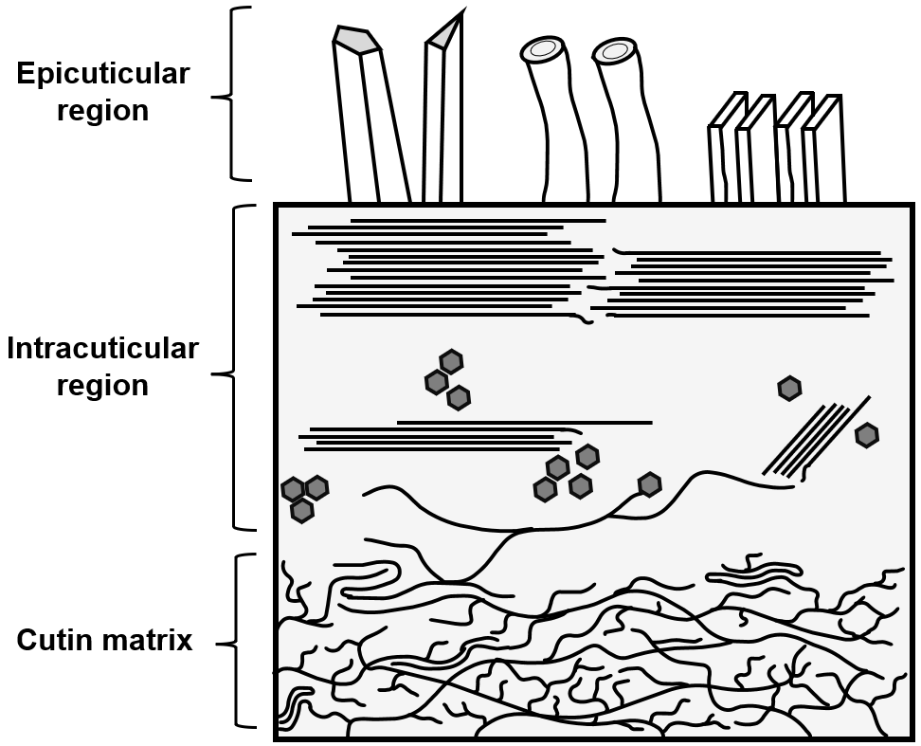
Figure 1.1. Schematic diagram of three major regions of the plant cuticle. Cutin matrix consists of an amorphous branched polyester with a low degree of order. Intracuticular regions consists of amorphous and crystalline waxes supported by cutin matrix. Epicuticular regions consists of crystalline waxes with exotic morphologies (from left to right: rodlets, tubules, and platelets). Based on model proposed by Riederer and Schreiber.¹
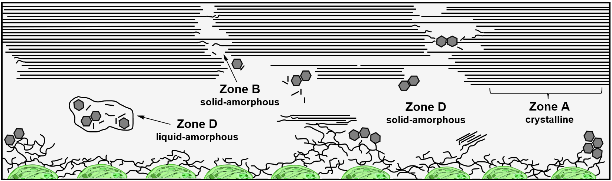
Figure 1.2. Schematic diagram of the intracuticular wax region and its subdivisions. Zone A represents the crystalline region(s); Zone B represents the solid-amorphous region(s); Zone D represents the mobile-amorphous region, composed of both solid-amorphous and liquid-amorphous regions. Based on model proposed by Riederer and Schreiber.¹

Table 1.1. Relative distribution of major wax constituents for representative plant species of commercial importance.
Wax class | Relative distribution (%)
Wax class | Rice¹  (Oryza sativa L.) | Sweet orange²  (Citrus sinensis L. Osbeck) | Canola³  (Brassica napus L.) | Sorghum⁴  (Sorghum spp.) | Carnauba⁵  (Copernicia prunifera)
odd n-alkanes | 14.8 | 11.5 | 55.1 | 1.3 | 0.3-1
aliphatic alcohols | 39.6 | 0.2 | 11.9 | 33.7 | 10-12
aliphatic aldehydes | 10.4 | 21.3 | 3.7 | 31.9 | nr
fatty acids | nr | 7.8 | 1.0 | 24.4 | 5-7
aliphatic ketones | nr | nr | 26.5 | nr | nr
aliphatic (wax) esters | 35.2 | nr | 2.0 | 4.0 | 75-84
nr = none reported
Wax classes present in concentrations greater than 20% are highlighted in bold.
¹data for epicuticular wax of leaves, adapted from Experientia 1979, 35, 1417-1540; ²data for total wax of fruit (terpenoids constitute mass balance), adapted from Plant Cell Rep. 2012, 31, 2239-2246; ³data for total cuticular wax of leaves, adapted from BMC Plant Biology 2013, 13, 215; ⁴data for epicuticular wax of leaves, adapted from Cereal Chem. 1979, 56, 491-492; ⁵data for total cuticular wax of leaves, adapted from J. Am. Oil Chem.' Soc. 1970, 47, 514-518.

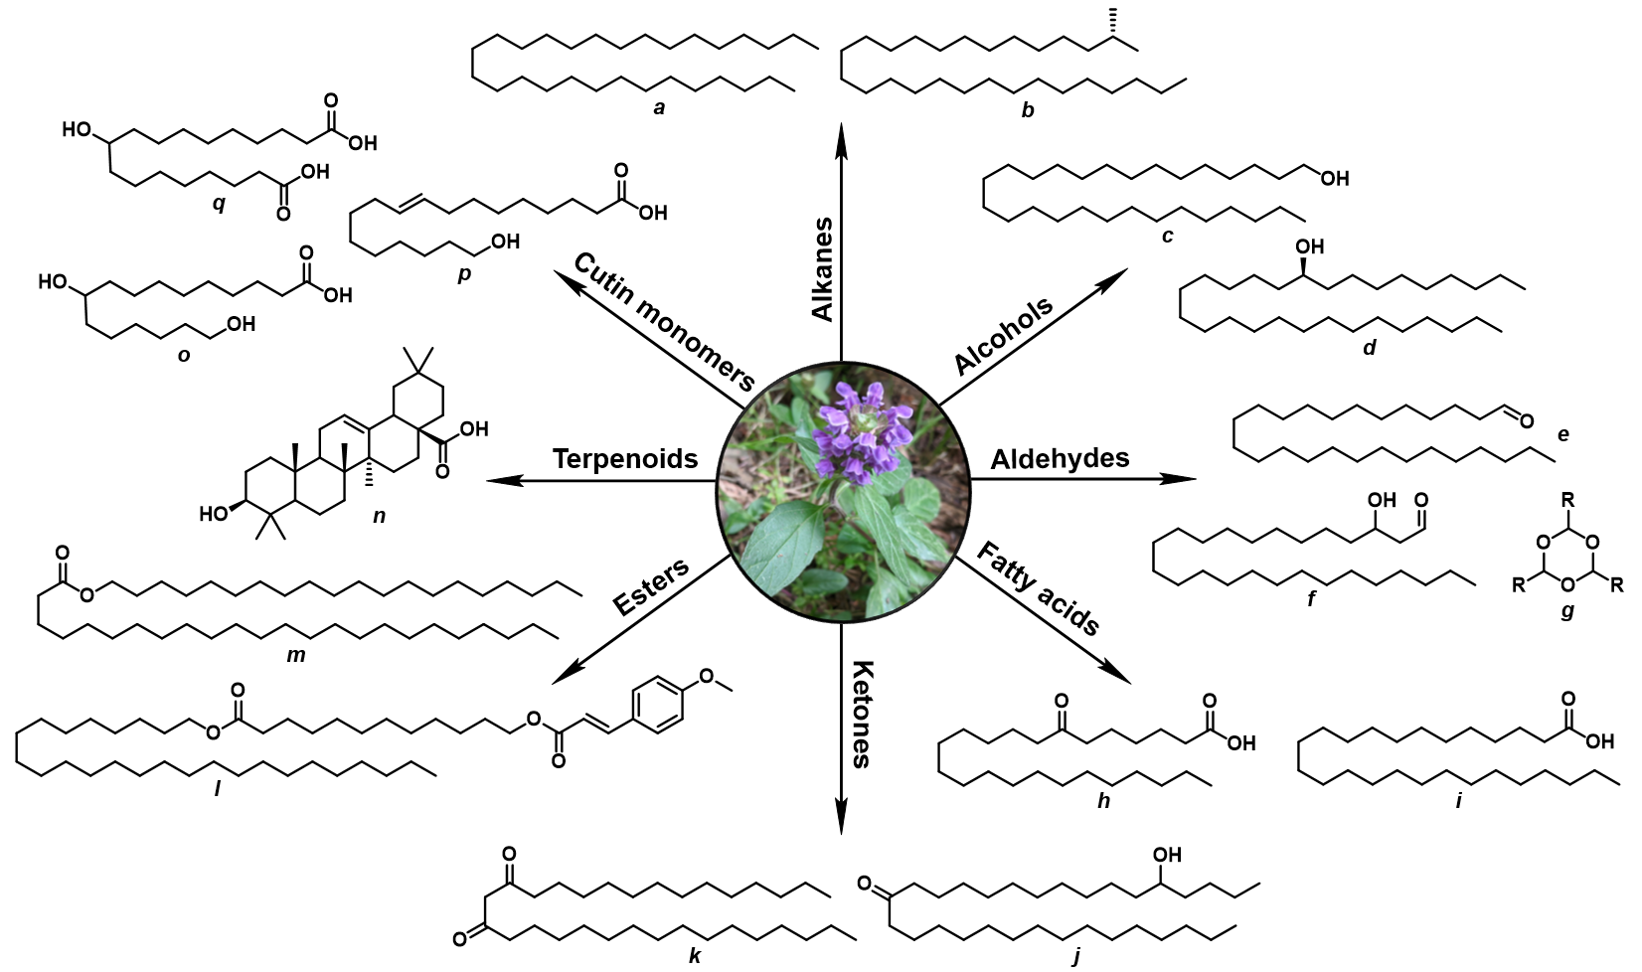
Figure 1.3. Chemical structure of representative constituents of plant waxes. a, n-nonacosane; b, 2-methyloctacosane; c, octacosan-1-ol; d, (S)-nonacosan-10-ol; e, hexacosanal; f, 3-hydroxyhexacosanal; g, aliphatic trioxane; h, 7-oxotetracosanoic acid; i, hexacosanoic acid; j, 5-hydroxyhentriacontan-16-one; k, hentriacontan-14,16-dione; l, hexacosyl (E)-12-((3-(4-methoxyphenyl)acryloyl)oxy)- dodecanoate; m, icosyl tetracosanoate; n, oleanolic acid; o, 10,16-dihydroxyhexdecanoic acid; p, 18-hydroxyoctadec-(E)-9-enoic-acid; q, 10-hydroxyhexadecanedioic acid. Inset: Coastal larkspur (Delphinium decorum). Copyright © 2022 by Francisco Miguel Angel Leyva Gutierrez.

CHAPTER II

Synthesis of Functionalized High-Oleic Soybean Oil Wax Coatings and Emulsions for Postharvest Treatment of Fresh Citrus Fruit
The following chapter details work reprinted with permission from European Journal of Lipid Science and Technology, 2020, 122, 2000005; Copyright 2020 John Wiley &. All synthetic transformations were proposed and performed by the author. Co-authors include Dr. Tao Fei, whose previous work included the synthesis of diesters and formulation of wax emulsions for fruit coating and Dr. Tong Wang who advised this work.

2.1 Abstract
High-oleic soybean oil was chemically functionalized in order to mimic the structure and physical properties of hydrogenated castor oil. The resulting wax-like material was evaluated for use as an alternative to other commercial wax coatings for the postharvest treatment of fresh citrus fruit. The racemic nature of the material inhibited ordered crystalline arrangement and negatively affected its relative crystallinity (17.7%), hardness (0.59 ± 0.04 mm⁻¹) and melting profile (44-46°C), with respect to hydrogenated castor oil (37.7%, 5.33 ± 0.01 mm⁻¹, 83-87°C). Nevertheless, compounding the new material with carnauba wax imparted a very attractive gloss and prevented moisture loss significantly better than polyethylene, shellac, and carnauba wax-based coatings. Compounding the hydroxy-functionalized high-oleic soybean wax may potentially reduce dependence on imported carnauba wax and other ingredients used in citrus coating emulsion formulations.

2.2. Introduction
Fresh citrus fruits undergo numerous physical and chemical changes immediately after harvest. Most notably, the moisture loss associated with transpiration inevitably leads to shrinkage, loss of firmness and a concomitant loss of sensory attributes. ¹⁻³ The postharvest coating of citrus fruits with emulsions from petroleum-based waxes such as paraffin and polyethylene (PE), as well as carnauba wax (CAR), beeswax, candelilla wax and shellac resin is an effective treatment used to prevent moisture loss. ³ Nevertheless, the shine imparted by these materials plays a central role in establishing perceived quality and consumer acceptance. ^{1, 4-5} With respect to fruit coatings, materials are often collectively referred to as “waxes” whether or not they fit the chemical definition of esters of long chain alcohols or glycerides; herein the term “wax” will be used consistent with industry usage and not the technical definition. Paraffin and PE-based waxes are relatively inexpensive ($0.97 kg⁻¹ and $1.2 kg⁻¹, respectively)⁶ and provide an excellent barrier to moisture. ^{3, 7} However, negative consumer attitudes toward non-renewable petroleum-based products and their potential migration into foods have warranted the use of suitable alternatives. CAR, beeswax, candelilla, and shellac resin coatings have likewise been shown to provide effective barriers to moisture and selective gas permeabilities.^{2-3, 8} However, their high cost ($6-9 kg⁻¹, $4-8 kg⁻¹, $17-20 kg⁻¹, and $16-21 kg⁻¹, respectively)⁴ highlights the need for a low-cost alternative. Fully hydrogenated soybean oil (FHSO) or “soy wax”, although inexpensive, is not suitable for fruit coating as it is brittle, fails to adhere to fruit surfaces, and does not impart shine.^{[9]} Hydrogenated castor oil (HCO) is a particularly attractive wax material due to its high hardness, high melting point, as well as lustrous appearance, and finds widespread use in the coating, pharmaceutical and cosmetic industries.¹⁰ Fatty acid polyglyceryl and polyethyleneglycol esters of HCO by the tradename Cremophor® RH 40 ($19-24 kg⁻¹) for example, are widely used as surfactants for aqueous microemulsion formulations in drug-delivery, fragrance, and cosmetic applications.¹¹ HCO, however, is a high-cost ($4-6 kg⁻¹) import commodity from Brazil, India, and East Asia and therefore not economical for use in coating of domestic commodities such as citrus fruits.
Recent years have witnessed a rise in global production of specialty high-oleic oils, specifically soybean oil (HOSO). HOSO is composed of up to 75% oleic acid (OA) with the balance consisting of linoleic (8%), linolenic (2.5%) and saturated fatty acids (10.5%);¹² this high OA content presents an opportunity for the large-scale utilization of HOSO as a low-cost ($0.26-0.57 kg⁻¹)¹³ renewable olefin with a single site per fatty acyl chain for controlled chemical modification. In our continuing efforts to produce soybean oil-based alternatives to commercial waxes, we sought out to develop an alternative to HCO from HOSO due to the desirable bulk physical properties of the former and sheer abundance of the latter. We were initially interested in examining the effect of introducing hydroxyl functionalities into linear fatty acid diesters, following leads from previous work in our group which showed an increase in material cohesion at the cost of a decrease in hardness when introducing a diol functionality.⁹ HCO and its free fatty acid (R)-12-hydroxystearic acid (HCOFFA) are singly hydroxy-functionalized on the other hand yet exhibit excellent hardness, high-melting range and shine (HCO only). Accordingly, using HCO and its free fatty acid as model materials we designed a structure-function study of hydroxy-functionalized fatty acid derivatives. We hypothesized that functionalizing HOSO with hydroxyl substituents could 1) result in materials with high hardness and melting point similar to HCO, 2) improve the cohesiveness of materials due to intermolecular hydrogen-bonding, and 3) create stable wax emulsions as required for citrus fruit postharvest processing. As previously alluded to, the shine imparted by wax coatings was of principal interest as well, as it is a key quality determinant as perceived by the consumer. The diverse nature and chemical structure of different wax materials does not provide an obvious set of guidelines for predicting the shine on coated fruit. Nevertheless, as a final hypothesis we predicted 4) the crystal morphology could be used as a determinant for gloss. The overall goal of this study was to synthesize a functional HOSO-based coating material capable of mimicking at least some of the desirable properties of HCO in order to provide a competitive edge over existing wax materials used in citrus fruit coatings.

2.3 Materials and Methods
2.3.1 Materials
Plenish high-oleic soybean oil (HOSO) was provided by DuPont. Hydrogenated castor oil (HCO) was provided by Acme-Hardesty Oleochemicals Co. Paraffin wax was provided by Michelman. Commercial citrus coating microemulsions, O-Wax (carnauba-based with morpholine and resin additive, ~22% total solids; t.s.), LS-Wax (oxidized PE-based ~22% t.s.), ORO (organic carnauba-based with caustic soda and resin additive, ~19-20% t.s.) and Star-O (shellac-based with ammonium hydroxide, ~17-18% t.s.), as well as freshly harvested, washed and uncoated Valencia oranges were provided by Fruit Growers Supply, LLC. Methyl oleate (90%, Alfa Aesar), oleic acid (90% Alfa Aesar), stearic acid, lauric acid (90% Alfa Aesar), lactic acid (80%, Fisher) hydrogen peroxide (30%, Fisher), glacial acetic acid, ammonium hydroxide (Fisher), dry Amberlyst-15 acid catalyst resin (MilliporeSigma), polyethylene glycol 200 (PEG200, Tokyo Chemical Industry (TCI)), borane-tetrahydrofuran complex (BTHF, 1.0 M, Oakwood Chemicals), Oxone™, sodium percarbonate, (Acros Organics), sodium perborate (TCI) and Dess-Martin periodinane (DMP, Oakwood Chemicals) were used as received. Solvents and all other reagents were used as received.

2.3.2 Syntheses
General. All manipulations were performed under dry N₂ using standard air-free techniques. Glassware was either dried overnight in a 120°C oven or flame-dried prior to use and cooled under a stream of dry N₂. Tetrahydrofuran (THF) was pre-dried over 3 Å molecular sieves and distilled before use. Other solvents were used as received unless otherwise noted. Thin layer chromatography (TLC) was performed using silica gel 60 coated plates and visualized with ceric ammonium molybdate (CAM) or 2,4-dinitrophenylhydrazine (DNP) stains. ¹H and ¹¹B NMR spectra were obtained using either a Bruker Avance III 600 MHz or Varian VNMRS 500/400 MHz spectrometer, using either the terminal methyl protons or methylene/methine protons on glycerol backbone as internal proton integration standards for the appropriate compounds.

General Procedure for Hydroboration of HOSO (1). An oven-dried, 500 mL three-necked round-bottomed flask was equipped with a wide magnetic stir bar, a gas inlet, sealed with two rubber septa and cooled under a blanket of nitrogen. The empty flask was then cooled to 0°C in an ice-water bath and charged with 57.0 mL (57 mmol) of cold 1.0 M BTHF using an 18-gauge stainless-steel cannula. Subsequently, 19.4 g of Plenish HOSO (55 mmol) were added dropwise to the stirring BTHF using a pressure-equalizing addition funnel replacing one of the rubber septa. After complete addition, a gel may or may not immediately develop, which causes mixture to cease stirring.

Mixture of Mono- and Diglycerides of Regioisomeric Hydroxyoctadecanoic Acid (2). To the hydroborated HOSO, 5 mL of deionized water were added slowly to destroy gel and excess BTHF and the mixture was left to stir for 10 min. The contents were cooled to 0 °C and 14.0 mL of 3 M sodium hydroxide (42 mmol) were added first, followed by dropwise addition of 7.2 mL of cold 30% hydrogen peroxide (70 mmol). The cold bath was removed, and the mixture allowed to warm to r.t. with stirring for 1.5 h. Subsequently the cloudy mixture was extracted 2× with 30 mL ethyl acetate, the pooled organic layers washed 2× with 30 mL saturated brine, dried over sodium sulfate and concentrated under vacuum to afford 18-19 g (90% yield) of a translucent light-white oil which solidified upon cooling. ¹H NMR (500 MHz, CDCl₃): δ 5.25 (m, J = 5.5, 4.5 Hz, 1H), 4.30 (dd, J = 11.9, 4.3 Hz, 2H), 4.17 (dd, J = 11.9, 6.0 Hz, 2H), 3.74 (m, 1H), 3.68 (q, J = 13.0, 6.5 Hz, 2H), 3.57 (br, 3H), 2.30 (m, 5H), 1.67 – 1.60 (m, 12H), 1.42 – 1.24 (br, 85H), 0.87 (t, J = 6.9 Hz, 9H).

Triacylglycerol of Regioisomeric Hydroxyoctadecanoic Acid (3). To the hydroborated HOSO, 5 mL of deionized water were added to destroy gel and excess BTHF and the mixture was left to stir for 10 min. To the stirring mixture at r.t., 22.3 g of sodium percarbonate (142 mmol) were added batchwise throughout the course of 1 h and left to stir for 6 h. Subsequently the cloudy mixture was extracted with 2× 30 mL ethyl acetate, the pooled organic layers washed 2× with 30 mL saturated brine, dried over sodium sulfate and concentrated under vacuum to afford 18-19 g (90% yield) of a translucent oil, which solidified upon cooling. ¹H NMR (400 MHz, CDCl₃): δ 5.23 (m, 1H), 4.26 (dd, J = 11.7, 5.7 Hz, 2H), 4.11 (dd, J = 11.7, 5.7 Hz, 2H), 3.54 (m, 3H), 2.28 (t, J = 7.2 Hz, 6H), 1.57 (br, 6H), 1.39-1.26 (br, 74H), 0.85 (t, J = 6.3 Hz, 9H).

Mixture of 9-Hydroxyoctadecanoic (4a) and 10-Hydroxyoctadecanoic Acid (4b). Twenty grams of solid TAG 3 were melted and heated to 80 °C on a hot plate in a 600 mL beaker. A magnetic stir bar was carefully added to molten TAG, followed by 120 mL 3 M sodium hydroxide, and the cloudy mixture left to stir at 80 °C until translucent. To the mixture, 150 mL of 3 M hydrochloric acid were added along with 60 mL of deionized water and contents left to stir until a yellow oil floated to the top. The contents were removed from heat, quickly cooled 0 °C, and left under refrigeration overnight to obtain 17-18 g (85% yield) of solid hydroxy free fatty acid, which was further dried in a vacuum oven for 6 h. ¹H NMR (500 MHz, CDCl₃): 3.58 (m, 1H), 2.31 (t, J = 7.5 Hz, 2H), 1.60 (m, 2H), 1.41 (m, 4H), 1.24 (br, 22H), 0.86 (t, J = 6.9 Hz, 3H).

Saponification of HCO (5) to (R)-12-Hydroxyoctadecanoic Acid (6). Saponification is the same as for the preparation of 4a and 4b. ¹H NMR (500 MHz, CDCl₃): δ 3.58 (m, 1H), 2.33 (t, J = 7.5 Hz, 2H), 1.62 (m, 2H), 1.41 (br, 4H), 1.24 (br, 22H), 0.87 (t, J = 6.1 Hz, 3H).

Dess-Martin Periodinane (DMP) Oxidation of Hydroxylated TAGs and Fatty Acids. A 500 mL two-necked round-bottomed flask was equipped with a thermometer, large magnetic stir bar and charged with 20.0 g of either HCO (5) or (R)-12-hydroxystearic acid (6), 70.0 mL of acetonitrile and 4.0 equivalents of water (0.4-1.2 mL). Contents were heated to 80°C with stirring in an oil bath until homogeneous and 1.2 equivalents of DMP were then added incrementally, such that the temperature did not exceed 90 °C. The mixture was left to stir for 3 h and transferred to a vacuum rotary evaporator to remove all traces of acetonitrile. The resulting thick, light-yellow slurry was transferred to a 500 mL wide-mouth Erlenmeyer flask 3× with 30 mL washings of hot ethyl acetate. Contents were heated to 65 °C on a hot plate with vigorous stirring, followed by slow batchwise addition of 14.0 g of sodium bicarbonate in 100 mL of hot deionized water, and 50 mL of 0.1 M sodium thiosulfate. The slurry was vacuum filtered using a sintered funnel (30-40 µm), and the filtrate heated on a hot plate to dissolve crude product into the organic layer. As much of the upper organic phase was decanted into a clean flask, and the hot filtrate was then extracted with an additional 2× 30 mL hot ethyl acetate. The pooled organic layers were washed 2× with 50 mL 10% sodium bicarbonate and 2× with 30 mL saturated brine, dried over sodium sulfate and gently heated on a hot plate to afford a translucent yellow organic extract, which was subsequently filtered and concentrated under vacuum to yield 17-18 g (87% yield) of a dark-yellow oil. 12-Oxooctadecanoic Acid (7): ¹H NMR (600 MHz, CDCl₃): δ 2.41 (dt, J = 7.1, 1.3 Hz, 4H), 2.37 (t, J = 7.5 Hz, 2H), 1.69 (m, 2H), 1.62 (m, 4H), 1.29 (br, 18H), 0.91 (t, J = 7.0, 3H). Oxidized Hydrogenated Castor Oil (propane-1,2,3-triyl tris(12-oxooctadecanoate)) (8): ¹H NMR (500 MHz, CDCl₃): δ 5.22 (m, 1H), 4.25 (dd, J = 11.9, 4.3 Hz, 2H), 4.11 (dd, J = 11.9, 6.0 Hz, 2H), 2.34 (t, J = 7.5 Hz, 12H), 2.27 (t, J = 7.5 Hz, 6H), 1.56-1.49 (m, 18H), 1.29 (br, 60H), 0.84 (t, J = 7.0, 9H).

9,10-Epoxyoctadecanoic Acid (10). A 500 mL two-necked round-bottomed flask was equipped with a magnetic stir bar and an addition funnel, charged with 20.0 g (70 mmol) of OA (9), 8.5 g (140 mmol) of glacial acetic acid and cooled to 0-4 °C in an ice water bath with stirring. Subsequently, 6.2 mL (200 mmol) of 30% hydrogen peroxide were added dropwise and the mixture heated to 55°C with stirring for 6 h. The upper oil layer was decanted into a separatory funnel, washed 5× with 200 mL chilled (1-3 °C) deionized water, 2× with 30 mL 10% sodium bicarbonate, 2× with 30 mL saturated brine and dried in a vacuum oven at 70 °C to obtain 17-18 g (85% yield) of a viscous yellow oil. ¹H NMR (500 MHz, CDCl₃): δ 2.94 (m, 2H), 2.38 (m, 2H), 1.66 (m, 2H), 1.53 (m, 4H), 1.29 (br, 20H), 0.91 (t, J = 7.0 Hz, 3H).

9,10-Dihydroxyoctadecanoic Acid (11). A 500 mL two-necked round-bottomed flask was equipped with a magnetic stir bar and an addition funnel, charged with 20.0 g (70 mmol) of OA (9), 8.5 g (140 mmol) of glacial acetic acid, 2 wt% of Amberlyst-15 acid catalyst, and heated to 55 °C in an oil bath with stirring. Subsequently, 6.2 mL (200 mmol) of 30% hydrogen peroxide were added dropwise and the mixture left to stir at 55 °C for 18 h. The upper oil layer was decanted into a separatory funnel, extracted 3× with 30 mL ethyl acetate, washed 5× with 200 mL hot (>80 °C) deionized water, 2× with 30 mL 10% sodium bicarbonate and 30 mL saturated brine. The upper layer was collected and dried in a vacuum oven at 70 °C to obtain 17-18 g (85% yield) of a viscous yellow oil which became semi-solid upon cooling. ¹H NMR (500 MHz, CDCl₃): 3.58 (m, 2H), 2.31 (t, 2H), 1.60 (m, 2H), 1.41 (m, 4H), 1.24 (br, 22H), 0.90 (t, 3H).

Mixture of 9-Hydroxy-10-((2-hydroxypropanoyl)oxy)octadecanoic Acid (12a) and 10-Hydroxy-9-((2-hydroxypropanoyl)oxy)octadecanoic Acid Regioisomers (12b). A 250 mL two-necked round-bottomed flask was equipped with a large magnetic stir bar, charged with 10.0 g (33.5 mmol) of 10, 5.6 g (50 mmol) of 80% (w/v) lactic acid solution and heated in an oil bath at 80 °C with stirring for 4 h. The mixture was allowed to cool to r.t., extracted 2× with 30 mL ethyl acetate, the pooled organic layers were washed 2× with 30 mL saturated brine, dried over sodium sulfate and concentrated under vacuum to afford 8-9 g (91% yield) of a translucent light-yellow oil. ¹H NMR (500 MHz, CDCl₃): 4.51 (q, 1H), 4.28 (m, 1H), 3.58 (m, 1H), 2.28 (t, 2H), 1.60 (m, 2H), 1.59-1.41 (m, 7H), 1.24 (br, 22H), 0.89 (t, 3H).

General Procedure for Synthesis of Diesters. A 500 mL round-bottomed flask was equipped with a large magnetic stir bar and charged with the appropriate molar ratio of fatty acid monomers (e.g., stearic acid, oleic diol, hydroxystearic acids), a half-molar equivalent of PEG200, and 1 wt% Amberlyst-15 acid catalyst. The flask was fitted with a drying tube and heated in an oil bath to 100 °C with stirring for 12 h under vacuum. The resulting wax was filtered through a preheated fine stainless-steel mesh to remove solid catalyst resin and used without further treatment. ¹H NMR (500 MHz, CDCl₃): δ 4.21 (m, 4H), 3.68-3.66 (m, 12H), 2.31 (m, 4H), 1.61 (m, H), 1.27-1.24 (br, variable), 0.87 (t, 6H)

2.3.3 Wax Emulsion Formulations
A 300 mL stainless steel cup was charged with 8 g CAR wax and 2 g 2 (80:20) , 0.75 g of OA, 0.75 g of lauric acid and heated on a hot plate until molten (100-120 °C), at which point a stir bar was added and set to stir at medium speed for 1 min. When contents became homogeneous 1.5 g of ammonium hydroxide were added, and immediately, the hot wax mixture was added to 50 mL of hot tap water (95-99 °C) and homogenized (Fisher Scientific, Model 850) at 5000 rpm. The hot emulsion was immediately cooled in an ice bath to r.t. with stirring using a metal spatula and stored in clean plastic containers.

2.3.4 Moisture Weight Loss of Citrus Fruit
Freshly harvested Valencia oranges were washed with warm soap water, dried with paper towels, and coated with 0.5 mL of wax emulsion per fruit delivered by a syringe. The emulsion was gently rubbed with two fingers throughout the entire surface to achieve an even coat. Coated fruit were blown dry for 1.5 min with a hot-air gun blowing air at 50-55 °C and set on a wire rack to fully air dry. Each treatment consisted of five replicates plus one uncoated control. Coated and uncoated fruit were stored for two weeks at 22-23 °C and 65-75% RH. Fruits were individually weighed daily until the end of the storage period. Percent weight loss was calculated and reported as the average of the five replicates.

2.3.5 Differential Scanning Calorimetry (DSC)
Melting profiles of wax materials were analyzed with a DSC 250 Discovery (TA Instruments, New Castle, DE) calorimeter using the methodology by Donhowe and Fennema. ⁷ Wax samples (approximately 10 mg) were first heated to 100°C at a rate of 200 °C min⁻¹, held for 3 min, cooled to 25 °C at a rate of 20 °C min⁻¹ and equilibrated for 3 min. Actual test ramp was then performed by heating to 100 °C at a rate of 10 °C min⁻¹. Melting point ranges were calculated from the average of three replicates from each material.

2.3.6 Hardness and Cohesiveness of Wax Materials
Hardness, defined as a measure of resistance to local deformation, was measured using an H-1200 Universal Penetrometer (Humboldt Mfg. Co., Raleigh, NC) following ASTM D1321 procedure. Ten grams of molten material were cast in a 5 cm diameter × 3 cm height hollow polyvinyl chloride plastic mold. Materials were allowed to cool and equilibrate to r.t. for at least 2 h prior to testing. The reciprocal of the distance traveled by the penetrometer needle (mm) into the wax disc was recorded as the hardness (mm⁻¹). Cohesiveness, defined as the strength of a material due to interatomic or intermolecular forces, was measured as per previous methodology⁹ by a three-point bend test using a TA.XTPlus Texture Analyzer (Stable Micro Systems, So. Hamilton, MA) with a TA-92N probe on a 4 mm-thick wax sample made by casting 2.2-2.8 g of molten material into a small hexagonal weighing boat. Samples were allowed to cool and equilibrate to r.t. for at least 2 h prior to testing. The samples were sanded flat to a uniform mass with a fine grit sanding sponge. Test was performed by placing sample between two vertical support bars 12 mm apart and driving the blunt blade normal to the sample at 0.5 mm s⁻¹ test speed to a trigger distance of 3 mm. The area under curve from the origin to the peak positive force was recorded as the cohesiveness (g mm) of the material and reported as the average of three replicates.

2.3.7 Polarized Light Microscopy (PLM)
The crystal morphology of selected wax materials was analyzed using PLM with an Olympus BX51 microscope (Olympus Corporation, Tokyo, Japan) following methodology by Meng et al.¹⁴ Approximately one milligram of wax was loaded onto microscope slide and heated for 30 min at 90°C to erase crystal memory. The molten wax was then covered with a preheated slide to produce a thin film, cooled to r.t. and observed under polarized light.

2.4. Results and Discussion
2.4.1 Synthesis of Wax Coating Materials
Hydroboration-oxidation. HOSO was functionalized with single hydroxyl moieties via hydroboration-oxidation following previous work on fatty acid methyl esters (FAMEs) (Scheme 2.1).^{[15]}. Addition of BTHF to HOSO results in the rapid formation of a clear, extremely viscous, and rigid gel at either low temperatures, sub stoichiometric BTHF, or dilution of HOSO with dry THF. Gelling during hydroboration has been reported for diverse olefinic substrates,¹⁶⁻¹⁸ although this is not typical of FAMEs. To overcome gelling during the hydroboration of HOSO, the order of addition was simply reversed, and stoichiometry adjusted from the assumed 1:3 molar ratio (BH₃: olefin) to a 1:1 molar ratio. These conditions suggested the hydroboration of HOSO favors the monoalkylborane stage, presumably due to the steric influence from neighboring fatty acyl chains. Similarly, the hydroboration of methyl oleate proceeded rapidly to the monoalkylborane stage as suggested by full conversion using a maximum of 1:1.5 (BH₃: olefin) ratio, above which increasing the olefin concentration results in incomplete conversion. ¹¹B NMR spectroscopy provided additional evidence, as the signals at δ 17.95 and δ 27.18 were within the range for similar monoalkylborane species (see Appendix). The rapid gel formation observed upon addition of BTHF to HOSO may be rationalized as the high olefin concentration-driven formation of a hyper-branched alkylborane which may be contributing to the observed increase in viscosity leading up to the gel. Dropwise addition of HOSO to BTHF ensures the reaction proceeds rapidly to the monoalkylborane stage first by saturating the olefin with borane. As the calculated 1:1 molar ratio is approached, a gradual increase in viscosity culminating in gel formation can be observed. Despite the presence of linoleic and linolenic fatty acids in HOSO, we found that a 1:1 molar ratio is sufficient for complete conversion into the alcohol. Previous reports propose the formation of cyclic five membered borolanes to explain the presence of two isomeric 1,4-diols from the hydroboration-oxidation of methyl linoleate.¹⁵ This behavior may be contributing to both the initial preference for the monoalkylborane and increase in viscosity since the geometry of TAG-linoleate chains would be modified in such a way that undue strain would be added onto the system. Bulkier hydroborating agents (e.g., thexylborane, pinacolborane) were entirely avoided due to their steric implications as well as cost since BTHF is comparatively less expensive and readily available.
The hydroboration-oxidation is typically performed by treating the generated alkylborane species with alkaline hydrogen peroxide to afford the respective alcohols. These conditions, however resulted in hydrolysis of fatty acyl chains in HOSO to yield a mixture of mono- and diglycerides of hydroxy fatty acids. In the ¹H NMR spectrum of 2 (see Appendix), the characteristic methylene doublet of doublets (δ 4.17 (dd, 2H), 4.33 (dd, 2H)) and methine multiplet (δ 5.30, (m, 1H)) from the glycerol backbone disappear and are replaced by a sharp quartet at δ 3.68 (J = 13.0, 6.5 Hz) corresponding to diastereotopic methylene protons α to the glycerol-backbone hydroxyls after hydrolysis of the ester linkage. The anticipated multiplet from the proton α to the newly installed alcohol from the hydroboration-oxidation is visible at δ 3.57. An additional multiplet at δ 3.78-3.74 (m, J = 6.6, 4.1, 2.5 Hz) suggests a degree of intra-esterification between hydrolyzed fatty acyl chains and hydroxyls at the C9- and C10- positions, although this is not always observed batch-to-batch especially when scaling-up. Lowering the temperature to between -10 and -5°C using an ice-acetone bath resulted in a slight decrease of hydrolysis products, as suggested by a lower integration value for backbone methylene protons (e.g., δ 4.33 = < 2H). These hydrolysis products took the form of a very lustrous, white, and homogeneous waxy material (2) which was chosen for further analysis due to its attractive appearance.
Alternative oxidations pathways were explored in order to prevent hydrolysis of the TAG and mimic the structure of HCO. Ripin et al.¹⁹ reported the successful oxidation of a number of organoboranes with Oxone™ under mild conditions, attributing it as a safe, shelf-stable, economical oxidizing salt. Indeed, the ¹H NMR spectrum revealed the TAG structure intact, although the resulting product was neither fully converted into the alcohol nor a solid wax but rather an amorphous, tacky, and resilient gel-like material that fiercely adhered to the walls of glassware. This presumed polysulfone was not further characterized as it proved to be extremely heat resistant, non-flowable, and difficult to dissolve for characterization. Oxidations using sodium percarbonate and sodium perborate proved the most promising pathways for ensuring complete oxidation without hydrolysis of the TAG. ²⁰⁻²¹ Sodium percarbonate efficiently afforded the single-hydroxyl functionalized TAG 3 in good yields and remarkably mild conditions (Scheme 2.1) with the generation of non-toxic waste products (i.e. aqueous bicarbonate and borates). Its lower cost compared to that of sodium perborate, as well as stability, ease of handling and storage makes it an ideal oxidant for commercialization given the intended use of the resulting wax material is for food-contact applications. To obtain the free fatty acid, TAG 3 was subjected to a saponification in the same way that HCO was saponified to obtain HCOFFA. The hydroxy fatty acids (4a-b and 6) from both sources (3 and 5) resembled each other, and were obtained as dull light-brown solids, which is in contrast to their TAG counterparts which were white and comparatively glossier.
DMP Oxidation. The hydroxyl-functionalized materials were further oxidized into the respective ketones using DMP for two reasons; 1) to compare the effect of ketones with respect to hydroxyl groups on the target physical properties of hardness, cohesiveness, melting point and shine (since many keto-waxes exist in nature), as well as 2) to investigate whether these structures could reduce the viscosity ²² of the wax emulsions for subsequent use in fruit coating. The oxidations reported herein were performed on solid hydrogenated castor oil (5) and (R)-12-hydroxyoctadecanoic acid (6) (Scheme 2.1), optimized by the inclusion of acetonitrile and four equivalents of water. Ketones 7 and 8 were obtained with relative ease, although work-up conditions necessitate careful temperature control to prevent product crystallization during separation from the spent solid DMP reagent which can lead to low isolated yields.
Epoxide Ring-opening Reactions and Synthesis of Diesters. Vicinal diol 11 was obtained from epoxidized OA, simply by prolonging the reaction conditions for a typical epoxidation with per-acid generated in-situ to promote ring-opening by water (Scheme 2.2). Hot water-promoted²³ and sulfonic-acid resin catalyzed ^{[24]} epoxide ring-openings have been previously reported for a wide scope of olefins. Incidentally, the acetic acid-promoted ring opening pathway faces a rather steep energy barrier ^{[25]} and diol 6 can be obtained in reasonable yields and purity. The lactic acid ring-opening of 10 to afford the mixture of regioisomeric products 12a and 12b was chosen as an extreme model to compare the physical properties of a hydroxyl and ester dual functionalized fatty acid. Previous work has shown that ethylene glycol and PEG200 bridged diesters of stearic acid show desirable properties for paperboard coating, which may translate well for fruit coatings. ^{[9]} The physical properties of neat functionalized fatty monomers 11 and 12a-b synthesized were unable to be measured as these were viscous, oily semi-solids in ambient conditions. Accordingly, these were formulated into diesters at variable ratios and characterized. Generally, increasing the content of hydroxyl and dual functionalized monomers resulted in soft, tacky, and dull solids which limited their utility.

2.4.2 Physical Characterization of Wax Coating Materials
Hardness, Cohesiveness and Melting Point. Hydroboration can be a powerful tool for asymmetric synthesis provided the olefin offers a structural or electronic bias. The internal cis- double bond on an oleic fatty acyl chain does not provide such bias and as result the hydroboration-oxidation of HOSO yields a mixture of regio- and enantiomeric alcohols. HCO (5) is composed of up to 94% (R)-12-hydroxystearic acid (6), with the balance consisting of fully saturated fatty acids after hydrogenation. This stereo-homogeneity is responsible for its high hardness, high melting point range and high relative crystallinity (Table 2.1). For the enantiopure leaf epicuticular wax, (S)-nonacosan-10-ol, Jetter and Rieter²⁶ reported a melting point decrease from 82°C to 76°C upon addition of up to 50% synthetic (R)-nonacosan-10-ol. The HCO and HCOFFA racemic analogues, 3 and 4a-b, likewise exhibited a drastic decrease in melting point with a concomitant decrease in hardness. For (S)-nonacosan-10-ol, the crystal structure preferentially orients alkyl chains in an antiparallel fashion placing hydroxyl substituents adjacent to one another, thereby promoting favorable inter-chain hydrogen bonding. These conditions result in only minimal perturbations in the predominantly orthorhombic crystal lattice.²⁶⁻²⁷ In contrast, for racemic mixtures of nonacosan-10-ol, hydrogen-bonding between opposite enantiomers is confined to a pair, thereby disrupting extended interactions and introducing a degree of disorder. We can reasonably extend these observations to explain the melting point depression, decrease in hardness and relative crystallinity for 3 with respect to 5. If we suppose a single HOSO molecule is composed of exactly three oleate chains, then there exists a total of 64 possible arrangements of isomeric alcohols after oxidation. Interestingly, hydroxy free fatty acid 6 was significantly more crystalline than TAG 5; perhaps this can be attributed to the ability of 6 to orient in a head-to-head fashion to form double layers²⁸ which in turn are further stabilized by the enantiopure hydroxyl at C12. This would similarly account for the higher relative crystallinity compared to racemate analogue 4a-b. Mixture of glycerides 2 was relatively more crystalline than TAG 3, perhaps due to a chain-lengthening effect by the glycerol backbone hydroxyl. Ketones 7 and 8 were less hard than the corresponding fatty alcohols 6 and 5, although harder than racemic alcohols 3 and 4a-b. Melting point ranges mirrored these observations. In the crystal structure of 13-oxoisostearic acid (m.p. 76.9-77.2°C; analogous to ketone 7), the sp²-geometry oxo- group is incorporated into the voids of neighboring methylene zigzag chains resulting in minimal disturbance of ordered packing.²⁹ This feature is likely responsible for the observed intermediate melting points and relative crystallinities of 7 and 8.
The cohesiveness between different materials was often statistically insignificant. However, a decrease in relative crystallinity was usually accompanied with a decrease in cohesiveness. Defined herein as the strength of interatomic and intermolecular forces, it is reasonable to expect the ability to pack into ordered crystalline structures contributes to overall structural cohesion. Similarly, hardness is more likely to be related to the crystalline structure rather than relative crystallinity. CAR was one of the hardest, most cohesive and highest melting range material, likely owing to its diverse composition of long-chain fatty esters, ω-hydroxy esters, and orthorhombic crystal structure. Additionally, π-stacking interactions arising from p-hydroxycinnamic esters in CAR may also contribute to its physical properties. Interestingly, glyceride mixture 2 was very cohesive despite its low relative crystallinity, probably as a result of hydrogen-bonding from glycerol backbone hydroxyl(s).
Both diester monomers, vicinal diol 11 and lactic acid polyol 12a-b were viscous semi-solids at r.t. presumably due to their racemic nature and large, hydrogen-bond capable protrusions which inhibited close packing. Formulating 11 and 12 into PEG200 bridged diesters of stearic acid generally improved hardness and melting point only at ratios above 90% stearic acid, owing to the ability of the latter for close packing. Ratios below 90% stearic acid, as expected, were much softer and greasy at ambient conditions. Given that the objective of the present study was to maximize HOSO utilization, these materials were discarded as potential candidates for fruit coating waxes and serve only as an illustrative point that increasing the degree of disorder from the mixture of isomeric diols destroys ordered crystal packing.

2.4.3 Crystal Morphology
Microscopy revealed TAG compounds 2, 3, 5, and 8 crystallized into fine clusters, unlike FHSO which crystallized into large spherulites (Fig. 2.1). The free fatty acid counterparts, 4a-b, 6 and 7 had more diverse morphologies. Racemic and isomeric mixture 4a-b, formed large crystal cluster aggregates, leaving large gaps of open space. This behavior is likely due to the enantiomeric pairwise hydrogen-bonding annihilation mentioned previously.²⁶ Enantiopure fatty acid 6 crystallized into very large spherulites, which is in stark contrast to 4a-b and its TAG counterpart 5. We can once again attribute this to the chiral secondary alcohol which elicits helical crystalline conformations as described for (S)-nonacosan-10-ol by Koch et al.²⁸ Ketone 7 crystallized as long fibrous clusters, likely due to the ability of the oxo- group to pack well with neighboring fatty acyl chains. The crystal morphology of hydrogenated castor oil (5) was not resolved well by PLM at 100x magnification. Nevertheless, a number of HCO crystal morphologies including fibers, rosettes, and other irregular crystals have been previously reported.^{[30]} CAR and the PEG200D diester previously developed exhibited similar distributions to ketone 7, despite their different chemistry. We invoked the fractal dimension value²⁴ as a quantitative measure for the spatial distribution of crystals based on their morphology. However, we were unsuccessful in correlating these results with the gloss of a material.

2.4.4 Citrus Coating Formulation and Performance
Wax Coating Emulsions. CAR is commonly used in the manufacture of postharvest citrus coatings despite its high cost and volatile price. Additional material costs are incurred when resins and additives are compounded with CAR to improve performance, as is the case for the commercial benchmarks used in this study. Therefore, we decided to compound materials 2 and 3 with CAR in an attempt to reduce the need for these secondary components. Previously, we encountered several complications in formulating FHSO and PEG-fatty diesters, into stable, low-viscosity, small-particle size emulsions. Materials 2 and 3 were both successfully made into low-viscosity emulsions using a well-known wax-to-water method.³¹ The structures of 2 and 3 resemble components of commercial surfactants Labrasol® and Cremophor RH 40® and we superficially attribute this feature to their emulsifying ability. In this report we focus on the performance of a CAR:2 compound emulsion, but detailed emulsion screening methodology and characterization will be presented in the subsequent portion of this study.

Moisture Weight Loss and Appearance of Coated Citrus. Moisture weight loss performance of the candidate wax emulsion was compared against the commercial microemulsion benchmarks O-Wax (carnauba-based), LS-Wax (oxidized PE-based), ORO (carnauba-based) and Star-O (shellac-based). Fruit were coated by hand, dried with a hot air gun (50-55°C) to simulate commercial packing house processing conditions and stored at 22-23°C and 65-75% RH. The total moisture loss (wt%) and appearance of coated fruit are depicted in Figures 2.2 and 2.3, respectively. The exact composition of each benchmark wax microemulsion is proprietary information and thus we cannot adequately explain the high moisture loss variability seen from ORO (14.6 ± 4.7%) versus O-Wax (7.0 ± 0.9%) coated fruit. In this case, both emulsions are CAR-based and contain a similar% t.s. The 11.4 ± 1.5% total moisture loss exhibited by STAR is reasonable, as the water vapor permeability of shellac (4.63-6.61 g[m·s·Pa]⁻¹ x 10⁻¹² at 30°C) is much higher than CAR (0.18 g[m·s·Pa]⁻¹ x 10⁻¹² at 25°C).⁷ There was no significant difference between our compounded emulsions at 50:50 (6.1 ± 1.1%) and 80:20 (6.0 ± 0.7%) CAR:2 (wt%). The 80:20 formulation imparted a very attractive gloss to coated fruit but increasing 2 beyond 20 wt% into compounded emulsions did not impart any gloss. There was no significant difference between 50:50 CAR:2, 80:20 CAR:2 and O-Wax (7.0 ± 0.9%) with respect to total moisture loss. However, both CAR:2 formulations were significantly more effective in preventing moisture loss compared to LS-Wax (9.7 ± 1.8%), ORO, STAR, and uncoated controls (11.4 ± 2.5%). It is our hypothesis that the presence of the aliphatic TAG structure contributed significantly to moisture loss prevention while racemic hydroxyl moieties inhibited crystallization. The crystallizing-out of wax coatings is a known defect and imparts coated fruit with undesirable surface flaking or “shatter.”⁴ Certain treatments exhibited obvious wrinkling and peel-pitting as well as shatter (for LS Wax and ORO), although these defects were much less pronounced for both CAR:2 treatments and O-Wax.

2.5 Conclusions
The racemic nature of the singly hydroxy-functionalized compounds 2 and 3 obtained via hydroboration-oxidation of HOSO had a significant impact on their physical properties and failed to match that of the enantiopure analogue, HCO. Nevertheless, these materials show promise as partial replacements for CAR in the formulation of citrus postharvest coatings and outperformed current commercial benchmarks. Synthesis of these materials can be performed under mild conditions with the generation of environmentally benign waste products, further highlighting the feasibility for commercialization.

References
1 Baldwin, E. A.; Hagenmaier, R. D.; Bai, J., Edible Coatings and Films to Improve Food Quality. 2 nd ed.; Taylor & Francis Group, LLC: Boca Raton, FL, 2012.
2 Hagenmaier, R. D.; Baker, R., Reduction in gas exchange of citrus fruit by wax coatings. J. Agric. Food. Chem. 1993, 41 283-287.
3 Hagenmaier, R. D.; Shaw, P. E., Gas permeability of fruit coating waxes. J. Am. Soc. Hort. Sci. 1992, 117 (1), 105-109.
4 Ruiz, T., Fruit Growers Supply, LLC, Exeter, CA. Personal communication ed.; 2019.
5 Motamedi, E.; Nasiri, J.; Malidarreh, T. R.; Kalantari, S.; Naghavi, M. R.; Safari, M., Performance of carnauba wax-nanoclay emulsion coatings on postharvest quality of ‘Valencia’ orange fruit. Scientia Horticulturae 2018, 240, 170-178.
6 Alibaba Petroleum and Petrochemical Products. https://dir.indiamart.com/indianexporters/o_petrol.html (accessed 06/24/2019).
7 Donhowe, G.; Fennema, O., Water vapor and oxygen permeability of wax films. J. Am. Oil Chem. Soc. 1993, 70 (9), 867-873.
8 Hagenmaier, R. D.; Shaw, P. E., Permeability of shellac coatings to gases and water vapor. J. Agric. Food. Chem. 1991, 39 (5), 825-829.
9 Fei, T.; Walker, J. A.; Vickerman, K. L.; Stanley, L. M.; Jarboe, D.; Wang, T., Synthesis and characterization of soybean oil-based waxes and their application as paraffin substitute for corrugated coating. J. Ind. Eng. Chem. 2018, 58, 113-122.
10 BASF, Kolliwax®HCO Hydrogenated castor oil powder for pharmaceutical use. BASF, Ed. 2015.
11 Djekic, L.; Primorac, M., The influence of cosurfactants and oils on the formation of pharmaceutical microemulsions based on PEG-8 caprylic/capric glycerides. Int. J. Pharm. 2008, 352 (1-2), 231-9.
12 Pioneer, D., Plenish High-oleic soybean oil Technical Data. Pioneer, D., Ed. 2015.
13 Knowlton, S., Corteva Agriscience, Wilmington DE. 2020.
14 Meng, Z.; Liu, Y. F.; Jin, Q. Z.; Huang, J. H.; Song, Z. H.; Wang, F. Y.; Wang, X. G., Characterization of graininess formed in all beef tallow-based shortening. J. Agric. Food. Chem. 2010, 58 (21), 11463-70.
15 Lucas, T.; Schäfer, H. J., Hydroboration of unsaturated fatty acid methyl esters and conversion of the boron adducts. Eur. J. Lipid Sci. Technol. 2014, 116 (1), 52-62.
16 Brown, H. C.; Moerikofer, A. W., Hydroboration. XIV. Rates and stoichiometry of the hydroboration of some representative hindered olefins. J. Am. Chem. Soc. 1962, 84 (8), 1478-1484.
17 Chujo, Y.; Tomita, I.; Hashiguchi, Y.; Saegusa, T., Hydroboration polymerization. 2. Synthesis of organoboron polymers by the reaction between diyne and thexylborane. Macromolecules 1992, 25 (1), 33-36.
18 Logan, J. T., Thermal isomerization of hydroborated olefins. J. Org. Chem. 1961, 26 (10), 3657-3660.
19 Ripin, D. H.; Cai, W.; Brenek, S. J., A safe, scaleable method for the oxidation of carbon-boron bonds with Oxone. Tetrahedron Lett. 2000, 41, 5817-5819.
20 Kabalka, G. W.; M., S. T.; Goudgaon, N. M., Sodium perborate: A mild and convenient reagent for efficiently oxidizing organoboranes. J. Org. Chem. 1989, 54, 5930-5933.
21 Kabalka, G. W.; Shoup, T. M.; Wadgaonkar, P. P., Oxidation of organoboranes with sodium percarbonate. Organometallics 1990, Vol. 9 (4), 1316-1320.
22 Ba, S.; Zhang, H.; Lee, Y. J.; Ng, C. W.; Li, T., Chemical modifications of ricinolein in castor oil and methyl ricinoleate for viscosity reduction to facilitate their use as biodiesels. Eur. J. Lipid Sci. Technol. 2016, 118 (4), 651-657.
23 Wang, Z.; Cui, Y.-T.; Xu, Z.-B.; Qu, J., Hot water-promoted ring-opening of epoxides and aziridines by water and other nucleopliles. J. Org. Chem. 2008, 73 2270-2274.
24 Usui, Y.; Sato, K.; Tanaka, M., Catalytic dihydroxylation of olefins with hydrogen peroxide: an organic-solvent- and metal-free system. Angew Chem Int Ed Engl 2003, 42 (45), 5623-5.
25 Caillol, S.; Desroches, M.; Boutevin, G.; Loubat, C.; Auvergne, R.; Boutevin, B., Synthesis of new polyester polyols from epoxidized vegetable oils and biobased acids. Eur. J. Lipid Sci. Technol. 2012, 114 (12), 1447-1459.
26 Jetter, R.; Riederer, M., Epicuticular crystals of nonacosan-10-ol: In-vitro reconstitution and factors influencing crystal habits. Planta 1994, 195, 257-270.
27 Lunden, B. M., The crystal structure of 12-D-hydroxyotadecanoic acid methyl ester. Acta Cryst. 1976, B32, 3149-3153.
28 Koch, K.; Ensikat, H. J., The hydrophobic coatings of plant surfaces: epicuticular wax crystals and their morphologies, crystallinity and molecular self-assembly. Micron 2008, 39 (7), 759-72.
29 Dahlen, B., The crystal structure of 13-oxoisostearic acid. Acta Cryst. 1972, B28, 2555-2562.
30 Yang, D.; Hrymak, A. N., Crystal morphology of hydrogenated castor oil in the crystallization of oil-in-water emulsions: Part I. Effect of temperature. Ind. Eng, 2011, 50 (20), 11585-11593.
31 Hagenmaier, R. D.; Baker, R., Wax microemulsions and emulsions as citrus coatings. J. Agric. Food. Chem. 1994, 42, 899-902.

Appendix

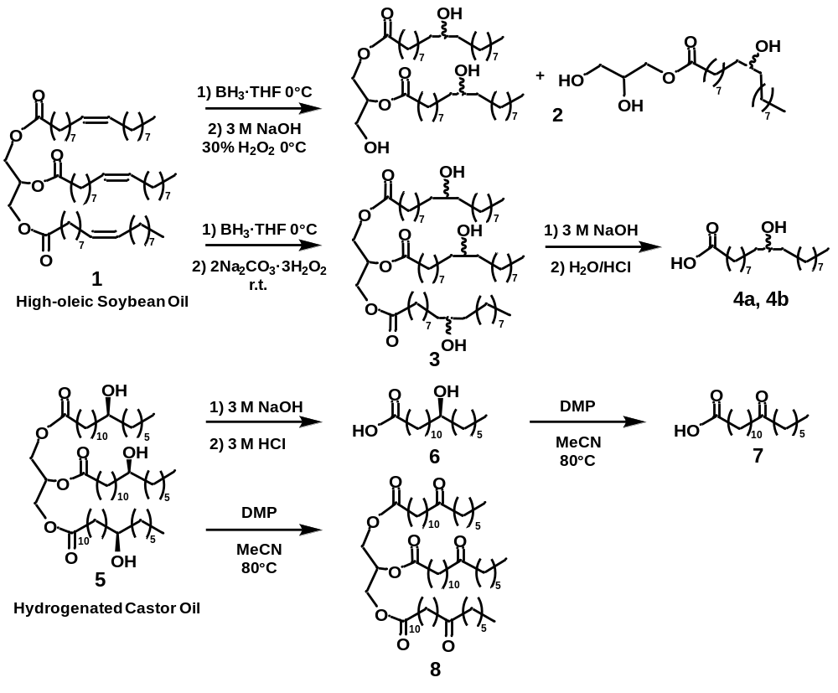
Scheme 2.1. Summary of triacylglycerol modifications. Top: Hydroboration-oxidation of high-oleic soybean oil from both pathways results in a regio- and stereoisomeric mixture of hydroxy fatty acids. Bottom: Oxidation of hydrogenated castor oil and its free fatty acid (i.e. (R)-12-hydroxystearic acid) proceeds quickly to ketone.

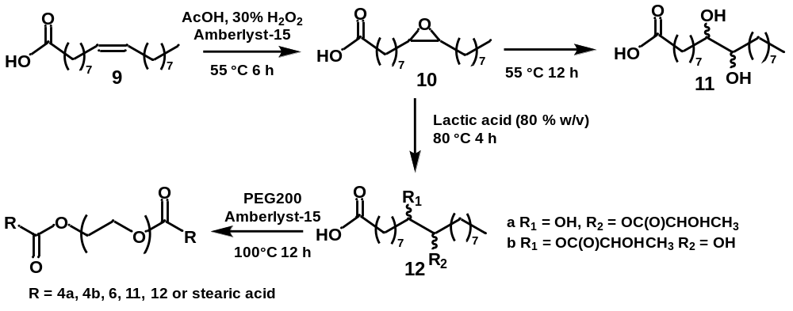
Scheme 2.2. Epoxide ring-opening of oleic acid (9) to afford vicinal diol (10) and mixture of hydroxyl and lactic acid dual functionalized isomers (12a, 12b). Subsequent condensation of 11, 12 and stearic acid with PEG200 affords the corresponding long-chain diester.
Table 2.1. Summary of key physical properties for wax materials.
Entry† | Hardness (mm⁻¹) | Cohesiveness  (g mm) | Melting Point (°C) | Enthalpy of Melting  (J g⁻¹) | Relative Crystallinity⃰ (%)
2 | 0.59 ± 0.04 | 1061 ± 128 | 44-46 | 51.3 ± 5.2 | 17.7 ± 1.8e
3 | 0.68 ± 0.05 | 113 ± 13 | 50-52 | 37.3 ± 4.3 | 12.9 ± 1.5^{ef}
4a-b | 0.30 ± 0.02e | 95 ± 1 | 66-67 | 18.3 ± 0.1 | 6.3 ± 0.4^{f}
5 | 5.33 ± 0.01^{b} | 316 ± 59 | 83-87 | 109.2 ± 0.2 | 37.7 ± 0.6^{cd}
6 | 2.22 ± 0.04^{c} | 1443 ± 30^{c} | 71-72 | 148.4 ± 3.1 | 51.2 ± 1.0^{ab}
7 | 0.63 ± 0.08 | 360 ± 34 | 72-75 | 124.3 ± 29.4 | 42.8 ± 10.1
8 | 0.50 ± 0.09 | 203 ± 49 | 77-78 | 126.8 ± 2.0 | 43.7 ± 0.7
FHSO | 1.6 ± 0.09^{d} | 521 ± 102 | 61-66 | 116.5 ± 0.6 | 40.2 ± 0.2^{bcd}
CAR | 9.05 ± 0.01ª | 7371 ± 1366ª | 81-83 | 180.7 ± 1.3 | 62.3 ± 0.5ª
Paraffin | 0.55 ± 0.01 | 2612 ± 424^{c} | 66-67 | 130.3 ± 4.8 | 44.9 ± 1.6
PEG200D** | 0.66 ± 0.05 | 5628 ± 1221^{b} | 43-44 | 94.9 ± 0.5 | 32.7 ± 0.2^{d}
† refer to Scheme 2.1 for structures
⃰290 J g⁻¹ for a 100% crystalline material
**material previously developed; stearic acid diester bridged with PEG200⁹.
For hardness, cohesiveness, and relative crystallinity columns, means not denoted with a letter are not significantly different at p = 0.05

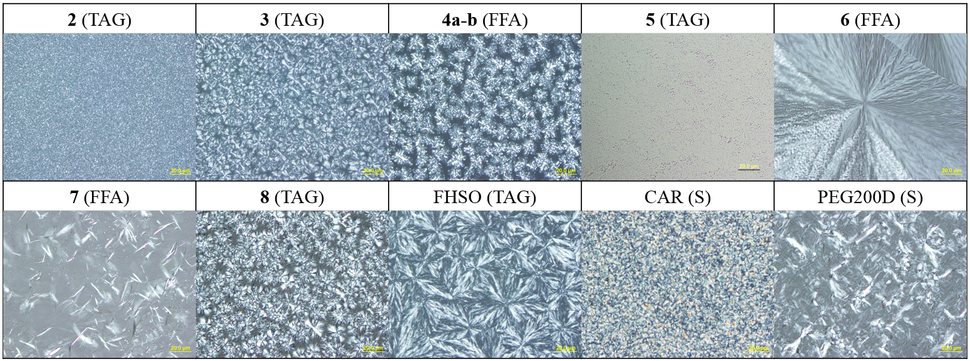
Figure 2.1. Crystal morphology of selected materials cooled at ambient conditions, classified by structural similarity. TAG = triacylglycerol, FFA = free fatty acid, S = straight chain. Scale bar = 20 µm.

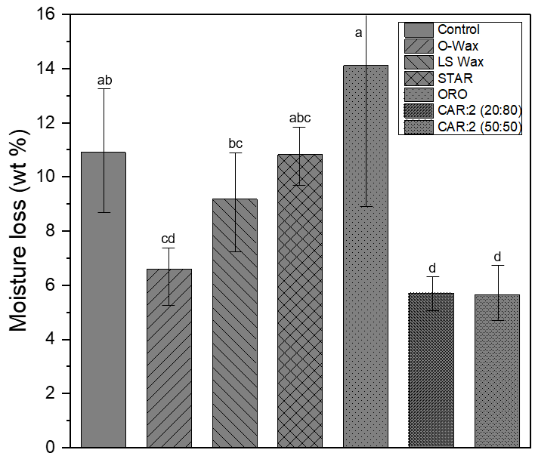
Figure 2.2. Total moisture loss (wt%) of Valencia oranges coated with wax emulsions (0.5 mL per fruit) over a two week storage period at 22-23°C and 65-75% RH. Means with the same letters are not significantly different at p = 0.05. Error bars represent one standard deviation of total moisture loss (wt%) per treatment.

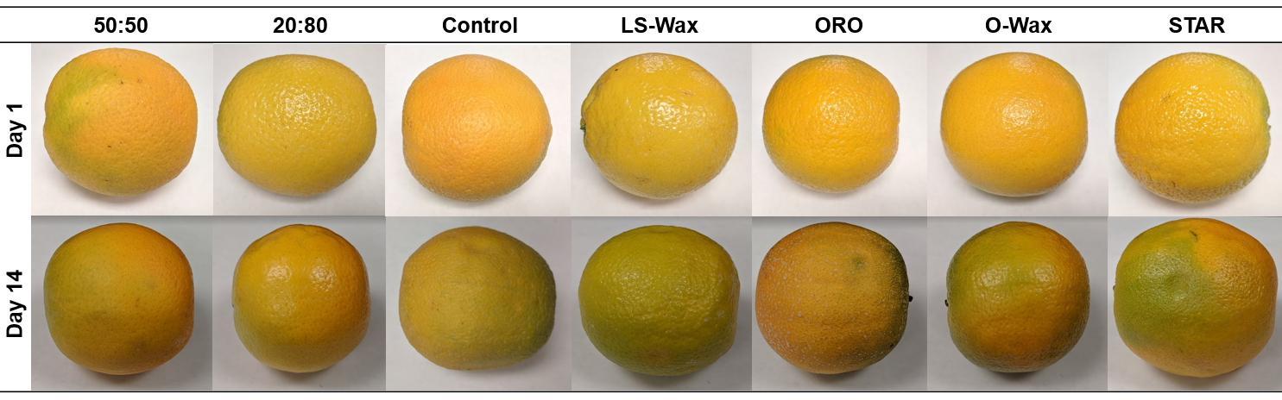
Figure 2.3. Appearance of Valencia oranges coated with wax emulsions (0.5 mL per fruit) over a two week storage period at 22-23°C and 65-75% RH.
Supplementary Figures

¹H, ¹³C, and ¹¹B NMR Spectra

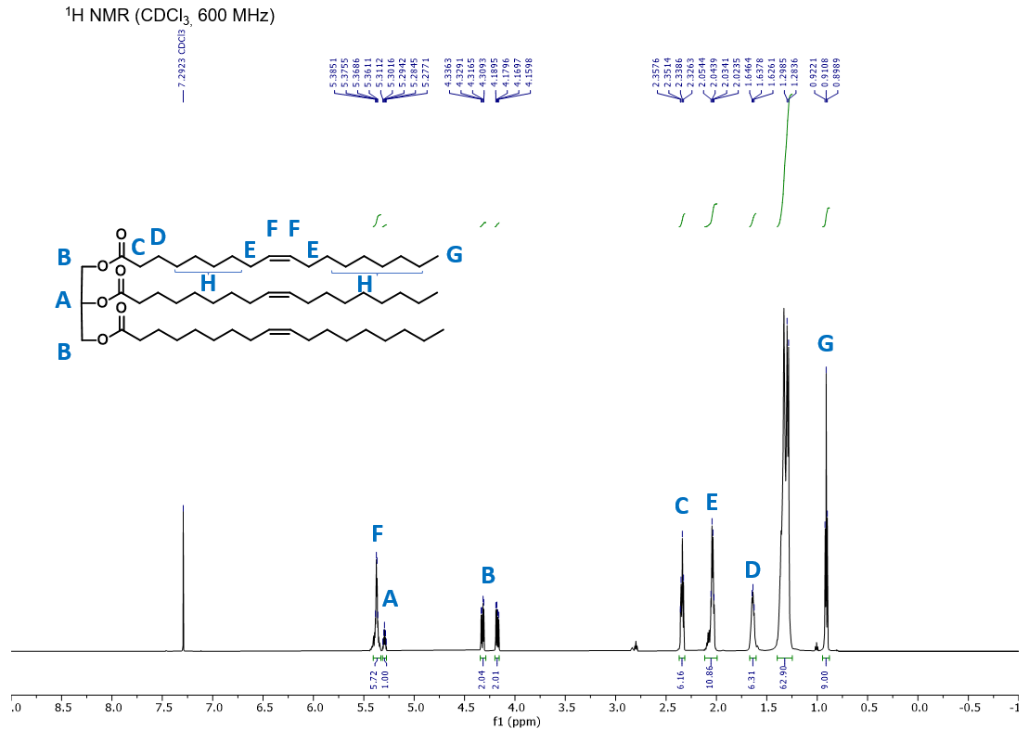
1
Figure 2.4. ¹H NMR spectrum of high-oleic soybean oil (1). ¹H NMR (600 MHz, CDCl₃): δ 5.37 (q, J = 5.1, 4.5 Hz, 6H), 5.29 (m, J = 5.1, 4.5 Hz, 1H), 4.32 (dd, J = 11.9, 4.3 Hz, 2H), 4.17 (dd, J = 11.9, 6.0 Hz, 2H), 2.37 – 2.31 (m, 6H), 2.04 (m, 11H), 1.67 – 1.61 (m, 6H), 1.29 (br, J = 8.9 Hz, 63H), 0.91 (t, J = 7.0 Hz, 9H).
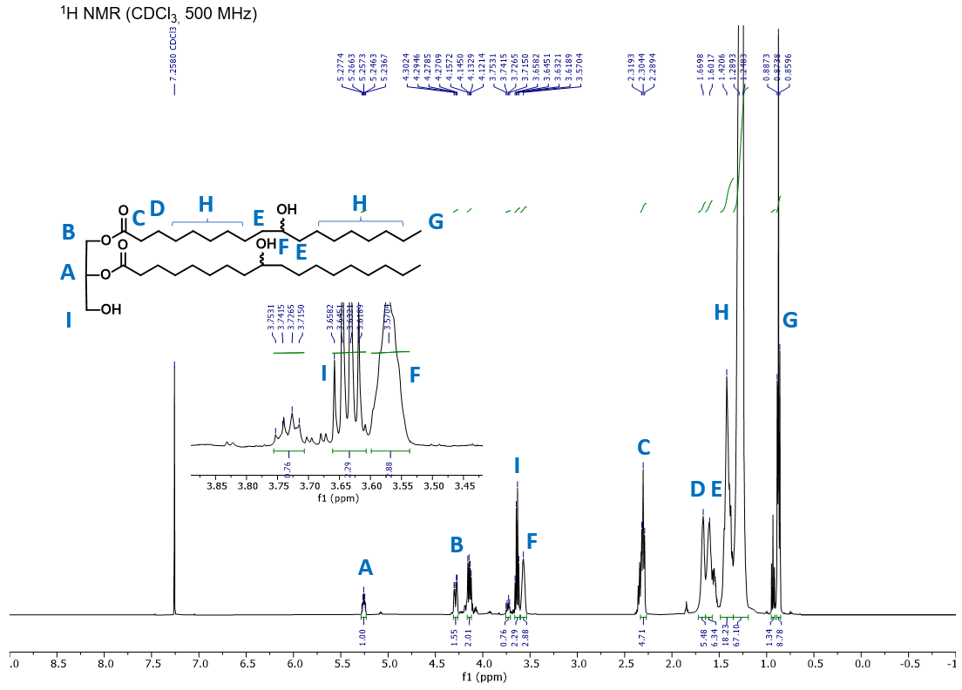
2
Figure 2.5. ¹H NMR spectrum of mixture of mono- and diglycerides of regioisomeric hydroxyoctadecanoic acid (2). ¹H NMR (500 MHz, CDCl₃): δ 5.25 (m, J = 5.5, 4.5 Hz, 1H), 4.30 (dd, J = 11.9, 4.3 Hz, 2H), 4.17 (dd, J = 11.9, 6.0 Hz, 2H), 3.74 (m, 1H), 3.68 (q, J = 13.0, 6.5 Hz, 2H), 3.57 (br, 3H), 2.30 (m, 5H), 1.67 – 1.60 (m, 12H), 1.42 – 1.24 (br, 85H), 0.87 (t, J = 6.9 Hz, 9H).
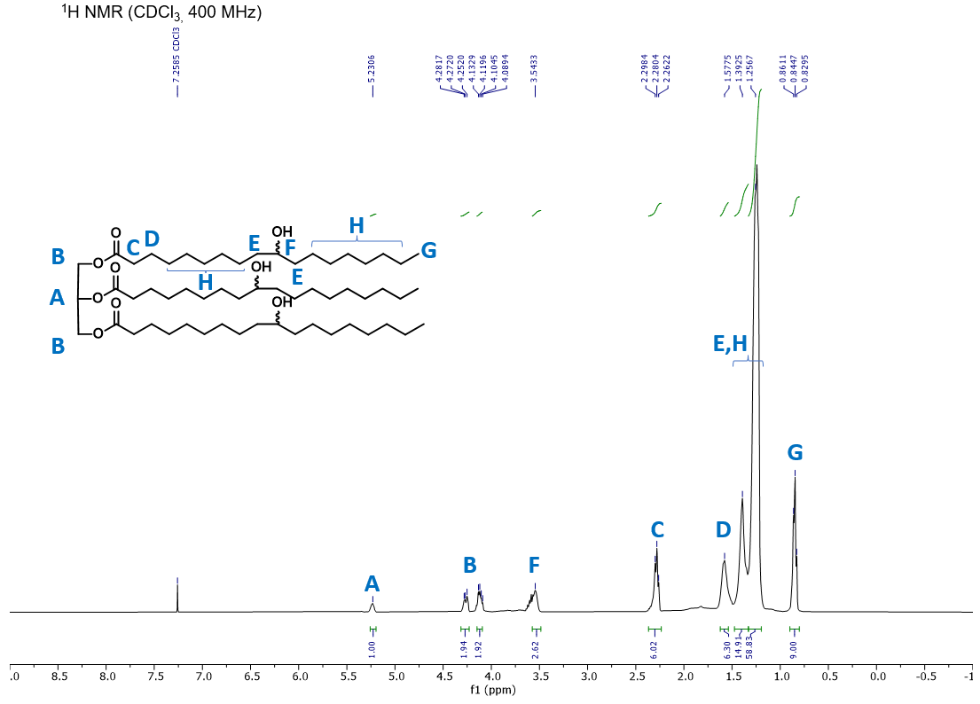
3
Figure 2.6. ¹H NMR spectrum of triglyceride of regio- and stereoisomeric hydroxyoctadecanoic acid (3). ¹H NMR (400 MHz, CDCl₃): δ 5.23 (m, 1H), 4.26 (dd, J = 11.7, 5.7 Hz, 2H), 4.11 (dd, J = 11.7, 5.7 Hz, 2H), 3.54 (m, 3H), 2.28 (t, J = 7.2 Hz, 6H), 1.57 (br, 6H), 1.39-1.26 (br, 74H), 0.85 (t, J = 6.3 Hz, 9H).

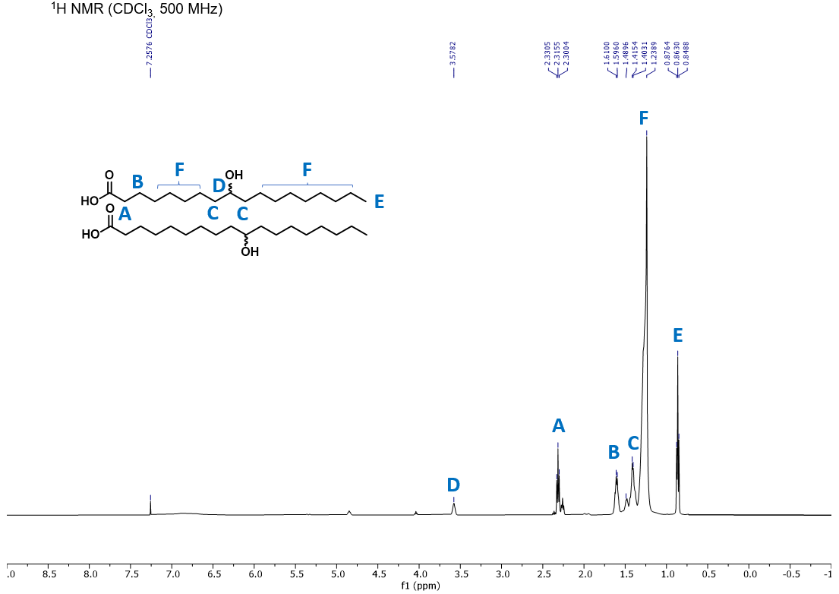
4a,b
Figure 2.7. ¹H NMR spectrum of mixture of 9-hydroxyoctadecanoic (4a) and 10-hydroxyoctadecanoic acid (4b). ¹H NMR (500 MHz, CDCl₃): δ 3.58 (m, 1H), 2.31 (t, J = 7.5 Hz, 2H), 1.60 (m, 2H), 1.41 (m, 4H), 1.24 (br, 22H), 0.86 (t, J = 6.9 Hz, 3H).
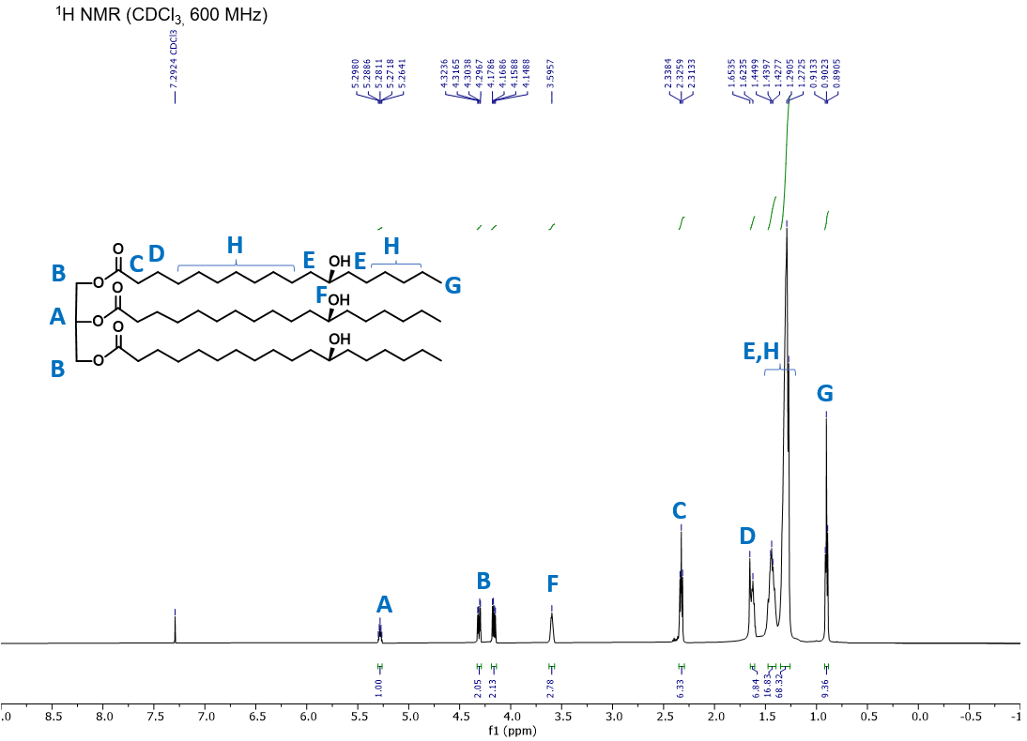
5
Figure 2.8. ¹H NMR spectrum of hydrogenated castor oil (HCO; 5). ¹H NMR (600 MHz, CDCl₃): δ 5.28 (m, 1H), 4.31 (dd, J = 11.9, 4.3 Hz, 2H), 4.16 (dd, J = 11.9, 6.0 Hz, 2H), 3.60 (s, 3H), 2.33 (t, J = 7.5 Hz, 6H), 1.64 (m, 6H), 1.44 (m, 18H), 1.29 (br, 68H), 0.90 (t, J = 6.8 Hz, 9H).

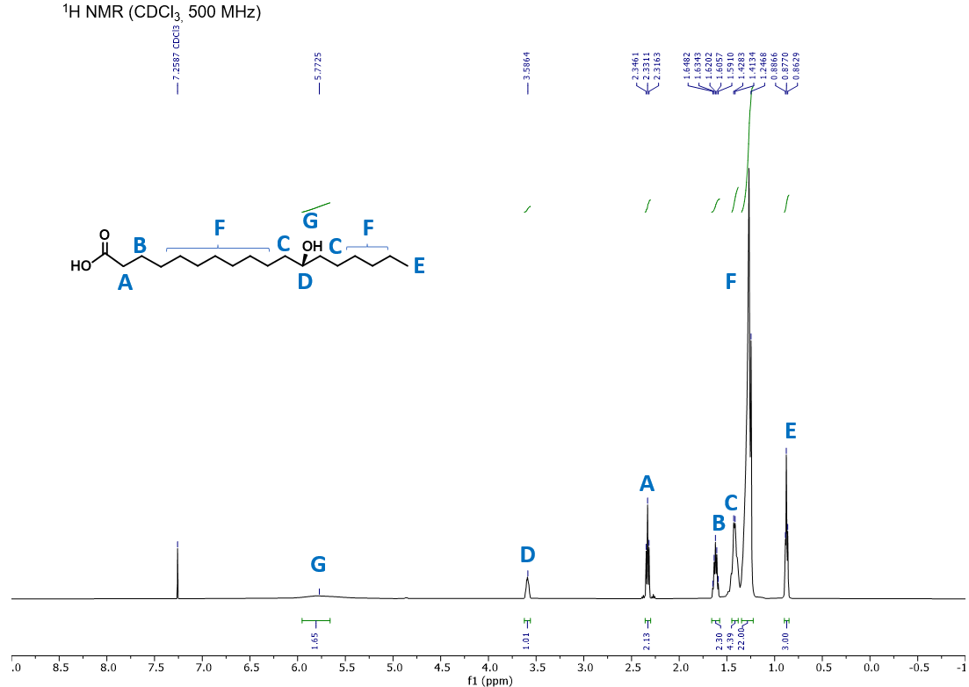
6
Figure 2.9. ¹H NMR spectrum of (R)-12-hydroxyoctadecanoic acid (HCOFFA; 6). ¹H NMR (500 MHz, CDCl₃): δ 3.58 (m, 1H), 2.33 (t, J = 7.5 Hz, 2H), 1.62 (m, 2H), 1.41 (br, 4H), 1.24 (br, 22H), 0.87 (t, J = 6.1 Hz, 3H).

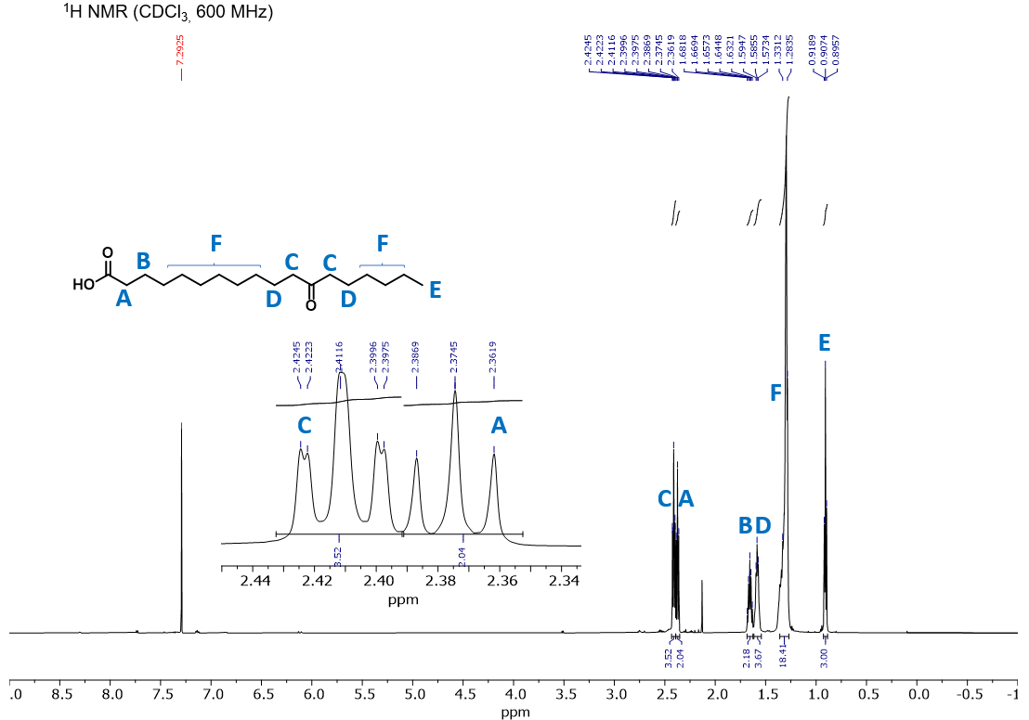
7
Figure 2.10. ¹H NMR spectrum of 12-oxooctadecanoic acid (7). ¹H NMR (600 MHz, CDCl₃): δ 2.41 (dt, J = 7.1, 1.3 Hz, 4H), 2.37 (t, J = 7.5 Hz, 2H), 1.69 (m, 2H), 1.62 (m, 4H), 1.29 (br, 18H), 0.91 (t, J = 7.0, 3H).
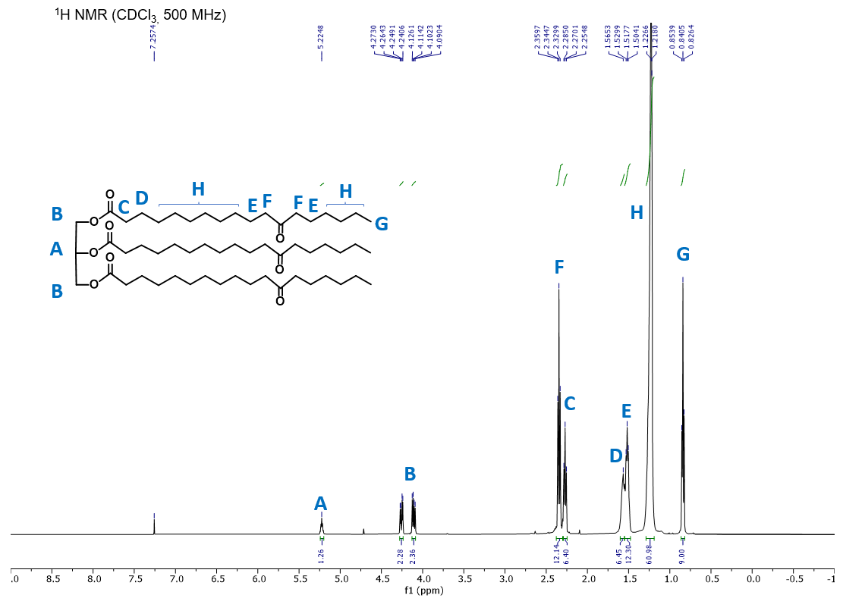
8
Figure 2.11. ¹H NMR spectrum of oxidized hydrogenated castor oil (propane-1,2,3-triyl tris(12-oxooctadecanoate)) (8). ¹H NMR (500 MHz, CDCl₃): δ 5.22 (m, 1H), 4.25 (dd, J = 11.9, 4.3 Hz, 2H), 4.11 (dd, J = 11.9, 6.0 Hz, 2H), 2.34 (t, J = 7.5 Hz, 12H), 2.27 (t, J = 7.5 Hz, 6H), 1.56-1.49 (m, 18H), 1.29 (br, 60H), 0.84 (t, J = 7.0, 9H).

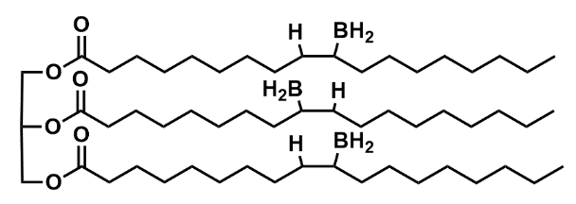
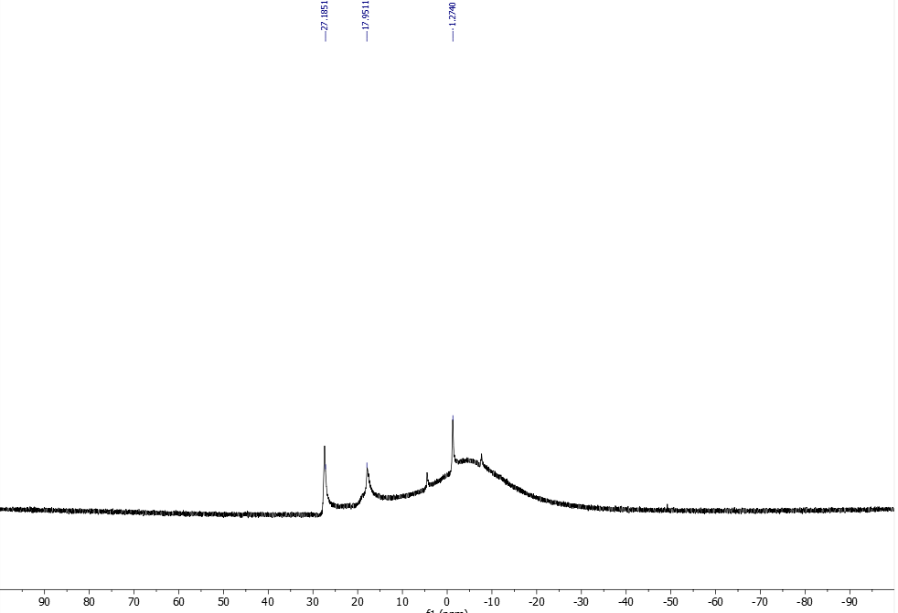
Figure 2.12. ¹¹B NMR spectrum of HOSO monoalkylborane signals at δ 27.18 and 17.95 (excess BH₃-THF observed at δ -1.27).

CHAPTER III
Crystallinity and Water Vapor Permeability of Model n-Alkane, Alcohol, Aldehyde, and Fatty Acid Constituents of Natural Waxes

The following chapter details work reprinted with permission from Industrial and Engineering Chemistry Research, 2021, 60, 146511-14663; Copyright 2021 American Chemical Society. The experimental design, synthesis, physical characterization, and water vapor permeability measurements were performed by the author. Dr. Tong Wang advised this work.

3.1 Abstract
Natural waxes are valuable industrial products consisting of complex chemical mixtures. To probe the structure-function role of select constituents, model n-alkanes, alcohols, aldehydes, and fatty acids of C₁₈₋₁₉, C₂₂₋₂₃, and C₂₆₋₂₇ carbon chain lengths were synthesized and analyzed via calorimetry and X-ray powder diffraction. Pure compounds and binary mixtures crystallized into monoclinic (M), triclinic (T) and orthorhombic (O) lattices or combinations thereof. The C₂₆ aldehyde formed an O lattice and exhibited one solid-solid phase transition similar to n-alkanes. The water vapor permeability (WVP) of model systems cast as films was determined. For pure compounds, WVP decreased in the order: fatty acid > even n-alkane > odd n-alkane > alcohol > aldehyde. Increasing carbon chain length, which translates to increasing unit cell volume, decreased WVP. Binary mixtures generally exhibited a more complex relationship with WVP. These findings may be applicable to the agricultural postharvest, pharmaceutical and paperboard coating industries.

3.2 Introduction
Natural waxes are valuable industrial products with applications in coating and waterproofing, cosmetics, pharmaceuticals, textile processing, inks, paints, polishes, and lubricants.¹ The postharvest coating of agricultural commodities represents an important market for waxes as these provide an effective barrier to moisture loss. Postharvest moisture loss must be mitigated as it decreases the marketable weight and negatively impacts the organoleptic properties of fruits and vegetables. Due to their low water vapor permeability (WVP), natural waxes of botanical and animal origin (e.g., carnauba, candelilla, beeswax) have long been used for the postharvest coating of fruits²⁻⁴ albeit at a premium cost. In contrast, edible coatings formulated from polysaccharide, protein, and lipid mixtures offer myriad functional properties at a low cost but rarely compete with the low WVP of natural waxes. Natural waxes are inherently complex chemical mixtures. As such, it is difficult to ascertain the relationship between their chemistry and functional properties. Notwithstanding H. Bennet’s 1944 commercial wax formulary,¹ information relating wax chemistry to functional properties is scarce. For example, the blending of bulk waxes with fillers and additives has long served as an imprecise means to attain a set of functional properties. As a result, a broad aim of this work was to explore whether the desirable properties of a bulk wax mixture, in this case low WVP, could be traced to specific constituent entities.
Understanding how plants utilize waxes to control moisture loss can provide invaluable insights for our purpose. The plant cuticle is recognized as the primary barrier to moisture loss as well as chemical, physical, and biological attack.⁵⁻⁸ Lipidic layers comprising the cuticle vary in chemical composition and ultrastructure among different genera, species, and organs. Intracuticular layers are generally composed of very-long chain (VLC; ≥ 22 carbon chain lengths) n-alkanes, alcohols, aldehydes, fatty acids, wax esters and triterpenoids (collectively referred to as “waxes”) interspersed within an amorphous polyester matrix known as cutin.⁵⁻⁶ Epicuticular layers are generally composed of VLC n-alkanes, alcohols, aldehydes, fatty acids, and ketones exhibiting various crystal morphologies and structures.⁹⁻¹¹ Electron and X-ray diffraction analyses of intact epicuticular waxes from 35 different plant species have revealed that despite a large diversity in chemical composition, most waxes exist as either orthorhombic (O), triclinic (T) or hexagonal (H) lattices and mixtures thereof.⁹ The distinction between amorphous and crystalline waxes is essential; in the accepted model, diffusion of water occurs through the amorphous rather than crystalline regions as crystals are considered impermeable.¹² For example, studies on tomato mutants with up to a 95% reduction of cutin have suggested that the amorphous biopolymer does not contribute to the control of moisture loss. In contrast, the selective removal of the wild-type epicuticular wax crystals resulted in a two- to four-fold increase in cuticle WVP.¹²
Reports on the cuticular wax composition of sweet oranges, an agricultural commodity of enormous economic significance worldwide, serve as a fitting case study. Selective analyses of the epicuticular wax of Newhall oranges have revealed a predominance of C₂₃₋₃₃ odd n-alkanes, C₂₆ aldehydes, and C₂₆₋₃₂ even fatty acids throughout development.¹³ Total cuticular wax analyses of both Newhall and Navelate oranges have likewise revealed a predominance of C₂₃₋₃₃ odd n-alkanes and C₂₂₋₃₀ even aldehydes.¹⁴⁻¹⁵ Mutations that alter the cuticular wax composition impart a glossy appearance to the fruit. Newhall and Navelate ‘glossy’ mutants have been shown to accumulate significantly lower amounts of VLC odd n-alkanes and C₂₆ aldehydes, as well as higher amounts of fatty acids in their epicuticular wax. For Newhall ‘glossy’ mutants, Liu and coworkers¹³ concluded both n-alkanes and aldehydes were required for deposition of epicuticular wax crystals. For Navelate ‘glossy’ mutants, Romero and Lafuente¹⁵ directly correlated the increase in fatty acids to an increase in cuticle WVP. In light of these reports, we decided that a model study interrogating the relationship between wax chemistry, crystallinity, and WVP was warranted and indeed relevant to other industries beyond agriculture.
Thus, the primary objective of this work was to probe the relationships between crystal structure and WVP for pure n-alkanes, alcohols, aldehydes, fatty acids, and select binary mixtures thereof. A secondary objective was to probe the crystallinity of aliphatic aldehydes as these are ubiquitous yet poorly characterized constituents of natural and cuticular waxes.
To directly relate our model to the sweet orange cuticular waxes, we chose to investigate the C₁₈, C₂₂, and C₂₆ even n-alkanes, alcohols, aldehydes, and fatty acids in addition to the C₁₉, C₂₃, and C₂₇ odd n-alkanes. The VLC (C₂₂-₂₇) constituents were chosen based on their natural predominance in natural and cuticular waxes. The shorter (C₁₈-₁₉) constituents are not present in appreciable quantities in these systems and were chosen for comparison.^{13, 16} The crystallinity of pure compounds and binary mixtures was examined via differential scanning calorimetry (DSC) and powder X-ray diffraction (XRD) and the respective WVPs determined. Information regarding the WVP of these model compounds will serve to advance our current understanding of natural and cuticular wax crystallinity and concomitant functional properties. More tangibly, this information may serve as useful guidance for the development of postharvest coatings for agricultural commodities.

3.3 Materials and Methods
3.3.1 Materials
n-Octadecane (1a), n-nonadecane (1b), octadecan-1-ol (2), octadecanoic acid (4), n-docosane (5a), n-tricosane (5b), docosan-1-ol (6), docosanoic acid (8), and n-hexacosane (9a) were purchased from commercial sources with >99.1% purities by GC (Appendix).
Octadecanal (3), docosanal (7), n-heptacosane (9b), hexacosan-1-ol (10), hexacosanal (11) and hexacosanoic acid (12) were synthesized in this work (Schemes 3.1-3.2) with >99.1% purities by GC (9b, 95.1% purity; Appendix).

3.3.2 Syntheses
General. All manipulations were performed under dry N₂ using standard air-free techniques. Glassware was either dried overnight in a 120 °C oven or flame-dried prior to use and cooled under a stream of dry N₂. Methyllithium was titrated with LiCl/I₂ prior to use. Tetrahydrofuran (THF) and acetone were pre-dried over 3 Å molecular sieves and distilled before use. Other solvents were used as received unless otherwise noted. Thin layer chromatography (TLC) was performed using silica gel 60 coated plates and visualized with ceric ammonium molybdate (CAM) or 2,4-dinitrophenylhydrazine (DNP) stains. All compounds, solvents and reagents were purchased from commercial sources (Acros Organics, TCI, Alfa Aesar, MilliporeSigma) and used as received unless otherwise noted.
¹H and ¹³C NMR spectra were acquired with a Varian VR500 500 MHz spectrometer using CDCl₃ with 1% tetramethylsilane (TMS) as solvent. Chemical shifts are reported relative to TMS signal. GC-FID and GC-MS analyses were performed on a Shimadzu GC-2010 and Agilent 7890B /5977N MS chromatographs, respectively, using a non-polar HP-5 (5%-phenyl methylpolysiloxane, 30 m × 0.25 mm i.d., 0.25 µm film thickness) capillary column (J&W Scientific) with a He carrier gas flow rate of 1.5 mL min⁻¹, 1:20 split ratio and the following temperature program: 1 min hold at 100 °C, followed by 10 °C min⁻¹ ramp to 320 °C held for 10 min, with injector at 250 °C and detector at 325 °C. Additional synthetic confirmation for methyl hexacosanoate (13) and n-heptacosane (9b) was achieved by comparing against certified reference standards and/or mass. Methyl stearate was used as internal standard to calculate percent purity of all synthetic compounds.

11-Iodoundecanoic Acid (15). A 100 mL round-bottom flask was equipped with an egg-shaped stir bar and charged with 11-bromoundecanoic acid (2.65 g, 10.0 mmol), anhydrous sodium iodide (1.80 g, 12.0 mmol), and anhydrous acetone (50 mL). The contents were refluxed for 6 h under darkness or until TLC confirmed full conversion (R_{f} =0.32, 80:20 hexane:ethyl acetate). Acetone was removed by evaporation and the remaining solids dissolved with stirring in deionized water (30 mL), 0.1 M Na₂S₂O₃ (5 mL), and diethyl ether (30 mL) for 15 min. The colorless biphasic mixture was extracted with diethyl ether (2× 30 mL). The pooled extracts were washed with deionized water (20 mL) and saturated brine (20 mL), dried over MgSO₄, concentrated, and further dried under high-vacuum overnight to afford a white crystalline solid (2.90 g, 93% yield). The iodide was used without purification. ¹H NMR (500 MHz, CDCl₃) δ 3.19 (t, J = 7.0 Hz, 2H), 2.35 (t, J = 7.4 Hz, 2H), 1.81 (quint, J = 14.6, 7.0 Hz, 2H), 1.63 (quint, J = 15.3, 7.5 Hz, 2H), 1.37-1.29 (br, 12H).

Methyl 11-Iodoundecanoate (14). A 100 mL round-bottom flask was equipped with an egg-shaped stir bar and charged with 11-iodoundecanoic acid (3.12 g, 10.0 mmol) and 2% (v/v) H₂SO₄ in methanol (30 mL). The mixture was refluxed for 6 h or until TLC confirmed full conversion (R_{f} =0.63, 80:20 hexane:ethyl acetate). The pale yellow solution was diluted with deionized water (30 mL) and extracted with diethyl ether (2× 30 mL). The pooled extracts were washed with saturated brine (2× 30 mL) and 10% aq. NaHCO₃ (30 mL). The organic extract was dried over MgSO₄, concentrated, and further dried under high-vacuum overnight to afford a pale yellow crystalline solid which was used without purification (3.06 g, 94% yield). ¹H NMR (500 MHz, CDCl₃) δ 3.66 (s, 3H), 3.18 (t, J = 7.0 Hz, 2H), 2.30 (t, J = 7.4 Hz, 2H), 1.81 (quint, J = 14.6, 7.0 Hz, 2H), 1.60 (quint, J = 14.8, 7.4 Hz, 2H), 1.37-1.28 (br, 12H).

Methyl Hexacosanoate (13). A 100 mL three-necked round-bottom flask was equipped with an egg-shaped stir bar and a condenser. The flask was charged with freshly tarnished magnesium turnings (0.77 g, 31.7 mmol) and the apparatus flame dried under high-vacuum. Neat 1-bromopentadecane (7.70 g, 26.5 mmol; previously dried by passing through activated alumina) was added dropwise to the stirring magnesium in anhydrous THF (30 mL) under a dry N₂ atmosphere. The mixture was refluxed for 4 h, with formation of the Grignard reagent assisted by addition of methyl iodide (50 µL). Note: allowing the Grignard preparation to cool may result in formation of a white precipitate (triacontane: m/z 422, 365, 323) and preclude a successful reaction. The turbid, dark gray Grignard preparation was transferred hot via cannulation to a stirring, bright yellow suspension of methylcopper at -70 °C.
The methylcopper suspension was prepared in a 250 mL two-necked round-bottomed flask by addition of ethereal 1.6 M methyllithium (17.5 mL, 28.1 mmol) to a suspension of copper(I) iodide (5.19 g, 27.2 mmol) in anhydrous THF (30 mL) at -70°C. The mixture was stirred at -70 °C, subsequently warmed to 0 - 20°C, and immediately cooled to -70 °C. Note: when using purified copper(I) iodide, the cloudy white to pale yellow suspension initially formed at -70 °C became bright yellow upon gradual warming to 0 – 20 °C. When using copper(I) iodide directly from the bottle (≥99.5%), the initial tan suspension became bright yellow immediately after addition of methyllithium. Aside from these observations, there was no difference in yields when using either purified or commercial copper(I) iodide.
The dark orange Grignard-methylcopper complex was stirred at -70 °C for 1 h, subsequently warmed to 0 °C to give a maroon or violet color, and immediately cooled to -70 °C. A solution of methyl 11-iodoundecanoate (9.77 g, 29.4 mmol) in anhydrous THF (5 mL) was added dropwise via a syringe and the mixture stirred at -70 °C for 1 h first, followed by gradual warming to 22 °C and stirred for 6 h.
The maroon-black reaction mixture was quenched at 0 °C by addition of saturated NH₄Cl (30 mL), stirred until dark blue, and extracted with diethyl ether (2× 60 mL). The pooled extracts were washed with saturated brine (2× 30 mL), dried over MgSO₄ and concentrated under vacuum to afford a yellow oil. The product was recrystallized from ethanol to afford a white crystalline solid (6.41 g, 61% yield from iodide). R_{f} =0.71 (80:20 hexane:ethyl acetate). ¹H NMR (500 MHz, CDCl₃) δ 3.68 (s, 3H), 2.30 (t, J = 7.5 Hz, 2H), 1.61 (quint, J = 14.8, 7.6 Hz, 2H), 1.28-1.25 (br, 44H), 0.87 (t, J = 6.9 Hz, 3H).

General Procedure for Hydrolysis of Methyl Esters to Fatty Acids. A 250 mL round-bottom flask was equipped with an egg-shaped stir bar and charged with methyl ester (20 mmol) and 2 N LiOH (24 mmol) in THF (30 mL). The contents were stirred at 22°C for 20 h or until TLC confirmed full conversion (80:20 hexane: ethyl acetate stain). The mixture was acidified with 2 N HCl (26 mmol) and cooled to -10 °C to precipitate the product. Filtration and recrystallization from 50:50 ethanol: acetic acid afforded a white crystalline solid (94% yield). Hexacosanoic acid (12): R_{f} =0.36 (80:20 hexane:ethyl acetate). ¹H NMR (500 MHz, CDCl₃) δ 2.34 (t, J = 7.4 Hz, 2H), 1.63 (quint, J = 14.7, 7.4 Hz, 2H), 1.25 (br, 44H), 0.88 (t, J = 6.9 Hz, 3H).

General Procedure for Reduction of Fatty Acids to Aliphatic Alcohols. A 250 mL two-necked round-bottom flask was equipped with an egg-shaped stir bar and charged with fatty acid (2-10 mmol) in anhydrous THF (60 mL). The solution was cooled to 0 °C and 2.0 M borane-dimethyl sulfide complex (1.1 equiv.) was added dropwise via a syringe. The cloudy mixture was warmed and stirred at 22 °C for 6 h or until TLC confirmed full conversion (50:50 hexane: diethyl ether). Note: the triacyloxiborane intermediate may precipitate from solution although this does not preclude a successful reaction. The mixture was cooled to 0 °C and hydrolyzed by dropwise addition of deionized water (10 mL). The cloudy mixture was stirred with additional water (30 mL) for 1 h and extracted with chloroform (2× 30 mL). The pooled extracts were washed with saturated brine (2× 30 mL), dried over MgSO₄, concentrated, and further dried under high-vacuum overnight to afford a white crystalline solid (97% yield). The product could also be purified by recrystallization from ethanol. Hexacosan-1-ol (10): R_{f} =0.46 (80:20 hexane:ethyl acetate). ¹H NMR (500 MHz, CDCl₃) δ 3.64 (t, J = 6.8 Hz, 2H), 1.57 (quint, J = 14.8, 6.8 Hz, 2H), 1.25 (br, 46H), 0.88 (t, J = 6.9 Hz, 3H).

General Procedure for Oxidation of Aliphatic Alcohols to Aldehydes. A 250 mL two-necked round-bottom flask was equipped with an egg-shaped stir bar, charged with the alcohol (2-10 mmol) and dissolved in warm chloroform (100 mL) with water (50 µL). To the clear solution, Dess-Martin periodinane (DMP; 1.1 equiv.) was added over the course of 0.1-1 h and the cloudy suspension stirred at 22 °C for 4-10 h or until TLC confirmed full conversion (80:20 hexane:ethyl acetate). The white slurry was filtered through a sintered funnel with a pad of alumina over Celite. The clear filtrate was washed repeatedly with 0.1 M Na₂S₂O₃ (20 mL) and 10% aq. NaHCO₃ (50 mL). The aqueous layer was extracted with chloroform (30 mL). The pooled extracts were washed with saturated brine (2× 30 mL), dried over MgSO₄ and filtered through a sintered funnel with pad of alumina over Celite. The organic extract was concentrated under vacuum to afford a white crystalline solid (83-90% yield). Note: the aldehydes are labile over prolonged storage and must be stored under dry N₂ at room temperature. A cloudy-white melt signals the presence of DMP-derived impurities. If needed, purification can be accomplished by column chromatography. Octadecanal (3): R_{f} =0.70 (80:20 hexane:ethyl acetate). ¹H NMR (500 MHz, CDCl₃) δ 9.76 (t, J = 1.9 Hz, 1H), 2.41 (dt, J = 7.4, 1.9 Hz, 2H), 1.62 (quint, J =14.7, 7.4 Hz, 2H), 1.29-1.25 (br, 28H), 0.87 (t, J = 6.9 Hz, 3H). Docosanal (7): R_{f} =0.72 (80:20 hexane:ethyl acetate). ¹H NMR (500 MHz, CDCl₃) δ 9.76 (t, J =1.9 Hz, 1H), 2.41 (dt, J = 7.4,1.9 Hz, 2H), 1.63 (quint, J = 14.7, 7.4 Hz, 2H), 1.29-1.25 (br, 36H), 0.88 (t, J = 6.9 Hz, 3H). Hexacosanal (11): R_{f} =0.77 (80:20 hexane:ethyl acetate). ¹H NMR (500 MHz, CDCl₃) δ 9.76 (t, J = 1.9 Hz, 1H), 2.41 (dt, J = 7.4, 1.9 Hz, 2H), 1.62 (quint, J = 14.8, 7.5 Hz, 2H), 1.29-1.25 (br, 44H), 0.88 (t, J = 6.9 Hz, 3H)

n-Heptacosane (9b). Using the procedure for 13, the pentadecyl Grignard-methylcopper complex was treated with 1-iodododecane (prepared from 1-bromododecane using the procedure for 15) in anhydrous THF (4 mL). The mixture was stirred at -70 °C for 1 h first, followed by gradual warming to 22 °C over the course of 4 h. The maroon-black reaction mixture was quenched at 0 °C by addition of saturated NH₄Cl (30 mL), stirred until dark blue, extracted with chloroform (2× 30 mL) and worked-up as before. The pale yellow oil was recrystallized from pentane to afford a white crystalline solid (71% yield from iodide). R_{f} =0.91 (80:20 hexane:ethyl acetate). ¹H NMR (500 MHz, CDCl₃) δ 1.27 (br, 50H), 0.89 (t, J = 6.9 Hz, 6H).

3.3.3 Preparation of Binary Mixtures
Binary mixtures of equal carbon chain lengths were prepared by mixing equal parts (wt.%) of compounds 1-12 in a dry N₂ flushed glass vial, melting the mixture at 10 °C above the highest melting point component, and cooling under ambient conditions. The following binary mixtures were prepared: odd n-alkane:alcohol, odd n-alkane:aldehyde, odd n-alkane:fatty acid, alcohol:aldehyde, alcohol:fatty acid, and aldehyde:fatty acid.

3.3.4 Differential Scanning Calorimetry (DSC)
Melting onset temperature and degree of crystallinity were determined with a Discovery DSC 250 (TA Instruments) calorimeter via the following temperature program: 10 °C min⁻¹ ramp to 90 °C, hold for 3 min, 10 °C min⁻¹ ramp to 20 °C, hold for 3 min, 10 °C min⁻¹ ramp to 90 °C. For the bulk materials, the enthalpy of fusion of the second heating curve was used for degree of crystallinity calculations.
To verify the degree of crystallinity of materials cast as films remained unchanged, a film was ground immediately after WVP determination and analyzed. The enthalpy of fusion of the first heating curve was used for this calculation. Unless otherwise noted, the degree of crystallinity of cast films was within ± 2-8% of the value for the bulk materials.

3.3.5 Powder X-ray Diffraction (XRD)
Diffraction patterns were acquired with an Empyrean (Malvern Panalytical) diffractometer using monochromatic Cu-Kα radiation (λ =1.54 Å) at 25 °C from 3-60° 2θ. Materials were gently ground into a fine powder using a mortar at 16-20°C and stored in N₂ flushed vials prior to analysis. Data was processed using HighScore Plus crystallographic software and diffraction patterns verified against the PDF-4+ ICDD database where applicable.
To verify the structure of materials cast as films remained unchanged, films were ground immediately after WVP determination and analyzed. Unless otherwise noted, the XRD patterns for cast films were identical to the bulk materials.

3.3.6 Water Vapor Permeability (WVP) Determination
Pure films could not be cast from the melt without cracking or damaging during handling. As such, molten materials were cast on a clear cellulose diacetate support film (~75 µm thick) due to its high WVP. A variety of tools such as a drawdown bar, drawdown block, or steel straightedge with spacings could be used to cast a uniform film on the surface of the support film. The only requirement was for these tools to be heated to prevent premature crystallization.
The cellulose diacetate support film was taped to a glass slide and the assembly warmed above the melting point of the material on a separate hot plate. To cast the film, molten material (~0.5 – 1 g) was poured or pipetted on the support film assembly and quickly drawn in one motion. The assembly was removed from the hot plate and allowed to cool under ambient conditions. The test area was reduced to 5.01 x 10⁻⁴ m² using aluminum tape masks for all samples. Films were cut with a precision knife and the average thickness determined by measuring at six different locations with a micrometer. Different material film thicknesses ranged from 0.2 – 1.2 mm after subtraction of the cellulose diacetate film thickness.
Films were mounted onto aluminum Fisher-Payne permeability cups and WVP determined gravimetrically according to the ASTM E96/E96M-16 desiccant method. Aluminum cups were pre-dried in an oven and cooled in a desiccator. The cups were charged with anhydrous silica gel containing cobalt(II) chloride indicator (~2 g). Films were mounted on Parafilm strips serving as a gasket, covered with an aluminum washer, and held with six screw clamps. The assembly was stored in a chamber at 100% relative humidity (RH) and 23.4 ± 0.3 °C. Weight gain (g) was monitored hourly throughout the course of 8 h after equilibrating for 1 h (for additional details on the experimental setup see Appendix).
Water vapor transmission rate (WVTR; g s⁻¹ m⁻²) describes the steady state flow of water vapor (g) per unit time (s) through unit area (m²) at a specific RH and temperature. WVTR was determined as the slope of the linear regression plot (R² > 0.98) of moisture weight gain versus time and divided by the exposed film area.
Water vapor permeance (P; g s⁻¹ m⁻² Pa⁻¹) describes WVTR by unit vapor pressure difference (Pa) and was calculated from equation 1
P =WVTR/S (RH₁-RH₂) (1)
where S is the saturation vapor pressure at the test temperature (2812 Pa at 23 °C), RH₁ is the humidity in the test chamber (100%) and RH₂ is the humidity inside the aluminum cup with anhydrous desiccant (0%).
The WVP (g s⁻¹ m⁻¹ Pa⁻¹) is P per unit thickness (m) and calculated from equation 2.
WVP = P × thickness (2)
This quantity is an intrinsic property of the material and provided for simplicity. Under the experimental conditions, the WVP of the cellulose diacetate support film was determined to be 1.74 ×10⁻¹⁰ g m⁻¹ s⁻¹ Pa⁻¹. All reported WVP values represent the average of three replicates.

3.4 Results
3.4.1 Crystallinity of Pure Compounds
XRD patterns for bulk odd n-alkanes (1b, 5b, 9b), alcohols (2, 6, 10), aldehydes (3, 7, 11) and fatty acids (4, 8, 12) are depicted in Figure 3.1. Table 3.1 lists the codes and compound names for reference. These homologous series differ by four -CH₂- units and were chosen based on their distribution in the cuticular wax of sweet orange cultivars as previously discussed. Figure 3.2 depicts crystal structure representations for model even and odd n-alkanes, alcohols, and fatty acids.
n-Alkanes. Odd n-alkanes of 13 ≤ C_{n} ≤ 41 are known to form O lattices and exhibit characteristic 4.13 and 3.72 Å d-spacings corresponding to the (110) and (200) reflections, respectively.^{9, 17} Compounds 1b, 5b, and 9b exhibited these reflections in addition to periodic structures as suggested by small-angle reflections. The even n-alkanes 1a, 5a, and 9a formed T lattices as evidenced by the three (010), (100) and (110) reflections with 4.58, 3.80 and 3.60 Å d-spacings, respectively (Appendix). Even n-alkanes of 14 ≤ C_{n} ≤ 26 are known to form T lattices, while those of 26 < C_{n} ≤ 38 form pseudo- to monoclinic (M) lattices.¹⁷⁻¹⁹ Figures 3.2a-b depict crystal structure representations for 1a and 5b.
Alcohols. Alcohols 2, 6 and 10 exhibited two intensive reflections with 4.08 and 3.62 Å d-spacings, characteristic of the M γ-form. In the γ-form, the molecules pack in bimolecular layers tilted with respect to the basal plane and are held together by continuous chains of hydrogen bonds along one of the basal axes (Fig. 3.2c). The aliphatic chains pack in the stable orthorhombic perpendicular (O⊥) subcell.¹⁷
Aldehydes. Aldehydes 3 and 7 exhibited reflections with 4.59, 3.77 and 3.50 Å d-spacings suggestive of a T lattice. VLC aldehyde 11 exhibited only two reflections with 4.12 and 3.73 Å d-spacings suggestive of an O lattice. To the best of our knowledge, there is currently no XRD data available for VLC aldehydes. Single crystal X-ray data is warranted for unambiguous confirmation of these tentative assignments.
Fatty acids. Fatty acids 4, 8, and 12 exhibited two intensive wide-angle reflections with 4.11, and 3.69 Å d-spacings characteristic of the M B-form. In the B-form, the molecules form hydrogen-bonded centrosymmetric dimers and the aliphatic chains pack in the O⊥ subcell (Fig. 3.2d).¹⁷ A detailed description of this structure will be considered in the proceeding sections.

3.4.2 Crystallinity of Binary Mixtures
Binary mixtures were prepared in 50:50 ratio to gain an insight as to the predominant structure formed between two different compounds. Several plants exhibit mutations wherein expression of one, two, or more wax constituents is decreased. This results in an enrichment of specific compounds and thus specific crystal structures. Figures 3.3-3.4 depict XRD patterns and DSC thermograms for all binary mixtures as bulk materials.
C₁₈₋₁₉ binary mixtures. XRD patterns (Fig. 3.3a) were generally broad and low intensity. Accordingly, the degree of crystallinity of these mixtures was generally low (Table 3.2). For the odd n-alkane:alcohol (1b:2) binary mixture, XRD and DSC suggested the coexistence of both pure compound O and M lattices. Notably, odd n-alkane:aldehyde (1b:3) and alcohol:aldehyde (2:3) binary mixtures did not exhibit the T reflections of the pure aldehyde. Instead, two intensive reflections approximating an O lattice suggested the aldehyde may be incorporated into the lattices of the odd n-alkane and alcohol. For 2:3, DSC supports this assertion as only one broad endotherm was observed. For 1b:3 however, DSC suggested that small amounts of pure 3 coexist as a separate lattice. The aldehyde:fatty acid (3:4) and odd n-alkane:fatty acid (1b:4) binary mixtures exhibited intensive fatty acid M reflections in both wide- and small-angle regions. DSC confirmed the coexistence of separate lattices. The alcohol:fatty acid (2:4) binary mixtures exhibited three intensive reflections approximating a T lattice and formed a eutectic solid solution.
C₂₂₋₂₃ binary mixtures. XRD patterns (Fig. 3.3b) exhibited sharper reflections and a higher degree of crystallinity than the lower homologues. The odd n-alkane:alcohol (5b:6) binary mixture was characterized by the coexistence of both pure compound O and M lattices. The same trends for the aldehyde binary mixtures (5b:7 and 6:7) were observed and supported by DSC. The pure aldehyde T reflections were lost, and predominantly O reflections of higher intensity were manifest. Similarly, the fatty acid mixtures (7:8 and 5b:8) exhibited fatty acid M reflections, although of lower intensity. Again, DSC confirmed the coexistence of separate lattices. The alcohol:fatty acid (6:8) binary mixture formed a eutectic solid solution with T reflections.
C₂₆₋₂₇ binary mixtures. XRD patterns (Fig. 3.3c) followed some of the trends of the lower homologues and exhibited higher intensities yet a lower degree of crystallinity. In line with the lower homologues, the odd n-alkane:alcohol (9b:10) binary mixture was characterized by the coexistence of both pure component O and M lattices. The odd n-alkane:aldehyde (9b:11) and alcohol:aldehyde (10:11) binary mixtures exhibited only two reflections suggestive of an O lattice. In the DSC thermograms of these two binary mixtures, a weak endotherm was manifest between 50-55°C. This feature complicated the characterization of the binary mixtures as solid solutions (unlike 2:3 and 6:7) and will be discussed in the proceeding section. Although the odd n-alkane:fatty acid (9b:12) binary mixture exhibited intensive O reflections, DSC suggested the coexistence of separate lattices. The aldehyde:fatty acid (11:12) binary mixture exhibited only two intensive reflections with 4.09 and 3.72 Å d-spacings. DSC demonstrated, however, that both components coexist as separate lattices. The alcohol:fatty acid (10:12) binary mixture in this case exhibited reflections of the pure M lattice although the weak endotherm at 64°C seen via DSC complicated its characterization as eutectic solid solution.

3.4.3 Water Vapor Permeability of Pure Compounds
Table 3.2 lists the crystal structure, degree of crystallinity and WVP for pure compounds as bulk materials. All films were analyzed via DSC and XRD after fabrication and were found to have the same structure and similar degree of crystallinity as the bulk material unless otherwise noted.
n-Alkanes. Even n-alkanes 1a, 5a, and 9a exhibited the second highest WVPs while odd n-alkanes 5b and 9b exhibited comparatively lower WVPs. The number of molecules per unit cell, Z, for the former and latter are Z =1 and Z = 4. The unit cell volumes of O odd n-alkanes are four times larger than T even n-alkanes (Appendix). The O lattice thus fills more space and can be expected to decrease WVP to a greater extent. For the even n-alkanes, the unit cell volume increase from 454 Å³ for 1a and to 635 Å³ for 9a was accompanied by small decrease in WVP. Conversely, for odd n-alkanes, the unit cell volume increase from 1929 Å³ for 1b to 2693 Å³ for 9b was accompanied by a large decrease in WVP. The WVP of 1b was higher than that of 1a, however. The effect of increasing carbon chain length, which translates to increasing unit cell volume, was evident between the C₁₈₋₁₉ and C₂₆₋₂₇ n-alkanes. No significant difference was observed between the C₁₈₋₁₉ and C₂₂₋₂₃ n-alkanes, however.
Alcohols. Alcohols exhibited low WVPs, decreasing in the order 2 > 6 > 10. For the M γ-form, Z = 8. No significant difference was observed between 2 and 6, although WVP decreased two-fold for 10 (5354 Å³) compared to 2 (3712 Å³). Crystallization of long-chain alcohols in the presence of water has been shown to stabilize the loosely-packed H α-form¹⁷ which would be expected to cause an increase in WVP. DSC thermograms for 2 and 6 films did not differ in shape, peak melting temperature or enthalpy with respect to the bulk materials, however, suggesting these were sufficiently anhydrous when cast. Although the alcohol unit cell volumes were approximately twice as large as the respective O odd n-alkane (Appendix), this doubling did not translate to a proportional reduction in WVP.
Aldehydes. Aldehydes exhibited low WVPs which decreased with increasing carbon chain length. The WVP of aldehydes 3 and 11 were not significantly different from alcohols 2 and 10. The degree of crystallinity for the 7 film was 16% lower than the bulk material although its observed WVP remained low.
Fatty acids. Fatty acids consistently exhibited the highest WVPs which decreased with increasing carbon chain length in the order: 4 > 8 > 12. For the M-B form Z = 4, and the unit cell volumes are similar to that of O odd n-alkanes one carbon atom greater in length. Despite this similarity the WVP of fatty acids far exceeded that of odd n-alkanes. For example, the WVPs of 5b (2301 Å³) and 8 (2194 Å³) were 1.24 ± 0.10 and 2.28 ± 0.42 ×10⁻¹² g m⁻¹ s⁻¹ Pa⁻¹, respectively.

3.4.4 Water Vapor Permeability of Binary Mixtures
Table 3.2 lists the tentative crystal structure assignments, degree of crystallinity and WVP for binary mixtures as bulk materials. Binary mixture films were found to a similar structure and degree of crystallinity as the bulk materials unless otherwise noted. With a few exceptions, the binary mixtures were characterized by the coexistence of separate lattices as previously discussed. The WVPs of these binary mixtures were determined to examine the possibility of cooperative effects.
C₁₈₋₁₉ binary mixtures. The odd n-alkane:alcohol (1b:2) binary mixture exhibited the lowest WVP out of all samples and pure compounds. The odd n-alkane:aldehyde (1b:3) binary mixture likewise exhibited a low WVP, similar in magnitude to pure VLC aldehydes. The odd n-alkane:fatty acid (1b:4) and aldehyde:fatty acid (3:4) binary mixtures exhibited the highest WVPs among the C₁₈₋₁₉ mixtures. Visually, the characteristic growth of 4 crystals could be seen as these films cooled. Despite the fact that the fatty acid exists as a separate lattice (Fig. 3.4a), its deleterious effect on WVP was suppressed by the inclusion of the other relatively non-polar components. The effective WVPs in this case were similar to the pure odd n-alkane and aldehyde. Alcohol:aldehyde (2:3) and alcohol:fatty acid (2:4) binary mixtures exhibited intermediate WVPs lower than the pure compounds. For the 2:3 film, the degree of crystallinity was 33% higher than the bulk material. Both of these systems appeared to form eutectic solid solutions (Fig. 3.4a) and new lattices (Fig. 3.3a) which differ from the pure compounds.
C₂₂₋₂₃ binary mixtures. The odd n-alkane:alcohol (5b:6) binary mixture exhibited the lowest WVP among the C₂₂₋₂₃ mixtures but a marked increase from the shorter homologue. The odd n-alkane:aldehyde (5b:7) binary mixture was low and likewise marked an increase from the shorter homologue despite a modest 19% increase in degree of crystallinity compared to the bulk material. The odd n-alkane:fatty acid (5b:8) binary mixture exhibited a WVP lower than the pure compounds and marked a decrease from the shorter homologue. Both alcohol:aldehyde (6:7) and alcohol:fatty acid (6:8) binary mixtures formed eutectic solid solutions (Fig. 3.4b) whose WVPs were higher than the respective shorter homologues. The O lattice formed by 6:7 exhibited a lower WVP increase from the shorter homologue. The WVP increase exhibited by the T lattice formed by 6:8 was comparatively higher, suggesting the O lattice may serve as a better barrier. The aldehyde:fatty acid (7:8) marked a large decrease in WVP with respect to the shorter homologue. This mixture formed a solid solution with small amounts of coexisting aldehyde (Fig 3.4b) and visually formed a more uniform film unlike 6:8. The deleterious effect on WVP exerted by the pure fatty acid appeared to have been suppressed by the aldehyde.
C₂₆₋₂₇ binary mixtures. The odd n-alkane:alcohol (9b:10) binary mixture exhibited a low WVP but once again marked an increase from the shorter homologues. The odd n-alkane:aldehyde (9b:11) binary mixture marked a slight increase in WVP while the odd n-alkane:fatty acid (9b:12) binary mixture marked a modest decrease in WVP from the shorter homologues. The alcohol:aldehyde (10:11) binary mixture marked a large increase in WVP from the shorter homologues. The alcohol:fatty acid (10:12) binary mixture, which did not form a eutectic solid solution, exhibited a high WVP comparable to pure 4. This binary mixture was extremely difficult to cast as a uniform film. As this mixture cooled, crystalline voids, ridges and valleys formed rapidly. Moreover, the degree of crystallinity was 10% higher than the bulk material. These features were likely attributed to the separation of 12 into separate regions and may partially account for the high WVP. The aldehyde:fatty acid (11:12) binary mixture in this case exhibited a large increase in WVP and once again formed abnormal surface features as it cooled from the melt. Note that this behavior was not observed for the 9b:12 binary mixture which exhibited a lower WVP.

3.5 Discussion
3.5.1 Syntheses of Model Compounds
Scheme 3.1 depicts the synthetic route used to access methyl ester 13. Scheme 3.2 is presented as a general route to access the VLC alcohols and aldehydes from the respective fatty acid after hydrolysis of the methyl ester. These synthetic routes are intended to serve as a facile method to access VLC compounds as multi-gram quantities of alcohols and fatty acids longer than 22 carbon chain lengths are typically expensive. Tailoring the alkyl fragment chain lengths in Scheme 3 would provide any desired VLC compound.
Although 13 and 9b were commercially available as analytical standards, multi-gram quantities were prohibitively expensive. The copper(I)-catalyzed cross coupling of alkyl halides with Grignard reagents²⁰⁻²¹ was confirmed to be the most direct route to VLC methyl ester 13. The same conditions were used to access odd n-alkane 9b in modest yields (71%). Homocoupling of the pentadecyl Grignard reagent is nontrivial, however, and is best minimized by keeping the solution hot. In the preparation of 9b, up to 5% of n-triacontane was observed by GC. Throughout the course of this investigation we found Gilman-type as well as mixed Lipschutz-type reagents to provide unsatisfactory yields (<17% by GC) for both synthetic targets, likely due to the large size of the alkyl fragments.²²
The reduction of fatty acid 12 to alcohol 10 with borane-dimethyl sulfide was fast, mild, and essentially quantitative. Oxidation of 10 with Dess-Martin periodinane likewise proceeded with remarkable ease and selectively afforded aldehyde 11 under mild conditions. Direct reduction of 13 to 11 with diisobutylaluminum hydride was possible at -50 °C in toluene, although up to 2% of 10 was observed (data not shown). Aldehydes 3 and 7 were commercially available albeit at nearly ×200-300 the cost per gram of the respective alcohol at >98% purity. High cost is a feature which may have precluded systematic studies on homologous VLC compounds, highlighting the utility of the methods compiled in this work.

3.5.2 Crystallinity of Pure Compounds and Binary Mixtures
The crystal structures of alkanes, alcohols and fatty acids have been previously reported and the reader is referred to excellent resources for additional details.^{17, 19, 23-24} Aliphatic aldehydes however have received much less attention despite their ubiquity in nature. The tentative structures of aldehydes 3, 7, and 11 were determined to be T, T, and O by XRD (Fig. 3.1c) – once again, we stress that single crystal X-ray data is necessary for unambiguous assignments. The DSC thermogram of pure 11 (Fig. 3.5a) exhibited two sharp endotherms during heating signaling a solid-solid transition. XRD patterns acquired from 50-58 °C (Fig. 3.5b) revealed a hexagonal rotator (R) phase as evidenced by the emergence of a reflection in the wide-angle region with a 4.18 Å d-spacing (presumably R_{II} type).^{18, 25} No reflections were observed in the small-angle region. No phase transitions were detected for pure 3 and 7.
R phases are ordered liquid (L) states capable of altering the energy barrier of nucleation for both even and odd n-alkanes as either pure or binary mixtures.¹⁸ These phase transitions have been well-characterized for C₉-C₃₆ n-alkanes as well as C₁₄-C₂₆ alcohols.^{18, 25-29} Interestingly, both even and odd n-alkanes 9a and 9b likewise undergo a solid-solid transition to the R_{II} phase at 53.2 and 52.5 °C, respectively.¹⁷ These solid-solid transitions account for the weak endotherms observed in the odd n-alkane:aldehyde (9b:11) and alcohol:aldehyde (10:11) binary mixtures. We similarly identified the pseudomonoclinic R_{IV} phase²⁷⁻²⁹ for pure 10 as evidenced by two reflections in the wide-angle region with 4.16, 3.75 Å d-spacing at 75 °C (Appendix). Notably, the R phase belonging to 10 was not observed for the 10:11 mixture (on cooling;²⁸ data not shown) but the R phase belonging to 11 was manifest (Fig. 3.4c).
The presence of the R phase might implicate 11 and other VLC aldehydes in wax crystal growth. Liu and coworkers¹³⁻¹⁴ characterized the epicuticular wax composition of ‘glossy’ mutant Newhall oranges and reported a 96.4 and 81.9% reduction in VLC aldehydes and n-alkanes, respectively. Specifically, both Newhall and Navelate¹⁵ mutant oranges have been shown to synthesize lower amounts of 11. For rice, reduced levels of C₂₉₋₃₃ odd n-alkanes and C₃₀ aldehydes have been shown to reduce the distribution of wax crystals on leaves.³⁰ For maize, the ‘glossy’ leaf phenotype has been ascribed to deficiencies in the C₂₄, C₂₆, and C₂₈ aldehydes despite a small increase in the expression of n-alkanes.³¹ Although VLC aldehydes and n-alkanes share a biosynthetic pathway,^{12, 30} there may exist a cooperative interaction between their R phases conducive to crystal growth. In support of this theory, the degree of crystallinity of the 9b:11 (62.2%) binary mixture was found to be higher than the 5b:7 (57.8%) and 1b:3 (53.1%) homologues (Table 2). Indeed, Cholakova and Denkov¹⁸ astutely speculated on the involvement of n-alkane R phases in epicuticular wax crystal growth based on in-situ atomic force microscopy observations reported elsewhere. Confinement in pores has been shown to shift n-alkane R transitions to lower temperatures, further implicating their possible role in wax crystal growth.¹⁸ Detailed crystallographic studies on cuticular waxes are warranted to fully explore the interactions between R phases during crystal growth.
For binary mixtures, fatty acids appeared to be incompatible with most other components at a 50:50 ratio. The favorable hydrogen bonding interactions between carboxyl dimers may be the driving force for their separation into distinct lattices. In contrast, the relatively non-polar aldehydes formed cooperative lattices with odd n-alkanes and alcohols. The tendency of the longer chain length components to form O lattices is a consequence of the overwhelming Van der Waals interactions between aliphatic chains.³² This feature is evident on examining XRD patterns for the C₂₆₋₂₇ components (Fig. 3.3c) and will be further discussed in the context of two natural waxes. We note that the interactions with even n-alkanes were not systematically investigated since they do not represent a significant component of the cuticular wax of sweet oranges. Moreover, it has been shown that binary mixtures of even and odd n-alkanes ultimately form O lattices at any ratio except unity.³³ Thus, the distribution of even and odd n-alkanes may be inconsequential as their crystallization would likely result in O lattices.

3.5.3 Water Vapor Permeability of Pure Compounds and Binary Mixtures
For pure compounds within the respective chain length class WVP decreased in the order: fatty acid (M-B) > even n-alkane (T) > odd n-alkane (O) > alcohol (M-γ) > aldehyde (T/O). To rationalize these results, let us first consider two structural factors that affect WVP: free volume and crystallinity.³⁴⁻³⁵ The free volume theory describes an accessible area for diffusion of a permeant molecule. Amorphous regions lead to free volume and arise from defect structures, voids, and phase boundaries. Crystalline regions are considered impermeable and act as excluded volume. The unit cell volume thus becomes an important parameter as crystalline regions reduce the free volume available for diffusion. Moreover, crystalline regions increase the tortuosity of the permeant’s migration path effectively reducing the rate of diffusion.³⁴⁻³⁵ The size and polarity of the permeant molecule are important; polar functionalities increase the permeability of polar permeants and vice-versa. Accordingly, the aliphatic chain present in all of these compounds has a negligible impact on the permeability of water³⁵ and thus the identity of the chain end functionality plays a decisive structural and functional role.
Alkanes. The WVPs of 1a and 1b were similar and seemingly in direct contradiction to our unit cell volume discussion. Here we could witness the incidental effect of the 1b OR_{I} solid-solid transition occurring at 21.5 °C.¹⁷⁻¹⁸ The R_{I}L solid-liquid transition was complete at 23.7 °C as observed via DSC. For the film, the enthalpy associated with this transition was calculated to represent 17% of the total enthalpy of fusion i.e., ~17% of the total O crystallites were lost due to the WVP test conditions. In addition to decreasing the degree of crystallinity of the film (10% lower compared to the bulk material), the increase in free volume from the R_{I}L solid-liquid transition (24.4 Å³ versus 29.7 Å³ per -CH₂-)¹⁷ may have ‘diluted’ existing O crystals, thereby increasing WVP.
Alcohols. In the crystal structure of alcohols crystallizing in the M γ-form, the tilted bimolecular layers are held together by infinite chains of hydrogen bonds along one of the basal axes with the hydroxyl H atoms located randomly in disordered sites (Fig. 3.2c).^{17, 24} The structure is thus characterized by repeating planes of oxygen atoms, a feature which may present a formidable energy barrier for a permeating water molecule in the gas phase. Based on XRD measurements, Lundquist³⁶ proposed that at the interface of long-chain alcohol monolayers, the molecules were aligned vertically with the polar head group pointing toward the polar interface. Since the alcohol films in this work were cast over a cellulose diacetate support film, we can reasonably envision a portion of crystals aligned vertically with hydroxyl groups pointing toward the surface of the support; this assumption remains to be proven, nonetheless. For long-chain alcohol monolayers existing as a loosely-packed H lattice, Barnes³⁷ calculated an energy of activation (E_{a}) of 41.5-46.1 kJ mol⁻¹ for a permeating water molecule in the liquid phase. This E_{a} represents the energy required for a water molecule to permeate through ‘holes’ in non-crystalline regions. For the tightly-packed M lattice, the E_{a} for a permeating water molecule in the gas phase (kinetic energy ~2.5 kJ mol⁻¹ at 25°C) can be expected to be higher than the H lattice. Further studies are necessary to substantiate these proposals, however.
Aldehydes. We did not have access to single crystal X-ray data and thus no information on the space group, unit cell parameters and volume of these compounds. As such, at present we can only speculate as to their crystalline structure. Nevertheless, the serendipitous discovery of the R phase for 11 may suggest VLC aldehydes behave in a manner similar to n-alkanes. Indeed, the solid-solid transitions for 11, 9a and 9b were found to occur within a similar temperature range. Crystallographic studies on keto-functionalized fatty acids may provide an insight as to the structural properties of the aldehyde C=O bond. In the crystal structure of 13-oxoisostearic acid reported by Dahlen,³⁸ the internal ketone C=O bond length was determined to be ~1.21 Å. By comparison, the average aliphatic chain C-C bond length varies between 1.49-1.52 Å in the crystalline state. The oxo- group did not exert a significant deformation and was incorporated into the zig-zags of neighboring aliphatic chains. Since the C=O group of VLC aldehydes is present at one end of the aliphatic chain, T and O structures similar to n-alkanes thus become plausible. The lower WVP of aldehydes with respect to n-alkanes cannot be adequately explained at present, however.
Fatty acids. The crystal structure of 4 is representative of the M-B form and has revealed that the C₂-C₃ bond adopts a gauche conformation unlike the rest of the all-trans aliphatic chain (Fig. 3.2d). This distortion causes the terminal methyl and carboxyl groups to be situated in separate layers.¹⁷ In the crystalline state, the volumes of the terminal methyl plus carboxyl region (-CH₃ + -COOH) as well as that of the carboxyl group (-COOH) have been reported to be 81.7 and 45.7 Å³, respectively.^{17, 39} By comparison, the average volume per -CH₂- unit in the aliphatic chain is ~24 Å³. The hydrogen bond length between carboxyl dimers situated in different layers is 2.65 Å and the nearest oxygen atom distance is 3.10 Å.²³ We propose that the size and shape of these regions may serve as polar ‘voids’ facilitating the diffusion of water. In the gas phase, the O-H bond lengths and H-O-H bond angle for a free water molecule are 0.957 Å and 104.5° respectively.⁴⁰ A free water molecule is thus sufficiently small and may be expected to interact with these regions.
The increase in carbon chain length translates to an increase in c-axis length and unit cell volume. Thus, as fatty acids become longer the aliphatic chain domains increase in volume while the number of ‘voids’ remains unchanged. This would result in a dilution of diffusion sites thereby explaining the observed trend. For fatty acid monolayers a similar decrease in WVP, measured as the rate of water evaporation, as a function of increasing carbon chain length was reported by Archer and La Mer.⁴¹
On searching the literature, we found a single report examining the contribution of different wax constituents to WVP. In 1967 Grncarevic and Radler⁴² examined the effect of Sultana grape wax fractions on cuticle WVP using a methodology similar to the present work. The constituents analyzed included bulk grape wax fractionated into VLC hydrocarbon, alcohol, aldehyde, and fatty acid fractions although precise compositions were not specified. The authors likewise determined the WVP for paraffin, pure 2 and 8, and the triterpenoid, oleanolic acid. In agreement with our analysis, the VLC hydrocarbon, alcohol and aldehyde fractions as well as pure 2 were reported to be similarly effective in retarding moisture loss. The VLC fatty acid fraction and pure 8 were approximately half as effective in retarding moisture loss with respect to aforementioned fractions. Oleanolic acid, which constitutes up 70% of the total grape wax, was entirely ineffective since it was likely in its amorphous form⁴³ as prepared by the authors.
For binary mixtures, increasing the alcohol carbon chain length increased WVP for all binary mixtures. Alcohols possess the largest unit cell volume and their crystallization may be lowering the overall degree of crystallinity of the mixture by preventing the crystallization of other components. The behavior of fatty acids in the crystalline state exerted complex effects on the WVP of binary mixtures. Their phase separation, likely driven by hydrogen bonding, necessarily creates amorphous phase boundaries which may be responsible for the observed increases in WVP. Odd n-alkanes and aldehydes appeared to attenuate the effects exerted by alcohols and fatty acids. Their relatively non-polar nature and ability to form cooperative lattices may be partially responsible for these observations.
The results from our model agree with observations made by Romero and Lafuente for Navelate orange mutants.¹⁵ During the early ‘mature green’ and ‘breaker’ stages of maturity, the cuticular wax composition was characterized by a significant increase in C₁₆₋₂₆ fatty acids. During the intermediate ‘colored’ maturation stage, the cuticular wax composition was characterized by a significant increase in C₁₆₋₂₄ fatty acids, a significant decrease in C₂₇₋₃₁ odd n-alkanes, although no major change in aldehydes and alcohols with respect to the wild-type. Nevertheless, aldehyde expression decreased throughout all stages of maturity. Despite an overall increase in epicuticular wax load, the mutant exhibited a nearly two-fold increase in cuticular WVP.
At a 50:50 ratio, the fatty acid component exists as a separate lattice in the presence of odd n-alkanes and aldehydes. Increasing the ratio of fatty acid with respect to other components can be expected to favor its separation and increase WVP. The decrease in aldehydes, which appear to form cooperative lattices with odd n-alkanes and alcohols, may have further exacerbated this effect. Similar conclusions can be drawn from studies on rice mutants shown to express lower amounts of C₂₉-C₃₃ odd n-alkanes as well as C₃₀ aldehydes resulting in increased cuticular WVP.³⁰

3.5.4 Crystallinity and Water Vapor Permeability of Other Postharvest Coating Materials
Table 3.3 lists the putative crystal structures, degree of crystallinity and reported WVP for various natural waxes, resins, and edible films used or promoted for the postharvest coating of fruits.
Natural waxes. In their investigation on the effect of grape wax fractions on cuticular WVP, Grncarevic and Radler⁴² remarked that the low WVP of bulk grape wax was likely not a unique feature since paraffin wax performed similarly; herein we consider the possible origin of this observation. Paraffin, microcrystalline, carnauba, candelilla and beeswax are the most common waxes used in postharvest coatings. Paraffin and microcrystalline wax are composed almost entirely of C₃₀-C₅₀ even and odd, n-, branched and cyclic alkanes.² Carnauba wax is composed of up to ~82% VLC aliphatic, ω-hydroxy, and cinnamic esters, ~11% VLC alcohols, ~5% VLC fatty acids and ~1% VLC n-alkanes.⁴⁴ Candelilla wax is composed of ~58% VLC n-alkanes (primarily n-hentriacontane), ~29% VLC wax esters, ~14% VLC alcohols and ~7% VLC fatty acids.² Beeswax is composed of ~65-71% VLC wax esters, ~23% VLC n-alkanes (primarily n-hentriacontane), ~12% VLC fatty acids (primarily 12), ~1% VLC alcohols and ~6% triterpenoid and other inorganic substances.⁴⁵ The WVPs of these bulk waxes are low and within the same order of magnitude (Table 3). Despite their diverse chemical composition, all bulk waxes form O lattices and possess degrees of crystallinity lower than their pure components.
The crystal structures of these natural waxes are rationalized as follows: multicomponent C_{n} mixtures with a log-normal distribution form solid solutions with O lattices whose c-axis length is approximately equal to the average carbon chain length in the mixture.⁴⁶ In other words, the average carbon chain length of the mixture dictates the c-axis magnitude and thus the average unit cell volume. The low degree of crystallinity arises from the compositional diversity in the mixtures. The degree of disorder is highly sensitive to carbon chain length differences yet insensitive to the number of components.⁴⁷
Crystallographic reports on carnauba and beeswax serve as appropriate case studies. The average carbon chain lengths in carnauba and beeswax have been estimated to be 50 and 40, respectively.⁴⁴⁻⁴⁵ The c-axis is roughly proportional to the length of the molecule and can be calculated by the formula c/2 =(1.273n + 1.875) Å, where n is the number of carbon atoms.⁴⁸ Assuming no changes to the a- (~4.96 Å) and b-axis (~7.93 Å) dimensions, the estimated average O unit cell volumes are 5,154 and 4,153 Å³, respectively. These large unit cell volumes provide an explanation for the exceptionally low WVP (0.33 and 0.58 ×10⁻¹² g m⁻¹ s⁻¹ Pa⁻¹ at 25 °C, 100-0 RH%, respectively) of these natural waxes. The higher WVP of beeswax may be attributed to its high degree of branching (e.g., fatty acids). Branched chain ends are concentrated as lattice defects into amorphous boundary regions which impede lamellar growth and reduce the degree of crystallinity.^{32, 45}
Resins. Shellac is a polymeric insect resin often used as a postharvest coating for sweet oranges, mandarins, and apples.^{3, 49} This amorphous resin (Appendix) features methyl branches as well as hydroxyl and carboxylic acid functional groups in its structure; these properties may be invoked to explain its high WVP (30-198 ×10⁻¹² g m⁻¹ s⁻¹ Pa⁻¹ at 20 °C, 100-0 RH%). Incorporating shellac into carnauba wax coating formulations imparts an attractive gloss to coated fruit. This combination, however, exhibits a much higher WVP than pure carnauba films. Similarly, the reported WVP of a beeswax and sodium caseinate edible film is two orders of magnitude higher than pure beeswax films (Table 3.3).⁵⁰
Oxidized PE wax is a substance obtained from the degradative oxidation of PE. This material has been used for the postharvest coating of citrus, stone fruit, and other vegetables.⁵¹ Its WVP at 30 °C and 75-0 RH% ranges from 7.1-143 ×10⁻¹² g m⁻¹ s⁻¹ Pa⁻¹. By comparison, crystalline high-density PE exhibits a low WVP of 0.11 ×10⁻¹² g m⁻¹ s⁻¹ Pa⁻¹ at 37.8 °C, 100-0 RH%.²
Edible films. Hydrocolloid films made from polysaccharides, proteins and lipids,⁵²⁻⁵³ as a general example, exhibit high WVPs (Table 3.3) likely as a result of their inherent hydrophilicity and disruption of the semi-crystalline nature of the pure materials. A recent report on an edible film composed of egg protein and cellulose nanocrystals was reported to have a low WVTR of 15 g mm m⁻² day⁻¹ at 23 °C, 50-0 RH%.⁵⁴ Although precise values were not provided, the edible film outperformed chitosan, pectin, starch, and protein isolate films but was admittedly not competitive with carnauba wax. This report conforms to our discussion, as electron and atomic force microscopy images of the coating revealed a dense network of cellulose nanocrystals interspersed within the protein film. The presence of crystals and morphology of the coating provide an explanation for reported moisture barrier properties.
The properties of these coating materials illustrate the importance of crystallinity as it relates to WVP. Disruption of molecular order by inclusion of a component which may inhibit crystallization necessarily increases WVP. This effect may be exacerbated when the added component features polar functional groups (e.g., shellac, sodium caseinate) which may increase the permeability of water.

3.5.5 Guidance for the Development of Wax-based Postharvest Coatings
Given this discussion we propose a set of guidelines for the development of postharvest coatings for agricultural commodities. The scope is limited to the reduction of WVP since postharvest moisture loss is directly linked to economic loss.
Single components. Odd n-alkanes are effective moisture barriers although their judicious choice is necessary to ensure compatibility with coating formulations and intended application temperatures. Even chain alcohols such as 2 and 6 are food grade, commercially available, and effective moisture barriers. These may be well suited for aqueous coating formulations due to their compatibility with water.²⁰ Aldehydes serve as effective moisture barriers but either require chemical synthesis or are expensive if commercially available. Fatty acids should be avoided as these are not effective in retarding moisture loss compared to n-alkanes, alcohols, or aldehydes, and tend to phase separate. Pure fatty acids nonetheless outperform edible coatings derived from polysaccharides, protein, and lipid mixtures.
Multiple components. Binary and multicomponent mixtures can form O lattices whose average unit cell volume may be estimated from the average carbon chain length of the mixture. Binary mixtures must be of similar length to minimize crystalline disorder. Odd n-alkane:alcohol binary mixtures are effective and accessible moisture barriers, although more information on their solubility as a mixture is warranted.
Plant waxes are more direct and economical multicomponent mixtures available for the formulation of postharvest coatings. Sorghum wax may be a promising candidate as it forms an O lattice (Appendix) and is composed primarily of C₂₇₋₂₉ odd n-alkanes as well as C₂₈₋₃₀ alcohols and aldehydes.⁵⁵
Other ingredients. Amorphous resins such as shellac and abietane rosins (Appendix) are often used to impart gloss and assist in the formulation of wax emulsion coatings. Polar functional groups in these additives should be avoided as these may inhibit crystallization and negatively impact moisture barrier properties. From this perspective, the hydrophobic abietane rosins used commercially (personal communication) are useful. Polysaccharides and proteins are inherently hydrophilic, may disrupt the crystallinity of other components, and may not contribute to the moisture barrier properties of the coating.

3.6 Conclusions
The crystallinity and WVP of n-alkane, alcohol, aldehyde, and fatty acid constituents of natural waxes were investigated. For pure compounds, WVP decreased in the order: fatty acid (M-B) > even n-alkane (T) > odd n-alkane (O) > alcohol (M-γ) > aldehyde (T/O). This trend could be adequately explained by considering the crystal structure and unit cell volume of the respective compounds. Aldehydes 3 and 7 formed T lattices while 11 formed an O lattice and exhibited one rotator solid-solid phase transition; the latter may be implicated in wax crystal growth. Binary mixtures of increasing chain length formed O lattices, but generally exhibited a complex relationship with WVP. Based on our findings and comparisons, a set of guidelines for the development of postharvest coatings was proposed.

References
1. Bennet, H., Commercial waxes. Natural and synthetic. Chemical Publishing Co., Inc,: Brooklyn, NY, 1944.
2. Donhowe, G. I.; Fennema, O., Water vapor and oxygen permeability of wax films. J. Am. Oil Chem.' Soc. 1993, 70 (9), 867-873.
3. Hagenmaier, R. D.; Baker, R. A., Wax microemulsions and emulsions as Citrus coatings. J. Agric. Food Chem. 1994, 42 (4), 899-902.
4. Hagenmaier, R. D.; Baker, R. A., Edible coating from candelilla wax microemulsions. J. Food Sci. 1996, 61 (3), 562-565.
5. Lara, I.; Belge, B.; Goulao, L. F., The fruit cuticle as a modulator of postharvest quality. Postharvest Biol. Technol. 2014, 87, 103-112.
6. Muller, C.; Riederer, M., Plant surface properties in chemical ecology. J. Chem. Ecol. 2005, 31 (11), 2621-51.
7. Gniwotta, F.; Vogg, G.; Gartmann, V.; Carver, T. L.; Riederer, M.; Jetter, R., What do microbes encounter at the plant surface? Chemical composition of pea leaf cuticular waxes. Plant Physiol. Biochem. 2005, 139 (1), 519-30.
8. Hansjakob, A.; Bischof, S.; Bringmann, G.; Riederer, M.; Hildebrandt, U., Very-long-chain aldehydes promote in vitro prepenetration processes of Blumeria graminis in a dose- and chain length-dependent manner. New Phytol. 2010, 188 (4), 1039-54.
9. Ensikat, H. J.; Boese, M.; Mader, W.; Barthlott, W.; Koch, K., Crystallinity of plant epicuticular waxes: electron and X-ray diffraction studies. Chem. Phys. Lipids 2006, 144 (1), 45-59.
10. Koch, K.; Ensikat, H. J., The hydrophobic coatings of plant surfaces: epicuticular wax crystals and their morphologies, crystallinity and molecular self-assembly. Micron 2008, 39 (7), 759-72.
11. Bargel, H.; Koch, K.; Cerman, Z.; Neinhuis, C., Structure-function relationships of the plant cuticle and cuticular waxes - a smart material? Funct. Plant Biol. 2006, 33 (10), 893-910.
12. Yeats, T. H.; Rose, J. K., The formation and function of plant cuticles. Plant Physiol. Biochem. 2013, 163 (1), 5-20.
13. Liu, D.; Yang, L.; Zheng, Q.; Wang, Y.; Wang, M.; Zhuang, X.; Wu, Q.; Liu, C.; Liu, S.; Liu, Y., Analysis of cuticular wax constituents and genes that contribute to the formation of 'glossy Newhall', a spontaneous bud mutant from the wild-type 'Newhall' navel orange. Plant Mol. Biol. 2015, 88 (6), 573-90.
14. Liu, D. C.; Zeng, Q.; Ji, Q. X.; Liu, C. F.; Liu, S. B.; Liu, Y., A comparison of the ultrastructure and composition of fruits' cuticular wax from the wild-type 'Newhall' navel orange (Citrus sinensis [L.] Osbeck cv. Newhall) and its glossy mutant. Plant Cell Rep 2012, 31 (12), 2239-46.
15. Romero, P.; Lafuente, M. T., Abscisic acid deficiency alters epicuticular wax metabolism and morphology that leads to increased cuticle permeability during sweet orange (Citrus sinensis) fruit ripening. Front. Plant Sci. 2020, 11, 594184.
16. El-Otmani, M.; Coggins, C. W., Fruit development and growth regulator effects on normal alkanes of 'Washington' Navel orange fruit epicuticular wax. J. Agric. Food Chem. 1985, 33 (4), 657-663.
17. Small, D., Handbook of lipid research. Plenum Press: New York, 1986.
18. Cholakova, D.; Denkov, N., Rotator phases in alkane systems: In bulk, surface layers and micro/nano-confinements. Adv. Colloid Interface Sci. 2019, 269, 7-42.
19. Gerson, A. R.; Robert, K. J.; Sherwood, J. N., X-ray powder diffraction studies of alkanes: Unit-cell parameters of the homologous series C₁₈H₃₈ to C₂₈H₅₈. Acta Cryst. 1991, B47, 280-284.
20. Gensler, W. J.; Prasad, R. S.; Chaudhuri, A. P.; Alam, I., New synthesis of meromycolic acid. J. Org. Chem. 1979, 44 (21), 3643-3652.
21. Bergbreiter, D. E.; Whitesides, G. M., Synthesis of fatty acids using organocopper (I) ate complexes derived from Grignard reagents. J. Org. Chem. 1975, 40 (6), 779-82.
22. Neumeier, M.; Gschwind, R. M., Elongated Gilman cuprates: the key to different reactivities of cyano- and iodocuprates. J. Am. Chem. Soc. 2014, 136 (15), 5765-72.
23. Goto, M.; Asada, E., The crystal structure of the B-form of stearic acid. Bull. Chem. Soc. Jpn. 1978, 51 (9), 2456-2459.
24. Michaud, F.; Ventola, L.; Calvet, T.; Cuevas-Diarte, M. A.; Solans, X.; Font-Bardia, M., The gamma-form of n-eicosanol. Acta Cryst. 2000, C56, 219-221.
25. Ungar, G., Structure of rotator phases in n-alkanes. J. Phys. Chem. 1983, 87 (4), 689-695.
26. Gorb, E.; Haas, K.; Henrich, A.; Enders, S.; Barbakadze, N.; Gorb, S., Composite structure of the crystalline epicuticular wax layer of the slippery zone in the pitchers of the carnivorous plant Nepenthes alata and its effect on insect attachment. J. Exp. Biol. 2005, 208 (Pt 24), 4651-62.
27. Valoppi, F.; Calligaris, S.; Marangoni, A. G., Phase transition and polymorphic behavior of binary systems containing fatty alcohols and peanut oil. Cryst. Growth Des. 2016, 16 (8), 4209-4215.
28. Ventola, L.; Ramirez, M.; Calvet, T.; Solans, X.; Cuevas-Diarte, M. A., Polymorphism of n-alkanols: 1-Heptadecanol, 1-octadecanol, 1-nonadecanol, and 1-eicosanol. Chem. Mater. 2002, 14 (2), 508-517.
29. Sirota, E. B.; Wu, X. Z., The rotator phases of neat and hydrated 1-aclohols. J. Chem. Phys. 1996, 105 (17), 7763-7773.
30. Zhou, L.; Ni, E.; Yang, J.; Zhou, H.; Liang, H.; Li, J.; Jiang, D.; Wang, Z.; Liu, Z.; Zhuang, C., Rice OsGL1-6 is involved in leaf cuticular wax accumulation and drought resistance. PLoS One 2013, 8 (5), e65139.
31. Avato, P.; Bianchi, G.; Salamini, F., Absence of long chain aldehydes in the wax of the glossy 11 mutant of maize. Phytochemistry 1985, 24 (9), 1995-1997.
32. Dorset, D. L., From waxes to polymers - crystallography of polydisperse chain assemblies. Struct. Chem. 2002, 13 (3), 329-337.
33. Rajabalee, F.; Metivaud, V.; Mondieig, D.; Haget, Y.; Cuevas-Diarte, M. A., New insights on the crystalline forms in binary systems of n-alkanes: Characterization of the solid ordered phases in the phase diagram of tricosane + pentacosane. J. Mater. Res. 1999, 14 (6), 2644-2654.
34. Rogers, C. E., Polymer permeability. Elsevier: London, 1985.
35. Salame, M.; Steingiser, S., Barrier polymers. Polym. Plas. Technol. Eng. 1977, 8 (2), 155-175.
36. Lundquist, M., Molecular arrangement in condensed monolayer phases. Prog. Chem. Fats other Lipids. 1978, 16, 101-124.
37. Barnes, G. T.; Hunter, D. S., The evaporation resistance of octadecanol monolayers as a function of temperature. J. Colloid Interface Sci. 1990, 16 (1), 198-212.
38. Dahlen, B., The crystal structure of 13-oxoisostearic acid. Acta Cryst. 1972, B28, 2555-2562.
39. Precht, D., Studies on crystal structure of fatty alcohols and fatty acids using electron and X-ray diffraction I. Fette, Seiffen, Anstrichmittel 1976, 78 (4), 145-149.
40. Milovanovic, M. R.; Zivkovic, J. M.; Ninkovic, D. B.; Stankovic, I. M.; Zaric, S. D., How flexible is the water molecule structure? Analysis of crystal structures and the potential energy surface. Phys Chem Chem Phys 2020, 22 (7), 4138-4143.
41. Archer, R. J.; La Mer, V. K., The rate of evaporation of water through fatty acid monolayers. J. Phys. Chem. 1955, 59 (3), 200-208.
42. Grncaveric, M.; Radler, F., The effect of wax components on cuticular transpiration - model experiments. Planta 1967, 75, 23-27.
43. Tong, H. H.; Wu, H. B.; Zheng, Y.; Xi, J.; Chow, A. H.; Chan, C. K., Physical characterization of oleanolic acid nonsolvate and solvates prepared by solvent recrystallization. Int J Pharm 2008, 355 (1-2), 195-202.
44. Basson, I.; Reyndhardt, E. C., An investigation of the structures and molecular dynamics of natural waxes. II. Carnauba wax. J. Phys. D: Appl. Phys 1988, 21, 1434-1437.
45. Basson, I.; Reyndhardt, E. C., An investigation of the structures and molecular dynamics of natural waxes. I. Beeswax. J. Phys. D: Appl. Phys 1988, 21, 1421-1428.
46. Dirand, M.; Bouroukba, M.; Chevallier, V.; Petitjean, D.; Behar, E.; Ruffier-Meray, V., Normal alkanes, multialkane synthetic model mixtures, and real petroleum waxes: Crystallographic structures, thermodynamic properties and crystallization. J. Chem. Eng. Data 2002, 47, 115-143.
47. Clavell-Grunbaum, D.; Strauss, H. L.; Snyder, R. G., Structure of model waxes: Conformation disorder and chain packing in crystalline multicomponent n-alkane solid solutions. J. Phys. Chem. B. 1997, 101 (335-343).
48. Dorset, D. L., The crystal structure of waxes. Acta Cryst. 1995, B51, 1021-1028.
49. Hagenmaier, R. D.; Shaw, P. E., Permeability of shellac coatings to gases and water vapor. J. Agric. Food Chem. 1991, 39 (5), 825-829.
50. Morillon, V.; Debeaufort, F.; Blond, G.; Capelle, M.; Voilley, A., Factors affecting the moisture permeability of lipid-based edible films: a review. Crit. Rev. Food Sci. Nutr. 2002, 42 (1), 67-89.
51. Hagenmaier, R. D.; Shaw, P. E., Permeability of coatings made with emulsified polyethylene wax. J. Agric. Food Chem. 1991, 39 (10), 1705-1708.
52. Cortes-Rodriguez, M.; Villegas-Yepez, C.; Gil Gonzalez, J. H.; Rodriguez, P. E.; Ortega-Toro, R., Development and evaluation of edible films based on cassava starch, whey protein, and bees wax. Heliyon 2020, 6 (9), e04884.
53. Adjouman, Y. D.; Nindjin, C.; Tetchi, F. A.; Dalcq, A. C.; Sindic, M., Water vapor permeability of edible films based on improved cassava (Manihot esculenta Crantz) native starches. Int. J. Food Process. Technol. 2017, 08 (03), 1000665.
54. Jung, S.; Cui, Y.; Barnes, M.; Satam, C.; Zhang, S.; Chowdhury, R. A.; Adumbumkulath, A.; Sahin, O.; Miller, C.; Sajadi, S. M.; Sassi, L. M.; Ji, Y.; Bennett, M. R.; Yu, M.; Friguglietti, J.; Merchant, F. A.; Verduzco, R.; Roy, S.; Vajtai, R.; Meredith, J. C.; Youngblood, J. P.; Koratkar, N.; Rahman, M. M.; Ajayan, P. M., Multifunctional bio-nanocomposite coatings for perishable fruits. Adv Mater 2020, 32 (26), e1908291.
55. Hwang, K. T.; Cuppet, S. L.; Weller, C. L.; Hanna, M. A., Properties, composition and analysis of grain sorhum wax. J. Am. Oil Chem.' Soc. 2002, 79 (6), 521-527.
56. Blaine, R. L. Determination of polymer crystallinity by DSC. http://www.tainstruments.com/pdf/literature/TA123new.pdf. (accessed April 4, 2021)

Appendix

Table 3.1. Codes, names, and carbon chain lengths of compounds analyzed in this work.
Entry | Compound | Carbon chain length
1a | n-octadecane | 18
1b | n-nonadecane | 19
2 | octadecan-1-ol | 18
3 | octadecanal | 18
4 | octadecanoic acid | 18
5a | n-docosane | 22
5b | n-tricosane | 23
6 | docosan-1-ol | 22
7 | docosanal | 22
8 | docosanoic acid | 22
9a | n-hexacosane | 26
9b | n-heptacosane | 27
10 | hexacosan-1-ol | 26
11 | hexacosanal | 26
12 | hexacosanoic acid | 26

Table 3.2. Reported and tentative crystal structure assignments, degree of crystallinity†, and average water vapor permeability (WVP††; 23 °C, 100-0 RH% gradient) of model C₁₈₋₁₉, C₂₂₋₂₃, and C₂₆₋₂₇ pure compounds and binary mixtures (50:50).
Entry | Struct. | Crystallinity | WVP | Entry | Struct. | Crystallinity | WVP | Entry | Struct. | Crystallinity | WVP
1a | T | 75.7 | 1.57^{aA} | 5a | T | 80.5 | 1.46^{aA} | 9a | T | 83.2 | 1.33^{aA}
1b | O | 73.9 | 1.62^{aA} | 5b | O | 77.6 | 1.24^{aAB} | 9b | O | 69.6 | 0.88^{bB}
2 | M | 77.2 | 1.22^{aA} | 6 | M | 82.3 | 1.23^{abA} | 10 | M | 69.7 | 0.57^{bB}
3 | T | 72.8 | 1.44^{aA} | 7 | T | 73.8 | 0.49^{bC} | 11 | O | 54.7 | 0.64^{bB}
4 | M | 66.3 | 3.50^{aB} | 8 | M | 71.3 | 2.28^{bAD} | 12 | M | 66.8 | 2.16^{bC}
1b:2 | O/M | 60.6 | 0.33^{aC} | 5b:6 | O/M | 74.1 | 0.43^{bC} | 9b:10 | O/M | 63.3 | 0.57^{cBD}
1b:3 | O | 53.1 | 0.52^{aC} | 5b:7 | O | 57.8 | 0.56^{aCE} | 9b:11 | O | 62.2 | 0.59^{aBD}
1b:4 | O/M | 59.1 | 1.25^{aA} | 5b:8 | O/M | 72.4 | 1.13^{aAB} | 9b:12 | O/M | 68.5 | 0.58^{bBD}
2:3 | O | 46.8 | 0.72^{aD} | 6:7 | O | 69.2 | 0.87^{abB} | 10:11 | O | 42.7 | 1.31^{bAB}
2:4 | T | 69.9 | 0.70^{aCD} | 6:8 | T | 75.8 | 1.26^{bA} | 10:12 | M | 63.5 | 3.38^{cE}
3:4 | T/M | 64.8 | 1.28^{aA} | 7:8 | T/M | 68.4 | 0.60^{bE} | 11:12 | M | 63.8 | 2.35^{cC}

† degree of crystallinity (%) relative to 100% crystalline polyethylene (ΔH_{m} = 293 J g⁻¹) determined by DSC.⁵⁶
†† expressed as: ×10⁻¹² g m⁻¹ s⁻¹ Pa⁻¹; standard deviations represents the average of three replicates.
abbreviations: M = monoclinic; O = orthorhombic; T = triclinic. For compound names, refer to Table 3.1.
values with the same lower case letter within a row are not significantly different (p < 0.05); values with the same upper case letter within a column are not significantly different (p < 0.05).
Table 3.3. Putative crystal structure, degree of crystallinity†, and reported water vapor permeability (WVP††) under specified conditions of natural waxes, resins, and edible films used or promoted for the postharvest coating of fruits.
Entry | Structure | Crystallinity | Temperature (°C) | RH gradient (%) | WVP | Ref.
paraffin | O | 58.4* | 25 | 100-0 | 0.22 | 2
microcrystalline wax | O | 39.6* | 25 | 100-0 | 0.34 | 2
carnauba wax | O | 58.9* | 25 | 100-0 | 0.33 | 2
candelilla wax | O | 56.9* | 25 | 100-0 | 0.18 | 2
yellow beeswax | O | 44.8* | 25 | 100-0 | 0.58 | 2
shellac | A* | <2.0* | 25 | 100-0 | 4-11 | 49
carnauba wax + shellac | n.a. | n.a. | 30 | 92-0 | 1.8 | 50
beeswax + sodium caseinate | n.a. | n.a. | 25 | 100-0 | 111-425 | 50
oxidized polyethylene | n.a. | n.a. | 30 | 75-0 | 7-143 | 51
cassava starch + whey + beeswax | n.a. | n.a. | 25 | 33-0 | 1,100-9,900 | 52
cassava starch + peanut oil | n.a. | n.a. | 25 | 75-0 | 10-43 | 53
† degree of crystallinity (%) relative to 100% crystalline polyethylene (ΔH_{m} = 293 J g⁻¹) determined by DSC.⁵⁶
†† expressed as: ×10⁻¹² g m⁻¹ s⁻¹ Pa⁻¹; for ref (49), originally expressed as: cc mil m⁻² day⁻¹ atm⁻¹; for ref (50), originally expressed as ×10⁻¹¹ g m⁻¹ s⁻¹ Pa⁻¹; for ref (51), originally expressed as: g mil m⁻² day⁻¹ mmHg⁻¹; for ref (52), originally expressed as ×10⁻¹¹ g mm cm⁻² s⁻¹ Pa⁻¹; for ref (53), originally expressed as ×10⁻¹¹ g m⁻¹ s⁻¹ Pa⁻¹.
* determined in this work.
abbreviations: A = amorphous; O = orthorhombic; n.a. = not available.

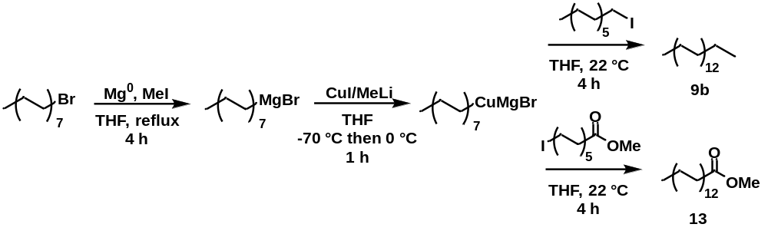
Scheme 3.1. Preparation of methyl hexacosanoate (13) and n-heptacosane (9b) from the copper(I)-catalyzed alkylation of iodides with Grignard reagents.

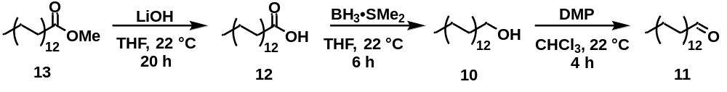
Scheme 3.2. Preparation of hexacosanoic acid (12), hexacosanal (11), and hexacosan-1-ol (10) from methyl hexacosanoate (13).

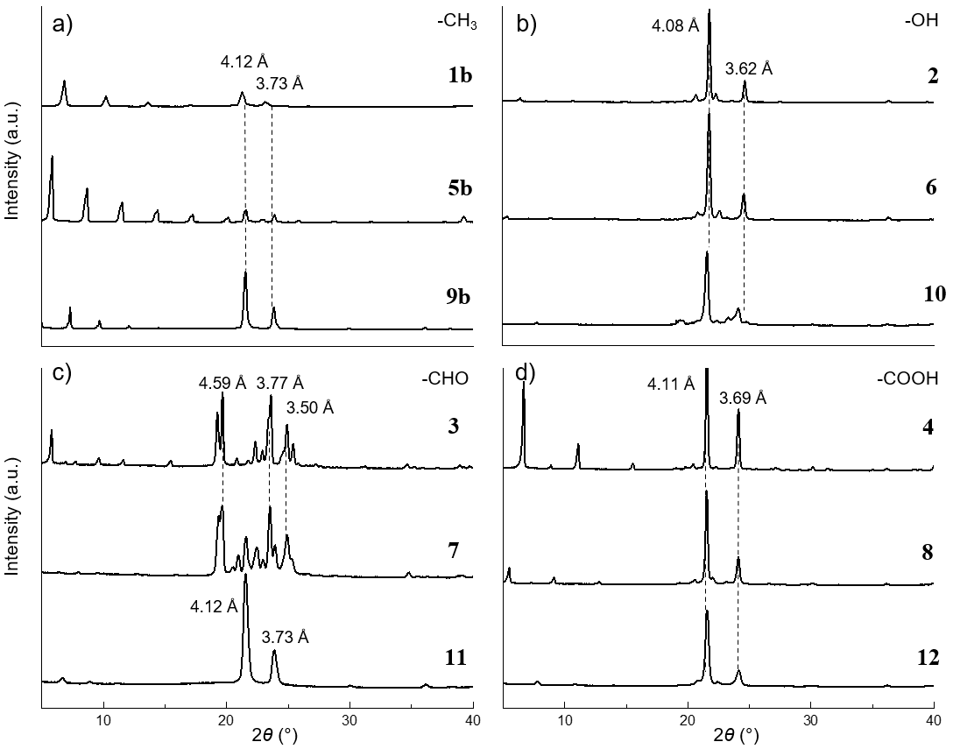
Figure 3.1. XRD patterns for pure a) odd n-alkanes (1b, n-nonadecane; 5b, n-tricosane; 9b, n-heptacosane), b) alcohols (2, octadecan-1-ol; 6, docosan-1-ol; 10, hexacosan-1-ol), c) aldehydes (3, octadecanal; 7, docosanal; 11, hexacosanal), and d) fatty acids (4, octadecanoic acid; 8, docosanoic acid; 12, hexacosanoic acid).

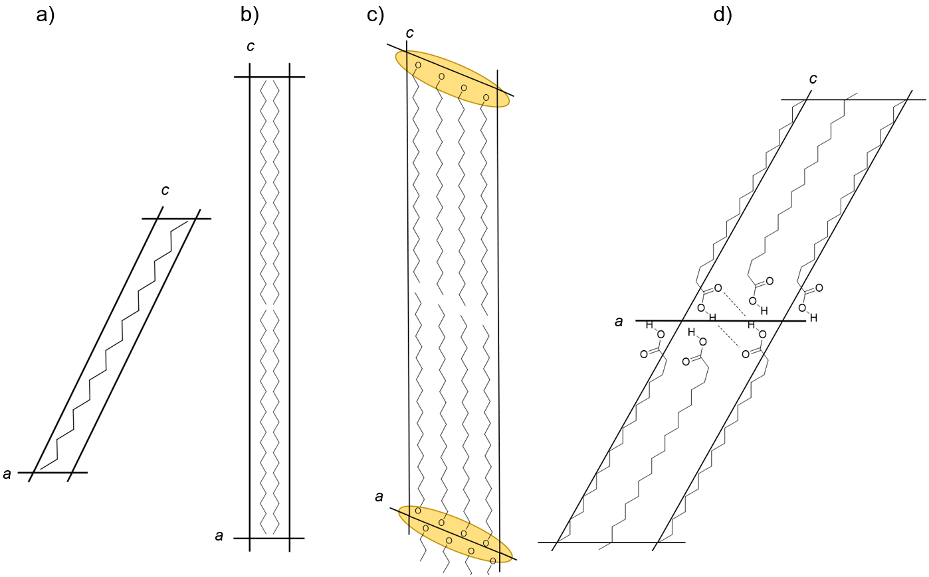
Figure 3.2. Crystal structure representation for n-alkanes, alcohols, and fatty acids, projected down the b-axis. Structures not drawn to scale. a) Triclinic (space group P-1) structure of n-octadecane (1a), adapted from data by Small.²⁰ b) Orthorhombic (space group Pbcm) structure of n-tricosane (5b) adapted from data by Small.²⁰ c) Monoclinic γ-form (space group C2/c) structure of eicosan-1-ol, adapted from data by Michaud and coworkers.³⁴ Hydroxyl H atoms are omitted for simplicity; the continuous chain of hydrogen bonds along basal axes is depicted in yellow. d) Monoclinic B-form (space group P2₁/a) crystal of octadecanoic acid (4), adapted from data by Goto and Asada.³⁹

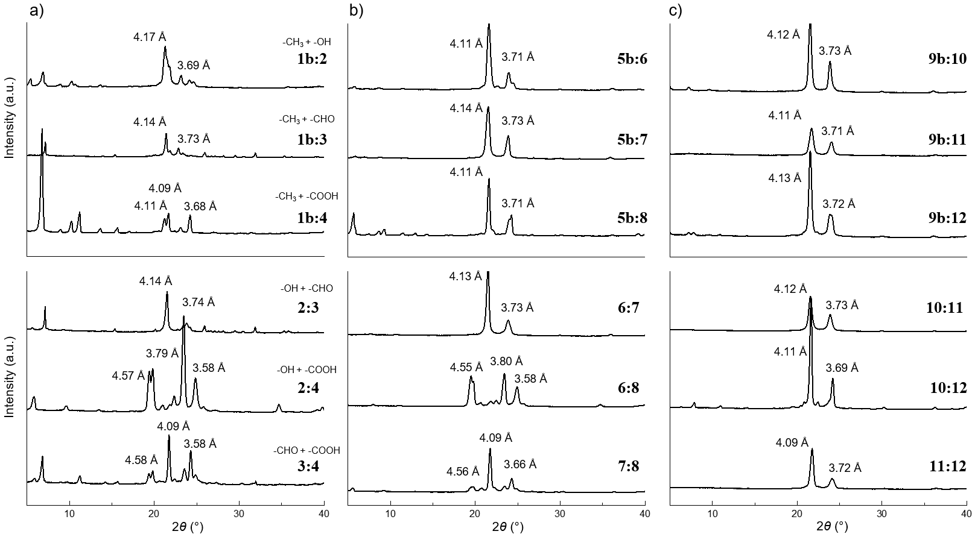 Figure 3.3. XRD patterns for a) C₁₈₋₁₉, b) C₂₂₋₂₃, and c) C₂₆₋₂₇ bulk binary mixtures (50:50) comprised of n-alkane:alcohol, n-alkane:aldehyde, n-alkane:fatty acid, alcohol:aldehyde, alcohol:fatty acid, aldehyde:fatty acid. For compound names, refer to Table 3.1.

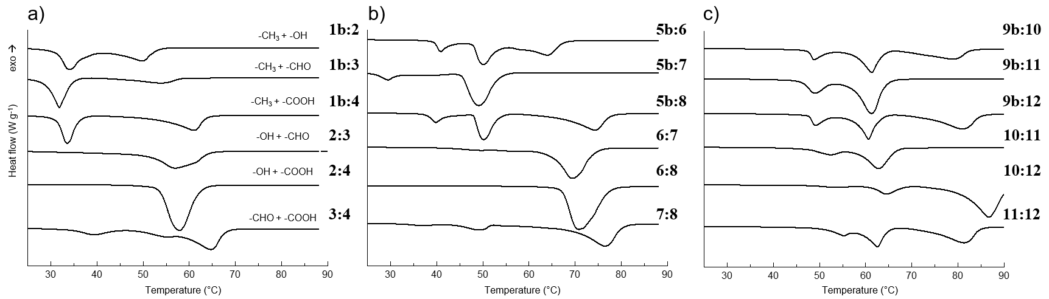
Figure 3.4. DSC thermograms for a) C₁₈₋₁₉, b) C₂₂₋₂₃, and c) C₂₆₋₂₇ bulk binary mixtures (50:50) comprised of n-alkane:alcohol, n-alkane:aldehyde, n-alkane:fatty acid, alcohol:aldehyde, alcohol:fatty acid, aldehyde:fatty acid. Heating curves shown correspond to the bulk mixtures after erasing thermal history for 3 min at 90°C. For compound names, refer to Table 3.1.
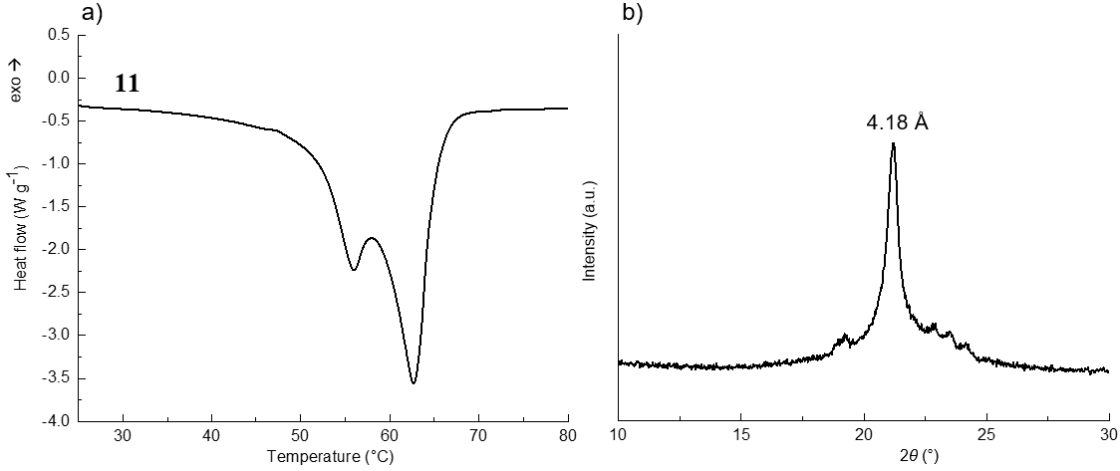
Figure 3.5. a) DSC melting curve and b) XRD pattern recorded at 50°C for hexacosanal (11) indicating a solid-solid rotator transition.

Supplementary Figures and Tables

Table 3.4. Melting onset temperature (T_{m}) and purity of compounds 1-12.
Entry | T_{m}† (°C) | Purity (% GC) | Vendor/Lot*
1a | 28.2 (32.1) | 99.8 | TCI; VZKOJ
1b | 31.1 (33.9) | 99.6 | AA; Q06G075
2 | 56.4 (60.8) | 99.2 | AO; A0335270
3 | 39.0 (44.9) | 99.6 | n.a.
4 | 67.1 (72.0) | 99.4 | AO: A0370805
5a | 43.0 (46.2) | 99.4 | TCI; KFJ4F
5b | 47.8 (50.5) | 99.8 | TCI: GE01
6 | 70.1 (74.2) | 99.9 | TCI; AX45E
7 | 57.7 (59.0) | 99.4 | n.a.
8 | 79.6 (82.7) | 99.1 | TCI; 83B4E
9a | 56.5 (58.5) | 99.2 | AA; Y14E049
9b | 56.7 (60.6) | 95.4 | n.a.
10 | 79.5 (81.1) | 99.3 | n.a.
11 | 61.7 (62.7) | 99.1 | n.a.
12 | 83.6 (87.9) | 99.1 | n.a.
1a, n-octadecane; 1b, n-nonadecane; 2, octadecane-1-ol; 3, octadecanal; 4, octadecanoic acid; 5a, n-docosane; 5b, n-tricosane; 6, docosan-1-ol; 7, docosanal; 8, docosanoic acid; 9a, n-hexacosane; 9b, n-heptacosane; 10, hexacosan-1-ol; 11, hexacosanal; 12, hexacosanoic acid (as the methyl ester).
†melting peak temperature indicated in parentheses
*TCI = Tokyo Chemical Industry; AA = Alfa Aesar; AO = Acros Organics
n.a. = not applicable

Table 3.5. Reported unit cell volumes (Å³) of pure compounds 1-12.
Entry | Structure | Z | Volume | Entry | Structure | Z | Volume | Entry | Structure | Z | Volume
1a | T | 1 | 454ª | 5a | T | 1 | 557ª | 9a | T | 1 | 635ª
1b | O | 4 | 1929ª | 5b | O | 4 | 2301ª | 9b | O | 4 | 2693ª
2 | M | 8 | 3712ª | 6 | M | 8 | 4534^{b} | 10 | M | 8 | 5354^{b}
3 | T † | n.d. | n.d. | 7 | T † | n.d. | n.d. | 11 | O† | n.d. | n.d.
4 | M | 4 | 1849ª | 8 | M | 4 | 2194ª | 12 | M | 4 | 2670^{b}

†tentative assignment from XRD
a = PDF-4+ ICDD database entry; b = calculated from Precht.¹ n.d. = not determined

Water Vapor Permeability Determination

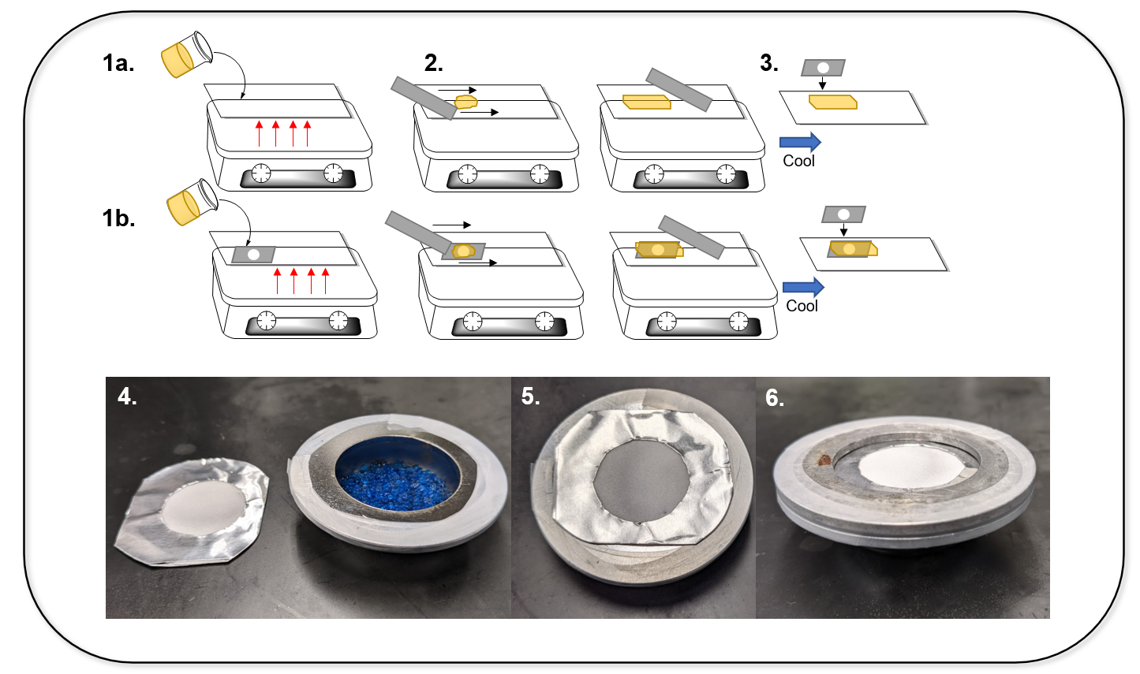
Figure 3.6. Experimental setup for water vapor permeability determination of wax films. 1a. Molten wax poured/pipetted on a cellulose diacetate support film taped to glass slide. The glass slide and support film are preheated on a hot plate. 1b. For challenging waxes, an aluminum tape mask can be used as a mold. The aluminum tape mask is taped to the cellulose diacetate support film mounted on the glass slide; 2. A heated metal straightedge used to smear a liquid film over a small area of the support film or mold; 3. Assembly is left to cool, and an additional aluminum tape mask placed over the film to reduce the test area; 4. The wax film fitted with the aluminum mask and Fisher-Payne permeability cup containing silica gel desiccant and Parafilm strip gaskets; 5. Wax film mounted on permeability cup. Any gaps are sealed with additional Parafilm strips; 6. Washer mounted on permeability cup which sealed with Parafilm strip. The permeability cup is then sealed with four to six screw clamps and introduced in controlled chamber.

¹H and ¹³C NMR Spectra

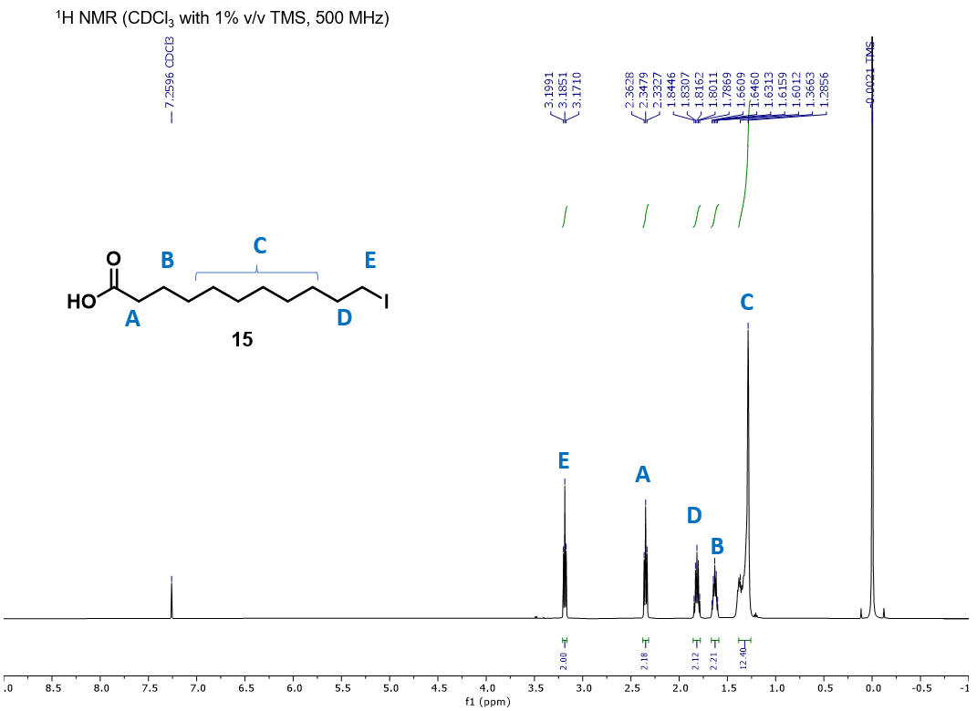
15
Figure 3.7. ¹H NMR spectrum of 11-iodoundecanoic acid (15). ¹H NMR (500 MHz, CDCl₃) δ 3.19 (t, J = 7.0 Hz, 2H), 2.35 (t, J = 7.4 Hz, 2H), 1.81 (quint, J = 14.6, 7.0 Hz, 2H), 1.63
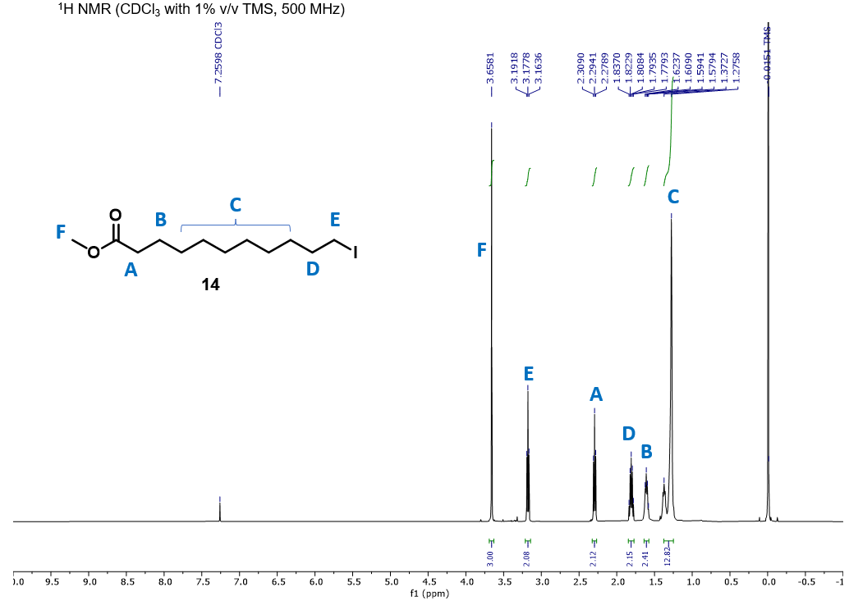 Figure 3.8. ¹H NMR spectrum of methyl 11-iodoundecanoate (14). ¹H NMR (500 MHz, CDCl₃) δ 3.66 (s, 3H), 3.18 (t, J = 7.0 Hz, 2H), 2.30 (t, J = 7.4 Hz, 2H), 1.81 (quint, J = 14.6, 7.0 Hz, 2H), 1.60 (quint, J = 14.8, 7.4 Hz, 2H), 1.37-1.28 (br, 12H).
14

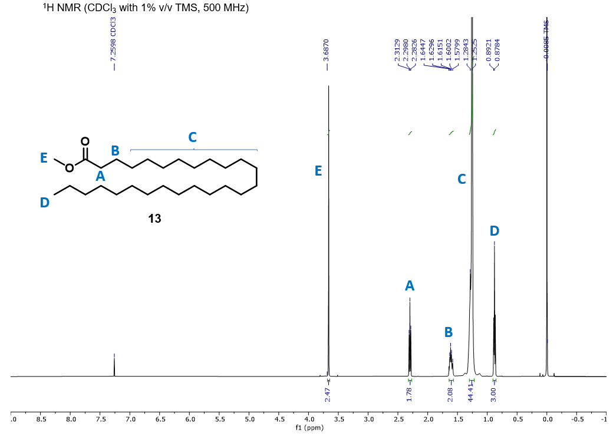 Figure 3.9. ¹H NMR spectrum of methyl hexacosanoate (13). ¹H NMR (500 MHz, CDCl₃) δ 3.68 (s, 3H), 2.30 (t, J = 7.5 Hz, 2H), 1.61 (quint, J = 14.8, 7.6 Hz, 2H), 1.28-1.25 (br, 44H), 0.87 (t, J = 6.9 Hz, 3H).
13
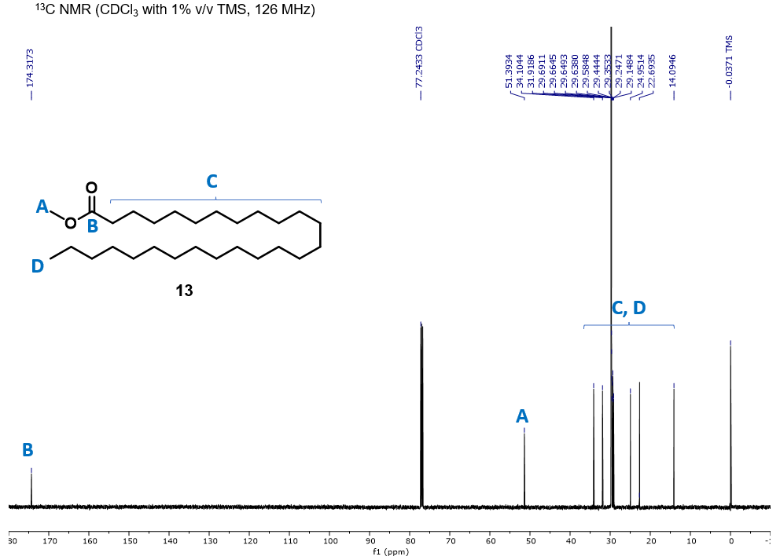 Figure 3.10. ¹³C NMR spectrum of methyl hexacosanoate (13). ¹³C NMR (126 MHz, CDCl₃) δ 174.3, 51.4, 34.1, 31.9, 29.7, 29.7, 29.6, 29.6, 29.6, 29.4, 29.4, 29.2, 29.1, 25.0, 22.7, 14.1.
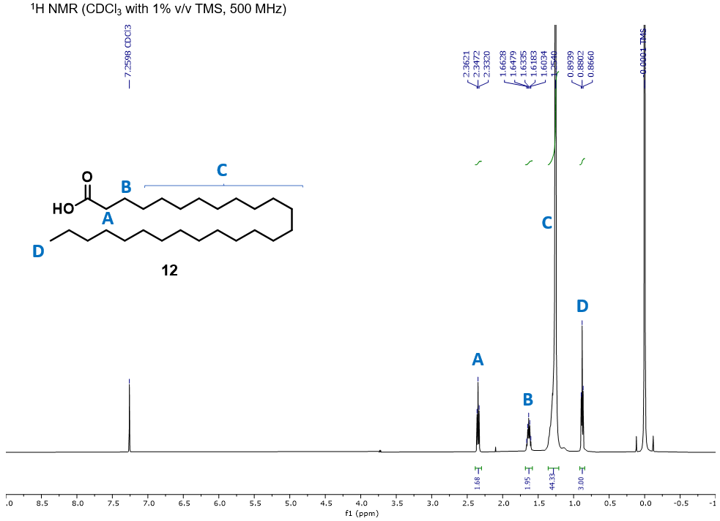 Figure 3.11. ¹H NMR spectrum of hexacosanoic acid (12). ¹H NMR (500 MHz, CDCl₃) δ 2.34 (t, J = 7.4 Hz, 2H), 1.63 (quint, J = 14.7, 7.4 Hz, 2H), 1.25 (br, 44H), 0.88 (t, J = 6.9 Hz, 3H).
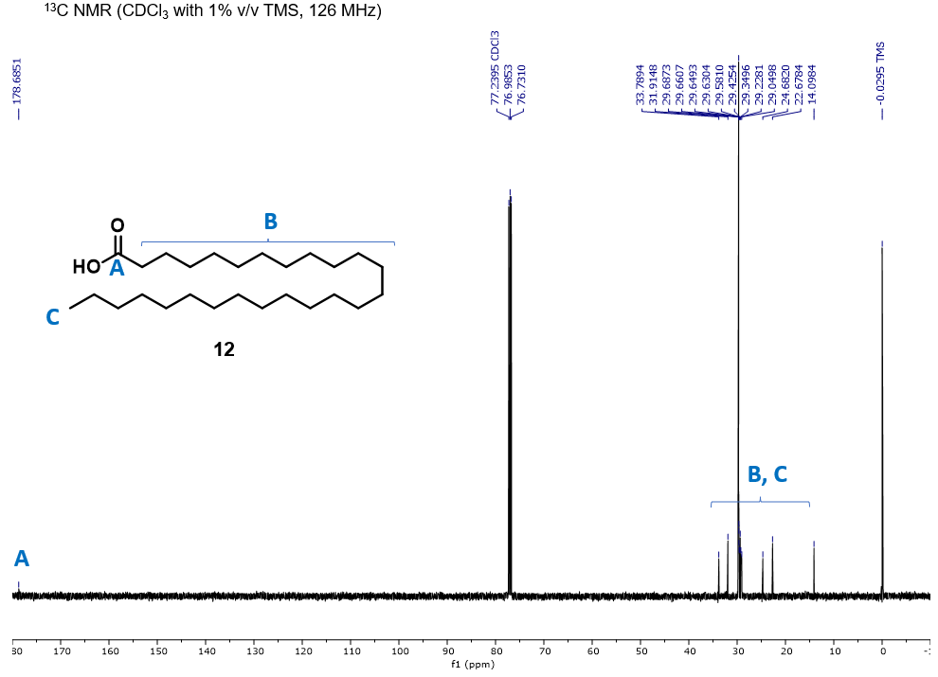 Figure 3.12. ¹³C NMR spectrum of hexacosanoic acid (12).¹³C NMR (126 MHz, CDCl₃) δ 178.7, 33.8, 31.9, 29.7, 29.7, 29.6, 29.6, 29.6, 29.4, 29.3, 29.2, 29.0, 24.7, 22.7, 14.1.
13
12
12

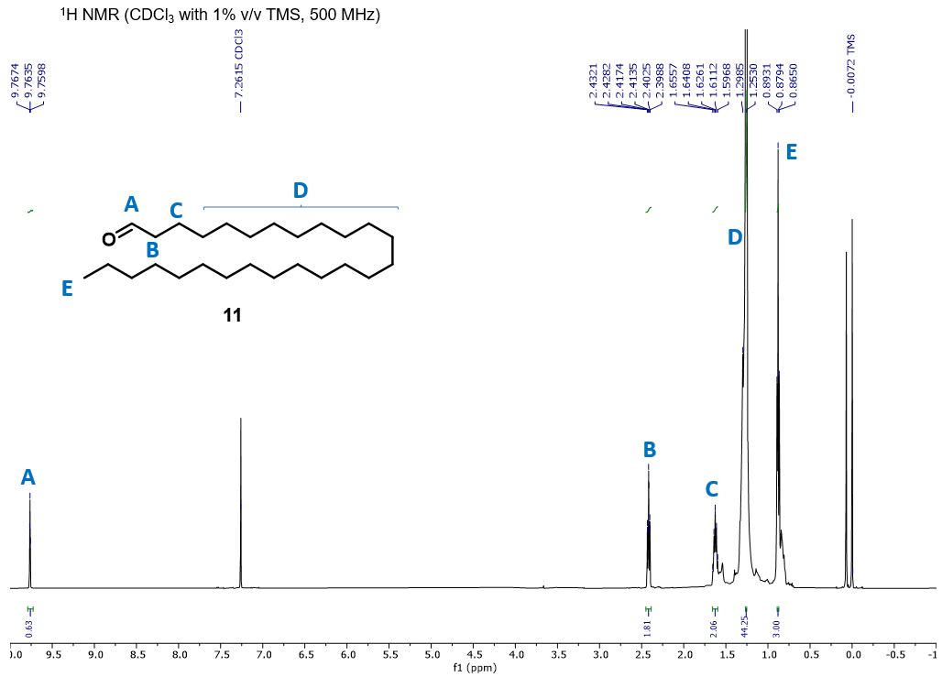 Figure 3.13. ¹H NMR spectrum of hexacosanal (11). ¹H NMR (500 MHz, CDCl₃) δ 9.76 (t, J = 1.9 Hz, 1H), 2.41 (dt, J = 7.4, 1.9 Hz, 2H), 1.62 (quint, J = 14.8, 7.5 Hz, 2H), 1.29-1.25 (br, 44H), 0.88 (t, J = 6.9 Hz, 3H).
11

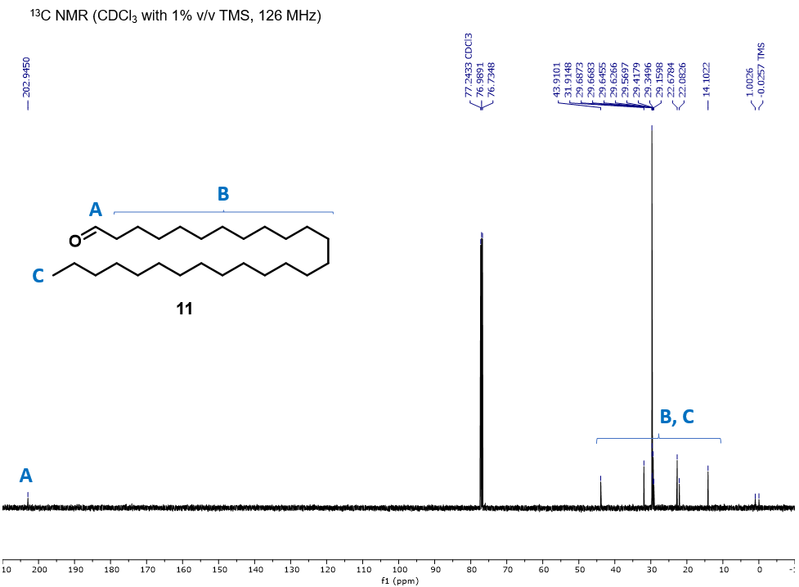 Figure 3.14. ¹³C NMR spectrum of hexacosanal (11).¹³C NMR (126 MHz, CDCl₃) δ 202.9, 43.9, 31.9, 29.7, 29.7, 29.6, 29.6, 29.6, 29.4, 29.3, 29.2, 22.7, 22.1, 14.1.
11

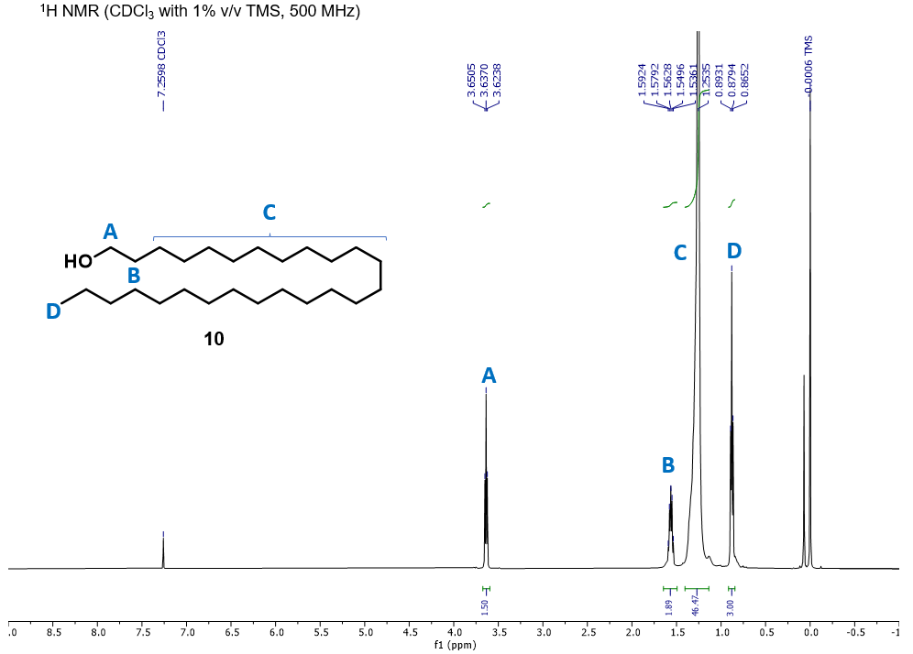 Figure 3.15. ¹H NMR spectrum of hexacosan-1-ol (10). ¹H NMR (500 MHz, CDCl₃) δ 3.64 (t, J = 6.8 Hz, 2H), 1.57 (quint, J = 14.8, 6.8 Hz, 2H), 1.25 (br, 46H), 0.88 (t, J = 6.9 Hz, 3H).
10

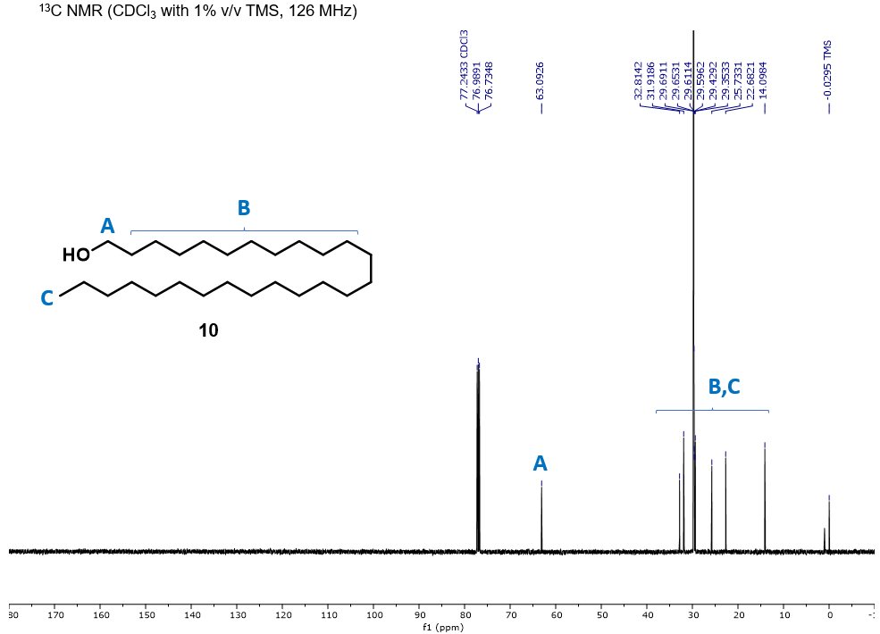 Figure 3.16. ¹³C NMR spectrum of hexacosan-1-ol (10).¹³C NMR (126 MHz, CDCl₃) δ 63.1, 32.8, 31.9, 29.7, 29.7, 29.6, 29.6, 29.4, 29.4, 25.7, 22.7, 14.1.
10
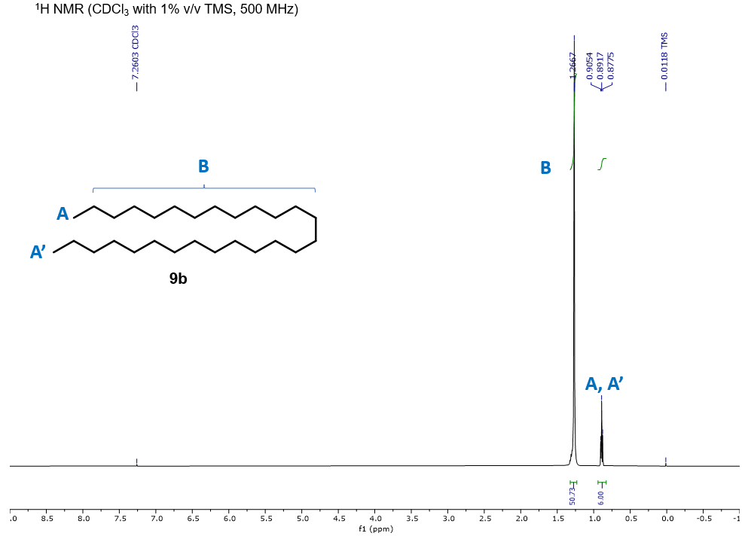 Figure 3.17. ¹H NMR spectrum of n-heptacosane (9b). ¹H NMR (500 MHz, CDCl₃) δ 1.27 (br, 50H), 0.89 (t, J = 6.9 Hz, 6H).
9b
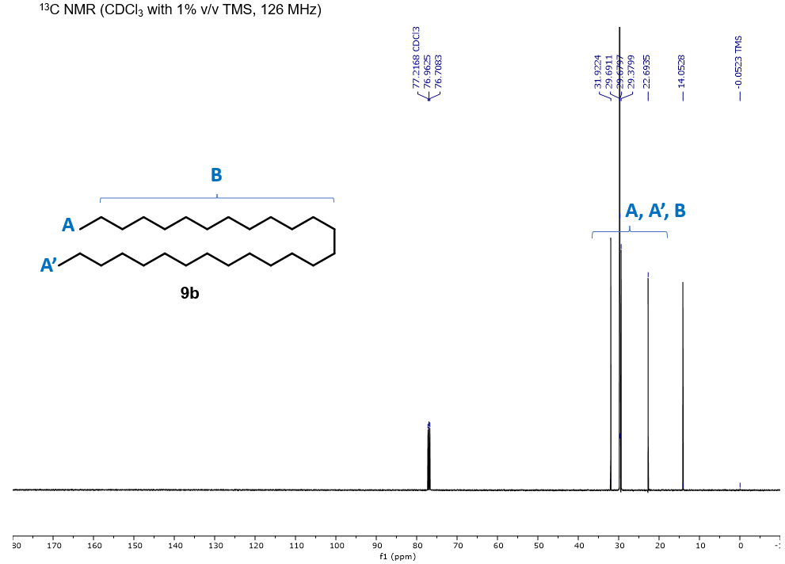 Figure 3.18. ¹³C NMR spectrum of n-heptacosane (9b). ¹³C NMR (126 MHz, CDCl₃) δ 31.9, 29.7, 29.7, 29.4, 22.7, 14.1.
9b
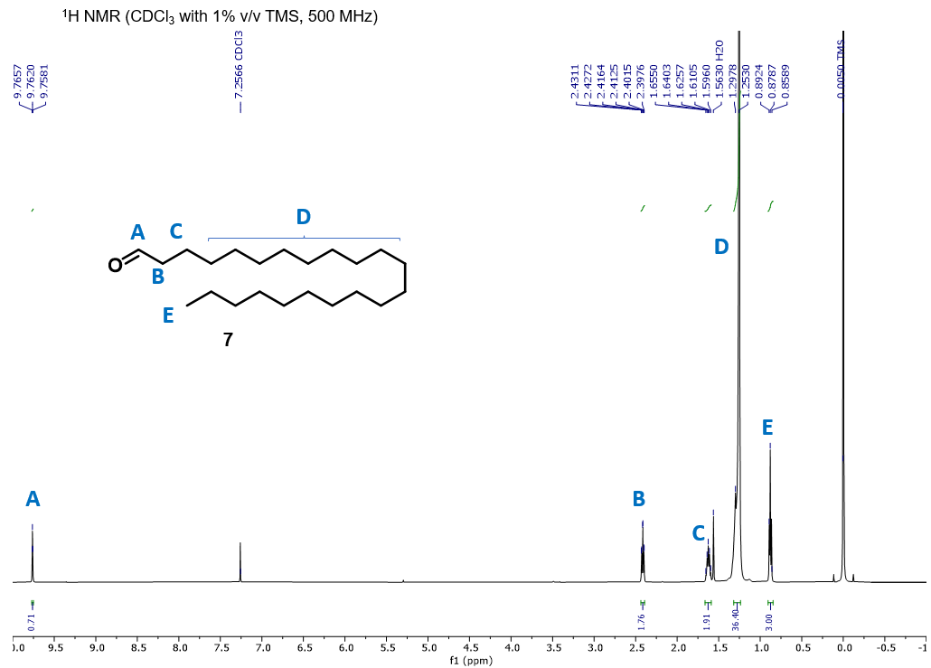 Figure 3.19. ¹H NMR spectrum of docosanal (7). ¹H NMR (500 MHz, CDCl₃) δ 9.76 (t, J =1.9 Hz, 1H), 2.41 (dt, J = 7.4,1.9 Hz, 2H), 1.63 (quint, J = 14.7, 7.4 Hz, 2H), 1.29-1.25 (br, 36H), 0.88 (t, J = 6.9 Hz, 3H).
7

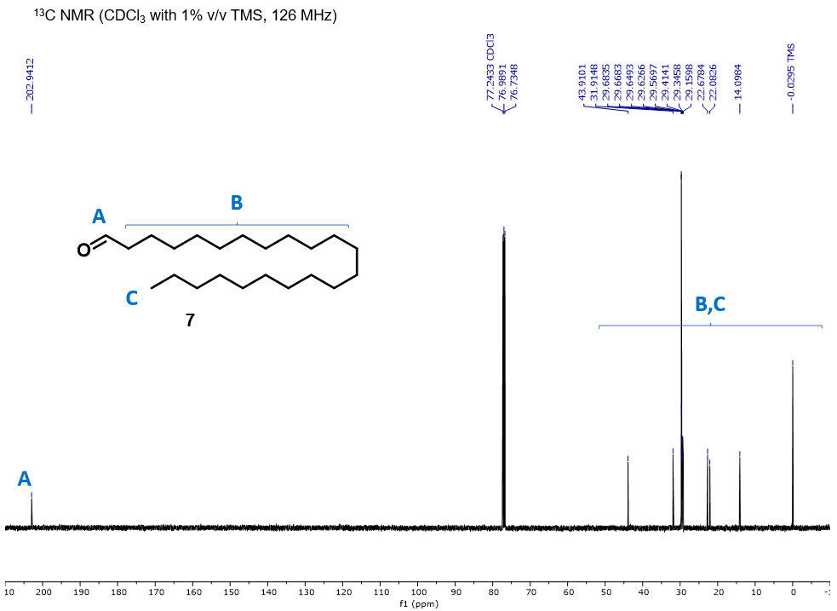 Figure 3.20. ¹³C NMR spectrum of docosanal (7). ¹³C NMR (126 MHz, CDCl₃) δ 202.9, 43.9, 31.9, 29.7, 29.7, 29.6, 29.6, 29.6, 29.4, 29.3, 29.2, 22.7, 22.1, 14.1.
7
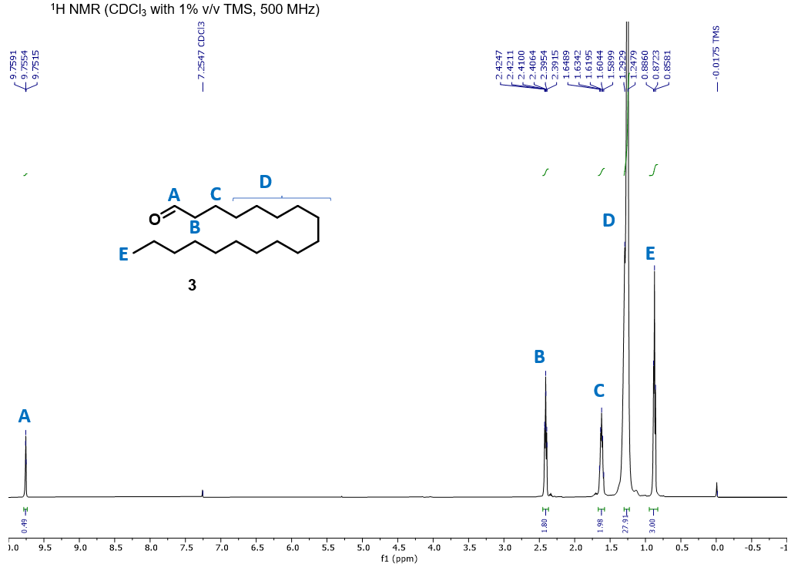 Figure 3.21. ¹H NMR spectrum of octadecanal (3). ¹H NMR (500 MHz, CDCl₃) δ 9.76 (t, J = 1.9 Hz, 1H), 2.41 (dt, J = 7.4, 1.9 Hz, 2H), 1.62 (quint, J =14.7, 7.4 Hz, 2H), 1.29-1.25 (br, 28H), 0.87 (t, J = 6.9 Hz, 3H).
3

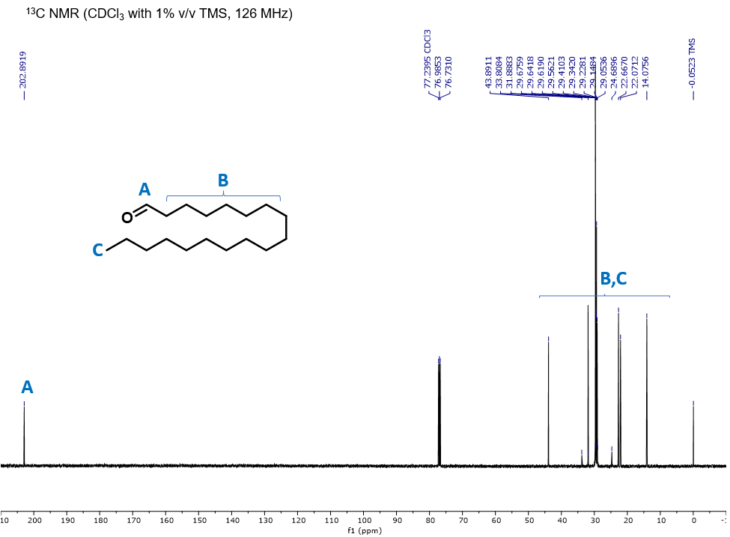 Figure 3.22. ¹³C NMR spectrum of octadecanal (3). ¹³C NMR (126 MHz, CDCl₃) δ 202.9, 43.9, 33.8, 31.9, 29.7, 29.6, 29.6, 29.6, 29.4, 29.3, 29.2, 29.1, 29.1, 24.7, 22.7, 22.1, 14.1.
3

Mass Spectra for Select Synthetic Compounds

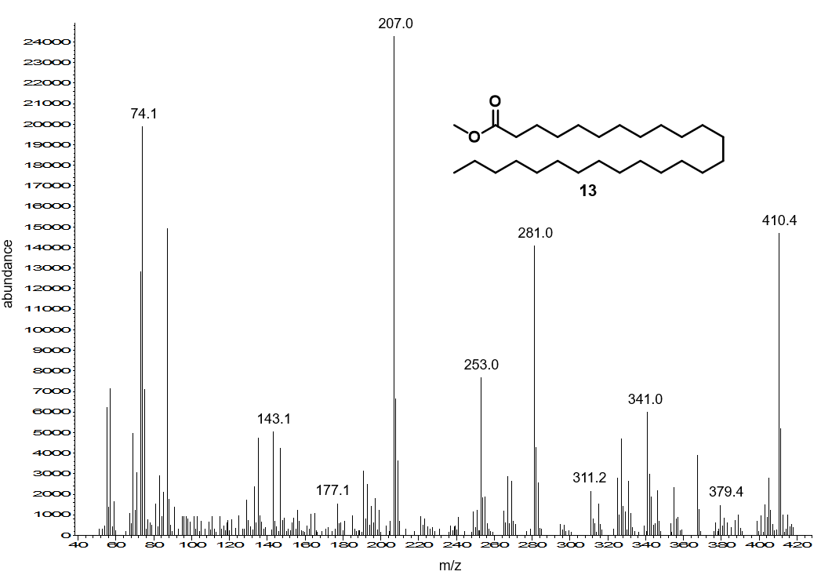
13
Figure 3.23. EI mass spectrum of methyl hexacosanoate (13). EI-MS (70 eV; r.t. (min): 20.540). m/z 410.4, 379.4, 342.0, 311.2, 281.0.

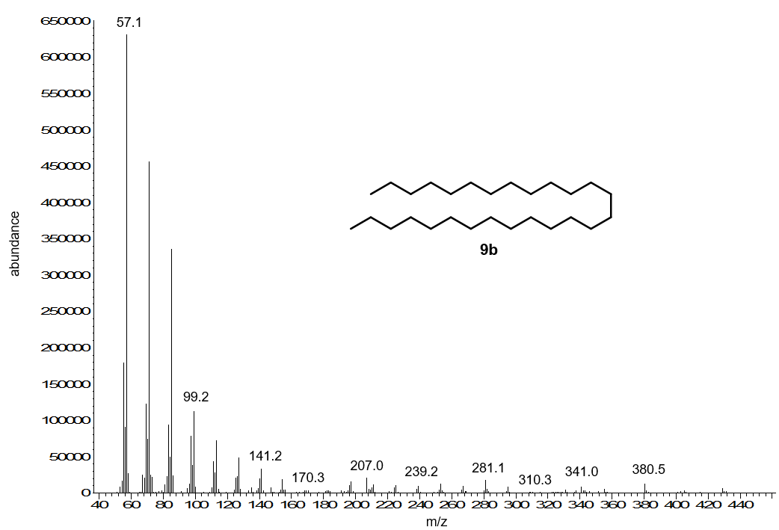
9b
Figure 3.24. EI mass spectrum of n-heptacosane (9b). EI-MS (70 eV; r.t. (min): 25.201). m/z 380.5, 341.0, 281.1, 239.2, 141.2.
9b

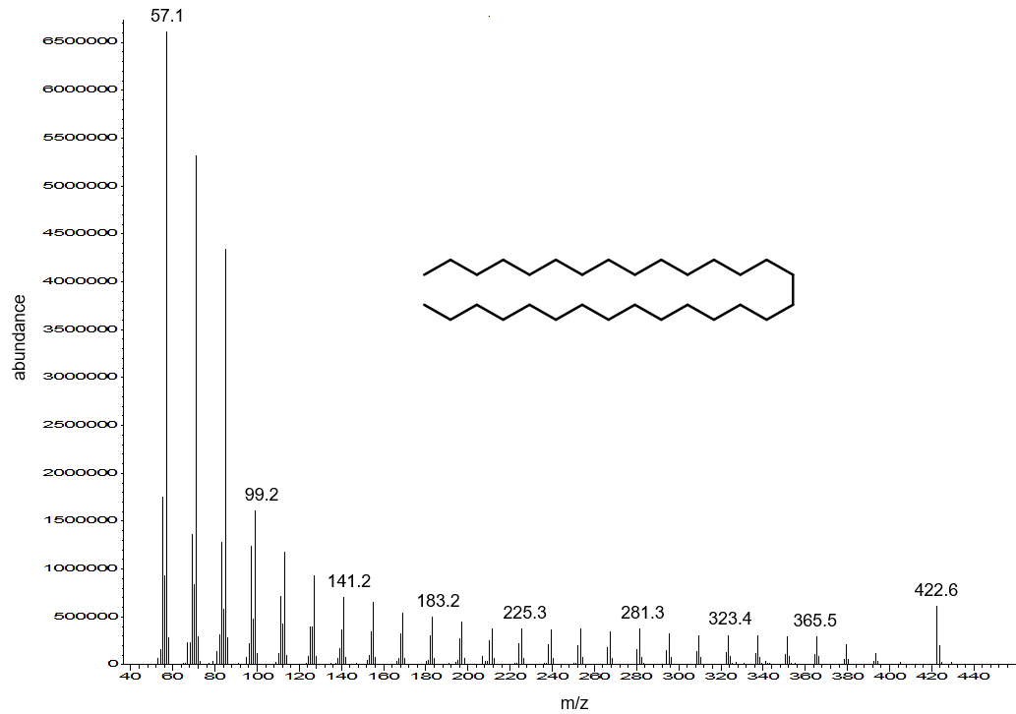
Figure 3.25. EI mass spectrum of n-triacontane (side product). EI-MS (70 eV; r.t. (min): 27.299). m/z 422.6, 365.5, 323.4, 281.3, 225.3.

X-ray Diffraction Patterns

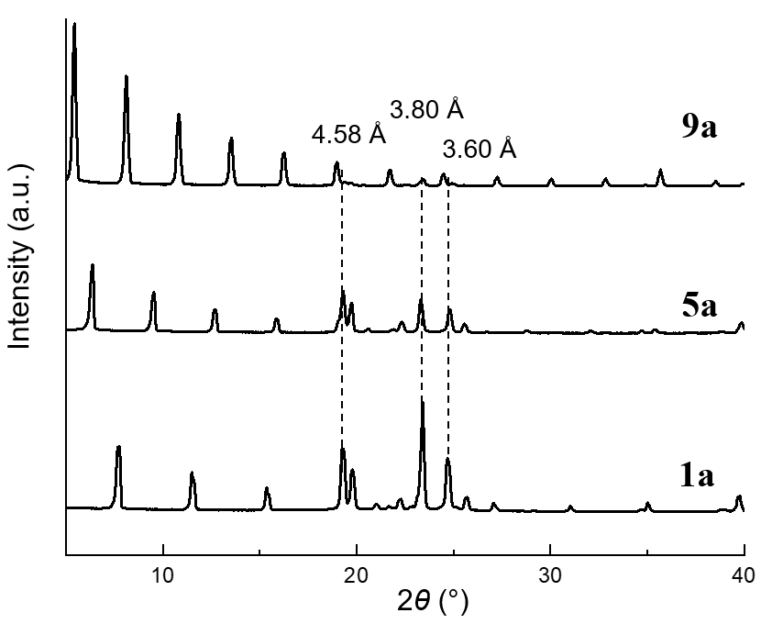
Figure 3.26. XRD patterns for pure n-octadecane (1a), n-docosane (3a), n-hexacosane (9a).
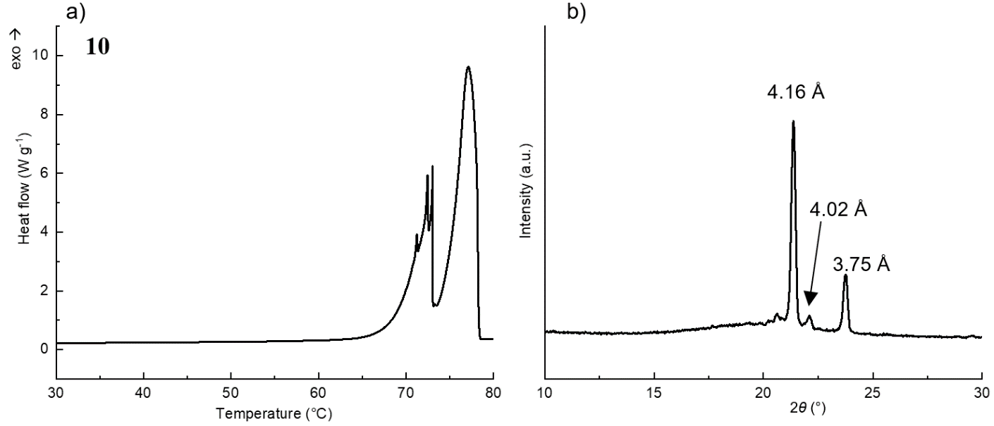
Figure 3.27. a) DSC cooling curve and b) XRD pattern recorded at 75°C for hexacosan-1-ol (10) indicating the rotator transition. The liquid-rotator transition begins at 78.5°C. On heating, the solid-rotator transition overlaps with melting curve.

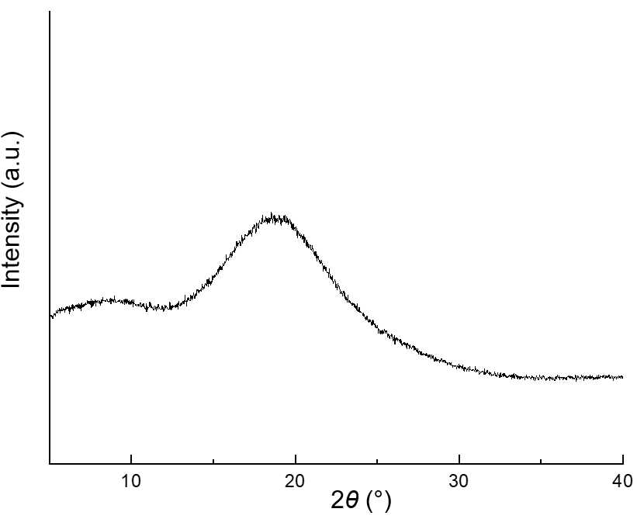
Figure 3.28. XRD pattern for pure shellac resin indicating amorphous structure.

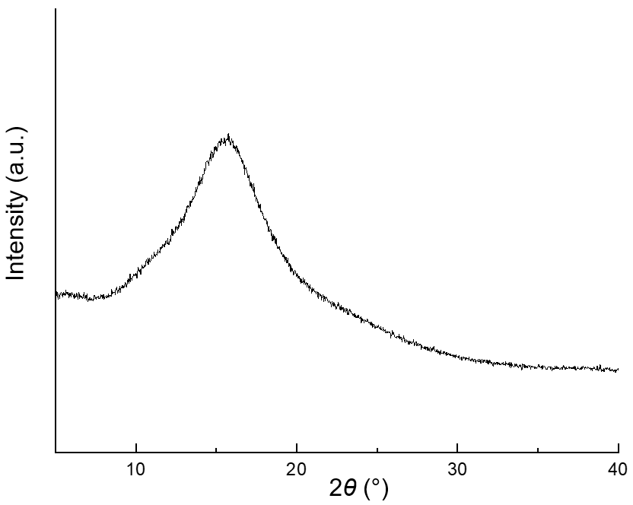
Figure 3.29. XRD pattern for abietane rosin indicating amorphous structure.

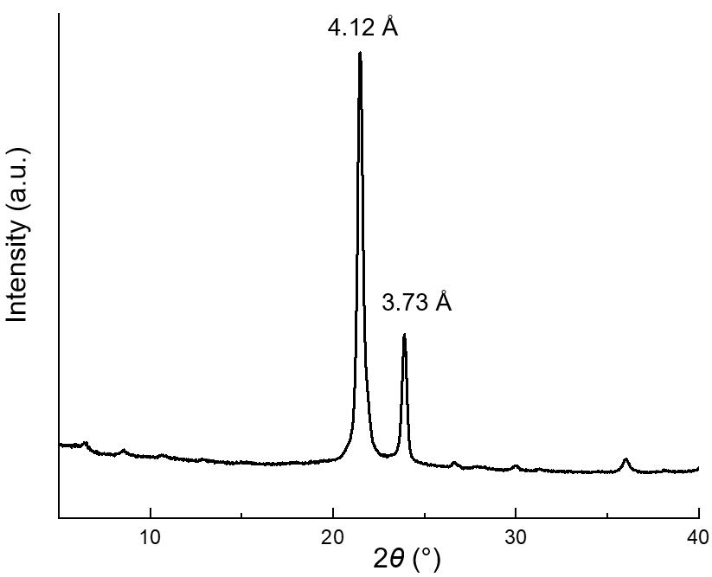
Figure 3.30. XRD pattern for dichloromethane-extracted sorghum wax (Sorghum bicolor).

CHAPTER IV
The Rotator Phases of Aliphatic Aldehydes and Implications
for Wax Crystal Growth

The following chapter details the work intended to be submitted for publication. The experimental design, synthesis, and physical characterization were performed by the author. Dr. Tong Wang advised this work.

4.1 Abstract
The even C₂₂₋₃₂ aliphatic aldehydes were determined to crystallize into triclinic, monoclinic, and orthorhombic lattices and undergo solid-solid transitions into the rotator phase. Binary mixtures of n-nonacosane and triacontanal, two representative constituents of plant cuticular waxes, were determined to form solid solutions and likewise possess rotator phases. Many plants exhibit mutations wherein the expression of aldehydes is significantly decreased. Afflicted mutants are often glabrous, devoid of epicuticular wax crystals, and suffer from increased cuticular permeability and drought intolerance. Our results suggest aldehydes may play an important role in wax crystal growth.

4.2 Introduction
Aliphatic aldehydes in the range of C₂₄₋₃₂ chain length are ubiquitous constituents of plant cuticular waxes.¹ Yet, despite their prevalence in Nature, there is limited information on their physical properties in the literature. Recently, we reported on the tentative crystal structures of the C₁₈, C₂₂, and C₂₆ aldehydes and their binary mixtures with n-alkanes, alcohols and fatty acids.² We serendipitously discovered that hexacosanal undergoes a solid-solid transition from an orthorhombic (O) to a loosely-packed hexagonal (H) lattice in the vicinity of its melting temperature. In the context of the aliphatic chain, this phenomenon is better known as the rotator (R) phase and first reported on by Müeller in 1932 for n-alkanes.³ Since its discovery, five distinct stable, metastable, and transient R phases have been reported.⁴⁻⁹ It is noteworthy that aliphatic alcohols and phospholipids are known to possess R phases, although fatty acids do not.^{3, 4, 8, 10} In general, the R phases are capable of altering the energy barrier for crystallization, especially when confined in pores.^{5, 7} Given the omnipresence of the aliphatic chain, studies on the R phases have provided invaluable insights on the crystallization kinetics of polymers, biological membrane dynamics, as well as other crystallization phenomena in industrial products and Nature.^{4, 7, 11}
Our principal interest in the R phases of aldehydes lies in their possible and as yet unknown role in cuticular wax crystal growth. Several reports have documented mutations which render plant surfaces glabrous exhibit a concomitant decrease in the concentration of aldehydes in cuticular waxes. Salient examples include maize,^{12, 13} rice,¹⁴ sorghum,¹⁵, ¹⁶ and citrus fruit,^{17, 18}. In many cases, electron microscopy imaging of “glossy” mutant surfaces has revealed a decrease in the density of epicuticular wax crystals relative to that of wild-type plants. Further, few reports have ventured to correlate the decrease in aldehyde expression to an increase in cuticular transpiration and drought intolerance.¹⁹
Based on these reports and our previous work, we hypothesized that aldehydes play an essential role in cuticular wax crystal growth. The adaptation of the Le Roux wax model to the plant cuticle, as described by Rieder and Schreiber,²⁰ serves as the foundation for our hypothesis. According to this model, the mixed amorphous and crystalline intracuticular region serves as the transport-limiting barrier of the cuticle. The mobility of permeants, or very well any other molecular entity, is dependent on the aspect ratio (i.e., thickness and lateral extension) and loading (volume fraction) of wax crystallites.²⁰ According to theoretical and empirical studies, the idealized equation:
mobility (w/ crystallites) = mobility (w/o crystallites) • (loading)² • (aspect ratio)²
describes to a good approximation the mobility of permeants across the cuticle in the presence of wax crystallites.¹ Thus, any phenomenon capable of affecting the loading and or aspect ratio of wax crystallites should have a pronounced effect on the permeability of water, for example. The dynamic and polydisperse nature of the cuticle gives rise to temperature-dependent properties. Namely, wax crystallites have been hypothesized to continuously “break” and “rearrange,” presumably by mode of the R phase, as has been observed for Fischer-Tropsch waxes.^{21, 22}
The fact that the absence of aldehydes in cuticular waxes has been linked to an increase in cuticular transpiration, that afflicted mutants are often devoid of epicuticular wax crystals, and that at least one aldehyde has been shown to possess a R phase,² warranted further investigation. The objectives of this work were thus 1) to synthesize aldehydes representative of those found in cuticular waxes, 2) to further characterize their crystal structures and R phases and to 3) interrogate their possible role in wax crystal growth. In the present work, we synthesized and analyzed the even C₂₂₋₃₂ aldehydes by high-temperature powder X-ray diffraction and differential scanning calorimetry. We further characterized binary mixtures of n-nonacosane and triacontanal, two representative constituents of cuticular waxes, to gain further insights as to their synergistic behavior.

4.3 Materials and Methods
4.3.1 Materials
Docosan-1-ol was purchased from commercial sources with >98% purity by GC. Tetracosanal and hexacosanal were synthesized according to our previous report with >98% purity by GC. 6-Bromohexan-1-ol, 3,4-dihydro-2H-pyran, methanesulfonyl chloride, and lithium aluminum hydride solution (2.4 M in tetrahydrofuran (THF)) were purchased from commercial sources (Acros Organics, MilliporeSigma) and used as received unless otherwise noted.

4.3.2 Syntheses
General. All manipulations were performed under dry N₂ or Ar using standard air-free techniques. Glassware was either dried overnight in a 120°C oven or flame-dried prior to use and cooled under a stream of dry N₂ or Ar. THF and dichloromethane were pre-dried over activated 3 Å molecular sieves and distilled before use. Other solvents were used as received unless otherwise noted. Thin layer chromatography (TLC) was performed on silica gel 60 coated plates and visualized with ceric ammonium molybdate (CAM). Flash chromatography was performed on silica gel 60. ¹H and ¹³C NMR spectra were acquired with a Varian VR500 500 MHz spectrometer using CDCl3 with 1% tetramethylsilane (TMS) as solvent. Chemical shifts are reported relative to TMS signal. GC-MS analyses were performed using an 7890B/5977N MS chromaograph using a non-polar HP-5 (5%-phenyl methylpolysiloxane, 30 m × 0.25 mm i.d., 0.25 µm film thickness) capillary column (J&W Scientific) with a He carrier gas flow rate of 1.5 mL min-1, 1:20 split ratio and the following temperature program: 1 min hold at 100 °C, followed by 10 °C min⁻¹ ramp to 320 °C held for 10 min, with injector at 250 °C and detector at 325 °C.

General Procedure for the Synthesis of Aliphatic Aldehydes. The following procedure is representative for the gram-scale synthesis of the aldehydes in the range of C₂₄₋₃₂ chain lengths (Scheme 4.1). An alternative procedure applicable for the gram-scale synthesis of tetracosanal and hexacosanal is detailed in our previous report. The C₁₈₋₂₂ aldehydes, or any other aldehyde, can be prepared by oxidation of any commercially available alcohol. Reduction of the corresponding methyl esters with diisobutylaluminum hydride in toluene is also possible.

2-((6-Bromohexyl)oxy)tetrahydro-2H-pyran (1). 3,4-Dihydro-2H-pyran (6.6 mL, 72 mmol) was added to a solution of 6-bromohexan-1-ol (2.60 g, 14.4 mmol) and pyridinium p-toulenesulfonate (5 mol%) in dry THF (10 mL) at 0 °C. The reaction mixture was stirred at 22°C overnight. The pale-yellow reaction mixture was concentrated under vacuum and the viscous residue purified by column chromatography using 95:5 hexane:ethyl acetate. Concentration and drying under vacuum afforded a colorless oil (3.51 g, 92% yield): R_{f} = 0.35 (95:5 hexane:ethyl acetate). ¹H NMR (500 MHz, CDCl₃) δ 4.54 (t, J = 7.3, 2.3 Hz, 1H), 3.83 (m, 1H), 3.71 (dt, J = 9.5, 6.7 Hz, 1H), 3.46 (dd, J = 11.2, 5.4 Hz, 1H), 3.38 (d, J = 6.8 Hz, 2H), 3.36 – 3.33 (m, 1H), 1.88 – 1.79 (m, 3H), 1.71 – 1.65 (m, 1H), 1.60 – 1.35 (m, 10H).

1-((Tetrahydro-2H-pyran-2-yl)oxy)dotriacontan-7-ol (2). A solution of 1 (2.60 g, 14.4 mmol) in dry THF (5 mL) was added to a stirring suspension of freshly tarnished magnesium turnings (0.42 g, 17.3 mmol) in dry THF (30 mL). Dibromoethane (10 µL) was added to assist in formation of the Grignard reagent and the reaction mixture refluxed for 4 h. The dark gray solution was cooled to 22 °C and a solution of hexacosanal (4.56 g, 12.0 mmol) in dry THF (5 mL) added in one portion. The resulting dark brown solution was stirred at 22 °C for 4 h before being quenched by addition of saturated NH₄Cl (10 mL) and deionized water (20 mL). The mixture was partitioned, and the aqueous layer extracted with chloroform (3× 20 mL). The pooled extracts were washed with saturated brine (2× 30 mL), dried over MgSO₄, concentrated, and the residue purified by column chromatography using a gradient elution of 90:10 hexane:ethyl acetate followed by acetone. The acetone flush afforded the titular compound. Concentration and drying under vacuum afforded a white crystalline solid (3.42 g, 52% yield): R_{f} = 0.21 (90:10 hexane:ethyl acetate). ¹H NMR (500 MHz, CDCl₃) δ 4.57 (dd, J = 4.5, 2.7 Hz, 1H), 3.90 – 3.84 (m, 1H), 3.72 (dt, J = 9.5, 7.0 Hz, 1H), 3.57 (br, 1H), 3.52 – 3.47 (m, 1H), 3.41 – 3.35 (m, 1H), 1.87 – 1.79 (m, 1H), 1.74 – 1.68 (m, 1H), 1.62 – 1.55 (m, 4H), 1.42, (m, 4H),1.25 (s, 52H), 0.88 (d, J = 7.0 Hz, 3H).

1-((Tetrahydro-2H-pyran-2-yl)oxy)dotriacontan-7-yl methanesulfonate (3). Methane sulfonyl chloride (0.77 mL, 10 mmol) was slowly added to a solution of 2 (3.42 g, 6.2 mmol) and triethylamine (5.2 mL, 37 mmol) in 80:20 dry dichloromethane:chloroform (30 mL) at 0 °C. The clear yellow solution was stirred at 22 °C for 6 h. The reaction mixture was quenched by addition of deionized water (60 mL). The mixture was partitioned, and the aqueous layer was extracted with chloroform (3× 20 mL). The pooled extracts were washed with saturated brine (2× 30 mL), dried over MgSO₄, and concentrated under vacuum to afford to afford a white crystalline solid that was used without further purification (3.64 g, 93% yield): R_{f} = 0.26 (90:10 hexane:ethyl acetate). ¹H NMR (500 MHz, CDCl3) δ 4.69 (quint, J = 6.1 Hz, 1H), 4.56 (dd, J = 4.5, 2.7 Hz, 1H), 3.86 (ddd, J = 11.0, 7.5, 3.3 Hz, 1H), 3.72 (dt, J = 9.6, 6.8 Hz, 1H), 3.52 – 3.47 (m, 1H), 3.37 (dt, J = 9.6, 6.6 Hz, 1H), 2.99 (s, 3H), 1.82 (m, J = 7.8, 3.5 Hz, 1H), 1.79 – 1.71 (m, 1H), 1.71 – 1.64 (m, 4H), 1.64 – 1.49 (m, 4H), 1.25 (br, 52H), 0.87 (t, J = 6.9 Hz, 3H). Note: occasionally a primary mesylate side product may be observed (~15%), but this is easily removed as the corresponding n-alkane in subsequent transformations and purifications.

2-(Dotriacontyloxy)tetrahydro-2H-pyran (4). A solution of lithium aluminum hydride in dry THF (9.7 mL, 23.2 mmol) was added to a pale yellow solution of 3 (3.64 g, 5.8 mmol) in dry THF (30 mL) cooled to 0 °C. The colorless mixture was stirred overnight before being quenched with water and 10% NaOH according to the Fieser workup. After filtration of the aluminum salts, the filter cake was washed repeatedly with hot chloroform (3× 30 mL). The organic extracts were concentrated under vacuum to afford a white crystalline solid that was used without further purification. (2.89 g, 93% yield): R_{f} = 0.85 (90:10 hexane:ethyl acetate). ¹H NMR (500 MHz, CDCl₃) δ 4.57 (dd, J = 4.5, 2.7 Hz, 1H), 3.90 – 3.84 (m, 1H), 3.72 (dt, J = 9.5, 7.0 Hz, 1H), 3.52 – 3.47 (m, 1H), 3.41 – 3.35 (m, 1H), 1.87 – 1.79 (m, 1H), 1.74 – 1.68 (m, 1H), 1.62 – 1.55 (m, 4H), 1.25 (br, 60H), 0.88 (d, J = 7.0 Hz, 3H).

Dotriacontan-1-ol (5). A solution of 4 (2.89 g, 5.4 mmol) in 95% ethanol (60 mL) and 6 N HCl (4 mL) was refluxed for 6 h. The mixture was cooled to 0 °C to elicit crystallization and the bulk of the solvent carefully decanted. The product was either recrystallized from ethanol or purified by column chromatography using a gradient elution of 90:10 hexane:ethyl acetate followed by acetone to afford a white crystalline solid (2.44 g, 97% yield): R_{f} = 0.30 (90:10 hexane:ethyl acetate). ¹H NMR (500 MHz, CDCl₃) δ 3.64 (t, J = 6.9 Hz, 2H), 1.58 (quint, J = 14.8, 6.8 Hz, 2H), 1.46 (br, 2H), 1.25 (br, 56H), 0.88 (t, J = 6.9 Hz, 3H).

Dotriacontanal (6). Pyridinium chlorochromate over alumina was added in portions to a solution of 5 (1.2 g, 2.6 mmol) in 80:20 dry dichloromethane (40 mL). The reaction mixture was maintained at 22 °C with the aid of a water bath. After complete addition, the dark brown reaction mixture was stirred at 22 °C for 6 h. Note: the supported oxidant was prepared by dissolving freshly prepared pyridinium chlorochromate (0.89 g, 4.1 mmol ) in dry THF (20 mL), adding anhydrous alumina (10 g), and concentrating under vacuum. The reaction mixture was filtered through a thick pad of silica and MgSO₄, the filtrate concentrated under vacuum, and the brown residue purified by column chromatography using of 90:10 hexane:ethyl acetate. Concentration and drying under vacuum afforded a white crystalline solid (1.05 g, 86% yield): R_{f} = 0.76 (90:10 hexane:ethyl acetate). ¹H NMR (500 MHz, CDCl₃) δ 9.76 (t, J =1.9 Hz, 1H), 2.42 (dt, J = 7.4,1.9 Hz, 2H), 1.63 (quint, J = 14.7, 7.4 Hz, 2H), 1.29-1.25 (br, 56H), 0.88 (t, J = 6.9 Hz, 3H).

4.3.3 Differential Scanning Calorimetry (DSC)
Analyses were performed with a Discovery DSC 250 (TA Instruments) calorimeter via the following temperature programs at either 1.0 °C min⁻¹: ramp to 90 °C, hold for 3 min, ramp to 20 °C, hold for 3 min, ramp to 90 °C. Data and thermodynamic quantities were processed using TRIOS 5.2 analysis software (TA Instruments). Thermodynamic quantities for n-alkanes and alcohols were compiled from literatures sources^{3, 7, 8} or from compounds synthesized in our work.

4.3.4 Powder X-ray Diffraction (XRD)
Diffraction patterns were acquired with an Empyrean (Malvern Panalytical) diffractometer using monochromatic Cu-K_{α} radiation (λ =1.54 Å) with a scan time of 25 steps s⁻¹ over the range of 3−60° 2θ. Samples (~300 mg) were gently ground into a fine powder using a mortar at 16-20 °C and stored in N₂ flushed vials prior to analysis. High-temperature X-ray analyses were performed with an HTK 1200N oven chamber (Anton Paar) under a N₂ atmosphere via the following program: scan at 25 °C, ramp to 10 °C above peak melting point, hold for 3 min, scan, stepwise ramp to 25 °C by 2 °C min⁻¹, scanning at each step. Data was processed using HighScore Plus crystallographic software.

4.4 Results
4.4.1 Pure Aldehydes
As a prelude to our discussion, let us first consider some features of the R phase. We will henceforth adopt the R_{n} notation although it is typically reserved for n-alkanes. The subscript n, where n = I-V, denotes the symmetry and structure of the R phase. The R_{I} and R_{V} phases are characterized by face-centered orthorhombic symmetry (space group Fmmm), sometimes referred to as pseudohexagonal, with an ABAB layer stacking sequence. The R_{I} phase is not tilted with respect to the layers unlike the R_{V} phase which is tilted. The R_{II} phase is characterized by rhombohedral, or equivalently, true H symmetry (space group R-3m), with an ABCABC layer stacking sequence and no tilt with respect to the layers. The R_{III} and R_{IV} phases are characterized by triclinic (T; space group P-1) and monoclinic (M; P2₁/a) symmetry, respectively, with an AAA layer stacking sequence and thus tilted with respect to the basal plane. For n-alkanes, transitions between R phases follow any subset of the sequence: R_{IV}R_{III}, R_{II}R_{I}R_{V}. The rules concerning the order of these transitions have been reviewed elsewhere.^{6, 9}
Docosanal. Figure 4.1 depicts the DSC thermogram (1 °C min⁻¹) and XRD pattern at different temperatures for docosanal. On heating, no transitions were discernable. At 50 °C docosanal exists as an isotropic liquid. On cooling and traversing the liquid-to-rotator transition temperature (T_{LR} = 49.2 °C), a sharp reflection with a 4.13 Å d-spacing consistent with a H lattice, or R_{II} phase, was manifest. The R_{II} phase existed for ~7 °C and was occluded on traversing the rotator-to-solid transition temperature (T_{RS} = 41.9 °C). Below the T_{RL}, a complex set of reflections were manifest. At 38 °C the two most intensive reflections near ~21° 2θ possessed 4.15 and 4.09 Å d-spacings and may correspond to a transient R_{I} phase and an emerging low-temperature ordered phase of M symmetry, respectively. The accompanying (020) reflection of the R_{I} phase could be discerned, although the (113) reflection was occluded by the (111) reflection in accordance with the R_{II}R_{I} transition schematic for n-tricosane reported elsewhere.⁹ Indeed, the R_{I} phase is often observed for n-alkanes 22 ≤ n ≤ 25.^{7, 9, 23} The R_{I} phase, unlike the R_{II} phase, has been described as a second-order transition; this phenomenon would explain the absence of a pre-melting transition endotherm on the DSC thermogram. At 32 °C, a mixture of M and T reflections were observed. On cooling to 25 °C from the melt, the low-temperature ordered phase exhibited the characteristic reflections of the M lattice (4.07 and 3.63 Å d-spacings) along with low intensity reflections belonging to the T lattice previously identified. The transition enthalpies (ΔH) for the liquid-to-rotator and rotator-to-solid transitions amounted to 72.9 and 27.1% of the total enthalpy of crystallization, respectively (Table 4.1). The observed ΔH ratios resemble those of n-tricosane (ΔH_{LR} = 71.3%) but not n-docosane (ΔH_{LR} = 63.4%) or docosan-1-ol (ΔH_{LR} = 61.2%).^{3, 7} The transition entropy (ΔS) for the liquid-to-rotator transition amounted to 0.146 kJ K⁻¹ mol⁻¹ (Table 4.1) and was lower than n-docosane (0.157 kJ K⁻¹ mol⁻¹) but similar to docosan-1-ol (0.149 kJ K⁻¹ mol⁻¹).^{3, 7, 8}
Tetracosanal. Figure 4.2 depicts the DSC thermogram (1 °C min⁻¹) and XRD pattern at different temperatures for tetracosanal. On heating, a weak pre-melting transition endotherm at ~45 °C could be discerned. On traversing the T_{LR} (55.2 °C) from the isotropic liquid phase, a sharp reflection a 4.13 Å d-spacing indicative of the R_{II} phase was manifest. The R_{II} phase existed for ~10 °C. Below the T_{RS} (44.1 °C), at 42 °C two overlapping reflections with 4.16 and 3.80 Å d-spacing became manifest and may correspond to a transient R_{I} phase and may explain the weak pre-melting transition endotherm on the DSC thermogram. On cooling to 25 °C from the melt, the low-temperature ordered phase exhibited the characteristic reflections of the O lattice (4.11 and 3.73 Å). An additional low intensity reflection at 20.9° 2θ with 4.23 Å d-spacing was also observed on cooling from the melt. This latter feature may be a consequence of a coexisting M lattice as it matches well with the (11-2) reflection observed for a M form (space group P2₁/c) of n-octacosane. It is noteworthy that tetracosanal may also crystallize into a lower symmetry T lattice (Appendix). This symmetry became accessible from routine solvent evaporation after synthesis and purification. The ΔH_{LR} and ΔH_{RS} amounted to 71.0 and 29.0% of the total enthalpy of crystallization, respectively (Table 4.1). Once again, the observed ΔH ratios closely resembled that of next higher odd n-alkane, in this case, n-pentacosane (ΔH_{LR} = 68.9%). The ΔS_{LR} amounted to 0.152 kJ K⁻¹ mol⁻¹ (Table 4.1) and was lower than both n-tetracosane (0.167 kJ K⁻¹ mol⁻¹) and tetracosan-1-ol (0.164 kJ K⁻¹ mol⁻¹).
Hexacosanal. Figure 4.3 depicts the DSC thermogram (1 °C min⁻¹) and XRD pattern at different temperatures for hexacosanal. A pre-melting transition at ~42 °C was obvious on heating. On traversing the T_{LR} (60.4 °C) from the isotropic liquid phase, a weak reflection with 4.20 Å d-spacing was manifest. Additionally, weak reflections with 3.70, 3.80, 3.90 and 4.63 Å d-spacings were evident in the vicinity of 56-60 °C. As it is known that n-hexacosane and n-heptacosane traverse through the metastable R_{IV}R_{II}R_{V} and R_{IV}R_{III}R_{V} phases in the vicinity of 50-60°C, respectively, the observed features suggest a similar behavior for hexacosanal. Admittedly, previous studies on these transitions for the aforementioned n-alkanes were difficult and a completed only after extensive calorimetric, spectroscopic, and structural studies.²³⁻²⁵ Sirota and coworkers²³ proposed that the R_{IV} phase might be conceptualized as an equal mixture of R_{III} twins existing microscopically in equilibrium. As such, the global, time-averaged nature of XRD might suggest symmetries higher than that of the local packing of aliphatic chains. This is especially true of the R phase at high-temperatures since the interactions between molecules are weak. This might explain the collection of weak reflections observed at 56°C, which suggest a predominantly H, in addition to M and T symmetries consistent with the R_{II}, R_{IV}, and R_{III} phases, respectively.^{4, 23} At present, only the presence of R_{II} phase can be tentatively assigned, as evidenced by the strong reflection with 4.18 Å d-spacing. This presumed R_{II} phase in particular was long-lived (~18 °C) and became sharper below T_{RS} (41.5 °C). The low-temperature ordered phase exhibited the characteristic reflections of the O lattice (4.11 and 3.73 Å d-spacings). This was the only symmetry observed, be it from routine solvent evaporation after synthesis and purification or on cooling from the melt. If indeed this is the only low-temperature ordered phase accessible, the strong pre-melting transition endotherm on the DSC thermogram is readily understood.⁷ The ΔH_{LR} and ΔH_{RS} amounted to 81.1 and 18.9% of the total enthalpy of crystallization, respectively (Table 4.1). In this case, the observed ΔH ratios were anomalously high relative to n-hexacosane (ΔH_{LR} = 64.9%), n-heptacosane (ΔH_{LR} = 67.6%), and hexacosan-1-ol (ΔH_{LR} = 61.2%). The ΔS_{LR} amounted to 0.172 kJ K⁻¹ mol⁻¹ (Table 4.1) and was lower than both n-hexacosane (0.178 kJ K⁻¹ mol⁻¹) and hexacosan-1-ol (0.181 kJ K⁻¹ mol⁻¹).
Octacosanal. Figure 4.4 depicts the DSC thermogram (1 °C min-1) and XRD pattern at different temperatures for octacosanal. Unlike hexacosanal, a transition on heating was difficult to discern. Nevertheless, on heating a weak pre-melting transition endotherm was manifest at ~53 °C. On traversing the T_{LR} (60.4 °C) from the isotropic liquid phase, a weak reflection with 4.13 Å d-spacing indicative of the R_{II} phase was manifest. A broad reflection with 4.07 Å d-spacing was also manifest throughout the 62-54 °C, but given the lack of any other reflections, its assignment was difficult. At 52 °C, a broad reflection with 4.11 Å d-spacing was manifest, and upon cooling to 25 °C, this reflection gradually became more intense. The low-temperature ordered phase exhibited the characteristic reflections of the O lattice (4.11 and 3.73 Å d-spacings). Octacosanal was the first aldehyde to exhibit a single reflection in the long-spacing region at ~4.1-4.2° 2θ suggestive of a long-range ordered structure. The d-spacing of this reflection gradually decreased from 21.6-20.8 Å on cooling from 60 to 52 °C. The ΔH_{LR} and ΔH_{RS} amounted to 69.5 and 30.5% of the total enthalpy of crystallization, respectively (Table 4.1). The observed ΔH ratios closely resembled that of n-nonacosane (ΔH_{LR} = 67.7%). The ΔS_{LR} amounted to 0.172 kJ K⁻¹ mol⁻¹ (Table 4.1) and was lower than both n-octacosane (0.189 kJ K⁻¹ mol⁻¹) and octacosan-1-ol (0.197 kJ K⁻¹ mol⁻¹).
Triacontanal. Figure 4.5 depicts the DSC thermogram (1°C min⁻¹) and XRD pattern at different temperatures for triacontanal. A pre-melting transition at ~54°C was obvious on heating. On traversing the T_{LR} (66.1 °C) from the isotropic liquid phase, a short-lived exotherm with a peak temperature of 65.9 °C was consistently observed on the DSC thermogram. XRD patterns acquired between 64-66 °C revealed two broad, merged reflections with 4.16 and 4.07 Å d-spacing. On cooling to 62 °C, the broad reflection began to split and at 60 °C new reflections with 4.20, 4.10, and 4.04 Å d-spacings were manifest. These reflections suggest the presence of a monoclinic R_{IV} phase which is typically observed for n-alkanes of 26 ≤ n ≤ 34.⁷ The concomitant R_{IV}R_{III} is likewise present and indeed a requisite as a result of the thermodynamic twinning of the R_{IV} phase.²⁴ At 54 °C and below, the only reflections present were those of the O lattice (4.12 and 3.73 Å). The ΔH_{LR} and ΔH_{RS} amounted to 75.9 and 24.1% of the total enthalpy of crystallization, respectively (Table 4.1). The observed ΔH ratios were higher than that of triacontan-1-ol (ΔH_{LR} = 68.7%). The ΔS_{LR} amounted to 0.160 kJ K⁻¹ mol⁻¹ (Table 4.1) and was lower than both n-triacontane (calculated:⁸ 0.199 kJ K⁻¹ mol⁻¹) and triacontan-1-ol (0.198 kJ K⁻¹ mol⁻¹).
Dotriacontanal. Figure 4.6 depicts the DSC thermogram (1°C min⁻¹) and XRD pattern at different temperatures for triacontanal. On heating, a pre-melting transition at ~62 °C was discernable. On traversing the T_{LR} (71.9 °C) from the isotropic liquid phase, a weak reflection with 4.15 Å d-spacing indicative of the R_{II} phase was manifest. At 56 °C, the reflection became intense and gradually shifted to the low-temperature ordered phase with characteristic reflections of the O lattice (4.13 and 3.74 Å d-spacings). This R_{II} phase was likewise long-lived. Long-spacing reflections at ~4.3° 2θ were also observed for dotriacontanal. This d-spacing gradually decreased from 20.3-19.9 Å on cooling from 60 to 52 °C. The ΔH_{LR} and ΔH_{RS} amounted to 76.2 and 23.8% of the total enthalpy of crystallization, respectively (Table 4.1). The observed ΔH ratios were higher than that of dotriacontan-1-ol (ΔH_{LR} =66.8%).The ΔS_{LR} amounted to 0.217 kJ K⁻¹ mol⁻¹ (Table 4.1) and was higher than n-dotriacontane (calculated: 0.210 kJ K⁻¹ mol⁻¹) but lower than dotriacontan-1-ol (0.227 kJ K⁻¹ mol⁻¹).

4.4.2 Binary Mixtures
Binary mixtures of triacontanal:n-nonacosane were prepared to model the crystallization behavior of n-alkanes and aldehydes in cuticular waxes. Figure 4.7 depicts the DSC thermograms for binary mixtures of triacontanal:n-nonacosane at 25:75, 50:50, 75:25 ratios. We may choose to account for the terminal oxygen atom in triacontanal as a one-unit contribution to the total chain length, especially since the Van de Waal’s radii of oxygen (1.52 Å) is shorter than that of a methyl group (2.0 Å). Regardless of this choice, the chain length differences between both components, (Δn) would only be Δn = 1-2. Accordingly, such binary mixtures may reasonably be expected to be miscible.^{4, 7, 9} Binary mixtures of n-alkanes and alcohols have been extensively studied by Metivaud and coworkers.²⁶ In general, results indicate that even if the mixture is isostructural, no continuous miscibility is observed. We have observed the same behavior in our previous work.
Binary mixtures at all three ratios formed eutectics on heating and cooling. The T_{LR} for triacontanal and n-nonacosane were 65.8 and 63.4 °C, respectively. On decreasing the ratio of triacontanal from 75:25 to 50:50, the T_{LR} decreased by 0.3 °C from 63.5 to 63.2 °C. On decreasing 50:50 to 25:75, the T_{LR} decreased by 0.5 °C to 62.8 °C. The T_{RS} for triacontanal and n-nonacosane (R_{III}) are 54.4 and 56.5 °C, respectively. The T_{RS} for binary mixtures experienced minimal undercooling and occurred within a narrow temperature range (53.7-54.1 °C) for all three ratios. There appear to exist some transient transitions accessible by the 75:25 binary mixture but not the 50:50 and 25:75 binary mixtures, as evidenced by the jagged exotherms of the former. The calculated temperature interval for the existence of the R phase, T_{ΔR},⁷ of 12.3 °C matches well with the observed ~10-12 °C interval between transitions.

4.5 Discussion
As a whole, our results suggest the behavior of aldehydes in the solid state is similar to that of the n-alkanes. Most importantly, all of the even C₂₂₋₃₂ aldehydes have been shown to possess R phases and the same transition sequences as the n-alkanes. A plot of the transition temperatures, T_{LR}, for the even and odd C₂₀₋₃₂ n-alkanes, as well as the even C₂₂₋₃₂ alcohols and aldehydes suggests that the aldehyde T_{LR} closely resemble that of the isostructural even n-alkane. (Figure 4.8). As the odd aldehydes were not analyzed in this work, it is not possible to delineate whether there exists a difference between odd and even transition enthalpies, ΔH_{LR}, as it does for the n-alkanes. For n-alkanes of 21 ≤ n ≤ 30, the ΔH_{LR} have been observed to converge to a mean value of 57.8 kJ mol⁻¹. Similarly, for the even C₂₂₋₃₀ aldehydes the ΔH_{LR} appears to converge to a mean value of 53.4 kJ mol⁻¹, or 56.7 kJ mol⁻¹ if dotriacontanal is considered. XRD patterns for the C₁₈₋₂₀ aldehydes, octadecanal and eicosanal, previously synthesized in our lab suggest only the T lattice is accessible.² As has been shown, docosanal and tetracosanal may crystallize in T, M, or O lattices. Hexacosanal and the higher homologues readily crystallize into an O lattice. A parallel can be drawn to the even n-alkanes, which can only crystallize in a T lattice when n ≤ 26. Both T and M lattices become accessible when 26 ≤ n ≤ 38, and O lattices accessible when 36 ≤ n.^{3, 4, 7} Evidently, the aldehydes can surmount these constraints with ease. At high temperatures, the n-alkanes experience an increase in the concentration of gauche defects along the chain ends relative to the all-trans main chain.²⁷ It may be possible for the terminal C=O group to be involved in dipole-dipole interactions with neighboring molecules, thereby restraining gauche defects. As a result, the higher symmetry M and O lattices may become readily accessible. The calculated transition entropies, ΔS_{LR}, were on average lower than that of the n-alkanes. This implies a lower degree of freedom relative to the n-alkanes and supports the proposed interaction.
As it pertains to the plant cuticle, the aldehydes may indeed play an essential role in wax crystal growth. In our previous work, we characterized binary mixtures (50:50) of n-alkanes, alcohols, aldehydes, and fatty acids. We observed that the aldehyde can form solid solutions and eutectics with n-alkanes (Δn = 1) as well as isostructural alcohols. Further, with increasing chain length, the binary mixtures predominantly crystallized into O lattices.² The plate-like crystal habit of the average O lattice, characteristic of a polydisperse assembly of aliphatic chains, would have the effect of contributing to the aspect ratio of wax crystallites in the cuticle. If this behavior is indeed general, then the aldehydes may represent one type of Lucas and Schreiber’s hypothesized crystallite “[nucleation] promoting modifiers.” We may envision aldehydes as miscibility intermediaries for the polydisperse assembly of intracuticular waxes. In this manner, the R phases of constituent entities may provide a mechanism for wax crystal growth and contribute to the wax crystallite loading in the cuticle. Notably, the T_{ΔR} for binary mixtures of n-alkanes with large chain length differences (Δn = 2-3) have been reported to widen as a function of the average chain length in the mixture by as much as 35°C.²⁸ As a result, ambient temperatures might be sufficient to access these transitions. To further underscore the likelihood of this phenomenon, confinement of n-alkanes in a porous matrix has often been observed to widen T_{ΔR} and stabilize otherwise transient or metastable R phases.⁷ In the plant cuticle, the hydrophobic amorphous biopolymer, cutin, might serve this function. Thus, the absence of aldehydes may result in an increase in regions of immiscibility, a decrease in overall crystallinity, and an increase in cuticular permeability.

4.6 Conclusions
To the best of our knowledge, the present work is the first to report on the R phases of aldehydes. The physical properties and R phases of aldehydes were found to closely resemble that of n-alkanes. Further, binary mixtures of n-nonacosane and triacontanal, two representative constituents of cuticular waxes, suggested n-alkanes and aldehydes can form solid solutions with R phases. We propose that aldehydes serve as miscibility intermediaries between the various constituents of cuticular waxes. This ability might provide a mechanism for wax crystal growth and explain the frequently observed features of aldehyde deficient plant mutants. Without a doubt, further studies are necessary to confirm this hypothesis. Nevertheless, our efforts provide the foundation for future studies.

References
1. Bianchi, G., Plant waxes. The Oily Press: Dundee, Scotland, 1995; Vol. 6.
2. Leyva-Gutierrez, F. M. A.; Wang, T., Crystallinity and water vapor permeability of n-alkane, alcohol, aldehyde, and fatty acid constituents of natural waxes. Ind. Eng. Chem. Res. 2021, 60 (41), 14651-14663.
3. Small, D., Handbook of lipid research. Plenum Press: New York, 1986.
4. Dorset, D. L., Crystallography of the polymethylene chain. Oxford University Press: New York, 2005.
5. Nozaki, K.; Hikosaka, M., Nucleation and growth in the solid-solid phase transitions of n-alkanes. Marcel Dekker, Inc.: New York, 2001.
6. Ungar, G., Structure of rotator phases in n-alkanes. J. Phys. Chem. 1983, 87, 689-695.
7. Cholakova, D.; Denkov, N., Rotator phases in alkane systems: In bulk, surface layers and micro/nano-confinements. Adv. Colloid. Interface Sci. 2019, 269, 7-42.
8. Sirota, E. B.; Wu, X. Z., The rotator phases of neat and hydrated 1-alcohols. J. Chem. Phys. 1996, 105 (17), 7763-7773.
9. Dirand, M.; Bouroukba, M.; Chevallier, V.; Petitjean, D.; Behar, E.; Ruffier-Meray, V., Normal alkanes, multialkane synthetic model mixtures, and real petroleum waxes: Crystallographic structures, thermodynamic properties and crystallization. J. Chem. Eng. Data 2002, 47, 115-143.
10. Kaneko, F., Polymorphism and phase transitions of fatty acids and acylglycerols. Marcel Dekker, Inc.: New York, 2001.
11. Ungar, G.; Zeng, X. B., Learning polymer crystallization with the aid of linear, branched, and cyclic model compounds. Chem. Rev. 2001, 101, 4157-4188.
12. Avato, P.; Bianchi, G.; Salamini, F., Absence of long chain aldehydes in the wax of the glossy 11 mutant of maize. Phytochemistry 1985, 24 (9), 1995-1997.
13. Hansjakob, A.; Riederer, M.; Hildebrandt, U., Wax matters: absence of very-long-chain aldehydes from the leaf cuticular wax of the glossy11 mutant of maize compromises the prepenetration processes of Blumeria graminis. Plant Pathol. 2011, 60 (6), 1151-1161.
14. Zhou, L.; Ni, E.; Yang, J.; Zhou, H.; Liang, H.; Li, J.; Jiang, D.; Wang, Z.; Liu, Z.; Zhuang, C., Rice OsGL1-6 is involved in leaf cuticular wax accumulation and drought resistance. PLoS One 2013, 8 (5), e65139.
15. Hwang, K. T.; Cuppet, S. L.; Weller, C. L.; Hanna, M. A., Properties, composition, and analysis of grain sorghum wax. J. Am. Oil Chem.' Soc. 2002, 79 (6).
16. Uttam, G. A.; Praveen, M.; Rao, Y. V.; Tonapi, V. A.; Madhusudhana, R., Molecular mapping and candidate gene analysis of a new epicuticular wax locus in sorghum (Sorghum bicolor L. Moench). Theor Appl Genet 2017, 130 (10), 2109-2125.
17. Liu, D.; Yang, L.; Zheng, Q.; Wang, Y.; Wang, M.; Zhuang, X.; Wu, Q.; Liu, C.; Liu, S.; Liu, Y., Analysis of cuticular wax constituents and genes that contribute to the formation of 'glossy Newhall', a spontaneous bud mutant from the wild-type 'Newhall' navel orange. Plant Mol. Biol. 2015, 88 (6), 573-90.
18. Liu, D. C.; Zeng, Q.; Ji, Q. X.; Liu, C. F.; Liu, S. B.; Liu, Y., A comparison of the ultrastructure and composition of fruits' cuticular wax from the wild-type 'Newhall' navel orange (Citrus sinensis [L.] Osbeck cv. Newhall) and its glossy mutant. Plant Cell Rep 2012, 31 (12), 2239-46.
19. Romero, P.; Lafuente, M. T., Abscisic acid deficiency alters epicuticular wax metabolism and morphology that leads to increased cuticle permeability during sweet orange (Citrus sinensis) fruit ripening. Front. Plant Sci. 2020, 11, 594184.
20. Riederer, M.; Schreiber, L., Waxes - The transport barriers of plant cuticles. The Oily Press: Dundee, Scotland, 1995; Vol. 6.
21. Lourens, J. A. J.; Reynhardt, E. C., NMR investigation of Fischer-Tropsch waxes. J. Phys. D: Appl. Phys. 1979, 12, 1963-1972.
22. Reynhardt, E. C., NMR investigation of Fischer-Tropsch waxes. II. Hard wax. J. Phys. D: Appl. Phys. 1985, 18, 1185-1197.
23. Sirota, E. B.; Singer, D. M., Phase transitions among the rotator phases of the normal alkanes. J. Chem. Phys. 1994, 101 (4), 10873.
24. Wentzel, N.; Milner, S. T., Crystal and rotator phases of n-alkanes: A molecular dynamics study. J. Chem. Phys. 2010, 132 (4), 044901.
25. Paolini, S.; Mecuri, F.; Zammit, U.; Leys, J.; Glorieux, C.; Thoen, J., Analysis of rotator phase transitions in the linear alkanes hexacosane to triacontane by adiabatic scanning calorimetry and by photopyroelectric calorimetry. J. Chem. Phys. 2010, 148, 094503.
26. Metivaud, V.; Lefevre, A.; Ventolà, L.; Negrier, P.; Moreno, E.; Calvet, T.; Mondieg, D.; Cuevas-Diarte, M. A., Hexadecane (C₁₆H₃₄) + 1-hexadecanol (C₁₆H₃₃OH) binary system: Crystal structures of the components and experimental phase diagram. Application to thermal protection of liquids. Chem. Mater. 2005, 17, 3302-3310.
27. Clavell-Grunbaum, D.; Strauss, H. L.; Snyder, R. G., Structure of model waxes: Conformation disorder and chain packing in crystalline multicomponent n-alkane solid solutions. J. Phys. Chem. B. 1997, 101 (335-343).
28. Sirota, E. B.; King, H. E.; Shao, H. H.; Singer, D. M., Rotator phases in mixtures of n-alkanes. J. Phys. Chem. 1995, 99, 798-804.

Appendix

Table 4.1. Liquid-to-rotator (T_{LR}) and rotator-to-solid transition temperatures (T_{RS}), as well as transition enthalpies (ΔH) and entropies (ΔS) on cooling for the C₂₂₋₃₂ aldehydes.
C_{n} | T_{LR}  (°C) | T_{RS}  (°C) | ΔH_{LR}  (kJ mol⁻¹) | ΔH_{RS}  (kJ mol⁻¹) | ΔS_{LR}  (kJ K⁻¹ mol⁻¹) | ΔS_{RS}  (kJ K⁻¹ mol⁻¹)
22 | 49.2 | 41.9 | 46.9 | 17.4 | 0.145 | 0.55
24 | 55.2 | 44.1 | 50.0 | 20.4 | 0.152 | 0.64
26 | 60.4 | 41.5 | 57.5 | 13.4 | 0.172 | 0.42
28 | 64.3 | 54.9 | 58.1 | 25.6 | 0.172 | 0.77
30 | 66.1 | 54.4 | 54.2 | 17.2 | 0.160 | 0.52
32 | 71.9 | 58.4 | 75.1 | 23.5 | 0.217 | 0.70

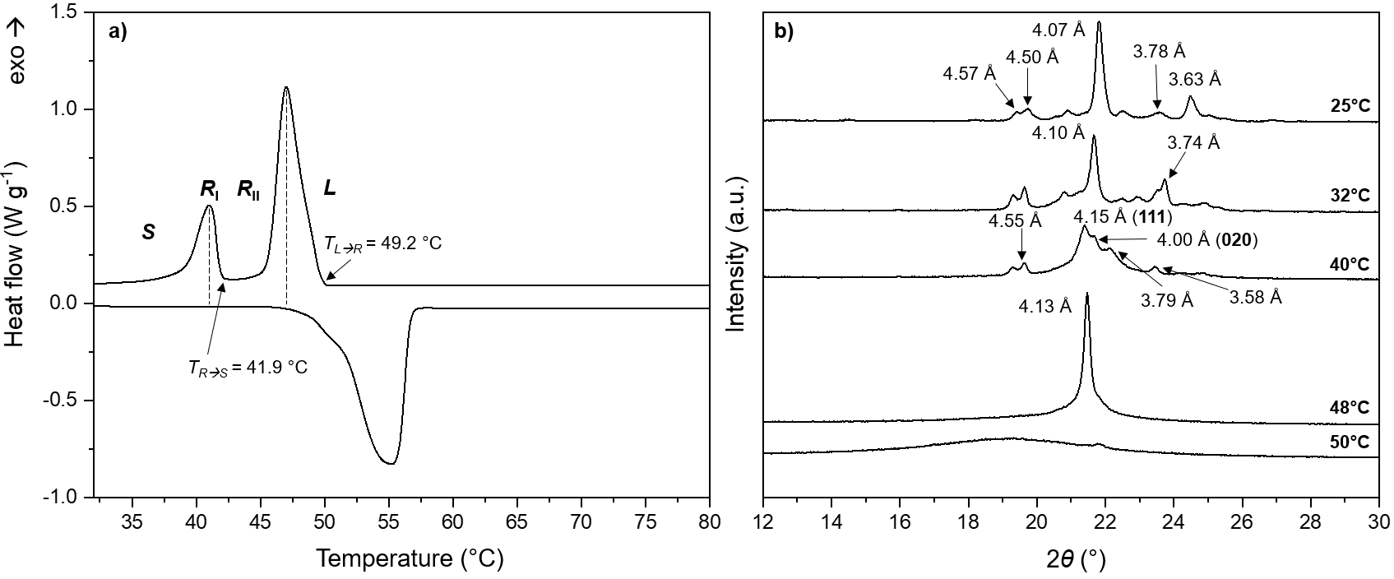
Figure 4.1 a) DSC thermogram (1°C min⁻¹) and XRD patterns recorded at different temperatures for pure docosanal indicating a R_{II} type transition (tentative assignment).

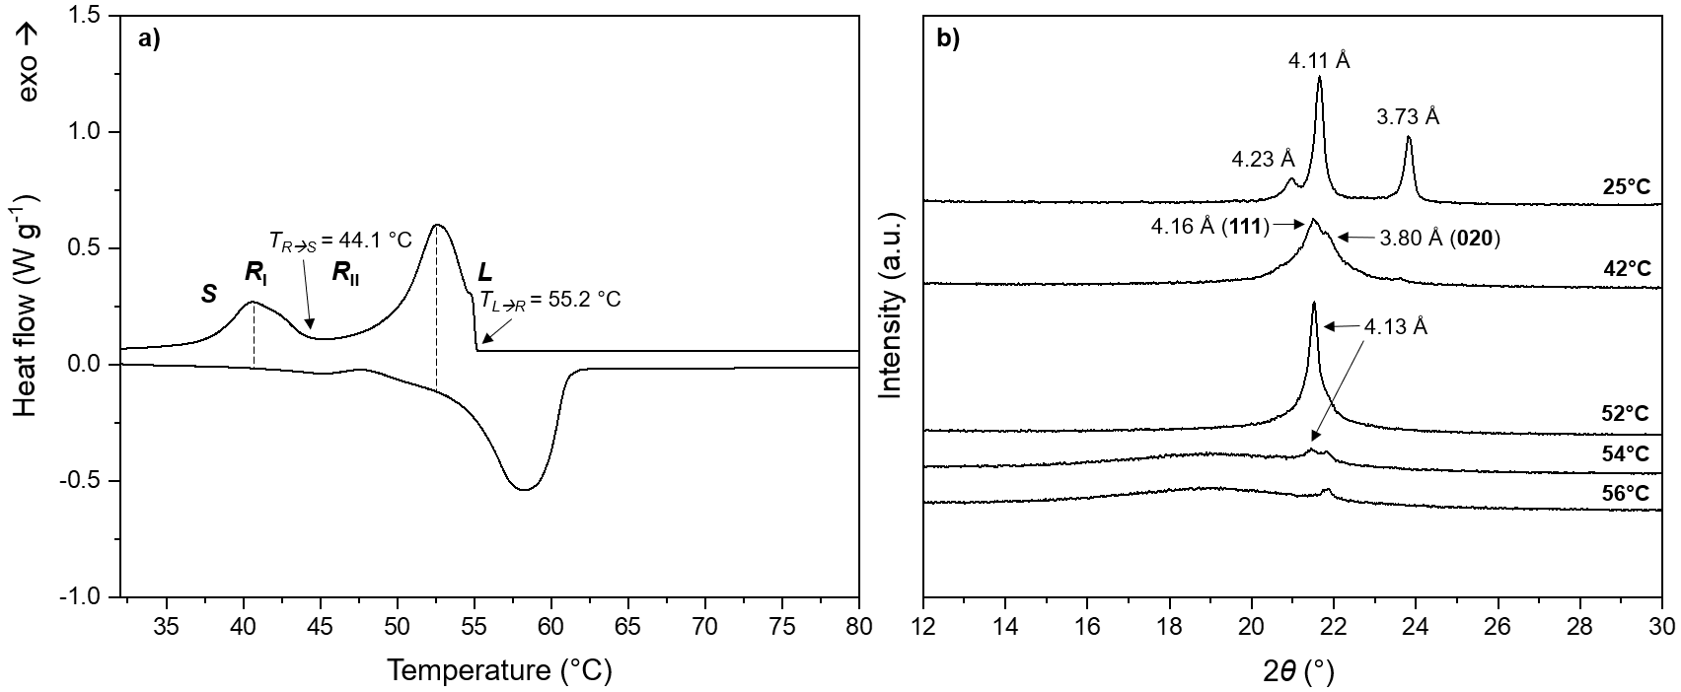
Figure 4.2 a) DSC thermogram (1°C min⁻¹) and XRD patterns recorded at different temperatures for pure tetracosanal indicating a R_{II} type transition (tentative assignment).

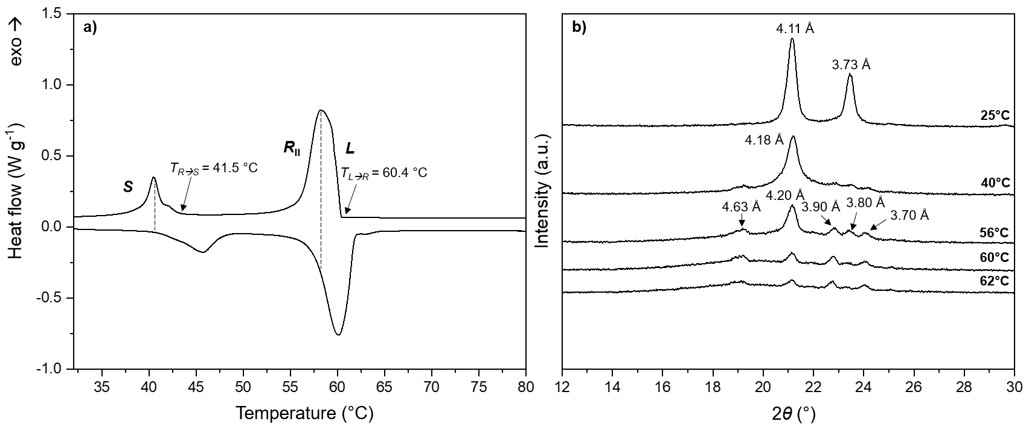
Figure 4.3 a) DSC thermogram (1°C min⁻¹) and XRD patterns recorded at different temperatures for pure hexacosanal indicating a R_{II} type transition (tentative assignment).

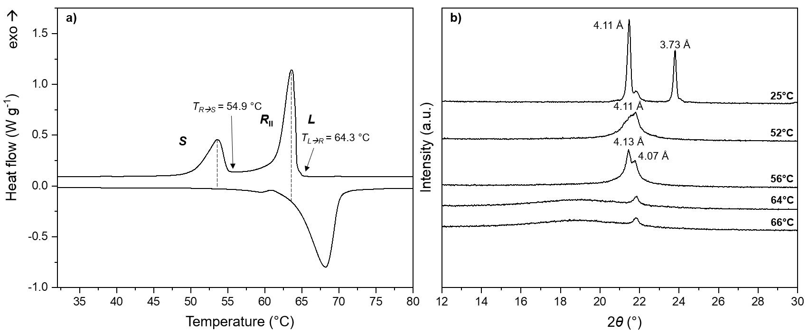 Figure 4.4 a) DSC thermogram (1°C min⁻¹) and XRD patterns recorded at different temperatures for pure octacosanal indicating a R_{II} type transition (tentative assignment).

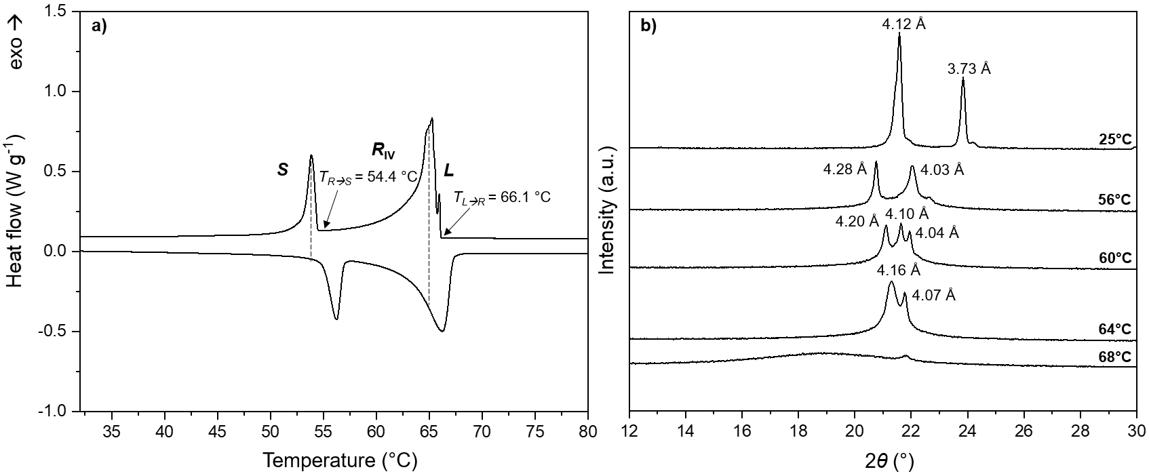
Figure 4.5 a) DSC thermogram (1°C min⁻¹) and XRD patterns recorded at different temperatures for pure triacontanal indicating a R_{IV} type transition (tentative assignment).

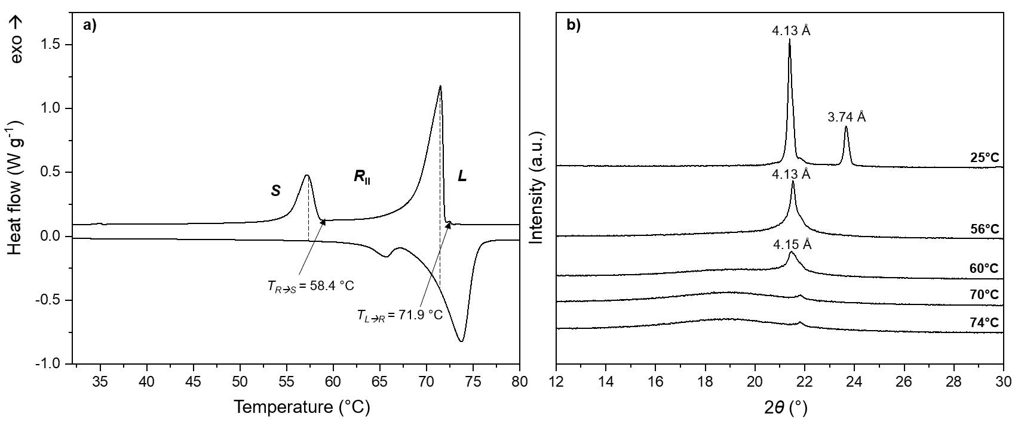
Figure 4.6 a) DSC thermogram (1°C min⁻¹) and XRD patterns recorded at different temperatures for pure dotriacontanal indicating a R_{II} type transition (tentative assignment).

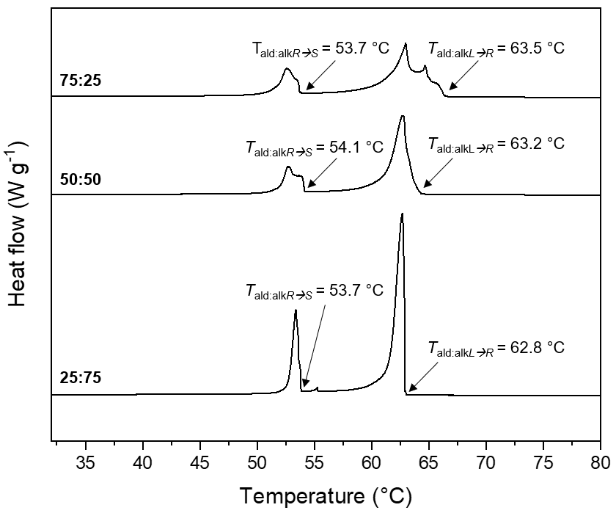
Figure 4.7 a) DSC thermograms (1°C min⁻¹) for binary mixtures (25:75, 50:50, and 75:25) for triacontanal:n-nonacosane.

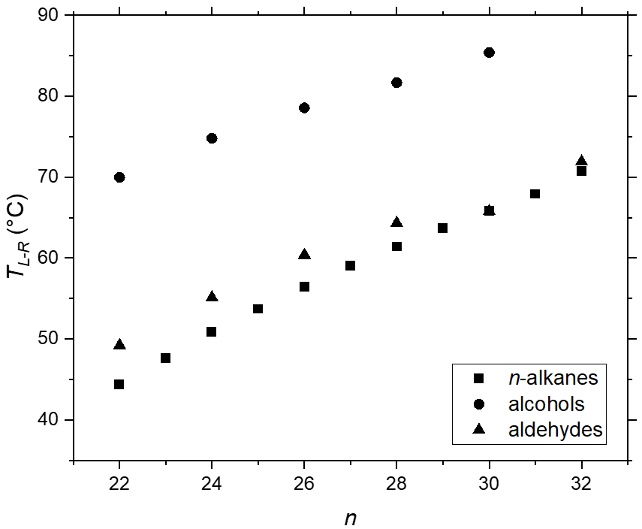
Figure 4.8 Liquid-to-rotator (T_{LR}) transition temperatures for the C₂₂₋₃₂ n-alkanes, alcohols, and aldehydes. Transition temperatures for the n-alkanes and alcohols were compiled from literature sources. ^{3,7}

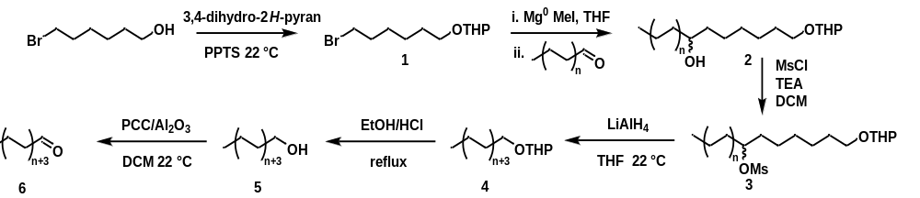
Scheme 4.1. Preparation of aliphatic aldehydes. For dotriacontanal (6), n = 12.
Supplementary Figures

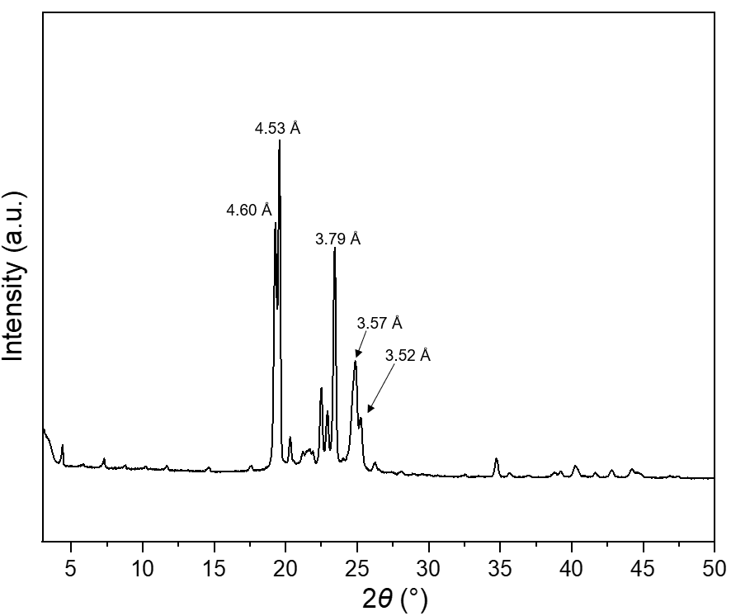
Figure 4.9. XRD pattern for pure tetracosanal obtained from solvent evaporation indicating T symmetry.
¹H and ¹³C NMR Spectra

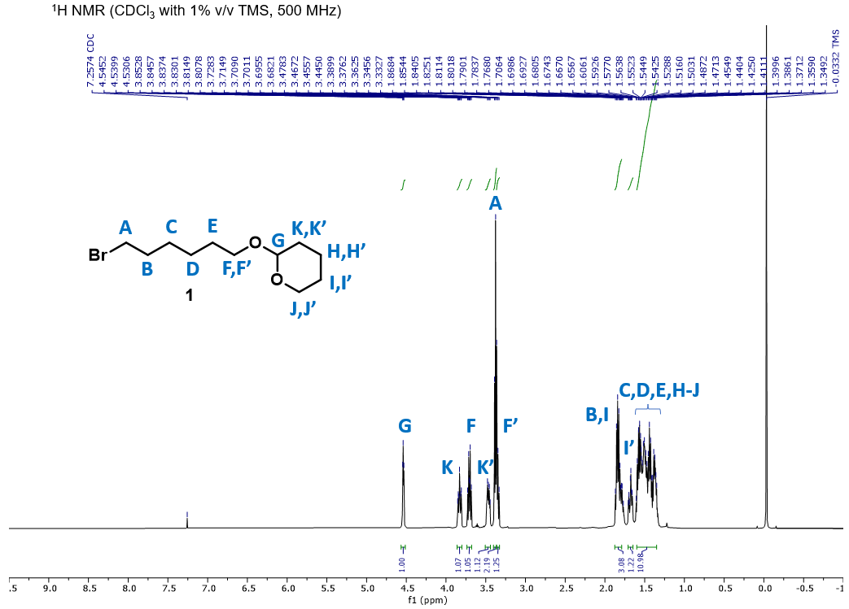
1
Figure 4.10. ¹H NMR spectrum of 2-((6-bromohexyl)oxy)tetrahydro-2H-pyran (1). ¹H NMR (500 MHz, CDCl₃) δ 4.54 (t, J = 7.3, 2.3 Hz, 1H), 3.83 (m, 1H), 3.71 (dt, J = 9.5, 6.7 Hz, 1H), 3.46 (dd, J = 11.2, 5.4 Hz, 1H), 3.38 (d, J = 6.8 Hz, 2H), 3.36 – 3.33 (m, 1H), 1.88 – 1.79 (m, 3H), 1.71 – 1.65 (m, 1H), 1.60 – 1.35 (m, 10H).

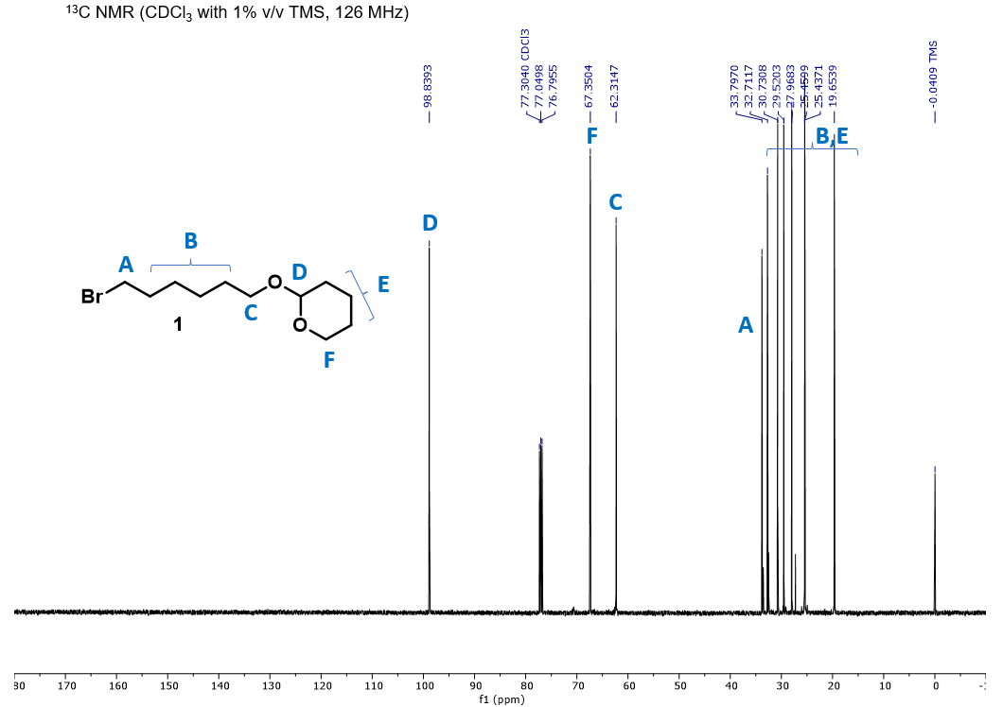
1
Figure 4.11.¹³C NMR spectrum of 2-((6-bromohexyl)oxy)tetrahydro-2H-pyran (1). ¹³C NMR (126 MHz, CDCl₃) δ 98.84, 67.35, 62.31, 33.80, 32.71, 30.73, 29.52, 27.97, 25.46, 25.44, 19.65.

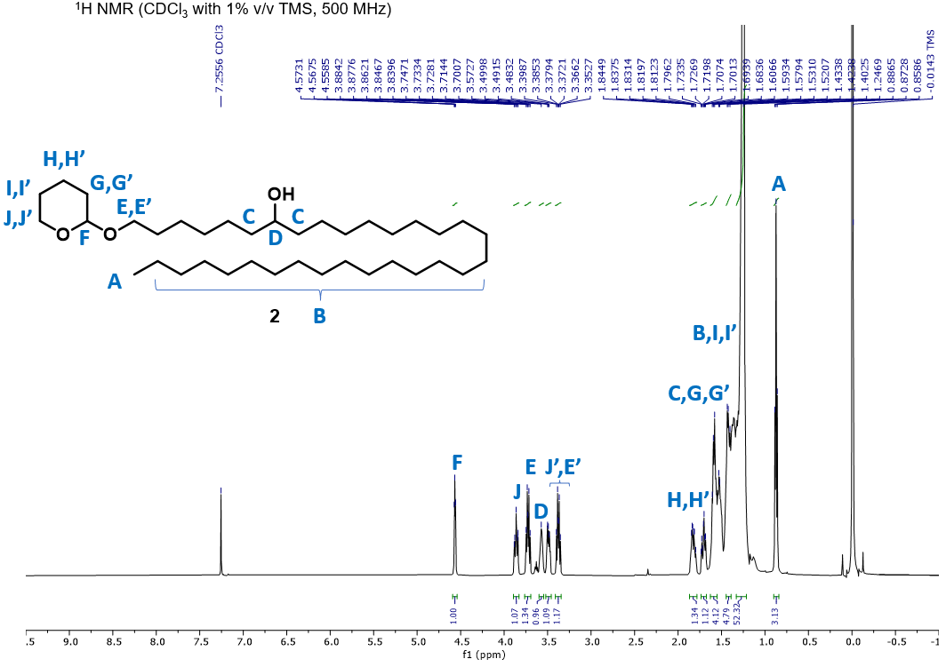
2
Figure 4.12. ¹H NMR spectrum of 1-((tetrahydro-2H-pyran-2-yl)oxy)dotriacontan-7-ol (2). ¹H NMR (500 MHz, CDCl₃) δ 4.57 (dd, J = 4.5, 2.7 Hz, 1H), 3.90 – 3.84 (m, 1H), 3.72 (dt, J = 9.5, 7.0 Hz, 1H), 3.57 (br, 1H), 3.52 – 3.47 (m, 1H), 3.41 – 3.35 (m, 1H), 1.87 – 1.79 (m, 1H), 1.74 – 1.68 (m, 1H), 1.62 – 1.55 (m, 4H), 1.42, (m, 4H),1.25 (br, 52H), 0.88 (d, J = 7.0 Hz, 3H).

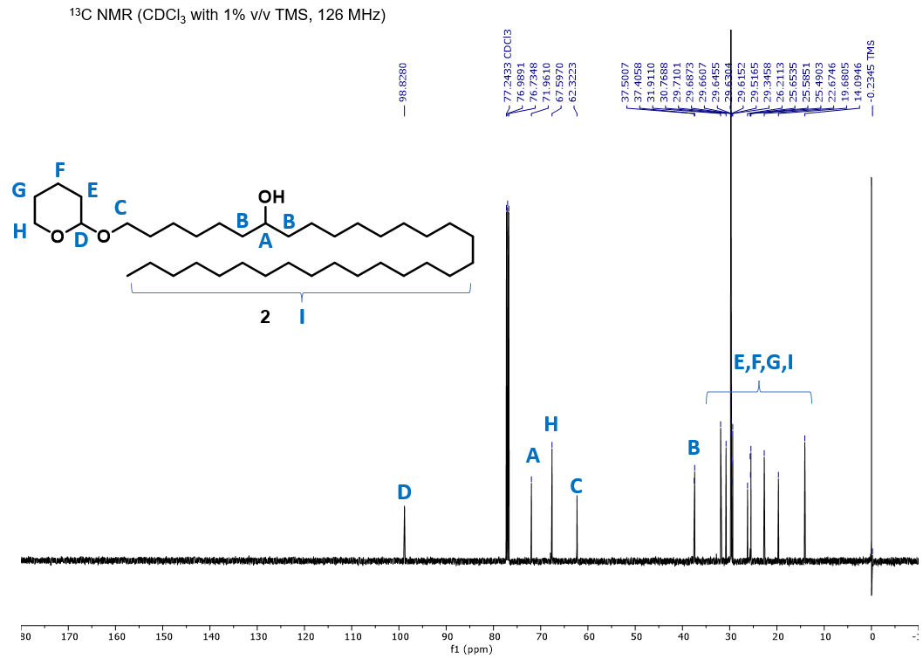
2
Figure 4.13.¹³C NMR spectrum of 1-((tetrahydro-2H-pyran-2-yl)oxy)dotriacontan-7-ol (2). ¹³C NMR (126 MHz, CDCl₃) δ 98.83, 71.96, 67.60, 62.32, 37.50, 37.41, 31.91, 30.77, 29.71, 29.69, 29.66, 29.65, 29.63, 29.62, 29.52, 29.35, 26.21, 25.65, 25.59, 25.49, 22.67, 19.68, 14.09.

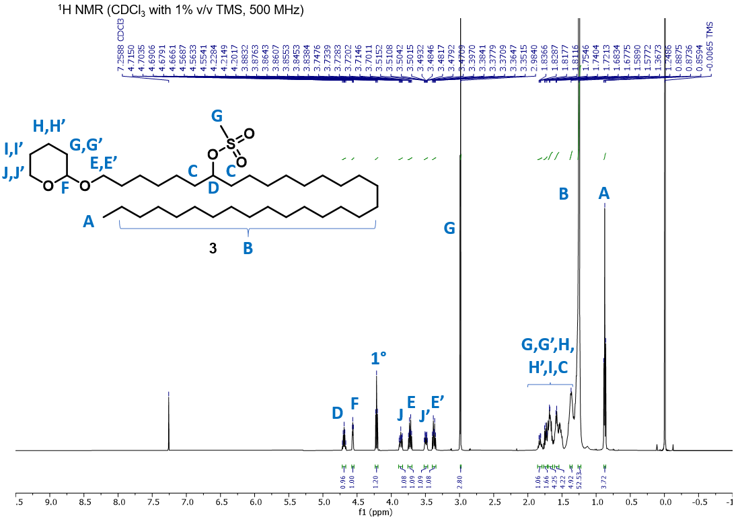
3
Figure 4.14. ¹H NMR spectrum of 1-((tetrahydro-2H-pyran-2-yl)oxy)dotriacontan-7-yl methanesulfonate (3). ¹H NMR (500 MHz, CDCl₃) δ 4.69 (quint, J = 6.1 Hz, 1H), 4.56 (dd, J = 4.5, 2.7 Hz, 1H), 3.86 (ddd, J = 11.0, 7.5, 3.3 Hz, 1H), 3.72 (dt, J = 9.6, 6.8 Hz, 1H), 3.52 – 3.47 (m, 1H), 3.37 (dt, J = 9.6, 6.6 Hz, 1H), 2.99 (s, 3H), 1.82 (m, J = 7.8, 3.5 Hz, 1H), 1.79 – 1.71 (m, 1H), 1.71 – 1.64 (m, 4H), 1.64 – 1.49 (m, 4H), 1.25 (br, 52H), 0.87 (t, J = 6.9 Hz, 3H). Note: δ 4.22 (t, J = 6.6 Hz, 1H) corresponds to a 1° mesylate side product.

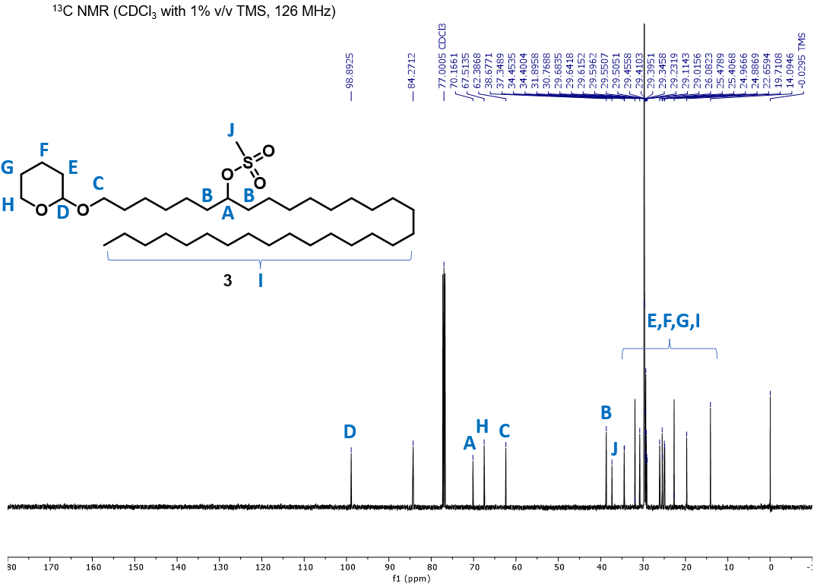
3
Figure 4.15.¹³C NMR spectrum of 1-((tetrahydro-2H-pyran-2-yl)oxy)dotriacontan-7-yl methanesulfonate (3). ¹³C NMR (126 MHz, CDCl₃) δ 98.89, 70.16, 67.51, 62.38, 38.67, 37.34, 31.89, 30.76, 29.68, 29.64, 29.61, 29.59, 29.55, 29.45, 29.41, 29.39, 29.34, 29.23, 29.11, 29.01, 26.08, 25.47, 25.40, 24.96, 24.88, 22.65, 19.71, 14.09.

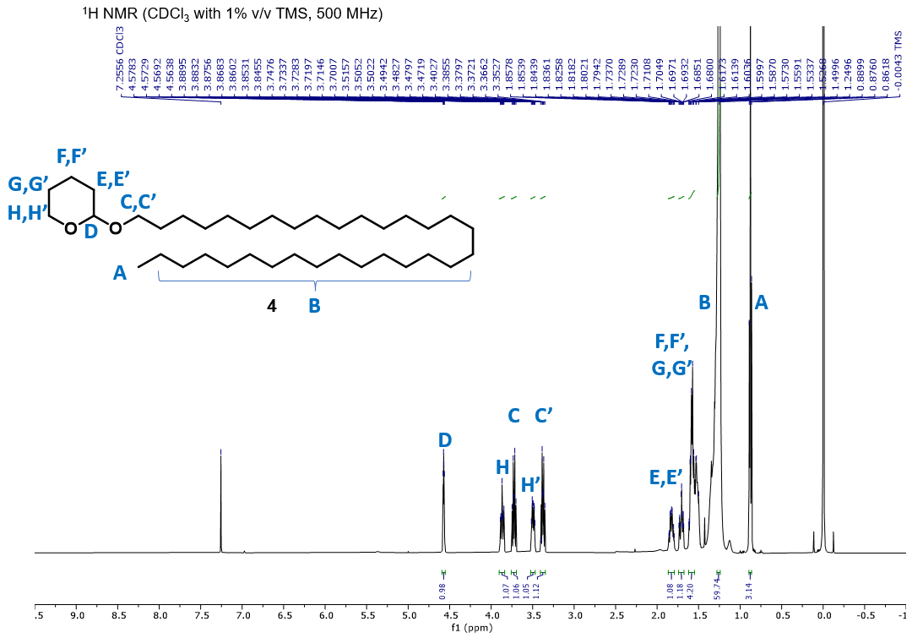
4
Figure 4.16. ¹H NMR spectrum of 2-(dotriacontyloxy)tetrahydro-2H-pyran (4). ¹H NMR (500 MHz, CDCl₃) δ 4.57 (dd, J = 4.5, 2.7 Hz, 1H), 3.90 – 3.84 (m, 1H), 3.72 (dt, J = 9.5, 7.0 Hz, 1H), 3.52 – 3.47 (m, 1H), 3.41 – 3.35 (m, 1H), 1.87 – 1.79 (m, 1H), 1.74 – 1.68 (m, 1H), 1.62 – 1.55 (m, 4H), 1.25 (br, 60H), 0.88 (d, J = 7.0 Hz, 3H).

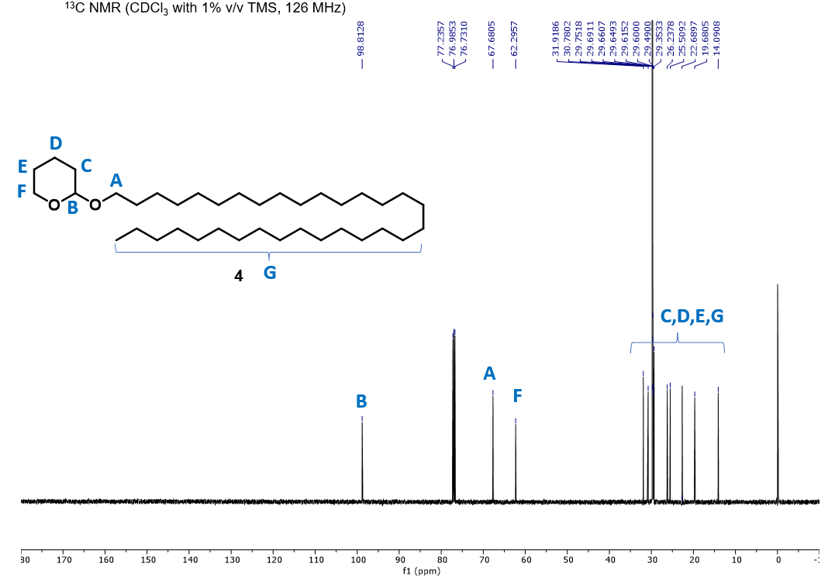
4
Figure 4.17.¹³C NMR spectrum of 2-(dotriacontyloxy)tetrahydro-2H-pyran (4).¹³C NMR (126 MHz, CDCl₃) δ 98.81, 67.68, 62.30, 31.92, 30.78, 29.75, 29.69, 29.66, 29.65, 29.62, 29.60, 29.49, 29.35, 26.24, 25.51, 22.69, 19.68, 14.09.

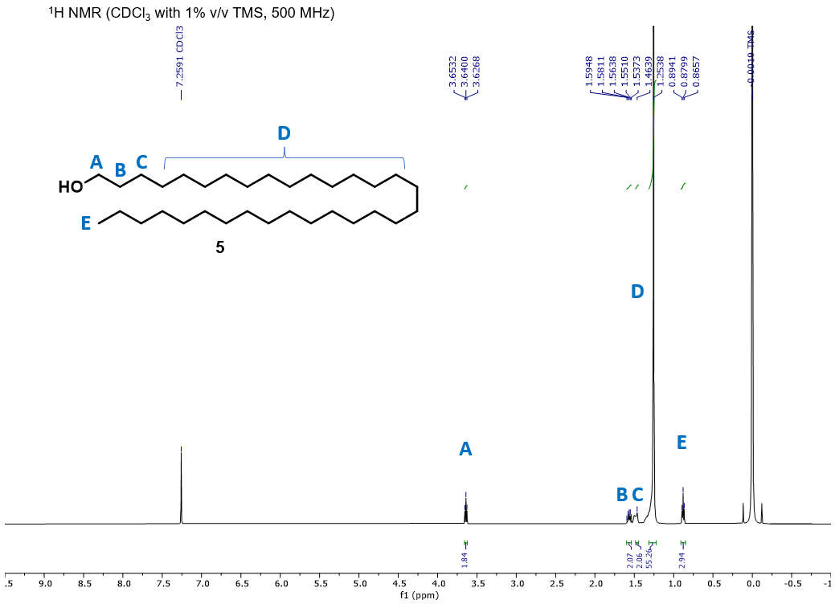
5
Figure 4.18. ¹H NMR spectrum of dotriacontan-1-ol (5). ¹H NMR (500 MHz, CDCl₃) δ 3.64 (t, J = 6.9 Hz, 2H), 1.58 (quint, J = 14.8, 6.8 Hz, 2H), 1.46 (br, 2H) 1.25 (br, 56H), 0.88 (t, J = 6.9 Hz, 3H).

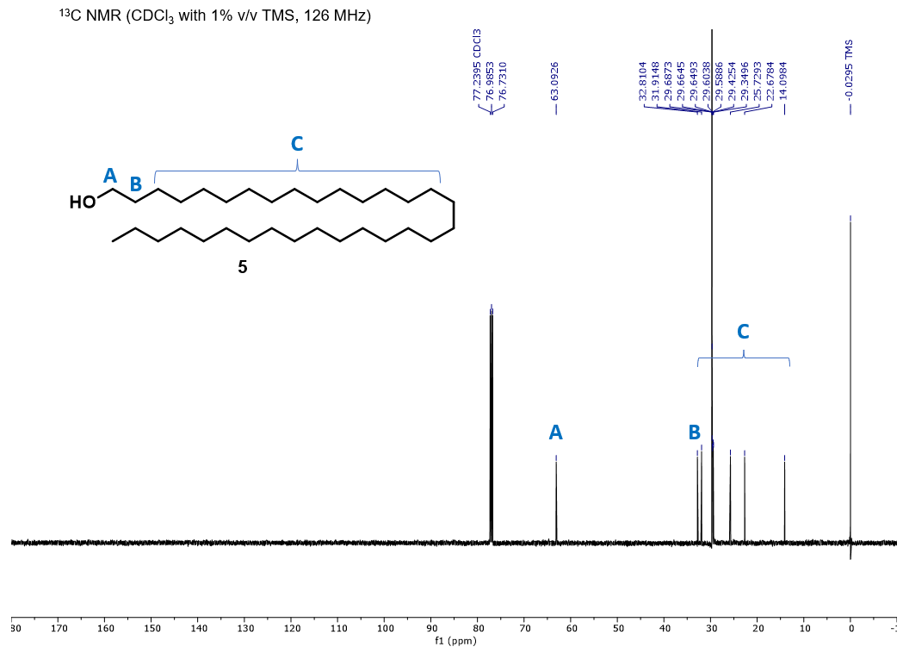
5
Figure 4.19.¹³C NMR spectrum of dotriacontan-1-ol (5). ¹³C NMR (126 MHz, CDCl₃) δ 63.1, 32.8, 31.9, 29.7, 29.7, 29.6, 29.6, 29.4, 29.3, 25.8, 22.7, 14.1.
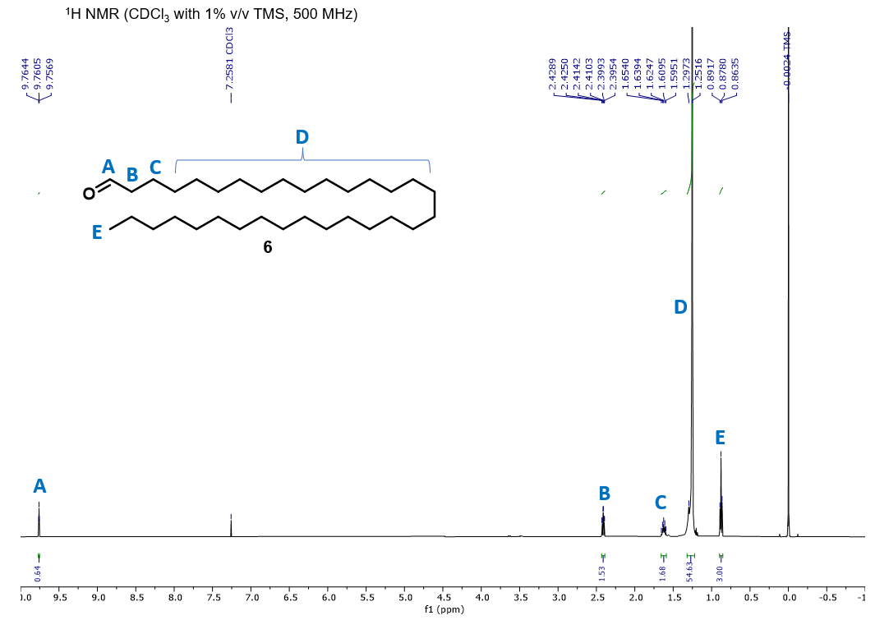
6
Figure 4.20. ¹H NMR spectrum of dotriacontanal (6). ¹H NMR (500 MHz, CDCl₃) δ 9.76 (t, J =1.9 Hz, 1H), 2.42 (dt, J = 7.4,1.9 Hz, 2H), 1.63 (quint, J = 14.7, 7.4 Hz, 2H), 1.29-1.25 (br, 56H), 0.88 (t, J = 6.9 Hz, 3H).
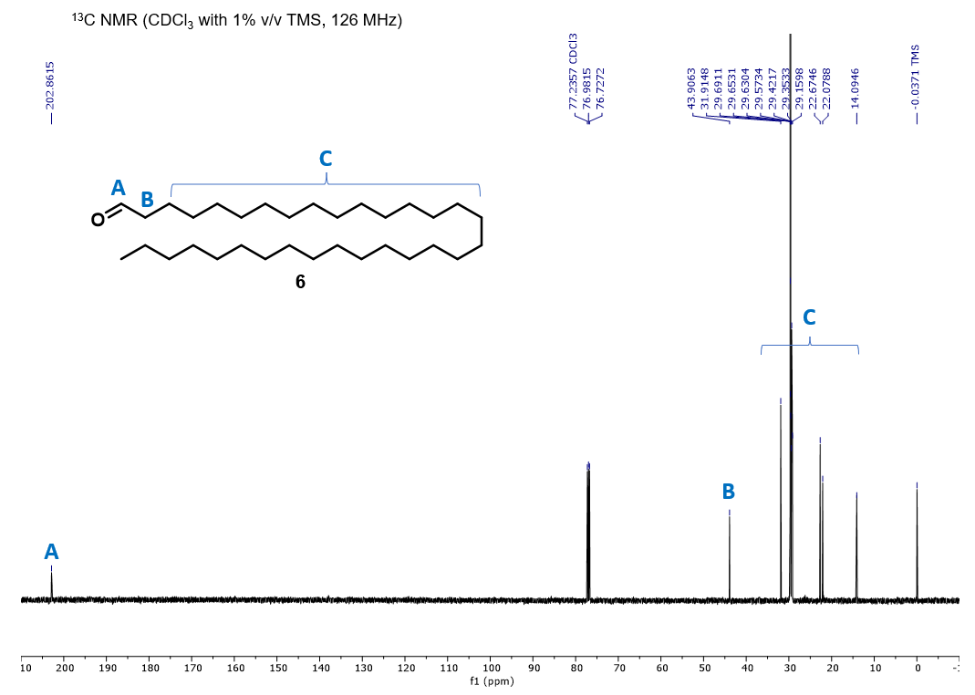
6
Figure 4.21.¹³C NMR spectrum of dotriacontanal (6). ¹³C NMR (126 MHz, CDCl₃) δ 202.9, 43.9, 31.9, 29.7, 29.7, 29.6, 29.6, 29.4, 29.4, 29.2, 22.7, 22.1, 14.1.
Mass Spectra for Select Synthetic Compounds

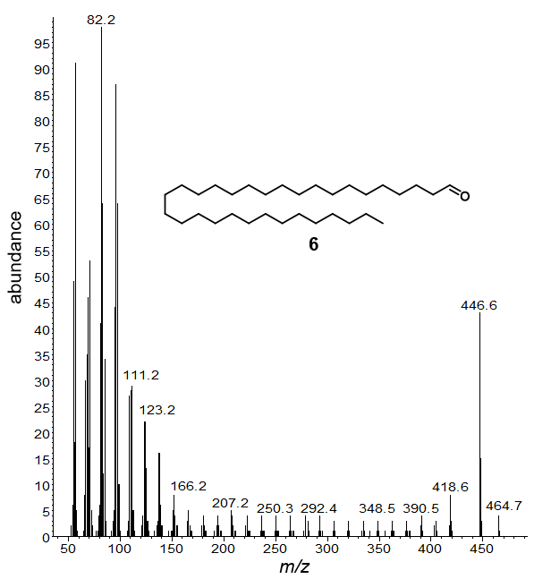
6
Figure 4.22 EI mass spectrum of dotriacontanal (6). EI-MS (70 eV; HP-5MS, RI: 3470.3). m/z 464.7 (5), 446.6 (45), 418.6 (9), 404.5 (4), 390.5 (4).

CHAPTER V
Characterization of By-Products from Commercial Cannabidiol Production

The following chapter details work reprinted with permission from Journal of Agricultural and Food Chemistry, 2020, 68, 7648-7659; Copyright 2020 American Chemical Society. All analytical and physical characterizations were performed by the author. Dr. John P. Munafo and doctoral student, Melissa Dein, performed the solvent-assisted flavor extraction protocol. Dr. Tong Wang and Dr. John P. Munafo advised this work.

5.1 Abstract
The chemical compositions of by-products from commercial cannabidiol (CBD) extraction were characterized and quantitated employing gas chromatography mass spectrometry (GC-MS) and gas chromatography flame-ionization detection (GC-FID). The four major by-products included an ethanol-wax suspension (WAX), terpenoid distillate (DIST-A), tar-like residue (TAR), and red resin (RES). The composition of WAX consisted of ~28 wt% n-alkanes and ~33-38 wt% cannabidiolic acid and CBD combined. The DIST-A consisted of ~40 wt% sesquiterpenoids and ~58 wt% cannabinoids. The DIST-A terpenoid profile was compared to dried unprocessed inflorescences (HEMP) to observe changes in monoterpene content after the distillation process. The TAR was composed of ~5-9 wt% higher n-alkanes and up to 91 wt% cannabinoids, while RES consisted of up to 99 wt% cannabinoids. Several impurities including cannabidibutol and dehydroabietic acid were identified in commercial CBD samples. Compositional information of these by-products may provide manufacturers with the opportunity to optimize processing conditions.

5.2 Introduction
Historically, hemp (Cannabis sativa L.) has been cultivated for the production of its oil, foodstuff, and fibers.¹⁻³ However, the recent increasing recreational and therapeutic use of cannabinoids has greatly increased hemp cultivation to fulfill demands from the rapidly-growing cannabidiol (CBD) market.³ In the U.S.A., CBD is the most popular non-psychoactive constituent, and in its acidic form (cannabidiolic acid, CBDA) is present in concentrations ranging 1.81 – 2.11 wt% of dried inflorescences, for high-CBD cultivars.⁴ Delta-9-tetrahydrocannabinol (Δ⁹-THC) in its acidic form delta-9-tetrahydrocannabinolic acid (THCA), in addition to cannabigerol (CBG), cannabichromene (CBC), cannabidavarin (CBDV) and tetrahydrocannabidavarin (THCV), are the next most often-recognized cannabinoids although present in comparatively lower concentrations. While Δ⁹-THC has long been the focus of extensive ethnobotanical and clinical studies, the latter cannabinoids have recently garnered public interest because of their diverse and potentially beneficial pharmacological effects; however, a consensus on their safety and putative health benefits has not been reached.¹ The much debated so-called “entourage effect,” or synergistic action of hemp constituents, is believed to be dependent on the sum of individual cannabinoids and other constituents which include monoterpenoids, sesquiterpenoids, and diverse classes of phenolic compounds.^{2, 5} As a result, a large body of work has characterized the cannabinoids and volatile fraction of Cannabis sativa, although fewer works have examined the composition of by-products from the production thereof.
In commercial operations, CBDA is most commonly extracted from dried hemp inflorescences using either ethanol (0-24 °C) or supercritical carbon dioxide, then subjected to high temperatures (>125 °C) to induce decarboxylation to the neutral form, CBD. It is then typically purified by distillation, crystallization, liquid chromatography, or solid-phase extraction methods.⁶ Extraction methodologies usually vary according to a manufacturer’s processing capabilities, but none of these processes is impervious to waste. In the present work, we describe the extraction sequence of a manufacturer processing 900-1000 kg day⁻¹ of dry hemp inflorescences, which generates up to 58 wt% (relative to total crude extract) of by-product waste from three different procedural operations. The composition of these by-products is currently unknown. The extraction process is outlined schematically in Figure 5.1 and described below (exact conditions have been omitted in some steps to preserve the manufacturer’s proprietary information).
Extraction and Filtration. A batch consisting of ~1000 kg crushed and dried hemp inflorescences (forced-air dried at 20-22 °C, 60% RH, and packaged in nylon bags) is loaded into stainless steel extraction tanks and extracted with a counter-current flow of ethanol at 20-24 °C. The extract is then concentrated by solvent evaporation, chilled, and passed through a pressurized filtration system to separate the winterized “waxes.” The cold ethanol-wax suspension (WAX), which corresponds to approximately 5-10 wt% waste, is periodically removed from the filtration screen and collected for disposal.
Distillation. The crude CBD oil concentrate is then transferred to a vessel, heated gradually under a regular atmosphere to a maximum of 150 °C, and subsequently distilled under vacuum (<1 Torr). A viscous brown distillate (DIST-A), commonly referred to in the industry as the ‘terpenes’ fraction, is collected at temperatures below 120 °C and later re-distilled to recover cannabinoids carried over. The twice distilled DIST-A results in a black, viscous residue (DIST-B) that is collected for disposal. DIST-A comprises 10-15 wt% waste from the crude oil concentrate, while DIST-B represents a smaller waste fraction from DIST-A. In the crude oil CBDA is assumed to decarboxylate to CBD during the initial distillation at 120-150 °C and is collected as an oily concentrate. The black, tar-like residue (TAR) remaining in the distillation vessel represents 20-30 wt% waste from the original mass and, along with the DIST-A and DIST-B by-products, is collected and discarded.
Wiped-Film Distillation. Next, the crude oily product is transferred into a wiped-film distillation apparatus, and distilled to yield a second concentrate product, as well as a red resin (RES) representing 10-15% waste from the input.
Crystallization. The distilled concentrate product is crystallized from organic solvent at 0-5 °C to afford crystalline “CBD isolate” with batch purities in the range of 94.87-99.99%. If necessary, batches are recrystallized until >99.5% purity is achieved as determined in-house and by third-party certification via high-performance liquid chromatography (HPLC) coupled with ultraviolet (UV) or photodiode array (PDA) detectors. The identity of the impurities is unknown.
The objectives of this study were (1) to elucidate and quantify the composition of the WAX, DIST-A, DIST-B, TAR, and RES by-products, (2) to compare the volatile profile of the DIST-A by-product to that of unprocessed dried hemp inflorescences (HEMP), using the same strain in order to illustrate the changes induced by the high-temperature distillation, and (3) to identify the impurities present in resulting CBD isolates. The composition of these by-products is unknown, and to the best of our knowledge, studies characterizing the composition of by-products from similar CBD commercial operations have not been previously reported. Such studies are important because they may provide manufacturers the opportunity to optimize their processing conditions, find potential applications for these by-products, identify impurities, and minimize the environmental impact associated with waste generation.

5.3 Materials and Methods
5.3.1 Standards and Reagents
Certified reference standards of the three main classes of compounds, namely, cannabinoids, terpenoids, and long-chain alkanes, were employed in this study. Cannabidiol (CBD), cannabidiolic acid (CBDA), cannabidivarin (CBDV), Δ⁹-tetrahydrocannabinol (Δ⁹-THC), Δ⁸-tetrahydrocannabinol (Δ⁸-THC), tetrahydrocannabinolic acid (THCA), cannabichromene (CBC), cannabigerol (CBG), and cannabinol (CBN) standards were each purchased from Cerilliant (MilliporeSigma) as 1.0 mg mL⁻¹ solutions in either methanol or acetonitrile. Cannabis Terpene Mix 1 (Lot No. AA190320009) and Cannabis Terpene Mix 2 (Lot No. AA190306002) standards, representing a combined total of 42 different common Cannabis sativa terpenoids, were purchased from SPEXCerti-Prep as 100 μg mL⁻¹ solutions in methanol, with purities in the range of 75-100% for individual components and/or isomer mixtures. A long-chain C₈₋₄₀ (inclusive) alkanes standard was purchased from Supelco (SKU: 40147-U, Lot No. LRACC 1880) (Millipore Sigma) as a 500 μg mL⁻¹ solution in dichloromethane. A dehydroabietic acid reference standard was purchased from MilliporeSigma. Derivatizing agent N,O-bis(trimethylsilyl)-trifluoroacetamide (BSTFA) with 1% trimethylchlorosilane (TMCS) (Ricca Chemical), methyl stearate (~99%), solvents, and other chemicals (ThermoFisher) were distilled prior to use and dried over 3 Å molecular sieves or used as received.

5.3.2 By-Product Samples
WAX was obtained as an ethanol-wax suspension by scraping the build-up from the screen filtering the winterized waxes from the chilled ethanolic CBD extract.
DIST-A was obtained from a collection vessel as a viscous brown liquid after the initial distillation of the crude filtered CBD extract.
DIST-B was collected as a viscous black residue from the re-distillation of bulk DIST-A in a separate distillation apparatus.
TAR was collected hot (>150 °C), as a slow-flowing black residue from the first distillation apparatus, immediately after distillation of cannabinoids.
RES was obtained as a semi-crystalline, tacky, red resin from a side-collection vessel on the wiped film distillation apparatus.
All by-product samples were collected in duplicate for two separate production batches (Batch A and B) and stored in glass vials at 2 °C under darkness

5.3.3 Other Samples
HEMP and CBD isolate. Recently harvested whole inflorescences (HEMP; cultivar, Special Sauce; 17% CBD as determined by the grower) were forced-air dried (20-23°C, and 60% RH for 10 d), vacuum-sealed, and stored at 20-22 °C in a dry box under darkness prior to analysis. The HEMP sample was the same material used in the CBD production process. Five different lots of CBD isolate with purities in the 95.68-99.62% range were stored in glass jars at 20-22 °C in a dry box under darkness prior to analysis. Both samples (HEMP and CBD isolate) were kindly provided by the manufacturer.

5.3.4 Sample Preparation
For WAX samples, approximately 1.0 g of the ethanol-wax suspension was taken up in 20 mL dichloromethane, acidified with 1.0 N HCl, and washed with saturated brine (3× 20 mL). The amber organic phase was dried over Na₂SO₄, filtered from insoluble particulates using a 25 mm syringe filter with a 0.45 μm PTFE membrane, and evaporated to dryness under a gentle stream of N₂ in a vial to afford a dark-brown solid resin.
For TAR samples, approximately 1.0 g was dissolved in dichloromethane, filtered from insoluble particulates, and evaporated to dryness under N₂ to recover a soft, black-brown resin. DIST, RES and CBD samples were analyzed without prior sample preparation.
To detect the presence of cannabinoids in their acidic form, all by-products as well as CBD isolate samples were silylated prior to chromatography by the following general procedure. Approximately 1.0 mg of a sample was charged into a 1.0 mL Reacti-Vial® with 100 µL anhydrous pyridine, 200 µL BSTFA with 1% TMCS, and heated at 70 °C for 4 h, cooled to ambient temperature, and diluted with freshly distilled pentane to a final concentration of 100 µg mL⁻¹. By-product samples were also analyzed underivatized by dissolving in dichloromethane to prepare stock solutions and diluted with freshly distilled pentane to a final concentration of 100 µg mL⁻¹. Methyl stearate was used as the internal standard.

5.3.5 Gas Chromatography-Mass Spectrometry (GC-MS) Qualitative Analysis
Freshly prepared samples were analyzed using an Agilent 7890B GC system coupled to a 5977N MS detector (Agilent Technologies). Separation was achieved using non-polar HP-5MS (5%-phenylmethylpolysiloxane, 30 m × 0.25 mm i.d., 0.25 µm film thickness) capillary column (J&W Scientific), with a He carrier gas flow rate of 1.5 mL min⁻¹, 1:20 split ratio, and full scan electron-impact (EI, 70 eV) acquisition in the 50–700 m/z mass range. Two temperature programs were used. The first temperature program consisted of a 1 min hold at 40 °C, followed by 6 °C min⁻¹ ramp to 250 °C held for 10 min, with both injector and detector temperatures at 250 °C, resolved terpenoids and cannabinoids in chromatographically distinct regions. The second temperature program consisted of a 1 min hold at 50°C, followed by 10 °C min⁻¹ ramp to 320 °C held for 10 min, with injector at 250 °C and detector at 320 °C, resolved long-chain n-alkanes. Compounds were identified using the Agilent MassHunter (v. B.006.00) suite and compared against NIST02 spectral libraries and certified reference standards. Additional identity confirmation was achieved by a linear retention index (RI) (underivatized) relative to a homologous series of n-alkanes (C₉-C₂₆) and comparing against NIST-compiled values for the identical stationary phase.⁷

5.3.6 Gas Chromatography-Flame Ionization Detector (GC-FID) Quantitative Analysis
Compounds were quantified using an Agilent HP6890 GC with FID system (Agilent Technologies). Separation was achieved using a non-polar HP-5 (5%-phenyl methylpolysiloxane, 30 m × 0.25 mm i.d., 0.25 µm film thickness) capillary column (J&W Scientific) with a He carrier gas flow rate of 1.5 mL min⁻¹, 1:20 split ratio using either of the two temperature programs described for GC-MS.
Cannabinoids were quantitated as the trimethylsilyl (TMS) derivatives by a six-point calibration curve (5-100 µg mL⁻¹) constructed from silylated cannabinoid standards. To prepare derivatized standards,⁴ 500 µL of each cannabinoid were pooled into a 20 mL vial, evaporated to dryness under N₂, and then dissolved in 5.0 mL methanol to prepare a stock 100 µg mL⁻¹ solution. Aliquots corresponding to the range of calibration concentrations were transferred to individual 1.0 mL Reacti-Vials®, evaporated to dryness under N₂, and reacted with 100 µL BSTFA with 1% TMCS at 70°C for 1 h, cooled to ambient conditions, and injected directly into the chromatograph.
Terpenoids were quantitated by constructing individual six-point calibration curves (5-100 µg mL⁻¹) from underivatized Cannabis Terpene Mix 1 and Cannabis Terpene Mix 2 reference standards. Alkanes were similarly quantitated by constructing a six-point calibration curve (5-100 µg mL⁻¹) from a C₈-C₄₀ (inclusive) n-alkane reference standard.
Linear correlation coefficients ranged from 0.9897-0.9991 and results are reported as the average of two analytical replicates per sample, per batch. Methyl stearate was used as the internal standard and relative percentages are reported on a weight-by-weight basis for each analytical sample (i.e., derivatized cannabinoids, underivatized terpenoids, alkanes). Analytes for which reference standards were unavailable were quantitated using methyl stearate as internal standard.

5.3.7 Isolation of Volatiles from Dried Unprocessed Inflorescences via High-Vacuum Distillation
The volatile profile of the dried unprocessed hemp material was obtained for comparison as follows: approximately 25 g of the hemp inflorescences were placed in a plastic container and chilled by submersion in liquid N₂ for 2 min. The chilled sample was then finely ground in a coffee grinder, added to a centrifuge tube, and extracted with 100 mL of freshly distilled pentane by shaking for 5 min, followed by centrifugation at 8000 rpm for 15 min. A second extraction with 50 mL pentane was repeated on the residual pellet after decanting and processed as before. The extracts were pooled into a clean, dry, round-bottom flask and distilled at 40 °C and <750 mTorr. The pentane distillate was dried over anhydrous Na₂SO₄ and concentrated to approximately 10 mL in a Vigreux column by distillation at 40°C. The concentrate was transferred to an amber vial and the solvent fully evaporated under a gentle flow of N₂ to afford a fragrant volatile isolate. An aliquot was diluted to 1 mL in freshly distilled pentane and analyzed via GC-FID and GC-MS.

5.4 Results and Discussion
5.4.1 Composition of Ethanol-Wax Suspension (WAX) By-Product
WAX by-product disposal presents an economic challenge because of the substantial amounts generated during production (personal communication with the manufacturer). Evaporation of ethanol yielded a dark brown, tacky, solid resin (17.9 ± 3.8% total solids from WAX) with a faint herbal aroma. GC-FID and GC-MS analysis revealed WAX to be largely composed of C₂₀-C₃₅ n-alkanes with n-heptacosane and n-nonacosane as the dominant species (Table 5.1). In total, the long-chain n-alkanes accounted for 27-28% of the total solid resin. Surprisingly, no long-chain wax esters were identified via mass spectrometry using the method developed by Moldovan and coworkers.^{8, 9} Although no long chain fatty alcohols nor fatty aldehydes were detected, medium chain fatty acids and aldehydes were identified in trace quantities. The chemical composition of dust by-products and lipid fractions from the pulping of hemp bast fibers has previously been reported to consist of n-heptacosane and n-nonacosane as well as lesser amounts of long-chain n-alkanes, fatty aldehydes, fatty alcohols, free fatty acids, and their respective wax esters.^{10, 11} Hemp bast fibers are obtained from phloem tissue¹ (i.e., stalks and stems) which, although technically a part of the inflorescent matter used for CBD extraction, constitute only a small fraction of the dried raw material. Nevertheless, visual inspection of both the raw and spent plant material subjected to extraction revealed the presence of woody fibers (2-6 cm in length) interspersed with dried inflorescences (~16 fibers per 50 g of raw material), as well as inflorescences with significant portions of the stem still attached. Since alkanes are largely confined to bast fibers, harvesting of inflorescences with care to minimize the presence of woody stems would reduce generation of lipidic waste.
The terpenoid profile was characterized by few sesquiterpenes, and only traces of monoterpenoids were observed, and of those p-cymene (~3-5%) and dehydro-1,8-cineole (~1-2 wt%) predominated. Owing to their high volatility, monoterpene (e.g., α-pinene, myrcene, and terpinolene) concentrations from the hemp volatile fraction have been shown to decrease significantly with drying and size-reduction of the raw material as well as prolonged storage.¹² Conversely, such treatments do not tend to affect concentrations of less-volatile sesquiterpenes such as (-)-trans-caryophyllene (~6-7 wt%).
The cannabinoids comprised 41-46 wt% of the total solid resin from WAX. Relatively large quantities of CBDA and THCA were present (~22-35 wt% and 5.8 wt%, respectively) and presumably trapped by the cold lipidic cake on the filtration screen. The detection of neutral CBD (~4-9 wt%) and CBN (1-2 wt%) might be attributable to decarboxylation and subsequent degradation of Δ⁹-THC to CBN, induced during raw material drying and storage with exposure to air.¹ CBC, CBG and Δ⁸-THC were present in concentrations below 0.2 wt% from batch to batch, suggesting these were either endogenous or potentially artifacts of raw material drying conditions; however, further studies would be needed to support this hypothesis. Other minor components included short chain fatty acids and the corresponding ethyl esters (potentially generated via esterification due to ethanol as the solvent), short chain aldehydes, vanillin, and dehydroabietic acid, in trace amounts (<0.05 wt% ).

5.4.2 Composition of Terpenoid Distillate (DIST) By-Products
Collection of the initial distillate from the crude CBD oil concentrate affords the DIST-A by-product. This viscous, brown liquid is assumed to be the sum of all components boiling below 120-125°C under high vacuum (<500 mTorr) which condense and travel approximately one-half meter down a water-cooled condenser arm into a collection vessel. Upon reaching the 120-125 °C range, a second inverted collection vessel positioned higher along the condenser arm is flipped to collect the intended volatizing cannabinoids until the main distilling vessel reaches a maximum temperature of 150°C, at which point the distillation is terminated. DIST-A is later re-distilled to recover additional cannabinoids, which in turn it generates a lesser amount of a black, viscous residue (DIST-B). The re-distillation conditions that generate DIST-B are identical to the first distillation, albeit at a shorter duration.
Monoterpenes are characteristic components of the volatile fraction of Cannabis sativa, and chemotaxonomic volatiles typically include α-pinene, β-pinene, myrcene, (+)-3-carene, α-phellandrene, limonene, and α-terpinene. All DIST waste samples contained less than 1 wt% or trace amounts of each of these volatiles (Table 5.2). Sesquiterpenes are present in slightly higher concentrations, although only (-)-trans-caryophyllene, α-bisabolene, and α-humulene were in concentrations greater than 1 wt%. Similarly, cis-nerolidol, caryophyllene oxide, guaiol, and α-bisabolol were the only sesquiterpenoids present in concentrations higher than 2 wt%. The monoterpene concentrations were uncharacteristically low, leading to the hypothesis that these compounds may have either been degraded or been lost during raw material drying and size reduction; however, additional studies are required to support this hypothesis.^{12, 13} A chromatogram illustrating the differences in monoterpene profile between DIST-A and unprocessed dried hemp inflorescences (HEMP) is shown in Figure 5.2. In each chromatogram, the hemp variety used as the raw material as well as drying conditions (forced-air drying at 20-23 °C and 60% RH for 10 d) are identical. HEMP samples were analyzed within 1-2 days of being dried. However, the amount of time the raw material remained under storage after size reduction, prior to extraction is unknown. The terpenoid profile obtained from the mild, high-vacuum, solvent-assisted distillation is rich in α-pinene, myrcene, sabinene, limonene, and isoborneol. DIST-A samples had reduced levels of monoterpenes, instead exhibiting an enrichment in sesquiterpenoids.
Some terpenoid species may be present as the oxidation products of mono- and sesquiterpenes, as these are seldom reported as part of the volatile fraction of freshly harvested hemp inflorescences obtained by steam distillation and hydrodistillation.^{5, 14, 15} Such compounds include linalool oxide, pinene oxide, trans-pinene hydrate, caryophyllenyl alcohol, humulene epoxide II, and caryophyllenol II. Indeed, the concentrations of these compounds mirror the volatile fraction composition of steam and hydrodistilled inflorescences subjected to drying (120°C in air, for 1-3 min) and size reduction (powdered or sieved) sample preparations.¹⁴ The distillation process contents are heated under an ambient atmosphere before vacuum is applied, and such conditions may result in these compounds as artifacts; however, additional studies are needed to support this hypothesis. The relatively high concentration of the sharp unpleasant-smelling p-cymene in DIST-A samples (~4 wt%), for instance, may be due to the aromatization of limonene. The presence of elevated levels of p-cymene may present a quality concern if the DIST-A by-product were to be used as a source of monoterpenes, which are increasingly used as popular aroma additives for CBD oil preparations. Conversely, the recovery of (-)-trans-caryophyllene, for example, may lead to the use of these by-products as a source of flavor and fragrance ingredients, and even biopesticides.¹⁴
For DIST-A samples from both batches, the cannabinoids constitute ~58 wt% of the total mass, and CBD represents 89% of this share. CBC, Δ⁹-THC, Δ⁸-THC, CBG, and CBN are present in lower yet similar concentrations. Although Δ⁸-THC is an endogenous cannabinoid,¹ it occurs in trace amounts that the distillation temperature may be the mechanism for its occurrence, given that it is the thermodynamic isomer of Δ⁹-THC.^{13, 16} Delta-8-THC was present only in minor amounts in WAX samples, yet increased in concentration in DIST-A and subsequent by-products. CBG was present in less than 2 wt%, although given its relatively low boiling point (105 °C), it was unexpected to detect such low quantities, since DIST-A is collected as the initial distillate. CBG may be present in TAR and RES by-products by a combination of physical entrapment and strong interactions with other cannabinoids. Undoubtedly, the narrow window between collection of DIST-A and CBD oil product is conducive to substantial losses.
Other minor constituents included short- and medium-chain alcohols, aldehydes and ketones, as well as guaiacol and its biosynthetic product veratrole. Vanillin (also seen in WAX), guaiacol, and veratrole should not be unexpected given their shared lignolosic origin. Abietatriene may be the direct result of the decarboxylation of dehydroabietic acid (DHAA), previously detected in WAX samples.
The second pass distillation residue DIST-B is obtained from pooled DIST-A from different batches, and only one sample was available. Interestingly, DIST-B retains a few monoterpenoids, namely p-cymene, although ~94 wt% is comprised by the cannabinoids. DIST-B contains the second highest concentration of CBG (~7 wt%) and the highest concentration of Δ⁹-THC (~10 wt%), similar in composition to TAR. The high viscosity of DIST-B may be responsible for the retention of such large amounts of other cannabinoids.

5.4.3 Composition of Tar-Like (TAR) By-Product
Upon first impression, the TAR resembles black coal tar in appearance. This solid residue is left behind from distillation of the initial crude CBD oil concentrate that yields the DIST-A by-product and second CBD oil concentrate. The TAR does not flow unless heated above 150°C, at which point it becomes viscous, tacky, and odorous. On cooling to ambient conditions, it solidifies as a hard but malleable solid. If deformed and left unrestrained, it flows slowly into a puddle over the course of several days. The TAR dissolves readily in toluene, chlorinated solvents, and tetrahydrofuran to yield a semi-translucent, dark brown solution, although its solubility is limited in alcohols and short-chain nonpolar solvents.
Since TAR is exposed to temperatures in excess of 150 °C, we were interested in probing whether polymerization of any olefinic constituents had taken place. Gel permeation chromatography (GPC; see Appendix) using dimethylformamide as eluent, and calibration with a polyethylene oxide standard, resulted in two peaks below the molecular weight limit (i.e., less than 599 g mol⁻¹). Differential scanning calorimetry (DSC; see Appendix) with a heating ramp from -40 to 300 °C at 10 °C min⁻¹ (after erasing thermal history; 300 °C, held for 3 min) revealed no well-defined phase transitions, but more constant heat absorption until 225-230 °C, at which point a weak endotherm (~0.23 J g⁻¹) was manifest. Occasionally, a small crystallization exotherm (~0.19 J g⁻¹) could be observed during the heating ramp at around 120°C. However, these events were inconsistent, perhaps because of the heterogeneity of the material. The results were used to discount the possibility of polymerization of olefinic constituents. The bulk material appears to be an amorphous mixture.
GC resolved all major components (Table 5.3) and revealed the cannabinoids to represent 87-91 wt% of the total mass, with approximately 5-9 wt% higher n-alkanes and ~2-4.5 wt% unidentified compounds. TAR contains the highest concentrations of Δ⁹-THC and CBG (~7-10 wt% and 10-13 wt%, respectively) suggesting CBG may become physically entrapped throughout the distillation. Minor quantities of CBDA were present in both TAR and RES (see subsequent discussion) for batch B only. CBD is known to form mono- and dimeric deep-purple colored quinones upon oxidation by atmospheric oxygen, and these were initially thought to be possibly contributing to the distinctive color. However, the infrared (IR) spectrum of TAR did not provide evidence of carbonyl absorptions from the known CBD-quinones (1645 cm⁻¹), nor were any distinctive mass fragments identified.¹⁷ Thus the blackness of the resin cannot be unequivocally attributed to the dark-colored CBD quinones, and the exact nature of the observed color was not adequately explained in this study.

5.4.4 Composition of Red Resin (RES) By-Product
All RES samples collected were on average composed of ~80 wt% CBD, 6.5-9.7 wt% Δ⁹-THC, 4.3-6 wt% CBG, 1.7-1.8 wt% CBN, and less than 1 wt% of each Δ⁸-THC and CBC (Table 5.4). CBDV, THCV, as well as CBGA were not initially analyzed in this study because they were assessed as minor endogenous constituents, often reported as part of the sum of the respective neutral cannabinoids.^{1,7} In addition to CBDA, batch B samples also contained on average ~2 wt% residual terpenoids. Incidentally, this minute amount of terpenoid impurities results in a soft flowable resin, unlike the cannabinoid-pure batch A resin which is more crystalline, thus harder. The consistency of this resin by-product may be used as a diagnostic of unsuccessful distillations.
The failure to fully decarboxylate all CBDA represents an inherent economic loss because it is a direct loss of CBD. Decarboxylation of THCA to Δ⁹-THC has been described as stoichiometric, assuming first-order kinetics up to 130 °C; consequently, no THCA was detected. Decarboxylation of CBDA to CBD is more complex, though, with the molar concentrations of the sum of both species having been shown to decrease by up to 14% and 18% for pure CBDA and CBDA-containing plant extracts (a possible matrix effect), respectively, at 130 °C.¹⁸ RES samples are collected as the condensate of a wiped-film distillation apparatus with heated walls at 150°C. Assuming a controlled crude CBD oil mass flow rate, this temperature should be sufficient to induce decarboxylation, although deviations from either of these two parameters could be responsible for the incomplete decarboxylation of CBDA.
CBN is biosynthesized in trace quantities in the Cannabis sativa plant and the concentrations did not appear to increase during this last thermal processing stage. Oxidative aromatization of Δ⁹-THC to CBN is inconsequential below 110 °C under darkness, and presumably up to 130 °C.¹⁸ As such, CBN is probably an artifact from raw material drying and storage. CBG is present in concentrations lower than the corresponding TAR by-products and may be travelling with the bulk cannabinoids as a result of strong hydrogen-bonding and π-interactions. Although CBG is often considered fully separated during the initial distillation passes owing to its low boiling point, these results suggest that it can persist in subsequent streams. Optimization of processing conditions may thus serve to ensure full decarboxylation and separation of CBD from other cannabinoids and extractives.
The overall trend in by-product composition is depicted in Figure 5.3. Cannabinoids, principally CBD, are incrementally concentrated in successive by-products while terpenoids and alkanes decrease with the rising distillation temperature. Three of these by-products, WAX, DIST-B, and TAR are discarded without any reprocessing to recover CBD, while the DIST-A and RES by-products are only minimally reprocessed. Alkanes are confined to WAX and TAR owing to their high boiling points under high-vacuum (e.g., n-nonacosane b.p. ~172 °C at 500 mTorr). Similarly, terpenoids are confined to WAX and DIST-A, although small amounts can persist in successive distillation steps.

5.4.5 Identity of CBD Impurities
Five samples of CBD isolates with declared “total CBD” purities of 95.68%, 96.07%, 96.98%, 97.03%, and 99.62% were analyzed via GC-FID and GC-MS. The manufacturer obtained these purities through a third-party firm employing ultra-performance LC-PDA, using CBDA, CBD, THCA, Δ⁹-THC, Δ⁸-THC, CBC, CBN, CBG, CBGA, CBDV, and THCV reference standards with a declared 10-20 ppm limit of quantitation (LOQ). “Total CBD” is reported as the sum of CBD and CBDA, while “total cannabinoids” sums the wt% of the eleven cannabinoids. Certificates of analysis (COAs) reported CBDV in all samples at 0.24 ± 0.03 wt%. CBDA and the other cannabinoids were reported as “not detected” (i.e., < LOQ). A previous study reported discrepancies in the labeled cannabinoid concentrations as well as several small molecule impurities for seventeen different store-bought “CBD oil” products.¹⁹ We were interested in identifying the unknown impurities of these CBD isolates (results are listed in Table 5.5). The presence of CBDV was verified for all samples by GC-MS and comparison against reference standards. DHAA was identified in three out of five samples as the TMS ester using the characteristic mass fragments (Fig. 5.4b). Here we note that DHAA-TMS co-elutes with Δ⁹-THC-TMS via our separation conditions but can be resolved by MS as shown by the peak purity trace (Fig. 5.4a) and by comparison against reference standards. The abietane resin acids are diterpenoids ubiquitous in the resins of the Pinacea family, although similar diterpenoids are common metabolites synthesized by the glandular trichomes of other plants.^{4, 20, 21} Nevertheless and to the best of our knowledge, resin acids have not been reported in Cannabis sativa extracts.
We identified the cannabidibutol (CBDB) TMS ether as an impurity eluting between CBDV-diTMS and CBD-diTMS in four samples based on its MS fragmentation pattern. The m/z 458 [M⁺] ion, as well as characteristic m/z 390 retro-Diels-Alder product, m/z 337 tropylium, and m/z 301 CBD-diTMS ions all differ by 14 u, suggesting the presence of the n-butyl homologue (Fig. 5.4c). Citti and coworkers recently confirmed the identity of CBDB as a prominent impurity in ten commercial CBD samples in concentrations ranging 0.08–0.23 wt%.²² All five samples in the present work were estimated to contain ~0.04 wt% CBDB. Given the only-recent development of a validated HPLC-UV analysis method²² for the CBDV, CBDB, and CBD homologous series, in addition to the current lack of CBDB certified reference standards available, other commercial operations may not detect CBDB. Based on our quantitation method the other impurities consisted of CBC (~0.04 wt%), Δ⁸-THC (~0.04-0.10 wt%), Δ⁹-THC (co-eluting with DHAA-TMS; ~0.09-0.16 wt%), CBG (~0.08-0.11 wt%), and CBN (~0.04-0.06 wt%) in addition to two unidentified compounds whose mass spectra are included in the supplementary information.

5.5. Conclusions
The composition of the major by-products from commercial CBD extraction, WAX, DIST-A, DIST-B, TAR, and RES were elucidated and quantified in the present work. WAX consisted of ~28 wt% n-alkanes and up to a 46 wt% cannabinoids. The DIST-A and DIST-B by-products consisted of ~50 and 91 wt% cannabinoids, respectively, with the balance largely comprised by sesquiterpenoids. The terpenoid profile obtained from the mild, high-vacuum distillation of HEMP was found to be rich in monoterpenes in contrast to DIST-A, TAR and RES by-products were composed of up to 91 and 99 wt% cannabinoids, respectively. Lastly, two unexpected impurities in crystalline CBD isolates were determined to be CBDB and the abietane resin acid, DHAA. The composition of these by-products may serve as a starting point for manufacturers to optimize their operations to increase yields and reduce disposal costs, while also providing an opportunity for the development of other value-added products.

References
1. Small, E., Evolution and classification of Cannabis sativa (Marijuana, Hemp) in relation to human utilization. Bot. Rev. 2015, 81, 189-294.
2. Andre, C. M.; Hausman, J. F.; Guerriero, G., Cannabis sativa: The plant of the thousand and one molecules. Front. Plant Sci. 2016, 7, 19.
3. Cherney, J.; Small, E., Industrial hemp in North America: Production, politics and potential. Agronomy. 2016, 6(54), 58.
4. Ibrahim, E. A.; Gul, W.; Gul, S. W.; Stamper, B. J.; Hadad, G. M.; Abdel Salam, R. A.; Ibrahim, A. K.; Ahmed, S. A.; Chandra, S.; Lata, H.; Radwan, M. M.; ElSohly, M. A., Determination of acid and neutral cannabinoids in extracts of different strains of Cannabis sativa using GC-FID. Planta Med. 2018, 84, 250-259.
5. Hillig, K. W., A chemotaxonomic analysis of terpenoid variation in Cannabis. Biochem. Syst Ecol. 2004, 32, 875-891.
6. Grijó, D. R.; Vieitez Osorio, I. A.; Cardozo-Filho, L., Supercritical extraction strategies using CO₂ and ethanol to obtain cannabinoid compounds from Cannabis hybrid flowers. J. CO2 Util. 2018, 28, 174-180.
7. Babushok, V. I.; Linstrom, P. J.; Zenkevich, I. G., Retention indices for frequently reported compounds of plant essential oils. J. Phys. Chem. Ref. Data. 2011, 40, 043101.
8. Moldovan, Z.; Jover, E.; Bayona, J. M., Systematic characterization of long-chain aliphatic esters of wool wax by gas chromatography-electron impact ionization mass spectrometry. J. Chromatogr. A. 2002, 193-204.
9. Moldovan, Z.; Jover, E.; Bayona, J. M., Gas chromatographic and mass spectrometric methods for the characterization of long-chain fatty acids: Application to wool wax extracts. Anal. Chim. Acta. 2002, 465, 359-378.
10. Attard, T. M.; Bainier, C.; Reinaud, M.; Lanot, A.; McQueen-Mason, S. J.; Hunt, A. J., Utilization of supercritical fluids for the effective extraction of waxes and Cannabidiol (CBD) from hemp wastes. Ind. Crops. Prod. 2018, 112, 38-46.
11. Gutierrez, A.; Rodriguez, I.; Del Riao, J. C., Chemical characterization of lignin and lipid fractions in industrial hemp bast fibers used for manufacturing high-quality paper pulps. J. Agric. Food. Chem. 2006, 54, 2138-2144.
12. Fiorini, D.; Molle, A.; Nabissi, M.; Santini, G.; Benelli, G.; Maggi, F., Valorizing industrial hemp (Cannabis sativa L.) by-products: Cannabidiol enrichment in the inflorescence essential oil optimizing sample pre-treatment prior to distillation. Ind. Crops Prod. 2019, 128, 581-589.
13. Brenneisen, R. Chemistry and analysis of phytocannabinoids and other Cannabis constituents. In Forensic science and medicine: Marijuana and the cannabinoids 2007 ed.; M. A. ElSohly, Eds.; Humana Press Inc: Totowa, New Jersey, 2006.
14. Benelli, G.; Pavela, R.; Petrelli, R.; Cappellacci, L.; Santini, G.; Fiorini, D.; Sut, S.; Dall’Acqua, S.; Canale, A.; Maggi, F., The essential oil from industrial hemp (Cannabis sativa L.) by-products as an effective tool for insect pest management in organic crops. Ind. Crops Prod. 2018, 122, 308-315.
15. Bertoli, A.; Tozzi, S.; Pistelli, L.; Angelini, L. G., Fibre hemp inflorescences: From crop-residues to essential oil production. Ind. Crops Prod. 2010, 32, 329-337.
16. Hanus, L. O.; Meyer, S. M.; Munoz, E.; Taglialatela-Scafati, O.; Appendino, G., Phytocannabinoids: a unified critical inventory. Nat. Prod. Rep. 2016, 33, 1357-1392.
17. Mechoulam, R.; Ben-Zvi, Z.; Gaoni, Y., Hashish-XIII On the nature of the beam test. Tetrahedron. 1968, 24, 5615-5624.
18. Wang, M.; Wang, Y. H.; Avula, B.; Radwan, M. M.; Wanas, A. S.; van Antwerp, J.; Parcher, J. F.; ElSohly, M. A.; Khan, I. A., Decarboxylation study of acidic cannabinoids: A novel approach using ultra-high-performance supercritical fluid chromatography/photodiode array-mass spectrometry. Cannabis Cannabinoid Res. 2016, 1, 262-271.
19. Pavlovic, R.; Nenna, G.; Calvi, L.; Panseri, S.; Borgonovo, G.; Giupponi, L.; Cannazza, G.; Giorgi, A., Quality traits of "cannabidiol oils": Cannabinoids content, terpene fingerprint and oxidation stability of European commercially available preparations. Molecules. 2018, 23, 1230.
20. Bohlmann, J.; Meyer-Gauen, G.; Croteau, R., Plant terpenoid synthases: Molecular biology and phylogenetic analysis. Proc. Natl. Acad. Sci. USA. 1998, 98, 4126-4133.
21. Silvestre, A. J. D.; Gandini, A., Rosin: Major sources, properties and applications. In Monomers, polymers and composites from renewable resources. Belgacem, M. N.; Gandini, A., Eds. Elsevier: Amsterdam, 2008; 67-88.
22. Citti, C.; Linciano, P.; Forni, F.; Vandelli, M. A.; Gigli, G.; Lagana, A.; Cannazza, G., Analysis of impurities of cannabidiol from hemp. Isolation, characterization and synthesis of cannabidibutol, the novel cannabidiol butyl analog. J. Pharm. Biomed. Anal. 2019, 175, 112752.
Appendix

Table 5.1. Chemical class composition and relative concentrations† of WAX by-product from batches A and B.
Compound | Batch A  ( wt% ) | Batch B  ( wt% ) | Compound | Batch A  ( wt% ) | Batch B  ( wt% )
n-Alkanesª  heptadecane  pristane  phytane  nonadecane  eicosane  heneicosane  docosane  tricosane  tetracosane  pentacosane  hexacosane  heptacosane  octacosane  nonacosane  triacontane  hentriacontane  dotriacontane  tritriacontane  pentatriacontane  heptatriacontane  nonatriacontane  Total  Monoterpenes^{b}  α-pineneª  cis-thujene  sabineneª  p-cymeneª  Sesquiterpenes^{b}  β-cubebene  (-)-trans-caryophylleneª  β -copaene  α-humuleneª  (E,E)-β-farnesene  γ-gurjunene  γ-curcumene  valenceneª  germacrene A  α-7-epi-selinene  α-cadinene  α-bisabolene  (E,E)-α-farnesene | tr  tr  tr  tr  tr  tr  tr  tr  tr  2.17  tr  7.55  0.75  10.51  0.58  3.05  0.49  1.58  1.24  1.18  tr  28.85  tr  nd  0.51  5.15  0.40  7.22  0.40  0.52  0.33  nd  0.70  0.60  0.39  0.54  0.33  2.50  nd | tr  tr  tr  tr  tr  tr  tr  tr  tr  1.92  nd  6.96  2.56  9.92  0.44  2.85  nd  2.06  1.13  1.23  tr  27.02  nd  0.27  0.31  3.32  0.31  5.90  0.32  0.94  0.30  0.27  0.59  0.51  0.44  0.42  0.20  1.63  0.28 | Terpenoids^{b}  dehydro-1,8-cineole  isoborneolª  fenchoneª  cis-thujone  endo-fenchol  geranyl acetate  cis-nerolidolª  trans-nerolidolª  caryophyllene oxideª  humulene epoxide II  10-epi-γ-eudesmol  1,10-di-epi-cubenol  γ-eudesmol  α-muurolol  β-eudesmol  α-bisabolol  (2Z,6Z)-farnesol  Total  Other^{b}  heptanal  2,4-hexadienal  nonanal  vanillin  nonanoic acid  tridecanoic acid  ethyl tetradecanoate  hexadecenoic acid  ethyl hexadecanoate  dehydroabietic acid  Total  Cannabinoids^{ac}  CBD  CBC  Δ⁸-THC  Δ⁹-THC  CBG  CBN  CBDA  THCA  Total | 1.99  0.38  0.44  tr  0.28  nd  2.84  nd  0.89  0.31  0.82  0.36  0.47  0.35  1.01  nd  0.49  23.7  0.61  nd  nd  nd  tr  0.31  nd  0.25  0.31  nd  1.48  9.67  0.18  0.13  0.37  0.22  2.40  22.91  5.78  41.67 | 1.23  tr  0.26  0.27  0.26  tr  2.50  0.43  0.49  0.37  0.61  0.29  0.29  0.25  0.67  0.18  nd  22.92  0.22  0.11  0.37  0.27  tr  0.21  0.42  0.27  0.22  tr  2.09  4.20  0.11  0.12  0.22  0.07  1.20  34.56  5.89  46.37
Table 5.1 Continued

ªidentified and quantified using an external calibration curve from reference standards
^{b}identified from the linear retention index for separation on a dimethylsilicone with 5% phenyl groups stationary phase fused silica column (HP 5) and mass spectrometry, unless noted as identified from reference standards
^{c}as TMS derivatives using calibrated standards
tr = trace, < 0.05 wt%, nd = none detected
†relative concentration reported as wt% for the average of two analytical replicates
Compounds present in concentrations greater than 2.0 wt% are highlighted in bold. Coefficient of variation for individual compounds per batch is within 1-8%

Table 5.2. Chemical class composition and relative concentrations† of DIST-A and DIST-B‡ by-products from batches A and B.
Compound | Batch A  ( wt% ) | Batch B  ( wt% ) |  | Compound | Batch A  ( wt% ) | Batch B  ( wt% )
Monoterpenes^{b}  α-pineneª  α-fenchene  thuja-2,4(10)-diene  verbenene  β-pineneª  sabineneª  myrceneª  α-phellandreneª  (+)-3-careneª  α -terpineneª  p-cymeneª  β-phellandrene  (Z)-ocimeneª  (E)-ocimene  γ-terpinene  1,3,8-p-menthatriene  Sesquiterpenes^{b}  α-ylangene  α-copaene  β-cubebene  longifolene  α-gurjunene  α-cedrene  (-)-trans-caryophylleneª  α-trans-bergamotene  aromadendrene  α-humuleneª  (E,E)-β-farnesene  allo-aromadendrene  γ-gurjunene  β-chamigrene  β-selinene  valenceneª  β-trans-guaiene  (E,E)-α-farnesene  β-bisabolene  γ-cadinene  α-7-epi-selinene  cis-calamenene  δ-cadinene  α-cadinene  α-bisabolene  germacrene B  β-calacorene  Terpenoids^{b}  dehydro-1,8-cineole  1,8-cineole  isoborneolª  linalool oxide  fenchoneª  α-pinene oxide  linaloolª  cis-thujone  endo-fenchol  trans-pinene hydrate  cis-p-menth-2-en-1ol  α-campholenal | 0.33  0.73  0.92  tr  0.56  nd  0.26  0.06  0.22  nd  4.29  0.18  0.62  0.73  0.08  nd  tr  tr  tr  tr  tr  tr  3.99  0.30  0.13  1.36  0.35  0.11  0.18  tr  0.51  0.89  0.11  0.54  0.18  0.15  0.24  nd  0.24  0.29  1.67  tr  0.16  0.16  0.61  0.05  0.23  0.34  0.13  0.05  tr  tr  0.07  0.20  tr | nd  nd  0.91  tr  0.35  0.20  0.32  0.07  0.18  0.14  3.99  0.17  0.57  0.81  0.09  0.06  tr  tr  0.09  tr  tr  tr  4.37  0.29  0.09  1.23  0.29  0.11  0.17  0.05  0.65  0.93  0.07  0.37  0.18  0.14  0.23  0.30  0.23  0.40  2.91  0.06  0.09  0.16  0.60  tr  0.12  0.31  0.15  tr  0.09  nd  0.07  0.17  0.12 | ‡  0.31  tr  tr  3.88  tr  0.30  tr  0.06  0.05  tr  tr | terpine-1-ol  cis-verbenol  menthone  nerol oxide  δ-terpineol  mentholª  trans-1(7),8-p-menthadien-2-ol  trans-dihydrocarvone  cis-carveol  nerolª  citronellyl formate  carvyl acetate  cis-nerolidolª  trans-nerolidolª  caryophyllenyl alcohol  germacrene-D-4-ol  caryophyllene oxideª  guaiolª  humulene epoxide II  1,10-di-epi-cubenol  10-epi-γ-eudesmol  γ-eudesmol  cubenol  α-muurolol  β-eudesmol  α-eudesmol  caryophyllenol II  intermedeol  β-bisabolol  α-bisabololª  (2Z,6Z)-farnesol  (2E,6Z)-farnesol  (2Z,6E)-farnesol  α-sinensal  nootkatone  Total  Other^{b}  1-octen-3-one  6-methyl-5-hepte-2-one  2,4-heptadienal  trans-2-octenal  1-octanol  heptanoic acid  guaiacol  veratrole  cinnamaldehyde  ethyl decanoate  1-tetradecanol  ethyl tetradecanoate  1-hexadecanol  2-heptadecanone  abietatriene  Total | tr  0.07  tr  tr  0.13  0.17  0.05  tr  tr  0.28  tr  tr  2.36  0.26  0.06  0.08  2.06  2.52  0.62  0.09  0.66  0.26  0.21  0.22  nd  0.69  0.21  0.37  0.24  1.46  0.43  0.31  0.12  0.93  0.06  36.67  0.23  0.21  tr  tr  0.07  0.09  tr  0.06  0.06  tr  0.24  0.07  0.13  0.13  nd  1.29 | tr  tr  tr  tr  0.17  0.18  nd  nd  nd  nd  nd  nd  3.87  0.28  tr  nd  1.90  2.76  0.55  0.10  1.17  0.26  0.46  0.45  0.90  1.35  0.52  1.43  nd  1.18  0.42  0.17  nd  tr  tr  41.3  0.28  0.24  nd  0.54  0.06  0.16  0.06  nd  nd  nd  tr  tr  nd  tr  tr  1.34 | ‡
Table 5.2 Continued
Compound | Batch A  ( wt% ) | Batch B  ( wt% )
Cannabinoids^{ac}  CBD  CBC  Δ⁸-THC  Δ⁹-THC  CBG  CBN  Total | 52.41  1.18  1.04  1.61  1.99  0.81  59.03 | 52.49  1.10  1.02  1.66  1.84  tr  58.11 | 70.39  1.07  3.65  9.99  7.11  2.27  94.49
ªidentified and quantified using an external calibration curve from reference standards
^{b}Identified from the linear retention index for separation on a dimethylsilicone with 5% phenyl groups stationary phase fused silica column (HP-5) and mass spectrometry, unless noted as identified from reference standards
^{c}As TMS derivatives using calibrated standards
tr = trace, < 0.05 wt%, nd = none detected
†Relative concentration reported as wt% for the average of two analytical replicates
‡DIST-B only available for batch B and listed in a separate column
Compounds present in concentrations greater than 2.0 wt% are highlighted in bold. Coefficient of variation for individual compounds per batch is within 2-6%.
Table 5.3. Chemical class composition and relative concentrations† of TAR by-product from batches A and B.
Compound | Batch A  ( wt% ) | Batch B  ( wt% ) | Compound | Batch A  ( wt% ) | Batch B  ( wt% )
n-Alkanesª  pentacosane  hexacosane  octacosane  nonacosane  hentriacontane  dotriacontane  tritriacontane  tetratriacontane  pentatriacontane  Total | 0.32  0.20  0.30  0.08  0.27  1.36  1.26  3.34  2.05  9.16 | 0.41  0.15  0.37  0.14  nd  nd  1.25  2.14  1.20  5.65 | Cannabinoids^{ac}  CBD  Δ⁹-THC  CBG  CBN  CBDA  Total  Unidentified  Total | 62.87  10.51  12.96  5.04  nd  91.39  2.01 | 61.63  7.74  10.75  4.45  2.61  87.18  4.57
ªidentified and quantified using an external calibration curve from reference standards
^{c}as TMS derivatives using calibrated standards
nd = none detected
†relative concentration reported as wt% for the average of two analytical replicates.
Compounds present in concentrations greater than 2.0 wt% are highlighted in bold. Coefficient of variation for individual compounds per batch is within 1-2%.

Table 5.4. Chemical class composition and relative concentrations† of RES by-product from batches A and B.
Compound | Batch A  ( wt% ) | Batch B  ( wt% ) | Compound | Batch A  ( wt% ) | Batch B  ( wt% )
Monoterpenes^{b}  thuja-2,4(10)-diene  β-pineneª  γ-terpinene  Sesquiterpenes^{b}  bicyclogermacrene  Terpenoids^{b}  dehydro-1,8-cineole  linaloolª  cis-verbenol  menthone  cis-nerolidolª  guaiolª  α-bisabololª  eudesm-7(11)-en-4-ol  α-sinensal  Total  Other^{b}  (E)-2-octenal  4-ethyl-guaicol  2-pentadecanone  isophytol  Total | nd  nd  nd  nd  nd  nd  nd  nd  nd  nd  nd  nd  nd  -  nd  nd  nd  nd  nd | tr  0.08  0.07  0.07  tr  0.11  tr  0.07  0.07  0.13  tr  0.30  0.06  1.12  0.17  0.05  0.25  0.61  1.08 | Cannabinoids^{ac}  CBD  CBC  Δ⁸-THC  Δ⁹-THC  CBG  CBN  CBDA  Total | 81.37  0.44  0.35  9.73  6.00  1.81  nd  99.68 | 80.09  1.38  tr  6.49  4.27  1.70  2.31  96.26
ªidentified and quantified using an external calibration curve from reference standards
^{b}identified from the linear retention index for separation on a dimethylsilicone with 5% phenyl groups stationary phase fused silica column (HP-5) and mass spectrometry, unless noted as identified from reference standards.
^{c}as TMS derivatives using calibrated standards
tr = trace, < 0.05 wt%, nd = none detected
†relative concentration reported as wt% for the average of two analytical replicates.
Compounds present in concentrations greater than 2.0 wt% are highlighted in bold. Coefficient of variation for individual compounds per batch is within 0.2-1%.
Table 5.5. Identity of impurities from five different commercial CBD isolate samples.
Sample No. | Declared Purityª (%) | Impurity Identity^{b}
1 | 96.07 | CBDV, CBDB, CBC, Δ⁸-THC, DHAA, Δ⁹-THC, CBG, CBN
2 | 96.98 | CBDV, CBDB, CBC, Δ⁸-THC, DHAA, Δ⁹-THC, CBG, CBN
3 | 99.62 | CBDV, CBDB
4 | 97.03 | CBDV, CBDB, CBC, Δ⁸-THC, Δ⁹-THC, CBG, CBN
5 | 95.68 | CBDV, CBDB, CBC, Δ⁸-THC, DHAA, Δ⁹-THC, CBG, CBN
ªreported as “total CBD = CBD + CBDA” on third-party certificate of analysis
^{b}as TMS derivatives by GC-MS

Table 5.6. Key mass spectral data for impurities identified in commercial CBD isolate samples.
Impurityª | Base Ion (m/z) | Qualifier Ions (m/z)
CBDV  CBDB | 362  376 | 430, 309, 273  444, 323, 287
CBC | 303 | 388, 371, 246
Δ⁸-THC | 303 | 386, 330, 265
DHAA  Δ⁹-THC  CBG  CBN | 239  371  337  367 | 281, 255, 207  388, 315, 303  417, 391, 321  385, 310, 295
ªas TMS derivatives by GC-MS
a)

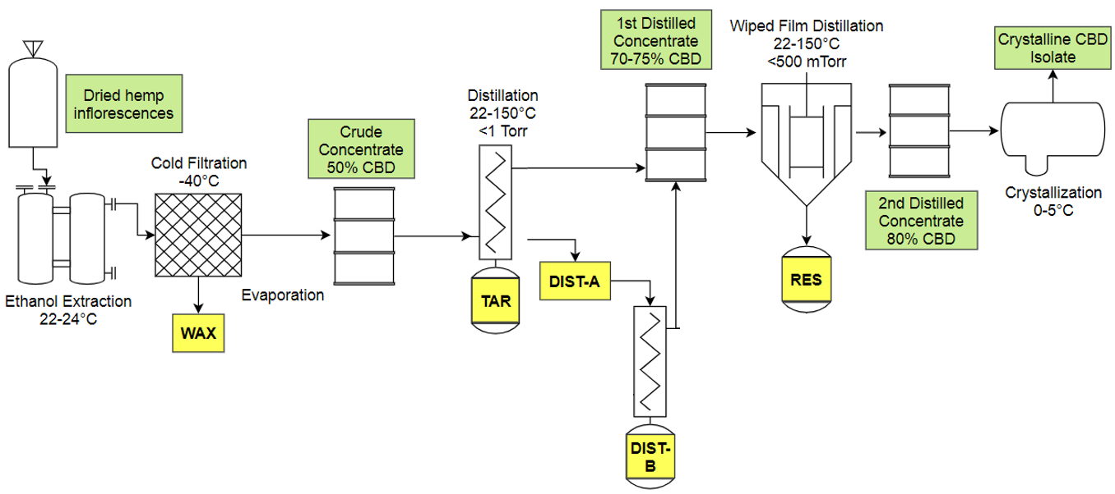
b)
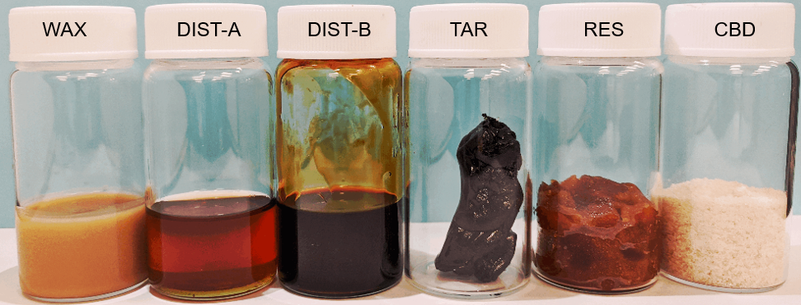
Figure 5.1. a) Simplified process flow diagram for commercial cannabidiol (CBD) production discussed in this study. b) Physical appearance of ethanol-wax suspension (WAX), terpenoid distillate (DIST-A), residue from re-distillation of initial distillate (DIST-B), tar-like residue (TAR) and red resin (RES) by-products, as well as crystalline CBD isolate.

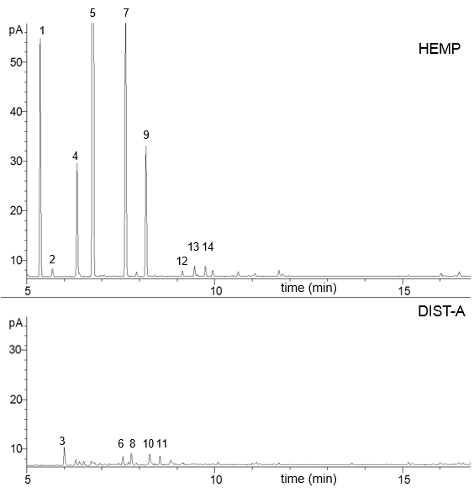
Figure 5.2. Excerpt from qualitative chromatogram of terpenoid profile obtained from mild, high-vacuum solvent assisted distillation (top) of unprocessed dried hemp inflorescences (HEMP), and terpenoid distillate by-product (DIST-A, batch B) after having undergone high-temperature distillation (bottom). Numbers correspond to the following compounds: 1, α-pinene; 2, camphene; 3, thuja-2,4(10)-diene; 4, sabinene; 5, β-myrcene; 6, p-cymene; 7, limonene; 8, 1,8-cineole; 9, isoborneol; 10, (E)-ocimene; 11, trans-2-octen-al; 12, fenchone; 13, linalool; 14, endo-fenchol

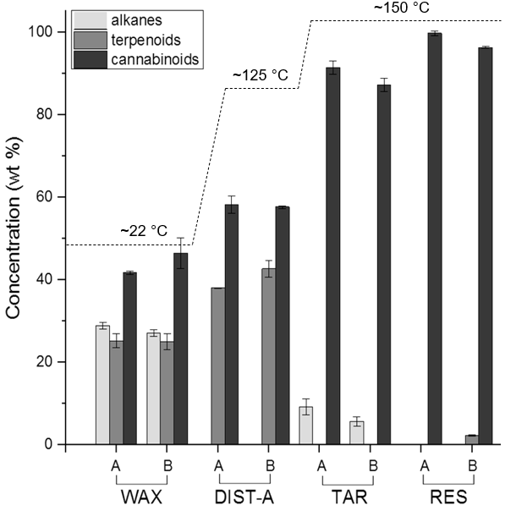
Figure 5.3. Trends of average concentrations (wt%) of alkane, terpenoid, and cannabinoid compound classes in ethanol-wax suspension (WAX), terpenoid distillate (DIST-A), tar-like residue (TAR) and red resin (RES) by-products for two batches (A and B) from commercial cannabidiol extraction.

a)
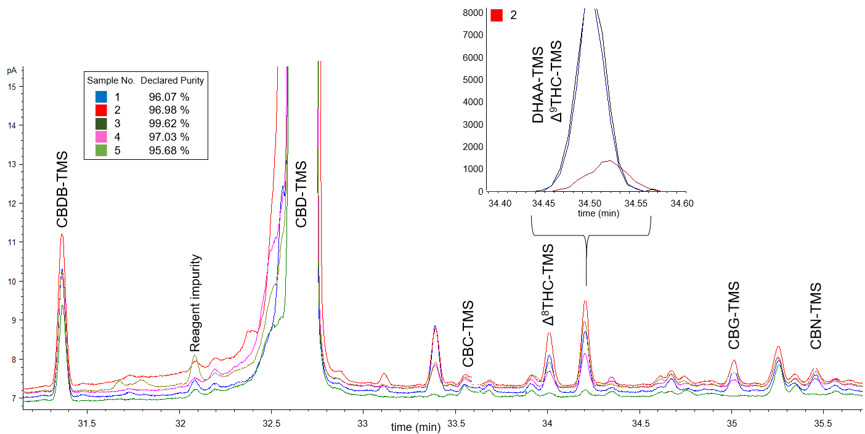
b) c)
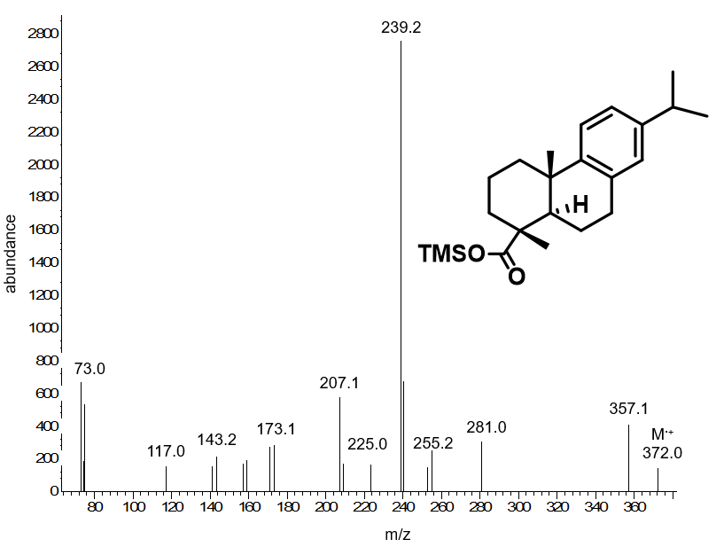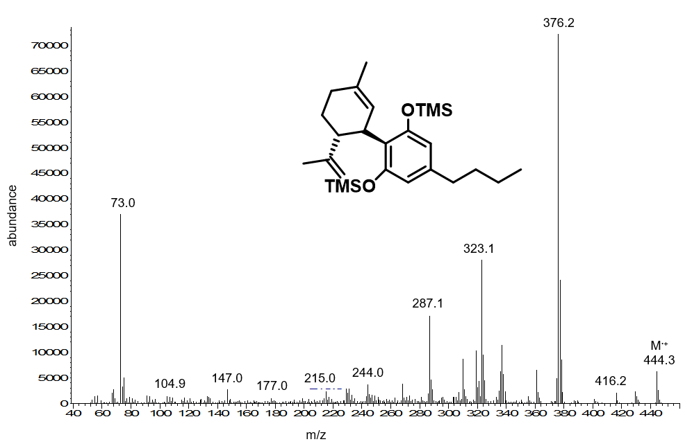
Figure 5.4. a) GC-FID chromatogram excerpt of five CBD isolate samples with identified impurities. Declared purities represent the sum of CBD and CBDA. Insert shows co-eluting Delta-9-THC and DHAA peaks in sample 2 resolved by mass. b) Electron-impact (EI) mass spectrum of DHAA-TMS identified as a persistent non-cannabinoid impurity. c) EI mass spectrum of CBDB-TMS identified as a cannabinoid impurity.

Supplementary Figures and Tables

Table 5.7. Experimentally determined and literature linear retention indices (RI) used for identification in non-derivatized samples. STD = compound identified from certified reference standard.
Compound | ID |  |  | Compound | ID
Compound | Exp. RI |  | Lit. RI | Compound | Exp. RI | Lit. RI
Monoterpenes  α-pinene  α-fenchene  thuja-2,4(10)-diene  verbenene  β-pinene  sabinene  myrcene  α-phellandrene  (+)-3-carene  α -terpinene  p-cymene  β-phellandrene  (Z)-ocimene  (E)-ocimene  γ-terpinene  1,3,8-p-menthatriene | STD  949.5  957.4  964.2  STD  STD  STD  STD  STD  STD  STD  1028.4  STD  1050.8  1056.8  1109.7 | -  949.4  955.6  963.3  -  -  -  -  -  -  -  1030.0  1047.7  1059.7  1111.7 |  | menthone  nerol oxide  δ-terpineol  menthol  trans-1(7),8-p-menthadien-2-ol  trans-dihydrocarvone  cis-carveol  nerol  citronellyl formate  carvyl acetate  cis-nerolidol  trans-nerolidol  caryophyllenyl alcohol  germacrene-D-4-ol  caryophyllene oxide  guaiol  humulene epoxide II  1,10-di-epi-cubenol  10-epi-γ-eudesmol  γ-eudesmol  cubenol  α-muurolol  β-eudesmol  α-eudesmol  caryophyllenol II  intermedeol  β-bisabolol  α-bisabolol  eudesm-7(11)-en-4-ol  (2Z,6Z)-farnesol  (2E,6Z)-farnesol  (2Z,6E)-farnesol  α-sinensal  nootkatone  Other  heptanal  2,4-hexadienal  1-octen-3-one  6-methyl-5-hepte-2-one  (E)-2-octenal  2,4-heptadienal  trans-2-octenal  1-octanol  heptanoic acid  guaiacol  nonanal  veratrole  cinnamaldehyde  4-ethyl-guaicol  ethyl decanoate  vanillin  tridecanoic acid  1-tetradecanol  2-pentadecanone  ethyl tetradecanoate  1-hexadecanol  2-heptadecanone  isophytol  hexadecenoic acid | 1151.5  1154.8  1163.9  STD  1178.2  1199.0  1225.7  STD  1277.5  1336.7  STD  STD  1568.6  1572.9  STD  STD  1608.4  1613.1  1619.2  1631.0  1637.4  1643.5  1649.8  1652.1  1658.3  1667.1  1671.3  STD  1693.0  1695.3  1712.3  1719.5  1753.4  1813.2  900.4  913.6  979.1  987.9  1011.6  1059.5  1061.5  1068.1  1077.4  1091.0  1102.0  1112.7  1270.0  1279.9  1396.1  1403.6  1668.9  1677.0  1704.5  1792.1  1877.7  1899.2  1948.6  1970.7 |  | 1150.5  1154.7  1164.5  -  1180.5  1201.4  1226.7  -  1276.7  1336.6  -  -  1568.6  1574.2  -  -  1604.7  1612.3  1618.7  1630.9  1636.5  1642.9  1650.1  1651.7  1659.7  1666.2  1672.0  -  1692.3  1694.4  1713.6  1722.5  1753.5  1813.4  902.0  913.2  980.0  985.9  1011.5  1059.8  1060.2  1071.5  1080.1  1092.1  1103.3  1112.5  1271.3  1280.2  1395.0  1404.7  1668.9  1676.3  1699.1  1793.9  1879.7  1903.4  1946.8  1968.4
Sesquiterpenes  α-ylangene  α-copaene  β-cubebene  longifolene  α-gurjunene  α-cedrene  (-)-trans-caryophyllene  α-trans-bergamotene  aromadendrene  α-humulene  (E,E)-β-farnesene  allo-aromadendrene  γ-gurjunene  β-chamigrene  β-selinene  valencene  bicyclogermacrene  β-trans-guaiene  (E,E)-α-farnesene  β-bisabolene  γ-cadinene  α-7-epi-selinene  cis-calamenene  δ-cadinene  α-cadinene  α-bisabolene  germacrene B  β-calacorene  Terpenoids  dehydro-1,8-cineole  1,8-cineole  isoborneol  linalool oxide  fenchone  α-pinene oxide  linalool  cis-thujone  endo-fenchol  trans-pinene hydrate  cis-p-menth-2-en-1ol  α-campholenal | 1369.8  1371.0  1390.8  1404.8  1406.1  1413.9  STD  1434.7  1437.4  STD  1456.2  1459.4  1475.6  1478.7  1485.5  STD  1495.7  1499.5  1505.0  1507.4  1513.3  1517.0  1519.4  1523.1  1537.2  1540.9  1552.0  1556.5  991.8  1031.3  STD  1074.7  STD  1096.6  STD  1105.7  1115.6  1118.6  1123.1  1125.6 | 1369.9  1376.1  1386.6  1406.5  1408.6  1412.2  -  1434.5  1440.6  -  1455.9  1459.9  1472.2  1478.9  1486.1  -  1494.1  1499.2  1504.1  1508.4  1513.1  1517.2  1522.9  1523.2  1533.3  1540.3  1550.9  1559.4  989.8  1031.8  -  1075.1  -  1097.0  -  1105.1  1115.1  1121.2  1123.1  1124.1
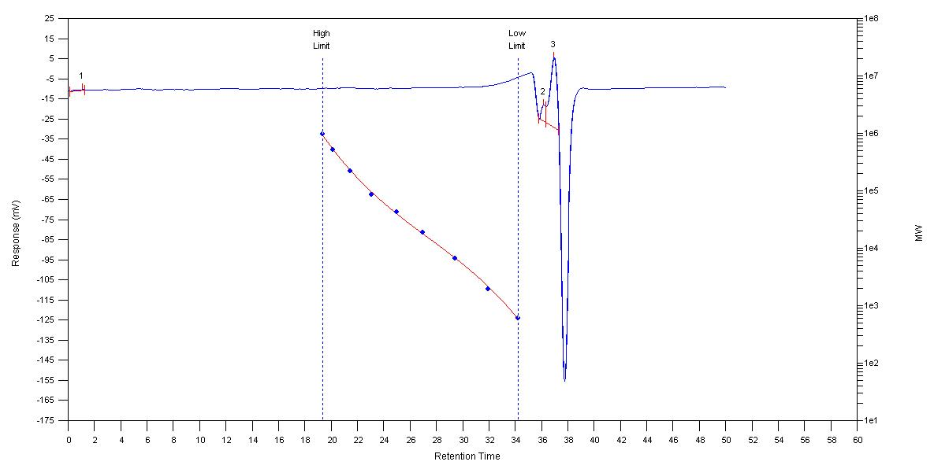Figure 5.5. Representative GPC chromatogram of TAR using dimethylformamide with 0.1 M LiBr as the eluent and calibration against a polyethylene oxide standard (599 g mol⁻¹ -10⁶ g mol⁻¹) with RI and UV detectors.

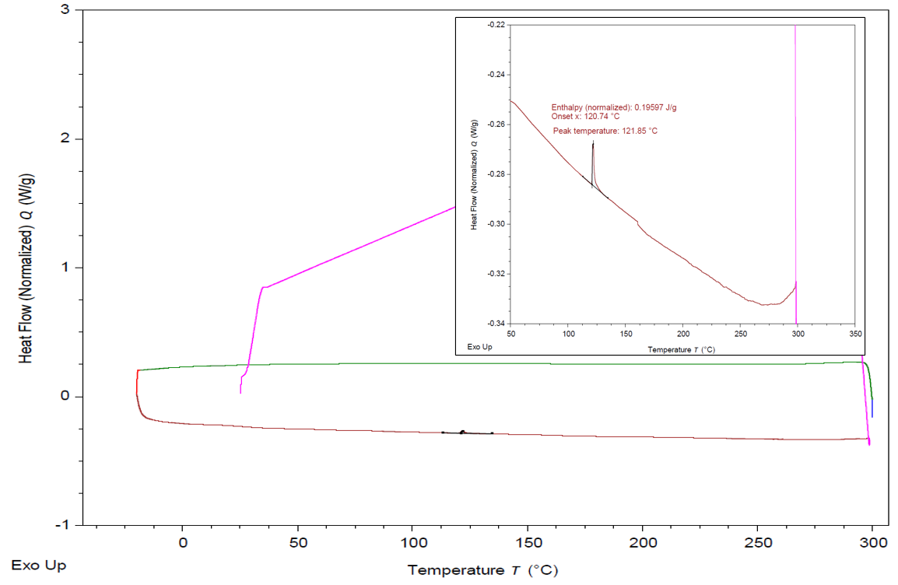
Figure 5.6. Representative DSC thermogram of TAR. Temperature program as follows: ramp to 300°C, held for 3 min, equilibrate to -40°C, ramp from -40 to 300°C at 10°C min⁻¹.

Mass Spectra for Derivatized Cannabinoids

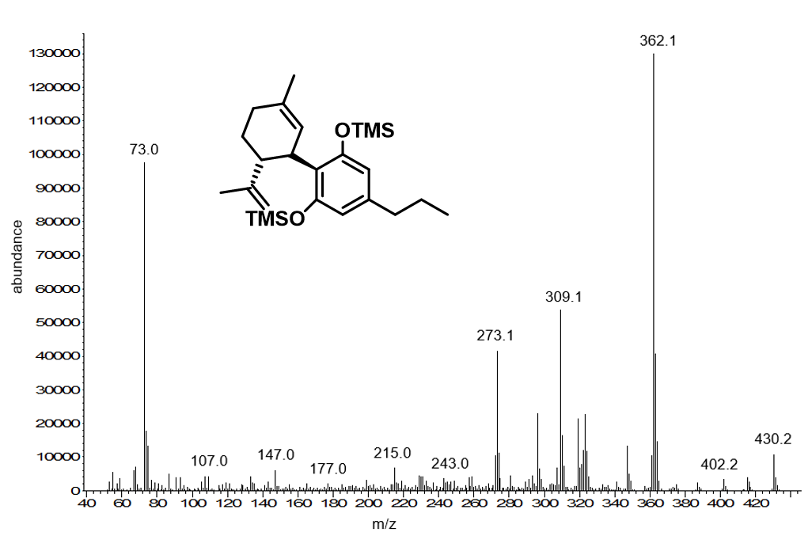
Figure 5.7. EI mass spectrum of cannabidivarin-trimethylsilyl derivative (CBDV-TMS) impurity from samples.

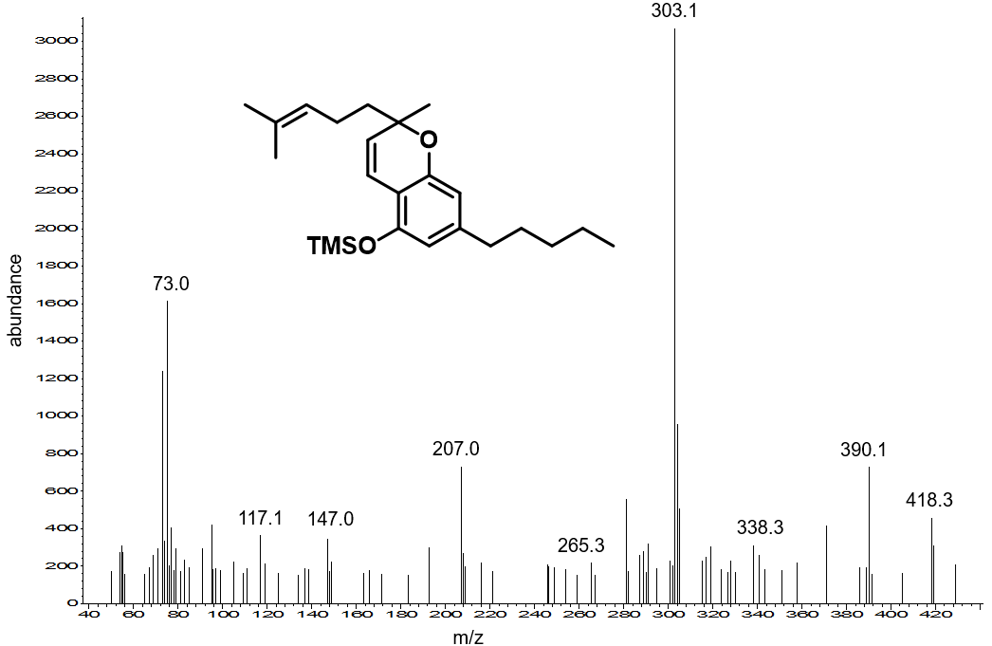
Figure 5.8. EI mass spectrum of cannabichromene-trimethylsilyl derivative (CBC-TMS) impurity from samples.

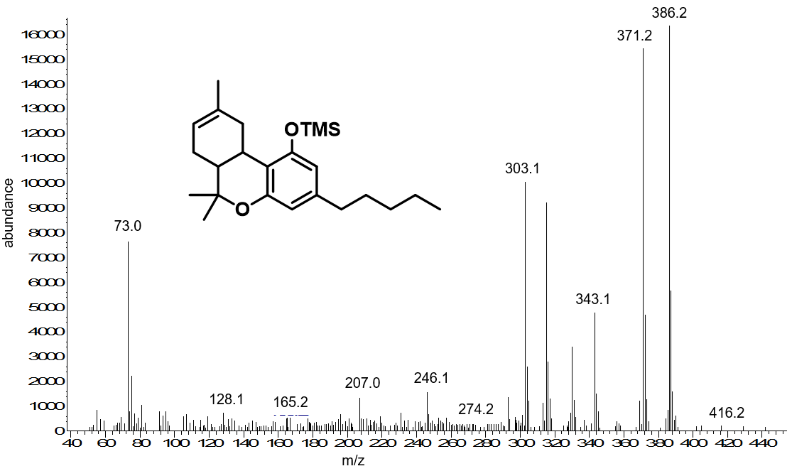
Figure 5.9. EI mass spectrum of Δ⁸-tetrahydrocannabinol-trimethylsilyl derivative (Δ⁸-THC-TMS) impurity from samples.

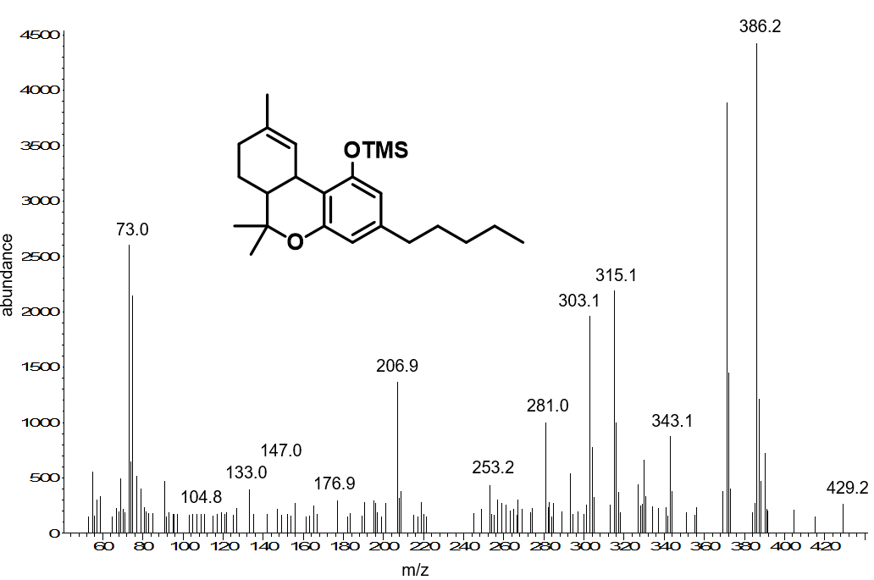
Figure 5.10. EI mass spectrum of Δ⁹-tetrahydrocannabinol-trimethylsilyl derivative (Δ⁹-THC-TMS) impurity from samples.

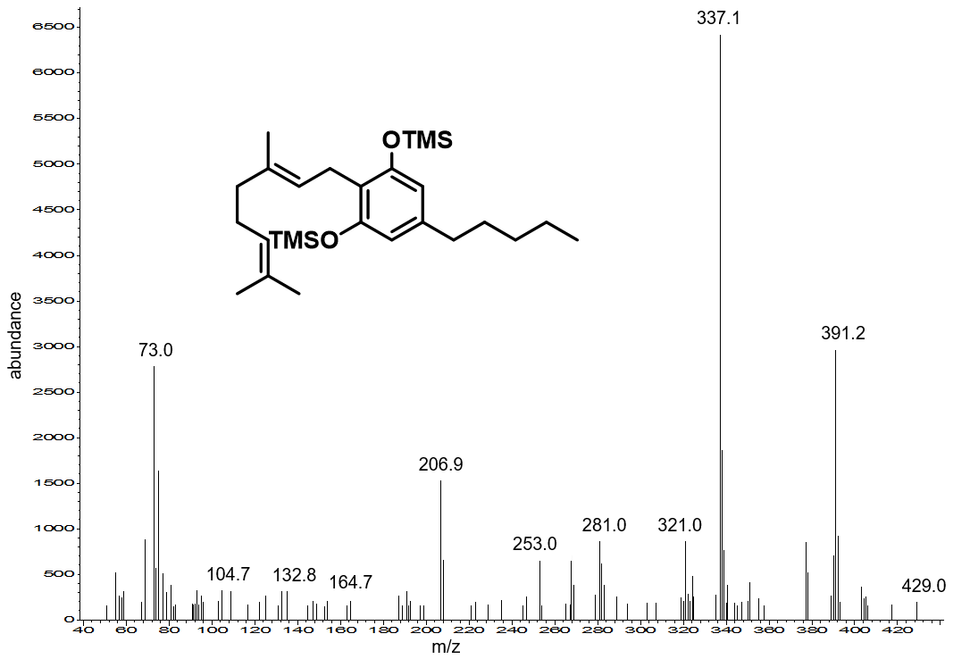
Figure 5.11. EI mass spectrum of cannabigerol-trimethylsilyl derivative (CBG-TMS) impurity from samples.

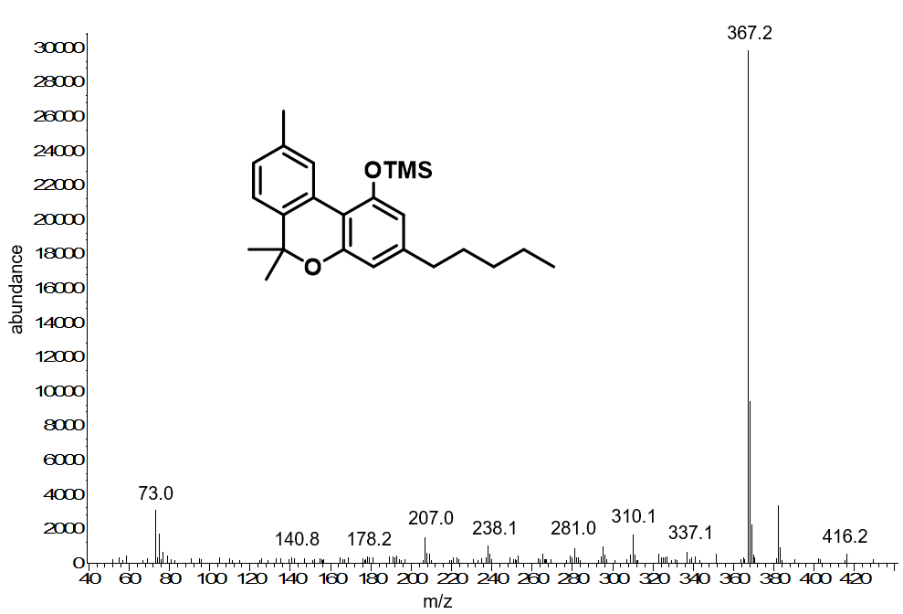
Figure 5.12. EI mass spectrum of cannabinol-trimethylsilyl derivative (CBN-TMS) impurity from samples.

Mass Spectra for Unknown Impurities

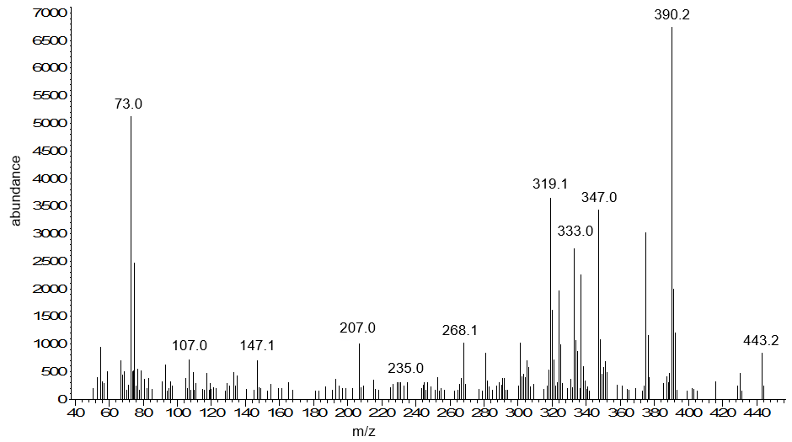
Figure 5.13. EI mass spectrum of unknown impurity 1 (after TMS derivatization) eluting before CBC-TMS.

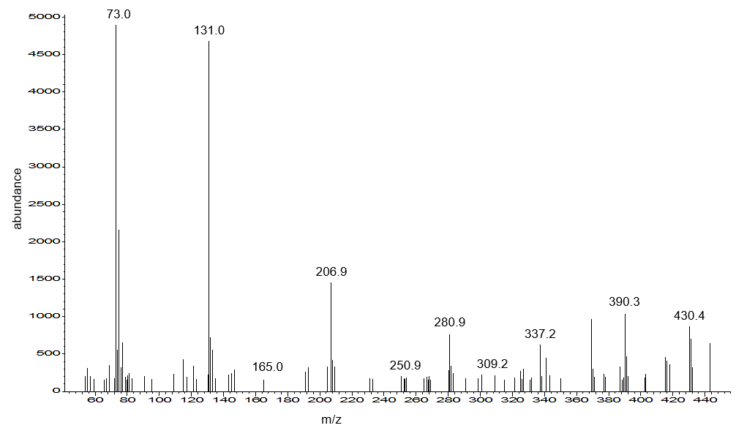
Figure 5.14. EI mass spectrum of unknown impurity 2 (after TMS derivatization) eluting in between CBG-TMS and CBN-TMS.

Chapter VI
Conclusions
6.1 Summary and Key Findings
To date, waxes of botanical and animal origin continue to be premier materials for coating and waterproofing. Progress toward the development of alternative wax materials requires that the structure-function properties of constituent entities be systematically investigated. The work described herein arose from a desire to mimic Nature and matured into an investigation of the chemistry and crystallinity of natural waxes.
The first portion of this work detailed the synthesis and physical characterization of a structural analogue of hydrogenated castor oil. This was the first report of a hydroboration-oxidation of a monounsaturated triacylglycerol scaffold. The resulting racemic triol was a solid material with desirable functional properties capable of serving as an alternative wax material. The melting point and crystallinity of said material, however, was inferior to that of the enantiopure analogue (i.e., hydrogenated castor oil). These observations prompted further investigations into the chemistry, crystallinity and functionality of waxes.
The second portion of this work detailed the synthesis and characterization of model n-alkane, alcohol, aldehyde and fatty acid constituents common to many plant waxes. Chain length families were chosen based on the natural distribution in plants. The crystal structures and water vapor permeability of pure components and binary mixtures were characterized to delineate the contributions of chemistry and structure. To the best of our knowledge, Grncaveric and Radler’s 1967 report on the water vapor permeability of Sultana grape wax fractions represents the only other study of this type.¹ The low water vapor permeability and surprising ability of aliphatic aldehydes to modulate the crystallization of binary mixtures into orthorhombic (O) lattices represent key findings. A significant and novel contribution to the field was the discovery of the solid-solid “rotator” transition of hexacosanal, a ubiquitous constituent of plant waxes. Finally, to consolidate the information in the study, a set of guidelines for the development of wax-based postharvest coatings was proposed.
The third portion of this work was built upon our previous discovery of the rotator transition of hexacosanal. A review of the literature revealed that many plants exhibit mutations wherein the expression of aliphatic aldehydes (typically C₂₄-C₃₂ carbon chain lengths) is significantly decreased. Horticultural and genomic studies have linked the decrease in the expression of aliphatic aldehydes to the absence of epicuticular wax crystals, higher rates of moisture loss, and drought intolerance in plants. Thus, we hypothesized aliphatic aldehydes were integral to wax crystal growth in plants and proposed the rotator transitions as a plausible mechanism. The C₂₂-C₃₂ aliphatic aldehydes were synthesized, their tentative crystal structures assigned, and the rotator transition identified by differential scanning calorimetry and high-temperature X-ray diffraction. A binary mixture composed of n-nonacosane and triacontanal, two representative constituents of cuticular waxes, provided additional insights as to the role of aldehydes in wax crystal growth.
The last portion of this work detailed the chemical characterization of by-products from the commercial production of cannabidiol from hemp (Cannabis sativa L.), an industrial crop of agricultural importance in the United States. This work was undertaken with the intent to identify potential uses for a lipidic by-product of no commercial value colloquially referred to as “waxes.” Gas chromatography-mass spectrometry analyses revealed said by-product to be composed largely of n-alkanes in addition to valuable cannabinoids. Analyses of three other by-products suggested inadequacies in the commercial processing conditions. Moreover, dehydroabietic acid and cannabidibutol, two novel impurities of pharmacological significance, were identified in cannabidiol final products.

6.2 Future Work
Science often generates more questions than answers. Throughout the course of this work, several intriguing questions and opportunities for future studies were identified. My intent is for these research questions to serve as a platform upon which the projects of future students can be built. My ideas are not monoliths, however; I encourage future students to sculpt these ideas into a reflection of themselves.

6.2.1 Stereoselective Hydroboration-Oxidation of Monounsaturated Triacylglycerols
The hydroboration-oxidation of high-oleic soybean oil with borane-tetrahydrofuran or borane-dimethylsulfide complexes affords a mixture of hydroxy fatty acid regio- and stereoisomers. Addition of borane to the internal cis- olefin fatty acyl chains would not be expected to be stereoselective. However, methanolysis of the glycerol backbone and analysis of the liberated methyl esters by ¹H NMR in the presence of a chiral shift reagent (Chirabite-AR™) revealed a surprising selectivity for the (R) enantiomer at a 70:30 e.r. (the enantiopure commercial product, (R)-12- hydroxyoctadecanoic acid, was used to determine that Chirabite-AR™ binds to the (S) enantiomer). This suggested that neighboring fatty acyl chains introduce a bias for the subsequent addition of borane to the triacylglycerol scaffold. According to our findings, the addition of borane to a monounsaturated fatty acyl chain proceeds quickly to the monoalkylborane stage. Thus, by utilizing either a chiral auxiliary or a metal-catalyzed hydroboration protocol, a bias for additional stereoselectivity can be introduced.
The order of borane addition to the triacylglycerol scaffold needs to be established. Due to steric implications, it is hypothesized that addition would occur first at either the sn-1 or sn-3 positions, and then slowly at the sn-2 position. This can be best visualized by imaging the cis- olefins of the triacylglycerol scaffold existing on a plane as depicted in Figure 6.1a. Note that this is an oversimplification because the fatty acyl chains would possess a high degree of freedom in solution. If we suppose addition of the first borane molecule occurs at the sn-1 position, addition of the second borane molecule would preferentially occur at the sn-3 position but opposite face. Relative to one another, the two monoalkylboranes are diastereotopic, thus addition of the third borane molecule at the sn-2 position could occur at either face (Figure 6.1b). This assumption would explain the observed ~70:30 e.r., but offers no insight as to why the (R) enantiomer is preferred. An in-depth structural and kinetic analysis is thus warranted. Such a study should examine the kinetics of borane addition at different temperatures, selectively hydrolyze the fatty acyl chains with stereospecific lipases, and determine the distribution of hydroxy fatty acid enantiomers (after oxidation) by ¹H NMR in the presence of Chirabite-AR™.
With these new insights, a protocol for the asymmetric hydroboration of the triacylglycerol scaffold can be designed. Hydrogenated castor oil is a triacylglycerol composed of up to 91 wt% (R)-12- hydroxyoctadecanoic acid used as a rheological modifier in paints and cosmetics. If we were interested in developing an alternative to this expensive import, we would not be concerned with stereospecificity; in other words, we do not need to target the (R) enantiomer. Because enantiomers have identical physical properties, we would only be concerned with increasing the selectivity for one enantiomer over the other. Without a doubt, this proposal represents a formidable synthetic challenge. Nevertheless, surmounting this challenge would serve the agricultural sector by increasing the demand and utilization of domestic plant oils.

6.2.2 Antifungal Mode of Action of Hydroxy Fatty Acids
Fungicides are added to commercial postharvest wax coatings to inhibit fungal growth during storage and transport.² When we performed fungicide compatibility and fungal inhibition assays with the materials developed in Chapter 2, we were surprised to observe the mixture of hydroxy fatty acid glycerides inhibited the growth of Aspergillus niger and Penicillium spp. A review of the literature revealed that several hydroxy fatty acids are known to exhibit antifungal activity.³⁻⁸ Interestingly, both plants and fungi utilize hydroxy fatty acids to inhibit the growth of other fungi.^{3, 6, 7, 9-11} These reports have suggested that the mode of action must involve the disruption of the phospholipid bilayer resulting in cell death. This behavior was originally documented for cis- and methyl-branched fatty acids.¹² However, this mode of action cannot be extended to hydroxy fatty acids. If disruption of the phospholipid bilayer was the primary mode of action, then all hydroxy fatty acids should exhibit a similar degree of antifungal activity, yet they do not. For example, the reported minimum inhibitory concentrations against Aspergillus niger for (R)-12-hydroxyoctadecanoic acid and 10-hydroxyoctadecanoic acid (unknown configuration) are >20 and 0.7 ± 0.2 g L⁻¹, respectively.⁸ Indeed, very few studies have reported the absolute configuration of antifungal hydroxy fatty acids and virtually no one has proposed an alternative mode of action.
A recent study examined the mode of action for susceptibility of three filamentous fungi (Aspergillus niger, Aspergillus fumigatus, and Fusinarium graminearum) and two yeasts (Saccharomyces cerevisiae and Pichia pastoris) to an antimicrobial peptide produced by Aspergillus giganteus.¹¹ In brief, it was established that enzymatic desaturation of fungal glycosylceramides (GlyCers) by Δ3(E)-desaturase (dtdA) was necessary for the embedding of chitin synthase at membrane raft domains, allowing for chitin synthesis and cell growth to occur (Figure 6.2a). ¹¹ To reiterate, the presence of unsaturated of GlyCers, accessible only by the action of dtdA, is a requisite for cell growth. Note that both the sphingosine base and fatty acid moieties of fungal GlyCers contain hydroxyl groups on chiral centers (Figure 6.2a).
It is our hypothesis that hydroxy fatty acids self-segregate into membrane rafts wherein they interact with dtdA. Saturated hydroxy fatty acids have been shown to easily partition into cell membranes and contain all the requisite features for self-segregation into membrane raft domains.¹³ The proposed mode of action is depicted in Figure 6.2b. Upon self-segregation into membrane raft domains, hydroxy fatty acids may be inhibiting dtdA functioning since the activity of this enzyme relies on the recognition of the (R)-2-hydroxyl group on the GlyCer fatty acid moiety. Such an interaction may impede chitin synthesis and cell growth. The potent activities of rac-3-hydroxydecanoic acid, rac-3-hydroxydodecanoic acid, and rac-3-hydroxytetradecanoic acid against Aspergillus spp. and other fungi may be explained by the proposed mode of action.⁶
The most direct way to test this hypothesis would be to isolate dtdA and monitor enzyme kinetics in the presence of synthetic hydroxy fatty acids of known absolute configuration. The synthesis of pure 6-hydroxy fatty acid enantiomers, as an example, is depicted in Scheme 6.1. Note that the position of the hydroxyl group can be controlled by tailoring the chain length of the two commercially available synthons. Alkylation of short chain aldehydes with α,ω-tetrahydropyran (THP) ether protected Grignard reagents would afford racemic alcohols. Protection with acetic anhydride and chiral resolution with Candida antarctica lipase B would afford the (S)-acetate and (R)-alcohol. After isolation of the products by chromatography, the (R)-alcohol would be acylated once again, and the THP ether protecting group cleaved with a mild acid catalyst. The primary alcohol would then oxidized to the carboxylic acid with pyridinium dichromate, and the acetate cleaved by refluxing in basic conditions. The enantiomerically pure hydroxy fatty acid soaps can then be dissolved in water and used to conduct enzyme kinetic experiments. Isolation of dtdA is beyond the scope of this dissertation and would require a collaboration with synthetic biologists and biochemists.
This proposal would provide evidence for or against the presumed phospholipid bilayer disruption mode of action and advance our knowledge of plant-fungal and fungal-fungal interactions. Perhaps most importantly, hydroxy fatty acids may represent an underutilized class of potent antifungal agents with applications in medicine and agriculture.

6.2.3 Structural and Thermodynamic Properties of ω-Hydroxy Wax Esters
Carnauba wax is an expensive import used in coatings, waterproofing, polishes, cosmetics and inks. ω-Hydroxy wax esters are a unique constituent representing ~14 wt% of the total wax.¹⁴ We hypothesize that ω-hydroxy wax esters self-assemble in a head-to-head configuration by hydrogen bonding in a similar manner to aliphatic alcohols in the crystalline state (Figure 6.3).¹⁵ A 1964 U.S. Patent for printing inks serves as the only evidence for this behavior. The authors claimed ω-hydroxy wax esters assemble in a head-to-head configuration, as determined by dielectric spectroscopy of bulk carnauba wax.¹⁶ Unfortunately, no quantitative evidence was provided.
This behavior might be responsible for the desirable physical properties of carnauba wax and may be exploited by using inexpensive structural analogues. Electron diffraction studies of wax esters have suggested these have the ability to serve as reinforcements between crystalline domains in bulk wax mixtures.¹⁷⁻¹⁹ Moreover, previous studies have established that the internal ester group does not significantly affect the packing of neighboring aliphatic chains in the crystalline state.^{4, 17-19} If ω-hydroxy wax esters do in fact self-assemble as hypothesized, the resulting structures would manifest as ultra-long aliphatic chains capable of improving the physical properties of bulk wax mixtures.
This behavior should be investigated for two types of ω-hydroxy wax esters, the natural structure biosynthesized from an ω-hydroxy fatty acid and an aliphatic alcohol (type A), and a structural analogue prepared from a fatty acid and a diol (type B). The purpose of studying these two types would be to delineate any differences between the natural and synthetic products. Homologous series of type A and B wax esters (e.g., C_{n}, C_{n+2}, C_{n+4}, C_{n+6}) would be synthesized and analyzed by powder X-ray diffraction/grazing-incidence X-ray diffraction. The objective would be to observe whether the d-spacing for the (001) reflection, or higher orders of reflection (e.g., n = 2, 3, 4) representative of molecular long axis (i.e., c-axis), is in agreement with the calculated chain length. Based on our studies, we predict symmetric ω-hydroxy wax esters crystallize into monoclinic lattices (O⊥ subcell) that approach an O symmetry with increasing chain length. Asymmetric ω-hydroxy wax esters are predicted to crystallize into O lattices (O⊥ subcell). ¹⁷⁻¹⁹ Further, we predict a linear relationship between c-axis length and carbon chain length.
The synthesis of type A wax esters depicted in Scheme 6.2 utilizes the commercially available 12-hydroxydodecanoic acid synthon. The ω-hydroxyl group is first protected as the robust tert-butyldimethyl silyl ether. The carboxylic acid is activated by conversion into the acid chloride and esterified with an aliphatic alcohol of variable carbon chain length. Deprotection of the silyl ether with acid or fluoride affords the desired type A wax ester. The synthesis of type B wax esters is trivial and would proceed via Fischer esterification of a fatty acid in the presence of excess α,ω-diol.
Type B wax esters might serve as convenient and valuable diluents or structural modifiers for other expensive waxes of botanical or animal origin. Conversely, they may serve as a biobased modifiers for petroleum waxes to expand their utilization and marketability.

References
1. Grncaveric, M.; Radler, F., The effect of wax components on cuticular transpiration - model experiments. Planta 1967, 75, 23-27.
2. Baldwin, E. A.; Hagenmaier, R. D.; Bai, J., Edible coatings and films to improve food Quality. 2 nd ed.; Taylor & Francis Group, LLC: Boca Raton, FL, 2012.
3. Masui, H.; Kondo, T.; Kojima, M., An antifungal compound, 9,12,13-trihydroxy-(E)-10-octadecenoic acid, from Colocasia antiquorium inoculated with ceratocystis fimbriata. Phytochemistry 1989, 28 (10), 2613-2615.
4. Dellar, J. E.; Cole, M. D.; Waterman, P. G., Antifungal polyoxygenated fatty acids from Aeollanthus parvifolius. Chem. Ecol. 1996, 22 (5), 897-906.
5. Hou, C. T.; Forman, R. J., Grwoth inhibition of plant pathogenic fungi by hydroxy fatty acids. J. Ind. Microbiol. Biot. 2000, 24, 275-276.
6. Sjogren, J.; Magnusson, J.; Broberg, A.; Schnurer, J.; Kenne, L., Antifungal 3-hydroxy fatty acids from Lactobacillus plantarum MiLAB 14. Appl. Environ. Microbiol. 2003, 69 (12), 7554-7.
7. Cantrell, C. L.; Case, B. P.; Mena, E. E.; Kniffin, T. M.; Duke, S. O.; E., W. D., Isolation and identification of antifungal fatty acids from the basiduimycete Gomphus floccosus. J. Agric. Food Chem. 2008, 56, 5062-5068.
8. Black, B. A.; Zannini, E.; Curtis, J. M.; Ganzle, M. G., Antifungal hydroxy fatty acids produced during sourdough fermentation: microbial and enzymatic pathways, and antifungal activity in bread. Appl. Environ. Microbiol. 2013, 79 (6), 1866-73.
9. Avis, T. J.; Boulanger, R. R.; Belanger, R. R., Synthesis and biological characterization of (Z)-9-heptadecenoic and (Z)-6-methyl-9-heptadecenoic acids: Fatty acids with antibiotic activity produced by Pseudozyma flocculosa. Chem. Ecol. 2000, 26 (4), 987-1000.
10. Gessler, N. N.; Filippovich, S. Y.; Bachurina, G. P.; Kharchenko, E. A.; Groza, N. V.; Belozerskaya, T. A., Oxylipins and oxylipin synthesis pathways in fungi. Appl. Biochem. Microbiol. 2017, 53 (6), 628-639.
11. Paege, N.; Warnecke, D. C.; Zauner, S.; Hagen, S.; Rodrigues, A.; Baunmann, B.; Thiess, M.; Jung, S.; Meyer, V., Species-specific differences in the susceptibility of fungi to the antifungal protein AFP depend on C-3 saturation of glycosylceramides. mSphere 2019, 4 (6), 1-15.
12. Avis, T. J.; Belanger, R. R., Specificity and mode of action of the antifungal fatty acid cis-9-heptadecenoic acid produced by Pseudozyma flocculosa. Appl. Environ. Microbiol. 2001, 67 (2), 956-60.
13. Jacobson, K.; Mouritsen, O. G.; Anderson, R. G., Lipid rafts: at a crossroad between cell biology and physics. Nat. Cell Biol. 2007, 9 (1), 7-14.
14. Vandenburg, L. E.; Wilder, E. A., The structural constituents of carnauba wax. J. Am. Oil Chem.' Soc. 1970, 47, 514-518.
15. Small, D., Handbook of lipid research. Plenum Press: New York, 1986.
16. Callman, T. D.; Crimi, J. S.; McGee, H. L.; Parks, A. M.; Schwartz, P. M. Synthetic wax substitutes for carnauba wax and transfer ink compositions containing such substitutes. 3,129,104, 1964.
17. Dorset, D. L., Crystallography of the polymethylene chain. Oxford University Press: New York, 2005.
18. Dorset, D. L., Crystallography of waxes - an electron diffraction study of refined and natural products. J. Phys. D: Appl. Phys. 1997, 30, 451-457.
19. Dorset, D. L., Structural electron crystallography. Plenum Press: New York, 1995.

Appendix

a)
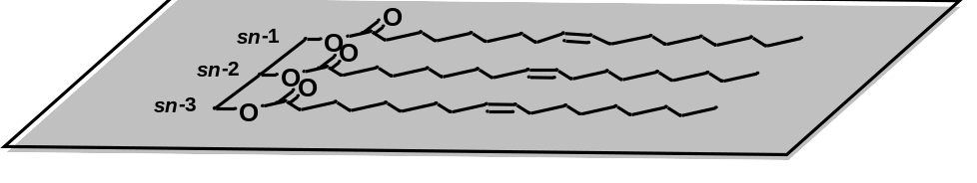
b)
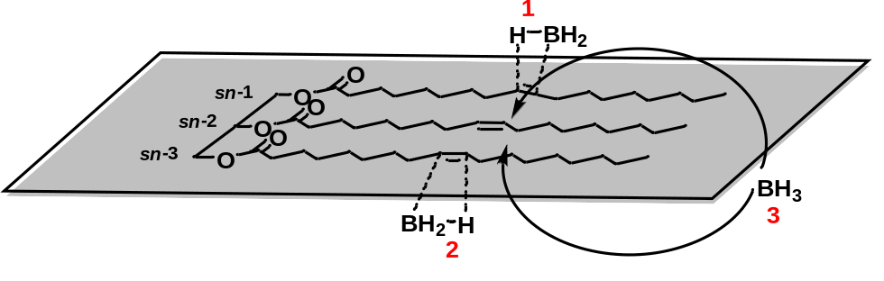
Figure 6.1. Schematic representation of borane addition to a monounsaturated triacylglycerol scaffold. a) Scaffold prior to addition. b) Sequential addition of borane where “1, 2, and 3” denote the proposed order of addition.

a) 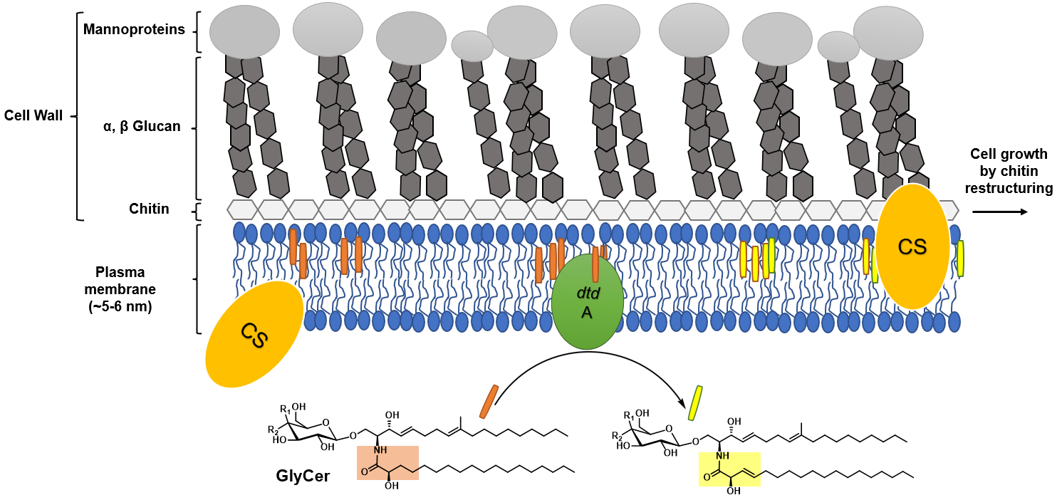
b) 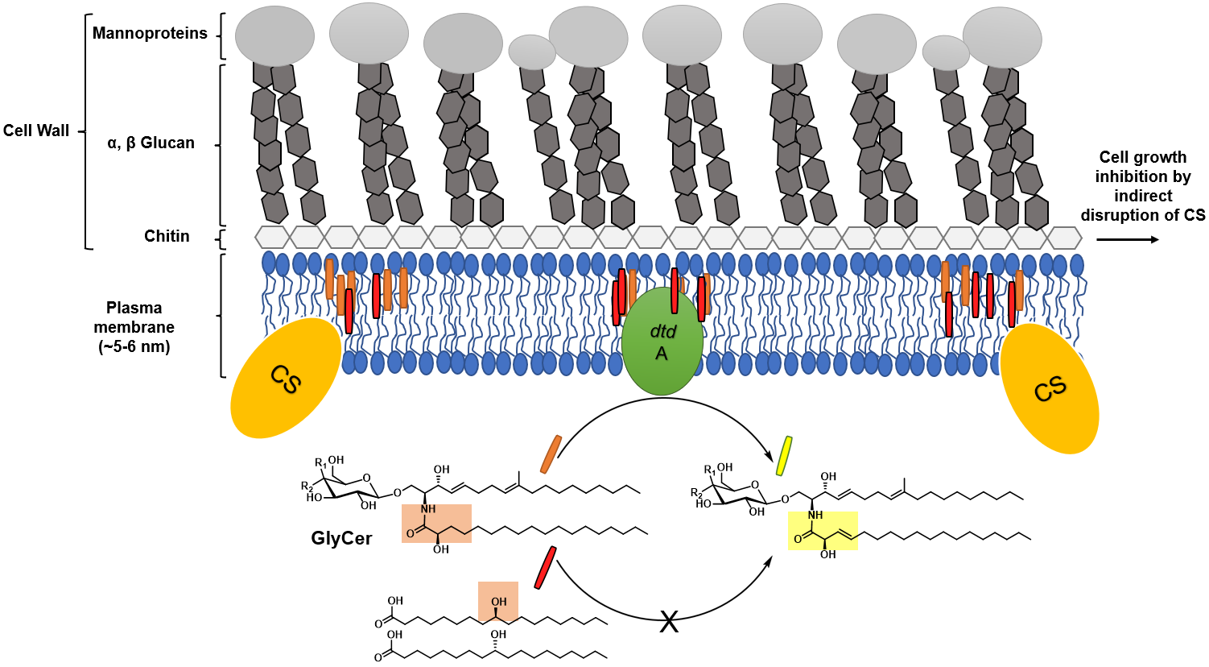
Figure 6.2. Proposed mode of action for hydroxy fatty acids. Orange and yellow rods represent saturated and desaturated GlyCer, respectively. Yellow and green ellipsoids represent chitin synthase (CS) and Δ3(E)-desaturase (dtdA) fungal enzymes, respectively. Red rods represent exogenous hydroxy fatty acid. a) Desaturation of GlyCer by dtdA is a requirement for CS embedding in the membrane. b) In the presence of exogeneous hydroxy fatty acids, the normal function of dtdA may be inhibited thereby disrupting the functions of CS.

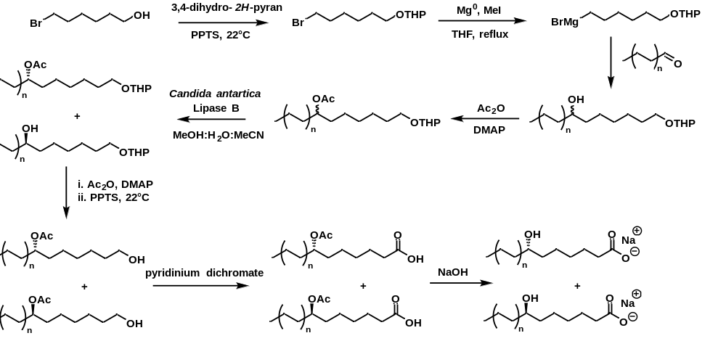
Scheme 6.1. Preparation of enantiomerically pure 6-hydroxy fatty acids. The position of the hydroxyl group can be controlled by tailoring the chain length of the α,ω-bromo alcohol and aldehyde. Note: after chiral resolution the enantiomers are separated by chromatography before proceeding with subsequent transformations.

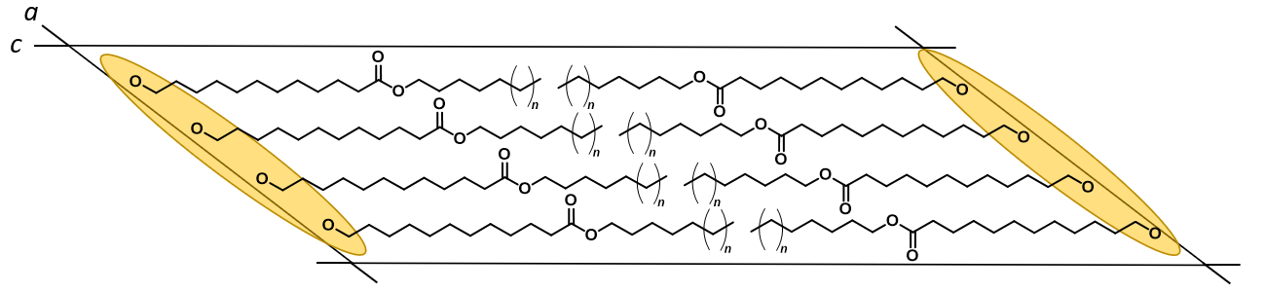
Figure 6.3. Representation of the proposed crystal structure of ω-hydroxy wax esters projected down the b-axis. Hydroxyl H atoms omitted for simplicity; the continuous chain of hydrogen bonds along basal axes is depicted in yellow. Proposed structure predicts a monoclinic lattice (O⊥ subcell) approaching orthorhombic symmetry with increasing carbon chain length. Unit cell is arbitrary and may not represent the actual molecules per unit cell.

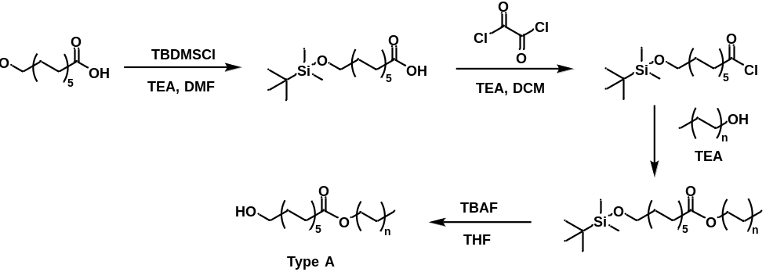

Scheme 6.2 Preparation of type A wax esters from 12-hydroxydodecanoic acid.
Vita
Francisco Miguel Angel Leyva Gutierrez was born in Mexico City, Mexico. At age 6, Francisco immigrated with his brother and mother to Southern California, United States, where he attended elementary, middle, high school, and community college. He dual majored in chemistry and food science at the California Polytechnic State University, Pomona. He also worked as an intern and seasonal employee for the United States Forest Service at the Klammath and Tahoe National Forest(s); botany and forestry were and are currently among his most beloved fields of study. His inseparable and innate love of chemistry, however, motivated him to continue his education. In 2018, he joined the research group of Professor Tong Wang at Iowa State University. In 2019, the research group transferred to the University of Tennessee, Knoxville. Under a generous fellowship sponsored by the United States Department of Agriculture, he was given freedom to pursue research related to lipid chemistry and nanotechnology in service to the agricultural sector. He is grateful for the opportunities afforded to him by the United States government and will continue to serve and make advancements in the field of food and agricultural chemistry.

