
12-2016

Effects of the Great Recession on American Retirement Funding

Tanner Hamil
University of Tennessee-Knoxville thamil@vols.utk.edu
Honors Thesis Project University of Tennessee Chancellor’s Honors Program

Abstract

This study analyzes the influence that the Great Recession had on American retirement funding. Studies on this subject have been done before with varying parameters, and this in turn produced conflicting results. The recession undeniably reduced wealth in the United States, however, some research suggests that those approaching retirement were relatively unaffected by the economic downturn. Other research found large percentages of Americans with inadequate savings. Given this loss of wealth, the state of the economy, and unemployment rates, I hypothesized that the financial crisis had a strong negative effect on retirement saving. The results of my study concluded that holding all else equal, financial assets were roughly 6% lower in 2009 than in 2007. This shows negative influence, but not in the magnitude that I originally predicted.

Introduction

The 2007-2008 financial crisis undoubtedly caused the worst economic downturn since the Great Depression, but how much did this recession influence retirement savings of the American public? This paper will use financial data to analyze the effects that the Great Recession had on retirement savings, as well as look at future issues that may arise due to this economic setback. This issue is not only a concern for individuals, but also may create burdens for government welfare programs. Aging Americans may have to severely lower their standard of living upon retirement if trends of insufficient retirement savings do not correct themselves. Americans close to retirement hit by the recession may be left without time to recover savings (Rutledge). Younger generations may be set back in their careers and have trouble accumulating savings at all. With unemployment rates reaching 10% (Katz) at the peak of the recession, many Americans may have accumulated large amounts of debt due to lack of income. This debt would logically have to be paid off before individuals can return focus to retirement. Years without saving could put Americans in a situation where they will never be able to reach adequate savings to retire with the same standard of living they experienced in pre-retirement years. However, while there was somewhat of a setback in retirement savings through the recession, the magnitude of this setback was small.

Literature Review

This is a topic that has been written about extensively. While there are many academic publications on the subject, there is some debate as to the actual effects of the recession. The various authors referenced in this paper focused on specific age groups nearing or just entering retirement. This is a pertinent focus as those people would have the least amount of time to make up for any lost earnings, and therefore lost savings, due to the recession. However, the Social Security Administration has concluded that those nearing retirement were not severely affected during this downturn (Gustman). This study also revealed that retirement trends remained relatively stable with individuals entering this stage of their lives at similar ages with similar funding. Most losses sustained were from devaluation of housing due to the housing bubble collapse.
The National Poverty Center reported different results on retirement funding during the financial crisis. The NPC concluded that the recession had a profound effect on American retirement funding, and this could have a lasting impact on the quality of life during retirement years. It goes on to cite many different reasons for this, but one of the major concerns are that Americans nearing retirement before the Great Recession may be forced to lock in lower income levels for Social Security benefits (Rutledge).
The Center for Retirement Research shed light on why there may be so much contradicting work on this subject. This paper states that many factors affect a work’s findings. Different research obviously uses different methods and parameters. There are two major data sources for research on retirement planning. The National Retirement Risk Index covers all ages of individuals. The Health and Retirement Study only covers those approaching retirement age. This is an important difference because results will obviously be drastically different between the two data sets. Someone directly out of college may have been affected by the Great Recession in a much different way than someone who was middle-aged or nearing retirement. Another factor that may cause differing results is the standard for retirement savings. Is there a benchmark number that people must hit in order to have acceptable funds? One key consideration is the replacement rate. The replacement rate is the projected retirement income that a couple or individual expects to receive as a percentage of pre-retirement earnings (Munnell). However, there are factors that could cause replacement rates to be unrepresentative of adequate savings. In order to truly look at replacement rates, data needs to represent an individual’s lifetime earnings. If someone just graduated from school or received a promotion, his or her expected income should increase dramatically. If this person had just gotten the salary increase, then their replacement rate would plummet, because their savings reflect the lower income they previously had. It would take time for the individual to accrue savings that reflect the increased income.
This study on the National Retirement Risk Index was conducted in 2007. The date of this study is important because it found that 43% of Americans were at risk of inadequate retirement funding in 2004. This indicates that insufficient retirement saving may have been a problem long before the Great Recession. The percentage of individuals at risk has been consistently trending upward since 1992. However, there are certainly reasons for the increasing number of “at risk” Americans. It is becoming much more common for households to have two adults earning an income. This makes for a larger pre-retirement household income. Yet only one earner will receive full Social Security benefits. This means that their Social Security benefits will be a smaller percentage of pre-retirement income. A two-earner household would naturally have a lower replacement rate than a household with one earner (Munnell).
A study by John Gist examined retirement funding by specifically looking at cohorts of age groups. This study looked at wealth among age groups and found startling results. Early and late baby-boomers were hit by the recession just as they were approaching or entering retirement. This proved disastrous for many, as the cohorts lost 28% and 25% percent of wealth, respectively. Yet those born between 1966 and 1975 (Generation X) lost 45% of wealth. This study found that younger generations were less prepared for retirement than previous generations had been at the same age (Gist).
Another aspect of this subject, which the previous two publications do not focus on is the sustainability of the Social Security Program. This government fund is vital to many Americans to provide a source of income during retirement years. For many without substantial savings, this fund is the only way they can retire comfortably. However, current projections predict that this fund will be exhausted by as early as 2037. This would obviously only happen if no policy changes were made to increase dedicated taxation for the program, or restructure the program itself. It is also important to note that the Social Security Program has come close to exhaustion before, but remained solvent due to legislation allowing for temporary borrowing in order to meet the needs of American beneficiaries. The normal retirement age has also been raised in the past to help ensure full benefit payments. This fund exhaustion is primarily caused by a declining birthrate. The issues facing the Disability Insurance fund must be resolved by year 2020 in order to keep the program fully solvent (Goss). This deadline is quickly approaching, and without action could result in decreased benefits.

Data

This project uses data from the Federal Reserve through the Survey of Consumer Finances from the years 2007 to 2009. Specifically, the variables age, education, income, financial assets, and debt are included in research. This data set consists of panel data taken from the same participants in 2007 and again in 2009. Panel data allows for the Great Recession to be reflected within the data. I chose this particular data set because of its combination of both large sample size and broad coverage of relevant variables. I will use the change that these variables experienced to test the effect that the Recession had on American retirement savings. Individuals with income over one-million dollars, and financial assets over two-million dollars have been dropped from the dataset. These individuals represent a miniscule percentage of the American population, and only serve to skew the data. The log of financial assets, income, and debt was taken to reduce the extreme range. Values of less than zero in education level were changed to zero. The following table summarize the data:
Table 1: Data Summary
Variable | Observations | Mean | Std. Deviation | Min | Max
Financial Assets | 38,570 | 10.89844 | 4.00696 | 0 | 20.59222
Age | 38,570 | 52.68253 | 15.65101 | 19 | 95
Education Level | 38,570 | 14.08035 | 2.720415 | 0 | 17
Income | 38,570 | 11.39755 | 2.101979 | 0 | 19.05229
Debt | 38,570 | 8.517086 | 5.146906 | 0 | 18.54326
Empirical Analysis

Regression Equation
${Financial Assets}_{it}$ = ${}_{i}$ + ${}_{1}{Age}_{it}$ + ${}_{2}{Year}_{t}$ + ${}_{3}{Education}_{it}$+ ${}_{4}{Income}_{it}$
+ ${}_{5}{Debt}_{it}$+${}_{it}$

The following table is an Ordinary Least Squared Regression (OLS):

Table 2: Standard OLS Regression
Financial Assets | Coef. | Std. Err. | t | P>t | [95% Conf. | Interval]
Age | 0.0734 | 0.0010 | 74.74 | 0 | 0.0714 | 0.0753
Year | -0.0995 | 0.0148 | -6.73 | 0 | -0.1284 | -0.0705
Education Level | 0.4492 | 0.0059 | 76.58 | 0 | 0.4377 | 0.4607
Income | 0.8287 | 0.0123 | 67.43 | 0 | 0.8046 | 0.8528
Debt | 0.1159 | 0.0035 | 33.42 | 0 | 0.1091 | 0.1227
_cons | 189.5939 | 29.6868 | 6.39 | 0 | 131.4065 | 247.7812

$r^{2}$ = 0.4482
${Adj. r}^{2}$ = 0.4481
N = 31,086

The variables all have the expected sign in the coefficient except debt. Surprisingly, debt had a positive coefficient suggesting that as an individual’s debt goes up one unit, his or her financial assets should increase by over eleven percent holding everything else constant. Every variable has a t-statistic over the 95% critical value of 1.965. This means that if you ran this regression with a portion of this data 100 times, the coefficient values would fall within their respective confidence intervals and zero would not be a part of those intervals 95% of the time. The r² value measures the strength and linear relationship between the variables. One issue with r² is that adding another variable can never decrease this value. But if the regression includes a non-related variable then the r² should decrease. The ${Adj. r}^{2}$ value represents the goodness of fit between the y variable and the x variables, but it accounts for irrelevant variables. In this case 45% of the variation in Y is explained by this regression. I expected the ${Adj. r}^{2}$ to be higher than it is, but this is understandable because there are so many unobserved factors that can go into a person’s savings. Because all of these variables heavily reliant on each other, it would be expected that there is a high level of correlation between the independent variables. However, after testing the Variance Inflation Factor (VIF) the results suggested otherwise. The following table shows the VIF values for each x variable:
Table 3: VIF Scores
Variable | VIF | 1/VIF
Income | 1.19 | 0.8383
Education Level | 1.18 | 0.8483
Debt | 1.12 | 0.8962
Age | 1.11 | 0.8998
Year | 1.01 | 0.9863
Mean VIF | 1.12

A VIF score of 5 or higher for any variables would be cause for concern. The Variable Inflation Factor detects multicollinearity by examining the extent explanatory variables explain a single explanatory variable. This shows that no x variable is overly correlated with other x variables.
Heteroscedasticity occurs when variance is not constant throughout the regression. There is a strong possibility of a change in variance for this particular project because it centers on a single shock to the US economy. Heteroscedasticity causes bias in the standard errors, which in turn causes biased t-scored. To avoid errors due to heteroscedasticity, I will incorporate White’s or robust standard errors. These standard errors are created to specifically avoid heteroscedasticity. The following table shows the regression equation with robust standard errors

Table 4: OLS Regression with Robust Standard Errors
Financial Assets | Coef. | Robust Std. Error | t | P>t | [95% Conf. | Interval]
Age | 0.0734 | 0.0010 | 70.09 | 0 | 0.0713 | 0.0754
Year | -0.0995 | 0.0148 | -6.74 | 0 | -0.1284 | -0.0705
Education Level | 0.4492 | 0.0079 | 56.59 | 0 | 0.4337 | 0.4648
Income | 0.8287 | 0.0329 | 25.2 | 0 | 0.7642 | 0.8931
Debt | 0.1159 | 0.0046 | 25.01 | 0 | 0.1069 | 0.1250
_cons | 189.5939 | 29.6373 | 6.4 | 0 | 131.5035 | 247.6842
$r^{2}$= 0.4482
N=31,086

With robust standard errors, our results changes slightly. It is clear that there is correlation between the x variables and financial assets. However, this study is analyzing data in order to see if Americans are falling behind on retirement saving. The most significant x variable is age because that determines how much an individual should have in retirement savings. Year is also extremely important because this study revolves around the Great Recession. The t-statistics reflect this significance with age and year having the highest values.
Because this study uses panel data, fixed effects should be used. Fixed effects remove omitted variable bias caused by variables that don’t change over time. In this all variables have can change. Fixed affects allow each unit to have its own intercept. This is important in panel data because it measures individuals overtime. The following table includes fixed effects:

Table 5: OLS Regression with Robust Standard Errors and Fixed Effects
Financial Assets | Coef. | Robust Std. Error | t | P>t | [95% Conf. | Interval]
Age | 0.0155 | 0.0133 | 1.17 | 0.243 | -0.0105 | 0.0416
Year | -0.0582 | 0.0169 | -3.44 | 0.001 | -0.0913 | -0.0251
Education Level | -0.0869 | 0.0428 | -2.03 | 0.042 | -0.1707 | -0.0031
Income | 0.1657 | 0.0137 | 12.09 | 0 | 0.1388 | 0.1925
Debt | -0.0010 | 0.0057 | -0.18 | 0.854 | -0.0122 | 0.0101
_cons | 125.1195 | 33.4458 | 3.74 | 0 | 59.5617 | 190.6772
N=31,086

This table gives some surprising results. Education level has a negative value coefficient due to cost. As individuals gain a year of education, they also gain the expense and most likely debt that comes along with it. Debt has a coefficient that is smaller than expected and also insignificant according to the t statistic. It also has a large standard error relative to its coefficient value. According to the regression equation debt is not significant. However, because of theory it will be left in the equation. T-statistics change dramatically with fixed effects. Income is now the most significant value. This makes sense because income plays a huge role in determining how much an individual can afford to save. Holding everything else constant, financial assets were 6% lower in 2009 than in 2007.

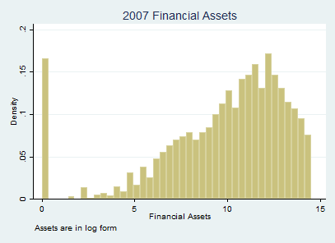

.

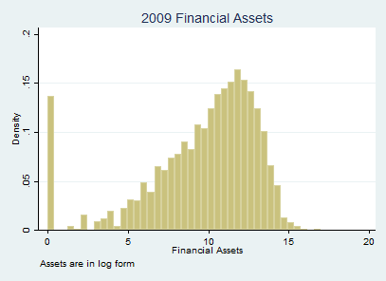

These two histograms show surprising results. Overall savings did not seem to change much throughout the time period. The number of individuals without savings actually decreased through the Great Recession. To further explore this relationship, I have included the following graphs:
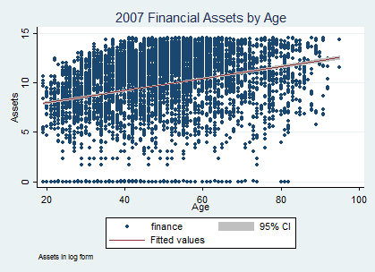

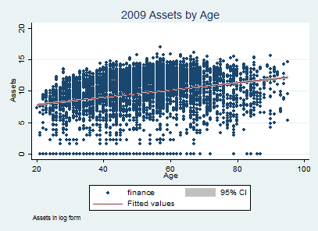

These once again show that overall there did not seem to be any drastic change in this dataset through the Great Recession. One particularly interesting point in these graphs is the line of best fit. This line shows the expected Asset value by age. There is clearly a range of values at every range that are far outside of the 95% confidence interval.
In order to make the effect that the individuals without any financial assets have on this regression I will remove them from the data set. This will indicate whether the data is driven by the individuals without assets. The following regression table shows the data set excluding individuals with no financial assets:

Table 6: OLS Regression excluding individuals without financial assets including Robust Standard Errors and Fixed Effects
Financial Assets | Coef. | Robust Std. Err. | t | P>t | [95% Conf. | Interval]
Age | 0.0164 | 0.0113 | 1.46 | 0.144 | -0.0056 | 0.0385
Year | -0.0430 | 0.0136 | -3.16 | 0.002 | -0.0697 | -0.0163
Education Level | 0.0136 | 0.0267 | 0.51 | 0.61 | -0.0387 | 0.0659
Income | 0.1223 | 0.0112 | 10.96 | 0 | 0.1004 | 0.1442
Debt | -0.0143 | 0.0040 | -3.55 | 0 | -0.0222 | -0.0064
_cons | 94.3769 | 26.8828 | 3.51 | 0 | 41.6833 | 147.0705
N=29,408

This new regression excluding those who have financial assets of zero is similar to the previous regression. The coefficient for debt increased in value and is now has a much higher t statistic. Education level’s coefficient is now a positive value. This makes sense because those with financial assets have most likely paid off debts incurred because of schooling. When examining the age distribution of those without any assets we can see that it is skewed right. Most individuals are below 40. This distribution can be seen below.

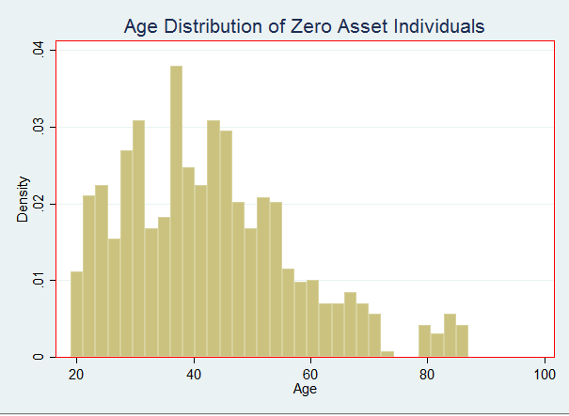

Finally, I will run a regression on the data on the original, level-based data (non-logged). This regression can be seen below.
Table 7: OLS Regression on level-based data with Robust Standard Errors and Fixed Effects
Financial Assets | Coef. | Robust Std. Err. | t | P>t | [95% Conf. | Interval]
Age | -1149.4270 | 731.8368 | -1.57 | 0.116 | -2583.9130 | 285.0584
Year | 1268.1130 | 1801.7000 | 0.7 | 0.482 | -2263.4280 | 4799.6550
Education Level | 3828.7730 | 1820.1480 | 2.1 | 0.035 | 261.0702 | 7396.4770
Income | 0.7369 | 0.0701 | 10.51 | 0 | 0.5994 | 0.8743
Debt | 0.0194 | 0.0301 | 0.65 | 0.519 | -0.0396 | 0.0785
_cons | 2407191.0000 | 3595398.0000 | -0.67 | 0.503 | 9454590.0000 | 4640208.0000
N=31,086

These results are not what was expected. Year, education level, and debt all changed from negative coefficient values to positive values. Age switched from a positive coefficient to a negative coefficient. This new data suggests that holding all else equal, in 2009 financial assets were $1,268 more than 2007. It also tells us that as an individual gets a year older, his or her financial assets decrease by $1,149. For these reasons using logged data is logical. I believe that the outliers in the data overly influence regression results. By using logged values, the outliers have less influence on results.

Table 8: OLS Regression on level-based data excluding individuals without financial assets including Robust Standard Errors and Fixed Effects
Financial Assets | Coef. | Robust Std. Err. | t | P>t | [95% Conf. | Interval]
Age | -1270.6220 | 846.9719 | -1.5 | 0.134 | -2930.7890 | 389.5453
Year | 1426.0620 | 1981.0280 | 0.72 | 0.472 | -2456.9920 | 5309.1170
Education Level | 4820.3160 | 2511.9220 | 1.92 | 0.055 | -103.3540 | 9743.9850
Income | 0.7371 | 0.0702 | 10.51 | 0 | 0.5996 | 0.8746
Debt | 0.0192 | 0.0302 | 0.64 | 0.525 | -0.0400 | 0.0784
_cons | 2724088 | 3947742 | -0.69 | 0.49 | 10500000 | 5013963
N=29,522

The table above shows the same regression without individuals who do not have any financial assets. We can see that the two tables are extremely similar. This shows that zero asset individuals are not skewing this regression. If the results were extremely different it would indicate that the non-asset individuals were driving the coefficient values.

Table 9: Quantile Regression on level-based data
Financial Assets | Coef. | Std. Err. | t | P>t | [95% Conf. | Interval]
Age | 1385.304 | 64.58 | 21.45 | 0 | 1258.724 | 1511.883
Year | -2606.042 | 1003.143 | -2.6 | 0.009 | -4572.242 | -639.8425
Education Level | 5070.744 | 386.6038 | 13.12 | 0 | 4312.985 | 5828.503
Income | 1.412996 | 0.0063 | 225.68 | 0 | 1.4007 | 1.4253
Debt | 0.0407216 | 0.0039 | -10.56 | 0 | -0.0483 | -0.0332
_cons | 5083373 | 2014061 | 2.52 | 0.012 | 1135731 | 9031014
N= 31,086
To minimize the effect of outliers, I ran a Quantile Regression. Instead of finding the mean estimation for the least variance regression, this method finds the median estimation. This regression produced expected results. According to this regression with as an individual ages one year, his or her financial assets should rise by $1,385 holding everything else constant. The Quantile Regression seems more appropriate for the level-based data.
Conclusion
Many individuals may have experienced financial collapse during the recession, but overall, the American public’s savings trend did not suffer as much as I originally predicted. However, this data does suggest that Americans may have a retirement crisis that began long before the recession. The US Department of Labor suggests that high income earners plan to spend 70% of their current income in retirement years, and for low income earners this number can reach 90% (DOL). With the average American spending twenty years in retirement, this is a large amount for many people to accumulate. John Gist found that staggering amounts of Americans are in danger of inadequate retirement savings (Gist). I believe my results support this, because while the regression shows a small percentage change in financial assets, the data shows that many Americans have almost no retirement preparation. Gist shows that younger generations were hit the hardest by the recession and lost 45% of their wealth. This can be supported by Katz’s finding that younger workers were hurt by rising unemployment rates more than other generations of Americans (Katz). Ultimately, I believe that younger generations have fallen behind in saving for retirement. They are clearly off track relative to what previous generations had reached in replacement rates by that time in their lives (Gist). The Great Recession slightly magnified a problem that already existed in the United States. My hypothesis, while not wrong, was inaccurate, according to the results of this research.

Bibliography

Gist, John. "Retirement Security Across Generations." . , The PEW Charitable Trusts, May 2013, www.pewtrusts.org/~/media/legacy/uploadedfiles/pcs_assets/2013/empretirementv405101 3finalforwebpdf.pdf. Accessed 6 Dec. 2016.

Goss, Stephen C. "The Future Financial Status of the Social Security Program ." Social Security: Office of Retirement and Disability, Social Security Administration, Aug. 2010, https://www.ssa.gov/policy/docs/ssb/v70n3/v70n3p111.html. Accessed 5 Nov. 2016.

Gustman, Alan, Thomas Steinmeier, and Nahid Tabatabai. How Did the Recession of 2007–2009 Affect the Wealth and Retirement of the Near Retirement Age Population in the Health and Retirement Study? Social Security Administration, Nov. 2012. Web. 09 Oct. 2016. <https://www.ssa.gov/policy/docs/ssb/v72n4/v72n4p47.html>.

Katz, Lawrence. "Long-Term Unemployment in the Great Rece." Harvard University, Apr. 2010. Address.

Munnell, Alicia, Anthony Webb, and Francesca Golub-Sass. "Is There Really a Retirement Savings Crisis? An NRRI Analysis." . , Center for Retirement Research at Boston College, Aug. 2007Google Scholar. , www.prisha.co.il/UserFiles/File/pdf/mixsom14.pdf. Accessed 6 Dec. 2016.

Rutledge, Matthew, and Alicia Munnell. The Effects of the Great Recession on the Retirement Security of Older Workers. Npc.umich.edu. National Poverty Center, Mar. 2013. Web. 09 Oct. 2016. <http://npc.umich.edu/publications/u/2013-03-npc-working-paper.pdf>.

"Top 10 Ways to Prepare for Retirement." , Department of Labor, https://www.dol.gov/sites/default/files/ebsa/about-ebsa/our-activities/resource- center/publications/top10ways.pdf. Accessed 7 Nov. 2016.

