The Transnational Semiotics of “Policing Murals”: How Representations of Police Power in Murals Conceal and Reveal State Violence

A Dissertation Presented for the
Doctor of Philosophy
Degree
The University of Tennessee, Knoxville

Vivian Swayne
August 2024

Copyright © 2024 Vivian Swayne
All rights reserved.
ACKNOWLEDGMENTS

This dissertation would not have been possible without the generosity of my committee and community. I would like to thank Dr. Michelle Brown, who selflessly agreed to serve as my committee chair during her sabbatical. Dr. Tyler Wall also graciously served on my committee during his time on leave. I owe them both a special acknowledgement for the personal sacrifices they made to help me. Additionally, I thank Dr. Lois Presser for serving on my committee, her unwavering support, and brilliant feedback. Thank you to Dr. Leia Cain for being my external committee member and offering her expertise and kind encouragement. I would also like to thank the University of California Santa Cruz’s Visualizing Abolition Dissertation Workshop, during which I received invaluable feedback and critique. Thank you, as well, to Zee Scout for sharing her instrumental comments and friendship. To Jennifer Swayne, Matthew Swayne, Mollie Swayne, Darcy Ayers—and to all of my friends, family, and community—thank you for your generosity, compassion, and love.

ABSTRACT

Murals tell visual stories that legitimize/delegitimize formations of state power, conceal/reveal state violence, and attract collective interface from diverse parties. Scholars, artists, and organizers have studied murals as an aesthetic medium, tools for social movements, affective memorials, and episodes of conflict in the public space, but patterns and distinctions in the local, global, and digital duration of policing murals requires critical analysis. Policing murals refers to (1) murals made by police (and/or their advocates) to reproduce its preferred representations and (2) the censorship and control of unauthorized murals. Murals painted on police departments share semiotics globally, all of which conceal violence, and require visual decryption to interrupt hegemonic narratives. To compensate for absences in policing murals, I vetted their visual claims vis-à-vis insurgent murals with sentiments of abolition, such as demands to defund police. Using NVivo qualitative software, I conducted a Multimodal Critical Discourse Analysis (MCDA) of policing murals. I assembled keywords from my literature review, which concerns the cultural reproduction and resistance of state power, to conduct an online search for relevant murals. To be included, a mural had to relate to state power and be painted on an exterior surface after the year 2000. I selected 289 images for analysis, which included 93 “policing murals” collected from over fifty police departments around the world. Additionally, I analyzed 167 murals that responded to and/or resisted formations of state violence. The corpus also contains images of vandalism, in-progress mural painting, and police washing away or painting over insurgent murals. In optimistic scenes of playgrounds and paperwork, policing murals omitted and obfuscated peoples’ lived experiences with white supremacy, cis-heteropatriarchy, and state violence. Artists who opposed state power and violence painted murals as rapid responses to violence and death, visual accountability statements, tools to decrease social isolation, containers for hope and grief, sources for reparative political education, and portals to the worldly redistribution of resources, power, and love. Muralism is a morally neutral practice people use to construct oppositional narratives, validate or invalidate truth claims about police power, and to address, or erase, the structural foundations of violence.

TABLE OF CONTENTS
INTRODUCTION 1
Why Murals? 2
Dissertation Overview 5
CHAPTER ONE: The Cultural Reproduction and Resistance of State Power 8
Capacious State Power 8
Capturing Copspeak 14
Abolition Artworlds 17
Notes on Transnational Solidarity 20
CHAPTER TWO: A Method for Murals 23
Research Questions 23
Data Collection Procedure and Translation 24
Data Storage 26
Multimodal Critical Discourse Analysis 26
Risky Positionality or Critical Reflexivity? 28
Coding Procedures 29
Murals and Meanings 30
CHAPTER THREE: Painting Policing, Policing Painting 32
Pacification 32
Liberal Solidarity in the Community 37
Insecurity 40
A Superiority Complex 44
Memorialization 46
A Note on Policing Murals 47
CHAPTER FOUR: Muralism in Response to State Violence 49
Memorialization 50
Insurgent Critique 56
Pigs 57
Fire 60
Eyes 63
Constructions of Solidarity 65
Solidarity from the Outside 66
Intergenerational Solidarity 66
Interracial Cross-Movement Solidarity 67
Gender Solidarity 68
Transnational Solidarity: Think Global Act Local 70
CONCLUSION 75
REFERENCES 79
APPENDIX 94
VITA 264

LIST OF FIGURES

Figure 1. Immigration is Beautiful on Immigration Office 94
Figure 2. No Greater Love on Police Department 95
Figure 3. Love is the Answer 96
Figure 4. Standing Bold and Strong for Peace, Role of Police in Society 96
Figure 5. First Responders Mural 97
Figure 6. Mural on Salo Police Station 97
Figure 7. Police Mural Project Call for Artists for Police Mural Headquarters 98
Figure 8. compareNEWs Coverage of the National Police Mural Competition 99
Figure 9. Memorial Mural of Alton Sterling where Police Killed Him 100
Figure 10. Memorial Mural of Eric Garner where Police Killed Him 100
Figure 11. Ceasefire & Stop Bombing Hospitals 101
Figure 12. Police Free Schools 102
Figure 13. We Are Universal 102
Figure 14. Non Dobbiamo Chiedere Il Permesso Per Essere Liberi (We Don't Have to Ask Permission to Be Free) 103
Figure 15. Non Dobbiamo Chiedere Il Permesso Per Essere Liberi (We Don't Have to Ask Permission to Be Free), Translated 103
Figure 16. Immigration is Beautiful on Immigration Office, Vandalized 104
Figure 17. Defund/Defend the Police Street Mural 104
Figure 18. Portrait of Gandhi at Delhi Police Headquarters 105
Figure 19. Portrait of Gandhi at Lodhi Police Station 105
Figure 20. Police Pacification I on Police Department 106
Figure 21. Police Pacification II on Police Department 106
Figure 22. Mural on Child-Friendly Fort Police Station 107
Figure 23. Mural on Child-Friendly Chirag Nagar Police Station 108
Figure 24. Mural on Child-Friendly Police Station II, Translated 108
Figure 25. The Art of Taking Care of Yourself Mural Campaign, Quadrant I 109
Figure 26. The Art of Taking Care of Yourself Mural Campaign, Lower Pamplonita Neighborhood 109
Figure 27. The Art of Taking Care of Yourself Mural Campaign, Torcoroma Neighborhood 110
Figure 28. The Art of Taking Care of Yourself Mural Campaign, San Luis Neighborhood 110
Figure 29. The Nigeria Police Force Headquarters I 111
Figure 30. The Nigeria Police Force Headquarters II 112
Figure 31. The Nigeria Police Force Headquarters III 112
Figure 32. Cartoon Mural at San José Municipal Police Headquarters 113
Figure 33. Traffic Safety Mural by Art Students at Kaiho High School on Outside Wall of Yonaburu Police Station 113
Figure 34. South Korean Police “Human Rights” Mural 114
Figure 35. Police Parasol Mural on Haeundae Police Station 114
Figure 36. “Eradicate the Four Major Evils” Mural Sponsored by Police, Before and After 115
Figure 37. Police Mascots Reveal “Eradicate the Four Major Evils” Mural Sponsored by Police 115
Figure 38. “Cute” Mural at Korean National Police Station I 116
Figure 39. “Cute” Mural at Korean National Police Station II 116
Figure 40. Crime Prevention Mural 117
Figure 41. Police Mascots Podori and Posuni Give Thumbs Up 117
Figure 42. Police Mascots Podori and Posuni Surrounded By Hearts 112 118
Figure 43. Police Mascots Podori and Posuni Salute on Traffic Accident Prevention Mural 118
Figure 44. Police Chase Pills on Tin Sum Police Station I 119
Figure 45. Police Chase Pills on Tin Sum Tin Sum Police Station II 119
Figure 46. Yo Vivo Mi Barrio Sin Drogas Series I Sponsored By National Police 120
Figure 47. Yo Vivo Mi Barrio Sin Drogas Series II Sponsored By National Police 120
Figure 48. Yo Vivo Mi Barrio Sin Drogas Series III Sponsored By National Police 121
Figure 49. Yo Vivo Mi Barrio Sin Drogas Series IV Sponsored By National Police 121
Figure 50. Train Up a Child to be Drug Free Mural Sponsored by Police 122
Figure 51. STRIVE Mural across the street from Police Department 122
Figure 52. Mural at the Philippine National Police Headquarters 123
Figure 53.Policía Vigilante y Protector (Vigilant and Protective Police) 123
Figure 54. Girl Petting Mounted Officer’s Horse on Police Station 124
Figure 55. Mural Across the Street from Secretariat of Public Security 124
Figure 56. Big Brother is Watching on Police Department 125
Figure 57. “The Breeze” on Philadelphia Police 17th District 126
Figure 58. To Serve and Protect Mural at 22nd Police District Headquarters 127
Figure 59. First Responders Mural painted on St. Johns Fire Station 128
Figure 60. Westside Police Station Mural 128
Figure 61. Mural on Boarded Business during Quarantine 129
Figure 62. George Floyd Memorial Mural on Bar 130
Figure 63. “Unidos Somos Mas!” (United We Are More!) I on Sincelejo Police Station 131
Figure 64.“Unidos Somos Mas!” (United We Are More!) II on Sincelejo Police Station 131
Figure 65. Honor, Serve, and Unite 9/11 Mural 132
Figure 66. Police and Community Mural at 49th Precinct 132
Figure 67. Para Los Niños on Santa Monica Police Activities League 133
Figure 68. “Community” on Police Department Parking Garage 133
Figure 69. Desde La Comunidad Para La Comunidad Y Por La Comunidad/ Vinculación A La Comunidad Around Police Station 134
Figure 70. Vinculación A Los Problemas De La Comunidad/Reunión Del Jefe De Sector Around Police Station 134
Figure 71. Acercando Nuestros Servicios A La Comunidad/Unidades Móviles Policiales Around Police Station 135
Figure 72. Enfoque Con Equidad De Género/Partipación De La Mujer En La Institcución Around Police Station 135
Figure 73. Vinculados A Los Problemas De La Familia/Convirtiendo En Protagonista A La Mujer Y La Niñez./Comisara De La Mujer Y La Niñez Around Police Station 136
Figure 74. Defensa De La Democracia Participativa/Cobertura De Las Elecciones Around Police Station 136
Figure 75. Intvervención Rápida En La Escena Del Crimen/ Técnica Canina Around Police Station 137
Figure 76. En Solidaridad Permanente Con Nuestro Pueblo/ Ante Desastres Naturales Around Police Station 137
Figure 77. Commemorative Mural after Volcano in 2018 I Painted on Perimeter Wall of Suchitepéquez Police Station 33 138
Figure 78. Commemorative Mural after Volcano in 2018 II Painted on Perimeter Wall of Suchitepéquez Police Station 33 138
Figure 79. Thin Blue Line Mural painted on Police Department 139
Figure 80. Thin Blue Line Memorial Mural for Five Police Officers Killed 139
Figure 81. Back the Blue Mural Painted on Street Outside Police Headquarters 140
Figure 82. Blue Lives Matter on the Former Mayor’s Fence 140
Figure 83. Orden y Seguridad Social Drug Dog Mural on Police Canine Training Center in Police Heroes Plaza 141
Figure 84. Angel Shoots Cop Tag on Youth Center 142
Figure 85. Kill Cops Not Trees Stencil 143
Figure 86. Kill More Cops Tag 143
Figure 87. Anti-Police Graffiti on Tattoo Parlor 144
Figure 88. Kill a Cop Save a Child Tag on Police Department Mural 144
Figure 89. Assata Shakur in the “E” of Black Lives Matter Mural I 145
Figure 90. Assata Shakur in the “E” of Black Lives Matter Mural II 145
Figure 91. EL AMOR NO TIENE GENERO 146
Figure 92. National Police Chief Helps Paint Who Dares Critique Police? I Mural at Bhayangkara Mural Festival for Freedom of Expression 146
Figure 93. National Police Chief Helps Paint Who Dares Critique Police? II Mural at Bhayangkara Mural Festival for Freedom of Expression 147
Figure 94. National Police Chief Helps Paint Who Dares Critique Police? III Mural at Bhayangkara Mural Festival for Freedom of Expression 147
Figure 95. Fallen Heroes Memorial Mural Sponsored by Police 148
Figure 96. You Too Can Do Something Extraordinary Police Recruitment Mural 148
Figure 97. Petaluma Police Mural on Police Department 149
Figure 98. SEMA Mural on Ntinda Police Station 149
Figure 99. Superheroes on Police Department 150
Figure 100. The Adventures of Trenton P.D. Mural on Police Department 150
Figure 101. Let’s Appreciate Our Cops, Role of Police in Society 151
Figure 102. I Believe in Heroes Mural Honoring Police Response to Bombing 152
Figure 103. Lieutenant Milton Resendez Memorial Mural At Public Library 153
Figure 104. End of Watch First-Responders Tribute on Vacant Storefront 154
Figure 105. Memorial Mural of Five Police Officers at Last Call Lounge 154
Figure 106. Tribute to Philadelphia Police Officers Along Gun Range at Police Academy 155
Figure 107. Five Years An Officer Memorial Mural of Officer Manny Familia 155
Figure 108. #BELIKEJULIAN Police Memorial Mural 156
Figure 109. Heroes Are Never Forgotten at the Uniontown Police Department Headquarters 157
Figure 110. Es Un Honor Ser Policia Mural Sponsored by National Police 158
Figure 111. The Art of Taking Care of Yourself Mural Campaign, Santa Ana Neighborhood 158
Figure 112. Tribute To Our Fallen Heroes: Courage, Sacrifice, Loyalty on 35th District Police Department 159
Figure 113. Officer’s Parents look at Memorial Mural of Son at Officer Daniel Boyle Memorial Recreation Center 160
Figure 114. Memorial Mural of Sgt. Robert Wilson III in Neighborhood Where He Patrolled 160
Figure 115. Memorial Mural of Sgt. Robert Wilson III 161
Figure 116. Vandalized Memorial Mural of Sgt. Robert Wilson III 161
Figure 117. Justicia Para Victoria Anti-Femicide Memorial Mural on Town Hall During Protests 162
Figure 118. Justicia Para Victoria Anti-Femicide Memorial Mural on Town Hall During Protests (Vandalized I) 163
Figure 119. Justicia Para Victoria Anti-Femicide Memorial Mural on Town Hall During Protests (Vandalized II) 164
Figure 120. George Floyd Memorial Mural Painted at site of Murder 164
Figure 121. George Floyd Sunflower Memorial Mural In-Progress Painted at site of Murder 165
Figure 122. Kneeling in Front of George Floyd Sunflower Memorial Mural Painted at site of Murder 165
Figure 123. George Floyd Sunflower Memorial Mural Painted at site of Murder 166
Figure 124. Digital Display of George Floyd Sunflower Memorial Mural During Service Location: Minneapolis, Minnesota 166
Figure 125. George Floyd Sunflower Memorial Mural Vandalized 167
Figure 126. The Black Experience via the White Gaze 167
Figure 127. Sean Monterrosa and George Floyd Memorial Mural on Plywood 168
Figure 128. Memorial Mural of George Floyd and Adama Traore 169
Figure 129. FOREVER Memorial Mural of Breonna and Jatarius Tolbert at Grandma's in Da Kitchen (Restaurant) 169
Figure 130. Justice 4, Say Their Names, and Black Lives Matter Mural 170
Figure 131. Say Their Names: David McAtee, Sandra Bland, Breonna Taylor, Elijah McClain, Ahmaud Arbery, George Floyd 170
Figure 132. Say Their Names: Dontre Hamilton, Sandra Bland, Sylville Smith 171
Figure 133. Philando Castille’s 33rd Birthday Memorial Mural Where He Worked 171
Figure 134. Against Impunity Memorial Mural Interrupted by Police 172
Figure 135. Memorial Mural of Children Murdered by Police 172
Figure 136. Memorial Mural of Jhonny Silva Aranguren where Police Killed Him in 2005 at the University of Valle del Cauca 173
Figure 137. Mohamed Mahmoud and Victims of Police and Miliary Attacks Memorial Mural 174
Figure 138. #BLUEFORMATTAR 174
Figure 139. Memorial Mural of Carlo Giuliani Killed During 2001 G8 Summit Protests in Genoa, Italy 175
Figure 140. Son of Thanwa, Protester Safaa al-Saray Memorial Mural 175
Figure 141. Activist Hachalu Hundessa Memorial Mural in Solidarity with Omoro People 176
Figure 142. “Sagging Pants… is Not Probable Cause” Mike Brown Memorial Mural 176
Figure 143.“Sagging Pants… is Not Probable Cause” Mike Brown Memorial Mural Graffiti Blasted 177
Figure 144. Black Lives Matter, Fight Racism, George Floyd Solidarity Mural 178
Figure 145. Disparity in Hashtags on Social Media 178
Figure 146. Say Her Name: Kayla Moore, Breonna Taylor, Nia Wilson, Charlena Lyles Memorial Mural 179
Figure 147. Sandra Bland Memorial Mural 180
Figure 148. Sandra Bland Memorial Mural, Vandalized with All Lives Matter 180
Figure 149. Rest in Power Memorial Mural for Trans Women of Color 181
Figure 150. Rest in Power Memorial Mural, Vandalized: All Lives, No Double Standard, You’ve Been Warned 181
Figure 151. Give Us Our Flowers Now 182
Figure 152. “Woman Who Filmed Abused By Police Officers Is Beaten And Arrested.” Solidarity Mural 182
Figure 153. “BLKKK Lives Don’t Matter” in Progress 183
Figure 154. BLKKK Lives Don’t Matter 183
Figure 155. Defund The Police Invest In Community 184
Figure 156. Abolish the Police, Justice, BLM, and Love on Boarded Up Building 184
Figure 157. “Humanity Over Hate” on Criminal and Immigration Law Building 185
Figure 158. #Pare O Abuso De Poder (Stop Abuse of Power) Street Mural 185
Figure 159. No Human Being is Illegal 186
Figure 160. Mexicans in Action! Ningun Ser Humano Es Ilegal! 186
Figure 161. Baby With a Handgun 187
Figure 162. What is a Pig? 188
Figure 163. Police Pig Eating Donut under Barb Wire 189
Figure 164. Police Pig with Eyes Bulging through Snout 189
Figure 165. Two Little Police Piggies 190
Figure 166. Mural Denouncing Police Attack on Hospital 190
Figure 167. Police Pig Smokes Cigar 191
Figure 168. All Colors Are Beautiful, 1312 192
Figure 169. Ab—PIG—lish 1312 193
Figure 170. Police Officers Tou Thad and Derek Chauvin as Pigs 193
Figure 171. ACAB, Police Pig, and I Can’t Breathe Sign 194
Figure 172. A.C.A.B. Police Pig with His Tongue Out 194
Figure 173. ACAB and Smiley Face Police Pig 195
Figure 174. Police Pig Gallops in Blue Smoke 196
Figure 175. Peppa Pig Police 196
Figure 176. Defund the Police Porky Police Pig 197
Figure 177. Quarantine the Pigs Stencil 198
Figure 178. Das Drogen Police Dept 198
Figure 179. Police Pig Chases Burning Cop Car: 911’s a Joke! 199
Figure 180. Solidarity From Sydney with Love! 199
Figure 181. Hate Vic Pol 200
Figure 182. Burning Cop Car Mural in Enmore 200
Figure 183. A Symbol of Pain and Frustration 201
Figure 184. 2020 Now But Not Forever 202
Figure 185. Police Car on Fire from Behind 202
Figure 186. Visca l’anarquia! 203
Figure 187. Cop Car on Fire, License Plate 1312 204
Figure 188. Police Car on Fire RIOT 205
Figure 189. No Justice No Peace Abolish Police, ACAB Ablaze 205
Figure 190. La Yuta Me Da Amsiedad, or "The police give me anxiety" 206
Figure 191. Green, Upside Down, and on Fire 206
Figure 192. Police Car on Fire on Abandoned Building 207
Figure 193. 1312 Police Car on Fire 207
Figure 194. Fight Cops 208
Figure 195. Justice 4 Nahel! 208
Figure 196. Cop Car on Fire Mid-Mural 209
Figure 197. Stop Cop City/ RIP Tort!/ Defend ATL Forest 209
Figure 198. May the Flame of Those Who Will Not Return Never Be Extinguished 210
Figure 199. Solidarity with Tibet and Taiwan Mural Commissioned By Businessman David Lin 210
Figure 200. Walaalo is Jeceyl and George Floyd in the Wings of a Phoenix 211
Figure 201. Disarm Police: Cops Murder & Mutilate Us 211
Figure 202. Justicia Verdad Y Reparacion Victims of Police Killings Memorial Mural in Location: Santiago, Chile 212
Figure 203. Solider in the Pupil of a Bloody Eye 212
Figure 204. Eyes in a Molotov Cocktail 213
Figure 205. US-Taliban Agreement Towards Peace 214
Figure 206. US-Taliban Agreement Towards Peace, After: Don’t Trust the Enemy’s Propaganda 214
Figure 207. Eyes of Alex Nieto 215
Figure 208. Eyes of Eyad al-Halak 215
Figure 209. Palestinian Children Run in between Palestinian Flower Eyes 216
Figure 210. Palestinian Flower Eyes 216
Figure 211. Eyes Looking Out, Including George Floyd’s 217
Figure 212. Eyes of George Floyd 217
Figure 213. Eyes of George Floyd in Grayscale 218
Figure 214. Don’t Kneel On Me 218
Figure 215. Oakland Palestine Solidarity Mural I 219
Figure 216. Oakland Palestine Solidarity Mural II 219
Figure 217. Solidarity Mural 220
Figure 218. Solidarity P.O.W.s 220
Figure 219. No és una Guerra, és un Genocidi (It is not a War, It is a Genocide) 221
Figure 220. Artists Arrested After Painting Solidarity with Imprisoned Activist Ahed Tamimi 221
Figure 221. Solidarity with Imprisoned Youth from Alsasua I 222
Figure 222. Solidarity with Imprisoned Youth from Alsasua I, Vandalized 222
Figure 223. Solidarity with Imprisoned Youth from Alsasua II 223
Figure 224. Solidarity with Imprisoned Youth from Alsasua III 223
Figure 225. Officer Pacing in Front of “Hero of a New Time,” Solidarity with Imprisoned Activist Aleksei Navalny 224
Figure 226. Painting Over “Hero of a New Time,” Solidarity with Imprisoned Activist Aleksei Navalny 224
Figure 227. Amadou Diallo Memorial Mural 225
Figure 228. Restored Amadou Diallo Memorial Mural 225
Figure 229. Together We Rise 226
Figure 230. Black Brown Unity 226
Figure 231. Stronger Together 227
Figure 232. Black Lives Matter/Stop Asian Hate 228
Figure 233. Chopsticks in a Bundle are Stronger Together 228
Figure 234. Yellow Peril Supports Black Power 229
Figure 235. Black Trans Lives Matter Street Mural at Previous Site of Compton’s Cafeteria 229
Figure 236. Protect Our Trans Daughters 230
Figure 237. Solidarity with Parents and Childcare Providers 230
Figure 238. Deus é Mãe (God is Mother) 231
Figure 239. Solidarity Knows No Borders 232
Figure 240. Fuck Your Borders 232
Figure 241. No Human Being is Illegal 233
Figure 242. Education Is Not A Crime: Harlem 233
Figure 243. #EducationIsNotACrime: Nightingale 234
Figure 244. Woman Life Freedom, #MahsaAmini 235
Figure 245. Je Suis Née Pour te Connaître pour te Nommer, Femme Vie Liberté 236
Figure 246. Jin Jîyan Azadî, Women Live Free/Women, Life, Freedom 236
Figure 247. Free Iran 237
Figure 248. Solidarno S Revolucijom U Rojavi (Solidarity With the Revolution in Rojava) 238
Figure 249. Solidarity with the Chilean revolt, the EZLN in Chiapas, Mexico, and the Movement for an Autonomous Kurdistan 239
Figure 250. Viva La Rebelion en Chile 239
Figure 251. Por La Hermandad Entre Los Pueblos Latinoamericanos 240
Figure 252. Solidaridad como Arma (Solidarity as a Weapon) I 241
Figure 253. Solidaridad como Arma (Solidarity as a Weapon) II 241
Figure 254. Viva Palestina Libre 242
Figure 255. Tortuguita Vive, La Lucha Sigue (Little Turtle Lives, The Fight Continues) 242
Figure 256. Stop War! Ukraine, Syria, Yemen, Somalia, Wallmapu 243
Figure 257. Against Racism 243
Figure 258. Children Painting George Floyd in Norway 244
Figure 259. I Can’t Breathe George Floyd Memorial Mural 244
Figure 260. George Floyd and Slain Palestinian Medic Razan al-Najajr Memorial Murals Next to Portrait of Imprisoned Teen Activist Ahed Tamimi 245
Figure 261. George Floyd Memorial Mural with Microphone 245
Figure 262. George Floyd Memorial Mural on Street Art Out House 246
Figure 263. Memorial Mural Dedicated to George Floyd and Afghan Migrants Killed in Iran 246
Figure 264. Whitewashed Memorial Mural Dedicated to George Floyd and Afghan Migrants Killed in Iran 247
Figure 265. George Floyd, May He Live On, May His Name Be Spoken 248
Figure 266. Can’t Breathe Need Justice 249
Figure 267. George Floyd Memorial Mural in Belgium 249
Figure 268. Artist Paints George Floyd Memorial Mural in the Rubble 250
Figure 269. Haki (Swahili for Justice) 251
Figure 270. Lavi Nwa yo Enpotan (Black Lives Matter) 251
Figure 271. Artist Paints George Floyd 252
Figure 272. From Greece to America - Struggle to breathe freely 253
Figure 273. Artist Semhar Solomon in Front of Plywood Memorial Mural of Philando Castile 253
Figure 274. Officer Friendly Listens Through Pay Phone on Bejeon Station 254
Figure 275. Hear Us Out! 255
Figure 276. Are You Listening? I 256
Figure 277. Are You Listening? II 256
Figure 278. Still Here 257
Figure 279. We Will Return & We Will Remain 258
Figure 280. “I Can’t Breathe But We Can Hear You” George Floyd Memorial Mural 259
Figure 281. Mother and Artist in front of Memorial Mural of Walid Abdelrahim 259
Figure 282. Paint Versus Mace 260
Figure 283. Murdering Flowers Will Not Delay a Spring & The People’s Revolution 260
Figure 284. Un Monde Sans Police 261
Figure 285. Artist’s Response to Un Monde Sans Police, Vandalized 261
Figure 286. Daddy Changed the World 262
Figure 287. Time to Change the World 263

INTRODUCTION

Consider the following declarations. Immigration is beautiful (Figure 1). Bring life together. End familia separation. Love is the answer. El amor no tiene género (Love has no gender). No human being is illegal. Non dobbiamo chiedere il permesso per essere liberi (We don't have to ask permission to be free). Murdering flowers will not delay a spring. Chopsticks in a bundle are stronger together. La Vie Des noir es compte (Black Lives Matter). #Pare o abuso de poder (#Stop abuse of power). Police free schools. Our kids will not be next. I can’t breathe, but we can hear you. Rest in peace. Rest in power. All he wanted to do is get home. Never forgotten. Say their names. We can’t live so we are waiting for death. Kill a cop, save a child. Defund police. Justicia verdad y reparacion (Justice, truth, and reparation). Yellow peril supports black power. Stronger together. Un monde sans police (A world without police). Artists painted these words on walls, streets, and bridges around the world in murals that critiqued state power.
Contemplate the slogans listed next. No greater love (Figure 2). Hear us out! Police and community working together. We are here when you need us. You too can do something extraordinary. Train up a child to be drug free. Peed parayi jaane re (Knowing the pain of others). Standing bold and strong for peace. Back the blue. Blue lives matter. Orden y securidad (Order and security). Only the finest can walk the thin blue line. Honor, service, integrity. Invervencion reapida en la escana del crime tecnica canina (rapid intervention at the crime scene, canine technique). Five years an officer but a hero forever. Defend police. I was born for this, I will live for this, I would die for this—Let’s appreciate our cops. End of watch. These slogans appeared on murals sponsored by police and made by their supporters around the world.
I found the slogans presented above in murals that reflected competing narratives regarding state power and policing. Infused with cultural and ideological meanings, large exterior murals painted on material structures such as walls, bridges, and streets are easily visible to the public. As such, the slogans and symbols artists selected conveyed significant meanings and beliefs to a broad audience about life, death, and the role of police in society. Audiences identified with stories and ideas portrayed in murals, which suggests muralism can create personal and social paths for people to recognize similar viewpoints as theirs and experience political belonging. Groups with opposing feelings about policing painted murals that obscured or responded to the life determining odds of structural racism. Murals on police departments did not overtly name group-differentiated vulnerabilities or acknowledge racism, but they contained symbolism that, with a close read, reflected state ideologies about racial and gender hierarchies. Semiotics, or the study of signs and communication of meaning, invites the viewer to study hidden meanings (Mannay, 2016). How can a systematic approach to “reading” murals and their potential meanings contribute to robust critical theories of global police power and its abolition?
The core of my dissertation interrogates what visual stories police tell using murals. I also consider how the state reacts to the vandalism of policing murals and unauthorized representations of police. Policing murals, then, refers both to (1) the censorship and control of unauthorized murals as well as (2) murals made by police (and/or their advocates) to reproduce its preferred images and stories. I used Multimodal Critical Discourse Analysis (MCDA) to dissect murals as technologies of policing as well as popular sites for significant social/symbolic interactions. MCDA equips the researcher with theoretical and methodological tools necessary to decipher meaningful distinctions between shared symbols, phrases, references, and colors used by diverse, often opposing, groups. Tools for visual analysis are paramount because images “follow a logic by association, connecting different meanings that would not necessarily make sense if written down or communicated orally” (Müller and Özcan, 2007: 287). As community-oriented art, policing murals are an ideal medium to identify and study patterns in visual stories told by and about police. In what follows, I explore how murals are uniquely equipped to tell stories, and confirm beliefs, that buttress or reject police power.

Why Murals?

Murals are material and ideological structures that use large visual elements to communicate claims and reflect semiotic patterns as people move around the world. The term refers to a painting on a structure, either indoors or outdoors, usually applied directly to a wall (although sometimes a ceiling or street). Wall paintings date back thousands of years, from cave paintings during the Paleolithic era, murals painted in the ornate tombs of Ancient Egypt (31,000 BC-1,000 BC), and to Leonardo da Vinci’s The Last Supper, which was painted on a wall in the basement of a convent in Milan, Italy in 1497 (Capek, 1996; Potter, 2005). Although humans began painting murals in caves and cathedrals, murals became a prevalent form of street art during increased urbanization and industrialization at turn of the 20th century. As a public practice, muralism became an especially popular medium for people to communicate their ideas about social justice and state power. Ample studies focus on the role of murals used in social movement organizing and, relevant to this project, movement murals historically backdropped and celebrated efforts to abolish slavery, occupation, Jim Crow, capitalism, border imperialism, and ongoing manifestations of racist state violence (Reed, 2005; Coffey, 2012; Jeffery and Murray, 2018; Lennon, 2022). Distinct from traditional fresco, the Mexican Revolution in 1910 inspired an eruption of political muralism called El Movimiento. Mexican artist and activist David Alfaro Siqueiros proclaimed muralism as the “aesthetic of the new developing society” (García and McCracken, 2021: 94). Motivated by the need to delegitimize the 35-year dictatorship of Porfirio Díaz, El Movimiento was largely a popular education project that highlighted Mexican histories, struggles, and uprisings.
Although beyond the scope of my project, in Mexico, the shift from revolutionary muralism to murals funded and commissioned by museums marks an important historical turn. Coffey (2012) describes the ideological and material similarities and differences between murals as radical wall paintings that shifted to a new form of state propaganda. As community-oriented public artworks and sites of heritage and tourism, exterior murals lend themselves to cultural organizing, or the use of arts and culture to achieve policies and practices of a particular aim. Interdisciplinary research about murals tends to focus on murals painted as vehicle for political dissent, individual muralists, famous murals, murals in a specific culture or country, and arts institutions. However, cultural organizing (in this case, painting murals) is morally neutral and can be harnessed by the powerless and the powerful.
Although researchers have analyzed police culture (Mawby, 2013; Kurtz and Upton, 2017; Linnemann, 2017b; Wood and McGovern, 2020; Petersen, 2024), and state censorship of socially progressive murals (Cockcroft, Weber, and Cockcroft, 1998; Lennon, 2022; Morrison, 2022), critical police scholarship has not yet engaged the role of murals painted by police and their advocates to legitimize state power. Representations of police in murals sponsored by police and made by police advocates correspond with other cultural representations of police in Hollywood film and television, media narratives, and on pro-police social media. However, different from memes, artificial intelligence renderings, and other contemporary forms of digital art, murals are physically contested sites that signify ongoing struggles to access the commons and public discourse. Unlike memes, murals require time and embodied labor to create, and they often call for collaboration. While murals on police departments are only one of “many ways policing hopes to (re)produce its own authority by ordering the visual field” (Linnemann, 2017a: 244), their role as large public artworks distinguish them as a medium with the potential to bind or fragment communities (van der Vaart, van Hoven, and Hulgen, 2017). Police use murals as community building exercises, and due to the privileged position of police, policing murals are less likely (than insurgent imagery) to find a critical eye. Large scenes of playgrounds, sports, community service, safety, and angels conceal logics of control and violence that undergird policing as the fabrication of social order (see Neocleous, 2000). Thus, it is necessary to decrypt visual narratives in policing murals that fail to accurately reflect how police embody and exercise state power. Decryption exposes discrepancies between police stories and behavior that open abolitionist avenues for dissent, delegitimization, education, and alternative representations of safety and protection.
Inspiration for the project began in April 2021 after a local police officer shot and killed 17-year-old Black youth Anthony Thompson, Jr. in his high school bathroom in front of his best friend. Organizers requested a set of listening sessions to discuss safety and the role of school resource officers from the local school board and city government. After a lack of meaningful dialogue between directly impacted schools and the city, organizers turned to Community Defense of East Tennessee, Knoxville’s NAACP chapter, and university scholar activists. I was one of the scholar activists who helped conduct a community centered listening project that involved focus groups with underrepresented recent high school graduates. Through facilitating these focus groups, I met local cultural organizer Felicia Outsey, who invited me to collaborate on a mural in East Knoxville. Love is the Answer (Figure 3) is a mural dedicated to Black families who lost their children to suicide, medical issues, interpersonal, and police violence. In the mural, twenty-five Black children are represented as who they wanted to be grown up—graduates, artists, athletes, and doctors—and doing the things they loved. A Bible verse sits at the utmost left edge of the wall, Jeremiah 29: 11, which reads “‘For I know the plans I have for you,’ declares the Lord, ‘plans to prosper you and not to harm you, plans to give hope and a future.’” Felicia found and paired local artists with every child represented, and she asked me to draw Anthony. Felicia and other community organizers hosted a block party to release the mural, and the collective experience led me to realize the cultural fortitude of muralism. It also left me with questions.
What love is the answer? Whose love is the answer? Which love is the answer? Policing murals often depict a form of love that demands control rather than care and autonomy, and understanding the difference is vital for visualizing a world without police. Consider Figure 2, a memorial mural painted on the Hallettsville Police Department in Texas that depicts an angel cop hugging a small girl with a teddy bear. It reads No Greater Love. The image suggests there is no greater love than a divine policing love, innately bound to some amorphous authority. Berlant (2012) demystifies love as a psychoanalytical, institutional, and ideological fantasy. She characterizes love as a fantasy that “allows out-of-sync-ness and unevenness of being in the ordinary world at once to generate a secure psychotic enclave and to maintain the subject’s openness to the ordinary disturbances of experience” (75). In the material conditions of our present society, “public displays of cop love” (Wall, 2020: 320) at once fabricate security and the ordinary disturbances Berlant describes. The world is full of contradictions, like love, that weigh on the individual (amounting to what is colloquially called baggage) and ultimately serve the current social order.
hooks (2000) tells us that love takes many forms, and though people want to know what it means “to love and be loved,” we are estranged from love by systems of white supremacy and patriarchy that too often conflate love with abuse, possession, and control. Lewis (2022) explains that “to love a person is to struggle for their autonomy as well as for their immersion in care, insofar such abundance is possible in a world choked by capital” (2). Insurgent love recognizes the constraints of structural inequity and reframes effective boundary-setting as a radical act of care (Whynacht, 2021). As Whynacht (20201) writes, “love, as insurgence, disrupts coercive relations and fights for a future that is defined by care rather than coercion” (129). Whereas an insurgent love framework advocates for reparation under compassionate community supervision, policing shames and disposes of people who have been violent/harmed others. People can set boundaries to refuse harm, which is a radical act of care. Love does not have to be fantasy, possession, or subservience. It can be an act of justice and collective survival in the face of nationalist martyrdom.
Both murals in Figure 2 and Figure 3 appeal to the concept of love and belief in a higher authority, and both function as memorials. Whereas Love is the Answer recognizes the collective struggles faced by Black Knoxville, No Greater Love asserts paternal love between police and child is superlative, which replicates deference to police authority. As highly affective images and sites, memorial murals help convey the meaning of someone’s life and affirm to their community that their life and death matter (Moulton, 2021). Land as a mnemonic device, as Moulton (2021) contends, can address the incommensurability of Black and Indigenous liberation movements. If ignored, however, infusing land and memory “can lead to memorialization that eclipse[s] the history of one group vis-à-vis another” (7). The memorialization of state agents in the US, from Confederate soldiers to police officers, often eclipses tributes for Black and Indigenous victims of state violence. In effect, policing memorial murals deflect attention away from state violence and reserve victimhood for police. As Turner (2019) explains, “the collective grief invoked by the murder of a state agent de-politicizes the state’s subsequent [and prerequisite] acts” (245, my addition). Through the public act of mourning, social actors absorb scripts about how to solve “crime,” or more appropriately, violence and harm, which reproduces identity, political positions, and organizing.
As I demonstrate throughout the dissertation, murals mirror the power of their creators, and evaluating them requires careful analysis of cultural content and contexts. So, while murals like Love is the Answer provide conduits for holding onto visions of a better world, the same concepts, art, and murals are wielded by the nation state, such as No Greater Love. In conversation with the Black Panther Party’s Minister of Culture Emory Douglas, MacPhee (2023) questions art’s use as a tool in the Master’s House, referencing Audre Lorde’s (1979) provocation that “The master’s tools will never dismantle the master’s house.” Douglas distinguishes art that informs and enlightens the people from commercial art, branding, advertising, and I might add public art made in the police image. Murals also play a role in popular education, community safety, mutual aid, and maybe even insurgent love. In what follows, I analyze the omnipresent work of policing images (Mawby, 2013), specifically how police use murals to represent themselves as well as censor unauthorized murals that emerge on walls, streets, and surfaces around the globe.

Dissertation Overview

This project is rooted in sociology, critical police scholarship, state violence studies, narrative and visual criminologies, as well as transnational abolition feminism; it equally benefits from my experience as an artist and cultural organizer. I view my dissertation as an opportunity to conduct rigorous research in a creative manner that openly blends art, theory, and methods/praxis. Both research and creative praxis center contexts, processes, and require the ability to think conceptually. Indeed, throughout graduate school and writing the dissertation, often I drew maps by hand to connect collaged scrap papers full of my immediate thoughts, important quotes, compelling concepts, and many referrals. This method is also known as keeping a commonplace book or scrapbook. By physically layering information and images in one commonplace book, I developed a tactile ritual that helped me visualize certain dynamics of culture, policing, and abolition. The book was then a tool used for investigating “contexts to find cultural articulations, then deconstructing them into pieces and finally re-articulating the found elements in new and surprising ways” that eventually helped me craft a dissertation (Collanus and Heinonen: 2011: 88). The transparent triangulation of art, theory, and method is a holistic means to challenge hegemonic discourses and affirm alternative forms of knowledge production.
The dissertation will proceed as follows. In Chapter One, I build from Gramsci’s (1971) theory of hegemony—or how state domination functions vis-à-vis legitimation—to theorize master narratives (and their gaps) central to police power. Hegemony models how people should think and act in ways that benefit the ruling class, and it emphasizes politeness and respect for authority. At global and local scales, police tell various stories that naturalize their presence and ostensible indispensability while they erase stories in murals that suggest otherwise. Police around the world bolster their legitimacy by hosting mural painting competitions or festivals, using public art as a form of hegemonic community pacification. I offer a critical conceptualization of “pacification” that insists on the conjoined nature of state power to lay the theoretical foundations for my analysis; to separate this power by institution or academic discipline is to “obscure the unity of state power and act as a blockage on radical thought” (Neocleous, 2013: 9). From a historical perspective, Seigel (2005) argues that, unlike international relations and military studies, transnational approaches treat “the nation as one among a range of social phenomena to be studied, rather than the frame of the study itself” (63). I draw from transnational frameworks that examine “units that spill over and seep through national borders, units both greater and smaller than the nation-state” to conceptualize state power and its resistance represented via murals (Seigel, 2005: 63; see also Mohanty, 2013; Beaman, 2022). I briefly discuss art censorship by the state and the ways activists use art to build relationships that resist criminalization and policing. I consider the importance and risks of transnational solidarity and local community before transitioning to Chapter Two, where I discuss a method to answer the following:

- How do people around the world represent police and policing in murals?
  - What themes, slogans, and motifs appear in murals on police departments in different countries?
  - What are the themes, slogans, and motifs in murals that critique police across borders?

- How do police use murals to maintain social order?
  - What stories do police tell using murals?
  - How do police control and censor collective, radical, and liberatory creativity at the site of the mural?

- How do conditions of state violence spur the creation of insurgent murals?
  - What are the themes, slogans, and motifs of murals that express solidarity against interconnected forms of state violence?

In Chapter Two, I outline my methods, general criteria for inclusion, and the data collection procedures I used to build and store the corpus. Using NVivo qualitative software, I conducted Multimodal Critical Discourse Analysis (MCDA), a methodology equipped to analyze both visual and linguistic choices that achieve ideological and material ends. Throughout the dissertation, I refer to “discourse” as both the modes and mechanics of knowledge production as well as the bodies of knowledge produced and considered true. Socially situated knowledge about aspects of reality include “the events constituting that reality (who is involved, what takes place, where and when it takes place, and so on) as well as a set of related evaluations, purposes, interpretations, and legitimations” (Kress and van Leeuwen, 2001: 20-21). Public exterior murals constitute part of knowledge production in which opposing discourses—police and abolitionist—are inextricable from and defined by one another.
Chapter Three analyzes murals painted on police departments around the world. Transnationally, police use scenes of intimate meetings with families and children, superheroes in battle, angelic police power, textual emphases on service, excellence, order, protection, love, and visual motifs that are deployed to capture the imaginations of the communities who view policing murals. I organized policing murals into overlapping sections to analyze police pacification, liberal solidarity, insecurity, superiority, and memorialization. Memorial murals are mnemonic devices used by people at individual, collective, national, and planetary scales (Moulton, 2021), but who gets to be memorialized, where, and for how long?
Chapter Four considers murals that resist police narratives and that function as radical and insurgent critiques, emergency response memorials, visual accountability statements, political education, and expressions of solidarity against state violence. Art in Chapter Four was more often painted anonymously and on alternative surfaces like plywood, dilapidated buildings, and the homes of lost loved ones. Summers (2022) explains that the urgency of insurgent spatial practices, such as murals that respond to state violence, is a “direct challenge to infrastructure as a material form since the ephemeral use of space goes against modernist conceptions of space that are based on a strict segregation of functions in clearly deﬁned zones” (843). Artists challenge mainstream misrepresentations, erasures, and control over public space in murals that repeatedly assert Black, Indigenous, queer, trans, and migrant dignity and humanity. I organized these murals around the central overlapping themes of whether it memorialized someone targeted by the state, explicitly critiqued (at varying scales) violence work, and/or expressed solidarity. In Chapter Five, I summarize my key findings and offer a small note on what abolitionist worlding might mean according to the discursive powers of policing murals.

CHAPTER ONE: THE CULTURAL REPRODUCTION AND RESISTANCE OF STATE POWER

In this chapter, I theorize the cultural reproduction and resistance of state power. Whereas power refers to the capacity to bring about some objective (by force, if necessary), authority refers to the capacity to get people to do things because they think that they should abide by the commands of the people and institutions above them (Manza, Arum, and Haney, 2018). Authority requires legitimacy—the acceptance of a ruler, system, or state actor—to exercise power, what Gramsci originally theorized as “hegemony.” Of hegemony, Strinati (1995) explains that powerful groups of people (i.e., the ruling class) “maintain their dominance by securing the 'spontaneous consent' of subordinate groups” and thereby maintain “political and ideological consensus which incorporates both dominant and dominated groups” (165). Hegemonic rule depends on the third dimension of power, or the power to persuade others that their interests are the same as those of a powerholder, according to Lukes (1974). It is the most subtle dimension of power that bolsters police legitimacy and reinforces popular deference for authority. By painting murals, state actors and institutions exercise the third dimension of to reinforce hegemonic narratives that build police legitimacy and eclipse state violence.
People contest hegemonic social order via counterhegemonic or “countervisual” projects, in which they demand to be seen, humanized, and tell their own stories. Countervisual projects constitute what I refer to as “abolition artworlds.” The sociological language of artworlds (Danto, 1964; Becker, 1982) references and invokes theoretical traditions, including the imagination (Mills, 1959), in which aesthetic values influence behavioral and institutional outcomes. Scholars generally conceive of artworlds as the people and institutions that circulate capital to affirm an artwork’s existence and validate artists. Artworlds must include sites of imagination and creativity that exist outside of normative art institutions (including the police imaginary and its resistance). I consider elements of art production beyond market contexts and build from Luhmann’s (2000) theory that art is a system of communication. Abolitionist art messaging (Negrete-Lopez, 2022), counterimages (Brown, 2014; 2023), and representational refusal (Triburgo and Van Dyck, 2022) are visual tools that movement actors use to buttress political education, communication, relationships, and solidarity across borders. I conclude the chapter with a note on the necessity and risks of solidarity-building in abolition artworlds.

Capacious State Power

People tend to think of police as local, individual actors who ensure community safety, but their power transcends local jurisdictions and operates on a transnational scale. To refer to state power as capacious acknowledges the inseparability of police and war power as globalizing violence work in which “the lethality of domestic and foreign violence workers evolves together, their labors of mortal containment indebted to each other for material support and ideological justification” (Seigel, 2019: 533). Intertwined formations of state power transcend discrete titles, departments, practices, and individuals who embody and that organize violence work. Violence workers physically exercise the state’s monopoly on “legitimate” violence (see Weber, 1919). Thus, violence work includes interconnected institutions and occupations premised on the duty to inflict violence or the threat of such (see Seigel 2018a, 2018b). The police are most apparently violence workers, but the term implicates labor organized around the power to police, including a “broad range of powers through which social order is fabricated and subjects constituted” (Neocleous, 2014: 11, my emphasis). A capacious understanding of state power is needed to connect seemingly distinct policing projects that share the common goal to fabricate and maintain a social order premised on structural forms of violence.
Consider retired army lieutenant colonel Dave Grossman’s philosophy of “killology,” a pseudo-academic discipline used to teach cops to think like “warriors” so that neighborhoods become “battlegrounds” where killing is “justified” (Balko, 2014; Peters, 2020). Consider, too, current programs like the Georgia Israel Law Enforcement Program (GILEE) that arrange thousands of American and Israeli police officers to train together. GILEE’s stated goal is “to provide peer-to-peer professional training through the introduction of principles of community policing and best practices in order to enhance agency capabilities to better deal with threats to public safety and improve security” (Georgia Israel Law Enforcement Program, 2023). Housed within Georgia State University, GILEE’s program supported racial profiling, shoot-to-kill, knee-on-neck, and shared systems of mass surveillance, capitalizing on racialized panics surrounding constructs of “crime” and “terror.” By looking at murals around the world painted on police departments and by police advocates, I will demonstrate how a theory of geographically and structurally capacious state power materializes as shared representations of violence workers and scenes of policing (with contextual distinctions) that build legitimacy and erase violence.
Overlapping forms of state power produce amorphous symbols of patriarchal authority that naturalize police power across all contemporary social institutions. According to Seigel (2018b), to distinguish between police and military requires myths that help build police legitimacy, supported by the misbelief that police are only public entities (state rather than private or market agents) and bound to local geographies (13). The history of urban policing is shrouded in the language and logics of militarization and counterinsurgency, indicating local and global mutuality (Schrader, 2019). The professionalization of military, medical, academic, and legal fields depends upon the social construction (or fabrication) of private property, adolescence, race, gender, and sexuality—and the white, land-owning, patriarchal authority over such (Mies, 1986). Structures of patriarchy produce authoritarian personalities, individuals, and ideologies with highly fascist principles such as conventionality, aggression, forced submission, anti-subjectivity, stereotyping, discrimination, assertion of power and strength, destructivity, projectivity, and virility (Adorno, Frenkel-Brunswik, Levinson, and Sanford, 1950; see also Dahms, 2021). The principles listed above are rooted in traditionally masculine gender roles (Bederman, 1995). Familial, legal, and religious concepts of male power, in addition to the constant ebb and flow of agencies and actors, led to the acceptance of patriarchal authority.
Legal systems of patriarchy date back to Germanic/Frankish law (“munt”, or “mund;” see Dubber, 2005), medieval law (“parens patriae,” see Shelden and Vasiliev, 2018), and lay the foundations for modern discretionary power. Contemporary police emerged alongside the shift from feudalism to capitalism, the creation of the modern nuclear family, and the expansion of settler colonialism (Mies, 1986; Dubber, 2005; Shelden and Vasiliev, 2018). People claimed “natural” gender and race hierarchies, and the symbol of a submissive Christian, nuclear family remains a core feature (and function) of cis-homonationalist state power (Mies, 1986; Peterson, 1999; Lewis, 2022). Peterson (1999) explains that “heterosexist ideology and practice is inextricable from the centralization of political authority/coercive power that we refer to as state-making” (39). States rely upon gendered and racialized techniques of domination and pacification to produce amorphous authoritarian and fabrications of social hierarchy.
Due to the fact police disguise and/or legitimize their violence using techniques of appeasement and scenes of submissive citizenship, a critical concept of police pacification is paramount. Pacification “quickly came to describe the creation of a certain kind of peace for a specific group of people (the ruling class)” as well as “notions of order and security enforced by fifteenth and sixteenth century ‘peacemakers’ and ‘peacekeepers’” (Neocleous, 2013; see Figure 4). The word “pax” (to pacificate, offer peace, and the root of “pacifier”) emerged from the Roman imperial military tradition and a simultaneous political interest in burgeoning categories of “police'' (‘Policey’, ‘Policei’, ‘Polizei’). Pacification, in this context, facilitates bourgeois order “under the sign of security” and within the nexus of “war-police-accumulation” (Neocleous, 2013: 9). Weber (1978) wrote that “the increasing demand of a society accustomed to absolute pacification for order and protection” formulated the bureaucratic state and its hunt for surplus (972). Capital and police share a goal: pacification, compliance, and “a dream of workers available for work, present and correct, their papers in order, their minds and bodies docile, and a dream of accumulation thereby secure from resistance, rebellion or revolt” (Neocleous 2013: 18). The dream of pacification is one of global conquest structured by histories of conquest and settler colonialism that continue into the present day, a process Grosfoguel (2011) calls “coloniality.” Coloniality informs contemporary policing murals that use police, soldiers, and children as symbols to depict statist visions of peace and security.
In addition to the economic pacification necessary for capital accumulation, racialized formations of gender, “the sexual division of labor,” and the nuclear family also pacify people into obedient children, wives, and husbands. High rates of intimate partner and family violence among police, correctional, and military families, comprising a “spill-over” effect, go unmentioned in mainstream public discourse (Stinson & Liederbach, 2013; Schulman, 2016; Whynacht, 2021). Carceral institutions and the domestic sphere mutually reinforce cycles of violence (see Richie, 2012; Speed, 2014; Whynacht, 2021) that manifest as physical, financial, and emotional abuse, intimidation, stalking, coercion, threats, abuse of privilege, denying, blaming, isolation, and/or using children (Kaba & Ritchie, 2022). When it is acknowledged, violence is individualized, distinct from other police agents. While not every police officer is a domestic terrorist, violence work and domestic terrorism share features in which an abuser restricts, dominates, and occupies the target’s existence. Legally sanctioned abuse and abuse in the home both feature surveillance and secrecy. Domestic and state violence intersect throughout racist histories of family separation that persists as the Child Protective Services (Roberts, 2022) and the contours of border imperialism (Walia, 2013; Vega-Rodriguez, 2023). These policing logics are extensions of the patriarchal prerogative that Dubber (2005) traces to the Athenian “king of the household” doctrine (480-323 BC). Criminal law and modern police power emerged from the exercise of patriarchal power in the home, discretionary and limitless dominion over his family, which is to say his property. If Wallerstein (2004) was correct in saying “households serve as the primary socializing agencies of the world-system,” we must acknowledge the ways in which patriarchal prerogative in the home translates onto policing discretion and pacification at a planetary scale.
Violence work is not healthy for its agents either. Agents of war and violence often exhibit post-traumatic stress, hypersensitivity, and hypervigilance that lead police to pacify themselves by engaging “in negative coping mechanisms such as antisocial behavior, callous unemotionality toward family, and substance abuse predominately alcohol” (Garcia, 2023). People who experience income inequality and occupational stress face the highest risk of committing domestic homicide (Whynacht, 2021). One study by Sadulski, Russon, and Loux (2023) finds higher rates of suicide among police personnel due to stress, lack of focus on police mental health, substance abuse, and their access to firearms. Studies like this claim that to mitigate such trends in police suicide, they would require additional resources. Such claims miss the larger issue, being that violence work is healthy for no one and violence reproduces itself. Racism, sexism, and ableism repeatedly worsen conditions for society. Individual police suffer under patriarchy, too, whether they are belittled for seeking help, construed as weak, or exercise their occupational discretion to use force in personal relationships.
Given the fact that police discretion is criminogenic, that it manifests the legal categorization of “crime,” police power has little to no ability to prevent or solve crime, harm, or violence. It foundationally requires them. The institution demands compliance and coercion rather than provide care. Police often escalate conflicts instead of mediating or resolving them, which disparately impacts minorities such as those with mental illnesses, queer people, the poor, and/or people of color (Fuller, Lamb, Biasotti, and Snook, 2015; Ritchie, 2017). However, as Seigel (2018a) writes, the masculinist idea of a “benign protector, the state, looking after us all via its proxy, police, is devastatingly seductive” (28). Part of the seduction assumes police are effective at protecting whiteness and private property, but victims report crime less than half of the time it occurs, and police convict people for as few as 2% of major crimes reported (Baughman, 2020). Official statistics provided by state agencies are incomplete considering unreported crimes and voluntary participation in reporting (Beirne and Messerschmidt, 2015). Official state data might best describe police activity rather than realities of harm, pain, and violence. Gramlich (2017) found most violent crimes and property crimes in the US go unsolved after people contact police. In 2019, people reported an estimated one third of all property crimes to police, only 17.2% of which police cleared (Uniform Crime Report, 2019). Clearance rates for property crimes in the US are particularly low; 94% of robberies go unsolved, 97% of burglaries, and 99% instances of larceny (Baughman, 2020: 111). Vitale (2017) notes that the bulk of police work is administrative, and in the US, most uniformed cops make no more than one felony arrest a year, if that (31). Most crimes identified and investigated by police go unsolved.
When people from vulnerable populations seek police for safety, support, care, and resources, they are heavily surveilled, often prosecuted, and punished for much larger social issues rooted in centuries of structural inequality (Schenwar and Law, 2021; Kaba and Ritchie, 2022). Gilmore (2022) locates structural neglect in what she calls “organized abandonment,” or a dismantling of welfare that guts resources from life-saving institutions and creates profit from a permanent state of crisis. The state organized outsourcing, mass surveillance, criminalization, “structural adjustment, environmental degradation, privatization, genetic modification, land expropriation, forced sterilization, human organ theft, neocolonialism, involuntary and super exploited labor,” all of which are forms of violence that target the historically dispossessed (Gilmore, 2022: 113-114). The state is, in fact, an anti-state state, or one that expands under the guise of its own shrinkage (Gilmore and Gilmore, 2008). Over the last half century, the US government has increasingly rationalized privatization and criminalization, and it capitalizes from poverty, racism, and social othering generated by the 1970s prison boom (Greer and Jewkes, 2005; Brown, 2009; Shelden and Vasiliev, 2018). People with distance from carceral violence dissociate from the criminalized to help rationalize “the stories we are told about policing and safety that fail to add up” (Kaba and Ritchie, 2022: 37). Stories told in policing murals provide scenes of community success and well-being that allow the public to ignore and dissociate from histories, forms, and consequences of structural violence.
Mainstream public discourse legitimizes violence work as the singular solution or avenue to address to harm, what McDowell (2019) calls “carceral safety,” which forecloses discussions on alternatives to policing, prisons, and punishment. Insurgent muralism offers alternative means to “jailbreak” the public’s imagination that police are the only means to achieve safety (Kaba, 2021). Theories “offering alternative imaginations of what the world might look like and the strategies, tactics, and prefigurations that might get us there” lay a sturdy foundation for movement artists (Akbar, Ashar, and Simonson, 2021: 831). The sociological imagination (Mills, 1959), Black radical imagination (Kelley, 2003, Carruthers, 2018), radical imagination (Haven and Khasnabish, 2014), abolitionist imagination (Kaba, 2021; Cullors, 2022), and acknowledging imagination as knowledge (Stallings, 2015), all tap into theories of creativity, representation, and power. These alternative imaginations materialize in the forms of abolitionist art messaging (Negrete-Lopez, 2022), counter-images (Brown, 2014, 2023), and representational refusal (Triburgo and Van Dyck, 2021). They compete with copaganda and copspeak, which are discursive tactics used by the state to reference its own amorphous authority via language and culture (Correia and Wall, 2018; Petersen, 2024). Amorphous authority is vague and “friendly,” which makes it easier for police to inject hidden messages and into their murals and deflect opposition.
Rodriguez-Vega’s attention to the amorphous nature of police power in people’s imaginations is key to my concept of state power, as police power wears multiple uniforms. While scholars like Neocleous and Seigel trace the overlapping and fatal historical developments of state power, Rodriguez-Vega (2023) situates a capacious theory of state power elsewhere: the minds of young immigrant children. The role of children is a vastly underdiscussed, pivotal function of patriarchal police pacification vis-à-vis public art. Using arts-based research methods, Rodriguez-Vega investigated young people’s challenges with deportation and family separation. She found that children, in their drawings, did not distinguish between agencies like metropolitan police, border patrol officers, or Immigrant and Customs Enforcement (ICE). Rather, in the minds of young people, blurred lines between these agencies further “foster the feelings of constant surveillance and never-ending fear of being pulled over, with that interaction potentially resulting in family separation” (48). Cop, soldier, guard, agent, officer, sheriff, social worker—despite the nomenclature for state power, all sectors function to maintain disparate social order.
First responder murals, in particular, show the ease with which police phase into other forms of guard labor, emergency response, social service, and violence work (Figure 5). The concept of first response fuels a powerful narrative about the efficacy, authority, and bravery of police. However, in the most devastating cases, discretionary power steeped in racial and cishomophobic biases led police to exercise their authority to kill by choosing not to provide care or not to administer CPR. After they shot him in 2021, Knoxville police officers chose not to perform CPR for Anthony Thompson, Jr., and he bled out in his high school bathroom. In the 2015 mass shooting at Pulse, a gay club in Orlando, victims who were already shot and bleeding crawled to bathroom. They texted and called their loved ones to ask why no one was coming to help them. Five people who had contacted their loved ones bled out in the bathroom while police officers barricaded the club for hours, unwilling to enter, let others enter, or pursue the shooter (see Stanley, 2021: 44). Informed, deliberate abandonment and neglect with deadly, preventable consequences problematizes the notion of first responder, in which not everyone receives first response. A portion of police power comes from their willingness to ignore people in pain. Neglect in emergency response scenarios emerge from much larger structures of racism, trans/homophobia, abandonment, and entitlement while hegemonic narratives bolster public support for increased police funding and recruitment. Neglect must also be juxtaposed with overkill, such as in the case of the Parkland mass shootings in which sheriffs reiterated to police that their oath to “serve and protect” included the use of deadly force (Shenwar and Law, 2021; Stanley, 2021). The police first response framework focuses on violence and compliance, not care, which is largely the sentiment of first responder and policing murals.
Policing murals are hegemonic visual narratives comprised of stories told using available vocabularies (including representations), curated by the state. Stories crafted by state agents limit “our ability to understand police as anything other than essential” and describe a world “forever threatened by disorder and chaos” (Correia and Wall, 2018: 10). Police and mainstream media assert that policing in its current form is indispensable, or what Correia and Wall (2018) dub “copspeak.” Copspeak is a form of discursive power that relies on pacification and forecloses transformation. The lack of alternative norms for emergency response overshadows the public’s distrust, dissatisfaction, and “legal cynicism” of cops—their deep belief in the unresponsiveness, illegitimacy, and incompetence of the criminal punishment system (Bell, 2016). To reclaim legitimacy and maintain their many resources, police pacify communities with various public art events, which stresses “the creative ways police work to gain a population's consent and support” (Correia and Wall, 2018: 106, my emphasis). Police departments in Finland, Colombia, Ecuador, South Korea, Indonesia, India, Canada, and the US participated in art festivals, launched mural campaigns, and hosted mural painting competitions to pacify communities and disseminate the state’s preferred image at a macro scale (Figures 6-8).
Policing murals reinforce the normalization, and eventual naturalization, of 911 calls for service through the figure of “Officer Friendly,” a trope used to divert the public’s attention away from state violence. They can influence individual and public imaginations in scenes that distract people “from the systemic and routine violences of policing,” and replace them with the “redemptive potential of the heroic, kind-hearted, and uncomplicated officer” (Petersen, 2024: 5). Due to his characterization as positive, friendly, and kind, Officer Friendly makes it difficult for the public to “capture copspeak,” or decrypt cultural artifacts that emphasize police excellence, community success, and social well-being. In the next section, I theorize a reliable foundation from which critics may capture, expose, and dismantle multimodal forms of copspeak.

Capturing Copspeak

Copspeak, or discursive control over narratives about the irreplaceable role of police in society, shapes content in policing murals, how they are produced, and their social reception. Relying on positive representation in the media, police advocates, and unions, the state argues the focal issue “is not police violence but the lack of faith some hold for our police officers” (Correia and Wall, 2018: 11). Control over art and creative praxis can revitalize faith in police power. The (re)production of a certain narrative or image maintains conventional structures of authority and standardize who can look, what can be seen, and how to do the looking (Mirzoeff, 2011; Wall and Linnemann, 2014; Schept, 2016; Brown, 2017a, 2017b; Linnemann, 2017a, 2017b; McClanahan, 2021). Policing murals perform copspeak to reinforce their authority, alleged expertise, and indispensability—as well as conceal police shortcomings and state violence. To “keep the faith,” police host benevolent events (and paint murals) that obscure structural state violence, like coffee with a cop and Santa stop events (Correia and Wall, 2018; Peach, 2020). Departments use social media to employ humorous memes to increase public engagement and attempt relatability, what Wood and McGovern (2020) term “memetic copaganda.” Copaganda parodies propaganda (communication used to influence/persuade) and specifically refers to materials disseminated to shape positives public opinions about police (see MacPhee, 2023; Petersen, 2024). Police carefully craft and edit hegemonic narratives that people take at face value as an accurate portray of events/reality, which researchers demonstrate is not the case.
Police frequently exercise their authority to erase, edit, splice, and manufacture the “official” narrative to build its public legitimacy, cultural capital, and ideologies of state power. They have the editorial power to double count clearances, or report clearances after presenting warrants for arrest, which would manipulate departmental “clearance rates” and bolster legitimacy claims (Baughman, 2020). In addition to deeply problematic governmental measurements of “police effectivity,” reality television shows like COPS afford police complete editorial power. Police can select what footage makes the cut, which determines the final product and influences public perceptions (Peach, 2020). Also, consider the Mumbai Blast Case. Lokaneeta (2020) details torture tactics in India (based on US models) used by policing agents to coerce and edit confessions of the accused. She describes how police forced the accused to describe actions they did not do, and if the accused refused, the state tortured them into compliance. On behalf of his client, one lawyer noted that “anyone could see that the CD was edited, because the words were not in sync with the video” (Lokaneeta, 2020: 151). Police control the stories we absorb and “our ability to perceive them, the available vocabularies with which to speak of them, and the contexts in which to place them” (Schept, 2016: 201). Often, violence workers literally tell us, “move on, there’s nothing to see here” (Mirzoeff, 2011: 474). Utilizing dominant discursive techniques such as interruption, diversion, denial, and erasure, police highly value control over their image production and prevailing narrative.
Copspeak and copaganda largely rely on cultural narratives about children, police, protection, and safety. The child as a symbol of police pacification, and the socialization of children as agents of police logic, are core features of “community policing.” Community policing is a liberal reform that emerged in the 1990s as a discursive response to the civil unrest during the 1960s and '70s. Community policing obfuscates the inherent violence of police and its “failure to produce safety” by assigning faults to individual officers and “community members who refuse to collaborate with police to fight crime” (Kaba and Ritchie, 2022: 125). Police increasingly entered schools and extended surveillance and punishment into poor families and communities (Vitale, 2017; Fedders, 2021; Schenwar and Law, 2021; Kaba and Ritchie, 2022). As environmentalist sociologists Bullard and Wright (2012) contend, not all communities are not created equal:

…if a community happens to be poor or working class or is in a geographic area made up of predominantly people of color, its residents have fewer choices and opportunities—on a range of residential amenities, such as housing, schools, jobs, shopping, parks, green space, hospitals, police, and fire protection—than residents of affluent, middle-class, or white neighborhoods (3).

The premise of their text is not everyone has the right complexion for protection, and even they appeal to the idea of police as an amenity. Policing’s definition of community often excludes the incarcerated, immigrant, and homeless neighbors. Community policing rhetoric legitimizes increased funding for training, recruitment, and technology. The state depends on constant adaptations and reforms to continually insist upon its own indispensability and funnel resources into an inherently flawed system. Vitale (2017) explains that the nature of police is “to criminalize all disorderly behavior and fund local government through massive ticketing-writing campaigns” and that “their interactions with the public in high crime areas will be at best gruff and distant and at worst hostile and abusive” (16). Then, segments of the public perceive police as intrusive and illegitimate, and police respond with defensiveness and assertiveness, which suggests the impossibility of such a reform. Vitale (2017) explains further that the criminalization of minor drug dealing and substance use generates an enormous number of 911 police calls for service, draining local and state resources, while doing nothing to alleviate the impacts of drugs in local communities.
Other reformist language appears throughout the series of murals and refers to diversity initiatives to recruit and “include” gay, Black, and female officers. Diversity and inclusion rhetoric expands carceral forms of feminism (Kim, 2018, 2021) and safety (McDowell, 2016) that justify policing and imprisonment as ways to reduce domestic or sexual abuse. Carceral systems require narratives that shame the individual who has harmed, isolate them from opportunities for reparation, and deprive them of their basic needs—factors that reproduce harm, violence, and incarceration (Presser, 2018; Sered, 2021).
When police lose control over their image or narrative, they often retaliate with silencing and censorship, revealing psychosocial forms of insecurity “linked to or derived directly from the ability to exert one’s will over another” (Linnemann, 2017b: 59). Top-down censorship occurs because the state, on various levels, understands the power of critical, insurgent messages delivered through public art. For this reason, history is replete with the political and religious control of the arts, including fascist political propaganda, the prohibition of art criticism, police raids of museums to confiscate pieces deemed problematic (often constructed as lascivious), and igniting thousands works of arts as a means of racialized social cleansing (Nayeri, 2022). However, there is no police power without an attendant countervisual relationality, often disappeared, which seeks to create liberatory spaces safe from state violence. To activate the countervisual is a “means by which one tries to make sense of the unreality created by visuality’s authority while at the same time proposing a real alternative” (Mirzoeff, 2011: 485). Recognizing the human entitlement to not be disappeared, erased, and to look back are countervisual efforts to express, and ultimately practice, more ethical realities. One does not exist without the other. The people fear police power, police fear the people power, but no one escapes the weight of patriarchal state domination including in the form of internalized authoritarianism, especially heavy in communities targeted by the state.
Visuality and its counter ordering constitute a dialectic of terror, leaving in its wake trauma, with which individuals and communities must cope (Seltzer, 1997). Seltzer (1997) suggests trauma is “inseparable from the breakdown between psychic and social registers—the breakdown between inner and other and “subject” and the “world”—that defines the pathological public sphere (11). The repetition of trauma defines it, whether it is fantasizing about the traumatic event or the compulsive return to the scene of the crime. Trauma is rendered real through “hypnotic mimetic identification” (Seltzer, 1997: 9). Indeed, victims of state violence often return and gather at murals painted where the state arrests and exercises its fatal authority (Figures 9-10). The production of a mural is always contextualized within this wound culture profoundly fascinated with shock, trauma, suffering, and wounds that publicly circulate as images and narratives (Seltzer, 1997). The image circulates faster than ever, given prolific globalization and the “technologization of the image,” or how modern images become reality by at once distorting and memorializing the event (Young, 1996). Tensions between appearances and reality proliferate as the event “speaks across the distance between semblance and substance, demanding our response to its images” (Young, 1996: 137). Trauma both demands interpretation and prohibits it.
In her theorization of art and power in the digital age, Nayeri (2022) explains that artists are active participants in society. They hold up a mirror to create a dialogue, never a monologue, and interaction with the viewer is crucial to a work of art’s existence. Public art offers an outlet to speak to collective trauma using popular education, such as in the case of research on three mural sites (Wat Thlork, Kok Sung, and Kraing Ta Chan) that depict scenes of the Khmer Rouge’s atrocities and the genocide of 1.5 to 2 million people, including 200,000–300,000 Chinese Cambodians; 90,000–500,000 Cambodian Cham, predominantly Muslim; and 20,000 Vietnamese Cambodians (Hannum and Rhodes II’s, 2018). Showing children images of the state’s violence helps uncover lost narratives, confirm the truth of the past, and documents when reparations are won. With art’s uncanny capacity to engage emotional intelligence, it possesses enormous social powers of persuasion, including avenues to reproduce and capture copspeak. The reparative potential of art exists at all social scales, from individual therapy to reparation packages with federally sponsored public memorials.

Abolition Artworlds

Communities and people around the world interrupt hegemonic narratives using creative praxis and art messaging, which suggests there is an artworld concerned with abolition. Abolitionist art messaging functions as a multipronged creative force inextricably tied to artmaking as it challenges people, here and in the future, to dig deep within ourselves to shift our everyday social understanding of power (Negrete-Lopez, 2022: 12). The mental production of sensation, imagination, is the core link between abolition, artworlds, individual agency, and “globally defined fields of possibility” (Appadurai, 1996: 31). To use such terminology as “artworld,” “field,” and “imagination” beckons the scholarship of core twentieth century sociologists; namely, the sociological imagination (Mills, 1959), fields and cultural/symbolic capital (Bourdieu, 1996), and theoretical artworlds as conceptualized by Danto (1964) and Becker (1982). Danto (1964) considered artworlds as “literally that which makes it possible to define and view something as a work of art” (Abrams-Husso, 2018), while Becker (1982) was concerned with how any given field impacted its members, in which artists are bound to collective activity. Bourdieu (1996) theorized presumed hierarchies between actors in each social field, or the settings in which people (individuals and groups) compete for social positionality including resources, prestige, and profit. Scholars have since taken up Bourdieu’s theory to develop frameworks for global cultural fields that concern collaborative and competition among micro, meso, and macro cultural entities (see Buchholz, 2022).
Through alternative means of expression and communication, art opens accessibility to discourse. Unlike theories that solely focus on actors and/or agencies, Luhmann's (1995) understanding of the artworld theorized closed group communication and collective activity. Only in the “imaginary experience (in the folk tale, for example), which neutralizes the sense of social realities, does the social world take the form of a universe of possibles equally possible for any possible subject” (Bourdieu 1994: 357). Universalism tends towards the groups which currently dominate, but theories of the multitude (Hardt and Negri, 2000) and multiversalism (Grosfoguel, 2011) work in tandem to interrupt current hegemonic social order. For example, in the case of the Arab Springs, Hong Kong, and George Floyd uprisings, social movements utilized digital communication to circulate their messages and artworks around the planet, opening previously closed forms of group communication.
Adorno (1970) wrote tentatively, “artworks correspond to the objective need for a transformation of consciousness that could become a transformation of reality” (243). Artwork functions as both an artifact and social fact, “constructed in and against society whilst also being a social construct,” in which “any aesthetic theory of the work of art is, at once, a critical theory of society, and both art and aesthetics may become placeholders for a radical politics long since lost to late-capitalist society” (Hellings, 2014: 3). Visual, cultural, and aesthetic concepts demonstrate deep connections between imagination as theory, theory as art, art as praxis, and praxis as theory (Collanus and Heinonen, 2011; Harcourt, 2019). It is important to note aesthetics refers to an affective encounter in which “subject positions such as ‘victim’, ‘criminal’ and ‘judge’ are corporeally registered,” and marks the embodied moment of “connection to something seen, heard, experienced or thought” and “then demands that it be named or defined” (Young, 2014: 162; see also Mannay, 2016: 13). Adorno thought that aesthetic experience and cultivation could transform and raise social consciousness as a “radical and visceral site of cultural critique (aesthetic theory), which may bring about real, practical, changes in society (critical theory and social praxis) (Hellings, 2014:7). His uncertainty behind the potential for transformation results from tensions between the individual imagination and the ideologies that limit them.
Abolition artworlds and transformative art allow people to visualize alternatives to hegemonic narratives. I find Haven and Khasnabish’s (2014) definition of autonomy promising: “a critical element of ‘play’ within the network of social power relations, a limited and always tenuous degree of wriggle room within the neoliberal confiscation of all things public or common” (60). Art, play, and creativity open the portal for people to reject police ontologies; “they are the unconscious schemata of that world’s transformation” (Adorno, 1970: 177). The radical imagination is a transformative “ability to envision and work towards better futures based on an analysis of the root cause of social problems” to be convoked by calling “something which is not yet fully present into being” (Haven and Khasnabish, 2014: 61). To accomplish something tangible, like reducing people’s contact with the criminal punishment system, first requires a “vision that permits an understanding of the new connections” necessary for transformation (Mannay, 2016: 64). To create, we first imagine. Without overemphasizing the potential of any singular artwork to serve as a social catalyst, the process of art making as a means to build relationships might lead to transformative moments. One person or artwork alone will not topple capacious state power.
In the age of mass incarceration, creating art allows incarcerated people, and their communities, to maintain visions of and plots for freedom (Fleetwood, 2020). Creating art to share his story freed wrongfully convicted Ndume Olatushani from death row in Tennessee; he says, “art literally freed me” (Hutson, 2013; Fleetwood, 2020: 35). Artist collectives convoke the radical imagination in emergency response pieces, skill sharing workshops, or mural painting events that block off entire streets and demand Ceasefire, Stop Bombing Hospitals (Figure 11), and Police Free Schools (Figure 12). The radical imagination transcends border thinking (see Walia, 2013) in multifaceted campaigns for social change, educates the masses, builds relationships, presents alternative paradigms, frees people, and saves lives. However, the work of artists and abolitionists is not inherently altruistic, which is to say using these categories does not automatically benefit others. Abolition artworlds are contested and policed fields of imagination, but I identify with convoking the radical imagination in my art and research.
Visual images—in this case murals—possess many attributes that shape and reproduce opposing realities, carceral and abolitionist. A singular piece or art may be used to capture the ineffable and hard to translate or articulate. Images make people pay attention in innovative and memorable ways, and they communicate holistically to evoke multilayered stories or questions. Oftentimes, a mural tells multiple stories that accumulate into a collective message, a holistic aesthetic experience with details worth engaging and researching. Images can enhance empathy; they can use metaphors and symbolism to carry theory to their audience (Weber, 2008: 44-47). Murals are often an intense, collective, and embodied labor of love. Artist Kah Yangni describes people passing out, bleeding, and experiencing intense physical pain due to painting We Are Universal (Figure 13), a mural honoring trans people in Philadelphia. While painting presents forms of embodied knowledge (Sullivan, 2008: 248) that are more accessible than other kinds of academic or legal discourses, its representation might distort or obscure the reality it portrays. Baudrillard (1994) leads us to ask what it means to prove the real with the imaginary, when the imaginary becomes real, so that all we see are two ends of a curved mirror? How do we communicate with one another when our sense of “what is real” is fractured and fragmented and dominant discourses draw from caricatures and stereotypes to represent reality? How do opposing realities shape one another? In the face of these questions, and the potential obstacles they indicate, insurgent images and abolitionist art proliferate (Brown, 2014, 2023).
Big ideas build confidence and creativity, allowing people to intimately connect from afar. Counternarratives in the form of “images, artwork, performances, protests, and visual iconography” work to transform “the political terrain of reform and struggle in the public sphere surrounding criminal justice” (Brown, 2023: 170). Counterimages often depict scenes of destruction and rebirth, fire and flora, and refuse current representations of police and “criminality.” For example, in a photo essay by Triburgo and Van Dyck (2022), they experiment with “representational refusal” by subverting mainstream expectations of gender representation and the representations of criminality and incarceration. Using presences and absences, and lights and shadows, the artists experiment with their hormones and photography “to disrupt the binaries that have attempted to trap us and render us invisible” (Triburgo and Van Dyck, 2022: 254). Artists demonstrate the possibilities of refusal, experimentation, and alternative representations.
Art has the potential to harness the capaciousness of sociology, intersectionality, and critical theory; it can translate complex visualizations of global relationships (see artists Ashley Hunt and Elizabeth Hee for beautifully complex concept maps), transnational power conglomerates, and the overwhelming amount of individual and collective lived experiences and trauma. As a theoretical portal, creativity creates space for irreconcilability and reparative action. Progressive art can help people learn about social forces and the immensely social character of their interior lives; “ultimately it can propel people toward social emancipation” (Angela Davis in James, 1998: 200). Scholars recognize the uniquely Black tradition of creative pushback as it “emerges from long lines of innovative responses to the death and violence that plague our communities” (Alexander, 2020). For centuries, Black women have resisted that authority in poetry, the blues, performance, art, dance, and all kinds of uniquely Black creation (Collins, 1990; Haley, 2016; Cooper, 2017; Alexander, 2020). Artists generate visibility beyond Black death that challenge dominant carceral narratives, including within criminology. Artists continue to self-actualize despite violently inflicted external definitions of self by policing and its agents.
Abolition artworlds manage extreme tensions emergent from the cultural values, beliefs, and morality associated with violence, life, and death. While symbology in murals across my imposed categorizations shared semiotic references to Christian values and beliefs associated with mores and taboos, much to Durkheim’s interest, tensions between policing and its subversions are distinguished by their contextual relationship to power. The master’s tools are melted and reforged to activate changes, reparations, and social transformations. Murals have a specific relationship to revolutionary social movements as contested paces for gathering, building community, embodying grief and joy, and reparative place-making in the highly policed neoliberal city. Muralism is a visual vernacular in which people can communicate solidarity globally, regardless of if they share a spoken language. In the next section, I provide a brief background on transnational solidarity from a movement perspective, which is necessary to demonstrate how murals, symbols, and creative tactics transcend borders.

Notes on Transnational Solidarity

A global semiotic awareness is central to strengthening the abolitionist imagination and solidarity, which I investigate using murals. What even is solidarity? Describing solidarity as a social construction gives us the power to investigate its multivariate machinations, or in Durkheim’s (1893) thinking, how shared beliefs, values, and experiences connect—and fracture—people, and thus, societies. Abolitionists forged one of the first transnational solidarity movements during the Haitian Revolution “with an understanding that struggles could resonate across space regardless of if revolutionaries could actually see one another” (Heatherton, 2021: 299). Today’s abolitionists express solidarity that consists of strategies and tactics including campaigns to dismantle precincts and prisons, pipeline sabotage, popular education, and systems of mutual aid such as ridesharing, childcare collectives, and food distribution (Spade, 2020: 134-135). In an interview with Black Ink, Kelley (2020) states that liberation movements must include “multiracial, transnational, and international political identiﬁcations” to open “fresh paths for constructing a new global history…from below.”
Black feminist thinkers especially assert the importance of transnational forms of solidarity that emphasize the intersectional nature of racial, gendered, and anticapitalist struggles; they also problematize Western and Eurocentric claims of sisterhood made too easily (Mohanty, 2003, 2013; Beaman, 2022). Particularly, abolition feminists recognize the generative contradictions of solidarity by embracing the “ambiguous terrain located in the space between necessary responses to immediate needs and collective and radical demands for structural and ultimately revolutionary change” (Davis, Dent, Meiners, and Richie, 2022: 5). Abolition is a movement in which people struggle to meet the basic needs of vulnerable communities and simultaneously demand social change at a global scale. Black feminist thought has been crucial for abolitionists to identify intersecting forms of oppression across borders (Collins, 2006) and continually develop transnational strategies so people identify with issues in other parts of the world as their own. At its core, abolition feminism an intersectional form of transnational solidarity.
Scholars and activists alike critique individualism, a problematic feature of neoliberal capitalism premised on competition and exclusion that actively prevents solidarity.

Why were we so quick to imagine the nation as the limit of human solidarity, precisely at a moment when people all over the world identified with our pain and suffering? Why was it not possible to receive that solidarity in a way that allowed us to return it and to imagine ourselves more broadly as citizens of the world? (Davis, 2005)

Angela Davis asked the questions above after September 11th, 2001, when US passenger jets collided into New York’s Twin Towers, two skyscrapers, and left thousands dead. She explains how racialized specters of terrorism stewed massive moral panics that amplified police security logics rather than addressed dimensions of security that would require attention to issues such as healthcare, education, and housing disparities (see also Puar, 2007; Rana, 2011). The US government urged people to identify with their nationality and offered only the nation state as a mode for solidarity, which excluded people without citizenship and stratified communities.
Symbols of race, sexuality, and gender are bound to the nation to produce geopolitical imaginaries about different countries that emphasize progress, democracy, and modernity. Sex and gender are central to national processes in which women are cultural carriers assigned the primary responsibility for fostering nationalism within socialization (Peterson, 2014). The state deploys the symbol of women and children as always at risk of violation by Black and brown men to justify imprisonment, war, and genocide (Spivak, 1988). Racist structures and histories (colonialism, genocide, enslavement, scientific racism, militarism, foreign aid, etc.) organize the world’s current borders, economies, institutions, discourses, and representations. The global transmission of racial logics continually fabricates contemporary social hierarchies, in which whiteness is “deep and malleable” and comprised of material and ideological processes through which white property owners maintained economic control throughout global political development (Christian, 2019). Christian (2019) clearly explains how “countries and groups learn antiblackness through the global transmission of symbols and ideas and its local adoption and interpretation in local contexts” (181). Symbolic interactions focus on “how people interact with one another and the role that symbols play in those interactions” (Manza et al 2018: 40). Signs and slogans in murals reinforce, and resist, a global racialized political economy and gendered, sexed, classed, and nationalist structures.
Murals with messages of inter/transnational movement solidarity have been examined on the walls of Northern Ireland, Southern California, Chile, Italy, Palestine, Turkey, and elsewhere (Rolston, 2009, 2011; Doyduk, 2019; García and McCracken, 2021). In their local communities, progressive artists express allyship with vulnerable groups and/or empathy for groups abroad subjected to similar forms of state power. Murals and artist collectives in contested geographies such as Palestine, Sudan, Afghanistan, and cities all over the US, often materialize the abolitionist imagination by inserting humanizing visualizations across carceral landscapes. People paint murals that embody abolitionist geographies, claiming space through muralism while also making visual claims about our world. Abolition geographies consist of plots, plans, and places for freedom fighting that take the form of mutual aid, maroon communities, resource redistribution, and visions for a better world (Chua, 2020; James, 2021; Gilmore, 2022; Schept, 2022). Artists redefine daily life “by creating abolitionist geographies of joy within the cityscapes of carceral terror” (Janak, 2022: 270). Within murals that interact with state power, people develop and circulate metaphors and symbols that build upon similar experiences and are reconfigured by artists throughout time and place. When people travel to other places, they often visit famous walls and murals to show solidarity, respect, or learn more about the mural’s historical context. The solidarity mural proliferates digitally, shared across platforms and populations. Muralism in diverse geographies is certainly distinct, but by drawing transnational patterns, we can expose the shared semiotics of state power and their machinations.
Tensions between and within representations of solidarity persist at all social scales. As Roediger (2016) advises, “we ought to be willing to make solidarity uneasy…seeking it by owning its difficulties” (245). I see a couple of ways abolitionists can own the difficulties of practicing transnational solidarity. Mohanty (2013) reminds the academic feminist who critiques neoliberalism to always “turn the critique of privilege on ourselves” so we can nurture our (abolition) feminist imaginations from within our own capitalist complicity (986). From this position, as Moten and Harney (2013) demonstrate, academics can activate the potential for “undercommoning” and leverage the university’s resources in service to collaboration, care, and critique. The practice’s purpose is abolitionist in that it defines “success” far beyond the outcome of a singular policy, regulation, ruling, or sentence. Undercommoning for abolition can hone the queer art of failure, an anticapitalistic struggle consisting of “art without markets, drama without a script, narrative without progress” that quietly loses “and in losing it imagines other goals for life, for love, for art, and for being” (Halberstam, 2011: 88). The queer art of failure is a function of the abolitionist imagination that unfolds various artworlds to betray the impossible, the improbable, the unlikely, and the unremarkable. Queer art of failure explodes the win/lose binary, and all-pervasive binaries, and it builds love and solidarity beyond individual “successes.” Like my own artistic practice and perspective, it values process over product. The queer art of failure juxtaposes amorphous authoritarianism and strict hierarchical thinking. I believe for every mural that professes state supremacy, there exists a mural to combat that message. The tensions between visuality and countervisuality, copspeak and the queer art of failure, define modern society. Abolition artworlds are inherently discursive, but muralism as a specific form of cross-cultural communication in the digital age requires further investigation. I will now describe a method for analyzing murals.

CHAPTER TWO: A METHOD FOR MURALS

In this chapter, I lay out my method of collecting and analyzing murals. To understand the cultural reproduction and resistance of state power via murals, I interpreted a wealth of visual, textual, and media data. I blended work on visuals and narratives that assume stories, even without words, influence human behavior. Still images like murals have the capacity for storytelling. To claim that a mural tells a story gestures to scholarship on narratives and discourse, the former being “a particular type of discourse” that is a “temporally ordered, morally suggestive statement about events and/or actions in the life of one or more protagonists” (Presser, 2016: 138-139). Most narratologists consider textual stories, but pictures are also a suitable method for storytelling and transmitting ideology (Speidel, 2013). To discover how murals transmit ideology vis-à-vis visual storytelling, I drew from Multimodal Critical Discourse Analysis (MCDA) to locate semiotic modes, materiality, and meanings at the more abstract levels of discourse (Bateman at Wildfeuer, 2014: 181). Semiotic modes include color, oral and written language, images, and gestures that may be combined using different paper or digital media. Icons, symbols, and signs comprise a field of many meanings and function as material forces that impact the social world. Semiotics are not literal relations and can obscure the truth vis-à-vis misrepresentation. I paid attention to the presence and absence of specific stories and semiotics in murals, due to the fact what goes unsaid or is obscured in an image can be harmful and promote injustice (Presser, 2023). When needed, I drew from additional arenas of thought and methods to embark on what is at once a digital exhibition of policing murals around the world and a robust analytical inquiry. Below, I present my research questions and data collection, storage, analytical, and coding procedures.

Research Questions

- How do people around the world represent police and policing in murals?
  - What themes, slogans, and motifs appear in murals on police departments in different countries?
  - What are the themes, slogans, and motifs in murals that critique police across borders?

- How do police use murals to maintain social order?
  - What stories do police tell using murals?
  - How do police control and censor collective, radical, and liberatory creativity at the site of the mural?

- How do conditions of state violence spur the creation of insurgent murals?
  - What are the themes, slogans, and motifs of murals that express solidarity against interconnected forms of state violence?

Data Collection Procedure and Translation

After I received approval from the University of Tennessee Institutional Review Board (IRB) in June 2023, I collected over 600 images, all publicly available and retrieved using online databases and reverse image searching. Drawing from the literature previously reviewed, in searching for murals, I selected keywords frequently associated with policing, murals, and resistance. I organized keywords into loose clusters to help generate the most relevant search results. These clusters included categories related to policing (police department, station, police violence, police memorial, cop car), murals (mural, murals, memorial, public art, graffiti, street art), and geographies (US, Palestine, Canada, Japan, etc.). For example, an example of a loose cluster was “police department mural South Korea.” Clusters helped systematize the approach to data collection as two/three keywords were selected from the clusters. I experimented searching in multiple languages, with some success.
To meet the criteria for this project, I included murals painted on an exterior, public surface and that either reproduced or rejected copspeak (cultural devices that posit policing in its current form as indispensable; see Correia and Wall, 2018). Most of the murals were painted after 2010, but I included exceptions such as in the case of intergenerational restoration projects. I collected murals using multiple social media platforms including Instagram, Facebook, Pinterest, and Reddit. Upon gathering these images, I also discovered many databases, blogs, campaigns, and research projects that archive public murals (some topic specific, some area specific) such as Urban Art Mapping, Arte En Resistencia, Endless Canvas, Art Blog Pro, Wikimedia Commons, Creative Commons, ArtWorks, Social and Public Art Resource Center (SPARC), Mural Arts Philadelphia, (BaltiMore) Murals, Not A Crime, Walls of Justice Gallery, Oakland Murals, Creative Resistance’s A Showcase for Activist Art, and others.
I relied on Google Translation (GT) to build portions of the corpus. Google released its free-to-use translation service in 2006 to translate texts, websites, images, and documents from a target language to one specified by the user. To translate text in images, GT overlays the original text with the language selected by the user, in my case English (Figures 14-15). As of December 2022, Google translated 133 languages out of an estimated thousands (Shukla, Bansal, Badhe, Ranjan, and Chandra, 2023). Kusuma and Yulia (2023) note that, in terms of vocabulary and terminology, GT has “good” translation quality. However, due to limits in terms of clarity and grammar, they recommend that a novice translator should rely on a dictionary when translating Arabic texts to Indonesian. According to Yilmaz, Naumovska, and Aggarwal (2023), artificial intelligence platforms such as Google Translate and ChatGPT more successfully translate language with analytical elements when compared to affective and cultural elements. However, for the purposes of this project, I believe GT supplemented a valuable translation service. I primarily focused on murals with visual themes (police, George Floyd, peace signs, etc.), and GT was helpful tool to contextualize available text. I recognize translation as a limitation, as well as situated in a legacy of inequality, assimilation, and erasure. As a monolingual American, my translations are situated in a global power differential in which languages cross borders in specific directions (Cottet and Picq, 2019: 2). The state demands a hierarchy of translation, such as by criminalizing Spanish speakers in Puerto Rico after US colonization in 1917. Much is lost in translation, imposed upon by interpretative privileges, or erased and unsaid (see Presser, 2023: 100). Building from Spivak’s (1988) theorization of subaltern voices’ incapacity to speak, Cottet and Picq (2019) write that translation always captures other cultures, suggesting the subaltern cannot speak in part “because their worlds are automatically effaced once translated into English” (2). People use visual art to communicate in ways that do not require shared spoken language and remain open to interpretation.
Barthes (1967) challenged the idea that an artist or author dictated the sole meaning of a “text.” I become the author and artist in that, I consume the text with my own sense of meaning, as does every viewer. I avoid solipsistic interpretation by emphasizing systems, collectives, and structures. To balance my voice in the Anglosphere, I center my analysis around state tactics while amending dominant visual narratives by including murals, and the stories they entail, painted by oppressed, subaltern, and marginalized people around the world. Overt reflexivity and a focus on technologies of dominance qualify my research as “critical,” but it still felt mandatory to include murals painted by people of color, queer people, and workers around the world as a moment to hold police power accountable, contradict its fabrications, and celebrate the beauty of art and relationships. Using murals, I demonstrate how carceral and abolitionist realities are inextricable from one another, each defining itself in opposition to the other.

Data Storage

Using Google Sheets, I inventoried each mural, supplementing the image itself with archival data such as personal artist statements, existing interviews, news coverage, and public social media posts and comments. This archival research, in addition to online image tracing, helped me to determine how and why people use distinct symbols to circulate specific stories. All images were stored on my computer, Google Drive, and in NVivo. My dissertation is also informed by my current role as Project Manager for Abolition Now! (AN), a curated, searchable, and open-source web platform with an expansive database featuring original art, study guides, and documentary interviews that fulfill urgent needs of preservation and representation. Many murals from this project will be included in the AN archive.

Multimodal Critical Discourse Analysis

Discourses are structures in which only certain groups’ voices are heard, and there is disparate access to whose speech can achieve social influence. Scholars created Critical Discourse Analysis (CDA) to target hidden ideologies, subtexts, and consequences in language, cognition, and knowledge production. The critical element within CDA focuses on “the role of discourse in the (re)production and challenge of dominance,” which allows me to take an explicit stance of “solidarity with those who need it most”—the vulnerable, abused, subaltern, dispossessed, and oppressed (van Dijk, 1993: 249-252). Founders of CDA argue discourse, society, and the reproduction of dominance and inequality require detailed examination. van Dijk (1993) defines the influence of dominant discourses as “the exercise of social power by elites, institutions or groups, that results in social inequality, including political, cultural, class, ethnic, racial and gender inequality” (250). CDA explains how dominant linguistic choices influence and reproduce knowledge production and cultural attitudes, in this case that legitimize or delegitimize state power.
CDA is a method that tracks the often hidden and complicated processes of ideas entering discourse through written/spoken/visual cultural artifacts and entities, or “texts.” Texts are always in relationship to preceding and simultaneously occurring texts, a process discourse analysts call intertextuality. Intertextuality posits that “texts and signs refer not to the world or even primarily to concepts, but to other texts, other signs” (Allen, 2011: 112), whereas interdiscursivity concerns cultural epistemologies and genres in communication more broadly. Policing murals are both intertextual and interdiscursive, and I pay attention the repetition of symbols as well as patterns of what goes unsaid in policing murals. In both dominant and counterhegemonic discourses, absences and silences “govern what can even be thought of as comment-worthy,” too (Presser, 2023: 109). CDA allows the analyst to tease out how both presences and absences transit meaning, verbally and visually.
Scholars realized the need for a method that could be applied to visual choices as Critical Discourse Analysis (CDA) had been applied to linguistic choices, and Multimodal Critical Discourse Analysis (MCDA) emerged (Kress and van Leeuwen, 2001). Multimodality refers to “the use of several semiotic modes in the design of a semiotic product or event, together with the particular way in which these modes are combined,” as they may reinforce one another or be hierarchically ordered (Kress and van Leeuwen, 2001: 20). The dual nature of text and imagery requires techniques MCDA can provide with appropriate semiotic attention. The murals in my collection are multimodal in a variety of ways. Firstly, they are all photographs of murals, rather than experiencing the mural in person (Love is the Answer, Figure 3, is the exception as I helped paint it). Each mural requires a surface, usually on public infrastructure such as walls, bridges, and fences, oftentimes incorporating part of the structure into the painting itself (Cockcroft et al., 1998). Murals frequently includes imagery and text, requiring tools to understand both and how they work together. Lastly, people interact with one another’s murals by editing them or vandalizing them. Muralism is thus intertextual, interdiscursive, and multimodal as a medium and visual vernacular.
I built an NVivo database to conduct MCDA and juxtapose counter/insurgent “visual semiotic choices” that send specific messages about state power (Machin and Mayr, 2012: 49). MCDA aligns with various cultural and visual criminologies that emphasize “a new methodological orientation towards the visual that is capable of encompassing meaning, affect, situation, symbolic power and efficiency and spectacle in the same frame” (Hayward, 2010: 3). When collecting and analyzing murals, I scrutinized murals for their iconography, denotation, connotation, human and nonhuman characterization, setting, body language, metaphors, color, and other pertinent semiotic choices. Kress and van Leeuwen (2002) discuss the semiotic modes of color, which inform the visual vernaculars of policing murals as, in the US context, shades of blue often imply police power. One “relatively simple visual technique to make sure something is not perceived first is to make it small to put it in the background and to avoid bright colors” (Speidel 2013: 189). With MCDA, elements of an image that are often taken for granted are given time, attention, and deliberation.
How material is situated in the back, middle, and foregrounds matters in MCDA. Ahmed (2006) explains the importance of backgrounding in relation to perception. She writes, “some things are relegated to the background to sustain a certain direction, in other words, to keep attention on the what that is faced.” Ahmed explains that “perception involves such acts of relegation that are forgotten in the very preoccupation with what it is that we face” (547). I pay attention to when the artist distorts or removes a background, as well as other stylistic choices including exaggeration, distortion, and ridicule (Müller and Özcan, 2007). Stylistic choices can abstract. Machin and Mayr (2012) remind us that “wherever abstractions replace actual places, actions, and persons, we must beware that ideological work is being done” (133), as the abstract and empty diffuse harm.
Additionally, overlexicalization, overstatement, and the over-repetition of texts may also obscure or abstract ideology (Machin and Mayr, 2012; Presser, 2023). Whereas not much is elaborated upon in understatements, or the stakes are silent, overstatements may include excessive text, performativity, express regret for a text, or make intricate characterizations (Presser, 2023: 38). Presupposition, or the taken for granted information embedded in all parts of language (including visual communication), is necessary to understand what is emphasized and silenced in specific texts (Machin and Mayr, 2012). The viewer brings their own parameters of what is coherent, and cultures organize options for knowing. For example, highly stylized graffiti sometimes seems incoherent to the untrained eye but there is often more to the story. Graffiti artists purposefully hide their messages in personalized fonts only meant for some to decipher. My application of MCDA necessitates a brief discussion about the assumptions and experiences I bring to the analysis as a researcher, artist, and person. Traditional theory and positivist methodologies assume objectivity is possible, but critical approaches insist that what the observer observes must always include the observer.

Risky Positionality or Critical Reflexivity?

Every time we write, paint, speak, interpret, and live we perform our subject positions (Goffman, 1956; Butler, 1990). Subject positions are produced within and exposed to discourses. We locate ourselves in the discourse that makes the most sense to us and carry its meanings and regulations (Foucault, 1978; Hall, 1997). Every researcher brings to the “field” their internalized subject positions, activating the “fundamental question of which versions of truth will prevail and shape thought and action” (Collins, 1990: 203). Artists and academics often fail to appropriately redistribute their privileges, reproducing racial insensitivities foundational to discursive ordering. Our own epistemological and ontological positions foundationally inform how we perceive, and my whiteness is a part of my perception. While I have written on my personal racialization elsewhere, it feels essential to name this privilege in a global visual project. I imposed a Western and Anglocentric point of view when I consumed these murals. My identity informed my methodological choices, and I acknowledge how my own presumptions, socialization, and agenda, whether intentionally or unintentionally, influenced my data selection and analysis. Critical reflexivity offers meaningful ways to reorient myself across method or even identity. To practice critical reflexivity throughout data collection and analysis, I included a space in the mural inventory and recorded memos and theoretical connections. Additionally, I showed and talked about the images with colleagues, friends, mentors, and people who shared their own perceptions and reflections about the murals. The “show and tell” allowed me to externally process some of my internal analysis, as well as make new connections, which created a relational element in my reflexive practice. I focused on policing murals as technologies of dominance and included insurgent murals, which created analytical space for me to redistribute some of my power and authority as the interpreter. I consider overt reflexivity part of what made my methodological approach critical.

Coding Procedures

I relied heavily upon NVivo qualitative software for storing and coding the literature and collected images. I began my analysis using an open coding procedure to help surface themes from deep within the data (Neuman, 2009; Machin and Mayr, 2012). In an ongoing effort to be transparent, there are translation gaps in coding some of the murals and as you will see below, I included an “unsure” code. I used the aggregate tool to group similar “child” codes under broader “parent” codes. Aggregating codes into a hierarchical structure allowed me to better organize and identify patterns in the corpus.

Date: Murals in my collection span from 1979-2024. The older murals are mostly relevant for their more recent restoration.

Durée: To use the language of durée references the work of historical scholars who trace the ongoing longue durée, or the long duration of, social structures and processes that shift and evolve, racially, economically, environmentally, legally, and otherwise (Winant, 2015). I coded for murals that were demolished, restored, painted over by police, shut down, vandalized, restored after vandalism, and washed away. The mural’s durée is of utmost importance to understand the discursive and symbolic interactions that transpire around murals transnationally.

Foreign Language: I identified and coded for multiple languages other than English including Arabic, French, Italian, Portuguese, Spanish, Japanese. I included an “unsure” code for any mural with language I could not confidently identify, with the hopes to return to them one day for the translation they deserve.

Literature Review: I coded much of my literature review in NVivo as well. These codes included alternatives, children, crisis, culture, death, discourse, life, memorialization, police power, and racism.

Location: I coded over 40 sovereign states and over 120 census designated areas, mostly cities. If there were multiple areas in the same state (West Bank and Gaza), they were child codes for the country's parent code (Palestine).

Slogans: Slogans, themselves small stories (Presser, 2023:30), help indicate narratives within some murals. Slogans are the language of the masses. I assigned either a general or specific “slogan” code for murals that included text. The general slogan code (Hearing, Listening) refers the researcher to murals with more specific slogans (Are You Listening, Hear Us Out, We Hear You, and I Can’t Breathe, But We Can Hear You). I also categorized singular words (Love, Peace, Excellence) under the slogan code. The slogan child codes included slogans relevant to the policing’s self-image (Back the Blue or Thin Blue Line) and slogans that rejected policing (Abolish the Police). Both groups shared slogans about love, justice, and freedom.

State Violence: This code helped me to identify the kinds of state violence addressed in murals and included fascism, Immigration Customs Enforcement (ICE), internment, labor, natural disaster, occupation, organized abandonment (housing), police murder, political prisoner, war, and xenophobia.

Surface: I coded for various surfaces in exterior public locations including border walls, entire building, fences, garage doors, plywood, police department, street, and wall.

Type: I also coded “types” of murals, the essence of my corpus. The types that I searched for, and that occurred to me, included covid responses, insurgent critique, memorials (child codes: George Floyd, police memorial, and site—if the mural was painted at the site of killing or arrest, as previously mentioned), police images (child codes: liberal solidarity, reality tv, recruitment), political education, same-sex kissing, series, and solidarity murals (child codes: gender and sexuality, interracial, and international solidarity (with another set of child codes for “with Bolivia,” “with Taiwan,” etc.).

Visual Motifs: Repeated visual elements also needed careful coding. I tracked recurring cultural symbols like the elements, animals, officer friendly, guns, angels, power fists, and other common political iconography to analyze what features stand out in a composition and why (Machin and Mayr, 2012). Understanding visual associations requires a comparative analysis to disclose specific contexts, or iconography (Müller and Özcan, 2007). Blue, eyes, hearts, peace signs, crosses, and other symbols cross the counter/insurgent categories I used to organize the data, which upon first glance might suggest homogenous shared values and/or understanding of one another. However, in my interpretation, the symbol is a contested field with the potential to erase violence and replace it with an idealistic other. While both police and the victims of their violence paint hearts, the symbol of love may mean something distinct to each group.

Murals and Meanings

The content within murals conveyed meaning, as well as social interactions with murals. For example, let us briefly return to Figure 1, Immigration is Beautiful, to discuss how content and interaction communicate varying ideas about immigration and cross-border solidarity. Immigration is Beautiful tells a story about Mexican-US coexistence in several distinct, but overlapping, scenes. The center of the composition features two people standing side by side in the outline of the US. One person is wrapped in the Mexican flag and the other is covered by the American flag, which extends into the plotline as three figures wearing graduation caps (presumably “dreamers,” or undocumented children) scale the flag’s red and white stripes. A pair of large hands in the foreground climb a (presumably border) fence. The outline of the US seems to emerge from a book painted in the lower left-hand corner, from which a butterfly also emerges. Figure 1 uses bright colors to attract the viewer’s attention as well as foregrounds and centralizes national emblems to emphasize the central message of transnational solidarity. Altogether, the mural asserts the beauty of immigration in a visual story using nonlinear scenes that still speak to the temporal experiences of immigration.
Immigration is Beautiful was painted in 2014 on the Immigration Law Offices of Shamieh, Shamieh & Ternieden (an interesting tension, as law produces the border) in Wichita, Kansas by artist Armando Minjarez and local high school students. Figure 16 documents one of the two times it was defaced with racial slurs and swastikas within five weeks. In one interview, Minjarez declared the student artists were not discouraged, “but they're certainly pissed off" (Carrasquillo, 2014). Both times, the artists restored the mural to its original message, Immigration is Beautiful, demonstrating patience and resilience in the face of racism, classism, and xenophobia. Production, vandalism, and restoration reflect the mural’s stake in conversations about immigration and ongoing tensions between cultural meanings.
In another instance, consider how it only took one letter for pro-police advocates to change a mural’s meaning in Milwaukee, Wisconsin from “DefUnd the police” to “defEnd the police” (Aoraha, 2020; Figure 17). The original mural was painted by 30 art activists, and it was restored to its original message within 24 hours. However, while the mural advocates to shift funds from police to education, one of the artists explained, "People keep asking us, what does defund mean? It doesn't mean abolish. Let's make this clear for them, we don't hate cops” (Aoraha, 2020). The artist purposefully distanced the mural from abolition, which they equated to hating cops. The artist’s logic exemplified contested ideas and lexicon within social movements, not just between opposing groups.
One symbol, letter, or word carries tremendous influence. Word play, parodies, and shared iconography surface and migrate throughout the following chapters. I organized the findings chapters into categories of murals that either reproduced or resisted police power. At times, the chapters bridge categories to further develop (and complicate) theoretical frameworks. I developed the procedures set forth above to better understand the creation of, and interactions with, murals as a unique form of knowledge production. While the same words and symbols appear across the categories I created to explore the discursive roles of policing murals, I take care not to conflate them or reduce them to a singular meaning. Across categories, artists use eyes, angels, hearts, peace signs, and flags to convey competing meanings that reflect power relations. Thousands, if not millions, of murals exist in relationship to the complicated interplay between pacification, discretion, and their subversion. I first turn to how policing paints itself.

CHAPTER THREE: PAINTING POLICING, POLICING PAINTING

How does policing paint itself? Murals painted on police departments and sponsored by police tended to emphasize the pacification of children, scenes of play, community well-being, and the overlexicalization of security, order, and excellence. Policing murals visually conjured elements of their power that are “hidden in plain view” (Linnemann, 2017), which appeared as whiteness, patriarchy, control, and/or nationalism. In this chapter, I present murals painted by police (and/or their advocates) in Colombia, Costa Rica, Ecuador, Guatemala, Hong Kong, India, Indonesia, Japan, Mexico, New Zealand, Nicaragua, Nigeria, Philippines, South Korea, Uganda, and the United States. The development of individual police states resulted in geographically specific political iconography, like multiple murals of Gandhi painted on police departments in Delhi, India (Figures 18-19), or, specific to the US context, murals on police departments that memorialize police officers in uniforms in front of the American flag. However, my goal is not to conduct an in-depth analysis of any singular state, agency, department, or officer. Rather, alongside theories of capacious state power, I identify overlapping visual motifs and discursive patterns used to describe policing across global geographies. What does the shared use of symbols and slogans by police across cultures and languages indicate about modern state power? Ultimately, I find police mainly represent themselves doing everything except the main role of their chosen profession: threatening and enacting violence. In the following sections, I discuss how policing murals function as pacification devices, expressions of liberal solidarity, insecurity, superiority, and the power of memorialization.

Pacification

Pacification is twofold. To maintain order, protect, and keep “the peace,” police perform juxtaposed forms of “hunting” powers. Two scenes on the Topeka, Kansas police department demonstrate the dialectic of pacification, both featuring the police K9 (or “sniffer dog,” Neocleous, 2011a, see also Wall, 2016). The first scene (Figure 20) is painted on a garage door and depicts a K9, four children, and a cop with his back to the viewer and holding the K9’s lead. It is a sunny day and bright colors attract the viewer, creating a sense of social cohesion centered around the K9. Three of the children are blonde, clearly racialized as white, and occupy the center of the composition. One pets the K9 while a fourth child with darker skin hovers to the side, only partially in frame. The first mural transitions to another, Figure 21, on a separate garage door tucked in an enclave that creates a more dangerous ambience. The painting shows a grimacing cop and his K9 facing the viewer, their tail and arm both raised as if in action. The first scene of play starkly juxtaposes the second scene of police hunting powers, including assimilative pacification powers, as described by Neocleous (2011a, 2013), Dafnos (2013), Wall (2016) and others. The police officer and three blonde children are very clearly racialized as white, which is perhaps expected in a city like Topeka, Kansas where the majority population is white.
The white child is a central figure in murals on police departments in various countries, even those with majority non-white populations. In 2017, the city of Thiruvananthapuram, Kerala, India inaugurated seven “child-friendly” police stations (Figures 22-24) painted on the Fort Police Station as part of Child and Police (CAP), “a project to make police stations child friendly conducted in association with UNICEF’s Our Responsibility to Children scheme” (TNN, 2017). In Figure 22, you see a completely yellow cross guard (like a default emoji) helping white children cross the road. In the photograph, passing the wall with the mural, is an average looking Indian man phenotypically distinct from the static story behind him. Another example of white children in policing murals in majority non-white populations is evident in a series of eleven murals painted by Colombian police in 2013 called “The art of taking care of yourself.” The series looks like scenes from children’s’ storybooks: scenes of the anthropomorphized sun and moon (Figure 25), white children sliding down a slide and playing in a park (Figure 26), bikes and rainbows (Figure 27), and cops and kids riding a scooter together (Figure 28).
The global appearance of police “protecting” white children (through play) in majority non-white populations evidences the malleability of whiteness. White supremacy and anti-blackness were never eradicated, are the “bedrock of all national racial social systems,” and persist “through new models and systems of malleable signification that maintains whiteness on top even in spaces in which there are no white bodies” (Christian, 2019: 181). So even though the Indian Imperial Police was established in 1905 during British occupation, and the Colombian National Police (CNP) was established in 1891, the power to enforce social order was “inherited from the colonial period and thus from the police ideology of the early modern European state system” (policía beyond the police, see Gutiérrez and Neocleous, 2023: 407). Racialization and the focus on children in the Indian and CNP policing murals demonstrates extensions of colonialism into the present, or coloniality. Discursive representations of innocent whiteness are malleable, present, and global.
To be clear, the police officer or department does not have to be male nor white, nor the child white and female, for white, cis-heteronormative, symbols of pacification to reproduce at a planetary scale. Consider a mural painted in 2017 that spans the entire Nigeria Police Force Headquarters (Figures 29-31), in which no white people are present but colonial histories are present. The mural spans the entire building and features an African man holding a peace sign shield next to the word “peace.” A dove passes over a deconstructed cityscape and a scene of someone hugging the globe, forming a heart with their hands. An elephant is featured on in the extended cityscape painting in a small nook. Another large scene adorns the other half of the front wall, red hearts floating towards an African angel holding three Black children tucked in her wings. Love and peace seem to be the central message, as a dove passes over the city in a third image (Sunday, 2017). Local children helped paint the mural, organized by Sola Ajayi, who said:

We have the symbol of peace, which represents a protector, which refers to the police. A lot of symbols of peace, security and warmth are displayed for people to see and understand. How they should welcome people and for them to be more civil in the discharge of their duties (Sunday, 2017).

I find the last sentence interesting as a it almost seems instructive, for the police to learn from the artists’ choices. However, structures in place from colonization in the region define civility and protection, which are principles that do not apply to all citizens equally. For example, from around 1863-1960, colonizers and missionaries imported anti-gay laws still intact today (see Sogunro, 2022: 495). State depictions of pacification and peace are structured by scientific racism and religious justification for violence, extraction, and legal constructions centered around white, male, property owning, accumulative powers (Mies, 1986; Christian, 2019; Gilmore, 2022). This notion of peace, in the modern world system, cannot be unbound from racial capitalism, anti-blackness, and settler colonialism as global processes beyond (but never without) individual racialization. White bodies are not included in the mural on the Nigerian Police Headquarters, but the history of white supremacist structural development is very much present.
Policing murals often feature children and police doing fun and playful things together in cartoon aesthetics that speak directly to children, such as a cartoon policewoman with purple hair who is smiling at farm animals on a police headquarters in Costa Rica (Figure 32). Murals on police departments in different cultures certainly feature distinct styles, such as manga-inspired paintings on Japanese police departments (Figure 33). In South Korea, police frequently paint murals on their departments, mostly appealing to children in animated styles like Figure 34 (although at least one artist used more realism, see Figure 35). Many of the murals on police departments in South Korea addressed traffic safety, were “crime prevention” initiatives, and featured popular police mascots Podori and Posuni (Figures 36-43).
South Korean police birthed Podori and Posuni around the time of the Daewoo Struggle in 2001, which was a police raid on a factory occupied by workers organized against unemployment, austerity, and the financial crisis. The “cute” unarmed officers were part of a larger state campaign launched to rebrand the police as benevolent and reformed. Podori and Posuni “inundated the cultural landscape,” and appeared on “the walls of every police station, on every police notice board, on police stationery, on street signs, and so forth” (Kwon, 2014: 81). In front of one mural on the Dodu-dong Folk Oil Market, live mascots of Podori and Posuni cut a ribbon at the mural reveal ceremony hosted by police (Figures 36-37). In this painting, a police car crashes through the center of the composition. A scene of police and children playing together in the park occupies the foreground. As part of the “Crime Prevention and Environmental Design” campaign to attract tourists, each of the mural’s four corners depicts a scene of what the article calls the “four major evils,” but I struggled to distinguish the scenes. According to Cha (2014), the 2014 Park Geun-hye government identified the four evils as “bullying in school, low-quality or “adulterated” food products, domestic violence, and rape.” What does remains clear is the centrality of the image of “child,” play, and the idea of murals as crime prevention projects, which is a cross-cultural “broken-windows policing” narrative worth unpacking.
Drug prevention was a central theme in policing murals. An illustrated scene of anthropomorphized pills running from the police and an angry hospital sits at the corner of the Tai Wai Police Station in Hong Kong (Figures 44-45). In 2021, the National Police of Ecuador painted at least four murals (Figures 46-49) as an initiative “to apply an inter-institutional intervention model to prevent crime, use and consumption of drugs in urban areas considered vulnerable due to the influence of illicit activities.” Each mural in the Ecuadorian series features a happy police officer giving a thumbs up with the phrase Yo Vivo Mi Barrio Sin Drogas, or I Live in My Neighborhood Without Drugs. In one tweet, the National Police posted “Actions like these [painting murals] are the change of a society that seeks peace and security throughout the national territory” (2021). The tweet follows the mainstream logic that drug use automatically defies statist concepts of peace and good order, when in fact, international research indicates abstinence-only drug education programs are largely ineffective and often counterproductive. Researchers conversely advocate for decriminalization and harm reduction (Obot and Csete, 2015; Sellers, 2015; Meehan, 2017). Scare tactics and shame exacerbate harm caused by drug use and may lead youth to conclude the opposite to be true (i.e., drug use has no real consequences) whilst a focus on abstinence erases the reality that young people do in fact use drugs. Parents, teachers, and cops might deploy these tactics, and in the carceral era, punish transgressors disparately. Contrary to the National Police of Ecuador’s statement, murals do not “prevent crime.” Police actively use social interactions with murals and sociolegal constructions (like vandalism) to criminalize people.
Policing murals in the US also emphasize purity culture as it pertains to drug use. Figure 50 reads Train Up a Child Drug Free. The mural was sponsored by local police in Manchester, TN and painted on a Sonic fast-food restaurant in 2014 by muralist Randall Oldrieve. This mural depicts a group of four policemen and ten children in front of a playground. The police are all men, and there are ten children total, all white. Everyone except one person has a bicycle, scooter, or tricycle. The only person without a bike is also the token Black person, the police officer in the middle of the mural standing with his hands clasped together. The Manchester Police logo sits in the upper left corner, and “Train up a child to be drug free” is painted in big yellow block letters. Written by a couple from Memphis, Tennessee, To Train Up a Child is a controversial parenting book that emphasizes the use of corporal punishment as an “instrument of love” (Pearl and Pearl, 1994: 47). According to the Pearls, the “parent’s role is not to be that of a policeman, but more like that of the Holy Spirit” (18), appealing to another logic that also defers to patriarchal authority. The Institute in Basic Life Principles (IBLP), a Christian fundamentalist group founded by Bill Gothard, promoted the Pearls’ parenting philosophy laid out in the book. IBLP hosted workshops on how to apply corporal punishment in which facilitators demonstrate on a child “volunteer” in front of a bemused crowd and referring to the baton or switch as the “policeman.” While the Pearls write the parent’s role is closer to divine than police, the blunt force of amorphous authority materializes as physical and psychological violence. In both this book and the mural, the key phrase is “train up a child.” The word choice “training” animalizes children and reduces them to objects of parental and state control. The prerequisite to any hunting mechanism of state power (including expansion of police resources), however short or extensive, is training.
Oldrieve is from Ohio, and I doubt his artwork has an overt intertextual connection to the IBLP or the Pearls. However, verbatim use of “train up a child” mirrors and interdiscursive ideologies of patriarchal prerogative and obligatory obedience. The population of Manchester, TN is only around 12,000 people. However, since 2002, Manchester has hosted Bonnaroo Music and Arts festivals, one of the most popular music festivals in the US attended by over 80,000 people known for its recreational drug use as a “form of resistance to dominant ideologies” (Highbaugh, 2016: 16). While vendors are allowed to sell paraphernalia on the festival grounds, harm reduction groups are not allowed on the premises. It seems the landscape is much more complicated than a passing glance at a mural painted on a Sonic; the idea of training children at once remains in Manchester and travels in the minds and systems beyond. In this mural, the image of happy children and cops, introduced earlier as Officer Friendly, in a friendly park legitimizes surveillance and punishment, manufacturing stigma around drugs and race.
The image of Officer Friendly and child (largely, but not exclusively white) qualifies police pacification as discursive overlexicalization, overstatement, or the over-repetition of a motif that functions to obscure or abstract harm (Machin and Mayr, 2012; Presser, 2023). Artists paint police pacification, or submission to “good order” and “peace,” in the form of the state agent kneeling and facing the child or holding an infant. Pacification on policing murals appears as Officer Friendly holding a baby on a police department located in East Palo Alto, California (Figure 51); attending a child’s birthday party in the city of Tacloban, Philippines (Figure 52); as a young girl sitting in the lap of the mounted police in Loja, Ecuador (Figure 53); and as a small girl in the arms of a man petting a mounted policeman’s horse in Zapopan, Jalisco, Mexico (Figure 54). The last mural is part of an album documenting the celebration of Zapopan’s new forestry and mounted police during 2020. The ideological force of police pacification lives on in billions of minds and dollars
Another police department in Mexico (Figure 55) demonstrated what I am calling the “Crouching Cop” motif. The motif connects symbolic interactions with children on policing murals to the capitalist hunt for accumulation vis-à-vis the pacification, or discipline, of children into obedient girls, boys, and workers. In 2020, The Municipal Government of Acapulco in Mexico sponsored the mural Secretaria de seguridad publica (Department of Public Security) on Sonora Street and adjacent to the Transit and Public Safety Secretariat buildings. The mural is a beach scene with the gulls flying past a mountain in the background. The tide is coming in from the left side of the mural. A police officer kneels on their right knee facing the ocean, and a small boy wearing yellow swim trunks and a baseball cap faces the cop eye-to-eye. The cop is still a little taller than the boy, who reaches for the cop's mouth, covered by a mask. In the middle of the wall sits a red sun. Project director Miguel Ángel Navarrete “commented that the murals are part of the program for the recovery of public spaces,” but blogger Miguel Benítez calls the mural a waste of public space and “more like a decorative design than a tribute to public servants” (Benítez, 2020). To this blogger, the mural did not appropriately honor police, but the kneeling police officer is an important pattern central to pacification.
The kneeling or Crouching Cop is an American staple (see Figure 56 in New York City, NY; Figures 57 and 58 in Philadelphia, Pennsylvania; Figure 59 in St. John’s, Florida; Figure 60 in Long Beach, California; and Figure 61 in Los Angeles, California). Kneeling is a symbolic social interaction, something one does before a higher power, in prayer, a part of an apology or maybe in explanation. In contemporary culture, kneeling might also bring to mind Colin Kaepernick, who took a knee to raise awareness of police violence during the American National Anthem during an NFL game in 2016. It may conjure thoughts of Derek Chauvin, who violently kneeled on George Floyd’s neck and murdered him in broad daylight in Minneapolis, Minnesota during the 2020 COVID-19 pandemic. Artists use murals to connect these cultural events, like in Figure 62. When policing murals depict state actors kneeling, they further fabricate the myth that police submit to the law, to an equal exchange between actors, or to holistic community well-being. In addition to depictions of gentle police, policing murals disguise violence work by emphasizing various forms of unity, service, and community policing.

Liberal Solidarity in the Community

In 2020, a mural in Los Angeles read United we can change the world and depicted a Black boy and a male police officer (racialized as blue, the same color as the background) kneeling next to one another, both wearing masks (Figure 61). A patrol car is artfully parked to the left of the wall, a posed photo with the mural that depicts a moment of interpersonal interracial mutuality, a common trope used to obfuscate systematic and structural racism under the guise of solidarity, what is ultimately “liberal solidarity.” In 2023, a similar phrase, Unidos Somos Mas! (United We Are More!) surfaced on the Sincelejo Police Station in Sucre, Colombia (Figures 63-64). The mural features a community band, giant shaking hands, and officers interacting with children. Policing murals call for unity after crisis, such as 9/11 in the US context. Touchstone cultural events like 9/11 are recurrent in murals with kneeling first responders, including police, and slogans like Honor, Serve, and Unite that emphasize unity, service, and honor (Figure 65). The repetition, or overstatement, of unity and the basic premise of Police and Community Working Together (see Figure 66) normalizes police presence and mass surveillance to the extent of naturalization. People assume the police are a natural component of society rather than a process slowly normalized to the point to where it seems natural. Lost in these murals are histories of state violence and realities of structural racism that organize the landscapes from which contemporary policing murals rise.
Policing murals, like several shown in the section above, depict their monopoly on safety and community, often on police buildings that are centralized, well-lit, and highly visible. Daniel Galvez painted Para Los Niños, or For the Children (Figure 67), at the Santa Monica Police Activities League in 2005. A dozen scenes of children playing foreground a beautiful beach scene with a pink and blue sky. The building, the title of the mural, and its visual fabula indicate police provide the safety and well-being necessary for children to have fun, play, and do their homework. Most of the people in the mural are smiling and touching someone else, scenes that, when compiled in a mural, create a sense of happiness, care, and support associated with police. Overlapping scenes of a thriving community naturalize police as the sole arbiters of neighborhood well-being and safety, what McDowell (2016) calls “carceral safety.” Consider another mural stretched across the Colorado Springs Police Department’s Parking Garage that simply reads Community (Figure 68). Deputy Police Chief with the Colorado Springs Department Adrian Vasquez told the local news station, "I am hoping that they [people in the community] do see the commitment that CSPD does have to build that trust…our officers are just other people in the community—all the things that we all do in the community we are part of that and this symbolizes that to me” (Arenas, 2022). Buzz words like “community” and painted scenes of community cohesion with police presence further solidify the ideological and material dependence on police.
Murals indicate police agencies use diversity initiatives to insert, normalize, and extend their reach into communities. One striking case is a police station in Managua, Nicaragua that depicts police presence in 24 scenes of various need and crisis. Each scene has a text at the top, an image in the middle, and subtext at the bottom of the image. The series overstates its commitment to community. The top of Figure 69 reads Desde La Comunidad Para La Comunidad Y Por La Comunidad (From The Community For The Community And By The Community). The image underneath is a recurring visual motif: the police shaking hands with a layperson, in this case a woman with dark hair wearing purple. The text underneath reads Vinculación A La Comunidad (Connection To The Community). Additional murals directly mention “comunidad,” or community, such Figure 70 which reads Vinculación A Los Problemas De La Comunidad/Reunión Del Jefe De Sector (Connection To Community Problems/ Department Head Meeting) and depicts a policeman leading a meeting. Figure 71 reads Acercando Nuestros Servicios A La Comunidad/Unidades Móviles Policiale (Bringing Our Services To the Community/ Mobile Police Units), and the image show police in blue interacting with laypeople and providing an ambiguous “service.”
Several scenes appeal to more specific groups and focus on diversity initiatives, a familiar reformist rhetoric. For example, several scenes emphasize gender equality among police (and community). Figure 72 depicts five female officers in beige uniform and green hats; it reads Enfoque Con Equidad De Género/Partipación De La Mujer En La Institcución (Approach With Gender Equality/Participation Of Women In The Institution). Figure 73 has more text than the others and reads Vinculados A Los Problemas De La Familia/Convirtiendo En Protagonista A La Mujer Y La Niñez/Comisara De La Mujer Y La Niñez (Linked To Family Problems/ Turning Women And Children Into Protagonists/ Commissioner For Women And Children). In this mural, two female officers assist more women and children, reiterating police pacification vis-à-vis social security services. Child and family services dictated by police power cannot be detangled from the histories of racist dispossession, enslavement, colonization, boarding schools, forced apprenticeships, and the contemporary foster care/family policing system (Roberts, 2022).
The police power portrayed within the Managuan murals is part of the larger history of the transnational development of colonial police and military institutions, often rationalized using the abstraction known as “democracy” (Figure 74; Defensa De La Democracia Participativa/ Cobertura De Las Elecciones [Defense Of Participatory Democracy/ Election Coverage]). Historically, “US police assistance backed brutal repression,” particularly notable in pre–World War II policing by US marines in Nicaragua, “where a weak state and lack of resources stymied constructive US efforts and left only a deeply repressive security force” (Schrader, 2019:144). Western (US) state officials helped craft Central American police forces, such as Marine General Smedley Butler’s influence in Haiti and Nicaragua before he served as the police chief of Philadelphia in 1924 (Vitale, 2017; Maher, 2021). Nazi police and soldiers worked for US intelligence and alongside public safety advisors in Vietnam and Nicaragua (Schrader, 2019).
Although Alexey Beshenov published pictures of the Nicaraguan police murals in 2016-2017, centuries of colonial and imperial forces influenced and contextualized the initial production of these images. I found that the Managuan murals exaggerated police effectiveness while simultaneously admitting their intense gatekeeping of what could be autonomously controlled community resources. Though not always, police work is patrol work and largely administrative. In the US context, most uniformed cops make no more than one felony arrest a year, if that, while most crimes investigated by police go unsolved (Vitale, 2017: 31). In the Nicaraguan context, “the Nicaraguan National Police (NNP) is the sole law enforcement agency … responsible for public safety and security, all types of criminal investigations, and traffic control,” but “police often lack resources to respond effectively to crimes in progress,” and crime victims frequently “must go to a police station to file a report, as police will often not come to the scene of a crime (Nicaragua Crime and Safety Report, 2020). The Nicaragua Crime and Safety report indicates arbitrary police detainment and inconsistent law enforcement. And yet, (somewhat ironically) in Figure 75, a mural of a cop and his K9 claims Intvervención Rápida En La Escena Del Crimen/ Técnica Canina (Rapid Intervention At The Crime Scene: Canine Technique). Police repeatedly portray the public responsibilities assigned to them during the last half of the 20th century, but the stories these murals tell about “rapid intervention” do not align with research published in the NNP’s Crime and Safety Report.
Despite research findings, policing murals herald their actors as rapid or first responders, which is part of their larger strategy to cast and legitimize themselves as the sole arbiters of safety. Two murals concretize “the rescue” from natural disasters, largely obscuring the patterns of organized abandonment. The first scene, Figure 76, reads En Solidaridad Permanente Con Nuestro Pueblo/ Ante Desastres Naturales (In Permanent Solidarity With Our People/ Before Natural Disasters). A male officer holding a small boy wearing red wades through a river towards the viewer. His eyes are cast down while the boy makes eye contact with the viewer. To the left, a child wearing white holds a barbwire fence on the bank and peers to the right where a woman holds her hands on her hips. The child cradled by a state agent occupies the center of the composition. In another example, four years after Volcán de Fuego (Volcano of Fire) erupted near Guatemala City, La Policía Nacional Civil (Guatemala’s National Police) tweeted a picture of a mural commemorating 200 people who died. The mural was painted in 2022 outside of police station 33 in Mazatenango, Suchitepéquez and depicts a male officer in all black cradling a young girl (gendered by her long hair, flower pants, and doll dangling from her arm, see Figure 77). Another officer cradles a fawn as parrots fly in between them and a third officer, who I perceive as female. She holds a young boy who beams at the viewer from her lap (Figures 78-79). The scenes above erase environmental racism and disaster capitalism that produced organized abandonment. Rather, policing murals idolize members of violent institutions that use public funds to criminalize and harm people.

Insecurity

In addition to commitments to community, police overstated concepts such as order, security, service, protection, and safety to naturalize the hierarchy of racial capitalism. Wall’s (2020) work on the thin blue line (TBL) is informative. The motif projects humanity as eternally insecure and unable to “fully eradicate the bestial trace” of “savagery” without police. The TBL licenses state violence and assuages the racist “colonial bourgeois anxiety that humanity will regress back into a violent nature” (319). Indeed, a police department in Virginia Beach (Figure 79) features a lion sitting in front of a TBL American Flag, “torn and roughed up, yet still standing” (Wavy Web Staff, 2020). According to the department’s Facebook post, it is a “visual reminder of the police officers forming a ‘thin blue line’ between the innocent people and those who intend to do harm.” The lion is male, a symbol of “strength, courage, and power” (even though lion prides are matriarchal). A memorial mural we will return to also features the TBL in Dallas, Texas (Figure 80).
Unpermitted murals by police supporters also use TBL to express solidarity with police, such as this Back the Blue street mural forty people painted outside the police headquarters in Tampa, Florida to “improve police morale” during the unrest in 2020 (Holton, 2020; Figure 81). Back the Blue member Kristen Krutz organized the painting, designed by her husband, which they began without a permit. She sympathized with the police because “They’re being defunded and things that they need and require to do their job are not going to be provided anymore… that would make anybody feel unappreciated, unwanted, and that’s the opposite of what we wanted them to see with the mural” (Talbot, 2020). They started painting without a permit “because Black Lives Matter has murals all over the city that say Black Lives Matter, and they were not permitted,” says Krutz. Police advocates paint policing murals in retaliation, after they notice Black Lives Matter murals, like this Blue Lives Matter mural on the fence of the home of the former Mayor of St. Paul, Minnesota (Figure 82, see Shanahan and Wall, 2021). Scholars go as far as to argue that “Blue Lives Matter” constitutes a modern form of blackface minstrel shows, in which “by racialising themselves as ‘blue,’ the countermovement seeks to expropriate the virtue associated with racial victimisation and articulate their racial fantasies about how Black folks ought to be” (Longazel, 2021: 91). Attachment to “Blue life” is foundationally insecure as it is a reactionary fabrication, rooted in attachment issues to policing as a form of racial domination. People paint murals as a defense mechanism to redirect victimhood, largely from people of color targeted by the state, to the state’s most visible agents.
Police obscure their insecurity by using buzzwords and intricate scenes that emphasize “order and security.” Let us return to Figure 53, a mural painted on Comando de la Policía Nacional (the National Police Command) in Loja, Ecuador in collaboration with a local university’s visual arts department and the national police. The text reads Orden y seguridad social (Order and social security) overlaid with various scenes of “duty,” beginning with a bird’s wing and enormous talon at the edge of the left frame. A green army man and his K9 run to the right, behind a helicopter hovering over what looks like two officers scaling a wall. Above them, someone in an all-white hazmat suit waves a blanket above a corpse, forever in motion. There is a female officer being saluted by another officer in a different uniform, the girl and the mounted police previously mentioned, and a warrior grasping a weapon and a shield within a shield emblem. According to Francisco Mesías Hidalgo, colonel of the State Police,

The work symbolizes all the services and the axes of prevention, investigation and intelligence offered by the National Police. I thank those who put their hearts into this mural; From the south of Ecuador, we dream of having the best barracks and unit at the national level, committing ourselves to the vocation of fulfilling our duties when we go out to the streets and serve our neighbor (UTPL, 2021).

Totalizing statements (“all the services”), future goals (“we dream”), and ostensible values (“serve our neighbor”) indicate the state’s hunt for capital is a secret “hidden in plain view” (Linnemann, 2017a). The mural at once implies a story of carceral encroachment as the only way to achieve “order and social security,” the penultimate form of pacification and mythical promise of capital.
In 2022, a mural painted on the local police K9 training center in Guayaquil, Ecuador’s “Police Heroes Plaza” won a mural competition and features the same tagline mentioned above: Orden y seguridad social (Figure 83). The painting celebrates police K9s (sniffer dogs) whose “smells” police use to generate reasonable suspicion, and the “mythical reliability of the dog means that the initial sniff is virtually unchallengeable in the courts and thus the police officer has very simple and universal grounds for stopping and searching” (Neocleous, 2011a:13). The police dog is a central “weapon” in domestic and foreign colonial encounters, used to both animalize predatory police and the people upon which they prey (Wall, 2016). Do not forget Figure 20 in which children happily play with the police K9 and in Figure 21 where the police and his sniffer dog peer out at the viewer during a hunt. Police use dogs in a multitude of ways—pacifying children and unleashing violence upon command—to reproduce systems of racial and gender hierarchy. The police K9 symbolizes the endless “hunt” for security. However, when unauthorized artists visualize the violence of such a hunt, the state’s retaliation (censorship) signals an element of insecurity.
We can discern elements of an insecure state from the censorship (and the supervision) of unauthorized dissent, free speech ostensibly guaranteed under First Amendment rights. For instance, news outlets frequently report on street art and vandalism that suggested killing police, thus challenging the state’s monopoly on violence. In Figure 84, a small tag depicted the silhouette of an angel shooting a police officer with their hands in the air painted on an orange wall of a youth center. You can see a SafePlace placard above the art. In 2016, following police murders of unarmed Black men and high-profile murders of police, taggers in Los Angeles, California painted several “Kill More Cops” stencils around the city (Figures 85-86; Blakely, 2016). In 2020 in Houston, Texas, graffiti appeared of a police officer hanging from a noose on a tattoo parlor (Shadwick, 2020; Figure 87). Finally, someone spraypainted “Kill a Cop, Save a Child” on top of a mural at the Garner Police Department in Garner, North Carolina (Figure 88). Police Chief Brandon Zuidema called the tag a “hate crime” and offered a $5,000 reward for the person responsible (Corbin, 2015). I wonder if by using the phrase “kill police,” artists meant kill police systems, rather than attacking individual state agents? Regardless, there is a double standard; the state defeats its claim to free speech when it paints over insurgent critiques or solidarity murals. State reactions to inflammatory, or simply empathetic, street art suggests police sensitivity matters more than community grief, rage, and the freedom of expression.
After Minneapolis Police Officer Derek Chauvin murdered George Floyd, cities erupted in BLM murals. Palo Alto, California commissioned a 245-foot-long BLM mural painted in front of their city hall, and each block letter had a different vignette painted inside it. In the “E” of “MATTER,” an artist painted Assata Shakur gazing over her shoulder at the viewer (Figures 89- 90). Five Palo Alto police officers sued the city for sponsoring a mural with “offensive, discriminatory, and harassing iconography” (Akhalbey, 2021). The five police officers described working across from the mural as a hostile work environment. The National Police Association released the following statement:

If it is not possible to imagine putting a 17′ tall mural of […] of Dan White, who assassinated San Francisco Mayor George Moscone and Supervisor Harvey Milk, in front of a mayor’s house, the atrocity of the celebration of a fugitive convicted cop killer in front of Palo Alto’s City Hall is equally reprehensible (Akhalbey, 2021).

The Association’s statement presupposes that Shakur’s presence in the image immediately implies celebratory cop killing. The mural’s use of Shakur’s direct quote, however, suggests the opposite sentiment by stating We Must Love and Support Each Other. The misguided logic in the statement also assumes queer people move through the world without microaggressions, discrimination, harassment, and structural forms of oppression (such as anti-trans bathroom and healthcare legislation) already designed against at them. The Association also falsely equivocated the people and contexts in these scenarios. Assata Shakur was targeted by state agents and exercised self-defense during a routine traffic stop, whereas Dan White was a mentally ill man motivated by internalized homophobia when he murdered Milk before he eventually committed suicide. The false equivalence in the statement legitimized the notion of a victimized state rather than grounding harm in the experiences of those targeted by police. When state actors embody and reify this kind of offense, it shifts victimhood from historically oppressed groups to the abstraction of a state. As such, inflammatory reactions, censorship, and misguided claims to harm and victimhood are counterinsurgent tactics that defeat the state’s claim to free speech and further legitimate police power.
Building from economic insecurities made apparent by overstatements of security, order, protection, and safety in public policing murals, insecurity is also intimately bound to the gender binary and its machinations. I found insecurity regarding gender and sexuality when police painted over same sex kissing murals. Particularly relevant is Morrison’s (2022) research on the production and reaction to El Amor No Tiene Genero (Love Has No Gender; Figure 91). This brightly colored mural depicted three same sex couples kissing in Quito, Ecuador and was “halted by police, repeatedly defaced, and ultimately erased” (432). The mural was a celebratory response to Ecuador legalizing same sex marriage in 2019. Police interrupted the painting, it was vandalized, and eventually whitewashed. Morrison applies a queer visibility framework concerned with whose bodies are allowed to occupy public space and in what manner (see also Mortimer-Sandilands and Erickson, 2010). Various community interactions with the mural signal the stronghold of binary epistemes and the inherent instability of gender founded on domination and accumulation, like capital. The state censors all kinds of same sex kissing murals, whether it symbolizes liberation, celebration, or critique. Erasing same sex kissing murals functions as an additional means to exclude and erase queer, trans, nonbinary, and gender nonconforming people, and their love and joy, from the public. The battle for visibility reifies a binary not dissimilar from sex, as in the public and private. The reality of same sex love and gender diversity threatens a colonial state founded on gender stratification and transphobia.
At times the nation state encourages dissent as a means to further build its legitimacy. A festival hosted by national police in Jakarta, Indonesia (mentioned in Chapter 1) juxtaposes the response of US police to the graffiti discussed above. The Bhayangkara Mural Festival for Freedom of Expression took place at the National Police Headquarters Complex in 2021. Coinciding with the 70th Anniversary of the National Police Public Relations, the state advertised the festival as proof that the police openly welcome critique (TB News, 2021). According to the National Police Chief General Listyo Sigit Prabowo, the sub-theme of the Festival was to provide a platform specifically for people to critique police. Initially, only 18 people registered because people thought it was a sting operation and that they would be arrested for their critiques. After police pushed campaigns that encouraged positive and negative opinions, 803 people registered.
In Figure 92, Prabowo helps paint one of the murals that reads Siapa Berani Kritik Polisi?, or, Who Dares to Criticize the Police? The entire mural depicted the posterior of two arms in long orange sleeves, in handcuffs (Figure 93). Between the light hands is a shhh emoji and the words “siap siap aja…just get ready…” In Figure 94, a politician controls a police marionette above silhouetted protesters, foregrounded by a ribbon that asks To Whom Do You Confess? During his opening statement, Prabowo stated, “We, the National Police, want the public to give us an idea of how the public perceives the National Police” to then “prepare this institution and our personnel to be better” (TB News, 2021). In this case, police pacification actively facilitates dissent to control the discourse surrounding their faults, using critiques from murals to rationalize further improvements and reforms that further bolster state power, and thus defeat critiques that aim to reduce the state’s reach. Policing’s security in terms of self-presentation is contingent upon its control over the critique, distinguishing dissent in these murals from insurgent critiques in murals unauthorized by the state discussed in the next chapter.
In the battle for visibility and access to public art, police take special measures unavailable to artists whose murals are not funded. For example, Figure 95 is a memorial mural of three police officers killed during duty in Grand Prairie, Texas. Sponsored by the department,
it was painted with a chemical to make it “graffiti-proof” and the department installed a security camera to “capture” any tampering (CBS Texas, 2020). The police chief claimed the mural was meant to combat calls to defund the police, saying that as “other cities in our country are defunding police departments and turning backs on their officers, our elected officials and our city council and our citizens are honoring cops in Grand Prairie” (CBS Texas, 2020). It is a rather simple mural. With a “carceral blue” background (Fleetwood, 2020), the mural depicts three men in uniform and the text Honoring Our GPPD Fallen Heroes. A police dog is staged in front of the photograph of the mural. Before I discuss memorialization at greater length, I identify a discursive complex of superiority issues that undergirds police power, from graffiti-proof paint and heroism in both life and death.

A Superiority Complex

From Topeka, Kansas to Itanagar, Arunachal Pradesh in India, policing systems represent their actors as super. Self-referenced as heroes, the finest, extraordinary, and excellent, policing overstates its superiority, a discursive veil that erases its violence. A 2011 police recruitment campaign “Kiwi Police do Banksy” painted a mural in Wellington, New Zealand that reads “you too can do something extraordinary” (Figure 96). In Banksy’s street stencil style, on one side of the mural a policewoman chases an ambiguous criminal figure looking over his shoulder as another policewoman, who waits for him on the wall perpendicular with her hands raised in anticipation. On the Petaluma Police Department in California, a mural depicts police shaking hands, swearing an oath, riding a motorcycle, doing computer work, a K9, and descriptive words in yellow block letters including community, excellence, teamwork, professionalism, volunteer, leadership, and winning attitude (Figure 97). Police describe themselves similarly in a mural in Kampala, Uganda on the Ntinda Police Station (Figure 98). In the mural, a cop helps an African woman with paperwork. The woman is wearing orange and hoop earrings and points to a paper with the words date, contact, place, etc. In the photo, at the corner where the walls meet, the words excellence, integrity, and dialogue are painted in black block letters. Murals overstate positive attributes with which police want to be associated.
Murals also exaggerate the positive influence of police using depictions of superheroes. The previously mentioned Topeka Police Department painted a wall of super-cops (Figure 99). In the photograph of the mural, the artist was in the process of painting clouds and lightning. A deep blue swollen stormfront approaches from the left. Three super-cops are foregrounded, a white man and woman, and a black man flanking them in the back. They are all dressed in skintight blue jumpsuits with black belts and black boots. Curiously none of them are equipped with guns, rather they grip bronze shields and what looks like swords, katanas, or bayonets. Behind the super-cops stands a long line of people, maybe the citizens of Topeka. The most detailed of them is a man wearing a yellow shirt, standing in the front of the line, and pointing towards the ensuing chaos of the storm. Several other characters are legible before the citizens of Topeka fades into a thin blue line that reaches the horizon’s vanishing point. The storm is analogous to crime, and thus disorder, a specific choice that might play on the fact Kansas is the heart of the US’s tornado alley. Most foregrounded stands the white male supercop using his shield to deflect lightning, reckoning to divine characters like Thor or Zeus. That the police interpret themselves as superheroes, bordering on godly, makes sense as both exercise the authority to act outside of the law (Galaver, 2013: 193). Forgotten is the historical connection between the nationalist superhero archetype and the reformation of the Ku Klux Klan (KKK), characteristics steeped in racial hysteria that “continue to shape present-day superheroes” (Galaver, 2013: 191). Divine power is super power is police power is white power, complicated by projects specifically designed to pacify vulnerable communities.
The superhero trope appears on the Trenton, New Jersey police department where the Black Panther, dressed in police gear, approaches the viewer in front of scenes of community policing (Figure 100). In the photograph of this mural, entitled The Adventures of Trenton P.D., the painting is only visible through a chain link fence. It was designed by Kwenci Jones and executed by local teenagers and interested community members in 2018. The mural appropriated the original Black Panther’s anti-capitalist and anti-imperialist plotline in which Wakanda is a sovereign, advanced Black society. Combining police institutions founded through colonial violence with a franchise dedicated to anticolonial Black diaspora is incongruous and contradictory. The image also deepens liberalist myths that emphasize diversity as a reform to reduce state violence.
Similarly, Role of Police in Society I in Itanagar, Arunachal Pradesh, India (Figure 101), depicts a police officer wearing sunglasses, giving a salute, and casting his shadow adorned with the superman S on its chest. The super-cop is surrounded by various scenes of disorder, people speeding, drinking, and partying in the streets, and someone robbing a bank. There are smaller scenes of the super-cop helping and hugging children. The most significant scene to me, however, is in the lower left quadrant of the mural. We see a young girl wearing a pink dress and clinging tightly to a stuffed animal. It looks as if she is in a cell or basement of some kind as she is surrounded by dark gray bricks. From behind the bricks, black shadow hands are reaching for the girl, quite reminiscent of the boogeyman. Above her looms a large hand gripping a knife dripping blood. The mural was painted in 2019 by children at a Police Colony School in Itanagar, Arunachal Pradesh in India as part of a “community outreach program” organized by Arunachal Pradesh Police Welfare Society (APPWS) “to cultivate [a] positive human face of police among the masses” (A O News Service, 2019). Grosfoguel’s (2011) theorization of coloniality, or the continuation of colonial histories into present day societies, contextualizes student murals at the Police Colony School. What this means is that the police-image not only uses the symbol of the child, but they also use relationships with children to disseminate the police-image and build legitimacy. The super-cop metaphor conflates criminality with villainy, encouraging the isolation of and discrimination against people who are criminalized or imagined as criminals. The villainy-criminal conflation helps police construct superiority of their lives and deaths, in which people who kill police are the absolute worst and police who die are the absolute best. Wilt’s (2022) “myth of police as ‘embattled heroes’” proves relevant by problematizing police “who harness the ‘imaginary to locate danger’: the supposed threats to their bodies, psychologies, and time can never decrease, but only ever exponentially multiply.”
Murals materialize the concept, and social construction, of heroism which is especially salient in the next section on memorialization. On Christmas Day in 2020, Anthony Quinn Warner car-bombed downtown Nashville, causing massive damage (although this FBI report makes no mention of injuries or deaths). On the social media platform Instagram, user Charlie the Mini Golden Doodle posted a picture posing in front of a mural (Figure 102) honoring six police officers, “who stayed at a bombing site on 2nd Avenue to make sure people evacuated the area.” The mural was part of a campaign started by I Believe in Nashville called I Believe in Heroism and says I Believe In Heroes. A bombing is a crisis, and it is a net positive that police helped people evacuate.
Discursive constructions of heroism are both individualistic (Davis, 2016) and exaggerated in murals that depict police as superheroes. One might not know of police violence according to its murals. Mass harm, according to Presser (2018) is “typically promoted by stories of a virtuous protagonist facing off against a malevolent other whose forceful overcoming is necessary for salvation” (11). Murals might imply this “malevolent other” with visual metaphors like a storm. Murals might literally depict a prisoner, like on a police canteen in the West Indies. The protagonist? No protagonist, according to itself, is more virtuous than police.

Memorialization

The memorialization of police fundamentally extends its emphasis on superiority. In this section, I discuss heroism, nationalism, and religious overtones as they appear on police memorial murals. Policing murals with other themes appeared transnationally, but memorial murals that featured uniformed officers overwhelmingly appeared in the US, signaled by the American flag (Figures 103-106). Phrases like “Honoring Our GPPD Fallen Heroes” and “Five years an Officer But a Hero Forever” (Figure 107) sow “the seeds of ideology through intense and sacred narratives of sacrifice and heroism” (Peach, 2020: 21). All memorialized officers were male, and most were white men. As large exterior artworks often painted on official state buildings, police memorial murals occupy the visual hierarchy of public spaces and extend narratives related to heroism. Police memorial murals reflect what Peach (2020) calls “a sense of banal nationalism” and reproduce police subjectivity, narrative justification, and mainstream acceptance of violence work (1). Memorialization extends hero motif from life into death.
During a traffic spot in 2020, 20-year-old Eliceo Hernandez shot and killed 30-year-old wildlife conservation officer Julian Keen Jr. in Fort Myers, Florida. Artists Caesar Aguilar and Brian Weaver painted a tribute to Keen featuring his larger-than-life image to the far right in front of the state’s crest (Figure 108). A hashtag #BELIKEJULIAN sits in the middle of the composition, where the sky changes from an orange to dark blue signaling dusk as the time of day. The bottom of the mural is a city skyline with a football in the center and to the far left, the bat signal shines bright into the coming night sky. The emblem comes from the popular DC Comic Batman in which the fictional Gotham City Police Department casts the bat signal searchlight to project distress and summon Batman and intimidate criminals. The mural suggests Keen is the superhero being called upon by Fort Myers in his wake. Like Keen, memorialized state agents always appear in uniform, according to which carceral institution they served.
I made one exception to the exterior murals only rule. Figure 109 shows a mural and display inside the Uniontown Police Department Headquarters. It was painted by two high school students from nearby Lake Center Christian School in 2020 as a tribute to Captain Daniel Stiles and Officer Joshua Miktarian, who were both killed on duty in traffic-related incidents (Hall, 2020). It reads Honor The Fallen…Heroes Are Never Forgotten. Perhaps that it is painted inside the police department matters as it is a rather intimate image. Yellow and blue-gray clouds adorn the wall through which Saint Michael the Archangel emerges cradling the body of a limp policeman. Notice the chair in front of the wall display; it is the “Honor Chair,” donated by an organization Saving A Hero’s Place. In Dallas, TX, five chairs sit on the roof of the wall with a TBL memorial mural (Figure 80). Police power saves a seat at “the table” for its agents even postmortem.
When one’s death is seen as heroic, the memorial is “less likely to find a critical eye, and (because of this) less likely to be seen, examined or questioned” (Peach, 2020: 6). Religious beliefs compel viewers to empathize with heroic Christian exceptionalism bound to nationalist martyrdom. In Figure 2, a memorialized cop angel gazes down at a small girl who clutches her teddy bear as his wings, feathers colored as the American flag, wrap her closely. Two murals sponsored by Policía de Colombia replicate the same pacifying formula of cops clutching a girl wrapped in a cop angel’s wing and clutching a teddy bear (Figures 110-111). Yellow, blue, and red wings symbolize the Colombian flag. National colors within Christian iconography within policing murals suggests the church and state understand their powers as one in the same. The majority of police memorial murals were painted on public institutions in the US and featured the American flag while others intersected with the hero theme. No flora appears in masculine memorial murals of policemen.

A Note on Policing Murals

Policing murals are cultural devices that construct social norms, beliefs, and values through paradigms of pacification, solidarity, excellence, and nationalist martyrdom. According to policing murals, the role of police is limitless. Visual motifs within the many scenes of policing murals include children, thumbs ups, playgrounds, hearts, dogs, and peace signs that capture the imaginations of the communities subject to view them. My final note on policing murals highlights policing murals in city of Philadelphia, which is densely populated with both police and murals. Philadelphia’s Mural Arts Program painted Figure 112, which reads Tribute To Our Fallen Heroes/Courage/Sacrifice/Loyalty. It features four white, male officers in uniform within an ornate emblem, flanked by a lion to the left, dog to the right, and an angel from below. Another police memorial mural of Officer Daniel Boyle was painted in 2015, 24 years after his murder in 1991 (Figure 113). The mural is part of a local playground named in his honor. The photograph in an emotional scene as his parents gaze at their son’s portrait. A third memorial mural portrait of Sgt. Robert Wilson III was painted in the neighborhood where he patrolled (Figure 114).
Another mural memorializes Wilson, Always On Our Minds (Figure 115). From left to right is a scene of children playing at the park, an eagle emblem that reads “Protector of Community and Family,” a bust of Wilson’s portrait, an officer with his arms wide open, and the phrase …Forever in Our Hearts. The public was mortified after vandals tagged the mural with the politically polarizing anarchist acronyms ACAB (All Cops Are Bastards) and FTP (Fuck the Police) (Figure 116). After taggers vandalized both murals of Wilson, the Philadelphia Fraternal Order of Police (FOP) offered a $32,000 reward to be “paid immediately to an individual who offers a tip or information that leads to an arrest” (FOP Lodge #5 President John McNesby in Wilson, 2019). FOP President McNesby lamented the following:

It’s sickening and disgusting that some low-life would deface the mural of hero and fallen-officer, Robert Wilson III,” said FOP Lodge #5 President John McNesby. We will never forget Rob’s bravery, courage and valor when he saved lives inside that GameStop store.

Outraged community members and police were hurt by the tagging, in some part the purpose of such slogans or “little wars with police” (Wall and McClanahan, 2024). The large reward offered by the police confirms the taboo persistence of ACAB and FTP as police agitators and interrupters. Historically, FTP and ACAB are born out of legitimate outrage with the ongoing legacies of racist state violence. From this outrage, I turn to my next chapter that considers insurgent critiques of police, memorials of victims of state violence (the people police kill are completely missing from policing murals), and constructions of solidarity against state violence.

CHAPTER FOUR: MURALISM IN RESPONSE TO STATE VIOLENCE

In this chapter, murals appeared as emergency response memorials, visual accountability statements, radical and insurgent critique, political education, and expressions of solidarity. Murals repeatedly asserted Black, Indigenous, queer, trans, and migrant dignity and humanity despite misrepresentations and erasures in mainstream discourse. I present murals that shatter and contradict realities and fantasies according to policing murals, naming state violence and deaths in ways police refuse and actively erase. Presser’s (2023) methodological considerations concerning silence provide significant insight; focusing on “subaltern perspectives” in these murals does not automatically assume their content is “correct” or the “right” perspective. However, their inclusion is “a method for turning up their absence in speciﬁc texts, from knowledge of their general, damaging, and unjust absence”—an equaling of the discursive playing field (89). Murals that respond to state violence are often painted anonymously and on alternative surfaces like plywood, dilapidated buildings, and the homes of lost loved ones. During the 2020 uprisings, buildings boarded with “plywood barriers produced a visual record of state violence, disinvestment, displacement, and erasure, while providing a visual catalog of the many ways that artists, activists, and organizers claim public space—repurposing place and infrastructure left idle during the pandemic” (Summers, 2022: 845). Memorials, insurgent critique, and solidarity saturate the visual record of muralism in response to state violence.
I organized murals in this chapter around central themes: whether it memorialized someone targeted by the state, explicitly critiqued (at varying scales) violence work, and/or murals that expressed solidarity. The sections are merely guideposts to help make sense of the vast creation of murals that respond to state violence. The fluidity between imposed categories is necessary because a singular mural can do all three things, such as one memorial mural, Justicia para Victoria Salazar, that also critiques femicide and expresses migrant solidarity (Figure 117). In 2021, after walking on a highway in Tulum, Mexico, Salvadorian Victoria Salazar went limp after a female police officer knelt on her back during an arrest. The fact Salazar’s killer is female matters because women in violence work also harm, kill, and contribute to femicide. Rather than seek medical attention, police carried Salazar to the back of their truck. The officer fractured two vertebrae of Salazar’s spine, the official cause of her death. Salazar’s local and national community organized, and the mural was created during protests led by Colectiva Feminista Tulum, who demand justice from femicide (an average of ten women are killed daily in Mexico). Salazar’s portrait shows her lips lifted into a gentle smile, reminiscent of Leonardo DaVinci’s Mona Lisa. However, rather than a DaVinci’s sfumato style, a blending technique to soften transitions between colors, Salazar’s portrait is two toned. Art activists made this mural during the unrest, kettled by protestors while they quickly painted her on the town hall, a wall facing the main street. She wears large geometrical earrings and is surrounded by bushy yellow marigolds with four candles depicted in the foreground. The painted candles meshed with reality as physical candles burn laid before the wall. The image’s text reads Justicia Para Victoria Salazar (Justice For Victoria Salazar) to the left, and Los Derechos Humanos No Tienen Fronteras (Human Rights Don’t Have Borders) to the right (Lines, 2021; Wadhwa, 2021).
News media released several photos of the artwork and public square vandalized, condemning the tagging. I cannot decipher the vandalized text scrawled across her portrait in Figure 118, but in the photos the candles are no longer lit. In Figure 119, a woman walks in front of the mural. The tagged sidewalk is in front of her and reads policía a sesina, or “killer police.” From the same photo, above the mural and on the building’s mantle, a tagger wrote el paraíso huele a sangre, or “paradise smells of blood.” Colectiva Feminista Tulum denounced the damage and asked the mayor and governor to protect the murals as symbolic reparation. At once, the image memorialized Salazar near the site of their killing, thematic in the memorialization of the victims of state violence, was made in solidarity protesting femicide, and critiques border imperialism. This is the first mural in a larger corpus that calls attention to the mass displacement and increased securitization of border imperialism, the criminalization of immigration, state exploitation of migrant labor, and racialized hierarchies of citizenship (Walia, 2013). Murals can be at once beautiful and harrowing, many offering memorialization, critique, and solidarity at once, provoking state retaliation, public interference, and media coverage.

Memorialization

After Minneapolis police officer Derek Chauvin murdered George Floyd on May 25th, 2020 in front of a small bodega called Cup Foods, artists and organizers returned to the proverbial “scene of the crime” to paint murals memorializing a father police should not have killed. Multiple people installed murals where Chauvin kneeled at the corner of 38th Street and Chicago Avenue in South Minneapolis, spawning thousands of portraits of George Floyd in murals around the world. During the spring and summer of the 2020 Covid-19 pandemic, people around the world quickly took to walls, streets, roads, and fences to memorialize Floyd, a surreal “image-event,” or political and cultural event that “erupts onto and intervenes in a social field, becoming a focal point of discursive and affective engagement across diverse publics” (Strassler, 2020: 9–10). There are entire databases dedicated to street art in his honor, such as the George Floyd and Anti-Racist Street Art Database hosted by Urban Art Mapping. Many journalists published articles documenting Floyd’s appearance on murals around the world, framed mostly as expressions of solidarity. However, murals re-exposed Floyd to racism via tagging, vandalism, and whitewashing.
Significant symbolic interactions with two of the murals that were part of George Floyd memorials at Cup Foods are worth further explanation. First, Minneapolis artist Peyton Scott Russell painted and a 12-foot plywood mural of Floyd in black and white and installed it in front of Cup Foods (Figure 120). In Figure 120, you see Russell’s mural of Floyd surrounded by a memorial offered by the community. Reading the photograph from left to right, graffiti and posters on the building read BLM (crossed out Ø, indicating an ongoing dialogue across abolitionist and carceral imaginations); ACAB; Fuck 12; If not now when, if not me, then who; Justice George Floyd; Mother; Cries 4 Humanity; and Fuck Cup Foods (the bodega outside the street from his murder that has since changed its name). In front, flowers are laid out in the melting snow and a small blue and red placard declares Love is the Answer, leading back to the question I asked in the introduction: which, whose, what love?
One year later, Russell reflected on the iconic mural with PBS NewsHour, telling them, “I just kept seeing my father’s face on George’s face” and painting was “a reaction that just blew up in me” (Lazaro and Lane, 2021). He wanted to “paint Mr. Floyd’s face as large as I could, to say, ‘Look what you did.’” Russell painted as Minneapolis implemented a curfew, staying in his studio for fear of arrest while activists burned down the 3rd precinct, where Floyds’ killers worked. To quote Russell further, “Our city was smoldering. And I’m in my studio painting this picture, and there were times that I was weeping [while] painting the picture, and I had to take breaks. Seeing that face, that large, and painting it that way with that black and white, was profound to me.” He describes almost blacking out while painting the mural, as well as releasing the piece as “he needed to let it go and let the community own it. And that’s what street art is all about” (Lazaro and Lane, 2021). Grief and pain fuel creativity, embodied in ways that are unique to historically oppressed groups and dependent on context.
The other iconic mural of Floyd located at the scene of the crime was painted by a group of community artists including Cadex Herrera, Greta McLain, and Xena Goldman (Figures 121-123). The mural shows a portrait of Floyd alongside rallying protesters with raised fists, a sunflower, a halo with the names of other black victims of police brutality, including Eric Garner, Sandra Bland and Philando Castile, among others. Lips closed, Floyd gazes at the viewer. His first name appears in big orange block letters on the left, last name on the right, filled with light blue silhouettes of protestors. As part of Floyd’s hybrid memorial service, a photo of the mural hung in the background as a digital painting (Figure 124). Thousands of people gathered for his service. Among the other artworks at the service, there were two large wall rugs hanging in the image of Floyd portrayed as an angel. Herrera explained that artists wanted “to portray him in a positive light, not as a martyr, but as a hero…to make sure that his name was remembered” and hoping “that at least some peace can come from this to reflect on a life of a human being that was unnecessarily taken away” (Sayej, 2020). The hero figure is a dialectic, at once used to describe people slain by police and the valiant power of police to uphold “civilization.”
Sometimes well-intentioned art memorializes subjects “in ways that their families do not support” that “may cause more distress to the families than would have been the case if the artwork had not been painted” (Blankley, 2021: 145). Blankley’s (2021) description of George Floyd memorial murals is worth quoting at length as it highlights how racist vandalism may hurt a victim’s family and “function as a magnet, providing a focus for racist groups or individuals” (145). She explains

The artwork becomes more political by being defaced, and more political again when it is repainted to cover the original destruction. In essence the painting and repainting of these memorial artworks becomes a public debate about the subject being memorialized. The act of producing a disputed memorial is sufficient for the artist to become an implicated subject, as they are not merely recording facts, but are initiating a discussion, however distasteful, about the merits of the memorial (Blankley, 2021:145)

Indeed, the famous sunflower mural was defaced multiple times, such as the tag in Figure 125. The original mural was painted by white artists, a noteworthy factor behind the choice to paint a large image of Floyd in highly volatile publics. While “artists are undoubtedly showing their support by reproducing George’s image as a larger than life mural,” their murals might cause further pain (Blankley, 2021: 145). Maiya Lea Hartman (2020), herself a mixed-race artist, wrote that she felt disheartened after learning the famous sunflower mural was painted by white people. In Minneapolis during 2020, she responded by painting a parody of the original mural entitled The Black Experience Via the White Gaze (Figure 126). The center of the parody sunflower reads: “centering white voices around black trauma does not allow for an accurate representation of our experiences or for the accurate documentation of our history.” A white woman replaces George Floyd’s portrait, a purposefully uncomfortable reflection or distortion of the original mural. Hartman’s point highlights Black expertise on Black experiences and the ways white people, the white gaze, and whiteness silence, obscure, and replace Black voices. An artist’s intentions may be pure and still enculturated in racism and have harmful impacts. We certainly do not escape race in racialized world systems, and the role of the white artist in social movement spaces for intersectional liberation remains problematic.
The proliferation of the George Floyd murals was immediate and sustained for years. Floyd’s portrait became such a powerful, global symbol that artists included him in murals to signal other victims of police murder, indicated by Floyd’s presence. In Figure 127, Floyd stands to the right of Sean Monterrosa, a 22-year-old Latino American man murdered by the Vallejo Police Officer Jarret Tonn on June 2nd, 2020 in California. The viewer infers it was police who killed Monterrosa, by Floyd’s presence although the only words on the mural are their names and the image is a rather simple block colored portrait of both men. The text in the next mural, Figure 128, is in French and speaks against racism and violence, laced between two grayscale portraits of George Floyd and a Black man named Adama Traore, who died in police custody in 2016 outside of Paris (Bialy, 2020). Several months before police murdered Floyd in Minneapolis, police in Louisville, Kentucky murdered 26-year-old Breonna Taylor in March during a raid. Such as with Floyd’s portrait, artists painted Taylor’s face alongside victims of police shootings in their own communities. An artist called The Math painted a mural (Figure 129) of Taylor and 17-year-old Black boy named Jatarious Tolbert on the back of Seattle’s staple restaurant Grandma’s in Da Kitchen, owned by Knoxville native Sharon Tolbert, Jatarious’ mother. Portraits of many other victims of state violence are bound to Floyd image event, and victims of police killings often reappear in murals memorializing police’s most recent victims.
Artists and cultural organizers paint murals of George Floyd, Breonnna Taylor, and other victims of police killings as a visual vernacular to signal related violence as well as a form of rapid response. Murals are often the centerpieces to makeshift public memorials that arise soon after another racist police shooting, sometimes near or where the site of conflict occurred, like murals of Floyd and Salazar. The walls demand people say their names, say his name, say her name, a phrase that goes viral in digital and material realities after police kill again (Figures 130-132). People paint murals on what would have been victims’ birthdays, still celebrating life despite the person’s physical departure, rebirthing them into a visual world of memorials, recognition, and exposure. Philando Castile, shot by police during a traffic stop in July of 2016, worked at the J.J. Hill Montessori Magnet school in St. Paul, Minnesota. He was 32 years old. On what would have been his 33rd birthday, students painted his portrait on the street to resurrect his legacy (MPR News Staff, 2016; Figure 133). On every populated continent, people paint murals that offer their communities a visual outlet for love, grief, and aggravations.
Family members paint memorial murals of their relatives killed by police, frustrated with waiting three years for trials. In Figure 134, police interrupted the production of a mural that denounced “trigger-happy impunity” in Salta, Argentina (Página 12, 2019). In San Miguel del Monte, Argentina, Figure 135 is mural that memorializes five teenagers killed in 2019 after a superfluous police car chase and the adolescents crashed into a Trailor truck. A bar of music waves below their faces, background to an accordion, skateboard, camera, and radio, music notes floating in between. Unlike police memorial murals which feature uniforms and American flags, memorials of victims of state violence often represent the memorialized as doing activities they loved.
Artists memorialized other victims of state violence, honoring protestors killed for acting out against oppressive regimes. In Figure 136, artists memorialized university student Jhonny Silva Aranguren at the University of Valle del Cauca where he was killed during protests in Cali, Valle del Cauca, Colombia in 2005. During a return visit home to Tahrir, Egypt, Suzee in the City (2012) describes many faces victims of state violence lined the walls, leaving her shocked and bewildered (Figure 137). These were activists and protestors killed during the first Arab Springs uprisings in 2011. She writes of her return, “But today, the street feels like a museum of ghosts, not only of the dead, but of the fighting, the fighting spirit and the resilient hope for change, and in some sense, of me, an Egyptian who felt part of something massive and life changing and is now left with faces on a wall” (Suzee in the City, 2012). Suzee’s experience of what she calls a street “museum of ghosts” left her feeling both inspired by the resiliency of the protestors and upset with the necessity for these mnemonic portraits to represent the slain.
In 2019 during direct actions against Sudan’s head of state Omar Al-Bashir’s regime, Mohamed Mattar was killed during a violent raid on a protest camp in Khartoum. He was visiting home from Britain for his birthday. He was twenty-six. Thousands of people changed their social media profile pictures to a solid shade of blue, Mattar’s favorite color, with the hashtag #blueforSudan. On the wall of a local youth club and led by Assil Diab, artists painted Mattar’s face in grayscale against a blue wall that reads #BLUEFORMATTAR (Figure 138). The mural is one in a series of thirty memorial murals of protestors killed in Khartoum. Artists “painted the majority of around 10 kilometers of the walls and grounds of the sit-in outside the army headquarters in Khartoum” (Amin, 2019). Diab told Arab News in 2019, “The idea is to immortalize their legacy in their own homes and to make the people of their neighborhoods proud of a martyr who sacrificed his life for Sudan” (Arab News, 2019, my emphasis). Diab quotes each mural around $635 and reasons “martyrs took to the streets and died for us. This is the least we can do for them” (El-Tabei, 2019). She comments further on art’s power to resurrect, stating that her work “makes martyrs come alive and reminds people of them even if the people themselves did or did not support the revolution” (El-Tabei, 2019). A local resident spoke about how the murals inspired him “to achieve the demands of those who died for us,” before stating “I didn’t know Mattar before, but now we all know him.” Murals have life-granting power, introducing people to issues and movements of which they might not be aware. They return victims to their families and homes, but only through the image. Cultural and individual contexts for the semiotics of color, especially blue, prevail.
At the 2001 G8 summit in Genoa, Italy, police shot anti-globalization protestor Carlo Giuliana as he rushed towards their vehicle with a fire extinguisher, whose face appears on walls commemorating his life and resistance up to fifteen years later (Figure 139). Protesting corruption, unemployment, poor infrastructure, and foreign affairs, a thrown canister killed Safaa al-Saray during the 2019-2021 unrest in Baghdad, Iraq. Artists painted him in the alleyways in al-Tahrir Square, or Liberation Square, next to a rendition of Rosie the Riveter flexing her bicep and text that reads, “Our women are like this” (Figure 140). Under his face reads ‘Son of Thanwa’. Safaa al-Saray’s friends called him Ibn Thanwa (Son of Thanwa) after his mother, breaking the norm of naming according to paternal lineage (Haddad, 2019). In 2020, politically motivated assassins shot Hachalu Hundessa, renowned Oromo activist and singer, whose songs were known for being “a voice of his generation that protested against decades of government repression” (BBC, 2020). The days following, Ethiopian state actors arrested ten thousand protestors as Oromo people continue to struggle for national self-determination and protests ensued worldwide. Youth artists painted Figure 141, a memorial portrait of Hundessa in Minneapolis, Minnesota, which has an estimated Oromo population of 40,000 people and was a hotspot for Oromo protests (Georgiades and Schreiter, 2020), being the same city where police murdered Floyd a month prior, and activists took to the walls. The walls, these murals for as long as they may last, follow in the wake of state violence. Where there is conflict, look for these murals, and document them before they are disappeared.
On August 9, 2014, Ferguson, Missouri police officer Darren Wilson shot 18-year-old Michael Brown six times, killing him at noon in the suburb of St. Louis. The courts did not indict Wilson and the murder of Brown, which was ultimately sanctioned by law, incited protests nationwide. In October of that year, artist Will “Kasso” Condry painted a portrait of Brown wearing his graduation cap on a vacant storefront in in Trenton, Jersey (Figure 142). To the left of his face the text reads “‘Sagging pants…”, and on the right the phrase concludes “is not probable cause…’” Condry’s insurgent critique identifies how “probable cause” (Fourth Amendment “limitations” on state search powers) provides legal license for unlimited and unaccountable police prerogative. In an interview with The Trentonian (Associated Press, 2014), Condry said he knew the mural would “get a reaction, given the sensitivity of the topic” and that “we thought it would be a great chance to start an open dialogue about what’s going on around the country.” The mural was removed via graffiti-blasting (Figure 143) “after dialogue between the Trenton Police Department and the Trenton Downtown Association (TDA) determined it was not in the best location.” Director of the TDA said “I liked it personally. However, once we heard from the police department that it made some of the officers uncomfortable about policing that area, we decided to have it taken down,” adding that painting it “in the center of the commercial district on a known drug corner was probably not the best place for it.” In this statement, the director excuses himself and the police by appealing to personal taste and comfort as well as capitalist logics that prioritize commercial interests. The Trentonian produces its own “broken window policing” narrative by drawing attention to a double shooting (with no injuries) that occurred near the mural the day after it was painted. None of Condry’s other murals garnered this kind of legal reaction, even as he has painted vacant buildings in the area for twelve years prior. State agents asked Condry to remove the mural, to which he refused by saying “I stand behind what I did. I’m not taking it down.” He took to social media after a TDA employee threatened him with police charges and started a petition to keep the mural. On Monday, the city sent graffiti blasters to spray the surface with a highly pressurized stream of abrasive material to remove the portrait. Condry responded by saying, “The only way we’re going to stop the finger-pointing is sit down and talk about it. But covering it up is not doing anything but throwing more fuel on the fire.”
Condry’s mural was at once a memorial of Mike Brown that offered insurgent critique of probable cause, as well as an expression of solidarity from across the country in Trenton, NJ with Ferguson where Brown was murdered. While memorialization reappears throughout the remainder of the chapter, the next section focuses on themes in murals that mainly express insurgent critique. So, while Figure 144 memorializes Floyd, and was painted in Northern Ireland in transnational solidarity, the mural’s content also focuses on police violence. In the mural, three officers look away, cover their ears, eyes, and mouth: see no evil, hear no evil, speak no evil. Behind them is a cop car and Chauvin kneeling on George Floyd, whose bust reappears behind the scene of the murder. Over his shoulder, the blue background fades into the white robes of two KKK members to highlight the racial context of police violence. The title and subtitle read Black Lives Matter, Fight Racism and Floyd’s last words sit to the left of his face: “Please I can’t breathe,” “My stomach hurts,” “Everything hurts,” “They’re going to kill me!” George Floyd. Several memorial murals made transnationally in solidarity with BLM also depict the deadly scene of Chauvin’s violence as an insurgent critique that refuse to ignore state violence.
However, not all police killings go as viral as the unjust murder of George Floyd (Figure 145). Black feminist and queer scholars Crenshaw (1989), Mogul et al (2011), Richie (2012), Ritchie (2017) and others advocate for the legacies of Black women, including transwomen and gender non-conforming people, who are disproportionately targeted by agents of state violence and “missing subjects” in media coverage (Presser, 2023). They tell us to bear witness to the unjust theft of Black life and to include women and the queer community in campaigns against state violence. Say her name (Figure 146). Memorial murals leave the victims’ portraits exposed. Soon after Sandra Bland died in state custody in July 2015, a colorful portrait of her appeared on a wall in Ottawa painted by a group called Blak Collectiv and artists Allan Andre and Kalkidan Assefa. Within a day, vandals tagged “All Lives Matter” over her name (Figures 147-148), erasing both her image and the legacy of a movement meant to highlight the humanity of Black women and gender nonconformists in the wake of state violence. Erasure constructs the subject as unworthy of consideration, which equates them to being “unworthy of just treatment and social support, even unworthy of commemoration after death” (Presser, 2023: 87). All Lives Matter relies on colorblind racial ideologies that deracialize and neutralize BLM anti-racism.
Working against the erasure of Black and Indigenous transwomen who are disproportionately murdered by police, Figure 149 in Ottawa, Ontario, Canada reads: Rest in Power/#sayhername/all black lives matter/Because if your liberation is not bound up in mine, Then what is the point? It includes the names Lamia Beards, Sumaya YSL, Amber Monroe and other transwomen of color killed. Bright colors, prisms, rainbows, and somewhat mystical black portraits with glowing white eyes appear on the wall perpendicular to the text. After the painting, taggers spraypainted a layer of semi-transparent white over the names of the women. Over the whitewash, in orange, they wrote “All Lives Matter/No Double Standard/You’ve Been Warned” (Figure 150). All Lives Matter is a reactive hashtag used to silence voices that proclaim the urgency of Black life. Replacing Black with “All” reflects how inclusion “most properly names the state’s violent expansion,” rather than a “precondition of safety” (Stanley, 2021: 5). The lives of all individual people do matter, but oppressive structures and state violence specifically target and erase Black lives and histories.
Trans joy and the lives of transwomen, especially nonwhite transwomen, must be seen and celebrated while they are still alive. As one mural demands, Give Us Out Flowers Now (Figure 151). Four Black women, inspired by trans artists local to Brighton where the mural was painted in 2020, peer out from red, orange, and green growth above the words Black Trans Lives Matter in white on top of the trans flag. From this point, we turn to the ways in which murals offer insurgent critiques that depict and name police violence the state refuses to acknowledge.

Insurgent Critique

A business in Miami, Florida painted over a mural that expressed insurgent critique after police complained (Figure 152). Painted by Brazilian artist Panmela Castro, the mural depicted police holding a woman in a headlock, reading Woman Who Filmed Abused By Police Officers Is Beaten And Arrested. The mural referenced an incident in which Rio de Janeiro police arrested one of Castro’s students after the student filmed police questioning a man. One of the business managers said the police told them to “get this [the mural] out.” The managers tried to explain that the artist was from another country, saying “she’s just trying to show what’s going on there – but they [the police] didn’t want to have that” (Phillips, 2019). Local police complained that the mural was too aggressive for a family-oriented space, expressing concern about tourists seeing and police families viewing the piece. The abstraction of family comes into play as police dictated whose families count and what stories are allowed to be told.
In 2020, the Arts Council of Indianapolis told Mechi Shakur his proposal for a mural was too graphic. Originally, the mural would have depicted a police cruiser driving over the bodies of Black people murdered by police. Shakur, himself racialized as Black, commented about the initial design that he wanted to make people feel uncomfortable. Discomfort is the “only time people really listen” (Shakur in Bahr, 2020). The Council granted Shakur permission to paint an abstracted version of the proposed mural. Rather than bodies, the Council allowed Shakur to paint mural of a police car driving over the names of Black people killed by police and concepts including economic equality, freedom, justice, and civil rights (Figures 153-154). Shakur entitled the final piece BLKKK Lives Don’t Matter due to people saying “the reason they were offended by Black Lives Matter is that they felt like it was singling out Black people and excluding everybody else. If you’re mad at Black Lives Matter for that reason, you should be just as mad about hearing “BLKKK Lives Don’t Matter.” The glaring difference between the designed and executed murals is the different connotations. The Council censored Shakur but allowed him to express insurgent critique if he replaced images of bodily violence with textual references. Shakur’s idea and intention to disrupt the status quo using images of violence is thematic across murals that respond to state violence. Censorship in this specific case revolves around an insecurity to show the embodied life or death consequences of state violence.
By naming and depicting blood, brute force, fire, and rage, insurgent critiques in murals shatter respectability politics, bureaucratic decorum, and police pacification. Wall and McClanahan’s (2024) theorization of “intellects of insult” considers the cultural fortitude of insurgent critiques such as ACAB and FTP, phrases that appear on murals of cop cars ablaze and pigs in police uniforms. Yet, murals also allow for the “progressive identification with creative possibilities of insurgency” (Rodriguez, 2007: 16), working in tandem with abolitionist demands to defund, disarm, and dismantle oppressive systems. Insurgency is inherently oriented towards transformation. One small chalk mural, Figure 155, reads Defund The Police Invest In Community. Police washed it away only hours after it was drawn, even though chalk washes and wears away much faster than paint. Regardless of the impermanent message, the chalk message triggered immediate censorship.
Artists and organizers carefully select succinct, meaningful slogans to paint in large-scale murals, demanding to the public Abolish the Police (Figure 156), End Familia Separation (Figure 157), and #Pare O Abuso De Poder And To (Stop Abuse Of Power; see Figure 158). They assert that No Human Being Is Illegal (Figure 159), or Ningun Ser Humano Es Illegal (Figure 160). People recycle these catchphrases repeatedly in the wake of state violence, intertextually reusing symbols and remixing slogans in paintings made for the world we grieve and envision.
However, a critique need not center around written text. Take the striking example of a mural painted by Bip in 2019 in San Francisco, on a development site where construction was due to start, of a giant baby police officer (Figure 161). The baby cop’s brows are pulled together in a serious and inquisitive stare as they hold a gun. The baby is not clearly gendered but is clearly racialized as white with blonde hair. They are in uniform, including a crest that simply reads “Officer/Police Department” and a pink toy “body camera” clipped to the front of their shirt. They are holding a realistic looking gun. Bip, a prolific internationally recognized graffiti artist, writes about the mural in a post on his Instagram, saying

I kept practicing putting an adult expression on a child not really able to nail it, until I understood the image itself was about contrast and internal disagreement. When I made that understanding, I threw my old color studies and rebuilt the painting out of direct contrasts to echo that confliction.

Bip lists conflicting binaries represented in the mural, “sunlight vs. darkness, real vs. imaginary, infant vs. adult, confusion vs. resolve, innocence vs. guilt, feminine vs. masculine, dangerous vs. toy, fate vs. free choice… organic vs. inorganic textures, saturated vs. unsaturated colors, and warm vs. cool hues in extremes.” He concludes that “if people want to sit there and get lost in the painting that’s where I’m at with public art,” inviting further questions from interested viewers. Myriad interpretations of this mural exist. Might these dichotomized tensions point to policing’s incapacity for reflexivity, like a child, with weapons and power they play with like toys? Is the mural naming a naivety of policing? In a culture that emphasizes possession of and authority over children, infantilizing police is only one distortion people painted to deploy insurgent critique. I will discuss and offer a brief historical theory for three central motifs that appeared in murals all over the world as forms of insurgent critique: pigs, fire, and eyes.

Pigs

Let us turn to the humble pig, a derogatory metaphor that has referenced “boorish men” since as early as 1546 and, according to Warda, Aiello, and Hill (2020), first appeared in print as an insult for police in 1811. People associated pigs with filth, laziness, poverty, and overcrowding during the Irish famine in occupied Dublin (1846 -1852) and interpreted them as a social issue subject to policing rather than inspection (such as in other municipalities; see Adelman, 2020: 145-159). Throughout the Victorian era (1837-1901), police and pigs occupied the space “between ordered domestic society and the wild criminal and expected to clear up the dirt and refuse identified as such by its masters” (Neocleous, 2000: 87). As cities shifted more responsibility to police, Adelman (2020) notes urban reform and human-animal relationships created the global class lines in which, “[t]he policemen who enforced these changes were themselves barely elevated above the class of those whose animals they seized” (158). In Dublin, pigs symbolized the condemnation of subsistence farming associated with a lack of progress and increased urban policing/animal control. During the 1930s and 40s, Nazi propaganda included negative depictions of Jewish people either with pigs or as pigs themselves. Stereotypes may have crossed the Atlantic as the Irish escaped famine and Empire’s neglect, the Jewish escaped Nazism, and people targeted by the police redirected the symbol of pig towards state power.
In 1945, Orwell’s Animal Farm used pigs to symbolize repressive authority. In the US, Emory Douglas popularized the police-pig metaphor in weekly The Black Panther newspaper throughout the 1960s and 70s, beginning with a drawing simply called The Pig that defined the police-pig as “A low-natured beast that has no regard for law, justice, or the rights of people; a creature that bites the hand that feeds it; a foul depraved traducer, usually found masquerading as the victim of an unprovoked attack” (Figure 162; see Douglas in MacPhee, 2023: 58). Co-founder of the Black Panther Party Huey P. Newton explained the cultural strategy for “developing a catchy, vulgar insult for cops” in his 1973 autobiography Revolutionary Suicide (Wall and McClanahan, 2024: 6). Around this time, the Young Lords, organizers in pursuit of Puerto Rican and Hispanic self-determination, also published a newspaper, Palante, with a “Pig of the Week” column highlighting incidents of police violence (Shuman, Hoyer, and MacPhee, 2023). Another underground magazine, Frendz, published a “Pig of the Month” column, to which police affirmed the “pig’s greater propensity for cleanliness than the filthy criminal or semi-criminal” (Neocleous, 2001 88). In an issue of the Police magazine in 1970, an officer explains,

Should we be upset? Not at all. The pig has made a notable contribution to our national well-being over the centuries. As such, it has a great advantage over hippy squatters...whose concepts of sanitation are far more primitive than its own (Neocleous, 2000: 99).

The same year, anti-war student activists at Kent State University chanted “Fuck the Pigs!” in the 1970 riots protesting the Vietnam War (Gorden and Kelley, 1974). Wall and McClanahan (2024) describe other police “countercampaigns” to reappropriate “pig” by using their own slogans like “Pigs are Beautiful,” and the acronym “Pride. Integrity. Guts” (6). Considering none of the murals in support of policing depict police as pigs or include pigs at all, the police counter commentary does not apply to their murals.
Meanwhile, artists continually unravel hegemonic narratives by referencing police as pigs. Distinct communities have used other animals to reference police (such as students in Mexico City who used gorillas to symbolize police, see MacPhee, 2023:74), but the police pig is perhaps the most well-traveled, and continues to travel, across the world. Artists activate disgust and humor in the viewer by depicting hypermasculine pigs with cigars and bulging muscles or familiar cartoon pigs. In 2007, police pig appeared in Los Angeles, California, his eyes bloodshot, fangs visible from his overbite, and his uncomfortably human hand eating a sprinkled donut while the other brandishes his gun (Figure 163). Someone tagged Maywood PD, perhaps referencing their “sordid past” including the murder of unarmed motorist, also in 2007, by Maywood Police Officer Dwayne Wheeler (Herguth and Placko, 2012). The Armenian characters for Schutzstaffel appears on the police-pig’s cap, which is a reference to Nazism.
Several years later, police pig adorned a wall in Montpellier, France (Figure 164). In this disturbing image, his eyes bulge, attached to veins that disappear into his nostrils and snout. He drools and sweats and his cap bounces off his head as his (again human) fingers press into his cheeks. I found him twice in 2013, once as two little police piggies in São Paulo, Brazil (Figure 165) and in Borda, Argentina after police raided a hospital (Figure 166). Buenos Aires Metropolitan Police raided the José T. Borda Public Psychiatric Hospital in 2013, shooting rubber bullets at and using nightsticks on doctors, nurses, patients, and neighbors who were protesting the demolition of the hospital. Hundreds of police invaded the property to guard demolition workers and dozens of people (including patients and police) were injured and/or arrested. Borda Artists’ Front organized Figure 166 as part of a series of protests against the hospital demolition and police violence. In the mural, a monstrous pig descends from the sky with his mouth agape and dripping blood as he eats tiny people protesting on top of a military tank. A wrecking ball swings at the hospital in flames. Someone wearing a strait jacket is visible in the window. Below them and in the foreground is the TBL of police shields, topped with helmets obscuring the state agents’ faces—just helmets. Spectral characters float to the left. The pig symbolizes an exercise over sovereignty and the war for health, life, and dignity.
In 2017, police pig appears in in Copenhagen, Denmark (Figure 167) and in Bologna, Italy. Figure 168 reads “All colors are beautiful,” or ACAB. The pig police in this mural have hooves, seemingly handcuffed, and look more realistic than personified pigs. Each police pig’s ear is tagged, 13 on one, and 12 on the other. In this context, 1312 is the numerical rendering of ACAB, a central slogan to police critique (1=A, C=3, 2=B). 1312 appears again in a mural in Washington D.C., USA under the police pig’s face, which is the “O” in the stylized word abolition (Figure 169). After Minneapolis police officers Tou Thad and Derek Chauvin held George Floyd down and kill him in 2020, artists painted them as pigs on a wall in Edinburgh, Scotland that reads RIP George Floyd (Figure 170). ACAB appears on the police caps this time. The pigs’ eyes are Xs, implying they are dead. ACAB appears throughout the following critiques, sometimes more obviously than others, like murals in Faro, Portugal (Figure 171), Red Deer, Canada (Figure 172), and Chiang Mai, Thailand (Figure 173). All cops are bastards (and its pseudonyms, i.e., All Cats are Beautiful, 1312, or All Colors are Beautiful) “doesn’t attack individual cops—it points out the many flaws in the policing system that enable violence, especially against people of color” (Podnar, 2020). ACAB is intentionally rude, a “diagnostic” acronym, as Wall (2020) puts it, emergent from decades of multiracial and multimovement organizing against state violence. Bureaucratic decorum and bourgeois etiquette obscure and naturalize state violence by the dictating terms of what metaphors and slogans are acceptable.
Some of the police pigs are hyper-masculinized with bulging muscles and smoking cigars, exaggerating aggressive and masculinist aspects of police power (Figures 173-174). Others are familiar cartoons, like ironic street paintings of Porky and Peppa pigs that make fun of police in France (Figures 175-176). In Rodriguez, Philippines there is a stencil of two cartoon police pigs peering up at the words Quarantine the Pigs (Figure 177). In Belgrade, Serbia, we see manga character Goku roasting a police pig over a fire in a mural that reads Das Drogen Police Dept (Figure 178). I found several of these police pigs on Instagram, and many of the comments defended pigs, as if the real insult was calling pigs police. Goofy cartoon renditions of police pigs may mock the incompetence of police. The comedic connotation of a roast, the denotation of fire, segues us to when artists, rather than literally commit arson, set cars on fires in their murals. We can follow the police pig chasing a burning cop car with the words “911 is a joke!” (Figure 179), another nod to the state’s ineptitude.

Fire

In 1791, enslaved captives set fire to Gallifet plantation fields and buildings, “choking the night sky with smoke,” despite the French introduction of the hot air balloon as the first use of aerial surveillance over enslaved peoples (Heatherton, 2021: 295). As the first insurrection of the Haitian Revolution, The Gallifet Uprisings are remembered as the greatest slave rebellion in world history. Two years later in 1793 in New York, two Black teenage girls enslaved by the Rensselaer family burned down the homes of dozens of slave owners. Fire has always been a central tool used to target of systems of racial domination, and they burn throughout protest histories especially related to racial and food riots throughout the 20th and 21st centuries. When anti-war student activists felt the US government was ignoring their protests the Vietnam War in 1970, they set fire to the Kent State University ROTC and art buildings, sports storage sheds, information booths, American flags, campus trash cans, and in the streets downtown. On campus, student threw rocks at firemen, slashing their hoses to prevent extinguishment. The then governor of Ohio deployed 900 National Guards to the campus, escalating the student’s anger, open firing on them, killing four students and injuring at least nine. Gorden and Kelley (1974) explain the consequences of dominant bourgeois concerns with property due to the “destruction by fire and the recurrent threat of arson by a few dissenters blinded many people to the societal concerns of the students” (25). Fire and smoke blind people from their common oppressors, but they also provide “a ritual with potential for communication and mobilization” (Gomes and Sartorio, 2020: 4). Protests fires continue in the era of BLM, reignited after highly visible police killings in cities across the US.
After Floyd’s murder in 2020, activists set the Minneapolis third precinct ablaze, clearly communicating grief from decades of unjust racialized police killings in the city. As Chua (2020) beautifully writes, “the uneven geographies of economic inequality laid bare by the COVID-19 crisis became both a tinderbox for the uprising and a condition of possibility from which new abolitionist worlds grew” (127). Indeed, mutual aid grew from these fires. As stores and banks also burned, people stole diapers and food to redistribute to families in need, “imagining (if only momentarily) through these actions what a world of plenitude for the many might look like” (Chua, 2020: 128). BLM activist Tamika Mallory spoke out at a protest that later went viral, explaining to the world that

We cannot look at this as an isolated incident. The reason why buildings are burning are not just for our brother George Floyd. They are burning down because people here in Minnesota are saying to people in New York, in California, people in Memphis, to people all across this nation: enough is enough (Gomes and Sartorio, 2020: 5).

People seemed to agree; one study conducted in June 2020 by Monmouth University found 54% of Americans surveyed (n=807 respondents) thought activists’ burning the precinct was justified (Impelli, 2020). The legitimacy of abolitionist fires resonates with people around the world, and artists depict carceral worlds on fire to delegitimize state power. Turned upside down, snapped in half, and engulfed in reds, yellows, and oranges, the burning cop car has become a “ﬂaming symbol of a decaying world, is here understood to be a performative tactic that produces meaning and inﬂammatory reactions” (Gomes and Sartorio, 2020: 4). This is not just an American motif, but transnationally people symbolically set ablaze their oppressors, in murals, stickers, drawings, and posters. Burning cop car murals are sometimes symbols of transnational political solidarity, such as the mural in Figure 180. Artists in Sydney, Australia painted their support for anarchists arrested in Copenhagen in May 2017, accused of taking part in an anti-capitalist riot. In 2019, the motif appears in Australia twice more (Figures 181-182). Still in Sydney, Australia, after Floyd in 2020, artist Scott Marsh painted an NYPD police van engulfed in flames on a wall with the property owner’s permission (Figure 183). In the mural, he tagged the van with “TJ Hickey,” in honor of an Indigenous teenager whose death in 2004 was disputed after police “on patrol” followed him on his bike. Marsh wanted to create a piece that addressed issues of racism and policing for Aboriginal people in an Australian context. In his post on Instagram, he captioned the piece as A Symbol of Pain and Frustration, a symbol to resonate with people who are policed by the same power in different geographies. An hour after he posted it on Instagram, at the local pub, Marsh heard that the police were searching for the mural. Within twenty-four hours, the police painted over A Symbol of Pain and Frustration.
Since 2020, the burning cop car mural also appeared in the US (Figure 184); Lisbon, Portugal (Figure 185); Valencia, Spain (Figure 186); Bulgaricus, Montenegro (Figure 187); Milan, Italy (Figure 188); Vienna, Austria (Figure 189); Alta Gracia, Córdoba, Argentina (Figure 190); Valparaiso, Chile (Figure 191); Koszalin, Poland (Figure 192); Lyon, France (Figure 193); Munich and Dortmund Germany (Figures 194-195); and again in Sydney in 2024 (Figure 196). The burning cop car mural in Figure 197 pays tribute to Indigenous and nonbinary Atlanta Forest Defender Tortuga, RIP Tort!, killed by Atlanta Police officers during a raid on the protestor’s encampment. The mural echoes the demands they were dedicated to in life: Stop Cop City Defend ATL Forest, framed in curtains of green leaves—the forest fights back, growing through paintings on city walls.
Two cop cars and a crane burn in Figure 186. Painted in Valencia, Spain and documented in 2021, the mural reads Visca L’anarquia! Policia Especuladors For a Del Barr! (Long live anarchy! Police, Speculators out of the neighborhood!). The crane is significant as a symbol of development, less overtly associated with carceral projects, yet integral to their expansion: in flames. In Vienna, Austria, artists painted flames billowing out of a car into the letters ACAB with a list of names and the protest chant No Justice No Peace Abolish Police (Figure 189). In Alta Gracia, Córdoba, Argentina, popular meme character “doge” sits next to a blue police car in flames with a speech bubble that reads La Yuta Me Da Amsiedad, or "The police give me anxiety" in Figure 190 painted by Franco Cervato Cozza, or Vato, in 2022. Of course, the police give the artist anxiety; that is the purpose, the foundation, of their discretionary power. In another motion of solidarity, a mural of a burning cop car appears in Dortmund, Germany that demands “Justice 4 Nahel! Von Dortmund Nach Paris!~” (Figure 195). In 2023, French police officer Florian Menespiler shot and killed 17-year-old of Moroccan and Algerian descent Nahel Merzouk in the suburbs of Paris, leading to protests.
Other murals featuring this fiery vehicular motif have much less context, but nonetheless speak to the resistance of anti-blackness and state violence. The fire motif appears elsewhere, such as in one mural of the American flag composed of geometric stripes and in the TBL color scheme, with skulls instead of stars, on a skyscraper in Oakland during 2020. In 2021, a mural painted in Popayán, Colombia eloquently states May the Flame of Those Who Will Not Return Never Be Extinguished (Figure 198). One hand holds a candle, dripping wax, while the other hand dips the tip of a propane bomb into the flame, documenting the moment of ignition.
In Figure 199, you see a man standing in front of a bright mural that depicts rural Taiwan, police beating Buddhist monks in Tibet, and monks self-immolating, or deliberately burning themselves alive as an act of protest. The man in front is Taiwanese native David Lin, who commissioned Chao Tsung-song to paint this mural on his business in support of Tibetan and Taiwanese sovereignty. Lin says, “You burn yourself to death. Painful. And we cannot ignore that” (Lehman, 2012). The Chinese consulate in San Francisco sent a letter to the mayor of Corvallis, Oregon asking the mural to be removed before it “tainted” international relations. In Beijing, spokesman Hong Lei declared at a foreign ministry press briefing, “we oppose anyone abroad using any method to engage in Taiwan's or Tibet's separatist independence activities" (Lehman, 2012). Corvallis’ mayor defended Lin in a letter explaining that "the mural reflects protected speech under the First Amendment of the U.S. Constitution" (Lehman, 2012). Lin and Tsung-song’s mural, the depiction of violence at the hands of the Chinese state, threated China’s government and according to Todd Stein of the International Campaign for Tibet, “The fact that they would bother to travel all the way up to the cozy college town of Corvallis shows that they kind of leave no stone unturned when it comes to trying to impose their narrative” (Lehman, 2012). More than 100 Tibetans lit themselves on fire after 2009 to protest Chinese occupation. I doubt, but wonder, if news of this mural made it Tibetans in Tibet.
This past Sunday, February 25th, 2024, a 25-year-old male member of the Air Force set up a live stream before immolating himself in front of the Israeli Embassy in Washington, D.C. chanting Free Palestine. Like most Western news coverage of the ongoing conflict, coverage of his death refers to the Palestinian genocide as the Israel-Hamas war, a false equivocation that conflates war and genocide as well as Hamas and Palestine (Stieb, 2024). Palestinian poet and playwright Summer Awad comments “Self-immolation is not the same as suicide. War is not the same as genocide. RIP Aaron Bushnell.” In the age of US imperialism, it is prominent that a member of the US military translated his complicity to sacrifice, an inverse to the nationalist martyrdom of war.
Impressions of self-immolation as the “weaponization of life” (Bargu, 2014) and depictions of police violence disturb business as usual, and in the Corvallis case, provoked the nation state of China to interfere. Spivak (1988) suggests that within the double bind of two patriarchal systems, custom and colonial, “the fluid genital of fire…might figure a sexual indeterminacy providing a simulacrum for the intellectual indeterminacy of tattvajnāna (truth-knowledge)” (100). This is not to equate the cultural specifications of self-immolation, or impose a Western feminist lens on the subject, but it is a note on the power of fire and death as political symbols with material consequences. Spivak asks,

How can we take as the authority for the choice of a widow’s self-immolation a passage celebrating the entry of adorned wives into a dwelling place invoked on this occasion by its yoni-name, so that the extra contextual icon is almost one of entry into civic production or birth? (Spivak, 1988: 100).

Does this not suggest death as a civic birth, the reproductive element of fire? So that in both cases, referencing back to the Tibetan mural with perceived male monks and its distinct sociohistorical background, the “fluid genital of fire” can be read as birth, new life, and something more than the individual? So that in addition to pain and frustration, fire symbolizes life, growth, and transformation? Is this not the premise of abolition as a dialectic: destructions and reproductions, absences and presences, divestments and investments? In an interview with Amanda Priebe by Brooke Lober, Priebe asks “So what stories do we need to be able to grow, even when the world is on fire?” One mural painted in 2020 tells such a tale, the story of a phoenix (whose wings say George Floyd) rising from the ashes of a burning cityscape as the orange and yellow flames blend and transition into flora (Figure 200). The Somali phrase Walaalo is Jeceyl (Brothers and sisters love each other) is painted above green stems growing from the city buildings. The mural is painted on the doors of a Black owned business in Minneapolis, presumably the skyline depicted in the mural. Let us peer through these painted doors and discuss the urgent work of witnessing, often symbolized as eyes.

Eyes

Eyes are crucial symbols of power and resistance that symbolize bearing witness beyond an individual’s line of sight. Murals that “stare” act as a means of insurgent critique, often by indicting the state’s “right to maim,” or the deliberate debilitation of populations (Puar, 2017). From her ethnographic field work with Palestinians blinded by Israeli soldiers when they were children, Shalhoub-Kevorkian (2017) writes that the maiming of defenseless children “is intrinsic to the function of the colonial war machine,” what she calls an “occupation of the senses” (1293). An artist signals the state’s occupation of the senses in Los Angeles in a mural tucked in a nook of the city of a bloody blue eye that reads Disarm Police/Cops Murder and Mutilate Us (Figure 201). Guns frame the image, referencing serious eye injuries in the area due to police projectiles during the George Floyd uprisings. In 2021 in Santiago, Chile, artists painted a mural memorializing multiple protesters whose faces framed the words Justicia Verdad y Reparacion in the Plaza de Dignidad where demonstrations protesting human rights violations took place in 2019 (De Haan, 2022; see Figure 202). The man with sunglasses in the middle is Gustavo Gatica, who lost his site during a demonstration.
To pacify and disperse crowds, police practice “less-lethal” shootings with soft, sponge, foam, or rubber-tip (that are actually metal casings wrapped in rubber) bullets that frequently impair and blind protestors (Doumani and Dakwar, 2020). This “reform” is widely documented, maiming thousands in the US, Palestine, and Chile (see Figures 203-204). One mural of an eye in Chile depicts a solider taking aim, reflected in the pupil of a bleeding eye while another wall is adorned with a Molotov Cocktail full of fire and eyes. The disembodiment of an eye highlights its symbolism, which is often witnessing or looking back in ways that threaten state power. The critical stare back is a “means of scrutinized looking or visual interrogation that is not simply a passive looking in that it actively moves towards the grasping of unlicensed knowledge” (Wall and Linnemann, 2014: 141). Gestures for the abolition of a state’s “occupation of the senses” and “right to maim” are signaled transnationally by referencing impacted peoples’ faces and disembodied eyes.
The Taliban, a nationalist military organization in Kabul, Afghanistan, painted over a mural by that depicted the signing of the US-Taliban agreement towards “peace” (Figures 205-206). Flanked by two yellow sections, the center of Figure 205 is a pair of eyes watching US special envoy Zalmay Khalilzad and Taliban co-founder Abdul Ghani Baradar shaking hands after signing the Doha deal in 2020 to withdraw US troops from Afghanistan (McCarthy, 2021). The mural was part of a larger series called “The Soul of Kabul” painted by artist and co-founder of local artist collective ArtLords. Omaid Sharifi said the murals provided “beauty to the city and kindness to the people of Kabul who were suffering” (McCarthy, 2021). ArtLords invited up to 200 volunteers to assist with the murals, and the Taliban painted over all of them with “victory slogans.” The Taliban painted over the brightly colored walls with black and white Arabic text proclaiming the Taliban “are your brothers and sons, they are the protectors of this land and people” and the “true defenders” of the country” (McCarthy, 2021). The whitewashed walls disappeared “the wishes, demands, and the asks of Afghan people” and the collective’s vision of “peace.” The image of politicians shaking hands is a somewhat liberal vision, but the eyes in the background suggest an ongoing critical gaze. The Taliban’s response to whitewash the image mirrors censorship by the state in the US, Ecuador, and elsewhere.
People must continually center Palestine to challenge the continuation of settler colonialism and occupation, domestic and abroad. Consider the symbolic role of eyes in a transnational series called I Witness Silwan, an “art project in support of Silwan’s longstanding fight against dispossession,” organized by Madaa-Silwan Creative Center and Art Forces. Murals of eyes on homes in occupied East Jerusalem stare out towards the Old City and various tourist sites, symbols critical of dispossession, evictions, and Israeli occupation (Figures 207-212). The eyes in Figure 207 belong to Alex Nieto, a Salvadorian American shot by San Francisco Police in 2014. In Figure 208 are the eyes of Eyad al-Halak, a 32-year-old man with autism killed by the Israeli police in 2020 as he and his teacher were en route to Elwyn El-Quds center, a service provider for children and adults with disabilities. Figure 209 and Figure 210 depict eyes in the buds of the Palestinian heritage flower, the anemone or “shaqayiq al-numan.” This flower is a powerful visual motif in the streets of Silwan that symbolizes the coming spring, red blood spilled by occupation, and gazing back at violence workers and those complicit in the occupation’s activities. These murals resist simply by metaphorically looking out—a metaphorical “occupation-watch.”
Eyes belonging to different people from the past and present—innocent people and protestors killed by the state—“stare back” in murals. In Silwan, George Floyd’s eyes appear in the upper right-hand corner of Figure 211 and in Figure 212. In 2020, Floyd peers out from a wall in Los Angeles (Figure 213). Less overtly, the artist who painted Figure 214 subtly included eyes peering around a snake that reads Don’t Kneel On Me, a parody of Don’t Tread on Me, which is a popular conservative phrase included on the Gadsden Flag. Bearing witness, as these ocular murals do, is part of solidarity building inter-movement consciousness, empathy, and direct action at a transnational scale (Davis, 2016). This is the focus of the next section that considers constructions of solidarity in murals that speak out against racist and transphobic state violence and often transcend language barriers as well as physical borders.

Constructions of Solidarity

Constructions of solidarity intersect with murals that memorialize victims of state violence and/or demonstrate insurgent critique against state power. In this section, I specifically focus on murals that express solidarity in alignment with the principles of abolition feminism as a relational praxis (Akbar et al., 2021; Davis et al., 2022). Murals are centerpieces for gathering and social interaction, whether through the production of the mural, its association with community events, or as meaningful sites of heritage. Solidarity with social movements, including abolition, is “born of collaboration, relationship, and accountability” and carries “a degree of accountability to get the stories right” (Akbar et al., 2021: 869). On a personal level, solidarity demands one recognize the humanity of people with whom they may not identify (Kelley, Amariglio, Wilson, 2020), and requires a framework in which no one is disposable.
I explore themes across murals that resist state power and express solidarity with political prisoners; across generations; in interracial movements; through building transnational consciousness, empathy, and action; as political education; and with transgender joy and care work.
Davis (2016) tells us exactly where to start, that ongoing analysis within abolitionist movements requires “ways to talk about Palestine so that people who are attracted to a campaign to dismantle prisons in the US will also think about the need to end the occupation in Palestine” (21). Throughout the last decade, murals in solidarity with Palestine feature images of slain Palestinian journalists, state violence, political prisoners, as well as holding hands, flags, foliage, and fire. In 2014, the Estria Foundation, Art Forces, and NorCal Friends of Sabeel organized an Oakland Palestine Solidarity Mural Series (Figures 215-216) featuring prolific artists (including Emory Douglas) and elaborate murals of anthropomorphized treescapes, connecting faces, roots, flags, hands, shapes, and colors across nine panels. Another Palestinian solidarity mural appears in Oakland in 2020 with the word Solidarity written on the bridge next to a woman in a headscarf and a man with his hands raised and cuffed together (Figure 217). A white dove, often symbolic of “peace” flies in the middle. In Belfast, two prisoners of war hold hands between bars, each wearing an Irish and Palestinian flag, respectively (Figure 218, see Rolston, 2009).
Insurgent critique offered in Figure 219 expresses solidarity from Barcelona to Palestine as a masked protestor waves a Palestinian flag backlit by fire. The text reads No és una guerra, és un genocidi solidaritat amb el poble Palestí (It is not a war, it is genocide. Solidarity with the Palestinian people). In 2018, Israeli police arrested Italian and Palestinian artists after painting a beautiful portrait of Palestinian activist Ahed Tamimi on the separation wall in West Bank city Bethlehem (Figure 220). Her cheeks bare the artist Jorit’s signature red markings. After Israeli police shot and killed Tamimi’s cousin, they raided her home. The 17-year-old slapped an IDF agent, and the police subsequently arrested her. She was imprisoned for 8 months, and the state detained artists one day before her release (Matar, 2018). The artists put themselves at risk by painting this tribute mural. Solidarity with Palestine is not an afterthought and emerges in murals around the world opposing the violent intimacies between US and Israeli state power from all sides. Larger than life portraits of political prisoners in public spaces juxtapose their isolation and removal from society. Also, murals of political prisoners attract vandalism and police.

Solidarity from the Outside

In 2018, artist Elías Taño painted a stylistic mural in solidarity with eight youth (9–13-year-olds) in Alausa convicted of assaulting state agents and their girlfriends and critiquing the sentence. City workers assumed it should be removed and painted over the mural. City Council subsequently granted Taño a white wall before they took it away after it was vandalized and relocated multiple times (Figures 221-224, see Garsan 2018). In 2021, only a few hours after it was painted in the center of St. Petersburg, police arrived to cover a mural of political prisoner and Kremlin critic Aleksei Navalny with the inscription "Hero of a New Time" (Figures 225-226). The mural is in grayscale, and Navalny smiles with his teeth and makes a heart with his index fingers and thumbs, the same gesture he made to his wife after his sentencing. In the photograph, a uniformed officer anxiously paces in front of mural, captured mid step and during a phone call. Navalny’s lawyer commented on social media that censorship is “how they transform everything ‘alive’ and beautiful into faceless and ‘dead.’ We have Russia for happiness, they have it for despondency and stagnation” (Current Time, 2021). Solidarity building across walls, painting murals of people that may never be free to see them, pays homage to the bravery and price incarcerated protestors and activists pay for their work.

Intergenerational Solidarity

A mural originally painted in 2001 in the Bronx, NY by Hulbert Waldroup in 2001 memorialized the life of Amadou Diallo (Figure 227). In 1999, four police officers “mistook” the 23-year-old Guinean immigrant’s wallet for a gun and subsequently shot him 19 times and killed him shortly after midnight one night in February. Waldroup’s mural, near the scene of the murder, depicted the four responsible policemen in the white hoods of the KKK with their guns drawn and flanking the Statue of Liberty as she is mounted on skulls and bones and backdropped by the American flag in flames. To her right is a door on fire (perhaps the door Diallo approached on his journey home) and a portrait of Diallo frowning. Above the scene, large capital letters read The American Dream, which highlighted the dark irony of coming to the ostensibly “freest” country to only to be shot dead an innocent man. A small memorial with candles, boxes, and flowers sits in front of Diallo’s bust. The memorial mural was vandalized but restored by Waldroup in 2001. It slowly eroded since its construction until the community restored it again in 2017.
With Waldroup’s permission, refugee Hawa Diallo, no relation to Amadou (although also Fulani and from West Africa), painted the new mural with several distinctions from the first (Figure 228). Perhaps most obviously, she did not repaint the KKK cops, to which Waldroup commented, “Everyone may not have my views. When you put something on a wall, you know it’s temporary. I’m now OK with the mural changing” (Small, 2020). The new mural features a scene of an African woman in a red dress walking in front of a blue sky situated in the upper left-hand corner, somewhat mimicking the American flag as red and white stripes still wave in the background. The rest of the composition consists of three large bowls of food and Diallo’s portrait, his expression less miserable as he stares more directly at the viewer. In the bottom right sits a speech or thought bubble that reads “Amadou Diallo’s last words Mom Mom, I’m going to college 09/02/1975-02/04/1999 www.amadoudiallo.org” as well as the artist’s byline.
So much about this mural’s durée, its trajectory, strikes me as important: the replacement of his murderers with a scene from his homeland, his expression, the inclusion of his last words, and the community’s need to restore the image. Diallo’s mother attended the release of the restored mural that was unveiled in preparation for the second annual Amadou Diallo Foundation Benefit Dinner. She said the transition of images reflected her own healing process (Bronck, 2017). She told reporters “Time passes by, but for those who love, time will never pass. We will never forget what happened that night” (Small, 2020). The mural paused time. The new mural transitioned the original mural’s insurgent critique into a brighter scene, one that the artists said is meant to function as a “reminder of the work our city and our nation needs to do, so that lives like Amadou's are not lost in the future” (Bronck, 2017). Artists represent interracial solidarity as central to social change.

Interracial Cross-Movement Solidarity

Despite efforts to segregate communities by race and class, people can unlearn racist stereotypes and deliberate stratification to organize together against anti-black, anti-Indigenous, and anti-Asian capitalist (and thus policing) systems. As Black and Hispanic feminists historically explain, racism, misogyny, and homo/transphobia very much exist in organizing spaces (Roth, 2015; Carruthers, 2018). Chun, Lipshitz, and Shin (2013) write that “successful race-based mobilizations have in reality been less concerned with shared bloodlines than with shared histories of blood spilled” (938). While implicit biases and stratification do not disappear when people decide to organize interracially and across movement spaces, they still come together to identify the bigger picture. In this case, the bigger picture materializes as solidarity murals painted on large structures that empathize and support. They become part their landscapes, temporary mnemonic devices, in which place-based commemoration aids the public consciousness to retain histories of the Black freedom struggle (Moulton, 2021). The importance of place in history shapes this solidarity; settlers removed Indigenous people from the land (or deputized them) to secure property through the invention of property titles the slave trade (see McKay, Vinyeta, and Norgaard, 2018). Tuck and Yang’s (2012) work on decolonization specifically asks abolitionists to “consider how enslavement is a twofold procedure: removal from land and the creation of property (land and bodies). Thus, abolition is likewise twofold, requiring the repatriation of land and the abolition of property (land and bodies). Abolition means self-possession but not object-possession, repatriation but not reparation” (30). The is in part why Moulton (2021) argues the countervisual work of Black critical memory and abolition geographies are inseparable from decolonial Indigenous knowledges.
This speaks to the importance of intersectionality as a social movement strategy (Chun et al., 2013), which we find in slogans such as Together We Rise (Figure 229). A water protector holds their blue ribbon and includes the text “together we rise, Black lives matter, and Protect the Sacred.” In another mural, artists painted the words Black Brown Unity (Figure 230) and the image of a lighter-skinned person and darker-skinned person joining hands. The artist explained:

Our relationship is vital to the blood line of both struggles, hand in hand we will fight together for freedom, justice and victory against white supremacy and corporate/government greed that wants to keep our people back from reaching self-determination…Rest In Peace to all the lives lost at the hands of the brutal US police who have been trained to incite violence and criminalize the innocent and much respect to all the people fighting for justice out here. Palestinian Black Solidarity all day everyday! Struggle until justice! (Doan, 2020).

The phrase “hand in hand” encapsulates a hand holding theme in murals that resist state violence, unlike policing murals that predominantly feature shaking hands. In another example, painted by Kamela Eaton in 2019 in Wichita, Kansas, Stronger Together (Figure 231) depicts a Latina woman and a Black woman, as described by the artist, holding hands lifted high in the air. A rainbow ribbon weaves between them and a giant sunflower behind the women. Eaton explained she “wanted an image that was easily accessible and understandable, especially for children who pass through that area, because I passed through that area as a child, being bussed to Wichita public schools, and I thought it was just a very straightforward and strong way to illustrate the theme of solidarity” (Lee, 2019). In Figure 232, stain glass hands clasped together symbolize solidarity between Black and Asian populations. The mural appeared right after a mass shooting in Atlanta, Georgia in which the shooter killed eight people, six of which were women and explained that the elimination of these women was a solution for his “sexual addiction” (The New York Times, 2021). Members of the Bad Asian and Civic Walls organization painted the mural with the slogans Black Lives Matter and Stop Asian Hate on either side of two stain glass hands holding. Solidarity with the Asian and Asian American community necessarily gained visibility after the onset of the 2020 pandemic, during which violence against Asian Americans increased, especially against Asian women. Holding hands indicates solidarity has components of intimacy, embodiment, and togetherness.
In another statement of support between Black and Asian communities, in Seattle, Washington in 2021, Tân Nguyễn, Moses Sun, and collaborators painted Chopsticks in a Bundle are Stronger Together, a bright red mural covering the span of the building (Figure 233). Sun (2021) states the color palette (red, gold, and black) and incorporating family and archival photographs symbolized “the bond between our Vietnamese and Black Diasporas…We bundled together and became stronger.” The local radio sponsored the mural to address racism against both communities (KUOW, 2021). A group of thirty volunteers from Asians with Attitudes escorted Oakland’s Chinatown residents from point A to B after multiple attacks on elderly Asian Americans, and a solidarity mural connected the struggles to larger systems of anti-blackness and white supremacy: Yellow Peril Supports Black Power (Figure 234). The mural signals the mutual aid, and the mutual aid materializes as a static image to comfort and inspire people.

Gender Solidarity

This subsection builds from the analysis of interracial and cross movement solidarity expressed in the murals above, but the murals in this subsection center something particularly gendered about solidarity in those conversations. I am especially interested in archiving and amplifying trans voices, trans art, and queer and trans solidarity. Every year, US legislators write hundreds of bills to target, exclude, and punish trans people. Police, border patrol, and correctional officers disproportionately target trans women of color, who are often excluded from traditional labor markets and forced to participate in underground economies to survive (Mogul, et al., 2012; Vitale, 2017; Ritchie, 2017). Living openly as a transgender person is incredibly brave in worlds that do not want you, aim to hurt you, and insist you are naturally deceptive, mentally ill, and perverse. As long as there have been people, there have been trans people. Murals are public statements trans artists and their allies create to alter the landscape, naturalize trans existence, and normalize trans visibility.
In addition to Stonewall, the Compton’s Cafeteria riots are less well known as the beginnings of queer liberation movements. In 1966, police raided the diner where queer and trans people congregated, and trans women and drag queens rioted against the state, weaponizing hot cups of coffee. On the 54th anniversary of the Compton’s Cafeteria riots; activists and legislators organized a street mural that was painted at the intersection where the diner once stood— the mimesis of trauma via creative triumph that dares return to the scene of the crime. The mural reads Black Trans Lives Matter in white, pink, and light blue, like the trans pride flag, and is painted in San Francisco’s Tenderloin neighborhood which was declared the first “Transgender District” in the world in 2017 (Figure 235; Artavia, 2020). This return to the riot scene feels powerful, painting the very place where our ancestors paved the way for such a district’s existence.
Cuir Colombian-American muralistx Jessica Sabogal paints with the duty “to uplift the sacredness of women, people of color, the differently abled, queer and trans folks, immigrants and the undocumented, and our indigenous siblings, whom continue to face ongoing oppression and marginalization.” Their work in Sacramento, California, in collaboration with Shanna Strauss, is painted on the back of the Lavender Library and reads Protect Our Trans Daughters next to a large portrait of a woman (Figure 236). The description under the title reads,

This mural was created to document the epidemic of anti-transgender violence across the US. In 2017, Chyna Gibson, a powerful Black trans performer from Sacramento, was killed in New Orleans. Depicted here is her mother Tammie Crittindon Lewis who uplifted Chyna’s well-being, identity, and spirit throughout her life. What will you do to uplift and protect our trans community?

Two days after someone shot Chyna, another transwoman was stabbed to death in New Orleans, according to police (Bullington, 2017). The murders of many transwomen go unreported, or trans people are misgendered in death. In the portrait of Chyna’s mother, Tammie Lewis does have a stern, motherly gaze. The choice to include her mother normalizes parental support for trans children rather than family rejection, and it is a public sign that trans people deserve motherly care.
To call care “motherly” does not limit motherly care to someone’s reproductive anatomy or gender. Lewis’ gaze invokes the spirit of the “captive maternal,” or the fungibility of people targeted by state violence expressed through their agency to care for one another, protest, and maroon (James, 2021). Racial and gender solidarity center the equitable redistribution of care work (Figure 237). I will note a giant, bold mural painted by Robinho Santana during the 2021 Urban Art Circuit in Belo Horizonte, Minas Gerais, Brazil of a Black mother and her two children (Figure 238). Delegate Eduardo Vieira Figueiredo, from the State Department for the Investigation of Crimes against the Environment, investigated Deus é Mãe, or God is Mother, as an “environmental crime,” indicative of racism (Minas, 2021). This mural of Black mothering was singled out the state, but the organizers filed a request to have the investigation dropped, denouncing the racist attack.
If you wonder where the state is in these stories, while police did not pull the trigger, they embody the gendered order of binary bathrooms, legal restrictions to changing one’s ID, structural silence around the epidemic of violence against transwomen of color, healthcare bans, ads for drugs and alcohol targeted towards Black and queer communities, and neglecting or actively punishing people’s need to match their gender identity and expression. Murals show solidarity with queer, trans, and gender conforming people against state violence merely by existing in anti-trans and anti-black atmospheres. State formations dominate by refusing to recognize, and thereby erasing, the biologically accurate queer and trans viewpoint that “sex traits combine in nonbinary ways to create more than two binary genders” (Scout, 2024, forthcoming: 44). To Scout’s point, the state erases the trans viewpoint in legal doctrine. The stronghold of medical and legal biological determinism renders the trans person, and all trans people, missing (or deviant) subjects in most societal structures (Presser, 2023). Culturally, the censorship of murals, and especially murals that challenge hegemonic dominance, reinforce absences, and create undergrounds necessary for survival. The extension of Black trans life, as well as nonbinary sexes and genders, in the public landscape as giant murals is a potentially powerful anecdote to cope with worldly atmospheres that insist otherwise. However, visibility and inclusion are insufficient means for radical transformation.

Transnational Solidarity: Think Global Act Local

A complex web of murals indicates solidarity against state violence exists at the transnational scale. Despite regionally specific colonial and anti-Black histories, people recognize that “racialization and racism cannot be confined to a single nation-state, as ideas about blackness are continually situated and reinstated globally” (Beaman, 2022: 7).
We have already seen several murals that express transnational solidarity, but there are themes worth further exploration. In this section, we will spend time with murals that declare support across borders through various scenes, including the immense global response to the killing of George Floyd. These unauthorized murals might declare Immigration is Beautiful (Figure 1), Solidarity Knows No Borders (Figure 239), Fuck Your Borders (Figure 240), or No Human Being is Illegal (Figure 241). They bring to life the 1970s “Third World Feminist” adage: Think Global Act Local! Let us learn from more murals that tell shared stories about how borders cannot contain the compassion and rage we feel for fellow people, continuing with abolition feminist themes.
Organized by Paint the Change starting around 2015, #NotACrime is a decentralized mural, digital media, and workshop campaign in cities from Atlanta, New York (Figure 242), Sāo Paulo, Rio de Janeiro, London, Cape Town, Johannesburg, Delhi, and Sydney (Figure 243) to bring awareness to thousands of Iranian youths barred from higher education due to their religious beliefs as members of the Baha’i religious minority. The central hashtag was #EducationisNotaCrime. One mural shows solidarity with Iranian girls and women and appeared in San Francisco, an image of Masha Amini, who was a 22-year-old woman arrested in 2022 for wearing her hijab too loosely and died in police custody (Figure 244). In the image, a woman cuts her hair in protest in front of green, white, and red horizontal stripes of the Iranian flag. The popular phrase Woman Life Freedom is painted above her radical chop. Later that year in Tehran, 16-year-old Nika Shakarami burnt her headscarf at a protest following Amini’s death. Police killed her (Mezzofiore, Polglase, and Pourahmadi, 2022). A mural in her honor of women cutting their hair appeared in Paris, France soon after (Figure 245). In Lausanne, Switzerland a purple building features the words Jin Jîyan Azadî, Kurdish for Women Live Free/Women, Life, Freedom, in the colors of the Iranian flag. A tag in the corner reads From Kurdistan to Switzerland: Resistance (Figures 246-247). In Kansas City, Missouri, Chico Sierra painted a woman with her fist, in front of the Iranian flag, with the text “we honor the innocent lives lost fighting for a free Iran” (Figure 247). In Rojc, Pula, Croatia artist PolitebastArt painted a beautiful mural in solidarity with the Rojava Revolution in Northern Syria, known among Kurds as Rojava (Figure 248). Support for the movement for an autonomous Kurdistan, as well as solidarity with revolts in Chile and Mexico, also appears in a mural documented in Jena, Germany in 2021 (Figure 249).
Muralism is historically unique to Mexico and Latin American cultures (Coffey, 2012; García and McCracken, 2021). The density of muralism in Southern California can, in part, be attributed to the influence of Mexican migrants, traditions, and murals. Throughout Latin America, murals are connected to historic and contemporary student movements, farmer and labor organizing, and messages for transnational solidarity against borders and policing. In 2019, a student youth group painted a mural that reads Viva La Rebelion en Chile/Abajo el Golpe en Bolivia/Fuera Yankees de Latino America (Long live the rebellion in Chile/down with the coup in Bolivia/ Yankees out of Latin America) on the streets in San Miguel, Argentina during a cultural event (Figure 250). Three police officers approached the students painting this particular mural and demanded they leave due to a complaint about vandalism, indicating the state’s clear position against solidarity with Chilean and Bolivian workers and people. The students explain that the censorship indicated the following:

… a clear desire to repress any type of political expression that breaks with what is established by the traditional parties. We say that we are not going to let ourselves be afraid and we are going to continue with these conferences to continue disseminating and denouncing what is happening not only in Argentina but also in other countries, because we know that if the workers and the people of Chile and Bolivia win, we will to be in a better situation for all the workers (La Izquierda Diario Correspondent, 2019).

The police did not target other murals in the vicinity.

In Potosi, Bolivia a brightly colored mural reads Por La Hermandad Entre Los Pueblos Latinoamericanos (For the sisterhood of Latin American peoples)/Somos Cultura En Movimiento (We Are Culture In Motion, Figure 251). The insignia of flags from multiple countries—Bolivia, Chile, Cuba, etc.—and the hammer and sickle reiterate transnational solidarity. Sisterhood infers the role of women, femmes, and mothers in keeping “culture in motion.” In Chile, a mural exclaims Solidarity is a Weapon / Animal Liberation / Prisoners to the Streets (Figure 252-253). The eye appears, and the pupil is fire. Latin American solidarity turns outwards as well, connecting to people in Palestine and Atlanta. In Figure 254, a protester loads their slingshot on one end of the Palestinian flag, taking aim at the IDF from Quito, Ecuador, and the opposite end reads 1312 Viva Palestina Libre. Artists declared solidarity with the Atlanta Forest Defenders from Zapatista territory in Caracol Oventik in Chiapas, Mexico, in a beautiful mural of a turtle and the forest (Figure 255). Translated, the mural reads “In memory of Tortuguita, who was assassinated by the police on January 18, 2023 while fighting to defend the Weelaunee Forest in Atlanta, GA, USA against the construction of a massive police training facility ‘Cop City’ and a giant movie lot ‘Hollywood Dystopia.’ Since their murder, over 30 Forest defenders have been arrested and charged with domestic terrorism and denied bail. As our comrades sit in jail, the fight continues – May 2023/Cop City Will Never Be Built!/ Free them all, stop cop city.”
Solidarity continues in Berlin. Artists painted a mural in teal and red that reads Stop War! in Ukraine/Syria/Yemen/Somalia/Wallmapu (Figure 256). The left side of the wall shows the palm of a hand cupping two soldiers pointing their guns towards a woman in the foreground, wearing a headscarf, peering off to a green tank emerging from a smoky road. The scene is ambiguous enough it could be in any of the countries named, or all of them, but it is specific in its critique of state violence.
Lastly, beautiful and harrowing portraits of Floyd highlight transnational solidarity made evident by the people who felt compelled to either paint murals or document the sheer amount of art made in Floyd’s image. Journals published galleries following the sudden proliferation of exterior murals of Floyd as well as stories about culture, police, community activism, and vandalism. The US was saturated in murals on boarded up buildings and interrupting policing narratives. Artists spread the image of Floyd to the world such as these highly stylistic murals of George Floyd that appeared in Indonesia (Figure 257) and Norway (Figure 258). However, most of the transnational solidarity memorial murals of Floyd are based on the selfie Floyd took of himself (the reference artists used in the two iconic murals at the site of the murder). Floyd’s own sense of self, documented by himself, is resurrected by artists who repeatedly assert his self-image in larger-than-life scale works, from Germany (Figure 259), Palestine (Figure 260), Venezuela (Figure 261), the United Kingdom (Figure 262). The resurrection of Floyd’s selfie emphasizes his humanity by interrupting carceral landscapes and narratives with dissent and hope, but they repeatedly expose him to hostile vandalism and/or erasure. In Afghanistan, the Taliban whitewashed a realistic portrait George Floyd that read I Can’t Breathe and a sign in solidarity with Afghan migrants killed in Iran (Figure 263-264).
Not all solidarity murals featuring Floyd rely on realism, resurrect, and/or humanize Floyd. Artists purposefully conjure discomfort and transgress norms to critique state violence, to Mechi Shakur’s point previously mentioned. Insurgent critique in transnational solidarity memorial murals of George Floyd also featured pigs, eyes, and police cars burning (such as in Mexico, see Figure 265). A devastating mural in Athens, Greece by Hambas Greece (Figure 266) distorts Floyd’s age (thus, lifetime) to critique state violence by infantilizing the 46-year-old. In the mural, handcuffs are locked around a crying baby Black boy’s neck, perhaps a symbol of how Chauvin incapacitated Floyd, and the words Can’t Breathe/Need Justice. Walls of the world echoed Floyd’s cries of [I] Can’t Breathe and recreated the scene of the murder, such as murals in Northern Ireland, Belgium (Figure 267), and Syria (Figure 268). In a mural in Kenya, the same scene appears to the left of the Swahili word for Justice, Haki, and Floyd’s portrait (Figure 269). Justice remains fraught, too often too late, if gestured to at all.
Multilingually, murals of Floyd appear with messages of solidarity and critiques of anti-blackness, especially state violence. He appears in a mural in Port-Au-Prince in Haitian Creole that reads Lavi Nwa Yo Enpotan/ Hatti Future Matter/Geto Yo Anvi Respiro (Black Lives Matter/The ghetto is eager to breathe) (Figure 270). In Karachi, Pakistan, truck artist Haider Ali painted Floyd and messages of hope in Urdu on his home truck (Figure 271). Ali declared that his mural was a “message of love… from all of Pakistan” and “ racism is more dangerous than Covid-19” (Ahmed and Farooq, 2020). Himself dark-skinned, Ali offers the following metaphor about race:

Black people are like the sky. You will never be able to see the stars and moon if the sky is white. You see shining stars and the moon only when there is a black sky (Ahmed and Farooq, 2020).

Ali’s apt metaphor reflects the truth of world history and systems, in which white racial domination and capitalism required the racial formation of, and domination over, Blackness (Davis, 2005; Hartman, 2008; Winant, 2015; Gilmore, 2022). BLM sentiments in transnational solidarity memorial murals of Floyd included slogans in English, Arabic, Persian, French, Spanish, Swahili, Urdu, Creole, Greek (Figure 272), and others.
From the global to the local, people turn and return to solidarity muralism when they needed a physical place to gather and/or an embodied means for storytelling and expression. During the 2020 uprisings and near Minneapolis, the St. Anthony city council rejected 17-year-old artist Semhar Soloman’s proposal for a memorial mural of Philando Castile. The council justified the rejection by claiming the mural would be divisive and an affront to police, who “didn’t need a daily reminder of the incident” (quote from city council members in Horner, 2020). Despite city elites, community members helped Soloman materialize her vision anyways, by painting and installing a multi-panel plywood mural of Castile at a local BLM rally organized in the wake of Floyd’s murder (Figure 273). After the rally, residents volunteered their lawns to display the mural and people with access to highly visible areas in town hosted the mural with lighting and flowers. Soloman gifted the mural to the Philando Castile Peace Garden, which is the site where he was killed by police during a traffic stop. Summer (2022) writes that “the insurgent aesthetic practice of reappropriating the walls and plywood surfaces of buildings clariﬁes and exposes an enduring subaltern presence” (843). Soloman’s plywood mural kept the BLM vision alive via community love and support, a relational subaltern presence free to move.
Artists capitalized on the intertextual, interdiscursive, and multimodal features of muralism to communicate across abolition artworlds. However, unlike many commissioned policing murals, the material and ideological value of solidarity murals does not come from a market exchange (Kelley, 2020). Abolition artworlds are constituted by the noncommercial properties of artmaking and creativity as a life-giving paradigm, in which the process of making takes priority over the product produced or paycheck earned. Many murals in this chapter do not pursue an existence for eternity, rather they aimed to agitate or interrupt. As Summers (2022) argues, “the impermanent and ephemeral architecture of the adorned plywood makes legible what gets hidden through the violent processes of gentriﬁcation, neoliberal urbanism, displacement, and dispossession” (845). During the 2020 uprisings Oakland, artists reconfigured spatial interactions in the city by painting bright colors and provocative slogans on temporary plywood. As a social centerpiece, the process of community mural painting may be more important than the longevity of the finished product.
To summarize, the murals in this chapter constituted knowledge production that interrupted stories told in policing murals and carceral landscapes with memorials of missing subjects, insurgent critique, and solidarity. Solidarity murals that respond to state violence necessarily overlap with the semiotics and contexts within memorialization and insurgent critiques. Rage and fantasy emerge on walls as police as pigs and their cars on fire. Art in the public sphere poses risks to hurtful vandalism. However, artists do not let the fear of retaliation stop them from taking back the streets, demanding better, and claiming viewpoints that are actively censored or erased by various state apparatuses. Abolition artworlds and policing murals constitute one another, each reproducing the other by visually staking their claim to narrative, reality, life, and death. In the next and final chapter, I synthesize my findings, offer ideas about listening skills, and gesture to murals that envision better worlding.

CONCLUSION

Used by police, their advocates, and adversaries, murals proliferated across physical and digital landscapes, densely concentrated and thick with meaning in highly policed urban areas. As an “official art,” policing murals adorned highly visible walls on police departments, stations, headquarters, training centers, recreation leagues, parking garages, public libraries, and museums. I found that murals served as an escape for police from acknowledging victims of state violence and their own role as violence workers. Policing murals concealed the state’s monopoly on violence by emphasizing scenes of care, fun, accessible resources, and service. Policing murals featured scenes of jubilant play with, and the intimate guardianship over, children. Visual motifs within police department murals included cartoon aesthetics, playgrounds, hearts, peace signs, dogs, bikes, thumbs ups, angels, superheroes, traffic safety scenes, and male officers holding, kneeling, and/or playing sports with children. The state revealed its monopoly on safety in murals using the symbolic child to cast themselves as the sole arbiters of safety and protection.
Most policing murals included children and youth. In areas of the world with majority non-white populations (i.e., Colombia, India), policing murals featured white children. I argue that, largely through Christian iconography and the visual malleability of global whiteness, policing murals naturalize the history of settler colonialism and disguise present coloniality (see Grosfoguel, 2011; Christian, 2019; Lokaneeta, 2020). For example, the nascent colonial influences of Spanish missionaries emerged in murals on police departments in Texas in 2015 and Colombia in 2021. Both featured cops as angels, with wings the same color as the respective nation’s flag. In almost identical postures, both angelic police figures tucked a small child under their wing. Religious assimilation appeared in murals police used to normalize dominant narratives and patriarchal authority.
Policing murals obscured the advantages and power police sustain to shape public discourse, whether by painting murals, dictating press coverage, or erasing and silencing insurgent critiques. Despite the lack of equal access to dominant discourse, police insist otherwise. Rather, they are concerned with their status as an unheard group and victims of “hate crimes” (see Corbin, 2015; Peach, 2020). The police feel “targeted” by insurgent murals and graffiti that revealed state violence, expressed rage, advocated for the redistribution of resources, or echoed Assata Shakur’s reminder that We Must Love and Support Each Other (Akhapbey, 2021). In several murals, police claimed equitable dialog is possible, which veils the unequal and coercive social dynamic that exists between nonstate actors and police. According to policing murals like Figure 274, painted on the Bejeon Station in South Korea in 2021, the police patiently wait to take your call. A male police officer leans in and cups his ear, always ready to listen. A pay phone sits on the wall where the officer’s ear is painted. In a more overt example, a mural on the wall of a firehouse in a predominantly Black community in Cincinnati represented three kids and three police officers shouting at one another Hear Us Out! (Figure 275). The artist who mediated a discussion on the mural’s content reported, “the kids were saying…I need you to hear me… and we can try to meet in the middle” (Alfini, 2021). When the state asked to be heard out, youth recognized the potential for compromise and requested the same, but insurgent mural production, and policing, contradicts the idea police engage in equitable dialogue.
Painted by artist Milton Madison in Montgomery Alabama in 2020, murals in response to state violence ask Are You Listening? (Figure 276-277). The boy in the mural is in the middle of bright yellow caution tape that says Police Line Do Not Cross. Madison included the names of three Black men killed by police in Montgomery. Madison included blood to symbolize “the loss and the lives of all of us that have been victims of systemic racism, police brutality and any other injustices.” The artist explained that his mural was “not about negatively bashing the police,” but rather it was “about police reform and acknowledging that police brutality and systemic racism does exist” (Charles, 2020). Although the mural has abolitionist sentiments, and Milton is concerned with systemic issues, the artist’s framework is not abolitionist. The phrase “police brutality” exceptionalizes instances of state violence rather than address violence as the foundation for all policing, which would necessarily require abolition to eradicate (see Correia and Wall, 2018). Coverage of the mural in the Montgomery Advertiser notes that the police officer is painted in front a bloody American flag, next to the colorful portrait of the young Black person, but it failed to mention the artist’s choice for the officer to turn his back on the viewer. His turned back implies he is, in fact, not listening. The erasure of victims of state violence in policing murals indicates a chronic lack of lasting institutional dialogue, transparency, and accountability.
When artists challenge police claims and/or make state violence visible, the state must cloak the structure of its power to justify its agents’ actions. Power dynamics are not equal across discourses, which emerges as cycles of vandalism and restoration. It is not the same when a memorial of a cop and a memorial of a victim of police shooting are vandalized, in part due to the disproportionate political control police have over public discourse. The state has resources to ensure their murals outlast unauthorized ones that are simply unavailable to the lay artist, including graffiti-proof paint, security cameras, graffiti-blasting units, cash rewards to capture vandals, and arrest powers. Police erase murals that contest state power to maintain jurisdiction over what people think and how we act, but even if a critique/solidarity mural only lasts hours, its coverage gains coverage in across media platforms.
The battle for visibility is an ongoing tension between police and abolitionist movements. Despite being constantly erased, censored, and halted, abolition artworlds persist because artists embrace the impermanence of their work and know we will create again. The battle for visibility and accountability in dominant discourse is structured by violent histories of police and settler colonization, but people use murals to speak back and assert Still Here (Figure 278), We Will Return, and We Will Remain (Figure 279). Whereas police claim they engage in an equitable dialog, artists and activists depict how the state and its agents suffocate people and alternative discourses. In a mural painted in Toronto’s Graffiti Alley, a mask that reads I Can’t Breathe covers George Floyd’s mouth and potentially symbolizes the violence of silence and silencing (Figure 280). However, in big silver block letters, the artists reassured the viewer, and maybe Floyd, But We Can Hear You.
To counteract silence in policing murals, I vetted their visual claims vis-à-vis insurgent murals, as well as with research on the inefficacies and dangers of policing. During periods of political unrest, people take paint to city streets and walls to interrupt hegemonic narratives used to justify state violence. Artist collectives bring communities together, and “it is in collectivities that we find reservoirs of hope and optimism,” says Angela Davis (2016). Targeted communities used murals as tools to decrease social isolation, as containers for hope and grief, rapid responses to violence and death, visual accountability statements, sources for reparative political education, and as delegitimization devices. The semiotics of insurgent muralism included scenes of police violence and murder, police as the KKK, memorial portraits, flora, fire, eyes, blood, police as pigs, and demands for social change. Critiques of structural racism emerged from the US, France, Haiti, Indonesia, Kenya, Pakistan, and people around the world who acknowledged the ongoing plague of anti-Blackness and malleable forms of white supremacy. Unlike US policing memorial murals, memorial murals of victims of state violence appeared frequently in various geographies including Sudan, Argentina, Germany, Canada, Ireland, and others.
A major theme across policing and insurgent murals was memorialization, a practice with the ability to manipulate time and honor people decades after their deaths. According to his mother, the memorial mural of Sudanese protestor Walid Abdelrahim painted on the family’s home “keeps him alive” (Figure 281; see Al Bawaba, 2019). Whether an agent or victim of the state, memorials offered communities alters for grief and gathering. In police memorial murals and memorial murals of victims of state violence, similar religious Christian iconography included motifs including angels, halos, crosses, and bible verses. For instance, officers killed in the line of duty as well as people killed by police, including George Floyd, appeared as angels with wings and halos. Subtle difference emerged, however, such as the American flags that decorated memorialized uniformed state actors, whereas murals that memorialized victims of state violence featured sunflowers, marigolds, butterflies, and musical notes or instruments. Other shared semiotics between policing and insurgent murals have subtle differences, which are important to name to unpack how images communicate hierarchies. Policing murals tend to feature shaking hands while solidarity murals feature holding hands. Eyes on police murals are often situated at the top of the composition and “looking down” or surveilling, such as Big Brother is Watching. The state’s omnipotent eye implies power over people, rather than eyes in murals that “look back” and symbolize witnessing state violence.
Memorialized officers, the TBL, and the color blue generally (i.e., Back the Blue, Blue Lives Matter) were specific to policing murals in the US context. Most US officers memorialized in murals were racialized as white, and all were gendered as male. Because memorial murals of police are specific to the US, perhaps they materialize beliefs about American exceptionalism, or narratives that galvanize nationalist fanfare, myths about meritocracy, and the false belief that the US is an exemplary democracy in comparison to other nation states. Police memorial murals valorized the US through the individual martyr, which generates a heroic police identity as “the origin point” for other state agents, a process of narrative induction (Linde, 2001). Thus, police memorialization “takes on a life of its own” (Turner, 2019: 242). The reality of police death is more complicated than “heroic deaths” against “criminal enemies.” For example, in 2022, the number of police who accidentally died in the line of duty (mainly due to car crashes) and the number of felonious police deaths were almost equal. Stories told in police memorial murals expand state legitimacy at the expense of its own individual agents without acknowledging targeted populations. Whereas state institutions and cultural norms naturalize the police as heroic, victims killed by police are constructed as heroes from grassroots artists whose work resists structural racism. Police and policing murals are always in tension with insurgent art, which is complicated by shared semiotics by groups that relate to power differently.
Amid anxieties, tensions, and unequal access to discourse, activists and artists did “worlding work” that demanded and conjured abolitionist sentiments. Artists appear as characters in these murals, wielding their paint brushes against state agents and oppressive regimes in Cairo, Egypt (Figure 282) and Baghdad, Iraq (Figure 283), in both cities’ respective “Tahrir [Liberation] Square.” In 2020, Zola painted a garage door in Montréal, Quebec, Canada that predicted Un Monde Sans Police (Figure 284). When she thought of a world without police, Zola saw fireweed, a wildflower “neither rare nor delicate” that grows in the wake of forest fires. She also painted will-o-wisps, “which are an archetype in many different parts of the world to symbolize supernatural spirits.” Zola declared the will-o-wisps “as the lost souls of the police workforce who cannot find redemption or peace!” Not long after she painted the mural, the phrase was blacked out and someone spraypainted “Cretin” over Zola’s work. Zola, also a prolific wheat paster, responded by wheat pasting a police officer with a spray can, as if he had vandalized the mural (Art-Hound, 2021; see Figure 285). Unlike policing murals, insurgent art often uses humor to respond to state violence and repression. Maybe the evolution of a mural precursors the evolution of abolition artworlds.
I considered hundreds of murals that engaged with state power and the representations of police in a multitude of cultural contexts, with an emphasis on the US due to my own positionality. In the global imaginary, police are the sole arbiters of safety, security, protection, and victimhood. Police power painted over murals that challenged hegemonic social order, whitewashed walls and sidewalks, to silent dissent and stunt critical thinking. Police especially censored murals that depicted fire, state violence, and the ongoing realities of racism. The image of police is also threatened by the progressive politics of insurgency, evident when police covered slogans and scenes of investing in community after divesting from police power. The abolitionist work of worlding pushes the proverbial political needle by emphasizing investments people so desperately need that do not center (and actively divests from) confinement, control, punishment, and policing.
In 2020, on a board in Minneapolis, six-year-old Gianna Floyd told us all that her Daddy Changed the World (Figure 286). This dissertation examined only a miniscule sample (289 images) of public art that has erupted since the turn of the century in response to the increased visibility of state violence. Databases, research, archives, and attempts to document the proliferation of the image in the digital age. Dissent deserves to remain in the visual record. Artists paint their truth to power and choose space to create messages that viewers need time to process. Artists’ aesthetics accompany them as people migrate to new cities with stories of liberation, resistance, and insurgent love. Jorit, the same Italian artist whom police arrested after he painted political prisoner Ahed Tamimi on the Israeli separation wall, painted his iconic red marks on the cheeks of Vladmir Lenin, Marti Luther King, Jr., George Floyd, Malcolm X, and Angela Davis in a mural in Naples, Italy (Figure 287). On the street in front of the wall, in big black block letters, he tells us it is Time to Change the World.

REFERENCES

(2021) 8 Dead in Atlanta Spa Shootings, With Fears of Anti-Asian Bias. The New York Times. Available at: https://www.nytimes.com/live/2021/03/17/us/shooting-atlanta-acworth
(accessed 13 May 2024).
(2021) Opening the Bhayangkara Mural Festival, Nation Police Chief: Proof that the National Police Respects Freedom of Expression. Tribrata News. Available at: https://tribratanews.ponorogo.jatim.polri.go.id/30/10/2021/buka-festival-mural-bhayangkara-kapolri-bukti-polri-menghormati-kebebasan-berekspresi-2/ (accessed 16 May 2024).
(2021) Se realizó develamiento del mural: “Policía Vigilante y Protector.” UTPL. Available at: https://noticias.utpl.edu.ec/se-realizo-develamiento-del-mural-policia-vigilante-y-protector (accessed 16 May 2024).
A O News Service (2019) APPWS catapults police-people ties. Arunachal Observer. Available at: https://arunachalobserver.org/2019/02/05/appws-catapults-police-people-ties/ (accessed 16 May 2024).
Abrams-Husso L (2018) An Introduction to Sociological Art Theories. Available at: https://www.lucyabrams.net/news/2018/5/28/an-introduction-to-sociological-art-theory (accessed 16 May 2024).
Adams and Johnson (2023) Coroner says police recruit 'took his own life' at Jackson Training Academy. WAPT 16 ABC. Available at: https://www.wapt.com/article/jackson-police-recurit-dies-at-training-academy/43756740 (accessed 2 Dec 2023).
Adelman J (2020) Enforcing values and controlling animals: Dogs, pigs and police, 1865–80. In: Civilised by beasts. Manchester University Press, pp. 127-167.
Adorno TW (1970) Aesthetic Theory. London: The Athlone Press.
Adorno TW, Frenkel-Brunswik E, Levinson DJ, and Sanford RN (1950) The Authoritarian Personality. Harpers.
Ahmed M and Farooq M (2020) Pakistani truck artist paints George Floyd mural on his home. The Seattle Times. Available at: https://www.seattletimes.com/nation-world/pakistani-truck-artist-paints-george-floyd-mural-on-his-home/ (accessed 16 May 2024).
Ahmed S (2006) Orientations: Toward a queer phenomenology. GLQ: A journal of Lesbian and Gay Studies 12(4): 543-574.
Akbar AA, Ashar SM, and Simonson J (2021) Movement law. Stanford Law Review 73: 821-884.
Akhapbey F (2021) Five cops sue California city over BLM mural featuring FBI’s most wanted Assata Shakur. Face 2 Face Africa. Available at: https://face2faceafrica.com/article/five-cops-sue-california-city-over-blm-mural-featuring-fbis-most-wanted-assata-shakur (accessed 16 May 2024).
Al Bawaba (2019) Colorful mural keeps dead Sudanese protester smiling. Al Bawaba. Available at: https://www.albawaba.com/slideshow/colorful-mural-keeps-dead-sudanese-protester-smiling-1299297 (accessed 16 May 2024).
Alexander E (2020) The Trayvon Generation. The New Yorker. Available at: https://www.newyorker.com/magazine/2020/06/22/the-trayvon-generation (accessed 16 May 2024).
Alfini M (2021) Mediation Mural Seeks to Better Police Neighborhood Relations. Spectrum News 1. Available at: https://spectrumnews1.com/oh/columbus/news/2021/08/08/mediation-mural-seeks-to-better-police-neighborhood-relations (accessed 16 May 2024).
Allen G (2011) Intertextuality, 2nd ed. London: Routledge.
Amin M (2019) Murals tell the story of Sudan revolution. Anadolu Agency. Available at: https://www.aa.com.tr/en/africa/murals-tell-the-story-of-sudan-revolution/1533922 (accessed 16 May 2024).
Aoraha C (2020) ‘Defund the police’ changed to ‘DEFEND the police’ at Milwaukee city hall. The U.S. Sun. Available at: https://www.the-sun.com/news/us-news/1085586/milwaukee-defund-police-defend/ (accessed 16 May 2024).
Appadurai A (1996) Modernity at large: Cultural dimensions of globalization (Vol. 1). University of Minnesota Press
Arenas J (2022) New Colorado Springs Police mural created to build trust, bring community together. Available at: https://krdo.com/news/2022/06/08/new-colorado-springs-police-mural-created-to-build-trust-bring-community-together/ (accessed 16 May 2024).
Art-Hound (2021) Canettes de Rruelle 2020. wall2wall montreal. Available at: https://wall2wallmtl.com/2021/01/12/canettes-de-ruelle-2020/ (accessed 16 May 2024).
Artavia D (2020) ‘Black Trans Lives Matter’ Mural Created at Compton's Cafeteria Site. Advocate. Available at: https://www.advocate.com/transgender/2020/8/28/black-trans-lives-matter-mural-created-comptons-cafeteria-site (accessed 16 May 2024).
Associated Press (2014) Right Groups Want Trenton Michael Brown Mural Restored. The Trentonian. https://www.trentonian.com/2014/11/25/rights-groups-want-trenton-michael-brown-mural-restored/ (accessed 16 May 2024).
Bahr S (2020) Downtown Indy’s Racial Justice Murals, in Their Artists’ Own Words. Indianapolis Monthly. Available at: https://www.indianapolismonthly.com/arts-and-culture/downtown-indys-black-lives-matter-murals-in-their-artists-own-words/ (accessed 16 May 2024).
Balko R (2014) Rise of the Warrior Cop: The Militarization of America’s Police Forces. NY: Public Affairs.
Bargu B (2014) Starve and immolate: The politics of human weapons. Columbia University Press.
Barthes R (1967) The structuralist activity. MA ENGLISH. 19.
Baudrillard J (1994) Simulacra and simulation. University of Michigan Press.
Baughman SB (2020) How Effective Are Police? The Problem of Clearance Rates and Criminal Accountability. Alabama Law Review 72(1): 47-112.
BBC (2020) Hachalu Hundessa: Deadly protests erupt after Ethiopian singer killed.
BBC. Available at: https://www.bbc.com/news/world-africa-53233531 (accessed 16 May 2024).
Beaman J (2022) Black Feminism and Transnational Solidarity: Mobilization against Police Violence in France. Esclavages & Post-esclavages. Slaveries & Post-Slaveries (6).
Becker HS (1982) Art Worlds. Berkeley: University of California Press.
Bederman G (1995) Manliness and civilization: A cultural history of gender and race in the United States, 1880–1917. The University of Chicago Press
Beirne P and Messerschmidt JW (2015) Criminology: A Sociological Approach. New York : Oxford University Press
Bell MC (2016) Situational trust: How disadvantaged mothers reconceive legal cynicism. Law & Society Review 50(2): 314-347.
Benítez M (2020) Murales en honor de la SSP de Acapulco. ADN Cultura. Available at: https://adncultura.org/murales-en-honor-de-la-ssp-de-acapulco (accessed 16 May 2024).
Berlant L (2012) Desire/Love. NY: Dead Letter Office, BABEL Working Group
Beshnov A (2016-2017) Mural de una estación policial en Managua. Available at: https://cadadr.org/centroamerica/mural/ (accessed 16 May 2024).
Bialy C (2020) In France, George Floyd's death fueled a protest movement against police treatment. NBC News. Available at: https://www.nbcnews.com/news/world/france-george-floyd-s-death-fueled-protest-movement-against-police-n1239458 (accessed 16 May 2024).
Blakely K (2016) 'Kill More Cops': Hateful anti-police graffiti scrawled near busy Los Angeles freeway. Daily Mail. Available at: https://www.dailymail.co.uk/news/article-3705923/Kill-Cops-Hateful-anti-police-graffiti-scrawled-near-busy-Los-Angeles-freeway.html (accessed 16 May 2024).
Blankley B (2021) Murals as Memorials. UXUC-User Experience and Urban Creativity 3(1): 144-147.
Bourdieu P (1996) The Rules of Art, Genesis and Structure of the Literary Field. Cornwall: Stanford University Press.
Bronck J (2017) Bronx Mural Honoring Slain Amadou Diallo Is Restored. The Bronx Daily. Available at: https://bronx.com/bronx-mural-honoring-slain-amadou-diallo-is-restored/ (accessed 16 May 2024).
Brown M (2009) The Culture of Punishment: Prison, Society, and Spectacle. New York: NYU Press.
Brown M (2014) Visual criminology and carceral studies: Counter-images in the carceral age. Theoretical Criminology 18(2): 176-197.
Brown M (2017a) Visual criminology. In Oxford Research Encyclopedia of Criminology and Criminal Justice.
Brown M (2017b) Penal optics and the struggle for the right to look: Visuality and prison tourism in the carceral era. The Palgrave handbook of prison tourism, pp. 153-167.
Brown M (2023) Abolition Now: The Countervisual Turn in Criminology. In Abolish Criminology. Routledge.
Buchholz L (2022) The global rules of art: The emergence and divisions of a cultural world economy. Princeton University Press.
Bullard RD and Wright B (2012) The wrong complexion for protection: How the government response to disaster endangers African American communities. NYU Press.
Bullington J (2017) 'Persons of interest' in Chyna Gibson's murder found, questioned: NOPD. NOLA. Available at: https://www.nola.com/news/crime_police/persons-of-interest-in-chyna-gibsons-murder-found-questioned-nopd/article_708dbe0c-8aae-5af3-b7e9-3f81cd4fbafa.html (accessed 16 May 2024).
Butler J (1990) Gender Trouble: Feminism and the Subversion of Identity. New York: Routledge.
Camp JT (2016) Incarcerating the crisis: Freedom struggles and the rise of the neoliberal state (Vol. 43). University of California Press.
Capek M (1996) Murals—Cave, Cathedral, to Street. Lerner Publications Co.
Carrasquillo A (2014) “Immigration Is Beautiful” Mural Defaced With Racist Graffiti In Kansas. Buzzfeed News. Available at: https://www.buzzfeednews.com/article/adriancarrasquillo/immigration-is-beautiful-mural-defaced-with-racist-graffiti (accessed 16 May 2024).
Carruthers C (2018) Unapologetic: A Black, queer, and feminist mandate for radical movements. AK Press.
CBS News Texas (2020) “It Shows A Lot Of Respect”: New Mural Honors 3 Grand Prairie Officers Who Died in the Line of Duty. CBS News. Available at: https://www.cbsnews.com/texas/news/mural-honors-grand-prairie-officers-died-line-duty/ (accessed 16 May 2024).
Cha (2014) ‘Four Evils’ to be covered by South Korean insurance. CNN. Available at: https://www.cnn.com/2014/02/07/world/asia/south-korea-four-evils-insurance/index.html (accessed 16 May 2024).
Charles S (2020) Artist dedicates new Montgomery Street mural to police brutality and reform. Montgomery Advertiser. Available at: https://www.montgomeryadvertiser.com/story/news/2020/10/27/artist-dedicates-new-montgomery-street-al-mural-police-brutality-and-reform/3750057001/ (accessed 16 May 2024)
Christian M (2019) A Global Critical Race and Racism Framework: Racial Entanglements and Deep and Malleable Whiteness. Sociology of Race and Ethnicity 5(2): 169-185.
Chua C (2020) Abolition is a constant struggle: Five lessons from Minneapolis. Theory & Event 23(4): 127-147.
Chun JJ, Lipsitz G, and Shin Y (2013) Intersectionality as a social movement strategy: Asian immigrant women advocates. Signs: Journal of Women in Culture and Society 38(4): 917-940.
Cockcroft E, Weber J, and Cockcroft J (1998) Toward a People's Art: The Contemporary Mural Movement. University of New Mexico Press.
Coffey MK (2012) How a revolutionary art became official culture: Murals, museums, and the Mexican state. Duke University Press.
Coleman J (2004) A History of Cant and Slang Dictionaries Volume II 1785–1858. Oxford University Press.
Collanus M and Heinonen T (2012) Arts making as an act of theory. In Art and Social Justice Education. Routledge, pp. 83-88.
Collins PH (1990) Black Feminist Thought: Knowledge, Consciousness and the Politics of Empowerment. Hyman.
Collins PH (2006). Patricia Hill Collins: Intersecting oppressions. Sage.
Cooper B (2017) Beyond respectability: The intellectual thought of race women. University of Illinois Press.
Corbin (2015) ‘Kill a cop, save a child’ vandalism a ‘hate crime,’ North Carolina police chief says. Fox News. https://www.foxnews.com/us/kill-a-cop-save-a-child-vandalism-a-hate-crime-north-carolina-police-chief-says (accessed 16 May 2024).
Correia D and Wall T (2018) Police: A Field Guide. New York, NY: Verso.
Cottet C and Picq ML (2019) Sexuality and translation in world politics. Bristol: E-International Relations.
Crenshaw, K (1989) Demarginalizing the Intersection of Race and Sex: A Black Feminist Critique of Antidiscrimination Doctrine, Feminist Theory and Antiracist Politics. University of Chicago Legal Forum. 1:8.
Cullors P (2022) An abolitionist's handbook: 12 steps to changing yourself and the world. St. Martin's Press.
Current Time (2021) 'Now You See It...': Watch St. Petersburg's Navalny Tribute Mural Disappear. RFE/RL. Available at:
https://www.rferl.org/a/navalny-mural-painted-over-st-petersburg/31229298.html (accessed 16 May 2024).
Dafnos T (2013) Pacification and indigenous struggles in Canada. Socialist Studies/Études Socialistes.
Dahms H (2021) Social Theory's Burden: From Heteronomy to Vitacide (or, How Classical Critical Theory Predicted Proliferating Rackets, Authoritarian Personalities, and Administered Worlds in the Twenty-first Century). In: Dahms HF (ed) Society in Flux (Current Perspectives in Social Theory, Vol. 37). Emerald Publishing Limited, Leeds, pp. 3-55.
Danto A (1964) The Artworld. In Korsmeijer C (ed) Aesthestics: The Big Questions. Oxford: Blackwell Publishing, pp. 33-43.
Davis A (2005) Abolition democracy: Beyond empire, prisons, and torture. Seven Stories Press.
Davis A (2016) Freedom is a constant struggle: Ferguson, Palestine, and the foundations of a movement. Haymarket Books.
Davis A, Dent G, Meiners ER, and Richie BE (2022) Abolition. Feminism. Now. (Vol. 2). Haymarket Books.
De Haan MD (2022) Is a virtuous model of reparation emerging in Chile? Justice Info. Available at: https://www.justiceinfo.net/en/105681-virtuous-model-reparation-emerging-chile.html (accessed 16 May 2024)
Doan B (2020) Artists Transform Downtown Oakland for Black Lives Matter. Word Press. Available at: https://breedoan.wordpress.com/2020/07/15/artists-transform-downtown-oakland-for-black-lives-matter/ (accessed 16 May 2024).
Doumani T and Dakwar J (2021) Rubber Bullets and the Black Lives Matters Protests. Human Rights Brief 24(2): 3.
Doss EL (1995) Spirit poles and flying pigs: Public art and cultural democracy in American communities. Washington, D.C.: Smithsonian Institution Press.
Doyduk S (2019) Political Murals as Reflection of Cultural and Ideological Identity: The Case of Istanul's Slum Neighbourhoods. Megaron 14(3).
Dubber M (2005) The Police Power: Patriarchy and the Foundations of American Government. New York: Columbia University Press.
Durkheim É (1893/1997) The Division of Labor in Society. New York: Free Press. Translation of: Durkheim, Émile. De la division du travail social.
El-Tabei H (2019) Sudan murals commemorate protest 'martyrs'. The Jakarta Post. Available at: https://www.thejakartapost.com/life/2019/07/24/sudan-murals-commemorate-protest-martyrs.html (accessed 16 May 2024).
Fedders BA (2021) The end of school policing. California Law Review 109, 1443.
Fiúza P (2021) Obra em fachada de prédio no centro de BH é investigada pela polícia; 'estão criminalizando a arte', diz curadora. Minas Gerais. Available at: https://g1.globo.com/mg/minas-gerais/noticia/2021/01/29/obra-em-fachada-de-predio-no-centro-de-bh-e-investigada-pela-policia-estao-criminalizando-a-arte-diz-curadora.ghtml (accessed 16 May 2024).
Fleetwood N (2020) Marking Time: Art in the Age of Mass Incarceration. Cambridge, London: Harvard University Press.
Foucault M (1978) The History of Sexuality Vol. 1, translated by Robert Hurley. New York: Pantheon.
Fuller D, Lamb R, Biasotti M, and Snook J (2015) Overlooked in the undercounted: The role of mental illness in fatal law enforcement encounters. Treatment Advocacy Center. Available at: https://www.treatmentadvocacycenter.org/wp-content/uploads/2023/11/Overlooked-in-the-Undercounted.pdf (accessed 16 May 2024).
Garcia D (2023) The Relationship Between Occupational Stressors and Alcohol Use Among Police Officers (Doctoral dissertation, The Chicago School of Professional Psychology).
García MT and McCracken E (2021) Rewriting the Chicano Movement: New Histories of Mexican American Activism in the Civil Rights Era. University of Arizona Press.
Garsan C (2018) Elías Taño and freedom of expression: their mural on the 'Alsasua case' is erased again. culturplaza. Available at: https://valenciaplaza.com/elias-tano-y-la-libertad-de-expresion-borran-de-nuevo-su-mural-sobre-el-caso-alsasua (accessed 16 May 2024).
Gavaler C (2013) The Ku Klux Klan and the birth of the superhero. Journal of Graphic Novels and Comics. 4:2: pp.191-208.
Georgia Israel Law Enforcement Program (2023) Available at: https://gilee.gsu.edu/ (accessed 30 Nov 2023).
Georgiades N and Schreiter J (2020) Youth Lead Summer of Oromo Protests in Minnesota. Advocacy for Oromia. https://advocacy4oromia.org/2020/09/10/youth-lead-summer-of-oromo-protests-in-minnesota/ (accessed 16 May 2024).
Gilmore RW (2002) Race and Globalization. In: Johnson RJ (ed) Geographies of Global Change: Remapping the World. New York: Wiley-Blackwell.
Gilmore RW (2016) In the Shadow of the Shadow State. The Scholar and Feminist Online. Available at: https://sfonline.barnard.edu/ruth-wilson-gilmore-in-the-shadow-of-the-shadow-state/ (accessed 16 May 2024).
Gilmore RW (2022) Abolition Geography: Essays Towards Liberation. London, NY: Verso.
Gilmore RW and Gilmore C (2008) Restating the obvious. In Sorkin M (ed) Indefensible space: The architecture of the national insecurity state NY: Routledge, pp. 141–162.
Goffman E (1959) The presentation of self in everyday life. Garden City, NY: Doubleday
Gomes S and Sartorio L (2020) Fire, the Right to Breathe, and the Aesthetics of Protest in the Americas. Council on Hemispheric Affairs. Available at: https://coha.org/fire-the-right-to-breathe-and-the-aesthetics-of-protest-in-the-americas/ (accessed 16 May 2024).
Goodell E (2018) New graffiti-type mural falls victim to tagging; Yakima police seeking culprit. Yakima Herald-Republic. Available at: https://www.yakimaherald.com/news/local/new-graffiti-type-mural-falls-victim-to-tagging-yakima-police-seeking-culprit/article_03ac4272-aa8e-11e8-9b10-17ae9d189fd4.html (accessed 16 May 2024).
Gorden WI and Kelley R (1974) A Look at the Fire Symbol Before and After May 4, 1970. Free Speech Yearbook 13(1): 18-28.
Graham v. Connor, 490 U.S. 386 (1989) Available at: https://www.oyez.org/cases/1988/87-6571
Gramlich J (2017) ‘Most violent and property crimes in the U.S. go unsolved [Blog post]’. Pew Research Center. Available at: https://ncvc.dspacedirect.org/handle/20.500.11990/2030 (accessed 19 April 2021).
Gramsci A (1971) Gramsci Reader: Selected Writings. London: Lawrence & Wishart.
Greer C and Jewkes Y (2005) Extremes of Otherness: Media Images of Social Exclusion. Social Justice 32(1): 20-31.
Grosfoguel R (2011) Decolonizing post-colonial studies and paradigms of political-economy: Transmodernity, decolonial thinking, and global coloniality. Transmodernity: journal of peripheral cultural production of the luso-hispanic world 1(1).
Haddad R (2019) Murals of Baghdad: the art of protest – in pictures. The Guardian. Available at: https://www.theguardian.com/global-development/gallery/2019/nov/26/murals-of-baghdad-the-protest-art-in-pictures (accessed 16 May 2024).
Halberstam J (2011) The Queer Art of Failure. Durham and London: Duke University Press.
Haley S (2016) No mercy here: Gender, punishment, and the making of Jim Crow modernity. The University of North Carolina Press.
Hall M (2020) Lake Center students create mural tribute to fallen police officers. Beacon Journal. Available at: https://www.beaconjournal.com/story/news/local/2020/07/03/lake-center-students-create-mural-tribute-to-fallen-police-officers/113398974/ (accessed 16 May 2024).
Hall S (1997) Representation: Cultural representations and signifying practices. Sage Publications, Inc.: Open University Press.
Hannum KL and Rhodes MA (2018) Public art as public pedagogy: memorial landscapes of the Cambodian genocide. Journal of Cultural Geography 35(3), 334–361.
Harcourt BE (2019) Critique and Praxis. Columbia University Press.
Hardt M and Negri A (2001) Empire. Harvard University Press.
Hartman M (2020) The Black Experience via the White Gaze. Mn Artists. Available at: https://mnartists.walkerart.org/the-black-experience-via-the-white-gaze (accessed 16 May 2024).
Hartman S (2008) Venus in two acts. Small Axe: A Caribbean Journal of Criticism, 12(2), 1-14.
Haven M and Khasnabish A (2014) The Radical Imagination: Social Movement Research in the Age of Austerity. Zed Books.
Hayward K (2010) Opening the lens: Cultural criminology and the image. In: Framing crime Routledge: Cavendish, pp. 13-28.
Heatherton C (2021) Making the first international: Nineteenth-century regimes of surveillance, accumulation, resistance, and abolition. Cambridge History of America in the World.
Hellings J (2014) Adorno and art: Aesthetic theory contra critical theory. Springer.
Herguth R and Placko D (2012) Maywood Police Have Sordid Past—and Present. Chicago Mag. Available at: https://www.chicagomag.com/Chicago-Magazine/September-2012/Maywood-Police-Have-Sordid-Past-and-Present/ (accessed 16 May 2024).
Highbaugh KM (2016) A Multimodal Discourse Analysis of the Bonnaroo Music and Arts Festival Website: A Cultural Criminology of Peace-and Community-Building. (Master’s thesis, University of Tennessee).
Highlander Research and Education Center (2023) Cultural Organizing. Available at: https://highlandercenter.org/cultural-organizing/ (accessed 16 May 2024).
Hill ML (2018) “Thank You, Black Twitter”: State Violence, Digital Counterpublics, and Pedagogies of Resistance. Urban Education 53(2): 286-302.
Holton J (2020) ‘Back the Blue’ mural painted outside Tampa police headquarters. Fox 13 Tampa Bay. Available at: https://www.fox13news.com/news/back-the-blue-mural-painted-outside-tampa-police-headquarters (accessed 16 May 2024).
hooks b (2000) All about love: New visions. HarperCollins Publisher.
Hutson L (2013) Wrongfully imprisoned death row inmate Ndume Olatushani shows how paintings can change your life. Nashville scene. Available at: https://www.nashvillescene.com/arts_culture/wrongfully-imprisoned-death-row-inmate-ndume-olatushani-shows-how-paintings-can-change-your-life/article_c63bd5e8-388b-52af-8c29-aed2aa70d170.html (accessed 16 May 2024).
Impelli M (2020) 54 Percent of Americans Think Burning Down Minneapolis Police Precinct Was Justified After George Floyd's Death. Newsweek. Available at: https://www.newsweek.com/54-americans-think-burning-down-minneapolis-police-precinct-was-justified-after-george-floyds-1508452 (accessed 16 May 2024).
James J (2021) The captive maternal and abolitionism. TOPIA: Canadian Journal of Cultural Studies 43: 9-23.
James J (1998) The Angela Y. Davis Reader. Wiley-Blackwell.
Janak J (2022) (Trans)gendering Abolition: Black Trans Geographies, Art, and the Problem of Visibility. In: GLQ 28(2): 259–276.
Jankowski P (2018) Daniel Willis found not guilty in shooting death of unarmed woman. Austin American-Statesmen. Available at: https://www.statesman.com/story/news/2016/08/13/daniel-willis-found-not-guilty-in-shooting-death-of-unarmed-woman/9910759007/ (accessed 30 Nov 2023).
Jeffery H and Murray HR (2018) “A Colossal Work of Art”: Antislavery Methods of Visual Protest From 1845 to Today. Journal of Modern Slavery: A Multidisciplinary Exploration of Human Trafficking Solutions 4(2).
Kaba M (2021) We do this ‘till we free us: Abolitionist organizing and transforming justice. Haymarket Books.
Kaba M and Ritchie A (2022) No more police: a case for abolition. New York; London: The New Press.
Kelley RD (2020) Freedom dreams: The black radical imagination. Beacon Press.
Kelley RD, Amariglio J, and Wilson L (2018) Solidarity is not a Market Exchange: An RM Interview with Robin D.G. Kelley Part 1. Rethinking Marxism 30:4, pp. 568–598.
Kelling GL and Wilson JQ (1982) Broken windows. Atlantic monthly 249(3): 29-38.
Kim ME (2018) From carceral feminism to transformative justice: Women-of-color feminism and alternatives to incarceration. Journal of Ethnic & Cultural Diversity in Social Work 27(3): 219-233
Kim ME (2021) Transformative justice and restorative justice: Gender-based violence and alternative visions of justice in the United States. International review of victimology 27(2): 162-172.
Kress G and van Leeuwen T (2001) Multimodal discourse: The modes and media of contemporary communication. London: Arnold
Kress G and van Leeuwen T (2002) Colour as a semiotic mode: notes for a grammar of colour. Visual communication 1(3): 343-368.
Kurtz DL and Upton L (2017) War stories and occupying soldiers: A narrative approach to understanding police culture and community conflict. Critical criminology 25: 539-558.
Kusuma ED and Yulia F (2023) Analysis of Arabic-Indonesian Translation Errors on Google Translate. Scaffolding: Jurnal Pendidikan Islam dan Multikulturalisme 5(2): 1-13.
Kwon JB (2014) Forging a modern democratic imaginary: police sovereignty, neoliberalism, and the boundaries of neo-Korea. positions: east asia cultures critique 22(1): 71-101.
La Izquierda Diario Correspondent (2019) Criminalización de la juventud. San Miguel: la Policía amedrentó a jóvenes que hacían mural por Chile y Bolivia. La Izquierda Diario. Available at: https://www.laizquierdadiario.com/San-Miguel-la-Policia-amedrento-a-jovenes-que-hacian-mural-por-Chile-y-Bolivia (accessed 16 May 2024).
Lazaro and Lane (2021) How George Floyd’s image became an icon for artists and helped communities mourn. PBS News Hour. Available at: https://www.pbs.org/newshour/arts/the-artist-behind-a-george-floyd-mural-reflects-on-how-it-became-a-ubiquitous-icon (accessed 16 May 2024).
Lee A (2019) To Paint A Mural: Horizontes Project Helps North Wichitans See In Color. KMUW Wichita 89.1. Available at: https://www.kmuw.org/community/2019-01-25/to-paint-a-mural-horizontes-project-helps-north-wichitans-see-in-color (accessed 16 May 2024).
Lehman C (2012) Why Does China Want a Mural in Oregon Destroyed? NPR. Available at: https://www.npr.org/2012/09/19/161343395/why-does-china-want-a-mural-in-oregon-destroyed
Lennon J (2022) Bureaucratizing Black Lives Matter murals: Racial capitalism, policing and erasure of radical politics. Journal of urban cultural studies 9(1): 89-110.
Lewis S (2022) Abolish the family: A manifesto for care and liberation. Verso.
Linde C (2000) The Acquisition of a Speaker by a Story: How History Becomes Memory and Identity. Ethos 28(4): 608–32.
Lines T (2021) Police brutally killed Victoria Salazar: how are feminists representing her death in a dignified way? Redressing Gendered Health Inequalities of Displaced Women and Girls in Contexts of Protracted Crisis in Central and South America. Available at: https://lab.org.uk/wrv-police-brutally-killed-victoria-salazar-how-are-feminists-representing-her-death-in-a-dignified-way/ (accessed 16 May 2024).
Linnemann T (2017a) In plain view: Violence and the police image. In: Routledge international handbook of visual criminology Routledge, pp. 243-254.
Linnemann T (2017b) Proof of death: Police power and the visual economies of seizure, accumulation and trophy. Theoretical Criminology 21(1): 57-77.
Lokaneeta J (2020) The truth machines: Policing, violence, and scientific interrogations in India. University of Michigan Press.
Longazel J (2021) ‘Blue Lives Matter’ and the legacy of blackface minstrelsy. Race & Class, 63(1): 91-106.
Lorde A (1979) The master’s tools will never dismantle the master’s house (Comments at the “The personal and the political panel,” Second Sex Conference, New York, September 29, 1979). In Sister outsider. Sister Visions Press, pp. 110–113
Luhmann N (2000). Art as a Social System. Stanford University Press.
Lukes S (1974) Power: A Radical View. London.
Machin D and Mayr A (2012) How to Do Critical Discourse Analysis. A Multimodal Introduction. London: Sage.
MacPhee J (2023) Graphic Liberation: Image Making & Political Movements. New York: Common Notions.
Maher G (2021) A world without police: How strong communities make cops obsolete. Verso Books.
Mannay D (2015) Visual, narrative and creative research methods: Application, reflection and ethics. Routledge.
Manning PK (2018) The police: symbolic capital, class, and control. In: Inequality, Crime, and Social Control. Routledge, pp. 80-96.
Manza J, Arum R, and Haney L (2018) The sociology project. New York: Pearson.
Marx K and Engel F ([1848]1984) The Manifesto of the Communist Party. In: Marx K and Engels F, Collected Works, Vol. 6. London: Lawrence and Wishart.
Matar H (2018) Israel arrests artists behind Ahed Tamimi mural on separation wall. +972 Magazine. Available at: https://www.972mag.com/israel-arrests-artists-behind-ahed-tamimi-mural-on-separation-wall/ (accessed 16 May 2024).
Mawby R (2013) Policing images. Willan.
McCarthy (2021) Taliban paint over the 'soul of Kabul': Western murals that adorn the Afghan capital's walls - including one of George Floyd - are being replaced with 'victory slogans. Daily Mail UK. Available at: https://www.dailymail.co.uk/news/article-9968901/Taliban-paint-artists-murals-western-symbols-values-replace-victory-slogans.html (accessed 16 May 2024).
McClanahan B (2021) Visual criminology. Policy Press.
McDowell MG (2019) Insurgent safety: Theorizing alternatives to state protection. Theoretical Criminology 23(1): 43-59.
McKay D, Vinyeta K, and Norgaard K (2020) Theorizing race and settler colonialism within U.S. sociology. Sociology Compass 14(9): 1-17.
Meehan C (2017) Junkies, wasters and thieves”: school-based drug education and the stigmatisation of people who use drugs. Journal for Critical Education Policy Studies 15(1): 85-107.
Mezzofiore, Polglase, and Pourahmadi (2022) What really happened to Nika Shahkarami? Witnesses to her final hours cast doubt on Iran’s story. CNN. Available at: https://edition.cnn.com/2022/10/27/middleeast/iran-nika-shahkarami-investigation-intl-cmd/index.html (accessed 16 May 2024).
Mies M (1986) Patriarchy and accumulation on a world scale: Women in the international division of labour. Zed Books.
Mills CW (1959) The Sociological Imagination. NY: Oxford University Press.
Mirzoeff N (2011) The Right to Look. Critical Inquiry 37(3): 473-496.
Mogul J, Ritchie A, and Whitlock K (2011) Queer (in)justice: the criminalization of LGBT people in the United States. Beacon Press.
Mohanty CT (2013) Transnational feminist crossings: On neoliberalism and radical critique. Signs: Journal of Women in Culture and Society 38(4): 967-991.
Morrison C (2022) “Erasing a mural does not erase reality”: Queer visibility, urban policing, and the double life of a mural in Ecuador. Society and Space 40(3): 432–450
Mortimer-Sandilands C and Erickson B (2010) Queer ecologies: Sex, nature, politics, desire. Indiana University Press.
Moten F and Harney S (2004) The university and the undercommons: Seven theses. Social Text 22(2): 101-115.
Moulton A (2021) Black monument matters: Place‐based commemoration and abolitionist memory work. Sociology Compass 15(12).
MPR News Staff (2016) Timeline: The shooting death of Philando Castile. MPR News. Available at: https://www.mprnews.org/story/2016/07/07/timeline-philando-castile-shooting (accessed 16 May 2024).
Müller MG and Özcan E (2007) The political iconography of Muhammad cartoons: Understanding cultural conflict and political action. PS: Political Science & Politics 40(2): 287-291.
Nayeri F (2022) Takedown: Art and power in the digital age. Astra Publishing House.
Negrete-Lopez (2022) Imagining Freedom: Criminalization, Visuality, and the Circulation of Abolitionist Art Messages. (Doctoral dissertation, The University of Arizona).
Neocleous M (2000/2021) A Critical Theory of Police Power: The Fabrication of Order. NY: Verso.
Neocleous M (2011) The Smell of Power: A Contribution to the Critique of the Sniffer Dog. Radical Philosophy 167, pp. 9-14.
Neocleous M (2011b) ‘A brighter and nicer new life’: Security as pacification. Social & Legal Studies 20(2): 191-208.
Neocleous M (2014) War Power, Police Power. Edinburgh University Press.
Neocleous M (2013) The dream of pacification: Accumulation, class war, and the hunt. Socialist Studies/Études Socialistes.
Neuman LW (2009) Social research methods: Qualitative and quantitative approaches.
Obot I and Csete J (2015) Prevention of drug use and problematic use. Open Society Foundations (OSF).
Página 12 (2019) La policía quiso impedir que familiares pintaran un mural. Página 12. Available at: https://www.pagina12.com.ar/233093-la-policia-quiso-impedir-que-familiares-pintaran-un-mural (accessed 16 May 2024).
Peach DH (2020) Blue Lives Memorialized: Collective Memory and the Production of Ideology and Injustice in American Policing. (Master’s thesis, Eastern Kentucky University).
Pearl M and Pearl D (1994) To Train Up A Child. No Greater Joy Ministries
Peters J (2020) I Learned to Think Like a “Warrior Cop.” Slate. Available at: https://slate.com/news-and-politics/2020/08/warrior-cop-class-dave-grossman-killology.html (accessed 30 Nov 2023).
Petersen AM (2024) Community-oriented copaganda: Anti-Black violence in a visual archive of policing Crime, Media, Culture.
Peterson VS (1999) Sexing Political Identities/Nationalism as Heterosexism. International Feminist Journal of Politics 1:1, pp. 34-65.
Phillips D (2019) Miami mural of Rio police abuse painted over after officers complain. The Guardian. Available at: https://www.theguardian.com/us-news/2019/dec/05/miami-panmela-castro-mural-rio-de-janeiro-removed (accessed 16 May 2024)
Podnar S (2020) ACAB Explained: Part One. NA Eye. Available at: https://naeye.net/13558/opinion/acab-explained-part-one/ (accessed 16 May 2024).
Potter P (2005) Paleolithic Murals and the Global Wildlife Trade. Emergent Infectious Diseases. 11(7):1164–5.
Presser L (2016) Criminology and the narrative turn. Crime, Media. Culture 12(2): 137-151.
Presser L (2018) Inside story: How narratives drive mass harm. University of California Press.
Presser L (2023) Unsaid: Analyzing harmful silences. University of California Press.
Puar J (2007) Terrorist assemblages: Homonationalism in queer times. Duke University Press.
Puar J (2017) The right to maim: Debility, capacity, disability. Duke University Press.
Rana J (2011) Terrifying Muslims: Race and labor in the South Asian diaspora. Duke University Press.
Reed TV (2005) The art of protest: Culture and activism from the Civil Rights Movement to the present. University of Minnesota Press.
Richie B (2012) Arrested justice: Black women, violence, and America’s prison nation. New York University Press.
Ritchie AJ (2017) Invisible no more: Police violence against black women and women of color. Beacon Press.
Roberts D (2022) Torn apart: How the child welfare system destroys Black families--and how abolition can build a safer world. Basic Books.
Rodriguez D (2007) Warfare and the terms of engagement. In: Southern California Library (ed.) Without Fear: Claiming Safe Communities without Sacrificing Ourselves. Los Angeles, CA: Southern California Library for Social Studies and Research, pp. 9–18.
Rodrigues J (2013) Revolutionary Art on the Streets of Tunisia. Roger Williams University News Archive. Available at: https://www.rwu.edu/news/news-archive/revolutionary-art-streets-tunisia (accessed 16 May 2024).
Rodriguez SV (2023) Drawing Deportation: Art and Resistance among Immigrant Children. NYU Press.
Roediger D (2016) Making solidarity uneasy: Cautions on a keyword from Black Lives Matter to the past. American Quarterly 68(2): 223-248.
Rolston B (2009) “The brothers on the walls”: International solidarity and Irish political murals. Journal of Black Studies 39(3): 446-470.
Rolston B (2011) ¡Hasta la victoria!: Murals and resistance in Santiago, Chile. Identities 18(2): 113-137.
Roth B (2004) Separate roads to feminism: Black, Chicana, and White feminist movements in America's second wave. Cambridge University Press.
Sadulski J, Russo CW, and Loux M (2023) The Problem of Police Suicide from an International Perspective: Multiple Case Studies. Acknowledgements & Dedication 230.
Sayej N (2020) The Story Behind The Mural At The George Floyd Memorial. Forbes. Available at: https://www.forbes.com/sites/nadjasayej/2020/06/04/the-story-behind-the-mural-at-the-george-floyd-memorial/?sh=7a4556e627f1 (accessed 16 May 2024).
Schenwar M and Law V (2020) Prison by any other name: The harmful consequences of popular reforms. The New Press.
Schept J (2016) Visuality and criminology. In Oxford Research Encyclopedia of Criminology and Criminal Justice.
Schept J (2022) Coal, cages, crisis: the rise of the prison economy in Central Appalachia. New York University Press.
Schrader S (2019) Badges without Borders: How Global Counterinsurgency Transformed American Policing. University of California Press.
Schulman S (2016) Conflict is not abuse: Overstating harm, community responsibility, and the duty of repair. Arsenal Pulp Press.
Scout Z (2024, forthcoming) Trans erasure, intersex manipulation: The First Amendment and other reflections from Women in Struggle v. Bain. Harvard Law Review.
Seigel M (2005) Beyond compare: comparative method after the transnational turn. Radical History Review 91: 62-90.
Seigel M (2018a) Violence work: policing and power. Race & Class 59(4): 15-33.
Seigel M (2018b) Violence work: state power and the limits of police. Durham, NC: Duke University Press.
Seigel M (2019) Always Already Military: Police, Public Safety, and State Violence. American Quarterly 71(2): 519-539
Seigel M (2020) Places without Police. Radical History Review. Available at: https://www.semanticscholar.org/paper/b0079c60d6015fd0dbd362344f4d96f812b99fa3 (accessed 16 May 2024).
Sellers BG (2015) Community-based recovery and youth justice. Criminal justice and behavior 42(1): 58-69.
Seltzer M (1997) Wound culture: Trauma in the pathological public sphere. October 80: 3-26.
Sered D (2019) Until we reckon: Violence, mass incarceration, and a road to repair. The New Press.
Shadwick L (2020) Mural of Cop Hanging from Noose Found in Houston, Says Police Union. Breitbart. Available at: https://www.breitbart.com/border/2020/06/06/mural-of-cop-hanging-from-noose-found-in-houston-says-police-union/ (accessed 16 May 2024).
Shalhoub-Kevorkian N (2017) The occupation of the senses: The prosthetic and aesthetic of state terror. British Journal of Criminology 57(6): 1279-1300.
Shanahan J and Wall T (2021) ‘Fight the reds, support the blue’: Blue Lives Matter and the US counter-subversive tradition. Race & Class 63(1): 70-90.
Sharpe C (2016) In the wake: On blackness and being. Duke University Press.
Shelden R and Vasiliev PV (2018) Controlling the Dangerous Classes: A History of Criminal Justice in America. Third Edition. Waveland Press
Shukla A, Bansal C, Badhe S, Ranjan M, and Chandra R (2023) An evaluation of Google Translate for Sanskrit to English translation via sentiment and semantic analysis. Natural Language Processing Journal 4
Shuman BD, Hoyer J, and MacPhee J (2023) Defend/Defund: a visual history of organizing against the police: Interference Archive
Skinner J and Jolliffe L (2016) Murals and Tourism: Heritage, Politics, and Identity (1st ed.). Routledge.
Small Z (2020) Paint Fades, but Murals Remember People Killed by Police. The New York Times. Available at: https://www.nytimes.com/2020/06/05/arts/design/murals-remember-people-killed-by-police.html (accessed 16 May 2024).
Sogunro A (2022) An analysis of political homophobia, elitism and social exclusion in the colonial origins of anti-gay laws in Nigeria. African Human Rights Law Journal 22(2): 493-519.
Spade D (2020) Mutual aid: Building solidarity during this crisis (and the next). Verso Books.
Speed S (2014) “A Dreadful Mosaic: Rethinking Gender Violence through the Lives of Indigenous Women Migrants.” Gendered Perspectives on International Development Special Issue: Anthropological Approaches to Gender-based Violence and Human Rights 304.
Speidel K (2013) Can a single still picture tell a story? Definitions of narrative and the alleged problem of time with single still pictures. Diegesis 2(1).
Spivak GC (1988) Can the subaltern speak?. In: Cary Nelson and Lawrence Grossberg (eds) Marxism and the Interpretation of Culture. London: Macmillan.
Stallings LH (2015) Funk the erotic: Transaesthetics and black sexual cultures. University of Illinois Press.
Stanley E (2021) Atmospheres of violence: Structuring antagonism and the trans/queer ungovernable. Duke University Press.
Stieb M (2024) What We Know About the Man Who Self-Immolated in Front of the Israeli Embassy. Intelligencer. Available at: https://nymag.com/intelligencer/article/aaron-bushnell-self-immolation-what-we-know.html (accessed 16 May 2024).
Stinson P and Liederbach J (2013) Fox in the henhouse: A study of police officers arrested for crimes associated with domestic and/or family violence. Criminal Justice Faculty Publications 6: 1-40.
Strassler K (2020) Demanding images: Democracy, mediation, and the image-event in Indonesia. Duke University Press.
Strinati D (1995) An Introduction to Theories of Popular Culture. London: Routledge.
Sullivan G (2008) Painting as Research: Create and Critique. Handbook of the arts in qualitative research: Perspectives, methodologies, examples, and issues, pp. 42-54.
Summers BT (2022) Black insurgent aesthetics and the public imaginary. Urban Geography 43(6): 837-847.
Sunday O (2017) Why We are Painting Police Stations with Friendly Colors. The Guardian. Available at: https://guardian.ng/art/why-we-are-painting-police-stations-with-friendly-colours/ (accessed 16 May 2024).
Suzee in the City (2012) Return to Tahrir: Two Years and Graffiti of the Martyrs. Word Press. Available at: https://suzeeinthecity.wordpress.com/2012/12/29/return-to-tahrir-two-years-and-graffiti-of-the-martyrs/ (accessed 16 May 2024).
Talbot P (2020) There’s a ‘Back the Blue’ mural at police headquarters, but Tampa didn’t okay it. Tampa Bay Times. Available at: https://www.tampabay.com/news/tampa/2020/08/03/theres-a-back-the-blue-mural-at-police-headquarters-but-tampa-didnt-ok-it/ (accessed 16 May 2024).
Titscher S, Meyer M, Wodak R, and Vetter E (2012) Methods of Text and Discourse Analysis. London: SAGE.
TNN (2017) Fort station gets a ‘child-friendly’ makeover. The Times of India. Available at: https://timesofindia.indiatimes.com/city/thiruvananthapuram/fort-station-gets-a-child-friendly-makeover/articleshow/61634652.cms (accessed 16 May 2024).
Totey J (2021) At Grandma's in Da Kitchen, you'll find food you can't find anywhere else in town. Seattle Refined. Available at: https://seattlerefined.com/eat-drink/grandmas-southern-food-restaurant-is-a-labor-in-love (accessed 16 May 2024).
Triburgo L and Van Dyck S (2022) Representational Refusal and the Embodiment of Gender Abolition. In: M. Bey & J. Goldberg (eds) Queer Fire: Liberation and Abolition. A Journal of
Lesbian and Gay Studies. Duke University Press, pp. 207-226.
Tuck and Yang (2012) Decolonization is not a metaphor. Decolonization: Indigeneity, Education, and Society 1(1): 1-40
Turner J (2019) “It all started with Eddie”: Thanatopolitics, police power, and the murder of Edward Byrne. Crime, Media, Culture 15(2), 239-258.
Uniform Crime Reports (2019) 2019 Crime in the United States: Clearances, FBI: UCR. Available at: https://ucr.fbi.gov/crime-in-the-u.s/2019/crime-in-the-u.s.-2019/topic- pages/clearances (accessed 19 April 2021).
van der Vaart G, van Hoven B, and Huigen P (2019) ‘It is not only an artist village, it is much more than that’: The binding and dividing effects of the arts on a community. Community development journal 54(3): 446–462.
van Dijk TA (1993) Principles of critical discourse analysis. Discourse & society 4(2): 249-283.
Vitale AS (2017) The end of policing. London; New York: Verso.
Wadhwa (2021) Protests break out after femicide of Salvadoran migrant Victoria Salazar in Mexico. Peoples Dispatch. Available at: https://peoplesdispatch.org/2021/03/31/protests-break-out-after-femicide-of-salvadoran-migrant-victoria-salazar-in-mexico/ (accessed 16 May 2024).
Walia H (2013) Undoing Border Imperialism. AK Press
Wall T (2016) “For the very existence of civilization”: The police dog and racial terror. American Quarterly 68(4): 861–882.
Wall T (2020) The police invention of humanity: Notes on the “thin blue line.” Crime, Media, Culture 16(3): 319-336.
Wall T and Linnemann T (2014) Staring down the state: Police power, visual economies, and the “war on cameras.” Crime, Media, Culture 10(2): 133-149.
Wall T and McClanahan B (2024) “Little wars with the police”: Aesthetic arsenals and intellects of insult. Crime, Media, Culture.
Wallerstein I (2004) World-Systems Analysis: An Introduction. Durham, NC: Duke University Press.
Warda T, Aiello T, and Hill K (2022) Nonhuman Animals as Symbols in the #BlackLivesMatter Protests of 2020. Society & Animals 31(5-6): 825-843.
Warren N (2020) Erie Equal Mural Near City Hall Washed Away. Erie Reader. Available at:
https://www.eriereader.com/article/erie-equal-mural-by-city-hall-washed-away (accessed 16 May 2024).
Wavy Web Staff (2020) Virginia Beach Police unveil new mural honoring law enforcement officers. Wavy. Available at: https://www.wavy.com/news/local-news/virginia-beach/virginia-beach-police-unveils-new-mural-honoring-law-enforcement-officers/ (accessed 16 May 2024).
Weber M (1919/2004). The vocation lectures. Hackett Publishing.
Weber M (1978) Economy and Society. California: California University Press.
Weber S (2008) Visual images in research. Handbook of the arts in qualitative research: Perspectives, methodologies, examples, and issues, pp. 42-54.
Whynacht A (2021) Insurgent love: Abolition and domestic homicide. Fernwood Publishing
Wilson S (2019) Mural honoring slain Philadelphia Police Sgt. Robert Wilson III vandalized; FOP offering $32,500 reward. Fox 29 Philadelphia. Available at: https://www.fox29.com/news/mural-honoring-slain-philadelphia-police-sgt-robert-wilson-iii-vandalized-fop-offering-32500-reward (accessed 16 May 2024).
Wilt J (2022) The myth of police as “embattled heroes.” Briar Patch. Available at: https://briarpatchmagazine.com/articles/view/the-myth-of-police-as-embattled-heroes#:~:text=A%20permanent%20war%20posture,powers%20to%20conduct%20that%20work (accessed 16 May 2024).
Winant H (2015) The dark matter: Race and racism in the 21st century. Critical Sociology 41(2): 313-324.
Wood MA and McGovern A (2021) Memetic copaganda: Understanding the humorous turn in police image work. Crime, Media, Culture 17(3): 305-326.
Yilmaz ED, Naumovska I, and Aggarwal VA (2023) AI-driven labor substitution: Evidence from google translate and ChatGPT. INSEAD Working Paper.
Young A (1996). The Bulger case and the trauma of the visible. Imagining Crime: Textual Outlaws and Criminal Conversations. London; Thousand Oaks, California: Sage.
Young A (2014). From object to encounter: Aesthetic politics and visual criminology. Theoretical Criminology 18(2): 159-175.

APPENDIX

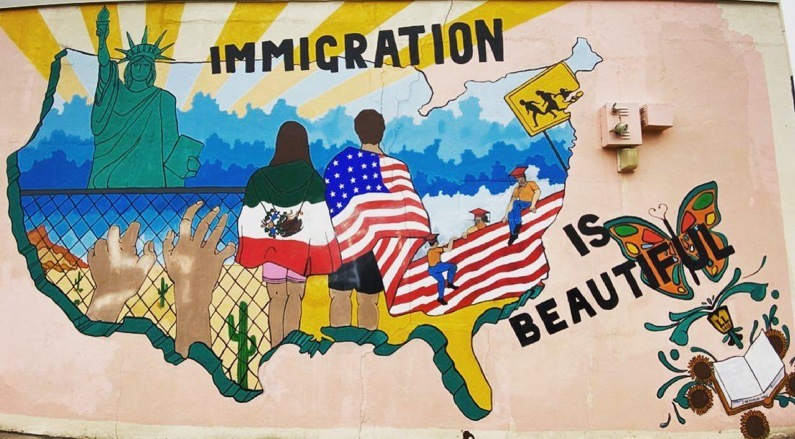
Figure 1. Immigration is Beautiful on Immigration Office
Location: Immigration Law Offices of Shamieh, Shamieh & Ternieden in Wichita, Kansas
Date: 2013 -2014
Artists: Armando Minjarez and high school students
Source: https://alteredbooklover.blogspot.com/2020/06/monday-murals-immigration-is-beautiful.html

Return to Page 1
Return to Page 30

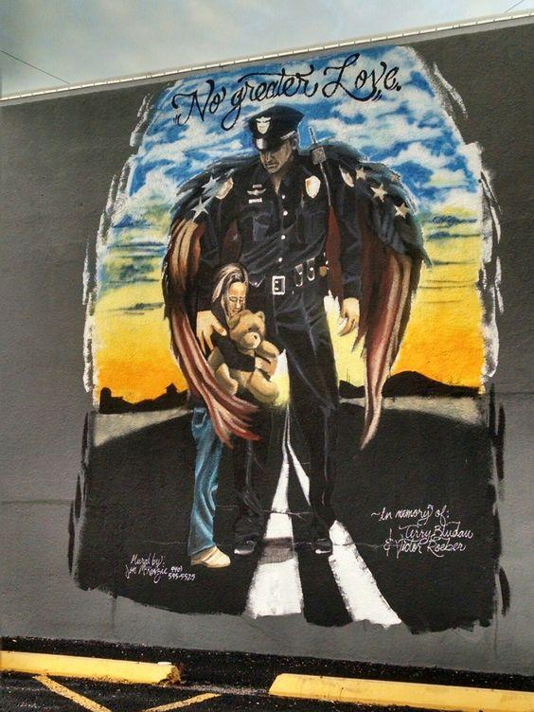
Figure 2. No Greater Love on Police Department
Location: Halletsville, Texas, USA
Date: 2015
Artist: Jon McKenzie
Source: https://www.facebook.com/law.enforcement.today/photos/a.195826530243/10156095575965244/?type=3 & https://cityofhallettsville.org/police/

Return to Page 1
Return to Page 4
Return to Page 47
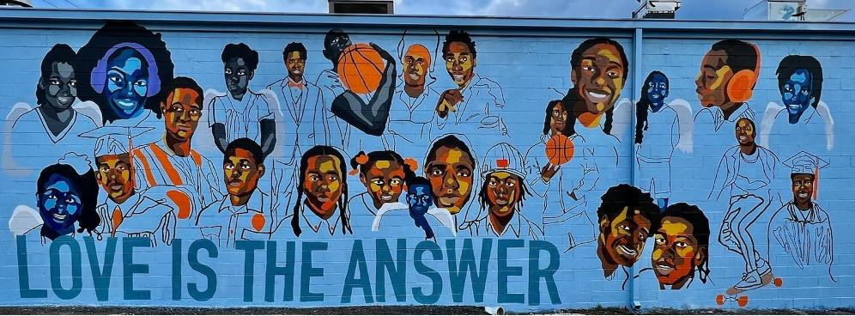
Figure 3. Love is the Answer
Location: Knoxville, Tennessee, USA
Date: 2022
Artist: E.L. Chilsom
Source: https://www.facebook.com/lovehealsviolencekills

Return to Page 3
Return to Page 26

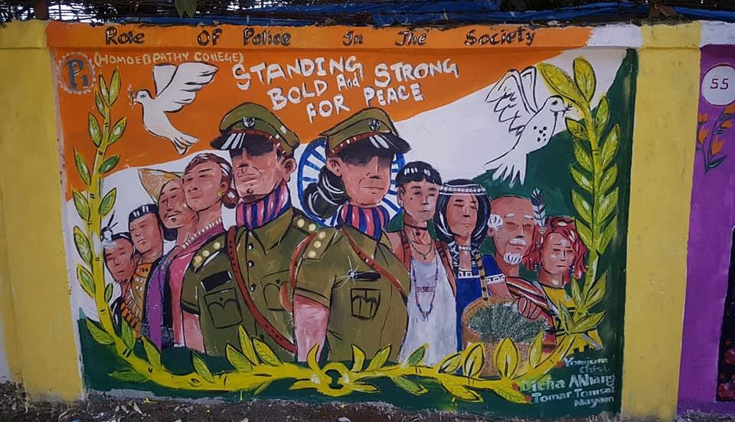
Figure 4. Standing Bold and Strong for Peace, Role of Police in Society
Location: Police Colony School in Arunachal, Pradesh, India
Date: 2018
Artists: Police Colony School students
Source: https://www.facebook.com/APPWelfareSociety/posts/1st-ever-mural-painting-competition-held-on-5th-6th-november-2018/330324334421612/

Return to Page 10
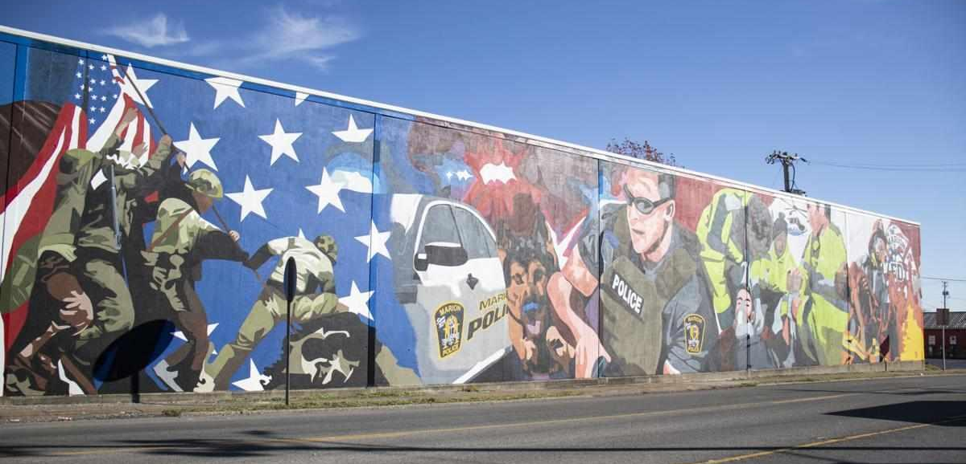
Figure 5. First Responders Mural
Location: Marion, Illinois
Date: 2021-2022
Artist: Maddie Deiters
Source: https://thesouthern.com/news/local/photos-marion-mural-honors-military-heroes-firefighters-and-more/collection_5e6cdc56-7e0b-5424-9253-ee1f86404da7.html#7

Return to Page 13

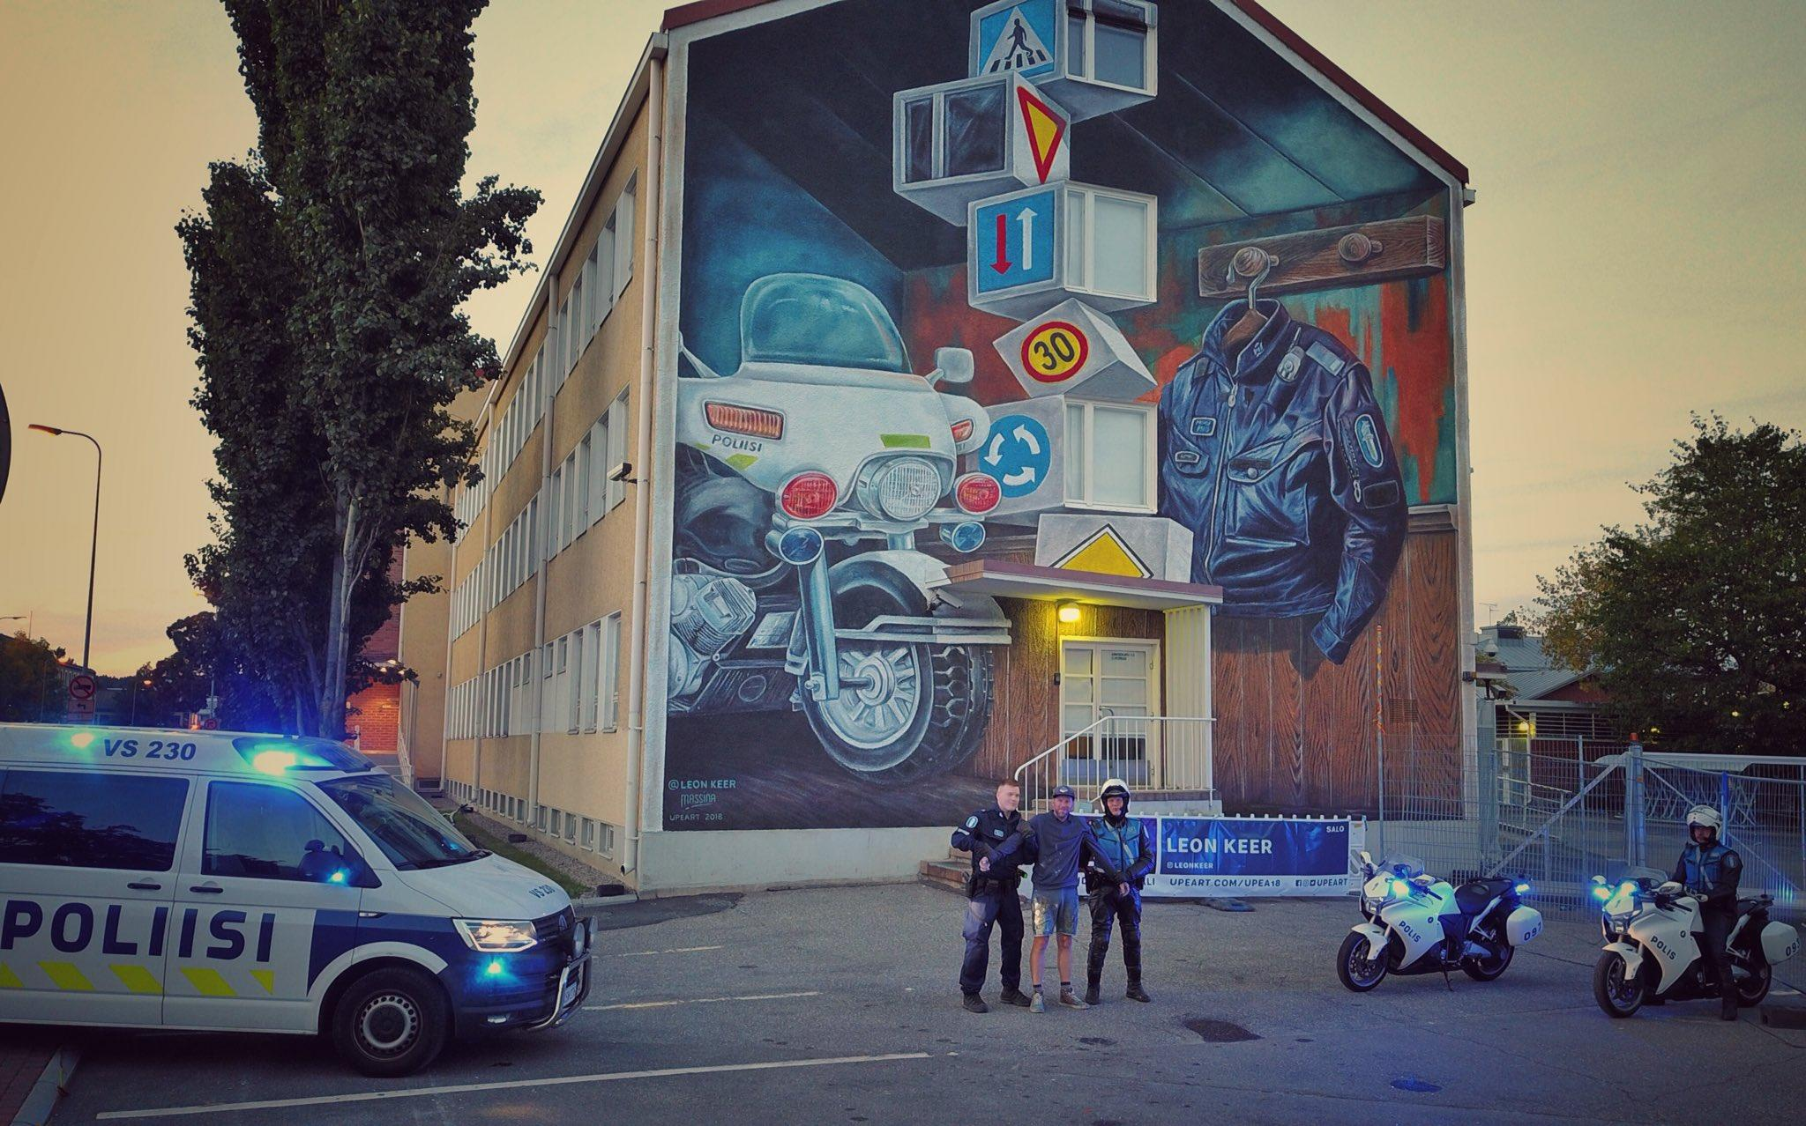
Figure 6. Mural on Salo Police Station
Location: Salo, Finland
Date: 2018
Artist: Leon Keep
Source: https://twitter.com/L_S_poliisi/status/1039436872659939333

Return to Page 13

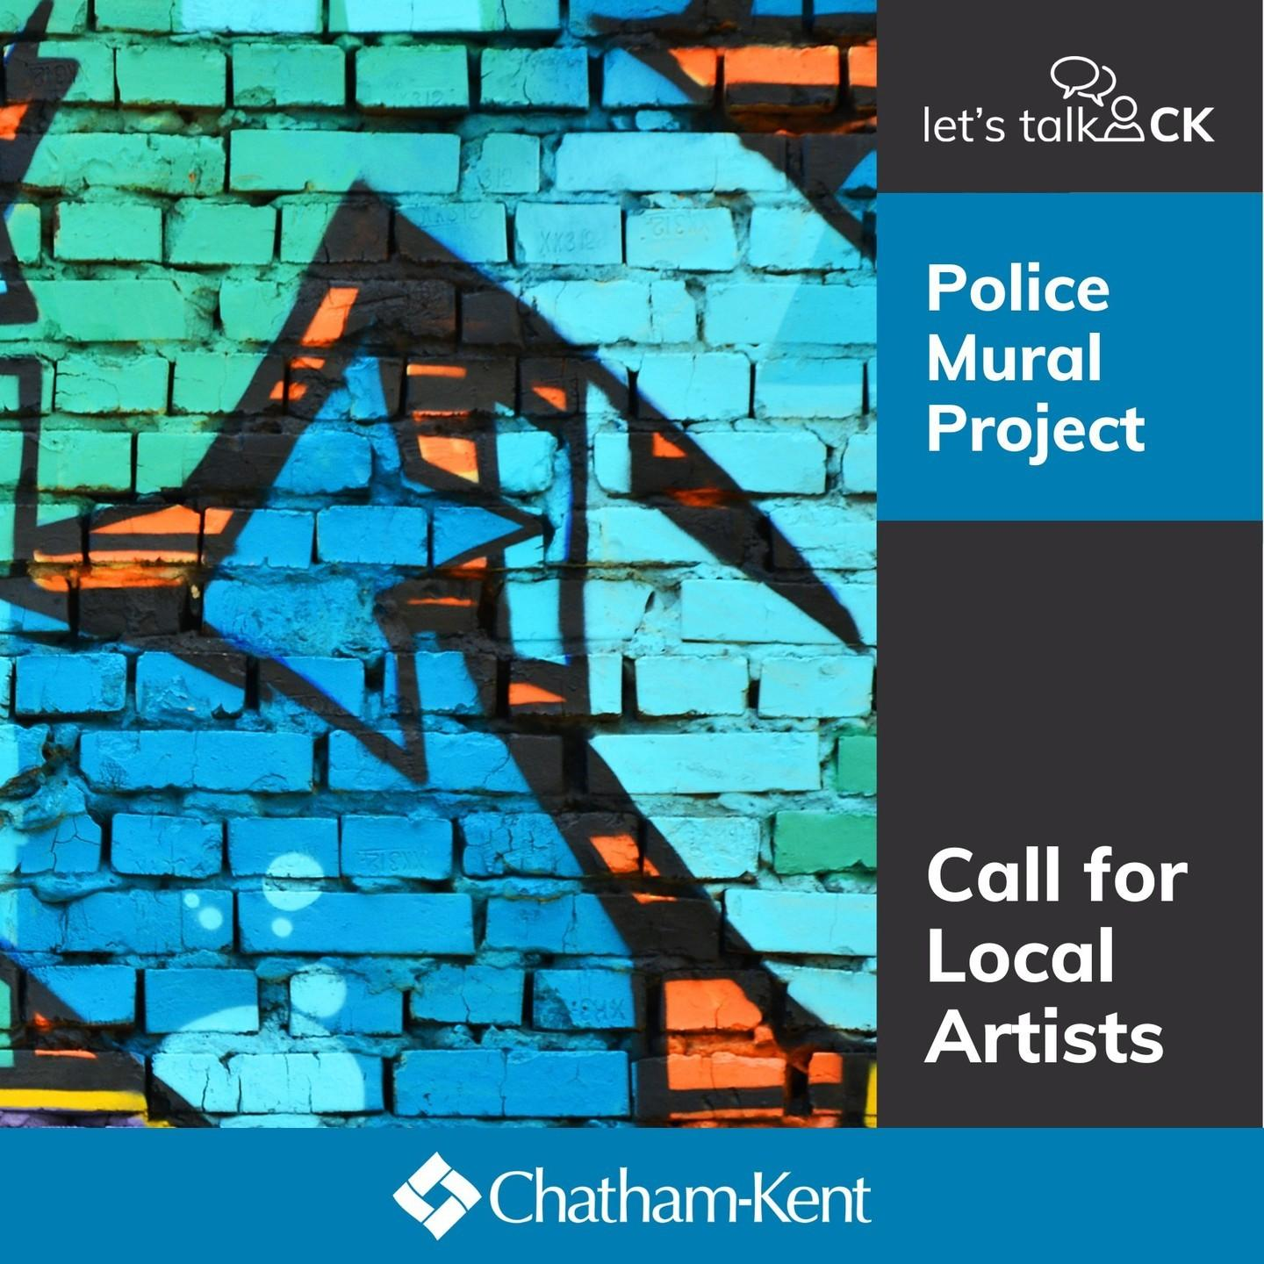
Figure 7. Police Mural Project Call for Artists for Police Mural Headquarters
Location: Chatham-Kent, Ontario, Canada
Date: 2023
Source: https://www.instagram.com/p/CwOFkiMu4ZI/

Return to Page 13

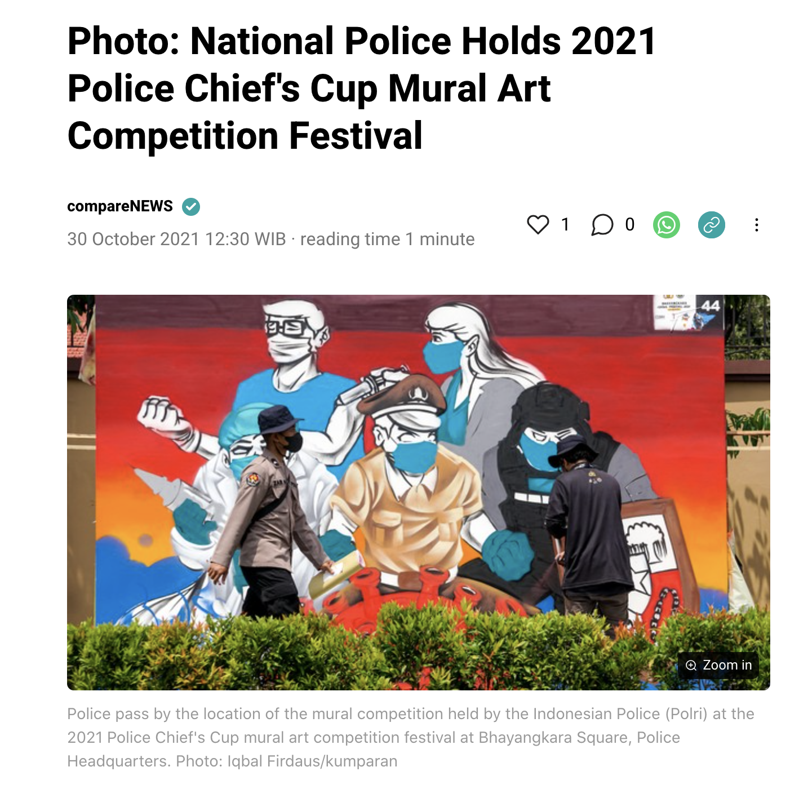
Figure 8. compareNEWs Coverage of the National Police Mural Competition
Location: Bekasi, West Java, Indonesia
Date: 2021
Source: https://kumparan.com/kumparannews/foto-polri-gelar-festival-lomba-seni-mural-piala-kapolri-2021-1wovJQ4QnFB/full

Return to Page 13

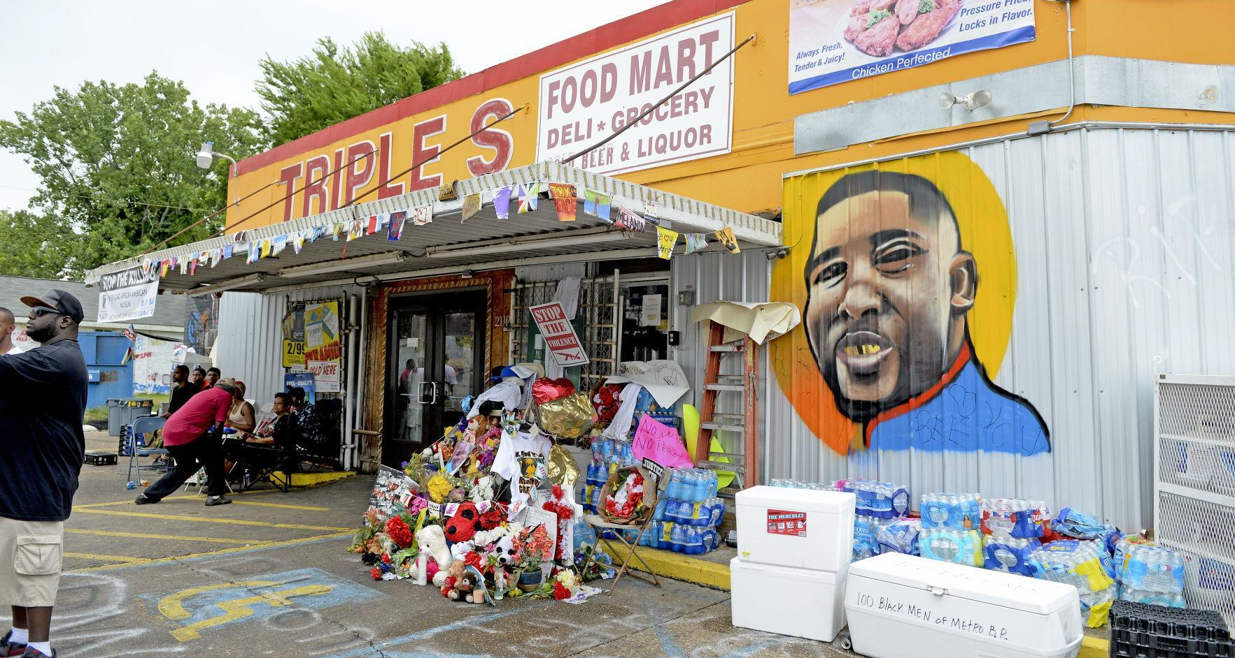
Figure 9. Memorial Mural of Alton Sterling where Police Killed Him
Location: Baton Rouge, Louisiana
Date: 2016
Artist: Jo Hines
Source: https://www.nytimes.com/2020/06/05/arts/design/murals-remember-people-killed-by-police.html

Return to Page 16

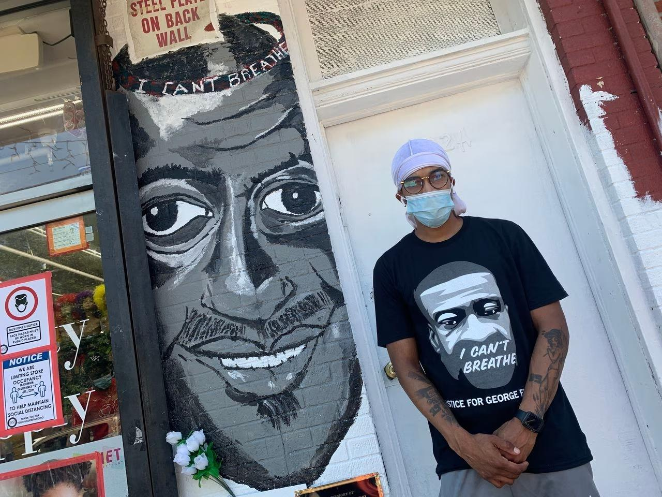
Figure 10. Memorial Mural of Eric Garner where Police Killed Him
Location: Staten Island, New York
Date: 2020
Artist: Brenton Evins
Source: https://www.silive.com/entertainment/2020/07/new-york-city-artists-create-murals-dedicated-to-eric-garner-and-erica-garner-on-staten-island.html

Return to Page 16
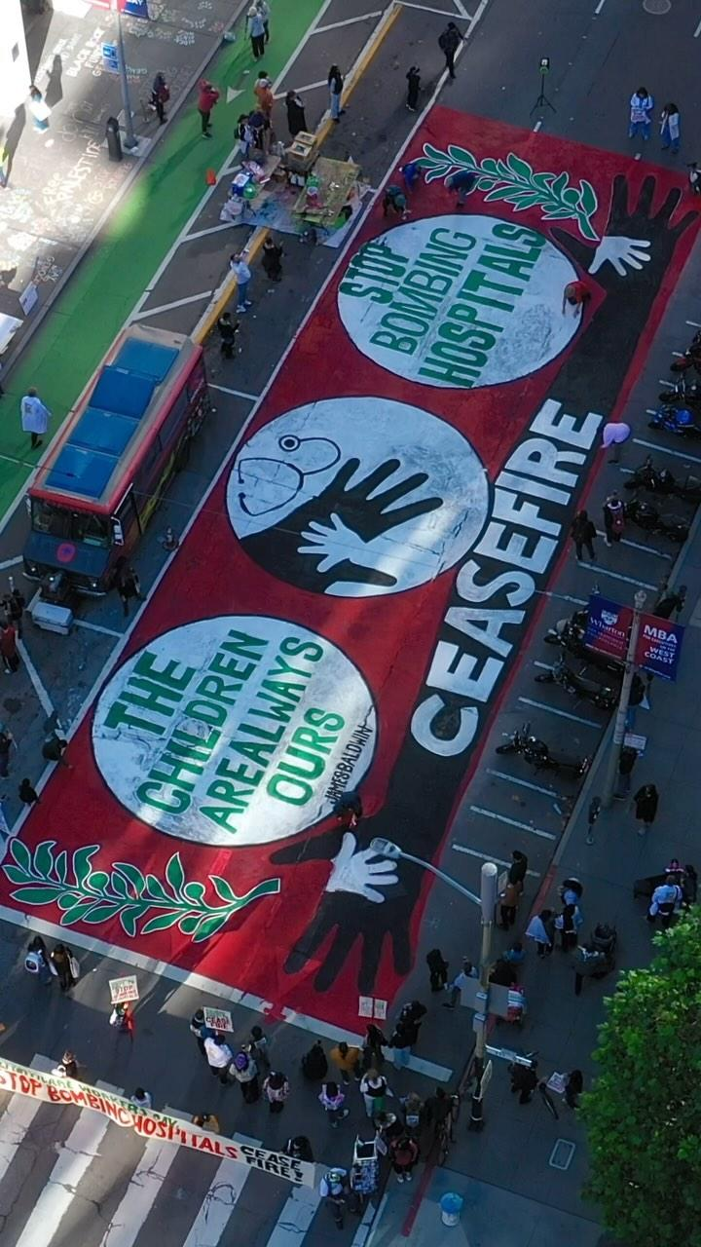
Figure 11. Ceasefire & Stop Bombing Hospitals
Location: San Francisco, California, USA
Date: 2023
Source: https://www.instagram.com/p/Cz4tUSav9Zl/

Return to Page 18
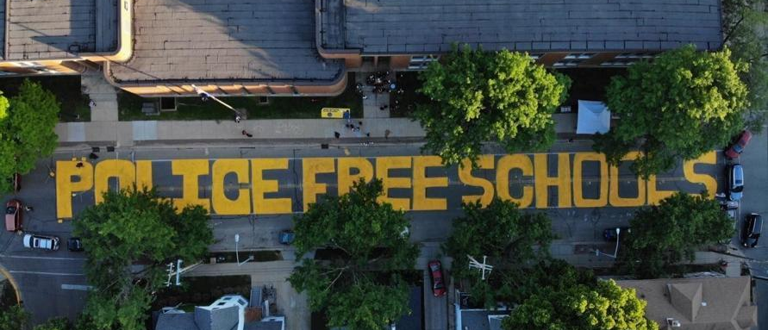
Figure 12. Police Free Schools
Location: School District Building in Madison, Wisconsin, USA
Date: 2020
Artists: Freedom Youth Squad
Source: https://www.wkow.com/archive/police-free-schools-painted-in-front-of-mmsd-administrative-building/article_d530f79c-e073-59c9-841d-0e628ac0432b.html

Return to Page 18

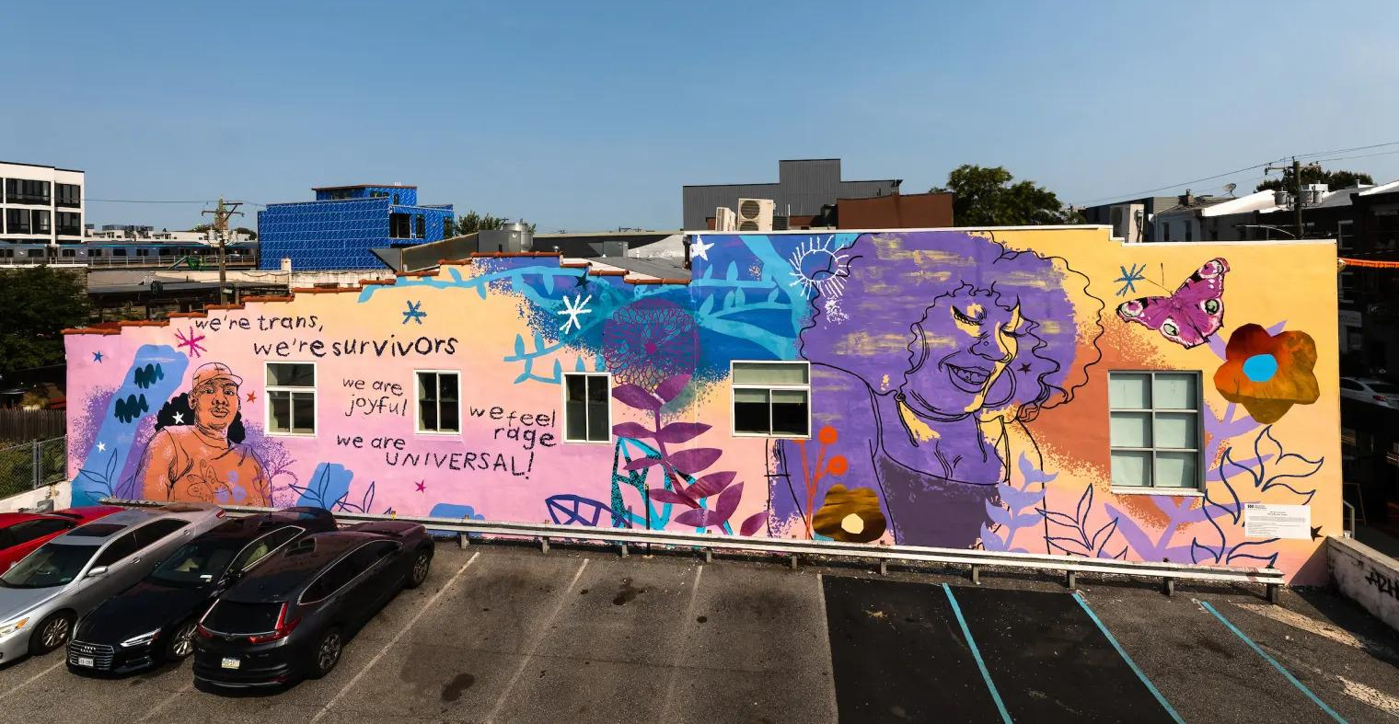
Figure 13. We Are Universal
Location: Philadelphia, Pennsylvania, USA
Date: 2021
Artists: Kah Yangni and residents of Morris Home
Photographer: Steve Weinik
Source: https://www.nbcnews.com/nbc-out/out-community-voices/philadelphia-unveils-first-mural-celebrating-transgender-people-rcna2569

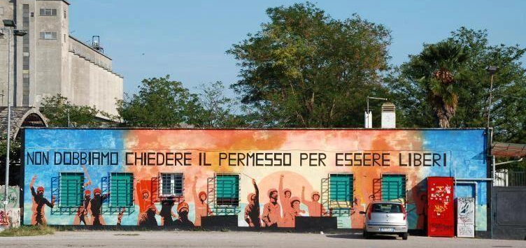
Figure 14. Non Dobbiamo Chiedere Il Permesso Per Essere Liberi (We Don't Have to Ask Permission to Be Free)
Location: Venice, Italy
Date: 2011
Source:https://commons.wikimedia.org/wiki/File:Non_dobbiamo_chiedere_il_permesso_per_essere_liberi_(6149839185).jpg

Return to Page 25

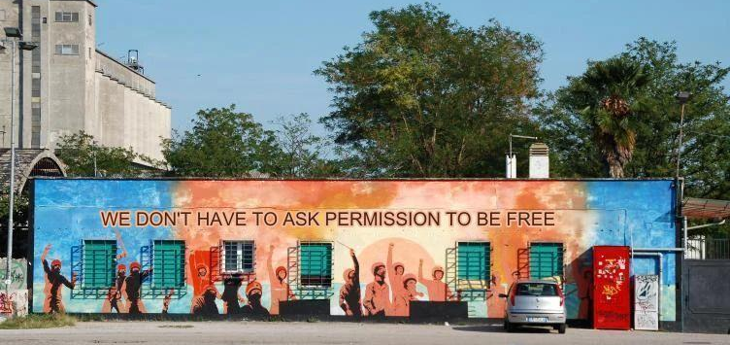
Figure 15. Non Dobbiamo Chiedere Il Permesso Per Essere Liberi (We Don't Have to Ask Permission to Be Free), Translated
Location: Venice, Italy
Date: 2011
Source:https://commons.wikimedia.org/wiki/File:Non_dobbiamo_chiedere_il_permesso_per_essere_liberi_(6149839185).jpg

Return to Page 25

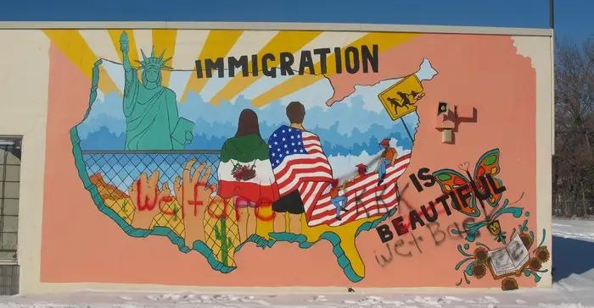
Figure 16. Immigration is Beautiful on Immigration Office, Vandalized
Location: Immigration Law Offices of Shamieh, Shamieh & Ternieden in Wichita, Kansas
Date: 2014
Artists: Armando Minjarez and high school students
Source: https://www.buzzfeednews.com/article/adriancarrasquillo/immigration-is-beautiful-mural-defaced-with-racist-graffiti

Return to Page 30

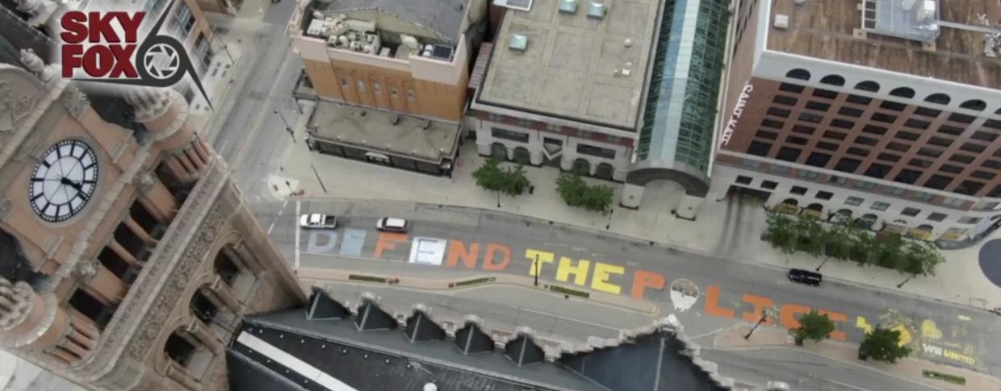
Figure 17. Defund/Defend the Police Street Mural
Location: City Hall in Milwaukee, Wisconsin
Date: 2020
Artist: Jeremy Wilbur and activists
Source: https://www.the-sun.com/news/us-news/1085586/milwaukee-defund-police-defend/

Return to Page 31

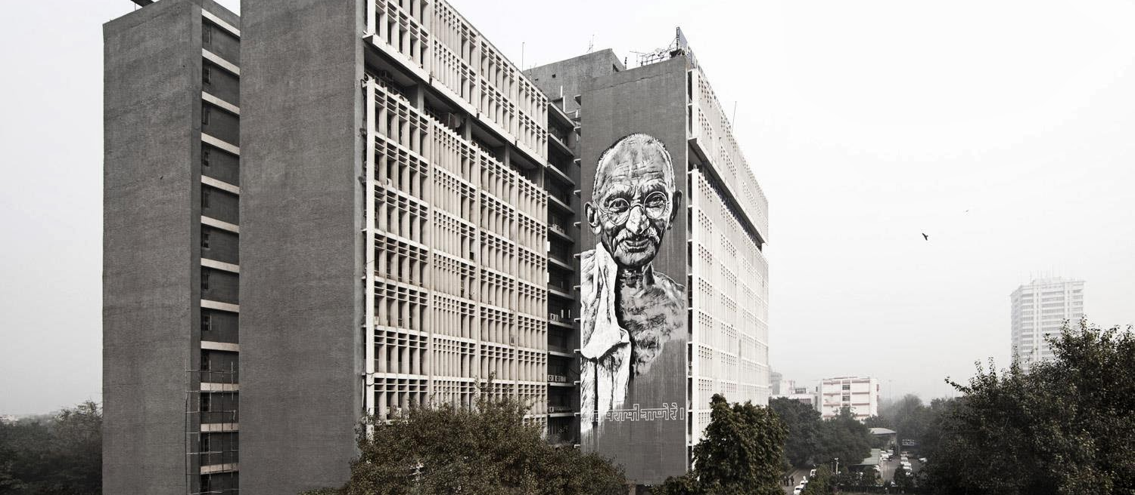
Figure 18. Portrait of Gandhi at Delhi Police Headquarters
Location: New Delhi, India
Date: 2014
Artist: ECB Hendrik Beikirchon
Photographer: Enrico Fabian
Source: https://streetartnews.net/2014/02/ecb-gandhi-new-mural-new-delhi-india.html

Return to Page 32

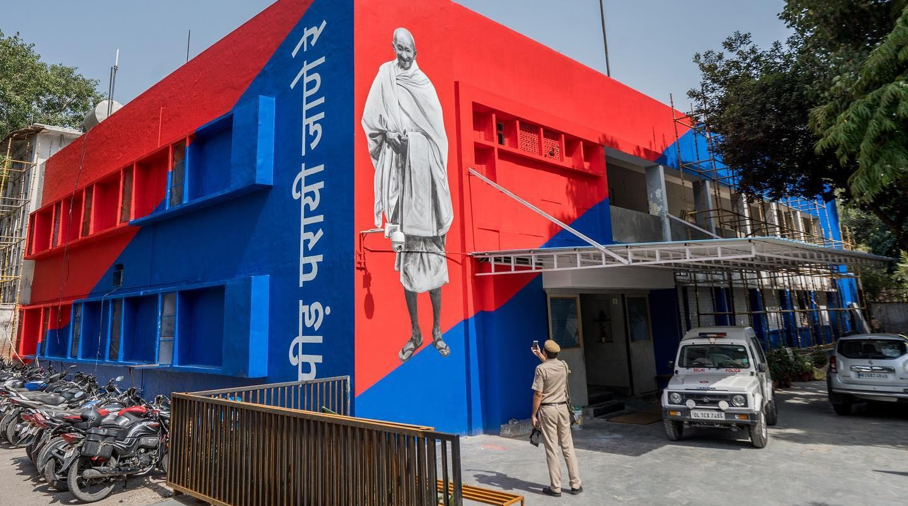
Figure 19. Portrait of Gandhi at Lodhi Police Station
Location: New Delhi, India
Date: 2019
Artist: Hanif Kureshi
Photographer: Pranav Gohil
Source: https://www.instagram.com/p/Bx9jdLPgi3s/

Return to Page 32
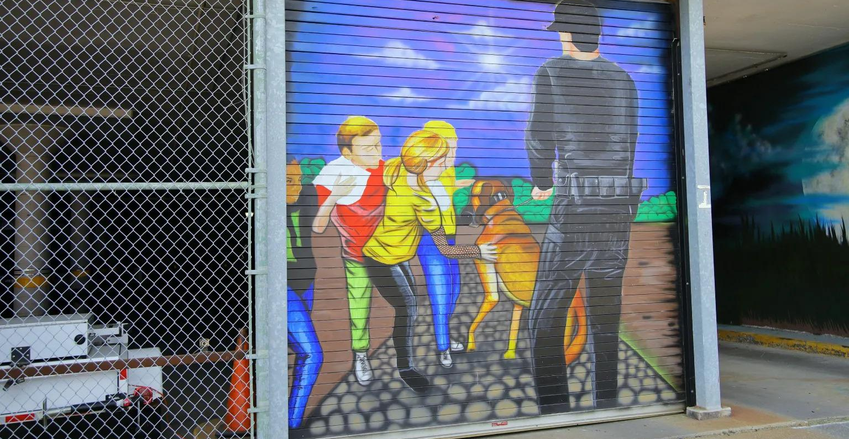
Figure 20. Police Pacification I on Police Department
Location: Topeka, Kansas
Date: 2019
Artists: Woody Woodward and collaborators
Source: https://artstopeka.org/mural/tpd & https://www.cjonline.com/story/news/2019/08/23/gaining-ground-work-continues-on-topeka-police-department-mural/4393932007/

Return to Page 32

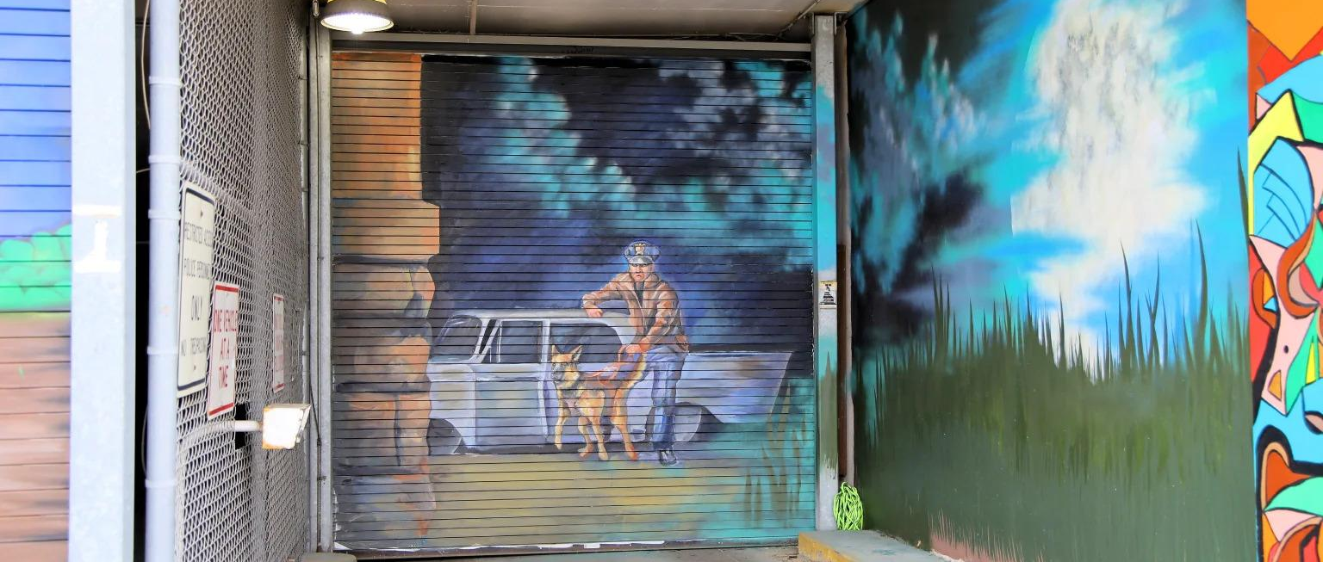
Figure 21. Police Pacification II on Police Department
Location: Topeka, Kansas
Date: 2019
Artists: Woody Woodward and collaborators
Source: https://artstopeka.org/mural/tpd & https://www.cjonline.com/story/news/2019/08/23/gaining-ground-work-continues-on-topeka-police-department-mural/4393932007/

Return to Page 32

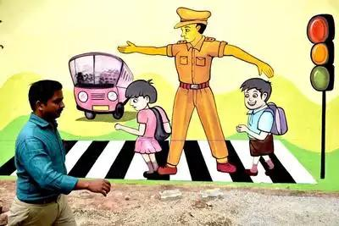
Figure 22. Mural on Child-Friendly Fort Police Station
Location: Thiruvananthapuram, Kerala, India
Date: 2017
Source: https://timesofindia.indiatimes.com/city/thiruvananthapuram/fort-station-gets-a-child-friendly-makeover/articleshow/61634652.cms

Return to Page 33

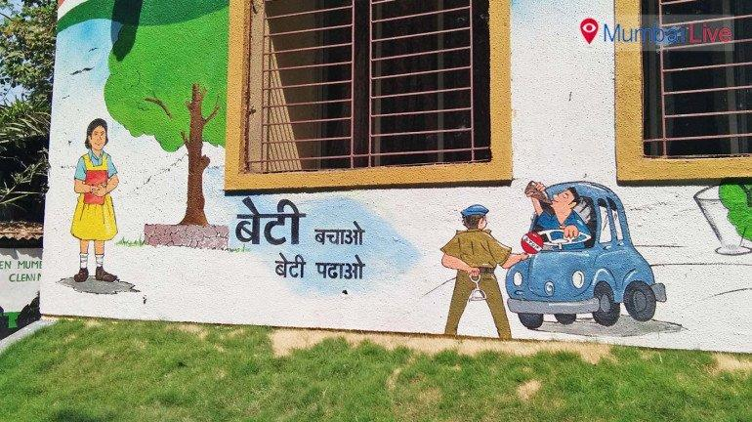
Figure 23. Mural on Child-Friendly Chirag Nagar Police Station
Location: Thiruvananthapuram, Kerala, India
Date: 2017
Source: https://timesofindia.indiatimes.com/city/thiruvananthapuram/fort-station-gets-a-child-friendly-makeover/articleshow/61634652.cms

Return to Page 33

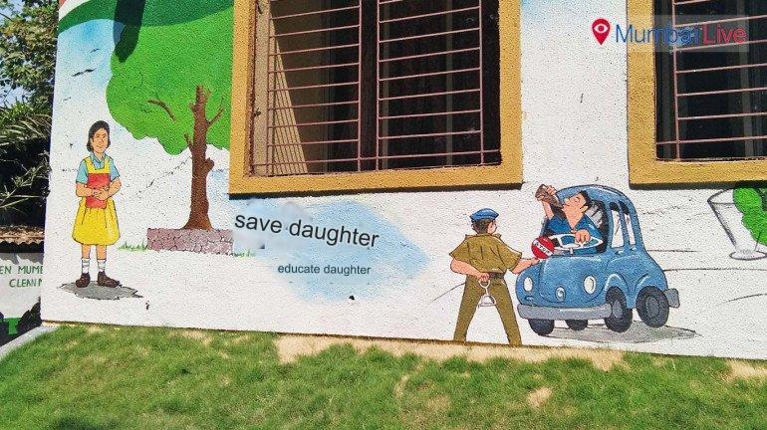
Figure 24. Mural on Child-Friendly Police Station II, Translated
Location: Thiruvananthapuram, Kerala, India
Date: 2017
Source: https://timesofindia.indiatimes.com/city/thiruvananthapuram/fort-station-gets-a-child-friendly-makeover/articleshow/61634652.cms

Return to Page 33

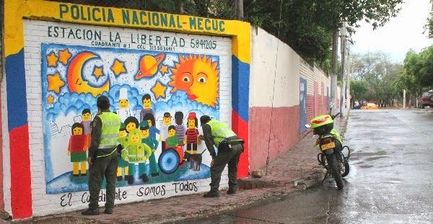
Figure 25. The Art of Taking Care of Yourself Mural Campaign, Quadrant I
Location: Cúcuta, Colombia
Date: 2013
Artists: Metropolitan Police of Cúcuta and community members
Source: https://www.areacucuta.com/once-murales-invitan-a-la-seguridad-y-rescate-de-los-valores-en-la-ciudadela-la-libertad-de-cucuta/

Return to Page 33

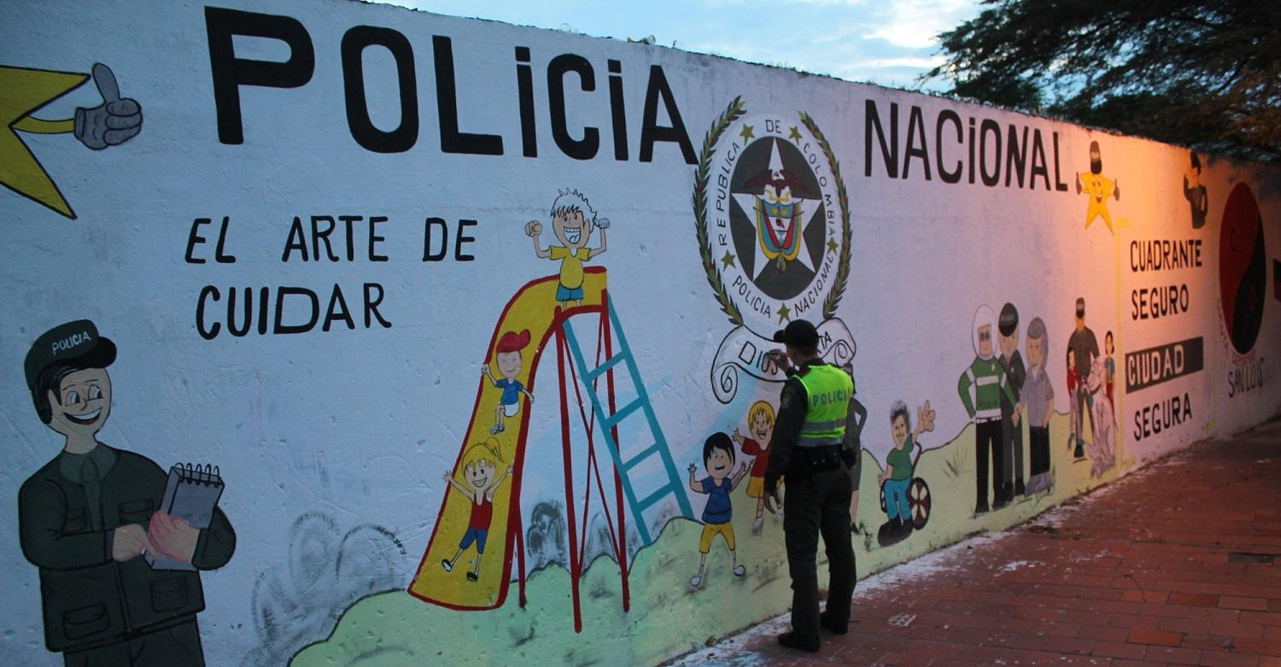
Figure 26. The Art of Taking Care of Yourself Mural Campaign, Lower Pamplonita Neighborhood
Location: Cúcuta, Colombia
Date: 2013
Artists: Metropolitan Police of Cúcuta and community members
Source: https://www.areacucuta.com/once-murales-invitan-a-la-seguridad-y-rescate-de-los-valores-en-la-ciudadela-la-libertad-de-cucuta/

Return to Page 33
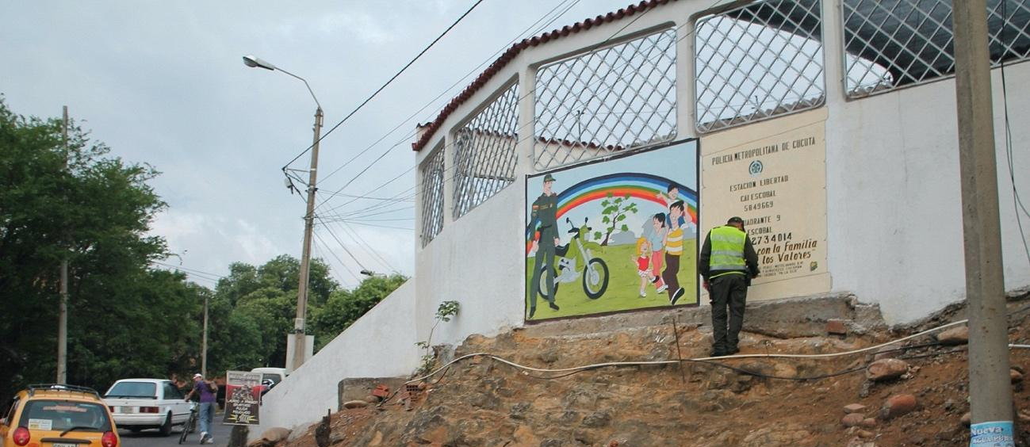
Figure 27. The Art of Taking Care of Yourself Mural Campaign, Torcoroma Neighborhood
Location: Cúcuta, Colombia
Date: 2013
Artists: Metropolitan Police of Cúcuta and community members
Source: https://www.areacucuta.com/once-murales-invitan-a-la-seguridad-y-rescate-de-los-valores-en-la-ciudadela-la-libertad-de-cucuta/

Return to Page 33

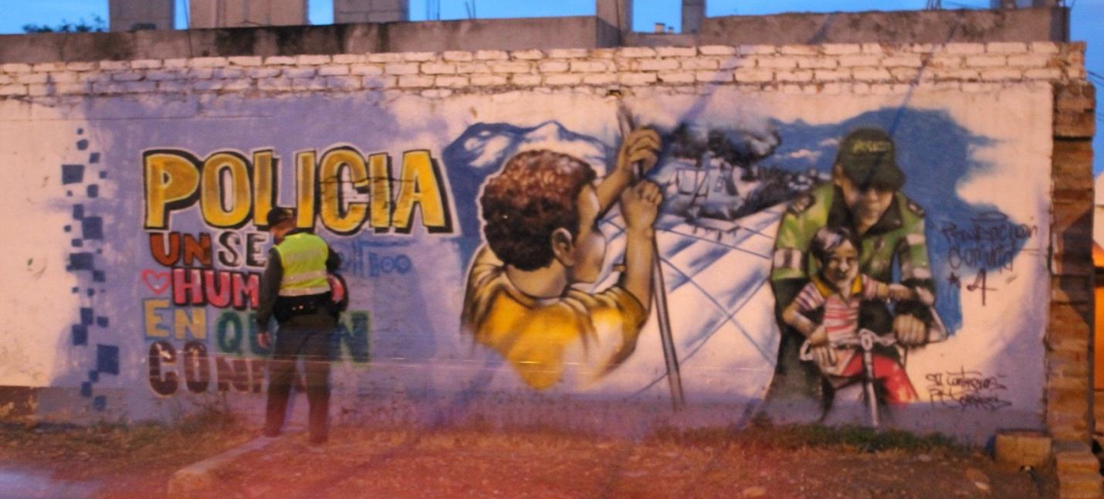
Figure 28. The Art of Taking Care of Yourself Mural Campaign, San Luis Neighborhood
Location: Cúcuta, Colombia
Date: 2013
Artists: Metropolitan Police of Cúcuta and community members
Source: https://www.areacucuta.com/once-murales-invitan-a-la-seguridad-y-rescate-de-los-valores-en-la-ciudadela-la-libertad-de-cucuta/

Return to Page 33

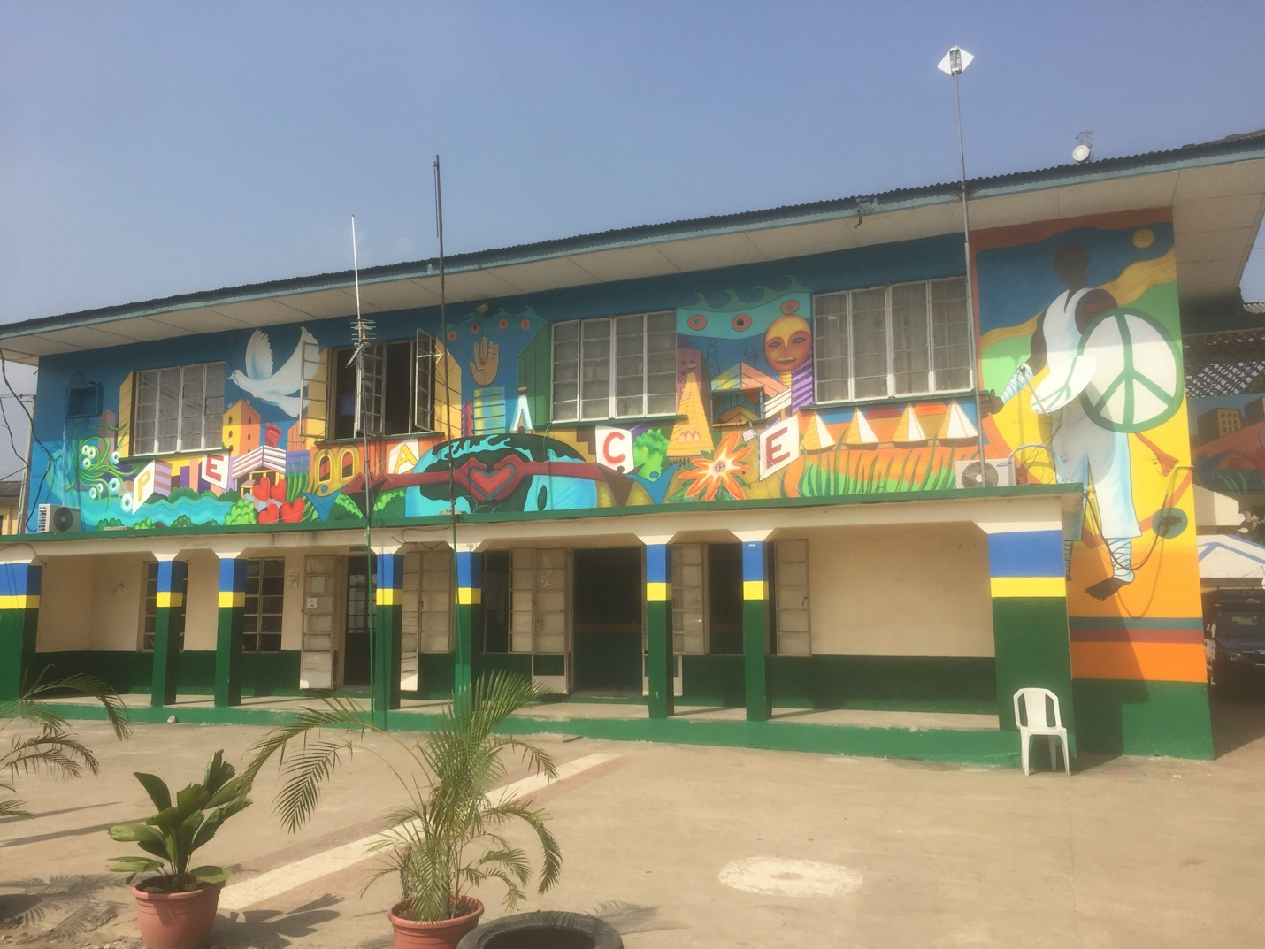
Figure 29. The Nigeria Police Force Headquarters I
Location: Lagos, Nigeria
Date: 2017
Artist: Paul Santoleri and students from Yaba Technical High School
Source: https://www.meridian.org/project/murals-lagos-nigeria/

Return to Page 33
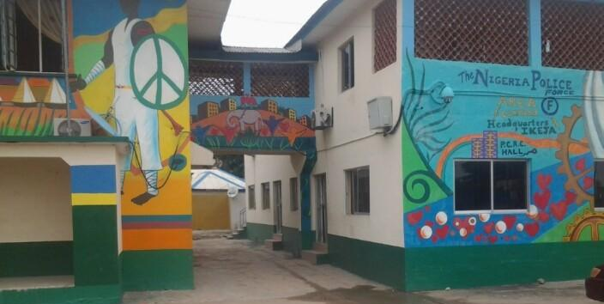
Figure 30. The Nigeria Police Force Headquarters II
Location: Lagos, Nigeria
Date: 2017
Artist: Paul Santoleri and students from Yaba Technical High School
Source: https://www.nairaland.com/3861373/area-f-police-station-sends

Return to Page 33

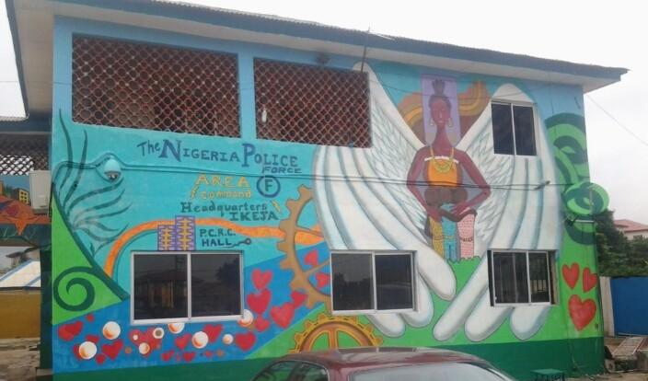
Figure 31. The Nigeria Police Force Headquarters III
Location: Lagos, Nigeria
Date: 2017
Artist: Paul Santoleri and students from Yaba Technical High School
Source: https://www.nairaland.com/3861373/area-f-police-station-sends

Return to Page 33
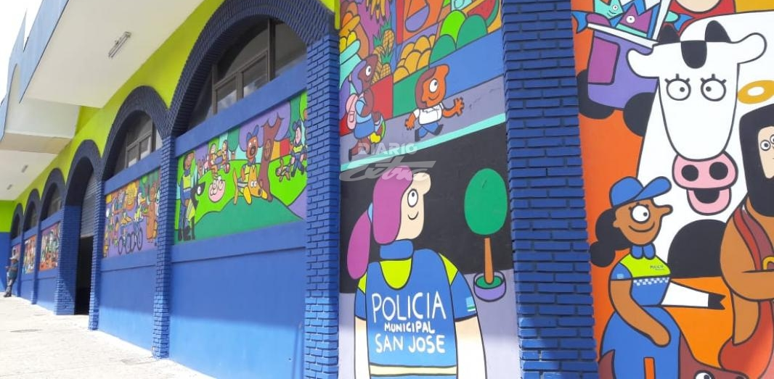
Figure 32. Cartoon Mural at San José Municipal Police Headquarters
Location: San José, Costa Rica
Date: 2018
Artist: Francisco Mungía
Photographer: Cristian Cartin
Source: https://www.diarioextra.com/Noticia/detalle/367033/nuevo-mural-adorna-edificio-de-policia-municipal

Return to Page 34

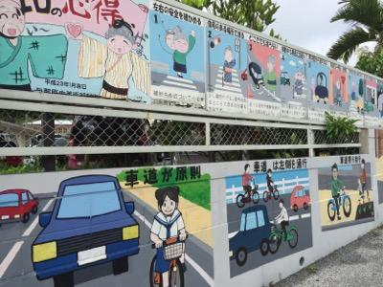
Figure 33. Traffic Safety Mural by Art Students at Kaiho High School on Outside Wall of Yonaburu Police Station
Location: Yonabaru, Okinawa, Japan
Date: 2016
Source: https://www.dee-okinawa.com/koneta/2016/05/yonabarupolice.html

Return to Page 34
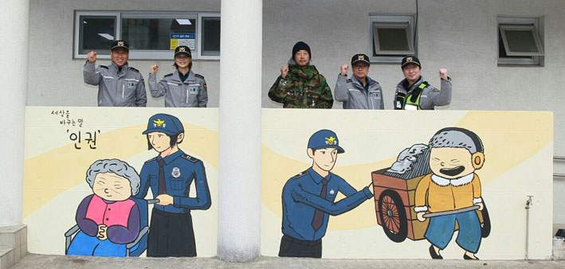
Figure 34. South Korean Police “Human Rights” Mural
Location: Seogwipo Police Station's Daejeong Police Station, South Korea
Date: 2018
Artist: Gong Hyeon-sik
Source: https://www.headlinejeju.co.kr/news/articleView.html?idxno=327074

Return to Page 34

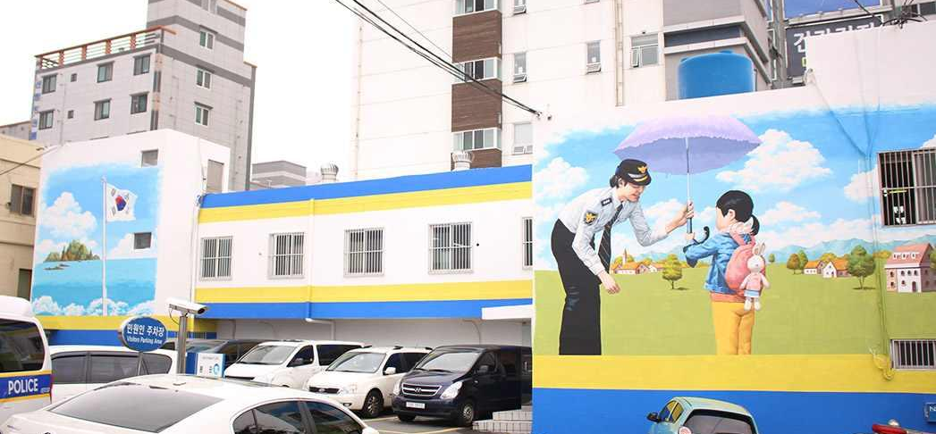
Figure 35. Police Parasol Mural on Haeundae Police Station
Location: Busan, South Korea
Date: 2016
Source: http://hubeinc.com/ecosupergraphic_portfolio/1429

Return to Page 34

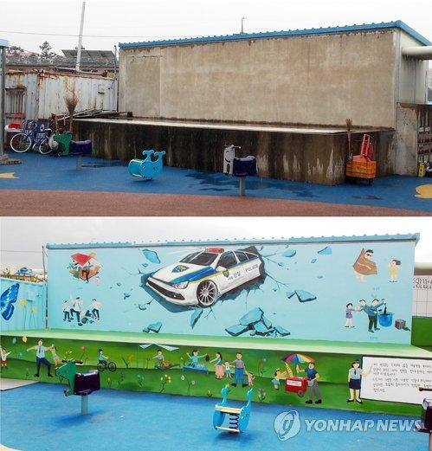
Figure 36. “Eradicate the Four Major Evils” Mural Sponsored by Police, Before and After
Location: Oil Market in Dodu-dong, Jeju City, South Korea
Date: 2014
Photographer: Jeju Western Police Station
Source: https://m.yna.co.kr/view/AKR20140902159700056

Return to Page 34

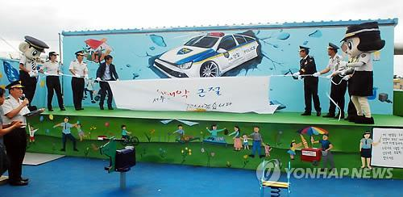
Figure 37. Police Mascots Reveal “Eradicate the Four Major Evils” Mural Sponsored by Police
Location: Oil Market in Dodu-dong, Jeju City, South Korea
Date: 2014
Photographer: Jeju Western Police Station
Source: https://m.yna.co.kr/view/AKR20140902159700056

Return to Page 34
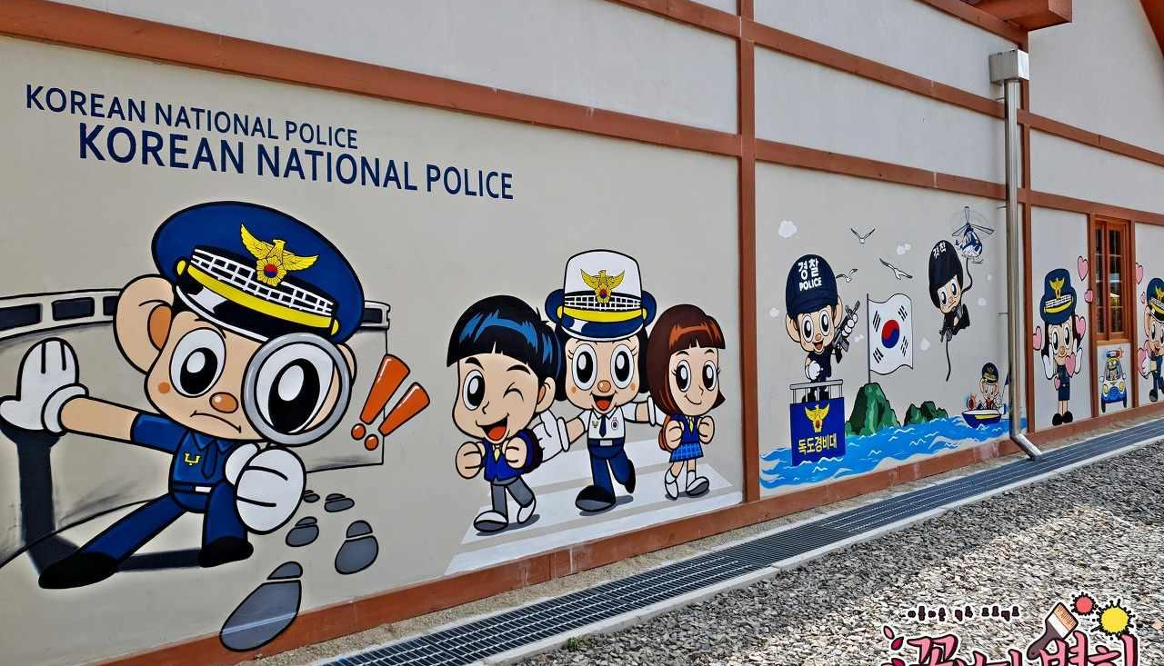
Figure 38. “Cute” Mural at Korean National Police Station I
Location: Gunwi, Gyeongsangbuk-do, South Korea
Date: 2019
Artist: Murals Over Flowers
Source: https://flowerpainting.tistory.com/64

Return to Page 34

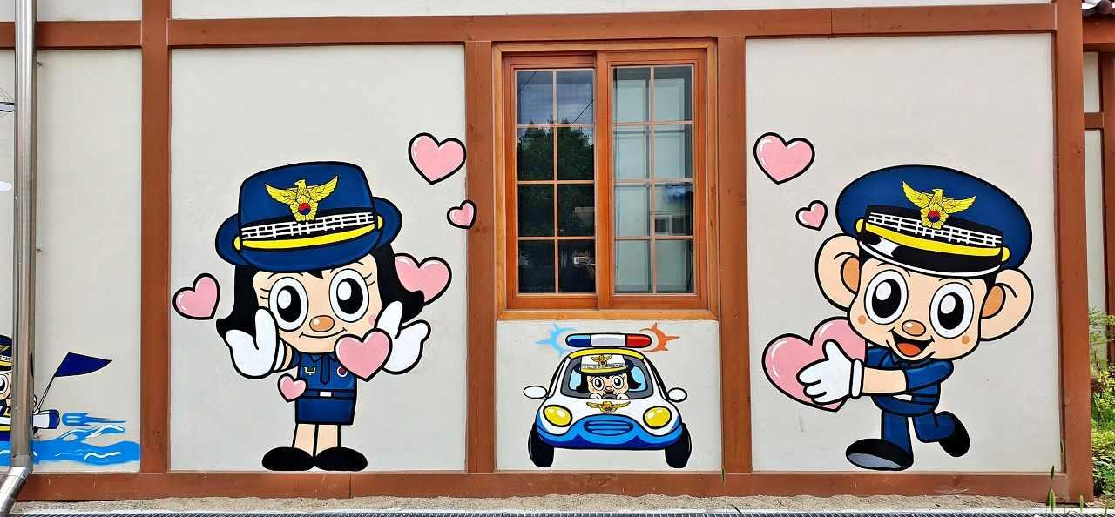
Figure 39. “Cute” Mural at Korean National Police Station II
Location: Gunwi, Gyeongsangbuk-do, South Korea
Date: 2019
Artist: Murals Over Flowers
Source: https://flowerpainting.tistory.com/64

Return to Page 34
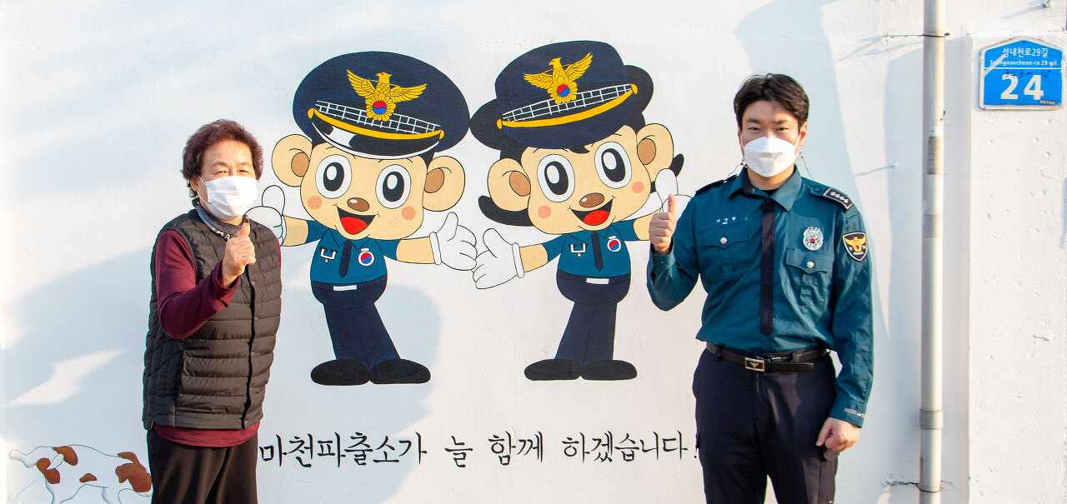
Figure 40. Crime Prevention Mural
Location: Seoul Songpa Police Station, South Korea
Date: 2021
Source: https://www.yna.co.kr/view/AKR20211105065100004

Return to Page 34

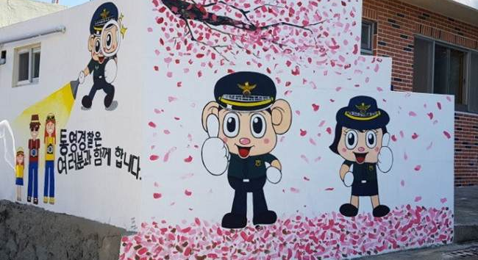
Figure 41. Police Mascots Podori and Posuni Give Thumbs Up
Location: Tongyeong Police Station, South Korea
Date: 2018
Source: https://www.knnews.co.kr/news/articleView.php?idxno=1263907

Return to Page 34

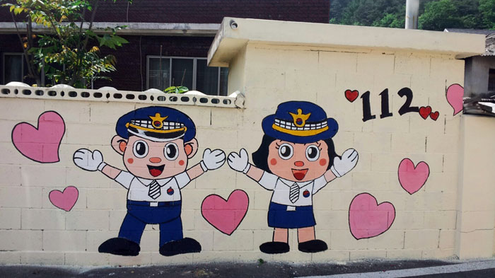
Figure 42. Police Mascots Podori and Posuni Surrounded By Hearts 112
Location: Cheongdo Police Station, Gyeongsang, South Korea
Date: 2015
Source: https://www.kbmaeil.com/news/articleView.html?idxno=353297

Return to Page 34

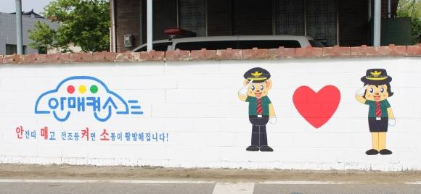
Figure 43. Police Mascots Podori and Posuni Salute on Traffic Accident Prevention Mural
Location: Geumgwang Police Station, Seowoon Police Center, Seoul, South Korea
Date: 2016
Source: http://www.wrtimes.co.kr/m/view.php?idx=2641

Return to Page 34
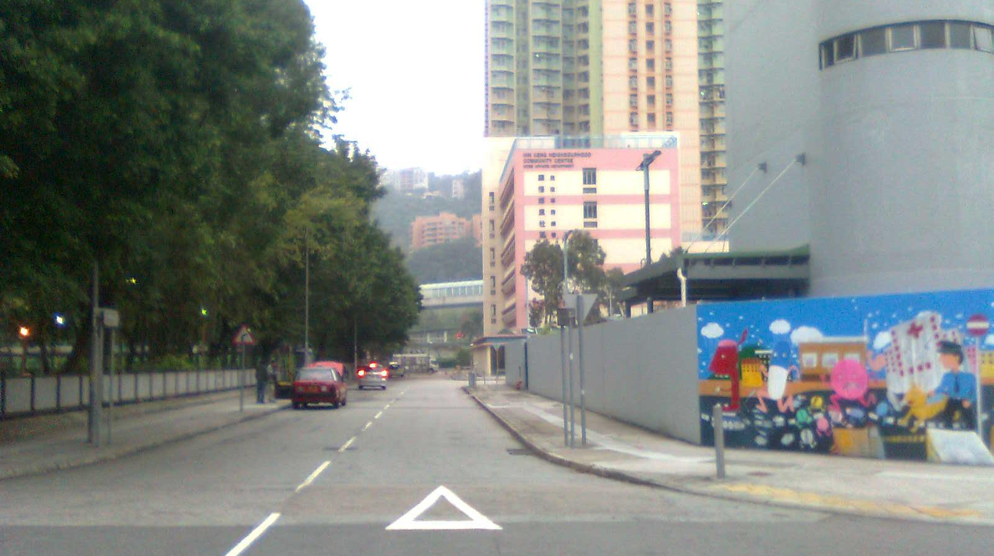
Figure 44. Police Chase Pills on Tin Sum Police Station I
Location: Sha Tin, Hong Kong
Date: 2012
Source: https://commons.wikimedia.org/wiki/File:Hin_Wo_Lane.jpg

Return to Page 34

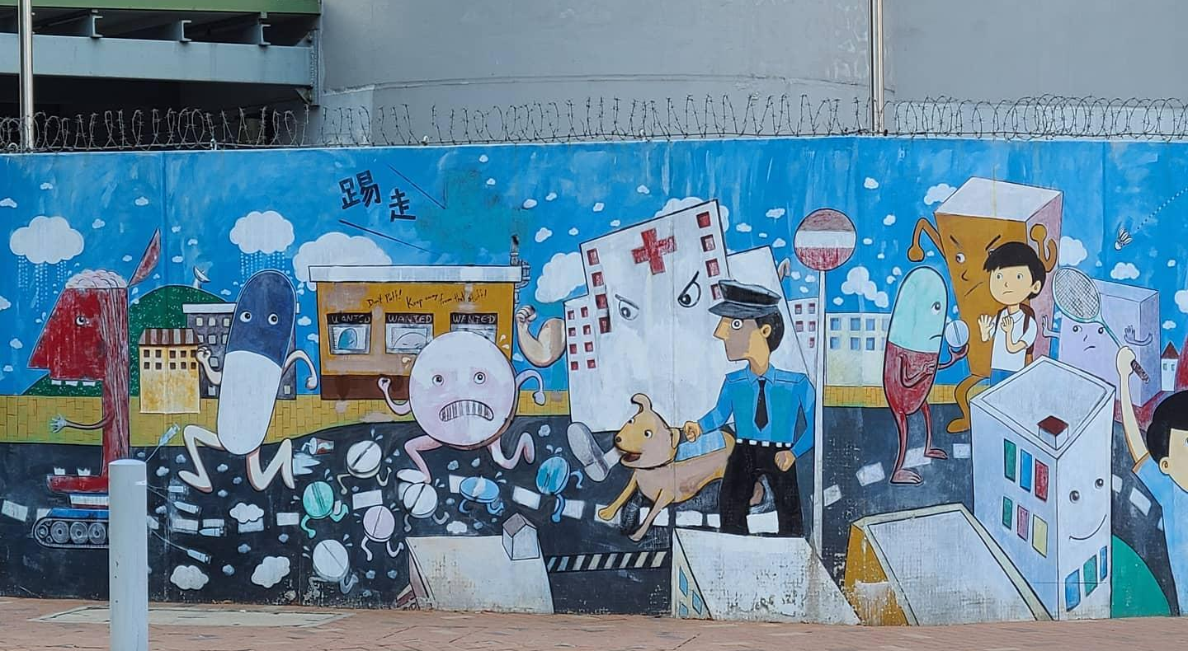
Figure 45. Police Chase Pills on Tin Sum Tin Sum Police Station II
Location: Sha Tin, Hong Kong
Date: Posted 2020
Source: https://www.instagram.com/p/CJYUSbHHWiE/

Return to Page 34

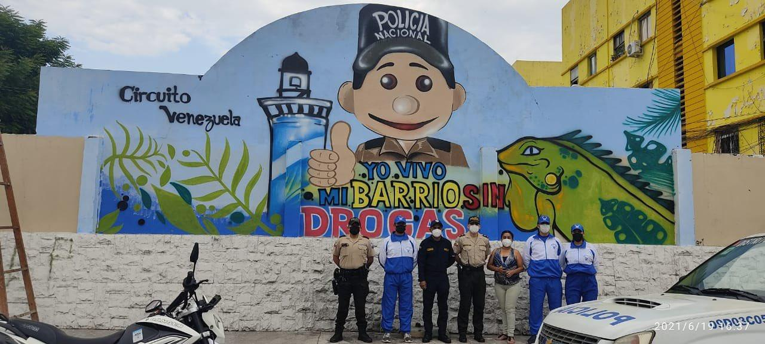
Figure 46. Yo Vivo Mi Barrio Sin Drogas Series I Sponsored By National Police
Location: Ecuador
Date: 2021
Source: https://twitter.com/policiaecuador/status/1406636732716654597

Return to Page 34

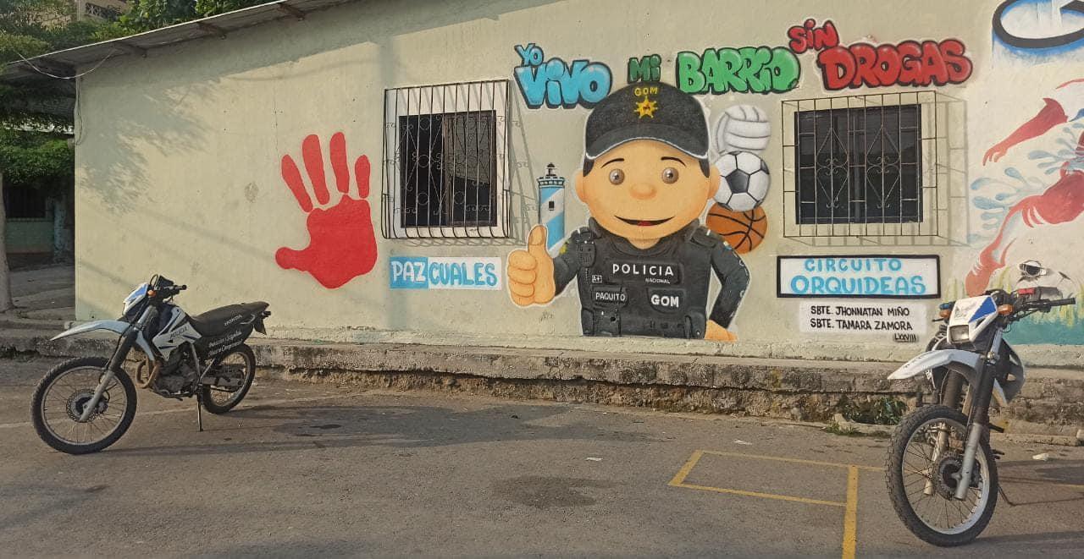
Figure 47. Yo Vivo Mi Barrio Sin Drogas Series II Sponsored By National Police
Location: Ecuador
Date: 2021
Source: https://www.facebook.com/policia.ecuador/posts/acciones-positivasjunto-a-la-comunidad-recuperamos-espacios-p%C3%BAblicos-e-inauguram/5771469419593500/

Return to Page 34

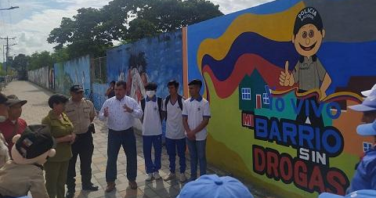
Figure 48. Yo Vivo Mi Barrio Sin Drogas Series III Sponsored By National Police
Location: Chone, Ecuador
Date: 2021
Source: https://www.policia.gob.ec/policia-pinta-mural-para-prevenir-consumo-de-drogas/

Return to Page 34

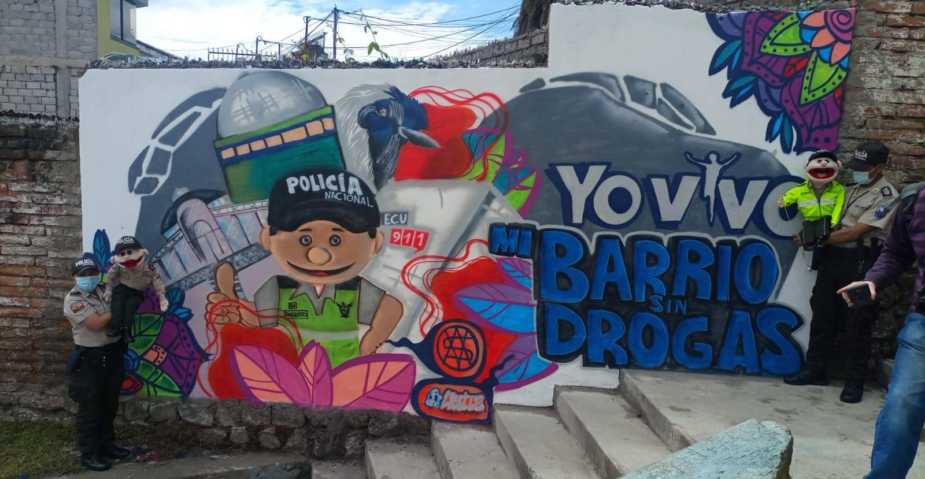
Figure 49. Yo Vivo Mi Barrio Sin Drogas Series IV Sponsored By National Police
Location: Quito, Ecuador
Date: 2021
Source: https://eluniverso-el-universo-prod.cdn.arcpublishing.com/noticias/ecuador/policia-nacional-inicio-planes-para-recuperacion-de-espacios-en-zona-conflictiva-de-quito-nota/

Return to Page 34
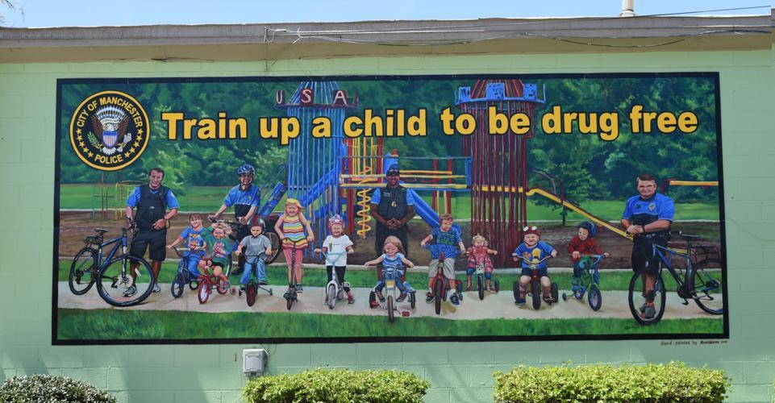
Figure 50. Train Up a Child to be Drug Free Mural Sponsored by Police
Location: Sonic Drive-In, Manchester, Tennessee
Date: 2014
Artist: Randall Oldrieve
Photographer:
Source: https://www.manchestertimes.com/news/local/new-police-mural-on-hillsboro-blvd-reminds-kids-to-stay/article_d4f43253-0b9d-5d90-8a93-6ac921d4903f.html

Return to Page 35

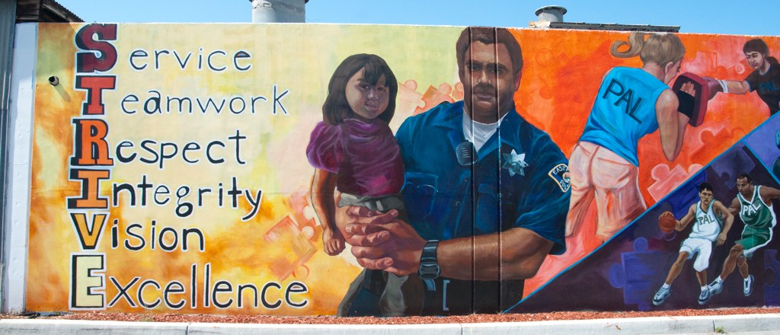
Figure 51. STRIVE Mural across the street from Police Department
Location: East Palo Alto, California
Date: 2010-2011
Artists: Mural Music & Arts Project
Photographer: Brian Imagawa
Source: https://www.flickr.com/photos/39772828@N03/5815894938/

Return to Page 36

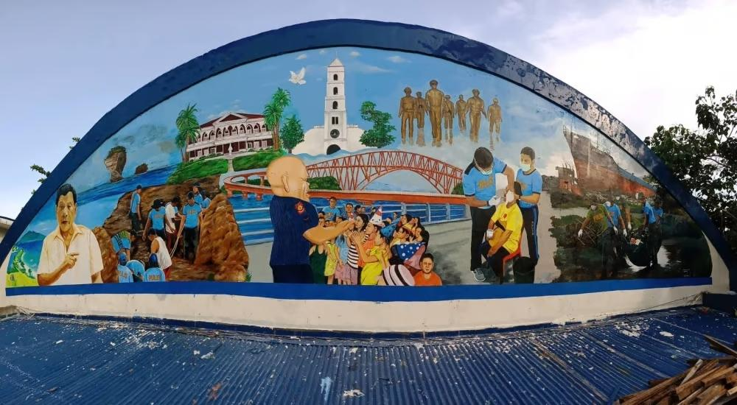
Figure 52. Mural at the Philippine National Police Headquarters
Location: Palo, Leyte, Philippines
Date: 2018
Artists: Dante Enage, Philip Salem, Archie Prisno and Clint Gonzales
Source: https://www.sunstar.com.ph/tacloban/local-news/tacloban-artists-unveil-mural-on-police-efforts-in-e-visayas

Return to Page 36

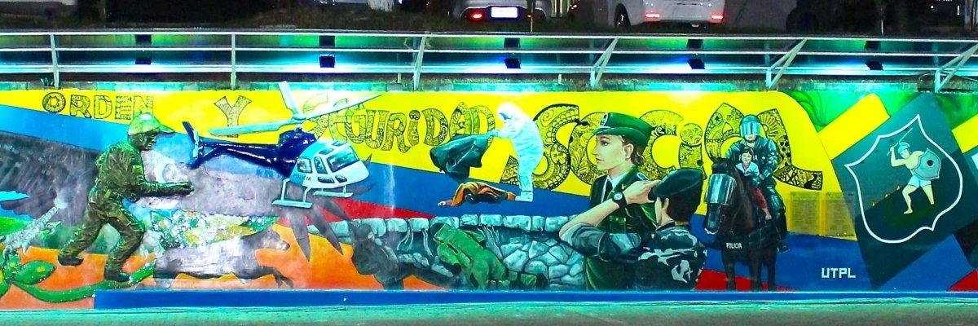
Figure 53.Policía Vigilante y Protector (Vigilant and Protective Police)
Location: Loja, Ecuador
Date: 2021
Artists: Private Technical University of Loja Visual Arts Program and National Police
Source: https://noticias.utpl.edu.ec/se-realizo-develamiento-del-mural-policia-vigilante-y-protector

Return to Page 36
Return to Page 40

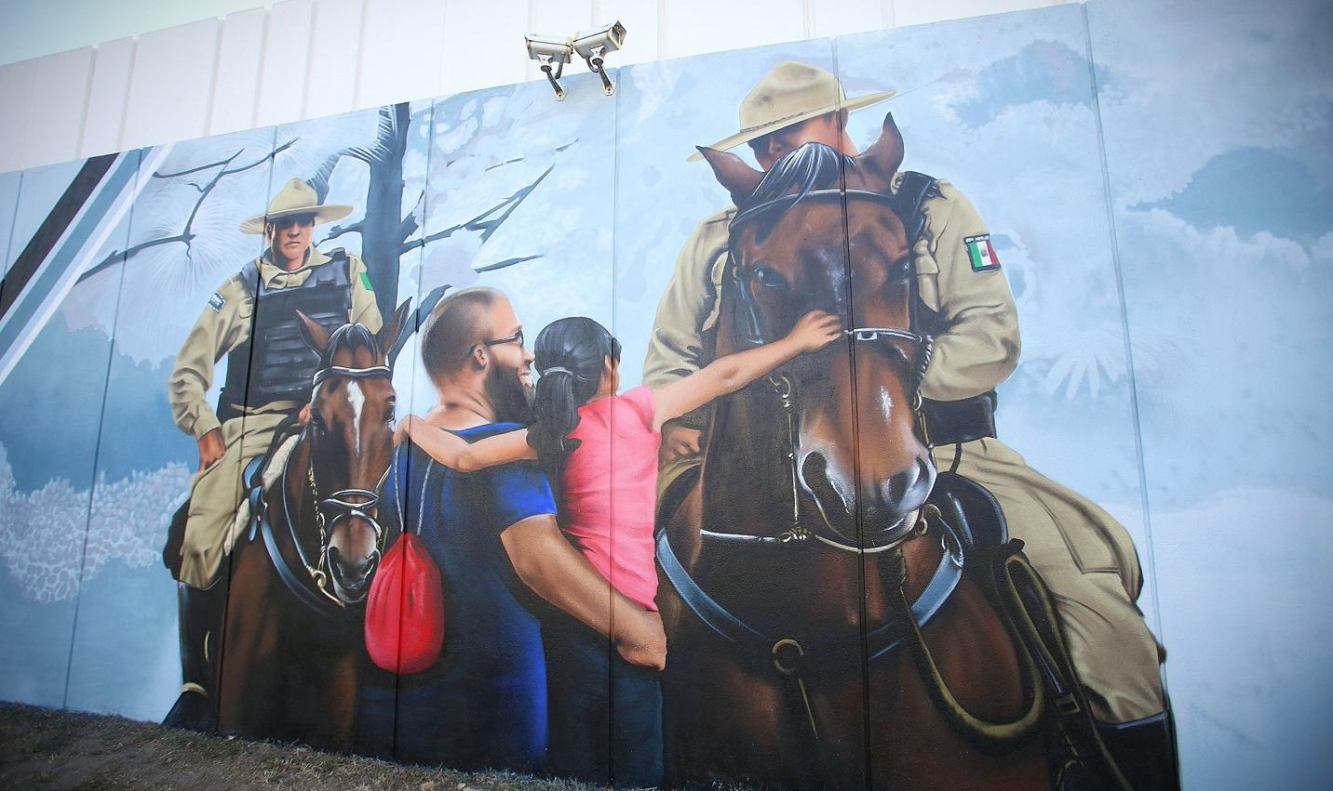
Figure 54. Girl Petting Mounted Officer’s Horse on Police Station
Location: Zapopan, Jalisco, Mexico
Date: 2020
Artist: Edson Velasco “Korba”
Photographer: Gobierno Zapopan, Edson Velasco “Korba,” and others
Source: https://www.flickr.com/photos/zapopangob/50698792833/in/album-72157717232826442/

Return to Page 36

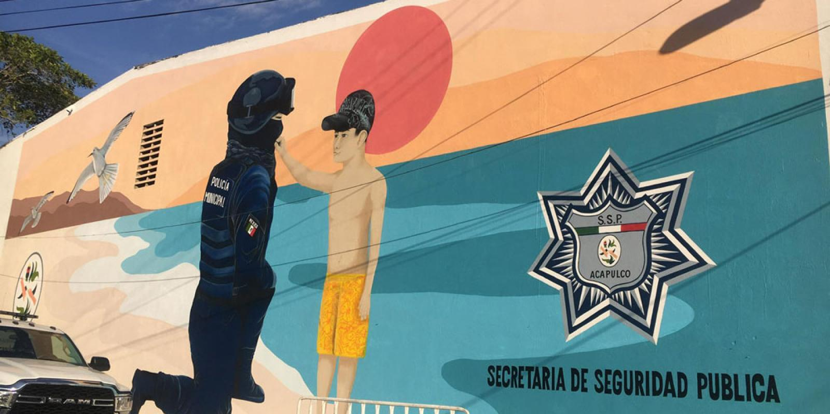
Figure 55. Mural Across the Street from Secretariat of Public Security
Location: Acapulco, Mexico
Date: 2020
Source: https://adncultura.org/murales-en-honor-de-la-ssp-de-acapulco

Return to Page 36
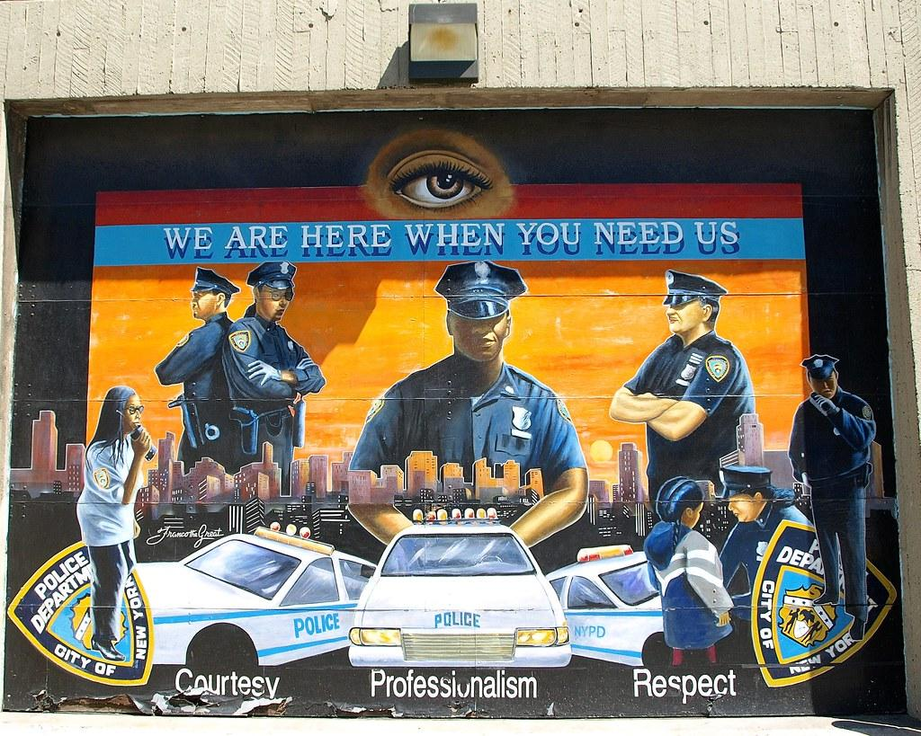
Figure 56. Big Brother is Watching on Police Department
Location: Manhattan, New York
Date: 2008
Artist: Franco Gaskin, "Franco the Great"
Source: https://www.flickr.com/photos/jag9889/2541856364

Return to Page 36

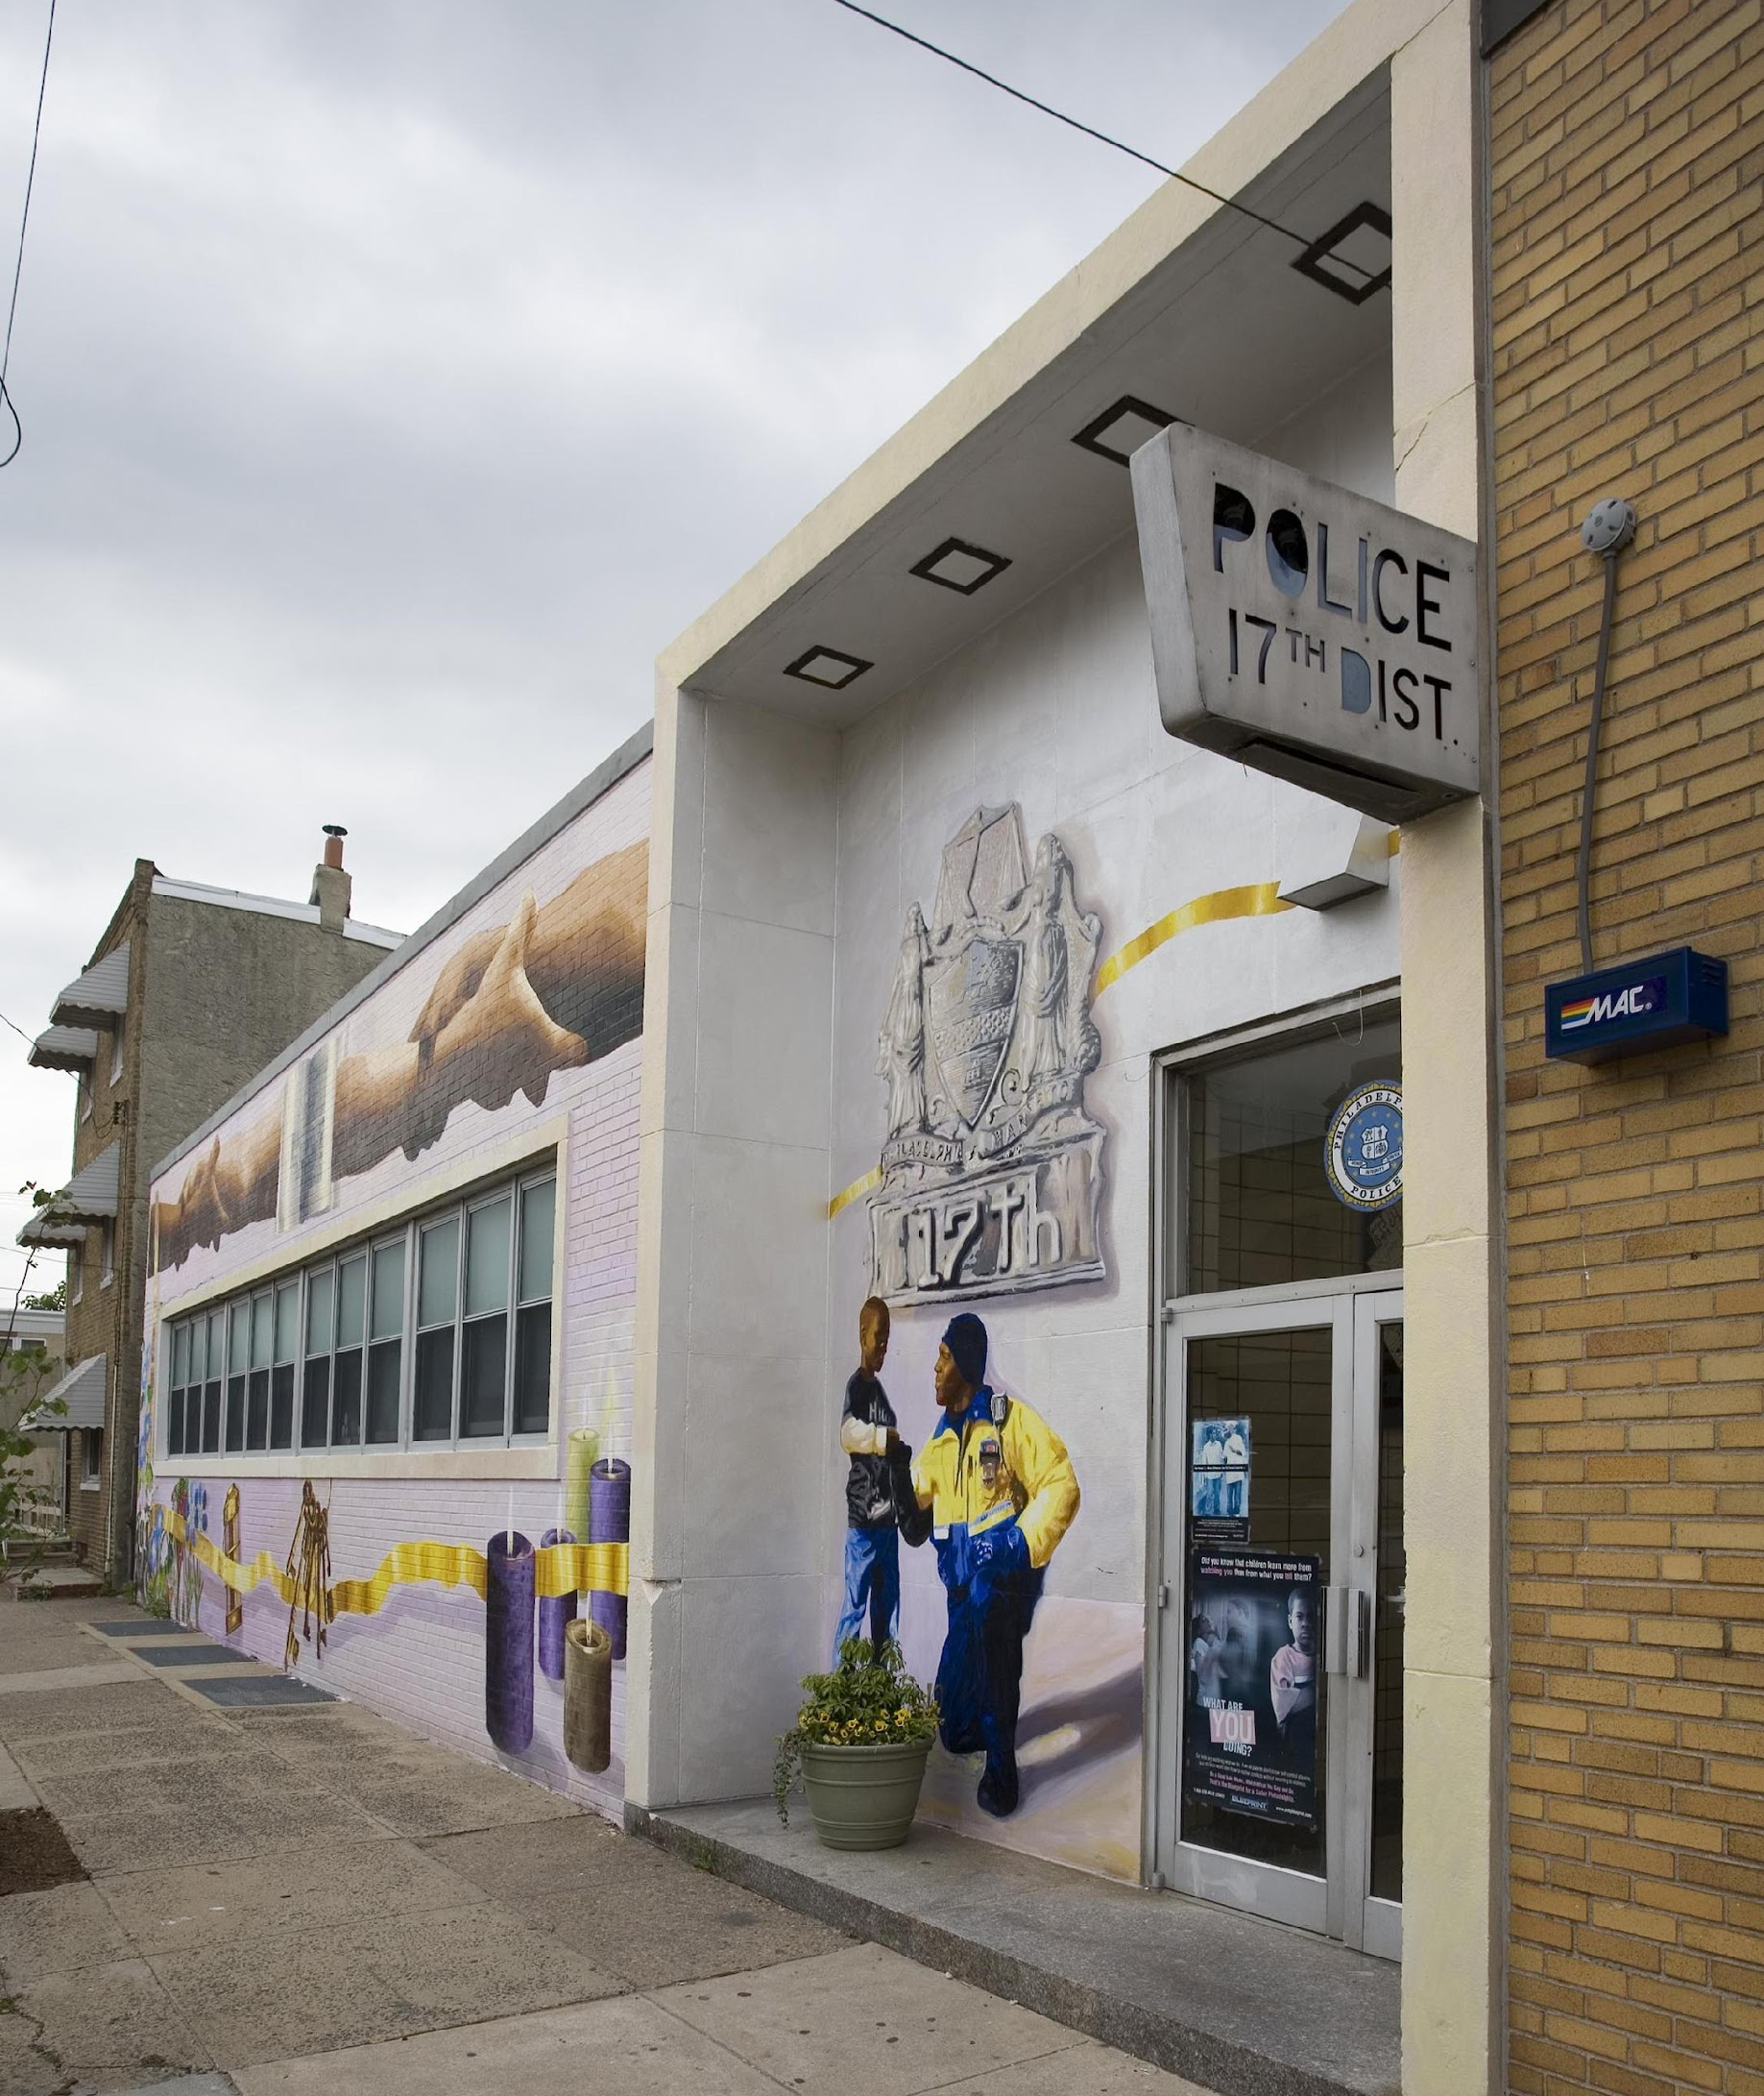
Figure 57. “The Breeze” on Philadelphia Police 17th District
Location: Philadelphia, Pennsylvania, USA
Date: 2007
Artist: César Viveros Herrera
Source: https://publicartarchive.org/art/The-Breeze/a10eec38

Return to Page 36
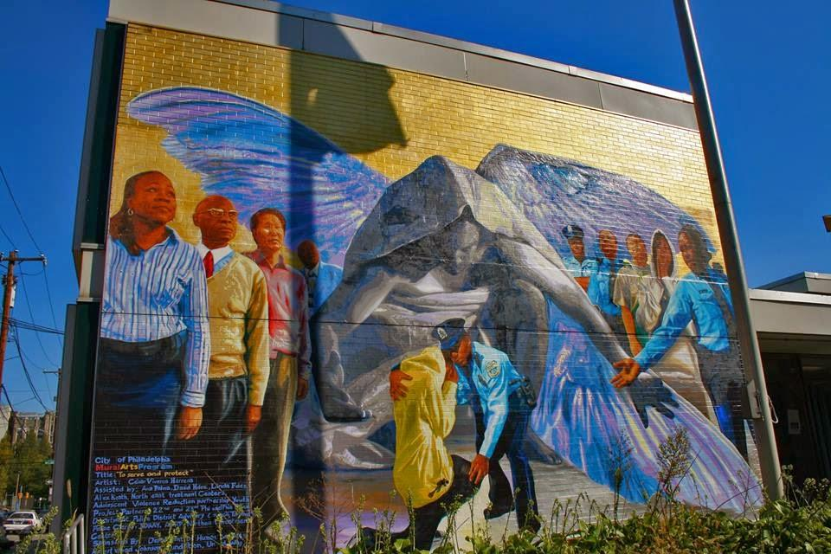
Figure 58. To Serve and Protect Mural at 22nd Police District Headquarters
Location: Philadelphia, Pennsylvania, USA
Date: 2009
Artist: César Viveros Herrera
Source: https://www.yelp.com/biz/22nd-police-district-philadelphia

Return to Page 36

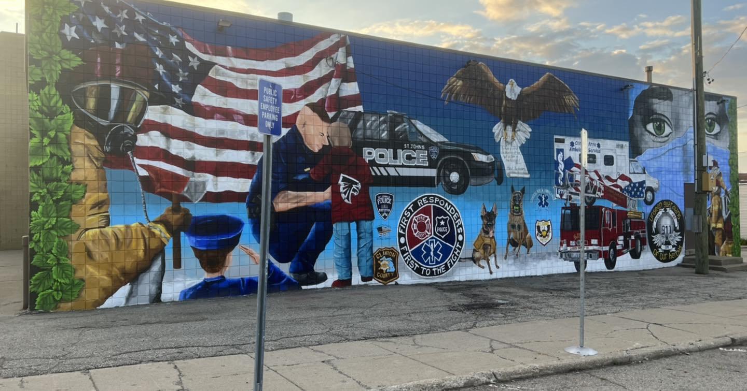
Figure 59. First Responders Mural painted on St. Johns Fire Station
Location: St. Johns, Florida, USA
Date: 2022
Artist: Tracie Davis
Photographer: Tracie Davis
Source: https://www.facebook.com/photo?fbid=509904024477115&set=pcb.509904224477095

Return to Page 36

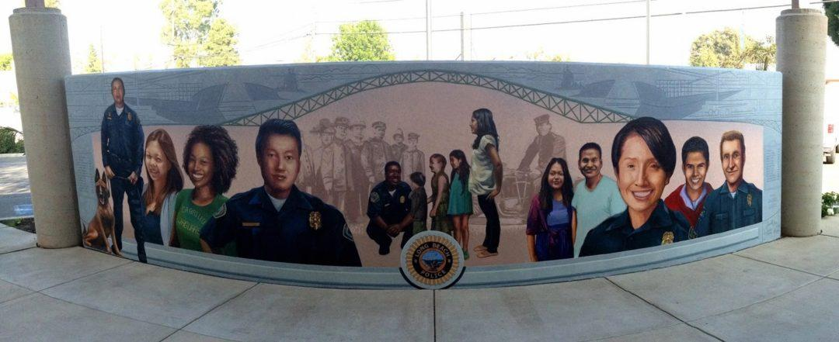
Figure 60. Westside Police Station Mural
Location: Long Beach, California, USA
Date: 2013
Artist: Jose M. Loza
Source: https://artslb.org/public-art/westside-police-station-mural/

Return to Page 36

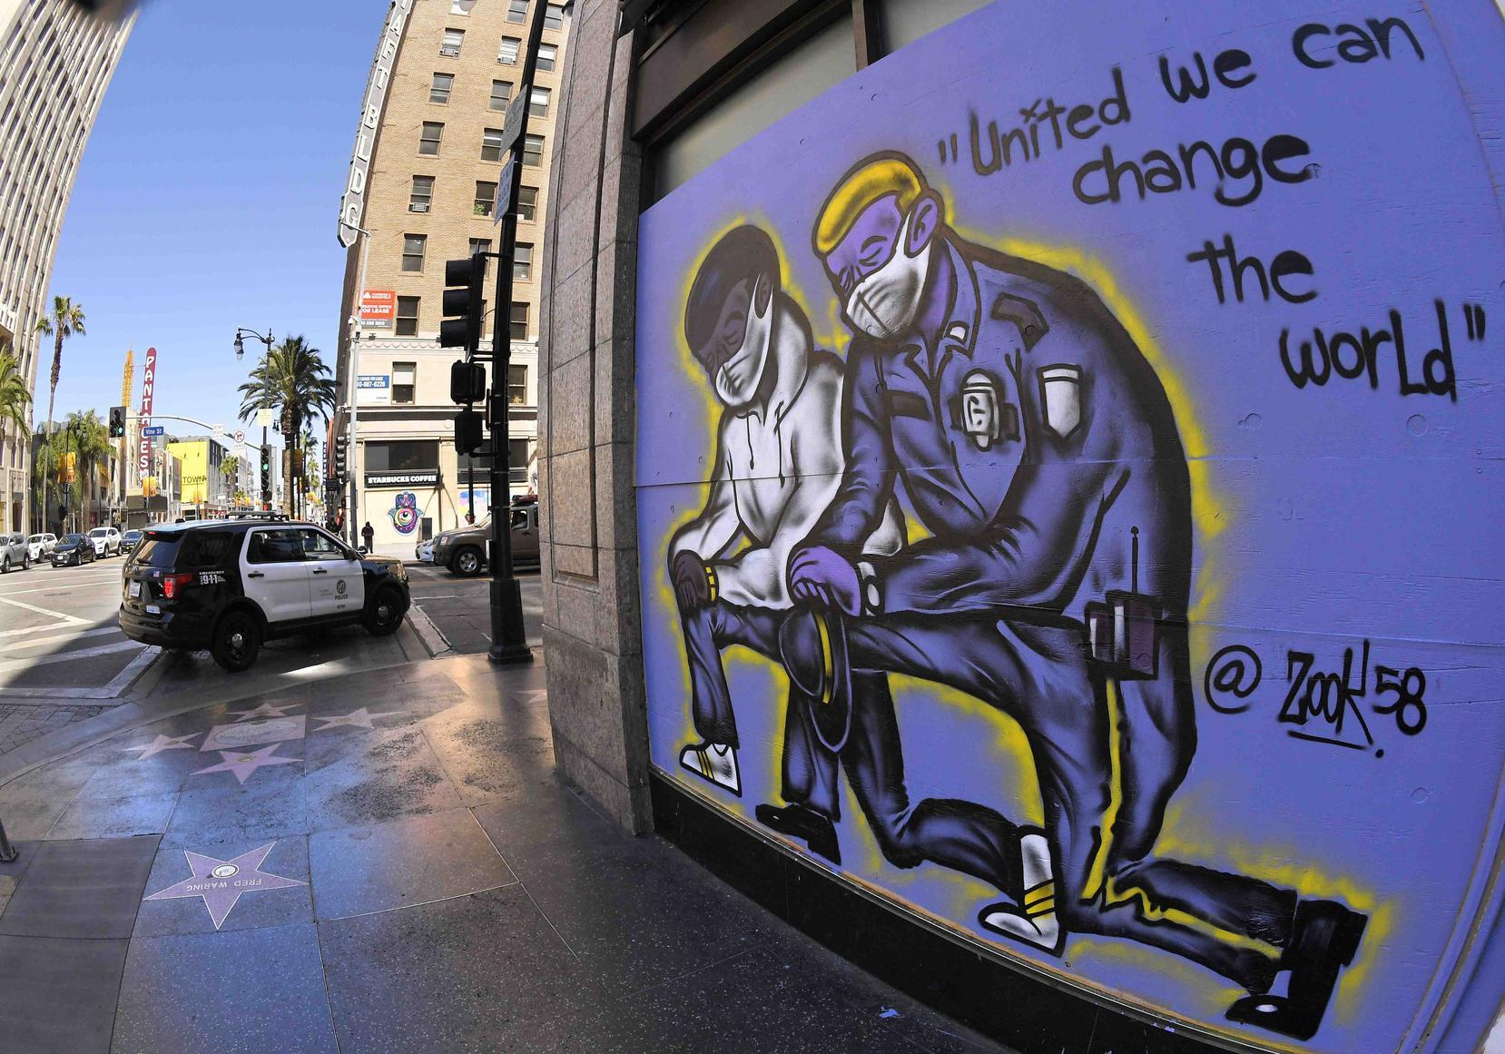
Figure 61. Mural on Boarded Business during Quarantine
Location: Los Angeles, California, USA
Date: 2020
Photographer: Mark J. Terrill
Source: https://www.wtnh.com/news/cops-on-air-for-33-seasons-dropped-by-paramount-network/

Return to Page 36

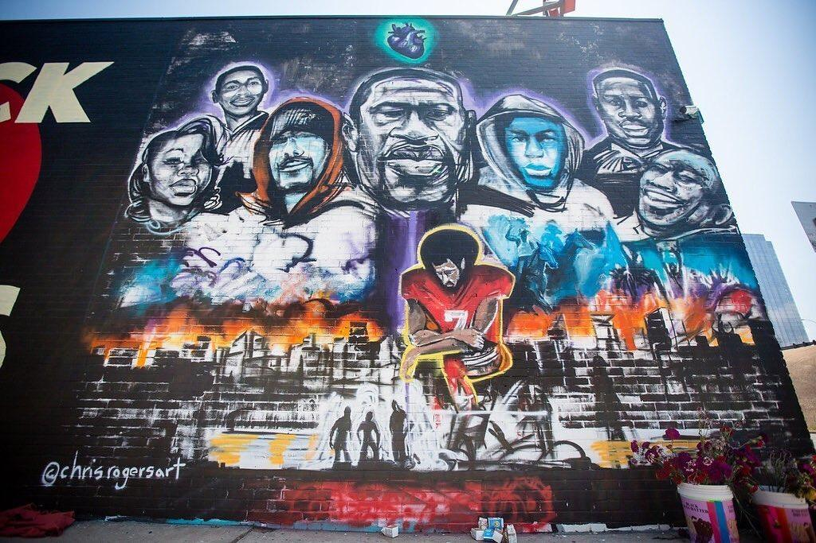
Figure 62. George Floyd Memorial Mural on Bar
Location: Austin, Texas, USA
Date: 2020
Artist: Chris Rogers
Photographer: Michael Minasi
Source: https://www.kut.org/crime-justice/2021-05-25/what-george-floyds-death-has-done-for-americans-ability-to-feel-empathy

Return to Page 36
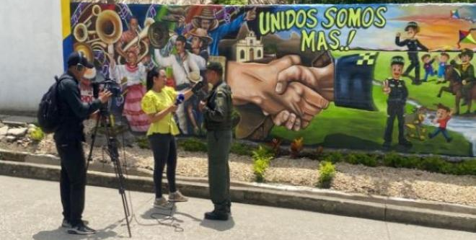
Figure 63. “Unidos Somos Mas!” (United We Are More!) I on Sincelejo Police Station
Location: Sincelejo, Colombia
Date: 2023
Artist: Deputy Superintendent Alexis Idarraga Montes
Source: https://www.policia.gov.co/noticia/mural-unidos-somos-mas-policia-sucre-sella-pacto-reconciliacion-corregimiento-chocho

Return to Page 37

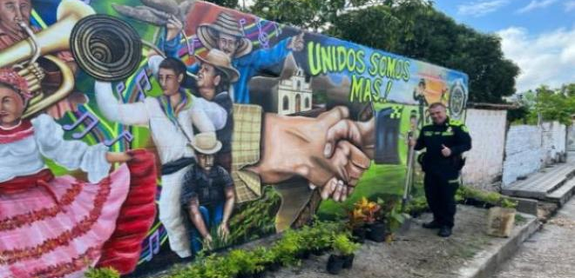
Figure 64.“Unidos Somos Mas!” (United We Are More!) II on Sincelejo Police Station
Location: Sincelejo, Colombia
Date: 2023
Artist: Deputy Superintendent Alexis Idarraga Montes
Source: https://www.policia.gov.co/noticia/mural-unidos-somos-mas-policia-sucre-sella-pacto-reconciliacion-corregimiento-chocho

Return to Page 37

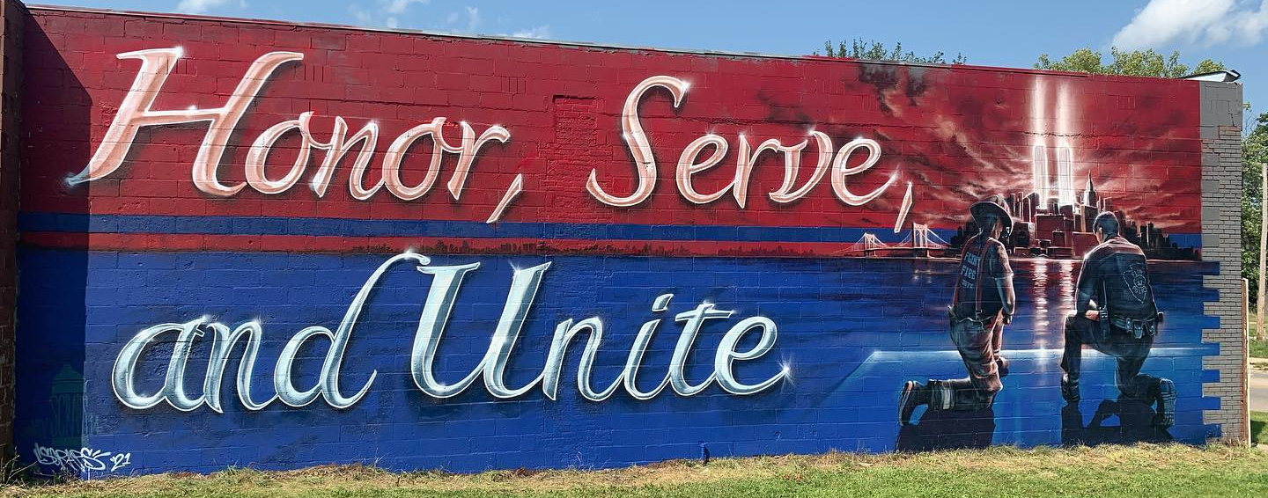
Figure 65. Honor, Serve, and Unite 9/11 Mural
Location: Flint, Michigan, USA
Date: 2021
Artist: Kevin Burdick
Source: https://www.instagram.com/p/CT0ONxILW2f/

Return to Page 37

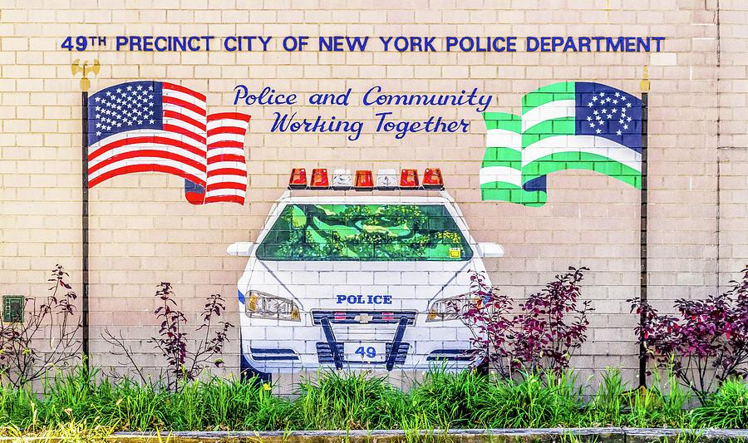
Figure 66. Police and Community Mural at 49th Precinct
Location: New York City, New York, USA
Date: 2017
Photographer: Ivan Santiago
Source: https://fineartamerica.com/featured/49th-precinct-bronx-nyc-ivan-santiago.html

Return to Page 37
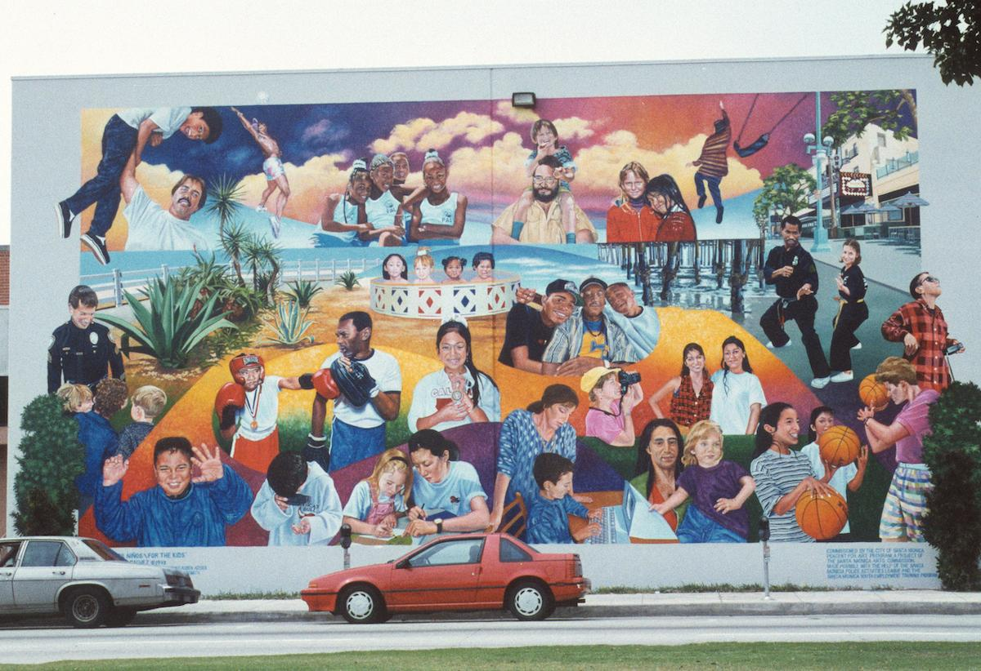
Figure 67. Para Los Niños on Santa Monica Police Activities League
Location: Santa Monica, California, USA
Date: 1993-2005
Artist: Daniel Galvez
Source: https://publicartarchive.org/search/art/73047c22

Return to Page 37

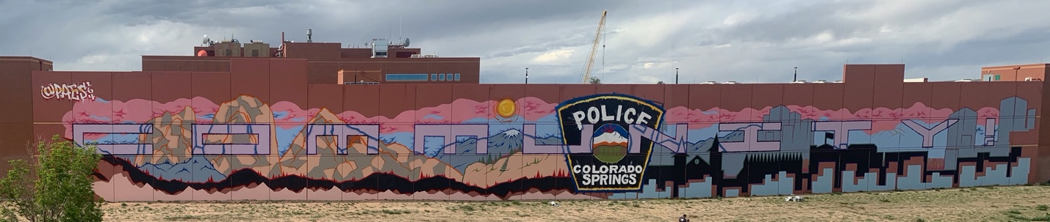
Figure 68. “Community” on Police Department Parking Garage
Location: Colorado Springs
Date: 2022
Artist: Paes 164
Source: https://www.facebook.com/photo/?fbid=383129553840377&set=pcb.383132200506779

Return to Page 37
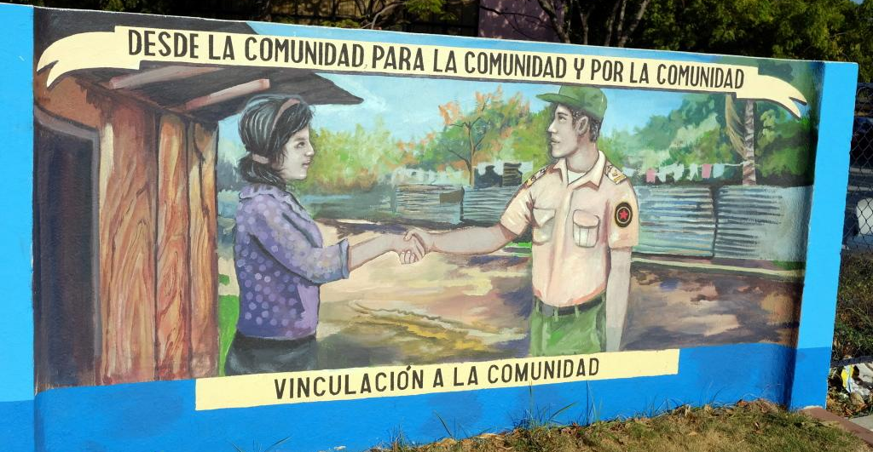
Figure 69. Desde La Comunidad Para La Comunidad Y Por La Comunidad/ Vinculación A La Comunidad Around Police Station
Location: Managua, Nicaragua
Date: 2016-2017
Photographer: Alexey Beshenov
Source: https://cadadr.org/centroamerica/mural/

Return to Page 38

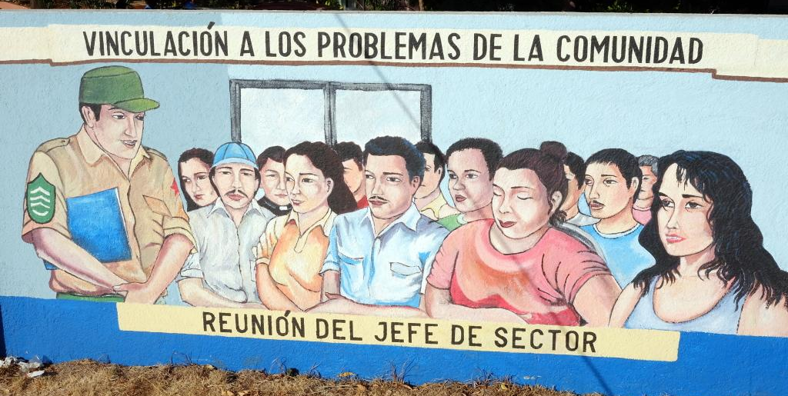
Figure 70. Vinculación A Los Problemas De La Comunidad/Reunión Del Jefe De Sector Around Police Station
Location: Managua, Nicaragua
Date: 2016-2017
Photographer: Alexey Beshenov
Source: https://cadadr.org/centroamerica/mural/

Return to Page 38
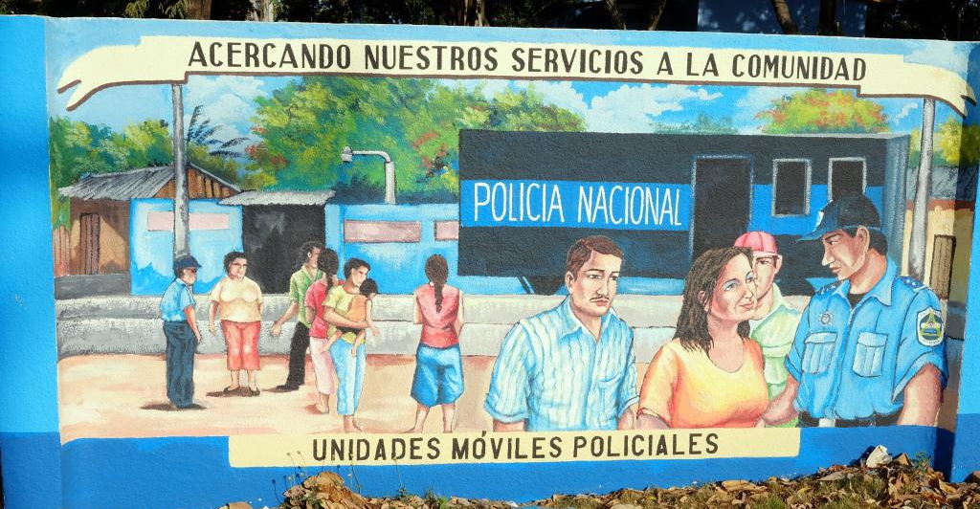
Figure 71. Acercando Nuestros Servicios A La Comunidad/Unidades Móviles Policiales Around Police Station
Location: Managua, Nicaragua
Date: 2016-2017
Photographer: Alexey Beshenov
Source: https://cadadr.org/centroamerica/mural/

Return to Page 38

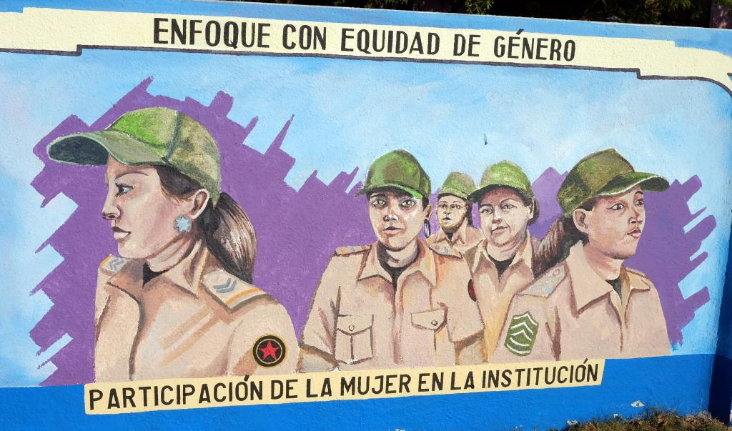
Figure 72. Enfoque Con Equidad De Género/Partipación De La Mujer En La Institcución Around Police Station
Location: Managua, Nicaragua
Date: 2016-2017
Photographer: Alexey Beshenov
Source: https://cadadr.org/centroamerica/mural/

Return to Page 38
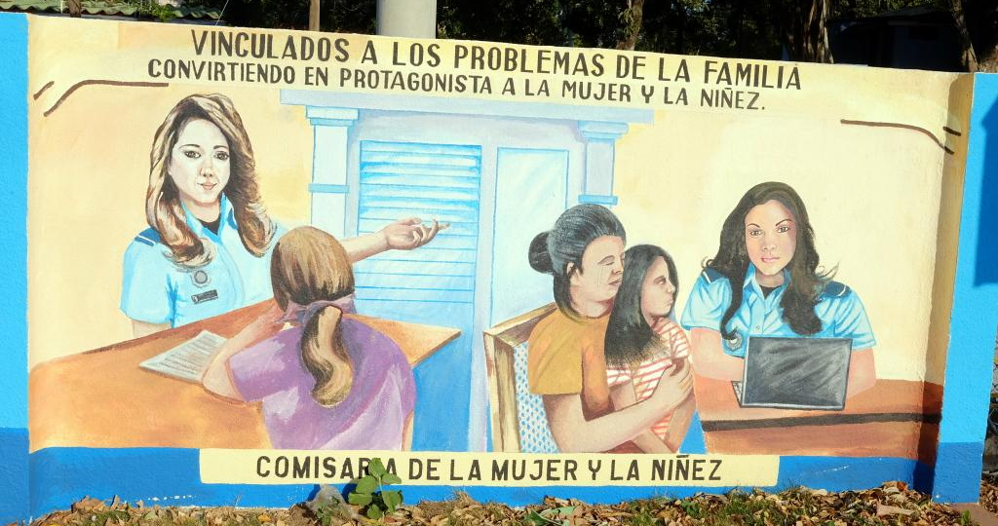
Figure 73. Vinculados A Los Problemas De La Familia/Convirtiendo En Protagonista A La Mujer Y La Niñez./Comisara De La Mujer Y La Niñez Around Police Station
Location: Managua, Nicaragua
Date: 2016-2017
Photographer: Alexey Beshenov
Source: https://cadadr.org/centroamerica/mural/

Return to Page 38

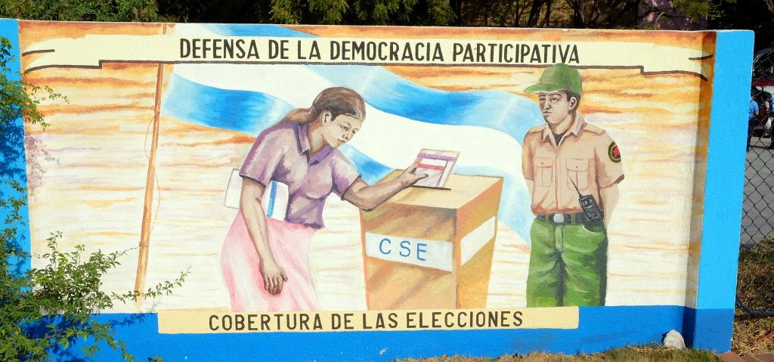
Figure 74. Defensa De La Democracia Participativa/Cobertura De Las Elecciones Around Police Station
Location: Managua, Nicaragua
Date: 2016-2017
Photographer: Alexey Beshenov
Source: https://cadadr.org/centroamerica/mural/

Return to Page 38
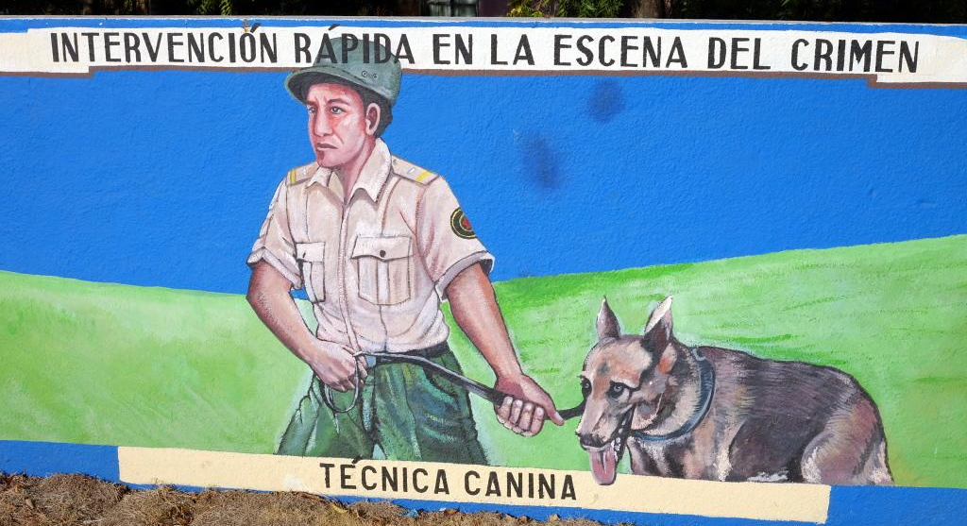
Figure 75. Intvervención Rápida En La Escena Del Crimen/ Técnica Canina Around Police Station
Location: Managua, Nicaragua
Date: 2016-2017
Photographer: Alexey Beshenov
Source: https://cadadr.org/centroamerica/mural/

Return to Pag 39

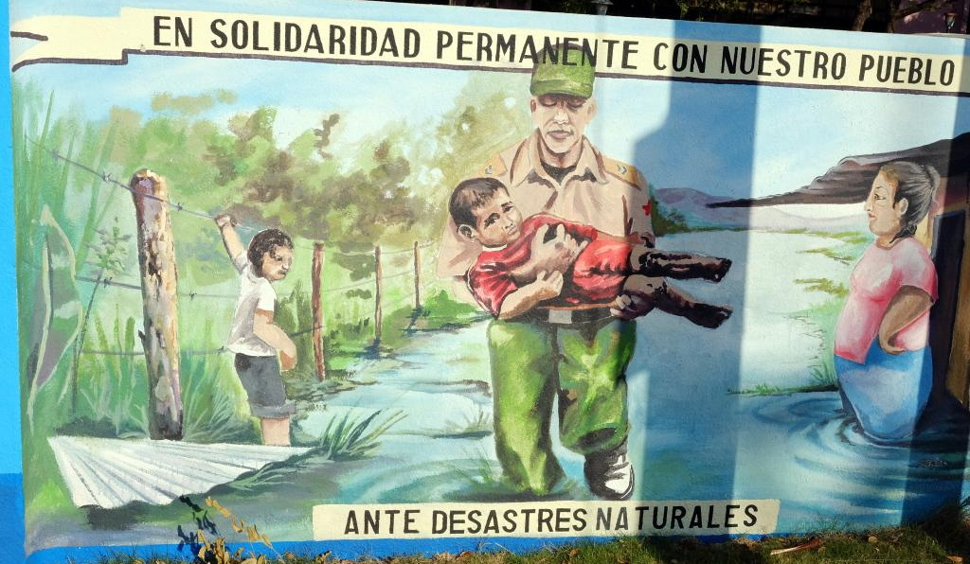
Figure 76. En Solidaridad Permanente Con Nuestro Pueblo/ Ante Desastres Naturales Around Police Station
Location: Managua, Nicaragua
Date: 2016-2017
Photographer: Alexey Beshenov
Source: https://cadadr.org/centroamerica/mural/

Return to Page 39

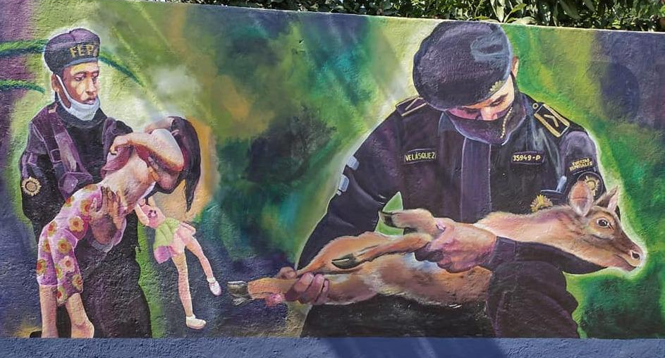
Figure 77. Commemorative Mural after Volcano in 2018 I Painted on Perimeter Wall of Suchitepéquez Police Station 33
Location: Mazatenango, Guatemala
Date: 2022
Source: https://twitter.com/PNCdeGuatemala/status/1533495194729041922

Return to Page 39

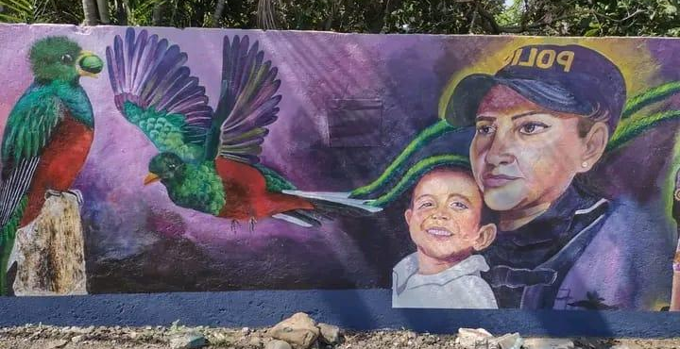
Figure 78. Commemorative Mural after Volcano in 2018 II Painted on Perimeter Wall of Suchitepéquez Police Station 33
Location: Mazatenango, Guatemala
Date: 2022
Source: https://twitter.com/PNCdeGuatemala/status/1533495194729041922

Return to Page 39
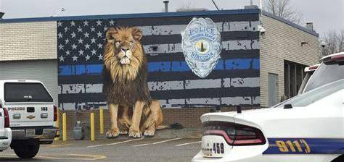
Figure 79. Thin Blue Line Mural painted on Police Department
Location: Virginia Beach, Virginia
Date: 2020
Artists: Todd and Eric Lindbergh
Source: https://www.police1.com/police-heroes/articles/va-police-unveil-new-mural-honoring-leos-tjO3IRFEF5c1umsC/

Return to Page 39

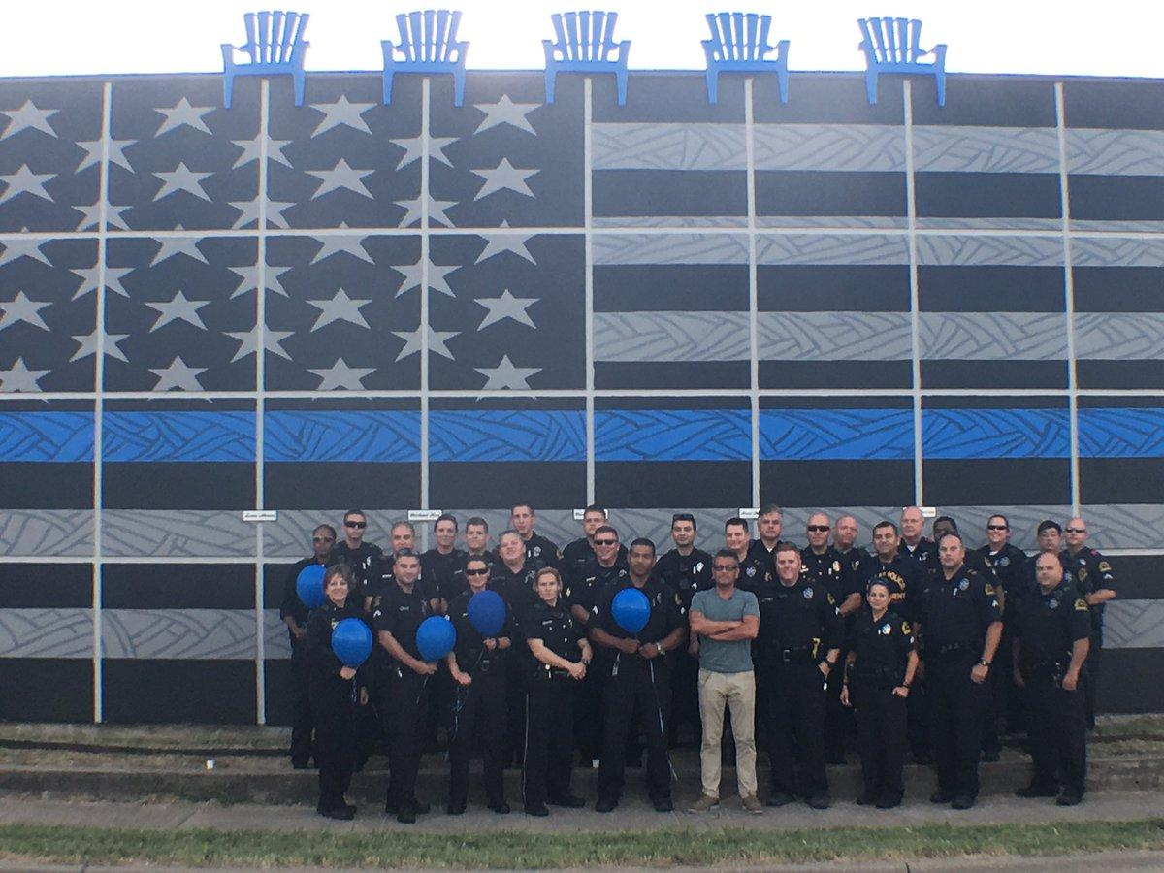
Figure 80. Thin Blue Line Memorial Mural for Five Police Officers Killed
Location: Dallas, Texas
Date: 2016
Source: https://www.klif.com/2016/08/01/newly-unveiled-mural-honors-slain-dallas-police-officers/

Return to Page 40
Return to Page 47
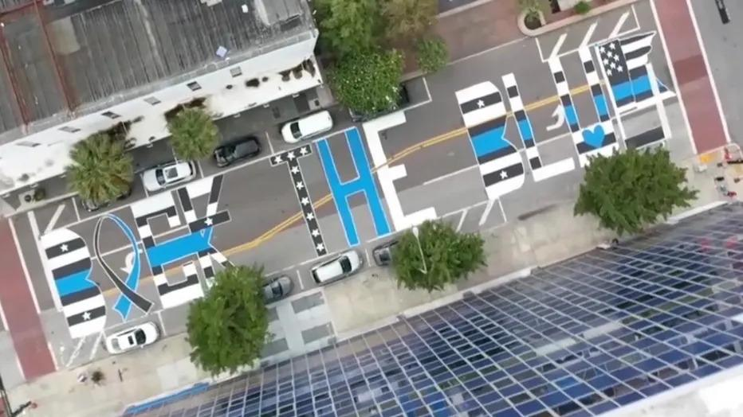
Figure 81. Back the Blue Mural Painted on Street Outside Police Headquarters
Location: Tampa, Florida
Date: 2020
Artists: Back the Blue Florida and Community Patriots of Tampa
Source: https://www.fox4news.com/news/back-the-blue-mural-painted-outside-tampa-police-headquarters

Return to Page 40

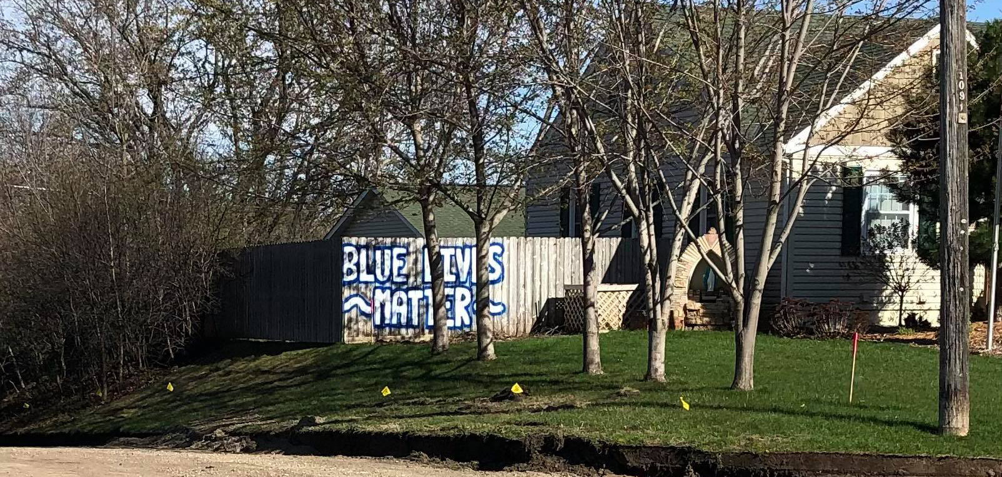
Figure 82. Blue Lives Matter on the Former Mayor’s Fence
Location: West St. Paul, MN, USA
Date: 2021
Source: https://weststpaulreader.com/2021/04/16/former-mayor-blue-lives-matter-west-st-paul/

Return to Page 40
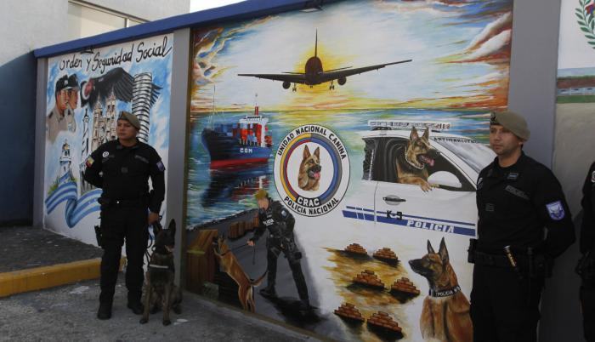
Figure 83. Orden y Seguridad Social Drug Dog Mural on Police Canine Training Center in Police Heroes Plaza
Location: Guayaquil, Ecuador
Date: 2022
Artist: Sergeant Édgar Almachi Velasco
Source: https://imghandler.expreso.ec/guayaquil/concurso-revela-dotes-artisticos-policia-142567.html

Return to Page 41

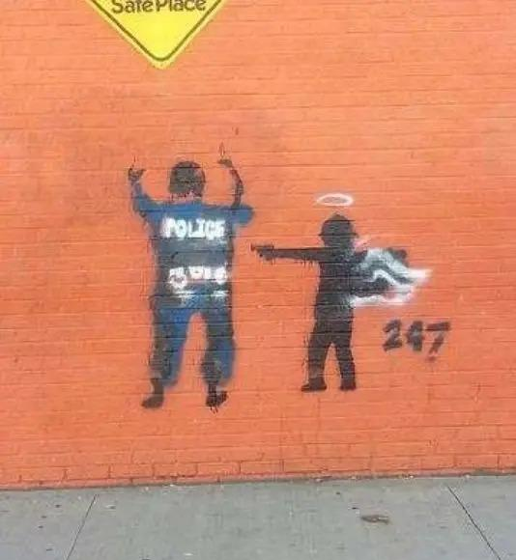
Figure 84. Angel Shoots Cop Tag on Youth Center
Location: Detroit, Michigan
Date: 2015
Source: https://patch.com/michigan/wyandotte/safe-place-tagged-graffiti-depicting-angel-pointing-gun-cop-0

Return to Page 41

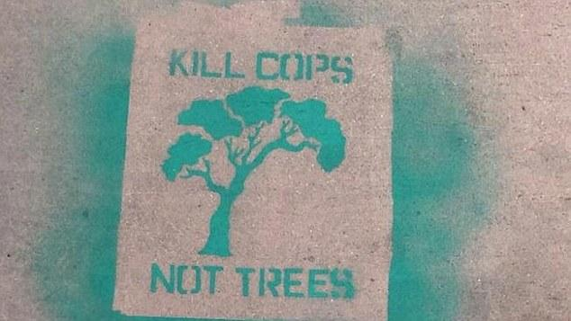
Figure 85. Kill Cops Not Trees Stencil
Location: Los Angeles, California
Date: 2016
Source: https://www.dailymail.co.uk/news/article-3705923/Kill-Cops-Hateful-anti-police-graffiti-scrawled-near-busy-Los-Angeles-freeway.html

Return to Page 41

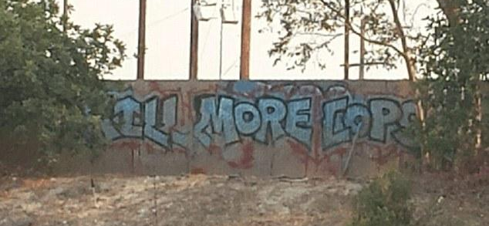
Figure 86. Kill More Cops Tag
Location: Los Angeles, California
Date: 2016
Source: https://www.dailymail.co.uk/news/article-3705923/Kill-Cops-Hateful-anti-police-graffiti-scrawled-near-busy-Los-Angeles-freeway.html

Return to Page 41

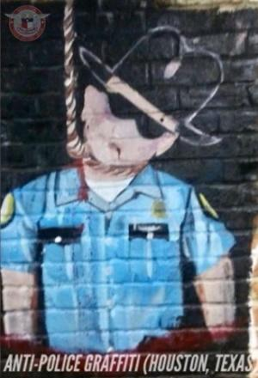
Figure 87. Anti-Police Graffiti on Tattoo Parlor
Location: Houston, Texas
Date: 2020
Source: https://blazingcatfur.ca/2020/06/06/mural-of-cop-hanging-from-noose-found-in-houston/

Return to Page 41

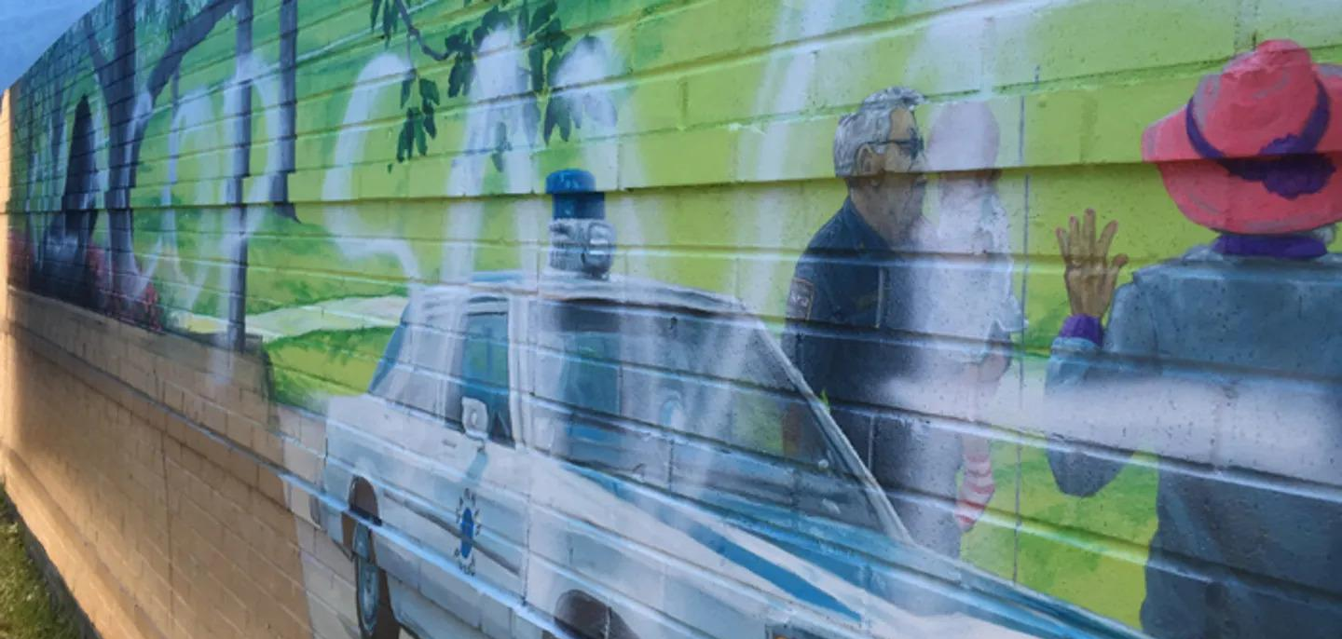
Figure 88. Kill a Cop Save a Child Tag on Police Department Mural
Location: Garner, North Carolina
Date: 2016
Source: https://www.foxnews.com/us/kill-a-cop-save-a-child-vandalism-a-hate-crime-north-carolina-police-chief-says

Return to Page 41
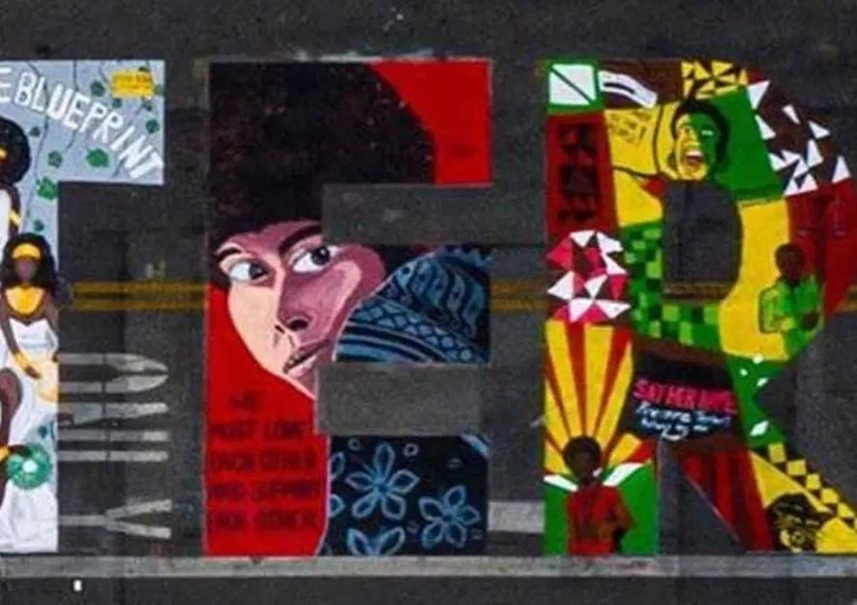
Figure 89. Assata Shakur in the “E” of Black Lives Matter Mural I
Location: Palo Alto, California
Source: 2020
Source: https://face2faceafrica.com/article/five-cops-sue-california-city-over-blm-mural-featuring-fbis-most-wanted-assata-shakur

Return to Page 42

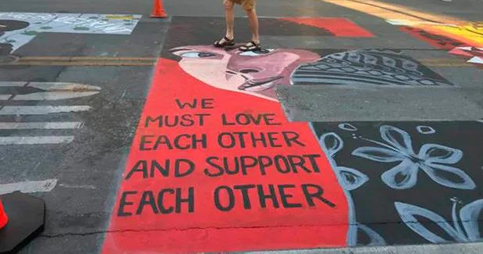
Figure 90. Assata Shakur in the “E” of Black Lives Matter Mural II
Location: Palo Alto, California
Date: 2020
Photographer: Dave Price
Source: https://ktla.com/news/california/officers-sue-city-of-palo-alto-over-black-lives-matter-mural/

Return to Page 42

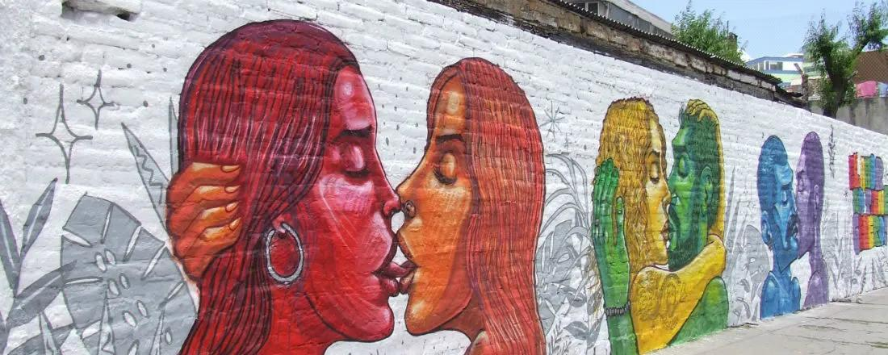
Figure 91. EL AMOR NO TIENE GENERO
Location: Quito, Ecuador
Date: 2019
Artist: Apitatán
Source: https://www.sinembargo.mx/07-09-2019/3641832

Return to Page 42

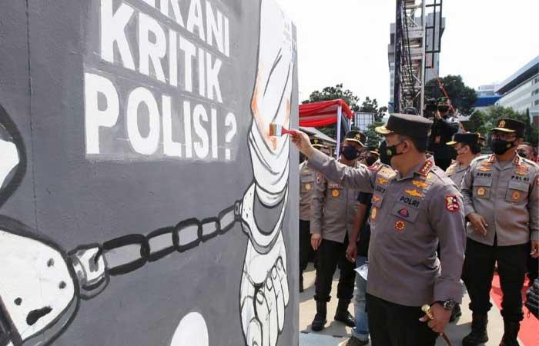
Figure 92. National Police Chief Helps Paint Who Dares Critique Police? I Mural at Bhayangkara Mural Festival for Freedom of Expression
Location: National Police Headquarters Complex in Jakarta, Indonesia
Date: 2021
Source: https://tribratanews.ponorogo.jatim.polri.go.id/30/10/2021/buka-festival-mural-bhayangkara-kapolri-bukti-polri-menghormati-kebebasan-berekspresi-2/

Return to Page 43

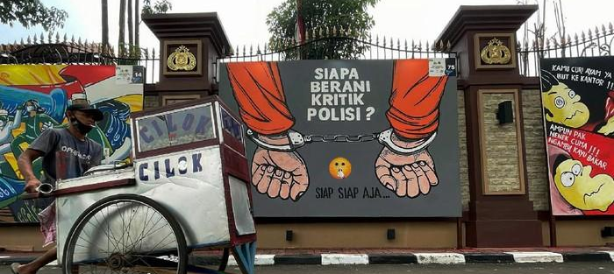
Figure 93. National Police Chief Helps Paint Who Dares Critique Police? II Mural at Bhayangkara Mural Festival for Freedom of Expression
Location: National Police Headquarters Complex in Jakarta, Indonesia
Date: 2021
Source: https://news.detik.com/foto-news/d-2463251/keindahan-bawah-laut-indonesia-dipamerkan/1

Return to Page 43

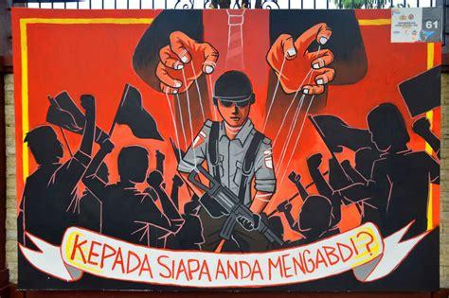
Figure 94. National Police Chief Helps Paint Who Dares Critique Police? III Mural at Bhayangkara Mural Festival for Freedom of Expression
Location: National Police Headquarters Complex in Jakarta, Indonesia
Date: 2021
Source: https://inilahkendari.com/foto-mural-kritik-polisi-mejeng-di-kompleks-mabes-polri/

Return to Page 43
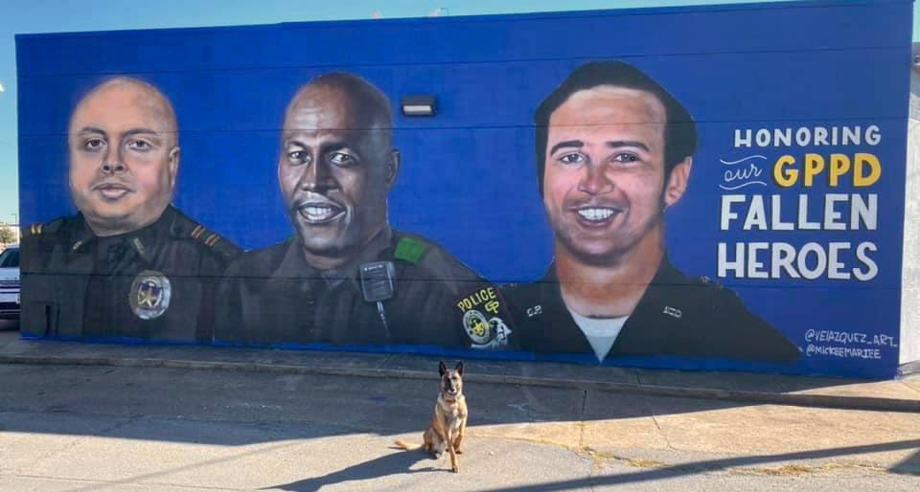
Figure 95. Fallen Heroes Memorial Mural Sponsored by Police
Location: Grand Prairie, Texas
Date: 2020
Artists: Juan Velazquez and Mickee Mariee
Source: https://twitter.com/GrandPrairiePD/status/1329180094250758144

Return to Page 43

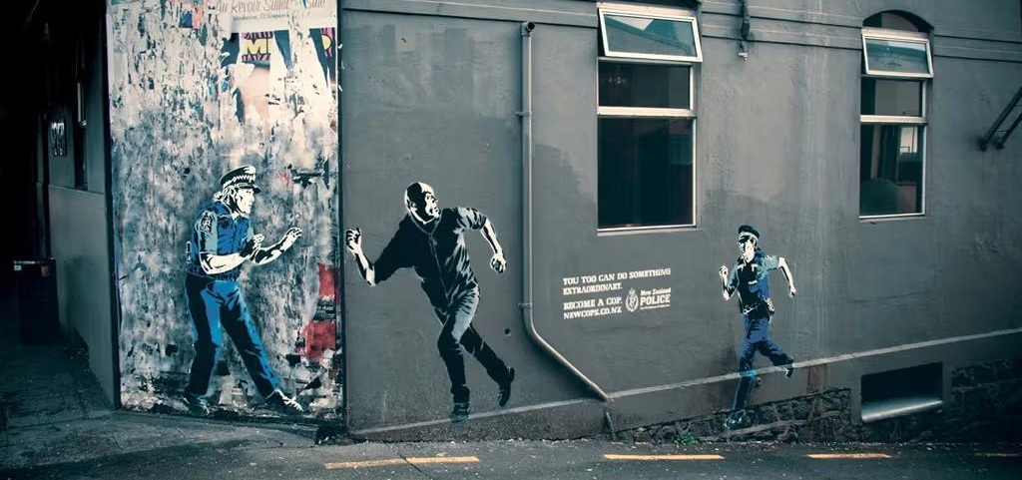
Figure 96. You Too Can Do Something Extraordinary Police Recruitment Mural
Location: Wellington, New Zealand
Date: 2011
Artist: Otis Frizzell
Source: https://hypebeast.com/2011/8/kiwi-police-do-banksy-style-recruitment-street-ads

Return to Page 44
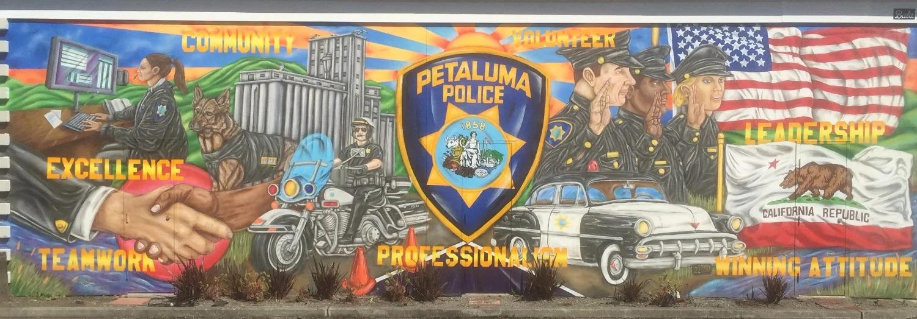
Figure 97. Petaluma Police Mural on Police Department
Location: Petaluma, California
Date: 2017
Artist: Bala Creative
Source: https://www.maxfieldbala.com/ppdmural

Return to Page 44

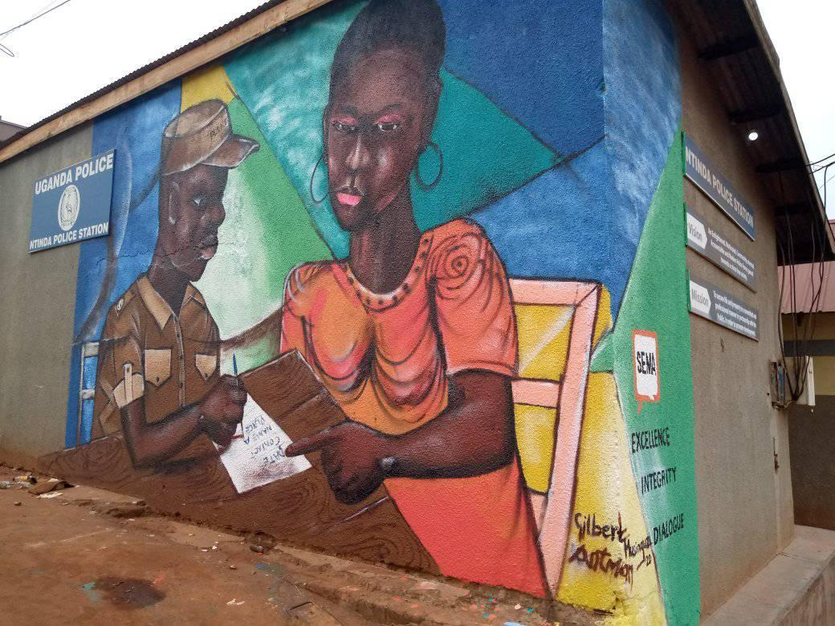
Figure 98. SEMA Mural on Ntinda Police Station
Location: Kamala, Uganda
Date: 2020
Artist: Musinguzi
Source: https://www.facebook.com/talktosema/posts/500489717282169/?paipv=0&eav=AfaLaPLbH-zcJsgYqMLZSLKxfKv925udbpwpO_2nv5-nCZT66dprrNZV8bBL_1STW9M&_rdr

Return to Page 44
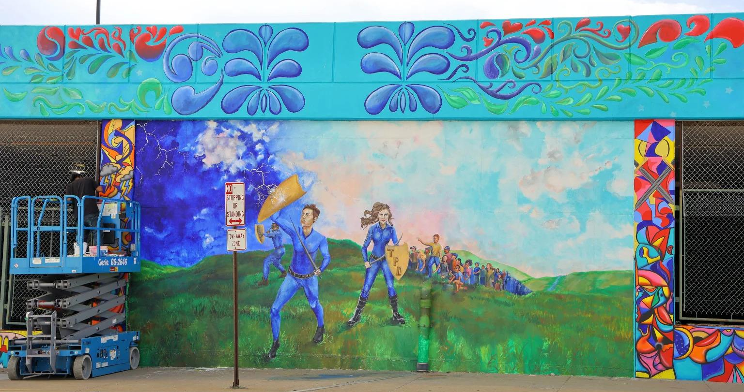
Figure 99. Superheroes on Police Department
Location: Topeka, Kansas
Date: 2019
Photographer: Nexstar Media Inc.
Source: https://www.ksnt.com/news/spotted/topeka-police-department-mural-nears-finish/

Return to Page 44

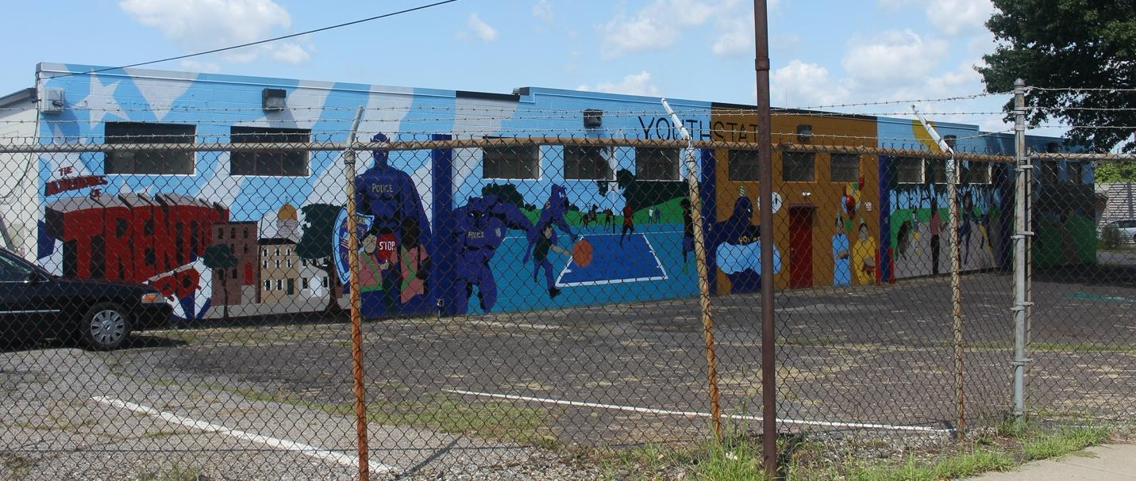
Figure 100. The Adventures of Trenton P.D. Mural on Police Department
Location: Trenton, New Jersey
Date: 2018
Artist: Kwenci Jones and YouthStat Program
Source: https://publicartarchive.org/art/Police-Mural/cca4ef56

Return to Page 44

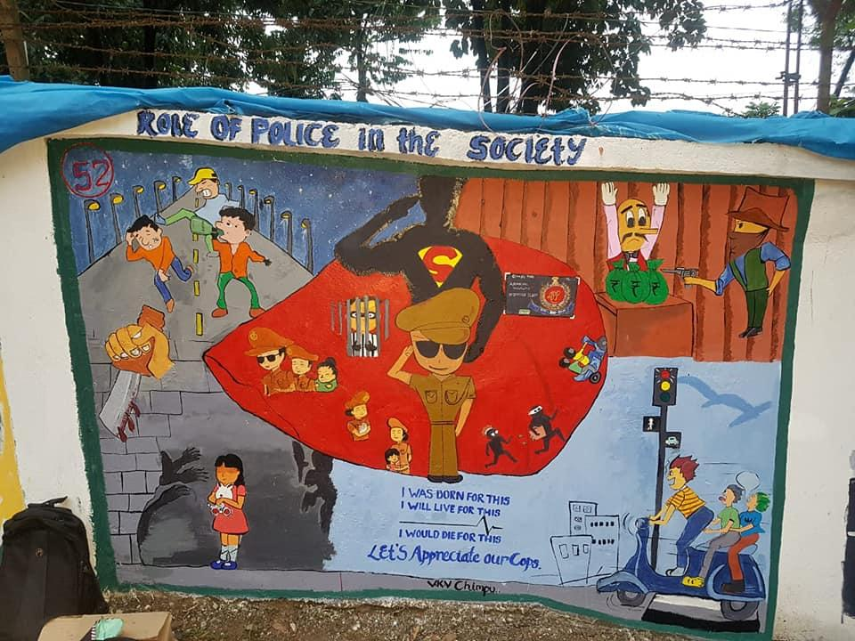
Figure 101. Let’s Appreciate Our Cops, Role of Police in Society
Location: Police Colony School in Arunachal, Pradesh, India
Date: 2018
Artists: Police Colony School students
Source: https://www.facebook.com/APPWelfareSociety/posts/1st-ever-mural-painting-competition-held-on-5th-6th-november-2018/330324334421612/

Return to Page 45
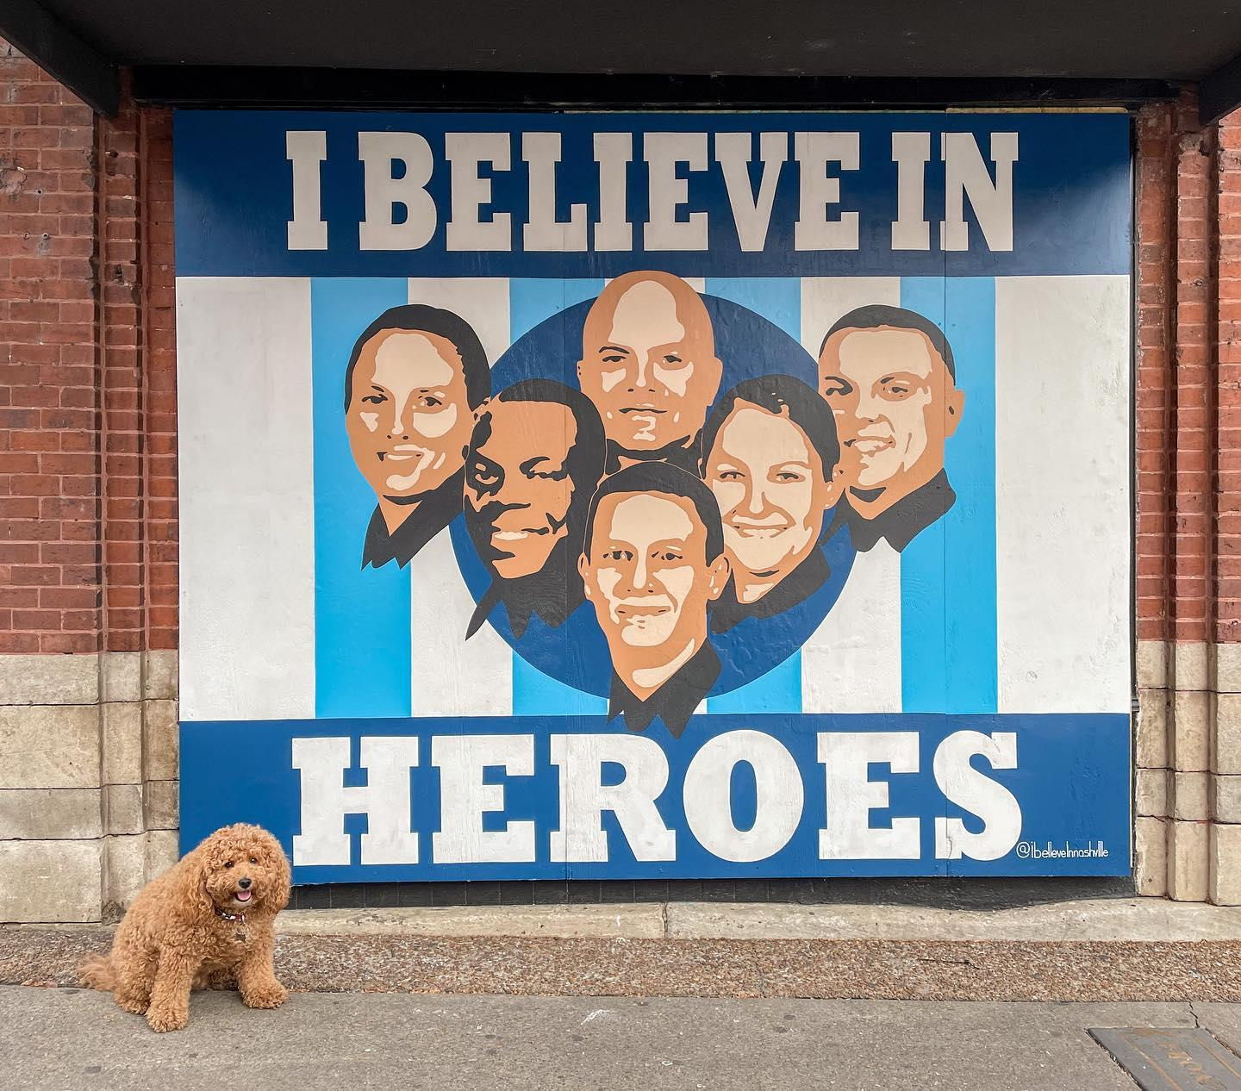
Figure 102. I Believe in Heroes Mural Honoring Police Response to Bombing
Location: Nashville, Tennessee
Date: 2021
Photographer: @charlie_the_minigoldendoodle
Source: https://www.instagram.com/p/CJpg9kiBV7E/

Return to Page 45

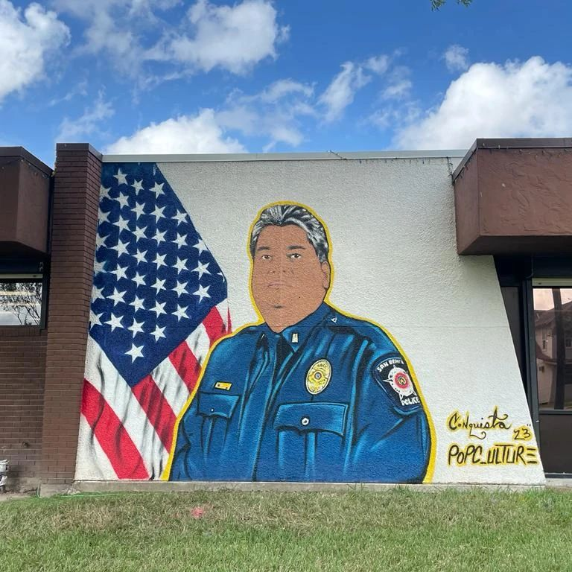
Figure 103. Lieutenant Milton Resendez Memorial Mural At Public Library
Location: San Benito, Texas
Date: 2023
Artist: Alex Andro
Source: https://www.instagram.com/p/Cy4eUVgu0PE/

Return to Page 46
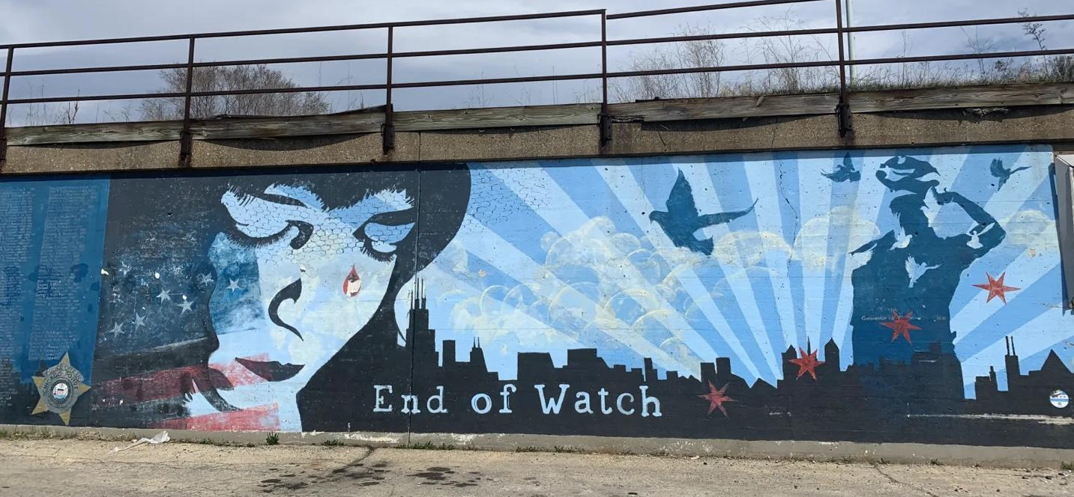
Figure 104. End of Watch First-Responders Tribute on Vacant Storefront
Location: Chicago, Illinois
Date: 2012
Artists: ArtsAlive45
Source: https://www.dnainfo.com/chicago/20121024/jefferson-park/mural-jefferson-park-honors-slain-chicago-police-officers/

Return to Page 46

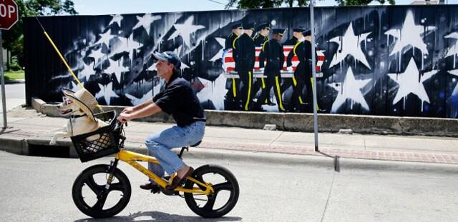
Figure 105. Memorial Mural of Five Police Officers at Last Call Lounge
Location: Dallas, Texas
Date: 2017
Photographer: Tony Gutierrez
Source: https://www.dallasnews.com/news/2017/07/16/fence-with-mural-honoring-dallas-ambush-victims-violates-city-code-officials-say/

Return to Page 46

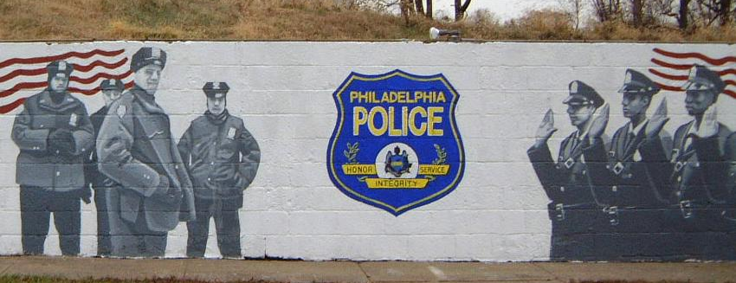
Figure 106. Tribute to Philadelphia Police Officers Along Gun Range at Police Academy
Location: Philadelphia, Pennsylvania
Date: 2004
Artist: Karl Yoder
Source: https://www.karlyoder.com/murals.php

Return to Page 46

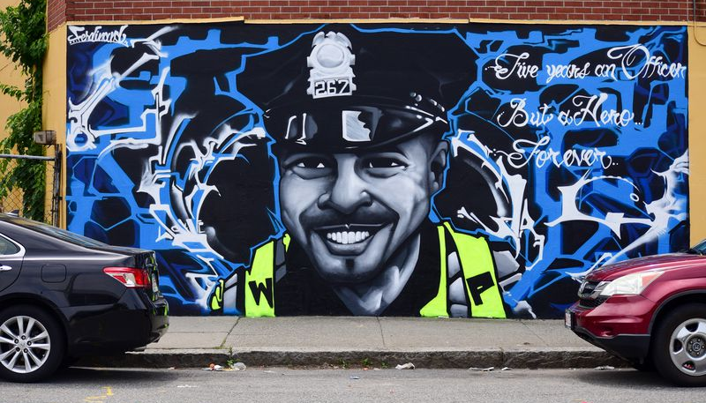
Figure 107. Five Years An Officer Memorial Mural of Officer Manny Familia
Location: Worcester, Massachusetts
Date: 2021
Artist: Ferdinand Nazario
Photographer: Tom Matthews
Source: https://www.masslive.com/worcester/2021/06/photos-and-video-mural-on-murray-avenue-honors-fallen-worcester-police-officer-manny-familia.html

Return to Page 46

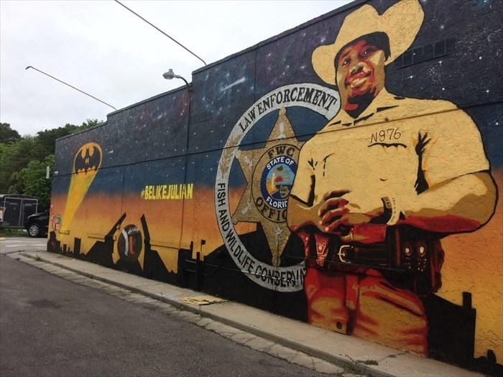
Figure 108. #BELIKEJULIAN Police Memorial Mural
Location: Fort Myers, Florida
Date: 2020
Artists: Cesar Aguilera and Brian Weaver
Source: https://www.waymarking.com/waymarks/wm14JBD_Julian_Keen_Mural_LaBelle_Florida_USA

Return to Page 46
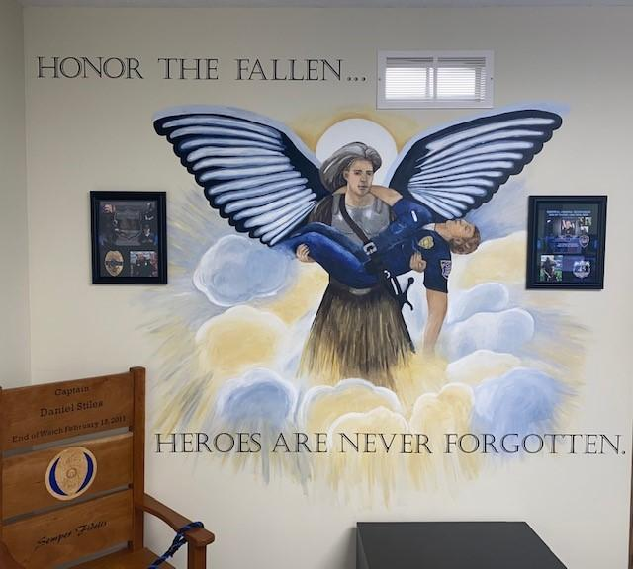
Figure 109. Heroes Are Never Forgotten at the Uniontown Police Department Headquarters
Location: Lake Township, Ohio
Date: 2020
Artists: Madison Osborne, Sophia Sommer, and Mary Beth Stauffer from Lake Center Christian School
Source: https://www.lccs.com/uniontown-police-department-art-mural/

Return to Page 46

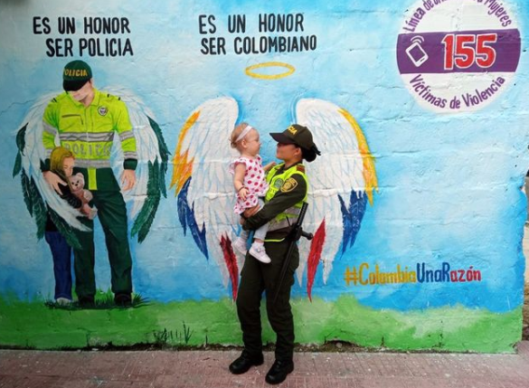
Figure 110. Es Un Honor Ser Policia Mural Sponsored by National Police
Location: Colombia
Date: 2021
Source: https://twitter.com/PoliciaColombia/status/1443531076563922954

Return to Page 47

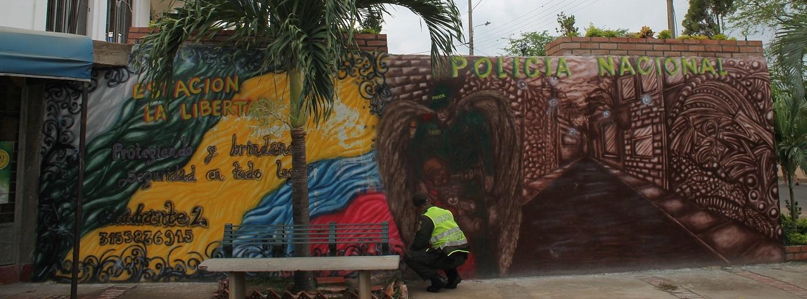
Figure 111. The Art of Taking Care of Yourself Mural Campaign, Santa Ana Neighborhood
Location: Cúcuta, Colombia
Date: 2013
Artists: Metropolitan Police of Cúcuta and community members
Source: https://www.areacucuta.com/once-murales-invitan-a-la-seguridad-y-rescate-de-los-valores-en-la-ciudadela-la-libertad-de-cucuta/

Return to Page 47
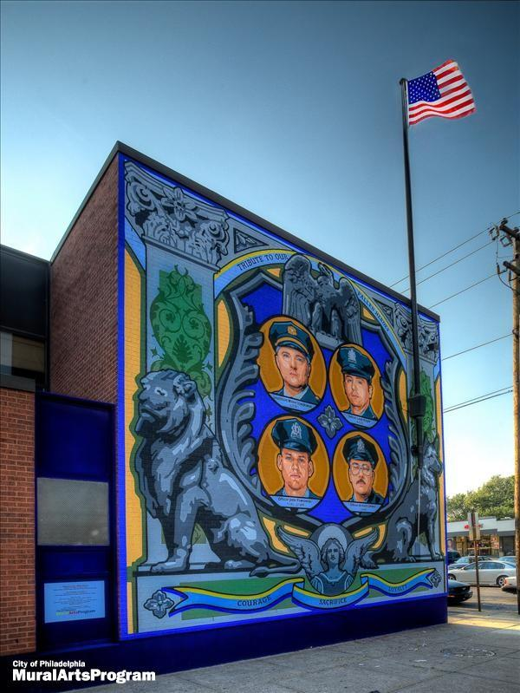
Figure 112. Tribute To Our Fallen Heroes: Courage, Sacrifice, Loyalty on 35th District Police Department
Location: Philadelphia, Pennsylvania
Date: 2009
Artists: David McShane and Desiree Bender
Location: https://scienceleadership.org/blog/th_police_district_mural & https://publicartarchive.org/art/Tribute-to-Our-Fallen-Heroes-Courage-Sacrifice-Loyalty/328b1ed6

Return to Page 47
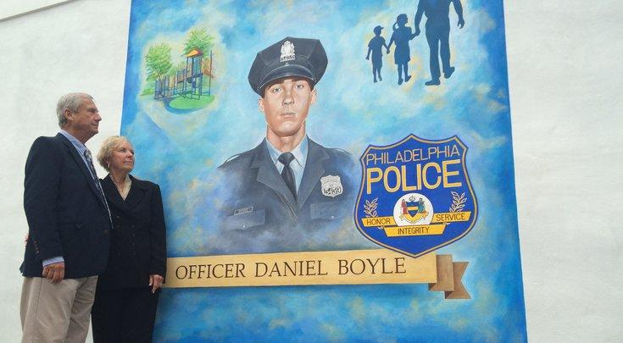
Figure 113. Officer’s Parents look at Memorial Mural of Son at Officer Daniel Boyle Memorial Recreation Center
Location: Philadelphia, Pennsylvania
Date: 2015
Artists: Greg Packer and Moira Regan
Photographer: Hayden Mitman
Source; https://www.phillyvoice.com/police-unveil-mural-fallen-officer/

Return to Page 47

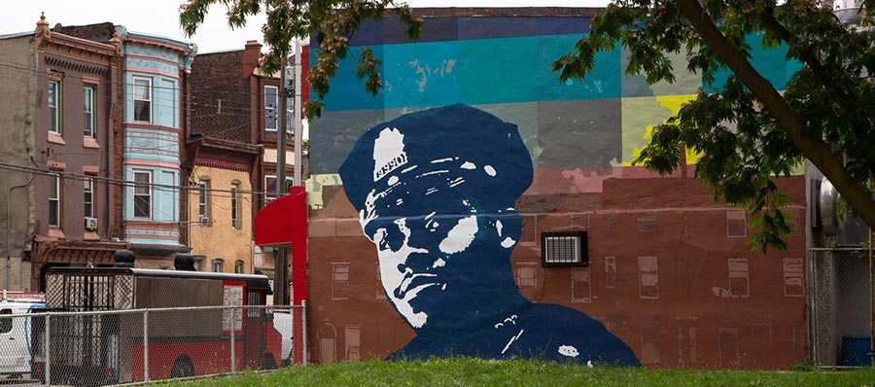
Figure 114. Memorial Mural of Sgt. Robert Wilson III in Neighborhood Where He Patrolled
Location: Philadelphia, Pennsylvania
Date: 2018
Photographer: Mural Arts Philadelphia
Source: https://www.phillymag.com/news/2019/06/28/robert-wilson-mural-vandalized/

Return to Page 47
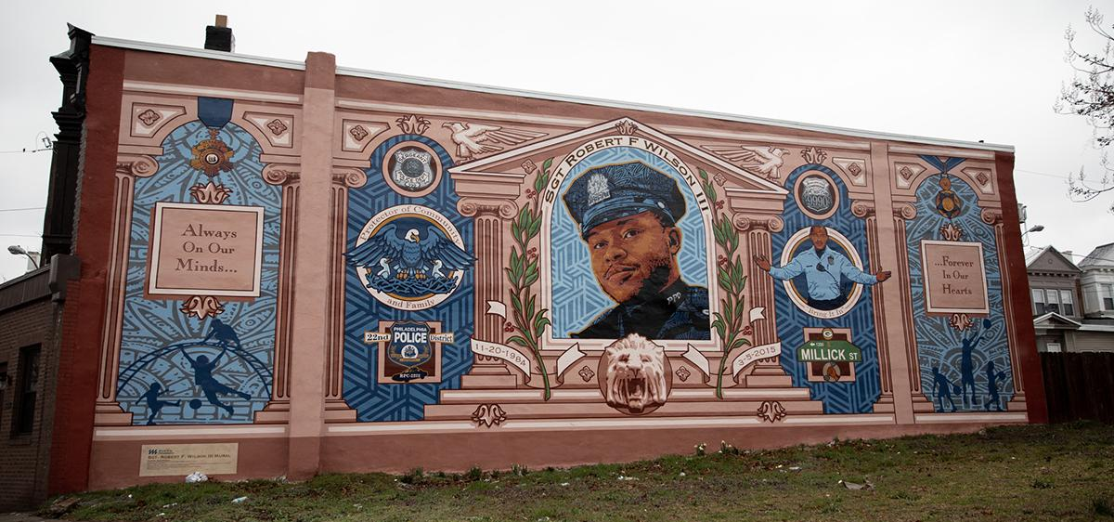
Figure 115. Memorial Mural of Sgt. Robert Wilson III
Location: Philadelphia, Pennsylvania
Date: 2017
Artist: David McShane
Source: https://www.senatoranthonyhwilliams.com/district/murals

Return to Page 47

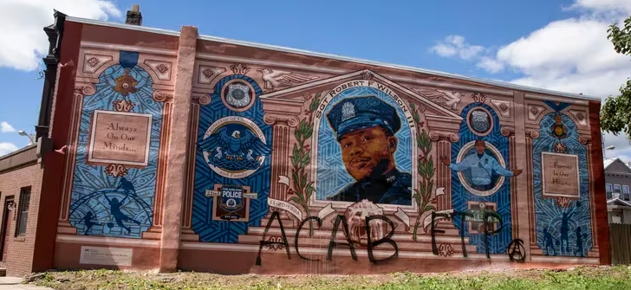
Figure 116. Vandalized Memorial Mural of Sgt. Robert Wilson III
Location: Philadelphia, Pennsylvania
Date: 2017
Artist: David McShane
Photographer: Monica Herndon
Source: https://www.inquirer.com/crime/philadelphia-police-sgt-robert-wilson-mural-vandalized-20200830.html

Return to Page 47
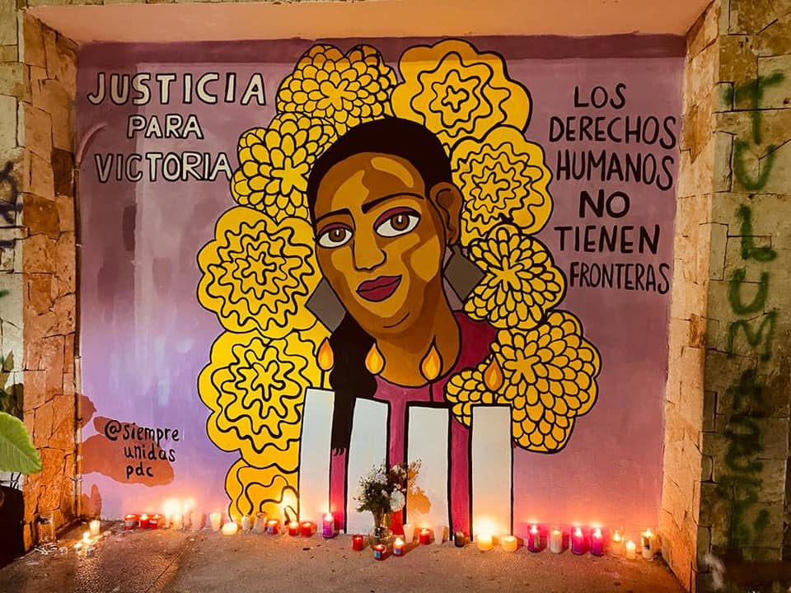
Figure 117. Justicia Para Victoria Anti-Femicide Memorial Mural on Town Hall During Protests
Location: Tulum, Mexico
Date: 2021
Artists: Colectiva Feminista Tulum
Photographer: Colectiva Feminista Tulum
Source: https://peoplesdispatch.org/2021/03/31/protests-break-out-after-femicide-of-salvadoran-migrant-victoria-salazar-in-mexico/

Return to Page 49
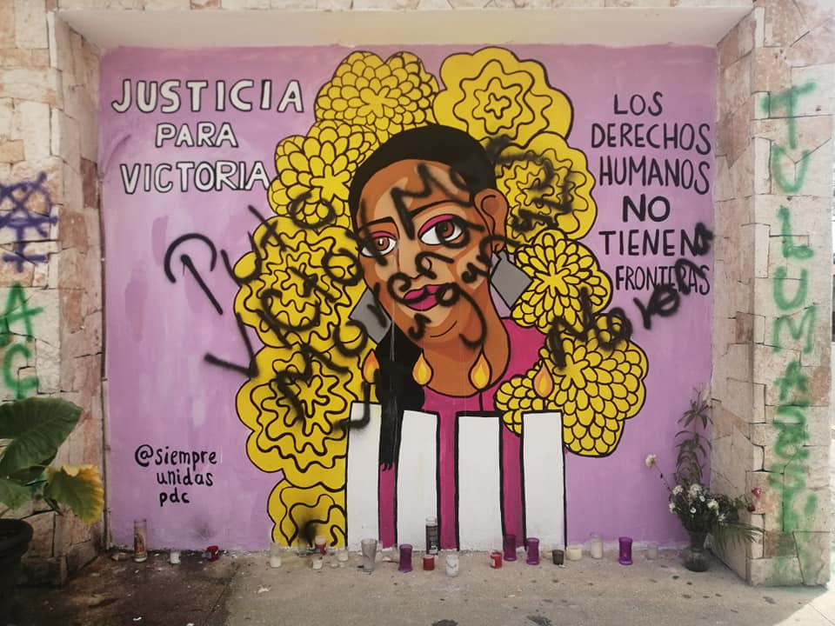
Figure 118. Justicia Para Victoria Anti-Femicide Memorial Mural on Town Hall During Protests (Vandalized I)
Location: Tulum, Mexico
Date: 2021
Artists: Colectiva Feminista Tulum
Photographer: Colectiva Feminista Tulum
Source:
https://www.facebook.com/colectivafeministatulum/photos/a.550284092149616/1094254047752615/?type=3&ref=embed_post

Return to Page 49

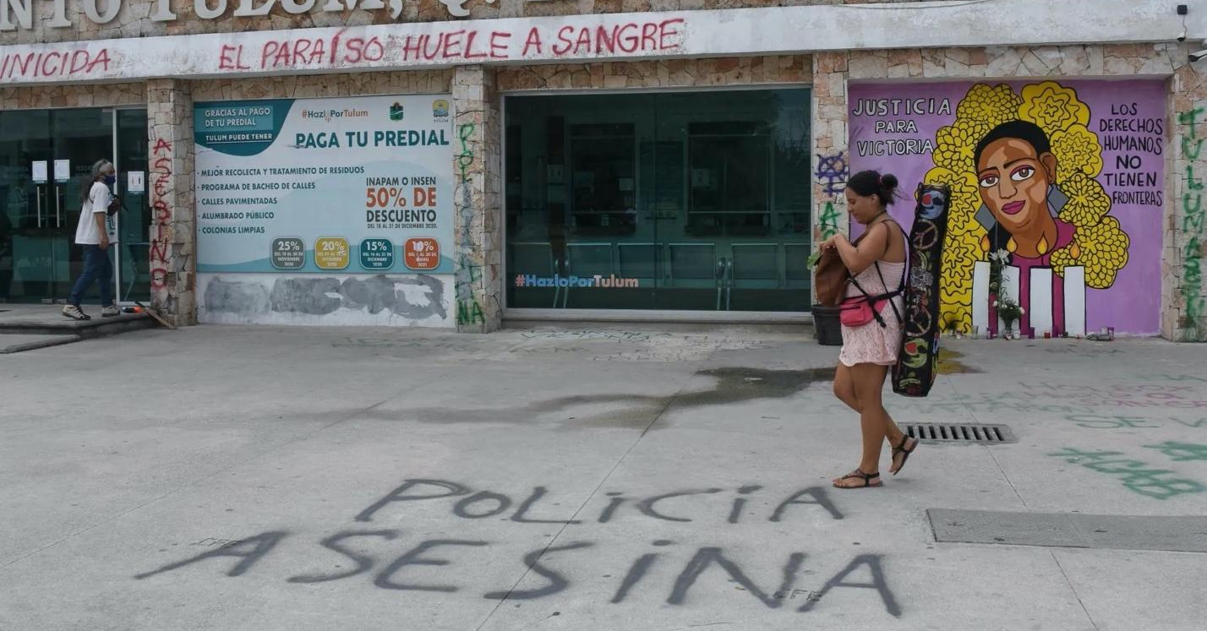
Figure 119. Justicia Para Victoria Anti-Femicide Memorial Mural on Town Hall During Protests (Vandalized II)
Location: Tulum, Mexico
Date: 2021
Artists: Colectiva Feminista Tulum
Photographer: Colectiva Feminista Tulum
Source: https://www.capital21.cdmx.gob.mx/noticias/?p=18372

Return to Page 49

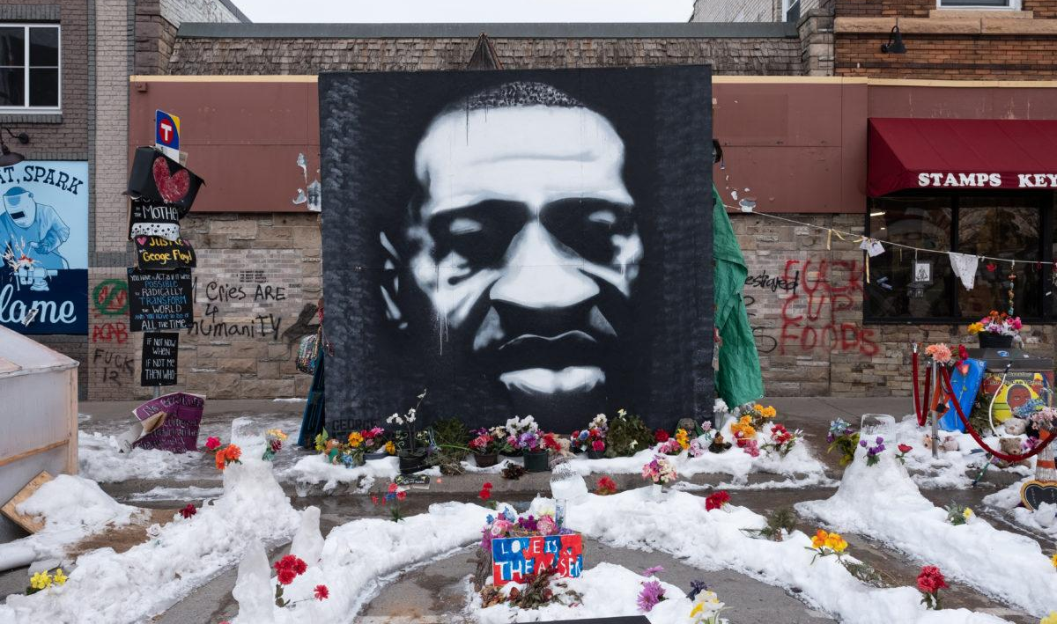
Figure 120. George Floyd Memorial Mural Painted at site of Murder
Location: Minneapolis, Minnesota
Date: 2020
Artist: Peyton Scott Russell
Photographer: Tim Evans
Source: https://www.pbs.org/newshour/arts/the-artist-behind-a-george-floyd-mural-reflects-on-how-it-became-a-ubiquitous-icon

Return to Page 50
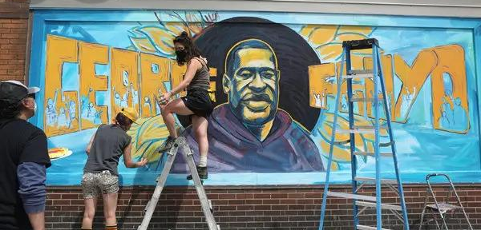
Figure 121. George Floyd Sunflower Memorial Mural In-Progress Painted at site of Murder
Location: Minneapolis, Minnesota
Date: 2020
Artists: Cadex Herrera, Greta McLain, Xena Goldman, and community artists
Photographer: Jenn Ackerman
Source: https://www.nytimes.com/2020/05/29/us/knee-neck-george-floyd-death.html

Return to Page 51

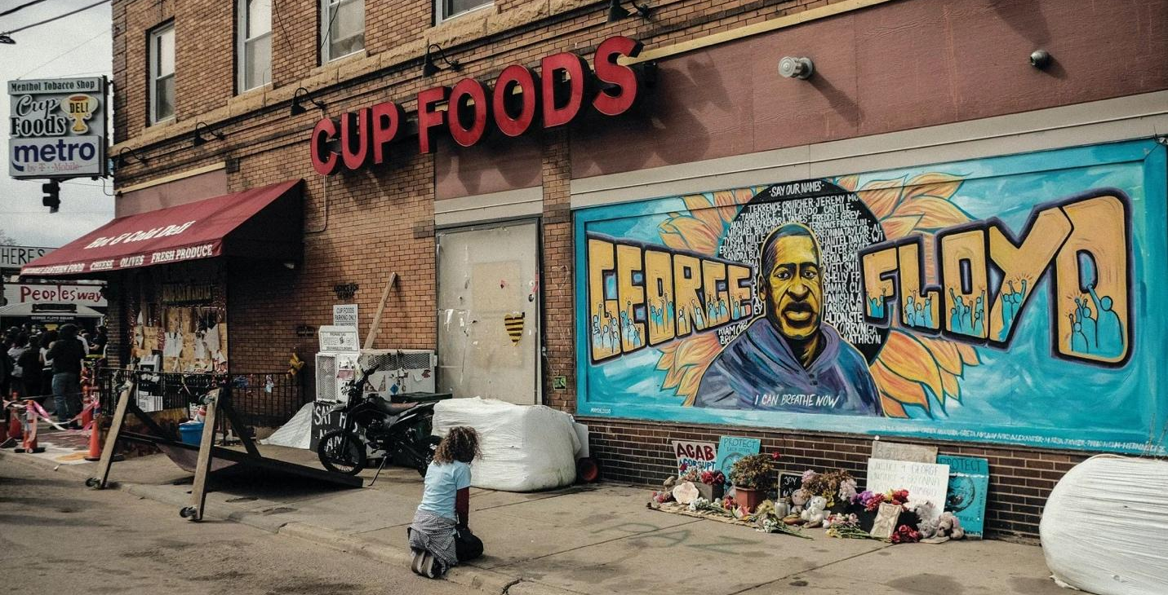
Figure 122. Kneeling in Front of George Floyd Sunflower Memorial Mural Painted at site of Murder
Location: Minneapolis, Minnesota
Date: 2020
Artists: Cadex Herrera, Greta McLain, Xena Goldman, and community artists
Source: https://www.inc.com/cameron-albert-deitch-gabrielle-bienasz/minneapolis-black-small-business-pain-recovery-george-floyd.html

Return to Page 51

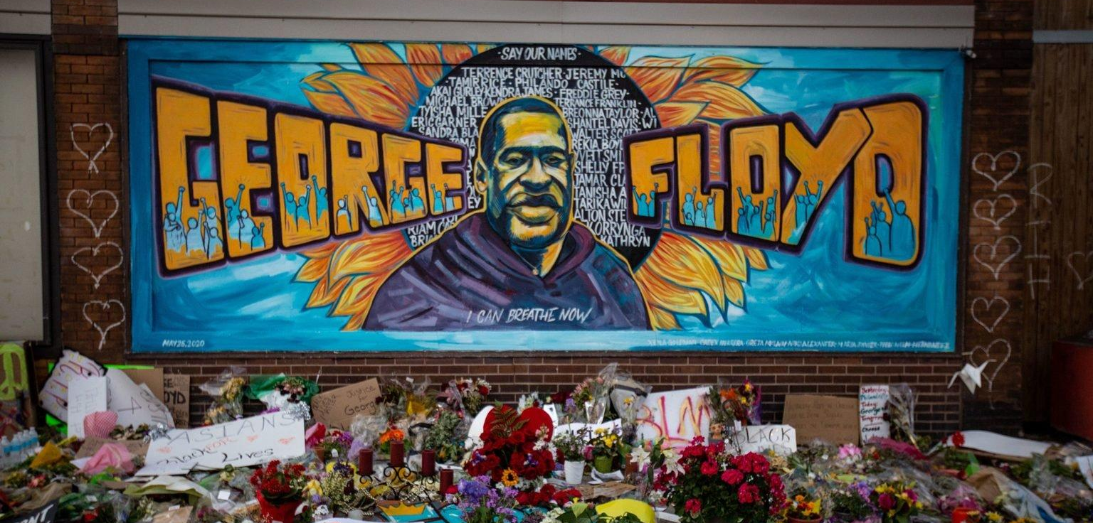
Figure 123. George Floyd Sunflower Memorial Mural Painted at site of Murder
Location: Minneapolis, Minnesota
Date: 2020
Artists: Cadex Herrera, Greta McLain, Xena Goldman, and community artists
Photographer: Jason Armond
Source: https://newrepublic.com/article/158176/righteous-power-george-floyd-mural

Return to Page 51

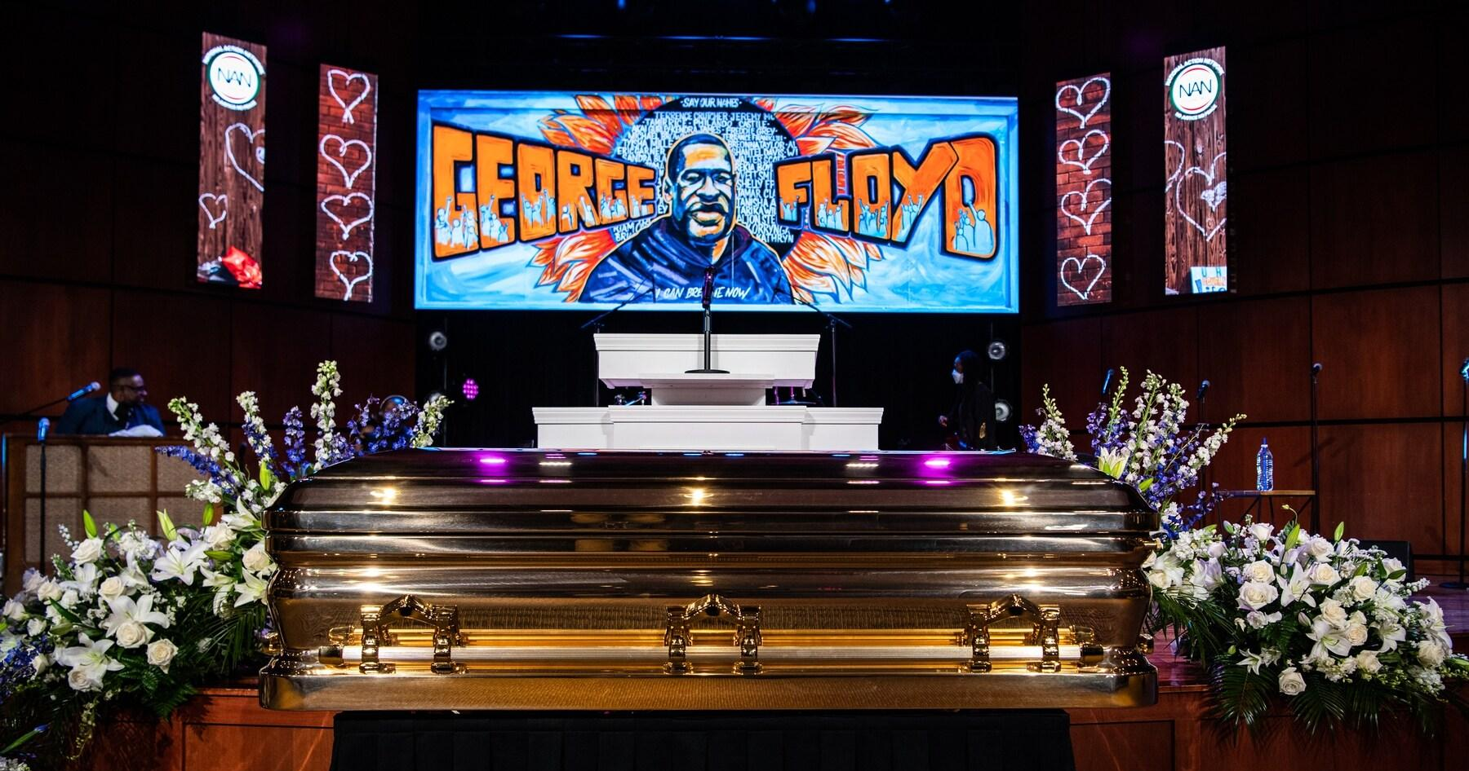
Figure 124. Digital Display of George Floyd Sunflower Memorial Mural During Service Location: Minneapolis, Minnesota
Date: 2020
Artists: Cadex Herrera, Greta McLain, Xena Goldman, and community artists
Photographer: Salwan Georges
Source: https://www.washingtonpost.com/graphics/photography/2020/06/04/photos-george-floyd-memorial/

Return to Page 51
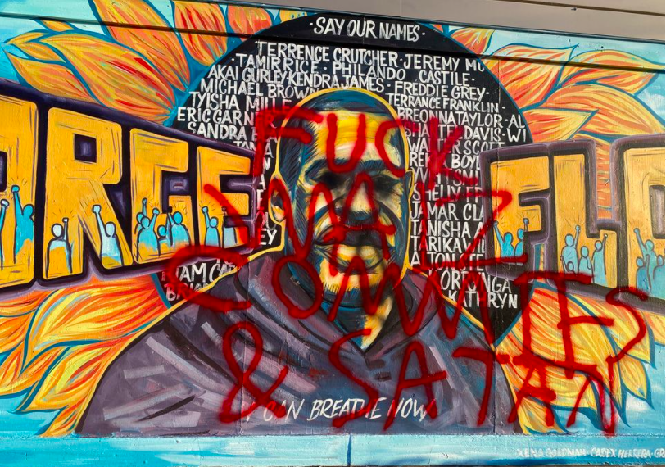
Figure 125. George Floyd Sunflower Memorial Mural Vandalized
Location: Minneapolis, Minnesota
Date: 2020
Artists: Cadex Herrera, Greta McLain, Xena Goldman, and community artists
Source: https://minnesotareformer.com/briefs/iconic-george-floyd-mural-at-cup-foods-vandalized-again-called-satans-mural/

Return to Page 51

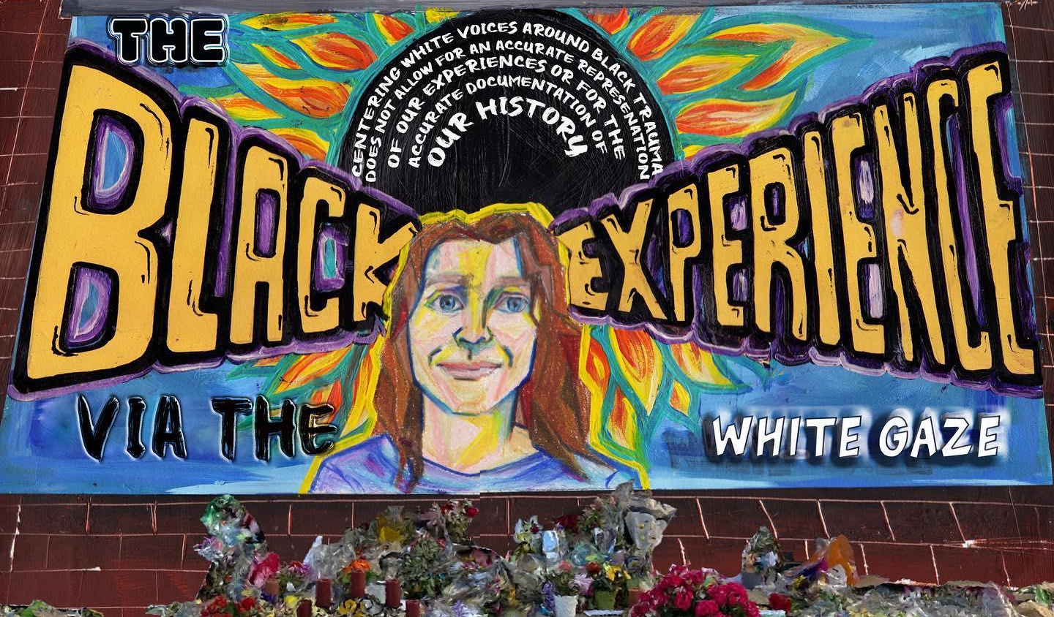
Figure 126. The Black Experience via the White Gaze
Location: Minneapolis, Minnesota, USA
Date: 2020
Artist: Maiya Hartman
Source: https://mnartists.walkerart.org/the-black-experience-via-the-white-gaze

Return to Page 51

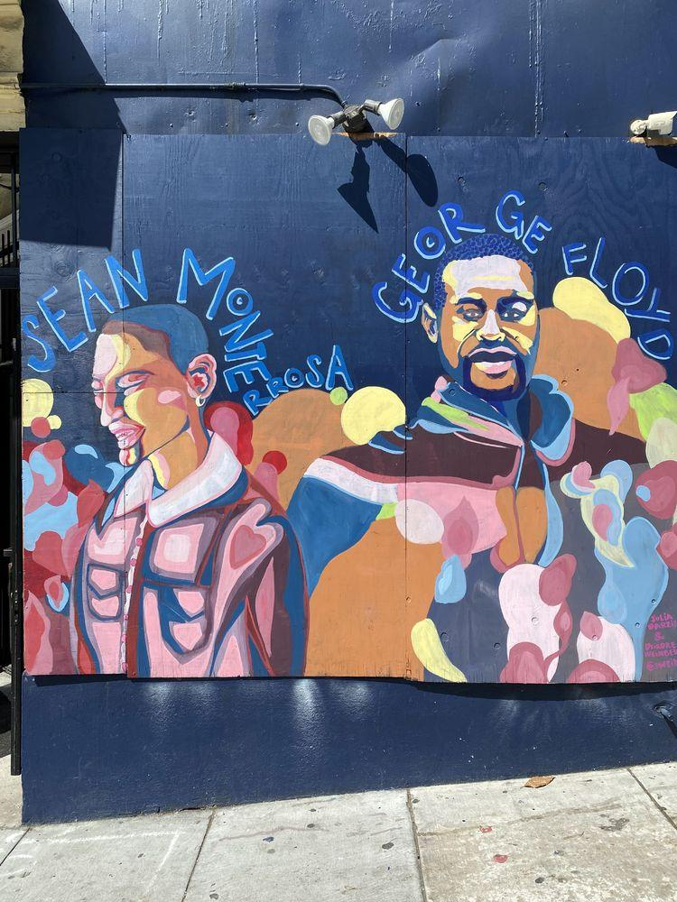
Figure 127. Sean Monterrosa and George Floyd Memorial Mural on Plywood
Location: San Francisco, California, USA
Date: 2020
Artists: Julia Barzizza , Deirdre Weinberg
Photographer: Chioma Uwagwu
Source: https://georgefloydstreetart.omeka.net/items/show/2209

Return to Page 52

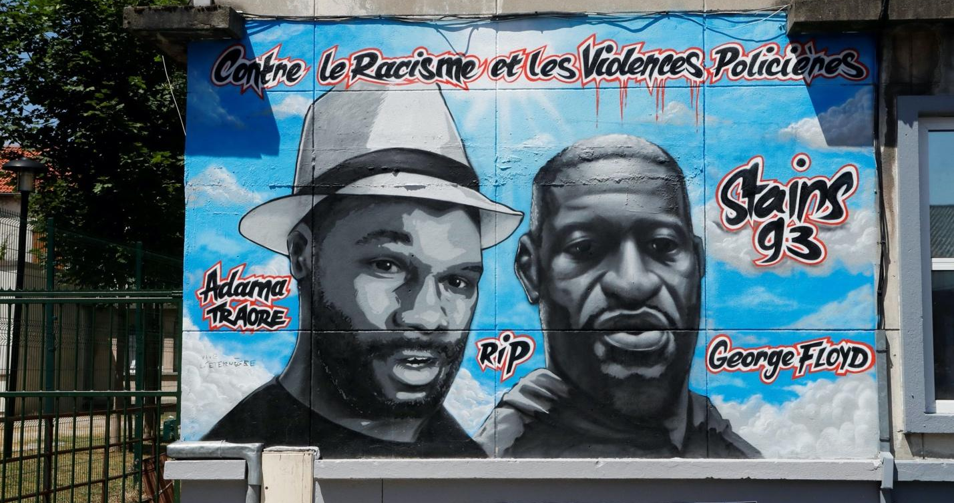
Figure 128. Memorial Mural of George Floyd and Adama Traore
Location: Paris, France
Date: 2020
Photographer: Francois Guillot
Source: https://www.nbcnews.com/news/world/france-george-floyd-s-death-fueled-protest-movement-against-police-n1239458

Return to Page 52

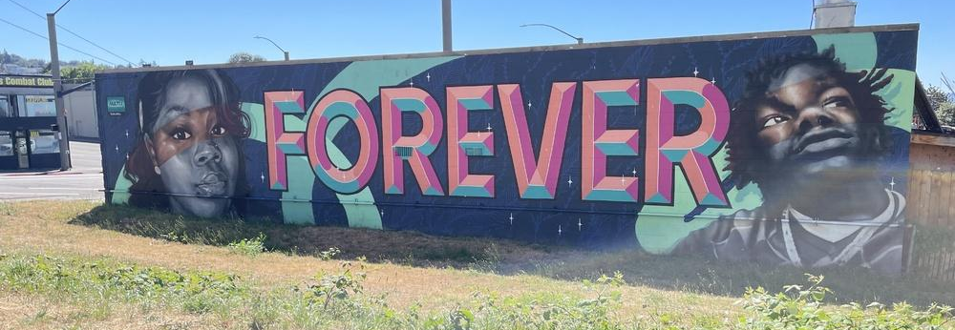
Figure 129. FOREVER Memorial Mural of Breonna and Jatarius Tolbert at Grandma's in Da Kitchen (Restaurant)
Location: Seattle, Washington, USA
Date: 2020
Artist: The Math
Photographer: Jeffrey Totey
Source: https://seattlerefined.com/eat-drink/grandmas-southern-food-restaurant-is-a-labor-in-love

Return to Page 52

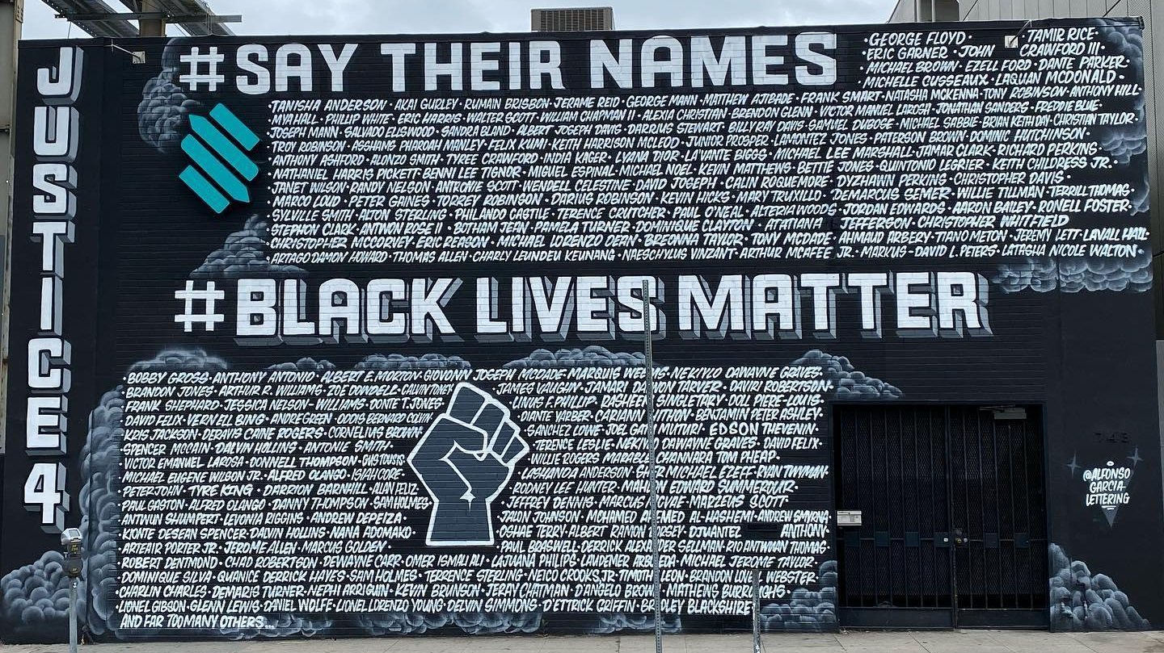
Figure 130. Justice 4, Say Their Names, and Black Lives Matter Mural
Location: Los Angeles, California, USA
Date: 2020
Artist: Alfonso Garcia
Source: https://www.instagram.com/p/CBFPug1F_NI/

Return to Page 52

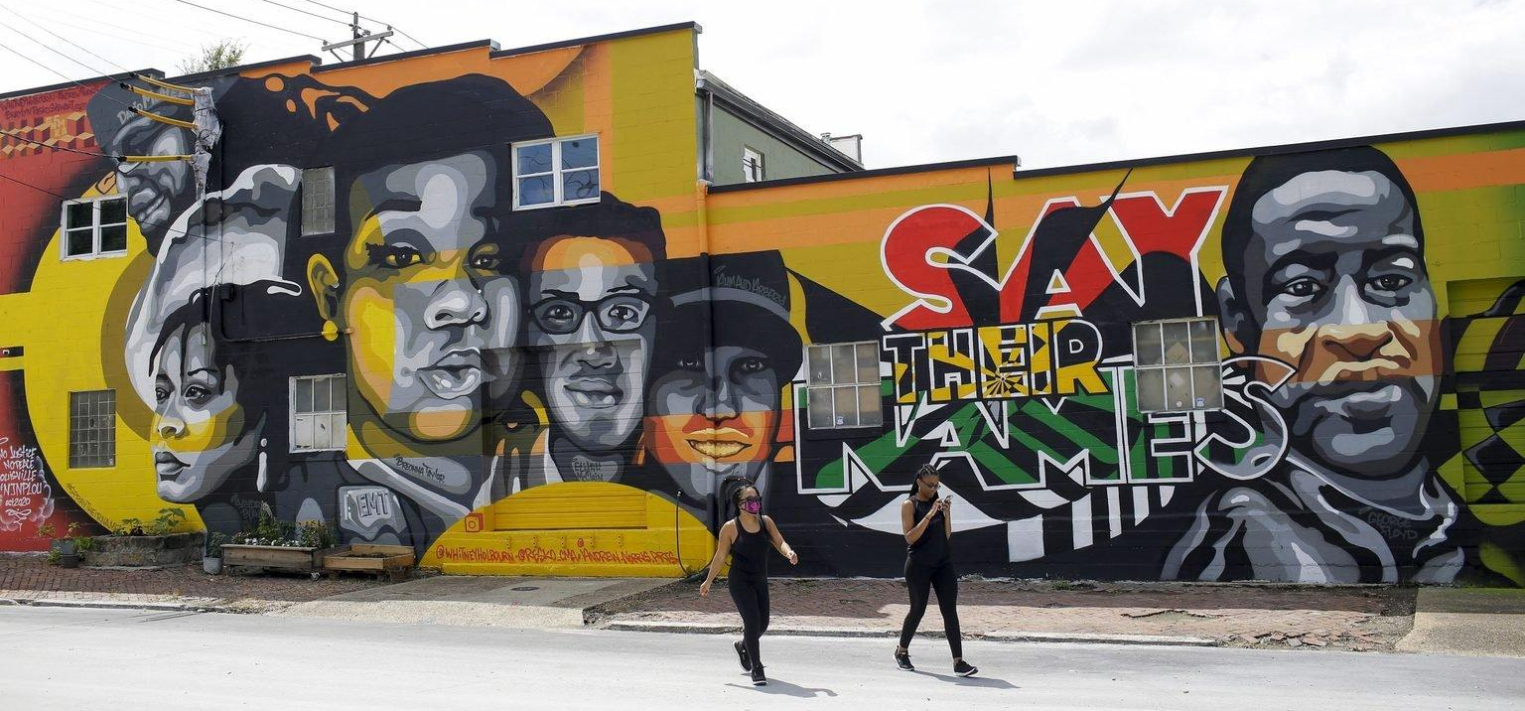
Figure 131. Say Their Names: David McAtee, Sandra Bland, Breonna Taylor, Elijah McClain, Ahmaud Arbery, George Floyd
Location: Louisville, Kentucky, USA
Date: 2020
Artists: Whitney Holbourn, Braylyn Resko Stewart, and Andrew Norris
Photographer: Joshua Lott
Source: https://www.washingtonpost.com/opinions/letters-to-the-editor/readers-critique-the-post-heed-the-writing-on-the-wall-and-say-their-names/2020/08/28/9f0c18c8-e94d-11ea-bc79-834454439a44_story.html

Return to Page 52
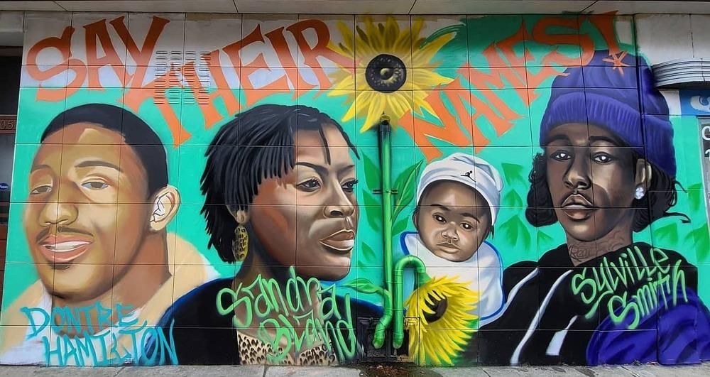
Figure 132. Say Their Names: Dontre Hamilton, Sandra Bland, Sylville Smith
Location: Milwaukee, Wisconsin, USA
Date: 2020
Artists: Ann M. Graf
Photographer: Ann M. Graf
Source: https://georgefloydstreetart.omeka.net/items/show/1802

Return to Page 52

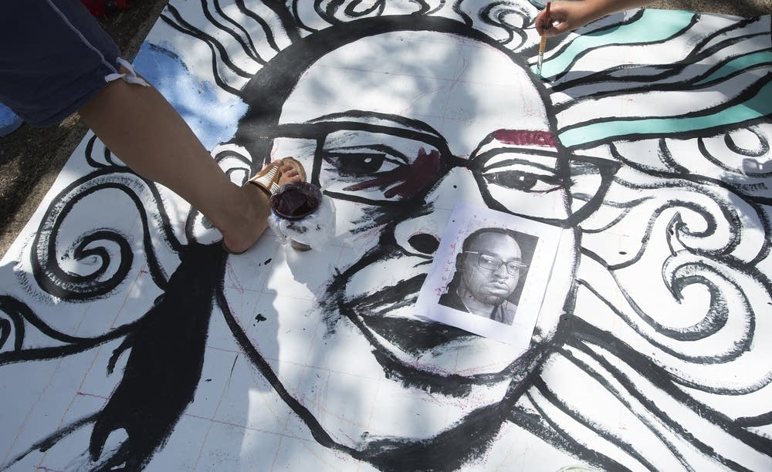
Figure 133. Philando Castille’s 33rd Birthday Memorial Mural Where He Worked
Location: J.J. Hill Montessori school in St. Paul, Minnesota, USA
Date: 2016
Photographer: Judy Griesedieck
Source: https://www.mprnews.org/story/2016/07/07/timeline-philando-castile-shooting

Return to Page 52

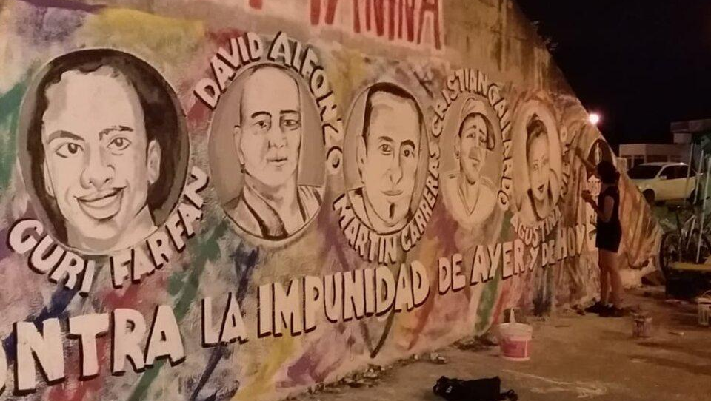
Figure 134. Against Impunity Memorial Mural Interrupted by Police
Location: Salta, Argentina
Date: 2022
Source: https://www.pagina12.com.ar/432118-a-3-anos-de-las-muertes-de-carreras-y-ovejero-alfonzo-siguen

Return to Page 52

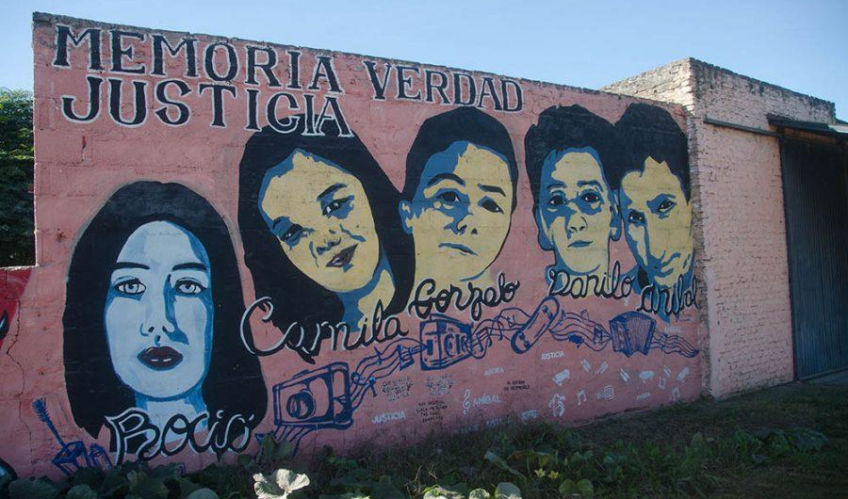
Figure 135. Memorial Mural of Children Murdered by Police
Location: San Miguel del Monte, Argentina
Date: 2023
Source: https://www.infobae.com/sociedad/policiales/2023/05/08/comienza-el-juicio-contra-cuatro-policias-acusados-de-la-masacre-de-monte-termino-la-espera/

Return to Page 52
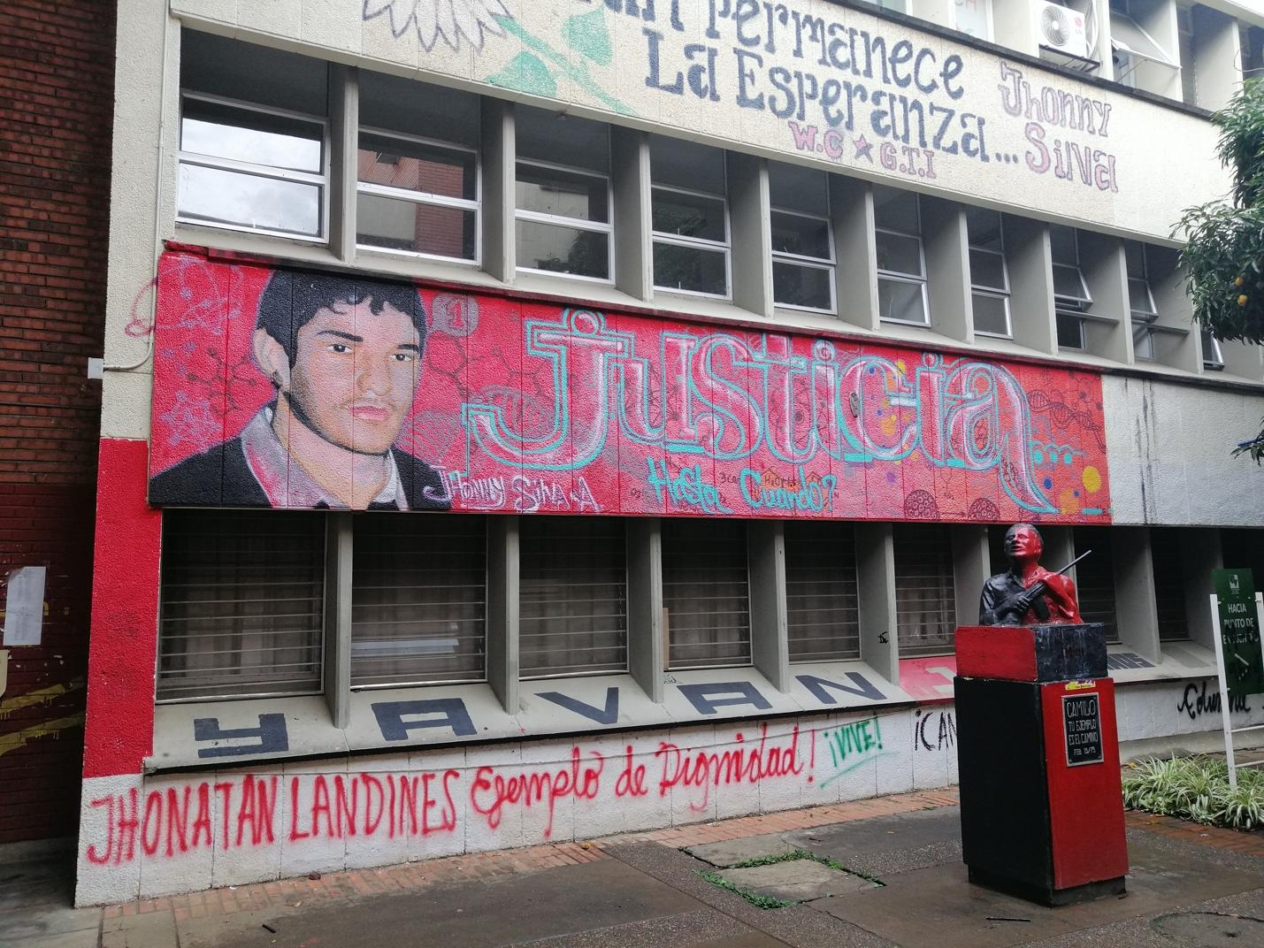
Figure 136. Memorial Mural of Jhonny Silva Aranguren where Police Killed Him in 2005 at the University of Valle del Cauca
Location: Cali, Colombia
Date: 2020
Source: https://www.utadeo.edu.co/es/articulo/crossmedialab/277626/las-43-muertes-que-involucran-al-esmad-antes-del-21n & https://cetacademicprograms.com/black-girl-abroad-how-i-learned-to-relinquish-my-hold-on-forced-identity/

Return to Page 53

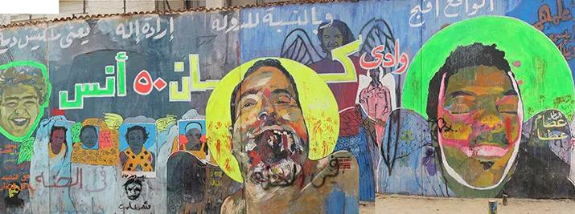
Figure 137. Mohamed Mahmoud and Victims of Police and Miliary Attacks Memorial Mural
Location: Tahrir, Egypt
Date: 2012
Source: https://suzeeinthecity.wordpress.com/2012/12/29/return-to-tahrir-two-years-and-graffiti-of-the-martyrs/

Return to Page 53

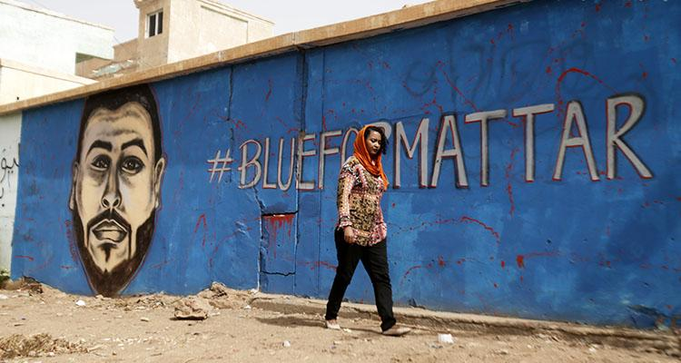
Figure 138. #BLUEFORMATTAR
Location: Khartoum, Sudan
Date: 2019
Artist: Assil Diab
Source: https://www.aa.com.tr/en/africa/murals-tell-the-story-of-sudan-revolution/1533922 & https://www.arabnews.com/node/1530186/offbeat

Return to Page 53

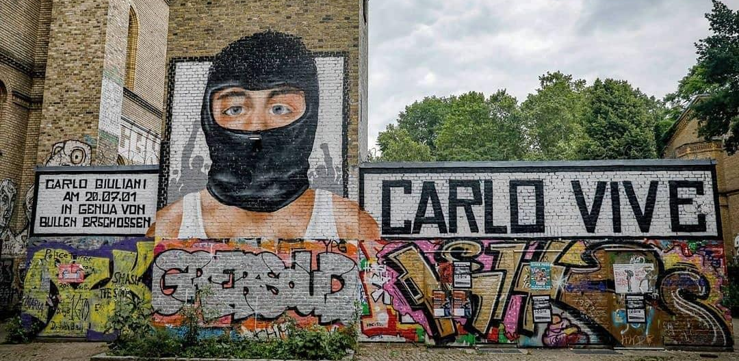
Figure 139. Memorial Mural of Carlo Giuliani Killed During 2001 G8 Summit Protests in Genoa, Italy
Location: Berlin, Germany
Date: 2021
Photographer: PM Cheung
Source: https://www.instagram.com/p/CRiqdzyLGRG/

Return to Page 53

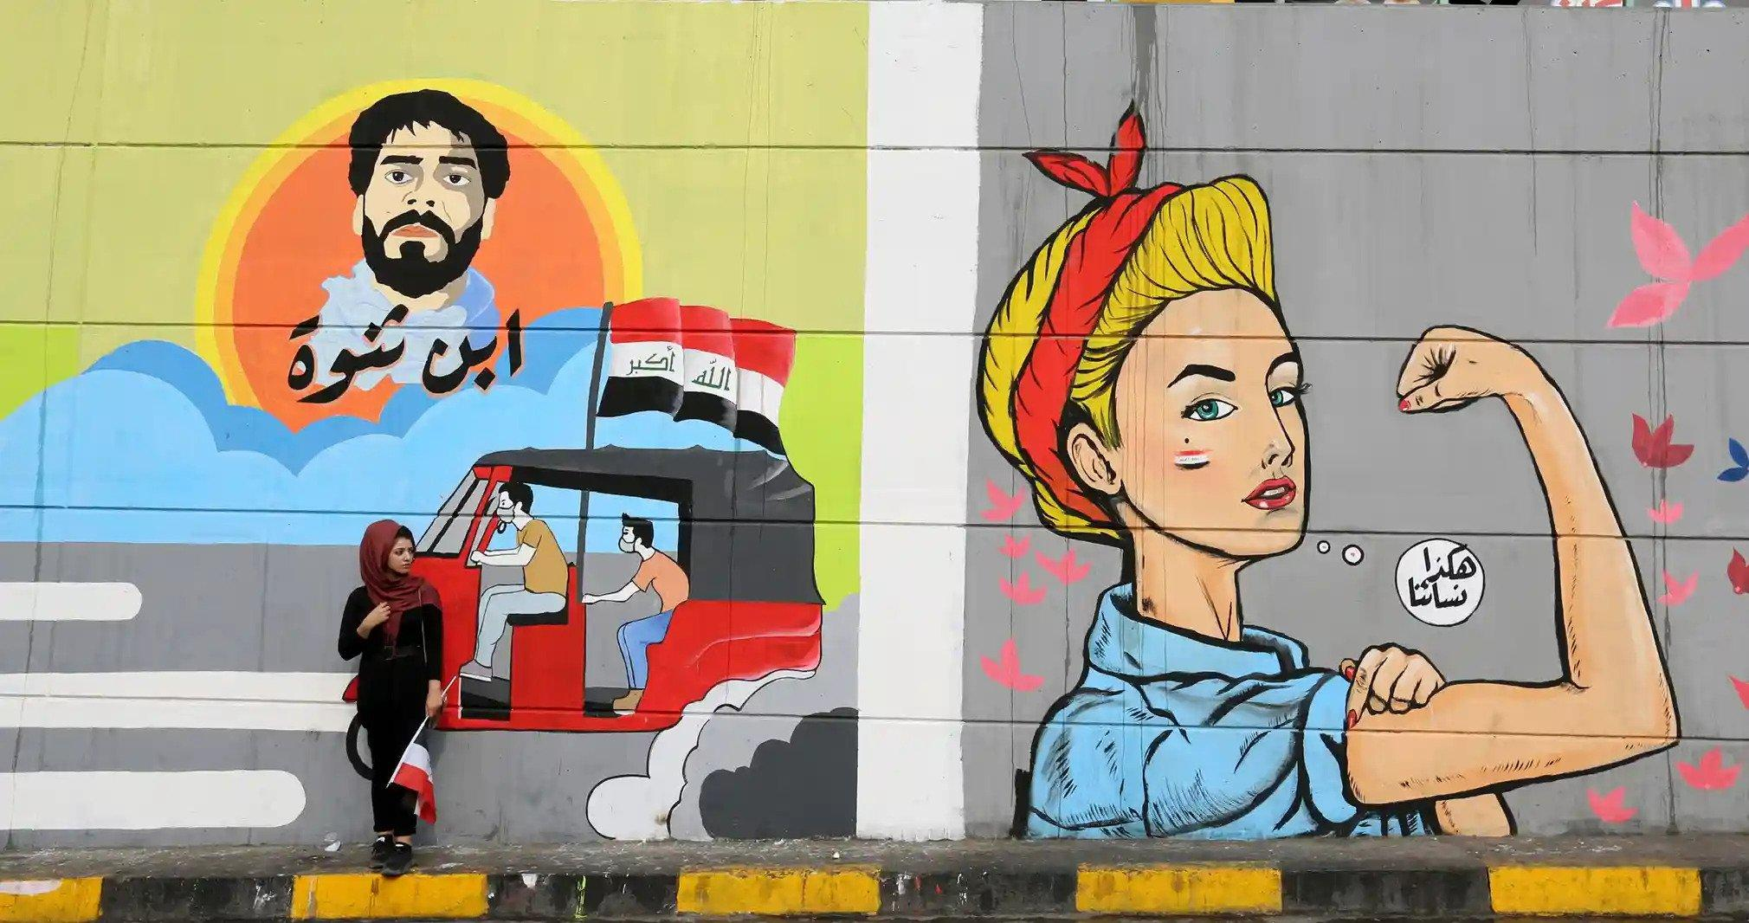
Figure 140. Son of Thanwa, Protester Safaa al-Saray Memorial Mural
Location: Baghdad, Iraq
Date: 2019
Photographer: Ahmed Jalil
Source: https://www.theguardian.com/global-development/gallery/2019/nov/26/murals-of-baghdad-the-protest-art-in-pictures

Return to Page 53

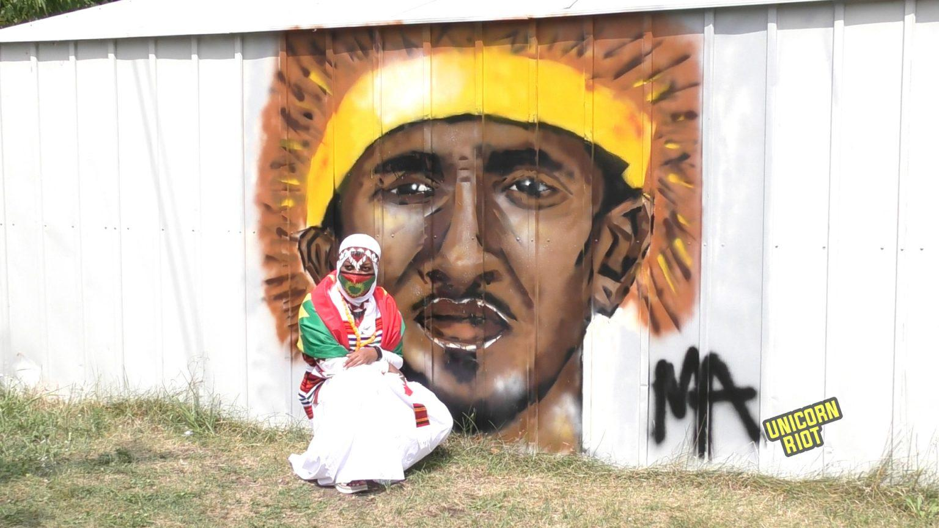
Figure 141. Activist Hachalu Hundessa Memorial Mural in Solidarity with Omoro People
Location: Minneapolis, Minnesota
Date: 2020
Source: https://unicornriot.ninja/tag/oromo-diaspora-media/

Return to Page 54

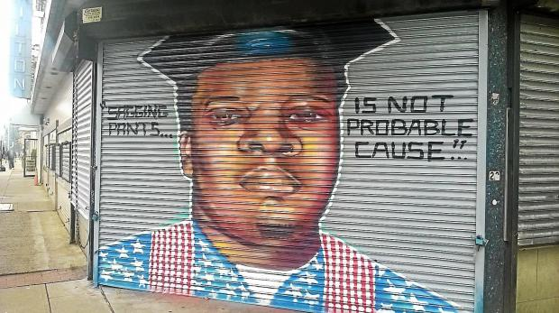
Figure 142. “Sagging Pants… is Not Probable Cause” Mike Brown Memorial Mural
Location: Trenton, New Jersey, USA
Date: 2014
Artist: Will “Kasso” Condry
Source: https://www.trentonian.com/2014/11/25/rights-groups-want-trenton-michael-brown-mural-restored/

Return to Page 54
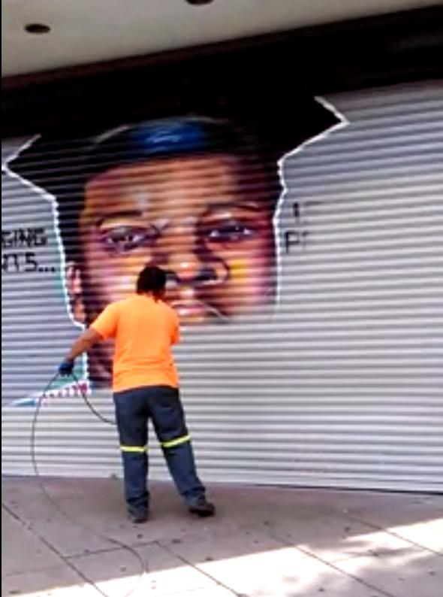
Figure 143.“Sagging Pants… is Not Probable Cause” Mike Brown Memorial Mural Graffiti Blasted
Location: Trenton, New Jersey, USA
Date: 2014
Artist: Will “Kasso” Condry
Source: https://greg.org/archive/2014/10/21/how-ya-like-me-now-trenton-edition.html

Return to Page 54
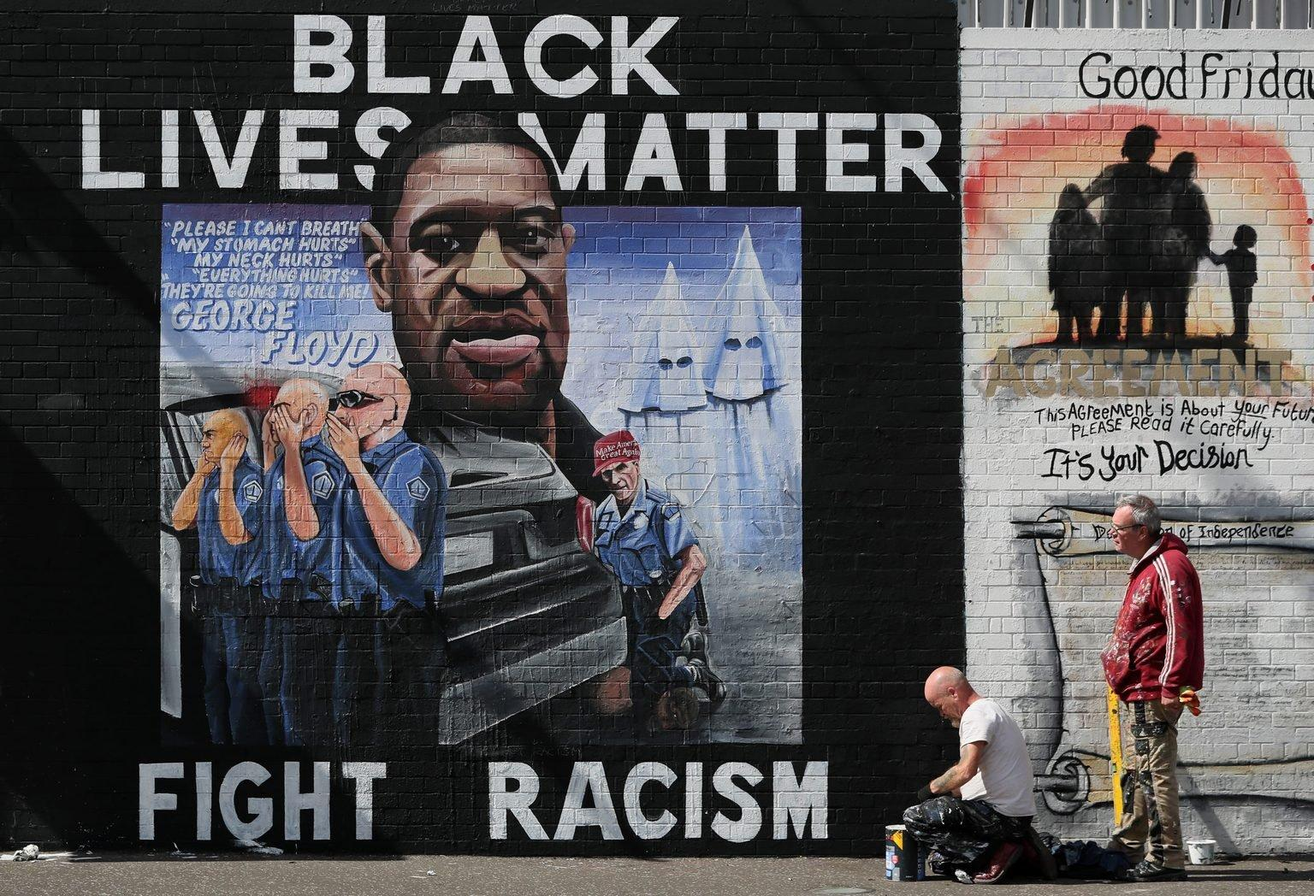
Figure 144. Black Lives Matter, Fight Racism, George Floyd Solidarity Mural
Location: Belfast, Northern Ireland
Date: 2020
Artist: Micky Docherty
Photographer: Brian Lawless
Source: https://www.huffpost.com/entry/street-art-black-lives-matter-george-floyd_n_5ee37c11c5b6090d86c5500b
Return to Page 54

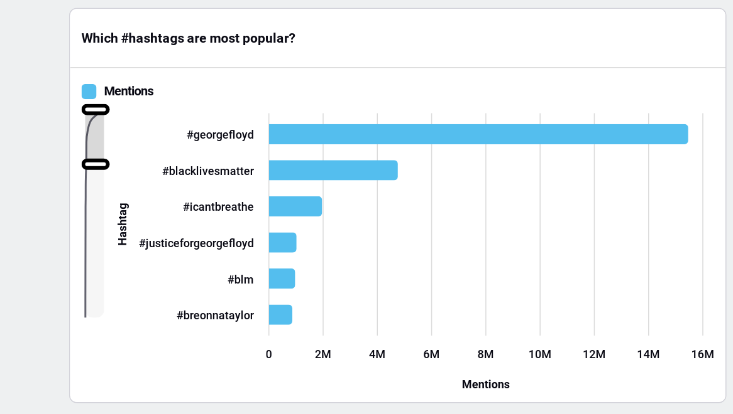
Figure 145. Disparity in Hashtags on Social Media
Source: Sprinklr, Accessed February 2024

Return to Page 55
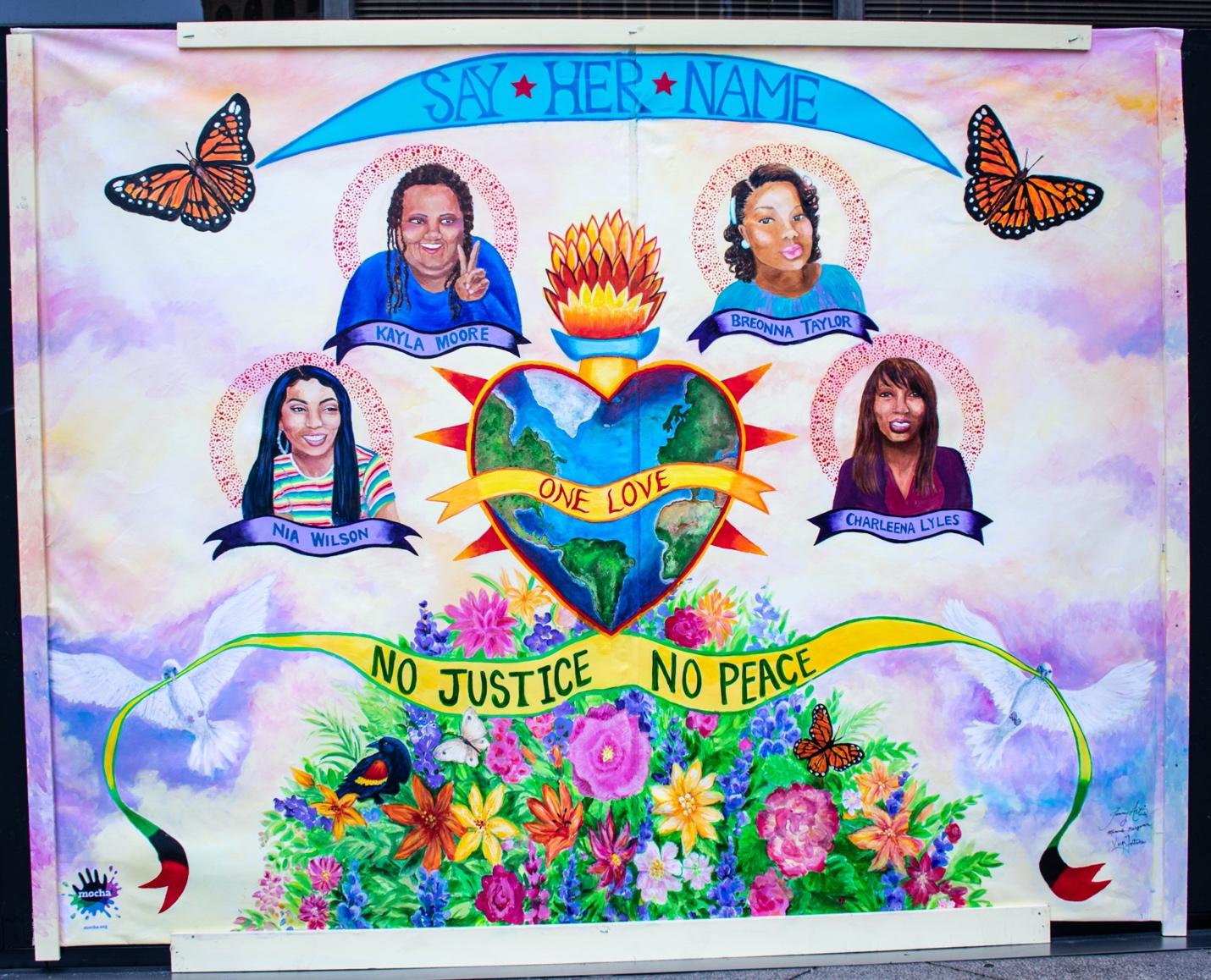
Figure 146. Say Her Name: Kayla Moore, Breonna Taylor, Nia Wilson, Charlena Lyles Memorial Mural
Location: Oakland, California, USA
Date: 2020
Artists: Kaya Fortune, Miranda Berman, Tammy Artis
Source: https://breedoan.wordpress.com/2020/07/15/artists-transform-downtown-oakland-for-black-lives-matter/

Return to Page 55

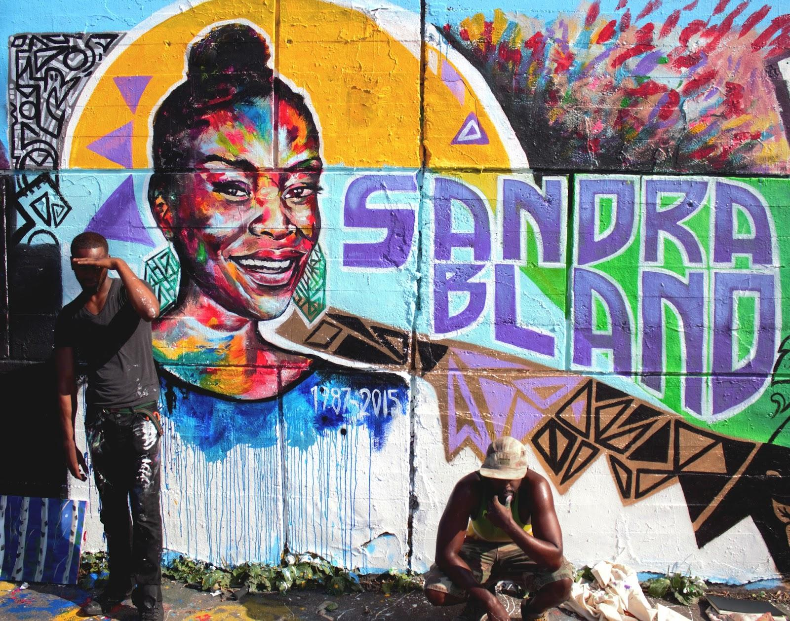
Figure 147. Sandra Bland Memorial Mural
Location: TechWall, Ottowa, Canada
Date: 2015
Artists: Allan Andre and Kalkidan Assefa (Aka DRPN Soul)
Source: http://www.kalkidan-assefa.com/2015/07/thoughts-on-ottawa-techwall-sandra.html

Return to Page 55

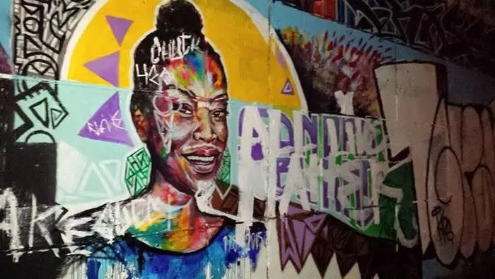
Figure 148. Sandra Bland Memorial Mural, Vandalized with All Lives Matter
Location: TechWall, Ottowa, Canada
Date: 2015
Artists: Allan Andre and Kalkidan Assefa (Aka DRPN Soul)
Source: https://www.complex.com/style/a/cameron-wolf/sandra-bland-mural-defaced-hours-after-completion

Return to Page 55

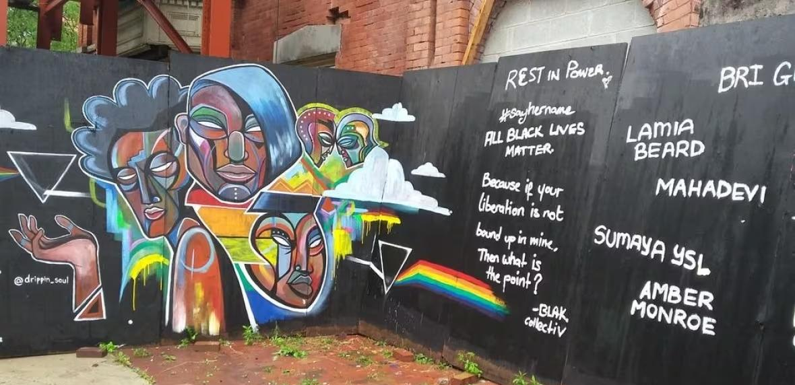
Figure 149. Rest in Power Memorial Mural for Trans Women of Color
Location: Ottowa, Canada
Date: 2015
Artist: Kalkidan Assefa and BlakCollectiv
Source: https://www.cbc.ca/news/canada/ottawa/transgender-women-colour-mural-vandalize-1.3241389

Return to Page 55

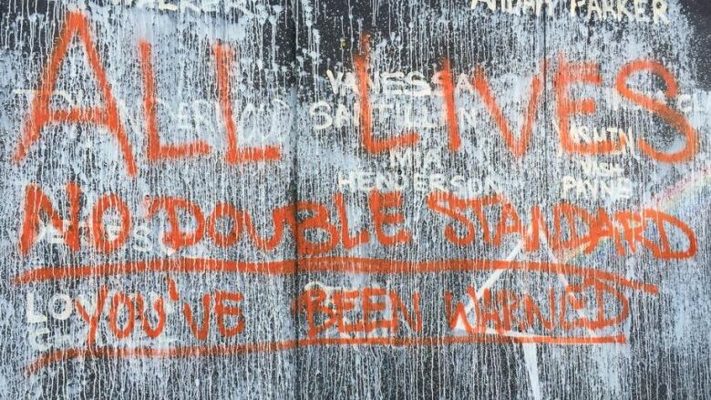
Figure 150. Rest in Power Memorial Mural, Vandalized: All Lives, No Double Standard, You’ve Been Warned
Location: Ottowa, Canada
Date: 2015
Artist: Kalkidan Assefa and BlakCollectiv
Source: https://www.cbc.ca/news/canada/ottawa/transgender-women-colour-mural-vandalize-1.3241389

Return to Page 55

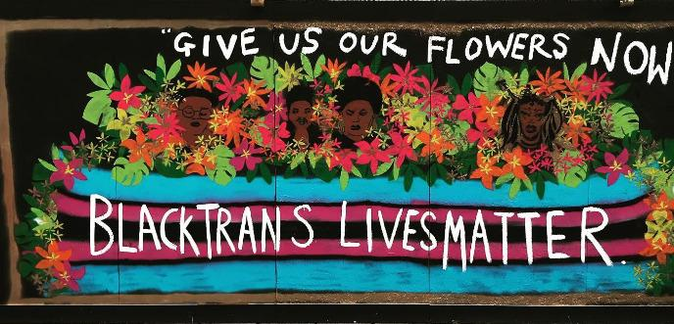
Figure 151. Give Us Our Flowers Now
Location: Brighton, United Kingdom
Date: 2020
Artist: Emma Frankland
Source https://georgefloydstreetart.omeka.net/items/show/1851 & https://www.emmafrankland.co.uk/work/btlm-mural

Return to Page 55

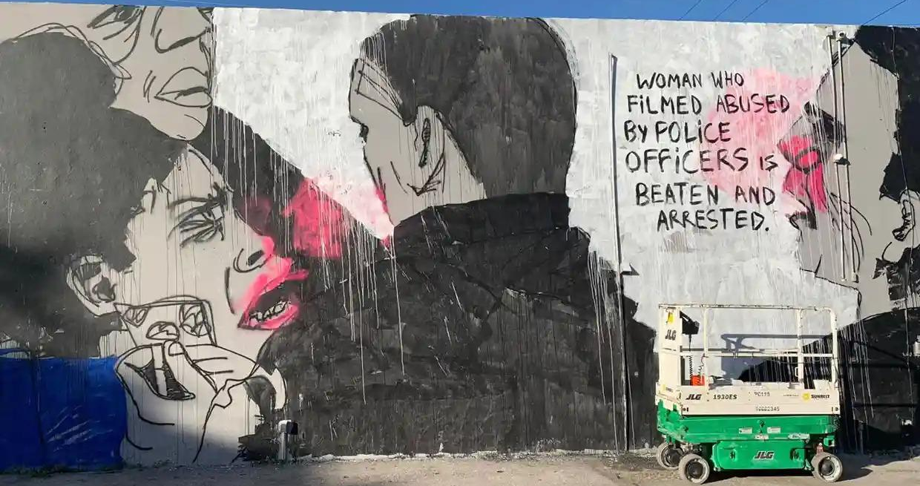
Figure 152. “Woman Who Filmed Abused By Police Officers Is Beaten And Arrested.” Solidarity Mural
Location: Miami, Florida, USA
Date: 2019
Artist: Panmela Castro
Photographer: Alexandre Abade
Source: https://www.theguardian.com/us-news/2019/dec/05/miami-panmela-castro-mural-rio-de-janeiro-removed
Return to Page 56
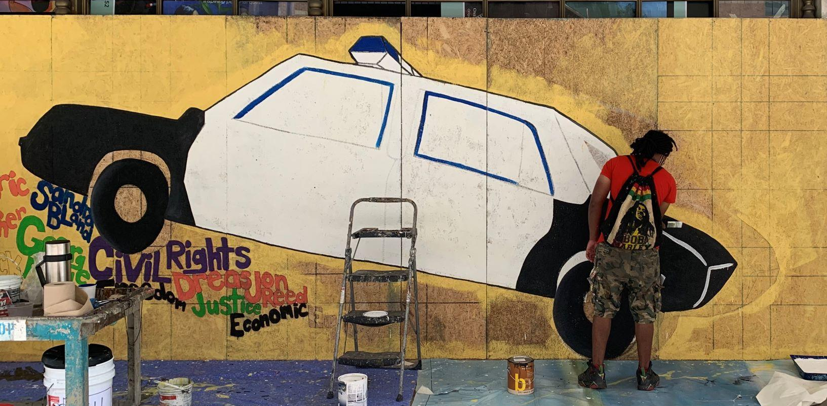
Figure 153. “BLKKK Lives Don’t Matter” in Progress
Location: Indianapolis, Indiana, USA
Date: 2020
Artist: Mechi Shakur
Source: https://www.nuvo.net/arts/visual/hoping-for-change-and-introspection-the-art-of-mechi-shakur/article_ff6258f0-ab7b-11ea-a6b0-375ba8843caf.html

Return to Page 56

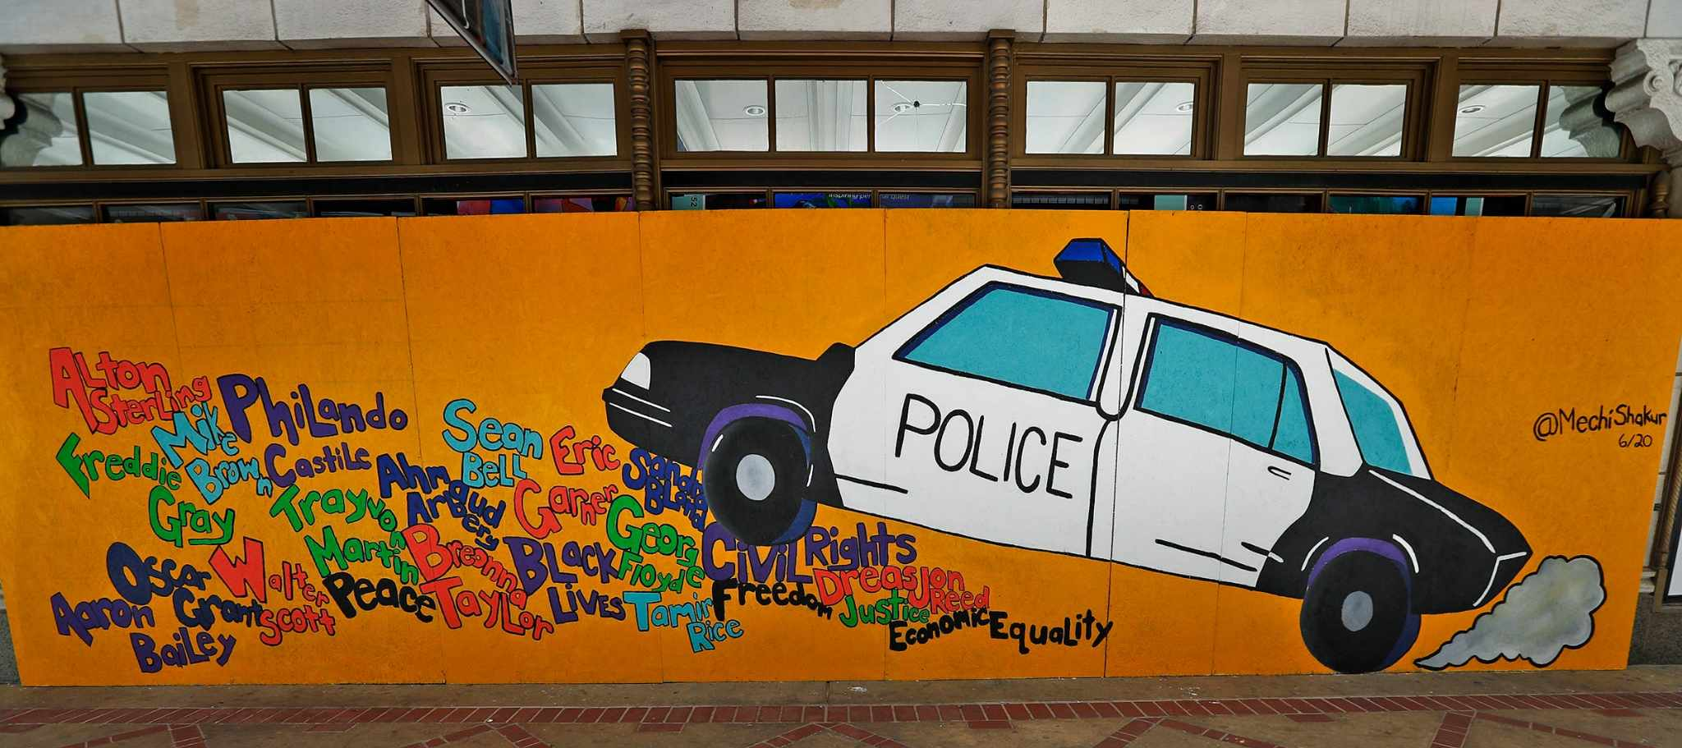
Figure 154. BLKKK Lives Don’t Matter
Location: Indianapolis, Indiana, USA
Date: 2020
Artist: Mechi Shakur
Source: https://indyencyclopedia.org/exhibit/blkkk-lives-dont-matter/

Return to Page 56
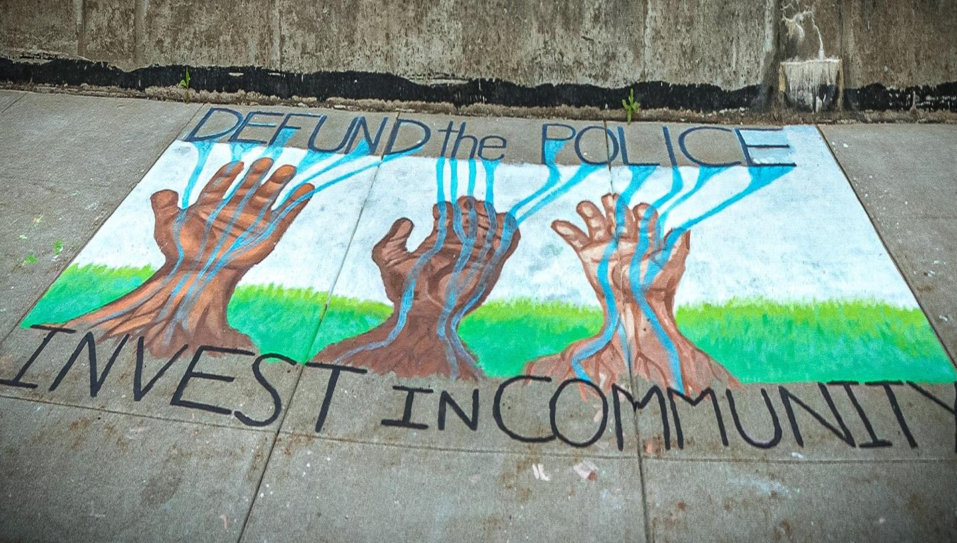
Figure 155. Defund The Police Invest In Community
Location: Erie, Pennsylvania, USA
Date: 2020
Artists: Erie Equal
Source: https://www.eriereader.com/article/erie-equal-mural-by-city-hall-washed-away

Return to Page 56

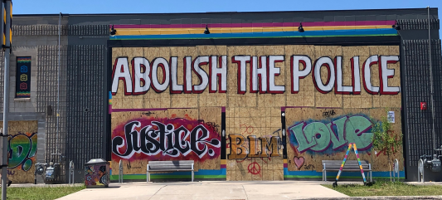
Figure 156. Abolish the Police, Justice, BLM, and Love on Boarded Up Building
Location: Minneapolis, Minnesota, USA
Date: 2020
Source: https://www.thewhitereview.org/feature/revolution-is-not-a-one-time-event-2/

Return to Page 56
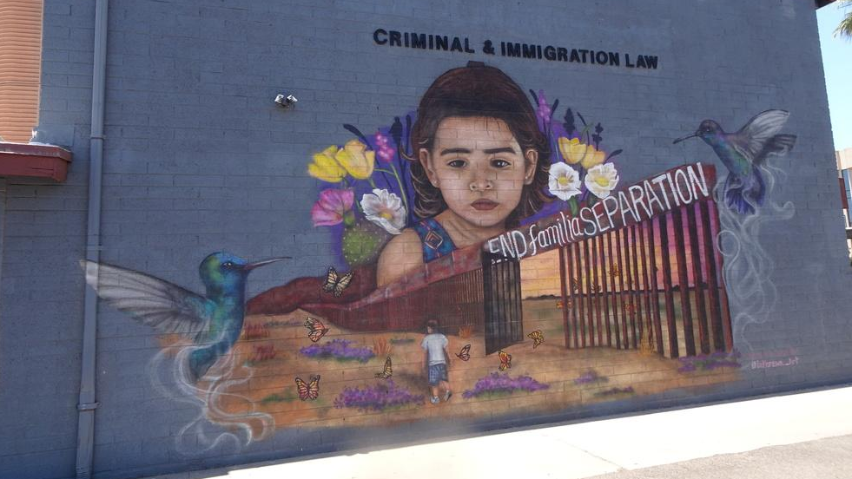
Figure 157. “Humanity Over Hate” on Criminal and Immigration Law Building
Location: Phoenix, Arizona, USA
Date: 2019
Artist: Lucinda Yrene, or La Morena
Photographer: Kathleen Arola-Johnson
Source: https://www.telesurenglish.net/news/WallTherapy-Muralist-La-Morena-Protests-Family-Separation-20190812-0019.html & https://georgefloydstreetart.omeka.net/items/show/2652

Return to Page 56

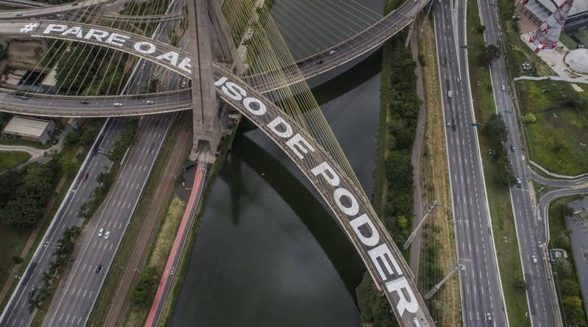
Figure 158. #Pare O Abuso De Poder (Stop Abuse of Power) Street Mural
Location: Octávio Frias de Oliveira Bridge, São Paulo, Brazil
Date: 2020
Artists: Nos Artivistas
Photographer: Eduardo Anizelli
Source: https://georgefloydstreetart.omeka.net/items/show/3522

Return to Page 56

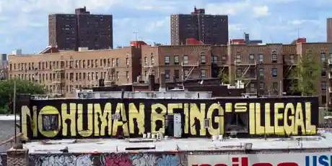
Figure 159. No Human Being is Illegal
Location: New York City, New York, USA
Date: 2010
Photographer: Salena Lettera
Source: https://www.theguardian.com/travel/2013/jun/22/top-10-us-iconic-road-signs

Return to Page 56

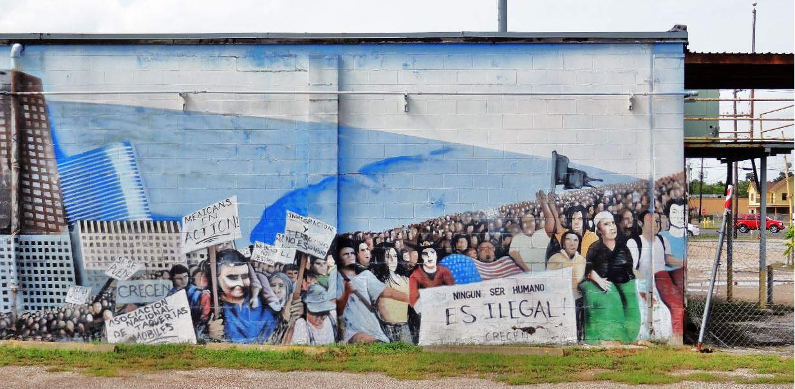
Figure 160. Mexicans in Action! Ningun Ser Humano Es Ilegal!
Location: Houston, Texas, USA
Date: 2015
Source: https://h-town-visually.blogspot.com/2015/07/political-muralism-in-houston.html#google_vignette

Return to Page 56
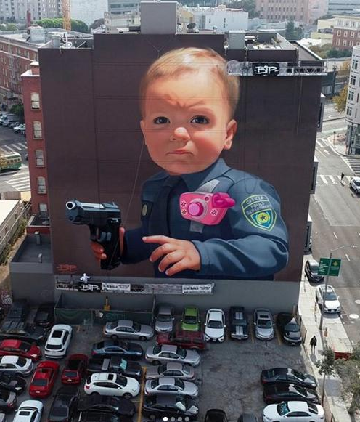
Figure 161. Baby With a Handgun
Location: San Francisco, California, USA
Date: 2019
Artist: Bip Apollo
Photographer: Maximize Video Productions
Source: https://www.instagram.com/p/B43d7IDBk-H/

Return to Page 57

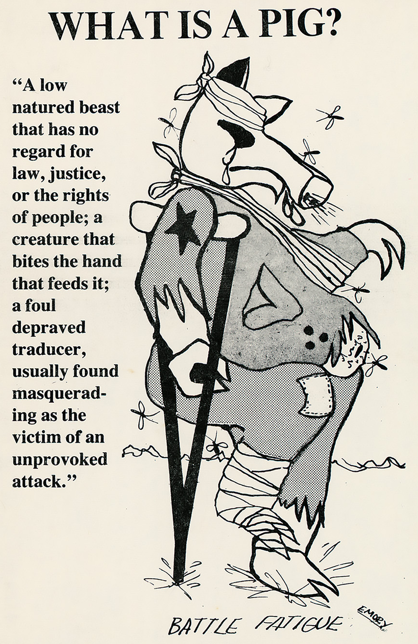
Figure 162. What is a Pig?
Date: 1967
Artist: Emory Douglas
Source: https://www.design.iastate.edu/wp-content/uploads/2021/09/What-is-a-Pig-by-Emory-Douglas.jpg

Return to Page 58
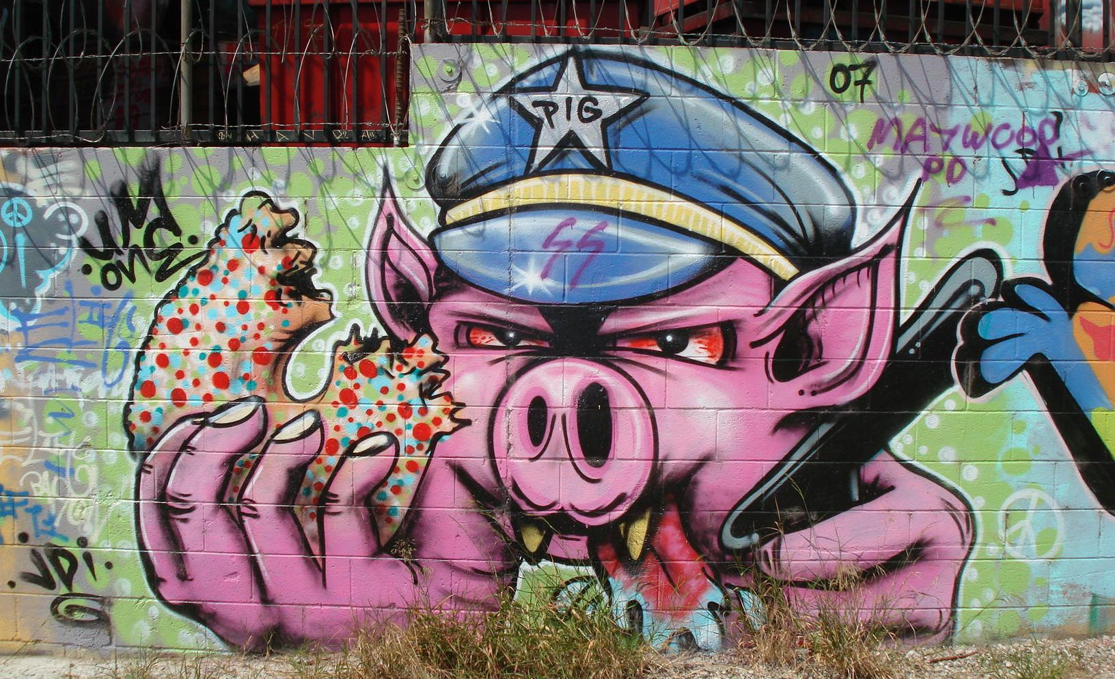
Figure 163. Police Pig Eating Donut under Barb Wire
Location: Los Angeles, California, USA
Date: 2007
Source: https://woowpost.blogspot.com/2008/03/best-cool-graffiti-arts-picture.html

Return to Page 58

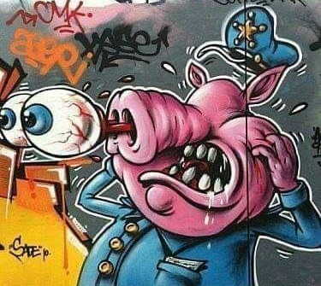
Figure 164. Police Pig with Eyes Bulging through Snout
Location: Montpellier, France
Date: 2012
Source: http://ist2011.over-blog.com/article-patandpatate-photographe-montpellier-105576789.html

Return to Page 59
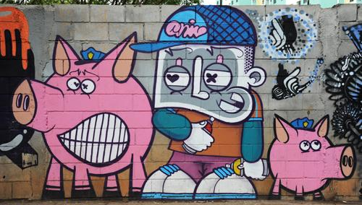
Figure 165. Two Little Police Piggies
Location: São Paulo, Brazil
Date: 2013
Photographer: Jurandir Lima
Source: https://www.flickr.com/photos/jurandir_lima/8367189460

Return to Page 59

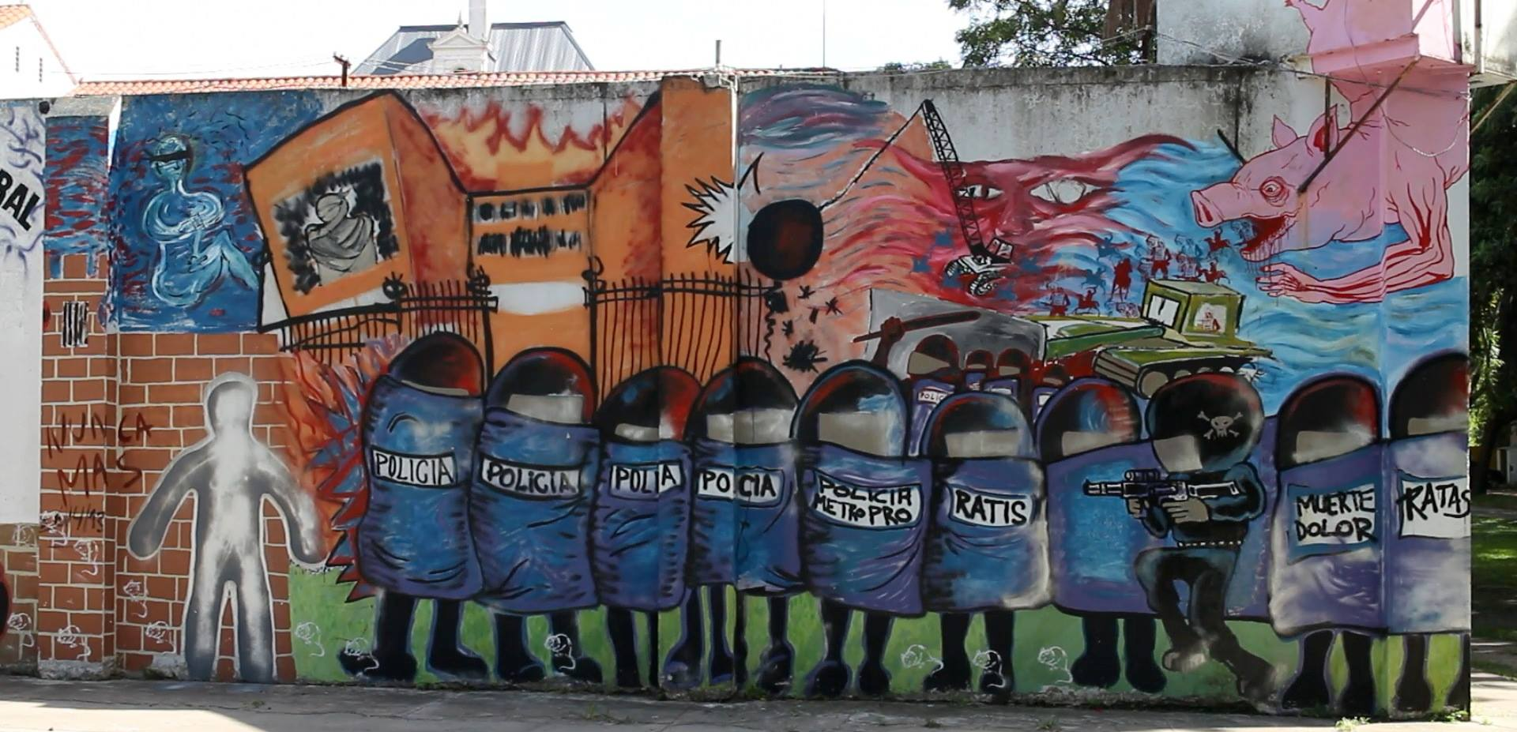
Figure 166. Mural Denouncing Police Attack on Hospital
Location: Borda, Argentina
Date: 2013
Artist: Borda Artists Front (see Ferigato and Caralho, 2011)
Source: https://www.perfil.com/noticias/sociedad/talleristas-del-borda-pintaron-murales-para-repudiar-la-represion-de-la-policia-20130504-0004.phtml & https://www.facebook.com/photo/?fbid=389608666710691&set=pb.100069846831380.-2207520000

Return to Page 59
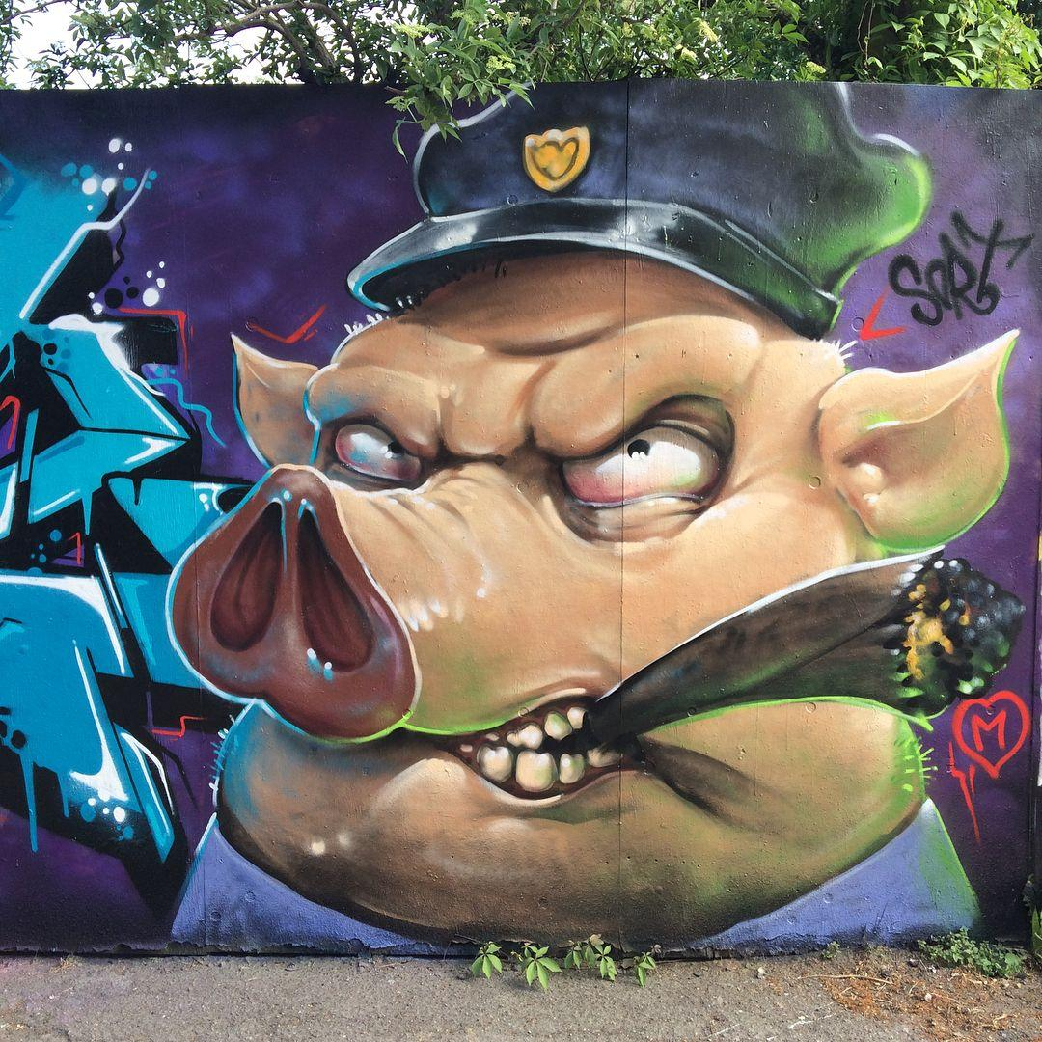
Figure 167. Police Pig Smokes Cigar
Location: Copenhagen, Denmark
Date: 2018
Artists: Frederik Bager and Royes
Source:https://www.instagram.com/p/BjScGC2nAen/?igshid=74ao54fiw4pm&epik=dj0yJnU9R25jODAwVnlnTjA1bjY5bmtqb3Q2bzFvSEVKZkl0Z3QmcD0wJm49YU1CcnRJWTl3WVNIYXJsRHFoVHpnUSZ0PUFBQUFBR1hOSll3

Return to Page 59

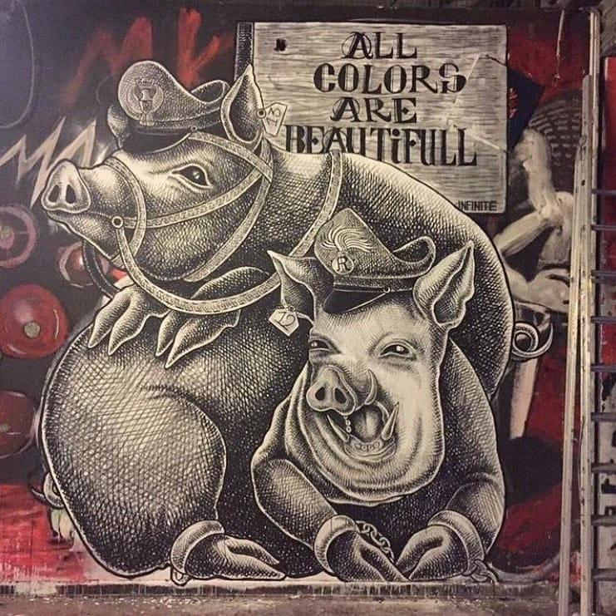
Figure 168. All Colors Are Beautiful, 1312
Location: Bologna, Italy
Date: 2018
Photographer: Marina Guibert
Source: https://social.shorthand.com/marina_guibert/n2wiBpvZPx/etre-contre-ou-ne-pas-etre

Return to Page 59

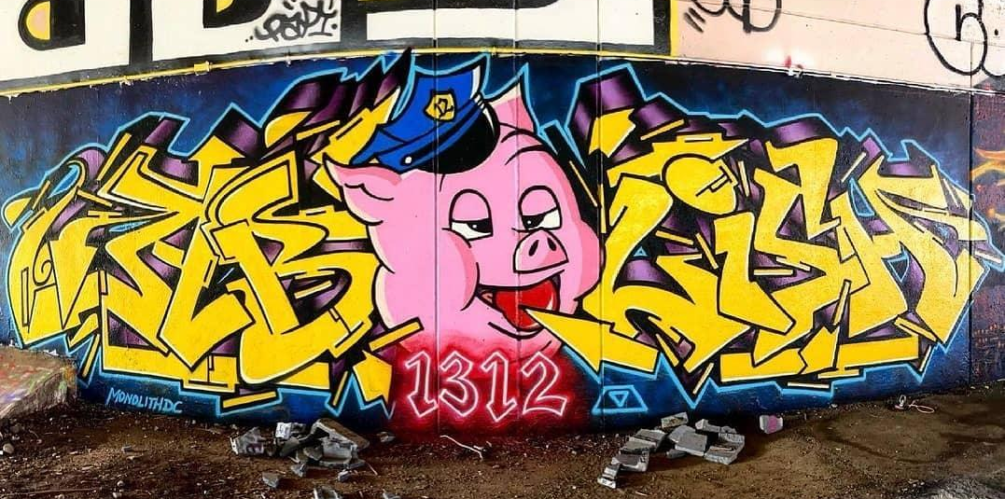
Figure 169. Ab—PIG—lish 1312
Location: Washington D. C., USA
Date: 2021
Artist: Monolith DC
Source: https://www.instagram.com/p/CQPk3fEFEr8/ & https://www.instagram.com/p/Cn7ihQ4OtqD/

Return to Page 59

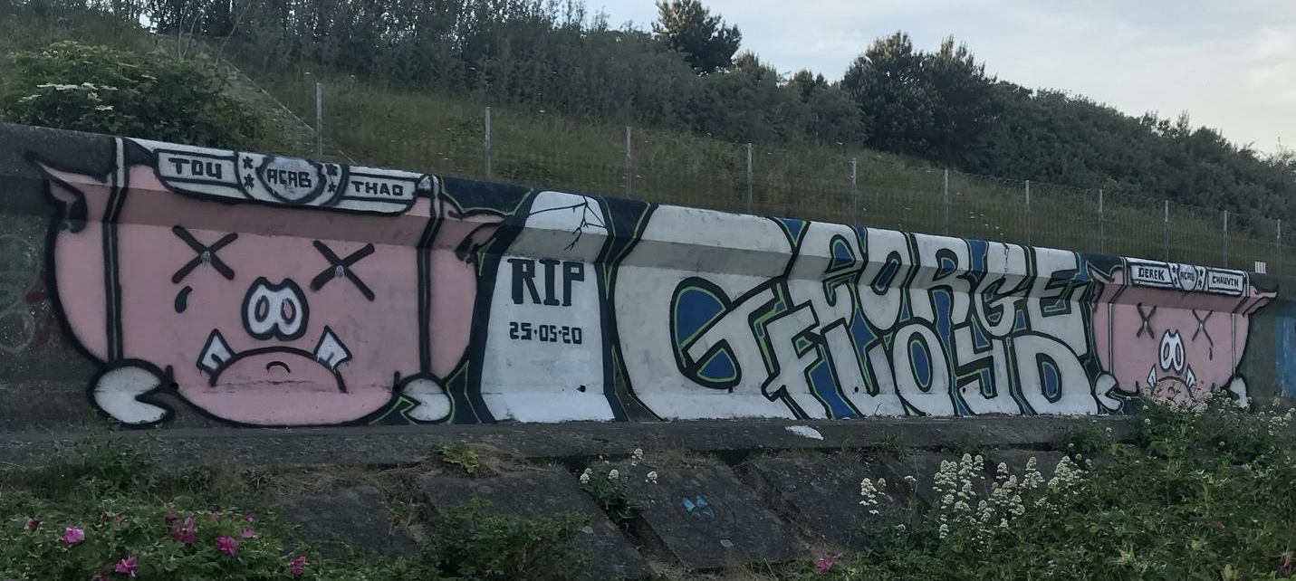
Figure 170. Police Officers Tou Thad and Derek Chauvin as Pigs
Location: Edinburgh, Scotland
Date: 2020
Photographer: Nicolas Le Bigre
Source: https://georgefloydstreetart.omeka.net/items/show/2140

Return to Page 59

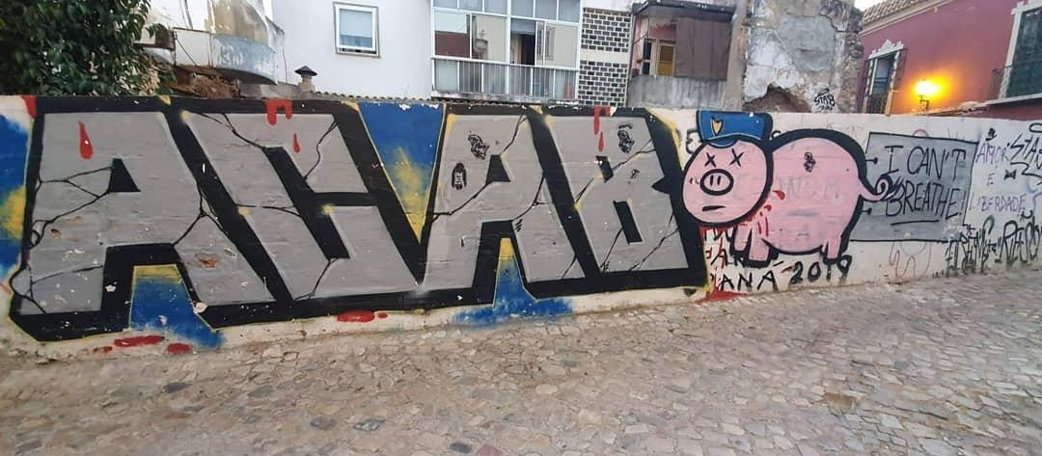
Figure 171. ACAB, Police Pig, and I Can’t Breathe Sign
Location: Faro, Portugal
Date: 2021
Source: https://www.instagram.com/p/CRqT0IlrMkx/

Return to Page 59

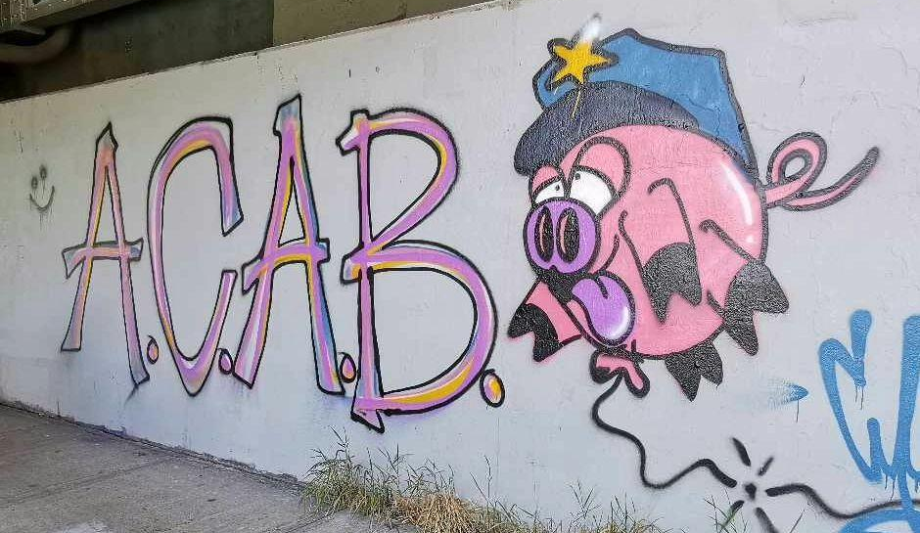
Figure 172. A.C.A.B. Police Pig with His Tongue Out
Location: Red Deer, Alberta, Canada
Date: 2023
Source: https://www.instagram.com/p/CxUT7R_SQYG/?img_index=2

Return to Page 59

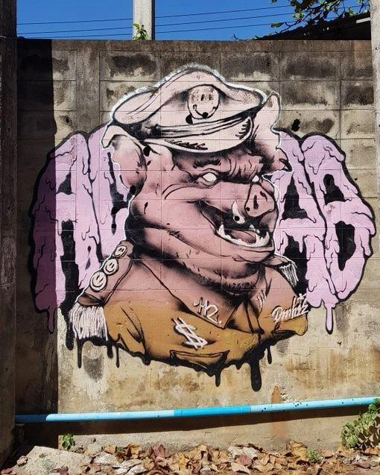
Figure 173. ACAB and Smiley Face Police Pig
Location: Chiang Mai, Thailand
Date: 2022
Source: https://www.instagram.com/p/Chodow0PO4F/ & https://th.trip.com/moments/detail/nong-pa-khrang-2016489-119407844?locale=th-TH

Return to Page 59
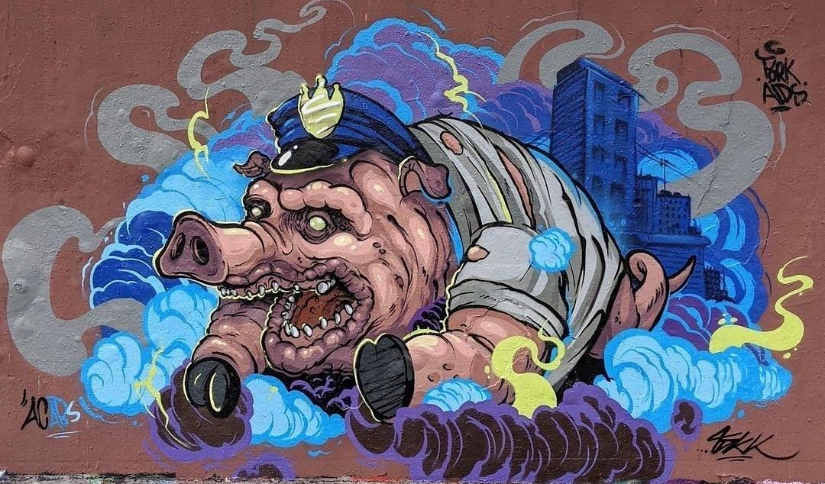
Figure 174. Police Pig Gallops in Blue Smoke
Location: Germany
Date: 2021
Artist: Tokk
Source: https://www.facebook.com/Grafffunk/photos/a.592550270830980/4007565559329417/ & https://www.instagram.com/dopegraffitidaily/p/CP0WF28hg1y/?img_index=2

Return to Page 59
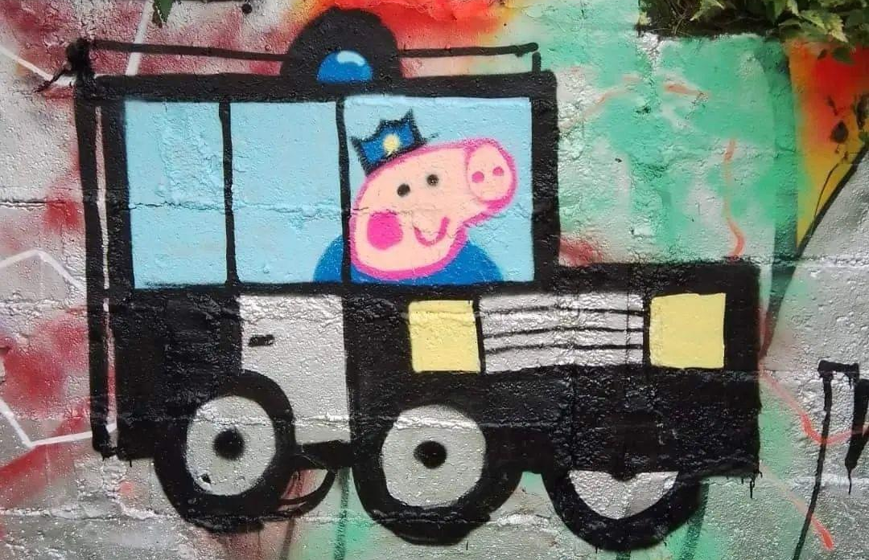
Figure 175. Peppa Pig Police
Location: France
Date: 2022
Source: https://www.instagram.com/p/CYum15mPLH2/?img_index=1

Return to Page 59
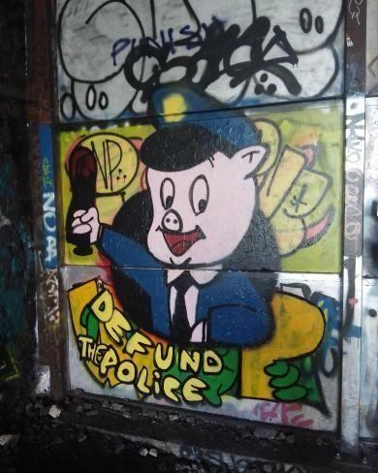
Figure 176. Defund the Police Porky Police Pig
Location: Paris, France
Date: 2022
Source: https://www.instagram.com/p/ChfNlzwvIxC/

Return to Page 59

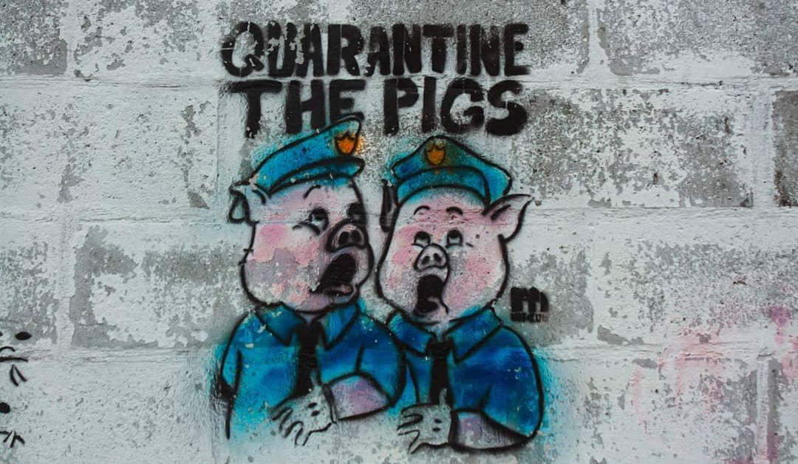
Figure 177. Quarantine the Pigs Stencil
Location: Rodriguez, Rizal, Philippines
Date: 2021
Source: https://www.instagram.com/p/CQn2mhHLgpC/?img_index=1

Return to Page 59

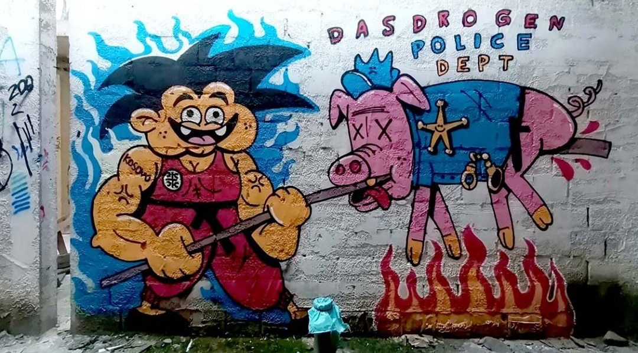
Figure 178. Das Drogen Police Dept
Location: Belgrade, Serbia
Date: 2021
Photographer: Aleksandar Dalek Dordevic
Source: Posted by Street Art Belgrad https://twitter.com/BGgrafiti/status/1394363503792775174

Return to Page 59

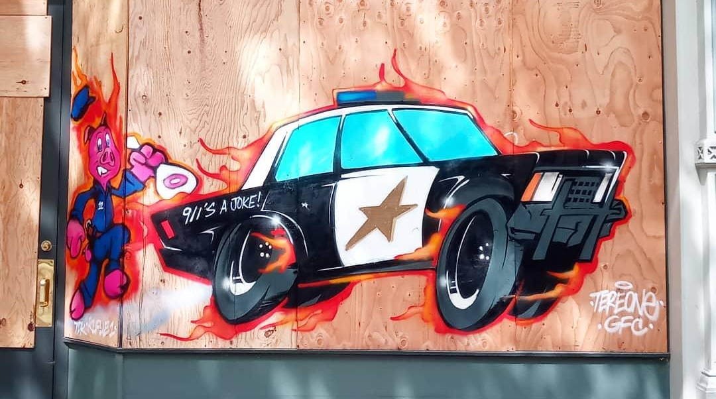
Figure 179. Police Pig Chases Burning Cop Car: 911’s a Joke!
Location: Oakland, California, USA
Date: 2021
Artists: Tere One, Kemest, GFC Krew
Source: https://www.instagram.com/p/CN3NgJEMXI1/

Return to Page 60

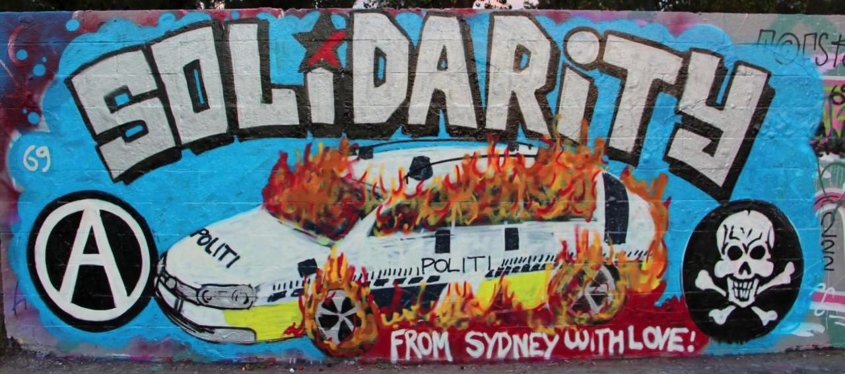
Figure 180. Solidarity From Sydney with Love!
Location: Sydney, Australia
Date: 2017
Sources: https://www.youtube.com/watch?v=JcoPNxpW4NI

Return to Page 61
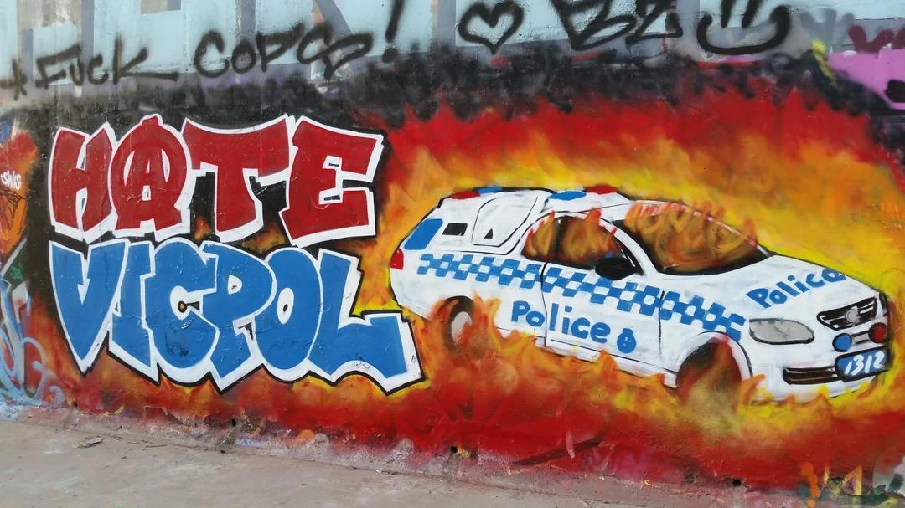
Figure 181. Hate Vic Pol
Locations: Melbourne, Australia
Date: 2019
Source: https://www.reddit.com/r/StreetArtPorn/comments/donijr/hate_victoria_police_mural_in_melbourne/

Return to Page 61

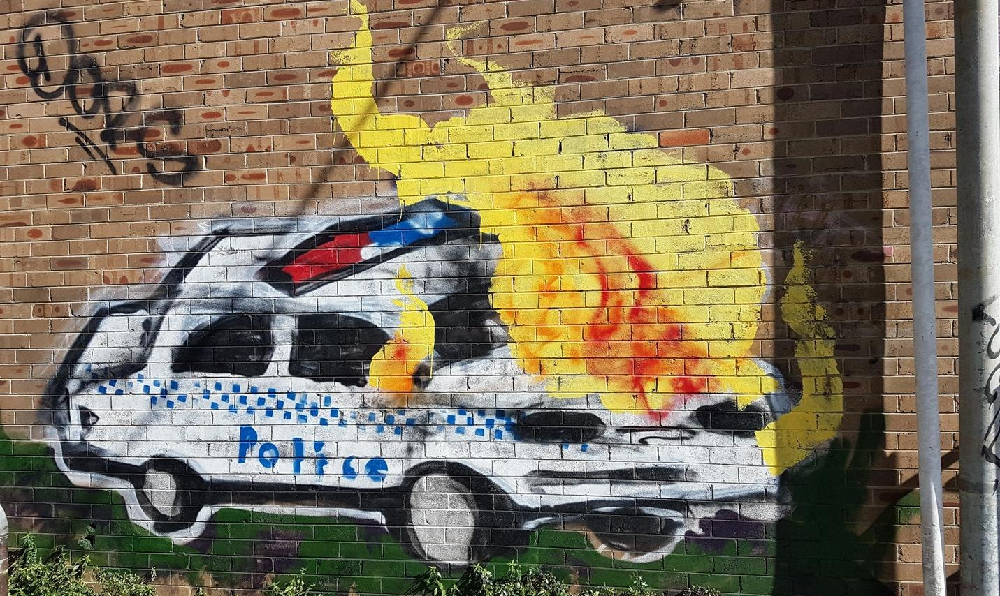
Figure 182. Burning Cop Car Mural in Enmore
Location: Sydney, Australia
Date: 2019
Source: https://www.reddit.com/r/sydney/comments/dsffz3/burning_cop_car_mural_in_enmore/

Return to Page 61
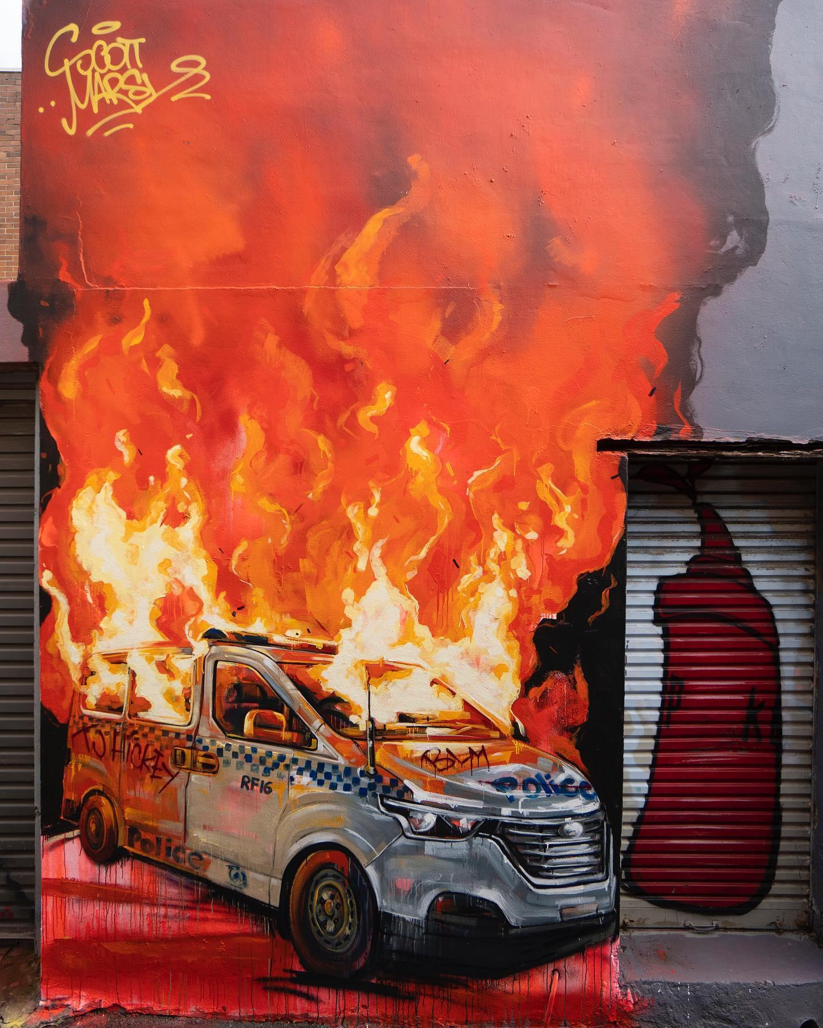
Figure 183. A Symbol of Pain and Frustration
Location: Sydney, Australia
Date: 2020
Artist: Scott Marsh
Sources: https://www.huffpost.com/archive/au/entry/scottie-marshs-black-lives-matter-mural_au_5ef2b749c5b601e599564885 & https://www.instagram.com/p/CBuihz5lfL7/

Return to Page 61

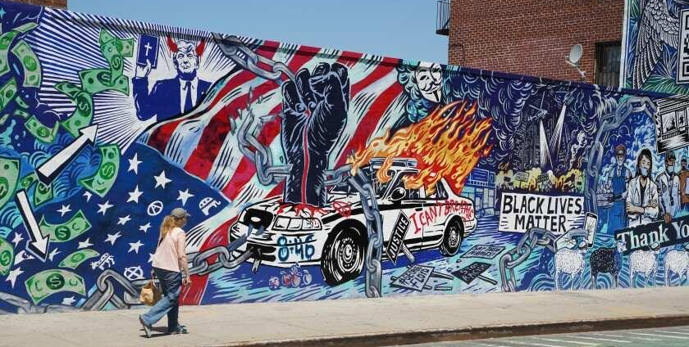
Figure 184. 2020 Now But Not Forever
Location: Brooklyn, New York, USA
Date: 2020
Artist: Overall Murals
Source: https://greenpointers.com/2020/06/30/williamsburg-mural-depicts-2020s-chaotic-headlines-so-far/

Return to Page 61

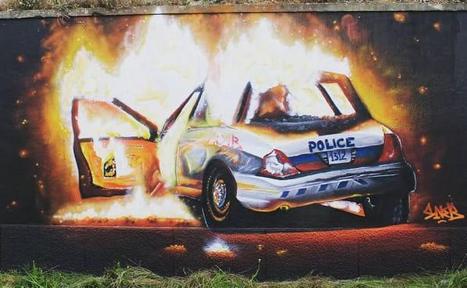
Figure 185. Police Car on Fire from Behind
Location: Lisbon, Portugal
Date: 2020
Artist: SNEB
Source: https://www.facebook.com/radicalgraff/posts/burning-cop-car-mural-in-lisbon-portugal/2511079972530278/

Return to Page 61

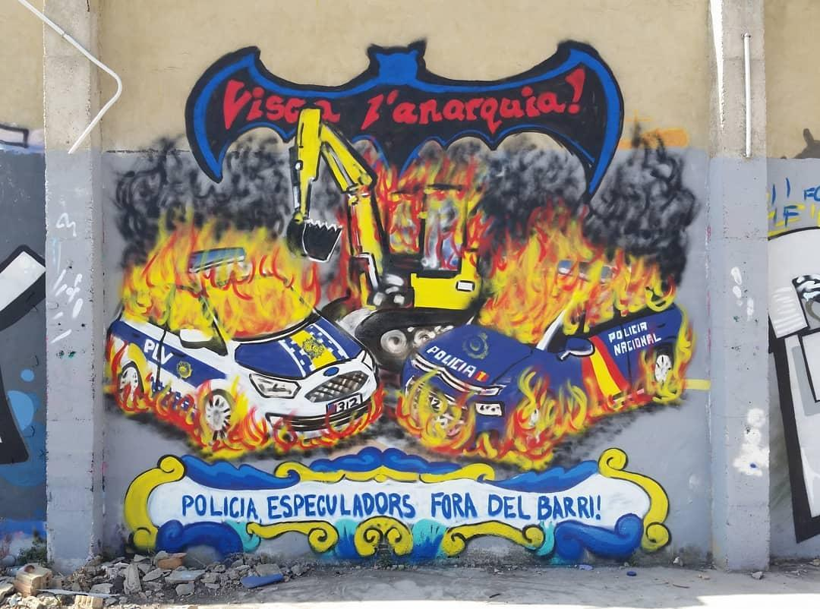
Figure 186. Visca l’anarquia!
Location: Valencia, Spain
Date: 2021
Source: https://www.instagram.com/p/CSEcDYGFO0c/

Return to Page 61

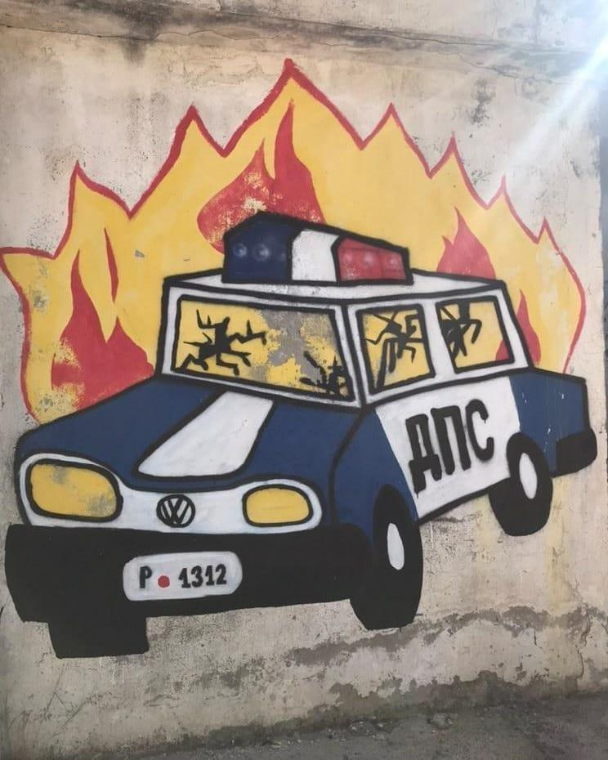
Figure 187. Cop Car on Fire, License Plate 1312
Location: Buljarice, Montenegro
Date: 2021
Source: https://www.facebook.com/radicalgraff/posts/mural-seen-in-buljarice-montenegro/2683929518578655/

Return to Page 61

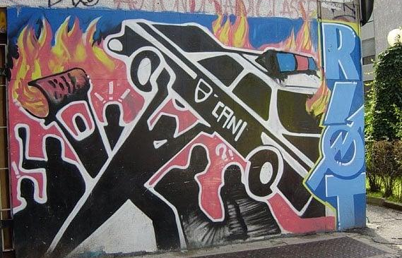
Figure 188. Police Car on Fire RIOT
Location: Milan, Italy
Date: 2021
Source: https://www.instagram.com/p/CVpXen3JWRO/

Return to Page 61

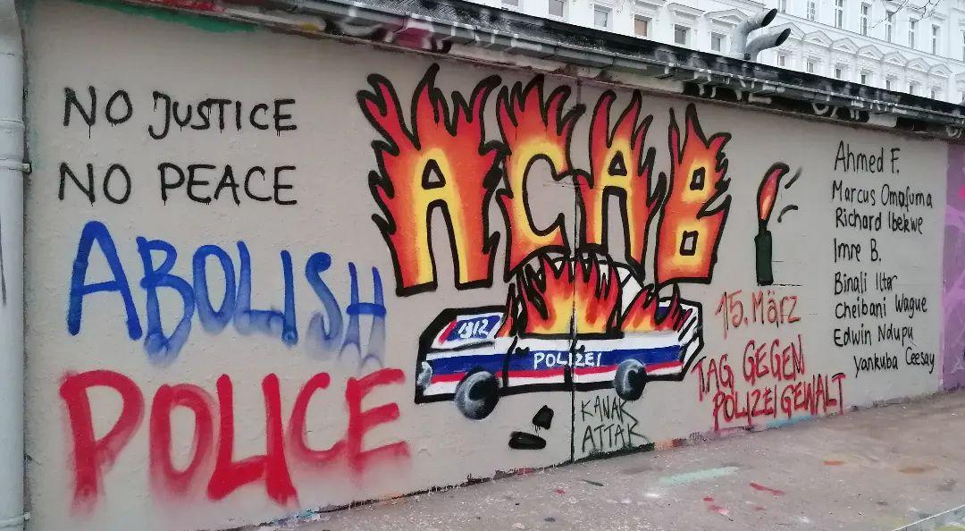
Figure 189. No Justice No Peace Abolish Police, ACAB Ablaze
Location: Vienna, Austria
Date: 2022
Source: https://www.instagram.com/p/Cbd7D7uvGEo/

Return to Page 61
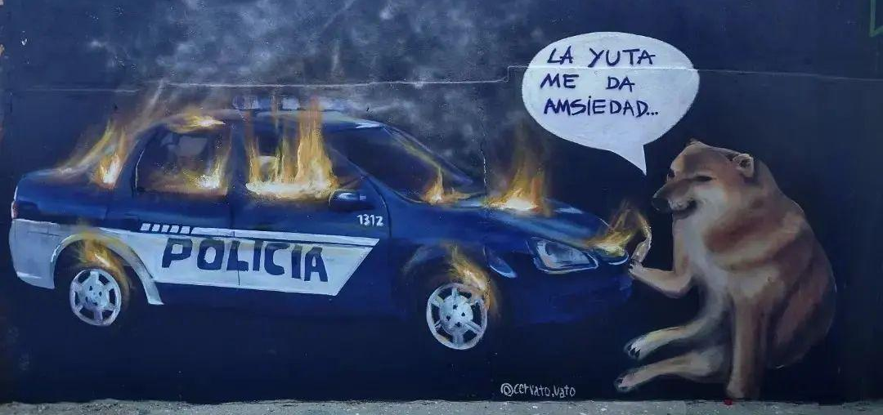
Figure 190. La Yuta Me Da Amsiedad, or "The police give me anxiety"
Location: Alta Gracia, Córdoba, Argentina
Date: 2022
Artist: Franco Cervato Cozza
Source: https://www.instagram.com/p/CcvTRSlOcmP/?img_index=1

Return to Page 61

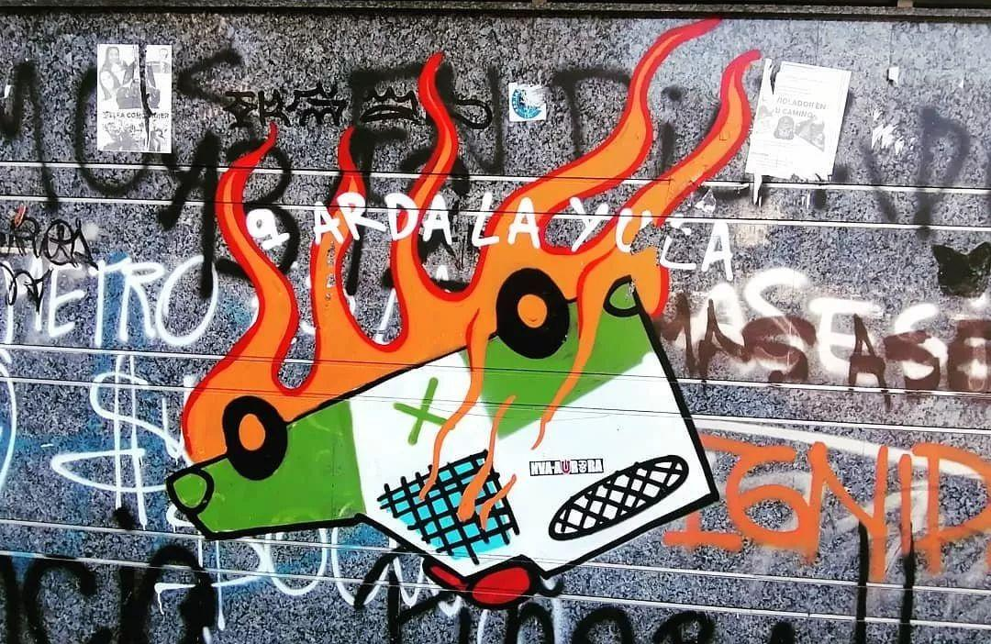
Figure 191. Green, Upside Down, and on Fire
Location: Valparaiso, Chile
Date: 2022
Source: https://www.instagram.com/p/Chcm54-vY-o/

Return to Page 61

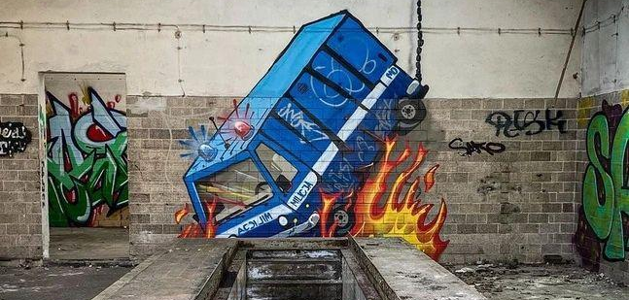
Figure 192. Police Car on Fire on Abandoned Building
Location: Koszalin, Poland
Date: 2022
Source: https://www.instagram.com/p/Cb1s6v1LPmf/

Return to Page 61

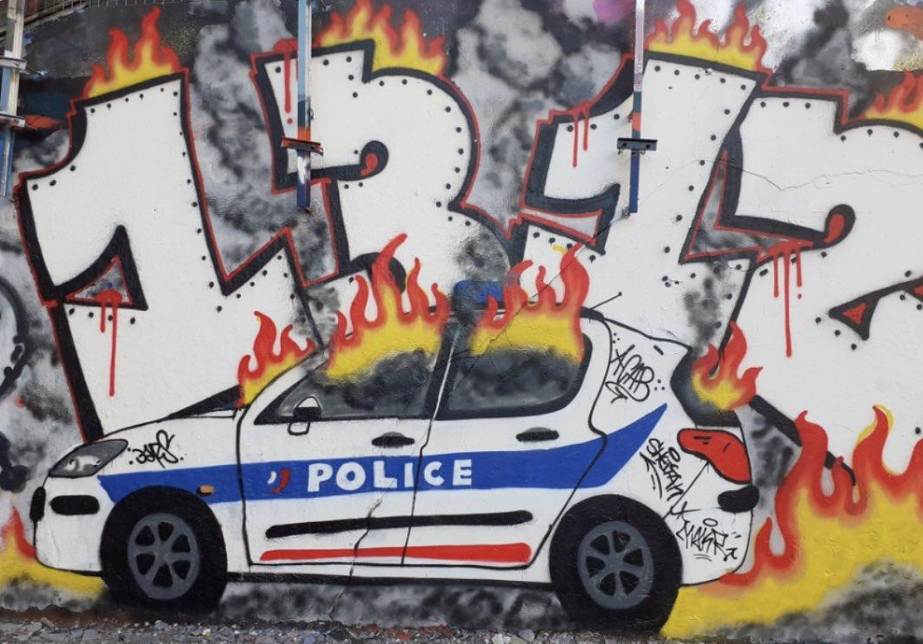
Figure 193. 1312 Police Car on Fire
Location: Lyon, France
Date: 2022
Source: https://www.leprogres.fr/faits-divers-justice/2022/02/24/un-nouveau-tag-anti-flics-a-la-croix-rousse-la-police-municipale-de-lyon-accuse-les-verts-de-complaisance-avec-les-groupes-antifascistes

Return to Page 61

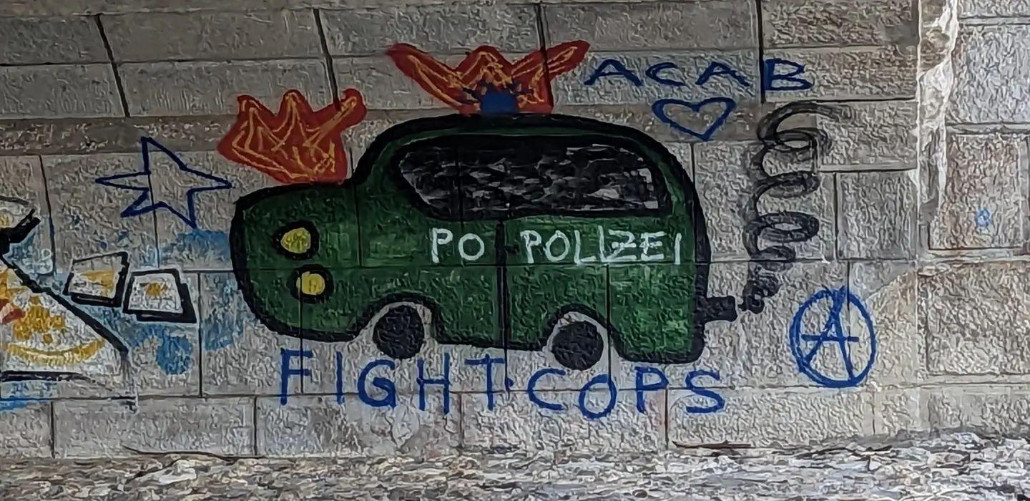
Figure 194. Fight Cops
Location: Munich, Germany
Date: 2023
Source: https://www.instagram.com/p/CznLpFvy_Y6/

Return to Page 61

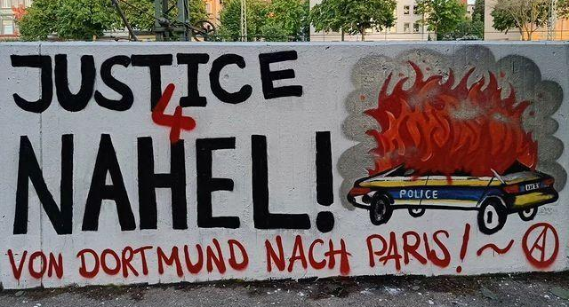
Figure 195. Justice 4 Nahel!
Location: Dortmund, Germany
Date: 2023
Artist: Die Plattform Ruhr
Source: https://www.instagram.com/p/CuadZSgNtFm/

Return to Page 61

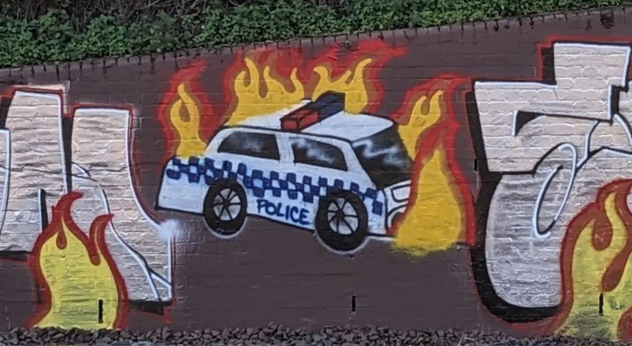
Figure 196. Cop Car on Fire Mid-Mural
Location: Sydney, Australia
Date: 2023
Source: https://www.instagram.com/p/CyD-tUXyddB/

Return to Page 61

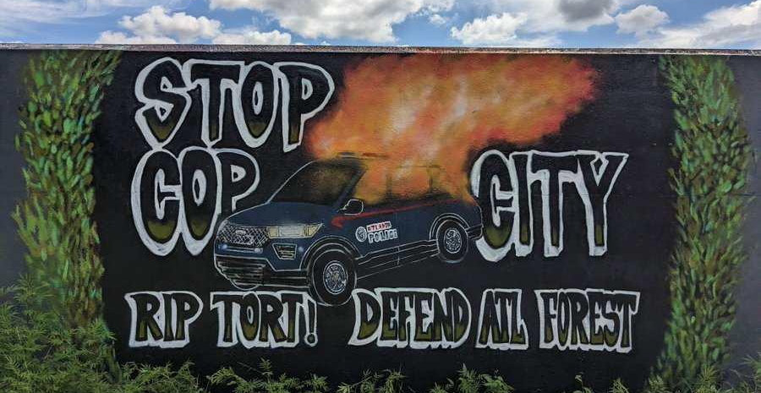
Figure 197. Stop Cop City/ RIP Tort!/ Defend ATL Forest
Location: Athens, Georgia
Date: 2023
Source: https://twitter.com/GraffitiRadical/status/1747993948654870969

Return to Page 61

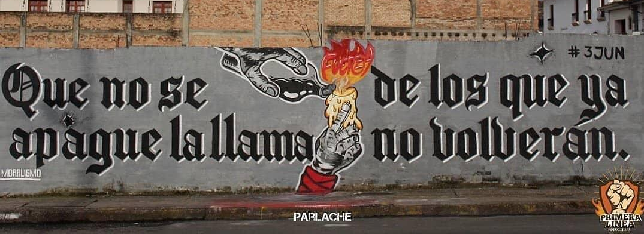
Figure 198. May the Flame of Those Who Will Not Return Never Be Extinguished
Location: Popayán, Colombia
Date: 2021
Photographer: Parlache Fotografía
Source: https://www.instagram.com/p/CQJMAZ3lXor/

Return to Page 63

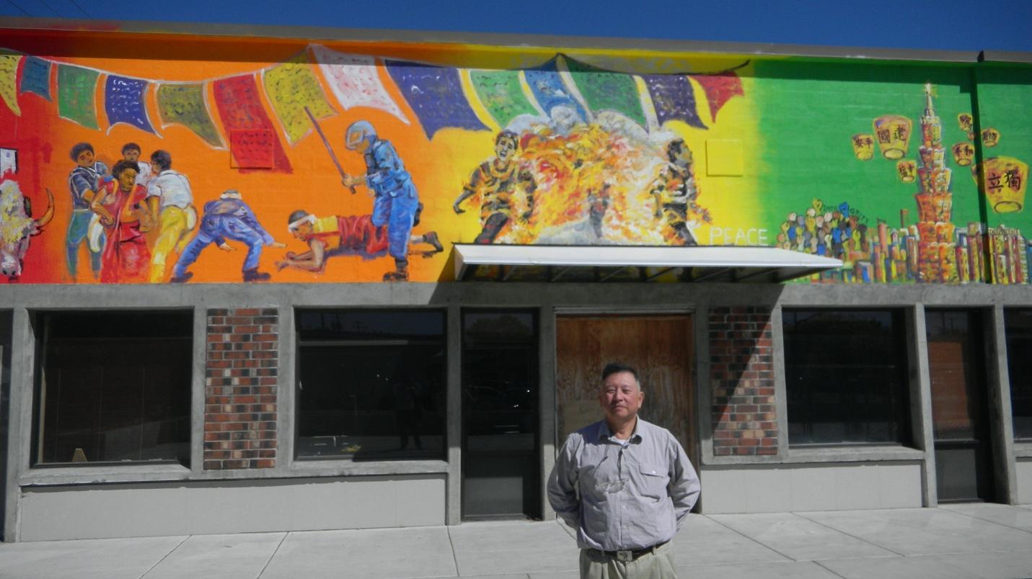
Figure 199. Solidarity with Tibet and Taiwan Mural Commissioned By Businessman David Lin
Location: Corvallis, Oregon, USA
Date: 2012
Artist: Chao Tsung-song
Photographer: Chris Lehman
Source: https://www.npr.org/2012/09/19/161343395/why-does-china-want-a-mural-in-oregon-destroyed

Return to Page 62
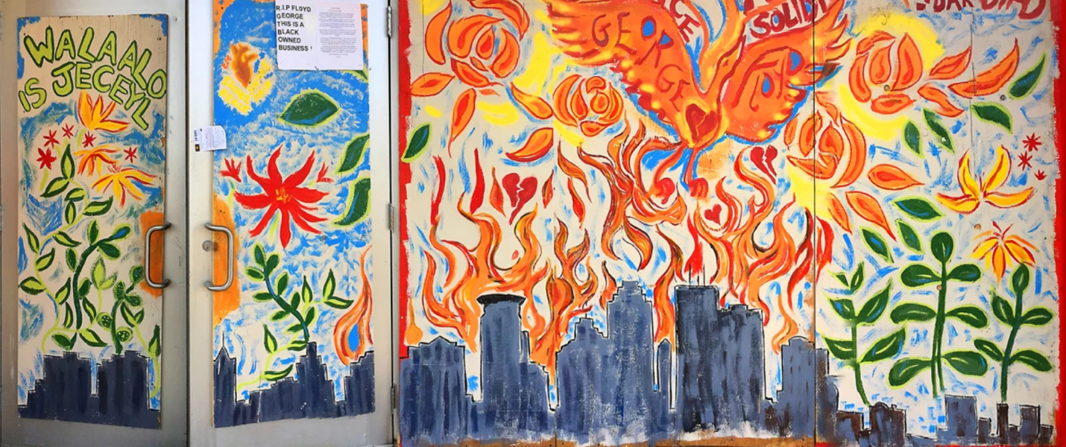
Figure 200. Walaalo is Jeceyl and George Floyd in the Wings of a Phoenix
Location: Minneapolis, Minnesota, USA
Date: 2020
Source: https://georgefloydstreetart.omeka.net/items/show/2922

Return to Page 63

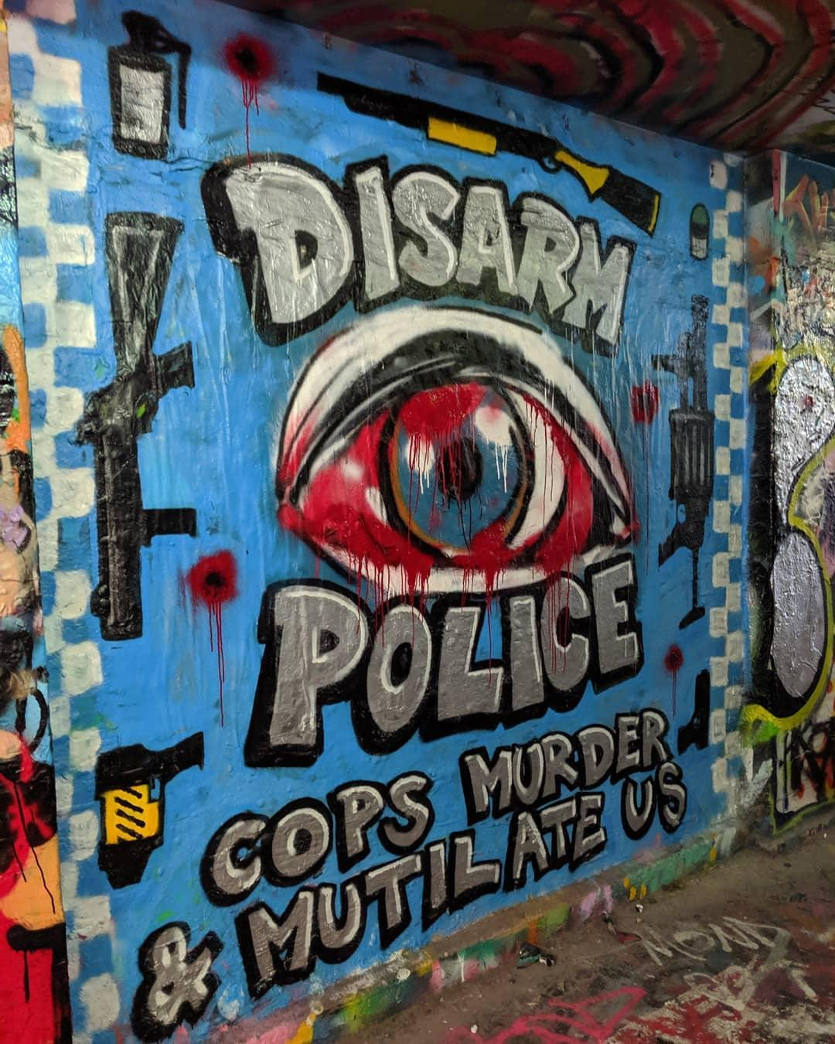
Figure 201. Disarm Police: Cops Murder & Mutilate Us
Location: Los Angeles, California, USA
Date: 2020
Source: https://www.instagram.com/p/CDIfPb3gmPY/

Return to Page 63

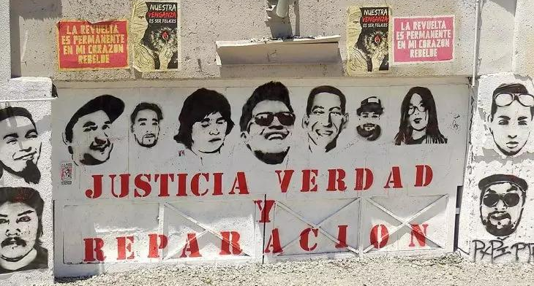
Figure 202. Justicia Verdad Y Reparacion Victims of Police Killings Memorial Mural in Location: Santiago, Chile
Date: 2021
Photographer: Marit de Haan
Source: https://www.justiceinfo.net/en/105681-virtuous-model-reparation-emerging-chile.html

Return to Page 63

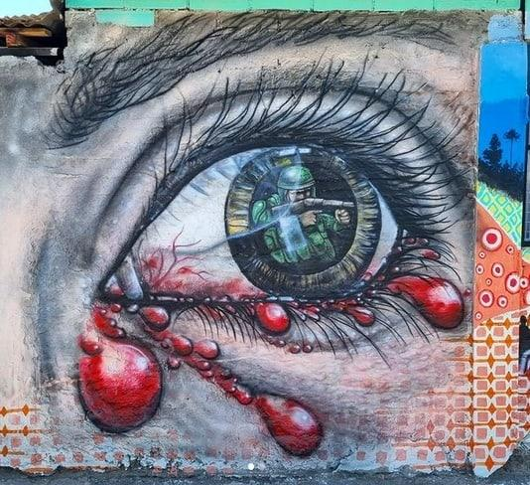
Figure 203. Solider in the Pupil of a Bloody Eye
Location: Santiago, Chile
Date: 2021
Source: https://www.instagram.com/p/CWM361ktuzT/

Return to Page 63

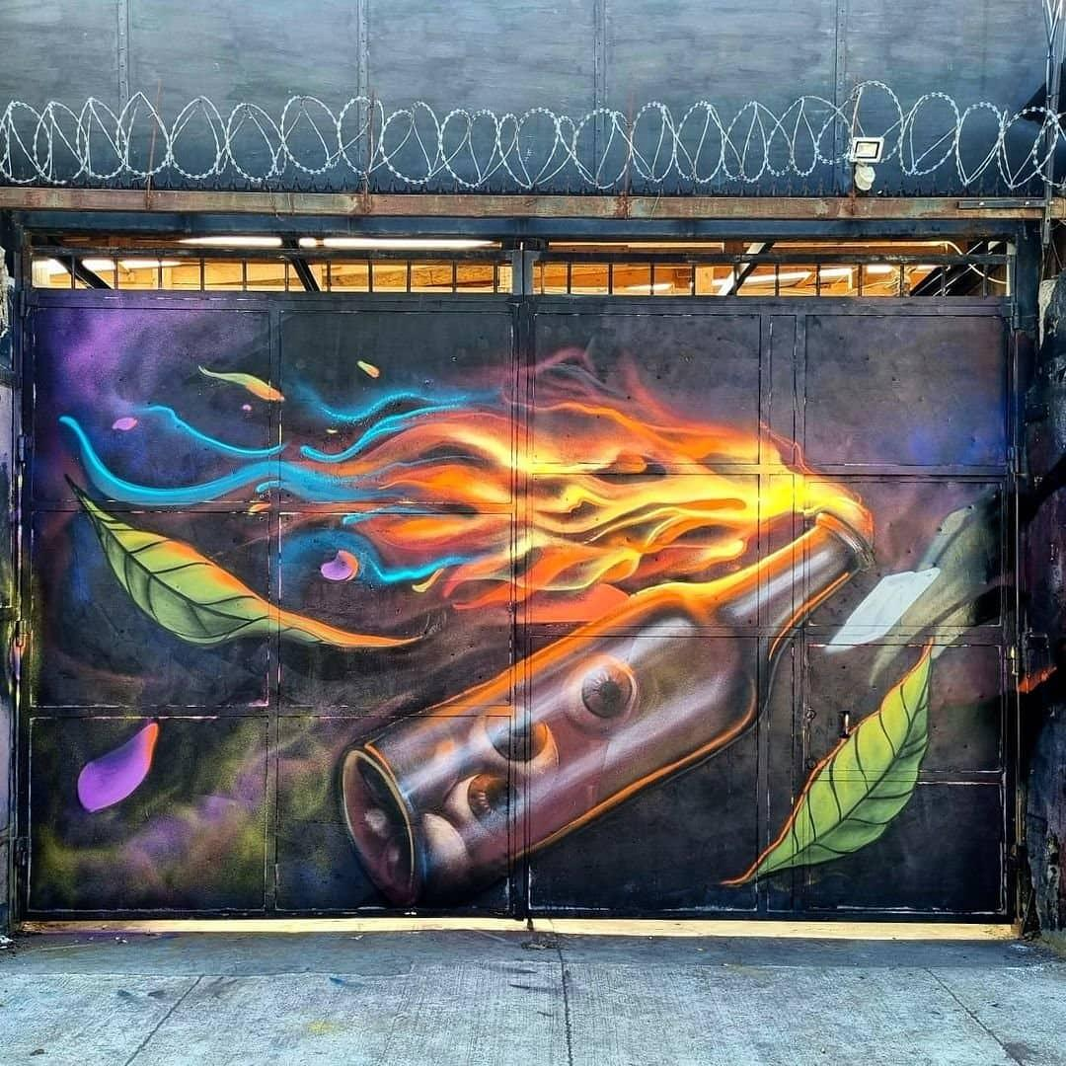
Figure 204. Eyes in a Molotov Cocktail
Location: Chile
Date: 2021
Source: https://www.instagram.com/p/CTTi6VXpk0q/

Return to Page 63

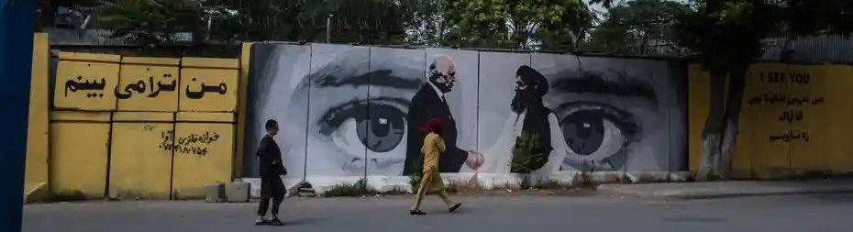
Figure 205. US-Taliban Agreement Towards Peace
Location: Kabul, Afghanistan
Date: 2021
Artists: ArtLords
Source: https://www.instagram.com/p/CTWjfxRprR9/?img_index=2

Return to Page 64

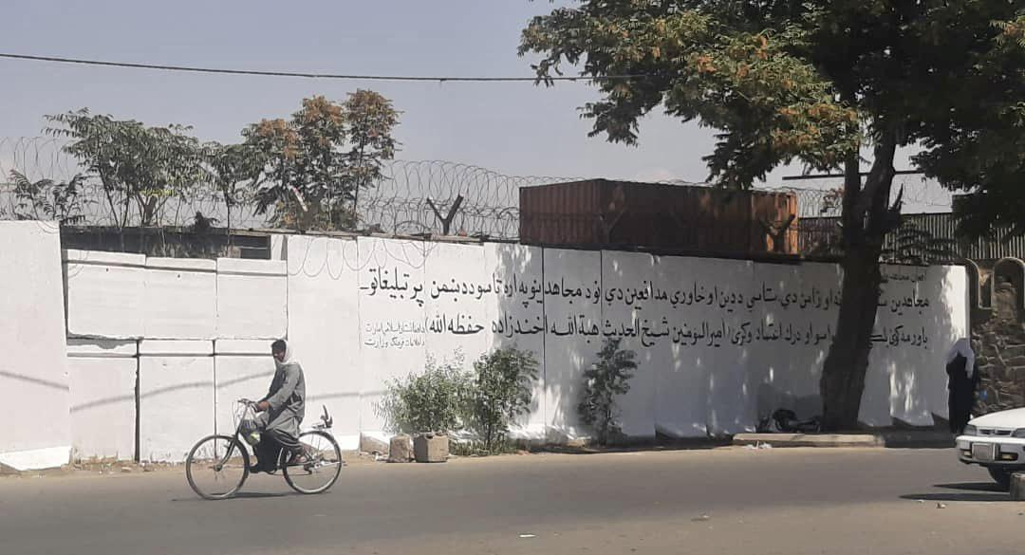
Figure 206. US-Taliban Agreement Towards Peace, After: Don’t Trust the Enemy’s Propaganda
Location: Kabul, Afghanistan
Date: 2021
Artists: The Taliban
Source: https://www.instagram.com/p/CTWjfxRprR9/?img_index=2

Return to Page 64

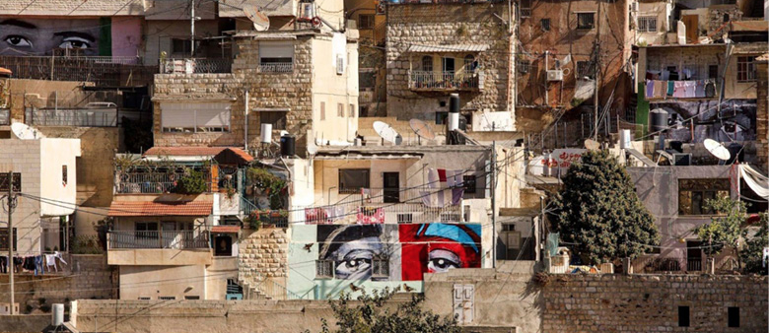
Figure 207. Eyes of Alex Nieto
Location: Silwan, Occupied Jerusalem
Date: 2016
Artist: Josué Rojas
Photographer: Kobi Wolf
Source: https://www.palestine-studies.org/en/node/1650290 & https://www.iwitnesssilwan.org/

Return to Page 64

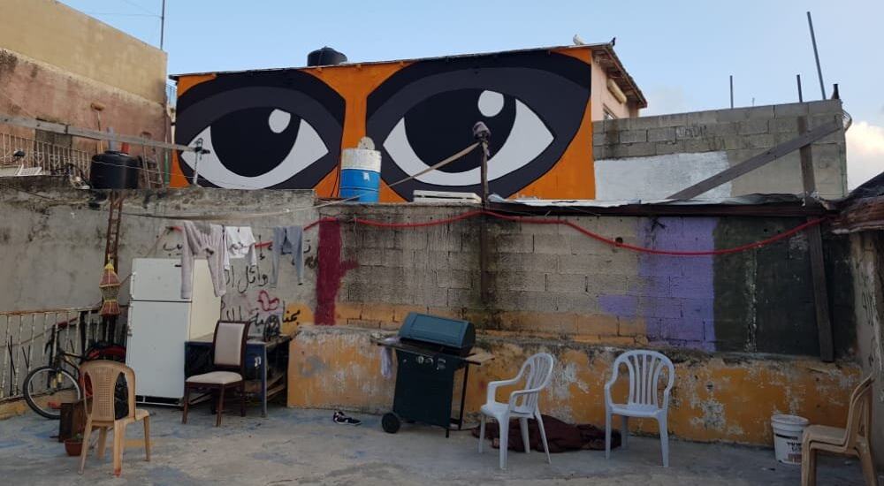
Figure 208. Eyes of Eyad al-Halak
Location: Silwan, Occupied Jerusalem
Date: 2020
Source: https://www.iwitnesssilwan.org/

Return to Page 64
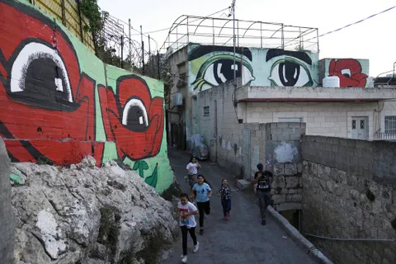
Figure 209. Palestinian Children Run in between Palestinian Flower Eyes
Location: Silwan, Occupied Jerusalem
Date: 2022
Photographer: Mahmoud Illean
Source: https://www.i24news.tv/en/news/israel/society/1691510380-israel-s-fm-smotrich-suspends-funds-for-arab-towns-citing-fear-of-criminals-and-terrorists

Return to Page 64

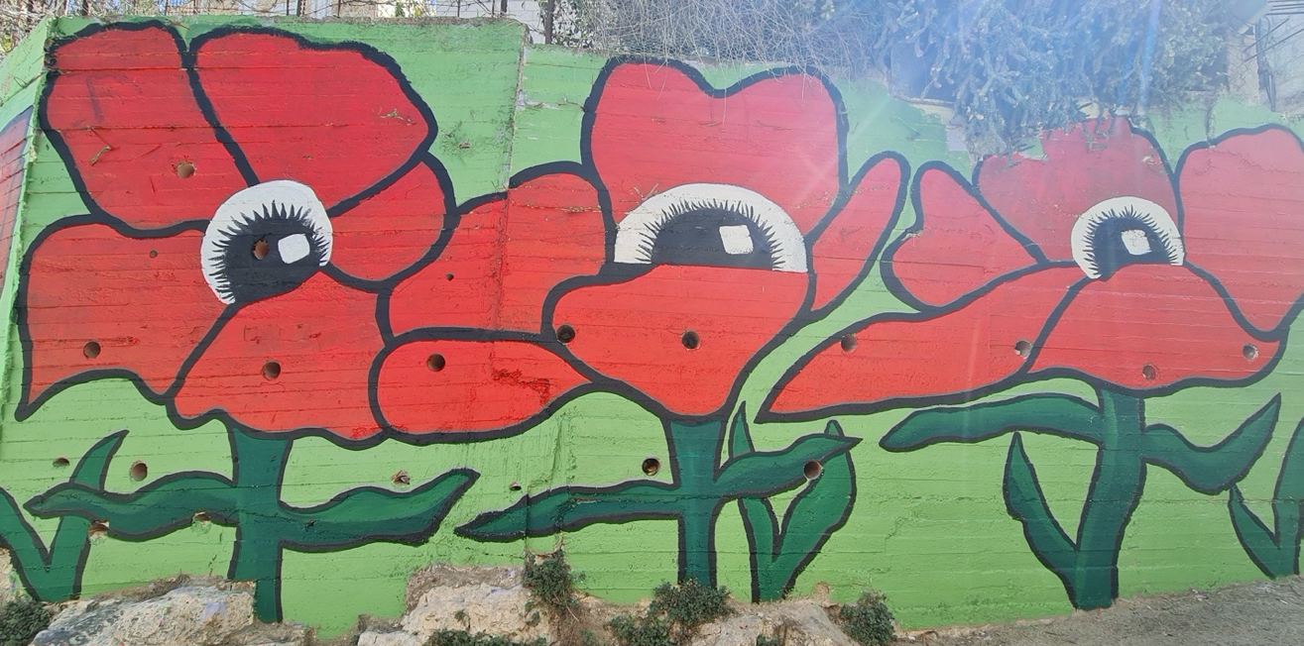
Figure 210. Palestinian Flower Eyes
Location: Silwan, Occupied Jerusalem
Date: 2022
Source: https://www.iwitnesssilwan.org/

Return to Page 64

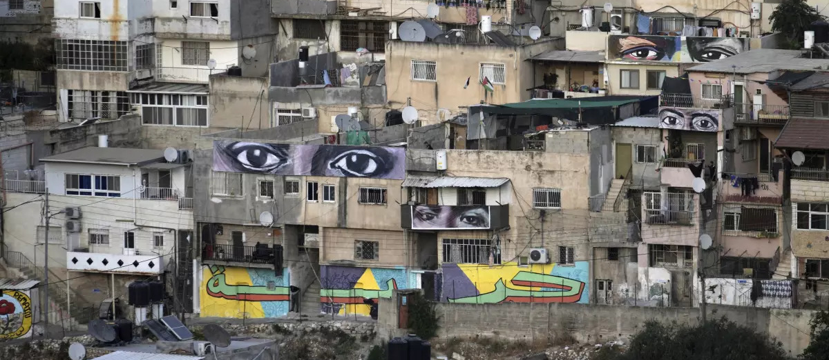
Figure 211. Eyes Looking Out, Including George Floyd’s
Location: Silwan, Occupied Jerusalem
Date: 2022
Photographer: Mahmoud Illean
Source: https://www.seattletimes.com/entertainment/giant-eye-murals-bear-witness-to-palestinians-in-jerusalem/

Return to Page 64

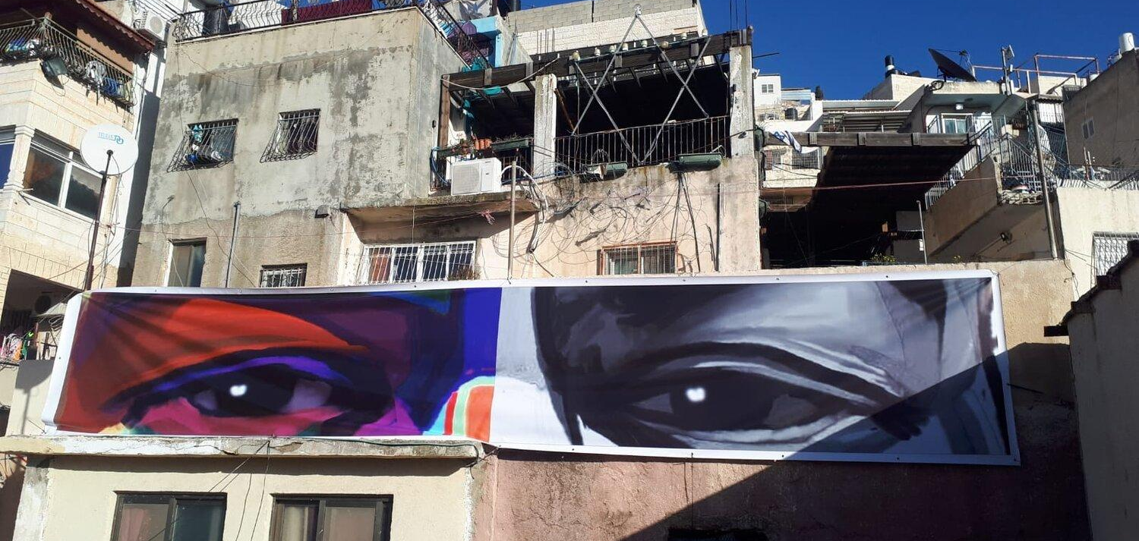
Figure 212. Eyes of George Floyd
Location: Silwan, Occupied Jerusalem
Date: 2021
Artist: Art Forces
Photographer: Jenan Maswadeh
Source: https://www.iwitnesssilwan.org/

Return to Page 64

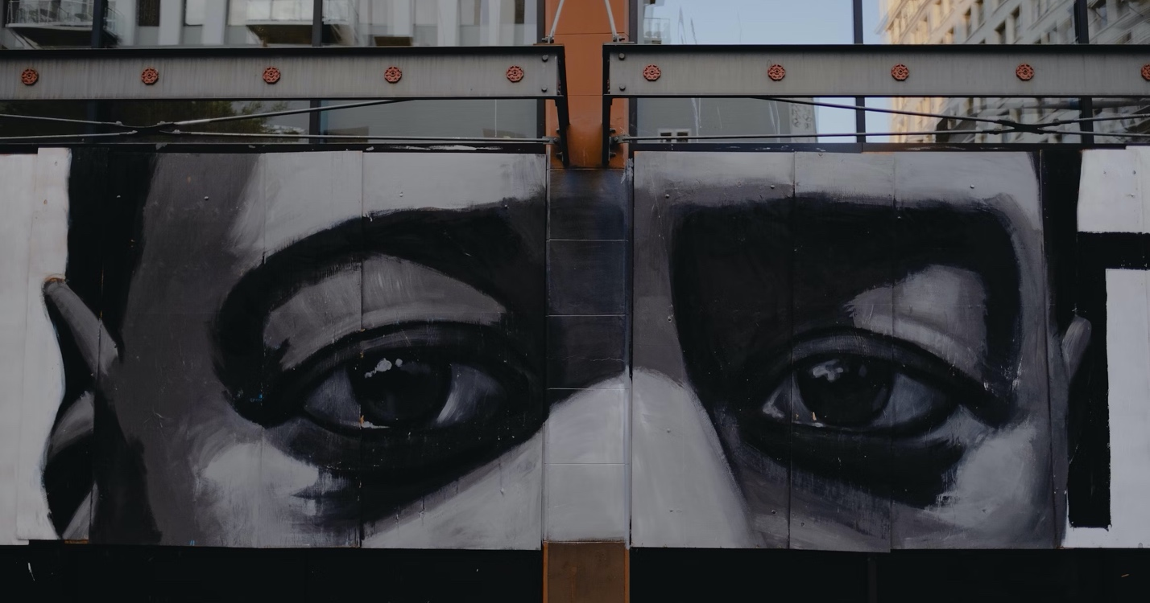
Figure 213. Eyes of George Floyd in Grayscale
Location: Los Angeles, California, USA
Date: 2020
Source: https://homelessness.acgov.org/coordinated-entry.page

Return to Page 64

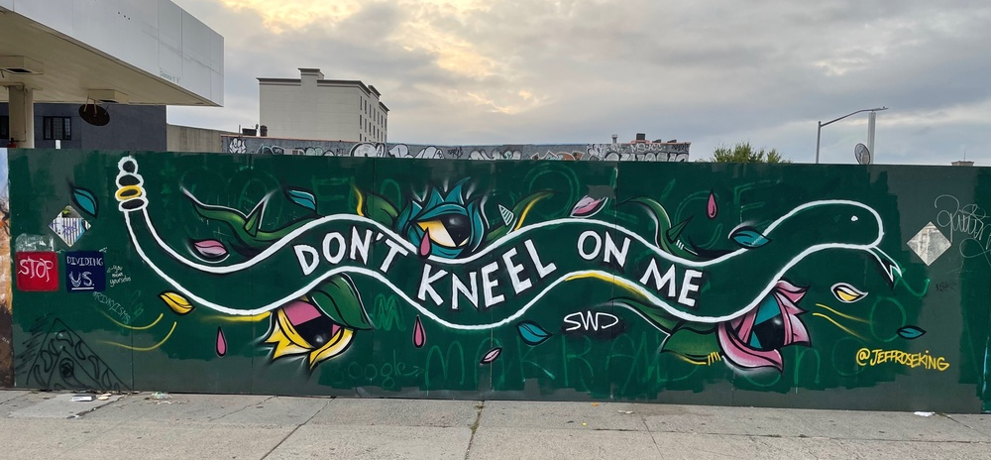
Figure 214. Don’t Kneel On Me
Location: New York City, New York, USA
Date: 2020
Artist: Jeff Rose King
Source: https://georgefloydstreetart.omeka.net/items/browse?tags=September+2021&sort_field=Dublin+Core%2CCreator

Return to Page 64

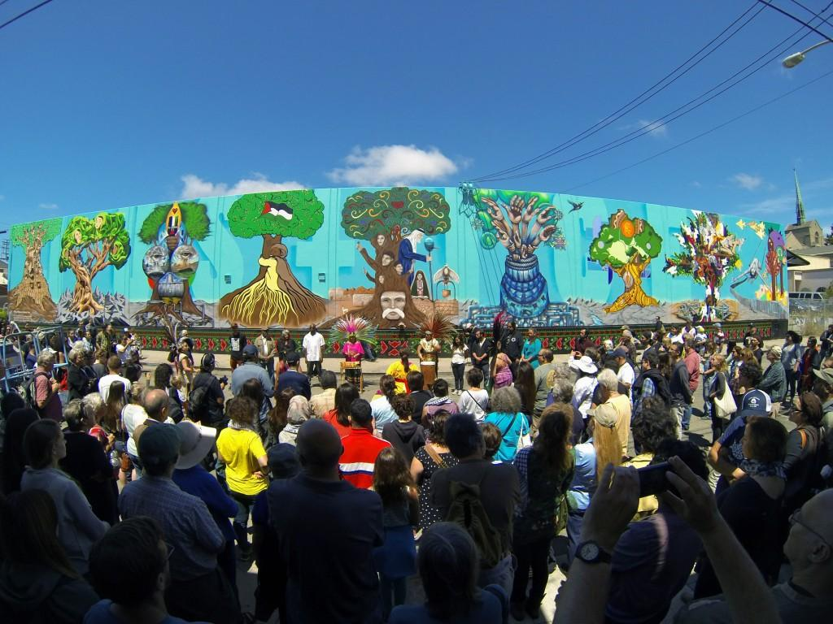
Figure 215. Oakland Palestine Solidarity Mural I
Artists: Left -Right: Nidal El Khairy, IROT, VYAL, Emory Douglas, Chris Gazaleh, Erin Yoshi, Deadeyes, SPIE, Deena Mattar in Collaboration with Susan Greene.
Location: Oakland, California, USA
Date: 2014
Source: https://artforces.org/home-not-suitcase-silwan-east-jerusalem/

Return to Page 65

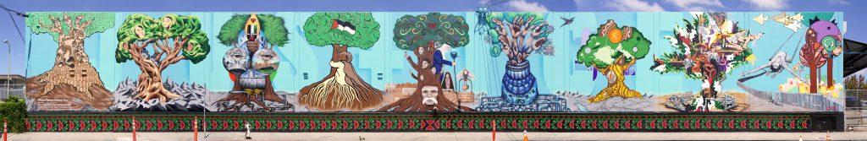
Figure 216. Oakland Palestine Solidarity Mural II
Artists: Left -Right: Nidal El Khairy, IROT, VYAL, Emory Douglas, Chris Gazaleh, Erin Yoshi, Deadeyes, SPIE, Deena Mattar in Collaboration with Susan Greene.
Location: Oakland, California, USA
Date: 2014
Source: https://artforces.org/projects/murals/usa/oakland-palestine-solidarity-mural/

Return to Page 65

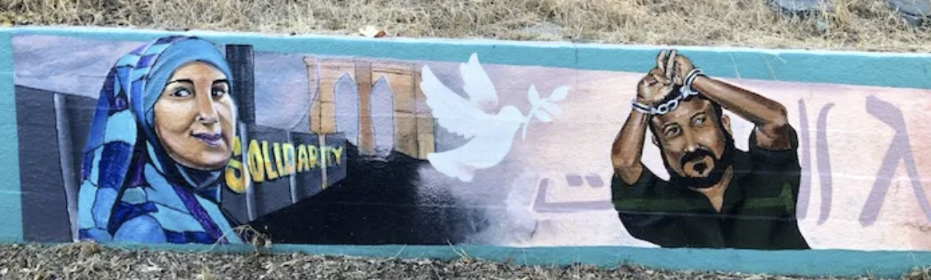
Figure 217. Solidarity Mural
Location: Oakland, California, USA
Date: 2017
Artists: Amend TDK, Eboni Stallworth, 67 Sueños, and students
Source: https://oaklandmurals.com/solidarity-mural-7/

Return to Page 65

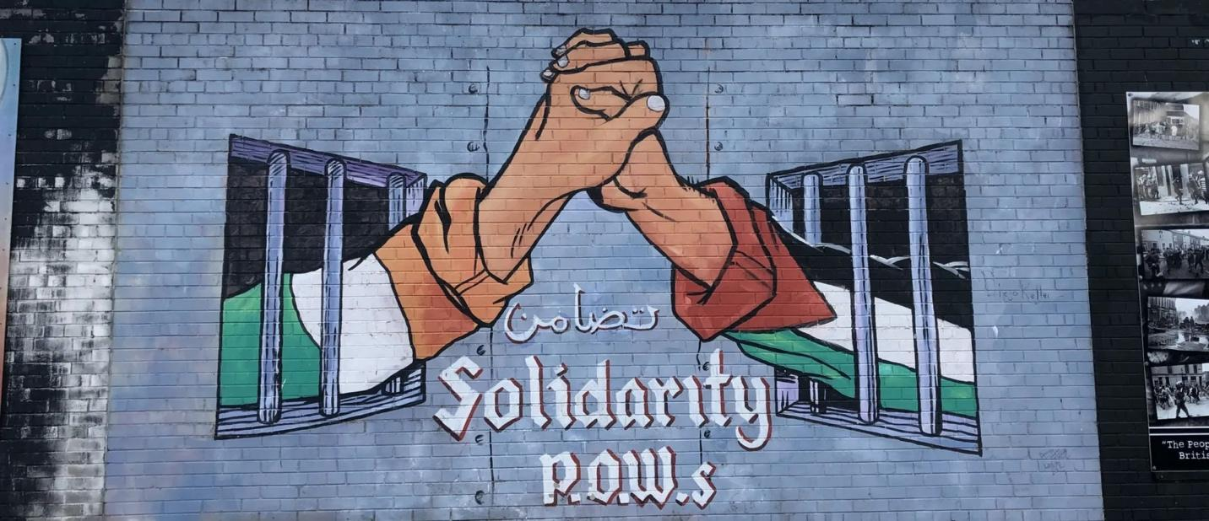
Figure 218. Solidarity P.O.W.s
Location: Belfast, Northern Ireland
Date: 2019
Source: https://www.flickriver.com/photos/zug55/50196577903/

Return to Page 65
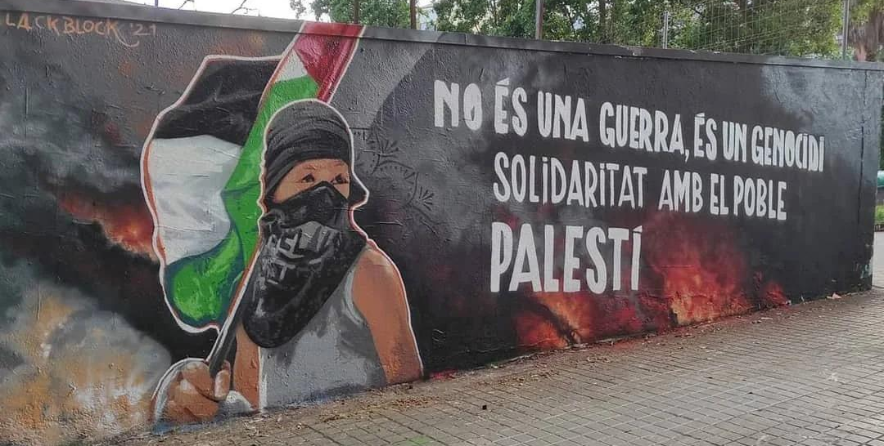
Figure 219. No és una Guerra, és un Genocidi (It is not a War, It is a Genocide)
Location: Barcelona, Spain
Date: 2021
Artist: Lack Block
Source: https://www.reddit.com/r/Barcelona/comments/nlezdl/palestine_solidarity_mural_in_barcelona/

Return to Page 65

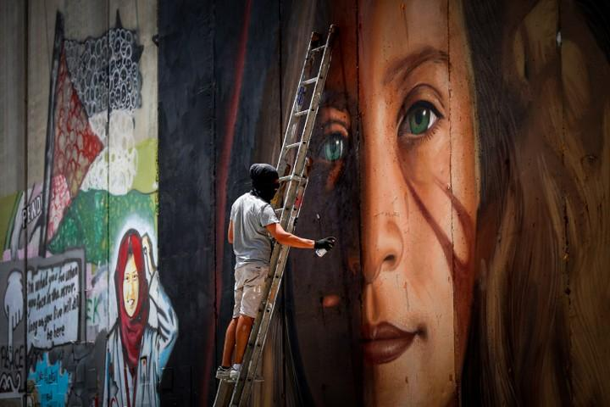
Figure 220. Artists Arrested After Painting Solidarity with Imprisoned Activist Ahed Tamimi
Location: West Bank, Palestine
Date: 2018
Artists: Jorit and Agostino Chirwin
Photographer: Wisam Hashlamoun
Source: https://www.972mag.com/israel-arrests-artists-behind-ahed-tamimi-mural-on-separation-wall/ & https://www.timesofisrael.com/italian-graffiti-artist-arrested-for-mural-of-ahed-tamimi-on-security-barrier/

Return to Page 65

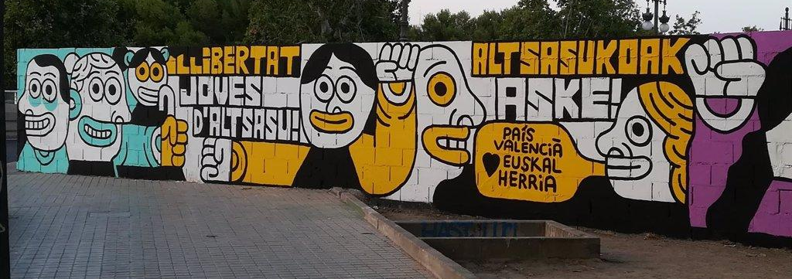
Figure 221. Solidarity with Imprisoned Youth from Alsasua I
Location: Valencia, Spain
Date: 2018
Artist: Elías Taño
Source: https://valenciaplaza.com/la-policia-interviene-en-la-convocatoria-para-borrar-el-mural-de-elias-tano

Return to Page 66

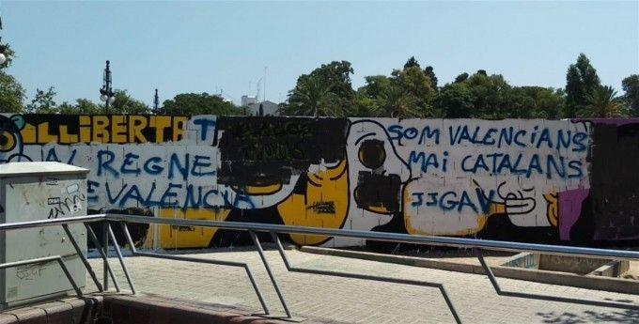
Figure 222. Solidarity with Imprisoned Youth from Alsasua I, Vandalized
Location: Valencia, Spain
Date: 2018
Artist: Elías Taño
Source: https://cadenaser.com/emisora/2018/07/25/radio_valencia/1532521042_864772.html

Return to Page 66

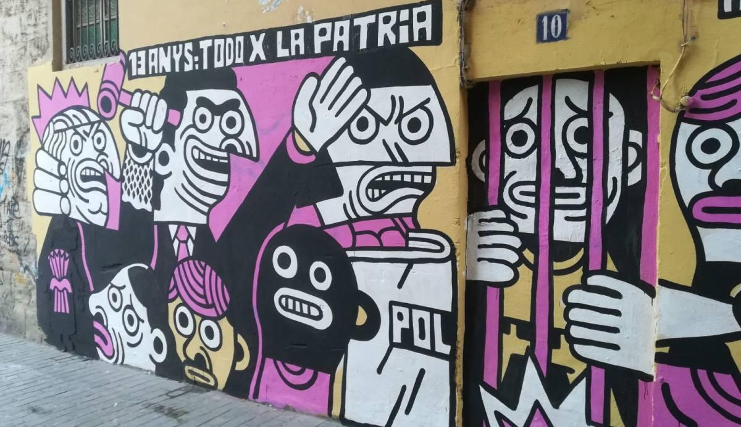
Figure 223. Solidarity with Imprisoned Youth from Alsasua II
Location: Valencia, Spain
Date: 2018
Artist: Elías Taño
Source: https://valenciaplaza.com/el-ayuntamiento-de-valencia-ofrece-a-elias-tano-un-muro-blanco-tras-borrar-su-mural-sobre-el-caso-alsasua

Return to Page 66

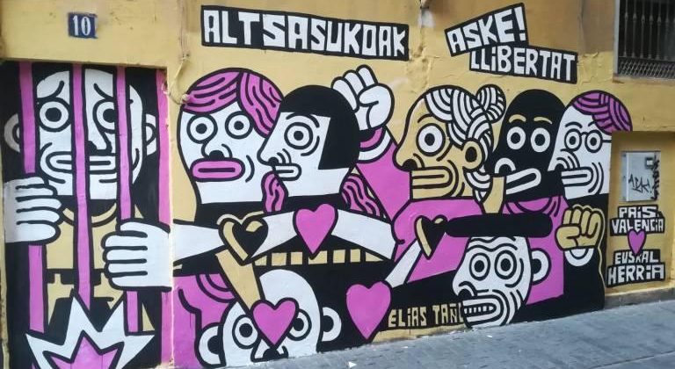
Figure 224. Solidarity with Imprisoned Youth from Alsasua III
Location: Valencia, Spain
Date: 2018
Artist: Elías Taño
Source: https://valenciaplaza.com/el-ayuntamiento-de-valencia-ofrece-a-elias-tano-un-muro-blanco-tras-borrar-su-mural-sobre-el-caso-alsasua

Return to Image 66
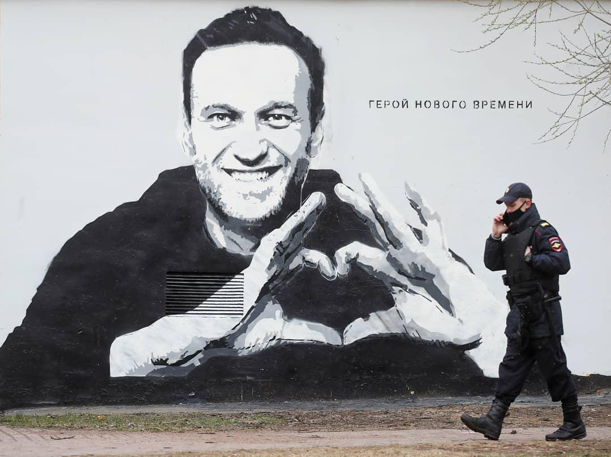
Figure 225. Officer Pacing in Front of “Hero of a New Time,” Solidarity with Imprisoned Activist Aleksei Navalny
Location: St. Petersburg, Russia
Date: 2021
Photographer: Anton Vagnov
Source: https://www.rferl.org/a/navalny-mural-painted-over-st-petersburg/31229298.html

Return to Page 66

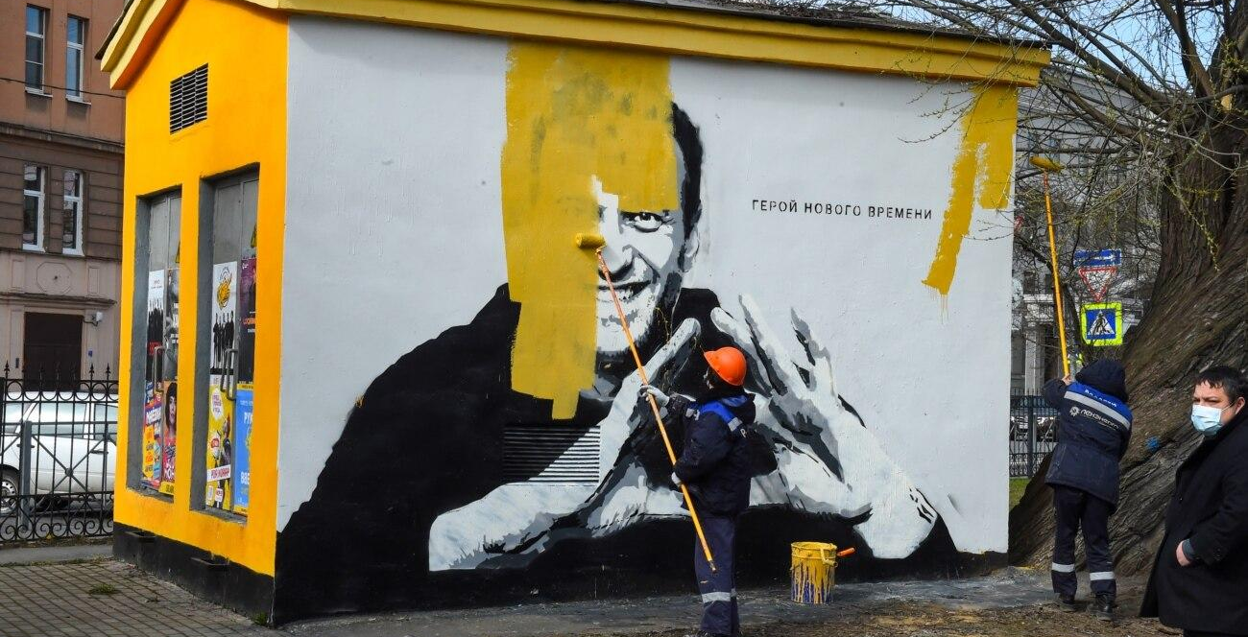
Figure 226. Painting Over “Hero of a New Time,” Solidarity with Imprisoned Activist Aleksei Navalny
Location: St. Petersburg, Russia
Date: 2021
Photographer: Olga Maltseva
Source: https://www.rferl.org/a/navalny-mural-painted-over-st-petersburg/31229298.html

Return to Page 66

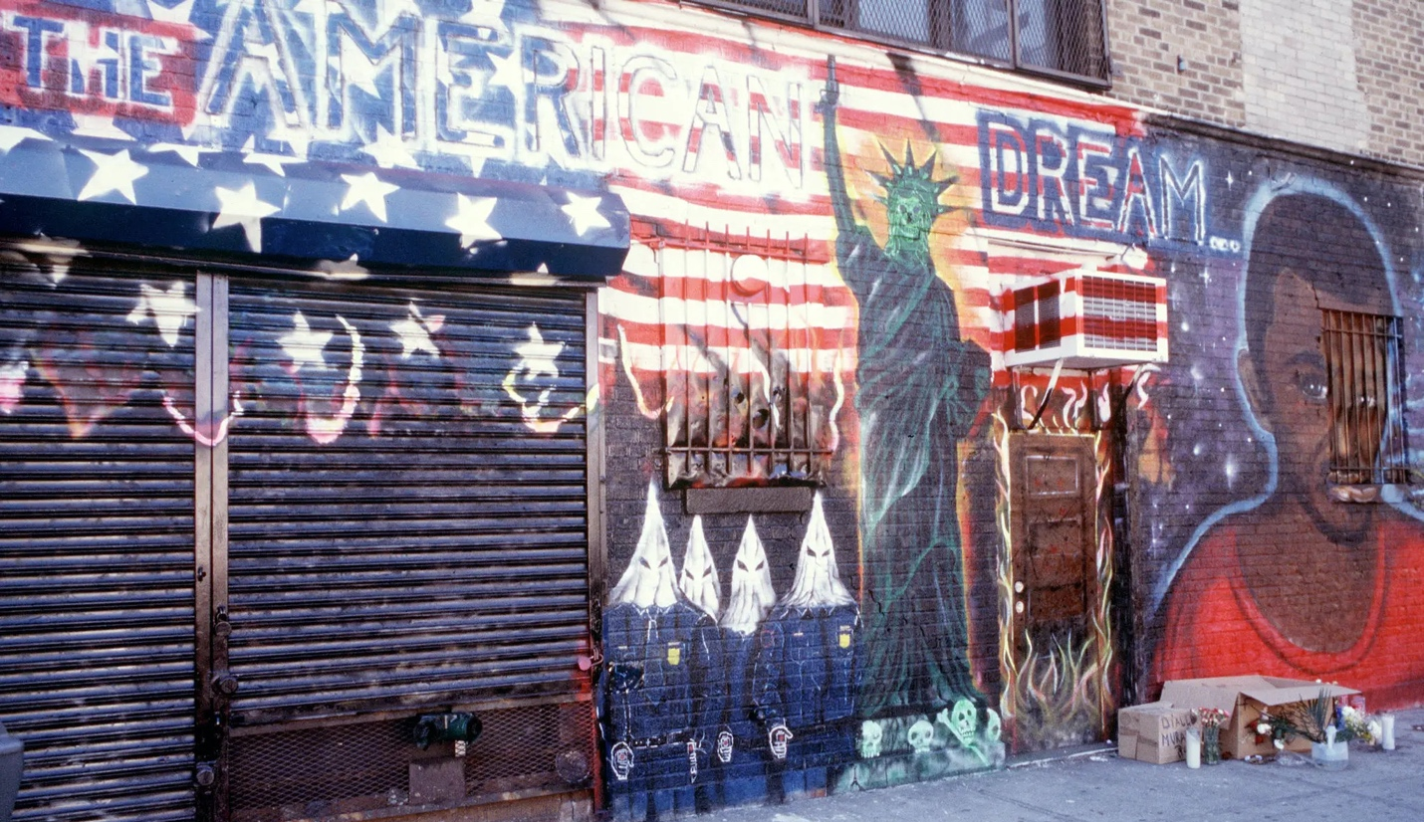
Figure 227. Amadou Diallo Memorial Mural
Location: New York City, New York, USA
Date: 2001
Artist: Hulbert Waldroup
Photographer: Tina Paul
Source: https://www.nytimes.com/2020/06/05/arts/design/murals-remember-people-killed-by-police.html

Return to Page 66

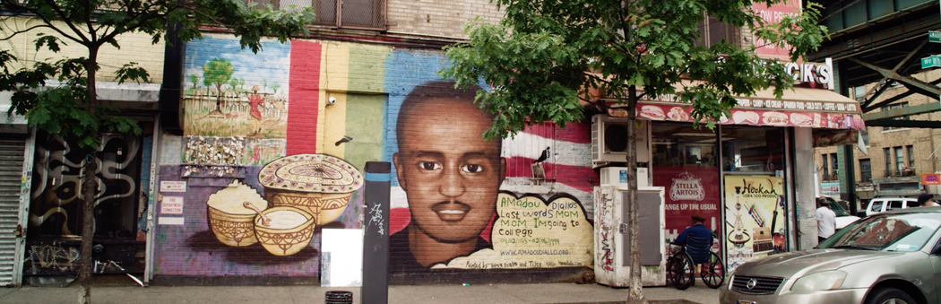
Figure 228. Restored Amadou Diallo Memorial Mural
Location: New York City, New York, USA
Date: 2017
Artist: Hawa Diallo
Photographer: Mohamed Sadek
Source: https://www.nytimes.com/2020/06/05/arts/design/murals-remember-people-killed-by-police.html

Return to Page 66
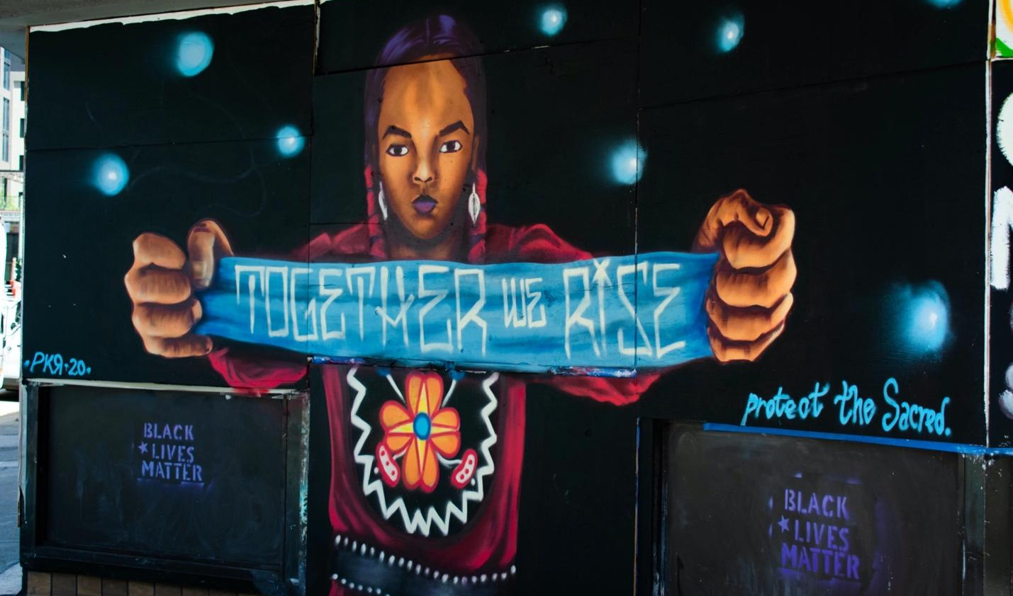
Figure 229. Together We Rise
Location: Oakland, California, USA
Date: 2020
Artist: Pancho Pescador
Photographer: Bree Doan
Source: https://breedoan.wordpress.com/2020/07/15/artists-transform-downtown-oakland-for-black-lives-matter/

Return to Page 67

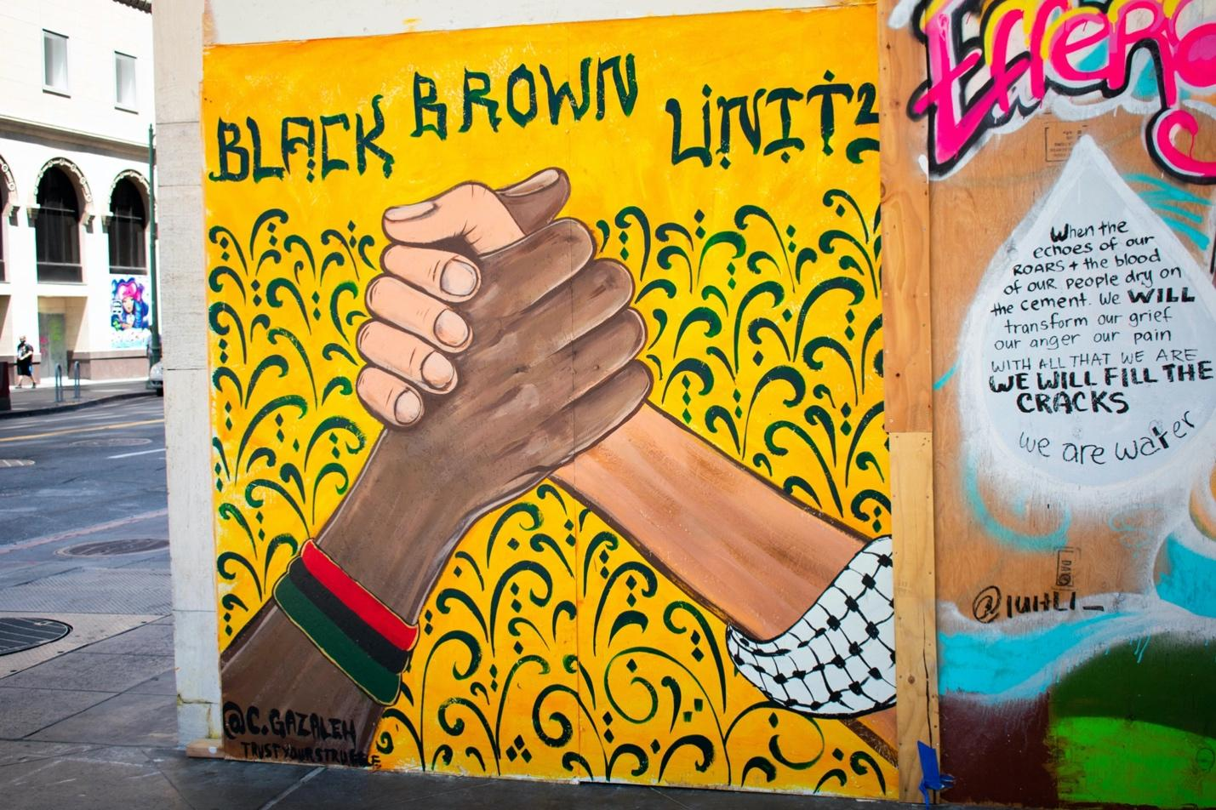
Figure 230. Black Brown Unity
Location: Oakland, California, USA
Date: 2020
Artist: Chris Gazaleh and Trust Your Struggle Art Collective
Photographer: Bree Doan
Source: https://breedoan.wordpress.com/2020/07/15/artists-transform-downtown-oakland-for-black-lives-matter/

Return to Page 67
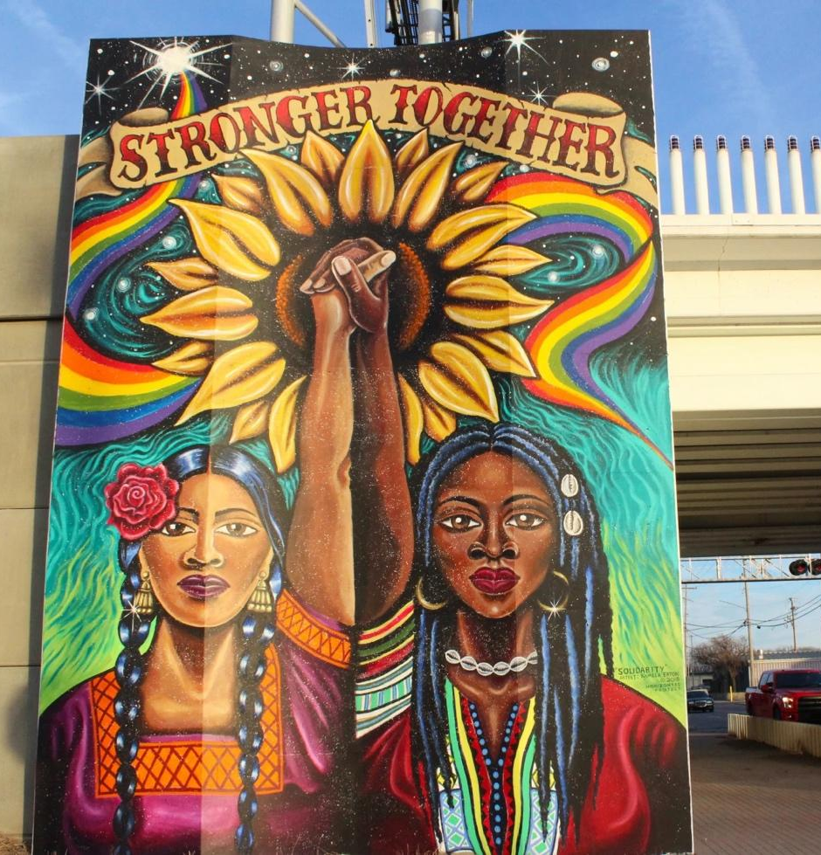
Figure 231. Stronger Together
Location: Wichita, Kansas, USA
Date: 2019
Artist: Kamela Eaton
Source: https://www.kmuw.org/community/2019-01-25/to-paint-a-mural-horizontes-project-helps-north-wichitans-see-in-color

Return to Page 68
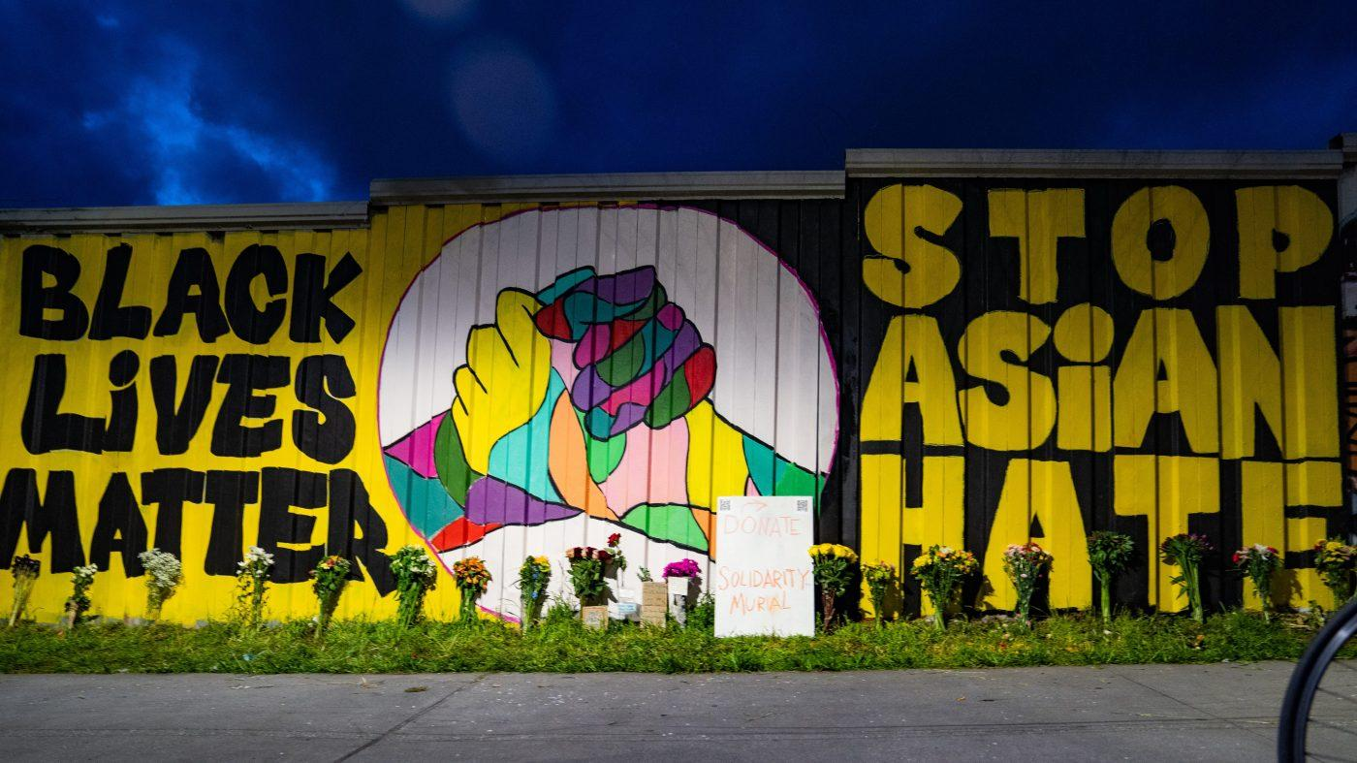
Figure 232. Black Lives Matter/Stop Asian Hate
Location: Atlanta, Georgia, USA
Date: 2021
Artists: Bad Asian and Civil Walls
Photographer: Megan Varner
Source: https://chicago.suntimes.com/columnists/2021/3/22/22345129/diversity-americas-strength-hateful-reaction-weakness-jesse-jackson

Return to Page 68

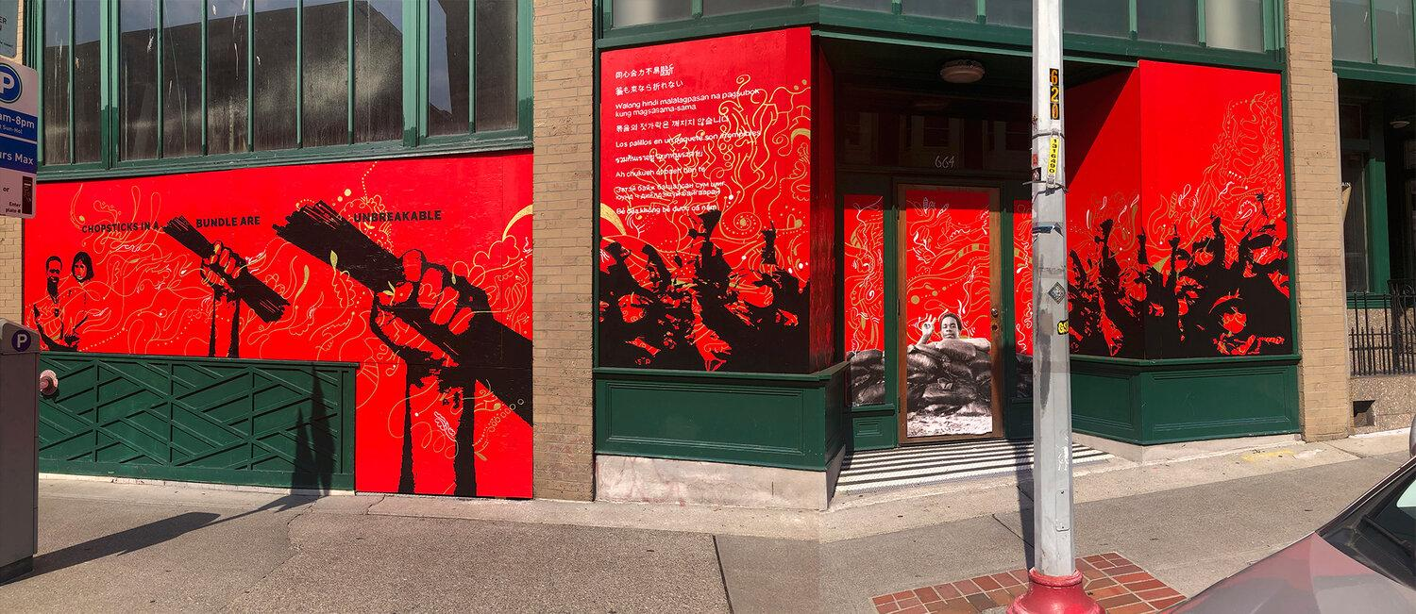
Figure 233. Chopsticks in a Bundle are Stronger Together
Location: Seattle, Washington, USA
Date: 2021
Artists: Tân Nguyễn, Moses Sun, and collaborators
Source: https://www.mosessun.studio/#/chopsticksinabundleareunbreakable/

Return to Page 68
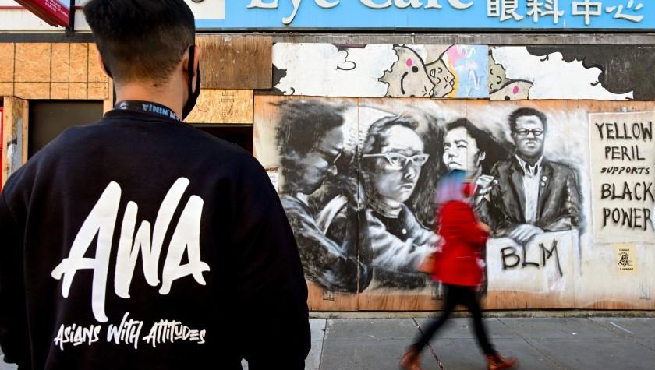
Figure 234. Yellow Peril Supports Black Power
Location: Oakland, California, USA
Date: 2021
Source: https://www.latimes.com/california/story/2021-03-19/anti-asian-racism-oakland-chinatown

Return to Page 68

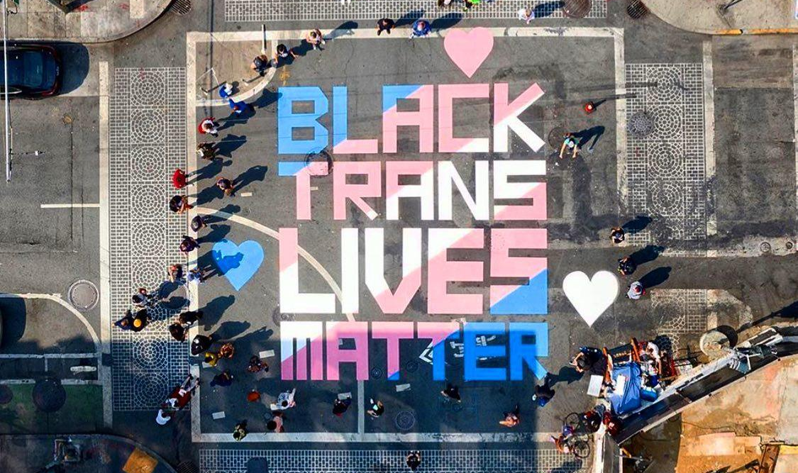
Figure 235. Black Trans Lives Matter Street Mural at Previous Site of Compton’s Cafeteria
Location: San Francisco, California, USA
Date: 2020
Photographer: Garaje Gooch
Source: https://www.instagram.com/p/CEc8tcJFqZc/

Return to Page 69
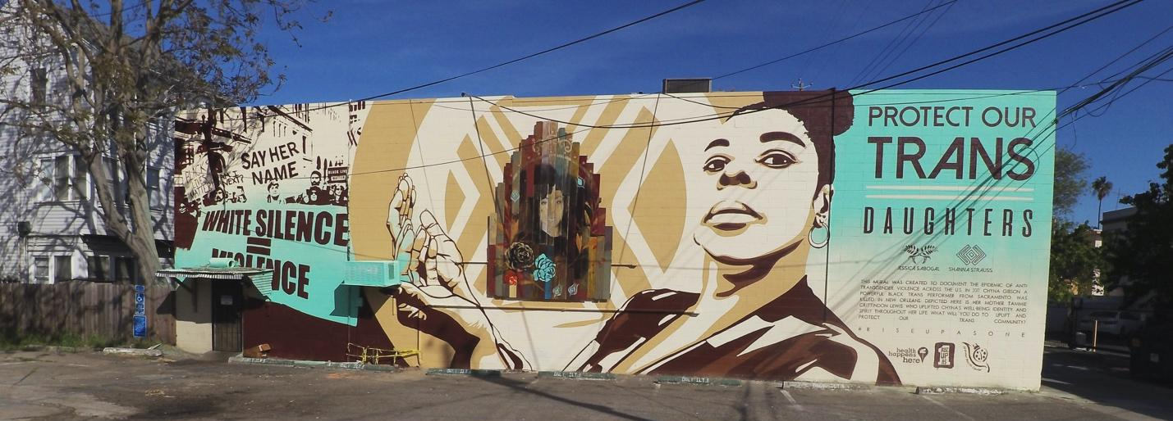
Figure 236. Protect Our Trans Daughters
Location: Sacramento, California, USA
Date: 2018
Artist: Jessica Sobogal
Source: https://www.jessicasabogal.com/sabogalpublicartworks/2018/7/26/2018/7/26/jpny9uyx002ohvtdlqzaz606eelkpw

Return to Page 69

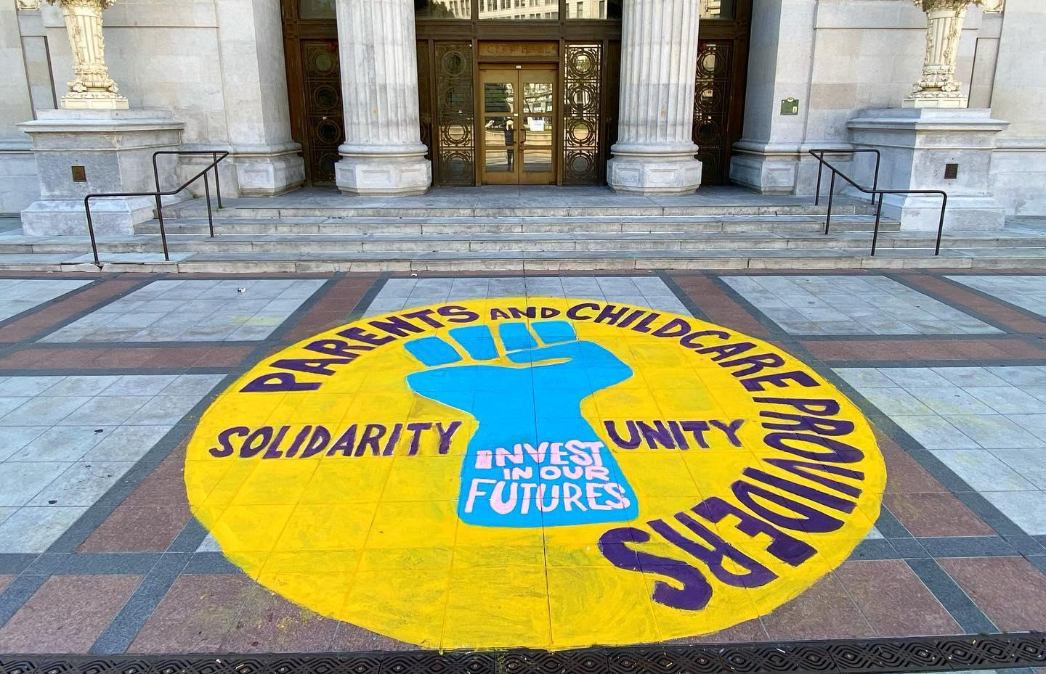
Figure 237. Solidarity with Parents and Childcare Providers
Location: Oakland, California, USA
Date: 2023
Source: https://www.instagram.com/p/Cs5SarruSbW/

Return to Page 69
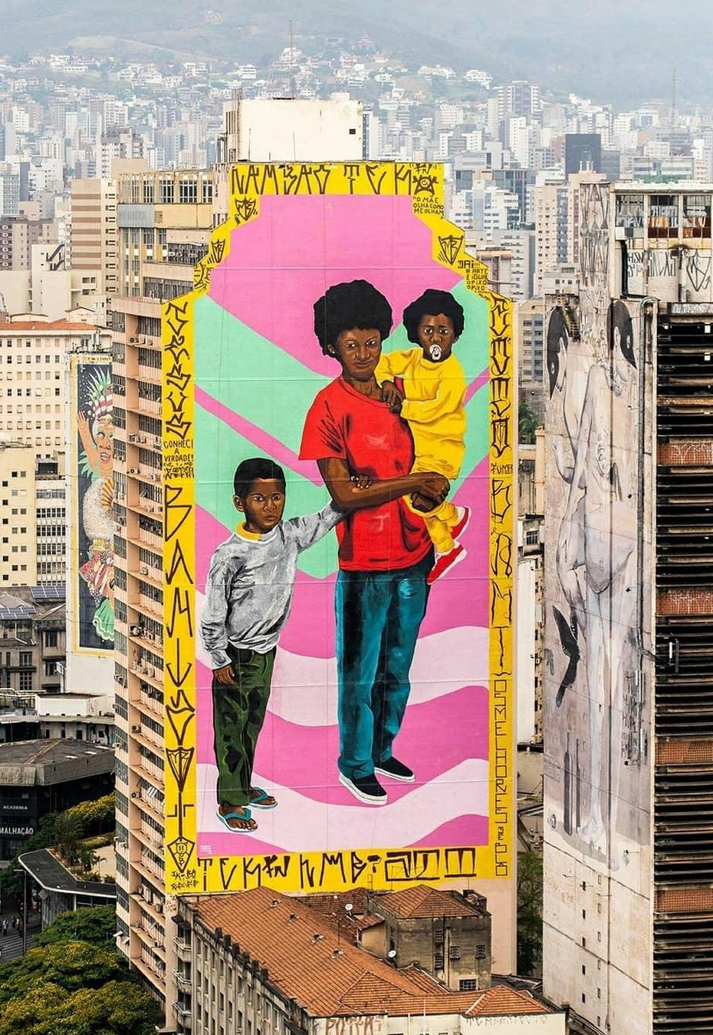
Figure 238. Deus é Mãe (God is Mother)
Location: Belo Horizonte, Minas Gerais, Brazil
Date: 2021
Artist: Robinho Santana ,BH Poter, Lmb, Bani, Tek and Zoto
Source: https://www.instagram.com/p/CKv3zGbnsYk/& https://g1.globo.com/mg/minas-gerais/noticia/2021/01/29/obra-em-fachada-de-predio-no-centro-de-bh-e-investigada-pela-policia-estao-criminalizando-a-arte-diz-curadora.ghtml

Return to Page 69
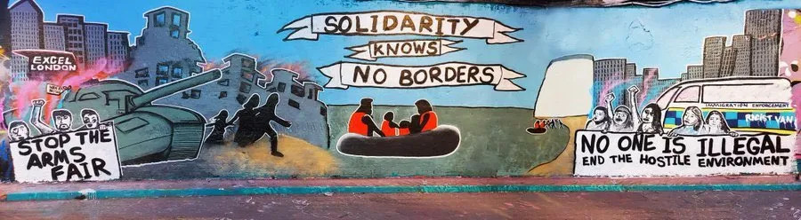
Figure 239. Solidarity Knows No Borders
Location: London, United Kingdom
Date: 2020
Artist: Dukz
Source: https://medium.com/are-you-syrious/ays-special-from-the-uk-precarity-deportations-and-detention-3fc6e45330e5 & https://www.instagram.com/p/CWvFpFIoeo1/

Return to Page 70

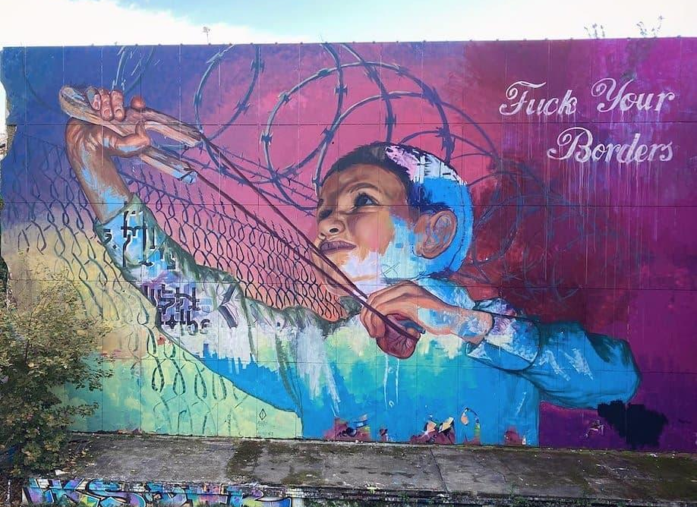
Figure 240. Fuck Your Borders
Location: Berlin, Germany
Date: 2021
Source: https://www.instagram.com/p/CVPYNsepJPe/

Return to Page 70

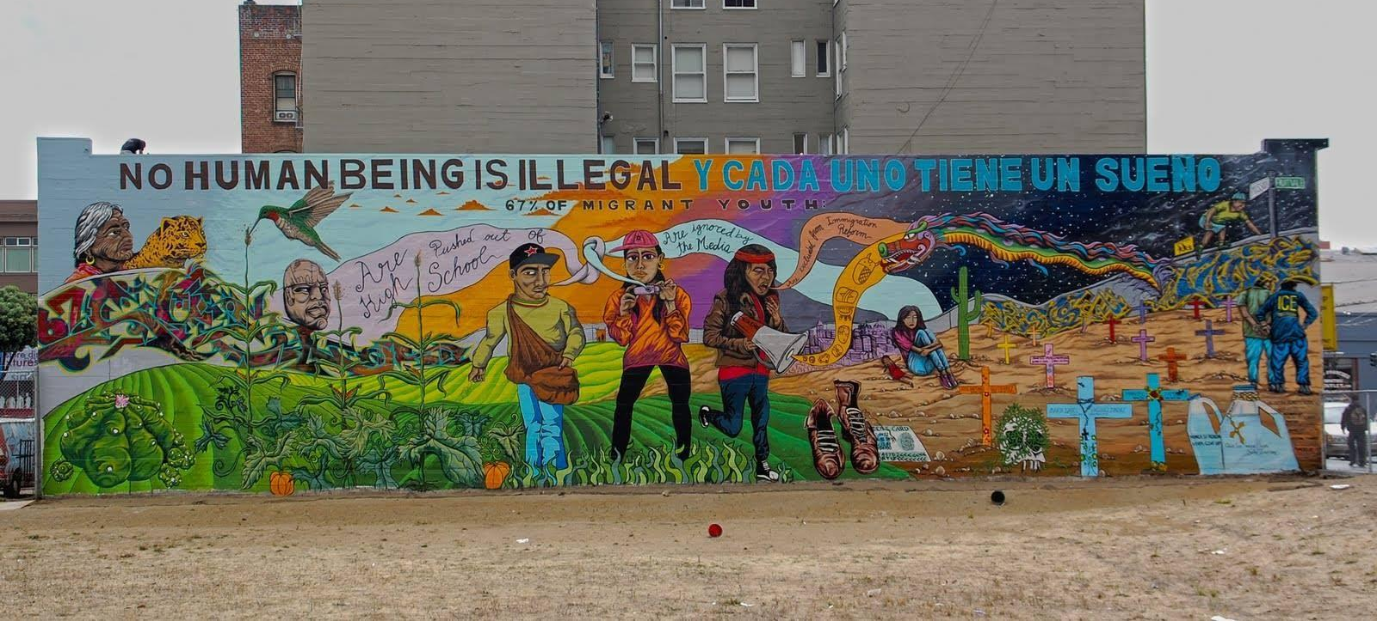
Figure 241. No Human Being is Illegal
Location: San Francisco, California, USA
Date: 2011
Artists: Pancho Peskador and 67 youth
Source: https://ips-dc.org/tengo_un_dream/ & https://www.facebook.com/photo/?fbid=484086893918997&set=a.484086877252332

Return to Page 70

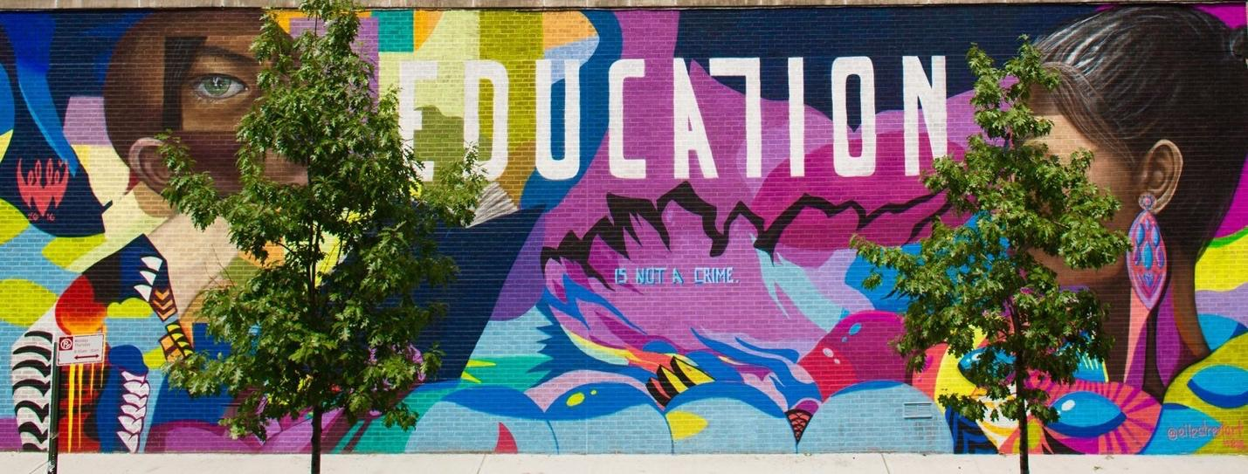
Figure 242. Education Is Not A Crime: Harlem
Location: New York, New York, USA
Date: 2016
Artist: ELLE
Source: https://www.paintthechange.me/education-is-not-a-crime-1

Return to Page 70

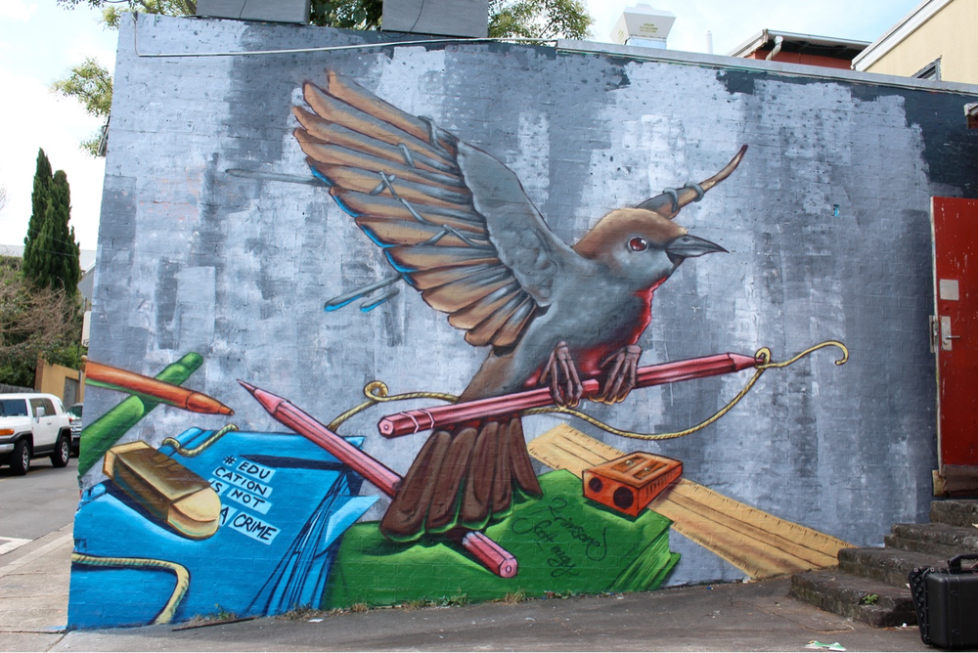
Figure 243. #EducationIsNotACrime: Nightingale
Date: 2015
Location: Newtown, Australia
Artists: Krimsone and Scott Nagy
Source: https://www.paintthechange.me/education-is-not-a-crime-1

Return to Page 70

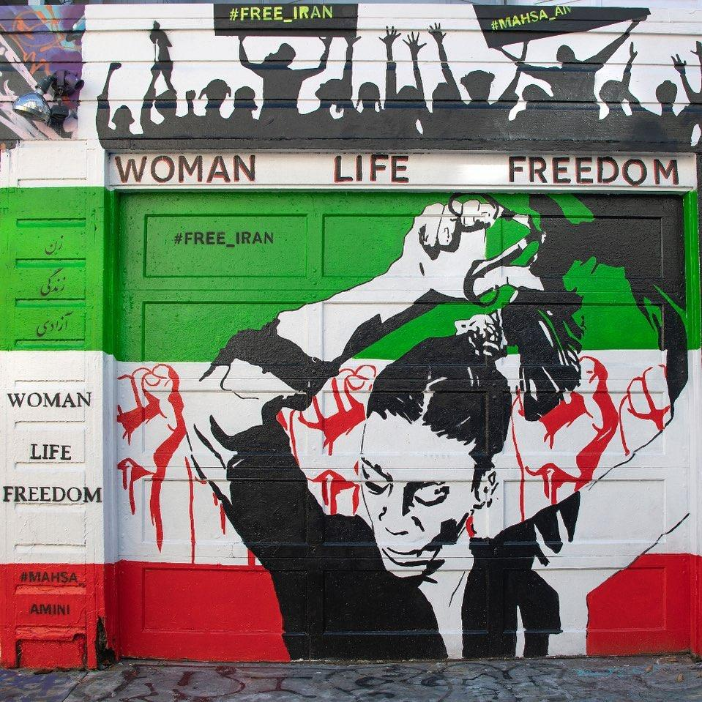
Figure 244. Woman Life Freedom, #MahsaAmini
Location: San Francisco, California, USA
Date: 2022
Artist: Farnaz Zabetian
Source: https://www.instagram.com/p/CoKqYBhpz3k/

Return to Page 71
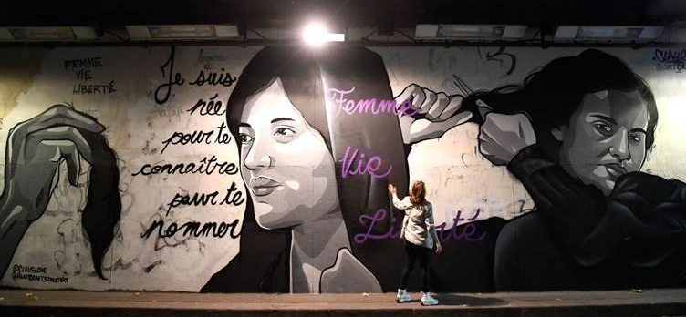
Figure 245. Je Suis Née Pour te Connaître pour te Nommer, Femme Vie Liberté
Location: Paris, France
Date: 2022
Artists: Claks One and HeartCraft
Photographer: Julien de Rosa
Source: https://www.rudaw.net/english/middleeast/iran/14102022

Return to Page 71

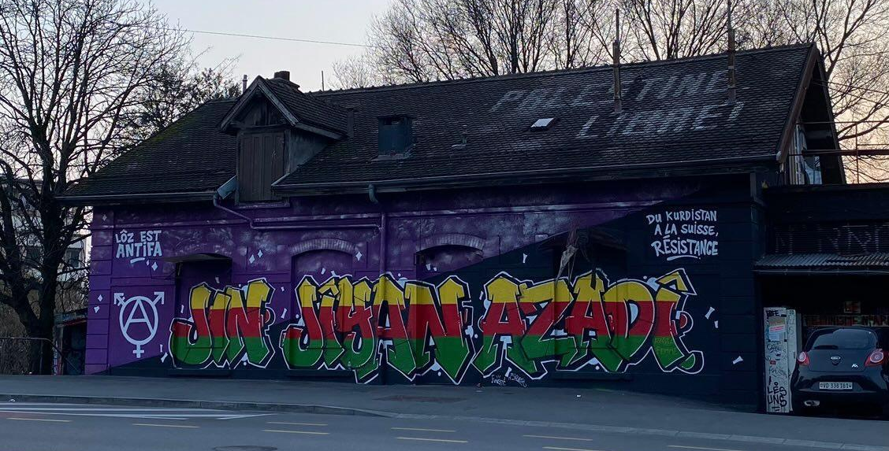
Figure 246. Jin Jîyan Azadî, Women Live Free/Women, Life, Freedom
Location: Lausanne, Switzerland
Source: https://radicalgraff.tumblr.com/post/714161729374978048/from-kurdistan-to-switzerland-resistance-women

Return to Page 71

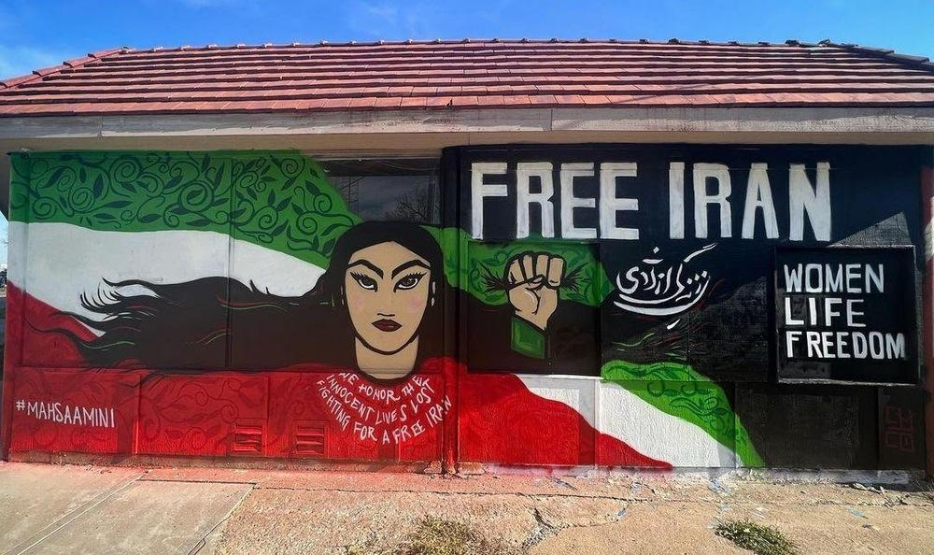
Figure 247. Free Iran
Date: 2022
Location: Kansas City, Missouri, USA
Artist: Chico Sierra
Source: https://www.instagram.com/p/CoLMC6tvEj2/ & https://www.kshb.com/news/local-news/new-midtown-mural-brings-awareness-to-iranian-protests

Return to Page 71

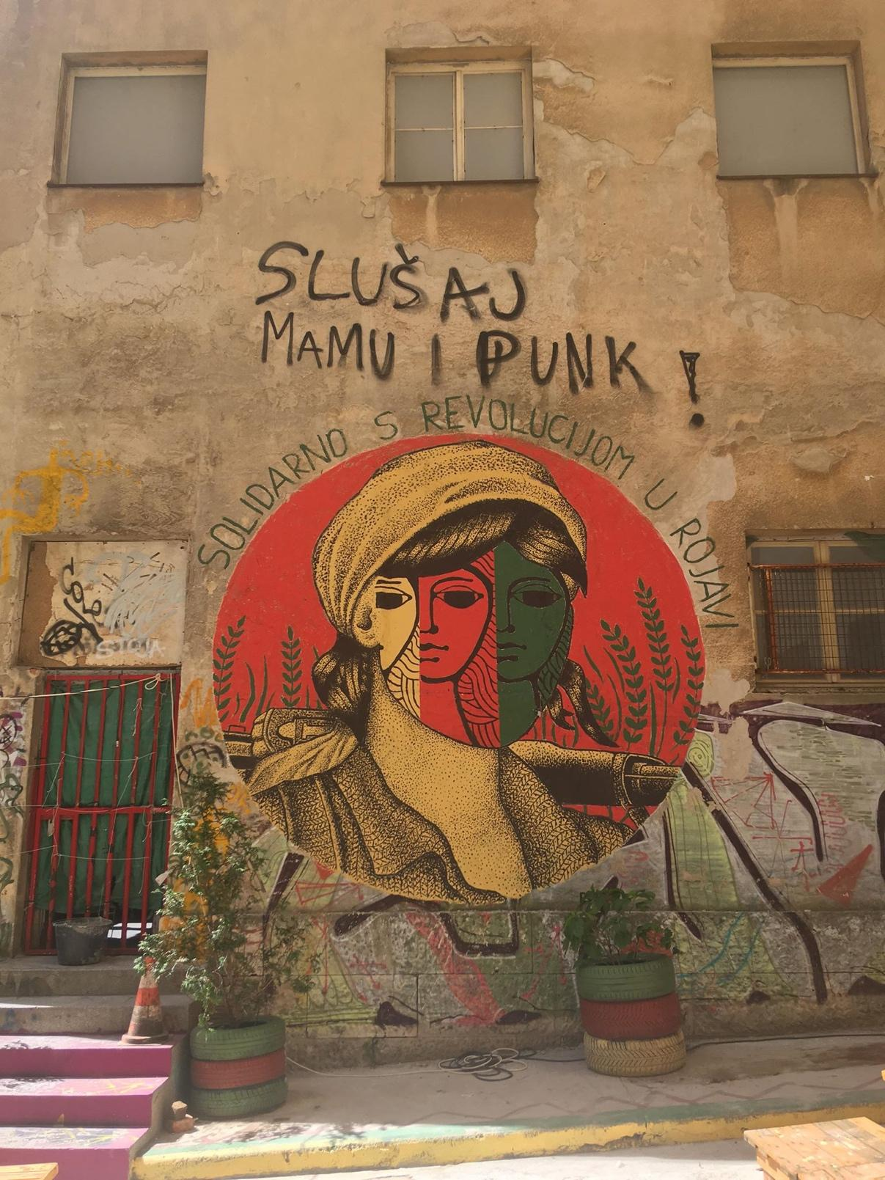
Figure 248. Solidarno S Revolucijom U Rojavi (Solidarity With the Revolution in Rojava)
Location: Rojc, Pula, Croatia
Date: 2020
Artist: PolitebastArt
Source: https://www.isupportstreetart.com/polite-bastart-update/& https://www.instagram.com/p/B1UGXxfnWgs/?img_index=1

Return to Page 71

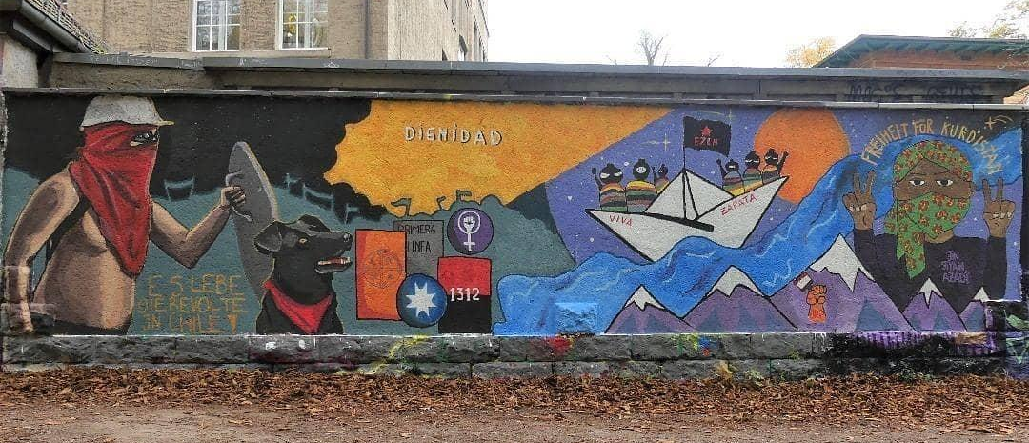
Figure 249. Solidarity with the Chilean revolt, the EZLN in Chiapas, Mexico, and the Movement for an Autonomous Kurdistan
Location: Jena, Germany
Date: 2021
Source: https://www.instagram.com/p/CVxsKeRPZX8/

Return to Page 71

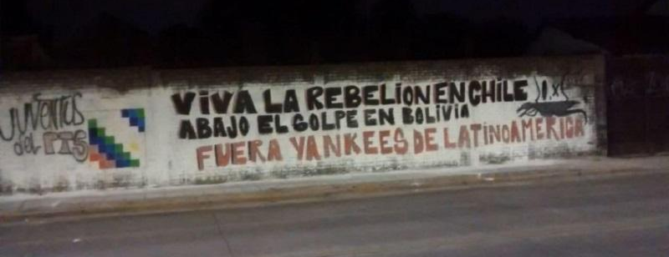
Figure 250. Viva La Rebelion en Chile
Location: San Miguel, Buenos Aires, Argentina
Date: 2019
Artist: PTS Youth Group
Source: https://www.laizquierdadiario.com/San-Miguel-la-Policia-amedrento-a-jovenes-que-hacian-mural-por-Chile-y-Bolivia

Return to Page 71

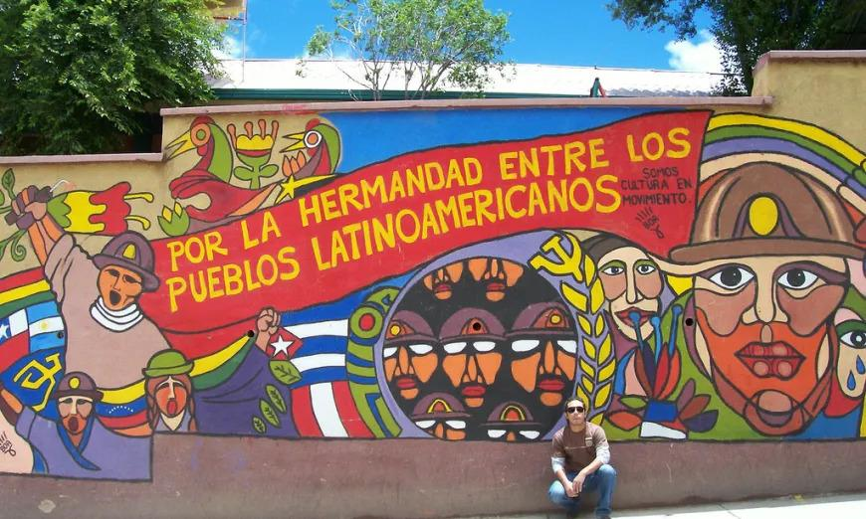
Figure 251. Por La Hermandad Entre Los Pueblos Latinoamericanos
Location: Potosi, Bolivia
Date: 2008
Source: https://anticonquista.com/2018/12/25/decolonizing-nationalism-in-latin-america/ & https://www.flickr.com/photos/gordogossa/2279689751

Return to Page 71

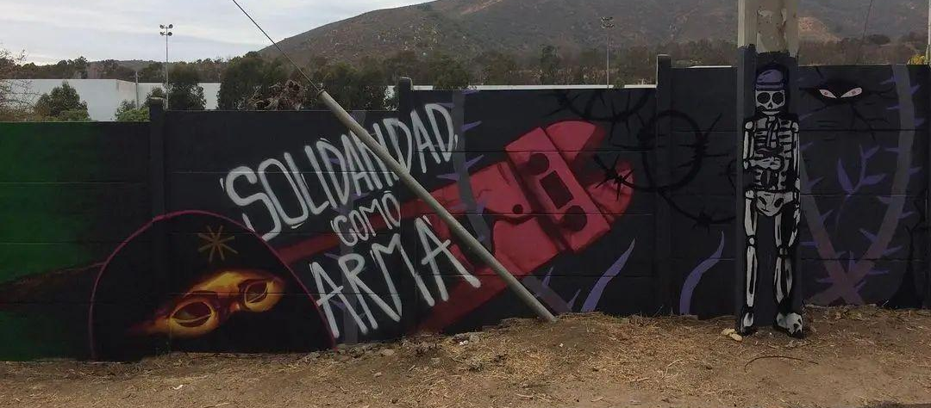
Figure 252. Solidaridad como Arma (Solidarity as a Weapon) I
Location: Chile
Date: 2022
Artist: Boa Solnegro
Source: https://www.instagram.com/p/CcjTVvpvYt1/?img_index=1
& https://www.instagram.com/p/CKooZd0pn3S/

Return to Page 71

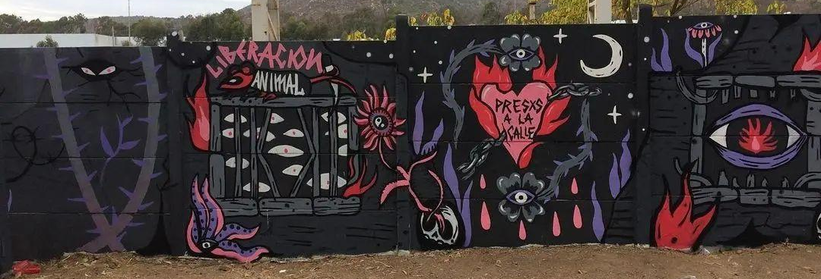
Figure 253. Solidaridad como Arma (Solidarity as a Weapon) II
Location: Chile
Date: 2022
Artist: Boa Solnegro
Source: https://www.instagram.com/p/CcjTVvpvYt1/?img_index=1
& https://www.instagram.com/p/CKooZd0pn3S/

Return to Page 71

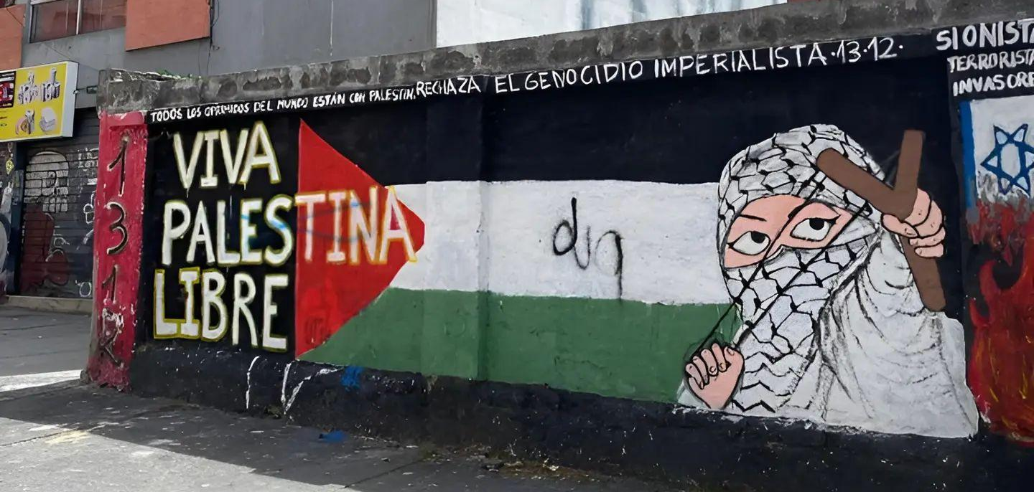
Figure 254. Viva Palestina Libre
Location: Quito, Ecuador
Date: 2024
Source: https://www.instagram.com/p/C3L1-_zycdM/

Return to Page 71

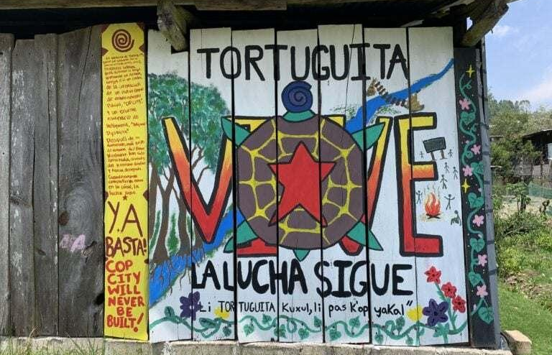
Figure 255. Tortuguita Vive, La Lucha Sigue (Little Turtle Lives, The Fight Continues)
Location: Caracol Oventik in Chiapas, Mexico
Date: 2023
Source: https://twitter.com/defendATLforest/status/1662831279740538886 & https://scenes.noblogs.org/post/2023/05/20/from-the-zapatista-territories-in-chiapas-mx/

Return to Page 72
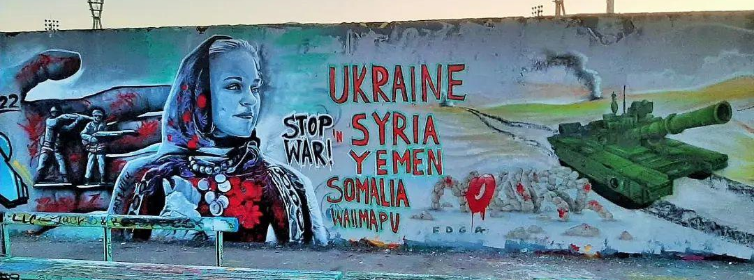
Figure 256. Stop War! Ukraine, Syria, Yemen, Somalia, Wallmapu
Location: Berlin, Germany
Date: 2022
Source: https://www.instagram.com/p/Ca0ctE4viKv/?img_index=2

Return to Page 72

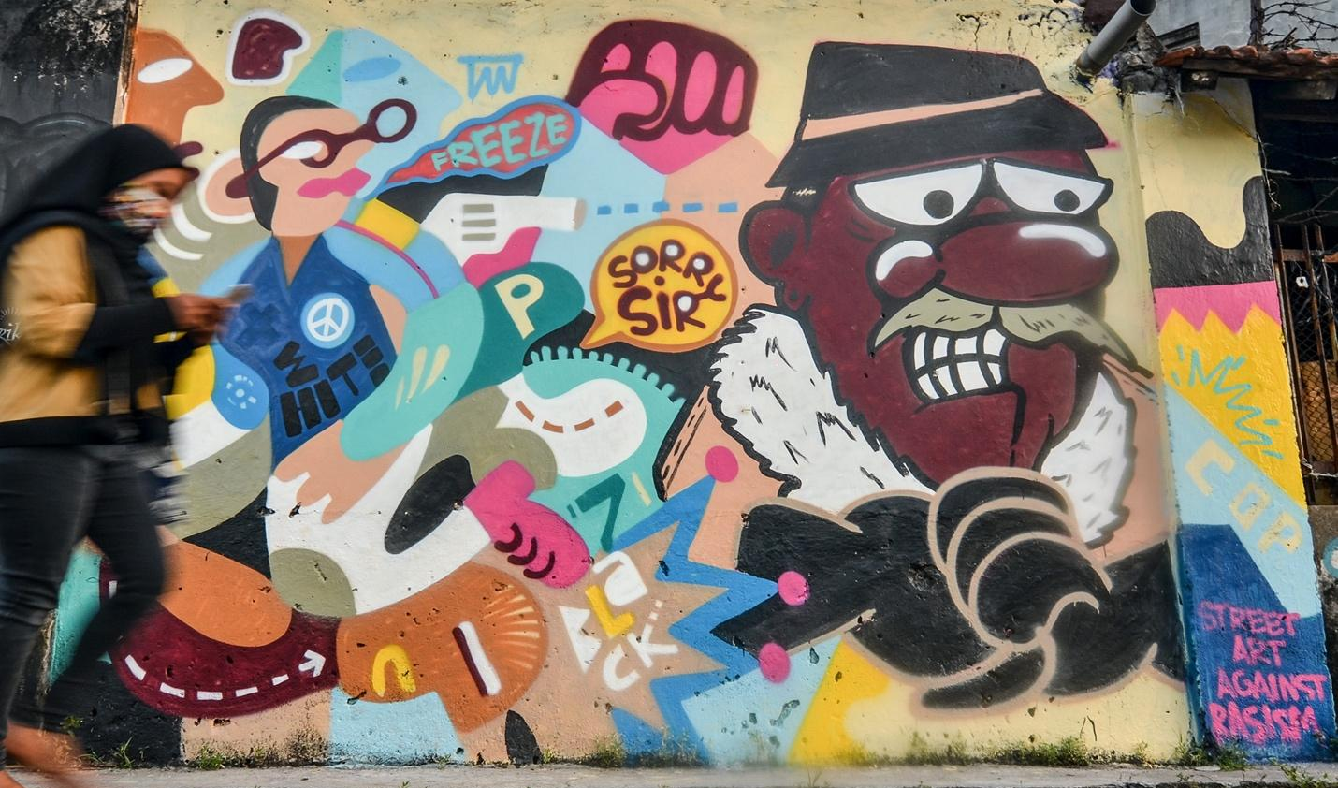
Figure 257. Against Racism
Location: Surabaya, Indonesia
Date: 2020
Photographer: Arlana Candra Wijaya
Source: https://www.accessonline.com/galleries/george-floyd-memorialized-in-powerful-street-art-around-the-world#google_vignette

Return to Page 72

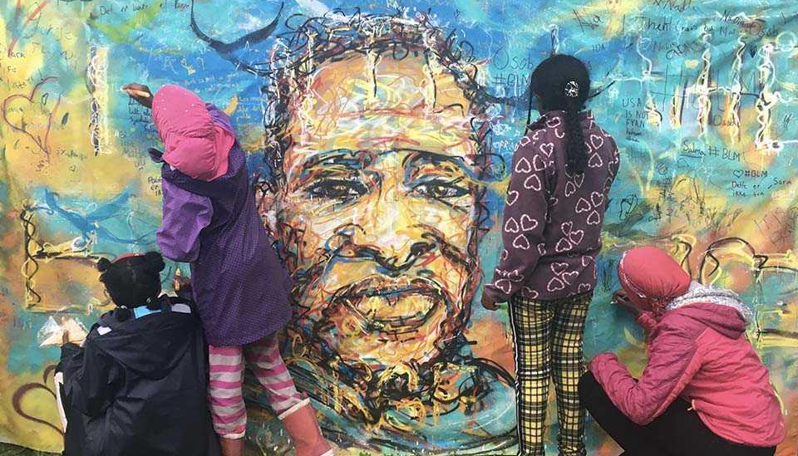
Figure 258. Children Painting George Floyd in Norway
Location: Oslo, Norway
Date: 2020
Artist: Astrid Solgaard and Arladiss Street Art
Source: https://cooltourspain.com/art-of-street/

Return to Page 72
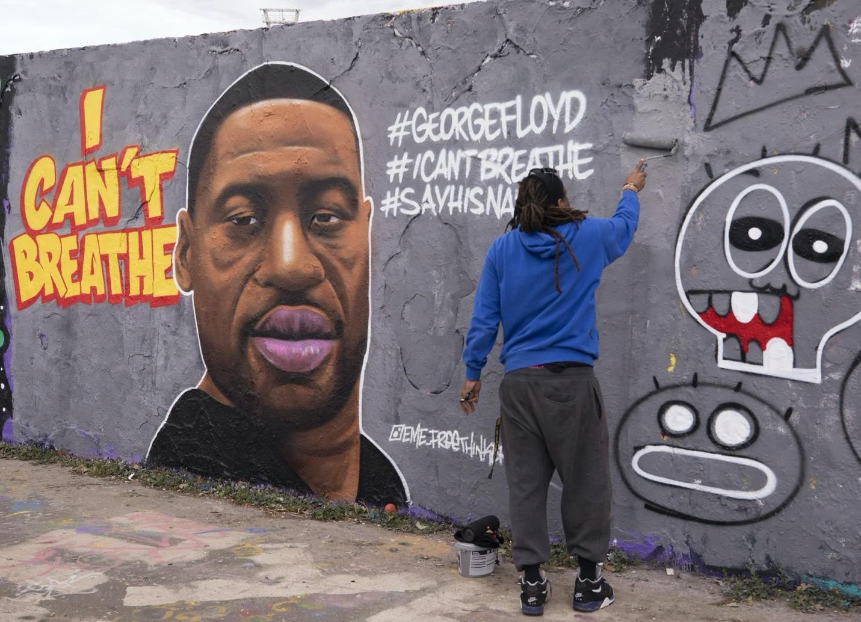
Figure 259. I Can’t Breathe George Floyd Memorial Mural
Location: Berlin, Germany
Date: 2020
Artist: Jesus Cruz Artiles (EME Freethinker)
Photographer: Abdulhamid Hosbas—Anadolu Agency
Source: https://sports.yahoo.com/artists-behind-george-floyd-murals-211112455.html

Return to Page 72

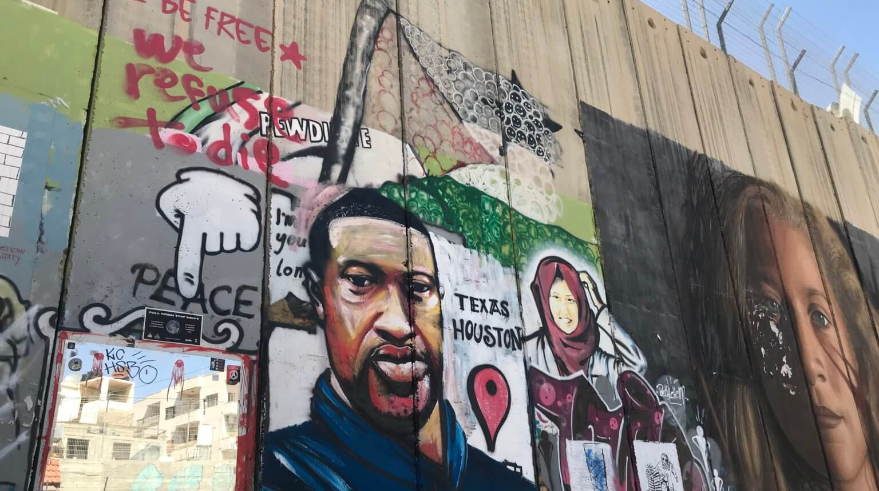
Figure 260. George Floyd and Slain Palestinian Medic Razan al-Najajr Memorial Murals Next to Portrait of Imprisoned Teen Activist Ahed Tamimi
Location: Bethlehem, West Bank, Palestine
Date: 2020
Artist: Taqi Spateen
Photographer: Yumna Patel
Source: https://mondoweiss.net/2020/06/meet-the-artist-who-painted-the-george-floyd-mural-on-the-separation-wall/

Return to Page 72

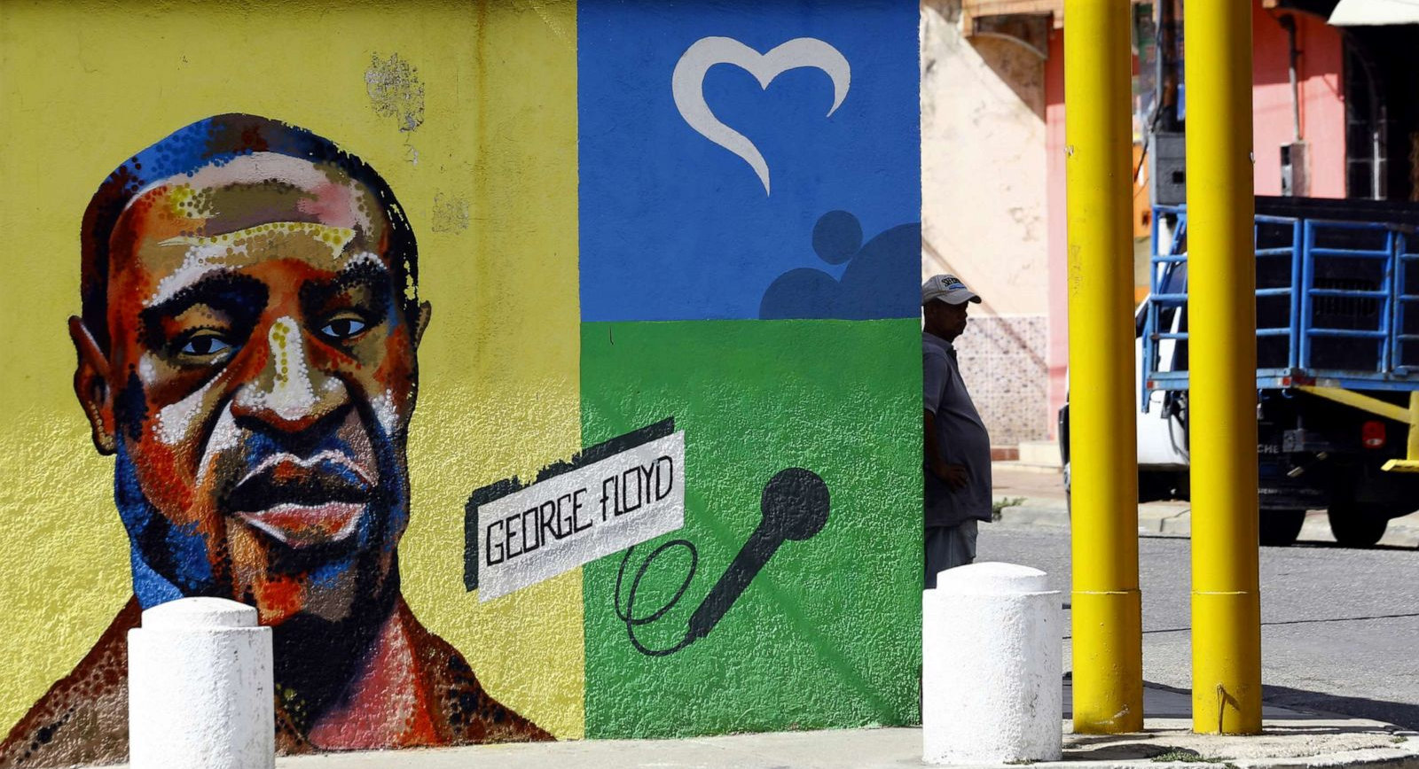
Figure 261. George Floyd Memorial Mural with Microphone
Location: Valencia, Venezuela
Date: 2020
Photographer: Juan Carlos Hernandez/
Source: https://abcnews.go.com/International/photos/george-floyd-murals-world-71224435

Return to Page 72

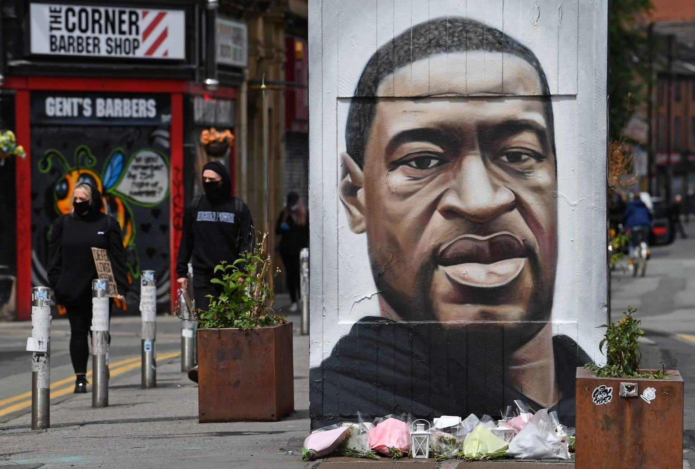
Figure 262. George Floyd Memorial Mural on Street Art Out House
Location: Manchester, United Kingdom
Date: 2020
Artist: AskeP19
Photographer: Paul Ellis
Source: https://www.gettyimages.ca/photos/great-american-mural & https://www.akse-p19.com/work/social/41578328-753508-photo-12

Return to Page 72

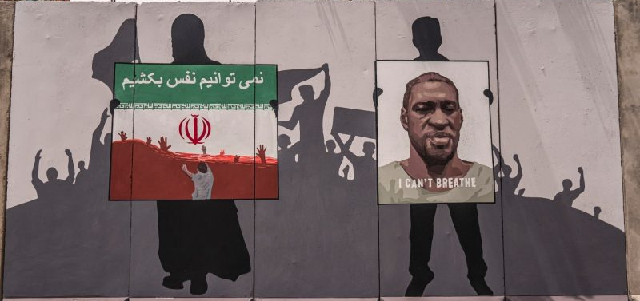
Figure 263. Memorial Mural Dedicated to George Floyd and Afghan Migrants Killed in Iran
Location: Green Zone, Kabul, Afghanistan
Date: 2020
Artists: ArtLords
Photographer: Omaid Sharifi
Source: https://globalvoices.org/2020/06/12/afghan-migrants-continue-to-die-in-the-hands-of-iranian-authorities/ & https://twitter.com/OmaidSharifi/status/1270687672193953792

Return to Page 72

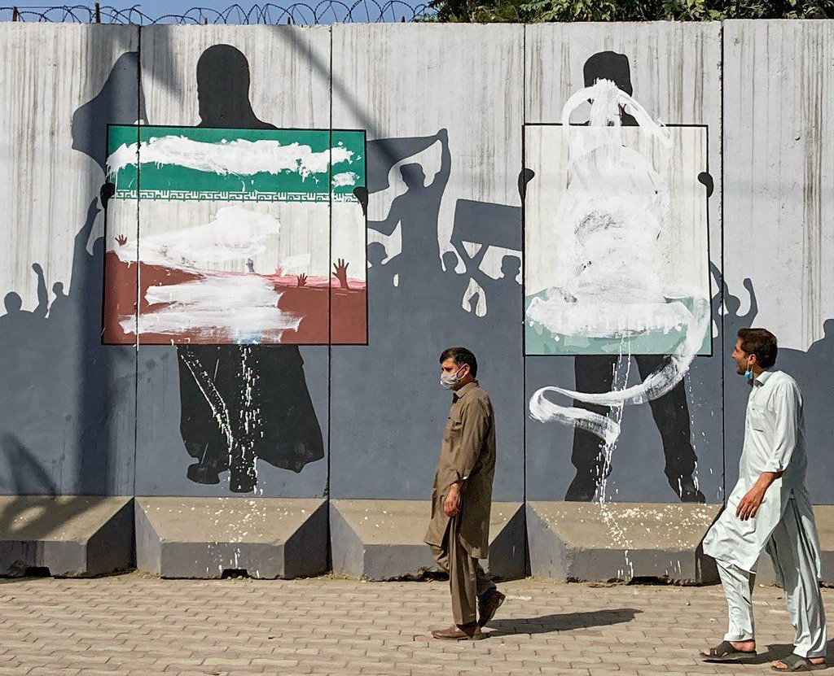
Figure 264. Whitewashed Memorial Mural Dedicated to George Floyd and Afghan Migrants Killed in Iran
Location: Green Zone, Kabul, Afghanistan
Date: 2020
Artists: ArtLords
Source: https://twitter.com/SuneEngel/status/1446036437195952130

Return to Page 72
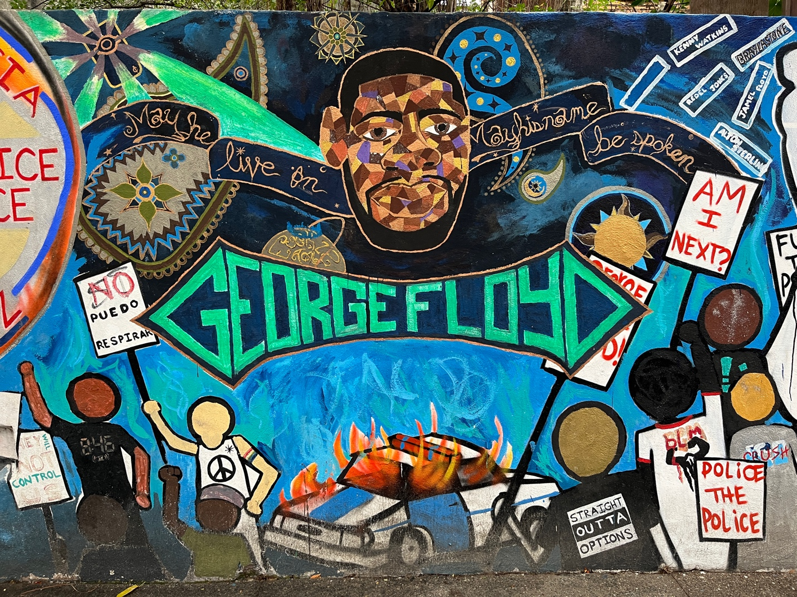
Figure 265. George Floyd, May He Live On, May His Name Be Spoken
Location: Puerto Vallarta, Mexico
Date: 2020
Photographer: Another Believer
Source: https://commons.wikimedia.org/wiki/File:Puerto_Vallarta,_Mexico_(February_2024)_-_448.jpg

Return to Page 72

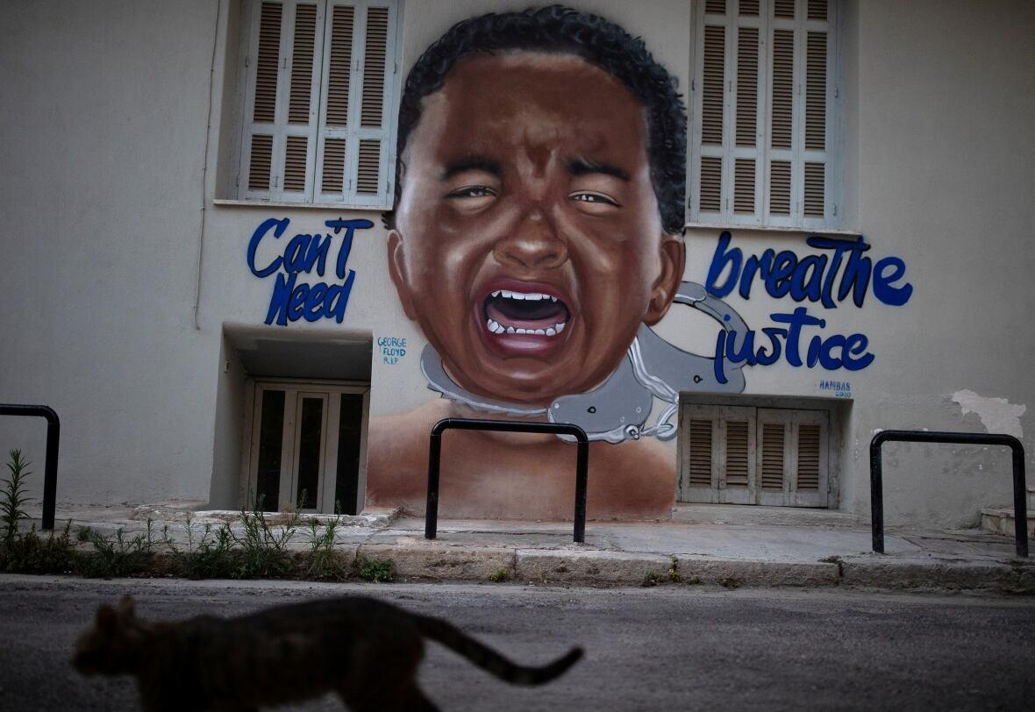
Figure 266. Can’t Breathe Need Justice
Location: Athens, Greece
Date: 2020
Artist: Hambas
Source: https://indianexpress.com/photos/world-news/art-of-protest-against-george-floyds-death-6463504/

Return to Page 72

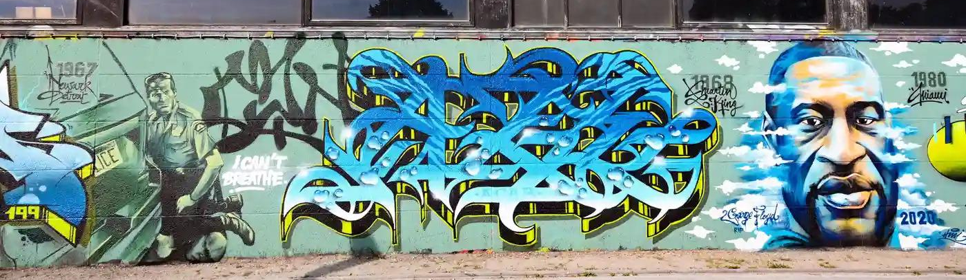
Figure 267. George Floyd Memorial Mural in Belgium
Location: Grimbergen, Belgium
Date: 2020
Artist: Djamel Oulkadi
Source: https://www.theguardian.com/artanddesign/gallery/2020/jun/05/george-floyd-murals-worldwide-street-artists

Return to Page 73

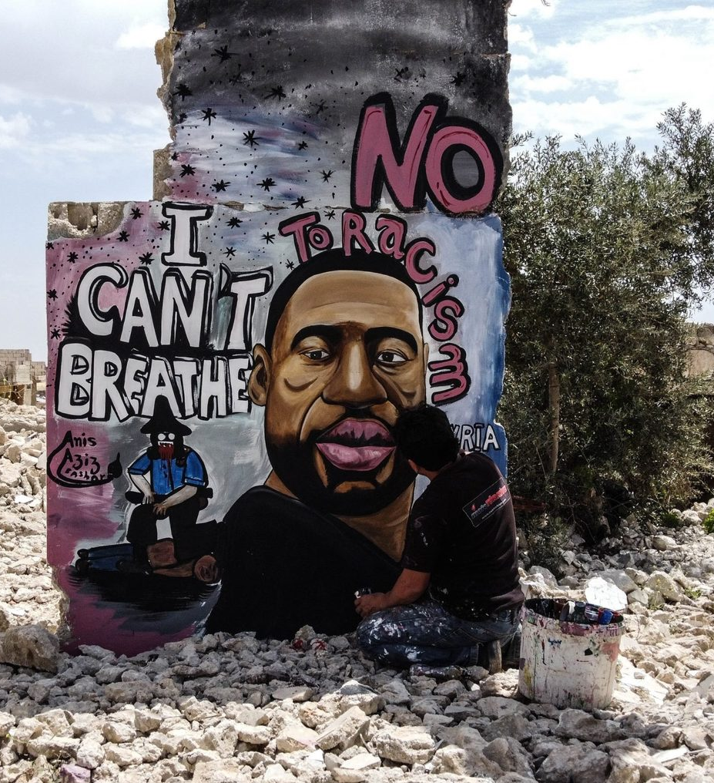
Figure 268. Artist Paints George Floyd Memorial Mural in the Rubble
Location: Idlib, Syria
Date: 2020
Artist: Aziz Asmar
Photographer: Anadolu Agency
Source: https://www.rd.com/list/george-floyd-murals/

Return to Page 73

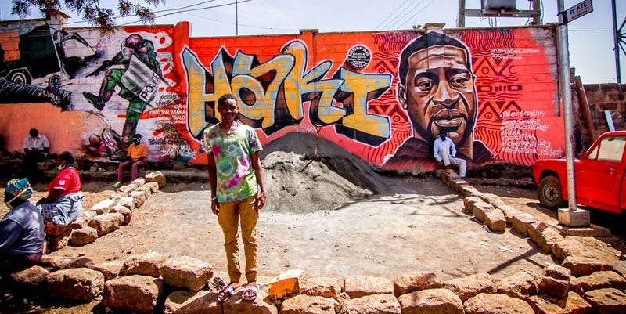
Figure 269. Haki (Swahili for Justice)
Location: Nairobi, Kenya
Date: 2020
Artist: Mr. Detail Seven
Photographer: Donwilson Odhiambo
Source: https://www.bbc.com/culture/article/20201209-the-street-art-that-expressed-the-worlds-pain

Return to Page 73
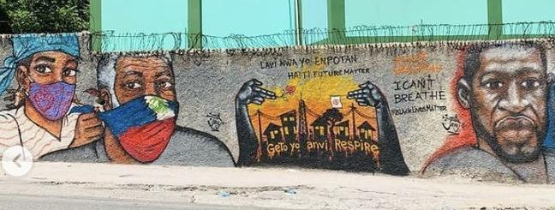
Figure 270. Lavi Nwa yo Enpotan (Black Lives Matter)
Location: Port-Au-Prince, Haiti
Date:
Artist: Jerry Graffiti
Photographer: Nadia Todres
Source: https://georgefloydstreetart.omeka.net/items/show/2152

Return to Page 73
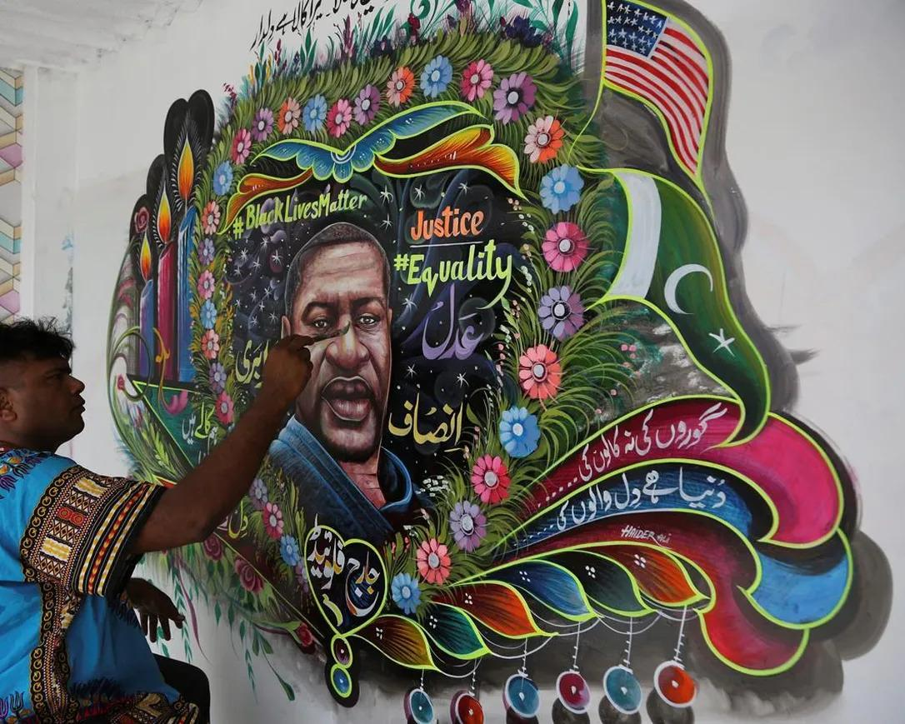
Figure 271. Artist Paints George Floyd
Location: Karachi, Pakistan
Date: 2020
Artist: Haider Ali
Photographer: Fareed Khan
Source: https://www.seattletimes.com/nation-world/pakistani-truck-artist-paints-george-floyd-mural-on-his-home/

Return to Page 73

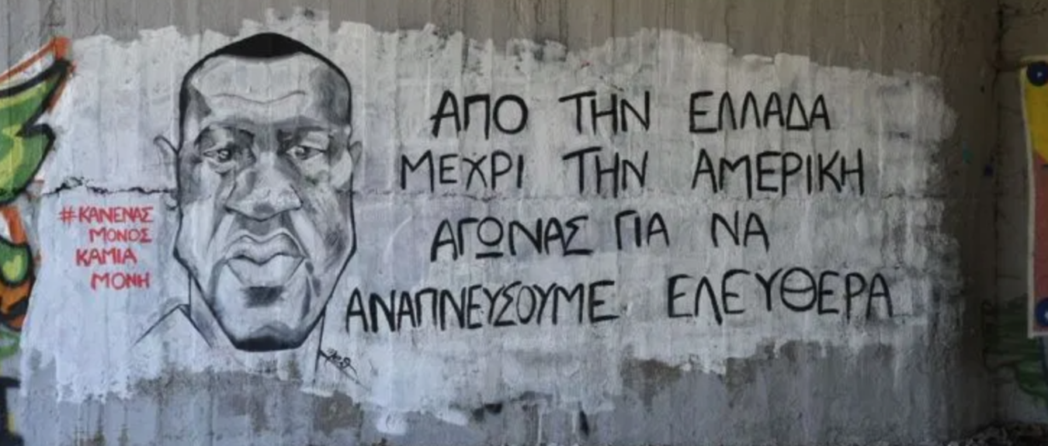
Figure 272. From Greece to America - Struggle to breathe freely
Location: Alcazar Bridge, Larissa, Greece
Date: 2020
Artist: Maria Eleni-Thalassinou
Source: https://greekcitytimes.com/2020/06/18/george-floyd-murals-in-greece/

Return to Page 73

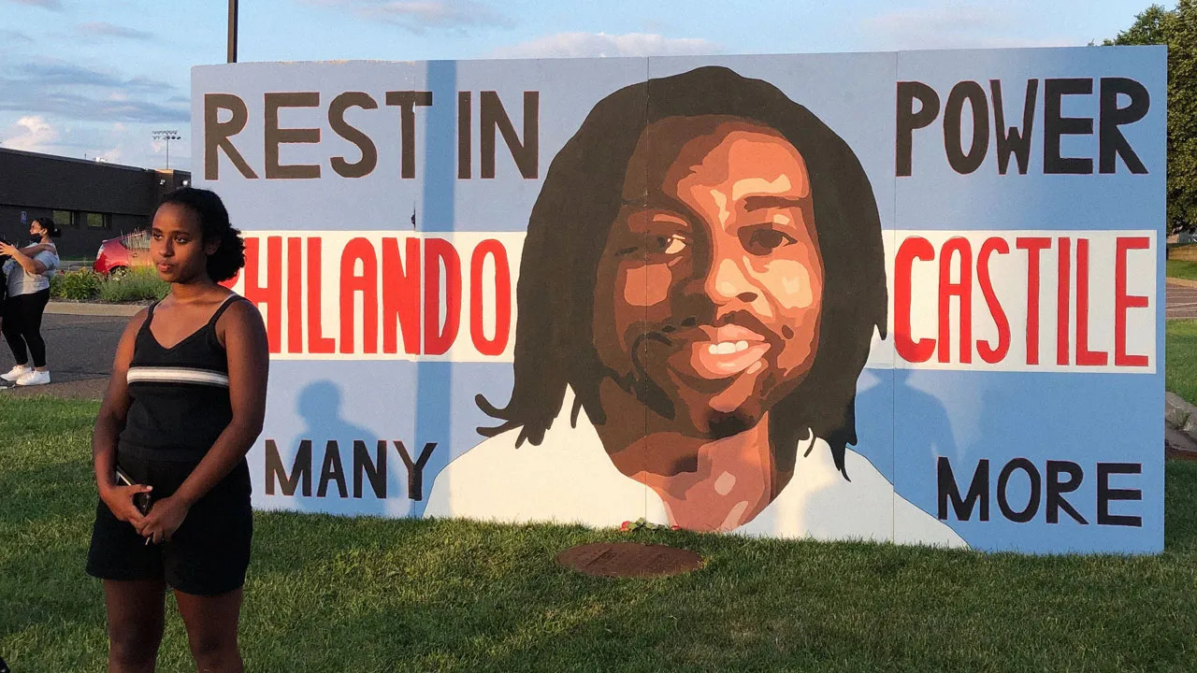
Figure 273. Artist Semhar Solomon in Front of Plywood Memorial Mural of Philando Castile
Location: St. Anthony, Minneapolis, USA
Date: 2020
Artist: Semhar Solomon
Source: https://www.teenvogue.com/story/philando-castile-anniversary-memorial

Return to Page 73

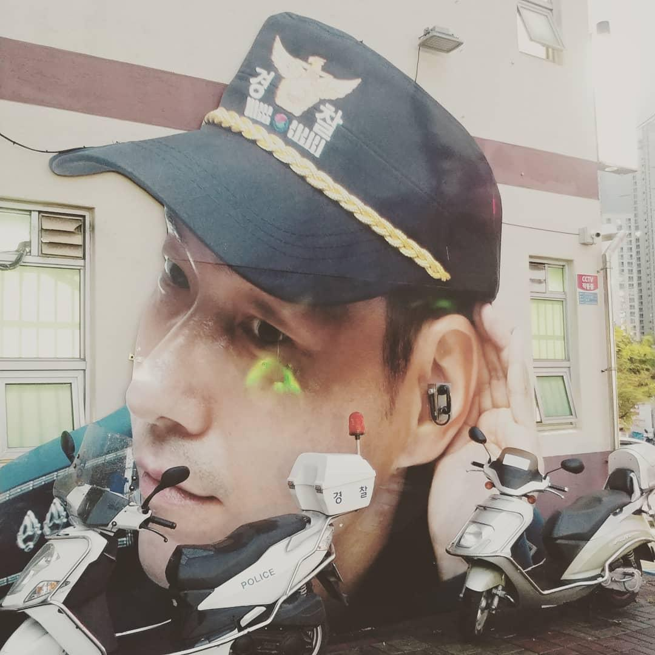
Figure 274. Officer Friendly Listens Through Pay Phone on Bejeon Station
Location: Busan, South Korea
Date: 2019
Source: https://www.facebook.com/2075006399438308/photos/a.2077608109178137/2387387218200223/?type=3

Return to Page 75

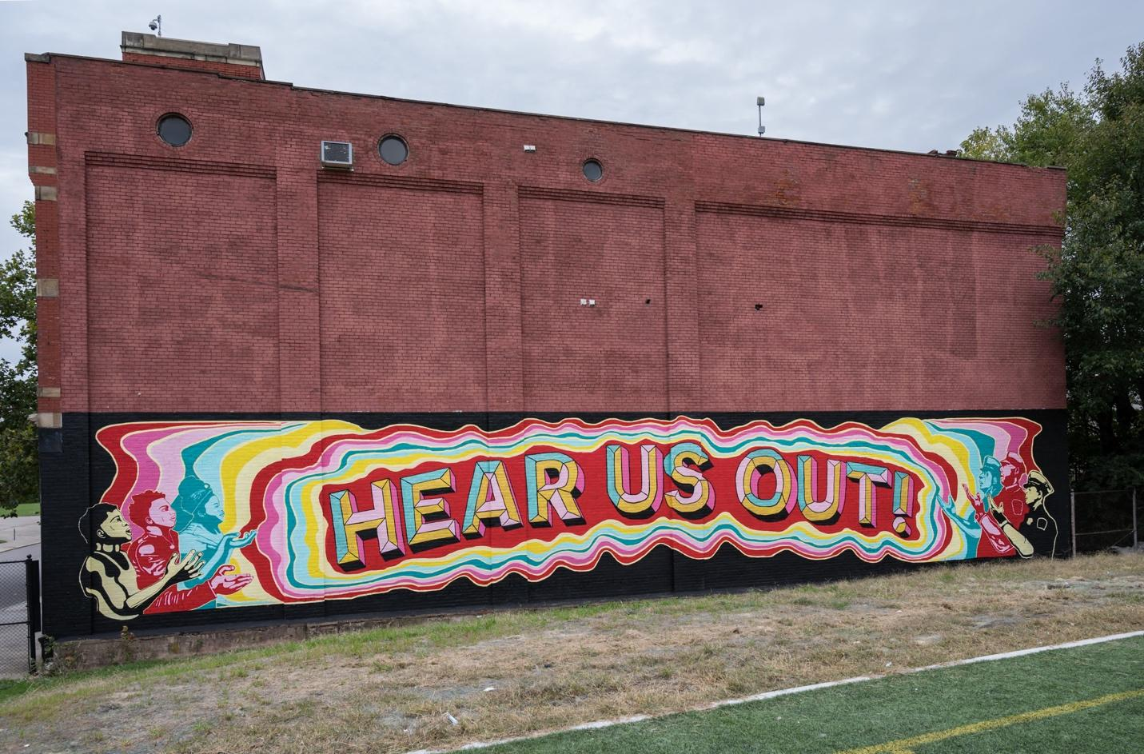
Figure 275. Hear Us Out!
Location: Cincinnati, Ohio, USA
Date: 2021
Artists: ArtWorks, Jeni Jenkins, Nytaya Babbitt, Michael Thompson, and others
Source: https://spectrumnews1.com/oh/columbus/news/2021/08/08/mediation-mural-seeks-to-better-police-neighborhood-relations
& https://www.artworkscincinnati.org/mural/hear-us-out/

Return to Page 75

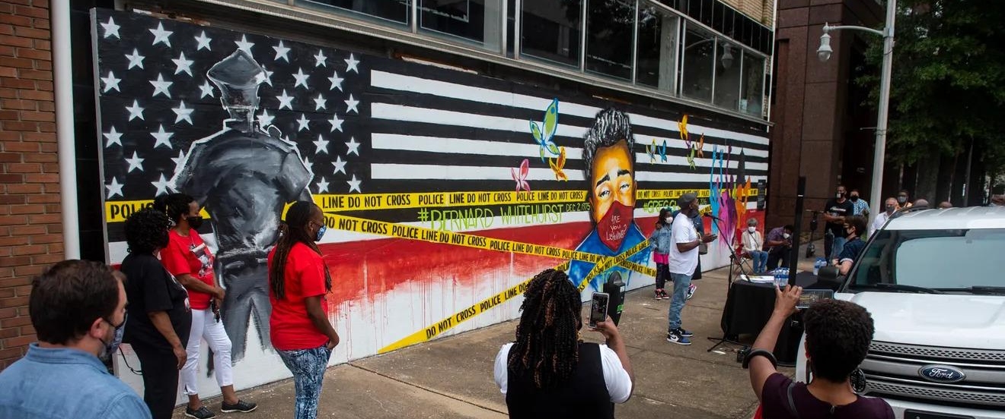
Figure 276. Are You Listening? I
Location: Montgomery, Alabama
Date: 2020
Artist: Milton Madison
Photographer: Jake Crandall
Source: https://www.montgomeryadvertiser.com/story/news/2020/10/27/artist-dedicates-new-montgomery-street-al-mural-police-brutality-and-reform/3750057001/

Return to Page 75

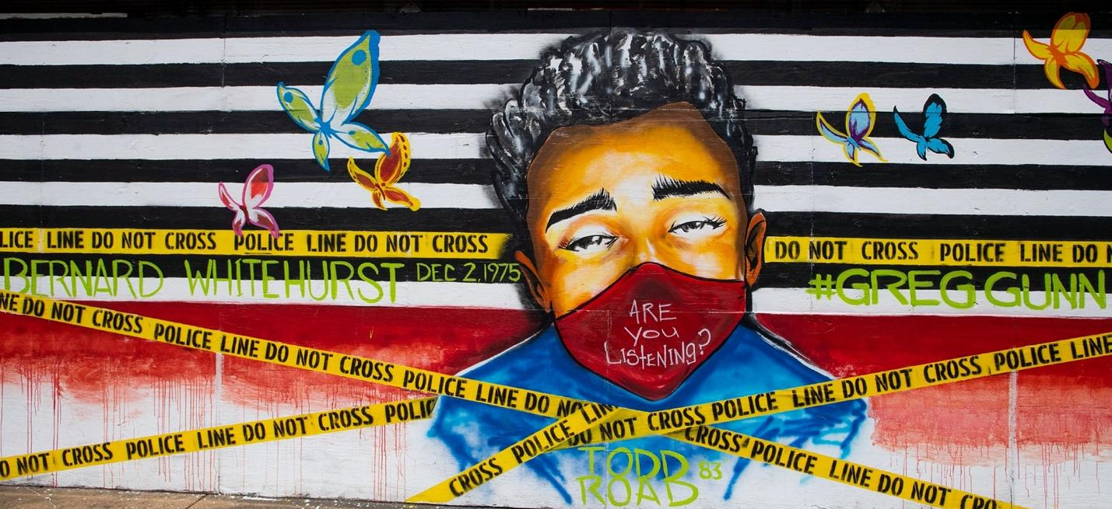
Figure 277. Are You Listening? II
Location: Montgomery, Alabama
Date: 2020
Artist: Milton Madison
Photographer: Jake Crandall
Source: https://www.montgomeryadvertiser.com/story/news/2020/10/27/artist-dedicates-new-montgomery-street-al-mural-police-brutality-and-reform/3750057001/

Return to Page 75
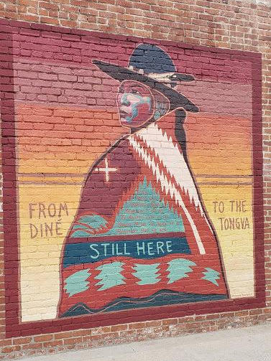
Figure 278. Still Here
Location: Venice, California, USA
Date: 2021
Artist: Lehi ThunderVoice Eagle
Photographer: Rachel Weiher
Source: https://georgefloydstreetart.omeka.net/items/show/2721

Return to Page 76
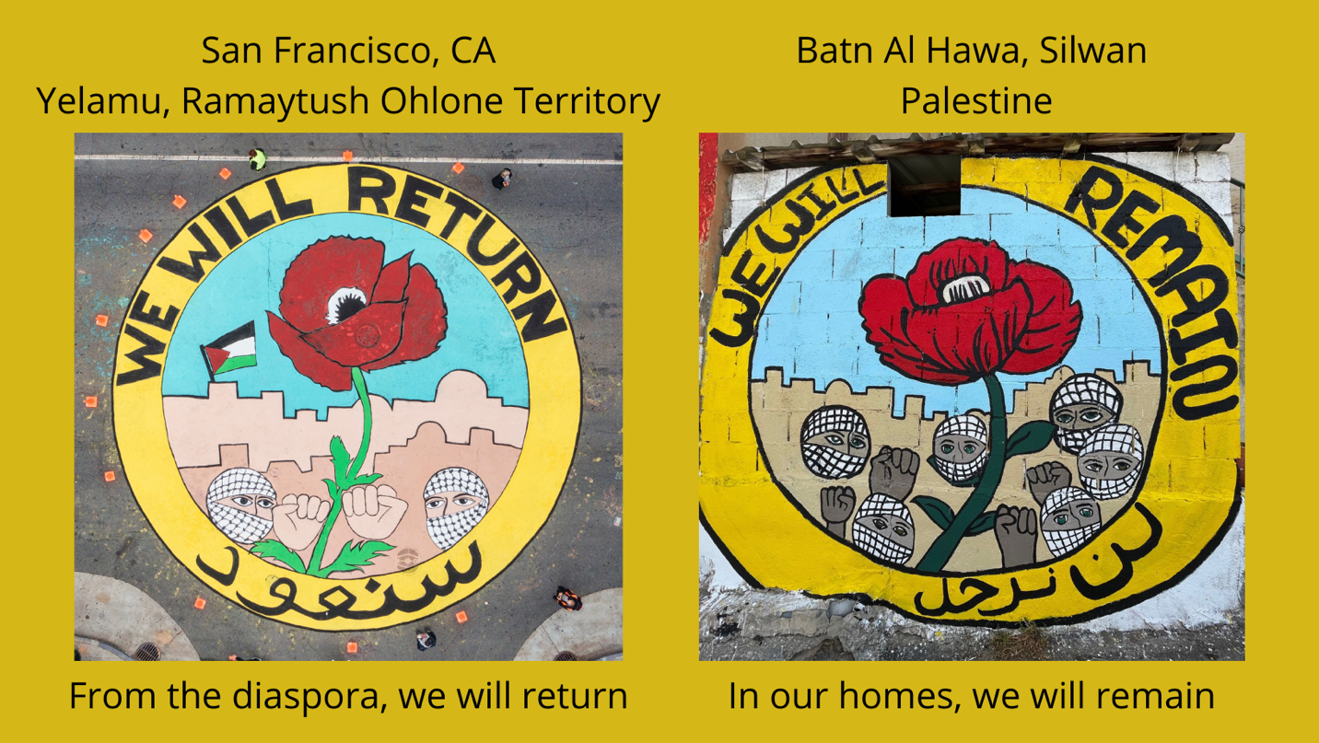
Figure 279. We Will Return & We Will Remain
Location: San Francisco, California, USA & Batn Al Hawa, Silwan, Palestine
Date: 2021
Artists: Palestinian Youth Movement’s Resistance Arts committee, I Witness Silwan, Art Forces, and Madaa-Silwan Creative Center
Photographer: Jenan Maswadeh
Source: https://palestinianyouthmovement.com/joint-mural-project

Return to Page 76

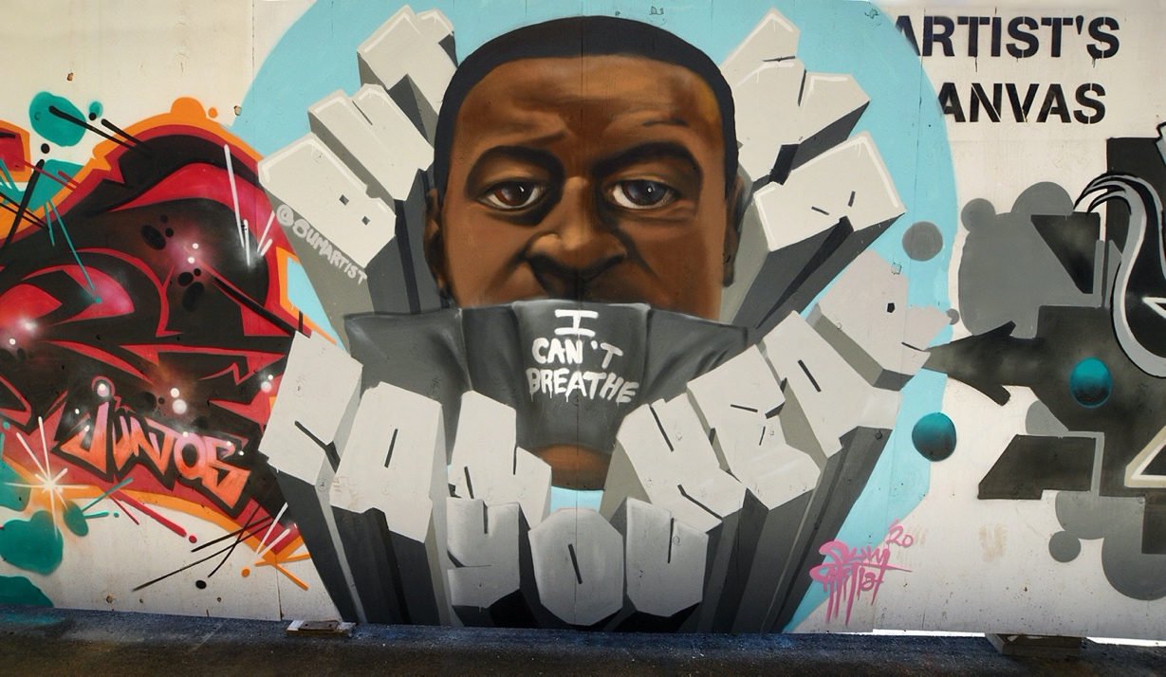
Figure 280. “I Can’t Breathe But We Can Hear You” George Floyd Memorial Mural
Location: Toronto, Canada
Date: 2020
Artist: Paul Glyn-Williams
Photographer: Greg's Southern Ontario
Source: https://www.flickr.com/photos/57156785@N02/49987025773

Return to Page 76

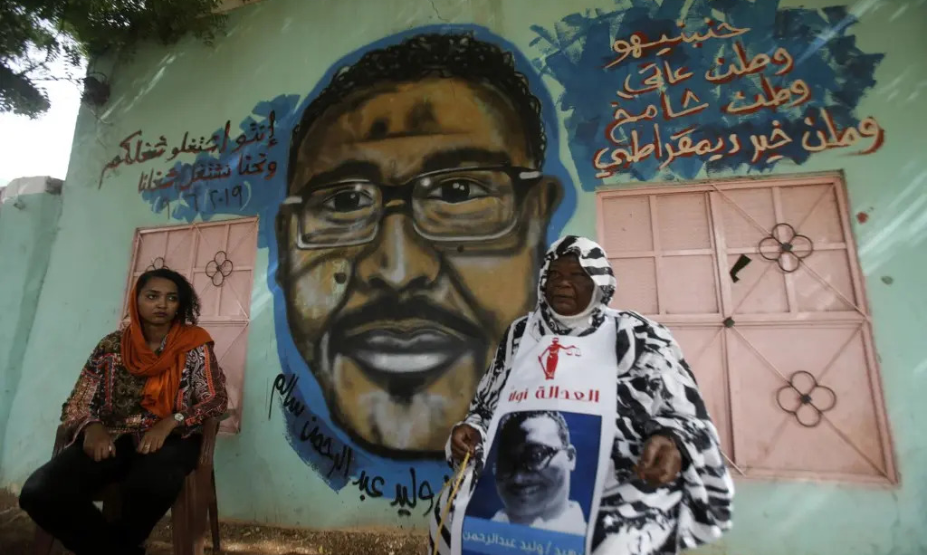
Figure 281. Mother and Artist in front of Memorial Mural of Walid Abdelrahim
Location: Khartoum, Sudan
Date: 2019
Artist: Assil Diab
Source: https://www.albawaba.com/slideshow/colorful-mural-keeps-dead-sudanese-protester-smiling-1299297

Return to Page 77
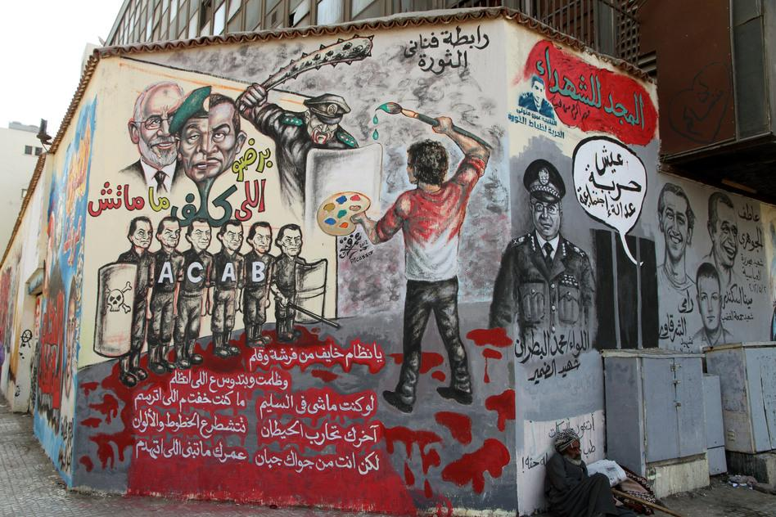
Figure 282. Paint Versus Mace
Location: Cairo, Egypt
Date: 2011
Artist: Omar Fathy
Photographer: Mona Abaza
Source: https://www.northcountrypublicradio.org/news/npr/243720260/elizabethgilbert.com

Return to Page 77

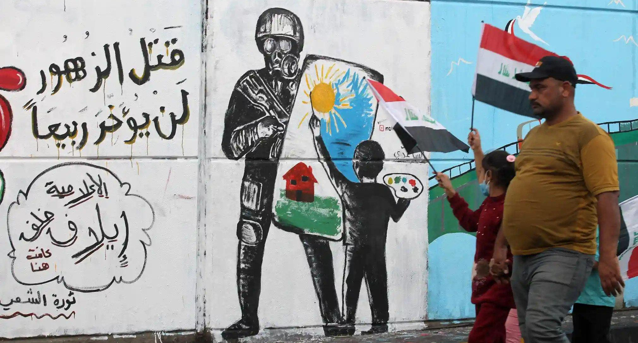
Figure 283. Murdering Flowers Will Not Delay a Spring & The People’s Revolution
Location: Baghdad, Iraq
Date: 2019
Photographer: Ahmad Al-Rubaye
Source: https://www.theguardian.com/global-development/gallery/2019/nov/26/murals-of-baghdad-the-protest-art-in-pictures

Return to Page 77

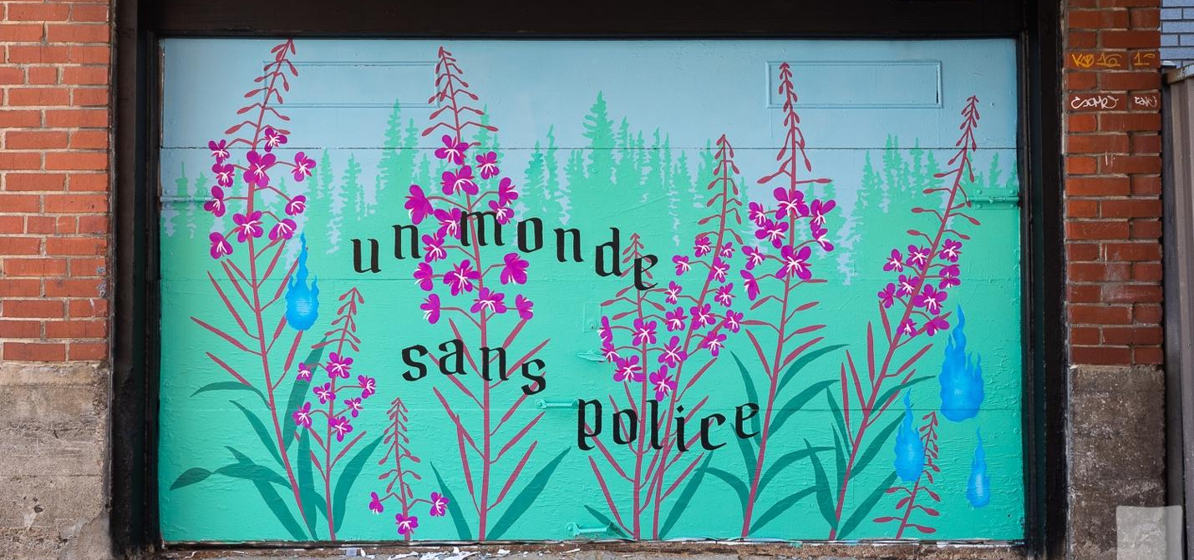
Figure 284. Un Monde Sans Police
Location: Montréal, Quebec, Canada
Date: 2020
Artist: Zola
Photographer: Olivier Bousquet
Source: https://justseeds.org/police-abolition-mural-montreal/

Return to Page 77

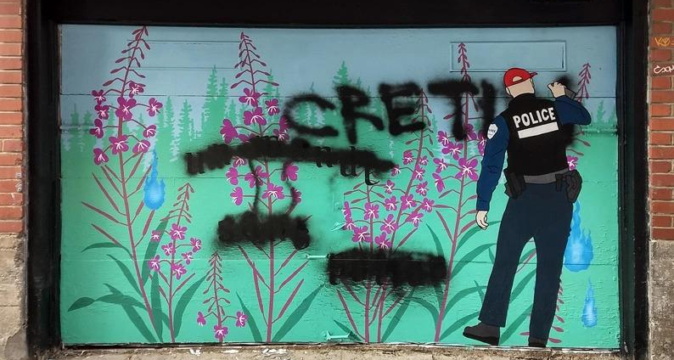
Figure 285. Artist’s Response to Un Monde Sans Police, Vandalized
Location: Montréal, Quebec, Canada
Date: 2020
Artist: Zola
Source: https://wall2wallmtl.com/2021/01/12/canettes-de-ruelle-2020/

Return to Page 77
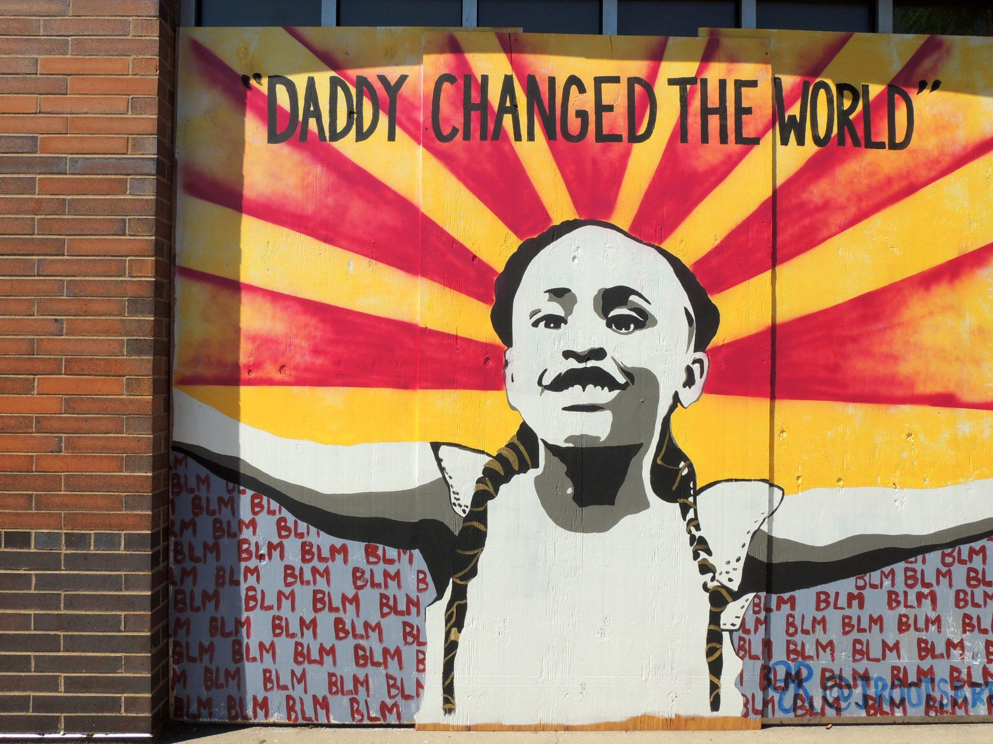
Figure 286. Daddy Changed the World
Location: Minneapolis, Minnesota, USA
Date: 2020
Artist: JRootsArt
Photographer: Hannah Black
Source: https://www.marylandmatters.org/2021/02/18/biden-backs-reparations-study-as-u-s-house-dems-push-for-commission/

Return to Page 78
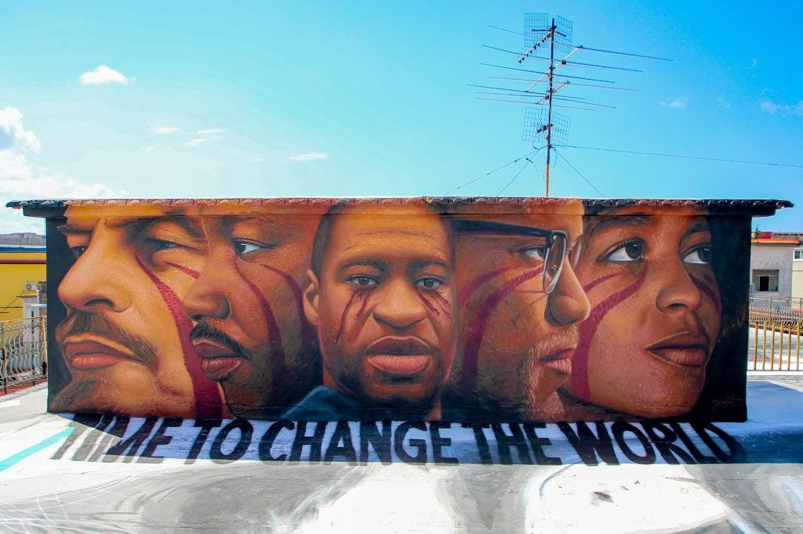
Figure 287. Time to Change the World
Location: Napoli, Italy
Date: 2020
Artist: Jorit
Source: https://www.napolidavivere.it/2020/06/07/lultimo-murales-di-jorit-e-dedicato-a-george-floyd/

Return to Page 78

VITA

Swayne is fourth year PhD candidate in sociology concentrating in critical criminology with certificates in social theory and women, gender, and sexuality studies. Her main areas of interest are policing, culture, housing, and sexuality. She has publications in Critical Criminology, The Journal of Law and Political Economy, Annual Review of Interdisciplinary Justice Research, and Current Perspectives in Social Theory. Her dissertation is an analytical tour of murals around the world that both reproduce and refuse cultural reproductions of police power. Swayne’s dissertation is informed by her role as Project Manager for Abolition Now (AN), an open-source web platform that represents the work of artists and cultural organizers whose work addresses mass incarceration and state violence. Other research projects central to her scholarship include collaborative work investigating police calls for service in the South, community listening projects about police and school safety, and working with the California Institute of Integral Studies (CIIS) as a Sexuality Fellow for their Housing and Sexuality data team. Swayne is a mixed media visual artist and the sousaphonist for the Knoxville Honkers and Bangers, a local adult marching band. She formerly worked as a residential and transitional housing counselor and has experience working with trauma survivors and the criminal punishment system.

All figures in this dissertation are hyperlinked. The reader should click where the Figure is stated in the body of the text (i.e. click “Figure 1”), which will then take them to the image’s location in the Appendix. Each figure in the appendix includes a caption, at the bottom of which there is a hyperlink the reader should click to “Return to Page” and continue reading.
Linde (2000) refers to the process of taking on a story as one’s own as “narrative induction.”
Gilmore (2007) defines structural racism as “the state-sanctioned and/or extra-legal production and exploitation of group-differentiated vulnerabilities to premature death, in distinct yet densely interconnected political geographies” (28).
For historical examples, see Street Meeting by David Alfaro Siqueiros (1932), Man at the Crossroads (1933) by Diego Rivera, Study for Aspects of Negro Life: An Idyll of the Deep South (1934) by Aaron Douglas, The Amistad Murals (1938) by Hale Woodruff, Tragic Prelude (1942) by John Steuart Curry, Wall of Respect (1967) by William Walker, The Hunger Wall or Resurrection City (1968) by The Poor People’s Campaign, Del Ray Mural (1968) by Antonio Bernal, The People’s Wall by Dion Henderson commissioned by the Seattle chapter of the Black Panther Party (1970), The Great Wall of Los Angeles by Judy Baca (1974-1983), and Gone: An Historical Romance of a Civil War as It Occurred b’tween the Dusky Thighs of One Young Negress and Her Heart (1994) by Kara Walker.
Fresco is a technique artists use in which paint is applied directly to wet plaster. The paint and plaster mix together to form the wall itself.
The postrevolutionary Mexican state incorporated radical muralism in its most popular museums—the Palace of Fine Arts, the National History Museum, and the National Anthropology Museum—“The young revolutionary state had need of a sort of legitimization or cultural consecration, and what better consecration than mural painting? That was the way in which a mistake began which ended with the perversion of Mexican mural painting: on the one hand it was revolutionary art, or one that called itself revolutionary, on the other it was an official art” (Octavio Paz in Coffey, 2012: 1).
See Highlander Research and Education Center’s framework: https://highlandercenter.org/cultural-organizing/
Rather than focusing on the outcome (as one does for a dissertation), the process of building a commonplace book was unpolished, messy, and free of parameters.
In the upsurge of public attacks and bombings on Gaza since October 2023, Stop Cop City organizers indict the shared systems of occupation and militarization deployed against them by sovereign, yet deeply interwoven, states. Stop Cop City organizers demonstrates these connections using social media: https://www.instagram.com/p/CyuUY6QrAYY/?img_index=1
Security politics persist as the state is “constantly revolutionising the instruments of production, and thereby the relations of production, and with them the whole relations of society,” resulting in an “uninterrupted disturbance of all social conditions, everlasting uncertainty and agitation [that] distinguish the bourgeois epoch from all earlier ones” (Marx 1848). By continually changing labor conditions, policies, and production, the “uninterrupted disturbance” of capitalist social order is constantly “fabricated, structured and administered” (Marx, 1848; Neocleous, 2011b: 19).
Constitutive criminologists Henry and Milovanovic (1996) argue that “crime” is caused by “the ideology and invocation of discursive practices that divide human relations into categories, that divide responsibility for others and to others into hierarchy and authority relations, and that render some subject positions vulnerable to excessive investment by others” (180).
To rely on official data inaccurately presumes the state accurately tracks its violence and inefficacies.
McDowell (2017) defines carceral safety as “the use of state-organized banishment (via jail, prison, or deportation), mass criminalization, and law enforcement as the only legitimate forms of protection from, and solutions to, harm and violence in the United States” (3-4).
Rodriguez Vera intended for her original site of study to be a community mural created by children, as part of the conclusion to a summer arts program sponsored by a local non-profit in Arizona. When asked what they would like to paint, the youth designed a 35x30 ft mural that depicted various experiences of their families. The design included undocumented students in caps and gowns with their parents, children playing, and in the center stood a sheriff shaking hands with a Mexican immigrant as a symbol of “peace.” The mural was to be painted on the wall of a local community center, somewhere frequently graffitied. However, the same day the children designed the sketch, the organization staff rejected the proposal due to concerns about controversy and possibly losing funding. The local organization policed, rather than empowered, the youth’s vision and demonstrates how people leverage their reputation to gain symbolic, cultural, and economic capital associated with police power.
This happy cop character’s “friendship” comes at a cost: “accept the police definition of reality and mold yourself and your family into ideal police subjects—polite, polished, obedient workers and snitches who never question the racial order of capitalist property relations” (Correia and Wall, 2018: 104). As a central figure in community policing, Officer Friendly “renders police power as a productive power that works to produce and build a particular social order by consent and not simply force” (Correia and Wall, 2018: 106).
Regardless of the sexuality, race, or gender of a state agent, the nature of their occupation symbolizes and materializes patriarchal authority by demanding compliance, and obedience, and assimilation. It should also be noted that community satisfaction rates do not vary between departments’ major racial composition, and use of force incidents and bias are consistent across majority white, Black, and Hispanic police department (Vitale, 2017).
Artist collectives around the world include JustSeeds, Anticapitalism for Artists, ARRT! (Artists Rapid Response Team!), Art Forces, Art Not War, Dignidad Rebelde, Art and Resistance Through Education (ARTE), Arte En Resistencia, The Art Lords (Kabul, Afghanistan), Muralistas Rebelde Accion, Clarion Alley Mural Project, For the People Artist Collective (Chicago, IL) Moriviví Colectivo (Puerto Rico), Know Peace Murals (Minneapolis, MN), Borda Artists Front (Borda, Argentina), and others.
https://ias.ucsc.edu/archives/artists/ashley-hunt/
https://www.lizartistry.com/
Schept (2022) defines “abolitionist geography” (in its Southern US context) as “the material and ideological terrain connected across time to earlier struggles in Appalachia and across space to other contemporary social movements, and mobilized to plot both a different story and a different vision for the region” (33).
Whereas some scholars highlight the differences between signs that coexist in space and signs that follow each other chronologically, artists do practice techniques to control the viewer’s perception and order of observation (i.e., position something in the background and avoid vibrant colors, see Speidel, 2013)
Bateman at Wildfeuer (2014) explain that semiotic modes draw upon “the least level of abstraction, on an acceptance of materiality and, at the highest level of abstraction, on a detailed model of discourse and its operation” (181). Critical discourse analysis at the higher levels of abstraction bridges nuances between written, verbal, and visual communication, in which “insights from linguistic models can be beneficially applied” and the “sequences of both verbal and visual material can function similarly as communicative artefacts or performances” (Bateman at Wildfeuer, 2014: 181).
Using Google Translation, I translated various searches from English to Spanish, French, Portuguese, Italian, Japanese, Korean, Arabic, and German. Translations proved helpful to discover murals on police departments outside of predominantly English-speaking geographies.
https://georgefloydstreetart.omeka.net/urban-art-mapping-databases
https://www.arteenresistencia.org/
https://endlesscanvas.com/
https://bretkelly.com/
https://commons.wikimedia.org/wiki/Main_Page
https://creativecommons.org/
https://www.artworkscincinnati.org/public-art/murals/all-murals/
https://sparcinla.org/digital-mural-lab/
https://www.muralarts.org/
https://morebaltimore.wordpress.com/2020/01/18/baltimore-murals/
https://www.notacrime.me/the-walls#thewalls
https://www.wallsofjustice.com/gallery
https://oaklandmurals.com/
https://creativeresistance.org/murals-of-the-carnation-revolution/
By “solipsistic interpretation,” I mean the perception that only oneself possesses experiences and beliefs that are valuable and can be considered true.
For instance, one harrowing memorial mural points to the death-wielding color of American policing: Blue is the Color We See Before We Die. In 2014, Yvette Smith called 911 while at a friend’s house to try and make peace during a neighborhood dispute. Daniel Willis, a Bastrop County, Texas Sheriff Deputy, arrived and demanded Yvette come outside. Willis shot and killed Smith within three seconds of her opening the door. He claimed he thought he saw Yvette wielding a gun, only to recant the statement the next day. Historically, the courts afford police immunity and impunity after exercising deadly legal discretion, justified so long as the officer refers to fear for his life (Gilmore, 2022; see Graham v. Connor, 490 U.S. 386 [1989]). Visiting Judge Albert McCaig Jr. acquitted Willis praising him as the “man in the arena,” referring to a speech given by Theodore Roosevelt that “praised those willing to take risks in the face of failure” (Jankowski, 2016). Texas based artist Delita Martin painted the mural chronicling the actions resulting in the theft of Smith’s lifetime, as part of Ava DuVernay’s Law Enforcement Accountability Project. As a color used to memorialize and mourne in US culture, blue in Martin’s mural symbolizes at once deadly police power and the emotional turmoil left in its wake. Historical processes of racialization marked Smith’s life as a nonwhite woman expendable, strengthening the state’s power to “govern life and fabricate social order by rendering some lives superfluous” (Turner, 2019: 251; see Ritchie, 2017). Martin chose her color palette and title to reflect such governance.
Hall (1997) lists useful questions that help the analyst decipher the “discursive event,” or the “emergence of a new regime of knowledge” (53). I use guiding questions he offers, including: Who commands the centre of the picture? [How] can you tell that knowledge is being produced here? What do you notice about relations of power in the picture? How are they represented? How does the form and spatial relationships of the picture represent this? Describe the 'gaze' of the people in the image: who is looking at whom? What does that tell us? What do the age and gender of the participants tell us? What is the relationship of you, the viewer, to the image? Do you notice anything else about the image which we have missed? (54).
When the abstract is incoherent, Presser (2016) suggests that maybe “like artists we [researchers] should get more comfortable with incoherence, which also conveys meaning and can be strategically deployed by actors” (148).
For example, Doss (1995) describes a 1989 “public art episode” in which the Los Angeles Museum of Contemporary Arts commissioned Barbara Kruger to paint a 29x218 foot mural on a wall of their building facing Little Tokyo. Despite Kruger’s goal to stimulate awareness about the impact of particular words and symbols such as the Pledge of Allegiance and the US flag, members of the Japanese American community interpreted her proposal as a racial slur. Recollecting the pain of “loyalty tests” given in internment camps in the US during World War II, “the thought of having to confront what they perceived as accusations of disloyalty again, on an everyday basis, in brightly painted letters five feet tall was too much,” and the community felt the mural dismissed a sensitive history and undermined their loyalty after Japanese Americans volunteered for combat (Doss, 1995: 10). Nayeri (2022: 111-118) mentions two more recent examples of white artists inserting themselves into histories that are not their own, Dana Shultz’s Open Casket (2016) and Sam Durant’s Scaffold (2012).
Although images of vandalism are hurtful, they are necessary to include and decrypt to show how vandalism distorts the mural’s original story and its intended perception.
The “plain view doctrine” is an exception to Fourth Amendment rights that allow police to seize “evidence” or “contraband” so long as the objects are visible and police can find “probable cause” that relates said objects to a crime or the intent to commit a crime.
https://datausa.io/profile/geo/topeka-ks/#demographics
The Headquarters is in Lagos, a city once a major port in the Transatlantic slave trade occupied by the British Empire and Christian missionaries.
Symbolic doves appear in Judaism, Christianity, Islam, and paganism in military and pacifist contexts. In the series On Christian Doctrine (circa 396), Augustine of Hippo (354–430) wrote that “perpetual peace is indicated by the olive branch (oleae ramusculo) which the dove brought with it when it returned to the ark,” referencing early Christian depictions of Noah’s Ark.
At the turn of the 21st century, Lee Hyun-se created Podori and Posuni for the South Korean National Police, who then awarded the artist an honorary status as police officer.
Broken-windows policing (Kelling and Wilson, 1982) relies on bourgeois logics that accelerated the war on drugs, declared by Nixon in the US in 1971, and justify increased resources for police to raid Black, brown, and poor communities. Broken windows policing initiatives conflate poverty with danger, “shift the burden of responsibility for declining living conditions onto the poor themselves,” and increase police power (Vitale, 2017: 7).
https://twitter.com/policiaecuador/status/1406636732716654597
Oldrieve’s use of “training” neatly fits into Neocleous’s theory of the capitalist fabrication of social order, in which capitalist accumulation rests on the “manhunt” (for addicts, queers, vagabonds, beggars, enemies, criminals, terrorists, witches, pirates, and truants).
https://www.flickr.com/photos/zapopangob/50698792923/in/album-72157717232826442/
This is Gilmore’s (2016) language, when “normalization slips into naturalization, and people imagine that locking folks in cages or bombing civilians or sending generation after generation off to kill someone else’s children is all part of ‘human nature.’”
Policing institutions dictate access to urgent social services such as housing and food security, basic medical and health needs, conflict resolution and mediation, and other basic resources (Schenwar and Law, 2021; Kaba and Ritchie, 2022).
See Beshenov, 2016-2017 for the full series: https://cadadr.org/centroamerica/mural/
https://twitter.com/PNCdeGuatemala/status/1533495194729041922
Naomi Klein’s (2007) The Shock Doctrine: The Rise of Disaster Capitalism is paramount. She explores how various national states purposefully use neoliberal free market ideologies to exploit periods of national crises, pass oppressive legislation, and profit from social upheaval.
In 2020, the city government of Tulsa, Oklahoma erased a BLM mural painted on a street where the former “Black Wall Street '' stood, a burgeoning and bustling neighborhood of Black businesses invaded and burned by white rioters in 1921. Residents understood the 1921 massacre of Black businesses and bodies “as an ongoing event directly tied to the white nationalist ideology” (Lennon, 2022: 94). Erasing the BLM murals illustrates a form of colorblind racism, or “how these instances of ‘race-neutral’ policies are part of the mundane racialized policing by city bureaucracies” (Lennon, 2022: 96).
In 1973, Assata Shuker received a life sentence in prison for killing a New Jersey state trooper as an act of self-defense during a routine traffic stop. She escaped to Cuba.
Suing protestors and organizers for "harassment" is an increasingly common counterinsurgent tactic.
In “acephalous” societies, before the shift from feudalism to nationalist capitalism, community and kin responded to perpetrated harms. The emergence of racial capitalism, however, required a centralized state to protect private property and merchant interests (Shelden and Vasiliev, 2018; Mies, 1986). Eventually the state took control over handling disputes, shifting responsibility to repair harm from the victim or their kin to a court system, resulting in the system we know today. The state represents the offended party. It became legally possible to commit a crime against the state, a new category of victim and new constructions of a private/public divide to construct “crimes” such as “theft,” “vagrancy,” and “loitering” (Shelden and Vasiliev, 2018; Neocleous, 2000; Haley, 2016).
It seems unlikely the police would have no idea how people perceive them given the numerous public displays of critique, whether it be murals, demonstrations, or news media.
Murals appear on police departments around the planet now because “heterogeneous and multiple global structures put in place over a period of 450 years did not evaporate with the juridical-political decolonization of the periphery over the past 50 years” (Grosfoguel, 2011). We live under what he calls the same “colonial power matrix.”
https://www.fbi.gov/contact-us/field-offices/memphis/news/press-releases/fbi-releases-report-on-nashville-bombing
https://www.instagram.com/p/CJpg9kiBV7E/
https://ibelieveinnashville.com/pages/i-believe-in-heroism?_pos=1&_sid=d10ec4ea6&_ss=r
Gilmore (2022) explains that “everywhere racism and machismo and exploitation are determined economically, they are also defined culturally” (87; see also Kurtz and Upton 2017). The police officers represented on department murals are largely gendered as men, revealing much about the image of “cop” in the global imaginary. Yet individual biology does essentialize harm-doing under white supremacy and patriarchy; conditions of these structures worsen life for everyone, but not equally.
All Cops Are Bastards is a well-known anti-policing acronym that posits policing is a foundationally problematic and violent system. ACAB appeared as early as the earliest modern police force in 1829 London, originally All coppers are bastards (Wall, 2020: https://www.youtube.com/watch?v=fnZq7_0Gfto, see also Wall and McClanahan, 2024).
George Floyd murals appeared in Afghanistan, Belgium, Canada, China France, Germany, Greece, Haiti, Indonesia, Jamacia, Ireland, Italy, Kenya, Mexico, Norway, Pakistan, Palestine, Spain, Syria, United Kingdom, USA, and Venezuela.
The Salta Police tried to prevent the painting of a mural that denounces impunity in the deaths of Jorge “Guri” Farfán, Cristián Gallardo, David Neri Ovejero Alfonzo, Martín Carreras and Agustina Nieto (Página 12, 2019).
In Los Angeles in 2020 on the second day of uprisings, to demonstrate Hispanic solidarity with Black communities, Celos and Mario Medina painted a George Floyd memorial mural. Floyd’s mouth is covered in red tape with the words “I can’t breathe.” A halo illuminates his face as he cries. Hashtags surround his portrait: #Freedom #Unity #Peace #Change #BlackLivesMatter #Pray #Love #Justice #AllLivesMatter #Hope #Faith. Does saying BLM followed by All Lives Matter negate BLM? Does it collapse Black into All?
https://www.instagram.com/p/B43d7IDBk-H/
In a history of slang dictionaries, Coleman (2004) cites the entry for pig in Lexicon Balatronicum (1811), which is as follows: PIG. A police officer. A China street pig; a Bow-street officer. Floor the pig and bolt; knock down the officer and run away (84).
Scholars date the deprecating personification of pigs back to the thirteenth century in medieval Europe when antisemites depicted Jewish people as nonhuman to mock Judaic beliefs that pigs are pork are unclean.
After police murdered George Floyd, activists held severed pig heads outside the Minneapolis Police Department and Los Angeles Police Department (Warda, Aiello, and Hill 2020).
Schutzstaffel was a Nazi paramilitary organization (1925–45), and the SS references the Waffen-SS military branch.
https://www.youtube.com/watch?v=fnZq7_0Gfto
https://www.instagram.com/p/CBuihz5lfL7/?img_index=1
https://www.instagram.com/p/C30WX5nx0hq/ & https://summerawad.com/poetry
https://www.iwitnesssilwan.org/
The Gadsden Flag, named after South Carolina politician Christopher Gadsden, dates back to the American Revolution. It took on modern right-wing meanings when it was adopted by the conservative anti-tax Tea Party Movement.
To various degrees, murals in this section speak to movements and moments “that aim to redistribute life chances and resources; those that aim to end our reliance on prisons and police to solve political, economic, and social problems; those that confront systems of white supremacy, anti-Blackness, capitalism, ableism, cisnormativity, and heteropatriarchy; and those that struggle to fundamentally transform state and society” (Akbar et al., 2021: 864).
For up-to-date information on anti-trans legislation, see https://translegislation.com/
https://www.jessicasabogal.com/about-1
https://www.notacrime.me/the-walls#everywhere
The Zapatista Army of National Liberation, or Zapatistas, is an Indigenous rebel movement known for its armed uprisings against the Mexican state in 1994.
In the painting, Ali quotes a popular Indian song in his home language: Hum kaalay hain toh kia hua, dilwale hain (So what if we are dark-skinned. We have got big hearts) and Goron ki na kaalon ki, dunya dil walon ki (This world doesn’t belong to white or black people, it belongs to the ones with heart) (Farooq and Ahmed, 2020).
Text in policing murals emphasized service, excellence, respect, professionalism, dialog, unity, honor, community, order, security, hero, teamwork, and integrity.
Correia and Wall (2018) that state violence is “never exceptional, however spectacular and appalling it might be, and that the majority of police violence is routine and ordinary, built into the very mandate of police that makes police such a unique and powerful force in all of our lives, but especially the lives of the poor” (78).
I acknowledge the limitations of this dissertation, which include my identity as a monolingual American. Limitations also included categorization, such as flattening nuances, that also relate to personal subjectivity. While I aimed to balance breadth and depth, I believe there are deeper dives to be made to account for the specific histories/geographies/contexts of policing murals. Any mistakes in the dissertation are my own, and I take full responsibility. I also want to acknowledge the potential of the research corpus as a horizon for future translations, research, collaborations, and as a means to reawaken our imaginations.

