Bioanalytical Applications of Digital Imaging: Applications to Organ-on-Chip and
Point-of-Care Analysis Systems

A Dissertation Presented for the
Doctor of Philosophy
Degree
The University of Tennessee, Knoxville

Amirus Saleheen
August 2020
Copyright © 2020 by Amirus Saleheen
All rights reserved.

Dedication

To my loving wife, friend, and partner in crime
PORI

Acknowledgements
The last five years have been a roller coaster ride for me. I have migrated to a foreign country, started a new life with my wife, had two wonderful boys, and of course, completed my graduation study towards my PhD degree. And I would not have been able to complete my journey without the help of a lot of people. I am thankful and grateful to each of them.
First, I would like to thank my PI, Dr. Christopher A. Baker. He has been an ideal PI to me since day 1 of my graduate life. I have learnt a great deal from him. He has helped me grow as a scientist and a professional being. He often took interest in my family life and my personal wellbeing, which made him even more amenable. He always provided me with advice when I seek them. As an international student, I sometimes found myself directionless and frustrated at a foreign land and he often helped me out of it. The best memory I share with him is about a football match (yes, I am going to call it a football match, it is not soccer!!! Ha-Ha!!). One time I had to crunch some quick data for a collaborative experiment and a world cup football match between Argentina and Nigeria was happening at that time. I am a fan of the Argentine football team, and he hates the guts of them. Even though, he brought a projector in the lab and live streamed the match for me while I was working. I will remember this day about you my whole life. For curious minds, Argentina won that match and he did not like it. Chris, I cannot thank you enough for your contributions to my graduate life and your persistent patience with my occasional learning curves. I would not be standing where I am now without your help.
I have had a wonderful time in the University of Tennessee, and my colleagues played an important role in it. I would like to thank Laura, Meagan, Claire, Victoria, Alex, Larry, Marlene, and Kevin for helping me to be a better scientist in the Baker lab. Special thanks to Redwan and Mamun for the countless hours of conversations about life, career, and future that helped me through the long journey of graduate studies.
I would like to thank some of my high school teachers who helped me strengthen my foundation for my higher studies. Mr. Anwar Hossain helped me with learning English as a second language which enabled me to pursue my PhD in an English-speaking country. Ms. Nahida Sultana helped me grow as a better person and improved my perception of the surrounding world. Mr. Sujit Saha is the major contributor in sparking my love for chemistry. I would also like to thank Mr. Jahangir Alam and Mr. Kazi Ansar Uddin for their kind support during the early stages of my life.
I want to thank some of my close friends who have supported me at different stages of my life and helped me complete this journey. I acknowledge the support of Hasib, Shaheen, Dipu, Swakshar, Kundu, and Fahad. Without them, my journey would have had a lot more roadblocks. I also want to thank my parents for their support towards my education.
Lastly, I want to thank my family: My wonderful wife and adorable two sons. Pori, without you I would not have completed this long journey of PhD. You are as much deserving for this honor as I am. I thank Omi and Ori to make these days more colorful and occasionally challenging!
Thank you all very much.

Abstract
Qualitative and quantitative analysis through digital imaging has significant potential in several scientific applications including bioanalytical applications. In this document, the implication of digital imaging to validate and characterize a novel microfluidic organ-on-chip device and establish a point-of-care method to estimate epinephrine concentrations in expired and degraded autoinjectors have been described in chapter 2 and 3 respectively. Chapter 4 includes description of the principle and methodology of strong cation exchange-based immunoassay for oxytocin and β-endorphin.
In chapter 2, fabrication of a novel microfluidic organ-on-chip device capable of culturing rodent SCN slices has been discussed. Characterization of the aCSF media droplets and carbogen gas bubbles have also been discussed. Viability of the cultured rodent brain slices using digital imagery through fluorescence calcium imaging and PI/DAPI staining have been reported. In chapter 3, utilization of quantitative smartphone imaging to estimate the concentration of epinephrine in expired and degraded autoinjectors have been described. Actual concentrations of the samples have been established by UHPLC technique. The estimated concentrations of the samples via quantitative smartphone imaging have been reported to possess a strong correlation (r > 0.7) with the actual concentration. Different lighting conditions, distance and angle of camera variations have been explored in chapter 3.
Direct immunoassay of relatively small neurotransmitters (~1-5 KDa) through capillary electrophoresis is prone to poor resolution challenge. The principle of using strong cation exchange-based chromatography to carry out such immunoassays have been described in chapter 4. The possible use of crosslinking agents such as sulfo-GMBS and sulfo-SMPB to improve antigen-antibody binding has also been discussed in this chapter. Chapter 5 explores the future directions of improving the rodent slice culture device to accommodate various size and shape of brain slices by chamber geometry and surface energy optimization.
Table of Contents

1. Introduction 1
1.1 Background concepts on microfluidic approaches to brain slice culture 2
1.1.1 Objective 2
1.1.2 Roller tube method for rodent brain slice culture 3
1.1.3 Microfluidic brain slice culture 5
1.1.4 Monodispersed bubble and droplet generation 8
1.1.5 Tissue adhesion 10
1.1.6 Brain slice viability in the perfusion experiments 13
1.1.7 Summary 17
1.2 Background concepts on quantitative smartphone imaging for epinephrine dose estimation 17
1.2.1 Objective 17
1.2.2 Anaphylaxis 18
1.2.3 Epinephrine 20
1.2.4 Epinephrine measurement by UHPLC 21
1.2.5 Quantitative smartphone imaging 24
1.2.6 Summary 26
1.3 SCXC based immunoassay 27
1.3.1 Objective 27
1.3.2 Regulatory relationship between oxytocin and β-endorphin 28
1.3.3 Immunoassays for peptide measurements 28
1.3.4 Analytical challenge for conventional immunoassays 30
1.3.5 Principles of ion exchange chromatography 31
1.3.6 Summary 33
2. Microfluidic brain slice culture via a novel bubble perfusion device 34
2.1 Abstract 36
2.2 Introduction 37
2.3 Experimental procedure 39
2.3.1 Device fabrication 39
2.3.2 Characterization of carbogen bubble and aCSF droplet 39
2.3.3 Synthesis of hydrogel glue 40
2.3.4 Tissue slice preparation and Fluo-4 AM dye loading 41
2.3.5 Perfusion experiment and calcium imaging setup 41
2.3.6 Propidium Iodide staining and fluorescence imaging setup 42
2.4 Results and Discussions 43
2.5 Conclusion 54
3. Estimation of available epinephrine dose in expired and discolored autoinjectors via quantitative smartphone imaging 56
3.1 Abstract 58
3.2 Introduction 59
3.3 Experimental section 62
3.3.1 Reagents and materials 62
3.3.2 Expired EAI samples 62
3.3.3 Epinephrine measurements by UHPLC 62
3.3.4 Characterization by UV-Vis spectrophotometry 63
3.3.5 Quantitative smartphone imaging 63
3.4 Results and discussion 64
3.5 Conclusions 74
4. Cation exchange chromatography of Oxytocin and β-endorphin 77
4.1 Method development for SCXC-based immunoassay of β-endorphin 78
4.2 Crosslinking of β-endorphin to IgG antibody for covalent stabilization 81
4.3 Minimization of equilibration time 83
4.4 Immunoassay of β-endorphin and Oxytocin 84
4.5 Conclusion 85
5. Future work 87
5.1 Objective 88
5.2 Alternate fluid delivery system 88
5.3 Size and shape of the device chamber 90
5.4 Surface energy of the device chamber 90
5.5 Carry-over analysis 91
5.6 Summary 91
List of references 93
APPENDIX A 111
APPENDIX B 116
VITA 119

List of Figures
Figure 1: Roller tube for brain slice culture 3
Figure 2: Schematic of a microfluidic slice culture device involving interstitial flow 7
Figure 3: Monodispersed carbogen bubble and aCSF droplet generation at a microfluidic T-junction 9
Figure 4: An example of the physical approach of tissue adhesion 11
Figure 5: Incapability of plasma clot as an adhesion approach for the microfluidic bubble perfusion device 12
Figure 6: Reaction schematic of the hydrogel based tissue adhesive material 13
Figure 7: Principle of calcium imaging 14
Figure 8: Molecular structure of a. propidium iodide, b. paraformaldehyde, and c. diaminophenylindol 16
Figure 9: Molecular structure of epinephrine 20
Figure 10: Reverse phase liquid chromatography 23
Figure 11: Quantitative image analysis through RGB stacking 25
Figure 12: Schematic representation of binding and elution in SCXC 32
Figure 13: Novel microfluidic rodent brain slice culture device 44
Figure 14: Characterization of the novel microfluidic rodent brain slice culture device 46
Figure 15: Tissue adhesion 48
Figure 16: Fluorescence calcium imaging 51
Figure 17: PI/DAPI staining 53
Figure 18: Graphical abstract of chapter 3 58
Figure 19: Epinephrine quantitation by UHPLC 64
Figure 20: Epinephrine quantitation by UV spectrophotometry 66
Figure 21: Visible Spectrophotometry of discolored EAI solutions 68
Figure 22: Relative color index vs. epinephrine concentration 69
Figure 23: Quantitative smartphone imaging of discolored EAI solutions 71
Figure 24: Influence of sample distance and orientation on color index determinations 73
Figure 25: Cation Exchange Chromatograms: individual injections of β-endorphin(i), IgG antibody(ii), and a mixture of these 78
Figure 26: Flowrate optimization 80
Figure 27: Crosslinking of IgG antibody and antigen complex with amine-sulfhydryl crosslinking reagent (Sulfo-GMBS or Sulfo-SMPB). 82
Figure 28: SCXC separation of immunomixture 83
Figure 29: Proposed modified fluid delivery system 89
Figure 30: Contact angles of a water droplet on various surfaces 92
Figure 31: Tissue immobilization via physical structures 111
Figure 32: Lag and Rise time 112
Figure 33: Calibration plots for quantitative smartphone imaging experiments 113
Figure 34: Slice culture chamber designs of various shapes and sizes 115

Chapter 1

Introduction

Background concepts on microfluidic approaches to brain slice culture

Objective
The tissue-on-a-chip approach for rodent brain culture is an emerging field of research in ex vivo modeling of neurobiology. Tissue-on-a-chip can offer online measurements of tissue secretions and integration to sophisticated analytical tools for selective and sensitive measurement. This approach also minimizes bio-waste and limit reagent usage promoting greener techniques. The project described in chapter 2 aims to achieve a microfluidic slice culture device which can complete the following goals: 1. Mimicking roller tube slice culture method in microfluidic platforms, 2. Maintaining slice viability for short to long term experiments, and 3. Establishing a platform to be integrable to analytical instruments for selective and sensitive measurements of tissue secretions.
Completing these goals will result in exploiting the benefits of the roller tube slice culture method in addition to the benefits of the microfluidic platform. The roller tube method, described below, is known for better oxygenation of the slice resulting in prolonged slice viability. A slice viable for days to weeks can be ideal candidates for studying the secretion profiles to investigate the tissue’s circadian characteristics or response to external stimuli. Integration of analytical instruments will enable studying upregulations or downregulations of cellular secretions due to external or internal stimuli in real time with high spatial and temporal resolution. To be able to complete these goals, a microfluidic flow device needs to be developed with precise control over the fluid flow and oxygen delivery. Proper housing of the slice with sufficient tissue adhesion is essential to withstand the stress from the fluid flow. The viability of the cultured tissue slice needs to be confirmed via techniques such as calcium imaging and PI/DAPI staining of the cell nucleus.

Roller tube method for rodent brain slice culture
Culture experiments of brain slices are a common practice in neurophysiology to study basic mechanisms of the brain [1-3]. A slice of the area of interest of an animal brain isolated for experiments require constant nutrients and oxygen supply due to the absence of the normal supply. Neuronal cells have an above average oxygen demand to thrive [4] and hence require continuous oxygen supply. There are numerous approaches for tissue perfusion described in the literature and they can be broadly classified to two categories [5]. In the first category, brain slices are submerged in oxygen rich artificial cerebrospinal fluid (aCSF). In the second category, brain slices are placed on an interface above aCSF with oxygen rich surroundings. In both categories, nutrients and oxygen penetrate the slice by diffusion, starting from the outer cells to the inner cells.

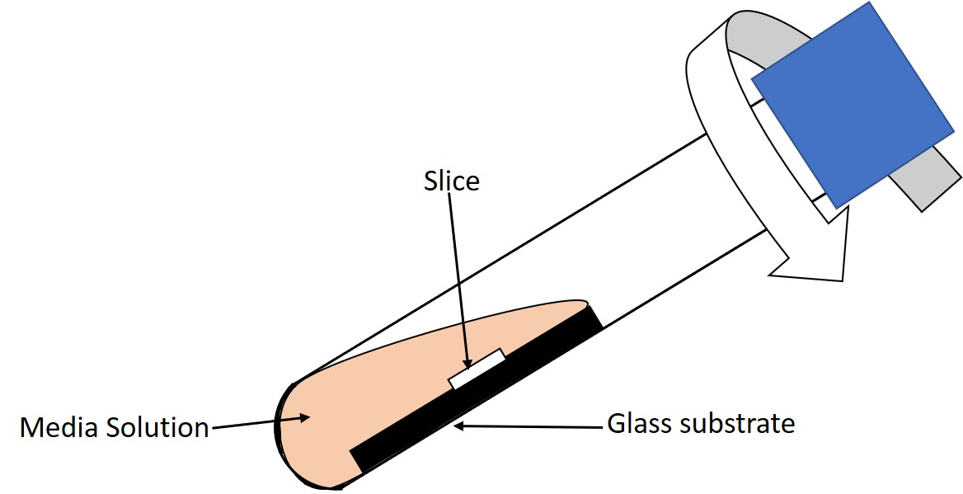
Figure 1: Roller tube for brain slice culture

A roller tube approach can be labeled as a combination of these two categories where the slice is adhered to a substrate placed inside a tube partially filled with aCSF and oxygen rich air [6]. The tube rotates along with the substrate and as a result, the slice is alternatively submerged into the aCSF and exposed to the oxygen (Figure 1) This approach allows maximum surface area of the slice to come into contact to both aCSF and oxygen in contrast to the other approaches. All these approaches are often used in experiments involving the measurements of the cell potentials related to neurophysiological activities [7]. The aCSF collects molecules secreted from the brain slice when in contact. Periodically analyzing the aCSF can potentially be important in studies of the secreted molecules and their response to outside stimuli. However, the concentration of the molecules of interest would be diluted to multiple orders of magnitude compared to in vivo concentrations due to the very low amounts of such secreted analytes [8] and the use of comparatively large volumes (mL) of the aCSF. The detection limits and the sensitivities of many common analysis techniques may not be suitable for such analyses. The measurements of analytes in the aCSF will not provide highly resolved temporal information since the media solution cannot be replaced in very short time intervals. To overcome these challenges, a microfluidic mimic of the roller tube approach is developed in chapter 2 of this dissertation. Although secretion measurements have not yet been demonstrated in this system, it is designed to limit the dilution of secreted analytes and offer secretion measurements highly resolved in the time domain.
The roller tube method has extensive applications reported in the literature where rodent brain slices had been viable for a few day days to a few months. Ostergaard and co-workers have applied the roller tube slice culture method to investigate tyrosine hydroxylase which is a biomarker of dopaminergic neuron and fibers. The method was successful in culturing the slices for up to 60 days which demonstrates the effective nutrient and oxygen delivery approach [9]. Roller tube method has also been reported to successfully culture sagittal cross-section of whole rodent brain slices to investigate cholinergic and dopaminergic neurons, effect of pathological triggers such as hydrogen peroxide on the dye stained nuclei, and factors contributing to Alzheimer’s and Parkinson’s disease [10]. Rodent brain tissue slices containing suprachiasmatic nuclei (SCN) have been studied in cultures modeled in roller tubes multiples times by several groups [11-14]. The circadian rhythm of rodent SCN is well-established and current topic of research by many scientists [15-17]. Studying rodent brain slices containing SCN by novel approaches will allow comparative studies and enable validation. Calcium response in SCN slices can be impacted by implementing receptor associated proteins (RAP). RAP acts as LDL inhibitors [18] which in result is hypothesized to suppress calcium responses in SCN slices stimulated by high concentration of potassium solution. SCN slices can be incubated with RAP to assess the suppression/recovery of the calcium responses due to LDL inhibition. The perfusate in the form of droplets will be collected to study the SCN secretion profile such as vasopressin and vasoactive intestinal peptide through mass-spectrometry. The perfusate droplets can also be investigated for ATP molecules through chemiluminescence. Mimicking of the roller tube method with microfluidic approach may bring new possibilities for microscopy and analysis of secreted molecules. This innovation has potential to address several analytical challenges of investigating regulation of hormones by improving measurement sensitivity and temporal resolution.

Microfluidic brain slice culture
Microfluidic devices for brain tissue culture is a significant improvement from conventional interface and submerged techniques. Microfluidic approaches for tissue culture can improve the penetration of oxygen and nutrients to the slice, enhance spatial and temporal resolution of measured responses by providing better controllability over the fluid flow, and widen the horizon of tissue experiments by opening up the opportunities of integration of modern microscopic and electrophysiological methods for improved experiments [19]. In vitro experiments on cultured brain cells offer a lot of opportunities to study cellular mechanisms of neurobiology, but such approaches typically fail to provide accurate models of specific brain regions, processes, and neural connections. A brain slice harvested from an animal immediately after decapitating it can be preserved by providing necessary nutrients and oxygen [20], and preserves cytoarchitecture, neural connections, and other important features not found in cell culture models.
Microfluidic approaches to brain slice culture can improve the oxygen and nutrient penetration by introducing interstitial flow. Interstitial flow of fluids through the slice can enable culturing thicker slices which can offer better preservation of the cytoarchitecture. Brain slices can be fixated inside microfluidic devices by anchor posts creating interstitial pathways. Laminar flow of nutrients can be guided through these pathways for better penetration of the nutrients [21, 22]. Another approach for introducing the interstitial flow is to utilize the Bernoulli effect. The slice will be place inside a microfluidic device in between an upper and a lower channel. The flowrate of the nutrient fluid will be faster in the lower channel and slower in the upper channel. There will be a pressure gradient between the channels which will make the fluid flow through the interstitial space of the slice from the slower fluid flow channel to the faster fluid flow channel [23]. Figure 2 illustrates an example of a microfluidic device for brain slice culture involving interstitial fluid flow. By carefully designing the shape and size of microfluidic channels, fluid flow manipulation can be implemented to treat different regions of the slice according to the necessity of the experiments. The spatial resolution of the tissue responses can be significantly improved in the microfluidic approach [24, 25]. Contrarily, in the conventional techniques the spatial resolution of the tissue responses is limited by the size of the entire tissue. Similarly, the temporal resolution of the tissue responses in the microfluidic approach can be improved since it inherently involves low fluid volumes [19]. Small volumes of fluid can entrap cellular secretions without any significant dilution effect which can improve any measurement sensitivity afterwards. Frequent exposers of small droplets to the slice can notably improve the temporal resolution of subsequent measurements, as Kennedy and coworkers have demonstrated with pancreatic tissue [26].
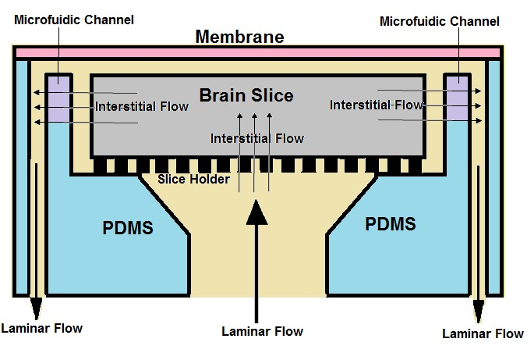
Figure 2: Schematic of a microfluidic slice culture device involving interstitial flow

Microfluidic slice culture devices enable integration of techniques like microscopy and electrophysiology. Neuroscientists are interested in all regions of the brain, and although stereotaxis allows electrical and fluidic probe insertion to deep brain regions, in vivo experiments do not allow easy microscopic observations to the internal regions. Contrarily, brain slices cultured in microfluidic devices expose the internal regions including neural connections on the surface to be easily observed. Additionally, microfluidic devices are often prepared with optically transparent materials which enables integration of microscopy technique with proper magnification. The integration of electrophysiological methods to the microfluidic slice culture devices are reported to be more challenging, but several research groups have addressed the issue. Open access microfluidic devices have been developed to allow probes to access the slice through removable parts of the device [27]. Other microfluidic approaches include microelectrode arrays embedded within the device for recording electrophysiological responses with spatial resolution [28, 29]. Such approaches have been used for reestablishing neural connections between two physically isolated brain slices [30] and recuperating medullary slices which can be used to initiate breathing activity if connected to a functionable lung [31, 32].
Numerous novel directions and improvements of conventional slice culture techniques provided by the microfluidic approach can also present some limitations. Fluid flow inside microfluidic channels may introduce shear stress to the slice resulting in displacement and damage [33]. Such experiments require careful consideration in regulating the fluid flow rate to avoid fatal shear stress. Microfluidic channels are known to hold on to small gas bubbles at the corners and channel walls where salt residue from earlier experiments may remain. Thorough cleaning in between experiments are essential to avoid the gas bubble issue [34]. Another limitation of the microfluidic slice culture devices can be the use of PDMS as a fabrication material. PDMS is known to absorb small hydrophobic molecules which may interact with subsequent experiments [34]. Disposable PDMS devices can be a possible solution for this issue since replication of PDMS microfluidic devices is generally not complex and inexpensive.

Monodispersed bubble and droplet generation
Monodispersed refers to having uniform sizes. Working with monodispersed bubbles and droplets in microfluidics enable uniform volume characteristics in applications such as material synthesis [35-37], chemical synthesis [38], drug formulation [39], and fluid dynamics [40, 41]. Generating monodispersed bubble and droplets for microfluidic brain slice culture can greatly improve the analysis of the secreted molecules. To be able to accurately measure the contents of droplets which have interacted with the brain slice, control over the dimensions of the bubbles and the droplets is essential. Since the channels of typical microfluidic device have uniform width and depth, the volume of the droplets and bubbles will be dependent on the length which will result in controlling several
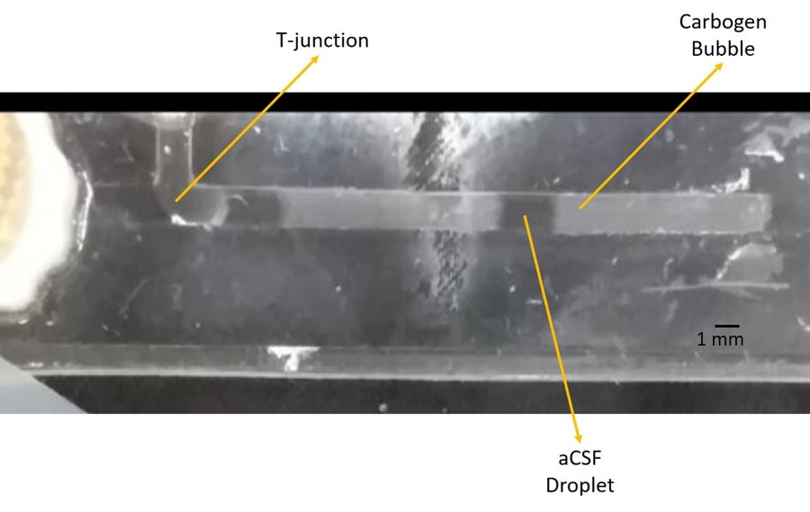
Figure 3: Monodispersed carbogen bubble and aCSF droplet generation at a microfluidic T-junction

other factors such as mixing time, dispersion time, and sample volume [42]. The length of the bubbles or droplets can be described according to equation 1 [43].
$$\frac{L}{w}= α+ β\frac{Qdisp}{Qcont}$$ | 1
Here, L is the length of the bubble or droplet, w is the width of the microfluidic channel, Qdisp and Qcont are the flowrates of the dispersed and continuous phase respectively, and α and β are channel geometry dependent constants. The values of these constants are in the order of 1. Gas phase fluids can be dispersed to a continuous flow of liquid resulting in alternative gas bubbles and media droplets a microfluidic device [44]. The flow of both the phases come into contact of each other in a T-junction and the continuous phase would squeeze the disperse phase leading to the bubble generation. The alternate gas bubbles and liquid droplets can be composed of carbogen (95% O₂ and 5% CO₂) gas and aCSF media respectively and would be passed over an SCN slice placed in a chamber downstream of the T-junction.(Figure 3) The aCSF droplets on the other side of the chamber would possibly contain secreted molecules from the SCN slice and can be analyzed for further investigations. The concentration of the analyte of interests would be minimally diluted since a single droplet volume would be in the low µL regime and would not come into contact of other droplets due to the segmentation by gas bubbles. The measurements will have temporal resolution dependent on the frequency of droplets coming into contact of the SCN slice.

Tissue adhesion
Tissue adhesion is a critical barrier to perform slice culture using the roller tube method. Without adequate tissue adhesion, brain slices in the culture container or device can be displaced by container movement or fluid flow in the microfluidic channels. Tissue adhesion approaches retain the slices in the desired positions for proper nutrient delivery and observing tissue responses due to experimental stimulations. There are several approaches for adhering brain slices during culture in either conventional or microfluidic methods. In this dissertation, two different approaches will be discussed which are namely, physical, and chemical approaches.
Physical approaches of tissue adhesion involve including physical anchors in the culture container or device. In microfluidic slice culture devices, such anchors can easily be fashioned and attached. In some cases, the anchors can be fabricated as components of the microfluidic device. The physical approach can be very effective in holding on to the slice and usually tolerant to significant amount of shear stress without displacement. But physical approaches have limitations which may not be ideal for specific experiments. Introducing an extra component inside the microfluidic device increases spots for air bubbles to hold on to. The
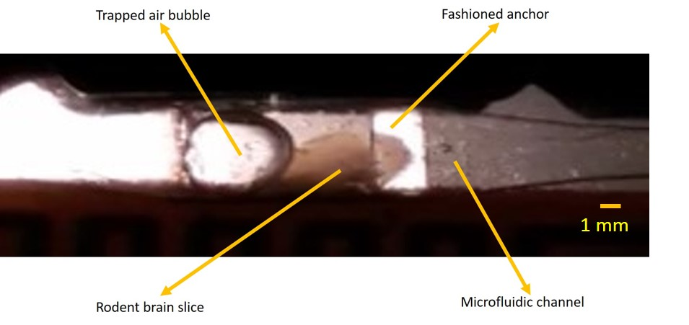
Figure 4: An example of the physical approach of tissue adhesion

surface energy inside the microfluidic device may alter due to added anchors which may disrupt the fluid flow. Moreover, the anchor itself may put stress on the slice resulting in damage and disrupt the experiment. In Figure 4, an example of the physical approach of tissue adhesion is demonstrated. The fashioned hook is seen to cause entrapment of an air bubble interrupting usual fluid flow. Several other similar examples are shown in appendix A (Figure 31).
Using plasma clot as an adhesive material is well studied and widely reported in the literature as a chemical approach for tissue adhesion [21, 45-47]. Blood plasma contains fibrinogen which acts as a blood coagulating agent in vertebrates [48]. Fibrinogen is produced in the liver and gets circulated to the entire body through blood circulatory system. In the presence of thrombin enzyme, water soluble fibrinogen converts to water insoluble fibrin [49]. The conversion process is rapid, as a result precise transfer protocol needs to be maintained to attach the slice on to a freshly applied plasma-thrombin mixture on a surface. The conversion

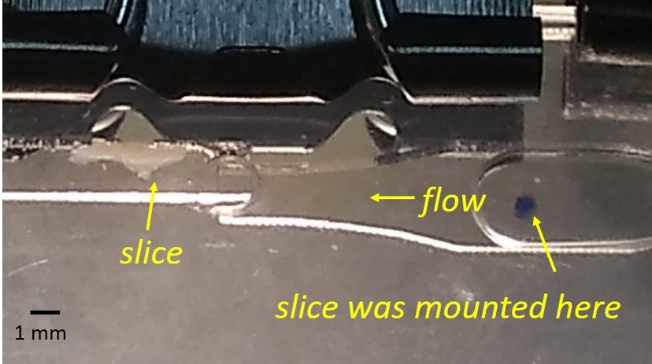
Figure 5: Incapability of plasma clot as an adhesion approach for
the microfluidic bubble perfusion device

process adheres the slice to the surface and disallows displacement during container movement or fluid flow in the microfluidic channels. While plasma clot approach has been proved to be successful in numerous brain slice culture studies for tissue adhesion, the retaining capability was unable to withstand the shear stress (Figure 5) in the microfluidic experiments described in chapter 2. For the purpose ensuring adequate tissue adhesion for the project described in chapter 2, a stronger adhesive compound was required.
Nontoxic and bio-degradable adhesive material is also a matter of interest to medical surgeon’s which can be used as an alternative approach to sutures. A significant body of research exists to develop and implement such adhesive materials in the surgery process [50-55]. Balakrishnan and co-workers have developed a hydrogel based adhesive which provides rapid gelation and proved
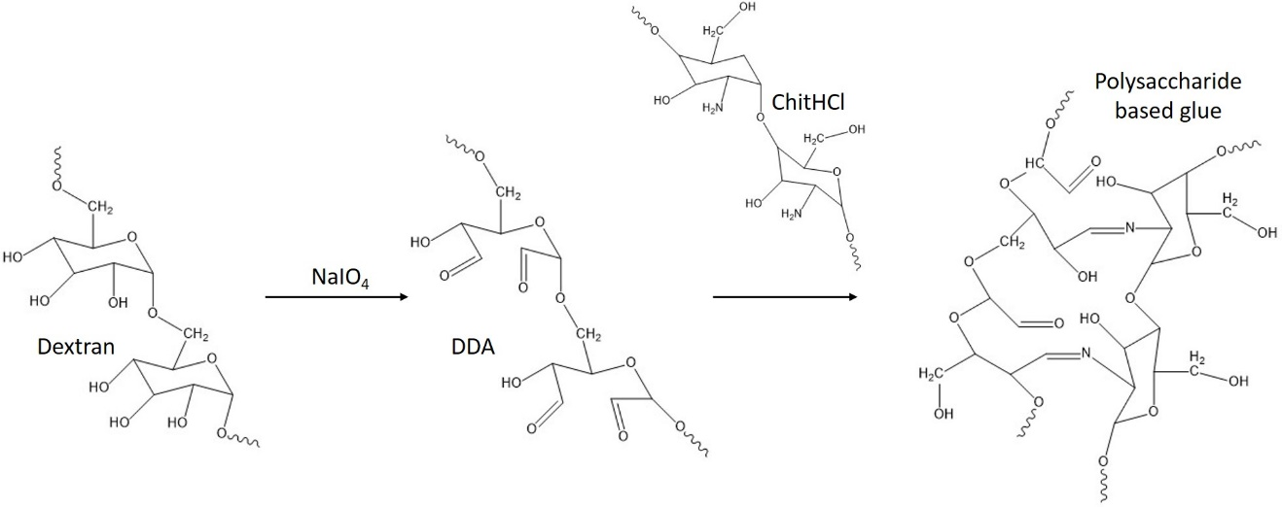
Figure 6: Reaction schematic of the hydrogel based
tissue adhesive material [56]

to be non-toxic and bio-degradable [56]. Chitosan treated with HCl was combined with dextran dialdehyde to form the hydrogel based adhesive material (reaction scheme in Figure 6). The novel adhesive material was extensively studied to observe the non-toxicity, biocompatibility, and biodegradability. In addition to perform all the said functions, the novel adhesive material also has hemostatic and drug carrier capabilities which can be very useful in surgery applications. The material also remains simple and inexpensive to synthesize. This novel adhesive material was used as a tissue adhesive in all the perfusion experiments described in chapter 2. The SOP of synthesizing the adhesive is in APPENDIX B.

Brain slice viability in the perfusion experiments
A fluorescent calcium imaging technique was utilized to confirm slice viability in the experiments described in chapter 2. Intracellular [Ca²⁺] is correlated to physiological and pathological activity of neurons [57]. Ca²⁺ acts as a messenger in the cellular level triggering physiological activities such as proliferation, migration, survival, and apoptosis [58-60]. Typical intracellular [Ca²⁺] falls in the range of 50-100 nM [61]. α₁ subunits of the voltage-gated calcium channels
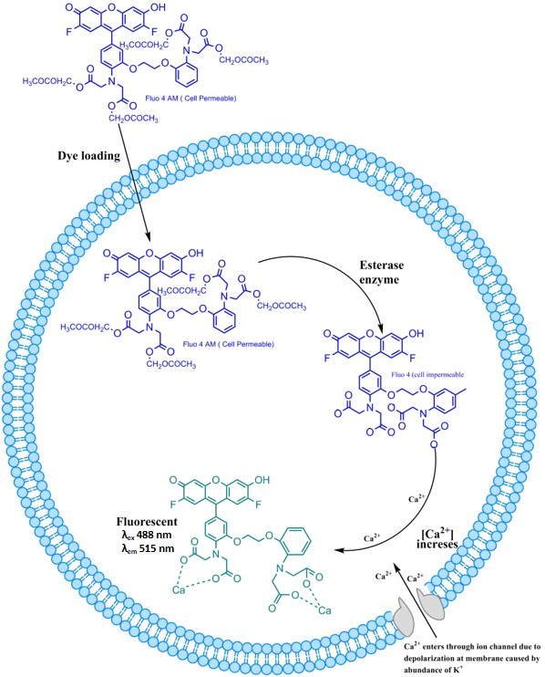
Figure 7: Principle of calcium imaging

(VGCC) in neuron cells are Ca²⁺ permeable [62]. Generally, cells in higher organisms possess a internal net negative charge in reference to the outside environment. Depolarization is a process when the net internal charge transforms to a temporary positive phase. The VGCCs open for Ca²⁺ during depolarization of the cell membranes. Influx of positive charges like K⁺ can depolarize the cell membrane initiating the opening of the VGCCs. As a result, the intracellular [Ca²⁺] increases. Subsequent repolarization of the cell membrane reestablishes the resting period of the cells. Fluo-4 AM is a cell membrane permeable dye. The acetoxy methyl ester groups present in the dye molecule mask the charged nature to make it membrane permeable [63]. An SCN slice can be loaded with the dye before placing in the microfluidic perfusion device. The loading process needs to occur for a minimum 1 hour for rodent brain slices while maintain the proper nutrient and oxygen supply. The masking groups in the Fluo-4 AM dye gets hydrolyzed inside the cells in the presence of esterase enzyme and Fluo-4 AM converts to a cell impermeable Fluo-4 dye. Figure 7 shows the principle of calcium imaging.
Periodical stimuli of K⁺ to the SCN slices will depolarize the cell membranes resulting to increase intracellular [Ca²⁺]. Ca²⁺ binds to Fluo-4 forming a fluorescent complex (λ_{ex} 488 nm and λ_{em} 515 nm) [64]. Measuring the fluorescence following a K⁺ stimulus can confirm intracellular Ca²⁺ activity and hence confirm the viability of the SCN slice in the microfluidic perfusion device. To measure the fluorescence of the Ca²⁺ and Fluo-4 complex, the dye loaded brain slice needs to be irradiated with a light source. The incident light should be passed through a bandpass filter allowing 488 nm wavelength to pass. The fluorescence light should be passed through a bandpass filter allowing the 515 nm wavelength to pass and be recorded. Depolarization of cell membranes can increase [Ca²⁺] 10x which enables significance change in the fluorescence activity [61].
Propidium iodide (PI)/Diaminophenylindol (DAPI) (structures in Figure 8) staining was carried out as an additional technique to confirm the viability of the
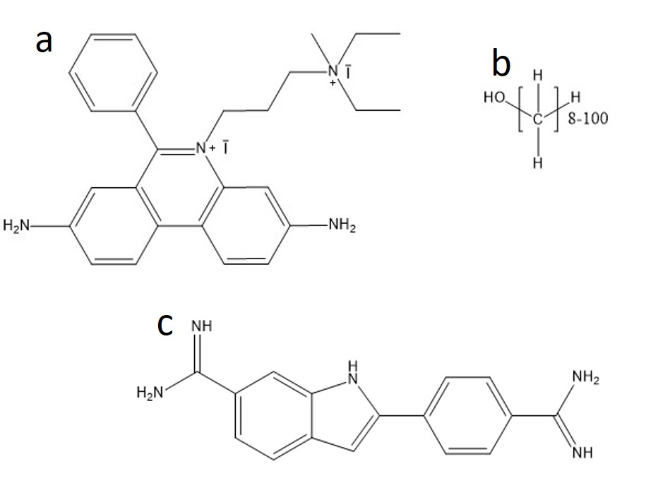
Figure 8: Molecular structure of a. propidium iodide,
b. paraformaldehyde, and c. diaminophenylindol

slices used in the experiments described in chapter 2. PI and DAPI are commonly used dyes for nucleus staining. Both PI and DAPI dye is permeable to dead cells due to damaged cell membrane. PI molecules interact inside the double helix DNA of nucleus and DAPI is known to bind itself to the minor groove of the double helix DNA. Both the molecules fluoresce after interacting with the cell nucleus components. These dyes can be used to determine the viability of a rodent brain slice by utilizing the fixation method. Fixation of cells implies preservation of bio-tissues because of degradation due to internal enzymes or external factors.
Paraformaldehyde (PFA) is a widely used cell fixation agent. The rodent brain slice can be treated with PI prefixation to stain the dead cells at a given time point. Post treatment with PI dye, the slice can be treated with PFA for fixation to take place. During fixation, PFA modifies the amino acids and peptide bonds by adding sidechains which results to protein stabilization and the morphology of the slice is preserved. The DAPI staining of the nucleus of the cells must follow the fixation process [65]. The cells inside a fixed tissue slice are not viable, so DAPI can penetrate them through the damaged cell membrane. The PI stained cells before fixation will appear magenta and all the DAPI stained cells which were not stained by PI dye will appear blue. The ration of these colored cells can be used to determine the viability of the tissue slice before fixation.

Summary
Background concepts pertaining to our microfluidic approach for mimicking roller tube tissue culture method are described. The mechanism of monodispersed bubble generation in a microfluidic T-junction is discussed. Proper tissue adhesion protocol and appropriate slice viability confirming experiments are also outlined in this section.

Background concepts on quantitative smartphone imaging for epinephrine dose estimation

Objective
The price of commercial epinephrine drugs has increased 10-fold since 2009 [66, 67]. This increase in price has encouraged the tendency of not replacing expired epinephrine among patients [68, 69]. In addition to that, lack of proper storage degrades and discolors the epinephrine. Doctors and manufacturers discourage using expired and degraded epinephrine. In the practice of austere medicine or wilderness medicine, fresh supply of epinephrine is scarce and the unpredictable weather in the remote places may not offer proper storage for the medicine. In such circumstances, the only possible way to treat an anaphylactic patient with an expired and/or degraded epinephrine auto-injector.
Presence of epinephrine in expired autoinjectors is established in the literature [70]. But study with degraded autoinjectors is absent, and a point-of-care estimation method is not established. In this project, we aim to study primarily expired autoinjectors. We also aim to establish a quantitative smartphone imaging-based point-of-care epinephrine concentration estimation method for degraded autoinjectors. The project takes several possible imaging conditions into account before establishing the quantitative method. We also focus on achieving a narrow confidence interval band for the concentration estimation near the standard epinephrine dosage. The success of the project can be helpful for medical professionals in their decision-making process of using an expired and degraded epinephrine autoinjector during an emergency when no other viable alternative is not available. We do not advocate using expired autoinjectors in this project. The wider medical community is more knowledgeable and better equipped to make that decision. This project only intends to offer an estimation tool for emergency circumstances.

Anaphylaxis
Anaphylaxis is a medical condition which exerts hyperallergic reactions in the patient affecting multiple parts of the organ system. The condition may be triggered by external stimuli such as food, medicine, and envenomation. The most common symptoms of anaphylaxis include itchy rash, swelling of throat area, difficulty in breathing, vomiting, weakness, and abnormal blood pressure.
The mechanism of anaphylactic shock in the human body is initiated by abrupt secretion of mast cells and basophil-derived mediators into the blood circulatory system [71]. The mechanism is classified into two categories, namely Immunologic or non-immunologic. The immunologic mechanism can either be IgE-dependent or IgG-dependent [72]. The mechanism pair is widely studied on rodent systems and is speculated to be applicable to human systems in a similar manner [73]. In the IgE-dependent mechanism, allergen induced cross-linking of high-affinity receptors from mast cells and basophils cause the release of inflammatory mediators and cytokinesis. This event leads to increased vascular permeability and smooth muscle contraction [74, 75]. The stated conditions are strongly associated with anaphylaxis. The IgG dependent mechanism involve macrophage and require a larger amount of antibody-antigen activity [75-78]. Platelet activating factor which is responsible for initiating blood clot is released in both the mechanisms resulting in increasing risk for the patient. The non-immunologic mechanism is triggered by external factors such as extreme temperatures, substance use, and use of certain anti-biotics which may dysregulate the mast cells and the basophils leading to anaphylaxis. This mechanism does not involve any immunological molecule [75, 78].
The trigger factors of anaphylaxis can be identified in many sources. Some common food sources responsible for anaphylaxis are nuts, gluten, shellfish, dairy, and beans. Penicillin, aspirin, vancomycin, morphine, selected cancer drugs, and vaccines are some of the common medication sources responsible for anaphylaxis. Stings from ants, bees, wasps, and kissing bugs are known envenomation sources responsible for anaphylaxis. Atopic disease patients such as patients suffering from asthma, eczema, and allergic rhinitis bear a higher threat of an anaphylactic attack due to exposure of any of the triggers.
The diagnosis of anaphylaxis is primarily dependent on the symptoms of the patient. The exposure to an allergen leading to two or more symptoms of anaphylaxis may be an initial indicator. Presence of histamine in blood may confirm anaphylaxis if triggered by medicine or envenomation but remains inconclusive if triggered by food [73]. Other medical conditions such as asthma, syncope or panic attacks may have overlapping symptoms but can be segregated by the presence of itching and gastrointestinal symptoms in case of anaphylaxis.
Approximately 2-5% of the population get anaphylactic attack in the USA each year and approximately 1000 people die as a result [79]. Anaphylaxis can be prevented by avoiding exposure to known allergens. An anaphylactic episode should be addressed by an anti-allergen drug at the earliest to mitigate complications and avoid fatality. Delay in treatment may lead to hospitalization and further complications.

Epinephrine
Epinephrine or Adrenaline (Figure 9) is a hormone produced in the adrenal glands and medulla oblongata. It is widely used as a treatment for anaphylaxis. The pharmacology of epinephrine allows it to alleviate the severe effects of anaphylaxis. Epinephrine binds to at least two receptors, termed alpha, and beta. The binding of epinephrine with alpha receptors decreases peripheral vasodilation which helps reduce elevated blood pressure, erythema, urticaria, and angioedema [80]. The binding of epinephrine with beta receptors causes bronchodilation to help breathing problems and suppress mast cells and basophils release [80]. As a result, epinephrine can treat abnormal blood pressure by enhancing blood flow, difficulty in breathing by loosening muscles in the lungs system, and blocking allergic reaction initiating cells. Therefore, epinephrine is considered the most preferable drug to treat anaphylaxis.

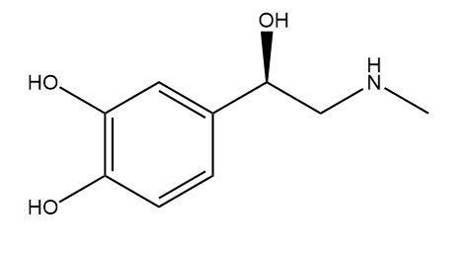
Figure 9: Molecular structure of epinephrine
Delay in administering epinephrine is correlated with poor performance of the drug by achieving delayed plasma peak concentration [81, 82]. Other reasons for poor performance of the drug include underlying diseases of the patient, lack of sufficient available dose of epinephrine in the drug, and presence of systematic disorders in the patient. Epinephrine is reported to have a very narrow therapeutic window [80]. Administering lower amount of epinephrine to the patient will have no significant benefit, and on the other hand overdose of epinephrine have occasionally led to myocardial infraction or ischemia, pulmonary edema, accelerated hypertension, and intracranial hemorrhage. Common side effects of epinephrine include palpitations, headache, anxiety, pallor, agitation, and dizziness [80]. Cross-interactions of epinephrine with beta adrenergic blocker medicine is known and therefore interference with intrinsic compensatory responses to hypotension occurs [80].
Several routes of administration of epinephrine into patients are practiced in the medical community such as intramuscular, intravenous, and inhalation. Though the intramuscular route is the most used, some medical professionals recommend an inhalation route or an intravenous route for unresponsive patients [80]. Though there is a lack of comparative study on different routes due to inability of conducting research on anaphylactic patients. In this work, epinephrine samples studied are collected from EAIs which were intended only for use through intramuscular route.

Epinephrine measurement by UHPLC
The drug formula for commercial EAIs contain several inactive ingredients along with epinephrine. According to the product literature of EpiPen, the inactive ingredients are sodium chloride, sodium metabisulfite, hydrochloric acid, and water. Due to degradation and discoloration, several other melanin-like compounds form in the solution [83, 84]. To measure epinephrine in such complex solution, separation-based quantification method can be successful. To determine the available dose of epinephrine, the analyte must be separated from the degraded compounds and other inactive ingredients. Consequently, reverse phase liquid chromatography was chosen as a functional quantification technique to measure available epinephrine dose in expired and degraded EAIs.
In liquid chromatography, a column packed with solid particles as stationary phase and a liquid flow through the column as mobile phase are used. In reverse phase liquid chromatography, the stationary phase particles are hydrophobic. The mobile phase used is a purely hydrophilic liquid or a mixture of both hydrophilic and hydrophobic liquids. The percent composition of the mobile phase can be manipulated to control the elution profile and achieve better separation of the analytes. The sample containing the desired analyte is injected to the column along with the stream of the mobile phase. The analyte will be adsorbed by the stationary phase particles along with the other compounds in the sample. By continuing the flow of the mobile phase and changing the polarity of the mobile phase, all the adsorbed molecules will elute the column based on the polarity. The more polar molecules will elute faster because of less interaction with the hydrophobic stationary phase and the less polar molecules will elute slower because of more interaction with the hydrophobic stationary phase. Decreasing the polarity reduces the analyte-stationary phase interaction, and as a result also aids the elution of the less polar molecules. The elution time also depends on the particle size and the pore size of the particles. The basic principle of the reverse phase liquid chromatography is depicted in Figure 10.
The efficiency of chromatographic separation is dependent on the resolving power of the column. Number of theoretical plates are correlated with the column resolving power. Theoretical plates are hypothetical zones in a chromatographic column where different phases are in equilibrium with each other. The resolving power of a column is proportionally related with the number of theoretical plates. Number of theoretical plates can be calculated using equation 2.

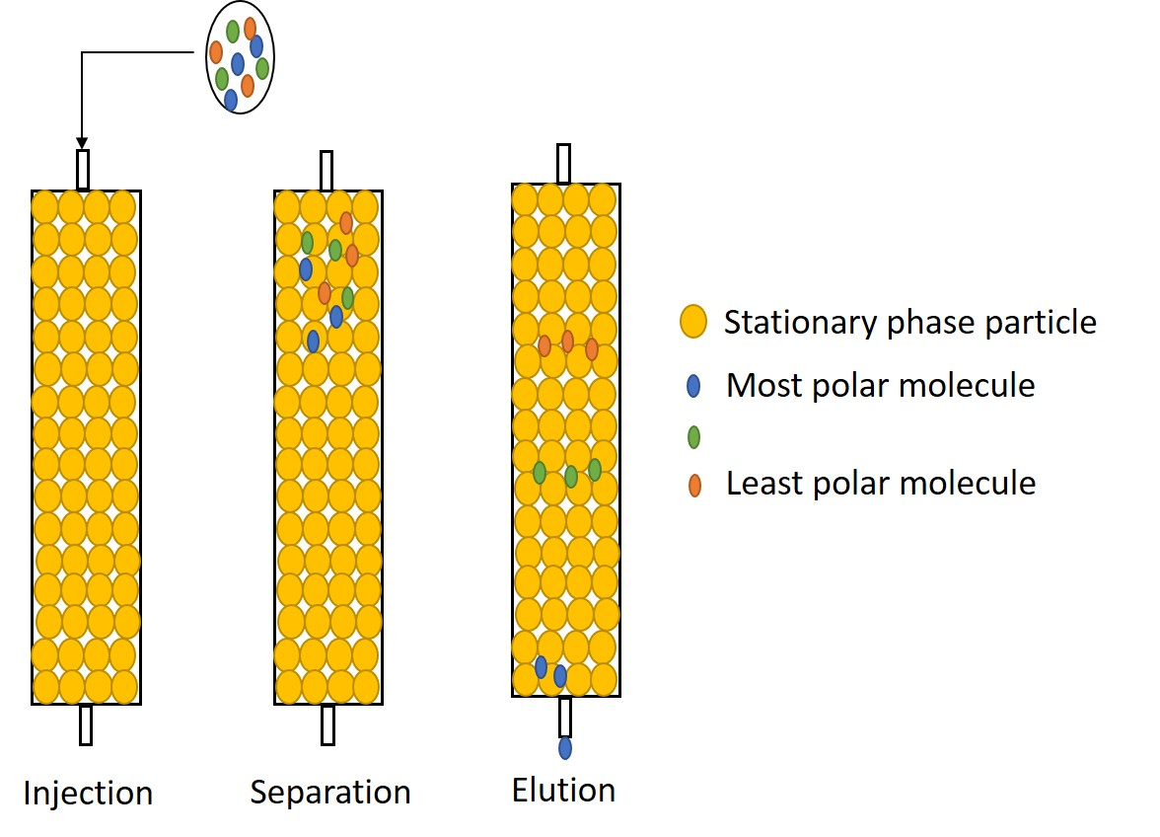
Figure 10: Reverse phase liquid chromatography

$$N= \frac{L}{H}$$ | 2
Here, N is the number of theoretical plates, L is the length of the column, and H is the is the height of the theoretical plates. H can be calculated using the Van Deemter equation (3).
$$H=2λd_{p}+ \frac{2γD_{m}}{u}+ \frac{ωd_{p}^{2}u}{D_{m}}+ \frac{Rd_{fu}^{2}}{D_{s}}$$ | 3
Here, λ is particle shape, d_{p} is particle diameter, γ, ω, and R are constants, D_{m} is diffusion co-efficient of the mobile phase, d_{f} is the film thickness, D_{s} is the diffusion co-efficient of the stationary phase, and u is the linear velocity. According to the Van Deemter equation, the resolving power of the column can be increased by reducing the stationary phase particle size. However, the back pressure in the column significantly increases due to decrease in particle size. Therefore, to enable using smaller particle for improved resolving power, UHPLC can be an alternative for conventional HPLC. UHPLC systems possess modified pumping facility to exert higher pressure to overcome the back pressure of the column due to smaller particles.
Resolution can be defined as the matric of how distinguishable two chromatographic peaks are resolved from each other. The resolution of a chromatographic separation can be described by fundamental chromatographic mechanisms via the fundamental resolution equation, equation 4.
$$R_{s}= \frac{1}{4}\sqrt{N} × \frac{α-1}{α} × \frac{k}{1+k}$$ | 4
Here, R_{s} is resolution, N is the number of theoretical plates, α is selectivity and k is the retention factor. k is a function of retention time (t) and α is the ratio of retention time of two separate peaks. Getting better resolution is a trade-off with analysis time. Increase in number of theoretical plates, better selectivity and longer retention time improve resolution at the expense of longer analysis time.
To establish the elution time of epinephrine under a certain method, pure epinephrine standard solutions need to be injected. Same elution profile of pure epinephrine at different concentrations can undoubtably establish the elution time. By carefully selecting the concentration range of the pure epinephrine standards, a calibration curve can be established. The calibration curve can be used to estimate the available epinephrine in the EAI samples.

Quantitative smartphone imaging
Smartphone imaging has offered a variety of point-of-care applications since it has emerged. All modern smartphones are equipped with a digital camera to capture still and motion pictures without using any films. Almost all smartphone camera has a CMOS sensor to process the light irradiated on it. CMOS stands for complementary symmetry metal oxide semiconductor.
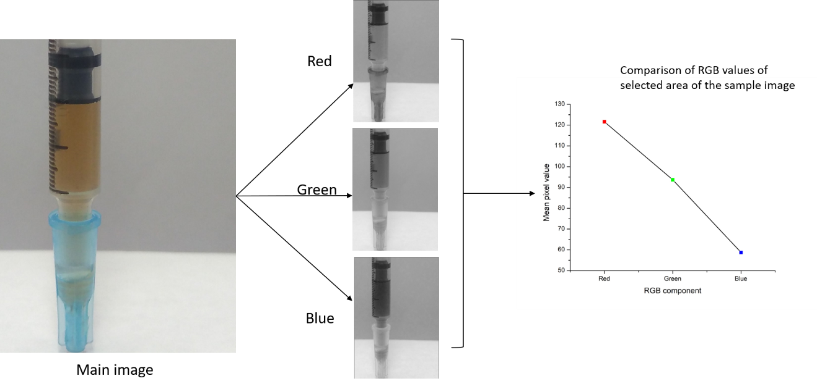
Figure 11: Quantitative image analysis through RGB stacking

Each pixel is equipped with the charge to voltage converter and voltage amplification systems. Light passes through the lens of the digital camera and irradiates the pixels on the CMOS sensor. Light received by each pixel generates proportional amount of charge which is converted to voltage. A voltage amplifier inside each pixel amplifies the voltage before transferring to the readout meter.
A Bayer filter is an array used in typical CMOS sensors for placing red, green, and blue color filters on square array of photosites [85]. The filter array is a combination of 25% red layer, 50% green layer, and 25% blue layer. A single pixel is aligned with only one of the filter layers. Therefore, the true color of a single pixel cannot be inferred from the raw data. Demosaicing algorithms are used to assign red, green, and blue component values of each pixel. Each of the components has a value range from 0 to 255 in a typical 8-bit system. The value of each color component is combined to portray a compound color. If a pixel is exposed to no light, all three components will have a value of 0. If a pixel is exposed to white light, all three components will have a value of 255. Any other color will have a combination of values within the range depending on the pixel being exposed to a color of light. This image processing technique can be utilized to conduct quantitative study on colored samples. If a sample contains a certain molecule or impurity which is responsible for the color it possesses, then analyzing the color pattern may be correlated with the concentration of the colored substance.
In this study, 23 expired and degraded EAIs have been investigated for available dosage of epinephrine. Most of the samples had discoloration due to the degradation and pure epinephrine drug appears as a clear solution. The increment of the discoloration is hypothesized to be an indicator of the available epinephrine in the solution. In Figure 11, an image of an EAI sample is shown. The image has been disintegrated to its RGB components. Since the discoloration due degradation in the samples exerts a brownish color, the sample should highly absorb the colors of the blue end of the visible spectrum and reflect the colors of the red end of the visible spectrum. Therefore, if the values of the blue component are considered and correlated with the epinephrine concentration of the samples, a calibration curve can be established and utilized to estimate the epinephrine concentration of unknown samples.
Smartphones are a nearly ubiquitous technology in the modern world. Therefore, using a smartphone camera for quantitative analysis of life-saving drugs in austere situations can be an easily accessible alternative to complex and expensive techniques. Using a smartphone as a quantitative analysis tool also makes the process portable and robust. The functionality of a modern smartphone perfectly aligns with the motivation of this study and achieves the analytical goal of the study.

Summary
Background concepts regarding to our point-of-care epinephrine estimation method are discussed in this section. The section includes brief discussion about anaphylaxis indicating the symptoms, mechanism, and treatments. Brief discussions about measuring epinephrine through conventional HPLC and alternate quantitative point-of-care method are also included in this section.

SCXC based immunoassay

Objective
The U.S. Centers for Disease Control reported a 29% increase in the prevalence of Autism Spectrum Disorder (ASD) among 8-year-old children from 2008 to 2012 [86]. ASD affected children suffer from impaired social, emotional and language development. The dynamic secretion of oxytocin in the hypothalamus is strongly correlated with the development and expression of these characteristics, and endogenous opioid peptides, such as β-endorphin, are known to have a complex regulatory relationship with oxytocin secretion. There is a lack of knowledge of the secretion dynamics of these hormones which prevents an accurate understanding of the regulatory relationship between oxytocin and β-endorphin. To facilitate the study of their secretion dynamics, new bioanalytical assays are needed to enable the measurement of these hormones at low concentrations in small volumes. This capability will enable the study of hormone secretions at biologically relevant concentrations (high pM to low nM) and with spatial resolution via ex-vivo slice culture.
The working hypothesis for this project is that SCXC can improve the separations required for direct homogeneous immunoassays. To test this hypothesis, immunoaffinity reaction between antigen (oxytocin or β-endorphin) and a fluorescently labeled antibody will be carried out and the immunocomplex will be crosslinked. SCXC separation of the crosslinked complex from unbound antibody will be carried out to quantify oxytocin and β-endorphin in complex sample matrices. Completing this project will enable a novel non-competitive immunoassay technique using SCXC to quantify low concentrations of proteins and peptides.

Regulatory relationship between oxytocin and
β-endorphin
Oxytocin is a neuropeptide produced in the paraventricular and supraoptic nuclei of the hypothalamus. It is dispersed in the bloodstream though the axon termini of the posterior pituitary gland [87]. Oxytocin secretion has long been known to be correlated with contraction of the uterus during childbirth and supply of milk afterwards [88]. Later, dysregulation of oxytocin was suggested to be responsible for expression of repetitive and affiliative behaviors which are dominant features of Autism Spectrum Disorder (ASD) [88, 89]. β-endorphin is a neurotransmitter secreted from the pituitary gland. It is known to act as an endogenous analgesic, and is secreted in high amounts during stressful events [90]. Opioid peptides like β-endorphin have regulatory relationships with oxytocin secretion which weaken during stressed situations and differ in regulations while observed in bovine and rodent plasma [91]. β-endorphin may play a role in the pathology of ASD by dysregulation of the secretion of oxytocin, which may lead to repetitive and affiliative behaviors observed in ASD. To better understand the regulatory relationships of β-endorphin and oxytocin, new tools are needed for modeling their secretion and measuring their concentrations in biologically relevant yet well controlled in vitro conditions.

Immunoassays for peptide measurements
Immunoassays exploit the specific binding of antibodies to their antigen to achieve high specificity detection of the antigen molecule. Thus, they are excellent tools to quantify a specific molecule within a complex biological sample matrix. In enzyme-linked immunosorbent assays (ELISA), antigens are bound to enzyme-labeled antibodies where the enzyme activity, typically a detectable color or luminescence change during reaction of a substrate with the enzyme, is measured to determine the concentration of the antigen. ELISA was reported to measure plasma oxytocin to correlate it to autism and found at lower levels in affected patients than controls [92]. Radioimmunoassay (RIA) work similarly to ELISA, but they employ radiolabeling and scintillation counting as a detection mode. RIA has been used to quantify plasma oxytocin levels, which were found to be higher in schizophrenic patients as compared to control patients [93]. Immunoassays performed using capillary electrophoresis (CE) were first reported in 1991 by Nielsen et al [94]. Capillary electrophoresis-based Immunoassays (CE-IA) offer fast measurements with ability to work with small sample volumes (low nL) presenting the opportunity for automated microfluidic CE-IA platforms. In the most common case, in which samples are collected via low flow rate techniques like microdialysis, the larger sample volumes (100s µL) and slower measurements (hours) required for ELISA and RIA make CE-IA a better choice when temporal resolution of the measurement is critical. In CE-IA, mixtures of antibody and antigen are injected into a fused silica capillary and separated based on their electrophoretic mobility under applied voltage. Both competitive and non-competitive Capillary Electrophoresis based Immunoassay (CE-IA) were successfully demonstrated by Schultz and Kennedy in 1993 [95]. In noncompetitive immunoassays, fluorescently labelled antibodies specific for the analyte of interest are introduced in excess to the sample to achieve maximum binding. Increased concentrations of analyte in the sample increases the amount of antibody-analyte complex formed which is ideally observed as a resolved peak in the CE electropherogram. Noncompetitive CE-IA has been applied to measure Bovine Serum Albumin (BSA) with a limit of detection of 5nM [96]. Since CE separates charged species based on size-to-charge ratio, obtaining desired resolution of antibody and antibody-analyte complex can be difficult when they are very similar in size. In competitive immunoassays, a fluorescently labelled antigen reagent is added to compete for antibody binding with unlabeled antigen (the analyte) present in the sample. Increased analyte concentration decreases the ratio of bound-to-free labeled antigen, observed as the ratio of two resolved peaks in the electropherogram. Clenbuterol was successfully measured by competitive CE-IA with a limit of detection of 2.5nM [97]. Competitive CE-IA overcomes the resolution challenge of non-competitive CE-IA as the complex-bound and free labeled antigen will be significantly different in size. This resolution advantage comes at the cost of detection sensitivity, since in non-competitive CE-IA the fluorescently labeled antibody can be present in excess, whereas in competitive CE-IA concentrations of antibody and antigen must be on the order of the dissociation constant of the antibody-antigen complex to maintain equilibrium conditions necessary for binding competition. To improve the analytical performance of separations-based immunoassays, new approaches are needed that enable the high sensitivity of non-competitive immunoassays while overcoming the resolution limitation of non-competitive CE-IA.

Analytical challenge for conventional immunoassays
Capillary Electrophoresis Immunoassay offer two different modes to measure peptide hormones: non-competitive and competitive immunoassay. In non-competitive CEIA, a fluorescently labeled antibody is introduced to the sample to bind with the analyte of interest. When an immunocomplex of the labeled antibody and analyte forms, the sample is injected to the capillary to separate the labeled antibody from the immunocomplex based on the different electrophoretic mobility of the species. The analytes of interest of this experiment are oxytocin and β-endorphin. The molecular weight of these peptide hormones are 1 kDa and 3.5 kDa respectively. The molecular weight of the antibodies used in these immunoassays are approximately 150 kDa. A successful non-competitive CEIA of the analyte molecules will require separation of 150 kDa antibody and 151 kDa/153.5 kDa immunocomplex because only these are fluorescently detectable. Separation of such similarly sized molecules by capillary electrophoresis with desired resolution is very difficult [98]. An alternative way to measure peptide hormones through CEIA is the competitive mode. In competitive immunoassay, fluorescently labeled analyte-analog will be introduced to the sample in addition to an unlabeled antibody. The labelled analyte molecules are expected to compete with the unlabeled analyte molecules from the sample to bind with the antibody. A successful competitive CEIA of the analyte molecules will require separation of 151 kDa/153.5 kDa immunocomplex and 1 kDa/3.5 kDa analyte-analog because only these are fluorescently detectable. So, competitive CEIA is effective to improve the separation challenge faced with non-competitive CEIA. But, competitive CEIA has two major drawbacks. First, to ensure the binding competition, appropriate concentrations of labeled antigen and analyte are essential which need to be in the same order of magnitude as the dissociation constant (K_{D}) of the antibody [99]. If the concentrations are significantly lower than the K_{D} of the antibody, the binding competition will be insufficient, and the equilibrium will not yield sufficient detectable free labeled analyte to deliver quantitative information of the sample analyte. Second, fluorescently labelling analyte may sterically hinder antibody-analyte interaction. Steric hindrance of antibody binding is specially challenging when the analyte molecule is as small as oxytocin. Non-competitive immunoassay can be useful for measuring low concentration analyte by increasing the concentration of the antibody to shift the equilibrium towards immunocomplex formation. To overcome the separation challenge of CEIA, new competitive immunoassay format involving ultra-high-performance liquid chromatography (UHPLC) in strong cation exchange (SCX) mode will be developed for oxytocin and β-endorphin.

Principles of ion exchange chromatography
Ion exchange chromatography (IEC) separates charged species based on their interactions with oppositely charged stationary phase particles packed inside a chromatography column. Analytes are eluted by a mobile phase gradient of increasing concentration or varying pH, resulting in competition for stationary phase binding sites or alteration of the charge on the molecule, respectively. Cation exchange stationary phases are negatively charged and bind to positively charged species, whereas anion exchange stationary phases are positively charged and bind to negatively charged species. In general, ion exchange
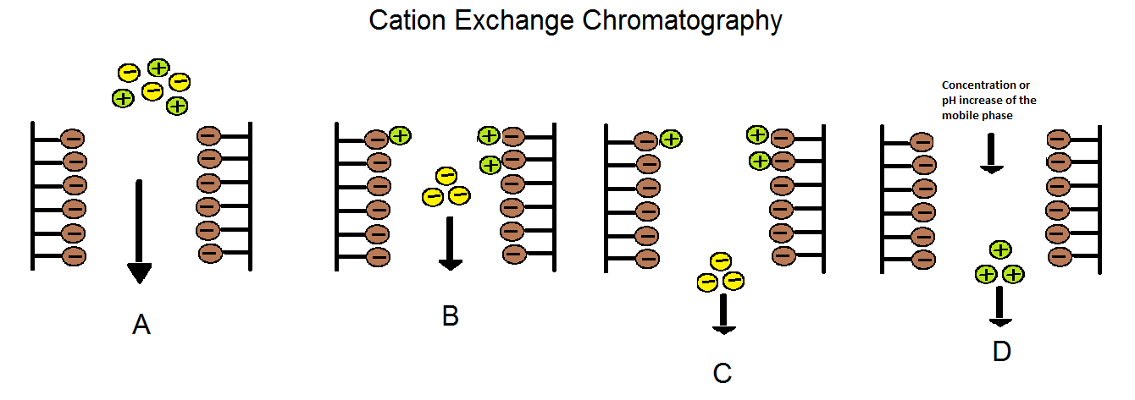
Figure 12: Schematic representation of binding and elution in SCXC
A. Injection of peptide mixture to a cation exchange column. The column has negatively charged stationary phase. B. Positive peptides bind to stationary phase; negative peptides remain non-retained. C. Negative peptides elute from column while positive peptides remain bound. D. Positive peptides elute due to the change of mobile phase profile (pH or Concentration change)

stationary phases are described as either “strong” or “weak” ion exchange materials. Strong ion exchangers function over a wide range of pH but weak ion exchangers alter their charge if pH falls out of a narrow tolerance range. pH gradient ion exchange chromatography is a common tool for high efficiency separation of protein mixtures in biological samples. For example, a mixture of proteins (IgG, albumin, transferrin and anti Hep-B) in a sample were separated using ion exchange chromatography by manipulating the pH of the elution buffer according to the isoelectric point (pI) of the components [100]. Isoelectric point (pI) is the pH value at which a molecule possesses no net charge, thus pH gradients enable efficient elution of proteins by disrupting the ion-ion interaction of the protein with the stationary phase. Importantly, the starting pH of the mobile phase must be at least one pH unit below the pI of the molecule of interest to achieve efficient binding of the protein to the stationary phase [101]. Method development for IEC includes choice of stationary phase, designing a suitable concentration or pH gradient of the mobile phase, and optimizing mobile phase flow rate. IEC can be employed for protein separations with exceptional resolution, for example the separations of two protein molecules differing by a single charged amino acid unit has been reported [102]. Importantly, IEC separations of high molecular weight (~150kDa) monoclonal antibodies like IgG₁ have resolved protein isoforms that differ because of charge heterogeneity [103]. To facilitate faster and efficient separation of protein complexes for non-competitive immunoassays, new IEC methods specific to oxytocin and β-endorphin are needed.

Summary
Background concepts related to strong cation exchange-based immunoassay of beta endorphin and oxytocin are discussed in this section. Brief descriptions of typical analytical challenges of immunoassays and principle of strong cation exchange-based chromatography are also included in this section.
Chapter 2

Microfluidic brain slice culture via a novel bubble perfusion device

Chapter 3 is based on an article submitted for publication by Amirus Saleheen, † Debalina Acharyya, ^{ꓕ} Rebecca A. Prosser, ^{ꓕ,2} and Christopher A. Baker. ^{†,2}

†Department of Chemistry, ^{ꓕ}Department of Biochemistry and Molecular Biology, and ²NeuroNET Research Center, University of Tennessee, Knoxville, Tennessee, 37996, United States

The first author’s contribution to this article includes: 1. Fabrication and characterization of the microfluidic device, 2. Synthesis and characterization of the biodegradable glue, 3. Performing fluorescence calcium imaging experiments, 4. Data analysis, and 5. Majority of the writing. The remaining authors contributed in determining the research problem, harvesting rodent brain slices, editing, and revising the article.

Abstract
Conventional brain slice culture techniques, such as rotary tube or membrane interface culture, can maintain viable slice cultures over the course of days to weeks, but these techniques are poorly suited for integration with perfusion sampling. As a result, temporal analysis of cellular secretions using conventional slice culture platforms is challenging. Here, we will discuss the development of a microfluidic perfusion system that mimics the rotary tube technique by providing alternating flows of liquid nutrients and carbogen gas. The system is based on microfluidic bubble generation at a T-junction, in which perpendicular flows of aqueous media and carbogen gas produces bubbles separated by liquid droplets in a fashion similar to that of conventional microfluidic emulsion generators. Characterization of flow conditions to control bubble/droplet frequency and volume will be discussed. Challenges in achieving slice adhesion will be discussed, and the characterization of a bio-compatible polysaccharide-based glue for slice adhesion will be described. The system is designed for medium-to-long term studies of slice culture biology lasting hours to days. Fluorescent calcium imaging and PI/DAPI staining of cultured tissue slices of rodent hypothalamus are used to confirm culture viability for medium-term temporal studies. The perfusion device has potential for reagent flows downstream of the slice culture chamber, and the application of segmented droplet flow for the temporally resolved analyses.

Introduction
Ex vivo brain slice cultures are widely utilized model systems for studying neurophysiology [1-3]. To prepare these models, living tissue slices containing brain structures of interest are excised from donor animals and maintained in environments that provide nutrient supply and waste removal sufficient to substitute, at least temporarily, for the vascular perfusion no longer present in the excised tissue. Neuronal tissues have a particularly high oxygen demand [4], thus careful consideration is needed to design tissue culture systems that provide appropriate oxygen supply. In the absence convection via vascular perfusion, oxygen transport into the tissue occurs only by diffusion, therefore gaseous oxygen delivery is most common as it takes advantage of higher rates of diffusion as compared to oxygenated aqueous media.
An early design of a fluidic system for ex vivo slice culture is the rotary-tube method [104], in which tissue slices are immobilized on a planar support and placed in cell culture tube partially filled with culture media. The tube and planar support assembly are slowly and continuously rotated about the central axis of the tube, causing the immobilized tissue slice to be repeatedly submerged in media, providing nutrient supply and waste removal, then emerged into the head space of the tube, providing gaseous oxygen supply. While rotary tube methods are particularly effective for long-term slice culture [104-110], the continuous motion of the system limits the ability for long-term monitoring by microscopy or electrophysiology. Membrane interface slice culture is an alternative approach that is more amenable to integration with microscopy and electrophysiology [111-113]. By this method, tissue is maintained on a porous membrane at the interface of aqueous media (below the membrane) and gaseous atmosphere (above the membrane), receiving simultaneous nutrient and oxygen supply from opposite faces of the tissue slice.
The emergence in recent years of research into “organ-on-chip” systems has highlighted the value of ex vivo tissue culture for modeling complex relationships in systems biology [114-120]. A key feature to these systems is the culture of cells and tissues in much smaller volumes of media, often with continuous perfusion, as compared to conventional culture methods. Microfluidic systems enable precise control of the culture environment, for modeling complex and dynamic biological stimuli, and the collection of cellular secretions with minimal dilution, for characterizing the response of these tissues to stimuli. The combination of precise environmental control and high-fidelity characterization of cellular secretions in a single microfluidic system can give insight into physiological phenomena difficult or impossible to observe by other methods [121, 122]. Importantly, the focus on secretion measurements in microfluidic organ-on-chip systems need not preclude the integration of electrophysiology [19], and often the integration of microscopy observations are greatly improved over conventional culture methods [123].
Roller tube and membrane interface culture methods utilize much larger media volumes than microfluidic organ-on-chip systems, complicating secretion measurements and motivating the design of microfluidic brain slice culture platforms. In the microfluidic regime, designing for adequate oxygen delivery is a unique challenge since flow systems are typically sealed, limiting access to gaseous atmosphere. Rambani and co-workers developed a novel microfluidic perfusion technique involving laminar interstitial flow of oxygenated aCSF to acute brain slices maintaining viability for 5 days [21]. The technique was also successful for removal of depleted medium and catabolites throughout the thickness of the slice. Lam and co-workers have demonstrated the ability of controlling both spatial and temporal variations of oxygen tension characteristic of in-vivo biology using microfluidic techniques [124]. The method has potential to study the importance of oxygen tension in the disease processes such as cancer, ischemic heart disease, and wound healing.
Here, we present a new approach to microfluidic brain tissue slice culture based on mimicking the alternating solution and gaseous oxygen delivery achieved by roller tube methodologies. In this system, which we term a microfluidic “bubble perfusion” device, the principles of droplet microfluidics are employed to generate droplets of culture media dispersed between bubbles of carbogen gas (95% O₂, 5% CO₂), and brain tissue slices are perfused with the resulting monodisperse droplets and bubbles. The present work focuses on demonstrating viability of hypothalamic tissue in the microfluidic system for experiments lasting > 8 hours, although the system has been designed with future applications to secretion measurements in mind. System design and operation are discussed, fluidic performance is characterized, and tissue health in the perfusion system is demonstrated via Ca²⁺ imaging and propidium iodide (PI) staining.

Experimental procedure

Device fabrication
The device was a laminated glass/PDMS structure. 750 µm thick PDMS sheets (Stockwell Elastomerics, Inc, Philadelphia, PA) were used as a channel layer. Channels were designed using AutoCAD 2019 (AutoDesk, San Rafael, CA) and cut using a CO₂ direct-write laser cutter (VLS 2.3, Universal Laser Systems, Scottsdale, AZ) to form a PDMS gasket. The PDMS gasket layer was plasma bonded between two 75 x 25 mm microscope slides using a plasma cleaner (PDC-001 HP, Harrick Plasma Inc., Ithaka, NY). Inlet and outlet holes were drilled on the surface of the chip using a Dremel rotary tool fitted with a 1 mm diameter carbide tipped bit. Luer ports (Cole Parmer, Vernon Hills, IL) were glued to form fluidic connections at the inlet and outlet holes. The tissue chamber volume was formed by cutting a gasket from clear VHB tape (McMaster Carr, Princeton, NJ). The VHB gasket was attached to the glass surface of the device and sealed using a layer of Gelbond film (Lonza Group LTD, Basel, Switzerland).

Characterization of carbogen bubble and aCSF droplet
Carbogen gas (95% O₂ and 5% CO₂, Airgas, Knoxville, TN) and Earl’s balanced salt solution (Sigma-Aldrich, Milwaukee, WI) were used as oxygen and nutrient supply, respectively. Carbogen gas was delivered to the device through direct connection to the storage cylinder and culture media solution was delivered to the chip using a syringe pump (New Era Pump Systems, Inc., Farmingdale, NY). Droplet and bubble dimensions and frequency were characterized via smartphone imaging using a Motorola G5S plus and digital image analysis using Fiji software [125].

Synthesis of hydrogel glue
A two-part polysaccharide hydrogel glue was synthesized and used to ensure tissue adhesion in the chamber. The synthesis protocol was followed as reported by Balakrishnan and co-workers [56]. Briefly, 5 g Dextran (Fisher Scientific, Suwanee, GA) dissolved in 100 mL Milli-Q purified water (Millipore, Bedford, MA) was oxidized in the presence of sodium metaperiodate (Fisher Scientific, Suwanee, GA) to dextran dialdehyde (DDA). The oxidation reaction was carried out for 6 hours at room temperature in dark while constantly stirring the mixture. The mixture was then dialyzed (MWCO = 12 KDa) for 48 hours to remove excess sodium metaperiodate. The dialyzed solution was tested by reaction with 1 wt% silver nitrate solution (Fisher Scientific, Suwanee, GA) and the lack of resulting precipitate indicated adequate removal of sodium metaperiodate. The dialysate was lyophilized and stored at 4 °C for future use. Chitosan hydrochloride (ChitHCl) was synthesized following protocol described in Austin and Sennett [126]. 10 g chitosan (Sigma-Aldrich, Milwaukee, WI) was continuously stirred in 60% ethanolic HCl (Fisher Scientific, Suwanee, GA) for 3 hours at room temperature. The ChitHCl product was filtered and washed thoroughly with 75% v/v acetone (Fisher Scientific, Suwanee, GA). The residue was dialyzed (MWCO = 12 KDa) and the absence of residual HCl was confirmed by 1 wt% silver nitrate. The dialysate was lyophilized and stored at 4 °C for future use. To form the final two-part hydrogel glue, separate 5 wt% ChitHCl and 10 wt% DDA solutions were prepared using phosphate buffer saline (Fisher Scientific, Suwanee, GA). 2 µL of each solution was mixed on the hydrophilic side of the Gelbond film immediately prior to placing a tissue slice on to the glue mixture. The tissue loaded Gelbond film was then used to seal the perfusion chamber, as described above.

Tissue slice preparation and Fluo-4 AM dye loading
500 µm thick coronal tissue sections containing the suprachiasmatic nucleus (SCN), underlying optic chiasm, and a small area of surrounding anterior hypothalamus were prepared from 2-4 month old male C57/Bl mice (Envigo, Indianapolis, IN) that had been housed in 12:12 light-dark conditions with food available ad libidium, as described previously [127]. Tissue slices were initially placed in an interface brain slice chamber constantly perfused with EBSS (pH 7.4) at a rate of approximately 25 mL h⁻¹, maintained at 37ºC, and supplied with carbogen gas as described [127, 128]. The tissue was allowed to recover from the trauma of slice preparation for 1 hour.
Tissue slices were submerged in 10 µM solution of Fluo-4 AM dye (Fisher Scientific, Suwanee, GA) and 1% Pluronic acid-127 (Molecular Probes, Eugene, OR). The Fluo-4 AM dye was diluted to the desired concentration using Earl’s balanced salt solution (Sigma-Aldrich, Milwaukee, WI). Slices were kept submerged in the dye-loading solution for 45 minutes, following the protocol reported by Cameron and co-workers [64].

Perfusion experiment and calcium imaging setup
To maintain the uninterrupted supply of the carbogen gas to the device, a direct connection between the storage cylinder and the device inlet was established. The flowrate of the gas was regulated by a gas regulator connected to fused silica capillary tubing (23 cm long, 25 µm I.D.) which provided appropriate back pressure and allowed control of gas flow rates by applying pressures determined by the Hagen-Poiseuille equation. The flowrate of the gaseous media was kept constant at 38 µL min⁻¹.
Images of dye-loaded tissue slices were captured at fixed time interval by a high-resolution monochrome CMOS camera (DCC3260M, Thorlabs, Newton, NJ) using a lab-built epi-fluorescent microscope system. Illumination was via a 488 nm laser diode (L488P60, Thorlabs, Newton, NJ) transmitted to the chamber via a 490 nm long pass dichroic mirror (DMLP490R, Thorlabs, Newton, NJ) and a 10X microscope objective lens (Newport Corporation, Mountain View, CA). Emission was collected by the same objective lens, then passed through a 515 +/- 5 nm bandpass filter (FL514.5-10, Thorlabs, Newton, NJ) before the image was captured by the camera. Images were processed and analyzed using Fiji [125]. The temperature of the chamber was regulated using a resistive heater powered by a programmable controller (TC200, Thorlabs, Newton, NJ).

Propidium Iodide staining and fluorescence imaging setup
To assess the tissue health in the perfusion system, the tissue slices were subjected to propidium iodide (PI) staining [129-132]. PI is able to enter dead and damaged cells due to reduced membrane integrity, after which it intercalates with the DNA and fluoresces upon excitation with appropriate wavelength of light (535 nm). After Ca²⁺ imaging was complete, the tissue sections were perfused within the microfluidic chamber for 2 h with 4.6 µg/ml PI (Fisher Scientific) prepared in EBSS. The tissue slices were then removed from the microfluidic chamber and transferred to a scintillation vial containing 4% PFA and incubated for 10 mins on ice. After 10 mins, the PFA was replaced with a 30% sucrose solution, and the tissue sections were incubated overnight in at 4ºC. The following day, the slices were removed from the sucrose solution and embedded in optimal cutting temperature compound (Fisher Scientific) and stored in -80º until sectioning. The tissue slices were thin-cut (10 µm) with a cryostat and the sections were collected on gelatin-subbed slides and stored in -80º to be processed further for staining. For staining, the slides containing the tissue sections were first allowed to air dry and then washed once in phosphate buffered saline for 10 mins. After the wash, the sections were coverslipped using mounting media that includes the nuclear stain 4′,6-diamidino-2-phenylindole (DAPI; Vectashield, Vector Laboratories, Burlingame, CA) and the edges were sealed using a nail-polish. Fluorescence images were acquired using a Leica DM6000B microscope. The images were analyzed using ImageJ software (NIH). Cell counts were performed on a single tissue section, taken near the middle of the SCN, from each tissue section. The images were split into blue and red channels, where the blue channel shows DAPI-stained cells and the red channel shows PI-stained cells. The SCN region was identified as a region of high cell density immediately dorsal to the optic chiasm. The total number of cells in the identified area were counted using the blue channel. The PI intensity across the cells in the same region was assessed using the red channel. The number of high PI intensity cells corresponds to the number of dead and damaged cells. The percent of dead/damaged cells was then calculated as the ratio of high PI intensity cells to DAPI cells.

Results and Discussions
To enable a new mode of oxygen delivery in microfluidic brain slice culture, a microfluidic device was developed to deliver alternating carbogen gas bubbles and media droplets to a miniature tissue culture chamber. The top view of the microfluidic device is shown in Figure 13a illustrating the inlets, outlet, the tissue perfusion chamber. The carbogen bubbles and the media droplets perfused through the tissue perfusion chamber providing oxygen and nutrients, respectively. The perfusate droplets were collected via the outlet port. Figure 13b shows the exploded view of the device. The channel containing PDMS layer was sandwiched between two microscope slides. The tissue perfusion chamber was placed on the top glass slide and sealed with the hydrophilic face of the GelBond film forming the interior wall of the tissue chamber.
The generation of segmented carbogen bubbles and media droplets is analogous to conventional droplet microfluidics techniques, albeit with a dispersing phase, in this case the carbogen gas, of particularly low viscosity [133]. It has been shown that in similar microfluidic systems droplet and bubble dimensions are a function of channel dimensions and the ratio of gas and liquid flow rates [42].

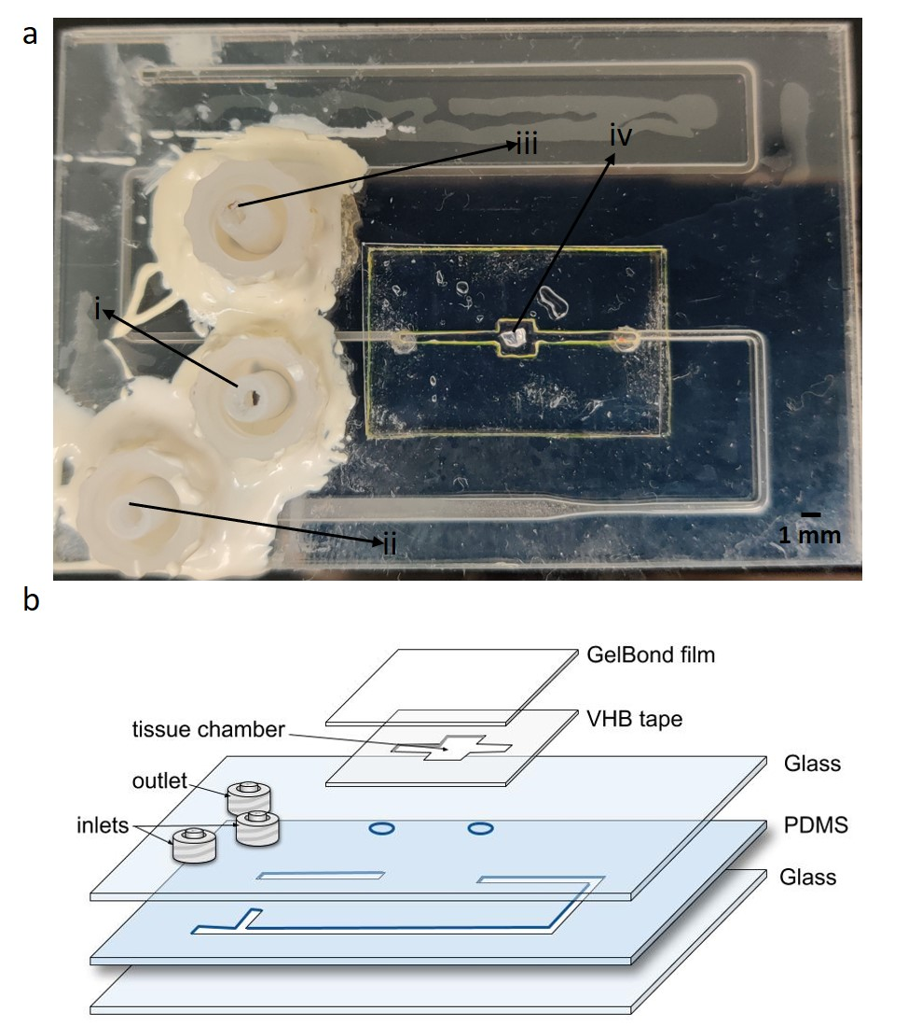
Figure 13: Novel microfluidic rodent brain slice culture device
a The top view of the slice culture chip showing i. carbogen inlet, ii. media inlet, iii. outlet/fractionation collection, and iv. tissue perfusion chamber with a mock agarose slice, b Exploded view of the slice culture chip showing the different layers.
In the present work, relatively large bubble, and droplet volumes, as compared to conventional microfluidic dimensions, were needed to achieve well-controlled perfusion behavior in the tissue chamber. Typical tissue slices were 0.5 mm thick with lateral dimensions of ca. 1.5 x 1 mm. The chamber was designed to allow convective flow around all exposed faces of the tissue slice, excluding the face adhered to the chamber surface. Chamber depth was 0.75 mm and overall chamber volume was ca. 6.75 μL. As a result, relatively large channel dimensions (channel width 1.6 mm) at the droplet-forming intersection were needed, and bubble/droplet formation was characterized at these channel dimensions (Figure 14).
To understand the precision with which bubble perfusion could be delivered to tissue slices, we characterized multiple dimensions of bubble and droplet generation. Bubble volume was characterized following the work of van Steijn and coworkers [42]. They showed that at conventional microfluidic scales bubble volume was well controlled via the ratio of volumetric flow rates for the gaseous (q_{g}) and liquid (q_{l}) components. We observed the same trend at larger channel dimensions in the current device (Figure 14a). The volume of both the bubbles and the droplets followed the expected trend of increasing and decreasing respectively with increasing q_{g} at a constant q_{l}(Figure 14b). A convenient approach for describing total liquid perfusion volumes in a system delivering segmented flow is to consider the duty cycle of liquid flow. Duty cycle of droplets was characterized at a constant q_{l} across various values of q_{g} (Figure 14c) and was observed to decreased linearly with increasing q_{g}. Precise control of droplet duty cycle enables perfusion of tissue slices with dynamic and highly reproducible perfusion volumes. Another key consideration of perfusion dynamics was the frequency of droplet generation, intended to ensure adequate oxygenation over hours-long perfusion experiments. Bubble frequency increased linearly with q_{g} (Figure 14d) which, along with the observations of droplet duty cycle, suggested that droplet and bubble dynamics resulted from laminar flow mechanisms as in conventional droplet microfluidics, despite large channel dimensions and low viscosity of the gaseous
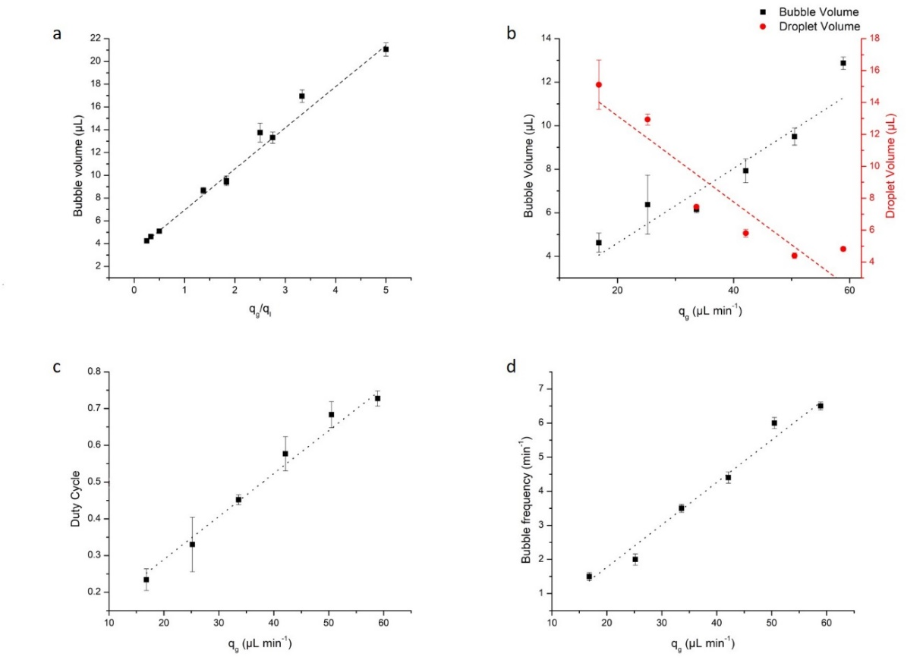
Figure 14: Characterization of the novel microfluidic
rodent brain slice culture device
a The characterization of the length of the bubbles generated at the T-junction as a function of the ration of the gas and liquid phase volumetric flowrates (R² = 0.99), b The characterization of the carbogen bubble volume (R² = 0.91) and media droplet volume (R² = 0.87) as a function of the volumetric flowrate of the carbogen gas, c the characterization of the duty cycle as a function of the volumetric flowrate of the carbogen gas (R² = 0.98), and d the characterization of the frequency of the bubbles generated at the T-junction as a function of the volumetric flowrate of the carbogen gas (R² = 0.98).

dispersing phase. Importantly, at all values of q_{g} evaluated here, observed bubble frequencies exceeded those common for roller tube culture techniques (typ. 1 – 2 gas emersions min⁻¹), which was limited by the high droplet duty cycle that would result at very low values of q_{g}. All tissue perfusion experiments in the present work were conducted at 50% droplet duty cycle (ca. 4.5 bubbles min⁻¹) to mimic the conditions of conventional roller tube tissue culture. The system provides significantly higher temporal resolution than a conventional in-vivo micro-dialysis technique which requires hours to accumulate enough sample for one measurement [134]. Controlling duty cycle and bubble frequency may offer a convenient mechanism to precisely model hyperoxia and hypoxia in tissue slice cultures, which we intend to explore further in future work.
To model the pressure environment of a tissue perfusion experiment while characterizing the bubble and droplet generation dynamics shown in Figure 14, the tissue chamber was loaded with either non-viable tissue slices prepared from frozen tissue or mock tissue slices prepared from 2% agarose gel. During these experiments we observed two key design challenges relating to the tissue chamber. First, slice immobilization within the tissue chamber was difficult to achieve. Initially, slices were immobilized to the chamber wall using thrombin-coagulated chicken plasma, which is a common technique utilized in roller tube culture [135]. When immobilized via coagulated chicken plasma, slices became dislodged from their mounted position and subsequently flushed into the flow channel within 45 minutes of perfusion (Figure 15a). We attributed this to increased shear forces as compared to those of a typical a roller tube experiment, and therefore presumed that the adhesion forces provided by the coagulated chicken plasma were insufficient. We investigated numerous approaches to immobilizing the tissue slice via physical structures that held the slice in place, but in every case the additional geometry within the chamber disrupted segmented flow. Although cyanoacrylate-based adhesives offer appropriate holding force, studies have shown poor cytocompatibility of these materials [136]. Ultimately, improved adhesion was possible by synthesizing a bio-compatible hydrogel glue first described by Balakrishnan and coworkers [56]. Details on the structure and synthesis of this Chitosan/Dextran-based glue are given in the supporting
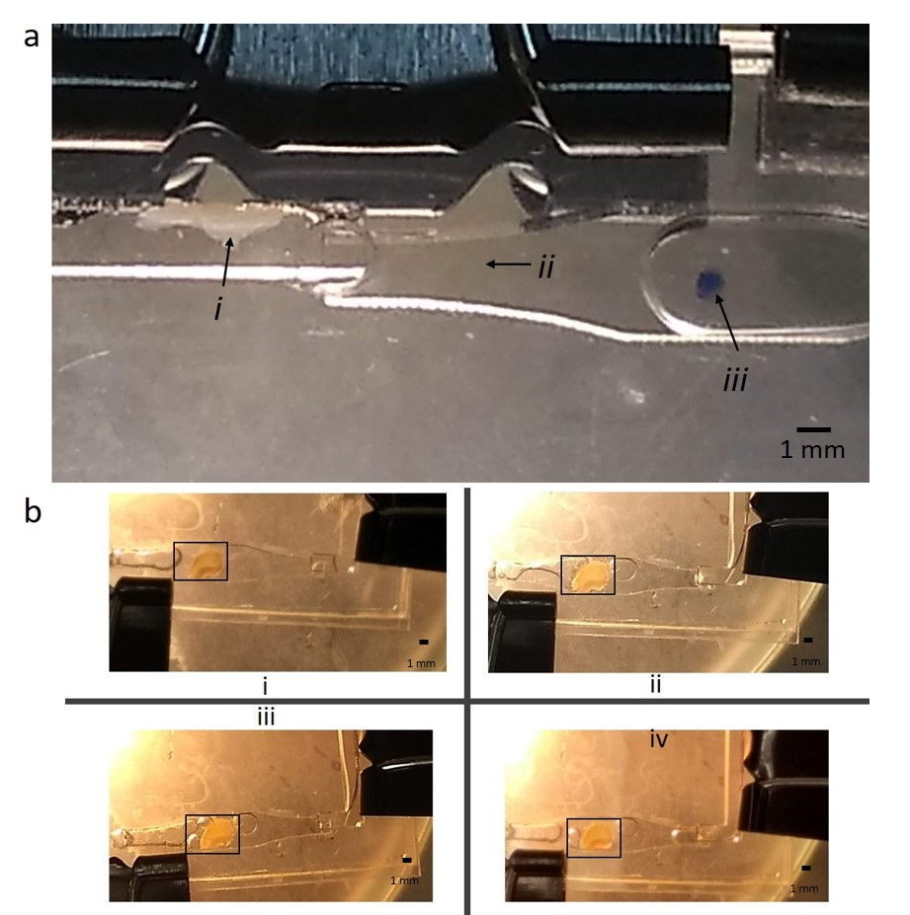
Figure 15: Tissue adhesion
a Unsuccessful attempt of tissue adhesion using chicken plasma and thrombin glue i. dislodged rodent brain slice, ii. Direction of flow, and iii. Original position of the rodent brain slice b Demonstration of successful implementation of polysaccharide-based hydrogel glue for tissue (shown in black rectangles) at i. beginning of perfusion, ii. 1 hour, iii. 2 hours, and iv. 3 hours.
information. Figure 15b shows a coronal cross section of a rodent hippocampus adhered to the chamber for more than 3 hours of perfusion, indicating a dramatic increase in adhesive performance as compared to thrombin-coagulated chicken plasma. Utilizing the hydrogel glue, slices routinely adhered to the chamber for the full duration of 10+ hour perfusion experiments with no observed indications of failure or fatigue.
The second design challenge was that of maintaining monodisperse droplets and bubbles as the flow entered the chamber, perfused the tissue slice, and exited the chamber. This can also be observed in Figure 15b, in which bubbles of various volume and generally poorly structured segmented flow is observed throughout the chamber and across multiple time points. We deemed it a strict requirement to maintain well-structured segmented flow over the tissue slice and in the effluent exiting the tissue chamber for two reasons. First, ensuring that the full volume of each droplet and bubble transited the chamber undisrupted was essential to ensuring that droplet/bubble generation accurately described the volumes and relative durations of perfusion conditions experienced by the tissue. Second, maintaining segmented flow in the effluent of the tissue chamber will offer benefits in future applications involving downstream temporal profiling of cellular secretions. Droplet microfluidics have been shown to offer substantial advantages for decoupling the timescales of analysis from those of perfusion [137, 138], and we postulate that the same advantages can be achieved with this bubble-segmented system. We intend to demonstrate this capability in future work.
We observed irregularities in segmented flow through the tissue chamber of two types which we termed “bubble sticking”, and “droplet coalescence”. Bubble sticking referred to the tendency for small fractions of a bubble to break apart from the main bubble and remain trapped within the chamber, often in contact with the tissue slice. This phenomenon can be observed in Figure 15b panels ii – iv. In this case, bubbles were typically trapped for the duration of the perfusion experiment, even as further droplets and bubbles perfused around the trapped bubble. This was not ideal for well controlled perfusion because the trapped bubble represented a barrier to transporting fresh oxygen and media to the adjacent region of tissue. Droplet coalescence occurred when a full oxygen bubble was observed to remain stagnant within the chamber while two or more droplets appeared to flow around the bubble via the wetted outer perimeter of the tissue chamber. In these cases, the problem typically persisted for several droplets before the trapped bubble was cleared by a subsequent bubble or droplet. When present, the phenomenon would typically recur in an irregular and chaotic manner for the duration of a perfusion experiment.
Although no quantitative metrics were observed by which these irregular flow phenomena could be predicted or controlled, we did develop best design practices that effectively eliminated their occurrence. First, the use of hydrophilic materials within the tissue chamber was essential. This motivated the construction of the tissue chamber from VHB adhesive and GelBond film rather than conventional materials such as PMMA or PDMS. Second, droplet and bubble volumes greater than 50% of the chamber volume were effective at reducing both types of flow irregularities. Finally, the geometry of the chamber, and especially the transitional from flow channel to chamber, had a dramatic impact on the occurrence of these flow phenomena. We anticipated that a gradual, sloping transition from the narrow flow channel to the wider tissue chamber would produce the least disruption at the gas-liquid interface and thereby help maintain segmented flow. Interestingly, we observed that the exact opposite was true. Flow irregularities were dramatically reduced or eliminated in chamber designs that included an abrupt transition from channel width to chamber width (as shown in Figure 13a), as opposed to those with gradual transitions (as shown in Figure 15b). Further work is needed to elucidate the precise relationship between chamber design parameters and the ability to maintain segmented flow throughout the perfusion experiment. This is especially important considering that various brain slice preparations will require different chamber dimensions and volumes. In future work, we intend to
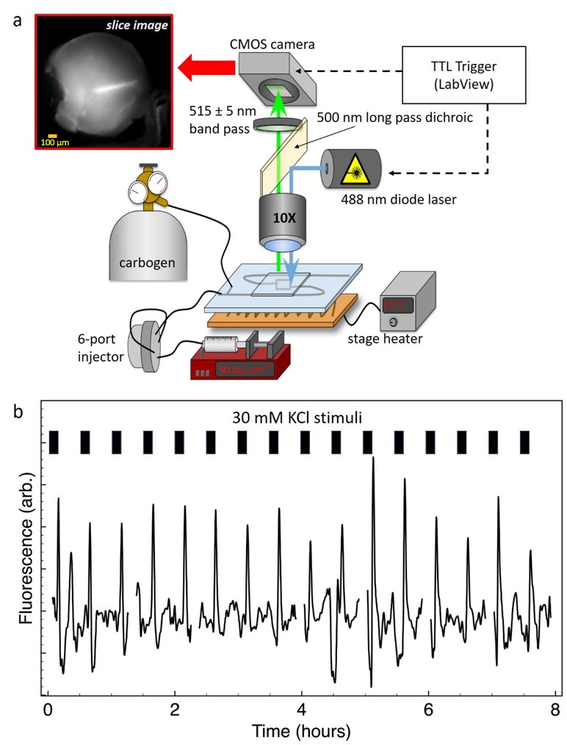
Figure 16: Fluorescence calcium imaging
a Schematic of the epifluorescence instrument setup for Ca²⁺ imaging for SCN slice viability. The image of an SCN slice is shown in the black rectangle and b the response of the SCN slice through Ca²⁺ induced fluorescence of Fluo-4 AM dye due to KCl stimuli.
characterize these relationships and optimize chamber design for a range of common slice preparations.
To demonstrate the utility of this microfluidic system for maintaining healthy model tissue, slices of murine hypothalamus containing the suprachiasmatic nucleus (SCN) were loaded with the calcium-sensitive fluorescent dye Fluo-4 before perfusion within the device for 8 – 10 hours. Calcium transients were induced in the SCN tissue by delivering a depolarizing stimulus of 30 mM KCl in culture medium, and fluorescence imaging was conducted via the instrumentation illustrated in Figure 16a. ImageJ was used to define a region of interest that included only SCN tissue, and grayscale value was recorded as relative fluorescence intensity. KCL stimuli were delivered as 32 µL injections every 30 mins, and the concentration profile of stimulus delivery was characterized prior to perfusion experiments using fluorescent dye injections (see appendix A, Figure 32). Figure 16b shows a representative plot of relative Fluo-4 fluorescence vs. time, indicating strong calcium influxes correlated with the timing of KCl stimulus delivery. These robust calcium responses give qualitative indication that tissue remained viable in the perfusion system for the duration of perfusion experiments lasting typically 8 – 10 hours. We observed a high rate of success in maintaining viable tissue in the perfusion system, with 80% of the experiments (n_{total} = 5, n_{viable} = 4) showing robust calcium response for the duration of perfusion. Tissue that failed to show robust calcium response could, in many cases, be attributed to prolonged handling time during the dye loading step or while mounting the tissue in the chamber.
To compare viable to non-viable perfusion experiments in a semi-quantitative manner, we conducted propidium iodide/DAPI co-staining on representative tissue samples that showed no calcium and robust calcium responses (Figure 17a and Figure 17b respectively). The circled regions represent SCN tissue, blue represents nuclei stained with DAPI, and dead cells are stained pink by propidium iodide. Based on digital image processing using ImageJ, the non-viable tissue
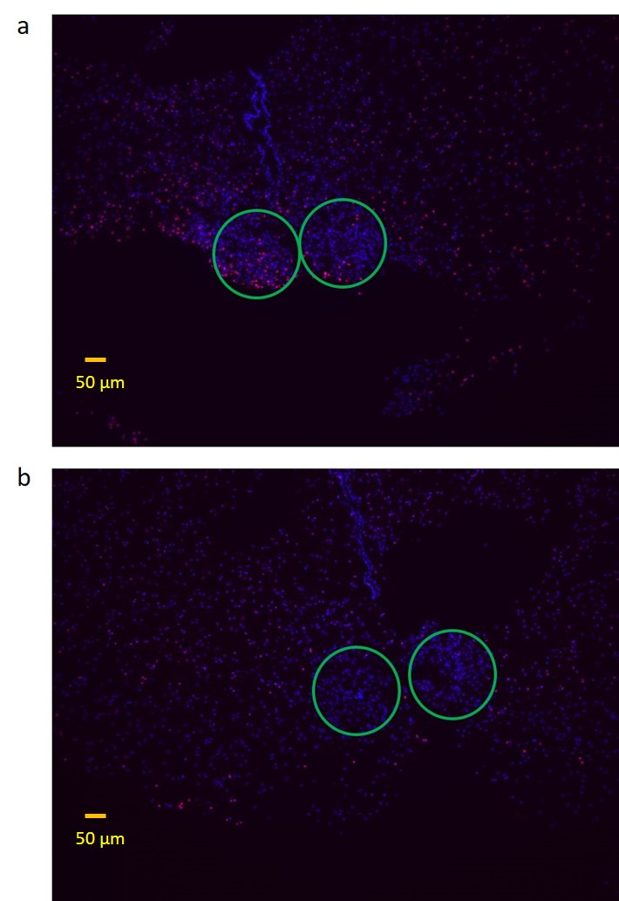
Figure 17: PI/DAPI staining
Fluorescent micrographs of DAPI/PI co-stained hypothalamic tissue slices after 8 – 10 hours of bubble perfusion. a Tissue for which no calcium transients were observed b Tissue that demonstrated robust calcium response throughout the perfusion experiment. Circles indicate the regions of analyzed as SCN tissue.
shows approximately 25 dead cells for every 100 total cells within the SCN. For tissue that showed robust calcium response, these numbers are approximately 7 dead cells for every 100 total cells. This study indicates that robust calcium response in the SCN is likely correlated with overall cell viability in the region.

Conclusion
Microfluidic organ-on-chip technologies are emerging as valuable tools for modeling complex biological systems under well-controlled conditions. The culture of brain tissue slices in microfluidic systems presents unique challenges, including that of providing adequate oxygen delivery. In the present work, a novel microfluidic perfusion system for brain tissue slice culture was designed and demonstrated. This system takes inspiration from both roller-tube tissue culture methods and droplet microfluidic devices to perfuse tissue slices with well-defined volumes of culture media and gaseous oxygen as monodisperse droplets and bubbles.
Via calcium imaging and DAPI/propidium iodide co-staining, this work demonstrated that the microfluidic perfusion system can maintain viable tissue slices throughout perfusion experiments lasting 8 – 10 hours. Importantly, these experiments were not limited by physiological concerns for the tissue, thus tissue viability in the perfusion system may last longer than these durations. While this work has demonstrated a novel system for tissue perfusion with unique operational advantages, substantial work in this area remains. Tissue chamber design plays an important and thus far poorly understood role in maintaining appropriate segmented perfusion, and unique geometries are likely needed for various tissue preparations. Importantly, the maintenance of segmented flow throughout perfusion has unique advantages for tissue secretion measurements, but further work is needed to demonstrate the utility of this system for such application. We intend to address these in future work outlining the continued development of this tissue perfusion platform. Still, this work represents an important proof-of-principle for droplet and bubble perfusion as a technique for providing appropriate nutrient and oxygen delivery for brain tissue slices cultured in microfluidic volumes.

Chapter 3

Estimation of available epinephrine dose in expired and discolored autoinjectors via quantitative smartphone imaging

Chapter 3 is based on a publication on the following

A. Saleheen, † B.M. Campbell, ^{₸,2} R.A. Prosser, ^{ꓕ,2} C.A. Baker, ^{†,2} Estimation of available epinephrine dose in expired and discolored autoinjectors via quantitative smartphone imaging, Anal. Bioanal., (2020).

†Department of Chemistry, ^{ꓕ}Department of Biochemistry and Molecular Biology, and ²NeuroNET Research Center, University of Tennessee, Knoxville, Tennessee, 37996, United States
₸Fellow Academy Wilderness Medicine, Wilderness Medical Society; Local Medical Advisor, National Park Service, Obed Wild and Scenic River and Big South Fork National River and Recreation Area; Assistant Chief TN Appalachian Mountain Rescue Team. Oak Ridge, TN 37830

The first author’s contribution to this article includes: 1. Analysis of the samples for concentration profiling, 2. Method development for quantitative smartphone imaging, 3. Data analysis, and 4. Majority of the writing. The remaining authors contributed in determining the research problem, collection of the samples, editing and revising the article.

Acknowledgment
This work was supported by start-up funding provided by the University of Tennessee, College of Arts and Sciences, and the Department of Chemistry.
We would like to thank Dr. Seth C. Hawkins MD for his interest in the project and supplying the EAIs that were used in testing.

Abstract

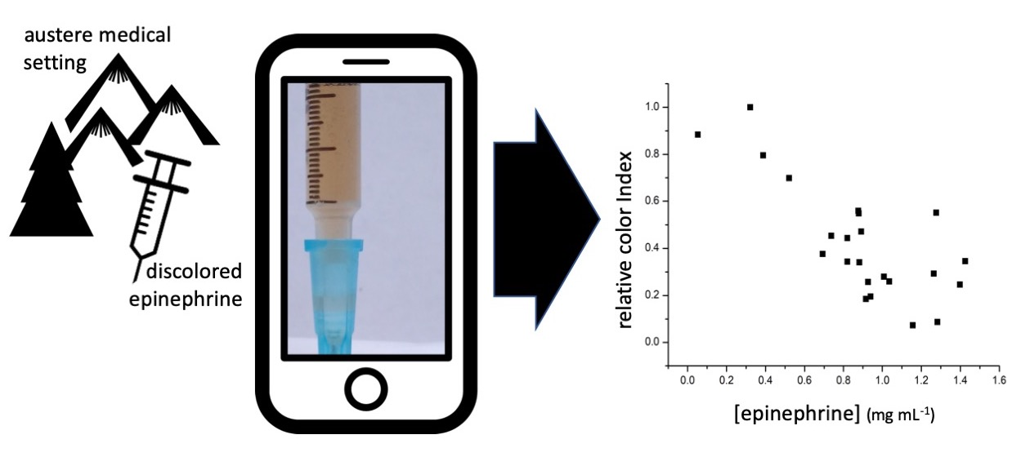
Figure 18: Graphical abstract of chapter 3

Epinephrine autoinjectors (EAIs) are important first aid medications for treating anaphylaxis. A 10-fold price increase over the past 12 years, and evidence that expired EAIs may still contain significant doses of available epinephrine, have motivated interest in the efficacy of expired EAIs as treatments of last resort. Degradation of expired EAIs, which can be caused by improper storage conditions, results in various degrees of discoloration of the epinephrine solution. Previous studies have determined that significant epinephrine remains available in expired EAIs, but these have only considered EAIs that show no discoloration. Here, we investigate the potential for colorimetric estimation of available epinephrine dose based on the degree of discoloration in expired EAIs. The correlation of available epinephrine dose and time since expiration date was poor (r = -0.37), as determined by an industry standard UHPLC protocol. Visible absorbance of the samples integrated across the range 430 - 475 nm correlated well with available epinephrine dose (r = -0.71). This wavelength corresponds to the blue channel of a typical smartphone camera Bayer filter. Smartphone camera images of the EAI solutions in various illumination conditions were analyzed to assign color indices representing the degree of discoloration. Color index of the samples showed similar correlation (|r| > 0.7) with available epinephrine dose as that of visible spectrophotometry. Smartphone imaging colorimetry is proposed as a potential point-of-use epinephrine dose estimator for expired and degraded EAIs.

Introduction
Epinephrine is widely used as a first aid drug for the treatment of anaphylaxis [139, 140]. Anaphylaxis can be triggered by a wide variety of stimuli including food, medication, and envenomation [141-145]. Anaphylaxis shows signs of hyperallergic reactions in quick successions and can lead to death [146, 147]. Epinephrine induces vasoconstriction which helps reduce or prevent upper airway mucosal edema, hypotension, and shock. Epinephrine also has important bronchodilator effects that help relieve laryngospasm and bronchospasm and cardiac inotropic and chronotropic effects, which also helps in treating hypotension and shock [146]. Fatality in cases of anaphylaxis is correlated with delayed epinephrine administration [147]. Immediate recognition of anaphylaxis and ability to administer epinephrine are vital to saving lives in cases of anaphylaxis, which is why many people prone to severe allergic reaction, as well as first aid providers, carry epinephrine autoinjectors (EAIs). Still, studies suggest that underuse of epinephrine as a first aid drug in cases of anaphylaxis is a significant problem [148].
EAIs typically contain 1 mg mL⁻¹ epinephrine (0.5 mg mL⁻¹ for EpiPen Junior) in saline solution, and are marked with expiration dates after which administration of the drug is not recommended [149]. Recent price increases of commercial EAIs have triggered interest in the efficacy of expired EAIs. In 2007, average EAI price increased 545% to $350 [66] and by 2016 the price was $600 [67]. A study on patient compliance reported that even patients with high awareness of EAI expiration date may still carry expired EAIs and delay replacement [68, 69]. Several studies have found 50-90% active ingredient still available in EAIs from 1-90 months after their expiration dates [70, 150, 151].
Epinephrine oxidizes in the presence of atmospheric oxygen, taking on a pink to brown appearance depending on the extent of oxidation [152]. Similar degradation of EAI contents was observed after prolonged heat exposure [153]. In-depth study on effect of oxidation on drug degradation is absent because such effects can be well managed via proper storage of drug containers by keeping them away from light, heat, and atmospheric oxygen [154]. Additionally, drugs susceptible to oxidation are often formulated with antioxidant agents. For example, EAIs contain inert sodium metabisulfite which is a widely used antioxidant used in numerous drugs [155]. Therefore, degradation of epinephrine in EAIs can be attributed to poor storage conditions and prolonged exposure to light, heat, and atmospheric oxygen. There is evidence to suggest that epinephrine degradation products are well tolerated in the body. Ocular epinephrine drugs can cause pigmentation of conjunctiva [156, 157] and cornea [84, 156-159] due to epinephrine degradation products produced upon light exposure [160, 161]. The oxidized derivative of epinephrine is melanin-like adrenochrome [83, 84], and the resulting discoloration of the eye is tolerated as a side-effect of ocular epinephrine drugs [161]. Although it is advised to not use discolored EAIs [70, 149, 150], the prevalence of expired EAIs due to cost pressures, and the nature of epinephrine as a drug of first aid, presents the possibility that expired and discolored EAIs can be the only option available in emergency and remote settings.
Austere medicine is the practice of medicine in resource-constrained environments, from wilderness areas in North America to third world countries [162]. In austere environments the ability to procure fresh medicine can be severely hampered, and the conundrum of using whatever medicine is available becomes the issue. Epinephrine is a life-saving drug for patients experiencing anaphylaxis and, if the medicine is discolored or out of date, waiting for replacement epinephrine may not be a viable option. The safety and efficacy of expired and discolored EAIs is not well established, and the current accepted practice is that discolored EAIs should not be administered. Still, austere medical scenarios exist in which discolored medication will be administered, and in such cases the ability to assess the concentration of epinephrine in discolored or expired EAIs using ubiquitous and readily available smart phone technology may save lives.
Simons and coworkers determined the available active ingredient in expired EAIs [70]. 28 EpiPens and 6 EpiPen Juniors were investigated via spectrophotometry and HPLC. Nearly all samples were colorless and free from precipitates, and all contained at least 50% of the intended epinephrine dose. They concluded that using an expired EAI during an emergency outweighs the potential risk of giving no treatment, presuming no signs of degradation are observed [70, 163]. These studies did not consider extensively expired EAIs that showed substantial degrees of discoloration.
Smartphone imaging is emerging as an approach to colorimetric detection for quantitative analysis. Blood glucose concentration in diabetic patients [164], electrolytes concentration in human sweat [165], and alkaline phosphate concentration in dairy [166] and serum [167] samples have been quantified via smartphone images. Smartphone imaging has also been utilized in applications such as detecting nucleic acids [168], influenza virus counting[169], immunoassay of prostate specific antigens [170], and detection of Hg²⁺ via smartphone fluorescence microscopy [171-173].
We hypothesized that discolored EAIs present the opportunity for simple colorimetric estimation of the available epinephrine dose by quantitative smartphone imaging, which may facilitate the evaluation of EAIs at the point of care. Here, we investigated expired EAIs showing various degrees of discoloration with the objectives of 1) Determining the correlation between available epinephrine and the time elapsed since expiration date; 2) Determining the correlation between available epinephrine and the degree of discoloration; and 3) Developing a simple colorimetric methodology that utilizes smartphone imaging to estimate available epinephrine dose in discolored EAI solutions.

Experimental section

Reagents and materials
Epinephrine, methanol, 1-octanesulfonic acid, 1 mL polypropylene syringes, and 0.22 µm nylon syringe filters were from Fisher Scientific (Suwanee, GA). All aqueous solutions were prepared with 18.2 MΩ water from Milli-Q purification system (Millipore, Bedford, MA). The Luna C18 chromatography column (50 x 4.6 mm, 5 µm particle size, 100 A⁰ pore size) was from Phenomenex Inc (Torrance, CA).

Expired EAI samples
Multiple EAIs were obtained from various sources. Expired EAIs were requested, without reference to storage, and it is assumed that most, if not all the EAIs, were carried by patients or EMS in non-temperature-controlled environments. After receipt of the EAIs, all syringe units were carefully removed from their delivery unit, placed in sealed Falcon tubes, and stored at room temperature until assayed. Researchers developing the protocols and analyzing the epinephrine samples were blinded to the expiration date until after analysis. These samples represent a real-world scenario of EAI storage rather than using EAIs from controlled environments. Time since expiration date for all the EAIs ranged from 12 to 207 months.

Epinephrine measurements by UHPLC
The samples were filtered through 0.22 µm nylon syringe filters to eliminate any particulates. The filtrates were diluted to 20% of original concentration with 50% methanol in water solution. Epinephrine concentrations were determined using an Agilent 1290 infinity series (Agilent Technologies, Inc, Santa Clara, CA) Ultra-High Pressure Liquid Chromatography (UHPLC) instrument equipped with a diode array detector following a US Pharmacopeia (USP) standard protocol [174]. Briefly, isocratic elution was conducted on a C18 column at 1 mL min⁻¹ with a mobile phase of 1:1 Methanol:Water with 0.1% 1-octanesulfonic acid added as an ion pairing agent. UV absorbance was recorded at 278 nm. Epinephrine standard solutions were used to produce a calibration curve in the range from 0.01 – 1.00 mg mL⁻¹. The concentrations of epinephrine in EAI samples were determined by fitting the resultant peak area to the best fit line of the calibration data.

Characterization by UV-Vis spectrophotometry
UV-Vis spectra of the EAI samples were obtained using a NanoDrop One spectrophotometer (Thermo Fisher Scientific, Waltham, MA). The absorbance maximum of 278 nm for epinephrine was determined using epinephrine standard solutions, and a calibration curve was constructed in the concentration range of 0.01 to 1.00 mg mL⁻¹. EAI samples were diluted to 20% of original concentration to fall within the calibration range. Epinephrine concentrations for expired EAI samples were determined via absorbance at 278 nm by fitting to the best fit line of the calibration data.

Quantitative smartphone imaging
Color index was defined as the integrated absorbance of the spectral region 430-475 nm, which corresponds to the blue bandpass component of a common photographic Bayer filter [175]. Smartphone images of the EAI samples were obtained with a Motorola G5S plus device. The Open Camera android application (http://opencamera.org.uk) was used to hold white balance and exposure time constant for all images taken under a particular lighting condition. EAI samples were imaged within standard 1 mL polypropylene syringes in four different lighting conditions: ambient sunlight, fluorescent office illumination with smartphone flashlight, fluorescent office illumination without smartphone flashlight, and under dark lab conditions while utilizing the smartphone flashlight.

Results and discussion

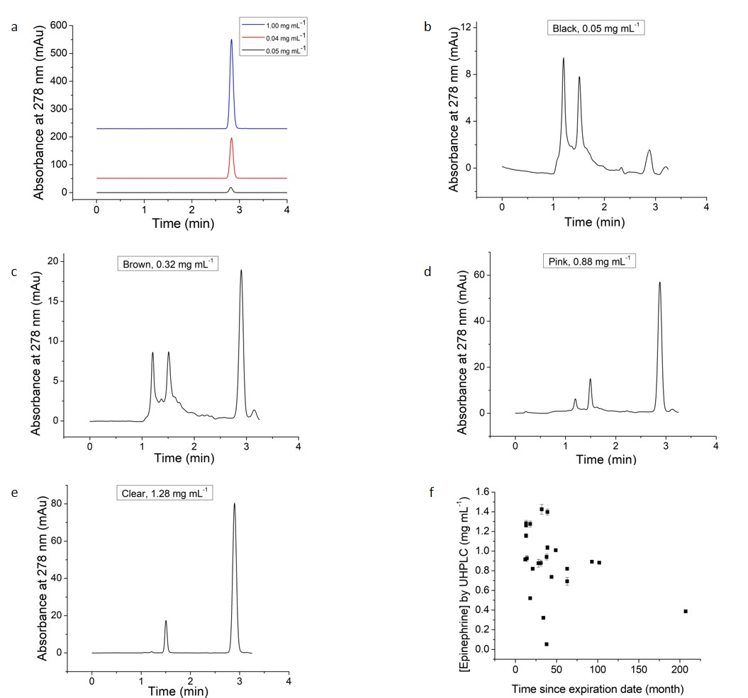
Figure 19: Epinephrine quantitation by UHPLC
Representative chromatograms of a pure epinephrine standards, b expired EAI sample that appeared black, c expired EAI sample that appeared brown, d expired EAI sample that appeared pink, e expired EAI sample that appeared clear, and f Poor correlation (r=-0.37) was observed for epinephrine concentration in expired and discolored EAI samples vs. time elapsed since expiration date

Twenty-three expired EAIs, ranging from 12 to 207 months past expiration date, were characterized to determine available epinephrine dose. UHPLC analysis of epinephrine standard solutions via a standardized USP protocol gave a peak at 2.86 ± 0.01 minutes (Figure 19a). The EAI samples were observed as a range of colored solution from clear to black, and were qualitatively categorized into four groups, Clear, Pink, Brown, and Black, based on their appearance to the naked eye. Figure 19b, Figure 19c, Figure 19d , and Figure 19e shows representative chromatograms of samples from each qualitative category. All samples showed a peak at approximately 2.9 minutes, indicative of available epinephrine in the EAI solution. Increasing color intensity correlated with an increase in additional peaks eluting in the range of 1 – 2 minutes. We postulate that these additional peaks are epinephrine degradation by-products, although further study is needed to identify these constituents. EAI samples were evaluated by UHPLC in triplicate to yield concentration determinations with RSD < 5% in all cases. In this study, epinephrine concentrations in expired EAIs were found to be in the range of 0.05 – 1.43 mg mL⁻¹ (See appendix A, Table 3). Although it was unexpected to observe epinephrine concentrations higher than the reported dose of 1 mg mL⁻¹, and the nature of this discrepancy is not immediately clear, this finding corroborates those of Simons and coworkers who measured epinephrine concentrations as high as 1.19 mg mL⁻¹ [70]. We found that time since expiration date was a poor predictor of available epinephrine dose in discolored EAIs. Simons and coworkers found a Pearson correlation coefficient (r) of -0.63 indicating moderate correlation between available epinephrine dose and time since expiration date in expired EAIs that had been stored appropriately to prevent sample discoloration and formation of particulates [70]. For discolored EAI solutions, we observed poor correlation (r = -0.37) of available epinephrine dose with time since expiration date (Figure 19f).
As an initial investigation into the efficacy of photometry for EAI characterizations, epinephrine concentrations were determined by UV-Vis spectrophotometry of the same filtered EAI samples used for UHPLC measurements. UV absorbance spectra are shown in Figure 20a for the same
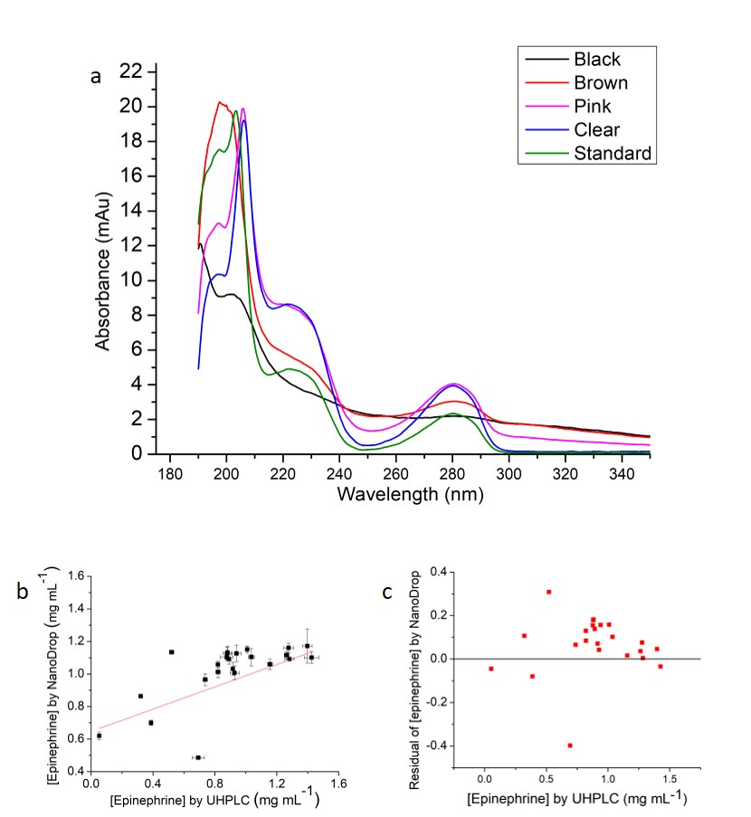
Figure 20: Epinephrine quantitation by UV spectrophotometry
a Representative UV absorbance spectrum of discolored EAI samples and an epinephrine standard solution at 0.4 mg mL⁻¹, b Comparison of epinephrine concentrations determined by UV spectrophotometry vs. those determined by the industry standard UHPLC protocol, and c Residual plot of epinephrine concentrations of EAI samples from UV spectrophotometry vs concentrations determined by UHPLC
representative samples shown in Figure 19b through Figure 19e, with an additional trace showing an epinephrine standard solution of concentration 0.4 mg mL⁻¹. EAI epinephrine concentrations were determined via calibration of UV absorbance at 278 nm.
Figure 20b shows the comparison of epinephrine concentrations determined by UV spectrophotometry with those determined by the standard UHPLC protocol. UV absorbance consistently overestimated epinephrine concentrations, which is evident from the mostly positive residual values shown in the residual plot of Figure 20c. We hypothesize that the inaccuracy of UV-absorbance in determining epinephrine concentration is a result of spectral overlap between degradation products in solution and epinephrine, which is supported by the observation of non-epinephrine peaks in the chromatograms of degraded EAI samples with absorbance detection at 278 nm (see Figure 19b through Figure 19e). Importantly, UV-absorbance was measured using filtered samples, which eliminated particulate matter and had the effect of reducing, although not eliminating entirely, the intensity of discoloration as observed by the naked eye. Filtration was necessary prior to UHPLC and was convenient for avoiding aberrant scatter in UV absorbance measurements, but it poorly approximated the conditions of expired EAI solutions at the point of use.
We hypothesized that colorimetry of the unfiltered, and thus more intensely colored, expired EAI samples would yield a more effective correlation with epinephrine concentration. Unfiltered samples appeared with various red hues ranging from pink to dark brown, thus we investigated absorbance in the blue region of the visible spectra. Figure 21a shows the UV-Visible spectra in the range 175 – 850 nm and an enlarged view of the range 430 - 475 nm (inset), which corresponds with the typical bandpass range of the blue component of a Bayer filter found in many digital cameras [176]. The trend of integrated absorbance across the range 430 - 475 nm corresponded with the trend of discoloration intensity, shown in Figure 21b, and with the trend of epinephrine concentrations as
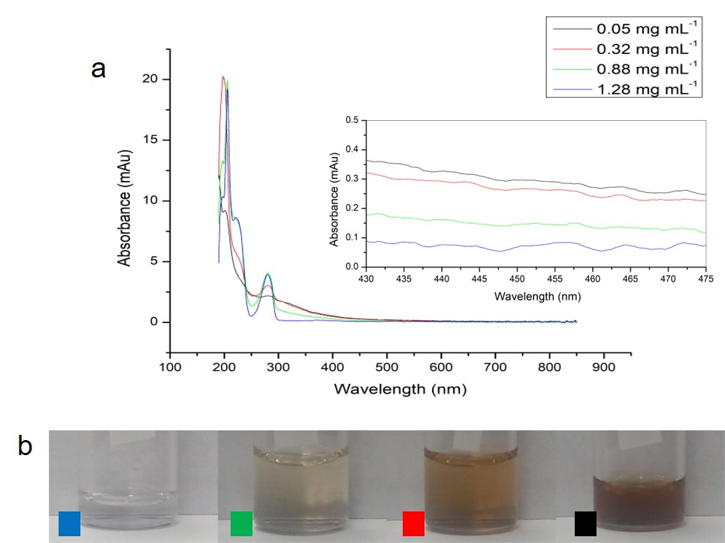
Figure 21: Visible Spectrophotometry of discolored EAI solutions
a Representative UV-Vis absorbance spectrum of discolored EAI samples, labeled by epinephrine concentration determined via UHPLC. The inset shows a magnified view of the visible spectra in the range 430-475 nm, and b Images of samples represented in panel a. Color labels correspond to the line colors of panel a

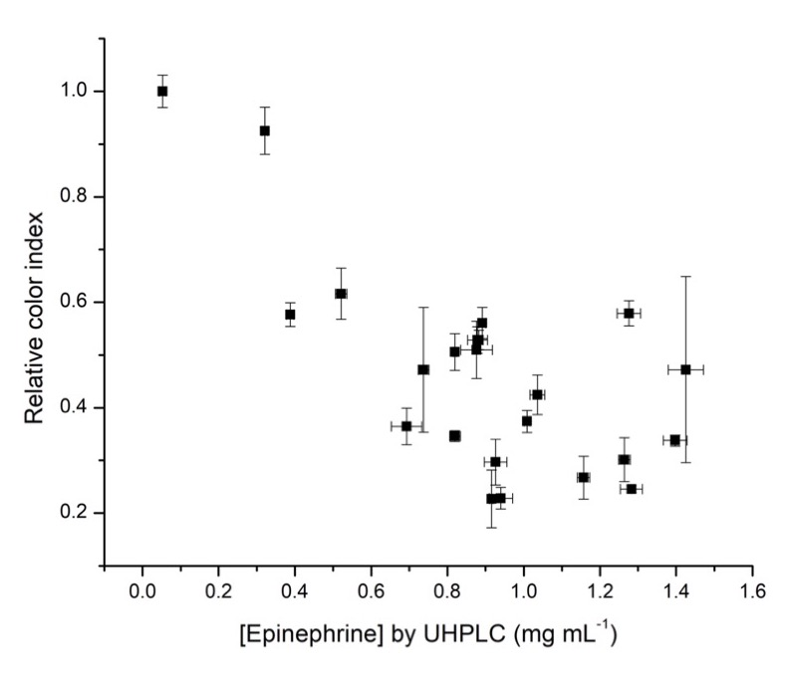
Figure 22: Relative color index vs. epinephrine concentration
Color index correlates well with epinephrine concentration as determined by UHPLC, giving a Pearson correlation coefficient of r = -0.71

determined by UHPLC (given in Figure 21a color legend), whereas absorbance at 278 nm did not show the same correlation with the trend of epinephrine concentrations.
The integrated area of the absorbance spectrum from 430 nm to 475 nm was calculated for each sample, and we termed this value the color index. All measured color index values were normalized by dividing by the highest measured color index to give the relative color index, which has a maximum possible value of 1. Figure 22 shows the correlation between epinephrine concentration as determined by UHPLC and the relative color index value. A significant negative correlation is observed as characterized by a Pearson correlation coefficient of -0.71. This negative correlation suggests that colorimetry of the unfiltered degraded EAI samples may offer an effective approach for estimating epinephrine concentration.
To demonstrate the efficacy of smartphone imaging for colorimetric assay of degraded EAIs, solutions were transferred into standard 1 mL polypropylene syringes and imaged via smartphone camera. Imaging conditions were standardized by utilizing a sheet of standard A4 printer paper as an imaging background, and multiple illumination conditions were investigated.
Each colored image was decomposed into 3 grayscale images representing the red, green, and blue components (i.e. converted to “RGB stack”) using the open source imaging application Fiji [125]. Mean grayscale intensities from the blue image channel in specific regions of interest were used to determine an approximated color index value according to equation 5.
$$Color index=\log_{10}{\frac{I_{0}}{I}}$$ | 5
where I₀ is the mean grayscale intensity from a representative region of interest on the white background, and I is the mean grayscale intensity from a representative area of the syringe as indicated in Figure 23a through Figure 23d. This image analysis was
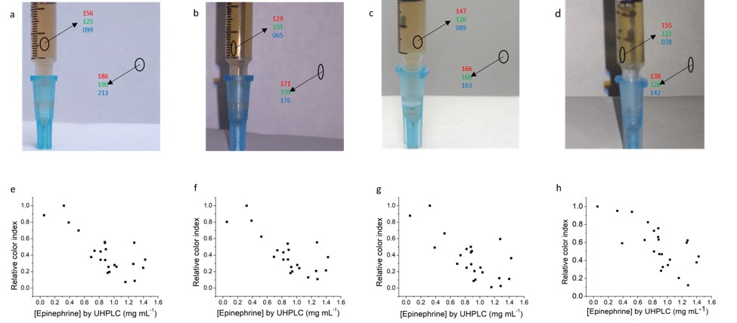
Figure 23: Quantitative smartphone imaging
of discolored EAI solutions
Representative images of EAI solutions illuminated via a ambient sunlight, b fluorescent office illumination with smartphone flashlight, c fluorescent office illumination without smartphone flashlight, and d dark ambient conditions with smartphone flashlight illumination; Plots of relative color index vs. epinephrine concentration under e ambient sunlight (r = -0.77), f fluorescent office illumination with smartphone flashlights (r = -0.76), g fluorescent office illumination without smartphone flashlights (r = -0.71), and h dark ambient conditions with smartphone flashlight illumination (r = -0.71). Black circles in figures a-d indicate regions of interest that gave mean intensity values for R, G, and B as indicated in each figure. Note smaller regions of interest were used in panel b and d to avoid the effects of glare on the syringe surface

performed on images collected outdoors under ambient sunlight (Figure 23a and Figure 23e), under fluorescent office illumination with the addition of smartphone flashlight illumination Figure 23b and Figure 23f), under fluorescent office illumination without the addition of smartphone flashlight illumination (Figure 23c and Figure 23g), and under dark conditions while utilizing the smartphone flashlight (Figure 23d and Figure 23h). As with the data shown in Figure 21, all calculated color index values were normalized to the highest measured color index to give relative color index. Under all illumination conditions, similar negative correlations are observed between the measured color index and the epinephrine dose as determined via the standard UHPLC protocol, with r ranging from -0.71 to -0.77. Following the methodology of Watters, and coworkers [177], the calibration plots in Figure 23e - h were each fitted with a 95% confidence band to estimate confidence interval as a function of epinephrine concentration (see appendix A, Figure 33). The estimated 95% confidence interval at 1 mg mL⁻¹ epinephrine ranged from ± 0.12 to ± 0.15 mg mL⁻¹ for all lighting conditions studied here, indicating that, dependent on lighting conditions, a 12 - 15% reduction in reported epinephrine dose can be detected with 95% confidence. There are two important points to note here. First, these calibrations are intended to demonstrate proof of principle, and further calibration from a wider variety of sample sources is needed to deliver an assay with clinical utility. Second, there are no empirical limits established on effective epinephrine dose because epinephrine dosing for the treatment of anaphylaxis is not based on empirical study of dose-response relationship [178]. Therefore, no empirical metric exists by which to determine whether the demonstrated assay performance is sufficient for clinical utility. Still, in-date EAIs have been reported to contain in the range of 86% - 114% of stated epinephrine dose [70] indicating that the current assay can determine epinephrine dose degradation to within the accuracy of dosage of unexpired EAIs.
A quantitative smartphone imaging assay can enable colorimetric estimation of epinephrine in environments where imaging conditions could be difficult to control. Thus, we investigated the robustness of this assay to sample
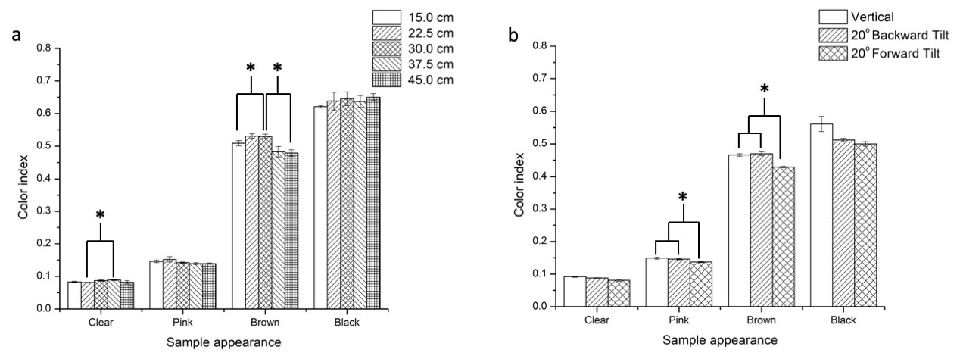
Figure 24: Influence of sample distance and orientation
on color index determinations
Color index values were determined for representative samples shown in Figure 21while varying a imaging distance, and b syringe orientation with respect to the camera. All bars within each sample color were compared via paired two sample two-tailed t-test, and statistically significant differences (p < 0.05) were observed between the bars indicated with an asterisk (*).

position and orientation with respect to the smartphone camera (Figure 24). Four representative samples of various hue (i.e. clear, pink, brown, and black in appearance) were studied to determine the variation of color index as a function of the syringe distance from the smart phone camera. We estimated that a natural ergonomic range of camera-sample distance for handheld image acquisition was 15 - 45 cm, and images were recorded with the syringe placed at 7.5 cm increments within that range. For all images, the white background was placed 3.8 cm behind the syringe, which we estimated as an appropriate distance to represent a syringe and white paper background held in the same hand approximately one-to-two finger widths apart. Figure 24a shows small but statistically significant differences in color index for the clear sample only when comparing images recorded at 22.5 cm to those recorded at 37.5 cm (p = 0.007). Statistically significant differences were observed for the brown sample when comparing images recorded at 30 cm to either those recorded at 15 cm (p = 0.002) or those recorded at 45 cm (p = 0.01), but no other significant differences were observed in the study of camera-sample distance. When color index values from all sample distances were pooled for each sample color, RSD was 4.8%, 4.3%, 4.9%, and 2.9% for clear, pink, brown, and black samples, respectively. This result suggests that, despite the small significant differences observed, the imaging assay is robust to camera-sample distance in the range of 15 - 45 cm.
We estimated that an operator could reasonably approximate syringe orientation to within ± 20° of vertical. Thus, to study the influence of syringe orientation, we collected sample images with syringes oriented vertically, and with 20° of tilt in the plane of the image (i.e. left and right tilt) and out of the plane of the image (i.e. forward and back tilt). There were no statistically significant differences observed when comparing data from vertically oriented syringes with those tilted left or right, within the plane of the image (data not shown). This is unsurprising, since tilted orientation within the plane of the image does not affect the path length of light from the white background through the volume of the syringe. Statistically significant reductions in color index value (p < 0.005) were observed when comparing syringes tilted forward (i.e. toward the camera) with either vertical or backward tilted syringe images for the pink and brown samples only (Figure 24b). The origin of this phenomenon is not immediately clear, but we do not attribute it to increased path length which would increase the observed color index value. When color index values from all sample orientations were pooled for each sample color, RSD was 5.0%, 3.4 %, 4.3%, and 7.5% for clear, pink, brown, and black samples, respectively. Thus, the assay is robust to sample orientation when the syringe is oriented within ± 20° of vertical.

Conclusions
We investigated available epinephrine dose in expired and discolored EAIs via the USP standard UHPLC methodology, spectrophotometry, and quantitative smartphone imaging. We found that time past expiration date is a poor predictor of available epinephrine concentration when EAIs have degraded and become discolored. Although spectrophotometry is employed for quality control in commercial epinephrine production [179], UV absorbance at 278 nm did not accurately estimate the epinephrine concentration in degraded EAIs, likely due to the presence of degradation products with spectral overlap with epinephrine. In discolored and unfiltered EAIs, visible absorbance in the range 430-475 nm correlated well with available epinephrine concentration, which enabled the development of a quantitative smartphone imaging protocol. A simple digital image processing procedure utilizing smartphone images yielded a strong correlation (|r| > 0.7) with epinephrine concentrations determined by standard UHPLC protocols, and this strong correlation persisted under various lighting conditions. Quantitative smartphone imaging was robust to moderate variations in sample-camera distance and sample orientation, yielding color index determination with RSD ≤ 7.5% in all cases studied.
The present work stops short of providing a point-of-use analysis tool for several important reasons. First, although our work demonstrates feasibility for quantitative imaging in various lighting conditions, a universal calibration that is normalized for illumination and white balance conditions is still needed. This presents a multivariate challenge that will form the basis of future work in this area. Second, although the digital image processing employed here is well within the computational abilities of common smartphones, in the present work digital image processing was accomplished offline using a personal computer. Substantial development is needed to package the image processing tasks along with an appropriate user interface into a simple-to-use smartphone application. Again, we intend to address this challenge with future work. Finally, and most importantly, the safety and efficacy of administering discolored EAI drugs is not well established. Although we postulate that the tolerance of discolored degradation products in ocular epinephrine drugs suggests low toxicity of the degradation products, this determination requires consideration by the wider medical community and lies well beyond the scope of the present work. Still, the present work establishes two key findings: 1) EAI discoloration can be utilized as an indicator for approximating available epinephrine concentration; and 2) EAI discoloration is readily quantified via a simple and robust smartphone imaging procedure.

Chapter 4

Cation exchange chromatography of Oxytocin and β-endorphin

Method development for SCXC-based immunoassay of β-endorphin
An appropriate SCXC method is essential to separate antibody and immunocomplex for successful non-competitive immunoassay. The retention of any molecule in a specific cation exchange column at constant temperature depends on the following factors: pH of mobile phase, isoelectric point of the molecule, concentration of mobile phase, and flow rate of mobile phase. The particle size in the cation exchange column is 5 µm. All the experiments were carried out at room temperature. The mobile phases used in the chromatographic separation are phosphate buffers in the concentration range of 5 mM to 1000mM. The isoelectric point of the IgG antibody is in the range of 6.6-7.2. At pH 6, the antibody molecule has a net positive charge, but it is expected to elute earlier than β-endorphin which has a much higher isoelectric point (9.9).

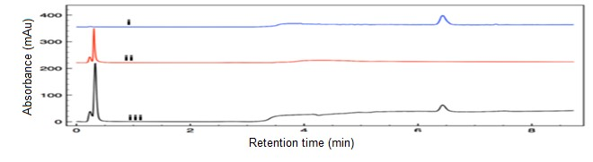
Figure 25: Cation Exchange Chromatograms: individual injections of β-endorphin(i), IgG antibody(ii), and a mixture of these

Table 1: The working method for separation of IgG antibody
Column | Agilent Bio SCX, non-porous, 2.1 x 50 mm, 5 µm, PEEK
Flowrate | 0.35 ml/min
Mobile phases | A (phosphate buffer, pH 6, 5.5 mM) and B (phosphate buffer, pH 6, 1000 mM)
Mobile phase gradient | 0-2 min – 0% B, 2-17 min – 0%-50% B
Detection wavelength | 214 nm
Runtime | 17 mins

Higher concentration of mobile phase A can make the IgG antibody possess a very short retention time making it practically non-retained in the column. Large number of particles in higher concentration mobile phase competes with the bound molecule vigorously for early elution. 20mM or higher concentration of mobile phase A made the IgG antibody elute earlier than 0.2 minute while even poorly retained molecules should elute after 0.3 minute based on the void volume of the column. 5.5mM concentration of mobile phase A allowed the IgG antibody to be retained in the column and elute at around 0.5 min. The separation of the antibody and analyte proved to be successful using a working method identified by trial and error. Table 1 shows the working method used to obtain the chromatograms in Figure 25.
Optimum flowrate maximizes separation efficiency in liquid chromatography by minimizing the height equivalent to theoretical plates (HETP). HETP can be expressed by the Van Deemter equation (6):
$$HETP=A+ \frac{B}{u}+Cu$$ | 6
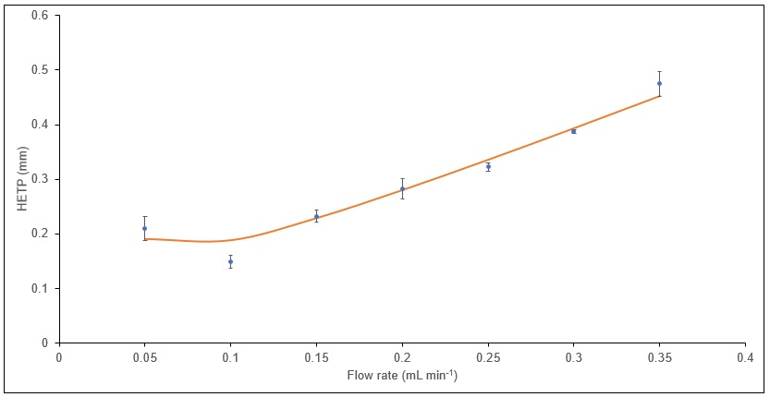
Figure 26: Flowrate optimization

Here, A is the multiple paths term, B is the longitudinal diffusion term, C is mass transfer term, u is mobile phase flowrate. Higher flowrate improves the longitudinal diffusion term in the column but negatively affects the mass transfer term from mobile and stationary phase. To identify a suitable flowrate for antibody separation, a series of experiments were carried out following the method mentioned in Table 1. The flowrate of the experiments was decreased gradually from 0.35 ml/min to 0.05 ml/min and HETP was minimum at 0.10 ml/min. Figure 26 shows the change of HETP with the change of flowrate.
When an immunomixture of β-endorphin and IgG antibody is injected, it is expected that the analyte will bind to the specific binding site of the IgG antibody and possess a different elution time from both the analyte and the antibody. The immunocomplex is expected to elute at an intermediary time to β-endorphin and IgG antibody retention time based on the following: when antibody binds to the analyte, it is likely to block solvent access to one or more (but not likely all) cationic residues of β-endorphin. It is less likely that β-endorphin (3.5 kDa) blocks the majority cationic residues of IgG antibody (150 kDa) because of the difference in their molecular size. If the immunocomplex has formed without the species blocking each other’s cationic residue, it is expected to elute slightly later than β-endorphin. This assumption is based on the summation of the cationic character of the strongly cationic β-endorphin and weakly cationic IgG antibody. Figure 25(iii) shows a chromatogram of the injection of immunomixture of 10:1 molar ratio of β-endorphin and IgG antibody. It does not show any unique migration time of any new species other than β-endorphin and IgG antibody. Based on the evidence, it can be hypothesized that the immunocomplex cannot withstand the stringency of UHPLC-SCXC separations resulting rapid dissociation. A solution to overcome this challenge can be introduction of covalent cross-linking of antigen to antibody to use UHPLC-SCXC as a separation tool for non-competitive immunoassay of β-endorphin.

Crosslinking of β-endorphin to IgG antibody for covalent stabilization
Crosslinking stabilizes a non-covalent complex by introducing covalent bonds formed between the proteins with a suitable linking reagent. Such reagents possess two different reactive functional groups in their structure specific for different functional groups in the two proteins to be crosslinked. β-endorphin sequence has 5 lysine amino acids which contain primary amine functional groups. IgG antibodies have cysteine residues forming di-sulfide bonds to retain the structure of relatively large and high molecular weight molecule. Free sulfhydryl functional group are also found in the variable domain of the light chain of IgG antibody [180]. Since there are no sulfhydryl functional group in β-endorphin, it is convenient to use amine-sulfhydryl crosslinking reagent for β-endorphin and IgG antibody mixture to avoid intra-crosslinking in the analyte molecule. The
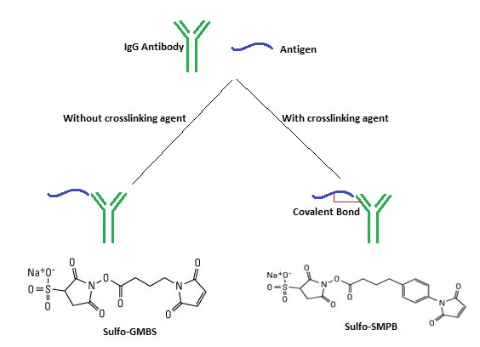
Figure 27: Crosslinking of IgG antibody and antigen complex with amine-sulfhydryl crosslinking reagent (Sulfo-GMBS or Sulfo-SMPB).

crosslinking procedure involves amine-sulfhydryl crosslinking reagent like Sulfo-SMPB or Sulfo-GMBS (structures in Figure 27). Both of the crosslinking reagents contain sulfo-N hydroxysuccinimide ester (Sulfo-NHS ester) and maleimide functional groups on either ends. Sulfo-NHS ester can conjugate with primary amines available in the Lysine amino acids in beta-endorphin by forming amide bonds. In physiological pH conditions (slightly alkaline, ~7.5), stable amide bonds form between primary amines and Sulfo-NHS ester groups by releasing sulfo-NHS. In similar physiological pH conditions, maleimide groups can conjugate with sulfhydryl groups available in variable domain of the light chain of the IgG antibody by forming stable thioether linkage. The spacer arm lengths of these crosslinking reagents are 11.6 Å and 7.3 Å respectively. First, the amine containing protein (β-endorphin) is solvated in pH 7.0 phosphate buffer saline. Then, the amine-sulfhydryl crosslinking reagent is added at least 10-fold molar in excess to ensure binding with the amine containing protein. Excess crosslinker molecules are separated from the mixture by desalting column using size exclusion principle. Next, the sulfhydryl containing protein (IgG antibody) is added at the desired concentration to the mixture to complete the crosslinking.

Minimization of equilibration time
Strong cation exchange columns require column equilibration between experiments to carry out efficient separation. This limits the speed of the assay which has an impact to the overall success of the aim. One of the integral parts of aim 1 is to innovate rapid measurements of oxytocin and β-endorphin. Longer column equilibration period will increase time delay between experiments making the overall process slower than desired. The column equilibration period can be shortened by utilizing the features of UHPLC, for example rapid flow rates and gradient conditions. The Bio-SCX column used in the experiments has a recommended column equilibration period of 30-45 minutes. The equilibration period has been decreased to 15 minutes while providing similar separation efficiency and resolution. Both IgG antibody and β-endorphin had similar retention time in SCXC separation after 15 and 45-minute column equilibration. IgG antibody

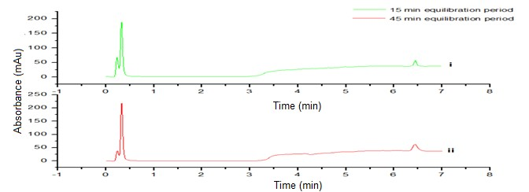
Figure 28: SCXC separation of immunomixture
(β-endorphin and IgG antibody)
and β-endorphin eluted at ca. 0.5 min and ca. 6.5 min respectively in both experiments with different equilibration period (Figure 28).
The equilibration period may further be decreased by faster flowrates and steeper mobile phase gradient. following the same protocol. In the scenario of not being able to have shorter equilibration period of the column to obtain desired separation speed, instrument modification may be done to add another SCX column in the UHPLC system. The proposed solution is to carry out separation in one column while the other one will go through equilibration protocol to become available immediately after the first column has completed an entire run.
The UHPLC-SCXC experiments have been using the concentration gradient mode of cation exchange chromatography which elutes the bound molecule in the column by increasing the concentration of the mobile phase. In the scenario of the immunocomplex being eluted at the same period of time to either the IgG antibody or β-endorphin, pH gradient mode of cation exchange chromatography can be applied. pH gradient mode increases the pH of the mobile phase over time instead of increasing the concentration. The formation of the immunocomplex will possibly block one or more cationic site of β-endorphin and/or IgG antibody which will modify the isoelectric point of the complex. pH gradient cation exchange chromatography will ensure different migration time of the complex with modified isoelectric point.

Immunoassay of β-endorphin and Oxytocin
Following SCXC-based non-competitive immunoassay method and performing necessary crosslinking procedures, β-endorphin and oxytocin will be measured. Known concentration samples will be assayed to build up a calibration curve for both assays. The calibration curves for both assays will provide the information that how the concentration of antibody-analyte complex changes with the change in concentration of sample analyte. The desired limit of detection for the assays is in the range of high pM to low nM.

Conclusion
Despite implementing the crosslinking protocol to establish additional covalent bonds between the antigen and the antibody, SCX based immunoassay failed to demonstrate a peak of the immunocomplex in the chromatogram. It can be implied the crosslinking agents were not successful to establish a stable covalent bond between the molecules. The functionality of the crosslinking agents is dependent on the spacer arm length. Spacer arm length is the physical length of the crosslinking agent and the appropriate distance of the functional groups in the antigen and the antibody. The proposed crosslinking agents had spacer arm lengths of 7.3 Å and 11.6 Å respectively. The distance between the primary amine group in the beta-endorphin structure and the free sulfhydryl group in the antibody has to match the spacer arm length of the applied crosslinking agent. The failure of the protocol can be attributed to use of improper crosslinking agent. Several other crosslinking agents reactive towards primary amines and sulfhydryl groups with different spacer arm lengths can be used to stabilize the immunocomplex. Sulfo-SMCC (8.3 Å), Sulfo-EMCS (9.4 Å), Sulfo-SIAB (10.6 Å), Sulfo-LC-SPDP (15.7Å), PEG4-SPDP (25.7 Å), and PEG12-SPDP (54.1 Å) are potential amine-sulfhydryl crosslinking agents with different spacer arm lengths than previously used. X-ray diffraction techniques can be used to determine the 3D structures of the antigen and the antibody to understand the relative distance of the amine groups in the antigen and the sulfhydryl group. The study will help choose an appropriate crosslinking agent to stabilize the immunocomplex. Stabilized immunocomplex will lead to successful immunoassays of the proposed antigens.
An alternate postulation of inability of appearing the immunocomplex peak in the chromatogram maybe attributed to the inability of resolution of the antibody and the immunocomplex peak. The immunocomplex peak was assumed to appear in the intermediary zone of the antibody and antigen based on the discussion in 4.1. Resolution of poorly resolved peaks in chromatograms can be improved by implementing the principles of equation 4. Further method optimization focused on increasing number of theoretical plates, improving selectivity, and increasing retention factors may be necessary. Number of theoretical plates can be increased by using smaller stationary phase particles. Selectivity and retention factors can be improved by reducing mobile phase flowrate, which will be a trade-off with analysis time.

Chapter 5

Future work

Objective
The work described in chapter 2 successfully reports viability of rodent SCN slices in the novel microfluidic perfusion device. The work has numerous future possible directions to improve the current device and the perfusion system. The current device is only intended to house SCN slices, but perfusion experiments can be carried out for a variety of sources of rodent brain slices. An alternate fluid delivery system to the continuous gas/fluid flow can be explored for simplification and improvement of precise stimulus delivery purpose. The prospect of changing the chamber geometry needs to be explored. Various sizes and shapes of the chamber can be characterized for seamless laminar fluid flow. The surface energy inside the chamber can also be characterized to improve the fluid flow. Finally, the modifications can be optimized to achieve seamless fluid flow and least carryover issues.

Alternate fluid delivery system
The current device uses a combination of a syringe pump and a cylinder valve to deliver the aCSF and carbogen gas, respectively. The current delivery system can generate alternate droplets of aCSF and bubbles of carbogen gas at the T-junction of the device channels. A new approach of the fluid delivery system is shown in Figure 29. In all the panels of Figure 29, carbogen gas, stimulus solution, and aCSF media are shown to enter the device through the horizontal inlet, top vertical inlet, and bottom vertical inlet, respectively. In this approach, carbogen gas and aCSF media flow will be controlled using pneumatic valves where the duration of slice interaction with the bubbles and droplets can be easily controlled and manipulated. Instead of a continuous flow, the bubbles and droplets can remain stagnant in the chamber for any period intended according to the experiment
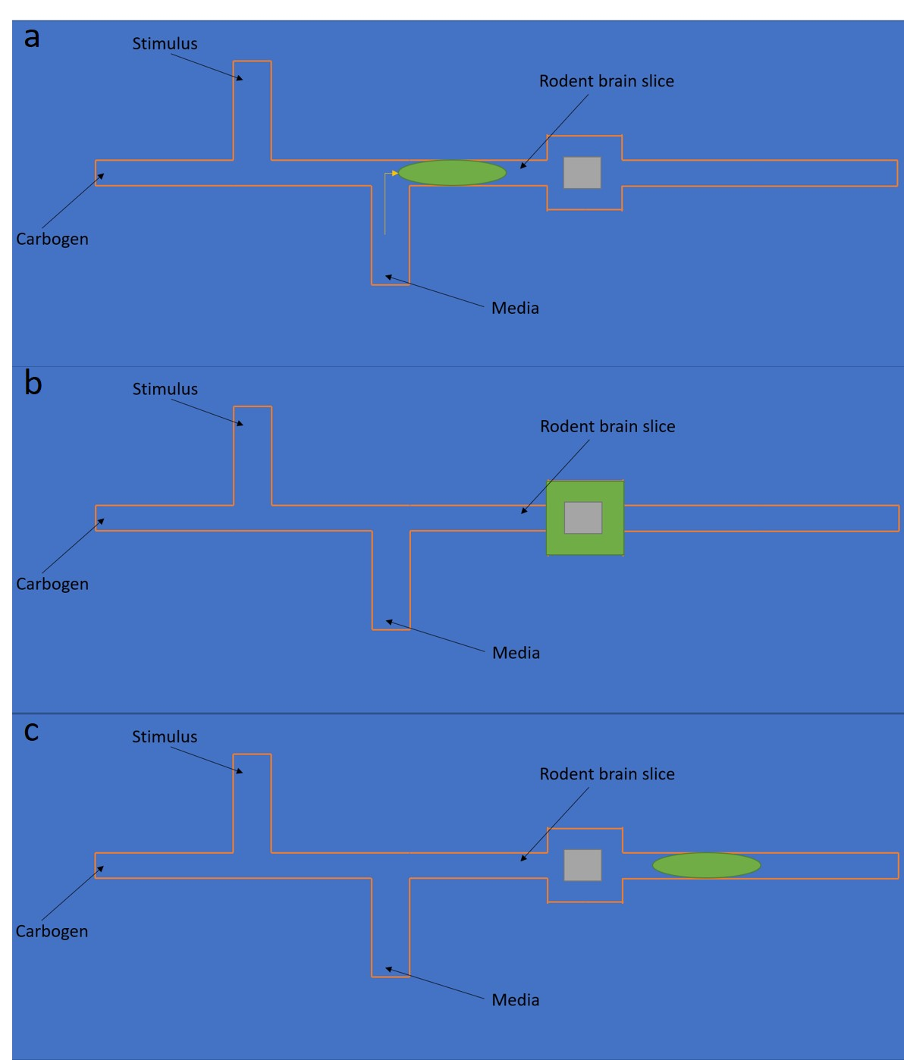
Figure 29: Proposed modified fluid delivery system

necessity. A separate pneumatic valve will be used to deliver occasional stimulus to the slice in lieu of aCSF media. This modification to the fluid delivery system can enhance the nutrient supply, reduce reagent usage, and improve measurement sensitivity of consequent perfusate analysis.

Size and shape of the device chamber
Rodent brain slices from different regions of the brain can have a variety of sizes and shapes. Typical dimensions of some widely used rodent brain slices in culture experiments are listed in Table 2. The geometrical features of a media droplet changes when it enters the culture chamber from the narrower rectangular channels. Consequently, the droplets are prone to be disintegrated due to abrupt change of dimension. The droplets are also observed to remain stagnant inside the culture chamber if the volume is roughly < 50% of the chamber volume. Additionally, the shape of the chamber guides the change in length to width ration of a droplet. The droplets are more prone to be disintegrated if the chamber shape compels significant width expansion and length contraction. The size of the culture chamber needs to be customized according to the size of the intended tissue slice size. The current device uses a square shaped chamber to house the rodent brain slices. The square shape of the chamber was selected based on a series of qualitative trial and error attempts where the minimum disintegration and coalescence of aCSF droplets were observed. The impact of the size and shape of the chamber needs to quantitatively be investigated and the variables need to be optimized for intended tissue slices. The future work will explore all the possible shapes of the chamber (see appendix A, Figure 34) at different sizes quantitatively for seamless laminar flow of fluids and minimum carryover issues.

Surface energy of the device chamber
The surface inside the device chamber plays an important role for seamless laminar fluid flow and minimum carryover issues. In the current device, top of the chamber is sealed with the hydrophilic side of a GelBond film to facilitate proper tissue adhesion. The bottom of the chamber is the glass surface of the device. The bottom surface can be modified to increase or decrease the hydrophilicity and
Table 2: Dimensions of widely used rodent brain slices in culture experiments
Regions of rodent brain slice | Typical dimensions (mm x mm)
Whole brain slice – sagittal plane [10] | 12 x 8
Hippocampus slice – coronal plane | 4 x 2.5
SCN slice – axial plane | 1.2 x 1

study its effect on the seamless laminar flow of fluids and carryovers issues. An additional layer of either the hydrophilic or the hydrophobic side of a GelBond film can be used to modify the surface energy inside the device chamber. The device can be alternatively fabricated using PMMA instead of glass to modify the surface energy. The contact angles of a droplet of water on all three proposed materials are shown in Figure 30. All the proposed surface materials can be studied to ensure seamless laminar flow of fluids and minimum carryover issues.

Carry-over analysis
Carryover can be defined as the remnant of aCSF from a previous droplet that has left the chamber. The carryover issue is particularly detrimental for perfusate analysis since it can alter the true concentration of the secreted molecules and decrease temporal resolution of the analysis. Carryover of aCSF droplets will be studied with respect to the changes of each variable discussed in this chapter. The optimized conditions for each of the variables achieving minimum carryover issues will be determined.

Summary
Achieving the goals discussed in this chapter will provide an improved version of the microfluidic brain slice culture device described in chapter 2. The device will be able to house brain slices from several regions irrespective of size and
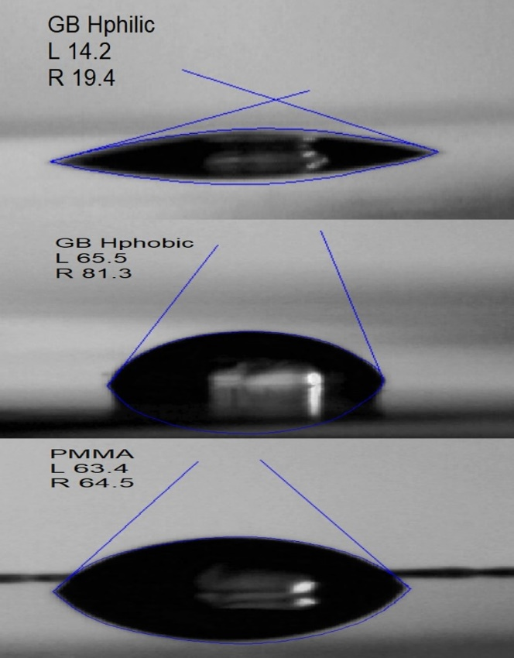
Figure 30: Contact angles of a water droplet on various surfaces

shape. Seamless flow of media droplets will be ensured by introducing stagnant droplet approach and optimized surface energy inside the chamber region resulting in eliminating disintegration and coalescence.

List of references

[1] R. Dingledine, J. Dodd, J.S. Kelly, THE INVITRO BRAIN SLICE AS A USEFUL NEUROPHYSIOLOGICAL PREPARATION FOR INTRACELLULAR-RECORDING, Journal of Neuroscience Methods, 2 (1980) 323-362.
[2] T.J. Teyler, BRAIN SLICE PREPARATION - HIPPOCAMPUS, Brain Research Bulletin, 5 (1980) 391-403.
[3] G.L. Collingridge, THE BRAIN SLICE PREPARATION - A TRIBUTE TO THE PIONEER MCILWAIN,HENRY, Journal of Neuroscience Methods, 59 (1995) 5-9.
[4] A.C. Guyton, Textbook of Medical Physiology, Harcourt Brace Jovanovich, Inc., Philadelphia, 1991.
[5] P.A. Passeraub, A.C. Almeida, N.V. Thakor, Design, Microfabrication and Analysis of a Microfluidic Chamber for the Perfusion of Brain Tissue Slices, Biomed. Microdevices, 5 (2003) 147-155.
[6] F. Cavaliere, C. Matute, Utility of Organotypic Slices in Parkinson's Disease Research, Towards New Therapies for Parkinson's Disease, David I. Finkelstein, IntechOpen2011.
[7] J.H. Lindsay, R.A. Prosser, The Mammalian Circadian Clock Exhibits Chronic Ethanol Tolerance and Withdrawal-Induced Glutamate Hypersensitivity, Accompanied by Changes in Glutamate and TrkB Receptor Proteins, Alcoholism, clinical and experimental research, 42 (2018) 315-328.
[8] G. Leng, The endocrinology of the brain, Endocrine connections, 7 (2018) R275-R285.
[9] K. Ostergaard, J.P. Schou, J. Zimmer, Rat ventral mesencephalon grown as organotypic slice cultures and co-cultured with striatum, hippocampus, and cerebellum, Exp Brain Res, 82 (1990) 547-565.
[10] C. Ullrich, N. Daschil, C. Humpel, Organotypic vibrosections: Novel whole sagittal brain cultures, Journal of Neuroscience Methods, 201 (2011) 131-141.
[11] M. Belenky, S. Wagner, Y. Yarom, H. Matzner, S. Cohen, M. Castel, The suprachiasmatic necleus in stationary organotypic culture, Neurocscience, 70 (1996) 127-143.
[12] R. Silver, W.J. Schwartz, The suprachiasmatic nucleus is a functionally heterogeneous timekeeping organ, Methods Enzymol., 393 (2005) 451-465.
[13] E.A. Van der Zee, K. Jansen, M.P. Gerkema, The Suprachiasmatic Nucleus in Organotypic Slice Cultures of the Common Vole (Microtus arvalis):Comparison of Development with Rat andHamster and the Effect of Age, Zoological Laboratory.
[14] T.-Y. K., U. T., O. H., Suprachiasmatic Nucleus Cultures That Maintain Rhythmic Properties In Vitro. In: Rosato E. (eds) Circadian Rhythms, Methods in Molecular Biology, 362 (2007).
[15] A.H. Tsang, M. Astiz, B. Leinweber, H. Oster, Rodent Models for the Analysis of Tissue Clock Function in Metabolic Rhythms Research, Frontiers in Endocrinology, 8 (2017) 27.
[16] J.D. Johnston, J.M. Ordovás, F.A. Scheer, F.W. Turek, Circadian Rhythms, Metabolism, and Chrononutrition in Rodents and Humans, Adv Nutr, 7 (2016) 399-406.
[17] L. Mei, Y. Fan, X. Lv, D.K. Welsh, C. Zhan, E.E. Zhang, Long-term in vivo recording of circadian rhythms in brains of freely moving mice, Proceedings of the National Academy of Sciences, 115 (2018) 4276.
[18] G. Bu, The roles of receptor-associated protein (RAP) as a molecular chaperone for members of the LDL receptor family, Int Rev Cytol, 209 (2001) 79-116.
[19] Y. Huang, J.C. Williams, S.M. Johnson, Brain slice on a chip: opportunities and challenges of applying microfluidic technology to intact tissues, Lab Chip, 12 (2012) 2103.
[20] M.J. Hogue, Human fetal brain cells in tissue cultures: Their identification and motility, Journal of Experimental Zoology, 106 (1947).
[21] K. Rambani, J. Vukasinovic, A. Glezer, S.M. Potter, Culturing thick brain slices: an interstitial 3D microperfusion system for enhanced viability, Journal of neuroscience methods, 180 (2009) 243-254.
[22] D.K. Cullen, J. Vukasinovic, A. Glezer, M.C. LaPlaca, Microfluidic engineered high cell density three-dimensional neural cultures, Journal of Neural Engineering, 4 (2007) 159-172.
[23] M.R. Hill, S.A. Greenfield, The membrane chamber: a new type of in vitro recording chamber, J Neurosci Methods, 195 (2011) 15-23.
[24] A. Queval, N.R. Ghattamaneni, C.M. Perrault, R. Gill, M. Mirzaei, R.A. McKinney, D. Juncker, Chamber and microfluidic probe for microperfusion of organotypic brain slices, Lab Chip, 10 (2010) 326-334.
[25] M.A. Qasaimeh, T. Gervais, D. Juncker, Microfluidic quadrupole and floating concentration gradient, Nature Communications, 2 (2011) 464.
[26] J.F. Dishinger, K.R. Reid, R.T. Kennedy, Quantitative monitoring of insulin secretion from single islets of Langerhans in parallel on a microfluidic chip, Anal. Chem., 81 (2009) 3119-3127.
[27] J.S. Mohammed, H.H. Caicedo, C.P. Fall, D.T. Eddington, Microfluidic add-on for standard electrophysiology chambers, Lab Chip, 8 (2008) 1048-1055.
[28] Y. Berdichevsky, H. Sabolek, J.B. Levine, K.J. Staley, M.L. Yarmush, Microfluidics and multielectrode array-compatible organotypic slice culture method, J Neurosci Methods, 178 (2009) 59-64.
[29] A.M. Taylor, M. Blurton-Jones, S.W. Rhee, D.H. Cribbs, C.W. Cotman, N.L. Jeon, A microfluidic culture platform for CNS axonal injury, regeneration and transport, Nat Methods, 2 (2005) 599-605.
[30] Y. Berdichevsky, K.J. Staley, M.L. Yarmush, Building and manipulating neural pathways with microfluidics, Lab Chip, 10 (2010) 999-1004.
[31] D. Huh, B.D. Matthews, A. Mammoto, M. Montoya-Zavala, H.Y. Hsin, D.E. Ingber, Reconstituting organ-level lung functions on a chip, Science, 328 (2010) 1662-1668.
[32] A.J. Blake, T.M. Pearce, N.S. Rao, S.M. Johnson, J.C. Williams, Multilayer PDMS microfluidic chamber for controlling brain slice microenvironment, Lab Chip, 7 (2007) 842-849.
[33] K.V. Christ, K.B. Williamson, K.S. Masters, K.T. Turner, Measurement of single-cell adhesion strength using a microfluidic assay, Biomed. Microdevices, 12 (2010) 443-455.
[34] J.H. Sung, M.L. Shuler, Prevention of air bubble formation in a microfluidic perfusion cell culture system using a microscale bubble trap, Biomed. Microdevices, 11 (2009) 731-738.
[35] H. Zhang, E. Tumarkin, R. Peerani, Z. Nie, R.M.A. Sullan, G.C. Walker, E. Kumacheva, Microfluidic Production of Biopolymer Microcapsules with Controlled Morphology, Journal of the American Chemical Society, 128 (2006) 12205-12210.
[36] A.S. Utada, E. Lorenceau, D.R. Link, P.D. Kaplan, H.A. Stone, D.A. Weitz, Monodisperse double emulsions generated from a microcapillary device, Science, 308 (2005) 537-541.
[37] E.M. Chan, A.P. Alivisatos, R.A. Mathies, High-Temperature Microfluidic Synthesis of CdSe Nanocrystals in Nanoliter Droplets, Journal of the American Chemical Society, 127 (2005) 13854-13861.
[38] H. Song, D.L. Chen, R.F. Ismagilov, Reactions in droplets in microfluidic channels, Angew. Chem. Int. Ed. Engl., 45 (2006) 7336-7356.
[39] P.S. Dittrich, A. Manz, Lab-on-a-chip: microfluidics in drug discovery, Nat Rev Drug Discov, 5 (2006) 210-218.
[40] M. Prakash, N. Gershenfeld, Microfluidic bubble logic, Science, 315 (2007) 832-835.
[41] M.J. Fuerstman, P. Garstecki, G.M. Whitesides, Coding/decoding and reversibility of droplet trains in microfluidic networks, Science, 315 (2007) 828-832.
[42] V. van Steijn, M.T. Kreutzer, C.R. Kleijn, μ-PIV study of the formation of segmented flow in microfluidic T-junctions, Chem. Eng. Sci., 62 (2007) 7505-7514.
[43] P. Garstecki, H.A. Stone, G.M. Whitesides, Mechanism for flow-rate controlled breakup in confined geometries: a route to monodisperse emulsions, Phys. Rev. Lett., 94 (2005) 164501.
[44] K. Wang, Y.C. Lu, J.H. Xu, J. Tan, G.S. Luo, Generation of Micromonodispersed Droplets and Bubbles in the Capillary Embedded T-Junction Microfluidic Devices, AlChE J., 57 (2011) 299-306.
[45] C. Humpel, Organotypic brain slice cultures: A review, Neuroscience, 305 (2015) 86-98.
[46] U. Scheidweiler, L. Nezlin, J. Rabba, B. Müller, D. Schild, Slice Culture of the Olfactory Bulb of Xenopus laevis Tadpoles, Chem. Senses, 26 (2001) 399-407.
[47] F. Cavaliere, M. Benito-Muñoz, C. Matute, Organotypic Cultures as a Model to Study Adult Neurogenesis in CNS Disorders, Stem Cells International, 2016 (2016) 3540568.
[48] Y. Jiang, R.F. Doolittle, The evolution of vertebrate blood coagulation as viewed from a comparison of puffer fish and sea squirt genomes, Proc Natl Acad Sci U S A, 100 (2003) 7527-7532.
[49] O.D. Ratnoff, J.E. Colopy, AN ACCELERATING PROPERTY OF PLASMA FOR THE COAGULATION OF FIBRINOGEN BY THROMBIN, The Journal of Clinical Investigation, 33 (1954) 1175-1182.
[50] D. Farrar, Bone adhesives for trauma surgery: A review of challenges and developments, Int. J. Adhes. Adhes., 33 (2012) 89–97.
[51] D.M. Toriumi, V.K. Chung, Q.M. Cappelle, Surgical Adhesives in Facial Plastic Surgery, Otolaryngologic Clinics of North America, 49 (2016) 585-599.
[52] T.W. Gilbert, S.F. Badylak, E.J. Beckman, D.M. Clower, J.P. Rubin, Prevention of seroma formation with TissuGlu® surgical adhesive in a canine abdominoplasty model: long term clinical and histologic studies, J Plast Reconstr Aesthet Surg, 66 (2013) 414-422.
[53] A.I. Bochyńska, G. Hannink, D. Janssen, P. Buma, D.W. Grijpma, Development of a fast curing tissue adhesive for meniscus tear repair, J Mater Sci Mater Med, 28 (2017) 1.
[54] M. Fernández-Gutiérrez, M. Rodriguez-Mancheño, B. Pérez-Köhler, G. Pascual, J.M. Bellón, J.S. Román, Structural Analysis and Application of n-Alkyl Cyanoacrylate Surgical Adhesives to the Fixation of Meshes for Hernia Repair, Macromol Biosci, 16 (2016) 1803-1814.
[55] J.C. Wheat, J.S. Wolf, Jr., Advances in bioadhesives, tissue sealants, and hemostatic agents, Urol Clin North Am, 36 (2009) 265-275, x.
[56] B. Balakrishnan, D. Soman, U. Payanam, A. Laurent, D. Labarre, A. Jayakrishnan, A novel injectable tissue adhesive based on oxidized dextran and chitosan, Acta Biomaterialia, 53 (2017) 343-354.
[57] G. Zündorf, G. Reiser, Calcium dysregulation and homeostasis of neural calcium in the molecular mechanisms of neurodegenerative diseases provide multiple targets for neuroprotection, Antioxidants & redox signaling, 14 (2011) 1275-1288.
[58] G. Hajnoczky, E. Davies, M. Madesh, Calcium signaling and apoptosis, Biochem. Biophys. Res. Commun., 304 (2003) 445-454.
[59] J. Magee, D. Hoffman, C. Colbert, D. Johnston, Electrical and calcium signaling in dendrites of hippocampal pyramidal neurons, Annual review of physiology, 60 (1998) 327-346.
[60] S. Dragoni, U. Laforenza, E. Bonetti, F. Lodola, C. Bottino, R. Berra-Romani, G. Carlo Bongio, M.P. Cinelli, G. Guerra, P. Pedrazzoli, V. Rosti, F. Tanzi, F. Moccia, Vascular endothelial growth factor stimulates endothelial colony forming cells proliferation and tubulogenesis by inducing oscillations in intracellular Ca2+ concentration, Stem cells (Dayton, Ohio), 29 (2011) 1898-1907.
[61] M.J. Berridge, P. Lipp, M.D. Bootman, The versatility and universality of calcium signalling, Nature reviews. Molecular cell biology, 1 (2000) 11-21.
[62] G. Gurkoff, K. Shahlaie, B. Lyeth, R. Berman, Voltage-Gated Calcium Channel Antagonists and Traumatic Brain Injury, Pharmaceuticals, 6 (2013) 788.
[63] R.Y. Tsien, A non-disruptive technique for loading calcium buffers and indicators into cells, Nature, 290 (1981) 527-528.
[64] M. Cameron, O. Kékesi, J.W. Morley, J. Tapson, P.P. Breen, A. van Schaik, Y. Buskila, Calcium Imaging of AM Dyes Following Prolonged Incubation in Acute Neuronal Tissue, PLOS ONE, 11 (2016) e0155468.
[65] B. Chazotte, Labeling Nuclear DNA Using DAPI, Cold Spring Harbor Protocols, 2010.
[66] A.N. Pepper, E. Westermann-Clark, R.F. Lockey, The High Cost of Epinephrine Autoinjectors and Possible Alternatives, J Allergy Clin Immunol Pract, 5 (2017) 665-+.
[67] R. Rubin, EpiPen price hike comes under scrutiny, Lancet, 388 (2016) 1266-1266.
[68] S.A. Noone, S.H. Sicherer, Patient compliance with self-administered epinephrine (SAE) for food allergic (FA) children, J. Allergy Clin. Immunol., 103 (1999) S54-S54.
[69] S.W. Huang, A survey of Epi-PEN use in patients with a history of anaphylaxis, J. Allergy Clin. Immunol., 102 (1998) 525-526.
[70] F.E.R. Simons, X.C. Gu, K.J. Simons, Outdated EpiPen and EpiPen Jr autoinjectors: Past their prime?, J. Allergy Clin. Immunol., 105 (2000) 1025-1030.
[71] H.A. Sampson, A. Muñoz-Furlong, R.L. Campbell, N.F. Adkinson, Jr., S.A. Bock, A. Branum, S.G. Brown, C.A. Camargo, Jr., R. Cydulka, S.J. Galli, J. Gidudu, R.S. Gruchalla, A.D. Harlor, Jr., D.L. Hepner, L.M. Lewis, P.L. Lieberman, D.D. Metcalfe, R. O'Connor, A. Muraro, A. Rudman, C. Schmitt, D. Scherrer, F.E. Simons, S. Thomas, J.P. Wood, W.W. Decker, Second symposium on the definition and management of anaphylaxis: summary report--Second National Institute of Allergy and Infectious Disease/Food Allergy and Anaphylaxis Network symposium, J Allergy Clin Immunol, 117 (2006) 391-397.
[72] S.B. Johansson, T, R. Dahl, Revised nomenclature for allergy for global use: report of the Nomenclature Review Committee of the World Allergy Organization, J. Allergy Clin. Immunol., (2004).
[73] B.Q. Khan, S.F. Kemp, Pathophysiology of anaphylaxis, Current Opinion in Allergy and Clinical Immunology, 11 (2011) 319-325.
[74] J. Kalesnikoff, S.J. Galli, Anaphylaxis: mechanisms of mast cell activation, Chem Immunol Allergy, 95 (2010) 45-66.
[75] F.D. Finkelman, Anaphylaxis: lessons from mouse models, J Allergy Clin Immunol, 120 (2007) 506-515; quiz 516-507.
[76] H. Karasuyama, Y. Tsujimura, K. Obata, K. Mukai, Role for basophils in systemic anaphylaxis, Chem Immunol Allergy, 95 (2010) 85-97.
[77] Y. Tsujimura, K. Obata, K. Mukai, H. Shindou, M. Yoshida, H. Nishikado, Y. Kawano, Y. Minegishi, T. Shimizu, H. Karasuyama, Basophils play a pivotal role in immunoglobulin-G-mediated but not immunoglobulin-E-mediated systemic anaphylaxis, Immunity, 28 (2008) 581-589.
[78] R.T. Strait, S.C. Morris, F.D. Finkelman, IgG-blocking antibodies inhibit IgE-mediated anaphylaxis in vivo through both antigen interception and Fc gamma RIIb cross-linking, The Journal of clinical investigation, 116 (2006) 833-841.
[79] J.K. Lee, P. Vadas, Anaphylaxis: mechanisms and management, Clinical & Experimental Allergy, 41 (2011) 923-938.
[80] S.F. Kemp, R.F. Lockey, F.E.R. Simons, A. World Allergy Organization ad hoc Committee on Epinephrine in, Epinephrine: the drug of choice for anaphylaxis-a statement of the world allergy organization, World Allergy Organ J, 1 (2008) S18-S26.
[81] R.S. Pumphrey, Lessons for management of anaphylaxis from a study of fatal reactions, Clin Exp Allergy, 30 (2000) 1144-1150.
[82] H.A. Sampson, L. Mendelson, J.P. Rosen, Fatal and near-fatal anaphylactic reactions to food in children and adolescents, N Engl J Med, 327 (1992) 380-384.
[83] S. Garnayak, S. Patel, Oxidation of Epinephrine to Adrenochrome by Cetyltrimethylammonium Dichromate: A Mechanistic Study, Industrial & Engineering Chemistry Research, 53 (2014) 12249-12256.
[84] A.P. Ferry, L.E. Zimmerman, BLACK CORNEA - COMPLICATION OF TOPICAL USE OF EPINEPHRINE, Am. J. Ophthalmol., 58 (1964) 205-&.
[85] B.E. Bayer, Color imaging array Eastman Kodak Co, USA, 1975.
[86] Center for Disease Control and Prevention. Identified Prevalance of Autism Spectrum Disorder.
[87] Grey's Anatomy The Anatomical Basis of Clinical Practice, 41 ed., Elsevier2015.
[88] J.A. Bartz, E. Hollander, Oxytocin and experimental therapeutics in autism spectrum disorders, in: I.D. Neumann, R. Landgraf (Eds.) Advances in Vasopressin and Oxytocin: From Genes to Behaviour to Disease, Elsevier Science Bv, Amsterdam, 2008, pp. 451-462.
[89] K.S.L. Lam, M.G. Aman, L.E. Arnold, Neurochemical correlates of autistic disorder: A review of the literature, Research in Developmental Disabilities, 27 (2006) 254-289.
[90] P.C. Dinas, Y. Koutedakis, A.D. Flouris, Effects of exercise and physical activity on depression, Irish Journal of Medical Science, 180 (2011) 319-325.
[91] W.D. Kraetzl, V. Tancina, D. Schams, R.M. Bruckmaier, Naloxone cannot abolish the lack of oxytocin release during unexperienced suckling of dairy cows, Applied Animal Behaviour Science, 72 (2001) 247-253.
[92] V.M. Husarova, S. Lakatosova, A. Pivovarciova, K. Babinska, J. Bakos, J. Durdiakova, A. Kubranska, I. Ondrejka, D. Ostatnikova, Plasma Oxytocin in Children with Autism and Its Correlations with Behavioral Parameters in Children and Parents, Psychiatry Investigation, 13 (2016) 174-183.
[93] G.P. Strauss, W.R. Keller, J.I. Koenig, S.K. Sullivan, J.M. Gold, R.W. Buchanan, Endogenous oxytocin levels are associated with the perception of emotion in dynamic body expressions in schizophrenia, Schizophrenia Research, 162 (2015) 52-56.
[94] R.G. Nielsen, E.C. Rickard, P.F. Santa, D.A. Sharknas, G.S. Sittampalam, SEPARATION OF ANTIBODY-ANTIGEN COMPLEXES BY CAPILLARY ZONE ELECTROPHORESIS, ISOELECTRIC-FOCUSING AND HIGH-PERFORMANCE SIZE-EXCLUSION CHROMATOGRAPHY, J. Chromatogr., 539 (1991) 177-185.
[95] R.T. Kennedy, N. Schultz, RAPID IMMUNOASSAYS USING CAPILLARY ZONE ELECTROPHORESIS WITH LASER-INDUCED FLUORESCENCE DETECTION, Abstracts of Papers of the American Chemical Society, 206 (1993) 156-ANYL.
[96] Q.Q. Wang, G.A. Luo, J.P. Ou, S.B. Yang, Noncompetitive capillary electrophoresis based immunoassay for proteins with laser induced fluorescence detection, Chinese Journal of Analytical Chemistry, 28 (2000) 687-691.
[97] J.Y. Zhou, X.S. Xu, Y.X. Wang, Competitive immunoassay for clenbuterol using capillary electrophoresis with laser-induced fluorescence detection, Journal of Chromatography B-Analytical Technologies in the Biomedical and Life Sciences, 848 (2007) 226-231.
[98] A.C. Moser, D.S. Hage, Capillary electrophoresis-based immunoassays: Principles and quantitative applications, Electrophoresis, 29 (2008) 3279-3295.
[99] K. Shimura, B.L. Karger, Affinity probe capillary electrophoresis: analysis of recombinant human growth hormone with a fluorescent labeled antibody fragment, Anal. Chem., 66 (1994) 9-15.
[100] Y.C. Huang, Y.C. Yu, T.Y. Lee, PURIFICATION OF ANTIBODIES BY ZEOLITE-A, Enzyme Microb. Technol., 17 (1995) 564-569.
[101] L. Bai, S. Burman, L. Gledhill, Development of ion exchange chromatography methods for monoclonal antibodies, J. Pharm. Biomed. Anal., 22 (2000) 605-611.
[102] A.C. Grodzki, E. Berenstein, Antibody Purification: Ion-Exchange Chromatography, in: C. Oliver, M.C. Jamur (Eds.) Immunocytochemical Methods and Protocols, Third Edition, Humana Press Inc, Totowa, 2010, pp. 27-32.
[103] M. Perkins, R. Theiler, S. Lunte, M. Jeschke, Determination of the Origin of Charge Heterogeneity in a Murine Monoclonal Antibody, Pharm. Res., 17 (2000) 1110-1117.
[104] B.H. Gahwiler, Organotypic monolayer cultures of nervous tissue, J Neurosci Methods, 4 (1981) 329-342.
[105] B.H. Gahwiler, S.M. Thompson, D. Muller, Preparation and maintenance of organotypic slice cultures of CNS tissue, Curr Protoc Neurosci, Chapter 6 (2001) Unit 6.11.
[106] U.F. Braschler, A. Iannone, C. Spenger, J. Streit, H.R. Luscher, A modified roller tube technique for organotypic cocultures of embryonic rat spinal cord, sensory ganglia and skeletal muscle, J Neurosci Methods, 29 (1989) 121-129.
[107] B.H. Gahwiler, Morphological differentiation of nerve cells in thin organotypic cultures derived from rat hippocampus and cerebellum, Proc R Soc Lond B Biol Sci, 211 (1981) 287-290.
[108] B.H. Gahwiler, Organotypic cultures of neural tissue, Trends Neurosci, 11 (1988) 484-489.
[109] B.H. Gahwiler, M. Capogna, D. Debanne, R.A. McKinney, S.M. Thompson, Organotypic slice cultures: a technique has come of age, Trends Neurosci, 20 (1997) 471-477.
[110] I.V. Victorov, A.A. Lyjin, O.P. Aleksandrova, A modified roller method for organotypic brain cultures: free-floating slices of postnatal rat hippocampus, Brain Res Brain Res Protoc, 7 (2001) 30-37.
[111] A. De Simoni, L. My Yu, Preparation of organotypic hippocampal slice cultures: interface method, Nature Protocols, 1 (2006) 1439-1445.
[112] L.D.P. Miller, J.J. Petrozzino, N.K. Mahanty, J.A. Connor, Optical Imaging of Cytosolic Calcium, Electrophysiology, and Ultrastructure in Pyramidal Neurons of Organotypic Slice Cultures from Rat Hippocampus, NeuroImage, 1 (1993) 109-120.
[113] P. Thiebaud, N.F.d. Rooij, M. Koudelka-Hep, L. Stoppini, Microelectrode arrays for electrophysiological monitoring of hippocampal organotypic slice cultures, IEEE Transactions on Biomedical Engineering, 44 (1997) 1159-1163.
[114] S. Misra, C.F. Moro, M. Del Chiaro, S. Pouso, A. Sebestyén, M. Löhr, M. Björnstedt, C.S. Verbeke, Ex vivo organotypic culture system of precision-cut slices of human pancreatic ductal adenocarcinoma, Scientific Reports, 9 (2019) 2133.
[115] C.L. Croft, H.S. Futch, B.D. Moore, T.E. Golde, Organotypic brain slice cultures to model neurodegenerative proteinopathies, Molecular Neurodegeneration, 14 (2019) 45.
[116] C.L. Croft, W. Noble, Preparation of organotypic brain slice cultures for the study of Alzheimer's disease, F1000Res, 7 (2018) 592-592.
[117] F.S. Chou, P.S. Wang, Neuronal Precursor Migration in Ex Vivo Brain Slice Culture, Methods Mol Biol, 1749 (2018) 135-143.
[118] S. Sekizar, A. Williams, Ex Vivo Slice Cultures to Study Myelination, Demyelination, and Remyelination in Mouse Brain and Spinal Cord, Methods Mol Biol, 1936 (2019) 169-183.
[119] S. Cho, A. Wood, M.R. Bowlby, Brain slices as models for neurodegenerative disease and screening platforms to identify novel therapeutics, Curr Neuropharmacol, 5 (2007) 19-33.
[120] A.F. van de Merbel, G. van der Horst, M.H. van der Mark, J.I.M. van Uhm, E.J. van Gennep, P. Kloen, L. Beimers, R.C.M. Pelger, G. van der Pluijm, An ex vivo Tissue Culture Model for the Assessment of Individualized Drug Responses in Prostate and Bladder Cancer, Frontiers in Oncology, 8 (2018).
[121] R. Dhumpa, T.M. Truong, X. Wang, M.G. Roper, Measurement of the entrainment window of islets of Langerhans by microfluidic delivery of a chirped glucose waveform, Integr Biol (Camb), 7 (2015) 1061-1067.
[122] L. Yi, X. Wang, R. Dhumpa, A.M. Schrell, N. Mukhitov, M.G. Roper, Integrated perfusion and separation systems for entrainment of insulin secretion from islets of Langerhans, Lab Chip, 15 (2015) 823-832.
[123] A.U.R. Aziz, C. Geng, M. Fu, X. Yu, K. Qin, B. Liu, The Role of Microfluidics for Organ on Chip Simulations, Bioengineering (Basel), 4 (2017) 39.
[124] S.F. Lam, V.S. Shirure, Y.E. Chu, A.G. Soetikno, S.C. George, Microfluidic device to attain high spatial and temporal control of oxygen, PLOS ONE, 13 (2018) e0209574.
[125] J. Schindelin, I. Arganda-Carreras, E. Frise, V. Kaynig, M. Longair, T. Pietzsch, S. Preibisch, C. Rueden, S. Saalfeld, B. Schmid, J.-Y. Tinevez, D.J. White, V. Hartenstein, K. Eliceiri, P. Tomancak, A. Cardona, Fiji: an open-source platform for biological-image analysis, Nat. Methods, 9 (2012) 676.
[126] P.R. Austin, S. Sennett, Dry Chitosan Salts and Complexes of Aliphatic Carboxylic Acids, in: R. Muzzarelli, C. Jeuniaux, G.W. Gooday (Eds.) Chitin in Nature and Technology, Springer US, Boston, MA, 1986, pp. 279-286.
[127] J.M. Cooper, A. Rastogi, J.A. Krizo, E.M. Mintz, R.A. Prosser, Urokinase-type plasminogen activator modulates mammalian circadian clock phase regulation in tissue-type plasminogen activator knockout mice, Eur J Neurosci, 45 (2017) 805-815.
[128] J.H. Lindsay, R.A. Prosser, The Mammalian Circadian Clock Exhibits Chronic Ethanol Tolerance and Withdrawal-Induced Glutamate Hypersensitivity, Accompanied by Changes in Glutamate and TrkB Receptor Proteins, Alcohol Clin Exp Res, 42 (2018) 315-328.
[129] J.D. Macklis, R.D. Madison, Progressive incorporation of propidium iodide in cultured mouse neurons correlates with declining electrophysiological status: a fluorescence scale of membrane integrity, J Neurosci Methods, 31 (1990) 43-46.
[130] J.H. Laake, F.-M. Haug, T. Wieloch, O.P. Ottersen, A simple in vitro model of ischemia based on hippocampal slice cultures and propidium iodide fluorescence, Brain Research Protocols, 4 (1999) 173-184.
[131] H.-S. Sun, R.J. French, Z.-P. Feng, A method for identifying viable and damaged neurons in adult mouse brain slices, Acta Histochemica, 111 (2009) 531-537.
[132] D.F. Happ, R.A. Tasker, A method for objectively quantifying propidium iodide exclusion in organotypic hippocampal slice cultures, Journal of Neuroscience Methods, 269 (2016) 1-5.
[133] D. Saeki, S. Sugiura, T. Kanamori, S. Sato, S. Ichikawa, Microfluidic preparation of water-in-oil-in-water emulsions with an ultra-thin oil phase layer, Lab Chip, 10 (2010) 357-362.
[134] V.I. Chefer, A.C. Thompson, A. Zapata, T.S. Shippenberg, Overview of brain microdialysis, Current protocols in neuroscience, Chapter 7 (2009) Unit7.1-Unit7.1.
[135] B.B. Fixman, I.W. Babcock, L.S. Minamide, A.E. Shaw, M.I. Oliveira da Silva, A.M. Runyan, M.T. Maloney, J.J. Field, J.R. Bamburg, Modified Roller Tube Method for Precisely Localized and Repetitive Intermittent Imaging During Long-term Culture of Brain Slices in an Enclosed System, J Vis Exp, (2017) 56436.
[136] V. Bhagat, M.L. Becker, Degradable Adhesives for Surgery and Tissue Engineering, Biomacromolecules, 18 (2017) 3009-3039.
[137] W.H. Lee, T. Ngernsutivorakul, O.S. Mabrouk, J.-M.T. Wong, C.E. Dugan, S.S. Pappas, H.J. Yoon, R.T. Kennedy, Microfabrication and in Vivo Performance of a Microdialysis Probe with Embedded Membrane, Anal. Chem., 88 (2016) 1230-1237.
[138] R.T. Kennedy, Emerging trends in in vivo neurochemical monitoring by microdialysis, Curr. Opin. Chem. Biol., 17 (2013) 860-867.
[139] F.E. Simons, Epinephrine (adrenaline) in the first-aid, out-of-hospital treatment of anaphylaxis, Novartis Found Symp, 257 (2004) 228-243; discussion 243-227, 276-285.
[140] A. Lieberman, A. Marks, A. Peet, Mark's Basic Medical Biochemistry: A Clinical Approach, 4th ed., Wolters Kluwer Health/Lippincott Williams & Wilkins, Philadelphia, 2013.
[141] S.R. Boden, A. Wesley Burks, Anaphylaxis: a history with emphasis on food allergy, Immunol. Rev., 242 (2011) 247-257.
[142] D.B. Golden, D.G. Marsh, A. Kagey-Sobotka, L. Freidhoff, M. Szklo, M.D. Valentine, L.M. Lichtenstein, Epidemiology of insect venom sensitivity, Jama, 262 (1989) 240-244.
[143] J.H. Barnard, Studies of 400 Hymenoptera sting deaths in the United States, J Allergy Clin Immunol, 52 (1973) 259-264.
[144] H.A. Sampson, A. Munoz-Furlong, S.A. Bock, C. Schmitt, R. Bass, B.A. Chowdhury, W.W. Decker, T.J. Furlong, S.J. Galli, D.B. Golden, R.S. Gruchalla, A.D. Harlor, Jr., D.L. Hepner, M. Howarth, A.P. Kaplan, J.H. Levy, L.M. Lewis, P.L. Lieberman, D.D. Metcalfe, R. Murphy, S.M. Pollart, R.S. Pumphrey, L.J. Rosenwasser, F.E. Simons, J.P. Wood, C.A. Camargo, Jr., Symposium on the definition and management of anaphylaxis: summary report, J Allergy Clin Immunol, 115 (2005) 584-591.
[145] H.A. Sampson, Anaphylaxis and emergency treatment, Pediatrics, 111 (2003) 1601-1608.
[146] S.H. Sicherer, F.E.R. Simons, Epinephrine for First-aid Management of Anaphylaxis, Pediatrics, 139 (2017).
[147] P.L. Lieberman, Recognition and first-line treatment of anaphylaxis, Am J Med, 127 (2014) S6-11.
[148] B.T. Prince, I. Mikhail, D.R. Stukus, Underuse of epinephrine for the treatment of anaphylaxis: missed opportunities, J. Asthma Allergy, 11 (2018) 143-151.
[149] What is Epinephrine?, Mylan, 2019.
[150] D.D. Patadia, D.R. Stukus, Are Expired EpiPens Still Viable?, J Allergy Clin Immunol Pract, 5 (2017) 1469-1470.
[151] O. Rachid, F.E.R. Simons, M.B. Wein, M. Rawas-Qalaji, K.J. Simons, Epinephrine doses contained in outdated epinephrine auto-injectors collected in a Florida allergy practice, Ann. Allergy Asthma Immunol., 114 (2015) 354-+.
[152] American Society of Health System Pharmacists, AHFS Drug Information, Bethesda, MD, 2009.
[153] H.G. Parish, C.S. Bowser, J.R. Morton, J.C. Brown, A systematic review of epinephrine degradation with exposure to excessive heat or cold, Ann. Allergy Asthma Immunol., 117 (2016) 79-87.
[154] Understanding the chemical basis of drug stability and degradation, The Pharmaceutical Journal, 285 (2010).
[155] A. Noorafshan, R. Asadi-Golshan, S. Monjezi, S. Karbalay-Doust, Sodium metabisulphite, a preservative agent, decreases the heart capillary volume and length, and curcumin, the main component of Curcuma longa, cannot protect it, Folia Biol (Praha), 60 (2014) 275-280.
[156] M.E. Corwin, W.H. Spencer, CONJUNCTIVAL MELANIN DEPOSITIONS - A SIDE-EFFECT OF TOPICAL EPINEPHRINE THERAPY, AMA Arch. Ophthalmol., 69 (1963) 317-&.
[157] E.R. Veirs, J.C. McGrew, Ocular complications from topical epinephrine therapy of glaucoma, Eye Ear Nose and Throat Monthly, 42 (1963) 46-52.
[158] R.D. Reinecke, T. Kuwabara, CORNEAL DEPOSITS SECONDARY TO TOPICAL EPINEPHRINE, AMA Arch. Ophthalmol., 70 (1963) 170-&.
[159] G. Cleasby, D.D. Donaldson, Epinephrine Pigmentation of the Cornea, JAMA Ophthalmol, 78 (1967) 74-75.
[160] J.D. Bullock, EPINEPHRINE PIGMENTATION, JAMA Ophthalmol, 84 (1970) 546-546.
[161] H.N. Bernstein, EPINEPHRINE PIGMENTATION - REPLY, AMA Arch. Ophthalmol., 84 (1970) 546-+.
[162]
[163] N. Pietroski, Expired Drugs: Immortal or DOA?, Wilderness Medicine Magazine,, Wilderness Medical Society, Austin, TX, 2015.
[164] T.T. Wang, C.K. Lio, H. Huang, R.Y. Wang, H. Zhou, P. Luo, L.S. Qing, A feasible image-based colorimetric assay using a smartphone RGB camera for point-of-care monitoring of diabetes, Talanta, 206 (2020).
[165] Y. Sekine, S.B. Kim, Y. Zhang, A.J. Bandodkar, S. Xu, J. Choi, M. Irie, T.R. Ray, P. Kohli, N. Kozai, T. Sugita, Y.X. Wu, K. Lee, K.T. Lee, R. Ghaffari, J.A. Rogers, A fluorometric skin-interfaced microfluidic device and smartphone imaging module for in situ quantitative analysis of sweat chemistry, Lab Chip, 18 (2018) 2178-2186.
[166] K. Mahato, P. Chandra, Paper-based miniaturized immunosensor for naked eye ALP detection based on digital image colorimetry integrated with smartphone, Biosens. Bioelectron., 128 (2019) 9-16.
[167] L. Hou, Y.X. Qin, J.Y. Li, S.Y. Qin, Y.L. Huang, T.R. Lin, L.Q. Guo, F.G. Ye, S.L. Zhao, A ratiometric multicolor fluorescence biosensor for visual detection of alkaline phosphatase activity via a smartphone, Biosens. Bioelectron., 143 (2019).
[168] A. Priye, C.S. Ball, R.J. Meagher, Colorimetric-Luminance Readout for Quantitative Analysis of Fluorescence Signals with a Smartphone CMOS Sensor, Anal. Chem., 90 (2018) 12385-12389.
[169] Y. Minagawa, H. Ueno, K.V. Tabata, H. Noji, Mobile imaging platform for digital influenza virus counting, Lab Chip, 19 (2019) 2678-2687.
[170] S.Z. Lv, K.Y. Zhang, D.P. Tang, A new visual immunoassay for prostate-specific antigen using near-infrared excited CuxS nanocrystals and imaging on a smartphone, Analyst, 144 (2019) 3716-3720.
[171] Y.K. Shan, B. Wang, H.C. Huang, D. Jiang, X.P. Wu, L. Xue, S.Y. Wang, F. Liu, On-site quantitative Hg2+ measurements based on selective and sensitive fluorescence biosensor and miniaturized smartphone fluorescence microscope, Biosens. Bioelectron., 132 (2019) 238-247.
[172] R. Ravindranath, A.P. Periasamy, P. Roy, Y.W. Chen, H.T. Chang, Smart app-based on-field colorimetric quantification of mercury via analyte-induced enhancement of the photocatalytic activity of TiO2-Au nanospheres, Anal. Bioanal., 410 (2018) 4555-4564.
[173] W.I. Lee, Y. Park, J. Park, S. Shrivastava, Y.M. Son, H.J. Choi, J. Lee, B. Jeon, H. Lee, N.E. Lee, A smartphone fluorescence imaging-based mobile biosensing system integrated with a passive fluidic control cartridge for minimal user intervention and high accuracy, Lab Chip, 19 (2019) 1502-1511.
[174] U.S.P. Convention, USP35 NF30, 2012: U. S. Pharmacopoeia National Formulary, United States Pharmacopeial2011.
[175] W. Xiaoqian, F. Fan, S. Jiatong, W. Lu, A. Srivastava, V.G. Chigrinov, Evaluation of LC Fresnel Phase Plate Utilized as Colour Filter, 2012.
[176] P.A. Cheremkhin, V.V. Lesnichii, N.V. Petrov, Use of spectral characteristics of DSLR cameras with Bayer filter sensors, J. Phys. Conf. Ser., 536 (2014) 012021.
[177] R.L. Watters, R.J. Carroll, C.H. Spiegelman, Error modeling and confidence interval estimation for inductively coupled plasma calibration curves, Anal. Chem., 59 (1987) 1639-1643.
[178] P. Lieberman, R.A. Nicklas, C. Randolph, J. Oppenheimer, D. Bernstein, J. Bernstein, A. Ellis, D.B.K. Golden, P. Greenberger, S. Kemp, D. Khan, D. Ledford, J. Lieberman, D. Metcalfe, A. Nowak-Wegrzyn, S. Sicherer, D. Wallace, J. Blessing-Moore, D. Lang, J.M. Portnoy, D. Schuller, S. Spector, S.A. Tilles, Anaphylaxis&#x2014;a practice parameter update 2015, Ann. Allergy Asthma Immunol., 115 (2015) 341-384.
[179] The United States Pharmacopeia : USP 24 : the National Formulary : NF 19 : by authority of the United States Pharmacopoeial Convention, Inc., meeting at Washington, D.C., March 9-12, 1995 ; prepared by the Committee of Revision and published by the Board of Trustees, United States Pharmacopeial Convention, Rockville, Md., 1999.
[180] H. Liu, K. May, Disulfide bond structures of IgG molecules: Structural variations, chemical modifications and possible impacts to stability and biological function, mAbs, 4 (2012) 17-23.

APPENDIX A

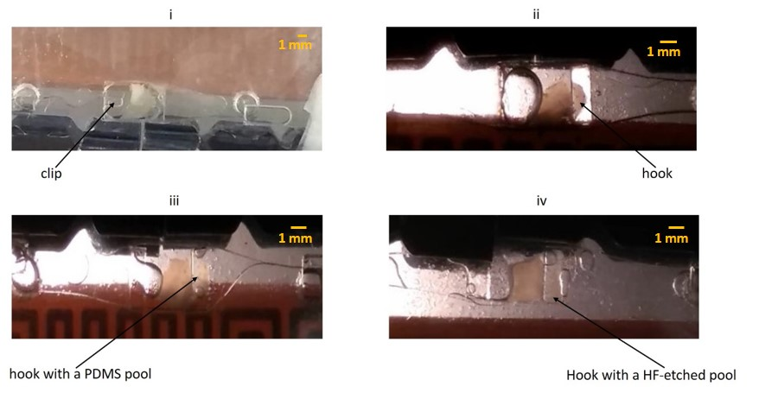
Figure 31: Tissue immobilization via physical structures
In panel i, a clip like structure fashioned out of a GelBond film is used to hold the slice in the chamber. In panel ii, iii, and iv two hook like structures are fashioned out of GelBond films to hold the tissue in the chamber. In panel iii and iv, additional pool like physical structures fashioned out of PDMS and etch by hydrofluoric acid are introduced respectively to provide additional immobilization to the slice. In all four panels, disintegration and stagnation of media droplets are visible.

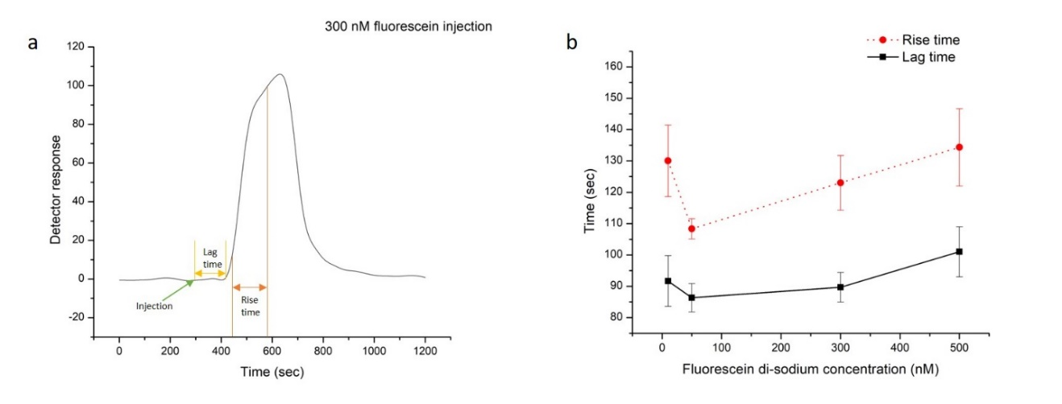
Figure 32: Lag and Rise time
a An example plot of lag time and rise time for a 300 nM fluorescence injection and b the estimation of the lag and rise time of the effect of stimuli delivered to the device. The average lag and rise time for the fluid delivery system was 92 s and 127 s respectively.

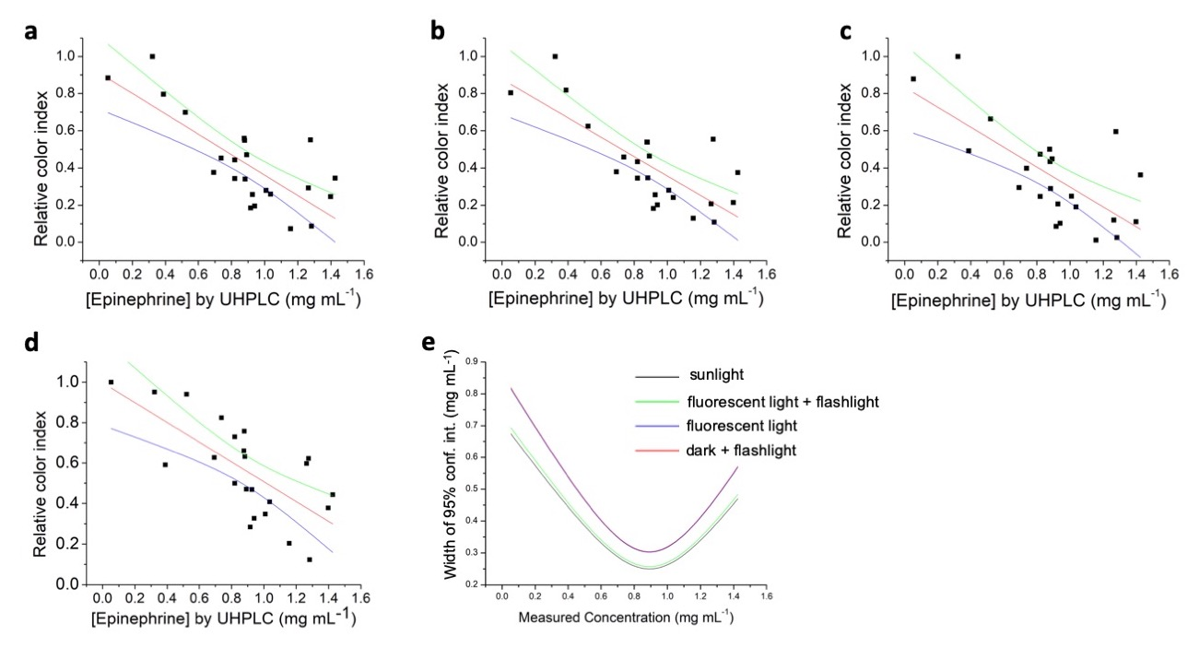
Figure 33: Calibration plots for
quantitative smartphone imaging experiments
Calibration plots are shown with linear fit (red), upper (green), and lower (blue) bounds of the 95% confidence band of the linear fit for illumination conditions including a. sunlight, b. fluorescent office illumination with smartphone flashlight, c. fluorescent office illumination without the use of flashlight, and d. dark ambient light with smartphone flashlight. The full width of the 95% confidence interval as a function of measured epinephrine concentration is shown in e.

Table 3: [Epinephrine] in the discolored EAIs measured by UHPLC

Sample ID | Epinephrine Concentration (mg mL⁻¹)
S2 | 1.28
S3 | 0.88
S5 | 1.43
S6 | 0.82
S7 | 0.52
S8 | 0.88
S9 | 0.32
S11 | 0.82
S12 | 0.93
S13 | 0.94
S14 | 0.92
S15 | 0.74
S16 | 0.88
S22 | 0.69
S24 | 0.05
S25 | 1.40
S26 | 0.89
S27 | 1.04
S28 | 1.01
S29 | 1.26
S31 | 1.16
S32 | 1.28
S33 | 0.39
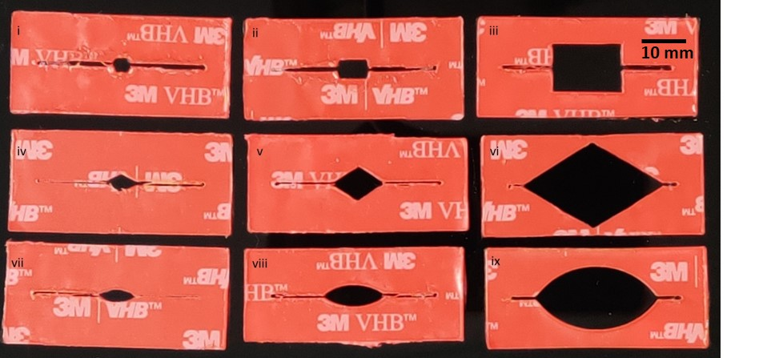
Figure 34: Slice culture chamber designs of various shapes and sizes
i. square small, ii. square medium, iii. square large, iv. diamond small, v. diamond medium, vi, diamond large, vii. oval small, viii. oval medium, and ix. oval large

APPENDIX B

SOP for synthesis of Chitosan-Dextran based glue

Part A: Preparation of Chit-HCl (chitosan hydrochloride)
- Weigh 10 g of high molecular weight chitosan and transfer to a 250 mL beaker
- Slowly mix 60 mL of HCl into 40 mL of ethanol in a fume hood
- Carefully pour the HCl-ethanol mixture into the 250 mL beaker containing chitosan
- Put a stir bar in the beaker and gently stir (100 rpm) the mixture for 3 hours at room temperature.
- After 3 hours filter off the Chit-HCl salt using a gravity filter
- Make a 6:2 acetone-water mixture
- Wash the Chit-HCl salt extensively with acetone-water mixture while still on the filter paper
- Put the Chit-HCl salt inside a dialysis tubing (MWCO 12 KDa)
- Tie both ends of the dialysis tubing firmly to prevent any leaks
- Put the dialysis tubing in a 1000 mL beaker in such a manner so that the bottom of the tubing does not touch the floor of the beaker. You may use binder clips to hold both ends of the tubing on the wall of the beaker, essentially making a U-shape for the tubing
- Fill the 1000 mL beaker with ultra-pure water (>14.1 MΩ) and put a stir bar in the beaker
- Gently stir (100 rpm) the water in the 1000 mL beaker for 2 hours
- Change the water in the beaker and repeat steps 11-13 for 3 times
- Pour 2 mL water from the 1000 mL beaker into a test tube and add a few drops of 1 wt% AgNO₃(aq) solution. If white precipitate appears due to presence of HCl in the water, repeat steps 11-14 until no precipitate appears.
- Transfer the solution from inside of the dialysis tubing to a glass vial.
- Freeze dry the solution
- Store the freeze-dried Chitosan-HCl at 4˚C until use

Part B: Preparation of DDA (dextran dialdehyde)
- Weigh 5 g of dextran and transfer to a 250 mL beaker
- Weigh 4.5 g of sodium metaperiodate and transfer to the same beaker
- Add 100 mL of ultra-pure water (>14.1 MΩ) to the beaker
- Add a stir bar in the beaker
- Cover the beaker with aluminum foil to prevent exposure of light
- Stir gently (100 rpm) the mixture in the beaker for 6 hours
- Take 5 mL of the solution and transfer it inside a dialysis tube (MWCO 12 KDa)
- Tie both ends of the dialysis tubing firmly to prevent any leaks
- Put the dialysis tubing in a 1000 mL beaker in such a manner so that the bottom of the tubing does not touch the floor of the beaker. You may use binder clips to hold both ends of the tubing on the wall of the beaker, essentially making a U-shape for the tubing
- Fill the 1000 mL beaker with ultra-pure water (>14.1 MΩ) and put a stir bar in the beaker
- Gently stir (100 rpm) the water in the 1000 mL beaker for 2 hours
- Change the water in the beaker and repeat steps 10-12 for 3 times
- Pour 2 mL water from the 1000 mL beaker into a test tube and add a few drops of 1 wt% AgNO₃(aq) solution. If white precipitate appears due to presence of I⁻ in the water, repeat steps 10-13 until no precipitate appears.
- Transfer the solution from inside of the dialysis tubing to a glass vial.
- Freeze dry the solution
- Store the freeze-dried DDA at 4˚C until use

Part C: Formation of the two-part hydrogel glue
- Obtain phosphate buffer saline (PBS)
- Hydrate Chit-HCl with PBS to form a 5 wt% solution
- Hydrate DDA with PBS to form a 10 wt% solution
- Apply 2 µL of each solution on the hydrophilic side of a GelBond film to adhere a typical rodent SCN slice. The volume of each part may vary for different dimension of tissue slices.

VITA

Amirus Saleheen was born and brought up in Narayanganj, Bangladesh. He graduated from Narayanganj Ideal High School, Narayanganj in 2005 and Dhaka City College, Dhaka in 2007. He earned his bachelors of science degree with a major in applied chemistry and chemical engineering from the University of Dhaka, Bangladesh in August 2012. While in the University of Dhaka, he grew a keen interest in higher study in analytical chemistry. After graduating from the University of Dhaka, he started teaching chemistry to high school students alongside preparing to apply for graduate admission in the United States. He joined the graduate program in the department of chemistry at the University of Tennessee at Knoxville in August 2015 and shortly after was accepted into the research group of Dr. Christopher A. Baker. In the Baker lab, he has been involved in several projects focused on analytical challenges in biological applications involving microfluidics and chemical separation. His work has resulted in numerous peer-reviewed publications and presented several times in national conferences. Amirus will receive his Ph.D. in Analytical Chemistry in Summer 2020.

