Increasing Attendance in the National Premier & Women’s Premier Soccer League

Madison Moreland

May 2015

Department of Business Analytics
Chancellor Honor’s Program
University of Tennessee
Knoxville, TN

A thesis submitted for the completion of an honors degree in Business Analytics.
Abstract

This paper aims to identify the key factors that influence attendance at sporting events, namely for soccer teams in the National Premier Soccer League and Women’s Premier Soccer League. The end purpose of the study is to help increase the number of attendees at games for the Knoxville Force, located in Knoxville, TN. Data was collected from a survey distributed to all National Premier Soccer teams and Women’s Premier Soccer teams. In addition, research was collected from studies on compatible leagues, for instance, Minor League baseball. After using statistical analysis (quantitative and descriptive) to identify the key factors influencing attendance, ideas and concepts are discussed to help present an effective and efficient marketing strategy that could be used for matches and league events. It can be found through the analysis that factors such as whether or not a team has a junior club and the size of the city in which they are located appear to influence their attendance statistics.

Introduction
The Knoxville Force is one of many teams in the National Premier Soccer League and Women’s Premier Soccer league that struggles with attracting enough attendance to their games in order to help cover the costs of owning and operating their teams. While these teams are considered “semi-professional”, they can occasionally still be a source of revenue for organizations if operated correctly. The Knoxville Force is a National Premier Soccer team that was recently purchased by a non-profit organization, the Emerald Youth Foundation. The team has fairly low attendance numbers, and management is curious as to what factors they should focus on in order to increase attendance at home games (in turn increasing their revenue stream). The Knoxville Force is hoping to identify the factors the most largely influence attendance in order to help create strategies that maximize the number of people that are attending their matches (this analysis will be a framework for other National Premier and Women’s Premier Soccer teams to follow as well). There are many studies around other semi-professional sports leagues, such as Minor League baseball, however since the NPSL/WPSL is an amateur league, there is little to no information or former studies to help guide management strategies. This study hopes to develop a statistical model, as well as some recommendations based on the success of other teams, to create a more effective strategy for increasing match attendance.

Background on the League
The National Premier Soccer League (hereafter referred to as the NPSL) was formed as the successor to the Men’s Premier Soccer League in 2002. The league has been rapidly expanding since its formation, and as of 2011, is considered a nationwide league. In 2014, with the expansion of 30 additional teams, the NPSL consisted of 70 teams and became the largest national soccer league in the United States soccer development pyramid. The NPSL falls underneath the governance of the United States Soccer Federation (USSF), which is the official governing body of soccer in the United States. The NPSL consists of four regions (West, Midwest, Northeast, South), each consisting of a number of conferences. A list of conferences and their encompassing teams is listed below in Figure 1.
Each individual team is individually owned and operated (typically by a business, non-profit organization, or private owner). The league is primarily run by the Chairman of the Board, Mr. Joe Barone, who is affiliated with the Brooklyn Italians (About NPSL – National Premier Soccer League).
The women’s version of the NPSL – the WPSL (Women’s Premier Soccer League) is run in a very similar way. However, the format and structure of the teams varies so greatly (also, many are extremely new) that their strategies and results are difficult to analyze.
Figure 1
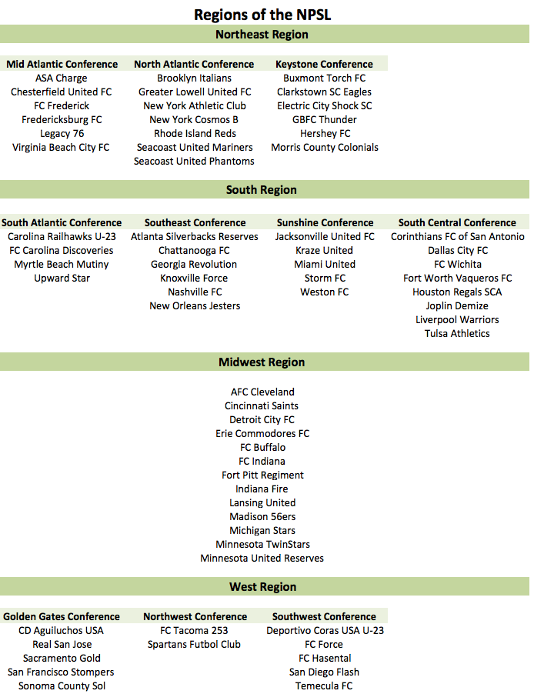
Background on the Knoxville Force
The Knoxville Force is an entity located in Knoxville, TN consisting of a men’s (NPSL) and women’s (WPSL) team. The Knoxville Force was formed and incorporated as a part of the creation of the South region in 2011 - its inaugural year of existence. The NPSL team competes in the South Region and the Southeast Conference with seven other teams (three being from Tennessee). The Knoxville Force was originally formed and owned by Barry Goss, owner of Knoxville Soccer LLC, but switched hands in 2014 when it was acquired by the Emerald Youth Foundation. The Emerald Youth Foundation is a non-profit organization that caters to high risk, inner-city youth. Their goal is to incorporate their recreational and club soccer programs (the Emerald Force) with the NPSL team in order to give inner city children a great experience as well as potential growth opportunities (Crooks, John).

Literature Review & Limitations
As previously stated, literature on this topic is extremely limited. While studies do exist around attendance for amateur leagues in other sports (such as Minor League Baseball), many of these studies focus on win/team quality as a major predictor of attendance statistics. However, there is literature that recommends techniques involving ticket pricing, behavior loyalty, social media usage, etc. that could help improve the team’s business strategy and, in turn, help improve attendance.
Managing Leisure’s study on ticket pricing tactics (Crompton 2004) discusses ideas such as Differential Pricing, Flexible Season Ticket Pricing, Web-Based Ticket Sales, and Money-Back Guarantees that could be beneficial when thinking about match operations. Ticket pricing is important to think about because the wrong price can drive fans away. The loss of one fan does not only equate to the loss of his individual ticket revenue, but also the loss of other match day revenues that would have been a result of his presence such as concessions, parking fees, and apparel/souvenir sales. Differential pricing tactics can seem unnecessary, but they aid in ensuring that there is a ticket for any market segment as well as capitalizing on matches/situations with higher demand. The literature presents three pricing tactics, price based on: quality of the opposing team, time of day/week/season, seat placement. On a similar note, flexible season ticket packaging is another strategy to target all customer segments. These packages can involve a couple matches (of the consumer’s choice or that are designated), “Arch-Rival Pack” involving the most popular opponents, or even family packs that include tickets, concessions, and a shirt/movie ticket. These diverse techniques can help attract new customers that have never attended games and even repeat customers who may never have returned. “Finding ways to increase ticket sales to new customers, and to retain existing fans, in an increasingly cluttered marketplace requires increasingly sophisticated pricing tactics” (Crompton 2004).
It is commonly known that the cost of acquiring new customers is much more expensive than the cost of retaining an organization’s already existing customers. In the International Journal of Sports Marketing and Sponsorship, Colleen Bee and Mark Havitz discuss the relationship between involvement, fan attraction, psychological commitment, and behavioural loyalty. They find that involvement in a sport influences an individual’s loyalty at sporting events through psychological commitment. The practical implications of these finding are that sports teams should focus on creating interest and commitment to the sport as a whole (not just their particular sporting events). It is a good practice to promote participation and education in specific sports. By doing this, organizations can create psychological commitment, and in turn fan loyalty and then involvement (Bee 2010). The International Journal of Hospitality Management also aims to identify attendance factors, but in major sporting events (not amateur events). Despite this, some of the insight can still be helpful and relevant. Like previous literature discussed, it found that one of the most important predictors to attendance was the individual’s emotion attached to the sport itself. However, it also uncovered that the perceived quality and availability of the facilities strongly affected fan attendance. In relation to emotion, it was found that “if the spectators perceive that the event will be fun, challenging, stimulating, and satisfying, then they are much more likely to want to attend an event in the future” (O’Mahony 2010). This would lend to the idea that organizations should promote the anticipation and excitement that surround an event in order to draw crowds. On the other hand, quality of facilities as a determining factor means that organizations should ensure that facilities are clean and easily accessible in areas such as parking and seating. These go along with picking the perfect venue to draw fans and hold the event/match.
Lastly, in a world of rapidly expanding technology and influential social media, marketing through social media is not only becoming popular, but necessary to remain competitive in the market. The International Journal of Sport Communication discusses a conceptual model for sports marketers to use when marketing through social media sites. This process involves relationship-marketing. Therefore, it is not significant enough to simply have social media accounts where administrators occasionally post information about events and team. The accounts need to foster a direct connection between the customers/fans and the organization. Three key elements are needed to do this: communication, interaction, value. Communication and interaction relate to letting fans have a direct role in social media. They should be able to participate in polls, discuss with other fans, and even give their opinions on certain organization topics. This will help them to feel involved and as they are a part of the organization. When implementing this direct marketing, consumer segments and niche markets should be identified in order to continue to market more effectively. The literature refers to fans as “prosumers” instead of “consumers”. This implies that they are directly and actively involved with the sports organization. Based on the marketing segments defined by the organization in accordance with its marketing goals, there are a number of platforms for online/social media marketing: blogs, social networks, content communities, forums and bulletin boards, and content aggregators.
Again, while literature directly relating to the topic of attendance and marketing in amateur soccer leagues is limited, key factors and marketing concepts identified by other sports league and events can be applicable and can help generate ideas for amateur organization marketers. The reoccurring theme in most of the literature is creating a connection between the fan and the organization. Fans are much more likely to attend events/matches if they feel a connection/loyalty with the sport and the organization. Also, with the increasing age of technology, social media is a great way to connect with fans and develop these loyalties and interactions.

Theoretical Model
While common knowledge would infer that the quality of a team (with quality defined as the athletic ability of the players and the record of the team) would be the largest indicator of attendance, it is difficult to develop a strategy that directly increases quality. This is especially true for a non-profit organization that cannot afford to hire the most qualified coaches and players. This is why factors that are more readily controllable are analyzed in this study. The variables used in this model were gathered based on general knowledge of the factors that differentiate the teams in the NPSL as well as based on factors that were easily measured. Since each team is individually owned and operated, data is scarce, in many forms, and hard to collect. Below is a table of each variable measured for the teams of the NPSL and its description.
Figure 2
Variable | Description
Team | Team name
Region | West, Midwest, Northeast, or South
Gender | Male or Female
GamesPlayed_2014 | Number of games played in the 2014 season
Wins_2014 | Number of wins in the 2014 season
Ties_2014 | Number of ties in the 2014 season
Losses_2014 | Number of losses in the 2014 season
GoalsFor_2014 | Goals scored in the 2014 season
GoalsAg_2014 | Number of goals scored against the team in the 2014 season
GoalDiff_2014 | Goals scored – Goals against
PtsPerGame_2014 | Average points per game in the 2014 season
City
State
City_Pop | Population of the city
NmbrPlayers | Number of total players on the roster
NmbrUSA | Number of players originally from the United States
NmbrLocal | Number of players from the same city as where the team is located
Membership | Does the program have a membership club?
NmbrTypeMembership | Number of levels of membership that the program has
NmbrMembership | Number of memberships purchased total
JuniorClub | Does the program have a youth club/teams?
NmbrJCTeams | Number of teams in the youth club
NmbrCamps | Number of camps the team puts on
Store | Does the program have a store? Online or physical?
NmbrItems | Number of items in the store inventory
NmbrSocialMedia | Number of social media platforms utilized
TicketPrice | Average ticket price
NmbrMediums | Number of marketing mediums used
YrEst | Number of years program has been established

Method
Because the teams of the NPSL/WPSL are all independently owned and operated, data collection proposes some difficulty. Many teams do not have up to date websites, and if they do, they lack pertinent information. Therefore, data was collected in three different manners:
a. From the NPSL website
b. From individual team websites
c. From questionnaires distributed to General Managers/Coaches/Registrars
While a portion of data could be found on the websites – such as social media usage and store information, the most important metric for this analysis, number of attendees, had to be acquired from each individual team’s records. In order to do this, e-mail addresses were compiled from each team’s website, and a questionnaire was distributed via e-mail to any addresses that could be found that were associated with the team (whether this be the General Manager, Coach, Registrar, etc.). The response rate for the questionnaires is represented the figure below, and a list of specific teams who responded can be found in the Appendix.
Figure 3
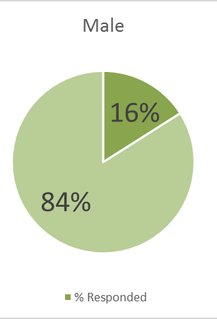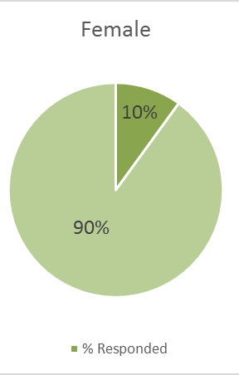
These response rates are low for various reasons. First, the teams frequently change ownership and management; therefore, finding a current contact can be difficult. Secondly, the duration of the NPSL season is from approximately April-July (this is for practices and games). The surveys were distributed in September, again in January, and again in early March. Many management teams are not operating in these months as they are still fairly far from the beginning of the season.
Once the data was collected, it was transferred from questionnaire form into an Excel sheet, and then into JMP statistical software. The analysis was performed only on teams who responded to the questionnaire (there were too many null values to apply techniques such as imputation). Using statistical techniques such as regression analysis, analyzing distributions, and variability analysis, the most influential factors were identified (to be explained in the Results section).

Results
After a great deal of analysis, it was determined that there are three factors that appear to have an influential effect on attendance in the NPSL/WPSL (gender was not an influential factor, so these analysis combines the data from both leagues). These three predictors were: city population size, the number of social media accounts an organization uses, and whether or not the organization has a junior club. While it makes logical sense that other predictors may be influential as well, they were not statistically significant. Although the sample size is fairly small in relation to the population, it is representative of the population. The distribution of each influential predictor will be illustrated, and then the analysis of the combination of the three will be shown through a variability plot analysis
A plot of the first influential predictor, city population, can be seen in the figure below.
Figure 4
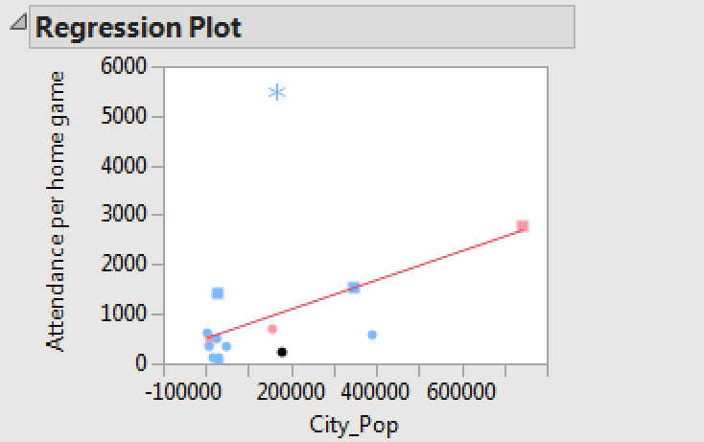
The regression line was created with the exclusion of one point, the LA Hotspur FC. This team was excluded based on the fact that it was a brand new club in 2014. The General Manager stated that they did not play in a major stadium and did not market their matches. Therefore, it can be reasonable concluded that this point is not representative of the population. By excluding this point, we can see a more linear distribution of city population and attendance per home game. In order to more accurately account for city population, the populations were filed into “population groups”. The resulting distribution is in Figure 5.
Figure 5
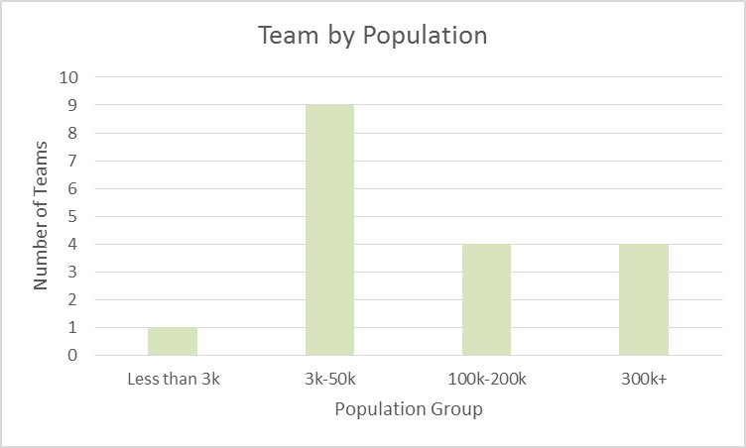
Each city’s population is accurately described by one of the four population groups. The next variable that was determined to be influential was the number of social media accounts that the organization uses. The distribution is illustrated in Figure 6.

Figure 6
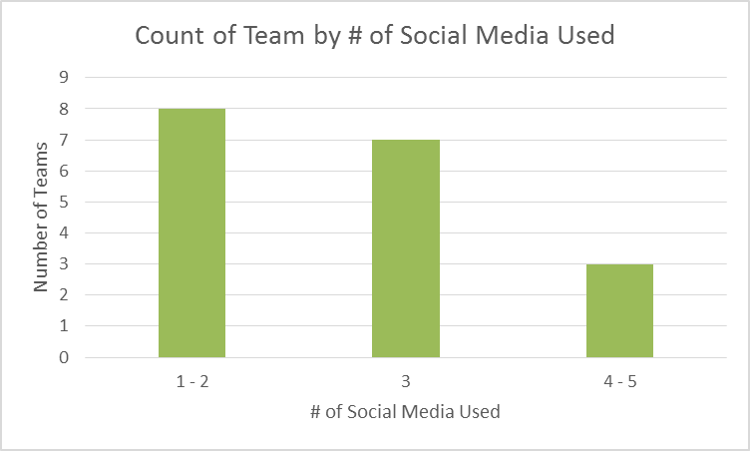
It was determined that there was little to no difference in attendance between those utilizing one or two social media accounts, so they were grouped together (the same goes for using four or five social media accounts). As will be seen in the variability analysis, the number of social media accounts used is influential, however there are some factors that would need to be further explored to use number of social media accounts as a solid predictor of attendance. For example, it would have been ideal to have data on the number of posts, number of followers, fan interaction, etc. for each social media account in order to make concrete statements about how the usage affects attendance. The final influential variable was whether or not the organization has a junior club.

Figure 7
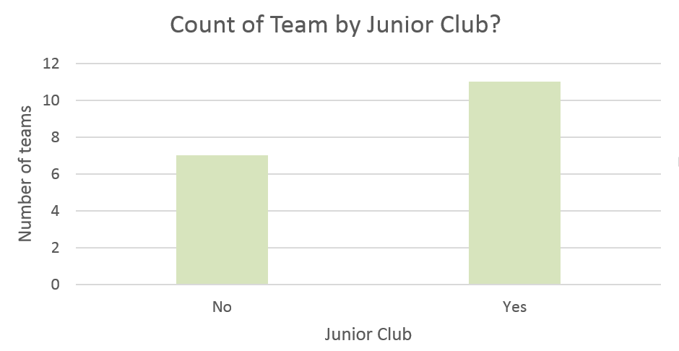
While the presence of a junior club team is influential, the number of teams in the junior club was not determined to be a significant predictor of attendance. Based on the three predictors above and their distributions, the following variability plot (Figure 8) was created. This plot is an excellent depiction of how the factors interact and affect attendance. To read the chart, notice that the data is grouped along the horizontal axis by the three influential predictors – population group, junior club, and number of social media accounts. Along the vertical axis is attendance per home game. The individual dots or markers on the chart indicate exact team data points while the lines connecting them illustrate the variability between the points. As can be viewed, the most ideal point with the highest attendance (representing the team Chattanooga FC) utilizes four to five social media accounts, has a junior club, and is located in a city with a moderately large population. This illustrates that the interaction of these three factors leads to the largest attendance statistics. The chart also illustrates that the predictors are trade-offs of one another. It appears that if a team maximizes two of the three predictors, they will mitigate the loss create by the absence of the third. For example, the point that lies in the
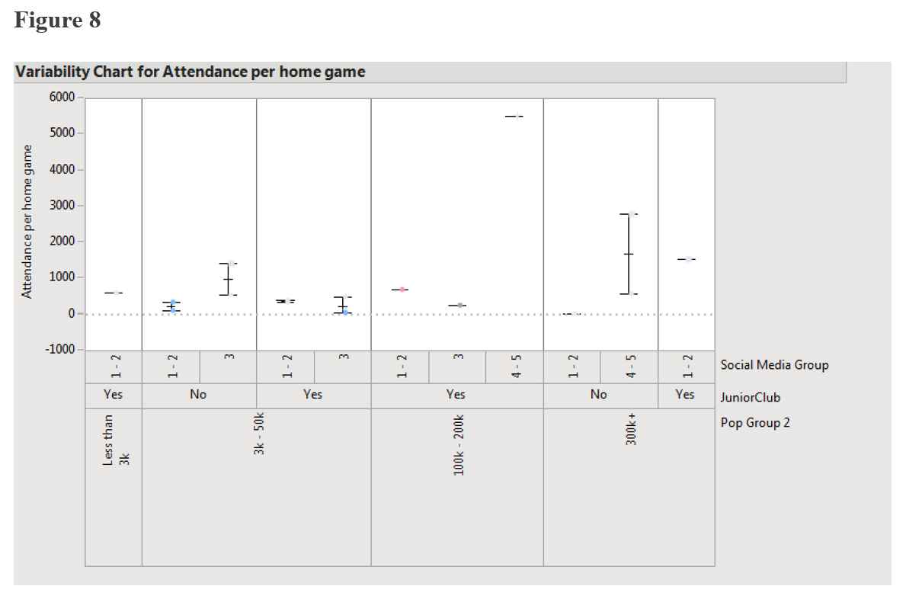
population group of 300k, utilizes four to five social media accounts, but has no junior club still lends to a relatively high attendance statistic. This attendance statistics is close to a similar team that also falls into the 300k population group, only uses one to two social media accounts, but does have a junior club team. Both of these points only fall on the upper end of two predictors (and not the same two) but still have very similar (and high) attendance statistics. However, when a team maximizes two or even all three of the influential predictors, it is harder to compensate on the attendance statistic. For example, the point the falls into the 3k-50k population group, has no junior club, and only uses one to two social media accounts (on the low side of each predictor) has an extremely low attendance statistic. The point that lies at 300k, no junior club, and one to two social media account has almost the exact same attendance statistic. This means that even though the city in which the team is located has a minimum of 250,000 more people, they do not attract any more people. This shows that city population cannot compensate for the lack of effective social media marketing and the presence of a junior club to help drive fans to games. While this chart and its conclusions are not fool proof, they lend to a great deal of insight that can help NPSL/WPSL more narrowly direct their operations.

Discussion & Recommendations
The following discussion and recommendations are a result of the analysis performed, the viewing of the websites and tactics of many of the NPSL/WPSL teams, and the secondary sources and literature that were discussed previously in this paper. Before getting into the specific tactics that the Knoxville Force should think about, it is necessary to state that for NPSL/WPSL teams in general, an emphasis should be placed on maximizing social media usage and establishing a junior club (especially in cities with small populations and a smaller potential fan base). Both the analysis and literature reviewed emphasize the necessity of communication via social media.
Based on the research, the following are recommendations to the management of the Knoxville Force in order to help improve operations, awareness, attendance, and hopefully in turn, revenue. The recommendations have been split into three categories: ticket pricing, consumer integration, marketing.
Ticket Pricing (Crompton 2004)
1. Charge higher prices for matches with greater demand (e.g. Knoxville Force vs. Chattanooga FC)
2. Charge cheaper prices for games occurring on weeknights
3. Create “match packages” instead of season tickets; “match packages would allow fans to bundle a number of matches together and receive them at a discounted price as many times a full season is a large commitment
4. Create a “rival package” consisting of the teams most popular opponents
5. Create a “family pack” with tickets, popcorn/concessions vouchers, and a small coupon for apparel/souvenirs

Consumer Integration: All the following recommendations relate to creating a connection between the customer, and not only with the Knoxville Force, but with the sport of soccer in general.
1. Use social media to post soccer related news, videos, play tips, etc. (This can include a range of news from local junior clubs to popular professional teams).
2. Create an online game day countdown
3. Interactive polls such as player of the week and t-shirt/brochure design contests
4. Post exclusive videos such as pre/post game talks and practice sneak peaks
5. House international players with families from local clubs as well as with other soccer related entities in the community such as Emerald Youth Sports donors

Marketing
Figure 9 shows a table of marketing mediums that were reported to be in use by the teams of the NPSL/WPSL from the questionnaire that was distributed.
Figure 9
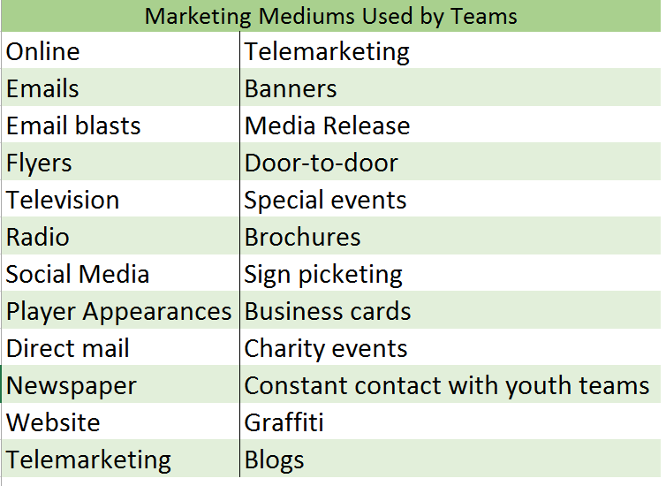
1. Utilize as many marketing mediums as possible (especially those of low cost) to create awareness
2. Sell Knoxville Force gear at local retailers such as Soccer Post and Soccer USA
3. Identify unaware market segments that have the potential for a great deal of demand. These may include, but are not limited to: students at the University of Tennessee, local schools, local clubs, local adult leagues, AYSO teams, firms that are donors of the Emerald Youth Foundation
4. Create an online “store” even if products can only be viewed and must be purchased on site at the matches

Conclusion
To conclude, the NPSL and WPSL are amateur soccer leagues with teams that operate with a large variety of strategies. While there is no existing data to compare study results with, it can be determined from this study that the three biggest factors influencing attendance are city population, the presence of a junior club, and the number of social media accounts that an organization uses. While these are the only three statistically influential predictors, a number of other operations (largely involving marketing) can be taken in order to increase awareness of the team and its matches. Other various studies on amateur sports help identify some of these operations. Focusing on the factors identified above as influential as well as imitating the strategies of other successful clubs is a first step in the right direction to increasing attendance at Knoxville Force matches.

Acknowledgements
I would like to thank Lecturer Julie Ferrara and the staff and faculty of the Haslam College of Business at the University of Tennessee for their endless aid and encouragement in the analysis of the collected data.

Appendix
A.1 - Team Questionnaire Distributed
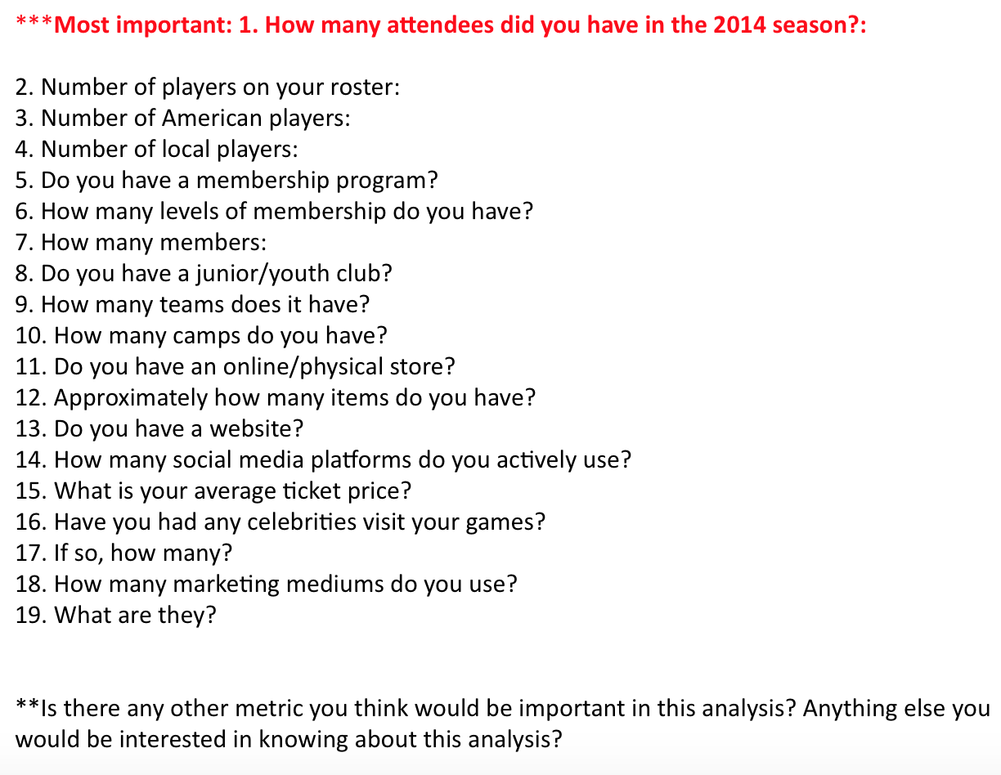

A. 2 – Teams Responded
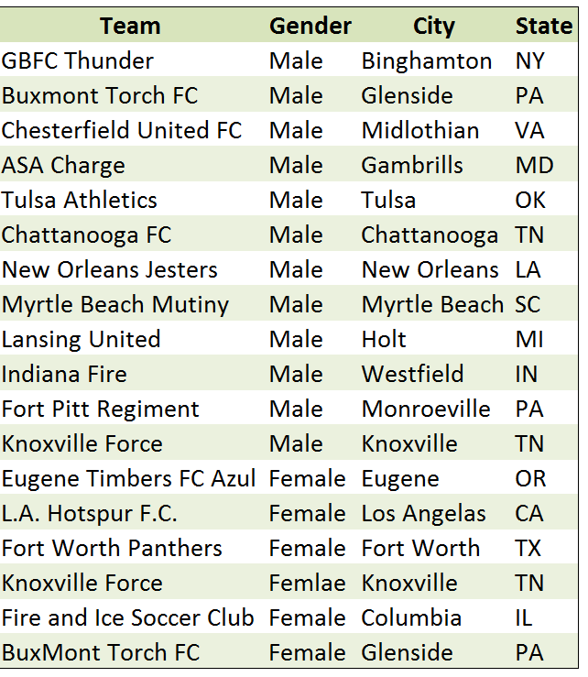

References
Bee, Colleen C., and Mark E. Havitz. "Exploring the Relationship between Involvement, Fan Attraction, Psychological Commitment and Behavioural Loyalty in a Sports Spectator Context." International Journal of Sports Marketing & Sponsorship 11.2 (2010): 140. EBSCO Host Connection. EBSCO Publishing. Web. 15 Feb. 2015.
Crooks, John. “Knoxville Force.” Emerald Youth Sports. Emerald Youth Foundation. November 2014. Web. 05 Apr. 2015.
Crompton, John L. "Tactics Used by Sports Organizations in the United States to Increase Ticket Sales." Managing Leisure. By Dennis R. Howard. 2nd ed. Vol. 9. 2004. 87-95. Taylor & Francis. Routledge, 18 Feb. 2007. Web. 7 Feb. 2015.
National Premier Soccer League. "About NPSL - National Premier Soccer League." National Premier Soccer League. Demosphere, 2014. Web. 05 Apr. 2015.
O'Mahony, Barry, John Hall, and Julian Vieceli. "An Empirical Model of Attendance Factors at Major Sporting Events." International Journal of Hospitality Management 29.2 (2010): 328-34. ScienceDirect. Elsevier B.V. Web. 4 Mar. 2015.
United States. US Department of Commerce. Census Bureau. Annual Estimates of the Resident Population for Incorporated Places of 50,000 or More, Ranked by July 1, 203 Population. Population Division, 2014. American FactFinder. Web 20 Nov. 2014
Williams, Jo, and Susan J. Chinn. "Meeting Relationship-Marketing Goals Through Social Media: A Conceptual Model for Sport Marketers." International Journal of Sport Communication 3 (2010): 422-37.

