To the Graduate Council:

I am submitting herewith a dissertation written by Jean-Philippe Lessard entitled “Linking community ecology and biogeography: the role of biotic interactions and abiotic gradients in shaping the structure of ant communities.” I have examined the final electronic copy of this thesis for form and content and recommend that it be accepted in partial fulfillment of the requirements for the degree of Doctor of Philosophy, with a major in Ecology and Evolutionary Biology.

Dr Nathan Sanders, Major Professor

We have read this dissertation and recommend its acceptance:

Daniel Simberloff

James Fordyce

Jennifer Schweitzer

Michael McKinney

Accepted for the Council:

Carolyn R. Hodges

Vice Provost and Dean of the Graduate School

(Original signatures are on file with official student records.)
To the Graduate Council:

I am submitting herewith a dissertation written by Jean-Philippe Lessard entitled “Linking community ecology and biogeography: the role of biotic interactions and abiotic gradients in shaping the structure of ant communities.” I have examined the final electronic copy of this thesis for form and content and recommend that it be accepted in partial fulfillment of the requirements for the degree of Doctor of Philosophy, with a major in Ecology and Evolutionary Biology.

Dr Nathan Sanders, Major Professor

We have read this dissertation and recommend its acceptance:

Daniel Simberloff

James Fordyce

Jennifer Schweitzer

Michael McKinney

Accepted for the Council:

______________________________
Carolyn R. Hodges, Vice Provost and
Dean of the Graduate School

Linking community ecology and biogeography: the role of biotic interactions and abiotic gradients in shaping the structure of ant communities.

A Dissertation Presented for the
Doctor of Philosophy
Degree
The University of Tennessee, Knoxville

Jean-Philippe Lessard
December 2010

Copyright © 2009 by Jean-Philippe Lessard
All rights reserved.

DEDICATION
This dissertation is dedicated to my wife Noa and my son Ilan, my father Francois and my mother Lyne for their support and encouragement.
ACKNOWLEDGEMENTS
My years as a PhD student at the University of Tennessee have been times of tremendous growth and learning, both as a person and as an ecologist. Influences, guidance and inspiration have come from all directions, thus I will without a doubt neglect to mention many people who have helped me directly or indirectly.

My adviser Nathan Sanders has been both an amazing academic adviser and a mentor. Nate, in large part, made me the ecologist I am today. I am extremely grateful for how devoted Nate has been with advising me on all aspect of academic and professional life. But more importantly, it has been a great pleasure and a privilege to have Nate as a friend throughout my time at UT. God only knows how many more papers I would have published had we not held all of our meetings at the Sunspot.

Jim Fordyce has been elemental to helping me develop the tools I needed to reach my goal of integrating ecology and evolutionary biology. Jim spent a substantial amount of time sitting with me at a computer and introducing me to phylogenetic methods. I have great admiration for how creative and rigorous Jim is as a scientist and I would be satisfied ending up being half the scientist he is. Noteworthy to mention is the fact that Jim has returned roughly 2% of the e-mails I sent him throughout my PhD and most of those were when I was writing to share my sympathy for the early elimination of the Detroit Red Wings form the Stanley Cup playoffs.

Many other faculty members at UT provided me with advice, guidance and friendship. Dan Simberloff was instrumental in keeping me connected with the history, culture and actuality of “my people” in Quebec. Jen Schweitzer has been supportive of my projects and ideas and was a great source of positivism. Aimee Classen’s outlook on my research and her straightforwardness were incredibly valuable and often helped me separate the good ideas from the bad ones, the realistic plans from overambitious ones. I had many fascinating discussions with Jim Drake, Joe Bailey and Ben Fitzpatrick, which have broadened my perception of ecological patterns and the mechanisms that create them.

Rob Dunn at NCSU has also been an important part of my academic circle. Rob’s enthusiasm for my ideas and his sustained support really helped me make it through the last stretch of my dissertation.

Matt Fitzpatrick has been a huge help with providing me with data and reading grants and paper drafts. Friends and colleagues at UT have been a great source of exchange and mutual learning. Martin Nunez, Mariano Rodriguez-Cabal and Lara Souza were extremely resourceful and interactions with them made my experience as a graduate student an enriching one. Lab mates Tara Sackett, Greg Crutsinger, Windy Bunn, Maggie Fitzpatrick, Jarrod Blue and Katie Stuble helped me improve drafts of papers and grant applications and provided me with feedback on my work throughout my PhD. Interactions with Michael Lawton and Marc Genung were incredibly beneficial to my progression as a PhD student as they many time demonstrated, in all humility, the limits of my understanding and the immensity of their intelligence.

Finally, but most significantly, my life partner, and wife and mother of my son: Noa. Noa participated in literally every aspect of my PhD dissertation. She spent many hours working in the field with me, setting up Winkler extractors in the lab, editing my grants and manuscripts and listening to hours of delirious brainstorming. Her presence, love and support were fundamental to keeping balance and perspective.

ABSTRACT

Understanding what drives variation in species diversity in space and time and limits coexistence in local communities is a main focus of community ecology and biogeography. My doctoral work aims to document patterns of ant diversity and explore the possible ecological mechanisms leading to these patterns. Elucidating the processes by which communities assemble and species coexist might help explain spatial variation in species diversity. Using a combination of manipulative experiments, broad-scale surveys, behavioral assays and phylogenetic analyses, I examine which ecological processes account for the number of species coexisting in ant communities. Ants are found in most terrestrial habitats, where they are abundant, diverse and easy to sample (Agosti et al. 2000). Hölldobler and Wilson (1990) noted that competition was the hallmark of ant ecology, and we know that ant diversity varies along environmental gradients (Kusnezov 1957). Thus ants are an ideal taxon to examine the factors shaping the structure of ecological communities and how the determinants of community structure vary in space.

TABLE OF CONTENTS
Chapter I. General Introduction 1
Biotic interactions and coexistence in native ant communities 2
Invasion, diversity and phylogenetic structure of ant communities 5
Ant species diversity and the abiotic environment 6
References 7
Chapter II. From colonies to communities: the discordant effects of a dominant ant species across levels of organization 11
Abstract 12
Introduction 13
Methods 15
Results 23
Discussion 27
Acknowledgments 32
References 33
Tables and figures 39
Chapter III. Invasive ants alter the phylogenetic structure of ant communities 48
Abstract 49
Methods 52
Results 61
Discussion 62
Acknowledgements 66
References 67
Tables and figures 73
Chapter IV. Determinants of the detrital arthropod community structure: the effects of temperature and resources along an environmental gradient. 83
Abstract 84
Introduction 85
Methods 89
Results 94
Discussion 97
Acknowledgments 104
References 105
Tables and figures 115
VITA 126
List of Tables
Table II-1. Variation in colony size and productivity of colonies of subdominant ant species near and far from F. subsericea nests 40
Table II-2. Difference in resource use of dominant and subdominant ant species near and far from nests of F. subsericea. 41
Table II-3.Difference in the number of species and worker of subdominant ants recorded on baits between the day and night 42
Table II-4.Mean number of workers of all ant species recorded at baits during the day and at night. 43
Table III-1.Literature sources for data on community composition of invaded and intact ant assemblages. 74
Table III-2.List of the taxa that were absent in the phylogeny and substituted in the sample dataset. 75
Table III-3. Species richness and phylogenetic structure of pooled intact and invaded communities 76
Table III-4. Mean Net Relatedness Index and Nearest Taxon Index for intact and invaded communities for the six local-scale studies. 77
Table IV-1. For each site, the table shows elevation, general forest type, composition of the dominant vegetation, minimum, maximum and mean temperature. 116
Table IV-2.List of leaf-litter arthropod taxa sampled using Winkler extractors in Great Smoky Mountains National Park 117
Table IV-3. Total number of individuals and morphospecies recorded for each taxonomic group, taxonomic resolution and range of the number of species and individuals recorded among leaf-litter samples. 118
Table IV-4.Best-fit models for relationship between species richness and abundance against elevation 119
Table IV-5. ANCOVA table examining the effects of elevation, food addition and microclimate alteration on the abundance and richness of ants, spiders, beetles, mites, springtails and all arthropods combined. 121
Table IV-6. Results of ANCOVA on Hurlbert’s index of evenness and rarefied species richness 123
List of Figures
Figure II-1. The unimodal relationship between the richness of subdominant ant species recorded in pitfall traps at a site and the number of pitfall traps in which a dominant F. subsericea was recorded 44
Figure II-2. Mean colony size and colony productivity of subdominant ant species A. rudis and P. faisonensis near and far from focal nests of dominant F. subsericea. 45
Figure II-3. Mean number of workers of A. rudis, M. punctiventris and P. faisonensis recorded on baits near and far from focal nests of dominant F. subsericea during the day and at night 46
Figure II-4. Mean difference in the number of workers and species richness of subdominant ant species recorded on baits during day and night 47
Figure III-1. Complete genus-level phylogeny with branch-length. 78
Figure III-2. Scenario for generated polytomies when multiple species within a genera are present in community 79
Figure III-3. Example of regional-scale phylogenetic structure of intact California ant communities versus those invaded by the Argentine ant Linepithema humile. 80
Figure III-4. Phylogenetic structure of intact and invaded ant communities pooled for 12 studies listed in Table III-1 81
Figure III-5. Mean phylogenetic relatedness of extinct species subset for 7 regional-scale studies. Phylogenetic relatedness is estimated using mean NRI and NTI values 82
Figure IV-1. Variation in species richness and abundance along the elevational gradient 124
Figure IV-2. Change in overall arthropod community composition along the elevational gradient 125

General Introduction
Global and local species extinctions are sharply increasing as habitat is lost and invasive species homogenize communities (McKinney and Lockwood 1999, Smart et al. 2006). Furthermore, global trends in climatic warming ask for a comprehensive framework in order to predict the future distribution of biodiversity (Araujo and Rahbek 2006). Thus there is a pressing need to understand the factors allowing coexistence and the maintenance of species diversity within communities, and the factors governing contemporary patterns of diversity among communities. My doctoral dissertation integrates behavioral ecology, community ecology and biogeography to understand the processes that create and constrain patterns of ant community structure. Community structure refers to characteristics of a community such as the number of species (species richness), the relative abundance of species and the composition of species in a community. Ants are an excellent model system to address questions of community structure as they are found in most terrestrial systems, are abundant and diverse, and are easy to sample.
Co-authored by Katharine L. Stuble and Nathan J. Sanders

Biotic interactions and coexistence in native ant communities
Ants are ubiquitous in most terrestrial ecosystems and, as a result, the factors regulating the structure of ant communities have been often studied (Albrecht and Gotelli, 2001; Davidson, 1977; Parr et al., 2005; Sanders and Gordon, 2003; Savolainen and Vepsäläinen, 1988; Yanoviak and Kaspari, 2000). Hölldobler and Wilson (1990) noted that competition is ‘the hallmark of ant ecology’, and numerous studies have indicated that competition can shape ant communities (Andersen, 1992; Bernstein and Gobbel, 1979; Fellers, 1987; Parr et al., 2005; Sanders and Gordon, 2003; Savolainen and Vepsäläinen, 1988). Evidence for the role of competition includes behavioural dominance hierarchies (Fellers, 1987; Perfecto, 1994; Sanders and Gordon, 2003; Savolainen and Vepsäläinen, 1988; Vepsäläinen and Pisarski, 1982), hump-shaped dominance-diversity relationships (Andersen, 1992; Parr et al., 2005), and the alteration of native ant communities in the presence of dominant introduced species (Holway, 1999; Porter and Savignano, 1990; Sanders et al., 2003). In sum, results from these studies suggest that competitively dominant species often shape the structure of ant communities.

If competition is a strong determinant of the structure of ant communities, a key question becomes what allows multiple ant species to coexist in a given habitat (Andersen 2008). One possibility is that species coexist because of tradeoffs between dominance over resources and foraging efficiency (see Davidson, 1998 for a review). Behaviourally dominant ant species can displace behaviourally subordinate ant species at transient food resources. They do so by use of overt aggression, which leads to submissive behaviour, and usually escape, by the subordinate species. Early in the study of ant interactions, Wilson (1971) noted a divergence in the competitive strategies of ant species at transient food sources. Such divergences may allow subordinate ant species to coexist with dominant species. One hypothesis is that behaviourally subordinate species are better at discovering than at defending food resources (Fellers, 1987), such that the ability of a species to discover food resources is inversely related to its ability to defend those resources. This hypothesis has been coined “the discovery-dominance tradeoff” by Fellers (1987) who studied behavioural interactions in a guild on woodland ants in Maryland.
A second mechanism that might allow coexistence in ant communities is the partitioning of possible foraging temperatures. In addition to being structured by competition, resource access in ants is shaped by the abiotic environment, and in particular, temperature (e.g. Bestelmeyer, 2000; Cerdá et al., 1997; 1998a). Species vary in their abilities to forage at different climatic conditions such that the abiotic environment can influence competitive outcomes. For example, Cerdá et al. (1997; 1998) found that behaviourally dominant ant species were less successful than subordinate species at exploiting food resources under extremely warm temperatures. Thus, to understand the relative importance of factors structuring ant communities, field studies should consider both the role of species interactions and how such interactions vary with the environmental conditions.
In a study I have conducted prior entering the Ph.D. program at the University of Tennessee, I found that a dominance-thermal tolerance tradeoff might allow coexistence in ground-dwelling ant communities of southern Appalachian temperate forests (Coweeta Hydrologic Laboratory Long-term Ecological Research, NC)(Lessard et al. 2009). Dominant species foraged at warmer temperatures than did subordinate species, and in a narrower temperature envelope, in support of a dominance-thermal tolerance tradeoff. However, our results did not support the discovery-dominance tradeoff, because subordinate ant species were not better at discovering resources than were behaviourally dominant species.

While many studies on coexistence in ant communities have focused on mechanisms allowing diversity to be maintained, others suggest that high level of dominance cause local ant richness to decline (Andersen, 1992; Parr et al., 2005; 2008), somewhat contradicting theories on behavioral tradeoffs. Chapter III examines the balance between coexistence mechanisms and competitive exclusion across levels of organization, and these shape patterns of community structure in temperate forest ants.

Invasion, diversity and phylogenetic structure of ant communities
The question of how species coexist further applies to systems wherein introduced species have drastic impacts on the structure and diversity of native communities. Many invasive species are known to displace native species and alter the structure and function of ecological communities (Lockwood et al. 2006). Because invasive ants alter native communities via competitive interactions, they offer a unique opportunity to examine the role of dominant ants in shaping communities and more generally, the mechanisms regulating species coexistence and the maintenance of diversity. Chapter III compares intact and invaded ant communities from numerous habitat types and regions. My results suggest that invasive ant species, most likely through competitive exclusion, disrupt the phylogenetic structure of native ant communities. In particular, intact communities were phylogenetically evenly dispersed, suggesting that competition structures native ant communities in the absence of an invasive species. However, in the presence of an invasive species, ant communities are phylogenetically clustered, suggesting that invasive species act as strong environmental filters on native ant community structure. That is, only a subset of closely related native ant species tend to persist following invasion. Collectively, these results suggest that there is phylogenetic structuring in intact native ant communities, but the spread of invasive species disassembles those communities above and beyond the effect of simple reductions in diversity. In order to pinpoint the exact ecological mechanisms underlying theses patterns of phylogenetic structure, the next logical step will be to pinpoint which traits might allow certain native ant species to coexist with dominant invasive ants.

Ant species diversity and the abiotic environment
Environmental gradients, and elevational gradients in particular, have been used as natural experiments for decades (reviewed by Lomolino 2001). Typically, diversity studies along elevational gradients are correlative, which often leaves ecological mechanisms underlying these patterns unexplained. Clearly, both regional and local processes interact to shape the structure of communities (Ricklefs 2004). In order to assess the extent to which environmental variation and local processes interact to determine ant community structure, I manipulated food availability and microclimate at 18 sites along a well-studied (Lessard et al. 2007, Sanders et al. 2007) elevational gradient in southeastern USA. Results from this study show that variation in temperature along the gradient combines with the effect of food availability and microclimate to shape ant community structure. The effects of food availability and microclimate on ant diversity suggest that both local and regional ecological processes can shape ant communities along climatic gradients.
References
Albrecht, M., and N. J. Gotelli. 2001. Spatial and temporal niche partitioning in grassland ants. Oecologia 126:134-141.
Andersen, A. N. 1992. Regulation of Momentary Diversity by Dominant Species in Exceptionally Rich Ant Communities of the Australian Seasonal Tropics. American Naturalist 140:401-420.
Andersen, A. N. 2008. Not enough niches: non-equilibrial processes promoting species coexistence in diverse ant communities. Austral Ecology 33:211-220.
Araujo, M. B., and C. Rahbek. 2006. How does climate change affect biodiversity? Science 313:1396-1397.
Bernstein, R. A., and M. Gobbel. 1979. Partitioning of Space in Communities of Ants. Journal of Animal Ecology 48:931-942.
Bestelmeyer, B. T. 1997. Stress tolerance in some Chacoan dolichoderine ants: Implications for community organization and distribution. Journal of Arid Environments 35:297-310.
Bestelmeyer, B. T. 2000. The trade-off between thermal tolerance and behavioural dominance in a subtropical South American ant community. Journal of Animal Ecology 69:998-1009.
Cerda, X., J. Retana, and S. Cros. 1997. Thermal disruption of transitive hierarchies in Mediterranean ant communities. Journal of Animal Ecology 66:363-374.
Cerda, X., J. Retana, and A. Manzaneda. 1998. The role of competition by dominants and temperature in the foraging of subordinate species in Mediterranean ant communities. Oecologia 117:404-412.
Davidson, D. W. 1977. Foraging Ecology and Community Organization in Desert Seed-Eating Ants. Ecology 58:725-737.
Davidson, D. W. 1998. Resource discovery versus resource domination in ants: a functional mechanism for breaking the trade-off. Ecological Entomology 23:484-490.
Fellers, J. H. 1987. Interference and exploitation in a guild of woodland ants. Ecology 68:1466-1478.
Hölldobler, B., and E. Wilson. 1990. The Ants. Belknap, Cambridge, Mass.
Holway, D. A. 1999. Competitive mechanisms underlying the displacement of native ants by the invasive Argentine ant. Ecology 80:238-251.
Lessard J.-P. et al. 2007. Rarity and diversity in forest ant assemblages of Great Smoky Mountains National Park. – Southeastern Naturalist 6:215-228.
Lessard, J. P., R. R. Dunn, and N. J. Sanders. 2009. Temperature-mediated coexistence in temperate forest ant communities. Insectes Sociaux 56:149-156.
Lockwood, J., M. Hoopes, and M. Marchetti. 2006. Invasion Ecology. Blackwell Scientific Press, UK.
Lomolino, M. V. 2001. Elevation gradients of species-density: historical and prospective views. Global Ecology and Biogeography 10:3-13.
McKinney, M. L., and J. L. Lockwood. 1999. Biotic homogenization: a few winners replacing many losers in the next mass extinction. Trends in Ecology & Evolution 14:450-453.
Parr, C. L., B. J. Sinclair, A. N. Andersen, K. J. Gaston, and S. L. Chown. 2005. Constraint and competition in assemblages: A cross-continental and modeling approach for ants. American Naturalist 165:481-494.
Perfecto, I. 1994. Foraging Behavior as a Determinant of Asymmetric Competitive Interaction between 2 Ant Species in a Tropical Agroecosystem. Oecologia 98:184-192.
Phillips, S. J., R. P. Anderson, and R. E. Schapire. 2006. Maximum entropy modeling of species geographic distributions. Ecological Modelling 190:231-259.
Porter, S., and D. Savignano. 1990. Invasion of Polygyne Fire Ants Decimates Native Ants and Disrupts Arthropod Community. Ecology 71:2095-2106.
Ricklefs, R. E. 2004. A comprehensive framework for global patterns in biodiversity. Ecology Letters 7:1-15.
Sanders, N. J., and D. M. Gordon. 2003. Resource-dependent interactions and the organization of desert ant communities. Ecology 84:1024-1031.
Sanders, N. J., N. J. Gotelli, N. E. Heller, and D. M. Gordon. 2003. Community disassembly by an invasive species. Proceedings of the National Academy of Sciences of the United States of America 100:2474-2477.
Sanders N. J., J.- P. Lessard, R. R. Dunn, and M. C. Fitzpatrick. 2007. Temperature, but not productivity or geometry, predicts elevational diversity gradients in ants across spatial grains. – Global Ecology and Biogeography 16:640-649.
Savolainen, R., and K. Vepsalainen. 1988. A Competition Hierarchy among Boreal Ants - Impact on Resource Partitioning and Community Structure. Oikos 51:135-155.
Smart, S. M., K. Thompson, R. H. Marrs, M. G. Le Duc, L. C. Maskell, and L. G. Firbank. 2006. Biotic homogenization and changes in species diversity across human-modified ecosystems. Proceedings of the Royal Society B-Biological Sciences 273:2659-2665.
Vepsalainen, K., and B. Pisarski. 1982. Assembly of Island Ant Communities. Annales Zoologici Fennici 19:327-335.
Verdu, M., and J. G. Pausas. 2007. Fire drives phylogenetic clustering in Mediterranean Basin woody plant communities. Journal of Ecology 95:1316-1323.
Ward, P. S. 2001. Taxonomy, phylogeny and biogeography of the ant genus Tetraponera (Hymenoptera : Formicidae) in the Oriental and Australian regions. Invertebrate Taxonomy 15:589-665.
Warren, D., R. Glor, and M. Turelli. In press. Environmental niche equivalency versus conservatism: Quantitative approaches to niche evolution. Evolution.
Webb, C. O., G. S. Gilbert, and M. J. Donoghue. 2006. Phylodiversity-dependent seedling mortality, size structure, and disease in a bornean rain forest. Ecology 87:S123-S131.
Wilson, E. 1971. The Insect Societies. Belknap Press, Cambridge, Mass.
Yanoviak, S. P., and M. Kaspari. 2000. Community structure and the habitat templet: ants in the tropical forest canopy and litter. Oikos 89:259-266.

From colonies to communities: the discordant effects of a dominant ant species across levels of organization

Co-authored by Katharine L. Stuble and Nathan J. Sanders

Abstract
An increasing number of studies suggest that the unimodal dominance–richness relationship among ant communities is evidence that dominant species can reduce the number of species in a community. However, few studies have demonstrated the competitive mechanisms by which dominant ants might affect the richness of subdominant species. In this study, we found a unimodal relationship between the richness of subdominant ant species and the abundance of the dominant species, Formica subsericea, among forest ant assemblages in the eastern US. However, we found only limited evidence that F. subsericea negatively affects the subdominant ant species at lower levels of organization. For example, at the colony-level, the size and productivity of colonies of subdominant ant species was not lower in close proximity to dominant ant nests than it was away from these nests and, in fact, was associated with increased productivity in one species. Additionally, the number of foraging workers of only one subdominant ant species was lower at transient food sources near the nest of a dominant ant than far from it, while the number of foragers of other species was not negatively affected. However, foraging activity of the subdominant ant species was greater at night when F. subsericea was inactive, suggesting a potential mechanism by which some subdominant species might avoid interactions with competitively dominant species. Gaining a mechanistic understanding of how patterns of community structure arise requires linking processes operating at different levels of organization, from colonies to communities. Our study suggests that mechanisms of coexistence might offset the negative effects of dominant ant species on subdominant species.

Introduction
Dominant species are those species that excel at exploiting and sequestering resources (Grime 1984) thereby affecting the behavior and population dynamics of subdominant species, and potentially the structure of communities. In ants, evidence that dominant species have community-level effects on subdominant species includes the effects of competitively dominant exotic species on the diversity (Gotelli and Arnett 2000; Holway 1998; Human and Gordon 1996; Porter and Savignano 1990), spatial arrangement (Sanders et al. 2003) and phylogenetic structure of native ant communities (Lessard et al. 2009a). Additional evidence stems from the effects dominant ants have on patterns of co-occurrence in arboreal assemblages of the tropics (Adams 1994; Davidson et al. 2007; Jackson 1984; Leston 1978; Majer et al. 1994; Sanders et al. 2007) and the dominance-species richness relationship (Andersen 1992; Parr 2008; Parr et al. 2005). However, some experimental removals of dominant species have yielded mixed results (Gibb 2003; Gibb and Hochuli 2004).

Community-level effects of dominant ants on subdominant ant species are well documented, but much less is known regarding the colony-level effects of dominant ants on subdominant ants. It is well established that dominant ants often interfere with resource exploitation by subdominant ants (Cerdá et al. 1998; Fellers 1987; Holway 1999; Human and Gordon 1996). And, it is often assumed that by interfering with the foraging activities of subdominant species, dominant ants also affect rates of resource acquisition and sequestration by these species (but see Savolainen 1991). If that were the case, dominant ants should decrease the productivity, size and/or fitness of subdominant ant colonies (Savolainen 1990; Savolainen and Vepsalainen 1988). But whether the negative effect of dominant species on colony success of subdominant ants is the rule rather than the exception and whether colony-level effects always translate into community-level effects is unclear (Andersen 2008).

Several studies have documented the effects of dominant ant species on the behavior, resource use and fitness of subdominant ant colonies (Deslippe and Savolainen 1995; Herbers and Banschbach 1998; Savolainen 1990; Savolainen 1991; Vepsalainen and Savolainen 1990), while others have documented their effects on community structure (Andersen 1992; Fellers 1987; Herbers 1989; Parr 2008; Savolainen and Vepsalainen 1988; Savolainen and Vepsalainen 1989; Savolainen et al. 1989). Examining the outcome of interspecific interactions across organization levels is key to elucidating the mechanism by which competition might shape community structure (Tilman 1987). However, few studies to date (Gibb and Hochuli 2004; Savolainen et al. 1989) have linked the effects of a single dominant ant species on subdominant ants across organization levels to examine how dominant species might shape community structure.

Effects of dominant Formica ants on subdominant ant species have been well documented in a series of seminal studies with Finnish ant assemblages (Savolainen 1990; Savolainen 1991; Savolainen and Vepsalainen 1989; Savolainen et al. 1989; Vepsalainen and Savolainen 1990). Here, we examine how a dominant species, Formica subsericea Say, affects colony productivity, foraging behavior, and the species richness of subdominant ants in a low-elevation temperate forest in the eastern US.

It is often assumed that the outcome of exploitative and interference competition for food resources has direct effects on colony behavior and productivity, which in turn scales up to influence population dynamics and community structure (Andersen 1992; Fellers 1987; Holway 1998; Human and Gordon 1996; Sanders and Gordon 2003). Here we find that, at the community-level, the relationship between the abundance of dominant F. subsericea and the richness of subdominant species is unimodal, a pattern consistent with previous studies (Andersen 1992; Parr 2008; Parr et al. 2005). To elucidate whether this community-level effect of dominant species concords with colony-level effects, we tested the following hypotheses: (i) the abundance of subdominant ant species decreases with increasing abundance of F. subsericea, (ii) the colony size and/or productivity of colonies of subdominant ant species is lower near the nest of F. subsericea than far from it, (iii) resource use by subdominant ants is lower near the nest of F. subsericea than far from it, and (iv) subdominant ant foraging activity is lower when F. subsericea are active than when inactive.

Methods
Study site and natural history
We conducted this study in a mid-elevation (∼740m elevation) forest in southern Appalachian, within Great Smoky Mountains National Park (35°38’41” N, 83°35’06”W) in June-August 2008 and 2009. Dominant overstory vegetation included Liriodendron tulipifera, Halesia tetraptera var. monticola, Tilia americana var. heterophylla, Acer rubrum, Magnolia acuminata and Fraxinus americana. Dominant understory vegetation included Acer pensylvanicum, Calycanthus floridus, and Rhododendron maximum.

Formica subsericea Say is common in open and partially open woodlands and forest ecotones of eastern North American temperate forests (Francoeur 1973). Nests of F. subsericea are usually deep and the nest entrance is often in a dead log or adjacent to large stones. In the absence of a log or rock, F. subsericea often form small mounds covered by leaf-litter around the nest entrance.

In temperate forests of eastern North America, F. subsericea is one of several behaviorally dominant species (Fellers 1987; Fellers 1989). In our study system, the abundance of F. susbericea is high, and its presence is likely to affect other species. Workers of F. subsericea do not maintain exclusive foraging territories (i.e., absolute territories; Adams 1994; Davidson 1997; Davidson 1998; Heil and McKey 2003; Hölldobler and Wilson 1990), but do aggressively defend their nest and food. Typically, workers of F. subsericea rapidly recruit to food resources, displace any subdominant species and monopolize the resource. Workers of C. pennsylvanicus sometimes manage to displace F. subsericea from food resources, but their success in displacing F. subsericea depends on the distance of the food resource from the F. subsericea nest and the size of the F. subsericea colony (J.-P. Lessard pers. obs.). However, because C. pennsylvanicus was not numerically dominant in our system, we classified the species as subdominant (Cammell et al. 1996). In our study plots, the mean distance between a focal nest of F. subsericea and the nearest F. subsericea neighbor nest was 10.25 ± 3.15m, which roughly corresponds to the average radius of a F. subsericea foraging territory in the studied sites (foraging territories are usually asymmetrical in shape).

Several sites within the study area had among the highest densities of F. subsericea of any sites of which we are aware (Sanders et al. 2007, Lessard et al. 2007, Lessard et al. 2009). However, there was among-site variation in the density of F. subsericea. We took advantage of this natural variation in the density of F. subsericea to examine the effects of this species on community and population-level effects. When experimental removals are not viable (Gibb and Hochuli 2004), this is a commonly used approach in studies of dominance on ant community structure (Andersen 1992; Parr 2008; Parr et al. 2005). To assess community-level effects of dominant ants on subdominant ants, we located 10 sites separated by at least 50 m. Each site was 600 m² and had 12 sampling stations arranged in a 3 × 4 grid and separated by 10 m. At each site we surveyed ants using baits and pitfall traps during peak ant activity (June-July) in both 2008 and 2009. Within these 10 sites we also located 16 nests of F. subsericea, which were later used for colony-level tests of dominance effects. To assess the colony-level effects of F. subsericea on subdominant species, we compared behavioral and colony traits near and far from F. subsericea nests, an approach used in a similar study by Savolainen (1990).

We used baits to quantify the outcome of behavioral interactions and the relative abundance of ant species at food resources, a common technique in studies of ant ecology (Cerdá et al. 1998; Fellers 1987; LeBrun and Feener 2007; Retana and Cerdá 2000; Savolainen and Vepsalainen 1988; Vepsalainen and Savolainen 1990). Baits consisted of 5 g of cat food (11% protein, 4% fat, 78% moisture) on a white laminated index card positioned on the ground. Cat food is a useful resource for baiting for ants because it can be retrieved both in liquid and solid form and contains a mix of protein, lipids and salts. It has been used in several community-level studies with ants to assess behavioral dominance and species richness (Lessard et al. 2009b; Parr 2008; Tschinkel and Hess 1999). In our study system, all of the ant species that were recorded on sugar-based baits were also recorded on cat food baits. At each of the 10 sites, we placed baits at the 12 sampling stations and recorded the number of workers of each species as well as any interspecific behavioral interactions. We visited each bait station for 1 min every 15 mins for 3 hours and visited each of the 10 sites once. One of us (JPL) conducted all of the baiting trials on sunny or partially sunny days between 1:00pm and 5:00pm, during peak ant activity (Fellers 1989).

To estimate the abundance of ant species in our system, we placed pitfall traps at each of the 12 sampling stations at the 10 sites within 1 meter of the bait station. Pitfall traps are commonly used to estimate the abundance of ants (Andersen 1992; Cerdá et al. 1998; LeBrun and Feener 2007; Parr 2008; Parr et al. 2005). We set up pitfall traps 24 hours after the last baiting trial. Each pitfall trap (55 mm diameter, 75 mm deep) was partially filled with propylene glycol (low toxicity antifreeze), buried flush with the ground, and left in place for 72 hours. All ants were counted, identified to species and deposited in NJ Sanders’s collection at the University of Tennessee.

Because the proximity of an ant colony to a pitfall trap might influence the number of ant workers collected, a worker count can be an inaccurate estimate of abundance for ants (where abundance is the number of nests or colonies). Therefore, we used the total number of pitfall traps in which a species occurred (i.e., incidence) as an estimate of its abundance for that site (Ellison et al. 2007; Longino and Colwell 1997). Pitfall trap incidence is the most conservative approach to estimating the abundance of ant nests, and has been used in previous studies with temperate forests ant assemblages (Ellison et al. 2007; Gotelli and Ellison 2002).

The effects of F. subsericea on community structure
We examined the relationship between the species richness of subdominant ants and the incidence of F. subsericea. At each site, we estimated the incidence of F. subsericea by counting the number of pitfall traps containing at least one F. subsericea worker. Because the proximity of an ant colony to a pitfall trap might influence the number of ant workers collected, a worker count can be an inaccurate estimate of abundance for ants (where abundance is the number of nests or colonies). Therefore, we used the total number of pitfall traps in which a species occurred (i.e., incidence) as an estimate of its abundance for that site (Ellison et al. 2007; Longino and Colwell 1997). Pitfall trap incidence is the most conservative approach to estimating the abundance of ant nests, and has been used in previous studies with temperate forests ant assemblages (Ellison et al. 2007; Gotelli and Ellison 2002).

Species richness was the total number of subdominant ant species recorded at a site across all pitfall traps (excluding F. subsericea). We also used an estimator of species richness to assess whether the pattern we found was sensitive to the completeness of our sampling. To estimate species richness had sampling gone to completion, we used the Chao2 (Chao 1984) estimator as:
S_{Chao2} = S_{Obs} + Q₁² / 2Q₂
where S_{Obs} is the observed number of species that occurred in the site, Q₁ is the number of species that occurred in only one sample (singletons), and Q₂ is the number of species that occur in two samples (doubletons). We used observed and estimated species richness of subdominants in separate regressions to assess whether insufficient sampling biased our results. One data point was a highly influential observation, therefore, we conducted this part of the analyses with and without the outlier. Because it has been suggested that the species richness of subdominants might be negatively related to the abundance of dominant ants only at high levels of dominance (Parr 2008; Parr et al. 2005), we considered whether the relationship between the species richness of subdominants and abundance of F. subsericea was best described by either a linear least squares regression or a polynomial regression. We compared the fit of the models by comparing the adjusted r² and AIC values for each fit. When comparing models, AIC values indicate goodness of fit such that the model with the lowest AIC value best fit the data.

Hypothesis 1: the abundance of subdominant ant species decreases with increasing abundance of F. subsericea
We estimated the abundance (i.e., incidence) of subdominant ant species at each of the 10 sites by counting the number of pitfall traps in which each species of subdominant ants was recorded, and then pooling the abundance of all subdominant ants. We considered whether the relationship between species richness and dominance was best described by a linear least squares regression or a polynomial regression by comparing the adjusted r² and AIC values for each regression. We also tested whether the effect of F. subsericea on subdominant ants differed between common and rare species by pooling the incidence of common (A. rudis, P. faisonensis, M. punctiventris) and less-common species (all other species) separately.
Hypothesis 2: the colony size and/or productivity of colonies of subdominant ant species is lower when near a nest of F. subsericea than far from it
Prior to this experiment, we set up one 5 × 5 observation grid around each F. subsericea nest. The grid comprised 25 quadrats (each 1m²) separated by 2m and with the middle quadrat located next to the entrance of a F. subsericea nest. We found that the activity level of F. subsericea workers was in average 3× higher in quadrats that are within 1m of the nest entrance than in any other quadrats (unpublished data).

Thus, to test whether F. subsericea affected the size and productivity of colonies of subdominant ants, we collected entire colonies of the two most abundant subdominant ants on baits - Aphaenogaster rudis and Paratrechina faisonensis - near (≤ 1m) and far (5-10 m) from 16 F. subsericea nests. Both A. rudis and P. faisonensis frequently interacted with F. subsericea on baits and their colonies are conspicuous and relatively easy to collect. Another subdominant ant species, Myrmica punctiventris, was also abundant on baits and frequently interacted with F. subsericea, but we were unable to locate enough colonies of M. punctiventris for statistical analyses. Thus, for this part of the study we focused on A. rudis and P. faisonensis colonies. For each of these species, we attempted to collect one colony near and one colony far from each of the 16 F. subsericea nests, but we found only 22 A. rudis colonies (near = 12, far = 12) and 14 P. faisonensis colonies (near = 8, far = 6). Colonies were collected during the last 2 weeks of July 2008. For each colony, we counted the number of brood, workers and queens. Due to the size and quantity of P. faisonensis eggs, it was impossible to accurately estimate the number of eggs in the colonies sampled. Colony size was calculated as the total number of workers in a colony, and colony productivity was calculated as the proportion of brood to worker numbers in a colony (Kaspari 1996; McGlynn et al. 2002).
We used a paired t-test to determine whether colony size and productivity of A. rudis differed between colonies near and far from a focal F. subsericea nests. Because P. faisonensis colonies could not always be paired, we used an unpaired t-test to assess whether mean colony size and productivity was higher far from F. subsericea nests relative to near. The data were not always normally distributed, thus we used both parametric (i.e., one-sample, two-sample or paired t-tests) and non-parametric (i.e., Wilcoxon or Wilcoxon signed rank tests) tests for all colony-level analyses.
Hypothesis 3: resource use by subdominant ants is lower near the nest of F. subsericea than far from it
We placed bait stations near (≤ 1 m) and far (5-10 m) from 12 focal F. subsericea nests. Baiting stations consisted of 4 laminated index cards arranged in a square, with 10 cm between each card. We used cotton balls dipped into a sugar-water solution on two of the baits, and cat food on the other two. Because it is possible that the effect that F. subsericea has on the foraging of subdominant ants varies between the night and day, we operated the baits both between 1:00 pm and 5:00 pm, and, on the same day, between 9:00 pm and 1:00 am. At night, we used a red-light headlamp to avoid interfering with ant foraging activities (Beugnon and Fourcassie 1988; Torres et al. 2000). For each baiting session, we visited the baits every hour for three hours. Baiting was not conducted on days with heavy precipitation. At each bait station we tallied (1) the number of workers from the three most common subdominant ants on baits (i.e., A. rudis, P. faisonensis and M. punctiventris), (2) the total abundance of subdominant workers (i.e., all ants other than F. subsericea) and (3) the total species richness of subdominant species. For each F. subsericea nest, we pooled observations from the 4 baits and all three observational visits to get a single value for each of the variables listed above both near and far from each F. subsericea colony. We tested whether the abundance and species richness of subdominant workers at baits depended on distance from the focal nest using a paired t-test and a Wilcoxon signed rank test. We performed the analyses separately for day and night baiting sessions. We did not combine the distance and time variables into a single model because the observations were paired.
Hypothesis 4: subdominant ant foraging activity is lower when F. subsericea are active than when they are inactive
It is possible that subdominant species might take advantage of lower foraging activities of F. subsericea at night to exploit resources and avoid interference competition. Thus, we assessed whether there was a difference in foraging activity between day and night. Using data from the diurnal and nocturnal bait sampling above, we estimated differences between day and night foraging patterns by subtracting the number of workers of subdominant species recorded during the night from the number recorded during the day. In addition, we estimated whether there was a difference between day and night in the number of species foraging by subtracting the number of species recorded at baits during the night from the number recorded during the day. Depending on the normality of the data, we used one-sample t-tests or one-sample Wilcoxon signed rank tests to ask whether the difference between the (1) total abundance of workers and (2) total number of species of subdominant ants foraging during day and night differed from zero.

Results
The incidence of the dominant F. subsericea varied from 1 to 8 pitfall traps per site. Since F. subsericea rarely forages further than 10 m away from a nest in this system (J.-P. Lessard pers. obs.), and the pitfall traps were separated by 10 m, we assume that F. subsericea incidence in pitfall traps is a fair estimate of nest density within the 3 × 4 grids. The total abundance of subdominant species (the total number of pitfall traps occupied by all subdominant species) varied from 24 to 45, and total richness of subdominant species varied from 4 to 12 species per site. There was a marginally significant polynomial relationship between the abundance of F. subsericea and species richness when the statistical outlier was included in the analyses (r² = 0.53, r²_{adjusted} = 0.39, n = 10, P = 0.07, AIC = 17.90 for quadratic fit vs. r² = 0.26, r² = 0.00, r²_{adjusted} = -0.12, n = 10, P = 0.95, AIC = 23.40 for linear fit; Fig. II-1) and a significant polynomial relationship when the outlier was removed (r² = 0.63, r²_{adjusted} = 0.51, n = 9, P = 0.05, AIC = 10.36 for quadratic fit vs. r² = 0.25, r²_{adjusted} = 0.15, n = 9, P = 0.16, AIC = 14.64 for linear fit). Note that adjusted r² values can be negative when the model fits the data poorly (Gotelli and Ellison 2004). We also used Chao2 estimator values to examine the relationship between the estimated species richness of subdominant species and the abundance of F. subsericea. There was no significant relationship between Chao2 estimator values and the abundance of dominant F. subsericea when the statistical outlier was included in the analyses (r² = 0.38, r²_{adjusted} = 0.21, n = 10, P = 0.18, AIC = 39.80 for quadratic fit vs. r² = 0.18, r²_{adjusted} = 0.08, n = 10, P = 0.22, AIC = 40.69 for linear fit), but a significant, negative linear relationship when the outlier was removed (r² = 0.54, r²_{adjusted} = 0.39, n = 9, P = 0.09, AIC =33.70 for quadratic fit vs. r² = 0.48, r²_{adjusted} = 0.41, n = 9, P = 0.04, AIC = 32.84 for linear fit).
Hypothesis 1: the abundance of subdominant ant species decreases with increasing abundance of F. subsericea
There was no relationship between the abundance of F. subsericea and the total abundance of subdominant species (r² = 0.28, r²_{adjusted} = 0.07, n = 10, P = 0.32, AIC = 39.77 for quadratic fit vs. r² = 0.04, r²_{adjusted} = -0.07, n = 10, P = 0.57, AIC = 39.00 for linear fit). This relationship was not different when the statistical outlier was removed (r² = 0.17, r²_{adjusted} = -0.10, n = 9, P = 0.57, AIC = 30.80 for quadratic fit vs. r² = 0.08, r²_{adjusted} = -0.05, n = 9, P = 0.47, AIC = 29.76 for linear fit). The relationship between the abundance of subdominant ants and dominant ants did not depend on whether the subdominant species were common (r² = 0.30, r²_{adjusted} = 0.10, n = 10, P = 0.29, AIC = 28.87 for quadratic fit vs. r² = 0.30, r²_{adjusted} = 0.21, n = 10, P = 0.10, AIC = 26.91 for linear fit) or rare (r² = 0.37, r²_{adjusted} = 0.19, n = 10, P = 0.20, AIC = 27.65 for quadratic fit vs. r² = 0.00, r²_{adjusted} = -0.12, n = 10, P = 0.94, AIC = 30.30 for linear fit).
Hypothesis 2: the colony size and/or productivity of colonies of subdominant ant species is lower when near the nest of F. subsericea than far from it
Neither colony size (Fig. 2a) nor colony productivity (Fig. 2b) of A. rudis depended on distance from F. subsericea nests (Table II-1). Likewise, the colony size of P. faisonensis did not depend on distance from F. subsericea nests (Fig. II-2a), whereas productivity was, on average, 2× higher near a nest of F. subsericea than far from it (Fig. II-2b), though this result was marginally significant (Table II-1).
Hypothesis 3: resource use by subdominant ants is lower near the nest of F. subsericea than far from it
The mean number of F. subsericea recorded at baits was 3× higher near (≤ 1m) than far (≥ 5m) from the focal nest (Table II-2, Fig. II-3a). During the day, the number of workers of subdominant species was 50% lower at baits near to than far from focal F. subsericea nests, but the richness of subdominant species did not differ between baits that were near and those that were far (Table II-2). There were 4× fewer A. rudis workers on baits near the nest of F. subsericea during the day (Table II-2, Fig. II-3a). However, there was no difference in the number of P. faisonensis (Table II-2, Fig. II-3a) or M. punctiventris (Table II-2, Fig. II-3a) workers on baits near to than far from F. subsericea nests during the day.
Only in one instance did we find F. subsericea workers foraging at night (i.e., one worker at one bait), suggesting that F. subsericea is largely diurnal, at least in this system (also see Klotz 1984). At night, there was no difference in the number of workers of subdominant species (Table II-2, Fig. II-3b), nor in the number of subdominant species (Table II-2, Fig. II-3b) on baits near focal nests of F. subsericea than far from them. Likewise, there was no difference in the average number of A. rudis (Table II-2, Fig. II-3b) or M. punctiventris workers (Table II-2, Fig. II-3b) on baits near the nest of F. subsericea than far from it. There were, however, 2× more P. faisonensis workers on baits near to than far from F. subsericea nests at night (Table II-2, Fig. II-3b).
Hypothesis 4: subdominant ant foraging activity is lower when dominant ants are active than when dominant ants are inactive
There were a higher number of workers of subdominant species foraging on baits at night than during the day (mean difference = -28.5 ± 9.60; Table II-3; Fig. II-4a). Additionally, there were fewer species of subdominant ants recorded on baits at night than during the day (mean difference = 1.33 ± 0.36; Table II-3; Fig. II-4b). There were 2× more A. rudis workers recorded on baits at night than during the day (mean difference = -14.92 ± 5.83, Table II-3). The same trend was seen in P. faisonensis, with 2× more workers on baits at night than during the (mean difference = -8.50 ± 3.29, Table II-3). There were 2× fewer M. punctiventris workers recorded on baits at night than during the day (mean difference = -2.92 ± 1.19, Table II-3).

Discussion
We found that the abundance of F. subsericea was related to the richness of subdominant ant species across sites. In particular we found a unimodal relationship between richness of subdominant species and the abundance of dominant species, as has been documented in other studies of the effects of competitively dominant ant species on ant community structure (Andersen 1992; Parr 2008; Parr et al. 2005; Sanders et al. in review). The most common explanation for this unimodal relationship is that at low levels of dominance, the abundance of both dominant and subdominant ants increases as environmental stress decreases. But as dominant species become more abundant, they competitively exclude subdominant species leading to the descending portion of the hump-shaped curve (Parr 2008; Parr et al. 2005). Though environmental stress is most likely context dependant, in our system microsites that are shaded might be more stressful than microsites that are exposed to sunrays (Lessard et al. 2009). Thus the ascending part of the richness-dominance curve here could be the results of temperature affecting both dominant and subordinate ant species in the same way.
Studies examining the relationship between ant species richness and dominance have not assessed how differences in sampling efficiency might affect this relationship (Andersen 1992; Parr 2008; Parr et al. 2005). When we controlled for differences in sampling efficiency among sites using Chao2 as an estimator of actual species richness in our models, the relationship between species richness of subdominant species and the abundance of dominant species became linear and negative. This change in the relationship between richness and dominance suggests that the low species richness at sites with low abundance of F. subsericea resulted from insufficient sampling at low dominance sites. Although controlling for differences in sampling efficiency affected the ascending part of the unimodal relationship, the descending part remained unchanged, supporting the hypothesis that the species richness of subdominant ant species declines at high levels dominance.
One mechanism by which dominant ant species might negatively affect the richness of subdominant species is by reducing the amount resources available in the system (e.g., dominance-impoverishment rule; Hölldobler and Wilson 1990). Though dominant ant species may not affect the abundance of subdominant ants in a community (i.e., the number of colonies), they might affect the success of subdominant colonies (i.e., the size, productivity, fitness of a colony). By interfering with resource use by subdominant species (Savolainen and Vepsalainen 1989), dominant species may negatively affect the size, productivity and fitness of colonies of subdominant ants (Savolainen 1990). For example, in Finnish ant assemblages colonies of subdominant ants found inside the territory of dominant Formica tend to be smaller than those found outside dominant Formica territories (Savolainen 1990). However, proximity to a F. subsericea nest, the dominant ant species in our study system, did not affect colony size in two of the most common subdominant ant species (i.e., A. rudis and P. faisonensis).
While we did not observe any effect of dominant ants on colony size, colony productivity of P. fasionensis tended to be higher in colonies near F. subsericea nests relative to colonies that were far from these nests (note that P = 0.06). Thus, contrary to our expectations, dominant ants did not negatively affect the size and productivity of subordinate colonies of these common species, and may actually be associated with enhanced productivity in one species - P. fasionensis. Such positive effects of dominant species on subdominant species can arise when the indirect effects of competition outweigh the direct effects (e.g. in ants: Davidson 1980, in general: Wootton 1994). Competition between two species might indirectly benefit a third one if, for example, species x excludes species y from its foraging area via exploitative or interference competition, but tolerates species z. Then species x will appear to facilitate species z, even though they might compete for the same food resources. Positive associations can also arise when a subdominant species acquires protection against predatory (Davidson et al. 2007) or parasitic ants (Punttila et al. 1996) as a result of close proximity to a dominant species. However, we can’t reject the hypothesis that colonies of P. fasionensis are more productive near a nest of F. subsericea than away from it simply because both species have similar nest site requirements.
We did not find colony-level evidence that dominant F. subsericea negatively affects subdominant ants. We did, however, limit our analyses to a subsample of species in the assemblage. One possibility is that dominant ants do not affect the resource use of all of the subdominant species equally. For example, although F. subsericea interferes with foraging and resource use by A. rudis, two subdominant ant species (P. faisonensis and M. punctiventris) did not exhibit lower resource use near nests of F. subsericea than far from them. Thus, while F. subsericea was dominant over P. faisonensis and M. punctiventris in aggressive encounters, it did not effectively decrease the abundance of these species at transient food sources. However, we did not estimate the amount of time spent at resources or the rate at which resources were removed (e.g., Savolainen 1991), which might be more accurate estimates of resource use by ants. Nevertheless, the lower foraging among A. rudis observed near to than far from F. subsericea nests did not translate to reduced colony size or productivity. Herbers (1989) noted that suitable nest sites in temperate forest ant assemblages were perhaps more limiting than food resources. Thus the benefit of nesting in a suitable patch might outweigh the cost incurred by increased competition for food resources when nesting near a dominant ant nest. Variation in microhabitat temperature might be driving the degree of nest site suitability for many ant species in this system (Lessard et al., Oikos).
The discordance between the community- and colony-level effects of dominant ants on subdominant ants suggests a need for further examination of the life strategies that allow dominant and subdominant species to coexist. Foraging of subdominant ant species was higher during the night than during the day, which may suggest a strategy to avoid interference competition (Retana and Cerdá 2000). In our system, interspecific overlap in seasonal activity is high, with most species reaching peak foraging activity in the warmest months of the year (Dunn et al. 2007). However, our results suggest that on a daily basis, variation in activity levels may be important for coexistence. While there were more species active during the day when F. subsericea forages than at night when F. subsericea is not active, there were more workers of subdominant ants foraging at night. Thus, colonies of some subdominant ants might send more workers out to forage at night than during the day to avoid aggressive encounters with dominant species, a phenomenon that has been previously documented with dominant Formica in Finnish forest ant assemblages (Vepsalainen and Savolainen 1990). But interference competition is not the only explanation for this temporal segregation in foraging schedules. Instead, subordinate ant species could be responding to daily fluctuations in the abiotic environment (Cerdá et al. 1998). Assessing whether temporal shift in foraging activities are linked to interference competition will likely involve manipulating the abundance of dominant ants or examine among-site differences in temporal activity patterns.
Though previous studies on ant communities in arid systems have shown strict temporal segregation in foraging activity of dominant and subdominant ants (Retana and Cerdá 2000), here we found that, for the most part, subdominant species that were active at night were also active during the day (Table II-4). However, in arid systems environmental stress (e.g. extremely hot temperatures) can exert a very strong selection pressure over ant activity such that daily fluctuation in ambient temperatures also drives temporal niche partitioning (Cerdá et al. 1998). Temperature also controls foraging activity in our system (Lessard et al. 2009b), but daily fluctuations in temperature do not seem to impose strict physiological limits on foraging (unpublished data). Temporal segregation of ant foraging activities has been documented in other temperate assemblages (Albrecht and Gotelli 2001) and in boreal assemblages (Vepsalainen and Savolainen 1990). In that case too, species that peaked in foraging activity during the night remained, to a lesser extent, active during the day.

Our results suggest that, although dominant ants seem to play an important role in structuring ant communities, as evidenced by the unimodal relationship between dominance and richness, there is very little evidence of their negative effects at lower levels of organization. In addition, subdominant species seem to increase their foraging activity at night in order to capitalize on food resources in the absence of dominant ants, which explains why interference competition with dominant ant species does not translate into negative effects on colony size and productivity. Further, our results indicate that some subdominant species may actually benefit from nesting in the vicinity of dominant ant species (Davidson 1980) as was evidenced by higher productivity and nocturnal foraging in a subdominant species near to than far from dominant ant nests. These results demonstrate that multiple explanations for the commonly observed hump-shaped relationship between the abundance of dominant ants and species richness among ant communities may be required. Variation in the abiotic environment alone could be driving this widespread pattern if dominant and subdominant ant species differ in their abiotic requirements. Disentangling the direct and indirect effects of dominant ants on subdominant ants likely requires field experiments that manipulate the density of dominants (e.g., Deslippe and Savolainen 1995; Gibb and Hochuli 2004) to assess colony-level as well as population- and community-level responses of subdominant ants over many years.

Acknowledgments
We thank Tara Sackett, Mariano Rodriguez-Cabal, David Fowler and two anonymous reviewers for making comments on the manuscript and Noa Davidai and Benoit Guenard for help in the field. This study was permitted by and enhanced through collaboration with the Great Smoky Mountains National Park. JP Lessard was supported by an NSERC-PGS doctoral scholarship, a NSF-DDIG and the Department of Ecology and Evolutionary Biology at the University of Tennessee.

References
Adams, E. S. 1994. Territory defense by the ant Azteca trigona - maintenance of an arboreal ant mosaic. Oecologia 97:202-208.
Andersen, A. N. 1992. Regulation of Momentary Diversity by Dominant Species in Exceptionally rich ant communities of the australian seasonal tropics. American Naturalist 140:401-420.
Andersen, A. N. 2008. Not enough niches: non-equilibrial processes promoting species coexistence in diverse ant communities. Austral Ecology 33:211-220.
Beugnon, G., and V. Fourcassie. 1988. How do red wood ants orient during diurnal and nocturnal foraging in a 3 dimensional system .2. Field experiments. Insectes Sociaux 35:106-124.
Cammell, M. E., M. J. Way, and M. R. Paiva. 1996. Diversity and structure of ant communities associated with oak, pine, eucalyptus and arable habitats in Portugal. Insectes Sociaux 43:37-46.
Cerdá, X., J. Retana, and A. Manzaneda. 1998. The role of competition by dominants and temperature in the foraging of subordinate species in Mediterranean ant communities. Oecologia 117:404-412.
Chao, A. 1984. Nonparametric-estimation of the number of classes in a population. Scandinavian Journal of Statistics 11:265-270.
Davidson, D. W. 1980. Some consequences of diffuse competition in a desert ant community. American Naturalist 116:92-105.
Davidson, D. W. 1997. The role of resource imbalances in the evolutionary ecology of tropical arboreal ants. Biological Journal of the Linnean Society 61:153-181.
Davidson, D. W. 1998. Resource discovery versus resource domination in ants: a functional mechanism for breaking the trade-off. Ecological Entomology 23:484-490.
Davidson, D. W., J. P. Lessard, C. R. Bernau, and S. C. Cook. 2007. The tropical ant mosaic in a primary Bornean rain forest. Biotropica 39:468-475.
Deslippe, R. J., and R. Savolainen. 1995. Mechanisms of competition in a guild of formicine ants. Oikos 72:67-73.
Dunn, R. R., C. R. Parker, and N. J. Sanders. 2007. Temporal patterns of diversity: Assessing the biotic and abiotic controls on ant assemblages. Biological Journal of the Linnean Society 91:191-201.
Ellison, A. M., S. Record, A. Arguello, and N. J. Gotelli. 2007. Rapid inventory of the ant assemblage in a temperate hardwood forest: Species composition and assessment of sampling methods. Environmental Entomology 36:766-775.
Fellers, J. H. 1987. Interference and exploitation in a guild of woodland ants. Ecology 68:1466-1478.
Fellers, J. H. 1989. Daily and seasonal activity in woodland ants. Oecologia 78:69-76.
Francoeur, A. 1973. Révision taxonomique des espèces néarctiques du groupe fusca, genre Formica (Formicidae, Hymenoptera). Mem. Soc. Ent. Québec:1-316.
Gibb, H., and D. F. Hochuli. 2004. Removal experiment reveals limited effects of a behaviorally dominant species on ant assemblages. Ecology 85:648-657.
Gotelli, N. J., and A. E. Arnett. 2000. Biogeographic effects of red fire ant invasion. Ecology Letters 3:257-261.
Gotelli, N. J., and A. M. Ellison. 2002. Biogeography at a regional scale: determinants of ant species density in New England bogs and forests. Ecology 83:1604-1609.
Grime, J. P. 1984. Colonization, succession and stability. Blackwell, Oxford, UK.
Heil, M., and D. McKey. 2003. Protective ant-plant interactions as model systems in ecological and evolutionary research. Annual Review of Ecology Evolution and Systematics 34:425-453.
Herbers, J. M. 1989. Community structure in north temperate ants - temporal and spatial variation. Oecologia 81:201-211.
Herbers, J. M., and V. S. Banschbach. 1998. Food supply and reproductive allocation in forest ants: repeated experiments give different results. Oikos 83:145-151.
Hölldobler, B., and E. Wilson. 1990. The Ants. Belknap, Cambridge, Mass.
Holway, D. A. 1998. Effect of Argentina ant invasions on ground-dwelling arthropods in northern California riparian woodlands. Oecologia 116:252-258.
Holway, D. A. 1999. Competitive mechanisms underlying the displacement of native ants by the invasive Argentine ant. Ecology 80:238-251.
Human, K. G., and D. M. Gordon. 1996. Exploitation and interference competition between the invasive Argentine ant, Linepithema humile, and native ant species. Oecologia 105:405-412.
Jackson, D. A. 1984. Ant Distribution patterns in a cameroonian cocoa plantation - investigation of the ant mosaic hypothesis. Oecologia 62:318-324.
Kaspari, M. 1996. Testing resource-based models of patchiness in four Neotropical litter ant assemblages. Oikos 76:443-454.
Klotz, J. H. 1984. Diel differences in foraging in 2 ant species (Hymenoptera, Formicidae). Journal of the Kansas Entomological Society 57:111-118.
LeBrun, E., and D. Feener. 2007. When trade-offs interact: balance of terror enforces dominance discovery trade-off in a local ant assemblage. Journal of Animal Ecology 76:58-64.

Lessard, J. P., R. R. Dunn, C. R. Parker, and N. J. Sanders. 2007. Rarity and diversity in forest ant assemblages of Great Smoky Mountains National Park. . Southeastern Naturalist 6:215-228.
Lessard, J.-P., J. A. Fordyce, N. J. Gotelli, and N. J. Sanders. 2009a. Invasive ants alter the phylogenetic structure of ant communities. Ecology 90:2664-2669.
Lessard, J. P., R. R. Dunn, and N. J. Sanders. 2009b. Temperature-mediated coexistence in forest ant communities. Insectes Sociaux 56:149-156.
Lessard, J. P., T. E. Sackett, W. N. Reynolds, D. A. Fowler, and N. J. Sanders. Determinants of the detrital arthropod community structure: the effects of temperature, resources, and environmental gradients. Oikos: 000-000.
Leston, D. 1978. Neotropical ant mosaic. Annals of the Entomological Society of America 71:649-653.
Longino, J. T., and R. K. Colwell. 1997. Biodiversity assessment using structured inventory: Capturing the ant fauna of a tropical rain forest. Ecological Applications 7:1263-1277.
Majer, J. D., J. H. C. Delabie, and M. R. B. Smith. 1994. Arboreal ant community patterns in Brazilian cocoa farms. Biotropica 26:73-83.
McGlynn, T. P., J. R. Hoover, G. S. Jasper, M. S. Kelly, A. M. Polis, C. M. Spangler, and B. J. Watson. 2002. Resource heterogeneity affects demography of the Costa Rican ant Aphaenogaster araneoides. Journal of Tropical Ecology 18:231-244.
Parr, C. L. 2008. Dominant ants can control assemblage species richness in a South African savanna. Journal of Animal Ecology 77:1191-1198.
Parr, C. L., B. J. Sinclair, A. N. Andersen, K. J. Gaston, and S. L. Chown. 2005. Constraint and competition in assemblages: a cross-continental and modeling approach for ants. American Naturalist 165:481-494.
Porter, S., and D. Savignano. 1990. Invasion of polygyne fire ants decimates native ants and disrupts arthropod community. Ecology 71:2095-2106.
Retana, J., and X. Cerdá. 2000. Patterns of diversity and composition of Mediterranean ground ant communities tracking spatial and temporal variability in the thermal environment. Oecologia 123:436-444.
Sanders, N. J., G. M. Crutsinger, R. R. Dunn, J. D. Majer, and J. H. C. Delabie. 2007. An ant mosaic revisited: dominant ant species disassemble arboreal ant communities but co-occur randomly. Biotropica 39:422-427.
Sanders, N. J., N. J. Gotelli, N. E. Heller, and D. M. Gordon. 2003. Community disassembly by an invasive species. Proceedings of the National Academy of Sciences of the United States of America 100:2474-2477.
Sanders, N. J., J. P. Lessard, and R. R. Dunn. in review. Niche-based, not neutral processes, shape spatial variation in the structure of ant assemblages.
Savolainen, R. 1990. Colony success of the submissive ant Formica fusca within territories of the dominant Formica polyctena. Ecological Entomology 15:79-85.
Savolainen, R. 1991. Interference by wood ant influences size selection and retrieval rate of prey by Formica fusca. Behavioral Ecology and Sociobiology 28:1-7.
Savolainen, R., and K. Vepsalainen. 1988. A Competition hierarchy among boreal ants - impact on resource partitioning and community structure. Oikos 51:135-155.
Savolainen, R., and K. Vepsalainen. 1989. Niche differentiation of ant species within territories of the wood ant Formica polyctena. Oikos 56:3-16.
Savolainen, R., K. Vepsalainen, and H. Wuorenrinne. 1989. Ant assemblages in the taiga biome - testing the role of territorial wood ants. Oecologia 81:481-486.
Tilman, D. 1987. Secondary succession and the pattern of plant dominance along experimental nitrogen gradients. Ecological Monographs 57:189-214.
Torres, J. A., R. R. Snelling, and T. H. Jones. 2000. Distribution, ecology and behavior of Anochetus kempfi (Hymenoptera : Formicidae) and description of the sexual forms. Sociobiology 36:505-516.
Tschinkel, W. R., and C. A. Hess. 1999. Arboreal ant community of a pine forest in northern Florida. Annals of the Entomological Society of America 92:63-70.
Vepsalainen, K., and R. Savolainen. 1990. The Effect of interference by Formicine ants on the foraging of Myrmica. Journal of Animal Ecology 59:643-654.
Wootton, J. T. 1994. The Nature and Consequences of Indirect Effects in Ecological Communities. Annual Review of Ecology and Systematics 25:443-466.

Appendix II

Tables and figures

Table II-1. Variation in colony size and productivity of colonies of subdominant ant species (Ar and Pf) near and far from F. subsericea nests. The table shows significant differences for parametric or non-parametric statistical tests, depending on the distribution of the data (* P<0.05, **P<0.01).
Source of Variation | Response variable | Taxa | Test | Test statistic | df | P
Distance | Colony size | Ar | Wilcoxon Sign-Rank | Z = 4.00 | 10 | 0.40
Distance | Colony size | Pf | Two-sample t-test | t-Ratio = -0.14 | 11.53 | 0.44
Distance | Colony productivity | Ar | Wilcoxon Sign-Rank | Z = -13.00 | 10 | 0.14
Distance | Colony productivity | Pf | Wilcoxon Rank Sums | X² = 3.45 | 11.61 | 0.06
Table II-2. Difference in resource use of dominant (Fs) and subdominant (Ar, Pf and Mp) ant species near and far from nests of F. subsericea. Differences are shown separately for day and night baiting trials. The table shows significant differences for parametric or non-parametric statistical tests, depending on the distribution of the data (* P<0.05, **P<0.01).
Source of Variation | Response variable | Taxa | Test | Test statistic | P
Distance (day) | Species richness | all | Paired t-test | t-Ratio = -1.20 | 0.13
Distance (day) | Worker abundance | all | Wilcoxon Sign-Rank | Z = 23.00 | 0.04*
Distance (day) | Worker abundance | Ar | Wilcoxon Sign-Rank | Z = 27.50 | 0.01*
Distance (day) | Worker abundance | Fs | Wilcoxon Sign-Rank | Z = -39.00 | <0.0001**
Distance (day) | Worker abundance | M | Wilcoxon Sign-Rank | Z = -9.00 | 0.13
Distance (day) | Worker abundance | Pf | Wilcoxon Sign-Rank | Z = -2.00 | 0.41
Distance (night) | Species richness | all | Paired t-test | t-Ratio = 0.00 | 1.00
Distance (night) | Worker abundance | all | Wilcoxon Sign-Rank | Z = -2.00 | 0.46
Distance (night) | Worker abundance | Ar | Wilcoxon Sign-Rank | Z = -2.00 | 0.55
Distance (night) | Worker abundance | Fs | Wilcoxon Sign-Rank | NA | NA
Distance (night) | Worker abundance | M | Wilcoxon Sign-Rank | Z = -1.50 | 0.41
Distance (night) | Worker abundance | Pf | Paired t-test | t-Ratio = -2.36 | 0.02*

Table II-3.
Difference in the number of species and worker of subdominant ants recorded on baits between the day and night (day – night). The table shows significant differences for parametric or non-parametric statistical tests, depending on the distribution of the data (* P<0.05, **P<0.01).
Source of Variation | Response variable | Taxa | Test | Test statistic | P
Time | Species richness | all | t-test | t = 3.75 | 0.002**
Time | Worker abundance | all | t-test | t = -2.94 | 0.007**
Time | Worker abundance | Ar | t-test | t = -2.56 | 0.01*
Time | Worker abundance | Fs | t-test | t = 5.57 | <0.0001**
Time | Worker abundance | M | Wilcoxon Signed-Rank | Z = 22.5 | 0.002**
Time | Worker abundance | Pf | t-test | t = -2.58 | 0.01*

Table II-4.
Mean number of workers (± STE) recorded at baits during the day and at night.
Species | Day |  | Night
Species | Mean | STE | Mean | STE
Aphaenogaster rudis Enzmann | 7.67 | 1.95 | 15.13 | 3.6
Camponotus americanus Mayr | 1 | 0.73 | 0.83 | 0.5
Camponotus pennsylvanicus (DeGeer) | 0.38 | 0.25 | 1.38 | 0.76
Formica subsericea Say | 20.25 | 3.97 | 0.08 | 0.08
Lasius alienus (Förster) | 2.29 | 2.25 | 2.33 | 2.16
Myrmica punctiventris Roger | 2.21 | 0.88 | 0.75 | 0.54
Paratrechina faisonensis (Forel) | 3.08 | 0.97 | 7.33 | 1.88
Prenolepis imparis (Say) | 0 | 0 | 4.25 | 4.25
Temnothorax curvispinosus (Mayr) | 0.63 | 0.22 | 0 | 0
Temnothorax longispinosus (Roger) | 0.63 | 0.28 | 0 | 0

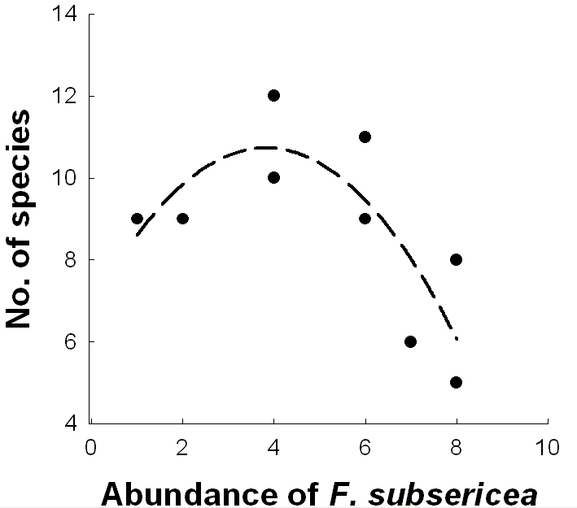
r² = 0.63
y = -0.28x² – 0.47x + 12.73

Figure II-1.
The unimodal relationship between the richness of subdominant ant species recorded in pitfall traps at a site and the number of pitfall traps in which a dominant F. subsericea was recorded. Note that the figure does not include the statistical outlier. We show unadjusted r² for the polynomial fit (n = 9, P = 0.05).

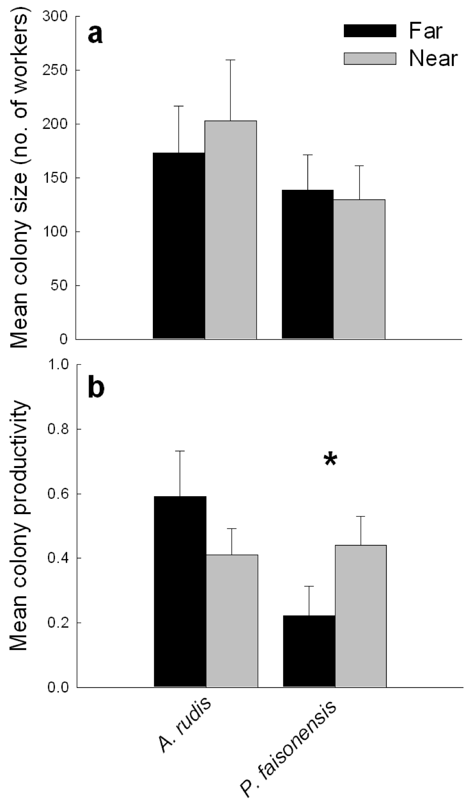
Figure II-2.
Mean (± SE) a) colony size (number of workers) and b) colony productivity (number of broods/number of workers) of subdominant ant species A. rudis and P. faisonensis near and far from focal nests of dominant F. subsericea.
P = 0.06

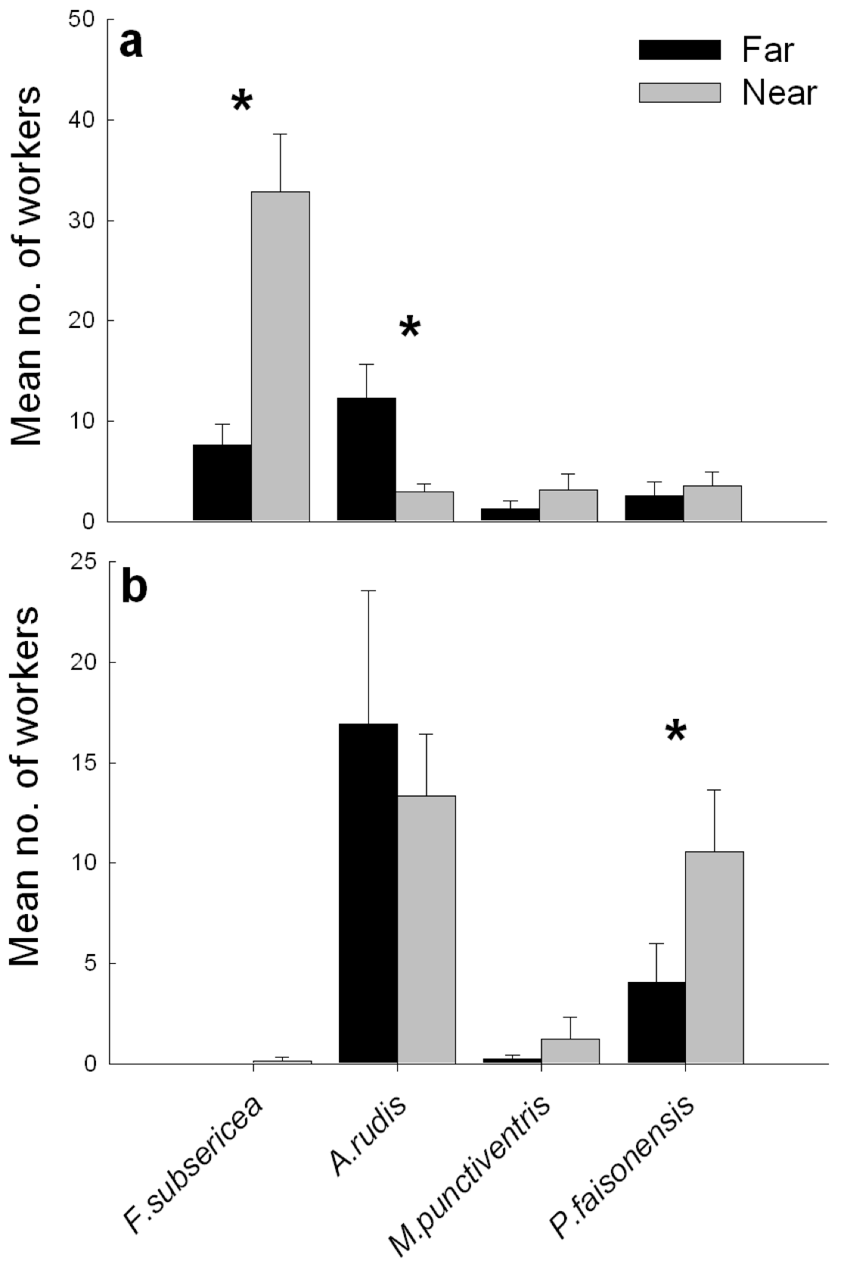
Figure II-3.
Mean (± SE) number of workers of A. rudis, M. punctiventris and P. faisonensis recorded on baits near and far from focal nests of dominant F. subsericea a) during the day and b) at night. Asterisks indicate significant differences between near and far baits (P < 0.05).

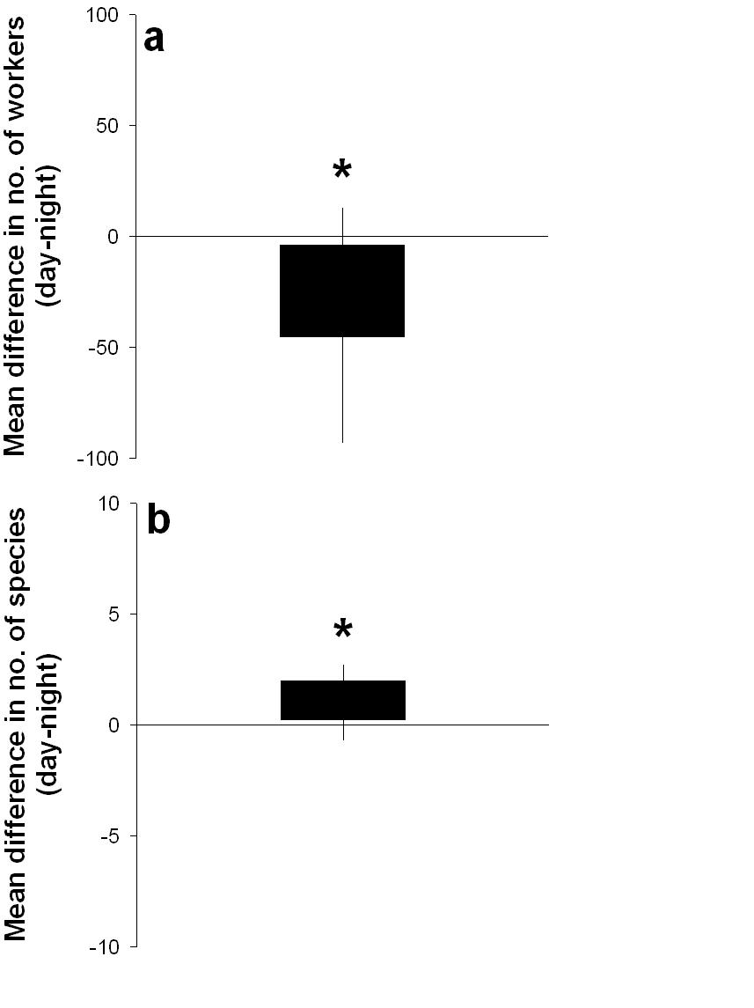
Figure II-4.
Mean difference in the a) number of workers and b) species richness of subdominant ant species recorded on baits during day and night. The boundary of the box closest to zero indicates the 25th percentile, and the boundary of the box farthest from zero indicates the 75th percentile. Whiskers above and below the box indicate the 90th and 10th percentiles. An asterisk indicates a significant difference (day – night) from zero using a one-sample t-test (P < 0.01).

Invasive ants alter the phylogenetic structure on native communities

Published in Ecology and Co-authored by James A. Fordyce, Nicholas J. Gotelli and Nathan J. Sanders

Lessard, J. P., J. A. Fordyce, N. J. Gotelli, and N. J. Sanders. 2009. Invasive ants alter the phylogenetic structure of ant communities. Ecology 90:2664-2669.
Abstract
Invasive species displace native species and potentially alter the structure and function of ecological communities. In this study, we compared the generic composition of intact and invaded ant communities from 12 published studies and found that invasive ant species alter the phylogenetic structure of native ant communities. Intact ant communities were phylogenetically evenly dispersed, suggesting that competition structures communities. However, in the presence of an invasive ant species, these same communities were phylogenetically clustered. Phylogenetic clustering in invaded communities suggests that invasive species may act as strong environmental filters and prune the phylogenetic tree of native species in a non-random manner, such that only a few closely related taxa can persist in the face of a biological invasion. Taxa that were displaced by invasive ant species were evenly dispersed in the phylogeny, suggesting that diversity losses from invasive ant species are not clustered in particular lineages. Collectively, these results suggest that there is strong phylogenetic structuring in intact native ant communities, but the spread of invasive species disassembles those communities above and beyond the effect of simple reductions in diversity.
Introduction
Recent studies have taken advantage of the increasing availability of phylogenetic data to infer assembly processes from the taxonomic composition of local communities (e.g., Ackerly et al. 2006, Cavender-Bares et al. 2006, Kembel and Hubbell 2006, Kraft et al. 2007, Swenson et al. 2007). Because ecological niches tend to be phylogenetically conserved (Swenson et al. 2006, Johnson and Stinchcombe 2007), examining the extent to which co-occurring species are related can provide insights into the ecological processes shaping communities (but see Losos 2008). Phylogenetic clustering (i.e., coexisting species are more closely related than expected by chance) can arise if habitats filter species. This results in a set of closely related species whose traits allow them to persist in a particular habitat (Horner-Devine and Bohannan 2006). Alternatively, phylogenetic evenness (i.e., coexisting species are more distantly related than expected by chance) might arise if competitive exclusion reduces co-occurrence among closely related species (Slingsby and Verboom 2006). If community structure arises by neutral processes (Hubbell 2001), or if the opposing forces of habitat filtering and interspecific competition counteract one another, then phylogenetic structure may appear random (Kraft et al. 2007).

The spread of invasive species can also offer insights into the mechanisms controlling community assembly. In a recent study, Strauss et al. (2006) used community phylogenetics in the context of biological invasions to investigate susceptibility of native plant communities to invasion by introduced grass species. They found that introduced grasses were more likely to become established if the native community lacked taxa closely related to the introduced species.

The spread of invasive species can also offer insights into the mechanisms controlling community assembly. In a recent study, Strauss et al. (2006) used community phylogenetics in the context of biological invasions to investigate susceptibility of native plant communities to invasion by introduced grass species. They found that introduced grasses were more likely to become established if the native community lacked taxa closely related to the introduced species.

Invasive ant species provide some of the best evidence that competitively dominant species can affect biodiversity (Holway et al. 2002), alter species composition (O'Dowd et al. 2003), and alter patterns of species co-occurrence (Gotelli and Arnett 2000, Sanders et al. 2003). In this study, we describe the effects of invasive ant species on the phylogenetic structure of native ant communities at both local and regional scales to infer the processes underlying community assembly.

We examined the phylogenetic structure of intact and invaded ant communities through a meta-analysis of 12 published studies for which phylogenetic information for the taxa in the intact and invaded ant communities is available. We asked three questions: (i) Do intact ant communities exhibit non-random phylogenetic structure? (ii) Does phylogenetic structure change in the presence of an invasive species? (iii) Are species that become locally extinct in the presence of an invasive ant species a phylogenetically non-random subset of the intact community?

Methods
We compiled data on the composition of ant communities by searching Web of Science and Google Scholar using the keywords ants, invasive, invasion, community, richness, diversity and structure on 30 November 2007. From this search we selected studies that (i) explicitly compared invaded and un-invaded (i.e. “intact”) communities, and (ii) used standardized, quantitative sampling methods (sensu Agosti et al. 2000) to quantify ant community structure in both the invaded and intact sites. Only 12 studies met those criteria (Table III-1).

Invaded sites were those in which the invasive ant species was at least twice as abundant as in intact sites, and intact sites were those in which the invasive species was either absent or very uncommon relative to the invaded sites. Locally extinct taxa were defined as those species that were recorded in intact sites but were absent from the invaded sites. However, the degree to which sampled communities are accurate estimates of actual community composition depends on sampling efficiency and techniques (Longino and Colwell 1997). In our study, the absence of a species in a sample suggests that it is either absent from or not abundant enough to be detected in the sampled community (e.g. Morrison 2002).

We further categorized these 12 studies into regional-scale studies (Ward 1987, Porter and Savignano 1990, Holway 1998, Suarez et al. 1998, Gotelli and Arnett 2000, Sanders et al. 2003, Ipser et al. 2004 , King and Tschinkel 2006, Wetterer et al. 2006, Abbott et al. 2007, Garnas et al. 2007, Human and Gordon 2007) and local-scale studies (Ward 1987, Suarez et al.1998, Gotelli and Arnett 2000, Sanders et al. 2003, Ipser et al. 2004, Wetterer et al. 2006). Regional-scale studies were those in which the author(s) provided a single list of species collected from some number of invaded sites and a single list of species from some number of intact sites. A region varied in size from 32 ha (Porter and Savignano 1990) to a 2000 km transect that spanned several eastern U.S. states (Gotelli and Arnett 2001). In contrast, local-scale studies were those studies in which the author(s) provided lists of ant species from replicated samples of the invaded and intact communities. In these local-scale studies, the sampling area ranged from 50 to 200 m². We pooled intact and invaded sites separately in each of the six local-scale studies so that we could examine the impacts of invasive ants on phylogenetic structure at regional scales for these studies as well. We also used these 12 pooled datasets to determine which taxa were displaced in each study. Because not all studies had locally extinct taxa, we used only 8 datasets to form locally extinct taxa subsets for the community phylogenetic analyses.

Constructing the phylogeny
We examined phylogenetic structure of ant communities at the genus level using the phylogeny proposed by Brady et al. (2006). This genus-level phylogeny is based on a Bayesian analysis of 7 nuclear loci (5988 bps). Using the Brady et al. tree as a topological constraint, we estimated branch lengths with maximum likelihood under a GTR+I+Γ model of sequence evolution in PAUP* (Swofford 2002). Branch lengths were estimated using the combined molecular data, and the 18s and 28s data separately. Although branch length estimates based on combined and separated data differed slightly, they did not affect the conclusions of our analyses. Results herein are based upon branch length estimates obtained from the combined dataset. An ultrametric tree was obtained via penalized likelihood (Sanderson 2002) using a smoothing parameter selected via cross validation implemented in r8s (Sanderson 2006) (see Fig. III-1). We explored chronograms based on a single fixed age constraint at the base of the tree, and those obtained with multiple age constraints on the tree, using the lineage age estimates proposed by Brady et al. (2006) and Moreau et al. (2006). None of our results were affected by examining chronograms under these alternate age constraints.

Brady et al.’s (2006) phylogenetic tree is at the taxonomic scale of the genus, thus we assigned each species in our dataset to a genus present in the phylogeny. Note that a robust species-level phylogeny for ants has yet to be completed. In addition, because the phylogeny of Brady et al. (2006) does not include all of the ant genera that occurred in the 12 datasets, we substituted 4 genera in the datasets with genera that were present in the phylogeny. We substituted closely related genera based on phylogenetic and taxonomic information available in the primary literature (see Table III-2) for a list of substituted taxa and for references. For the genera in our analysis that were represented by two species in the Brady et al. (2006) phylogeny, we chose the species which occurred in North America. If the genus was polyphyletic or paraphyletic, we chose the branch of the phylogeny which represented a genus in North America. For the only two studies that were not conducted in North America (Abbott et al. 2007, Wetterer et al. 2006 ), we did not have decide which species would represent each missing genus because all genera recoded in the study were either represented by only one species in the phylogeny or by two species that were monophyletic (e.g. Solenopsis xyloni and Solenopsis molesta).

Polytomies were generated by directly editing the NEWICK tree. For example, consider a tree with three genera, A, B, and C, where A and B are sister taxa that diverge 10 time units before the present, and both diverged from the lineage that gave rise to C 15 time units before the present. Thus, the tree is described as ((A:10,B:10):5,C:15) (Fig. III-2a). If three representatives of genus A were present in the community, we explored the consequences of considering each species within A as a basal polytomy (i.e., each species equally divergent to one another as they are to the sister genus) and a terminal polytomy (i.e., each species with zero divergence time among them). Thus, the basal polytomy is described as (((A1:10,A2:10,A3:10):0,B:10):5,C:15) (Fig. III-2b), and the terminal polytomy is described as (((A1:0,A2:0,A3:0):10,B:10):5,C:15) (Fig. III-2c). It should be noted that these polytomies represent the unrealistic extremes of the distribution of all possible topologies and timing of cladogenetic events.

Testing for phylogenetic structure
We examined phylogenetic structure of ant communities at the genus level using the phylogeny proposed by Brady et al. (2006; Fig. III-1). Unfortunately, a robust species-level phylogeny of the ants does not yet exist. For the analyses here, that means that for an entire genus to be displaced, all of the species in this genus would have to be displaced. Therefore, our metric of the effect of invasive species on the phylogenetic structure is conservative. We note that the only previous study that examined changes in community phylogenetic structure as a consequence of invasive species (Strauss et al. 2006) employed a similar strategy of using a genus-level phylogeny because a species-level phylogeny was not available. We explored the consequences of including species as terminal taxa by creating trees where members of the same genus were modeled as terminal and basal polytomies (see Fig. III-2 for details). However, analyses of tree topologies that included these unrealistic extremes yielded phylogenetic patterns that were uninformative. Hereafter we present the results from only genus-level analyses. Figure 1 illustrates an example of the phylogenetic patterns for California ant communities in the presence and absence of the invasive Argentine ant Linepithema humile (Ward 1987).

We estimated the phylogenetic structure of each community from the 12 studies using two indices: mean phylogenetic distance (MPD) and mean nearest neighbor distance (MNND; Webb et al. 2002). MPD estimates the average phylogenetic relatedness between all possible pairs of taxa in a local community. MNND estimates the mean phylogenetic relatedness between each taxon in a community and its nearest relative.

We then calculated measures of standardized effect sizes (Gotelli and McCabe 2002) of each estimate of phylogenetic structure to facilitate comparisons among studies. The Net Related Index (NRI) estimates the standardized effect size for MPD values, and the Nearest Taxon Index (NTI) estimates standardized effect size for MNND values (Webb et al. 2002). These two standardized indices describe the difference between average phylogenetic distances in the observed and randomly generated null communities, standardized by the standard deviation of phylogenetic distances in the null communities (see Webb et al. 2008 and Appendix B for details). We tested whether the average NRI and NTI values in invaded and intact sites differed from one another using paired t-tests and whether either differed from zero using one-sample t-test. In all analyses and comparisons, the invasive species is not included in the phylogeny.

Constructing the null communities
We compared the observed NTI and NRI values of intact communities to the NTI and NRI values of invaded communities to assess the effect of invasive ants on the phylogenetic structure of native communities. To create null communities we built separate species pools for each study. The species pool from which species were drawn to create the null local and regional communities consisted of all the species recorded in a study (intact and invaded sites). As an example, suppose an investigator sampled only two communities. In Community 1, species A, B, C, and D were collected. In Community 2, species A, C, E, F, and G were collected. The regional species pool for that particular study would consist of species A, B, C, D, E, F, and G. These same species pools were used to test for non-randomness of phylogenetic structure for intact sites, invaded sites, and for displaced taxa at regional scales, and intact and invaded sites at local scales. The invaded communities did not include the invasive species. For the local-scale studies, and for the extinct taxa subsets, we used MODEL 3 in PHYLOCOM (Webb et al. 2007). To generate null communities, MODEL 3 uses an independent swap algorithm developed by Gotelli and Entsminger (2003) to reshuffle the data in a species x sample presence/absence matrix (see Webb et al. 2007 for details). Thus, this approach does not rely on the entire phylogeny to define the possible species pool from which species are drawn. Instead, it uses only the taxa observed in the study for which phylogenetic structure is being estimated. The independent swap algorithm is the most conservative one in terms of rejecting the null, and it is appropriate for the analysis of large datasets. It randomizes genus occurrences, but preserves row totals (number of sites occurrences per genus) and column totals (number of genera per site) in the original matrix. Because the independent swap algorithm is not suitable for small datasets (i.e. n=2 genera), we used a different algorithm for the regional-scale studies. For the analysis of the 12 pooled datasets (6 regional scale, 6 transformed local-scale studies) we used the MODEL1 algorithm in PHYLOCOM to generate null communities (Webb et al. 2007). We also ran MODEL 1 on the local-scale studies to allow direct comparison between local scale and regional scale results. Although the local-scale dataset tended to give more phylogenetically clustered communities when analyzed with MODEL 1 than with MODEL 3, overall, the idiosyncratic nature of the local-scale results did not differ among models. The randomization algorithm for MODEL1 maintains the species richness of each sample, but randomizes the identities of the species occurring in each sample. For each sample, species are drawn without replacement from the species pool (consist of a species list of all the species recorded in a study: intact + invaded sites). Thus, using MODEL1, species in the phylogeny that are not actually observed to occur in a sample were not included in the null communities.

To ask whether the phylogenetic structure of intact ant communities differed from phylogenetic structure of invaded communities using the 6 local-scale studies, we used all the genera that were detected in each of the local communities in the study to construct the taxon source pool from which null communities were assembled. We obtained an NRI and NTI value for each community in the study and then calculated average NRI and NTI values for the intact and invaded communities separately in each study. We then asked whether the average NRI and NTI values in invaded and intact sites differed from one another using paired t-tests and whether either differed from zero using one-sample t-test. Significant departure of mean NRI and NTI values from zero was interpreted as communities being phylogenetically evenly dispersed if mean values were negative, or phylogenetically clustered if mean values were positive (Kembel and Hubbell 2006).

For the regional-scale studies (those which provided only a combined list of species for invaded sites and intact sites), we estimated an NRI and NTI value for the set of invaded sites and an NRI and NTI value for the set of intact sites within each study. Then, we pooled the NRI and NTI values for intact and invaded communities across studies and used one-sample t-tests to determine whether the NRI and NTI for intact and invaded sites differed from 0. For one of the datasets (Wetterer et al. 2006) we used a Wilcoxon Signed-Rank test because the sample size for intact communities was small (n=2). We also used a paired t-test to ask whether average NRI and NTI across studies differed for intact and invaded communities.

To assess whether locally extinct taxa were a non-random subset of the phylogeny, we used the same procedure as for the regional-scale studies. Thus phylogenetic relatedness was estimated from a subset of taxa that were found in the pooled intact communities but were absent from the pooled invaded communities. Invasive taxa were not included in any analyses of phylogenetic structure.

Testing for differences in species and generic richness
We also examined whether ant species richness and generic richness differed between intact and invaded communities. We estimated local species richness (species density) for intact and invaded communities by averaging the number of species recorded across sites in each study and regional species richness as the total number of species recorded in all of the intact or invaded sites. We also estimated the relative proportion of displaced taxa by subtracting the number of taxa recorded in invaded sites from the number recorded in intact sites and dividing that difference by the number of taxa recorded in intact sites. We tested for differences in the absolute number and relative proportion of native species and genera in intact and invaded sites, at both local and regional scales, using paired t-tests and one-sample t-tests.

Testing for differences in phylogenetic diversity
We assessed whether there were differences in phylogenetic diversity between intact and invaded sites using Faith’s index in PHYLOCOM (Webb et al. 2008). We tested that phylogenetic diversity was higher in intact than invaded sites using paired t-tests for the regional-scale studies and Wilcoxon tests for local-scale studies.

Results
Regional-scale studies
At the regional scale, phylogenetic structure of intact ant communities differed significantly from random. Intact ant communities tended to be phylogenetically evenly dispersed (NRI = -0.41, P = 0.01; NTI = -0.06, P = 0.40; Fig. III-4a, 3b; Table III-3). Alternatively, in the presence of invasive species the phylogenetic structure of ant communities tended to be clustered (NRI = 0.78, P = 0.02; NTI = 0.59, P = 0.04; Fig. III-4a, 3b; Table III-3). Finally, ant genera that were displaced showed a pattern opposite of the pattern represented by the species that persisted: they were significantly evenly dispersed in the phylogeny (NRI = -0.92, P < 0.003; NTI = -0.68, P = 0.03; Fig. III-5).

The phylogenetic structure of paired invaded and intact sites differed from one another (NRI: t_{paired} = 1.95, n = 12, P = 0.04; NTI: t_{paired} = 2.09, n = 12, P = 0.03). Although at regional scales the mean number of species in intact and invaded communities differed (intact mean = 26.58 ± 5.08; invaded mean = 17.67 ± 4.93; t_{paired} = -5.72, n = 12, P < 0.0001), the number of genera did not (intact mean = 12.5 ± 1.62; invaded mean = 10.67 ± 1.75; t_{paired} = -1.08, n = 12, P = 0.15). Similarly, the proportional difference in the number of species was greater than zero (t_{one-sample} = -1.76, n = 12, P < 0.0001), but the proportional difference in the number of genera was not (t_{one-sample} = -0.07, n = 12, P = 0.31).

At the genus level, there was no difference in phylogenetic diversity between intact and invaded sites (intact mean = 0.135 ± 0.013, invaded mean = 0.116 ± 0.016; t_{paired} = -1.23; n = 12; P = 0.12). At the species level, there was also no difference in phylogenetic diversity between intact and invaded sites (intact mean = 0.131 ± 0.015, invaded mean = 0.116 ± 0.019; t_{paired} = -0.94; n = 12; P = 0.18).

Local-scale studies
The phylogenetic structure of local intact communities was idiosyncratic. Phylogenetic structure was clustered in one study, evenly dispersed in three, and random in three (Table III-4). Further, neither the number of species (t_{paired} = 0.55, n = 12, P = 0.30) nor the number of genera (t_{paired} = -0.44, n = 12, P = 0.34) differed between intact and invaded communities at local scales. Phylogenetic diversity was higher in intact communities in two studies, higher in invaded communities in one study and not different in three.

Discussion
We found that the phylogenetic structure of intact ant communities at the regional scale differed significantly from random: coexisting genera were, on average, more distantly related than expected from a random assignment of taxa to local sites (Fig. III-3). Although intact communities were phylogenetically evenly dispersed as estimated by NRI, their structure was random as estimated by NTI. Because NRI is sensitive to deeper clade-level patterns of phylogenetic structure, even dispersion as measured by the NRI index indicates that genera from a few disparate lineages co-occur in intact communities.

Under the assumptions of niche conservatism, an evenly dispersed pattern of phylogenetic structure suggests that competition shapes the structure of un-invaded communities by preventing species that are closely related from coexisting with one another (Kraft et al. 2007). An alternative explanation for even phylogenetic dispersion is that it may reflect the effects of habitat filtering (Cavender-Bares et al. 2004) if important ecological traits reflect ecological convergence, rather than niche conservatism (Kraft et al. 2007). Additionally, facilitation might cause communities to appear phylogenetically evenly dispersed (Valiente-Banuet and Verdu 2007). However, both the habitat filtering and the facilitation mechanisms seem implausible for ant assemblages. Habitat filtering is unlikely to be operating here because most genera recorded in these studies have large geographic ranges and are not strong habitat specialists. For example, most of the genera found in Sanders et al.’s (2003) study of the impacts of Linepithema humile on native ants in California were also represented in Gotelli and Arnett’s (2000) study of impacts of Solenopsis invicta in the eastern U.S. Facilitative interactions between ant species have not been documented in the communities analyzed here, but they have been documented in desert (Davidson et al. 1984) and tropical (Davidson et al. 2007) ant assemblages. Clearly, the role of positive, indirect, and facilitative interactions in shaping ant assemblages deserves more attention (Callaway 2007).

In the presence of invasive species the phylogenetic structure of ant communities tended to be clustered. This is consistent with the prediction that invasive species prune the phylogenetic tree of native species in a non-random manner, such that only a few closely related taxa can subsist in the face of biological invasion. Another possibility to account for phylogenetic clustering in invaded communities is that some other factor, such as disturbance, affected both the phylogenetic structure of the invaded community and their susceptibility to invasion (King and Tschinkel 2006). However, at least for several studies in our database, both the invaded and intact sites were relatively undisturbed and yet the structure of the native ant community still differed between intact and invaded sites. Although disturbance affects native ant communities and can increase the probability that invasive species become established, one study in our analysis (Sanders et al. 2003), and one recent study by Tillberg et al. (2007), used pre- and post-invasion data in sites that had not been disturbed, and still found strong impacts of invasive species on native ant communities.

On average, the phylogenetic structure of intact and invaded ant communities differed even though genus-level richness did not. The lack of a difference in genus-level richness indicates that the differences in the phylogenetic structure between invaded and intact sites arose from shifts in community composition rather than from simple reductions in the number of genera in invaded communities. Similarly, Sanders et al. (2003) found differences in the structure of intact ant communities and invaded communities, even though the number of species did not differ between invaded and intact communities. Although ant invasions did not alter the number of genera present, other studies have documented a decline in native ant species richness in the presence of invasive species (Holway et al. 2002). However, even in those studies, there is evidence that changes in species composition cannot be accounted for simply by species losses (Gotelli and Arnett 2000, Sanders et al. 2003).

The relative importance of habitat filtering and competition on community assembly can vary with spatial scale (Kembel and Hubbell 2006). Here, although the phylogenetic structure of intact ant communities at the regional scale was evenly dispersed, results at the local scale were inconsistent, with examples of even, random, and clustered patterns. Our findings are similar to other studies that have documented differences in phylogenetic structure at different spatial scales (e.g., Cavender-Bares et al. 2006, Kembel and Hubbell 2006, Swenson et al. 2006). Why might the phylogenetic structure of ant communities be scale dependent? Dayan and Simberloff (1994) argued that long-term responses of species to interspecific competition are more likely to be detected at regional scales than at local scales, perhaps because competing species might avoid competition at local scales by partitioning time, space and resources. Two other studies of ant community structure have also detected non-random community structure at regional, but not local, spatial scales (Gotelli and Ellison 2002, Sanders et al. 2007).

The ant genera that were displaced were significantly evenly dispersed in the phylogeny. Our results contrast with results from previous studies on plants in which extinct taxa were more related than expected by chance (Willis et al. 2008). If displaced taxa were evenly dispersed in the phylogeny, then how could it be that the remaining communities were phylogenetically clustered? One possibility is that all subfamilies have an equal probability of losing at least one genus. But, because some subfamilies have perhaps only one genus, displacement of that genus strongly affects the topology of the remaining tree (see Figure 1). As an example, when a species in the genus Neivamyrmex (usually the only representative of the Ecitoninae) is displaced, then there are likely to be drastic changes in phylogenetic structure.

If the phylogenetic structure of the displaced taxa were clustered, it would be consistent with the hypothesis that displaced taxa share traits that make them more vulnerable to displacement following the spread of an introduced species. Two possibilities are that invasive species displace specialists (e.g., seed dispersers Suarez et al. 1998; or specialist predators) or primitive lineages (Ward 1987), perhaps because these groups are locally rare even in intact communities. But, our results suggest that identifying which species will be displaced by invasive species may be challenging. In addition, and in contrast to Strauss et al.’s (2006) analysis of invasive plants, we found no association between the position of the invader in the phylogeny and the phylogenetic structure of the community it invades (unpublished results). Nevertheless, the phylogenetic re-organization of invaded ant communities suggests that invasive ants act as strong structuring agent and can affect community membership. Documenting which morphological, behavioral and/or ecological traits are conserved in the ant phylogeny and which of those traits allow resident species to persist following the spread of an invader offers exciting venues for future research.

Acknowledgements
We thank Rob Dunn, Ben Fitzpatrick, Jen Schweitzer and Joe Bailey for insightful conversations, and Mike Weiser, Marc Cadotte and Chris Nice for providing comments on the manuscript. Discussion with Nate Swenson and comments from two anonymous reviewers contributed to improving the manuscript. JP Lessard was supported by NSERC and FQRNT scholarships, and the Department of Ecology and Evolutionary Biology at the University of Tennessee. J Fordyce was supported by a grant from NSF. NJ Gotelli was supported by a grant from NSF and DOE-PER. NJ Sanders was supported by grants from DOE-NICCR and DOE-PER.

References
Abbott, K. L., S. N. J. Greaves, P. A. Ritchie, and P. J. Lester. 2007. Behaviourally and genetically distinct populations of an invasive ant provide insight into invasion history and impacts on a tropical ant community. Biological Invasions 9:453-463.
Ackerly, D. D., D. W. Schwilk, and C. O. Webb. 2006. Niche evolution and adaptive radiation: Testing the order of trait divergence. Ecology 87:S50-S61.
Agosti, D., J. D. Majer, L. E. Alonso, and T. R. Schultz. 2000. Ants: standard methods for measuring and monitoring biodiversity. Smithsonian Institution Press Washington, D. C.
Bolton, B. 1991. New Myrmicine Ant Genera from the Oriental Region (Hymenoptera, Formicidae). Systematic Entomology 16:1-13.
Brady, S. G., T. R. Schultz, B. L. Fisher, and P. S. Ward. 2006. Evaluating alternative hypotheses for the early evolution and diversification of ants. Proceedings of the National Academy of Sciences of the United States of America 103:18172-18177.
Callaway, R.M. (2007) Positive Interactions and Interdependence in Plant Communities. Springer, Dordrecht.
Cavender-Bares, J., D. D. Ackerly, D. A. Baum, and F. A. Bazzaz. 2004. Phylogenetic overdispersion in Floridian oak communities. American Naturalist 163:823-843.
Cavender-Bares, J., A. Keen, and B. Miles. 2006. Phylogenetic structure of floridian plant communities depends on taxonomic and spatial scale. Ecology 87:S109-S122.
Davidson, D.W., J.-P. Lessard, C.R. Bernau and S.C. Cook. 2007. Tropical ant mosaic in a primary Bornean Rain Forest. Biotropica 39: 468-475.
Davidson, D.W., R.S. Inouye and J.H. Brown 1984. Granivory in a desert ecosystem: experimental evidence for indirect facilitation of ants by rodents. Ecology 65:1780-1786.
Dayan, T., and D. Simberloff. 1994. Morphological relationships among coexisting heteromyids - an incisive dental character. American Naturalist 143:462-477.
Garnas, J. R., F. A. Drummond, and E. Groden. 2007. Intercolony aggression within and among local populations of the invasive ant, Myrmica rubra (Hymenoptera : Formicidae), in coastal Maine. Environmental Entomology 36:105-113.
Gotelli, N. J., and A. E. Arnett. 2000. Biogeographic effects of red fire ant invasion. Ecology Letters 3:257-261.
Gotelli, N. J., and A. M. Ellison. 2002. Assembly rules for New England ant assemblages. Oikos 99:591-599.
Gotelli, N. J., and G. L. Entsminger. 2003. Swap algorithms in null model analysis. Ecology 84:532-535.
Gotelli, N. J., and D. J. McCabe. 2002. Species co-occurrence: A meta-analysis of J. M. Diamond's assembly rules model. Ecology 83:2091-2096.
Holway, D. A. 1998. Effect of argentine ant invasions on ground-dwelling arthropods in northern California riparian woodlands. Oecologia 116:252-258.
Holway, D. A., L. Lach, A. V. Suarez, N. D. Tsutsui, and T. J. Case. 2002. The causes and consequences of ant invasions. Annual Review of Ecology and Systematics 33:181-233.
Horner-Devine, M. C., and B. J. M. Bohannan. 2006. Phylogenetic clustering and overdispersion in bacterial communities. Ecology 87:S100-S108.
Hubbell, S. P. 2001. The Unified Neutral Theory of Biodiversity and Biogeography. Princeton Univ. Press., Princeton, NJ.
Human, K. G., and D. M. Gordon. 1997. Effects of Argentine ants on invertebrate biodiversity in northern California. Conservation Biology 11:1242-1248.
Ipser, R. M., M. A. Brinkman, W. A. Gardner, and H. B. Peeler. 2004. A survey of ground-dwelling ants (Hymenoptera : Formicidae) in Georgia. Florida Entomologist 87:253-260.
Johnson, M. T. J., and J. R. Stinchcombe. 2007. An emerging synthesis between community ecology and evolutionary biology. Trends in Ecology & Evolution 22:250-257.
Kembel, S. W., and S. P. Hubbell. 2006. The phylogenetic structure of a neotropical forest tree community. Ecology 87:S86-S99.
King, J. R., and W. R. Tschinkel. 2006. Experimental evidence that the introduced fire ant, Solenopsis invicta, does not competitively suppress co-occurring ants in a disturbed habitat. Journal of Animal Ecology 75:1370-1378.
Kraft, N., W. Cornwell, C. Webb, and D. D. Ackerly. 2007. Trait evolution, community assembly, and the phylogenetic structure of ecological communities. American Naturalist 170:271-283.
Longino, J. T., and R. K. Colwell. 1997. Biodiversity assessment using structured inventory: Capturing the ant fauna of a tropical rain forest. Ecological Applications 7:1263-1277.
Losos, J. B. 2008. Phylogenetic niche conservatism, phylogenetic signal and the relationship between phylogenetic relatedness and ecological similarity among species. Ecology Letters 11:995-1003.
Morrison, L. W. 2002. Long-term impacts of an arthropod-community invasion by the imported fire ant, Solenopsis invicta. Ecology 83:2337-2345.
O'Dowd, D. J., P. T. Green, and P. S. Lake. 2003. Invasional 'meltdown' on an oceanic island. Ecology Letters 6:812-817.
Porter, S., and D. Savignano. 1990. Invasion of polygyne fire ants decimates native ants and disrupts arthropod community. Ecology 71:2095-2106.
Sanders, N. J., N. J. Gotelli, N. E. Heller, and D. M. Gordon. 2003. Community disassembly by an invasive species. Proceedings of the National Academy of Sciences of the United States of America 100:2474-2477.
Sanders, N. J., N. J. Gotelli, S. E. Wittman, J. S. Ratchford, A. M. Ellison, and E. S. Jules. 2007. Assembly rules of ground-foraging ant assemblages are contingent on disturbance, habitat and spatial scale. Journal of Biogeography 34:1632-1641.
Sanderson, M. J. 2002. Estimating absolute rates of molecular evolution and divergence times: a penalized likelihood approach. Molecular Biology and Evolution 19:101-109.
Sanderson, M. J. 2006. r8s (ver. 1.70.) University of California Davis , California, USA.
Slingsby, J. A., and G. A. Verboom. 2006. Phylogenetic relatedness limits co-occurrence at fine spatial scales: Evidence from the schoenoid sedges (Cyperaceae : Schoeneae) of the Cape Floristic Region, South Africa. American Naturalist 168:14-27.
Strauss, S. Y., C. O. Webb, and N. Salamin. 2006. Exotic taxa less related to native species are more invasive. Proceedings of the National Academy of Sciences of the United States of America 103:5841-5845.
Suarez, A. V., D. T. Bolger, and T. J. Case. 1998. Effects of fragmentation and invasion on native ant communities in coastal southern California. Ecology 79:2041-2056.
Swenson, N. G., B. J. Enquist, J. Thompson, and J. K. Zimmerman. 2007. The influence of spatial and size scale on phylogenetic relatedness in tropical forest communities. Ecology 88:1770-1780.
Swenson, N. G., B. J. Enquist, J. Pither, J. Thompson, and J. K. Zimmerman. 2006. The problem and promise of scale dependency in community phylogenetics. Ecology 87:2418-2424.
Swofford, D. L. 2002. PAUP* (ver. 4.0b10): phylogenetic analysis using parsimony. Sunderland, MA: Sinauer.
Tillberg, C. V., D. A. Holway, E. G. LeBrun, and A. V. Suarez. 2007. Trophic ecology of invasive Argentine ants in their native and introduced ranges. Proceedings of the National Academy of Sciences of the United States of America 104:20856-20861.
Valiente-Banuet, A., and M. Verdu. 2007. Facilitation can increase the phylogenetic diversity of plant communities. Ecology Letters 10:1029-1036.
Ward, P. 1987. Distribution of the introduced Argentine ant (Iridomyrmex humilis) in natural habitats of the Lower Sacramento Valley and its effects on the indigenous ant fauna. Hilgardia 55:1-16.
Webb, C. O., D. D. Ackerly, and S. W. Kembel. 2008. PHYLOCOM (ver. 3.40): software for the analysis of community phylogenetic structure and character evolution.
Webb, C. O., D. D. Ackerly, M. A. McPeek, and M. J. Donoghue. 2002. Phylogenies and community ecology. Annual Review of Ecology and Systematics 33:475-505.
Wetterer, J. K., X. Espadaler, A. L. Wetterer, D. Aguin-Pombo, and A. M. Franquinho-Aguiar. 2006. Long-term impact of exotic ants on the native ants of Madeira. Ecological Entomology 31:358-368.
Wetterer, J., T. Schultz, and R. Meier. 1998. Phylogeny of fungus-growing ants (Tribe Attini) based on mtDNA sequence and morphology. Molecular Phylogenetics and Evolution 1:42-47.
Willis, C. G., B. Ruhfel, R. B. Primack, A. J. Miller-Rushing, and C. C. Davis. 2008. Phylogenetic patterns of species loss in Thoreau's woods are driven by climate change. Proceedings of the National Academy of Sciences of the United States of America 105:17029-17033.
Yoshimura, M., and B. Fisher. 2007. A revision of male ants of the Malagasy region (Hymenoptera : Formicidae): Key to subfamilies and treatment of the genera of Ponerinae Zootaxa 1654:21-40.

Appendix III

Tables and figures
Table III-1.
Literature sources for data on community composition of invaded and intact ant assemblages.
Reference | Region | Country | Invasive species | Sampling
Abbott et al. 2007 | Tokelau Island | New Zealand | Anoplolepis gracilipes | pitfall trap
Garnas et al. 2007 | Maine | USA | Myrmica rubra | baiting, pitfall trap
Gotelli and Arnett 2000 | Eastern USA | USA | Solenopsis invicta | pitfall trap
Holway 1998 | California | USA | Linepithema humile | pitfall trap, baiting
Human and Gordon 2007 | California | USA | Linepithema humile | pitfall trap
Ipser et al. 2004 | Georgia | USA | Solenopsis invicta | pitfall trap, leaf-litter, baiting
King and Tschinkel 2006 | Florida | USA | Solenopsis invicta | pitfall trap
Porter and Savignano 1990 | Texas | USA | Solenopsis invicta | pitfall trap
Sanders et al. 2003 | California | USA | Linepithema humile | baiting, visual survey
Suarez et al. 1998 | California | USA | Linepithema humile | pitfall trap
Ward 1987 | California | USA | Linepithema humile | leaf-litter, baiting  visual survey
Wetterer et al. 2006 | Madeira Island | Portugal | Linepithema humile | leaf-litter, visual survey

Table III-2.
Table of taxa substitutions. List of the taxa that were absent in the phylogeny and substituted in the sample dataset.
Original taxa | Substitution | No. of substitution(s) | References
Atta | Acromyrmex | 1 | Wetterer et al. 1998
Cyphomyrmex | Trachymyrmex | 24 | Wetterer et al. 1998
Ponera | Hypoponera | 50 | Yoshimura and Fisher 2007
Rogeria | Stenamma | 1 | Bolton 1991

Table III-3.
Species richness (No. of species) and phylogenetic structure (NRI, NTI) of pooled intact and invaded communities. The table includes results from 7 regional-scale studies, and 5 local-scale studies for which the species data were pooled to create a regional-scale dataset. Table entries are standardized effect sizes. Negative values indicate phylogenetic dispersion. Positive values indicate phylogenetic clustering.
Reference | No. species  Intact | No. species  Invaded | NRI  Intact | NRI  Invaded | NTI  Intact | NTI  Invaded
Abbott et al. 2007 | 11 | 8 | -0.65 | 2.14 | -0.62 | 2.12
Garnas et al. 2007 | 19 | 4 | 0.58 | 1.02 | 1 | 1.51
Gotelli and Arnett 2000 | 56 | 49 | -0.3 | 2.15 | -0.45 | 1.08
Holway 1998 | 24 | 13 | -0.19 | -0.15 | 0.76 | 0.01
Human and Gordon 2007 | 11 | 6 | -1 | 0.32 | 1 | 0.73
Ipser et al. 2004 | 67 | 57 | 0 | 0.78 | -0.71 | 0
King and Tschinkel 2006 | 18 | 16 | -0.58 | 1.95 | -0.77 | 1.65
Porter and Savignano 1990 | 30 | 16 | -0.43 | 0.12 | 0.27 | -0.1
Sanders et al. 2003 | 12 | 10 | -0.63 | 1.68 | 0.07 | 1.54
Suarez et al. 1998 | 23 | 16 | 0.4 | -1.47 | 1.04 | -1
Ward 1987 | 28 | 10 | -0.84 | 1.13 | -1 | 0.49
Wetterer et al. 2006 | 20 | 7 | -1.32 | -0.33 | -1.33 | -1

Table III-4.
Mean Net Relatedness Index (NRI) and Nearest Taxon Index (NTI) for intact and invaded communities for the six local-scale studies. Asterisks indicate the level of statistical significance using single sample t-tests (* = P ≤ 0.05, ** = P <0.01) and the P gives the level of significance on the difference of average NRI and NTI values between intact and invaded communities.
Reference | NRI  Intact | NRI  Invaded | NRI Difference | NTI Intact | NTI Invaded | NTI Difference
Gotelli and Arnett 2000 | -1.27** | -1.95** | P = 0.02 | -1.80** | -1.24** | P = 0.04
Ipser et al. 2004 | 0.66 | 2.04** | P = 0.03 | 0.46 | 0.99** | P = 0.25
Sanders et al. 2003 | -0.37* | -0.04 | P = 0.31 | -0.38* | -0.02 | P = 0.29
Suarez et al.1998 | 0.20* | -0.18 (p=0.08) | P = 0.21 | 0.23 | -0.19 | P = 0.25
Ward 1987 | 0.04 | -0.14 | P = 0.22 | 0.24 | -0.28 | P = 0.64
Wetterer et al. 2006 | -1.91 | 0.3 | P < 0.01 | -1.27* | -0.06 | P = 0.07
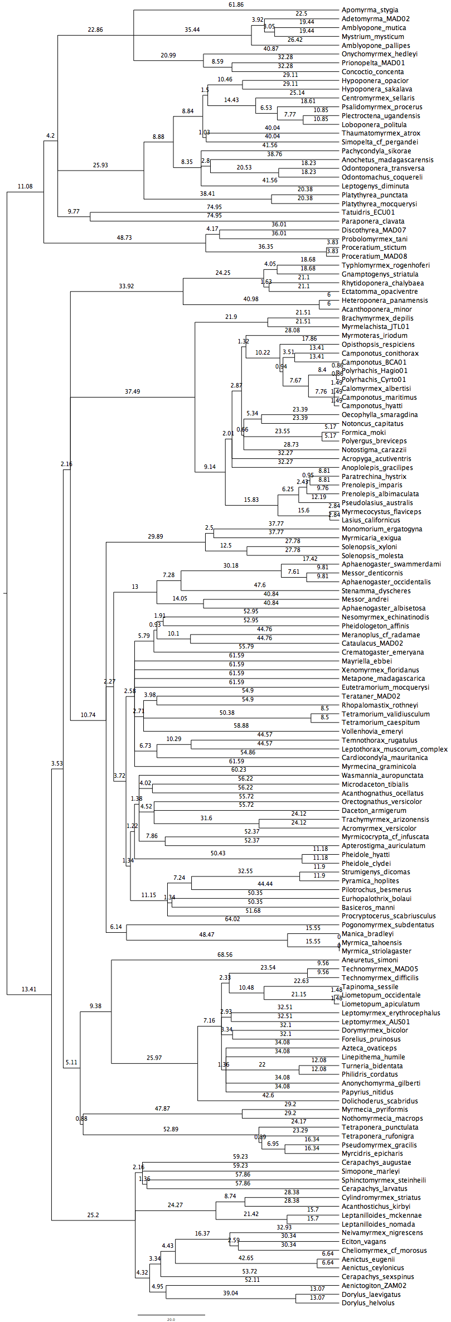
Figure III-1. Complete genus-level phylogeny with branch-length.
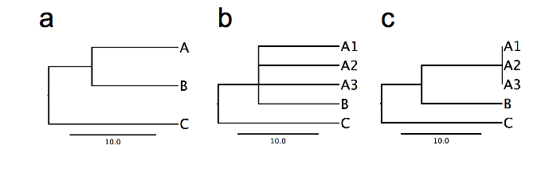
Figure III-2. Scenario for generated polytomies when multiple species within a genera are present in community. a) Phylogeny with three genera. b) Phylogeny with three genera and three representatives of genus A forming a basal polytomy. c) Phylogeny with three genera and three representatives of genus A forming a terminal polytomy.
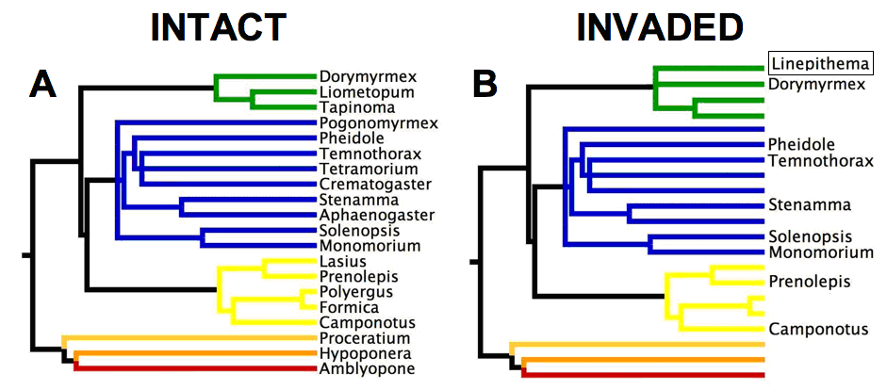
Figure III-3.
Example of regional-scale phylogenetic structure of intact California ant communities versus those invaded by the Argentine ant Linepithema humile (Ward 1987). A: intact communities are phylogenetically evenly dispersed; B: invaded communities are phylogenetically clustered. Colored branches indicate different ant subfamilies: green = Dolichoderinae; blue = Myrmecinae; light yellow = Formicinae; dark yellow = Proceratiinae; orange = Ponerinae; red = Amblyoponinae. The phylogenetic position of the invader Linepithema is indicated by the black rectangle.

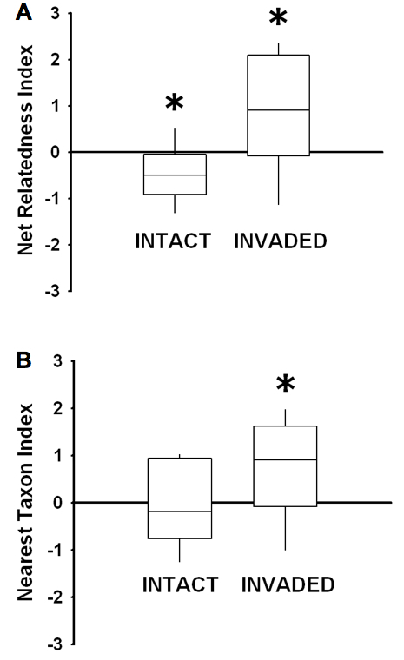

Figure III-4.
Phylogenetic structure of intact and invaded ant communities pooled for 12 studies listed in Table III-1. Boxplots showing (A) NRI and (B) NTI values. Positive NRI and NTI values indicate phylogenetic clustering whereas negative values indicate phylogenetic evenness. Asterisks indicate significant departure from the null expectation of no phylogenetic structure (P ≤ 0.05).

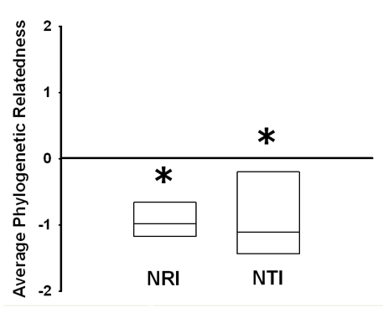

Figure III-5.
Mean phylogenetic relatedness of extinct species subset for 7 regional-scale studies. Phylogenetic relatedness is estimated using mean NRI and NTI values. Asterisks indicate means that are significantly different from zero.

Determinants of the detrital arthropod community structure: the effects of temperature and resources along an environmental gradient.

Accepted for publication in Oikos

Co-authored by Tara E. Sackett, William N. Reynolds, David A. Fowler and Nathan J. Sanders
Abstract
Understanding the factors that shape community structure, and whether those factors vary geographically, has a long history in ecology. Because the abiotic environment often varies in predictable ways along elevational gradients, montane systems are ideal to study geographic variation in the determinants of community structure. In this study, we first examined the relative importance of environmental gradients, microclimate, and food resources in driving spatial variation in the structure of detrital communities in forests of southeastern USA. Then, in order to assess whether the determinants of detrital community structure varied along a climatic gradient, we manipulated resource availability and microclimatic conditions at 15 sites along a well-studied elevational gradient. We found that arthropod abundance and richness generally declined with increasing elevation, though the shape of the relationship varied among taxa. Overall community composition and species evenness also varied systematically along the climatic gradient, suggesting that broad-scale variation in the abiotic environment drives geographic variation in both patterns of diversity and community composition. After controlling for the effect of climatic variation along the elevational gradient, food resource addition and microclimate alteration influenced the richness and abundance of some taxa. However, the effect of food resource addition and microclimate alteration on the richness and abundance of arthropods did not vary with elevation. In addition, the degree of community similarity between control plots and either resource-added or microclimate-altered plots did not vary with elevation suggesting a consistent influence of microclimate and food addition on detrital arthropod community structure. We conclude that using manipulative experiments along environmental gradients can help tease apart the relative importance, and detect the interactive effects, of local-scale factors and broad-scale climatic variation in shaping communities.

Introduction
Because both abiotic conditions and local community composition vary geographically, the processes that determine community structure could also vary geographically. Indeed, there is a long history in ecology of attempts to understand how local processes like competition, predation, and herbivory vary along geographic gradients, such as the latitudinal gradient (Paine 1966, MacArthur 1972, Jeanne 1979, Pennings et al. 2003, Schemske et al. 2009). Elucidating the ecological determinants of community structure along climatic gradients can be challenging because of the confounding influence of multiple factors such as evolutionary history (Ricklefs and Schluter 1993) and variation in the composition of regional species pools (Cornell 1999). However, studies carried out along elevational gradients can partially circumvent these problems, for at least two reasons. First, variation in evolutionary history is likely to be less pronounced along elevational gradients than along latitudinal gradients because elevational gradient studies are typically restricted to one region (Ricklefs 2007). Second, elevational gradients typically exhibit a continuous change in climate (i.e., temperature often decays monotonically with increasing elevation; McCain 2005, 2009) while habitat type changes little (relative to changes along latitudinal gradients), minimizing the confounding effects of among-site differences in habitat characteristics (Sanders et al. 2007, Romdal and Rahbek 2009).

Species diversity often varies in predictable ways along elevational gradients. Linear and monotonic relationships between species diversity and elevation are widespread in both plant and animal taxa (McCain 2005, Rahbek 2005, McCain 2007a, b, Nogues-Bravo et al. 2008, McCain 2009). But understanding the underlying mechanisms driving these diversity patterns remains elusive. Temperature often correlates with diversity along elevational gradients, but temperature might mediate changes in diversity either directly or indirectly. With arthropods, temperature can directly impose a physiological limit on the elevational distribution of taxa (Addo-Bediako et al. 2000, Clarke and Gaston 2006). Another possibility, which has not been thoroughly examined, is that temperature might mediate access to food resources (Sanders et al. 2007) such that more time can be spent foraging for resources at low than at high elevation. Distinguishing between these possibilities requires experimentally manipulating both temperature and resource availability along elevational gradients, which is the central aim of this paper.

Broad-scale variation in climate, whether along latitudinal or elevational gradients, influences both the structure of arthropod communities (e.g., the number of species; Sanders et al. 2010) and the rates of activity of particular taxa (Jeanne 1979, Pennings and Silliman 2005, O'Donnell et al. 2007). In particular, variation in temperature can modify species interactions (Cerdá et al. 1997, Morelissen and Harley 2007, O'Connor 2009) and influence the degree to which food resources are accessible (Murcia 1990, Sanders and Platner 2007, Sanders et al. 2007, Stringer et al. 2007). Small-scale variation in temperature within a single site can also drive spatial variation in rates of activity and in the composition and abundance of a variety of arthropod groups (Basset and Kitching 1991, Niemela et al. 1996, Cerdá et al. 1998, Villalpando et al. 2009). For example, humidity and temperature control the timing and duration of ant foraging activity at small spatial scales (e.g., 1-10 m²) (Kaspari 1993, Kaspari and Weiser 2000) and rates of nest emigration/relocation in some forest ant species (Smallwood 1982).

Spatial variation in food resource availability can also shape the structure of local arthropod communities (Polis et al. 1997). In detrital communities, food resource addition often increases abundance and species richness of ants (Kaspari 1996, McGlynn 2006, Arnan et al. 2007), spiders (Chen and Wise 1999), beetles (Yang 2006), and microarthropods (Chen and Wise 1999, Halaj and Wise 2002). Food resource addition can either increase macroarthropod abundance via a bottom-up effects from increased abundance of prey for macroarthropods (Chen and Wise 1999), or increase the activity of top predators (e.g.,, dominant ants) such that intraguild predation intensifies and subsequently decreases the abundance of subdominant predators (e.g., spiders, beetles) (Moya-Larano and Wise 2007). Previous studies have documented the effects of resource addition on detrital communities (Chen and Wise 1999, Halaj and Wise 2002), but to our knowledge no studies have examined whether there is geographic variation in the effects of resource addition on detrital communities.

In temperate forests, pulses of nitrogen-based resources can dramatically alter the cycling of nitrogen and stimulate bacterial and fungal communities indicating possible nitrogen limitation (Yang 2004, Lovett et al. 2009). A pulse in nitrogen-based resource availability can directly affect detrital communities (Yang 2006). In particular, specialized and generalist scavenging beetles increase in density following nitrogen-based food resource addition (Yang 2006). Omnivorous taxa such as ants and predators such as spiders can also increase in density, especially if nitrogen-based resource addition increases the density of prey items such as springtails and mites (Cole et al. 2005, 2008), which feed on microbes occurring on decaying material (Klironomos et al. 1992).

In this study, we took advantage of natural variation in the abiotic environment combined with an experimental manipulation to examine the relative and interactive influence of regional climate and local factors in shaping community structure. In particular, we manipulated food resource availability and microclimate along an elevational gradient to assess whether there was a geographic variation in the effect of these local factors on the structure of arthropod communities. First we tested whether there is a relationship between (1) arthropod abundance and elevation and (2) between arthropod richness and elevation, and we tested whether the relationship was linear or monotonic. We predicted that the diversity of all arthropod groups would decline with elevation because the drastic change in temperature should limit the number of species that can persist and the sizes of populations at high elevations. Our experimental design further allowed for disentangling competing ecological mechanisms underlying elevational gradients in arthropod diversity. Specifically, we tested whether temperature directly drives variation in arthropod abundance and richness or affects arthropods by controlling access to food resources. We tested this hypothesis in two ways: (1) we examined whether there is an interaction between food addition and microclimate alteration and (2) there is an interaction between food addition and elevation. Second, we tested the hypotheses that microclimate alteration reduces arthropod abundance and richness and that food resource addition increases arthropod abundance and richness. Since all arthropod groups are ectotherms, we predicted that all groups would decrease in abundance and richness in the temperature-reduced plots. However, we predicted that because omnivorous ants and scavenging beetles can directly exploit added food resources, these groups would respond more strongly to food addition than would spiders, springtails or mites. Finally, we tested the hypothesis that changes in the richness, abundance and composition of arthropods associated with the manipulation of local factors would vary along the elevational gradient. More specifically, we predicted that the importance of food resource availability in structuring arthropod communities would decline with increasing elevation because environmental filtering might be more limiting than food availability in harsh climatic conditions.

Methods
Study Sites
This experiment was conducted between May – September 2007 at 15 sites along an elevational gradient (383 – 1318 m) in Great Smoky Mountains National Park, Tennessee, USA. The 15 sites were located at least 100m apart in tree-fall gaps of mixed hardwood forest away from roads and heavily visited trails. Sites were evenly spread along the elevational gradient. Gap canopy cover varied from 60% to 85%. Dominant tree species included Acer saccharum, Quercus rubra, Tsuga canadensis, Liriodendron tulipifera, Fagus grandifolia, Castanea dentata, and Betula alleghaniensis (see Appendix A for the details), and the composition of the tree community did not vary systematically among the plots. Annual temperature declines linearly with elevation in this system (Sanders et al. 2007, Fridley 2009; Table IV-1).

Experimental Design
At each of the 15 sites we randomly placed four 4-m² plots at least 2 m from one another, and we randomly assigned each plot to one of four treatments: food addition, shading, food addition+shading, or control (no food or shade). Previous studies have used a variety of food items to enhance food resource input into detrital communities: mushrooms, potatoes, instant Drosophila medium (Chen and Wise 1999), shredded muck mulch (Halaj and Wise 2002), and cicada carcasses (Yang 2006). Here we manipulated food availability by adding 225g of ground dog food (18% protein, 8% fat, 6% fiber, 12% water) once per week throughout the month of June. Beginning in July, we used dead crickets (length ~ 1.5cm) as a food resource instead of dog food because dog food attracted bears near some of the study sites. Changing the type of food resource in mid-summer might have affected the responses of some arthropod species. Note however that both dog food and crickets were protein-based, and all plots would have been equally affected. That is, we did not apply dog food to low elevation plots, but crickets to high elevation plots. In addition, previous resource addition experiments with detrital communities have varied widely in the food item they used, in the same way that the resources available to the detrital community varies throughout the summer (Sackett et al. in prep.).

Bears visited a few sites (Lessard, personal observation). To assess whether disturbance by bears affected the results of our experiment, we conducted our analyses excluding the sites that had been frequently visited. Removing these sites from our analyses did not affect the general conclusions stemming from the experiment. Once per week until the end of the experiment (i.e.,, September 16th, 2007), we added 50 crickets to the food addition treatment plots. Food items were evenly distributed within a 1m² quadrat in the center of each experimental plot.

We manipulated shade (thereby reducing temperature) by using square shade tables. Shade tables consisted of 90% knitted polyethylene shade cloth covering a square PVC pipe frame anchored by rebar stakes placed 30 cm in the ground at each plot corner, with the shade cloth 50cm from the ground. Control plots and food addition plots had no shade tables, but we placed a rebar at each corner to control for disturbance effects.

Arthropod Sampling
Three months after the beginning of the experiment (mid-September 2007), we sampled the leaf-litter arthropod communities within each experimental plot using Winkler extractors (see Sanders et al. 2007 for details). We sampled leaf-litter arthropods two weeks after the last food addition to increase the likelihood that the sampled communities reflected the structure of the resident rather than transient arthropod communities. Winkler extraction consists of sifting the leaf-litter through a metal screen, and transferring the leaf-litter residue into a mesh bag. The mesh bag is then suspended within a nylon bag to which is attached a jar filled with 95% ethanol. Arthropods were collected from the ethanol 72 hours after the Winkler extractors were suspended. We counted and identified all ants (Formicidae), spiders (Araneae), beetles (Coleoptera), springtails (Collembola), and mites (Acari). We identified ants to species (except for those in the genera Pyramica and Stenamma), beetles to morphospecies within families, and spiders, mites and springtails to morphospecies. All taxa were identified to the lowest possible taxonomic resolution by well-trained investigators. Although we identified adult spider specimens to species, we present data at the family level because the majority of individuals in our samples were immature and could be identified only to the family level. Family-level richness and species richness (excluding immature individuals) were positively correlated (r² = 0.78, P < 0.0001). Voucher specimens were deposited in N.J. Sanders’s collection in the Department of Ecology and Evolutionary Biology at the University of Tennessee.

Microclimate treatments
We assessed whether resource addition and shading affected the microclimatic condition in our experimental plots by recording soil and air temperature and humidity once per month in each experimental plot. We measured ambient air temperature and humidity in each treatment plot using an Extech Hygro-Thermometer. We used a hand-held infrared thermometer (Raytec® Raynger ST™) to measure ground surface temperature, and a HydroSense Soil Water Content Measurement System to measure soil humidity. For each microclimatic variable, we averaged 4 measurements taken at random at the center of each experimental plot, once per month. Of all microclimatic factors measured, only ground temperature was affected, and temperature was affected only by the shade treatments. Ground temperature in shade treatments was on average 2.80 ± 0.64 ºC lower in shade than in control treatments (F_{1, 13} = 22.26, P < 0.0001).

Statistical Analyses
Because we were interested in the shape of the relationship between elevation and the abundance and richness of several taxa, we used regressions to test whether richness and abundance were related to elevation. We tested for the best-fit line using a second-degree polynomial or a linear model. We selected the best model by comparing AIC scores.

Our experimental design was a 2×2 factorial analysis of covariance (ANCOVA) with food, shade and their interaction as the main effects and elevation as the covariate. We used MANCOVA to assess the overall effects of food, shade and elevation on richness and abundance of multiple arthropod taxa: the abundance and richness of each taxa were our response variables. Because the MANCOVA yielded significant results (Wilks’ Lambda = 0.054, P < 0.0001), we followed it with subsequent ANCOVA’s on each taxon. ANCOVA assesses how much of the variation in the response variable is explained by local factors (i.e., food addition and microclimate alteration) after removing the effect of the covariate (i.e., elevation). Because the response variable and the covariate (elevation) were not always linearly related, we added a polynomial term (i.e., elevation²) to the ANCOVA model when a second-degree polynomial model best fit the relationship between the response variable and the covariate (see Table 2). In addition, because the food×shade, food×shade×elevation, food×elevation and shade×elevation interactions were never significant, we did not include interaction terms in any of the analyses. We did not use a traditional Bonferroni correction because it is generally too conservative and unfairly penalizes analyses involving multiple comparisons (Gotelli and Ellison 2004). However, we used sequential Bonferroni correction, which is less conservative than traditional Bonferroni correction. Note that a sequential Bonferroni correction also increases the probability of a Type II error and thus should be used cautiously (Nakagawa 2004).

We also assessed the effect of resource addition, microclimate and elevation on the structure of the overall arthropod communities using two different metrics of community structure. For each experimental plot we calculated both Hurlbert’s PIE (Hurlbert 1971), which is an index of species evenness. We estimated species evenness using Hurlbert’s (1971) PIE, which estimates the probability of an interspecific encounter in a given sample:
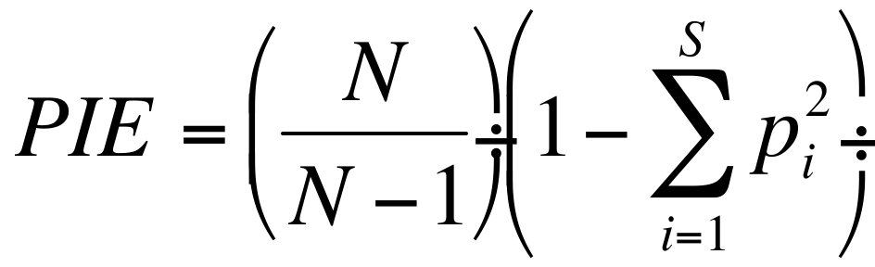

where N represents the total number of individuals, S is the number of species, and p_{i} is the proportion of the sample comprised of species i. PIE estimates the probability that two randomly sampled individuals represent two different species. PIE is an unbiased metric of evenness and is equivalent to measuring the slope of an individual-based rarefaction curve at its base (Olszewski 2004). We used EcoSim 7.0 (Gotelli and Entsminger 2009) to calculate PIE for each experimental plot. We also estimated rarefied species richness for each experimental plot. Rarefaction standardizes species richness across experimental plots based on the lowest number of individuals collected in any one sample. Therefore, rarefaction assesses whether differences in species richness among plots or treatments persist after controlling for differences in abundance. In our case, we rarefied richness in communities to 39 individuals using the VEGAN package in R (Oksanen 2008).

Finally, we assessed whether the degree to which overall arthropod community composition differed between experimental and control plots varied with elevation. We used the Bray-Curtis similarity index to assess pair-wise differences in community composition between experimental and control plots. We compared the species composition of control plots to the species composition of shade plots and resource enhanced plots. We then used linear regression to test whether the degree of similarity between control plots and either resource enhanced or shaded plots varied with elevation.

Results
In total, we collected 8277 arthropod individuals representing over 258 morphospecies (hereafter species) at the 15 sites (details summarized in Table IV-2 and IV-3).

The pattern of ant species richness with elevation was best fit with a second-degree polynomial regression and peaked at ~ 600m, whereas the relationship between worker abundance and elevation was best fit by a linear regression (Figure IV-1, Table IV-4). Both the richness and abundance of spiders were best fit with a second-degree polynomial regression and peaked at ~600m, but note that both of these relationships were only marginally significant following sequential Bonferroni corrections. Both the richness and abundance of beetles were best fit with a second-degree polynomial regression. Species richness of beetles peaked at ~ 600m, but the abundance of beetles peaked at ~ 900m. The species richness and abundance of mites were not related to elevation. The richness of springtails was not related to elevation, but the abundance of springtails was best fit with a second-degree polynomial regression (not significant using sequential Bonferroni corrections). Overall species richness of arthropods was best fit by a second-degree polynomial regression and peaked at ~ 600m, whereas overall arthropod abundance was best fit with a decelerating linear regression.

Food addition had no statistically significant effect on species richness or abundance of ant workers in the leaf litter (Figure VI-1, Table IV-5). There was no effect of food addition on species richness of spiders, but the abundance of spiders was, on average, 32% lower in food addition plots (7.89 ± 1.54) than in control plots (11.89 ± 2.01). The species richness of beetles was 33% lower in food addition plots (4 ± 0.88) than in control plots (6 ± 1.08), but the abundance of beetles did not differ. The richness and abundance of both springtails and mites were not affected by food addition. Overall arthropod richness was 11% lower in food addition plots (26.95 ± 2.42) than in the control plots (31.78 ± 2.47), but overall arthropod abundance did not differ between treatments. There was no interaction between the effect of food addition and elevation.

Ant species richness was 11% lower in shade treatments (3.11 ± 0.49) than in control treatments (3.45 ± 0.55), but there was only a marginal statistical difference in the abundance of ant workers between shade and control treatments (Figure IV-1, Table IV-5). In contrast, the richness of spiders did not differ between shade and control treatments whereas the abundance of spiders was 43% higher in shade treatments (16.95 ± 2.67) than in control treatments (11.89 ± 2.01). For spiders, within-site abundance and richness patterns were driven by web-spinning spiders, with a 62% higher abundance in shade plots (10.28 ± 2.07) than in control plots (6.33 ± 1.54), while the abundance of cursorial spiders did not differ between shaded and control plots (F_{2,57} = 0.87, P = 0.36). Neither the species richness nor the abundance of beetles, mites or springtails was affected by shade. Similarly, the overall species richness or abundance of arthropods was not affected by the shade treatments. There was never an interaction between the effect of shade and elevation.

We used two different metrics as response variables in ANCOVA’s to assess the effects of resource addition, microclimate and elevation on the overall structure of the arthropod communities (Table IV-6). Hurlbert’s PIE, a measure of species evenness, was negatively related to elevation, but did not depend on resource addition or microclimate. Rarefied species richness was not related to any of the explanatory variables, suggesting that variation in arthropod abundance mediates whatever effects the treatments or elevation have on overall arthropod richness. There was no interaction between food addition and elevation, or between shade and elevation for either evenness or rarefied richness.

The Bray-Curtis similarity index indicated that the degree to which community composition differed between control and experimental plots
was not related to elevation, when either the resource enhanced plots (r² = 0.02, df = 14, P = 0.64) or microclimate altered plots (r² = 0.02, df = 14, P = 0.64) were compared to control plots.

Discussion
Broad-scale variation in climate drives spatial variation in the structure and composition of many detrital communities (Reynolds et al. 2003, Chatzaki et al. 2005, Escobar et al. 2005, Jimenez-Valverde and Lobo 2007, Lessard et al. 2007, Sanders et al. 2007, Sanders et al. 2010). Although richness and abundance of arthropod taxa studied here varied idiosyncratically with elevation, the richness and abundance of most macroarthropod groups were related to elevation while there was no or only a weak relationship between elevation and the richness and abundance of microarthropod groups. In addition, when statistically significant, the relationship between both the species richness of individual arthropod taxa and overall arthropod richness with elevation was always hump-shaped (Figure IV-1). One possible explanation for the general hump-shaped pattern of arthropod richness is that species richness saturates at low elevations due to the small size of our sampling units (i.e., 1m²). Alternatively, even though we selected sites that were apparently not disturbed, the history of human disturbance might have been more pronounced at low than high elevation such that low elevation sites tended to be species depauperate (Nogues-Bravo et al. 2008). The abundance of arthropod taxa either declined linearly with elevation or peaked at mid-elevation. But the fact that overall arthropod abundance declined linearly with elevation suggests that temperature constrains the size of populations at high elevations (Sanders et al. 2007). Note that rarefied arthropod species richness was not related to elevation, suggesting that patterns of total arthropod species richness along the elevational gradient were sensitive to differences in local abundance. That is, richness varied along the elevational gradient likely because abundance varied along the elevational gradient.

As a caveat to our experiment, the size of the sampling grain can greatly affect the shape of the abundance and richness-elevation relationship within and among groups of varying body sizes (Rahbek 2005). Differences in body size and dispersal ability among taxonomic groups are likely to affect how organisms perceive the environment: small-bodied organisms may respond to finer scale heterogeneity in the environment than large-bodied ones (Kaspari and Weiser 1999, Espadaler and Gomez 2001, Parr et al. 2003, Farji-Brener et al. 2004, Kaspari and Weiser 2007). Thus, among-taxa differences in patterns of diversity along climatic gradients might be the consequence of the size of the sampling grain being better suited to capture variation in the diversity of large-bodied taxa than small-bodied ones. In addition, the sampling protocol used in the current study likely sampled some taxa differentially. However, our sampling protocol was standardized such that comparisons of the richness and abundance of taxa among plots is constant, and our main focus was to assess variation along the gradient, not to compare richness of one taxon to another. In other similar studies, leaf-litter extraction, or a variant of leaf-litter extraction, tends to be the most commonly used approach for sampling a variety of leaf-litter arthropods (Chen & Wise 1999; Halaj & Wise 2002). Some studies have used pitfall traps, but this sampling technique tends to be biased towards mobile organisms (Topping and Sunderland 1992).

Though our results support the hypothesis that temperature limits abundance and therefore richness in this system, other factors that covary with elevation might also be important. For example, even though we sampled in broadleaf deciduous forests along the gradient, subtle differences in plant community composition could affect soil arthropod communities in ways that we did not measure (Donoso et al. 2010, Oecologia). While ant diversity does not correlate with leaf-litter depth in our study system (Sanders, unpublished data), many arthropod groups are sensitive to leaf-litter complexity (Hansen 2000), leaf-litter depth (Uetz 1979, Bultman and Uetz 1982, Wagner et al. 2003) or micro-habitat architectural characteristics (Kaspari and Weiser 1999, Espadaler and Gomez 2001, Parr et al. 2003, Farji-Brener et al. 2004, Kaspari and Weiser 2007). In particular, spiders (Uetz 1979, Bultman and Uetz 1982, Wagner et al. 2003) and mites (Hansen 2000) are sensitive to changes in leaf-litter characteristics, which might explain why diversity in these groups is not or only weakly related to elevation. Carrying out experiments, which manipulate habitat heterogeneity in the leaf-litter, could also help understand these, and other, patterns of diversity (Hansen 2000, Sarty et al. 2006).

The importance of climate in driving spatial variation in the structure of detrital communities was further evidenced by changes in the relative abundance of major taxa along the elevational gradient. Evenness varied systematically along the elevational gradient, indicating that climate filters out cold-intolerant species at high elevation sites, a pattern previously documented with ants in this system (Lessard et al. 2007). Relative dominance or evenness decreased with elevation because as elevation increased, microarthropods became increasingly overrepresented relative to the rest of the community while macroarthropods became underrepresented (Figure IV-2A, 2B). The disproportionally high abundance of microarthropods at high elevation calls into question whether cold temperatures or seasonality imposes a limit on body size (Mousseau 1997, Schutze and Clarke 2008, Entling et al. 2009). Changes in the relative dominance of functional groups can result in changes to the magnitude of interactions or the performance of functions (Hillebrand et al. 2008). The shift in evenness of macroarthropods and microarthropods could reflect an interesting shift in interactions and processes resulting from these interactions to be examined further.

Within sites, resource addition and microclimate alteration had only limited effects on the overall structure of detrital communities. Although overall arthropod richness was lower in resource-added plots than in control plots, the effects of resource addition on arthropod richness disappeared when we controlled for differences in abundance among plots, indicating that changes in overall arthropod abundance drove down overall arthropod richness in resource-added plots. Nevertheless, a reduction in the overall diversity of arthropods when resource availability was increased is likely due to the loss of specialist species that were not able to exploit the type of resources we used. For example, a closer examination of hyperdiverse taxon such as beetles shows that the richness of a specialized phytophagous family (i.e., Curculionidae) was lower in resource-added plots than in control plots (F_{1,58} = 14.68, P = 0.0003), whereas the abundance and richness of species in most other beetle families was not affected.

We found that manipulations of resource availability and microclimate at the local scale affected only specific arthropod groups in detrital communities. Neither richness nor abundance of any of the arthropod taxa studied here were higher in resource addition plots than in the control plots. Results from our resource addition experiment thus contrast with previous studies showing that nitrogen-based resource addition in detrital food webs increases the abundance of microbial and fungal consumers such as springtails and mites (Cole et al. 2005, 2008). Perhaps then it is not surprising that predaceous spiders or ants did not respond positively to food resource addition since some of these macroarthropods might rely largely on mites and springtails to fulfill their diet (Chen and Wise 1999, Halaj and Wise 2002). The lack of a significant response to resource addition in our system suggests that the amount of nitrogen-based food resource available to detrital communities is not limiting, and thus has minimal effects on the local distribution of most arthropod groups. Instead, spatial variation in microclimate seemed to drive the local distribution of species. Reduced ground temperature under the shade structures led to a decrease in the abundance of ants and an increase in the abundance of spiders. Given that ground temperature is known to control the timing and duration of ant foraging activity (Cerdá et al. 1998, Lessard et al. 2009), microclimate alteration might have reduced the activity of particular ant species. Thus the absence or reduced activity of particular ant species in shaded plots might have provided taxa such as spiders with a refuge against ant predation or a release from interference competition.

Biotic interactions could be responsible for some of the patterns observed within sites. Of particular interest is the low abundance of spiders in the food addition plots. The presence of particular ant species attracted to the added food resources could have deterred web-spinning spiders. A previous study in temperate forests showed that artificial baits increased the activity of large omnivorous ants (e.g., Camponotus and Formica) and led to the local displacement of certain groups of spiders (Moya-Larano and Wise 2007). Though in the current study food addition did not increase ant richness and abundance in the leaf-litter, it might have caused ground-dwelling ants (which includes Camponotus and Formica) to forage more intensively in and around the food added plots.

In addition to direct effects of temperature and resource availability, microsite temperature could mediate the effect of food availability on arthropod communities by controlling access to those resources (e.g., foraging activities; Cerdá et al. 1998, Lessard et al. 2009). If that were the case, then we would predict that un-shaded, resource-added plots would have more species and individuals than shaded, resource-added plots or control plots. However, we found that resource addition did not interact with temperature to control arthropod richness and abundance. Nevertheless, our results indicate that within-site variation in temperature shapes arthropod communities via other ecological mechanisms than controlling access to food resources. Instead, variation in microclimate within sites might act as an environmental filter and shape the local distribution of species in the same way that broad-scale variation in climate drives the geographic distribution of species. Temperature can shape the structure of communities via a variety of other mechanisms, including its effect on energy availability (Clarke and Gaston 2006).

Because temperature affects the rate at which species interact (Cerdá et al. 1998, O'Donnell et al. 2007) and can mediate access to resources (Murcia 1990), we predicted that the effect of local factors on arthropod communities would vary along the elevational gradient due to variation in ambient temperatures. We expected resource addition to have a stronger effect on low elevation communities than high elevation ones because temperature is less likely to restrict activity rates (e.g., rates of foraging activities) at low than at high elevation. We further predicted that microclimate alteration would have a stronger effect on community structure at high than low elevation, because the abiotic environment already exerts a strong selective pressure at high elevation. Our results, however, indicate that the influence of local factors on arthropod community composition does not vary along this climatic gradient (indicated by the lack of significant interaction terms - food×elevation and shade×elevation). For example, when ground temperature was reduced, ant species richness was always lower and spider abundance always higher locally than in control treatments, regardless of elevation. In addition, the difference in overall arthropod species composition (estimated with the Bray-Curtis similarity index) between experimental and control plots did not co-vary with elevation, further refuting the hypothesis that the importance of local food availability and microclimate on arthropod community structure depends on regional climate. Several studies have documented geographic variation in biotic interactions and the outcome of those interactions on community structure (Jeanne 1979, Pennings and Silliman 2005, O'Donnell et al. 2007). But here, we found no evidence of geographic variation in the effect of local-scale factors on arthropod community structure.

Taken together, our work suggests that broad-scale variation in climate strongly influences the structure of detrital communities among sites. Within-sites, local factors such as spatial variation in resource availability and microclimate can further affect the number of species and individuals of particular taxa. While the importance of the interplay between local and regional factors has been recognized for some time (Schluter and Ricklefs 1993), few studies have explicitly examined how local and regional factors interact, especially along elevational gradients. Integrative gradient analyses (i.e., conducting manipulative experiments along environmental gradients; Fukami and Wardle 2005), such as the one used here can provide a unique opportunity to disentangle the relative contribution of processes operating over broad spatial scales, and those operating locally, in shaping the structure of communities. Integrative gradient analyses further offer an exciting opportunity for testing alternate hypotheses while trying to determine the underlying ecological mechanisms driving variation in species diversity along environmental gradients.

Acknowledgments
Thanks to Andrew Jones, Chris Burges, Audry Hite, Noa Davidai for help in the lab and in the field and to Rob Dunn, Christy McCain, Walter Jetz, Chris Buddle, Katie Stuble and Mariano Rodriguez-Cabal for providing useful comments on a previous version of the manuscript. We especially thank Daniel Gruner and two anonymous reviewers for making comments that greatly improved the quality of the manuscript. JP Lessard was supported by FQRNT and NSERC doctoral scholarships and the Department of Ecology and Evolutionary Biology at the University of Tennessee. Tara Sackett was supported by a FQRNT post-doctoral fellowship. Nathan Sanders was supported by DOE-PER grant DE-FG02-08ER6451.

References

Addo-Bediako, A., S. L. Chown, and K. J. Gaston. 2000. Thermal tolerance, climatic variability and latitude. Proceedings of the Royal Society of London Series B-Biological Sciences 267:739-745.

Arnan, X., A. Rodrigo, and J. Retana. 2007. Uncoupling the effects of shade and food resources of vegetation on Mediterranean ants: an experimental approach at the community level. Ecography 30:161-172.

Bailey, J. K., S. C. Wooley, R. L. Lindroth, and T. G. Whitham. 2006. Importance of species interactions to community heritability: a genetic basis to trophic-level interactions. Ecology Letters 9:78-85.

Basset, Y., and R. L. Kitching. 1991. Species number, species abundance and body length of arboreal arthropods associated with an Australian rain-forest tree. Ecological Entomology 16:391-402.

Bultman, T. L., and G. W. Uetz. 1982. Abundance and community structure of forest floor spiders following litter manipulation. Oecologia 55:34-41.

Cerdá, X., J. Retana, and S. Cros. 1997. Thermal disruption of transitive hierarchies in Mediterranean ant communities. Journal of Animal Ecology 66:363-374.

Cerdá, X., J. Retana, and A. Manzaneda. 1998. The role of competition by dominants and temperature in the foraging of subordinate species in Mediterranean ant communities. Oecologia 117:404-412.

Chatzaki, M., P. Lymberakis, G. Markakis, and M. Mylonas. 2005. The distribution of ground spiders (Araneae, Gnaphosidae) along the altitudinal gradient of Crete, Greece: species richness, activity and altitudinal range. Journal of Biogeography 32:813-831.

Chen, B. R., and D. H. Wise. 1999. Bottom-up limitation of predaceous arthropods in a detritus-based terrestrial food web. Ecology 80:761-772.

Clarke, A., and K. J. Gaston. 2006. Climate, energy and diversity. Proceedings of the Royal Society B-Biological Sciences 273:2257-2266.

Clarke, K. R., and R. M. Warwick. 2001. Change in marine communities: an approach to statistical analysis and interpretation, 2nd edition. PRIMER-E. Plymouth.

Cole, L., S. M. Buckland, and R. D. Bardgett. 2005. Relating microarthropod community structure and diversity to soil fertility manipulations in temperate grassland. Soil Biology & Biochemistry 37:1707-1717.

Cole, L., S. M. Buckland, and R. D. Bardgett. 2008. Influence of disturbance and nitrogen addition on plant and soil animal diversity in grassland. Soil Biology & Biochemistry 40:505-514.

Cornell, H. V. 1999. Unsaturation and regional influences on species richness in ecological communities: A review of the evidence. Ecoscience 6:303-315.

Donoso, D., M. Johnston, and M. Kaspari. Trees as templates for tropical litter arthropod diversity. Oecologia.

Entling, W., M. H. Schmidt-Entling, S. Bacher, R. Brandl, and W. Nentwig. 2009. Body size-climate relationships of European spiders. Journal of Biogeography 37:477-485.

Escobar, F., J. M. Lobo, and G. Halffter. 2005. Altitudinal variation of dung beetle (Scarabaeidae : Scarabaeinae) assemblages in the Colombian Andes. Global Ecology and Biogeography 14:327-337.

Espadaler, X., and C. Gomez. 2001. Formicine ants comply with the size-grain hypothesis. Functional Ecology 15:136-138.

Faith, D. P., P. R. Minchin, and L. Belbin. 1987. Compositional dissimilarity as a robust measure of ecological distance. Vegetatio 69:57-68.

Farji-Brener, A. G., G. Barrantes, and A. Ruggiero. 2004. Environmental rugosity, body size and access to food: a test of the size-grain hypothesis in tropical litter ants. Oikos 104:165-171.

Fridley, J. D. 2009. Downscaling climate over complex terrain: high fine-scale spatial variation of near-ground temperatures in a montane forested landscape (Great Smoky Mountains, USA). Journal of Applied Meteorology and Climatology:in press.

Fukami, T., and D. A. Wardle. 2005. Long-term ecological dynamics: reciprocal insights from natural and anthropogenic gradients. Proceedings of the Royal Society B-Biological Sciences 272:2105-2115.

Gotelli, N., and G. Entsminger. 2004. EcoSim: Null models software for ecology. Acquired Intelligence Inc. & Kesey-Bear., Jericho, VT 05465.

Gotelli, N. J., and A. M. Ellison. 2004. A primer of ecological statistics. Sinauer Associates, Sunderland, Massachusetts, USA.

Halaj, J., and D. H. Wise. 2002. Impact of a detrital subsidy on trophic cascades in a terrestrial grazing food web. Ecology 83:3141-3151.

Hansen, R. A. 2000. Effects of habitat complexity and composition on a diverse litter microarthropod assemblage. Ecology 81:1120-1132.

Hillebrand, H., D. M. Bennett, and M. W. Cadotte. 2008. Consequences of dominance: A review of evenness effects on local and regional ecosystem processes. Ecology 89:1510-1520.

Hurlbert, S. H. 1971. Nonconcept of Species Diversity - Critique and Alternative Parameters. Ecology 52:577-&.

Jeanne, R. L. 1979. A latitudinal gradient in rates of ant predation. Ecology 60:1211-1224.

Jimenez-Valverde, A., and J. M. Lobo. 2007. Determinants of local spider (Araneidae and Thomisidae) species richness on a regional scale: climate and altitude vs. habitat structure. Ecological Entomology 32:113-122.

Kaspari, M. 1993. Body-size and microclimate use in neotropical granivorous Ants. Oecologia 96:500-507.

Kaspari, M. 1996. Testing resource-based models of patchiness in four Neotropical litter ant assemblages. Oikos 76:443-454.

Kaspari, M., and M. Weiser. 2007. The size-grain hypothesis: do macroarthropods see a fractal world? Ecological Entomology 32:279-282.

Kaspari, M., and M. D. Weiser. 1999. The size-grain hypothesis and interspecific scaling in ants. Functional Ecology 13:530-538.

Kaspari, M., and M. D. Weiser. 2000. Ant activity along moisture gradients in a neotropical forest. Biotropica 32:703-711.

Klironomos, J. N., P. Widden, and I. Deslandes. 1992. Feeding preferences of the collembolan Folsomia candida in relation to microfungal successions on decaying litter. Soil Biology and Biochemistry 24:685-692.

Lessard, J. P., R. R. Dunn, C. R. Parker, and N. J. Sanders. 2007. Rarity and diversity in forest ant assemblages of Great Smoky Mountains National Park. . Southeastern Naturalist 6:215-228.

Lessard, J. P., R. R. Dunn, and N. J. Sanders. 2009. Temperature-mediated coexistence in forest ant communities. Insectes Sociaux 56:149-156.

Lovett, G. M., L. M. Christenson, P. M. Groffman, C. G. Jones, J. E. Hart, and M. J. Mitchell. 2009. Insect defoliation and nitrogen cycling in gorests. BioScience 52:335-341.

MacArthur, R. H. 1972. Geographical Ecology: Patterns in the Distributions of Species. Harper & Row, New York.

McCain, C. M. 2005. Elevational gradients in diversity of small mammals. Ecology 86:366-372.

McCain, C. M. 2007a. Area and mammalian elevational diversity. Ecology 88:76-86.

McCain, C. M. 2007b. Could temperature and water availability drive elevational species richness patterns? A global case study for bats. Global Ecology and Biogeography 16:1-13.

McCain, C. M. 2009. Global analysis of bird elevational diversity. Global Ecology and Biogeography 18:346-360.

McGlynn, T. P. 2006. Ants on the move: resource limitation of a litter-nesting ant community in Costa Rica. Biotropica 38:419-427.

Morelissen, B., and C. D. G. Harley. 2007. The effects of temperature on producers, consumers, and plant-herbivore interactions in an intertidal community. Journal of Experimental Marine Biology and Ecology 348:162-173.

Mousseau, T. A. 1997. Ectotherms follow the converse to Bergmann's Rule. Evolution 51:630-632.

Moya-Larano, J., and D. H. Wise. 2007. Direct and indirect effects of ants on a forest-floor food web. Ecology 88:1454-1465.

Murcia, C. 1990. Effect of floral morphology and temperature on pollen receipt and removal in Ipomoea trichocarpa. Ecology 71:1098-1109.

Nakagawa, S. 2004. A farewell to Bonferroni: the problems of low statistical power and publication bias. Behavioral Ecology 15:1044-1045.

Niemela, J., Y. Haila, and P. Punttila. 1996. The importance of small-scale heterogeneity in boreal forests: Variation in diversity in forest-floor invertebrates across the succession gradient. Pages 352-368. Munksgaard Int Publ Ltd.

Nogues-Bravo, D., M. B. Araujo, T. Romdal, and C. Rahbek. 2008. Scale effects and human impact on the elevational species richness gradients. Nature 453:216-U218.

O'Connor, M. I. 2009. Warming strengthens an herbivore-plant interaction. Ecology 90:388-398.

O'Donnell, S., J. Lattke, S. Powell, and M. Kaspari. 2007. Army ants in four forests: geographic variation in raid rates and species composition. Journal of Animal Ecology 76:580-589.

Oksanen, J., Kindt, R., Legendre, P., O'Hara, R., Simpson, G.L., Solymos, P., Henry, M., Stevens, H. Wagner, H. . 2008. VEGAN: Community Ecology Package. R package.

Olszewski, T. D. 2004. A unified mathematical framework for the measurement of richness and evenness within and among multiple communities. Oikos 104:377-387.

Paine, R. T. 1966. Food web complexity and species diversity. American Naturalist 100:65-&.

Parr, Z. J. E., C. L. Parr, and S. L. Chown. 2003. The size-grain hypothesis: a phylogenetic and field test. Ecological Entomology 28:475-481.

Pennings, S. C., E. R. Selig, L. T. Houser, and M. D. Bertness. 2003. Geographic variation in positive and negative interactions among salt marsh plants. Ecology 84:1527-1538.

Pennings, S. C., and B. R. Silliman. 2005. Linking biogeography and community ecology: Latitudinal variation in plant-herbivore interaction strength. Ecology 86:2310-2319.

Polis, G. A., W. B. Anderson, and R. D. Holt. 1997. Toward an integration of landscape and food web ecology: the dynamics of spatially subsidized food webs. Annual Review of Ecology and Systematics 28:289-316.

Rahbek, C. 2005. The role of spatial scale and the perception of large-scale species-richness patterns. Ecology Letters 8:224-239.

Reynolds, B. C., D. A. Crossley, and M. D. Hunter. 2003. Response of soil invertebrates to forest canopy inputs along and elevational gradient. Pedobiologia 47:127-139.

Ricklefs, R. E. 2007. History and diversity: Explorations at the intersection of ecology and evolution. American Naturalist 170:S56-S70.

Ricklefs, R. E., and D. Schluter. 1993. Species Diversity in Ecological Communities: Historical and Geographical Perspectives. . University of Chicago Press, Chicago.

Romdal, T. S., and C. Rahbek. 2009. Elevational zonation of afrotropical forest bird communities along a homogeneous forest gradient. Journal of Biogeography 36:327-336.

Sanders, D., and C. Platner. 2007. Intraguild interactions between spiders and ants and top-down control in a grassland food web. Oecologia 150:611-624.

Sanders, N. J., R. R. Dunn, M. C. Fitzpatrick, C. E. Carlton, M. R. Pogue, C. R. Parker, and T. R. Simons. 2009. Diverse elevational diversity gradients in Great Smoky Mountains National Park, USA.

Sanders, N. J., J. P. Lessard, M. C. Fitzpatrick, and R. R. Dunn. 2007. Temperature, but not productivity or geometry, predicts elevational diversity gradients in ants across spatial grains. Global Ecology and Biogeography 16:640-649.

Sarty, M., K. L. Abbott, and P. J. Lester. 2006. Habitat complexity facilitates coexistence in a tropical ant community. Oecologia 149:465-473.

Schemske, D. W., G. G. Mittelbach, H. V. Cornell, J. M. Sobel, and K. Roy. 2009. Is There a latitudinal gradient in the importance of biotic interactions? Annual Review of Ecology Evolution and Systematics 40:245-269.

Schluter, D., and R. E. Ricklefs. 1993. Convergence and the regional component of species diversity. Pages 230–242 in R. E. Ricklefs and D. Schluter, editors. Species diversity in ecological communities: historical and geographical perspectives. University of Chicago Press, Chicago, IL,.

Schutze, M. K., and A. R. Clarke. 2008. Converse Bergmann cline in a Eucalyptus herbivore, Paropsis atomaria Olivier (Coleoptera : Chrysomelidae): phenotypic plasticity or local adaptation? Global Ecology and Biogeography 17:424-431.

Shuster, S. M., E. V. Lonsdorf, G. M. Wimp, J. K. Bailey, and T. G. Whitham. 2006. Community heritability measures the evolutionary consequences of indirect genetic effects on community structure. Evolution 60:991-1003.

Smallwood, J. 1982. The Effect of Shade and Competition on Emigration Rate in the Ant Aphaenogaster-Rudis. Ecology 63:124-134.

Stringer, L. D., J. Haywood, and P. J. Lester. 2007. The influence of temperature and fine-scale resource distribution on resource sharing and domination in an ant community. Ecological Entomology 32:732-740.

Topping, C. J., and K. D. Sunderland. 1992. Limitations to the Use of Pitfall Traps in Ecological-Studies Exemplified by a Study of Spiders in a Field of Winter-Wheat. Journal of Applied Ecology 29:485-491.

Uetz, G. W. 1979. Influence of Variation in Litter Habitats on Spider Communities. Oecologia 40:29-42.

Villalpando, S. N., R. S. Williams, and R. J. Norby. 2009. Elevated air temperature alters an old-field insect community in a multifactor climate change experiment Global Change Biology 15:930-942.

Wagner, J. D., S. Toft, and D. H. Wise. 2003. Spatial stratification in litter depth by forest-floor spiders. Journal of Arachnology 31:28-39.

Yang, L. H. 2004. Periodical cicadas as resource pulses in North American forests. Science 306:1565-1567.

Yang, L. H. 2006. Interactions between a detrital resource pulse and a detritivore community. Oecologia 147:522-532.

Appendix IV

Tables and figures
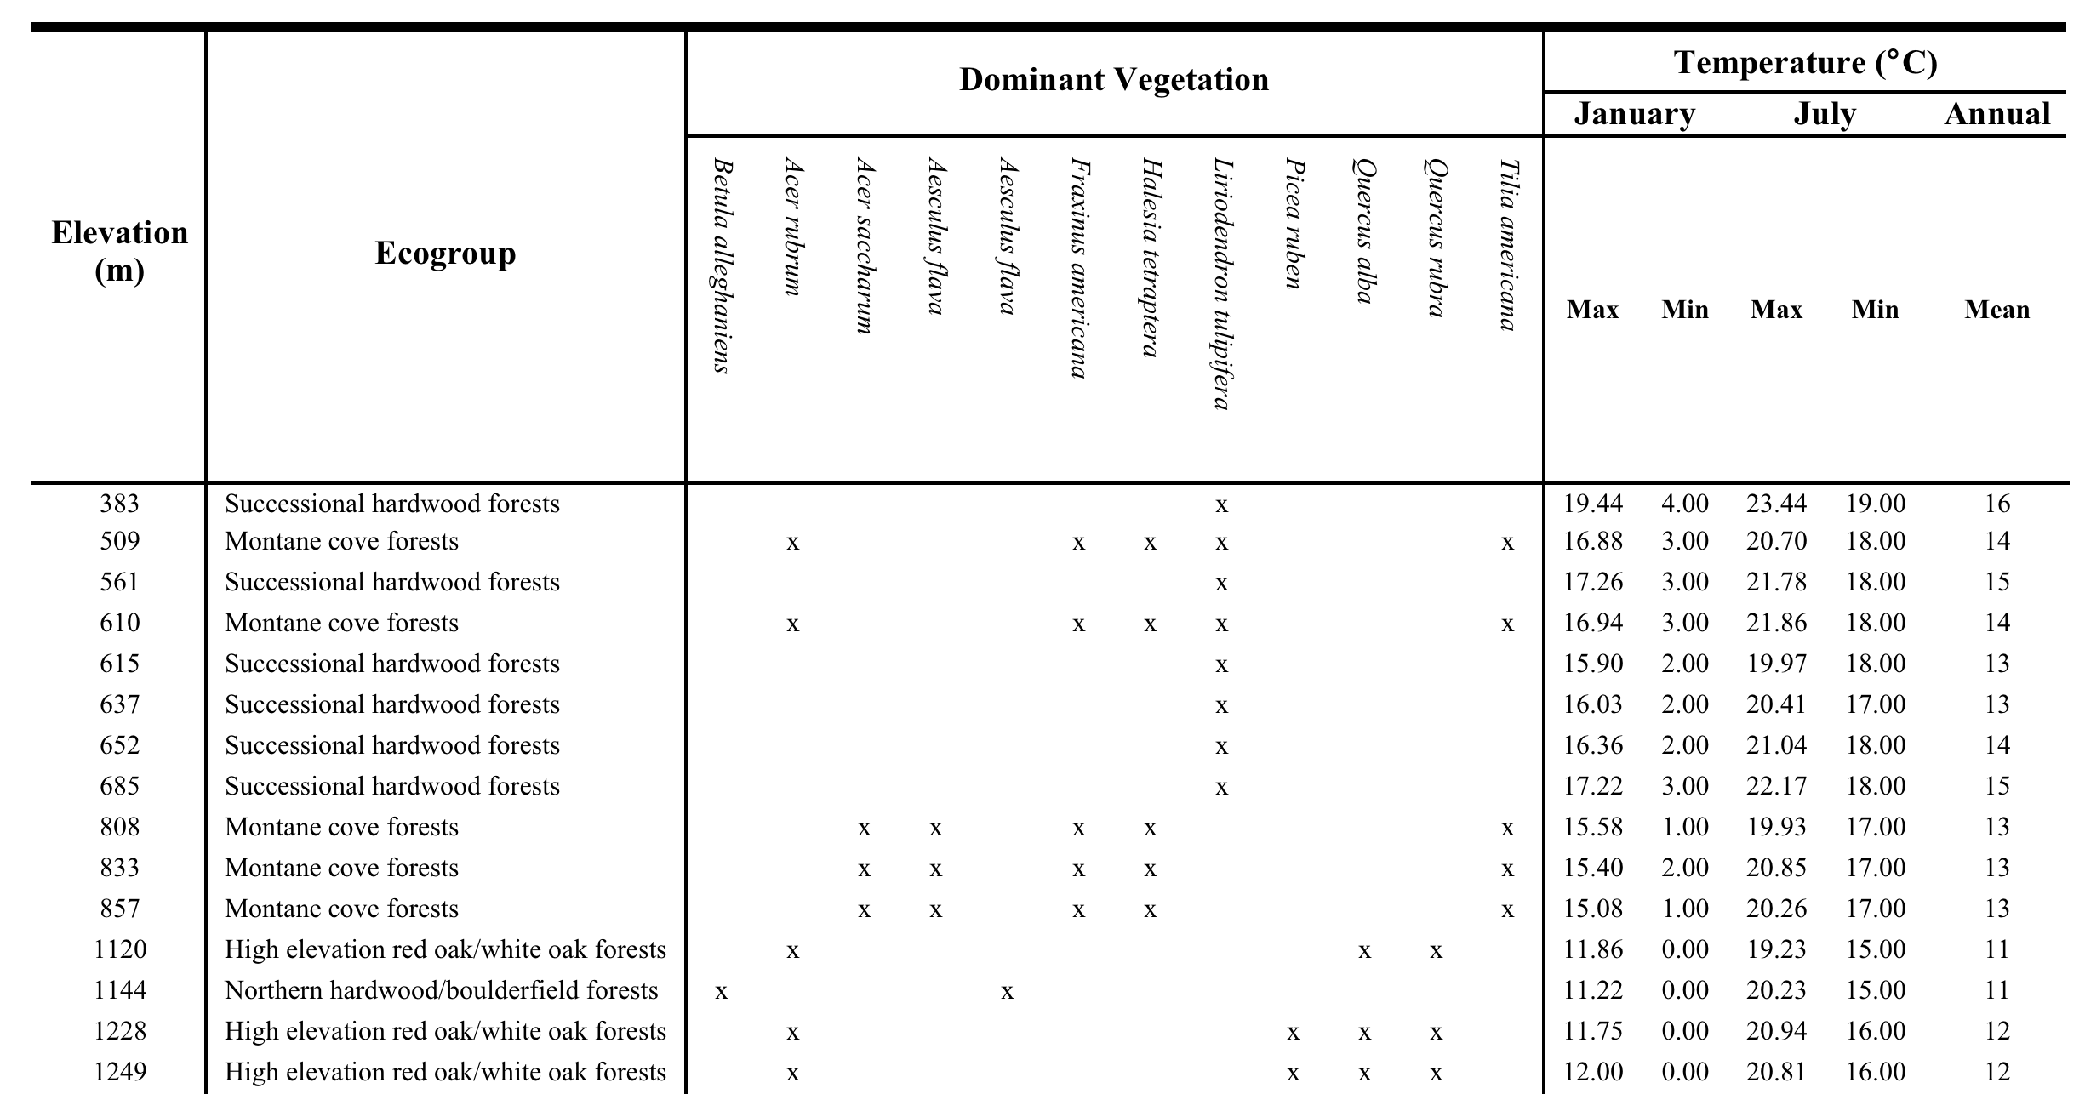
Table IV-1.
Site description. For each site, the table shows elevation, general forest type, composition of the dominant vegetation, minimum, maximum and mean temperature. Science staff at Great Smoky Mountains National Park provided the vegetation and climate.

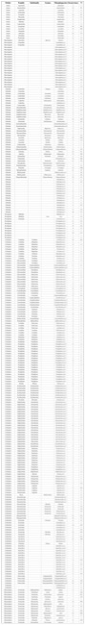
Table IV-2.
List of leaf-litter arthropod taxa sampled using Winkler extractors in Great Smoky Mountains National Park. Except for ants, morphospecies names are arbitrary and correspond to a specimen in the voucher collection. The occurrence column shows the number of 1m2 quadrats in which each morphospecies was recorded and the abundance column shows the total number of individuals recorded across all quadrats.

Table IV-3
Total number of individuals and morphospecies recorded for each taxonomic group, taxonomic resolution and range of the number of species and individuals recorded among 1m² leaf-litter samples.
Taxon | Total no. of individuals | No. of morphospecies | Taxonomic resolution | Range in Species richness | Range in abundance
Ants (Formicidae) | 1808 | 15 | species | 1 to 8 | 1 to 259
Spiders (Aranae) | 774 | 15 | families | 1 to 8 | 1 to 38
Beetles (Coleoptera) | 511 | 110 | morphospecies | 1 to 13 | 1 to 43
Mites (Acari) | 4009 | 86 | morphospecies | 6 to 23 | 15 to 213
Springtails (Collembola) | 1175 | 41 | morphospecies | 1 to 16 | 1 to 256

Table IV-4.
Best-fit models for relationship between species richness (S) and abundance (N) against elevation. Results are shown for analyses across all treatments (n = 60) and averaged for each site (n = 15). Grey shading indicates significant (P < 0.05) best-fit models for each taxa and response variable.
 |  |  |  |  |  | All Treatments |  |  |  |  |  |  | Averaged
Taxa |  | Response variables |  | Models |  | R² |  | AIC |  | P |  |  | R² |  | AIC |  | P
Ants |  | S |  | Linear |  | 0.71 |  | 3.59 |  | 0.0001 |  |  | 0.85 |  | -8.47 |  | 0.0001
Ants |  | S |  | Polynomial |  | 0.75 |  | -2.80 |  | 0.0001 |  |  | 0.89 |  | -11.77 |  | 0.0001
Ants |  | N |  | Linear |  | 0.26 |  | 407.88 |  | 0.0001 |  |  | 0.39 |  | 96.15 |  | 0.01
Ants |  | N |  | Polynomial |  | 0.27 |  | 409.84 |  | 0.0002 |  |  | 0.39 |  | 98.13 |  | 0.05
Spiders |  | S |  | Linear |  | 0.07 |  | 60.95 |  | 0.05 |  |  | 0.12 |  | 8.00 |  | 0.2
Spiders |  | S |  | Polynomial |  | 0.12 |  | 59.57 |  | 0.03 |  |  | 0.22 |  | 8.30 |  | 0.23
Spiders |  | N |  | Linear |  | 0.02 |  | 257.07 |  | 0.26 |  |  | 0.06 |  | 50.24 |  | 0.36
Spiders |  | N |  | Polynomial |  | 0.11 |  | 253.13 |  | 0.03 |  |  | 0.34 |  | 47.04 |  | 0.08
Beetles |  | S |  | Linear |  | 0.19 |  | 138.84 |  | 0.0005 |  |  | 0.30 |  | 28.83 |  | 0.04
Beetles |  | S |  | Polynomial |  | 0.27 |  | 134.89 |  | 0.0001 |  |  | 0.42 |  | 28.02 |  | 0.04
Beetles |  | N |  | Linear |  | 0.09 |  | 248.59 |  | 0.02 |  |  | 0.16 |  | 56.54 |  | 0.15
Beetles |  | N |  | Polynomial |  | 0.23 |  | 241.02 |  | 0.0006 |  |  | 0.38 |  | 53.99 |  | 0.06

Mites |  | S |  | Linear |  | 0.02 |  | 161.10 |  | 0.31 |  |  | 0.06 |  | 25.48 |  | 0.4
Mites |  | S |  | Polynomial |  | 0.08 |  | 159.18 |  | 0.09 |  |  | 0.25 |  | 24.00 |  | 0.18
Mites |  | N |  | Linear |  | 0.00 |  | 426.73 |  | 0.98 |  |  | 0.00 |  | 93.18 |  | 0.99
Mites |  | N |  | Polynomial |  | 0.01 |  | 428.39 |  | 0.85 |  |  | 0.02 |  | 94.92 |  | 0.9
Springtails |  | S |  | Linear |  | 0.00 |  | 122.49 |  | 0.79 |  |  | 0.00 |  | 18.62 |  | 0.84
Springtails |  | S |  | Polynomial |  | 0.00 |  | 124.45 |  | 0.95 |  |  | 0.00 |  | 20.60 |  | 0.97
Springtails |  | N |  | Linear |  | 0.07 |  | 319.39 |  | 0.05 |  |  | 0.14 |  | 70.09 |  | 0.17
Springtails |  | N |  | Polynomial |  | 0.11 |  | 318.74 |  | 0.04 |  |  | 0.23 |  | 70.49 |  | 0.21
Total |  | S |  | Linear |  | 0.26 |  | 233.49 |  | 0.0001 |  |  | 0.46 |  | 48.55 |  | 0.006
Total |  | S |  | Polynomial |  | 0.37 |  | 226.32 |  | 0.0001 |  |  | 0.64 |  | 44.46 |  | 0.002
Total |  | N |  | Linear |  | 0.24 |  | 457.42 |  | 0.0001 |  |  | 0.53 |  | 98.74 |  | 0.002
Total |  | N |  | Polynomial |  | 0.26 |  | 458.31 |  | 0.0002 |  |  | 0.56 |  | 99.75 |  | 0.008

Table IV-5.
ANCOVA table examining the effects of elevation, food addition (food) and microclimate alteration (shade) on the abundance (N) and richness (S) of ants, spiders, beetles, mites, springtails and all arthropods combined. Degrees of freedom were F_{3, 59} or F_{4, 59} when a polynomial term of the second degree was included in the model. Asterisks indicate level of significance: *P < 0.05, **P < 0.01, ***P < 0.0001.
Taxa | Source of Variance | Response | SS | F | P
Ants | Elevation*** | S | 84.57 | 96.99 | <0.0001
Ants | Elevation²** | S | 7.78 | 8.92 | 0.004
Ants | Food | S | 0.60 | 0.69 | 0.41
Ants | Shade | S | 3.26 | 3.74 | 0.06
Ants | Elevation*** | N | 18091.51 | 21.64 | <0.0001
Ants | Food | N | 201.63 | 0.24 | 0.63
Ants | Shade | N | 3285.45 | 3.93 | 0.05
Spiders | Elevation | S | 2.29 | 0.90 | 0.35
Spiders | Elevation² | S | 8.49 | 3.36 | 0.07
Spiders | Food | S | 6.02 | 2.38 | 0.13
Spiders | Shade | S | 1.35 | 0.53 | 0.47
Spiders | Elevation | N | 1.19 | 0.02 | 0.88
Spiders | Elevation²* | N | 383.64 | 7.00 | 0.01
Spiders | Food* | N | 365.07 | 6.66 | 0.01
Spiders | Shade* | N | 308.27 | 5.62 | 0.02
Beetles | Elevation | S | 43.80 | 5.12 | 0.03
Beetles | Elevation²* | S | 53.61 | 6.27 | 0.02
Beetles | Food* | S | 40.02 | 4.68 | 0.03
Beetles | Shade | S | 3.74 | 0.44 | 0.51
Beetles | Elevation | N | 34.03 | 0.66 | 0.42
Beetles | Elevation²** | N | 521.56 | 10.18 | 0.002
Beetles | Food | N | 190.82 | 3.73 | 0.06
Beetles | Shade | N | 7.34 | 0.14 | 0.71

Mites | Elevation | S | 14.85 | 1.07 | 0.31
Mites | Food | S | 19.27 | 1.38 | 0.24
Mites | Shade | S | 26.67 | 1.92 | 0.17
Mites | Elevation | N | 0.52 | 0.00 | 0.98
Mites | Food | N | 0.60 | 0.00 | 0.98
Mites | Shade | N | 0.60 | 0.00 | 0.98
Springtails | Elevation | S | 0.54 | 0.07 | 0.79
Springtails | Food | S | 1.35 | 0.18 | 0.68
Springtails | Shade | S | 1.35 | 0.18 | 0.68
Springtails | Elevation* | N | 1267.14 | 6.51 | 0.01
Springtails | Elevation² | N | 495.90 | 2.55 | 0.12
Springtails | Food | N | 62.00 | 0.32 | 0.57
Springtails | Shade | N | 244.06 | 1.25 | 0.27
Total | Elevation*** | S | 328.80 | 8.48 | 0.005
Total | Elevation²*** | S | 389.74 | 10.05 | 0.002
Total | Food* | S | 183.79 | 4.74 | 0.03
Total | Shade | S | 43.33 | 1.12 | 0.30
Total | Elevation*** | N | 36950.36 | 18.25 | <0.0001
Total | Food | N | 135.06 | 0.07 | 0.80
Total | Shade | N | 679.93 | 0.33 | 0.57

Table IV-6.
Results of ANCOVA on Hurlbert’s index of evenness (PIE) and rarefied species richness (rSR). All arthropod taxa were included to estimate the metrics of evenness, rarefied richness and community composition listed in the table. Significant P values (P < 0.05 are highlighted in grey).

Source of Variance | Response | SS | F | P
Food | PIE | 0.01 | 1.35 | 0.25
Shade | PIE | 0.00 | 0.00 | 0.98
Elevation | PIE | 0.02 | 4.40 | 0.04
Food | rSR | 31.51 | 2.82 | 0.10
Shade | rSR | 0.56 | 0.05 | 0.82
Elevation | rSR | 27.78 | 2.48 | 0.12

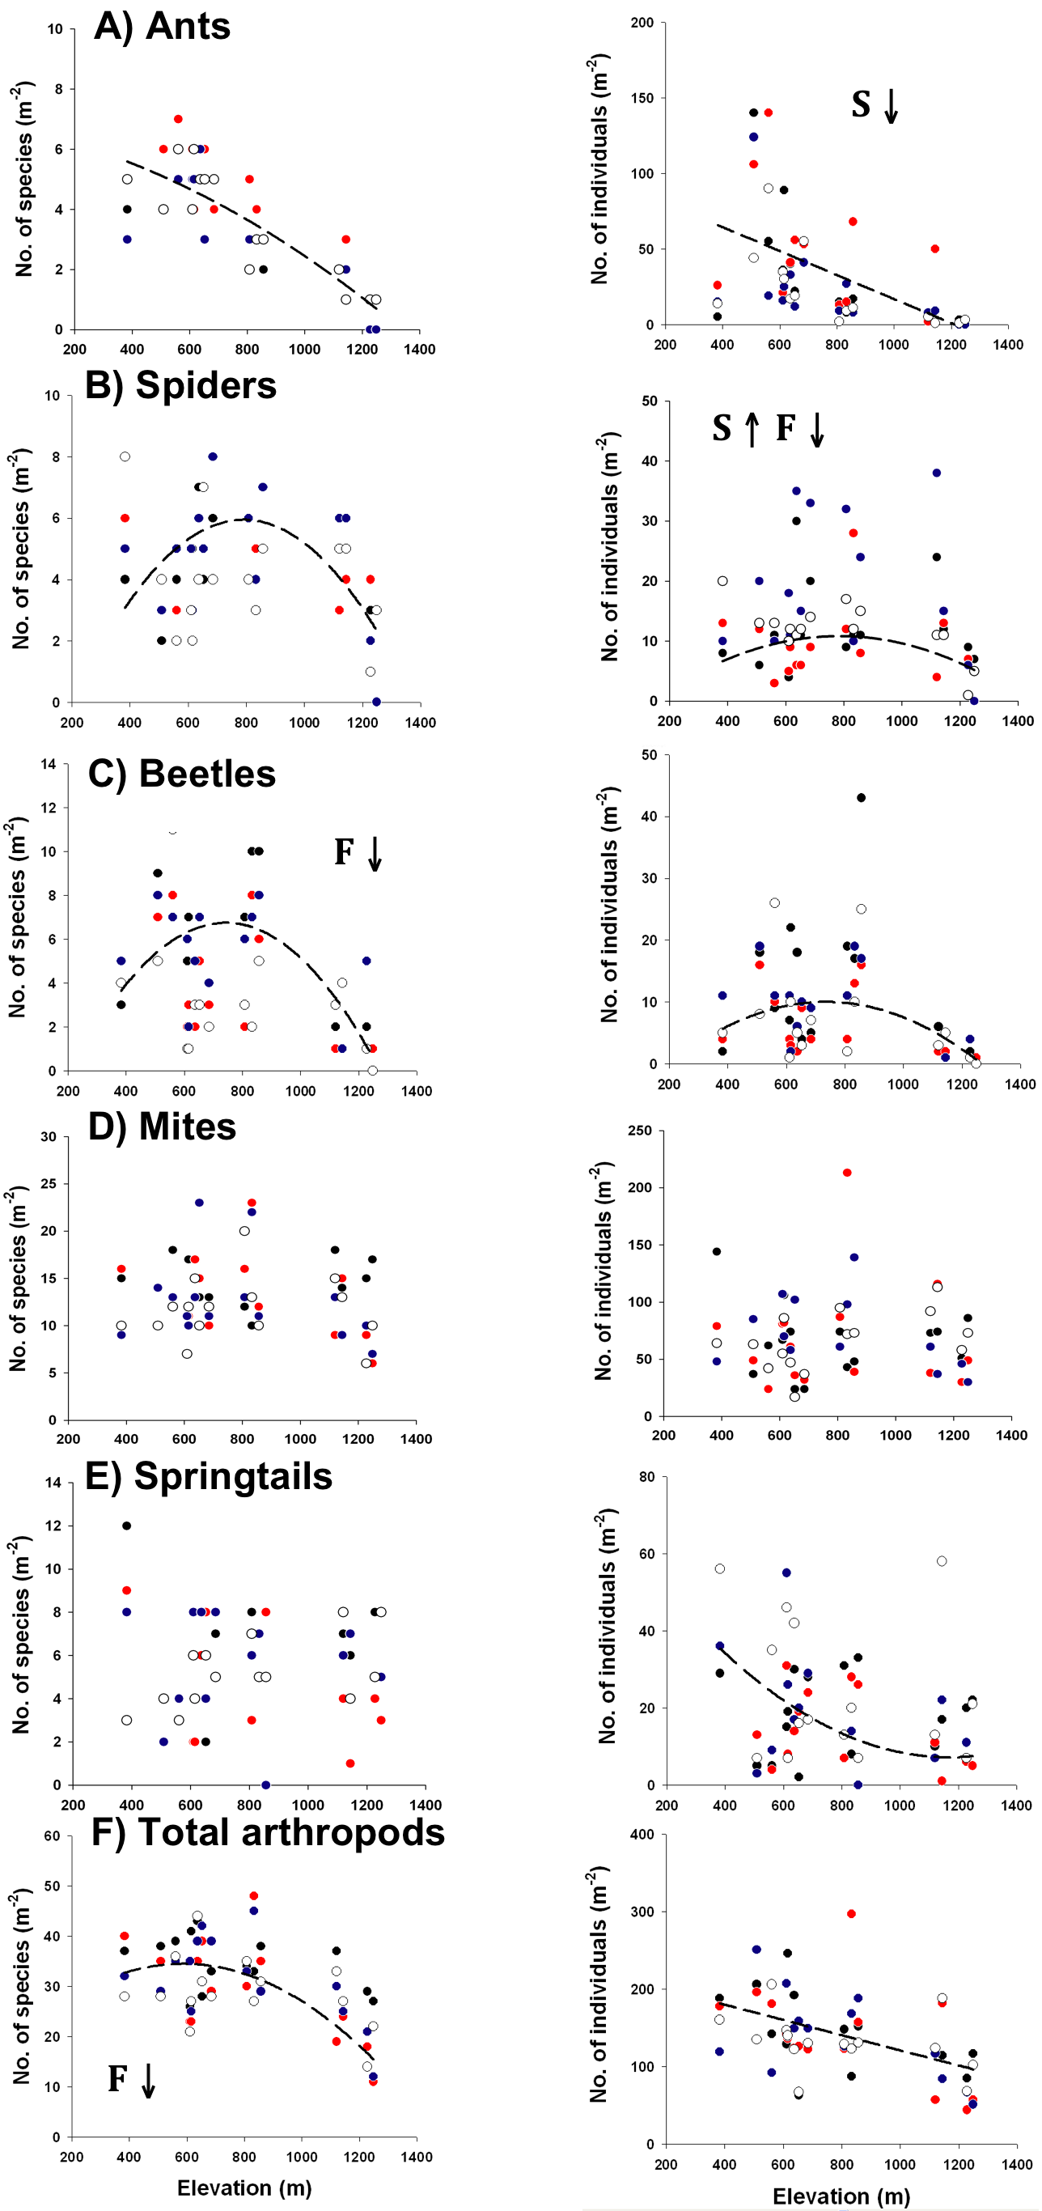
Figure IV-1.
Variation in species richness and abundance along the elevational gradient. Black symbols are control plots, red symbols are food addition treatments, blue symbols are shade treatments and open symbols are food+shade treatments. Note that the scale of the Y axis varies among taxonomic groups. Bold letters indicate statistical significance of food addition (F) and shade (S) treatments at P ≤ 0.05. Arrows indicate whether experimental treatments had a positive (↑) or negative (↓) effect on the response variable.

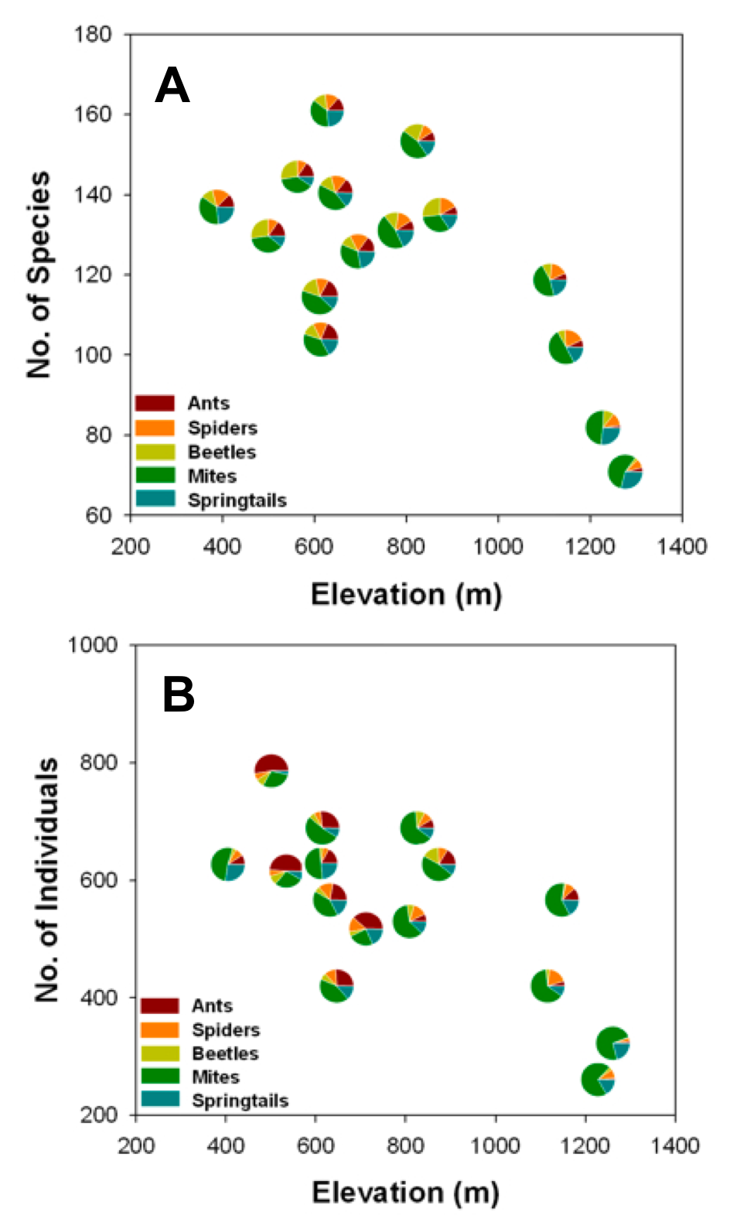
VITA
Figure IV-2.
Change in overall arthropod community composition along the elevational gradient. Each symbol shows the relative contribution of each taxon to the overall (A) species richness and (B) abundance of arthropods in the leaf-litter. The position of each dot indicates the total arthropod (A) species richness and (B) abundance at the site.

Jean-Philippe Lessard was born in Quebec City, Canada on April 1st 1980. He attended public elementary school from 1986 to 1992 at L’Ecole Beausoleil and high school from 1992 to 1997 at La Courvilloise in Beauport. He graduated from CEGEP at Collège François-Xavier-Garneau in Quebec City with a degree in Natural Sciences. In 2001 he entered McGill University in Montreal, where in Mai 2005 he received a Bachelor of Science in Agricultural and Environmental Sciences, with a major in zoology. In August 2006 he started the Ph.D. program in Ecology and Evolutionary Biology at the University of Tennessee, Knoxville.

