To the Graduate Council:

I am submitting herewith a thesis written by Thomas W. McAlexander entitled “Zone Refining of Raw Materials for Metal Halide Scintillator Crystal Growth.” I have examined the final electronic copy of this thesis for form and content and recommend that it be accepted in partial fulfillment of the requirements for the degree of Master of Science, with a major in Material Science and Engineering.

Dr. Mariya Zhuravleva, Major Professor

We have read this [dissertation or thesis]
and recommend its acceptance:

Dr. Mariya Zhuravleva

Dr. Chuck Melcher

Dr. Claudia Rawn

Accepted for the Council:

Carolyn R. Hodges
Vice Provost and Dean of the Graduate School

(Original signatures are on file with official student records.)

Zone Refining of Raw Materials for Metal Halide Scintillator Crystal Growth

A Thesis Presented for the
Master of Science
Degree
The University of Tennessee, Knoxville

Thomas W. McAlexander
November 2014

Copyright © 2014 by Thomas W. McAlexander
All rights reserved.

ACKNOWLEDGEMENTS

Thank you all for your help. However, this page is optional.
ABSTRACT

This is a sample Word document that can be used as a template in formatting your thesis/dissertation. It must be 350 words or less and contain no special characters.
PREFACE

This page is optional.
TABLE OF CONTENTS

Chapter Page

CHAPTER I 1
Introduction to scintillators and impurities 1
1.1 – Applications of Scintillators 1
1.1.1 –Requirements for Homeland Security 1
1.1.2 – Current Detector Standards 2
1.2 – Impurities in Scintillators 4
1.2.1 – Intentional Impurities 4
1.2.2 – Unintentional Impurities 4
1.3 – Techniques for Impurity Detection 9
1.3.1 – Differential Scanning Calorimetry 9
1.3.2 – Inductively Coupled Plasma Spectroscopy 11
1.4 – Techniques for Impurity Mitigation 13
1.4.1 – Zone Refining 13
1.4.2 – Chemical Reactions 15
1.4.3 – Vacuum Dehydration 15
1.4.4 – Melt Filtering 16
CHAPTER II 17
Overview of Zone refining 17
2.1 – Introduction 17
2.1.1 – Motivation 17
2.1.2 – Hypothesis 17
2.1.2 – Approach 18
2.2 – Literature Review 18
2.2.1 – Semiconductors 18
2.2.2 – Metals 20
2.2.3 – Halides 21
2.3 – Important Parameters for Zone Refining 23
2.3.1 – Segregation Coefficient 23
2.3.2 – Length Ratio 25
2.3.3 – Pass Speed 27
2.4 – General Considerations for Zone Refining Equipment 27
2.4.1 – Consequences of Using a Chamber Heater 28
2.4.2 – Spike Heater Design Requirements 28
2.4.3 – Material Containment Considerations 29
2.4.4 – Container Material 30
2.4.5 – Process Orientation 30
CHAPTER III 31
Experimental Methods 31
3.1 – Zone Refining 31
3.1.1 – Description of Equipment 31
3.1.2 – Material Handling Procedures 31
3.1.3 – Parameters Used for Zone Refining EuI₂ 31
3.2 – Inductively Coupled Plasma Mass Spectroscopy 31
3.2.1 – Sample Preparation 31
3.2.2 – Measurements Methods and Parameters 32
3.2.3 – Data Treatment and Analysis 32
3.3 – Differential Scanning Calorimetry 32
3.3.1 – Sample Preparation 32
3.3.2 – Measurement Methods and Parameters 32
3.3.3 – Data Treatment and Analysis 33
CHAPTER IV 34
Design and Implementation of a Miniature Zone Refining Furnace 34
4.1 – Merits of Having a Miniature Zone Refining Furnace 34
4.1.1 – Smaller Sample Size 34
4.1.2 – Secondary Furnace 34
4.1.3 – Optimized Parameters 34
4.1.4 – Modularity for Future Upgrades 35
4.2 – Construction of the Furnace 35
4.2.1 – Design Considerations 35
4.2.2 – Considerations Made for Upgrades 35
4.2.3 – Differences and Similarities to Existing Furnace 35
4.3 – Testing of the Miniature Furnace 36
4.1.1 – Thermal Profiling of the Furnace 36
4.1.2 – Adjustments Made after Initial Construction 36
CHAPTER V 37
Results and Discussion 37
5.1 – EuI₂ 37
5.1.1 – Visual Observations 37
5.2.1 – ICP-MS Results 37
5.1.3 – DSC Results 37
5.1.4 – Impact on Scintillation Performance 37
5.2 – Segregation Coefficient Calculations 38
5.2.1 – Theoretical Calculation of Segregation Coefficient 38
5.2.2 – Comparison of Calculated Coefficients with Observed Trends 38
5.3 – Effectiveness of Zone Refining EuI₂ 38
Chapter VI 39
Conclusions and Recommendations 39
6.1 – Summary 39
6.2 – Suggestions for Future Work 39
LIST OF REFERENCES 40
APPENDIX 46
Vita 48

LIST OF TABLES

Table Page

Table 1- Common Impurities in EuI₂ 7
Table 2- Major Impurities in Aluminum and Their Effects, adapted from [56] 20

LIST OF FIGURES

Figure Page

Figure 1- Comparison of Detector Resolution for Background Radiation [5] 2
Figure 2- DSC Spectrum of a Representative Metal Halide, CsCl 10
Figure 3- Illustration of Peak Onset Determination Method [36] 10
Figure 4- Schematic of Sample Aspiration in ICP Spectroscopy [40] 11
Figure 5- Periodic Table Showing Detection Limits of the Elements by ICP-MS [40] 12
Figure 6- Example Mechanism for Continuous Zone Refining [42] 14
Figure 7- Visual Difference Between Opposite Ends of As-Received EuI₂ After Melting 17
Figure 8- Correlation of Melt Behavior with Segregation Coefficient , [65] 23
Figure 9- Effect of Segregation Coefficient on Impurity Concentration after Zone Refining, [42] 24
Figure 10- Variation of Impurity Concentration with Pass Number for Various k, [65] 25
Figure 11- Impurity Distribution for a Length Ratio of 10, [65] 26
Figure 12- Impurity Distribution for a Length Ratio of 5, [65] 26
Figure 13- Effect of Pass Rate of Zone Refining, [42] 27
Figure 14. Shapes. 33

LIST OF EQUATIONS

Equation Page

Equation 1- Ion Exchange Synthesis for Divalent Iodide from Oxide 5
Equation 2- Dependence of the Depletion Layer Thickness on Impurity Concentration [1] 19
Equation 3- Equilibrium Segregation Coefficient, [66] 24
Equation 4- Length Ratio 25

CHAPTER I

Introduction to scintillators and impurities

– Applications of Scintillators

1.1.1 –Requirements for Homeland Security

Since the discovery of NaI:Tl in the late 1940s, inorganic scintillators have been commonly used as radiation detectors [1]. Scintillators are materials which absorb high energy radiation such as gamma rays and x-rays emit photons of visible light in response that can then be converted into an electrical signal by a photodetector. This class of materials is commonly used in radiation detectors found at border crossings, airports, shipyards, and other transportation hubs. Modern security concerns have necessitated the detection of high energy radiation on a large scale to identify nuclear threats while minimizing false alarms. These recent demands have sparked interest in the development of high performance scintillators capable of commercialized production [2].

To prevent illegal transport of radioactive material, it is necessary to detect the minute amounts of radiation which may escape from a shielded container. To increase the likelihood of producing a significant signal, the detector must emit a large number of photons as a result of interaction with any ionizing radiation. The resulting parameter, light output, is described in terms of the number of photons emitted per unit energy absorbed. In this context, scintillators with a high light yield are more advantageous as they produce a scintillation pulse which is easily distinguished from the background.

A related parameter, energy resolution, is a derived parameter which quantifies the material’s ability to discriminate between photons of similar energies. The energy resolution is defined as the full width of the full energy peak at half of its maximum divided by the centroid position of the peak. In contrast to the light output, a smaller value of energy resolution is desirable as it corresponds to a small variation in the energy of emitted photons. This is important as it allows the detector to more effectively distinguish between radionuclides likely to be used in a nuclear attack such as ²⁵³U and ²⁴⁰Pu and those used in medical procedures.

It is not always easy to differentiate between the energies associated with these two types of radioactive material. A common radioisotope used in medical diagnostics is ^{99m}Tc [3] which has a half life of ~6 hours and produces a gamma ray with an energy of 140.511 keV [4]. This energy is within 45 keV of ~75% of the gamma rays produced during the decay of ²³⁵U [4], which is used in nuclear weaponry. As seen in Figure 1, the spectroscopic capabilities of different detectors vary widely and depending on the energy resolution of the detector, and so the gamma ray signature of these two isotopes could be confused. This comparison highlights the need for low energy resolution in spectroscopic applications where the occurrence of false positives needs to be minimized.

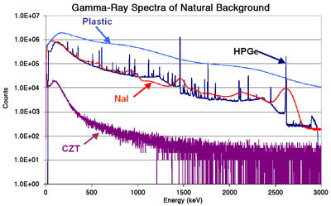
Figure 1- Comparison of Detector Resolution for Background Radiation [5]

1.1.2 – Current Detector Standards

The current benchmark scintillator is NaI:Tl, which has been heavily researched in the nearly 70 years since its discovery. This material is capable of being grown in very large boules, upwards of 500 mm in diameter without cracking. This large crystal yield means that it is able to be used in the construction of gamma cameras which require single crystal plates which are 500 x 600 x 10 mm in size [6]. This material is also very cheap, costing approximately $2/cc, which allows for very cost effective, large scale detectors, especially when compared to other popular scintillators such as LSO:Ce (~$100/cc) and LaBr₃:Ce (~$500/cc) [7].

The highly desirable cost and crystal yield of NaI(Tl) is not without any drawbacks, however. This material has a light yield of 37700 ± 5000 photons/MeV as reported by Holl, et al.[8] which is much lower than what is reported for several more recent materials such as SrI2:Eu and LaBr3:Ce which have reported light yields as high as 110,000 ph/MeV and 60,000 ph/MeV, respectively [9], [10]. At 7% resolution for 662 keV gammas, NaI(Tl) has an energy resolution that is inferior to these two materials as well [11]. SrI₂:Eu has a reported energy resolution for 662 keV gamma rays of 2.7%, while Sr²⁺ codoped LaBr₃:Ce has been reported recently as having an energy resolution of 2.0% [9], [12].

For instances where the spectroscopic capability of the detector is the only concern, the material of choice is a semiconductor, high purity germanium (HPGe). This detector material provides an unparalleled 0.2% energy resolution at 662 keV [13]. This outperforms all current scintillators, but has a few detriments which keep it from being used in all situations. The first of these is it’s small band gap, which is also the source of its superior spectroscopic capabilities. Because of the small size of its bandgap, 0.7 eV, HPGe requires cryogenic temperatures to operate effectively [1]. When operated at room temperature, the thermal noise is sufficient to destroy the resolution of the detected signal. The other issues are related to material processing and availability.

As the name implies, germanium detectors must be made from very pure raw materials to ensure that any electrons or holes which contribute to the current through the material are a result of interaction with radiation. To this end, the material which is used in germanium detectors has an impurity concentration near 10⁻⁶ ppm, which is very difficult to achieve commercially [14]. This purity is the major source of the final problem: price. The amount of work necessary to produce the material with the requisite purity, and then grow it into a single crystal for implementation in a detector means the final product is expensive enough to prohibit large-scale implementation. The resulting price for HPGe instruments can be prohibitively expensive as a result, costing over $130,000 for one instrument [14].

More recently, scintillators such as LaBr₃:Ce and SrI₂:Eu have been a major focus of research efforts to replace NaI:Tl as the next generation of detectors used for low cost gamma ray spectroscopy [15]. As mentioned previously, both of these scintillators have high light outputs and excellent energy resolution compared to NaI:Tl, though they each have challenges to overcome. A major drawback of LaBr₃ is the presence of ¹³⁸La, which presents an inherent source of gamma radiation with energies 788.7 keV and 1435.8 keV which may interfere with certain measurements [4]. It also tends to crack during growth, making large single crystals difficult to obtain [16]. This limits the obtainable crystal yield and increases the cost of a detector. For SrI₂:Eu, the major problem is the relatively long decay time characteristic of Eu²⁺-activated scintillators, in this case 670 ns [17]. The final difficulty present when working with either is their hygroscopicity. Packaging technology has advanced enough to allow encapsulation of both materials to protect them for an extended period of time. This does not, however, prevent the need for careful handling of the material during growth and processing which hinders these scintillators ability to be easily scaled to industrial production capacities.

1.2 – Impurities in Scintillators

1.2.1 – Intentional Impurities

In scintillators, there are two categories of intentional impurities which must be considered: activators and codopants. When an impurity is intentionally added to a scintillator, it is said to be doped with that element. Some materials are capable of producing scintillation photons by virtue of their inherent electronic structure. Other materials possess a band gap large enough that intermediate energies must be introduced to produce photons with energies compatible with conventional photodetectors. Activators are elements which create these energy levels in the host material’s band gap capable of producing a photon of visible light. Examples include Tl⁺, Eu²⁺, Ce³⁺, and Pr³⁺, though others exist.

In some cases, the host material is capable of producing a scintillation photon, but is inefficient or ill-suited to a specific application without the addition of an activator. A prime example of this phenomenon is NaI. Undoped, it produces only 2,500-4,000 ph/MeV at room temperature with an energy resolution of 15-16%. At liquid nitrogen temperatures, its performance improves significantly, ultimately producing 62,000-84,000 ph/MeV with an energy resolution of 3.8-6.2% [18]. These values are much better than what is seen for the Tl⁺ doped material at room temperature, but the cryogenic temperatures required makes it impractical for sustained use.

The second class of intentional impurity, the codopant, is commonly used to tune the physical and scintillation properties of a material. By adding Ba²⁺ to CsSrI₃, it has been seen that the hygroscopicity of the scintillator decreases. Over a period of 120 minutes, the percent change in mass is reduce by a factor of 2 for high levels of Ba-doping, dropping from ~12% to ~6% [19]. The effect which codoping can have on the scintillation properties is more dramatic, resulting from the sensitivity of the scintillation process to changes in the electronic structure. Recently it has been seen that adding a small amount of Sr²⁺ to LaBr₃:Ce greatly improves the energy resolution of the scintillator. Without a codopant, the energy resolution of LaBr₃:Ce is 2.9% [20]. The addition of 200 ppm of Sr²⁺ to the LaBr₃:Ce crystal is enough to drop to the energy resolution to 2.0%, a value which is unparalleled for scintillators [12].

1.2.2 – Unintentional Impurities

Just as impurities may be added to a scintillator to improve its properties, impurities may exist in the material from the manufacturing process or as a result of contamination. There are two main classes of impurities in metal halide scintillators: adsorbed gasses and metallic impurities.

Adsorbed Gas Impurities

Metal halide materials are characteristically hygroscopic, i.e. sensitive to moisture. Because of this, sorption of water vapor is a major concern in the preparation and handling of metal halide materials. Any contact with atmosphere results in moisture contamination, resulting in sample degradation. Similarly, oxygen contamination is a major issue as it reacts with many metal halide compounds to form either oxides or oxyhalides such as perchlorates and iodates. In an effort to minimize atmospheric contamination, many metal halide materials are grown using the Bridgman technique which allows the material to be directionally solidified in a sealed container. By virtue of this sealed environment, any impurities or contaminants which are present when the ampoule is sealed are trapped. Since oxides and oxyhalides typically melt at a much higher temperature than the associated metal halide salts, atmospheric contamination make it difficult to produce a single crystal as the oxide and oxyhalide particles act as nucleation sites for competing grains. In cases where the large grains grow in spite of these particulates, they can still destroy crystal yield by acting as a stress intensifier, promoting crack propagation.

In addition to atmospheric exposure, gaseous impurities are also present in metal halides as incomplete reactants from their synthesis. Commonly, metal halides are manufactured by reaction of oxides or carbonates with acids, yielding the metal halide salt and some combination of oxygen, carbon dioxide, and water [21], [22]. An example reaction is shown as Equation 1, from which it may be seen that the reaction is in equilibrium. If there is an excess of hydriodic acid being passed over the solid, the equilibrium is shifted to the right side, but is always balanced with the left side. This works against the system when water vapor is present in small amounts.

$$MO\left(s\right)+2HI\left(g\right)\underset{↔}{heat}MI_{2}\left(s\right)+H_{2}O(g)$$
Equation 1- Ion Exchange Synthesis for Divalent Iodide from Oxide

When water is present in large amounts, metal halides will dissolve due to their natural deliquescence. Smaller amounts of water can drive the formation of the oxide form of the metal as seen in Equation 1, or the formation of oxyhalides or hydrides when heat is applied. Several of the lanthanide halides have multiple stable valences. It has been reported that lanthanide halides such as EuI₂ can be made to change valence depending upon the surrounding atmosphere. An oxidizing atmosphere will stabilize the trivalent halide state; a reducing atmosphere will stabilize the divalent halide state [23]. The stability of the Eu²⁺ salt is of concern from a scintillation perspective.

Divalent Europium is favored for metal halide scintillators due to the bright interconfigurational luminescence of the allowed 5d-4f transition as well as the alignment of its peak emission wavelength of ~440nm to the peak detection wavelengths of standard photomultipliers [24]. The divalent and trivalent forms of Europium differ fundamentally in their scintillation characteristics. The scintillation decay of Eu³⁺ is approximately 1000 times slower than the ~1 μs decay intrinsic to the de-excitation of Eu²⁺, a speed already much slower than other popular activators such as Ce³⁺. Additionally, the peak emission wavelength of Eu³⁺ activated materials of ~610 nm is too long for effective detection by common bialkali-type photomultiplier tubes [25].

Metallic Impurities

Though metallic impurities may be beneficial in controlled quantities, unregulated they may have a negative impact on the properties of scintillators. Much like adsorbed gas impurities, these impurities are the result of their handling errors or manufacturing deficiencies. When working with high purity materials, it is important to make an effort to keep materials separate except when intentionally mixing them. If the working environment is not kept clean, it is easy to introduce potentially large amounts of impurities from due to contact with dirty utensils and containers. From a manufacturing perspective, these impurities may be the result of residual components of the parent ore from which the material was originally derived. Rare earth halides are derived from ores in which many of lanthanide elements are present [26].

The effects of metallic impurities can be similar to those caused by the presence of oxides and oxyhalides, though the reasons differ somewhat. In general, metallic impurities are much more likely to dissolve into the molten salt but there are cases where the impurity may remain solid in the melt, creating a nucleation site for secondary grain growth. These situations are more common in situations where the halide component has changed as well, as is the case when a chloride is present in an iodide-based melt. When the metallic contaminant is incorporated into the melt, the matrix will be stressed as a result of the lattice mismatch caused by its integration into the solid. Depending on the severity of the mismatch, this growth strain may be forcibly released as a crack upon cooling, especially if the strain field interacts with similar defects. It is also possible that a crack which forms elsewhere is enlarged by the impurity in an effort to lower the total system energy [27]. Even in cases where the cracking behavior is not exacerbated by the impurity content, cracking behavior is still heavily influenced by it. For example, Kermode, et al. has reported that cracks can also be deflected by individual impurity atoms if the bond strength is sufficient [28].

Depending on the impurity, it is possible that it will interfere with the crystals scintillation mechanism. Two possible methods are through luminescence quenching and charge defect formation, though the exact effect heavily depends on the specific system in question. A literature search will provide insight into results for a specific system, as many groups have published studies on the effects of codoping in different matrices. A variety of lanthanide, alkali and transition metal elements have reported optical transitions which offer radiative de-excitation pathways for excitons. Such elements include not only common activators such as Ce³⁺ and Eu²⁺, but also elements such as Na⁺, In⁺, Pb²⁺, and Yb^{3+[29]}.

By having multiple radiative pathways in the same material, each luminescence center must compete for the electrons and holes produced by radiation interaction. This competition results in neither site yielding a large number of photons per MeV absorbed by the crystal, effectively quenching the light output. In some instances, activators may cause mutual quenching by capturing different charged particles, preventing their recombination as is the case when Ce³⁺ and Yb³⁺ are present in the same matrix. Additionally, it is possible for luminescence to be quenched through metal-metal charge transfer as seen in tungstates and vanadates doped with Ce³⁺ [24]. The formation of charge defects can affect the scintillation properties in a very similar manner. By introducing aliovalent impurities, the charge balance of the crystal is perturbed, resulting in the addition of charge defects such as F centers and V centers that trap electrons and holes, respectively [30].

Impurities in EuI₂

The impurity content of EuI2 has been seen to vary widely from batch to batch. Table 1 shows several common impurities in EuI2 as detected in 4 different batches of material by the manufacturer, Sigma Aldrich. Elements with a range were reported in at least 2 material batches. Elements with a single value were either detected in only one batch, or were found in multiple batches in the same concentration. Determination of H₂O/OH⁻ and O impurities is not performed on every batch and so the values listed are for a single batch, but are expected to be similar in other batches.

Table 1- Common Impurities in EuI₂
Impurity | Concentration (ppm) | Impurity | Concentration (ppm)
As | 1.7-7.3 | La | 0.3
Ag | 0.3 | Na | 0.5-0.8
Ba | 0.3-1.1 | Pb | 0.2
Bi | 0.2-1.8 | Se | 0.7-2.2
Cs | 0.1 | Sn | 0.4
Cu | 0.4-1.2 | Sr | 0.6-0.8
Fe | 1.1-4.6 | Th | 0.2
Hg | 0.2 | Tl | 0.5
K | 3.1 | W | 0.5
H₂O/OH⁻ | 16 | O | 82

As mentioned in the previous section, the presence of multiple impurities with optical transitions can quench luminescence through activator competition. Impurities such as Ag and Bi are known to facilitate scintillation in appropriate matrices [24], but Tl⁺ and Pb²⁺ have been reported by Novosad, et al. alongside Eu²⁺ as being capable of effectively activating CaI₂. The authors do note that there is overlap between the thermoluminescence spectra which indicates that not all of the traps are directly related to the dopants. They posit that the cation impurities and intrinsic defects form complexes which act as hole traps, producing the measured spectra [31]. For effective activation of an iodide scintillator with Eu²⁺, it is necessary that the concentration of these competitive impurities be minimized.

A separate example of Pb impurities being detrimental to the scintillation properties, specifically the energy resolution, may be found in a paper by Shulz and Breiter. They report that lead impurities in the crystal create an absorption band at ~359 nm, near the maximum emission wavelength for NaI:Tl. The result of this is that the intensity of the scintillation light varies depending upon where in the crystal the scintillation photon is produced and how far it must travel before reaching the photodetector. For an 8 inch diameter by 8 inch tall NaI:Tl crystal, they measure an energy resolution of ~8% at 1.84 MeV versus the 4.5% typically measured for smaller crystals, which they attribute solely to lead impurity effects [32].

When considering impurities not typically associated with an optical transition, there is still evidence to indicate that these impurities need to be removed. As part of the effort to improve the scintillation properties of SrI₂:Eu, Nishimoto, et al. has recently published a study on the effects of codoping SrI₂:Eu with three different trivalent lanthanide elements, including one of the impurities reported in Table 1, lanthanum. Samples of SrI₂ were prepared with 7.5% Eu²⁺ doping and 1% RE doping. The results of their study indicate that codoping with lanthanum decreases the light output by between 7% and 28%, depending on the actual incorporation of La. The energy resolution was likewise seen to suffer, more than doubling the excellent resolution of pure SrI₂:Eu of ~2.7% for most samples [33].

In addition to the examples above, many of the impurities found in EuI₂ have stable oxidation states other than the divalent state of the matrix. This indicates that though they would likely conform to the divalent configuration, the possibility exists that they would be incorporated as an aliovalent impurity. A model has been proposed by Li, et al. in which the nonproportionality, and hence the energy resolution, of a scintillator is directly affected by the free carrier mobility. Through the introduction of aliovalent impurities, charge traps such as F and V centers are incorporated into the crystal. These traps affect charge carrier mobility by either brief detention or complete entrapment of the carrier, and by limiting carrier movement they preferentially segregate charges, leading to nonlinearity of the light yield by preventing recombination [34].

1.3 – Techniques for Impurity Detection

1.3.1 – Differential Scanning Calorimetry

Differential scanning calorimetry (DSC) is a thermal analysis technique which measures heat flow into a sample with respect to a reference. This technique is widely used to determine phase purity and to evaluate temperature-dependent transformations [35]. The measurement is performed by loading material into a crucible and then increasing its temperature. The heat flow required to increase the sample’s temperature relative to a reference crucible is then recorded as a function of temperature. One complete measurement consists of running a blank sample using an identical thermal profile to the experimental sample. This is done to provide a baseline for later subtraction to negate any effects from the crucible. Thermodynamics predicts that phase transitions and chemical reactions occur because of a change in the free energy of the system. This energy change is measured in the system as heat flow, providing quantitative information about the heat of transformation as well as the associated temperatures.

DSC measurements yield temperature correlated heat flow data. Figure 2 shows a typical spectrum obtained by DSC. By convention, heat flow values are positive if heat is being released by the sample, i.e. the process is exothermic. Similarly, endothermic processes require heat to be absorbed by the sample and are presented as negative values. Phase transitions are typically reversible processes, and as such occur in pairs as seen in Figure 2. Since the enthalpy of the transformation is constant, paired peaks should have similar heats of reaction, represented by the area under the curve.

One of the common uses for DSC is determination of transformation temperatures. Figure 3 shows the method used here to determine peak onsets, which is taken as the transformation temperature. A baseline is constructed across the peak base and the leading edge of the peak is extrapolated and the intersection of the extrapolation and the baseline is recorded as the onset temperature [36].

Endothermic
Exothermic
Solid-Solid Phase Transition
Melting Endotherm
Crystallization
Exotherm
Figure 2- DSC Spectrum of a Representative Metal Halide, CsCl
Figure 3- Illustration of Peak Onset Determination Method [36]

DSC curves may be used to calculate phase purity of systems containing eutectic impurities. This process, which takes advantage of melting point depression, equates the percent peak area at different temperatures to the percentage of the material that’s molten at a given time. By plotting this relation, it is possible to extract not only material purity, but also the melting point of the pure material [37]. This is not to say, however, that it is possible to identify exact contaminants and their relative amounts. In this investigation, the material as a whole is examined.

During crystal growth, scintillation materials are subjected to a range of temperatures as the charge is melted and then slowly solidified. The thermal environment produced during DSC recreates the growth process and provides a look at the thermodynamics affecting the material during solidification. DSC is also extremely sensitive to minor changes in the composition or temperature profile, able to detect heat flow with microwatt precision and temperature differences as small as 1°C [38]. For this level of resolution, it is necessary to scan at very slow rate, ~1-5 K/min. Depending on the melting point of the material and the thermal profiled desired, this may cause the total measurement time to be 24 hours or more for one complete measurement.

Though DSC is a powerful tool, it has its limitations. The high sensitivity that allows the DSC to detect minute changes in heat flow also renders it sensitive to outside disturbances such as cell phone interference, RF generators, and vibrations. It is also not possible to interpret DSC scans without some outside knowledge of how the material behaves, even if this is purely anecdotal. Due to sample volatility, it is necessary to at least have an estimate of the melting temperature before measurement of metal halides is feasible [39].

1.3.2 – Inductively Coupled Plasma Spectroscopy

Inductively coupled plasma (ICP) spectroscopy is a set of techniques used to determine trace impurities in solid and liquid samples. Variations in the technique are based upon the detection modality, either by mass (MS) or emission energy (OES). Both processes begin by aspirating a solution in which the sample has been dissolved through plasma, usually composed of superheated argon. This plasma treatment forcibly strips electrons from even the most stable molecules and atoms. Figure 4 displays a schematic of the aspiration and ionization process. After ionization, the differences between the methods become important.

Figure 4- Schematic of Sample Aspiration in ICP Spectroscopy [40]

For ICP-OES, the energy emitted by the ions as they de-excite is detected by a photodetector. As energy levels of each element are unique, the light emitted as ions de-excite is characteristic of the elemental species present. By examining the wavelengths of light produced after ionization and their ratios, it is possible to determine what elements are present and quantify their concentration when compared to known standards. ICP-MS instead looks at the mass-charge ratio of ions. This is accomplished by using electromagnetic filtering optics to separate the ions leaving the plasma from photons, particulates and neutral species. Ions are focused towards the mass separator, usually either a quadrupole, a magnetic sector, or other related technology.

The exact manner of mass detection varies according to the type and design of the mass separator. After mass separation, the ions are converted to an electrical signal through interaction with an element called a discrete dynode detector. This instrument functions in much the same way that a photomultiplier tube does. The charge of the ion is converted to electrons at the first dynode which are attracted to the next dynode, increasing in number at each subsequent dynode. In this way, ICP-MS is generally capable of detecting elemental concentrations across ~8 orders of magnitude, from ppt levels up to hundreds of ppm levels [40]. Detection limits of each element are displayed in Figure 5.

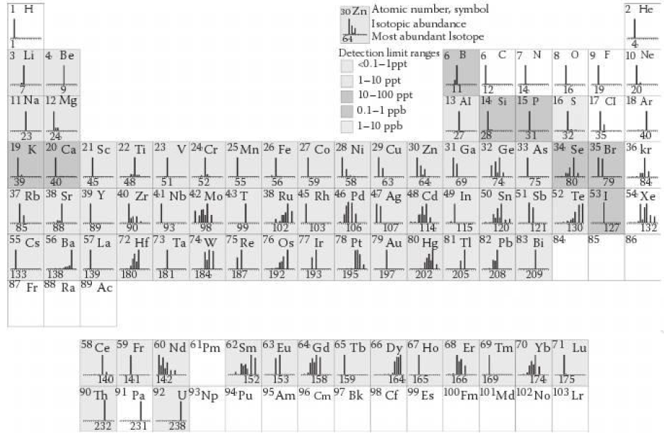
Figure 5- Periodic Table Showing Detection Limits of the Elements by ICP-MS [40]

Data obtained from ICP spectroscopy is meaningful only when calibrated against know reference samples. Without this comparison, it is impossible to quantify the concentrations of trace elements as each ion response is unique. In the case of ICP-MS, data analysis is often tricky as the mass-charge ratios for multiple species may overlap. In this case it is necessary to use a multi-peak analysis to determine elemental concentrations. As each element has a natural distribution of isotopes, Figure 5, it is possible to use the known distribution of isotopes to deconvolve any overlapping peaks by comparison with isolated peaks from other isotopes of the same element. It should be noted, however, that this is only possible in samples which have not been specifically enriched with a specific isotope [41].

The primary draw of ICP spectroscopy is the fast acquisition of quantitative impurity concentrations. Aside from reference standards, this technique is an independent technique which no outside data for interpretation. That being said, signal masking introduces uncertainty into the measurement. Innate components of technique, such as ⁴⁰Ar⁺, have the potential to mask other ions of interest, ⁴⁰K⁺. Workarounds exist, such as the above described isotope ratio comparison, though this is limited by the relative amounts of each isotope. In cases where the trace element’s concentration is near the detection limit, it is probable that the secondary isotope is below the detection limit. Similarly, it is possible that multiple ions overlap in the same peak, complicating deconvolution efforts. Without an idea of what is expected, some peak overlaps may go unnoticed, leading to an incorrect quantitative analysis. For ICP-OES, high concentrations of optically active elements such as Eu²⁺ or Ce³⁺ are likely to saturate the photodetector, in which case it is impossible to determine the concentration of any trace elements.

1.4 – Techniques for Impurity Mitigation

As described in Section 1.2, impurities have a variety of sources and properties. Techniques for impurity mitigation are similarly diverse. Depending upon the impurity, difference aspects such as melt behavior, thermal stability, and chemical reactivity may be exploited to segregate the impurities so that they might be removed from the system.

1.4.1 – Zone Refining

Zone refining is a technique which utilizes the different melt behavior of impurities species to segregate them in a solid charge. To accomplish this, a spike heater is moved along a solid charge, melting the material in a discrete section which moves through the charge as the heater is moved with respect to the solid. At the end of the pass, the melt zone is reset without melting the charge on the return. This process of moving a molten zone through the charge is repeated many times, with the end result being a region in the center which has a lower net impurity content. This is due to impurities segregating at either ends of the charge, according to their stability in either the solid or the liquid phase [42]. As this purification method targets soluble impurities, it is typically applied to metallic impurities with 7N purity or higher being achievable with appropriate parameters. The parameters affecting the effectiveness of the zone refining process are discussed in Section 2.3.

This technique exploits a fundamental aspect of material thermodynamics, and so may be applied to a variety of material systems. The only restrictions on zone refining are practical. The material must be thermally stable and not decompose before melting and it must experience a solid-liquid phase transition at a reasonable temperature which is to say that zone refining of elements such as iridium and helium are not realistic. Even with these requirements, many material systems lend themselves to zone refining. This technique is also well suited to industrialization as large batch sizes are possible, as is continuous zone refining. Zone refining may be adapted into a continuous process in a few ways, with one example being through the use of gravity and mass transport to move purified material and impurities in opposite directions, Figure 6. By placing several of these systems in series, it is possible to obtain highly purified materials just as with traditional zone refining.

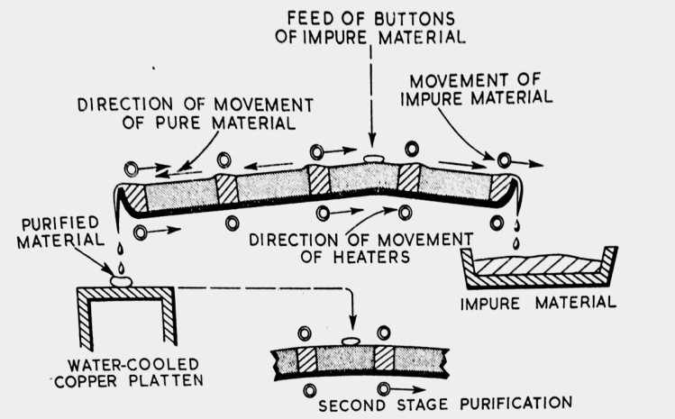
Figure 6- Example Mechanism for Continuous Zone Refining [42]
Though the widespread applicability and high achievable purity are enticing, zone refining is by no means a perfect technique. Depending upon the matrix, some elements will not readily segregate due to negligible differences in melt and solid free energies. The refining speed also is slow, with pass speeds on the order of 1 cm/hr being typical for metal halide compositions [43]. In an effort to create a sharp melt zone, the thermal gradient at the melt edge is usually sharp. By moving this sharp gradient across the crucible many times, it is possible for thermal stresses to build, ultimately resulting in cracking of the container. Improper selection of the crucible material can cause leaching of container elements into the purified material, negating any positive effects from refining.

1.4.2 – Chemical Reactions

Chemical equilibrium can be used to purify material as well. By reacting hydrated or oxidized material with a chemical more reactive with either oxygen or water the raw material may be stripped of these impurities. The reaction seen in Equation 1 provides an example of this process. By passing an acid over oxidized molecules, the anions exchange, producing the desire product and water. At the temperatures necessary for this process to take place, the water which is produced should exist as a gas which is carried away by the stream of unreacted acid. Additionally, it is possible to make use of a solid reactant to achieve similar results. Ammonium halides have been used for more than forty years to prepare oxygen-free halide materials [44]. These materials split into ammonia and acid when heated, providing a source of acid to react with any oxygen or hydroxyls. Byproducts are removed by vacuum, as this process is achievable at lower temperatures under evacuation.

This technique prevents the formation of halide vacancies by replacing any removed anions with the appropriate halide component [45]. Since the reaction is performed in vacuum, the reaction products are easily removed before they have a chance to be reintroduced. The hazards associated with the usage of such reactive chemicals can pose a significant threat if not handled with caution. Any acid vapors should be contained or neutralized to prevent inhalation or corrosion of equipment. The most efficient way of accomplishing this is through the use of cold traps. Depending on the size of the operation, cost may be an issue as well since effective use of the ammonium halides requires a molar excess of the ammonium compound of ~4:1for the target material. [44]

1.4.3 – Vacuum Dehydration

In the process of handling metal halides, it is difficult to guarantee that the material is free of all trace amounts of moisture. In small amounts, moisture is generally considered to be lightly bound to the salt’s surface until high temperature reactions can occur. Several groups have reported the use of low temperature vacuum dehydration to remove this surface moisture before it reacts and forms oxyhalide compounds [46], [47], [48]. The moisture is then removed by vacuum.

This technique is easily implemented, requiring only a vacuum system with a wrap-around heater, of which several types exist. As it uses no consumables other than the treated material, this is also a very cost-effective and scalable process. The major variation between different reported methods is the drying temperature. There has been no published report to show the effects of time or temperature on the effectiveness of vacuum dehydration, possibly because of difficulty in producing reproducible results. Due to this disagreement, it is possible that temperatures are used which are sufficient to react the surface moisture rather than remove it.

1.4.4 – Melt Filtering

Where the techniques mentioned previously were primarily concerned with preventing or reversing reaction of the metal halides with oxygen and moisture, melt filtering may be used to mitigate the impact of oxyhalides by simply removing them. As oxyhalide compounds are characteristically insoluble in the molten salt, by using a high temperature filter, they may be physically separated. By inserting a porous quartz frit below a previously synthesized charge, any oxyhalide materials will be separated once the charge is heated to melting prior to crystal growth [49].

Since the frit is inserted into the growth assembly, there is no possibility of recontamination between purification and growth which minimizes the possibility of user error. This does, however, present its own set of unique problems, notably a large addition to the ampoule. Depending on the size of the furnace used for growth, the addition of the fritted assembly may require augmentation of the furnace to accommodate the increased size. Additionally, the charge must sit higher in the ampoule, generally exposing it to higher temperatures as it is sealed under vacuum. Some materials are more tolerant to heat than other, and the high temperatures necessary for sealing (>1300°C at the seal) may result in decomposition. When the material melts, it will bring the vacuum in the ampoule into equilibrium with its vapor pressure [50]. A larger volume above the melt requires more material to volatilize, disturbing the charge’s stoichiometry.

CHAPTER II

Overview of Zone refining

2.1 – Introduction

2.1.1 – Motivation

For the effective detection of nuclear threats, it is necessary to produce large radiation detectors with spectroscopic capabilities. As has been established in the last chapter, the unrestricted presence of impurities in a scintillator impairs both of these goals. EuI₂ has many impurity species present from the manufacturer, Table 1, including many metallic impurities which should respond well to zone refining. The effect of these impurities on the quality of as-received EuI₂ is highlighted in Figure 7, where the charge has been melted and allowed to solidify. Most notably, the two ends have a significant difference in clarity. The as-received material is known to regularly vary between yellow, green, and tan colors, depending on impurity content. This variability is especially troublesome as many promising scintillators being explored for nuclear nonproliferation efforts, including SrI₂, CsSrI₃, and CsCaI₃, are activated with Eu²⁺. For these reasons, EuI₂ has been evaluated as a candidate for purification by zone refining.

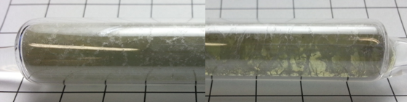
Figure 7- Visual Difference Between Opposite Ends of As-Received EuI₂ After Melting

2.1.2 – Hypothesis

EuI₂ is common activator used in scintillators being developed for implementation in next generation radiation detectors. It currently is known to contain impurities which are detrimental to its scintillation performance and crystal quality, including K, La, and Tl. By zone refining EuI₂, I believe that the concentration of these impurities can be reduced, improving the quality of scintillators made with this material.
.

2.1.2 – Approach

A literature survey has been used to examine the techniques and parameters used in zone refining of various materials. From this review, refining methods believed to be suitable for purifying EuI₂ were determined. Material received from Sigma Aldrich was loaded into an ampoule and was melted in a horizontal position to densify the charge before refining. After several passes of the melt zone, the charge was extracted and sectioned to enable analysis of impurity content along the charge length. Thermal analysis was done using DSC and ICP-MS was used to provide quantitative impurity concentrations. A second sample was prepared and refined at a faster speed. The goal of this was to determine if comparable results are achievable after a shorter time.

Methods to estimate the segregation coefficients of known impurities in EuI₂ were investigated based on calculations reported in literature. This was done to provide a means of screening material systems for zone refining based on the impurities present. The results of these calculations were compared to the trends seen in refined material as measured by ICP-MS. In order to facilitate future refining efforts, a miniature zone refining furnace was designed and implemented based upon lessons learned by working with the full-sized furnace. This miniature furnace provides a test bed for smaller batches of material, allowing more economical trial runs as well as refinement of less plentiful material.

2.2 – Literature Review

2.2.1 – Semiconductors

Germanium

As mentioned in Chapter 1, germanium is often used as in gamma ray spectroscopy due to its exceptional energy resolution. For this application, high purity germanium is needed since, as with all semiconductors, germanium’s electronic structure is extremely sensitive to impurities. Semiconductor-based radiation detectors function by separating the charge carriers that form as a result of interaction with ionizing radiation. The segregation of these carriers is only viable in the depletion region, the size of which is governed by Equation 2. In this equation, the depletion layer thickness, d, is shown to vary based on the reverse bias voltage, V, the impurity concentration, N, the material’s dielectric constant, ε, and the elementary charge, e [1]. For a given material, the dielectric constant and elementary charge are constants. Thus, the size of the usable detection layer in germanium is determined by the impurity content and the applied voltage. The voltage does have an upper limit termed the breakdown voltage, ~350 V in germanium at 77 K [51]. From this, the depletion layer size is heavily dependent upon impurity concentration.

$$d={\left(\frac{2εV}{eN}\right)}^{\frac{1}{2}}$$
Equation 2- Dependence of the Depletion Layer Thickness on Impurity Concentration [1]

Yang, et al. reported an investigation into factors affecting the quality of zone refined Ge ingots. In this work, it is reported that the three major impurities present in HPGe are boron, phosphorous, and aluminum. Each of these is present in the raw materials, though boron and phosphorous are found in higher concentrations in ingots melted in carbon crucibles, suggesting that carbon is a source of contamination. Fortunately, it has been reported that for many impurities in germanium, the segregation coefficient is much less than one, allowing for efficient removal by zone refining. Also presented in this report is a discussion of the effects of pass speed and the ratio of ingot length to melt zone length. From a theoretical standpoint, pass speeds on a similar timescale to melt diffusion rates are preferred to allow time for the impurities to diffuse without getting trapped prematurely as is discussed in greater detail later. From a practical point of view, however, refining at these speeds is not feasible. The ratio of charge length to melt zone length has a similar compromise to consider since it determines the achievable ultimate concentration and how fast it is approached. From their study, Yang, et al. found that a balance between performance and practicality was achieved for a pass speed of 7-8 cm/hr and a charge length to melt length ratio of 15:1 – 20:1 [52].

Silicon

Silicon is primarily used in the electronics and photovoltaic industries, each with their own purity requirements. As with germanium, very pure material is needed for effective application, less than 1 ppm of impurities for electronics applications. Cheaply produced metallurgical grade silicon (maximum 10,000 ppm impurities) is widely used as starting material for either application, though purification is necessary before it is useful [53]. In the photovoltaic industry, silicon is used as the primary material in the photocell. The incident sunlight is sufficient to create electron-hole pairs which may be separated to profuce a current flow. In the electronics industry, silicon is used as a substrate for integrated electronics and as a component in computer chips. Though this accounts for a relatively small fraction of the total silicon volume used each year, the increase in purity from metallurgical grade to electronics grade is accompanied by a 30-50 fold increase in the price [54].

Due to its relatively high melting point, silicon zone refining is done using an electron beam furnace to produce the melt zone as is reported by Mei, et al. To begin, metallurgical grade silicon is placed in a water-cooled copper crucible and placed under a vacuum to prevent oxidation. Using the electron beam, the material was melted twice to ensure homogeneity. The ingot refined by Mei et al. was 150 mm long, with a melt zone width of 10 mm, giving a ratio of 10. The pass speed for their experiment varied between 1 mm/min and 10 mm/min (6 cm/hr and 60 cm/hr, respectively). In a related publication, Mei, et al. determined that all of the impurities investigated in their silicon zone refining studies had an equilibrium segregation coefficient less than 1, i.e. they all moved with the melt to the end of pass region. These values ranged from 0.8 for B, to 1.6·10⁻⁸ for Zr [55].

2.2.2 – Metals

Aluminum

Aluminum alloys are used in many modern applications where a balance of strength and weight is needed and the demand for these alloys has resulted in increased production. To keep up, aluminum recycling has become popular, and so it is necessary to remove previous alloying agents and other impurities introduced during manufacture or usage. The properties of metal alloys are based, in part, on the impurities present in the material and any impurities with detrimental effects on the alloy properties, such as Fe, need to be removed. The effects of various impurities in aluminum alloys are detailed in Table 2.

Table 2- Major Impurities in Aluminum and Their Effects, adapted from [56]
Impurities | Effects on Al Properties and Production Process
Ti, V, Cr, Zr | - Deteriorates electrical conductivity  - Affects cold working properties
Mg | - May improve mechanical properties  - Can contaminate and upset the electrolyte in the Hall Heroult process
Ca | - Hot cracking (casting)  - Can contaminate the electrolyte in the Hall Heroult process
Na | - Harmful if hydrogen is present  - Cause fabrication defects (edge cracking)  - Hot cracking
Li | - Increase the corrosion rate of Al foil by moisture  - Hot cracking
Fe | - Stress raisers and points of weak coherence  - Reduces mechanical properties
Ni | - Increase high temperature creep  - Reduces corrosion resistance

Zone refining, one of the most effective methods of purifying Al, has been used to produce aluminum with 7N purity. Optimal zone refining of Al was reported to consist of a 30 mm zone being passed through a charge 10 times at speeds between 24 and 55 mm/hr [56]. Kino, et al. presented a study on the zone refining of aluminum where they varied several parameters to determine the most effective parameters for purifying aluminum. Using an inductive heating coil, they produced a melt zone varying between ~20 and 50 mm in an ingot 900 mm long. The number of passes varied between 1 and 20, using speeds between 236 and 11 mm/hr. The effectiveness of step-refining was tested by passing a 30 mm wide molten region through the charge at a rate of 236 mm/hr for 5 passes, and then following that with 3 passes at 11 mm/hr. The purity of an ingot which was refined for 5 passes at 11 mm/hr with a melt zone length of 20-25 mm was determined by correlating electrical conductivity to impurity concentration. By this method, the purity of the ingot was 1ppm at the beginning of pass region and 100 ppm at the end of pass region [57].

Cadmium and Tellurium

Cadmium and tellurium are primarily used to produce semiconductors such as CdTe and Cd_{1-x}Zn_{x}Te (CZT), both of which are used in radiation detection. As with Ge and Si, the performance of these detectors is dependent upon the purity of the material. Impurity concentrations below 1 ppm have been seen to affect the mechanical properties of these materials, inhibiting large scale crystal growth. To improve the detection and physical properties of these compounds, Zaiour, et al. have produced 7N pure Te. After using vacuum distillation to purify Te to 5N, they used zone refining to purify the material to the desired level. It was found that some impurities, including Ag, Ni, Pb, Zn, and Fe, were effectively removed from the bulk of the material and deposited at the end after 9 refining passes. To achieve this, a melt zone 1.5 cm wide was passed through a 20 cm long charge at ~6 cm/hr.They note that due to size considerations, large impurities such as Xe were found to have a segregation coefficient close to unity due to their sluggish diffusion rates. Impurities which tend to form the same crystal structure in the bulk, such as Se and As, were also found to segregate poorly [58].

Similar work has been done to purify Cd by Munirathnam , et al. The refining of Cd is complicated due to its high thermal conductivity. Because of this, forming a stable melt zone is problematic. For this report, a melt zone size of 65 mm was estimated in an ingot 560 mm long. A zone speed of 30 mm/hr was used to draw the melt zone through the ingot for a total of 4 cycles, each 15 passes long and culminating in the removal of one zone length at either end. The remaining material is used as feed stock for subsequent cycles. This process resulted in 6N pure Cd, with less than 0.1ppm for 14 of the 15 tested impurities [59].

2.2.3 – Halides

Thallium Bromide

Several popular room-temperature, semiconductor radiation detectors, including HPGe, CdTe, and CZT, have disadvantages which hamper their large-scale implementation. Thallium bromide is becoming a competitive alternative to these detector materials due to its high density (7.5 g/cm³), its easily grown cubic crystal structure, low temperature congruent melting point (480°C), and its band gap (2.7 eV), which is wide enough to eliminate thermal noise [60]. This material was widely ignored for many years due to its poor carrier mobility, but zone refining has been shown to improve the carrier mobility-lifetime product [61].

The effectiveness of zone refining TlBr has been reported by Hitomi, et al. over the course of their development of the material [61]. They have reported the results of high pass numbers on the concentration of impurities in initially 4N pure TlBr. The details of the refining were not shared other than the pass speed, 5 cm/hr. The characterization results for TlBr as a function of zone refining pass number, however, show an impressive improvement. A detector made from material refined for 1 pass shows an energy resolution of >30% at 59.5 keV. Material refined for 300 passes, by comparison, produced a peak with an energy resolution of only 11% at the same energy [62]. This performance is expected to improve with further development as is reported by Dmitriev, et al several years later where a value of 6.5% is reported at 60 keV [60].

A more detailed account of TlBr zone refining is provided by Oliveira, et al. who reports that they used 40 cm long ingots, which had a 3 cm long molten zone passed through it at 2 cm/hr. The material was refined for 1, 20, and 30 passes. The concentration of impurities was reported to fall by 1-2 orders of magnitude after one pass for each of 7 reported impurities. After 30 passes, two thirds of the reported impurities were reported in concentrations less than 1 ppm, including Ba, which initially was determined to be 324.72 ppm [63]. Additional details can be found in a publication by Churilov, et al. where the refinement is said to have taken place at 5 cm/hr for 50-100 passes. The ingot length is estimated to be ~26 cm based upon images in the paper. The melt zone is said to have been maintained at a width of 2-2.5 cm. Though no trace metal analysis was reported, the mobility-lifetime product was determined to increase by three orders of magnitude after zone refining, improving the charge carrier collection efficiency [61].

Potassium Chloride

As a popular material for color center research, KCl has been the subject of many purity investigations. These studies have attempted to purify KCl so that defect formation caused by intentionally added dopants, such as Ca²⁺, can be better observed [64]. Zone refining is one technique mentioned in literature to produce purified material, though many reports are incomplete and offer information on only one or two variables with minimal quantitative results. In contrast, an investigation done by Warren provides a detailed overview of not just KCl zone refining, but also an outline of zone refining for metal halides. For KCl, he describes the refining length as being 70 cm long, through which a melt zone passes 10 times at ~5.8 cm/hr. He unfortunately neglects to mention the width of his melt zone, though it is likely ~2 cm wide as the nichrome ribbon he uses is mentioned to be a half inch wide. Due to limitations in trace impurity analysis at the time of publication, Warren is unable to determine the exact concentration for a wide range of impurities in his material, though he details the results for detection of a few specific impurities. From absorption and conductivity measurements, he ascertains that the level of hydroxyl, heavy metal, and heterovalent impurities are 1 ppm, <2 ppm, and ~0.8 ppm, respectively [43].

2.3 – Important Parameters for Zone Refining

2.3.1 – Segregation Coefficient

The thermal behavior of a material varies significantly with composition, a fact displayed in phase diagrams. This is especially true for the melting temperature, which may either be raised or lowered by the addition of solute. One of the parameters central to zone refining is the segregation coefficient (also called the partition or distribution coefficient), a value quantifying the effect that an impurity has on melting point of the matrix in which it is dissolved. For impurities which result in the lowering of the melting point, the segregation coefficient is less than unity. The reverse is also true, as is seen in Figure 8. At its most basic, the segregation coefficient of an impurity in a solvent is the ratio of the impurity’s concentration in the solid versus the liquid, Equation 3, corresponding to what is schematically displayed in Figure 8.

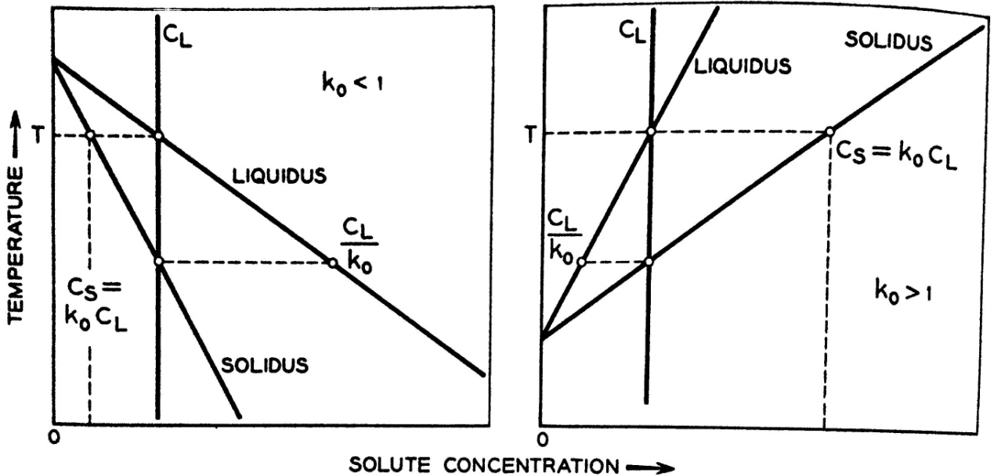
Figure 8- Correlation of Melt Behavior with Segregation Coefficient , [65]
$$k_{0}=\frac{C_{s}}{C_{l}}$$
Equation 3- Equilibrium Segregation Coefficient, [66]
When the system is not in equilibrium, the liquid impurity concentration is not uniform, and a depleted or enriched liquid layer forms at the solidification front. As a result of this, the impurity acts according to the effective segregation coefficient, k, rather than the equilibrium segregation coefficient, k₀ [65]. In systems where the pass speed is slow, the two are generally used interchangeably as the impurities are generally assumed to diffuse into the main body of the liquid if the pass is slow enough.

Since the segregation coefficient describes the preference of an impurity to exist in the melt or solid, it may be used as an indicator of zone refining effectiveness. The distribution of impurities in a zone refined charge after a finite number of passes is seen in Figure 9 for various segregation coefficients. In general, the further from unity the segregation coefficient, the faster the impurity may move. Impurities with k<1 typically segregate faster as the are able to “ride” the liquid zone further before getting trapped in the solid. Lower values of k indicate greater displacement with a single pass. Those impurities with k>1 move opposite the pass direction, and so must diffuse through the melt to the advancing solidification front. This movement is much less efficient as the diffusion rates in the liquid are much higher than those of the solid and so the impurity at best can move ~1 zone length each pass. In many studies, impurities with a k≈0 are considered unresponsive to zone refining. This distinction is purely practical, though an impurity with k=1 would not move as a result of zone refining except through mechanical means, such as melt convection. This efficiency is displayed in Figure 10 as a function of pass number.

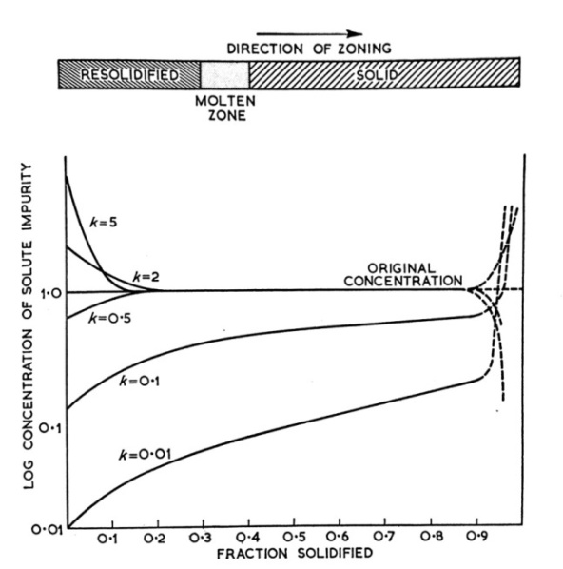
Figure 9- Effect of Segregation Coefficient on Impurity Concentration after Zone Refining, [42]
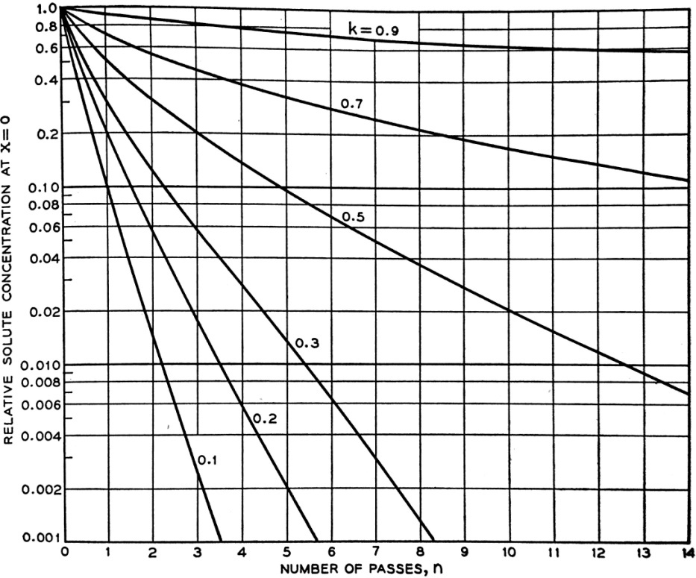
Figure 10- Variation of Impurity Concentration with Pass Number for Various k, [65]

2.3.2 – Length Ratio

Zone refining requires the movement of a melt zone through a solid charge. As the size of the melt increases, the refining process becomes less effective. The length ratio is an operational parameter derived from the charge length, L, and the melt zone length, l, as shown in Equation 4. In his work on zone refining, Pfann shows the effect that the length ratio can have on the purity of a material. By comparing Figure 11 and Figure 12, it is evident that a larger length ratio is desirable. Not only is the relative concentration of impurities six times smaller at the beginning of the charge after 20 passes for the larger ratio, the length of material which has been purified is also larger. This is a result of the impurities moving further with each pass. When the melt zone is small, the distance an impurity must diffuse through to reach either the bulk of the liquid (k<1) or the solidification interface (k>1) is decreased, improving the ability of the impurity to move efficiently through the material without getting trapped by the advancing solidification front prematurely [65]. Charges with a small length ratio have a poor achievable ultimate distribution and reach their maximum purification rather quickly [67].

$$Length Ratio=\frac{L}{l}$$
Equation 4- Length Ratio

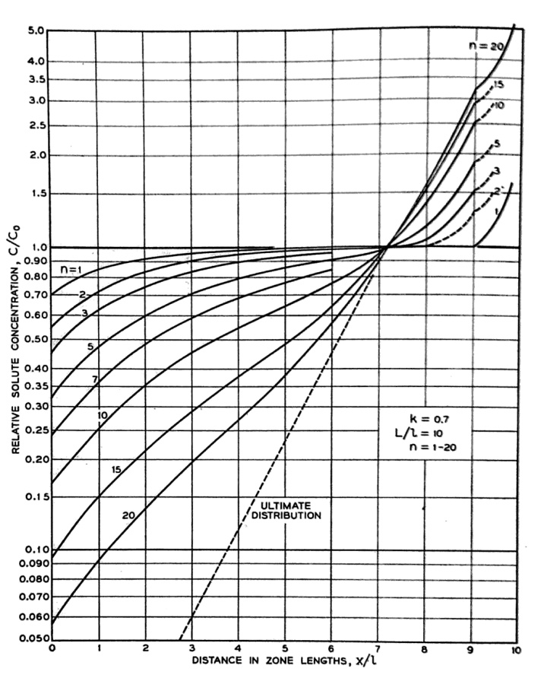
Figure 11- Impurity Distribution for a Length Ratio of 10, [65]

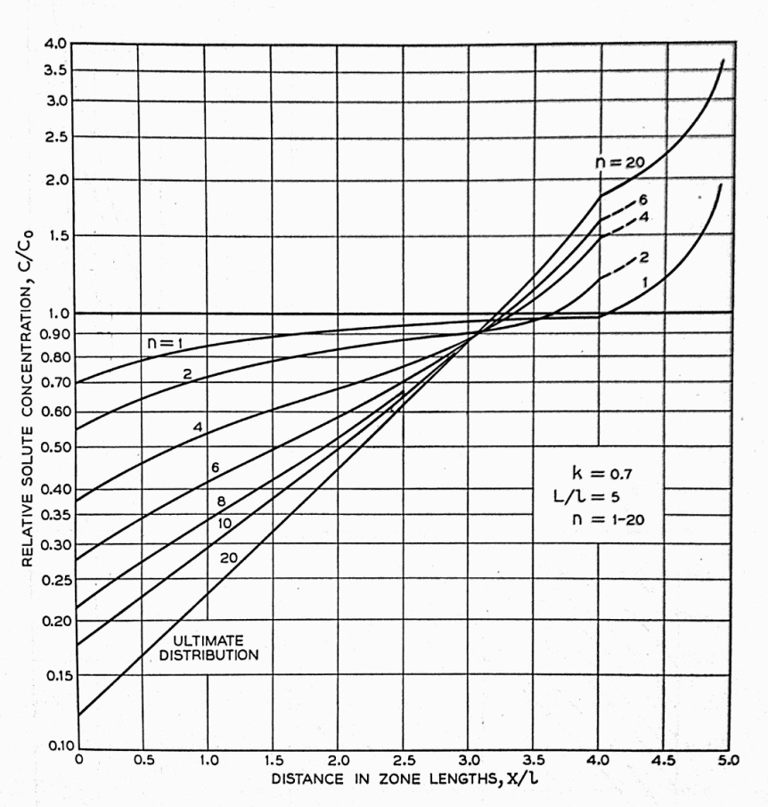
Figure 12- Impurity Distribution for a Length Ratio of 5, [65]

2.3.3 – Pass Speed

The effects of pass speed can be intuited by considering the diffusion processes taking place during zone refining. As mentioned previously, the concentration of impurities in the liquid is generally considered to be in equilibrium. This assumption is only valid when the refining pass speed is sufficiently slow to allow impurities to diffuse to and away from the solidification front [67]. If the speed is too fast, impurities will either build up or be depleted at this phase boundary. If the speed is much too fast, the melt zone becomes unstable, trapping pockets of liquid in an advancing solid as seen in Figure 13. This growth instability retards effective impurity segregation by locking in the impurities instead of allowing them to move as dictated by the segregation coefficient. An excessively slow pass speed, however, prevents diffusion in the solid from being a negligible process. As such, impurities in the melt which would otherwise not move into the solid, such as those which have k<1, have sufficient time to diffuse into the solid, acting as a competing process to refining [42]. This need for a very slow pass speed is tempered by practical considerations. The purpose of zone refining is to efficiently purify an impure feedstock for some future application. If zone refining does not proceed at a reasonable rate, it is impractical and irrelevant. It is for this reason that refining speeds are typically in the region of 1-10 cm/hr as described in Section 2.2 though the most effective speed is likely lower.

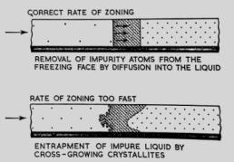
Figure 13- Effect of Pass Rate of Zone Refining, [42]

2.4 – General Considerations for Zone Refining Equipment

The practical considerations for zone refining manifest themselves in the design of the furnace. Depending on the material being refined, and the desires of the operator, the ideal furnace for zone refining varies. The most general considerations which must be made relate to how the melt zone is formed and how it is contained. All other aspects of the design are fixed, in their presence if not their specific manifestation. This includes the translation mechanism of the furnace. The design of this component doesn’t matter so long as it is capable of moving at an appropriate speed. Other parts such as the inclusion of a chamber heater, on the other hand, can have a large impact on the refining process.

2.4.1 – Consequences of Using a Chamber Heater

The thermal expansion of some materials is quite aggressive, resulting in the fracture of the charge container if the material adheres to the walls of the vessel. To minimize this occurrence, it is possible to maintain the entire charge at an elevated temperature, below the melting temperature, thereby limiting the thermal expansion. The trade-off with this addition is the lower achievable thermal gradient at the melt interface. As the entire charge is hot, the rate of heat dissipation is lowered impeding the formation of a stable, narrow melt zone. This does lower the stress on the spike heater as it doesn’t have to work as hard to hold its temperature, potentially increasing its service life.

With a conventional furnace, it is necessary to heat a large area around the charge to keep it at an elevated temperature. This requires a large amount of insulation to minimize heat losses for practical application. The addition of this insulation comes at the cost of material visibility. It is advantageous to be able to see the first signs of container failure, for example, as it allows the impact of this event to be minimized. A second benefit is the ability to monitor refining progress in situ. When purifying a contaminated material, a change in the melting temperature is expected. Depending on the magnitude of this change, the material may cease to melt at the original temperature. The converse of this is the material’s melting temperature is lowered and the melt zone elongates during refining. By monitoring the refining process, adjustments may be made as necessary.

2.4.2 – Spike Heater Design Requirements

Regardless of whether a chamber heater is included, the spike heater is a core component of a zone refining furnace. A narrow melt zone is required for efficient refining, as previously established. To achieve this, the spike heater must be narrow, relative to the average charge size. Smaller heaters are more delicate, susceptible to both mechanical fracture and oxidation corrosion, especially at high temperature. The heater must also closely fit the typical vessel size used with it. A large mismatch results not only in waste heat, but also in a wider melt zone as the radiated heat warms the nearby charge.

The melt zone may be divided or minimized by using a cooling system. This is especially popular in lower temperature zone refining apparatuses, mostly due to the types of coolants available at lower temperatures. Water is an obvious choice as a coolant, but above 100°C, this isn’t a possibility. Oil is another possibility and is capable of reaching higher temperatures, though is not encouraged for use in a furnace. The coolant must be cool enough to absorb heat from the system effectively without inducing thermal shock in the container material. To improve the coolants thermal contact, copper tubing is used to contain the coolant, improving the efficiency of the heat exchange. At higher temperatures, the choice of coolants drops dramatically. Most possible liquid coolants, such as molten salts, are too dangerous to justify their widespread use. In these instances, it is much more efficient to simply manipulate the size of the heater itself or use air circulation to promote cooling.

2.4.3 – Material Containment Considerations

For materials which are not hygroscopic, it may still be advantageous to have the material sealed inside of an airtight container as this prevents any oxidation. There is another reason to consider a closed ampoule: melt convection. Even in moderately deep melts, convection can cause an irregularly shaped molten zone where the top of the melt is wider than the bottom. This problem, detailed by Pfann, is easily prevented by rotating the ampoule about its long axis during refining. By rotating the ampoule, there is no static “up” for the melt to rise towards, and so levels the solid-liquid interfaces. In addition to obviating the melt convection, this process also improves mixing in the melt which prevents impurity from collecting at the solidification front.

Ampoule rotation requires that the entire ampoule cross-section be filled with material. Should it be only half full, the material will coat the ampoule walls during solidification, degrading the effectiveness of zone refining. This full-ampoule geometry is not always feasible due to thermal expansion and gas release considerations. If the material expands upon heating, the material may burst the ampoule during melting. If the material releases gases during heating, such as through decomposition or release of a dissolved gas, these gases will accumulate in the ampoule and cause fracture through pressurization. To counteract these concerns, a half-filled ampoule geometry may be adopted to provide headroom into which the material may expand or give off gases without fracturing. These concerns may also be addressed by using a self-plugged ampoule. In this geometry, the ampoule is tilted, allowing it to collect at one end during melting where it fully fills the cross-section. The plug at the end remains unmelted during refining, and will prevent expansion or gas-release fracture. A caveat of this method is that it will only work if the solid is deformable or doesn’t stick to the ampoule. If neither is true, the ampoule is liable to fracture.

2.4.4 – Container Material

The choice of container material is based mostly on what is being refined. Quartz is a common container material for zone refining due to its high melting point, chemical stability, transparency, low thermal expansion coefficient, and low cost. The major drawback of quartz is that it is very brittle. Because of this low fracture strength, it is very susceptible to fracture due to thermal expansion or in cases where the material adheres to the container wall. A second common material is vitreous carbon (also known as glassy carbon). This material is more nonreactive than quartz, lowering the chances that material will adhere to it. Vitreous carbon is also very brittle, however, and is comparatively expensive in addition to being opaque. The only major alternative to these materials is a metal foil to coat one of the previous materials. Boats made only from metal are not common as metal is not as chemically inert and may leech impurities into the zone refined charge.

2.4.5 – Process Orientation

Zone refining may be done in either a vertical or horizontal orientation, with an appropriate boat geometry. The primary difference between the two methodologies is the influence of gravity and convective processes on the chemically-based segregation governed by k in the vertical configuration. The influences of gravity may either enhance or retard the segregation of impurities depending on whether they increase or decrease the density, much as the melting differential determines zone refining behavior in general. Depending on the impurities which are being removed, the vertical arrangement may be used to complement segregation. If the melt viscosity is high enough to neglect melt convection, or the process is done in a low gravity environment, the difference between orientations should be negligible.

CHAPTER III

Experimental Methods

3.1 – Zone Refining

3.1.1 – Description of Equipment

Don’t forget to refer to all tables/figures by number within the text. Once you have mentioned a table/figure, you must place it on the next page. For instance, if you mention figure 1 it should be placed on the next page.

3.1.2 – Material Handling Procedures

Blah blah blah. Begin writing text here. You may use single, double, or 1.5 spacing. You may use any font of your choosing, but you must be consistent. TEXT text Text TEXT text Text TEXT text Text TEXT text Text TEXT text Text TEXT text Text TEXT text Text TEXT text Text TEXT text Text TEXT text Text TEXT text Text TEXT text Text TEXT text Text TEXT text Text TEXT text Text TEXT text Text TEXT text Text Once you use styles to generate the lists, you can update them quickly and easily.

3.1.3 – Parameters Used for Zone Refining EuI₂

Begin writing text here. You may use single, double, or 1.5 spacing. You may use any font of your choosing, but you must be consistent. TEXT text Text TEXT text Text TEXT text Text TEXT text Text TEXT text Text TEXT text Text TEXT text Text TEXT text Text TEXT text Text TEXT text Text TEXT text Text TEXT text Text TEXT text Text TEXT text Text TEXT text Text TEXT text Text TEXT text Text Once you use styles to generate the lists, you can update them quickly and easily.

3.2 – Inductively Coupled Plasma Mass Spectroscopy

3.2.1 – Sample Preparation

Things and stuff, stuff and things. Begin writing text here. You may use single, double, or 1.5 spacing. You may use any font of your choosing, but you must be consistent. TEXT text Text TEXT text Text TEXT text Text TEXT text Text TEXT text Text TEXT text Text TEXT text Text TEXT text Text TEXT text Text TEXT text Text TEXT text Text TEXT text Text TEXT text Text TEXT text Text TEXT text Text TEXT text Text TEXT text Text Once you use styles to generate the lists, you can update them quickly and easily.

3.2.2 – Measurements Methods and Parameters

More things and stuff and words and information. Begin writing text here. You may use single, double, or 1.5 spacing. You may use any font of your choosing, but you must be consistent. TEXT text Text TEXT text Text TEXT text Text TEXT text Text TEXT text Text TEXT text Text TEXT text Text TEXT text Text TEXT text Text TEXT text Text TEXT text Text TEXT text Text TEXT text Text TEXT text Text TEXT text Text TEXT text Text TEXT text Text Once you use styles to generate the lists, you can update them quickly and easily.

3.2.3 – Data Treatment and Analysis

Begin writing text here. You may use single, double, or 1.5 spacing. You may use any font of your choosing, but you must be consistent. TEXT text Text TEXT text Text TEXT text Text TEXT text Text TEXT text Text TEXT text Text TEXT text Text TEXT text Text TEXT text Text TEXT text Text TEXT text Text TEXT text Text TEXT text Text TEXT text Text TEXT text Text TEXT text Text TEXT text Text Once you use styles to generate the lists, you can update them quickly and easily.

3.3 – Differential Scanning Calorimetry

3.3.1 – Sample Preparation

Begin writing text here. You may use single, double, or 1.5 spacing. You may use any font of your choosing, but you must be consistent. TEXT text Text TEXT text Text TEXT text Text TEXT text Text TEXT text Text TEXT text Text TEXT text Text TEXT text Text TEXT text Text TEXT text Text TEXT text Text TEXT text Text TEXT text Text TEXT text Text TEXT text Text TEXT text Text TEXT text Text Once you use styles to generate the lists, you can update them quickly and easily.

3.3.2 – Measurement Methods and Parameters

Begin writing text here. You may use single, double, or 1.5 spacing. You may use any font of your choosing, but you must be consistent. TEXT text Text TEXT text Text TEXT text Text TEXT text Text TEXT text Text TEXT text Text TEXT text Text TEXT text Text TEXT text Text TEXT text Text TEXT text Text TEXT text Text TEXT text Text TEXT text Text TEXT text Text TEXT text Text TEXT text Text Once you use styles to generate the lists, you can update them quickly and easily.

3.3.3 – Data Treatment and Analysis

Begin writing text here. You may use single, double, or 1.5 spacing. You may use any font of your choosing, but you must be consistent. TEXT text Text TEXT text Text TEXT text Text TEXT text Text TEXT text Text TEXT text Text TEXT text Text TEXT text Text TEXT text Text TEXT text Text TEXT text Text TEXT text Text TEXT text Text TEXT text Text TEXT text Text TEXT text Text TEXT text Text Once you use styles to generate the lists, you can update them quickly and easily.

Figure 14. Shapes.

CHAPTER IV

Design and Implementation of a Miniature Zone Refining Furnace

Another chapter, and I’ve run out of things to say. I kind of hope a template will help some. Remember that consistency is the most important thing. You may use any spacing style or font as long as you use it consistently. It should also be legible. Rules for placement of tables and figures are more specific. Good luck with your writing!

4.1 – Merits of Having a Miniature Zone Refining Furnace

4.1.1 – Smaller Sample Size

Begin writing text here. You may use single, double, or 1.5 spacing. You may use any font of your choosing, but you must be consistent. TEXT text Text TEXT text Text TEXT text Text TEXT text Text TEXT text Text TEXT text Text TEXT text Text TEXT text Text TEXT text Text TEXT text Text TEXT text Text TEXT text Text TEXT text Text TEXT text Text TEXT text Text TEXT text Text TEXT text Text Once you use styles to generate the lists, you can update them quickly and easily.

4.1.2 – Secondary Furnace

Begin writing text here. You may use single, double, or 1.5 spacing. You may use any font of your choosing, but you must be consistent. TEXT text Text TEXT text Text TEXT text Text TEXT text Text TEXT text Text TEXT text Text TEXT text Text TEXT text Text TEXT text Text TEXT text Text TEXT text Text TEXT text Text TEXT text Text TEXT text Text TEXT text Text TEXT text Text TEXT text Text Once you use styles to generate the lists, you can update them quickly and easily.

4.1.3 – Optimized Parameters

Begin writing text here. You may use single, double, or 1.5 spacing. You may use any font of your choosing, but you must be consistent. TEXT text Text TEXT text Text TEXT text Text TEXT text Text TEXT text Text TEXT text Text TEXT text Text TEXT text Text TEXT text Text TEXT text Text TEXT text Text TEXT text Text TEXT text Text TEXT text Text TEXT text Text TEXT text Text TEXT text Text Once you use styles to generate the lists, you can update them quickly and easily.

4.1.4 – Modularity for Future Upgrades

Begin writing text here. You may use single, double, or 1.5 spacing. You may use any font of your choosing, but you must be consistent. TEXT text Text TEXT text Text TEXT text Text TEXT text Text TEXT text Text TEXT text Text TEXT text Text TEXT text Text TEXT text Text TEXT text Text TEXT text Text TEXT text Text TEXT text Text TEXT text Text TEXT text Text TEXT text Text TEXT text Text Once you use styles to generate the lists, you can update them quickly and easily.

4.2 – Construction of the Furnace

4.2.1 – Design Considerations

Begin writing text here. You may use single, double, or 1.5 spacing. You may use any font of your choosing, but you must be consistent. TEXT text Text TEXT text Text TEXT text Text TEXT text Text TEXT text Text TEXT text Text TEXT text Text TEXT text Text TEXT text Text TEXT text Text TEXT text Text TEXT text Text TEXT text Text TEXT text Text TEXT text Text TEXT text Text TEXT text Text Once you use styles to generate the lists, you can update them quickly and easily.

4.2.2 – Considerations Made for Upgrades

Begin writing text here. You may use single, double, or 1.5 spacing. You may use any font of your choosing, but you must be consistent. TEXT text Text TEXT text Text TEXT text Text TEXT text Text TEXT text Text TEXT text Text TEXT text Text TEXT text Text TEXT text Text TEXT text Text TEXT text Text TEXT text Text TEXT text Text TEXT text Text TEXT text Text TEXT text Text TEXT text Text Once you use styles to generate the lists, you can update them quickly and easily.

4.2.3 – Differences and Similarities to Existing Furnace

Begin writing text here. You may use single, double, or 1.5 spacing. You may use any font of your choosing, but you must be consistent. TEXT text Text TEXT text Text TEXT text Text TEXT text Text TEXT text Text TEXT text Text TEXT text Text TEXT text Text TEXT text Text TEXT text Text TEXT text Text TEXT text Text TEXT text Text TEXT text Text TEXT text Text TEXT text Text TEXT text Text Once you use styles to generate the lists, you can update them quickly and easily.

4.3 – Testing of the Miniature Furnace

4.1.1 – Thermal Profiling of the Furnace

Begin writing text here. You may use single, double, or 1.5 spacing. You may use any font of your choosing, but you must be consistent. TEXT text Text TEXT text Text TEXT text Text TEXT text Text TEXT text Text TEXT text Text TEXT text Text TEXT text Text TEXT text Text TEXT text Text TEXT text Text TEXT text Text TEXT text Text TEXT text Text TEXT text Text TEXT text Text TEXT text Text Once you use styles to generate the lists, you can update them quickly and easily.

4.1.2 – Adjustments Made after Initial Construction

Begin writing text here. You may use single, double, or 1.5 spacing. You may use any font of your choosing, but you must be consistent. TEXT text Text TEXT text Text TEXT text Text TEXT text Text TEXT text Text TEXT text Text TEXT text Text TEXT text Text TEXT text Text TEXT text Text TEXT text Text TEXT text Text TEXT text Text TEXT text Text TEXT text Text TEXT text Text TEXT text Text Once you use styles to generate the lists, you can update them quickly and easily.Write stuff here. Now!

CHAPTER V

Results and Discussion

5.1 – EuI₂

5.1.1 – Visual Observations

Begin writing text here. You may use single, double, or 1.5 spacing. You may use any font of your choosing, but you must be consistent. TEXT text Text TEXT text Text TEXT text Text TEXT text Text TEXT text Text TEXT text Text TEXT text Text TEXT text Text TEXT text Text TEXT text Text TEXT text Text TEXT text Text TEXT text Text TEXT text Text TEXT text Text TEXT text Text TEXT text Text Once you use styles to generate the lists, you can update them quickly and easily.

5.2.1 – ICP-MS Results

Begin writing text here. You may use single, double, or 1.5 spacing. You may use any font of your choosing, but you must be consistent. TEXT text Text TEXT text Text TEXT text Text TEXT text Text TEXT text Text TEXT text Text TEXT text Text TEXT text Text TEXT text Text TEXT text Text TEXT text Text TEXT text Text TEXT text Text TEXT text Text TEXT text Text TEXT text Text TEXT text Text Once you use styles to generate the lists, you can update them quickly and easily.

5.1.3 – DSC Results

Begin writing text here. You may use single, double, or 1.5 spacing. You may use any font of your choosing, but you must be consistent. TEXT text Text TEXT text Text TEXT text Text TEXT text Text TEXT text Text TEXT text Text TEXT text Text TEXT text Text TEXT text Text TEXT text Text TEXT text Text TEXT text Text TEXT text Text TEXT text Text TEXT text Text TEXT text Text TEXT text Text Once you use styles to generate the lists, you can update them quickly and easily.

5.1.4 – Impact on Scintillation Performance

Begin writing text here. You may use single, double, or 1.5 spacing. You may use any font of your choosing, but you must be consistent. TEXT text Text TEXT text Text TEXT text Text TEXT text Text TEXT text Text TEXT text Text TEXT text Text TEXT text Text TEXT text Text TEXT text Text TEXT text Text TEXT text Text TEXT text Text TEXT text Text TEXT text Text TEXT text Text TEXT text Text Once you use styles to generate the lists, you can update them quickly and easily.

5.2 – Segregation Coefficient Calculations

5.2.1 – Theoretical Calculation of Segregation Coefficient

Begin writing text here. You may use single, double, or 1.5 spacing. You may use any font of your choosing, but you must be consistent. TEXT text Text TEXT text Text TEXT text Text TEXT text Text TEXT text Text TEXT text Text TEXT text Text TEXT text Text TEXT text Text TEXT text Text TEXT text Text TEXT text Text TEXT text Text TEXT text Text TEXT text Text TEXT text Text TEXT text Text Once you use styles to generate the lists, you can update them quickly and easily.

5.2.2 – Comparison of Calculated Coefficients with Observed Trends

Begin writing text here. You may use single, double, or 1.5 spacing. You may use any font of your choosing, but you must be consistent. TEXT text Text TEXT text Text TEXT text Text TEXT text Text TEXT text Text TEXT text Text TEXT text Text TEXT text Text TEXT text Text TEXT text Text TEXT text Text TEXT text Text TEXT text Text TEXT text Text TEXT text Text TEXT text Text TEXT text Text Once you use styles to generate the lists, you can update them quickly and easily.

5.3 – Effectiveness of Zone Refining EuI₂

Begin writing text here. You may use single, double, or 1.5 spacing. You may use any font of your choosing, but you must be consistent. TEXT text Text TEXT text Text TEXT text Text TEXT text Text TEXT text Text TEXT text Text TEXT text Text TEXT text Text TEXT text Text TEXT text Text TEXT text Text TEXT text Text TEXT text Text TEXT text Text TEXT text Text TEXT text Text TEXT text Text Once you use styles to generate the lists, you can update them quickly and easily.

Chapter VI

Conclusions and Recommendations

6.1 – Summary

Begin writing text here. You may use single, double, or 1.5 spacing. You may use any font of your choosing, but you must be consistent. TEXT text Text TEXT text Text TEXT text Text TEXT text Text TEXT text Text TEXT text Text TEXT text Text TEXT text Text TEXT text Text TEXT text Text TEXT text Text TEXT text Text TEXT text Text TEXT text Text TEXT text Text TEXT text Text TEXT text Text Once you use styles to generate the lists, you can update them quickly and easily.

6.2 – Suggestions for Future Work

Begin writing text here. You may use single, double, or 1.5 spacing. You may use any font of your choosing, but you must be consistent. TEXT text Text TEXT text Text TEXT text Text TEXT text Text TEXT text Text TEXT text Text TEXT text Text TEXT text Text TEXT text Text TEXT text Text TEXT text Text TEXT text Text TEXT text Text TEXT text Text TEXT text Text TEXT text Text TEXT text Text Once you use styles to generate the lists, you can update them quickly and easily.

LIST OF REFERENCES

[1] G. F. Knoll, Radiation Detection and Measurement: John Wiley & Sons, 2010.
[2] K. E. NELSON, T. B. GOSNELL, and D. A. KNAPP, "LLNL-TR-411374 The Effect of Gamma-Ray Detector Energy Resolution on the Ability to Identify Radioactive Sources," 2009.
[3] (September 23, 2014). Technetium-99.
[4] R. B. Firestone and L. P. Ekström. WWW Table of Radioactive Isotopes [Online]. Available: http://ie.lbl.gov/toi/index.asp
[5] "Gamma-Ray Spectra of Natural Background," ed. Web: AMETEK, Inc.
[6] V. I. Goriletsky and S. K. Bondarenko, "Production of preset quality large Na(I)(Tl) single crystals for detectors used in medical instrument building," Materials Science and Engineering: A, vol. 288, pp. 196-199, 9/15/ 2000.
[7] E. V. van Loef and K. S. Shah, "Advances in scintillators for medical imaging applications," in SPIE Optical Engineering+ Applications, 2014, pp. 92140A-92140A-5.
[8] I. Holl, E. Lorenz, and G. Mageras, "A measurement of the light yield of common inorganic scintillators," Nuclear Science, IEEE Transactions on, vol. 35, pp. 105-109, 1988.
[9] R. Hawrami, M. Groza, Y. Cui, A. Burger, M. D. Aggarwal, N. Cherepy, et al., "SrI2, a Novel Scintillator Crystal for Nuclear Isotope Identifiers," in Hard X-Ray, Gamma-Ray, and Neutron Detector Physics X. vol. 7079, A. Burger, L. A. Franks, and R. B. James, Eds., ed Bellingham: Spie-Int Soc Optical Engineering, 2008.
[10] K. S. Shah, J. Glodo, M. Klugerman, W. W. Moses, S. E. Derenzo, and M. J. Weber, "LaBr<sub>3</sub>:Ce scintillators for gamma-ray spectroscopy," Nuclear Science, IEEE Transactions on, vol. 50, pp. 2410-2413, 2003.
[11] E. V. D. Van Loef, P. Dorenbos, C. W. E. Van Eijk, K. Kramer, and H. U. Gudel, "High-energy-resolution scintillator: Ce³⁺ activated LaBr₃," Applied Physics Letters, vol. 79, pp. 1573-1575, 2001.
[12] M. S. Alekhin, J. T. M. de Haas, I. V. Khodyuk, K. W. Krämer, P. R. Menge, V. Ouspenski, et al., "Improvement of γ-ray energy resolution of LaBr3:Ce3+ scintillation detectors by Sr2+ and Ca2+ co-doping," Applied Physics Letters, vol. 102, pp. -, 2013.
[13] P. A. Russo and D. T. Vo, "Gamma-Ray Detectors for Nondestrcutive Analysis," ed. Los Alamos National Laboratory, 2007.
[14] S. S. Kapoor and V. Ramamurthy, Nuclear radiation detectors vol. 1: New Age International, 1986.
[15] S. M. Maurer, WMD terrorism: Science and policy choices: MIT Press, 2009.
[16] K. Yang, M. Zhuravleva, and C. L. Melcher, "Crystal growth and scintillation properties of Cs3EuI5 crystals," Journal of Crystal Growth, vol. 318, pp. 833-835, 3/1/ 2011.
[17] K. Yang, M. Zhuravleva, and C. L. Melcher, "Scintillation kinetics and thermoluminescence of SrI₂:Eu²⁺ single crystals," Journal of Luminescence, vol. 132, pp. 1824-1829, 2012.
[18] M. Moszynski, M. Balcerzyk, W. Czarnacki, M. Kapusta, W. Klamra, P. Schotanus, et al., "Study of pure NaI at room and liquid nitrogen temperatures," in Nuclear Science Symposium Conference Record, 2002 IEEE, 2002, pp. 346-351 vol.1.
[19] H. Wei, M. Zhuravleva, K. Yang, B. Blalock, and C. L. Melcher, "Effect of Ba substitution in CsSrI3: Eu2+," Journal of Crystal Growth.
[20] P. Dorenbos, "Light output and energy resolution of Ce3+-doped scintillators," Nuclear Instruments and Methods in Physics Research Section A: Accelerators, Spectrometers, Detectors and Associated Equipment, vol. 486, pp. 208-213, 2002.
[21] D. H. Gahane, N. S. Kokode, P. L. Muthal, S. M. Dhopte, and S. V. Moharil, "Luminescence of Eu2+ in some iodides," Optical Materials, vol. 32, pp. 18-21, 11// 2009.
[22] A. Y. Grippa, N. V. Rebrova, T. E. Gorbacheva, V. Y. Pedash, N. N. Kosinov, V. L. Cherginets, et al., "Crystal growth and scintillation properties of CsCaBr3:Eu2+(CsCa1−xEuxBr3, 0≤x≤0.08)," Journal of Crystal Growth, vol. 371, pp. 112-116, 2013.
[23] P. Dorenbos, "Valence Stability of Lanthanide Ions in Inorganic Compounds," Chemistry of Materials, vol. 17, pp. 6452-6456, 2005/12/01 2005.
[24] P. Lecoq, A. Annenkov, A. Gektin, M. Korzhik, and C. Pedrini, Inorganic Scintillators for Detector Systems: Physical Principles and Crystal Engineering: Springer, 2006.
[25] (September 25, 2014). Photocathode Technology. Available: https://www.hamamatsu.com/us/en/technology/innovation/photocathode/index.html
[26] Y. Kanazawa and M. Kamitani, "Rare earth minerals and resources in the world," Journal of Alloys and Compounds, vol. 408–412, pp. 1339-1343, 2/9/ 2006.
[27] G. E. Dieter and D. Bacon, Mechanical metallurgy vol. 3: McGraw-Hill New York, 1986.
[28] J. Kermode, L. Ben-Bashat, F. Atrash, J. Cilliers, D. Sherman, and A. De Vita, "Macroscopic scattering of cracks initiated at single impurity atoms," Nature communications, vol. 4, 2013.
[29] W. W. Moses, "Current trends in scintillator detectors and materials," Nuclear Instruments and Methods in Physics Research Section A: Accelerators, Spectrometers, Detectors and Associated Equipment, vol. 487, pp. 123-128, 7/11/ 2002.
[30] J. H. Schulman and W. D. Compton, Color centers in solids vol. 2: Pergamon, 1962.
[31] S. Novosad and I. Novosad, "Recombination luminescence of CaI2 crystals activated with Eu2+, Gd2+, Tl+, Pb2+, and Mn2+," Inorganic Materials, vol. 45, pp. 198-202, 2009.
[32] G. Schulz and G. Breiter, "Influence of lead impurity on the scintillation performance of NaI(Tl) crystals," Nuclear Instruments and Methods, vol. 56, pp. 179-180, // 1967.
[33] K. Nishimoto, Y. Yokota, S. Kurosawa, J. Pejchal, K. Kamada, V. Chani, et al., "Effects of La, Gd, or Lu co-doping on crystal growth and scintillation properties of Eu: SrI< sub> 2</sub> single crystals," Journal of Crystal Growth, 2014.
[34] Q. Li, J. Q. Grim, R. T. Williams, G. A. Bizarri, and W. W. Moses, "A transport-based model of material trends in nonproportionality of scintillators," Journal of Applied Physics, vol. 109, pp. -, 2011.
[35] G. Höhne, W. Hemminger, and H.-J. Flammersheim, Differential scanning calorimetry: Springer, 2003.
[36] J. Winn, "Phase Transformations and Differential Scanning Calorimetry," ed. Dartmouth College, 2011.
[37] "DSC Purity Determination," vol. 10, ed. Columbus, OH: Mettler-Toledo, Inc, 1999.
[38] "LABSYS evo TGA, DTA, DSC, and Simultaneous TGA-DTA, TGA-DSC," Setaram, Ed., ed, 2012.
[39] "Interpreting DSC Curves Part 1: Dynamic Measurements," vol. 11, ed. Columbus, OH: Mettler-Toledo, Inc, 2000.
[40] R. Thomas, Practical guide to ICP-MS: a tutorial for beginners: CRC press, 2013.
[41] J. Meija and J. A. Caruso, "Deconvolution of isobaric interferences in mass spectra," Journal of the American Society for Mass Spectrometry, vol. 15, pp. 654-658, 5// 2004.
[42] N. L. Parr, Zone refining and allied techniques: Newnes, 1960.
[43] R. Warren, "Procedures and Apparatus for Zone Purification of the Alkali Halides," Review of Scientific Instruments, vol. 36, pp. 731-737, 1965.
[44] D. E. Cox and F. K. Fong, "Growth of single crystals of anhydrous lanthanide halides," Journal of Crystal Growth, vol. 20, pp. 233-238, 10// 1973.
[45] G. Meyer and P. Ax, "An analysis of the ammonium chloride route to anhydrous rare-earth metal chlorides," Materials Research Bulletin, vol. 17, pp. 1447-1455, 11// 1982.
[46] E. D. Bourret-Courchesne, G. A. Bizarri, R. Borade, G. Gundiah, E. C. Samulon, Z. Yan, et al., "Crystal growth and characterization of alkali-earth halide scintillators," Journal of Crystal Growth, vol. 352, pp. 78-83, 2012.
[47] M. Voda, M. Al-Saleh, G. Lobera, R. Balda, and J. Fernández, "Crystal growth of rare-earth-doped ternary potassium lead chloride single crystals by the Bridgman method," Optical Materials, vol. 26, pp. 359-363, 9// 2004.
[48] M. Zhuravleva, B. Blalock, K. Yang, M. Koschan, and C. L. Melcher, "New single crystal scintillators: CsCaCl₃:Eu and CsCaI₃:Eu," Journal of Crystal Growth, vol. 352, pp. 115-119, 2012.
[49] L. A. Boatner, J. O. Ramey, J. A. Kolopus, R. Hawrami, W. M. Higgins, E. van Loef, et al., "Bridgman growth of large SrI2:Eu2+ single crystals: A high-performance scintillator for radiation detection applications," Journal of Crystal Growth, vol. 379, pp. 63-68, 9/15/ 2013.
[50] I. Lisek, Kapała, and J. M Miller, "Thermodynamic study of the CsCl–CeCl< sub> 3</sub> system by Knudsen effusion mass spectrometry," Journal of alloys and compounds, vol. 280, pp. 77-84, 1998.
[51] S. Pytel, A. Hoenshei, L. Lu, E. Santi, J. Hudgins, and P. Palmer, "Cryogenic germanium power diode circuit simulator model including temperature dependent effects," in Power Electronics Specialists Conference, 2004. PESC 04. 2004 IEEE 35th Annual, 2004, pp. 2943-2949.
[52] D. Ding, Y. Wu, G. Ren, J. Yang, and G. Zhang, "Effects of Li co-doping on the luminescence properties of Lu0.8Sc0.2BO3:Ce polycrystals," Journal of Alloys and Compounds, vol. 546, pp. 296-299, 2013.
[53] P. R. Mei, S. P. Moreira, E. Cardoso, A. D. S. Côrtes, and F. C. Marques, "Purification of metallurgical silicon by horizontal zone melting," Solar Energy Materials and Solar Cells, vol. 98, pp. 233-239, 3// 2012.
[54] A. Ciftja, "Refining and Recycling of Silicon: A Review," 2008.
[55] P. Mei, S. Moreira, A. Côrtes, E. Cardoso, and F. Marques, "Determination of the effective distribution coefficient (K) for silicon impurities," Journal of Renewable and Sustainable Energy, vol. 4, p. 043118, 2012.
[56] M. Dewan, M. A. Rhamdhani, J. B. Mitchell, C. Davidson, G. Brooks, M. Easton, et al., "Control and removal of impurities from Al melts: A review," in Materials Science Forum, 2011, pp. 149-160.
[57] T. Kino, N. Kamigaki, H. Yamasaki, J. Kawai, Y. Deguchi, and I. Nakamichi, "Zone-Refining of Aluminum," Transactions of the Japan Institute of Metals, vol. 17, 1976.
[58] A. Zaiour, K. Zahraman, M. Roumie, J. Charara, A. Fawaz, F. Lmai, et al., "Purification of tellurium to nearly 7N purity," Materials Science and Engineering: B, vol. 131, pp. 54-61, 7/15/ 2006.
[59] N. Munirathnam, D. Prasad, C. Sudheer, J. Rao, and T. Prakash, "Zone refining of cadmium and related characterization," Bulletin of Materials Science, vol. 28, pp. 209-212, 2005.
[60] Y. Dmitriev, K. Hadong, W. Higgins, L. Cirignanog, P. Dokhale, P. Wong, et al., "Recent Progress in TlBr Radiation Detectors," in Nuclear Science Symposium Conference Record, 2006. IEEE, 2006, pp. 3708-3710.
[61] A. V. Churilov, W. M. Higgins, G. Ciampi, H. Kim, L. J. Cirignano, F. Olschner, et al., "Purification, crystal growth and detector performance of TlBr," 2008, pp. 70790K-70790K-8.
[62] K. Hitomi, T. Onodera, and T. Shoji, "Influence of zone purification process on TlBr crystals for radiation detector fabrication," Nuclear Instruments and Methods in Physics Research Section A: Accelerators, Spectrometers, Detectors and Associated Equipment, vol. 579, pp. 153-156, 8/21/ 2007.
[63] I. B. Oliveira, F. E. Costa, J. F. Chubaci, and M. M. Hamada, "Purification and preparation of TlBr crystals for room temperature radiation detector applications," Nuclear Science, IEEE Transactions on, vol. 51, pp. 1224-1228, 2004.
[64] J. H. J. Crawford and C. M. Nelson, "DEFECT INTERACTIONS IN IRRADIATED CALCIUM-DOPED POTASSIUM CHLORIDE," Journal Name: Phys. Rev. Letters; Journal Volume: Vol: 5; Other Information: Orig. Receipt Date: 31-DEC-60, pp. Medium: X; Size: Pages: 314-15, 1960.
[65] W. G. Pfann, Zone melting. New York: Wiley, 1958.
[66] H. Schildknecht, Zone melting: Verlag Chemie, 1966.
[67] H. B. Singh, "ZONE REFINING," in Encyclopedia of Analytical Science (Second Edition), P. W. T. Poole, Ed., ed Oxford: Elsevier, 2005, pp. 463-468.

APPENDIX
You’ll put appendix material here. This section is optional as well. You can place tables and figures in the appendix if you like. If you choose this option, you should indicate that tables and figures are in the appendix after the first mention in the text. You can place some tables/figures in the text and others in the appendix.
Vita

John X. Doe was born. He wrote a thesis. He graduated. This page really is required.

