Understanding host-microbe interactions in maize kernel and sweetpotato leaf metagenomic profiles.

A Dissertation Presented for the

Doctor of Philosophy

Degree

The University of Tennessee, Knoxville

Alison Kay Adams

May 2023

Copyright © 2023 by Alison Kay Adams
All rights reserved.

DEDICATION

For my mother, the late Rev. Dr. Natalie N. Adams.
Thank you for inspiring me to pursue my blue bird dream.

ACKNOWLEDGEMENTS

First and foremost, I would like to acknowledge my mentor Dr. Bode Olukolu. Thank you for seeing my potential from the very beginning.

My greatest appreciation to all who have assisted in both my lab work and experimental field work.

Last, to my family and friends for their love and support.

ABSTRACT

Functional and quantitative metagenomic profiling remains challenging and limits our understanding of host-microbe interactions. This body of work aims to mediate these challenges by using a novel quantitative reduced representation sequencing strategy (OmeSeq-qRRS), development of a fully automated software for quantitative metagenomic/microbiome profiling (Qmatey: quantitative metagenomic alignment and taxonomic identification using exact-matching) and implementing these tools for understanding plant-microbe-pathogen interactions in maize and sweetpotato. The next generation sequencing-based OmeSeq-qRRS leverages the strengths of shotgun whole genome sequencing and costs lower that the more affordable amplicon sequencing method. The novel FASTQ data compression/indexing and enhanced-multithreading of the MegaBLAST in Qmatey allows for computational speeds several thousand-folds faster than typical runs. Regardless of sample number, the analytical pipeline can be completed within days for genome-wide sequence data and provides broad-spectrum taxonomic profiling (virus to eukaryotes). As a proof of concept, these protocols and novel analytical pipelines were implemented to characterize the viruses within the leaf microbiome of a sweetpotato population that represents the global genetic diversity and the kernel microbiomes of genetically modified (GMO) and nonGMO maize hybrids. The metagenome profiles and high-density SNP data were integrated to identify host genetic factors (disease resistance and intracellular transport candidate genes) that underpin sweetpotato-virus interactions Additionally, microbial community dynamics were observed in the presence of pathogens, leading to the identification of multipartite interactions that modulate disease severity through co-infection and species competition. This study highlights a low-cost, quantitative and strain/species-level metagenomic profiling approach, new tools that complement the assay’s novel features and provide fast computation, and the potential for advancing functional metagenomic studies.

TABLE OF CONTENTS

INTRODUCTION ………………………………………………………………………...1

REFERENCES …………………………………………………………………..12

CHAPTER I: QMATEY: A FAST AND AUTOMATED PIPELINE FOR EXACT MATCHING-BASED ALIGNMENT AND TAXONOMIC PROFILING OF METAGENOMES…………………………………………………...…………………. 14

INTRODUCTION………………………………………………………………. 16

MATERIALS AND METHODS……………………………………………….. 20

RESULTS………………………………………………………………………. 34

DISCUSSION…………………………………………………………………... 39

SOFTWARE AND DATA AVAILABILITY………………………………….. 41

REFERENCES………………………………………………………………….. 42

APPENDIX: FIGURES……………………………………………………….... 45

APPENDIX: TABLES…………………………………………………………...48

APPENDIX: SUPPLEMENTAL FIGURES…………………………………..... 50

CHAPTER II: QUANTITATIVE REDUCED REPRESENTATION SEQUENCING OF LEAF METAGENOMES REVEALS THAT SWEETPOTATO DEFENSE RESPONSE, TRANSPORT, AND CHROMATIN REMODELING GENES DRIVE PLANT-VIRAL INTERACTIONS ...……………………………………………………………………...52

INTRODUCTION………………………………………………………………. 54

MATERIALS AND METHODS……………………………………………….. 59

RESULTS………………………………………………………………………. 62

DISCUSSION…………………………………………………………………... 69

REFERENCES………………………………………………………………….. 76

APPENDIX: FIGURES……………………………………………………….... 81

APPENDIX: TABLES…………………………………………………………...85

APPENDIX: SUPPLEMENTAL FIGURES…………………………………..... 87

CHAPTER III: CATALOG OF KERNEL-ASSOCIATED METAGENOMES AND MICROBE-MICROBE INTERACTIONS IN NON-GMO AND BT MAIZE HYBRIDS EVALUATED FOR FUSARIUM EAR ROT……………………………………….…...92

INTRODUCTION………………………………………………………………. 95

MATERIALS AND METHODS………………………………………………...99

RESULTS……………………………………………………………………....106

DISCUSSION…………………………………………………………………..113

REFERENCES………………………………………………………………… 118

APPENDIX: FIGURES……………………………………………………….. 122

APPENDIX: TABLES………………………………………………………….137

APPENDIX: SUPPLEMENTAL FIGURES…………………………………... 139

APPENDIX: SUPPLEMENTAL TABLES………………………………….....142

CONCLUSION…………………………………………………………………………144
VITA……………………………………………………………………………………147

LIST OF TABLES

Table 1: Results of Qmatey analysis on the MBARC-26 mock community……………...48

Table 2: Results from Qmatey simulating whole genome sequencing of reference genomes of all MBARC-26 species……………………………………………………………… ..49

Table 3A: Percent occurrence (>10%) and taxonomic information of selected viruses within the leaf metagenome of the diversity sweetpotato panel…………...……………...85

Table 3B: Percent occurrence (5-10%) and taxonomic information of selected viruses within the leaf metagenome of the diversity sweetpotato panel………………………......86

Table 4A: Analysis of variance for FER, yield, and yield components for GMO maize hybrids…………………………………………………………………………………..137
Table 4B: Analysis of variance for FER, yield, and yield components for nonGMO maize hybrids…………………………………………………………………………..............138

LIST OF FIGURES
Figure 1: Flow chart of the Qmatey pipeline………………………………………..….....45
Figure 2: Diversity sunburst plots and venn diagrams of Rp1D21 maize results produced by Qmatey………………………………………………..................……………….…...46
Figure 3: Analysis of sensitivity, false discovery rate, and number of taxa found per level with and without cross-rank validation…………………………………………………..47
Figure 4A: CCLasso correlations between selected sweetpotato leaf viruses and the metagenome (5% subset).………………………………………………….......................81
Figure 4B: CCLasso correlations between selected sweetpotato leaf viruses and the metagenome (10% and 20% subset) …………………………………………………......82
Figure 5: CCLasso correlations between selected bacteriophage Families and Entero- and related bacteria hosts……………………………………………………………...……...83
Figure 6: Annotated metagenome-assisted GWAS (with covariates) Manhattan plots of selected sweetpotato viruses…………………………………………………………......84
Figure 7: Photos of field work……………………………………………………….….122
Figure 8: Visual Fusarium isolate morphologies in 2020 and 2021……………...….....123
Figure 9: Toothpick inoculation method and FER disease severity scale……………….124
Figure 10: Boxplots showing FER disease severity for inoculated and non-inoculated ears across five environments and six maize hybrids………………………………..……….125
Figure 11: Boxplots showing yield on a plot-basis, yield based on 10-plants and yield based on 100-seed weight between inoculated and non-inoculated conditions………...............126
Figure 12: Pearson correlation coefficients among FER disease severity, yield on plot-basis, and yield components…………………………………………………………….127
Figure 13: Alpha and beta diversity by environment……………………………………128
Figure 14: Venn diagrams showing the overlap in species between environments across all inoculation treatments…………………………………………………………………..129
Figure 15: Relative abundance sunburst plots of species level validated GMO and nonGMO maize hybrid………………………………………………………………….130
Figure 16: Alpha and beta diversity of samples by environment…………..…………...131
Figure 17: Relative abundance sunburst plots of species level validated GMO and nonGMO maize hybrid including treatments…………………………………………...132
Figure 18: Venn diagrams showing the overlap in species diversity between GMO and nonGMO maize hybrid metagenomes across all environments…………………………133
Figure 19: Boxplots showing Fusarium species abundance with outliers omitted………134
Figure 20: Spearman correlations in GMO maize hybrids………………………………135
Figure 21: Spearman correlations in nonGMO maize hybrids…………………………..136

LIST OF SUPPLEMENTAL TABLES
Table S1: Field herbicide management at each environment…………………………....142
Table S2: Field fertilizer management for each environment…………………………...143

LIST OF SUPPLEMENTAL FIGURES
Figure S1: Project directory set up………………………………………..…………..…..50
Figure S2: Additional diversity and relative abundance sunburst plots of species level validated Rp1D21 maize results produced by Qmatey………………………....………...51
Figure S3: CCLasso correlations between Watermelon mosaic virus and metagenome….87
Figure S4: CCLasso correlations between bacteriophages and the metagenome…………88
Figure S5: Bar plots of the percent of negative and positive interactions between Pseudomonas and non-Pseudomonas microbes within sweetpotato leaf metagenome…..89
Figure S6: CCLasso correlations between selected Pseudomonas rhizosphaerae and the metagenome …………………………………………………………………………….. 90
Figure S7: QQ plots of GWAS results for sweetpotato leaf curl Japan virus ……………..91
Figure S8: Line graph showing temperatures and total precipitation across duration of field trials in 2020 and 2021…………………………………………………………………..139
Figure S9: PCoAs using the Bray Curtis dissimilarity index for GMO and nonGMO maize hybrids with and without treatment per environment for all environments……………...140
Figure S10: Boxplots showing Fusarium species abundance with outliers included……141

INTRODUCTION

A compelling theory in biology is that an organism’s genome is not the only factor that drives gene and phenotypic expression. While phenotypes are often studied only within the context of the genome and abiotic cues, there is growing evidence that it is more of a collaborative effort between the host and all the microorganisms (i.e., bacteria, viruses, and eukaryotes) that live on and within hosts. This host-metagenome interaction and the underlying coevolution between the host and associated microbes is the basis for the holobiont theory. In turn, previous research has shown that the structure of the microbiome, a community of microorganisms, is influenced by the environment and host genetics (Gopal and Gupta 2016). The most common type of microbiome research is the influence of a diseased state on the species diversity and abundance. By investigating these differences, scientists can uncover microbes that either enhance (synergism) or inhibit (antagonism) the pathogen(s) causing the disease.
Changes in the metagenome in relation to the host phenotype are believed to be both an effect of host response and the cause of the host phenotype. The human gut microbiome has been found to differ in composition between healthy patients and those with IBS (Menees and Chey 2018). In animal rumen microbiome research, bacteria have been found to be correlated with methane emission (Hess et al. 2020). In plants, the soil and rhizosphere (root) microbiomes are often the go-to when researching how to improve agronomic traits, including increasing yield components and disease resistance (Marques et al. 2014; Pérez-Jaramillo et al. 2018). Often, the microbes found to be beneficial for plant growth and that are antagonistic to pathogens are often sold commercially as biocontrols. While the market for biocontrols and the idea of using fecal transplant for animal/human gut health is growing, results are mixed because these products do not account for the background metagenome and complex host-microbe-microbe interactions. Regardless of the type of microbiome/metagenome research being conducted towards understanding these multipartite interactions, there are similar limitations that exist due to the current extraction protocols, sequencing technologies and bioinformatic pipelines available.
​​Extracting high quality DNA and/or RNA for metagenome analysis starts with understanding the research question. If the research will be focused on bacteria or fungi only, such for amplicon based sequencing projects, one might choose an extraction protocol that is optimized for only one over the other. The physical differences between bacteria and fungi, including the composition of cell membranes, means that a protocol optimized for fungi DNA extraction has the potential to degrade bacterial DNA before it can be collected. In metagenomics, which expands microbiome research to include domains beyond bacteria and fungi, DNA extraction protocols are optimized to evenly degrade and capture microbes while also removing inhibitors of PCR and high throughput sequencing (HTS). However, these same protocols can also be biased against certain types of microbial species based on their lysis approach and time. Mechanical lysis through bead beating has been shown to produce better quality microbial DNA from soil for PCR than enzymatic lysis as it better degrades cell walls, exposing DNA to extraction buffers (Yeates et al. 1998). The lysis method and time needs to be a happy medium. If you bead beat for too long, you run the risk of potential degradation of gram-negative bacterial DNA and an underrepresented bacterial population. But if you bead beat for too short, you run the risk of not degrading gram positive bacteria and fungi enough, thus also underrepresenting the microbial population. (Brauer and Bengtsson 2022).
In microbiome and metagenome research, the type of next generation sequencing used is also influenced by the original research question. If you are only interested in identifying the prokaryotes or eukaryotes, exclusively, amplicon sequencing provides sufficient read depth and coverage of the target sequence (i.e., 16S rRNA or ITS) for a reasonable price. However, since the library preparation for amplicon sequencing is dependent on amplicon-specific PCR primers, there is potential to introduce bias due to PCR bias and primers that will often anneal targets with a few base mismatches (Acinas et al. 2005). There is also the possibility of a high positive rate in low biomass samples and taxonomic resolution only to genus level (Liu et al. 2021). Therefore, an alternative to amplicon sequencing that mitigates PCR bias is shotgun whole genome sequencing (WGS). WGS is more expensive than amplicon sequencing due to the higher number of unique genomes present within individual samples that need to be sequenced. To obtain sufficient coverage of all the genomes present, WGS has to be sequenced more “deeply,” which increases the price 10-20X more than amplicon sequencing. More recently, reduced representation sequencing (RRS) now leverages the strength of amplicon and shotgun sequencing at costs (~$20) lower than amplicon sequencing and without compromising the high taxonomic profiling resolution associated with medium to high read depth shotgun sequencing. The RRS method and a newer approach that is quantitative (OmeSeq-qRRS) captures several genes in a genome-wide manner and uses only diagnostic genes for taxonomic profiling down to strain level. Since only a fraction of genes and partial gene sequence in a genome (less than 0.5% of the DNA content) are sufficient taxonomic identification, this results in significant cost-savings with the added advantage of reducing multiple testing problems associated with shotgun metagenome data. Additionally, it allows for metagenomic sequencing and profiling of endophytic microbial communities without the need to build subtractive libraries that skew community composition and estimates of abundance.
RRS achieves subsampling of the component genomes restriction enzyme digest followed by selection of fragments within a size range (size selection) and that are flanked both sides by one or two unique restriction enzyme motifs. Various proportions of these reads (partial gene sequence) will be diagnostic are different taxonomic levels with proportion smallest at strain level and highest at phylum level. This is because, oftentimes only one base polymorphism (SNP) differentiates strains within a species (i.e., high percent identity), while the percent identity of alignment decreases from species to phylum level and allows for more diagnostic reads to be used. RRS is appealing to the microbiome and metagenome research community because it’s an alternative to the more expensive WGS and recovers more than one domain of life as opposed to amplicon sequencing that is often limited to genus-level and strictly prokaryotes and with some success for fungi. Additionally, compared to shotgun, RRS datasets provide better estimates of abundance than shotgun probably since reads are flushed (i.e., begin and end with the same motifs).
While designing an experiment, simulations are often used to establish parameters amenable to specific research questions. While simulating metagenomic sequencing and metagenomic analyses identify members of the community and abundance estimates, this is a no effort to test the prediction accuracy of the abundance estimates. Through simulation, you would be able to see the predicted read lengths and thus genome coverage you would be able to recover. However, the correlation between simulation and experimental results depends on the quality of the reference genome used and how effective the extraction method is at recovering whole genome DNA. If the various parameters are not robust enough to capture the nuance in real life experimental conditions, the simulated results may appear too good to be true.
For 16S and ITS amplicon sequencing, the preferred method is to generate operational taxonomic units (OTUs) based on clustering similarity thresholds. While OTUs generated after aligning to a reference (closed reference OTUs) are held to be more appropriate than de-novo OTUs, closed reference OTUs rely on well populated reference databases (i.e., SILVA for 16S rRNA sequencing data and UNITE for ITS sequencing data). Quantitative Insights Into Microbial Ecology (QIIME) (Caporaso et al. 2010) and mothur (Schloss et al. 2009) are the most popular pipelines for amplicon analysis but are limited to resolution at genus level. In more recent years, OTUs have been replaced with a newer taxonomic profiling approach known as amplicon sequence variants (ASVs). The process to generate ASVs is reference free and distinguishes between biological nucleotide sequence differences and sequencing error (Callahan, McMurdie, and Holmes 2017). The most popular pipeline for generating ASVs is the R package Divisive Amplicon Denoising Algorithm 2 (DADA2) (Callahan et al. 2016). For identification and quantification of non-amplicon sequencing (WGS), the bioinformatic approaches are more computationally intensive due to the nature and size of the data. However, current WGS metagenomic bioinformatic pipelines, such as Kraken2 and MEGAN, still suffer from a multiple testing problem as methods to determine the best hit for a sequence (i.e., lowest common ancestor) limits resolution due to elevated false negative rates (Huson et al. 2007; Wood and Salzberg 2014). Consequently, “quantitative metagenomic alignment and taxonomic identification using exact-matching” or Qmatey was created with the novel intent of an exact-matching algorithm at strain level and exact-matching of consensus sequences algorithm from species to phylum level. After profiling, Qmatey performs a cross-rank validation to identify spurious identifications not found at higher taxonomic level which tend to suffer less from multiple testing problems.
As next generation sequencing technologies used in microbiome and metagenomics evolve, so should the bioinformatic resources and pipelines used to analyze them. Contamination in genome assemblies existing in uncurated and curated databases is a major problem for microbiome and metagenome studies (Eisenhofer et al. 2019). For exact-matching algorithms, a microbial sequence that aligns to both a microbial genome and eukaryotic genome mistakenly containing the bacterial sequence would be discarded from the analysis. If no other diagnostic sequence is available for that microbe, then it wouldn’t be reported as part of the microbial community (Cornet and Baurain 2022). Besides, errors in assemblies, database submissions or curations can cause problems through misidentifications. For example, transgenic organisms that contain genes from other taxa may have the transgene annotated with the transgenic organism’s taxonomic ID, hence, causing confusion (Aragonés et al. 2019). Also, taxonomic profiling pipelines will need to consider chimeric reads and gene duplicates that inflate quantification (Beszteri et al. 2010). Besides the quality of reference databases, bioinformatic pipelines for taxonomic assignment should be optimized for resolution down to species and strain level. Taxonomic resolution is particularly important when performing functional microbiome or metagenomic research as there can be SNP-level differences between agricultural important microbes (Bush et al. 2020). Plant viruses can lead to significant economic losses but unless they cause observable symptoms, such as leaf discolorations and distortions, they often go undetected (Scholthof et al. 2011). Therefore, molecular tests and pipelines for taxonomic assignment are important not only to determine viral presence but also the specific microbial strain/isolate. For microbes in general, there can be phenotypic differences between strains of the same species, ranging from pathogenic to commensal strains (Van Rossum et al. 2020).
With respect to agriculture, microbiome and metagenome research is primarily focused on discovering microbial associations between disease and non-diseased states. In a typical experiment, there will be two treatments: a non-inoculated host plant and a host plant that was inoculated with a pathogen. By observing the differences in diversity and abundance, you can discover microbes in the diseased samples that are associated with decreased disease symptoms- indicating the microbes are involved in the modulation of the defense response based on their interaction with the host and/or pathogen. However, to prove causation, a follow up inoculation experiment with the specific microbial strain is needed to prove the biocontrol properties of the microbe of interest. Unfortunately, most studies test these biocontrols without consideration for the multi-way interactions context that can make the efficacy most robust across multiple environmental conditions to present variability in biotic and abiotic components. Consequently, biocontrols still tend to be hit-or-miss. In some cases, the potential biocontrol is engineered to either enhance or decrease gene activity to further increase its biocontrol abilities (Liu et al. 2019). Commercial companies such as AgBiome have capitalized on the idea of biocontrols by selling synthetic microbial communities to combat chemically resistant pathogens. Synthetic microbial communities can also help in cases where the host plant doesn’t have the genetic factors to recruit microbes beneficial to disease resistance and desirable phenotypic traits.
Studies have already shown that host genetics plays a role in microbiome and metagenome recruitment (Gopal and Gupta 2016). These studies use a modified form of genome-wide association (GWA) studies where instead of focusing on a physical phenotype, the abundances of individual microbes are used as the trait. In the case of a pathogen, the GWAS may reveal specific genes involved in disease resistance, such as resistance (R) genes or salicylic-acid–jasmonic-acid/ethylene signaling, as being associated with lower disease severity (Jones and Dangl 2006). However, under the holobiont theory, a host’s gene expression can be influenced by environmental factors, including interactions within the host’s microbiome (Hassani, Durán, and Hacquard 2018). This means the statistical power of detection in GWA studies could be hindered by confounding factors that mask genetic effects. Therefore, including the full or a subset of correlated microbes within the metagenome as a covariate in the mixed linear models can increase the power of detection and elimination of spurious hits due to the confounding effect of microbe-microbe interaction.
After proving the candidate gene does lead to desirable phenotypes, the candidate gene can be incorporated into a marker-assisted selection (MAS) strategies in breeding programs. MAS allows for accelerated homozygosity in populations for combinations of desired traits that otherwise have low combined heritability using standard breeding techniques (Collard and Mackill 2007). For example, breeders would be more interested in developing populations using markers that target both increased yield and disease resistance. However, given that MAS relies primarily on genotyping through presence/absence of molecular markers, simple traits controlled through one locus have been favored over complex traits controlled through multiple loci (Ashraf et al. 2012). Therefore, researchers have used genomic selection as both an alternative and as a supplement to MAS to not only test the predictive breeding values of complex allelic combinations, but also their heritability across a diverse population (Juliana et al. 2019). While selective breeding is seen as a process to improve the economic value of agricultural crops, advancements in microbiome and metagenomic research provide the opportunity to explore the selectivity and predictability of microbial composition in relation to the same agronomic traits targeted through traditional breeding methods.
The realm of metagenomic research is just approaching the mountain top as new studies continue to reveal the importance of host-microbe interactions on genetic and phenotypic expression patterns. Fortunately, next generation sequencing costs have decreased over time and new innovative bioinformatic pipelines are readily developed to interpret the increasing amount of metagenome data being curated. There is still room for improvement, however, but with the current state of resources, metagenomic research has proven its ability to produce economic, agricultural, and health relevant results.

REFERENCES
Acinas, Silvia, et al. "PCR-Induced Sequence Artifacts and Bias: Insights from Comparison of Two 16S rRNA Clone Libraries Constructed from the Same Sample." Appl. Environ. Microbiol. 71.12 (2005): 8966-69. Print.
Aragonés, Verónica, et al. "A Watermelon Mosaic Virus Clone Tagged with the Yellow Visual Maker Phytoene Synthase Facilitates Scoring Infectivity in Melon Breeding Programs." Eur. J. Plant Pathol. 153.4 (2019): 1317-23. Print.
Ashraf, M., et al. "Marker-Assisted Selection in Plant Breeding for Salinity Tolerance." Methods Mol Biol 913 (2012): 305-33. Print.
Beszteri, Bánk, et al. "Average Genome Size: A Potential Source of Bias in Comparative Metagenomics." The ISME Journal 4.8 (2010): 1075-77. Print.
Brauer, Anne, and Mia M. Bengtsson. "DNA Extraction Bias Is More Pronounced for Microbial Eukaryotes Than for Prokaryotes." MicrobiologyOpen 11.5 (2022): e1323. Print.
Bush, Stephen J et al. “Genomic diversity affects the accuracy of bacterial single-nucleotide polymorphism-calling pipelines.” GigaScience vol. 9,2 (2020): giaa007. doi:10.1093/gigascience/giaa007
Callahan, Benjamin J., Paul J. McMurdie, and Susan P. Holmes. "Exact Sequence Variants Should Replace Operational Taxonomic Units in Marker-Gene Data Analysis." The ISME Journal 11.12 (2017): 2639-43. Print.
Callahan, Benjamin J., et al. "DADA2: High-Resolution Sample Inference from Illumina Amplicon Data." Nature Methods 13.7 (2016): 581-83. Print.
Caporaso, J. Gregory, et al. "QIIME Allows Analysis of High-Throughput Community Sequencing Data." Nature Methods 7.5 (2010): 335-36. Print.
Collard, Bertrand C. Y., and David J. Mackill. "Marker-Assisted Selection: An Approach for Precision Plant Breeding in the Twenty-First Century." Philosophical Transactions of the Royal Society B: Biological Sciences 363.1491 (2007): 557-72. Print.
Cornet, Luc, and Denis Baurain. "Contamination Detection in Genomic Data: More Is Not Enough." Genome Biology 23.1 (2022): 60. Print.
Eisenhofer, R., et al. "Contamination in Low Microbial Biomass Microbiome Studies: Issues and Recommendations." Trends Microbiol 27.2 (2019): 105-17. Print.
Gopal, Murali, and Alka Gupta. "Microbiome Selection Could Spur Next-Generation Plant Breeding Strategies." Front. Microbiol. 7 (2016). Print.
Hassani, M. A., P. Durán, and S. Hacquard. "Microbial Interactions within the Plant Holobiont." Microbiome 6.1 (2018): 58. Print.
Hess, Melanie K., et al. "A Restriction Enzyme Reduced Representation Sequencing Approach for Low-Cost, High-Throughput Metagenome Profiling." PLOS ONE 15.4 (2020): e0219882. Print.
Huson, D. H., et al. "MEGAN Analysis of Metagenomic Data." Genome Res 17.3 (2007): 377-86. Print.
Jones, Jonathan D. G., and Jeffery L. Dangl. "The Plant Immune System." Nature 444.7117 (2006): 323-29. Print.
Juliana, Philomin, et al. "Improving Grain Yield, Stress Resilience and Quality of Bread Wheat Using Large-Scale Genomics." Nature Genetics 51.10 (2019): 1530-39. Print.
Liu, Yong-Xin, et al. "A Practical Guide to Amplicon and Metagenomic Analysis of Microbiome Data." Protein & Cell 12.5 (2021): 315-30. Print.
Marques, Joana M., et al. "Plant Age and Genotype Affect the Bacterial Community Composition in the Tuber Rhizosphere of Field-Grown Sweet Potato Plants." FEMS Microbiology Ecology 88.2 (2014): 424-35. Print.
Menees, S., and W. Chey. "The Gut Microbiome and Irritable Bowel Syndrome." F1000Res 7 (2018). Print.
Pérez-Jaramillo, Juan E., et al. "The Wild Side of Plant Microbiomes." Microbiome 6.1 (2018): 143. Print.
Schloss, Patrick, et al. "Introducing Mothur: Open-Source, Platform-Independent, Community-Supported Software for Describing and Comparing Microbial Communities." Appl. Environ. Microbiol. 75.23 (2009): 7537-41. Print.
Scholthof, Karen-Beth G., et al. "Top 10 Plant Viruses in Molecular Plant Pathology." Molecular Plant Pathology 12.9 (2011): 938-54. Print.
Van Rossum, Thea, et al. "Diversity within Species: Interpreting Strains in Microbiomes." Nat Rev Microbiol 18.9 (2020): 491-506. Print.
Wood, Derrick E., and Steven L. Salzberg. "Kraken: Ultrafast Metagenomic Sequence Classification Using Exact Alignments." Genome Biology 15.3 (2014): R46. Print.
Yeates, C., et al. "Methods of Microbial DNA Extraction from Soil by PCR Amplification." Biological procedures online 1 (1998): 40-47. Print.

CHAPTER I

Qmatey: A fast and automated pipeline for exact matching-based alignment and taxonomic profiling of metagenomes.

ABSTRACT

NGS-based metagenomic profiling is a powerful high-throughput tool for understanding organismal interactions, however, fast, quantitative, and accurate analyses remain challenging. We present Qmatey, a fast, user-friendly, and automated pipeline that implements an exact matching algorithm for quantitative taxonomic profiling down to strain-level resolution. The workflow implements best practices while integrating multiple and novel quality controls. Using experimental and simulation studies, we highlight Qmatey’s utility for amplicon, quantitative reduced representation (RRS), and shotgun metagenome sequencing datasets. It mitigates limiting factors such as multiple testing and misclassification problems. The subsampling of shotgun data, which mimics RRS, led to improvements marked by high recovery rates (85-100%), high prediction accuracy of abundance (r=0.62-0.92), and low false positive rates (0-8%). Reads with lower stringency quality filtering resulted in higher FPR and loss of taxa. The exact matching method outperformed the OTU/ASV based method, while overlap of identified taxa across all metagenomic/microbiome sequencing methods validated Qmatey’s accuracy. The broad-spectrum taxonomic profiles (viruses to eukaryotes) at species/strain-level and the CCLasso-based correlation network analysis allows for robust understanding of multipartite interactions.

INTRODUCTION

Metagenomics facilitates the high-throughput study of micro-ecosystems based on the analysis of DNA sequence data derived from a community of organisms (Aguiar-Pulido et al. 2016). This method is essential for estimating diversity, abundance, and biotic interactions within ecosystems found in various hosts and environments (Lepage et al. 2013; Pepe-Ranney et al. 2019). While the organisms usually profiled are prokaryotes and fungi, there is growing interest in other groups of unicellular and multicellular organisms, such as viruses, protists, nematodes, and insects, that play critical roles within community of organisms. In recent years, metagenomic sequencing and analysis is being used to uncover how microbes functionally contribute to host or ecosystem health and productivity, hence, establishing the importance of host-microbiome and microbe-microbe interactions (Berendsen et al. 2012). The development of high-throughput technologies and library preparations is steadily improving metagenomic profiling of complex communities. This in turn necessitates the need for development of fast, reproducible, and accurate analytical pipelines for taxonomic identification and quantification. Furthermore, variability in metagenomic library preparation, base calling errors, chimeric reads, and nuances in the curation of databases shape considerations for downstream computational analysis that remain challenging.
Currently, the two dominant library preparation methods for profiling biotic communities are amplicon sequencing and shotgun metagenomic sequencing. Amplicon sequencing profiles community members by using PCR amplification of target genic sequence(s), typically the rRNA gene. Primers are designed within highly conserved regions that flank variable regions between taxonomic groups, and consequently used as diagnostic markers for taxonomic classification (Poussin et al. 2018). Computational analysis of data derived from amplicon sequencing-based libraries are typically limited to genus-level resolution since sequences of high similarity (about 97%) are clustered into operational taxonomic units (OTUs) that represent a group of classified and related microbial organisms (Nguyen et al. 2016). Bioinformatic pipelines such as DADA2, QIIME 2, and MOTHUR process amplicon sequencing data with OTU clustering and more recently, amplicon sequence variant (ASV)-based methods (Schloss et al. 2009; Callahan et al. 2016; Bolyen et al. 2019). Although clustering-based analysis of amplicon sequencing data is computationally more straightforward and less expensive compared to analysis of shotgun metagenomic data, there are several factors that limit their applications for drawing functional inference (Langille et al. 2013). Accurate microbial quantification is also hindered due to PCR bias, copy number variation of rRNA genes and oligo design (Poretsky et al. 2014; Nguyen et al. 2016; Zhou et al. 2010). Additionally, quantification of all species/strains clustered within OTUs are lost after aggregating abundance values at genus level and higher taxonomic levels. Furthermore, amplicon sequencing strategies are often focused on bacterial and/or fungal microorganisms, restricting the analysis of other important taxonomic groups such as virus, protista, and higher-order eukaryotes.
In contrast to amplicon sequencing, shotgun metagenomic sequencing attempts to holistically evaluate the metagenome and maximize the amount of sequenced genomic material. Tools such as MetaPhlAn2, Kraken2, and HUManN2 integrate user-directed genome databases that are based on de novo assembled metagenomes or curated reference databases (Wood and Salzberg 2014; Truong et al. 2017; Franzosa et al. 2018). The downstream binning and taxonomic classification, the most basic step in metagenomic profiling/classification, is not a trivial task due to factors such as size of data, chimeric assemblies, use of short read data, and predominance of unassembled reads when using de novo assembled metagenome references. The alignment-based approach, adopted by most software, is a straightforward approach that evaluates similarity of query (i.e., reads, kmer, translated protein) to reference sequences using algorithms such as NCBI BLAST tools, BLAT and Hidden Markov Models (HMM)-based homology search. Due to large datasets generated from metagenome sequencing and the high computational burden associated with BLAST, tools favor less sensitive and faster alignment-based approaches.
The best hit approach following alignments also suffers from a scenario where multiple best hits from several taxa lead to elevated false positive rates. While highly similar reads can be derived from different taxa, they are often artifacts generated from base calling errors in a unique read and consequently matching taxa that are absent in metagenome but present in the database. While the lowest common ancestor (LCA) method is widely implemented (e.g., MG-RAST server, MEGAN, Kraken), it does not resolve this false positive problem and only addresses it by reducing profiling resolution (Huson et al. 2007; Wood and Salzberg 2014; Keegan, Glass, and Meyer 2016). While shotgun metagenomic sequencing can improve taxonomic resolution down to strain-level resolution, analysis is limited due to a lack of reproducibility associated with widespread computational algorithms and a lack of standardization (Sczyrba et al. 2017; Doster et al. 2019). Additionally, the presence of eukaryotic paralogs and variability in genome size limits the accuracy of shotgun metagenomic sequencing for quantification (Beszteri et al. 2010). Several factors impose limitations on metagenomic analysis and the variability in quality control and best practices necessitates a need for analytical tool benchmarking to determine reproducibility of results. To establish a ground truth, mock/synthetic metagenomic communities can be simulated in silico from whole genome assemblies. Nevertheless, to more accurately capture the nuance associated with NGS library preparation and sequencing, mock communities can be constituted from microbial cultures. An example of such a mock community is the Mock Bacteria ARchaea Community (MBARC-26) used in previous studies (Singer et al. 2016). The MBARC-26 shotgun sequencing data was used for benchmarking Qmatey in this study.
Oftentimes, large reference database (e.g., NCBI databases) create challenges since the volume of data increases computational load and time, as well as the presence of genomes of phylogenetically related and environmentally overlapping species/strains that can lead to elevated false positive rates (FPR) (The 1000 Genomes Project Consortium 2015; Klemesten et al. 2018; Meyer et al. 2022). While the use of minimal custom databases does decrease computational burden, false negative (FNR) rates are increased in experimental studies where community members are usually unknown. The FNR problem is obvious in taxa not represented in the database. The FPR problem is typically persistent since the best-hit alignment can match something phylogenetically similar in both minimal and large database.
In this study, we address limitations of microbiome and metagenomic profiling by implementing an automated and fast exact matching algorithm in Qmatey (Quantitative Metagenomic Alignment and Taxonomic Exact matching), as well as multiple novel quality control methods (Fig. 1, S1). Improved speeds are achieved during an optimized multiprocessing MegaBLAST search that entails joint alignment of singletons within and across samples. We present the utility of Qmatey using multiple databases and input data derived from multiple microbiome and metagenome sequencing methods, including a novel quantitative reduced representation sequencing method. Qmatey’s strain-level profiling is achieved with an exact matching algorithm, while profiling at higher taxonomic levels (phylum to species) is achieved based on the extension of the exact matching algorithm, termed exact matching of consensus sequence (EMC). These novel algorithms ensure that only a taxon-specific diagnostic sequence drawn from single gene assays (16S/ITS amplicon sequencing data) or from the abundance of genome-wide data is used for taxonomic identification. This method, including a new cross-rank validation method, reduces false positive rates.
MATERIALS AND METHODS

Maize wild type and mutant rhizosphere
Experimental data derived from metagenomic communities were obtained from the rhizosphere of mutant and wild type maize inbred lines (2 wild type, B73 and H95, and 2 mutant genotypes, B73-Rp1D21 and H95-Rp1D21) grown under field condition in 2020 at ETREC, Knoxville, TN. The mutant lesion mimic phenotype caused by an out-of-control hypersensitive response is driven by a mutation in the Rp1D21 R-gene that underlies resistance to the maize rust disease (Karre et al. 2021). The four inbred lines used in this study is a subset of a trial based on an augmented randomized incomplete block design with six repeated checks. Within this larger trial, the four inbred lines used in this study were replicated 3 times. DNA extraction from the rhizosphere soil samples was based on a modified SDS-based protocol (Pang et al. 2008).
Maize rhizosphere DNA library preparation protocols and sequencing
The DNA samples were quantified with the Invitrogen Quant-iT™ PicoGreen™ dsDNA Assay and used for NGS library preparation based on amplicon sequencing (16S sequencing) and genome-wide sequencing (OmeSeq-qRRS and shotgun sequencing). The 16S library preparation and amplicon sequencing was performed at the Genomic Sciences Laboratory, NCSU, by targeting the 16S V3 and V4 region. The PCR primer sequences were previously published by Klindworth et al. (2013). The Illumina adapter overhang sequences were added to the gene specific sequences and the full length forward and reverse primer sequences are TCGTCGGCAGCGTCAGATGTGTATAAGAGACAGCC-TACGGGNGGCWGCAG and GTCTCGTGGGCTCGGAGATGTGTATAAGAGACA-GGACTACHVGGGTATCTAATCC, respectively. The NGS 16S amplicon sequencing was performed on a MiSeq v3 300x2 PE flow cell. The shotgun sequencing library was prepared with the Illumina Truseq Nano DNA library prep kit and sequenced on a lane of NovaSeq 6000 150x2 PE S4 flow cell. The reduced representation sequencing library preparation (OmeSeq-qRRS patent pending; Yencho and Olukolu, 2022) was performed as previously described (Kuster, Yencho, and Olukolu 2021) and sequenced along with other DNA samples on a lane of NovaSeq 6000 150x2 PE S4 flow cell.

MBARC-26 mock community NGS data
The fastq file for the Illumina HiSeq shotgun sequences of the MBARC-26 mock community were downloaded from the NCBI Sequence Read Archive (SRA ID SRX1836716 and run ID SRR3656745). Five MBARC-26 species (Clostridium thermocellum, Desulfotomaculum gibsoniae, Meiothermus silvanus, Pseudomonas stutzeri, and Spirochaeta smaragdinae) were identified through their synonym species name (Acetivibrio thermocellus, Allomeiothermus silvanus, Desulfoscipio gibsoniae, Sediminispirochaeta smaragdinae, and Stutzerimonas stutzeri) after running the metagenome profiling and taxonomic identification in the Qmatey pipeline and against the NCBI nt database. A Pearson correlation analysis was performed to determine the prediction accuracy between Qmatey’s abundance estimates of the MBARC-26’s 23 bacterial and 3 archaeal species and the expected abundance computed from the percentage of total mapped reads for each species (Singer et al. 2016, Supplementary Table 1). Genome assemblies of each of the 26 species of MBARC-26 mock community were downloaded from NCBI to simulate next-generation sequencing using Qmatey. Three simulated NGS datasets were generated in Qmatey to mimic shotgun metagenome sequencing and quantitative reduced representation sequencing (qRRS) following a complete and partial digest of component genomes.
NGS data demultiplexing and quality filtering
The sequencing data from all library preparation methods was demultiplexed and quality filtered using ngsComposer (Kuster, Yencho, and Olukolu 2021). With ngsComposer’s automated pipeline, the first six bases (buffer sequence) of the reads were trimmed off, the samples were demultiplexed with a mismatch of 1 (minimum edit distance of 3 between barcodes sequences), only reads with intact restriction site motifs (NsiI and NlaIII) were retained, quality-based end trimming was performed with a minimum end quality score of 30 within a 10 bp sliding window and then only reads with minimum read length of 64 bps were retained, adapter contamination removal was performed based on a k-mer option using 12 bp substrings, and finally a quality filtering step along entire reads that is based on a minimum score of 30 for at least 80% of bases within each sequence read. The MBARC-26 mock community was quality filtered with the same parameters as described above for other libraries.
ASV based microbiome profiling using 16S data
We used DADA2 (Callahan et al. 2016) to perform an amplicon sequencing variant (ASV) based microbiome profiling of the maize rhizosphere 16S sequence data. We followed the standard workflow of filtering for ambiguous bases, primer removal with cutadapt, quality filtering, learning error rates, dereplicating, denoising, and merging of paired end data (minimum overlap of 12 bases and zero mismatches). To assign taxonomy to our ASVs, the SILVA nr99 database was used (version 138.1 with species training set). ASVs that were not of bacterial origin were removed. We did not rarefy our samples after ASV filtering to account for differences in library sizes since we are more concerned with profiling the total community (Willis 2019).
Qmatey automated pipeline
The Qmatey pipeline completely automates metagenome alignment, taxonomic identification, network correlation analysis, and visualization, using quality filtered data as input. It is designed to handle various metagenome sequencing library methods including amplicon sequencing (16S/ITS), shotgun metagenome sequencing, and reduced representation sequencing (RRS such as GBS, RADdseq, ddRADseq and Omeseq-qRRS). Qmatey integrates multiple quality controls, described below, to mitigate typical and challenging problems that lead to type I and type II errors in metagenome/microbiome profiling.
Building database: Qmatey uses a single or combination of databases downloaded from ftp://ftp.ncbi.nlm.nih.gov/blast/db/ or builds custom databases within the pipeline using the NCBI makeblastdb. Based on the former, the NCBI database types are typically matched to the type of microbiome/metagenomic data i.e., nt, nr or refseq databases for shotgun and RRS metagenomic datasets and 16S/18S/28S/ITS rRNA databases for amplicon sequencing datasets. To build custom databases with the NCBI makeblastdb, a fasta file containing genome assembly sequences and a file containing the associated taxa IDs are placed within a user-defined folder that is specified within the config.sh file or upon a prompt during job submission. Example files can be found within the Qmatey examples folder included in download and NCBI’s website (https://www.ncbi.nlm.nih.gov/books/NBK569841/).
Simulation of Next-Generation sequencing: Qmatey simulates NGS reads and relative abundance of metagenomic community members based on random shearing and restriction enzyme-based fragmentation (complete or partial digest) during shotgun and RRS library preparation, respectively. The expected coverage, E(C), (i.e., number bases across genomes covered by at least one sequencing read) represented by the simulation of any of the fragmentation and library preparation method is computed based on the extension of the Lander-Waterman equation, which accounts for discontinuities and position-based sampling biases or edge effect (Lander and Waterman 1986, Wendl and Barbazuk 2005). The equation is
$$E(C)=2i\left(λ-1-\sum_{x=1}^{λ-1}{e^{-xn/Π}}\right)+i(σ-2(λ-1))(1-e^{-nλ/Π})$$
where i is the number of filtered genomic islands, σ is the size of a filtered genomic island, λ is the length of a sequencing read and is less than or equal to σ/2, n is the number of sequencing reads processed, and п is derived from i(σ- λ+1) and is the total number of possible placements over whole targets within a library. The term x defines the nucleotide-based island coordinate system, where the origin is the boundary to the left. For a read which no overlapping read will extend beyond the right end of the genomic island, the coordinate range is x ϵ {1, 2, 3, …, σ - 2(λ - 1)}. For a read which one or more overlapping reads extend beyond the right end of the genomic island, the coordinate range is x ϵ {σ - 2(λ - 1) + 1, …, σ - λ}. For a read that exists on the extreme right of an island, its position is x = σ - λ + 1.
For the simulation function in Qmatey, a sequencing read length range is defined for expected read length from short or long read sequencing platforms. The frequency and span of gaps between genome islands are variable depending on the fragmentation and library preparation and method being modeled. Complete and partial digests during RRS can be specified with single or multiple restriction enzymes. Following fragmentation, partially digested and randomly sheared libraries produce multiple partially overlapping and variable length reads that span a genomic island. Reads from completely digested libraries overlap completely and are flushed on both ends for each locus. Randomly sheared libraries produce the least number of gaps and provide higher coverage of the genome, while digested libraries produce more gaps since the aim is to sample only a fraction of the genome.
Each genome (taxon) in the metagenomic community is replicated to simulate the sequencing coverage for each taxon and consequently the abundance estimate. The mean depth of sequencing coverage is theoretically defined as LN/G, where L is the sequencing read length, N is the total number of reads and G is the haploid genome size. The abundance of all the taxa in a community are scaled relative to the rarest taxon. Each replicated genome is fragmented independently to simulate the expected random fragmentation during genome shearing or partial digestion. To simulate deep sequencing often associated with NGS datasets, a parameter is set to perform a second round of replication of the entire dataset across the metagenome (default is skim sequencing at 3x coverage). Only fragments within the sequence read length range are retained. For partial digests, the restriction enzyme sequences are randomly selected until fragment size is within the read length range. Only reads flanked by any combination of the restriction site motif(s) on both ends are retained.
Sequence data compression and indexing: To improve the speed of MegaBLAST search, joint alignments of singletons within and across samples were performed following read compression and indexing of read depth values and associated sample IDs for each singleton. Since sequence reads are often redundant within and across samples, compression, and indexing of reads are performed for joint-alignment, hence speeding up MegaBLAST by several hundred- or thousand-folds depending on the level of read redundancy within and across samples. The index is used to assign read depth to each sample for each singleton read after the MegaBLAST search. Subsequently, the read depths of diagnostic sequence reads are used to compute absolute abundance (average of diagnostic sequence read depth), relative abundance estimates (using normalization factor described below), standard error, and relative standard error (RSE). Additional speed improvement was achieved by implementing an optimized multiprocessing to ensure 80-100% CPU resource allocation to MegaBLAST. Using a multicore processor, a batch of reads (up to 1000) are processed on each core. While the number of sequences in each batch can be user-defined, the optimal number of sequences per batch/core has been hard-coded for various data types. Genome-wide data alignments are set to 1000 reads/batch. Since 16S/ITS amplicon data are highly conserved and return a lot of hits, only 20 reads/batch used to avoid overwhelming the RAM.
Exclusion of host-derived sequencing reads: For endophytic metagenome data derived directly from host tissue, if a user provides a host reference genome in the “norm_ref” folder, Qmatey automatically excludes sequencing reads that match the host reference genome, assuming these are assemblies of the nuclear organelle genomes. These are excluded from the metagenome analysis. If multiple reference genomes are provided, all references are concatenated. Alignment and removal of mapped reads are performed with BWA-MEM and samtools, respectively. Picard tools are used for reference genome indexing and sorting SAM files. Since the host tissue associated metagenome can constitute as low as ~2% of total DNA, excluding host DNA will significantly improve analytical speed. Nevertheless, caution should be taken since host genome assemblies can be contaminated by a significant amount of microbial sequence that will also be excluded from the metagenome analysis.
Normalization and estimation of relative abundance: To normalize the metagenomic data and compute relative abundance, Qmatey computes normalization factors which are then used to multiply the abundance for each diagnostic sequence. The normalization can be based on (i) using spike-in standard as internal control, which is preferably based on recombinant cells that contain unique synthetic tags or organisms that typically do not exist within the metagenomic community (Hardwick et al. 2017), (ii) using a host-derived DNA as internal control, where metagenomic DNA is derived from host tissue and the total DNA has been normalized before library preparation, and (iii) in the absence of any form of internal control, the total number of reads from each metagenomic sample can be used, although it is the less preferred method. To compute the normalization factor, a novel hybrid approach, Relative Sum Scaling (RSS), is implemented in Qmatey and as an extension of the Trimmed mean of M-values (TMM) and Total Count (TC) methods (Pereira et al. 2018). The RSS calculates the normalization factor N_{j} based on the assumption that most genes/sequences are not differentially abundant between samples. This is particularly true of metagenome data (compared to metatranscriptome data) and genomes composed of mostly single copy genes/sequences. Like the cumulative sum scaling (CSS) method, the RSS method is robust for metagenomic datasets where high-dimensional sparse data and genome-wide undersampling (i.e., only diagnostic sequences) are common features, particularly in amplicon-based methods (Paulson et al. 2013). The equation below describes the computation of the normalization factor N_{j}:
N_{j} = $S_{j}^{(r)}\sum_{i=1}^{m}{Y_{ij}}$
where the total read count S is obtained for each sample j, a sample r indicating the sample with lowest total read count that is used as a reference sample, Y_{ij} is the counts for gene i = 1,...,n , m in sample j = 1, ... , n. To compute normalization factor N_{j} in experiments with internal controls, absolute abundance is obtained on a sample-by-sample basis using the unique tags of the spike in controls as reference sequence. The entire reads from the spike-in standard DNA can also be used to validate the accuracy of estimating relative abundance (by comparing the expected and observed abundance of the taxa within the spike-in standards). On a sample-by-sample basis, all reads are mapped to the reference genomes/sequences (host or spike-in standard) with BWA-MEM and the mapped reads matching host or spike-in control DNA/tags are obtained and used to estimate the normalization factor using the RSS method. The normalization factor is calculated for each sample by dividing the number of reference-aligned reads to the total number of reads; a sample’s ratio is subsequently used as a normalization factor and used to multiply the absolute abundance.
Sequence alignment: A single FASTA file is obtained after two rounds of data compression and indexing within and then across samples. The resulting file is split so that multiple instances of MegaBLAST search can be multi-processed. The alignments can be performed against local (custom or NCBI) and remote NCBI databases. The MegaBLAST parameters were set to default except for maximum target sequence of 10,000 (maximum number of aligned sequences to keep), percent identity of 95% and the percent query coverage per hsp of 50%. These thresholds to restrict search or results can also be redefined by users with the Qmatey parameters (Altschul et al. 1990). The high maximum target sequence threshold ensures that all hits are exhaustively sampled from the database. The top best hits can be missed if the threshold is set too low.
Reformatting the NCBI Ranked Lineage File: The NCBI taxonomic ranked lineage file is required for fetching taxa names and lineage track information from taxid. While this is very useful for metagenomic at various taxonomic rank levels, the curation requires reformatting to inconsistency in standard nomenclature. The species and genus column are often designated “NA” when, the species and genus name can be extracted from the taxname (“organism name”). Not all entries, particularly viruses and environmental or uncultured organisms, in the ranked lineage follow Linnean binomial nomenclature. Thus, for viruses, species designated “NA” are replaced with the taxname.
Decompressing the combined, compressed, and indexed MegaBLAST results: Upon completion of MegaBLAST search, entries in the combined and compressed MegaBLAST results are assigned to samples along with the read depth using the index information created during compression. Eventually, two files are generated per sample. Regardless of the library type, the reads and corresponding alignment information are separated into “uncultured” and “cultured”. These files are used to produce two independent metagenomic profiles so that profiles of uncultured microbes can be evaluated separately if it is of interest to users. The theory behind delineation is to produce metagenomic profiles from only reliable (preferably cultured) sources and well annotated taxa. The exception to this rule is those designated Candidatus since they are well researched and sequenced organisms despite being unculturable for in vitro studies (Pallen 2021). If a library type is anything other than amplicon, there is a parameter to leave out ribosomal DNA from taxonomic identification and abundance estimation since organisms tend to have variable number of rDNA sequences in their genomes.
Exact matching based taxonomic profiling at strain-level: Metagenomic reads are stringently filtered for strain level taxonomic identification. Only reads match only a single taxid at 100% identify and reads with at least a query coverage of 32 bases are retained for downstream analysis. Taxonomic rank lineage is obtained from the rank lineage file for each taxonomic ID and abundance is estimated based on the average read depth of the filtered diagnostic reads associated with each organism. If the normalization factor was previously calculated, then the abundance estimated derived from the average read depth per taxa is multiplied by the sample-by-sample normalization factor. The quantification accuracy for each taxon in each sample is calculated based on the standard error (SE) of the read depths of the diagnostic reads. The relative standard error (RSE) is also computed by dividing the SE by the mean value and multiplied by 100. A RSE over 25% is prone to sampling error and should be used with caution.
Taxonomic profiling at species-to-phylum level using EMC method: The exact matching of consensus sequence algorithm for species- to phylum-level profiling is similar for each level except for the percent identity threshold (i.e., 99% for species, 98% for genus, 97% for family, 96% for order, and 95% for class and phylum). A minimum query coverage of 32 bases is also used, similar to strain level profiling. Taxonomic rank lineage if obtained from the rank lineage file for each taxonomic ID, information at lower taxonomic rank eliminated, and abundance is estimated based on the average read depth of the filtered diagnostic reads associated with each taxon (e.g., species at species-level profiling and genus at genus-level profiling). Following these, the next step retains only reads that match one or more taxa within a single taxon at the taxonomic rank being profiled. For example, at genus-level profiling, a diagnostic read can match multiple species (Pseudomonas aeruginosa and Pseudomonas putida) but only within the genus (Pseudomonas). Abundance, relative abundance, SE and RSE are computed in a similar manner described above at strain-level.
Controlling for multiple testing problems with genome-size scaling: If the genome scaling parameter is set to true, the expected number of unique diagnostic sequences for a group of individuals at phylum level (genome size within are relatively narrow range) are computed within a range of the 5th and 95th percentiles of the distribution of the observed number of unique diagnostic reads. Taxa with values outside this range are considered to be spuriously identified taxa. This only applies to metagenomic sequencing methods (shotgun and RRS) that sample sequences in a genome-wide manner. Additionally, except for 16S/ITS amplicon sequencing, taxon supported by less than two unique diagnostics reads across all samples are excluded from the analysis. Since only one diagnostic sequence might delineate strains, particularly for organisms with very small genomes (e.g., viruses), strain-level profiles are provided with a minimum unique diagnostic sequence threshold of 1.
Controlling for multiple testing problems with cross-rank validation: In a successive manner, starting from strain to class, higher taxonomic ranks are used as a “reference” and the immediate lower rank as the “test”. Taxa in the “test” that are absent in the reference rank are excluded from the results. The results are reported as validated and unvalidated and saved to different directories. Since viruses do not strictly follow the binomial nomenclature, viruses are not cross-rank validated.
Metadata for downstream metatranscriptome analysis: The gene annotation of diagnostic sequences across all samples are retrieved from the MegaBLAST output. This is also provided on a sample-by-samples basis along with the relative abundance of each gene. If the relative abundance of the genes is derived from metatranscriptome data, this will approximate the gene expression levels rather than the abundance of cells in the community in the case of metagenomic data (assuming gene is single copy).
Visualizations: Visualization of results include: (i) box plots; (ii) sunburst chart showing taxa at user-specified taxonomic ranks; (iii) visualization of the network correlation analysis; and (iv) line plots for sensitivity and false positive rates based on cross-rank validation. The interactive box plots show distribution of number of unique diagnostics reads, abundance, relative abundance, standard error, and relative standard errors for each taxon (color-coded based phylum) across samples. Generated using the R package plotly (Sievert 2020), a minimum of 3 samples are required for these boxplot visualizations. Two versions of the interactive sunburst chart, using the R package plotme ​​(https://github.com/yogevherz/plotme), are generated metagenomic profiling at each taxonomic rank to visualize the diversity (unweighted) and abundance (weighted by relative or absolute abundance estimate) of metagenomic community members. The sunburst default shows 2 or 3 layers/circles, which include the outer (only at strain- and species-level; default is species), middle (default is genus) and inner (default is phylum) circle. The correlogram is based on the correlation coefficients computed using the CCLasso method (Fang et al. 2015), which accounts for the multi-interactions in the compositional data. A minimum of 24 samples are required for the correlation analysis and visualization. Multiple correlograms are produced based on combinations of positive and negative correlations coefficients. Multiple versions of the correlograms are also created based on as well as based on the thresholds for limit the level of zero-inflation (e.g., at 20% threshold, only taxa with relative/absolute abundance greater than 0 in a minimum of 20% of samples are retained for analysis). Multiple versions of the boxplots, sunburst is also created with different levels of zero-inflated data. Following cross-rank validation sensitivity and false positive rates metrics are computed and plotted to show trends across taxonomic ranks.
RESULTS

Comparison of 16S (DADA2 vs. Qmatey), OmeSeq-qRRS, and shotgun data
To assign taxonomic IDs to the quality filtered 16S NGS reads derived from Rp1D21 mutant and wild type maize inbred lines, we implemented the ASV-based method with DADA2 (Callahan et al. 2016) and an exact matching-based algorithm with Qmatey. DADA2 identified 116 ASVs, which were assigned taxonomic IDs using the SILVA database. Of the 116 bacterial ASVs, 103 ASVs were assigned down to genus level (25 genera) and 20 were assigned to 7 species. Qmatey identified 1.8 times more phyla (18), 6.9 times more bacterial genera (172), and 18.7 times more bacterial species (131). Results from Qmatey confirmed 4 of 7 species and 16 of 25 genus identified with DADA2 (Fig. 2A, B). Of the three NCBI reference database (16S, refseq, or nt) used for taxonomic assignment in Qmatey, the 16S database produced the best results (Fig. 3A, B). While cross-rank validation was used to further reduce false positive rates in Qmatey, cross-rank validation could not be performed on the DADA2 result since OTU/ASV-based analyses don’t perform independent analysis at different taxonomic levels.
Using Qmatey, the shotgun and OmeSeq-qRRS metagenome data identified 450 and 195 strains, respectively. As expected, there were no strains found with the 16S data except for 4 strains that are the only taxa in representing the species in the database. A total of 701, 271, and 131 bacterial species were identified with shotgun, OmeSeq-qRRS, and 16S data, respectively. Excluding bacterial species, a total of 42 and 48 species were identified with shotgun and OmeSeq-qRRS, respectively. While shotgun identified more bacteria species, OmeSeq-qRRS identified more non-bacterial species (Fig. 3G, H).
Quality performance metrics of 16S, OmeSeq-qRRS and shotgun metagenomic data
To assess the performance of Qmatey’s taxonomic profiling algorithm after cross-rank validation, we computed the false positive rate (FPR) and taxa recovery rate (sensitivity). The performance metrics are also computed before cross-rank validation. Our results indicated that regardless of library preparation method, sensitivity increases and FPR decreases at higher taxonomic rank (Fig. 3). OmeSeq-qRRS and shotgun sequencing both had a consistently high and similar sensitivity and outperformed 16S at species and strain level by 25-40%. Sensitivity at higher taxonomic levels were similar across all sequencing methods (Fig. 3). With regards to the reference database used for metagenomic profiling, the 16S and refseq databases outperformed the nt database for 16S amplicon sequencing data, whereas the nt database outperformed the refseq database for OmeSeq-qRRS and shotgun sequencing (Fig. 3A). For all sensitivity comparisons, cross-rank validation marginally improved sensitivity rates (0-5%) in the rhizosphere experimental data set.
We defined our false positive rates (FPR) as the percent of lower rank taxon missing in the higher rank during cross-rank validation. The FPR tends to decrease as rank increases (Fig 3B). When comparing the sequencing type regardless of the reference database, qRRS and shotgun sequencing have lower FPR than 16S at species level. From the genus level on, all the sequencing types have similar/comparable FPRs (within a margin of 5%). Arguably, 16S against the nt database has the highest FPR overall. As expected, cross-rank validation led to FPRs of zero.
When comparing reference databases for 16S sequencing, the curated databases (refseq and 16S) have moderate FPRs at species level that sharply decrease at genus and then continue to stay low. In comparison, 16S against the nt database had the highest FPR at each taxa level until order (Fig. 3B). The NCBI nt database also led to species annotation that was not as precise as the results using the 16S or refseq reference databases, as over half of the species were defined as a “sp.” or “bacterium” of a genus (Fig. S2). Additionally, the strain/taxa level results were overwhelmed with environmental samples such as “bacterial soil clones” that were removed through cross-rank validation (Fig. 3C, D). Thus, we do not recommend using the NCBI nt database for profiling of 16S sequencing data below genus level.
Metagenomic profiling of experimental and simulated MBARC-26 mock community shotgun data
Shotgun data obtained from Illumina NGS short read sequencing of the MBARC-26 mock community (Singer et al. 2016) were subjected to 3 levels of subsampling to capture various proportions of the genome, which were then consequently used for metagenome profiling (Table 1). Subsampling was based on in silico digestion of reads and selection of ensuing reads that were flanked the restriction enzyme motifs (RE1: NsiI and RE2: NlaIII). Subsampling of genomic regions was achieved by selecting reads flanked by both motifs (RE1::RE2), flanked by 3 combinations of motifs (RE1::RE1, RE2::RE2, and RE1::RE2). Metagenome profiling was also performed on reads that where not subsampled. As seen in Table 1, when the MBARC-26 mock community shotgun data is in-silico digested to mimic RRS, the low density digestion (RE1::RE2 only) produced better quality metrics overall than the high-density digestion (RE1/2::RE1/2) but had a lower prediction accuracy of abundance estimates than when no subsampling was used on the quality filtered data. In cases where the metagenomic profile derived from sampling higher proportion of the genome sometime performed better at taxa recovering, there was a high FPR and low prediction accuracy of the abundance estimate. The rare microbial members, Nocardiopsis dassonvillei DSM_43111 and Escherichia coli K12_MG1655 that represent 0.0001% and 0.0019% of the community, respectively, were not recovered under most parameter settings at both strain- and species-level in experimental data and at strain-level in simulated data but were recovered at species-level in the simulated data for most parameter settings (Table 1 and 2). In experimental data, these microbial strains were recovered in the MegaBLAST alignment output but did not pass Qmatey’s taxonomic filtering parameters. At strain-level and in the experimental data, two more rare strains, Corynebacterium glutamicum ATCC_13032 and Salmonella bongori NCTC_12419 that represent 0.0031% and 0.0015% of the community, respectively, were not recovered. However, bacteriophages annotated to be specifically derived from this species were identified. Prediction accuracy of abundance was only estimated at strain- and species-level since such a metric at higher taxonomic level would be based on an aggregate value that would provide little biological significance.
As shown in Table 2, Qmatey had both high recovery and low true negatives at strain and species level for the detection of the MBARC-26 species when the community structure is simulated based on reference genomes. Strain level profiles had lower recovery than species level and higher FPRs when high proportions of the genomes were subsampled. The low-density subsampling had the highest prediction accuracies and lowest FPRs. Overall, the complete digestion had the best performance. Often the missing MBARC-26 mock community species at species and strain level were the same ones missing from the Qmatey results using the real experimental data. Additionally, most true negatives were bacteria-hosted viruses or bacteriophages of bacteria within the MBARC-26 communities.

DISCUSSION
Qmatey performs metagenomic profiling with high sensitivity independent of sequencing method. In this study, we used real experimental data sequenced by 16S, OmeSeq-qRRS and WGS shotgun to test Qmatey’s novel implementation of metagenomic exact matching algorithm. We found that the reference database used for metagenomic assignment had an influence on sensitivity and FPR. The qRRS and shotgun data both have higher sensitivity and capture taxa at all taxonomic levels (strain to phylum level) and taxonomic groups (i.e., virus to eukaryotes). The genome-wide and unbiased sequencing approach uses of multiple genes and increases the chance of finding diagnostic genes that delineate taxa, particularly in complex metagenomic communities and in case where very similar strains/species exist with the community. On the other hand, the amplicon sequencing lacks sensitivity at strain and species level and lower sensitivity at higher taxonomic levels. Also, taxa identification is limited to prokaryotes (16S and fungi (ITS). The ability to confidently identify taxa at species-level and recover more taxa at genus- level using Qmatey for metagenomic profiling with 16S amplicon sequencing data highlights the superior approach of exact matching compared to OTU/ASV methods. It’s important to note that one of reasons for differences in taxa found between using DADA2 and Qmatey is that the SILVA database will combine similar genera into one entry, such as Burkholderia-Caballeronia-Paraburkholderia, whereas NCBI’s 16S database treats them as separate entries with unique taxids.
In this study, we tested Qmatey’s ability to recover the 26 known species of the MBARC-26 mock community (Table 1). At strain level, 22-24 of 26 species were recovered. At species level, only two of the rarest (i.e., representing only 0.0001% and 0.0019% of the community) species were not recovered. Other rare strains accounting for as low as 0.0015% were identified. Despite the low proportion (0.05% and 0.24%) of the metagenome subsampled, with minimal penalty on recovery rate due to the low-density subsampling, these datasets produced the highest prediction accuracy of abundance and no FPR (0.66-0.76).Simulating sequencing data for species of interest can provide information to support one’s decision to perform a specific type of enzymatic digestion. In simulating the MBARC-26 mock community at the species level, we found that subsampling WGS shotgun data at low density recovered more species and had higher predictive accuracies than when the WGS shotgun data is subsampled too much or not at all. In simulating the MBARC-26 mock community at the strain level, although partial digestion had the highest recovery, it recovered more true negatives that were removed through cross-rank validation. When compared to the experimental MBARC-26 mock community results from Qmatey, the simulated results are comparable but not better. The discrepancy between the results could be from lower sequencing error rate modeled in the simulated NGS reads or the fact that the WGS data was quality filtered before processed with Qmatey.
Qmatey is a step in the right direction for metagenomic analysis
Qmatey’s modular workflow encourages robust metagenomic analysis, integrating NGS data regardless of metagenomic library preparation or short-read sequencing platform. The modular decision to profile metagenomes with (i) exact matching of consensus sequences for species to phylum-level profiling or (ii) exact matching for strain-level profiling encourages researchers to choose the profiling algorithm best suited for their sequencing platform and library preparation strategy. The utility of these profiling algorithms is further enhanced by a cross-rank validation filtering module, increasing the profiling stringency of the metagenomic data. By implementing these functions in a modular fashion, the user has significant control over profiling stringency, increasing taxonomic precision relative to accuracy or vice versa. In addition to Qmatey’s modular profiling and filtering algorithms, Qmatey’s novel reference normalization strategy facilitates accurate metagenomic quantification for researchers with spike-in standards and host-associated reference genomes. The metadata produced by Qmatey can be used for downstream metatranscriptome analysis and the pipeline’s pairwise correlation matrix shows promise for predicting inter-microbial interactions, identifying co-occurrence relationships across input samples.
SOFTWARE AND DATA AVAILABILITY
The Qmatey pipeline is written in bash and R scripting languages (excluding dependencies). It is open source and available on github (https://github.com/bodeolukolu/Qmatey) with a comprehensive set of example datasets differentiated by amplicon, shotgun, and reduced representation sequencing strategies.

REFERENCES
Aguiar-Pulido, Vanessa, et al. "Metagenomics, Metatranscriptomics, and Metabolomics Approaches for Microbiome Analysis: Supplementary Issue: Bioinformatics Methods and Applications for Big Metagenomics Data." Evolutionary Bioinformatics 12s1 (2016): EBO.S36436. Print.
Altschul, Stephen, et al. "Basic Local Alignment Search Tool." Journal of Molecular Biology 215.3 (1990): 403-10. Print.
Berendsen, Roeland L., Corné M. J. Pieterse, and Peter A. H. M. Bakker. "The Rhizosphere Microbiome and Plant Health." Trends in Plant Science 17.8 (2012): 478-86. Print.
Beszteri, Bánk, et al. "Average Genome Size: A Potential Source of Bias in Comparative Metagenomics." The ISME Journal 4.8 (2010): 1075-77. Print.
Bolyen, Evan, et al. "Reproducible, Interactive, Scalable and Extensible Microbiome Data Science Using QIIME 2." Nature Biotechnology 37.8 (2019): 852-57. Print.
Callahan, Benjamin J., et al. "DADA2: High-Resolution Sample Inference from Illumina Amplicon Data." Nature Methods 13.7 (2016): 581-83. Print.
Curry, Kristen D., et al. "Emu: Species-Level Microbial Community Profiling of Full-Length 16S rRNA Oxford Nanopore Sequencing Data." Nature Methods 19.7 (2022): 845-53. Print.
Doster, Enrique, et al. "A Cautionary Report for Pathogen Identification Using Shotgun Metagenomics; a Comparison to Aerobic Culture and Polymerase Chain Reaction for Salmonella Enterica Identification." Front. Microbiol. 10 (2019). Print.
Dulanto Chiang, A., and J. P. Dekker. "From the Pipeline to the Bedside: Advances and Challenges in Clinical Metagenomics." J Infect Dis 221.Suppl 3 (2020): S331-s40. Print.
Edgar, Robert. “Accuracy of taxonomy prediction for 16S rRNA and fungal ITS sequences.” PeerJ 6 (2018): e4652. Print.
Fang, Huaying, et al. "Cclasso: Correlation Inference for Compositional Data through Lasso." Bioinformatics 31.19 (2015): 3172-80. Print.
Franzosa, Eric A., et al. "Species-Level Functional Profiling of Metagenomes and Metatranscriptomes." Nature Methods 15.11 (2018): 962-68. Print.
Hardwick, Simon A., Ira W. Deveson, and Tim R. Mercer. "Reference Standards for Next-Generation Sequencing." Nature Reviews Genetics 18.8 (2017): 473-84. Print.
Huson, D. H., et al. "MEGAN Analysis of Metagenomic Data." Genome Res 17.3 (2007): 377-86. Print.
Karre, Shailesh, et al. "Maize Plants Chimeric for an Autoactive Resistance Gene Display a Cell-Autonomous Hypersensitive Response but Non–Cell Autonomous Defense Signaling." Molecular Plant-Microbe Interactions 34.6 (2021): 606-16. Print.
Keegan, Kevin P., Elizabeth M. Glass, and Folker Meyer. "MG-RAST, a Metagenomics Service for Analysis of Microbial Community Structure and Function." Microbial Environmental Genomics. Eds. Martin, Francis and Stephane Uroz. New York, NY: Springer New York, 2016. 207-33. Print.
Klemetsen, T., et al. "The Mar Databases: Development and Implementation of Databases Specific for Marine Metagenomics." Nucleic Acids Res.46.D1 (2018): D692-d99. Print.
Klindworth, Anna, et al. "Evaluation of General 16S Ribosomal RNA Gene PCR Primers for Classical and Next-Generation Sequencing-Based Diversity Studies." Nucleic Acids Res.41.1 (2013): e1-e1. Print.
Kuster, Ryan D., G. Craig Yencho, and Bode A. Olukolu. "Ngscomposer: An Automated Pipeline for Empirically Based Ngs Data Quality Filtering." Brief. Bioinformatics 22.5 (2021): bbab092. Print.
Lander, E. S., and M. S. Waterman. "Genomic Mapping by Fingerprinting Random Clones: A Mathematical Analysis." Genomics 2.3 (1988): 231-9. Print.
Langille, Morgan G. I., et al. "Predictive Functional Profiling of Microbial Communities Using 16S rRNA Marker Gene Sequences." Nature Biotechnology 31.9 (2013): 814-21. Print.
Lepage, Patricia, et al. "A Metagenomic Insight into Our Gut’s Microbiome." Gut 62.1 (2013): 146. Print.
Meyer, Fernando, et al. "Critical Assessment of Metagenome Interpretation: The Second Round of Challenges." Nature Methods 19.4 (2022): 429-40. Print.
Nguyen, Nam-Phuong, et al. "A Perspective on 16S rRNA Operational Taxonomic Unit Clustering Using Sequence Similarity." npj Biofilms and Microbiomes 2.1 (2016): 16004. Print.
Pallen, Mark J. "The Status Candidatus for Uncultured Taxa of Bacteria and Archaea: Swot Analysis." International Journal of Systematic and Evolutionary Microbiology 71.9 (2021). Print.
Pang, Mei-Fong et al. “Isolation of High Molecular Weight DNA from Forest Topsoil for Metagenomic Analysis.” Asia Pacific Journal of Molecular Biology and Biotechnology 16.2 (2008): 35-41. Print.
Paulson, Joseph N., et al. "Differential Abundance Analysis for Microbial Marker-Gene Surveys." Nature Methods 10.12 (2013): 1200-02. Print.
Pepe-Ranney, C., et al. "Surveying the Sweetpotato Rhizosphere, Endophyte, and Surrounding Soil Microbiomes at Two North Carolina Farms Reveals Underpinnings of Sweetpotato Microbiome Community Assembly." Phytobiomes Journal 4.1 (2019): 75-89. Print.
Pereira, Mariana Buongermino, et al. "Comparison of Normalization Methods for the Analysis of Metagenomic Gene Abundance Data." BMC Genomics 19.1 (2018): 274. Print.
Poretsky, Rachel, et al. "Strengths and Limitations of 16S rRNA Gene Amplicon Sequencing in Revealing Temporal Microbial Community Dynamics." PLOS ONE 9.4 (2014): e93827. Print.
Poussin, Carine, et al. "Interrogating the Microbiome: Experimental and Computational Considerations in Support of Study Reproducibility." Drug Discovery Today 23.9 (2018): 1644-57. Print.
Rico, Yessica, et al. "Development of Genomic Resources in Mexican Bursera (Section: Bullockia: Burseraceae): Genome Assembly, Annotation, and Marker Discovery for Three Copal Species." Genes 13.10 (2022): 1741.
Schloss Patrick, D., et al. "Introducing Mothur: Open-Source, Platform-Independent, Community-Supported Software for Describing and Comparing Microbial Communities." Appl. Environ. Microbiol. 75.23 (2009): 7537-41. Print.
Sczyrba, Alexander, et al. "Critical Assessment of Metagenome Interpretation—a Benchmark of Metagenomics Software." Nature Methods 14.11 (2017): 1063-71. Print.
Sievert, Carson. (2020). Interactive Web-Based Data Visualization with R, plotly, and shiny. Chapman and Hall/CRC. ISBN 9781138331457, https://plotly-r.com.
Singer, Esther, et al. "Next Generation Sequencing Data of a Defined Microbial Mock Community." Sci Data 3.1 (2016): 160081. Print.
The 1000 Genomes Project Consortium. "A Global Reference for Human Genetic Variation." Nature 526.7571 (2015): 68-74. Print.
Truong, D. T., et al. "Microbial Strain-Level Population Structure and Genetic Diversity from Metagenomes." Genome Res 27.4 (2017): 626-38. Print.
Wendl, Michael C., and W. Brad Barbazuk. "Extension of Lander-Waterman Theory for Sequencing Filtered DNA Libraries." BMC Bioinformatics 6.1 (2005): 245. Print.
Willis, Amy D. "Rarefaction, Alpha Diversity, and Statistics." Front. Microbiol. 10 (2019). Print.
Wood, Derrick E., and Steven L. Salzberg. "Kraken: Ultrafast Metagenomic Sequence Classification Using Exact Alignments." Genome Biology 15.3 (2014): R46. Print.
Yencho, G.C and Bode Olukolu. Compositions and Methods Related to Quantitative Reduced Representation Sequencing. 2022. Available online: https://patents.google.com/patent/US20220243267A1/
Zhou, Xiaoguang, et al. "The Next-Generation Sequencing Technology and Application." Protein & Cell 1.6 (2010): 520-36. Print.

APPENDIX: FIGURES
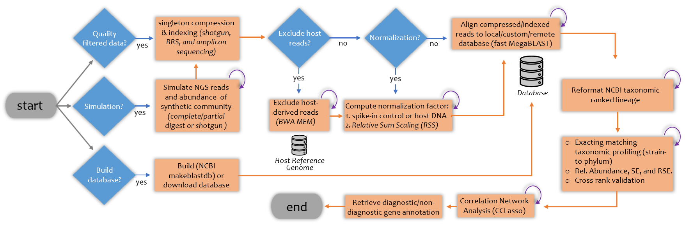
Figure 1: Flow chart of the Qmatey pipeline.

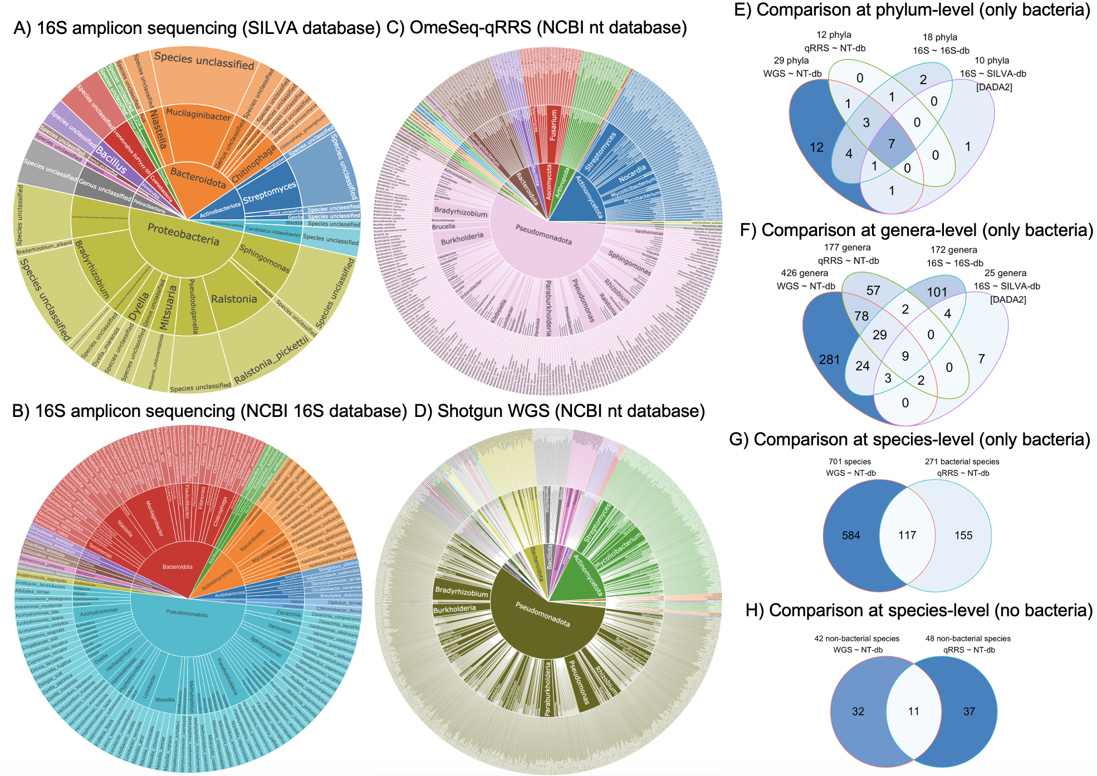
Figure 2: Sunburst showing diversity of taxa at species level (from center to outer ring: phylum, genus, and species) for DADA2 (A) and Qmatey (B) based on microbiome profiling of 16S NGS paired-end reads aligned against the SILVA and NCBI 16S database, respectively, OmeSeq-qRRS sequences reads (C) aligned against the NCBI nt database, and shotgun WGS sequencing reads (D) aligned against the NCBI nt database. Sequence data are derived from rhizosphere of Rp1D21 mutant and wild type maize inbred lines. Venn Diagrams (E-H) show the overlap of taxa at certain levels and between different methods.

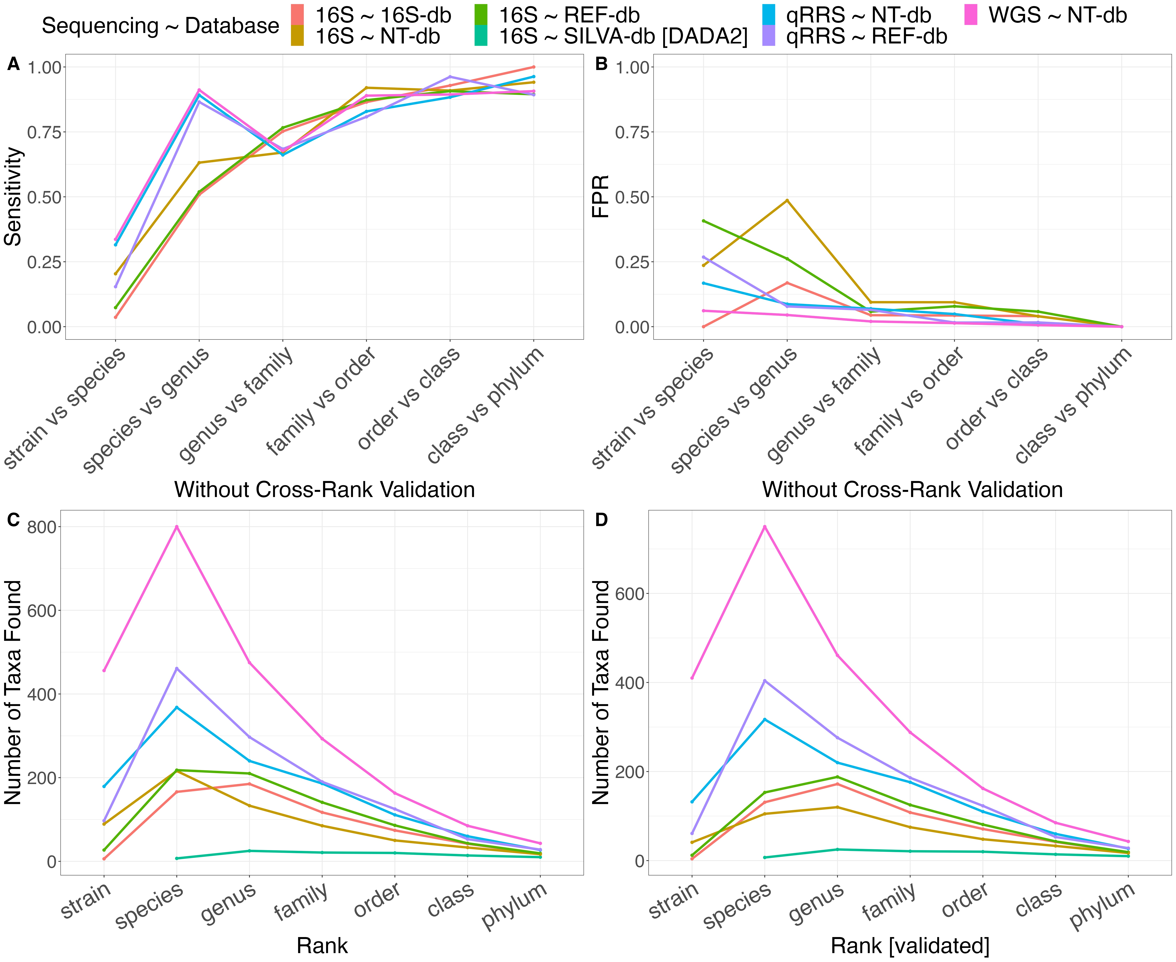
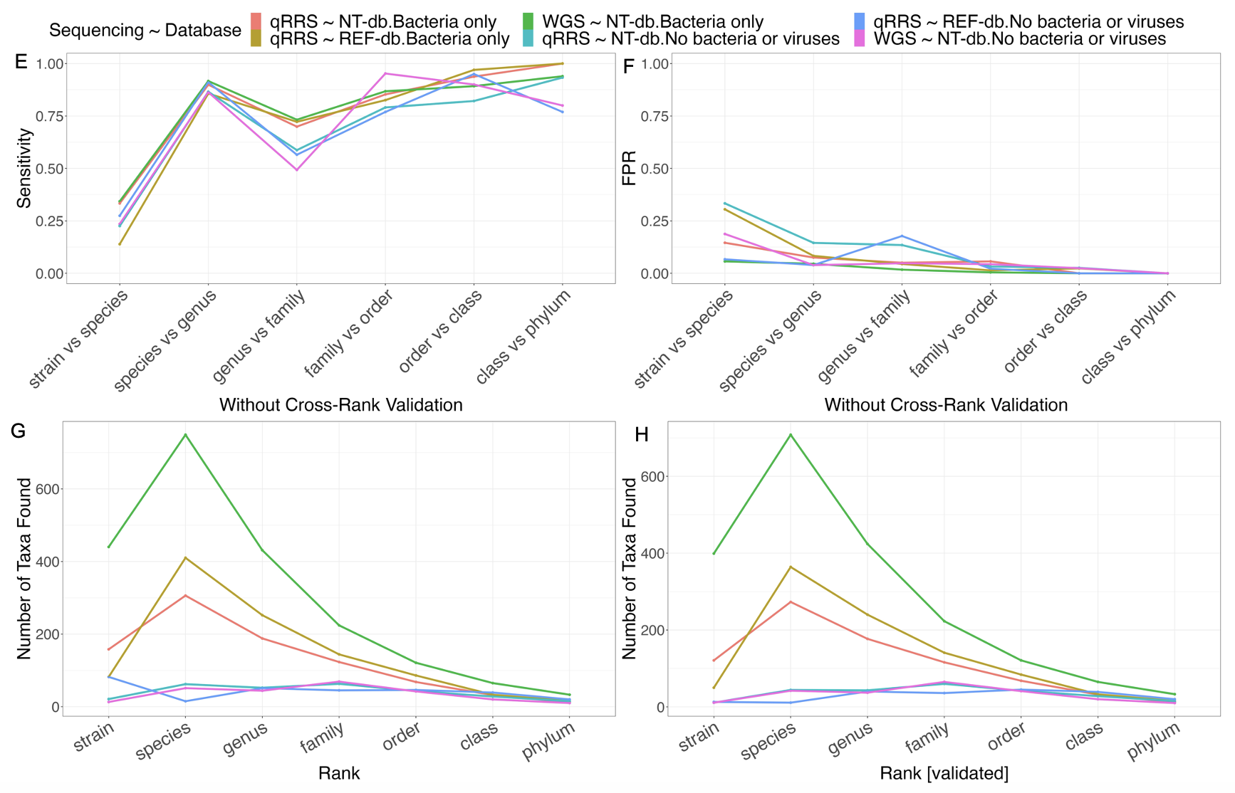
Figure 3: Analysis of sensitivity (A, E), false discovery rate (B, F), and number of taxa found per level with and without cross-rank validation (C, D, G, H). Lines are color coded by type of sequencing data and the database(s) used for taxonomic assignment of Rp1D21 mutants.
APPENDIX: TABLES
Table 1: Quantitative metagenome profiling of MBARC-26 mock community using various types of subsampling depths. Quality performance metrics (FPR, recovery rate, and prediction accuracy of abundance) allow for comparison of Qmatey’s results with experimental parameters.
Taxa Level | Quality filtered  reads | Subsampled  fragments | Genome  coverage  (%) | FPR (%) | Recovery Rate  (%) | Prediction
 |  |  |  |  |  | accuracy
Taxa Level | Quality filtered  reads |  | Genome  coverage  (%) | FPR (%) | Recovery Rate  (%) | of abundance
Strain | Yes | RE1::RE2 | 0.24 | 0 | 85 | 0.76
Strain | Yes | RE1/2::RE1/2 | 3.2 | 4 | 85 | 0.63
Strain | Yes | No subsample | 70.16 | 8 | 85 | 0.92
Strain | No | RE1::RE2 | 0.87 | 31 | 85 | 0.71
Strain | No | RE1/2::RE1/2 | 11.48 | 92 | 96 | 0.62
Species | Yes | RE1::RE2 | 0.24 | 0 | 92 | 0.74
Species | Yes | RE1/2::RE1/2 | 3.2 | 0 | 92 | 0.68
Species | Yes | No subsample | 70.16 | 0 | 92 | 0.92
Species | No | RE1::RE2 | 0.87 | 52 | 96 | 0.66
Species | No | RE1/2::RE1/2 | 11.48 | 94 | 100 | 0.66

Table 2: Quantitative metagenome profiling and simulation of short read next-generation sequencing of 26 genome assemblies (MBARC-26 mock community). NGS simulation is based on various genome fragmentation methods (shotgun/random, complete digest, and partial digest) while subsampling (restriction enzyme double-digest) simulates quantitative reduced representation sequencing (qRRS). Quality performance metrics (FPR, recovery rate, and prediction accuracy of abundance) allow for comparison of simulation and subsampling parameters.
Taxa Level | Subsampled  fragments | Genome  coverage  (%) | Simulation  fragmentation  method | FPR (%) | Recovery Rate  (%) | Prediction
 |  |  |  |  |  | accuracy
 |  |  |  |  |  | of abundance
Strain | RE1::RE2 | 0.05 | shotgun + complete digest | 0 | 77 | 0.66
Strain | RE1::RE2 | 1.35 | complete digest | 0 | 85 | 0.53
Strain | RE1::RE2 | 97.37 | partial digest | 0 | 92 | 0.58
Strain | RE1/2::RE1/2 | 1.43 | shotgun + complete digest | 4 | 88 | 0.49
Strain | RE1/2::RE1/2 | 20.75 | complete digest | 0 | 92 | 0.43
Strain | RE1/2::RE1/2 | 99.52 | partial digest | 4 | 96 | 0.57
Strain | No subsample | 84.04 | Shotgun | 5 | 81 | 0.47
Species | RE1::RE2 | 0.05 | shotgun + complete digest | 0 | 92 | 0.66
Species | RE1::RE2 | 1.35 | complete digest | 0 | 100 | 0.53
Species | RE1::RE2 | 97.37 | partial digest | 0 | 100 | 0.65
Species | RE1/2::RE1/2 | 1.43 | shotgun + complete digest | 0 | 100 | 0.42
Species | RE1/2::RE1/2 | 20.75 | complete digest | 0 | 100 | 0.42
Species | RE1/2::RE1/2 | 99.52 | partial digest | 0 | 100 | 0.58
Species | No subsample | 84.04 | Shotgun | 0 | 85 | 0.53

APPENDIX: SUPPLEMENTAL FIGURES
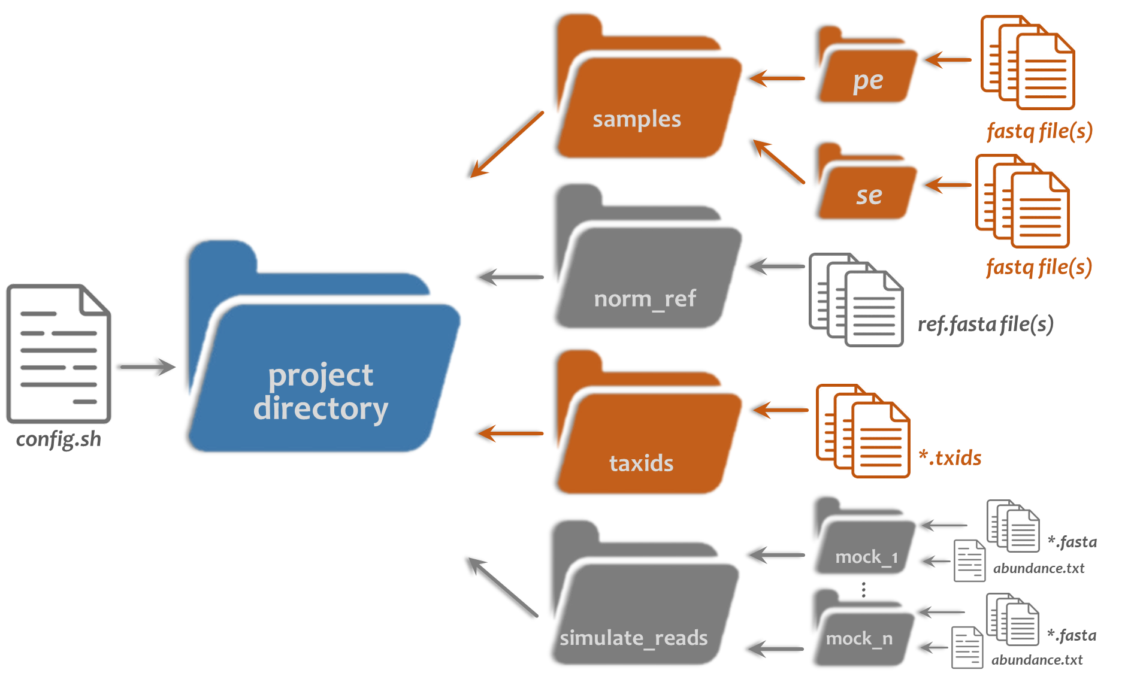
Figure S1: Project directory set up.

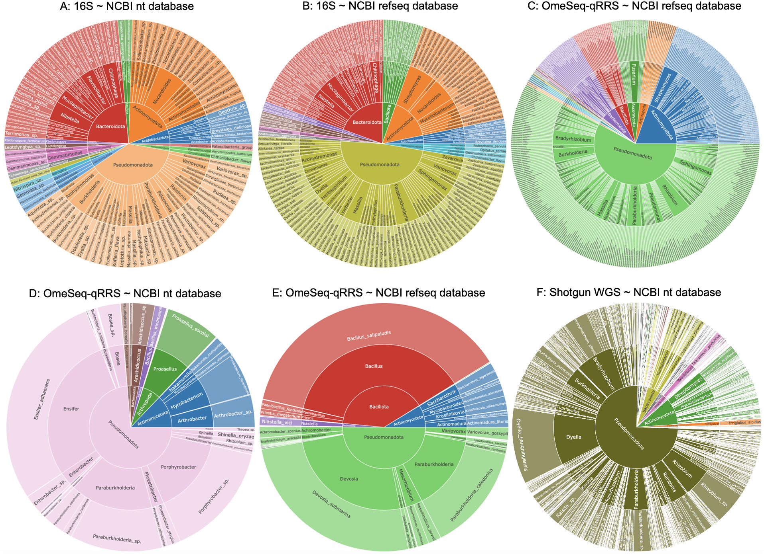
Figure S2: Diversity sunburst plots of species level (from center to outer ring: phylum, genus, and species) validated Rp1D21 maize results produced by Qmatey when using 16S sequencing against the nt database (A), 16S sequencing against the refseq database (B), and OmeSeq-qRRS against the refseq database (C). Relative abundance sunburst plots of species level (from center to outer ring: phylum, genus, and species) validated Rp1D21 maize results produced by Qmatey when using OmeSeq-qRRS sequencing against the nt database (D), OmeSeq-qRRS against the refseq database (E), and shotgun WGS against the nt database (F).

CHAPTER II

Quantitative reduced representation sequencing of leaf metagenomes reveals that sweetpotato defense response, transport, and chromatin remodeling genes drive plant-viral interactions

ABSTRACT

Sweetpotato, Ipomoea batatas, is an important crop for food security that can experience up to 50% of yield loss due to viral infection. Besides the host genetic control of disease resistance, host-associated biotic factors (microbe-microbe interactions) can also explain a significant proportion of variation in disease severity, hence reducing the utility of breeding models for crop improvement. To develop a robust and predictive model to dissect the impacts of the holobiont (i.e., host-genetics and associated microbe-microbe interactions) on phenotypic expression, high-density SNP data was integrated with meta-data derived from the leaf microbiomes of 767 sweetpotato accessions. The species/strain-level metagenomic profiles were obtained by quantitative reduced representation sequencing (OmeSeq-qRRS) and processed with ngsComposer and Qmatey. Ten sweetpotato viruses were identified along with several pathogenic and beneficial organisms. Using 80,000 genome-wide SNPs, GWASPoly identified SNPs/genes underlying host-viral interactions while modeling all dosage-based additive and dominance SNP effects. Plausible functions of candidate genes co-localized with significantly associated SNPs are described based on functional annotations of gene orthologs. An initial inquiry revealed associations between viral presence and enrichment of host genes that function in intracellular signaling, transport, and disease resistance. The comprehensive insight into multi-way interactions within the microbiome holds great promise for precision breeding by providing more accurate models that account for both host and metagenome genetic factors.

INTRODUCTION

Endophytic microbial communities typically represent a complex niche where member microbes have often co-evolved with the host to form a holobiont and act as a secondary genome that plays a key role in the gene and phenotypic expression of the host (Vandenkoornhuyse et al. 2015). While understanding the genetic basis for specific host-microbe interactions are often confounded by microbe-microbe interactions, a multipartite model involving the host, microbes, pathogens, and pests is crucial to understanding and accurately modeling traits such as resistance to complex diseases and disease complexes (Floc’h et al. 2020). For example, pathogens have been documented to infect host tissue without disease symptoms and remain in a latent state until poorly understood cues trigger pathogenicity (Roossinck 2010). Techniques for metagenome and microbiome profiling continue to advance and have reached a point where inexpensive high-throughput, quantitative and strain-level profiling is now possible following interrogation with genome-wide diagnostic sequences in component genomes. Until now, in addition to being expensive and computationally intensive, quantitative metagenomic profiling remains challenging partly due to the requirement for SNP-level resolution during strain-level taxonomic identification while avoiding false positive and false negative errors due to base calling errors (Simmonds et al. 2017; Rubio, Galipienso, and Ferriol 2020). To underscore the latter point, while viruses have a high point mutation rate, only a few of these mutations persist and are fixed in populations. Consequently, microbial strains are typically delineated by only a few SNPs across their genomes (Bush et al. 2020). Nonetheless, accurate and inexpensive diagnostic and quantitative assays are crucial given their economic impact on crop production and human health (Mumford, Macarthur, and Boonham 2016).
Current serological and molecular techniques, such as enzyme-linked immunosorbent assay (ELISA), DNA/RNA amplification through quantitative polymerase chain reaction (qPCR or RT-qPCR) and isothermal amplification (LAMP-PCR) are reliant on having prior knowledge of the viral genome to design antibodies and primers, respectively. When designing antibodies and primers, the genetic variability within and among viral species need to be accounted for to optimize detection while reducing false positives (Rubio, Galipienso, and Ferriol 2020). High-throughput sequencing (HTS) of metagenomes that use shotgun next-generation sequencing (NGS) (Bulgarelli et al. 2015) and NGS-based reduced representation sequencing (Hess et al. 2020), however, do not require prior knowledge of the viral genome sequences or virome composition except during downstream read alignment to sequences in databases for taxonomic identification. These assays provide the ability to sequence the virome present in a host and provide estimates of relative abundance (Rubio, Galipienso, and Ferriol 2020). When compared to serological and molecular techniques, HTS NGS-based profiling techniques are more broad-spectrum in their diagnostic abilities, have unbiased identifications, and can be more cost efficient (Maree et al. 2018).
Compared to NGS-based amplicon sequencing that use the rRNA sequence for profiling only bacteria and fungi, genome-wide sequencing of metagenomes is a more robust approach for viral detection and quantification since viruses lack rRNA sequences in their genomes (Wooley, Godzik, and Friedberg 2010). The ability to quantitatively capture a broad spectrum of organisms, including viruses, bacteria, protista, fungi, and higher eukaryotes offers a great appeal for a holistic understanding of multipartite interactions within complex metagenomic communities. This robustness and broad-spectrum also extends to profiling endosymbionts that are now known to play critical roles in hosts’ biological processes, such as regulation of immunity and reproductive success (Hedges et al. 2008).
Recent advancements in computational algorithms and sequencing platforms have enhanced metagenomic profiling’s ability to functionally study multipartite relationships involving community members and their hosts at the most fundamental genomic level (Wooley, Godzik, and Friedberg 2010). One improvement is the ability to quantitatively profile metagenomes and use this for genome-wide marker-phenotype associations (GWAS), where the relative abundance of cells estimated from preferably unique gene sequences are used to determine how well a host genetic background recruits an organism or how successful an organism can colonize and proliferate within a host. The community members can include both microorganisms and multicellular organisms like nematodes and insects. The GWA analysis can provide an opportunity to discover the host genetic factors that drive these interactions, while correlation network analyses that are robust for compositional data can detect potential interactions between and among (within microbial hubs) community members (Matchado et al. 2021). Within the last decade have there been reviews published discussing the importance of microbiome genome-wide association studies (mGWAS) and metagenome-wide association studies (MWAS) in understanding host-microbe relationships in plant phyllosphere research and human gut research, respectively (Wang and Jai, 2016; Awany et al. 2019; Beilsmith et al. 2019). Amplicon sequencing has been used for mGWAS to discover host-genetic factors in the recruitment and/or assembly of crop microbiomes (Sutherland et al. 2022; Tan et al. 2022). In this study, we present a novel implementation of using metagenomic data generated through a quantitative reduced representation sequencing approach (OmeSeq-qRRS) to enhance GWAS.
Interpreting GWAS results is not always straightforward since there can be significant confounding factors (e.g., population structure, host-pathogen-microbe interactions, long range linkage disequilibrium, and errors in variant calling) that can lead to spurious associations (Hussman et al. 2011; Wang et al. 2018; Park 2019; Nicholls et al. 2020). With respect to using quantitative metagenomic profiles as trait data for GWAS, it is expected that the relative abundance of community members is driven by both the genetic factors of the host and other members of the metagenome that play a role in multi-way biotic and abiotic interactions (Hassani, Durán, and Hacquard 2018). Consequently, using component members of the metagenome as a covariate might help minimize spurious association and improve statistical power. Recent studies are now exploring the utility of microbiomes as a biosensor for obvious and hidden biotic stress (Zolti et al. 2020). For example, a positive correlation between a virus and a fungus might indicate the viral infection’s ability to compromise the host immunity and consequently make the host susceptible to other pathogens (Tang et al. 2019). In this study, we introduce a metagenome enhanced GWA by using correlated community members as covariate to improve statistical power.
Ipomoea batatas, commonly known as sweetpotato, is a staple food crop grown through vegetative propagation (Loebenstein and Thottappilly 2009). Like other vegetatively propagated crops produced, the planting stocks tends to accumulate several of the at least 30 viruses identified to infect sweetpotato (Loebenstein and Thottappilly 2009; Clark et al. 2011). The most common methods for viral detection in sweetpotatoes are serological- or PCR-based and in the case where virus titer is low, grafting to Brazilian morning glory, I. setosa (Clark et al. 2011). Emerging methods for viral detection in sweetpotatoes include LAMP-PCR/rolling-circle amplification (RCA) and deep-sequencing of small RNAs (siRNAs) (Paprotka et al. 2010; Cao et al. 2017). While many sweetpotato viruses can be identified by their phenotypic effects (i.e., curling of leaves, color change from a green to a yellow shade), some viruses appear symptomless and would only be confirmed through molecular techniques (Kim et al. 2015). The early detection of sweetpotato viruses either through molecular techniques or observed symptoms can facilitate efforts to mitigate significant yield losses.
In this study, we propose a novel quantitative metagenomic profiling assay (OmeSeq-qRRS: quantitative reduced representation sequencing of component genomes) to catalog and quantify the viruses found across 767 sweetpotato accessions. Using the relative abundance of viral titer (mimicking methods like RT-qPCR/qPCR and LAMP-PCR) as the phenotype for GWAS, we present candidate genes underlying plant-viral interactions with implications for breeding disease resistance to viral pathogens. These candidate genes are enriched in leucine-rich-repeat motifs, JA-dependent defense pathway (​​wound-responsive proteins) that acts upstream of viral infection and during insect vector herbivory, and host cellular transport pathway co-opted by the virus for intercellular and intracellular movement. This study highlights a metagenome-assisted genome-wide association analysis that models the multipartite interactions that modulate viral diseases in sweetpotato.
MATERIALS AND METHODS
Sweetpotato greenhouse samples
The entire USDA sweetpotato germplasm (767 sweetpotato accessions or “diversity population”) were obtained from tissue culture plant materials (virus-tested) that were maintained at the USDA gene bank in Griffin, GA. The plantlets were obtained in test-tubes and grown under greenhouse conditions at the USDA Vegetable Laboratory in Charleston, South Carolina. Leaves were sampled, freeze-dried, and then stored at -20°C.
DNA extraction, library preparation, and sequencing
Sweetpotato leaf microbiome DNA was extracted using a CTAB DNA extraction protocol (Doyle and Doyle 1990). Library preparation and sequencing was performed as described in Wadl et al. 2018. The library preparation technique is known as GBSpoly (renamed OmeSeq-qRRS after modifications and to emphasize its use for quantitative reduced representation sequencing). An updated version of the bioinformatic pipelines described in Wadl et al. 2018 were used for NGS data demultiplexing (ngsComposer), read quality filtering (ngsComposer), variant calling (GBSapp), and variant filtering (GBSapp) (Kuster, Yencho, and Olukolu, 2021). Consequently, a total of 80,000 dosage-based (6x) variants (SNPs and InDels) were identified across the 767 sweetpotato accessions.

Quantitative metagenomic profiling
The metagenomic profiling of the diversity sweetpotato leaf population was performed using a bioinformatic pipeline, Qmatey (Quantitative Metagenomic Alignment and Taxonomic Exact matching), which uses a novel implementation of an exact-matching algorithm for strain level identification and an exact-matching of consensus sequencing for species to phylum level identification. The NCBI nucleotide (nt) database was used as the reference for alignment using the NCBI MegaBLAST. The two purported ancestral diploid reference genomes (I. trifida and I. triloba) were provided to remove host-specific sequencing reads and retain host-associated metagenomic sequence reads (Wu et al. 2018). The quantitative abundance profiles (normalized gene counts based on a relative sum scaling; RSS) produced by Qmatey were used in the GWA analysis, with the viral load as the phenotype and the correlated members of the metagenome as the covariate. All pairwise correlations were computed based on a CCLasso method that accounts for the compositional nature of the data (i.e., multi-way interactions) (Fang et al. 2015).
Genome-wide association study (GWAS)
An R script was written to automate the GWA analysis. The initial variables determined trait of interest, minimum proportion of taxa present across sweetpotato accessions, kinship/relationship Matrix method for polyploid organisms (VanRaden or Slater), and the use of covariates within the mixed linear model. The GWA analysis was performed using the R package GWASpoly (Rosyara et al. 2016) based on the following dosage models: “additive”, “1-dom alt”, “1-dom ref”, “2-dom alt”, “2-dom ref”, “3-dom ref”, and “3-dom alt”. The genotypic information used for the GWA analysis is the 6x dosage-based variant data generated by GBSapp, which filtered to a total of 80,000 SNPs and Indels. Filtering included maf > 0.02, sample missing rate < 0.3, and SNP missing rate < 0.3. A read depth threshold of 45 was used and evaluated on each genotype call rather than average read depth for each variant. Genotype calls below this threshold were re-coded as missing before missing rate filtering. The phenotypic information used for the GWAS was based on the relative abundance of the metagenomic profiles derived from Qmatey. The strategy of using sequenced DNA or DNA/RNA titer as proxy for phenotype data, has been employed in fields such as cancer research (Zukowski, Rao, and Ramachandran, 2020) and particularly for viral diseases (using qPCR/RT-qPCR or LAMP-PCR assays)
Identifying SNPs and candidate gene function
For candidate gene analysis, we first identified the gene-dosage model that provided the best (statistically speaking) results- low background noise on the Manhattan plot and had a QQ-plot whose line didn’t deviate significantly. For most viruses, the additive model was chosen to pursue. The SNPs that were identified as being significantly associated were evaluated for co-localization or proximity to candidate genes using the I. trifida Jbrowse (Wu et al. 2018). While evaluating the local LD around the SNP region, if the SNP was not within the coding or promoter region of a gene, the closest genes were considered as plausible genes based on indirect association. The threshold to determine significantly associated SNPs was based on the Bonferroni and FDR significance thresholds. Each genome-wide scan was evaluated to estimate the false discovery rate using the QQ-plots. If the Jbrowse returned genes for hypothetical proteins, we performed a NCBI blastn and explored conserved motifs using the NCBI conserved domain database (CDD) search. Literature review, online gene catalogs (such as UniProt and TAIR), and the STRING database (Szklarczyk et al. 2023) were used to establish the function of the candidate genes.
RESULTS
Sweetpotato virome profiles
A total of 269 viral strains were identified across the 767 sweetpotato leaf metagenome. Bacteriophages were the most abundant kind of virus found in the population, followed by Geminiviridae plant viruses. At a threshold of 10% (i.e., at least 77 of the 767 accessions have the virus in their metagenome), six sweetpotato viruses (Sweetpotato badnavirus B, Sweetpotato badnavirus C, Sweetpotato leaf curl Canary virus, Sweetpotato leaf curl virus, Sweetpotato pakakuy virus, and Sweetpotato symptomless virus 1) and eight bacteriophages (Acinetobacter phage Ab1656 2, Acinetobacter phage AbTJ, Acinetobacter phage YMC11/11/R3177, Caudovirales sp., Escherichia phage P1, Myoviridae sp., Podoviridae sp., and Siphoviridae sp.) were detected and further analyzed for host-microbe and microbe-microbe interactions (Table 3A). However, there were four additional sweetpotato viruses (Sweetpotato badnavirus A, Sweetpotato golden vein associated virus, Sweetpotato leaf curl Japan virus, and Sweetpotato leaf curl South Carolina virus) between a threshold of 5-10% that we chose to include given their economic importance (Table 3B). Human viruses were excluded from our analysis since these were probably environmentally derived.
Since the version of the library prep protocol (GBSpoly) used in this study was designed to capture only DNA viruses or RNA viruses with DNA intermediates, the presence of the Watermelon mosaic virus (WMV) within the metagenome was unexpected. WMV is single stranded positive-sense RNA with no known DNA intermediate. Upon further analysis of the MegaBLAST results, although the tax id (146500) identifies it as WMV, the diagnostic sequence used for identification is listed as “Mutant Watermelon mosaic virus isolate Vera-crtB.” This WMV strain is engineered to express the Pantoea ananatis phytoene synthase (crtB) (Aragonés et al. 2019). The diagnostic sequence used for the identification also matched the crtB gene sequence in a manual MegaBLAST. The fact that WMV has strong, positive correlations with several strains of Pantoea ananatis further confirmed that WMV was a spurious result (Fig. S3). Thus, we excluded WMV from our virome analysis.
Insect-transmitted sweetpotato viruses dominate leaf metagenome
There were three major types of sweetpotato viruses found within the leaf metagenome and all are transmitted by insects. Badnaviruses are spread by both horizontal transmission with a mealybug or aphid species and through seed transmission and grafting (Kreuze et al. 2020). The virus that was found in the most accessions was the Sweetpotato badnavirus B (SPPV-B) (Table 3A). SPPV-B is recognized as a variant of the species Sweetpotato pakakuy virus (SPPV), alongside Sweetpotato badnavirus A (SPPV-A) and Sweetpotato badnavirus C (SPPV-C), which all were also found in the population. The pea aphid, Acyrthosiphon pisum, a Badnavirus host, was detected within the metagenome (Ng and Zhou 2015). Badnaviruses are considered cryptic viruses since they can be detected by high throughput sequencing in otherwise healthy-looking crops (Roossinck 2015). The second most frequently seen virus was the leafhopper-transmitted Sweetpotato symptomless virus 1 (SPSMV-1) (Table 3A; Cao et al. 2017). While a leafhopper species was not detected within the metagenome, the brown plant hopper, Nilaparvata lugens, was detected. Begomoviruses are spread from plant to plant by vegetative propagation, seed transmission, and by the insect vector Bemisia tabaci (Kim et al. 2015). Sweetpotato leaf curl virus (SPLCV) is a well-defined and recognized Begomovirus that can cause up to a 30% decrease in yield (Clark and Hoy, 2006). Since SPLCV can be found worldwide, SPLCV is often given an isolate name for where the symptoms were observed, and the viral DNA was isolated and sequenced. For example, Sweetpotato leaf curl Canary virus (SPLCCaV) was detected in the Canary Island off the coast of Spain, Sweetpotato leaf curl Japan virus (SPLCJV) was first isolated in Japan, and Sweetpotato leaf curl South Carolina virus (SPLCSCV) was discovered from isolates in South Carolina, USA (Zhang and Ling 2011), which also happens to be the state where this population of Sweetpotato accessions were maintained. Another type of Begomovirus, Sweetpotato golden vein associated virus (SPGVaV) was also detected but is less characterized in literature (Kil et al. 2014).
Bacteriophages are present in about half of the sweetpotato leaf viromes
As expected, a large portion of the virome (~46%) was composed of tailed bacteriophages. Tailed bacteriophages are related through the Order Caudovirales but differ in tail structure as defined by their Family (Maniloff and Ackermann 1998). The presence of such tailed bacteriophages in the sweetpotato leaf virome were further confirmed by the presence of their bacteria hosts, such as Pseudomonas (present in 99.9% of accessions) and Bacillus (present in 44% of accessions), within the full metagenome results (Maniloff and Ackermann 1998). Two types of host-specific tailed bacteriophages were specifically identified in the top 10% of the results- three Acinetobacter strains and one Escherichia strain.
Significant virus-microbe correlations
To discover biological interactions between the ten sweetpotato viruses, various kinds of bacteriophages and other microbes in the leaf metagenome, we calculated CCLasso correlations based on relative abundance data. The results were filtered for significance (p < 0.05) and magnitude of the correlation coefficient (|r|>0.1) (Fig. 4A, B). As expected, the variants of sweetpotato leaf curl viruses were positively correlated with one another. Interestingly, there was a negative correlation between SPLCV and SPPV. None of the plant viruses had significant correlations with any of their known insect vectors above the threshold. The viruses primarily had positive correlations with pathogenic fungi, such as Alternaria alternata and Fusarium oxysporum. The negative correlations more so appear between bacteria that are known biocontrols of the pathogenic fungi, such as Acinetobacter and Pseudomonas species. These results suggest a synergistic relationship between viral and fungal infections, of which beneficial bacteria could be used to combat both. Additionally, these results suggest that sweetpotato viruses do not always have the same type of relationship with metagenome community members, a distinction made apparent when grouping virus-microbe interactions by viral Genus.

Significant phage-microbe correlations
We also calculated CCLasso correlations for the selected bacteriophages with the results filtered for significance (p < 0.05) and magnitude of correlations coefficient (|r|>0.1) (Fig. 5, S4). As expected, bacteriophages had both positive and negative correlation coefficients with their known bacteria hosts (i.e., Acinetobacter, Bacillus, and Pseudomonas). The positive and negative correlations might be indicative of types of interactions, including but not limited to resistance mechanisms and how long a virus stays in the latent vs. lytic phase. Additionally, the correlation seen between the bacteriophage and its host is modulated by the host’s relationship with other community members. For example, the most dominant Pseudomonas strains found in the metagenome have more negative than positive correlations with other non-Pseudomonas strains (Fig. S5).
Metagenome-assisted GWAS improves statistical power of detection
GWAS was performed using viral abundance as the phenotype, while members of the metagenome that are correlated with the virus of interest were used as covariates. All the sweetpotato viruses except for SPBV-C had significant correlations (|r|>0.1, p-value <= 0.05) with other microbes (Fig. 4A, B). The number and strength of the correlations corresponded to how much the statistical power of detection for associated SNPs changed during the metagenomic-enhanced GWAS. There do appear to be virus-specific cases where using covariates overcorrected the dosage model and lead to a decrease in associated SNPs as seen in the QQ-plots (Fig. S7). When comparing the GWAS results with and without metagenomic covariates, although the noise in the covariate results was reduced and allowed for the detection of SNPs not previously identified, the use of covariates did not significantly change the overall result in most viruses. In addition, through the comparison, we were able to see SNPs that persisted, indicating they had a true significance to the associated phenotype.
Bacteriophages have no direct interaction with Sweetpotato
Although the GWAS results for all the tailed bacteriophages had reduced noise when using the metagenome as a covariate, there were still too many significant SNPs above the Bonferroni threshold to declare any significant associations. The QQ-plots further confirmed the SNPs as spurious hits as the lines deviated very early, indicating high false positive rates. Consequently, we elected not to do candidate gene analysis on the GWAS results from the tailed bacteriophages since they do not seem to interact directly with the host plant.
Sweetpotato express strain-specific multi-chromosomal SNPs in response to viral infection
The results of the GWAS revealed multiple genes and various chromosomes underlying control of viral infection (Fig. 6). The exception is SPSMV-1, which has a significant association to a single hotspot on chromosome 14 that harbors a cluster of disease resistance (R) genes. Despite being variants of sweetpotato Badnavirus, SPBV-A, SPBV-B, SPBV-C and SPPV have no overlap in significantly associated SNPs. The same goes for all four types of SPLCV. These results indicate that sweetpotato’s defense response is strain specific.

Hypothetical and uncharacterized proteins are significantly associated with sweetpotato viruses
All the sweetpotato viruses, except for SPPV, had significantly associated SNPs in a gene or near a gene described as a hypothetical protein or a protein of unknown function. After performing a MegaBLAST using the nt database, we were able to find orthologs in related species for most of the uncharacterized genes. However, since there are still several yet to be characterized gene products found in at least two dosage models, these gene products still may have a role in defense response. For example, a hypothetical gene on Chromosome 7 (position 350325) in I. trifida is yet to be characterized but has a strong association with SPBV-A that was discovered with four gene dosage models.
Significantly associated SNPs for sweetpotato viruses are in or linked to Resistance (R) genes, cellular transport, and chromatin remodeling
While most of the significant SNPs for all the sweetpotato viruses rarely overlap, the candidate genes have similar motifs, fall within similar gene functions and defense response pathways (Fig. 6). Leucine motifs, such as leucine-rich-repeats (LRR or CC-NBS-LRR), basic leucine zippers (bZIP), and LRR protein kinases, were the most observed motifs and are characteristic of defense response genes (Jones and Dangl, 2006). The second most common type of motif was a peptide repeat, such as tetratricopeptide repeat (TPR) and pentatricopeptide repeat (PPR) proteins. These peptide repeats are known to mediate protein-protein interactions across numerous cellular functions, including responding to plant hormone signaling (Schapire, Valpuesta, and Botella 2006). However, given the wide vast array of functions, it’s hard to pinpoint what the proteins with these motifs are specifically associated with in terms of disease response. A third common type of motif was NB-ARC domain-containing, characteristic of R-coded disease resistance proteins (van Ooijen et al. 2008). Besides binding motif proteins, there were several candidate genes found that are involved in intracellular transport, from nuclear entry (nucleoporins) to vesicle movement (class XI myosins), and chromatin remodeling (SNF2) (Ryan and Owen-Hughes 2011; Talts et al. 2016).
DISCUSSION

In this study, we presented a novel sequencing protocol (OmeSeq-qRRS) and a taxonomic profiler (Qmatey) to enhance future metagenomic research. With the combined use of these tools, we were able to not only detect strain level taxa within sweetpotato leaf viromes but also capture the prokaryotic and eukaryotic community members they interact with. The sweetpotato viruses we recovered have great interest to the agricultural community as they cause significant yield losses. The CCLasso correlations produced by Qmatey revealed that microbes, particularly pathogenic ones, within the leaf metagenome are modulating viral abundance. Through a GWAS using the metagenome as a covariate to control for the multipartite interactions within the community, we discovered the genetic factors in sweetpotato involved in viral disease response but also the genetic factors hijacked during viral infection. These candidate genes provide a basis for future work in marker-assisted selection in sweetpotato breeding programs.
Bacteriophages experience indirect interactions through their host bacteria
Tailed bacteriophages are primarily hosted by Entero- and related bacteria (i.e., Acinetobacter, Aeromonas, Pseudomonas, and Vibrio). After subsetting our 20% of samples based on thresholds to minimize zero-inflation, the remaining members of the metagenome were all potential bacterial hosts. However, not all the interactions are positive, indicating that the interaction between the tailed bacteriophage and the bacterial host is also mediated by multi-way microbe-microbe interactions within the metagenome. For example, although Pseudomonas rhizosphaerae is a potential host of Caudovirales sp. and promotes plant growth through solubilizing phosphates, the presumed biocontrol abilities of P. rhizosphaerae against Botrytis cinerea modulates the microbe-phage relationship (Fig. S6).
Genus of sweetpotato plant viruses determines their relationship to pathogenic fungi
The CCLasso correlation results indicate a synergistic relationship between sweetpotato viruses and fungi pathogens. As the taxa in the metagenome was increasingly subsetted from 5% to 20% based on the number of samples where the taxa were found (reduces effect of zero-inflation), variants of SPLCV and SPGVaV were consistently positively correlated with Fusarium. Fusarium strains colonize roots and cause wilt diseases of stems and leaves by disrupting xylem function (Michielse and Rep 2009). Causal species of Fusarium wilt in sweetpotatoes, such as Fusarium oxysporum, were detected in the metagenome (Scruggs and Quesada-Ocampo 2016; Mphela et al. 2022). Variants of SPLCV were also consistently positively correlated with Pseudomonas and Sphingomonas. Pseudomonas is a common bacterial endophyte of sweetpotato plants (Khan and Doty 2009). With respect to viruses, some Pseudomonas species have been found to be effective biocontrol agents and induce systemic resistance in response to viral infection (Al-Ani and Tawfik 2011; Khalimi and Suprapta 2011). In contrast to Begomoviruses, the Badnaviruses and Mastrevirus were more often negatively correlated with Pseudomonas species, especially P. oryzihabitans, and positively correlated with non-Fusarium pathogenic fungi. Diaporthe batatas is the causal agent of dry root in sweetpotatoes, Alternaria species, such as A. alternata, cause necrotizing leaf spots and stem blight, and Botrytis cinerea causes grey rot/mold in sweetpotato storage facilities (van Bruggen 1984; Arinze and Smith 1982; Qian et al. 2016; Fujiwara et al. 2021). While sweetpotatoes are already susceptible to these and other pathogenic fungi, we expected co-infections with the viruses to result in more severe fungal disease symptoms. This virus-fungi co-infection trend has been observed in Asparagus officinali and Nicotiana tabacum (Evans and Stephens 1989; Tang et al. 2019).
Since the library protocol used in this study was optimized for DNA only, the sweetpotato viruses detected in our results are DNA viruses, but they differ by genus in DNA structure and genome segmentation. Begomoviruses and Mastreviruses (family Caulimoviridae) both have single stranded closed circular DNA structures. The genomes of Begomoviruses (family Geminiviridae) are usually segmented while the genomes of Mastreviruses are not. In contrast, Badnaviruses have circular double stranded DNA structure and their genomes are non-segmented. Geminiviridae and Caulimoviridae plant viruses have been found to incorporate into their host genomes as endogenous viral elements (EVEs). Research into EVEs’ effect on host gene expression in plants is recent but has been explored in vegetables such as brinjal eggplant and tomato. Caulimovirid EVEs, for example from a Badnavirus, have been found to be inserted within and disrupt the function of R1, an NBS-LRR gene involved in resistance against the causal agent of potato late blight, Phytophtora infestans (Serfraz et al. 2021). Given that our results reveal sweetpotatoes also have NBS-LRR genes used in defense response, it would be intuitive to reason that these genes are also at risk from disruption given the susceptibility of sweetpotatoes to Badnavirus infection.
The relationship between sweetpotato viruses and pathogens also involves the viruses’ insect host. Insect vectors can infect hosts that live or feed on with several types of microorganisms. Studies on two Begomovirus hosts found in the sweetpotato-associated metagenome, Aphis gossypii and Myzus persicae, found that their bacterial communities are enriched with endosymbiont Buchnera aphidicola but do contain Pseudomonas and Sphingomonas (Gallo-Franco, Duque-Gamboa, and Toro-Perea 2019). Therefore, the positive correlation between SPLCVs and SPGVaV and Pseudomonas and Sphingomonas species is part of a multipartite interaction involving the aphid vectors, plant hosts, and the viruses and bacteria they both host (Fig. 4A, B). Additionally, the positive correlation between Begomoviruses and Fusarium is a multipartite interaction as aphid infestation has been shown to correlate with Fusarium disease severity in wheat (Drakulic et al. 2016). In contrast to Begomoviruses, SPBV-C and SPPV had a negative correlation with Pseudomonas, which has been shown to be a biocontrol against white flies, the insect vector of Badnaviruses (Qessaoui et al. 2020). Although leafhopper microbiomes have been characterized, no viruses had any association with any known leafhopper endosymbiont. The sweetpotato metagenome results did reveal a parasitic fungus (aka zombie fungus), Ophiocordyceps species, that parasitizes insects and is also found in several leafhopper species (Nishino et al. 2016). The role of Ophiocordyceps species as an entomopathogen has been documented in multiple species of Ophiocordyceps and leafhoppers.
Sweetpotato viruses are primarily recognized through R-gene encoded receptors
Plants have two primary immune responses: an immune response triggered by pathogen elicitors and an immune response triggered by R-gene encoded receptors (Jones and Dangl 2006). Both immune responses often activate a hypersensitive response that leads to accumulation of reactive oxygen species. Viral coat proteins have been found to be effective elicitors as well as avirulence (Avr) gene products recognized by R proteins. The results of our metagenome-assisted GWAS revealed that the primary class of R proteins involved in the recognition of sweetpotato viruses have LRR and NB-ARC domains (van Ooijen et al. 2008). Regardless of the model used, the metagenome-assisted GWAS using SPSMV-1 indicated a strong association on Chromosome 14 with an R gene cluster (Fig. 6). At this locus, there are several copies of R genes within the NB-ARC and CC-NBS-LRR class and bZIP transcription factors. Our results also suggest the activation of reactive oxygen species accumulation as a defense response to viruses through the identification of candidate genes that function in oxidative stress or as oxidases. Ascorbate oxidase is a copper-containing enzyme found exclusively in plants and fungi that has been suggested to participate in redox reactions to aid in survival under stress conditions (De Tullio, Guether, and Balestrini 2013). Before sweetpotato viruses are recognized by the immune system, the plant may initiate an ET/JA-mediated defense response after being wounded by the insect hosts. This response to herbivory might be the first line of defense to viral infection. Wound-responsive proteins, such as pectin methylesterase, were found to be significantly associated with SPBV-A and SPLCV-C (Savatin et al. 2014). Plant pectin methylesterases play a critical role in multiple plant–microbe interactions and stress responses through cell wall modulation (Coculo and Lionetti 2022). Both virus’s insect hosts are known to cause physical damage during their feeding (Guerrieri and Digilio 2008; Padilha et al. 2021).
Sweetpotato viruses hi-jack cell machinery for replication and transport
Plant viruses rely on a host for replication. Caulimoviridae viruses, such as sweetpotato Badnaviruses, replicate first in the nucleus from an RNA template derived from virion DNA and then in the cytoplasm through reverse transcription (Harper et al. 2002). Our metagenome-assisted GWAS results revealed candidate genes that function in nuclear transport. Nucleoporin is an essential component of nuclear pore complexes (NPCs) and nuclear transport factor 2 (NTF2) participates in the nucleo-cytoplasm transport of proteins (He et al. 2010; Khan et al. 2020). Geminiviruses have been reported to integrate into host genomes and manipulate the cell cycle to control its own replication (Bejarano et al. 1996; Bhattacharjee and Hallan 2022). Candidate genes that function in chromatin remodeling (SNF2) were found and possibly contribute to the mechanism of how sweetpotato viruses initiate genome insertion or is part of the defense mechanism to prevent it (Ryan and Owen-Hughes 2011).
Beside replication, plant viruses rely on the host for intracellular transport. The Endosomal Sorting Complex Required for Transport (ESCRT) pathway has been implicated in viral budding and functions within regulated cell death. The essential partners for ESCRT are called vacuolar sorting proteins (Vsps) (Yang et al. 2022). The specific Vsp found through the metagenome-assisted GWAS, Vps51, is one of the subunits of the Golgi-associated retrograde protein (GARP) complex. Mutation analysis of homologs of Vps51 in Arabidopsis revealed a role of GARP in leaf shape (Pahari et al. 2019). Other transport-related candidate genes found included SNARE associated Golgi proteins, Endoplasmic reticulum vesicle transporter proteins and myosin-like protein XI-F (Avisar et al. 2009). Besides vesicles, viruses rely on microtubules for intracellular transport so distorting the cytoskeleton can limit a viral infection (Naghavi and Walsh 2019).
Sweetpotato hypothetical proteins are targets for further experimental study on response to viral infection
When annotating reference genomes, the gene sequences that have a predicted an open reading frame but have a yet to be characterized gene product are labeled as hypothetical proteins. If the uncharacterized gene sequence is found in several phylogenetic lineages, the gene is referred to as a conserved hypothetical protein. In the early 2000s, there was a call to action for bioinformaticians to help identify conserved hypothetical proteins so they can be targets for experimental research (Galperin and Kooin 2004). Recent advancements in next generation sequencing, mass spectrometry, and gene editing tools have not only allowed for the identification of new conserved hypothetical proteins but have proposed a function for them (Ijaq et al. 2015). With respect to sweetpotato research, dedicating time to perform functional analysis on conserved hypothetical proteins, such as the ones identified in this study, may lead to advancements in breeding for virus resistance.

REFERENCES
Al-Ani, R. A., and Tawfik, L. K. “Induced of systemic resistance in cucumber plants against Cucumber mosaic virus (CMV) by Pseudomonas fluorescens Migula.” AJPP 29.1 (2011): 36-42. Print.
Aragonés, Verónica, et al. "A Watermelon Mosaic Virus Clone Tagged with the Yellow Visual Maker Phytoene Synthase Facilitates Scoring Infectivity in Melon Breeding Programs." Eur. J. Plant Pathol. 153.4 (2019): 1317-23. Print.
Arinze, A. E., and I. M. Smith. "Effect of Storage Conditions on the Resistance of Sweet Potato Tissues to Rotting by Botryodiplodia Theobromae (Pat.) Amd Other Fungi." J. Stored Prod. Postharvest Res. 18.2 (1982): 37-41. Print.
Avisar, Dror, et al. "A Comparative Study of the Involvement of 17 Arabidopsis Myosin Family Members on the Motility of Golgi and Other Organelles " Plant Physiol. 150.2 (2009): 700-09. Print.
Awany, Denis, et al. "Host and Microbiome Genome-Wide Association Studies: Current State and Challenges." Front. Genet. 9 (2019). Print.
Beilsmith, K., et al. “Genome-wide association studies on the phyllosphere microbiome: Embracing complexity in host–microbe interactions.” Plant J 97 (2019): 164-181. Print.
Bejarano, E. R., et al. "Integration of Multiple Repeats of Geminiviral DNA into the Nuclear Genome of Tobacco During Evolution." Proc Natl Acad Sci U S A 93.2 (1996): 759-64. Print.
Bhattacharjee, Bipasha, and Vipin Hallan. "Geminivirus-Derived Vectors as Tools for Functional Genomics." Front. Microbiol. 13 (2022). Print.
Bulgarelli, Davide, et al. "Structure and Function of the Bacterial Root Microbiota in Wild and Domesticated Barley." Cell Host Microbe 17.3 (2015): 392-403. Print.
Bush, Stephen, et al. “Genomic diversity affects the accuracy of bacterial single-nucleotide polymorphism-calling pipelines.” GigaScience 9.2 (2020): giaa007. Print.
Cao, Mengji, et al. "Genome Characterization of Sweet Potato Symptomless Virus 1: A Mastrevirus with an Unusual Nonanucleotide Sequence." Arch Virol 162.9 (2017): 2881-84. Print.
Clark C., and M. Hoy. “Effects of common viruses on yield and quality of Beauregard sweetpotato in Louisiana.” Plant Dis. 90 (2006): 83–8.
Clark, Christopher A., et al. "Sweetpotato Viruses: 15 Years of Progress on Understanding and Managing Complex Diseases." Plant Dis. 96.2 (2011): 168-85. Print.
Coculo, Daniele, and Vincenzo Lionetti. "The Plant Invertase/Pectin Methylesterase Inhibitor Superfamily." Front. Plant Sci. 13 (2022). Print.
De Tullio, Mario, Mike Guether, and Raffaella Balestrini. "Ascorbate Oxidase Is the Potential Conductor of a Symphony of Signaling Pathways." Plant Signal. Behav. 8.3 (2013): e23213. Print.
Doyle, J.J. and J.L. Doyle. “Isolation of plant DNA from fresh tissue.” Focus 12 (1990):13–15. Print.
Drakulic, J., et al. "Aphid Infestation Increases Fusarium Langsethiae and T-2 and Ht-2 Mycotoxins in Wheat." Appl Environ Microbiol 82.22 (2016): 6548-56. Print.
Evans, TA., and CT Stephens. “Increased susceptibility to Fusarium crown and root rot in virus-infected asparagus.” Phytopathology 79 (1989): 253-258. Print.
Fang, Huaying, et al. "CCLasso: Correlation Inference for Compositional Data through Lasso." Bioinformatics 31.19 (2015): 3172-80. Print.
Floc’h, Jean-Baptiste, et al. "Bacterial Communities of the Canola Rhizosphere: Network Analysis Reveals a Core Bacterium Shaping Microbial Interactions." Front. Microbiol. 11.1587 (2020). Print.
Fujiwara, Kazuki, et al. "Real-Time PCR Assay for the Diagnosis and Quantification of Co-Infections by Diaporthe Batatas and Diaporthe Destruens in Sweet Potato." Front. Plant Sci. 12 (2021). Print.
Gallo-Franco, J. J., D. N. Duque-Gamboa, and N. Toro-Perea. "Bacterial Communities of Aphis Gossypii and Myzus Persicae (Hemiptera: Aphididae) from Pepper Crops (Capsicum Sp.)." Sci Rep 9.1 (2019): 5766. Print.
Galperin, Michael Y, and Eugene V Koonin. “'Conserved hypothetical' proteins: prioritization of targets for experimental study.” Nucleic Acids Res. 32.18 (2004): 5452-63. Print.
Guerrieri, Emilio, and Maria Cristina Digilio. "Aphid-Plant Interactions: A Review." J. Plant Interact. 3.4 (2008): 223-32. Print.
Harper, Glyn, et al. "Viral Sequences Integrated into Plant Genomes." Annu. Rev. Phytopathol. 40.1 (2002): 119-36. Print.
Hassani, M. A., P. Durán, and S. Hacquard. "Microbial Interactions within the Plant Holobiont." Microbiome 6.1 (2018): 58. Print.
He, Hong-Juan, et al. "Function of Nuclear Transport Factor 2 and Ran in the 20e Signal Transduction Pathway in the Cotton Bollworm, Helicoverpa Armigera." BMC Cell Biology 11.1 (2010): 1. Print.
Hedges, Lauren M, et al. “Wolbachia and virus protection in insects.” Science (New York, N.Y.) 322.5902 (2008): 702. Print.
Hess, Melanie, et al. "A Restriction Enzyme Reduced Representation Sequencing Approach for Low-Cost, High-Throughput Metagenome Profiling." PLOS ONE 15.4 (2020): e0219882. Print.
Hussman, J. P., et al. "A Noise-Reduction Gwas Analysis Implicates Altered Regulation of Neurite Outgrowth and Guidance in Autism." Mol Autism 2.1 (2011): 1. Print.
Ijaq, Johny, et al. "Annotation and Curation of Uncharacterized Proteins- Challenges." Front. Genet. 6 (2015). Print.
Jones, Jonathan D. G., and Jeffery L. Dangl. "The Plant Immune System." Nature 444.7117 (2006): 323-29. Print.
Khalimi, K., and Suprapta, D. N. “Induction of plant resistance against Soybean stunt virus using some formulations of Pseudomonas aeruginosa.” Journal of ISSAAS 17.1 (2011): 98-105. Print.
Khan, Asmat Ullah, et al. "Role of Nucleoporins and Transport Receptors in Cell Differentiation." Front. Physiol. 11 (2020). Print.
Khan, Zareen, and Sharon L. Doty. "Characterization of Bacterial Endophytes of Sweet Potato Plants." Plant and Soil 322.1 (2009): 197-207. Print.
Kil, E.-J., et al. “First Report of Sweet Potato Golden Vein Associated Virus Infecting Sweet Potato in Korea.” Plant Dis. 98.8 (2014): 1163–1163. Print.
Kim, J., et al. "Seed Transmission of Sweet Potato Leaf Curl Virus in Sweet Potato (Ipomoea Batatas)." Plant Pathol. 64.6 (2015): 1284-91. Print.
Kreuze, Jan F., et al. "Badnaviruses of Sweet Potato: Symptomless Coinhabitants on a Global Scale." Front. Plant Sci. 11 (2020). Print.
Kuster, Ryan D, G Craig Yencho, and Bode A Olukolu. "Ngscomposer: An Automated Pipeline for Empirically Based Ngs Data Quality Filtering." Brief. Bioinformatics (2021). Print.
Loebenstein G., and G. Thottappilly. 2009. The Sweetpotato. Dordrecht, Netherlands: Springer.
Maniloff, J., and H. W. Ackermann. "Taxonomy of Bacterial Viruses: Establishment of Tailed Virus Genera and the Other Caudovirales." Archives of Virology 143.10 (1998): 2051-63. Print.
Maree, Hans J., et al. "Application of HTS for Routine Plant Virus Diagnostics: State of the Art and Challenges." Front. Plant Sci. 9 (2018). Print.
Matchado, Monica Steffi, et al. "Network Analysis Methods for Studying Microbial Communities: A Mini Review." Comput. Struct. Biotechnol. J. 19 (2021): 2687-98. Print.
Michielse, C.B. and Rep, M. “Pathogen profile update: Fusarium oxysporum.” Mol. Plant Pathol. 10 (2009): 311-324. Print.
Mphela, W. M., et al. "Development and Screening of Fusarium Wilt Resistant Lines in Sweet Potato [Ipomoea Batatas (L.) Lam]." Euphytica 218.6 (2022): 68. Print.
Mumford, R., Macarthur, R., and Boonham, N. “The role and challenges of new diagnostic technology in plant biosecurity.” Food Secur. 8 (2016): 103–109. Print.
Naghavi, Mojgan H, and Derek Walsh. “Microtubule Regulation and Function during Virus Infection.” JVI 91.16 (2017): e00538-17. Print.
Nicholls, Hannah L., et al. "Reaching the End-Game for Gwas: Machine Learning Approaches for the Prioritization of Complex Disease Loci." Front. Genet. 11.350 (2020). Print.
Nishino, Takanori, et al. "Fungal and Bacterial Endosymbionts of Eared Leafhoppers of the Subfamily Ledrinae (Hemiptera: Cicadellidae)." Appl. Entomol. Zool. 51.3 (2016): 465-77. Print.
Ng, James C. K., and Jaclyn S. Zhou. "Insect Vector–Plant Virus Interactions Associated with Non-Circulative, Semi-Persistent Transmission: Current Perspectives and Future Challenges." Curr Opin Virol 15 (2015): 48-55. Print.
Padilha, Guilherme, et al. "Damage Assessment of Bemisia Tabaci and Economic Injury Level on Soybean." Crop Protection 143 (2021): 105542. Print.
Pahari, Shankar, et al. "Arabidopsis Unhinged Encodes a Vps51 Homolog and Reveals a Role for the Garp Complex in Leaf Shape and Vein Patterning." Development 141.9 (2014): 1894-905. Print.
Paprotka, T., et al. "Genomic Diversity of Sweet Potato Geminiviruses in a Brazilian Germplasm Bank." Virus Research 149.2 (2010): 224-33. Print.
Park, L. Population-specific long-range linkage disequilibrium in the human genome and its influence on identifying common disease variants. Sci Rep 9, 11380 (2019). https://doi.org/10.1038/s41598-019-47832-y
Qessaoui, et al. "Inoculation of Tomato Plants with Rhizobacteria Suppresses Development of Whitefly Bemisia Tabaci (Gennadius) (Hemiptera: Aleyrodidae): Agro-Ecological Application." PLOS ONE 15.4 (2020): e0231496. Print.
Qian, H. W., et al. "First Report of Alternaria Alternata Causing Leaf Spot on Sweetpotato in China." Plant Dis. 100.9 (2016): 1947. Print.
Roossinck, Marilyn J. "Lifestyles of Plant Viruses." Philos. Trans. R. Soc. B 365.1548 (2010): 1899-905. Print.
Roossinck, Marilyn J. "Metagenomics of Plant and Fungal Viruses Reveals an Abundance of Persistent Lifestyles." Front. Microbiol. 5 (2015). Print.
Rosyara, Umesh R., et al. "Software for Genome-Wide Association Studies in Autopolyploids and Its Application to Potato." The Plant Genome 9.2 (2016): plantgenome2015.08.0073. Print.
Rubio, Luis, Luis Galipienso, and Inmaculada Ferriol. "Detection of Plant Viruses and Disease Management: Relevance of Genetic Diversity and Evolution." Front. Plant Sci. 11 (2020). Print.
Ryan, D. P., and T. Owen-Hughes. "Snf2-Family Proteins: Chromatin Remodellers for Any Occasion." Curr Opin Chem Biol 15.5 (2011): 649-56. Print.
Savatin, Daniel V., et al. "Wounding in the Plant Tissue: The Defense of a Dangerous Passage." Front. Plant Sci. 5 (2014). Print.
Schapire, A. L., V. Valpuesta, and M. A. Botella. "TPR Proteins in Plant Hormone Signaling." Plant Signal Behav 1.5 (2006): 229-30. Print.
Scruggs, A. C., and L. M. Quesada-Ocampo. "Etiology and Epidemiological Conditions Promoting Fusarium Root Rot in Sweetpotato." Phytopathology 106.8 (2016): 909-19. Print.
Serfraz, Saad, et al. "Insertion of Badnaviral DNA in the Late Blight Resistance Gene (R1a) of Brinjal Eggplant (Solanum Melongena)." Front. Plant Sci. 12 (2021). Print.
Simmonds, Peter, et al. "Virus Taxonomy in the Age of Metagenomics." Nat Rev Microbiol 15.3 (2017): 161-68. Print.
Sutherland, Jeremy, et al. "Host Genomic Influence on Bacterial Composition in the Switchgrass Rhizosphere." Molecular Ecology 31.14 (2022): 3934-50. Print.
Szklarczyk, Damian et al. “The STRING database in 2023: protein-protein association networks and functional enrichment analyses for any sequenced genome of interest.” Nucleic Acids Res. 51.D1 (2023): D638-D646.
Talts, K., et al. "Arabidopsis Myosins XI1, XI2, and XIK Are Crucial for Gravity-Induced Bending of Inflorescence Stems." Front Plant Sci 7 (2016): 1932. Print.
Tan, Xiangfeng, et al. "Host Genetic Determinants Drive Compartment-Specific Assembly of Tea Plant Microbiomes." Plant Biotechnology Journal 20.11 (2022): 2174-86. Print.
Tang, Zhong-Qin, et al. "Characterization of Synergy between Cucumber Mosaic Virus and Alternaria Alternata in Nicotiana Tabacum." Physiol. Mol. 108 (2019): 101404. Print.
Wadl, Phillip A., et al. "Genetic Diversity and Population Structure of the Usda Sweetpotato (Ipomoea Batatas) Germplasm Collections Using Gbspoly." Front. Plant Sci. 9 (2018). Print.
Wang, Jun, and Huijue Jia. "Metagenome-Wide Association Studies: Fine-Mining the Microbiome." Nature Reviews Microbiology 14.8 (2016): 508-22. Print.
Wang, Tao, et al. "Adjustment for Covariates Using Summary Statistics of Genome-Wide Association Studies." Genetic epidemiology 42.8 (2018): 812-25. Print.
Wooley, John C., Adam Godzik, and Iddo Friedberg. "A Primer on Metagenomics." PLOS Computational Biology 6.2 (2010): e1000667. Print.
Wu, Shan, et al. "Genome Sequences of Two Diploid Wild Relatives of Cultivated Sweetpotato Reveal Targets for Genetic Improvement." Nature Communications 9.1 (2018): 4580. Print.
Vandenkoornhuyse, Philippe, et al. "The Importance of the Microbiome of the Plant Holobiont." New Phytologist 206.4 (2015): 1196-206. Print.
van Bruggen. A.H.C. “Sweet potato stem blight caused by Alternaria sp.: A new disease in Ethiopia.” Neth. J. Plant Pathol. 90 (1984): 155-164. Print.
van Ooijen, Gerben, et al. "Structure–Function Analysis of the Nb-Arc Domain of Plant Disease Resistance Proteins." Journal of Experimental Botany 59.6 (2008): 1383-97. Print.
Yang, Ye, et al. "The Endosomal Sorting Complex Required for Transport Repairs the Membrane to Delay Cell Death." Frontiers in Oncology 12 (2022). Print.
Zhang, S.C., Ling, KS. “Genetic diversity of sweet potato begomoviruses in the United States and identification of a natural recombinant between sweet potato leaf curl virus and sweet potato leaf curl Georgia virus.” Arch Virol 156 (2011): 955–968.
Zolti, Avihai, et al. "The Microbiome as a Biosensor: Functional Profiles Elucidate Hidden Stress in Hosts." Microbiome 8.1 (2020): 71. Print.
Zukowski, Alexis, Satyanarayan Rao, and Srinivas Ramachandran. "Phenotypes from Cell-Free DNA." Open Biology 10.9 (2020): 200119. Print.

APPENDIX: FIGURES
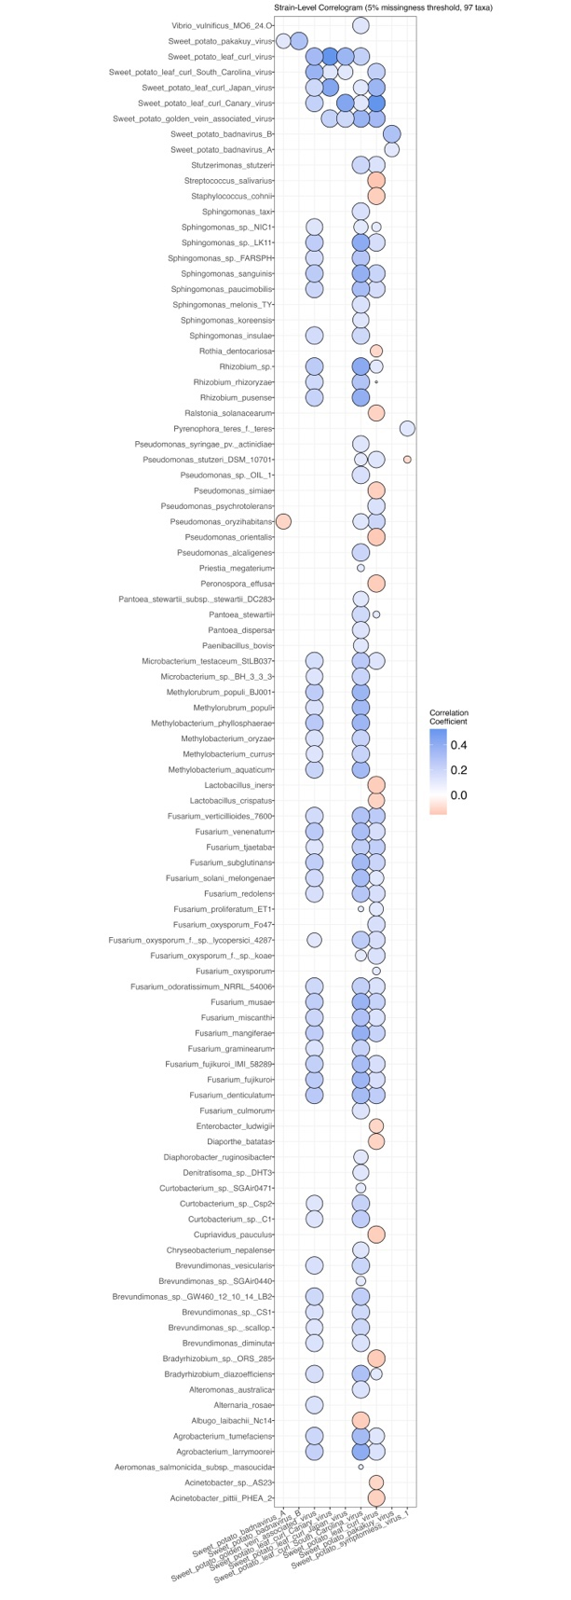
Figure 4A: CCLasso correlations between selected sweetpotato leaf viruses (x-axis) and the metagenome, filtered for |r| > 0.1, p-value < 0.05, and at a missingness of 5%. Size of data point is inversely proportional to associated p-value.

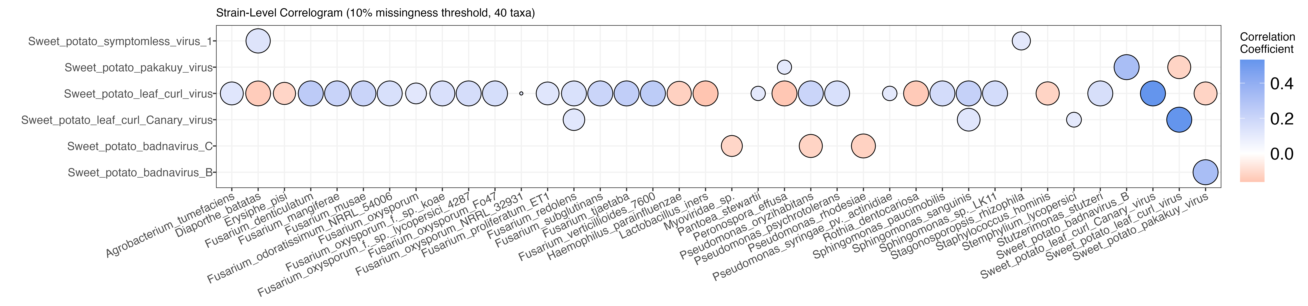
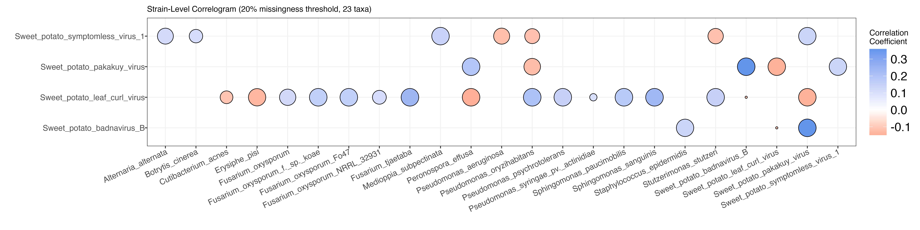
Figure 4B: CCLasso correlations between selected sweetpotato leaf viruses (y-axis) and the metagenome, filtered for |r| > 0.1, p-value < 0.05, and at a missingness of 10 and 20%. Size of data point is inversely proportional to associated p-value.

Figure 5: CCLasso correlations between selected bacteriophage Families (y-axis) and Entero- and related bacteria hosts, filtered for |r| > 0.1, p-value < 0.05, and at a missingness of 5, 10, and 20%. Size of data point is inversely proportional to associated p-value.

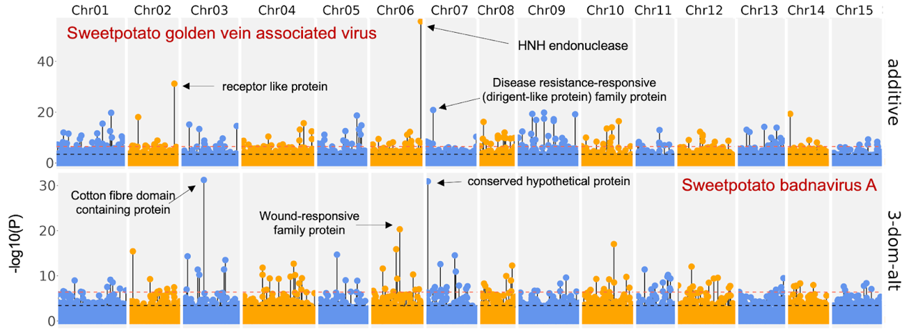
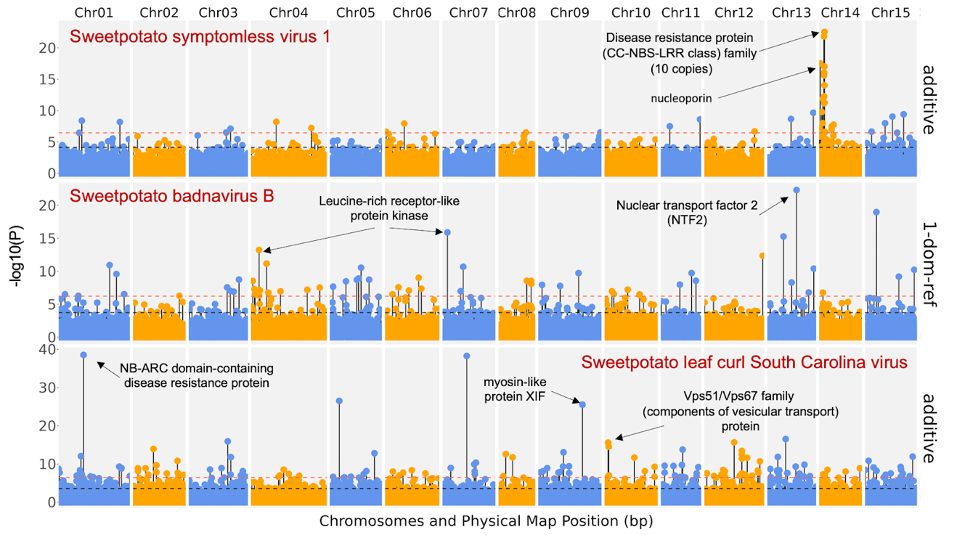
Figure 6: Annotated metagenome-assisted GWAS (with covariates) Manhatten plots of selected sweetpotato viruses. Dashed horizonal lines indicate the Bonferroni significance threshold (red) and the false discovery rate threshold (black). Dosage model is listed on the right y-axis.

APPENDIX: TABLES
Table 3A: Percent occurance (>10%) and taxonomic information of selected viruses within the leaf metagenome of the diversity sweetpotato panel.
Percent Occurance in DIV Population | Strain | Species | Genus | Family
88.27 | Sweetpotato badnavirus B | Sweetpotato  badnavirus B | Badnavirus | Caulimoviridae
70.14 | Siphoviridae sp. | Siphoviridae sp. | NA | Siphoviridae
59.45 | Sweetpotato symptomless virus 1 | Sweetpotato symptomless  virus 1 | Mastrevirus | Geminiviridae
53.59 | Sweetpotato  leaf curl virus | Sweetpotato  leaf curl virus | Begomovirus | Geminiviridae
53.59 | Myoviridae sp. | Myoviridae sp. | NA | Myoviridae
35.72 | Sweetpotato pakakuy virus | Sweetpotato  pakakuy virus | Badnavirus | Caulimoviridae
23.21 | Caudovirales sp. | Caudovirales sp. | NA | NA
21.25 | Podoviridae sp. | Podoviridae sp. | NA | Podoviridae
20.34 | Acinetobacter phage Ab1656 2 | Acinetobacter  phage Ab1656 2 | NA | NA
16.56 | Acinetobacter phage AbTJ | Acinetobacter  phage AbTJ | NA | Myoviridae
15.38 | Sweetpotato  leaf curl  Canary virus | Sweetpotato  leaf curl  Canary virus | Begomovirus | Geminiviridae
13.56 | Escherichia  phage P1 | Punavirus P1 | Punavirus | NA
11.99 | Human gammaherpes-virus 4 | Human gammaherpesvirus 4 | Lymphocrypto-virus | Herpesviridae
10.82 | Sweetpotato badnavirus C | Sweetpotato  badnavirus C | Badnavirus | Caulimoviridae
10.30 | Acinetobacter phage YMC11/11/  R3177 | Vieuvirus R3177 | Vieuvirus | NA
Table 3B: Percent occurance (5-10%) and taxonomic information of selected viruses within the leaf metagenome of the diversity sweetpotato panel.
Percent Occurance in DIV Population | Strain | Species | Genus | Family
9.00 | Sweetpotato badnavirus A | Sweetpotato  badnavirus A | Badnavirus | Caulimoviridae
8.87 | Sweetpotato  leaf curl  South Carolina virus | Sweetpotato  leaf curl  South Carolina  virus | Begomovirus | Geminiviridae
8.47 | Sweetpotato golden vein associated virus | Sweetpotato  golden vein associated virus | Begomovirus | Geminiviridae
8.34 | Watermelon mosaic virus | Watermelon  mosaic virus | Potyvirus | Potyviridae
7.04 | Human immuno-deficiency virus 1 | Human immuno-deficiency virus 1 | Lentivirus | Retroviridae
6.52 | Sweetpotato leaf curl Japan virus | Sweetpotato leaf curl Japan virus | Begomovirus | Geminiviridae

APPENDIX: SUPPLEMENTAL FIGURES

Figure S3: CCLasso correlations between selected Watermelon mosaic virus (y-axis) and the metagenome, filtered for |r| > 0.1, p-value < 0.05, and at a missingness of 5%. Size of data point is inversely proportional to associated p-value.

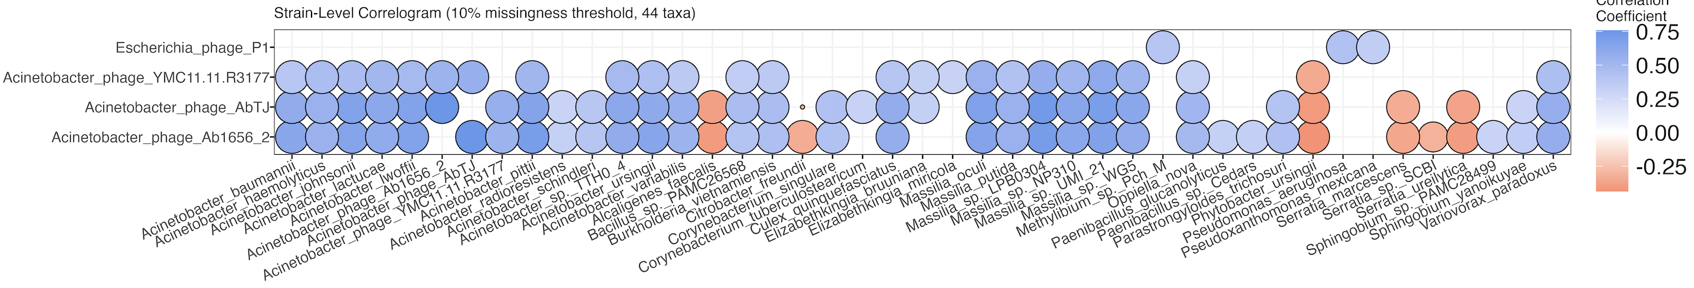
Figure S4: CCLasso correlations between selected bacteriophages (y-axis) and the metagenome, filtered for |r| > 0.3, p-value < 0.05, and at a missingness of 10%. Size of data point is inversely proportion to associated p-value.

Figure S5: Bar plots of the percent of negative (red) and positive (blue) interactions between Pseudomonas and non-Pseudomonas microbes within the sweetpotato leaf metagenome. The correlations were filtered for |r| > 0.1, p-value < 0.05, and at a missingness of 5, 10, and 20%. Correlations were filtered to remove Pseudomonas-Pseudomonas interactions.

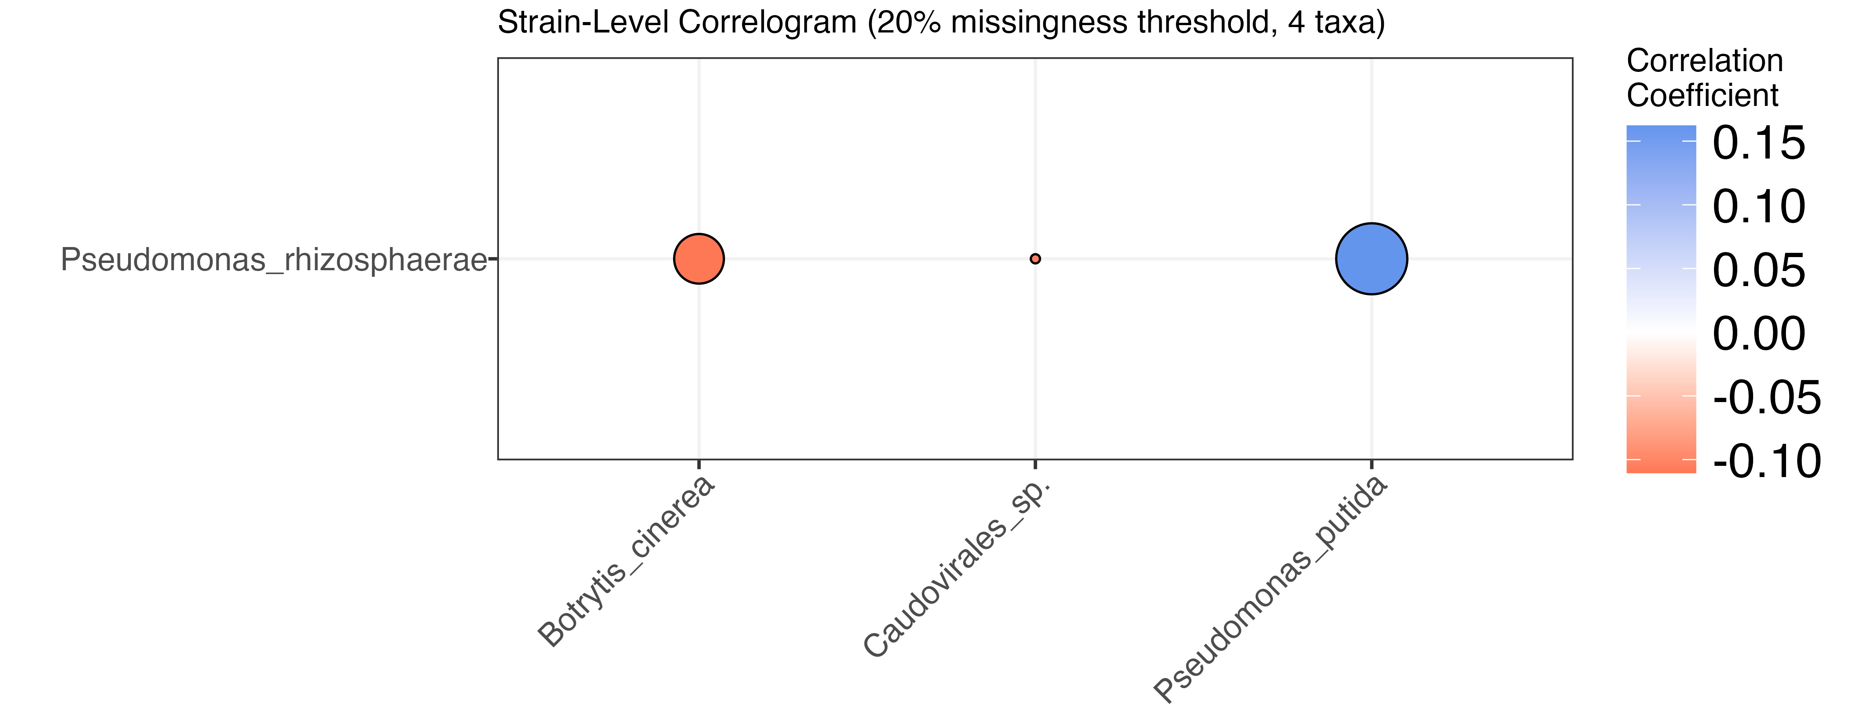

Figure S6: CCLasso correlations between selected Pseudomonas rhizosphaerae (y-axis) and the metagenome, filtered for |r| > 0.1, p-value < 0.05, and at a missingness of 20%. Size of data point is inversely proportional to associated p-value.

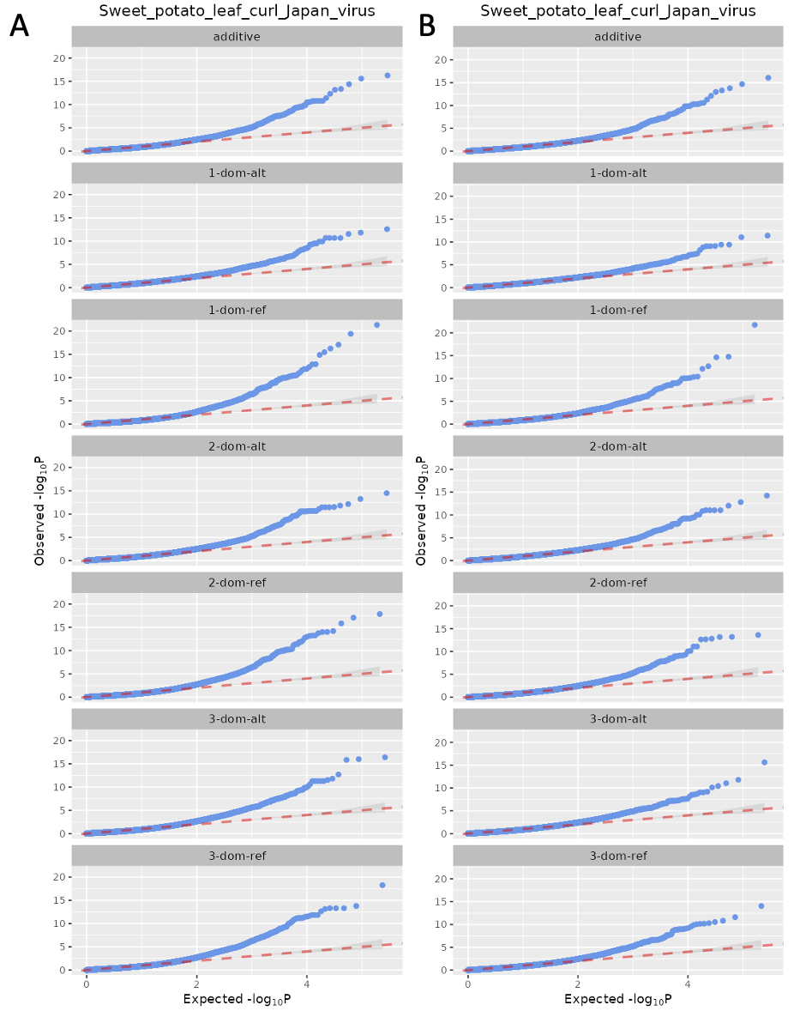
Figure S7: QQ plots of GWAS results for Sweetpotato leaf curl Japan virus with (B) and without (A) using the metagenome as a covariate.

CHAPTER III

CATALOG OF KERNEL-ASSOCIATED METAGENOMES AND MICROBE-MICROBE INTERACTIONS IN NON-GMO AND BT MAIZE HYBRIDS EVALUATED FOR FUSARIUM EAR ROT.

ABSTRACT

Maize hybrids have been genetically modified (GMO) to express proteins from Bacillus thuringiensis (Bt) that are toxic to certain insect pests. Consequently, lower insect damage in Bt-maize can lower the severity of Fusarium ear rot (FER). This study aims to evaluate FER resistance, the role of the kernel-associated metagenomes, and the impact of FER on yield. Analyses of data from three GMO (Dekalb) and three nonGMO (Spectrum) hybrids were performed independently since the transgene is not in the same different genetic background as the nonGMOs. A significant difference was observed across environments, hybrids, and treatments (inoculated and non-inoculated) for FER and the alpha and beta diversity indices of the kernel metagenomes. As expected, this confirms that FER severity and metagenomes were controlled by both environmental and genetic components. While there was no significant difference for yield between treatments, yield was negatively correlated with FER. Results confirm that Bt-toxins prevent infection under natural infection conditions. This is evident in the relative abundance of the major pathogen causing FER, Fusarium verticillioides (Fv), with 1.7 times and 6 times more Fv abundance in inoculated treatments for nonGMO and GMOs. Trends between nonGMO and Bt hybrids suggests that Bt toxin plays a significant role in metagenome composition and abundance. Microbes that were negatively correlated with Fv were identified as potential biocontrols (specific strains of Pantoea, Talaromyces, Acinetobacter, and Klebsiella), including antagonistic Fusarium strains (F. graminearum, F. mangifera, F. subglutinans, F. vanetteni, F. venenatum, and F. coffeatum) that probably suppress Fv through competition. The documented interactions between Aspergillus and Fusarium strains in maize was confirmed but results suggest indirection interaction with Fv through multipartite interactions involving synergy between Aspergillus and non-pathogenic Fusarium strains. Identifying host genetic factors and host-pathogen-microbe interactions are crucial for a sustainable strategy in breeding that is robust across environments.

INTRODUCTION

Zea mays (Maize) is a crop of worldwide importance and is grown on almost every continent. It is grown across the largest acreage in the United States and has a wide range of uses including livestock feed, food products and industrial products, such as, starch, sweeteners, corn oil, alcohol, and fuel ethanol (McConnel 2021). Similar to other crops, maize is susceptible to several yield- and quality-impacting fungal diseases caused by pathogens such as Fusarium and Aspergillus. Fusarium is one of the most economically important maize fungal pathogens due to its impact on yield and toxigenic capacity. Fifteen Fusarium spp. have been found to produce a group of mycotoxins called fumonisins (Rheeder, Marasas and Vismer 2002).
While F. verticillioides is the major causal pathogen of Fusarium ear rot (FER) in maize, other Fusarium species, including F. proliferatum, F. subglutinans, F. moniliforme, and F. graminearum, have sometimes been suggested to produce similar symptoms and accumulate fumonisins (Cotten and Munkvold 1998; Mesterházy, Lemmens and Reid 2011). Temperature, moisture, and drought stress affect the range and severity of Fusarium spp. that cause FER infection (Miller 2001). Hot and dry weather conditions typical of the southern United States and lowland tropics are optimal for ear rot caused by F. verticillioides and F. temperatum, while the F. graminearum prefers cool and wet conditions (Pfordt et al. 2020). Besides fumonisin, these Fusarium species are also responsible for producing a wide variety of mycotoxins such as deoxynivalenol and zearalenon (Pfordt et al. 2020). These favorable climates across the globe are also home to the primary plant-wounding insect vectors Ostrinia nubilalis (European corn borer) and Helicoverpa zea (corn earworm) (Henderson, Bennett, and McQueen 1966; Clements et al. 2003; Bibb et al. 2018). Host resistance for Fusarium infections is controlled by several host genes that each contribute small effects to total phenotypic variation (Zila et al. 2014; Lanubile et al. 2017). The complex mode of inheritance underlying resistance and the various pathogenic isolates that likely interact in unpredictable ways make breeding and crop improvement challenging (Robertson-Hoyt et al. 2006). In addition to mycotoxin contamination, which reduces the market value of the crop, the disease can typically lead to about 10% yield loss and as much as 30% under severe conditions (Logrieco et al. 2002; Czembor et al. 2019). Mycotoxins can persist through seeds harvested from infected crops (Bhat and Reddy 2017). When compared to other plant tissue-associated metagenomes, the kernel metagenome is one of the least studied, but research has shown that seed microbiota is related to overall plant fitness (Nelson 2018; Simonin et al. 2022).
Fusarium infection can occur in multiple ways, including: (1) fungal spores landing on silks, germinating, growing, and infecting kernels and cobs; (2) wounding caused by animal and hail damage; and (3) systemic infection after root wounding, which allows the infection to travel through the stalk and to the ears (Mesterházy, Lemmens and Reid 2011). Besides seed borne pathogens, the initial infection is mostly derived from Fusarium that has overwintered in soil and plant materials (Freije 2016). Previous studies have shown that FER infections are associated with damage due to insects feeding as little as 10 to 15 days after maize plants silk (Pfordt et al. 2020). As the plant reallocates resources for kernel development, their defense responses may possibly weaken and leave certain tissues, such as the stalk, susceptible to fungal infections (Pfordt et al. 2020).
While breeding resistance against these complex fungal diseases continues, genetically modified (GMO) maize hybrids expressing Bt gene products, such as the δ-endotoxins (Cry proteins), which are toxic to some insect pests, have been considered as an alternative to control FER and thus making it popular among US maize producers (Ostry et al. 2010; Dinon et al. 2011; Fernandez-Cornejo and Wechsler 2013). Disease studies on Bt-toxin maize hybrids have shown lower incidence of FER, indicating that insect damage is a significant driver of FER (Munkvold, Hellmich, and Showers 1997). By preventing insect damage, infection through wounding sites can be limited. However, the extent of FER resistance in Bt-toxin maize hybrids or how their resistance compares to nonGMO maize hybrids is not fully known. Findings on fumonisin contamination between Bt and nonGMO maize are mixed, suggesting Bt-toxin may only be effective against FER under conditions of low Fusarium infection potential (Abbas et al. 2013). Since the pathogens can also infect maize ears through the silk channel and other sources of wounding, avoiding wounding-induced infection by specific insects as a strategy to control the disease can be limited to various extents. For example, selection for genotypes with drooping ears at maturity have been suggested to reduce disease severity (Alakonya, Monda, and Ajanga 2008). Nevertheless, breeding for innate host resistance is a desirable and robust strategy for controlling the disease (Afolabi et al. 2007).
Bacteriocins, such as Cry proteins, have been found to control microbial population dynamics through antimicrobial activity (Subramanian and Smith 2015). Bt-produced bacteriocins inhibit the growth of gram-negative bacteria and fungi such as Aspergillus niger (Salazar-Marroquín et al. 2016). However, in Bt-maize hybrids, bacteriocins are released into the environment through root metabolites or through above-ground insect damage. Recent studies have found that phyllosphere and rhizosphere composition did not significantly differ between Bt and non-Bt cultivars when grown under natural (healthy) conditions (Mashiane et al. 2017; Chen et al. 2022). There has not been a study, however, which investigates the differences in the kernel metagenomes of Bt and non-Bt cultivars under different disease treatments.
Field trials were conducted across various agro-ecological regions of Tennessee to evaluate resistance to FER, the impact of FER disease on yield, and characterize the kernel metagenomes. The maize hybrids tested consisted of three GMOs (expressing Cry1A.105 and Cry2Ab2 Bt proteins and herbicide roundup ready) and three nonGMOs. To measure the impact of Fusarium disease on yield and yield components, a toothpick inoculation (via wounding and silk channel) method was used to control infection of ears. Our results indicate that the environment had a consistent impact on yield and disease severity. By performing artificial wounding-induced infection, we were able to evaluate the innate host resistance of Bt-maize and nonGMO hybrids and discover FER severity is strongly correlated with yield losses. Through characterizing the kernel metagenomes of the Bt-maize and nonGMO hybrids, we learned that the environment, again, had a major impact on species diversity and that there are different multipartite interactions involving Fusarium depending on the genetic background.

MATERIALS AND METHODS
Experimental design
Maize plants were grown in 2-row plots measuring 30 feet long by 5 feet wide (9.144 meters long by 1.524 meters wide) with 150 plants per plot. The trials were based on a completely randomized factorial design (CRD) with 3 replications and 2 factors: hybrid (6 different hybrids) and inoculation treatment (natural infection through non-inoculation (NI) and artificial infection through ear inoculation (EI)). To prevent cross contamination between experimental plots, the plots were separated by 2-row buffer plots sown with a GMO hybrid (Dekalb 62-89). The same GMO hybrid was used in 2 border plots. Experiments were conducted across 5 environments in various agroecological zones of Tennessee: Milan (RECM; 35°55’27°N, 88°42’43°W; Grenada soil type), Knoxville (ETREC 2020: 35°53’45°N, 83°57’38°W and ETREC 2021: 35°53’51°N, 83°57’38°W; shady whitwell complex soil type), and Springfield (HREC; 36°28’01°N, 86°50’19°W; Dickson Silt Loam soil type) (USDA web soil survey) (Fig. 7).
Field trials were conducted at all 3 locations in 2020 and 1 location for the 2 trials at ETREC in 2021. Trials were planted in the second week of April in West TN (RECM) and HREC, and at the second week of May for ETREC 2021a. The trials at ETREC were planted in the second week of June in 2020 and 2021b. ETREC and RECM were irrigated using a sprinkler system, while HREC was not irrigated. For ETREC trials in 2020, seeds were sowed in a field that was tilled. In the 2020 trials at RECM and HREC, and 2021 at ETREC, seeds were sowed in a no-till fields. The plants were all grown in fields that were previously cultivated with soybean. Herbicides and Fertilizer application rates are shown in Tables S1 and S2.
Environmental conditions
According to the Tennessee State Climate Summary in 2020 (Tollefson and Joyner 2020), the 3 locations experienced similar temperatures from May to July as temperatures increased from lower to above normal range as the growing season progressed. From August to October, RECM experienced below normal temperatures whereas HREC and ETREC experienced above normal temperatures. These temperature trends in 2020 and 2021 were similar at ETREC. The year 2020 was a wetter year on record than 2021 for Tennessee (Tollefson and Joyner 2021) due to landfall of multiple tropical storms. Precipitation at ETREC in 2021 was lower than normal. More detailed weather information for average temperatures and total precipitation for each field experiment is shown in Figure S8 (obtained from NOAA Online Weather Data).
Experiment factors
Six hybrids (three GMO and three nonGMO) and 2 inoculation treatments (natural infection through non-inoculation (NI) and artificial infection through ear inoculation (EI)) were evaluated during the field trial. The GMO hybrids used were selected based on the 2019 TN corn grain hybrid variety trials (Sykes et al. 2019). Dekalb 62-53 (DK62-53), Dekalb 63-57 (DK63-57), and Dekalb 64-35 (DK64-35), have been previously evaluated to have high, moderate, and low resistance to FER, respectively. The nonGMO hybrids used were Spectrum 6228 (SP6228), Spectrum 6416 (SP6416) and Spectrum 6775 (SP6775) and have unknown FER disease rating.
Inoculum
Inoculum was prepared from maize kernels that were collected from multiple locations across Tennessee and that visually had FER symptoms, including white to pinkish coloration and the typical starburst pattern (Lanubile et al. 2017). In 2020, the Fusarium isolates were taken from corn research plots at RECM and WTREC after being harvested in Fall of 2019. The kernels were surface disinfected (soaked in 10% bleach solution for 60 seconds then rinsed in distilled water for 30 seconds), and then plated onto potato dextrose agar (PDA) (IBI Scientific) with 5 kernels per plate. Isolates were re-plated to grow as single pure isolates on PDA. Plugs were transferred from original PDA plates to malachite green agar (MGA; MP Biomedicals LLC) plates and incubated at 23°C to selectively grow Fusarium (Castellá, G et al. 1997). The MGA recipe included 15g of Peptone, 1g of Potassium Phosphate (KH₂PO₄), 0.5g of magnesium sulfate heptahydrate (MgSO₄ •7H₂O), 2.5mg of Malachite green oxalate, and 20g of Agar into 1 L of H₂O. The solution was autoclaved and cooled to 65°C before adding 20 ml of streptomycin and 12 ml of chloramphenicol. Plugs from MGA plates with observable growth were transferred to new MGA plates and then to PDA plates. The PDA plates were then maintained in an incubator (23°C) with transfers to fresh media, as needed. Eight isolates of differing visual morphologies were selected for the 2020 inoculum cocktail (Fig. 8C). To make the inoculum cocktail, the selected isolates were washed off the PDA plates and mixed in equal amounts of spores.
In the 2021 trials, Fusarium isolates were obtained from infected kernels from the 2020 field trials at RECM, HREC, and ETREC. The kernels were placed on MGA plates and incubated at 23°C (Fig. 8A). Once fungal growth was observed (1-2 weeks), several hyphal samples from a single plate were transferred to a second MGA plate and kept in an incubator at 23°C until colony formation (Fig. 8B). Once colony formation was observed (2-3 weeks), hyphal samples were transferred to PDA plates and kept in the incubator for 2 to 4 weeks to achieve maximum fungal growth. Nine isolates of differing visual morphologies were selected for the 2021 inoculum cocktail (Fig. 8D). To make the inoculum cocktail, we again washed the selected isolates off the PDA plates and mixed in equal amounts of spores.
Inoculation techniques
A toothpick method was used to inoculate the maize ears. Before use, toothpicks were prepared by boiling 3 times for 30 minutes and straining the water each time to remove residue chemicals, sterilized in an autoclave on a wet cycle (121℃ for 20 minutes at 15-17 psi) and left to dry. Once the toothpicks were dry, they were bundled using rubber bands then autoclaved again. Toothpick bundles were directly placed in 1000 mL beakers containing PDA media that had been inoculated with 1 mL of the inoculum cocktail. The toothpick-containing beakers were incubated at 23℃ for 4 weeks prior to inoculation (Fig. 9A).
Inoculation
All plants in the plot were inoculated in the ear (EI) inoculated plots, while the non-inoculated plots (NI) received no inoculum. Inoculation occurred 10 days after silking. For EI plants, one toothpick was stabbed and left in the side of the cob, while a second toothpick was inserted into the silk channel (Fig. 9B).
Sample collection and phenotyping
At full maturity and harvest time, ears from 10 plants were collected for disease ratings in each plot. Afterwards, plots were then harvested using a plot combine for yield data. All ears were subsequently photographed. FER disease ratings were conducted visually using a 1-7 scale where 1 = 0% (except inoculated kernel), 2 = 1-3%, 3 = 4-10%, 4 = 11-25%, 5 = 26-50%, 6 = 51-75%, and 7= 76-100% of infected area (Pierce 2016; Fig. 9C). The ears from the 10 plants in each plot were hand-harvested, air-dried, shelled, and the kernels were weighed to obtain 10-plant and 100-seed weights.
Kernel wash and DNA extraction
A kernel wash was performed on collected kernels to capture the kernel-associated metagenome. Kernels were collected up to the 35 mL line in a 50mL falcon tube. To wash the kernels, 10 mL of 4°C double-autoclaved ddH₂O was added to the sample falcon tube and shaken vigorously for ten minutes. Afterwards, the kernels and other debris were removed from the falcon tube and the supernatant was spun down using a centrifuge (4°C, 3220 RCF for 5 minutes). After centrifugation, the supernatant was decanted and 20uL of 20% glycerol was added to the pellet, transferred to a 2 mL centrifuge tube, and stored in a -80°C freezer until DNA extraction was performed.
For DNA extractions, an optimized “uniform lysis” protocol was used. This protocol utilizes the extraction buffer from Pang et al. (2008) and contains lysozyme, proteinase K and RNase A. SDS (20% w/v) is used as the lysis buffer for incubation at 65°C for 30 minutes. After incubation, samples are centrifuged and the supernatants are transferred to a new clean, labeled tube. Once the supernatant is transferred, PEG 8000/MgCl is used to precipitate DNA. DNA pellets are resuspended in a TE buffer (containing RNase A). The resuspension is cleaned by adding equal volume of chloroform:isoamyl alcohol and mixing for two minutes by inversion. After centrifuging, the upper aqueous phase is transferred to a clean tube, after which DNA is pelleted using 5M NaCl. The protocol ends with the DNA being washed with 70% ethanol and then resuspending the sample in a 30µL TE buffer.
NGS library preparation and sequencing
The reduced representation sequencing library preparation (OmeSeq-qRRS) was performed as previously described (Rico et al. 2022) and sequenced on an Illumina NovaSeq 6000 S4 flow cell at the Genomic Sciences Laboratory, North Carolina State University.
Quality filtering and demultiplexing
The demultiplexing and quality filtering of the sequenced libraries were performed with ngsComposer (Kuster, Yencho, and Olukolu 2021). The ngsComposer parameters for quality filtering included demultiplexing with a maximum of 1 mismatch, trimming of 6 bases of the buffer sequence flanking the NsiI-HF and NlaIII restriction enzyme motifs, filtering based on intact restriction enzyme motifs, trimming of individual reads based on an end quality score threshold of 20 within a 10-base sliding window, minimum read length of 64 after trimming, adapter removal at a minimum of 12 bases match, and a minimum Q score of 20 for 80% of a sequencing read.

Taxonomic profiling
The metagenomic profiling of the collected kernels was performed using a bioinformatic pipeline, Qmatey (Quantitative Metagenomic Alignment and Taxonomic Exact matching), which uses a novel implementation of an exact-matching algorithm for strain level identification and an exact-matching of consensus sequencing for species to phylum level identification. The NCBI nt database was used as the reference for alignment using the NCBI MegaBLAST and a Zea mays reference genome was provided to filter out non-metagenomic reads. The quantitative abundance profiles (normalized gene counts based on a relative sum scaling; RSS) produced by Qmatey were used for visualizations, diversity indexes, and for pairwise Spearman correlations.
Statistical analysis and visualizations
To determine significant differences in yield, yield components and disease ratings, an analysis of variance and group means comparison based on Duncan’s multiple range test were performed in R Version 4.1.1. The FER disease rating was analyzed across all 5 environments based on ears from 10 plants. The yield, 100-seed weight, and moisture content data on a plot-basis were analyzed across all 5 environments in non-inoculation treatment and across 3 environments for both ear inoculated and non-inoculated treatments. The 10-plant based yield component data was analyzed across all 5 environments under ear inoculated and non-inoculated treatments. Pairwise Pearson and Spearman correlation coefficients were computed in R and among all traits. FER and yield data from GMO and nonGMO plants were analyzed independently since the Bt-toxin gene was in a different genetic background from the nonGMO plants. The R package “vegan” was used for alpha diversity analysis (Oksanen et al. 2022) and the R package “plotme” was used for visualizations (https://github.com/yogevherz/plotme). A principal coordinate analysis was performed for beta diversity using the Bray Curtis Dissimilarity index.
RESULTS
Environment is a significant driver of Fusarium ear rot severity
As expected, FER ratings were observed to be significantly different between inoculated and non-inoculated treatments across environments. The greatest FER severity was observed in fields with late planting in the second week of June (ETREC in 2020 and 2021b; Fig. 10A). Based on trials planted within the normal planting window, disease severity was significantly higher at ETREC compared to trials at HREC and RECM. RECM at West TN had a significantly lower FER severity (Fig. 10A). A plausible causation for the higher disease severity at ETREC in 2020 is that the field was tilled according to the previous experiment’s protocol, which unintentionally led to activation of dormant fungal spores.
Inoculation treatment is an important factor driving Fusarium ear rot severity within GMOs more than in nonGMOs
There was a significant difference in FER score based on the treatment within GMO and nonGMO hybrids, which were analyzed independently. Under non-inoculated conditions where we expect a low FER disease pressure, using the Duncan multiple range test, the hybrids were not significantly different within the GMO and nonGMO trials. Although not genetically similar to the GMOs, the nonGMO SP6416 had significantly lower FER scores under both treatments, is similar to FER score of GMOs under non-inoculated treatment, and lower FER score than all hybrids under inoculated conditions. Consequently, the innate host resistance in SP6416 matches the indirect protective properties (i.e., prevents infection mediated by insects) of the Bt-toxin in the GMO hybrids (Fig. 10B). Upon inoculation, the GMO DK63-57 and nonGMO SP6416 had the lowest mean and median FER severity among GMO and nonGMO inoculated plants, respectively. There was no significant difference in the FER scores between inoculated and non-inoculated conditions of nonGMOs SP6228 and SP6775 (Fig. 10B). However, there was a significant difference in FER scores for all GMO hybrids between inoculated and non-inoculated conditions (Fig. 10B).
Yield on plot-basis is significantly different across environments but does not differ significantly within GMOs and nonGMOs
We can only compare yield on plot-basis across all the 5 environments under non-inoculated conditions, since only 3 environments received a full plot inoculation. There was a significant difference in yield on plot-basis across environments but no significant difference within GMO and nonGMO hybrids except for the GMOs at ETREC 2021b (Fig. 11A). For yield on plot-basis evaluated across the 3 environments with both inoculated and non-inoculated treatments, ETREC 2020 had a significantly low mean yield and ETREC 2021a had the highest (nonsignificant from ETREC 2021b) mean yield (Table 4 A, B and Fig. 11B). Based on the Duncan multiple range test, there is no significant difference in treatment within GMO and nonGMO hybrids (Fig. 11B). For the yield component on a 10-plants and 100-seeds basis across the three environments with both inoculated and non-inoculated treatments, environment and samples were both significantly different (Table 4A, B). GMO hybrids were not significantly different despite inoculation whereas the nonGMO SP6416 had the highest yield on a 10-plants basis under both inoculated and non-inoculated conditions (Fig. 11C). For the yield component on a 100-seed basis, both the GMO and nonGMO hybrids significantly differed under inoculation conditions (Fig. 11D). The GMO DK64-35 had the highest mean values under inoculated and non-inoculated conditions. The nonGMO SP6416 also had the highest mean and median values under inoculated conditions and second highest under non-inoculated conditions.
Fusarium ear rot has a significantly negative correlation with yield and yield components
Correlation estimates among FER, yield, and yield components followed expected trends (Fig. 12). While yield was not significantly different among most of the maize hybrids in these trials, FER severity was revealed to impact yield negatively. This trend was consistent in analyses based on (i) only inoculated samples, (ii) only non-inoculated samples, and (iii) combination of both inoculated and non-inoculated samples for GMO and nonGMO hybrids. As expected, the highest negative correlation was observed under inoculated conditions (Fig. 12B, E). The yield component based on 10-plants from GMO hybrids had a stronger correlation (0.69-0.75) with yield on plot-basis than nonGMO hybrids (0.5-0.71). Yield components based on 100-seeds only had a moderate correlation (0.52 for nonGMO, 0.62 for GMO) with yield on plot-basis under inoculated conditions. Under non-inoculated conditions, there was a slight correlation between moisture and FER severity (0.34 for GMO, 0.42 for nonGMO) (Fig. 12A, D).
Environment drives alpha and beta diversity in kernel ear metagenomes
To evaluate the influence of environment on kernel ear metagenomes, the species level metagenomic results were subsetted for species in at least 5% of samples. When the metagenomic results are parsed by environment and GMO status, alpha and beta diversity metrics differed significantly (Fig. 13). As seen in the alpha diversity indices (Fig. 13A-D) and the beta diversity index plotted as a PCoA (Fig. 13E) based on the Bray Curtis dissimilarity index, the distributions and confidence ellipse indicate that the environment is a more important factor for driving diversity than hybrid genetic backgrounds, i.e., environments have the least overlap. By having two years of data from one location (ETREC), observations revealed significant influence of year-to-year environmental conditions on kernel ear metagenome composition.
To investigate the overlap in species diversity at ETREC, venn diagrams were plotted using the full metagenomic results and a subset of the metagenome based on taxa occurring in at least 5% of samples (Fig. 14). While looking at the 5% metagenome subset, 75% of the species from ETREC 2020 were also found in both ETREC 2021 environments. Interestingly, ETREC 2020 had a 11% overlap with ETREC 2021b but a 1% overlap with ET21a, indicating these species may be correlated to planting date. The 13% of species unique to ETREC 2020 could be due to year-specific influences, including tillage. For ETREC 2021a, there was a higher overlap with ETREC 2021b (61%) than with ETREC 2021b and ETREC 2020 (31%), indicating the same year of planting has a greater effect on metagenome similarity than the same environment across different years. Despite ETREC 2021b having nearly double the total number of species as the two other ETREC environments, it shares its greatest overlap (24%) with ETREC 2021a. As expected, all three ETREC environments shared more metagenome similarity with each other than the other two locations, HREC 2020 and RECM 2020 (Fig. 14).
GMO and nonGMO maize hybrids do not differ significantly in alpha and beta diversity
With respect to overall metagenomic composition and relative abundance, overall trends tend to be similar between GMO and nonGMO hybrids (Fig. 15), nevertheless there are marked key differences for relative abundance within some taxonomic groups. Bacteria was the dominant domain, followed by Eukaryota. Pseudomonadota and Ascomycota were the most common Phyla of bacteria and fungi, respectively. Often, the only non- Ascomycota fungus found was Ustilago maydis (or corn smut), which was observed in all environments (Ferris and Walbot 2021). The common species with high relative abundance seen in both GMO and nonGMO species are well-documented known endophytes of Zea mays (Johnston-Monje and Raizada, 2011).
The species-level metagenomic results produced from Qmatey were used to investigate differences in alpha and beta diversity of the kernel metagenomes of the GMO and nonGMO maize hybrids. Since the environment was a key driver for differences in kernel ear metagenome, each environment was analyzed separately (Fig. 16). In terms of observed species richness, GMOs and nonGMOs did not significantly differ under inoculated conditions. However, GMOs did tend to have a larger richness increase on average when inoculated compared to non-inoculation, the exception being RECM 2020. In terms of Shannon’s Equitability, which measures how similar the abundance of species is within a community, inoculation led to higher evenness in all the GMOs except at HREC 2020 and lower evenness in all the nonGMOs except at ETREC 2020. In terms of beta diversity using the Bray Curtis similarity, the PCoAs reveal no clear distinction between nonGMO and GMO samples with and without inoculation in any environment (Fig. S2).
When the metagenome is parsed between GMO and nonGMO hybrids, F. verticillioides, Fusarium musae, and Brucella pseudogrignonensis are the most abundant species in terms of relative abundance, as well as percent of samples where it is found (Fig. 15, 17). F. verticillioides was detected in 94% of the nonGMO samples and 93% of the GMO samples. In fact, the species found in the GMO and nonGMO metagenomes overlapped by 60% and 65%, respectively (Fig. 18). When the metagenome is subsetted to species appearing in at least 5% of samples, the overlap percentages increased to 72% and 94%, respectively. When looking at species that are unique to either GMO or nonGMO samples, the species were only in one to five samples, indicating these species are not major contributors to the native metagenome composition. However, when the metagenome is subsetted to species appearing in at least 5% of samples, previous species that appeared in both GMO and nonGMO samples now appear unique (Fig. 15C, D). For example, Clavispora lusitaniae becomes unique to nonGMO samples and Diaporthe citri becomes unique to GMO samples. Changes in the most abundant species based on relative abundance differed between inoculated and non-inoculated treatment (Fig. 17).
By observing differences between the GMO and nonGMO maize metagenomes, differential microbial recruitment was discovered to be influenced by host genetics and environmental conditions (Fig. 17). Given that the Cry proteins in Bt-maize have been found to have antimicrobial properties against gram-negative bacteria and Aspergillus fungi (Salazar-Marroquín et al. 2016), we investigated the species abundance differences between GMO and nonGMO hybrids. Gram-negative Enterobacteriaceae bacteria and Aspergillus species were least abundant in GMO non-inoculated samples compared to GMO inoculated hybrids and nonGMO with both treatments.
Fusarium ear rot severity correlates more with Fusarium diversity than abundance
When the metagenome is subsetted to only Fusarium species that appear in at least 5% of samples, it was observed that GMO and nonGMO hybrids differ in response to inoculation (Fig. 19). For nonGMO hybrids that did not receive inoculation, F. verticillioides, F. musae, F. fujikuroi, and F. graminearum had high relative abundance. These same species are still highly abundant (except for reduced F. graminearum) in the inoculated samples but also included F. coffeatum and F. mangiferae. For GMO hybrids that did not receive inoculation, only F. fujikuroi was highly abundant. In the inoculated samples, F. verticillioides and F. musae appeared more abundant. Also, the GMO hybrids have a higher Fusarium number of species found and evenness particularly in the non-inoculated treatment.
Observations of insects within kernel ear metagenomes
Although the fields were treated with insecticide, a total of 70 Arthropoda (Insecta or Arachnida) species were found within the kernel ear metagenomes (Fig. 15). DNA from the corn earworm, the target insect of Bt-maize, was not detected within any of the metagenomes. Of the 70 species detected, only four were found in at least 5% of the sample population- Gryllus bimaculatus (7.8%), Rhagoletis pomonella (7.2%), Othophagus taurus (5.5%) and Nysson spinosus (5%). Crickets, such as Gryllus bimaculatus, are a major pest of agricultural crops and were observed causing field damage during the trials (Masson et al. 2020). R. pomonella is known as the apple maggot, O. taurus is the bull-headed dung beetle, and N. spinosus, is the large-spurred digger wasp.
Correlations within the kernel ear metagenomes of GMO and nonGMO maize hybrids
Spearman correlations were performed among the species found in at least 5% of the GMO and nonGMO hybrids. The correlations were then subsetted to focus on Fusarium species and their interactions with potential biocontrols (Acinetobacter, Talaromyces, Pantoea, and Klebsiella) as well as Aspergillus and all Fusarium that are pathogenic and non-pathogenic in maize (Fig. 20, 21). Some of the Fusarium species that were negatively correlated with F. verticillioides were also positively correlated with A. niger and A. sclerotioniger. In the GMO hybrids, F. verticillioides had negative correlations with F. vanettenii, F. coffeatum, F. venenatum, F. subglutinans, F. mangiferae, and F. graminearum (Fig. 20). In the nonGMO hybrids, F. verticillioides had negative correlations with F. subglutinans (Fig. 21). The correlations also reveal multipartite interactions of pathogenic fungi (i.e., Aspergillus niger and a recent novel causal agent of maize ear rot in China, Talaromyces funiculosus (Liu et al. 2021)) encouraging growth of inhibitors of F. verticillioides.
DISCUSSION
There is limited information regarding FER resistance in maize hybrids and breeding for resistance has remained challenging due to various biotic and abiotic factors (Robertson-Hoyt et al. 2006). Bt-toxin maize hybrids suppress some insect pests and have been considered to potentially lower FER disease by preventing wounding-induced infections that are specifically caused by insect damage (Ostry et al. 2010; Dinon et al. 2011; Fernandez-Cornejo and Wechsler 2013). Similar to our observations, a previous study revealed significantly lower insect damage and FER in Bt-maize (de la Campa et al. 2005). Results were mixed on Fumonisin contamination, suggesting Bt-toxin may only be effective against FER under conditions of low Fusarium infection potential (Abbas et al. 2013). Evaluating the impact of Bt-toxin on yield and FER disease incidence and severity are not easily accessible due to the difficulty in obtaining known agronomically comparable hybrids with varying levels of pest and FER resistance (Peterson and Higley 2001).
Fusarium infections can be reduced by using good agricultural practices to reduce biotic and abiotic stress, such as, soil and crop residue management, growing resistant varieties, crop rotation, fertilization, insect management, irrigation, and planting time (Jacobsen 2014). Using Bt maize is an effective way to control the European corn borer (Ostrinia nubilalis (Hubner)), as it can reduce F. verticillioides infections and fumonisin accumulation (Gatch and Munkvold 2002; Folcher et al. 2010; Parsons and Munkvold 2010; Abbas et al. 2013). Unfortunately, Bt maize can only be effective in controlling contamination that occurs because of insect damage. It does not mitigate all factors that lead to FER infection. Intense use of Bt maize over time has resulted in insect populations resistant to Bt genes. To prevent losing benefits of Bt-toxin due to pests evolving resistance, some laws now require planting of non-Bt maize in refuge alongside Bt maize to serve as resistance insurance. However, contamination of these refuges with low to moderate levels of Bt-toxin have been reported through pollen-mediated gene flow resulting in kernels of non-Bt maize expressing Bt-toxin (Chilcutt and Tabashnik 2004).
Since the inoculated samples had a significantly higher FER rating than the non-inoculated samples, we can confirm that the toothpick inoculation was successful in inducing infection. Our experimental design allowed us to also test the influence of planting date on yield, disease severity, and kernel metagenome composition and our statistical analyses revealed that the environment played a significant role in driving the differences in all three variables. With reference to the yield and yield components, ETREC 2020 underperformed compared to all other locations. We believe this might be due to the late planting at ETREC 2020, consequently leading to lower levels of photosynthate (limited exposure to light due to reduced day length). We confirmed this conclusion in the late planting at ETREC 2021b, which also had lower yield than early planting at ETREC and RECM.
Our statistical analysis revealed that when we look at the hybrids with reference to presence or absence of Bt expression, there was no statistical difference in yield under both inoculated and non-inoculated conditions. However, within the context of overall performance, nonGMO SP6416 consistently performed well for both yield and yield components, while maintaining the lowest FER disease ratings compared to both GMO and nonGMO hybrids (Fig. 10B and 11B). Disease severity was statistically different between inoculated and non-inoculated in both the GMO and nonGMO hybrids (Fig. 10B). Our results suggest that the genetic backgrounds of two of the three GMOs were susceptible to FER, thus eliminating the protective properties of the Bt-toxin under artificial inoculation. This study shows an inherent host resistance in the DK63-57 GMO genetic background, despite the wounding-induced infection that would have rendered the Bt-toxin’s protective property null. Nevertheless, this GMO DK63-57 was shown to have the highest yield penalty upon infection (Fig. 11B). This is probably because more resources are devoted to Bt-toxin expression and elevated defense response in the genetic background of DK63-57. Elevated and constitutive defense response genes have been shown to lead to yield penalties (Karasov et al. 2017). Therefore, it is required for crop improvement strategies to maintain hemostasis between defense response pathways and resource allocation for accumulation of photosynthate in plant sink materials that result in greater yields.
Investigating the differences in kernel metagenome composition between GMO and nonGMO hybrids revealed that environment is the driving factor (Fig. 13). GMO and nonGMO hybrids did not differ significantly in alpha and beta diversity metrics with GMO status and inoculation treatment was used as a factor when looking at each environment individually (Fig. 16). GMO hybrids samples did tend to have higher abundance of species that were negatively correlated with F. verticillioides than nonGMO hybrids, especially under inoculated conditions (Fig. 17, 20, 21). Among these species, Acinetobacter and Klebsiella have previously been associated with Fusarium-infected plant tissue and have been engineered as possible biocontrols for Fusarium wilt in bananas (Liu et al. 2019). We also discovered that on par with previous studies of Cry proteins modulating gram-negative bacteria, GMO hybrids were less abundant in Enterobacteriaceae species than nonGMO hybrids. Given that Arthopoda was a small percent of metagenomes and insecticide was used in the field, it’s possible that there was a low insect damage pressure that made these results look insignificant. Although DNA from the corn earworm did not show up in our results, they were frequently found in maize ears of a neighboring trial. Furthermore, we discovered multipartite interactions driving F. verticillioides abundance, indicating a possible competitive-based antagonistic interaction between some Fusarium species and pathogenic Fusarium species. This suggests that the well-documented antagonistic interaction between Aspergillus and pathogenic Fusarium might be mediated through the positive interaction between Aspergillus and some Fusarium species (Chatterjee et al. 2016).
In conclusion, while Bt-maize hybrids have been shown to provide long-term sustainable benefits, including improving yield performance, and minimizing problems associated with pesticide use, deploying host genetic resistance remains a more desirable strategy for preventing FER. As confirmed by results in this study, constitutive expression of Bt-toxin can also lead to yield penalty, particularly under high FER disease pressure or infection via other means besides wound-mediated infection by insects. To provide robust resistance to FER in addition to the benefits of Bt-toxin, it is necessary to breed for host resistance in genetic backgrounds that maintain plant homeostasis and balanced resource allocation between the defense response pathway and photosynthate in sink materials that impact crop yield. With the increasing resistance to commercially available fungicides, it is also necessary to breed for genetic backgrounds that optimize beneficial microbial recruitment.

REFERENCES
Abbas, Hamed K., et al. "Implications of Bt Traits on Mycotoxin Contamination in Maize: Overview and Recent Experimental Results in Southern United States." Journal of Agricultural and Food Chemistry 61.48 (2013): 11759-70. Print.
Afolabi, C. G., et al. “Evaluation of Maize Inbred Lines for Resistance to Fusarium Ear Rot and Fumonisin Accumulation in Grain in Tropical Africa.” Plant Dis 91.3 (2007): 279–286. Print
Alakony, A. E., E.O. Monda and S. Ajanga. “Effect of Delayed Harvesting on Maize Ear Rot in Western Kenya.” American-Eurasian J. Agric. & Environ. Sci 4.3 (2008): 372–380. Print.
Bhat, Rajeev, and Kasa Ravindra Nadha Reddy. "Challenges and Issues Concerning Mycotoxins Contamination in Oil Seeds and Their Edible Oils: Updates from Last Decade." Food Chemistry 215 (2017): 425-37. Print.
Bibb, Jenny L., et al. "Impact of Corn Earworm (Lepidoptera: Noctuidae) on Field Corn (Poales: Poaceae) Yield and Grain Quality." Journal of Economic Entomology 111.3 (2018): 1249-55. Print.
Castellá, G., et al. "Malachite Green Agar, a New Selective Medium for Fusarium Spp." Mycopathologia 137.3 (1997): 173-78. Print.
Chatterjee, Subhankar, et al. "Interactions among Filamentous Fungi Aspergillus Niger, Fusarium Verticillioides and Clonostachys Rosea: Fungal Biomass, Diversity of Secreted Metabolites and Fumonisin Production." BMC Microbiology 16.1 (2016): 83. Print.
Chen, Yanjun, et al. "Comparison of Genetically Modified Insect-Resistant Maize and Non-Transgenic Maize Revealed Changes in Soil Metabolomes but Not in Rhizosphere Bacterial Community." GM Crops & Food 13.1 (2022): 1-14. Print.
Chilcutt, Charles F., and Bruce E. Tabashnik. "Contamination of Refuges by Bacillus Thuringiensis Toxin Genes from Transgenic Maize." PNAS 101.20 (2004): 7526-29. Print.
Clements, M. J., et al. "Influence of Cry1ab Protein and Hybrid Genotype on Fumonisin Contamination and Fusarium Ear Rot of Corn." Crop Science 43.4 (2003): 1283-93. Print.
Cotten, T. K., and G. P. Munkvold. "Survival of Fusarium Moniliforme, F. Proliferatum, and F. Subglutinans in Maize Stalk Residue." Phytopathology 88.6 (1998): 550-55. Print.
Czembor, Elżbieta, et al. "Differences in Ear Rot Resistance and Fusarium Verticillioides-Produced Fumonisin Contamination between Polish Currently and Historically Used Maize Inbred Lines." Frontiers in Microbiology 10 (2019). Print.
de la Campa, R., et al. "Modeling Effects of Environment, Insect Damage, and Bt Genotypes on Fumonisin Accumulation in Maize in Argentina and the Philippines." Mycopathologia 159.4 (2005): 539-52. Print.
Dinon, Andréia Z., et al. "Development and Validation of Real-Time Pcr Screening Methods for Detection of Cry1a.105 and Cry2ab2 Genes in Genetically Modified Organisms." Analytical and Bioanalytical Chemistry 400.5 (2011): 1433-42. Print.
Fernandez-Cornejo, Jorge, and Seth J. Wechsler. “USDA ERS - Bt Corn Adoption by U.S. Farmers Increases Yields and Profits.” www.ers.usda.gov, 2013, www.ers.usda.gov/amber-waves/2013/february/Bt-corn-adoption-by-us-farmers-increases-yields-and-profits/.
Ferris, Alex C, and Virginia Walbot. "Understanding Ustilago Maydis Infection of Multiple Maize Organs." Journal of Fungi 7.1 (2021): 8. Print.
Folcher, L., et al. "Lower Mycotoxin Levels in Bt Maize Grain." Agronomy for Sustainable Development 30.4 (2010): 711-19. Print.
Gatch, E. W., and G. P. Munkvold. "Fungal Species Composition in Maize Stalks in Relation to European Corn Borer Injury and Transgenic Insect Protection." Plant Disease 86.10 (2002): 1156-62. Print.
Henderson, C. A., S. E. Bennett, and H. F. McQueen. "Known Distribution of the Southwestern Corn Borer in the United States12." Journal of Economic Entomology 59.2 (1966): 360-63. Print.
Jacobsen, Barry J. “Good Agricultural and Harvest Practices to Reduce Mycotoxin Contamination in Wheat in Temperate Countries.” Mycotoxin Reduction in Grain Chains. Chichester, UK: John Wiley & Sons, Ltd, 2014. 209–219. Web.
Johnston-Monje, D., and M. N. Raizada. “Conservation and diversity of seed associated endophytes in across boundaries of evolution, ethnography and ecology.” PLoS ONE 6 (2011): e20396.
Karasov, T. L., et al. "Mechanisms to Mitigate the Trade-Off between Growth and Defense." Plant Cell 29.4 (2017): 666-80. Print.
Kuster, Ryan D, G Craig Yencho, and Bode A Olukolu. "Ngscomposer: An Automated Pipeline for Empirically Based Ngs Data Quality Filtering." Briefings in Bioinformatics (2021). Print.
Lanubile, Alessandra, et al. "Molecular Basis of Resistance to Fusarium Ear Rot in Maize." Frontiers in Plant Science 8 (2017). Print.
Liu, Shusen et al. “Talaromyces funiculosus, a Novel Causal Agent of Maize Ear Rot and Its Sensitivity to Fungicides.” Plant Dis. 105.12 (2021): 3978-3984. Print.
Liu, Yupei, et al. "Engineering Banana Endosphere Microbiome to Improve Fusarium Wilt Resistance in Banana." Microbiome 7.1 (2019): 74. Print.
Logrieco, A., et al. "Toxigenic Fusarium Species and Mycotoxins Associated with Maize Ear Rot in Europe." European Journal of Plant Pathology 108.7 (2002): 597-609. Print.
Mashiane, Ramadimetja A., et al. "Metagenomic Analyses of Bacterial Endophytes Associated with the Phyllosphere of a Bt Maize Cultivar and Its Isogenic Parental Line from South Africa." World Journal of Microbiology and Biotechnology 33.4 (2017): 80. Print.
Masson, Marcus Vinicius, et al. "Bioecological Aspects of the Common Black Field Cricket, Gryllus Assimilis (Orthoptera: Gryllidae) in the Laboratory and in Eucalyptus (Myrtaceae) Plantations." Journal of Orthoptera Research 29.1 (2020): 83-89. Print.
McConnell, M. (2021, June 28). USDA ERS - Bt Corn Adoption by U.S. Farmers Increases Yields and Profits. Retrieved from www.ers.usda.gov website: https://www.ers.usda.gov/amber-waves/2013/february/bt-corn-adoption-by-us-farmers-increases-yields-and-profits/
Mesterházy, Ákos, Marc Lemmens, and Lana M. Reid. "Breeding for Resistance to Ear Rots Caused by Fusarium Spp. In Maize – a Review." Plant Breeding 131.1 (2012): 1-19. Print.
Miller, J. D. "Factors That Affect the Occurrence of Fumonisin." Environmental Health Perspectives 109.suppl 2 (2001): 321-24. Print.
Munkvold, G. P., R. L. Hellmich, and W. B. Showers. "Reduced Fusarium Ear Rot and Symptomless Infection in Kernels of Maize Genetically Engineered for European Corn Borer Resistance." Phytopathology 87.10 (1997): 1071-77. Print.
Nelson, Eric B. "The Seed Microbiome: Origins, Interactions, and Impacts." Plant and Soil 422.1 (2018): 7-34. Print.
Oksanen, Jari, et al. “vegan: Community Ecology Package. R package version 2.6-4.” (2022): https://CRAN.R-project.org/package=vegan
Ostry, Vladimir, et al. "A Review on Comparative Data Concerning Fusarium Mycotoxins in Bt Maize and Non-Bt Isogenic Maize." Mycotoxin Research 26.3 (2010): 141-45. Print.
Pang, Mei-Fong et al. "Isolation of High Molecular Weight DNA from Forest Topsoil for Metagenomic Analysis." Asia Pacific Journal of Molecular Biology and Biotechnology 16.2 (2008): 35-41. Print.
Parsons, M. W., and G. P. Munkvold. "Associations of Planting Date, Drought Stress, and Insects with Fusarium Ear Rot and Fumonisin B1 Contamination in California Maize." Food Additives & Contaminants: Part A 27.5 (2010): 591-607. Print.
Peterson, Robert K.D., and Leon G. Higley. Biotic Stress and Yield Loss. CRC Press, 2001.
Pfordt, Annette, et al. "Impact of Environmental Conditions and Agronomic Practices on the Prevalence of Fusarium Species Associated with Ear- and Stalk Rot in Maize." Pathogens 9.3 (2020): 236. Print.
Pierce, Paul. “Corn Ear Rots: Identification, Quantification and Testing for Mycotoxins.” agcrops.osu.edu/newsletter/corn-newsletter/2016-32/corn-ear-rots-identification-quantification-and-testing. Accessed Mar. 2022.
Rheeder, John, P., Walter F. O. Marasas, and Hester F. Vismer. "Production of Fumonisin Analogs by Fusarium Species." Applied and Environmental Microbiology 68.5 (2002): 2101-05. Print.
Rico, Yessica, et al. "Development of Genomic Resources in Mexican Bursera (Section: Bullockia: Burseraceae): Genome Assembly, Annotation, and Marker Discovery for Three Copal Species." Genes. 13.10 (2022). Web.
Robertson-Hoyt, Leilani A., et al. "QTL Mapping for Fusarium Ear Rot and Fumonisin Contamination Resistance in Two Maize Populations." Crop Science 46.4 (2006): 1734-43. Print.
Salazar-Marroquín, E. L., et al. "Bacteriocins Synthesized by Bacillus Thuringiensis: Generalities and Potential Applications." Rev Med Microbiol 27.3 (2016): 95-101. Print.
Simonin, Marie, et al. "Seed Microbiota Revealed by a Large-Scale Meta-Analysis Including 50 Plant Species." New Phytologist 234.4 (2022): 1448-63. Print.
Subramanian, Sowmyalakshmi, and Donald L. Smith. "Bacteriocins from the Rhizosphere Microbiome – from an Agriculture Perspective." Front. Plant Sci. 6 (2015). Print.
Sykes, V. R., et al. “Corn grain hybrid tests in Tennessee 2019.” UT Ext. PB 1878 (2019). Print.
Tollefson, W. and Joyner A. (2020) Tennessee State Climate Summary, www.etsu.edu/cas/geosciences/tn-climate/documents/2020.pdf
Tollefson, W. and Joyner A. (2021) Tennessee State Climate Summary, https://www.etsu.edu/cas/geosciences/tn-climate/documents/2021_01.pdf.
United States Department of Agriculture. “Web Soil Survey.” usda.gov, United States Department of Agriculture, 2018 websoilsurvey.sc.egov.usda.gov/App/WebSoilSurvey.aspx.
US Department of Commerce, NOAA. “Climate.” www.weather.gov, www.weather.gov/wrh/climate.
Zila, Charles T., et al. "Genome-Wide Association Study of Fusarium Ear Rot Disease in the U.S.A. Maize Inbred Line Collection." BMC Plant Biology 14.1 (2014): 372. Print.
APPENDIX: FIGURES
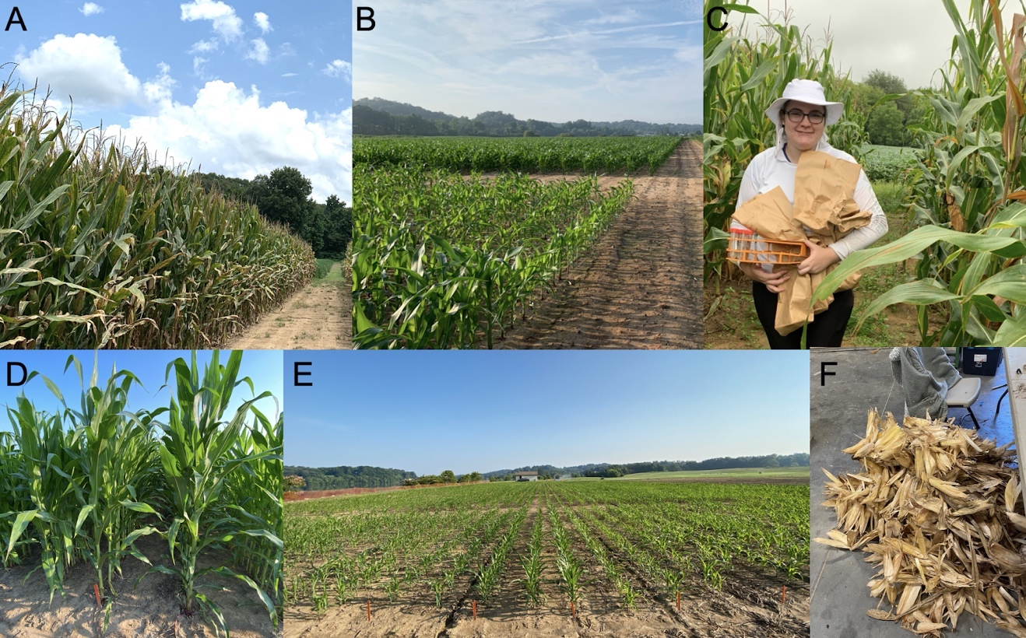
Figure 7: Photos of field work at RECM 2020 (A), ETREC 2020 (B), HREC 2020 (C), ETREC 2021a (D) and ETREC 2021b (E). Panel F shows the aftermath of harvesting ETREC 2021 samples.

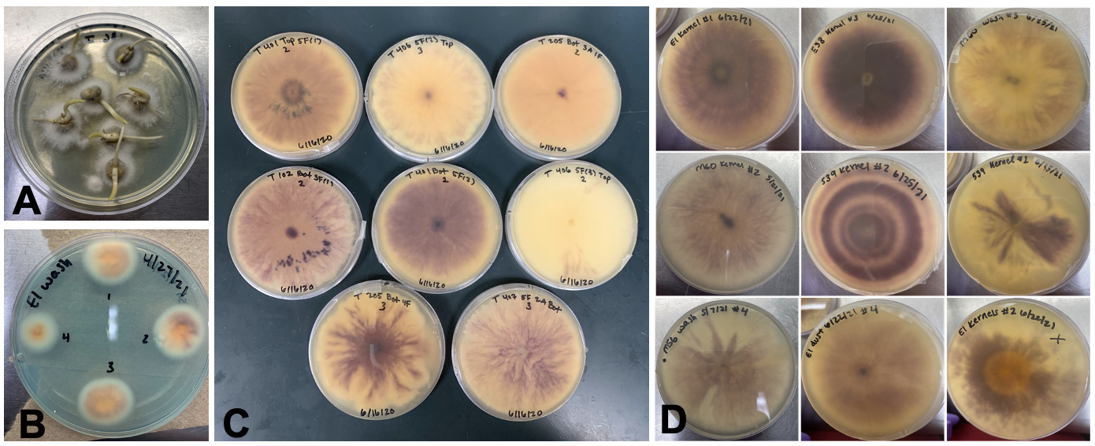
Figure 8: Fusarium infected kernels growing on malachite green agar (A), Fusarium colony formation (B), and visual Fusarium isolate morphologies in 2020 (C) and 2021 (D).

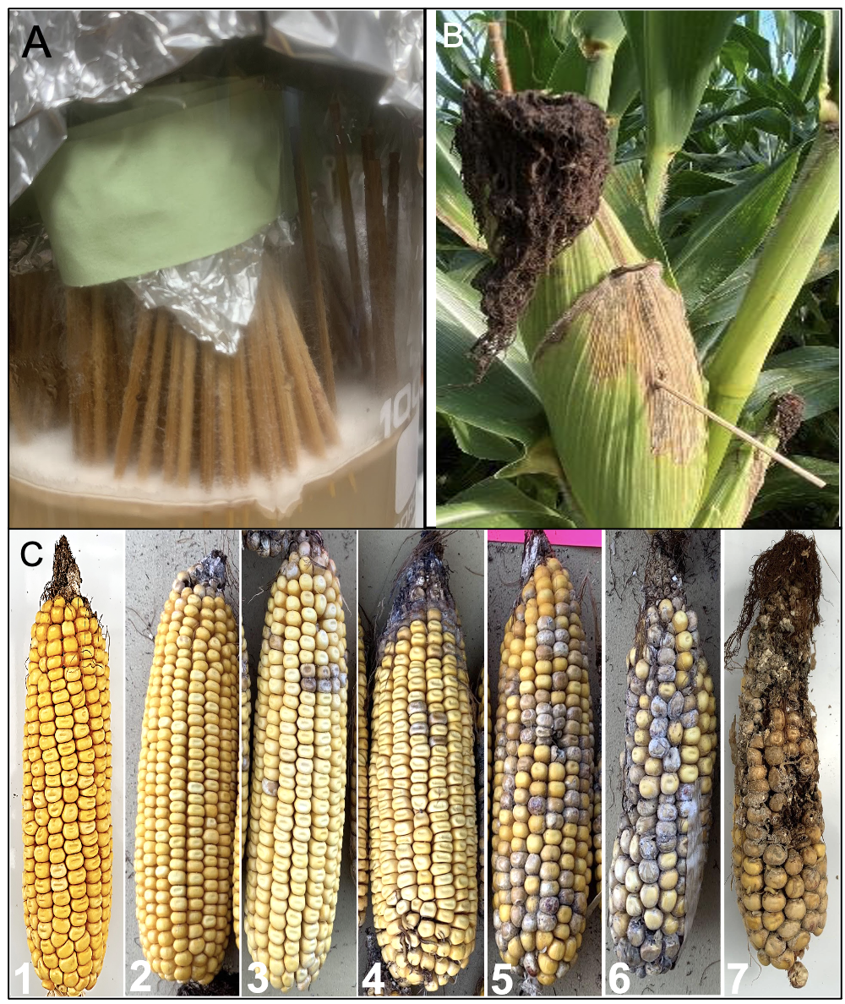
Figure 9: Toothpick coated with a mixture of Fusarium isolates (A); inoculation with spore-coated toothpicks by inserting toothpick into silk channel (B) and stabbing ear with toothpick (B). FER disease severity ratings on a scale of 1-7 (C).

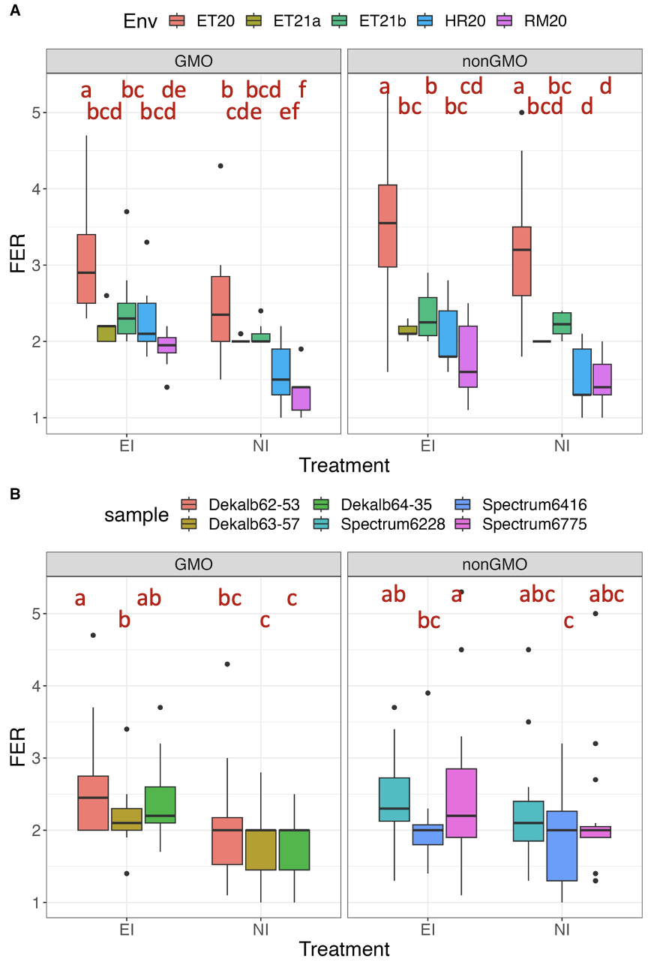
Figure 10: Boxplot showing Fusarium Ear Rot (FER) disease severity for ear-inoculated (EI) and non-inoculated (NI) ears across five environments (A) and six maize hybrids (B). Means comparison based on the Duncan multiple range test are indicated in lower case letters. Environments include Milan in 2020 (RM20), Knoxville in 2020 and 2021 (ET20, ET21a, and ET21b), and Springfield in 2021(HR20).

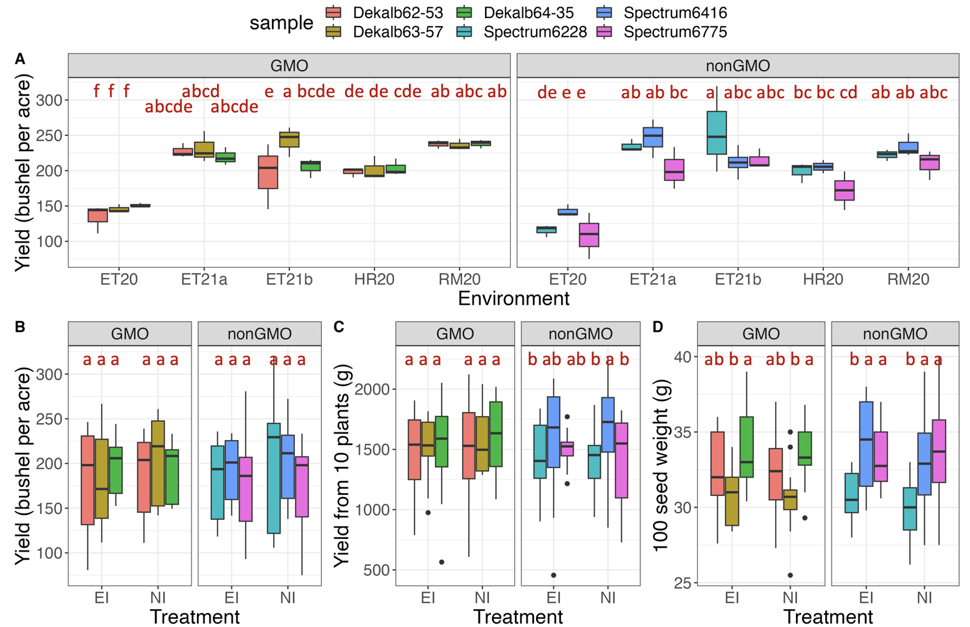
Figure 11: Boxplot showing yield on a plot-basis across all environments without inoculation (A). Boxplots showing yield on a plot-basis across 3 environments.at ETREC, Knoxville (B), yield based on 10-plant across 5 environments (C), and yield based on 100-seed weight across 5 environments (D) between inoculated and non-inoculated conditions. Means comparison based on the Duncan multiple range test are indicated in lower case letters.

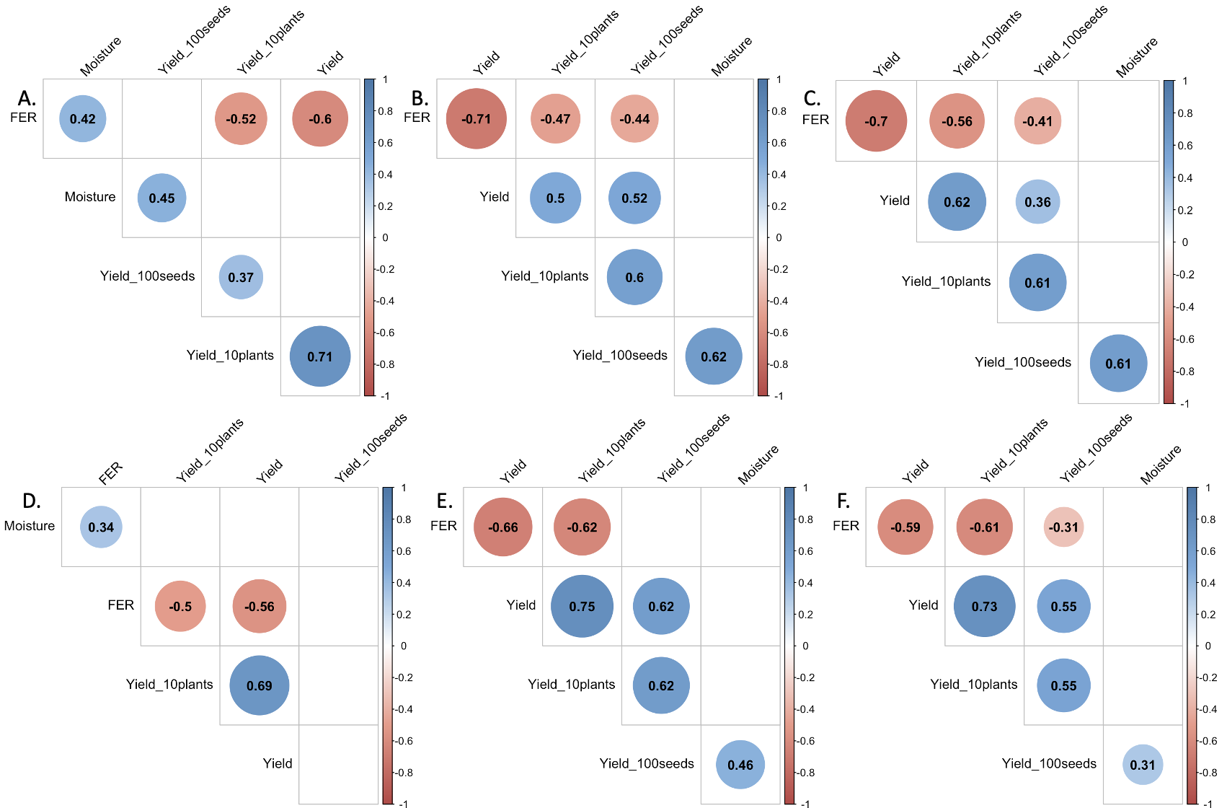
Figure 12: Pearson correlation coefficients among Fusarium ear rot disease severity, yield on plot-basis, and yield components. To investigate influence of inoculation, data is separated by nonGMO (A, B, C) and GMO (D, E, F) status with (B, E) and without (A, D) inoculation treatment. Significance is based on p-values < 0.05 and only significant estimates are shown (larger colored circles corresponds to lower p-value). Blue and red cells indicate positive and negative correlations coefficient values, respectively.

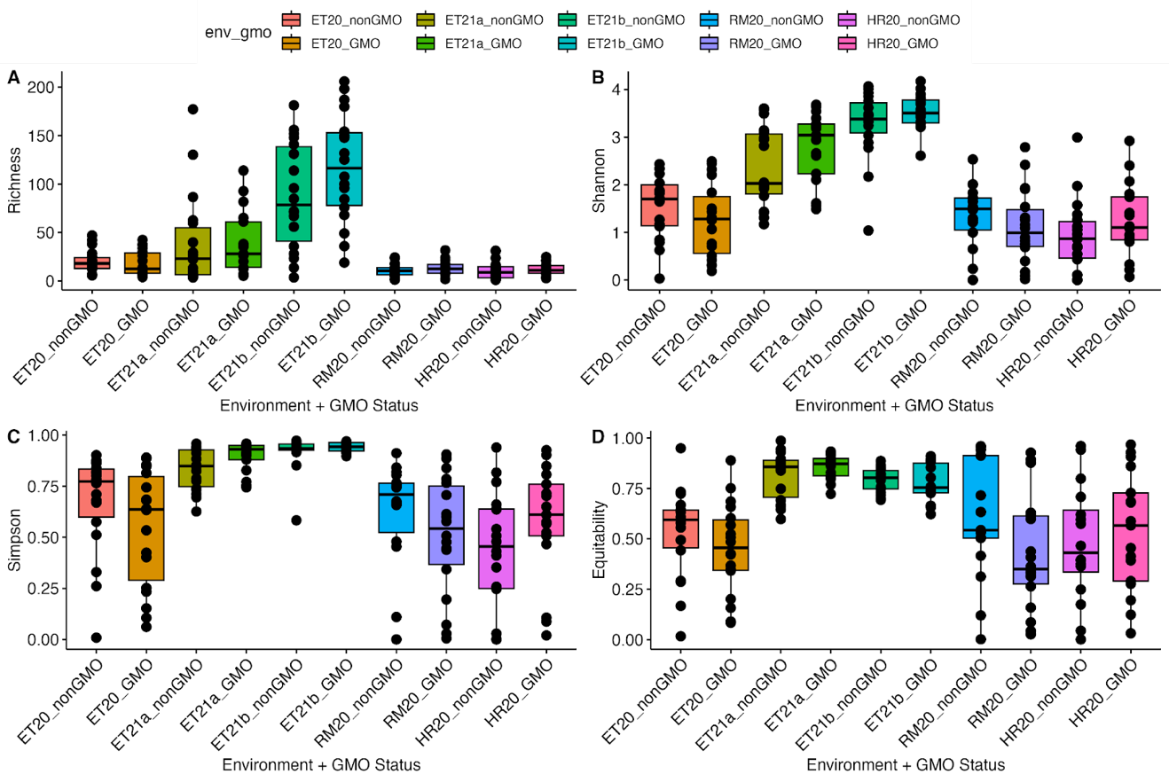
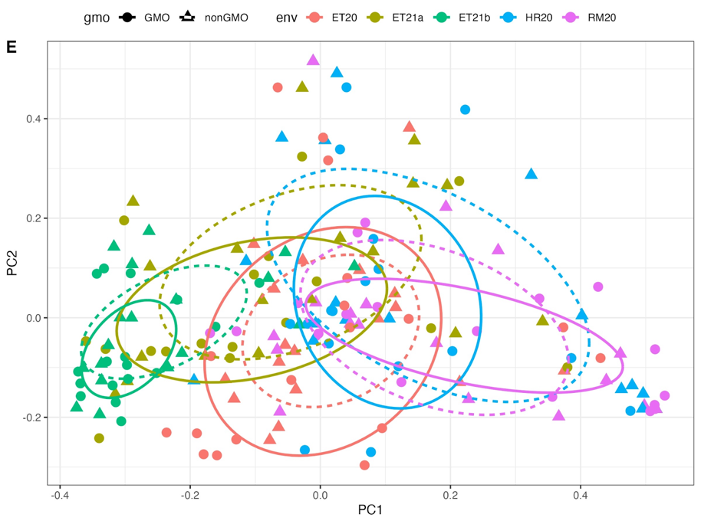
Figure 13: Boxplots showing richness (A), Shannon’s diversity (B), Simpson’s diversity (C), Shannon’s equitability (D) and a PCoA using the Bray Curtis Dissimilarity index (E) for samples on an environment by GMO status. Metagenome results were subsetted to species in at least 5% of samples.

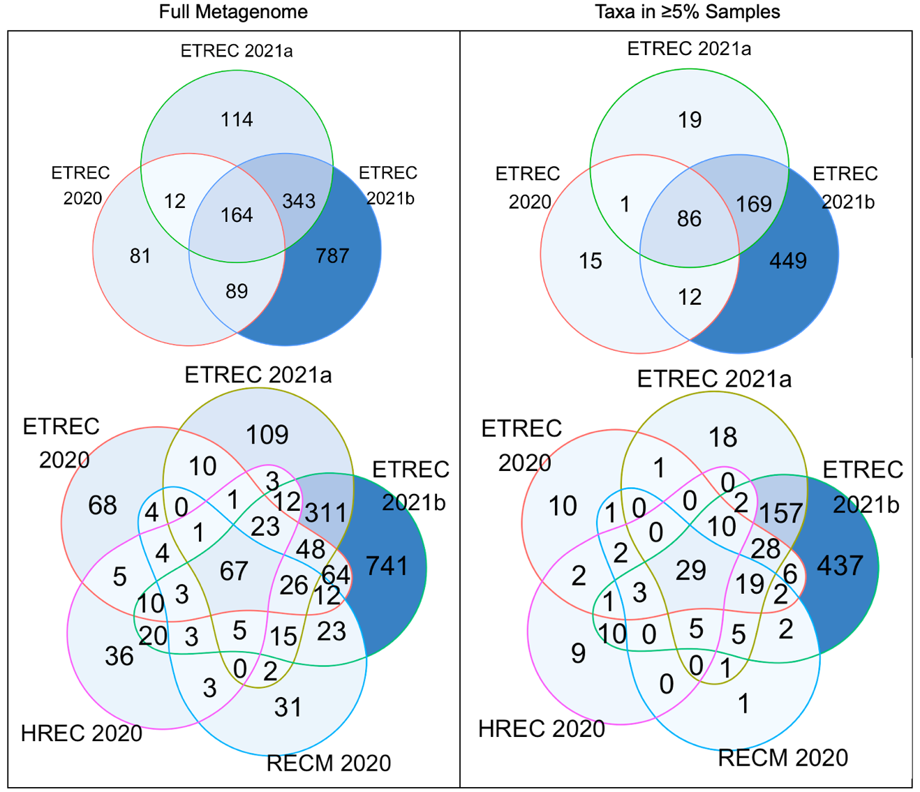
Figure 14: Venn diagrams showing the overlap in species between environments across all inoculation treatments.

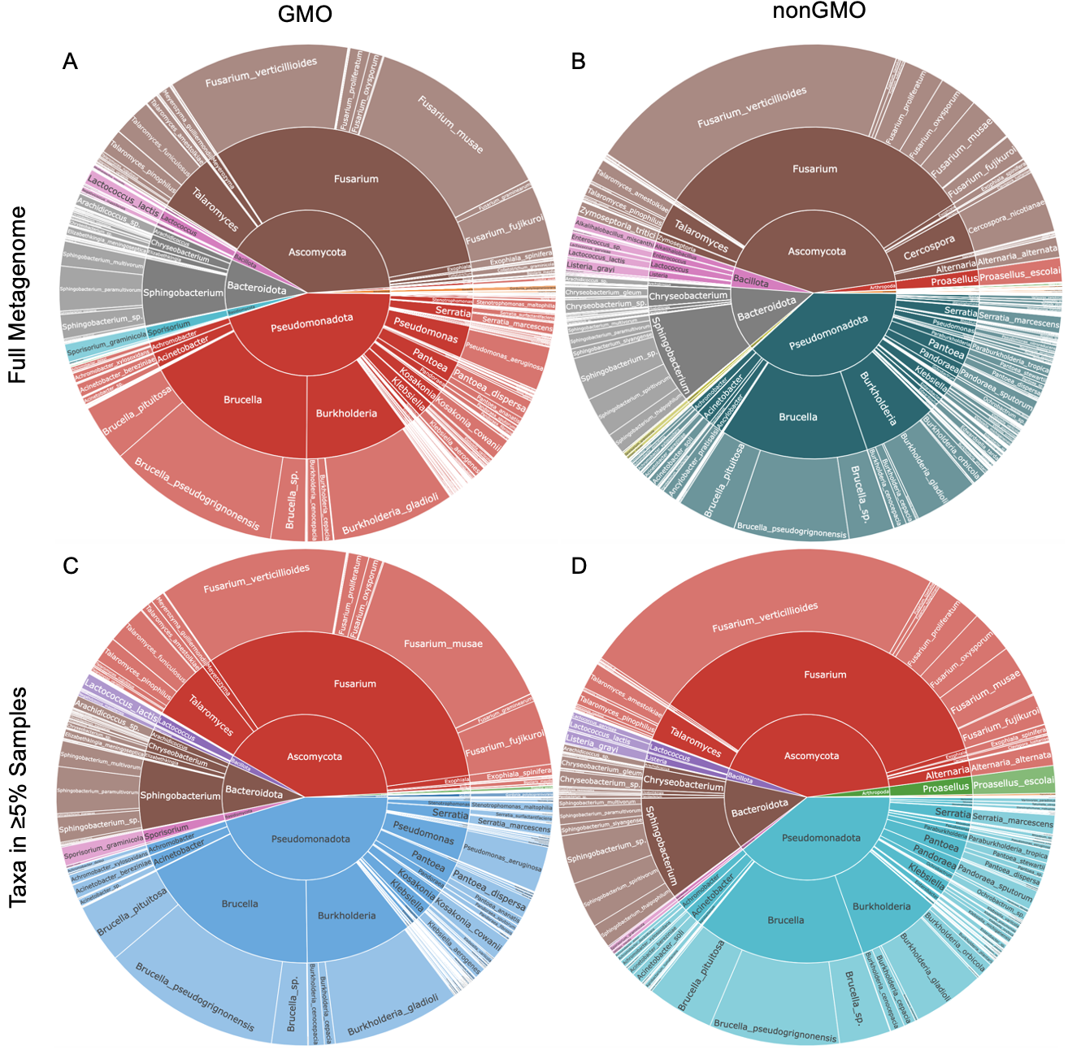
Figure 15: Relative abundance sunburst plots of species level (from center to outer ring: phylum, genus, and species) validated GMO (A, C) and nonGMO (B, D) maize hybrid kernel metagenomes across all environments and all treatments with the top row (A, B) showing full metagenomic results and the bottom row (C, D) showing metagenomic results subsetted for species appearing in at least 5% of samples.

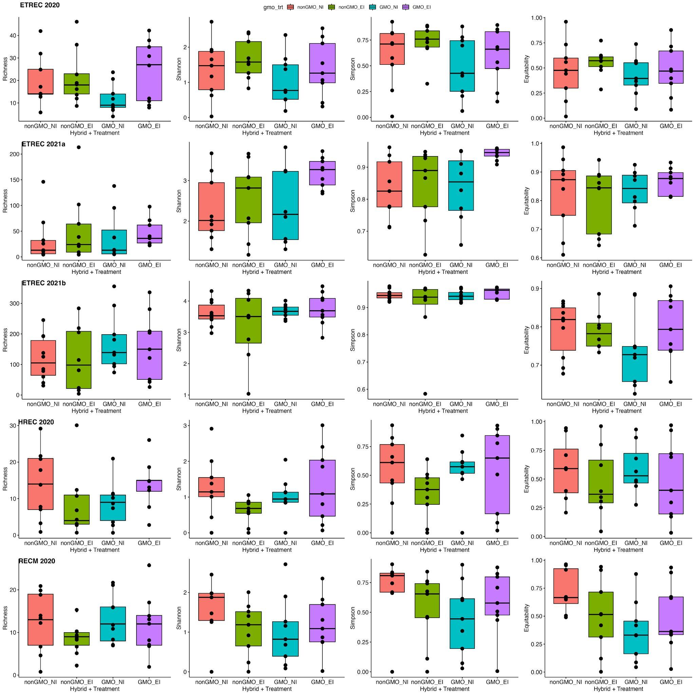
Figure 16: Boxplots showing richness, Shannon’s diversity, Simpson’s diversity, Shannon’s equitability for GMO and nonGMO maize hybrids with and without treatment per environment. Metagenome results were subsetted to species in at least 5% of samples.

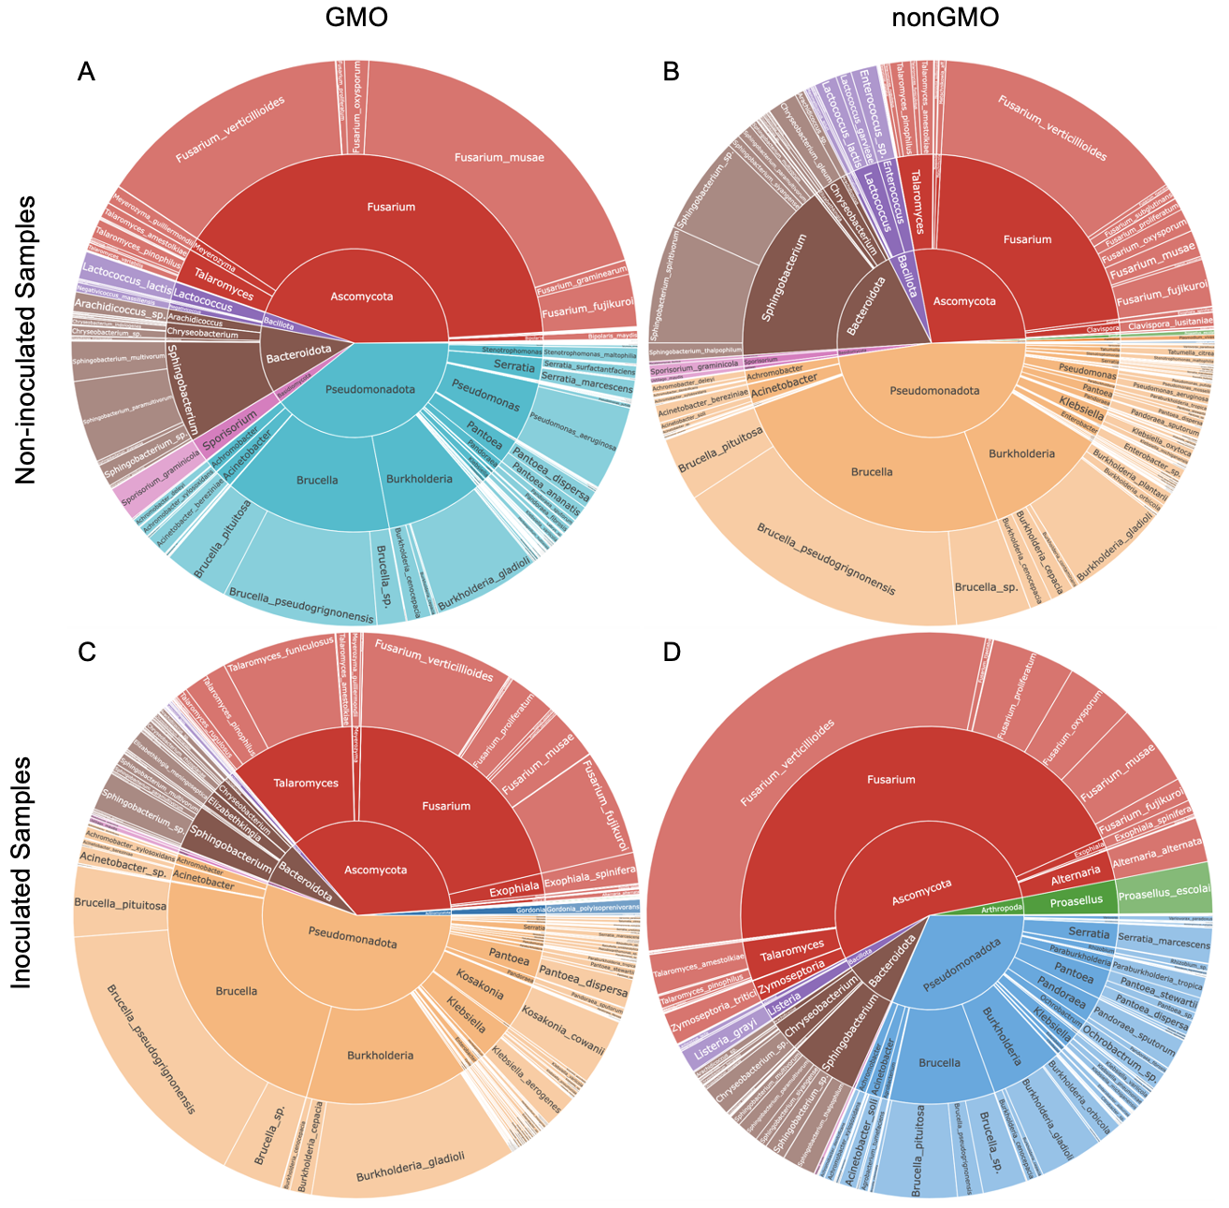
Figure 17: Relative abundance sunburst plots of species level (from center to outer ring: phylum, genus, and species) validated GMO (A, C) and nonGMO (B, D) maize hybrid kernel metagenomes across all environments for non-inoculated (A, B) and inoculated (C, D) samples. Metagenomic results shown were subsetted for species appearing in at least 5% of samples.

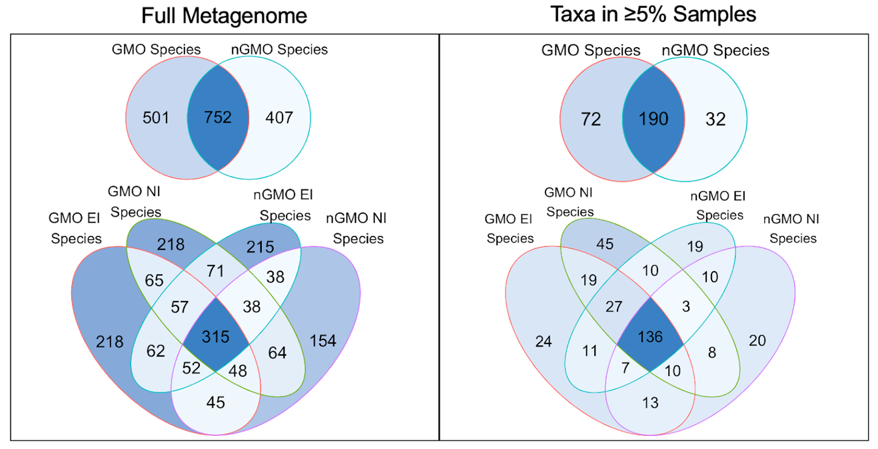Figure 18: Venn diagrams showing the overlap in species diversity between GMO and nonGMO maize hybrid metagenomes across all environments.

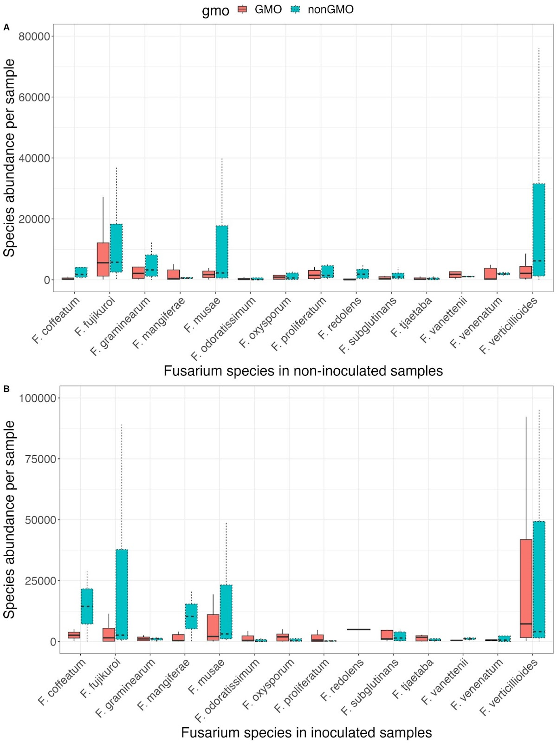
Figure 19: Boxplots showing Fusarium species (subsetted for being in at least 5% of all samples) abundance in non-inoculated (A) and inoculated (B) GMO and nonGMO maize hybrid metagenomic samples. Outliers are omitted.

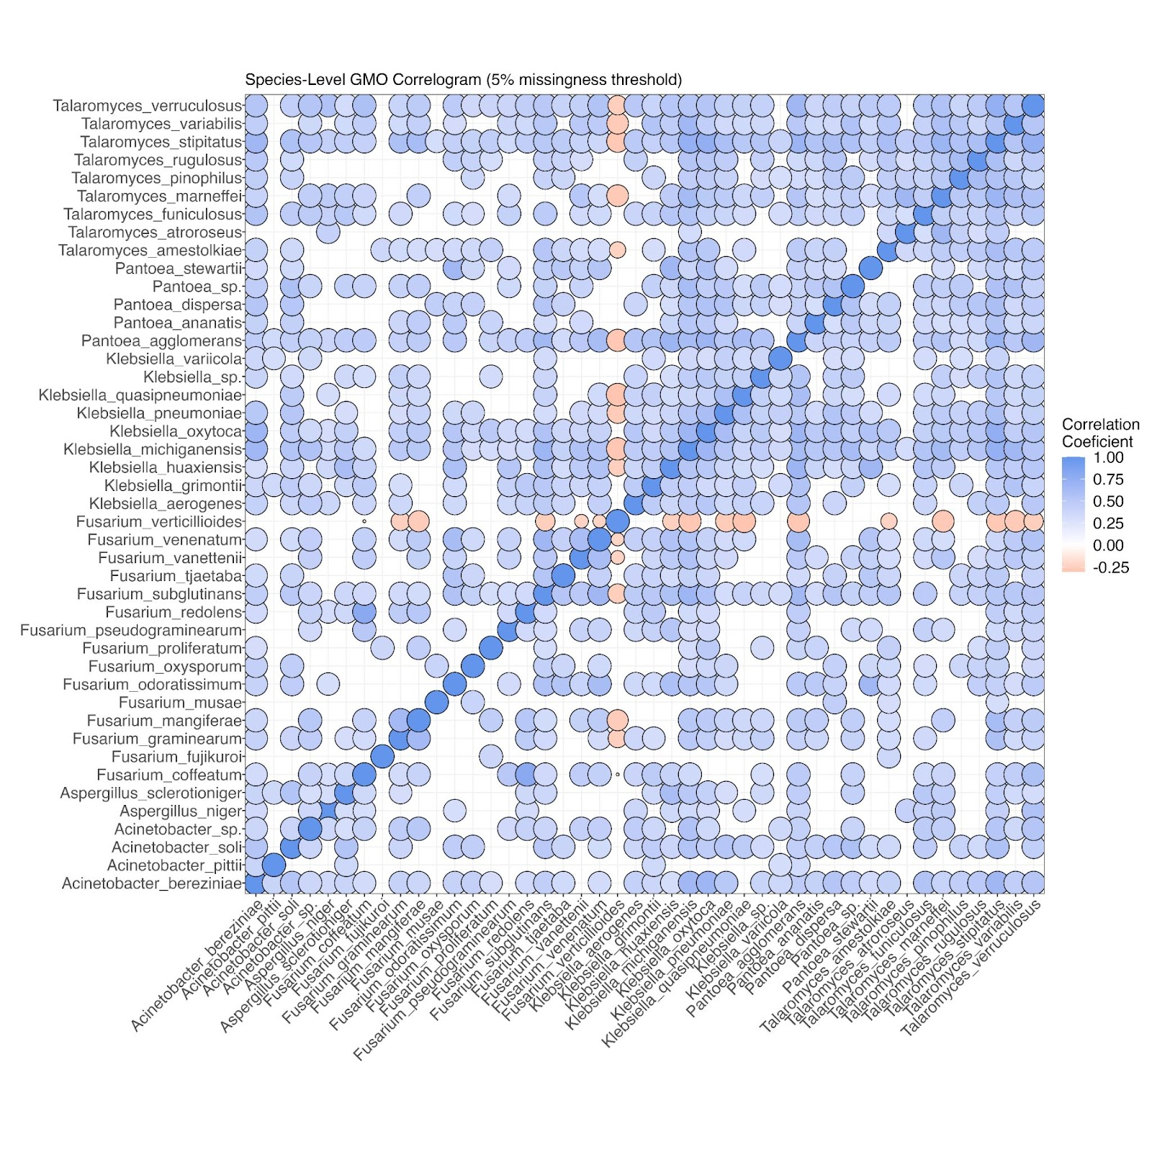
Figure 20: Spearman correlations of selected species that appear in at least 5% of GMO maize hybrid metagenomic samples, respectively, filtered for r ≤ -0.2, r ≥ 0.3 and p-value < 0.05. Size of data point is inversely proportional to associated p-value.

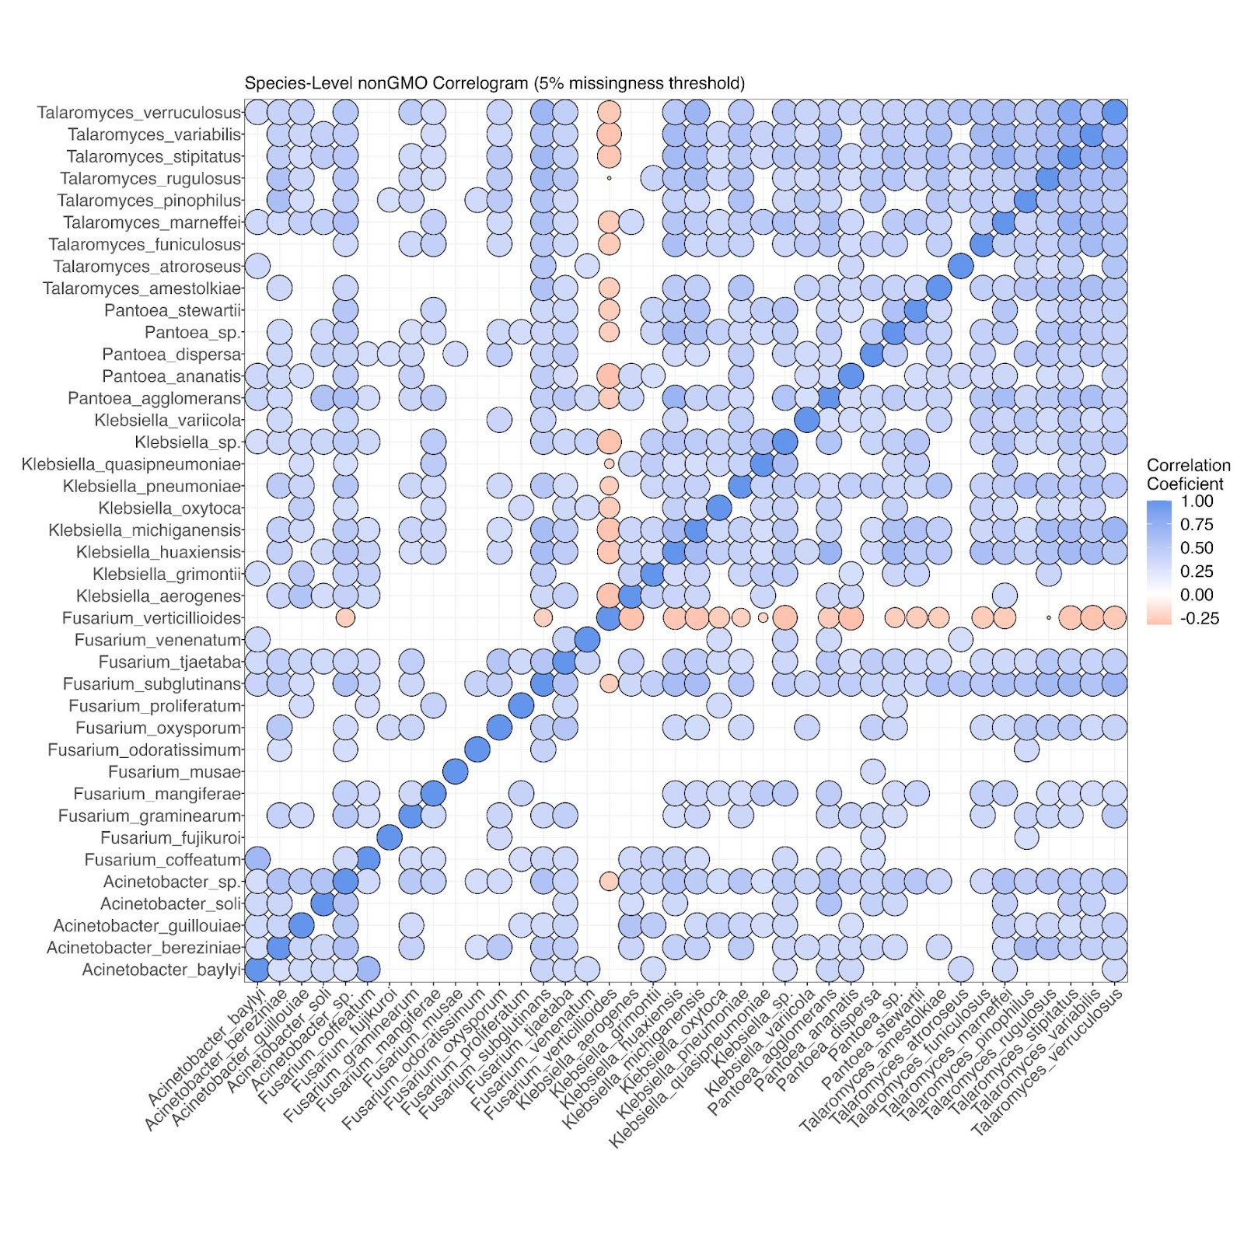
Figure 21: Spearman correlations between species that appear in at least 10% of nonGMO maize hybrid metagenomic samples, respectively, filtered for r ≤ -0.2, r ≥ 0.3 and p-value < 0.05. Size of data point is inversely proportional to associated p-value.

APPENDIX: TABLES
Table 4A: Analysis of variance for FER, yield, and yield components for GMO maize hybrids.
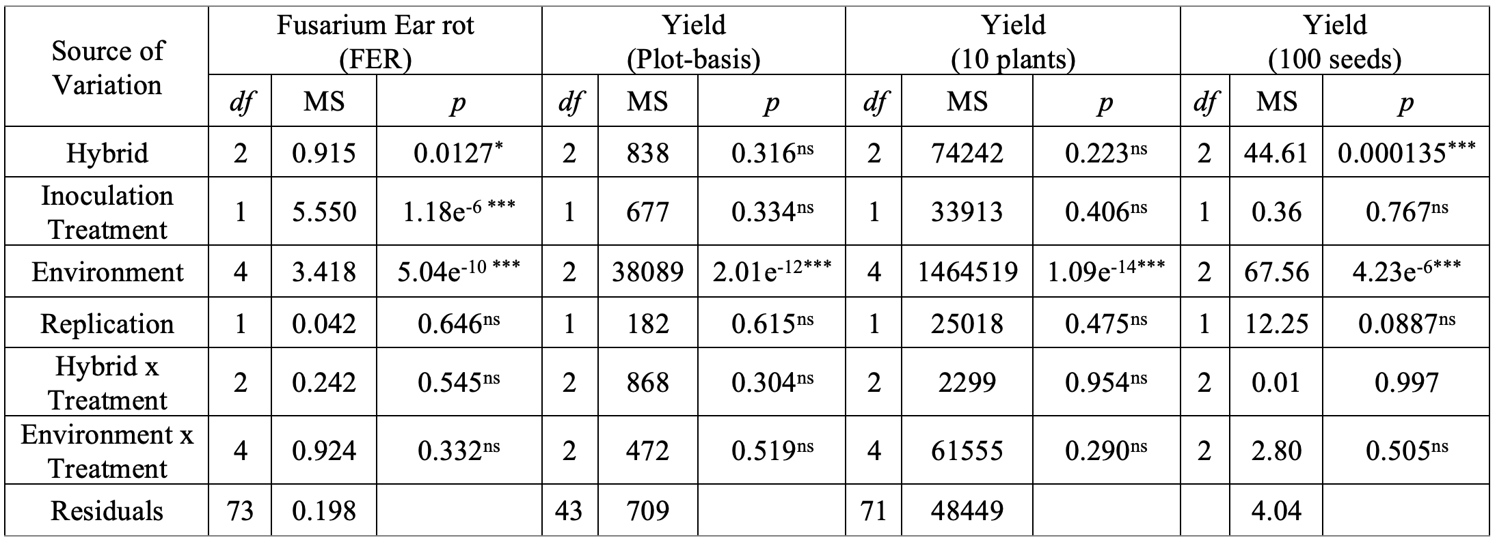Significance levels: ns = not significant, <0.05 = *, <0.01 = **, <0.001 = ***; df: degrees of freedom; MS: mean square

Table 4B: Analysis of variance for FER, yield, and yield components for nonGMO maize hybrids.
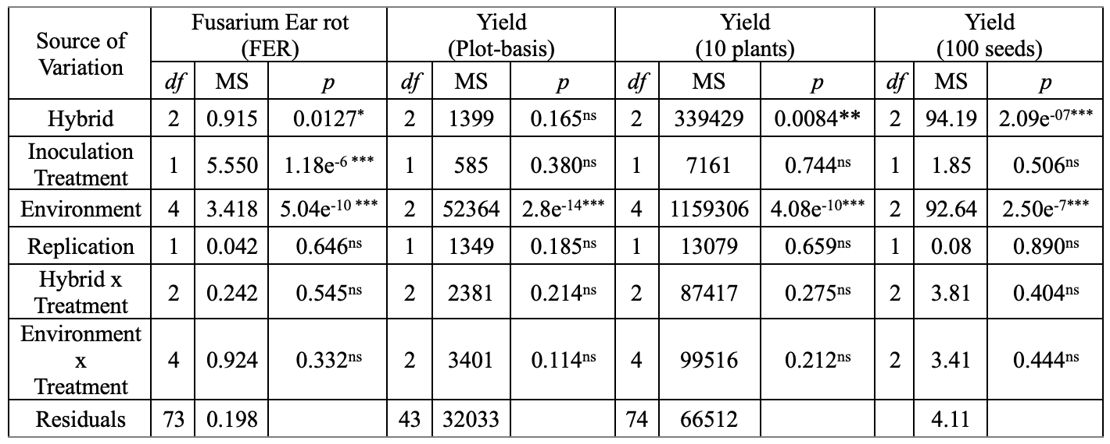Significance levels: ns = not significant, <0.05 = *, <0.01 = **, <0.001 = ***; df: degrees of freedom; MS: mean square

APPENDIX: SUPPLEMENTAL FIGURES
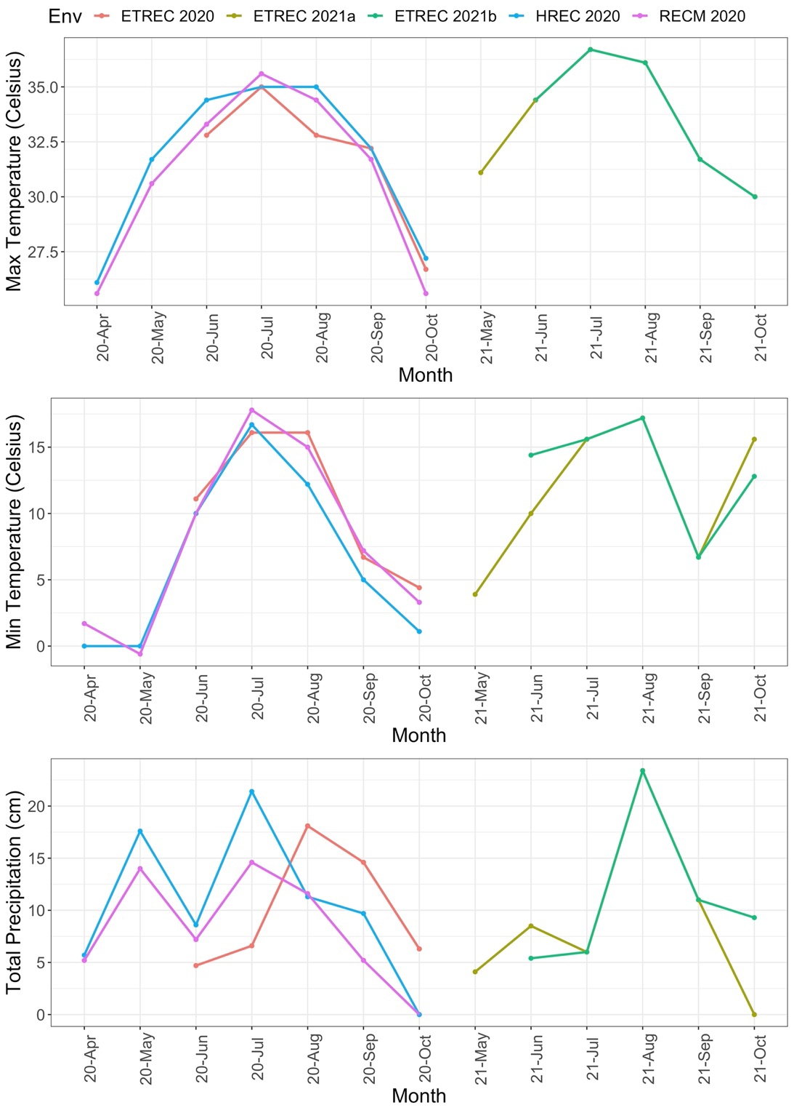
Figure S8: Line graph showing the minimum and maximum temperatures (℃), and total precipitation (cm) across duration of field trials in 2020 and 2021 for each environment. Environments include Milan (RECM 2020), Knoxville (ETREC 2020, ETREC 2021a, and ETREC 2021b), and Springfield (HREC 2020).

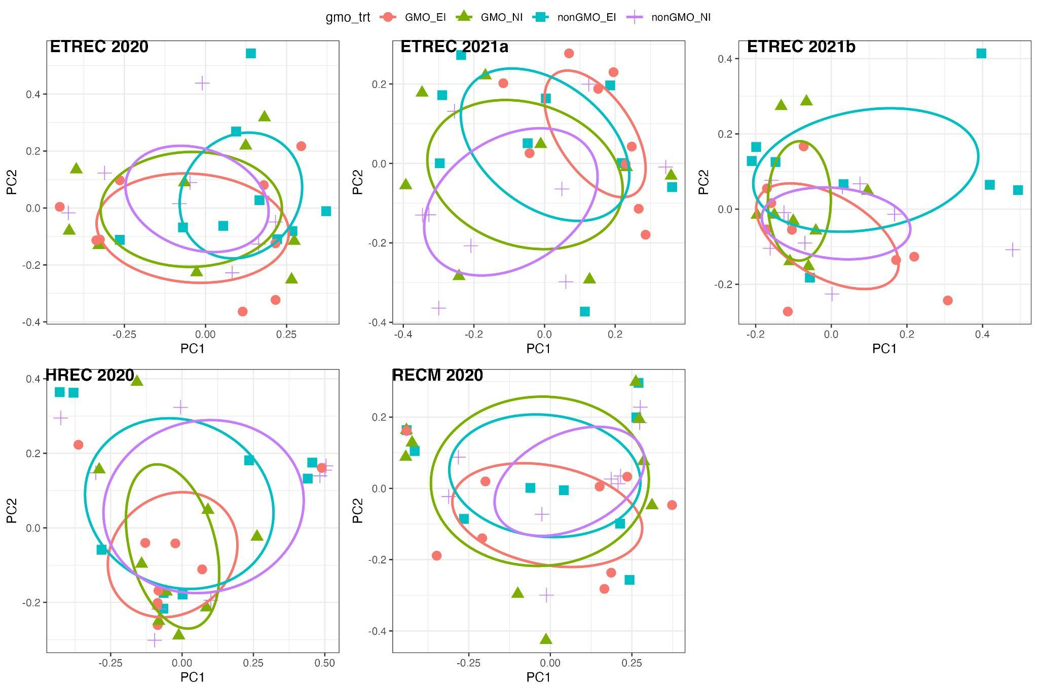
Figure S9: PCoAs using the Bray Curtis dissimilarity index for GMO and nonGMO maize hybrids with and without treatment per environment for all environments. Metagenome results were subsetted to species in at least 5% of samples.

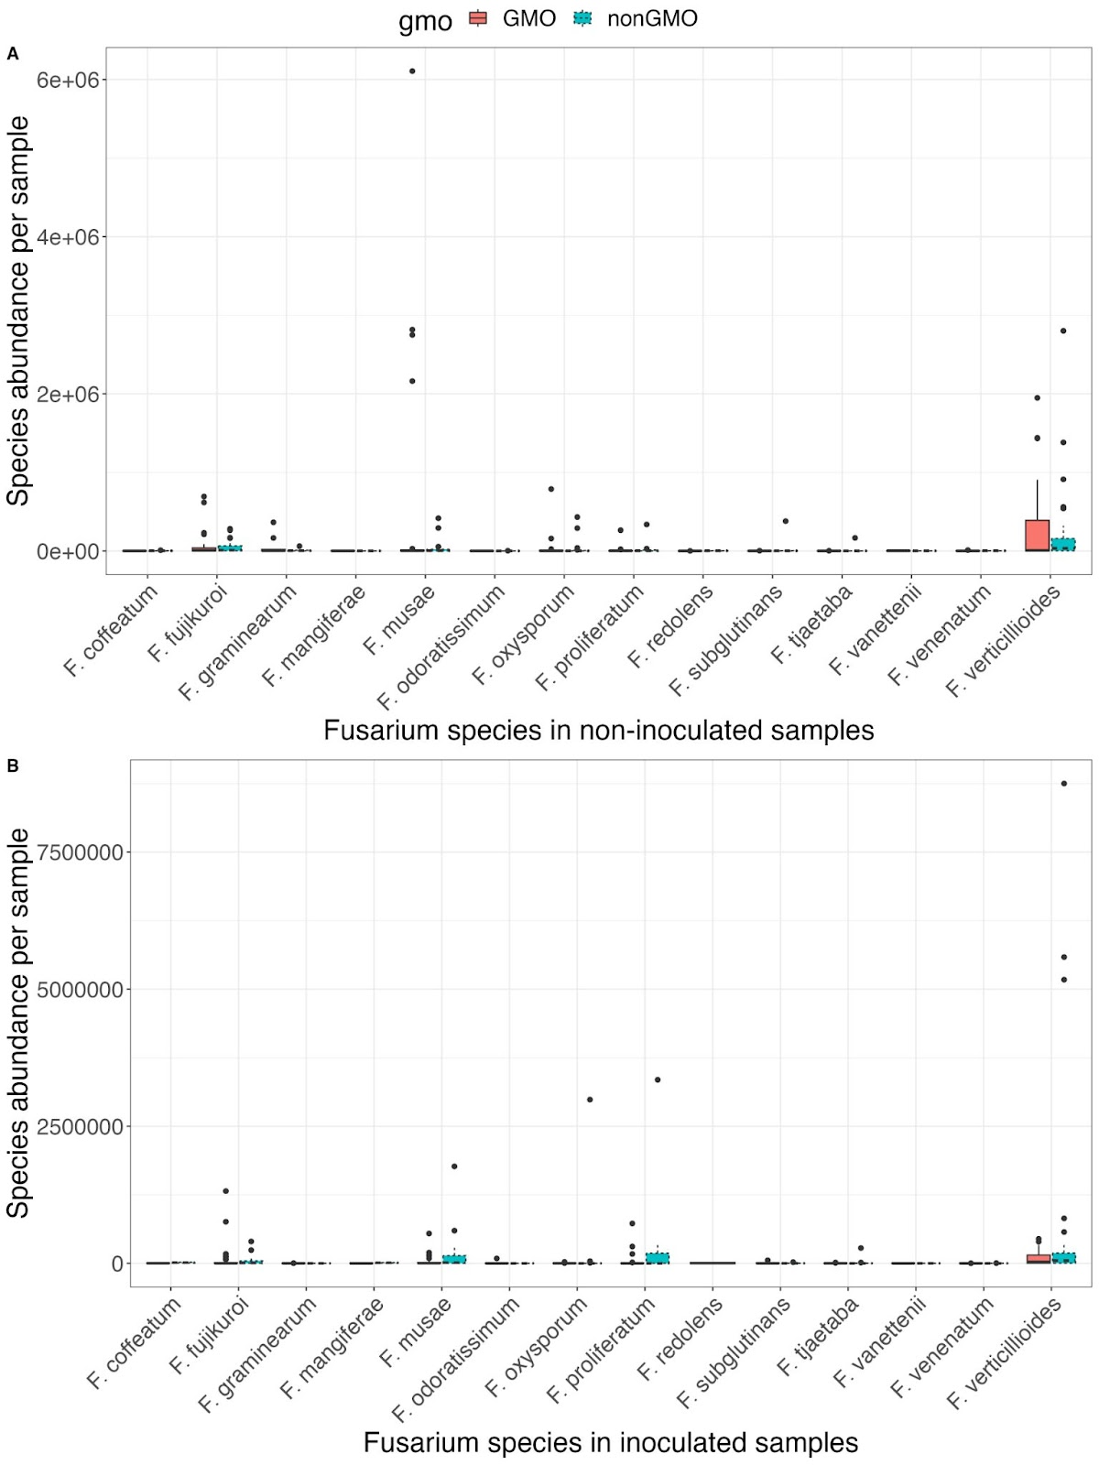
Figure S10: Boxplots showing Fusarium species (subsetted for being in at least 5% of all samples) abundance in non-inoculated (A) and inoculated (B) GMO and nonGMO maize hybrid metagenomic samples. Outliers are included.

APPENDIX: SUPPLEMENTAL TABLES
Table S1: Field herbicide management at each environment.
Location | Pesticide Type | Pesticide | Rate |  | Timing
RECM | Herbicide | Roundup PowerMax | 32 | oz | Burndown
RECM | Herbicide | Sterling Blue | 12 | oz | Burndown
RECM | Herbicide | Atrazine 4L | 32 | oz | Pre-emergence
RECM | Herbicide | Dual II Magnum | 16 | oz | Pre-emergence
RECM | Herbicide | Karate | 1.6 | oz | Pre-emergence
RECM | Herbicide | Gramoxone SL 2 | 40 | oz | Pre-emergence
RECM | Herbicide | Atrazine 4L | 48 | oz | Post
RECM | Herbicide | Callisto | 30 | oz | Post
RECM | Herbicide | Dual II Magnum | 20 | oz | Post
HREC | Herbicide | Slam 54 Extra | 32 | fl oz | Burndown
HREC | Herbicide | Bicep II Magnum | 51.2 | fl oz | Pre-emergence
HREC | Herbicide | Slam 54 Extra | 40 | fl oz | Pre-emergence
HREC | Herbicide | Atrazine | 16 | fl oz | Post
HREC | Herbicide | Steadfast Q | 1.5 | oz | Post
HREC | Herbicide | Laudis | 3 | fl oz/ac | Post
ETREC | Herbicide | Princep 4L | 2 | qt/ac | Pre-emergence
ETREC | Herbicide | Dual II Magnum | 21 | fl ozac | Pre-emergence
ETREC | Herbicide | Roundup Powermax | 32 | fl oz/ac | Pre-emergence
ETREC | Herbicide | Callisto | 4 | fl oz/ac | Post
ETREC | Herbicide | Aatrex | 1 | pt/ac | Post
ETREC_21 | Herbicide | Roundup Powermax | 23 | fl oz/ac | Burndown
ETREC_21 | Herbicide | Dual II Magnum | 21 | fl ozac | Pre-emergence
ETREC_21 | Herbicide | Princep 4L | 2 | oz/ac | Pre-emergence
ETREC_21 | Herbicide | Callisto | 3 | fl oz/ac | Post
ETREC_21 | Herbicide | Aatrex | 1 | pt/ac | Post

Table S2: Field fertilizer management for each environment.
Location | Type | N | P | K | Other | Rate
HREC | Fertilizer | 120 | 80 | 160 |  | 633 | lbs/ac
HREC | Fertilizer | 14 | 0 | 0 |  | 304 | lbs/ac
RECM | Fertilizer | 44 | 90 | 90 | 10S | 196, 150, 42 | lbs
RECM | Fertilizer | 200 | 0 | 0 |  | 600 | lbs
ETREC_20 | Fertilizer | 10 | 10 | 10 |  | 600 | lbs/ac
ETREC_20 | Fertilizer | 46 | 0 | 0 |  | 350 | lbs/ac
ETREC_21 | Fertilizer | 10 | 10 | 10 |  | 600 | lbs/ac

CONCLUSION

The advancements in next generation sequencing and bioinformatic pipelines have helped scientists investigate the genetic factors in agricultural crops contributing to disease resistance, abiotic and biotic stress tolerance, and yield components. However, given the complex nature of most plant genomes, bringing genetically enhanced crops to the market is a years-long effort. The genetically modified Bt maize hybrids used in my Chapter III were first introduced in 1996 after a decade of trials. The years it takes to establish an effective population containing the gene of interest falls in line with natural selection and selective breeding practices used since the dawn of agriculture. The difference now is since the discovery of transmission genetics, we have developed techniques to speed up evolution.
The results presented in my Chapter II are like many genome-wide association studies because I am using next generation sequencing and bioinformatics to present candidate genes for future plant breeding research. However, since I am not a sweetpotato breeder, my work is fruitless without the further involvement of the scientific community. I expect that first, my candidate genes would be used to create PCR primers to help in the selection of appropriate genotypes. Next, once accessions are selected, the genotypes will be bred over several generations to establish a homozygous locus, and then subjected to virus inoculation to test for enhanced disease resistance. However, since my research showed that multiple genes are underlying viral abundance in sweetpotato, molecular tests could quickly become time consuming and expensive since each locus target would need a unique PCR primer. Therefore, I can utilize genomic prediction to see how various combinations of alleles predict a genotype’s ability to respond to viral infection. In the event there are alleles with high predictive power and the genotype can be obtained for breeding, then breeding for virus resistance in sweetpotatoes could be accelerated. However, if traditional breeding is too complex, one proposed method is to enhance phenotypic expression by targeting a plant’s secondary genome- the microbiome.
Traditional studies have targeted bacterial and fungal microbiomes identified through amplicon sequencing. By cataloging microbiomes under different environment conditions, scientists have been able to determine the type of beneficial microbes that plants recruit. The two main categories recruited help with nutrient allocation and disease resistance. In both cases, commercial companies have capitalized on the knowledge of plant microbiomes to sell fertilizers and biocontrols. Through my analysis of sweetpotato viruses, I discovered their symbiotic interactions with pathogenic fungi through immune system repression and/or diversion. Therefore, by understanding the virus-fungi interactions, we can thus use known biocontrols of the pathogenic fungi to co-control viral infection. Although my work in maize did not involve viruses, it did involve Fusarium which is a pathogen to both maize and sweetpotato. Thus, the metagenomic results from my Chapter III can be used to further the results from my Chapter II. My thesis presented henceforth for graduation provides proof of concept that quantitative reduced sequencing produced through the OmeSeq-qRRS protocol and the novel implementation of exacting match of consensus sequences in Qmatey’s pipeline are both effective methodologies to further metagenomic analysis.

VITA

Alison Adams was born in Atlanta, GA in July 1996, two months after her mother obtained her PhD. At the age of two, Alison underwent brain surgery to remove a tumor and at the age of four, an eye doctor discovered her left eye was underdeveloped. When she was ten, Alison was diagnosed with her second (smaller and inoperable) brain tumor. During high school, Alison suffered a seizure-like episode that resulted in a reading comprehension disability that continues to hinder her studies to this day. Nonetheless, Alison persisted with the help of academic accommodations and graduated as one of three valedictorians of West Forsyth High School in May 2014. In May 2018, Alison graduated with honors from the University of Georgia with Bachelor of Sciences in Genetics and Applied Mathematics. While applying to graduate programs, Alison chose to pursue a PhD instead of a Master’s in honor of her mother’s PhD. In October 2020, two weeks before her comprehension exam, Alison’s mother passed away unexpectedly, ten years after her Multiple Myeloma diagnosis. In 2023, Alison will graduate from the University of Tennessee with a PhD in Life Science, obtained through the Genome Science and Technology Program and under the advisement of Dr. Olukolu.

