An Economic Analysis of the Extraction of Rare Earth Elements from WPPA Sand Tailings Waste Stream

CBE 488: Honors Design in Green Engineering
Abdullah Alzubairi, Tyler Leek, Luke Weber

Department of Chemical and Biomolecular Engineering
University of Tennessee
1331 Circle Park Drive SW, Knoxville, TN, 37916

Table of Contents

- Introduction
- Synthesis Information for Processes
  - Overall Conceptual Processes
  - Chemical Equations
  - Literature Summary
- Method of Approach
- Results
  - Flowsheets
4.1.1Conceptual Flowsheet for Recovery of REEs from Amine Tails
4.2 Capital Cost Estimates
4.2.1 Capital Cost Estimate for Recovery of REEs from Amine Tails
4.3 Operating Cost Estimate
4.3.1 Capital Cost Estimate for Recovery of REEs from Amine Tails
- Discussion of Results
- Conclusions
- Recommendations
- References
Appendices

1.0 Introduction
The purpose of this manuscript is to document the development and economic analysis of processes for the recovery of rare earth elements (REEs) from the wet process of phosphoric acid production (abbreviated WPPA). Each year around 220 million tons of phosphate rock is processed annually, with China and the US producing a combined 121 million tons. The phosphates extracted are used primarily as a fertilizer in the agricultural sector for commercial farming operations. In this project, we develop and compare flow sheets, capital cost, and operating cost estimates for the recovery of REEs from sand (amine tails), a side waste stream of phosphoric acid processing, and the produced phosphoric acid stream (typically of approximately 30 wt % H₃PO4) of the wet phosphoric acid process. The basis for our stream flow rates is a process to handle 3 million tons of phosphate rock (10 million tons of extracted ore) per year, a sand flow rate of about 4 million ton/yr and a produced total acid stream of about 1.6 ton/yr. The composition of these steams is presented in Table 1.
Table 1. Composition (ppm) of rare earth elements in sand (amine tails) waste stream and in produced acid stream.
REE | Amine Tails | Acid
Y | 36.05 | 31.0
La | 29.35 | 3.28
Ce | 65.75 | 15.5
Pr | 5.705 | 0
Nd | 39.65 | 9.61
Sm | 4.925 | 0
Eu | 0.955 | 0
Gd | 3.95 | 0.91
Tb | 0.205 | 0
Dy | 4.745 | 0.54
Ho | 1.09 | 0.11
Er | 2.815 | 1.92
Tm | 0.495 | 0.57
Yb | 2.265 | 3.18
Lu | 0.075 | 0.56
Th | 6.54 | 6.21
U | 24.8 | 212.0
Total | 229

The final report will document the results of this study. A Chemical Engineering Index of 574 will be used in the economic calculations of the current report. Supporting information and advice is provided by Dr. Watson and Dr. DePaoli of Oak Ridge National Research Laboratories located in Oak Ridge, TN and Dr. Patrick Zhang of the Florida Industrial and Phosphate Research Institute.

2.0 Synthesis Information for Processes
Rare earth elements are present in small quantities in ore mined for production of H₃PO₄. These REEs are present in the product H₃PO₄ and in waste streams from the wet process, a common process for H₃PO₄ production. In the current activity, waste streams and the product stream from H₃PO₄ production in central Florida are considered as sources of REEs. The production of H₃PO₄ in central Florida begins with the mining of apatite, Ca₅(PO₄)X, where X may include OH, F, Cl or Br. In the apatite formations are small concentrations of rare earth elements, iron, aluminum, uranium, thorium and other elements. In the manufacturing of H₃PO₄ the ore is first separated into fractions of phosphate rock, sand, and clay, with each fraction containing impurities such as phosphates and rare earth elements. The sand and clay fractions are currently discarded as waste materials while the phosphate rock is used for production of H₃PO₄. Another waste steam is the phosphogypsum stream from the dissolution of phosphate rock by aqueous H₂SO₄. Yet another waste stream of interest is the sludge stream from H₃PO₄ concentration operations.

2.1 Process Schematics
Figure 1. Conceptual Process for Recovery of REEs from Sand (Amine Tails)
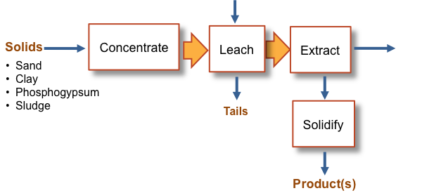

Figure 2. Conceptual Process for Recovery of REEs from Initial Produced Acid Stream
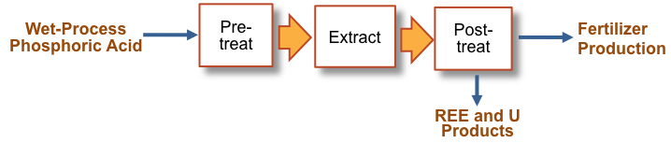

  - Chemical Equations
In the wet process for production of H₃PO_{4,} the phosphate rock fraction is contacted with concentrated H₂SO₄ resulting in production of CaSO₄ , a highly insoluble compound, and H₃PO₄.

Ca₅(PO₄)X + 5H₂SO₄ +10 H₂0 3H₃PO₄ + 5 CaSO₄.2(H₂O) (1)

The REEs, present as impurities in the ore, react similarly, illustrated here with YPO₄ and a soluble sulfate product.

YPO₄ + 3H₂SO₄ Y₂(SO₄₎₃. (2)

Other metals present as impurities in the ore such as Fe₂O₃ and Al₂O₃ also react with H₂SO₄, resulting in reactions illustrated here as sulfates of varying solubility in water.

Fe₂O₃ + 3 H₂SO₄ Fe₂(SO₄)₃ + 3H₂O (3)

and

Al₂O₃ + 3 H₂SO₄ Al₂(SO₄)₃ + 6 H₂O. (4)

In the current activity REEs are recovered purified to produce a product concentration of > 50 % mixed REEs.

  - Literature Summary
Rare earth elements are a set of fifteen elements that are usually considered difficult to extract and refine to their purest form, because of their low concentrations. Despite their low demand in industry in terms of weight, specific REEs can serve an evolving array of high-technology applications, many of which are in the green energy sector. It is for this reason they are often referred to as the ‘seeds of technology’¹. Most of these elements are not as uncommon as the name suggest; they are simply uncommon in commercially viable concentrations. Cerium, for instance, is more abundant in the earth’s crust than copper or lead. Such elements make for strong magnets commonly used in electric motors to produce greater power and torque due to their strong magnetic abilities. These electric motors are an essential component in hybrid vehicles. This is one of many examples of REE-dependent technology that is becoming increasingly popular in the automobile industry, soon to become abundant on roads across the world.
In a world of increasing technological innovations, REEs also serve as components of efficient lighting and display panels. The popularity of such applications leads to an increase in demand for europium, terbium, and yttrium, those being the main REEs for these applications². Lanthanum is another example of an REE used in rechargeable batteries. It is used in a mix of metal alloy that makes the anode of the most utilized battery system, NiOH.
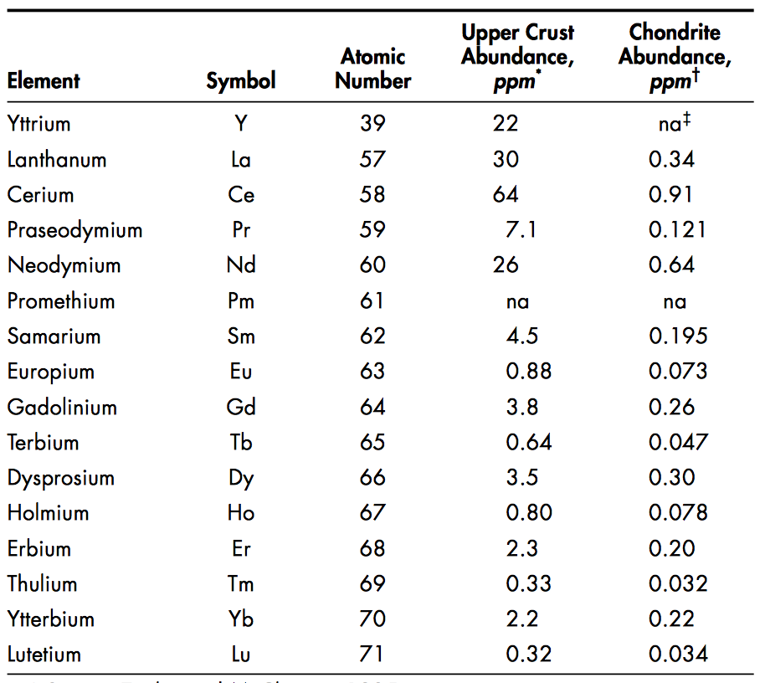
Table 2. Rare Earth Elements with respective abundance in ppm.

Currently, China accounts for 94% of global production while other countries make up for the rest, which leaves the US 100% dependent on foreign exports³. The growing demand for REEs causes a deficit in supply due to worldwide limitations. For this reason, several projects are projected to overcome this deficit. Such projects include finding viable economic means to recover REEs from sand, clay, sludge, phosphogypsum and phosphoric acid.

3.0 Method of Approach
By using a basis of 10 million metric tonnes of phosphate ore, the corresponding mass of sand tailings to be processed is 4 million metric tonnes based on existing phosphoric acid production processes. Amine sand tailings, which are the focus of the process, account for approximately 297,000 tonnes of the 4 million tonnes of tailings, according to the beneficiation mass balance given in Table 3 below.
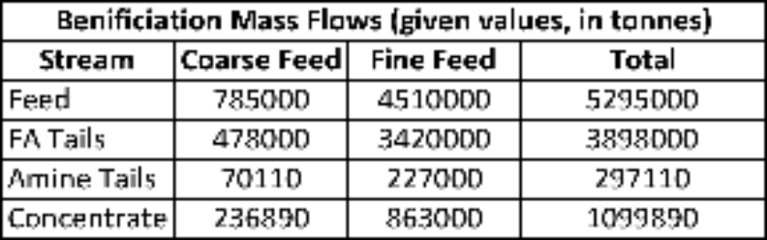
Table 3. Incoming mass flows from beneficiation process.
Once the mass of amine sand tailings had been established, the object was to design an industrial process that would maximize extraction of rare earth elements from the tailings while minimizing cost and waste products. The method of approach for the design of the process began by researching existing extraction and stripping processes and equipment, and carrying out preliminary calculations to test the viability of these processes in REE extraction. Research and calculations yielded a number of process steps that were chosen to be included in the industrial design, and the next task was to put the steps in an order that was most effective for extraction. The results of these first tasks and the final design flowsheet are summarized later in Section 4.1.
The next task was to construct a mass balance of the overall process. This task involved gathering large amounts of raw data from small-scale experimental results, and implementing this data in extensive calculations. Key data sets included step-by-step REE concentration estimations; percent recovery values of overall mass and REE mass; extraction and stripping distribution coefficients varied by extraction and stripping agent concentration; and solid-liquid contact ratios. The results of the overall mass balance are summarized in various tables throughout this report, as well as a comprehensive summary included in the Appendix.
For the next task in the design process, the mass balance was to be used to size and cost the equipment. The mass of the streams to be processed in each step of the design directly correlate to the minimum equipment size that can efficiently carry out the processes. The size of the equipment then subsequently determines the cost. Many literary sources had to be consulted to accurately cost the equipment, and the results of this task are summarized in Section 4.2.
The final task, a corollary to the previous one, is to analyze the finalized design to estimate operating cost and total economic potential of the process. Up-to-date pricing estimates of input energy and raw materials needed to be gathered for this task, as well as current market prices of rare earth elements. The final results of this task are summarized in Section 4.3.

4.0 Results
4.1 Flowsheets
4.1.1 Recovery of REES from Amine Tails (Sand) Waste Stream
From the separation of phosphate ore, the amine tails in the sand waste effluent are sent through a separate extraction process to recover the REEs. The incoming amine tail feed stream is initially sent through a gravity separator in order to remove the larger sand components. From a mass balance, a 56% recovery of REEs from the gravity separation unit is expected. This process has two product streams that include a large sand component waste stream and a stream containing the REE’s and finer sand particles, which is fed into a flotation unit. In the flotation step, any remaining sand components are physically separated from the REEs and sent out as a waste stream, with an estimated 89% REE recovery. The concentrated REEs are fed into a mixing tank and reacted with aqueous 93%-weight sulfuric acid to produce REE-sulfates. At this point in the process, the stream of interest should contain primarily REE-sulfates, sulfuric acid, and water with minimal sand particle and phosphoric acid components. The stream is then sent to an extraction unit to separate the REEs via the use of Isopar-L diluent, a commercial solvent with properties similar to kersone. Using an estimated 5 extraction stages followed by 5 scrubbing stages, our calculations estimate this extraction unit can reach 31% recovery. The sulfuric acid product stream is sent off as waste (potential recovery possible), and the REE-carrier stream is fed into a striping unit. In this step, very dilute sulfuric acid is introduced as a stripping agent to remove the REEs from the Isopar-L. The solvent stream is recycled back to the extraction unit and the REE/Stripping agent stream is fed into a mixing tank, where it is reacted with ammonium carbonate. From the tank, the components are separated physically through a settling unit in which the precipitate REE-carbonates are removed and the liquid stripping agent/ammonium stream is sent out as waste (potential recovery possible). After this final step, the REE-carbonates are in a marketable form and can be sold to a potential customer.
Should the calculations show a low REE recovery from this process, a calcination step may need to be introduced after the carbonation precipitation. This will concentrate the REEs in a higher weight percent, and can provide for cheaper transportaton costs in our cost estimations.

4.2 Capital Cost Estimates
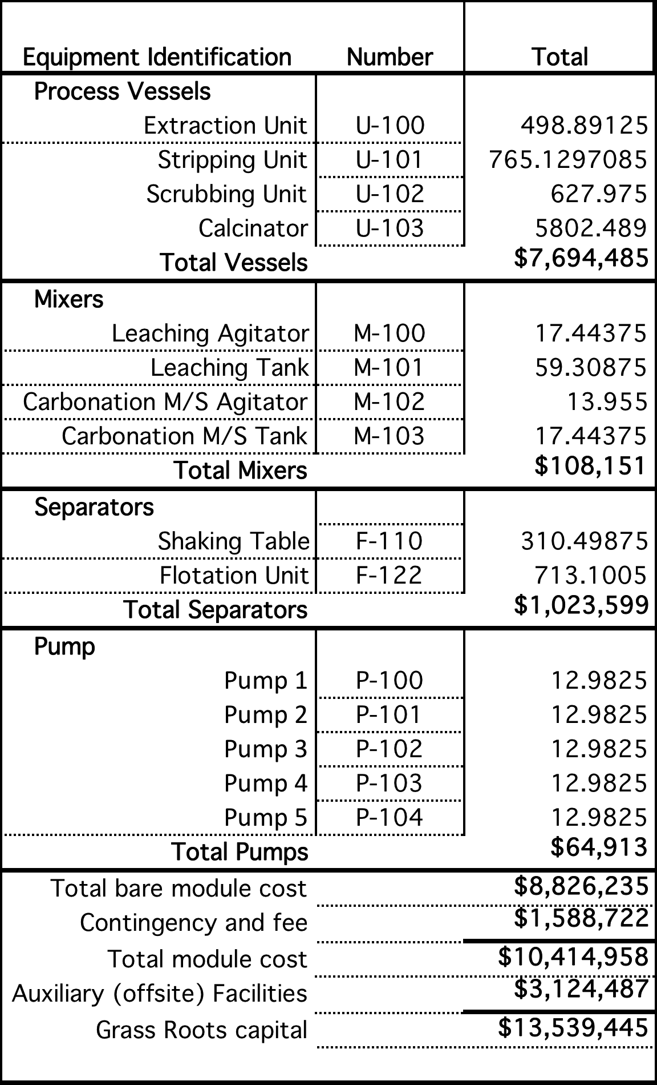
Table 4. Capital costs of process equipment used recovering Rare Earths.

4.3 Operating Cost Estimate for Recovery of REES from Amine Tails
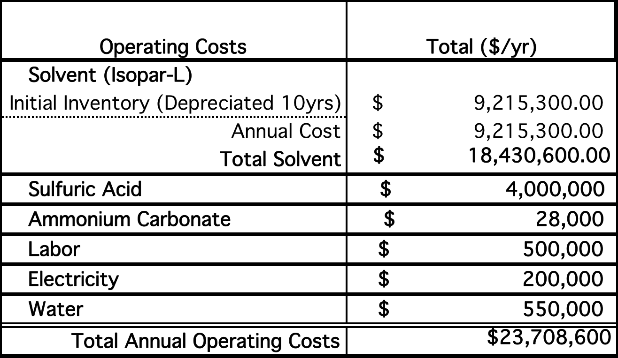
Table 5. Annual operating costs of recovery of Rare Earths. Cost of capital is spread over 10-year operational life of equipment. Individual mass flow rates and related costs are located in Appendix A.

5.0 Discussion of Results
Based on the equipment design proposed in this study, approximately 68.15 tonnes of REE’s can be processed annually with a 13% recovery rate. The estimated capital costs are around $13,600,000 with a yearly operating cost of $23,710,000. The bulk of the operating costs stem from the use of Isopar-L as the primary solvent, with an initial inventory charge of over $92,000,000. This cost was depreciated over 10 years and combined with a 10% expected operational loss. The following shows an annual balance sheet.
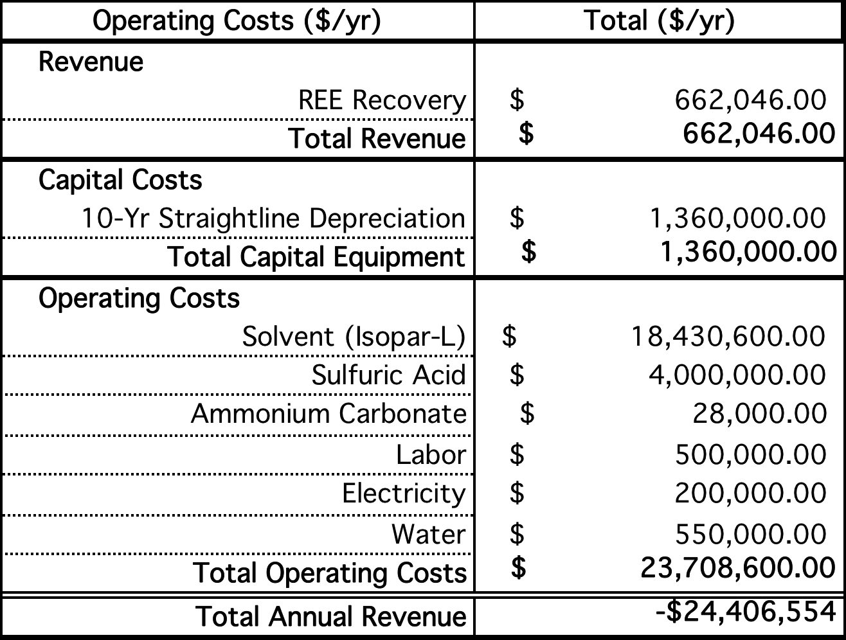
Table 6. Balance sheet providing estimates on yearly revenue, expenses, and operating profit in recovery of rare earths from sand tailings.

6.0 Conclusions
As seen from the results, the process does not seem to be economically viable under the current design parameters. However, several variables can be worked on to improve the economic profitability of the process, some of which include reducing solvent cost, using a centrifugal contractor at the extraction step, and finding alternative cheaper equipment than the ones used in this design. These variables prove to show great promise in reducing overall expense, making the economic design of the process worthwhile.

7.0 Recommendations
An initial recommendation is to incorporate a centrifugal contact separator to the equipment design. In turn, this would lower the unit residence time to about 20 seconds (factor of 30), reducing the initial solvent inventory proportionately and the annual solvent loss by a factor of 10. The combined effect on annual solvent cost is a 300X reduction and a total savings of over $18 Million per year relative to our initial design. This is represented in the following table.
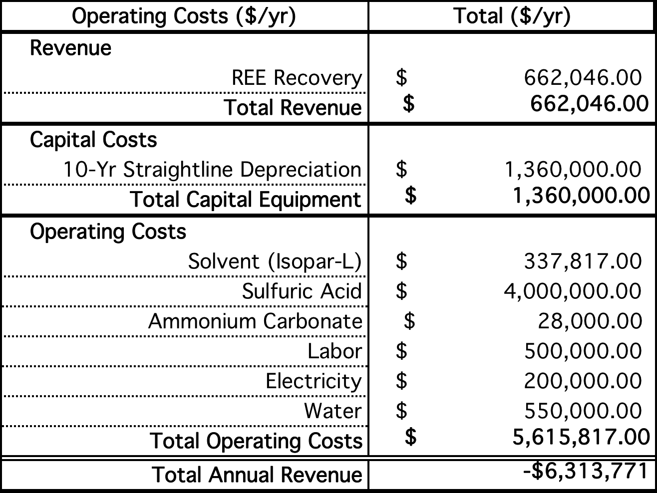
Table 7. Balance sheet providing estimates on yearly revenue, expenses, and operating profit in recovery of rare earths from sand tailings with addition of centrifugal contactors.

After the addition of centrifugal contactors, the costs for sulfuric acid remain one of the largest opportunities for improvement. Sulfuric acid is a major component in the leaching and stripping steps of the process, and further explorations must be made for ways to recycle and maximize its use. It has also been proposed to investigate a range of acid concentrations to see which are the most effective in both processes and give the largest return on our investment.
Additional cost savings could potentially be found in the choice of equipment and more efficient use of utilities and labor to accompany. For example, further study may find that more effective means exist than the gravity separation step paired with a flotation unit featured in this design. The alternative methods may provide savings in initial capital purchases as well as the energy and resources needed in operation.
Finally, society in general must find more ways to increase the demand of REEs and, thus, the price in order to generate a substantial revenue for this process. As noted in Appendix A, the market price of bulk rare earths would need to rise to almost $1,800 per kilogram to reach a 10% profit from the initial design. Even with the implementation of the contactors and potential savings aforementioned, the current $4/kg bulk rate will likely not be enough to overcome the high capital and operating costs of this process. More research is necessary to find ways to reduce costs, increase revenue, and make rare earth processes a reality here in the United States of America.

References:
1. Young, Laura. RARE EARTH ELEMENTS 101 (n.d.): n. pag. Iamgold Corporation. Apr. 2012. Web. <http://www.iamgold.com/files/REE101_April_2012.pdf>.
2. Herzmann, Nina, Shalabh Gupta, and John D. Corbett. "Reduced Ternary Rare-Earth-Transition Metal Tellurides for the Smaller Rare-Earth Elements." Zeitschrift Für Anorganische Und Allgemeine Chemie 635.6-7 (2009): 848-54. El Servicio Geológico Minero Argentino. Web.
3. Humphries, Marc. Rare Earth Elements: The Global Supply Chain (n.d.): n. pag. Federation of American Scientists. Congressional Research Service, 16 Dec. 2013. Web. <http://fas.org/sgp/crs/natsec/R41347.pdf>.

Appendix A. Comprehensive Mass Balance
- All mass values are in metric tons, taken on a yearly basis
- Given values are taken from small-scale laboratory testing done by FIPR and/or the Critical Materials Institute research group at ORNL
- Critical REEs (those with significant economic value) are highlighted in yellow, undesirable radioactive elements (Thorium and Uranium) are highlighted in red
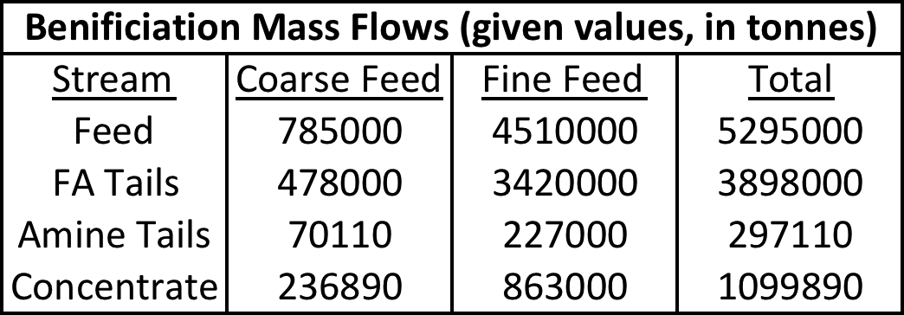
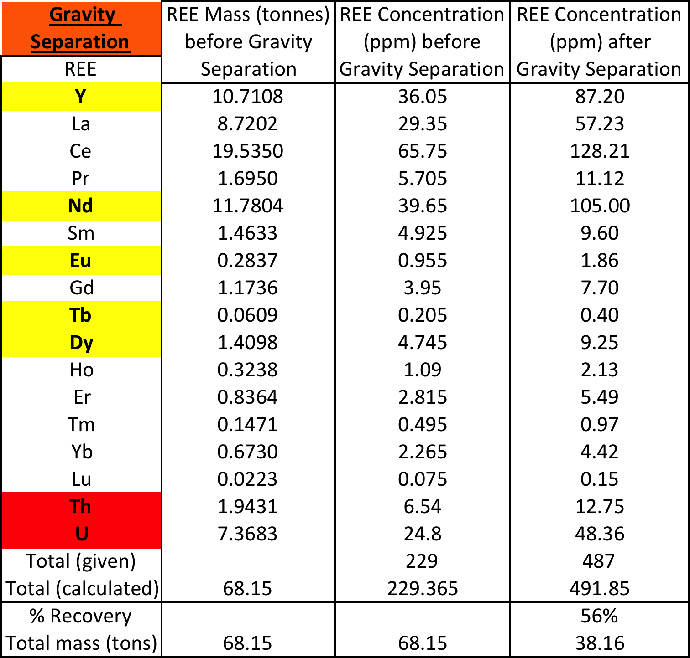

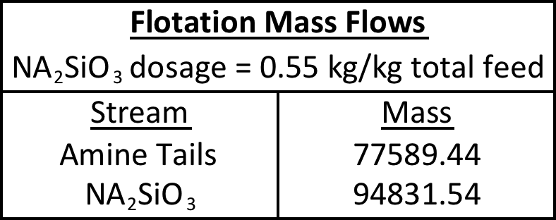
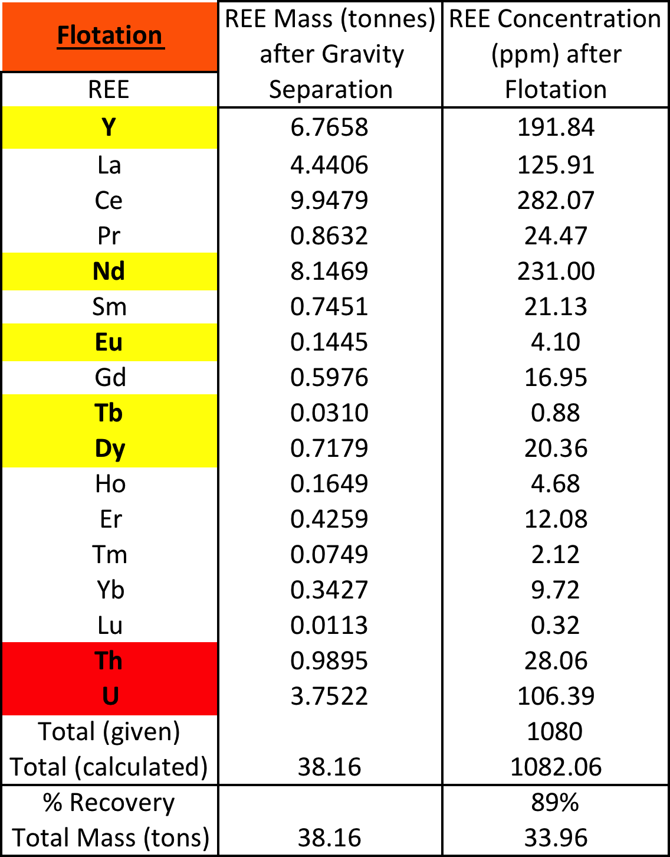

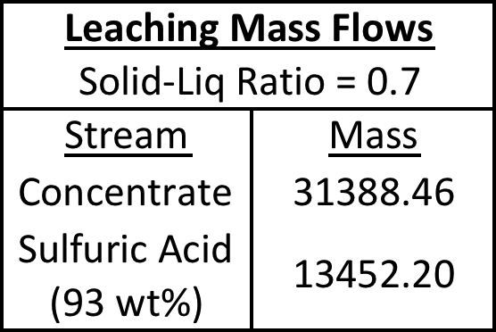
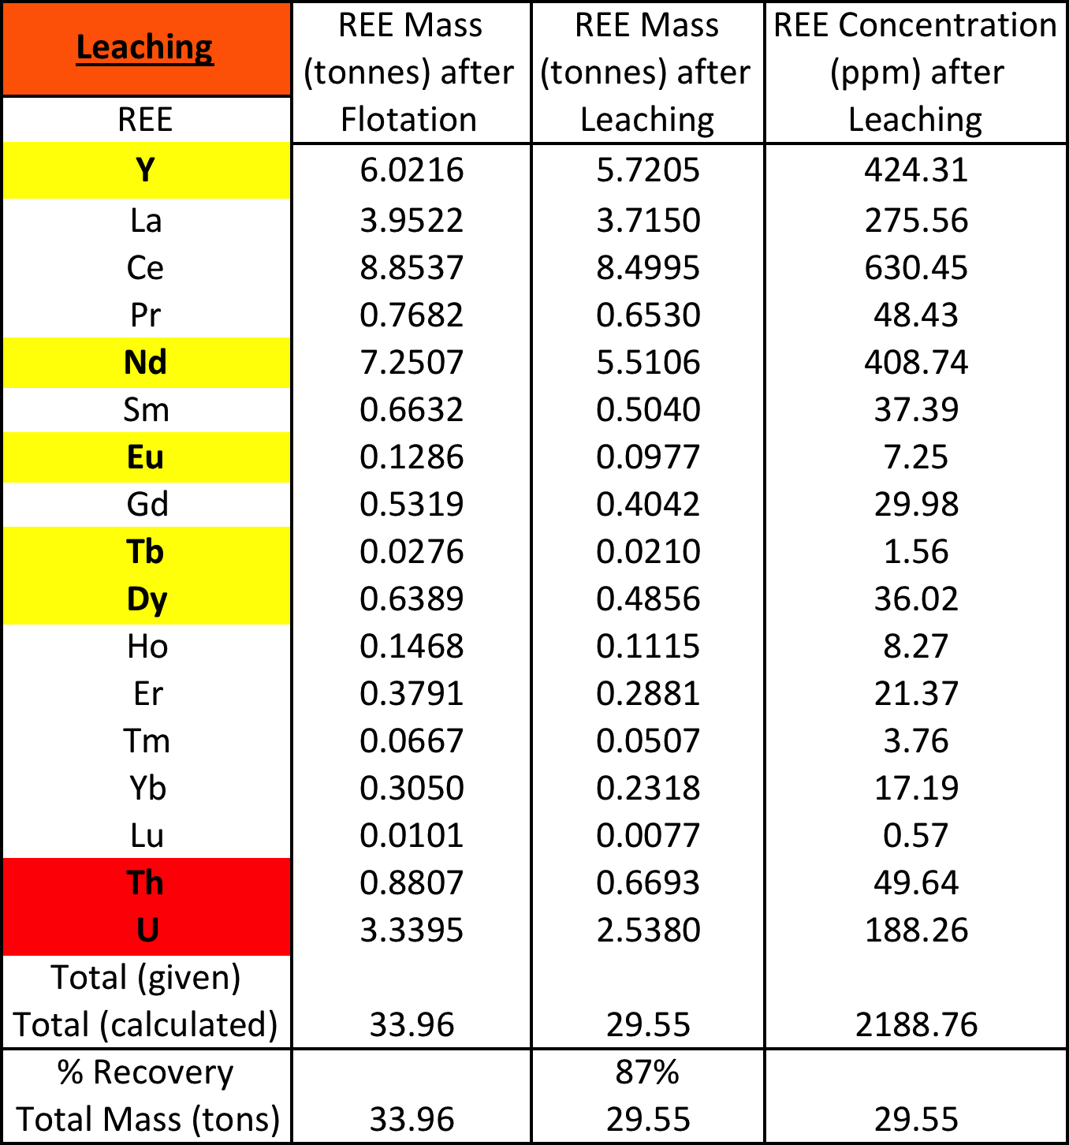

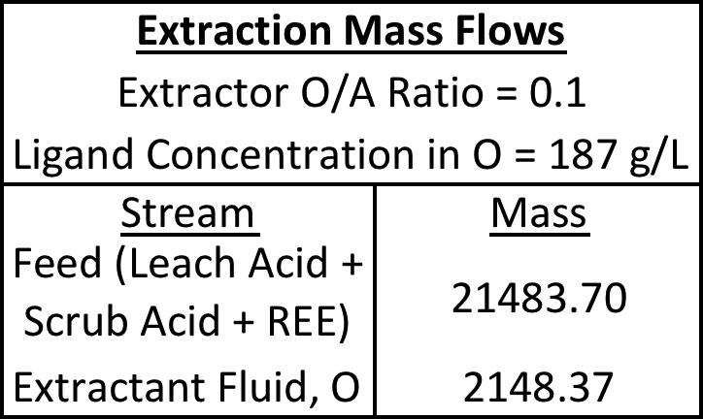
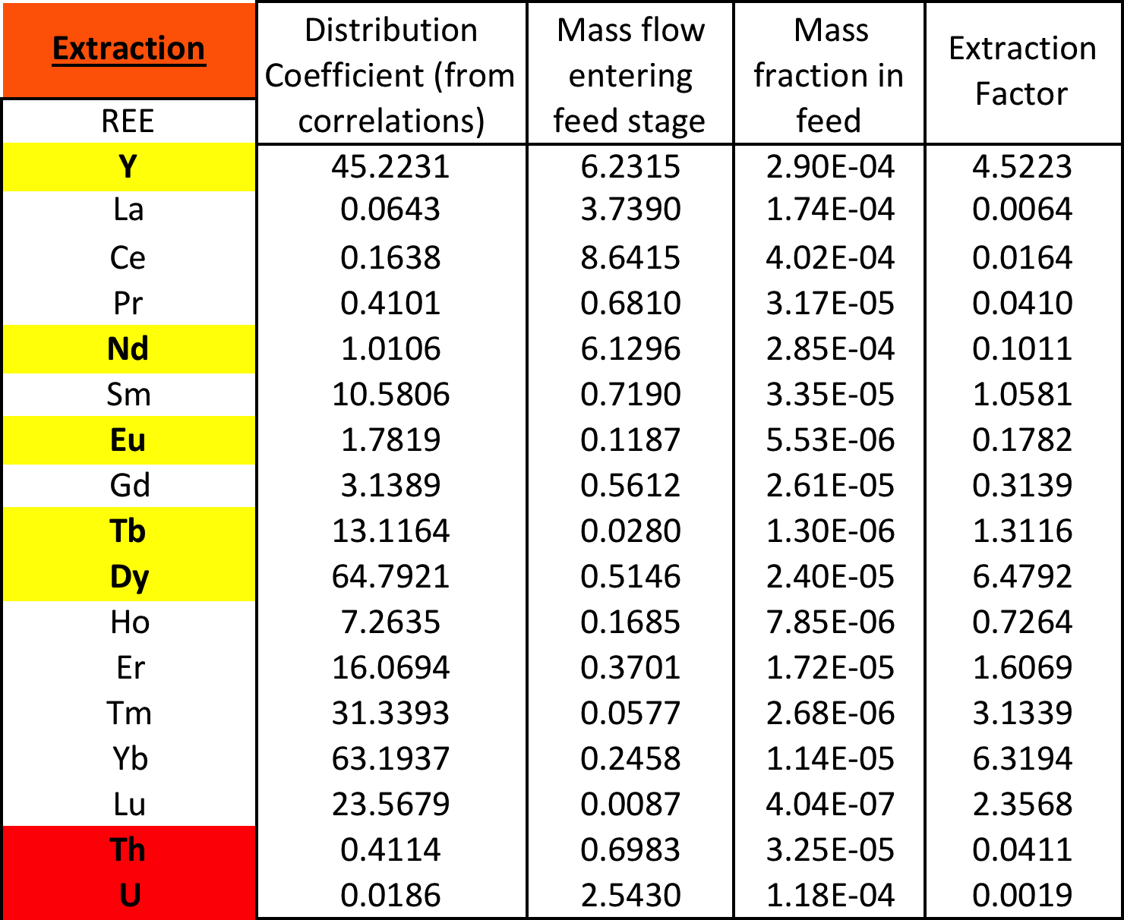

- Number of stages was increased until percent recovery of critical REEs did not change significantly

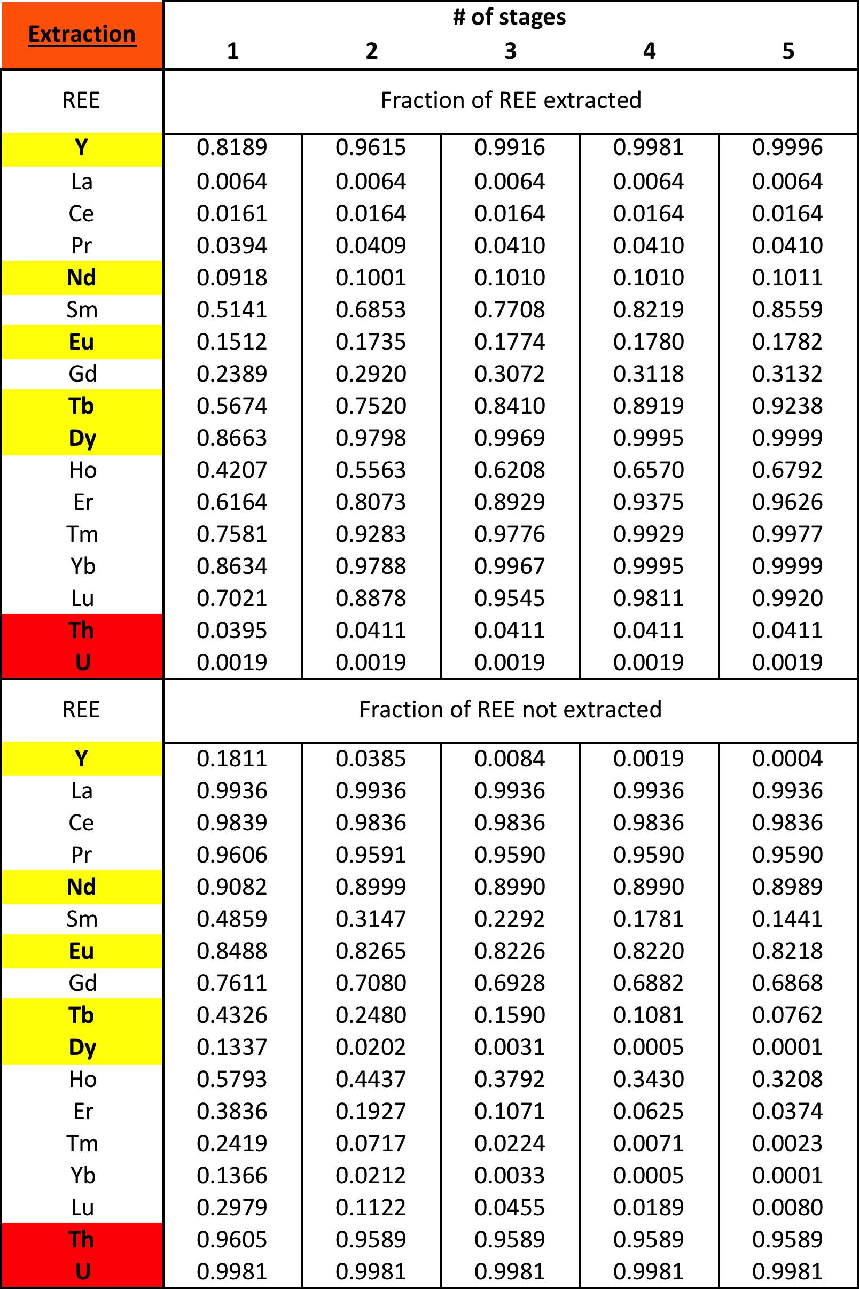
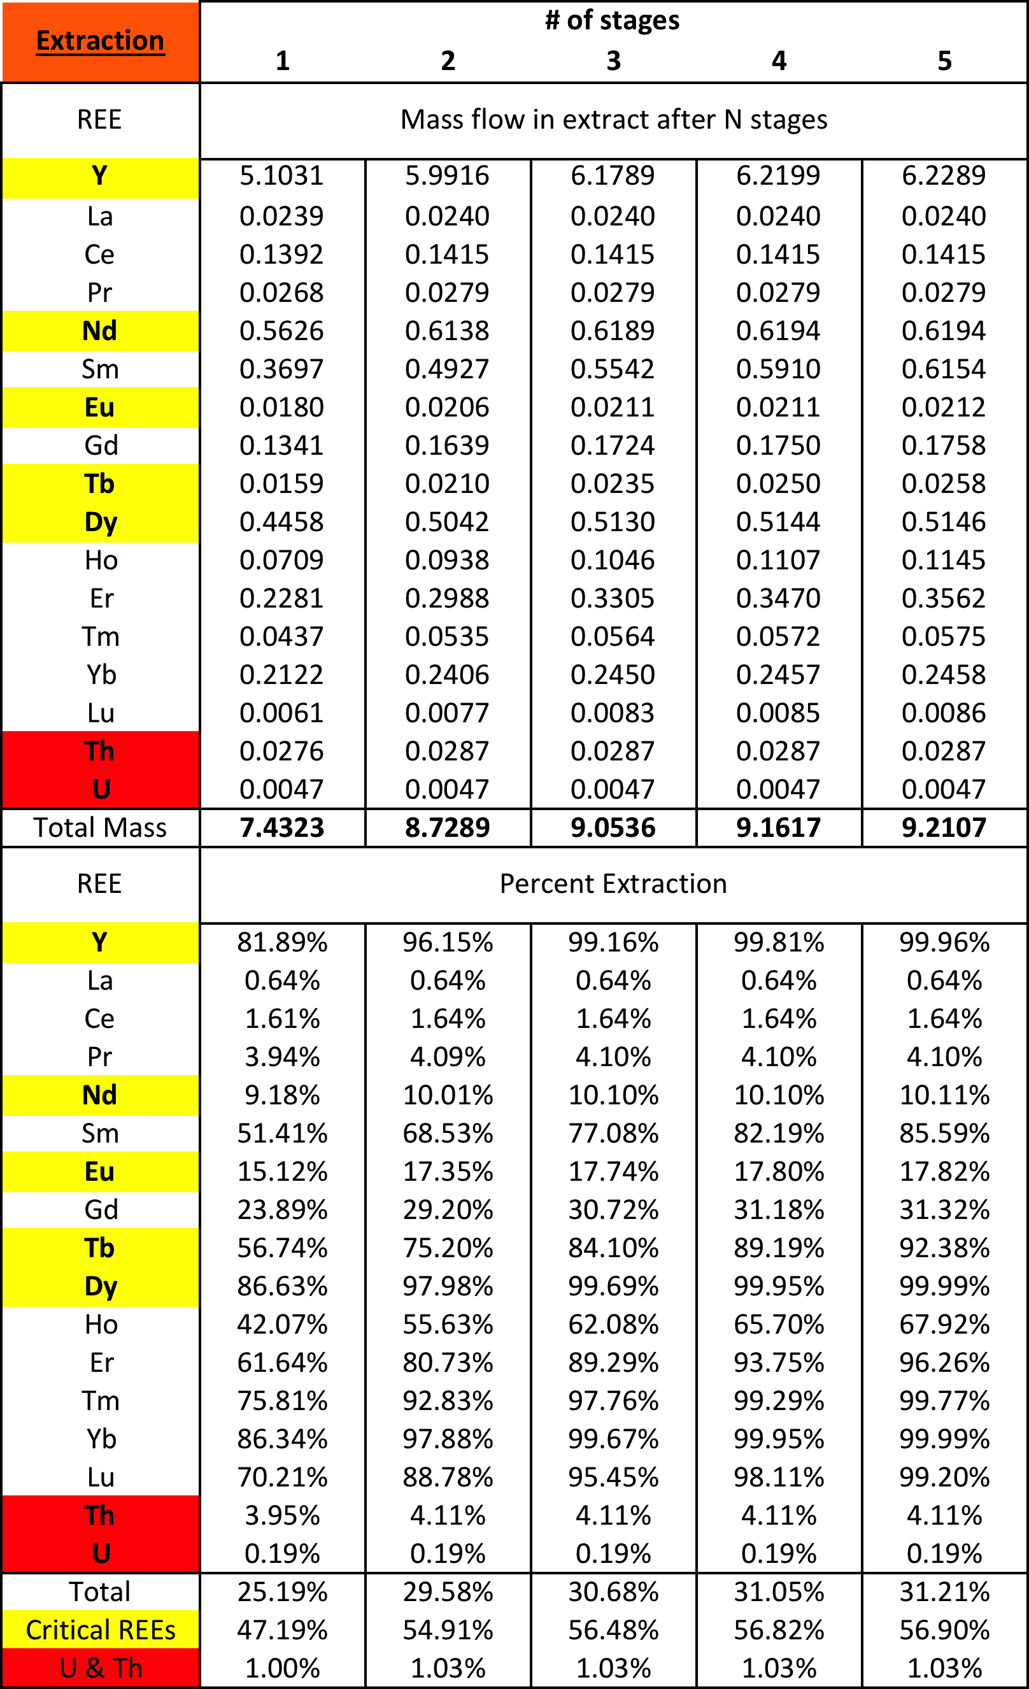

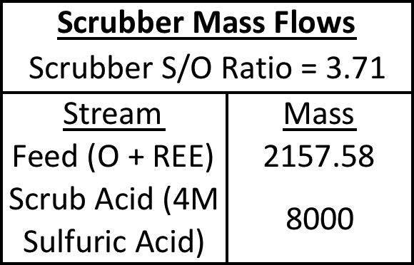
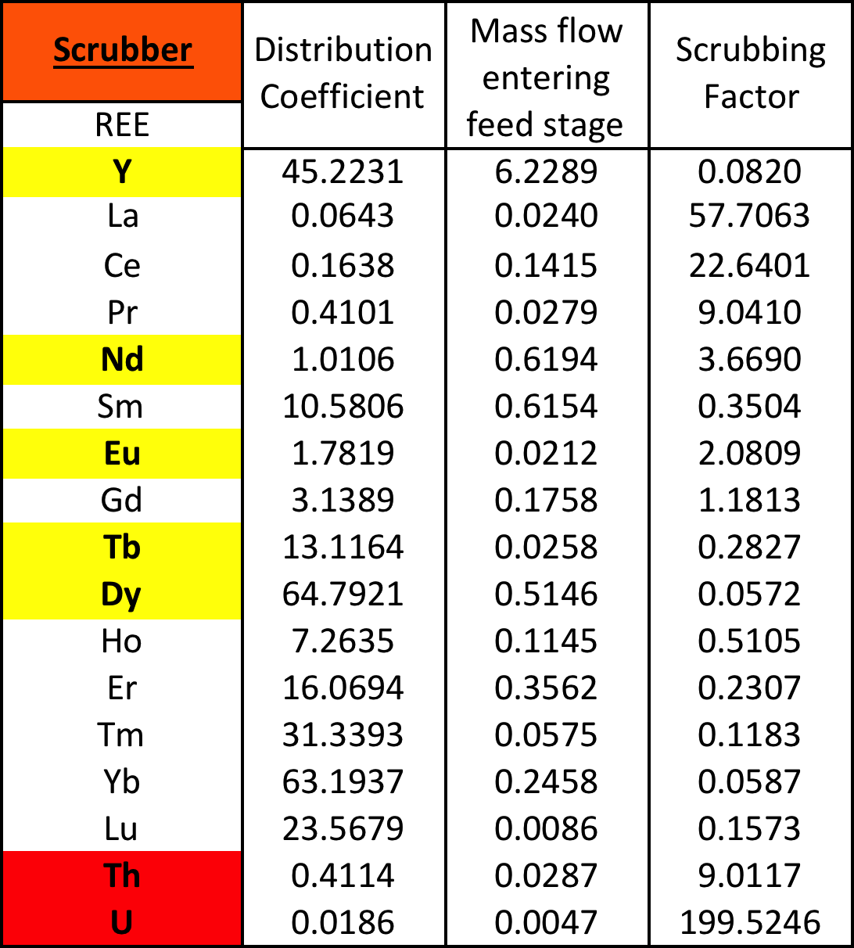

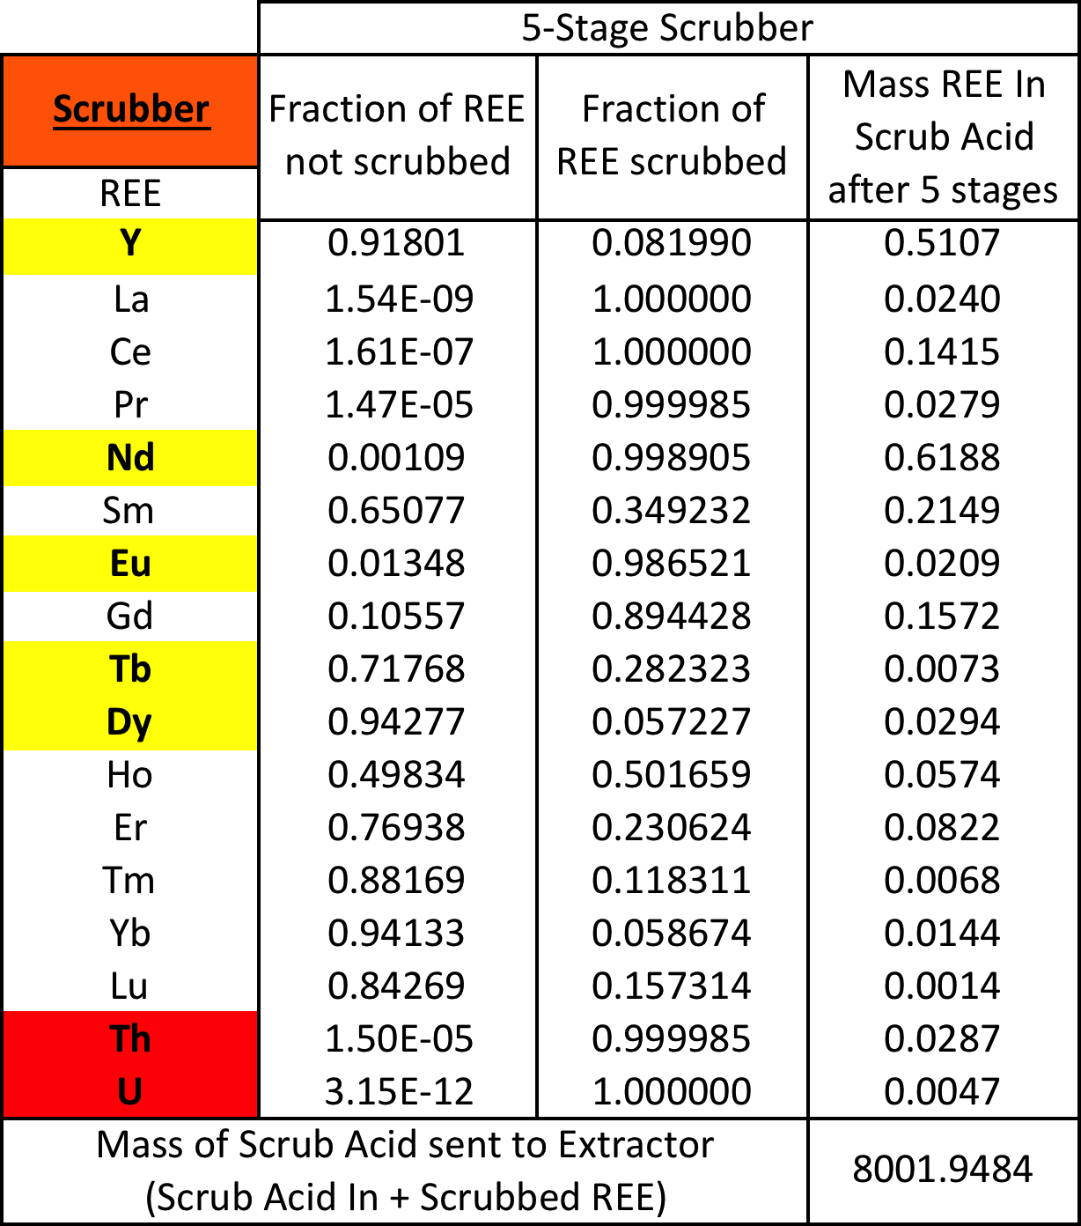
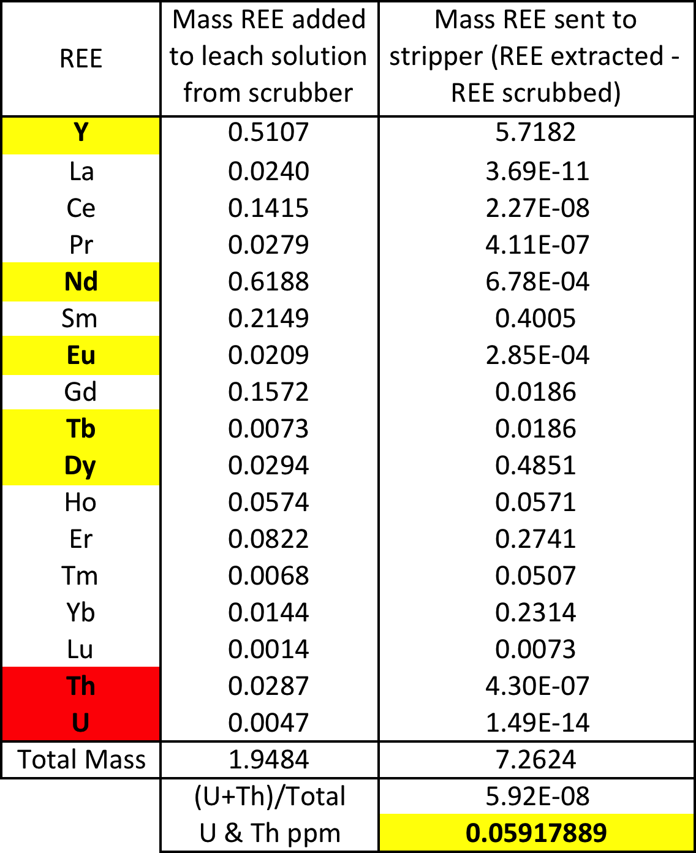

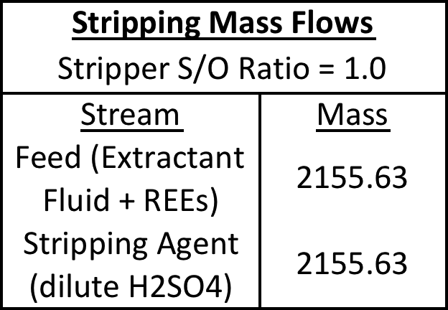
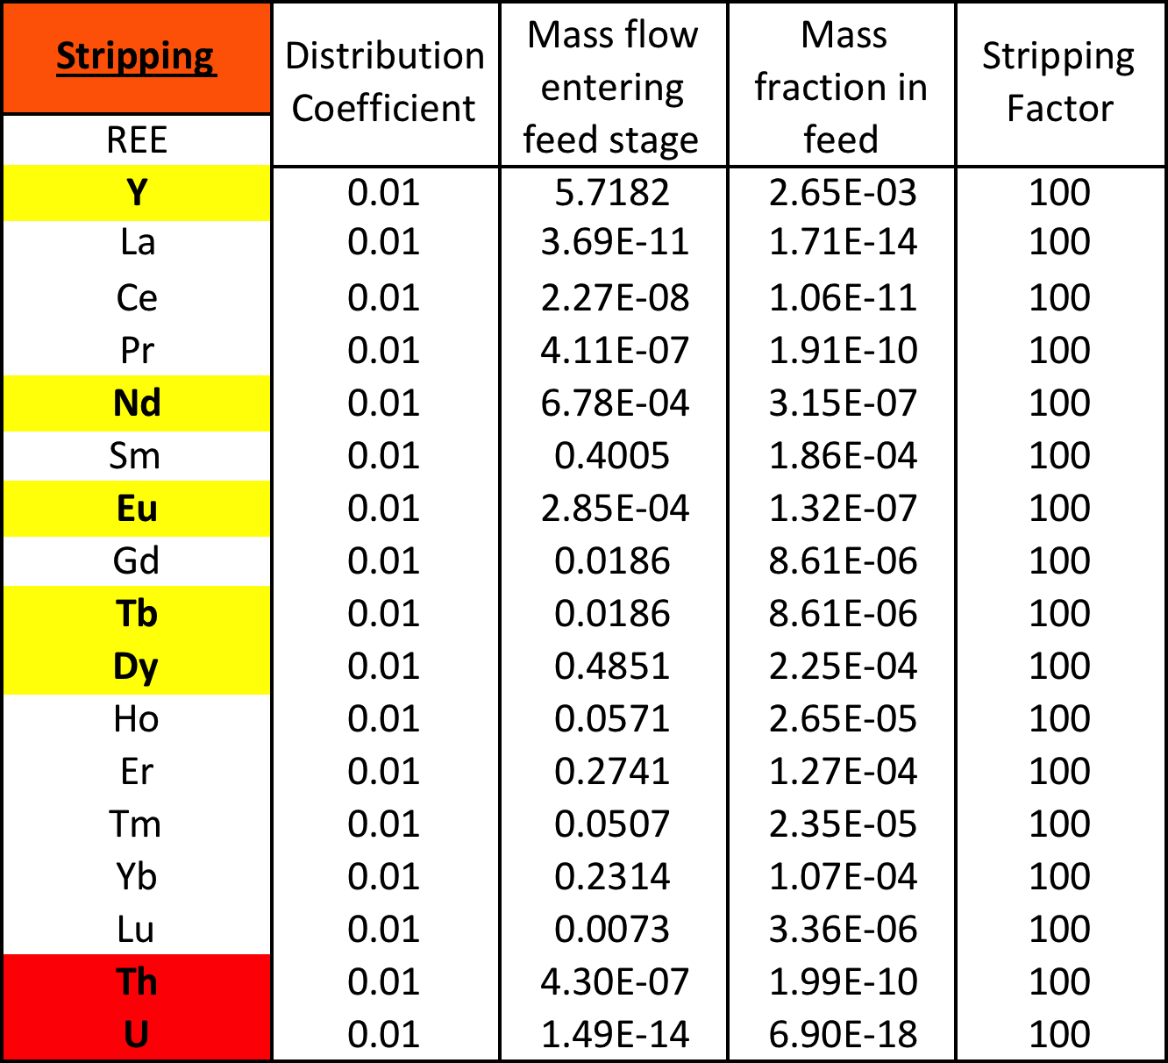

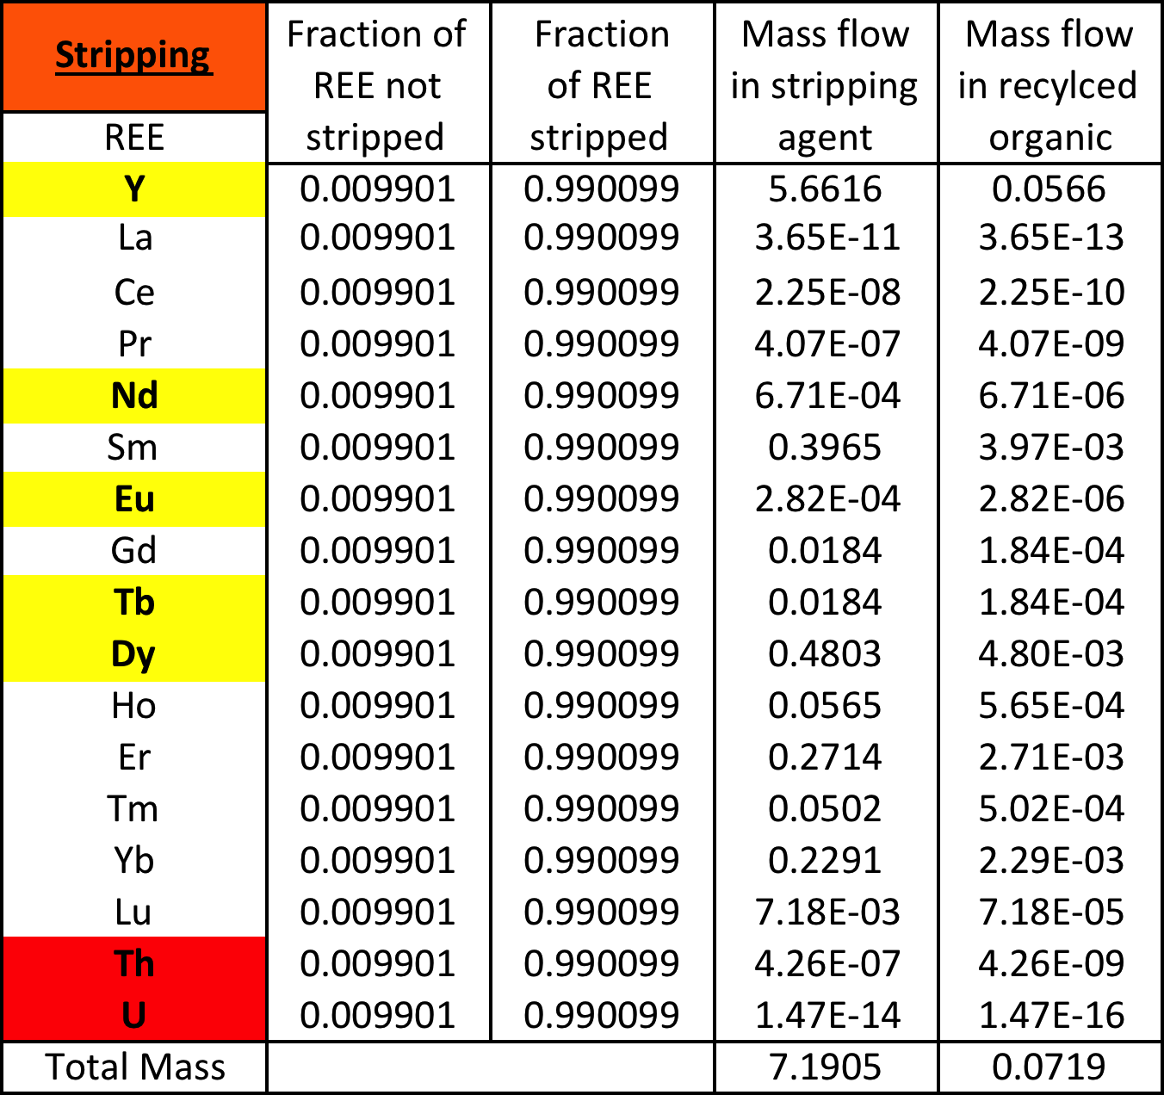

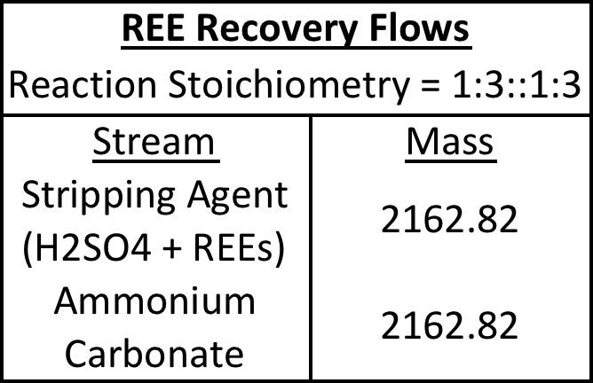
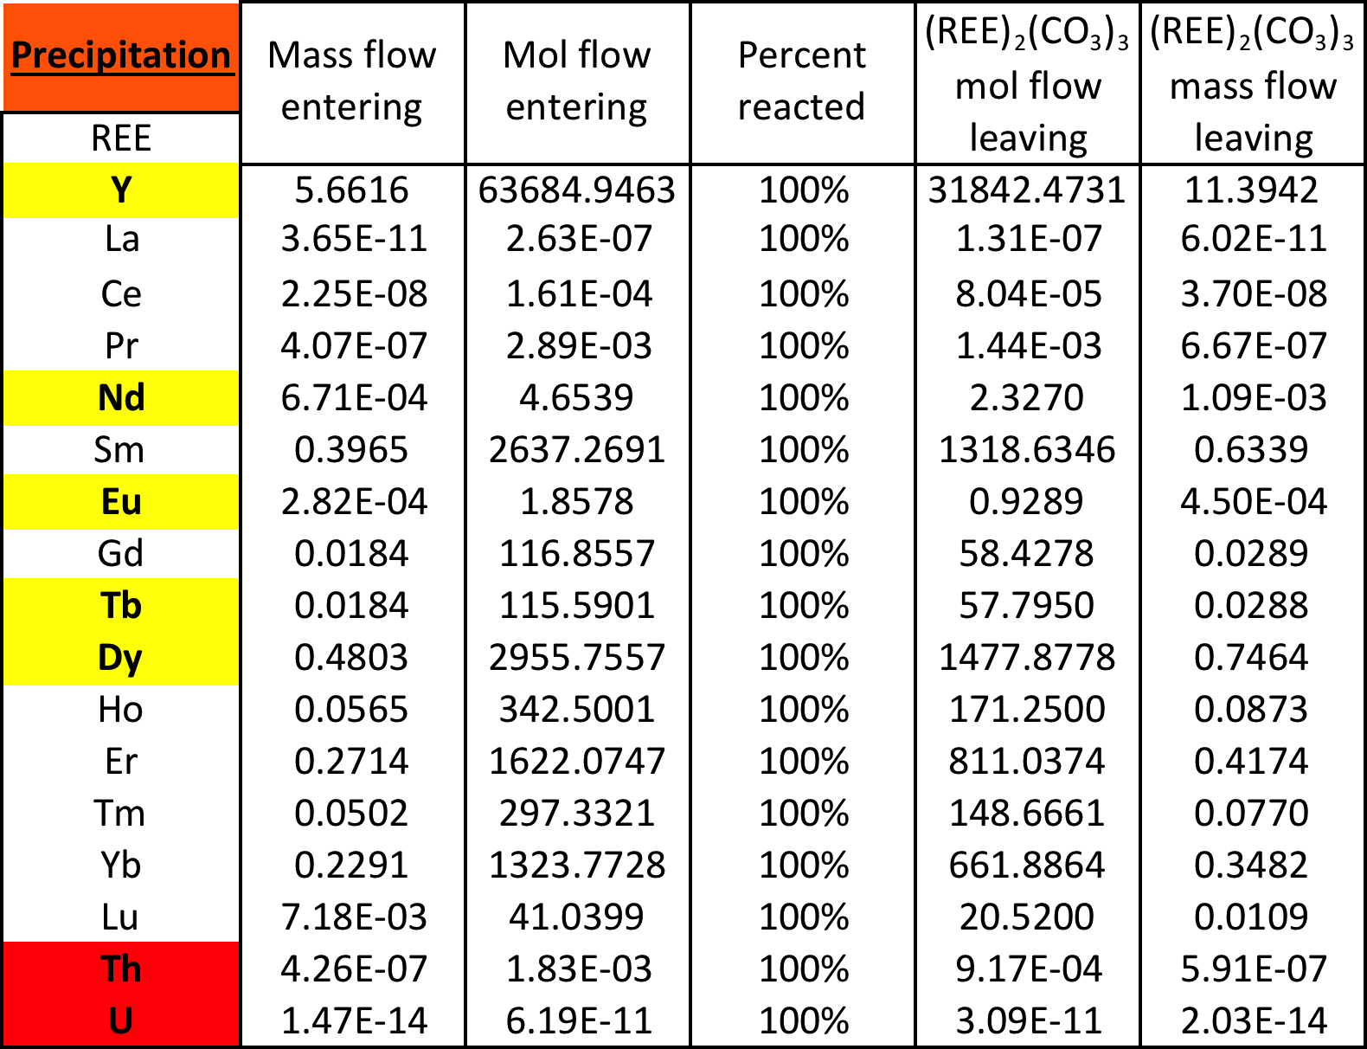

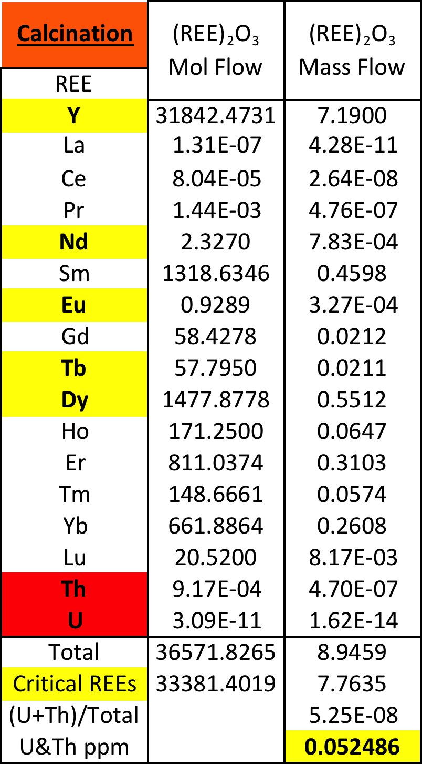

- Molar mass (g/mol) of recovery step reaction streams for reference

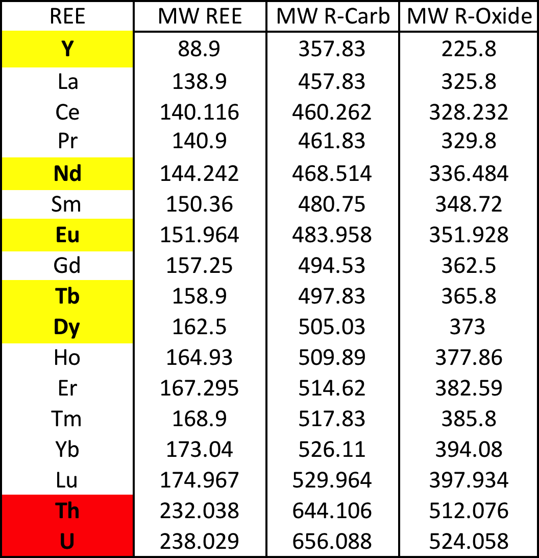

Appendix B. Cost Information

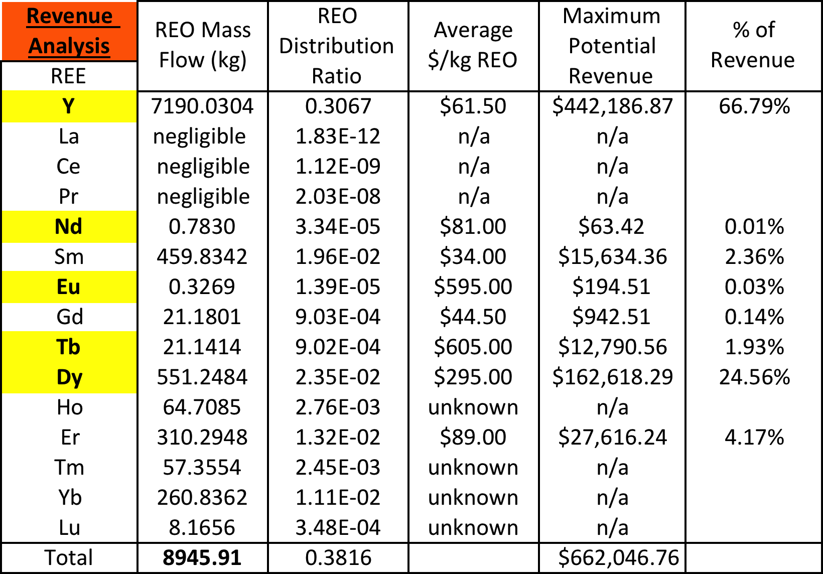

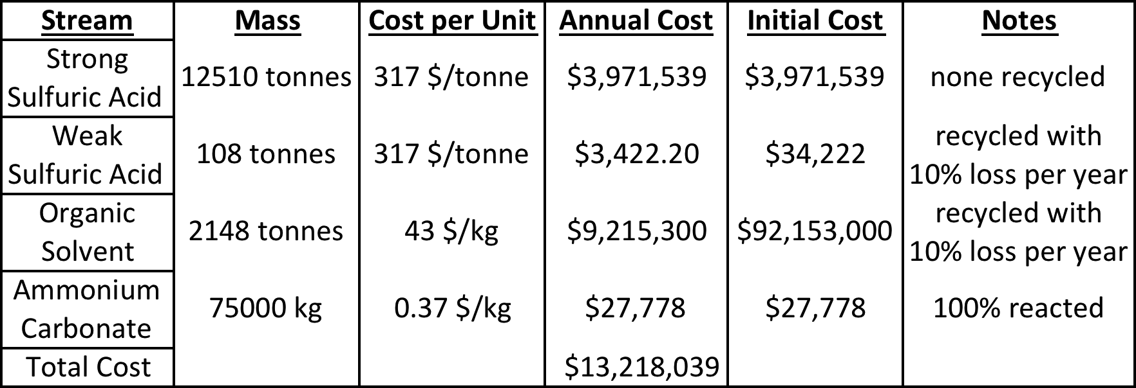

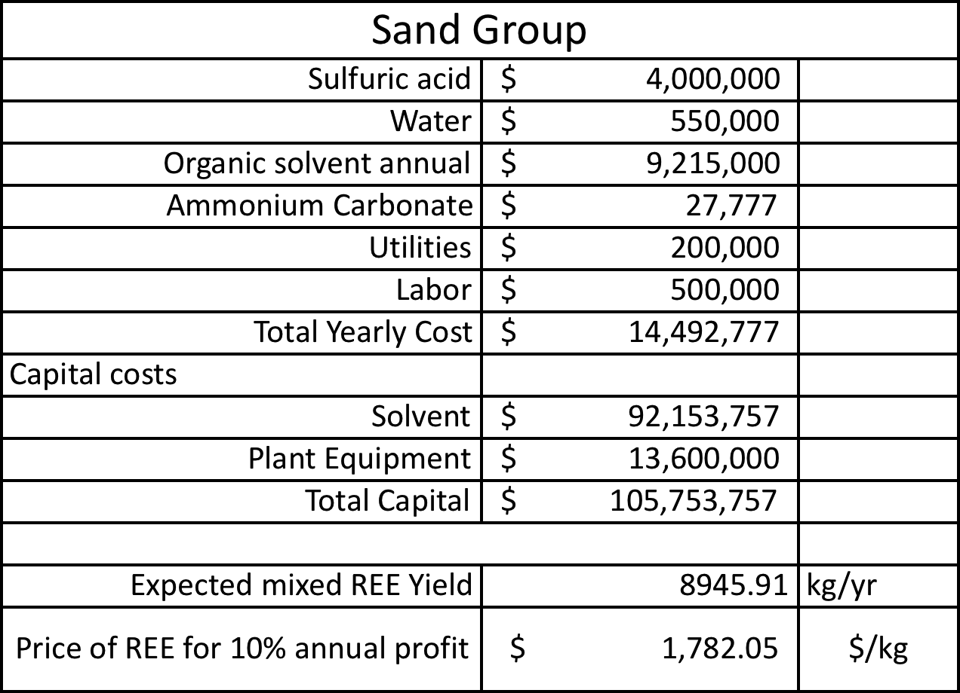

Appendix C. Miscellaneous Tables and Figures
- Distribution Coefficient Raw Laboratory Data

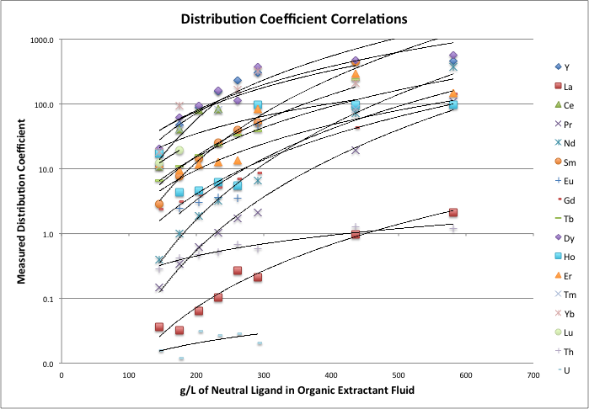

- Distribution Coefficient Power Law Models based on raw data

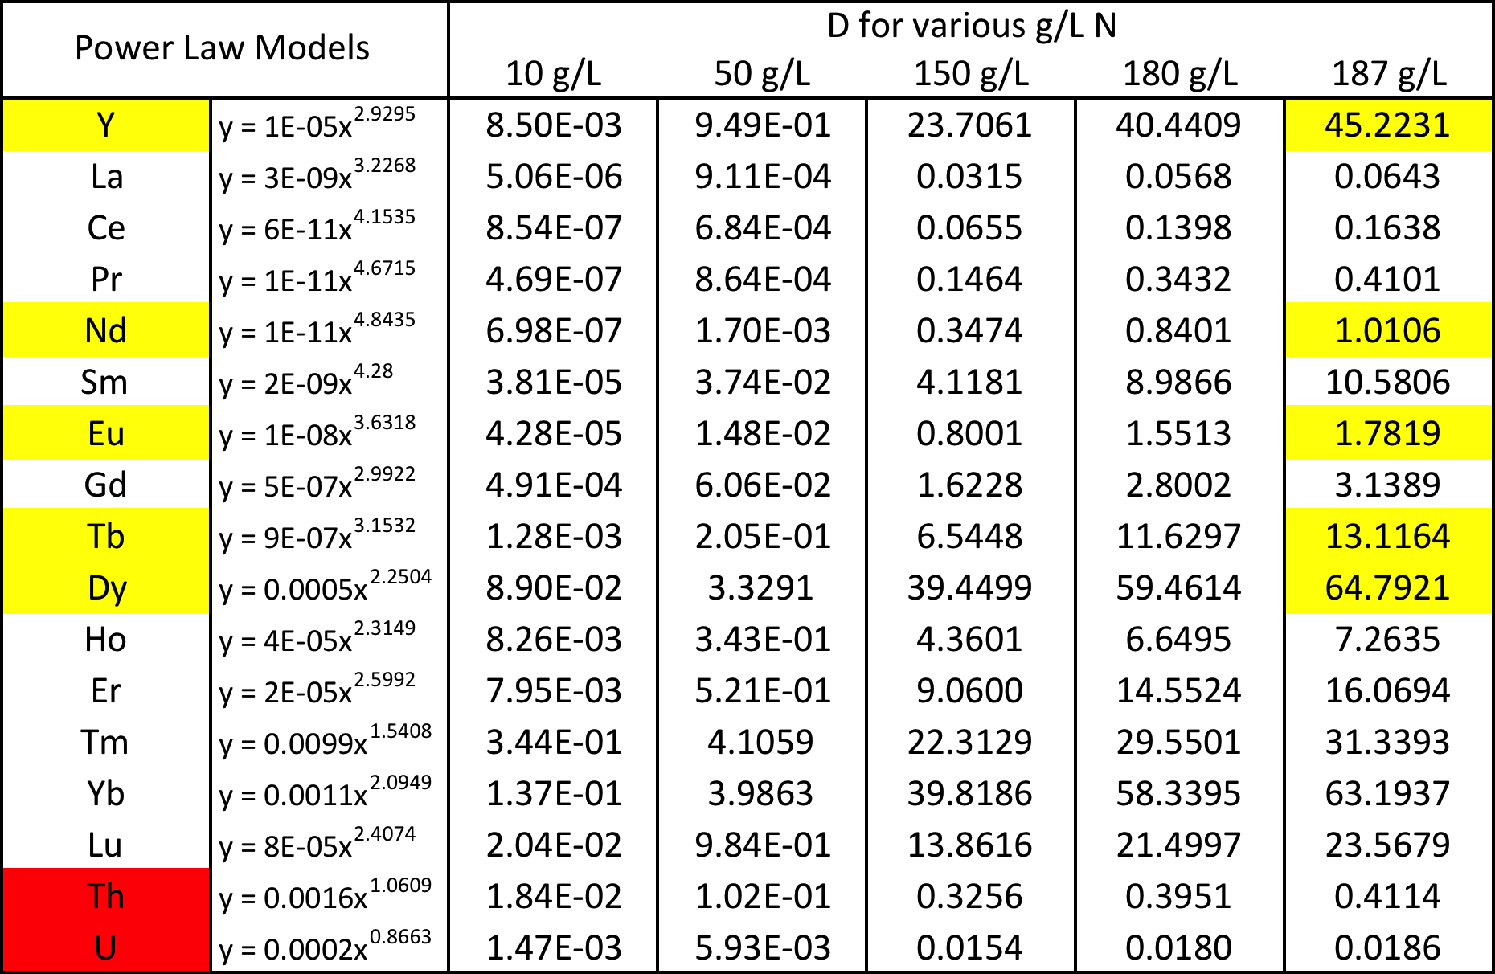

- Capital Cost Summary

