Reforming Oil and Natural Gas Severance Taxation as a Means of Strengthening Rural Tennessee

A Chancellor’s Honors Program Senior Thesis

Erica Davis
Sociology
Spring 2016

Reforming Oil and Natural Gas Severance Taxation as a Means of Strengthening Rural Tennessee
A Chancellor’s Honors Program Senior Thesis
Erica Davis, Sociology
Spring 2016

Table of Contents

PART I: Intro p. 3
PART II: Creating the Bill p. 7
  - Clause 1: Roads p. 7
  - Clause 2: Backlash p. 9
  - Clause 3: Broadening the Base p. 10
  - Clause 4: Counties with Oil and Gas p. 11
  - Clause 5: Exploration p. 12
  - Clause 6: Not a Deterrence p. 14
  - Clause 7: Absentee Ownership p. 15
  - Clause 8: At the Bottom of the Totem Pole p. 16
  - Clause 9: Paving the Way for a Brighter Future p. 17
  - Clause 10: The Goal p. 18
PART III: Be it Enacted p. 19
PART IV: Conclusion p. 22

Acknowledgments

I would like to acknowledge my thesis advisor, Professor Dean Rivkin of the UT College of Law, for his support throughout this process and for providing me with endless wisdom. I would also like to thank my academic advisor, Dr. Robert Jones, for challenging me throughout my undergraduate career. Furthermore, I don’t know where I would be without Ann League, Adam Hughes, and all my friends at SOCM. Finally, my deepest, most heartfelt gratitude goes out to the people of Campbell County, TN—thank you for welcoming me with open arms into the mountain community you call home.
- Introduction

In June 2014, I packed a suitcase and drove myself to Blacksburg, Virginia, where I didn’t know a soul. I had committed to spending the next 9 weeks as a research fellow at the Virginia Tech StREAM Lab, part of a National Science Foundation (NSF) summer research opportunity for undergraduates. The projects were mainly designed for engineering students and faculty, but academia is slowly—and fortunately—learning the importance of the social sciences, so there was a survey-focused project for me to work on as well.
All summer, I communicated with the Institutional Review Board, carefully fine-tuned survey instruments, conducted 1,000 in-person surveys about valuation of the urban hydroscape in the blazing summer sun, and tediously coded results. While I was getting doors repeatedly slammed in my face, my colleagues were paddling around in kayaks to test water quality in local bodies of water to measure things such as pH and phosphorous concentration.
My results revealed interesting relationships and opportunities: larger bodies of water are used more frequently and valued more than smaller ones, most residents of the community were willing to pay money for protection of local waterways, and there was a need for education throughout the watershed. I presented at the Virginia Tech research symposium, received affirmation and praise for my contributions, and then—well, that was it.
Before leaving Blacksburg to drive back home to Knoxville, I grew incredibly frustrated. I had spent all summer literally shedding blood, sweat, and tears to run a well-conducted study, and I had gained incredibly valuable information about a topic that I deeply cared about, all while enduring the snide remarks and mocking tones of the engineering students who felt superior to me. I was frustrated because I could not use this information to implement effective measures to facilitate long-lasting, positive change.
That experience is what led me to make the most important and intimidating decision of my life: to use my environmental sociology degree to pursue a career in environmental law. I realized that my passion for the betterment of society, nature, and the relationship between the two positioned me for a career in justice-seeking, law-making, and using research to implement solutions. The road following that decision begins in a stranger’s red pick-up truck at an Arby’s off a highway exit in an unfamiliar town situated deep within the beautiful Appalachian Mountains.

* * * * *

Over two years ago, I started a research project for a class on social values and the environment. The project led me to Jellico, Tennessee, to learn about mountaintop removal coal mining with local resident Carol Judy. I learned that Jellico is a typical coal town in Campbell County, Tennessee. Though the coal industry is in steep decline, the communities it subsumed are still heavily burdened by its legacy. Carol offered to chauffeur me around in her truck while explaining the landscape to me—historically, geographically, socio-economically, and politically.
As we drove around, Carol pointed out sites of environmental destruction: severed and desolate mountain peaks, streams flowing with polluted water, and clear-cut forests. I asked many questions: who, what, how, but why? Carol introduced me to her friend Vicky at the home that she had built herself. A couple hundred yards away was a new surface mining site, and I listened to her stories about explosive blasts keeping her awake throughout the night. She was sick, suffering from severe respiratory issues, and wished for nothing more than to live off of the food from her garden. However, she couldn’t trust the town’s groundwater because of the mining operation next door and its toxic runoff; the coal industry did not let her rest. It haunted her waking moments as well.
Following that first encounter with the land and people of Campbell County, I dedicated myself to academic study and environmental activism. I began to understand the role of the coal industry, particularly in Appalachia, and its influence that runs as deep as the seams of natural resources it relentlessly extracts. I was troubled by my interactions with the innocent victims, who were caught in the greedy crossfire wrought on historically impoverished communities that are not equipped to mobilize in opposition to the destruction of their home. I immersed myself in the truth, gazed upon destroyed mountains, and breathed coal-dust air into my lungs. I came to share Carol’s fear that unless significant change occurred, the mountains she called home would not be around for long. I learned that even though I am small and simply human, I could be a force for justice.
The summer before my senior year, I could not pass up an opportunity to work in Campbell County again, this time with a much more intimate and meaningful project. Advised by University of Tennessee Law Professor Dean Rivkin, and in partnership with a local advocacy organization called SOCM, I spent months researching coal, oil, and natural gas severance taxation. My research culminated in drafting a bill to be presented at the state level. The legislation became HB 1881/SB 1944, sponsored by Representative Dennis Powers and Senator Ken Yager, respectively.
The bill ensures that extractive communities receive more than seven times as much revenue from the oil and gas industries as they currently receive. This solution is important in helping to correct the tragic removal of both mineral and monetary wealth from the impoverished communities that need it the most. The money from this measure is allocated for infrastructure maintenance and improvement projects—desperately needed in areas where coal trucks and oil and gas machinery cause severe damage to roads through repeated wear and tear.
To make this bill a reality with tangible and lasting impacts for the state, I started by fostering local support. This aspect of my project was necessary to secure committed sponsors as well as to mobilize an advocacy network. The logical place to start was Campbell County, which had stolen my heart years before.
I have repeatedly seen the failures of the law to protect the mountains and people I have come to love, which is why I am called to pursue legal education. I believe in the law as a vital tool for justice and as a lifeline for many of the struggles happening daily in Appalachia and in other frontiers of environmental destruction. Although my bill unfortunately did not become a law, this process has taught me so much about research, writing, advocacy, networking, legislation, working with decision-makers, and ultimately about keeping hope alive no matter what.
II. Creating the Bill

This section breaks down my original bill by clause and offers a more thorough explanation of the process, reasoning, and necessity for each component.

CLAUSE 1

The Legislature Finds and Declares that the Tennessee Department of Transportation (TDOT) and Governor Bill Haslam have said the state faces a backlog of approximately $8 billion in roadway projects, and a gasoline tax is required within the next four years for Tennessee to continue funding highways and public transportation, a solution Haslam hopes “isn’t just a band aid.”

The roads in mining towns are in bad shape. Out of the approximately $8 million dollars in backlogged projects, at least $216,650,000 worth of needed repairs are located in the counties that experience the most mining (i.e., Campbell, Claiborne, Overton, Roane, Scott, Morgan, and Fentress Counties). It should be noted that the roads on this list are only those that have been identified. These tend to be segments of major highways and other infrastructure important for interstate travel and commerce. Unfortunately for extractive communities, their smaller roads can easily be overlooked because they are not used for transport that is tangibly beneficial to the state, other than the import of mining machinery and export of natural resources.
Roads connect people with each other, with life’s necessities, and with the world outside their own communities. Roads can also pose significant hazards. One of these hazards is fugitive dust, which contributes to Appalachia’s prevalence of respiratory disease. Damaged roads can also harm vehicles and cause dangerous accidents.
It seems quite fitting that the first time I met the Duff Community Group they were strategizing on how to get their main road paved. It was October, and I was driving along White Oak Road with the windows down, heading toward the Parent Resource Center where they meet every other Thursday night. I remember the sound of my tires grumbling along, the debris crunching underneath as I dodged pothole after pothole, my body feeling stress from the experience of traveling on such a horrible road. I pulled into the gravel lot, was greeted by a cat that everyone treated as their own, and entered a room where I met about 15 local community members. Their warm, welcoming smiles reminded me of home.
I spent most of the meeting listening intently to their stories, their expressions not concealing their frustration. I realized that I was in the midst of truly passionate, civically engaged individuals who loved their community with all their hearts and were determined to make it a better place. When it was my turn to present my idea to them, I was very careful to communicate how humbled I was to be in their presence and how appreciative I was for their taking the time to listen to me, an outsider, about something I thought could help them in their mission.
I told them about my bill. I explained that, if enacted, it would mean their county would have more money to fix up White Oak Road and the other damaged, gravel paths that crisscrossed through the mountains like crust on top of a homemade apple pie. They loved the idea and decided to support it; they invited me back the next week to talk through a plan and to present at the Campbell County Commission forum. By the end of November, the Commission had unanimously passed a resolution in support of the bill. The resolution declared the county’s desire for Representative Dennis Powers and Senator Ken Yager, members of the Tennessee General Assembly, to sponsor the bill in the state legislature in the spring. By then, the Duff group had also won the fight to get their road paved.

CLAUSE 2

The Legislature Finds and Declares the necessity of the Governor launching a statewide tour to communicate the “declining trajectory” of transportation funding throughout the State, which was met with considerable backlash from Tennesseeans.

In recent years, an increase in the Tennessee gas tax has been promoted as the most desirable way to generate new revenue for roads in the state. Tennessee’s gas tax rate, which has been stagnant for decades, is the 12th lowest in the country. This is one reason that the state’s roads have become “maintenance-only,” meaning there is only enough money to repair damage to existing roads rather than expanding or improving infrastructure. Thus, it is clear a solution is necessary to generate the desperately needed revenue.
Governor Haslam embarked on a statewide tour to make a case in favor of the hike. He was faced with intense criticism from many individuals and groups, including the Tennessee chapter of Americans for Prosperity, Charles and David Koch’s conservative advocacy group. At the beginning of the legislative session in January 2016, the Governor decided to halt the pursuit of this gas increase.

CLAUSE 3

The Legislature Finds and Declares that, in accordance with statements made by House Speaker Beth Hardwell, R-Nashville, lawmakers are compelled to identify means by which to “broaden the base” of funding for transportation, even if that necessitates the first gas tax increase in Tennessee in 25 years.

The Governor’s statewide tour to promote the tax serendipitously happened at the same time that I began research on oil and gas severance taxation. The buzz around the Governor’s tour indicated the following: there was a need to broaden the tax base to fund road projects in Tennessee, and the Governor’s proposed solution was not going to work. The timing was perfect to introduce legislation that would provide the necessary revenue without burdening Tennessee citizens; instead, the owners of the mining operations, who often reside out-of-state, would be responsible for sharing the burden that they were placing on our communities.
The current severance tax rate for oil and natural gas is 3% of the sale price. If raised to 7.5%, the severance tax would yield $2,468,000 in revenue in just the first year. With the change in distribution designated by this bill, all of that money—save administrative costs—would be returned to the counties where the resources were mined. An important feature of this bill is that it is forward-looking, coming at the forefront of increasing exploration as the coal industry declines and oil and gas rise up to take its place.

CLAUSE 4

The Legislature Finds and Declares that many of the roads and highways requiring maintenance are located in counties with active production of oil and natural gas.

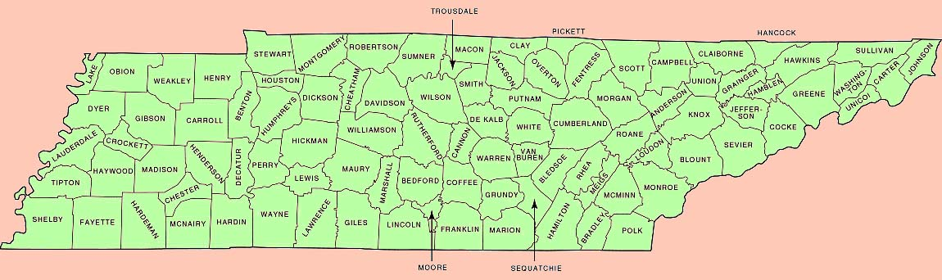
Source: tngenweb.org

According to the Tennessee Oil & Gas Association (TOGA) of the Tennessee Department of Environment and Conservation (TDEC), in 2014 the top counties for oil production were, in order, as follows: Overton, Morgan, Scott, Anderson, Fentress, Claiborne, Pickett, and Campbell Counties, followed by Clay, Hancock, Cumberland, Roane, and Putnam Counties. The top producers for natural gas were: Anderson, Morgan, Scott, Claiborne, Campbell, Fentress, Roane, and Hancock Counties. The following counties can be found on both lists: Morgan, Scott, Anderson, Fentress, and Campbell Counties, as well as Hancock and Roane Counties. Because of the prominence of extractive industries in the counties listed, those areas were priorities in outreach, organizing, and research.
I worked in partnership with Statewide Organizing for Community eMpowerment (SOCM), formerly Save Our Cumberland Mountains, to reach out to these counties. SOCM is a “member-run grassroots community organization that has been empowering Tennesseans to fight for environmental, economic, and social justice for more than forty years.” Through the SOCM network, I met the Duff Community Group and passed the Campbell County Commission resolution mentioned previously. This is ultimately what convinced Senator Yager and Representative Powers to sponsor the bill at the state level.
In Anderson County, SOCM organizer Adam Hughes and I presented at a Citizens’ Climate Coalition (CCC) meeting on December 20, 2015—almost exactly a month before the deadline for getting legislation introduced in the General Assembly. The CCC is an open-membership small group ministry that met in the Hearth Room at Oak Ridge Unitarian Universalist Church (ORUUC). Its ambition is to become a community-wide force for change.

CLAUSE 5

The Legislature Finds and Declares that as of 2013, the State of Tennessee is among the 10 lowest oil and natural gas producing states, but new exploration of the Chattanooga Shale in the eastern part of the state, in addition to further exploration of the highly productive Marcellus Shale, will provide plentiful extraction opportunities. Additionally, the Energy Information Administration has identified Tennessee as one of 12 states with potential for significant increase in production of shale gas.

Policy Matters Ohio prepared a tax policy brief in 2011 that is extremely relevant to understanding the state of oil and natural gas in Tennessee. It describes how “the mineral wealth that lies under the land can create great private wealth but in [the state] the one tax that specifically captures a share of that wealth for the people of the state—the severance tax—is low” (p. 1).
The tax is low now—just 3%—but raising that tax and adjusting the distribution before a foreseeable boom in those resources would benefit Tennessee immensely. The table below illustrates that Tennessee is one of a dozen states with potential for significant increase in production of shale gas, accompanied by: Texas, Louisiana, Arkansas, Oklahoma, Pennsylvania, Michigan, Indiana, Kentucky, Missouri, North Dakota, and West Virginia.

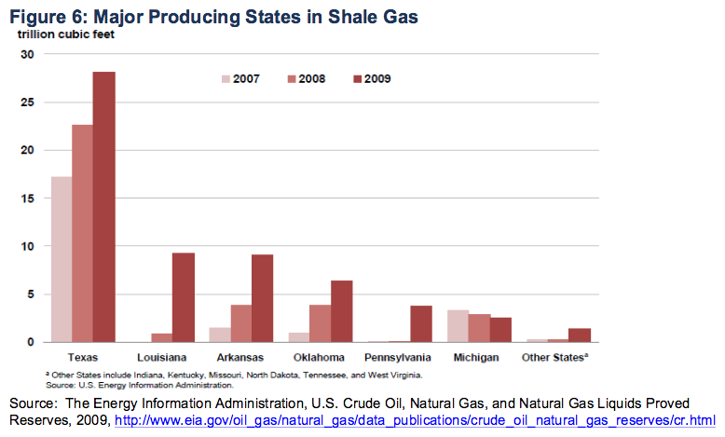

Thus even though Tennessee currently ranks close to the bottom of oil and gas producing states, there is huge potential on the horizon. This makes it an incredibly opportune time to utilize the legislative tool of severance taxation to ensure that extractive communities receive their fair share of revenue from these operations even before they begin to expand in frequency and scale.

CLAUSE 6

The Legislature Finds and Declares that studies have concluded there is no negative impact of severance taxation on the business potential of extractive industries. Policy groups have indicated examples such as North Dakota, Texas, and Oklahoma, whose production levels have significantly increased despite having severance taxes of 11.5%, 7.5%, and 7%, respectively. Julia Haggerty wrote in The Philadelphia Enquirer, “It’s important to note that taxes do not deter fossil-fuel development. They are only one of many factors affecting companies’ decisions about where to focus their activity.”

Decision makers, particularly conservatives, tend to resist additional tax burdens. They view this resistance as supporting business. The fact that tax increases are discouraged, even demonized, made this strategy particularly difficult. The largest challenge was in pitching the idea to state legislators, who inevitably would hear the words “tax” and “increase” in the same sentence and muster up opposition nearly instantaneously. Thus an important finding of my research is that severance taxes are not a deterrence to production of oil and natural gas. Higher severance taxes level the playing field, not discourage business.
Severance taxes generally should be seen in a positive light: “In addition to being a robust source of revenue, severance taxes are considered desirable because they shift the weight of the tax to buyers from other states” (p. 11). It may even be the case that every $100 million in severance taxation creates more than 1,000 jobs and boosts the economy; with this legislation, that would be through the creation of jobs required to complete road and infrastructure projects in extractive communities.

CLAUSE 7

The Legislature Finds and Declares that absentee ownership is a problem in Appalachia, and severance taxation is a way to ensure natural resource wealth stays in the state. Our land is rich in natural resource wealth, but the severance tax is the only legislative instrument for insuring part of that wealth is reserved for Tennesseans. It is possible for severance taxation to be a robust, broadened base for revenue that shifts the tax burden from Tennesseans to buyers from other states. Mineral wealth belongs to the people and they deserve their fair share.

According to Appalachian Mountain Advocates, “Absentee ownership is a primary reason that central Appalachia, despite its abundant mineral wealth, remains one of the poorest regions in the nation.” One of the best ways to address this impoverishment is to increase the severance tax. This is because a higher severance tax rate requires out-of-state operators to pay more for the damages incurred due to extractive activities. Otherwise, these “absentee owners” utilize this region’s abundant resource wealth to their own advantage and profit more than the local residents who experience every consequence.
If the drawbacks of absentee ownership and the resulting impoverishment are not adequately and comprehensively addressed, Appalachia will remain plagued by the resource curse—a concept that highlights the irony of Appalachia being a remarkably rich source of biodiversity, minerals, and energy resources, while having a poverty rate that is double that of the rest of the nation.
CLAUSE 8

The Legislature Finds and Declares that as of 2010, the following producing states have enacted higher value-based severance tax rates than that of Tennessee, including those with graduated tax bracket systems: Alabama, Alaska, Arkansas, Colorado, Kansas, Kentucky, Michigan, Mississippi, Montana, Nevada, Oklahoma, Oregon, South Dakota, Texas, Utah, West Virginia, Wisconsin, and Wyoming. 1 of these states—Nevada—has a lower production rate than Tennessee. Conversely, only two states have a consistently lower severance tax rate, Idaho and New Mexico, and Nebraska has an analogous 3% tax.

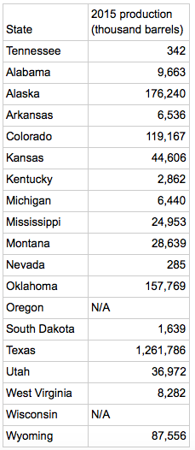

This table outlines the production rates for states with higher severance tax rates than Tennessee, with Tennessee included in the table for comparison. The table illustrates that even though each state has a higher severance tax rate than Tennessee (as of 2015), all states except for Nevada have higher rates of production. Opponents claim that increasing the tax rate would hamper production, but that is simply not true.
This table also provides evidence for a larger narrative: Tennessee is missing an opportunity to create more revenue for its counties that need it the most. During a presentation at the Governor’s Rural Task Force on January 19, 2016, Tennessee Department of Transportation (TDOT) Deputy Commissioner/Environmental Bureau Chief Toks Omishakin agreed that based on the data and reasoning that I provided, this was a lost opportunity—and a badly needed one, given the condition of our state’s roads, particularly in extractive communities.
CLAUSE 9

The Legislature Finds and Declares that oil and natural gas should be adequately taxed in order to generate funds for road maintenance and projects, as well as to pave the way for a brighter future for Tennessee communities and to pay for the externalized costs associated with resource extraction, such as the costs of environmental impact on families and communities that could have lasting implications for medical, public health, and infrastructure costs imposed upon the state.

Improved road infrastructure in counties such as Morgan, Scott, Campbell, Anderson, and others, will have far-reaching benefits. It will reduce damage to vehicles, pose fewer threats to road safety, prevent respiratory issues stemming from fugitive dust, and prevent excessive runoff of loose road material into nearby waterways, which pollutes people’s drinking water. In essence, this is a bill to pave the way for a brighter future for rural Tennessee.

CLAUSE 10

The Legislature Finds and Declares that Tenn. Code Ann. 60-1-301 shall be amended as follows:

60-1-301. Severance tax levied – Exceptions – Disposition of revenues – Moratorium on taxes.

(a) There is levied a severance tax on all gas and oil removed the ground in Tennessee. The measure of the tax for such gas and oil shall be seven and one-half (7.5%) of the market value of such gas and oil. Every person actually engaged in severing oil or gas, or actually operating oil or gas property under contracts or agreements requiring direct payments to the owners of any royalty interest, excess royalty or working interest, either in money or otherwise, shall be liable for the tax imposed by this section and shall, prior to making any such payments, withhold from any quantity or amount due the amount of tax due pursuant to this section.
(b) The tax shall be levied for the use and benefit of the county governments, excluding the amount necessary for administrative costs at the state level. All other revenues collected from the tax shall be allocated to the county which was the site of the wellhead for that gas or oil. Each county shall allocate the revenues to road maintenance and infrastructure projects, as administered by the county highway department.
(c) No other tax shall be imposed on such gas and oil by the state, counties or any other political subdivision of the state; provided, however, that:
(1) Free gas used by the property owner or tenant under the terms of the lease, unless it be in lieu of cash payment.

The amendment above was the original, bold goal of my legislative project. It would barely double the tax burden on operators while multiplying the reward for victim communities more than sevenfold. I proved through my research that the list of backlogged projects in the state far exceeds the capacity of current revenue, there is a dire need to broaden the base for transportation funding, and there is residual damage from the coal industry now that oil and gas extraction is occurring in those very counties at an increasing rate. I worked with community groups, presented to state task forces and legislators, and, after over eight months of work, our collaborative efforts got an oil and gas severance tax bill sponsored in the General Assembly. But in the end, the legislation was almost unrecognizable from its original form.
III. Be it Enacted by the General Assembly of the State of Tennessee

The work detailed in Section II took place from May 2015 through December 2015; when the new year rolled around, a very different part of my project began. I quickly learned that spending hours doing research and writing was the easiest part of the process, and that building relationships with local folks affected by resource and taxation issues was the most fun. Trying to convince conservative decision makers that raising a tax on natural resources was a good idea was neither easy nor enjoyable.
On January 13, 2016, I made my first trip to Nashville to lobby for this bill. The goal of the trip was to secure at least one sponsor, hopefully either Senator Yager or Representative Powers of Campbell County. I determined these legislators were the best targets because of the Campbell County resolution, their constituencies’ prominence in oil and gas production in the state, and their dire need for increased revenue.
I was accompanied by Ann League, Executive Director of SOCM. We spent several hours walking up and down the halls of the Capitol building in Nashville, talking to staffers and strategizing.
Our friendliest conversation was with Senator Lee Harris’s staffers, who offered to introduce a caption bill that we could use as a placeholder until legislators from affected constituencies agreed to get on board. We left materials with Senator McNally and Representatives Clemmons, Ragan, and Windle, in addition to Sen. Yager and Rep. Powers. Reps. Clemmons and Windle were the only individuals who had the time and willingness to meet with us directly.
We left Nashville with a lot of uncertainty, but at the very least we had Sen. Harris’s caption bill to add language to later. The deadline for introducing bills was January 21, which gave us just one week following our Nashville visit to convince Sen. Yager and Rep. Powers to champion my project in its final stages. I called Josh Longmire, Rep. Powers’s assistant, every single day to keep pressure on them and make sure I was updated with their decisions; one of the times I called during that week, I found out Sen. Yager and Rep. Powers had decided to sponsor my bill.
When I checked the TN Capitol website, I found SB 1944/HB 1881. I was not pleased with what I saw:
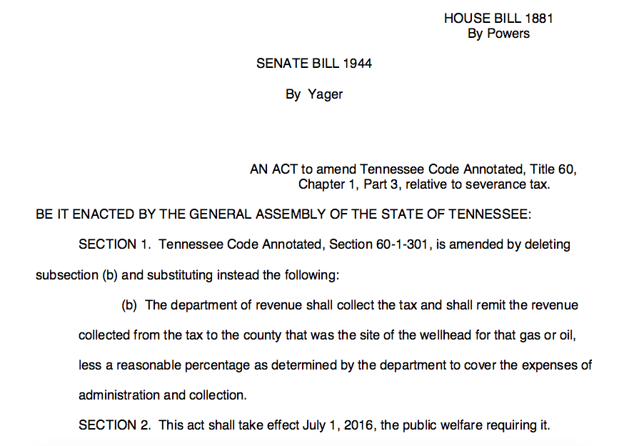

The sponsors completely cut the increase from the text of the bill. Rather than the reform I had envisioned, the bill became simply a change in the distribution of revenue. While it was disappointing to see over half of my work the past several months erased, I accepted that this bill would still help the people living in extractive communities and burdened by extractive industries. I decided to celebrate this as a step in the right direction.
The timeline for SB 1944/HB 1881 was as follows:

- January 19: Filed for introduction in the House
- January 20: Filed for introduction in the Senate
- January 21: Passed on First Consideration in the Senate
- January 25: Passed on Second Consideration, referred to Senate Finance, Ways & Means Committee
- January 26: Assigned to House Finance, Ways & Means Subcommittee
- February 2: Referred to Senate Revenue Subcommittee
- February 10: Placed behind the budget in the House Subcommittee
- March 1: Referred to Senate Finance, Ways & Means Committee with a negative recommendation
- April 18: Taken off notice in the House

This timeline is a story of a bill that died—it didn’t fail, but it didn’t get very far at all either. In the end, reluctance to remove a stream of revenue to the state’s general fund prevented progress. I have since continued conversations on what can be done next to make the changes my original bill would make—to reform oil and natural gas severance taxation as a means of strengthening rural Tennessee.

IV. Conclusion
In the end, I learned that democracy is a difficult and time-consuming process. I also learned that, unfortunately, the facts don’t always matter. I had the research, evidence, and widespread support to justify the need and desire for this bill, but all of that failed to make it happen. This reveals that it is often other, less transparent forces that lead to change—things such as deep-seated values of constituents, extremism, ties to organizations and corporations, and re-election strategies.
This story also serves a lesson: sometimes, unexpected windows of opportunity arise to make a difference. Despite the obstacles and previous failures, and in the face of rampant injustice, it is necessary—and absolutely worth it—to take these opportunities and to stay determined as an agent of positive change.

Tennessee Department of Transportation. “Current Backlog (Projects Approved by the TN General Assembly and Currently Under Development). November 9, 2015. https://www.tn.gov/assets/entities/governor/attachments/Backlog_Projects_2015.pdf
Dave Boucher & Joey Garrison. “Gas tax increase gains momentum in Tennessee,” The Tennessean. December 21, 2014. http://www.tennessean.com/story/news/politics/2014/12/20/gas-tax-increase-gains-momentum-tennessee/20663975/
Erik Schelzig. “Haslam srikes defiant tone toward critics of gas tax hike,” Associated Press. June 17, 2015. http://www.tennessean.com/story/news/politics/2015/06/17/bill-haslam-tennessee-gas-tax/28882861/
Associated Press. “Haslam: Gas tax off the table for 2016 legislative session,” Times Free Press. January 14, 2016. http://www.timesfreepress.com/news/local/story/2016/jan/14/haslam-gas-tax-table-2016-legislative-session/344802/
Statewide Organizing for Community eMpowerment. “What is SOCM?” Accessed May 9, 2016. https://socm.org/about-us/
U.S. Energy Information Administration. “Petroleum & Other Liquids: Crude oil production.” April 29, 2016. http://www.eia.gov/dnav/pet/pet_crd_crpdn_adc_mbbl_a.htm
Wendy Patton. “Beyond the Boom: Ensuring adequate payment for mineral wealth extraction.” Policy Matters Ohio. December 19, 2011. http://www.policymattersohio.org/wp-content/uploads/2011/12/BeyondBoomDec2011.pdf
[See 6]
Wendy Patton. “Beyond the Boom: Ensuring adequate payment for mineral wealth extraction.” Policy Matters Ohio. December 19, 2011. http://www.policymattersohio.org/wp-content/uploads/2011/12/BeyondBoomDec2011.pdf, p. 17.
Rose M. Baker and David L. Passmore. “Benchmarks for Assessing the Potential Impact of a Natural Gas Severance Tax on the Pennsylvania Economy.” Penn State Institute for Research in Training & Development, September 2010. From [See 8]
Appalachian Mountain Advocates. “Absentee ownership holds Appalachia back.” July 23, 2013; Accessed May 9, 2016. http://www.appalmad.org/2013/07/23/absentee-ownership-holds-appalachia-back/
Partridge, Mark D., Betz, Michael R., & Lobao, Linda. 2016. “Natural Resource Curse and Poverty in Appalachian America.” American Journal of Agricultural Economics, 98(3), 449-456. doi: 10.1093/ajae/aas086.
U.S. Energy Information Administration. “Petroleum & Other Liquids: Crude oil production.” April 29, 2016. http://www.eia.gov/dnav/pet/pet_crd_crpdn_adc_mbbl_a.htm
Tennessee Department of Transportation. “TDOT Key Staff Directory.” Accessed May 9, 2016. https://www.tn.gov/tdot/article/tdot-key-staff-directory

