Sydney Ellen Lashbrook Sullivan Graduating May 2025
Advisor - Professor Gregor Kalas Chancellor’s Honors Capstone Project

Redefining the Intent of St. John’s at the Lateran – a Study of Site Significance and Political Strategy
INTRODUCTION
St. John’s at the Lateran, the first Christian basilica, has been researched extensively by scholars, especially in the publications of Richard Krautheimer, Ian Haynes, Paolo Liverani, and Lex Bosman. Their work, and that of others, establish that the design of the original structure began after the synod of 313 AD, which was a gathering of the clergy and others important to the church, and was “consecrated by Pope Sylvester I in either 318 or 324.” The basilica was damaged by natural disasters and had to be almost completely reconstructed by Francesco Borromini in the late 1640s. Previous scholarship has focused on the appearance of the Lateran, yet this paper will look into the question of how does the landscape surrounding the Basilica and that which is below the modern structure inform the political impact of founding the first basilica for Christian worship. Specifically, this paper will break down the political landscape of Rome in the fourth century and discuss current understandings of the Caelian Hill in an attempt to address the extent to which the foundation of St. John’s at the Lateran was a move by Constantine to reshape the political structure of the Roman Empire.
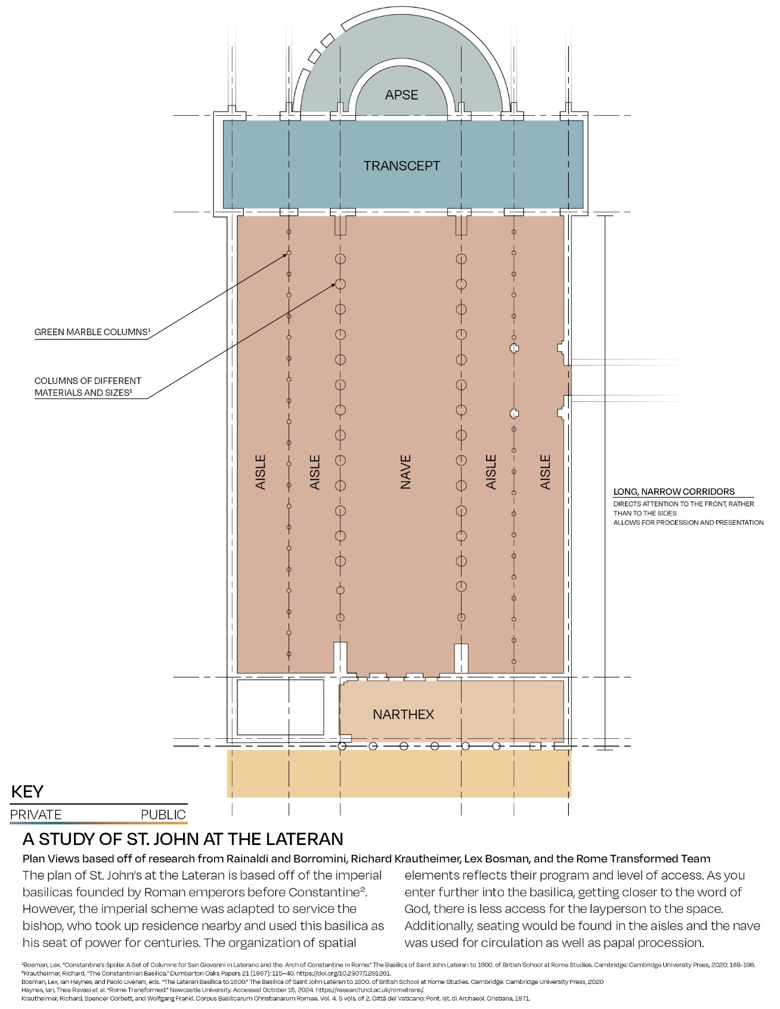
Figure 1: Diagrammatic Plan View Study of St. John at the Lateran looking at level of public access based on program. Based off research from Rainaldi and Borromini, Richard Krautheimer, Lex Boxman, and the Rome Transformed Team.
One reason why Constantine contributed to the foundation of this first Christian basilica is the emperor’s interpretation of his success in the Battle of the Milvian Bridge in 312 AD. Constantine was in the process of challenging Maxentius for Roman imperial status in the west and reportedly had a vision prior to the confrontation with the opposing forces at the Milvian Bridge. Eusebius states that “while he [Constantine] was…praying with fervent entreaty, a most marvelous sign appeared to him from heaven…about mid-day,…he saw with his own eyes the trophy of a cross of light in the heavens…bearing the inscription, CONQUER BY THIS,” (capitalization follows the source’s formatting). The next morning, as Eusebius continues to recount, Constantine commanded the goldsmiths and lapidarists to recreate the symbol in their media, and after adorning the symbol, Constantine’s forces won the battle. Eusebius’s account of this story is argued to be biased because he was commissioned by Constantine to write the emperor’s story. Examples of this bias can be seen as he discusses Maxentius as a ruler. Eusebius depicts Maxentius as a dictator of sorts – a murderer, adulterer, and sorcerer. Eusebius then juxtaposes Maxentius with Constantine, painting the latter as if he were a saint and the savior of the Roman people, only ever thinking of their good. However, Constantine slandered the name of and killed political opponents like Licinius, and Maxentius returned seized property back to Christians. Despite Eusebius being generally biased in favor of Constantine, others without such associations corroborate the story of the Milvian Bridge Battle’s preceding events in the same way. These sources also denote that Constantine gave imperial land to the Roman church so that Christian followers could build a center for unified worship, as these members of the church were separated because the Christian population lacked a structure large enough to house them.
While the story of the Constantine’s vision is well known, this paper will join Ian Haynes, Paolo Liverani, Susanna McFadden, and Bill Leadbetter to argue that Constantine did not simply want to thank the Christian god for his victory or contribute to the rising Christian population’s built environment, but rather that the choice of site and imperial financial investment towards a gift to the Christian bishop imply he wanted to make a political statement. As this paper will demonstrate, Constantine’s goal was to create new political alliances, gather the Christian populus under his rule, and redefine the political structure of Imperial Rome. Specifically, this paper will investigate the history of the site and the partnership between Bishop Miltiades and Pope Sylvester and discuss the origins of the basilica’s typology and the ornamentation donated by Constantine.
POLITICAL CLIMATE OF ROME IN 312 AD
St. John’s at the Lateran was the first imperially-sponsored space built with the intention to house Christian worship; to this end, it was given to Bishop Miltiades – who was bishop from 311 AD to 314 AD, and subsequently Pope Sylvester – who was pope from 314 AD to 335 AD, for their use along with a nearby residence and a baptistry. In order to understand the situation surrounding Emperor Constantine when he arrived as the Roman ruler after the battle in 312 AD, Leadbetter discusses the political climate of Roman Christianity. He explains that fourth-century Christianity was riddled with disputes when Constantine became emperor, resulting from suffering persecution, episcopal desertion, and ideological fraction. These complications caused the Roman church to be disunified and to have been lacking a leader. Therefore, Constantine entered Rome with the intention to define himself as emperor, but also to unite the Roman church, so that the church could come together to support him as emperor.
The donation of this basilica to a bishop is significant, and this gift established an allyship between Constantine and the Christian leaders. This alliance is significant, because it was the first time an emperor had done so. While Maxentius had tolerated Christians, his father, Maximian, had allowed the alienation of their property, and others before Maximian had actively persecuted the Christians to the point of death. However, Bill Leadbetter describes the impact of the gift to the Roman church as he recounts that Constantine created “a carefully calculated program of benefaction” in his contributions to the Lateran basilica, because this act of patronage was meant to benefit not just one faction of the Christian worshipers but all of them. Rather than attempting to reconstruct or embellish one group’s meeting place over others, Constantine chose an unaffiliated site on which the Lateran was constructed; had he not, the Christian community would not have so easily been united. The emperor would have picked one group over the others, causing even more division than they were experiencing.
Constantine needed a group of people who would accept his leadership, and he wanted leaders separate from the Senate to support him in his rule. By uniting the Christian worshippers with this gift, it would, in turn, allow church leaders to be more significant and powerful in Roman society. This would also allow the presence of ecclesiastic authorities and to have a voice that mattered more to the people and thereby allow Constantine to reshape the political structure of the empire by elevating these empowered Christian leaders. Additionally, if the Christian followers were united and were hearing support of the emperor from their leaders, the Roman Senate would be less likely to publicly challenge Constantine, cementing his rule further.
This cohesion would continue to spread from Christians to pagans as Constantine’s rule continued during and after the completion of the Lateran basilica, as citizens began selecting traits with which they could identify to make the emperor more relatable. Lenski discusses this idea and discusses how pagan cities, such as Athens and Delphi, associated Constantine with the sun god, claims which he did not immediately admonish, even as he did begin to disapprove of pagan practices around 324 AD, near the time of the Roman basilica’s completion. Allowing groups to support Constantine even by non-Christian actions helps to show that the emperor was more focused on gaining popular support rather than choosing one religion over another. One pitfall of committing to this thought, however, is that Constantine eventually did begin to speak out against paganism by ordering the removal of sacred objects from pagan temples; his successor and son – Constantius II – acted against pagan practices as well. However, what cannot be argued against is the complexity of politics in fourth-century Rome, as cities and towns chose representatives to support their interests on the political stage. These varied across the spectrum of religious affiliation, but all were vying for the emperor’s approval and consideration. This political schema, when considered alongside the growing power of the Christian religious elite, creates a governmental climate that causes the study of the Lateran basilica to be of importance, due to its timing, size, and form.
TRANSFORMATION OF THE CAELIAN HILL
The basilica complex’s site was of importance, and modern-day archeology reveals that the chosen site had strong ties to emperors and the imperial families in its history. Prominent Lateran scholar, Paolo Liverani, specifically discusses the timeline of the area. Before Constantine’s involvement and the construction of the Lateran basilica complex, the landscape was adorned with the Castra Nova equites singulares – a military complex which housed battalions led by men of equestrian status, whose soldiers chose to support Maxentius the day that Constantine overthrew him, ending a civil war. According to Liverani’s work alongside Ian Haynes and the “Rome Transformed” research team (on a project pursued from 2020-2024), the military barracks had increased military presence in the city of Rome substantially, causing citizens to associate Emperor Septimius Severus, the one who founded the Castra, with security and strength. This association would have continued as new emperors utilized the fort or castra, from Septimius Severus to Maxentius, so Constantine’s demolition was a political move intended to position him as an emperor who was distinguished from the ones who came before.
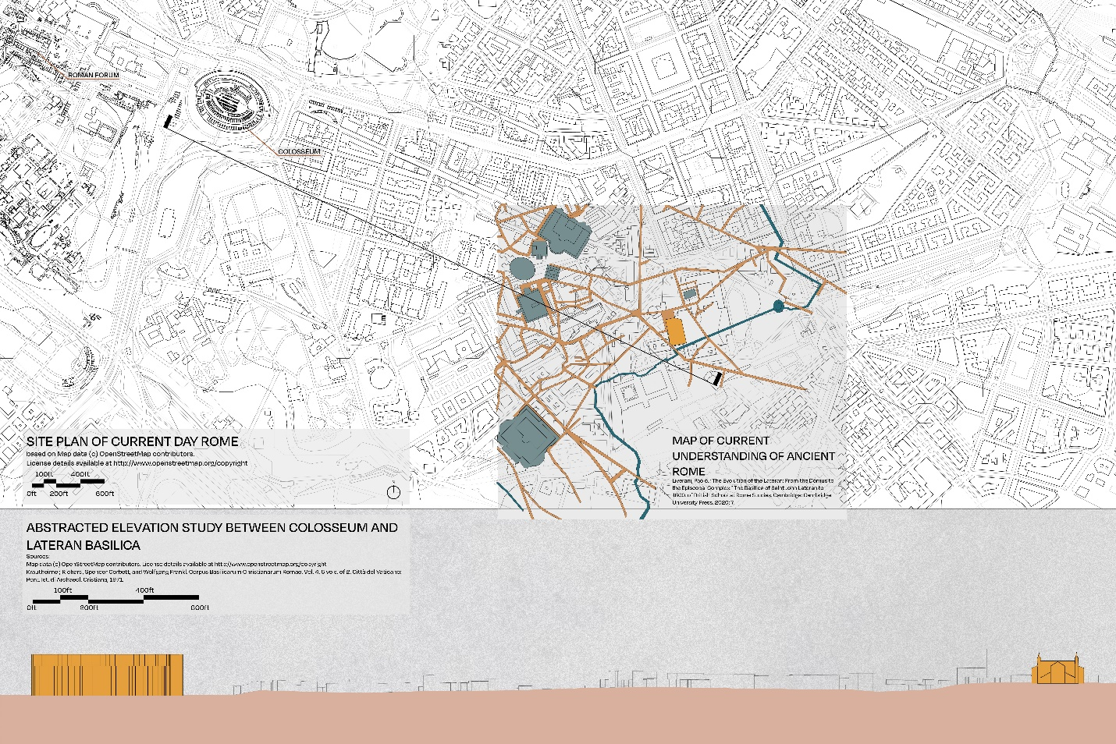
Figure 2: Map of scholar’s current understanding of ancient Rome overlayed onto a site plan of modern-day Rome.
Constantine’s desire to detach his imperial leadership from previous emperors is separately evidenced by scholarship on other buildings and Constantine’s treatment of his family, as is documented in the work of Susana McFadden on the “domus Faustae.” This domus is close to the Lateran Basilica and was the location of the synod of 313 AD. McFadden studies the ancient frescoes and their placement on the walls to argue that the imperial family had real ties to the domus, which is still in debate for current scholars. These frescos are significant, because they were a carefully crafted depiction of Constantine and his family that was used to quell worries regarding his legitimacy as a ruler. However, even McFadden remains open to the idea that a patron outside of Constantine’s immediate family funded this project. Julia Hillner also discusses the idea that Constantine desired to distance himself from Maxentius in her work on the imperial women of Constantine’s family. She writes “When Constantine entered Rome…he not only had to deal with the ghost of Maxentius, but also with that of Maximian [Maxentius’s father], although…this was less easily done (also because Maximian had once been a legitimate emperor).” While the work to separate himself from these previous emperors was substantial and intricate, Constantine dedicated himself to reforming the imperial throne and included the basilica at the Lateran in that work.
Scholarship is still unclear regarding the degree to which the Castra Nova’s form was transformed or reused as the area became the Lateran complex. However, the “Rome Transformation” team took technologically-enhanced scans of the landscape and archeological remains to create digital mappings and reconstructions of what does currently exist, and could have previously, been in the area. From their efforts, we know that the foundations of the Lateran basilica reused some of the structural system and the foundation of the Castra. The “Rome Transformed” team’s reconstructions, that members of the scholarly teams call provocations, explore the idea that the landscape of the Caelian Hill could have been redefined as the Castra was demolished and reused as described above (See Fig. 01). While working on the same project, Ian Haynes and Paolo Liverani discuss that the Castra Nova had been instrumental in defining Septimus Severus’s transformation of the area, which turned the area into a demonstration of military might. They state that its relation to the Roman Forum and Sessorian Palace also inform this understanding. In situating the basilica in the same spot as this military fort, Constantine demonstrated that he was choosing to ally himself with the growing Christian leadership rather than staying with the tradition of keeping these leaders at arm’s length; to this end, on this site specifically, the emperor departed from representing the relationship between imperial throne and military might by turning a symbol of such might into a donated religious institution. This gift gave these church authorities more political power, beginning what would become a centuries-long, dramatic power shift from the Roman Senate to the Papal leadership.
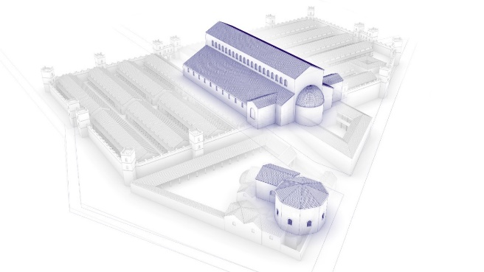
Figure 3: St. John's Basilica superimposed onto the Castra Nova - "Provocation looking from NW to SE showing the remodeling of the Castra site under Constantine" created by Rome Transformed
Leadbetter describes that those changes in the landscape had much larger effects than simply razing the castra. He states the area on which the castra sat could have been reached by a road that went from the ceremonial center of Rome straight to the Caelian Hill. This link contradicts Krautheimer’s long-held belief that Constantine chose the Caelian Hill because it was on the outskirts of the city, allowing the emperor to keep the peace with the Roman senate, who were still mostly pagan. Constantine, by choosing the Caelian Hill for this prominent place of Christian worship, connected the basilica to the center of the city by an artery – a road that went from the heart of Rome straight to this unique structure. By replacing the Castra Nova with the basilica, Constantine changed the citizen’s view of the Caelian hill from that of military might to community gathering for Christian worship.
FLOOR PLAN AND ORNAMENTATION
The site is not the only aspect of the Lateran basilica that informs its political impact or significance, but the ornamentation and floor plan inspiration are of note as well. We can look to papal documentation to understand Constantine’s relation to the ornamentation of the basilica, specifically in the Liber Pontificalis. The Liber Pontificalis contains biographies of popes from Peter until around the fifteenth century. Additionally, in this source, Pope Sylvester’s biography explains that Constantine donated a significant amount of ornamentation to the Lateran basilica, including 30 bronze lights/chandeliers as well as silver scyphi and amae, and many other gifts. These gifts, too, would showcase the emperor’s dedication and care for the Lateran basilica, so they needed to be carefully selected. In addition to these decorative elements, Emperor Constantine also supplied green marble structural columns to separate the nave from the aisles, furthering the claim that he wanted to show the generosity of the imperial throne through every part of the design of the Lateran.
Pope Sylvester’s biography also denotes Constantine’s donations to the baptistry at the Lateran, featured in the Lateran complex for use by the bishop. This baptistry is important to this discussion, because it is where the church leader – bishop or pope – would have interacted directly with new converts at the time of their baptism into the Christian faith, giving each new catechumen a personal connection to the church leader as they participated in the sacrament of baptism. A moment of close proximity with converts would have given bishops more power and influence in their individual lives, as believers would have felt a strong association with the leader who baptized them. While these relationships were forming between baptizer and baptized prior to Constantine becoming emperor, his donations to the baptistry demonstrated a level of desiring those moments of conversion to continue. By donating to the baptistry in this way, Constantine put the sponsorship and support of the imperial throne behind this religious practice – not just in words, but in action.
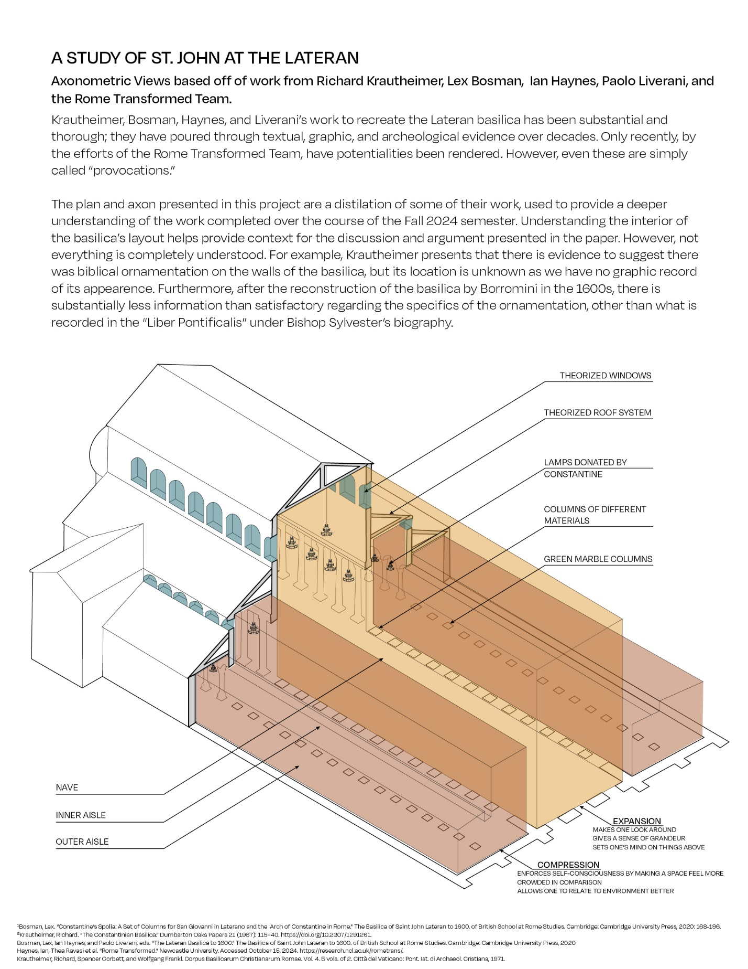
Figure 4: Diagrammatic Axonometric Drawing based off work from Richard Krautheimer, Lex Bosman, Ian Haynes, Paolo Liverani, and the Rome Transformed Team.
In the Christian tradition, baptism is not the final step in one’s religious journey, but a convert must continue in study, causing the relationship between bishop and catechumen to shift to a student to teacher relationship which is where the liturgical importance of the basilica enters back into the discussion. The Roman church needed a space to house liturgical practices, leading the church leaders and Constantine to decide what the floor plan would look like and how the appearance could serve the church’s needs. Even though it was the first of its kind, the architectural typology of St. John’s at the Lateran was not as innovative as one might think. Rather, it represents an interpretation of an imperial form under the framework of what Richard Krautheimer describes as the “genus basilica.” A basilica in the Roman imperial era was a place for people to gather, and there were a wide range of uses for such spaces. For example, basilicas were constructed by the upper class to act as their reception halls, and, at times, these regal, lofty spaces were reserved for places of importance, representing the power and authority of the one who founded the basilica. Therefore, because this basilica would be the seat of the leaders of the Christian faith and would be funded by the emperor, there was an aspect of grandeur to the design. However, the basilica at the Lateran was also a space for laypeople to inhabit and worship within, so the specific type of basilica typology chosen as the basis for the design was a civic basilica. Elsewhere, this type of basilica would be used to dispense law, but here it would be used to guide followers to deeper Christian understanding.
This place of worship needed to act as the gathering place for a divided group of people; therefore, the choices made in its ornamentation and floor plan reflected the importance of the program. Made to be a place of gathering for a higher purpose, designers chose to model the church after the public gathering spaces that attendees would have associated with gathering, but with a gilded touch to remind them the reason for gathering. Long stretches of the nave not only welcomed more people, but allowed leaders to process through it, reigning in attentions. Luxurious ornamentation hinted at the imperial donation but established an air of importance to the space. These choices were made deliberately to solidify the relationships between bishop and catechumen, and because Constantine was the donator, then the alliance between bishop and the emperor.
CONCLUSION
The site of the Caelian Hill was the center that had witnessed a massive political shift in Rome’s history because of the construction of St John’s at the Lateran. After Maxentius’s loss at the Milvian bridge in 312 AD., Constantine began working to establish himself as the rightful ruler of Rome and a benefactor of the Roman Christian church. He allied himself with the newly elected Bishop Miltiades and then Pope Sylvester and created a new place of worship for followers of Christianity. Through this, he sought to help the divided Christian communities see past their differences and work together to build a unified body of worshippers. These followers would in turn support Constantine, or so the emperor plausibly desired, as he ruled.
Choosing the high point of the Caelian Hill proved to be a strategic move, as it was the location of the Castra Nova, out of which the forces of his rival operated. This selection was not simply because the emperor owned the land, as he owned many other sites, but because of the military significance and the soldiers’ allegiances to Maxentius. Constantine needed these ties to be erased and replaced. Therefore, newly sanctioned Emperor Constantine disbanded the brigade of military members and mostly razed their fort to create a new center of the Christian faith, choosing to place significant imperial funds towards its completion so that new alliances could be formed.
Overall, Constantine, as a new ruler, needed support, and was willing to gift imperial resources to receive it. Therefore, Constantine wiped out the memory of Roman military might at the Caelian Hill, and Maxentius’s presence in addition, choosing to place a Christian basilica literally on its foundations. This, in turn, changed the religious makeup of Rome significantly because Christianity was now supported by the emperor. Constantine would go on to limit the pagans’ ability to practice their religions, increasing the moral and religious authority of the bishops and therefore increasing their power among the populus as more relationships were formed. This is why Constantine chose the Castra Nova as the site of St. John’s at the Lateran – to shift power and create for himself a political situation where his rule was secure. The alliance between Constantine and the Christian church would redefine the city’s identity by intertwining faith and state that would shape the empire’s future.
List of Figures
Figure 1: Diagrammatic Plan View Study of St. John at the Lateran looking at level of public access based on program. Created by Sydney Ellen Lashbrook Sullivan, under the guide of Gregor Kalas. The figure is based off research from Rainaldi and Borromini, Richard Krautheimer, Lex Boxman, and the Rome Transformed Team.
Figure 2: Map of scholar’s current understanding of ancient Rome overlayed onto a site plan of modern-day Rome. Created by Sydney Ellen Lashbrook Sullivan, under the guide of Gregor Kalas. The figure is based off research from Google Maps, Rodolfo Lanciani, and the Rome Transformed Team.
Figure 3: St. John's Basilica superimposed onto the Castra Nova - "Provocation looking from NW to SE showing the remodeling of the Castra site under Constantine" created by Rome Transformed.
Figure 4: Diagrammatic Axonometric Drawing. Created by Sydney Ellen Lashbrook Sullivan, under the guide of Gregor Kalas. Based off work from Richard Krautheimer, Lex Bosman, Ian Haynes, Paolo Liverani, and the Rome Transformed Team.

References
Bosman, Lex. “Constantine’s Spolia: A Set of Columns for San Giovanni in Laterano and the
Arch of Constantine in Rome.” The Basilica of Saint John Lateran to 1600. of British School at Rome Studies. Cambridge: Cambridge University Press, 2020: 168-196.
Bosman, Lex, Ian Haynes, and Paolo Liverani, eds. “The Lateran Basilica to 1600.” The
Basilica of Saint John Lateran to 1600. of British School at Rome Studies. Cambridge: Cambridge University Press, 2020: 1-5.
Eusebius. The Life of the Blessed Emperor Constantine: From AD 306 to AD 337.
Merchantville, NJ: Evolution Pub, 2009.
Haynes, Ian. Rome Transformed | The Transformation of the Eastern Caelian from the first
to eighth centuries CE. Youtube. British School at Rome, 2024. https://www.youtube.com/watch?v=QrayUdRq3xk.
Haynes, Ian, Paolo Liverani. “The Castra Nova and the Severan Transformation of Rome.”
The Basilica of Saint John Lateran to 1600. of British School at Rome Studies. Cambridge: Cambridge University Press, 2020: 91-113.
Haynes, Ian, Paolo Liverani, Thea Ravasi, Steven Kay. “The Changing Face of the Eastern
Caelian in the 1st-4th centuries AD: work by the Rome Transformed Project.” Rome urbanism in Italy. Oxbow Books. 2024. (22-43).
Haynes, Ian, Thea Ravasi et al. “Rome Transformed.” Newcastle University. Accessed
October 15, 2024. https://research.ncl.ac.uk/rometrans/.
Hillner, Julia. “A Woman’s Place: Imperial Women in Late Antique Rome.” Antiquité Tardive
25 (January 2017): 75–94. https://doi.org/10.1484/j.at.5.114851.
Krautheimer, Richard, Spencer Corbett, and Wolfgang Frankl. Corpus Basilicarum
Christianarum Romae. Vol. 4. 5 vols. of 2. Città del Vaticano: Pont. Ist. di Archaeol. Cristiana, 1971.
Krautheimer, Richard. “The Constantinian Basilica.” Dumbarton Oaks Papers 21 (1967):
115–40. https://doi.org/10.2307/1291261.
Krautheimer, Richard. “Rome.” Three Christian capitals: topography and politics. Berkeley,
CA: University of California Press, 1983. pp. 1-40.
Lanciani, Rodolfo Amedeo. Forma urbis romae. Roma: Quasar, 1990.
Leadbetter, Bill. “Constantine and the Bishop: The Roman Church in the Early Fourth
Century.” Journal of Religious History, 2002. Vol. 21, Issue 1. pp. 1-14. https://doi-org.utk.idm.oclc.org/10.1111/1467-9809.00139
Lenski, Noel. “Constantine and the Cities : Imperial Authority and Civic Politics.” University
of Pennsylvania Press, 2016. ProQuest Ebook Central, pp. 209-229 http://ebookcentral.proquest.com/lib/utk/detail.action?docID=4401752.
Liverani, Paolo. “The Evolution of the Lateran: From the Domus to the Episcopal Complex.”
The Basilica of Saint John Lateran to 1600. of British School at Rome Studies. Cambridge: Cambridge University Press, 2020: 6-24.
McFadden, Susanna. “A Constantinian Image Program in Rome Rediscovered: The Late
Antique Megalographia from the So-Called ‘Domus Faustae.’” Memoirs of the American Academy in Rome. University of Michigan Press for the American Academy in Rome, 2013. Vol 58, pp. 83-114.
Spinola, Giandomenico. “The First Residential Phases of the Lateran Area and a
Hypothesis to Explain the So-Called Trapezoidal Building.” The Basilica of Saint John Lateran to 1600. of British School at Rome Studies. Cambridge: Cambridge University Press, 2020: 71-90.

Bosman, Lex, Ian Haynes, and Paolo Liverani, eds. “The Lateran Basilica to 1600.” The Basilica of Saint John Lateran to 1600. of British School at Rome Studies. Cambridge: Cambridge University Press, 2020: 4.
Bosman, Lex, Ian Haynes, and Paolo Liverani, eds. “The Lateran Basilica to 1600.” The Basilica of Saint John Lateran to 1600. of British School at Rome Studies. Cambridge: Cambridge University Press, 2020: 2.
Bosman, Lex, Ian Haynes, and Paolo Liverani, eds. “The Lateran Basilica to 1600.” The Basilica of Saint John Lateran to 1600. of British School at Rome Studies. Cambridge: Cambridge University Press, 2020: 4.
Eusebius. The Life of the Blessed Emperor Constantine: From AD 306 to AD 337. Merchantville, NJ: Evolution Pub, 2009. 23.
Eusebius. The Life of the Blessed Emperor Constantine: From AD 306 to AD 337. Merchantville, NJ: Evolution Pub, 2009. 24.
Eusebius. The Life of the Blessed Emperor Constantine: From AD 306 to AD 337. Merchantville, NJ: Evolution Pub, 2009. 26-28.
Eusebius. The Life of the Blessed Emperor Constantine: From AD 306 to AD 337. Merchantville, NJ: Evolution Pub, 2009. 29.
Eusebius. The Life of the Blessed Emperor Constantine: From AD 306 to AD 337. Merchantville, NJ: Evolution Pub, 2009. 39, 40, 42, 49, 53, 57, 60, 61 62.
Leadbetter, Bill. “Constantine and the Bishop: The Roman Church in the Early Fourth Century.” Journal of Religious History, 2002. Vol. 21, Issue 1. pp. 9. https://doi-org.utk.idm.oclc.org/10.1111/1467-9809.00139
Leadbetter, Bill. “Constantine and the Bishop: The Roman Church in the Early Fourth Century.” Journal of Religious History, 2002. Vol. 21, Issue 1. pp. 11. https://doi-org.utk.idm.oclc.org/10.1111/1467-9809.00139
Haynes, Ian, Paolo Liverani. “The Castra Nova and the Severan Transformation of Rome.” The Basilica of Saint John Lateran to 1600. of British School at Rome Studies. Cambridge: Cambridge University Press, 2020: 91-113.
McFadden, Susanna. “A Constantinian Image Program in Rome Rediscovered: The Late Antique Megalographia from the So-Called ‘Domus Faustae.’” Memoirs of the American Academy in Rome. University of Michigan Press for the American Academy in Rome, 2013. Vol 58, pp. 83-114.
Leadbetter, Bill. “Constantine and the Bishop: The Roman Church in the Early Fourth Century.” Journal of Religious History, 2002. Vol. 21, Issue 1. pp. 1-14. https://doi-org.utk.idm.oclc.org/10.1111/1467-9809.00139
Leadbetter, Bill. “Constantine and the Bishop: The Roman Church in the Early Fourth Century.” Journal of Religious History, 2002. Vol. 21, Issue 1. pp. 12. https://doi-org.utk.idm.oclc.org/10.1111/1467-9809.00139
Leadbetter, Bill. “Constantine and the Bishop: The Roman Church in the Early Fourth Century.” Journal of Religious History, 2002. Vol. 21, Issue 1. pp. 10. https://doi-org.utk.idm.oclc.org/10.1111/1467-9809.00139
Leadbetter, Bill. “Constantine and the Bishop: The Roman Church in the Early Fourth Century.” Journal of Religious History, 2002. Vol. 21, Issue 1. pp. 9. https://doi-org.utk.idm.oclc.org/10.1111/1467-9809.00139
Leadbetter, Bill. “Constantine and the Bishop: The Roman Church in the Early Fourth Century.” Journal of Religious History, 2002. Vol. 21, Issue 1. pp. 11. https://doi-org.utk.idm.oclc.org/10.1111/1467-9809.00139
Leadbetter, Bill. “Constantine and the Bishop: The Roman Church in the Early Fourth Century.” Journal of Religious History, 2002. Vol. 21, Issue 1. pp. 11. https://doi-org.utk.idm.oclc.org/10.1111/1467-9809.00139
Lenski, Noel. “Constantine and the Cities : Imperial Authority and Civic Politics.” University of Pennsylvania Press, 2016. ProQuest Ebook Central, pp. 212 http://ebookcentral.proquest.com/lib/utk/detail.action?docID=4401752.
Lenski, Noel. “Constantine and the Cities : Imperial Authority and Civic Politics.” University of Pennsylvania Press, 2016. ProQuest Ebook Central, pp. 214-215 http://ebookcentral.proquest.com/lib/utk/detail.action?docID=4401752.
Lenski, Noel. “Constantine and the Cities : Imperial Authority and Civic Politics.” University of Pennsylvania Press, 2016. ProQuest Ebook Central, pp. 216-217 http://ebookcentral.proquest.com/lib/utk/detail.action?docID=4401752.
Lenski, Noel. “Constantine and the Cities : Imperial Authority and Civic Politics.” University of Pennsylvania Press, 2016. ProQuest Ebook Central, pp. 219, 221, 229 http://ebookcentral.proquest.com/lib/utk/detail.action?docID=4401752.
Liverani, Paolo. “The Evolution of the Lateran: From the Domus to the Episcopal Complex.” The Basilica of Saint John Lateran to 1600. of British School at Rome Studies. Cambridge: Cambridge University Press, 2020: 6.
Haynes, Ian, Paolo Liverani, Thea Ravasi, Steven Kay. “The Changing Face of the Eastern Caelian in the 1st-4th centuries AD: work by the Rome Transformed Project.” Rome urbanism in Italy. Oxbow Books. 2024. 32.
McFadden, Susanna. “A Constantinian Image Program in Rome Rediscovered: The Late Antique Megalographia from the So-Called ‘Domus Faustae.’” Memoirs of the American Academy in Rome. University of Michigan Press for the American Academy in Rome, 2013. Vol 58, pp. 106.
Hillner, Julia. “A Woman’s Place: Imperial Women in Late Antique Rome.” Antiquité Tardive 25 (January 2017): 80. https://doi.org/10.1484/j.at.5.114851.
Haynes, Ian, Thea Ravasi et al. “Rome Transformed.” Newcastle University. Accessed October 15, 2024. https://research.ncl.ac.uk/rometrans/. Haynes, Ian. Rome Transformed | The Transformation of the Eastern Caelian from the first to eighth centuries CE. Youtube. British School at Rome, 2024. https://www.youtube.com/watch?v=QrayUdRq3xk.
Haynes, Ian, Paolo Liverani. “The Castra Nova and the Severan Transformation of Rome.” The Basilica of Saint John Lateran to 1600. of British School at Rome Studies. Cambridge: Cambridge University Press, 2020: 91-113.
Leadbetter, Bill. “Constantine and the Bishop: The Roman Church in the Early Fourth Century.” Journal of Religious History, 2002. Vol. 21, Issue 1. pp. 13. https://doi-org.utk.idm.oclc.org/10.1111/1467-9809.00139
Krautheimer, Richard. “Rome.” Three Christian capitals: topography and politics. Berkeley, CA: University of California Press, 1983. pp. 1-40.
Raymond, Davis, translator. “The Book of Pontiffs: Liber Pontificalis.” Liverpool University Press. 2003 pp. 14.
Bosman, Lex. “Constantine’s Spolia: A Set of Columns for San Giovanni in Laterano and the Arch of Constantine in Rome.” The Basilica of Saint John Lateran to 1600. of British School at Rome Studies. Cambridge: Cambridge University Press, 2020: 173.
Krautheimer, Richard. “The Constantinian Basilica.” Dumbarton Oaks Papers 21 (1967): 118. https://doi.org/10.2307/1291261. Krautheimer, Richard. Three Christian capitals: topography and politics. Berkeley, CA: University of California Press, 1983. 18.
Krautheimer, Richard. “The Constantinian Basilica.” Dumbarton Oaks Papers 21 (1967): 123. https://doi.org/10.2307/1291261.
Krautheimer, Richard. “The Constantinian Basilica.” Dumbarton Oaks Papers 21 (1967): pp. 123. https://doi.org/10.2307/1291261.
Krautheimer, Richard. “The Constantinian Basilica.” Dumbarton Oaks Papers 21 (1967): pp. 123. https://doi.org/10.2307/1291261.
Krautheimer, Richard. “Rome.” Three Christian capitals: topography and politics. Berkeley, CA: University of California Press, 1983. pp. 3
Bosman, Lex. “Constantine’s Spolia: A Set of Columns for San Giovanni in Laterano and the Arch of Constantine in Rome.” The Basilica of Saint John Lateran to 1600. of British School at Rome Studies. Cambridge: Cambridge University Press, 2020: 169.

