To the Graduate Council:

I am submitting herewith a thesis written by Jessica C. Bundy entitled “Disappearing Vistas.” I have examined the final electronic copy of this thesis for form and content and recommend that it be accepted in partial fulfillment of the requirements for the Master of Landscape Architecture degree.

___Curtis Stewart____, Major Professor

We have read this thesis
and recommend its acceptance:

Avigail Sachs

Ronald Foresta

Accepted for the Council:

Carolyn R. Hodges
Vice Provost and Dean of the Graduate School

(Original signatures are on file with official student records.)

DISAPPEARING VISTAS

A Thesis Presented for the
Master of Landscape Architecture
Degree
The University of Tennessee, Knoxville

Jessica Bundy
August 2012

Copyright © 2012 by Jessica Bundy.
All rights reserved.

ACKNOWLEDGEMENTS

I am extremely grateful to all of the wonderful people who have guided me throughout my academic career. Without your continuous support, this thesis would have not been possible.

I would like to thank everyone at Great Smoky Mountains National Park for all of the time and information that they have willingly contributed to this project. I would like to especially recognize Alan Sumeriski and Imelda Wegwerth; your support and kind-heartedness has meant the world to me.

I would also like to show my gratitude to my thesis committee, Curtis Stewart, Avigail Sachs and Ronald Foresta, who constantly reminded me to examine the bigger picture. Thank you for your time, support, and consideration. I would like to especially thank Ken McCown for his remarkable contribution to this thesis; his insight and attention to detail was instrumental throughout this entire process.

And last but not least, I want to express my deepest appreciation to my family. Thank you for all of your love and patience, I truly could not have done any of this without you. I promise I will never dedicate another night to homework…ever.

ABSTRACT

National parks have historically used long distance scenic views, known as vistas, to reveal iconic American landscapes to auto tourists. However, decades of budget constraints and inadequate management have prevented National Parks from maintaining vistas as originally intended. Many important vistas are disappearing due to encroaching vegetation. As a result, numerous complaints and concerns have been expressed by park visitors, especially within Great Smoky Mountains National Park. Vistas still play an intricate role in the visitor experience of national parks – an experience worth protecting. In an effort to conserve this experience, ecologically sustainable vistas must be established that are both aesthetically pleasing to visitors and manageable by limited Park resources.
The Great Smoky Mountains National Park is America’s most visited national park, preserving one of the largest, most diverse natural areas in the country. Recent studies showed that 95 percent (approximately 8.5 million) of the Park’s tourists participated in scenic drives. Vistas along Newfound Gap Road – arguably the Park’s most scenic corridor – serve as windows into a variety of forest ecosystems, an experience comparable to a drive from Georgia to Maine.
Traditionally, Park vista management has consisted of ad hoc vegetation removal and does not address additional ways to manage future clearing. This thesis suggests that utilizing herbicide and native low growing shrubs that already exist on site to inhibit regrowth is the best way to manage vistas. Once these new low growing ecosystems are established, vista clearings should be nearly self-sustaining, only requiring minimal vegetation removal every seven years. The vista management recommendations made in this document offer a practical, ecological plan that addresses the maintenance needs of the Park and restores memorable views for millions of visitors.

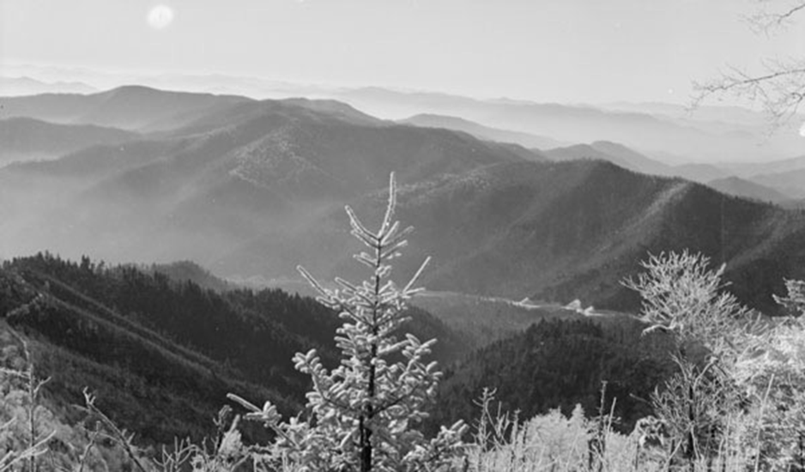
View from Unknown Vista
Source: http://www.lib.utk.edu

“Park design, or landscape architecture, has figured in the history of national parks since the 19th century. This may seem a paradox since many people intuitively reject the importance of human design in an environment valued primarily for its pristine, natural condition.

The natural wonders of national parks obviously brook no comparison to any works of landscape ark; but the significance of landscape architecture in such a setting lines in how and where these natural features are appreciated, not in the creation of alternative attractions. Designed landscapes guide the experience of many park visitors and enhance their appreciation of the vast wilderness beyond”
(Carr 1998, 1).

TABLE OF CONTENTS

Chapter Page

Acknowledgements....................................................................................iii
Abstract.......................................................................................................iv
Chapter 1. Introduction................……………………………………………..1
Chapter 2. Methods and Materials …………………………………………..4
Data Collection…………………………………………………………...4
Methods…………………………………………………………………...5
Chapter 3. Examining the Issues ……………………………………………6
Budget Constraints………………………………………………………6
Inadequate Vista Management………………………………………..13
Chapter 4. Site Selection.………………………………………………..…...18
Chapter 5. Case Studies ……………………………………………………..21
Yosemite National Park………………………………………………...22
Glacier National Park…………………………………………………...23
Blue Ridge Parkway………………………………………………….…24
Chapter 6. Results and Discussion ………………………………………..29
Landscape Narrative……………………………………………………29
Landscape Evaluation………………………………………………….32
Visual Inventory…………………………………………………………37
Visual Simulations, Research and Monitoring…………………….…40
Visual Predictions…………………………………………………….…42
Chapter 7. Conclusions and Recommendations………………..…….....48
List of References……………………………………………………………..53
Appendix………………………………………………………………………...56
Literature Review………………………………………………………..57
Critique of Roadways in National Parks……………………………....57
Critique of Visual Management………………………………………..68
LIST OF FIGURES

Figure Page

Figure 3.1. NPS Budget trends and Projected Funding Impacts….…………..9
Figure 3.2. NPS Budget Information for Fiscal Years 2008 and 2010.………10
Figure 3.3. Historic Vista Conditions …………………………………………....16
Figure 3.4. Current Vista Conditions ……………………………………………17
Figure 4.1. Eight Major Vista Groups along Newfound Gap Road…………...20
Figure 6.1. Vista Evaluation Process…………………………………....………31
Figure 6.2. Location Map of Vistas ………………………………………….......34
Figure 6.3. Vegetation and Topography for Campbell Overlooks……………35
Figure 6.4. Vegetation and Topography for Newfound Gap Parking Area….36
Figure 6.5. Vista Evaluation Process …………………………………………...39
Figure 6.6. Visual Simulations ………………………………………………..…41
Figure 6.7. Vista Predictions – Existing Condition.……………………………44
Figure 6.8. Vista Predictions – Establishing the Clearing …………………....45
Figure 6.9. Vista Predictions – Encouraging Low Growth ……………………46
Figure 6.10. Vista Predictions – Process………………………………….……47
Figure 7.1. Inhibiting Regrowth of Taller Tree Species…………………….....50
Figure 7.2. Potential View from one of the Campbell Overlooks ……………52
Appendix Figure 1.1. Boundaries Associated with a Visual Unit…....……...76

Chapter 1

Introduction

Influenced heavily by the English Picturesque Movement of the 18th century, numerous works of art have been dedicated to capturing the best scenes within iconic landscapes – the valley of Hetch Hetchy, The Grand Canyon, and the magnificent Sequoia redwood forests. These important scenes, also known as vistas, are beautiful distant views of exceptional aesthetic quality typically enjoyed from a specific location. “Once people learned to ‘connect scenery and paintings in their minds, the picturesque became the nineteenth century’s mode of vision’” (Carr 1998, 11). For decades, artists and writers such as Edmund Burke and Sir Joshua Reynolds portrayed America’s natural beauty and power through an arrangement of stunning images or vistas. With limited accessibility to scenic wilderness areas throughout the 18th and 19th centuries, most of middle-class Americans could only experience these important landscapes through scenes revealed in paintings and books. However, this did not prevent Americans from developing a profound affection for the romantic ideal of wilderness and the national symbolism associated with them. As natural scenery gave way to development in the 20th century, National Parks were created to conserve the most iconic American landscapes “to conserve the scenery and the nature and the historic objects and the wildlife therein, and to provide for the enjoyment of the same in such a manner by such means as will leave them unimpaired for the enjoyment of future generations” (Organic Act 1916). However, with the introduction of the automobile by Ransom Olds and Henry Ford in the early 20th century, there was a radical shift in how Americans experienced nature.
Auto-touring spiked as the affordability of cars and the availability of vacation time dramatically increased. The landscape in national parks began to rapidly change, as scenic road corridors made a majority of the parks’ features easily accessible. Ethan Carr explains that

“As the annual number of national visitors climbed during the 1920s from thousands to millions, the increase was taken up almost entirely by people arriving in cars. These tourists needed campgrounds, parking lots, decentralized conveniences, and park drives with frequent scenic overlooks, modernized alignments, and increased lane widths. Without these improvements, multitudes of campers would easily mar or destroy the landscape beauty they came to admire” (Carr 1998, 7).

Landscape Architects strategically arranged overlooks along these corridors to reveal the best panoramic views into the wilderness. Roadway vistas were designed throughout parks to provide long-distance views of tumbling mountain streams, waterfalls, rock outcrops, lakes, and panoramic views of forests and valleys stretching to the horizon. “The agency had to convey to a public, a few of whom would never step out of their cars into the backcountry, the significance of the wilderness park they could not see” (Louter 2006,7). For the first time, middle-class Americans were able to drive to important vistas and interpret iconic wilderness areas for themselves. The popularity of auto touring continued to grow well into the 21st century, becoming America’s preferred way to experience National Parks. Great Smoky Mountains National Park is a prime example of how auto touring continues to be America’s favored way to see wilderness. Vistas along these scenic highways frame breath-taking views of nature and a few of the highest points east of the Mississippi River (Gove 2008, 6). Studies have shown that over 70 percent of the popular recreational activities in the Park reasonably close to major roadways and that visitors only spend eight minutes outside of their cars for every hour that they spend traveling. Visitors enjoy new aspects of the Park with each trip, discovering how the change of seasons, weather conditions, and even times of day can alter the appearance of vistas (DeLaughter 1986, 2). Several different publications and self-guided tours have been created to highlight natural and cultural resources along important road corridor, providing visitors with supplemental information as they experience nature from the comfort of their cars.
Unfortunately, this American experience is at risk. Many parks, such as the Great Smoky Mountains National Park, have been unable to maintain vistas as originally intended, due to budget constraints and inadequate vista management. In an effort to restore vistas within the Park, this thesis developed a framework that addressed current issues and clearly defined vista management techniques. This thesis examined Newfound Gap Road to determine the condition of important vistas, focusing specifically on Campbell Overlook and Newfound Gap Parking Area.
The vista clearing recommendations in this document explored a variety of methods to collect environmental and social data to develop landscape inventories and visual simulations for each vista. Analysis of the each vista was completed, and a cyclic management strategy was developed to restore and maintain the visual quality of vistas for the enjoyment of visitors. Ultimately, this thesis provides a vista management framework to create vista specific recommendations that are economically, ecologically, and aesthetically beneficial to the Park and its visitors.

Chapter 2

Methods and Materials

Data Collection

The environmental and social data for this project was collected through Park staff, fieldwork, and online research. The data collected from Park staff and online articles revealed that 93% of the Park’s 9.2 million visitors enjoy taking a scenic drive through the Great Smoky Mountains. However, these sources also discussed how many visitors and local resident of adjacent gateway communities are unhappy with the Park’s management of important vistas. These communities fear that visitors will continue to become upset as drive great distances to take a scenic tour of the Park, only to find that there are no longer any views. Numerous complaints have already been submitted, formally to the Park or informally posted on blogs and websites, about the encroaching vegetation that has been allowed to block important vistas in the Park. Budget information for the past was collected from Park staff, the National Park Conservation Association (NPCA), The Department of the Interior Green Book, and official and unofficial National Park Service (NPS) websites. Past vista management documentation provided by Park staff and the Great Smoky Mountains National Park Archives.
In addition to social data, Park staff across various divisions provided vital information regarding the flora, fauna, topography, and geology present at each vista and the different issues associated with them. Several trips to the Park archives uncovered a number of photographs and postcards depicting the historic condition of important vistas during the early 20th century. Photographs and data collected during extensive fieldwork revealed how seasonal changes, weather conditions, and adjacent vegetation impacted the quality of the view. Information collected from online resources provided a basic understanding of vegetation clearing impacts on threatened and endangered, as well as invasive species such as the garlic mustard, hemlock woolly adelgid, and yellow birch diseases. Additional information gathered from field research and by interviewing park staff revealed the average growth habits of vegetation surrounding vistas, that was used to determine which vegetation would remain and which would obscure the vistas in the near future.

Methods
The data collected was evaluated in several ways. Historic vista management documentation was reviewed and analyzed to determine the pervious condition of vistas, the views intended by Park planners, and information that might be useful in future vista planning. Several clearing techniques used in current plans collected from Yellowstone National Park, Glacier National Park, and Blue Ridge Parkway were reviewed, and the clearing methods and treatments were critiqued for future vista management planning for Great Smokies. Field work was categorized and the photographs were documented to show the vegetation changes, to determine potential viewpoints, and used in visual simulations. In order to analyze environmental data, Visual Management Systems (VMS) and descriptive terminology were applied to the vegetation and other landscape elements adjacent to the overlook.

Chapter 3

Examining the Issues

Budget Constraints

The National Park Service (NPS), an agency within the Department of the Interior, relies heavily on budget review and approval from Congress. According to the NPS official website the Green Book, the most recent fiscal year (October through February) funding levels are:

FY 2011(request) $3.14 billion 21,501 employees
FY 2010 $3.16 billion 21,574 employees
FY 2009 $2.92 billion 20,876 employees

Other monetary contributions come in the form of recreation fees ($190 million), park concessions ($60 million), film and photography special use fees ($1.2 million), and donations of money, property, and time from numerous local nonprofit partners.
The NPS budget situation is not as stable as it would appear. Even though the budgets for the past few years look consistent, NPS Green Book data does not take into account the rising cost of services and inflation. This means that the current budget is considerably less than previous budgets. In their 2011 report, Made in America: Investing in National Parks for Our Heritage and Our Economy, the National Park Conservation Association (NPCA) revealed that the NPS discretionary budget has suffered a 13 percent decline in the past two years. The study went on to expose the Park’s $2 billion land acquisition backlog and the $10.8 billion dollar deferred maintenance backlog - $3.7 billion of which affects critical systems (NPCA 2011,7). “In real dollars, the current National Park budget is more than $385 million dollars below where it was in 2002” (NPCA 2011,8-9). According to the NPCA, the National Park Service received less than 1 percent (2.75 billion) of the Federal Budget (3.7 trillion) in 2010. The NCPA argued that it “costs less than 1/13th of one percent of the federal budget” to keep national park well-managed and open to the public, which is quite a bargain for a park system that inspires visitors from around the world and produces nearly 270,000 private sector jobs across the country. The NPCA revealed that NPS visitation has exceeded 281 million for the last two years, yet, “our treasured parks” are experiencing a $500 to $600 million budget shortfall – money that is desperately “needed to staff visitor centers, teach people about the natural and cultural wealth owned by all Americans, protect those precious resources, and assure visitors’ safety” (NPCA 2011,11).
Recent studies have revealed a 60 percent decline in park service maintenance since 2002, which prevents the NPS from continuing to adequately reinvesting into Park programs and facilities. Unfortunately, this budget crisis is not expected to improve anytime soon. Figure 3.1 describes NPS budget trends for the past ten years, including inflation and projected funding cuts. It is anticipated that the NPS budget will receive additional funding cuts between 5-10 percent in the approaching fiscal year. During the 2011 fiscal year, Congress and the Obama administration narrowly avoided a government shut down by reducing the NPS funding by nearly $140 million, which included an $11.5 million reduction in park operations. The NPCA study also explained that for every dollar invested into national parks, there is a 4 dollar increase in economic value to the public (NPCA 7). Ultimately, cuts in the NPS budget and rising service costs prevent an already limited park staff from adequately managing programs and assets, which results in a degraded visitor experience and decaying infrastructure.
The NPS recently announced that “visitors to national park properties spent $12 billion on food, lodging and retail purchases in 2010 and helped sustain 258,000 jobs” (USA Today, Chebium 2012). Since tourism plays a vital economic role in sustaining gateway communities, it is easy to see why locals and visitors alike have voiced their concerns about park management – specifically the deficiencies in park facilities, roads, and the deteriorating visibility of iconic landscapes. NPCA explained that not all parks are able to distribute their funding evenly across park activities. “Large parks with heavy visitation and lots of employees can often shift money or use fees collected from visitors to maintain needed capacity and improve visitors’ experiences—though likely at the cost of delaying maintenance projects or other work” (NPCA 21). Great Smoky Mountains National Park is a prime example of this uneven funding distribution. The Park hosts an average of 9.2 million recreational visits annually, making it the most visited national park in America. Since a majority of the Park’s facilities and programs are operational year round, most of the budget must be reinvested into properly maintaining Park infrastructure. Figure 3.2 outlines the Park’s budget for NPS activities.

Figure 3.1: NPS Budget trends and Projected Funding Impacts Based off of the NPS Green Book

Park Activities | Employees for each task | Frequency of each task | Cost per year
Mowing | 1-2 each road | 7 times annually per road | $300,000
Vegetation Management | 2-4 each road | 3 times annually per road | $300,000
Litter Pick up | 1-3 each road | 1-3 a week per road | $50,000
Cemetery Maintenance | 3-5 each area | Annually | $200,000
General Roadway/Drainage Maintenance | 4-7 each road | Annually | $500,000
Operating and Maintaining Machinery |  |  | $250,000
TOTAL COST |  |  | $1,000,000

Figure 3.2: NPS Budget Information for Fiscal Years 2008 and 2010 Based off of the NPS Green Book

Great Smoky Mountains National Park is one of the largest protected land areas east of the Rocky Mountains. The Park straddles the North Carolina/Tennessee border for approximately 70 miles, covering 521,000 acres or 800 square miles. It is world-renowned for the diversity of its plant and animal resources, the beauty of its ancient mountains, the quality of its remnants of American pioneer culture, and the depth and integrity of the wilderness sanctuary within its boundaries. Located within a two-day drive for half of the nation’s population, the Great Smoky Mountains National Park has the highest visitation of all the national parks in the country, accommodating between 8 to 10 million visits annually (NPS.gov 2012).
Visitors to the Park spend nearly $800 million a year in gateway communities outside of the Park, which supports more than 11,000 local jobs (NPCA 2011, 41). Like most national parks administrations, the management staff at Great Smoky Mountains National Park understands that budget cutbacks directly contribute to the deterioration of the visitor experience. The ecotourism destinations and advice states, “Great Smoky Mountains National Park is operating under a budget shortfall of more than $11 million annually, and the maintenance backlog is approaching $170 million” (weather.com 2012). The NPCA explained that “the compromised impact on the visitor experience also has an unmeasured impact on return park visitors and the economic stimulation that accompanies those visits” (NPCA 2011, 21). Current budget restrictions have prevented the Park from retaining the necessary staff and funding to adequately manage its resources. Future budget shortfalls could force the Park to make further cutbacks, possibly reducing the amount of facilities and activities available to the public.
According to The Great Smoky Mountains National Park FY 2008-2012 Strategic Plan Report, the Park’s Maintenance Division strives “to provide operational maintenance to all facility assets that support visitor use and enjoyment” (NPS.gov 2007). Recent statistics revealed that a majority of the Park’s $20.3 million dollar budget is spent on facility operations and maintenance. Approximately 121 full time permanent and 219 seasonal employees are charged with maintaining numerous recreational facilities including: 384 miles of roads with associated parking areas and pull-offs, 169 bridges, 5 tunnels, over 800 miles of trails, 100 backcountry campsites and shelters, 1,000 front country campsites in 10 campgrounds, 11 picnic grounds, 3 visitor centers, 72 comfort stations, 194 historic structures, 5 amphitheaters, 5 horse camps, 143 cemeteries, 4 wastewater treatment plants, 22 water systems, and 41 maintained landscapes. Maintenance of the park recreational facilities addresses “road maintenance, road rehabilitation projects, drainage maintenance, road striping, mowing, brushing, vista clearing, sign maintenance, litter pickup, trail maintenance, cemetery maintenance, hazard tree removal, campsite maintenance, building maintenance, snow and ice removal, utility system maintenance, and solid waste disposal” (NPS.gov 2007).
Because of the Park’s immense size, numerous assets, and heavy visitation, many non-essential maintenance activities are routinely neglected. A prime example of this neglect is the Park’s inadequate management of vistas. Recent vista inventories and analysis determined that there are 34 significant vistas in critical need of restoration. Further investigation revealed that each vista has a “clearing size” between 1/2 and 1 1/2 acres (on average) that needs to be maintained on a cyclic basis in order to protect the integrity of the vista. Consequently, the total area to be cleared and maintained is between 35 and 36 acres. Research of current vista clearing procedures at other parks, primarily Blue Ridge Parkway, revealed that the average cost of a vista clearing project is between $400 and $500 thousand dollars. According to current clearing estimations, it would cost approximately $10,000 an acre.
Unfortunately, because staff is limited, vistas have been allowed to become overgrown as the park struggles to maintain mandatory operations. The Park is barely able to manage the cost of mandatory operations at $17.9 million dollars, it is impossible for the Park to take on the additional financial burden of re-clearing vistas every year. Even if the Great Smoky Mountains National Park was able to take on the additional work and financial burden, there is no vista management plan in place that was able to maintain vistas to meet the Park’s current goals and mission.

Inadequate Vista Management

The visitor’s ability to observe the natural scenic landscape is a critical part of their experience at Great Smoky Mountains National Park. The Park’s Objectives and Policies developed in the 1940s recognized

“the importance of scenic views of the Park’s landscapes, continuing studies will be made of needs for vista clearing along roadways and trails. Steps will be taken, as part of carefully planned clearing programs, to open views which rapid and dense growing vegetation has closed or conceals” (Great Smoky Mountains National Park Objectives and Policies 18).

However, research of past and present planning exposed serious gaps in the Park’s vista management. According to Park employees, Great Smokies has never conducted a full scale analysis of vista ecological conditions, clearly defined vista clearing techniques, or established a rating system to prioritize maintenance efforts. In fact, park management did not consider the vegetation around the vistas to be an issue until the 1940s. The vista management plan was developed in 1943 provided the general location, intended view, and focal points for each vista. Unfortunately, this plan lacks photographs and clearing specifications for each vista. Once World War II started all efforts to establish a formal Park vista plan was abandoned. After the 1940s, vistas were not formally addressed again until the 1990s. This vista plan was more of a summary of recently completed work than an actual management strategy. While this plan has photos, it only covered a limited number of vistas and there were no defined clearing specifications listed.
The only formal prescription for vista management is in the Park’s current Performance Work Statement, prepared as part of the Most Efficient Organization (a review conducted in the Park, 2004-2005):

“Clear vistas and overlooks areas of encroaching trees, brush, and other vegetation to provide unobstructed views and safe conditions. The area to be cleared for each vista shall be defined as the current limits being maintained and historically cleared. [Current limits and historically cleared limits may not be the same]. Within the cleared area, herbaceous materials shall be cut to a maximum three inch height and laid flat. Woody material shall be cut flush to the ground and laid flat. Trees greater than twelve inches in diameter shall be in left in place. Vistas and overlooks shall be cleared every four years” (24).

This statement allowed very little flexibility for adjustments and lacks an outline specifying the view for each vista, leaving the appropriate view to be determined subjectively by the field crew. Traditionally, Park vista management has consisted of ad hoc vegetation removal and does not address additional ways to manage the vista clearing in the future.
Currently, the maintenance of vistas is dependent on the availability of funds and labor. Vista cutting has typically occurred in the past when: 1) directed by management as a result of visitor complaints regarding the visibility at vistas; 2) the removal of hazard trees in a vista provides an opportunity to remove other vegetation within a vista; or 3) cyclic funds have been provided for clearing/brushing work at vistas. The lack of collaborative park planning has resulted in inadequate vista management and confusion, as current employees are unsure of past management procedure. As a result, the rapid growth rate of vegetation within the Great Smoky Mountains has been uninhibited; allowing vistas to become obscured by large trees such yellow-poplar, sourwood, and pitch pine.
The Park has received numerous complaints inquiring why many significant scenic points, or vistas, are now obscured by vegetation. A visitor from Springfield, Ohio wrote,

“One of our greatest reasons for the road over Newfound Gap is the marvelous view to the North. Recently I noticed the growth of trees is partially blocking that view. Surely, there are enough trees in the Smokies that cutting the trees blocking the view would not be a significant loss. That view has to be one of the most stupendous views in the world and for it to be blocked is a tragedy -- a real loss” (Park Archives 2010).

In order to establish adequate vista management, a new plan must be developed that includes site specific clearing recommendations that are sensitive to current conditions, before and after photos, and priority list of most to least significant vistas.

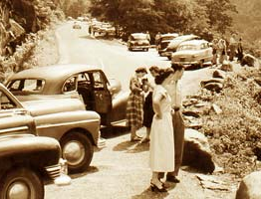

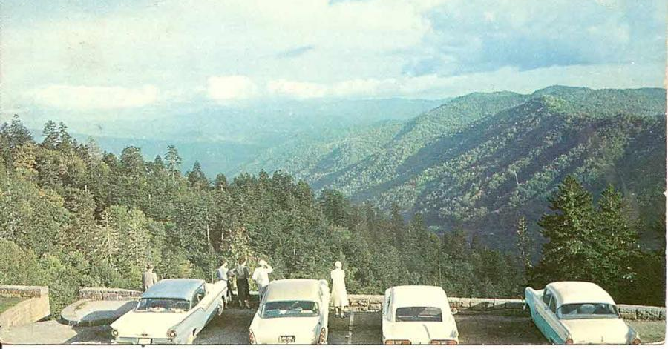
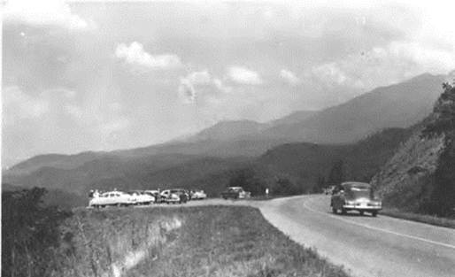
Figure 3.3: Historic Great Smoky Mountains National Park Vista Conditions, Courtesy of NPS Archives

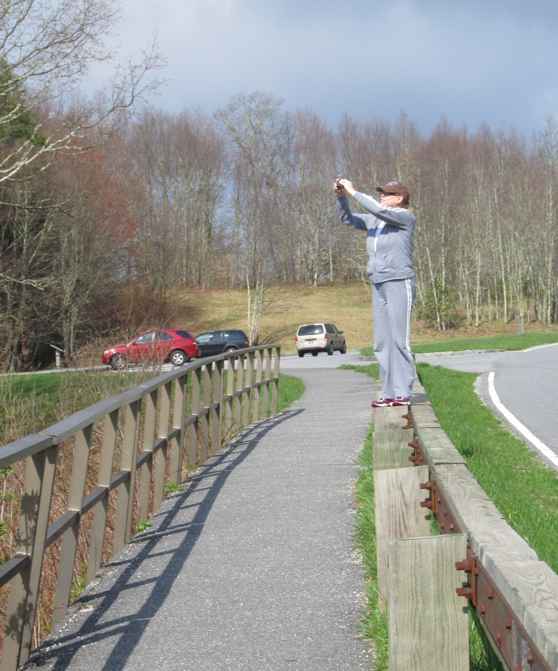
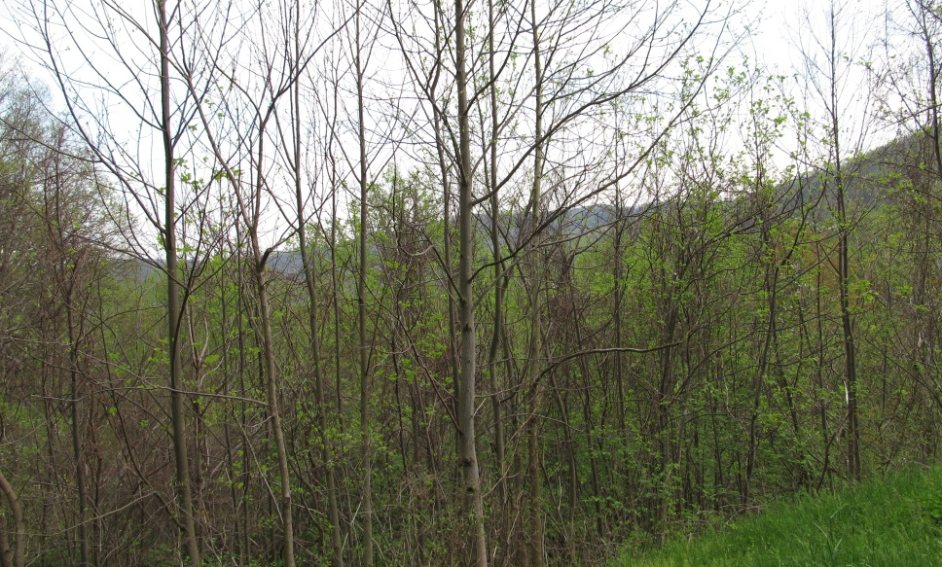
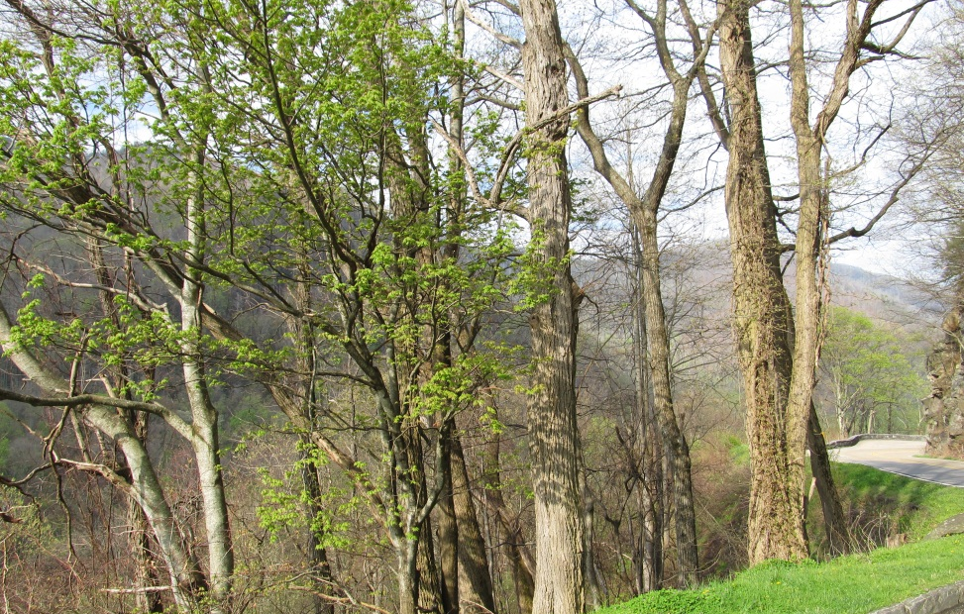
Figure 3.4: Current Great Smoky Mountains National Park Vista Conditions, Photos by Jessica Bundy

Chapter 4

Site Selection

Newfound Gap Road is the most traveled, and arguably the most impressive, scenic highway within the Park. A trip over the Newfound Gap Road has often been compared to a drive from Georgia to Maine in terms of the variety of forest ecosystems one experiences. Starting from Cherokee, North Carolina or Gatlinburg, Tennessee, travelers climb approximately 3,000 feet, ascending through cove hardwood, pine-oak and northern hardwood forests to attain the evergreen spruce forests at Newfound Gap (elev. 5,046’). This fragrant evergreen woodland is similar to the boreal forests of New England and eastern Canada.
Designated as a Scenic Byway in 2009, Newfound Gap Road (NPS Route 10) is a principal north-south roadway within Great Smoky Mountains National Park, and the only roadway that completely transverses the Park. The National Park Service website described Newfound Gap Road as a

“regional corridor that allows travelers from North Carolina or Tennessee to access the other side of the Park with ease, without travelling around the mountain ridge or outside the Park. It stretches approximately 31 miles from Cherokee, North Carolina, to Gatlinburg, Tennessee. The posted speed limit along the entire road varies from 25 to 45 miles per hour” (NPS.gov, 2012).

The initial road was completed in 1930. The Park Service designed Newfound Gap Road with approximately eight major groups of vistas, in an effort to provide with an ideal, scenic wilderness experience viewed from the road. “The agency had to convey to a public, a few of whom would never step out of their cars into the back country, the significance of the wilderness park they could not see” (Louter 2006). From the time the Park was officially created through the 1960’s, the National Park Service realigned sections of the road to take advantage of more scenic views, reduce steep grades, and to adhere to National Park Service design guidelines. However, research of current vista conditions revealed that many of these major vistas along Newfound Gap Road have become densely overgrown.
This thesis focuses on two major vista groups along Newfound Gap Road: the most overgrown vistas – Campbell Overlook – and the least overgrown vista – Newfound Gap Parking Area. Because Campbell Overlooks exist at a lower elevation with a longer growing season, these vistas are overwhelmed by dense stands of tall trees. Tulip Poplars, which are very common along the Campbell Overlooks, grow up to six feet a year in ideal growing conditions. Newfound Gap Parking Area exists on the ridgeline between the North Carolina and Tennessee State lines at an elevation of over 5,000 feet. This Overlook is not affected by any encroaching vegetation. In fact, most of the vegetation growing near Newfound Gap has been negatively impacted or nearly wiped out by invasive species such as the hemlock wooly adelgid, the balsam fir adelgid, acid rain, and wind. Figure 4.1 shows the location of these vistas along Newfound Gap Road.

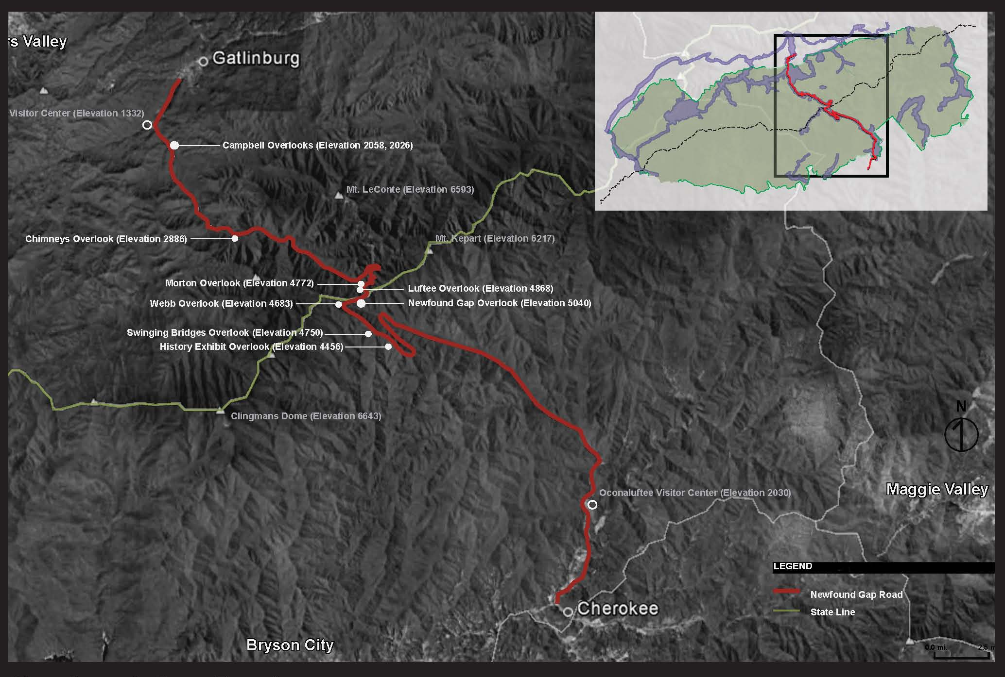

Figure 4.1: Eight Major Vista Groups along Newfound Gap Road

Chapter 5

Case Studies

After reviewing vista management documents for Yosemite National Park, Glacier National Park, and Blue Ridge Parkway, it was evident that vista management strategies vary throughout the National Park Service (NPS). Since each park has been met with a different set of vista challenges – topography, vegetation, and land use – parks tend to develop vista management strategies that address the unique to that park’s needs. This means that many plans have to be both economically efficient and ecologically sustainable to meet their specific goals. The greatest difference in vista management strategies are between western and eastern parks. Typically, vistas in western parks are framed by slower growing species and require less cyclic work to maintain, while eastern parks and parkways frequently cleared through dense, fast growing vegetation.
Many parks have defined scenic routes that highlight the unique characteristics and iconic landscapes; some routes encircle the park while others connect communities and extend across state lines. But no matter the size, shape, or location of the park and its scenic roadways, the message is clear: parks have always intended to protect and enhance the visitor experience by maintaining vistas. After examining parks with significant vista management experience, valuable information was adapted and incorporated into clearing recommendations for Great Smoky Mountains National Park.

Yosemite National Park, California

Yosemite National Park was one of the first wilderness parks to be established in the United States, and provides visitors with unique views of “deep valleys, grand meadows, ancient giant sequoias, a vast wilderness area, and much more. Over 3.5 million visitors explore Yosemite annually” (NPS.gov 2012). Like many national parks, Yosemite was originally set aside in efforts to preserve its extraordinary scenery. The NPS website describes every road in Yosemite National Park to be scenic, but that the most famed scenic opportunity is along the Tioga Road, a 39-mile drive from Crane Flat to Tioga Pass. The road is usually open between the end of May and the beginning of June through sometime in November (NPS.gov 2012).
The NPS reported that “Ongoing scientific research abounds at Yosemite from vista management to soundscape preservation to human carrying capacity issues” (NPS.gov). Recent scenic vista management strategies have replaced the Park’s former ad hoc approach. Yosemite’s Scenic Vista Management Plan was developed to “reestablish and maintain Yosemite National Park's iconic views, vistas, and discrete lines of sight that are obscured by vegetation growth”(NPS.gov). By utilizing a comprehensive plan, Yosemite was able to “prioritize viewpoints for management and identify which methods of vegetation clearing are appropriate; when and where to use them” (NPS.gov 2012).
Similar to Yosemite, the management staff at Great Smoky Mountains National Park has been aware of encroaching vegetation blocking a majority of their vistas for some time. However, the vistas at Great Smokies are surrounded by dense deciduous forest with a longer growing season at a much lower elevation. This makes the challenge of maintaining vistas more difficult, as vegetation needs to be maintained more frequently. Great Smokies would greatly benefit from using public meetings to explain the benefits of vista management to visitors. This would allow knowledgeable park staff to address the comments and concerns of the public on a personal level. However, Yosemite’s approach of using historic photos to guide vista clearing may not be as successful at Great Smoky Mountains National Park, as most vista photos were taken while the slopes were starting to heal and vegetation was slowly reclaiming the sides of vistas.

Glacier National Park, Montana

Referred to by the NPS website as the “Crown of the Continent”, Glacier National Park offers visitors magnificent views of “pristine forests, alpine meadows, rugged mountains, and spectacular lakes” (NPS.gov 2012). One of the most premier attractions to Glacier National Park is a drive on the Going-to-the-Sun Road. This road has been considered to be an engineering marvel, spanning 50 miles through the park's interior and winding along mountainsides. This scenic drive treats visitors to the best vistas in northwest Montana (NPS.gov 2012).

The Glacier National Park Vista Management Plan was developed in 2009 to address the Park’s “need for providing scenic viewing opportunities along the historic road” (NPS 2009). The plan’s purpose was to provide a framework to managing vegetation along the road corridor “with a viewer’s perspective in mind, in order to reintroduce the historic purpose and experience in its historic and contemporary setting” (NPS 2009). The 2002 Going-to-the-Sun Road Cultural Report stated that “the preservation of vistas is an integral part of the Sun Road’s historic character” (NPS 2009). Several conditions and treatments outlined in the vista management plan offered guidelines for reopening vistas. The treatments include “French Cut”, “filtered”, and “canopy cut” clearing techniques. The French cut technique is a conservative vista clearing method that only removes the lower limbs of the trees to produce a framed view and preserve the trees. The filtered technique is a moderate vista clearing method that removes up to fifty percent or 2/3rds of the vegetation impacting the vista. The canopy cut technique is the historic vista clearing method that removes all of the encroaching vegetation that impacts the vista.

Similar to Glacier, Great Smoky Mountains National Park has well-traveled scenic roads with one central scenic route that offers the most iconic vistas.

Great Smokies would greatly benefit from the use of Glacier’s condition and treatment methods that offer specific clearing recommendations for each vista.

Great Smokies are surrounded by dense deciduous forest with a longer growing season at a much lower elevation. This makes the challenge of maintaining vistas more difficult, as vegetation needs to be maintained more frequently.

Glacier’s approach to vista clearing usually focused on specific views and framed vistas, most of which are viewed while driving by instead of stopping and observing from an overlook. Most of Great Smoky Mountain’s vistas are associated with static points, or points where you can pull off and reflect on the scenic beauty of the view without being distracted by driving. These views must strategically framed to provide the best view from one or more specific points, whereas vistas viewed through driving are typically just windows into the preserved wilderness.

Blue Ridge Parkway, North Carolina and Virginia

Marketed by the NPS as “America’s Favorite Drive” (NPS.gov), “the Blue Ridge Parkway emerged at the end of a century-long process of developing an American aesthetic and style for public parks, first in nineteenth-century cities and later in the huge expanses of national parklands”. Author Anne Mitchell Whisnant discussed how “both national trends and regional dynamics gave birth to the Parkway, and the roads-auto-tourism connection shaped the road in crucial ways” (Whisnant 2006,14). The road’s surface was “laid gently on the land” which adhered to the “Park Service ‘rustic’ design aesthetic” (Whisnant 2006,15).
http://www.visitblueridgeparkway.com/maps/brpmap003.gif
The National Park Service website described the Parkway experience as “unlike any other, a slow paced and relaxing drive revealing stunning long-range vistas and close-up views of the mountains and pastoral landscapes of the Appalachian highlands” (NPS.gov 2012). The iconic landscape of the Parkway is a formation of diverse geology and topography. The NPS stated that this regional-scale Parkway meanders for 469 miles, offering visitors a window into the natural, historic, and cultural character and resources that make this part of the country so special.
The experience along the Blue Ridge P’arkway varies depending on the section you travel. According to the NPS, the Virginia section of the Parkway “highlights the rolling agricultural scenery that is so much a part of the Blue Ridge” and “how humans have interacted with the land in these mountains”. In this section, visitors are introduced to a variety of cultural sites and landscapes associated with communities in the southern Appalachians including evidence of human occupation from prehistoric to contemporary times”, including stories of early tourism, arts and crafts, music, and social institutions of the mountain region (NPS.gov). The NPS explained that “much of the road travels through US National Forest lands as well and, north of Roanoke, the drive is dominated by a ridge-top experience with magnificent views of the flora and fauna of Appalachian hardwood forests and sweeping vistas of the Great Valley of Virginia” (NPS.gov 2012).
The North Carolina section of the Blue Ridge Parkway highlights the natural history preserved along the corridor (NPS.gov 2012). The NPS described the portion of the Parkway south of Asheville, specifically along Grandfather Mountain, offers “dramatic views less affected by human presence dominate the visitors' experience” (NPS.gov 2012). This section has the highest overall elevation and biological diversity, which can be best experienced through secluded natural areas.
The Parkway has kept extensive vista management documentation and has succeeded in maintaining open views along many of their vistas. Unfortunately, recent budget shortfalls have required Parkway staff to re-examine the amount of vista maintenance they can accomplish each year. The Parkway’s new strategy of maintaining vistas, Shifting the way we manage vistas – Moving towards a resource and landscape management approach, outlined a three, six, and nine year clearing cycle with a smaller workforce. The document described how the Parkway’s maintenance division should be celebrated for its commitment to maintaining these vistas for the park visitors. Even though the primary purpose of vistas are to provide scenic views for the park visitor, the document also acknowledged that the many current vista management methods have had negative impacts on natural resources and native plant communities (Anderson et. al. 2010,3). Other issues addressed in the Parkway’s assessment included adapting vistas to meet current goals and reshaping vistas for modern viewsheds. The new vista management strategy for Blue Ridge Parkway began by examining vista challenges. Due to of the sharply sloping topography that characterizes most vistas, species located closest to the road corridor (at the top of the vista) often obstruct the view more than species located the farthest away (at the bottom of the vista). Despite the 3-year frequency of cutting, views are often obstructed by several species (generally exotics), occurring near the top of a vista. In recent years, the Parkway has incorporated the use of herbicide that has been approved under specific conditions in an attempt to maintain the vista clearing and keep the view open (Anderson et. al. 2010, 3). So far, there have been no complications with this method, but further research might show that herbicide could have negative effects on the local flora and fauna.
Since vegetation types in Great Smoky Mountains National Park are very similar to those found along the Blue Ridge Parkway, the use of herbicide on taller, faster growing vegetation should be just as beneficial. This would also allow native low growing vegetation to dominate the clearing without having to compete with undesirable species for sunlight and nutrients. The Parkway’s document also points out that vistas are often obstructed by exotics that often flourish once vista clearings are cut.
Further research could also show that the selective use of herbicides while clearing could help control certain exotic species along vistas. Exotics that could not be effectively controlled with herbicide could be suppressed by lower vegetation already found on site, such as rhododendron, mountain laurel, and native grapevine. Using controlled burns along vistas can be very effective in eliminating exotic plants, especially in clearings where cutting significant amounts of vegetation removal can be very expensive. However, many vistas along Great Smoky Mountains National Park and Blue Ridge Parkway are at such high elevations that steep slopes render using controlled burns next to impossible.
Unfortunately, exotics are not the only vegetation that needs to be controlled. Many native trees that surround the vistas grow very quickly due to the significant amount of rain and the extended duration of the growing season. Without inhibiting the growth of these trees, they will obscure the vista within a relatively short amount of time (3-4 years).
The Parkway’s assessment aimed to determine if “trees at the vista edge can be selectively cut to provide views which have been lost due to native trees reaching mature height” (Anderson et. al. 2010,3). This means that instead of removing a large amount of trees, a conservative vista clearing method could be applied. The economic benefits would be significant; however, selective cutting may not restore the visual integrity to the vista, which would prevent it from meeting the Parkway’s goals. Further research would be needed to determine if this assessment would be sufficient for vista management goals.
Vegetation along the Blue Ridge Parkway and within the Great Smoky Mountains National Park varies from low growing natives to old growth forests. The Parkway’s assesment does not list the types of vegetation, but previous research documented that the Appalachian region is home to diverse forest types, including spruce-fir, northern hardwood, cove hardwood, hemlock, and pine-oak forests. The fastest growing trees, yellow poplar, sweet gum, white pine, yellow birch, black birch, black locust, are usually found in the cove hardwood and pine-oak forests which are found in the lower to mid elevations along Newfound Gap Road. Vistas surrounded by these fast growing trees are currently the most impaired.
Recent evaluations of Parkway vistas have concluded that not all vistas along the Parkway should be reopened (Anderson et. al. 2010,3). The Parkway’s vista management strategy explained that vistas are impacted by trees along the boundary, which cannot be removed by the Parkway. This means that vistas impacted by these trees should be removed from the program or maintained as vegetative openings through selective limbing or French cutting. Some vistas would require reshaping to focus views from intruding development. This means that some vistas that were historically maintained as panoramic views may now be negatively impacted by development outside of the park. The National Park Service relies on local and state ordinances to prevent development within key viewsheds of the park. Because parks and parkways are protected natural spaces which offer fantastic scenic opportunities, development frequently occurs along ridgelines or in valleys right outside of NPS boundaries. This issue has greatly impacted several vistas near the boundary of Great Smoky Mountains National Park and its gateway communities.

Chapter 6

Results and Discussion

Extensive research of vista management in the National Park Service, both past and present techniques, revealed a variety of options for maintaining viewsheds. Each park addresses vegetation differently; parks out west are allowed to use a minimalistic approach to vista clearing while parks in the east are confronted with tall, fast growing tree species and a much longer growing season. However, each park had the same goal – to maintain vistas for the enjoyment of present and future generations. These parks were willing to go to extensive measures to address the needs of each vista. Vistas within Great Smokies are in need of such attention. Figure 6.1 outlines the process for analyzing each vista.

Landscape Narrative

Before each vista was evaluated, the landscape narrative method was used to establish a “common threads of perception” – explaining the landscape in terms most people can understand. Once the landscape can be easily understood by the public, landscape architects can begin to create spaces that a majority of people would consider aesthetically pleasing. To establish this understanding, this method explored narrative techniques derived from an article by R. Burton Litton Jr., entitled “Descriptive Approaches to Landscape Analysis” which highlights key processes from various researchers. Research by Zube, Sell, and Taylor emphasizes that “Beautiful landscapes are important because they offer unique opportunities to those seeking a special kind of experience often called ‘aesthetic’, that are highly valued and less likely to occur in less-beautiful places” (Chenoweth,1990, 1).
A study of the landscape perception paradigm by Ndubisi (2002) clarified that landscape perception “seeks to understand human values and aesthetic experience in order to take them into account in creating and maintaining landscapes that are socially responsible and ecologically sound” (North Carolina State University 2006,308). Essentially, the ideology of landscape perception is a belief that people prefer settings that meet their needs, function well, and successfully interpret their environment (Kaplan and Kaplan 1998). By using aesthetic evaluation techniques along with visual analysis, it is possible to create vistas that highlight the aspects of nature people value and screen the elements that are undesirable.
The next method, visual inventory, examined each vista based on criteria listed by Litton to determining aesthetic values, visual values, and relationships in a landscape. This method inventoried both typical (common) and atypical (extraordinary) landforms, so that patterns and relationships can be identified between the four elements (landform, vegetation, water, and land use). Vistas, like many landscapes, are affected by time and space. Examples of this are viewing the landscape as you transcend from one forest type to the next; associating color and texture changes to the seasonal aspects of the landscape; and revealing how sunlight effects the observer’s impressions of the landscape as it shifts between sunrise to sunset. Many of the Park’s vistas display extraordinary examples of the scenic quality that can be found in this region.

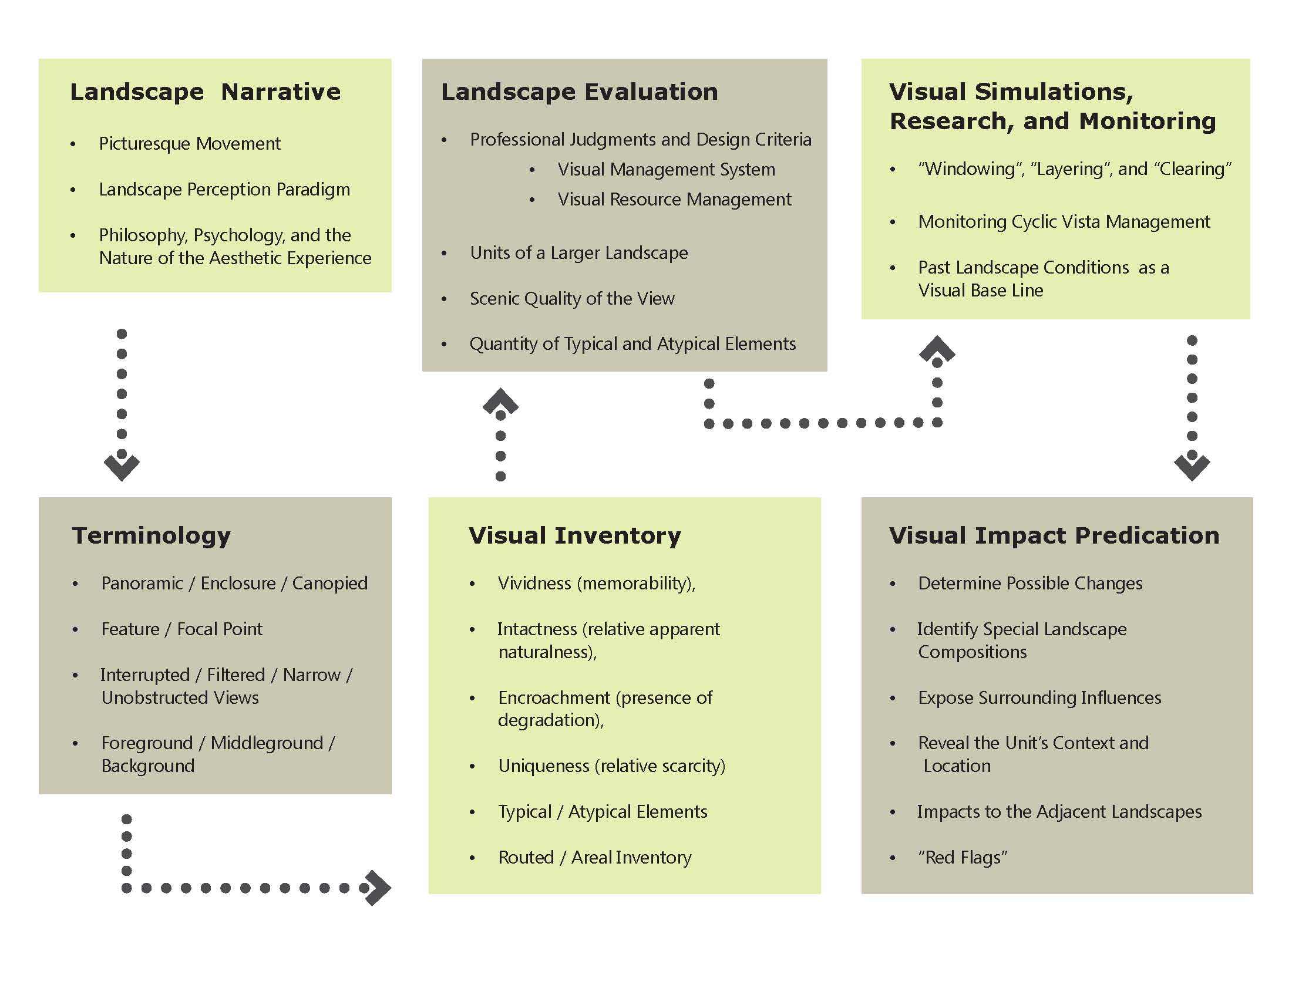

Figure 6.1: Vista Evaluation Process, Based on the Visual Management Systems Framework

Landscape Evaluation

Once patterns were identified and landscape narratives were established, landscape evaluations were conducted. The landscape evaluations are judgments based on criteria used by professionals, including guidelines derived from the Visual Management Systems (VMS) (USFS 1974) and the Visual Resource Management guides (USBLM 1976). Vistas are fundamentally “units” within a larger landscape. Tetlow and Sheppard described the visual unit as being “a portion of the landscape enclosed and limited by topography, bounding an observer’s field of view. That spatial enclosure enables the viewer to accumulate and form a unified impression of his surroundings”. Each unit reveals the relationships between atypical and typical elements, framed for the enjoyment of the observer.
Vista evaluations were conducted based on the line, form, color, texture and the quantity of typical and atypical elements. In Tetlow and Sheppard’s scenic distinction rating, a “mapped geographical arrangement of visual units and their portals indicates the sequence of differing landscapes to be seen along possible travel routes” is required (Tetlow 1979,118). Great Smoky Mountains National Park has a complex arrangement of typical and atypical landforms. A routed inventory was completed and each vista was located on a map of the Park and Newfound Gap Road. Figure 6.2 is a location map of the vistas in Great Smoky Mountains National Park. The areal inventory revealed similar topography and vegetation between vistas of low elevation and those in higher elevations.
Even though several vistas revealed mountain peaks, mature forests, waterfalls, or valleys; each vista presented these elements differently, allowing the observer to see the landscape in a unique way. Figure 6.3 and Figure 6.4 are vegetation analyses for Campbell Overlooks and Newfound Gap Overlook. It was very evident in initial research that not all vistas face the same issues. Certain vistas like the Campbell Overlooks are impacted by challenges with topography and fast growing vegetation, while other vistas like Newfound Gap Parking Area are confronted with impacts and concerns, such as exotic inspect species and environmental factors.
R. Burton Litton Jr. explained that “with conflicting political views and administrative/legal restrictions, it is virtually impossible for public agencies to conduct social response studies on public land” (Litton 1979,82). Consequently, most public agencies rely on academic research as insight. Litton discusses how workshops conducted by the National Park Service in 1978 revealed that preferences are generalized judgments that include “a complex of variables in which visual elements are elusive” (Litton 1979,82). As earlier research revealed, visual evaluation are typically based on personal preference and values in nature. This means that the publics’ ability to determine vista management methods would be based completely on subjectivity, not necessarily what is best for the Park.
Numerous requests have been made, urging Great Smoky Mountains National Park to restore the view the way it was originally intended. These visitors remember the vast panoramic views of magnificent landscapes that were historically maintained by the Park several decades ago. However, landscape conditions that were desirable in the past are not always compatible with present or future Park landscapes. This thesis developed a framework to determine the best management recommendation for each vista. With these ideas in mind, Park staff assembled a vista evaluation team to determine which view is right for each vista. Due to current development trends outside of the Park and new environmental standards, reopening all vistas to a panoramic view was determined to be impractical and undesirable.

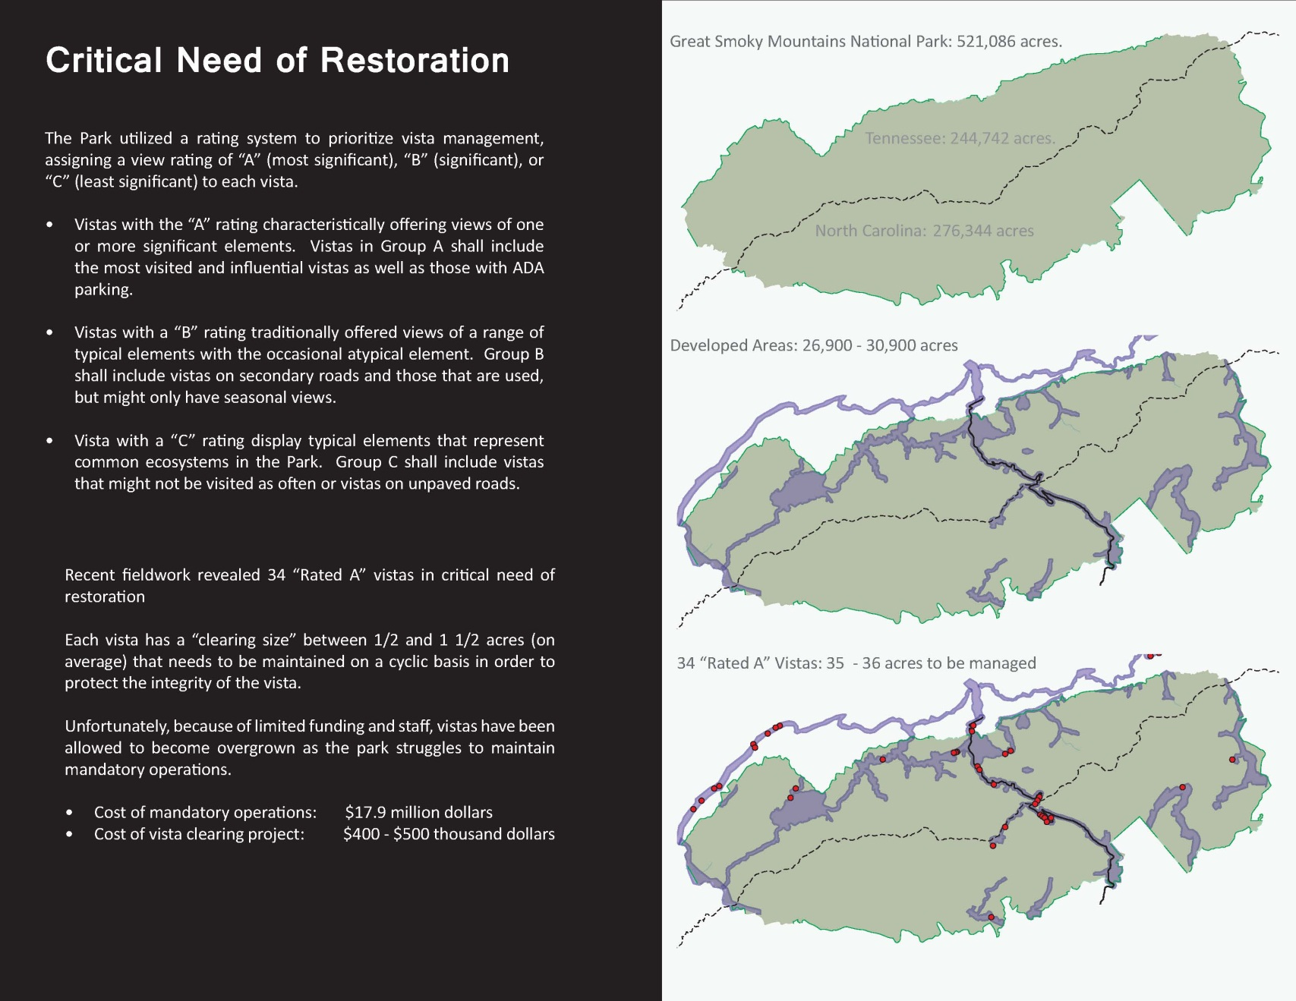
Figure 6.2: Location Map of Vistas within Great Smoky Mountains National Park

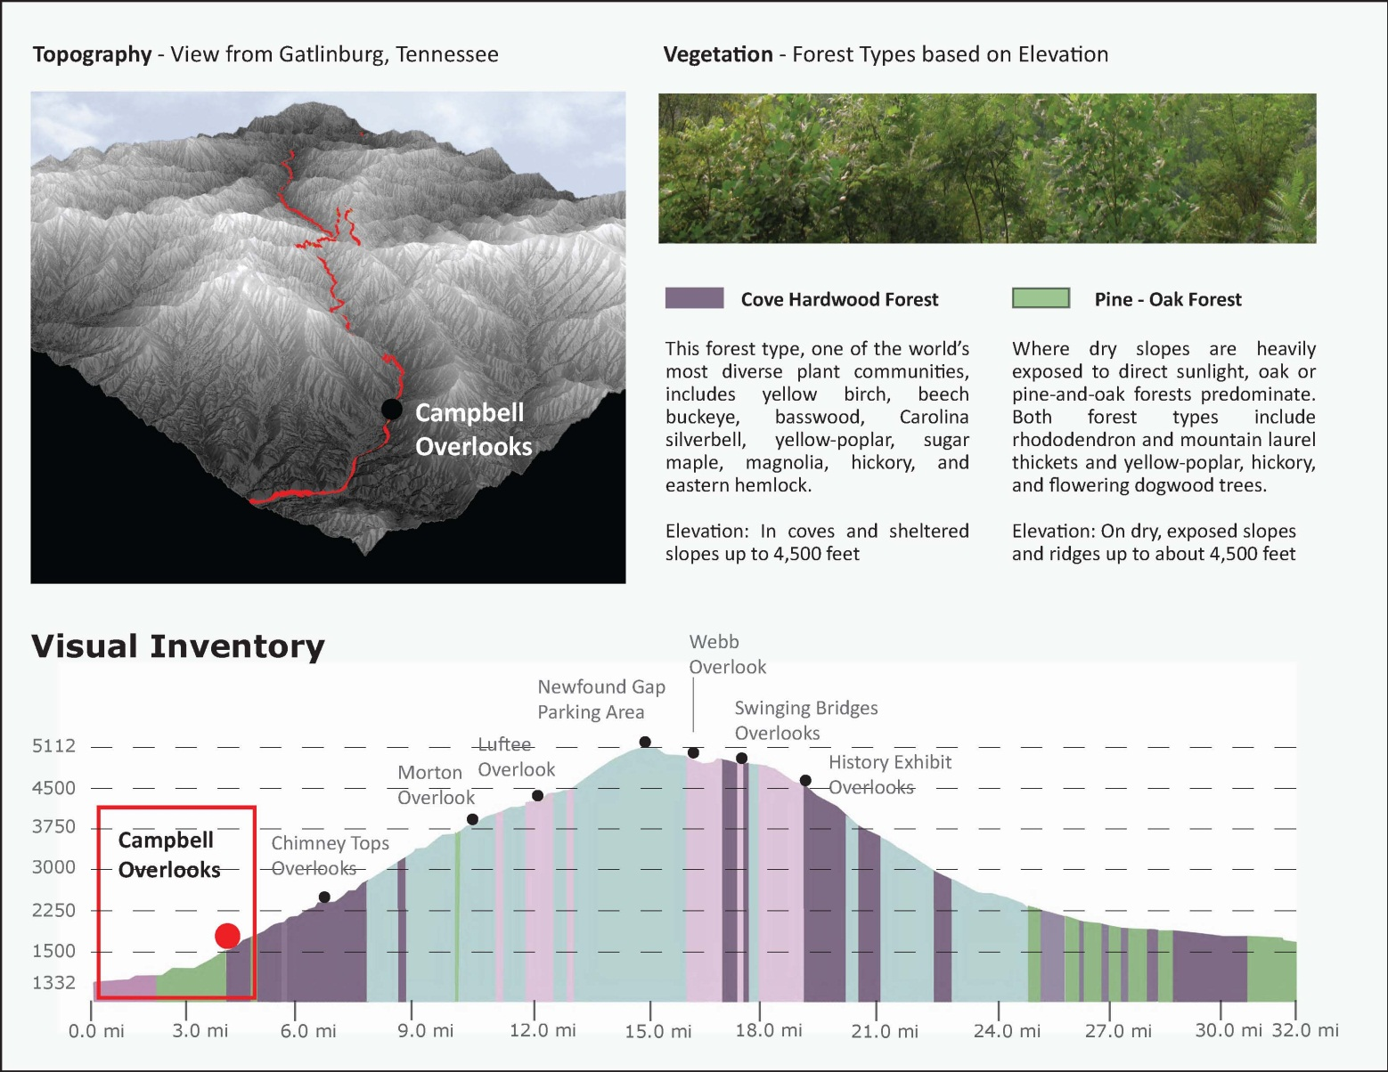
Figure 6.3: Vegetation and Topographical Profile for Campbell Overlooks

Figure 6.4: Vegetation and Topographical Profile for Newfound Gap Parking Area
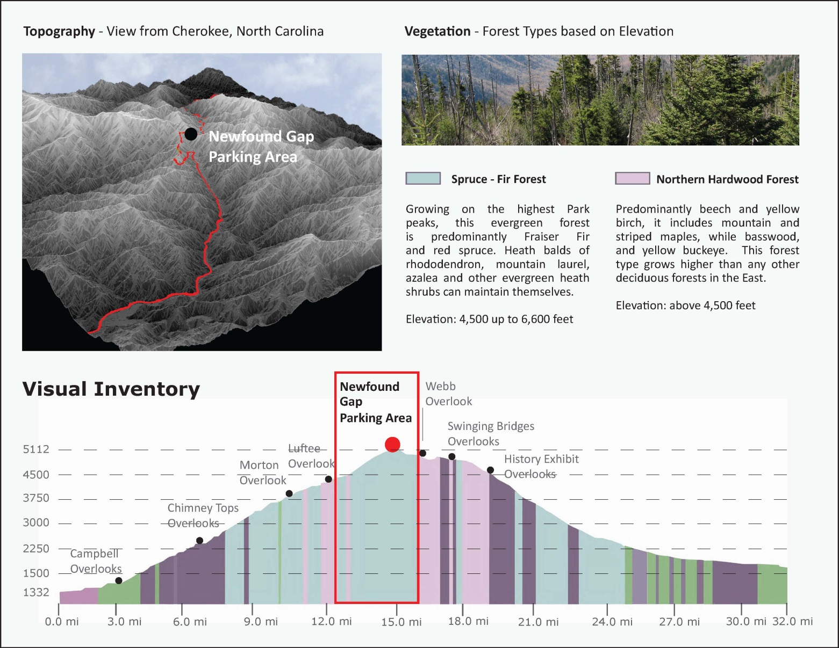
Visual Inventory

Research by Litton, Chaik, and Zube noted that that there is a high level of agreement between the visual perception of an average person and that of the professional, it can be assumed that the inventory’s results would be agreeable with the needs of the majority of people. Figure 6.5 applies this terminology to Campbell Overlook. Numerous vistas within Great Smoky Mountains National Park exhibit all of the aesthetic value criteria listed by Litton used in determining aesthetic values, visual values, and relationships in a landscape.
• vividness (memorability),
• intactness (relative apparent naturalness),
• encroachment (presence of degradation), and
• uniqueness (relative scarcity).
Many of the most memorable and unique views can be seen from Newfound Gap Road. Since the topography and vegetation varies throughout the Park, each vista requires a detailed management plan that outlines the specific techniques for maintaining each view, making vista management a cumulative effort.
This thesis used a rating system similar to the “Visual Management System (VMS)” introduced by Ribe, Armstrong, and Gobster. In this approach, VMS procedures established visual landscape protection and mitigated impacts to meet visual quality objective (VQO) design standards for projects that affect scenery, like vista clearing. Litton’s suggestion of using past landscape conditions as a visual base line was also incorporated, because it is important to understand the original intent of the vista. However, many vistas were previously managed as panoramic views without regard for plant communities who might inhabit the clearing as a part of natural succession.
This thesis evaluated the aesthetic quality of each view, the focal points in each view, and the significance of each vista. Next, each of the scenic qualities in each vista was evaluated, and the scenic beauty of the view was ranked from most scenic to least scenic. Finally, a rating system centered on the framework from analysis and the VMS model mentioned above, was used to categorize vista based on scenic quality: “A” vistas (most significant views), “B” vistas (significant views), and “C” vistas (common views). It was concluded that even though many vistas are in critical need of restoration, not all views should be reopened. Since the implementation of vistas within the Park, a number of viewsheds have been significantly impacted by ever-increasing development along the ridge lines and in the valleys outside the Park boundary. Other views were not to be reopened because the Park did not want to allocate the resources if other vistas could offer a better view of the same focal points. After the initial vista rating was complete, each category was reviewed by a team of Park staff that was assembled to ensure that the each vista recommendation would meet the Park’s current needs and that the vistas were not evaluated subjectively.

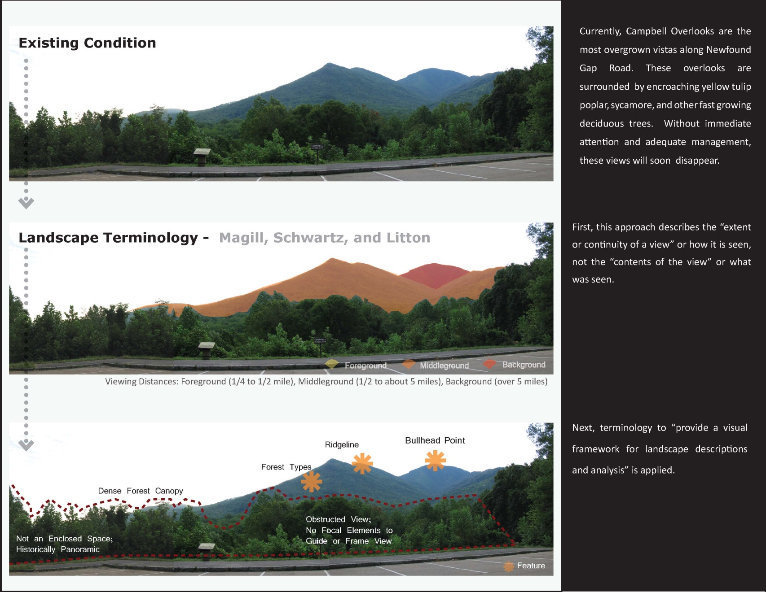
Figure 6.5: Vista Evaluation Process, Based on the Visual Management Systems Framework
Visual Simulations, Research, and Monitoring

Once the vista categories were approved by the Park’s vista management team, visual simulations were developed using the VMS research. These simulations depicted the probable results of selected clearing treatments such as “windowing” (restoring 1/3rd of the original panoramic view), “layering” (restoring 2/3rd of the original panoramic view), and “clearing” (restoring the original panoramic view). These clearing treatments were adapted from the vista management techniques used by Glacier National Park and a visual simulation methods developed in a study along the Blue Ridge Parkway. Figure 6.6 applies these clearing treatments to one of the Campbell Overlooks. After viewing all of the simulations, a preferred alternative was chosen. The layering technique was selected because only 2/3rds of the vegetation needed to be removed in order to restore all of the intended viewpoints. This treatment should also encourage the wild grape vine on site to flourish and dominate the clearing. These clearings should continue to be monitored to ensure that no further changes needed to be made to the management plan and that any unforeseen impacts would be resolved. According to research of other national park vista management plans, vista management should be cyclic to prevent large re-clearings from being necessary.

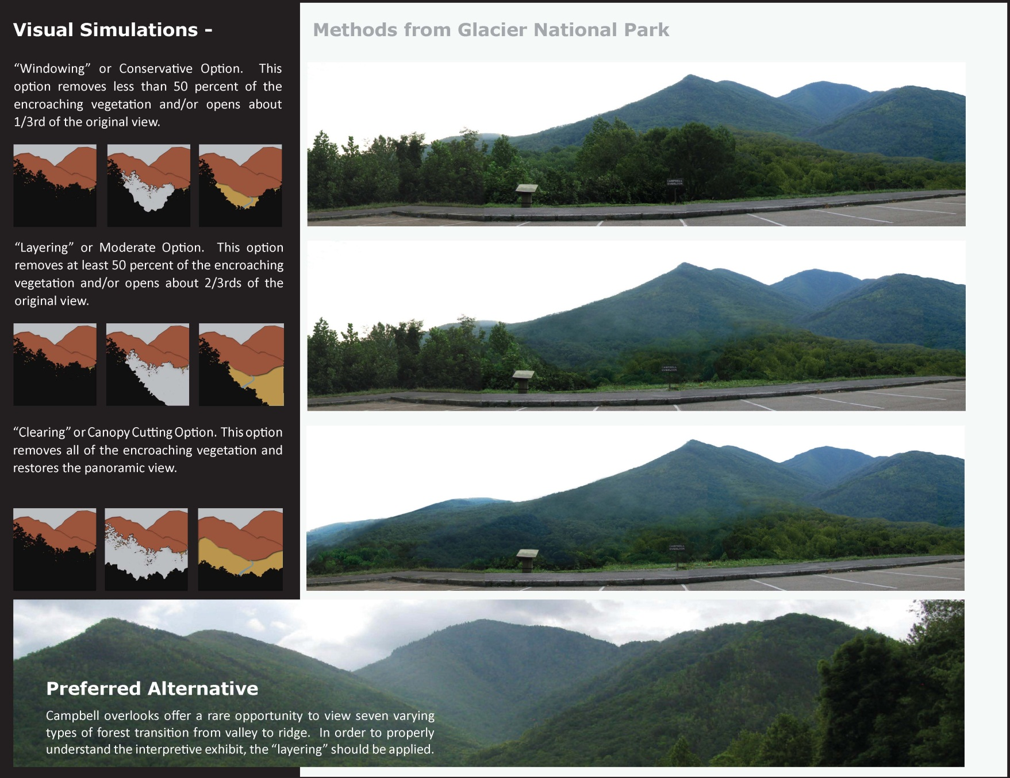
Figure 6.6: Vista Simulations, Based on the Visual Management Systems Framework
Visual Predictions

Another set of visual simulations, called visual impact predictions, for each vista were created to determine what changes might occur over the next several years. These visual predications revealed the pros and cons of three clearing alternatives for Campbell Overlook and one clearing alternative for Newfound Gap Parking Area. Positive impacts included removing encroaching vegetation to reveal the opposing peaks and valley, view of the river, increased sunlight for lower growing flowering shrubs, and an increased food supply for animals by encouraging fruiting plants. Negative impacts included the disturbance of a natural ecosystem and temporary unpleasant appearance of the clearing until a new ecosystem could be established. Potential impacts could be erosion, accidental release of chemicals into waterways (herbicide, gas, geological disturbance), and more invasive plants with the increase of sunlight.
The vista recommendation for Newfound Gap Parking Area required significantly less clearing, the visual impact predications only revealed one practical alternative. By selectively removing trees that were obstructing the view and treating the stump with herbicide, the view should be preserved for years to come. Minimal work would be needed cyclically to maintain this clearing. Positive impacts included a panoramic view of mountain ranges to the horizon. Negative impacts included loss of possible flying squirrel habitat, although the amount of possible habitat to be removed is so small, this impact is negligible. Since the clearing will be done at the top of Newfound Gap and herbicide will be used in such small amounts, it is doubtful chemicals will enter the waterways.
If a majority of changes were beneficial, and there were no significant negative impacts, then the treatment would become a practical alternative to the exciting condition. From these results, a preferred alternative was agreed upon by the Park team, and detailed landscape prescriptions or recommendations for vista management were developed.

Visual predictions identified special landscape compositions, exposed surrounding influences and conditions, and revealed the unit’s context and location in a larger environment and possible impacts to the adjacent landscapes, both positive and negative (“red flags”). These impact predictions are valuable tools for landscape architects to use to show the proposed changes to the public and become review material for resource management. Figures 6.7, 6.8, 6.9, and 6.10 show these clearing predictions applied to one of the Campbell Overlooks.

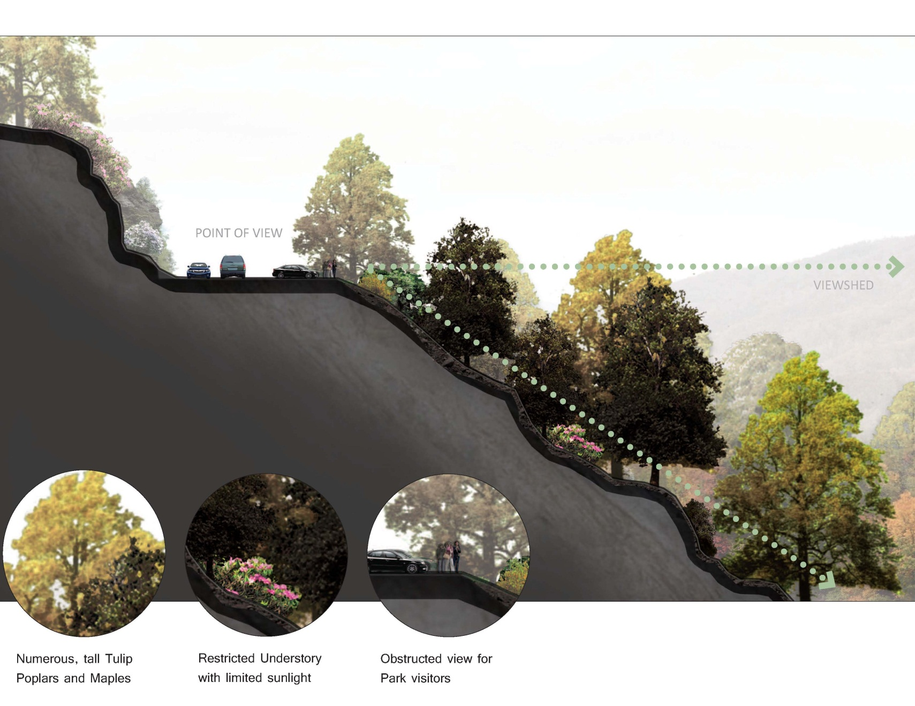
Figure 6.7: Vista Predictions – Existing Condition, Based on the Visual Management Systems Framework
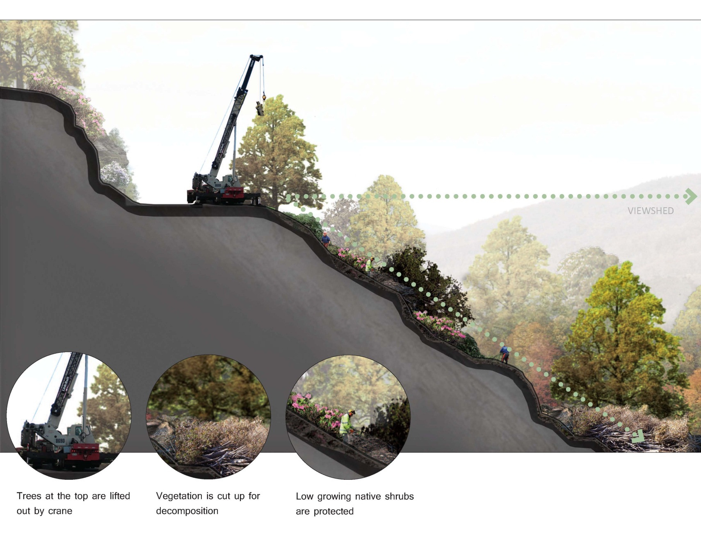
Figure 6.8: Vista Predictions – Establishing the Clearing, Based on the Visual Management Systems Framework

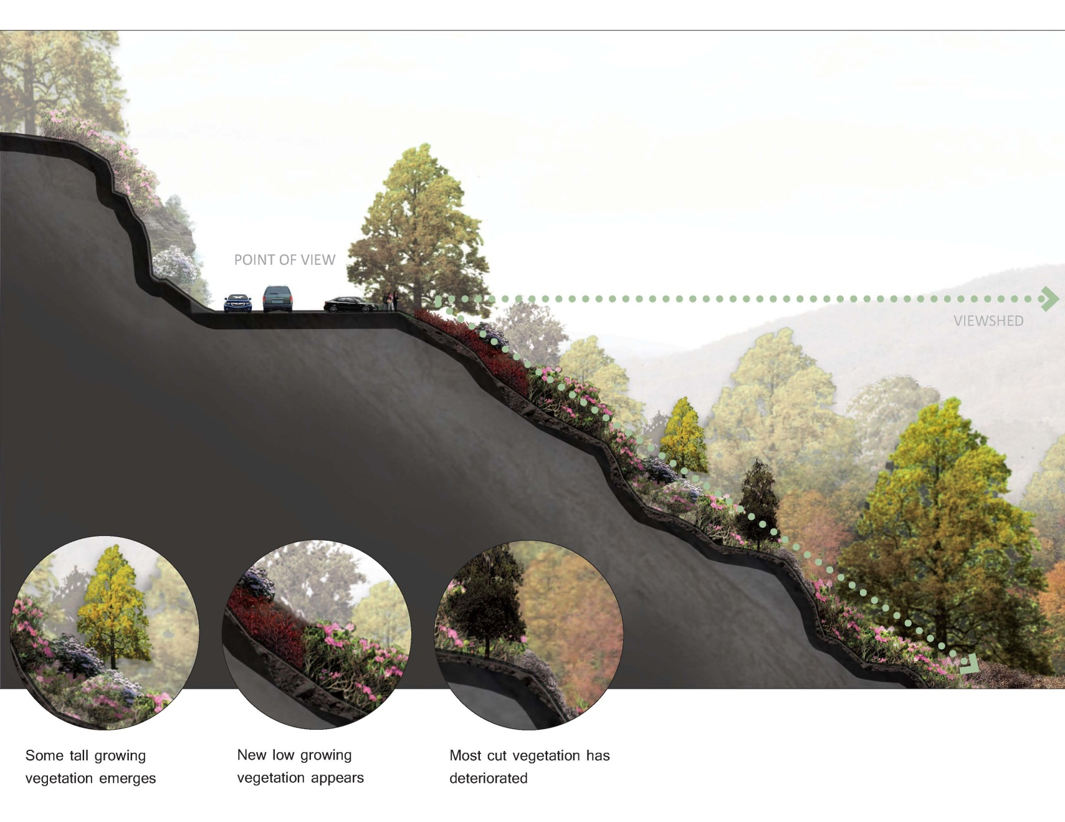
Figure 6.9: Vista Predictions – Encouraging Low Growth, Based on the Visual Management Systems Framework

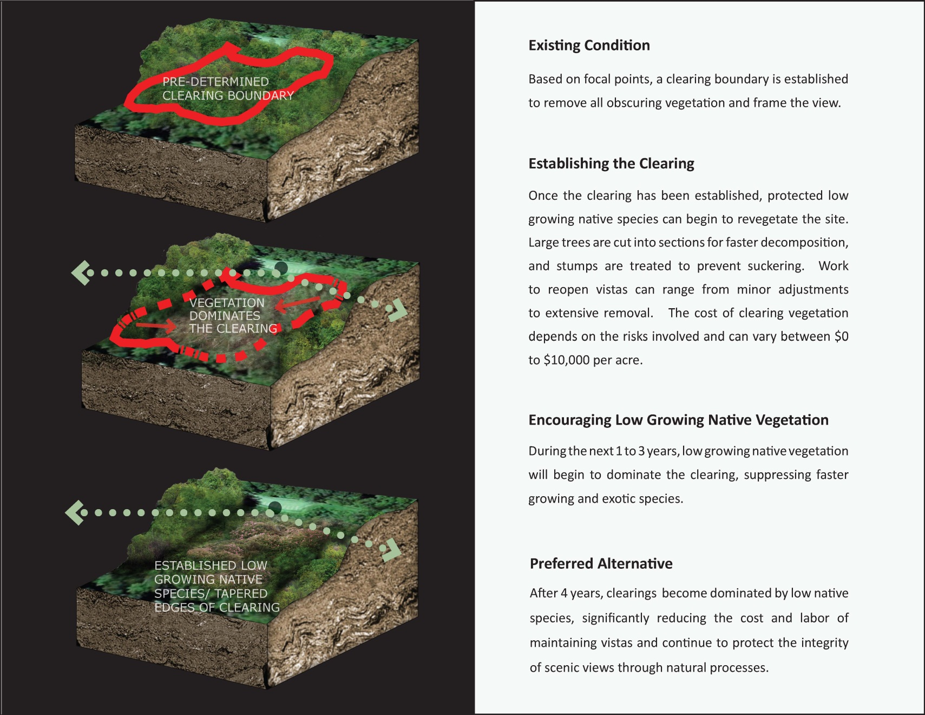
Figure 6.10: Vista Predictions - Process, Based on the Visual Management Systems Framework

Chapter 7

Conclusions and Recommendations

There is a fundamental need to address important vistas throughout the National Park Service (NPS), specifically Great Smoky Mountains National Park, that have not been adequately maintained for decades. The long term goals of vista management are to create places for people to observe, interpret, and enjoy iconic natural landscapes. To be successful, these areas must be maintained in a way that will be beneficial to the Park, its visitors, and the native flora and fauna. According to Litton’s description of the range of landscape planning and design, vistas are considered to be alterations or modifications of the landscape, which is about the middle ground between natural and man-made.
Typical Park vista management consisted of ad hoc vegetation removal and does not address additional ways to manage the clearing in the future. Because of the long growing season and the ideal growing environment for most plants, vistas are frequently obstructed again within a few years. According to Tetlow and Sheppard more flexible methods are needed to address more comprehensive information and to relate to specific landscapes and their inherent qualities. The recommendations in this thesis replaced the Park’s current ad hoc approach to scenic vista management with a cyclic, comprehensive strategy, which allowed the Park to resolve both recreational and ecological concerns with sustainable solutions.
First, by encouraging native low growing shrubs that already exist on site to inhibit regrowth and utilizing the selective use of herbicide, these vista clearings should be nearly self-sustaining, requiring minimal vegetation removal every seven years. Several desirable low growing plants on site are allelopathic, allowing them to naturally inhibit the growth of other species and create dense stands of shrubs, like rhododendron balds that already occur naturally in the Park. These recommendations also optimized the growing conditions for sensitive/rare species, and other native flora/fauna, as several threatened and endangered species would benefit from the increased sunlight. One of the region’s largest populations of yellow ladies-slipper orchid (Cypripedium calceolus), an endangered plant species, thrives on a vista clearing along Newfound Gap Road. It can be assumed that since vista management has been positive for this species in the past, it can be positive for many other species as well. Through the selective use of herbicide and encouragement of allelopathic plants and low growing vegetation to inhibit regrowth within the vista, the Park should be able to keep up with the minimal maintenance required to preserve the view. Figure 7.1 provides additional information on the allelopathic plants and other methods used to inhibit regrowth of taller tree species. These low growing native plants are not only sustainable because they already inhabit the site, they should provide an aesthetic frame to many of the Park’s vistas.

Figure 7.1: Inhibiting Regrowth of Taller Tree Species, Based on Research and Data Collected in the Park.

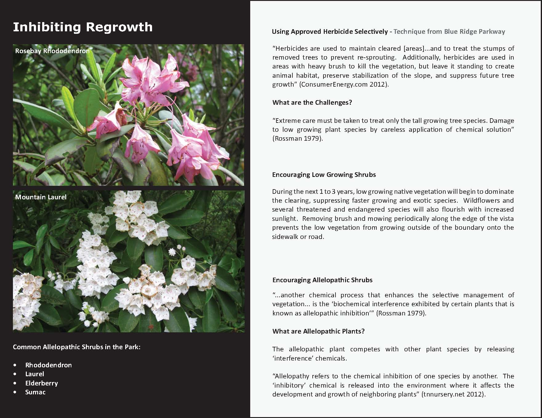
Second, in order to facilitate adequate vista management, special attention must be given to the size and treatment of the clearing, and an effort should be made to mimic natural openings that result from tree falls or other natural processes. This means that the vegetation management should gradually diminish in intensity as the clearing moves outwards from the overlook to mimic the appearance of a naturally occurring clearing boundary. This vista management recommendation should allow Great Smoky Mountains National Park to maintain vistas on a seven year cycle instead of the Blue Ridge Parkway’s cycle of three, six, and nine years. By reducing the amount of future clearing that will be needed, and the workforce necessary to complete this work, the Park will save millions of dollars in the upcoming years.
However, once these clearings are established with low growing vegetation, further monitoring must be done. By monitoring these clearings over a period of seven years (it is assumed it will take seven years for tree species to grow tall enough to impact the view), it will be possible to track the rate of regrowth of both desired and undesired plants within the clearing and alter or confirm the suggested cyclic vista management frequency. Litton suggested that monitoring and revisions to plans would be necessary, and that landscape analyses should be maintained to keep track of the dynamics of the change, including outside influences such as fire, natural disasters, and insect infestation.
Research and analysis of historic park documents and current vista conditions have led to the development of clearly outlined recommendations that meet the Park’s long term goals and specifically addressed the challenges at each vista. Figure 7.2 reveals a possible view of one of the Campbell Overlooks after vista has been reopened. This analysis framework has been designed to be easily adapted to address vista management issues Park wide and even throughout the National Park System. The solutions developed through this framework are financially beneficial for the Park with its limited resources, provide visitors with long term vista opportunities, and allow new ecosystems mimicking naturally occurring clearings of desirable native plants to flourish.

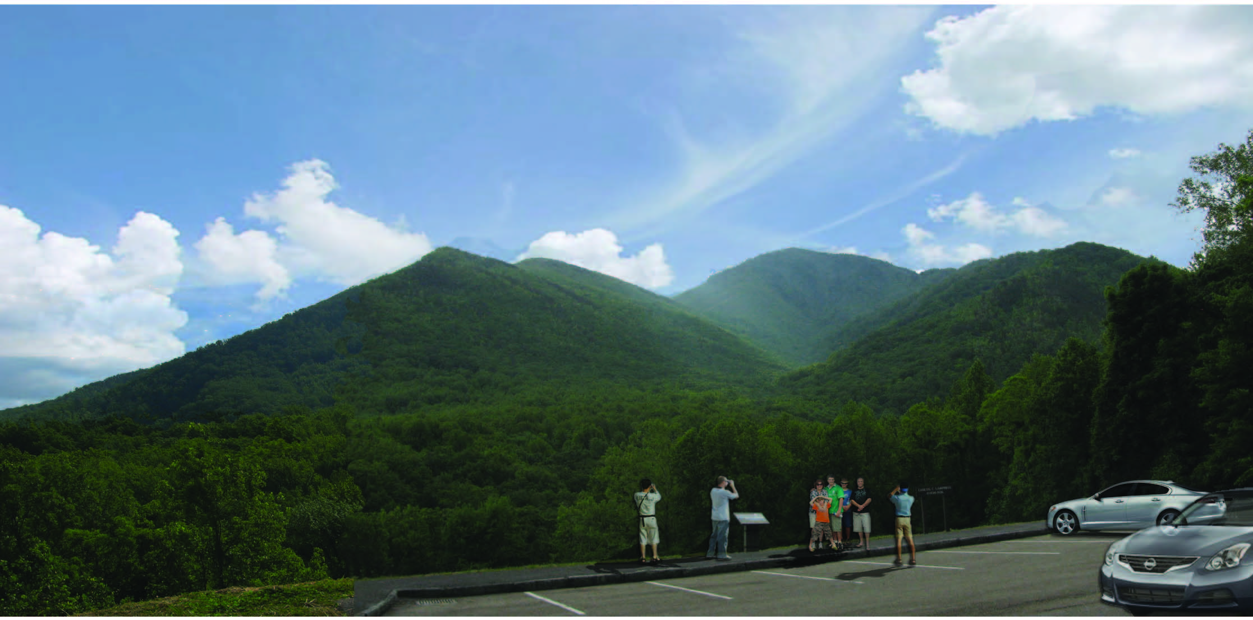

Figure 7.2: Potential View from one of the Campbell Overlooks, Based on Visual Simulations.

LIST OF REFERENCES

Carr, Ethan. Wilderness by Design: Landscape Architecture and the National
Park Service. Lincoln, Neb.: University of Nebraska, 1998. Print.

Chenoweth, Richard E., and Paul H. Gobster. "The Nature and Ecology of
Aesthetic Experiences in the Landscape." Landscape Journal 9.1 (1990): 1-8. Print.

DeLaughter, Jerry, and Rebecca Burks. Smokies Road Guide. Gatlinburg, TN:
Great Smoky Mountains Association, 2004. Print.

Dorwart, Cathrine E., Roger L. Moore, and Yu-Fai Leung. "Visitor Employed
Photography: Its Potential and Use in Evaluating Visitors' Perceptions of Resource Impacts in Trail and Park Settings." Proceedings of the 2006 Northeastern Recreation Research Symposium P-14 GTR.NRS (2006): 307-315. Print.

Foresta, Ronald A. America's National Parks and Their Keepers. Washington,
D.C.: Resources for the Future, 1984. Print.

Forster, Richard R. Planning for Man and Nature in National Parks: Reconciling
Perpetuation and Use. Morges: International Union for Conservation of Nature and Natural Resources, 1973. Print.

Litton, R. Burton. "Descriptive Approaches to Landscape Analysis." National
Conference on Applied Techniques for Analysis and Management of the Visual Resource (1979): 77-87. Print.

Louter, David. Windshield Wilderness: Cars, Roads, and Nature in Washington's
National Parks. Seattle: University of Washington, 2006. Print.

Magill, Arthur W., and Charles Fredrick. Schwarz. Searching for the Value of a
View. [Berkeley, Calif.]: U.S. Dept. of Agriculture, Forest Service, Pacific Southwest Forest and Range Experiment Station, 1989. Print.

McClelland, Linda Flint. Building the National Parks: Historic Landscape Design
and Construction. Baltimore, MD: Johns Hopkins UP, 1998. Print.

McClelland, Linda Flint. Presenting Nature: The Historic Landscape Design of the
National Park Service, 1916 to 1942. Washington, D.C.: U.S. Dept. of the Interior, National Park Service, Cultural Resources, Interagency Resources Division, National Register of Historic Places, 1993. Print.

Noe, Francis P., and William E. Hammitt. Visual Preferences of Travelers along
the Blue Ridge Parkway. Washington, D.C.: U.S. Dept. of Interior, National Park Service, 1988. Print.

Ribe, R. G., E. T. Armstrong, and P. H. Gobster. "Scenic Vistas and the
Changing Policy Landscape: Visualizing and Testing the Role of Visual Resources in Ecosystem Management." Landscape Journal 21.1 (2002): 42-66. Print.

Sellars, Richard West. Preserving Nature in the National Parks: A History. New
Haven: Yale UP, 1997. Print.

Sutter, Paul. Driven Wild: How the Fight against Automobiles Launched the
Modern Wilderness Movement. Seattle: University of Washington, 2002. Print.

Tetlow, R. J., and S. R.J. Sheppard. "Visual Unit Analysis: A Descriptive
Approach to Landscape Assessment." National Conference on Applied Techniques for Analysis and Management of the Visual Resource (1979): 117-124. Print.

APPENDIX

Literature Review

A Critique of Roadways in National Parks

Windshield Wilderness

In his book, Windshield Wilderness, “David Louter…used the three great national parks of the state of Washington to produce an invaluable case study of the radical shifts in attitudes toward automobiles that affected most national parks in the United States over the course of the twentieth century”. In the beginning of the book, William Cronon introduces Louter’s core argument as an investigation “about the changing role of automobiles in the twentieth-century American experience of wild nature and the history it explore…of parks and wild places all across the nation” (IX).
Louter uses the ironic phrase “windshield wilderness” to discuss how people can “experience” nature in national parks through car-based tourism. He describes how “Early park managers actively embraced the automobile as an ideal way to expose a growing number of Americans to wild nature. Roads were carefully designed to provide a beautifully unfolding series of views…the windshield in effect serving as the screen in which images of wild nature were projected for maximum visual impact” (XI). Funding from the New Deal in conjunction with cheap labor from the Civilian Conservation Corps (CCC) lead to the explosion of highways leading to and around the national parks. Louter explains that, “When the National Park Service was created in 1916 as the agency with primary responsibility for managing parks, its first and second directors, Stephen Mather and Horace Albright, put enormous energy into promoting parks and encouraging as many people as possible to visit them” (X). This initiative made national parks greatly accessible to middle class Americans, shortening the travel time and distance. Louter goes on to explain how “Parks were not only reservoirs of wilderness, characterized by an uninhabited, pristine nature, to which Americans retreated to escape their urban-industrial lives. They were also landscapes in which people could engage wilderness in a new way, in which automobiles and highways seemed to be mutually beneficial” (5).
Louter reveals that in 1930 a group of activists, concerned by the rapid proliferation of infrastructure within wilderness areas, would form the Wilderness Society. Their belief that national parks were becoming “too accessible to automobiles” would result in the establishment of regulations that would guide future development in national parks. As development within national parks progressed, roads would be designed to created views into wilderness, no longer directly cutting through it.
Throughout the book, Louter examines the national park’s “classic struggle driven by the management paradox of preservation and use” (9). He acknowledges that, “Beginning in the late 1960s, the Park Service approached a rather daunting task for an agency wedded to the idea that wilderness was a scenic experience viewed from the road. The agency had to convey to a public, few of whom would never step out of their cars into the backcountry, the significance of the wilderness park they could not see” (7). This is a struggle that continues today as millions of visitors continue use roads and highways within national parks to experiencing “nature”, and nature continues to decline as levels man-made pollutants continues to rise.
In conclusion, Louter explains that “…the narrative proposed here suggests that many Americans do not have as strict a definition of wilderness. They like ‘wild’ nature but less restrictive about its meaning. To many traveling Americans, national parks represent – in the past as well as the present – their expectations about and experiences with a wild landscape; ‘wilderness’ in this sense is something they encountered while driving” (8).

Wilderness by Design

“’There is nothing so American as our national parks,’ Franklin Roosevelt exclaimed… ‘The fundamental idea’ behind them, he suggested, was ‘that the country belongs to the people; that what it is and what it is in the process of making is for the enrichment of the lives of all of us. This the parks stand as the outward symbol of this great human principle” (303).

In Ethan Carr’s book, “Wilderness by Design”, he discusses the need for national parks in an effort to preserve wilderness from uncontrolled urban development. Carr believes, “Neither pure wilderness nor mere artifact, the national park is the purest manifestation of the peculiarly American genius which sought to reconcile a people obsessed with progress with the unmatched price paid for that advance: the near total loss of the North American wilderness” (9). The author examines the extensive history and relationships between American culture, natural places, national parks, and landscape architecture. In the beginning Carr describes the cultural value that is invested in natural places. He explains that
“…landscape architecture does not immediately come to mind when considering national parks; national parks are, after all, great wilderness preserved, valued primarily for their primeval qualities. The roads, trails, overlooks, and other carefully planned and designed works of landscape architecture that convey us through and mediate our experience with those larger landscapes are often taken for granted – quite understandably – in the presence of the awesome drama of a Grand Canyon or Mount Rainier” (9).
Parks were always intended to be people spaces, carefully planned by landscape architects. Vistas and overlooks were deliberately placed along skillfully designed scenic roads, to reveal but not dictate the importance of nature to the park visitor. As important as preserved nature is to the park, the author discusses how the “The history of the parks as natural resource and biological reserves similarly has overshadowed the history of their physical development” (pg. 9). Carr argues that Park development has typically been viewed as “a necessary evil in otherwise ‘Edenic’ settings” (9). Since these spaces designed for people needed to be easily accessible to the typical visitor, roads had to be built, and formal infrastructure such as visitor centers, bridges, tunnels, and overlooks had to be developed. In an effort to control this development, most of the parks’ infrastructure, especially in eastern national parks was restricted to key corridors. Many vistas are solely located along these corridors, and are the only views of preserved nature most visitors see. The author reinforces this notion by revealing Fredrick Law Olmsted, Jr.’s idea, that
“it is the cultural value invested in natural places through their physical development as parks that best assures the preservation of those places in a relatively natural state. The designed landscape in national and state parks, as works of art, directly express the value of social invests in preserving and appreciating natural areas” (pg. 9).
The physical development of the NPS was never meant to detract or dominate the natural beauty that already existed in wilderness areas. Much of the later development in parks aimed to restrict public access, preventing uncontrolled access to natural areas.

The Influence of Landscape Architecture on National Parks

Ethan Carr explains that park design and landscape architecture has been figured in national park history since the 19th century. “By the time Stephen Mather became the first director of the National Park Service in 1917, the term ‘park development’ had come to imply certain aesthetic values, and even suggested specific landscape design features” (6). The author explains that Mather consulted landscape architects such as Fredrick Law Olmsted, Jr., “as experts who could provide not only professional design services, but expert validation as well, analogous (in more artistic vein) to the scientific expertise provided by Pinchot’s forests. Landscape architects subsequently planned the physical development of national parks from the earliest days of the National Park Service” (pg. 6).
Carr describes how the history of national parks developed of course when the federal government first set aside preserved wilderness areas to protect the public health and recreation opportunities they offer to so many Americans who live in densely populated urban areas. He discusses how the social and geography variety of tourism broadened rapidly in the early 20th century, as many middle class Americans began to enjoy a two-day weekend and the two-week vacation for the first time, with the increase availability of hotel accommodations and other services. Carr states that former luxuries – including the automobile – were now affordable to most of the general public. He explains that these changes opened the American countryside to middle class tourists like never before. The author reveals as the public became more mobile, they began looking for Sunday outing destinations or summer vacation opportunities. These tourists began to swarm into remotely scenic areas that were nearly inaccessible a generation earlier. He describes how auto touring in national parks became popular as soon as it was feasible.
“As the annual number of national visitors climbed during the 1920s from thousands to millions, the increase was taken up almost entirely by people arriving in cars. These tourists needed campgrounds, parking lots, decentralized conveniences, and park drives with frequent scenic overlooks, modernized alignments, and increased lane widths. Without these improvements, multitudes of campers would easily mar or destroy the landscape beauty they came to admire” (7).
Carr explains that between World War I and World War II, the National Park Service modernized and developed extensively. “It was during this era that the ‘developed areas’ in national parks (and in many state and local parks as well) acquired the consistent appearance, character, and level of convenience that most visitors have sine come to associate, almost unconsciously, with their park experience of park scenery, wildlife, and wilderness” (7-8). Landscape architects and engineers were employed to design countless scenic roads, campgrounds, administrative “villages”, resulting in the most intensive human alternations in National Park Service history. Carr acknowledges that “this may seem a paradox since many people intuitively reject the importance of human design in an environment valued primarily for its pristine, natural condition” (1). Even though there is no comparison between park design and the natural wonders of national parks, the author argues that there is an obvious significance in how landscape architecture impacts the way these natural features are appreciated, “not in the creation of alternative attractions. Designed landscapes guide the experience of many park visitors and enhance their appreciation of the vast wilderness beyond” (1). For example, Carr reveals that roads and trails were placed strategically to reveal a specific sequence of vistas. All designed sections of the park – campgrounds, visitor facilities, and scenic overlooks – have shaped the “overall pattern of public activities and frame visual encounters with the awesome (and certainly “undersigned”) scenery of the larger park landscape” (1). The author explains that the importance of landscape architecture in national park history can be seen in the visitor’s experience and appreciation of the park. Carr argues that
“For most visitors, even today, the emotional enjoyment achieved through the appreciation of landscape beauty is not an inevitable, accidental, or haphazard affair. The designed landscapes within the park choreograph visitors’ movements and define the pace and sequence of much of their experience. The designed landscapes mediate between the individual and the vast terrain of the backcountry. Wilderness and designed landscapes together generate the aesthetic appreciation of landscapes and emotional communion with the natural world which, at least historically, the word ‘park’ implied” (pg. 1).
The author discusses how many historians have commented on the ‘dual’ or ‘contradictory’ directive in the 1916 Act of Congress that official established the National Park Service. Carr reveals that the most quoted portion of this ordinance is the purpose of national parks: ‘to conserve the scenery and the natural and historic objects and the wild life therein and to provide for the enjoyment of the same in such a manner and by such means as will leave them unimpaired for future generations’. Carr explains that Fredrick Law Olmsted, Jr., a landscape architect immersed in the tradition of Park design, drafted this portion of the legislation. To Olmsted, there was no inherent inconsistency in conserving a place through its strategic development as a park. Carr points out that without thoughtful planning – carefully designed roads, discernible trails, adequate facilities, and permanent campgrounds – the destruction of the fragile environment caused by visitors would be compounded dramatically. He goes on to explain that “Olmsted knew that bringing people into parks and facilitating their appreciation of the flora, fauna, and scenic beauty to be found there was the surest means of building a public constituency for preserving such places in a relatively ‘unimpaired’ state’” (2). The author explains that by the mid-1920s, other Park service landscape architects such as Daniel R. Hull and Thomas C. Vint began working with other architects and engineer. Like Olmsted, they had initiated a characteristic and original style of national park development that responded to the practical necessity for modernizing park facilities, while remaining firmly rooted in the theory and practice of American landscape park design (2-3).

The Cultural Value Placed on Scenic Landscape Beauty

Carr explains that since the 1820s, tourism, painting, and literature had come together in a “common fascination for the description and celebration of American landscape scenes, from the Hudson River eventually to the Far West” (11). American leaders aimed to strengthen the public’s sense of nationalism by identifying the young country with its unmatched natural landscape. However, the author reveals that the persistent longing to see and appreciate scenery did not originate from cultural nationalism alone.
“The interpretation of geographic features into landscape scenes – which the historian Christopher Hussey describes as ‘picturesque vision’ – implied a broad cultural basis and aesthetic tradition for understanding places as pictures, and seeing land as landscape” (pg. 11)
Carr describes how this cultural tradition of ‘seeing nature with the painter’s eye’ developed in Britain, shaped values and attitudes toward the appreciation and preservation of natural scenic landscape in American as well. He suggests that “the compositional rules of picturesque landscape aesthetics, combined with the technologies of land improvement, resulted in a powerful and flexible tool for altering landscapes for modern social and economic purposes” (15).
The author clarifies that even though parks often preserved scenic areas from the uncontrolled development and exploitation occurring around them, the park was still required to make essential alternations to the landscape it preserved. Carr explains that the park must interpret “a place as a view” – physically and conceptually – as well as convert land into landscape. This meant using modern management techniques and landscape analysis used by landscape architects to accomplish these goals. “Writing of the ‘power of scenery to affect men,’ Olmsted’s appreciation of landscape beauty remained consistent whether it was applied to the ‘landscape effects’ he sought to enhance” (27). The author reveals how the framework of American picturesque culture allowed landscape architects like Olmsted to imagine that “land could be set aside and managed specifically for the preservation and appreciation of scenic qualities conducive to interpretation according to certain aesthetic rules” (27). As urban development rapidly increased, park leaders and advocates agreed that special considerations had to be made if parks were to be preserved for the benefit of present and future generation. These early park planners argued that scenic preservation – the preservation of certain areas as parks based their scenic qualities – would only increase in importance.
“Whether appreciating the engineered scenes of landscape parks close to home or the less contrived beauty of more remote scenic areas, the visual grammar and aesthetic language needed to interpret places as pictures, and lands as landscape, remained constant for park visitor and regional tourist alike” (41).
Charles Eliot was one of the first to park planners to recognize that “the larger scenic reservations demanded a new balance of landscape development, forest management, and preservation of natural systems” (48). Eliot believed that if
“the 19th century…park had required extensive landscape engineering to produce desired picturesque effects, the 20th century scenic reservation often eliminated the need for heavy manipulation of topography and hydrology, since the reservation could be selected according to its existing scenic qualities. But the formal features and engineering techniques developed earlier in…landscape park designs were adapted as needed in the more limited development of scenic reservations”.
Carr explains that Eliot was a major proponent for maintaining vistas within national parks for this purpose. Like Olmsted and other landscape architects, Eliot was an advocate of careful development for the enjoyment of visitors. Eliot once said that “Such paths or roads as will be needed to make the scenery accessible will be mere slender threads of graded surface winding over and among the huge natural forms of the ground” (48). One of Eliot’s most influential stances on park design was his belief that vegetation must be controlled if vistas were to be adequately maintained.

Necessity of Managing Vistas

According to Carr, vistas are the “necessary middle ground: the mediation between the American automotive tourist and the vast reservoirs of natural resources and national imagination that are our state and national parks” (93).
Charles Eliot and others encouraged the selected cutting or trimming of forests and other vegetation, based on the aesthetic desirability of the vista. Eliot argued that “vegetation in the reservations is an exceedingly important component part of the scenery”, however, he conclude that if vegetation was allowed to grow unrestricted it would result in a “continuous interference with natural process by men, fire, and browsing animals’” (49). In other words,
“Eliot believed that ‘to preserve existing beauty, grass-lands must continue to be mowed or pastured annually, trees must be removed from shrubberies, competing trees must be kept away from veteran oaks and chestnuts, and so on…To prepare for increasing the interest and beauty of the scenery, work must be directed to removing screens of foliage, to open vistas through ‘notches’, to substituting low growing cover for high woods, and to other like operations’” (49).
Carr reveals that many other landscape architects and park official shared Eliot’s conviction of protecting for the visual experience of regional landscape scenery. These park leaders and planners believed that
“If scenic views were lost or impaired through the growth of vegetation, the public would miss an important aspect of its experience of the place. Keeping vistas open from roads, paths, and overlooks therefore figured in management plans. Landscape management otherwise was kept as inconspicuous as possible, and physical development exhibited a character appropriate to the character of what were often wooded, relatively secluded landscapes” (49).
It was understood by many park planners the benefits of forest improvement and vista thinning projects. A few parks had already undertaken several improvement projects with outstanding results. However, it was agreed that “the guiding principle is that the natural conditions of the parks must be disturbed as little as possible consistent with necessary development in the public interest” (88). Forest and vista improvement activities highlighted by Charles Eliot in early park management were essential to protect important scenic views from disappearing behind dense stands of vegetation. Carr suggests that vistas are one of the most important landmarks of landscape architecture in the history of American park design.

A Critique of Visual Management

The Role of Visual Resources in Ecosystem Management

In the article, “The Role of Visual Resources in Ecosystem Management”, authors Ribe, Gobster, and Armstrong introduce issues in “forest aesthetics and the shifting policy landscape” by revealing that the public became aware of the “visual spoils created by ‘cut and run’ loggers” in the early 20th century (44). The public’s outcry for better management policies spurred the creation of the national forests and national parks. In an effort avoid creating unaesthetic clearings, the Forest Service has introduced the “Visual Management System (VMS) to assign a visual quality objective (VQO) to every area of land, setting a level of scenic protection” (44). The authors explain that the VMS procedures establish visual landscape protection and mitigate impacts to meet VQO design standards for projects that affect scenery, like clear cutting and harvesting. For the past 20 years, the National Forest Management Act (NFMA) in 1976, has been responsible for limiting the size of clearcuts, distributing them further apart, and creating “more naturally-appearing clearcut designs in more scenic and visually sensitive places” (44). The authors emphasize that “ecosystem management should change how scenic management plays out in the landscape, especially where scenic protection is at its weakest” (45). This suggests that collaboration between new aesthetic policies and new public land management paradigms would present numerous opportunities to incorporate ecology with aesthetics.
The authors explain that the study “derived and analyzed scenic perceptions of one simulated, authentic pattern of landscape change to explore potential scenic impacts” (47). This analysis helps researchers locate areas for potential harvesting and create cleared areas that mimic natural fire disturbance patterns. Phase 1 of the experiment addresses the “visualizing and modeling policy- induced change” and “simulating future forest cover” (47). Photographs were taken frequently to reveal the vista views within the study area and beyond. For each photo a corresponding photo-simulation was produced to reveal the same seen 20 years into the future. Fifteen scenes were selected to reveal a range in size and landscape appearance. Each photo was listed by vista scale, distance zones (foreground/middleground/background), and the characteristics it was selected for. Phase 2 evaluated the scenic qualities. Phase 3 created “models to create changes in scenic beauty” (53). The authors reveal that the focus of the photo analyses was to improve the “scenic beauty in pertinent vista views…where policy produced low beauty” (53).
The results of the before and after photo study reveal that the most favorable improvements were toward harvest reductions in large to medium size vistas. The authors conclude by explain that even though new biocentric paradigms are in place to improve the scenic quality of landscapes, visual resource management is still necessary to assure this outcome. They also argue that “Landscape architecture is still needed to mitigate the scenic impact of foreground harvests, even with green-tree retention” (59). In time, this new ecosystem management may prove to be a valuable asset in reducing conflicts between the public and professionals, enable managers to preserve traditional scenic values, and allow landscape architects to improve scenically challenged locations in nature.
By addressing the specific challenges of maintain scenic beauty in areas that have a utilitarian agenda, formal vista management plans can be created. The authors discuss, in great detail, the benefits and limitations of using visual simulations to reveal possible landscape changes. Using visual simulations are extremely beneficial anytime removing large amount of trees in a dense area such as vista clearing is proposed. This allows managers to understand all of the positive and negative impacts associated with clearing, and it allows the public to understand the process behind the decision. The authors stress the need for landscape architects in land management to ensure that the results of the project meet the public’s expectations and perceptions of scenic beauty.

Searching for the Value of a View

The USDA Forest Service paper entitled “Searching for the Value of a View” discusses the strong correlation between the view quality of a site and property values. The authors Arthur W. Magill and Charles F. Schwarz clearly assessed “the trade-offs between market and nonmarket products” by arguing that even though “scenic quality is a resource that is not quantifiable in monetary terms”, it can still be used to “define relative dollar values for physical dimensions and objects in a view” (i). This study examines the variables that describe the “extent or continuity of a view” not the “contents of the view”.
The authors used basic terms to describe the view content; “physical landscape features such as mountains, valleys, and lakes; vegetation types such as conifer or hardwood forests and meadows; and various constructed features such as roads, power lines, and buildings that might influence view quality” (2). The authors intended to describe “how the view was seen, not what was seen” (5). The terminology they used aimed to identify variables that contributed to the value of the view, not those that detracted from it. The authors define the view from the observer position to be inferior (observer looks up toward the view), normal (observer is level with the view), or superior (observer looks toward the view). The authors go on to outline view distance zones as: foreground (1/4 to 1/2 mile), middleground (1/2 to about 5 miles), and background (over 5 miles).
The paper also utilizes view composition types were used by Litton (1968) to “provide a visual framework for landscape descriptions and analysis” (5). These view types include:
- Panoramic (wide, unobstructed views – largely a horizontal view variable and describes a viewing situation)
- Feature (a dominant or distinctive object such as a lake, meadow, mountain, ridge, or peak – describes unspecified objects)
- Enclosed (strongly defined, contained spaces; e.g. a meadow surrounded by trees – describes the conditions of the site; not of the view)
- Focal (landscape elements focus attention; e.g. trees to the right and the left focus attention straight ahead – largely a horizontal view variable and describes a viewing situation)
- Canopied (under a forest canopy – describes the conditions of the site; not of the view)
The authors also used terms for natural view values. Some views were obstructed by either constructed objects (roads, buildings, power lines, etc.) or natural objects (existing trees or trees that grow into the view):
- Interrupted view (trees or buildings destroy the continuity of a relatively wide view)
- Filtered view (a view seen through trees stems or foliage not dense enough to block the view)
- Narrow view (a view greatly limited in width by trees, rocks, or buildings, directly in line of sight down a corridor)
- Unobstructed view (a view with no potential for becoming blocked)
The results of the study “suggest that landscape components cannot be used as indicators of the value of views” because the value “cannot be predicted from the relation between asking or selling prices of view lots and the land, water, and vegetation elements that define the landscape character” (5). The authors argue that value of the view can only be determined by removing the value of the site’s elements from the total price; this reduced price represents a site without a view. Once this new “non-view” price is subtracted from the original price, a relatively accurate view value is revealed. The authors believe this approach to reveal realistic results (5).

The study concludes by suggesting that the only way to determine the value of the view is by removing the market value from the site. A pilot test of this approach revealed that “visual quality judgments by natural resource professionals, ranging from no view to best view, are not related to real estate prices. Realtors typically assign lot prices increasing from ‘no view’ to ‘best view’” (8). However, the authors acknowledge that realtors are often influenced by their understanding of site conditions unrelated to the site’s scenic quality. They explain that view quality evaluations by the public are influenced by view premiums set by realtors and general scenic knowledge to assign relatively accurate monetary values for landscape views. The authors argue that “these values could be used to evaluate market and non-market trade-offs between alternative uses of ‘wildland’ resources” (8).
The authors’ approach to determining realistic view values was extremely easy to understand. However the scenic views or vistas within the national parks are priceless; typically revealing the most beautiful preserved nature left in America. Even though this topic does not address these vistas directly, the terminology, variables, and attributes used in this study will be extremely helpful in describing the view quality of scenic vistas.

Visitors' Perception and Preference of Natural Attributes

A qualitative study conducted by North Carolina State University examined “visitors’ perceptions and to determine how their perceptions affected over all recreational experiences along a 2.9 segment of the Appalachian Trail in the Great Smoky Mountains National Park” (307).
The paper begins by explaining how park and trail managers are usually responsible for both protecting natural resources and providing the appropriate public enjoyment of those resources. The authors address the responsibility of understanding the visitor perceptions and experiences through surveying, interviewing, and assessing written material.
The second part of the paper addresses the background of the study, noting that many previous studies of people’s “evaluations, conceptualizations, and relationships with the natural environment (in particular perception and preference in relation to experiences of nature, landscape, and the environment) have been guided by a landscape perception paradigm” (307). The authors argue that this paradigm helps identify why certain things like scenic views, pathway design, and social and environmental conditions are perceived as either negative or positive to the overall experience (307). They support this idea by stating that Ndubisi (2002) clarified that the study of landscape perception “seeks to understand human values and aesthetic experience in order to take them into account in creating and maintaining landscapes that are socially responsible and ecologically sound” (pg. 308). Essentially, the ideology of landscape perception is a belief that people prefer settings that meet their needs, function well, successfully interpreting their environment (Kaplan and Kaplan 1998). According to work by Taylor et. al. (1995), it is also necessary in environmental perception research to accept perception as a dynamic interaction between humans and the environment that is intricately “linked to the whole psychology of the observer and immersed in the environment that is experienced” (308).
In the VEP methods section of the paper the authors explain that their methods were adapted from previous VEP studies by Kim et. al. (2003), Lynn (2000), and Taylor et. al. (1995). The goal of this method was to capture the images of objects or locations in the environment that had the strongest influence on the visitor’s experience (310). They describe that the data was coded and counted for each photograph to determine which qualities of the trail (i.e. scenic vistas, trees, exposed roots, people, etc.) were photographed the most. Once this data had been coded, it was then categorized by attribute. The results revealed that both sets of photographs (attributes visitors liked and disliked) show similar perceptual themes —“nature-oriented details, scenic values, management influences, presence of other people, and depreciative behavior” (311).
Scenic values ranked second most important perceptual theme in the study. Previous research data supports this statement, revealing how “visitors prefer scenic vistas, restorative settings, and sites along the water’s edge. These elements seem to affect the perception of visitors’ surroundings and of the trail environment or landscape. One middle-aged male hiker—who had once visited this trail many years ago—found joy in the “high altitude vistas” writing, “It’s one of the reasons I chose this hike [for the] inspiration (hey I’m a pastor—inspiration is my business).” An older gentleman agreed. It is the “vista with [the] clouds… beautiful expansive views [I am] in awe…unfortunately you can hear the vehicles on the road below” (312). The authors continue by explaining the other perceptual themes in great detail. They discuss how using the visitor employed photography (VEP) approach gave the participants control of the situation and provided better results than previous methods. The authors argue that information on visitor perceptions is integral to carrying out both parts of the National Park Service’s mandate” (312) To improve natural resource management, it is essential that the National Park Service understand how visitors perceive nature so that they can identifying critical areas and designing better facilities to enhance the visitor’s experience.
This study confirms that visitors want to experience places with both functionality and purpose. Places that people can connect are generally the areas where people create the most memories and where they can interpret their surroundings. However, when these iconic places begin to suffer from insufficient planning and funding, the visitor experience deteriorates. The authors of this study (and previous studies) reveal that most people who visit the Great Smoky Mountains National Park, particularly trails along Newfound Gap, are particularly attracted to the nature oriented details and the scenic views. The study concludes by arguing that consideration must be given to visitor’s perceptions and preferences so that natural resources are both adequately protected and enjoyed.

Visual Unit Analysis and Scenic Distinction

In the article, authors Tetlow and Sheppard begin by stating that “This approach to describing scenic distinction, supplemented by graphic displays, permits comparison of visual attributes for the landscape units in a study area, supporting planning and design” (117). They explain that the intent of visual analysis is to ensure that visual qualities are given consideration during the process of environmental design and landscape management. However, various visual analysis methods have been developed to meet specific needs. “ the authors discuss how some methods are developed based on issues that relate to the general landscape or landscape in an indirect way (such as visibility assessment from static views), while others modify previous results or research. The authors argue that more flexible methods are needed to address more comprehensive information and to relate to specific landscapes and their inherent qualities. They suggest that the visual unit concept used in work by Litton and Shizowa (1971), and Tetlow (1975) would offer a “logical and useful framework for evaluation of the landscape, proposing its division into units which are coherent for planning or analysis purposes” (117).
The authors describe the visual unit as being “a portion of the landscape enclosed and limited by topography, bounding an observer’s field of view. That spatial enclosure enables the viewer to accumulate and form a unified impression of his surroundings (Tetlow and Shepard 1976). They explain that each unit has a “distinct visual character and a degree of unity”, and that its specific scenic distinction is created through the “combination of the landscape elements within and around it” (118). The authors discuss how these units are rarely completely enclosed, and that there are ‘portals’ or openings that function as thresholds into the view. Portals are significant dips in the skyline that provide access into and through the view, and allow the observer to visually orient themselves. Figure 2.1 illustrates the boundaries and portals associated with a visual unit.
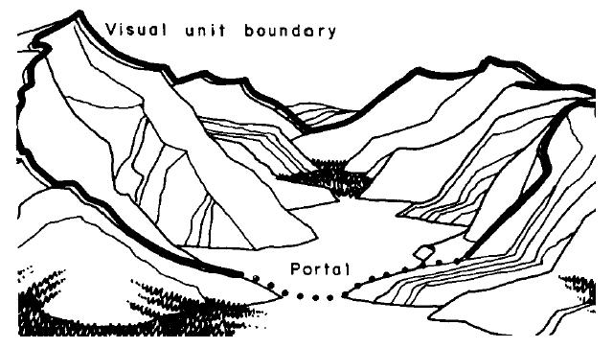

Appendix Figure 1.1 : Boundaries associated with a Visual Unit, Based on Tetlow and Sheppard framework.
Not all units have an easily apparent boundary; more commonly the boundary follows a complex high ground around the unit’s valley floor and upper slope. The authors suggest that even though most units are not enclosed, a “false” enclosure or rim can be used to intervene between the valley floor and the unit’s boundary. They define the rim as the extent of the view from valley floor to the upper slope before it the view becomes invisible or foreshortened. The illustration below is an example of the rims, vulnerability sectors, and visibility sectors of a view.
In the first part their scenic distinction rating, the authors explain that “mapped geographical arrangement of visual units and their portals indicates the sequence of differing landscapes to be seen along possible travel routes” (118). They also describe how scenic elements or individual features that contribute the scenic merit may be identified within or beyond the visual unit. Next, the authors discuss the key terms associated with visual unit mapping. Visibility sectors, minor variations in the landscape character or minor changes to the line of site, are used to subdivide the site into more complex visual units that provide specific information. Vulnerability sectors are the landscape’s potential “to absorb or be visually disturbed by man’s activities (Litton 1974)” (122).
Scenic distinction factors “describe the spatial dimensions and visual character of the unit, its water forms, its distinctive features and accents, its linkage with other units, and any degrading contrasts” (120). In the last section, the authors describe the actual scenic distinction rating system. They argue that units with indistinct enclosure and little visual variety receive a typically low distinction; units with defined topographic enclosure, clear orientation, but with few visual elements receive a moderate distinction; units with strong orientation and contrasts in features (water, skyline, reliefs, and vegetation) receive high distinction, and units with the best examples of vivid scenic elements receive a very high distinction.

Understanding Aesthetic Experiences in the Landscape

In the article “Understanding Aesthetic Experiences in the Landscape”, authors Chenoweth and Gobster have confidence in “The assumption that aesthetically pleasing environments provide valued experiences that can improve people’s quality of life underlies many government landscape policies and their resultant assessment procedures” (1). They emphasize that “Beauty has been considered to be a legitimate purpose of public landscape management, even to the point of being translated into public policy (Zube, Sell, and Taylor 1982)” (1). The authors describe the importance of beautiful landscapes, and the unique opportunities they provide to those seeking a “special kind of experience often called ‘aesthetic’, that are highly valued and less likely to occur in less-beautiful places” (1). They aim to identify and define the characteristics of these aesthetic experiences, reveal how subjectively they are expressed, how they fluctuate across space and time, how they relate to the impartial environment, and “what value they have to the individual” (2).
The first of these values is the “philosophy and the nature of the aesthetic experience” (2). This value refers to the subjective feelings, thoughts, and emotions expressed by each individual during the experience. The authors refer to the work of Osborne (1970), Stolnitz (1969), and Beardsley (1970) to support the idea that aesthetic experiences have a unity – a completeness – that distinguish them from the ordinary experiences and the routine of everyday life. These experiences are said to be intrinsically gratifying, allowing the observant to derive a satisfying pleasure from viewing a landscape. Simply by beholding a landscape it can give us a special experience. Popular literature works that describe and appreciate this experience are written by John McPhee, John Muir, Aldo Leopold, and Henry Thoreau. The authors argue that unlike art, landscapes are dynamic as people are in the landscape and the experience changes as observer’s gaze shifts.
The second of these values is the “psychology and the nature of aesthetic experience” (2). The authors use work by William James (1890) to describe the conscious experience “as a flow or ‘stream of consciousness’ combining multisensory environmental inputs, mental imagery, and affective response” (2). They explain that the peaks and flows associated with these experiences are characterized as having a richness not found in the experiences of routine life, and provide relief from the everyday events. The authors also cite work by Hevner (1937) that outline the “principle elements of the aesthetic experience” (3). Hevner concentrated on the experience’s attributes, effects, and conditions as well as the feelings that manifest in the observer. She also focused on the intensity of the experience and the importance of its memorability.
Next, the authors discuss the object of the aesthetic experience. Two decades have been spent investigating and identifying the attributes associated with the aesthetic experience in the landscape and how it affects people’s preference. The authors suggest that there are many factors surrounding aesthetic experiences. The three major categories include work by Hull, Buhyoff, and Cordell (1987) on physical attribute preferences such as topography and vegetation; research by the USDA Forest Service (1974) on formal and artistic attributes like line, form, color, and texture; and Kaplan and Kaplan’s work (1982) on psychological attributes including mystery and legibility. Others like Tuan (1974) and Lowenthal (1985) suggest that additional attribute categories including landscape symbolism and past associations significantly influence landscape preferences. Many other researchers have also chosen attributes based on their own landscape preferences and theories. The authors explain that “Past reliance on photographic surrogates in landscape preference research has constrained the scope of questions that investigators could ask about the aesthetic qualities of landscapes” (3). Photographic simulations cannot reveal specific preferences to a single element or the landscape as a whole, nor determine whether the emotion in the landscape is permanent or temporary.

Research describes how the aesthetic experience seems to isolate both us and that which we are experiencing aesthetically, from the flow of daily experience.
“We feel as though life had suddenly become arrested, for we are absorbed in the object of our attention and abandon any thought of its utility or function. We do not classify it, study it, judge it, nor consider it for any ulterior purpose it may serve. We are wholly in the present with no thought of the past or the future. There is no purpose or motivation behind our experience for its own sake” (4).
They explain the value of the aesthetic experience often relies on the estimated value that the scenic landscape has for the observer. Landscape assessments routinely depend on a rating scale approach to estimate this value. Two measures the authors examined to achieve their goals were “the value of the aesthetic experience relative to other significant life events and the changes in the overall mood of the individual as a result of the experience” (pg. 4). The authors hoped that by utilizing both measures that they could better understand the values of the observer. The study revealed that
Landscape objects responsible for aesthetic experiences tend to be ‘dynamic’ (51%) and ‘ephemeral’ (53%) rather than ‘static’ (35%) and ‘permanent’ (29%). In addition, many more experiences were related to natural objects (65%) than man-made ones (20%). In most cases, the aesthetic experience was not due to a specific object in the landscape (38%) seen at a micro scale; the object tended to be the whole landscape (54%) seen in a macro perspective (51%) (6).
The preferred object of the experience was consistently dynamic natural landscapes, which supports the authors’ claim that many government landscape policies and evaluation procedures trust that the public values aesthetically pleasing landscapes. The authors also suggest that part of this value may reside in the idea that people typically achieve a special experience in aesthetically pleasing places than anywhere else.

Descriptive Approaches to Landscape Analysis

The Role of Landscape Analysis

In the introduction, the Litton discusses how “Landscape analysis is a broad, sometimes fuzzy field which includes a set of different activities all concerned with visual resources” (77). This means that since landscapes are associated with a variety of activities, individual preferences toward a particular natural element or action can lead to subjective analysis in the landscape. Several activities are directly impacted by how natural and man-made elements are viewed, and what aspects of the landscape can be seen from different observation points. Litton goes on to explain how “inventories of physical-visual elements and their relationships, qualitative or quantitative evaluations (or assessments), landscape aesthetics reports,…visual impact predictions, and the identification of planning and design goals as related to the landscape” should be included in all aesthetic evaluations if the landscape is to managed holistically (77). Although there are been many different professions to participate in landscape analysis in the past, Litton emphasizes that landscape architects or environmental planners should typically assume the professional role for conducting visual analysis. Not only do landscape architects and environmental planners have an interest in the aesthetic quality of the outdoor environment, they possess the necessary perceptions and capabilities to approach landscape analysis holistically with concern for the needs of both people and the environment.

Landscape Narrative

Litton explains that, “Pragmatically, it is instructive to examine the language used in narrative accounts of landscape and to be aware of what artists such as Catlin and Moran would have done” (77). Since the Picturesque movement in the 18th century, books and paintings have used a similar landscape narrative to describe iconic places which has shaped our perceptions of what aesthetic landscapes should look and be like. By using landscape narrative that people familiar with, the author explains that it is easier to establish “common threads of perception” that can guide the landscape architect toward which landscape elements people prefer the most. Litton also suggests that “we should be acquainted with cultural and historic perspectives that landscape descriptions can carry” (77). To avoid confusion, the author argues that it is necessary to distinguish the difference between direct description of the landscape and the “appearance of personal or professional values attached to the outdoor environment” (78). He points out both descriptions are important because they offer diverse samples of how people perceive the landscape and to what aspects and visual values they consider important. These descriptions also represent the different relationships people have with the landscape, “whether seeking its protection, fitting it into a life philosophy, using it as a background to a set of activities, making man-made changes compatible with it or simply enjoying it” (78).

Descriptive Visual Inventories

Sigurd F. Olson, a 20th century ecologist and wilderness advocate, describes how “aesthetics of the landscape is a complex fabric of sight, sound, knowledge, time, and ethics” (pg. 79). Litton explains that “landscape inventories, based on description, are rational documentations of observed landscape. They are foundation for succeeding assessment and analytical interpretation” (pg. 80). If these inventories are professionally developed, they can clearly identify baseline information and serve as objective representations that reveal the landscape’s condition at given point in time. The objective representations “identify typical landform, vegetation, water, and land use elements that are characteristic for an area” (pg. 80). Usually typical landforms are important, but several landscapes also have atypical elements, such as extraordinary examples fast moving water, or old groves of mature trees. By visual inventorying both typical and atypical landforms, landscape architects can identify patterns and relationships between these four elements, and creates a straight forward way of describing the landscape in simple terms. In addition to describing what the landscape looks like, it is also important to use a map to coordinate the locations inventoried. Litton suggests that another way for the professional to maintain objectivity is to consider that the integrity of the typical or ordinary landscape combined with the atypical or extraordinary landscape it is necessary to maintain overall scenic quality (80). This means that landscape architects must make protect the integrity of all scenic areas, not just those who exhibit the most magnificent atypical landforms.
According to Litton, descriptive inventories fall into two categories: routed and areal. Routed inventories use roads, trails, or other locators to orient the traveling observer, “limiting attention to the landscape within the visual corridor” (80). Litton describes the visual corridor as a “bounded area visible to the observer”. Areal inventories vary in scale or extent and typically contain varied details that address broad planning issues or purposes. Both types of inventories are useful because they divide landscape variations into visual units. “Definitions of depend upon spatial characteristics of land forms and vegetation or upon presence of a visually consistent (or homogeneous) set of elements” (80). The units represent topographical enclosures “Each with its own distinct visual character and degree of unity’ (Tetlow and Sheppard 1977)” (81).

Landscape Evaluations

Litton suggests that there are two kinds of evaluations in visual inventorying: professional judgment and the perceptions of the public. In the first evaluation, the criteria used for professional judgments by landscape architects and environmental planners are essentially derived from design. Written guidelines include the Visual Management System (USFS 1974) and the Visual Resource Management guides (USBLM 1976). Both documents outline the fundamental ideas of “line, form, color, and texture as criteria; but they are exemplified but occurrences and relationships found in nature” (pg. 81). Litton’s preference has been the aesthetic criteria of vividness, unity, form, space, color, and variety (1972), but he has tied these abstract terms to landscapes that express these values in tangible ways.
- Line – edge, silhouette, or contour
- Form – space and shape
- Color – hue, chroma, brilliance, and value
- Texture – part of surface variance and patterns

These visual assessment associate aesthetic criteria terms with basic physical elements of visual landscape (vegetation, landforms, water, and land use patterns) to create assessments of the landscape that clear to the observer. The author also describes how “the sequential movement of an observer through the landscape, both in time and space, may profoundly alter a person’s sense of scenic values” (81).

Visual inventory units are intended to reveal the characteristics of a landscape within its regional context. Not only are these units part of an inventory, but they are essential in creating “comparative qualitative assessments among units” (81). By viewing the landscape in “more tangible” units and sub-units instead of as a whole, it allows the observer and the professional to create a more detailed description and assessment of the landscape. Litton explains that overall, the landscape evaluation is a sum of all the tangible units that emerge in a whole area. He adds even though professional evaluations are primarily qualitative judgments; they still have quantitative procedures that must be applied.
- Qualitative judgments – “express the results of using criteria which are not themselves readily reduced to simple or precise numerical values” ( 81).
- Quantitative procedures – applied to different visual units, these procedures can “systematically measure such things as relative relief, mosaic unit areas of various vegetation types, or numbers and coverage of water bodies” (81).

The results from these measurements and assessments are useful in creating systematic comparisons between differing components in different units, however the ranking of their visual value still demands qualitative judgment.

Litton explains that “community participation in identification of perceived values of the landscape requires psychological or sociological analysis” (82). However, he acknowledges that “Because of conflicting political views and administrative/legal restrictions, it is virtually impossible for public agencies to conduct social response studies on public land” (82). Consequently, most public agencies use academic research as insight. The author explains how workshops conducted by the National Park Service in 1978 revealed that preferences are generalized judgments that include “a complex of variables in which visual elements are elusive” (82). Litton notes that more work is needed to develop workshops that better correlate physical-visual landscape criteria utilized by professionals with perceptual values identified by the public.

Even with local values described in research and participatory evaluations, current opinions about landscape values should not restrict or solely dictate future landscape choices. The author argues that

“after evaluations are made, whatever their origin, the question remains about what decisions are most appropriate for landscape units of different value. Where high quality is identified –as it is apt to be a rare thing – it is clear enough that special planning and design efforts are called for…Otherwise the landscape falls apart, losing overall aesthetic quality” (82).

Litton believes that even though appropriate management should be given to regionally typical landscapes, special attention must be given to protect the landscapes that exhibit the highest level of regional scenic beauty and characteristics.

Landscape Inventories for Research and Monitoring

Litton explains that if professionally prepared landscape inventories and their supporting elements are prepared using the proper criteria, it also considered an expert’s document. Such criteria include Litton’s concepts of using landform features or spatial enclosures as inventory elements. An evaluation of these concepts (Chaik 1972, Zube et. al. 1974) noted
“…a high level of agreement between the visual perception of lay persons and that of the professional. In another example of psychological research directed toward landscape displays, visual relationships of elements found …in the environment…are subjects of perceptual response and evaluation” (82).
Since the criteria used is also utilized by practicing professionals who are trained in aesthetic evaluation and have an understanding of visual values and opinions identified by the public, it can be assumed that the inventory’s results would be agreeable with the needs of the majority of people.

Visual Impact Prediction

According to Litton, there are four criteria used in determining aesthetic values, visual values, and relationships in a landscape.
- vividness (memorability),
- intactness (relative apparent naturalness),
- encroachment (presence of degradation), and
- uniqueness (relative scarcity)
A report of these criteria also serves as an indicator of the landscape’s environmental aesthetics which can be clearly and tangibly established through visual landscape analysis. The author explains that visual impact predictions address the landscape’s visual vulnerability or sensitivity to change. Visual simulations identify special landscape compositions, expose surrounding influences, conditions, and reveal the unit’s context and location in a larger environment and possible impacts to the adjacent landscapes, both positive and negative (“red flags”). These impact predictions can also be valuable tools for landscape architects to use to show the proposed changes to the public and become review material for resource management. Litton argues that since these representations are developed by professionals that the results should be reasonably accurate. He goes on to explain that several alternatives must be prepared to display a difference in changes and impacts.
A visual absorption capability study by Jacobs and Way (1969) describes an alternative way of considering relative visual impacts. Similar to visual vulnerability, visual absorption is the “potential for developmental changes to be absorbed or screened by vegetation or topography” (84).

Visual Controls in Landscape Planning, Design, Goals, and Policies

Litton explains that “In a longer term view of the landscape and sustaining its varied qualities, landscape inventories and assessments of region and locality are tools to affect visual controls in landscape planning and design” (84). He also suggests that monitoring and revisions to plans are necessary, and that landscape analyses should be maintained to keep track of the dynamics of the change, including outside influences such as fire, natural disasters, and insect infestation. The author discusses the need for landscape planning that protects all scenic resources, not just the spectacular. Litton acknowledges that it is important to maintain an interdependent relationship between visual controls and landscape planning and design, as one is just as important as the other.
The author expresses general goals in protecting visual qualities in a regional landscape. He emphasizes that “To address the visual integrity…means to account for the landscape management intentions within a set of identified” areas or units (pg. 84). Litton suggests the following terms to express the degree of changes between natural between man-made domination.
- Preservation
- Protection/Retention/Maintenance
- Alteration/Modification
- Rehabilitation/Restoration
- Degradation/Deterioration/Destruction
These terms use landscape examples or displays as a graphic explanation. The National Forest Service has adopted these terms as “visual quality objectives”.
Design policies are founded on design solutions that appear appropriate for each specific site within unit scale. Litton explains that further study needs to be conducted on the visual interrelationships between individual projects or changes and the surrounding landscape. He argues that visual relationships need critical analysis if there are to be improvements in visual management.

Vita

Jessica Christine Bundy was born in Georgia. She attended high school at Collegedale Academy. After graduating from high school, she attended Cleveland State Community College where she majored in fine arts for three years before transferring to the University of Tennessee in Knoxville. In 2009, she received a Bachelor’s of Landscape Design and Construction from the University of Tennessee. Later that year she enrolled in the Masters of Landscape Architecture program at the University of Tennessee. She expects to receive her degree in August, 2012.

