To the Graduate Council:
I am submitting herewith a thesis written by Saeed Zabet entitled
“A COMPARISON OF 7Q10 LOW FLOW BETWEEN RURAL AND URBAN WATERSHEDS IN EASTERN UNITED STATES.” I have examined the final electronic copy of this thesis for form and content and recommend that it be accepted in partial
fulfillment of the requirements for the degree of Master of Science, with a major in
Environmental Engineering.
John Schwartz
Major Professor
We have read this thesis
and recommend its acceptance:

Joshua Fu
Glenn Tootle

Accepted for the Council:
…………
Carolyn Hodges
Vice Provost and Dean of the Graduate School

A COMPARISON OF 7Q10 LOW FLOW BETWEEN RURAL AND URBAN WATERSHEDS
IN EASTERN UNITED STATES

A Thesis
Presented for the
Master of Science
Degree
The University of Tennessee, Knoxville

Saeed Zabet
May 2012

Acknowledgements

I would like to thank Dr. John Schwartz for serving as my major professor. His help and
expertise played an essential role in this project and my graduate education.
I would like to give my special gratitude to Dr. Khomami, who was my sponsor. I would also like to express my gratitude to Dr. Joshua Fu and Dr. Glenn Tootle for sitting on my
committee and taking the time to help with my thesis defense.
This project could not have been possible without the help of Dr. Schmidhammer from the statistics department who helped me with statistical methods that we used for this paper. I appreciate Drs. Ungtae Kim and Keil Neff for their help and also Clay Wallace and Lindsey Orsburn that put the first stone.
Likewise, I would like to thank my wife, Maryam, who has always supported me and helped
me throughout my education.

Abstract: Increased runoff peaks and volumes from urbanizing watersheds have been well documented where watershed hydrology becomes modified after 10 to 25% of land area is developed. Lowering of baseflow has also been reported to be modified from urbanization; however hydrology thresholds related to percentage of land area developed are not well quantified. In this study, 100 watersheds in eastern USA were investigated to examine the potential effects of urbanization on low flows. The low flow metric chosen for this analysis is the 7Q10. Historical flow records were obtained from the USGS stream gauges, in which a minimum of 10 years of data were used for computing the 7Q10. Corresponding with flow data records, USGS Seamless land cover images for years 1992 and 2001 were used to quantify the percent land area urbanized. Using ArcGIS, land cover data for these two years were used to estimate percentage of urbanization by summing the land cover areas for industry, commercial, and high-density residential and dividing by the total watershed area above the USGS gauging station. Differences in 7Q10 values between the two periods were statistically analyzed using the Wilcoxon signed rank test. Results showed a significant decrease in low flow due to increased urbanization percentage from 0 to 11%. Decreases in low flows were sporadic as urbanization percentage increased from 11 to 23%, but for urbanization percentage more than 23% the increment of low flow were not significantly different.

Table of Contents

Chapter 1: Introduction 8

Chapter 2: Literature Review 13

2.1. Water Balance Equation 13
2.2. Urbanization and Imperviousness 15
2.3. Low Flow 19
2.4.7Q10 low flow 21
2.5.7Q10 estimation methods 23
2.5.1. Log-Pearson III (LPLII) Distribution 23
2.5.2. Three Parameter Weibull (WB) Distribution 24
2.5.3. Box-Cox Transformation Method 24
2.5.4. Log-Boughton Method 25
Chapter 3: Methods 27
3.1. Study Design 27
3.1.1. Study area 27
3.1.2. Discharge data and calculation of 7Q10 29
3.1.3. Land cover data and calculation of % impervious area 31
3.2. Computation of Urbanization 34
3.3. 7Q10 Computation 38
3.4. The Wilcoxon Signed-Rank Test 38

Chapter 4: Results 39

4.1. Preliminary analysis 39
4.2. Data Analysis using Wilcoxon singed rank test 40
4.2.1. Comparison of 7Q10 for Watersheds with urbanization less than 11% 42
4.2.2. Comparison of 7Q10 for Watersheds with urbanization 11 - 23% 45
4.2.3. Comparison of 7Q10 for Watersheds with urbanization greater than 23% 47

Chapter 5: Discussion 49

References: 51

Appendices: 55
Appendix A 56
Watershed data 57
Appendix B 59
MATLAB code 60
Appendix C 61
SAS codes 62
Appendix D 71
Regression Plots 72
Appendix E 73
Wilcoxon Signed Rank results 74
Appendix F 79
Comparing the percentage of three different land cover 80
Appendix G 82
Wilcoxon Signed Rank method 83

List of Tables

Table 1.1: Summary of research on the impact of urbanization on base flow
Table 2.1: Most typical types of 7Q indices (Pyrce, 2004)
Table 2.2: Hydrologically based low flow estimates using: a) flow indices, and
b) Flow duration Pyrce(2004)
Table 2.3: General usage of 7Q10 low flow (Pyrce, 2004)
Table 3.1: An example of data spreadsheet

List of Figures

Figure 2.1: Schematic diagram of process to form the baseflow (Lin et al., 2007)
Figure 2.2: Relation between land use and population density for countries in New Jersey for
public and quasi-public (Stankowski, 1972)
Figure 2.3: Most typical types of 7Q indices and their usage (Pyrce, 2004)
Figure 2.4: Hydrologically based low flow estimates using: a) flow indices, and b) flow duration
(Pyrce, 2004)
Figure 2.5: General usage of 7Q10 low flow. (Pyrce, 2004)
Figure 3.1: Study area (USGS seamless viewer, land cover 1992)

Figure 3.2: Climate zones of continental United States (The climatic zone were used in this thesis
is shown by a blue asterisk)
Figure 3.3: Land cover classification legend (Anderson, 1976)-left: Land Cover 1992; Right:
Land Cover 2001
Figure 3.4: 1” National Elevation Data, USGS seamless viewer 2011
Figure 3.5: Land cover 1992, USGS seamless viewer 2011
Figure 3.6: Land cover 2001, USGS seamless viewer 2011
Figure 3.7: Watershed area
Figure 3.8: Pictorial Urbanization area
Figure 4.1: Normtest results on Low Flow Difference data for all watersheds
Figure 4.2: Normal test results on 7Q10 difference for watersheds with urban area
less 11 %
Figure 4.3: Box plots for low flow data for watersheds with urbanization less than 11 %
Figure 4.4: Mean and standard deviation of low flow for watersheds with urbanization
less than 11 %
Figure 4.5: Normal test results on Low Flow Difference data for watersheds with
urbanization 11 - 23 %
Figure 4.6: Box plots for low flow data for watersheds with urbanization 11 - 23 %
Figure 4.7: Mean and standard deviation of low flow for watersheds with urbanization
11 - 23 %
Figure 4.8: Normal test results on Low Flow Difference data for watersheds with
urbanization greater than 23 %
Figure 4.9: Box plots for low flow data for watersheds with urbanization greater than 23 %
Figure 4.10: Mean and standard deviation of low flow for watersheds with urbanization
greater than 23 %

Chapter 1: Introduction

The importance of having sustainable low flow during drought seasons has increased the concern about whether a watershed exposed to an increasing rate of urbanization produces an essential amount of low flow (Brandes et al., 2005). According to International glossary of hydrology (WMO, 1974) “low ﬂow is the ﬂow of water in a stream during prolonged dry weather”. During a low flow event, there is not enough water available to meet the needs of effluent loadings dilution, this result in higher concentration of pollutants in stream and can endanger the aquatic and human life (EPA, 1991). It is of major concern for any urbanizing watersheds to sustain adequate amount of low flow (Brandes et al, 2005). The prediction of increases in population up to 83% and 56% in 2030 for developed and underdeveloped countries respectively, compared to 75% and 40% increases in 2000, dramatically increases these hydrological concerns (Jacobson, 2011).
Although numerous studies have been done to understand the impacts of urbanization on peak flow and runoff the knowledge of urban development impacts on low flow is scarce and the results are in contradiction (Brandes, 2005). A simplistic relation between low flow and urban development is depicted by the water budget equation (Thornthwaite and Mather, 1957) and Horton infiltration capacity equations (Horton, 1933).
Infiltration =Precipitation – Run off–Evapotranspiration+ Change in moisture storage (1)
Since infiltration to the groundwater table is the source of base flow in streams and deeper aquifers a change in amount of infiltration can alter the base flow conditions.
f_{p} = f_{c} + (f_{c} - f_{o})e^{-kt} (2)

Where:
f_{p} = the infiltration capacity (depth/time) at some time t
k = a constant representing the rate of decrease in / capacity
f_{c} = a final or equilibrium capacity
f_{o} = the initial infiltration capacity

The “f” parameter or infiltration capacity in equation 2 varies for different media or land cover. Because the infiltration capacity for asphalt (f=0.036-0.36mm/hr for Asphalt Concrete type A1)
is much less than for most soils (f=12.5-25mm/hr for sandy soils). Land cover that changes from natural material to artificial paving materials will theoretically result in decreased base flow. However, there is a possibility of increasing base flow as the consequence of increasing the amount of discharge from leaking water system and sewer systems (Meyer, 2002). Furthermore, urbanization increases the surface temperature which is known as heat islands effect (Myrup, 1969); this can exacerbate the impacts of urbanization by increasing evapotranspiration that results in reduction of both the runoff and infiltration.
Several studies have been conducted to understand the impacts of urban development on low flow (Table 1.3). Leopold (1968) displayed that increasing the amount of impervious surface cover results in declining low flow. Later Hammer (1973) confirmed Leopold’s results for imperviousness ratios less than 40-50%. Hollis (1976), Klein (1979), Simmons and Reynolds (1982), Ferguson and Suckling (1990) achieved the same results doing individual researches. Spinello and Simmons (1992) and Scorca (1997) conducted a study on Long Island, NY and explored that base flow decreased due to urbanization development.
Finkenbine et al. (2000) analyzed watersheds in Vancouver, Canada with range of urbanization varying from 5 to 77 percent of total area. The results of their study showed that summer base flow stays steadily low during summer when the imperviousness percentage is larger than 20 to 40 percent. Wang et al. (2001) reported a threshold region between 8 to 12% in which the stream conditions change abruptly due to changes in urbanization. The case study included 47 small watersheds exposed to urban development in southeastern Wisconsin. Another study of 10 selected streams in Puget Sound basin in western Washington showed increases in one urban stream and one suburban stream, and decreases in one suburban and two rural streams (Konrad and Booth, 2002). Later work done by Brandes et al. (2005) on six urbanizing watersheds at the scale of 25 to 200 km² showed that there was no decrease in base flow as urbanization increased from 7 to 21%. Kauffman et al. (2009) investigated the effects of urbanization on 19 watersheds in Newark, Delaware, where watersheds have experienced a growth in impervious surface coverage from 3 to 44%. The results displayed a correlation between increased impervious surface cover and decreased base flow. The results also confirmed that urbanization and its byproducts are factors that reduce groundwater recharge which is the source of base flow in streams. Other researchers similarly displayed a negative effect of urbanization development on low flow, while several show opposing results (Table 1.1).

Table 1.1: Summary of research on the impact of urbanization on base flow

No Date Author(s) Watershed Area Low Flow Urbanization%
Decrease Increase
1 1968 Leopold Brandywine Southeastern Pa. √
< 40-50
2 1973 Hammer Schuylkill Philadelphia, Pa. √
3 1976 Hollis Canon’s Brook England √
4 1979 Klein Chesapeake Maryland √
5 1982 Simmons, Reynolds South Shore Long Island, N.Y. √
6 1990 Ferguson, Suckling Peachtree Creek Atlanta √
7 1992 Ku et al. Nassau County New York √ (in growing season)
8 1992 Spinello, Simmons South Shore Long Island, N.Y. √
9 1997 Scorca East Meadow Long Island, N.Y. √
10 2000 Finkenbine, Atwater English Bay Vancouver, B.C. √ >20-40
11 2001 Wang, Lyons, Kanehl Fox River Southeastern Wis. √ 8-12treshhold
12 2001 Rose and Peters Piedmont & Blue Ridge Georgia √
13 2002 Jennings, Jarnagin Accotink Creek Virginia √(stream flow)
14 2002 Meyer Illinois √
15 2002 Konrad and Booth Puget Sound Washington √ √
16 2005 Brandes et al. Delaware River New Jersey, Pa -No change - 7–21
17 2005 Rogers and DeFee White Oak Houston √(drought)
18 2009 Kauffman White Clay Creek Delaware √ 3-44

While many studies have been conducted to understand the trends of base flow due to urbanization, the final results are inconsistent. The primary problem is that studies suffer from lack of study sites, usually fewer than 20 watersheds.While in one case, Wang et al. (2000) employed 47 watersheds for the research, it seems that no one else used a large enough data set to strongly accept or reject the hypothesis that low flow decreases due to urbanization. Because most scholars report both increases and decreases in base flow, it could be hypothesized that there are thresholds that change the results.
A third problem that some researchers (Brandes et al., 2005) used population density as the indicator of urbanization. Population density is not an appropriate indicator to calculate the exact percentage of imperviousness for several reasons: First, population density is typically based on census information, while, census area boundaries do not coincide with watershed boundaries. The accuracy of population density estimates will depend on the size and distribution of the census areas and the sub-watershed being considered. Second, population is only a good measure in areas with a relatively homogeneous pattern of urbanization (e.g. heavy concentrations of industrial development have high imperviousness but low population density); as a result, population is most useful at a somewhat larger, regional scale for rough comparisons.
The objective of this research was to investigate potential effects of urbanization on low flows, as a function of 7Q10 hydrological statistics and urban area percentage. For this reason it was decided to examine the relationship between urban development and stream base flow in 100 watersheds in northeast, eastern USA between 1985 and 2005. Number of watersheds was large enough to test the hypothesis that there is a statistical difference between periods of low-urbanization and high-urbanization. Only USGS gauging stations that had enough discharge data to calculate 7Q10 low flow during this period of time were selected.

Chapter 2: Literature Review

2.1. Water Balance Equation
A water budget or water mass balance can be calculated for any time increment for a chosen control volume, where:
Inflows − Outflows = ΔStorage

A more developed water budget equation, adapted from Thornthwaite and Mather (1957), could be written in this form:
I = P –R – ET + ∆ S
Where
I=infiltration to the groundwater table as the source of dry weather flow (low flow);
P=precipitation;
R=runoff that flows overland to a waterway;
ET =evaporation directly to the atmosphere plus transpiration by plants;
∆S=change in moisture storage in surface water, groundwater, and/or soil.
The different parts of water budget equation are depicted in Figure2.1 to give a better understanding of how these parameters work together.

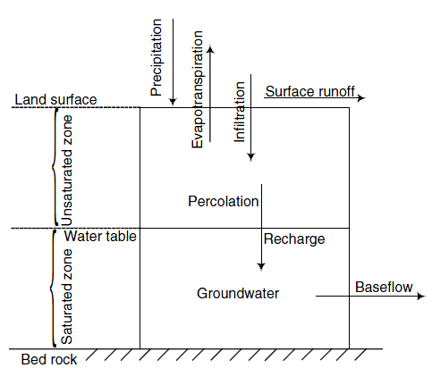
Fig 2.1: Schematic diagram of process to form the baseflow (Lin et al., 2007)

According to Horton (1933) inﬁltration divides rainfall into two parts. One part becomes surface runoff and the other goes initially into the soil and to the stream as base flow or it returns to the air by evaporative processes. By changing the land cover from grass or any natural area to an impervious area such as parking lots or rooftops, the infiltration capacity in Horton’s equation changes and it results in changes in water balance equation parameter, which normally decreases infiltration, therefore any change in land cover will change the infiltration amount into the ground.

2.2. Urbanization and Imperviousness

Urbanization is not a simple phenomenon but it is multidimensional (McIntyree et al, 2000) and incremental (Jacobson, 2011). Shuster et al. (2005) define urbanization as: “equivalent to the disturbance of natural landscape and eventual replacement of vegetated surfaces with impermeable surface.” It might happen gradually or rapidly and in different forms such as: industrial, retail, or housing development. In this process, topography, vegetation, soils, and channel networks can change, so the compound effect of all these alterations shape urban development (Booth et al., 2004). Imperviousness, which is an important environmental indicator, is also an essential characteristic of urbanization. Impervious land cover is any land cover that inhibits the infiltration of water into the ground. Roads and rooftops are two major types of impervious surfaces, while features such as sediment, patios, and bedrock are not as important (Arnold and Gibbons, 1996). Impervious land cover when considered for the entire area is called total impervious area (TIA) and is the most dominant measure of imperviousness (Shuster et al., 2005).
Aerial photography and satellite imagery are useful tools to identify land cover and level of urbanization. The knowledge of land mapping almost starts in mid-1940’s when Francis J. Marschner began mapping major land use in United States by using aerial photography method. Many land cover maps developed by individual companies and organizations employ both aerial and satellite imagery, but none of them were standard. It wasn’t until 1971 that Anderson developed the classification criteria for land use. The last revision of Anderson’s land cover classification were used as a standard land cover for 1992, 2001, and 2006 land cover maps of United States, which is available in USGS seamless viewer website. More recently remote sensing has been used to estimate the impervious area (Weng, 2010).
While satellite images are the most accurate techniques to determine the imperviousness percentage for urban area, it is time consuming and more expensive than the other techniques like the population density method introduced by Stankowski in 1972.
Stankowski (1972) explored a correlation between population density and impervious area by using the data from New Jersey. He used population density in New Jersey to generate curves relating percentage of impervious area to corresponding population density values. He realized that the curves follow a pattern of second degree polynomials and the equations are:

I _{low}=0.170D^{1.165-0.094logD},
I _{intermediate}=0.0218 D^{1.206-0.100logD},
I _{high}=0.0263D^{1.247-0.108logD},
where:
I _{low,} I _{intermediate},and I _{high} =Percentage of impervious land area on the low, intermediate, and high impervious area weighthing factors, respectively.
D = the population density, in persons per square mile.

By knowing the population density for each area, which is available in terms of census data, one can estimate the imperviousness percentage of that area for the given year, using the Stankowski (1972) empirical equation. Although it seems an easy and fast method it’s not as accurate as satellite imagery method. In Figure 2.2 it is shown that how for the same population density we may have two different imperviousness percentages.
Figure 2.2.a is the graph used by Stankowski to find the regression between public-quasi-public area and population density. In Figure 2.2.b it can be seen that for two different counties with the population density, we assume here as “D”, the real impervious percentage is equal to 7.5% for one county and 1.5% for the other one comparing to 2.5% value estimating from regression line. Despite the inaccuracy of this method some researchers such as Brandes et al. (2005) preferred to use population density method for their research. It can be assumed as the reason that their result is different from the other studies.

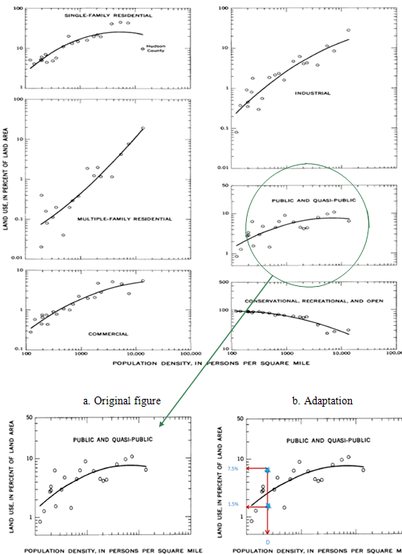
Fig 2.2: Relation between land use and population density for countries in New Jersey for public
and quasi-public (Stankowski, 1972)

2.3. Low flow

Low flow is the "flow of water in a stream during prolonged dry weather," according to the World Meteorological Organization. Smakhtin (2001) emphasizes that the sources of low flow can be ground water or surface water but it always refers to lowest annual flow that occurs seasonally each year. As he emphasized there are gains and losses that affect low flows. Gains to low flows may be maintained by: lakes, reservoirs, drainage from fracture zones above the watershed, and near surface. Losses to low flows may be caused by: direct evaporation, transpiration, ground water recharge, and bed losses
Low flow can be categorized as two different types: indices and exceedance percentiles. The notation for indices type is nQy, which can be interpreted as n-day low flow (Q) with y-year return period. On other hand the notion for the second form is Qp which can be interpreted as the flow discharge that is possibly exceeded p-percent of the time (Pyrce, 2004). The most typical types of low flow are shown in Tables 2.1 and 2.2.

Table 2.1: Most typical types of 7Q indices and their usage (Pyrce, 2004)
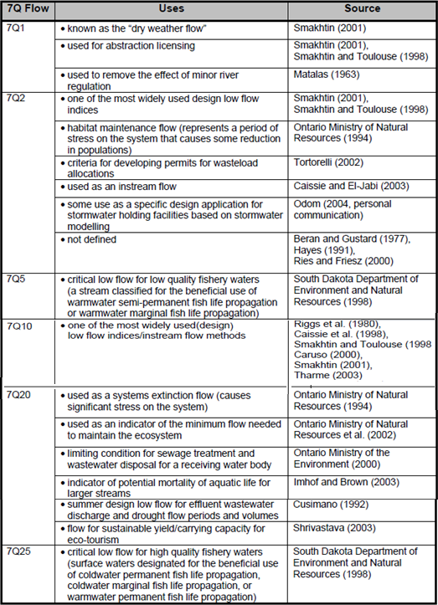

Table 2.2: Hydrologically based low flow estimates using: a) flow indices, and b) flow duration
(Pyrce, 2004)
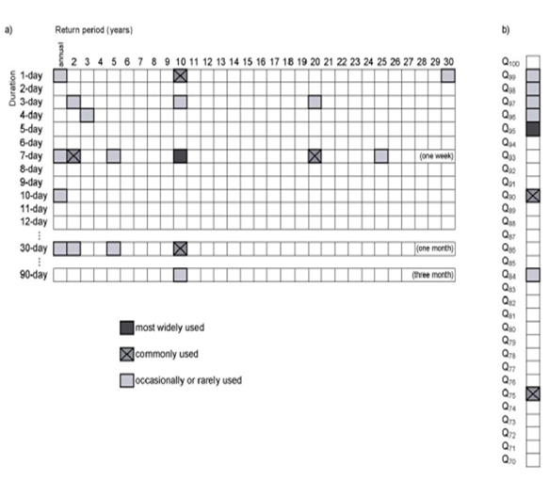

2.4. 7Q10 Low Flow

The most commonly used low flow metrics are 7Q10 and Q95. 7Q10 is the most dominant low flow metrics used by US agencies and researchers (Smakhtin, 2001). It’s the lowest 7-day average flow that occurs on average once every 10 years. In Russia and Eastern Europe 1-day and 30-day indices are mostly used for summer and winter respectively, and in UK 7-day average flow or dry weather flow is used for low flow (Smakhtin, 2001). General usage of 7Q10 is given in Table 2.3.
Table 2.3: General usage of 7Q10 low flow (Pyrce, 2004)
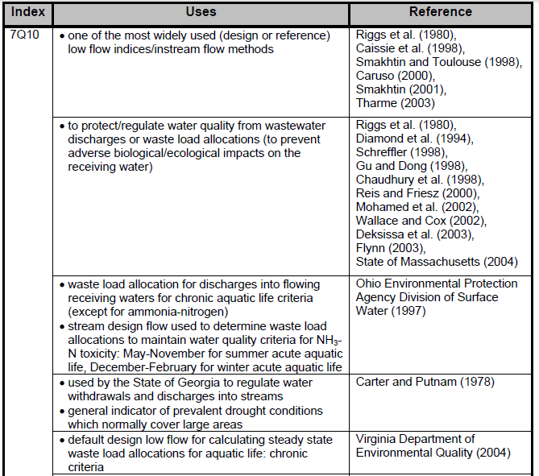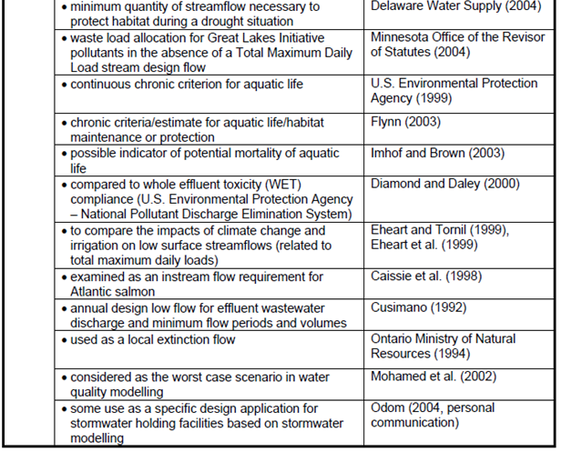

2.5. 7Q10 estimation methods

2.5.1. Log-Pearson III (LPLII) Distribution

This method was described by Bobee (1975). Using this method, the nonzero 7-day annual minimum for each day should be transformed to logarithms and then the other parameters should calculate as follows:
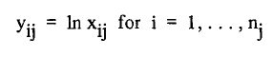
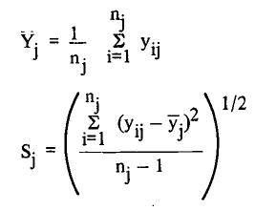
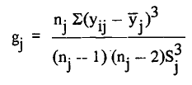
.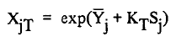
where:
x_{ij} = the 7-day annual minimum for year i at site
n_{j} = the number of years of record at site j
Y = the mean at site i are
S = standard deviation at site i are
gj = skewness coefficient at site i are
K_{T} =a function of the skewness coefficient
(Tables of KT are available in texts such as Haan (1977))
X_{jT} = The 7-day, T-year low flow

2.5.2. Three Parameter Weibull (WB) Distribution

The Weibull distribution is often used as the distribution of low stream flows. The probability density function is:
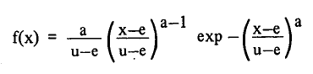
where:
e: is the lower boundary,
u: the characteristic drought,
a: the shape parameter.
The parameters are estimated using the algorithm suggested by Condie and Nix (1975).

2.5.3. Box-Cox Transformation Method

Box-Cox method initially introduced by Chander, et al (1978) and Kuczera (1983) individualy and later were generalized by Box and Cox in 1964 (Tasker, 1987). To estimate low flow with this method we need to develop an approximately normal arbitrary variable named q as follow:

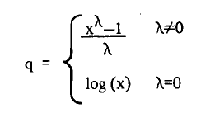
where λ is chosen so as to make q an approximately normal random variable with mean µ and standard deviation σ, and x is the annual 7-day low flow. λ should satisfy the following equation given by Cohn (1986):

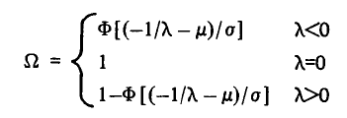
Where φ is the CDF of the standard normal distribution.
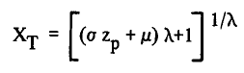
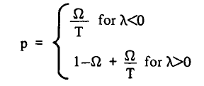
Zp is the standard normal deviate for probability p and Xt is the low flow.

2.5.4. Log-Boughton Method

This method was developed by Loganathan, et al (1985). In this method the observed 7-day annual minimums (Xi) are transformed to log (base 10) values and standardized as follows:
Then Ki were computed by knowing Zi:
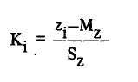
Where:
K is the standardized transformed flow,
Mz the sample mean of the z's,
Sz the sample standard deviation of the z's,
Then plotting positions, PPi' are obtained for each observation using the Cunnane (1978) formula, so that:
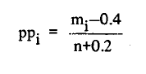
where m is the rank, from largest to smallest, of observation i and n is the number of observations. Then variable G1 is computed:
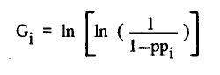
Boughton (1980) observed that the relation between K and G very nearly fits a curve given by:

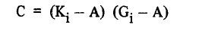
where C and A are constants to be determined. Parameters A and C are estimated using a least squares fit to minimize the mean square error of KG1. The fitted frequency factor is determined from:
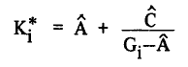
where A and are the least squares estimates of A and C. A linear least squares regression is used to determine an adjusted mean, M*, and adjusted standard deviation, S*, from the equation

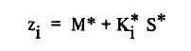
The T-year flow is
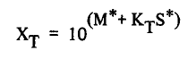

The results of a study done by Tasker (1987) showed that the LPIII and Weibull methods perform better in terms of mean square error than did the Box-Cox transformation method or the Log-Boughton method which is based upon a fit of plotting positions.

Chapter 3: Methods

3.1. Study Design

3.1.1. Study Area

Study sites 100 watersheds were selected from northeast, east central and east central United States, i.e., including Indiana (33watersheds), Virginia (12 watersheds), New Jersey (9 watersheds), Illinois (9 watersheds), Michigan (9 watersheds), Maryland (6 watersheds), Delaware (5 watersheds), Kentucky (3 watersheds), Mississippi (3 watersheds), Georgia (2 watersheds), and Wyoming (2 watersheds), and Florida, West Virginia, Pennsylvania, California, Texas, and Tennessee with one watershed each. The watershed areas ranged from 8.39 km2 to 1973 km², and the altitude varying from -3 to 1960 feet above NGVD29 (National Geodetic Vertical Datum of 1929, USGS).
Choosing watersheds was based on the following assumptions:

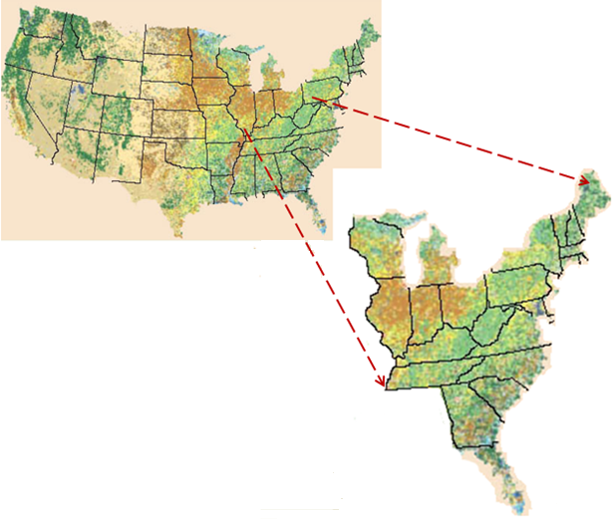
Fig 3.1: Study area (USGS seamless viewer, land cover 1992)

Almost all the watersheds were located in the same climatic zone (Figure 3.2) with a humid continental climate to have the same precipitation.
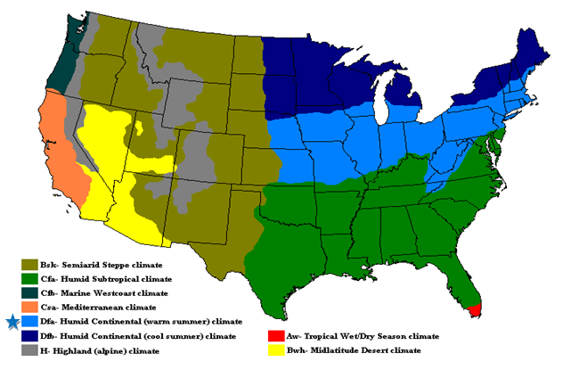
Fig 3.2: Climate zones of continental United States (The climatic zone were used in this thesis is
shown by a blue asterisk)

3.1.2. Discharge data and calculation of 7Q10
Historical discharge data were obtained from the USGS through their National Water Information System (NWIS) website. The daily discharge data then were downloaded from watersheds which met the following criterion:
1. Watersheds were located in areas with no dams or reservoirs within 3 kilometers upstream or downstream of the discharge data point (Brandes et al., 2005) to minimize the effects of dams on stream flow.

2. The watersheds contained USGS stations with at least 20 years daily discharge data so that 7Q10 for two ten-year time periods could be calculated. The periods for this research are assumed from 1985 to 1995 for first period and from 1996 to 2010 for the second period.
Daily mean streamflows were downloaded from the USGS database (http ://wdr.water . usgs.gov/nwisgmap/). From this page, the user should selected Surface Water from the pull down menu at the top right and then either United States or the appropriate state from the other pull down menu. The streamflow link on the Surface Water page loaded daily mean streamflow query page. The following is an abbreviated list of searchable criteria which was selected singularly or together to form complex queries: County, Lat-Long box, Site Name, Site Number, Drainage Area, Number of Observations, and Period of Record.
Using downloaded daily means, a MATLAB code (Appendix B) was written to calculate the 7Q10 low flow for each period of time and for each watershed. The Weibull methods were employed to compute the 7Q10 for each site in this research because it was purported by Tasker (1987) to have performed better than other methods.

3.1.3. Land cover data and calculation of % impervious area

All land cover data were downloaded directly from USGS (2011) seamless viewer
(http://seamless.usgs.gov/website/seamless/viewer.htm). Some important presumptions were considered in this procedure as follow:
The land cover we used for this research were the National Land Cover Data (NLCD) for 1992 and 2001, flow data was complied for ten year periods, five years before and after these “snap-shot-in-time” land cover images for 1992 and 2001. It is assumed that the land cover estimates represent a mean for the ten-year flow records. This assumption was tested by a comparison of land cover data for 2001 and 2006 for some sample watersheds (Appendix E), whereby it was found that the average change in land cover was less than 2 percent between 2001 and 2006.
The cover classification for 1992 is slightly different than for 2001. In 1992, we used cover class codes 22 and 23 (Figure 3.3), which are described as:
1992 class 22 or High Intensity Residential: Highly developed areas where people reside in high numbers such as apartment complexes and row houses. Vegetation accounts for less than 20% of the cover and constructed materials account for 80% to100% of the cover.
1992 class 23 or Commercial/Industrial/Transportation: Areas of infrastructure such as roads, railroads and so on and all highly developed areas that are not classified as High Intensity Residential.
In 2001, however, cover classes were described as:
2001 class 22 or Developed, Low Intensity: areas with a mixture of constructed materials and vegetation. Impervious surfaces account for 20% to 49% percent of total cover. These areas most commonly include single-family housing units.
2001 class 23 or Developed, Medium Intensity: areas with a mixture of constructed materials and vegetation. Impervious surfaces account for 50% to 79% of the total cover. These areas most commonly include single-family housing units.
2001 class 24 or Developed High Intensity: highly developed areas where people reside or work in high numbers. Examples include apartment complexes, row houses and commercial/industrial. Impervious surfaces account for 80% to 100% of the total cover.
The codes 22 and 23 for land cover 1992 are correspondent to the codes 22 and 23 for land cover 2001 because they result in same values if one calculates the urban area for both land covers 1992 and 2001, though they have different notions. The only difference between land cover 1992 and 2001 is code 24 that make these two separate from each other. All the existing codes in both land cover classification is shown in Figure 3.3.
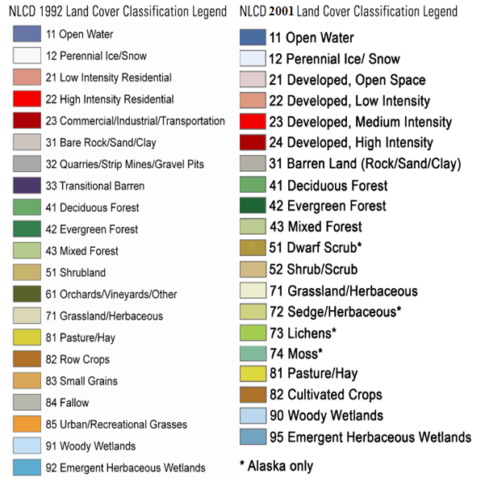
Figure 3.3: Land cover classification legend (Anderson, 1976)-left: Land Cover 1992; Right:
Land Cover 2001

3.2. Computation of Urbanization

In order to determine urban area percentage, the following steps were taken for each
watershed. First the latitude and longitude of each watershed downloaded from the website
http://waterdata.usgs.gov, were converted to decimal degree. Then 1992 and
2001 land cover and also 1” NED were downloaded from USGS Seamless site, at
http://seamless.usgs.gov.
After land cover and raster file have been downloaded, they can be opened by using Arc Map from the ESRI system Arc GIS version 10. An example of what the raster and land cover files may look like is shown in Figures 3.4, 3.5 and 3.6, respectively.
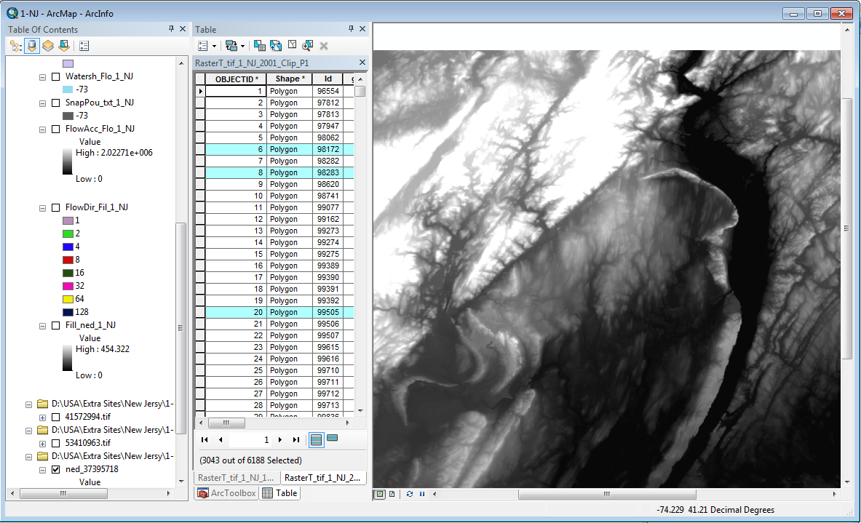
Figure 3.4: 1” National Elevation Data, USGS seamless viewer 2011

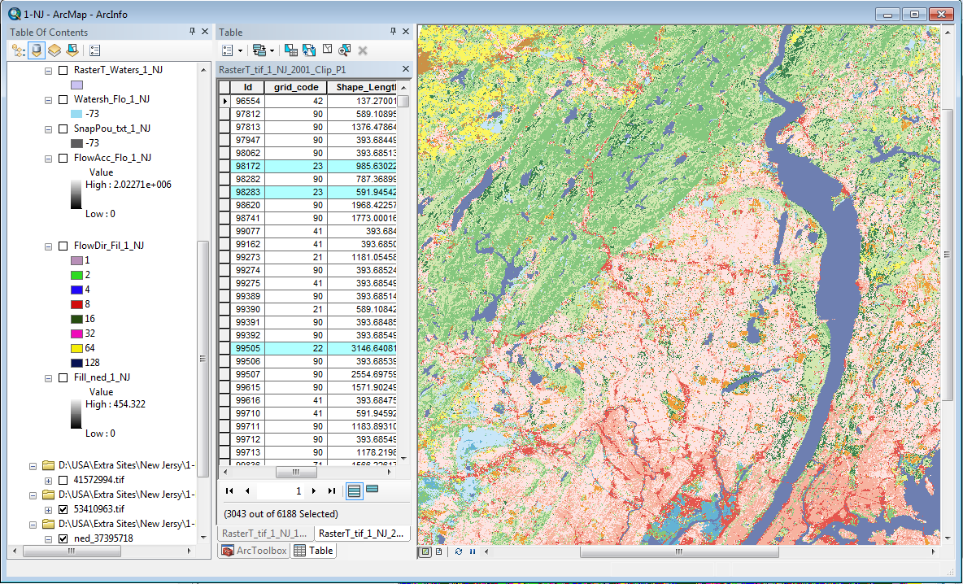
Figure 3.5: Land cover 1992, USGS seamless viewer 2011
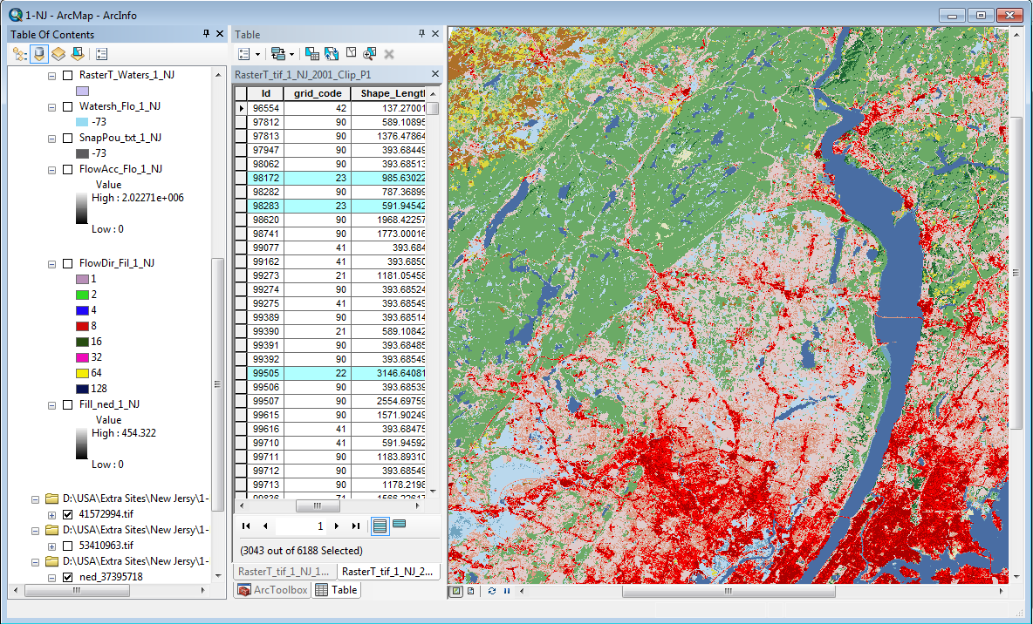
Figure 3.6: Land cover 2001, USGS seamless viewer 2011
The raster file can be used to delineate the watershed and then we need to determine the flow direction which is shown in Figure 3.7.

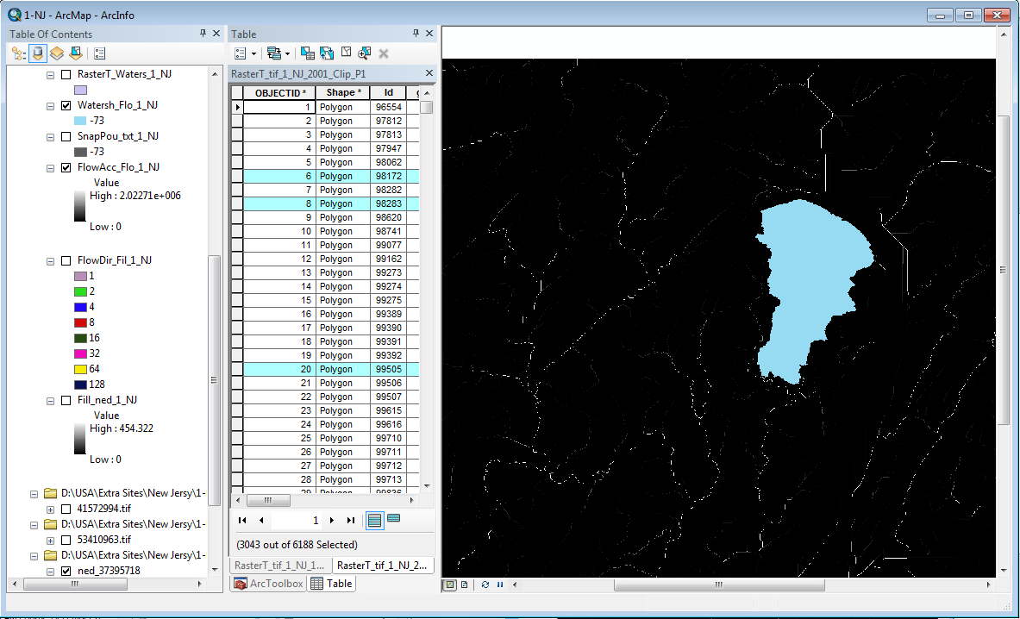
Figure 3.7: Watershed area
Now that the watershed has been delineated the next procedure is to convert it and the land cover or “tif” file into “shape file”. Then it needs to be clipped so that the land cover area is the same as the watershed area. Afterward land cover file has been projected into an utilizable coordinate system such as NAD 1983 (feet). The output needs to be named and when the process is complete will have units of feet.
The final step is to calculate the area of the watershed and the amount of urban area in the watershed. Figure 3.8, will be a cut out of the land cover shape file to match the watershed area.
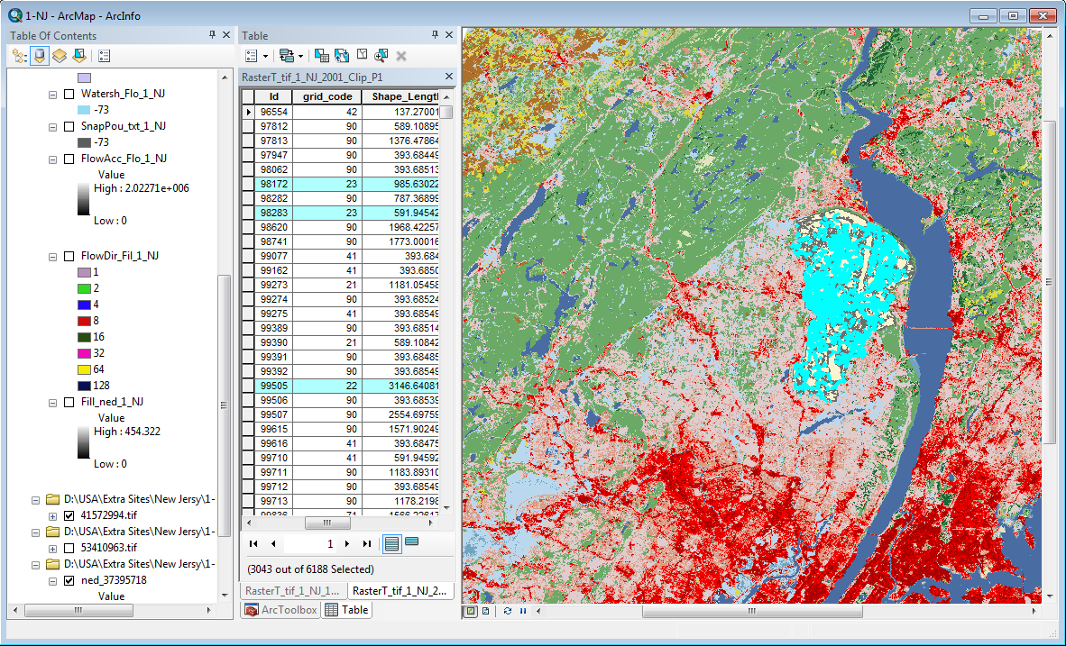
Figure 3.8: Pictorial Urbanization area
By right clicking on the map name, a box appears where the attributes table can be opened. Once the table has been opened it shows the id, grid code, and F_Area. The watershed area is calculated by summing the F_Area column. Then for each land cover the correspondent codes of urban area in land cover classification should be selected (the green rows in figure 3.8) and then the values of those rows should be summed in order to get the total urban area in the watershed. Finally the percent urban is determined by dividing the total urban area by the watershed area.

3.3. 7Q10 Computation

An easy and arguably as accurate method of determining the 7Q10 is to use Weibull distribution to plot the seven-day minimum flows for the selected period of record. This is the hydrological method used to analyze each site in this project. Daily mean streamflows can be obtained over the Internet through the USGS NWISWeb water data page. From this page, the user should select “Surface Water” from the pull down menu at the top right and then either United States or the appropriate state from the other pull down menu. The streamflow link on the “Surface Water” page loads daily mean streamflow query page. The following is an abbreviated list of searchable criteria which can be selected singularly or together to form complex queries: County, Lat-Long box, Site Name, Site Number, Drainage Area, Number of Observations, and Period of Record.

3.4. The Wilcoxon Signed-Rank Test
Wilcoxon Signed-Rank Test is used to test the hypothesis of this research and to find the possible thresholds. According to Ott et al. (2010) the Wilcoxon signed-rank test, which makes use of the sign and the magnitude of the rank of the differences between pairs of measurements is used as an alternative to the paired t test. Since the t test cannot be used for nonnormal distributions, the Wilcoxon signed-rank test is the best method for population with a nonnormal distribution of the differences (Appendix G).

Chapter 4: Results

4.1. Preliminary analysis

In this research, we are dealing with comparison of two populations:
a.The 7Q10 data for the interval from 1986 to 1995 or 1st period.
b.The 7Q10 data for the interval from 1996 to 2005 or 2nd period.
The useful statistical methods to compare two populations are t test or nonparametric To define which of these methods is appropriate to compare the two population in this research we need to follow these steps:
- Computing the difference between two populations
- Test the normality of difference distribution
- Test the dependency of samples.
A code was written with SAS9.2 (Appendix C) to test whether the difference distribution wasnormal or not. It was done by looking at the p-values of normtest; which is an inter code in SAS to define the normality of any distributions. If the resulted p-values from SAS code for both Skewness and Kurtosis are large enough, the distribution is normal and vice versa.
Since the p-values were so small (Figure 4.1), it was concluded that the difference distribution is nonnormal. The t-test is not appropriate and a nonparametric test was employed. Both Wilcoxon rank sum and Wilcoxon signed rank test do not require normality of the underlying populations (Appendix G). The only difference between these two tests is that Wilcoxon rank sum is applicable for those samples that are independent. Whereas the 7Q10 discharge were calculated for the same watershed at two different intervals, they are no longer independent and the only applicable test is Wilcoxon signed-rank test.

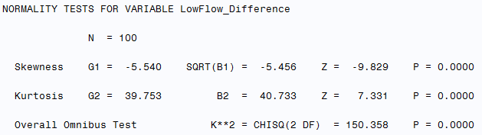
Figure 4.1: Normal test results on low flow difference data for all watersheds

4.2. Data Analysis Using Wilcoxon Singed Rank Test

The objective of this research is to find changes in low flow due to urbanization. For this purpose the null and research hypothesis can be defined as:
Null hypothesis H0 : μ2-μ1=0 (7Q10 mean for 1st period is equal to 7Q10 mean for 2nd
period)
Research hypothesis Ha: μ2-μ1≠0 not H0

The α=0.01 is chosen to test the hypothesis.
Another SAS code was written to compare the two populations (Appendix C). The p-value is less than 0.0001< α=0.01 therefore we reject the null hypothesis and concluded that 7Q10 mean for first period is not equal to 7Q10 mean for second period but the p-value doesn’t tell us if there is an increase in 7Q10 or decrease between two intervals. This can be determined by looking at the tables because Wilcoxin singed rank test computed the differences between 7Q10 for two intervals and then assigned a minus (–) sign to the negative differences and a plus (+) sign to the positive differences. Different parts that were distinguishable from the tables can be divided into three categories (Appendix E ):
- The watersheds with urban percntage less than 11% :
For these watesheds the differences between 7Q10 for two intervals are mostly negative. Since the difference is computed by subtracting 7Q10 for second period (1996-2005) from 7Q10 for first period (1986-1995). It means that the 7Q10 decreased due to urban development for these watersheds though this is just a hypothesis and needs to do extra statistical test to be accepted.
- The watersheds with urban percntage between 11% and 23 %:
For these watesheds the difference between 7Q10 for two intervals is altering between negative and positive. It means that the 7Q10 doesn’t change due to urban development for these watersheds. This also needs to be tested.
- The watersheds with urban percentage greater than 23%:
For these watesheds the differences between 7Q10 for two intervals are mostly positive. It means that the 7Q10 increased due to urban development for these watersheds.
Now we have three categories with three different hypothises. Each of which is a subset of the whole data set and can be considered as a subset that needs to be tested and to determine whether our assumptions are correct or not.

4.2.1. Comparison of 7Q10 for Watersheds with urbanization less than 11%

In this part we have 64 watersheds with urban areas ranging from close to zero to almost 11%. For these watersheds we have to follow the same process we did in section 4.1 to see if the distribution is normal or not and which method is more appropriate to employ.
Using SAS program, p-values for normality test obtained. Since the p-values were very small (Figure 4.2), it was concluded that the difference distribution is nonnormal and the t-test is not appropriate. As it mentioned earlier the populations are not independent therefore the only applicable test is Wilcoxon signed-rank test.

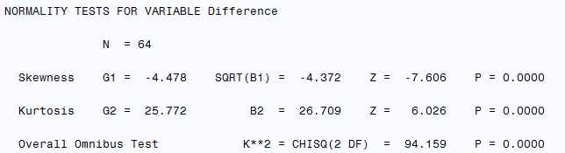
Fig 4.2: Normal test results on 7Q10 difference for watersheds with urban area
less 11 %

Now we should define the hypothesis. For this subset the null hypothesis is as same as the null hypothesis for the whole data but the research hypothesis (Ha) is different:
Null hypothesis H0 : μ2-μ1=0 (7Q10 mean for 1st period is equal to 7Q10 mean for 2nd
period)
Research hypothesis: Ha: μ2-μ1≤ 0 (7Q10 mean for 1st period is greater than 7Q10 mean
for 2nd period)

the “α=0.01” were used to test the hypothesis.
Using the Wilcoxon signed rank test the out put p-value is less than 0.0001 for a two-tailed test. Since we are testing the probabilty of μ2-μ1=<0 we need to divide p-value by 2 so the p-value < 0.00005 and is less than α=0.01
We reject the null hypothesis and conclude that 7Q10 mean for first period is greater than 7Q10
mean for second period. In other word the low flow 7Q10 decreases.
It also can be interpreted from box plots and average and variance table (Figures 4.3 and 4.4 ).
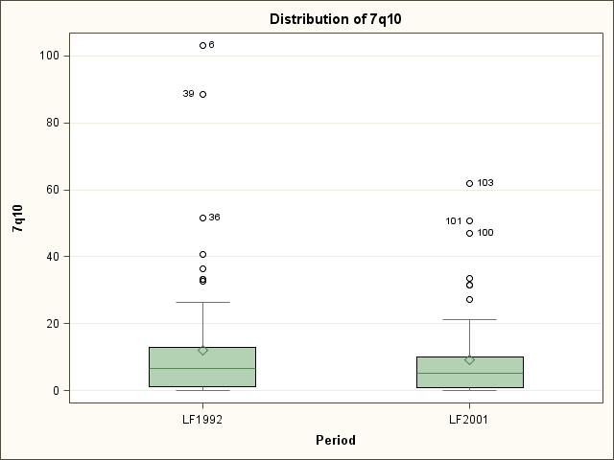
Fig 4.3: Box plots for low flow data for watersheds with urbanization percentage less than 11%
(LF is abbreviation for low flow).


Fig 4.4: Mean and standard deviation of low flow for watersheds with urbanization percentage
Less than 11

Both plots show there was a decrease in low flow mean that occurs from 12.1988 ft³/sec in 1986-1995 to 9.118272 ft³/sec in 1996-2005. There is also a decrease in maximum of 7Q10 for those periods from 103.1429 ft³/sec to 62 ft³/sec.

4.2.2. Comparison of 7Q10 for Watersheds with urbanization 11 - 23%

In this part we have 7 watersheds with urban areas ranging from 11% to 23%. Using SAS program p-values for normality test obtained. Since the p-values were very small (Figure 4.5), we concluded that the difference distribution is nonnormal and the t-test is not appropriate. Furthermore the populations are not independent so the only applicable test is Wilcoxon signed-rank test.

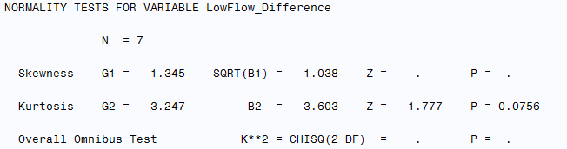
Fig 4.5: Normal test results on Low Flow Difference data for watersheds with urbanization
between 11 & 23 %

For this subset the null hypothesis is as same as the null hypothesis for the whole data but the research hypothesis (Ha) is different:
Null hypothesis H0 : μ2-μ1=0 (7Q10 mean for 1st period is equal to 7Q10 mean for 2nd
period)
Research hypothesis: Ha: μ2-μ1≠0 (7Q10 mean for 1st period is not equal to 7Q10 mean
for 2nd period)

the “α=0.01” were used to test the hypothesis.
Since p-value =0.4688>α=0.01, we do not reject the null hypothesis and conclude that 7Q10 mean for first period is equal to 7Q10 mean for second period, though by comparing the box plots and the mean and variance of two samples population it can be seen that there is a decrease in low flow 7Q10 due to increasing urbanization.

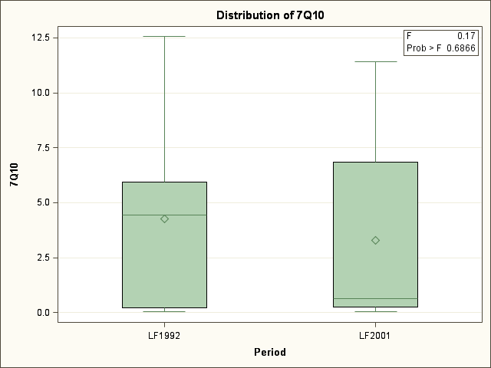
Fig 4.6: Box plots for low flow data for watersheds with urbanization percentage 11-23%

Fig 4.7: Mean and standard deviation of low flow for watersheds with urbanization percentage
11-23%

4.2.3. Comparison of 7Q10 for Watersheds with urbanization greater than 23%

In this part we have 29 watersheds with urban areas greater than 23%. Using SAS program p-values for normality test obtained. Since the p-values were very small (Figure 4.8), we concluded that the difference distribution is nonnormal and the t-test is not appropriate. Furthermore the populations are not independent so the only applicable test is Wilcoxon signed-rank test.

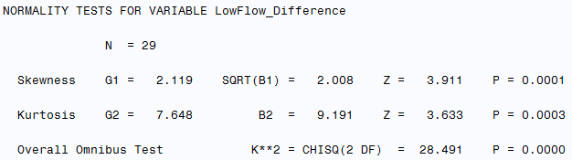
Fig 4.8: Normal test results on low flow difference data for watersheds with urbanization
greater than 23 %.

For this subset the null hypothesis is as same as the null hypothesis for the whole data but the research hypothesis (Ha) is different:
Null hypothesis H0 : μ2-μ1=0 (7Q10 mean for 1st period is equal to 7Q10 mean for 2nd
period)
Research hypothesis: Ha: μ2-μ1≠0 (7Q10 mean for 1st period is not equal to 7Q10 mean
for 2nd period)
the “α=0.01” were used to test the hypothesis.
Since p-value <0.0001/2=0.00005<α=0.01, we do reject the null hypothesis and conclude that 7Q10 mean for first period is smaller than 7Q10 mean for second period. By comparing the box plots and the mean and variance of two samples population the same results will be achieved (Figures 4.9 and 4.10).

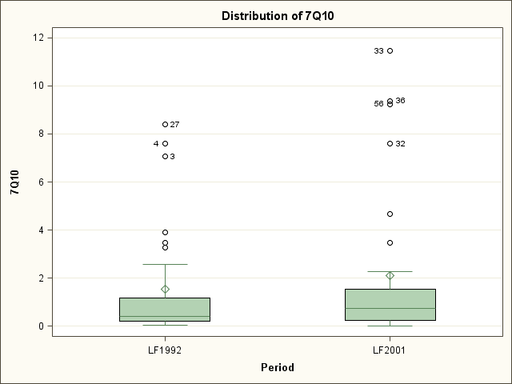
Fig 4.9: Box plots for low flow data for watersheds with urbanization percentage above
23%
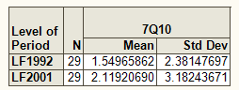
Fig 4.10: Mean and standard deviation of low flow for watersheds with urbanization percentage
above 23%.

Chapter 5: Discussion

The results of the Wilcoxon signed-rank test supported the objectives of this research in
determining the impacts of urban development within three different levels of the urbanization. Wicoxon signed-rank test was capable of establishing thresholds that represented the three scenarios in this research. The results of the test for urbanization percentage between 11 and 23 did not show evidence of change in low flow values. This is in concordant with study results done by Meyer (2002) and Brandes et al. (2005). For watersheds with urbanization percentage less than 11% the results showed a significant decrease in low flow, the same result Kauffman (2009) and others have had. Likewise, the Wilcoxon signed-rank test of the watersheds with urbanization percentage above 23 showed a significant increase in low flow. The results of the low flow with the urbanization between 11 and 23 percent had more differences than the Wilcoxon signed-rank test of the other two scenarios.

For a final conclusion and debate the water balance equation is repeated below. As earlier

mentioned, in introduction chapter, based on equation (1) low flow should increase due to urban

development unless other factors become dominant. By considering this assumption the change of low flow is due to urban development, one can speculate three possible scenarios:
1) As urban area increases from zero to values less than 11%, infiltration is more dominant in comparison to evapotranspiration, and discharges to storm sewer systems and leakage from water and sewer lines.
2) For urban percentage between the 11 and 23% the increasing impacts of evapotranspiration and discharges become greaer but still cannot compensate the infiltration reductive effects.
3) After urban area passes 23% the evapotranspiration and recharge factors become dominant and overshadow the effect of infiltration. It seems that evapotranspiration should play an important rule because during dry seasons trees and other plants play an important rule to break down the heat wave by pumping the water from deep levels of ground water to the air. In urban area by changing the land cover the process will be halted especially in large degrees of urbanization and it results in increasing the low flow.

References:

Anderson, J.R., Hardy, E.E., Roach, J.T., Witmer, R.E., 1976. A Land Use and Land Cover Classification System for Use with Remote Sensor Data. U.S. Geological Survey Professional Paper, No. 964.
Alley, W.M., Veenhuis, J.E., 1983. Effective Impervious Area in Urban Runoff Modeling. Journal of Hydraulic Engineering, 109.
Arnold, Jr., Chester, L., Gibbons, C., James, 1996. Impervious Surface Coverage: The Emergence of a Key Environmental Indicator, Journal of the American Planning Association, 62:2, 16.
Booth, D.B. et al., 2004. Reviving Urban Streams: Land use, Hydrology, Biology, and Human Behavior. Journal of the American Water Resources Association.
Booth, D.B. and C.R. Jackson, 1997. Urbanization of Aquatic Systems – Degradation Thresholds, Stormwater Detention, and the Limits of Mitigation. Water Resources Bulletin 33: 14.
Brandes, D., Cavallo, G.J., Nilson, M.L., 2005. Base Flow Trends in Urbanizing Watersheds of the Delaware River Basin. American Water Resources Association, 41: 15.
Brun, S.E., Band, L.E., 2000. Simulating runoff behavior in an urbanizing watershed. Computers, Environment and Urban Systems, 24: 18.
Caruso, B.S., 2000. Evaluation of Low-Flow Frequency Analysis Methods. Journal of Hydrology(NZ), 39: 29.
EPA, 1991. Technical Support Document for Water Quality-based Toxics Control.
Ferguson, B.K., Suckling, P.W., 1990. Changing Rainfall-Runoff Relationship in the Urbanizing Peachtree Creek Watershed, Atlanta, Georgia. American water resources association.
Finkenbine, j.k., Atwater, J.W., Mavinic, D.S., 2000. Stream Health after Urbanization. American Water Resources Association, 36: 12.
Hollis, G.E., 1977. Water yield changes after the urbanization of the Canon’s Brook catchment, Harlow, England. Hydrological Sciences Bulletin, 22: 15.
Horton, Robert, E., 1933. The Rule of Infiltration in the Hydrologic Cycle. Transactions, American Geophysical Union.
Jacobson, Carol, R., 2011. Identification and Quantification of the Hydrological Impacts of Imperviousness in Urban Catchments: A Review. Journal of Environmental Management, 92: 11.
Jennings, D.B., Jarnagin, S.T., 2002. Changes in Anthropogenic Impervious Surfaces, Precipitation and Daily Streamﬂow Discharge: A Historical Perspective in a Mid-Atlantic Subwatershed. Landscape Ecology 17: 19.
Kauffman, G.J., Belden, A.C., Vonck, K.J., Homsey, A.R., 2009. Link between Impervious Cover and Base Flow in the White Clay Creek Wild and Scenic Watershed in Delaware. Journal of Hydrologic Engineering: 11.
Klein, R.D., 1979. Urbanization and Stream Quality Impairment. Water Resources Bulletin, 15: 15.
Konrad, C.P., Booth, D.B., 2002. Hydrologic Trends Associated with Urban Development for Selected Streams in the Puget Sound Basin, Western Washington. U.S. Geological Survey Water-Resources Investigations Report, 20: 39.
Ku, F.H., Hagelin, N.W., Buxton, H.T., 1992. Effects of Urban Storm-Runoff Control on Ground-Water Recharge in Nassau County, New York. Ground Water, 30.
Leopold, L.B., 1968. Hydrology for- Urban Land Planning - A Guidebook on the Hydrologic Effects of Urban Land Use Geological Survey Circular 554.
McIntyre, N.E., K. Knowles-Yanez, and D. Hope, 2000. Urban Ecology as an Interdisciplinary Field: Differences in the Use of “Urban” Between the Social and Natural Sciences. Urban Ecosystems 4:5-24.
Meyer, S.C., 2002. Investigation of Impacts of Urbanization on Base Flow and Recharge Rates, Northeastern Illinois: Summary of Year 2 Activities. Illinois State Water Survey, Champaign, Ill: 13.
Myrup, L.O., 1969. A Numerical Model of the Urban Heat Island. Journal of Applied Meteorology, 8:11.
Ott, R. Lyman , Longnecker, Michael, 2010. An Introduction to Statistical Methods and Data Analysis , Sixth Edition,Brooks/Cole, Cengage Learning.
Pyrce, rich, 2004. Hydrological Low Flow Indices and Their Uses. Watershed Science Center Report. No.4.
Ridd, M., 1995. Exploring a VeIeS (Vegetationeimperviousesurface-Soil) Model for Urban Ecosystem Analysis through Remote Sensing: Comparative Anatomy for Cities. International Journal of Remote Sensing 16, 2165e2185.
Scorca, M.P., 1977. Urbanization and Aecharge in the Vicinity of East Meadow Brook, Nassau County, New York. Part 1: Stream Flow and Water-Table Altitude, 1939–90. U.S. Geological Survey Water-Resources Investigations Rep.96-4265: 39.
Shuster, W.D., Bonta, J., Thurston, H., Warnemuende, E., Smith, D.R., 2005. Impacts of Impervious Surface on Watershed Hydrology: A Review. Urban Water Journal, 2: 13.
Simmons, D., Reynolds, R., 1982. Effects of Urbanization on Baseflow of Selected South-Shore Streams, Long Island, N.Y. Water Resources Bulletin, 18: 9.
Smakhtin, V.U., 2001. Low Flow Hydrology: A Review. Journal of Hydrology, 240: 40.
Spinello, A. G., and Simmons, D. L. 1992. Baseflow of 10 South-Shore Streams, Long Island, New York, 1976–85, and the Effects of Urbanization on Baseflow and Flow Duration. Water Resources Investigations Rep. No. 90—4205, U.S. Geological Survey, Syosset, N.Y., 1–31.
Stankowski, S.J., 1972. Population Density as an Indirect Indicator of Urban and Suburban Land-Surface Modifications. U.S. Geological Survey Prof. Paper 800-B, B219-B224, Washington, D.C.
Tallaksen , L.M., 1995. A Review of Base Flow Recession Analysis. Journal of Hydrology,165: 22.
Tasker,G.D., 1987. A Comparison of Methods for Estimating Low Flow Characteristics of Streams.Water Resour. Bull. 23 (6), 1077–1083.
Thornthwaite, C. W., and Mather, J. R., 1957. The Water Balance. Drexel Institute of Technology, ,Centerton, N.J.Publications in Climatology, X, 3.
Vardanega , P. J., A.M. and Waters, T. J., 2010. Analysis of Asphalt Concrete Permeability Data Using Representative Pore Size. Journal of Materials in Civil Engineering, 23:18.
Wang, L., Lyons, J., Kanehl, P., 2001. Impacts of Urbanization on Stream Habitat and Fish Across Multiple Spatial Scales. Environmental Management, 28: 11.

Appendices

Appendix A

Watershed’s data
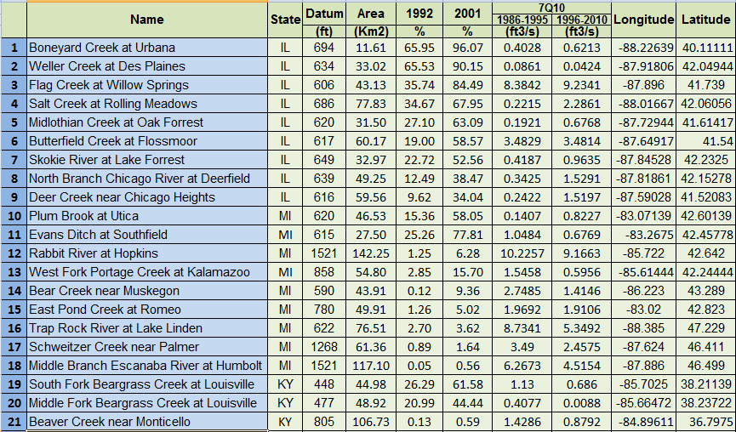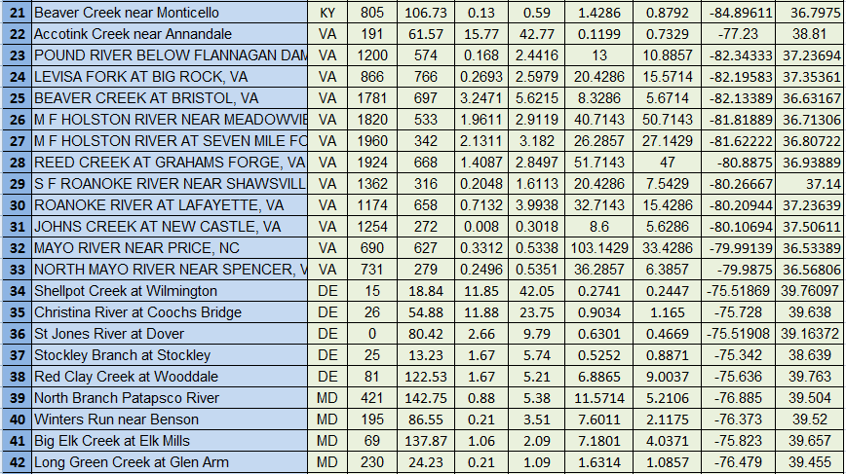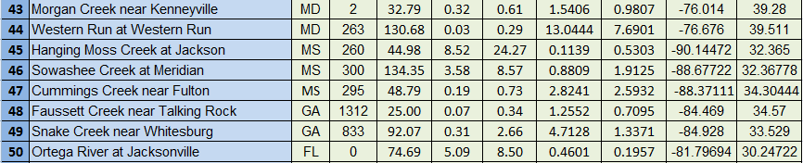
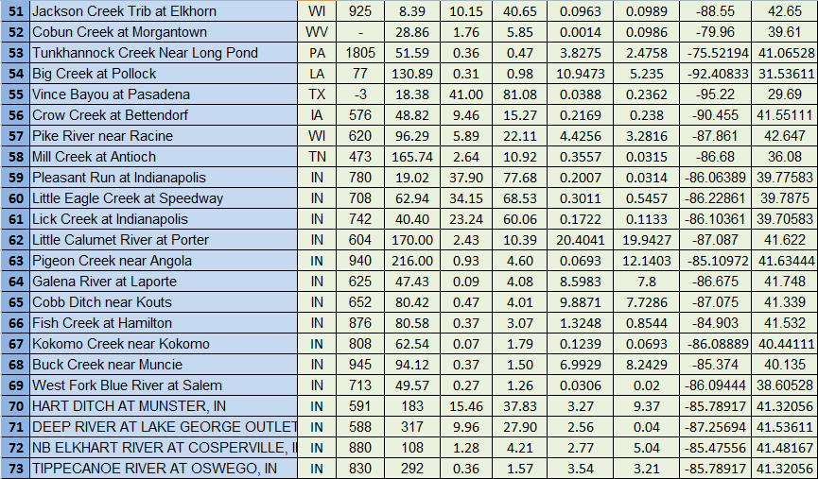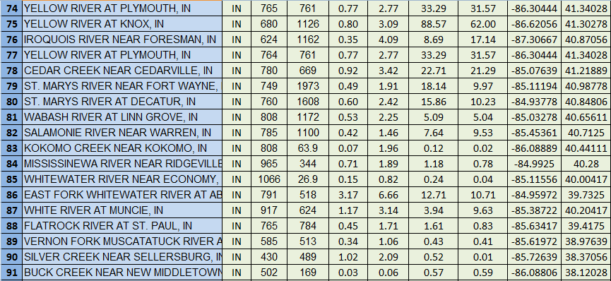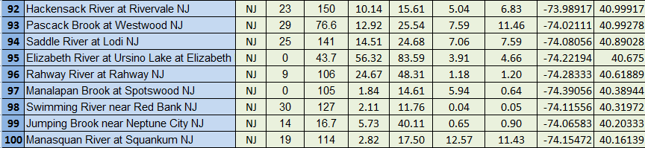

Appendix B

MATLAB CODE
%A MATLAB code is written to calculate the 7Q10 low flow based on Weibull %Distribution

clear all; close all; clc;
fid = fopen('16-Daily Discharge1986-1995.txt');
C = textscan(fid, '%s %s %s %f32 %s');
fclose(fid);
C{3};
A=C{4};
A = A(~isnan(A));
n=max(size(A));
x=zeros(n,1);
z=zeros(1,10);
for i=2:n-7;
m=(i+6)/365;
x(:)=0;
for j=i:i+6
x(j)=x(j-1)+A(j-1);
end
y(i)=x(j)/7;
end
y;
Q=y';
m=max(size(Q));
%f=365-(((m/365)-fix(m/365))*365);
l=fix(n/365);
f=l*365-m;
if f<0
f=365+f;
l=l+1;
elseif f>=0
f=l*365-m;
end
Q(1)=100;
for k=0:f-1
Q(n-6+k,1)=1000;
end
Q;
B=reshape(Q,365,l);
sevenQ=zeros(l,1);
for g=1:l
sevenQ(g)=min(B(:,g)) ;
end
sevenQ
sevenQ10=min(sevenQ)

Appendix C

SAS CODES and PLOTS

SAS code for comparing the 7Q10 of all the watersheds
Options PageNo=1 NoDate FormDLim='';
Title ' Low Flow data VS. Urbanization ';
Title2 'Paired Samples t-test, Sign Test, Wilcoxon Signed Ranks Test';

Data A;
Input WatershedDatum WatershedArea UrbanPercentage1992 UrbanPercentage2001 LowFlow1992 LowFlow2001;
LowFlow_Difference=Round(LowFlow2001-LowFlow1992,.001);
Abs_Diff=Abs(LowFlow_Difference);
Datalines;
502 169 0.029 0.063 0.5743 0.59
263 130.6849287 0.033386117 0.287813423 13.0444 7.6901
1254 272 0.008039447 0.301805595 8.6 5.6286
1312 25 0.070084154 0.341660575 1.2552 0.7095
1805 51.5859639 0.359708595 0.470254887 3.8275 2.4758
690 627 0.331194749 0.533800864 103.1429 33.4286
731 279 0.249625833 0.535141982 36.2857 6.3857
1521 117.1042225 0.054781008 0.564702149 6.2673 4.5154
805 106.7322551 0.134261701 0.585121698 1.4286 0.8792
2 32.78937527 0.31837997 0.613873875 1.5406 0.9807
295 48.78796526 0.188609026 0.72642122 2.8241 2.5932
1066 26.9 0.153382985 0.8204126 0.2414 0.0371
77 130.8870986 0.308098213 0.976811349 10.9473 5.235
585 513 0.339502075 1.058534411 0.4271 0.41
230 24.23021749 0.211913591 1.092798586 1.6314 1.0857
713 49.56624253 0.266886075 1.255002159 0.0306 0.02
785 1100 0.417292401 1.460216279 7.6429 9.5286
945 94.11728305 0.368731433 1.504000354 6.9929 8.2429
830 292 0.356111998 1.574783011 3.5429 3.2143
1362 316 0.204800407 1.611270678 20.4286 7.5429
1268 61.36 0.885036665 1.642469183 3.49 2.4575
765 784 0.449133588 1.708972504 1.6143 0.8271
808 62.54201335 0.071718081 1.789231207 0.1239 0.0693
965 344 0.71142923 1.890154052 1.18 0.7757
749 1973 0.486489536 1.91056687 18.1429 9.9714
808 63.9 0.071641342 1.963055987 0.1186 0.0206
430 489 1.019228292 2.085031079 0.5157 0.0114
69 137.8717555 1.061139005 2.091644874 7.1801 4.0371
808 1172 0.526016044 2.253221102 5.0857 5.0429
760 1608 0.599978937 2.416728217 15.8571 10.2286
1200 574 0.168031814 2.441620991 13 10.8857
866 766 0.26926167 2.597851296 20.4286 15.5714
833 92.06545906 0.313120993 2.659706921 4.7128 1.3371
765 761 0.7723999 2.774313193 33.2857 31.5714
764 761 0.7723999 2.774313203 33.2857 31.5714
1924 668 1.408730582 2.849672636 51.7143 47
1820 533 1.961129687 2.911884676 40.7143 50.7143
876 80.57940801 0.367404007 3.069310625 1.3248 0.8544
680 1126 0.798848475 3.088071779 88.5714 62
917 624 1.165308026 3.138441089 3.9429 9.6286
1960 342 2.13105213 3.182004962 26.2857 27.1429
780 669 0.916020628 3.422266999 22.7143 21.2857
195 86.5511611 0.211027561 3.514150489 7.6011 2.1175
622 76.51385515 2.701795204 3.62461961 8.7341 5.3492
1174 658 0.713249554 3.993752078 32.7143 15.4286
652 80.41852493 0.474282577 4.005340559 9.8871 7.7286
625 47.42542566 0.091855769 4.082155062 8.5983 7.8
624 1162 0.354552867 4.09211908 8.6857 17.1429
880 108 1.277166959 4.21194493 2.7714 5.0429
940 216 0.929326631 4.602567988 0.0693 12.1403
780 49.90926147 1.26042389 5.019852047 1.9692 1.9106
81 122.5348556 1.67031386 5.20886623 6.8865 9.0037
421 142.7517684 0.87569876 5.377378353 11.5714 5.2106
1781 697 3.247073983 5.621497627 8.3286 5.6714
25 13.22658831 1.665799978 5.739033712 0.5252 0.8871
0 28.85600941 1.756041808 5.849574267 0.0014 0.0986
1521 142.2541594 1.25339344 6.2806018 10.2257 9.1663
791 518 3.168559483 6.661180495 12.7143 10.7143
0 74.68500426 5.091311292 8.498513601 0.4601 0.1957
300 134.3480819 3.5750477 8.567099469 0.8809 1.9125
590 43.90696153 0.120947183 9.361985751 2.7485 1.4146
0 80.41549734 2.659841837 9.788442777 0.6301 0.4669
604 170 2.42889775 10.38794377 20.4041 19.9427
473 165.7356179 2.641293268 10.92229914 0.3557 0.0315
30 127 2.11 11.76 0.0443 0.05
0 105 1.84 14.61 5.9443 0.6429
576 48.82178171 9.46211821 15.27115306 0.2169 0.238
23 150 10.136 15.612 5.0429 6.8286
858 54.79963377 2.850960095 15.69657112 1.5458 0.5956
19 114 2.82 17.5 12.5714 11.4286
620 96.29238802 5.888358117 22.10977526 4.4256 3.2816
26 54.87879104 11.87551006 23.75123603 0.9034 1.165
260 44.97724911 8.523775204 24.26758599 0.1139 0.5303
25 141 14.51 24.68 7.0571 7.5857
29 76.6 12.92 25.54 7.5857 11.4571
588 317 9.956674816 27.89856705 2.5643 0.0414
616 59.55626173 9.623930081 34.04035185 0.2422 1.5197
591 183 15.45546234 37.82636297 3.2714 9.3714
639 49.25 12.48620677 38.47438897 0.3425 1.5291
14 16.7 5.73 40.11 0.6457 0.8971
925 8.386723776 10.15192955 40.64942871 0.0963 0.0989
15 18.84107271 11.85008582 42.04683 0.2741 0.2447
191 61.57477522 15.77471567 42.77342466 0.1199 0.7329
477 48.91835109 20.9948384 44.44199264 0.4077 0.0088
9 106 24.67 48.31 1.1814 1.2
649 32.96858853 22.71657329 52.56399899 0.4187 0.9635
620 46.52900563 15.36259809 58.05383552 0.1407 0.8227
617 60.16687598 18.99673091 58.57210624 3.4829 3.4814
742 40.4 23.24154015 60.05670284 0.1722 0.1133
448 44.9845201 26.28713052 61.57517786 1.13 0.686
620 31.5 27.09602335 63.08987638 0.1921 0.6768
686 77.83218863 34.66732908 67.94894149 0.2215 2.2861
708 62.94 34.14545576 68.52628288 0.3011 0.5457
780 19.01998913 37.90466995 77.68317186 0.2007 0.0314
615 27.50323239 25.26149817 77.80826762 1.0484 0.6769
-3 18.37537655 41.0008899 81.07877875 0.0388 0.2362
0 43.7 56.32 83.59 3.9143 4.6571
606 43.12545831 35.74273355 84.48649917 8.3842 9.2341
634 33.02131302 65.53357214 90.14666478 0.0861 0.0424
694 11.60832438 65.95105851 96.07069701 0.4028 0.6213
;
Run;
%include' \\Client\C$\Sta538\Normtest.sas';
%Normtest(Data=A,var=LowFlow_Difference);
Proc Rank Data=A Out=B;
Var Abs_Diff;
Ranks Rank;
Run;
Data C;
Set B;
Drop S;
S=Sign(LowFlow_Difference);
If S<0 Then Sign='-'; Else If S=0 Then Sign='0'; Else Sign='+';
SignedRank=Sign(LowFlow_Difference)*Rank;
Run;
Proc Print Data=C;
Run;
Options FormDLim='-';
Proc Univariate Data=A;
Var LowFlow_Difference;
ODS Select TestsforLocation;
Run;
Proc TTest Data=A;
Paired LowFlow2001*LowFlow1992;
ODS Select TTests;
run;
quit;
proc corr data=A;
var WatershedArea LowFlow1992 LowFlow2001;
run;
Proc Print Data=A;
Run;
Proc Corr Data=A;
Var WatershedDatum WatershedArea UrbanPercentage1992 UrbanPercentage2001 LowFlow1992 LowFlow2001;
ODS Select PearsonCorr;
Run;

Proc Reg Data=A;
Model LowFlow1992=WatershedArea / VIF Collin;
plot LowFlow1992*WatershedArea;
Run; Quit;
Proc Reg Data=A;
Model LowFlow2001=WatershedArea / VIF Collin;
plot LowFlow2001*WatershedArea;
Run; Quit;
Proc Reg Data=A;
Model LowFlow1992=WatershedArea;
Weight W; Run;
Plot RStudent.*(WatershedArea Pred.) / NoModel NoStat; Title3 'Residual Plot'; Run;
Quit;
Proc Reg Data=A;
Model LowFlow2001=WatershedArea;
Weight W; Run;
Plot RStudent.*(WatershedArea Pred.) / NoModel NoStat; Title3 'Residual Plot'; Run;
Quit;

SAS code for comparing the 7Q10 of watersheds with urban area less than 11%

Options PageNo=1 NoDate FormDLim='';
Title ' Low Flow data VS. Urbanization ';
Title2 'Paired Samples t-test, Sign Test, Wilcoxon Signed Ranks Test';

Data A;
Input WatershedDatum WatershedArea UrbanPercentage1992 UrbanPercentage2001 LowFlow1992 LowFlow2001;
LowFlow_Difference=Round(LowFlow2001-LowFlow1992,.001);
Abs_Diff=Abs(LowFlow_Difference);
Datalines;
502 169 0.029 0.063 0.5743 0.59
263 130.6849287 0.033386117 0.287813423 13.0444 7.6901
1254 272 0.008039447 0.301805595 8.6 5.6286
1312 25 0.070084154 0.341660575 1.2552 0.7095
1805 51.5859639 0.359708595 0.470254887 3.8275 2.4758
690 627 0.331194749 0.533800864 103.1429 33.4286
731 279 0.249625833 0.535141982 36.2857 6.3857
1521 117.1042225 0.054781008 0.564702149 6.2673 4.5154
805 106.7322551 0.134261701 0.585121698 1.4286 0.8792
2 32.78937527 0.31837997 0.613873875 1.5406 0.9807
295 48.78796526 0.188609026 0.72642122 2.8241 2.5932
1066 26.9 0.153382985 0.8204126 0.2414 0.0371
77 130.8870986 0.308098213 0.976811349 10.9473 5.235
585 513 0.339502075 1.058534411 0.4271 0.41
230 24.23021749 0.211913591 1.092798586 1.6314 1.0857
713 49.56624253 0.266886075 1.255002159 0.0306 0.02
785 1100 0.417292401 1.460216279 7.6429 9.5286
945 94.11728305 0.368731433 1.504000354 6.9929 8.2429
830 292 0.356111998 1.574783011 3.5429 3.2143
1362 316 0.204800407 1.611270678 20.4286 7.5429
1268 61.36 0.885036665 1.642469183 3.49 2.4575
765 784 0.449133588 1.708972504 1.6143 0.8271
808 62.54201335 0.071718081 1.789231207 0.1239 0.0693
965 344 0.71142923 1.890154052 1.18 0.7757
749 1973 0.486489536 1.91056687 18.1429 9.9714
808 63.9 0.071641342 1.963055987 0.1186 0.0206
430 489 1.019228292 2.085031079 0.5157 0.0114
69 137.8717555 1.061139005 2.091644874 7.1801 4.0371
808 1172 0.526016044 2.253221102 5.0857 5.0429
760 1608 0.599978937 2.416728217 15.8571 10.2286
1200 574 0.168031814 2.441620991 13 10.8857
866 766 0.26926167 2.597851296 20.4286 15.5714
833 92.06545906 0.313120993 2.659706921 4.7128 1.3371
765 761 0.7723999 2.774313193 33.2857 31.5714
764 761 0.7723999 2.774313203 33.2857 31.5714
1924 668 1.408730582 2.849672636 51.7143 47
1820 533 1.961129687 2.911884676 40.7143 50.7143
876 80.57940801 0.367404007 3.069310625 1.3248 0.8544
680 1126 0.798848475 3.088071779 88.5714 62
917 624 1.165308026 3.138441089 3.9429 9.6286
1960 342 2.13105213 3.182004962 26.2857 27.1429
780 669 0.916020628 3.422266999 22.7143 21.2857
195 86.5511611 0.211027561 3.514150489 7.6011 2.1175
622 76.51385515 2.701795204 3.62461961 8.7341 5.3492
1174 658 0.713249554 3.993752078 32.7143 15.4286
652 80.41852493 0.474282577 4.005340559 9.8871 7.7286
625 47.42542566 0.091855769 4.082155062 8.5983 7.8
624 1162 0.354552867 4.09211908 8.6857 17.1429
880 108 1.277166959 4.21194493 2.7714 5.0429
940 216 0.929326631 4.602567988 0.0693 12.1403
780 49.90926147 1.26042389 5.019852047 1.9692 1.9106
81 122.5348556 1.67031386 5.20886623 6.8865 9.0037
421 142.7517684 0.87569876 5.377378353 11.5714 5.2106
1781 697 3.247073983 5.621497627 8.3286 5.6714
25 13.22658831 1.665799978 5.739033712 0.5252 0.8871
0 28.85600941 1.756041808 5.849574267 0.0014 0.0986
1521 142.2541594 1.25339344 6.2806018 10.2257 9.1663
791 518 3.168559483 6.661180495 12.7143 10.7143
0 74.68500426 5.091311292 8.498513601 0.4601 0.1957
300 134.3480819 3.5750477 8.567099469 0.8809 1.9125
590 43.90696153 0.120947183 9.361985751 2.7485 1.4146
0 80.41549734 2.659841837 9.788442777 0.6301 0.4669
604 170 2.42889775 10.38794377 20.4041 19.9427
473 165.7356179 2.641293268 10.92229914 0.3557 0.0315
;
Run;
%include' \\Client\C$\Sta538\Normtest.sas';
%Normtest(Data=A,var=LowFlow_Difference);
Proc Rank Data=A Out=B;
Var Abs_Diff;
Ranks Rank;
Run;
Data C;
Set B;
Drop S;
S=Sign(LowFlow_Difference);
If S<0 Then Sign='-'; Else If S=0 Then Sign='0'; Else Sign='+';
SignedRank=Sign(LowFlow_Difference)*Rank;
Run;
Proc Print Data=C;
Run;
Options FormDLim='-';
Proc Univariate Data=A;
Var LowFlow_Difference;
ODS Select TestsforLocation;
Run;
Proc TTest Data=A;
Paired LowFlow2001*LowFlow1992;
ODS Select TTests;
run;
quit;
proc corr data=A;
var WatershedArea LowFlow1992 LowFlow2001;
run;
Proc Print Data=A;
Run;
Proc Corr Data=A;
Var WatershedDatum WatershedArea UrbanPercentage1992 UrbanPercentage2001 LowFlow1992 LowFlow2001;
ODS Select PearsonCorr;
Run;

Proc Reg Data=A;
Model LowFlow1992=WatershedArea / VIF Collin;
plot LowFlow1992*WatershedArea;
Run; Quit;
Proc Reg Data=A;
Model LowFlow2001=WatershedArea / VIF Collin;
plot LowFlow2001*WatershedArea;
Run; Quit;
Proc Reg Data=A;
Model LowFlow1992=WatershedArea;
Weight W; Run;
Plot RStudent.*(WatershedArea Pred.) / NoModel NoStat; Title3 'Residual Plot'; Run;
Quit;
Proc Reg Data=A;
Model LowFlow2001=WatershedArea;
Weight W; Run;
Plot RStudent.*(WatershedArea Pred.) / NoModel NoStat; Title3 'Residual Plot'; Run;
Quit;

SAS code for comparing the 7Q10 of watersheds with urban area 11%-23%

Options PageNo=1 NoDate FormDLim='';
Title ' Low Flow data VS. Urbanization ';
Title2 'Paired Samples t-test, Sign Test, Wilcoxon Signed Ranks Test';

Data A;
Input WatershedDatum WatershedArea UrbanPercentage1992 UrbanPercentage2001 LowFlow1992 LowFlow2001;
LowFlow_Difference=Round(LowFlow2001-LowFlow1992,.001);
Abs_Diff=Abs(LowFlow_Difference);
Datalines;
30 127 2.11 11.76 0.0443 0.05
0 105 1.84 14.61 5.9443 0.6429
576 48.82178171 9.46211821 15.27115306 0.2169 0.238
23 150 10.136 15.612 5.0429 6.8286
858 54.79963377 2.850960095 15.69657112 1.5458 0.5956
19 114 2.82 17.5 12.5714 11.4286
620 96.29238802 5.888358117 22.10977526 4.4256 3.2816
;
Run;
%include' \\Client\C$\Sta538\Normtest.sas';
%Normtest(Data=A,var=LowFlow_Difference);
Proc Rank Data=A Out=B;
Var Abs_Diff;
Ranks Rank;
Run;
Data C;
Set B;
Drop S;
S=Sign(LowFlow_Difference);
If S<0 Then Sign='-'; Else If S=0 Then Sign='0'; Else Sign='+';
SignedRank=Sign(LowFlow_Difference)*Rank;
Run;
Proc Print Data=C;
Run;
Options FormDLim='-';
Proc Univariate Data=A;
Var LowFlow_Difference;
ODS Select TestsforLocation;
Run;
Proc TTest Data=A;
Paired LowFlow2001*LowFlow1992;
ODS Select TTests;
run;
quit;
proc corr data=A;
var WatershedArea LowFlow1992 LowFlow2001;
run;
Proc Print Data=A;
Run;
Proc Corr Data=A;
Var WatershedDatum WatershedArea UrbanPercentage1992 UrbanPercentage2001 LowFlow1992 LowFlow2001;
ODS Select PearsonCorr;
Run;

Proc Reg Data=A;
Model LowFlow1992=WatershedArea / VIF Collin;
plot LowFlow1992*WatershedArea;
Run; Quit;
Proc Reg Data=A;
Model LowFlow2001=WatershedArea / VIF Collin;
plot LowFlow2001*WatershedArea;
Run; Quit;
Proc Reg Data=A;
Model LowFlow1992=WatershedArea;
Weight W; Run;
Plot RStudent.*(WatershedArea Pred.) / NoModel NoStat; Title3 'Residual Plot'; Run;
Quit;
Proc Reg Data=A;
Model LowFlow2001=WatershedArea;
Weight W; Run;
Plot RStudent.*(WatershedArea Pred.) / NoModel NoStat; Title3 'Residual Plot'; Run;
Quit;

SAS code for comparing the 7Q10 of watersheds with urban area greater than 23%

Options PageNo=1 NoDate FormDLim='';
Title ' Low Flow data VS. Urbanization ';
Title2 'Paired Samples t-test, Sign Test, Wilcoxon Signed Ranks Test';

Data A;
Input WatershedDatum WatershedArea UrbanPercentage1992 UrbanPercentage2001 LowFlow1992 LowFlow2001;
LowFlow_Difference=Round(LowFlow2001-LowFlow1992,.001);
Abs_Diff=Abs(LowFlow_Difference);
Datalines;
26 54.87879104 11.87551006 23.75123603 0.9034 1.165
260 44.97724911 8.523775204 24.26758599 0.1139 0.5303
25 141 14.51 24.68 7.0571 7.5857
29 76.6 12.92 25.54 7.5857 11.4571
588 317 9.956674816 27.89856705 2.5643 0.0414
616 59.55626173 9.623930081 34.04035185 0.2422 1.5197
591 183 15.45546234 37.82636297 3.2714 9.3714
639 49.25 12.48620677 38.47438897 0.3425 1.5291
14 16.7 5.73 40.11 0.6457 0.8971
925 8.386723776 10.15192955 40.64942871 0.0963 0.0989
15 18.84107271 11.85008582 42.04683 0.2741 0.2447
191 61.57477522 15.77471567 42.77342466 0.1199 0.7329
477 48.91835109 20.9948384 44.44199264 0.4077 0.0088
9 106 24.67 48.31 1.1814 1.2
649 32.96858853 22.71657329 52.56399899 0.4187 0.9635
620 46.52900563 15.36259809 58.05383552 0.1407 0.8227
617 60.16687598 18.99673091 58.57210624 3.4829 3.4814
742 40.4 23.24154015 60.05670284 0.1722 0.1133
448 44.9845201 26.28713052 61.57517786 1.13 0.686
620 31.5 27.09602335 63.08987638 0.1921 0.6768
686 77.83218863 34.66732908 67.94894149 0.2215 2.2861
708 62.94 34.14545576 68.52628288 0.3011 0.5457
780 19.01998913 37.90466995 77.68317186 0.2007 0.0314
615 27.50323239 25.26149817 77.80826762 1.0484 0.6769
-3 18.37537655 41.0008899 81.07877875 0.0388 0.2362
0 43.7 56.32 83.59 3.9143 4.6571
606 43.12545831 35.74273355 84.48649917 8.3842 9.2341
634 33.02131302 65.53357214 90.14666478 0.0861 0.0424
694 11.60832438 65.95105851 96.07069701 0.4028 0.6213
;
Run;
%include' \\Client\C$\Sta538\Normtest.sas';
%Normtest(Data=A,var=LowFlow_Difference);
Proc Rank Data=A Out=B;
Var Abs_Diff;
Ranks Rank;
Run;
Data C;
Set B;
Drop S;
S=Sign(LowFlow_Difference);
If S<0 Then Sign='-'; Else If S=0 Then Sign='0'; Else Sign='+';
SignedRank=Sign(LowFlow_Difference)*Rank;
Run;
Proc Print Data=C;
Run;
Options FormDLim='-';
Proc Univariate Data=A;
Var LowFlow_Difference;
ODS Select TestsforLocation;
Run;
Proc TTest Data=A;
Paired LowFlow2001*LowFlow1992;
ODS Select TTests;
run;
quit;
proc corr data=A;
var WatershedArea LowFlow1992 LowFlow2001;
run;
Proc Print Data=A;
Run;
Proc Corr Data=A;
Var WatershedDatum WatershedArea UrbanPercentage1992 UrbanPercentage2001 LowFlow1992 LowFlow2001;
ODS Select PearsonCorr;
Run;

Proc Reg Data=A;
Model LowFlow1992=WatershedArea / VIF Collin;
plot LowFlow1992*WatershedArea;
Run; Quit;
Proc Reg Data=A;
Model LowFlow2001=WatershedArea / VIF Collin;
plot LowFlow2001*WatershedArea;
Run; Quit;
Proc Reg Data=A;
Model LowFlow1992=WatershedArea;
Weight W; Run;
Plot RStudent.*(WatershedArea Pred.) / NoModel NoStat; Title3 'Residual Plot'; Run;
Quit;
Proc Reg Data=A;
Model LowFlow2001=WatershedArea;
Weight W; Run;
Plot RStudent.*(WatershedArea Pred.) / NoModel NoStat; Title3 'Residual Plot'; Run;
Quit;

Appendix D

Regression Plots
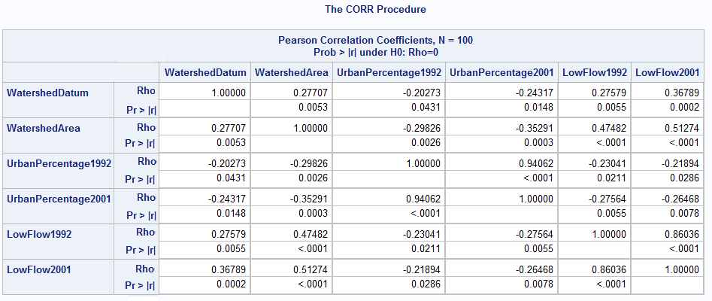
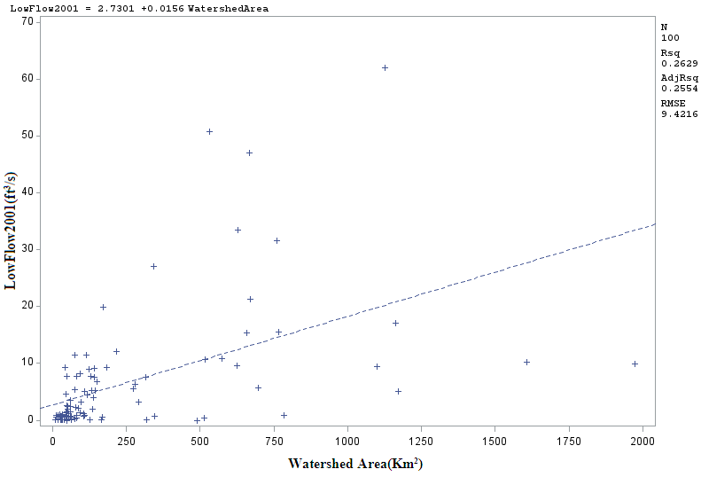

Appendix E

Wilcoxon signed rank results
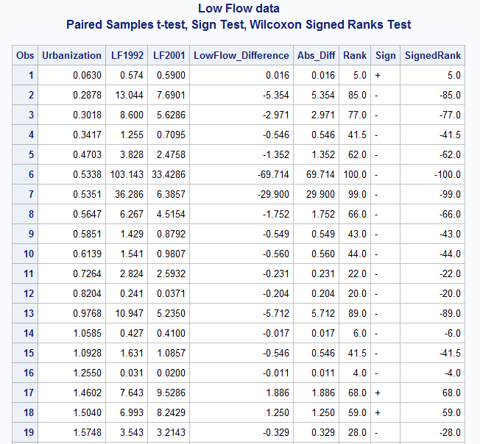


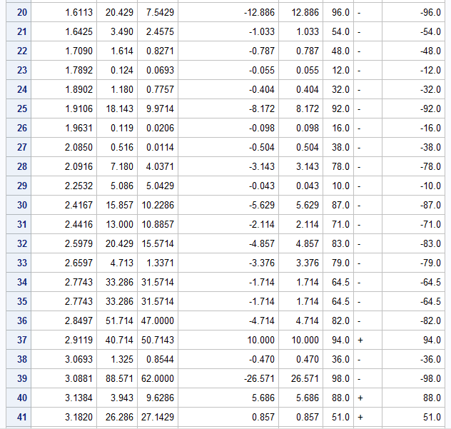


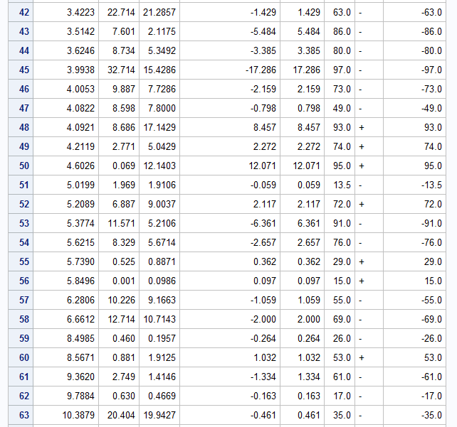

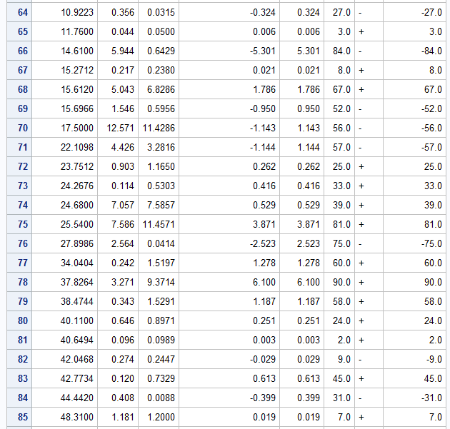

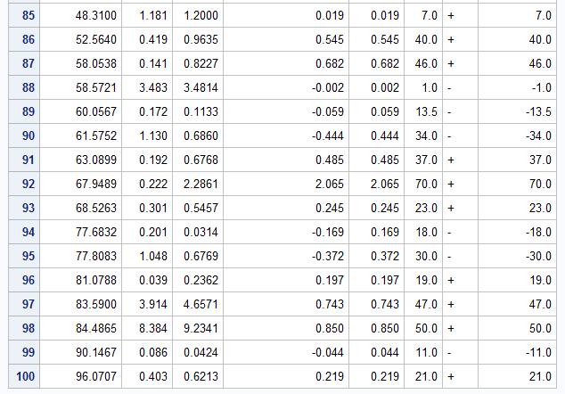

Appendix F

Comparing the percentage of three different land cover
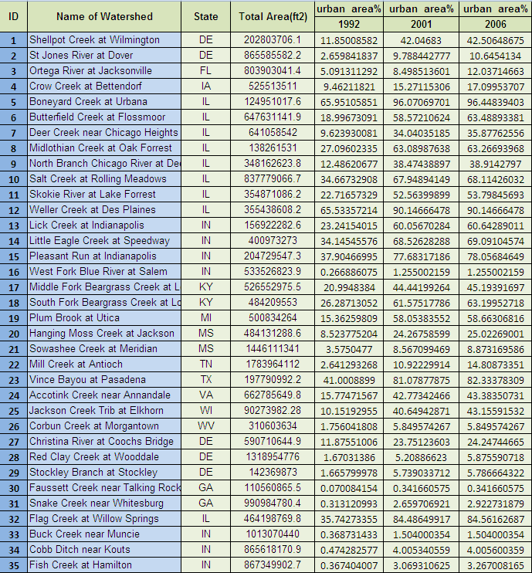

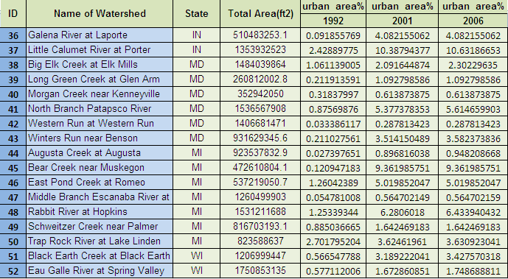

Appendix G

As Ott et al. (2010) emphasizes:”The Wilcoxon signed-rank test requires that the population distribution of differences be symmetric about the unknown median M. Let D0 be a specified hypothesized value of M. The test evaluates shifts in the distribution of differences to the right or left of D0; in most cases, D₀ is 0. The computation of the signed-rank test involves the following steps:
1. Calculate the differences in the n pairs of observations.
2. Subtract D₀ from all the differences.
3. Delete all zero values. Let n be the number of nonzero values.
4. List the absolute values of the differences in increasing order, and assign them the ranks 1, . . . ,
n (or the average of the ranks for ties).

We define the following notation before describing the Wilcoxon signed-rank test:
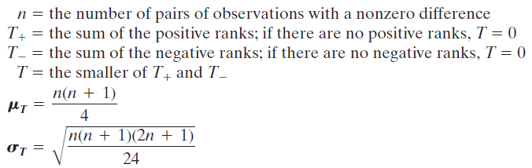
If we group together all differences assigned the same rank, and there are g such groups, the variance of T is
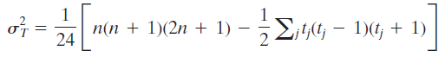
where tj is the number of tied ranks in the jth group. Note that if there are no tied ranks, g = n, and tj =1 for all groups. The formula then reduces to
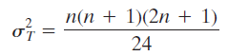
The Wilcoxon signed-rank test is presented here. Let M be the median of the population of differences.” The assumptions and procedure are shown in figure 3.9.
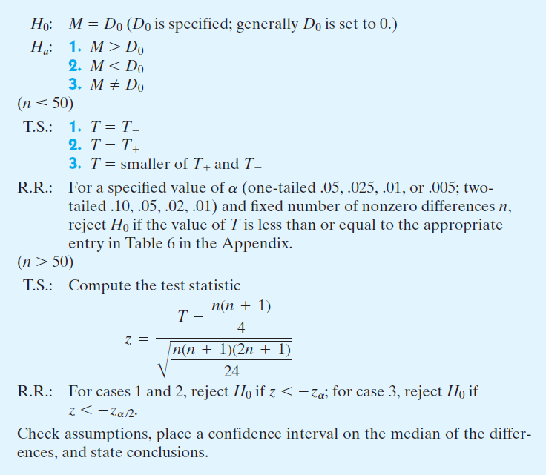
VITA

Saeed Zabet was born in Mashhad-Iran on October 14, 1975. He graduated from
Jabbarian High School in Mashhad, Khorasan Razavi in June 1993. He went to the University of Shahid Bahonar at Kerman, where he graduated with a Bachelor’s degree in civil engineering during May of 1998. Saeed then went to college at the University of Tennessee in pursuit of a Master’s degree in Civil and Environmental Engineering. He will receive his Master’s of Science degree in Environmental Engineering in May 2012, majoring in Water Resources Engineering.

