Precision Livestock Farming for Behavior Measurement and Welfare Management in Broiler Chickens

A Dissertation Presented for the
Doctoral of Philosophy
Degree
The University of Tennessee, Knoxville

Xiao Yang
December 2021

Copyright © 2021 by Xiao Yang.

ACKNOWLEDGEMENTS

Throughout my PhD study and the writing of this dissertation, I have received a great deal of support and assistance.
I would first like to express my deepest appreciation to my supervisor, Dr. Yang Zhao for his invaluable advice, continuous support, and patience during my PhD study. His attitude of research, scientific mind and professional skills have encouraged me in all the time of my academic research and daily life.
Additionally, I would like to express gratitude to my committees, Dr. Robert Burns, Dr. Liz Eckelkamp, Dr. Maria Prado, and Dr. Hao Gan for their treasured help of my research and effort they took in preparing my comprehensive exams. Especially thank Dr. Gan for his constructive advice, which was really influential in improving my knowledge of image processing.
I would also like to thank all of my co-authors (Dr. Xiaojing Huo, Dr. Guoming Li, Dr. Joseph Purswell, Dr. George Tabler, Dr. Gary Chesser and Dr. Christopher Magee, Dr. Yanbo Huang, Dr. Garrett Street, Dr. Filip To and Dr. Hairong Qi), who gave me constructive comments on experimental design, data analysis and scientific writing. Thank my lab mates, Dr. Guoming Li, Dr. Pratik Parajuli and Nguyen Xuan for a cherished time spent together in the lab, and in social settings.
Also, I must express thanks to the assistance provided by staff at the Johnson Animal Research and Teaching Unit at the University of Tennessee, and the USDA-ARS Poultry Research Unit at Mississippi. Without their help my experiment would not have been finished.
I would also like to acknowledge the faculty and staff of the department of Animal Science at the University of Tennessee, as well as the staff of department of Agricultural and Biological Engineering at Mississippi State University. Thanks for their assistance and guidance during my PhD.
I am deeply grateful to my parents and my boyfriend for their unfailing support and warm encouragement through my years of study. They are the strongest backing for me to face every challenge and keep moving forward bravely.
ABSTRACT

Rapid development of broiler production brings up multiple challenges for animal welfare. In recent years, Precision Livestock Farming (PLF) has been widely used for addressing these challenges. PLF aims to improve production efficiency and animal welfare via developing a real-time, continuous and automatic system. The objective of the dissertation is to explore and develop PLF techniques for broiler behavior measurement and welfare management based on welfare enrichment, smart sensors (accelerometer, microphone) and cameras.
The effects of Elevated Platform (EP) and Robotic Vehicle (RV on litter moisture content (LMC), NH₃ concentration, paw quality, plumage cleanliness, and bird activity index (AI) were investigated and described in Chapter II. The results show that the application of EP and RV could significantly improve housing environment and bird welfare.
The performance of using three-dimensional accelerometer and two machine learning models (K-Nearest Neighbor and Support Vector Machine) to classify broiler walking, resting, feeding and drinking behaviors was described in Chapter III. Both models show high sensitivities in identifying broiler resting (> 85%) and walking (99% for both).
The frequency ranges of six common sounds, including bird vocalization, fan, feed system, heater, wing flapping, and dustbathing in a commercial farm were explored and described in Chapter IV. The frequency ranges of bird vocalization continuously decreased as birds grew.
The effects of six image sampling time intervals (0.04, 0.2, 1, 10, 60, and 300 s) on the accuracy of broiler AI at different bird ages, locations and times of day were investigated and described in Chapter V. The results show time interval of 0.04 s yielded the highest broiler AI, followed by 0.2 s with an acceptable accuracy and 80% less computational resources.
The correlation of broiler gait score (GS) with several flock metrics (age, body weight, activity and distribution) were investigated and described in Chapter VI. Broiler GS positively correlated with body weight (R² = 0.97 for Cobb and Ross), while negatively correlated with activity (R² > 0.76 for Cobb and Ross).
In conclusion, PLF technologies for broilers are promising approaches to enhance farm management efficiency, monitor broiler behaviors, and improve bird welfare conditions.
Table of Contents

Chapter I 1
General Introduction 1
1.1 Background 1
1.2 Challenges in Broiler Production 1
1.3 Related Research 3
1.4 Objectives 8
Chapter II 10
Effects of Elevated Platform and Robotic Vehicle on Broiler Production, Welfare, and Housing Environment 10
2.1 Introduction 11
2.2 Materials and Methods 12
2.3 Results 16
2.4 Discussion 24
2.5 Conclusions 28
Chapter III 29
Classification of Broiler Behaviors Using Triaxial Accelerometer and Machine Learning 29
3.1 Introduction 30
3.2 Materials and Methods 31
3.3 Results 36
3.4 Discussion 42
3.5 Conclusions 46
Chapter IV 47
Characterizing Sounds of Different Sources in Commercial Broiler Houses 47
4.1 Introduction 48
4.2 Materials and Methods 49
4.3 Results 55
4.4 Discussion 59
4.5 Conclusions 62
Chapter V 63
Accuracy of Broiler Activity Index as Affected by Sampling Time Interval 63
5.1 Introduction 64
5.2 Material and Methods 65
5.3 Results 67
5.4 Discussion 69
5.5 Conclusions 74
Chapter VI 76
Broiler Gait Score in Relation to Bird Age, Body Weight, Activity and Distribution 76
6.1 Introduction 77
6.2 Materials and Methods 77
6.3 Results 81
6.4 Discussion 92
6.5 Conclusions 94
Chapter VII 95
Discussion and Conclusions 95
References 98
VITA 116

LIST OF TABLES

Table 1.1 Perch design for broilers in different studies. 5
Table 1.2 Elevated platform design for broilers in different studies. 5
Table 2.1 Body weight (BW), body weight gain (BWG), feed intake (FI) and feed conversion ratio (FCR) summarized at week 2, 4, 6 and 8 in the treatment and control experimental rooms. 18
Table 2.2 Normalized litter moisture content in the treatment and control experimental rooms over the production cycle. Elevated perching platforms were placed in the room at the end of week 2; and the robotic vehicle started operating in the beginning of week 2. 21
Table 3.1 Number of records and equivalent time labelled for model training and testing 34
Table 3.2 Formulas for calculating motion features of broilers using triaxial acceleration data. 35
Table 3.3 Sensitivity (%) of k-nearest neighbor (KNN) and support vector machine (SVM) in classifying broiler resting (R), walking (W), feeding (F) and drinking (D) behaviors (pure behavior dataset). 37
Table 3.4 Precision (%) of k-nearest neighbor (KNN) and support vector machine (SVM) in classifying broiler resting (R), walking (W), feeding (F) and drinking (D) behaviors (pure behavior dataset). 39
Table 3.5 Accuracy (%) of k-nearest neighbor (KNN) and support vector machine (SVM) in classifying broiler resting (R), walking (W), feeding (F) and drinking (D) behaviors (pure behavior dataset). 39
Table 3.6 Confusion matrix of k-nearest neighbor (KNN) and support vector machine (SVM) in classifying broiler resting (R), walking (W), feeding (F) and drinking (D) behaviors (pure behavior dataset). 40
Table 3.7 Proportion of undefined windows and the prediction accuracies of k-nearest neighbor (KNN) and support vector machine (SVM) in classifying broiler behaviors (continuous behavior dataset) with different window lengths. 41
Table 3.8 Confusion matrix of k-nearest neighbor (KNN) and support vector machine (SVM) for classifying continuous broiler behaviors (exclude undefined windows) with different window lengths. 43
Table 3.9 Accuracy (%) of k-nearest neighbor (KNN) and support vector machine (SVM) in classifying continuous broiler behaviors by including different number of broilers in the training dataset. 44
Table 4.1 Number of events and equivalent time labelled for each type of sound over eight weeks. 52
Table 4.2 Frequency range of bird vocalization at different bird ages (mean ± SD). 57
Table 4.3 Frequency range of fan at different bird ages (mean ± SD). 57
Table 4.4 Upper frequency limits of feed system, heater, wing flapping and dustbathing at different bird ages (mean ± SD). 58
Table 4.5 Behavioral frequency of wing flapping and dustbathing at different bird ages (mean ± SD). 60
Table 5.1 Average broiler activity index (AI) with different time intervals at different locations. 68
Table 5.2 Weekly average broiler activity index (AI) at different locations. 70
Table 5.3 Weekly average broiler activity index (AI) within three time periods (06:00 h – 07:00 h, 12:00 h – 13:00 h, and 18:00 h – 19:00 h) at three locations (feeder, drinker, and open area). 70
Table 6.1 Criteria of each gait score. 82
Table 6.2 Variables used for stepwise regression model development 83
Table 6.3 Average body weight (BW) and Gait score (GS) of Cobb 500 and Ross 708 broilers at different bird ages (mean ± SD). 84

LIST OF FIGURES

Figure 2.1 Schematic drawings of elevated perching platform. 13
Figure 2.2 Image processing for bird activity index analysis. (a) current cropped-out grayscale image; (a’) consecutive cropped-out grayscale image; (b) current binary image showing bird-representing pixels in white; (b’) consecutive binary image showing bird-representing pixels in white; (c) binary image showing changes of bird-representing pixels in two consecutive frames (b’ – b). 17
Figure 2.3 (a) Percentage (mean ± SD) of broilers on platform in treatment (w/ elevated perching platform only ‘EP’, and w/ both EP and RV ‘EP+RV’) rooms before, during, and after the robot operation period. (b) Average percentage of broilers on platform in two rooms with EP. ^{ab}Means with different superscripts are different (p < 0.05). 19
Figure 2.4 Weekly average percentage (mean ± SD) of broilers on platform in treatment (w/ elevated perching platform only ‘EP’, and w/ both EP and RV ‘EP+RV’). ^{abc} Means with different superscripts in the same series are different (p < 0.05). ^{AB} Means with different superscripts in the same series are different (p < 0.05). 21
Figure 2.5 Daily indoor NH₃ concentrations (mean ± SD) in rooms with or without EP, and the outdoor NH₃ concentration of ambient air environment. 22
Figure 2.6 Distribution of broiler gait score (GS) in the treatment (w/ elevated perching platform only ‘EP’, w/ robotic vehicle only ‘RV’, and w/ both EP and RV ‘EP+RV’) and the control rooms. Score ‘0’ means the best waking ability, and score ‘2’ means the worst. Number on the top of each bar means average score of each treatment. (a = week 4; b = week 8) 22
Figure 2.7 Distribution of broiler paw quality (PQ) in the treatment (w/ elevated perching platform only ‘EP’, w/ robotic vehicle only ‘RV’, and w/ both EP and RV ‘EP+RV’) and the control rooms. Score ‘0’ means the best footpad condition, and score ‘2’ means the worst. Pooled SEM for main effects of score level was listed in the table. Number on the top of each bar means average score of each treatment. (a = week 4; b = week 8) 23
Figure 2.8 Distribution of broiler plumage cleanness (PC) in treatment and control rooms at weeks 4 (a) and 8 (b) of bird age. Plumage cleanness is score 0-3, with score ‘0’ being best and score ‘3’ being worst. Pooled SEM for main effects of score level was listed in the table. Number on the top of each bar means average score of each treatment. ab Means with different superscripts are different (p < 0.05). (a = week 4; b = week 8) 23
Figure 2.9 Broiler activity index in treatment (w/ elevated perching platform only ‘EP’, w/ robotic vehicle only ‘RV’, and w/ both EP and RV ‘EP+RV’) and control rooms before, during, and after the robot operation period. 25
Figure 3.1 Pictures of an accelerometer with a battery (a), a sensor case (b), and a broiler carrying an accelerometer (c). 32
Figure 3.2 Example acceleration signals of broiler resting (a), walking (b), feeding (c) and drinking (d) behaviors in forward-backward, left-right, and up-down directions. 34
Figure 3.3 Diagram of sliding window with 50% overlap. 35
Figure 4.1 Image of the recorder (a) and location of the recorder M (b). 50
Figure 4.2 Example signals of bird vocalization (a), fan (b), feed system (c), heater (d), wing flapping (e) and dustbathing (f) in frequency domain. 53
Figure 4.3 Flowchart for three-level Maximum Overlap Discrete Wavelet Transform. 54
Figure 4.4 Single-sided amplitude spectrum of original signal (a) and decompositions 1-6 (b-g). Decomposition 2 (c) refers to bird vocalization, decomposition 4 (e) refers to fan. 56
Figure 4.5 Example of Gaussian regression (a) and calculation of behavioral frequency (b). The sound sources of two sounds are bird vocalization (a) and wing flapping (b), respectively. 56
Figure 5.1 Example images of (a) feeder (b) drinker and (c) open area. 66
Figure 5.2 Weekly average broiler activity index (least square means ± SEM) in feeder, drinker and open area with different time intervals. ^{a, b, c, d, e} Means with different superscripts within the same category are different (p < 0.05). 71
Figure 6.1 Pictures of pen settings. 79
Figure 6.2 Cropped areas in images. 79
Figure 6.3 Schematic of three areas that next to (A1), near (A2) and far from (A3) the feeder and drinker. 80
Figure 6.4 Correlations of gait score and body weight for Cobb 500 (a) and Ross 708 (b) broilers. Greater gait score means worse walking ability. 85
Figure 6.5 Correlations of gait score and body weight for Cobb 500 (a) and Ross 708 (b) broilers. Greater gait score means worse walking ability, and greater activity index means more active birds. 87
Figure 6.6 Correlations of gait score and distribution index for Cobb 500 (a) and Ross 708 (b) broilers. Greater gait score means worse walking ability, and less distribution index means more uniform distribution. 87
Figure 6.7 Bland-Altman plots for the evaluation of the agreement between the observed (human assessment) and predicted (linear regression model) gait score. Three figures correspond to models developed for AW (a), CS (b) and AW+CS (c), respectively. The solid red line represents the mean of difference between observed and predicted gait score. The dashed lines indicate the span of the 2 standard deviations (95% CI) away from the mean. 88
Figure 6.8 Goodness of fit of three linear regression models for Cobb 500 (a, c and e) and Ross 708 (b, d and f). Three rows of figures correspond to the performance of models developed for farms with automatic weighing system (AW), farms with camera system (CS), and farms with both automatic weighing system and camera system (AW+CS), respectively. 90

General Introduction

1.1 Background
Global poultry meat production continues to increase and has become the largest meat industry in 2020 (USDA, 2020). The United States is the global leader of broiler chicken production. In 2017, the U.S. broiler industry produced 8.89 billion broiler chickens for a total value of 30.6 billion dollars and exceeded the value of all other poultry products (USDA-NASS, 2018). Americans consume approximate 44 kg/capita chicken in 2020, more than any other countries.

1.2 Challenges in Broiler Production
The large-scale housing system and fast-growing genotype selection meet the huge market demand, meanwhile lead to multiple challenges regarding housing environment, animal health and welfare in recent years. Examples of challenges in current broiler production include poor litter quality, high ammonia (NH₃) level, contact dermatitis and leg disorders.
                - 1.2.1 Litter quality
Litter quality is of great importance for broiler welfare as they spend over 80% of their life resting on the floor. Litter quality is mostly determined through litter moisture content. The ideal litter moisture content (LMC) of broiler houses is 20-25%. Wet litter provides a perfect environment for pathogen bacteria and may cause health problems of broilers. One of the factors that may affect the litter moisture content is stocking density. Higher litter moisture content and pH are normally associated with higher stocking density (Petek et al., 2014). This is not only because larger amount of fecal is produced for higher stocking density, but also because the ventilation near the floor cannot remove the moisture efficiently. Another factor that related to litter quality is litter materials. Different types of bedding materials have been investigated in previous studies, such as wood shaving (Oke et al., 2019; Petek et al., 2014), rice hull (Abreu et al., 2013), sand (Bilgili et al., 2009), chopped wheat straws (van Harn et al., 2012), sugar cane bagasse (Garcia et al., 2012), newspaper (El-Deek et al., 2011) etc. The ability of absorption and quickly releasing moisture were considered as one of the most important characteristics of bedding materials (Bilgili et al., 2009).

                - 1.2.2 Air quality
Wet litter is an ideal environment for pathogenic bacteria and is the major source of ammonia (NH₃). National Institute for Occupational Safety and Health (NIOSH) recommended the eight-hour time-weighted average (TWA) NH₃ level not to exceed 25 ppm (NIOSH, 2007). However, the NH₃ concentrations inside broiler houses could exceed the recommended value (Miles et al., 2004). Elevated NH₃ concentration may decrease the body weight and feed efficiency of broiler chickens (Beker et al., 2004). It may also damage birds’ ocular and respiratory systems, and lead to keratitis, conjunctivitis, corneal edema, and ulceration (Miles et al., 2006). Furthermore, high NH₃ concentration may pose risks to the health of farm workers (Donham et al., 2002) and cause environmental issues, such as soil acidification, formation of fine particulate matter, and N deposition into aquatic system (Schrøder, 1985).
                - 1.2.3 Contact dermatitis
Contact dermatitis is another welfare issue that associated with poor litter condition (De Jong et al., 2014; Martland, 1985). It is characterized as nonallergic inflammation of the skin that caused by external substance (Frosch and John, 2011). Contact dermatitis in broiler chickens is typically observed first with footpad lesions, followed by hock burns. Both of them start with superficial hyperkeratosis, then transfer to deep ulcers covered with a dark deep crust (Greene et al., 1985; Michel et al., 2012). It may cause pain and lead to lameness when it transforms into deep ulcers (Da Costa et al., 2014). In addition, footpad dermatitis may cause economic loss because of the large demand of chicken feet in Asian countries (Giron et al., 2019; Shepherd and Fairchild, 2010). The prevalence of footpad dermatitis has been used as an audit criterion in welfare assessments of poultry production system in Europe and the United States (Council, 2014).
                - 1.2.4 Leg disorder
Leg disorder has major impacts on broiler welfare. The most common leg problems are typically observed in skeletal system, for instance, valgus, crooked toes, tibial dyschondroplasia, vertebral deformities, twisted legs, osteoporosis of the proximal femur, and femoral head necrosis (Sanotra et al., 2002; Thorp and Waddington, 1997). The reason for broiler lameness is complicated, including strain, growth rate, body weight, stocking density, light, nutritional deficiency, activity level etc. Most of lameness in broiler chickens is caused by heavy body weight on relative immature bones and appears between weeks 3-8. Knowles et al. (2008) conducted a comprehensive survey of 176 broiler flocks (4.8 million birds) and reported that over 27.6% of birds showed poor locomotion and 3.3% couldn’t move by the age of 40 days. Other studies also reported that 14%-50% of broilers were moderately to severely lame in commercial farms at the late phase of production cycle (Bassler et al., 2013; De Jong et al., 2016). Lame birds may suffer from pain (Hothersall et al., 2016), and have difficulty in getting access to feed and water (Bessei, 2006). Leg abnormalities may also cause economic loss due to higher mortality (Wideman Jr et al., 2012) and lower body weight gain (Gocsik et al., 2014). Reduced walking ability, on the other hand, may extend the contact time between birds and wet litter, thereby increase the occurrence of contact dermatitis (Nääs et al., 2009).

1.3 Related Research
                - 1.3.1Welfare enrichment
Introducing environmental enrichments into animal houses is one of the strategies that can improve the farm animal welfare. Environmental enrichment refers to modifications that can improve a captive animal’s interaction with its environment. It may benefit animal health by increasing the complexity of environment, providing opportunities of the performance of natural behaviors and increasing the general activity.
(1) Definition of welfare enrichment
Since the investigation of environmental enrichment was commenced in 1980s (de Azevedo et al., 2007), it has been extensively used in zoos. Although it hasn’t been generally used on farms, the positive effects of environmental enrichment on captive animal welfare seems convinced. Newberry (1995) described the effects of environmental enrichment as “An improvement in the biological functioning of captive animals resulting from modifications to their environment”. There are five main categorizes of enrichment: nutritional, occupational, sensory, physical, and social (Young et al., 2003). These categories work individually or jointly to optimize the animal’s environment, thus improving animal health and well-being. In broiler production, two of the widely used welfare enrichments are perches and elevated platform.
(2) Perch
Perching is a natural behavior for both jungle fowl and their domesticated relatives (Collias and Collias, 1967; Sandilands et al., 2009). Therefore, providing perches in broiler houses is considered as an effective method of developing enriched environment. The use of perches by broilers range 2–25%, which is much lower than that of laying hens (Groves and Muir, 2013; LeVan et al., 2000; Ventura et al., 2012b). One of the hypothesizes for low use of perches by broilers is that the design does not accommodate the high body weight, weak bones, and body conformation of broilers. Different designs of perch (Table 1.1) have been investigated regarding materials, dimension, height, angle, shape etc. Significant effects of perch design on the use of perches were observed in previous studies. LeVan et al. (2000) reported perch use of broilers was highest for 0° perch, followed by 10° and 20° perch. Norring et al. (2016) compared the use of perches with different height (10, 30cm) and found broilers prefer to use lower perches. However, the height of perch is not the lower the better. Estevez et al. (2002) observed that lower perches (7.5cm) were preferred by younger birds during 1-4 weeks of age, while greater use of higher perch (15 cm) was observed by week 5 and 6. Estevez et al. (2002) also reported that broiler chickens prefer water-cooled perches (10°C) to ambinent temperature perches. Clear age effects on the use of perches has been reported (Sandilands et al., 2009). The use of perches increased from week 1 to week 4, then gradually decreased at the late phase of the production cycle (Bailie and O’Connell, 2015; Estevez et al., 2002; LeVan et al., 2000; Pettit-Riley and Estevez, 2001; Ventura et al., 2012b). Sandilands et al. (2016) found a continued increase in perch use until week 5. Martrenchar et al. (2000) reported a longer upward trend in use of perches until week 6. Zhao et al. (2013) found accessibility of cool perches could reduce footpad or hock burns and imporve the plumage cleanliness. Perches is also believed to reduce the level of regression in the flock (Ventura et al., 2012b). No effect of accessing perches on broiler lameness nor the prevalance of tibia dyschondroplasia due to the low usage was observed (Bailie and O’Connell, 2015; Su et al., 2000). Reduction on the number of disturnaces, i.e., pushing and trampling (Ventura et al., 2012b) can be observed when a significant number of birds rest on perches. The concern of using perches is associated with the occurrence of breast blisters (Nielsen, 2004) due to the broiler’s genotype and sex.
(3) Elevated platform
Elevated platform is another method of providing elevated structures for broilers to perch. Different designs of platform have been studied and used in commercial farms (Table 1.2). The most common design is a slatted mesh area accessible by a ramp. Higher usage of platform than traditional perch was reported (Norring et al., 2016). The possible explanation is that platforms with ramps are easier for broilers to access at different ages. It is expected to improve the birds’ locomotion, thus benefits the leg health. Lower prevalence and severity of tibial dyschondroplasia and lower mean gait score was observed for birds have access to platforms (Kaukonen et al., 2017b). But no effect on broiler activity was found compared with control group (Norring et al., 2016). Furthermore, footpad and hock skin health and litter condition were not affected by platform (Kaukonen et al., 2017a). Baxter et al. (2020) introduced different number of platforms (0, 8, 10 and 12) into windowed broiler house and found lower level of avoidance behaviors in all platform treatments compared with control, though no difference between different number of platforms. Similar result was reported by Pedersen et al. (2017) that fearfulness level of fast-growing broilers were lower when platform was used. In addition, no effect of platform on bird vocalization volume, latency to approach peat, or play behaviors was observed (Baxter et al., 2020).
                - 1.3.2 Precision Livestock Farming (PLF)
Animal behavior determination is another method of animal welfare improvement. It has been reported that animal behavioral and physiological responses could provide reliable information regarding animal welfare (Mollenhorst et al., 2006; Nardone et al., 2004), such as time budget of feeding and drinking, time spent on walking, walking ability, activity level, etc. In addition, incidences of diseases (footpad dermatitis, hock burns, breast burns) and production performance (mortality) could be other indicators.
Table 1.1 Perch design for broilers in different studies.
Material | Height | Shape | Angle | Reference
PVC pipes | 8.5-35.5cm | With crossbars | 0°, 10°, 20° | LeVan et al. (2000); Pettit-Riley and Estevez (2001)
Cooled steel pipes (10°C) |  | Round |  | Zhao et al. (2012)
Wood | 10.0-30.0cm | Rounded upper edges | 0° | Norring et al. (2016)
PVC; wood | 10.4cm | Rounded edges | 0°, 13° | Hongchao et al. (2014)
Wood | 15.0cm | Rounded upper edge | 0° | Bailie and O’Connell (2015)
Wood | 12cm | I-shape | 0° | Kiyma et al. (2016)
Wood | 2.5-25cm | I-shape | 0° | Su et al. (2000)
Wood | 10cm | E-shape | 0° | Ventura et al. (2010)
Cooled iron pipes (10°C) | 7.5cm, 15cm | Round | 0° | Estevez et al. (2002)

Table 1.2 Elevated platform design for broilers in different studies.
Material | Dimension | Height | Ramp | Reference
Plastic mesh; Steel perch | 300×57.5cm | 12-20cm | -- | Baxter et al. (2020)
Plastic mesh | 120×60cm | 30cm | Two 15° ramps | Kaukonen et al. (2017b); Norring et al. (2016)
Plastic mesh; Wood structure | 120×60cm | 15cm | Two 15° ramps | Yang et al. (2020)
Perforated plastic slats | 540×60cm | 30cm | Two 14.5° ramps | Tahamtani et al. (2020); Pedersen et al. (2020)
Perforated plastic slats | 540×60cm | 5cm | -- | Tahamtani et al. (2020); Pedersen et al. (2020)
Slatted plastic floor;  Metal legs | 480×60cm | 48cm | Two 23.5° ramps | Vasdal et al. (2019)
Plastic | 480×60cm | 10, 30, 50cm | A 35° ramp | Malchow et al. (2019)

(1) Definition of Precision Livestock Farming (PLF)
Traditional animal welfare assessments mainly rely on human observation. However, assessing welfare in large poultry flocks efficiently and objectively, detecting potential welfare risks and controlling or minimizing their impact is challenging. Therefore, the concept of Precision livestock farming (PLF) was proposed. PLF aims to improve production efficiency and animal welfare via developing a real-time, continuous and automatic monitoring and managing system. In the last two decades, many precision technologies have been developed for animal behavior determination and welfare improvement, such as wearable sensors (accelerometers), microphones, radio-frequency identification (RFID) and machine vision techniques.
(2) Sensor
A sensor is a device that detects the variations of the environment or the interested objects. It converts a physical phenomenon into analog voltage or digital signal, thereafter, convert into a readable display after processing. Sensors that were widely used for animal welfare and behavior determination include accelerometers and microphones.
An accelerometer is an electromechanical device that measures acceleration forces. These forces may be static, like the constant force of gravity, or they could be dynamic caused by moving or vibrating the accelerometer. Accelerometers have been implemented to study behaviors and motions of different animal species, such as beef cattle (Robert et al., 2009; Watanabe et al., 2008; Williams et al., 2019; Wolfger et al., 2015), dairy cows (Diosdado et al., 2015; Nielsen et al., 2010; Reiter et al., 2018), and sheep (Alvarenga et al., 2016; Giovanetti et al., 2017) to recognize the behaviors of eating, drinking, ruminating, sitting, standing, walking and lying. Some waterproofed accelerometers were deployed to detect postures of fish (Brownscombe et al., 2014). The time budget of each behavior and the activity level were determined through classification, and served as the indicator of animal health (Pereira et al., 2018). By identifying abnormal behaviors, accelerometers showed the possibility of detecting lameness of animals. Thorup et al. (2015) detected lameness of dairy cows via leg-mounted accelerometers and pedometers. Kaler et al. (2020) investigated the behaviors of lame and non-lame sheep using ear-attached accelerometers. Similar research has been conducted on sows using ear tag-sampled acceleration data (Scheel et al., 2017). In other research, accelerometers were also used as a tool of detecting animal disease. For example, Tobin et al. (2020) deployed accelerometers on cattle to identify Bovine Ephemeral Fever by calculating the movement intensity from three dimensional accelerations.
Another type of sensor that is commonly used in livestock farm is the acoustic sensors (microphones). Sound produced by animals is a type of language that animals used to communicate with the outside world. Animal sounds can be used to determine not only the performance, but also the health and stress of animals. Fontana et al. (2017) developed a model that could detect the body weight of broilers based on the peak frequency of vocalization. The model was validated with high correlation (r = 96%) between expected and observed body weights. Aydin and Berckmans (2016) designed a novel sound monitoring system to detect the short-term feeding behaviors (meal size, meal duration, meals per day and feeding rate) of broiler chickens at group level with the accuracy of 89–95%. Except daily management, sound technologies also showed the potential of detecting animal diseases, such as cough of dairy calves (Ferrari et al., 2010), sneeze (Carpentier et al., 2019) and abnormal night vocalizations (Du et al., 2018) of poultry, stress (Moura et al., 2008) and pain (Marx et al., 2003) of pigs, as well as the claw lesions of dairy cows (Volkmann et al., 2019).
(3) Camera
Advancement of video cameras and machine vision techniques promote the application of digital imaging technology in animal production. Cameras, as non-invasive and cheap tools, have been intensively used to monitor and assess farm animal performance, behaviors and welfare at either individual or group level.
Kashiha et al. (2014a) used image processing to monitor the weight and growth of fattening pigs, yielded 97.5% accuracy at group level and 96.2% at individual level. Mollah et al. (2010) and Mortensen et al. (2016) estimated the live body weight of broilers through 2D or 3D cameras. For beef cattle, the digital image processing was more commonly used to predict the body weight and carcass weight, as well as the body fat content of young bulls (Gomes et al., 2016; Pradana et al., 2016). After the animal is slaughtered, identify and grade the meat quality before sending it to the market is another critical indicator of animal welfare. Generally, the determination of meat quality is carried out by authorized experts through visual inspection, which is time-consuming and laborious. Andaya et al. (2019) developed an automatic image processing system to classify meat samples based on marbling formation. Felfoldi et al. (2013) also used image processing methods to measure fat/meat ratio and fat distribution of pork and beef.
In respect of animal behaviors, camera-based system were applied for lameness detection, activity determination and behavior identification. Zhao et al. (2018) analyzed leg swing of cows using computer vision and developed an automatic locomotion score system to predict lameness of cows with over 90% accuracy. Other lameness indicators of dairy cows including step overlap (Pluk et al., 2010) and arc of back posture (Poursaberi et al., 2010a; Viazzi et al., 2013) were also featured to describe the body movement and detect lameness in recent studies. Flock activity monitoring using image processing have been investigated for pigs (Costa et al., 2014; Kashiha et al., 2014c) and broilers (Van Hertem et al., 2018b). The eYeNamic camera surveillance and software system (Fancom, Wilhelminastraat 17, NL-5981 XW Panningen, The Netherlands), which can automatically and continuously monitor the animal activity and floor distribution, suggesting the potential of assessing broiler lameness (Silvera et al., 2017). At individual level, numerous studies were conducted on animal behavior recognition, such as feeding (Yang et al., 2018), mounting (Li et al., 2019; Nasirahmadi et al., 2016), lactating (Lao et al., 2016; Yang et al., 2017; Zheng et al., 2018) and tail biting (Liu et al., 2020) of pigs; feeding, standing (Porto et al., 2015) and lying (Porto et al., 2013) behaviors of dairy cows; and mating of beef cattle (Tsai and Huang, 2014).
Cameras can also be used to detect animal diseases. Zhuang and Zhang (2019) used image processing to identify sick birds within flock in combination with deep learning algorithms. Colles et al. (2016) detected chickens infected with microorganisms within 7 to 10 days after hatch by using optical flow patterns. Jingqiu et al. (2017) reported that the recognition rates of dairy cow hoof disease were greater than 80% by object recognition based on image processing.

1.4 Objectives
In this dissertation, different types of PLF techniques were developed for broiler behavior determination and welfare improvement. The dissertation is constructed by presenting five studies that have been done during the PhD program. Each study was listed as one chapter. Structure of the dissertation and objectives of each study were shown below.
Chapter I: Summarize the background of global and U.S. broiler production. Reviews studies of precision technologies for animal behavior determination and welfare assessment, including welfare enrichment, smart sensors and video cameras.
Chapter II: Evaluate the effects of using elevated platform and robotic vehicle individually or jointly on broiler production performance, NH₃ concentration, LMC, gait score (GS), paw quality (PQ), plumage cleanliness (PC) and activity.
Chapter III: Classify specific broiler behaviors, including resting, walking, feeding and drinking, by analyzing acceleration data using two machine learning models, KNN and SVM.
Chapter IV: Determine the frequency ranges of six common sounds, including bird vocalization, fan, feed system, heater, wing flapping and dustbathing in a commercial broiler house over an eight-week production cycle. In addition, the frequencies of flapping (in wing flapping events, flaps/sec) and scratching (during dustbathing, scratches/sec) behaviors were examined through sound analysis.
Chapter V: Investigate the effect of sampling time interval (0.04, 0.2, 1, 10, 60, and 300 s) on the accuracy of broiler AI. The effects of bird age (1-7 weeks), location (feeder, drinker, and open area) and time of day (06:00-07:00 h, 12:00-13:00 h and 18:00-19:00 h) on broiler AI were also examined.
Chapter VI: Identify the broiler gait score as affected by bird body weight, activity and distribution for Cobb 500 and Ross 708 broilers. Prediction models based on body weight, activity and distribution were developed for automatic gait score assessment.
Chapter VII: Discuss the application and significance of these studies in the field of poultry industry, as well as the future of precision poultry farming.

Effects of Elevated Platform and Robotic Vehicle on Broiler Production, Welfare, and Housing Environment

This chapter has been published in Transactions of the ASABE.

Yang, X., Huo, X., Li, G., Purswell, J. L., Tabler, G. T., Chesser, G. D., ... & Zhao, Y. (2020). Effects of Elevated Platform and Robotic Vehicle on Broiler Production, Welfare, and Housing Environment. Transactions of the ASABE, 63(6), 1981-1990. (2021 ASABE Superior Paper Award)

2.1 Introduction
Broiler chickens are raised on floor housing system in the US. While the floor system has been used for years, the living conditions of broilers are increasingly questioned along with current public concerns on farm animal welfare. To address these concerns, animal welfare groups have been progressively promoting environmental enrichments in broiler houses. This movement has resulted in an increasing number of chain restaurants and retailers sourcing poultry meat produced in housing with higher welfare standards. As such, broiler producers are striving to improve the production environment to meet public demands; however, they are facing challenges in multiple dimensions.
Examples of major challenges related to the broiler production environment include poor litter and air quality, barren environmental complexity, and subpar animal welfare and health. Broilers are commonly kept at large flock size in the houses, where litter moisture content is gradually built up as birds grow. High litter moisture content may result in elevated ammonia (NH₃) concentration (Chai et al., 2018). Occupational agencies (NIOSH) have recommended the eight-hour time-weighted average (TWA) NH₃ level not exceed 25 ppm (NIOSH, 2007); however, NH₃ concentration may exceed the TWA level in commercial broiler houses at late phases of production cycles (Miles et al., 2004). Many studies have shown that high NH₃ concentration compromises welfare and health of both caretakers and broilers (Kristensen and Wathes, 2000; Moore Jr et al., 1999; Olanrewaju et al., 2007; Reece et al., 1981). Another problem with high litter moisture content is that it could increase broiler footpad dermatitis (FPD) incidence and promote pathogenic microorganism growth (Dunlop et al., 2016; Kyvsgaard et al., 2013). Plumage quality is also negatively affected by poor litter quality (De Jong et al., 2014). Most broiler houses only provide basic resources, such as feeders and drinkers, with few environmental enrichments. Because of the barren environmental complexity, animal welfare groups promote uses of a list of welfare enrichments to enhance the welfare standard in broiler production environment. For instance, Global Animal Partnership (GAP) proposed a 5-step program that requires broiler housing applying more enrichments to be qualified for a higher welfare rating. However, it remains unclear whether and to what extent the enrichments would improve broiler welfare and environment.
Elevated perching platform (EP) is one of the GAP-approved enrichments to accommodate perching behavior of broilers. Compared to a traditional bar perch, EP with ramps is easier for broilers to access at different bird ages and stocking densities (Pettit-riley and Estevez, 2001). Norring et al. (2016) reported that EP could improve bird leg health and walking ability. However, using EP alone did not improve activity, which is another critical parameter of farm animal welfare. Some poultry robots have been developed and commercialized to stimulate birds’ activity (Tibot, Tibot Technologies, Brittany, FR). The robot application may also have potential to increase the spatial awareness of broilers, thus encouraging their use of EP. However, the benefits of applying EP and RV cooperatively towards welfare and environmental improvement in broiler production have never been scientifically addressed.
The objective of this study was to evaluate the effects of using an elevated perching platform and robotic vehicle individually or jointly on broiler production performance, NH₃ concentration, litter moisture content (LMC), gait score (GS), paw quality (PQ), plumage cleanliness (PC) and activity. A removable manure catcher was installed under the platform to collect manure dropping from broilers staying on the platform. This additional component is expected to reduce the litter moisture content and indoor ammonia concentration by removing part of room-level manure production on a regular basis.

2.2 Materials and Methods
2.2.1 Bird husbandry
Four experimental rooms were used, each measured 3.8 × 1.5 × 2.1 m (L× W × H). Six nipple drinkers (9 birds/drinker) were installed in each room. Two tube feeders (4.2 cm/bird) were used before the implementation of EP, one of the feeders was replaced by the open feeder trough that equipped on EP (fig.1) after week 3 (5.2 cm/bird). Litter was collected from a commercial broiler house, mixed well, and placed onto the floor at around 10 cm depth. Two hundred and sixteen (216) Ross 708 chicks were procured from a commercial hatchery and equally assigned to four experimental rooms (54 birds/room, male:female = 50:50). Vaccination and feeding programs (4-phase) followed typical commercial practice. Feed and water were provided ad libitum. A commercial-type corn-soy diet (Dozier III et al., 2007) formulated to meet or exceed the requirements of National Research Council (1994) was provided. Birds were kept in the experimental rooms from day old to 8 weeks of age. Temperature was maintained at approximately 32°C at the start of experiment and was reduced as birds grew with a final temperature set point of 22°C on 38d and thereafter. The ventilation rates in all rooms were kept the same. The lighting schedule was set to 23L:1D at 30 lux light intensity from 1d to 7d, 20L:4D at 10lux from 8d to 27d, 16L:8D at 5 lux from 28d to 53d, and 23L:1D at 5 lux from 54d to 56d. All experimental procedures were approved by the USDA-ARS institutional animal care and use committee at the Mississippi State, Mississippi location.
                - 2.2.2 Elevated Perching Platform (EP)
The EP (Fig. 2.1) was built with wood frames and plastic mesh (hole size: 1 × 1 cm). The dimension of the horizontal section was 120 × 60 × 15 cm (L×W×H). Two 15-degree ramps were attached to the sides of the horizontal section, allowing bird access to the platform from both sides. An L-shape feed trough was installed above the EP to provide additional feed and encourage more broilers to use the EP. Manure defecated by birds standing on EP was collected by a removable manure catcher and cleaned out every two to three days (three times per week).
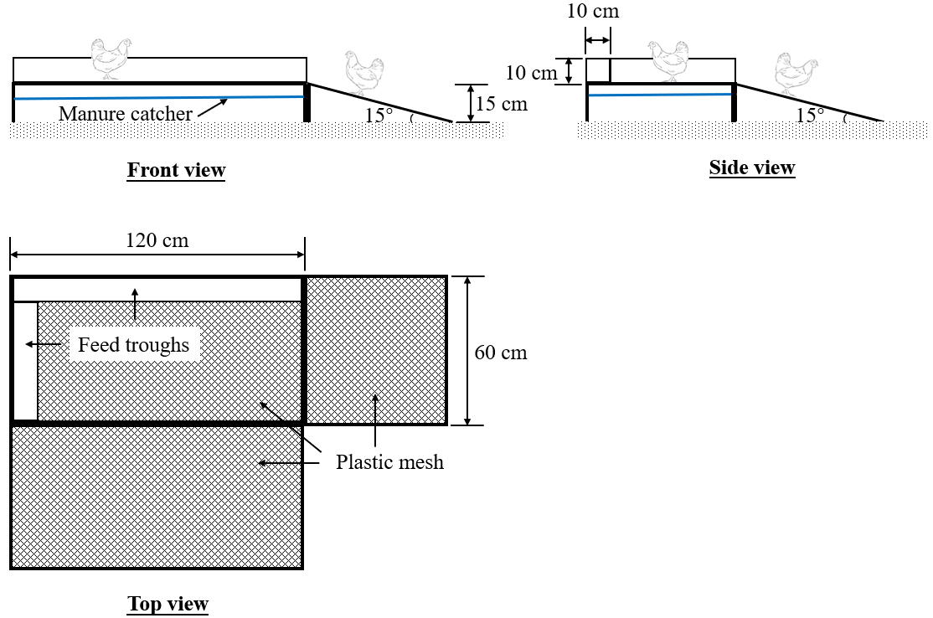
Figure 2.1 Schematic drawings of elevated perching platform.

                - 2.2.3 Robotic Vehicle (RV)
A variable-speed RV (Lynxmotion Aluminum A4WD1, Lynxmotion Inc., Mirabel, Canada) with a remote controller (Spektrum DXe Transmitter System with AR620 Receiver, Spektrum Horizon Hobby Inc., Champaign, IL) was used. The overall dimension of RV including caterpillar track was 32 × 24 × 10 cm (L × W × H). The speed of the RV was adjustable and can max out at 0.8 m/s. The payload of the RV was 2.3 kg.
                - 2.2.4 Experimental Design
Each experimental room was randomly assigned with one of the four treatments: with EP only (EP), with RV only (RV), with EP and RV (EP+RV), and with neither EP nor RV (Ctrl). Starting from week 2, the RV was operated four times a day. The four operations, each lasting 10-min, were performed within two hours. The RV roamed on the litter floor at a speed of ~0.2 m/s. The EPs were introduced to broiler rooms at the end of week 2 to enhance bird safety. The RV ran only in the open litter areas, but not on the EPs. The experiment was repeated three times. The first trial (replication 1) was conducted during August to October 2018, and the second trial (replication 2 & 3) was conducted during January to March 2020.
                - 2.2.5 Measurements
(1) Production performance
The bird body weight and feed intake (FI) was measured by rooms every two weeks to calculate body weight gain (BWG) and feed conversion ratio (FCR).
(2) Use of Elevated Perching Platform
The number of broilers on EP before (06:00 h), during and after (12:00 h) RV operation period were counted manually (one day per week, 30 min per day, and 10 min per counting). The broiler was considered on the platform only when it was standing or sitting on the platform with both feet. Use of EP will be expressed as the percentage of broilers on the platform.
(3) Litter moisture content
Litter moisture contents (LMC) were determined in the experimental rooms every two weeks. In each room, three litter samples were collected at different locations in the open litter area, and three additional samples were collected underneath the EP in rooms with EP. Each sample (around 40 g) was a composite of three subsamples collected within a 10 × 10 cm area. All subsamples were collected from the surface layer at 0-4 cm depth. The litter samples were weighed using an analytical balance (0.01 g precision) immediately after being fully mixed by shaking, and again after oven-dried at 105 °C for 24 hours. The normalized LMC, which represented the room level LMC by assuming homogeneous mix of litter in the open litter area and area underneath EP, was calculated using Equation 2.1.
$$LMC_{norm}=\frac{LMC_{op}×S_{op}+LMC_{EP}×S_{EP}}{S_{room}}$$ | (2.1)
Where:
LMC_{norm} = normalized litter moisture content, %;
LMC_{op} = litter moisture content of the open litter area, %;
LMC_{EP} = litter moisture content underneath EP, %;
Sop = area of open litter area, m²;
S_{EP} = area of EP, m²;
S_{room} = area of experimental room (S_{op} + S_{EP}), m².
(4) Gas concentration
Concentrations of NH₃ in the rooms and the supply plenum were monitored continuously by Innova multi-gas analyzer (model 1412, Innova AirTech Instruments, Denmark) (Purswell et al., 2018). The sampling cycle of Innova was set to 30 s. To ensure measurement of the accurate concentration values, considering the response time of the analyzer, each room was sampled for 12 minutes, with the first 11 minutes for stabilization and the last minute for measurement. This sequential measurement yielded hourly data of gaseous concentrations. A measurement and control data logger (CR1000, Campbell Scientific Inc., Logan, UT) was used to switch among sampling tunnels and record the data.
(5) Welfare Assessment
Scores of GS, PQ and PC for 16 broilers (8 males + 8 females) were determined in each experimental room at 4 and 8 weeks of age. Assessment procedures described in Welfare Quality Assessment Protocol (Welfare Quality, 2009) and American Association of Avian Pathologists (AAAP) were followed. For GS, broilers are classified into three different score levels with ‘0’ being capable to walk at least 1.5 m with a balanced gait (slightly awkward but no effect on accessing resources will be included), ‘1’ being able to walk over 1.5 m with clear limp, and ‘2’ being not able to walk 1.5 m. For PQ, broilers were assigned with a score from ‘0’ to ‘2’, with ‘0’ being no lesion or slight discoloration of skin, ‘1’ being lesion area < 50% footpad area, and ‘2’ being lesion area ≥ 50% footpad area (including lesions on the toes). The PC of broilers was scored from ‘0’ to ‘3’, with ‘0’ being white plumage without caked dirt, ‘1’ being light brown plumage without caked dirt, ‘2’ being brown plumage with small caked dirt, and ‘3’ being dark plumage with large caked dirt.
(6) Broiler Activity
Bird activity index (AI) before, during, and after RV operation period were determined via image processing in MATLAB (2018b, The MathWorks, Inc. Natick, MA). To that end, video files recorded by a ceiling-mounted camera (NHD-850, Swann, CA, US) in each room were firstly converted into grayscale images (3 frames per second). Same 900 × 700-pixel areas (Fig. 2.2a and Fig. 2.2a’) in the grayscale images were then cropped out. The total bird-representing pixels within the area (Fig. 2.2b and Fig. 2.2b’) and the pixel change in two consecutive images (Fig. 2.2c) were segmented and quantified. Broiler AI was calculated as the ratio of bird-representing pixel change to total bird pixels.
                - 2.2.6 Data Preparation and Statistical Analysis
Feed consumption of mortality was included in the calculation of FCR. The treatment effects on BW, BWG, FI and FCR were tested by age. Percentage of broilers using the EP was determined. The effects of RV operation on the use of the EP at different time periods were tested. The age effects of the use of EP was also tested. The NH₃ level was summarized as the daily average concentration of rooms with or without EP. Weekly average NH₃ concentration was used for multiple comparisons. Data of welfare assessment (GS, PQ and PC) were converted into the percentage of broilers at each score level of each room. The average scores of each room were calculated, as well. The treatment effects on broiler welfare were tested separately in week 4 and week 8. For the broiler AI, treatment effects on overall AI and AI at different time periods were tested. Due to the limited sample size, non-parametric test (Kruskal-Wallis test) was used to analyze the overall welfare scores. The rest of data were analyzed as a completely randomized design using PROC MIXED procedure of SAS software (SAS v9.4, SAS Institute, Inc., Cary, N.C.). Significant difference of multiple comparisons of group means was defined as p < 0.05.

2.3 Results
                - 2.3.1 Production Performance
Table 2.1 shows the BW, BWG, FI and FCR summarized at weeks 2, 4, 6 and 8 in the four experimental rooms. In general, BW, BWG, FI and FCR in four rooms increased as birds grew older. No significant difference of BW, BWG or FI was found among treatments and control. Significant higher FCR in Ctrl room was observed compare with RV (p = 0.019) and EP+RV (p = 0.049) room by week 2. However, no significant difference on FCR was observed among treatment and control rooms later on.
                - 2.3.2 Use of Elevated Perching Platform
No significant difference in percentage of broilers on platform was observed (p > 0.05) before and after RV operation. However, during RV running, percentage of birds on the platform in EP+RV (47.6%) room was significantly (p < 0.0001) higher than EP (30.2%) room (Fig. 2.3a). Over the flock, the average percentage of broilers on platform in EP+RV (37.2%) room is significantly (p < 0.0001) higher than EP (31.2%) room (Fig. 2.3b). Percentage of broilers using EP continuously increased from 3 to 5 weeks of age in both EP (p = 0.0006) and EP+RV (p < 0.0001) room, and slightly decreased (p > 0.05) after week 6 (Fig. 2.4). Although the effect of RV started to decrease after week 4 based on AI
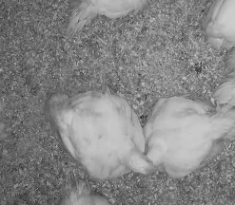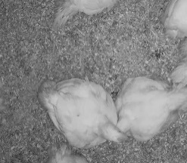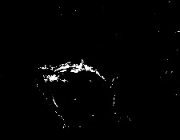

a
b
Binarization
a′
b'
Binarization
Subtraction
c
a
b
c
Figure 2.2 Image processing for bird activity index analysis. (a) current cropped-out grayscale image; (a’) consecutive cropped-out grayscale image; (b) current binary image showing bird-representing pixels in white; (b’) consecutive binary image showing bird-representing pixels in white; (c) binary image showing changes of bird-representing pixels in two consecutive frames (b’ – b).

Table 2.1 Body weight (BW), body weight gain (BWG), feed intake (FI) and feed conversion ratio (FCR) summarized at week 2, 4, 6 and 8 in the treatment and control experimental rooms.
Age (week) | Items | EP^{[a]} | RV^{[b]} | EP+RV^{[c]} | Ctrl^{[d]} | SEM^{[e]}
2 | BW, g bird | 392.4 | 398.3 | 398.1 | 386.4 | 12.8
2 | BWG, g bird ⁻¹ day ⁻¹ | 24.8 | 25.2 | 25.2 | 24.4 | 0.8
2 | FI, g bird ⁻¹ day ⁻¹ | 30.9 | 30.9 | 31.1 | 31.3 | 0.9
2 | FCR | 1.248 ^{abc} | 1.224 ^{c} | 1.238 ^{bc} | 1.287 ª | 0.015
4 | BW, g bird | 1331.6 | 1337.2 | 1310.5 | 1323.6 | 27.1
4 | BWG, g bird ⁻¹ day ⁻¹ | 45.9 | 46.1 | 45.2 | 45.6 | 1.0
4 | FI, g bird ⁻¹ day ⁻¹ | 66.6 | 66.7 | 65.8 | 66.3 | 2.2
4 | FCR | 1.452 | 1.447 | 1.457 | 1.453 | 0.025
6 | BW, g bird | 2389.7 | 2392.7 | 2344.3 | 2391.1 | 45.3
6 | BWG, g bird ⁻¹ day ⁻¹ | 55.8 | 55.9 | 54.7 | 55.8 | 1.1
6 | FI, g bird ⁻¹ day ⁻¹ | 96.6 | 96.5 | 94.8 | 96.4 | 1.0
6 | FCR | 1.731 | 1.726 | 1.732 | 1.727 | 0.041
8 | BW, g bird | 3751.2 | 3761.4 | 3699.8 | 3799.6 | 31.5
8 | BWG, g bird ⁻¹ day ⁻¹ | 66.2 | 66.4 | 65.2 | 67.0 | 0.6
8 | FI, g bird ⁻¹ day ⁻¹ | 119.5 | 119.7 | 117.2 | 120.0 | 0.9
8 | FCR | 1.806 | 1.804 | 1.797 | 1.791 | 0.007
[a] Treatment room with elevated perching platform only; [b] Treatment room with robotic vehicle only; [c] Treatment room with both EP and RV; [d] Treatment room with neither EP nor RV. [e] Pooled SEM for main effects of bird age; ^{abc} Means in the same row with different superscripts are different (p < 0.05).

(a) | (b)
Figure 2.3 (a) Percentage (mean ± SD) of broilers on platform in treatment (w/ elevated perching platform only ‘EP’, and w/ both EP and RV ‘EP+RV’) rooms before, during, and after the robot operation period. (b) Average percentage of broilers on platform in two rooms with EP. ^{ab}Means with different superscripts are different (p < 0.05).

results, use of EP in the EP+RV room was still numerically greater than the EP room (Fig. 2.4).
                - 2.3.3 Litter Moisture Content
Table 2.2 shows the normalized LMC of four treatments at different bird ages. No significant difference was observed among four rooms before the placement of EP (week 3). In week 4, LMC of EP and EP+RV rooms were significantly lower than RV room (p = 0.011 and p = 0.007, respectively). In week 6 and week 8, two rooms with EP had significantly lower LMC than those without (p < 0.03 for all).
                - 2.3.4 Ammonia Concentration
Daily NH₃ concentrations in the rooms with and without EPs are shown in Figure 2.5 No significant difference was observed between two groups with or without EPs by week 6. In week 7, the NH₃ level of rooms without EPs was significantly higher (p = 0.002) than rooms with EPs, and the difference continuously expanded till week 8 (p < 0.0001). concentration exceeded 25 ppm.
                - 2.3.5 Welfare Assessment
All broilers had GS of ‘0’ at weeks 4 and 8 of age, except for one in EP room got score ‘1’ in week 8 (Fig. 2.6). Over the flock, more than 99% broilers scored ‘0’
In week 4, all broilers in two rooms with EP had no footpad lesion (score ‘0’) while 4.1% broilers in RV and 6.3% broilers in Ctrl rooms had intermediate (score ‘1’) or severe (score ‘2’) lesions (Fig. 2.7a). At week 8 of age, occurrence of footpad lesion in EP room was 0, while 12.5% broilers in RV room, 6.3% broilers in EP+RV room and 6.3% broilers in Ctrl room had intermediate or severe lesions (score ‘1’ or ‘2’) (Fig. 2.7b). The average PQ score in rooms without EPs was 0.11, while rooms with EPs was only 0.01 by the end of the flock.
At 4 week of bird age, 66.7% broilers scored ‘0’ on PC in EP+RV room, while 50% broilers in EP room, 54.6% broilers in RV room and 54.2% broilers in Ctrl room scored ‘0’ (Fig. 2.8a). In week 8, in EP and EP+RV room, proportions of broilers with score ‘2’ or ‘3’ were 25% and 22.9%, respectively (Fig. 2.8b). However, 31.3% broilers in RV room and 58.3% broilers in Ctrl room scored ‘2’ or ‘3’. Most severe plumage condition (score ‘3’) was only observed in EP (8.3%) and Ctrl (6.3%) rooms (Fig. 2.8b). Proportions of broilers scored ‘0’ in EP (20.8%) and EP+RV (22.9%) rooms were higher than RV (14.6%) and Ctrl (4.2%) rooms in week 8 (Fig. 2.8b). The average PC score of EP+RV room (1.00) was numerically lower than Ctrl room (1.60) in week 8.
                - 2.3.6 Activity
In general, broiler AI in RV and EP+RV room were significantly higher than Ctrl (p = 0.003 and p = 0.0008) room. Significant higher broiler AI was also found in EP+RV (p = 0.017) compare with EP room. During the 40-min RV operation period, broiler AI in RV
Figure 2.4 Weekly average percentage (mean ± SD) of broilers on platform in treatment (w/ elevated perching platform only ‘EP’, and w/ both EP and RV ‘EP+RV’). ^{abc} Means with different superscripts in the same series are different (p < 0.05). ^{AB} Means with different superscripts in the same series are different (p < 0.05).

Table 2.2 Normalized litter moisture content in the treatment and control experimental rooms over the production cycle. Elevated perching platforms were placed in the room at the end of week 2; and the robotic vehicle started operating in the beginning of week 2.
Age of birds (week) | Mean normalized litter moisture content (%) |  |  |  |  |  |  | SEM^{[e]}
Age of birds (week) | EP^{[a]} |  | RV^{[b]} |  | EP+RV^{[c]} |  | Ctrl^{[d]} | SEM^{[e]}
0 | 6.5 |  | 7.0 |  | 6.4 |  | 6.9 | 2.1
2 | 14.0 |  | 14.3 |  | 13.2 |  | 13.9 | 3.2
4 | 16.0 ^{bc} |  | 20.6 ª |  | 15.6 ^{c} |  | 18.9 ^{ab} | 1.0
6 | 20.5 ^{b} |  | 29.9 ª |  | 20.9 ^{b} |  | 27.3 ª | 1.3
8 | 23.2 ^{b} |  | 32.8 ª |  | 23.5 ^{b} |  | 35.7 ª | 2.6
[a] Treatment room with elevated perching platform only; [b] Treatment room with robotic vehicle only; [c] Treatment room with both EP and RV; [d] Treatment room with neither EP nor RV; [e] Pooled SEM for main effects of bird age; ^{abc} Means in the same row with different superscripts are different (p < 0.05).

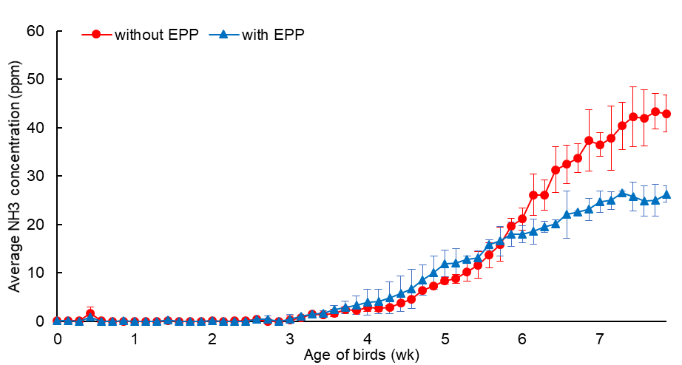
Placement of EP
Figure 2.5 Daily indoor NH₃ concentrations (mean ± SD) in rooms with or without EP, and the outdoor NH₃ concentration of ambient air environment.

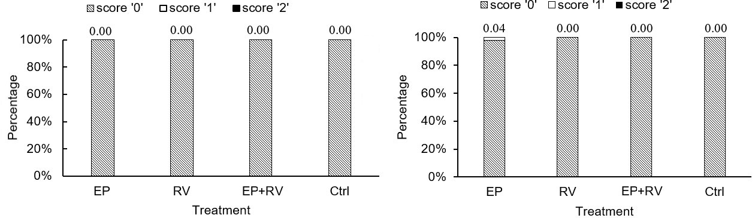
(a) | (b)
Figure 2.6 Distribution of broiler gait score (GS) in the treatment (w/ elevated perching platform only ‘EP’, w/ robotic vehicle only ‘RV’, and w/ both EP and RV ‘EP+RV’) and the control rooms. Score ‘0’ means the best waking ability, and score ‘2’ means the worst. Number on the top of each bar means average score of each treatment. (a = week 4; b = week 8)

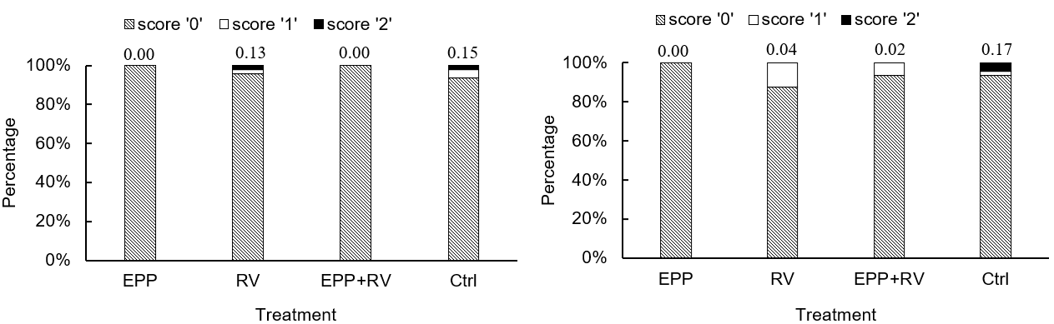
(a) | (b)
Figure 2.7 Distribution of broiler paw quality (PQ) in the treatment (w/ elevated perching platform only ‘EP’, w/ robotic vehicle only ‘RV’, and w/ both EP and RV ‘EP+RV’) and the control rooms. Score ‘0’ means the best footpad condition, and score ‘2’ means the worst. Pooled SEM for main effects of score level was listed in the table. Number on the top of each bar means average score of each treatment. (a = week 4; b = week 8)

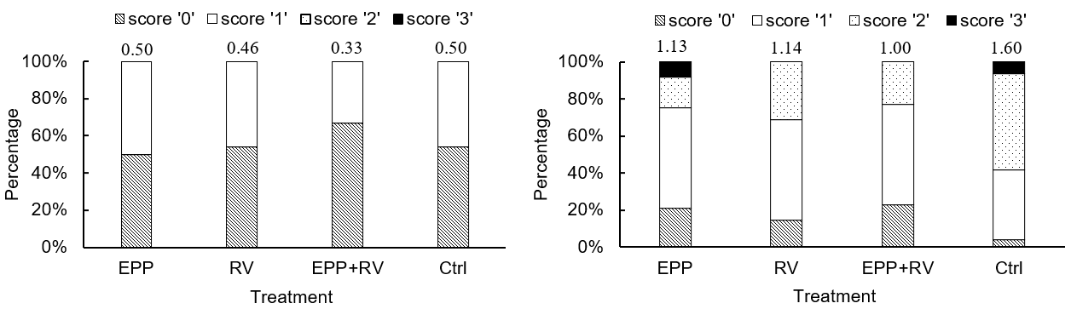

(a) | (b)
Figure 2.8 Distribution of broiler plumage cleanness (PC) in treatment and control rooms at weeks 4 (a) and 8 (b) of bird age. Plumage cleanness is score 0-3, with score ‘0’ being best and score ‘3’ being worst. Pooled SEM for main effects of score level was listed in the table. Number on the top of each bar means average score of each treatment. ab Means with different superscripts are different (p < 0.05). (a = week 4; b = week 8)
and EP+RV rooms was significantly higher (p < 0.0001) than that in Ctrl room (Fig. 2.9). No significant difference was observed among four rooms before and after RV operation (Fig. 2.9). Continuous increase of broiler AI was observed in rooms with RV from week 2 to week 4 and started to decrease thereafter.

2.4 Discussion
The application of EP and RV has no adverse effect on broiler production performance based on Table 2.1. Similar results were reported by Bailie et al. (2018) that platforms has no effect on slaughter weight of broilers.
Daily operation of RV can encourage more birds to use the EP. The slight decrease in EP usage after week 6 probably due to the broilers were larger and there was not enough room for more birds to use as before. Another factor reduced EP use by older birds could be their increased body weight that impeded them from climbing high. Ventura et al. (2012a) and Bailie and O’Connell (2015) reported the peak of perching rate of broilers was 4-5 weeks and gradually decreased thereafter.
The EP reduced the increase of LMC effectively in our study. However, Kaukonen et al. (2017b) reported that litter condition and quality were not affected by the platform. This conflicting observation could be explained by the additional manure catcher that was added underneath the platform. Manure that accumulated on the catcher, as well as under the two ramps, was cleaned manually three times per week. Assuming a consistent 30% of the birds using the platform (see section “Use of elevated platform”), about one third of the manure could be removed out of the room which significantly reduced the LMC. It should be noted that adding manure catcher to the EP would inevitably increase the system cost. However, such cost could be potentially compensated by a series of benefits, such as reduced NH₃ concentration and improved PQ, due to lower LMC. An economic analysis is, thus, warranted for commercial production. While this study proved the benefits of using the manure catcher with EP, application of manure catchers at commercial scale would rely on automated operations, rather than manual operations practiced in this lab-scale study.
The EP with manure catcher effectively reduced the NH₃ concentration in broiler houses during the last two weeks of the flock. No significant difference on daily NH₃ concentrations was observed until week 6. This was likely because the LMC in the first 6 weeks was not high enough for significant increase of NH₃. Carr et al. (1990) commented that NH₃ volatilization significantly increased when the LMC was higher than 30%. The LMC in rooms without EPs increased to 30% during week 6-8 in our study, which is consistent with the time that the NH₃ difference was observed. The big difference of NH₃ level in rooms with/without EP was mainly because the manure catcher. Cleaning manure catcher periodically enlarged the difference of LMC between rooms with or without EPs during the last two weeks. High LMC may increase the conversion rate of uric acid in manure to ammonia-N (Sims and Wolf, 1994), therefore, leading to higher NH₃
(a) | (b)
(c) | (d)
Figure 2.9 Broiler activity index in treatment (w/ elevated perching platform only ‘EP’, w/ robotic vehicle only ‘RV’, and w/ both EP and RV ‘EP+RV’) and control rooms before, during, and after the robot operation period.

volatilization from manure (Elliott and Collins, 1982; Liu et al., 2007). The NH₃ concentration in non-EP rooms exceeded NIOSH recommended threshold (25 ppm) and reached 43 ppm by the end of flocks. In EP rooms, the NH₃ level was largely reduced and ended with 26 ppm. For commercial production, body weight of broilers and FCR are among the most critical aspects of broiler production affected by elevated NH₃. It was reported that broilers exposed to 50 or 70 ppm NH₃ were significantly lighter than 0 or 25 ppm in week 4 and week 8, but no significant difference was observed for FCR (Miles et al., 2004). Quarles and Caveny (1979), however, found neither birds weight nor FCR was affected by 50 ppm NH₃ in week 8. Similar results were obtained in our study, there was no significant difference on body weight or FCR among different rooms when NH₃ concentration exceeded 25 ppm.
Majority (>90%) of the broilers had good walking ability (GS = 0) in our study. However, as a major welfare issue of broilers chickens that may cause economic loss, the prevalence of lameness in commercial houses could be much higher. Previous field research reported that over 90% broilers demonstrated at least some degree of lameness between 6-7 weeks of age (Kestin et al., 1992). Knowles et al. (2008) also reported at mean age of 40 days, over 27.6% birds showed poor locomotion and 3.3% were almost unable to walk. The difference between the results may due to husbandry practices (Edwards Jr and Sorensen, 1987), management, nutritional approaches (Waldenstedt, 2006) and genetic factors (Kestin et al., 1992). In addition, gait score assessment is mainly relied on human observation and the assessor’s interpretation of the protocol, which would yield subjective results. Comparison of these results among studies could be difficult, if not impossible, because of inherent human errors and variations in assessment protocols. Therefore, precision poultry farming technologies, e.g. motion sensors (Stevenson et al., 2019) and video monitoring systems (Aydin et al., 2010), that can evaluate the poultry welfare objectively and precisely are urgently needed.
The EP with manure catcher may improve broiler PQ. Previous studies showed very high incidences of footpad lesion caused by FPD. For example, Allain et al. (2009) found over 90% intermediate and deep FPD. However, another study in northern Europe (Haslam et al., 2007) only showed 11% prevalence which is similar to our results. The same study also showed very high variability, with FPD ranging from 0% to 71.5%, indicating a high prevalence in some flocks. The reason of FPD is multifactorial, which involves genetics, nutrition, housing environment, etc.(Shepherd and Fairchild, 2010). Among these factors, LMC appears to be the most important contributor (De Jong et al., 2014; Martland, 1985; Shepherd and Fairchild, 2010). The design of manure catcher reduced LMC and EP offered broilers opportunities to temporarily stay away from litter, which may potentially help to decrease the prevalence of FPD. As the results shown the average PQ score in rooms without EPs was 0.11, while rooms with EPs was only 0.01 by the end of the flock. The increases of exportation of chicken paws to Asia make FPD a great concern in broiler production. This demand has turned paws into the third most important economic chicken part and accounted for approximately $280 million in 2008 (Council, 2019). Lesions caused by FPD not only degrade paw products, but also negatively affect the health and welfare of broilers (Haslam et al., 2007). Our EP showed the possibilities of improving PQ of broilers. The overall PQ scores of EP and EP+RV rooms were numerically lower than Ctrl room over the flock, which probably because the manure catcher and RV operation Broilers were encouraged by RV and migrate to EP, therefore reduced the time of broilers contact with litter. On the other hand, exposed litter to ventilation for a longer period of time may help to maintain it dried, thereafter benefit birds’ welfare.
The application of EP and RV had the potential of improving the PC of broiler chickens, especially when used jointly. In general, PC degraded as broilers grew older, which is mainly due to the increase of LMC (De Jong et al., 2014; Federici et al., 2016) and time of birds lying on the floor. Plumage plays a major role in insulating the body of the bird. Clean and well-covered plumage can protect broilers from moist dirt and skin infections (Stephenson et al., 1960; Welfare Quality, 2009). On the other hand, plumage can optimize energy metabolism and feed efficiency of broilers at cool condition (Herreid II and Kessel, 1967; Leeson and Walsh, 2004). Higher proportions of broilers scored ‘0’ in EP and EP+RV rooms as compared with RV and Ctrl rooms in week 8 (Fig. 2.8b) was observed in our study. It may be because EP provides broilers a cleaner surface to rest, which may help to keep plumage clean. Furthermore, the results also indicate the operation of RV can contribute to better PC condition by reducing the time of birds contacting with litter. The average PC score of EP+RV room (1.00) was numerically lower than Ctrl room (1.60) in week 8, which indicated the potential of using EP and RV jointly to keeping broilers plumage clean.
The operation of RV could effectively improve the activity level of broilers. Previous studies have shown that increasing environmental complexity may improve activity, thus, improve both physical and psychological well-being in farm animals (Bizeray et al., 2002; Mench, 1998; Ventura et al., 2010). Elevated structures could increase spatial awareness of broilers and excite more locomotive behaviors like jumping and walking up and down hills. However, several studies (Bailie and O’Connell, 2015; Norring et al., 2016; Rodriguez-Aurrekoetxea et al., 2015) and our results failed to show an increase in birds activity level by only using EP. But the current study illustrated that combining static (EP) and dynamic (RV) objects may effectively promote broiler physical activity. Continuous increase of broiler AI was observed in rooms with RV from week 2 to week 4. The decrease after week 4 is probably due to broilers were adapted, thus less avoidant, to the RV after a few weeks of operation. Moreover, the broilers became less active as they grew older and heavier. Parajuli et al. (2020) determined the broiler-RV avoidance distances and reported similar results, that is, less bird avoidance to RV for older broilers. Warning signals could be considered to sustain the effect of RV on activity encouragement, such as playing sound or adding light beam to RV.

2.5 Conclusions
In this study, the effects of elevated perching platform and robotic vehicle on broiler production, welfare and housing environment were examined over eight-week production cycles. We conclude that using elevated perching platform with manure catcher reduced litter moisture content and ammonia concentration. Robotic vehicle encouraged bird movement and improve the use of platform. Using elevated perching platform and robotic vehicle jointly improved broiler paw quality and plumage cleanliness.

Classification of Broiler Behaviors Using Triaxial Accelerometer and Machine Learning

This chapter has been published in Animal.

Yang, X., Zhao, Y., Street, G. M., Huang, Y., To, S. D. F., Purswell, J. L. (2021). Classification of Broiler Behaviors Using Triaxial Accelerometer and Machine Learning. Animal.

3.1 Introduction
Behaviors are observable and measurable indicators of animal adaption to environmental stimuli. Studying animal behaviors may help to assess animal physiological status (Muri et al., 2019), well-being conditions (Aydin, 2017b; Granquist et al., 2019), and its preference of housing systems (Kaukonen et al., 2017b; Norring et al., 2016). To determine animal behaviors objectively and precisely, some precision agricultural tools have been applied, such as global positioning system (GPS) (Weber et al., 2015), electronic identification transponders (EIDs) (Brown-Brandl, 2019; Li et al., 2020), and video cameras (Aydin et al., 2010; Pereira et al., 2013; Yang et al., 2020). Three-dimensional accelerometers are also being increasingly used for quantification of bird spatial movements due to their characteristics of small physical size, light weight, low cost, and high resolution.
An accelerometer is an electromechanical device that measures acceleration forces. These forces may be static, like the constant force of gravity, or they could be dynamic caused by moving or vibrating the accelerometer. Accelerometers have been implemented to study behaviors and motions of different animal species. For example, accelerometers were mounted to beef cattle (Robert et al., 2009; Watanabe et al., 2008; Wolfger et al., 2015) and sheep (Alvarenga et al., 2016; Giovanetti et al., 2017) to classify the behaviors of eating, ruminating, sitting, standing, walking and lying. Some waterproofed accelerometers were deployed to detect posture of aquatic animals, such as seals (Iwata et al., 2012) and fish (Brownscombe et al., 2014). Research that uses accelerometers to detect broiler behaviors has not been widely done.
Machine learning is a popular method for accelerometer-based animal behavior classification. Many algorithms have been investigated in previous studies, such as neural network (Banerjee et al., 2012), discriminant analysis (Barwick et al., 2018), decision trees (Tamura et al., 2019), k-nearest neighbor (KNN) (Sakai et al., 2019; Sur et al., 2017), and support vector machine (SVM) (Benaissa et al., 2019; Mansbridge et al., 2018). Most of aforementioned studies are about the behavior classification for sheep or dairy cows, which cannot be directly translated to broilers. Therefore, the performances of broiler behavior classification using accelerometers and machine learning models are warranted.
Sliding window is a common data segmentation method for activity recognition (Bulling et al., 2014). In this approach, a window is moved through the time series data to segment data which are then used to generate features for use as training and testing datasets. It is important to select a proper window length in order to guarantee accurate behavior classification while maintaining efficient usage of computational resources (Robert et al., 2009). Fida et al. (2015) processed human physical activities using different window lengths and found that 1.5-s window length showed the best performance. Banos et al. (2014) compared the recognition performance of window lengths ranged from 0.25 s to 7 s in the steps of 0.25 s. Their results showed that shorter windows normally resulted in better performance in recognizing human behaviors, and window length of 1-2 s was preferable considering the balance between processing speed and accuracy. For animals, Decandia et al. (2018) reported that 30-s window length yielded the most accurate results in classifying sheep behaviors. Diosdado et al. (2015) found a small increase in behavioral classification accuracy of dairy cows at a window length of 10 min as compared with 1 and 5 min.
The objective of this study was to classify specific broiler behaviors, including resting, walking, feeding and drinking, by analyzing acceleration data using two machine learning models, KNN and SVM. The performances of the two models as affected by window length (1, 3, 5, 7, 10 and 20 s) and number of broilers involved in the training dataset were also evaluated.

3.2 Materials and Methods
                - 3.2.1 Housing, Animals and Management
Total 324 Ross 708 broilers were evenly assigned to six rooms (54 birds/room) at the stocking density of 0.1m2/bird. Nine broilers (tagged as No.1-9) at 7 weeks of age were randomly selected for this study (1 bird in room 1, and 2 birds in rooms 2-5). Two cameras were installed to the ceiling of each room to monitor the behaviors of broilers. Six nipple drinkers and two tube feeders were installed in each room. Feed and water were provided ad libitum. All procedures of animal care and handling were approved by USDA-ARS Institutional Animal Care and Use Committee at Mississippi State.
                - 3.2.2 Accelerometer
Lightweight triaxial accelerometers (DDAMTT, 27×26×10 mm, 3.0 g, ±16 gravity, Wildbyte Technologies Ltd., Swansea, UK) were used to detect the movement of individual broilers with the sampling frequency of 40 Hz. Each accelerometer was powered by a Li-Po battery (3.7 v, 300 mAh, LP402530, 35 × 20 × 4 mm, 5.0 g) (Fig. 3.1a), which was able to sustain the data logging for about 72 hours. Each pair of accelerometer and battery was sealed in a 3D printed box (38 × 32 × 18 mm) (Fig. 3.1b) and mounted to the back of broiler using a chicken harness (Valhoma Corporation, Tulsa, OK) (Fig. 3.1c). The broiler accelerations in the directions of forward and backward (X), left and right (Y), and up and down (Z), were recorded. The 3D acceleration data were stored in a Micro SD card and exported as excel files using the companion software (Animal Motion Visualization, Wildbyte Technologies Ltd., Swansea, UK).
                - 3.2.3 Behavior Description and Labelling
Four specific bird behaviors, including resting, walking, feeding and drinking, were examined in this study. Resting is considered as a bird is sitting on the litter or standing still. Feeding involves activities of both picking-up feed from feeder and swallowing behavior. Drinking is identified as a broiler is pecking at a nipple drinker. Figure 4.2 shows
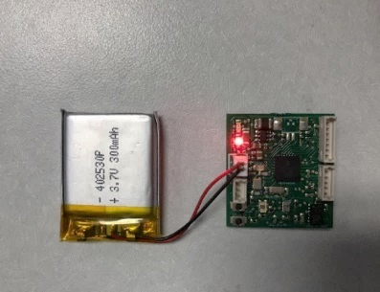 | 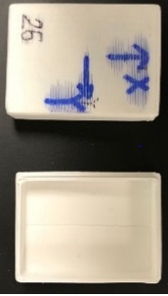  X  Y | 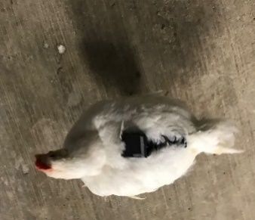
(a) | (b) | (c)
Figure 3.1 Pictures of an accelerometer with a battery (a), a sensor case (b), and a broiler carrying an accelerometer (c).

an example of triaxial accelerations for specific broiler behaviors. Resting behavior (Fig. 3.2a) is represented by steady acceleration curves in all three dimensions. Walking behavior (Fig. 3.2b) is identified as profound fluctuating acceleration curves in all three dimensions. Feeding behaviors (Fig. 3.2c) show more fluctuations in forward-backward directions as compared to drinking behaviors (Fig. 3.2d), and their baselines (or equilibrium) are slightly different, possibly because broilers need to raise heads to drink but bow to eat.
Labeling of the sensor data was done by observing broiler behaviors in recorded videos for all sliding windows. Table 3.1 lists the number of labelled records of each behavior. It has been shown that unbalanced datasets may compromise the classification accuracy, particularly for the minority class (Amrine et al., 2014; Weiss and Provost, 2003). Therefore, same training dataset size for different behaviors was used in our study. Total 124.4 min (298,560 records) of raw acceleration data were labeled for training, 78.4 min (188,160 records) for pure behavior testing and 58.8 min (141,120 records) for continuous behavior testing. Pure behavior dataset involved single type of behavior during each time period, while continuous behavior dataset was labelled based on continuous recording and involved at least three behaviors within each time period. A window may include multiple behaviors when labeling continuous behavior dataset. In this circumstance, the window is labelled to the predominant behavior (the behavior amounts to over half of the data in the window). A window without a predominant behavior was labelled as undefined behavior.
                - 3.2.4 Feature Extraction
Feature extraction was conducted using MATLAB (2018a). Eight instantaneous features including three-dimensional accelerations, magnitude area, vector magnitude, movement variation, energy and entropy were calculated using formulas listed in Table 3.2, where i is the record index. Different window lengths (1, 3, 5, 7, 10 and 20 s) with 50% overlap were applied to eight instantaneous features and the mean, variation, standard deviation, minimum, maximum of each feature and two-way correlations of 3D accelerations were calculated within each window (Fig. 3.3). Total 43 statistic features of each window were calculated to train classification models.
                - 3.2.5 Machine Learning Models
The broiler behavior classification models were developed using Statistics and Machine Learning Toolbox in MATLAB (2018a). Classification algorithms examined in this study were KNN and SVM. KNN is a non-parametric and lazy learning algorithm which is theoretically mature with low complexity. Lazy learning algorithms simply store the training data without learning from it and wait until a testing data appear. It classifies an input data point based on the distance between itself and its nearest K data points in the training dataset (Cover and Hart, 1967). SVM uses kernel functions and hyperplanes as a decision boundary to separate data into classes in a n-dimensional spaces. Multi-class
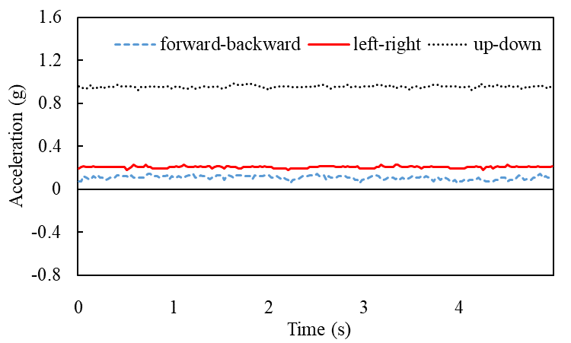  (a) | 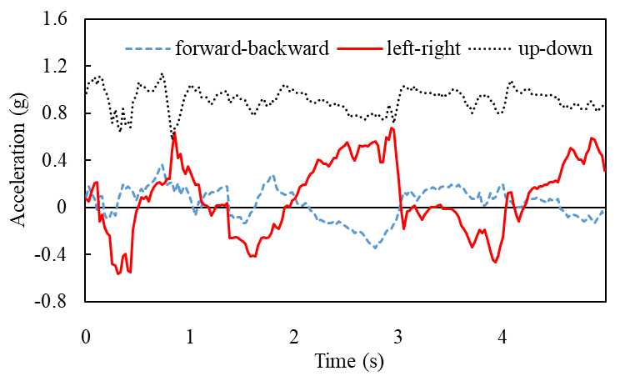(b)
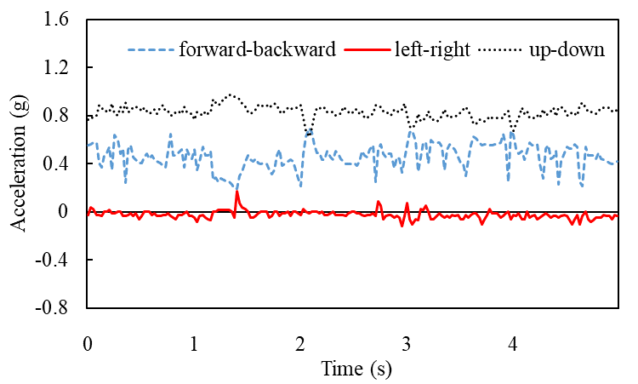  (c) | 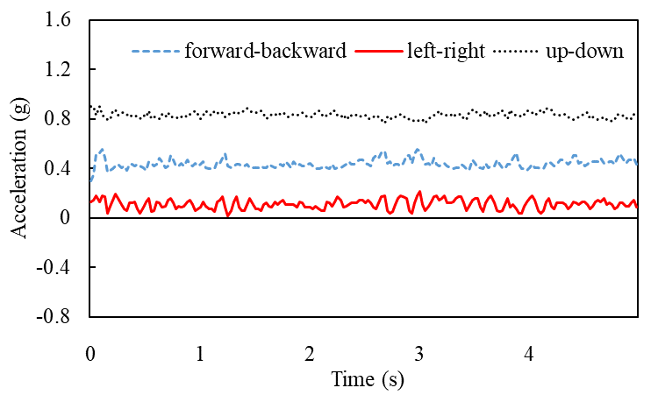  (d)
Figure 3.2 Example acceleration signals of broiler resting (a), walking (b), feeding (c) and drinking (d) behaviors in forward-backward, left-right, and up-down directions.

Table 3.1 Number of records and equivalent time labelled for model training and testing
Dataset | Bird ID | Total time labelled (min) | Number of records
Training | 1 | 23.6 | 56,640
Training | 3 | 21.6 | 51,840
Training | 5 | 32.0 | 76,800
Training | 7 | 17.2 | 41,280
Training | 9 | 30.0 | 72,000
Testing (pure behavior) | 2 | 24.0 | 57,600
Testing (pure behavior) | 4 | 17.6 | 42,240
Testing (pure behavior) | 6 | 17.2 | 41,280
Testing (pure behavior) | 8 | 19.6 | 47,040
Testing (continuous behavior) | 2 | 15.9 | 38,160
Testing (continuous behavior) | 4 | 6.6 | 15,840
Testing (continuous behavior) | 6 | 13.3 | 31,920
Testing (continuous behavior) | 8 | 23.0 | 55,200
Note: Same number of records were labelled for each behavior. The sampling frequency was set to 40 Hz in this study. For continuous behavior testing dataset, all four behaviors of interest were involved for bird 2, 6 and 8, three behaviors (resting, walking and feeding) were involved for bird 4.

Figure 3.3 Diagram of sliding window with 50% overlap.

Table 3.2 Formulas for calculating motion features of broilers using triaxial acceleration data.
Instantaneous motion feature | Formulas
Acceleration in X axis | $$X_{i}$$
Acceleration in Y axis | $$Y_{i}$$
Acceleration in Z axis | $$Z_{i}$$
Magnitude area | $$\left|X_{i}\right|+\left|Y_{i}\right|+\left|Z_{i}\right|$$
Vector magnitude | $$\sqrt{X_{i}+Y_{i}+Z_{i}}$$
Movement Variation | $$\left|X_{i+1}-X_{i}\right|+\left|Y_{i+1}-Y_{i}\right|+\left|Z_{i+1}-Z_{i}\right|$$
Energy | $${\left({X_{i}}^{2}+{Y_{i}}^{2}+{Z_{i}}^{2}\right)}^{2}$$
Entropy | $${\left(1+\left(X_{i}+Y_{i}+Z_{i}\right)\right)}^{2}×\ln\left(1+{X_{i}+Y_{i}+Z_{i}}^{2}\right)$$
Note: X, Y, and Z represent broiler accelerations in forward-backward, left-right, and up-down directions, respectively.

SVMs are usually implemented by combining several two-class SVM classifiers. In this study, one-against-all method was used, which has been used to solve multi-class pattern recognition problems (Liu and Zheng, 2005). In this study, six binary classifiers were constructed to classify four behaviors. To reduce overfitting, 5-fold cross validation was conducted considering the computational complexity.
                - 3.2.6 Model Performance Evaluation
Confusion matrix was used to evaluate the performance of classification models. Sensitivity, precision and accuracy were calculated using Equations 3.1-3.3. The accuracy of classifying continuous dataset (including/excluding undefined behavior) was also investigated by calculating the proportion of sliding windows that were correctly classified.
$$sensitivity=\frac{TP}{\left(TP+FN\right)}$$ | (3.1)
$$precision=\frac{TP}{\left(TP+FP\right)}$$ | (3.2)
$$accuracy=\frac{\left(TP+TN\right)}{\left(TP+TN+FP+FN\right)}$$ | (3.3)
where TP (true positive) is the number of windows that a behavior of interest was both reported by a model and observed in the video; FN (false negative) is the number of windows that a behavior of interest was observed but reported as other behaviors; FP (false positive) is the number of windows that a behavior of interest was reported by a model but not observed in the video; and TN (true negative) is the number of windows that a behavior of interest was neither reported by a model nor observed in the video.
                - 3.2.7 Data Preparation and Statistical Analysis
The effects of window length on the performance of KNN and SVM classification model were analysed using the PROC MIXED procedure in SAS 10.9 (SAS Institute., Cary, NC, USA). A significant difference in multiple comparisons of group means was defined as p < 0.05. The levels for window length were 1, 3, 5, 7, 10 and 20 s. Multiple comparisons were conducted to determine the effect of machine learning model and window length setting on classification performance. The effects of machine learning models on the performance of classifying specific behaviors were tested as well.

3.3 Results
                - 3.3.1 Classification Performance for Pure Behavior Dataset
Table 3.3 shows the sensitivity of KNN and SVM by validating the model-classified behaviors against visually labelled behaviors with different window lengths. No difference was observed between KNN and SVM in the sensitivities of classifying resting and walking
Table 3.3 Sensitivity (%) of k-nearest neighbor (KNN) and support vector machine (SVM) in classifying broiler resting (R), walking (W), feeding (F) and drinking (D) behaviors (pure behavior dataset).
Window length (s) | KNN |  |  |  |  |  | SVM
Window length (s) | R | W | F | D | SEM¹ |  | R | W | F | D | SEM¹
1 | 81^{ab} | 97ª | 71^{ab} | 62^{b} | 9 |  | 88^{ab} | 98^{Ca} | 81^{ab} | 73^{b} | 6
3 | 86^{ab} | 99ª | 77^{ab} | 64^{b} | 9 |  | 89^{ab} | 99^{BCa} | 89^{ab} | 80^{b} | 6
5 | 93ª | 99ª | 79^{ab} | 62^{b} | 9 |  | 93 | 99^{AB} | 88 | 85 | 6
7 | 93ª | 99ª | 77^{ab} | 61^{b} | 9 |  | 94 | 100^{A} | 88 | 87 | 5
10 | 70 | 99 | 76 | 56 | 16 |  | 70 | 100^{A} | 89 | 82 | 13
20 | 99^{ab} | 100ª | 70^{bc} | 70^{c} | 10 |  | 74 | 100^{A} | 89 | 94 | 13
mean | 87^{b} | 99ª | 75^{c*} | 62^{d***} |  |  | 85^{b} | 99ª | 88^{b*} | 83^{b***}
SEM² | 11 | 1 | 13 | 12 |  |  | 14 | 0 | 8 | 6
Note: SEM¹: pooled standard error mean for the effects of window length. SEM²: pooled standard error mean for the effects of behavior type. ^{a,b,c,d} Means in the same row with different superscripts are different (p < 0.05). ^{A,B,C} Means in the same column with different superscripts are different (p < 0.05). * (p < 0.05) ** (p < 0.01) *** (p < 0.0001) Means of the behavior classified by different models are different. Superscript is used only when significant difference exists.

behaviors. The sensitivities of using SVM (88% and 83%, respectively) to classify feeding (p = 0.0158) and drinking (p < 0.0001) behaviors were higher than using KNN (75% and 62%, respectively). The difference among window lengths was only observed in the sensitivity of SVM for classifying broiler walking behaviors ranged from 98% to 100%, with window length of 1 s yielding the lowest sensitivity (p < 0.05). Both KNN and SVM showed the highest sensitivity in classifying walking (p < 0.05). Lower mean sensitivities were observed in classifying feeding (p = 0.0213) and drinking (p < 0.0001) as compared to resting for KNN. However, no difference was observed in the mean sensitivity of classifying resting, feeding and drinking for SVM.
Table 3.4 shows the precision of KNN and SVM in classifying broiler behaviors with different window lengths. No difference was observed between KNN and SVM in the precisions of classifying resting, walking and feeding. The mean precision of using KNN (70%) to classify drinking (p = 0.0021) behavior was lower than using SVM (82%). The difference among window lengths was only observed in the precision of using KNN to classify broiler drinking behavior, with window length of 10 s yielding the lowest precision (p < 0.05). Higher mean precisions were observed in classifying resting than feeding (p = 0.0303) and drinking (p < 0.0001) using KNN. For SVM, higher mean precisions were observed in classifying resting (p = 0.0396) and walking (p = 0.0024) than drinking.
Table 3.5 shows the accuracy of KNN and SVM in classifying broiler behaviors with different window lengths. No difference was observed between KNN and SVM in the accuracies of classifying resting and walking. The accuracies of using SVM (90% and 92%, respectively) to classify feeding (p < 0.0001) and drinking (p < 0.0001) were higher than using KNN (83% and 86%, respectively). The 10-s window length yielded the lowest accuracy in classifying feeding using KNN and 1-s window length showed the lowest accuracy in classifying drinking using SVM. Higher mean accuracies were observed in classifying resting and walking than feeding and drinking (p < 0.0001 for all) for KNN. For SVM, higher mean accuracies were observed in classifying resting (p = 0.0003 and p = 0.0188, respectively) and walking (p < 0.0001 for all) than feeding and drinking.
Confusion matrices of KNN and SVM in classifying broiler behaviors with different window lengths were listed in Table 3.6. Both KNN and SVM models were highly accurate in classifying walking behavior with different window lengths (97%-100% and 98%-100%, respectively). Compared to walking, behaviors of feeding and drinking were classified with lower accuracies. The KNN model classified 27%-38% drinking as feeding, and 17%-22% feeding as drinking. As for SVM, 10%-17% drinking was misclassified as feeding, and 5%-20% feeding as drinking.
                - 3.3.2 Classification Performance for Continuous Dataset
Table 3.7 shows the proportion of undefined windows and the prediction accuracies of KNN and SVM models in classifying broiler behaviors of continuous dataset with different
Table 3.4 Precision (%) of k-nearest neighbor (KNN) and support vector machine (SVM) in classifying broiler resting (R), walking (W), feeding (F) and drinking (D) behaviors (pure behavior dataset).
Window length (s) | KNN |  |  |  |  |  | SVM
Window length (s) | R | W | F | D | SEM¹ |  | R | W | F | D | SEM¹
1 | 93ª | 84^{ab} | 77^{ab} | 67^{ABb} | 7 |  | 99ª | 92^{ab} | 82^{bc} | 74^{c} | 4
3 | 94ª | 92ª | 78^{ab} | 70^{ABb} | 6 |  | 99ª | 97^{ab} | 86^{bc} | 81^{c} | 4
5 | 97ª | 93ª | 85^{ab} | 69^{ABb} | 5 |  | 99 | 96 | 89 | 88 | 5
7 | 98ª | 93ª | 84ª | 66^{ABb} | 5 |  | 99 | 96 | 90 | 88 | 4
10 | 74 | 93 | 85 | 58^{B} | 13 |  | 75 | 96 | 93 | 75 | 14
20 | 100ª | 91^{ab} | 85^{ab} | 71^{Ab} | 7 |  | 75 | 98 | 93 | 83 | 14
mean | 93ª | 91^{ab} | 82^{b} | 70^{c**} |  |  | 91ª | 96ª | 89^{ab} | 82^{b**}
SEM² | 11 | 6 | 9 | 4 |  |  | 14 | 3 | 7 | 7
Note: SEM¹: pooled standard error mean for the effects of window length. SEM²: pooled standard error mean for the effects of behavior type. ^{a,b,c} Means in the same row with different superscripts are different (p < 0.05). ^{A,B,C} Means in the same column with different superscripts are different (p < 0.05). * (p < 0.05) ** (p < 0.01) *** (p < 0.0001) Means of the behavior classified by different models are different. Superscript is used only when significant difference exists.

Table 3.5 Accuracy (%) of k-nearest neighbor (KNN) and support vector machine (SVM) in classifying broiler resting (R), walking (W), feeding (F) and drinking (D) behaviors (pure behavior dataset).
Window length (s) | KNN |  |  |  |  |  | SVM
Window length (s) | R | W | F | D | SEM¹ |  | R | W | F | D | SEM¹
1 | 94ª | 94ª | 84^{ABb} | 84^{b} | 2 |  | 97ª | 97ª | 88^{b} | 89^{Bb} | 1
3 | 95ª | 97ª | 86^{Ab} | 85^{b} | 2 |  | 97ª | 99^{b} | 92^{b} | 91^{Bb} | 1
5 | 98ª | 98ª | 85^{Ab} | 86^{b} | 1 |  | 98ª | 99ª | 93^{b} | 92^{ABb} | 1
7 | 98ª | 98ª | 84^{ABb} | 86^{b} | 1 |  | 98ª | 99ª | 94^{b} | 93^{ABb} | 1
10 | 92^{ab} | 98ª | 77^{Bbc} | 85^{c} | 4 |  | 92 | 99 | 86 | 93^{AB} | 4
20 | 100ª | 97ª | 85^{Ab} | 88^{b} | 3 |  | 94 | 99 | 90 | 96^{AB} | 4
mean | 96ª | 97ª | 83^{b***} | 86^{b***} |  |  | 96ª | 99ª | 90^{b***} | 92^{Ab***}
SEM² | 3 | 2 | 3 | 2 |  |  | 4 | 1 | 4 | 2
Note: SEM¹: pooled standard error mean for the effects of window length. SEM²: pooled standard error mean for the effects of behavior type. ^{a,b,c} Means in the same row with different superscripts are different (p < 0.05). ^{A,B,C} Means in the same column with different superscripts are different (p < 0.05). * (p < 0.05) ** (p < 0.01) *** (p < 0.0001) Means of the behavior classified by different models are different. Superscript is used only when significant difference exists.

Table 3.6 Confusion matrix of k-nearest neighbor (KNN) and support vector machine (SVM) in classifying broiler resting (R), walking (W), feeding (F) and drinking (D) behaviors (pure behavior dataset).
Window length (s) | Labeled behaviors | Classified behaviors |  |  |  |  |  |  |  |  | Total
Window length (s) | Labeled behaviors | KNN |  |  |  |  | SVM |  |  |  | Total
Window length (s) | Labeled behaviors | R | W | F | D |  | R | W | F | D | Total
1 | R | 1879 (80) | 33  (1) | 188 (8) | 238 (10) |  | 2059  (88) | 22  (1) | 146  (6) | 111  (5) | 2338  (100)
1 | W | 5  (0) | 2257  (97) | 54  (2) | 22  (1) |  | 2  (0) | 2293  (98) | 26  (1) | 17  (1) | 2338  (100)
1 | F | 136  (0) | 313  (13) | 1633  (70) | 389  (17) |  | 2  (0) | 135  (6) | 1808  (77) | 393  (17) | 2338  (100)
1 | D | 136  (6) | 81  (3) | 619  (26) | 1502  (64) |  | 9  (0) | 39  (2) | 481  (21) | 1809  (77) | 2338  (100)
3 | R | 668  (86) | 7  (1) | 33  (4) | 70  (9) |  | 686  (88) | 8  (1) | 29  (4) | 55  (7) | 778  (100)
3 | W | 0  (0) | 767  (99) | 6  (1) | 6  (1) |  | 0  (0) | 768  (99) | 4  (1) | 7  (1) | 779  (100)
3 | F | 1  (0) | 52  (7) | 584  (75) | 140  (18) |  | 0  (0) | 11  (1) | 677  (87) | 89  (11) | 777  (100)
3 | D | 36  (5) | 6  (1) | 215  (28) | 521  (67) |  | 4  (1) | 7  (1) | 134  (17) | 633  (81) | 778  (100)
5 | R | 429  (92) | 7  (2) | 21  (5) | 7  (2) |  | 427  (92) | 7  (2) | 4  (1) | 26  (6) | 464  (100)
5 | W | 0  (0) | 458  (99) | 1  (0) | 5  (1) |  | 0  (0) | 460  (99) | 0  (0) | 4  (1) | 464  (100)
5 | F | 0  (0) | 26  (6) | 355  (77) | 83  (18) |  | 4  (1) | 5  (1) | 399  (86) | 56  (12) | 464  (100)
5 | D | 15  (3) | 6  (1) | 143  (31) | 300  (65) |  | 0  (0) | 6  (1) | 59  (13) | 399  (86) | 464  (100)
7 | R | 306  (92) | 5  (2) | 15  (5) | 5  (2) |  | 308  (93) | 5  (2) | 4  (1) | 14  (4) | 331  (100)
7 | W | 0  (0) | 328  (99) | 1  (0) | 2  (1) |  | 0  (0) | 331  (100) | 0  (0) | 0  (0) | 331  (100)
7 | F | 0  (0) | 20  (6) | 248  (75) | 63  (19) |  | 2  (1) | 3  (1) | 287  (87) | 39  (12) | 331  (100)
7 | D | 5  (2) | 2  (1) | 114  (34) | 210  (63) |  | 0  (0) | 4  (1) | 37  (11) | 290  (88) | 331  (100)
10 | R | 167  (73) | 3  (1) | 58  (25) | 1  (0) |  | 165  (72) | 4  (2) | 56  (24) | 4  (2) | 229  (100)
10 | W | 0  (0) | 227  (99) | 1  (0) | 1  (0) |  | 0  (0) | 229  (100) | 0  (0) | 0  (0) | 229  (100)
10 | F | 0  (0) | 14  (6) | 167  (73) | 48  (21) |  | 0  (0) | 4  (2) | 200  (87) | 25  (11) | 229  (100)
10 | D | 3  (1) | 2  (1) | 88  (38) | 136  (59) |  | 0  (0) | 1  (0) | 37  (16) | 191  (83) | 229  (100)
Note: Both number and percentage (in parentheses) of correctly predicted windows were listed. The final column “Total” gives the total number of data points for each behavior. The numbers in bold show the correct classifications.

Table 3.6. Continued.
Window length (s) | Labeled behaviors | Classified behaviors |  |  |  |  |  |  |  |  | Total
Window length (s) | Labeled behaviors | KNN |  |  |  |  | SVM |  |  |  | Total
Window length (s) | Labeled behaviors | R | W | F | D |  | R | W | F | D | Total
20 | R | 111  (99) | 0  (0) | 1  (1) | 0  (0) |  | 87  (78) | 0  (0) | 25  (22) | 0  (0) | 112  (100)
20 | W | 0  (0) | 112  (100) | 0  (0) | 0  (0) |  | 0  (0) | 112  (100) | 0  (0) | 0  (0) | 112  (100)
20 | F | 0  (0) | 11  (10) | 76  (68) | 25  (22) |  | 0  (0) | 2  (2) | 99  (88) | 11  (10) | 112  (100)
20 | D | 0  (0) | 2  (2) | 30  (27) | 80  (71) |  | 0  (0) | 0  (0) | 6  (5) | 106  (95) | 112  (100)
Note: Both number and percentage (in parentheses) of correctly predicted windows were listed. The final column “Total” gives the total number of data points for each behavior. The numbers in bold show the correct classifications.

Table 3.7 Proportion of undefined windows and the prediction accuracies of k-nearest neighbor (KNN) and support vector machine (SVM) in classifying broiler behaviors (continuous behavior dataset) with different window lengths.
Window length (s) | Proportion of undefined windows (%) | Accuracy (%)
Window length (s) | Proportion of undefined windows (%) | Undefined windows included |  |  | Undefined windows excluded
Window length (s) | Proportion of undefined windows (%) | KNN | SVM |  | KNN | SVM
1 | 0 | 80^{A} | 81^{A} |  | 80^{A} | 81
3 | 4 | 78^{AB} | 78^{A} |  | 81^{A} | 79
5 | 9 | 70^{ABC} | 68^{AB} |  | 77^{AB} | 75
7 | 13 | 66^{BC} | 66^{AB} |  | 77^{AB} | 77
10 | 19 | 59^{CD} | 62^{BC} |  | 76^{AB} | 79
20 | 30 | 48^{D} | 47^{C} |  | 71^{B} | 70
SEM |  | 6 | 8 |  | 3 | 4
Note: SEM: pooled standard error mean for the effects of window length. ^{A,B,C,D} Means in the same column with different superscripts are different (p < 0.05). Superscript is used only when significant difference exists.

window lengths. The proportion of undefined windows continuously increased from 1-s to 20-s window length. For dataset included undefined windows, the accuracies of KNN and SVM continuously decreased as the window length increased. For dataset excluded undefined windows, the accuracies of KNN decreased as the increase of window length. No difference was observed among different window lengths for SVM without undefined windows.
Confusion matrix of KNN and SVM in classifying continuous broiler behaviors with different window lengths were listed in Table 3.8. The accuracies of KNN in classifying continuous behavior dataset were 77%-88% for resting, 75%-95% for walking, 67%-77% for feeding and 51%-63% for drinking. For SVM, the accuracies in classifying continuous behavior dataset were 73%-84% for resting, 68%-86% for walking, 67-87% for feeding and 60%-90% for drinking. The KNN model misclassified 9%-15% feeding as walking, 12%-18% feeding as drinking and 27%-38% drinking as feeding. As for SVM model, 6%-16% feeding was misclassified as drinking and 5%-30% drinking as feeding.
                - 3.3.3 Number of Broilers Involved in Classification Model
Table 3.9 shows the accuracies of classification of continuous behavior dataset using KNN and SVM models that trained with dataset involved different number of broilers. Higher accuracies of SVM were observed when more birds were involved in the training dataset. A large decrease was observed for KNN when birds 1, 3, 5 and 7 was involved. By involving the testing bird (bird 2) into training dataset, the accuracies of KNN and SVM seemed to increase.

3.4 Discussion
In this study, we trained and evaluated the performances of KNN and SVM models with accelerometer data for classifying broiler behaviors. With a proper window length, both models achieved >93% sensitivity, precision, and accuracy when used to classify broiler walking behavior with pure behavior datasets. Such good performances were attributed to the distinguishable features of walking behavior, as illustrated in Figures 3.2b, which was readily picked up during the training and testing processes. The confusion matrix (Table 3.6) shows less than 3% walking into other behaviors. It is also shown that both models may be confused about differentiating resting, feeding and drinking behaviors. The possible reason could be different resting postures were covered in the dataset. Standing still was defined as resting in our study, which may have similar pattern as drinking or feeding. The model performances on feeding and drinking behaviors were less remarkable, but an accuracy of mid 80% to low 90% was still deemed as satisfactory. The challenges in differentiating feeding and drinking behaviors lie in the fact that both behaviors exhibited similar motions (i.e. standing still and pecking feeder or nipple drinker), yielding similar patterns in acceleration curves that may confuse the models (Table 3.6). We assume that features related to bird bowing angles were the main determinants of the model to
Table 3.8 Confusion matrix of k-nearest neighbor (KNN) and support vector machine (SVM) for classifying continuous broiler behaviors (exclude undefined windows) with different window lengths.
Window length (s) | Labelled behaviors | Classified behaviors |  |  |  |  |  |  |  |  | Total
Window length (s) | Labelled behaviors | KNN |  |  |  |  | SVM |  |  |  | Total
Window length (s) | Labelled behaviors | R | W | F | D |  | R | W | F | D | Total
1 | R | 3422  (86) | 52  (1) | 343  (9) | 178  (4) |  | 3365  (84) | 60  (2) | 173  (4) | 397  (10) | 3995  (100)
1 | W | 32  (6) | 469  (82) | 53  (9) | 18  (3) |  | 19  (3) | 483  (84) | 41  (7) | 29  (5) | 572  (100)
1 | F | 47  (3) | 159  (9) | 1364  (77) | 208  (12) |  | 9  (1) | 109  (6) | 1546  (87) | 114  (6) | 1778  (100)
1 | D | 40  (6) | 39  (5) | 191  (27) | 441  (62) |  | 40  (6) | 15  (2) | 206  (29) | 450  (63) | 711  (100)
3 | R | 1136  (88) | 37  (3) | 80  (6) | 42  (3) |  | 1077  (83) | 29  (2) | 97  (7) | 94  (7) | 1295  (100)
3 | W | 1  (1) | 122  (85) | 15  (10) | 5  (3) |  | 1  (1) | 157  (86) | 13  (7) | 12  (7) | 143  (100)
3 | F | 5  (1) | 70  (12) | 440  (75) | 68  (12) |  | 0  (0) | 58  (10) | 478  (82) | 47  (8) | 583  (100)
3 | D | 9  (4) | 10  (4) | 69  (29) | 149  (63) |  | 12  (5) | 12  (5) | 70  (30) | 143  (60) | 237  (100)
5 | R | 649  (86) | 40  (5) | 41  (5) | 25  (3) |  | 588  (78) | 32  (4) | 27  (4) | 109  (14) | 755  (100)
5 | W | 0  (0) | 42  (81) | 5  (10) | 5  (10) |  | 3  (6) | 43  (83) | 0  (0) | 6  (12) | 52  (100)
5 | F | 1  (0) | 51  (15) | 242  (71) | 46  (14) |  | 6  (2) | 42  (12) | 256  (75) | 36  (11) | 340  (100)
5 | D | 6  (4) | 7  (5) | 40  (30) | 81  (60) |  | 3  (2) | 6  (4) | 19  (14) | 106  (79) | 134  (100)
7 | R | 451  (85) | 36  (7) | 29  (5) | 13  (2) |  | 442  (84) | 22  (4) | 35  (7) | 30  (6) | 529  (100)
7 | W | 0  (0) | 18  (95) | 1  (5) | 0  (0) |  | 0  (0) | 13  (68) | 0  (0) | 6  (32) | 19  (100)
7 | F | 1  (0) | 31  (13) | 168  (73) | 30  (13) |  | 0  (0) | 28  (12) | 169  (73) | 33  (14) | 230  (100)
7 | D | 4  (5) | 7  (8) | 28  (32) | 48  (55) |  | 4  (5) | 6  (7) | 6  (7) | 71  (82) | 87  (100)
10 | R | 303  (85) | 29  (8) | 19  (5) | 5  (1) |  | 297  (83) | 22  (6) | 22  (6) | 15  (4) | 356  (100)
10 | W | 0  (0) | 3  (75) | 0  (0) | 1  (25) |  | 0  (0) | 3  (75) | 0  (0) | 1  (25) | 4  (100)
10 | F | 2  (1) | 19  (13) | 99  (67) | 27  (18) |  | 0  (0) | 12  (8) | 114  (78) | 21  (14) | 147  (100)
10 | D | 2  (4) | 4  (7) | 21  (38) | 28  (51) |  | 2  (4) | 3  (5) | 12  (22) | 38  (69) | 55  (100)
Note: R: resting. W: walking. F: feeding. D: drinking. Both number and percentage (in parentheses) of correctly predicted windows were listed. Total: the total number of windows for each behavior. The numbers in bold show the correct classifications. No walking behavior was detected by classification models with 20-s sliding window.
Table 3.8. Continued.
Window length (s) | Labeled behaviors | Classified behaviors |  |  |  |  |  |  |  |  | Total
Window length (s) | Labeled behaviors | KNN |  |  |  |  | SVM |  |  |  | Total
Window length (s) | Labeled behaviors | R | W | F | D |  | R | W | F | D | Total
20 | R | 128  (77) | 15  (9) | 16  (10) | 8  (5) |  | 122  (73) | 16  (10) | 10  (6) | 19  (11) | 167  (100)
20 | W | -- | -- | -- | -- |  | -- | -- | -- | -- | --
20 | F | 1  (2) | 5  (10) | 36  (71) | 9  (18) |  | 4  (8) | 8  (16) | 34  (67) | 5  (10) | 51  (100)
20 | D | 0  (0) | 4  (18) | 8  (36) | 10  (45) |  | 0  (0) | 1  (5) | 1  (5) | 20  (90) | 22  (100)
Note: R: resting. W: walking. F: feeding. D: drinking. Both number and percentage (in parentheses) of correctly predicted windows were listed. Total: the total number of windows for each behavior. The numbers in bold show the correct classifications. No walking behavior was detected by classification models with 20-s sliding window.

Table 3.9 Accuracy (%) of k-nearest neighbor (KNN) and support vector machine (SVM) in classifying continuous broiler behaviors by including different number of broilers in the training dataset.
Number of birds  (training dataset) | Bird tag | Testing bird tag | Accuracy
Number of birds  (training dataset) | Bird tag | Testing bird tag | KNN | SVM
1 | 1 | 2 | 51 | 41
2 | 1,3 | 2 | 56 | 45
3 | 1, 3, 5 | 2 | 68 | 74
4 | 1, 3, 5, 7 | 2 | 37 | 81
5 | 1, 3, 5, 7, 9 | 2 | 72 | 82
6 | 1, 3, 5, 6, 7, 9 | 2 | 72 | 81
6 | 1, 2, 3, 5, 7, 9 | 2 | 87 | 91
6 | 1, 2, 3, 5, 7, 9 | 4 | 78 | 83

differentiate feeding from drinking, and vice versa. The feeders were kept at a height that was level with the back height of a standing bird, while the nipple drinkers were ~2 cm above the head of a standing bird. Birds were required to exert different bowing angles in order to reach a “low” feeder and a “high” drinker, therefore shifting accelerations patterns and facilitating classifications. Model-wise, the SVM performed generally better than KNN.
Accuracies of both models for classifying behaviors in continuous acceleration records were lower than those of pure behavior data. The compromised performances were mainly due to the undefined windows without dominant behaviors. These undefined windows could include one or more transitional behaviors, such standing up, sitting down, etc. Future work may focus on including these transitional behaviors to develop more robust machine learning models with better performance on analysis of continuous acceleration records. By excluding the undefined windows from calculation, the classification accuracies seemed to be improved (Table 3.7).
Selecting a proper window length is important for accurate behavior classification while saving computational resources. In general, window length showed limited effects on the performance of classification models for pure behavior data. Banos et al. (2014) reported that shorter window length normally had better performance for human behaviors classification, and window length of 1-2 s was recommended after balancing the processing speed and accuracy. Similar results were obtained in our study that 1-s sliding window yielded the highest accuracy in classifying broiler continuous behaviors compared to other longer window lengths for both models (Table 3.7). As the 1 s was the shortest window length tested in this study, it is not clear whether the window length shorter than 1 s would produce better performance results.
Applications of machine learning models in pure or continuous behavior datasets depend on the research goals. If the goal is to screen specific broiler behaviors, a model that can perform accurate pure behavior analysis may be the wise choice. When multiple behaviors or behavior time budget are of interest, one may need to work with a model on continuous behavior records. But again, the model needs to be trained with both major and transitional behaviors for better performance. Current study included four behaviors which account for the major daily time budget of broilers. Weeks et al. (2000a) compared the time spent of birds with different gait score in 16 behaviors. The results showed broilers spent 88% to 96% of time on the four behaviors we looked at in our study. A small proportion (4%-12%) of behaviors are not included in our model, such as preening, dustbathing, shaking, etc., but would be of great value on welfare assessment.
Our results indicate that the accuracy generally increased as data of more birds were included for training (Table 3.9). Apart from the increasing size of training dataset, the model performance was also improved by covering variations among individuals. It has been reported by Foerster et al. (1999) that individual differences in movement patterns may interfere with classification results. Sampling from more individuals could improve the representativeness of training dataset, thus yielding better model generalization performance.
While accelerometer is a useful tool for lab-scale tests with a small group of birds, multiple challenges are needed to be addressed. Compared to large farm animals (beef cattle, swine, sheep and horse), broilers require the body-mounted sensors to be small and light, so that birds could adapt the sensors fast without largely altering their normal behaviors. For 11-week-old pullets with body weight of 700-900 g, Daigle et al. (2012) found that birds fully habituated to 10-g wearable sensors in less than 2 weeks. In current study, the total weight of sensor and battery was 7 g, and the bird body weight was over 3500 g. Per our observation, the broilers adapted the sensors in couple of days. An adjustable chicken harness is typically required to mount a sensor to a bird (Banerjee et al., 2012). Unlike laying hens, broilers grow fast so that the harness size needs to be frequently adjusted to avoid excessive choking of the birds. Commercial accelerometers with Bluetooth could stream the data directly to a computer for real-time analysis of bird motion and behavior. As the range of Bluetooth devices is generally short, one should strategically place the signal receiver in order to avoid loss of communication. Some other communication protocols, e.g. Zigbee protocols, may be incorporated for applications of accelerometer in large houses. Though the accelerometer has the potential to monitor motion-related welfare indicators, it is not practical for use in a commercial scale environment, at least for now, considering the cost sensitivity of the poultry industry.

3.5 Conclusions
The results of this study show that three-dimensional accelerometers and machine learning are viable tools for identifying specific behaviors of individual broilers. The two machine learning models developed in this study can accurately classify broiler resting and walking behaviors, while varying in performance for classifying feeding and drinking behaviors. A window length of 1 s showed the highest accuracy in classifying continuous dataset. The performance of classification model was improved by including more birds into training dataset. These findings provide important insights into accurate broiler behavior determination for broiler health, welfare and production evaluation.

Characterizing Sounds of Different Sources in Commercial Broiler Houses

This chapter has been published in Animals.

Yang, X., Zhao, Y., Qi, H., & Tabler, G. T. (2021). Characterizing Sounds of Different Sources in a Commercial Broiler House. Animals, 11(3), 916.

4.1 Introduction
Sound is defined as vibrations that travel through the air or another medium in the form of waves. The sound in commercial broiler houses is a mixture originated from multiple sources, and can be generally categorized into two groups: 1) animal-based sounds and 2) equipment-based sounds. Animal-based sounds can be further categorized into animal vocalization (produced by the vibration of bird vocal cord) and behavioral sounds (produced during bird’ behaviors, such as wing flapping and scratching). Equipment-based sounds refer to those produced during feed system, fans on and heaters on period.
Understanding the characteristics of sounds from different sources in broiler houses allows further sound analysis that may assist farmers on farm management and welfare monitoring. Frequency is one of the most important characteristics of sound. Audio signal in time domain only reflects the loudness, therefore, most of audio signal processing techniques and algorithms involves frequency analysis using techniques, such as Fourier Transform (Bracewell and Bracewell, 1986), filtering (Christiano and Fitzgerald, 2003), Spectrogram (Dörfler et al., 2017) etc., for source identification.
In recent years, sound analysis as a non-invasive method has become an increasing important tool on animal diseases detection, behavior measurement and welfare determination (Chelotti et al., 2018; Deniz et al., 2017; Sheng et al., 2020). Cuan et al. (2020) proposed a sound recognition method based on convolutional neural network to detect the infection of avian influenza, yielding 90% accuracy. Chung et al. (2013) found that audio data can accurately detect (94% accuracy) and recognize (91% accuracy) pig wasting diseases. A sound-based product (SoundTalks NV., Leuven, Belgium) has been commercialized to continuously and automatically detect pig respiratory disease at early stage (Hemeryck et al., 2015). For animal behaviors, several studies were conducted to identify the feeding behavior of broiler chickens by analyzing audio data (Aydin et al., 2015; Aydin and Berckmans, 2016). It is also shown that peak frequency of bird vocalization can serve as the indicator of broiler age (Fontana et al., 2016) and body weight (Fontana et al., 2017).
In previous studies, the equipment-based sounds that produced by mechanical systems were mostly considered as noise. The negative effects of farm noise on animal welfare have been reported (Campo et al., 2005; Otten et al., 2004; Rabin et al., 2003). However, as unavoidable acoustic sources in conventional broiler houses, equipment-based sounds also contain important information that can be used for farm management. For instance, the sound of feed system could be an indicator for proper operation of the feed system, and the sound of fans for proper ventilation. On the other hand, understanding the characteristics of the equipment-based sounds may better help to remove these background sounds when only animal-based sounds are the concerns.
The objective of this study was to determine the frequency ranges of six common sounds, including bird vocalization, fan, feed system, heater, wing flapping and dustbathing in a commercial broiler house over an eight-week production cycle. In addition, the frequencies of flapping (in wing flapping events, flaps/sec) and scratching (during dustbathing, scratches/sec) behaviors were examined through sound analysis.

4.2 Materials and Methods
                - 4.2.1 Housing, Animals and Management
The study was conducted in a commercial broiler house (East-West) located at Mississippi State University during 5/2020–7/2020. The house measured 120 × 13 × 3 m (L × W × H) with a capacity of 13,700 Ross 708 straight run broilers and a production cycle of 8 weeks. The average slaughter body weight was 4.25 kg. All chicks were provided by a contract integrator in Mississippi. Flock management and diets followed the typical procedures in the industry. The lighting schedule was set to 24L:0D from 1 d to 7 d, 20L:4D from 8 d to 56 d. The light intensity was set to 54 lux from 1 d to 13 d, then gradually dimmed to 3 lux by 20 d and kept at 3 lux till 56 d. Lights were turned on at 05:00 h and turned off at 01:00 h of the next day. Total of 10 consistent speed fans (Acme BDR48J-A, 48”, Acme Engineering & Manufacturing Corp., Muskogee, OK, USA) were installed in the broiler house, with six fans across the East end wall, two fans on the North side wall, and two fans on the South side wall. The air flow rate was 34,660 m³/h at the static pressure of 0.05. The number and running time of fans were controlled by the house controller based on indoor air house temperature. As the experiment was conducted in summer, all fans were used by the end of the flock. Total 13 heaters (Hog Slat GRO40, direct spark ignition, natural gas, 11.7 kW, Hog Slat Inc., Newton Grove, NC, USA) were distributed across the house and were installed 1.8 m above the floor. Heater on/off was controlled by the house controller as well. Automatic feeding system (Chore-Time, Revolution, A Division of CTB, Inc., Milford, IN, USA) was installed in the house. Feed was delivered along the feed line by an open coil auger inside the feed line tube and dropped into feeder pans halfway.
                - 4.2.2 Audio Data Collection and Camera System
An H2n handy recorder (Zoom North American Inc., Hauppauge, NY, USA) (Fig. 4.1a) was installed in the middle of broiler house at the height of 40 cm above the back of birds as shown in Figure 4.1b. The recorder is 67.6 × 113.85 × 42.7 mm (W × H × D) in size and 130 g in weight. It can be powered by two AA batteries or by an AD-17 USB to AC adapter (used in this study). Up to 120 dB sound can be captured. The sampling frequency was set to 44,100 Hz in this study. Audio signal was continuously recorded and saved to a 2GB micro SD card and exported weekly.
A fisheye IP camera (Dahua, IPC-EW4431-ASW, Dahua Technology USA Inc., Irvine, CA, USA) was installed on the ceiling (height = 3 m) right above the microphone to
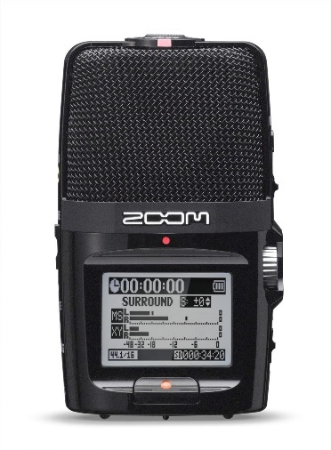  (a) | 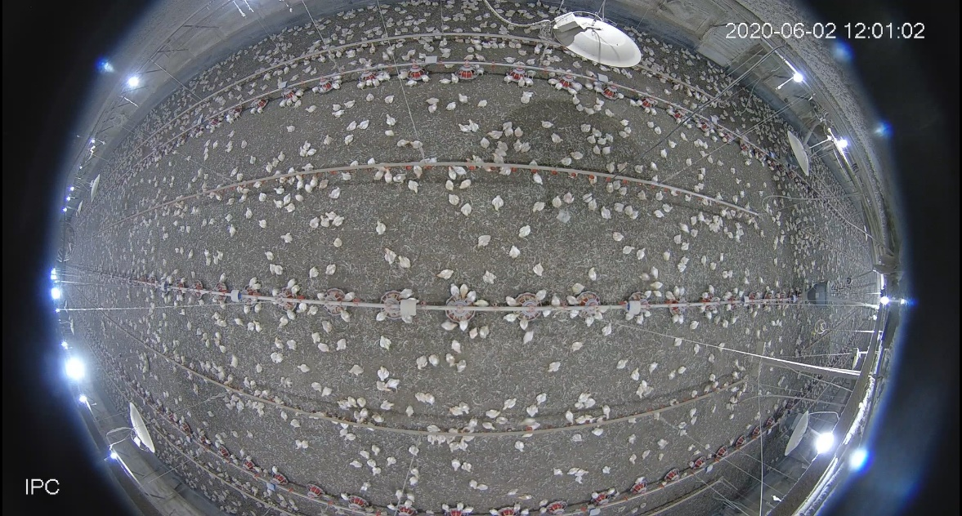  (b)  M
Figure 4.1 Image of the recorder (a) and location of the recorder M (b).

monitor the wing flapping and dustbathing behaviors of broilers. The frame rate of the camera was 25 frames per second.
                - 4.2.3 Sound Description
Six specific types of sound signals, including bird vocalization, fan, feed system, heater, wing flapping and dustbathing were examined in this study. Sound of fans was produced when mixing fans and/or ventilation fans were working. As the microphone was installed around 50 m away from the fan, the sound of fan is identified as the sound of wind from the recorded audios. Sound of feed system was produced during the period when feeder augers were running for feed delivery. Sound of heaters was produced during the first week when heaters were operating. Wing flapping is identified as a bout of continuous, rapid flapping behaviors (Coenen et al., 2009). Dustbathing is defined as birds performing classic vertical wing shakes, and performing side-rubs or prone leg scratches (Cornetto and Estevez, 2001). In this study, dustbathing specifically refers to the behavior of scratching the litter.
                - 4.2.4 Audio Signal Labelling and Pre-processing
The software Audacity (v.2.4.2, Audacity Team) was used to visualize and identify the signal by comparing with the recorded videos. Summary of labelled data is shown in Table 4.1. Bird vocalization, fan, feed system and heater were trimmed into multiple 10-s clips. As the wing flapping and dustbathing usually lasted for a short time, therefore, behavioral data were trimmed into multiple 1-s clips. Audio clips were then fed into MATLAB (2018b, The MathWorks, Inc. Natick, MA, USA) for further analysis. Spectrograms were used for an initial visual check on frequency ranges as shown in Figure 4.2. The frequencies of bird vocalization (Figure 4.2a) and fan (Figure 4.2b) ranged 0-5000 Hz. Sounds of feed system (Figure 4.2c), heater (Figure 4.2d), wing flapping (Figure 4.2e) and dustbathing (Figure 4.2f), the frequencies ranged 0- 19000 Hz.
                - 4.2.5 Maximum Overlap Discrete Wavelet Transform (MODWT)
The MODWT is a linear filtering operation that transforms a signal into multilevel wavelet and scaling coefficients (Nason and Sachs, 1999). As the flowchart for three-level MODWT shown in Figure 4.3, the MODWT applies low/high-pass filters to split the frequency components of the input signal into different scales. The filters are determined depending on the mother wavelet which is selected in advance. The mother wavelets include Daubechies wavelet, Coiflects wavelet, Haar wavelet, and Symlets wavelet, and so on. Details on different wavelets can be found in publications by Percival and Walden (2000). The default mother wavelet (Symlets, N = 4) in MATLAB was used in our study. The decomposition level was determined based on the Equation 4.1 (Nourani et al., 2009).
$$L=int\left[log\left(n\right)\right]$$ | (4.1)

Table 4.1 Number of events and equivalent time labelled for each type of sound over eight weeks.
Sound type | Total time labelled (min) | Total number of clips
Bird vocalization | 40.0 | 240
Fan | 40.0 | 240
Feed system | 40.0 | 240
Heater | 5.0 | 30
Wing flapping | 6.7 | 402
Dust bathing | 4.1 | 246

(a)  Bird vocalization | (b)  Fan on  Fan on switch  Fan off
(c)  Feed system off  Feed system on | (d)  Heater on on  Heater off
(e)  Flaps | (f)  Scratches
Figure 4.2 Example signals of bird vocalization (a), fan (b), feed system (c), heater (d), wing flapping (e) and dustbathing (f) in frequency domain.

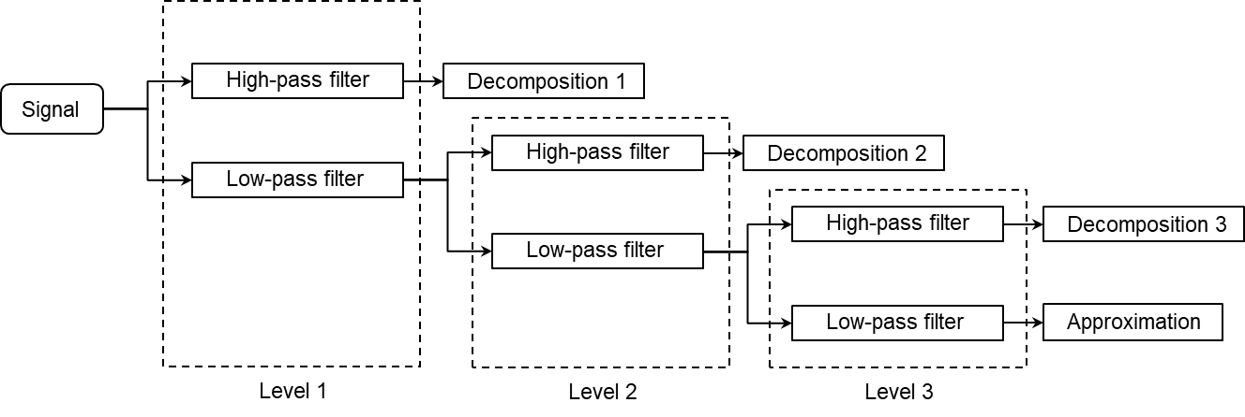
Figure 4.3 Flowchart for three-level Maximum Overlap Discrete Wavelet Transform.

Where int[] is the function that returns the nearest integer of a number and n is the data length. For the study, n = 441,000, L = 6. The decompositions of bird vocalization signal are shown in Figure 4.4.
                - 4.2.6 Signal Processing
Two sounds with narrow frequency ranges (bird vocalization and fan) were decomposed using MODWT. Decompositions of both sounds were then transformed with Fast Fourier Transform (FFT) method to generate the single-sided amplitude spectrums. By fitting the amplitude spectrum of each sound source into a Gaussian regression model, its frequency range was determined as the span of the three standard deviations (99% CI) away from the mean (Figure 4.5a). For those sounds with wide frequency ranges (feed system, heater, wing flapping and dustbathing), the upper range were determined by reading the largest frequency value from FFT plot. The behavioral frequencies were determined by examining the occurrence of peak amplitudes in spectrograms during wing flapping and dustbathing (Figure 4.5b). They were calculated by dividing the number of wing flaps and scratches by the time duration of complete behavioral events.

4.3 Results
                - 4.3.1 Bird Vocalization
Table 4.2 shows the lower and upper frequency limits of bird vocalization at different ages. Over the flock, the highest bird vocalization frequency was 4409 Hz, and the lowest was 1058Hz. In general, both lower and upper limits continuously decreased as the bird grew, but the decrease is not linear. Frequencies drop faster in the first few weeks. From weeks 1 to 4, the lower and upper limits decreased 1020 Hz and 1665 Hz, respectively. From week 4 to 8, the lower and upper limits decreased 403 Hz and 292 Hz, respectively. The frequency range during first three weeks were larger than week 4 to 8.
                - 4.3.2 Fan
Table 4.3 shows the upper and lower frequency limits of the fan at different bird ages. Generally, the lower and upper frequency limits of the fan increased as the bird grew. From week 1 to 8, the highest sound frequency of the fan was 1203 Hz, and the lowest was 305 Hz. In weeks 5-8, the lower frequency limits were significantly higher than other weeks. No significant difference was found on upper limits in weeks 2-4. The upper limits of weeks 6- 8 were significantly higher than other weeks. The frequency range varied between 716 Hz (week 1) and 791 Hz (week 3).
                - 4.3.3 Upper Limits of Feed system, Heater, Wing Flapping and Dustbathing
Table 4.4 shows the upper frequency limits of feed system, heater, wing flapping and dustbathing at different bird ages. In general, the frequency ranges of all the above sounds spanned widely from 0 to 19,000 Hz. For the feed system, the upper limits in the first two weeks were significantly lower than other weeks. In addition, the upper limit in week 8
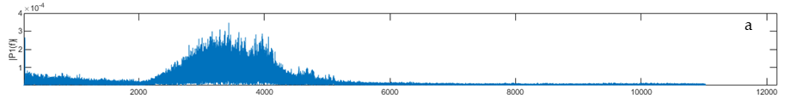
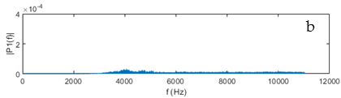 | 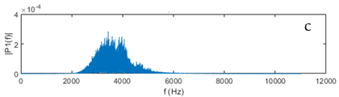
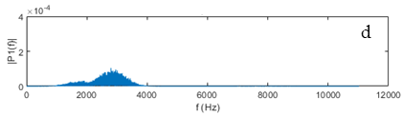 | 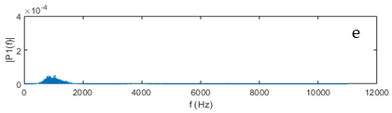
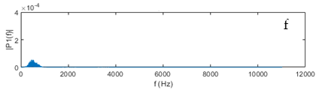 | 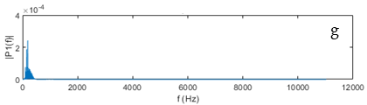
Figure 4.4 Single-sided amplitude spectrum of original signal (a) and decompositions 1-6 (b-g). Decomposition 2 (c) refers to bird vocalization, decomposition 4 (e) refers to fan.

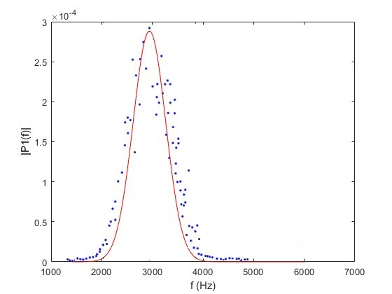
Measured
Fitted curve
Lower & Upper limits
(a) | (b)  Behavioral frequency = 11 Hz  Time duration = 0.7 s  Number of flaps = 8
Figure 4.5 Example of Gaussian regression (a) and calculation of behavioral frequency (b). The sound sources of two sounds are bird vocalization (a) and wing flapping (b), respectively.

Table 4.2 Frequency range of bird vocalization at different bird ages (mean ± SD).
Bird Age (week) | Lower Limit (Hz) | Upper limit (Hz)
1 | 2481 ± 191ª |  | 4409 ± 136ª
2 | 2038 ± 201^{b} |  | 4289 ± 89^{b}
3 | 1889 ± 307^{c} |  | 3997 ± 128^{c}
4 | 1461 ± 187^{d} |  | 2744 ± 155^{d}
5 | 1418 ± 164^{d} |  | 2668 ± 114e
6 | 1190 ± 154e |  | 2628 ± 113e
7 | 1100 ± 148e^{f} |  | 2615 ± 118e
8 | 1058 ± 123^{f} |  | 2501 ± 88^{f}
average | 1579 |  | 3231
^{a,b,c,d,e,f} Means in the same column with different superscripts are different (p < 0.05).

Table 4.3 Frequency range of fan at different bird ages (mean ± SD).
Bird Age (week) | Lower Limit (Hz) | Upper Limit (Hz)
1 | 353 ± 62^{c} |  | 1069 ± 40^{d}
2 | 331 ± 38c^{d} |  | 1080 ± 46^{cd}
3 | 312 ± 40^{d} |  | 1103 ± 52^{c}
4 | 335 ± 32^{cd} |  | 1101 ± 21^{c}
5 | 407 ± 81^{b} |  | 1161 ± 78^{b}
6 | 446 ± 28ª |  | 1191 ± 27ª
7 | 417 ± 34^{b} |  | 1203 ± 36ª
8 | 428 ± 44ª |  | 1200 ± 36ª
average | 379 |  | 1139
^{a,b,c,d} Means in the same column with different superscripts are different (p < 0.05).

Table 4.4 Upper frequency limits of feed system, heater, wing flapping and dustbathing at different bird ages (mean ± SD).
Bird Age (week) | Feed system (Hz) | Heater (Hz) | Wing Flapping (Hz) | Dustbathing (Hz)
1 | 18694 ± 149^{c} | 18903±24 | -- | --
2 | 18655 ± 244^{c} | -- | -- | --
3 | 18781 ± 61^{b} | -- | 18830 ± 27^{ab} | 18771 ± 26^{b}
4 | 18819 ± 45^{ab} | -- | 18833 ± 50ª | 18793 ± 27ª
5 | 18804 ± 54^{ab} | -- | 18819± 27^{b} | 18791 ± 30ª
6 | 18813 ± 113^{ab} | -- | 18832± 34^{ab} | 18797 ± 32ª
7 | 18833 ± 40^{ab} | -- | 18829 ± 27^{ab} | --
8 | 18857 ± 25ª | -- | 18837 ± 28ª | --
average | 18782 | 18903 | 18830 | 18788
^{a,b,c} Means in the same column with different superscripts are different (p < 0.05). Heater was only operated in week 1. The sound of wing flapping and dustbathing can be detected by microphone after week 2. No dustbathing behavior was identified in weeks 7 and 8.

was significantly higher than other weeks. The upper limit of the heater was the highest among the four types of sound. For wing flapping, the highest upper limit was observed in week 8, and the lowest was found in week 5. For dustbathing, the upper limit in week 3 was significantly lower than weeks 4-6. No significant difference was observed among weeks 4-6. When comparing two behavioral sounds, the average upper limit of wing flapping was higher than that of dustbathing.
                - 4.3.4 Behavioral Frequency
Table 4.5 shows the behavioral frequencies of wing flapping and dustbathing at different bird ages. The behavioral frequency of wing flapping and dustbathing were continuously decreased as the bird grew. In week 3, the behavioral frequencies of both wing flapping and dustbathing were significantly higher than other weeks. No significant difference was observed among weeks 4-6 for wing flapping and dustbathing. The behavioral frequency of wing flapping was significantly higher than that of dustbathing in weeks 4-6 (p = 0.049, p = 0.0003 and p = 0.0001, respectively).

4.4 Discussion
The frequency range of bird vocalization continuously decreased as the birds got older (Table 4.2). The result is consistent with previously reported by Fontana et al. (2015), who found a negative relationship between broiler vocalization frequency and bird age. The key assumption underlying the result is that larger animals often produce vocalizations with lower frequency than smaller animals. Vocalizations can be simply described as the result of tissue vibrations generated by the passage of air through a constriction in an animal’s vocal tract (Bowling et al., 2017). Due to the physical and energetic constrains, animals cannot efficiently produce sound waves larger than the size of their body or their sound-producing apparatus (Bradbury and Vehrencamp, 1998). According to the theory, bird vocalization has been used to automatically and continuously monitor broiler body weight (Fontana et al., 2017).
Different frequency-based filters have been adopted to remove the ventilation noise at pre-processing stage (Clapham et al., 2011; Fontana et al., 2016; Ginovart-Panisello et al., 2020). However, the frequency of sound produced by fan operation in commercial broiler houses remains to be understood. In this study, we found that the upper frequency range of fan in commercial broiler houses varied between 1069-1203 Hz, which is slightly higher than those reported (1000 Hz) in previous studies (Fontana et al., 2017; Ginovart-Panisello et al., 2020). Furthermore, our results show that both lower and upper limits of fan sound frequency generally increased as bird grew, probably due to the increased ventilation rate and air speed. As birds got older and the weather got hotter, more fans were required for higher ventilation rates and air speed to exhaust excess heat production by birds. If the size of air inlets does not change accordingly to maintain a proper static pressure (e.g. 25 Pa),
Table 4.5 Behavioral frequency of wing flapping and dustbathing at different bird ages (mean ± SD).
Bird Age (week) | Wing flapping (Hz) | Dustbathing (Hz)
1 | -- | --
2 | -- | --
3 | 17 ± 4^{Aa} | 16 ± 2^{Aa}
4 | 14 ± 3^{Ab} | 12 ± 1^{Bb}
5 | 14 ± 3^{Ab} | 12 ± 2^{Bb}
6 | 13 ± 2^{Ab} | 11 ± 1^{Bb}
7 | 11 ± 2^{c} | --
8 | 10 ± 1^{c} | --
^{a,b,c,d} Means in the same column with different superscripts are different (p < 0.05). ^{A,B} Means in the same row with different superscripts are different (p < 0.05). The sound of wing flapping and dustbathing can be detected by microphone after week 3. No dustbathing was found on week 8.

the airflow going through each fan would alter, which may affect the air interaction with fan blades and the fan sound frequency.
The frequency of feed system and heater ranged from 0 to 19,000 Hz. The result indicates that the sound produced during feed system and heater cannot be simply removed by adding a bandpass filter. Other noise reduction methods will be needed. There was statistical difference in upper limits of the automatic feeder sounds among weeks, which was possibly due to the differences in feed particle sizes that affected the frictions between augers and feed tubes during feed delivery. However, the changes of the upper limits were small.
Acoustic signal could be a useful tool for learning animal behaviors. Microphones have been widely used to detect the animal behaviors, e.g. foraging of beef cattle (Chelotti et al., 2016; Rau et al., 2020), chewing of dairy cow (Zhang and Wang, 2020), and feeding behavior of broilers (Aydin and Berckmans, 2016). However, using audio signal to determine broiler wing flapping and dustbathing behaviors hasn’t been reported before. Our results showed the upper frequency ranges limits of these two behavioral sounds varied between 0-18,85018,770-18,840 Hz. Therefore, in order to avoid information loss of the signal, adding a filter < 19,000 Hz is not recommended before analyzing wing flapping and dustbathing behaviors at pre-processing. From the spectrograms, both wing flapping and dustbathing showed unique patterns in time series, which may provide valuable information to behavior classification and recognition in future.
During the first two weeks, wing flapping and dustbathing behaviors can be observed in recorded videos, however, were not efficiently captured by the microphone. It indicates the limitation of using a microphone to learn behaviors of young chicks. No dustbathing was observed in weeks 7-8. Similar results were reported by Meluzzi and Sirri (2009) that dustbathing activity was decreased as broilers get older. Litter quality could be one of the factors. Broilers prefer to bathe at the area with loose and dry materials (Odén et al., 2002), while the litter is stiffer and moister by the end of flock. The behavioral frequency of wing flapping and dustbathing continuously decreased as bird grew. The possible reason is that older birds were more physically challenged to perform these behaviors due to the body weight. This hypothesis also indicated that the behavioral frequency could be another indicator of bird age. As no study has been conducted on broiler behavioral frequency so far, further investigation will be needed for the hypothesis.
As two types of non-invasive methods in animal research, cameras and microphones were often used separately. Both of them have been proved to be efficiently deployed in precision livestock farming. It would be exciting if two methods can be combined. Most off-the-shelf cameras come with both channels of video and audio, which could provide the system eyes and ears. Endless possibilities could be achieved by adding a computer as the brain, which will eventually achieve smart broiler farming.

4.5 Conclusions
In this study, the sound frequency ranges of bird vocalization, fan, feed system, heater, wing flapping and dustbathing in a commercial Ross 708 broiler house at different bird ages were determined using signal processing. The behavioral frequencies of wing flapping and dustbathing were examined as well. We conclude that the frequency range of bird vocalization continuously decreased as bird grew. Sound frequency of fan generally increased from week 1 to week 8. The upper frequency range of feed system, heater, wing flapping and dustbathing exceeded 18,000 Hz. Significant negative correlation of age on behavioral frequencies of wing flapping and dustbathing were observed. In summary, both broiler vocalization and equipment-based sounds showed temporal variations. These findings provide important insights into broiler welfare, health, and behavior determination using signal processing. Generalize the results to other housing system and broiler breeds will require more data.

Accuracy of Broiler Activity Index as Affected by Sampling Time Interval

This chapter has been published in Animals.

Yang, X., Zhao, Y., & Tabler, G. T. (2020). Accuracy of Broiler Activity Index as Affected by Sampling Time Interval. Animals, 10(6), 1102.

5.1 Introduction
Broiler activity is considered as a major indicator of animal physical and physiological conditions (Bizeray et al., 2002; Simsek et al., 2009). It has been suggested that a reasonable amount of activity may benefit broiler skeletal conditions of legs (Thorp and Duff, 1988), thus reducing incidences of lameness and improving bird walking ability (Hester, 1994). More movement and activity of broilers may also help to reduce the prevalence of hock burns (Wilson et al., 1984), footpad dermatitis (Kaukonen et al., 2016), and breast burns (Shepherd and Fairchild, 2010) by reducing the contact with wet litter.
In order to quantify the animal activity, activity index (AI), a measure of movement intensity through image processing, was proposed by Bloemen et al. (1997). Activity index was defined as the percentage of pixels of moving animals to the total number of pixels within the image (including animals and background). In more recent research, the total number of pixels was replaced with total bird-representative pixels to compensate variations in animal size at different ages (Aydin et al., 2010; Bloemen et al., 1997; Silvera et al., 2017). Since the concept was coined, AI has been widely used to quantify activities of broilers (Kristensen et al., 2006; Yang et al., 2020).
Broiler AI is calculated by determining changes in bird-representative pixels between consecutive images. Using a short time interval between consecutive images may capture more movement details and yield better AI accuracy; however, a time interval that is unnecessarily short (e.g. yielding too many consecutive images for only trivial bird movements) cannot further improve AI accuracy and may increase image processing time. Longer time interval, on the other hand, may miss-identify birds’ movements and compromise AI accuracy. Therefore, a proper time interval is important for ensuring accuracy of AI while improving processing efficiency and saving computational resources. Different time intervals have been used to determine broiler AI in previous research. For instance, Neves et al. (2015) analyzed the images at 60 s interval to determine bird activity as affected by feeder types. Bloemen et al. (1997) sampled images with time interval of 5 s to investigate the effect of thermal environment on broiler activity. Aydin et al. (2010) used time interval of 0.2 s to measure the activity of broilers with different gait scores. However, proper time intervals remain to be explored.
Selection of a proper time interval should be based on the bird movement intensity which could be affected by many factors such as bird age, location, and time of the day. Bird movement intensity may vary among different bird ages due to the changes in their physical conditions like body weight and walking ability (Aydin et al., 2010; Neves et al., 2015). Broilers do not always spread out evenly on the floor areas in commercial houses, resulting in different degrees of crowdedness that may affect bird movements. For example, Arnould and Faure (2003) found that areas near feeders and drinkers were more crowded because broilers tended to stay and rest near the sources of feed and water. Furthermore, bird movement intensity varies within a day. Previous research showed that birds are more active a couple of hours after light ON and before light OFF (Bessei, 2006). However, effects of above-mentioned temporal and spatial variations in broiler movement intensity on broiler AI have not been investigated.
The objective of this study was to investigate the effect of sampling time interval (0.04, 0.2, 1, 10, 60, and 300 s) on the accuracy of broiler AI. The effects of bird age (1-7 weeks), location (feeder, drinker, and open area) and time of day (06:00-07:00 h, 12:00-13:00 h and 18:00-19:00 h) on broiler AI were also examined.

5.2 Material and Methods
                - 5.2.1 Housing, Animals and Management
The study was conducted in a commercial broiler house located at Mississippi State University. The house measured 120 × 13 × 3 m (L × W × H) with a capacity of 16,120 Ross 708 straight run broilers and a production cycle of 8 weeks. Both tray and tube feeders were used in weeks 1 and 2 of bird age, then tray feeders were removed since week 3. Flock managements and diets followed the typical procedures in the industry. The lighting schedule was set to 24L:0D from 1d to 7d, 20L:4D from 8d to 56d. The light intensity was set to 54 lux from 1d to 13d, then gradually dimmed to 3 lux by 20d and kept at 3 lux till 56d. Lights were turned on at 05:00 h and turned off at 01:00 h of next day.
                - 5.2.2 Camera System
A fisheye IP camera (Dahua, IPC-EW4431-ASW, Dahua Technology USA Inc., Irvine, CA) was installed on the ceiling (height = 3 m), located in the middle of the house. The frame rate of the camera was 25 frames per second. Three one-hour video clips (06:00 to 07:00 h, 12:00 to 13:00 h and 18:00 to 19:00 h) were recorded on one day every week. The video clips were converted into images with all frames extracted (time interval of 0.04s between consecutive images) or partial frames at time intervals of 0.2, 1, 10, 60 and 300 s. Images were first corrected for distortions using Python (Python 3.7.1, Python Software Foundation, Beaverton, OR). Afterwards, three specific areas (200 × 200 pixels) located at feeder, drinker and open area (Fig. 5.1) were cropped out of the images and fed to MATLAB (2018b, The MathWorks, Inc. Natick, MA) for image processing. The dimension of cropped area was equivalent to the actual area of 0.71× 0.71 m. The images were used to calculate AI at the drinker and open areas in weeks 1-7, and at feeding area in weeks 3-7 when only tube feeders were provided.
                - 5.2.3 Activity Index
The value I(x, y) represents the intensity of the pixel at coordinates (x, y) in that image. The difference in intensity between the current image I(x, y, t) and the previous image I(x, y, t-1), was calculated by subtraction of the two consecutive images. A resulting image of I_{a}(x, y, t), in binary form, was then generated according to results of the subtraction (Equation 5.1).
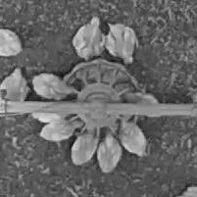  (a) | 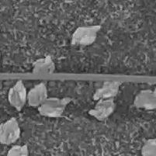  (b) | 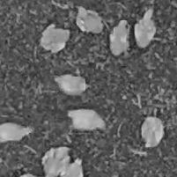  (c)
Figure 5.1 Example images of (a) feeder (b) drinker and (c) open area.

$$I_{a}\left(x,y,t\right)=\left\{\begin{aligned}1, &if I(x,y,t)-I\left(x,y,t-1\right)>τ \\ 0, &otherwise\end{aligned}\right.$$ | (5.1)
The threshold (τ) was set to 15% of the maximal intensity of each video clips by observing the “empty” background of first 20 frames for each clip to avoid erroneous results due to noise, e.g., electrical noise in the coaxial cabling and image acquisition circuits, and lighting variations.
Total number of non-zero pixels was calculated as the variation between the two consecutive images due to the activity of broilers. To compensate the sizes and number of the birds, the activity index AI(t) was calculated as the fraction of the number of non-zero pixels in the resulting binary image I_{a}(x, y, t) with respect to the number of broiler-representative pixels S(t-1) in the previous image I(x, y, t-1) (Equation 5.2).
$$AI\left(t\right)=\frac{\sum{I_{a}\left(x,y,t\right)}}{S\left(t-1\right)}$$ | (5.2)
                - 5.2.4 Data Preparation and Statistic Analysis
The effects of sampling time interval, bird age, sampling location, and time of the day as well as the major two-way interactions, on broiler AI was analyzed using PROC GLM (generalized linear model) procedure in SAS 10.9 (SAS Institute., Cary, NC, USA). Significant difference of multiple comparisons of group means was defined as p < 0.05. The levels for time intervals were 0.04, 0.2, 1, 10, 60 and 300 s. The levels of age were 1-7 weeks in drinker and open areas, and 3-7 weeks in feeder area. The levels of sampling location factor consisted of feeder, drinker and open areas. The levels of sampling time within a day were 06:00-07:00 h, 12:00-13:00 h and 18:00-19:00 h. In order to compare the difference of AI among different time intervals, the cumulative AI of every 300 s was calculated. Some of the video clips were not strictly hour-long (56 to 60 min), therefore, total 11 samples were obtained from each video clip. For the effects of bird age, location and time of the day, only data with time interval of 0.04 s (full frames) were used for analysis.

5.3 Results
                - 5.3.1 Time Interval
Table 5.1 shows the average broiler AI with different time intervals at different locations. Time interval of 0.04 s yielded the highest AI. As the increase of time interval, the broiler AI deceased from 99% (0.2 s) to 2% (300 s) of the AI determined with time interval of 0.04 s. There is no significant difference in broiler AI between 0.04 s and 0.2 s in drinker, feeder and open area. Significantly lower broiler AI were observed with time interval of 1 s than 0.2 s in feeder (p < 0.0001) and drinker (p = 0.0267) area. In the open area, the broiler AI with time interval of 1 s was significantly lower than 0.04 s (p = 0.0007), however, no significant difference was observed between 0.2 s and 1 s.
Table 5.1 Average broiler activity index (AI) with different time intervals at different locations.
Time interval (s) | Location
Time interval (s) | Feeder |  |  | Drinker |  |  | Open area
Time interval (s) | AI | Ratio (%) |  | AI | Ratio (%) |  | AI | Ratio (%)
0.04 | 38.8ª | 100 |  | 42.5ª | 100 |  | 81.2ª | 100
0.2 | 38.5ª | 99 |  | 41.7ª | 98 |  | 58.0^{ab} | 71
1 | 27.3^{b} | 70 |  | 31.1^{b} | 73 |  | 34.3^{bc} | 42
10 | 8.0^{c} | 21 |  | 11.7^{c} | 28 |  | 20.1^{cd} | 25
60 | 2.3^{cd} | 6 |  | 4.9^{cd} | 12 |  | 10.2^{cd} | 13
300 | 0.6^{d} | 2 |  | 0.9^{d} | 2 |  | 1.7^{d} | 2
SEM | 3.1 |  |  | 5.4 |  |  | 13.4
Ratio: AI calculated at a time interval relative to that at 0.04-s time interval; SEM: Pooled standard error mean for main effects of location; ^{abcd} Means in the same column with different superscripts are different (p < 0.05). Five weeks (week 3-7) of data in feeder area and seven weeks (week 1-7) of data in drinker and open areas were summarized.

                - 5.3.2 Age and Location
Table 5.2 shows the weekly average broiler AI at different locations. In the feeder area, the broiler AI in week 3 was significantly higher than that in weeks 4 and 7 (p < 0.0001). No significant difference was observed among weeks 4, 6 and 7. At the age of week 5, the AI was significantly higher than that in weeks 4 (p = 0.0024) and 6 (p = 0.0218), however, not significantly different from week 7. Broiler AI in open area gradually decreased from week 1 to week 5, and slightly increased (p > 0.05) in weeks 6 and 7. No significant difference in broiler AI in the open area was observed between weeks 2 and 3. The AI in week 4-7 were significantly lower than those in week 1-3. In addition, there is no significant difference among weeks 4-7. For the effects of sampling locations, the broiler AIs in open area were significantly higher than that in drinker area in weeks 1 and 2 (p = 0.0098 and p = 0.0011, respectively). In weeks 3 and 4, higher broiler AIs were observed in open area and the lowest AIs in drinker area. In weeks 6 and 7, the broiler AIs in feeder and drinker area were higher than that in open area. Generally, broiler AI decreased as broiler grew up in all locations of concerns.
                - 5.3.3 Time of Day
Table 5.3 shows the weekly average broiler AI within three time periods at three locations. In feeder area, significant differences among time periods were observed at 5 and 6 weeks of bird age. In drinker area, higher broiler AIs were observed at either 12:00 h or 18:00 h during 1-7 weeks of bird age. The lowest broiler AIs were observed at 06:00 h except week 3. In open area, significant differences were found in weeks 4 and 6, with highest AIs being identified at 12:00 h and lowest at 06:00 h.
                - 5.3.4 Selection for Proper Time Interval
Figure 5.2 shows the weekly average broiler AI in feeder, drinker and open area with different time intervals. In feeder area, no significant difference in broiler AI was observed between time interval of 0.04 s and 0.2 s in week 3 and weeks 5-7. In week 4, the AI with time interval of 0.2 s was higher than that of 0.04 s (p = 0.0320). In drinker area, the difference in broiler AI in weeks 1-4 and week 6 was not significant between 0.04-s and 0.2-s intervals. In week 5, the AI with time interval of 1 s was higher than that of 0.04 s (p = 0.0436). At the age of week 7, time interval of 0.2 s yielded significantly lower AI than that of 0.04 s (p = 0.0068). In open area, no significant difference in broiler AI between time intervals of 0.04 and 0.2 s was found in week 1-2 and week 4-6. In week 3 and 7, the AI with time interval of 0.2 s was higher than that of 0.04 s (p = 0.0056 and p = 0.0159).

5.4 Discussion
Different sampling time intervals, from seconds to minutes, have been adopted to calculate AI of livestock and poultry (Kashiha et al., 2014b; Poursaberi et al., 2010b; Yang et al., 2019). But how the time intervals affect the accuracy of animal AI remains to be understood. In this study, we found that AI decreased at longer sampling
Table 5.2 Weekly average broiler activity index (AI) at different locations.
Bird age | Location
Bird age | Feeder |  | Drinker |  | Open |  | SEM ^{[1]}
1 | -- |  | 83.2^{Ba} |  | 232.5^{Aa} |  | 39.7
2 | -- |  | 74.1^{Ba} |  | 137.2^{Ab} |  | 13.0
3 | 64.5^{Ba} |  | 28.9^{Cbc} |  | 95.8^{Ab} |  | 7.2
4 | 28.6^{Ac} |  | 16.5^{Bc} |  | 32.6^{Ac} |  | 1.9
5 | 37.8^{Ab} |  | 20.7^{Bc} |  | 21.6^{Bc} |  | 1.7
6 | 30.9^{Ac} |  | 31.5^{Abc} |  | 23.1^{Bc} |  | 1.6
7 | 31.9^{Bbc} |  | 42.4^{Ab} |  | 25.5^{Cc} |  | 1.8
SEM ^{[2]} | 2.1 |  | 6.1 |  | 14.8 |  | --
Data with the time interval of 0.04 s were included; ^{[1]} SEM: Pooled standard error mean for age effect; ^{[2]} SEM: Pooled standard error mean for location effect; ^{ABC} Means in the same row with different superscripts are different (p < 0.05); ^{abc} Means in the same column with different superscripts are different (p < 0.05).

Table 5.3 Weekly average broiler activity index (AI) within three time periods (06:00 h – 07:00 h, 12:00 h – 13:00 h, and 18:00 h – 19:00 h) at three locations (feeder, drinker, and open area).
Bird age | Location
Bird age | Feeder |  |  |  |  | Drinker |  |  |  |  | Open
Bird age | 06:00 | 12:00 | 18:00 | SEM |  | 06:00 | 12:00 | 18:00 | SEM |  | 06:00 | 12:00 | 18:00 | SEM
1 | -- | -- | -- | -- |  | 43.7^{B} | 136.3^{A} | 69.5^{B} | 21.0 |  | 179.0 | 384.9 | 133.7 | 91.0
2 | -- | -- | -- | -- |  | 46.0^{B} | 97.6^{A} | 78.7^{AB} | 11.4 |  | 91.7 | 159.0 | 160.7 | 28.3
3 | 60.2 | 64.0 | 69.2 | 6.4 |  | 31.6^{A} | 35.9^{A} | 19.1^{B} | 3.1 |  | 98.8 | 85.9 | 102.6 | 20.8
4 | 24.3 | 30.5 | 31.1 | 2.6 |  | 6.1^{C} | 19.6^{B} | 23.8^{A} | 1.3 |  | 22.5^{B} | 42.3^{A} | 32.9^{AB} | 3.7
5 | 43.4^{A} | 31.7^{B} | 38.3^{AB} | 2.3 |  | 18.7 | 19.1 | 24.2 | 3.1 |  | 18.5 | 26.3 | 20.0 | 3.2
6 | 28.8^{B} | 28.2^{B} | 35.7^{A} | 2.2 |  | 25.1^{B} | 31.8^{AB} | 37.8^{A} | 2.9 |  | 17.3^{B} | 29.1^{A} | 22.8^{AB} | 2.5
7 | 28.9 | 32.2 | 34.6 | 2.8 |  | 41.3 | 44.2 | 41.7 | 3.2 |  | 28.7 | 23.6 | 24.1 | 3.5
SEM: Pooled standard error mean for main effects of time periods at each location; ^{ABC} Means in the same row with different superscripts under same location category are different (p < 0.05); Data with time interval of 0.04 s were used.

Figure 5.2 Weekly average broiler activity index (least square means ± SEM) in feeder, drinker and open area with different time intervals. ^{a, b, c, d, e} Means with different superscripts within the same category are different (p < 0.05).

Figure 5.2. Continued.

time intervals (Table 5.1). This is because some transient behaviors, such as turning, bobbling, preening and shaking, can be miss-identified as sampling time interval increases. Our results also show that 0.2-s interval can be considered as an alternative of 0.04 s in broiler AI determination, because it delivered comparably high AI while reduced the image processing workloads by 80%. Selecting proper sampling time intervals for accurate AI measurement of certain animal species, should consider the velocities of both continuous movements (e.g. walking and running) and discrete movements (e.g. pecking, touching, smelling, dashing, etc.). Sampling time interval of 0.03 s has been used for cow (Chapinal et al., 2009; Poursaberi et al., 2010b), 0.04 s for pig (Kashiha et al., 2014b; von Wachenfelt et al., 2009), and 0.2 s and 0.3 s for poultry (Tickle et al., 2018; Yang et al., 2019).
Broiler AIs generally decreased as the birds got older (Table 5.2). This result is consistent with those previously reported by Alvino et al. (2009) and Bizeray et al. (2000) who also found older broilers were less active while gaining body weight (EFSA, 2010). Rebounds of AI at drinker and feeder areas were noticed after week 4 of bird age (Table 5.2). This is possibly because of bird increasing demands on feed and water (Bruno et al., 2011) at these ages which promoted more traffic around drinkers and feeders.
Our results show obvious spatial variations in broiler AI, which can be explained by the different movement intensities of predominant behaviors in the locations of concerns (i.e. feeder, drinker, and open areas). Feeding and drinking behaviors at feeder and drinker areas (Kristensen et al., 2007; Svihus et al., 2013) do not involve more intensive body movements as compared the walking, chasing, and playing behaviors in open litter area. Therefore, the broiler AIs in feeder and drinker areas were lower than that in open area in weeks 1-4 (Table 5.2). As getting older and heavier, broilers became less active and tended to use the open area as a place for resting which involves less body movements than feeding and drinking. As such, we found a lower broiler AI in open area, as compared to feeder and drinker areas, in weeks 5-7.
Understanding the broiler AI in feeder area may also help to understand the bird health status. For instance, Weeks et al. (2000b) compared the feeding patterns of broilers with different gait scores and found those birds with substantially impaired walking ability halved the number of feeding bouts but doubled the feeding time per visit to keep the same amount of feed intake as healthy birds. Be noted that the AI in our study quantifies the bird activity in a 0.71× 0.71 m area (including both the feeder/drinker and surrounding areas), thus, it involves not only the feeding and drinking behaviors, but also the traffic around feeders and drinker lines. This is different from the other measures of feed and water resources usage by broilers, such as feed intake (Bai et al., 2013). time budget of broiler feeding and drinking behaviors (Sultana et al., 2013; Ventura et al., 2012a), and feeding and drinking frequency (times of feeder or drinker visiting within an hour) (Bizeray et al., 2002; Hocking et al., 2007).
There were also temporal variations in broiler activity within a day (Table 5.3). The possible explanation for higher broiler AI at feeder area in the early morning or afternoon could be the broiler diurnal rhythms. Li et al. (2018) explored the effect of light intensity and spectrum on broiler (35-40 d) feeding behaviors with a schedule of 16L:8D and found the peak feeding occurred at 2-3 h after light ON and before light OFF. The high level of feeding behavior in the early morning could be a feed compensation after the dark period without any feed intake (May and Lott, 1994). More feeding behavior at the end of a day was probably because the birds can anticipate the darkness (Stahlbaum et al., 1986) and spontaneously increase the feed intake before the light was turned OFF (Kristensen et al., 2007). It should be pointed out that the broiler AI at feeder area during 06:00-07:00 did cover the early light ON period but was not consistently higher than that of mid-day period. The discrepancy is possibly because of the difference in bird age or lighting schedule (Xin et al., 1993). In addition, movement of birds around the feeder may result in higher AI during middle of the day, which can refer the data of AI at open area. There was no clear temporal pattern in AI in drinker area based on our results. Schwean-Lardner et al. (2014) studied the effect of day time length on broiler (27 d and 42 d) behavioral patterns and found the similar rhythm of drinking behavior as feeding. In another research that explored the effect of feeding and lighting programs on broiler feeding and drinking patterns indicated that the drinking patterns of broilers were largely influenced by lighting programs but independent of feeding behaviors (Xin et al., 1993). One explanation for the discrepancy could be the lighting schedule. Another reason could still be the movement of birds near the drinker line within the concerned area. As for open area, higher broiler AI was typically found at middle of the day in our study, which is consistent with the results reported by Sherlock et al. (2010).
It worth noting that the AI is a measure of bird movements in two dimensions on a horizontal plane. Bird movements in the vertical direction for behaviors, such as standing up, lying down, and pecking the feeder and drinker, are not included in the AI calculation, but may provide important implications on poultry welfare, health, and production efficiency. To account for the bird vertical motion, cameras with a depth sensor or body-mounted sensors that produce 3D motion measurements may be considered (Yang et al., 2019).

5.5 Conclusions
In this study, the effects of sampling time interval between consecutive images on accuracy of broiler AI at different bird age, sampling location and time of the day using image processing were investigated. We conclude that sampling time interval of 0.04 s yielded the best broiler AI results. The AI results of 0.2-s time interval was acceptable, yet requiring significantly less computational resource usage. At different ages, broiler AI in feeder and open area generally decreased from week 1 to week 7. However, a rebound in drinker area was observed after week 4. For the effects of location, higher AI during weeks 1-4 occurred in open area and switched to feeder and drinker area during weeks 5-7. Clear diurnal behavioral rhythms were also found in feeder and open area. In summary, broiler AI in commercial housing showed both temporal and spatial variations. These findings provide important insights into accurate broiler activity measurement for broiler welfare, health, and production evaluations.

Broiler Gait Score in Relation to Bird Age, Body Weight, Activity and Distribution

6.1 Introduction
Lameness in broiler chickens is a major issue that may cause welfare concerns and economic loss (Gocsik et al., 2017). It was reported that 14%-50% of broilers are moderately to severely lame in commercial farms at the late phase of production cycle (Bassler et al., 2013; De Jong et al., 2016; Kestin et al., 1992; Sanotra et al., 2003). Lame birds may suffer from pain (Caplen et al., 2014; Hothersall et al., 2016), and have difficulty in getting access to feed and water resources (Bessei, 2006; Butterworth et al., 2002). Furthermore, birds with leg abnormalities may cause economic loss due to the higher mortality (Verma, 2007; Wideman Jr et al., 2012) and slower body weight gain (Gocsik et al., 2014).
Gait score (GS) is a common metric for lameness assessment of broilers. One of the most widely used scoring systems is the six-point scoring protocol (0-5, a higher value indicates worse walking ability) developed by Kestin et al. (1992). However, implementing animal-based measures at farm level by human assessors and manual methods is discrete, laborious and time-consuming.
Advances in computational power and artificial intelligence have made image processing a viable solution for automatic animal behavior monitoring and welfare assessment (Pluk et al., 2012; Stavrakakis et al., 2014; Van Hertem et al., 2018a). Aydin (2017a) developed a machine vision-based early detection system of broiler lameness, and found high correlations (R2 = 0.988) between feature variables and gait scores. Broilers were required to walk through a corridor during the measurement however, which may limit the application of the method in commercial farms. Flock activity has been identified as a potential indicator of predicting broiler gait score in a previous study (Aydin et al., 2010). Van Hertem et al. (2018a) developed a prediction model for broiler gait score based on automated measurements of flock distribution, bird activity and body weight. The study was conducted in Europe where flock management and housing environments are different from those practiced in the US. Modification of the model may be required for farms in US.
The objective of this study was to identify the broiler gait score as affected by bird body weight, activity and distribution for Cobb 500 and Ross 708 broilers. Prediction models based on body weight, activity and distribution were developed for automatic gait score assessment.

6.2 Materials and Methods
                - 6.2.1 Housing, animals and management
The study was conducted in an experimental facility at the Johnson Animal Research and Teaching Unit at the University of Tennessee, Knoxville, TN, USA. Sixteen pens, each measuring 1.5 × 1.5 m (L × W), were used to raise Cobb 500 and Ross 708 broilers (8 pens/strain) for eight and nine weeks, respectively (Fig. 6.1a). Day-old chicks were procured from a commercial hatchery and randomly assigned to different pens (12 birds/pen). A tube feeder and a bell drinker were installed in each pen (Fig. 6.1b). Feed and water were provided ad libitum. Used litter (wood shavings and manure) was collected from a commercial broiler house, mixed well, and placed onto the floor at around 5 cm in depth. Temperature was maintained at approximately 32°C at the start of experiment and was reduced as birds grew with a final temperature set point of 22°C on 38d and thereafter. The lighting schedule was set to 24L:0D from 1 d to 3 d, 20L:4D from 4 d to 7 d, and 16L:8D after 8 d. The light intensity was set to 20 lux.
                - 6.2.2 Body weight
Overall body weight of all birds in each pen was measured weekly using a bench scale (OHAUS, OHAUS corporation, Parsippany, NJ, USA; capacity: 200 kg; resolution: 0.05 kg) to estimate the correlation between body weight and gait score of broilers.
                - 6.2.3 Broiler activity
Eight top-view cameras (IP5M-B1186EW-28MM, Amcrest Technologies, Huston, TX) were installed to continuously monitor broilers in the 16 pens. Each camera covered two pens. Videos were saved in an external hard drive and exported for analysis after the experiment. Images were firstly extracted from video clips (first 10 min of each hour) during light period (16L:8D) with the frame rate of 5 frames/sec. Same 820 × 480 pixel areas (Fig. 6.2) were cropped out of images and imported to MATLAB (2018b, The MathWorks, Inc. Natick, MA) for activity index (AI) determination. The AI was determined by calculating the ratio of bird moving pixel to overall bird-representative pixel in consecutive images. A detailed description of the method used is provided in Yang et al. (2020).
                - 6.2.4 Broiler distribution
Eight pens (four pens/strain) with good top views were selected for the determination of distribution index (DI). Each pen was divided into 3 parts as shown in Figure 6.3, corresponding to three areas that next to (A1), near (A2) and far from (A3) the feeder and drinker. Bird-representative pixel number at A2 (P₂) and A3 (P₃) was determined through image processing in MATLAB. To reduce the influence of feeder and drinker, bird-representative pixel number at A1 (P₁) was calculated by following Equation 6.1, where P₀ represents the average pixel number of one bird at different bird ages. Total 60 sub images with one or multiple birds were cropped out from the original images at each bird age. All sub images were binarized then non-zero pixels were counted for the estimation of bird size. To compensate the sizes of the birds, the DI was calculated as the standard deviation of normalized bird-representative pixel number at three locations (Equation 6.2).
$$P_{3}=P_{0}×12-P_{1}-P_{2}$$ | (6.1)
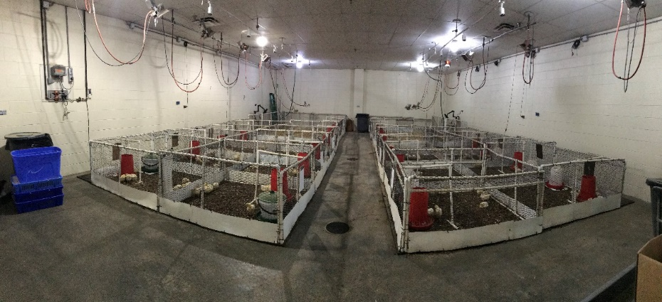  (a)  Cobb500  Ross708 | 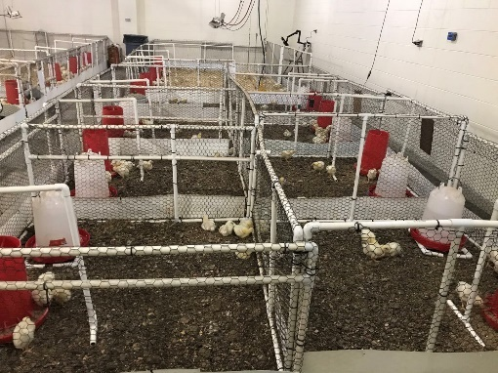  (b)
Figure 6.1 Pictures of pen settings.

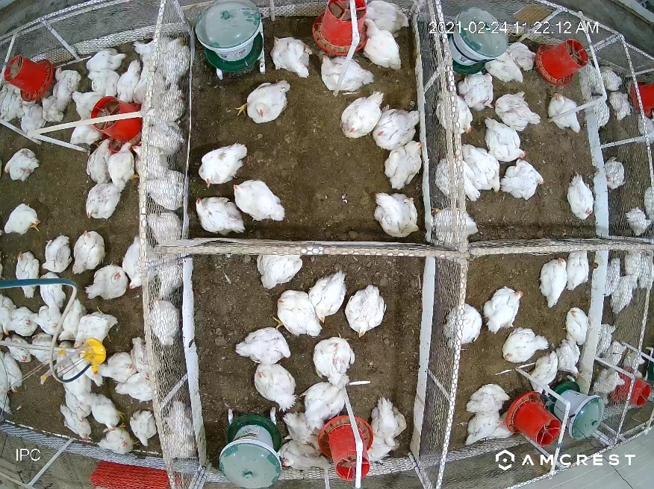
820 × 480 pixel
820 × 480 pixel
Figure 6.2 Cropped areas in images.

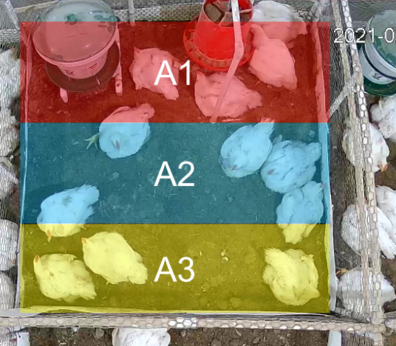
Figure 6.3 Schematic of three areas that next to (A1), near (A2) and far from (A3) the feeder and drinker.

$$DI=Sd\left(\frac{P_{1}}{P_{0}},\frac{P_{2}}{P_{0}},\frac{P_{3}}{P_{0}}\right)$$ | (6.2)
                - 6.2.5 Gait score (GS) assessment
Weekly GS assessment of all birds started from week 3. Two trained assessors classified broilers into 6 (0-5) score levels by following the Welfare Quality Assessment Protocol (Welfare Quality, 2009) and the scoring system proposed by Garner et al. (2002). The procedures used in current study are described in Table 6.1.
                - 6.2.6 Development and evaluation of stepwise regression model
Two stepwise linear regression models were developed for the application in farms with/without automated scales, respectively. Variables used for model development were listed in Table 6.2. Five variables that related to BW were excluded from the model developed for farms without automated scales. Merged dataset of Cobb 500 and Ross 708 was used for model development. The successive models were tested using ANOVA analysis with the significance level at 0.15. Ten-fold cross-validation was used to prevent over fitting.
                - 6.2.7 Statistical Analysis
Correlations between broiler gait score and bird age, body weight, activity were analyzed using the PROC REG (regression model) procedure in SAS 10.9 (SAS Institute., Cary, NC, USA). A significant difference in multiple comparisons of group means was defined as p < 0.05. Bland-Altman plots were used to evaluate whether the linear regression model is unbiased from the human assessment for gait score.

6.3 Results
                - 6.3.1 Age and body weight (BW)
The average BW and GS of Cobb 500 and Ross 708 broilers at different bird ages are shown in Table 6.3. The BW of Cobb and Ross broilers continuously increased over the production cycle. Cobb and Ross were reared for 8 and 9 weeks, respectively. There was no significant difference in BW between Cobb and Ross in the first two weeks. The BW of Cobb was significantly higher than that of Ross since week 3. The GS of both Cobb and Ross continuously increased from week 3. No significant difference in GS was observed between Cobb and Ross in week 3. After that, GS of Cobb was always higher than that of Ross (p < 0.0001). In respect of age effects, the significant increase of GS was observed 1 week earlier for Cobb (week 4) than Ross (week 5).
                - 6.3.2 Correlation of gait score (GS) and body weight (BW)
Figure 6.4 shows the correlation between BW and GS for Cobb 500 and Ross 708 broilers. In general, GS continuously increased as bird grew. Correlations of GS and BW for Cobb

Table 6.1 Criteria of each gait score.
Gait score | Criteria
0 | Normal, smooth and agile. The fingers are furled while raised.
1 | Slightly abnormality, but unidentifiable.
2 | Definite and identifiable abnormality, but has limited effects on walking ability.
3 | Obvious abnormality, affects ability to move. The bird has imbalanced steps and squat within 15 s.
4 | Severe abnormality, but still capable of walking. The bird takes more than 5s to rise when it was nudged, and squats after one or two steps.
5 | Incapable of walking.

Table 6.2 Variables used for stepwise regression model development
Variable name | Unit | Model 1 | Model 2
$$Age$$ | Bird age (week) | √ | √
$$BW$$ | Averaged pen body weight of birds (kg) | √
$${BW}^{2}$$ | -- | √
$$\frac{BW}{Age}$$ | -- | √
$$\frac{Age}{\ln{(BW)}}$$ | -- | √
$$AI$$ | Average value of activity indexes of three assessment days in the same week | √ | √
$${AI}^{2}$$ | -- | √ | √
$${AI}_{var}$$ | Variance of AI determined in three assessment days in the same week | √ | √
$$DI$$ | Average value of distribution indexes of three assessment days in the same week | √ | √
$${DI}_{var}$$ | Variance of DI determined in three assessment days in the same week | √ | √
$$\frac{AI}{DI}$$ | -- | √ | √
$$\ln{(\frac{DI}{{AI}_{var}})}$$ | -- | √ | √
$$\sqrt{\frac{WT}{AI}}$$ | -- | √
DI_eYeNamic | The distribution index based on the method of eYeNamic system | √ | √
SD | Stocking density (# of birds/m²) | √ | √
$$\frac{AI}{SD}$$ | -- | √ | √

Table 6.3 Average body weight (BW) and Gait score (GS) of Cobb 500 and Ross 708 broilers at different bird ages (mean ± SD).
Bird age (week) | BW (kg) |  |  | GS
Bird age (week) | Cobb 500 | Ross 708 |  | Cobb 500 | Ross 708
1 | 0.098 ± 0.016 ª | 0.082 ± 0.013 ª |  | -- | --
2 | 0.297 ± 0.024 ª | 0.204 ± 0.029 ª |  | -- | --
3 | 0.612 ± 0.052 ª | 0.380 ± 0.028 ^{b} |  | 0.2 ± 0.1 ^{Aa} | 0.1 ± 0.1 ^{Aa}
4 | 1.153 ± 0.083 ª | 0.679 ± 0.042 ^{b} |  | 0.8 ± 0.2 ^{Ba} | 0.3 ± 0.1 ^{Ab}
5 | 1.924 ± 0.083 ª | 1.151 ± 0.098 ^{b} |  | 1.6 ± 0.3 ^{Ca} | 0.8 ± 0.4 ^{Bb}
6 | 2.833 ± 0.126 ª | 1.809 ± 0.192 ^{b} |  | 2.8 ± 0.6 ^{Da} | 1.7 ± 0.6 ^{Cb}
7 | 3.734 ± 0.173 ª | 2.551 ± 0.301 ^{b} |  | 3.3 ± 0.4 ^{Ea} | 2.2 ± 0.5 ^{Db}
8 | 4.667 ± 0.273 ª | 3.442 ± 0.433 ^{b} |  | 3.5 ± 0.4 ^{Fa} | 2.8 ± 0.2 ^{Eb}
9 | -- | 4.132 ± 0.458 |  | -- | 3.0 ± 0.3 E
Note: ^{a, b} Means in the same row and same category (BW or GS) with different superscripts are different (p < 0.05). ^{A, B, C, D, E} Means of GS in the same column with different superscripts are different (p < 0.05).

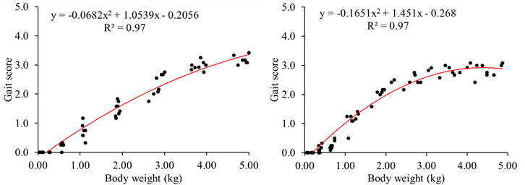  (a) | (b)
Figure 6.4 Correlations of gait score and body weight for Cobb 500 (a) and Ross 708 (b) broilers. Greater gait score means worse walking ability.

and Ross broiler fitted polynomial regressions (degree = 2) with high coefficients of determination (R² = 0.9367 for Cobb and R² = 0.9434 for Ross).
                - 6.3.3 Correlation of gait score (GS) and activity index (AI)
Figure 6.5 shows the correlation between GS and AI for Cobb 500 and Ross 708 broilers. Generally, birds with lower GS had higher AI. The correlation between GS and AI for Cobb and Ross fitted exponential regressions. The coefficients of determination (R²) were 0.7796 for Cobb and 0.7307 for Ross. The AIs for Cobb were more concentrated at lower level (0.00-0.03) as compared to Ross. The decay constant, which represents the decreasing speed of the regression curve (greater value demonstrates faster speed), was 158.8 for Cobb, while 88.69 for Ross.
                - 6.3.4 Correlation of gait score (GS) and distribution index (DI)
Figure 6.6 shows the correlation between GS and DI for Cobb 500 and Ross 708 broilers. No correlation between GS and DI was observed. The DIs for Cobb were more concentrated in the range of 2.00-3.00, while most of DIs for Ross were in the range of 1.50-2.50.
                - 6.3.5 Stepwise Linear Regression model
Equations 6.3-6.5 show the stepwise linear regression models developed for three types of farms (AW, CS and AW+CS). For AW model (Equation 3), the adjusted R² = 0.90, RMSE= 0.40. For CS model (Equation 4), the adjusted R² = 0.90, RMSE= 0.41. For AW+CS model (Equation 5), the adjusted R² = 0.91, RMSE= 0.38.
$$GS=0.45×{WT}^{2}+3.74×\frac{WT}{Age}-0.55$$ | (6.3)
$$GS=0.25×Age+391.28×{AI}^{2}+0.91×\ln{\frac{DI}{{AI}_{var}}}-7.16$$ | (6.4)
$$GS=0.52×WT+34.69×\frac{AI}{DI}+0.61×\ln{\frac{DI}{{AI}_{var}}}-4.60$$ | (6.5)
The Bland-Altman plots of three models are shown in Figure 6.7. Overall, three linear regression models were unbiased from the human assessment. For AW model, the mean difference between observed and predicted GS was -0.005±0.392. The limits of agreement between two methods were [-0.79, 0.78]. For CS model, the mean difference between observed and predicted GS was -0.016±0.394. The limits of agreement between two methods were [-0.80, 0.77]. For AW+CS model, the mean difference between observed and predicted gait scores was 0.005±0.369. The limits of agreement between two methods were [-0.73, 0.74].
                - 6.3.6. Validation
Goodness of fit of three linear regression models are shown in Figure 6.8. In general, all models could predict broiler GS accurately. The RMSE of three models were all lower than
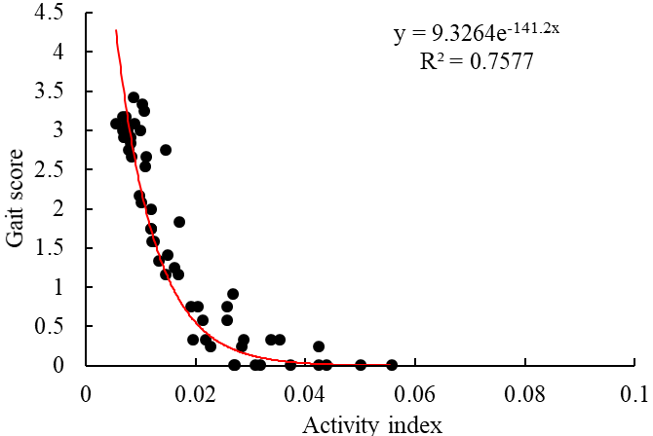  (a) | 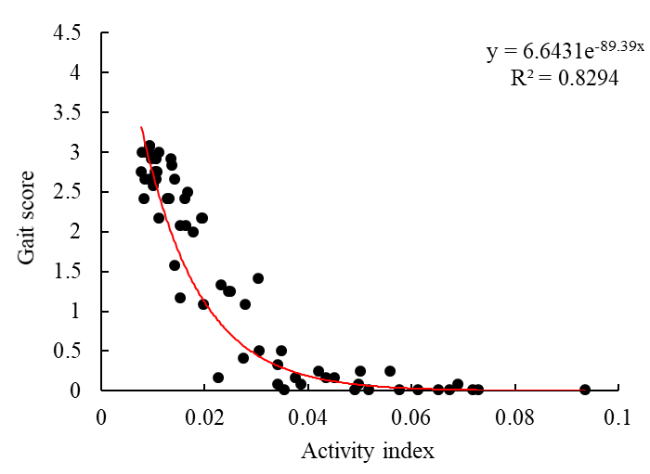  (b)
Figure 6.5 Correlations of gait score and body weight for Cobb 500 (a) and Ross 708 (b) broilers. Greater gait score means worse walking ability, and greater activity index means more active birds.

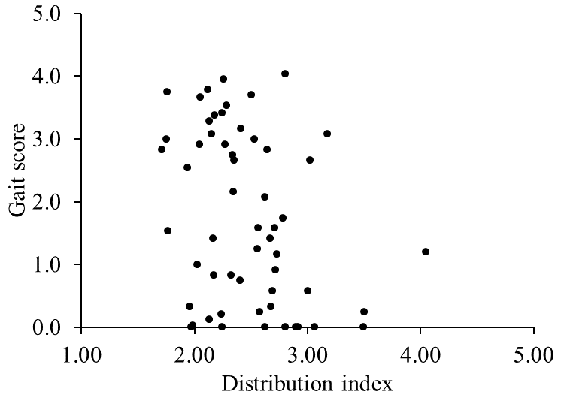 | 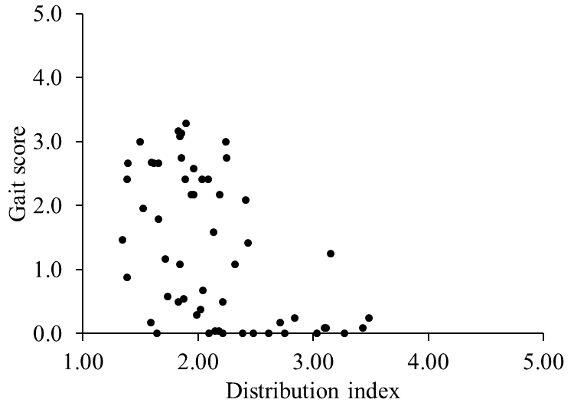
(a) | (b)
Figure 6.6 Correlations of gait score and distribution index for Cobb 500 (a) and Ross 708 (b) broilers. Greater gait score means worse walking ability, and less distribution index means more uniform distribution.

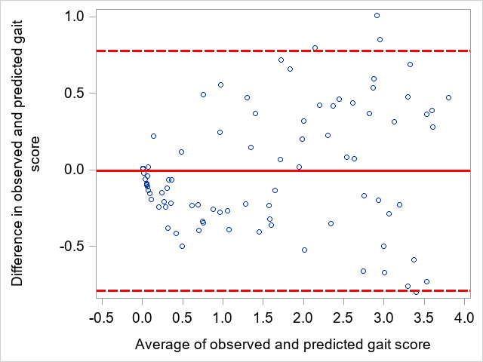
(a)
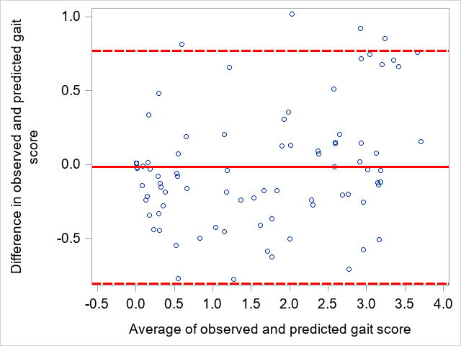
(b)
Figure 6.7 Bland-Altman plots for the evaluation of the agreement between the observed (human assessment) and predicted (linear regression model) gait score. Three figures correspond to models developed for AW (a), CS (b) and AW+CS (c), respectively. The solid red line represents the mean of difference between observed and predicted gait score. The dashed lines indicate the span of the 2 standard deviations (95% CI) away from the mean.

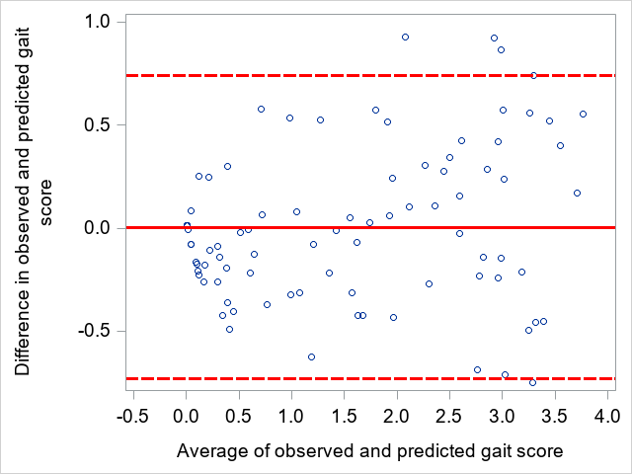
(c)
Figure 6.7. Continued.

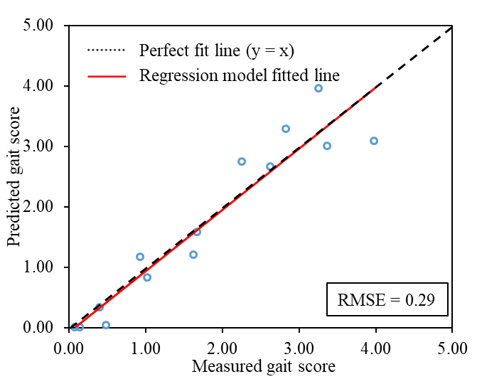  (a) | 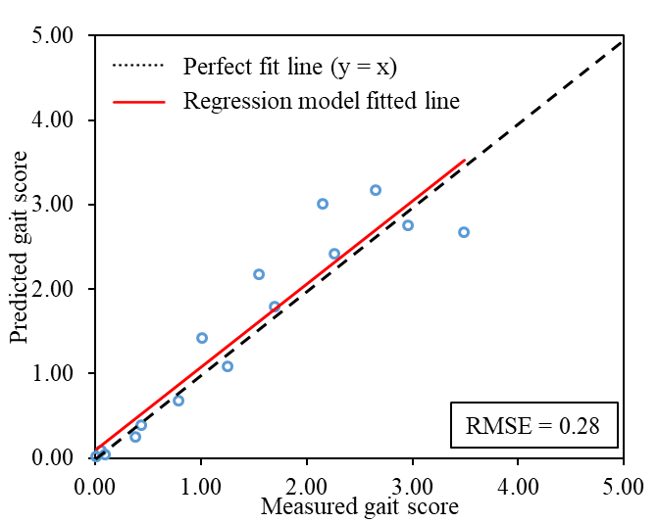(b)
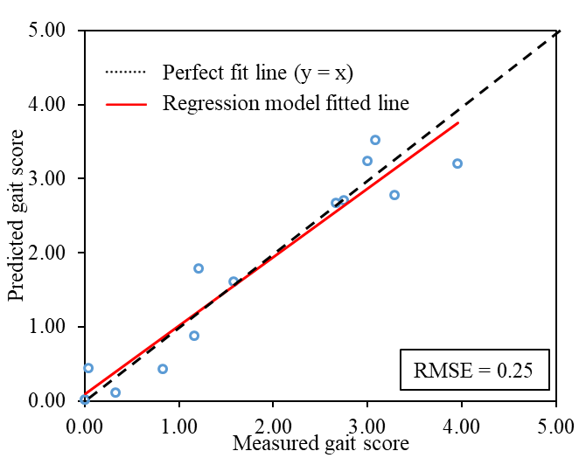  (c) | 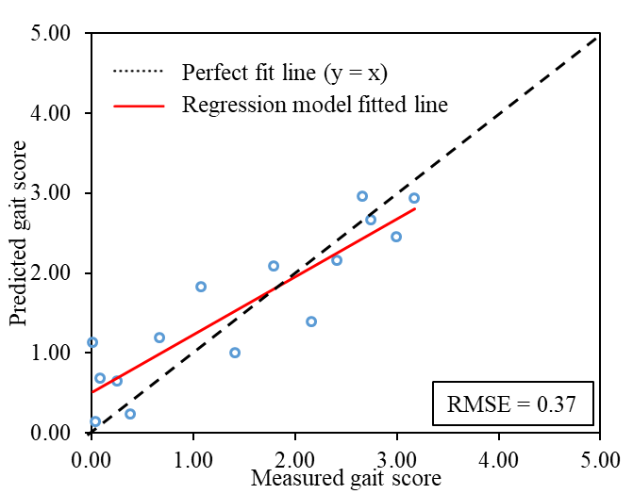  (d)
Figure 6.8 Goodness of fit of three linear regression models for Cobb 500 (a, c and e) and Ross 708 (b, d and f). Three rows of figures correspond to the performance of models developed for farms with automatic weighing system (AW), farms with camera system (CS), and farms with both automatic weighing system and camera system (AW+CS), respectively.

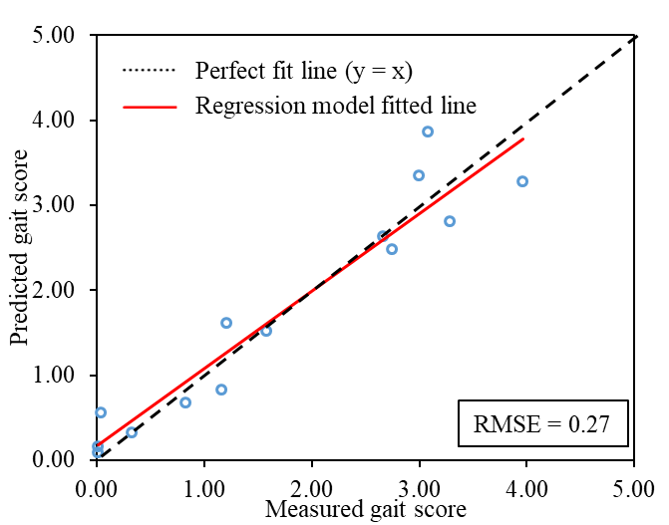  (e) | 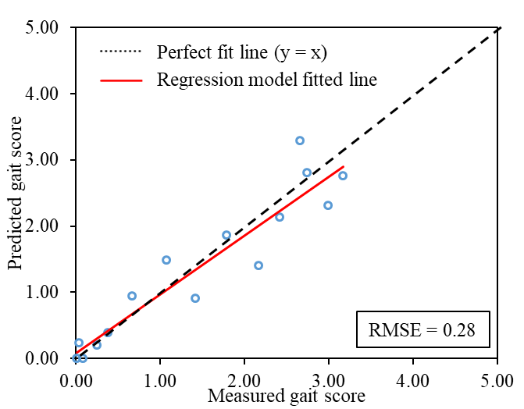(f)
Figure 6.8. Continued.

0.30, except that of the CS model for Ross 708 (RMSE = 0.37). The smallest RMSE (0.25) was observed by using CS model to predict the GS of Cobb 500. The slopes of linear regression lines for AW model were the closest to the perfect fit line (slope = 1) (1.01 for Ross and 0.98 for Cobb). In respect of different breeds, regression line slopes of three models for Cobb (1.01 for AW, 0.93 for CS, 0.91 for AW+CS) were closer to the perfect fit line as compared to Ross (0.98 for AW, 0.73 for CS, 0.89 for AW+CS).

6.4 Discussion
Broiler GS is highly correlated with BW. Many factors that were reported to be related to GS are actually functions of BW, such as genotype (Kestin et al., 1992; Knowles et al., 2008), growth rate, and feed regime (nutrient and quantity) (Brickett et al., 2007; Su et al., 1999). Kestin et al. (2001) assessed broiler GS for 13 genotypes fed with two feeding programs and found that broiler lameness was highly correlated with liveweight and growth rate. Similar results were observed in current study that the coefficients of determination of BW and GS for Cobb 500 and Ross 708 were 0.9367 and 0.9434, respectively. An earlier study by the same author found that slower-growing broilers are less prone to become lame (Kestin et al., 1992). Consistent results were found in our study that Ross broilers (3.0 ± 0.3) had lower GS than Cobb (3.5 ± 0.4) by the end of the flock due to slower growth (Table 3). Rapid growth of broilers may result in abnormally high weights being placed on relatively immature bones and joints, thereby compromise the walking ability (Webster, 1995).
Broiler AI could be an effective indicator of GS. It was observed in our study that GS and AI fitted exponential regression for both Cobb and Ross broilers. Similar results were reported by Van Hertem et al. (2018a) and van der Sluis et al. (2021) that activity level was negatively correlated with GS. In respect of physiology, gait problems may cause pain (Danbury et al., 2000), thus limit the locomotor activity of broiler chickens. On the other hand, several studies have suggested that broiler walking ability could be improved by increasing the activity level, such as the application of elevated platform (Kaukonen et al., 2017b) and robotic vehicle (Yang et al., 2020). Different results were reported by Aydin et al. (2010). The authors found a non-linear relationship between broiler AI and GS, while birds with score 3 showed the highest levels of AI compared to birds with scores 0, 1, 2, 4 and 5. Possible reason of the discrepancy could be because Aydin et al. (2010) grouped the broilers by GS. Therefore, the correlation between GS and AI at flock level could be different when birds with different GSs are mixed up.
Distribution of birds could be used for GS assessment in an indirect manner. Although, there was no significant relationship between GS and DI based on our results (Figure 6), strong correlations between GS and the transformed variables ($\frac{AI}{DI}$ and $\ln{\frac{DI}{{AI}_{var}}}$) were observed. Spatial distribution of broiler chickens indicates the preference of birds on housing environment. It has been suggested that higher DI could be linked to poor litter quality, thermal discomfort and insufficient feed or water supplies (Febrer et al., 2006). Broiler behaviors might be another factor of DI. For instance, the DI would be higher if multiple dust bathing spots are observed in the view of the camera. Because birds require more space for dust bathing as compared to resting. There are limited studies have been conducted regarding the relationship between GS and DI, further investigation will be needed in the future.
Three linear regression models were developed in our study, corresponding to different types of commercial farms. Farmers could choose the model based on what system is available in their houses. Automatic weighing system is designed for determining the real-time average BW of animals, which is usually installed in some well-equipped poultry houses. In such farms, AW model (Equation 3) could be considered. It is shown in our study that AW model had high accuracy in estimating GS with unknown dataset for Cobb (RMSE = 0.29) and Ross (RMSE = 0.28) broilers. The application of automatic weighing system, is however not common in commercial broiler houses. Low agreement between automatic weighing and manual weighing has been reported by Chedad et al. (2003), and the disagreement tended to be greater in the period of the finishing phase. Cameras, as non-invasive and economic tools, have been widely used for animal behavior determination and welfare assessment. The CS model could be implemented to broiler houses that are covered by cameras. It is found in the current study that CS model outperformed AW and AW+CS models in predicting GS of Cobb with unknown data (RMSE = 0.25). However, the performance of CS model for predicting GS of Ross with unknown data is the worst (RMSE = 0.37). The possible reason could be the difference between two flocks or the low uniformity among different pens for Ross birds. For those state-of-the-art farms that have both automatic weighing and camera systems, a comprehensive model (AW+CS) was also proposed in our study. The AW+CS model showed the highest adjusted coefficient of determination of 0.91 and the lowest root mean square error of 0.38 during the regression. The model also performed well in determining GS with unknow data (RMSE = 0.27 for Cobb and RMSE = 0.28 for Ross).
Van Hertem et al. (2018a) conducted a similar study in Europe. The authors developed a broiler GS prediction model with an adjusted R2 = 0.83 and RMSE = 0.18. Automatic weighing and camera systems were both required for the application of their model. In addition, the camera system they used (eYeNmaic) costs over $22,000, which is unaffordable for most of farmers. In our study, the cost of the system was reduced to $2,500 by using regular cameras and a computer. Different models (AW, CS and AW+CS) were developed to accommodate farms with different precision tools. This improvement may help to increase the acceptance of farmers of the system, thus improve the welfare of broiler chickens. But it should be noted that our models were developed in labs, further validation and modification will be conducted in commercial farms.

6.5 Conclusions
In this study, the relationships of broiler gait score with body weight, age, strain, activity and distribution were investigated. Three broiler gait score prediction models were also developed to be used in different commercial farms. Gait score is positively correlated with body weight (R² = 0.9367 for Cobb and R² = 0.9434 for Ross), while negatively correlated with activity (R² = 0.7796 for Cobb and R² = 0.7307 for Ross). Three models could predict flock gait score accurately based on automatically collected data (RMSE: 0.25-0.37). The study shows the potential of using camera system to automatically determine broiler gait score.

Discussion and Conclusions

                - New possibilities for litter management
Keep litter dry is the most important objective of litter management during the grow-out. Water evaporation is considered as the only way to remove moisture from litter after the placement of chickens. Among multiple sources of water addition to litter, manure is one of the primary sources. Therefore, it could be assumed that reducing manure accumulation is helpful to control LMC. In our study, manure dropped on the manure catcher was removed out of the house periodically during the flock, yielding a great improvement of air and litter quality (Chapter II). Some automated litter removal systems have been commercialized, such as the AutoShov Litter Removal System developed by Jansen Poultry Equipment (Barneveld, The Netherlands). The system has a litter slider every 5 m and slides automatically through the house with the help of a steel cable and motor unit. Excess litter and manure drop onto a conveyor belt at the end of the system and is transported out of the house. The performance of using litter removal system in commercial broiler farms needs further investigation. But the idea of removing manure out of house during the grow-out provides new possibilities for litter management in broiler houses.
                - Internet of things (IoT)
The SMART poultry farm won’t be far if different PLF technologies could communicate. Numerous studies have been conducted regarding the application of smart sensors and video cameras in poultry. Our research has proven that accelerometers (Chapter III), microphones (Chapter IV) and cameras (Chapter V and VI) could be efficiently implemented for broiler behavior determination. These tools are mostly used individually, which may restrict their maximum potential. For example, ordinary cameras can only capture the image information of a two-dimensional surface. Microphones can be used for sound analysis, yet it cannot be validated by vision data. It would be exciting if different PLF tools are combined. As such, the concept of internet of things (IoT) was coined. The IoT is a infrastructure where varieties of devices are connected to the internet for the purposes of data collection, transmission, storage, analysis and visualization (Astill et al., 2020). It enables the device-device communication, human-device communication and device-human communication (Bello and Zeadally, 2014). In broiler production, communications between PLF tools could be used to develop more intelligent systems. For instance, NH₃ concentration could be linked with ventilation system, or abnormal bird activity in conjunction with the sound of cough could trigger an alarm of respiratory disease. More devices are connected to the network, more complex the communication will be. To enable and manage the multi-device communications, many challenges are needed to be addressed, such as intelligent routing protocols, sustainable power supply for wireless sensors, synchronization of multi-source data and management of the big data.
                - Individual vs. flock measurement
Different from other large livestock animals (e.g. pigs and dairy cow), the majority of PLF in poultry were developed based on data collected at flock level. For example, the eYeNamic camera system monitors bird welfare by determining the flock distribution and activity. Our study (Chapter VI) also proved that flock distribution and activity were reliable indicators for broiler gait score. As another example, the optical flow patterns made by the movements of broiler flocks were highly correlated with the mortality and occurrence of hock burn (Dawkins et al., 2021). The major reason for monitoring broilers at flock level is the housing system. Broilers are usually reared in large flocks, with the capacity of over 10,000 birds. Take RFID system as an example, attaching tags to every bird is expensive and laborious. The management of such large amount of tags is another concern. On the other hand, the broiler chickens are too small (0.045-3 kg) to afford most of sensors. Wearable sensors are good tools for lab research, however, its application in commercial farms needs to be reconsidered.
                - Commercialization of PLF in poultry
In general, the commercialization of PLF in poultry lags behind that in other species (e.g. pigs). One of the reasons is that PLF technologies in broiler chickens are mostly developed in labs, where the housing environmental are completely different from commercial farms. Applying lab-based PLF technologies to real-life production may lead to rejection by early adopters due to poor robustness. Lacking of cooperation with researchers in other fields (e.g. computer science, electronic engineering) and manufacturing companies could also postpone the commercialization of PLF in poultry (Wathes, 2009). From farmers’ perspective, the demand and acceptance of PLF is still unclear. The payback period of PLF systems remains uncertain (Wathes et al., 2008). Therefore, it would be great for researchers to develop and test their technologies in commercial farms. Seeking cooperation with companies to optimize and commercialize the technologies is also important.
                - Future work
It was found in our lab-scale study that activity index and distribution index could be used for determining broiler chickens gait score at flock level (Chapter VI). To improve the generalization of the model, similar system will be installed in a commercial farm. The developed model will be validated and optimized based on commercial settings. Ultimately, an automated broiler gait score assessment camera system that could be used in commercial farms will be developed.

References
Abreu, V.M.N., de Abreu, P.G., PAIVA, D.d.P., Coldebella, A., Jaenisch, F.R.F., Cestonaro, T., Silva, V.S., 2013. Evaluation of Soybean Straw as Litter Material in Poultry Production and Substrate in Composting of Broiler Carcasses. Embrapa Suínos e Aves-Capítulo em livro científico (ALICE).
Allain, V., Mirabito, L., Arnould, C., Colas, M., Le Bouquin, S., Lupo, C., Michel, V., 2009. Skin lesions in broiler chickens measured at the slaughterhouse: relationships between lesions and between their prevalence and rearing factors. British poultry science 50, 407-417.
Alvarenga, F.A.P., Borges, I., Palkovič, L., Rodina, J., Oddy, V., Dobos, R., 2016. Using a three-axis accelerometer to identify and classify sheep behaviour at pasture. Applied Animal Behaviour Science 181, 91-99.
Alvino, G.M., Archer, G.S., Mench, J.A., 2009. Behavioural time budgets of broiler chickens reared in varying light intensities. Applied Animal Behaviour Science 118, 54-61.
Amrine, D.E., White, B.J., Larson, R.L., 2014. Comparison of classification algorithms to predict outcomes of feedlot cattle identified and treated for bovine respiratory disease. Computers and Electronics in Agriculture 105, 9-19.
Andaya, A.E., Arboleda, E.R., Andilab, A.A., Dellosa, R.M., 2019. Meat marbling scoring using image processing with fuzzy logic based classifier. Int. J. Sci. Technol. Res 8, 1442-1445.
Arnould, C., Faure, J.M., 2003. Use of pen space and activity of broiler chickens reared at two different densities. Applied Animal Behaviour Science 84, 281-296.
Astill, J., Dara, R.A., Fraser, E.D., Roberts, B., Sharif, S., 2020. Smart poultry management: Smart sensors, big data, and the internet of things. Computers and Electronics in Agriculture 170, 105291.
Aydin, A., 2017a. Development of an early detection system for lameness of broilers using computer vision. Computers and Electronics in Agriculture 136, 140-146.
Aydin, A., 2017b. Using 3D vision camera system to automatically assess the level of inactivity in broiler chickens. Computers and Electronics in Agriculture 135, 4-10.
Aydin, A., Bahr, C., Berckmans, D., 2015. A real-time monitoring tool to automatically measure the feed intakes of multiple broiler chickens by sound analysis. Computers and Electronics in Agriculture 114, 1-6.
Aydin, A., Berckmans, D., 2016. Using sound technology to automatically detect the short-term feeding behaviours of broiler chickens. Computers and Electronics in Agriculture 121, 25-31.
Aydin, A., Cangar, O., Ozcan, S.E., Bahr, C., Berckmans, D., 2010. Application of a fully automatic analysis tool to assess the activity of broiler chickens with different gait scores. Computers and Electronics in Agriculture 73, 194-199.
Bai, S., Wu, A., Ding, X., Lei, Y., Bai, J., Zhang, K., Chio, J., 2013. Effects of probiotic-supplemented diets on growth performance and intestinal immune characteristics of broiler chickens. Poult. Sci. 92, 663-670.
Bailie, C., O’Connell, N., 2015. The influence of providing perches and string on activity levels, fearfulness and leg health in commercial broiler chickens. Animal 9, 660-668.
Bailie, C.L., Baxter, M., O’Connell, N.E., 2018. Exploring perch provision options for commercial broiler chickens. Applied Animal Behaviour Science 200, 114-122.
Banerjee, D., Biswas, S., Daigle, C., Siegford, J.M., 2012. Remote activity classification of hens using wireless body mounted sensors. In Proceedings of 9th International Conference on Wearable and Implantable Body Sensor Networks, 10-12 May 2012, London, UK, pp. 107-112.
Banos, O., Galvez, J.-M., Damas, M., Pomares, H., Rojas, I., 2014. Window size impact in human activity recognition. Sensors 14, 6474-6499.
Barwick, J., Lamb, D.W., Dobos, R., Welch, M., Trotter, M., 2018. Categorising sheep activity using a tri-axial accelerometer. Computers and Electronics in Agriculture 145, 289-297.
Bassler, A., Arnould, C., Butterworth, A., Colin, L., De Jong, I., Ferrante, V., Ferrari, P., Haslam, S., Wemelsfelder, F., Blokhuis, H., 2013. Potential risk factors associated with contact dermatitis, lameness, negative emotional state, and fear of humans in broiler chicken flocks. Poult. Sci. 92, 2811-2826.
Baxter, M., Richmond, A., Lavery, U., O’Connell, N.E., 2020. Investigating optimal levels of platform perch provision for windowed broiler housing. Applied Animal Behaviour Science 225, 104967.
Beker, A., Vanhooser, S., Swartzlander, J., Teeter, R., 2004. Atmospheric ammonia concentration effects on broiler growth and performance. Journal of Applied Poultry Research 13, 5-9.
Bello, O., Zeadally, S., 2014. Intelligent device-to-device communication in the internet of things. IEEE Systems Journal 10, 1172-1182.
Benaissa, S., Tuyttens, F.A., Plets, D., Cattrysse, H., Martens, L., Vandaele, L., Joseph, W., Sonck, B., 2019. Classification of ingestive-related cow behaviours using RumiWatch halter and neck-mounted accelerometers. Applied Animal Behaviour Science 211, 9-16.
Bessei, W., 2006. Welfare of broilers: a review. World's poultry science journal 62, 455-466.
Bilgili, S., Hess, J., Blake, J., Macklin, K., Saenmahayak, B., Sibley, J., 2009. Influence of bedding material on footpad dermatitis in broiler chickens. Journal of Applied Poultry Research 18, 583-589.
Bizeray, D., Estevez, I., Leterrier, C., Faure, J., 2002. Effects of increasing environmental complexity on the physical activity of broiler chickens. Appl. Anim. Behav. Sci. 79, 27-41.
Bizeray, D., Leterrier, C., Constantin, P., Picard, M., Faure, J., 2000. Early locomotor behaviour in genetic stocks of chickens with different growth rates. Applied Animal Behaviour Science 68, 231-242.
Bloemen, H., AERTS, J.M., Berckmans, D., Goedseels, V., 1997. Image analysis to measure activity index of animals. Equine Veterinary Journal 29, 16-19.
Bowling, D.L., Garcia, M., Dunn, J.C., Ruprecht, R., Stewart, A., Frommolt, K.-H., Fitch, W., 2017. Body size and vocalization in primates and carnivores. Scientific reports 7, 1-11.
Bracewell, R.N., Bracewell, R.N., 1986. The Fourier transform and its applications. McGraw-Hill New York.
Bradbury, J.W., Vehrencamp, S.L., 1998. Principles of animal communication.
Brickett, K., Dahiya, J., Classen, H., Annett, C., Gomis, S., 2007. The impact of nutrient density, feed form, and photoperiod on the walking ability and skeletal quality of broiler chickens. Poult. Sci. 86, 2117-2125.
Brown-Brandl, T.M., 2019. Using RFID in Animal Management and More. Journal of Animal Science 97, 1-1.
Brownscombe, J.W., Gutowsky, L.F., Danylchuk, A.J., Cooke, S.J.J.M.E.P.S., 2014. Foraging behaviour and activity of a marine benthivorous fish estimated using tri-axial accelerometer biologgers. Marine Ecology Progress Series 505, 241-251.
Bruno, L., Maiorka, A., Macari, M., Furlan, R.L., Givisiez, P., 2011. Water intake behavior of broiler chickens exposed to heat stress and drinking from bell or and nipple drinkers. Braz. J. Poult. Sci. 13, 147-152.
Bulling, A., Blanke, U., Schiele, B., 2014. A tutorial on human activity recognition using body-worn inertial sensors. ACM Computing Surveys 46, 1-33.
Butterworth, A., Weeks, C., Crea, P., Kestin, S., 2002. Dehydration and lameness in a broiler flock. Animal Welfare 11, 89-94.
Campo, J., Gil, M., Davila, S., 2005. Effects of specific noise and music stimuli on stress and fear levels of laying hens of several breeds. Applied Animal Behaviour Science 91, 75-84.
Caplen, G., Hothersall, B., Nicol, C., Parker, R., Waterman-Pearson, A., Weeks, C., Murrell, J., 2014. Lameness is consistently better at predicting broiler chicken performance in mobility tests than other broiler characteristics. Anim Welf 23, 179-187.
Carpentier, L., Vranken, E., Berckmans, D., Paeshuyse, J., Norton, T., 2019. Development of sound-based poultry health monitoring tool for automated sneeze detection. Computers and Electronics in Agriculture 162, 573-581.
Carr, L., Wheaton, F., Douglass, L., 1990. Empirical models to determine ammonia concentrations from broiler chicken litter. Transactions of the ASAE 33, 1337-1342.
Chai, L., Xin, H., Zhao, Y., Wang, T., Soupir, M., Liu, K., 2018. Mitigating ammonia and PM generation of cage-free henhouse litter with solid additive and liquid spray. Transactions of the ASABE 61, 287-294.
Chapinal, N., De Passille, A., Weary, D., Von Keyserlingk, M., Rushen, J., 2009. Using gait score, walking speed, and lying behavior to detect hoof lesions in dairy cows. Journal of Dairy Science 92, 4365-4374.
Chedad, A., Aerts, J.-M., Vranken, E., Lippens, M., Zoons, J., Berckmans, D., 2003. Do heavy broiler chickens visit automatic weighing systems less than lighter birds? Br. Poult. Sci. 44, 663-668.
Chelotti, J.O., Vanrell, S.R., Galli, J.R., Giovanini, L.L., Rufiner, H.L., 2018. A pattern recognition approach for detecting and classifying jaw movements in grazing cattle. Computers and Electronics in Agriculture 145, 83-91.
Chelotti, J.O., Vanrell, S.R., Milone, D.H., Utsumi, S.A., Galli, J.R., Rufiner, H.L., Giovanini, L.L., 2016. A real-time algorithm for acoustic monitoring of ingestive behavior of grazing cattle. Computers and Electronics in Agriculture 127, 64-75.
Christiano, L.J., Fitzgerald, T.J., 2003. The band pass filter. International Economic Review 44, 435-465.
Chung, Y., Oh, S., Lee, J., Park, D., Chang, H.-H., Kim, S., 2013. Automatic detection and recognition of pig wasting diseases using sound data in audio surveillance systems. Sensors 13, 12929-12942.
Clapham, W.M., Fedders, J.M., Beeman, K., Neel, J.P., 2011. Acoustic monitoring system to quantify ingestive behavior of free-grazing cattle. Computers and Electronics in Agriculture 76, 96-104.
Coenen, A., Lankhaar, J., Lowe, J., McKeegan, D., 2009. Remote monitoring of electroencephalogram, electrocardiogram, and behavior during controlled atmosphere stunning in broilers: implications for welfare. Poultry Science 88, 10-19.
Colles, F.M., Cain, R.J., Nickson, T., Smith, A.L., Roberts, S.J., Maiden, M.C., Lunn, D., Dawkins, M.S., 2016. Monitoring chicken flock behaviour provides early warning of infection by human pathogen Campylobacter. Proceedings of the Royal Society B: Biological Sciences 283, 20152323.
Collias, N.E., Collias, E.C., 1967. A field study of the red jungle fowl in north-central India. The Condor 69, 360-386.
Cornetto, T., Estevez, I.J.P.S., 2001. Behavior of the domestic fowl in the presence of vertical panels. 80, 1455-1462.
Costa, A., Ismayilova, G., Borgonovo, F., Viazzi, S., Berckmans, D., Guarino, M., 2014. Image-processing technique to measure pig activity in response to climatic variation in a pig barn. Animal Production Science 54, 1075-1083.
Council, N.C., 2014. National Chicken Council Animal Welfare Guidelines and Audit Checklist.
Council, N.C., 2019. Broiler chicken industry key facts 2019.
Cover, T., Hart, P., 1967. Nearest neighbor pattern classification. IEEE Transactions on Information Theory 13, 21-27.
Cuan, K., Zhang, T., Huang, J., Fang, C., Guan, Y., 2020. Detection of avian influenza-infected chickens based on a chicken sound convolutional neural network. Computers and Electronics in Agriculture 178, 105688.
Da Costa, M., Grimes, J., Oviedo-Rondón, E., Barasch, I., Evans, C., Dalmagro, M., Nixon, J., 2014. Footpad dermatitis severity on turkey flocks and correlations with locomotion, litter conditions, and body weight at market age. Journal of Applied Poultry Research 23, 268-279.
Daigle, C., Banerjee, D., Biswas, S., Siegford, J., 2012. Noncaged laying hens remain unflappable while wearing body-mounted sensors: Levels of agonistic behaviors remain unchanged and resource use is not reduced after habituation. Poultry Science 91, 2415-2423.
Dale, N., 1994. National research council nutrient requirements of poultry–ninth revised edition (1994). Journal of Applied Poultry Research 3, 101.
Danbury, T., Weeks, C., Waterman-Pearson, A., Kestin, S., Chambers, J.J.V.R., 2000. Self-selection of the analgesic drug carprofen by lame broiler chickens. Vet. Rec 146, 307-311.
Dawkins, M.S., Wang, L., Ellwood, S.A., Roberts, S.J., Gebhardt-Henrich, S.G., 2021. Optical flow, behaviour and broiler chicken welfare in the UK and Switzerland. Applied Animal Behaviour Science 234, 105180.
de Azevedo, C.S., Cipreste, C.F., Young, R.J., 2007. Environmental enrichment: A GAP analysis. Applied Animal Behaviour Science 102, 329-343.
De Jong, I., Hindle, V., Butterworth, A., Engel, B., Ferrari, P., Gunnink, H., Moya, T.P., Tuyttens, F., Van Reenen, C., 2016. Simplifying the Welfare Quality® assessment protocol for broiler chicken welfare. Anim. 10, 117-127.
De Jong, I.C., Gunnink, H., Van Harn, J., 2014. Wet litter not only induces footpad dermatitis but also reduces overall welfare, technical performance, and carcass yield in broiler chickens. Journal of Applied Poultry Research 23, 51-58.
Decandia, M., Giovanetti, V., Molle, G., Acciaro, M., Mameli, M., Cabiddu, A., Cossu, R., Serra, M., Manca, C., Rassu, S., 2018. The effect of different time epoch settings on the classification of sheep behaviour using tri-axial accelerometry. Computers and Electronics in Agriculture 154, 112-119.
Deniz, N.N., Chelotti, J.O., Galli, J.R., Planisich, A.M., Larripa, M.J., Rufiner, H.L., Giovanini, L.L., 2017. Embedded system for real-time monitoring of foraging behavior of grazing cattle using acoustic signals. Computers and Electronics in Agriculture 138, 167-174.
Diosdado, J.A.V., Barker, Z.E., Hodges, H.R., Amory, J.R., Croft, D.P., Bell, N.J., Codling, E.A., 2015. Classification of behaviour in housed dairy cows using an accelerometer-based activity monitoring system. Animal Biotelemetry 3, 15.
Donham, K.J., Cumro, D., Reynolds, S., 2002. Synergistic effects of dust and ammonia on the occupational health effects of poultry production workers. Journal of Agromedicine 8, 57-76.
Dörfler, M., Bammer, R., Grill, T., 2017. Inside the spectrogram: Convolutional Neural Networks in audio processing, 2017 International Conference on Sampling Theory and Applications (SampTA). IEEE, pp. 152-155.
Dozier III, W., Kidd, M., Corzo, A., Anderson, J., Branton, S., 2007. Dietary amino acid responses of mixed-sex broiler chickens from two to four kilograms. Journal of Applied Poultry Research 16, 331-343.
Du, X., Lao, F., Teng, G., 2018. A sound source localisation analytical method for monitoring the abnormal night vocalisations of poultry. Sensors 18, 2906.
Dunlop, M.W., Moss, A.F., Groves, P.J., Wilkinson, S.J., Stuetz, R.M., Selle, P.H., 2016. The multidimensional causal factors of ‘wet litter’in chicken-meat production. Science of the Total Environment 562, 766-776.
Edwards Jr, H.M., Sorensen, P., 1987. Effect of short fasts on the development of tibial dyschondroplasia in chickens. The Journal of nutrition 117, 194-200.
EFSA, 2010. Scientific opinion on the influence of genetic parameters on the welfare and the resistance to stress of commercial broilers. EFSA J. 8, 1666.
El-Deek, A., Al-Harthi, M., Khalifah, M., Elbanoby, M., Alharby, T., 2011. Impact of newspaper as bedding material in arid land on broiler performance. Egyptian Poultry Science 31, 715-725.
Elliott, H., Collins, N., 1982. Factors affecting ammonia release in broiler houses. Transactions of the ASAE 25, 413-0418.
Estevez, I., Tablante, N., Pettit-Riley, R., Carr, L., 2002. Use of cool perches by broiler chickens. Poultry Science 81, 62-69.
Febrer, K., Jones, T.A., Donnelly, C.A., Dawkins, M.S., 2006. Forced to crowd or choosing to cluster? Spatial distribution indicates social attraction in broiler chickens. Animal Behaviour 72, 1291-1300.
Federici, J., Vanderhasselt, R., Sans, E., Tuyttens, F., Souza, A., Molento, C., 2016. Assessment of broiler chicken welfare in southern brazil. Brazilian Journal of Poultry Science 18, 133-140.
Felfoldi, J., Baranyai, L., Firtha, F., Friedrich, L., Balla, C., 2013. Image processing based method for characterization of the fat/meat ratio and fat distribution of pork and beef samples. Progress in Agricultural Engineering Sciences 9, 27-53.
Ferrari, S., Piccinini, R., Silva, M., Exadaktylos, V., Berckmans, D., Guarino, M., 2010. Cough sound description in relation to respiratory diseases in dairy calves. Preventive veterinary medicine 96, 276-280.
Fida, B., Bernabucci, I., Bibbo, D., Conforto, S., Schmid, M., 2015. Varying behavior of different window sizes on the classification of static and dynamic physical activities from a single accelerometer. Medical Engineering & Physics 37, 705-711.
Foerster, F., Smeja, M., Fahrenberg, J., 1999. Detection of posture and motion by accelerometry: a validation study in ambulatory monitoring. Computers in Human Behavior 15, 571-583.
Fontana, I., Tullo, E., Butterworth, A., Guarino, M., 2015. An innovative approach to predict the growth in intensive poultry farming. Computers and Electronics in Agriculture 119, 178-183.
Fontana, I., Tullo, E., Carpentier, L., Berckmans, D., Butterworth, A., Vranken, E., Norton, T., Berckmans, D., Guarino, M., 2017. Sound analysis to model weight of broiler chickens. Poultry Science 96, 3938-3943.
Fontana, I., Tullo, E., Scrase, A., Butterworth, A., 2016. Vocalisation sound pattern identification in young broiler chickens. Animal 10, 1567-1574.
Frosch, P.J., John, S.M., 2011. Clinical aspects of irritant contact dermatitis, Contact Dermatitis. Springer, pp. 305-345.
Garcia, R., Almeida Paz, I., Caldara, F., Nääs, I., Pereira, D.F., Ferreira, V., 2012. Selecting the most adequate bedding material for broiler production in Brazil. Brazilian Journal of Poultry Science 14, 121-127.
Garner, J., Falcone, C., Wakenell, P., Martin, M., Mench, J., 2002. Reliability and validity of a modified gait scoring system and its use in assessing tibial dyschondroplasia in broilers. Br. Poult. Sci. 43, 355-363.
Ginovart-Panisello, G.J., Alsina-Pagès, R.M., Sanz, I.I., Monjo, T.P., Prat, M.C., 2020. Acoustic Description of the Soundscape of a Real-Life Intensive Farm and Its Impact on Animal Welfare: A Preliminary Analysis of Farm Sounds and Bird Vocalisations. Sensors 20, 4732.
Giovanetti, V., Decandia, M., Molle, G., Acciaro, M., Mameli, M., Cabiddu, A., Cossu, R., Serra, M., Manca, C., Rassu, S., 2017. Automatic classification system for grazing, ruminating and resting behaviour of dairy sheep using a tri-axial accelerometer. Livestock Science 196, 42-48.
Giron, T., Vieira, B., Viott, A., Pozza, M., Castilha, L., Reis, I., Nunes, R., 2019. Mechanical removal (epidermal scarification) of pododermatitis injuries reduces the presence of both inflammatory tissue and its associated microbiota in broiler feet. Poultry Science 98, 1455-1460.
Gocsik, E., Kortes, H., Lansink, A.O., Saatkamp, H., 2014. Effects of different broiler production systems on health care costs in the Netherlands. Poult. Sci. 93, 1301-1317.
Gocsik, É., Silvera, A., Hansson, H., Saatkamp, H., Blokhuis, H., 2017. Exploring the economic potential of reducing broiler lameness. Br. Poult. Sci. 58, 337-347.
Gomes, R., Monteiro, G., Assis, G., Busato, K., Ladeira, M., Chizzotti, M., 2016. Estimating body weight and body composition of beef cattle trough digital image analysis. Journal of Animal Science 94, 5414-5422.
Granquist, E.G., Vasdal, G., De Jong, I.C., Moe, R.O.J.a., 2019. Lameness and its relationship with health and production measures in broiler chickens. Animal 13, 2365-2372.
Greene, J.A., McCracken, R., Evans, R., 1985. A contact dermatitis of broilers‐clinical and pathological findings. Avian Pathology 14, 23-38.
Groves, P., Muir, W., 2013. Use of perches by broiler chickens in floor pen experiments, Proceedings of the IX European Symposium on Poultry Welfare, pp. 17-20.
Haslam, S., Knowles, T.G., Brown, S.N., Wilkins, L., Kestin, S.C., Warriss, P.D., Nicol, C.J.J.B.p.s., 2007. Factors affecting the prevalence of foot pad dermatitis, hock burn and breast burn in broiler chicken. 48, 264-275.
Hemeryck, M., Berckmans, D., Vranken, E., Tullo, E., Fontana, I., Guarino, M., Van Waterschoot, T., 2015. The Pig Cough Monitor in the EU-PLF project results and multimodal data analysis in two case studies, Proceedings of The 7th European Conference on Precision Livestock Farming (EC-PLF), Milan, Italy, 15th, pp. 147-155.
Herreid II, C.F., Kessel, B., 1967. Thermal conductance in birds and mammals. Comparative Biochemistry and Physiology 21, 405-414.
Hester, P.Y., 1994. The role of environment and management on leg abnormalities in meat-type fowl. Poultry Science 73, 904-915.
Hocking, P.M., Rutherford, K.M.D., Picard, M., 2007. Comparison of time-based frequencies, fractal analysis and T-patterns for assessing behavioural changes in broiler breeders fed on two diets at two levels of feed restriction: a case study. Applied Animal Behaviour Science 104, 37-48.
Hongchao, J., Jiang, Y., Song, Z., Zhao, J., Wang, X., Lin, H., 2014. Effect of perch type and stocking density on the behaviour and growth of broilers. Animal Production Science 54, 930-941.
Hothersall, B., Caplen, G., Parker, R., Nicol, C., Waterman-Pearson, A., Weeks, C., Murrell, J., 2016. Effects of carprofen, meloxicam and butorphanol on broiler chickens' performance in mobility tests. Anim Welf 25, 55-67.
Iwata, T., Sakamoto, K.Q., Takahashi, A., Edwards, E.W., Staniland, I.J., Trathan, P.N., Naito, Y., 2012. Using a mandible accelerometer to study fine‐scale foraging behavior of free‐ranging Antarctic fur seals. Marine Mammal Science 28, 345.
Jingqiu, G., Zhihai, W., Ronghua, G., Huarui, W., 2017. Cow behavior recognition based on image analysis and activities. International Journal of Agricultural and Biological Engineering 10, 165-174.
Kaler, J., Mitsch, J., Vázquez-Diosdado, J.A., Bollard, N., Dottorini, T., Ellis, K.A., 2020. Automated detection of lameness in sheep using machine learning approaches: novel insights into behavioural differences among lame and non-lame sheep. Royal Society Open Science 7, 190824.
Kashiha, M., Bahr, C., Ott, S., Moons, C.P., Niewold, T.A., Ödberg, F.O., Berckmans, D., 2014a. Automatic weight estimation of individual pigs using image analysis. Computers and Electronics in Agriculture 107, 38-44.
Kashiha, M.A., Bahr, C., Ott, S., Moons, C.P., Niewold, T.A., Tuyttens, F., Berckmans, D., 2014b. Automatic monitoring of pig locomotion using image analysis. Lives. Sci. 159, 141-148.
Kashiha, M.A., Bahr, C., Ott, S., Moons, C.P., Niewold, T.A., Tuyttens, F., Berckmans, D., 2014c. Automatic monitoring of pig locomotion using image analysis. Livestock Science 159, 141-148.
Kaukonen, E., Norring, M., Valros, A., 2017a. Evaluating the effects of bedding materials and elevated platforms on contact dermatitis and plumage cleanliness of commercial broilers and on litter condition in broiler houses. British poultry science 58, 480-489.
Kaukonen, E., Norring, M., Valros, A.J.a., 2017b. Perches and elevated platforms in commercial broiler farms: use and effect on walking ability, incidence of tibial dyschondroplasia and bone mineral content. Anim. 11, 864-871.
Kaukonen, E., Norring, M., Valros, A.J.A.p., 2016. Effect of litter quality on foot pad dermatitis, hock burns and breast blisters in broiler breeders during the production period. 45, 667-673.
Kestin, S., Gordon, S., Su, G., Sørensen, P., 2001. Relationships in broiler chickens between lameness, liveweight, growth rate and age. Vet. Rec 148, 195-197.
Kestin, S., Knowles, T., Tinch, A., Gregory, N., 1992. Prevalence of leg weakness in broiler chickens and its relationship with genotype. Veterinary Record 131, 190-194.
Kiyma, Z., Küçükyılmaz, K., Orojpour, A., 2016. Effects of perch availability on performance, carcass characteristics, and footpad lesions in broilers. Archives Animal Breeding 59, 19-25.
Knowles, T.G., Kestin, S.C., Haslam, S.M., Brown, S.N., Green, L.E., Butterworth, A., Pope, S.J., Pfeiffer, D., Nicol, C.J., 2008. Leg disorders in broiler chickens: prevalence, risk factors and prevention. PloS one 3, e1545.
Kristensen, H.H., Aerts, J.-M., Leroy, T., Wathes, C., Berckmans, D.J.A.a.b.s., 2006. Modelling the dynamic activity of broiler chickens in response to step-wise changes in light intensity. 101, 125-143.
Kristensen, H.H., Prescott, N.B., Perry, G.C., Ladewig, J., Ersbøll, A.K., Overvad, K.C., Wathes, C.M., 2007. The behaviour of broiler chickens in different light sources and illuminances. Applied Animal Behaviour Science 103, 75-89.
Kristensen, H.H., Wathes, C., 2000. Ammonia and poultry welfare: a review. World's poultry science journal 56, 235-245.
Kyvsgaard, N.C., Jensen, H.B., Ambrosen, T., Toft, N., 2013. Temporal changes and risk factors for foot-pad dermatitis in Danish broilers. Poultry Science 92, 26-32.
Lao, F., Brown-Brandl, T., Stinn, J.P., Liu, K., Teng, G., Xin, H., 2016. Automatic recognition of lactating sow behaviors through depth image processing. Computers and Electronics in Agriculture 125, 56-62.
Leeson, S., Walsh, T., 2004. Feathering in commercial poultry II. Factors influencing feather growth and feather loss. World's poultry science journal 60, 52-63.
LeVan, N.F., Estevez, I., Stricklin, W.R., 2000. Use of horizontal and angled perches by broiler chickens. Applied Animal Behaviour Science 65, 349-365.
Li, D., Chen, Y., Zhang, K., Li, Z., 2019. Mounting behaviour recognition for pigs based on deep learning. Sensors 19, 4924.
Li, G., Zhao, Y., Purswell, J.L., Du, Q., Chesser Jr, G.D., Lowe, J.W., 2020. Analysis of feeding and drinking behaviors of group-reared broilers via image processing. Computers and Electronics in Agriculture 175, 105596.
Li, G., Zhao, Y., Purswell, J.L., Liang, Y., Lowe, J.W., 2018. Feeding behaviors of broilers at chicken-perceived vs. human-perceived light intensities under two light spectrums, 2018 ASABE Annual International Meeting. American Society of Agricultural and Biological Engineers, p. 1.
Liu, D., Oczak, M., Maschat, K., Baumgartner, J., Pletzer, B., He, D., Norton, T., 2020. A computer vision-based method for spatial-temporal action recognition of tail-biting behaviour in group-housed pigs. Biosystems Engineering 195, 27-41.
Liu, Y., Zheng, Y.F., 2005. One-against-all multi-class SVM classification using reliability measures, In Proceedings of International Joint Conference on Neural Networks, 31 July-4 Aug, 2005, Montreal, Canada, pp. 849-854.
Liu, Z., Wang, L., Beasley, D., Oviedo, E., 2007. Effect of moisture content on ammonia emissions from broiler litter: A laboratory study. Journal of Atmospheric Chemistry 58, 41-53.
Malchow, J., Puppe, B., Berk, J., Schrader, L., 2019. Effects of elevated grids on growing male chickens differing in growth performance. Frontiers in veterinary science 6, 203.
Mansbridge, N., Mitsch, J., Bollard, N., Ellis, K., Miguel-Pacheco, G.G., Dottorini, T., Kaler, J., 2018. Feature selection and comparison of machine learning algorithms in classification of grazing and rumination behaviour in sheep. Sensors 18, 3532.
Martland, M., 1985. Ulcerative dermatitis dm broiler chickens: The effects of wet litter. Avian Pathology 14, 353-364.
Martrenchar, A., Huonnic, D., Cotte, J., Boilletot, E., Morisse, J., 2000. Influence of stocking density, artificial dusk and group size on the perching behaviour of broilers. British poultry science 41, 125-130.
Marx, G., Horn, T., Thielebein, J., Knubel, B., Von Borell, E., 2003. Analysis of pain-related vocalization in young pigs. Journal of Sound and Vibration 266, 687-698.
May, J., Lott, B., 1994. Effects of light and temperature on anticipatory feeding by broilers. Poult. Sci. 73, 1398-1403.
Meluzzi, A., Sirri, F., 2009. Welfare of broiler chickens. Italian Journal of Animal Science 8, 161-173.
Mench, J.A., 1998. Environmental enrichment and the importance of exploratory behavior. Second nature: Environmental enrichment for captive animals, 30-46.
Michel, V., Prampart, E., Mirabito, L., Allain, V., Arnould, C., Huonnic, D., Le Bouquin, S., Albaric, O., 2012. Histologically-validated footpad dermatitis scoring system for use in chicken processing plants. British poultry science 53, 275-281.
Miles, D., Branton, S., Lott, B., 2004. Atmospheric ammonia is detrimental to the performance of modern commercial broilers. Poultry Science 83, 1650-1654.
Miles, D., Miller, W., Branton, S., Maslin, W., Lott, B., 2006. Ocular responses to ammonia in broiler chickens. Avian Diseases 50, 45-49.
Mollah, M.B.R., Hasan, M.A., Salam, M.A., Ali, M.A., 2010. Digital image analysis to estimate the live weight of broiler. Computers and Electronics in Agriculture 72, 48-52.
Mollenhorst, H., Berentsen, P., De Boer, I.J.B.p.s., 2006. On-farm quantification of sustainability indicators: an application to egg production systems. 47, 405-417.
Moore Jr, P., Daniel, T., Edwards, D., 1999. Reducing phosphorus runoff and improving poultry production with alum. Poultry Science 78, 692-698.
Mortensen, A.K., Lisouski, P., Ahrendt, P., 2016. Weight prediction of broiler chickens using 3D computer vision. Computers and Electronics in Agriculture 123, 319-326.
Moura, D., Silva, W., Naas, I., Tolón, Y., Lima, K., Vale, M., 2008. Real time computer stress monitoring of piglets using vocalization analysis. Computers and Electronics in Agriculture 64, 11-18.
Muri, K., Stubsjøen, S.M., Vasdal, G., Moe, R.O., Granquist, E.G., 2019. Associations between qualitative behaviour assessments and measures of leg health, fear and mortality in Norwegian broiler chicken flocks. Applied Animal Behaviour Science 211, 47-53.
Nääs, I., Paz, I.A., Baracho, M., Menezes, A., Bueno, L., Almeida, I., Moura, D., 2009. Impact of lameness on broiler well-being. J. Appl. Poult. Res. 18, 432-439.
Nardone, A., Zervas, G., Ronchi, B., 2004. Sustainability of small ruminant organic systems of production. Livestock Production Science 90, 27-39.
Nasirahmadi, A., Hensel, O., Edwards, S.A., Sturm, B., 2016. Automatic detection of mounting behaviours among pigs using image analysis. Computers and Electronics in Agriculture 124, 295-302.
Nason, G.P., Sachs, R.v., 1999. Wavelets in time-series analysis. Philosophical Transactions of the Royal Society of London. Series A: Mathematical, Physical and Engineering Sciences 357, 2511-2526.
Neves, D.P., Mehdizadeh, S.A., Tscharke, M., de Alencar Nääs, I., Banhazi, T.M.J.I.P.i.A., 2015. Detection of flock movement and behaviour of broiler chickens at different feeders using image analysis. 2, 177-182.
Newberry, R.C., 1995. Environmental enrichment: increasing the biological relevance of captive environments. Applied Animal Behaviour Science 44, 229-243.
Nielsen, B.L., 2004. Breast blisters in groups of slow-growing broilers in relation to strain and the availability and use of perches. British poultry science 45, 306-315.
Nielsen, L.R., Pedersen, A.R., Herskin, M.S., Munksgaard, L., 2010. Quantifying walking and standing behaviour of dairy cows using a moving average based on output from an accelerometer. Applied Animal Behaviour Science 127, 12-19.
NIOSH, 2007. NIOSH pocket guide to chemical hazards.
Norring, M., Kaukonen, E., Valros, A., 2016. The use of perches and platforms by broiler chickens. Applied Animal Behaviour Science 184, 91-96.
Nourani, V., Alami, M.T., Aminfar, M.H., 2009. A combined neural-wavelet model for prediction of Ligvanchai watershed precipitation. Engineering Applications of Artificial Intelligence 22, 466-472.
Odén, K., Keeling, L., Algers, B., 2002. Behaviour of laying hens in two types of aviary systems on 25 commercial farms in Sweden. British poultry science 43, 169-181.
Oke, O.E., Daramola, J.O., Uyanga, V., Iyasere, O.S., Njoku, C.P., Babatunde, M.B., 2019. Influence of bedding materials on organ weights, meat quality, breast and footpad dermatitis of broiler chickens under hot humid climate. Agricultura Tropica et Subtropica 52, 3-8.
Olanrewaju, H., Miller, W., Maslin, W., Thaxton, J., Dozier III, W., Purswell, J., Branton, S., 2007. Interactive effects of ammonia and light intensity on ocular, fear and leg health in broiler chickens.
Otten, W., Kanitz, E., Puppe, B., Tuchscherer, M., Brüssow, K., Nürnberg, G., Stabenow, B., 2004. Acute and long term effects of chronic intermittent noise stress on hypothalamic-pituitary-adrenocortical and sympatho-adrenomedullary axis in pigs. Animal Science 78, 271-283.
Parajuli, P., Huang, Y., Tabler, T., Purswell, J.L., DuBien, J.L., Zhao, Y., 2020. Comparative Evaluation of Poultry-Human and Poultry-Robot Avoidance Distances. Transactions of the ASABE 63, 477-484.
Pedersen, I., Tahamtani, F., Riber, A., 2017. Effects of elevated platforms on fearfulness in fast-growing broilers, Proc. 51st Congress of the International Society of Applied Ethology. August, pp. 7-10.
Pedersen, I.J., Tahamtani, F.M., Forkman, B., Young, J.F., Poulsen, H.D., Riber, A.B., 2020. Effects of environmental enrichment on health and bone characteristics of fast growing broiler chickens. Poultry Science 99, 1946-1955.
Percival, D.B., Walden, A.T., 2000. Wavelet methods for time series analysis. Cambridge university press.
Pereira, D.F., Miyamoto, B.C., Maia, G.D., Sales, G.T., Magalhães, M.M., Gates, R.S., 2013. Machine vision to identify broiler breeder behavior. Computers and Electronics in Agriculture 99, 194-199.
Pereira, G., Heins, B.J., Endres, M.I., 2018. Validation of an ear-tag accelerometer sensor to determine rumination, eating, and activity behaviors of grazing dairy cattle. Journal of Dairy Science 101, 2492-2495.
Petek, M., Üstüner, H., Yeşilbağ, D., 2014. Effects of stocking density and litter type on litter quality and growth performance of broiler chicken. Kafkas Univ Vet Fak Derg 20, 743-748.
Pettit-Riley, R., Estevez, I.J.A.A.B.S., 2001. Effects of density on perching behavior of broiler chickens. 71, 127-140.
Pluk, A., Bahr, C., Leroy, T., Poursaberi, A., Song, X., Vranken, E., Maertens, W., Van Nuffel, A., Berckmans, D., 2010. Evaluation of step overlap as an automatic measure in dairy cow locomotion. Transactions of the ASABE 53, 1305-1312.
Pluk, A., Bahr, C., Poursaberi, A., Maertens, W., Van Nuffel, A., Berckmans, D., 2012. Automatic measurement of touch and release angles of the fetlock joint for lameness detection in dairy cattle using vision techniques. Journal of Dairy Science 95, 1738-1748.
Porto, S.M., Arcidiacono, C., Anguzza, U., Cascone, G., 2013. A computer vision-based system for the automatic detection of lying behaviour of dairy cows in free-stall barns. Biosystems Engineering 115, 184-194.
Porto, S.M., Arcidiacono, C., Anguzza, U., Cascone, G., 2015. The automatic detection of dairy cow feeding and standing behaviours in free-stall barns by a computer vision-based system. Biosystems Engineering 133, 46-55.
Poursaberi, A., Bahr, C., Pluk, A., Van Nuffel, A., Berckmans, D., 2010a. Real-time automatic lameness detection based on back posture extraction in dairy cattle: Shape analysis of cow with image processing techniques. Computers and Electronics in Agriculture 74, 110-119.
Poursaberi, A., Bahr, C., Pluk, A., Van Nuffel, A., Berckmans, D., 2010b. Real-time automatic lameness detection based on back posture extraction in dairy cattle: Shape analysis of cow with image processing techniques. Computers and Electronics in Agriculture 74, 110-119.
Pradana, Z.H., Hidayat, B., Darana, S., 2016. Beef cattle weight determine by using digital image processing, 2016 International Conference on Control, Electronics, Renewable Energy and Communications (ICCEREC). IEEE, pp. 179-184.
Purswell, J., Olanrewaju, H., Linhoss, J., 2018. Effect of light intensity adjusted for species-specific spectral sensitivity on live performance and processing yield of male broiler chickens. Journal of Applied Poultry Research 27, 570-576.
Quarles, C., Caveny, D., 1979. Effect of air contaminants on performance and quality of broilers. Poultry Science 58, 543-548.
Rabin, L.A., McCowan, B., Hooper, S.L., Owings, D.H., 2003. Anthropogenic noise and its effect on animal communication: an interface between comparative psychology and conservation biology. International Journal of Comparative Psychology 16.
Rau, L.M., Chelotti, J.O., Vanrell, S.R., Giovanini, L.L., 2020. Developments on real-time monitoring of grazing cattle feeding behavior using sound, 2020 IEEE International Conference on Industrial Technology (ICIT). IEEE, pp. 771-776.
Reece, F., Lott, B., Deaton, J., 1981. Low concentrations of ammonia during brooding decrease broiler weight. Poultry Science 60, 937-940.
Reiter, S., Sattlecker, G., Lidauer, L., Kickinger, F., Öhlschuster, M., Auer, W., Schweinzer, V., Klein-Jöbstl, D., Drillich, M., Iwersen, M., 2018. Evaluation of an ear-tag-based accelerometer for monitoring rumination in dairy cows. Journal of Dairy Science 101, 3398-3411.
Robert, B., White, B., Renter, D., Larson, R., 2009. Evaluation of three-dimensional accelerometers to monitor and classify behavior patterns in cattle. Computers and Electronics in Agriculture 67, 80-84.
Rodriguez-Aurrekoetxea, A., Leone, E.H., Estevez, I., 2015. Effects of panels and perches on the behaviour of commercial slow-growing free-range meat chickens. Applied Animal Behaviour Science 165, 103-111.
Sakai, K., Oishi, K., Miwa, M., Kumagai, H., Hirooka, H., 2019. Behavior classification of goats using 9-axis multi sensors: The effect of imbalanced datasets on classification performance. Computers and Electronics in Agriculture 166, 105027.
Sandilands, V., Moinard, C., Sparks, N., 2009. Providing laying hens with perches: fulfilling behavioural needs but causing injury? British poultry science 50, 395-406.
Sandilands, V., Wang, C., Sparks, N., 2016. Perching behaviour in broiler chickens exposed to two different perch designs, Proc. 50th Congress of the International Society of Applied Ethology. July, pp. 12-15.
Sanotra, G., Lund, J.D., Vestergaard, K., 2002. Influence of light-dark schedules and stocking density on behaviour, risk of leg problems and occurrence of chronic fear in broilers. British poultry science 43, 344-354.
Sanotra, G.S., Berg, C., Lund, J.D., 2003. A comparison between leg problems in Danish and Swedish broiler production. Animal Welfare 12, 677-683.
Scheel, C., Traulsen, I., Auer, W., Müller, K., Stamer, E., Krieter, J., 2017. Detecting lameness in sows from ear tag-sampled acceleration data using wavelets. Animal: an International Journal of Animal Bioscience 11, 2076.
Schrøder, H., 1985. Nitrogen losses from Danish agriculture—trends and consequences. Agriculture, Ecosystems & Environment 14, 279-289.
Schwean-Lardner, K., Fancher, B., Laarveld, B., Classen, H., 2014. Effect of day length on flock behavioural patterns and melatonin rhythms in broilers. Br. Poult. Sci. 55, 21-30.
Sheng, H., Zhang, S., Zuo, L., Duan, G., Zhang, H., Okinda, C., Shen, M., Chen, K., Lu, M., Norton, T., 2020. Construction of sheep forage intake estimation models based on sound analysis. Biosystems Engineering 192, 144-158.
Shepherd, E., Fairchild, B.J.P.s., 2010. Footpad dermatitis in poultry. 89, 2043-2051.
Sherlock, L., Demmers, T., Goodship, A.E., McCarthy, I., Wathes, C.M., 2010. The relationship between physical activity and leg health in the broiler chicken. Br. Poult. Sci. 51, 22-30.
Silvera, A., Knowles, T., Butterworth, A., Berckmans, D., Vranken, E., Blokhuis, H., 2017. Lameness assessment with automatic monitoring of activity in commercial broiler flocks. Poultry Science 96, 2013-2017.
Sims, J., Wolf, D., 1994. Poultry waste management: Agricultural and environmental issues. Advances in agronomy 52, 1-83.
Simsek, U.G., Dalkilic, B., Ciftci, M., Cerci, I.H., Bahsi, M., 2009. Effects of enriched housing design on broiler performance, welfare, chicken meat composition and serum cholesterol. Acta Veterinaria Brno 78, 67-74.
Stahlbaum, C.C., Rovee-Collier, C., Fagen, J.W., Collier, G., 1986. Twilight activity and antipredator behavior of young fowl housed in artificial or natural light. Physiology & Behavior 36, 751-758.
Stavrakakis, S., Guy, J., Warlow, O., Johnson, G., Edwards, S., 2014. Walking kinematics of growing pigs associated with differences in musculoskeletal conformation, subjective gait score and osteochondrosis. Livestock Science 165, 104-113.
Stephenson, E., Bezanson, J., Hall, C., 1960. Factors affecting the incidence and severity of a breast blister condition in broilers. Poultry Science 39, 1520-1524.
Stevenson, R., Dalton, H.A., Erasmus, M., 2019. Validity of micro-data loggers to determine walking activity of turkeys and effects on turkey gait. Frontiers in veterinary science 5, 319.
Su, G., Sorensen, P., Kestin, S., 1999. Meal feeding is more effective than early feed restriction at reducing the prevalence of leg weakness in broiler chickens. Poult. Sci. 78, 949-955.
Su, G., Sørensen, P., Kestin, S., 2000. A note on the effects of perches and litter substrate on leg weakness in broiler chickens. Poultry Science 79, 1259-1263.
Sultana, S., Hassan, M.R., Choe, H.S., Ryu, K.S., 2013. The effect of monochromatic and mixed LED light colour on the behaviour and fear responses of broiler chicken. Avian Biol. Res. 6, 207-214.
Sur, M., Suffredini, T., Wessells, S.M., Bloom, P.H., Lanzone, M., Blackshire, S., Sridhar, S., Katzner, T., 2017. Improved supervised classification of accelerometry data to distinguish behaviors of soaring birds. PloS one 12, e0174785.
Svihus, B., Lund, V., Borjgen, B., Bedford, M., Bakken, M., 2013. Effect of intermittent feeding, structural components and phytase on performance and behaviour of broiler chickens. Br. Poult. Sci. 54, 222-230.
Tahamtani, F.M., Pedersen, I.J., Riber, A.B., 2020. Effects of environmental complexity on welfare indicators of fast-growing broiler chickens. Poultry Science 99, 21-29.
Tamura, T., Okubo, Y., Deguchi, Y., Koshikawa, S., Takahashi, M., Chida, Y., Okada, K., 2019. Dairy cattle behavior classifications based on decision tree learning using 3‐axis neck‐mounted accelerometers. Animal Science Journal 90, 589-596.
Thorp, B., Duff, S.J.R.i.v.s., 1988. Effect of exercise on the vascular pattern in the bone extremities of broiler fowl. 45, 72-77.
Thorp, B., Waddington, D., 1997. Relationships between the bone pathologies, ash and mineral content of long bones in 35-day-old broiler chickens. Research in Veterinary Science 62, 67-73.
Thorup, V.M., Munksgaard, L., Robert, P.-E., Erhard, H., Thomsen, P., Friggens, N., 2015. Lameness detection via leg-mounted accelerometers on dairy cows on four commercial farms. Animal 9, 1704-1712.
Tickle, P.G., Hutchinson, J.R., Codd, J.R., 2018. Energy allocation and behaviour in the growing broiler chicken. Sci. Rep. 8, 1-13.
Tobin, C., Bailey, D.W., Trotter, M.G., O'Connor, L., 2020. Sensor based disease detection: A case study using accelerometers to recognize symptoms of Bovine Ephemeral Fever. Computers and Electronics in Agriculture 175, 105605.
Tsai, D.-M., Huang, C.-Y., 2014. A motion and image analysis method for automatic detection of estrus and mating behavior in cattle. Computers and Electronics in Agriculture 104, 25-31.
USDA, 2020. Livestock and poultry: World markets and trade. United States of America.
van der Sluis, M., Ellen, E.D., de Klerk, B., Rodenburg, T.B., de Haas, Y., 2021. The relationship between gait and automated recordings of individual broiler activity levels. Poult. Sci., 101300.
van Harn, J., Aarnink, A., Mosquera, J., Van Riel, J., Ogink, N., 2012. Effect of bedding material on dust and ammonia emission from broiler houses. Transactions of the ASABE 55, 219-226.
Van Hertem, T., Norton, T., Berckmans, D., Vranken, E., 2018a. Predicting broiler gait scores from activity monitoring and flock data. Biosystems Engineering 173, 93-102.
Van Hertem, T., Norton, T., Berckmans, D., Vranken, E.J.B.E., 2018b. Predicting broiler gait scores from activity monitoring and flock data. 173, 93-102.
Vasdal, G., Vas, J., Newberry, R.C., Moe, R.O., 2019. Effects of environmental enrichment on activity and lameness in commercial broiler production. Journal of Applied Animal Welfare Science 22, 197-205.
Ventura, B., Siewerdt, F., Estevez, I., 2010. Effects of barrier perches and density on broiler leg health, fear, and performance. Poultry Science 89, 1574-1583.
Ventura, B.A., Siewerdt, F., Estevez, I., 2012a. Access to barrier perches improves behavior repertoire in broilers. PloS One 7.
Ventura, B.A., Siewerdt, F., Estevez, I., 2012b. Access to barrier perches improves behavior repertoire in broilers. PloS one 7, e29826.
Verma, D.S., 2007. Effects of mycotoxins on the bone structure and leg weakness in poultry: Estimation of the economic loss by leg weakness.
Viazzi, S., Bahr, C., Schlageter-Tello, A., Van Hertem, T., Romanini, C., Pluk, A., Halachmi, I., Lokhorst, C., Berckmans, D., 2013. Analysis of individual classification of lameness using automatic measurement of back posture in dairy cattle. Journal of Dairy Science 96, 257-266.
Volkmann, N., Kulig, B., Kemper, N., 2019. Using the footfall sound of dairy cows for detecting claw lesions. Animals 9, 78.
von Wachenfelt, H., Pinzke, S., Nilsson, C., 2009. Gait and force analysis of provoked pig gait on clean and fouled concrete surfaces. Biosyst. Eng. 104, 534-544.
Waldenstedt, L., 2006. Nutritional factors of importance for optimal leg health in broilers: A review. Animal Feed Science and Technology 126, 291-307.
Watanabe, N., Sakanoue, S., Kawamura, K., Kozakai, T., 2008. Development of an automatic classification system for eating, ruminating and resting behavior of cattle using an accelerometer. Grassland Science 54, 231-237.
Wathes, C., 2009. Precision livestock farming for animal health, welfare and production. Sustainable animal production: The challenges and potential developments for professional farming, 411-419.
Wathes, C.M., Kristensen, H.H., Aerts, J.-M., Berckmans, D., 2008. Is precision livestock farming an engineer's daydream or nightmare, an animal's friend or foe, and a farmer's panacea or pitfall? Computers and Electronics in Agriculture 64, 2-10.
Weber, N., Duengkae, P., Fahr, J., Dechmann, D.K., Phengsakul, P., Khumbucha, W., Siriaroonrat, B., Wacharapluesadee, S., Maneeorn, P., Wikelski, M., 2015. High‐resolution GPS tracking of Lyle's flying fox between temples and orchards in central Thailand. Journal of Wildlife Management 79, 957-968.
Webster, J., 1995. Animal welfare: a cool eye towards Eden: a constructive approach to the problem of man's dominion over the animals. ATLA 24, 238-238.
Weeks, C., Danbury, T., Davies, H., Hunt, P., Kestin, S., 2000a. The behaviour of broiler chickens and its modification by lameness. Applied Animal Behaviour Science 67, 111-125.
Weeks, C., Danbury, T., Davies, H., Hunt, P., Kestin, S., 2000b. The behaviour of broiler chickens and its modification by lameness. Applied Animal Behaviour Science 67, 111-125.
Weiss, G.M., Provost, F., 2003. Learning when training data are costly: The effect of class distribution on tree induction. Journal of Artificial Intelligence Research 19, 315-354.
Welfare Quality, 2009. The Welfare Quality® assessment protocol for poultry (broilers, laying hens). The Welfare Quality® Consortium, Lelystad, The Netherlands.
Wideman Jr, R., Hamal, K., Stark, J., Blankenship, J., Lester, H., Mitchell, K., Lorenzoni, G., Pevzner, I., 2012. A wire-flooring model for inducing lameness in broilers: evaluation of probiotics as a prophylactic treatment. Poult. Sci. 91, 870-883.
Williams, L.R., Bishop-Hurley, G.J., Anderson, A.E., Swain, D.L., 2019. Application of accelerometers to record drinking behaviour of beef cattle. Animal Production Science 59, 122-132.
Wilson, J., Weaver Jr, W., Beane, W., Cherry, J.J.P.s., 1984. Effects of light and feeding space on leg abnormalities in broilers. 63, 565-567.
Wolfger, B., Timsit, E., Pajor, E., Cook, N., Barkema, H., Orsel, K., 2015. Accuracy of an ear tag-attached accelerometer to monitor rumination and feeding behavior in feedlot cattle. Journal of Animal Science 93, 3164-3168.
Xin, H., Berry, I., Barton, T., Tabler, G., 1993. Feeding and drinking patterns of broilers subjected to different feeding and lighting programs. J. Appl. Poult. Res. 2, 365-372.
Yang, A., Xue, Y., Huang, H., Huang, N., Tong, X., Zhu, X., Yang, X., Mao, L., Zheng, C., 2017. Lactating sow image segmentation based on fully convolutional networks. Transactions of the Chinese Society of Agricultural Engineering 33, 219-225.
Yang, Q., Xiao, D., Lin, S., 2018. Feeding behavior recognition for group-housed pigs with the Faster R-CNN. Computers and Electronics in Agriculture 155, 453-460.
Yang, X., Huo, X., Li, G., Purswell, J.L., Tabler, G.T., Chesser, G.D., Magee, C.L., Zhao, Y., 2020. Effects of Elevated Platform and Robotic Vehicle on Broiler Production, Welfare, and Housing Environment. Trans. ASABE 63, 1981-1990.
Yang, X., Huo, X., Li, G., Purswell, J.L., Tabler, T., Chesser, D., Zhao, Y., 2019. Application of Elevated Perching Platform and Robotic Vehicle in Broiler Production, 2019 ASABE Annual International Meeting. American Society of Agricultural and Biological Engineers, Boston, US, p. 1.
Young, R., de Azevedo, C.S., Cipreste, C.F., 2003. Environmental enrichment. Zoo Animal Learning and Training, 101.
Zhang, T., Wang, J., 2020. Design and Implementation of Cow Chewing Behavior Recognition Based on Sound Sensor, Data Processing Techniques and Applications for Cyber-Physical Systems (DPTA 2019). Springer, pp. 817-822.
Zhao, J., Jiao, H., Jiang, Y., Song, Z., Wang, X., Lin, H., 2012. Cool perch availability improves the performance and welfare status of broiler chickens in hot weather. Poultry Science 91, 1775-1784.
Zhao, J., Jiao, H., Jiang, Y., Song, Z., Wang, X., Lin, H., 2013. Cool perches improve the growth performance and welfare status of broiler chickens reared at different stocking densities and high temperatures. Poultry Science 92, 1962-1971.
Zhao, K., Bewley, J., He, D., Jin, X., 2018. Automatic lameness detection in dairy cattle based on leg swing analysis with an image processing technique. Computers and Electronics in Agriculture 148, 226-236.
Zheng, C., Zhu, X., Yang, X., Wang, L., Tu, S., Xue, Y., 2018. Automatic recognition of lactating sow postures from depth images by deep learning detector. Computers and Electronics in Agriculture 147, 51-63.
Zhuang, X., Zhang, T., 2019. Detection of sick broilers by digital image processing and deep learning. Biosystems Engineering 179, 106-116.

VITA
Xiao Yang was born in Shaanxi, China. Her interest in agricultural was inspired by her family. Many of her family members are engaged in works related to agriculture. She received her Master’s degree in 2018 from the Department of Agricultural Bio-environmental and Energy Engineering in China Agricultural University, Beijing, China. Before she came to Knoxville, she spent two years in the Department of Agricultural and Biological Engineering in Mississippi State University for PhD. Then she transferred to the Department of Animal Science in the University of Tennessee in August, 2020. Her research focused on developing precision technologies toward broiler welfare improvement and behavior monitoring. It has always been her dream to become an excellent scientific researcher in the field of precision poultry management.

