STUDY OF MAGNETO-OPTICAL BEHAVIORS AT A FERROMAGNETIC/ORGANIC SEMICONDUCTOR INTERFACE

A Thesis Presented for the
Master of Science
Degree
The University of Tennessee, Knoxville

Jeremy T. Tisdale
May 2015

Copyright © 2015 by Jeremy T. Tisdale
All rights reserved.

ACKNOWLEDGEMENTS

Thank you to Judy King from OIT for her help making this template! However, this page is optional.
ABSTRACT

This is a sample Word document that can be used as a template in formatting your thesis/dissertation. It cannot exceed 350 words.

If you use any special characters (including superscripts and subscripts) in your abstract, you must write out the term in plain English in square brackets immediately following the first use of the character. For example: H₂O [water] and µ [micron]. This has nothing to do with how common the term is in your field of study-- our catalogers have to enter the abstract in our records using a plain text format that cannot accommodate the special characters, but has no problem with word substitutes.
PREFACE

This page is optional.

Table of Contents

Chapter One Introduction 1
Organic Semiconductors for Photovoltaic and Applications 1
Impact of Interfacial Interactions 1
Chapter Two Theoretical Background and Literature Review 2
Singlet Fission in Organic Semiconductors 2
Magnetic Field Effect Measurements 2
Chapter Three Experimental Design 3
Materials and Sample Design 3
Measurement Designs 3
Chapter Four Results and Discussion 6
Magnetic Field Effect Results 6
Non-Magnetic Field Effect Results 7
Chapter Five Conclusions 10
References 11
Appendix 13
Vita 15

LIST OF FIGURES

Figure 3-1: Schematic of MFE_{PL} Measurement Setup. 5
Figure 4-1: Magneto-photoluminescence for Tetracene Sample with Thicknesses of 10, 50, 100 and 150 nm (a) without a Cobalt Layer and (b) with a 10 nm Layer of Cobalt between the Tetracene and Glass. 6
Figure 4-2: Magneto-photoluminescence for Tetracene Samples with and without a 10 nm Cobalt Layer (a,c) for a 10 nm Layer of Tetracene and (c,d) for a 100 nm Layer of Tetracene. 7
Figure 4-3: Photoluminescence Spectra for Tetracene Samples with Thicknesses of 10, 15, 50, 100 and 150 nm (a) without a Cobalt Layer and (b) with a 10 nm Cobalt Layer Between the Tetracene and Glass. 8
Figure 4-4: Absorption Spectra for Tetracene Samples with and without a 10 nm Cobalt Layer between the Glass and Tetracene for (a) a 10 nm Layer of Tetracene and (b) a 100 nm Layer of Tetracene. 8

Introduction

Organic Semiconductors for Photovoltaic and Applications

Here we can talk about how organic semiconductors have been previously used in photovoltaic application studies, which influences us to do fundamental studies on this organic semiconductor to better understand the mechanisms responsible for important properties so that we can manipulate samples for better efficiency and different intrinsic properties.

Impact of Interfacial Interactions on Photovoltaic Applications

Here we can talk about previous studies that have been done using interfacial interactions that influenced us to do this study using our ferromagnetic/organic semiconductor interface. Such as Mingxing’s recently published paper on CT states/Magnetic charged states using cobalt and perovskite.

Theoretical Background and Literature Review

Singlet Fission in Organic Semiconductors

Here we talk about singlet fission in organic semiconductors. We can use figures to properly explain how it works and why it is important to study as well as talk about previous literature that has reported on this phenomenon.

Magnetic Field Effect Measurements

Here we can talk about how we can use our unique measurements of magnetic field effects and why they are important measurements to understand fundamental principles for organic semiconductors in photovoltaic and related applications.

Experimental Design

Materials and Sample Design

Tetracene and cobalt wire were purchased from Sigma Aldrich and used as received for sample preparation. The pre-cleaned glass substrates were treated with UV-zone before sample preparation. For thin films without cobalt, tetracene films were deposited on the glass substrates by thermal evaporation with thicknesses of 10, 15, 50, 100, and 150 nm. For thin films with cobalt, cobalt was first deposited on the glass substrates by thermal evaporation with a thickness of 10 nm, then the same tetracene thicknesses from above were deposited onto the cobalt layer. All thermal evaporation was done in a high-vacuum chamber at a pressure of 2x10⁻⁶ torr.

Measurement Designs
Absorption measurements were completed using a Lambda 35 UV/VIS spectrometer from PerkinElmer instruments. Absorption measurements were always completed first on the samples to make sure that exposure to the photoexcitation source during photoluminescence measurements did not affect the samples. After absorption measurements, photoluminescence was measured for each sample using a 405 nm continuous wavelength (CW) laser as the photoexciation source. The PL spectra were recorded using a Flurolog spectrofluorometer from Horiba. Lastly, magnetic field effect photoluminescence (MFE_{PL}) was measured for each sample. For MFE_{PL} measurements the samples were placed between poles of a large electromagnet. The samples were aligned parallel to the applied magnetic field from the electromagnet. The applied magnetic field was slowly increased from 0 to 900 mT. The same 405 nm CW laser was used as the photoexcitation source and was placed at a 60º angle to the sample. The photoluminescence from the sample was then transferred by an optical fiber to be recorded by the same Fluorolog spectrofluorometer used for the PL measurements. MFE_{PL} was defined as
${MFE}_{PL}=\frac{{PL}_{B}-PL}{PL}$ (Equation 1)
where PL_{B} is the photoluminescence under the applied magnetic field and PL is the photoluminescence with no applied magnetic field. The schematic shown in Figure 3-1 shows how the MFE_{PL} measurements were setup.
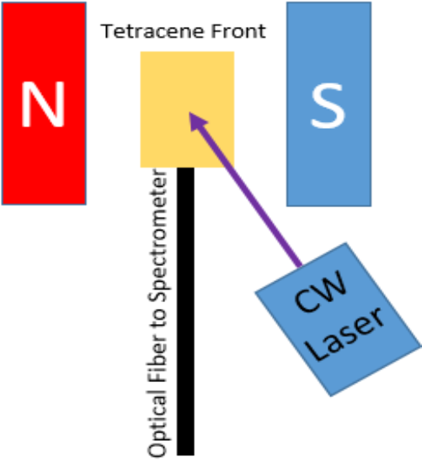
Figure 3-1: Schematic of MFE_{PL} Measurement Setup.

Results and Discussion

Magnetic Field Effect Results
As discussed in Chapter 2, magnetic field effect measurements have been widely used to study single fission in organic materials. Figure 4-1 shows the percent change of magneto-photoluminescence (MFE_{PL}) for tetracene thin films ranging from 10 nm to 150 nm. The curve shape of each sample agrees with previous MFE_{PL} studies in previous literature on thin film tetracene. CITE INTER-TRIPLET SPIN-SPIN. Figure 4-1a shows MFE_{PL} data for tetracene samples without a cobalt layer, and Figure 4-1b shows MFE_{PL} data for tetracene samples with a 10 nm cobalt layer between the tetracene and glass substrates. All of the films from 50 nm to 150 nm film thickness in Figure 4-1 have an initial negative MFE_{PL} component at low field (< 50 nm) and then a positive MFE_{PL} signal at high field (> 50 nm). The 10 nm film shows higher negative to positive critical field values from the thicker films, and also changes value when cobalt is added, unlike the thicker films. These low-field effects will be discussed later in this section. In Figure 4-1a, there is a clear trend in thickness dependence for MFE_{PL}, where increasing the thickness of the tetracene thin film increases the maximum percent change in photoluminescence. At an applied magnetic field of 900 mT, the 150 nm film of tetracene reaches a maximum change of 10%, the 100 nm and 50 nm films reach a maximum change of about 8.5% and 9%, respectively, and the 10 nm film reaches a maximum change of ~5%. This thickness dependence occurs because thicker films of tetracene have many more molecules and are able to absorb more photoexcitation. Greater absorption allows for greater generation of excited states to occur in thicker films, which increases the possible amount of intermediate triplet-triplet pairs towards singlet fission inside the organic semiconductor. Because the thicker films have many more molecules, it is much more likely for excited molecules of tetracene to interact with adjacent un-excited molecules. Consequently, more intermediate triplet-triplet pairs are formed inside thicker films of tetracene giving rise to an increase in MFE_{PL} maximum percent change, which describes an increase in the rate of singlet fission for thicker films of tetracene. Figure 4-1b shows the same measurements as Figure 4-1a with the addition of a 10 nm cobalt layer between the tetracene thin films and glass substrates. In Figure 4-1b, at an applied magnetic field of 900 mT, the 150 nm film of tetracene reaches a maximum change of ~11%, and the 100 nm and 50 nm films reach a maximum change of about 9% and 10%, respectively. Comparing Figures 4-1a to 4-1b, there is only a small change of about 1% in MFE_{PL} maximums for thicker tetracene films of tetracene (50 nm to 150 nm) when cobalt is added. Also, the same thickness dependence from the 50 nm to 150 nm tetracene films is shown with and without cobalt. This shows that interfacial interactions between tetracene and cobalt do not have much of an impact on thicker films of the organic semiconductor. As mentioned above, this is caused by larger amounts of excited states in the thicker films. These bulk interactions between excited states inside the semiconducting film dominate the phenomena of the films, forbidding the interfacial interactions to have large impacts of the material properties. To discuss the results from the 10 nm thin film of tetracene, and to analyze the low field phenomena of the system, it is best to refer to Figure 4-2.

- (b)
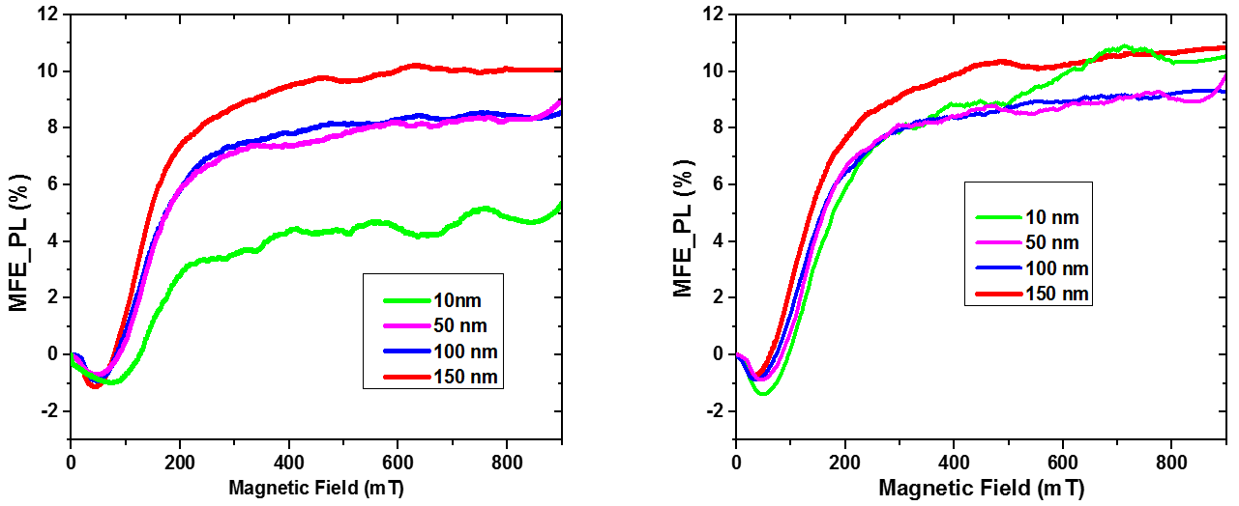
Figure 4-1: Magneto-photoluminescence for Tetracene Sample with Thicknesses of 10, 50, 100 and 150 nm (a) without a Cobalt Layer and (b) with a 10 nm Layer of Cobalt between the Tetracene and Glass.

Figure 4-2 shows the same MFE_{PL} data from Figure 4-1 for tetracene films of (a) 10 nm and (b) 100 nm thickness with and without cobalt for a better view of the effects of the cobalt layer on the organic semiconducting layer. The data in 4-2(c) and 4-2(d) is zoomed-in on the data from 4-2(a) and 4-2(b), respectively, for a more clear view of the low field data. In Figure 4b and 4d, it is shown that there is very little to no change in the MFE_{PL} curve shape or value when a cobalt layer is added to the thicker tetracene film of 100 nm. As discussed before, this is because the bulk interactions in the thicker film of tetracene are not heavily influenced by the interfacial interactions between the cobalt and tetracene layers. However, in Figure 4a and 4c, there are major changes in the MFE_{PL} in both the large-field spin exchange regime and low-field hyperfine regime for the 10 nm tetracene film when the 10 nm cobalt layer is added. Under a larger magnetic field, the maximum MFE_{PL} change increases by about 5.5%, as discussed before. Also, Figure 4a shows a curve shape change in the range from 100 to 200 mT. This curve shape narrowing is caused by the change in hyperfine interactions with the addition of cobalt, as seen in Figure 4c. Here the negative to positive change in MFE_{PL} can show relative strength of the hyperfine interactions in tetracene. When the cobalt layer is added to the system the required applied magnetic field to switch the MFE_{PL} change from negative to positive decreases from 126 mT to 95 mT. This data confirms that adding a thin ferromagnetic layer between the glass and tetracene is able to decrease the hyperfine interactions in tetracene. This is caused by the spin polarization of cobalt previously discussed. Because cobalt is able to align the spin of the tetracene electrons, the hyperfine interactions are weakened.

- (b)
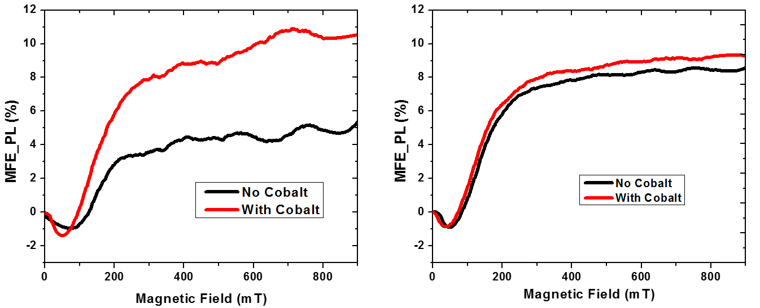
(c) (d)
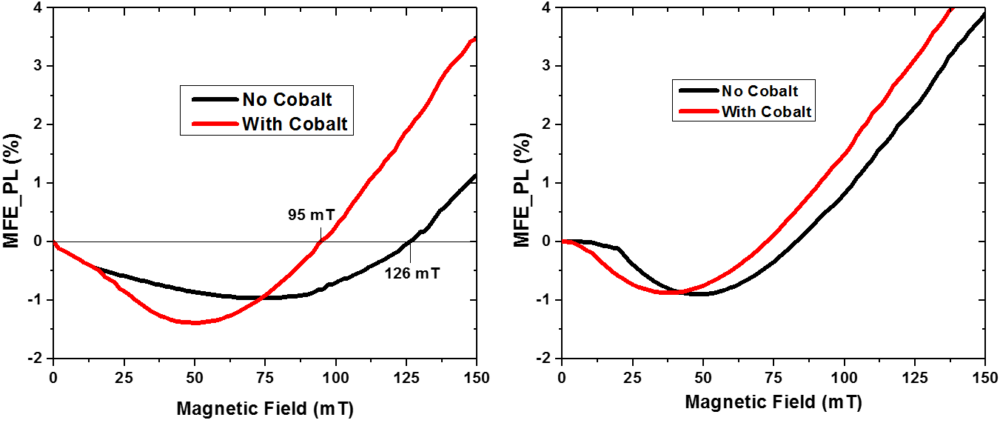
Figure 4-2: Magneto-photoluminescence for Tetracene Samples with and without a 10 nm Cobalt Layer (a,c) for a 10 nm Layer of Tetracene and (b,d) for a 100 nm Layer of Tetracene. The data in (c) and (d) is a zoom-in of (a) and (b) to more clearly see the low-field effects.

Non-Magnetic Field Effect Results

Here we will show results for non-MFE_{PL} and absorption with and without the ferromagnetic layer and discuss electrical polarization from the interface and other effects, such as band gap changes and band bending, and important phenomena that occur from these effects. Figure 4-3 shows BLAH BLAH BLAH

- (b)
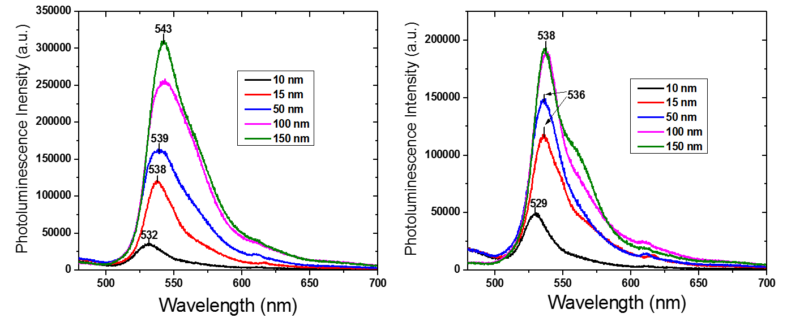
Figure 4-3: Photoluminescence Spectra for Tetracene Samples with Thicknesses of 10, 15, 50, 100 and 150 nm (a) without a Cobalt Layer and (b) with a 10 nm Cobalt Layer Between the Tetracene and Glass.

Figure 4-4 shows BLAH BLAH BLAH

- (b)
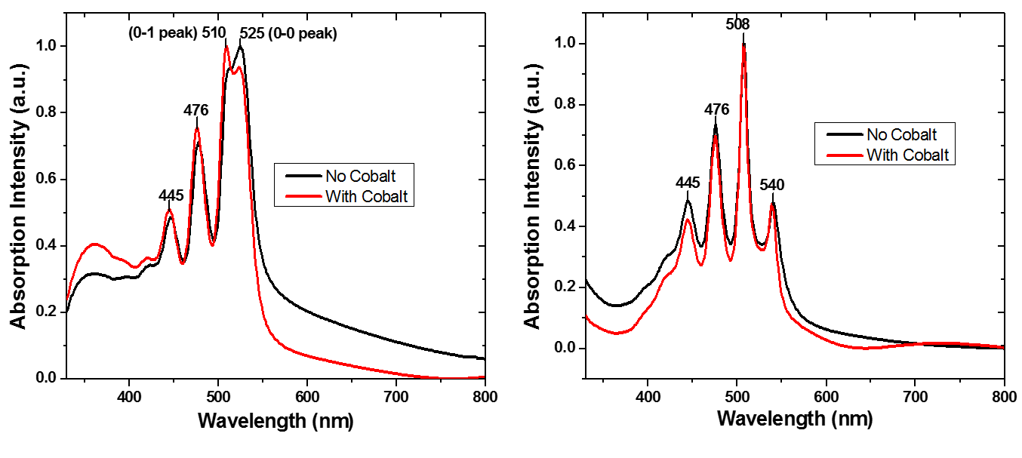
Figure 4-4: Absorption Spectra for Tetracene Samples with and without a 10 nm Cobalt Layer between the Glass and Tetracene for (a) a 10 nm Layer of Tetracene and (b) a 100 nm Layer of Tetracene.

Conclusions

References

[1] Qiao, X., et al., Inter-triplet spin-spin interaction effects on inter-conversion between different spin states in intermediate triplet-triplet pairs towards singlet fission. Organic Electronics, 2014. 15: p. 2168-72.

Appendix
I AM PRETTY SURE I WON’T NEED AN APPENDIX
[Remove this note, but DO NOT REMOVE THIS PAGE, AND/OR DO NOT PUT APPENDIX MATERIAL ON THIS PAGE – you can change “Appendix” to “Appendices” if you would like, but this is the ONLY text that should be on this page. The actual appendix material should start at the top of the NEXT page. Please note that you should remove both this page and the next one if you are not including an appendix at all – “do not remove this page” refers only to students who ARE including an appendix]
You’ll put appendix material here. This section is optional. You can place tables and figures in the appendix if you like. If you choose this option, you should indicate that tables and figures are in the appendix after the first mention in the text. You can place some tables/figures in the text and others in the appendix, or all tables/figures in the appendix.

Vita

Jane X. Doe was born. She wrote a thesis. She graduated. She followed instructions and wrote her vita in third person and paragraph form (as opposed to a resume or CV), which made her thesis consultant very happy. This page is required.

