To the Graduate Council:

I am submitting herewith a thesis written by Jinlyung Choi entitled “Global regulator: The role of GlyR3 as a global regulator in Clostridium thermocellum.” I have examined the final electronic copy of this thesis for form and content and recommend that it be accepted in partial fulfillment of the requirements for the degree of Doctor of Philosophy, with a major in Chemical and Biomolecular Engineering.

Chris D. Cox, Major Professor

We have read this dissertation
and recommend its acceptance:

Eric T. Boder

Paul D. Frymier

Cong T. Trinh

Qiang He

Accepted for the Council:

Carolyn R. Hodges
Vice Provost and Dean of the Graduate School

(Original signatures are on file with official student records.)

Global regulation:

The role of GlyR3 as a global regulator in

Clostridium thermocellum:

A Dissertation Presented for the

Doctor of Philosophy

Degree

The University of Tennessee, Knoxville

Jinlyung Choi

December 2014

Copyright © 2014 by Jinlyung Choi
All rights reserved.

ACKNOWLEDGEMENTS

Thank you all for your help. I would like to thank Chris D. Cox

I would also like to thank the U.S. Department of Energy funded Bioenergy Science Center and University of Tennessee for providing funding.

ABSTRACT

Many of human daily life and economic activities are dependent on the availability of economical energy sources. Limited energy sources such as petroleum and coal are a major cause of the acceleration of global warming since they produce carbon dioxide when they are burned. However energy demand is still increasing, especially in developing counties. So, it is important to develop renewable energy to replace fossil based energy sources. As part of this effort, the U.S. government has set goals to increase the portion of the renewable energy among transportation fuels. (Sannigrahi, Ragauskas, & Tuskan, 2010; Solomon, Barnes, & Halvorsen, 2007)
There are many candidates to replace fossil fuels used in transportation, such as hydrogen-fuel cells, electric, hybrid-electric, bio-ethanol and bio-diesel. However, hydrogen-fuel cell seems difficult to commercialize in the near future. So, bio-ethanol could be a good candidate to use as a liquid transportation fuel. It is relatively safer then hydrogen to store and deliver. The bio-ethanol can be used in the normal engine up to 10% without modification. It doesn’t required extended periods to fill the tank. It is advantageous on long distance traveling with frequent refilling. Bio-ethanol produces carbon dioxide when it burns but plants fix carbon dioxide when they grow. So, it dose not increase concentration of carbon dioxide in the air. (Solomon et al., 2007)
In addition to bio-ethanol, bio-butanol is considered as a second-generation biofuel. Researchers think bio-butanol has potential to replace gasoline in an internal combustion engine since it is more similar to gasoline than ethanol. Also, butanol can be produced from biomass. (Atsumi et al., 2010; Bhandiwad et al., 2013)
Most of bio-ethanol is currently produced from sugar and starch based materials such as corn and sugarcane(Mussatto et al., 2010). In 2008, more than 95 percent of bio-ethanol in the US was produced from corn. But, using corn as a transportation fuel can result in competition between food and fuel. In 2008 corn prices became too high due to the demand from bio-ethanol. Corn production can vary every year because of market demands and environmental conditions such as drought or flood. These factors could increase criticism that farmlands are used for fuel instead of food. Also, corn ethanol has low net energy balance because it cannot use the stover and stem portions of the plant, but only uses starch from the grain. Growing corn needs lands and wate("Origin of mutants disputed," 1988)r. Growing corn has problem of soil erosion and loss of biodiversity. Corn also uses nitrogenous fertilizer and pesticides which can create additional environmental problems. (Giampietro, Ulgiati, & Pimentel, 1997; Sannigrahi et al., 2010; Solomon et al., 2007)
Switch grass in an example of a fuel crop that can be grown on marginally productive lands such as side of highway and may have lower need for irrigation. Almost all material from switch grass has cellulose. Trees and grasses have high contents of cellulose which represents a vast potential energy resource. For these reasons, cellulosic ethanol has potential to be more sustainable(Lynd, Wyman, & Gerngross, 1999). Cellulosic ethanol can exploit underutilized resources such as idle land and waste biomass such as wood chips from furniture manufacturing. Also, it is possible to use almost all parts of the plant because cellulose is the major component of the cell wall. For example, cellulosic technology can make use of the corn stover, including stem, leaf, and cob portions of the plant, compared to conventional technology that can only utilize the starchy grain portions of the plant. Switch grass is another promising candidate as a bioenergy crop because it has high productivity per acre and grows in most parts of North America and can be grown on marginal croplands without fertilizer(David & Ragauskas, 2010). Waste paper is also a good material to get cellulose. Using waste paper can save cost of landfill. Researchers believe bio-ethanol from cellulose can solve the problem because it is the most abundant component in the plant biomass(Lynd, Weimer, van Zyl, & Pretorius, 2002b). The U.S. government wants to increase portion of renewable energy on energy consumption.
The major challenge of switch grass is that it forms a stable structure that difficult to breakdown to convert to ethanol(Chundawat, Beckham, Himmel, & Dale, 2011). The cell wall is composed of cellulose, hemicellulose and lignin. The cellulose and hemicellulose components contain the sugars that can be fermented into biofuels; however, their stable structure in the cell wall poses a significant challenge to their bioavailability. But lignin is a complex polymer of aromatic alcohols. It gives the cell wall strength but can inhibit enzyme activity to produce ethanol(Sannigrahi et al., 2010).

TABLE OF CONTENTS

INTRODUCTION 1
Background 4
Gene regulation 4
Sigma factor 5
Transcription Factors (TF), TF family and Helix-turn-helix 8
Computational regulation site identification 14
Multiple alignments 14
Position specific scoring matrix with information content 14
GlyR3 and celC operon in C. thermocellum 20
Anti sigma factor regulation in C. thermocellum 23
CHAPTER I The LacI family protein GlyR3 co-regulates the celC operon and manB in Clostridum thermocellum 26
Abstract 27
Backgrund 28
Results 31
Identification of putative transcription factor binding sites 31
Electrophoretic mobility shift assay (EMSA) 31
In vivo expression profiles by RT-PCR 32
In vivo expression profiles by mRNA sequencing 33
In Vitro Transcription Assay 34
Discussion 34
Conclusions 37
Methods 37
Bioinformatics analysis 37
Bacterial strains 38
Culture conditions 39
Cloning of glyR3 40
Expression and Purification of GlyR3 40
Electrophoretic mobility shift assay (EMSA) 41
RNA extraction 41
Quantitative Real Time PCR 42
mRNA Sequencing 42
In Vitro Transcription Assay 42
CHAPTER II GlyR3 as a global regulator: Reveals two motifs for GlyR3 both positive and negative regulation. 44
Abstract 45
Introduction 46
Results 46
GlyR3 induced after adding laminaribiose : Whole genome In vivo expression profiles by mRNA sequencing with over expression of GlyR3 by adding laminaribiose 46
GlyR3 binding sites were found among genes that had changed expression: Prediction of the GlyR3 binding site by motif based search 47
Evidence of direct binding of the GlyR3 by EMSA 47
In vitro transcription assay reveals GlyR3 impacts expression level directly: GlyR3 regulates genes in two different way reveals by in vitro transcription assay 48
Each induced and repressed gene motif has (make motif) 48
Genes that searched by two motifs shows statistically significant different 48
Validate motif 48
Discussion 49
Conclusions 50
Methods 51
Bacterial strains and Culture Conditions 51
RNA extraction 51
RNA sequence analysis 52
Motif Based GlyR3 binding search 52
Electrophoretic mobility shift assay (EMSA) and In vitro transcription assay (IVT) 53
Bibilography 54
Appendix A 62
VITA 63

LIST OF TABLES

Table 1 PSSM 19

LIST OF FIGURES
Figure 1 Cell wall structure: Green: cell wall, Orange: cellulose, Blue: hemicellulose, Dark green: lignin, http://www.ceres.net/AboutUs/AboutUs-Biofuels-Carbo.html 2
Figure 2 Structure of cellulosome(Bayer, Belaich, Shoham, & Lamed, 2004b) 3
Figure 3 Structure of Sigma factor and binding to promotoer. Image from Cold Spring Harbor Teaching Resources. http://www.genesandsignals.org/_gs_image.php?file=GS_CH05/5.13.jpg 7
Figure 4. lac operon(Pardee, Jacob, & Monod, 1959) 9
Figure 5. lac operon expression in other carbon source(Emmer et al., 1970) 12
Figure 6 Web logo 17
Figure 7 celC Operon (Newcomb et al., 2007a) 22

INTRODUCTION

A traditional cellulosic bio-ethanol process needs two major steps. First, the sugars contained within cellulose and hemicellulose must be freed from the plant cell wall and broken down into short chains or sugar monomers. Second, a microorganism such as yeast ferments the sugars into ethanol or other biofuels. The first step in particular is time and energy consuming. A potential process improvement is to produce ethanol in one step through consolidated bioprocessing using a bacterium that has many enzymes able to hydrolize cellulose and ferment the resulting sugars into ethanol. Clostridium thermocellum is considered to be a model organism for consolidated bioprocessing. It is a thermophilic, anaerobic bacterium that has a cellulosome. The cellulosome is a multi-enzyme complex consisting of 1) cohesion, 2) dockerin, 3) scaffold and 4) catalytic subunits. Dockerin connect catalytic enzymes to cohesion units on the scaffoldin (Figure 2-1). The anchoring scaffoldin is attached to cell and connected to the primary scaffoldin by and adaptor (Figure 2-2,3). The presence of various cellulases within the cellulosome depends on available carbohydrate substrates and other environmental factors, but the mechanism of regulation is not well researched yet. (Lynd, Zyl, McBride, & Laser, 2005)

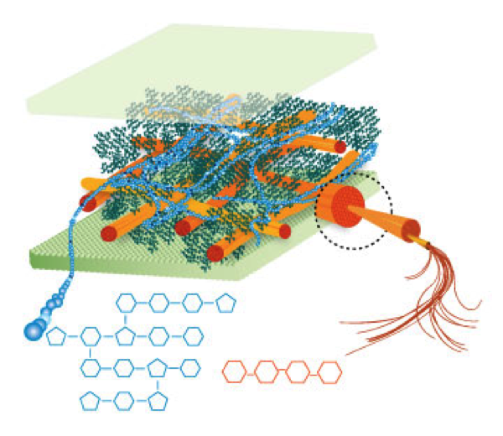
Figure 1 Cell wall structure: Green: cell wall, Orange: cellulose, Blue: hemicellulose, Dark green: lignin, http://www.ceres.net/AboutUs/AboutUs-Biofuels-Carbo.html

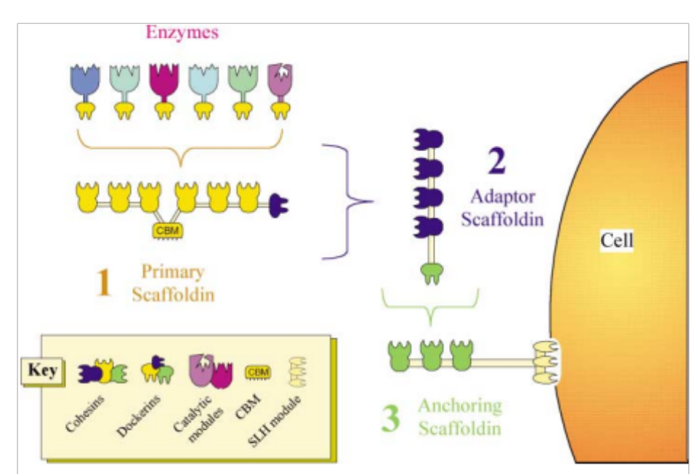
Figure 2 Structure of cellulosome(Bayer, Belaich, Shoham, & Lamed, 2004b)
Many researchers have studied this bacterium. However, relatively few studies have focused on gene regulation in Clostridium thermocellum. This study will focus on developing a better understanding of gene regulation in C. thermocellum. Such an understanding will contribute to improved strain engineering with the goal of increasing the efficiency of consolidated bioprocessing to realize a commercially viable process.

Background

Gene regulation
There are many genes in bacteria. For example, E. coli has around 3000 genes in the genome(Blattner et al., 1997; Brown et al., 2012b). It is inefficient to transcribe 3000 genes all at once, especially if some proteins are not needed under a given condition (B. Raman, C. K. McKeown, M. Rodriguez, S. D. Brown, & J. R. Mielenz, 2011). For example, E. coli uses different proteins under carbon and nitrogen limiting environments(Lowry, Carter, Ward, & Glaser, 1971). So, it is necessary to express different genes in different environments via gene regulation(Bennett et al., 2008). Gene regulation occurs at various levels: transcriptional regulation, post-transcriptional regulation, and post-translational regulation. Transcriptional regulation regulates the level of mRNA that is expressed from DNA through the action of sigma factors and transcription factors(Hill & Treisman, 1995). Post-transcriptional regulation regulates mRNA activity after it is produced. Post-translational regulation regulates the activity of proteins once they have been produced. The focus of my research is transcriptional regulation which will be briefly reviewed below.

Sigma factor
Sigma factors are the most influential element in the transcriptional regulation(Bautz & Dunn, 1969; Burgess, Travers, Dunn, & Bautz, 1969; Merrick, 1993; Revel & Gros, 1967). RNA polymerase is made up of core enzyme and sigma factor (Helmann & Chamberlin, 1988). The core enzyme and sigma factor complex forms a holoenzyme capable of initiating transcription of a gene (Borukhov & Nudler, 2003). The sigma factor has binding affinities to both the RNA polymerase core enzyme and to the promoter sequence of the operon on the DNA(Hinkle & Chamberl.Mj, 1972). A sigma factor is able to bind to various promoters that regulate numerous genes at the same time(Shingler, 1996). This characteristic of the sigma factor results in it being known as a global regulator(Shultzaberger, Chen, Lewis, & Schneider, 2007).
The primary sigma factor, known as _{A}, binds directly to the promoter, which consists of two regions of DNA, located approximately 35 and 10 base pairs upstream of the transcription initiation site (Shultzaberger et al., 2007). This region is well conserved in most of organism since sigma factors in the bacteria have high homology(Gribskov & Burgess, 1986). The conserved sequences of the -35 and -10 regions in E. coli are TTGACA and TATAAT, respectively(Harley & Reynolds, 1987). The conserved sequences in other organisms are similar but may have small differences. B. subtilis is another organism in which the sequence of _{A} has been well studied (Huang & Helmann, 1998) Other sigma factors recognize different DNA promoter sequences.(Ishihama, 2000). E. coli and B. subtilis are the model organisms of gram negative and gram positive bacteria, respectively. There are many similarities between the sigma factors in both organisms. However, the delta subunit is only present in the B. subtilis and some of the subunits in the B. subtilis are not functional in E. coli(Pero, Nelson, & Fox, 1975). So, it is difficult to say those proteins are same.

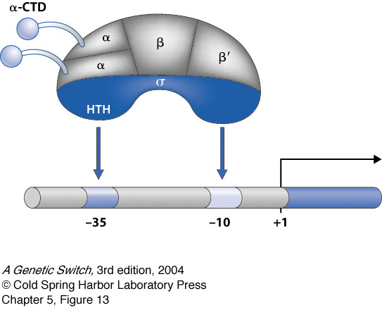
Figure 3 Structure of Sigma factor and binding to promotoer. Image from Cold Spring Harbor Teaching Resources. http://www.genesandsignals.org/_gs_image.php?file=GS_CH05/5.13.jpg
B. subtilis has two different stages of life cycle called vegetative cell and sporulation cell(Stragier & Losick, 1990). The vegetative state is the normal condition, while under stress conditions the cell will sporulate. Sigma a, b, c, d, h, and I are expressed in the vegetative state. On the other hand, when the cell reaches early stationary phase, the cell enters sporulation under control of the sigma factors e, f, g, and k (Haldenwang, 1995).
Not all sigma factors are necessarily expressed at the same time. An anti-sigma factor is a protein that binds to a sigma factor to impair its ability to regulate the expression of genes (Kahel-Raifer et al., 2010). The anti-sigma factor releases the sigma factor when the cell receives the appropriate signal from inside or outside(Helmann, 1999).

Transcription Factors (TF), TF family and Helix-turn-helix
There are two types of the regulation: positive and negative regulation. In the case of negative regulation, a repressor protein binds to DNA, to prohibit expression of mRNA. In the case of positive regulation, an inducer binds to DNA to activate transcription (Jacob & Monod, 1961). The protein that binds to operator to regulate expression of mRNA is called a transcription factor. The lactose operon (lac operon) is considered as a model system to introduce the concept of positive and negative regulation and transcription factor.

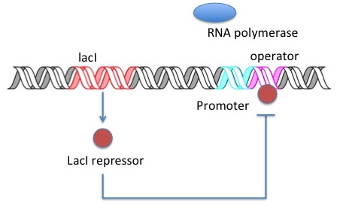
Figure 4. lac operon(Pardee, Jacob, & Monod, 1959)
The lac operon is regulated by LacI protein. The LacI protein is a repressor that binds to operator to forbid transcription(Jacob, Ullman, & Monod, 1964). (Figure 1.) The lac operon codes three different genes lacZ, lacY, and lacA(Ippen, Miller, Scaife, & Beckwith, 1968; Jacob, Perrin, Sanchez, & Monod, 1960). The gene lacZ encodes for the beta-galactosidase, lacY encodes beta-galactoside permease, lacA encodes galactoside acetyltransferase. Beta-galactosidase cleaves the lactose into glucose and galactose. Beta-galactoside permease is a membrane-bound protein that is in charge of the transport of lactose into the cell. But the role of the galactoside acetyltansferase is not yet fully understood(Vilar, Guet, & Leibler, 2003). The LacI protein undergoes a change of conformation such that it does not bind to DNA, if lactose, IPTG or other similar molecule binds to it (Pardee et al., 1959). So, the lac operon expresses mRNA in the presence of lactose or similar molecules (Jacob & Monod, 1961; Scaife & Beckwith, 1966).
The lac operon also is an example of positive regulation. The operon expresses high levels of mRNA when the cAMP (cyclic adenosine monophosphate) -CRP (cyclic AMP receptor protein) complex is present (Emmer, Decrombr.B, Pastan, & Perlman, 1970; Perlman & Pastan, 1968).
The cAMP-CRP complex binds to the CAP (catabolic activator protein) site to induce expression(Crombrug.Bd et al., 1971). However, expression of cAMP decreases in the presence of high levels of glucose (Grossman, Ullmann, Burgess, & Gross, 1984). When the cell is growing in the presences of glucose (absence of cAMP-CRP complex on the CAP), the lac operon expresses low level of mRNA called the basal level (Hippel, Revzin, Gross, & Wang, 1974). The overall function of lac operon causes E. coli not to use lactose when both the glucose and lactose are available. (Figure 5.)
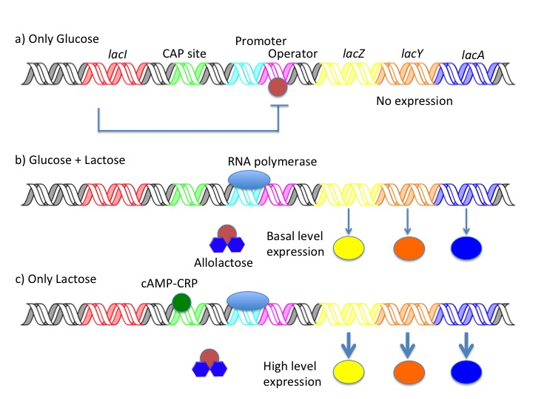
Figure 5. lac operon expression in other carbon source(Emmer et al., 1970)
Gilbert and Muller-Hill used an in vitro binding assay to confirm that the lac repressor binds to lac operator. They used DNA from bacteriophage because cloning techniques were not available at that time. They mixed operator DNA with radio-labeled lac repressor. Then they separated the DNA using glycerol gradient centrifuge to show that lac repressor only binds to lac operator(W. Gilbert & Mullerhi.B, 1966, 1967). Recently, researchers have used DNaseI foot printing and electrophoretic gel mobility shift assay (EMSA) to show DNA-protein binding interaction (Fried & Crothers, 1981; Galas & Schmitz, 1978; Garner & Revzin, 1981).
There are other well-researched examples of regulatory system including the galactose operon, the arabinose operon, and the tryptophan operon. The arabinose operon is an example of special type of regulator, called AraC. AraC has ability to act as both a positive and negative regulator. AraC binds to the arabinose operon to prohibit transcription without presence of arabinose. But it binds to arabinose to activate transcription (Englesbe.E, Irr, Power, & Lee, 1965; Englesbe.E, Sheppard, Squires, & Meronk, 1969; Helling & Weinberg, 1963; Sheppard & Englesbe.E, 1967).
The part of the transcription factor protein that binds to DNA is called the DNA-binding domain. The helix-turn-helix motif is the one of the well-studied and common examples of a DNA-binding domain. The LacI protein has a helix-turn-helix domain. DNA-binding domains can be classified by family or structure. There are five super classes of domains (basic domains, zinc-coordinating DNA-binding domains, helix-turn-helix, beta-scaffold factors with minor groove contacts, and others). This classification system can be useful to find DNA-binding domains for unknown protein or to find the binding site of a known protein.

Computational regulation site identification

Multiple alignments
Regulatory proteins bind specific, conserved, DNA sequences. While these sequences are conserved, it is rare to find a perfect match to the consensus sequence. The variation of the DNA sequence from the consensus sequence results in the regulatory protein having different strength of binding to various DNA sequences. The conservation of sequences makes it possible to identify potential DNA binding sequences by automated searching.

Position specific scoring matrix with information content
Information content is a method that applies information theory to quantify the binding affinity of regulatory proteins to specific nucleotide sequences. Information theory quantifies the information content of communication and was founded by Claude Shannon in 1948. The theory is used in various fields. The information content weighs the uncertainty of finding a given base at a given position by using the concept of entropy. The general formula for uncertainty is:
$$H≡-\sum_{i=1}^{Ω}{p_{i} \log_{2}{p_{i}}}$$

Where, H is the uncertainty, p_{i} is the i^{th} symbol’s probability at a specific location in the DNA, Ω is number of symbols (Ω=4 for DNA).
Log base 2 was chosen because it represents bits of information communicated by a certain of number of symbols. For example, if you want to determine which of 2 boxes contains candy, you need 1 trial or question to find (log₂ 2=1). But if there are 4 boxes, you need at least 2 questions (log₂ 4=2). If there are 8 boxes, you need 3 questions (log₂ 8 =3). So, log base 2 can represent the least of questions to find answer.
The formula is also used as information entropy. So, uncertainty and information entropy are synonyms (Jaynes, 1957). When the concept is applied to mean that uncertainty of sequence information, it is reasonable to call it its information content. In the case of searching protein binding site on DNA, we can use the concept that ‘before’ and ‘after’ state. ‘Before’ state means uncertainty of maximum choices. ‘After’ state means uncertainty of choice after binding. So, information contents can be described as substrate of before and after state.
$$R=\left[-\sum{f \log_{2}{f}}\right]—\sum_{i=1}^{Ω}{p_{i} \log_{2}{p_{i}}}$$
Where, R is the information content, f is overall frequency of background. This equation can be rewriten to show individual information of each symbols of each position as:
$$R_{i}=\left[-\log_{2}{f}\right]—\log_{2}{p_{i}}$$
Where, R_{i} is the information content of each symbols of each position.
Schneider et. al(Schneider, Stormo, Gold, & Ehrenfeucht, 1986) assume that overall frequency of background has equal probability since composition of nucleic acid should not matter before protein has physical contact. Schneider et. al think overall frequency is close to 2 bits because they consider E. coli which its GC contents is 50.79%. Then, ‘before’ state can be replaced by 2 (f=1/4).
$$R_{i}=2—\log_{2}{p_{i}}$$

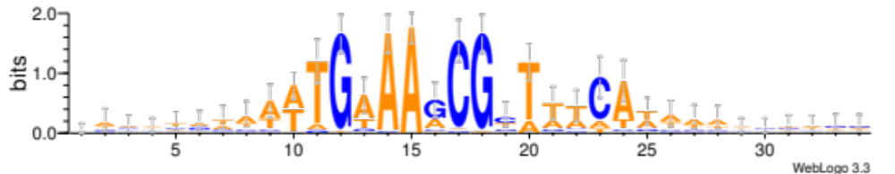
Figure 6 Web logo

The sequence logo is an example of using this equation(Crooks, Hon, Chandonia, & Brenner, 2004; Schneider & Stephens, 1990). This graph shows information content from aligned set of sequences. This graph is an example of finding LacI family protein binding site (CcpA) of Bacillus subtilis. The probabilities (p_{i}) are determined empirically from 44 sequences of known binding sites(Sierro, Makita, de Hoon, & Nakai, 2008). According to the information content, there is highly conserved sequence positioned near 11~24. It tells us the consensus is TGAAAGCGCTTTCA.
However, Stormo et. al assume that overall frequency does not have equal probability in the biased genome. Stormo et. al think that if the genome is not ‘equiprobable’, overall frequency can be important to be considered(Stormo, 1998). So, information contents can be described as:

$$R_{i}=\log_{2}{\frac{p_{i}}{f}}$$

Table 1 PSSM
Base | Position
 | 1 | 2 | 3 | 4 | 5 | 6 | 7 | 8 | 9 | 10 | 11 | 12 | 13 | 14
A | -1.69 | -4.01 | 0.85 | 1.45 | 1.48 | -0.21 | -3.01 | -3.01 | -2.01 | -0.84 | -0.21 | -0.01 | -1.21 | 1.07
G | -1.82 | 2.06 | -1.08 | -3.40 | -3.40 | 1.35 | -2.40 | 2.06 | -0.40 | -3.40 | -1.08 | -1.40 | -3.40 | -2.40
C | -3.10 | -3.10 | -2.10 | -2.10 | -3.10 | -1.10 | 2.33 | -3.10 | 1.15 | -3.10 | -1.51 | -1.10 | 2.03 | -1.51
T | 1.62 | -2.67 | -0.08 | -3.67 | -3.67 | -2.08 | -3.67 | -3.67 | 0.42 | 1.54 | 1.03 | 0.92 | -1.35 | -0.50
 | T | G | A | A | A | G | C | G | C | T | T | T | C | A
This figure shows a Position Specific Scoring Matrix (PSSM) from the information content. PSSM shows the score for each base at each position. We can compare sequences to search binding site as add score at base at each position. There is a high possibility the sequence is a binding site if it has a high score than others. Also, it is able to guess that binding strength is proportional to the score. Score of TGCAATCGCTTACA is 1.62 + 2.06 + (-2.10) + 1.45 + 1.48 + (-2.08) + 2.33 + 2.06 + 1.15 + 1.54 + 1.03 + (-0.01) + 2.03 + 1.07 = 13.63. (Schneider, 1997; Schneider et al., 1986)
We are going to use the equation form Stormo et. al. because C. thermocellum has a GC content of 39.0%.

GlyR3 and celC operon in C. thermocellum
Newcomb et al. have found a regulation of celC operon by GlyR3 which is a LacI family protein. The celC operon codes for the celC, glyR3 and licA proteins, respectively. Those three genes share one promoter.
The first gene produces CelC. The CelC is a glycoside hydrolase (GH) family 5 protein that has beta-1-4-glucanase (cellulase) activity. CelC is a non-cellulosomal cellulase. Clostridium thermocellum has more than 100 glucanases including more than 70 cellulosomal cellulases.
The second gene produces GlyR3. GlyR3 is a LacI family regulatory protein that has Helix-Turn-Heilx(HTH) motif to bind to DNA. The GlyR3 binds to operator of celC operon to suppress its own expression. If laminaribiose binds with GlyR3, the GlyR3 loses its ability to bind to the celC operon. Newcomb et al. found binding between celC operon and GlyR3 by DNA foot printing and EMSA. The laminaribiose was added to show decrease binding affinity by increasing laminaribiose during EMSA. Also, gene expression patterns predicted by the EMSA experiments were verified in vitro by RT-PCR.
The last gene produces LicA. The LicA has a beta-1-3-glucanase activity. LicA breaks beta-1-3 glucan bonds. The laminaribiose is transported into the cell by ABC transporters (Nataf et al., 2009b) where it binds to GlyR3 to induce expression of the celC operon.
Recent research shows manB and celT, located downstream of celC operon, are co-regulated with celC. However, the mechanism of co-regulation is unknown. This proposal sets a hypothesis that GlyR3 protein is involved in the regulation of manB and celT. (Newcomb, Chen, & Wu, 2007a; Newcomb, Millen, Chen, & Wu, 2011a)

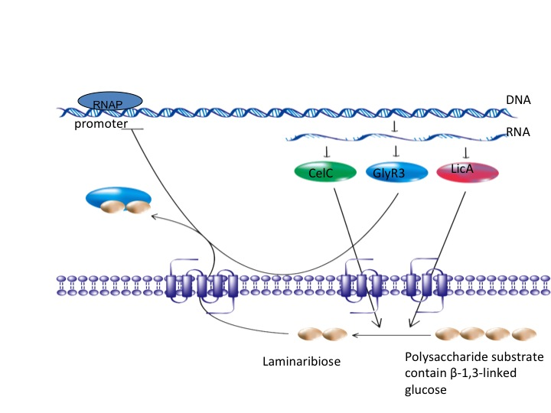
Figure 7 celC Operon (Newcomb et al., 2007a)
Anti sigma factor regulation in C. thermocellum
Anti-sigma factors are trans-membrane proteins characterized by an extracelluar carbohydrate binding module and a sigma-factor binding module extending into the cytoplasm. The anti-sigma factor binds the sigma factor when a specific polysaccharide is not present. Each anti-sigma factor has a binding affinity specific to a particular sigma factor. When the sigma factor is bound to the anti-sigma factor, the genes under its control are not expressed. However, the anti-sigma factor releases the sigma factor when a specific polysaccharide binds to the carbohydrate-binding module outside of the cell. Then the sigma factor can enable expression of the genes under its control.
Kahel-raifer et al. and Bahari et al. tested anti-sigma factor 1,3,5 6, and 24 of C. thermocellum, respectively. They incubated insoluble polysaccharides with anti-sigma factors, separated them by centrifugation, determined binding by SDS-PAGE. They found anti sigma factor 1 binds cellulose, 3 binds pectin, 5 binds arabinoxylan, 6 binds xylans and cellulose, and 24 binds cellulose. (Bahari et al., 2011a; Kahel-Raifer et al., 2010)

Nataf et al. found that anti-sigma factor (RsgI) which is located down stream of sigma factor binds to sigma factor I. Also the sigma factor and anti-sigma factor are regulated together. Isothermal titration calorimetry was used to confirm that the sigma factor binds specifically to the anti-sigma factor. They also found that the sigma factor and RNAP express mRNA but transcription is interrupted when the anti-sigma factor is added. RT-PCR results show that the expression of the sigma factor is different by carbon source. (Nataf et al., 2010a)

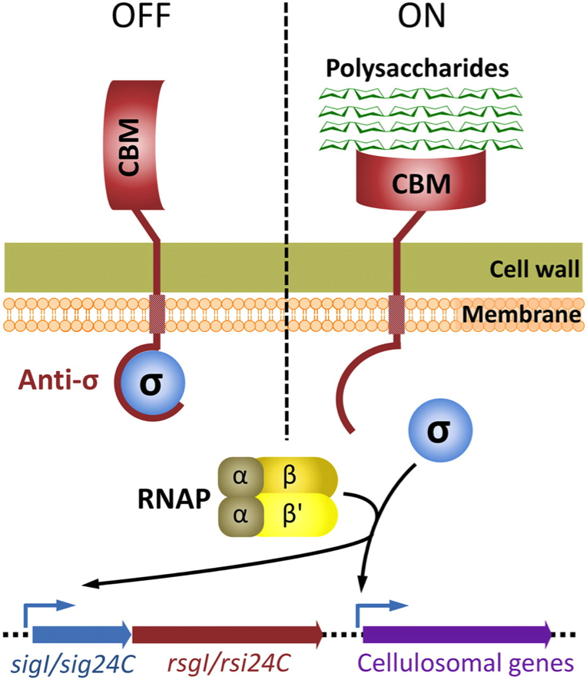

Figure 8 Mechanism for the altenate sigma factor (Nataf et al., 2010a)

CHAPTER I
The LacI family protein GlyR3 co-regulates the celC operon and manB in Clostridum thermocellum

A version of this chapter was originally submitted to publication by Jinlyung Choi and Chris Cox:
Jinlyung Choi, Chris Cox. Wii be submitted to Biotechnology for Biofuel

Jinlyung Choi design and conduct experiment, analyze data, write paper.

Abstract

Clostridium thermocellum utilizes a wide variety of free and cellulosomal cellulases and accessory enzymes to hydrolyze polysaccharides present in complex substrates. To date only a few studies have unveiled the details by which the expression of these cellulases are regulated. Recent studies have described the autoregulation of the celC operon (Newcomb, Chen, & Wu, 2007b) and determined that the celC-glyR3-licA gene cluster and nearby manB-celT gene cluster are cotranscribed as polycistronic mRNA (Newcomb, Millen, Chen, & Wu, 2011b).
In this paper we first identify putative GlyR3 binding sites within or just upstream of the coding regions of manB and celT. Using an electrophoretic mobility sift assay (EMSA) we determined that the putative manB site binds GlyR3 more weakly than the celC site. Neither the putative celT site nor random DNA significantly binds GlyR3. While laminaribiose interfered with GlyR3 binding to the celC binding site, binding to the manB site was unaffected. Expression of manB was repressed in the presence of laminaribiose both in vivo and in vitro assay.
Together these results reveal a mechanism by which manB is expressed at low concentrations of GlyR3 but repressed at high concentrations. In this way C. thermocellum is able to coregulate both the celC and manB gene clusters in response to the availability of -1,3 polysaccharides in its environment.

Backgrund

Clostridium thermocellum is an anaerobic, thermophilic, Gram-positive bacterium that has a highly efficient cellulolytic system (Lynd, Weimer, van Zyl, & Pretorius, 2002a). This bacterium is considered to be a model organism for biofuels processing since it combines cellulolytic and ethanologenic abilities (Carere, Sparling, Cicek, & Levin, 2008; Demain, Newcomb, & Wu, 2005; Lynd et al., 2002a; Maki, Leung, & Qin, 2009; Olson & Lynd, 2012; B. Raman, C. K. McKeown, M. Rodriguez, Jr., S. D. Brown, & J. R. Mielenz, 2011). Cellulolytic activity is conferred by a combination of free glycosyl hydrolases and an extracellular multienzyme cellulase complex called the cellulosome (Bayer, Belaich, Shoham, & Lamed, 2004a; Fontes & Gilbert, 2010; Garciamartinez, Shinmyo, Madia, & Demain, 1980; H. J. Gilbert, 2007; Schwarz, 2001; Sheehan & Himmel, 1999). C. thermocellum ATCC 27405 is the reference strain. Strains YS and AD2 were used in many of the key studies which developed the cellulosome concept and have recently been sequenced (Brown et al., 2012a). An efficient transformation methodology has been developed for strain DSM 1313 (Tripathi et al., 2010) facilitating the development of an engineered strain capable of high ethanol titer (Argyros et al., 2011).
The C. thermocellum employs more than 100 genes for biomass degradation, including more than 70 genes that encode for various cellulosomal enzymes (Newcomb et al., 2007b). The cellulosome has a core, scaffold protein called CipA that binds to the surface of the bacterial cell, to the catalytic subunits, and to the carbohydrate-binding module (CBM) (Newcomb et al., 2011b). Various CBM and catalytic subunits may be deployed to provide cellulolytic activity specific to various biomass substrates (Bahari et al., 2011b). While many studies have described the structural and catalytic activity of the cellulosome and free cellulases, relatively few investigations have focused on the regulation of these genes; the most significant of these are reviewed below.
Recently it was determined that many cellulosomal genes are regulated by a common mechanism involving the  alternate transcription factor, which binds to the core RNA polymerase to form a holoenzyme capable of transcribing these genes (Nataf et al., 2010b). In the absence of polysaccharides, SigI is inactivated via binding to the anti-sigma factor N-terminal domain of the transmembrane protein RsgI. The conformation of RsgI changes upon binding of a target extracellular polysaccharide to the C-terminal CBM of the RsgI protein, thereby releasing SigI to the cytoplasm of the cell and up regulating SigI-regulated genes, including sigI and many cellulosomal genes. Various SigI-RsgI proteins are activated by specific polysaccharides, thereby providing specificity in regulation of cellulosomal genes. (Nataf et al., 2009a).
In contrast, the celC operon, containing the celC, glyR3, and licA genes, is regulated by a different mechanism involving the LacI family protein GlyR3, which negatively auto-regulates the operon by binding to the celC promoter region to repress its expression (Newcomb et al., 2007b). The repression of the operon is relieved in the presence of laminaribiose, which interferes with GlyR3 binding to the promoter. Regulation of the celC operon is perhaps the most well characterized of the non-cellulosomal cellulases in C. thermocellum. CelC is a non-cellulosomal endoglucanase affiliated to the glycoside hydrolase family 5, which is one of the largest of the glycoside hydrolase families. LicA is a endo-1,3-beta-D-glucosidase. Recently it has been shown that the nearby manB-celT gene cluster is coregulated with celC by an unknown mechanism (Newcomb et al., 2011b). It was also shown that the manB-celT gene cluster was transcribed as a single operon (Newcomb et al., 2011b). ManB is a cellulosomal family 26 glycoside hydrolase and CelT is a cellulosomal family 9 endoglucanase (Halstead, Vercoe, Gilbert, Davidson, & Hazlewood, 1999; Kurokawa et al., 2002).
In this paper, we demonstrate an inverse relationship between glyR3 and manB gene expression and identify a binding site of GlyR3 within the coding region of manB, thereby allowing us to infer a GlyR3-dependent regulatory mechanism for the manB in C. thermocellum. In other gram-positive organisms, LacI family proteins similar to GlyR3 are known to repress numerous carbon metabolism pathways (Henkin, 1996). This result opens the possibility of GlyR3 playing a larger role in regulating C. thermocellum cellulolytic activity than previously known.

Results

Identification of putative transcription factor binding sites
Putative GlyR3 binding sites in the vicinity of the celC operon were identified by sequence analysis and are listed in Table 3. A putative GlyR3 binding site for manB with a PSSM score of 15.89 was identified. Since the score of the manB site was similar to the score of the celC (17.08), this was a promising site for GlyR3 binding. In addition a putative GlyR3 binding site for celT was also identified. While the celT PSSM score of 6.07 was significantly lower than that of celC and manB, it was significantly greater than the average PSSM score for a random location in the overall genome (-15.04).

Electrophoretic mobility shift assay (EMSA)
EMSA was used to further investigate protein-DNA interactions in the presence and absence of laminaribiose for the GlyR3 binding regions of celC, manB, and celT. The binding region celC was included to show consistency with the binding behavior previously reported in reference (Newcomb et al., 2007b). In the absence of laminaribiose, addition of GlyR3 results in a strong shift in the celC band, a partial shift in the location of the manB band, and no shifting of the celT or random DNA bands (Figure 2). The top band in lane 2 of Figure 2b can be attributed to high-molecular-weight DNA-GlyR3 aggragates (Fried & Crothers, 1981). The GlyR3-induced shifts of the celC and manB bands were reversed upon addition of competitor DNA (unlabeled 18-mer), confirming that the putative binding sites were responsible for the GlyR3 binding.
The strength of DNA binding by GlyR3 was further investigated using a titration test in which the GlyR3 concentration was increased while keeping the DNA concentration constant (Figure 3). It was observed that GlyR3 interactions with the celC binding domain were insignificant at levels less than or equal to 15 ng of protein but that all DNA was bound by GlyR3 at levels equal to or greater than 30 ng. In contrast, levels equal to or greater than 60 ng of GlyR3 were needed to achieve significant binding of the manB binding domain. The band was partially shifted upon addition of 60 ng and further shifted at 140 ng of GlyR3. Overall the data in Figure 3 suggest that the celC binding domain has a higher affinity for GlyR3 than the manB binding domain.
Addition of 35 and 70 g of laminaribiose was shown to relieve GlyR3 repression in a dose-dependent manner (Figure 4), consistent with previous reports (Newcomb et al., 2007b). In contrast, GlyR3 binding to the manB binding site appeared to be unaffected by laminaribiose addition. Therefore the effect of laminaribiose on GlyR3 binding to DNA was different for the two binding sites, which may affect the way in which laminaribiose controls expression of the regulated genes.

In vivo expression profiles by RT-PCR
We determined the effect of adding laminaribiose on the expression of celC, manB and celT in C. thermocellum using qRT-PCR. C. thermocellum was incubated at 60°C for one hour after adding different concentrations of laminaribiose to each vial. The data was normalized to the housekeeping gene recA. Gene expression changes were determined by the comparative CT method using a control sample to which no laminaribiose was added (Schmittgen & Livak, 2008). As shown in Fig. 5a, transcription of celC increased with laminaribiose concentration. All samples showed an increase in gene expression compared to samples without laminaribiose. In contrast, manB was repressed by laminaribiose in a non-dose-dependent manner (Figure 5 b). All samples show a decrease in manB gene expression compared to samples without laminaribiose. Expression of celT was unaffected by laminaribiose addition (Figure 5 c).

In vivo expression profiles by mRNA sequencing
We used RNA sequencing to identify transcriptional start sites for the celC and manB gene clusters (Figure 6a and b). The transcriptional start site for celC approximately coincides with the GlyR3 binding site. Furthermore, we were able to identify candidate -10 and -35 sigma A promoter sequences with high fidelity to the consensus sequence just upstream of the transcription start sites for both the celC and manB (Figure 6a, b, and c). The RNA-seq data also revealed an interesting feature of the manB-celT expression profile (Figure 6d), in that there was a strong increase in expression at the beginning of the celT expression gene, suggesting the presence of a transcription initiation site between the two genes. However, we were unable to identify a nearby upstream sigma A promoter site for celT.

In Vitro Transcription Assay
As shown in Fig 7A, expression of celC was repressed by GlyR3 in a dose-dependent manner. But, laminaribiose the relieved effect of GlyR3. This result showed a same pattern from Newcomb et. al. The gene, manB was not repressed by GlyR3 at 20 ng where celC was repressed but repressed at 50 ng of GlyR3. However, the repression of manB was not affected by laminaribiose. This result showed in vivo and in vitro expression assay in the same pattern.

Discussion
Our results suggest an extended model of the celC regulon that includes regulation of manB via GlyR3 (Figure 8). In the model proposed by Newcomb et al., expression of the celC operon is auto-repressed in the absence of laminaribiose due to binding of GlyR3 to the celC promoter (Newcomb et al., 2007b). Our EMSA results show that binding of GlyR3 to the manB binding site is relatively weak compared to GlyR3 binding to the celC binding site. Therefore, the low concentration of GlyR3 that is likely to occur when the celC operon is autorepressed may be insufficient to repress the expression of manB. Indeed, manB expression was observed in the absence of laminaribiose in the gene expression results presented here and earlier by Newcomb et al (Newcomb et al., 2011b).
Laminaribiose relieves the repression of GlyR3 according to the celC model of Newcomb (Newcomb et al., 2007b). Under these conditions, GlyR3 may be expressed at sufficiently high levels to bind to the manB binding site, thereby blocking expression of manB. Gene expression data presented here confirms that manB expression decreases in the presence of laminaribiose (Figure 5b). Consistent with this observation, Newcomb (Newcomb et al., 2011b) also observed a decrease in manB expression when grown on laminarin in comparison to cellulose. In contrast to GlyR3 binding to the celC binding site, GlyR3 binding to the manB binding site is mostly unaffected by laminaribiose according to the gene expression data (Figure 5b and 7b) and EMSA experiments (Figure 4). The mechanism by which laminaribiose would decrease binding at the celC site, but not affect binding at the manB site is unknown, but could be related to different conformations of the GlyR3 protein when it bounds to the two different DNA sequences. Overall, this model allows for repression of manB and expression of the celC operon to be under control of laminaribiose. This contrary behavior is critically dependent both upon the weaker relative binding of GlyR3 to the manB binding site and the apparent lack of effect of laminaribiose on the GlyR3-manB-binding-site complex.
We were able to identify DNA sequences consistent with the σ_{A} promoter directly upstream of the transcriptional start sites identified by mRNA sequencing. The presence of a σ_{A} promoter not only lends confidence to the location of the transcriptional start site, but it also provides mechanisms for expression of these gene clusters under “housekeeping” conditions. The transcriptional start sites identified in this work differ from those reported by Newcomb (Newcomb et al., 2011b). These differences possibly represent alternative transcripts regulated by alternative mechanisms that may be operative under the different experimental conditions.
Newcomb (Newcomb et al., 2011b) presented evidence that manB and celT form an operon which produces polycistronic mRNA when transcribed. Our gene expression data showed that while manB expression was regulated by laminaribiose, celT expression was unaffected (Figure 5c). The mRNA sequence data in Figure 6d, indicates an increase in expression near the beginning of the celT coding region. These lines of evidence suggest a possible alternate transcription initiation site for celT, independent of manB.
Our bioinformatic analysis identified two potential weak GlyR3 binding sites located just upstream of the celT coding region (Figure 9a). EMSA showed no evidence of GlyR3 binding by the more upstream of the two sites (Fig. 2c), and showed only very weak binding by the downstream site (data not shown). Expression of celT did not appear to be affected by the presence of laminaribiose further suggesting that GlyR3 binding was not functional at these sites. However, these two sequences characterized by relatively low PSSM scores (in the range of 6 or 7), could mutate into sequences characterized by relatively high PSSM scores (in the range of 10 to 15) through one or two hypothetical single-nucleotide polymorphisms (SNP) (Figure 9b). It is possible that these GlyR3 binding sites may have played a role in celT regulation in the evolutionary history of the organism.
As discussed above, we identified a σ_{A} promoter region that appears to regulate manB expression, at least under certain conditions. In addition to this regulatory mechanism, the manB operon is among those recently reported to be regulated by the anti- factor mechanism (Nataf et al., 2010b). Specifically, manB is regulated by the  factor. The N-terminal sensing domain of the corresponding RsigI6 transmembrane protein is sensitive to xylans and cellulose. This mechanism would seem to up regulate the manB operon in the presence of a broad spectrum of biomass substrates. Regulation by GlyR3 may be superimposed on the anti- factor mechanism. The GlyR3 mechanism tends to down regulate the manB operon in the presence of β -1,3 polysaccharides, while at the same time up regulating celC and licA. ManB is a cellulosomal cellulase with β -1,4 hydrolytic activity, while CelC and LicA are non-cellulomal proteins with β -1,4 and β -1,3 hydrolytic activities respectively. Thus, by combining various regulatory mechanisms it appears that C. thermocellum can regulate the expression of its carbohydrate active enzymes depending on available polysaccharides.

Conclusions
Text for this section.

Methods

Bioinformatics analysis
CcpA is a LacI family protein in Bacillus subtilis that is known to regulate at least 44 different operons (Sierro et al., 2008). We observed that the GlyR3 binding site (TGAACGCGCGTACA) in the celC operon was similar to the consensus CcpA binding site in B. subtilis (TGNAANCGNWNNCW). In addition, the alignment of the helix-turn-helix domains of CcpA and GlyR3 show a high degree of similarity (Figure 1). Therefore, we hypothesized that CcpA could be used as a model to identify additional GlyR3 binding sites in C. thermocellum.
The DBTBS transcriptional regulation database (http://dbtbs.hgc.jp) (Sierro et al., 2008) was used to identify 44 CcpA LacI binding sites in B. subtilis and a consensus sequence was determined. The frequency of each base at each of the 14 positions were normalized to determine the information content of the sequence (Schneider et al., 1986) and the position specific scoring matrix (PSSM) was determined. DNA sequences similar to the sequence of the B. subtilis CcpA binding site will be characterized by a high PSSM score. For example, the PSSM scores for random DNA, the celC binding site, and the consensus binding site are -15.04, 17.08, and 32.92, respectively. This matrix was used to search for possible GlyR3 binding sites in the proximity of the manB-celT gene cluster in C. thermocellum.

Bacterial strains
Bacterial strains and plasmids used in this study are summarized in Table 1. The glyR3 gene was cloned into pTXB1 (New England Biolabs) expression vector and transformed into E. coli Top10 (Invitrogen). The plasmids were harvested and purified by Minipreparation kit (Wizard® Plus Minipreps, Promega) and transformed into T7 Express Competent E. coli strain C2566 (New England Biolabs) for production of GlyR3 (Table 1).

Culture conditions
C. thermocellum cultures were prepared under anaerobic conditions in 100 mL batch serum bottles and grown at 60°C in chemically defined MTC medium prepared as described by Zhang et al. (Zhang & Lynd, 2005). Avicel (PH105, FMC Biopolyer, Philadelphia, PA) was used as the carbon source. E. coli were grown in liquid culture with shaking at 37°C in Lunia-Bertani(LB) medium containing 100 μg/ml ampicillin. Expression of glyR3 was induced with 0.5 mM isopropyl thiogalactoside (IPTG) when an OD₆₀₀ of 0.4 was obtained. E. coli colonies for screening and selection were grown on LB medium agar with 100 μg/ml ampicillin at 37°C. C. thermocellum ATCC 27405 cultures used for RNA sequence analysis were grown in MTC medium in batch fermentations as described previously and for previously described samples (Yang et al., 2012). Briefly, control cellobiose fermentations contained no ethanol supplementation while treatment fermentations were exposed to 3.9 g/L (or 0.5% [v/v]) ethanol shock at mid-exponential growth phase (OD₆₀₀ ~ 0.5). Samples were taken pre-shock and 2, 12, 30, 60, 120, and 240 min post-shock from treated and untreated control fermentations.

Cloning of glyR3
Genomic DNA was extracted from C. thermocellum using the Wizard® Genomic DNA Purification Kit (Promega) and was used as a template for the amplification of the glyR3 gene. The target DNA was PCR amplified using PuReTaq™ Ready-To-Go™ PCR beads (GE Health care) following reference (Newcomb et al., 2007b). EcoRV and XhoI were used for restriction sites (Newcomb et al., 2007b) at 37°C overnight after washing by MinElute PCR purification kit (Qiagen) (Table 2, primers 1 and 2). The target DNA was inserted into the pTBX1 plasmid (New England Biolabs) and transformed into E. coli (Oneshot Top10, Invitrogen). The colonies were selected on an ampicillin (100 μg/ml) plate. The target plasmid was extracted using a Minipreparation kit (Wizard® Plus Minipreps, Promega) and then sequenced for verification.

Expression and Purification of GlyR3
GlyR3 was obtained using an expression vector and purified following the procedures of reference (Newcomb et al., 2007b). The cloned vector was transformed into T7 Express Competent E. coli (Table 1) and induced with 0.5mM IPTG. Expression of the target protein was verified using SDS-PAGE. GlyR3 was purified following the IMPACT system protocol (New England Biolabs). The purified GlyR3 concentration was measured using the Bradford (Bio-rad) method with bovine serum albumin as a standard.

Electrophoretic mobility shift assay (EMSA)
DNA fragments from celC, manB and celT were amplified with biotin labeled primers 3-10 (Table 2). GlyR3 protein was obtained as described above. Running buffer was prepared following the LightShift Chemiluminescent EMSA kit Protocol. Electrophoresis was done under 100mV for 30 min with TBE (Tris-Bis-EDTA) gel (Invitrogen) which was transferred to nylon paper. The signal was developed using the LightShift Chemiluminescent EMSA kit. The image was detected by ChemiDOC XRS+(Bio-Rad) with 30 sec exposure. Unlabeled 18-mers matching the sequence of interest were used to competitively bind GlyR3 and provide confirmation of the binding locations. The effect of laminaribiose (Megazyme) on GlyR3-DNA interactions was also assessed using EMSA.

RNA extraction
To preserve RNA for qRT-PCR analysis, live cells were centrifuged at 10,000 g for 5 minutes. The cells were resuspended in10 volumes of RNAlater (Qiagen) and incubated for 15 minutes. The cells were centrifuged again and 1 mL of TRIzol (Invitrogen) was added before freezing at -80°C. After thawing, the cells were subjected to three 20-second cycles of bead beating (FastPrep-24, MP Biomedical). Chloroform (250 l) was added to the lysate before vortexing for 45 seconds. The contents were centrifuged after a 3 minutes rest and the upper layer was collected and mixed with ethanol (1:1 volume). RNA was purified using an Ultra CleanTM Microbial RNA isolation kit (MO BIO). DNA contamination was removed by addition of DNase I (Qiagen) to the membrane of the kit.

Quantitative Real Time PCR
Brilliant ®II SYBR Green QRT-PCR Master Mix kit (Agilent technologies) was used with 10 ng total RNA and 100 nM each forward and reverse primer as listed in Table 2 (17-22). New primers were designed using Primer3.

mRNA Sequencing
Transcriptomic profiles have been characterized previously using an expression DNA microarray (Yang et al., 2012). In this study, we generated RNA-Seq data from two independent biological replicates for each of the 60 min treatment and control samples using the 454 GS FLX instrument (454 Roche, Branford, CT) (Margulies et al., 2005). The 454 DNA libraries were generated from total RNA following the manufacturer’s instructions, except that the small fragment removal step was omitted and the libraries were then sequenced using Titanium chemistry. Sequence data has been deposited in the National Center for Biotechnology Information (NCBI) Sequence Read Archive (SRA) under accession number SRX021497. Data deposited under SRR605557 and SRR605560 are derived from control fermentations 1 and 3, respectively, and data under SRR605564 and SRR605566 are derived from ethanol treatment fermentations 2 and 4, respectively.

In Vitro Transcription Assay
In this assay, the celC promoter and coding region and manB coding region which was generated by using primers 23-26 (Table 2) was inserted into pCR2.1-TOPO vector. The plasmid vector was transformed into TOP 10 E. coli to be selected on ampicillin contained LB plate. The DNA template was generated by using primers 23, 25 and 27 (Table 2) to amplify the promoter and coding region of celC and manB. TranscriptAid T7 High Yield Transcription Kit (Thermo scientific) was used to perform the in vitro transcription assay. DNase was treated followed by protocol from manufacturer. The RNA product was isolated by using the TRIzol method (Invitogen) along with RNeasy mini kit (Qiagen). Quantifying of mRNA expression was performed by 1-step SYBR Green QRT-PCR (Agilent Technologies) with the primers 17-20 (Table 2).

CHAPTER II
GlyR3 as a global regulator: Reveals two motifs for GlyR3 both positive and negative regulation.

A version of this chapter was originally submitted to publication by Jinlyung Choi and Chris Cox:
Jinlyung Choi, Chris Cox. Wii be submitted to Biotechnology for Biofuel

Jinlyung Choi design and conduct experiment, analyze data, write paper.

Abstract
Clostridium thermocellum is an anaerobic, thermophilic, ethanogenic bacterium that has ability to utilize cellulosic biomass. GlyR3, as a transcription factor, is known to regulate hydrolysis enzyme and be regulated by laminaribiose in the Clostridium thermocellum. However, GlyR3 binding motif is unknown.
To find unknown GlyR3 motif, we use CcpA binding motif and experimental data. The CcpA motif-based search was applied to decide genes to further confirm the role of GlyR3. Electro mobility shift assay (EMSA) and in vitro transcription assay (IVT) were performed to test GlyR3 binding affinity. RNA sequencing showed that gene expression profiles (how the gene expression changed. Such as how many genes were upregulated and how many genes were downregulated )under over expression of GlyR3 by the addition of laminaribiose, which indicated the role of GlyR3 as a global regulator. Nine additional GlyR3 binding sites were confirmed by EMSA. Two of them were further studied by IVT to show in vitro gene expression change. We categorize genes into two according to the behavior after adding laminaribiose.
Combine the results, we reveal two motifs, celC like and manB like, for GlyR3 binding site. In conclusion, GlyR3 plays a great role in the regulation in Clostridium thermocellum

Introduction
We are going to show that we use CcpA binding motif to search GlyR3 binding site. With experimental confirmation, we can categorize genes that regulated by laminaribiose into two groups. Then we reveal the two motifs. (Figure 1)
Motif based search
CcpA
We start from CcpA -> search -> experimental (mRNA, EMSA, IVT) -> two new motif

Results

GlyR3 induced after adding laminaribiose : Whole genome In vivo expression profiles by mRNA sequencing with over expression of GlyR3 by adding laminaribiose
RNA sequencing was performed to measure expression profile on the whole genome. Laminaribiose is added to induce expression of GlyR3. The samples were collected 0, 1, 2 hours after adding laminaribiose. All samples were triplicated (total 18 samples). JGI performed RNA sequencing and expression counting (do I need to explain detail?). ANOVA test was performed by JMP genomics after transformed to log base 2 and normalization(do I need to show normalization graph?). The table shows that ?? genes are induced and ?? genes are repressed statistically significant (p<0.05). explain the category. (additional file)

GlyR3 binding sites were found among genes that had changed expression: Prediction of the GlyR3 binding site by motif based search
GlyR3 binding search was performed to find GlyR3 binding site. Whole genome was searched based on CcpA binding motif. ?? sequences has over score 15. ??of ?? sequences are located upstream or front part of the coding region.

Evidence of direct binding of the GlyR3 by EMSA
EMSA was performed to see direct binding between GlyR3 and binding sites. GlyR3 was added to each binding sites to see binding affinity. 0391 and 0481 shows binding to GlyR3. But 0391 has stronger binding than 0481. Laminaribiose was added to see the effect of the binding. 0391 lose its binding affinity when laminaribiose was added but 0481 was not affected by the laminaribiose. The results have same pattern to celC and manB. 13 candidates are chosen by GlyR3 binding search to test EMSA. 9 of them shows binding but 4 are not

In vitro transcription assay reveals GlyR3 impacts expression level directly: GlyR3 regulates genes in two different way reveals by in vitro transcription assay
0391 and 0481 shows GlyR3 binding on EMSA and has high score on binding search. To see the gene expression change, IVT was performed. mRNA was quantified by RT-PCR. RNA expression was repressed on both 0391 and 0481 when GlyR3 was added. On 0391, the repression was released when laminaribiose was added but it was not happened on 0481.

Each induced and repressed gene motif has (make motif)
Text will be here

Genes that searched by two motifs shows statistically significant different

Validate motif
Text will be here

Discussion
Motif based search is used many places such as transcription binding search, sigma factor binding of RNA polymerase, histin binding in Eukaryotes and any kind of pattern recognition of DNA sequence. The binding search gives good information of regulation and finding target genes.
Yet, many organisms dose not have known motif information. Experimental data is essential to find motif. EMSA and DNA foot printing are possible way to get information experimentally. But it needs a lot of time and effort to do it.
So, it is a good starting point to use known binding information and structure information of protein. CcpA is a one of the most known transcription factor in Gram-positive bacteria, which regulates carbon metabolism. CcpA and GlyR3 is a lacI family protein that has helix-turn-helix domain. These two proteins have very high similarity on their amino acid sequences of DNA binding point. CcpA has important role in regulation carbon metabolism.
Lrp protein. Leucine responsive protein (Lrp) is a global regulator protein in E. coli that regulates biosynthesis of leucine and other amino acid.

0481 is located on the first part of the flagella synthesis genes. So, it is reasonable guess that the regulation of 0481 affect other expression of the genes in downstream. It is possible that the cell represses the flagella synthesis when it find new carbon source.

Conclusions
Motif based search is a useful tool to search binding site in the whole genome. But experimental data is required to build motif. We use known motif of CcpA that is higher similarity with GlyR3 binding domain as a starting point. EMSA and IVT were performed to confirm the binding sites. Finally we can build up two motifs for GlyR3 binding.

Methods

Bacterial strains and Culture Conditions
Bacterial strains and plasmids used in this study are summarized in Table 1. C. thermocellum was cultured in MTC medium(Zhang & Lynd, 2005). Bacteria were grown at 60 °C in 100 mL batch serum bottles under anaerobic condition. C. thermocellum were grown in Avicel (PH105, FMC Biopolyer, Philadelphia, PA) as the sole carbon source until late exponential phase before the addition of 1 mM laminaribiose. Cells were collected at 0, 1 and 2 hours after the addition of laminaribiose.

RNA extraction
RNA extraction was performed according to the modified protocol as described previously (Choi et al. in review) 100 ml of culture was spun down at ?g for ? min in two 50 ml centrifuge tube. Supernatant was discarded and 3 ml of Trizol was added to pellet and vortex vigorously. The cell pellet with Trizol was added into eight 2 ml tubes with 0.6 ml of beads. Beads were beaten for 20 sec three times. The lysate was transferred into a new tube without beads. Chloroform (250 ul) was added, vortexed 45 sec, and incubated at room temperature for 3 min. The tube was centrifuged at 10,000g for 15 min at 4ºC. Upper phase was transferred into new tube with 80% ethanol added with 1:1 ratio (v:v). The following procedures were done according to the previous paper (reference). Total RNA samples were quality-controlled by bioanalyzer (Agilent Technologies). RNA concentration was measured by Nano-drop (Thermo NanoDrop 1000??). Total 18 RNA samples were sent to JGI for RNA sequencing.

RNA sequence analysis
RNA sequence analysis was performed to see the gene expression change for whole genome. RNA expression was counted by JGI. RNA expression counts are analyzed by JMP Genomics. The counts are transformed by log base 2, normalized by K??. Differential expression was test statistically by ANOVA with time and concentration of laminaribiose. RNA sequencing is confirmed by RT-PCR (SYBR 2-step kit). Primers are listed on table.

Motif Based GlyR3 binding search
CcpA binding motif was used to search GlyR3 binding site. Similarity of CcpA and GlyR3, CcpA binding sequences and position specific scoring matrix (PSSM) is described previously. Whole genome of C. thermocellum was searched with PSSM. Also, reverse complement sequences were compared with forward sequence. Scores were added or subtracted according to the number of palindromes when searched by CcpA motif. The scoring penalty was followed the formula:
Probability to show up* Probability not to show up (will be changed)
The search results were filtered by score (>15), location (upstream 400 bp and 14% of early coding region) and p value (p<0.05). Two additional motifs (celC like and manB like) were calculated based on the binding sequence from experimental result (EMSA and IVT). Both motifs are used to search whole genome of C. thermocellum. Penalty formula was used on searching with celC like motif but was not used on searching with manB like motif.

Electrophoretic mobility shift assay (EMSA) and In vitro transcription assay (IVT)
EMSA and IVT were performed following the described methods(need reference). Primers are listed in the table ?.

Bibilography

Argyros, D. A., Tripathi, S. A., Barrett, T. F., Rogers, S. R., Feinberg, L. F., Olson, D. G., . . . Caiazza, N. C. (2011). High Ethanol Titers from Cellulose by Using Metabolically Engineered Thermophilic, Anaerobic Microbes. Appl Environ Microbiol, 77(23), 8288-8294. doi: 10.1128/aem.00646-11

Atsumi, S., Wu, T. Y., Machado, I. M. P., Huang, W. C., Chen, P. Y., Pellegrini, M., & Liao, J. C. (2010). Evolution, genomic analysis, and reconstruction of isobutanol tolerance in Escherichia coli. Molecular Systems Biology, 6. doi: Artn 449

Doi 10.1038/Msb.2010.98

Bahari, L., Gilad, Y., Borovok, I., Kahel-Raifer, H., Dassa, B., Nataf, Y., . . . Bayer, E. A. (2011a). Glycoside hydrolases as components of putative carbohydrate biosensor proteins in Clostridium thermocellum. Journal of Industrial Microbiology & Biotechnology, 38(7), 825-832. doi: Doi 10.1007/S10295-010-0848-9

Bahari, L., Gilad, Y., Borovok, I., Kahel-Raifer, H., Dassa, B., Nataf, Y., . . . Bayer, E. A. (2011b). Glycoside hydrolases as components of putative carbohydrate biosensor proteins in Clostridium thermocellum. J Ind Microbiol Biotechnol, 38(7), 825-832. doi: Doi 10.1007/S10295-010-0848-9

Bautz, E. K. F., & Dunn, J. J. (1969). DNA-Dependent RNA Polymerase from Phage T4 Infected E. coli - An Enzyme Mission a Factor Required for Transcription of T4 DNA. Biochemical and Biophysical Research Communications, 34(2), 230-&. doi: 10.1016/0006-291x(69)90636-6

Bayer, E. A., Belaich, J. P., Shoham, Y., & Lamed, R. (2004a). The cellulosomes: Multienzyme machines for degradation of plant cell wall polysaccharides. Annu Rev Microbiol, 58, 521-554. doi: 10.1146/annurev.micro.57.030502.091022

Bayer, E. A., Belaich, J. P., Shoham, Y., & Lamed, R. (2004b). The cellulosomes: Multienzyme machines for degradation of plant cell wall polysaccharides. Annual Review of Microbiology, 58, 521-554. doi: 10.1146/annurev.micro.57.030502.091022

Bennett, Matthew R., Pang, Wyming Lee, Ostroff, Natalie A., Baumgartner, Bridget L., Nayak, Sujata, Tsimring, Lev S., & Hasty, Jeff. (2008). Metabolic gene regulation in a dynamically changing environment. Nature, 454(7208), 1119-1122. doi: HTTP://WWW.NATURE.COM/NATURE/JOURNAL/V454/N7208/SUPPINFO/NATURE07211_S1.HTML

Bhandiwad, A., Shaw, A. J., Guss, A., Guseva, A., Bahl, H., & Lynd, L. R. (2013). Metabolic engineering of Thermoanaerobacterium saccharolyticum for n-butanol production. Metab Eng, 21C, 17-25. doi: 10.1016/j.ymben.2013.10.012

Blattner, F. R., Plunkett, G., Bloch, C. A., Perna, N. T., Burland, V., Riley, M., . . . Shao, Y. (1997). The complete genome sequence of Escherichia coli K-12. Science, 277(5331), 1453-&. doi: 10.1126/science.277.5331.1453

Borukhov, S., & Nudler, E. (2003). RNA polymerase holoenzyme: structure, function and biological implications. Current Opinion in Microbiology, 6(2), 93-100. doi: Doi 10.1016/S1369-5274(03)00036-5

Brown, S. D., Lamed, R., Morag, E., Borovok, I., Shoham, Y., Klingeman, D. M., . . . Bayer, E. A. (2012a). Draft Genome Sequences for Clostridium thermocellum Wild-Type Strain YS and Derived Cellulose Adhesion-Defective Mutant Strain AD2. Journal of Bacteriology, 194(12), 3290-3291. doi: 10.1128/jb.00473-12

Brown, S. D., Lamed, R., Morag, E., Borovok, I., Shoham, Y., Klingeman, D. M., . . . Bayer, E. A. (2012b). Draft Genome Sequences for Clostridium thermocellum Wild-Type Strain YS and Derived Cellulose Adhesion-Defective Mutant Strain AD2. Journal of Bacteriology, 194(12), 3290-3291. doi: 10.1128/jb.00473-12

Burgess, R. R., Travers, A. A., Dunn, J. J., & Bautz, E. K. F. (1969). Factor Stimulation Transcriptioin by RNA Polymerase. Nature, 221(5175), 43-&. doi: 10.1038/221043a0

Carere, C. R., Sparling, R., Cicek, N., & Levin, D. B. (2008). Third generation biofuels via direct cellulose fermentation. International J. Mol Sci, 9(7), 1342-1360. doi: 10.3390/ijms9071342

Chundawat, Shishir P.S., Beckham, Gregg T., Himmel, Michael E., & Dale, Bruce E. (2011). Deconstruction of Lignocellulosic Biomass to Fuels and Chemicals. Annual Review of Chemical and Biomolecular Engineering, 2(1), 121-145. doi: doi:10.1146/annurev-chembioeng-061010-114205

Crombrug.Bd, Chen, B., Anderson, W. B., Gottesma.Me, Perlman, R. L., & Pastan, I. (1971). Role of Cyclic Adenosine 3',5'-Monophosphate and Cyclic Adenosine 3',5'-Monophosphate Receptor Protein in Initication of lac Transcription. Journal of Biological Chemistry, 246(23), 7343-&.

Crooks, G. E., Hon, G., Chandonia, J. M., & Brenner, S. E. (2004). WebLogo: A sequence logo generator. Genome Research, 14(6), 1188-1190. doi: Doi 10.1101/Gr.849004

David, Kasi, & Ragauskas, Arthur J. (2010). Switchgrass as an energy crop for biofuel production: A review of its ligno-cellulosic chemical properties. Energy & Environmental Science, 3(9), 1182-1190.

Demain, A. L., Newcomb, M., & Wu, J. H. D. (2005). Cellulase, clostridia, and ethanol. Microbiol Mol Biol Rev, 69(1), 124-+. doi: 10.1128/mmbr.69.1.124-154.2005

Emmer, M., Decrombr.B, Pastan, I., & Perlman, R. (1970). Cyclic AMP Receptor Protein of E. coli - Its role in Synthesis of Inductible Enzymes. Proceedings of the National Academy of Sciences of the United States of America, 66(2), 480-&. doi: 10.1073/pnas.66.2.480

Englesbe.E, Irr, J., Power, J., & Lee, N. (1965). Positive Control of Enzyme Synthesis by Gene c in L-arabinose System. Journal of Bacteriology, 90(4), 946-&.

Englesbe.E, Sheppard, D., Squires, C., & Meronk, F. (1969). An Analysis of Revertants of a Deletion Mutation in c Gene of L-arabinose Gene Complex in Escherichia coli B/R - Isolation of Initiator Constitutive Mutations (IC). Journal of Molecular Biology, 43(2), 281-&. doi: 10.1016/0022-2836(69)90268-x

Fontes, Cmga, & Gilbert, H. J. (2010). Cellulosomes: Highly Efficient Nanomachines Designed to Designed to Deconstruct Plant Cell Wall Complex Carbohydrates. In R. D. Kornberg, C. R. H. Raetz, J. E. Rothman & J. W. Thorner (Eds.), Annual Review of Biochemistry, Vol 79 (Vol. 79, pp. 655-681).

Fried, Michael, & Crothers, Donald M. (1981). Equilibria and kinetics of lac repressor-operator interactions by polyacrylamide gel electrophoresis. Nucleic Acids Research, 9(23), 6505-6525. doi: 10.1093/nar/9.23.6505

Galas, D. J., & Schmitz, A. (1978). DNAase Footprinting - Simple Method for Detection of Protein - DNA Binding Specificity. Nucleic Acids Research, 5(9), 3157-3170. doi: 10.1093/nar/5.9.3157

Garciamartinez, D. V., Shinmyo, A., Madia, A., & Demain, A. L. (1980). Studies on Cellulase Production by Clostridium Thermocellum. Eur J Appl Microbiol d Biotechnol, 9(3), 189-197. doi: 10.1007/bf00504485

Garner, Mark M., & Revzin, Arnold. (1981). A gel electrophoresis method for quantifying the binding of proteins to specific DNA regions: application to components of the Escherichia coli lactose operon regulatory system. Nucleic Acids Research, 9(13), 3047-3060. doi: 10.1093/nar/9.13.3047

Giampietro, M., Ulgiati, S., & Pimentel, D. (1997). Feasibility of large-scale biofuel production - Does an enlargement of scale change the picture? Bioscience, 47(9), 587-600. doi: Doi 10.2307/1313165

Gilbert, H. J. (2007). Cellulosomes: microbial nanomachines that display plasticity in quaternary structure. Mol Microbiol, 63(6), 1568-1576. doi: 10.1111/j.1365-2958.2007.05640.x

Gilbert, W., & Mullerhi.B. (1966). Isolation of lac Repressor. Proceedings of the National Academy of Sciences of the United States of America, 56(6), 1891-&. doi: 10.1073/pnas.56.6.1891

Gilbert, W., & Mullerhi.B. (1967). Lac Operator Is DNA. Proceedings of the National Academy of Sciences of the United States of America, 58(6), 2415-&. doi: Doi 10.1073/Pnas.58.6.2415

Gribskov, M., & Burgess, R. R. (1986). Sigma-Factors from Escherichia-coli, Bacillus-subtilis, phage-SP01, and phage-T4 are Homologous Proteins Nucleic Acids Research, 14(16), 6745-6763. doi: 10.1093/nar/14.16.6745

Grossman, A. D., Ullmann, A., Burgess, R. R., & Gross, C. A. (1984). Regulation of Cyclic-AMP Synthesis in Escherichia-coli K-12 - Effects of the RPOD800 Sigma Mutation, Glucose, and Chloramphenicol. Journal of Bacteriology, 158(1), 110-114.

Haldenwang, W. G. (1995). The Sigma-Factors of Bacillus-subtilis. Microbiological Reviews, 59(1), 1-30.

Halstead, J. R., Vercoe, P. E., Gilbert, H. J., Davidson, K., & Hazlewood, G. P. (1999). A family 26 mannanase produced by Clostridium thermocellum as a component of the cellulosome contains a domain which is conserved in mannanases from anaerobic fungi. Microbiol, 145, 3101-3108.

Harley, C. B., & Reynolds, R. P. (1987). Analysis of Escherichia-coli Promoter Sequences. Nucleic Acids Research, 15(5), 2343-2361. doi: 10.1093/nar/15.5.2343

Helling, R. B., & Weinberg, R. (1963). Complementation Studies of Arabinose Genes in Escherichia coli. Genetics, 48(10), 1397-&.

Helmann, J. D. (1999). Anti-sigma factors. Current Opinion in Microbiology, 2(2), 135-141. doi: 10.1016/s1369-5274(99)80024-1

Helmann, J. D., & Chamberlin, M. J. (1988). Structure and Fuction of Bacterial Sigma Fators. Annual Review of Biochemistry, 57, 839-872. doi: 10.1146/annurev.biochem.57.1.839

Henkin, Tina M. (1996). The role of the CcpA transcriptional regulator in carbon metabolism in Bacillus subtilis. FEMS Microbiol Lett, 135(1), 9-15. doi: 10.1111/j.1574-6968.1996.tb07959.x

Hill, Caroline S., & Treisman, Richard. (1995). Transcriptional Regulation by Extracellular signals: Mechanisms and Specificity. Cell, 80(2), 199-211. doi: HTTP://DX.DOI.ORG/10.1016/0092-8674(95)90403-4

Hinkle, D. C., & Chamberl.Mj. (1972). Studies of Binding of Escherichia-coli RNA-Polymerase to DNA .1. Role of Sigma Subunit in Site Selection. Journal of Molecular Biology, 70(2), 157-&. doi: Doi 10.1016/0022-2836(72)90531-1

Hippel, P. H. V., Revzin, A., Gross, C. A., & Wang, A. C. (1974). Nonspecific DNA Binding of Genome Regulating Proteins as a Biological-Control Mechanism .1. Lac Operon - Equilibrium Aspects. Proceedings of the National Academy of Sciences of the United States of America, 71(12), 4808-4812. doi: Doi 10.1073/Pnas.71.12.4808

Huang, Xuejun, & Helmann, John D. (1998). Identification of target promoters for the Bacillus subtilis σX factor using a consensus-directed search. Journal of Molecular Biology, 279(1), 165-173. doi: HTTP://DX.DOI.ORG/10.1006/JMBI.1998.1765

Ippen, K., Miller, J. H., Scaife, J., & Beckwith, J. (1968). New Controlling Element in lac Operon of E. coli. Nature, 217(5131), 825-&. doi: 10.1038/217825a0

Ishihama, A. (2000). Functional modulation of Escherichia coli RNA polymerase. Annual Review of Microbiology, 54, 499-518. doi: 10.1146/annurev.micro.54.1.499

Jacob, F., & Monod, J. (1961). Genetic Regulatory Mechanisms in Synthesis of Proteins. Journal of Molecular Biology, 3(3), 318-&. doi: 10.1016/s0022-2836(61)80072-7

Jacob, F., Perrin, D., Sanchez, C., & Monod, J. (1960). The operon: A group of genes whose expression is coordinated by an operator. Comptes Rendus Hebdomadaires Des Seances De L Academie Des Sciences, 250(9), 1727-1729.

Jacob, F., Ullman, A., & Monod, J. (1964). The promoter, a genetic element necessary for the expression of an operon. Comptes Rendus Hebdomadaires Des Seances De L Academie Des Sciences, 258(11), 3125-&.

Jaynes, E. T. (1957). Information Theory and Statistical Mechanics. Physical Review, 106(4), 620-630. doi: 10.1103/PhysRev.106.620

Kahel-Raifer, Hamutal, Jindou, Sadanari, Bahari, Liat, Nataf, Yakir, Shoham, Yuval, Bayer, Edward A., . . . Lamed, Raphael. (2010). The unique set of putative membrane-associated anti-Sigma factors in Clostridium thermocellum suggests a novel extracellular carbohydrate-sensing mechanism involved in gene regulation. FEMS microbiology letters, 308(1), 84-93. doi: 10.1111/j.1574-6968.2010.01997.x

Kurokawa, J., Hemjinda, E., Arai, T., Kimura, T., Sakka, K., & Ohmiya, K. (2002). Clostridium thermocellum cellulase CelT, a family 9 endoglucanase without an Ig-like domain or family 3c carbohydrate-binding module. Applied Microbiology and Biotechnology, 59(4-5), 455-461. doi: 10.1007/s00253-002-1048-y

Lowry, O. H., Carter, J., Ward, J. B., & Glaser, Luis. (1971). The Effect of Carbon and Nitrogen Sources on the Level of Metabolic Intermediates in Escherichia coli. Journal of Biological Chemistry, 246(21), 6511-6521.

Lynd, Lee R., Weimer, Paul J., van Zyl, Willem H., & Pretorius, Isak S. (2002a). Microbial Cellulose Utilization: Fundamentals and Biotechnology. Microbiol Mol Biol Rev, 66(3), 506-577. doi: 10.1128/mmbr.66.3.506-577.2002

Lynd, Lee R., Weimer, Paul J., van Zyl, Willem H., & Pretorius, Isak S. (2002b). Microbial Cellulose Utilization: Fundamentals and Biotechnology. Microbiology and Molecular Biology Reviews, 66(3), 506-577. doi: 10.1128/mmbr.66.3.506-577.2002

Lynd, Lee R., Wyman, Charles E., & Gerngross, Tillman U. (1999). Biocommodity Engineering. Biotechnology Progress, 15(5), 777-793. doi: 10.1021/bp990109e

Lynd, Lee R., Zyl, Willem H. van, McBride, John E., & Laser, Mark. (2005). Consolidated bioprocessing of cellulosic biomass: an update. Current Opinion in Biotechnology, 16(5), 577-583. doi: HTTP://DX.DOI.ORG/10.1016/J.COPBIO.2005.08.009

Maki, M., Leung, K. T., & Qin, W. S. (2009). The prospects of cellulase-producing bacteria for the bioconversion of lignocellulosic biomass. IntJ Bioll Sci, 5(5), 500-516.

Margulies, M., Egholm, M., Altman, W. E., Attiya, S., Bader, J. S., Bemben, L. A., . . . Rothberg, J. M. (2005). Genome sequencing in microfabricated high-density picolitre reactors. Nature, 437(7057), 376-380. doi: Doi 10.1038/Nature03959

Merrick, M. J. (1993). In a Class of Its Own - the Rna-Polymerase Sigma-Factor Sigma(54) (Sigma(N)). Molecular Microbiology, 10(5), 903-909. doi: Doi 10.1111/J.1365-2958.1993.Tb00961.X

Mussatto, Solange I., Dragone, Giuliano, Guimarães, Pedro M. R., Silva, João Paulo A., Carneiro, Lívia M., Roberto, Inês C., . . . Teixeira, José A. (2010). Technological trends, global market, and challenges of bio-ethanol production. Biotechnology Advances, 28(6), 817-830. doi: HTTP://DX.DOI.ORG/10.1016/J.BIOTECHADV.2010.07.001

Nataf, Y., Bahari, L., Kahel-Raifer, H., Borovok, I., Lamed, R., Bayer, E. A., . . . Shoham, Y. (2010a). Clostridium thermocellum cellulosomal genes are regulated by extracytoplasmic polysaccharides via alternative sigma factors. Proceedings of the National Academy of Sciences of the United States of America, 107(43), 18646-18651. doi: Doi 10.1073/Pnas.1012175107

Nataf, Y., Bahari, L., Kahel-Raifer, H., Borovok, I., Lamed, R., Bayer, E. A., . . . Shoham, Y. (2010b). Clostridium thermocellum cellulosomal genes are regulated by extracytoplasmic polysaccharides via alternative sigma factors. Proc Natl Acad Sci USA, 107(43), 18646-18651. doi: Doi 10.1073/Pnas.1012175107

Nataf, Y., Yaron, S., Stahl, F., Lamed, R., Bayer, E. A., Scheper, T. H., . . . Shoham, Y. (2009a). Cellodextrin and Laminaribiose ABC Transporters in Clostridium thermocellum. Journal of Bacteriology, 191(1), 203-209. doi: Doi 10.1128/Jb.01190-08

Nataf, Y., Yaron, S., Stahl, F., Lamed, R., Bayer, E. A., Scheper, T. H., . . . Shoham, Y. (2009b). Cellodextrin and Laminaribiose ABC Transporters in Clostridium thermocellum. Journal of Bacteriology, 191(1), 203-209. doi: Doi 10.1128/Jb.01190-08

Newcomb, Michael, Chen, Chun-Yu, & Wu, J. H. David. (2007a). Induction of the celC operon of Clostridium thermocellum by laminaribiose. Proceedings of the National Academy of Sciences of the United States of America, 104(10), 3747-3752. doi: 10.1073/pnas.0700087104

Newcomb, Michael, Chen, Chun-Yu, & Wu, J. H. David. (2007b). Induction of the celC operon of Clostridium thermocellum by laminaribiose. Proc. Natl Acad Sci USA, 104(10), 3747-3752. doi: 10.1073/pnas.0700087104

Newcomb, Michael, Millen, Jonathan, Chen, Chun-Yu, & Wu, J. H. David. (2011a). Co-transcription of the celC gene cluster in Clostridium thermocellum. Applied Microbiology and Biotechnology, 90(2), 625-634. doi: 10.1007/s00253-011-3121-x

Newcomb, Michael, Millen, Jonathan, Chen, Chun-Yu, & Wu, J. H. David. (2011b). Co-transcription of the celC gene cluster in Clostridium thermocellum. Appl Microbiol Biotechnol, 90(2), 625-634. doi: 10.1007/s00253-011-3121-x

Olson, Daniel G., & Lynd, Lee R. (2012). Chapter seventeen - Transformation of Clostridium thermocellum by Electroporation. In J. G. Harry (Ed.), Methods in Enzymology (Vol. Volume 510, pp. 317-330): Academic Press.

Origin of mutants disputed. (1988). Nature, 336(6199), 525-528. doi: 10.1038/336525a0

Pardee, A. B., Jacob, F., & Monod, J. (1959). Genetic Control and Cytoplasmic Expression of Inducibility in the Synthesis of beta-galactosidase by E. coli. Journal of Molecular Biology, 1(2), 165-178.

Perlman, R. L., & Pastan, I. (1968). Regulation of beta-galactosidase Synthesis in Escherichia coli by Cyclic adenosine 3',5'-Monophosphate. Journal of Biological Chemistry, 243(20), 5420-&.

Pero, J, Nelson, J, & Fox, T D. (1975). Highly asymmetric transcription by RNA polymerase containing phage-SP01-induced polypeptides and a new host protein. Proceedings of the National Academy of Sciences, 72(4), 1589-1593.

Raman, B., McKeown, C. K., Rodriguez, M., Brown, S. D., & Mielenz, J. R. (2011). Transcriptomic analysis of Clostridium thermocellum ATCC 27405 cellulose fermentation. Bmc Microbiology, 11. doi: Artn 134

Doi 10.1186/1471-2180-11-134

Raman, B., McKeown, C. K., Rodriguez, M., Jr., Brown, S. D., & Mielenz, J. R. (2011). Transcriptomic analysis of Clostridium thermocellum ATCC 27405 cellulose fermentation. Bmc Microbiology, 11, 134. doi: 10.1186/1471-2180-11-134

Revel, M., & Gros, F. (1967). Stimulation by Ribosomes of DNA Transcription - Requirement for a Transctiption Factor. Biochemical and Biophysical Research Communications, 27(1), 12-&. doi: 10.1016/s0006-291x(67)80032-9

Sannigrahi, Poulomi, Ragauskas, Arthur J., & Tuskan, Gerald A. (2010). Poplar as a feedstock for biofuels: A review of compositional characteristics. Biofuels, Bioproducts and Biorefining, 4(2), 209-226. doi: 10.1002/bbb.206

Scaife, J., & Beckwith, J. R. (1966). Mutational Alteration of Meximal Level of lac Operon Expression. Cold Spring Harb Symp Quant Biol, 31, 403-&.

Schmittgen, Thomas D., & Livak, Kenneth J. (2008). Analyzing real-time PCR data by the comparative CT method. Nat Protocols, 3(6), 1101-1108.

Schneider, T. D. (1997). Information content of individual genetic sequences. Journal of Theoretical Biology, 189(4), 427-441. doi: 10.1006/jtbi.1997.0540

Schneider, T. D., & Stephens, R. M. (1990). Sequence Logos - a New Way to Display Consensus Sequences. Nucleic Acids Research, 18(20), 6097-6100. doi: Doi 10.1093/Nar/18.20.6097

Schneider, T. D., Stormo, G. D., Gold, L., & Ehrenfeucht, A. (1986). Information-Content of Binding-Sites on Nucleotide-Sequences. Journal of Molecular Biology, 188(3), 415-431. doi: 10.1016/0022-2836(86)90165-8

Schwarz, W. H. (2001). The cellulosome and cellulose degradation by anaerobic bacteria. Appl Microbiol Biotechnol, 56(5-6), 634-649.

Sheehan, J., & Himmel, M. (1999). Enzymes, energy, and the environment: A strategic perspective on the US Department of Energy's Research and Development Activities for Bioethanol. Biotechnology Progress, 15(5), 817-827. doi: 10.1021/bp990110d

Sheppard, D. E., & Englesbe.E. (1967). Further Evidence for Positive Control of L-Arabinose System by Gene araC. Journal of Molecular Biology, 25(3), 443-&. doi: 10.1016/0022-2836(67)90197-0

Shingler, V. (1996). Signal sensing by sigma(54)-dependent regulators: Derepression as a control mechanism. Molecular Microbiology, 19(3), 409-416. doi: 10.1046/j.1365-2958.1996.388920.x

Shultzaberger, R. K., Chen, Z. H., Lewis, K. A., & Schneider, T. D. (2007). Anatomy of Escherichia coli sigma(70) promoters. Nucleic Acids Research, 35(3), 771-788. doi: 10.1093/nar/gkl956

Sierro, N., Makita, Y., de Hoon, M., & Nakai, K. (2008). DBTBS: a database of transcriptional regulation in Bacillus subtilis containing upstream intergenic conservation information. Nucleic Acids Research, 36, D93-D96. doi: Doi 10.1093/Nar/Gkm910

Solomon, B. D., Barnes, J. R., & Halvorsen, K. E. (2007). Grain and cellulosic ethanol: History, economics, and energy policy. Biomass & Bioenergy, 31(6), 416-425. doi: Doi 10.1016/J.Biombioe.2007.01.023

Stormo, Gary D. (1998). Information Content and Free Energy in DNA–Protein Interactions. Journal of Theoretical Biology, 195(1), 135-137. doi: HTTP://DX.DOI.ORG/10.1006/JTBI.1998.0785

Stragier, P., & Losick, R. (1990). Cascasdes of Sigma-Factors Revisited. Molecular Microbiology, 4(11), 1801-1806. doi: 10.1111/j.1365-2958.1990.tb02028.x

Tripathi, Shital A., Olson, Daniel G., Argyros, D. Aaron, Miller, Bethany B., Barrett, Trisha F., Murphy, Daniel M., . . . Caiazza, Nicky C. (2010). Development of pyrF-Based Genetic System for Targeted Gene Deletion in Clostridium thermocellum and Creation of a pta Mutant. Appl Environ Microbiol, 76(19), 6591-6599. doi: 10.1128/aem.01484-10

Vilar, J. M. G., Guet, C. C., & Leibler, S. (2003). Modeling network dynamics: the lac operon, a case study. Journal of Cell Biology, 161(3), 471-476. doi: Doi 10.1083/Jcb.200301125

Yang, Shihui, Giannone, Richard, Dice, Lezlee, Yang, Zamin, Engle, Nancy, Tschaplinski, Timothy, . . . Brown, Steven. (2012). Clostridium thermocellum ATCC27405 transcriptomic, metabolomic and proteomic profiles after ethanol stress. BMC Genomics, 13(1), 336.

Zhang, Y. H. P., & Lynd, L. R. (2005). Regulation of cellulase synthesis in batch and continuous cultures of Clostridium thermocellum. Journal of Bacteriology, 187(1), 99-106. doi: Doi 10.1128/Jb.187.1.99-106.2005

Appendix A

VITA

Jinlyung Choi was born. He wrote a thesis. He graduated. This page really is required.

