Olivia Hysinger
July 06, 2017
Honors Thesis
Merging the Contemporary with the Classic Through Jane Austen’s Pride and Prejudice
Introduction
Austen herself stated, in her juvenilia, “If a book is well written, I always find it too short.” This may also be the case for some high school students, however many of them never get to this point as their love for reading diminishes throughout the years. Classroom walls are coated with textbooks and revered classic works of literature, but testing takes center stage. As kids struggle through their English classes, it is no wonder they harbor such animosity toward classic texts—who would want to stumble over the prose of Joseph Conrad or trudge through Shakespearean English? Children cower when they encounter pre-1900 texts, largely due to the difficulty of the language, but Austen classics are unique in that they continue to find themselves in classrooms again and again. If one looks close enough, they will see Austen’s universal themes and characters in the form of young adult novels, films, vlogs, and other adaptations. Because of this, Austen provides a grand example of how classics still have a very important slot camouflaged among the contemporary on our classroom bookshelves with the ability to entice students to love reading.
Analysis of Arguments For and Against Classics in the Classroom
Educational scholars all over have a difficult time agreeing as to whether or not teachers should stick to the classics in their classrooms. Many feel as if these books have been taught forever; therefore, they must be doing something right in the realm of learning. Furthermore, some of these scholars believe that these classic texts are what prepare students for their impending standardized tests, as well as many of the other difficult readings students will be faced with throughout the rest of their lives. On the flip side of that, there are plenty of scholars who believe that the classics are ruining reading for our children. They believe that if students do not enjoy reading, then they will not comprehend what is on the page. Additionally, several scholars would even argue that reading things besides the classics are actually helping out standardized test scores because students’ scores will go up if they just read. All that being said, there is no set answer as to whether or not classics should have a place on our classroom bookshelves. Each side has valid points, and their scholarship is important when determining why teachers teach certain things. However, in order to really understand, each side of the debate must be examined further.
One of the arguments on the positive side of teaching classics in the classroom centers around the fact that students should not be sheltered from certain texts just because they are difficult to comprehend. In her short piece, “In Defense of the Classics,” Carol Jago argues, “Reading Toni Morrison and Fyodor Dostoevski makes students stronger readers and stronger people. If we care about kids, we teachers can’t give up just because the books are difficult.” (10). Jago believes that if teachers do not provide their students with access to all texts—even difficult classic texts—students will be, in a way, shorted something valuable from their education. Jago pulls from the theories of Russian psychologist Lev Vygotsky who “felt that the only good kind of instruction is that which marches ahead of development and leads it.” (10). This supports Jago’s defense of the classics because, chances are, classic texts are a bit above grade level for the average high school student. However, Jago believes that if teachers challenge them with classic texts they will eventually become better readers and actually enjoy the books they are assigned to read. Therefore, Jago is not only on the side of supporting classic texts in the classroom; she thinks they are also a necessity.
On the flip side of the classics argument, there are several scholars that believe classics should not be taught in the classroom because they see them as detrimental to a student’s self-concept of reading. In his article “How Classics Create an Aliterate Society,” scholar Donald Gallo says that classics in the classroom are setting students up for failure because students cannot understand the stories, they cannot see themselves in the work, and they create a dread for reading due to frustration. He reflects upon his own frustration while reading classics saying, “Many of my classmates and I could never figure out what we were supposed to get out of those assigned stories and poems. Like most students, we relied on the teacher to tell us what they meant.” (33). If students are unable to figure out the premise of classics for themselves, they will struggle to grow as readers and be less inspired to become avid readers. In addition, even if the students understand the work, they fail to see themselves throughout the pages. Gallo states,
The classics are not about TEENAGE concerns! They are about ADULT issues. Moveover, they were written for EDUCATED adults who had the LEISURE time to read them. […] Now you can see why I understand and sympathize with the tenth grade boy who told me that his required literature books “. . . have nothing to do with me.” And the tenth grade girl who defined literature as “keeping in touch with the dead.” Or the teenager who said, “I’m tired of reading this boring stuff. I want to read something with a pulse!” (34).
If students feel like they are not represented in the literature they are given, they will be less inclined to continue to seek themselves out in books. This could be discouraging in the long run. Finally, Gallo sums everything up using a developed dread for reading. He states, “We are a nation that teaches its children how to read in the early grades, then forces them during their teenage years to read literary works that most of them dislike so much that they have no desire whatsoever to continue those experiences into adulthood.” (34). Essentially, if we ruin students’ desires to read, then it will not matter whether they have read the classics or not—they will still not be readers.
Though the scholars may not agree on whether or not students should study classics, they do all agree on one thing: Students should be reading. Additionally, neither side can deny the current prominence of classics in every classroom. Looking at a new way of thinking, what if both sides are right? What if there is a way to study classics alongside texts that students are able to relate to? One classic author that does just that is Jane Austen.
Universal Austen
Lots of names float throughout high school classroom hallways—Joseph Conrad, William Shakespeare, Chaucer, Emily Dickenson, George Orwell, Harper Lee, F. Scott Fitzgerald. However, there is one name that stands out among the rest, and that name is Jane Austen. Not only are her novels on millions, if not billions, of bookshelves, but the culture that surrounds Jane and her works is unlike any other. You can find Austen memorabilia of all sorts, and people that have not even read her novels probably know who Jane Austen is. Because of this, Austen holds a universality that is unique and undeniable. The universality of Austen can be found through her themes and her character tropes. More specifically, the theme of forbidden love (or loving the boy that you really do not want to love) is a theme that pops up again and again in young adult novels and classics alike. Chances are, each student can find something to relate to out of Austen’s work.
First of all, Jane Austen’s theme of forbidden love is a theme that young adults everywhere adore. They may not realize that this theme came from Jane Austen, but they have definitely encountered it in at least one form or fashion. Digging deeper into Pride and Prejudice reveals that the strain placed on Elizabeth Bennet and Mr. Darcy’s impending relationship is due to their extreme differences in social class. Mr. Darcy is used to separating himself from those that are not of the same class as himself, and this typically keeps him from entering any romantic relationships. However, Mr. Darcy falls for Elizabeth Bennet, of course, despite it going against everything he has ever said. In the disastrous proposal from Mr. Darcy to Elizabeth Bennet, he begins his speech with “You must allow me to tell you how ardently I admire and love you” (145). This is a moment when readers swoon over Mr. Darcy’s eloquence and openness and recognize why Mr. Darcy is one of the most sought-after men in classic literature. Not Elizabeth Bennet, however. Instead, Elizabeth Bennet is offended and is not afraid to tell Mr. Darcy of her poor opinions that she holds of him. As she begins to reject him, Mr. Darcy gets extraordinarily bent out of shape and says the following:
These bitter accusations might have been suppressed, had I with greater policy concealed my struggles, and flattered you into the belief of my being impelled by unqualified, unalloyed, inclination […] Nor am I ashamed of the feelings I related. They were natural and just. Could you expect me to rejoice in the inferiority of your connections? To congratulate myself on the hope of relations, whose condition in life is so decidedly beneath my own? (148)
Mr. Darcy sees his social status as something not to be ashamed of, rather, something that is a very important determining factor in many of his life decisions. Even in the case of proposing to Elizabeth Bennet, he cannot put his social class away and make her feel truly admired. In the end, their love is restored when Elizabeth decides she no longer hates Mr. Darcy, but their forbidden love cannot be removed from the prevalence of their social classes. Young adult readers tend to search for some sort of satisfying love story that packs a punch, and Elizabeth and Darcy do just that, making young adult readers and classic-lovers alike adore their unlikely love story.
The theme of unlikely lovers is one that pops up throughout literature everywhere. It may not take the exact form of Elizabeth Bennet and Mr. Darcy, but there are many books sitting on classroom libraries that have two teens at their center that are madly in love with each other but cannot seem to make the relationship work right away because of some societal conflict such as Augustus Waters and Hazel Grace Lancaster in John Green’s The Fault in Our Stars, as well as Violet Markey and Theodore Finch in Jennifer Nivens’ All The Bright Places. In fact, scholar Penelope Fritzer argues that by reading Pride and Prejudice, students are actually able to dig deeper into “what the individual owes to society and what he or she is obliged to tolerate in the way of strictures on behavior, a question that is especially relevant for adolescents” (597). Fritzer sees the relevance of novels like Pride and Prejudice, even for teens. She states:
Pride and Prejudice lends itself to classroom discussion of what one owes to family and society. Must one always follow family advice, even when that advice is harmful […] Does Darcy’s aunt, for example, have the right to demand that Elizabeth abjure any relationship with Darcy? High school students resoundingly say no […] Deciding one’s own fate versus heeding society’s strictures is a major issue for students, and they will gain valuable insight into the repercussions of behavior by seeing how Austen’s characters respond to this dilemma. (598)
Fritzer suggests that students can actually relate to what the characters are going through in Pride and Prejudice. If students can understand and relate to what is going on in Austen’s greatest work of literature, then Austen must be doing something different—creating universal appeal.
Austen’s classic roots seem to juxtapose Gallo’s argument about classics in the classroom being damaging. Rather, Austen’s work provides a story where students really can see themselves, where they actually can understand the language, and that they actually enjoy reading. In fact, the story is loved so much that it can be found in a variety of other places that students probably encounter each and every day. Students are unknowingly gobbling up the work of Jane Austen daily, often times via pop culture, and that truly says something about the universality that Austen created through her novels.
Analysis of Places Austen is Found in the Classroom
Jane Austen is one of the places where classics in the classroom does not have to be an either-or game. With a little bit of forethought and planning, teachers can use Jane Austen as an example of a way to combine classics and young adult novels in the classroom. This combination is valuable in that it is what will truly allow students to reach a level of understanding that is not obtainable with just young adult literature or just the classics. There are Austen novel spin-offs, various film adaptations, and even vlog series that teachers of all grade levels can access in their classrooms when deciding to tackle the classic works of Jane Austen. All of these different spinoffs, including the other elements of Austen that are found all over pop culture, expose students to different skills and mediums that are valuable in their overall education. With a focus on classic literature—a crucial part of any student’s high school experience—they can also gain experience with technology, writing, and even other forms of reading such as graphic novels. Jane Austen might not have been aware, but the culture that she created through her classic texts is invaluable throughout the education world.

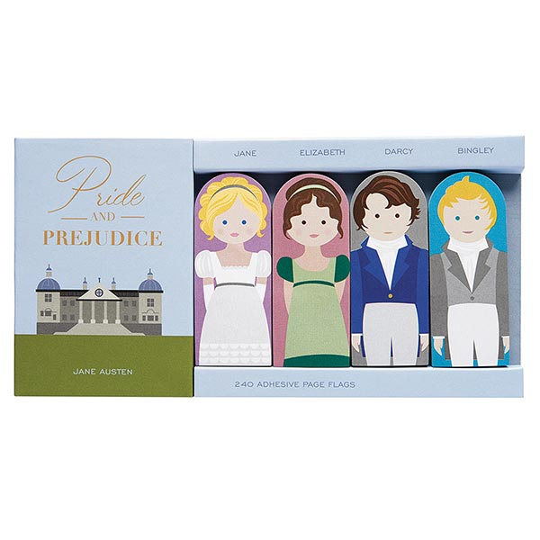
As previously mentioned, the universality of Austen is undeniable. Therefore, it is likely that Jane Austen has found her way onto classroom shelves everywhere, whether those teachers are teaching the original novels or not. There are so many revisions, spinoffs, etc. that exist; it is almost impossible to keep up with them all. Everywhere a person turns, they can find something related to Austen whether it is a pad of post-it notes (Figure A), a pair of socks (Figure B), or even an air freshener (Figure C). Jane Austen is definitely lurking around every corner, and children have undoubtedly been exposed to her whether they realize it or not.
Figure B
Figure A
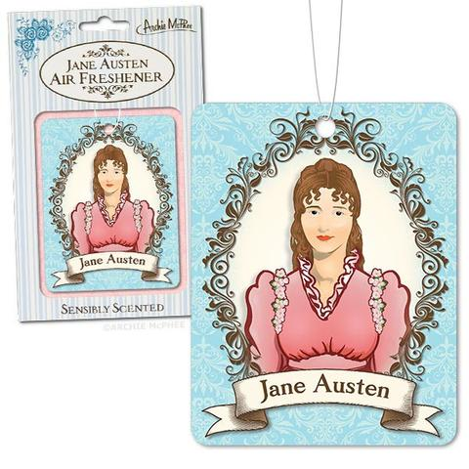
Because of the Jane Austen phenomenon, teachers can take advantage of a very interesting culture attached to Jane Austen and her works. Whether the elements of this culture can be found directly in the classroom or not, it is important to note that they probably have affected young adults in one way or another, so teachers everywhere should be aware of the ways that students are uniquely blending the classics with the contemporary. If teachers are aware of this influence, they will be more likely to successfully reach their students in all facets of the classroom. Lessons that play off of students’ interests will always be more successful, and if teachers want their students to embrace the classics, they need a way to connect to their students—pop culture Jane can do just that. Three ways to look at the contemporary Austen is by acknowledging young adult novel spinoffs, various film adaptations and spinoffs, and a vlog series that can be accessed on YouTube with the click of a button. Through all of these mediums, Jane Austen lives on in the hearts and classrooms everywhere.
Figure C
As far as young adult novels are concerned, the Jane Austen influence is abundant. One of the most popular spinoffs, however, is entitled Austenland. Austenland was recognized in scholar Jessica Jerrit’s column, where she describes Austenland by Shannon Hale saying,
Jane Hayes’s obsession with the fictional Mr. Darcy has more than likely jeopardized each of her past relationships. When she inherits an Austen-themed vacation to Pembrook Park, Jane has a chance to live out her fantasy and hopefully get Mr. Darcy out of her system. With a cranky Regency gentleman (an actor) and a handsome gardener (background staff member) vying for her attention, our heroine has her work cut out for her. This humorous novel with a cast of well-drawn characters will charm fans who wish to relive their favorite books. (107)
Austenland combines the elements of a spin-off, as well as including some of the characters readers know and love. The heroine endures a sort of love triangle very similar to the love situations found in Pride and Prejudice, but the heroine is also obsessed with the actual novel. This young adult novel provides a totally different way of looking at the novel, as well as a way to see how the culture surrounding the novel can play out. This culture in itself is a way to reach many students, which is a discussion in and of itself.
Another young adult novel that is difficult to ignore in the discourse surrounding Jane Austen is Epic Fail by Claire LaZebnik. This YA novel is more of a direct spinoff in that the characters all have a matching character in Pride and Prejudice based on their personality in the novel. For example, the main characters are the Benton sisters rather than the Bennet sisters, and Mr. Darcy becomes Derek. Instead of taking place in England centuries ago, this novel takes place in Los Angeles, and the girls attend a prep school where everyone has parents that are wickedly rich and famous. Naturally Elise, one of the Benton sisters, falls in love with Derek, and their relationship struggles as the kids try and navigate their respective social classes. This novel is a true young adult novel, and it is written at a level that is appropriate for ages twelve and up. If kids have not read Pride and Prejudice, they will still enjoy the story. However, if students are familiar with Pride and Prejudice, it will be impossible for them to ignore the parallels.
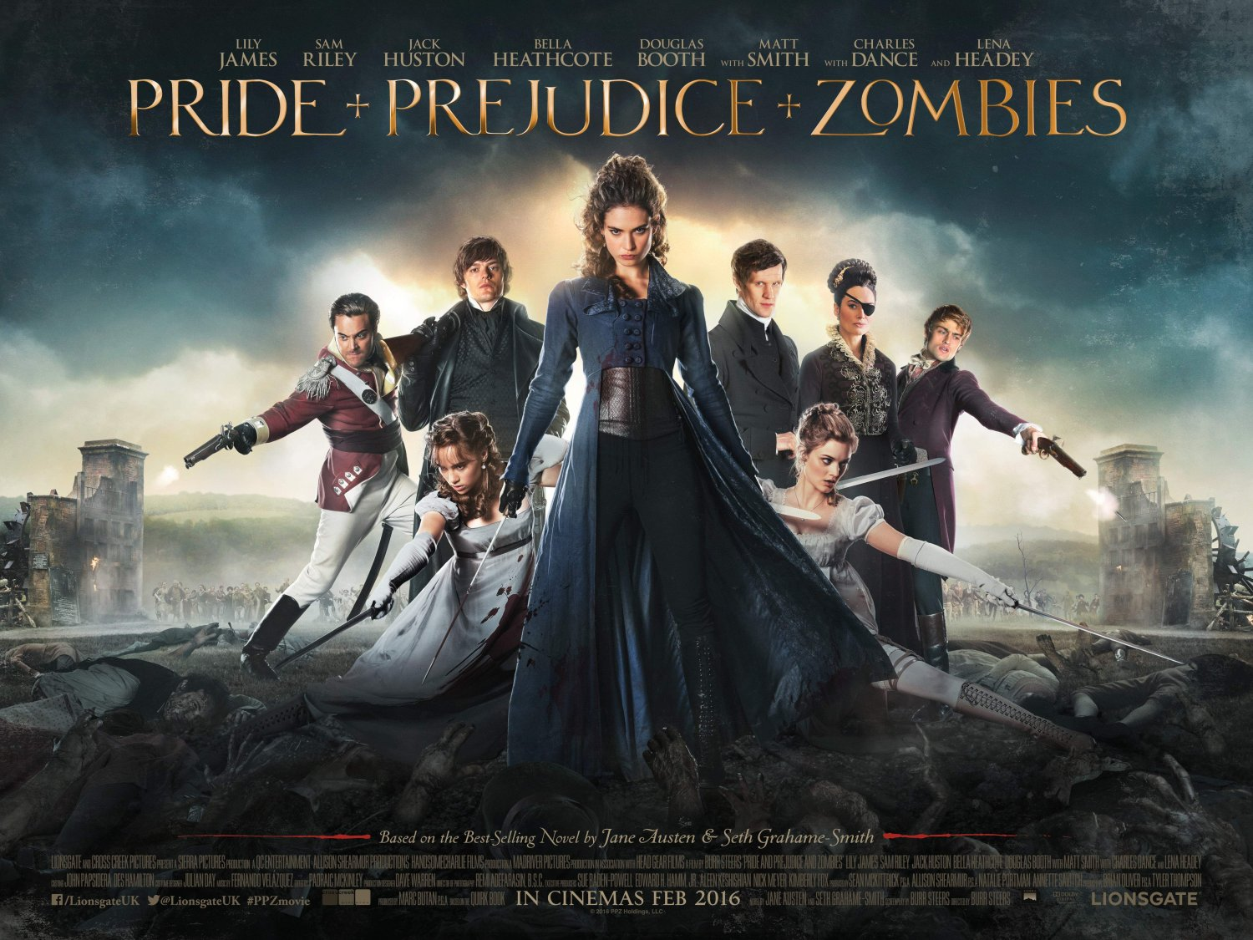
Moving on from young adult literature, film is another place where people can find spinoffs and adaptations of their favorite Austen novels. As one would imagine, Pride and Prejudice is also wildly popular in the movie adaptation field as well as the field of written work. Most people have at least heard of, if not seen, at least one Pride and Prejudice based movie. One of the more recent adaptations that took the big screen by storm is Pride and Prejudice and Zombies (Figure D). Based off a novel, this movie hit theaters in 2016, and it is basically the original story of Pride and Prejudice with some zombies and fighting thrown into the mix. The Bennet sisters still exist, except this time they are trying to protect themselves from the zombie threat that is ever-growing all while trying to find love and save their country. This adaptation is unique in that it sticks to the original story full of love and marriage, but it also adds a little bit of action. Why zombie action? Zombies are a popular pop culture fad currently, and there is a very high chance that many students have encountered something with zombies whether it be a TV show, movie, or something in a store. The zombie fad does not appear to be going anywhere, and if students are already embracing it, combining zombies and classic texts may just be the way to get them on board. The creators of this movie really knew what they were doing when they created this unlikely pair. It drew many people back to theaters to re-familiarize themselves with a classic text, or even create interest in a text that many had not read before. In a similar fashion, this may be a good way to spark interest in many students as a way to get them to buy into the text at hand. Additionally, this may be a movie that teachers have stocked in their classroom to get some boys on board with Jane Austen’s classic love stories, as well as provide another window through which to examine
Figure D
Another extraordinarily popular movie that was based off the novel Pride and Prejudice is Bridget Jones’s Diary. It is a bit older having been released in 2001, but many people have seen it or at least heard about it. The movie deals with a bit of an older cast, having the main character be a middle-aged professional. The main character, Bridget, begins keeping a diary as a New Year’s resolution. She battles unexpected and seemingly unwelcome love, and she cannot seem to get rid of an acquaintance that she is unexpectedly drawn toward. It is likely that there will be many students who have not seen this movie or are not allowed to see it because it is rated R, but in our ever-changing world, more and more students will likely be exposed to it. Though not as explicitly based off Pride and Prejudice as Pride and Prejudice and Zombies is, Bridget Jones’s Diary is still one of the great novel-turned-movie spinoffs of one of Austen’s greatest novels.
Another unique place to look for Austen in the classroom is through vlog series. There are several vlog series based off Austen novels, but the one based off Pride and Prejudice is entitled The Lizzie Bennet Diaries. This is a very interesting phenomenon because, as scholar Silke Jandl states, it “is the first literary adaptation produced exclusively on the free Internet platform YouTube” (167). The Lizzie Bennet Diaries has a book that pairs with it entitled The Secret Diary of Lizzie Bennet, but both can be consumed independently and still perfectly understood. The Lizzie Bennet Diaries is unique because students have almost unlimited access to YouTube. They have grown up in an era of technology, and searching for YouTube videos is almost as second nature as brushing teeth. If teachers need another way to allow access to Austen’s novels, a vlog series can do just that. In fact, there is a YA series by author Patrick Carman entitled Skeleton Creek that is part book, part video series. Students love it because it breaks up the monotony of reading an entire book, and it provides really useful visuals for understanding the words at hand. Using technology in the classroom is a great way to enhance classic texts and open students’ minds to embracing the text in front of them. The Lizzie Bennet Diaries in particular play off students’ technological interests, and it gets them into the story without actually realizing it.
Though this is just a small sample of the Austen spin-offs and adaptations that exist, it is undeniable that Austen has one of the largest cultures surrounding her works. There are many different ways that you can find Austen in classrooms without even picking up her classic novels. Students are able to explore YA novels, films, and vlog series all related to the classic novel Pride and Prejudice, and this allows for a greater understanding of the novel at hand. If students are given alternate ways to study a text, there is bound to be something that appeals to each and every one of them. Additionally, by bringing in alternate activities, the various learning styles of all the students in the classroom should be reached. Multi-modal approaches are the best for reaching all students and creating maximum understanding for whatever text is at hand. After looking at all of these different access points, maybe it is safe to say that there needs to be a balance in the classroom of classics and contemporary.
Though some teachers believe in a classics-only approach to education while others believe solely YA literature is the way to go, there lies true value in pursuing a combination of both. There is absolutely no shame in enjoying a YA novel or gobbling up a book that is a few reading levels too low—getting books in students’ hands is really all that matters. However, teachers should want their students to grow as readers. Unfortunately, students will have to encounter texts that are less than enjoyable. They may have to struggle through a housing contract or a boring college textbook without the choice to abandon. In order to better understand complicated and potentially dry pieces of text, those students need tools in their figurative toolboxes that they can access in times of need. By starting with texts that are enjoyable, teachers should be able to work their students up to the more difficult texts, which will teach them that just because something is hard does not mean it is impossible. A little bit of confidence in their toolbox is extremely valuable, and it will be a tool that they access time and time again. One way to do this is by introducing reading ladders.
Combining YA Literature and Jane Austen in Practice: Reading Ladder
In theory, the combination of YA literature and classic Jane Austen seems like a foolproof way to teach the classics. Then comes the golden question—How does one go about creating a successful tool to teach both? That is where reading ladders come into play. Author Teri S. Lesesne wrote an entire book entitled Reading Ladders: Leading Students from Where They Are to Where We’d Like Them to Be where she goes in depth about what reading ladders are, how to make them work, and why teachers should utilize them in the classroom. Using examples of poetry and other classic works Lesesne discusses building reading ladders saying:
Often, we read in either a horizontal or vertical movement. In horizontal reading, we read books serially. Specializing in an author’s works or in the works of one series, we find comfort. Each book is quite like the one before. We know what to expect in terms of plot and character and resolution. There are few surprises. […] Vertical reading seems to be the domain of secondary school reading. In vertical reading, we move ever upward. Elementary poetry, for instance, which involves humorous verses and lots of puns and other funny plays on words, gives way to classic forms and poets. We move from “ha ha ha” to haiku without much of a transition to assist our students. The Outsiders (Hinton 1967) gives way to Hamlet (Shakespeare 2003). Memoirs of a Teenage Amnesiac (Zevin 2007) fades into essays by Thoreau and Emerson with nary a bridge to help readers cross successfully. Vertical reading is where we lose many readers, I fear. The path is too steep and there are few guideposts along the way to assist the inexperienced climber. What I propose is more of a diagonal movement, just the situation for reading ladders. (47)
What Lesesne is suggesting is that instead of giving students a YA novel like LaZebnik’s Pride and Prejudice spinoff Epic Fail and then encouraging them to pick up an actual copy of Pride and Prejudice because “they should enjoy the story,” teachers should scaffold up to Pride and Prejudice so as not to discourage students when they realize that though sharing a similar story, Austen’s classic novel is vastly different from LaZebnik’s teenage characters with teenage problems. With a little bit of scaffolding, however, students will be able to understand the classic texts better than ever before.
Reading ladders are a way of getting students to start in one place and work their way up to a more difficult text. The top rung of the ladder is the goal, and all of the proceeding rungs should help support students so they will all make it to the very tippy top of that ladder. For this reading ladder, the goal is to have students reach the classic novel Pride and Prejudice (Figure E). This ladder was created with freshman or sophomores in mind, but could be altered for almost any high school grade level. There are many ways that students can explore texts similar to Pride and Prejudice, but this ladder deals with the issue of social class, meaning the place that one holds in society and how that status shapes his/her life. Social class can be found in all sorts of texts in very different ways, and students should be able to trace this theme throughout all of the texts they encounter.
In Tennessee, teachers must adhere to a strict set of standards when creating lessons for their students. A teacher’s purpose is typically formed around said standards, and those standards strongly influence the lesson and how it is taught. This reading ladder would be a part of a larger unit that would cover many different reading, writing, speaking and listening, and other standards. As far as reading, this reading ladder would cover five important standards taken from the tn.gov website: 9-10.RL.KID.1 Analyze what a text says explicitly and draw inferences; cite the strongest, most compelling textual evidence to support conclusions, 9-10.RL.KID.3 Analyze how complex characters, events, and ideas develop and interact over the course of a text to impact meaning, 9-10.RL.CS.6 Analyze how point of view and/or author purpose shapes the content and style of diverse texts, 9-10.RL.IKI.7 Evaluate the topic, subject, and/or theme in two diverse formats or media, 9-10.RL.IKI.9 Analyze a variety of related literary texts and evaluate
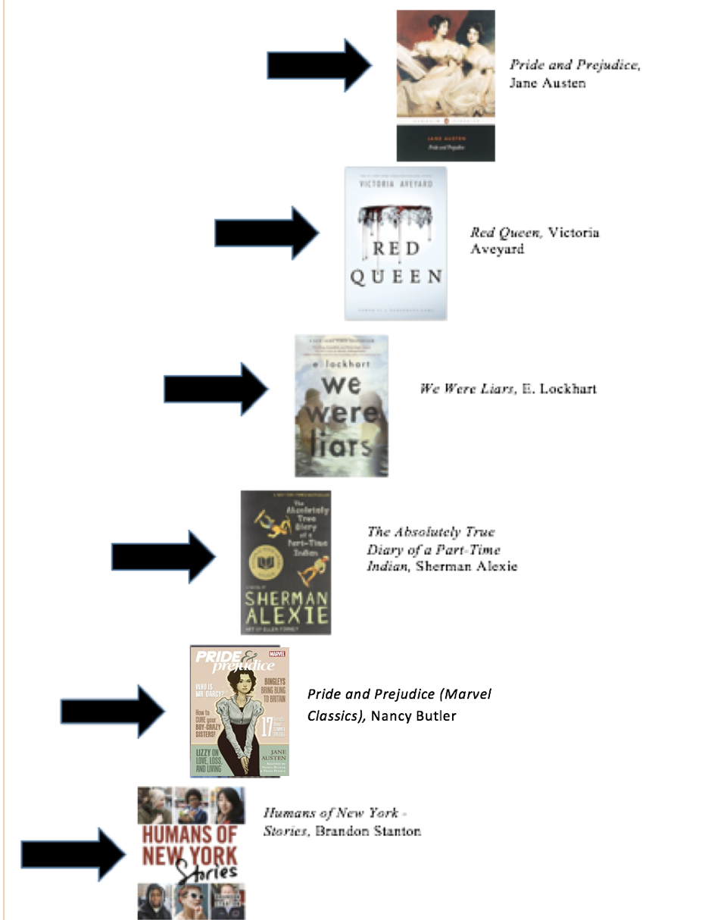
Figure E
how an author draws on, alludes to, or transforms source material to provide a deeper and more thorough interpretation of the text. As a teacher, it is important that you teach your students not only how to analyze, but also how to transfer that analysis to real life topics. By exploring the different works within the reading ladder, students will be exposed to different genres, situations, and styles, and they should be fully equipped to understand how social class works in various situations within literature, as well as their everyday lives.
The top rung of the ladder is Pride and Prejudice—a love story that everyone adores that is inexplicably attached to social class. All of the works leading up to this top rung will give students various ways to study and understand social class and how it is framed throughout society. Additionally, students should be able to infer how social class is interpreted by society, as well as what that means in a larger context when it comes to perception, resources, and relationships. The very bottom rung of the ladder is Humans of New York – Stories by Brandon Stanton. Students will be expected to interpret the photos and stories of the individuals present while digging for evidence of social class and what that means for the individuals at hand. The second rung is a graphic novel version of the goal text— Pride and Prejudice (Marvel Classics) by Nancy Butler. By providing a graphic novel version of the very last text, students will be exposed to the text early but will have a mixture of words and illustrations to help them with their interpretations. The different style of text will hopefully allow for a new level of interest and understanding, and students will be able to refer back when they finally reach the top rung of the ladder. The third rung is The Absolutely True Diary of a Part Time Indian by Sherman Alexie. This is a young adult favorite, and the students will not be able to ignore the influence that social class has on Junior, the protagonist, and his relationship to his friends and family. That close, personal relationship is also present in Pride and Prejudice, and this text will give students a way of comparing social class based on region. Additionally, this text will provide another window for students to access social class by drawing their attention also to Junior’s ethnicity. The fourth rung is We Were Liars by E. Lockhart. This novel is kind of confusing at first, which is why it is higher on the ladder, but the whole novel is centered on social class, and the twist at the end keeps everyone engaged. Much like the other texts, social class in this novel really effects personal relationships, and students should be able to study the interactions of the characters and determine how those are effected by social class. The fifth rung is Red Queen by Victoria Aveyard. This series is wildly popular among high school students at the moment, and it will also provide a type of dystopian/fantasy novel for readers that are interested in that specific genre. By providing social class in a sort of make-believe context, students will be able to use their imagination to see how social class can work in situations that might not be as prevalent or as common. Hopefully this will assist some struggling readers by providing a text that they enjoy, as well as giving them inference tools to reference when they begin to explore Pride and Prejudice. Finally, students will reach the top rung—Jane Austen’s classic text Pride and Prejudice. All of the works chosen will make for a very comprehensive ladder that will hit the many varied interests of students and allow them all to reach (and hopefully enjoy!) a popular classic text.
Bottom rung: Humans of New York – Stories, Photo Book/Short Stories, Stanton (2015). Brandon Stanton started off with a project in mind—he was going to create a photographic census of New York City. As he began to collect photos and stories, he created a blog entitled Humans of New York. This is the second book he has done that is filled with all new subjects, but this book has a lot more dialogue that adds to the emotion-filled photos that line the pages. This book is the bottom rung because of the pictures. Even students that are not too keen on reading novels will enjoy the pictures. They will be able to identify social class in the context of peoples’ situations through the photographic elements that are displayed, and they will be able to use the text to support their inferences. For higher readers, they may be interested in facing their biases—how do they feel just by looking at the photo? When they read the person’s story, does that match up with the social class they originally thought that person was in? How and why? This exploration of social class will be a bit different than Pride and Prejudice because it is exploring present-day New York City. The region will provide differences, and the century will also provide differences. Additionally, Stanton’s pictures will cause students to feel differently about social class than just reading Austen’s words. They may have to face their own biases, but they should be able to understand how social class is framed through words vs. how social class is framed through pictures. This will provide good opportunities to explore social class for lower readers and advanced readers alike.
Second rung: Pride and Prejudice (Marvel Classics), Graphic Novel, Butler (2010). This graphic novel explores the well-known classic text Pride and Prejudice, but spices it up in graphic novel format. It takes the story that readers know so well and adds compelling images paired with carefully selected text to tell the story in a unique, engaging way. Marvel Comic’s adaptation of this classic text successfully compresses the story and creates a visualization to assist readers in navigating the story of Elizabeth Bennet and her family. In addition to the visualization of the characters and situations, this adaptation also slightly modernizes the sometimes-tricky classic dialogue and makes it a bit easier to follow along. Students should be able to fully understand what is going on in the classic story, and they should be able to carry their knowledge with them through to the top rung. This fits well on the second rung because it is in graphic novel format. The words and language are not too difficult, and they are really enhanced by the illustrations provided on the page. Additionally, the graphic novel format is useful in the classroom for furthering reading and inference skills. It not only captures the attention of students who have been growing up in a digital-age, but it also strengthens their reading skills and encourages them to read even more.
Third rung: The Absolutely True Diary of a Part-Time Indian, YA Novel, Alexie (2007). This young adult novel tells the story of a young boy, Junior, who lives on the Spokane Indian Reservation. He believes he can do better than staying put on the reservation, so he leaves to attend an all-white school in the neighboring town where he is the only Indian. His social class, which is inextricably bound to his ethnicity, is very apparent as Junior tries to navigate his new world and fit in, and his life both on and off the reservation will never be the same. This novel is here because it is a favorite with young adult readers. The prose is very manageable, and there are several cartoons sprinkled throughout that add to the story and make it easier to visualize. This makes it a bit harder than a graphic novel, but still a little less scary than a huge novel. Junior struggles with his identity and how that is connected to his social class, and his relationships with his new, white friends are very different than those with his old friends on the reservation. This novel will introduce questions that are related to social class and how that is related to ethnicity and affected by relationships. What happens when people try to enter relationships—either friendships or romantic relationships—with people from different social classes? How do different social classes interact with one another? How much should people let their social classes determine who they are as individuals? These are all questions that students can also ask as they read along to Austen’s classic Pride and Prejudice. All students will really get into this story, and they will enjoy following Junior around in his quest for success.
Fourth rung: We Were Liars, YA Novel, Lockhart (2014). This novel is completely centered around social class as it follows a very rich family to their summer vacation homes on a private island off the coast of Martha’s Vineyard. The entire family is obsessed with who is going to get the most fortune and the main characters, deemed “the Liars,” are sick of it. They decide to take measures into their own hands and burn their grandfather’s house down (sorry for the spoiler) with all of his possessions inside. Cadence, one of the Liars, suffers a terrible head injury and cannot remember anything except that she is in love with Gat, a boy who does not come from her same social circle, and that something big happened that summer that she cannot remember. This novel is placed towards the top because it is a little trickier to follow. It is short, which makes it very manageable, but the twist at the end is somewhat difficult to follow. All students will enjoy this novel because it is fast-paced and very intriguing. Also, it is completely focused on social class with a forbidden love (hello Pride and Prejudice!) at the center.
Fifth rung: Red Queen, YA Fantasy, Aveyard (2016). This fantasy novel is all about a main character, Mare Barrow, who lives in a world that is divided by people’s blood. People that have common, Red blood serve the elite, Silver blood who all have some sort of superhuman power. Mare is a Red who lives in a poor, rural village until she discovers she actually has a superhuman ability. The Silver court—the king, princess, and all the nobles—say it is impossible, so she is forced to play a role as a Silver princess. She uses her position in the Silver world to help out a Red rebellion as she finds herself torn and unsure of her fate. This novel is here because it is a bit longer, denser, and a little harder to comprehend. However, it is a favorite of many YA readers right now, so readers should be excited about encountering it. It will give some students a new genre to explore, and it will show them another way of looking at social class—class hierarchy in a fantasy world. Hopefully lower readers will be able to explain the significance of the social classes in the novel, and higher readers should be expected to be able to identify social classes within the novel and connect them to our current real-world. This novel should be appropriate for all readers at one level or another.
Top rung: Pride and Prejudice, Fiction Novel, Austen (1813). This classic novel tells the story of the Bennet family, who comes from a lower class, and their endeavors in navigating life and love. The main focus of the novel is the protagonist, Elizabeth Bennet, and her emotional development throughout the novel as she learns to differentiate what is superficial and what is real. All of the Bennet sisters are looking for love, and Elizabeth finds her love in Mr. Darcy—a character that everyone loves to hate (or hates to love?). Mr. Darcy is a rich man who is very condescending toward Elizabeth due to her social rank, however he is undeniably in love with Elizabeth Bennet. Eventually the characters must overcome their pride and their prejudice, and the two end up in a lovely relationship. This story is at the top of the ladder because it is definitely going to be the most difficult for students to comprehend. The language is challenging, and the story can be somewhat difficult to follow due to the culture and time differences. However, it is on this list because Elizabeth Bennet and Mr. Darcy’s relationship completely revolves around their social classes. Besides the other texts on the ladder, some background knowledge would probably be needed on the culture and customs of the time, but this ladder should have challenged students to look for social class in all sorts of ways. Because of this, they should be ready for the challenge of reading Pride and Prejudice, and they should understand and even enjoy the story.
Overall, this reading ladder should allow students to understand how to follow a given theme in a text set that employs many sorts of texts. They should look at this ladder like a challenge, but they should also be excited about some of the texts that they are given. Because of the scaffolding of Pride and Prejudice with young adult texts, they should be able to appreciate everything that the classic novel has to offer, and they will feel as if it is more manageable for them as they have grown as readers.
Other Ways to Have an Austen-Filled Classroom
Though a reading ladder is a great place to start when looking at ways to bring the classics into the classroom, saying that is the only solution would severely limit teachers’ capabilities of reaching their students. There are plenty of other ways to incorporate classic literature into various classrooms including composition and writing prompts, as well as through technology. Once students reach Austen classics such as Pride and Prejudice, it is imperative that they learn how to study and apply the text in further detail. If students are given further activities, they will learn to appreciate the text at a more in-depth level, and they will hopefully feel more confident about the work they are doing and be more willing to face other classic texts in the future.
One of the first ways of furthering Jane Austen classic study is through composition. Regardless of the grade-level, there is some sort of composition activity that can be created around the study of the classics. For example, Daniel R. Mangiavellano writes about encountering Pride and Prejudice through writing in his article “First Encounters with Pride and Prejudice in the Composition Classroom”. Though he models his paper on a first-year college level composition class, this method could easily be used for advanced students in an honors or AP class, or even with any Pride and Prejudice unit. Mangiavellano talks about his strategy saying:
I use the novel to introduce students to a variety of prose strategies exemplified in the text they can fold into their own academic writing. Since students want to read themselves into the text, I “meet students where they are” by playing off this instinct and spotlighting the novel’s many letters, letter writers, and readers whose striking resemblance to our student writers is an important pedagogical aspect of this novel; after all, writers in Pride and Prejudice admit to troubling issues of clarity and coherence that our students similarly struggle against. (550-1)
Mangiavellano makes sure to point out that when students read, it is more enjoyable if they can see themselves in the text—one of the main reasons that teachers push for YA novels in the classroom. If students study a novel like Pride and Prejudice, composition exercises are more likely to allow them to see a glimpse of themselves and make reading more enjoyable all together.
As Mangiavellano talks more in depth about his composition class, he talks about a specific exercise he uses to encapsulate students in their composition exercises. He discusses the famous first line that readers struggle to forget—“It is a truth universally acknowledged, that a single man in possession of a good fortune, must be in want of a wife” (1). He asks his students to then do an exploration of topic sentences in general by asking them to “air o0ut what they already know about how topic sentences function in essays or novels” (551-2). Some common answers are “draw the reader in” and “make the reader want to know more” (552). By doing a study like this with students, you can reassure that they are familiar with the mechanics behind composition, as well as why authors make the word choices they do. This hits a few different state standards, and gives students a way to further understand the novel of Pride and Prejudice as a whole. If students are willing to look that far into a text, they should be fairly knowledgeable when it comes to the text at hand. Though Mangiavellano uses this strategy for his freshman college students, high school teachers would definitely be able to adapt this to fit their needs and further their novel study of Pride and Prejudice.
Besides the composition classroom, Pride and Prejudice can also be studied in the context of technology. One ninth grade teacher in Melbourne Australia, Madeleine Coulombe, wrote an article entitled “Pride and Prejudice and Facebook: Social Media in a Year 9 English Classroom” that outlined her experiences with a Facebook activity surrounding Pride and Prejudice in her classroom. She taught a lesson where students used Facebook accounts to be different characters from Pride and Prejudice. The students were required to fully role play which included using language from the Regency period in which Austen wrote Pride and Prejudice. It was a large success in her classroom—the students loved pretending to be their character, and they all interacted really well in their discussion day. One example post states:
Elizabeth Bennet: is astonished … Mr. Darcy has proposed to me just like that. Rude human being.
—4 people like this.
—View all 37 comments (89).
It is clear that the students really got into the project, and it is also clear that they really understood the texts at hand. In order to make specific posts, the students must have a pretty solid background in the text at hand, meaning they must have thoroughly studied the text to pick up on small details. Coulombe reflected on her experience saying, “Our hour of Facebooking in Year 9 English was one of the most exhilarating lessons I have ever ‘taught’” (92). She goes on to describe her classroom as she states, “It generated energy and enthusiasm that remained with the class until the end of the unit, when each student in the class produced an extended short story. Most of these were set in the Regency Period” (92). She makes it clear that her lesson was successful—not only did her students get valuable technological experience, but they also got some creative writing experience through writing their own short stories.
Lessons such as these are a great addition to any unit surrounding classic texts, specifically Jane Austen’s Pride and Prejudice. The storyline and characters of Pride and Prejudice really lend themselves to all sorts of academic study, making them a perfect fit for any high school classroom. If teachers give their students enough scaffolding, as well as various access points and lessons surrounding the text, students are bound to embrace the classic text more than if they were just blindly given something of that nature. It is clear that with enough preparation, teachers can bring classics successfully into their classrooms in new and innovative ways.
Conclusion
Jane Austen’s Pride and Prejudice is a novel that is known in many different areas of life for many different things. It has been around for many, many years, and it appears as if it is not going anywhere anytime soon. The novel itself is full of important themes, characters, and styles of language, and it is truly amazing what can be done. As important as the novel is, however, sometimes it is still difficult to get students on board with reading classic texts such as Pride and Prejudice. Hopefully some of this study sheds light on the various ways that teachers can frame classics such as Pride and Prejudice to make them more interesting for students and earn permanent spots on their classroom bookshelves. It is true that classics are important, but Jane Austen has proved that their importance is much more than what is written on the page.
The success of Jane Austen in young adult literature and secondary schools suggests that this classics argument is not an either-or game—Austen lets us have it both ways. She provides open access to the past, while also engaging students through immediacy and relevancy. Because of this, Austen is a grand example of how combining the classics and contemporary in the secondary classroom is more beneficial than just one or the other. If teachers take the extra time to scaffold around lessons pertaining to the classics, they will be more successful in meeting the learning demands of their students and making their classroom a fun, interactive space where a love for reading is cultivated daily.

Works Cited
Austen, Jane. Pride and Prejudice. Oxford: Oxford UP, 2004. Print
Coulombe, Madeleine. “Pride and Prejudice and Facebook: Social Media in a Year 9 English Classroom.” English in Australia 46.3 (2011): 89-93. JSTOR [JSTOR]. Web. 01 July 2017.
Emig, Leigh. "Combining Young Adult and Classic Literature in a Secondary English Classroom." Rising Tide 7 (2015): 1-27. St. Mary's County Public Schools. Web. 09 Apr. 2017.
Fritzer, Penelope. "Jane Austen's Novels as a Guide to Social and Individual Responsibility for High School Students." Adolescence 33.131 (1998): 597-600. Academic Search Complete [EBSCO]. Web. 09 Apr. 2017.
Gallo, Donald R. "How Classics Create an Aliterate Society." The English Journal 90.3 (2001): 33-39. JSTOR [JSTOR]. Web. 07 Apr. 2017.
Jago, Carol. "In Defense of the Classics." The English Journal 90.5 (2001): 10. JSTOR [JSTOR]. Web. 08 Apr. 2017.
Jandl, Silke. “The Lizzie Bennet Diaries: Adapting Jane Austen in the Internet Age.” AAA: Arbeiten Aus Anglistic Und Amerikanistik 40 (2015): 167-96. JSTOR [JSTOR]. Web. 01 May 2017.
Jerrit, Jessica. "No Persuasion Necessary: Jane Austen's Eternal Appeal." Library Journal 135.15 (2010): 107. Academic Search Complete [EBSCO]. Web. 08 Apr. 2017.
Lesesne, Teri S. Reading Ladders: Leading Students from Where They Are to Where We’d Like Them to Be. Portsmouth: Heinemann, 2010. Print.
Mangiavellano, Daniel R. “First Encounters with Pride and Prejudice in the Composition Classroom.” Pedagogy 12.3 (2012): 550-55. Project MUSE [Johns Hopkins UP]. Web. 01 July 2017.
Tennessee State Board of Education. “Tennessee English/Language Arts Standards.” (2017): n. pag. TN.gov. Web. 02 July 2017.

