Synthesis, Characterization, and Property Comparison of High Entropy Oxide Materials Belonging to the Spinel, Perovskite, and Ruddleson-Popper Crystal Systems

A Thesis Presented for the
Doctor of Philosophy
Degree
The University of Tennessee, Knoxville

Brianna L. Musicó
May 2021

Copyright © 2021 by Brianna L. Musicó
All rights reserved.

DEDICATION

I dedicate this to my husband, Cordell, whose endless support and friendship has helped me make it to this point. I look forward to the life we will build together.

ACKNOWLEDGEMENTS

I would like to thank my advisors Veerle Keppens and David Mandrus for their support and encouragement on my graduate work. I would also like to thank Zac Ward and Claudia Rawn for their involvement as collaborators, mentors, and committee members.

…add more to later…
ABSTRACT

By utilizing entropy as the driving force for engineering oxide materials, the deviation from traditional prediction methods and principles offers a path for new structure-property relations to be discovered and innovative structures and subsequent properties to be explored. The multi-cation approach inherent to high entropy oxides (HEOs) could allow for the tailoring of physical properties to meet the requirements of the application. While HEOs offer significant opportunities for functional material applications, their intrinsic disorder and highly localized chemical environments bring along new challenges. Investigations into these effects is performed with systematic studies of polycrystalline samples across multiple crystal systems resulting in the successful synthesis of multiple compositions, with many achieving pure single phase, and 11 of which were novel compositions. To gain understanding of the effects the disorder has on the structure and ordering to uncover and ultimately utilize the tremendous possibilities of HEOs these studies provide foundational groundwork towards understanding the mechanisms involved in phase formation, synthesis method variation, and compositional effects on obtaining single phase materials and their result on homogeneity and properties. This work expanded the multi-component concept to new compositions and crystal systems and investigate kinetic, magnetic, and elastic properties of spinel, perovskite, and Ruddlesden-Popper multi-component materials for the growth towards ‘tunability’ within this new materials class.

Table of Contents

Chapter One Introduction and General Information 1
1.1. Overview of high entropy oxides (HEOs) 1
1.2. Entropy and Materials Design 2
Entropy is not the whole story 2
Selection criteria and synthesis 4
1.3. Literature review of HEOs and properties 5
1.4. Magnetism 5
Magnetic classifications 5
Magnetism in oxide materials 6
1.5. Kinetic theory 7
Kinetic Transformation Investigation and Mechanisms 8
1.6. Background on crystal structures investigated 12
Spinel 13
Cubic and orthorhombic Perovskites 14
Ruddlesden-Popper 14
Chapter Two Materials and methods 16
2.1. Material synthesis 16
Solid State Method 16
Polymeric Steric Entrapment Method 17
Hot Uniaxial Pressing 22
2.2. X-ray Diffraction Techniques 24
2.3. Scanning electron microscopy 24
2.4. Thermal Analysis 24
2.5. Magnetometry 25
2.6. Resonant Ultrasound Spectroscopy 25
Chapter Three Material charactarization Results and discussion 26
3.1. Single Phase verification and elemental homogeneity 26
Spinel 26
Perovskite 26
Ruddlesden-Popper 26
3.2. Magnetic Properties- Spinels 26
Ferritic spinels: high temperature magnetic behavior 27
Ferritic spinels: low temperature magnetic behavior 28
Chromium based spinels: low temperature magnetic behavior 30
Chromium based spinel First Order Reversal Curve 34
3.3. Magnetic Properties-Perovskites 34
3.4. Magnetic Properties- Ruddlesden-Popper cuprates 34
3.5. Thermal Analysis 34
3.6. Thermal Stability 34
3.7. Kinetic Analysis 34
In-situ HTXRD results 35
Determining kinetic behavior from time and temperature dependent data 38
Comparison of synthesis method 40
3.8. Resonant ultrasound spectroscopy results 43
Chapter Four Conclusions and reccomendations 46
List of References 47
Appendix 65
Vita 86

LIST OF TABLES

Table 1 Summary of types of magnetism and their typical magnetic behavior with schematics for dipole ordering, inverse susceptibility with temperature, and magnetization with magnetic field. 6
Table 2 Summary of select models for solid state kinetic transformations and their algebraic expressions for the f(α) and g(α) functions adapted from Gotor and Khawam. 12
Table 3 Precursor material for (Mg_{0.2}Ni_{0.2}Co_{0.2}Cu_{0.2}Zn_{0.2})Al₂O₄ synthesis with PSE. 17
Table 2.4. Summary of all material compositions synthesized, heat treatments used, whether single phase was achieved, and their crystal structure and space group. 19
Table 5 Summary of hot-pressing conditions and resultant densities for single phase samples for the investigated spinel compositions. 23
Table 6 RUS fit results for (Mg_{0.2}Ni_{0.2}Co_{0.2}Cu_{0.2}Zn_{0.2})Al₂O₄ hot pressed pellet. 44
Table 7 RUS fit results for MgAl₂O₄ hot pressed pellet. 45
Table 8.A: Summary of High Entropy Oxide compounds synthesized in literature, their crystal structure, synthesis method, their investigated properties/application and reference. ‘ES’ indicates that the study showed the composition to be entropy stabilized. 66

LIST OF FIGURES

Figure 1-1 Timeline for the development of different classes of compositionally complex materials. 2
Figure 1-2 Timeline representing the expansion of high entropy oxides to other crystal systems since their realization with the rocksalt structure. 5
Figure 1-3 Schematics representing the interactions in (a) Superexchange, (b) double exchange and (c) RKKY interactions in magnetic materials. 7
Figure 1-4 The theoretical master plots (a) in integral form representing, (b) in differential form, (c) in differential-integral form, and (d) curves in differential-integral form all as a function of alpha for the different kinetic models. 11
Figure 1-5 The theoretical shape of degree of crystallization, α, with time as calculated from per-forming an area normalized integral of the f(α)g(α)/f(0.5)g(0.5) data set for each kinetic model. 12
Figure 1-6 Representative unit cell of the spinel structure with labeled atoms sites. 13
Figure 1-7 Plot of site occupancy preferences for transition metal cation species based on energy values from taken from Dunitz and McClure. 14
Figure 1-8 The (a) T-structure and (b) T′-structure of (RE)₂CuO₄ rare earth (RE) cuprates with the (RE)CuO₃ and (RE)O layers labeled. 15
Figure 2-1 processing diagram for the solid state method. 17
Figure 2-2 processing diagram with steps and pictures for the polymeric steric entrapment method. 19
Figure 2-3 Visual representation of the cross-section of a loaded graphite die used for hot uniaxial pressing. 23
Figure 2-4 Visual schematic of resonant ultrasound spectroscopy measurement and resultant spectra. 26
Figure 3-1 (a) Field cooled magnetization of ferritic HEO spinels from 300 K – 850 K with applied field of 1000 Oe and (b) magnetization as a function of applied field at 300 K with inset showing hysteretic behavior (1 emu = 10⁻³ Am²). The legend applies to both. 28
Figure 3-2 DC magnetization for (Cr_{0.2}Mn_{0.2}Fe_{0.2}Co_{0.2}Ni_{0.2})₃O₄ (a) with temperature from 3 K - 300 K showing the ZFC, FC, and FW plots with applied field of 100 Oe; and (b) magnetic hysteresis loops measured at 300K, 200K, 125K, and 50K. 29
Figure 3-3 DC magnetization as a function of temperature from 3 K – 300 K showing the ZFC, FC, and FW measured at 1000 Oe, for (a) (Mg_{0.2}Mn_{0.2}Co_{0.2}Ni_{0.2}Cu_{0.2})Fe₂O₄ and (b) (Mg_{0.2}Fe_{0.2}Co_{0.2}Ni_{0.2}Cu_{0.2})Fe₂O₄. 29
Figure 3-4 Zero-Field Cooled Magnetization vs Temperature of (Cr_{0.2}Mn_{0.2}Fe_{0.2}Co_{0.2}Ni_{0.2})₃O₄ in both a positive field (+100 Oe) and negative field (-100 Oe) performed on a Quantum Design VersaLab with VSM. 30
Figure 3-5 Low temperature DC magnetization from 3 K – 300 K under 100 Oe and 1000 Oe for (a) (Mg_{0.2}Fe_{0.2}Co_{0.2}Ni_{0.2}Cu_{0.2})Cr₂O₄, (b) (Mg_{0.2}Mn_{0.2}Co_{0.2}Ni_{0.2}Cu_{0.2})Cr₂O₄ and (c) (Mg_{0.2}Co_{0.2}Ni_{0.2}Cu_{0.2}Zn_{0.2})Cr₂O₄. 31
Figure 3-6 The hysteresis plots at 25 K, 15 K, 5 K and 1.9 K for (Mg_{0.2}Fe_{0.2}Co_{0.2}Ni_{0.2}Cu_{0.2})Cr₂O₄ with inset showing behavior at 300 K. 32
Figure 3-7 Magnetization with Field of (Mg_{0.2}Mn_{0.2}Co_{0.2}Ni_{0.2}Cu_{0.2})Cr₂O₄ at 300 K, 50 K, 20 K, and 1.9 K with inset better showing hysteresis. 33
Figure 3-8 The magnetization with magnetic field behavior at 300K, 50K, 25K and 3K for (Mg_{0.2}Ni_{0.2}Co_{0.2}Cu_{0.2}Zn_{0.2})Cr₂O₄. 33
Figure 3-9 The magnetization with magnetic field behavior at 300K, 50K, 25K and 3K for (left) (Mg_{0.2}Mn_{0.2}Co_{0.2}Ni_{0.2}Cu_{0.2})Fe₂O₄ and (right) (Mg_{0.2}Fe_{0.2}Co_{0.2}Ni_{0.2}Cu_{0.2})Fe₂O₄ showing slight hysteresis. 34
Figure 3-10 Heatmaps (temperature (°C) vs position (°2θ) and the intensity is shown in color) of the in-situ HTXRD data collected on solid-state synthesized (Co_{0.2}Cr_{0.2}Fe_{0.2}Mn_{0.2}Ni_{0.2})₃O₄ with both ramping experiments (lower) and subsequent dwell experiment (upper). 36
Figure 3-11 X-ray diffraction data for the initial and final scans of isothermal measurements of PSE synthesized (Mg_{0.2}Ni_{0.2}Co_{0.2}Cu_{0.2}Zn_{0.2})Al₂O₄ samples measured at varying temperature compared to data collected at 950°C during a ramping temperature dependent run. 37
Figure 3-12 (a) The heatmap of the in-situ HTXRD data collection performed on solid-state synthesized (Co_{0.2}Cr_{0.2}Fe_{0.2}Mn_{0.2}Ni_{0.2})₃O₄. The red dashed box outlines the peak used for the calculations plotted on (b). 40
Figure 3-13 Room temperature x-ray diffraction spectra comparing of the (113) reflection for (left) polymeric steric entrapment synthesized and (right) solid state synthesized (Mg_{0.2}Ni_{0.2}Co_{0.2}Cu_{0.2}Zn_{0.2})Al₂O₄ showing the difference is peak shape. 41
Figure 3-14 The heatmaps of the in-situ HTXRD samples made via (a) SSS and (b) PSE. Red dashed box outlines the peak used for the α with temperature plotted in (c) and (d) as well as the calculations from the experimental data over the master plot shown in (e) and (f). 42

Introduction and General Information

Overview of high entropy oxides (HEOs)

A version of this chapter was originally published by Brianna L. Musicó, Dustin Gilbert, Thomas Zac Ward, Katharine Page, Easo George, Jiaqiang Yan, David Mandrus, and Veerle Keppens
B. L. Musicó et al., “The emergent field of high entropy oxides: Design, prospects, challenges, and opportunities for tailoring material properties,” APL Mater., vol. 8, no. 4, p. 040912, Apr. 2020.
Selected portions from this paper have been stated in this section. The introduction, material design, compilation of literature studies, magnetic, mechanical, thermal expansion, and concluding remarks sections were written by Brianna L. Musicó as well as the compilation, editing, and organization of the contributors’ written sections. The entropy section was written by Easo George; the correlated electron section by Thomas Zac Ward; local structure and prediction models section written by Katharine Page; and the ionic conductivity, thermoelectric, and ferroelectric sections written by Dustin Gilbert. David Mandrus and Veerle Keppens were advisors involved in the editing and revision of the paper and Jiaqiang Yan as an advisor.

This section is to provide background on the field of disordered materials and introduce the specific class of HEOs that this dissertation work investigates. “High entropy” became a commonplace term in materials research ever since a new method of alloy design was proposed in 2004, relying on the combination of multiple elements in equimolar ratios [1],[2]. This was the start of a new research focus, called High Entropy Alloys (HEAs) that is still active and growing. HEAs attracted interest because of the possibility that a solid solution of five or more elements could be stabilized due to high mixing entropy. The exceptional mechanical properties achieved by the multicomponent approach has dominated HEA research in the field of structural materials [3]. More recently, HEAs have expanded to include studies of electronic, ionic, magnetic, thermal, and superconducting properties [4], [5], [6]. Reports on the unique properties achieved with HEAs motivated the exploration of compositional complexity as an approach to materials design [7]. The field of multi-component materials was expanded in 2015 to include High Entropy Oxides [8], and was followed by High Entropy Metal Diborides [9], High Entropy Carbides [10], High Entropy Sulfides[11], High Entropy Fluorides [12], and High Entropy Alumino Silicides [13] as depicted in Figure 1-1. Metal oxides are attractive for applications [14], and multicomponent design could expand the available compositional space, providing greater flexibility to meet the demands of today’s advanced materials. HEOs also show great promise for applications in energy storage and catalysis. The electrochemical application of HEOs, including the high Li-ion conductivity and Li-storage capabilities of rocksalt-HEOs for use in battery applications [15].
Figure 1-1 Timeline for the development of different classes of compositionally complex materials.

Entropy and Materials Design

Entropy is not the whole story
In HEAs it was initially proposed that the increased ∆S_{conf} of near-equimolar alloys with 5 or more elements may favor the formation of solid solution phases over competing intermetallic compounds [7]. However, experiments showed that configurational entropy is generally not able to override the competing driving forces, such as enthalpy, which also contribute to phase stability [16]. For example, the equiatomic alloy CoCrFeMnNi is known to solidify as a single-phase solid solution [2]. Since the change in ideal configurational entropy (mixing entropy) of an equiatomic alloy is given by R ln n, where R is the gas constant and n the number of elements in the alloy, its value for the CoCrFeMnNi alloy is 1.61 R. This value will not change when individual elements are replaced one at a time to produce new alloys as long as n does not change. Thus, it is 1.61 R also in CoCrFeMnCu (where Cu replaces Ni in the original alloy). Otto, et al. [16] showed that every new alloy thus created (CoCrFeMnCu, CoMoFeMnNi, TiCrFeMnNi, etc.) rather than being a single-phase solid solution, phase-separated into multiple metallic and intermetallic phases after 3-day anneals at high temperatures. Therefore, although in the CoCrFeMnNi alloy entropic effects were stronger than enthalpic effects (at sufficiently high temperatures), in the other derivative alloys, enthalpic effects won out (at comparable temperatures). Even in the CoCrFeMnNi alloy, at lower temperatures (<800 °C), the single-phase solid solution decomposes into multiple metallic and intermetallic phases [17], consistent with the decreasing influence of entropy with decreasing temperature.
Recent work by Rost, et al. [8] has demonstrated analogous behavior in oxide mixtures. When they mixed five binary oxides (MgO, CoO, CuO, NiO, and ZnO) in equimolar proportions and heated the mixture in the 850-900 °C temperature range, a single-phase quinary HEO, (Mg_{0.2}Co_{0.2}Cu_{0.2}Ni_{0.2}Zn_{0.2})O, with the rocksalt structure was observed to form, which separated into a two-phase mixture (rocksalt and tenorite) at lower temperatures. The phase transformation from single-phase to two-phase and back was reversible with temperature, similar to that observed in the CrMnFeCoNi alloy [18], indicative of the increased/decreased contribution of configurational entropy at high/low temperatures. The authors attributed the increased configurational entropy of the HEO to the random distribution of cations on the cation sublattice sites, which was confirmed by extended X-ray absorption fine structure. Nevertheless, the formation of a single-phase quinary HEO is fascinating because its individual components (binary oxides) do not show complete solid solubility with each other. They also have different crystal structures: MgO, NiO and CoO have the rocksalt structure, CuO has the tenorite structure, and ZnO has the wurtzite structure. This is reminiscent of the CrMnFeCoNi HEA in which Ni, Fe and Co (the latter two only at elevated temperatures) have the face-centered cubic structure, Cr has the body-centered cubic structure, and Mn the complex A12 crystal structure; yet when mixed together the result is a single-phase solid solution with the face-centered cubic crystal structure. In both cases, the formation enthalpy of competing phases appears to be low enough that it can be overcome by configurational entropy at elevated temperatures. Additional work has been done on this rocksalt to investigate the effect that grain size has on controlling the phase spectrum behavior[19]. As in the rocksalt system, a reversible multi-to-single phase transition was observed in later HEO perovskite work on (Gd_{0.2}La_{0.2}Nd_{0.2}Sm_{0.2}Y_{0.2})MnO₃ indicating entropy stabilized behavior along with information supporting that the 10-cationic system (Gd_{0.2}La_{0.2}Nd_{0.2}Sm_{0.2}Y_{0.2})(Co_{0.2}Cr_{0.2}Fe_{0.2}Mn_{0.2}Ni_{0.2})O₃ is also most likely entropy stabilized, extending the concept of entropy stabilization to multicomponent perovskites [20]. Work on a five -component fluorite (Ce_{0.2}Zr_{0.2}Hf_{0.2}Sn_{0.2}Ti_{0.2})O₂ also showed a reversible multi-phase to single phase transition indicating entropy stabilization of the compound [21]. An interesting aspect of the formation of these perovskites is the stabilization of the lower symmetry orthorhombic phase, whereas the rocksalt [8] and fluorite type [22] had a preference to maintain a high symmetry structure, which suggests an enthalpy contribution to octahedral tilt Jahn-Teller type distortion making an adaptation to the cubic phase energetically costly [20]. While the nominal work in this field showed the rocksalt (Mg_{0.2}Ni_{0.2}Co_{0.2}Cu_{0.2}Zn_{0.2})O composition to be truly entropy stabilized, this has not been verified for many of the other compositions in literature. The recent review of the electrochemical applications of HEOs points out that entropy stabilization may be contributing to not just phase stability, but to the functional properties as well, as shown in reversible de/lithiation behavior of the rocksalt based HEOs [15]. The differentiation between compositionally complex materials that are truly entropy stabilized versus multicomponent solid solutions is imperative as research in this area continues to progress.
There are also key differences that are worth noting. For example, in the rocksalt HEO mentioned earlier, removal of any one of the components (binary oxides) from the quinary mixture to produce a quaternary mixture results in the loss of the single-phase rocksalt structure and decomposition into multiphase structures [8]. This is consistent with the notion that a decrease in the configurational entropy (quinary to quaternary) decreases the stability of the solid solution. In contrast, removal of several of the components (elements) from the quinary HEA CrMnFeCoNi (Mn, Cr, and Fe) to form quaternaries (FeNiCoCr, FeNiCoMn, and NiCoCrMn) retains the single-phase solid solution state [23]. The lower configurational entropy of the metallic quaternaries presumably is sufficient to overcome the enthalpy of competing intermetallic phases whereas that of the oxide quaternaries is insufficient to overcome the enthalpy of competing oxide phases. Another difference is that, in some perovskite, spinel, and fluorite HEOs, when certain cation species are switched out for others based on ionic radii, not all compositions stabilize as a single phase [24]–[27]. Additionally, rare earth oxides crystallizing in the fluorite CaF₂ type structure with 5 elements on the rare-earth site form a single phase only with the addition of cerium, showing evidence of cerium as a stabilizer in this case [22]. This is reminiscent of the HEA results [16] discussed earlier.
Materials design is challenging given that entropy is but one factor contributing to phase stability of ceramic compounds. In some cases, if the system’s configurational entropy is large enough it can be a stabilizing factor, as was shown in the seminal HEO work [8]. In general, though, the picture is much more complicated, and it is necessary to take into account variables such as the charge states and the ionic radii of the individual cations. Understanding the underlying reasons behind compositional effects on phase stability and distinguishing entropy-stabilized material systems versus solid-solutions is an important area for future investigation.

Selection criteria and synthesis
The initial HEO work of Rost, et al. showed that even in cases where i) the component binary oxides do not exhibit uniform crystal structure, electronegativity or cation coordination, and ii) the pairs of binary oxides do not exhibit extensive mutual solubility, it may be possible to obtain single-phase solid solutions if the entire collection is isovalent [8]. In later studies, the initial oxidation state of the starting materials has not proven to be a primary factor in the formation of the desired phase, as equilibrium can be reached at high temperatures with oxygen loss and preserved upon quenching [28]. This aliovalent substitution widens the possibilities for compositional variation and in turn properties and applications. The synthesis of (Co,Cr,Fe,Mn,Ni)₃O₄ shows the expansion into other crystal structures with the creation of a single phase HEO with either spinel or rocksalt structure by means of varying the oxygen partial pressure [29]. This manipulation of synthesis method was not something that was seen or able to be used in HEA systems, but should be considered with other oxide synthesis methods as the broader range of structures available in oxides, as shown by the timeline in Figure 1-2, which opens up possibilities to maximize the potential of this new materials class.
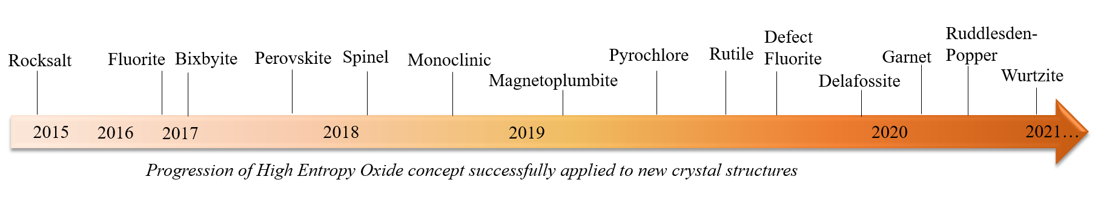
Figure 1-2 Timeline representing the expansion of high entropy oxides to other crystal systems since their realization with the rocksalt structure.
In summary:
- Evidence supports that high configurational entropy of mixing is a contributing factor to the formation of a single-phase solid solution, but not exclusively.
- Work on rare earth HEOs shows evidence that particular element additions can be a stabilizing factor [30].
- Minimization of Gibbs free energy to achieve single phase stability benefits from configurational entropy maximization via the mixing of many diverse element species.
- For the case of oxides, it has been stated that there should be appropriately diverse structures, coordination, and cationic radii to directly test whether entropy is a dominant factor in stabilizing solid solutions.

Literature review of HEOs and properties

An extensive literature review has been performed and is summarized in the appendix by Table 8.A which lists the crystal structure, composition, synthesis method, and material properties investigated.

Magnetism

Magnetic classifications

Add stuff….

Table 1 Summary of types of magnetism and their typical magnetic behavior with schematics for dipole ordering, inverse susceptibility with temperature, and magnetization with magnetic field.
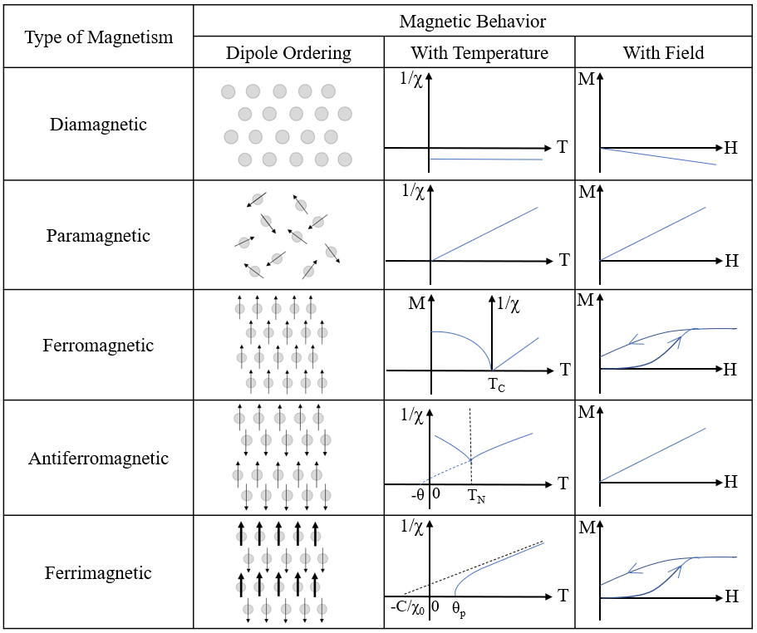

Magnetism in oxide materials

Magnetism in oxide materials is generally governed by indirect interactions such as Superexchange, double exchange, and Ruderman–Kittel–Kasuya–Yosida (RKKY), and are influenced by the local environment. Superexchange is a short-range interaction and, depending on the geometrical characteristics of the bond and the electronic configuration of the two coupled transition metal ions, this can be either an antiferromagnetic or ferromagnetic interaction. It is highly dependent on the metal-oxygen-metal (M-O-M) bond angle and orbitals involved, given by the schematic in Figure 1-3 (a). In double exchange, an electron has moved between the neighboring metal ions, retaining its spin as shown in Figure 1-3 (b). The ability to delocalize reduces the kinetic energy and can lead to ferromagnetic alignment of neighboring ions. If no hopping occurs, this can be antiferromagnetic. RKKY is an itinerant exchange that happens in rare earths, where the 4f states are localized and exchange is mediated by (non-magnetic) conduction electrons as shown but Figure 1-3 (c) and is a long-range interaction. In a disordered material there is a variation in element constituents and bond angles and multi-valent states could be expected, so these interactions come into play. In oxides, where the physical behavior is strongly correlated to stereochemistry and electronic structure, poly-cation approach creates a unique platform to tailor the interplay of extreme structural and chemical disorder to realize unprecedented functionalities.

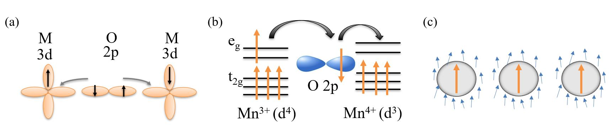
Figure 1-3 Schematics representing the interactions in (a) Superexchange, (b) double exchange and (c) RKKY interactions in magnetic materials.

The multi-component approach makes these interesting as any type of structural changes, such as lattice distortion or tilting of octahedra, have often shown a decisive impact on material properties.

Kinetic theory
A version of text from this section is to be published in a textbook chapter “Experimental Characterization of High Entropy Oxides with In-situ High Temperature X-Ray Diffraction Techniques” by Brianna L. Musicó, Cordell J. Delzer, John R. Salasin, Michael R. Koehler, and Claudia J. Rawn in the textbook:
Brechtl, J., Liaw, P.K. (2021). Fundamental Studies of High Entropy Materials. Manuscript in preparation for publication by Springer.

Selected portions from this chapter have been stated in this section. The introduction and background were written by Brianna L. Musicó and Claudia J. Rawn. Experiments were performed by Brianna L. Musicó and Michael R. Koehler. Background knowledge for experiment set up and design provided by John R. Salasin. Data analysis performed by Brianna L. Musicó and Cordell J. Delzer. Discussion and prospects written by Brianna L. Musicó and reviewed by Claudia J. Rawn.

.

Kinetic Transformation Investigation and Mechanisms

The focus of this section is to provide the necessary background needed for understanding data analysis performed from high temperature X-ray powder diffraction to study the formation or transformation of high entropy materials. Kinetic transformations can be investigated by determining the reacted fraction, α as a function of time using a variety of characterization methods. From X-ray powder diffraction data, α can be calculated by either analyzing the integrated peak area (A) if limited diffraction maxima are available or the phase fraction (wt%) if determined through Rietveld refinement, as shown in Equation 1.

$α=\frac{A_{observed}}{A_{max}}=\frac{{Wt\%}_{observed}}{{Wt\%}_{max}}$ (1)

The Johnson-Mehl-Avrami-Kolmogorov (JMAK) model, often known as simply the Avrami equation, shown in Equation 2 relates the reacted fraction to the reaction time (t), rate constant (k) with units of time⁻¹, and a constant (n) that depends on the reaction mechanism. These JMAK mechanisms are denoted in later figures as An, where n represents the reaction mechanism included in Equations 2, 3, and 4.

$α=1-\exp{{(-kt)}^{n}}$ (2)

Rearranging Equation 2 to solve for kt results in Equation 3

$-[\ln{{(α-1)]}^{1/n}}= kt$ (3)

The JMAK model describes homogeneous random nucleation and growth, and substituting various values of α into the equation above yields a sigmoidal curve with three distinct stages corresponding to slow growth when homogenous random nucleation initially occurs, faster growth during the second stage of nuclei growth, and a return to slower growth due to nuclei impingement as the reacted fraction α approaches 100%.

Mathematically manipulating Equation 3 gives the form of Equation 4

$-\ln{\ln\left(1-α\right)=n\ln{k+n\ln{t}}}$ (4)

where -ln ln (1 - α) can be plotted against ln t for a line with a slope of n and a y-intercept of k for an isothermal experiment. When several isothermal curves collected on a compound are plotted and are parallel but displaced from each other, the reaction mechanism n (from the slope) is the same for each curve but the rate constant k (from the intercept) is different.

The Arrhenius equation, Equation 5,

$k=A\exp{(\frac{-E_{a}}{RT}})$ (5)

relates the rate constant to the activation energy, E_{a}. Other information used in the equation includes the gas constant (R) and the absolute temperature (T). A is the pre-exponential factor and is constant for each reaction. Once k is determined at each temperature from the isothermal experiments described above, E_{a} can be determined from the slope (-E_{a}/R) that results when plotting ln k vs 1/T (K).

The JMAK model is useful when describing (1) a single step nucleation and growth from a solution or wet chemistry synthesis where reactants are well mixed and diffusion lengths are short or (2) for certain material systems a reaction where a solid decomposes at higher temperatures to form a different solid and a gas (e.g., BaCO₃ → BaO + CO₂ (g)) [31]. However, other kinetic models are also important when studying solid-state synthesis techniques, not only for comparisons but for insights into the reactions occurring during the synthesis. The shape of the fraction transformed vs. time (α vs. t) curve guides the choice of a potential kinetic model. When data are collected isothermally, the α vs. t curve for the JMAK model, as discussed above, results in a sigmodal shape. However, for the solid-state reaction models in which the amount transformed proceeds quickly at low t and then slowly approaches the 100% conversion limit, a geometric contraction (R) or diffusion controlled (D) deceleration model should be considered. In a review paper, Khawam and Flanagan [32] present these models along with acceleratory and linear models and provide an in-depth discussion.

For reactions occurring based on geometric contraction (R), initial nucleation occurs rapidly on the surface of the particle, and the rate of conversion is controlled by the resulting reaction interface as it progresses toward the center of the particle. The model used will depend on the shape of the particle, and Khawam and Flanagan derived the equations relating the transformed fraction to the rate constant and time for constricted area (R2), described as a cylindrical particle, and for constricted volume (R3), described as a spherical or cubic particle; these are given in Equations 6 and 7, respectively.

${1-(1-α)}^{1/2}=k_{o}t$ (6)

${1-(1-α)}^{1/3}=k_{o}t$ (7)

In the derivation of these equations, the initial radius of the particle (r₀) and the radius at any time (r) are considered, and k_{o} = k/r₀.

For equations based on diffusion controlled (D) reactions, the interfacial reaction product that forms between the initial phase(s) and the resultant phase after the reaction is an important factor. Considered in the derivation of the diffusion-controlled reactions are the molecular weight, density, and thickness of the reactant and product layers, the molecular weight of the second reactant, the diffusion coefficient, and the concentration gradient. Using these factors, Khawam and Flanagan present the derivations to arrive at the diffusion-controlled reactions for the 1-D (infinite flat plate, D1), 2-D (cylindrical, D2), and 3-D (spherical, D3) geometries given in Equations 8, 9, and 10, respectively.

$α^{2}=kt$ (8)

$(\left(1-α\right)\ln\left(1-α\right)+α=kt$ (9)

${(1-{\left(1-α\right)}^{1/3})}^{2}=kt$ (10)

The above discussion examining the α vs. t curves focuses on isothermal data collection, but experiments for obtaining α can also be conducted as a function of temperature (T), resulting in an α vs. T curve. For evaluating this non-isothermal data, “master plots” are often used. In Gotor et al. [33], a method of creating master plots is presented. Equations 3 and 6-10 were previously presented in the review by Khawam and Flanagan as g(α) = kt, where g(α) is the integral of the reaction model defined by Equation 11.

$g\left(α\right)= \int_{0}^{α}{\frac{dα}{f(α)}}$ (11)

Taking the reciprocal of the derivative of g(α) results in the equation f(α). f(α)/f(α)_{0.5}, where f(α)_{0.5} is the value when α = 0.5 or 50% of the material has been transformed, is then used to generate the master plots presented by Gotor et al. [22] and recreated in Figure 1-4 (a). These were calculated using the algebraic expressions given in
Table 2. As the plot progressions show, some of these kinetic mechanisms are hard to distinguish and sometimes even overlap, especially in the case of f(α)g(α)/f(0.5)g(0.5) given in Figure 1-4 (d). This is a drawback in using non-isothermal data since some behaviors can no longer be discerned.

Using the data for the master plot depicted in Figure 1-4 (d), a plot of the theoretical α as a function of time since crystallization can be generated by applying an area normalized integral of the f(α)g(α)/f(0.5)g(0.5) data set for each kinetic model, the result of which is given in Figure 1-5. In this study we are not considering order-based models.

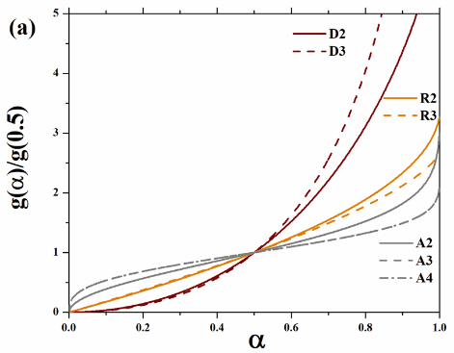
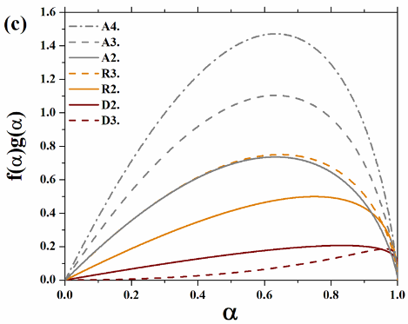
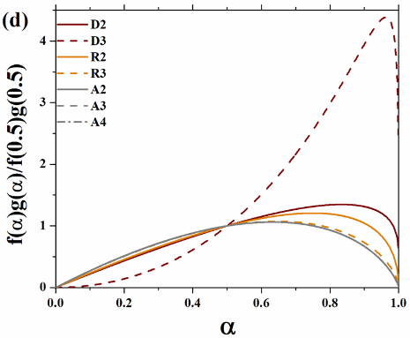
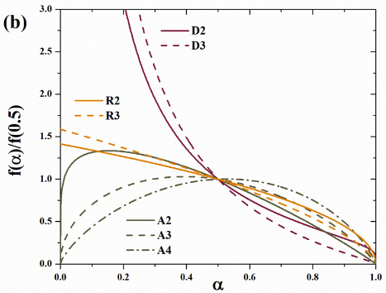
Figure 1-4 The theoretical master plots (a) in integral form representing, (b) in differential form, (c) in differential-integral form, and (d) curves in differential-integral form all as a function of alpha for the different kinetic models.

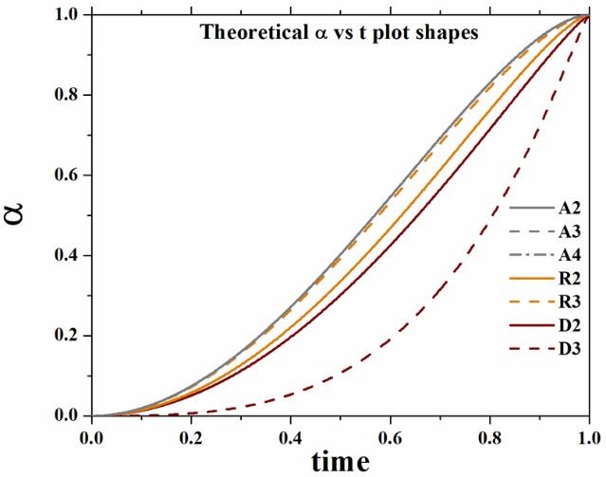
Figure 1-5 The theoretical shape of degree of crystallization, α, with time as calculated from per-forming an area normalized integral of the f(α)g(α)/f(0.5)g(0.5) data set for each kinetic model.

Table 2 Summary of select models for solid state kinetic transformations and their algebraic expressions for the f(α) and g(α) functions adapted from Gotor and Khawam.
Kinetic Mechanism | symbol | f(α) | g(α)
Phase boundary controlled reaction (2D) | R2 | $${(1-α)}^{1/2}$$ | $$2[1-{\left(1-α\right)}^{1/2}]$$
Phase boundary controlled reaction (3D) | R3 | $${(1-α)}^{2/3}$$ | $$3[1-{\left(1-α\right)}^{1/3}]$$
Random nucleation and growth (Johnson-Mahl-Avrami equation, JMAK model) | An | $${n\left(1-α\right)[-\ln\left(1-α\right)]}^{1-1/m}$$ | $${[-\ln\left(1-α\right)]}^{1/n}$$
2D diffusion | D2 | $$\frac{1}{[-\ln\left(1-α\right)]}$$ | $$\left(1-α\right)\ln\left(1-α\right)+α$$
3D diffusion (Jander equation) | D3 | $$\frac{{3\left(1-α\right)}^{2/3}}{2[{\left(1-α\right)}^{1/3}]}$$ | $${{[1-(1-α)}^{1/3}]}^{2}$$

Background on crystal structures investigated

As a variety of compositions were synthesized and studied in this work, an understanding of the crystal structures for the materials investigated is critical to understanding the role disorder and composition variation have on the material properties. This section will provide crystallographic background and is divided into sections for the primary three structures investigated: spinel, perovskite, and Ruddlesden-Popper.

Spinel
The spinel structure, space group Fd-3m, has a complex unit cell consisting of 32-anions and 24-cations. The face centered cubic arrangement of the anions lead to octahedral (B) or tetrahedral (A) crystallographic sites for the cations, as shown by the representative unit cell in Figure 1-6. Only 1/8 of the tetrahedral and ½ of the octahedral sites generated by the anion arrangement are occupied. The structure’s distribution can be described by (A_{1-x}B_{x})[A_{x/2}B_{1-x/2}]₂O₄ where the parentheses denote the tetrahedral site and the brackets denote the octahedral site and x = 0 corresponds to a normal spinel distribution, x = 1 to an inverse, and x = 2/3 to a completely random solution. In the normal spinel MgAl₂O₄, the 2+ cation occupies the tetrahedral A site, while both 3+ ions occupy the octahedral sites so that it is of the form (Mg²⁺)[Al³⁺Al³⁺]O₄. The MgAl₂O₄ composition follows the normal ordering, with the larger Mg²⁺ cation filling the smaller tetrahedral site while the smaller Al³⁺ cations occupy the octahedral sites. In 2-3 type spinels, such as those reported here, the larger ion typically occupies the tetrahedral site, resulting in the normal spinel configuration as described for MgAl₂O₄ [34], [35]. This is the case for three of the individual spinels of this multicomponent composition, MgAl₂O₄, CoAl₂O₄, and ZnAl₂O₄, whereas NiAl₂O₄ takes on a largely inverse spinel configuration [36] and CuAl₂O₄ [37] has a disordered structure with tendency towards some degree of inversion. In the case of an inverse spinel such as NiFe₂O₄, the occupational preference is such that the cation distribution is (Fe³⁺)[Ni²⁺Fe³⁺]O₄. Preferential site occupancies for the cation species based off charge [38], [39] is provided in Figure 1-7 for reference, but the effect of the complexity of the compositions studied in this work should be considered.
Figure 1-6 Representative unit cell of the spinel structure with labeled atoms sites.

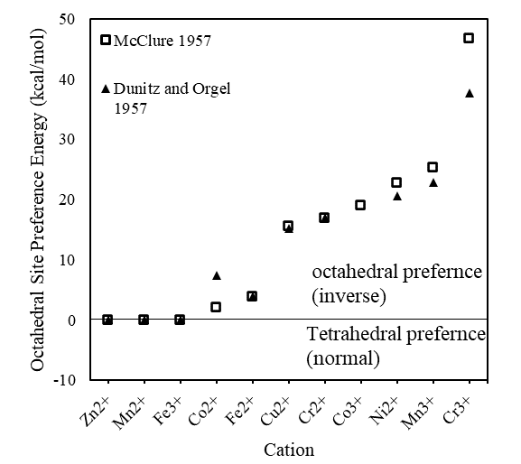
Figure 1-7 Plot of site occupancy preferences for transition metal cation species based on energy values from taken from Dunitz and McClure.
The magnetic behavior in spinel materials is largely dependent on the cation species occupying the A and B sites………………………add stuff………….

Cubic and orthorhombic Perovskites
Oxide perovskites are generally of the form ABO3 where the larger ion typically occupies the 12-fold occupancy A site while the smaller cations occupy the corner octahedral sites. The Goldschmidt tolerance factor, t, is an indicator of the stability degree of distortion within the material from a ratio of the radii of the elemental constituents and is given by: $t=\frac{r_{A}+r_{O}}{\sqrt{2}(r_{B}+r_{O})}$ where r_{A}, r_{B}, and r_{O} are the radii of the A cation, B cation and oxygen anion, respectively. For t >1 a hexagonal or tetragonal structure is expected, while for a t 0.9 to 1 a cubic structure is expected, and for t 0.71 to 0.9 an orthorhombic or rhombohedral structure expected. These have often been useful predictors in perovskite material synthesis. However, in high entropy oxide materials it has been shown that a Goldschmidt tolerance factor near 1 may be necessary for single perovskite phase but is not a criteria indication that single phase formation will occur [25]. This is an interesting result and something to consider when studying multi-component perovskite materials.

Ruddlesden-Popper
The Ruddlesden Popper (RP) series is generally of the form A_{n+1}B_{n}X_{3n+1}, where A and B are cations, X is an anion, and n is the number of the layers of octahedra in the perovskite-like stack. Typically, A is an alkali, alkaline metal, or rare earth (RE) metal ion; and B is a transition metal located inside anionic octahedra, pyramids, or squares [40]. The tetragonal T-structure, shown in Figure 1-8 (a), is typically formed for RE=La while the T′-structure, Figure 1-8 (b), can be expected for traditional RP n=1 cuprate compositions of Pr through Gd. The RP phase A₂BO₄, having the K₂NiF₄ structure with space group I4/mmm, has been extensively studied for energy and electronic device applications [41] because of their dielectric, superconducting, and magnetic properties. Composition, oxygen stoichiometry, and electron/hole doping are known to impact the functional properties in RP oxides with the Nd₂CuO₄ type T′-structure [42]–[44], but the effect of disorder in addition to such factors has yet to be investigated and could be an area for continued study. The ability to manipulate the configurational complexity within the 2D planes could lead to a new approach toward functionalities.

Figure 1-8 The (a) T-structure and (b) T′-structure of (RE)₂CuO₄ rare earth (RE) cuprates with the (RE)CuO₃ and (RE)O layers labeled.

Materials and methods

This chapter details the methods utilized for the synthesis and characterization of the investigated multicomponent oxide materials.

Material synthesis

Solid State Method
The solid-state method is common in ceramic synthesis and usually involved individual metal oxides or carbonated being combined in stoichiometric amounts and heated to high temperature to achieve a thermodynamically favorable state and is a diffusion driven process. The time required for full reaction and the development of a stoichiometric phase can be hours of days of time and can often require multiple reprocessing steps to get a homogenous phase and stoichiometry. The solid state method is a relatively straightforward synthesis method with minimal equipment requirements but has limited control over the resultant material microstructure and has long times required. Ensuring homogeneity becomes more problematic with multiple metal oxide constituent in the mixture, which is the case for high entropy oxides. In all the materials synthesized, metal oxides were used as the starting materials for reactions similar to that shown for (Mg_{0.2}Ni_{0.2}Co_{0.2}Cu_{0.2}Zn_{0.2})Al₂O₄ in reaction {1}:
{1}
$MgO+NiO+CoO+CuO+ZnO+{5Al}_{2}O_{3}→5\left({Mg}_{0.2}{Ni}_{0.2}{Co}_{0.2}{Cu}_{0.2}{Zn}_{0.2}\right){Al}_{2}O_{4}$

For the solid-state synthesized samples made in these studies, precursor powders of individual metal oxides were used. Prior to being weighed to stoichiometric amounts, the individual oxides were dried overnight to remove any moisture. This is a very important step as water content in the metal oxides would throw off the stoichiometry of the end compound. The rare earth oxides were dried at 900 °C while the other metal oxides in a warming oven. The higher temperature drying for the rare earth oxides is necessary due to the strong binding of water with them. Small 5-gram batches of each composition were ball milled in a SPEX 8000M Mixer/Mill. Through the process of making these samples, it was found that mixing in polypropylene containers was necessary as tungsten carbide and zirconia cannisters led to incorporation into the samples. This incorporation from zirconia canisters did not negatively affect zirconia containing compositions, but in the case of other compositions led to zirconia segregation at the grain boundaries. Samples were then pressed into ½-inch pellets using a die and Carver Uniaxial Press under 3 metric tons of force. These pellet samples were then placed into alumina boats into a muffle furnace and sintered in air. In some cases, if single phase was not achieved upon initial heat treatment, the sample we ground, re-pressed and heat treated again. These steps are summarized in the process diagram in Figure 2-1.
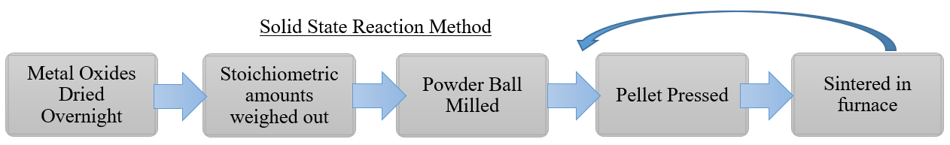

Figure 2-1 processing diagram for the solid state method.

Polymeric Steric Entrapment Method
The polymeric steric entrapment (PSE) method of synthesis is a wet chemistry technique where the cations are thoroughly mixed and held close together by polymer chains and can be described as a polymer assisted sol gel [45], [46]. Using long chain polymers, in these studies polyvinyl alcohol (PVA), ensures a high degree of mixing and a homogenous distribution of the cation species. As the ions are physically entrapped in a polymeric network within the solution, this inhibits elemental segregation or precipitation. For non-water soluble salts, elythene glycol (EG) can be used as the polymerization agent as it is a solvent for some such species in wet chemistry methods where a water soluble form of a material is not available. In these studies, this was not proven to be a necessary route as some form of the metal salt, whether nitrate, acetate or chloride, could be used that was water soluble. Other the type of solvent, additional factors that can be varied in this method include: the degree of polymerization, the cation to organics ratio, the solution pH, and the calcination and crystallization temperatures and times. Changing these parameters can affect to resultant particle size and size distribution, morphology, and microstructure. Because obtaining a homogenously distributed single- phase material was the main priority for the work performed in these studies, the effects of such variable changes on the powder properties was not investigated but does present an avenue for future studies.

An example calculation process for the production of (Mg_{0.2}Ni_{0.2}Co_{0.2}Cu_{0.2}Zn_{0.2})Al₂O₄ , termed XAlO for the following equations, with the PSE method is presented in the following steps. The total cation valence is calculated from the cation charges multiplied by the mol per formula unit of the cation in the final desired compound as shown in Table 3. This is then used to calculate the amount of PVA, $CH_{2}CH\left(OH\right)$, needed for the batch based on the batch size and mol ratio of the total cation valence to the valences of the OH- functional groups in the PVA, as shown in Equation 2. In all syntheses, a 4:1 cation to PVA ratio was used. A 5wt.% PVA solution with deionized (DI) water is then produced by mixing the PVA and water in a beaker on a hot plate at 60°C. While there will be much more water than this in the final solution, this is approximately how much is needed for completely dissolving the PVA before it is added to the nitrate solution.

Table 3 Precursor material for (Mg_{0.2}Ni_{0.2}Co_{0.2}Cu_{0.2}Zn_{0.2})Al₂O₄ synthesis with PSE.
Precursor | Cation Charge | Mol per formula unit
Mg(NO₃)₂·6H₂O | 2 | 0.2
Ni(NO₃)₂·4H₂O | 2 | 0.2
Co(NO₃)₂·4H₂O | 2 | 0.2
Cu(NO₃)₂·3H₂O | 2 | 0.2
Zn(NO₃)₂·6H₂O | 2 | 0.2
Al(NO3)2·9H2O | 3 | 2
Total cation valence: |  | 8

{2}
$$\left(5 g XAlO\right)\left(\frac{1 mol XAlO}{172.13 g XAlO}\right)\left(\frac{8 mol charges}{1 mol XAlO}\right)\left(\frac{1 mol PVA}{4 mol charges}\right)\left(\frac{44.05 g PVA}{1 mol PVA}\right)=2.55 g PVA$$

Stoichiometric amounts of the metal nitrates are calculated and weighed out and then dissolved into DI water in a beaker on hot plate at 60 °C while continuously stirring. The nitrate salts are in complete solution once the mixture is transparent. Note: if the mixture is not transparent after thorough stirring has been done, nitric acid can be slowly dropped into the beaker to aid dissolution and is stopped once a cloudy to clear transition in the solution is reached. Once both mixtures are completely into solution, the stir bar is removed from the PVA solution and the beaker slowly poured into the nitrate solution while it is stirring. Mixing is continued until the solution is clear indicating the nitrates and PVA has fully dissociated. Once good mixing is achieved, the hot plate is turned up so that the solution in the beaker is around 100°C and the water is evaporated. This step can take several hours. After the water has been driven off, the beaker is placed in a drying oven overnight. The next day the resultant foam powder is scraped out of the beaker, lightly ground in a mortar and pestle, and placed into a crucible. This crucible is then covered with two layers of aluminum foil with holes poked into them in alternating locations. As the calcining step is exothermic, these alternating layers allow for gases to exit while preventing any powder from escaping. In addition, a slow furnace ramp rate of 1°C/minute is used for the calcining step to also reduce powder activity. Equation 3 shows the stoichiometric equation for producing (Mg_{0.2}Ni_{0.2}Co_{0.2}Cu_{0.2}Zn_{0.2})Al₂O₄ with the PSE method. As some steps involved produce gases, the water reduction, drying, and calcining steps should all be performed in a fume hood.

(3)
$Mg{{(NO}_{3})}_{2}∙6H_{2}O+Ni{{(NO}_{3})}_{2}∙4H_{2}O+Co{{(NO}_{3})}_{2}∙4H_{2}O+Cu{{(NO}_{3})}_{2}∙3H_{2}O+Zn{{(NO}_{3})}_{2}∙6H_{2}O+5Al{{(NO}_{3})}_{2}∙9H_{2}O+{\left(CH_{2}CH\left(OH\right)\right)}_{n}→5\left({Mg}_{0.2}{Ni}_{0.2}{Co}_{0.2}{Cu}_{0.2}{Zn}_{0.2}\right){Al}_{2}O_{4}+{WNO}_{x}↑+{XCO}_{x}↑+{YNH}_{3}↑+{ZH}_{2}O↑$

The calcined powder is then pressed into a pellet and crystallized at a crystallization temperature for 1 h with a 5 °C/min ramp rate and furnace cooled. The described steps for the PSE synthesis process are summarized in the processing diagram in Figure 2-2.

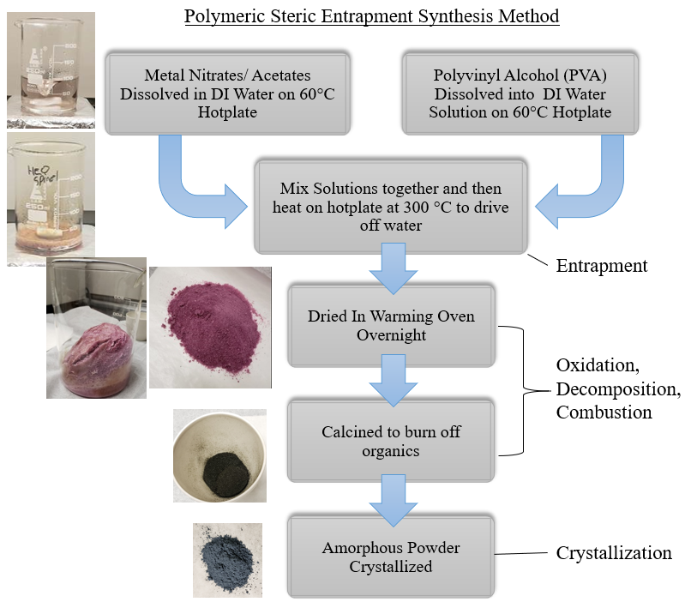
Figure 2-2 processing diagram with steps and pictures for the polymeric steric entrapment method.
The advantages of this technique include its low heating temperatures, improved mixing, low cost and easily scalable. This processing results in a homogenous distribution of chemical species and in material with small particle size.

A summary of all the multicomponent compositions produced, whether they were successful in producing a single-phase material, their resultant crystal structure, and the processing method and conditions utilized are summarized in Table 2.4.

Table 2.4. Summary of all material compositions synthesized, heat treatments used, whether single phase was achieved, and their crystal structure and space group.
Composition | Solid State reaction method | Polymeric steric entrapment (PSE) | Single  phase? | Crystal Structure and Space Group
(Mg_{0.2}Ni_{0.2}Co_{0.2}Cu_{0.2}Fe_{0.2})Fe₂O₄* | 1250°C 10 hrs 5°C/min ramp, furnace cooled | - | Yes, SSS | Spinel:  Fd-3m
(Mg_{0.2}Ni_{0.2}Co_{0.2}Cu_{0.2}Zn_{0.2})Fe₂O₄ | 1250°C 10 hrs 5°C/min ramp, furnace cooled | - | Yes, SSS | Spinel:  Fd-3m
(Mg_{0.2}Ni_{0.2}Co_{0.2}Cu_{0.2}Mn_{0.2})Fe₂O₄ | Calcine 950°C for 10 hrs then  1250°C 10 hrs 5°C/min ramp, furnace cooled | - | Yes, SSS | Spinel:  Fd-3m
(Ni_{0.2}Co_{0.2}Cu_{0.2}Fe_{0.2}Mn_{0.2})Fe₂O₄ | 1250°C 10 hrs 5°C/min ramp, furnace cooled | - | Yes, SSS | Spinel:  Fd-3m
(Ni_{0.2}Co_{0.2}Cr_{0.2}Fe_{0.2}Mn_{0.2})₃O₄* | 1250°C 10 hrs 5°C/min ramp, furnace cooled | - | Yes, SSS | Spinel:  Fd-3m
(Ni_{0.2}Co_{0.2}Cu_{0.2}Fe_{0.2}Mn_{0.2})₃O₄ | 1250°C 10 hrs 5°C/min ramp, furnace cooled | - | No, SSS | Multiphase
(Mg_{0.2}Ni_{0.2}Co_{0.2}Cu_{0.2}Fe_{0.2})₃O₄ | 1250°C 10 hrs 5°C/min ramp, furnace cooled | - | No, SSS | Multiphase
(Mg_{0.2}Ni_{0.2}Co_{0.2}Cu_{0.2}Zn_{0.2})Al₂O₄ | 1600°C 10 hrs 5°C/min ramp, furnace cooled | Calcine: 300°C 2.5 h 1°C/min  Crystallize: 550°C, 1 h, 5°C/min, FC | Yes,  SSS, PSE | Spinel:  Fd-3m
(Mg_{1/6}Ni_{1/6}Co_{1/6}Cu_{1/6}Zn_{1/6}Al_{1/6})₃O₄ | - | Calcine: 300°C 2.5 h 1°C/min  Crystallize: 550C, 900°C, 1 h, 5°C/min, FC | No | Mixed phase: spinel and rocksalt
(Mg_{0.2}Ni_{0.2}Co_{0.2}Cu_{0.2}Zn_{0.2})Cr₂O₄ | 1250°C 10 hrs 5°C/min ramp, furnace cooled | - | Yes, SSS | Spinel:  Fd-3m
(Mg_{0.2}Ni_{0.2}Co_{0.2}Cu_{0.2}Fe_{0.2})Cr₂O₄ | 1250°C 10 hrs 5°C/min ramp, furnace cooled | - | Yes, SSS | Spinel:  Fd-3m
(Mg_{0.2}Ni_{0.2}Co_{0.2}Cu_{0.2}Mn_{0.2})Cr₂O₄ | 1250°C 10 hrs 5°C/min ramp, furnace cooled | - | Yes, SSS | Spinel:  Fd-3m
(Ni_{0.2}Co_{0.2}Cu_{0.2}Fe_{0.2}Mn_{0.2})Cr₂O₄ | 1250°C 10 hrs 5°C/min ramp, furnace cooled | - | No, SSS | -
Ba(Zr_{0.2}Hf_{0.2}Sn_{0.2}Ti_{0.2}Nb_{0.2})O₃* | 1400°C 10 hrs, 5°C/min ramp, furnace cooled | - | Yes, SSS | Perovskite: Pm-3m
Ba(Zr_{0.2}Hf_{0.2}Sn_{0.2}Ti_{0.2}Nb_{0.2})O₃+.5at% Ce  Ba(Zr_{0.2}Hf_{0.2}Sn_{0.2}Ti_{0.2}Nb_{0.2})O₃+1at% Ce | 1300°C 10 hrs 2X 5°C/min ramp, 270 min cool 1300°C to 300°C then furnace cool | - | Yes, SSS | Perovskite: Pm-3m
Sr(Zr_{0.2}Hf_{0.2}Sn_{0.2}Ti_{0.2}Nb_{0.2})O₃* | 1500°C 10 hrs 5°C/min ramp, furnace cooled | - | Yes, SSS | Perovskite: Pm-3m
Sr(Zr_{0.2}Hf_{0.2}Sn_{0.2}Ti_{0.2}Nb_{0.2})O₃+0.5at% Ce  Sr(Zr_{0.2}Hf_{0.2}Sn_{0.2}Ti_{0.2}Nb_{0.2})O₃+1at%Ce  Sr(Zr_{0.2}Hf_{0.2}Sn_{0.2}Ti_{0.2}Nb_{0.2})O₃+1at% Eu | 1500°C 10 hrs 5°C/min ramp, furnace cooled | - | Yes, SSS | Perovskite: Pm-3m
Sr(Zr_{0.2}Hf_{0.2}Sn_{0.2}Ti_{0.2}Mn_{0.2})O₃* | 1500°C 10 hrs 5°C/min ramp, furnace cooled | - | Yes, SSS | Perovskite: Pm-3m
La(Co_{0.2}Cr_{0.2}Fe_{0.2}Mn_{0.2}Ni_{0.2})O₃* | 1200°C 10 hrs 5°C/min ramp, furnace cooled 2X  1200°C 10 hrs 5°C/min ramp, 1200°C to 300°C 4 hr cool, then furnace off | - | Yes, SSS | Perovskite: Pbmn
Bi(Co_{0.2}Cr_{0.2}Fe_{0.2}Mn_{0.2}Ni_{0.2})O3* | 700°C 5 hr, 5°C/min ramp, furnace cooled | Calcine: 550°C 2.5 hrs ramp 1°C/min  Crystallize:  700°C 1 hr 1°C/min ramp, furnace cooled | Nearly, SSS, PSE | Tetragonal Bi₁₄CrO₂₄ (I4/m) slight unknown secondary phase
(Gd_{0.2}La_{0.2}Sm_{0.2}Nd_{0.2}Y_{0.2})MnO₃* | 950C 10 hrs, 1250C 10 hrs | - | Yes, SSS | Perovskite: Pbmn
(Gd_{0.2}La_{0.2}Sm_{0.2}Nd_{0.2}Y_{0.2})NiO₃ | 1250C 10 hrs | - | No, SSS | Multiphase matches literature [20]
(Gd_{0.2}La_{0.2}Sm_{0.2}Nd_{0.2}Y_{0.2})AlO₃ | 1500C 10 hrs | - | Yes, SSS | Perovskite: Pm-3m
(Gd_{0.2}La_{0.2}Sm_{0.2}Nd_{0.2}Y_{0.2})(Co_{0.2}Cr_{0.2}Fe_{0.2}Mn_{0.2}Ni_{0.2})O₃ | 950C 10 hrs  1250C 10 hrs 5c/min ramp, furnace cool  Also tried 1400C 20 hr | - | No | Perovskite (Pbmn) with remnant metal oxide phase
(La_{0.2}Y_{0.2}Ce_{0.2}Pr_{0.2}Nd_{0.2})MnO₃ | 1200°C 10 hrs 5°C/min ramp, furnace cool 2X  1200°C 10 hrs 5°C/min ramp, 1200°C-300°C 4 hr cool, furnace off | - | No | Mixed phase: perovskite and fluorite
(La_{0.2}Y_{0.2}Ce_{0.2}Pr_{0.2}Nd_{0.2})(Co_{0.2}Cr_{0.2}Fe_{0.2}Mn_{0.2}Ni_{0.2})O₃ | 1200°C 10 hrs 5°C/min ramp, furnace cool 2X  1200C 10 hrs 5c/min ramp, 1200-300c 4 hr cool, furnace off | - | No | Mixed phase: perovskite and fluorite
(La_{0.2}Pr_{0.2}Nd_{0.2}Sm_{0.2}Eu_{0.2})₂CuO₄* | 1000°C 12 hr, 5 °C/min ramp furnace cooled | Calcine: 550°C 2.5 hr 1°C/min  Crystallize: 900°C 1 hr, 5°C/min, FC | Yes,  SSS, PSE | RP n=1:  I 4/m m m
(La_{0.2}Nd_{0.2}Gd_{0.2}Tb_{0.2}Dy_{0.2})₂CuO₄ | 1000°C 12 h, 5 °C/min ramp furnace cooled | Calcine: 550°C 2.5 h 1°C/min  Crystallize: 900°C 1 h, 5°C/min, FC | Yes,  SSS, PSE | RP n=1:  I 4/m m m
(La_{0.36}Pr_{0.36}Nd_{0.36}Sm_{0.36}Eu_{0.36}Sr_{0.2})CuO₄ | 1170°C 24 hrs 5°C/min ramp, air quench | - | SSS appears single phase, but slightly melted/ vaporized | RP n=1:  I 4/m m m
(La_{0.2}Pr_{0.2}Nd_{0.2}Sm_{0.2}Eu_{0.2}Gd_{0.2}Tb_{0.2}Dy_{0.2}Ho_{0.2}Sr_{0.2})CuO₄ | 1100°C 15 hrs 5°C/min, furnace cooled |  | SSS no, PSE no | -
(Gd_{0.2}La_{0.2}Y_{0.2}Tb_{0.2}Sm_{0.2})₃(Al₅)O₁₂+1at%Ce | - | Calcine: 550°C 2.5 h 1°C/min  Crystallize: 1050°C 1 hr | PSE yes | Garnet

Hot Uniaxial Pressing
In order obtain high-density samples for resonant ultrasound spectroscopy measurement, PSE synthesized spinel powders were hot-pressed using a uniaxial hot press procured from OXY-GON industries (Model No. FR210-25T-A-200-04T). Single phase powder was loaded into a 13 mm diameter grafoil-lined graphite die, as shown in Figure 2-3, and hot pressed for 1 hour at 67 MPa under vacuum or flowing Ar depending on sample composition. After hot pressing, the samples were air annealed in a muffle furnace for 2 hours at the hot-pressing temperature to reduce residual stress and remove the carbon from the sample surface. The density of the hot-pressed pellets after the anneal was measured by the Archimedes method using a Mettler-Toledo XS64 scale with density kit and the summary of heating conditions and achieved densities in Table 5.
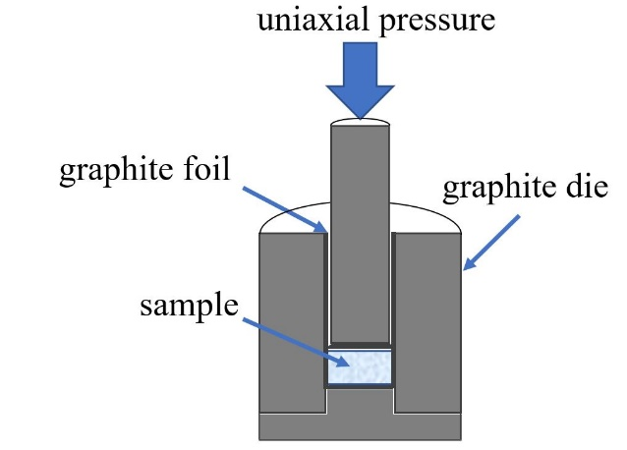
Figure 2-3 Visual representation of the cross-section of a loaded graphite die used for hot uniaxial pressing.

Table 5 Summary of hot-pressing conditions and resultant densities for single phase samples for the investigated spinel compositions.
Sample | Archimedes Density | % Theoretical Density | Hot pressing conditions
MgAl₂O₄ | 3.1664 g/cm³ | 88% | 1100°C, flowing argon
MgAl₂O₄ | 3.5187 g/cm³ | 98% | 1400°C, vacuum
(Mg_{1/5}Ni_{1/5}Co_{1/5}Cu_{1/5}Zn_{1/5})Al₂O₄ | 3.9973 g/cm³ | 93% | 1100°C, flowing argon

X-ray Diffraction Techniques

All x-ray diffraction experiments were conducted using a Malvern PANalytical Empyrean diffractometer with a Cu-source and a PIXcel^{3d} area detector. X-ray diffraction was used to verify phase formation and identify the crystal structure(s) of the synthesized materials. High temperature X-ray diffraction (HTXRD) measurements were performed with an Anton Paar HTK 1200N high temperature furnace and allowed for investigation into the phase formation and thermal stability of a few selected HEO materials.
Kinetic Studies: This experimental setup provided both a stable and controlled environmental chamber that, coupled with rapid data collection on heating, can capture both dynamic and static phase transformations. When collecting diffraction data, the compromise between intensity and resolution are weighed and decisions made for data collection parameters. For in-situ measurements data can be collected as quickly as 30 seconds, however, rapid data collection sacrifices data quality. Sample quality (including disorder effects, apparent in HEO’s) make such a rapid data collection ill advised, and the time required for data collection for each unique sample is evaluated when such in-situ experiments are performed. For kinetic studies, in order to gain information on the phase formation mechanisms within the HEO materials, data were collected between 28-38° 2θ with a 0.026° step size, and four-minute scans were performed continuously while ramping from 25 °C to the dwell temperature, at a heating rate of 1.7 °C/min. For isothermal experiments, the temperature was then held at the dwell temperature for several hours while continually collecting.
Thermal stability: Samples’ thermal stability and lattice expansion with temperature were also investigated with HTXRD techniques. Full range 10-90° 2θ scans were performed when the sample reached each set temperature. Using Rietveld refinement techniques after data collection with the GSASII package [47], lattice parameters can be determined and plotted as a function of temperature with a linear or polynomial fit performed to determine the thermal expansion behavior. In addition, the collected diffraction spectra enable phase stability analysis at high temperatures.

Scanning electron microscopy

Microscopy of the sample surfaces was performed using a ZEISS EVO scanning electron microscope (SEM) with Bruker xFlash 6130 energy dispersive X-ray spectrometer (EDXS). SEM images were used to gain information about the microstructure and grain sizes of polycrystalline samples and to look powder morphology.

Thermal Analysis

………………..Add stuff here…………..

Magnetometry

High-temperature magnetometry measurements from 300–850 K were performed using a Quantum Design VersaLab with vibrating sample magnetometer (VSM), while low-temperature measurements 3–300 K were performed with a Quantum Design Magnetic Property Measurement System (MPMS) with VSM. The low-temperature magnetization sequence was performed in the following method on rounded pieces from polycrystalline pellets [48]. For the zero-field- cooled (ZFC) measurement the sample was cooled in a zero field from room temperature. The magnetic field was then applied and the magnetization is measured as a function of temperature in warming. The field-cool-cooling (FC) curve is then obtained from measuring the magnetization while cooling to low temperature in the same field. With the same field still applied the field-cooled-warming (FW) curve is obtained from then measuring magnetization while warming from low temperatures back up. The material’s magnetic moment was measured both as a function of temperature and as a function of applied magnetic field.

Resonant Ultrasound Spectroscopy

Resonant ultrasound spectroscopy (RUS) utilizes the mechanical resonances of a material and the sample dimensions to “match” the resonances experimentally collected to a calculated spectrum using a nonlinear optimization procedure to fit the full elastic tensor of the material [49], [50]. In a typical RUS experimental set-up, a specimen is lightly held between an exciting and receiving piezoelectric transducer as shown in the schematic on the left in Figure 2-4. A frequency generator produces an electromagnetic wave that is sent to one transducer, which is then converted into a mechanical wave that travels through and is converted back into an electrical signal through the second transducer. The frequency is swept, typically between 100kHz and 2 MHz, and the sample’s response is recorded, as shown with a representative spectrum collected on hot pressed MgAl₂O₄ in the right portion of Figure 2-4. Large responses are detected when the frequency corresponds to sample’s eigenfrequency. The resonance position in terms of frequency value is dependent on the sample’s dimensions, density, and elastic moduli.

While other methods exist for determining a material’s elastic properties, the main advantages of RUS, other than being non-destructive, are its high precision and sensitivity. The Young’s modulus and bulk modulus are calculated from the RUS output for longitudinal (c11) and shear (c44) moduli. Using the elastic constant relations values can be calculated and compared to those in literature.

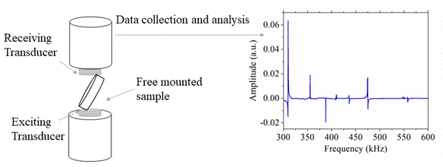
Figure 2-4 Visual schematic of resonant ultrasound spectroscopy measurement and resultant spectra.

Material charactarization Results and discussion

Single Phase verification and elemental homogeneity

Spinel
Add stuff…..

Perovskite
Add stuff…..

Ruddlesden-Popper
Add stuff…..

Magnetic Properties- Spinels
A version of this chapter was originally published by Brianna L. Musicó, Quinton Wright, Thomas Zac Ward, Alexander Grutter, Elke Arenholz, Dustin Gilbert, David Mandrus, and Veerle Keppens. The results and discussion portions from this paper have been stated in this section.
B. Musicó, Q. Wright, T. Z. Ward, A. Grutter, E. Arenholz, D. Gilbert, D. Mandrus, and V. Keppens: Tunable magnetic ordering through cation selection in entropic spinel oxides. Phys. Rev. Mater. 3(10), 104416 (2019).
Samples were synthesized by Brianna L. Musicó and Quinton Wright. Magnetic measurements were performed by Brianna L. Musicó. X-ray absorption spectroscopy with x-ray magnetic linear dichroism performed by Dustin Gilbert at Advanced Light Source (ALS) on Beamline 4.0.2 with the help of Alexander Grutter and Elke Arenholz. Alexander Grutter, Dustin Gilbert, David Mandrus, Veerle Keppens, Thomas Zac Ward, and Brianna L. Musicó all contributed to the result discussion. The final compilation, editing, and organization of findings done by Brianna L. Musicó.

Ferritic spinels: high temperature magnetic behavior

This section focuses on the effect of multicomponent composition on the magnetic properties. Ferrite spinels with a structure (X²⁺)(Fe³⁺)₂O₄, typically have the B-site ions antiferromagnetically coupled with no net magnetization, while the unpaired electrons on the A-site ion order collinear relative to the B-site ions. This interaction between A-site and B-site cations gives rise to Neel Ferrimagnetism, collinear spins, with net magnetization sensitivity to the cation distribution over the sites. The A-site ion, having no canceling partner, contributes to the observed magnetism of the ferrite. Introducing highly disordered A-site occupancy will naturally setup a local distribution in the magnetization. Complicating this picture is the change in occupancy of the A-site ions when substituting the Fe³⁺ ions causing an imbalance in the antiferromagnetism, generating an additional magnetic moment. This is known to occur when the A-site ion is small, as is the case for the elements Mg and Zn. In ferritic spinels these such additions are known to increase the magnetization, due to its preference of tetrahedral site occupancy and the resultant change in the net magnetic moment, and decrease the transition temperature [51]–[54]. Furthermore, the filled s and d-shells of Mg and Zn means they do not contribute to the magnetism, maximizing the asymmetry, but also causing a reduction in the Néel Temperature, T_{N}. Indeed, the HEOs incorporating both Zn and Mg show the largest moment and have the lowest T_{N} relative to the other HEOs, as shown in Figure 3-1 (a). The ferrites with only Mg show the next-largest saturation moment and a higher T_{N,} where T_{N} is the high temperature ferrimagnetic to paramagnetic transition temperature. Finally, the ferrite without either Mg or Zn has the smallest moment, but also a lower T_{N}. This indicates some site preference trends are maintained. These results emphasize the crucial role played by the antiferromagnetic ordering on the B-site, in that even fractional substitution causes significant changes in T_{N}. This sentiment is further emphasized in the HEO without a preferred B-site occupancy, which shows a significantly suppressed T_{N} and magnetic moment. The room temperature magnetization with magnetic field measured on each of the HEOs were measured at 300 K and are presented in Figure 3-1 (b). These measurements show a narrow coercivity for each of the samples, with saturation fields of >4 kOe (1 kOe = 0.1 T). The hysteretic behavior confirms the ferrimagnetic behavior expected for these materials. The large saturation field may indicate local regions that are mutually antiferromagnetically coupled or possess large magnetocrystalline anisotropy.

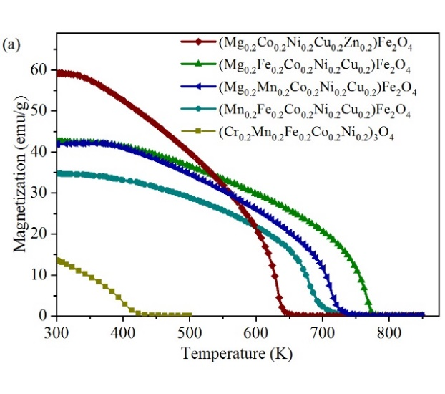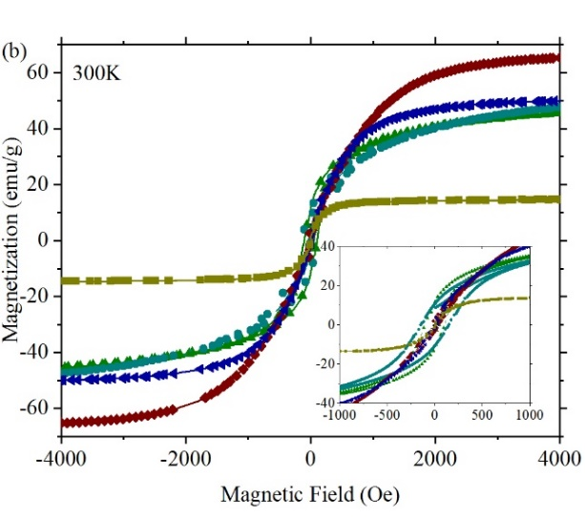
Figure 3-1 (a) Field cooled magnetization of ferritic HEO spinels from 300 K – 850 K with applied field of 1000 Oe and (b) magnetization as a function of applied field at 300 K with inset showing hysteretic behavior (1 emu = 10⁻³ Am²). The legend applies to both.

Ferritic spinels: low temperature magnetic behavior
Magnetometry measurements performed on (Cr_{0.2}Mn_{0.2}Fe_{0.2}Co_{0.2}Ni_{0.2})₃O₄ are shown in Figure 3-2. The ZFC plot shows a series of inflections, potentially indicating the onset of ordering of various regions within the sample. The direct exchange interaction, which exists only between two neighboring atoms, is intrinsically localized. Specifically, statistical fluctuations may cause regions to be particularly rich in a specific element at a local level, resulting in a localized variation in T_{N}. Alternatively, local atomic regions particularly rich in Cr or Mn may possess an antiferromagnetic to ferromagnetic transition, resulting from their negative exchange coupling with the other constituent elements. This hypothesis is further supported by the FC and FW plots in Figure 3-2(a) which show a peak in the plot at 230 K, where the magnetization is in-fact decreasing with decreasing temperature, and by the small magnetization in this sample shown in Figure 3-1(a). Magnetic hysteresis loops were also measured and show an increase in coercivity with decreasing temperature – as would be expected for thermally activated reversal. However, the scale of the coercivity’s thermal dependence is notable for a bulk material, increasing from 20 Oe at 300 K to 197 Oe at 50 K. This is likely a consequence of the large site-specific T_{N}, resulting from the compositional distribution.
Figure 3-3 shows the low temperature magnetization of two ferrite-based HEO spinels, (Mg_{0.2}Mn_{0.2}Co_{0.2}Ni_{0.2}Cu_{0.2})Fe₂O₄ and (Mg_{0.2}Fe_{0.2}Co_{0.2}Ni_{0.2}Cu_{0.2})Fe₂O₄, revealing interesting magnetic behavior with (i) the FW data dipping below the FC plot, and (ii) a reduction in magnetization with decreasing temperature. Inset plots are provided to emphasize the cross-over and hysteresis in the FC and FW plots. This again could be due to an antiferromagnetic coupling between neighboring elemental components. These minority phases may be frozen upon cooling, and persist upon warming, exhibiting a thermal hysteresis, and explaining the crossover.

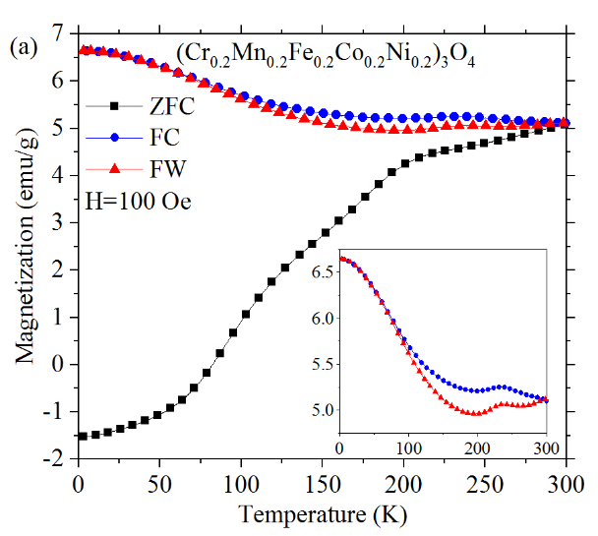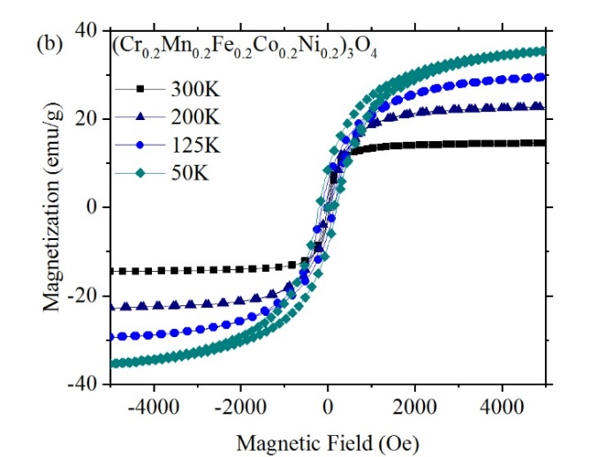

Figure 3-2 DC magnetization for (Cr_{0.2}Mn_{0.2}Fe_{0.2}Co_{0.2}Ni_{0.2})₃O₄ (a) with temperature from 3 K - 300 K showing the ZFC, FC, and FW plots with applied field of 100 Oe; and (b) magnetic hysteresis loops measured at 300K, 200K, 125K, and 50K.

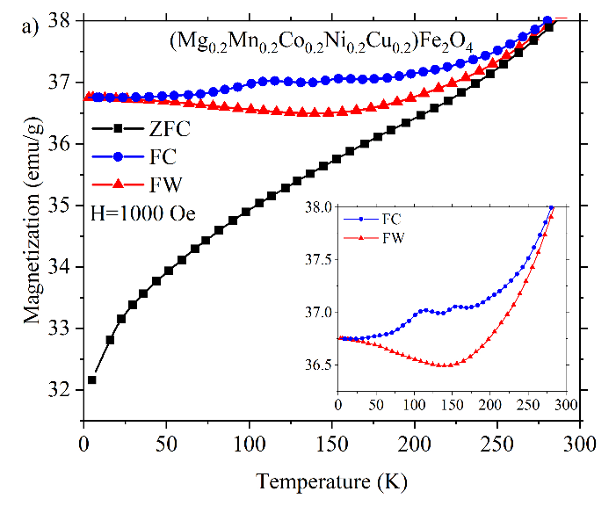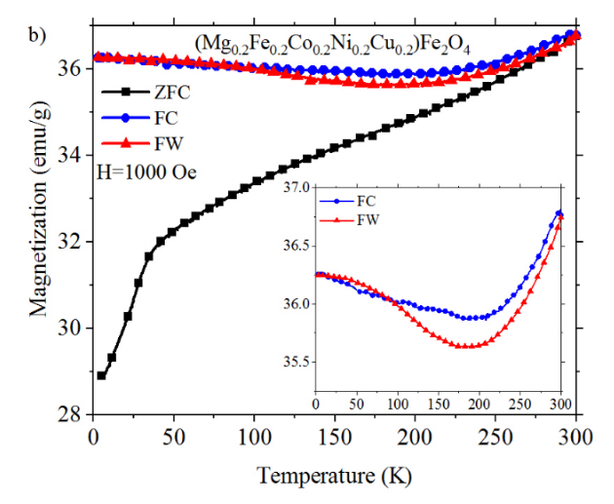
Figure 3-3 DC magnetization as a function of temperature from 3 K – 300 K showing the ZFC, FC, and FW measured at 1000 Oe, for (a) (Mg_{0.2}Mn_{0.2}Co_{0.2}Ni_{0.2}Cu_{0.2})Fe₂O₄ and (b) (Mg_{0.2}Fe_{0.2}Co_{0.2}Ni_{0.2}Cu_{0.2})Fe₂O₄.

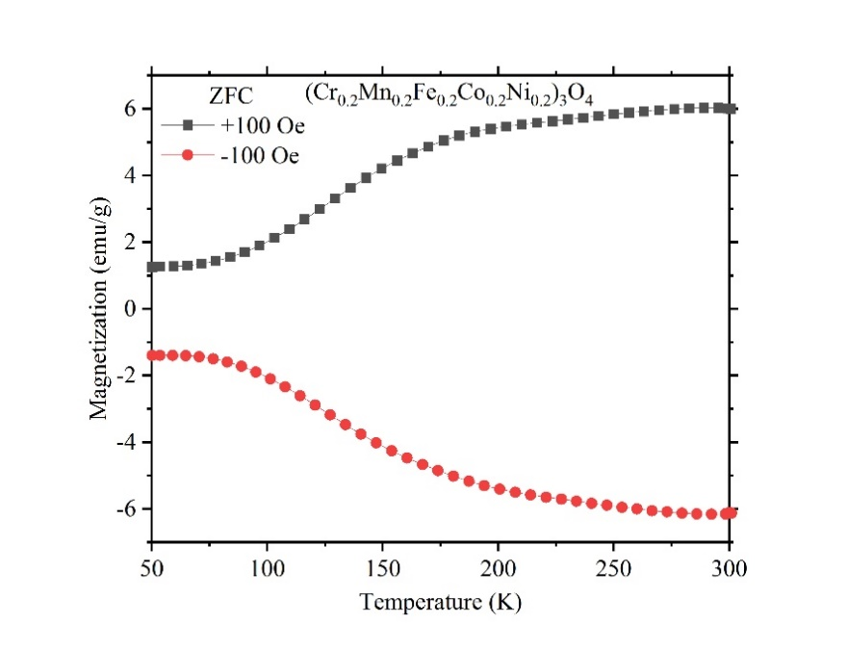
Figure 3-4 Zero-Field Cooled Magnetization vs Temperature of (Cr_{0.2}Mn_{0.2}Fe_{0.2}Co_{0.2}Ni_{0.2})₃O₄ in both a positive field (+100 Oe) and negative field (-100 Oe) performed on a Quantum Design VersaLab with VSM.

Chromium based spinels: low temperature magnetic behavior
While the ferrite spinels show features typical of ferro – or ferri – magnetic behavior, the chrome-based spinels are notably different. The ZFC magnetization versus temperature for the chromates, shown in Figure 3-5, increases from low temperatures and approaches a maximum before decreasing upon further increasing temperatures. This feature is well known and associated with superparamagnetic behavior, with the maximum called the blocking temperature (T_{B}) [55]. Superparamagnetism arises due to the magnetic interaction volume and anisotropy being smaller than the thermal fluctuations. Thus, the presence of a blocking temperature indicates that the magnetic regions within the sample are small and relatively isolated. Estimating that the magnetic anisotropy is approximately similar to ferrite spinels (18.7×10⁻³ J/m³), the diameter of the magnetic regions can be estimated as ≈7.3 nm [56]. The FC data shows an increase in the magnetization with increasing field, which is not typical for superparamagnetic materials, but simply indicates that there may be some residual regions with antiferromagnetic ordering at room temperature.
The magnetization curves in Figure 3-5 (a), (b), and (c) show slight dips approaching T_{B} as well as different character at the antiferromagnetic onset approaching T_{N}. There is also a field dependence seen in the magnetization curves. This could be explained by ferromagnetic contributions to the lattice. This was noted as a possible factor in the recent HEO perovskite magnetic investigation where small ferromagnetic contributions are distinguished amidst predominantly antiferromagnetic behavior possibly due to small ferromagnetic clusters or configurations within the antiferromagnetic matrix [10]. In a disordered material, especially ones such as these with multiple magnetic constituents, homogeneity at the atomic level is not assumed. Local variations could give rise to small ferromagnetic clusters, small pockets of slightly differently ordered spins within a larger overall ordering. Ferrimagnetic contributions are further supported by the mirror-like symmetry in the FC- ZFC behavior in (Mg_{0.2}Mn_{0.2}Co_{0.2}Ni_{0.2}Cu_{0.2})Cr₂O₄ shown in Figure 3-5 (b) as this symmetry is typical for materials containing a ferromagnetic component [57]. The inverse susceptibility of (Mg_{0.2}Co_{0.2}Ni_{0.2}Cu_{0.2}Zn_{0.2})Cr₂O₄ shown in the inset of Figure 3-5 (c) shows more classical Curie-Weiss-like behavior, with low-temperature antiferromagnetic ordering at T_{N} =36 K. The blocking temperatures can be identified at 100 Oe and 1000 Oe to be ≈38.1 K and ≈39 K for (Mg_{0.2}Co_{0.2}Ni_{0.2}Cu_{0.2}Zn_{0.2})Cr₂O₄, ≈69 K and ≈112.2 K for (Mg_{0.2}Fe_{0.2}Co_{0.2}Ni_{0.2}Cu_{0.2})Cr₂O₄, and ≈102.2 K and ≈69 K for (Mg_{0.2}Mn_{0.2}Co_{0.2}Ni_{0.2}Cu_{0.2})Cr₂O₄, respectively.
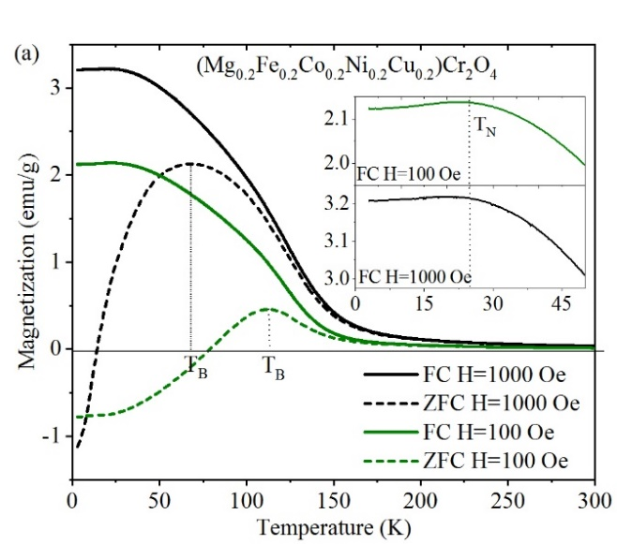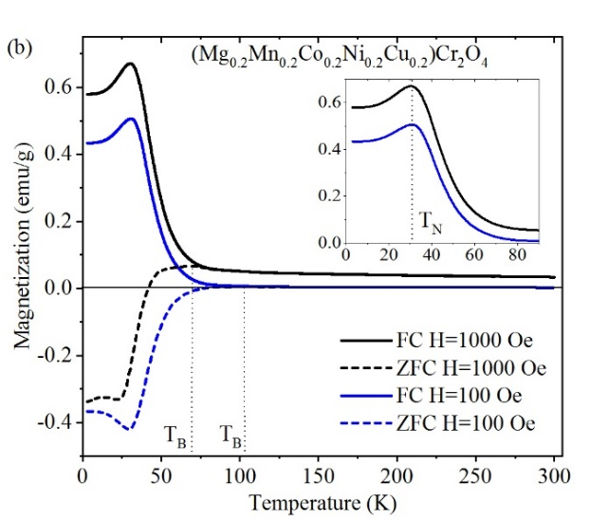
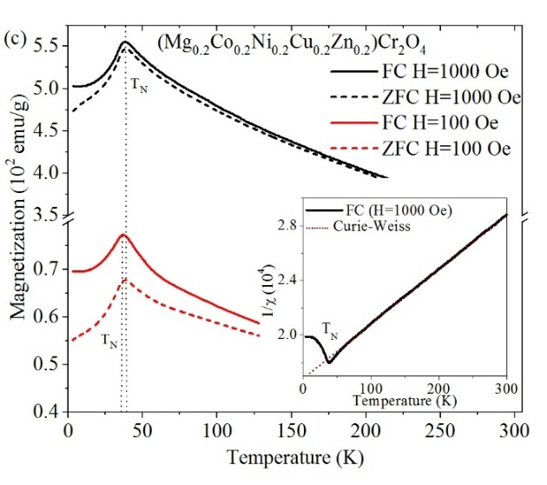
Figure 3-5 Low temperature DC magnetization from 3 K – 300 K under 100 Oe and 1000 Oe for (a) (Mg_{0.2}Fe_{0.2}Co_{0.2}Ni_{0.2}Cu_{0.2})Cr₂O₄, (b) (Mg_{0.2}Mn_{0.2}Co_{0.2}Ni_{0.2}Cu_{0.2})Cr₂O₄ and (c) (Mg_{0.2}Co_{0.2}Ni_{0.2}Cu_{0.2}Zn_{0.2})Cr₂O₄.

Magnetization versus magnetic field for (Mg_{0.2}Fe_{0.2}Co_{0.2}Ni_{0.2}Cu_{0.2})Cr₂O₄ and (Mg_{0.2}Mn_{0.2}Co_{0.2}Ni_{0.2}Cu_{0.2})Cr₂O₄ was measured using a Quantum Design Physical Property Measurement System (PPMS) DynaCool with VSM. Hysteresis of (Mg_{0.2}Fe_{0.2}Co_{0.2}Ni_{0.2}Cu_{0.2})Cr₂O₄ is shown in Fig. 7 and has a saturation field of ~5T at 30 K with the coercive force increasing towards 1.9 K, but without any changes in the saturation behavior. For (Mg_{0.2}Mn_{0.2}Co_{0.2}Ni_{0.2}Cu_{0.2})Cr₂O₄, there is a lack of saturation even at 9T fields. In Figure 3-7 an exchange bias is seen increasingly at lower temperature. Increasing coercivity with decrease in temperature is indicative of thermally activated reversal and was expected, however at lower temperature the coercivity diverges and narrows as depicted by the behavior at 1.9 K. Just as seen in Figure 3-6, in Figure 3-7 there is no decrease in the magnetic saturation which in this case would have been expected to occur in correlation with the coercivity divergence. These behaviors could indicate more complex changes in the ordering at the transitions identified in Figure 3-5. Exchange coupling as well as small localized antiferromagnetic contributions and antiferromagnetic stability could be contributing to an increase in coercivity. In a recent study on (Mg_{0.25(1-x)}Co_{x}Ni_{0.25(1-x)}Cu_{0.25(1-x)}Zn_{0.25(1-x)})O heterostructures with changes in Co concentration, anisotropic magnetic exchange and the presence of a critical blocking temperature was observed, indicating antiferromagnetic order with composition changes tuning the disorder, exchange field and magnetic anisotropy [58]. Magnetization with magnetic field plots for (Mg_{0.2}Ni_{0.2}Co_{0.2}Cu_{0.2}Zn_{0.2})Cr₂O₄, (Mg_{0.2} Mn_{0.2}Co_{0.2} Ni_{0.2}Cu_{0.2})Fe₂O₄ and (Mg_{0.2} Fe_{0.2}Co_{0.2} Ni_{0.2}Cu_{0.2})Fe₂O₄ are provided in Figure 3-8 and Figure 3-9 [59].
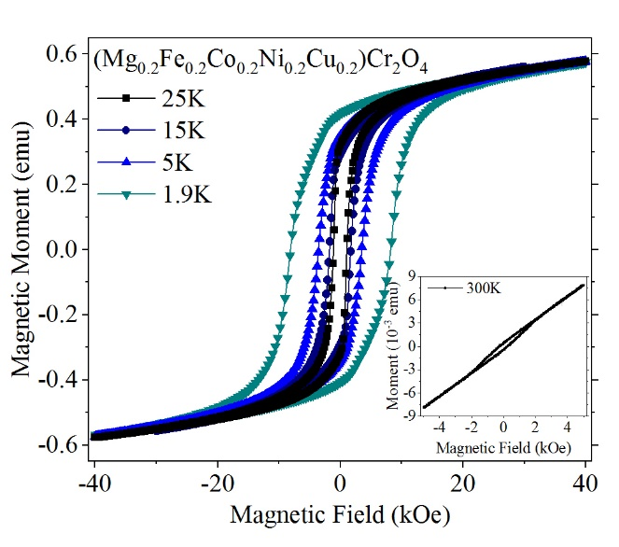

Figure 3-6 The hysteresis plots at 25 K, 15 K, 5 K and 1.9 K for (Mg_{0.2}Fe_{0.2}Co_{0.2}Ni_{0.2}Cu_{0.2})Cr₂O₄ with inset showing behavior at 300 K.

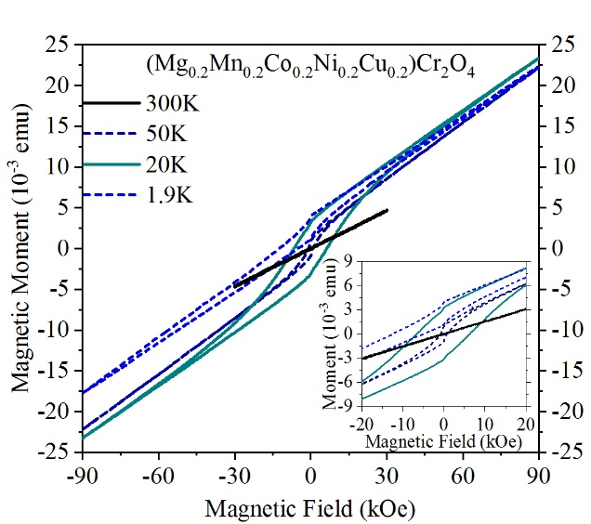
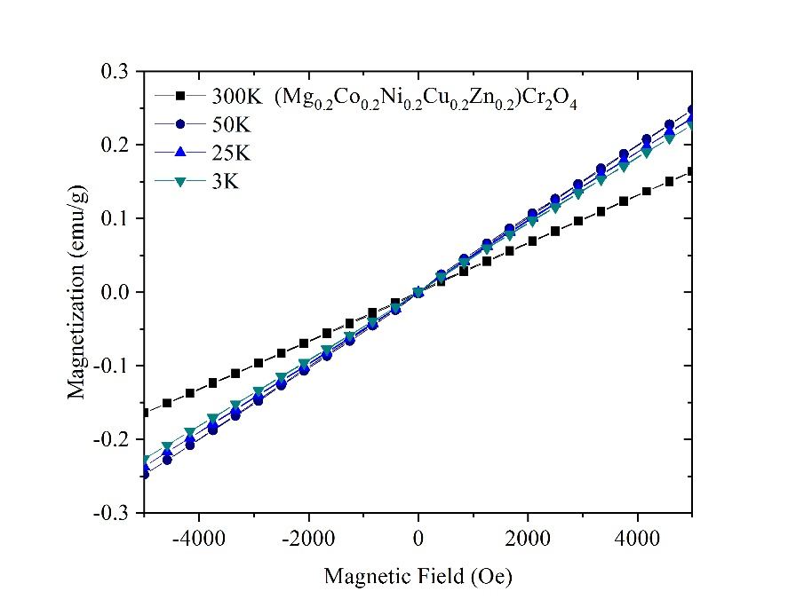
Figure 3-7 Magnetization with Field of (Mg_{0.2}Mn_{0.2}Co_{0.2}Ni_{0.2}Cu_{0.2})Cr₂O₄ at 300 K, 50 K, 20 K, and 1.9 K with inset better showing hysteresis.
Figure 3-8 The magnetization with magnetic field behavior at 300K, 50K, 25K and 3K for (Mg_{0.2}Ni_{0.2}Co_{0.2}Cu_{0.2}Zn_{0.2})Cr₂O₄.

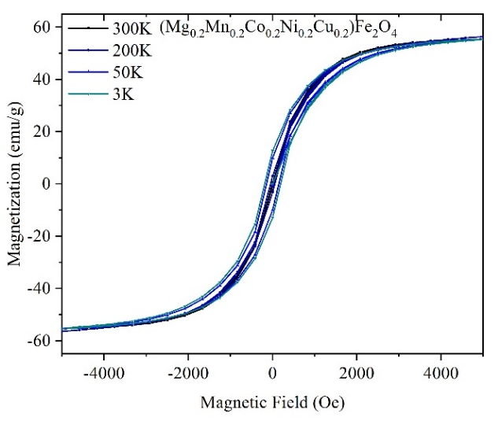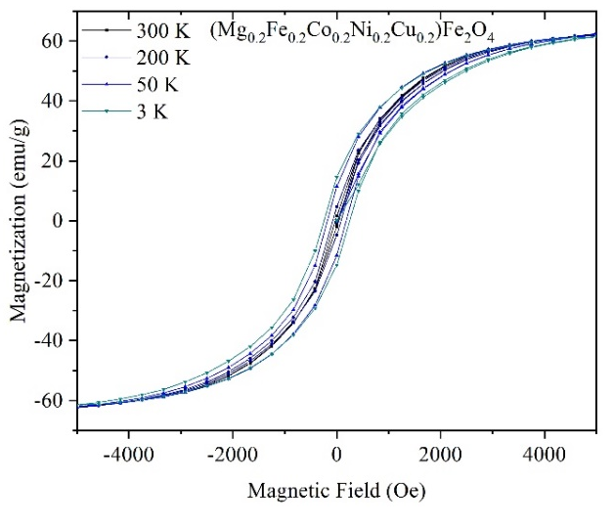
Figure 3-9 The magnetization with magnetic field behavior at 300K, 50K, 25K and 3K for (left) (Mg_{0.2}Mn_{0.2}Co_{0.2}Ni_{0.2}Cu_{0.2})Fe₂O₄ and (right) (Mg_{0.2}Fe_{0.2}Co_{0.2}Ni_{0.2}Cu_{0.2})Fe₂O₄ showing slight hysteresis.

Chromium based spinel First Order Reversal Curve

Add stuff…..

Magnetic Properties-Perovskites
Add stuff…..

Magnetic Properties- Ruddlesden-Popper cuprates
Add stuff…..

Thermal Analysis

Add stuff…..

Thermal Stability
Add stuff…..

Kinetic Analysis

A version of this chapter is to be published in a textbook chapter “Experimental Characterization of High Entropy Oxides with In-situ High Temperature X-Ray Diffraction Techniques” by Brianna L. Musicó, Cordell J. Delzer, John R. Salasin, Michael R. Koehler, and Claudia J. Rawn in the textbook:
Brechtl, J., Liaw, P.K. (2021). Fundamental Studies of High Entropy Materials. Manuscript in preparation for publication by Springer.

Selected portions from this chapter have been stated in this section. The introduction and background was written by Brianna L. Musicó and Claudia J. Rawn. Sample synthesis was performed by Brianna L. Musicó. Diffraction experiments were performed by Brianna l. Musicó and Michael R. Koehler. Background knowledge for experiment set up and design provided by John R. Salasin. Data analysis performed by Brianna L. Musicó and Cordell J. Delzer. Discussion and prospects written by Brianna L. Musicó and reviewed by Claudia J. Rawn.

Add some sort of intro

In-situ HTXRD results

In our study an HEO spinel composition (Mg_{0.2}Ni_{0.2}Co_{0.2}Cu_{0.2}Zn_{0.2})Al₂O₄ [24] is synthesized via the solid-state synthesis method and polymeric steric entrapment (PSE) in order to investigate and contrast the kinetic behavior. An additional HEO spinel composition, (Co_{0.2}Cr_{0.2}Fe_{0.2}Mn_{0.2}Ni_{0.2})₃O₄, made via solid-state synthesis was also studied. In an ideal situation, isothermal data would be used, resulting in fewer variables and making the subsequent kinetic analysis easier. However, in this type of in-situ data collection and analysis it should be expected that multiple data sets will be required to capture the necessary data for optimum evaluation. Often, with both solid-state and wet chemistry synthesis methods, the exact crystallization point is unknown unless other thermogravimetric or other temperature dependent measurements have been conducted. Even then, discerning the exact temperature at which to dwell to capture the phase’s crystallization can require multiple attempts. This is shown by the two ramping experiments for which data were collected on solid-state synthesized (Co_{0.2}Cr_{0.2}Fe_{0.2}Mn_{0.2}Ni_{0.2})₃O₄ and shown in Figure 3-10 as heatmaps. Figure 3-10 (a) shows the initial experiment where the data were collected on ramping to 1200 °C before dwelling at that temperature. The lower portion of these plots shows the data collected while ramping to the desired temperature and the upper portion of these plots shows data collected at the dwelling temperature (isothermal). During both the ramping and isothermal experiments, the data were recorded continuously. Figure 3 indicates that during the ramping experiment, crystallization of the spinel phase occurred at approximately 800ºC and prior to the dwell temperatures. This is denoted by the appearance of the marked (022), (113) and (222) reflections. Figure 3-10 (b) shows a subsequent experiment where the data were collected on ramping to 850°C, followed by a dwell. Even at this significantly lower temperature, the material crystallized prior to the dwell temperature, and there was not enough of a change in the degree of crystallinity, α, to determine kinetic information from these isothermal data. This illustrates a case where using non-isothermal data and master plots is valuable.
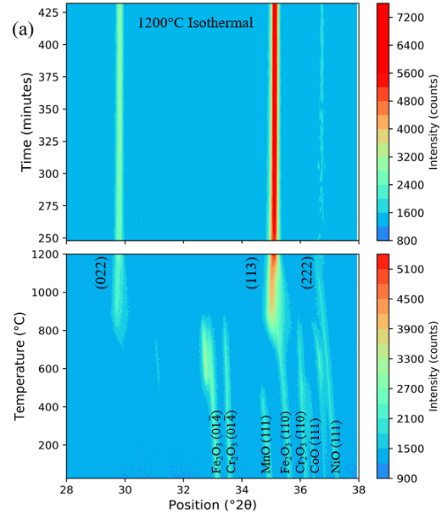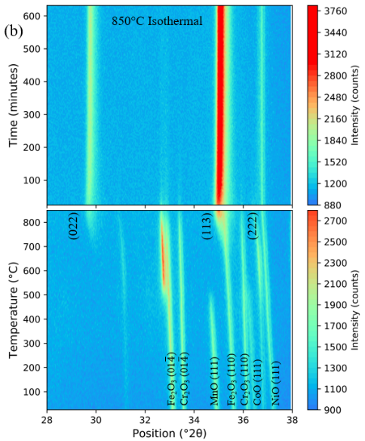
Figure 3-10 Heatmaps (temperature (°C) vs position (°2θ) and the intensity is shown in color) of the in-situ HTXRD data collected on solid-state synthesized (Co_{0.2}Cr_{0.2}Fe_{0.2}Mn_{0.2}Ni_{0.2})₃O₄ with both ramping experiments (lower) and subsequent dwell experiment (upper).
Isothermal experiments were performed on the PSE synthesized (Mg_{0.2}Ni_{0.2}Co_{0.2}Cu_{0.2}Zn_{0.2})Al₂O₄, and the results are shown in Figure 3-11. A maximum ramp rate was used to reach the target temperature before dwelling for two hours. In the case of the 400 °C experiment it took 8 minutes to reach temperature and start data collection; for the 600 °C experiment it took 10 minutes to reach temperature and start data collection. As seen in the plot, the samples showed evidence of initial crystallinity early in the experiments even with such fast ramping rates. While data were continually collected during the two-hour dwell, only the last scan of the dwell is plotted. This indicates that there was not a considerable change in peak intensity for the isothermal experiments, especially when compared to the change between initial and final measurement during the ramping experiment. This slight change in peak area was not enough to gain significant information about the kinetic behavior from the isothermal runs. The rapid crystalline formation was unexpected, and without further experimentation cannot be attributed to the disordered nature of the material, to a feature unique to this specific system and/or synthesis method, or to other factors.

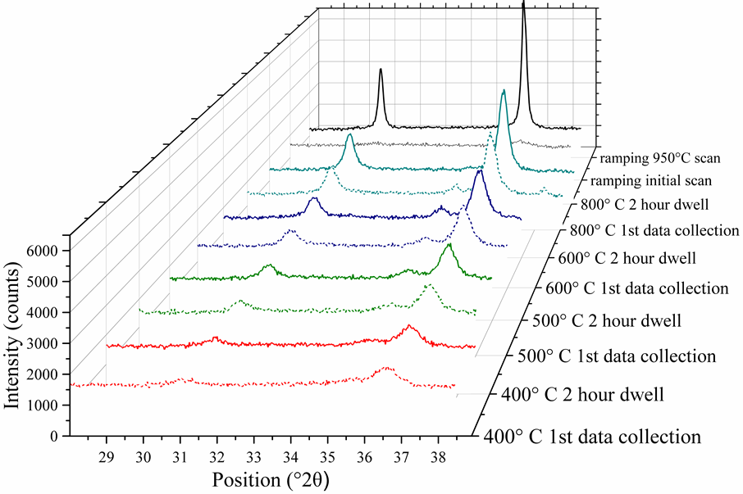

Figure 3-11 X-ray diffraction data for the initial and final scans of isothermal measurements of PSE synthesized (Mg_{0.2}Ni_{0.2}Co_{0.2}Cu_{0.2}Zn_{0.2})Al₂O₄ samples measured at varying temperature compared to data collected at 950°C during a ramping temperature dependent run.
Isothermal data analysis is not only easier for kinetic, but also required to determine information such as the activation energy. Although not obtainable from the experimental data collected in this work, the steps for this determination are described. The Avrami behavior is the first step and can be given by the following modified equations:

$α=1-e^{{-(k_{a}t)}^{n}}$ (12)

$\ln\left[-\ln\left(1-α\right)\right]=n\ln{k_{a}}+n\ln{t}$ (13)

where α is still the fraction transformed, k_{a} is the rate constant, and n is the reaction mechanism [60]. Note, Eq. 13 was previously seen in a slightly different form in Eq. (4) but is restated here for convenience. The rate constant is dependent on the growth and nucleation and is thus susceptible to temperature. The value of n gives information on the dimensionality of crystalline transformation and whether it is lineal, plate-like, or polyhedral [61]. The information learned from the value of n can tie into the dimensionality of the behavior followed when further kinetic calculation is performed and plotted over the master plot. When $\ln\left[-\ln\left(1-α\right)\right]$ is plotted versus $\ln{t}$, the slope is n and the y-intercept is $n\ln{k_{a}}$. An Arrhenius plot can then be made by plotting $\ln{k_{a}}$ versus 1/T and the activation energy E_{a} determined from the linear slope, where the slope is E_{a}/R and R is the gas constant. Note that this requires the collection of isothermal data at multiple temperatures in order to generate a sufficient Arrhenius plot from the information learned from the Avrami plot. This E_{a} can then be used as a comparative value for different regions of kinetic trends [62], or for subsequent calculations.

Determining kinetic behavior from time and temperature dependent data

The master plots, described in 1.5 Kinetic theory, can be used for analyzing both isothermal and non-isothermal using the methods described by the following series of equations which are further explained in the work by Gotor et al. [33]. The amount transformed, α, can be determined from the experimental data and used in the relationship shown in Equation 14.

$\frac{dα/dθ}{{dα/dθ}_{α=0.5}}=\frac{dα/dt}{{dα/dt}_{α=0.5}}\frac{exp⁡(\frac{E}{RT})}{{exp⁡(E/RT}_{0.5})}$ (14)

The generalized time is used to determine the kinetic rate equation at infinite temperature, given in Equation 15, where θ denotes the reaction time taken to obtain a given α at infinite temperature.

$θ=\int_{0}^{t}{\exp\left(-\frac{E}{RT}\right)dt}=\frac{E}{βR}\int_{x}^{∞}{\frac{exp⁡(-x)}{x^{2}}dx=\frac{E}{βR}p(x)}$ (15)

Using the expansion given in Equation 15, where x=E/RT and β is the linear heating rate, the function p(x) is defined in an open form using Equations 16 and 17 in order to obtain the value of $θ/θ_{0.5}$ given by Equation 18.

$p\left(x\right)=\frac{e^{-x}}{x}π(x)$ (16)

$π\left(x\right)=\frac{x^{3}+18x^{2}+86x+96}{x^{4}+20x^{3}+120x^{2}+240x+120}$ (17)

$\frac{θ}{θ_{0.5}}=\frac{p(x)}{p(x_{0.5})}$ (18)

As shown in Equations 15-18, the activation energy E is required for determining the reaction mechanism from linear non-isothermal data. This interdependence of the kinetic model with these parameters is a drawback and why, as mentioned earlier, isothermal data is ideal for further analysis as well as necessary to obtain the actual value for E. In the case of this study it was found that while the exact value could not be experimentally determined or calculated for these systems it was not vital. Changing the order of magnitude of the value used did not cause any significant alteration, and the kinetic behavior that the data best followed did not shift.
The experimental data can then be analyzed by plotting $\frac{θ(\frac{dα}{dθ})}{θ_{0.5}{(\frac{dα}{dθ})}_{α=0.5}}$ as a function of α over the master plot given by Figure 1-4 (d). An example of this analysis is provided using the ramping data collected up to 1200 ºC on the solid-state synthesized (Co_{0.2}Cr_{0.2}Fe_{0.2}Mn_{0.2}Ni_{0.2})₃O₄. The previously collected data (Figure 3-10 (a)) is shown again in Figure 3-12 (a) with the formation and crystallization of the desired phase denoted by the red dashed outline. It is preferable to utilize the highest intensity peak in this analysis, however, as in the example presented here, this is not always the best option. It would be difficult to separate the characteristic peaks belonging to the transformed phase from characteristic peaks indicative of the precursor or untransformed phase(s). Two examples of this difficulty can be found in Figure 3-12 (a), namely the close spatial relation of the transformed (222) peak to the precursor NiO (111) peak and of the transformed (113) peak to the precursor Fe₂O₃ (110) peak. In laboratory XRD experiments, compromises are often made between data collection time, intensity, and resolution. Minimizing data collection time is vital for kinetic investigations of rapidly-changing systems, maximizing intensity helps reduce noise and ensure an accurate modeling of the peaks, and maximizing resolution helps in the differentiation of peaks located at similar values of 2θ. If we were to optimize resolution in this example to avoid the problems of spatial resolution outlined above, data collection time and intensity would need to be sacrificed, which would create new difficulties. Fortunately, the (022) peak was not spatially obscured within the transformation range by precursor peaks for the solid state synthesized (Co_{0.2}Cr_{0.2}Fe_{0.2}Mn_{0.2}Ni_{0.2})₃O₄ and (Mg_{0.2}Ni_{0.2}Co_{0.2}Cu_{0.2}Zn_{0.2})Al₂O₄ samples, so the need to optimize resolution to the detriment of data collection time and intensity could be avoided by selecting this peak for analysis. Using the (022) reflection for SSS (Co_{0.2}Cr_{0.2}Fe_{0.2}Mn_{0.2}Ni_{0.2})₃O₄, $\frac{θ(\frac{dα}{dθ})}{θ_{0.5}{(\frac{dα}{dθ})}_{α=0.5}}$ is calculated and plotted over the f(α)g(α)/f(0.5)g(0.5) master plot and given in Figure 3-12 (b). This shows a distribution following either the An or Rn mechanism and does not appear to be diffusion controlled.

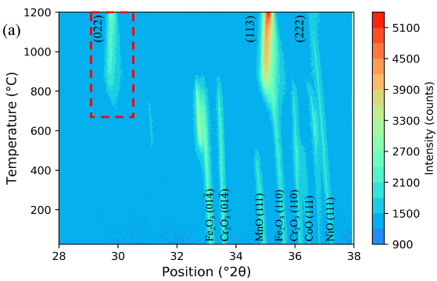
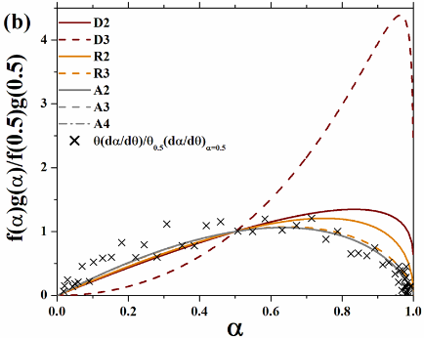
Figure 3-12 (a) The heatmap of the in-situ HTXRD data collection performed on solid-state synthesized (Co_{0.2}Cr_{0.2}Fe_{0.2}Mn_{0.2}Ni_{0.2})₃O₄. The red dashed box outlines the peak used for the calculations plotted on (b).

Comparison of synthesis method

The in-situ HTXRD data collection and analysis techniques described above can be utilized to compare the phase transformation behavior for different synthesis methods.
Figure 3-14 illustrates an example of this in (a) and (b) for (Mg_{0.2}Ni_{0.2}Co_{0.2}Cu_{0.2}Zn_{0.2})Al₂O₄ made via solid state synthesis (SSS) SSS and polymeric steric entrapment (PSE), respectively. The data is plotted in the 28-38 °2θ range as a heat map with the polymeric steric entrapment precursor material plot starting at 250°C since the material was previously heat treated up to this temperature in calcining. The SSS (Mg_{0.2}Ni_{0.2}Co_{0.2}Cu_{0.2}Zn_{0.2})Al₂O₄ sample, similar to the SSS (Co_{0.2}Cr_{0.2}Fe_{0.2}Mn_{0.2}Ni_{0.2})₃O₄ discussed above, the individual metal oxides transform into a single-phase solid solution spinel. This phase transformation initiates around 1000 °C, whereas the crystallization of the PSE sample from an amorphous state begins to appear at a significantly lower temperature, near 500 °C. Besides the difference in transformation temperature, another notable variance is the peak shape of the (022) and (113) reflections. There is an increase in the peak broadening for the PSE sample when compared to that of the SSS (Mg_{0.2}Ni_{0.2}Co_{0.2}Cu_{0.2}Zn_{0.2})Al₂O₄. This could be indicative of a higher degree of positional species disorder since the PSE method has the advantage of forming a more homogenous distribution of cations. However, there are several factors that contribute to peak broadening. These include disorder, micro strains (which can result from different size cations in different places), crystallite size variation, and a distribution in lattice parameters. To better understand the contributions to the difference in peak shape, as shown in
Figure 3-13, Rietveld refinements were performed using GSAS-II [47] on room temperature XRD scans of both PSE and SSS samples in the 10-90 °2θ range. The lattice parameters from refinement results were a=8.079(5) Å for PSE and a=8.059(1) Å for SSS. Crystallite size is estimated from the refined spectra using the Scherrer equation:
$D=\frac{Kλ}{FWHM cos⁡(θ)}$ (19)
where: $D=$crysallite size, $K=$ Scherrer constant = 0.94 for spherical crystallites with cubic symmetry, $λ=$ wavelength of x-rays= 1.54051Å for Cu-kα source, FWHM= full width at half maximum in $2θ$, and $θ=$ Bragg angle.
The crystallite sizes from the most intense peak, (113), are found to be 53.77 nm for polymeric steric entrapment synthesized powder and 139.03 nm for solid state powder. The average crystallite sizes for the entire 10-90 °2θ spectra are 55.52 nm and 101.79 nm for PSE and SSS, respectively. There is a considerable difference in crystallite size between the two synthesis methods, and while the smaller value for PSE is to be expected, this large difference can be an attributing factor to the difference seen in peak shape. The peak position in °2θ along with the full width at half maximum (FWHM) values for each are listed on the plots.
The degree of crystallinity, α, versus temperature for the (113) reflection of the PSE synthesized material given in Figure 3-14 (d) shows a classic sigmoidal shape. As seen in Figure 1-5, this is indicative of a JMAK (An) or geometric contraction (R) type behavior. This is further confirmed by the calculation of $\frac{θ(\frac{dα}{dθ})}{θ_{0.5}{(\frac{dα}{dθ})}_{α=0.5}}$ plotted in Figure 3-14 (f) which shows a distribution following the An and Rn mechanism on the f(α)g(α)/f(0.5)g(0.5) master plot. The SSS sample analysis from the (222) reflection has a different shape to the α plot given in Figure 3-14 (c). As corroborated by the overlay on the master plot in Figure 3-14 (e), this is suggestive of initially being diffusion controlled, but then switching to a JMAK or geometric contraction kinetic mechanism for the remainder.
Figure 3-13 Room temperature x-ray diffraction spectra comparing of the (113) reflection for (left) polymeric steric entrapment synthesized and (right) solid state synthesized (Mg_{0.2}Ni_{0.2}Co_{0.2}Cu_{0.2}Zn_{0.2})Al₂O₄ showing the difference is peak shape.
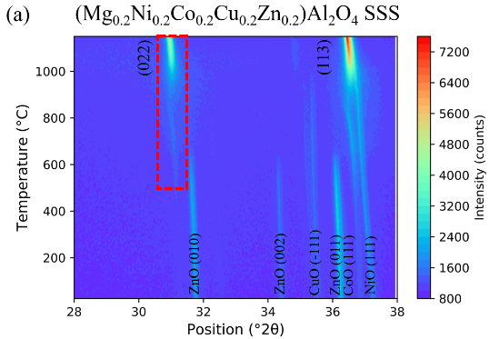
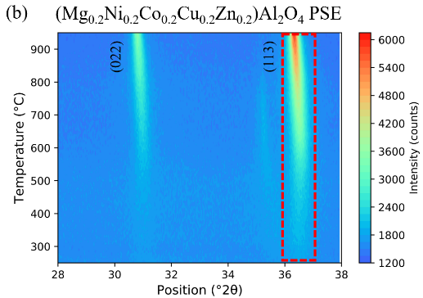

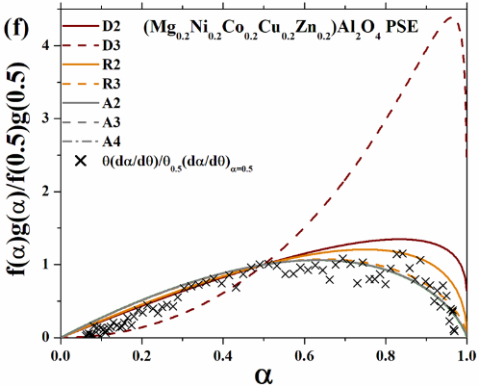
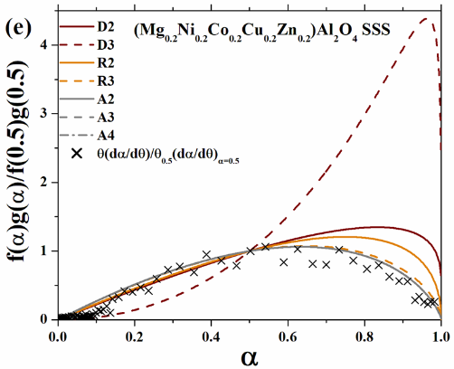

Figure 3-14 The heatmaps of the in-situ HTXRD samples made via (a) SSS and (b) PSE. Red dashed box outlines the peak used for the α with temperature plotted in (c) and (d) as well as the calculations from the experimental data over the master plot in (e) and (f).

In general, higher temperature provides more energy allowing for increasing diffusion, but the spontaneity of the switch to JMAK or R-type seen here is not yet well understood. Following the changes seen in Figure 3-14 (a), (c), and (e), the ZnO reflection disappears during the diffusion period, while it is not until after the CuO reflection begins to decrease in intensity that the JMAK or R-type behavior starts. This could be indicative of the diffusion limited into JMAK as the thermodynamics change being kinetically favorable. Typically, solid state synthesis is diffusion controlled and wet-chemistry based methods such as sol-gel synthesis and PSE are JMAK controlled and therefore have lower crystallization temperatures. This difference in crystallization temperature is seen from the XRD phase analysis when comparing synthesis methods, but when looking at the kinetic analysis other differences can also be gleaned. While, as mentioned above, diffusion controlled kinetic mechanisms would be expected for solid state synthesis, the behavior seen for solid state synthesized (Co_{0.2}Cr_{0.2}Fe_{0.2}Mn_{0.2}Ni_{0.2})₃O₄ in Figure 3-12 indicates a JMAK type mechanism. For the solid state (Mg_{0.2}Ni_{0.2}Co_{0.2}Cu_{0.2}Zn_{0.2})Al₂O₄, this is not entirely the case as it initially follows diffusion controlled behavior. There is also a lower transition temperature at which the spinel phase forms for (Co_{0.2}Cr_{0.2}Fe_{0.2}Mn_{0.2}Ni_{0.2})₃O₄ when compared to solid state (Mg_{0.2}Ni_{0.2}Co_{0.2}Cu_{0.2}Zn_{0.2})Al₂O₄. As they have different compositions and arguably different degrees of disorder the exact contributions to these differences, whether it be kinetic mechanism, composition dependent, entropic contribution, or a mixture of these, cannot be ascertained. This does however provide an interesting avenue for thought and further study as the high entropy material field continues to be explored, and the experimental techniques and analysis provided in this work provide one such method for investigation.

Resonant ultrasound spectroscopy results
The complete elastic tensor is extracted by fitting 25 resonances and…add stuff….

Table 6 RUS fit results for (Mg_{0.2}Ni_{0.2}Co_{0.2}Cu_{0.2}Zn_{0.2})Al₂O₄ hot pressed pellet.
resonance | f _{measured} | f_{fitted} | %error | c11 dependence | c44 dependence
1 | 0.265534 | 0.264185 | -0.51 | 0 | 1
2 | 0.291939 | 0.292812 | 0.3 | 0.24 | 0.76
3 | 0.329593 | 0.327375 | -0.67 | 0.23 | 0.77
4 | 0.464095 | 0.464176 | 0.02 | 0.2 | 0.8
5 | 0.495586 | 0.496011 | 0.09 | 0.06 | 0.94
6 | 0.513997 | 0.514939 | 0.18 | 0.03 | 0.97
7 | 0.52734 | 0.527821 | 0.09 | 0.11 | 0.89
8 | 0.624956 | 0.622268 | -0.43 | 0.01 | 0.99
9 | 0.643355 | 0.644335 | 0.15 | 0.28 | 0.72
10 | 0.678071 | 0.673385 | -0.69 | 0.06 | 0.94
11 | 0.697086 | 0.696091 | -0.14 | 0.23 | 0.77
12 | 0.702722 | 0.701327 | -0.2 | 0.14 | 0.86
13 | 0.726866 | 0.724518 | -0.32 | 0.14 | 0.86
14 | 0.728734 | 0.729917 | 0.16 | 0.05 | 0.95
15 | 0.734158 | 0.733459 | -0.1 | 0.08 | 0.92
16 | 0.740877 | 0.741011 | 0.02 | 0.06 | 0.94
17 | 0.775673 | 0.780433 | 0.61 | 0.09 | 0.91
18 | 0.778328 | 0.780828 | 0.32 | 0.03 | 0.97
19 | 0.781542 | 0.784586 | 0.39 | 0.08 | 0.92
20 | 0.788478 | 0.786354 | -0.27 | 0.18 | 0.82
21 | 0.801587 | 0.80206 | 0.06 | 0.13 | 0.87
22 | 0.830273 | 0.830546 | 0.03 | 0.19 | 0.81
23 | 0.854682 | 0.855357 | 0.08 | 0.07 | 0.93
24 | 0.885993 | 0.887539 | 0.17 | 0.03 | 0.97
25 | 0.923474 | 0.929234 | 0.62 | 0.16 | 0.84
rms error | 0.3388%
C11 | 240.6 | GPa
C44 | 79.6 | GPa
Bulk modulus | 134.5 | GPa
Young’s modulus | 200 | GPa

Table 7 RUS fit results for MgAl₂O₄ hot pressed pellet.
resonance | f _{measured} | f_{fitted} | %error | c11 dependence | c44 dependence
1 | 0.135855 | 0.135542 | -0.23 | 0.05 | 0.95
2 | 0.136664 | 0.135542 | -0.82 | 0.05 | 0.95
3 | 0.210564 | 0.210167 | -0.19 | 0.57 | 0.43
4 | 0.268987 | 0.27018 | 0.44 | 0.06 | 0.94
5 | 0.270417 | 0.27018 | -0.09 | 0.06 | 0.94
6 | 0.309189 | 0.308351 | -0.27 | 0.01 | 0.99
7 | 0.309887 | 0.308351 | -0.5 | 0.01 | 0.99
8 | 0.355295 | 0.355622 | 0.09 | 0.18 | 0.82
9 | 0.355877 | 0.355622 | -0.07 | 0.18 | 0.82
10 | 0.387813 | 0.387501 | -0.08 | 0.39 | 0.61
11 | 0.387813 | 0.387501 | -0.08 | 0.39 | 0.61
12 | 0.40893 | 0.41138 | 0.6 | 0.06 | 0.94
13 | 0.40981 | 0.411382 | 0.38 | 0.06 | 0.94
14 | 0.436253 | 0.435625 | -0.14 | 0.64 | 0.36
15 | 0.474203 | 0.47281 | -0.29 | 0.02 | 0.98
16 | 0.47484 | 0.47281 | -0.43 | 0.02 | 0.98
17 | 0.54698 | 0.549852 | 0.53 | 0.19 | 0.81
18 | 0.549483 | 0.549852 | 0.07 | 0.19 | 0.81
19 | 0.551112 | 0.554155 | 0.55 | 0.05 | 0.95
20 | 0.551112 | 0.554155 | 0.55 | 0.05 | 0.95
21 | 0.557625 | 0.558614 | 0.18 | 0.3 | 0.7
22 | 0.558489 | 0.558621 | 0.02 | 0.3 | 0.7
23 | 0.602677 | 0.603255 | 0.1 | 0.32 | 0.68
24 | 0.616904 | 0.61474 | -0.35 | 0.04 | 0.96
rms error | 0.3630%
C11 | 316.4 | GPa
C44 | 101.5 | GPa
Bulk modulus | 180.9 | GPa
Young’s modulus | 257 | GPa

Conclusions and reccomendations
Add here….

List of References

[1] J. W. Yeh et al., “Nanostructured high-entropy alloys with multiple principal elements: Novel alloy design concepts and outcomes,” Adv. Eng. Mater., vol. 6, no. 5, pp. 299-303+274, 2004.
[2] B. Cantor, I. T. H. Chang, P. Knight, and A. J. B. Vincent, “Microstructural development in equiatomic multicomponent alloys,” Mater. Sci. Eng. A, vol. 375–377, no. 1-2 SPEC. ISS., pp. 213–218, 2004.
[3] E. P. George, D. Raabe, and R. O. Ritchie, “High-entropy alloys,” Nat. Rev. Mater., 2019.
[4] M. C. Gao, D. B. Miracle, D. Maurice, X. Yan, Y. Zhang, and J. A. Hawk, “High-entropy functional materials,” J. Mater. Res., vol. 33, no. 19, pp. 3138–3155, Oct. 2018.
[5] L. Sun and R. J. Cava, “High-entropy alloy superconductors: Status, opportunities, and challenges,” Phys. Rev. Mater., vol. 3, no. 9, p. 090301, Sep. 2019.
[6] N. Dragoe and D. Bérardan, “Order emerging from disorder,” Science (80-. )., vol. 366, no. 6465, pp. 573–574, Nov. 2019.
[7] D. B. Miracle and O. N. Senkov, “A critical review of high entropy alloys and related concepts,” Acta Mater., vol. 122, pp. 448–511, 2017.
[8] C. M. Rost et al., “Entropy-stabilized oxides,” Nat. Commun., vol. 6, no. 1, p. 8485, Dec. 2015.
[9] J. Gild et al., “High-Entropy Metal Diborides: A New Class of High-Entropy Materials and a New Type of Ultrahigh Temperature Ceramics,” Sci. Rep., vol. 6, no. October, pp. 2–11, 2016.
[10] J. Zhou, J. Zhang, F. Zhang, B. Niu, L. Lei, and W. Wang, “High-entropy carbide: A novel class of multicomponent ceramics,” Ceram. Int., no. August, pp. 0–1, 2018.
[11] R. Z. Zhang, F. Gucci, H. Zhu, K. Chen, and M. J. Reece, “Data-Driven Design of Ecofriendly Thermoelectric High-Entropy Sulfides,” Inorg. Chem., vol. 57, no. 20, pp. 13027–13033, 2018.
[12] X. Chen and Y. Wu, “High‐entropy transparent fluoride laser ceramics,” J. Am. Ceram. Soc., vol. 103, no. 2, pp. 750–756, Feb. 2020.
[13] T. Wen, H. Liu, B. Ye, D. Liu, and Y. Chu, “High-entropy alumino-silicides: a novel class of high-entropy ceramics,” Sci. China Mater., vol. 63, no. 2, pp. 300–306, Feb. 2020.
[14] M. Lorenz et al., “The 2016 oxide electronic materials and oxide interfaces roadmap,” J. Phys. D. Appl. Phys., vol. 49, no. 43, p. 433001, Nov. 2016.
[15] A. Sarkar et al., “High‐Entropy Oxides: Fundamental Aspects and Electrochemical Properties,” Adv. Mater., vol. 31, no. 26, p. 1806236, Jun. 2019.
[16] F. Otto, Y. Yang, H. Bei, and E. P. George, “Relative effects of enthalpy and entropy on the phase stability of equiatomic high-entropy alloys,” Acta Mater., vol. 61, no. 7, pp. 2628–2638, 2013.
[17] F. Otto et al., “Decomposition of the single-phase high-entropy alloy CrMnFeCoNi after prolonged anneals at intermediate temperatures,” Acta Mater., vol. 112, pp. 40–52, Jun. 2016.
[18] B. Schuh et al., “Mechanical properties, microstructure and thermal stability of a nanocrystalline CoCrFeMnNi high-entropy alloy after severe plastic deformation,” Acta Mater., vol. 96, pp. 258–268, Sep. 2015.
[19] A. D. Dupuy, X. Wang, and J. M. Schoenung, “Entropic phase transformation in nanocrystalline high entropy oxides,” Mater. Res. Lett., vol. 7, no. 2, pp. 60–67, Feb. 2019.
[20] A. Sarkar et al., “Rare earth and transition metal based entropy stabilised perovskite type oxides,” J. Eur. Ceram. Soc., vol. 38, no. 5, pp. 2318–2327, May 2018.
[21] K. Chen et al., “A five-component entropy-stabilized fluorite oxide,” J. Eur. Ceram. Soc., vol. 38, no. 11, pp. 4161–4164, Sep. 2018.
[22] R. Djenadic et al., “Multicomponent equiatomic rare earth oxides,” Mater. Res. Lett., vol. 5, no. 2, pp. 102–109, Mar. 2017.
[23] Z. Wu, H. Bei, F. Otto, G. M. Pharr, and E. P. George, “Recovery, recrystallization, grain growth and phase stability of a family of FCC-structured multi-component equiatomic solid solution alloys,” Intermetallics, vol. 46, pp. 131–140, Mar. 2014.
[24] B. Musicó et al., “Tunable magnetic ordering through cation selection in entropic spinel oxides,” Phys. Rev. Mater., vol. 3, no. 10, p. 104416, Oct. 2019.
[25] S. Jiang et al., “A new class of high-entropy perovskite oxides,” Scr. Mater., vol. 142, pp. 116–120, Jan. 2018.
[26] A. Sarkar et al., “Rare earth and transition metal based entropy stabilised perovskite type oxides,” J. Eur. Ceram. Soc., vol. 38, no. 5, pp. 2318–2327, May 2018.
[27] M. Pianassola, M. Loveday, J. W. McMurray, M. Koschan, C. L. Melcher, and M. Zhuravleva, “Solid‐state synthesis of multicomponent equiatomic rare‐earth oxides,” J. Am. Ceram. Soc., vol. 103, no. 4, pp. 2908–2918, Apr. 2020.
[28] D. Bérardan, S. Franger, D. Dragoe, A. K. Meena, and N. Dragoe, “Colossal dielectric constant in high entropy oxides,” Phys. status solidi - Rapid Res. Lett., vol. 10, no. 4, pp. 328–333, Apr. 2016.
[29] J. Dąbrowa et al., “Synthesis and microstructure of the (Co,Cr,Fe,Mn,Ni) 3 O 4 high entropy oxide characterized by spinel structure,” Mater. Lett., vol. 216, no. January, pp. 32–36, Apr. 2018.
[30] A. Sarkar et al., “Multicomponent equiatomic rare earth oxides with a narrow band gap and associated praseodymium multivalency,” Dalt. Trans., vol. 46, no. 36, pp. 12167–12176, 2017.
[31] J. D. HANCOCK and J. H. SHARP, “Method of Comparing Solid‐State Kinetic Data and Its Application to the Decomposition of Kaolinite, Brucite, and BaCO3,” J. Am. Ceram. Soc., vol. 55, no. 2, pp. 74–77, 1972.
[32] A. Khawam and D. R. Flanagan, “Solid-state kinetic models: Basics and mathematical fundamentals,” J. Phys. Chem. B, vol. 110, no. 35, pp. 17315–17328, 2006.
[33] F. J. Gotor, José, M. Criado, J. Malek, and N. Koga, “Kinetic analysis of solid-state reactions: The universality of master plots for analyzing isothermal and nonisothermal experiments,” J. Phys. Chem. A, vol. 104, no. 46, pp. 10777–10782, 2000.
[34] R. F. COOLEY and J. S. REED, “Equilibrium Cation Distribution in NiAl2O4, CuAl2O4, and ZnAl2O4 Spinels,” J. Am. Ceram. Soc., vol. 55, no. 8, pp. 395–398, 1972.
[35] H. S. C. O’Neill and A. Navrotsky, “Simple spinels: crystallographic parameters, cation radii, lattice energies, and cation distribution.,” Am. Mineral., vol. 68, no. 1–2, pp. 181–194, 1983.
[36] H. S. C. O’Neill, W. A. Dollase, and C. R. Ross, “Temperature dependence of the cation distribution in nickel aluminate (NiAl2O4) spinel: a powder XRD study,” Phys. Chem. Miner., vol. 18, no. 5, pp. 302–319, Dec. 1991.
[37] H. S. t. C. O’Neill, M. James, W. A. Dollase, and S. A. T. Redfern, “Temperature dependence of the cation distribution in CuAl2O4 spinel,” Eur. J. Mineral., vol. 17, no. 4, pp. 581–586, 2005.
[38] J. D. Dunitz and L. E. Orgel, “Electronic properties of transition-metal oxides-II. Cation distribution amongst octahedral and tetrahedral sites,” J. Phys. Chem. Solids, vol. 3, no. 3–4, pp. 318–323, 1957.
[39] D. S. McClure, “The distribution of transition metal cations in spinels,” J. Phys. Chem. Solids, vol. 3, no. 3–4, pp. 311–317, 1957.
[40] B. V. Beznosikov and K. S. Aleksandrov, “Perovskite-like crystals of the ruddlesden-popper series,” Crystallogr. Reports, vol. 45, no. 5, pp. 792–798, 2000.
[41] G. Nirala, D. Yadav, and S. Upadhyay, “Ruddlesden-Popper phase A2BO4 oxides: Recent studies on structure, electrical, dielectric, and optical properties,” J. Adv. Ceram., vol. 9, no. 2, pp. 129–148, Apr. 2020.
[42] H. Eduardo et al., “Charge ordering in the electron-doped superconductor Nd 2 − x Ce x CuO 4,” Science (80-. )., vol. 347, no. 6219, pp. 282–286, 2015.
[43] M. Naito, Y. Krockenberger, A. Ikeda, and H. Yamamoto, “Reassessment of the electronic state, magnetism, and superconductivity in high-Tc cuprates with the Nd2CuO4 structure,” Phys. C Supercond. its Appl., vol. 523, pp. 28–54, 2016.
[44] N. P. Armitage, P. Fournier, and R. L. Greene, “Progress and perspectives on electron-doped cuprates,” Rev. Mod. Phys., vol. 82, no. 3, pp. 2421–2487, 2010.
[45] A. G. Mehmet, M. H. Nguyen, and Waltraud M. Kriven, “Polymerized Organic–Inorganic Synthesis of Mixed Oxides,” J. Am. Ceram. Soc., vol. 82, no. 3, pp. 556–560, 1999.
[46] M. H. Nguyen, S. J. Lee, and W. M. Kriven, “Synthesis of oxide powders by way of a polymeric steric entrapment precursor route,” J. Mater. Res., vol. 14, no. 8, pp. 3417–3426, 1999.
[47] B. H. Toby and R. B. Von Dreele, “GSAS-II: the genesis of a modern open-source all purpose crystallography software package,” J. Appl. Crystallogr., vol. 46, no. 2, pp. 544–549, 2013.
[48] Y. Liu, D. J. Sellmyer, and D. Shindo, Handbook of Advanced Magnetic Materials. New York: Springer, 2006.
[49] A. Migliori et al., “Resonant ultrasound spectroscopic techniques for measurement of the elastic moduli of solids,” Phys. B Condens. Matter, vol. 183, no. 1–2, pp. 1–24, Jan. 1993.
[50] A. Migliori and J. L. Sarrao, Resonant Ultrasound Spectroscopy: Applications to Physics, Materials Measurements, and Non- Destructive Evaluation. New York: Wiley, 1997.
[51] D. S. Birajdar, D. R. Mane, S. S. More, V. B. Kawade, and K. M. Jadhav, “Structural and magnetic properties of ZnxCu l.4-xMn0.4Fel.2O4 ferrites,” Mater. Lett., vol. 59, no. 24–25, pp. 2981–2985, 2005.
[52] M. Rana, M. Islam, and T. Abbas, “Cation distribution and magnetic interactions in Zn-substituted CuFe 2 O 4 ferrites,” Mater. Chem. Phys., vol. 65, pp. 345–349, 2000.
[53] H. El Moussaoui, R. Masrour, O. Mounkachi, M. Hamedoun, and A. Benyoussef, “Cation distribution and magnetic interactions in ZN-substituted Fe(Cu)Fe2O4 ferrites,” J. Supercond. Nov. Magn., vol. 25, no. 7, pp. 2473–2480, 2012.
[54] S. A. Mazen, S. F. Mansour, and H. M. Zaki, “Some physical and magnetic properties of Mg-Zn ferrite,” vol. 478, no. 6, pp. 471–478, 2003.
[55] B. D. Cullity and C. D. Graham, Introduction to Magnetic Materials, 2nd editio. Hoboken, NJ: John Wiley & Sons Inc., 2009.
[56] S.-J. Cho et al., “Characterization and magnetic properties of core/shell structured Fe/Au nanoparticles,” J. Appl. Phys., vol. 95, no. 11, pp. 6804–6806, Jun. 2004.
[57] D. J. Dunlop, “Transition warming and cooling remanences in pyrrhotite and hematite,” Geophys. J. Int., vol. 203, no. 1, pp. 605–613, 2015.
[58] P. B. Meisenheimer, T. J. Kratofil, and J. T. Heron, “Giant Enhancement of Exchange Coupling in Entropy-Stabilized Oxide Heterostructures,” Sci. Rep., vol. 7, no. 1, p. 13344, Dec. 2017.
[59] “See Supplemental Material.” [Online]. Available: URL.
[60] M. E. Ayturk, E. A. Payzant, S. A. Speakman, and Y. H. Ma, “Isothermal nucleation and growth kinetics of Pd/Ag alloy phase via in situ time-resolved high-temperature X-ray diffraction (HTXRD) analysis,” J. Memb. Sci., vol. 316, no. 1–2, pp. 97–111, 2008.
[61] M. Avrami, “Kinetics of phase change. I: General theory,” J. Chem. Phys., vol. 7, no. 12, pp. 1103–1112, 1939.
[62] S. M. Everett, C. J. Rawn, D. J. Keffer, D. L. Mull, E. A. Payzant, and T. J. Phelps, “Kinetics of methane hydrate decomposition studied via in situ low temperature X-ray powder diffraction,” J. Phys. Chem. A, vol. 117, no. 17, pp. 3593–3598, 2013.
[63] A. Sarkar et al., “Nanocrystalline multicomponent entropy stabilised transition metal oxides,” J. Eur. Ceram. Soc., vol. 37, no. 2, pp. 747–754, Feb. 2017.
[64] P. B. Meisenheimer, T. J. Kratofil, and J. T. Heron, “Giant Enhancement of Exchange Coupling in Entropy-Stabilized Oxide Heterostructures,” Sci. Rep., vol. 7, no. 1, p. 13344, Dec. 2017.
[65] C. M. Rost, Z. Rak, D. W. Brenner, and J.-P. Maria, “Local structure of the Mg x Ni x Co x Cu x Zn x O( x =0.2) entropy-stabilized oxide: An EXAFS study,” J. Am. Ceram. Soc., vol. 100, no. 6, pp. 2732–2738, Jun. 2017.
[66] D. Bérardan, S. Franger, A. K. Meena, and N. Dragoe, “Room temperature lithium superionic conductivity in high entropy oxides,” J. Mater. Chem. A, vol. 4, no. 24, pp. 9536–9541, 2016.
[67] A. Sarkar et al., “High entropy oxides for reversible energy storage,” Nat. Commun., vol. 9, no. 1, p. 3400, Dec. 2018.
[68] H. Chen et al., “Entropy-stabilized metal oxide solid solutions as CO oxidation catalysts with high-temperature stability,” J. Mater. Chem. A, vol. 6, no. 24, pp. 11129–11133, 2018.
[69] Z. Rák, J.-P. Maria, and D. W. Brenner, “Evidence for Jahn-Teller compression in the (Mg, Co, Ni, Cu, Zn)O entropy-stabilized oxide: A DFT study,” Mater. Lett., vol. 217, no. February, pp. 300–303, Apr. 2018.
[70] M. Biesuz, L. Spiridigliozzi, G. Dell’Agli, M. Bortolotti, and V. M. Sglavo, “Synthesis and sintering of (Mg, Co, Ni, Cu, Zn)O entropy-stabilized oxides obtained by wet chemical methods,” J. Mater. Sci., vol. 53, no. 11, pp. 8074–8085, Jun. 2018.
[71] Z. Rak et al., “Charge compensation and electrostatic transferability in three entropy-stabilized oxides: Results from density functional theory calculations,” J. Appl. Phys., vol. 120, no. 9, p. 095105, Sep. 2016.
[72] D. Berardan, A. K. Meena, S. Franger, C. Herrero, and N. Dragoe, “Controlled Jahn-Teller distortion in (MgCoNiCuZn)O-based high entropy oxides,” J. Alloys Compd., vol. 704, pp. 693–700, May 2017.
[73] G. N. Kotsonis, C. M. Rost, D. T. Harris, and J.-P. Maria, “Epitaxial entropy-stabilized oxides: growth of chemically diverse phases via kinetic bombardment,” MRS Commun., vol. 8, no. 03, pp. 1371–1377, Sep. 2018.
[74] J. L. Braun et al., “Charge-Induced Disorder Controls the Thermal Conductivity of Entropy-Stabilized Oxides,” Adv. Mater., vol. 30, no. 51, p. 1805004, Dec. 2018.
[75] W. Hong, F. Chen, Q. Shen, Y. Han, W. G. Fahrenholtz, and L. Zhang, “Microstructural evolution and mechanical properties of (Mg,Co,Ni,Cu,Zn)O high‐entropy ceramics,” J. Am. Ceram. Soc., p. jace.16075, Oct. 2018.
[76] Q. Wang et al., “High entropy oxides as anode material for Li-ion battery applications: A practical approach,” Electrochem. commun., vol. 100, pp. 121–125, Mar. 2019.
[77] N. Qiu, H. Chen, Z. Yang, S. Sun, Y. Wang, and Y. Cui, “A high entropy oxide (Mg0.2Co0.2Ni0.2Cu0.2Zn0.2O) with superior lithium storage performance,” J. Alloys Compd., vol. 777, pp. 767–774, Mar. 2019.
[78] M. P. Jimenez-Segura et al., “Long-range magnetic ordering in rocksalt-type high-entropy oxides,” Appl. Phys. Lett., vol. 114, no. 12, p. 122401, Mar. 2019.
[79] J. Zhang et al., “Long-Range Antiferromagnetic Order in a Rocksalt High Entropy Oxide,” Chem. Mater., vol. 31, no. 10, pp. 3705–3711, May 2019.
[80] M. R. Chellali et al., “On the homogeneity of high entropy oxides: An investigation at the atomic scale,” Scr. Mater., vol. 166, pp. 58–63, Jun. 2019.
[81] Z.-M. Yang, K. Zhang, N. Qiu, H.-B. Zhang, Y. Wang, and J. Chen, “Effects of helium implantation on mechanical properties of (Al 0.31 Cr 0.20 Fe 0.14 Ni 0.35 )O high entropy oxide films,” Chinese Phys. B, vol. 28, no. 4, p. 046201, Apr. 2019.
[82] N. Osenciat et al., “Charge compensation mechanisms in Li‐substituted high‐entropy oxides and influence on Li superionic conductivity,” J. Am. Ceram. Soc., vol. 102, no. 10, pp. 6156–6162, Oct. 2019.
[83] Q. Wang et al., “Multi-anionic and -cationic compounds: new high entropy materials for advanced Li-ion batteries,” Energy Environ. Sci., vol. 12, no. 8, pp. 2433–2442, 2019.
[84] H. Chen et al., “Mechanochemical Synthesis of High Entropy Oxide Materials under Ambient Conditions: Dispersion of Catalysts via Entropy Maximization,” ACS Mater. Lett., vol. 1, no. 1, pp. 83–88, Jul. 2019.
[85] J. Chen et al., “Stability and Compressibility of Cation-Doped High-Entropy Oxide MgCoNiCuZnO 5,” J. Phys. Chem. C, vol. 123, no. 29, pp. 17735–17744, Jul. 2019.
[86] S. Zhai et al., “The use of poly-cation oxides to lower the temperature of two-step thermochemical water splitting,” Energy Environ. Sci., vol. 11, no. 8, pp. 2172–2178, 2018.
[87] Z. Zhang et al., “Mechanochemical Nonhydrolytic Sol–Gel-Strategy for the Production of Mesoporous Multimetallic Oxides,” Chem. Mater., vol. 31, no. 15, pp. 5529–5536, Aug. 2019.
[88] M. Balcerzak, K. Kawamura, R. Bobrowski, P. Rutkowski, and T. Brylewski, “Mechanochemical Synthesis of (Co,Cu,Mg,Ni,Zn)O High-Entropy Oxide and Its Physicochemical Properties,” J. Electron. Mater., vol. 48, no. 11, pp. 7105–7113, Nov. 2019.
[89] H. Chen, N. Qiu, B. Wu, Z. Yang, S. Sun, and Y. Wang, “Tunable pseudocapacitive contribution by dimension control in nanocrystalline-constructed (Mg 0.2 Co 0.2 Ni 0.2 Cu 0.2 Zn 0.2 )O solid solutions to achieve superior lithium-storage properties,” RSC Adv., vol. 9, no. 50, pp. 28908–28915, 2019.
[90] P. B. Meisenheimer et al., “Magnetic frustration control through tunable stereochemically driven disorder in entropy-stabilized oxides,” Phys. Rev. Mater., vol. 3, no. 10, p. 104420, Oct. 2019.
[91] M. Lim et al., “Influence of mass and charge disorder on the phonon thermal conductivity of entropy stabilized oxides determined by molecular dynamics simulations,” J. Appl. Phys., vol. 125, no. 5, p. 055105, Feb. 2019.
[92] R. Witte et al., “High-entropy oxides: An emerging prospect for magnetic rare-earth transition metal perovskites,” Phys. Rev. Mater., vol. 3, no. 3, p. 034406, Mar. 2019.
[93] Y. Sharma et al., “Magnetic anisotropy in single-crystal high-entropy perovskite oxide La(C r0.2 M n0.2 F e0.2 C o0.2 N i0.2) O3 films,” Phys. Rev. Mater., vol. 4, no. 1, p. 014404, Jan. 2020.
[94] Y. Sharma et al., “Single-crystal high entropy perovskite oxide epitaxial films,” Phys. Rev. Mater., vol. 2, no. 6, p. 060404, Jun. 2018.
[95] M. Biesuz et al., “High entropy Sr((Zr 0.94 Y 0.06 ) 0.2 Sn 0.2 Ti 0.2 Hf 0.2 Mn 0.2 )O 3− x perovskite synthesis by reactive spark plasma sintering,” J. Asian Ceram. Soc., vol. 7, no. 2, pp. 127–132, Apr. 2019.
[96] F. Okejiri, Z. Zhang, J. Liu, M. Liu, S. Yang, and S. Dai, “Room‐Temperature Synthesis of High‐Entropy Perovskite Oxide Nanoparticle Catalysts through Ultrasonication‐Based Method,” ChemSusChem, p. cssc.201902705, Nov. 2019.
[97] R. K. Patel et al., “Epitaxial stabilization of ultra thin films of high entropy perovskite,” pp. 1–5, Nov. 2019.
[98] S. Zhou et al., “Microstructure and dielectric properties of high entropy Ba(Zr0.2Ti0.2Sn0.2Hf0.2Me0.2)O3 perovskite oxides,” Ceram. Int., no. November, pp. 1–8, Nov. 2019.
[99] Y. Pu, Q. Zhang, R. Li, M. Chen, X. Du, and S. Zhou, “Dielectric properties and electrocaloric effect of high-entropy (Na 0.2 Bi 0.2 Ba 0.2 Sr 0.2 Ca 0.2 )TiO 3 ceramic,” Appl. Phys. Lett., vol. 115, no. 22, p. 223901, Nov. 2019.
[100] K. Tseng, Q. Yang, S. J. McCormack, and W. M. Kriven, “High‐entropy, phase‐constrained, lanthanide sesquioxide,” J. Am. Ceram. Soc., vol. 103, no. 1, pp. 569–576, Jan. 2020.
[101] J. Gild et al., “High-entropy fluorite oxides,” J. Eur. Ceram. Soc., vol. 38, no. 10, pp. 3578–3584, Aug. 2018.
[102] V. I. Sachkov, R. A. Nefedov, and I. V Amelichkin, “High entropy oxide systems based on rare earth elements,” IOP Conf. Ser. Mater. Sci. Eng., vol. 597, p. 012005, Aug. 2019.
[103] M. Anandkumar, S. Bhattacharya, and A. S. Deshpande, “Low temperature synthesis and characterization of single phase multi-component fluorite oxide nanoparticle sols,” RSC Adv., vol. 9, no. 46, pp. 26825–26830, 2019.
[104] B. Cheng et al., “Pressure-induced tuning of lattice distortion in a high-entropy oxide,” Commun. Chem., vol. 2, no. 1, p. 114, Dec. 2019.
[105] A. J. Wright, Q. Wang, C. Huang, A. Nieto, R. Chen, and J. Luo, “From High-Entropy Ceramics to Compositionally-Complex Ceramics: A Case Study of Fluorite Oxides,” Dec. 2019.
[106] A. Mao, F. Quan, H. Xiang, Z. Zhang, K. Kuramoto, and A.-L. Xia, “Facile synthesis and ferrimagnetic property of spinel (CoCrFeMnNi)3O4 high-entropy oxide nanocrystalline powder,” J. Mol. Struct., vol. 1194, pp. 11–18, Oct. 2019.
[107] A. Mao, H. Xiang, Z.-G. Zhang, K. Kuramoto, H. Zhang, and Y. Jia, “A new class of spinel high-entropy oxides with controllable magnetic properties,” J. Magn. Magn. Mater., vol. 497, p. 165884, Mar. 2020.
[108] M. Stygar et al., “Formation and properties of high entropy oxides in Co-Cr-Fe-Mg-Mn-Ni-O system: Novel (Cr,Fe,Mg,Mn,Ni)3O4 and (Co,Cr,Fe,Mg,Mn)3O4 high entropy spinels,” J. Eur. Ceram. Soc., no. October, pp. 1–7, Nov. 2019.
[109] D. Wang et al., “Low-temperature synthesis of small-sized high-entropy oxides for water oxidation,” J. Mater. Chem. A, vol. 7, no. 42, pp. 24211–24216, 2019.
[110] A. Radoń, Ł. Hawełek, D. Łukowiec, J. Kubacki, and P. Włodarczyk, “Dielectric and electromagnetic interference shielding properties of high entropy (Zn,Fe,Ni,Mg,Cd)Fe2O4 ferrite,” Sci. Rep., vol. 9, no. 1, p. 20078, Dec. 2019.
[111] Z. Zhao, H. Xiang, F.-Z. Dai, Z. Peng, and Y. Zhou, “(La0.2Ce0.2Nd0.2Sm0.2Eu0.2)2Zr2O7: A novel high-entropy ceramic with low thermal conductivity and sluggish grain growth rate,” J. Mater. Sci. Technol., vol. 35, no. 11, pp. 2647–2651, Nov. 2019.
[112] F. Li, L. Zhou, J.-X. Liu, Y. Liang, and G.-J. Zhang, “High-entropy pyrochlores with low thermal conductivity for thermal barrier coating materials,” J. Adv. Ceram., vol. 8, no. 3, Jul. 2019.
[113] Z. Teng et al., “Synthesis and structures of high-entropy pyrochlore oxides,” J. Eur. Ceram. Soc., no. December, pp. 1–5, Dec. 2019.
[114] K. Ren, Q. Wang, G. Shao, X. Zhao, and Y. Wang, “Multicomponent high-entropy zirconates with comprehensive properties for advanced thermal barrier coating,” Scr. Mater., vol. 178, pp. 382–386, Mar. 2020.
[115] K. Zhang et al., “Preparation of (La0.2Nd0.2Sm0.2Gd0.2Yb0.2)2Zr2O7 high-entropy transparent ceramic using combustion synthesized nanopowder,” J. Alloys Compd., vol. 817, p. 153328, Mar. 2020.
[116] A. J. Wright, Q. Wang, S.-T. Ko, K. M. Chung, R. Chen, and J. Luo, “Size disorder as a descriptor for predicting reduced thermal conductivity in medium- and high-entropy pyrochlore oxides,” Scr. Mater., vol. 181, pp. 76–81, May 2020.
[117] Z. Lei, X. Liu, R. Li, H. Wang, Y. Wu, and Z. Lu, “Ultrastable metal oxide nanotube arrays achieved by entropy-stabilization engineering,” Scr. Mater., vol. 146, no. January, pp. 340–343, Mar. 2018.
[118] Y. Dong, K. Ren, Y. Lu, Q. Wang, J. Liu, and Y. Wang, “High-entropy environmental barrier coating for the ceramic matrix composites,” J. Eur. Ceram. Soc., vol. 39, no. 7, pp. 2574–2579, Jul. 2019.
[119] X. Ren, Z. Tian, J. Zhang, and J. Wang, “Equiatomic quaternary (Y1/4Ho1/4Er1/4Yb1/4)2SiO5 silicate: A perspective multifunctional thermal and environmental barrier coating material,” Scr. Mater., vol. 168, pp. 47–50, Jul. 2019.
[120] H. Chen, H. Xiang, F.-Z. Dai, J. Liu, and Y. Zhou, “High entropy (Yb0.25Y0.25Lu0.25Er0.25)2SiO5 with strong anisotropy in thermal expansion,” J. Mater. Sci. Technol., vol. 36, no. 19, pp. 134–139, Jan. 2020.
[121] J. Zhang, X. Zhang, Y. Li, Q. Du, X. Liu, and X. Qi, “High-entropy oxides 10La2O3-20TiO2-10Nb2O5-20WO3-20ZrO2 amorphous spheres prepared by containerless solidification,” Mater. Lett., vol. 244, pp. 167–170, Jun. 2019.
[122] D. A. Vinnik et al., “High-entropy oxide phases with magnetoplumbite structure,” Ceram. Int., vol. 45, no. 10, pp. 12942–12948, Jul. 2019.
[123] D. A. Vinnik et al., “The new extremely substituted high entropy (Ba,Sr,Ca,La)Fe6-x(Al,Ti,Cr,Ga,In,Cu,W)xO19 microcrystals with magnetoplumbite structure,” Ceram. Int., vol. 46, no. 7, pp. 9656–9660, May 2020.
[124] A. Kirnbauer, C. Spadt, C. M. Koller, S. Kolozsvári, and P. H. Mayrhofer, “High-entropy oxide thin films based on Al–Cr–Nb–Ta–Ti,” Vacuum, vol. 168, no. August, p. 108850, Oct. 2019.
[125] C.-H. Tsau, Z.-Y. Hwang, and S.-K. Chen, “The Microstructures and Electrical Resistivity of (Al, Cr, Ti)FeCoNiO x High-Entropy Alloy Oxide Thin Films,” Adv. Mater. Sci. Eng., vol. 2015, pp. 1–6, 2015.
[126] M. S. Lal and R. Sundara, “High Entropy Oxides—A Cost-Effective Catalyst for the Growth of High Yield Carbon Nanotubes and Their Energy Applications,” ACS Appl. Mater. Interfaces, vol. 11, no. 34, pp. 30846–30857, Aug. 2019.
[127] Y. Zhong et al., “Exploration of high entropy ceramics (HECs) with computational thermodynamics - A case study with LaMnO3±δ,” Mater. Des., vol. 182, p. 108060, Nov. 2019.
[128] B. L. Musicó et al., “The emergent field of high entropy oxides: Design, prospects, challenges, and opportunities for tailoring material properties,” APL Mater., vol. 8, no. 4, p. 040912, Apr. 2020.
[129] T. Parida, A. Karati, K. Guruvidyathri, B. S. Murty, and G. Markandeyulu, “Novel rare-earth and transition metal-based entropy stabilized oxides with spinel structure,” Scr. Mater., vol. 178, pp. 513–517, 2020.
[130] D. Liu, X. Peng, J. Liu, L. Chen, Y. Yang, and L. An, “Ultrafast synthesis of entropy-stabilized oxide at room temperature,” J. Eur. Ceram. Soc., vol. 40, no. 6, pp. 2504–2508, 2020.
[131] H. Z. Xiang, H. X. Xie, A. Mao, Y. G. Jia, and T. Z. Si, “Facile preparation of single phase high-entropy oxide nanocrystalline powders by solution combustion synthesis,” Int. J. Mater. Res., vol. 111, no. 3, pp. 246–249, 2020.
[132] R. J. Clément, Z. Lun, and G. Ceder, “Cation-disordered rocksalt transition metal oxides and oxyfluorides for high energy lithium-ion cathodes,” Energy Environ. Sci., vol. 13, no. 2, pp. 345–373, 2020.
[133] B. Breitung et al., “Gassing Behavior of High‐Entropy Oxide Anode and Oxyfluoride Cathode Probed Using Differential Electrochemical Mass Spectrometry,” Batter. Supercaps, vol. 3, no. 4, pp. 361–369, 2020.
[134] L. K. Bhaskar, V. Nallathambi, and R. Kumar, “Critical role of cationic local stresses on the stabilization of entropy-stabilized transition metal oxides,” J. Am. Ceram. Soc., vol. 103, no. 5, pp. 3416–3424, 2020.
[135] L. Spiridigliozzi, C. Ferone, R. Cioffi, G. Accardo, D. Frattini, and G. Dell’Agli, “Entropy-stabilized oxides owning fluorite structure obtained by hydrothermal treatment,” Materials (Basel)., vol. 13, no. 3, pp. 1–12, 2020.
[136] J. Wang et al., “Lithium containing layered high entropy oxide structures,” Sci. Rep., vol. 10, no. 1, pp. 1–13, 2020.
[137] D. A. Vinnik et al., “High entropy oxide phases with perovskite structure,” Nanomaterials, vol. 10, no. 2, pp. 2–9, 2020.
[138] R. Witte et al., “Magnetic properties of rare earth and transition metal based perovskite type high entropy oxides,” arXiv, vol. 185109, no. February, 2020.
[139] A. Mao, H. X. Xie, H. Z. Xiang, Z. G. Zhang, H. Zhang, and S. Ran, “A novel six-component spinel-structure high-entropy oxide with ferrimagnetic property,” J. Magn. Magn. Mater., vol. 503, no. 59, p. 166594, 2020.
[140] C. Oses, C. Toher, and S. Curtarolo, “High-entropy ceramics,” Nat. Rev. Mater., Feb. 2020.
[141] B. Yoon, V. Avila, R. Raj, and L. M. Jesus, “Reactive flash sintering of the entropy-stabilized oxide Mg0.2Ni0.2Co0.2Cu0.2Zn0.2O,” Scr. Mater., vol. 181, no. 3, pp. 48–52, 2020.
[142] A. J. Wright and J. Luo, “A step forward from high-entropy ceramics to compositionally complex ceramics: a new perspective,” J. Mater. Sci., vol. 55, no. 23, pp. 9812–9827, 2020.
[143] A. Kumar, G. Sharma, A. Aftab, and M. I. Ahmad, “Flash assisted synthesis and densification of five component high entropy oxide (Mg, Co, Cu, Ni, Zn)O at 350 °C in 3 min,” J. Eur. Ceram. Soc., vol. 40, no. 8, pp. 3358–3362, 2020.
[144] Z. Zhao et al., “High-entropy (Y0.2Nd0.2Sm0.2Eu0.2Er0.2)AlO3: A promising thermal/environmental barrier material for oxide/oxide composites,” J. Mater. Sci. Technol., vol. 47, pp. 45–51, 2020.
[145] H. Chen et al., “Achieving strong microwave absorption capability and wide absorption bandwidth through a combination of high entropy rare earth silicide carbides/rare earth oxides,” J. Mater. Sci. Technol., vol. 47, pp. 216–222, 2020.
[146] A. Sarkar et al., “Role of intermediate 4 f states in tuning the band structure of high entropy oxides,” APL Mater., vol. 8, no. 5, 2020.
[147] J. Yan et al., “A high-entropy perovskite titanate lithium-ion battery anode,” J. Mater. Sci., vol. 55, no. 16, pp. 6942–6951, 2020.
[148] H. Chen, N. Qiu, B. Wu, Z. Yang, S. Sun, and Y. Wang, “A new spinel high-entropy oxide (Mg0.2Ti0.2Zn0.2Cu0.2Fe0.2)3O4 with fast reaction kinetics and excellent stability as an anode material for lithium ion batteries,” RSC Adv., vol. 10, no. 16, pp. 9736–9744, 2020.
[149] H. Chen et al., “High entropy (Y0.2Yb0.2Lu0.2Eu0.2Er0.2)3Al5O12: A novel high temperature stable thermal barrier material,” J. Mater. Sci. Technol., vol. 48, pp. 57–62, 2020.
[150] J. Wang et al., “Spinel to Rock-Salt Transformation in High Entropy Oxides with Li Incorporation,” Electrochem, vol. 1, no. 1, pp. 60–74, 2020.
[151] J. C. Zhang, S. Sun, Z. M. Yang, N. Qiu, and Y. Wang, “Extended damage range of (Al0.3Cr0.2Fe0.2Ni0.3)3O4high entropy oxide films induced by surface irradiation,” Chinese Phys. B, vol. 29, no. 6, pp. 0–5, 2020.
[152] M. Brahlek et al., “Unexpected crystalline homogeneity from the disordered bond network in La(C r0.2 M n0.2 F e0.2 C o0.2 N i0.2) O3 films,” Phys. Rev. Mater., vol. 4, no. 5, pp. 1–9, 2020.
[153] Q. Du et al., “Phase evolution and dielectric properties of Ba(Ti1/6Sn1/6Zr1/6Hf1/6Nb1/6Ga1/6)O3 high-entropy perovskite ceramics,” J. Mater. Sci. Mater. Electron., vol. 31, no. 10, pp. 7760–7765, 2020.
[154] B. A. Frandsen et al., “Spin dynamics and a nearly continuous magnetic phase transition in an entropy-stabilized oxide antiferromagnet,” Phys. Rev. Mater., vol. 4, no. 7, p. 074405, Jul. 2020.
[155] K. Wang et al., “Fabrication of high-entropy perovskite oxide by reactive flash sintering,” Ceram. Int., vol. 46, no. 11, pp. 18358–18361, 2020.
[156] K. C. Pitike et al., “On the elastic anisotropy of the entropy-stabilized oxide (Mg, Co, Ni, Cu, Zn)O compound,” J. Appl. Phys., vol. 128, no. 1, p. 015101, Jul. 2020.
[157] M. Fracchia et al., “Stabilization by Configurational Entropy of the Cu(II) Active Site during CO Oxidation on Mg0.2Co0.2Ni0.2Cu0.2Zn0.2O,” J. Phys. Chem. Lett., vol. 11, no. 9, pp. 3589–3593, 2020.
[158] N. J. Usharani, A. Bhandarkar, S. Subramanian, and S. S. Bhattacharya, “Antiferromagnetism in a nanocrystalline high entropy oxide (Co,Cu,Mg,Ni,Zn)O: Magnetic constituents and surface anisotropy leading to lattice distortion,” Acta Mater., vol. 200, pp. 526–536, 2020.
[159] E. Lökçü, Ç. Toparli, and M. Anik, “Electrochemical Performance of (MgCoNiZn)1-xLixO High-Entropy Oxides in Lithium-Ion Batteries,” ACS Appl. Mater. Interfaces, vol. 12, no. 21, pp. 23860–23866, 2020.
[160] C. Deng et al., “High-entropy oxide stabilized molybdenum oxide via high temperature for deep oxidative desulfurization,” Appl. Mater. Today, vol. 20, p. 100680, 2020.
[161] J. Liu, K. Ren, C. Ma, H. Du, and Y. Wang, “Dielectric and energy storage properties of flash-sintered high-entropy (Bi0.2Na0.2K0.2Ba0.2Ca0.2)TiO3 ceramic,” Ceram. Int., vol. 46, no. 12, pp. 20576–20581, 2020.
[162] Z. Rák and D. W. Brenner, “Exchange interactions and long-range magnetic order in the (Mg,Co,Cu,Ni,Zn)O entropy-stabilized oxide: A theoretical investigation,” J. Appl. Phys., vol. 127, no. 18, p. 185108, 2020.
[163] M. Anandkumar, P. M. Bagul, and A. S. Deshpande, “Structural and luminescent properties of Eu3+ doped multi-principal component Ce0.2Gd0.2Hf0.2La0.2Zr0.2O2 nanoparticles,” J. Alloys Compd., vol. 838, p. 155595, 2020.
[164] G. Zhang, I. Milisavljevic, E. Zych, and Y. Wu, “High-entropy sesquioxide X2O3 upconversion transparent ceramics,” Scr. Mater., vol. 186, pp. 19–23, 2020.
[165] H. Chen et al., “An ultrastable heterostructured oxide catalyst based on high-entropy materials: A new strategy toward catalyst stabilization via synergistic interfacial interaction,” Appl. Catal. B Environ., vol. 276, no. May, p. 119155, 2020.
[166] D. Feng et al., “Holey Lamellar High‐Entropy Oxide as an Ultra‐High‐Activity Heterogeneous Catalyst for Solvent‐free Aerobic Oxidation of Benzyl Alcohol,” Angew. Chemie, vol. 132, no. 44, pp. 19671–19677, 2020.
[167] W. Zhang et al., “Applying Configurational Complexity to the 2D Ruddlesden–Popper Crystal Structure,” ACS Nano, vol. 14, no. 10, pp. 13030–13037, Oct. 2020.
[168] Z. Zhao et al., “High-entropy (Nd0.2Sm0.2Eu0.2Y0.2Yb0.2)4Al2O9 with good high temperature stability, low thermal conductivity and anisotropic thermal expansivity,” vol. 9, no. 5, pp. 595–605, 2020.
[169] L. Tang, Z. Li, K. Chen, C. Li, X. Zhang, and L. An, “High-Entropy Oxides Based on Valence Combinations: Design and Practice,” J. Chem. Inf. Model., vol. 53, no. 9, pp. 1689–1699, Jun. 2020.
[170] A. Sarkar, B. Breitung, and H. Hahn, “High entropy oxides: The role of entropy, enthalpy and synergy,” Scr. Mater., vol. 187, pp. 43–48, 2020.
[171] G. N. Kotsonis et al., “Property and cation valence engineering in entropy-stabilized oxide thin films,” Phys. Rev. Mater., vol. 4, no. 10, p. 100401, 2020.
[172] Z. Zhao et al., “High entropy defective fluorite structured rare-earth niobates and tantalates for thermal barrier applications,” J. Adv. Ceram., vol. 9, no. 3, pp. 303–311, 2020.
[173] M. Ridley, J. Gaskins, P. Hopkins, and E. Opila, “Tailoring thermal properties of multi-component rare earth monosilicates,” Acta Mater., vol. 195, pp. 698–707, 2020.
[174] D. Wang et al., “Spinel-structured high entropy oxide (FeCoNiCrMn)3O4 as anode towards superior lithium storage performance,” J. Alloys Compd., vol. 844, p. 156158, 2020.
[175] K. C. Pitike, S. Kc, M. Eisenbach, C. A. Bridges, and V. R. Cooper, “Predicting the Phase Stability of Multicomponent High-Entropy Compounds,” Chem. Mater., vol. 32, no. 17, pp. 7507–7515, 2020.
[176] A. Miura, S. Ishiyama, D. Kubo, N. C. Rosero-Navarro, and K. Tadanaga, “Synthesis and ionic conductivity of a high-entropy layered hydroxide,” J. Ceram. Soc. Japan, vol. 128, no. 7, pp. 336–339, 2020.
[177] V. Jacobson, D. Diercks, B. To, A. Zakutayev, and G. L. Brennecka, “Thin film growth effects on electrical conductivity in entropy stabilized oxides,” arXiv, pp. 1–7, 2020.
[178] L. Sun et al., “A multicomponent γ-type (Gd1/6Tb1/6Dy1/6Tm1/6Yb1/6Lu1/6)2Si2O7 disilicate with outstanding thermal stability,” Mater. Res. Lett., vol. 8, no. 11, pp. 424–430, 2020.
[179] Y. Fujita et al., “Growth and Characterization of ROBiS2High-Entropy Superconducting Single Crystals,” ACS Omega, vol. 5, no. 27, pp. 16819–16825, 2020.
[180] J. Dąbrowa et al., “Stabilizing fluorite structure in ceria-based high-entropy oxides: Influence of Mo addition on crystal structure and transport properties,” J. Eur. Ceram. Soc., vol. 40, no. 15, pp. 5870–5881, 2020.
[181] S. Qiu et al., “(Ca,Sr,Ba)ZrO3: A promising entropy-stabilized ceramic for titanium alloys smelting,” J. Mater. Sci. Technol., vol. 65, pp. 82–88, 2021.
[182] P. B. Meisenheimer and J. T. Heron, “Oxides and the high entropy regime: A new mix for engineering physical properties,” MRS Adv., pp. 1–18, 2020.
[183] M. Fracchia, M. Manzoli, U. Anselmi-Tamburini, and P. Ghigna, “A new eight-cation inverse high entropy spinel with large configurational entropy in both tetrahedral and octahedral sites: Synthesis and cation distribution by X-ray absorption spectroscopy,” Scr. Mater., vol. 188, pp. 26–31, 2020.
[184] L. Sun et al., “High temperature corrosion of (Er0.25Tm0.25Yb0.25Lu0.25)2Si2O7 environmental barrier coating material subjected to water vapor and molten calcium–magnesium–aluminosilicate (CMAS),” Corros. Sci., vol. 175, no. February, p. 108881, 2020.
[185] Y. Liu et al., “Zn0.1Ca0.1Sr0.4Ba0.4ZrO3: A non-equimolar multicomponent perovskite ceramic with low thermal conductivity,” J. Eur. Ceram. Soc., vol. 40, no. 15, pp. 6272–6277, 2020.
[186] F. Tietz and C. Fronia, “Polyanionic Lattice Modifications Leading to High-Entropy Sodium Ion Conductors: Mathematical Solution of Accessible Compositions,” ChemPhysChem, vol. 21, no. 18, pp. 2096–2103, 2020.
[187] L. Zhou et al., “High-entropy thermal barrier coating of rare-earth zirconate: A case study on (La0.2Nd0.2Sm0.2Eu0.2Gd0.2)2Zr2O7 prepared by atmospheric plasma spraying,” J. Eur. Ceram. Soc., vol. 40, no. 15, pp. 5731–5739, 2020.
[188] H. Xu et al., “Entropy-stabilized single-atom Pd catalysts via high-entropy fluorite oxide supports,” Nat. Commun., vol. 11, no. 1, pp. 1–9, 2020.
[189] B. Cheng et al., “Lattice distortion and stability of (Co0.2Cu0.2Mg0.2Ni0.2Zn0.2)O high-entropy oxide under high pressure,” Mater. Today Adv., vol. 8, p. 100102, 2020.
[190] M. Anandkumar, A. Lathe, A. M. Palve, and A. S. Deshpande, “Single-phase Gd0.2La0.2Ce0.2Hf0.2Zr0.2O2 and Gd0.2La0.2Y0.2Hf0.2Zr0.2O2 nanoparticles as efficient photocatalysts for the reduction of Cr(VI) and degradation of methylene blue dye,” J. Alloys Compd., vol. 850, p. 156716, 2021.
[191] L. Bi et al., “Performance and local structure evolution of NbMoTaWV entropy-stabilized oxide thin films with variable oxygen content,” Surf. Coatings Technol., vol. 402, no. 2, p. 126326, 2020.
[192] A. Ostovari Moghaddam and E. A. Trofimov, “Toward expanding the realm of high entropy materials to platinum group metals: A review,” J. Alloys Compd., vol. 851, 2021.
[193] Y. Gao et al., “Efficient generation of hydrogen by two-step thermochemical cycles: Successive thermal reduction and water splitting reactions using equal-power microwave irradiation and a high entropy material,” Appl. Energy, vol. 279, no. August, p. 115777, 2020.
[194] J. Zhu et al., “Ultra-low thermal conductivity and enhanced mechanical properties of high-entropy rare earth niobates (RE3NbO7, RE = Dy, Y, Ho, Er, Yb),” J. Eur. Ceram. Soc., vol. 41, no. 1, pp. 1052–1057, 2021.
[195] A. J. Wright, C. Huang, M. J. Walock, A. Ghoshal, M. Murugan, and J. Luo, “Sand corrosion, thermal expansion, and ablation of medium- and high-entropy compositionally complex fluorite oxides,” J. Am. Ceram. Soc., vol. 104, no. 1, pp. 448–462, 2021.
[196] M. Pianassola, M. Loveday, B. C. Chakoumakos, M. Koschan, C. L. Melcher, and M. Zhuravleva, “Crystal Growth and Elemental Homogeneity of the Multicomponent Rare-Earth Garnet (Lu1/6Y1/6Ho1/6Dy1/6Tb1/6Gd1/6)3Al5O12,” Cryst. Growth Des., vol. 20, no. 10, pp. 6769–6776, 2020.
[197] Y. Shu, J. Bao, S. Yang, X. Duan, and P. Zhang, “Entropy-stabilized metal-CeOx solid solutions for catalytic combustion of volatile organic compounds,” AIChE J., vol. 67, no. 1, 2021.
[198] G. Wang et al., “Sol-Gel Synthesis of Spherical Mesoporous High-Entropy Oxides,” ACS Appl. Mater. Interfaces, vol. 12, no. 40, pp. 45155–45164, 2020.
[199] A. V. Saghir, S. M. Beidokhti, J. V. Khaki, and A. Salimi, “One-step synthesis of single-phase (Co, Mg, Ni, Cu, Zn) O High entropy oxide nanoparticles through SCS procedure: Thermodynamics and experimental evaluation,” J. Eur. Ceram. Soc., vol. 41, no. 1, pp. 563–579, 2021.
[200] M. Gazda et al., “Novel Class of Proton Conducting Materials - High Entropy Oxides,” ACS Mater. Lett., vol. 2, no. 10, pp. 1315–1321, 2020.
[201] C. Kinsler-Fedon et al., “Synthesis, characterization, and single-crystal growth of a high-entropy rare-earth pyrochlore oxide,” Phys. Rev. Mater., vol. 4, no. 10, p. 104411, 2020.
[202] H. Li, H. Zhu, S. Zhang, N. Zhang, M. Du, and Y. Chai, “Nano High‐Entropy Materials: Synthesis Strategies and Catalytic Applications,” Small Struct., vol. 1, no. 2, p. 2000033, 2020.
[203] T. X. Nguyen, J. Patra, J. K. Chang, and J. M. Ting, “High entropy spinel oxide nanoparticles for superior lithiation-delithiation performance,” J. Mater. Chem. A, vol. 8, no. 36, pp. 18963–18973, 2020.
[204] L. Lin et al., “Mechanochemical synthesis: route to novel rock-salt-structured high-entropy oxides and oxyfluorides,” J. Mater. Sci., vol. 55, no. 36, pp. 16879–16889, 2020.
[205] A. Zywczak et al., “High-entropy perovskites as multifunctional metal oxide semiconductors: Synthesis and characterization of (Gd0.2Nd0.2La0.2Sm0.2Y0.2)CoO3,” ACS Appl. Electron. Mater., vol. 2, no. 10, pp. 3211–3220, 2020.
[206] F. Tavani, M. Fracchia, N. Pianta, P. Ghigna, E. Quartarone, and P. D’Angelo, “Multivariate curve resolution analysis of operando XAS data for the investigation of the lithiation mechanisms in high entropy oxides,” Chem. Phys. Lett., vol. 760, no. August, p. 137968, 2020.
[207] Y. Yang et al., “A novel facile strategy to suppress Sr segregation for high-entropy stabilized La0·8Sr0·2MnO3-δ cathode,” J. Power Sources, vol. 482, no. July 2020, 2021.
[208] L. R. Turcer, A. Sengupta, and N. P. Padture, “Low thermal conductivity in high-entropy rare-earth pyrosilicate solid-solutions for thermal environmental barrier coatings,” Scr. Mater., vol. 191, pp. 40–45, 2021.
[209] A. Sen, M. K. Hasan, A. H. Munna, D. J. Roy, M. R. Al Hassan, and F. Gulshan, “Structural, optical, and magnetic properties of compositionally complex bismuth ferrite (BiFeO3),” J. Mater. Sci. Mater. Electron., vol. 31, no. 22, pp. 19713–19727, 2020.
[210] K. Ren, Q. Wang, Y. Cao, G. Shao, and Y. Wang, “Multicomponent rare-earth cerate and zirconocerate ceramics for thermal barrier coating materials,” J. Eur. Ceram. Soc., vol. 41, no. 2, pp. 1720–1725, 2021.
[211] Q. Zheng, L. Chen, P. Song, Y. Wang, R. Liu, and J. Feng, “Potential thermal barrier coating materials: RE2FeTaO7 (RE = Y, Eu, Gd, Dy) compounds,” J. Alloys Compd., vol. 855, 2021.
[212] J. Liu et al., “Design and synthesis of chemically complex ceramics from the perspective of entropy,” Mater. Today Adv., vol. 8, 2020.
[213] Z. Lun et al., “Cation-disordered rocksalt-type high-entropy cathodes for Li-ion batteries,” Nat. Mater., vol. 20, no. February, 2020.
[214] T. Y. Chen et al., “In operando synchrotron X-ray studies of a novel spinel (Ni0.2Co0.2Mn0.2Fe0.2Ti0.2)3O4high-entropy oxide for energy storage applications,” J. Mater. Chem. A, vol. 8, no. 41, pp. 21756–21770, 2020.
[215] S. J. McCormack and A. Navrotsky, “Thermodynamics of high entropy oxides,” Acta Mater., vol. 202, pp. 1–21, 2021.
[216] P. Ghigna et al., “Lithiation Mechanism in High-Entropy Oxides as Anode Materials for Li-Ion Batteries: An Operando XAS Study,” ACS Appl. Mater. Interfaces, vol. 12, no. 45, pp. 50344–50354, 2020.
[217] T. Berlijn, G. Alvarez, D. S. Parker, R. P. Hermann, and R. S. Fishman, “Simulating Spin Waves in Entropy Stabilized Oxides,” no. 111, pp. 1–10, 2020.
[218] R. Banerjee et al., “High-Entropy Perovskites: An Emergent Class of Oxide Thermoelectrics with Ultralow Thermal Conductivity,” ACS Sustain. Chem. Eng., vol. 8, no. 46, pp. 17022–17032, Nov. 2020.
[219] T. X. Nguyen et al., “Exploring the First High-Entropy Thin Film Libraries: Composition Spread-Controlled Crystalline Structure,” ACS Comb. Sci., vol. 22, no. 12, pp. 858–866, Dec. 2020.
[220] J. Sushil, A. Kumar, A. Gautam, and M. I. Ahmad, “High entropy phase evolution and fine structure of five component oxide (Mg, Co, Ni, Cu, Zn)O by citrate gel method,” Mater. Chem. Phys., vol. 259, no. November 2020, p. 124014, Feb. 2021.
[221] H. Chen et al., “Self-regenerative noble metal catalysts supported on high-entropy oxides,” Chem. Commun., vol. 56, no. 95, pp. 15056–15059, 2020.
[222] W. Xiong et al., “Low-loss high entropy relaxor-like ferroelectrics with A-site disorder,” J. Eur. Ceram. Soc., vol. 41, no. 4, pp. 2979–2985, 2020.
[223] J. Zhu et al., “Dual-phase rare-earth-zirconate high-entropy ceramics with glass-like thermal conductivity,” J. Eur. Ceram. Soc., vol. 41, no. 4, pp. 2861–2869, 2020.
[224] P. Edalati, Q. Wang, H. Razavi-Khosroshahi, M. Fuji, T. Ishihara, and K. Edalati, “Photocatalytic hydrogen evolution on a high-entropy oxide,” J. Mater. Chem. A, vol. 8, no. 7, pp. 3814–3821, 2020.
[225] N. J. Usharani, R. Shringi, H. Sanghavi, S. Subramanian, and S. S. Bhattacharya, “Role of size, alio-/multi-valency and non-stoichiometry in the synthesis of phase-pure high entropy oxide (Co,Cu,Mg,Na,Ni,Zn)O,” Dalt. Trans., vol. 49, no. 21, pp. 7123–7132, 2020.
[226] A. L. F. Cardoso, C. P. F. Perdomo, R. H. G. A. Kiminami, and R. F. K. Gunnewiek, “Enhancing the stabilization of nanostructured rocksalt-like high entropy oxide by Gd addition,” Mater. Lett., vol. 285, p. 129175, Feb. 2021.
[227] Z. Lun, B. Ouyang, D. Kwon, Y. Ha, and E. E. Foley, “Cation-disordered rocksalt-type high-entropy cathodes for Li-ion batteries.”
[228] H.-R. Mao, R.-F. Guo, Y. Cao, S.-B. Jin, X.-M. Qiu, and P. Shen, “Ultrafast densification of high-entropy oxide (La0.2Nd0.2Sm0.2Eu0.2Gd0.2)2Zr2O7 by reactive flash sintering,” J. Eur. Ceram. Soc., vol. 41, no. 4, pp. 2855–2860, Apr. 2021.
[229] K. Yang, K. Bryce, W. Zhu, D. Zhao, and J. Lian, “Multicomponent pyrochlore solid solutions with uranium incorporation – A new perspective of materials design for nuclear applications,” J. Eur. Ceram. Soc., vol. 41, no. 4, pp. 2870–2882, Apr. 2021.
[230] L. Yang et al., “Multiprincipal Component P2-Na 0.6 (Ti 0.2 Mn 0.2 Co 0.2 Ni 0.2 Ru 0.2 )O 2 as a High-Rate Cathode for Sodium-Ion Batteries,” JACS Au, vol. 1, no. 1, pp. 98–107, Jan. 2021.
[231] D. Stenzel et al., “High Entropy and Low Symmetry: Triclinic High-Entropy Molybdates,” Inorg. Chem., 2021.
[232] K. Chen, J. Ma, H. Wang, C. Li, and L. An, “Entropy-stabilized oxides with medium configurational entropy,” Ceram. Int., no. November, pp. 1–5, 2020.
[233] B. Jiang et al., “Probing the local site disorder and distortion in pyrochlore high-entropy oxides,” J. Am. Chem. Soc., no. 1, 2021.
[234] Y. Chen et al., “Opportunities for High-Entropy Materials in Rechargeable Batteries,” ACS Mater. Lett., vol. 3, no. 2, pp. 160–170, 2021.
[235] A. J. Wright, Q. Wang, C. Hu, Y. Yeh, R. Chen, and J. Luo, “Single-Phase Duodenary High-Entropy Fluorite / Pyrochlore Oxides with an Order-Disorder Transition,” 2020.
[236] A. Karati, T. Parida, J. Gupta, H. K. Adigilli, P. H. Borse, and J. Joardar, “Band-gap engineering in novel delafossite-type multicomponent oxides for photocatalytic degradation of methylene blue,” Mater. Res. Bull., vol. 137, no. August 2020, p. 111181, May 2021.
[237] J. Cieslak et al., “Magnetic properties and ionic distribution in high entropy spinels studied by Mössbauer and ab initio methods,” Acta Mater., vol. 206, p. 116600, Mar. 2021.
[238] L. Tang, Z. Li, K. Chen, C. Li, X. Zhang, and L. An, “High-Entropy Oxides Based on Valence Combinations: Design and Practice,” SSRN Electron. J., no. September 2020, pp. 1–6, 2020.
[239] A. Dziegielewska et al., “Bi2V1-(Mg0.25Cu0.25Ni0.25Zn0.25) O5.5-3/2: A high entropy dopant BIMEVOX,” Solid State Ionics, vol. 360, no. July 2020, p. 115543, Feb. 2021.
[240] M. Zhang, X. Xu, Y. Yue, M. Palma, M. J. Reece, and H. Yan, “Multi elements substituted Aurivillius phase relaxor ferroelectrics using high entropy design concept,” Mater. Des., vol. 200, p. 109447, Feb. 2021.
[241] J. Dąbrowa et al., “Structure and transport properties of the novel (Dy,Er,Gd,Ho,Y)3Fe5O12 and (Dy,Gd,Ho,Sm,Y)3Fe5O12 high entropy garnets,” J. Eur. Ceram. Soc., no. January, pp. 4–9, Jan. 2021.
[242] X. Meng et al., “Pyrochlore-fluorite dual-phase high-entropy ceramic foams with extremely low thermal conductivity from particle-stabilized suspension,” Scr. Mater., vol. 194, p. 113714, Mar. 2021.
[243] M. Kheradmandfard et al., “Ultrafast green microwave-assisted synthesis of high-entropy oxide nanoparticles for Li-ion battery applications,” Mater. Chem. Phys., vol. 262, no. January, p. 124265, Apr. 2021.
[244] Z. Teng et al., “Preparation and phase evolution of high-entropy oxides A2B2O7 with multiple elements at A and B sites,” J. Eur. Ceram. Soc., no. January, Jan. 2021.
[245] A. Sarkar, R. Kruk, and H. Hahn, “Magnetic properties of high entropy oxides,” Dalt. Trans., 2021.
[246] X. Zhang et al., “(La0.2Y0.2Nd0.2Gd0.2Sr0.2)CrO3: A novel conductive porous high-entropy ceramic synthesized by the sol-gel method,” J. Alloys Compd., vol. 863, p. 158763, May 2021.
[247] T. Li et al., “Denary oxide nanoparticles as highly stable catalysts for methane combustion,” Nat. Catal., vol. 4, no. January, 2021.
[248] G. Zhang, I. Milisavljevic, K. Grzeszkiewicz, P. Stachowiak, D. Hreniak, and Y. Wu, “New optical ceramics: High-entropy sesquioxide X2O3 multi-wavelength emission phosphor transparent ceramics,” J. Eur. Ceram. Soc., vol. 36, no. January, pp. 911–916, Jan. 2021.
[249] Y.-W. Chen, J.-J. Ruan, J.-M. Ting, Y.-H. Su, and K.-S. Chang, “Solution-based fabrication of high-entropy Ba(Ti,Hf,Zr,Fe,Sn)O3 films on fluorine-doped tin oxide substrates and their piezoelectric responses,” Ceram. Int., no. January, Jan. 2021.
[250] G. Karthick, L. Raman, and B. S. Murty, “Phase evolution and mechanical properties of novel nanocrystalline Y2(TiZrHfMoV)2O7 high entropy pyrochlore,” J. Mater. Sci. Technol., vol. 2, p. 101778, Jan. 2021.
[251] C. R. Kreller and B. P. Uberuaga, “The role of cation ordering and disordering on mass transport in complex oxides,” Curr. Opin. Solid State Mater. Sci., vol. 25, no. 2, p. 100899, 2021.
[252] Y. Liang, B. Luo, H. Dong, and D. Wang, “Electronic structure and transport properties of sol-gel-derived high-entropy Ba(Zr0.2Sn0.2Ti0.2Hf0.2Nb0.2)O3 thin films,” Jan. 2021.
[253] S. H. Albedwawi, A. AlJaberi, G. N. Haidemenopoulos, and K. Polychronopoulou, “High Entropy Oxides-Exploring a Paradigm of Promising Catalysts: A Review,” Mater. Des., p. 109534, Jan. 2021.
[254] Y. Zheng et al., “Electrical and thermal transport behaviours of high-entropy perovskite thermoelectric oxides,” J. Adv. Ceram., vol. 10, no. 2, Jan. 2021.
[255] M. Rahat, A. Hassan, A. Sen, M. K. Hasan, and M. A. Matin, “Structural , Morphological and Optical Properties of Spray Deposited Multi-doped ( Ba , Sr , Mn , Fe and Ni ) Compositionally Complex ZnO Thin Films,” vol. 7, no. 1, pp. 6–14, 2021.
[256] H.-Z. Xiang, H.-X. Xie, Y.-X. Chen, H. Zhang, A. Mao, and C.-H. Zheng, “Porous spinel-type (Al0.2CoCrFeMnNi)0.58O4-δ high-entropy oxide as a novel high-performance anode material for lithium-ion batteries,” J. Mater. Sci., Feb. 2021.

Appendix
Table 8.A: Summary of High Entropy Oxide compounds synthesized in literature, their crystal structure, synthesis method, their investigated properties/application and reference. ‘ES’ indicates that the study showed the composition to be entropy stabilized.

Crystal Structure | Compound(s) | Synthesis | Investigated Property or Application | Ref.
Rock salt  (Fm-3m) | (Co_{0.25}Mg_{0.25}Ni_{0.25}Zn_{0.25})O  (Co_{0.2}Cu_{0.2}Mg_{0.2}Ni_{0.2}Zn_{0.2})O | nebulized spray pyrolysis,  flame spray pyrolysis,  reverse co-precipitation | Synthesis method for phase stability | [63]
Rock salt  (Fm-3m) | (Mg_{0.25(1-x)}Co_{x}Cu_{0.25(1-x)}Ni_{0.25(1-x)}Zn_{0.25(1-x)})O  x=0.2, 0.27, 0.33 | Pulsed Laser Deposition | Exchange bias | [64]
Rock salt  (Fm-3m) | (Mg_{0.2}Co_{0.2}Cu_{0.2}Ni_{0.2}Zn_{0.2})O, ES | Solid state reaction | Entropy Stabilization  Local Structure | [8]  [65]
Rock salt  (Fm-3m) | (Mg_{0.2}Co_{0.2}Cu_{0.2}Ni_{0.2}Zn_{0.2})_{1-x}Li_{x}O  (Mg_{0.2}Co_{0.2}Cu_{0.2}Ni_{0.2}Zn_{0.2}) _{1-2x}(LiGa)_{x}O  (Mg_{0.2}Co_{0.2}Cu_{0.2}Ni_{0.2}Zn_{0.2})_{0.8}(LiGa)_{0.2}O  (Mg_{0.2}Co_{0.2}Cu_{0.2}Ni_{0.2}Zn_{0.2})_{1-x}Li_{x}O  (Mg_{0.2}Co_{0.2}Cu_{0.2}Ni_{0.2}Zn_{0.2})_{1-x}Na_{x}O  (Mg_{0.2}Co_{0.2}Cu_{0.2}Ni_{0.2}Zn_{0.2})_{0.95}K_{0.5}O | Solid state reaction | Dielectric properties | [28]  [66]
Rocksalt  (Fm-3m) | (Mg_{0.2}Co_{0.2}Cu_{0.2}Ni_{0.2}Zn_{0.2})O  (Mg_{0.25}Co_{0.25}Cu_{0.25}Ni_{0.25})O  (Mg_{0.25}Co_{0.25}Ni_{0.25} Zn_{0.25})O  (Mg_{0.25}Cu_{0.25}Ni_{0.25} Zn_{0.25})O | Nebulized Spray Pyrolysis | Reversible Energy Storage | [67]
Rocksalt  (Fm-3m) | (Mg_{0.2}Co_{0.2}Cu_{0.2}Ni_{0.2}Zn_{0.2})O  PtMgCoCuNiZnO (0.3wt%Pt) | Physical Mixture and Co-precipitation | Catalysts with high-temperature stabilities | [68]
Rocksalt  (Fm-3m) | (MgCoNiZn)_{1-x}Cu_{x}O  (x=0.13, 0.2, 0.26) | N/A  DFT studies | first-principles study | [69]
Rocksalt  (Fm-3m) | (Mg_{0.2}Co_{0.2}Cu_{0.2}Ni_{0.2}Zn_{0.2})O | co-precipitation and hydrothermal synthesis | Density | [70]
Rocksalt  (Fm-3m) | (Mg_{0.2}Co_{0.2}Cu_{0.2}Ni_{0.2}Zn_{0.2})O  (Mg_{x}Co_{x}Cu_{x}Ni_{x}Zn_{x}Sc_{x})O, x~0.167 (Mg_{x}Co_{x}Cu_{x}Ni_{x}Zn_{x}Li_{x})O, x~0.167 | Solid state reaction, Pulsed Laser Deposition,  DFT studies | DFT studies of lattice stability | [71]
Rocksalt  (Fm-3m) | (Mg_{0.2}Co_{0.2}Cu_{0.2}Ni_{0.2}Zn_{0.2})O | Solid state reaction | Diffraction study of Jahn-Teller Distortion | [72]
Rocksalt  (Fm-3m) | (Mg_{x}Co_{x}Cu_{x}Ni_{x}Zn_{x}Sc_{x})O, x~0.167 | Pulsed Laser Deposition | Different growth conditions to modulate particle kinetic energy and plume reactivity | [73]
Rocksalt  (Fm-3m) | Mg_{x}Ni_{x}Cu_{x}Co_{x}Zn_{x}O, x = 0.2 Mg_{x}Ni_{x}Cu_{x}Co_{x}Zn_{x}Sc_{x}O, x = 0.167 Mg_{x}Ni_{x}Cu_{x}Co_{x}Zn_{x}Sb_{x}O, x = 0.167 Mg_{x}Ni_{x}Cu_{x}Co_{x}Zn_{x}Sn_{x}O, x = 0.167 Mg_{x}Ni_{x}Cu_{x}Co_{x}Zn_{x}Cr_{x}O, x = 0.167 Mg_{x}Ni_{x}Cu_{x}Co_{x}Zn_{x}Ge_{x}O, x = 0.167 | Pulsed Laser Deposition | Charge Induced Disorder controlled Thermal Conductivity | [74]
Rocksalt  (Fm-3m) | (Mg_{0.2}Co_{0.2}Cu_{0.2}Ni_{0.2}Zn_{0.2})O | Solid state reaction | Reaction Sequence and Mechanical Properties | [75]
Rocksalt  (Fm-3m) | (Co_{0.2}Cu_{0.2}Mg_{0.2}Ni_{0.2}Zn_{0.2})O  electrode material in full-cells with a LiNi_{1/3}Co_{1/3}Mn_{1/3}O₂ cathode | Nebulized Spray Pyrolysis | Lithium-ion battery applications | [76]
Rocksalt  (Fm-3m) | (Mg_{0.2}Co_{0.2}Cu_{0.2}Ni_{0.2}Zn_{0.2})O | Solid state reaction | anode material for lithium ion batteries | [77]
Rocksalt  (Fm-3m) | (Mg_{0.2}Co_{0.2}Ni_{0.2}Cu_{0.2}Zn_{0.2})O  (Co_{0.2}Ni_{0.2}Cu_{0.2}Zn_{0.2}Li_{0.1}Ga_{0.1})O  (Mg_{0.2}Co_{0.2}Ni_{0.2}Cu_{0.2}Li_{0.1}Ga_{0.1})O  (Mg_{0.19}Co_{0.19}Ni_{0.19}Cu_{0.19}Zn_{0.19}Li_{0.05})O  (Mg_{0.2}Ni_{0.2}Cu_{0.2}Zn_{0.2}Li_{0.1}Ga_{0.1})O  (Mg_{0.2}Co_{0.2}Cu_{0.2}Zn_{0.2}Li_{0.1}Ga_{0.1})O  (Mg_{0.2}Co_{0.2}Ni_{0.2}Zn_{0.2}Li_{0.1}Ga_{0.1})O  (Mg_{0.16}Co_{0.16}Ni_{0.16}Cu_{0.16}Zn_{0.16}Li_{0.10}Fe_{0.10})O | Solid state reaction | Influence of Substitution on Magnetic Properties | [78]
Rocksalt  (Fm-3m) | (Mg_{0.2}Co_{0.2}Cu_{0.2}Ni_{0.2}Zn_{0.2})O | Solid state reaction | Neutron Diffraction, Magnetic Structure and Properties | [79]
Rocksalt: Fm-3m  Fluorite: Fm-3m  Perovskite:Pbmn | (Co_{0.2}Cu_{0.2}Mg_{0.2}Ni_{0.2}Zn_{0.2})O, (Ce_{0.2}La_{0.2}Pr_{0.2}Sm_{0.2}Y_{0.2})O_{2-δ}, (Gd_{0.2}La_{0.2}Nd_{0.2}Sm_{0.2}Y_{0.2})(Co_{0.2}Cr_{0.2}Mn_{0.2}Fe_{0.2}Ni_{0.2})O₃ | Nebulized Spray Pyrolysis | Homogeneity at the atomic scale | [80]
Rocksalt  (Fm-3m) | (Al_{0.31}Cr_{0.20}Fe_{0.14}Ni_{0.35})O | radio frequency (RF) reactive magnetron sputtering | Effects of helium implantation on mechanical properties | [81]
Rocksalt  (Fm-3m) | (MgCoNiCuZn)_{1-x}Li_{x}O  (x=0 to 0.3) | Solid state reaction | charge compensation mechanisms | [82]
Rocksalt  (Fm-3m) | (Li_{x}(Co_{0.2}Cu_{0.2}Mg_{0.2}Ni_{0.2}Zn_{0.2})OF_{x})  Na_{y}(Co_{0.2}Cu_{0.2}Mg_{0.2}Ni_{0.2}Zn_{0.2})OCl_{y} | Solid state reaction | Energy storage: enhanced Li storage properties | [83]
Rocksalt  (Fm-3m) | (NiMgCuZnCo)O  2 and 5 wt % Pt/Ru-(NiMgCuZnCo)O | Mechano-chemial synthesis | High temperature stability and catalytic ability | [84]
Rocksalt  (Fm-3m) | Li/Mn doped (Mg_{0.2}Co_{0.2}Cu_{0.2}Ni_{0.2}Zn_{0.2})O | Solid state reaction | Thermal and compressive stability at high temperatures | [85]
Rocksalt  (Fm-3m) | (Mg_{0.2}Co_{0.2}Cu_{0.2}Ni_{0.2}Zn_{0.2})O, ES | Solid state reaction with Conventional Sintering and Spark Plasma Sintering | Study of the effect of grain size on controlling the volume fractions of a secondary phase and entropic single-phase | [19]
spinel-rocksalt two-phase oxide system | (FeMgCoNi)O_{x} | Solid state reaction | Thermochemical water splitting at low temperatures | [86]
mesoporous structure and single rock salt  phase | (CuNiFeCoMg)O_{x}−Al₂O₃ | Mechanochemical nonhydrolytic sol−gel method | mesoporous high-entropy metal oxide synthesis and superior SO₂-resisting performance in the catalytic oxidation of CO | [87]
Rocksalt  (Fm-3m) | (Mg_{0.2}Co_{0.2}Cu_{0.2}Ni_{0.2}Zn_{0.2})O | mechanochemical synthesis | Microstructure and electrical conductivity with temperature | [88]
Rocksalt  (Fm-3m) | (Mg_{0.2}Co_{0.2}Ni_{0.2}Cu_{0.2}Zn_{0.2})O | Solid state reaction and laser molecular beam epitaxy | Tunable pseudocapacitive contribution to achieve superior lithium-storage properties | [89]
Rocksalt  (Fm-3m) | Mg_{0.25(1-x)}Co_{0.25(1-x)}Ni_{0.25(1-x)}Cu_{x}Zn_{0.25(1-x)})O (x=0.11,0.17,0.20,0.24,0.27)  (Mg_{0.25(1-x)}Co_{x}Ni_{0.25(1-x)}Cu_{0.25(1-x)}Zn_{0.25(1-x)})O (x=0.20,0.27,0.33) | epitaxial films | Magnetic frustration control through tunable stereochemically driven disorder | [90]
Rocksalt  (Fm-3m) | (Mg_{0.2}Co_{0.2}Ni_{0.2}Cu_{0.2}Zn_{0.2})O | Comparison of experimental values from [74] with molecular dynamics values and Bridgman equation | Influence of mass and charge disorder on the phonon thermal conductivity of entropy stabilized oxides determined by molecular dynamics simulations | [91]
Orthorhombic Perovskite (Pbnm) | (Gd_{0.2}La_{0.2}Nd_{0.2}Sm_{0.2}Y_{0.2})MnO₃, ES  (Gd_{0.2}La_{0.2}Nd_{0.2}Sm_{0.2}Y_{0.2})FeO₃  (Gd_{0.2}La_{0.2}Nd_{0.2}Sm_{0.2}Y_{0.2})CrO₃  (Gd_{0.2}La_{0.2}Nd_{0.2}Sm_{0.2}Y_{0.2})CoO₃  Y(Co_{0.2}Cr_{0.2}Fe_{0.2}Mn_{0.2}Ni_{0.2})O₃  Sm(Co_{0.2}Cr_{0.2}Fe_{0.2}Mn_{0.2}Ni_{0.2})O₃  Nd(Co_{0.2}Cr_{0.2}Fe_{0.2}Mn_{0.2}Ni_{0.2})O₃  La(Co_{0.2}Cr_{0.2}Fe_{0.2}Mn_{0.2}Ni_{0.2})O₃  Gd(Co_{0.2}Cr_{0.2}Fe_{0.2}Mn_{0.2}Ni_{0.2})O₃  (Gd_{0.2}La_{0.2}Nd_{0.2}Sm_{0.2}Y_{0.2}) (Co_{0.2}Cr_{0.2}Fe_{0.2}Mn_{0.2}Ni_{0.2})O₃ | Nebulized Spray Pyrolysis | Synthesis, phase stability with HTXRD | [20]
Orthorhombic Perovskite (Pbnm) | Gd(Co_{0.2}Cr_{0.2}Fe_{0.2}Mn_{0.2}Ni_{0.2})O₃, La(Co_{0.2}Cr_{0.2}Fe_{0.2}Mn_{0.2}Ni_{0.2})O₃, Nd(Co_{0.2}Cr_{0.2}Fe_{0.2}Mn_{0.2}Ni_{0.2})O₃, Sm(Co_{0.2}Cr_{0.2}Fe_{0.2}Mn_{0.2}Ni_{0.2})O₃, Y(Co_{0.2}Cr_{0.2}Fe_{0.2}Mn_{0.2}Ni_{0.2})O₃.  (Gd_{0.2}La_{0.2}Nd_{0.2}Sm_{0.2}Y_{0.2}) (Co_{0.2}Cr_{0.2}Fe_{0.2}Mn_{0.2}Ni_{0.2})O₃ | Nebulized Spray Pyrolysis | Magnetic and Mössbauer Characterization | [92]
Orthorhombic Perovskite (Pbnm) | La(Cr_{0.2}Mn_{0.2}Fe_{0.2}Co_{0.2}Ni_{0.2})O₃ | solid-state synthesis and pulsed laser epitaxy | Strain mismatch, microstructure, atomic resolution and magnetic properties showing anisotropy | [93]
Perovskite  Cubic (Pm-3m) | Sr(Zr_{0.2}Sn_{0.2}Ti_{0.2}Hf_{0.2}Mn_{0.2})O₃  Sr(Zr_{0.2}Sn_{0.2}Ti_{0.2}Hf_{0.2}Nb_{0.2})O₃  Ba(Zr_{0.2}Sn_{0.2}Ti_{0.2}Hf_{0.2}Ce_{0.2})O₃  Ba(Zr_{0.2}Sn_{0.2}Ti_{0.2}Hf_{0.2}Y_{0.2})O_{3 – x}  Ba(Zr_{0.2}Sn_{0.2}Ti_{0.2}Hf_{0.2}Nb_{0.2})O₃  (Sr_{0.5}Ba_{0.5})(Zr_{0.2}Sn_{0.2}Ti_{0.2}Hf_{0.2}Nb_{0.2})O₃ | Solid state reaction | Phase formation and stability | [25]
Perovskite  Cubic (Pm-3m) | Ba(Zr_{0.2}Sn_{0.2}Ti_{0.2}Hf_{0.2}Nb_{0.2})O₃ | Pulsed Laser Deposition | Thermal Conductivity | [94]
Perovskite  Cubic (Pm-3m) | Sr((Zr_{0.94}Y_{0.06})_{0.2}Sn_{0.2}Ti_{0.2}Hf_{0.2}Mn_{0.2})O_{3−x} | Spark Plasma Sintering | Density | [95]
Perovskite  Cubic (Pm-3m) | Ba_{0.5}Sr_{0.5}(Zr_{0.4}Hf._{0.3}Ti_{0.3})O₃  Ba_{0.4}Sr_{0.4}Bi_{0.2}(Zr_{0.3}Hf_{0.3}Ti_{0.2}Fe_{0.2})O₃  Ru_{0.13}/Ba_{0.3}Sr_{0.3}Bi_{0.4}(Zr_{0.2}Hf_{0.2}Ti_{0.2}Fe_{0.27})O₃ | Sonochemical-Based Method | nanoparticle with good catalytic activity for CO | [96]
Orthorhombic Perovskite (Pbnm) | (La_{0.2}Pr_{0.2}Nd_{0.2}Sm_{0.2}Eu_{0.2})NiO₃ | Pulsed Laser Deposition | Valence state, temperature dependent electrical transport measurements | [97]
Perovskite  Cubic (Pm-3m) | Ba(Zr_{0.2}Ti_{0.2}Sn_{0.2}Hf_{0.2}Me_{0.2})O₃  (Me=Y³⁺,Nb⁵⁺,Ta⁵⁺,V⁵⁺,Mo⁶⁺,W⁶⁺) | Solid state reaction | Microstructure and dielectric properties | [98]
Perovskite  Cubic (Pm-3m) | (Na_{0.2}Bi_{0.2}Ba_{0.2}Sr_{0.2}Ca_{0.2})TiO₃ | Solid state reaction | Dielectric properties and electrocaloric effect | [99]
Cubic-Bixbyite | (Gd_{0.4}Tb_{0.4}Dy_{0.4}Ho_{0.4}Er_{0.})O3 | polymeric steric entrapment | Synthesis and high temperature phase stability | [100]
Fluorite  (Fm-3m) | (Hf_{0.25}Zr_{0.25}Ce_{0.25})(Y_{0.25})O_{2-x}  (Hf_{0.25}Zr_{0.25}Ce_{0.25})(Y_{0.125}Yb_{0.125})O_{2-x}  (Hf_{0.2}Zr_{0.2}Ce_{0.2})(Y_{0.2}Yb_{0.2})O_{2-x}  (Hf_{0.25}Zr_{0.25}Ce_{0.25})(Y_{0.125}Ca_{0.125})O_{2-x}  (Hf_{0.25}Zr_{0.25}Ce_{0.25})(Y_{0.125}Gd_{0.125})O_{2-x}  (Hf_{0.2}Zr_{0.2}Ce_{0.2})(Y_{0.2}Gd_{0.2})O_{2-x}  (Hf_{0.25}Zr_{0.25}Ce_{0.25})(Yb_{0.125}Gd_{0.125})O_{2-x}  (Hf_{0.2}Zr_{0.2}Ce_{0.2})(Yb_{0.2}Gd_{0.2})O_{2-x} | Ball mill, spark plasma sintering, annealing | lower thermal conductivities | [101]
Fluorite  (Fm-3m)  Bixbyite  (Ia-3) | (Ce,Gd,La,Nd,Pr,Sm,Y)O_{2- δ}  (Ce,La,Nd,Pr,Sm,Y)O_{2- δ}  (Ce,La,Pr,Sm,Y)O_{2- δ}  (Ce,La,Pr,Y)O_{2- δ}  (Ce,La,Pr,Sm)O_{2- δ}  (Ce,La,Pr)O_{2- δ}  (Ce,Pr)O_{2- δ}  (Ce,Gd,La,Nd,Pr,Sm,Y)O_{2- δ}  (Ce,La,Nd,Pr,Sm,Y)O_{2- δ}  (Ce,La,Pr,Sm,Y)O_{2- δ} | Nebulized spray pyrolysis (NSP)  Post NSP, Calcination | optical properties | [30]
Fluorite  (Fm-3m) | (Ce_{0.2}Zr_{0.2}Hf_{0.2}Sn_{0.2}Ti_{0.2})O₂, ES | Solid state reaction | Thermal conductivity, entropy stabilization | [21]
Fluorite  (Fm-3m) | (Sc_{0.2}Ce_{0.2}Pr_{0.2}Gd_{0.2}Ho_{0.2})₂O_{3±δ} | precipitation | Synthesis, structure and surface morphology of HEO nanoparticles | [102]
Fluorite  (Fm-3m) | (Gd_{0.2}La_{0.2}Y_{0.2}Hf_{0.2}Zr_{0.2})O₂ (Gd_{0.2}La_{0.2}Ce_{0.2}Hf_{0.2}Zr_{0.2})O₂ | chemical co-precipitation followed by peptization in acidic medium under mild conditions | Confirmation of synthesis of single phase nanoparticles | [103]
Fluorite  (Fm-3m) | (Ce_{0.2}La_{0.2}Pr_{0.2}Sm_{0.2}Y_{0.2})O_{2−δ} | Nebulized Spray Pyrolysis | pressure-induced continuous tuning of lattice distortion (bond angles) and band gap, pressure induced amorphization and partial recovery upon decompression, forming glass–nanoceramic composite HEO | [104]
Fluorite  (Fm-3m)  Bixbyite  (Ia-3)  Monoclinic  (C2/m) | (La,Pr)O_{2-δ}  (La,Pr,Y)O_{2-δ}  (Ce,La,Pr)O_{2-δ}  (Ce,Gd,La,Pr)O_{2-δ}  (Ce,La,Nd,Pr)O_{2-δ}  (Ce,La,Pr,Sm)O_{2-δ}  (Ce,La,Pr,Y)O_{2-δ}  (Ce,Gd,La)₂O_{3+δ}  (Ce,La,Sm,Y)₂O_{3+δ}  (Ce,Gd,La,Pr,Y)₂O_{3+δ}  (Ce,La,Pr,Sm,Y)₂O_{3+δ}  (Gd,La,Sm)₂O₃  (La,Nd,Y)₂O₃  (Gd,La,Nd,Sm)₂O₃  (La,Nd,Sm,Y)₂O₃  (Gd,La,Sm,Y)₂O₃  (Gd,La,Nd,Sm,Y)₂O₃  (Gd,La,Pr,Y)₂O₃  (La,Pr,Y)₂O₃  (La,Gd,Nd,Pr,Sm,Y)₂O₃ | Solid state reaction | Effect of composition, sintering temperature, sintering atmosphere and cooling rate on resulting crystal structure | [27]
Fluorite  (Fm-3m)  Tetragonal | Zr_{0.852}Y_{0.148}O_{2-δ}  Hf_{0.284}Zr_{0.284}Ce_{0.284}Y_{0.074}Yb_{0.074}O_{2-δ}  Hf_{0.2}Zr_{0.2}Ce_{0.2}Y_{0.2}Yb_{0.2}O_{2-δ}  Hf_{0.314}Zr_{0.314}Ce_{0.314}Y_{0.029}Ca_{0.029}O_{2-δ}  Hf_{0.284}Zr_{0.284}Ce_{0.284}Y_{0.074}Ca_{0.074}O_{2-δ}  Hf_{0.284}Zr_{0.284}Ce_{0.284}Y_{0.074}Gd_{0.074}O_{2-δ}  Hf_{0.2}Zr_{0.2}Ce_{0.2}Y_{0.2}Gd_{0.2}O_{2-δ}  Hf_{0.314}Zr_{0.314}Ce_{0.314}Y_{0.029}Yb_{0.029}O_{2-δ}  Hf_{0.314}Zr_{0.314}Ce_{0.314}Y_{0.029}Gd_{0.029}O_{2-δ} | Solid state reaction | Phase stability, mechanical properties, and thermal conductivities showing increased cubic stability and reduced thermal conductivity while maintaining high modulus and hardness | [105]
Spinel (Fd-3m) | (Co_{0.2}Cr_{0.2}Fe_{0.2}Mn_{0.2}Ni_{0.2})₃O₄ | Solid state reaction | Synthesis Method | [29]
Spinel  (Fd-3m) | (Co_{0.2}Cr_{0.2}Fe_{0.2}Mn_{0.2}Ni_{0.2})₃O₄ | Solution Combustion Synthesis | Lattice parameters, distortion. Magnetization versus Magnetic Field by powder size | [106]
Spinel  (Fd-3m) | (Cr_{0.2}Fe_{0.2}Mn_{0.2}Ni_{0.2}Zn_{0.2})₃O₄ (Cr_{0.2}Fe_{0.2}Mn_{0.2}Co_{0.2}Zn_{0.2})₃O₄ (Cr_{0.2}Fe_{0.2}Mn_{0.2}Co_{0.2}Ni_{0.2})₃O₄ | glycine-nitrate solution combustion synthesis method | Magnetic properties | [107]
Spinel  (Fd-3m) | (Mg_{0.2}Fe_{0.2}Co_{0.2}Ni_{0.2}Cu_{0.2})Fe₂O₄  (Mg_{0.2}Co_{0.2}Ni_{0.2}Cu_{0.2}Zn_{0.2})Fe₂O₄  (Mg_{0.2}Mn_{0.2}Co_{0.2}Ni_{0.2}Cu_{0.2})Fe₂O₄  (Mn_{0.2}Fe_{0.2}Co_{0.2}Ni_{0.2}Cu_{0.2})Fe₂O₄  (Cr_{0.2}Mn_{0.2}Fe_{0.2}Co_{0.2}Ni_{0.2})₃O₄  (Mg_{0.2}Co_{0.2}Ni_{0.2}Cu_{0.2}Zn_{0.2})Al₂O₄  (Mg_{0.2}Co_{0.2}Ni_{0.2}Cu_{0.2}Zn_{0.2})Cr₂O₄  (Mg_{0.2}Fe_{0.2}Co_{0.2}Ni_{0.2}Cu_{0.2})Cr₂O₄  (Mg_{0.2}Mn_{0.2}Co_{0.2}Ni_{0.2}Cu_{0.2})Cr₂O₄ | Solid state reaction | Magnetic properties as a function of temperature, charge state | [24]
Spinel  (Fd-3m) | (Co_{0.2}Cr_{0.2}Fe_{0.2}Mn_{0.2}Ni_{0.2})₃O₄  (Co_{0.2}Cr_{0.2}Fe_{0.2}Mg_{0.2}Mn_{0.2})₃O₄  (Cr_{0.2}Fe_{0.2}Mg_{0.2}Mn_{0.2}Ni_{0.2})₃O₄ | Solid state reaction | Seebeck coefficient and electrical conductivity as a function of temperature  Phase contents depending on the composition and sintering temperature | [108]
Spinel  (Fd-3m) | (Co_{0.2}Cu_{0.2}Fe_{0.2}Mn_{0.2}Ni_{0.2})₃O₄ | Solvothermal synthesis followed by annealing | Low-temperature synthesis of small-sized nanoparticles for water oxidation | [109]
Spinel  (Fd-3m) | (Zn_{0.2}Fe_{0.2}Ni_{0.2}Mg_{0.2}Cd_{0.2})Fe₂O₄ | annealing of co-precipitated amorphous precursor | AC electrical conductivity and microwave absorption. Frequency and temperature dependence of dielectric permittivity and magnetic permeability. | [110]
Pyrochlore  (Fd-3m) | (La_{0.2}Ce_{0.2}Nd_{0.2}Sm_{0.2}Eu_{0.2})₂Zr₂O₇ | Coprecipitation method | Low thermal conductivity and slow grain growth for use as thermal barrier coating | [111]
Pyrochlore  (Fd-3m) | (La_{0.2}Nd_{0.2}Sm_{0.2}Eu_{0.2}Gd_{0.2})₂Zr₂O₇ (Y_{0.2}Nd_{0.2}Sm_{0.2}Eu_{0.2}Gd_{0.2})₂Zr₂O₇ (La_{0.2}Y_{0.2}Sm_{0.2}Eu_{0.2}Gd_{0.2})₂Zr₂O₇ (La_{0.2}Nd_{0.2}Y_{0.2}Eu_{0.2}Gd_{0.2})₂Zr₂O₇ (La_{0.2}Nd_{0.2}Sm_{0.2}Y_{0.2}Gd_{0.2})₂Zr₂O₇ (La_{0.2}Nd_{0.2}Sm_{0.2}Eu_{0.2}Y_{0.2})₂Zr₂O₇ | Solid state reaction | low thermal conductivity for thermal barrier coating materials | [112]
Pyrochlore  (Fd-3m) | Gd₂Zr₂O₇  (Gd_{1/2}Eu_{1/2})₂Zr₂O₇  (Gd_{1/3}Eu_{1/3}Sm_{1/3})₂Zr₂O₇  (Gd_{1/4}Eu_{1/4}Sm_{1/4}Nd_{1/4})₂Zr₂O₇  (Gd_{1/5}Eu_{1/5}Sm_{1/5}Nd_{1/5}La_{1/5})₂Zr₂O₇ (Gd_{1/6}Eu_{1/6}Sm_{1/6}Nd_{1/6}La_{1/6}Dy_{1/6})₂Zr₂O₇ (Gd_{1/7}Eu_{1/7}Sm_{1/7}Nd_{1/7}La_{1/7}Dy_{1/7}Ho_{1/7})₂Zr₂O₇ | Solid state reaction | Synthesis and verified single phase and homogenous cation distribution | [113]
Pyrochlore  Defect Fluorite | Sm₂Zr₂O₇  Lu₂Zr₂O₇  (Sm_{1/3}Eu_{1/3}Dy_{1/3})₂Zr₂O₇  (Sm_{1/5}Eu_{1/5}Tb_{1/5}Dy_{1/5}Lu_{1/5})₂Zr₂O₇ | co-precipitation followed by solid-state reaction sintering utilizing spark plasma sintering | Thermal expansion, thermal conductivity, mechanical properties and phase stability for use as thermal barrier coating | [114]
Mixed Pyrochlore and Defect Fluorite | (La_{0.2}Nd_{0.2}Sm_{0.2}Gd_{0.2}Yb_{0.2})₂Zr₂O₇ | vacuum sintered using combustion synthesized nano-powder | In-line transmittance, Raman and UV-Vis spectra of transparent ceramic | [115]
Pyrochlore  (Fd-3m) | La₂(Hf_{1/2}Zr_{1/2})₂O₇  Sm₂(Sn_{1/4}Ti_{1/4}Hf_{1/4}Zr_{1/4})₂O₇ Gd₂(Sn_{1/4}Ti_{1/4}Hf_{1/4}Zr_{1/4})₂O₇ (Sm_{1/2}Gd_{1/2})₂(Ti_{1/3}Hf_{1/3}Zr_{1/3})₂O₇ (Eu_{1/2}Gd_{1/2})₂(Ti_{1/3}Hf_{1/3}Zr_{1/3})₂O₇ (La_{1/2}Pr_{1/2})₂(Sn_{1/3}Hf_{1/3}Zr_{1/3})₂O₇ (Eu_{1/2}Gd_{1/2})₂(Sn_{1/3}Hf_{1/3}Zr_{1/3})₂O₇ (La_{1/3}Pr_{1/3}Nd_{1/3})₂(Hf_{1/2}Zr_{1/2})₂O₇  (Sm_{1/3}Eu_{1/3}Gd_{1/3})₂(Hf_{1/2}Zr_{1/2})₂O₇  (Sm_{1/3}Eu_{1/3}Gd_{1/3})₂(Sn_{1/3}Hf_{1/3}Zr_{1/3})₂O₇ (Sm_{1/3}Eu_{1/3}Gd_{1/3})₂(Ti_{1/4}Sn_{1/4}Hf_{1/4}Zr_{1/4})₂O₇ (Sm_{1/4}Eu_{1/4}Gd_{1/4}Yb_{1/4})₂(Ti_{1/4}Sn_{1/4}Hf_{1/4}Zr_{1/4})₂O₇ (Sm_{1/3}Eu_{1/3}Gd_{1/3})₂(Ti_{1/2}Sn_{1/6}Hf_{1/6}Zr_{1/6})₂O₇ (Sm_{1/3}Eu_{1/3}Gd_{1/3})₂(Ti_{3/4}Sn_{1/12}Hf_{1/12}Zr_{1/12})₂O₇  (Sm_{1/3}Eu_{1/3}Gd_{1/3})₂Ti₂O₇ (Sm_{1/4}Eu_{1/4}Gd_{1/4}Yb_{1/4})₂(Ti_{1/2}Hf_{1/4}Zr_{1/4})₂O₇ (Sm_{3/4}Yb_{1/4})₂(Ti_{1/2}Zr_{1/2})₂O₇ (La_{1/5}Ce_{1/5}Nd_{1/5}Sm_{1/5}Eu_{1/5})₂Zr₂O₇ (La_{1/7}Ce_{1/7}Pr_{1/7}Nd_{1/7}Sm_{1/7}Eu_{1/7}Gd_{1/7})₂(Hf_{1/2}Zr_{1/2})₂O₇  (La_{1/7}Ce_{1/7}Pr_{1/7}Nd_{1/7}Sm_{1/7}Eu_{1/7}Gd_{1/7})₂(Sn_{1/3}Hf_{1/3}Zr_{1/3})₂O₇ | Solid state reaction | Thermal conductivity and Young’s modulus for use in thermal barrier coating applications. Thermal conductivity correlation with a size disorder parameter investigated as descriptor for thermally insulative material design. | [116]
Nanotubes | (TaNbHfZrTi)O | Anodizing HEA precursor | thermal stability | [117]
Monoclinic  (C12/m1) | (Yb_{0.2}Y_{0.2}Lu_{0.2}Sc_{0.2}Gd_{0.2})₂Si₂O₇ | Sol Gel Method | environmental barrier coating (EBC) for SiC-based composites | [118]
Monoclinic  (C2/c) | (Y_{1/4}Ho_{1/4}Er_{1/4}Yb_{1/4})₂SiO₅ | Ball mill, Hot press | Use as TEBC material:  Young's modulus, thermal conductivity, thermal expansion, and high temperature water vapor resistance | [119]
Monoclinic  (C12/m1) | (Yb_{0.25}Y_{0.25}Lu_{0.25}Er_{0.25})₂SiO₅ | Solid state reaction | phase stability and anisotropy in thermal expansion | [120]
Amorphous glass spheres | (La, Ti, Nb, W, Zr)O | containerless solidification: aerodynamic  levitation | Hardness and optical properties | [121]
Magnetoplumbite  (P63/mmc) | (Ba_{0.7}Sr_{0.3})(Fe_{2.9}Al_{2.5}Mn₃Ti₁Ni_{2.9})O₁₉  (Ba)(Fe_{5.9}Ti_{1.3}Cr_{1.2}Co_{1.3}Ga_{1.4}In_{0.9})O₁₉ (Ba)(Fe_{5.3}Ti_{1.5}Al_{1.4}Cr_{1.9}Mn_{1.2}Ni_{0.7})O₁₉  (Ba)(Fe_{7.2}Ti_{0.6}Al_{0.9}Cr_{0.7}V_{0.1}Mn_{0.3}Co_{0.3}Ni_{0.3}Ga_{0.6})O₁₉ (Ba)(Fe_{1.4}Ti_{1.1}Al_{1.2}Cr_{1.2}V_{1.2}Mn_{1.5}Co_{1.5}Ni_{1.3}Ga_{1.1})O₁₉  (Ba_{0.5}Sr_{0.2}La_{0.2}Ca_{0.1})(Fe₁₂)O₁₉  (Ba_{0.44}Sr_{0.33}La_{0.23})(Fe_{2.7}Al_{2.7}Cr_{2.7}Ga_{2.3}In_{1.3})O₁₉ | Solid state reaction | Microstructure, magnetization | [122]
Magnetoplumbite  (P63/mmc) | (Ba₁)(Fe_{5.83}Al_{1.19}Ti_{1.08}Cr_{1.12}Cu_{0.78}Ga_{1.03}In_{0.97})O₁₉ | Solid state reaction | Structure and magnetic properties with temperature | [123]
Rutile  (P42/mnm) | (Al_{0.19}Cr_{0.13}Nb_{0.19}Ta_{0.30}Ti_{0.19})O₂ | Reactive magnetron sputtering | Hardness and indentation moduli as a function of relative oxygen flow-rate | [124]
Non-crystalline films | FeCoNiO_{x}  CrFeCoNiO_{x}  AlFeCoNiO_{x}  TiFeCoNiO_{x} | Arc melting, Physical Vapor Deposition | Microstructures and Electrical Resistivity | [125]
Mixed phase spinel, BCC, FCC  nanoparticles | five elements (Ni, Fe, Co, Cr, and Al) and oxygen | sol−gel auto-combustion method and then used as the catalyst for the growth of CNTs by chemical vapor deposition technique | utilization of HEO nanoparticles as cost-effective catalyst for the growth of high yield carbon nanotubes for energy applications such as electrochemical capacitors | [126]
- | A case study with LaMnO_{3±δ} | defect chemistry analysis and CALculation of PHAse Diagram (CALPHAD) approach | Exploration of high entropy ceramics with computational thermodynamics | [127]
Review article | Review article | Review article | The emergent field of high entropy oxides: Design, prospects, challenges, and opportunities for tailoring material properties | [128]
Spinel  (Fd-3m) | NiFe_{1.9}(Dy_{0.02}Er_{0.02}Gd_{0.02}Ho_{0.02}Tb_{0.02})O₄, (Co_{0.2}Cr_{0.2}Fe_{0.2}Mn_{0.2}Ni_{0.2})Fe₂O₄ and (Co_{0.2}Cr_{0.2}Fe_{0.2}Mn_{0.2}Ni_{0.2})Fe_{1.9}(Dy_{0.02}Er_{0.02}Gd_{0.02}Ho_{0.02}Tb_{0.02})O₄  ES | Sol-gel | Synthesis, Saturation magnetization (calculated and experimental values) and coercivity, calculation of configurational entropy of mixing | [129]
Rock salt  (Fm-3m) | (Mg_{0.2}Co_{0.2}Cu_{0.2}Ni_{0.2}Zn_{0.2})O, ES | reaction assisted flash sintering at room temperature | feasibility of employing the reaction assisted flash sintering technique to fabricate ESOs | [130]
Rocksalt (Fm-3m) Spinel (Fd-3m)  CaF₂ (Fm-3m) or CaF₂ (Ia-3) | (Co_{0.2}Cu_{0.2}Mg_{0.2}Ni_{0.2}Zn_{0.2})O  (Cr_{0.2}Fe_{0.2}Mn_{0.2}Mg_{0.2}Zn_{0.2})₃O₄  (Ce_{0.2}La_{0.2}Pr_{0.2}Sm_{0.2}Y_{0.2})O₂ | solution combustion synthesis approach | nanocrystalline powders synthesis | [131]
Review article | Review article | Review article | Cation-disordered rocksalt transition metal oxides and oxyfluorides for high energy lithium-ion cathodes | [132]
Rock salt  (Fm-3m) | (Co_{0.2}Cu_{0.2}Mg_{0.2}Ni_{0.2}Zn_{0.2})O  Li(Co_{0.2}Cu_{0.2}Mg_{0.2}Ni_{0.2}Zn_{0.2})OF | nebulized  spray pyrolysis | report on side reactions leading to gas evolution in Li-ion cells | [133]
Rock salt  (Fm-3m) | (Co_{0.2}Cu_{0.2}Mg_{0.2}Ni_{0.2}Zn_{0.2})O | Solution combustion and solid state syntheses | Experiments concurrent with molecular dynamics (MD) simulations show local stress fields around the cations played a critical role in stabilizing single phase | [134]
Fluorite  (Fm-3m) | (Ce_{0.2}Zr_{0.2}Y_{0.2}Gd_{0.2}La_{0.2})O_{2−δ}, ES | hydrothermal | reversible multiphase to a single-phase state. Composition and synthesis variation. | [135]
Delafossite  Li_{x}MO₂-type  (R-3m) | Li(NiCoMnAlZn)₁O₂  Li(NiCoMnAlFe)₁O₂  Li_{0.8}Na_{0.2}(NiCoMnAlFe)₁O₂ | nebulized spray pyrolysis | Synthesis, potential cathode materials | [136]
Perovskite  Cubic (Pm-3m) | Na_{0.30}K_{0.07}Ca_{0.24}La_{0.18}Ce_{0.21}TiO₃ | Solid state reaction | Synthesis, dielectric properties | [137]
Orthorhombic Perovskite (Pbnm) | (Gd_{0.2}La_{0.2}Nd_{0.2}Sm_{0.2}Y_{0.2})CoO₃ (Gd_{0.2}La_{0.2}Nd_{0.2}Sm_{0.2}Y_{0.2})CrO₃ (Gd_{0.2}La_{0.2}Nd_{0.2}Sm_{0.2}Y_{0.2})FeO₃ | nebulized spray pyrolysis | X-ray absorption near edge spectroscopy, magnetometry, and Mössbauer spectroscopy | [138]
Spinel  (Fd-3m) | (Al_{1/6}Co_{1/6}Cr_{1/6}Fe_{1/6}Mn_{1/6}Ni_{1/6})₃O₄ | facile solution combustion synthesis | Magnetic properties, long-range ferrimagnetic behavior | [139]
Review article | Review article | Review article | High-entropy ceramics  (Nature Reviews Materials) | [140]
Rock salt  (Fm-3m) | (Mg_{0.2}Co_{0.2}Cu_{0.2}Ni_{0.2}Zn_{0.2})O | Polymeric synthesis, reactive flash sintering | Synthesis variables | [141]
Review article | Review article | Review article | A step forward from high-entropy ceramics to compositionally complex ceramics: a new perspective | [142]
Rock salt  (Fm-3m) | (Mg_{0.2}Co_{0.2}Cu_{0.2}Ni_{0.2}Zn_{0.2})O | flash assisted sintered | Synthesis variables | [143]
Orthorhombic Perovskite (Pbnm) | (Y_{0.2}Nd_{0.2}Sm_{0.2}Eu_{0.2}Er_{0.2})AlO₃ | co-precipitation method | Thermal expansion, thermal conductivity, candidate environmental barrier coating material for | [144]
Multiphase composite | (Tm_{0.2}Y_{0.2}Dy_{0.2}Gd_{0.2}Tb_{0.2})₃Si₂C₂  (Tm_{0.2}Y_{0.2}Pr_{0.2}Gd_{0.2}Dy_{0.2})₃Si₂C₂/(Tm_{0.2}Y_{0.2}Pr_{0.2}Gd_{0.2}Dy_{0.2})₂O₃)  (Tm_{0.2}Y_{0.2}Pr_{0.2}Gd_{0.2}Tb_{0.2})₃Si₂C₂/(Tm_{0.2}Y_{0.2}Pr_{0.2}Gd_{0.2}Tb_{0.2})₂O₃) | Solid state reaction | Potential as electromagnetic wave absorbing materials | [145]
Fluorite (Fm-3m) or C-type bixbyite (Ia-3) | (Ce_{0.2}La_{0.2}Pr_{0.2}Sm_{0.2}Y_{0.2})O_{2−δ} | reverse co-precipitation | reversible control of optical properties, heat treatment effects on bandgap energy, XANES, and bandgap tunability | [146]
Orthorhombic Perovskite (Pbnm) | [(Bi,Na)_{1/5}(La,Li)_{1/5}(Ce,K)_{1/ 5}Ca_{1/5}Sr_{1/5}]TiO₃ | Solid state reaction | explored as anode material for lithium-ion batteries. | [147]
Spinel  (Fd-3m) | (Mg_{0.2}Ti_{0.2}Zn_{0.2}Cu_{0.2}Fe_{0.2})₃O₄ | Solid state reaction | anode material for lithium-ion batteries | [148]
Garnet | (Y_{0.2}Yb_{0.2}Lu_{0.2}Eu_{0.2}Er_{0.2})₃Al₅O₁₂ | solid-state reaction method and spark plasma sintering | Thermal conductivity, thermal expansion coefficient for use as thermal barrier coating | [149]
Rock salt  (Fm-3m)  or  Spinel  (Fd-3m) | Li₀(Ni_{0.15}Fe_{0.15}Mn_{0.15}Cr_{0.14}Co_{0.15})O₁  Li_{0.15}(Ni_{0.14}Fe_{0.14}Mn_{0.13}Cr_{0.13}Co_{0.14})O₁  Li_{0.25}(Ni_{0.12}Fe_{0.12}Mn_{0.12}Cr_{0.11}Co_{0.12})O₁  Li_{0.34}(Ni_{0.11}Fe_{0.11}Mn_{0.11}Cr_{0.10}Co_{0.11})O₁ Li_{0.41}(Ni_{0.10}Fe_{0.10}Mn_{0.10}Cr_{0.09}Co_{0.10})O₁  Li_{0.41}(Ni_{0.08}Fe_{0.08}Mn_{0.08}Cr_{0.08}Co_{0.08})O₁ Li₀(Ni_{0.14}Fe_{0.14}Mn_{0.14}Cr_{0.14}Mg_{0.14})O₁ Li_{0.15}(Ni_{0.14}Fe_{0.13}Mn_{0.13}Cr_{0.13}Mg_{0.14})O₁ Li_{0.25}(Ni_{0.12}Fe_{0.12}Mn_{0.12}Cr_{0.12}Mg_{0.12})O₁ Li_{0.35}(Ni_{0.11}Fe_{0.11}Mn_{0.11}Cr_{0.11}Mg_{0.11})O₁ Li_{0.39}(Ni_{0.10}Fe_{0.10}Mn_{0.10}Cr_{0.10}Mg_{0.10})O₁ Li_{0.44}(Ni_{0.08}Fe_{0.08}Mn_{0.08}Cr_{0.08}Mg_{0.08})O₁ | nebulized spray pyrolysis | Redox behavior, spinel to rocksalt phase transformation with Li+ addition. Potential for usage as negative and positive electrode materials  in rechargeable lithium-ion batteries. | [150]
Spinel  (Fd-3m) | (Al_{0.3}Cr_{0.2}Fe_{0.2}Ni_{0.3})₃O₄ | radio frequency reactive magnetron sputtering system  and an ultra-high vacuum sintering furnace | effects of surface irradiation on the indirect irradiation region | [151]
Orthorhombic Perovskite (Pbnm) | La(Cr_{0.2}Mn_{0.2}Fe_{0.2}Co_{0.2}Ni_{0.2})O₃ | pulsed laser epitaxy | Refined structure, first principles calculations, strain and crystal structure controlled orientation based on substrate | [152]
Perovskite  Cubic (Pm-3m) | Ba(Ti_{1/6}Sn_{1/6}Zr_{1/6}Hf_{1/6}Nb_{1/6}Ga_{1/6})O₃ | Solid state reaction | Reversible multiphase to single phase transition, dielectric properties | [153]
Rock salt  (Fm-3m) | (Mg_{0.2}Co_{0.2}Ni_{0.2}Cu_{0.2}Zn_{0.2})O | Solid state reaction | magnetic order and the spin dynamic using muon spin relaxation and inelastic neutron scattering | [154]
Perovskite  Cubic (Pm-3m) | Sr(Ti_{0.2}Y_{0.2}Zr_{0.2}Sn_{0.2}Hf_{0.2})O_{3-x} | Reactive flash sintering | Synthesis technique | [155]
Rock salt  (Fm-3m) | (Mg_{0.2}Co_{0.2}Ni_{0.2}Cu_{0.2}Zn_{0.2})O | polymerized organic–inorganic synthesis, hot pressing | indentation modulus on grains showing a high degree of elastic isotropy, first principles calculations | [156]
Rock salt  (Fm-3m) | (Mg_{0.2}Co_{0.2}Ni_{0.2}Cu_{0.2}Zn_{0.2})O | sol−gel | CO oxidation mechanisms, reversible oxidation/ reduction of Cu | [157]
Rock salt  (Fm-3m) | (Mg_{0.2}Co_{0.2}Ni_{0.2}Cu_{0.2}Zn_{0.2})O  (Co,Ni,Mg,Cu, Zn)_{1−x}Fe_{x}O | Reverse co-precipitation, flame spray pyrolysis, nebulized spray pyrolysis | Magnetic effects on crystalline lattice distortion with Fe addition and different synthesis methods | [158]
Rock salt  (Fm-3m) | (MgCoNiZn)_{0.85}Li_{0.15}O  (MgCoNiZn)_{0.75}Li_{0.25}O  (MgCoNiZn)_{0.65}Li_{0.35}O | Solid state reaction | Electrochemical properties for use as anode material for lithium-ion batteries | [159]
Rock salt  (Fm-3m) | (Mo_{0.2}Co_{0.2}Ni_{0.2}Cu_{0.2}Zn_{0.2})O  (Co_{0.25}Ni_{0.25}Cu_{0.25}Zn_{0.25})O  (Mo_{0.25}Cu_{0.25}Zn_{0.25}Co_{0.25})O  (Mo_{0.25}Ni_{0.25}Zn_{0.25}Co_{0.25})O  (Mo_{0.25}Ni_{0.25}Cu_{0.25}Co_{0.25})O  (Mo_{0.25}Ni_{0.25}Cu_{0.25}Zn_{0.25})O | solid solution loading | application in oxidative desulfurization as function of composition, synthesis | [160]
Perovskite  Cubic (Pm-3m) | (Bi_{0.2}Na_{0.2}K_{0.2}Ba_{0.2}Ca_{0.2})TiO₃ | flash sintering | Dielectric and energy storage properties | [161]
Rock salt  (Fm-3m) | (Mg_{0.2}Co_{0.2}Ni_{0.2}Cu_{0.2}Zn_{0.2})O | Theoretical comparison to experimental reports | Magnetic structure investigation with first principles and Monte Carlo simulations | [162]
Defect Fluorite | Ce_{0.2}Gd_{0.2}Hf_{0.2}La_{0.2}Zr_{0.2}O₂ with Eu³⁺ doping | co- precipitation | luminescent properties and local structural studies | [163]
CaF₂ (Ia-3) | (Lu_{0.2}Y_{0.395}Gd_{0.2}Yb_{0.2}Tm_{0.005})₂O₃ with ZrO₂ and La₂O₃ as sintering additives | Solid state reaction, vacuum sintering | Transparent ceramic synthesis, transmittance | [164]
heterostructure of CeO₂ phase and rocksalt | CuZnCeO_{x}-(Mg_{0.2}Co_{0.2}Ni_{0.2}Cu_{0.2}Zn_{0.2})O | Entropy-driven mechano-chemical process | CO oxidation catalyst CuCeOx–HEO with a unique heterostructure | [165]
Rock salt  (Fm-3m) | (Mg_{0.2}Co_{0.2}Ni_{0.2}Cu_{0.2}Zn_{0.2})O | anchoring–merging process | Holey lamellar HEO material with mesoporous structure as catalysis for oxidation of benzyl-alcohol | [166]
Ruddlesden-Popper T′-type | (La_{0.2}Pr_{0.2}Nd_{0.2}Sm_{0.2}Eu_{0.2})₂CuO₄ | pulsed laser deposition | Role of heteroepitaxial strain in phase formation | [167]
Monoclininc (P21/c) | (Nd_{0.2}Sm_{0.2}Eu_{0.2}Y_{0.2}Yb_{0.2})₄Al₂O₉ | co-precipitation method | high-temperature phase stability, thermal conductivity, thermal expansion | [168]
Perovskite  Cubic (Pm-3m) | Ba(Mg_{0.2}Zn_{0.2}Ti_{0.2}W_{0.2}Mo_{0.2})O₃  Ba(Zn_{0.2}Yb_{0.2}Y_{0.2}W_{0.2}Mo_{0.2})O₃  Ba(Mg_{0.2}Zn_{0.2}Nb_{0.2}Ta_{0.2}W_{0.2})O₃  Ba(Zn_{0.2}Yb_{0.2}Ti_{0.2}Nb_{0.2}W_{0.2})O₃  Ba(Zn_{0.2}Yb_{0.2}Nb_{0.2}Ta_{0.2}Sb_{0.2})O₃  Ba(Zn_{0.2}Ti_{0.2}Zr_{0.2}Hf_{0.2}W_{0.2})O₃  Ba(Zn_{0.2}Ti_{0.2}Zr_{0.2}Nb_{0.2}Ta_{0.2})O₃  Ba(Yb_{0.2}Y_{0.2}Ga_{0.2}Nb_{0.2}W_{0.2})O₃  Ba(Yb_{0.2}Y_{0.2}Ti_{0.2}Zr_{0.2}W_{0.2})O₃  Ba(Yb_{0.2}Y_{0.2}Ti_{0.2}Nb_{0.2}Ta_{0.2})O₃  Ba(Yb_{0.2}Ti_{0.2}Zr_{0.2}Sn_{0.2}Nb_{0.2})O₃  Ba(Ti_{0.2}Zr_{0.2}Hf_{0.2}Sn_{0.2}Ce_{0.2})O₃ | Solid state reaction | geometric compatibility in compositional selection, electrical properties, substituted cations with different valences | [169]
Review article | Review article | Review article | High entropy oxides: The role of entropy, enthalpy and synergy | [170]
Rock salt  (Fm-3m) | (Mg_{0.2}Co_{0.2}Ni_{0.2}Cu_{0.2}Zn_{0.2})O | Pulsed laser deposition | systematic trend in structure and properties as a function of substrate temperature during growth | [171]
Defect Fluorite | (Y_{1/3}Yb_{1/3}Er_{1/3})₃TaO₇  (Y_{1/3}Yb_{1/3}Er_{1/3})₃NbO₇ (Sm_{1/6}Eu_{1/6}Y_{1/6}Yb_{1/6}Lu_{1/6}Er_{1/6})₃(Nb_{1/2}Ta_{1/2})O₇ | Solid state reaction | Thermal expansion, phase stability, hardness, for candidate as thermal barrier coating | [172]
Monoclinic  (X1 P2 1 /c or  X2 C2/c) | (Sc,Y,Dy,Er,Yb)₂SiO₅  (Dy,Er)₂SiO₅  (Dy,Sc)₂SiO₅  (Yb,Sc)₂SiO₅  (Yb,Er)₂SiO₅  Yb₂SiO₅  Er₂SiO₅  Dy₂SiO₅  Y₂SiO₅  Sc₂SiO₅  Yb₂SiO₅  Sc₂SiO₅ | Spark plasma sintering, annealing | tailoring the thermal conductivity and thermal expansion for candidates as thermal and environmental barrier coatings | [173]
Spinel  (Fd-3m) | (Fe_{0.2}Co_{0.2}Ni_{0.2}Cr_{0.2}Mn_{0.2})₃O₄ | Solid state reaction | structural stability and superionic conductivity for use as anode for lithium-ion batteries | [174]
 | AO type multicomponent | computational | method to estimate the phase formation of HEOs from first principles with Monte Carlo simulations to investigate the phase composition and local ionic segregation as a function of temperature | [175]
high-entropy layered hydroxide (HELH) 2D sheets | Mg²⁺, Al³⁺, Co²⁺, Ni²⁺, Zn²⁺ | co-precipitation method | Synthesis, thermal stability, and hydroxide ion conductivity | [176]
Rock salt  (Fm-3m) | (Mg_{0.2}Co_{0.2}Ni_{0.2}Cu_{0.2}Zn_{0.2})O | Pulsed laser deposition | substrate temperature and deposition pressure effects on film texture and lattice parameter, electrical conductivity | [177]
γ-type Monoclinic  (P21/c) | (Gd_{1/6}Tb_{1/6}Dy_{1/6}Tm_{1/6}Yb_{1/6}Lu_{1/6})₂Si₂O₇ | Solid state reaction | Synthesis, thermal stability | [178]
CeBiOS₂ type  (P 4/n m m Z) | (La_{0.3}Ce_{0.3}Pr_{0.2}Nd_{0.1}Sm_{0.1})OBiS₂  (La_{0.1}Ce_{0.3}Pr_{0.3}Nd_{0.2}Sm_{0.1})OBiS₂  (La_{0.2}Ce_{0.2}Pr_{0.2}Nd_{0.2}Sm_{0.2})OBiS₂  (La_{0.1}Ce_{0.3}Pr_{0.1}Nd_{0.2}Sm_{0.3})OBiS₂ | Single crystal growth using CsCl flux | Synthesis, valence states, superconducting transition temperatures and entropy effects on them | [179]
Fluorite (Fm-3m) or Bixbyite (Ia-3) | (Ce,Gd,Nd,Sm,Pr,Mo_{x})O_{2-δ} and (Ce,Gd,Nd,Sm,Pr,Mo_{x})O_{2-δ}, x = (0−0.5) | Solid state reaction | Composition effects on phase stabilization. Structural, microstructural and transport properties. Mo influence on oxygen vacancy concentration and charge state. | [180]
Tetragonal perovskite  (I4/mcm) | (Ca,Sr,Ba)ZrO₃, ES | Solid state reaction | Synthesis, density, hardness, thermal conductivity, use as novel crucible material for the melting of titanium alloys. | [181]
Review/ perspective | Review/ perspective | Review/ perspective | Oxides and the high entropy regime: A new mix for engineering physical properties | [182]
Spinel  (Fd-3m) | (Co_{0.2}Mg_{0.2}Mn_{0.2}Ni_{0.2}Zn_{0.2})(Al_{0.2}Co_{0.2}Cr_{0.2}Fe_{0.2}Mn_{0.2})₂O₄ | Solid state reaction | Synthesis, homogeneity and inversion, XAS | [183]
β-type  RE-disilcate | (Er_{0.25}Tm_{0.25}Yb_{0.25}Lu_{0.25})₂Si₂O₇ | Solid state reaction | high temperature corrosion resistances, use as environmental barrier coating | [184]
Perovskite  Cubic (Pm-3m) | Zn_{0.1}Ca_{0.1}Sr_{0.4}Ba_{0.4}ZrO₃ | Solid state reaction | Mechanical properties, thermal conductivity. potential as thermal barrier material. Non-equimolar multicomponent ceramics with targeted performances | [185]
NaSICON structure | Na₃Zr₂([B,Al,Si,P,As,Sb,S,Se]O₄)₃ | computational | Mathematical solution of accessible compositions | [186]
Pyrochlore  (Fd-3m) | (La_{0.2}Nd_{0.2}Sm_{0.2}Eu_{0.2}Gd_{0.2})₂Zr₂O₇ | atmospheric plasma spraying | double-ceramic-layer thermal barrier coating | [187]
Fluorite  (Fm-3m) | (Pd_{y}CeZrHfTiLa)O_{x} | mechanochemical-assisted synthesis | Pd single-atom supports.  CO oxidation activity, resistance to thermal and hydrothermal degradation | [188]
Rock salt  (Fm-3m) | (Mg_{0.2}Co_{0.2}Ni_{0.2}Cu_{0.2}Zn_{0.2})O | nebulized spray pyrolysis | Lattice distortion and stability under pressure | [189]
Fluorite  (Fm-3m) | Gd_{0.2}La_{0.2}Ce_{0.2}Hf_{0.2}Zr_{0.2}O₂  Gd_{0.2}La_{0.2}Y_{0.2}Hf_{0.2}Zr_{0.2}O₂ | co-precipitation followed by peptization | photo-catalysts with excellent performance for natural sunlight driven degradation of Cr(VI) and methyleneblue dye. | [190]
 | https://www.scientific.net/MSF.946.186.pdf
 | https://www.scientific.net/MSF.989.341.pdf
BCC to amorphous with increases oxygen content | (NbMoTaWV)_{100-x}O_{x} (x = 0–53.63) | radio frequency magnetron sputtering | Effect of oxygen content on local structure, hardness, modulus, resistivity, and conduction mechanism | [191]
Review article | Review article | Review article | Toward expanding the realm of high entropy materials to platinum group metals: A review | [192]
SiC foam to support multiphase | (FeMgCoNi)O_{1.2}@SiC | Sol-gel | thermal reduction and water splitting reactions are performed using equal-power microwave irradiation | [193]
Defect fluorite | (Dy_{0.2}Ho_{0.2}Er_{0.2}Y_{0.2}Yb_{0.2})₃NbO₇ | Solid state reaction | High thermal coefficient, ultra-low thermal conductivity, use as thermal barrier coating | [194]
Fluorite | (Hf_{0.314}Zr_{0.314}Ce_{0.314}Y_{0.029}Yb_{0.029})O_{2- δ}  (Hf_{0.284}Zr_{0.284}Ce_{0.284}Y_{0.074}Yb_{0.074})O_{2-δ}  (Hf_{0.2}Zr_{0.2}Ce_{0.2}Y_{0.2}Yb_{0.2})O_{2-δ} | Solid state reaction | Sand corrosion, thermal expansion, and ablation properties | [195]
Garnet | (Lu_{1/6}Y_{1/6}Ho_{1/6}Dy_{1/6}Tb_{1/6}Gd_{1/6})₃Al₅O₁₂ | Micro-pulling down bulk crystal growth | Effects of growth parameters on crystal quality | [196]
Nearly single phase fluorite | Ce_{0.5}Zn_{0.1}Co_{0.1}Mg_{0.1}Ni_{0.1}Cu_{0.1}O_{x} | Mechano-chemical synthesis | Synthesis and use as an ultra-stable catalyst in both thermal and hydrothermal conditions | [197]
Spinel  (Fd-3m) | Ni−Co−Cr−Fe−Mn-O | wet-chemistry sol–gel strategy | Synthesis spherical mesoporous HEO for use as recyclable catalyst, or detection of DNA in complex systems | [198]
Rock salt  (Fm-3m) | (Co, Mg, Ni, Zn)_{x}Cu_{1-x}O | Solution combustion synthesis | Thermodynamic calculations and synthesis type and conditions | [199]
Perovskite  Cubic (Pm-3m) | Ba(Zr_{0.2}Sn_{0.2}Ti_{0.2}Hf_{0.2}Ce_{0.2})O_{3−δ}  Ba(Zr_{0.2}Sn_{0.2}Ti_{0.2}Hf_{0.2}Y_{0.2})O_{3−δ}  Ba(Zr_{1/7}Sn_{1/7}Ti_{1/7}Hf_{1/7}Ce_{1/7}Nb_{1/7}Y_{1/7})O_{3−δ}  Ba(Zr_{0.15}Sn_{0.15}Ti_{0.15}Hf_{0.15}Ce_{0.15}Nb_{0.15}Y_{0.10})O_{3−δ} | Solid state reaction | proton conductivity investigated by studying water uptake and electrical conductivity in dry and wet air | [200]
Pyrochlore  (Fd-3m) | (Yb_{0.2}Tb_{0.2}Gd_{0.2}Dy_{0.2}Er_{0.2})₂Ti₂O₇ | Solid state reaction, floating zone growth | Synthesis, magnetic properties | [201]
Review article | Review article | Review article | Nano- HEO materials, synthesis strategies and catalytic applications | [202]
Spinel  (Fd-3m) | (Co_{0.2}Cr_{0.2}Fe_{0.2}Mn_{0.2}Ni_{0.2})₃O₄ | surfactant-assisted hydrothermal method | Nanoparticle synthesis and properties investigated for use as anode material in a lithium-ion battery | [203]
Rock salt  (Fm-3m) | (Zn_{0.2}Ni_{0.2}Co_{0.2}Mn_{0.2}Cu_{0.2})O  (Zn_{0.2}Ni_{0.2}Co_{0.2}Mn_{0.2}Fe_{0.2})O (Zn_{0.17}Ni_{0.17}Co_{0.17}Mn_{0.17}Fe_{0.17}Cu_{0.17})O (Zn_{0.14}Ni_{0.14}Co_{0.14}Mn_{0.14}Fe_{0.14}Cu_{0.14}Mg_{0.14})O  Li(Zn_{0.2}Ni_{0.2}Co_{0.2}Mn_{0.2}Cu_{0.2})OF  Li(Zn_{0.2}Ni_{0.2}Co_{0.2}Mn_{0.2}Fe_{0.2})OF Li(Zn_{0.17}Ni_{0.17}Co_{0.17}Mn_{0.17}Fe_{0.17}Cu_{0.17})OF Li(Zn_{0.14}Ni_{0.14}Co_{0.14}Mn_{0.14}Fe_{0.14}Cu_{0.14}Mg_{0.14})OF | Mechanochemical synthesis | Synthesis approach, elemental homogeneity | [204]
Orthorhombic Perovskite (Pbnm) | (Gd_{0.2}Nd_{0.2}La_{0.2}Sm_{0.2}Y_{0.2})CoO₃ | modified coprecipitation hydrothermal method | Structural and magnetic properties, Ab initio calculations of band gap, electronic transport properties | [205]
Rock salt  (Fm-3m) | (Mg_{0.2}Co_{0.2}Ni_{0.2}Cu_{0.2}Zn_{0.2})O | Solid state reaction | Multivariate curve resolution analysis of operando XAS data for the investigation of the lithiation mechanisms | [206]
Hexagonal Perovskite  (R-3cH) | La_{0.8}Sr_{0.2}MnO_{3-δ}  La_{0.2}Pr_{0.2}Nd_{0.2}Sm_{0.2}Sr_{0.2}MnO_{3-δ} | sol-gel combustion method | potential cathode material that can suppress cation segregation for solid oxide fuel cell | [207]
Monoclinic  (C2/ m) | (Y_{0.1}Yb_{0.9})₂Si₂O₇  (Y_{0.5}Yb_{0.5})₂Si₂O₇  (Y_{0.2}Yb_{0.2}Sc_{0.2}Gd_{0.2}Lu_{0.2})₂Si₂O₇ | Spark plasma sintering | phase stability and low thermal conductivity candidates for thermal barrier coatings or ceramic matrix composites in gas turbine engines | [208]
rhombohedral perovskite | BiFe_{1–5x}Mo_{x}Ti_{x}Zr_{x}Ni_{x}Ce_{x}O₃  (x = 0.01, 0.02, 0.03) | Solid state reaction | effect of equimolecular quinary doping on the structural, morphological, optical, and magnetic properties | [209]
Fluorite | (Sm_{0.2}Eu_{0.2}Tb_{0.2}Dy_{0.2}Lu_{0.2})₂Ce₂O₇ (Sm_{0.2}Eu_{0.2}Tb_{0.2}Dy_{0.2}Lu_{0.2})₂ZrCeO₇ | Solid state reaction | Phase stability, thermal expansion thermal conductivity, for thermal barrier coatings | [210]
Rhombohedral  (R-3) | (Y_{0.25}Eu_{0.25}Gd_{0.25}Dy_{0.25})₂FeTaO₇ | Solid state reaction | Thermal and mechanical properties for use as thermal barrier coating | [211]
Review article | Review article | Review article | Design and synthesis of chemically complex ceramics from the perspective of entropy | [212]
Rock salt  (Fm-3m) | Li_{1.3}Mn³⁺_{0.4}Ti_{0.3}O_{1.7}F_{0.3}  Li_{1.3}Mn²⁺_{0.2}Mn³⁺_{0.2}Ti_{0.1}Nb_{0.2}O_{1.7}F_{0.3}  Li_{1.3}Mn²⁺_{0.1}Co²⁺_{0.1}Mn³⁺_{0.1}Cr³⁺_{0.1}Ti_{0.1}Nb_{0.2}O_{1.7}F_{0.3}  Li_{1.3}Mn²⁺_{0.1}Co²⁺_{0.05}Mg_{0.05}Mn³⁺_{0.05}Cr³⁺_{0.05}Fe³⁺_{0.05}Ga_{0.05}Ti_{0.05}Zr_{0.05}Nb_{0.1}Sb_{0.05}Ta_{0.05}O_{1.7}F_{0.3} | Solid state reaction | Improved performance in battery cathodes | [213]
Spinel  (Fd-3m) | (Ni_{0.2}Co_{0.2}Mn_{0.2}Fe_{0.2}Ti_{0.2})₃O₄ | Solid state reaction | Synchrotron studies for application as anode material for Li-ion batteries | [214]
Discussion article | Discussion article | Discussion article | Thermodynamics of high entropy oxides | [215]
Rock salt  (Fm-3m) | (Mg_{0.2}Co_{0.2}Ni_{0.2}Cu_{0.2}Zn_{0.2})O | Solid state reaction | XAS study of HEO anode lithiation/delithiation cycle | [216]
Rock salt  (Fm-3m) | (Mg_{0.2}Co_{0.2}Ni_{0.2}Cu_{0.2}Zn_{0.2})O | Computational | Simulating spin waves with linear spin-wave theory and supercell approximations | [217]
Cubic Perovskite (Pm-3m) | Sr(Ti_{0.2}Fe_{0.2}Mo_{0.2}Nb_{0.2}Cr_{0.2})O₃ | Solid state reaction | Ultralow thermal conductivity | [218]
Spinel and multi-phase | (MgZnMnCoNi)Ox  (CrFeMnCoNi)Ox | combinatorial RF co-sputtering | Development of film library: High throughput analysis, film structure as a function of metallic elements | [219]
Rock salt  (Fm-3m) | (Mg_{0.2}Co_{0.2}Ni_{0.2}Cu_{0.2}Zn_{0.2})O | Citrate gel auto-combustion method | Synthesis effects on phase purity, XANES, EXAFS | [220]
Rock salt  (Fm-3m) | (Mg_{0.2}Co_{0.2}Ni_{0.2}Cu_{0.2}Zn_{0.2})O +1wt% Au, Pd or Ru | Solid state reaction | Stabilization and CO oxidation capabilities | [221]
Tetragonal (P4mm) | (Pb_{0.25}Ba_{0.25}Sr_{0.25}Ca_{0.25})TiO₃ | Solid state reaction | Relaxor-like ferroelectric with low loss | [222]
Pyrochlore  Single and multi-phase | (La_{0.2}Nd_{0.2}Sm_{0.2}Eu_{0.2}Gd_{0.2})₂Zr₂O₇ (La_{0.2}Nd_{0.2}Sm_{0.2}Gd_{0.2}Yb_{0.2})₂Zr₂O₇ (La_{0.2}Nd_{0.2}Y_{0.2}Er_{0.2}Yb_{0.2})₂Zr₂O₇  (Dy_{0.2}Y_{0.2}Ho_{0.2}Er_{0.2}Yb_{0.2})₂Zr₂O₇ | Solid state reaction | Glass-like thermal conductivity, hardness, thermal expansion, use as thermal barrier coating | [223]
Mixed phase monoclinic and orthorhombic perovskite | TiZrHfNbTaOx | mechanical alloying via the high-pressure torsion method | Low bandgap photocatalytic water splitting | [224]
Monoclinic (C12/m1),  Rocksalt  (Fm-3m), or  Multiphase | (Co,Cu,Mg,Ni,Zn)O  (Co,Cu,Mg,Na,Ni,Zn)O  (Cu,Mg,Na,Zn)O  (Cu,Mg,Na,Ni,Zn)O  (Co,Mg,Na,Ni,Zn)O  (Co,Cu,Na,Ni,Zn)O  (Co,Cu,Mg,Na,Zn)O  (Co,Cu,Mg,Na,Ni)O | Reverse co-precipitation | Role of size, alio-/multi-valency and non-stoichiometry in the synthesis, FTIR, XPS, Raman, magnetic properties | [225]
Rock salt  (Fm-3m) based | (Mg_{0.2}Co_{0.2}Ni_{0.2}Cu_{0.2}Zn_{0.2})O + 1%,5% Gd | polymeric solution method | Lattice effects from Gd addition | [226]
Rock salt  (Fm-3m) | Li_{1.3}Mn³⁺_{0.4}Ti_{0.3}O_{1.7}F_{0.3}  Li_{1.3}Mn²⁺_{0.2}Mn³⁺_{0.2}Ti_{0.1}Nb_{0.2}O_{1.7}F_{0.3}  Li_{1.3}Mn²⁺_{0.1}Co²⁺_{0.1}Mn³⁺_{0.1}Cr³⁺_{0.1}Ti_{0.1}Nb_{0.2}O_{1.7}F_{0.3} | Solid state reaction | short-range order, energy density and rate capability changes with composition for use as Li-ion cathode | [227]
Pyrochlore  (Fd-3m) | (La_{0.2}Nd_{0.2}Sm_{0.2}Eu_{0.2}Gd_{0.2})₂Zr₂O₇ | Reactive flash sintering | high density samples at low temperatures, effect of synthesis conditions on density and mechanical properties | [228]
Pyrochlore  (Fd-3m) | (Sm,Yb)₂Ti₂O₇  (Sm,Yb,Gd)₂Ti₂O₇  (Sm,Yb,Gd,Er)₂Ti₂O₇  (Sm,Yb,Gd,Er,Dy)₂Ti₂O₇  (Sm_{0.19}Yb_{0.19}Gd_{0.19}Er_{0.19}Dy_{0.19}U_{0.05})₂Ti₂O₇ | Milled powders, spark plasma sintering | thermal conductivity, mechanical properties for materials design for nuclear applications | [229]
(P63/mmc) with slight impurity phase | Na_{0.6}(Ti_{0.2}Mn_{0.2}Co_{0.2}Ni_{0.2}Ru_{0.2})O₂ | Solid state reaction | Cathode design and structural changes with cycling for sodium ion batteries | [230]
Triclinic  ZnMoO₄-type  (P-1) | (Mg_{0.25}Ni_{0.25}Cu_{0.25}Zn_{0.25})MoO₄  (Mg_{0.2}Ni_{0.2}Cu_{0.2}Zn_{0.2}Fe_{0.2})MoO₄ | oxalate-based coprecipitation method | Synthesis, homogeneity, Raman, XPS | [231]
Rock salt  (Fm-3m) | ((Mg_{1/3}Co_{1/3}Ni_{1/3})_{1-x}Zn_{x})O 0.292<x<0.388 | Solid state reaction | Enthalpy of mixing correlation to ZnO concentration, predicted critical temperatures | [232]
Pyrochlore Orthorhombic  (Imma) | Nd₂(Ta_{0.2}Sc_{0.2}Sn_{0.2}Hf_{0.2}Zr_{0.2})₂O₇  Nd₂(Ti_{0.2}Nb_{0.2}Sn_{0.2}Hf_{0.2}Zr_{0.2})₂O_{7+x} | Solid state reaction | Local structure PDF analysis, reverse monte carlo and ab initio molecular dynamic simulation | [233]
Perspective | Perspective | Perspective | Opportunities for High-Entropy Materials in Rechargeable Batteries | [234]
Pyrochlore  or  Defect Fluorite | Mixed fractions of:  [(Sm_{0.25}Eu_{0.25}Gd_{0.25}Yb_{0.25})₂(Ti_{0.5}Hf_{0.25}Zr_{0.25})₂O₇]_{1-x}  [(Sc_{0.266}Dy_{0.248}Tm_{0.246}Yb_{0.240})₃NbO₇]_{x}  [(Sc_{0.333}Dy_{0.226}Tm_{0.224}Yb_{0.218})₃NbO₇]_{0.5} [(Y_{0.266}Dy_{0.248}Tm_{0.246}Yb_{0.240})₃NbO₇]_{0.5}  x= 0, 0.02, 0.1, 0.25, 0.5, 0.75, 0.9, 0.98, 1 | Solid state reaction | Order-disorder transition with composition change, thermal conductivity, young’s modulus | [235]
Delafossite Na₃Ni₂SbO₆-type (C2/m) | Na₃Ni₂SbO₆  Na₃Cu₂SbO₆  Na₃(CuNi)₂SbO₆  Na₃(CuNiCo)₂SbO₆  Na₃(CuNiCoFe)₂SbO₆  Na₃(CuNiCoFeMn)₂SbO₆ | Solid state reaction | Synthesis, photocatalytic activity, optical band gap | [236]
Spinel  (Fd-3m) | (Cr,Mn,Fe,Co,Ni)₃O₄  (Cr,Mn,Fe,Co)₃O₄  (Cr,Mn,Fe,Ni)₃O₄ | Solid state reaction | Structural and magnetic properties with VSM and Mossbauer | [237]
Cubic perovskite | Ba(Mg_{0.2}Zn_{0.2}Ti_{0.2}W_{0.2}Mo_{0.2})O₃  Ba(Zn_{0.2}Yb_{0.2}Y_{0.2} W_{0.2}Mo_{0.2})O₃  Ba(Mg_{0.2}Zn_{0.2}Nb_{0.2}Ta_{0.2}W_{0.2})O₃  Ba(Zn_{0.2}Yb_{0.2}Ti_{0.2}Nb_{0.2} W_{0.2})O₃  Ba(Zn_{0.2}Yb_{0.2}Nb_{0.2}Ta_{0.2}Sb_{0.2})O₃  Ba(Zn_{0.2}Ti_{0.2}Zr_{0.2}Hf_{0.2} W_{0.2})O₃  Ba(Zn_{0.2}Ti_{0.2}Zr_{0.2}Nb_{0.2}Ta_{0.2})O₃  Ba(Yb_{0.2}Y_{0.2} Ga_{0.2}Nb_{0.2} W_{0.2})O₃  Ba(Yb_{0.2}Y_{0.2}Ti_{0.2}Zr_{0.2} W_{0.2})O₃  Ba(Yb_{0.2}Y_{0.2}Ti_{0.2}Nb_{0.2}Ta_{0.2})O₃  Ba(Yb_{0.2}Ti_{0.2}Zr_{0.2}Sn_{0.2}Nb_{0.2})O₃  Ba(Ti_{0.2}Zr_{0.2}Hf_{0.2}Sn_{0.2}Ce_{0.2})O₃ | Solid state reaction | Strategy for synthesis of single phase materials | [238]
Tetragonal  (I4/mmm) | Bi₂V_{1-x}(Mg_{0.25}Cu_{0.25}Ni_{0.25}Zn_{0.25})_{x}O_{5.5-3x/2-δ}  .05 ≤x ≤0.40 | Solid state reaction | Structural and electrical characterization | [239]
Aurivillius phase  Orthorhombic (A21am) | (Ca_{0.25}Sr_{0.25}Ba_{0.25}Pb_{0.25})Bi₂Nb₂O₉ (Ca_{0.2}Sr_{0.2}Ba_{0.2}Pb_{0.2}Nd_{0.1}Na_{0.1})Bi₂Nb₂O₉ | Solid state reaction | Relaxor ferroelectric, domain configuration | [240]
Garnet  (Ia-3d) | (Dy,Er,Gd,Ho,Y)₃Fe₅O₁₂ (Dy,Gd,Ho,Sm,Y)₃Fe₅O₁₂ | modified Pechini method | Structure, transport properties, phase stability | [241]
Pyrochlore  (Fd-3m) | (La_{0.2}Nd_{0.2}Sm_{0.2}Gd_{0.2}Yb_{0.2})₂Zr₂O₇ | Solid state reaction, particle-stabilized foaming method | Comparison of synthesis methods, porosity, thermal conductivity | [242]
Rock salt  (Fm-3m) | (Mg_{0.2}Co_{0.2}Ni_{0.2}Cu_{0.2}Zn_{0.2})O | microwave-assisted method | Nanoparticle synthesis for Li-ion battery applications | [243]
Pyrochlore  and/or fluorite | Gd₂Ti₂O₇  Gd₂(Ti_{1/2}Zr_{1/2})₂O₇  Gd₂(Ti_{1/3}Zr_{1/3}Sn_{1/3})₂O₇  Gd₂(Ti_{1/4}Zr_{1/4}Sn_{1/4}Hf_{1/4})₂O₇  Gd₂(Ti_{1/5}Zr_{1/5}Sn_{1/5}Hf_{1/5}Ce_{1/5})₂O₇  Gd₂(Ti_{1/5}Zr_{1/5}Sn_{1/5}Hf_{1/5}Nb_{1/5})₂O_{7.2}  (Eu_{1/2}Gd_{1/2})₂Ti₂O₇  (Eu_{1/2}Gd_{1/2})₂(Ti_{1/2}Zr_{1/2})₂O₇  (Eu_{1/2}Gd_{1/2})₂(Ti_{1/3}Zr_{1/3}Sn_{1/3})₂O₇  (Eu_{1/2}Gd_{1/2})₂(Ti_{1/4}Zr_{1/4}Sn_{1/4}Hf_{1/4})₂O₇  (Sm_{1/3}Eu_{1/3}Gd_{1/3})₂Ti₂O₇  (Sm_{1/3}EuGd_{1/3})₂(Ti_{1/2}Zr_{1/2})₂O₇  (Sm_{1/3}Eu_{1/3}Gd_{1/3})₂(Ti_{1/3}Zr_{1/3}Sn_{1/3})₂O₇  (Sm_{1/3}Eu_{1/3}Gd_{1/3})₂(Ti_{1/4}Zr_{1/4}Sn_{1/4}Hf_{1/4})₂O₇  (Nb_{1/4}Sm_{1/4}Eu_{1/4}Gd_{1/4})₂Ti₂O₇  (Nb_{1/4}Sm_{1/4}Eu_{1/4}Gd_{1/4})₂(Ti_{1/2}Zr_{1/2})₂O₇  (Nb_{1/4}Sm_{1/4}Eu_{1/4}Gd_{1/4})₂(Ti_{1/3}Zr_{1/3}Sn_{1/3})₂O₇  (Nb_{1/4}Sm_{1/4}Eu_{1/4}Gd_{1/4})₂(Ti_{1/4}Zr_{1/4}Sn_{1/4}Hf_{1/4})₂O₇  (La_{1/5}Nd_{1/5}Sm_{1/5}Eu_{1/5}Gd_{1/5})₂Ti₂O₇  (La_{1/5}Nd_{1/5}Sm_{1/5}Eu_{1/5}Gd_{1/5})₂(Ti_{1/2}Zr_{1/2})₂O₇  (La_{1/5}Nd_{1/5}Sm_{1/5}Eu_{1/5}Gd_{1/5})₂(Ti_{1/3}Zr_{1/3}Sn_{1/3})₂O₇  (La_{1/5}Nd_{1/5}Sm_{1/5}Eu_{1/5}Gd_{1/5})2(Ti_{1/4}Zr_{1/4}Sn_{1/4}Hf_{1/4})₂O₇  (La_{1/6}Nd_{1/6}Sm_{1/6}Eu_{1/6}Gd_{1/6}Dy_{1/6})₂Ti₂O₇  (La_{1/6}Nd_{1/6}Sm_{1/6}Eu_{1/6}Gd_{1/6}Dy_{1/6})₂(Ti_{1/2}Zr_{1/2})₂O₇  (La_{1/6}Nd_{1/6}Sm_{1/6}Eu_{1/6}Gd_{1/6}Dy_{1/6})₂(Ti_{1/3}Zr_{1/3}Sn_{1/3})₂O₇  (La_{1/6}Nd_{1/6}Sm_{1/6}Eu_{1/6}Gd_{1/6}Dy_{1/6})2(Ti_{1/4}Zr_{1/4}Sn_{1/4}Hf_{1/4})₂O₇  (La_{1/7}Nd_{1/7}Sm_{1/7}Eu_{1/7}Gd_{1/7}Dy_{1/7}Ho_{1/7})2Ti2O7  (La_{1/7}Nd_{1/7}Sm_{1/7}Eu_{1/7}Gd_{1/7}Dy_{1/7}Ho_{1/7})₂(Ti_{1/2}Zr_{1/2})₂O₇  (La_{1/7}Nd_{1/7}Sm_{1/7}Eu_{1/7}Gd_{1/7}Dy_{1/7}Ho_{1/7})₂(Ti_{1/3}Zr_{1/3}Sn_{1/3})₂O₇  (Gd_{1/7}Eu_{1/7}Sm_{1/7}Nd_{1/7}La_{1/7}Dy_{1/7}Ho_{1/7})₂(Ti_{1/4}Zr_{1/4}Sn_{1/4}Hf_{1/4})₂O₇  (Nd_{1/5}Sm_{1/5}Gd_{1/5}Ho_{1/5}Er_{1/5})₂Zr₂O₇  (Sm_{1/5}Eu_{1/5}Gd_{1/5}Dy_{1/5}Er_{1/5})₂Zr₂O₇  (Sm_{1/5}Gd_{1/5}Dy_{1/5}Ho_{1/5}Er_{1/5})₂Zr₂O₇  (Sm_{1/5}Gd_{1/5}Ho_{1/5}Er_{1/5}Tm_{1/5})₂Zr₂O₇  (Eu_{1/5}Dy_{1/5}Ho_{1/5}Er_{1/5}Tm_{1/5})₂Zr₂O₇  (Gd_{1/5}Dy_{1/5}Ho_{1/5}Tm_{1/5}Yb_{1/5})₂Zr₂O₇  (Gd_{1/5}Ho_{1/5}Er_{1/5}Tm_{1/5}Lu_{1/5})₂Zr₂O₇  (Dy_{1/5}Er_{1/5}Tm_{1/5}Yb_{1/5}Lu_{1/5})₂Zr₂O₇ | Solid state reaction | Investigation into size disorder and driving force for single phase formation | [244]
Frontier article | Frontier article | Frontier article | Magnetic properties of high entropy oxides | [245]
Orthorhombic perovskite | (La_{0.2}Y_{0.2}Nd_{0.2}Gd_{0.2}Sr_{0.2})CrO₃ | Sol-gel | Effect of porosity on resistivity and thermal conductivity | [246]
Rocksalt, Fluorite, Spinel | (Zr,Ce,Hf,Ti,Mn,Co)O_{2–x}  (Zr,Ce,Hf,Ti,La,Y)O_{2-x}  (Zr,Ce)_{0.6}(Mg,La,Y,Hf,Ti,Cr,Mn)_{0.3}Pd_{0.1}O_{2-x}  (Zr,Ce)_{0.6}(Mg,Hf,Ti,Cr,Mn,Fe,Cu)_{0.3}Pd_{0.1}O_{2-x}  (Zr,Ce)_{0.66}(Mg,La,Y,Hf,Ti,Cr,Mn)_{0.34}O_{2–x}  (Zr,Ce,Hf,Ti,La,Y,V,Nb,Ca,Mn)O_{2-x} | Solutions dried onto CNF films, dried and heated | nanoparticles design, synthesis, and structure and stability for catalytic methane combustion | [247]
Y₂O₃ type cubic  (Ia-3) | (Lu,Y,Yb,Gd,Dy)₂O₃ | Ball mill, vacuum sintering | Transparent ceramic for application as multi-wavelength emission phosphor transparent ceramics | [248]
Perovskite | Ba(Ti,Hf,Zr,Fe,Sn)O₃  Ba(Hf,Zr,Fe,Sn)O₃  Ba(Ti,Hf,Zr,Sn)O₃ | spin coating and hydrothermal synthesis | films on fluorine doped tin oxide substrates.  Distortion, use in piezoelectric and ferroelectric applications | [249]
Pyrochlore | Y₂(TiZrHfMoV)₂O₇ | Reverse co-precipitation | Synthesis, phase, hardness, Young’s moduli | [250]
Review article | Review article | Review article | The role of cation ordering and disordering on mass transport in complex oxides | [251]
Perovskite | Ba(Zr_{0.2}Sn_{0.2}Ti_{0.2}Hf_{0.2}Nb_{0.2})O₃ | Sol-gel, spin coat | electronic structure and charge transport properties | [252]
Review article | Review article | Review article | High Entropy Oxides-Exploring a Paradigm of Promising Catalysts: A Review | [253]
Cubic Perovskite (Pm-3m) | (Ca_{0.2}Sr_{0.2}Ba_{0.2}Pb_{0.2}La_{0.2})TiO₃ | Solid state reaction | Electrical and thermal transport properties for use as thermoelectric material | [254]
ZnO wurtzite | (Ba_{x}Sr_{x}Mn_{x}Fe_{x}Ni_{x})Zn_{1-5x}O  where x=0, 0.01, 0.02, and 0.03 | spray pyrolysis deposition | Structure, morphology, UV-Vis bandgap | [255]
Spinel  (Fd-3m) | (Al_{0.2}CoCrFeMnNi)_{0.58}O_{4-δ}  (CoCrFeMnNi)_{0.6}O_{4-δ} | Solution combustion synthesis | Structural stability and cycling performance for anode material for li-ion batteries | [256]

Vita

Add stuff…...

