Analyzing the Climate for Female Entrepreneurs in Spain and Chile
Hannah Reinbold
Honors Final Thesis Project
Fall 2015

Women Working Worldwide
According to the 2015 special report on Women’s Entrepreneurship by the Global Entrepreneurship Monitor (GEM), women currently make up 40% of the global workforce. Women across the globe still face many obstacles when entering the professional sphere or pursuing career growth. In the top Fortune 500 companies across the globe, only 14% have women in executive positions, and a resound quarter of the companies lack a female presence in high levels of leadership and management (García-Robles). Much evidence points to biases and misplaced perceptions of women’s abilities or proper roles in the workplace and as members of society. But what about women who want to start their own businesses?
Economic and cultural factors come into play when looking at the climate for female entrepreneurship within a nation or region, especially concerning their barriers to entry. GEM’s 2015 report also finds that in a number of regions, including Latin America and the Caribbean and innovation-driven European countries (such as Spain), “women are approaching gender equity in entrepreneurial intentions” (Kelley).
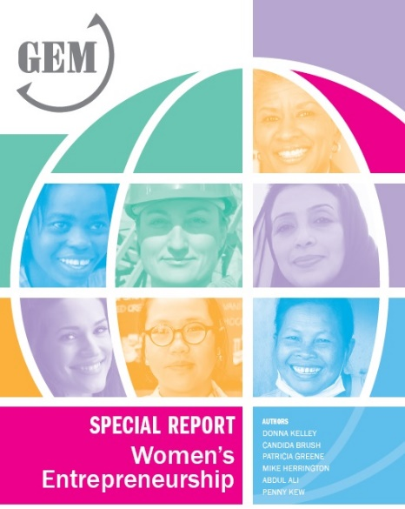
Analyses of entrepreneurship rates and gender gaps from GEM indicate that more women become entrepreneurs when they more actively participate in a country’s economy. Interestingly, though, the higher level of education a woman achieves means she is less likely to start her own business (Kelley). While this seems counterintuitive, it could relate to the number of enterprises across the globe founded by women out of necessity (rather than opportunity) that pertain to a lower-income demographic and receive on average a lower level of education.
The personal profiles of the female entrepreneurs spotlighted later demonstrate the variety of motivations, fears, opportunities and challenges of women who strike out on their own. These leaders from Spain and Chile exhibit entrepreneurial spirit and serve as models for the larger Hispanic community and women worldwide. They also highlight the diverse cultural and financial factors that make up the climate for female entrepreneurship in Spain and Chile, the two countries examined in this piece.

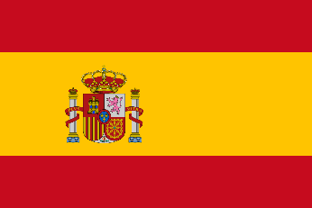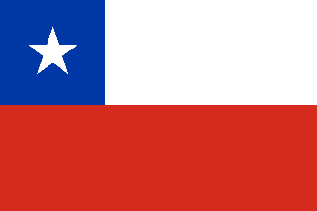

Two Countries in the Spanish-Speaking Global Community
Spain and Chile are two of the most developed countries in the Spanish-speaking world. Their higher level of economic stability (discounting Spain’s particularly negatively economic slump in recent years) permits and encourages higher levels of equality, and vice versa. The more women in the workforce increases their overall productivity and quality of life. These countries are on the forefront for fostering an environment supportive of female entrepreneurs and business leaders within their larger European and Latin American communities. It is important to note that while similarities exist between the countries of Spain and Chile with the common language and a broadly shared Hispanic identity, the cultures and diverse peoples are uniquely different and should not be stereotyped as the same. Women face diverse challenges and continue to persevere in their entrepreneurial efforts with varying levels of support from the public and private sectors.
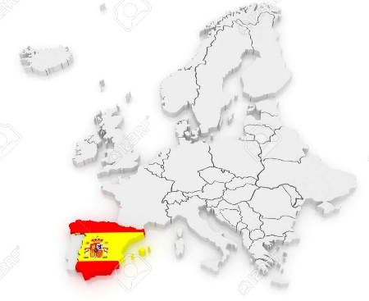
SPAIN
Spain has an interesting connection with the rest of the Spanish-speaking global community as the origin of the Spanish language. Outside of its conceptual connection with Latin America, Spain fits within the framework of Western Europe as a high-income, innovation-driven economy (Kelley). The Spanish are known for being proud, independent people, and they operate in a hierarchical society that respects those in positions of authority (Morrison). They also score highly on Geert Hofstede’s cultural dimension for uncertainty avoidance (86/100, the same as Chile), which means they value certainty in a situation and avoid taking risks (“Spain”). Entrepreneurs, on the other hand, have to take on risk in order to pursue their own business startup, which seemingly contradicts this cultural instinct. Many women hold professional positions, and more and more are entering into the field of entrepreneurship although still comparatively less than their male counterparts. About 20% of Spanish entrepreneurships are founded by a female (Kassam).
Many women decided to make the leap and start their own businesses under the financial constraints of the global economic crisis since 2008. Joan Torrent Sellens of the Open University of Catalonia’s business school claims the economic crisis “allowed women to seriously consider becoming entrepreneurs, something many had never thought of before” and that the number of business created by women had almost doubled during the crisis (Kassam). This rise in female entrepreneurship has been an interesting phenomenon in Spain, and may prove to be one of the silver linings of the crisis. Many women have become entrepreneurs as a response to the extremely high unemployment rates facing young women (54.7%) due to the recession of the last several years (Kassam). This shocking percentage tops the already high 50% unemployment rate facing youth as well as the average one-in-four unemployment rate in Spain overall.
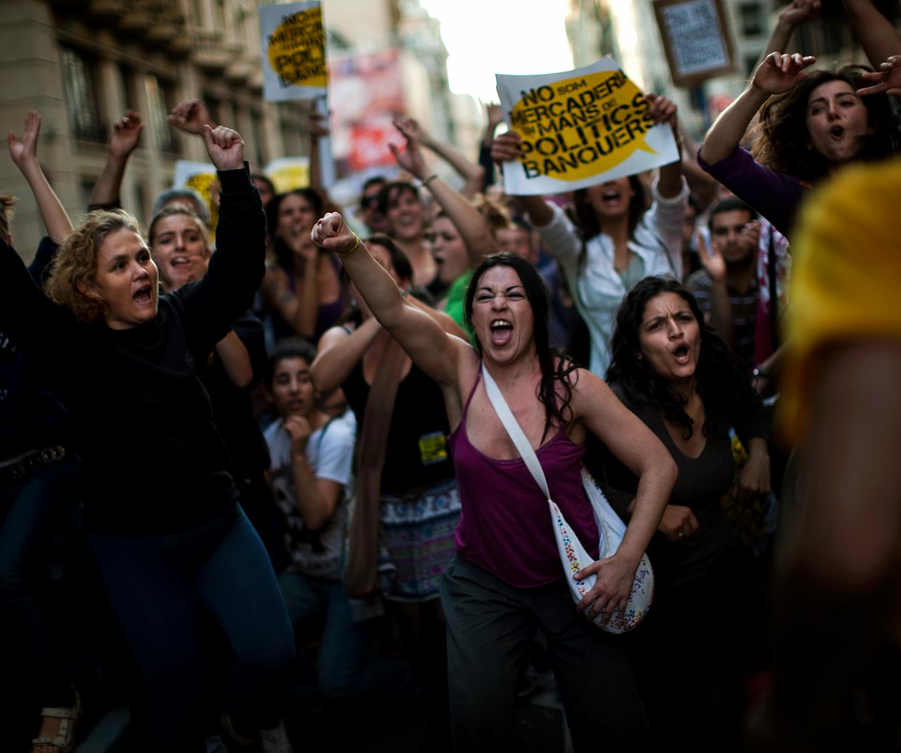
Women in Barcelona protest high youth unemployment rate and cutbacks due to Spain’s debt crisis. May 15, 2011.

Not considering the current economic hardship, women hold more positions in “education, politics, and the work force” than previously and have legal equality with men (Morrison). Even so, many women are discouraged lately from entering the workforce or straying outside the home. This regression stems from the societal instinct for conservatism in times of hardship despite recent decades’ rejection of the traditional and conservative policies enforced by previous dictator Francisco Franco, whose decades-long reign ended with his death in 1975. It was only in 1978 after this that Spain removed legal requirements that forced a married woman to get her husband’s permission to work outside the home (“Women, Business and the Law”).
According to The World Bank Group, the female labor force participation is 68%, and discrimination based on gender (but not on marital status) is prohibited in hiring (“Women, Business and the Law”). Currently, Spain is one of the 18 economies in the world that does not have any legal differences between the genders (“Women, Business and the Law”). These are favorable conditions for women in the workforce in Spain, but is that the whole picture? Here’s a look at the first featured entrepreneur from Spain.

Startup Spotlight: Izanami Martínez González, NonaBox

Izanami Martinez González, CEO and co-founder of NonaBox. Madrid, Spain.
At the young age of 29, Spanish entrepreneur Izanami Martínez González from Madrid founded Nonabox in 2012 as a subscription-based monthly package filled with a personalized selection of products for pregnant women and new mothers who often have insufficient time to purchase all the important items for their little ones. According to Martínez, the idea came to her in 2011 when her sister became pregnant, all the while working and attending school. Busy and tired, but wanting to provide for her new baby, her sister was overwhelmed with the multitude of infant products available on the market. With the goal of relieving some of the stress of purchasing baby products and allowing those initial months to be even more special in an expectant or new mother´s life, Martínez and her cofounder Ramón Sanchez launched Nonabox in March of 2012. Martínez had found investors, quit her job, and launched the new enterprise all within a week (Kassam).
The business model was simple: based on a monthly subscription, Nonabox provides a personalized selection of nine products, each one a surprise and different every month. Its subscribers pay 25 euros a month, but the products are valued around 70 euros, so the consumer saves money as well as precious time. Martínez credits her cofounder Sanchez as the fundamental piece in transforming her original idea into a viable online business, owing to his experience in the sector. Within 28 months of its launch, the company had sold over 100,000 boxes and become the leader in its European sector. Nonabox is also credited as a pioneer in launching the European subscription business model for diapers. Venture capitalists such as Bertelsmann Digital Media quickly recognized the company’s value, and other investors like Cabiedes & Partners (Spain) and H-Farm Ventures (Italy) provided capital (Fernández), allowing the company to expand its distribution internationally through Spain and into Italy, Germany, France, Austria, and the UK.

The Spanish ecommerce company eShop Ventures acquired Nonabox in March 2015. According to the cofounders, growth had flattened despite decent metrics, and when an important deal dropped with a potential investor, they had to sell. Sanchez admits that their aggressive and rapid expansion internationally created problems financially, saying, “If we had taken more time to expand and maybe wait to reach break-even in each market before launching in the next, things would have been different.” (Novoa) Operations closed in the UK and Italy, but remained open elsewhere. Martínez stayed on in a leadership capacity after the acquisition.
While Martínez feels that she did not experience any disadvantages for being a woman in a technological field, she also acknowledges the significantly lower proportion of women working in the online sector. Many of the ups and downs with the business depended on outside investment, a familiar tune for aspiring entrepreneurs. She has taken her experience with ecommerce and entrepreneurship to assist others in business as an associate professor at The Valley Digital Business School, a mentor of the business incubator Top Seeds Lab, and President of the Spanish Association of Startups. She is currently nominated for an award for innovation by ICON Magazine for her work launching Doctor24, an approach to fast and accessible medical care (“Entrevista de la semana con Izamani Martínez González”).
Opportunity-driven Entrepreneurship
Our next spotlighted entrepreneur from Spain launched her enterprise out of a sense of opportunity just like Martínez. According to the GEM 2015 report, the rate of female entrepreneurial activity is a fairly stable 4.5% for Spain, with a high proportion (70%) of women launching businesses out of opportunity (“El 70% de las mujeres”). This implies that a greater number of businesses are launched in an environment that allows for ease of entry to the market and promotes the development of all members of its society (seems obvious, right?).
Startup Spotlight: Judith Estrella, Charter & Dreams
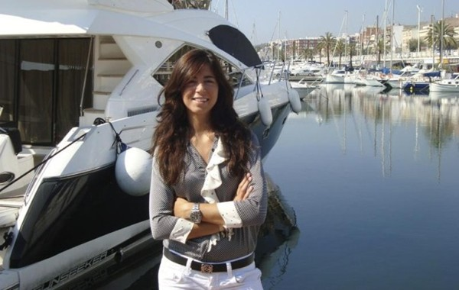
At 25 years old, Judith Estrella from Barcelona was working for a pharmaceutical company putting her chemical engineering degree to use and making a good salary. Regardless, she was bored and decided to leave her job to start her own yacht rental company in 2010 called Charter & Dreams. Her startup was opportunity-driven. Estrella realized there was a lack of professional boating companies in Barcelona with an office or effective marketing operations. She also had a sense of familiarity with the industry as she had grown up around her parents’ small boating business. As of 2015, Charter & Dreams has more than 12 yachts for rent, all comprising a 1 million euro business. Some boats come with extensive equipment on board such as kayaks or water skis, and even TV satellite and Internet, which costs over 13,000 euros per day.
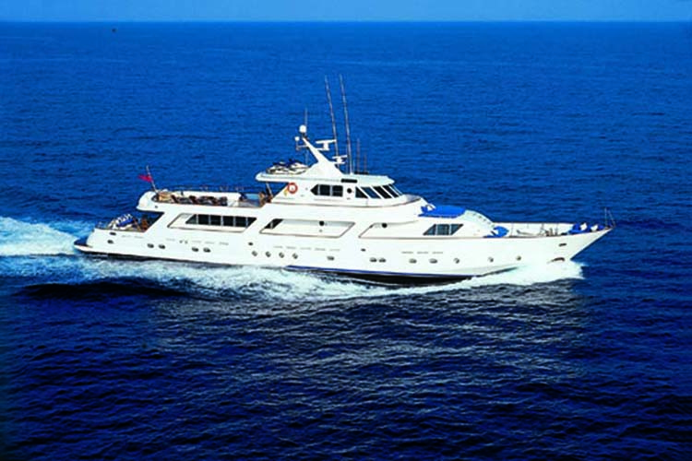
Her business model consists of renting out yachts that Estrella owns as well as those available from other companies in the area. Some of her customers are renting for business reunions or product presentations, and the largest yachts hold up to 80 people. The rentals cover the high maintenance costs that inevitably come with such expensive assets, such as mooring and keeping a crew, plus a pretty profit that keeps this young entrepreneur afloat (“10 emprendedores españolas”).
Machismo and Gender Biases in Financing
In Spain and across Latin America there is a stereotype of machismo. Machismo is a Spanish word that refers strong or aggressive masculine pride. Despite many advances in gender equality, cultural tradition dictates certain behavior and expectations for both genders: men are supposed to be strong leaders who speak their minds, while women are expected to be more caring and accommodating. This attitude bleeds into business culture and challenges women’s placement and growth in the workplace. According to the GEM Special Report 2015, “subtle biases exist in many societies that suggest women have lower ambitions or are less capable, or that running businesses is inappropriate for them” (Kelley). This damaging perception of women continues to discourage female entrepreneurship or investors in providing growth capital to them. In fact, many women in Latin America “lack alternative financing sources” outside of their family and friends, and when they seek support from other institutions, they are met with reluctance. Even banks only finance less than 20% of what they need to run their businesses, and there is also bias in that lending process (Garcia-Robles).
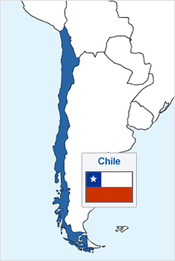
CHILE
Chile is situated on the Pacific coast of South America, almost all the way down the western side of the continent. It is one of 21 Spanish-speaking countries in the world and one of the leading economies in the Latin American region. Education rates are relatively high for the region, which contributes to their overall success and stability. Chile ranks first in Latin America for business overall, due to its “low macroeconomic risk, strong supplier diversity initiatives, and social service offerings” (“Women’s Entrepreneurial Venture Scope 2013”). This status also allows for greater equality and opportunities for Chilean women, including business and entrepreneurship.
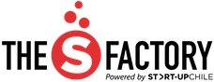
According to its profile in Kiss, Bow, or Shake Hands, Chile provides a more agreeable environment for professional advancement of women, who are more likely to have success there than in most other countries in the region. Although “conservative values in politics, economics, and social attitudes prevail,” (Morrison) many women are professionally advanced. As a country, Chile is a primarily collectivist society where the extended family is the core social group and dominates individual decision-making (Morrison). In social and business interactions, personal relationships are of the utmost importance. Like in many other South American countries, business success in Chile can hinge on an individual’s family status and connections, especially regarding receiving scarce credit. Banks or other third parties like consulting firms can provide much needed capital for an entrepreneurship, but they also hold an unnerving amount of power over small business owners for this reason. According to its country profile from the Hofstede Centre, Chile’s continuing “privilege for power holders” is just one of the “remnants of Chile’s authoritarian past” (referencing previous dictator Augusto Pinochet) that still lingers.
Support for Startups, Focus on Females
In Chile, the rate of women pursuing entrepreneurship is still relatively low, but has been a point of interest for public and private funding groups, including business incubators and the national government. Start-Up Chile is a public organization that provides funds for participating startups. Upon looking at their data, however, they realized that only about 15% of its applicants looking for startup support were women (“Chilean Government”). As a result, Start-Up Chile initiated a segment specifically focused on high-impact female entrepreneurs called The S Factory. To receive funding, a project has to be in the early stages of development (less than six months) and led by the female founder, who will relocate to Santiago for at least three months. Many of the projects originate in countries besides Chile, but all have to be scalable with “potential to expand across global markets” (The S Factory). Accepted applicants receive a grant of USD$15,000, a one-year resident visa, weekly training sessions with experts, and the opportunity to network with leaders and investors in their field.

Challenges and Fears Facing Women
The obstacles to entrepreneurship go beyond financial and legal concerns for women in Latin America. There are also “ingrained cultural obstacles” (García-Robles) like the stubborn idea of women belonging in the home or the stereotype that they are incapable or too soft to compete in business, let alone launch and run their own! This misplaced perception too often dissuades women from pursuing such endeavors, and it seeps into the business and lending practices within a country through cultural mindset. For example, women struggle more than their male counterparts in receiving funding and raising capital, in part because many of the investors are men (García-Robles). They do not respond as generously to a woman pitching her startup idea than they would to a fellow man seeking financial support.
Overall, there are wider gender gaps in the majority of economies in the Latin American region and a pervasive fear of failure on the part of women that comes from the many risks associated with starting one´s own business, especially with a gender disadvantage (Kelley). Nevertheless, some women choose to pursue their passions through entrepreneurship, while others turn to it out of necessity. With regard to the latter, let me introduce you to a particularly gifted baker and business owner in Santiago, Chile.
Startup Spotlight: Ana Maria, Dolcedonne
In Santiago, Chile, small business owner Ana Maria started her own bakery as a way of making ends meet for her four children after her husband left. She began her business out of necessity rather than ambition. She launched Dolcedonne as a bakery serving delicious pastries and chocolates using an old family recipe. Ana Maria had no great love for baking and says she doesn’t even enjoy chocolate! Regardless, her high quality sweets soon attracted hotels and other large companies to the new business.
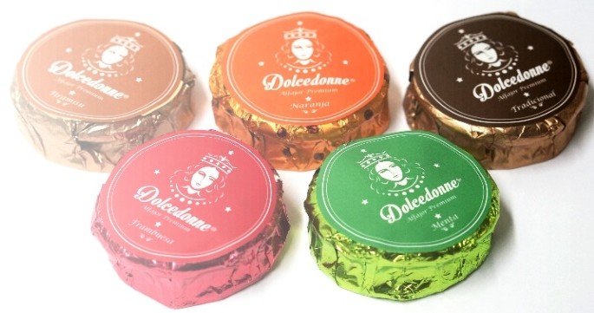An assortment of sandwich cookies, biscuits, and other sweets from the bakery Dolcedonne in Santiago.
Unfortunately, one problem that Ana Maria and many other small business owners face in Chile and the rest of South America is the lack of power they have, especially if they do not come from a well-known family with connections. Because credit is scarce and capital is hard to come by, many entrepreneurs face challenges with cash flow, if they can even get their business off the ground. Ana Maria fought many obstacles with her business clients, and to many her story serves as an unflattering depiction of the conditions small business owners face in the region.
For several years, she would have to drive an hour and a half just to pick up checks from a larger business client. Even though the trip was at the paying manager’s request, Ana Maria was often met with a secretary saying the manager of the larger company was out for the day. Sometimes, the checks were even backdated to be uncollectable, and she had to restart the collection process just to get paid for her products (Yin). The burden of payment collection is wholly shouldered by the small business owner, and legal enforcement is virtually nonexistent regarding delayed payments from a larger, more established company. In contrast, there are strict deadlines for a small business owner in making payments. In an unfortunate instance, Ana Maria was once a month late on her car payment due to her issues with cash flow, and the bank took the car away from her as a result.

A Common Challenge
Many South American small business owners like Ana Maria face serious cash flow issues as an obstacle to their growth or sustainability because they have no power. In South America, it is hard for small business entrepreneurs to have access to capital, and many times applications for credit are accepted or ignored simply on the basis of family connections. Compound those challenges with the social disadvantage of being a female in a male-driven and operated society and economy, and it is easy to see why relatively few women in South America are motivated or financially capable enough to pursue entrepreneurship. While Ana María’s success story provides an example of the determination and resilience required to start up and operate a small business, it also shines a harsh light on the unfair disadvantages facing entrepreneurs that organizations such as Start-Up Chile may not mention in their optimistic descriptions (Edmonson).
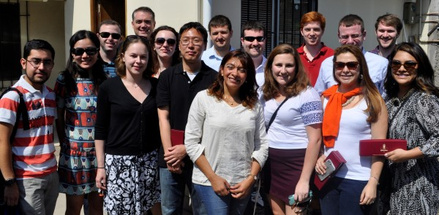Ana Maria (center), founder of Dolcedonne, with Babson graduate students in Santiago, Chile.
Now, Ana Maria continues to run Dolcedonne and employs over a dozen workers. With the money she has made running her own business, she is able to send her children to college, a privilege she never had. Despite her fears of the bank taking away the house if she were to miss a payment, Anna María dreams of owning her own home one day.
Born to Lead
Next we shine the spotlight on twice over entrepreneur and pioneer in her field Geraldine Mlynarz. Whereas Ana María felt forced to launch a business in order to survive, Geraldine seemed born to lead. That being said, Mlynarz also faced challenges on her path to entrepreneurship, several steeped in cultural gender biases of her country.
Startup Spotlight: Geraldine Mlynarz, ActivaQ
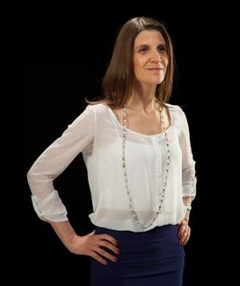
“I come from a family of natural-born entrepreneurs,” says Geraldine Mlynarz from Santiago, Chile. Her grandparents, European immigrants to Chile, and her parents demonstrated how to persevere in business and overcome hardships. Her education in agricultural engineering at Universidad Católica helped to propel her passion in the field of biotechnology, for which she is pursuing a PhD, and to spur her first entrepreneurial endeavor. While working on her undergraduate thesis on “non-invasive viral detection methods applied to salmon” under Ana Maria Sandino, Mlynarz and her mentor decided to join forces and became business partners. They launched their first venture, Diagnotec, in 1997 with the help of a leading Chilean pharmaceutical company as their strategic business partner. The company performed early screening for the IPVN virus which affects salmon worldwide. The two women eventually parted amicably from the company due to differing interests, but maintained an interest in the work and an entrepreneurial spirit. They took their ideas and several projects still in development to form a separate entity called ActivaQ, while Diagnotec was purchased by Andromaco Enterprises in 2011.
Swimming Upstream
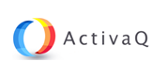
Mlynarz and Sandino faced numerous challenges as women in a male-dominated industry skeptical of their skills in innovation or management. It took letting the work speak for itself through the years to convince anyone in the industry that their nontraditional methods were functional and effective. Mlynarz also admitted that she felt that there was a certain camaraderie among men that she did not have as a woman in such a conservative industry, which proved difficult in the beginning.
She also struggled to manage her roles as an entrepreneur and a mother, but maintained that family was her first priority. That being said, she is highly ambitious, aspiring to be a global leader in her field. She acknowledges the need for both passion and organization to realize any project, and lauds female collaboration in business as a powerful force. Her main advice to aspiring entrepreneurs is to listen to yourself over others, and likewise, to decide what your definition of success is, not anyone else’s. Mlynarz asserts that the women of South America have the necessary “courage, willingness, and tools” to make their dreams a reality (“Una historia de éxito“).
Diversity of Backgrounds, But a Shared Spirit
Ana María and Geraldine demonstrate the different types of entrepreneurs women in Chile go on to become. While Ana Maria’s gourmet bakery serves a range of larger companies, it is ultimately a low-impact enterprise. Geraldine Mlynarz’s work diagnosing and treating viruses that affect salmon has a huge impact on the industry worldwide. The two women also differ in their educational background. Mlynarz is pursuing a PhD in her field as a two-time entrepreneur while Ana Maria lacks a college education. The two entrepreneurs Estrella and Martinez from Spain also have a college degree, although they did not necessarily pursue a career in the same field.

In addition to noting the intelligence, courage, and resilience of all of the women from Spain and Chile spotlighted here, it is important to acknowledge their diverse perspectives and challenges. For example, Ana Maria of Dolcedonne continues to struggle raising capital and maintaining a steady cash flow in large part due to Chile’s business culture toward small business owners without existing family connections or social clout. In contrast, Izanami Martínez González was able to quit her job, raise capital, and launch a new ecommerce business with her cofounder all within one week in Madrid. Judith Estrella from Barcelona also launched her own business out of a passion for the industry and a glimpse of economic opportunity, unlike Ana Maria’s sheer need to put food on her family’s table as a single mom. All of these women share the necessary entrepreneurial spirit that has helped them overcome obstacles to achieve their dreams. That being said, their varying cultural and socioeconomic backgrounds have shaped the path each one has forged with its unique challenges and climate.
Why Should We Care?
Evidence finds that “the more women in the workforce, the more per capita income rises” (Pellegrino). Advances in educational and professional opportunities for women boost a country’s GDP and competitiveness. They also allow for better family planning and work distribution in a household. Investing in women is therefore is not only a moral imperative based on the fundamental principle of equality, it is also one of the surest ways to improve a nation’s overall economy and quality of life.
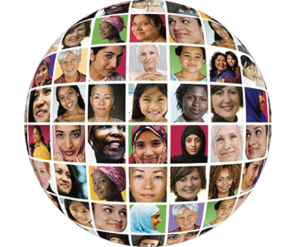
Female entrepreneurship specifically is an important subject to examine and promote because of its proportionally small, yet growing relevance in startup companies around the world. Ultimately, Spain and Chile both serve as models for positive financial and cultural climates for female entrepreneurs within the global Hispanic community. Hopefully these two nations will continue in their efforts in encouraging women in entrepreneurship and the professional business climate worldwide.

Bibliography
“10 emprendedores españolas de éxito a las que envidiarás a partir de ahora.” Casos de éxito, emprendedores.es. Emprendedores, 10 Jan 2015. Web.
“Chile.” The Hofstede Centre. ITIM International, 2015. Web.
“Chilean Government Seeks to Boost Female-led Start-Ups.” Voice of America. VOA, 17 Aug 2015. Web.
Edmonson, Dan. “Dolcedonne.” Graduate Life. Babson Blogs, 3 Apr 2015. Web.
“El 70% de las mujeres emprendedoras en España inician sus negocios por oportunidad.” RedEmprendia. RedEmprendia, 24 Nov 2015. Web.
“Entrevista de la semana con Izamani Martínez González.” The Digital Business News. The Valley Digital Business School, 7 Oct 2015. Web.
Fernández, A. “Nonabox surgió de la idea de ofrecer una solución a las mamás con poco tiempo.” ABC Tecnologiá. ABC, 29 July 2014. Web.
García-Robles, Susana. “El desafío del emprendimiento femenino en América Latina.” RedEmprendia. RedEmprendia, 21 Sep 2015. Web.
Kassam, Ashifa. “Spain’s Jobless Women Become the Boss to Beat the Recession.” The Guardian. The Guardian, 3 Feb 2014. Web.
Kelley, Donna, Candida Brush, Patricia Greene, Mike Harrington, Abdul Ali and Penny Kew. “GEM Special Report: Women’s Entrepreneurship 2015.” GEM Women’s Special Report. Global Entrepreneurship Monitor. GEM, 2015. Web.
Morrison, Terri and Wayne A. Conaway. Kiss, Bow, or Shake Hands. 2nd ed. Avon, MA: Adams Media, 2006. Print.
Novoa, Jaime. “Nonabox acquired by eShop Ventures: How Aggressive International Expansion Plans Can Hurt a Startup.” Novobrief, 31 Mar 2015. Web.
Pellegrino, Greg, Sally D’Amatto and Anne Weisberg. “The gender dividend: Making the business case for investing in women.” Deloitte Public Sector. Deloitte, 2011. Web.
“Spain.” The Hofstede Centre. ITIM International, 2015. Web.
The S Factory. Start-Up Chile, n.d. Web. 14 Oct 2015.
“Una historia de éxito: Geraldine Mlynarz, emprendedora chilena de alto crecimiento.” WEGrow Publications, Fondo Multilateral de Inversiones. Ernst & Young, 2013. Web.
“Women, Business and the Law 2016: Getting to Equal.” The World Bank Group. The Economist Intelligence Group, 2015. Web.
“Women’s Entrepreneurial Venture Scope 2013.” Multilateral Investment Fund. IDB, 2013. Web.
Yin, Yuan. “Meet Ana Maria: A Female Entrepreneur in Chile.” Women’s iLab. 8 July 2015. Web.

