Synthesis and Characterization of Support-Modified Nanoparticle-Based Catalysts and Mixed Oxide Catalysts for Low Temperature CO Oxidation

A Dissertation Presented for the
Doctor of Philosophy
Degree
The University of Tennessee, Knoxville

Andrew Justin Binder
May 2015
Copyright © 2014 by Andrew J. Binder.
All rights reserved.

DEDICATION

I would like to dedicate this dissertation to my parents, Glenn Binder and Dawn M. Fultz. Their perseverance and hard work, even in tough times, will always be a constant inspiration to me.
ACKNOWLEDGEMENTS
It would be impossible to complete such an arduous task as this without the help and support of many people, and quite a few have been instrumental in this work. Firstly, I would like to thank my advisor Dr. Sheng Dai for his support and guidance throughout the last 4 years. He truly cares for the success of his students and works very hard to create opportunities for myself and other members of the group. I would also like to thank the other members of my doctoral committee, Dr. Craig Barnes, Dr. Alexander Papandrew, and Dr. Bin Zhao who have pushed me at each stage of the process to think more deeply about my work and who have always been a fantastic source of advice and discussion. Here I would also like to thank Dr. Jon Camden for supporting me and pushing me to apply for graduate school at a time when I was unsure of my abilities as a scientist.
Next I would like to thank all the members of the Dai group and those at the National Transportation Research Center for their hard work and assistance in learning the wide array of synthesis techniques and characterization tools needed to complete this work. In particular, from the Dai group, I would like to mention Surree Brown, Richard Mayes, Shannon Mahurin, Zhen-an Qiao, and my fellow soon-to-be-graduate Kimberly Nelson. And from NTRC: Jim Parks II, Todd Toops, Josh Pihl, and Will Brookshear. Thank you all for many various and invaluable moments of inspiration, technical help, mentoring, friendship, and professional discussion which has shaped who I am as a student and a researcher.
Lastly, and on a personal level, I need to thank the following friends for their hilarity, emotional support, and general awesomeness:
Cole and Sydney Lindsey, and Christopher Laidlaw – Long live the Starbucks crew!
Tyler Newman, Matt Deaver, and Anthony Deaver – May all your rolls be Nat 20s (unless I am GM).
Christopher and Chelsea Talbert, and Daniel Lester – My oldest friends and the best anyone could have. Thanks for always being there.

ABSTRACT
Heterogeneous catalysts are responsible for billions of dollars of industrial output and have a profound, if often understated, effect on our everyday lives. New catalyst technologies and methods to enhance existing catalysts are essential to meeting consumer demands and overcoming environmental concerns. This dissertation focuses on the development of catalysts for low temperature carbon monoxide oxidation. CO oxidation is often used as a probe reaction to test overall oxidation activity of a given catalyst and is an important reaction in the elimination of toxic pollutants from automotive exhaust streams. The work included here presents three new heterogeneous catalysts developed over the last 4 years in our group.
The first type Au/SiO₂ catalyst synthesized using a new method for the deposition of Au nanoparticles onto SiO₂ via a nitrogen-containing polymer, carbon nitride (C₃N₄). C₃N₄-modification of SiO₂ allows us to ignore unfavorable electrostatic effects that hinder standard Au deposition onto this support. While removal of the C₃N₄ is necessary for good CO oxidation, this new method is an improvement over the standard deposition-precipitation procedure for supports with low isoelectric point that enables the successful deposition of Au nanoparticles onto SiO₂.
The second type includes precious metal catalysts deposited on an “inert” silica support but promoted by the addition of an “active” metal oxide. Here we present a Au/FeO_{x}/SiO₂ and a Pd/ZrO₂/SiO₂ catalyst which show increased activity and stability effects due to the presence of the metal oxide promoter. They are synthesized by a C₃N₄-deposition and sol-gel methods, respectively. These catalysts were also tested in simulated automotive exhaust streams. The results show that inhibition effects play a major role in the activity of these catalysts.
The third type of catalyst is a mixed oxide catalyst, CuO-Co₃O₄-CeO₂, developed with the goal of overcoming the inhibition effects seen in the previous precious metal catalysts. The catalyst was synthesized by co-precipitation method and shows exceptional activity for CO oxidation under simulated exhaust conditions. Also noteworthy is the observation that this catalyst also shows a lack of inhibition by a common exhaust component, propene.
TABLE OF CONTENTS
Chapter 1 -- Introduction and Background 1
1.1 Introduction to Catalysis 1
1.1.1 Introduction 1
1.1.2 Heterogeneous Catalysis 4
1.1 CO Oxidation 8
1.1.1 CO Oxidation over Supported Noble Metal Nanoparticles 8
1.1.2 Size dependency of Supported Metal Nanoparticles 9
1.1.3 CO Oxidation over Transition Metal Oxides 10
1.1.4 Mechanisms for CO Oxidation 11
1.2 Motivation 14
1.2.1 Deposition and Stabilization of Au Nanoparticles 14
1.2.2 Automotive Exhaust Treatment 16
1.3 Common Catalyst Synthetic Techniques 18
1.4 Dissertation Overview 24
Chapter 2 -- Characterization techniques 27
2.1 Catalyst Characterization 27
2.1.1 Scanning Transmission Electron Microscopy (STEM) 27
2.1.2 Powder X-Ray Diffraction (PXRD) 30
2.1.3 N₂ Adsorption/Desorption (BET) 32
2.1.4 Infrared Spectroscopy (FTIR and DRIFTS) 34
2.1.5 X-ray Photoelectron Spectroscopy (XPS) 37
2.1.6 Temperature Programmed Methods (TPR, TPO, TPD) 38
2.1.7 Thermo-gravimetric Analysis (TGA) 41
2.2 Catalytic Evaluation 41
2.2.1 Plug Flow Reactor 41
2.2.2 Gas Chromatography (GC) 44
2.2.3 Mass Spectrometry (MS) 46
Chapter 3 -- Carbon nitride modified silica for gold adsorption and stabilization 48
3.1 Published Work Disclosure 48
3.2 Introduction 48
3.3 Experimental 52
3.3.1 Materials 52
3.3.2 Preparation of C₃N₄/SiO₂ 53
3.3.3 Preparation of C/SiO2 53
3.3.4 Synthesis of Au/C₃N₄/SiO₂ Catalyst 54
3.3.5 Catalyst Characterization 54
3.3.6 Catalytic Test 55
3.4 Results and Discussion 56
3.5 Conclusion 67
Chapter 4 -- Metal-oxide modified silica for supported nanoparticle catalysts 70
4.1 Introduction 70
4.1.1 Introduction 70
4.1.2 Materials 71
4.1.3 Preparation of FeO_{x}/SiO₂ Support via Fe-C₃N₄ Deposition 72
4.1.4 Prepartion of Au/FeO_{x}/SiO₂ 72
4.1.5 Preparation of Pd/SiO₂, Pd/ZrO₂, and Pd/ZrO₂/SiO₂ Catalysts 73
4.1.6 Catalyst Characterization 74
4.1.7 Catalytic Evaluation 74
4.2 Au/FeO_{x}/SiO₂ via C₃N₄-Assisted Deposition 75
4.2.1 CO Oxidation over Au/FeO_{x}/SiO₂ in Simulated Exhaust Streams 75
4.2.2 Catalyst Characterization Results and Discussion 81
4.3 Pd/ZrO₂/SiO₂ via Sol-Gel Approach 89
4.3.1 Collaborative Work Disclosure 89
4.3.2 Catalyst Characterization 89
4.3.3 CO Oxidation over Pd/ZrO₂/SiO₂ in Simulated Exhaust Streams 93
4.4 Conclusion and Future Work 99
Chapter 5 -- Mixed Oxide Alternative to Deposited Metal Nanoparticles 103
5.1 Introduction 103
5.2 Experimental 105
5.2.1 Removal of DOC washcoat (DOC) 105
5.2.2 Synthesis of Pd/ZrO₂-SiO₂ catalyst (PdZrSi) 106
5.2.3 Synthesis of CuO, Co₃O₄, CeO₂ mixed oxide catalysts (CCC, CuCo, CoCe, and CuCe) 106
5.2.4 Catalytic Tests 107
5.2.5 Catalyst Characterization 108
5.2.6 DRIFTS measurements 109
5.3 Results and Discussion 109
5.4 Conclusion 119
Chapter 6 -- Summary and Future Work 121
6.1 Summary 121
6.2 Future Work 125
LIST OF REFERENCES 128
VITA 139

LIST OF TABLES
Table 5.1 Compositional and structural properties of ternary and binary catalysts 114

LIST OF FIGURES
Figure 1.1 Reaction coordinate diagram of a reaction with and without a catalyst. 2
Figure 1.2 Schematic diagram of chemical reactions at the surface of a heterogeneous catalyst. 5
Figure 1.3 Schematic diagrams of CO oxidation mechanisms. 12
Figure 1.4 Metal oxide support surfaces at pH relative to their isoelectric point (IEP). 23
Figure 2.1 Representative images of STEM techniques. 28
Figure 2.4 TPR of various CuO-Co₃O₄-CeO₂ (CCC) catalysts calcined at different temperatures⁴⁴. 39
Figure 2.5 Diagram of a plug flow reactor⁴. 43
Figure 3.1 Basic structure of carbon nitride, C₃N₄. 51
Figure 3.2 N₂ adsorption-desorption isotherms and BJH pore distributions (inset) before and after carbon nitride modification of SBA-15. 57
Figure 3.3 a) Deconvoluted N1s XPS spectrum of C₃N₄/SBA-15 support and b) FTIR spectra comparison of SBA-15 (black), carbon nitride modified SBA-15 (blue), carbon nitride recovered from HF treatment (green), and carbon nitride synthesized without SBA-15 (red). 58
Figure 3.4 Light-off curves of first (dashed) and subsequent (solid) cycles of temperature dependent CO oxidation tests of various supported Au samples. 61
Figure 3.5 (top) TGA measurements of Au/C₃N₄/SBA-15. (mid) FTIR spectra for the various stages of Au/C₃N₄/SBA-15 synthesis and use. (bot) Powder XRD pattern of Au/C₃N₄/SBA-15 catalyst (a) before catalytic test and (b) after 2 runs. 62
Figure 3.6 TEM and Dark Field images of Au nanoparticle catalysts: (a) Au/C₃N₄/SBA-15 (b) Au/C₃N₄/Cab-O-Sil (c) Au/C₃N₄/SBA-15 treated at 300°C (d) Au/C/SBA-15 64
Figure 3.7 Powder XRD patterns for Au/C₃N₄/SBA-15 treated at 300°C and Au/C₃N₄/Cab-O-Sil before (black) and after (red) catalytic testing. 66
Figure 3.8 Activity per gram for both Au/C₃N₄/SBA-15 and a similar sample treated at 300°C in air before Au deposition. 68
Figure 4.1 CO oxidation of AFS_{3.4%} after calcination at 600°C (black), 700°C (blue), and 800°C (red) in air. CO oxidation of FeO_{x}/SiO₂ calcined at 600°C is shown (green). 76
Figure 4.2 CO Oxidation over AFS_{1.86%} calcined at 600°C (black), 700°C (blue), 800°C (red). [CO]=1.8% and [O₂]=10% balanced with Ar. 78
Figure 4.3 CO oxidation over AFS_{7.86%} after calcination at 600°C (black), 700°C (blue), and 800°C (red). [CO]=1.8%, [O₂]=10%, balanced with Ar. 79
Figure 4.4 CO oxidation over AFS_{3.5%} in the presence of NO (red), C₃H₆ (blue), both NO and C₃H₆(green), and neither (black). 80
Figure 4.5 Light-off curves for CO oxidation (black) and C₃H₆ conversion (blue), and NO_{x} chemiluminescence data (red) during catalyst testing in simulated exhaust. 82
Figure 4.6 XRD patterns of Au/FeO_{x}/SiO₂ (AFS_{3.5%}) before (black) and after catalytic tests at 600°C (blue) and 800°C (red). Au nanoparticle size calculated by Scherrer method. 84
Figure 4.7 TEM images of Au/FeO_{x}/SiO₂. AFS_{3.5%} after performance testing at 600°C (A) and 800°C (B). Encapsulation of Au particles in the AFS_{2%} sample after performance testing at 800°C (C) and (D). 85
Figure 4.8 XRD patterns for Au/FeO_{x}/SiO₂ with varying content of iron. 86
Figure 4.9 X-ray diffraction patterns for Fe-modified silica (~8% Fe) using the C₃N₄-assisted deposition (blue) and standard impregnation (black) after calcination at 800°C in air. 88
Figure 4.11 XRD patterns of supported Pd catalysts hydrothermally aged at different temperatures. 92
Figure 4.12 TEM images and particle size distribution (inset) of supported Pd catalysts hydrothermally aged at 800°C (bottom) and fresh (top). 94
Figure 4.13 NO_{x} TPD results over Pd/ZrO₂/SiO₂ and calculated accessible ZrO₂ surface area and dispersion. 95
Figure 4.14 CO Oxidation temperatures at 50% conversion (T₅₀) for supported Pd catalysts calcined at 600°C, 800°C, or 900°C. 96
Figure 4.15 CO oxidation light-off curves over Pd/ZrO₂/SiO₂ under various stream compositions. 98
Figure 4.16 DRIFTS data for Pd/ZrO₂/SiO₂. The reaction of the Pd-CO binding site to the introduction of propene. 100
Figure 5.1 Light-off curves under simulated exhaust conditions for CCC, PdZrSi, and DOC catalysts. 110
Figure 5.2 DRIFTS data collected for (A) CCC at 120°C and (B) PdZrSi at 140°C before and after introduction of [C₃H₆] = 0.1%. Initial stream: [O₂] = 10%, [CO] = 0.4%, Ar balance. 112
Figure 5.3 CO₂ concentrations during temperature programmed oxidation of pre-adsorbed C₃H₆ on CCC and PdZrSi. 114
Figure 5.4 Powder XRD patterns of ternary (CCC) and binary (CoCe, CuCe, CuCo) catalysts composed of CuO, Co₃O₄, and CeO₂. 116
Figure 5.5 Light-off curves under simulated exhaust conditions for ternary CCC and binary catalysts. 117

Introduction and Background

Introduction to Catalysis

Introduction
The modern world owes much of its technological advances to the field of catalysis. The vast majority of modern industrial chemicals and the products made from them, have gone through a catalytic step at least once in their production, particularly those derived from the petrochemical industry¹. Even basic chemicals found in the chemistry classrooms and labs across the world such as sulfuric acid, nitric acid, and methanol are the result of catalytic reactions¹. The history of catalysis has been told by a number of authors¹⁻³ and the current field of catalysis research has been described as a multidisciplinary task requiring knowledge of chemistry, materials science, physics, and engineering⁴.
What is catalysis? In 1836, Berzelius first attributed the phenomenon to the existence of a new “catalytic force”^{2,3}. While that was not quite on the mark, after more than a century of dedicated effort we can now define the basic principles of catalysis. The International Union of Pure and Applied Chemistry (IUPAC) defines a catalyst as “A substance that increases the rate of a reaction without modifying the overall standard Gibbs energy change in the reaction…”⁵. Figure 1.1 describes this process schematically.
The change in Gibbs free energy (ΔG) is defined as the maximum amount of
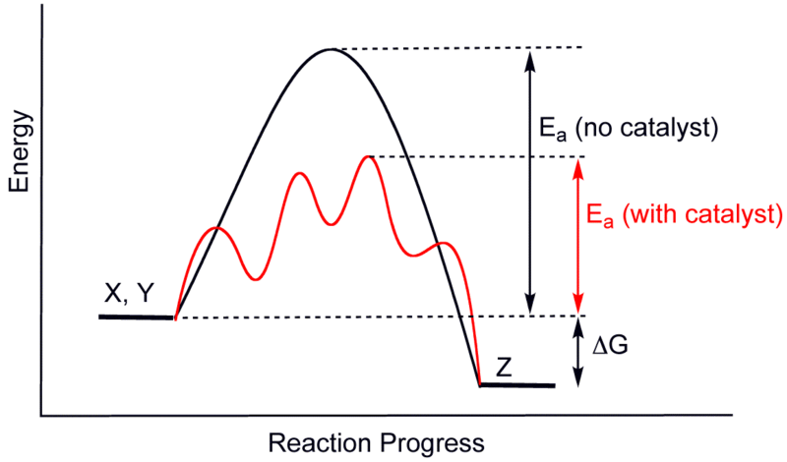
Figure 1.1 Reaction coordinate diagram of a reaction with and without a catalyst.
attainable work from a reaction and is a measure of spontaneity of a reaction, i.e. if ΔG is negative then the reaction happens spontaneously. But in many reactions while the net ΔG is negative with respect to the initial and final compounds, the reaction must overcome an energy barrier on its way to the final product. This barrier is called the activation energy, E_{a}, and is a result of the kinetic requirements for the reactants to enter the transition state. A catalyst is simply a substance that opens up alternative pathways (transition states and intermediates) to the final product that require less activation energy. In a practical sense, effective lowering of the required E_{a} means that less energy need be added to the system (generally by raising the temperature) to complete the desired reaction or the rate of the reaction increases at a given energy.
The focus of this dissertation is on the development of catalysts for low temperature carbon monoxide oxidation. CO oxidation is often used as a probe reaction to test overall oxidation activity of a given catalyst and is an important reaction in the elimination of toxic pollutants from automotive exhaust streams. The rest of this chapter is devoted to basic background information about heterogeneous catalysis, common techniques for catalyst synthesis, and the CO oxidation reaction over supported metal nanoparticles and transition metal oxide catalysts.

Heterogeneous Catalysis
There are two broad categories of catalyst chemicals and materials; these are homogeneous and heterogeneous. The distinction is determined by the phase of the catalyst relative to the reactants. In homogeneous catalysis, the reactants and the catalyst are in the same phase. Heterogeneous catalysis, on the other hand, refers to reactions in which the catalyst is of a difference phase from the reactants. Compared to homogeneous catalysts, heterogeneous catalysts are greatly desired for their ease of separation, ease of handling, and reusability. Most heterogeneous catalysts used today are solids composed of metals in the form of metal nanoparticles, metal oxides, and zeolites⁶ and react with liquid or gaseous reactants. Because heterogeneous catalyst surfaces are rarely perfectly defined and consist of many interacting components these catalysts can often be difficult to study in comparison to homogeneous catalysts and complete reaction mechanisms are commonly unknown except for a few simple and well-studied reactions. That said, heterogeneous catalysis can be described broadly by a three-step mechanism involving first an adsorption of reactants to the catalyst surface; followed by reaction at a catalytic active center; and finally, desorption of the products. Figure 1.2 shows the main steps of reaction schematically.
Catalyst surfaces are often very complex with supported nanoparticles dotting the surface such as with supported precious metals^{7,8}, edge and step regions with varying properties⁹, or composition variation such as with mixed oxides¹⁰. 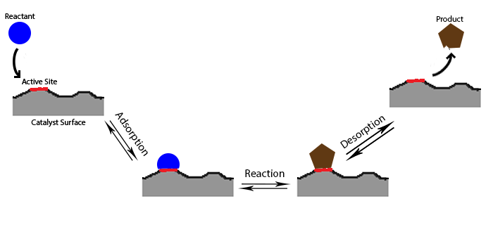
Figure 1.2 Schematic diagram of chemical reactions at the surface of a heterogeneous catalyst.
Because of the different properties of the complex catalyst surface, adsorption and reaction may occur preferentially at particular “active sites” of the catalyst ^{6,11}. In supported nanoparticle catalysts such as the Au/SiO₂, Au/Fe/SiO₂, and Pd/ZrO₂/SiO₂ presented here, the primary active site is usually the nanoparticle itself or its interface with the support but the surrounding environment can play a large role in the adsorption properties and activity of the catalyst.
The activity of the catalyst is preferably described by the turnover frequency (TOF).
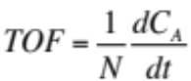 (1.1)
Where N is the number of active sites and C_{A} is the quantity of reactant A in moles. This value represents a direct measure of the activity of the catalyst on a per-site basis but, unlike homogeneous catalysts, an accurate measure of the number of active sites is exceptionally difficult on heterogeneous catalysts. Even precise determination of the number of atoms of metal on the surface of a support may be an overestimate of the number of active sites if the reaction occurs mainly at the interface between nanoparticles and support or only on certain structures of the metal. Because of this difficulty the TOF calculated using methods such as chemisorption to determine the number of available metal atoms represents a lower limit⁴. Other methods of comparison utilize the specific activity, i.e. the measured reaction rate normalized to surface area or mass.
For CO Oxidation the plot of conversion versus temperature, called a light-off curve, is also used to evaluate the performance of the catalyst. If a continuous flow is used to study the reaction, such as in plug flow reactors common to the study of gas phase heterogeneous catalysis, the conversion is defined by…
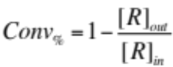 (1.2)
Where [R]_{out} and [R]_{in} are the concentrations of reactants measured at the inlet and outlet, respectively. While kinetic information is difficult to obtain from the light-off curve alone, these plots are often used to describe and compare catalysts over a broad temperature range or to evaluate the effects of pre-treatment on the performance of the overall catalyst.
One kinetic parameter which can be obtained from a light-off curve is the apparent activation energy, E_{app}. The Arrhenius equation describes the temperature dependence of the reaction constant for a given reaction.
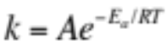 (1.3)
Where k is the reaction constant, E_{a} is the activation energy, R is the universal gas constant, and T is the temperature in kelvin. Thus the activation energy is…
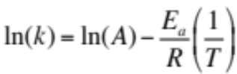 (1.4)
Which enables a means of graphically determining E_{a} by plotting ln(k) vs the inverse temperature. It is important to note that this method only works in the so-called kinetic region, i.e. 0-10% conversion. In this region there is a significant excess of reactants and so the reaction rate is unaffected by the presence of the product.
So long as the reaction is run at steady state so that the reactant concentrations are constant then…
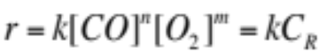 (1.5)
where r is the reaction rate and C_{R} is a constant. In this case the measured rate can be substituted for the rate constant in the Arrhenius equation and the activation energy calculated from the plot of ln(r) vs T⁻¹ is denoted as the apparent activation energy, E_{app}. While this value is not the true activation energy, changes in E_{app} between two similar catalysts indicates a change adsorption properties or intrinsic reactivity and can be useful for comparing catalysts with different surface areas or modified compositions.

CO Oxidation

CO Oxidation over Supported Noble Metal Nanoparticles
One of the most widely used and studied catalyst systems for CO oxidation is supported noble metal nanoparticles. Metal complexes have long been used as catalysts in homogeneous reactions due to their ability to temporarily change oxidation states¹². For heterogeneous reactions, the active component generally take the form of small noble metal (Pd, Pt, Au, etc…) nanoparticles deposited a support such as carbon¹³, a polymer¹⁴, or a metal oxide¹⁵ and much like the ligands in organometallic catalysts, the choice of support is known to have a profound effect on the activity of the overall catalyst

¹⁶⁻¹⁸.
For example, many supports have traditionally been categorized as “inert” (e.g. SiO₂, Al₂O₃) or “active” (e.g. TiO₂, CeO₂) based on their ability to provide oxygen to the CO oxidation reaction^{19,20}. Where the “inertness” of the support significantly effects the catalyst activity, the reaction mechanism is described by the CO binding to the noble metal and reacting at the interface with oxygen supplied to the reaction in the form of superoxide (-O₂⁻), peroxide (-O₂²⁻), or hydroxyl groups (-OH)^{21,22}. Supports can also effect the activity of the supported nanoparticle by influencing the electronic^{16,23} and structural

²⁴ properties or by increasing the stability of the small particles^{25,26}.

Size dependency of Supported Metal Nanoparticles
Masatake Haruta and coworkers were one of the first groups to show the dramatic effect the particle size has on the catalysis of CO oxidation over supported noble metals, particularly Au nanoparticles^{27,28}. What made this discovery so noteworthy was that previously Au was seen as a relatively inert metal for catalysis. But by shrinking Au down to less than 10 nm, Haruta et. al. found that not only was Au active for CO oxidation but that it stands as one of the most active catalysts for the reaction, being able to oxidize CO well below 0°C

²⁹. Since then a strong correlation between size and catalytic activity has been established in the literature^{28,30-32}. The exact cause of this size-dependent activity is still currently under investigation. The activity has been attributed to quantum confinement effects on electrons in the nanoparticle, a change in bandgap also related to quantum effects at the nano-scale, and also an increase in unsaturated surface atoms due to the geometry of small particles³³. One thing is clear, because of these findings it is crucial that the size of supported metal nanoparticle catalysts are determined during study through PXRD, TEM, or chemisorption methods.
This size-dependency is also a significant limitation in the use of supported metal catalysts. At the nanoscale the particles are subject to melting point depression, increasing the mobility of metal atoms over the support surface and increasing the likelihood of Ostwald ripening and sintering

³⁴. Development of methods to stabilize ever smaller nanoparticles on support surfaces in order to withstand high temperature use is a driving motivation for much of the research in supported metal catalysts.

CO Oxidation over Transition Metal Oxides
Many transition metal oxides (TMOs) are also active for CO oxidation without the use of a noble metal. Research into TMOs is primarily fueled by their high thermal stability and the desire to replace expensive noble metals for various applications³⁵. Two key factors generally determine the effectiveness of TMOs for CO oxidation, reducibility and oxygen mobility. During the reaction CO reduces an active metal center (e.g. Co³⁺ in Co₃O₄). Having a high reducibility, which can be measured with temperature programmed reduction (TPR), often correlates with the catalyst’s ability to absorb CO and subsequently an increased activity³⁶. Once bound to the catalyst, CO reacts with either surface adsorbed oxygen or lattice oxygen already present³⁵. A high degree of oxygen mobility in the TMO lattice corresponds to increased oxygen vacancies at the surface to adsorb active oxygen and more reactive lattice oxygen^{35,37}.

Mechanisms for CO Oxidation
The three most cited mechanisms for CO oxidation over both supported metal nanoparticles and TMOs are the Eley-Rideal, Langmuir-Hinshelwood, and Mars-van Krevelen mechanisms. These generic mechanisms are shown schematically in figure 1.3.
The Eley-Rideal mechanism (figure 1.3a) is a two step mechanism in which one reactant is first adsorbed to the surface (usually oxygen) and the second reactant coreacts directly with it in the gas phase.
$O_{2}+{2θ}_{s}⇄ 2θ_{O}$ (1.6)
$CO+ θ_{O }→{CO}_{2}+θ_{s}$ (1.7)
Where θ_{s} stands for an oxygen adsorption site and θ_{O} for an adsorbed oxygen species. With research increasingly identifying the complex interaction between 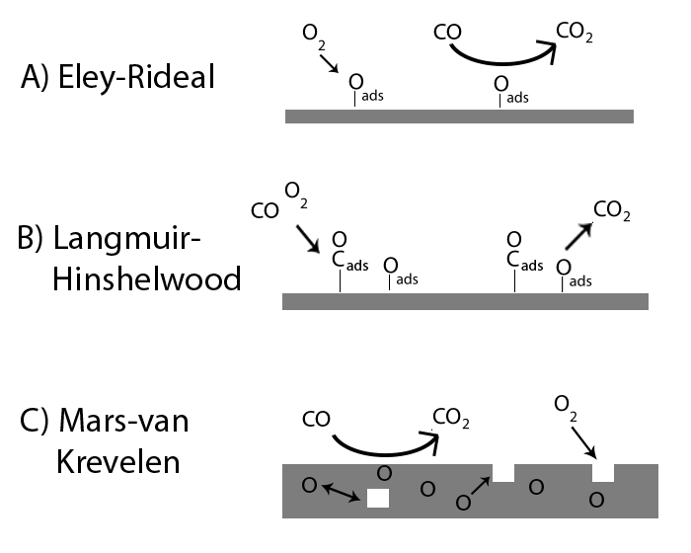
Figure 1.3 Schematic diagrams of CO oxidation mechanisms.
catalyst components this mechanism has fallen out of favor as the primary mechanism for CO oxidation
^{38,39}.
The Langmuir-Hinshelwood mechanism (figure 1.3b) involves the adsorption of both CO and O₂ on the surface of the catalyst and their subsequent reaction to form CO₂.
$CO+ θ_{s}⇄θ_{CO}$ (1.8)
$O_{2}+{2θ}_{s}⇄{2θ}_{O}$ (1.6)
$θ_{CO}+θ_{O}→{CO}_{2}+θ_{s}$ (1.9)
For supported metal catalysts this is most often the mechanism cited
³⁹. Noble metal nanoparticles readily adsorb gas phase CO which then reacts with adsorbed oxygen at the interface with the support. While Pt and Pd are known to be able to activate molecular oxygen themselves, the binding strength of CO to these noble metals is much greater than other catalysts which can lead to self-inhibition by CO when these metals are paired with an “inert” support such as Al₂O₃ or SiO₂⁴⁰.
The Mars-van Krevelen mechanism (figure 1.3c) is most commonly associated with transition metal oxide catalysts. In this mechanism, CO reacts with oxygen in the lattice at the surface of the metal oxide leaving an oxygen vacancy. The vacancy then acts as a site to adsorb and activate molecular oxygen or is filled by mobile bulk oxygen.
$CO+O_{surf}→{CO}_{2}+ θ_{V}$ (1.10)
$θ_{V}+\frac{1}{2}O_{2}→O_{surf}$ (1.11)
This mechanism can also occur at the interface sites of metal nanoparticles and supports⁴¹ but it is most often found in reactions over TMOs³⁵.

Motivation
Over the 4 years in which the work presented here was conducted the goal has always broadly been to investigate methods to develop low temperature oxidation catalysts. That said, while the work initially focused on methods to deposit and stabilize Au nanoparticles (as shown by numerous publications)^{25,26,42,43}, through a collaborative partnership with the Fuels, Engines, and Emissions Research Center my work within the project evolved to characterize and study heterogeneous catalysts in simulated exhaust streams for automotive exhaust purposes. It was at this point that we identified another major problem (namely inhibition) in which our knowledge of materials synthesis and characterization⁴⁴ could be put to good use. This section will provide a brief description of our motivations during the project as they apply to the work presented.

Deposition and Stabilization of Au Nanoparticles
Heterogeneous catalysis by gold has, for most of its history, been considered a fruitless endeavor mainly due to chemical inertness of the bulk metal. Since the observation by Haruta et. al. that nanometer sized gold becomes exceptionally catalytically active in the oxidation of CO, there has been a “gold rush” of scientific research into this metal and its applications as a catalyst

^{27,29}. In the last decade, the catalysis of nano-sized gold has found use in a number of important reactions relevant to green chemistry (CO oxidation, de-NO_{x}) and chemical synthesis (selective oxidation, hydrogenation, C-C coupling)

^{7,45}. Many studies have illustrated the effects of preparation methods (deposition-precipitation, co-precipitation) and synthesis details (size of particles, type of support, synthesis conditions) on catalytic performance

^{28,46-48}. The vast majority of publications focus on gold loaded onto conventional supports (i.e. Au/M_{x}O_{y})¹⁵. While this work has established a basis on which to build an understanding of gold catalysis, the development of more novel systems is crucial. The synthesis of more complex catalysts is beneficial to increasing the library of usable components in the design of future tailored catalysts, as well as aiding in understanding structure-property correlations from a fundamental perspective. Furthermore, modification of conventional supports has the possibility to solve lingering problems in supported gold catalysts, notably the ease of sintering and difficulty of deposition onto some supports, by way of promotional particle-support interactions

⁴⁹.
Gold is notorious for its difficulty in achieving well-dispersed and sinter resistant supported nanoparticles, a key factor in the effectiveness of the overall catalyst

^{15,34}. While good dispersity is a feature of other noble metal catalysts (i.e. Pt and Pd), the low melting point of Au (further reduced by quantum-size effects) causes these particles to easily aggregate and sinter over the surface of a support¹⁵. A number of methods have been employed to increase the stability of Au with respect to sintering. Arnal et. al. produced an Au@ZrO₂ yolk-shell system, wherein a gold nanoparticle is encased in a hollow ZrO₂ shell, through selective etching of a middle silica shell

⁵⁰. This approach (and similar core-shell type systems) achieves high sinter resistance but it proves to be a delicate synthesis that results in higher expense and longer time, and therefore is not suitable for industrial use.
Another common method to achieve sinter resistance in a simpler manner is pre-modification of supports. The Dai group has studied the effects of pre-modification of supports (i.e. modification before Au deposition) on Au/M_{x}O_{y}/TiO₂ systems, finding that these systems retain their high catalytic activity even after calcination at temperatures as high as 500$°$C

¹⁸. Motivated by work describing tight coordination of metal particles to a nitrogen-containing polymer called carbon nitride

⁵¹, C₃N₄, we decided to utilize carbon nitride in a pre-modification strategy to deposit Au nanoparticles onto a silica support via deposition-precipitation.

Automotive Exhaust Treatment
In much of the literature, CO oxidation over heterogeneous catalysts is studied in simple streams consisting of CO, O₂, and sometimes H₂O, and often at fairly low gas hourly space space velocities (≤ 30,000 h⁻¹ GHSV)

^{35,48,52,53}. While these studies are valuable for establishing basic property-activity relationships, many applications in which CO oxidation catalysts are needed require them to be active in complex reactant streams at higher space velocities where their apparent activity can drop dramatically. Automotive exhaust catalysts, such as three-way catalysts found in the catalytic converter of most automobiles, are one such application.
An oxidation catalyst operating in automotive exhaust streams must be able to handle a mixture primarily composed of CO, CO₂, nitrogen oxides (NO_{x}), hydrocarbons (HCs), oxygen, and water⁵⁴; it must perform well at space velocities as high as 150,000 hr⁻¹ ⁵⁵; and it must be active at temperatures from ~250°C to 800-900°C⁵⁶. The inhibition caused by various components in these complex exhaust streams often severely reduce the performance of even the most active catalysts^{54,57}. The vast majority of research into catalysts for this purpose has focused on three precious metals (Pd, Pt, and Rh) supported on metal oxides due to their intrinsically high activity and sulfur tolerance⁵⁸. Since then, sulfur levels in gasoline have fallen dramatically (from nearly 1000 ppm sulfur to 15 ppm) which has sparked a reevaluation of other catalyst materials for this purpose^{59,60}.
Further driving research into alternative catalysts is the need for low temperature activity. As engines become more fuel efficient due to increasing consumer demand and regulatory concerns, the temperature of the resulting exhaust drops which puts a strain on current exhaust catalysts that are not able to perform at these low temperatures⁶¹. As such, there is a significant push to develop new catalyst materials which are active at low temperature. With the collaboration of the Fuels, Engines, and Emissions Research Center, we were able to extend our previous work in nano-sized Au catalysts

^{42,62} and ternary oxide catalysts⁴⁴ toward developing effective oxidation catalysts for this application.

Common Catalyst Synthetic Techniques
The synthesis of heterogeneous catalysts is constantly evolving, but there are a number of techniques and methods which are frequently encountered in the literature. The vast majority of heterogeneous catalysts in use today, and are the focus of this dissertation, are composed of metals and metal oxides synthesized from metal-organic or metal-salt precursors. The following section will detail common synthetic methods metal oxide supports and catalysts, as well as methods for depositing metal nanoparticles onto supports relevant to the work presented here.
Sol-gel
The sol-gel method is commonly used in the synthesis of metal oxides, and mostly for silicas (SiO₂) and titanium dioxide (TiO₂). For SiO₂ and TiO₂, sol-gel refers to a method of hydrolysis and condensation of an alkoxide precursor such as tetraethyl orthosilicate (TEOS) or titanium butoxide. The synthesis of silica will During hydrolysis the TEOS precursor reacts with water, exchanging one of the ligands with a hydroxyl group and producing an alcohol.
(1.12)
Condensation occurs when the hydroxyl group reacts with other partially hydrolyzed silica precursors to form a siloxane bond between the silica atoms and producing water or alcohol.
(1.13)
(1.14)
The hydrolysis and condensation steps can be carried out in excess water to create a colloid of silica particles which are then removed from solution using centrifugation or filtration.
The product is then dried to remove as much of the solvent as possible. During the drying process the polymer matrix shrinks and the method of drying can have a significant impact on the structure of the final silica. For example, removal of solvent by exchange with another solvent above the supercritical point can create an aerogel, an material with extremely low density and thermal conductivity⁶³. Often the dried gel is then calcined at high temperature to remove any remaining alkoxy groups or template polymers used in the synthesis of porous materials.
The sol-gel method can also be used to modify previously synthesized metal oxides, as is the case in the Pd nanoparticle-silica materials presented here. In this case the metal alkoxide (zirconium n-propoxide) is allowed to react with hydroxyl groups at the surface of the pre-synthesized SiO₂. The advantage of this method is that the surface modification is well controlled by either the number of hydroxyl groups at the surface or the amount of alkoxide precursor added

¹⁷.
Precipitation and Coprecipitation
Straightforward precipitation is also a common method for the synthesis of metal oxide supports and catalysts. In this process a metal precursor, usually a metal salt such as CuCl₂ or Ce(NO₃)₃, is dissolved in water and precipitated out by the addition of a base. Coprecipitation, as the name suggests, refers to the simultaneous precipitation of two components in solution to one crystalline or mixed oxide product^{44,64}. The basic steps of the precipitation method are supersaturation, nucleation, and growth.
Supersaturation occurs when the dissolved metal salt reacts with excess hydroxide ions in basic solution. The resulting metal hydroxide has far less solubility in water than the salt and the solution quickly reaches supersaturation with respect to the metal hydroxide. Eventually nucleation occurs either due to disturbance by stirring or at nucleation sites on the walls of the flask. Once the first small seed crystals are formed aggregation and growth can occur. This process can occur quite rapidly but can be moderated by how fast the base is added to the solution.
Once the precipitation reaction is complete, the metal hydroxide product is retrieved by vacuum filtration or centrifugation. Calcination at high temperature in oxygen converts the metal hydroxide into the final metal oxide.
Impregnation
Impregnation is one of the most widely used methods for deposition of the active phase (such as precious metals) onto a catalyst support. Impregnation refers to the use of a of a precursor solution (aqueous HAu(Cl)₄ for example) directly added to the solid support, after which, the solvent is evaporated leaving the active phase on the support. As with other methods, the product is treated at high temperature to produce the final catalyst. Often the catalyst is subjected to hydrogen gas or another reductant during the heat treatment in order to control the reduction and Ostwald ripening of the precious metal precursor into nanoparticles.
There are two types of impregnation differentiated by the amount of precursor solution used. The first is “wet impregnation” where an excess of solution is used. The second is “dry impregnation” or “incipient wetness impregnation” whereby the volume of solution used is equivalent to the pore volume of the support. During incipient wetness capillary forces draw the solution into the pores of the support so that the precursor is better distributed throughout the catalyst⁶⁵. Incipient wetness is particularly useful for microporous and mesoporous supports where creating nanoparticles inside the pore structure is desired. On the other hand, if chloride precursors are used the left over chloride atoms can facilitate sintering and significantly increase particle size

⁶⁶.
Deposition-Precipitation
Another valuable method for synthesizing supported nanoparticle catalyst is deposition-precipitation (DP). Deposition-precipitation is a method which utilizes the electrostatic interactions between dissolved metal precursors and a metal oxide support and is primarily used as a method to reduce the amount of chloride ions on the catalyst surface compared to impregnation with metal chlorides.
Every metal oxide has a pH at which its surface carries no net electrical charge, this is called the isoelectric point (IEP). At a pH above the IEP the support surface becomes negatively charged with O- groups, and at a pH below the IEP the surface is positively charged with (-OH₂)⁺ groups (Figure 1.3). Simultaneously, when the pH of the solution is high enough, the metal chloride precursor will hydrolyze and begin to precipitate from solution. In the case of HAuCl₄, the hydrolyzed product in solution is the negatively charged (AuCl_{x}(OH)_{4-x})⁻.
The key to the DP method is simultaneous deposition and precipitation of the metal precursor. By carefully choosing the appropriate precursor and adjusting the pH of the solution, opposite charges are obtained for the metal precursor and support surface. If these conditions are met, then simultaneous deposition and precipitation of the metal will occur evenly on the surface of the support, ideally with very little chloride content.
The product is then recovered with vacuum filtration or centrifugation. Afterward, as with impregnation, hydrogen reduction and Ostwald ripening is used to form the metal nanoparticles on the support surface.
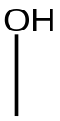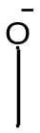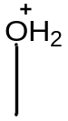

- pH < IEP
- pH = IEP
- pH > IEP
Figure 1.4 Metal oxide support surfaces at pH relative to their isoelectric point (IEP).

Dissertation Overview
The focus of this dissertation is on the development of catalysts for low temperature CO oxidation. The primary focus includes the synthesis and characterization of various metal and metal-oxide nanomaterials as well as evaluation of their catalytic capability for low temperature CO oxidation. The work presented here include both published and unpublished research completed in the group of Dr. Sheng Dai and in collaboration with the Fuels, Engines, and Emissions Research Center at Oak Ridge National Laboratory over the last four years.
Chapter 2 outlines numerous characterization techniques required to study heterogeneous catalysts. These include methods to probe their structure and composition such as powder x-ray diffraction (PXRD), transmission electron microscopy (XRD), and N₂ adsorption/desorption (BET) as well as techniques for studying their chemical properties such as temperature programmed reduction (TPR) and infrared spectroscopy (FTIR). The chapter ends with a look at catalyst performance evaluation using a plug flow reactor and two methods for on-line analysis of the gas streams.
Chapter 3 presents a paper published in the Catalysis Letters describing the use of carbon nitride (C₃N₄) as an aid to the deposition of small Au nanoparticles on silica. This method extends previous work by the Dai group on the modification of metal oxide supports for Au-based catalysts by utilizing the nitrogen functionality of the carbon nitride to facilitate deposition of Au onto SiO₂, a support which is normally difficult to deposit on. The article has been modified slightly to accommodate the thesis format.
Chapter 4 details work on silica supports modified by metal oxides to enhance the activity of noble metal nanoparticles for oxidation reactions in automotive exhaust streams. The first example is an extension of the work presented in chapter 3 in which carbon nitride was used to load the silica surface with iron prior to the deposition of Au. The results show increased dispersion of Fe₂O₃ on silica compared to standard impregnation, increased activity for CO oxidation, and high stability even at 800°C. The second example is a study of Pd deposited on zirconia modified silica. The zirconia modified support showed higher stability for the Pd particles and enhanced their activity for CO and C₃H₆ oxidation. In both examples C₃H₆ was found to dramatically inhibit CO oxidation, diffuse reflectance FTIR spectroscopy (DRIFTS) was used to study this effect on Pd/ZrO₂/SiO₂.
Chapter 5 presents a report currently submitted to the journal Science describing work on a unique ternary oxide catalyst which is able to overcome the propene inhibition effects described in chapter 4. The catalyst is composed of a three-phase mixture of CuO, Co₃O₄, and CeO₂ and outperforms the other precious metal catalysts tested in CO oxidation in simulated automotive exhaust streams. DRIFTS data confirms the lack of interaction between C₃H₆ and the CO binding site. Initial catalysis data is consistent with a separation of active sites for CO and C₃H₆ oxidation.

Characterization techniques

Catalyst Characterization

Scanning Transmission Electron Microscopy (STEM)
Scanning Transmission Electron Microscopy (STEM) is a technique that enables researchers to obtain high-resolution images of nanoscale samples and obtain valuable information on structural properties of materials. Like a standard transmission electron microscope (TEM), the STEM instrument operating in transmission mode sends a high-energy beam (typically 100kV to 300kV) of electrons through a sample and collects the transmitted electrons to obtain an image. Unlike a standard TEM, an STEM focuses the electrons into a much narrower beam, which it then moves across the sample. The rastering of the electron beam in this manner greatly improves the versatility of the electron microscope, allowing it to be used for multiple other imaging and characterization techniques (listed below) with the aid of additional detectors. Representative images of these techniques are given in figure 2.1. The STEM instrument used throughout the work presented here was a Hitachi HD-2000 STEM operated at 200kV and equipped with an EDX spectrometer.
- Transmission mode (Figure 2.1a) - Detection of transmitted electrons creates a TEM image of very high resolution. Because the density of a
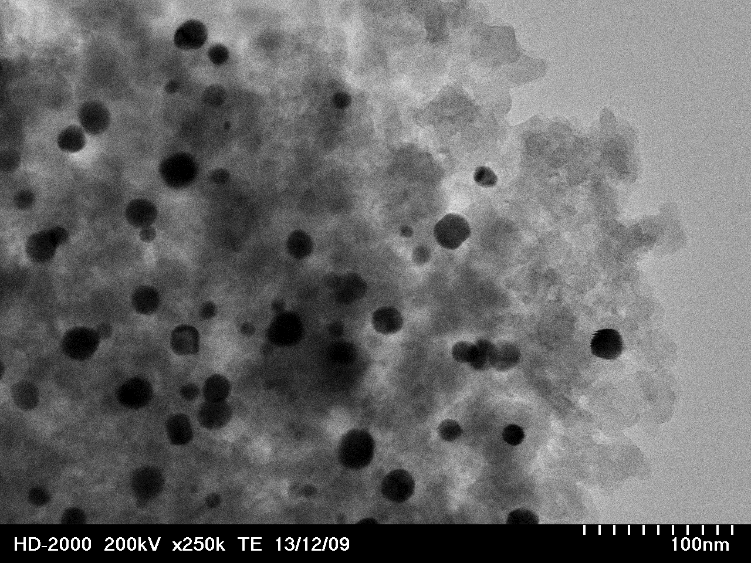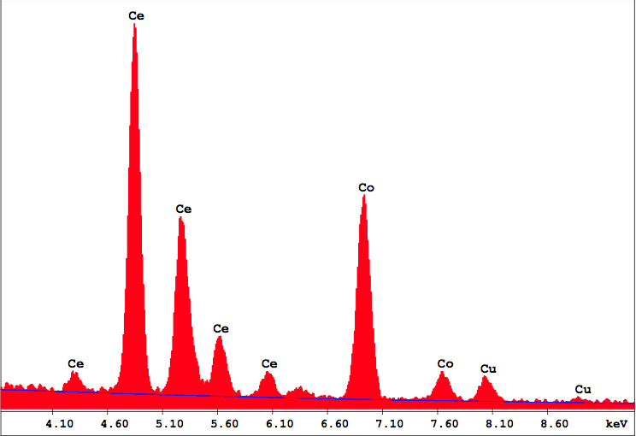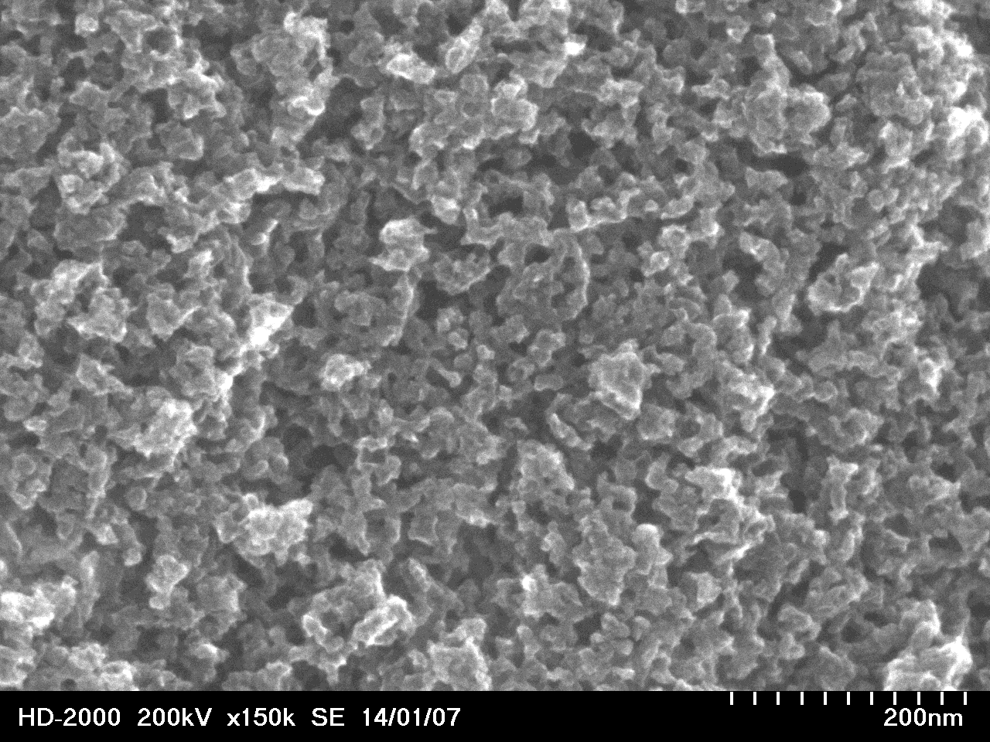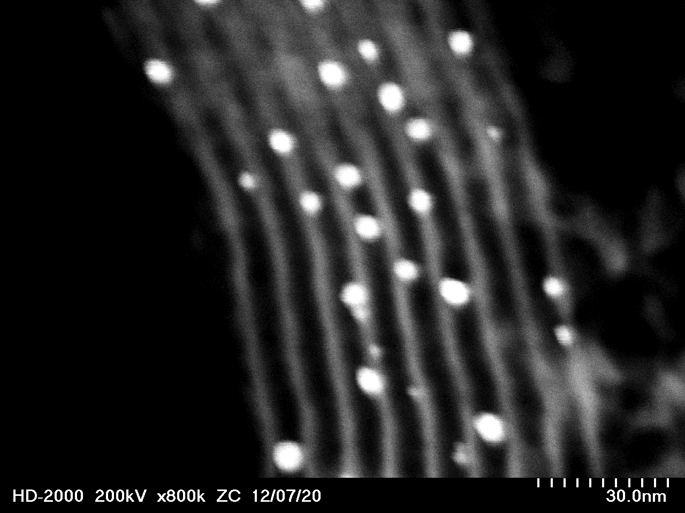
(a)
(b)
(c)
(d)
Figure 2.1 Representative images of STEM techniques.
(a) Transmission mode image of Au nanoparticles deposited on silica. (b) Scanning mode image showing worm-like pores of a mesoporous carbon. (c) Z-Contrast mode image of Au nanoparticles deposited in the pores of ordered-mesoporous SBA-15 silica. (d) EDX spectrum of CuO-Co₃O₄-CeO₂ ternary oxide.
material directly affects the image, this mode is very useful for imaging ordered porous materials and metal nanoparticles. At high resolution, transmission mode is also capable of viewing lattice spacing in nano-crystalline materials.
- Scanning mode (Figure 2.1b) – In this mode, scattered electrons are detected and matched with the rastered beam position to obtain a surface topography image of the sample. This mode can give valuable images of surface porosity, material structure, and heterogeneity.
- Z-Contrast mode (Figure 2.1c) – This mode operates by collection of electrons scattered at high angle. The contrast in the images formed is directly related to the atomic number of the elements in the material. As such, these images are immediately interpretable and are useful for determining a qualitative elemental makeup of the material.
- Energy Dispersive X-Ray Spectroscopy (EDX) (Figure 2.1d) – EDX is a technique in which the electron beam ejects an electron from an inner shell, allowing an outer-shell electron to fill the resulting hole. The energy difference between the outer shell and inner shell is released in the form of an X-ray, which can be detected and is characteristic of the specific element. EDX can be used for quantitative elemental evaluation and creating an elemental map of the sample.

Powder X-Ray Diffraction (PXRD)
Powder X-ray diffraction (PXRD) is an invaluable tool for heterogeneous catalyst researchers which enables them to quickly obtain information on the catalyst material makeup, including crystallite size and material composition, in an aggregate sample. X-ray diffraction is a technique in which X-rays are directed at a crystalline sample where they are scattered by the lattice of the crystal (Figure 2.2). When the beams scattered from different lattice planes interact on their way to the detector, constructive or destructive interference occurs depending on their relative phases. The constructive interference, which results in diffraction peaks, follows Bragg’s Law.
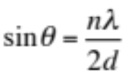 (2.1)
Where $θ$ is the angle of incidence (Bragg angle), $n$ is an integer, $λ$ is the wavelength of the incident X-ray, and $d$ is the lattice spacing between atomic layers. Therefore, by plotting the scattering intensity against the angle of incidence a spectrum can be obtained with detailed information on the crystal structure of a material. A great many materials have been characterized in this way and so by comparison of experimental diffraction patterns with a database of samples it is even possible to determine the phase composition of a powder sample.
PXRD is of particular use to those working with nanocrystalline materials, such as supported nanoparticles or mixed oxides, because analysis of the diffraction 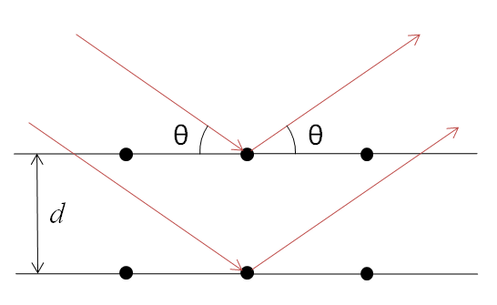 Figure 2.2 Schematic of X-ray diffraction of a crystalline material.
peaks can result in a good estimate of crystal size below 100nm. As particle size shrinks, a broadening of the diffraction peaks can be seen. The Scherrer Equation (eq. 2.2) (named after Paul Scherrer) is a formula, which can be used to determine the size of particles in a crystalline powder.
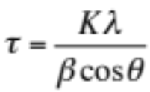 (2.2)
Where $τ$ is the mean size of a crystal domain, K is a shape factor (general 0.9 but can vary with crystallite shape), $λ$ is the wavelength of the incident X-ray, $β$ is the full-width half-maximum (FWHM) of the peak, and $θ$ is the Bragg angle.
It is important to note that this method is dependent on the width of the detected diffraction peaks and represents only a lower bound estimate of particle size. Lattice strain and other imperfections can cause some broadening of the peak and so while use of the Scherrer Equation is a good estimate, absolute determination of crystal size requires corroboration with other methods such as STEM imaging. That said, unlike STEM imaging, which can only view localized areas of a sample, PXRD allows relatively quick sampling of an entire sample to obtain a mean crystal domain size and material composition.

N₂ Adsorption/Desorption (BET)
Determination of surface properties is crucial to understanding both the synthesis and the apparent reactivity of heterogeneous catalysts. For example, because the catalyst interacts with gaseous molecules at the surface, an increase in surface area per gram catalyst can have a profound effect on the practical applicability of a given catalyst due to increased access to reactive sites. The standard technique for determining surface area and porosity is by N₂ physisorption measurement coupled with a calculation using Brunauer-Emmett-Teller (BET) theory.
In an N₂ sorption measurement, the sample is cooled to liquid nitrogen temperature and subjected to repeated doses of N₂ at various pressures and the quantity of physisorbed nitrogen is measured. The resulting adsorption isotherm is then fitted to the BET equation (eq. 2.3) to determine the monolayer capacity.
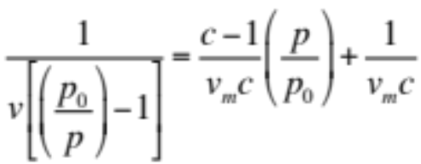 (2.3)
Where $v$ is the quantity of adsorbed N₂, $p$ and $p_{0}$ are the equilibrium and saturation pressures, $c$ is the BET constant specific to N₂, and $v_{m}$is the monolayer capacity. When the monolayer capacity is multiplied by the cross-sectional area of N₂, the total surface area of the material can be determined. The surface area is generally published in terms of specific surface area (SSA) in m²/g.
For pore size analysis the N₂ pressure is increased until the gas condenses inside of the pores, starting with the smallest. The pressure is then reduced incrementally, allowing the condensed gas to evaporate. This process creates a hysteresis in the isotherm, which can be analyzed to determine pore size, volume, and shape. A pore size distribution can then be determined using Barrett-Joyner-Halenda (BJH) theory⁶⁷.

Infrared Spectroscopy (FTIR and DRIFTS)
As then name suggests, infrared spectroscopy (IR) is a method which probes the chemical composition of a material by analyzing the absorption/transmission of infrared light. In an IR experiment, monochromated infrared light is passed through a sample while adjusting the wavelength from λ = 800 nm to λ = 2500 nm. When the frequency of the light ($f=\frac{c}{λ}$) matches the vibrational frequency of a bond in the sample, the light is absorbed. Thus by plotting the intensity of the transmitted/absorbed light and plotting it against the wavelength of the light (generally given in inverse units, cm⁻¹, and refered to as “wavenumbers”) it is possible to gain valuable information on the chemical makeup of the sample as determined by the vibration of certain functional groups and bonds. Generally, a background spectra is also subtracted in order to account for the IR adsorption of solvents or ambient atmosphere.
While the fundamentals are the same, many modern IR spectroscopy instruments do not use a monochromater to scan across multiple wavelengths of infrared light. Instead, a broadband beam containing the full spectrum of infrared light is passed through a Michelson interferometer (figure 2.3a) which blocks some combination of wavelengths before it reaches the sample. The interferometer can be easily adjusted by moving the position of one mirror to block many different combinations of wavelengths and the result is an “interferogram” (figure 2.3b) of light intensity vs. mirror position. Finally, a Fourier transform is applied which results in the desired spectrum of intensity vs wavenumber (figure 2.3c) giving this technique the name Fourier transform infrared spectroscopy (FTIR).
IR spectroscopy can also be used to probe surface chemistry on heterogeneous catalysts through the use of diffuse reflectance infrared Fourier transform spectroscopy (DRIFTS). In this case, infrared light is directed onto the surface of a powder sample instead of through a solution of the material, which causes scattering in all direction due to the imperfect or rough surface of the powdered catalyst. A DRIFTS apparatus is equipped with a series of mirrors or a single parabolic/ellipsoid mirror to direct this scattered light toward the detector to obtain enough signal for processing. Because catalytic reactions primarily occur at the surface, this method is ideal for examining a catalyst or catalytic reaction in-situ at a fundamental level. DRIFTS is a powerful tool for determining the nature of both the surface adsorbed species and the absorption site (typically a metal nanoparticle or metal-oxide). For example, when CO adsorbs to a metal binding site π-backbonding occurs from the metal center to the π* orbitals, weakening the C-O bond and lowering its vibrational frequency (vCO). As the oxidation state of the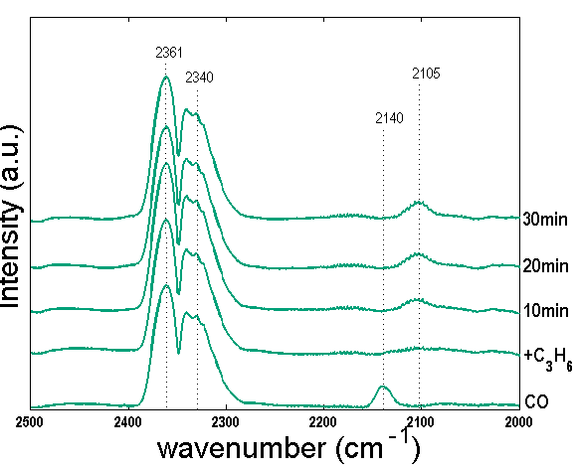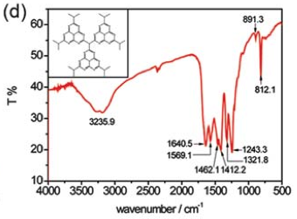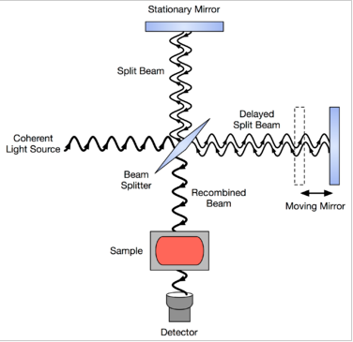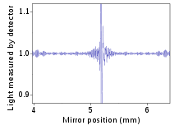 Figure 2.3 Representative figures relevant to Fourier transform infrared spectroscopy.
(c)
(a)
(b)
(d)
(a) Schematic diagram of Michelson interferometer, (b) Example FTIR interferogram (image source: Wikipedia), (c) Example FTIR spectrum: transmission spectrum of graphitic carbon nitride synthesized by pyrolysis of urea

⁶⁸, (d) DRIFTS spectra showing the change in Pd-CO adsorption site over Pd/ZrO₂-SiO₂.
metal decreases, so does v_{CO}. Therefore, by looking at changes in the C-O stretching vibration using DRIFTS it is possible to see changes in the electronic state of the metal binding site. Figure 2.3d gives an example of this effect from work discussed in Chapter 5. Here the addition of propene to a reactant stream of CO and oxygen causes a shift in the Pd-carbonyl band over Pd/ZrO₂-SiO₂ from 2140 cm⁻¹ to 2105 cm⁻¹, indicating a reduction in the Pd metal binding site.

X-ray Photoelectron Spectroscopy (XPS)
X-ray Photoelectron Spectroscopy (XPS) is another helpful technique for obtaining chemical information about a catalyst surface. The basics of XPS are an extension of the photoelectric effect. X-rays of a known energy are directed at a sample where they are absorbed by electrons. If the energy of the absorbed photon (E_{photon}) is greater than the binding energy (E_{b}) of the electron then the electron is ejected from the atom and any extra energy over the binding energy is added to the kinetic energy (E_{kin}) of the free electron.
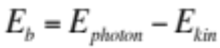 (2.4)
By measuring the kinetic energy of the free electrons it is possible to get a very accurate determination of both the element they were ejected from and their binding energy. Because this technique measures ejected electrons it is also a surface sensitive technique, i.e. any information gained only directly pertains to the surface of the material.
With respect to heterogeneous catalysts, XPS is particularly useful for determining the oxidation states of metals, electronic effects resulting from metal-support interactions, or the chemical makeup of organic species on surfaces. The binding energies of specific electrons in many bulk metals, such as Au4f_{7/2} or Fe2p_{1/2}, are well known so it is possible to check for small changes in the electronic state of these atoms by looking at shifts from reference values. Similarly, the bonding characteristics of carbon atoms in organic molecules changes have measurable effects on the binding energy of electrons in the molecule so it is possible to confirm the structure of a compound by comparing it to known standards.

Temperature Programmed Methods (TPR, TPO, TPD)
Temperature programmed reduction (TPR) and oxidation (TPO) are methods to probe the reducibility and oxidizability of a catalyst as a function of temperature. With adequate knowledge of the catalyst composition, TPR and TPO are able to provide valuable data on how a catalyst changes chemically during catalytic testing. In TPR, a sample is subjected to hydrogen gas (~10% in an inert gas) at increasing temperature and the resulting hydrogen uptake or H₂O formation is measured in the outlet gas stream by a thermal conductivity detector (TCD). Plotting the TCD signal vs the temperature reveals peaks associated with the reduction of catalyst components. For example, Figure 2.4 shows a TPR plots of a 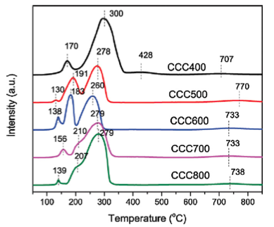
Figure 2.4 TPR of various CuO-Co₃O₄-CeO₂ (CCC) catalysts calcined at different temperatures⁴⁴.
catalyst composed of CuO, Co₃O₄, CeO₂ prepared at various calcination temperatures (labeled as CCCXXX, where XXX indicates the calcination temperature). The first peak on each plot is associated with the reduction of CuO to Cu metal and it is clear that calcination temperature has a significant effect on the reducibility of the CuO component, especially between calcination temperatures of 400°C and 500°C.
TPO functions much the same way that TPR does except that a sample is generally pre-reduced, O₂ is flowed instead of H₂, and oxygen uptake is detected. Many times TPO can be performed directly after a TPR experiment by simply cooling down the catalyst in inert atmosphere before introducing oxygen. For many catalysts the reducibility and oxidizability of the component metal oxides and metal nanoparticles can be directly related to the activity of the catalyst for low temperature oxidation. Therefore TPO and TPR experiments are very commonly used in this field.
Unlike TPO and TPR, temperature programmed desorption (TPD) is concerned with surface species. Generally the process involves pre-adsorbing some chemical and then increasing the temperature in inert atmosphere while detecting it or its reaction products in the exit stream. TPD can be used with a variety of gasses and goals in mind. For example, O₂-TPD can be used to determine the ability of a catalyst to adsorb O₂ to its surface or the availability of lattice oxygen for reactions. On the other hand, one can halt a reaction (such as hydrocarbon oxidation) at low conversion to pre-adsorb reactants and products. By then running a TPD experiment, the presence of partial reaction products and carbonaceous deposits can be assessed.

Thermo-gravimetric Analysis (TGA)
Thermo-gravimetric analysis (TGA) is a simple method for determining mass gain or loss due to effects such as gas adsorption/desorption, oxidation/reduction, or decomposition of catalysts and surface species. A standard TGA is equipped with a temperature controller and high precision balance in an isolated chamber (usually a high temperature capable pan set on, or hanging from, a delicate hook). The balance is zeroed and small changes in mass are recorded as the temperature is increased. In the work presented here, TGA is used to correlate the loss of organic material on the surface of a support with catalytic activity.

Catalytic Evaluation

Plug Flow Reactor
All of the catalyst evaluations described in this document were completed using a plug flow reactor equipped with either a gas chromatograph (GC) or a mass spectrometer (MS) for analysis of the products. In a plug flow reactor (PFR) the powdered catalyst is suspended (generally by packing with quartz wool) in a straight quartz tube, the reactant gasses are flowed through the catalyst bed, and the product stream is analyzed by gas chromatography to determine the conversion at a given temperature (plotted as a light-off curve). A simple diagram of a PFR is shown in figure 2.5 where dV_{r} is a differential volume element of the catalyst, F_{A} is the molal flow rate of reactant A, and f_{A} is the fractional conversion of reactant A.
The plug flow reactor can be viewed as sequential volume units of reactant gas reacting as it goes through the catalyst plug. The change in the reactant flow rate, dF_{A}, is related to the differential volume, dV_{r}, by the following:
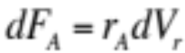 (2.5)
where r_{A} is the rate per unit volume of the catalyst. The reactant flow rate can be found by the following:
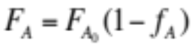 (2.6)
where F_{A0} is the reactant flow rate measured at the inlet, before reaching the catalyst. Combining equations 2.5 and 2.6, and integrating over the catalyst volume results in an equation for determining the rate per unit volume, r_{A}:
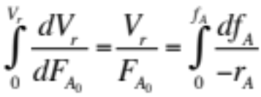 (2.7)
While equation 2.7 can be used directly to determine r_{A} by integrating a curve of (-1/r_{A}) vs f_{A}, it is much more useful to operate the reactor in differential mode (Δf_{A} ≈ df_{A}) and evaluate the catalyst in the kinetic regime (f_{A} ≤ 0.1). Operating in differential mode is accomplished by running in steady state conditions which helps alleviate heat and mass transfer limitations. By operating in the kinetic 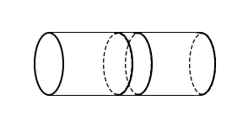
dV
F_{A}
f_{A}

F_{A} + dF_{A}
f_{A} + df_{A}
Figure 2.5 Diagram of a plug flow reactor⁴.
regime changes to the rate due to non-zero-order products are eliminated because the concentration of products are low compared to reactants. If these two requirements are met r_{A} effectively becomes constant and equation 2.7 becomes:
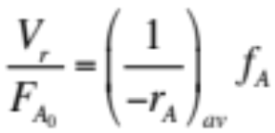 (2.8)
What this means is that an accurate reaction rate per unit volume (or unit mass if the catalyst density is known) can be easily extracted using a PFR reactor so long as it is operated in differential mode and in the kinetic regime.

Gas Chromatography (GC)
One method for analyzing product streams is gas chromatography (GC). GC is a method of separating gaseous compounds by their interaction with a stationary phase in a column. As the sample gas is pushed through the column by an inert carrier gas (He, Ar, or N₂), the different molecules of the sample travel at different rates dependent on their adsorption strength to the stationary phase or column wall and therefore elute from the column at different times. The time it takes for a particular substance to elute is called the retention time. In order to get good results the column, temperature, and pressure must be chosen carefully as each can change the exact retention time greatly.
When the sample exits the column it is fed to a detector to produce a signal intensity that is plotted against time and called a chromatograph. The most common detector equipped with GCs is the thermal conductivity detector (TCD). The TCD measures the change in resistance caused by differences in the thermal conductivity between a sample gas and a reference gas (typically the carrier gas). As the components of the separated sample pass through the detector, the TCD signal changes in intensity to produce the chromatograph. If a TCD is used, the GC carrier gas must be chosen to have the greatest difference in thermal conductivity compared to the samples to be studied. In the vast majority of cases a He carrier gas works well with the TCD due to its high thermal conductivity.
Once the chromatograph is plotted, compounds can be determined qualitatively by their order of elution. For quantitative analysis, standard gas mixtures can be used as a calibration so that integration of the chromatograph peaks will give an accurate value of the concentration of each compound. The advantage of GC is that it is fairly simple to use and calibration can yield direct values for concentration down to the ppm level. The downside is that some compounds may take minutes to elute which means using a slow ramp rate to get enough data points for a light-off curve and it may be difficult at times to fully separate all peaks in a chromatograph because of compounds with close retention times.

Mass Spectrometry (MS)
Another very common analysis technique that is coupled with catalytic reactors is mass spectrometry (MS). There are many types of MS instruments. The type used in the work presented here is an electron ionization quadrupole mass spectrometer (QMS). First the sample gas is passed through a capillary and into a vacuum chamber where the molecules are ionized and fragmented by an electron beam. The ionized sample is then directed toward the quadrupole mass analyzer where ions of a given mass-to-charge ratio (m/z) are selected and sent to a detector. The quadrupole mass analyzer is a group of four parallel metal rods which can select for a given m/z by modifying the electric field in the ion’s travel path such that only the desired ions have a stable trajectory to reach the detector.
Each value of m/z can be tracked separately over time during a catalyst evaluation and plotted as a function of catalyst temperature. Quantitation can be achieved by running a calibration gas and determining the spectrometers sensitivity to a given compound at a certain m/z with the following formula…
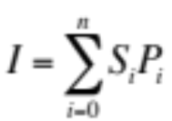 (2.9)
where I is the signal intensity at the given m/z, n is the number of compounds in the stream, and S and P are the sensitivities and partial pressures of compound i. If each sensitivity is found through calibration then the partial pressure of a desired compound can be determined by linear regression.
QMS is well suited to analyzing reactor streams because it is able to quickly monitor particular masses that are characteristic of a given compound (for example, m/z = 44 for CO₂). Unlike a GC, analysis by QMS is fast enough to accommodate fairly high temperature ramp rates (5-10 °C/min) and still achieve enough resolution (in time) for a light-off curve. On the other hand, complex gas streams can often have multiple compounds with fragments at the same m/z that can severely complicate the use of equation 2.9 to get quantitative data. Furthermore, if there are any unexpected reaction products that have not been calibrated for then quantitation can become even more difficult. In order to alleviate these issues, many systems use a combined GC-MS setup to first separate the compounds with GC and then determine their structure with MS, though this will again reduce the time resolution of the instrument.

Carbon nitride modified silica for gold adsorption and stabilization

Published Work Disclosure
This chapter is based on previously published paper:
Andrew J. Binder, Zhen-An Qiao, Gabriel M. Veith, and Sheng Dai, Deposition-Precipitation and Stabilization of a Silica-Supported Au Catalyst by Surface Modification with Carbon Nitride. Catalysis Letters 143, 1339-1345 (2013)
My contributions to this work include (i) gathering and reading literature, (ii) identification of the objectives, (iii) design and conducting of synthetic experiments, (iii) conducting of characterization experiments with the exception of XPS which was accomplished by Gabriel M. Veith, (iv) processing and analyzing experimental data, and (v) writing the paper itself with the aid of edits by all authors listed.

Introduction
The synthesis of supported gold nanoparticles (NPs) is of increasing importance due to their surprisingly high catalytic activity

^{7,15,62,69}. The performance of these catalysts are highly dependent on a number of factors including size, dispersion, and support composition and thus synthetic control is greatly desired to create stable materials with excellent activity

^{7,15,28,47,70}. A wide variety of metal oxides such as TiO₂, CeO₂, ZrO₂, Al₂O₃, etc., have been studied as supports for Au NPs, displaying the support dependent nature of these catalytic systems

^{15,48,62,66,71}. The most common method for the synthesis of supported Au nanoparticles is deposition-precipitation (DP) whereby the pH value of an auric acid (HAuCl₄) solution is adjusted to between 6 and 10 resulting in the deposition of the Au(OH)₃ species on the support surface²⁸. This process generally utilizes the high isoelectric point (IEP) of many common support materials to create a positively charged surface at high pH, which interacts with the negatively charged Au(OH)_{x}Cl_{4-x}⁻. Unfortunately, this simple process is unfavorable for supports with a low IEP such as silica (IEP ≈ 2) because of the highly negatively charged surface at the required pH value.
Previously, we have worked to alleviate this problem by the introduction of a secondary support surface layer by use of a “pre-modification” strategy

^{17,49}. Addition of a secondary surface layer with a higher IEP allows the deposition precipitation process to be used. Furthermore, these supporting layers were shown to have beneficial effects such as increased catalytic activity for CO oxidation and decreased pore size which may be useful for shape-selective organic catalysis

⁴⁹. While this method has proven to be effective in many cases, the pre-modification strategy has been limited to using additional layers of metal-oxides

^{17,72-74}. The introduction of an organic layer to a silica support presents the opportunity for functionalizable supported Au catalysts which also possess the advantage of tunable surface area.
Herein we report the surface modification of SiO₂ by carbon nitride for the loading of Au nanoparticles by DP. C₃N₄ (figure 3.1) aids in the deposition-precipitation of Au onto supports that are otherwise unreceptive to this method due to a low IEP. The structure of g-C₃N₄ allows for easy incorporation of metal species into the nitrogen “pots” of the polymer and the high concentration of nitrogen atoms act in a similar fashion to the amine ligands for the complexation of Au

^{52,75,76}. The introduction of amine functionalities to the deposition process has previously led to much success in obtaining stable Au/SiO₂ catalysts. One common method has been to change the normal DP procedure to incorporate a positively charged Au precursor, which is better attracted to the negatively charged surface of the silica support at high pH. In a method by our group, the Au-ethylenediamine complex (Au[en]₂³⁺) is prepared prior to the deposition onto the support⁵². Margitfalvi et. al. also reported a similar synthesis in which ammonia or urea is used both as a base and to create the cationic precursor during the deposition⁷⁷. In both of these cases, the resulting catalyst was highly active for CO oxidation with great stability. Unlike these methods, which focus on changing the charge of the Au precursor to make use of the low silica IEP, modification by carbon nitride “side steps” the issue of precursor and support charge by focusing on the nitrogen functionality which is known to complex easily with Au

^{70,78,79}. The nitrogen-metal interaction is also 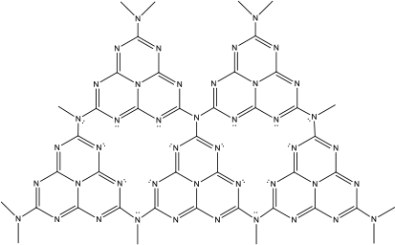
Figure 3.1 Basic structure of carbon nitride, C₃N₄.
known to favor the tight coordination and thereby stabilization of fully formed metal particles

⁵¹. Carbon nitride possesses a number of qualities that may make it a useful additive to traditional Au/SiO₂ catalysts. Unlike previously reported amine surface functionalization, C₃N₄ is synthesized with relative ease through the pyrolysis of dicyandiamide or urea and when well condensed into graphitic carbon nitride (g-C₃N₄) is highly stable with respect to thermal treatment (up to 600$°$C)

^{68,80}. It is also very stable against chemical attack, showing no detectable solubility or reactivity in many conventional solvents (water, alcohols, DMF, and toluene among others)

⁸¹. Furthermore, carbon nitride may add properties to a silica support such as photocatalytic activity and organic functionalization

^{82,83}.

Experimental

Materials
The chemicals used were the non-ionic triblock copolymer EO₂₀PO₇₀EO₂ (denoted as P123, MW = 5800), tetraethyl orthosilicate (TEOS), dicyandiamide (H₂NC(NH)NHCN), 3-hydroxytyramine hydrobromide (dopamine), and hydrogen tetrachloroaurate (III) trihydrate obtained from Aldrich. All chemicals were used as received without further purification.

Preparation of C₃N₄/SiO₂
SBA-15 and MCM-48 were synthesized according to literature procedures^{79,84}. Typically for SBA-15, P123 (4.0 g) was dissolved in 105mL H₂O followed by the dropwise addition of HCl (37%, 20 mL) at 35°C. After 30 min of stirring, TEOS (8.5 g) was added dropwise and left to stir for 4 hrs in a round bottom flask equipped with a condenser. The milky white solution was then transferred to a Teflon bottle to age overnight at 90°C under static conditions. For MCM-48, CTAB (0.5 g) and F127 (2.05 g) were dissolved in a solution of H₂O (96 g), EtOH (34 g), and NH₄(OH) (10.05 g). At room temperature, 1.8 g of TEOS was added at once and stirred for 1 min at very high speed (>1000rpm) then left static for 24 hr. In both cases, after filtration and washing with H₂O the sample was dried overnight at 80°C and then calcined at 550°C for 5 hrs in air. Commercial Cab-O-Sil was used as obtained.
The introduction of the carbon nitride component was accomplished by a simple dry mixing of SiO₂ to dicyandiamide (DCDA) at a 2:1 ratio, respectively, in a mortar and pestle thoroughly. The DCDA/SBA-15 material was then calcined at 550°C for 4 hr (2.3°C/min) under inert atmosphere to yield C₃N₄/SiO₂.

Preparation of C/SiO2
C/SiO₂ was prepared according to previous literature⁸⁵. Typically, 80 mg of SBA-15 was mixed with 80 mg dopamine in Tris-buffer (25 mL, 10 mM, pH 8.5) for 24 hr. The product was collected by centrifugation and then carbonized in inert atmosphere at 400°C for 2 hr (1°C/min rate) and then followed by treatment at 800°C for 3 hr (5°C/min rate).

Synthesis of Au/C₃N₄/SiO₂ Catalyst
The Au/C₃N₄/SiO₂ and Au/C/SiO₂ catalysts were prepared by deposition-precipitation (DP) method as described in literature sources

^{15,17,28}. First, 2.0 g of HAuCl₄●3H₂O was dissolved in deionized H₂O to form a gold precursor solution. From this solution, the support and desired amount of Au (by wt.) was added to 30 mL of H₂O and the pH was adjusted to ~10 by the addition of 1.0 M NaOH at room temperature. This solution was then heated to 80°C under vigorous stirring. The resulting solution was left to stir continuously for 2 hr. The catalyst was separated from solution by centrifugation and washed three times with deionized water. The final yellow product was left to dry under vacuum overnight resulting in the as-synthesized sample.

Catalyst Characterization
Powder X-ray diffraction (XRD) data were collected via a Panalytical Empyrean diffractometer with Cu Kα radiation (λ = 1.5418 Å). The surface areas and pore structures of catalysts were characterized using a nitrogen adsorption - desorption measurement (TriStar, Micromeretics). Both bright-field and dark-field (Z-contrast) transmission electron microscopy (TEM) investigations were carried out using an HD-2000 scanning transmission electron microscope (STEM) operated at 200 kV. Thermo-gravimetric analysis (TGA) was recorded on a TGA 2950 (TA Instruments) instrument using a heating rate of 10°C/min in air. IR data was taken using a PerkinElmer Frontier FTIR Spectrometer equipped with an attenuated total reflectance (ATR) sampling attachment. Surface chemistry was determined using a PHI 3056 X-ray Photoelectron Spectroscopy (XPS) spectrometer with an AI source in a 2x10⁻⁹ torr vacuum chamber. Samples were pressed into In foil during data collection. Adventitious C was used as an internal charge standard (284.8 eV). High resolution scans were taken with 23.5 eV pass energy, 0.05 eV energy step, and 100 repeats to increase the signal-to-noise ratio. Elemental analysis was performed via combustion method by Galbraith Laboratories, Inc.

Catalytic Test
Catalytic oxidation of carbon monoxide was carried out in an AMI 200 (Altamira Instruments). Typically, 30 mg of a selected catalyst was packed into a 4 mm i.d. silica U-tube and supported by quartz wools. The catalyst was first pretreated in flowing 4% H₂/Ar for 1 hr at 300°C and then the CO conversion of the sample was measured as a function of temperature (light-off curve) at a rate of 10°C/min to a max temperature of about 500°C. A gas stream of 1% CO balanced with dry air (< 4 ppm water) was flowed at ambient pressure through the catalyst at a rate of about 37 sccm. The gas exiting the reactor was analyzed by a Buck Scientific 910 gas chromatograph equipped with a dual molecular sieve/porous polymer column (Alltech CTR1) and a thermal conductivity detector. The light-off curve was typically measured two times or more to determine catalytic stability.

Results and Discussion
N₂ adsorption-desorption isotherms of SBA-15 before and after carbon nitride addition are shown in Figure 3.2. Calculated BET surface areas for the two samples were 638 m²g⁻¹ and 549 m²g⁻¹, respectively, indicating the presence of carbon nitride on the surface of the silica. Barrett-Joyner-Halenda (BJH) calculations also show an average pore size reduction from 6.5nm to 5.9nm, and a pore volume reduction from 6.2 mL g⁻¹ to 5.3 mL g⁻¹ confirming the presence of carbon nitride inside the pore structure. The type-IV isotherm typical of SBA-15 was maintained even after the addition of C₃N₄ demonstrating that the overall pore structure was undisturbed by the coating process.
XPS data for the N1s peak of the C₃N₄/SBA-15 (Figure 3.3a) is in agreement with a triazine or heptazine based structure and matches well with recorded literature

⁸⁶. Figure 3.3b shows FTIR spectra indicating successful deposition of carbon nitride species onto SBA-15. After the addition of carbon nitride through the pyrolysis of dicyandiamide, the spectra shows clear bands in the ~1300-1700 cm⁻¹ region commonly associated with s-triazine quadrant stretching and double semi-circle stretching^{85,87}. A strong band found at ~2200 cm⁻¹ is associated with cyano-
Figure 3.2 N₂ adsorption-desorption isotherms and BJH pore distributions (inset) before and after carbon nitride modification of SBA-15.
a)
b)
Figure 3.3 a) Deconvoluted N1s XPS spectrum of C₃N₄/SBA-15 support and b) FTIR spectra comparison of SBA-15 (black), carbon nitride modified SBA-15 (blue), carbon nitride recovered from HF treatment (green), and carbon nitride synthesized without SBA-15 (red).
groups or –N=C=N- groups which indicates the lack of full condensation of the polymer which leaves many edge groups and fractured regions

^{87,88}. Due to the high amount of silica relative to the carbon nitride, many characteristic bands for the carbon nitride are difficult to detect. The C₃N₄/SBA-15 was treated with HF in order to remove the silica component and the FTIR spectra was compared to that of C₃N₄ synthesized through direct pyrolysis of dicyandiamide without any silica. After HF treatment the characteristic band at ~800 cm⁻¹, attributed to the out of plane bending of the s-triazine, is found as well as the broad band at ~3200 cm⁻¹ associated with the N-H stretch. The full spectrum of the C₃N₄ resulting from HF treatment agrees quite well with that of C₃N₄ formed from direct pyrolysis of DCDA with the exception of the band found near ~2200 cm⁻¹ indicating again the presence of many edge and uncondensed regions.
The C/N ratio of C₃N₄ was found to be 0.624 by elemental analysis which is less than the ideal theoretical value of 0.75, which has been previously attributed to a defect rich surface resulting in surface termination with uncondensed amino groups⁸². Exact coverage of the carbon nitride over the SBA-15 is difficult to infer. FTIR results show no hydroxyl species before or after addition of C₃N₄ which renders that method unsuitable but based on the presence of bands relating to a large amount edge/uncondensed regions and elemental analysis we propose that it is likely that the carbon nitride exists in a more “patchy” in nature.
Following Au deposition-precipitation and pretreatment, the Au/C₃N₄/SBA-15 catalyst was tested for activity in the CO oxidation reaction (Figure 3.4, black). While the first run shows catalytic activity only at temperatures above 250°C (T₅₀ ≈ 400°C), consistent with reported activity of Au/C₃N₄ treated at pH ≈ 10, a second cycle showed vastly increased activity with 50% conversion occurring at only 240°C. The catalytic activity of a supported Au catalyst can be profoundly influenced by the amount of surface oxygen present on the support while carbon nitride has been shown to absorb very little surface oxygen

^{22,89}. Therefore we attribute the drastic increase in catalytic activity shown by the C₃N₄/SiO₂ samples to the availability of exposed SiO₂ as the carbon nitride layer decomposes at the high temperatures reached at the end of the reactor cycle ( >500°C).
TGA data (Figure 3.5, top) was collected from the Au/C₃N₄/SiO₂ sample in order to determine the loss of carbon nitride at conditions similar to those in the catalytic reactor (10°C/min ramp to 500°C in air and subsequently held for 2 hrs). The curve shows significant weight loss under these conditions suggesting, when combined with the catalytic data, that the loss of carbon nitride species increases catalytic activity by allowing the Au NPs better contact with the SBA-15 support and access to its surface oxygen. This is supported by FTIR data (Figure 3.5, mid) which shows the loss or reduction of multiple bands commonly attributed to carbon nitride species in the literature

^{22,81,85,88}. Furthermore, a sample of pure carbon nitride prepared through direct pyrolysis of dicyandiamide showed only slight
Figure 3.4 Light-off curves of first (dashed) and subsequent (solid) cycles of temperature dependent CO oxidation tests of various supported Au samples.
Figure 3.5 (top) TGA measurements of Au/C₃N₄/SBA-15. (mid) FTIR spectra for the various stages of Au/C₃N₄/SBA-15 synthesis and use. (bot) Powder XRD pattern of Au/C₃N₄/SBA-15 catalyst (a) before catalytic test and (b) after 2 runs.
catalytic activity above 250°C and reaching a maximum conversion of about 10% (Figure 3.4, blue), this catalytic test was stopped at 325°C to reduce the chance of decomposition seen in previous Au/CN/SiO₂ samples.
Powder XRD patterns for the Au/C₃N₄/SBA-15 catalyst before and after pre-treatment and catalytic testing are shown in Figure 3.5, bot. Before pre-treatment or catalytic runs, no Au peaks can be found indicating extremely small or molecularly dispersed Au on the support. In this same pattern, the amorphous silica peak (2θ ≈ 22°) shows a shoulder at 27° which is consistent with the 002 crystal face of the carbon nitride synthesized in this manner and corresponds to the stacking of conjugated aromatic structures with an interplanar distance of ≈.32nm

^{82,86}. This shoulder is lost after catalytic tests, again confirming the loss of carbon nitride at high temperature. Scherrer calculations were performed on the Au (111) peak of the post-catalytic sample resulting in an average particle size of ≈6nm which matches well with the pore size of the mesoporous SBA-15, indicating that the Au NPs may be confined within the pores of the support. This position was then confirmed by STEM imaging (Figure 3.6). This particle size stayed stable over multiple catalytic runs even after the removal of the carbon nitride component, which agrees with previous findings on the stability of Au/SiO₂ systems⁹⁰.
In order to investigate the effects of pore size on nanoparticle deposition, stability, and catalytic activity Au was deposited on a carbon nitride modified commercial Cab-o-Sil. ICP analysis revealed a similar loading of Au on both the
(c)
(d)
(a)
(b)
Figure 3.6 TEM and Dark Field images of Au nanoparticle catalysts: (a) Au/C₃N₄/SBA-15 (b) Au/C₃N₄/Cab-O-Sil (c) Au/C₃N₄/SBA-15 treated at 300°C (d) Au/C/SBA-15
non-porous CN/Cab-O-Sil (1.23 wt. %) and the CN/SBA-15 (1.17 wt. %). The Cab-O-Sil sample showed an average particle size of just 6-7nm, only slightly larger than the SBA-15 sample, even without any pore confinement effects and, as before, Au particles could not be detected before H₂ reduction by XRD (Figure 3.7). By comparison, deposition of Au onto a C/SBA-15 support immediately resulted in extremely large Au particles (Figure 3.6) without even the need for H₂ reduction. Thus the nitrogen content of the C₃N₄ can be said to have a positive role in the stabilization of small Au nanoparticles on silica and the good size cannot solely be attributed to pore confinement effects. Catalytic tests were performed as before with an initial and subsequent run. Again, the catalytic activity greatly increases on the second test of each catalyst with a shift in T₅₀ of over 200°C for the Cab-O-Sil sample (Figure 3.4, red).
Intrigued by the loss of the FTIR band at ~2200cm⁻¹ associated with uncondensed amines after the Au DP process (Figure 3.5, mid), we wanted to see if the successful Au deposition is due specifically to these amines. A C₃N₄/SBA-15 sample was treated at 300°C in air until the associated band no longer appeared. Au was then deposited in similar fashion to that used before. ICP analysis resulted in significantly less Au deposited (0.33%), which is to be expected with the loss of nitrogen content. XRD (Figure 3.7) and TEM (Figure 3.6) both indicate Au nanoparticles much smaller than on previous C₃N₄/SBA-15 samples (≈3-4 nm average) which despite the low Au loading, led to roughly equivalent CO Oxidation
Figure 3.7 Powder XRD patterns for Au/C₃N₄/SBA-15 treated at 300°C and Au/C₃N₄/Cab-O-Sil before (black) and after (red) catalytic testing.
activity around the T₅₀ point and increased activity at higher temperatures. The increased activity per gram of Au is expected given that the activity of Au nanoparticles is distinctly affected by their size, with smaller particles being much more active²⁸. Activity per gram Au in mol CO₂ s⁻¹ g_{Au}⁻¹ is plotted against reaction temperature in figure 3.8 to highlight this effect. Thus it can be said that the uncondensed amines facilitate not only the loading but also the increase in size of Au nanoparticles.

Conclusion
Carbon nitride has been successfully used as an aid to the deposition-precipitation of Au nanoparticles onto SiO₂, a traditionally difficult support to perform this method on. The core of this method relied on the nitrogen functionality of the C₃N₄ structure, which allowed us to bypass the normally low isoelectric point of the SiO₂ support. This differs from previous methods which have focused on modifying the initial charge of the Au precursor to accommodate the silica IEP^{52,77}. The resulting catalysts readily absorb Au in the DP process and stabilize reduced Au nanoparticles even at temperatures as high as 500°C. While they are active for CO oxidation, their activity greatly increases with the removal of some of the C₃N₄ layer, allowing access to the SiO₂ surface which is better at absorbing oxygen. These result are consistent with previous experiments showing that C₃N₄ is unsuitable for absorbing oxygen, a key factor in activity of Au
Figure 3.8 Activity per gram for both Au/C₃N₄/SBA-15 and a similar sample treated at 300°C in air before Au deposition.
nanoparticles for CO Oxidation and the addition of the silica support allows for much higher activity than previously reported in Au/C₃N₄ systems

^{22,89}. Unlike previous amine surface-modification strategies which require modification of the silica sol-gel before calcination or organic solvents, this method is accomplished by simple dry mixing between the fully synthesized silica and dicyandiamide and further calcination. While removal of some of the C₃N₄ layer is required for CO oxidation in air, the possibility remains that this layer may prove useful for its ability to be functionalized by organic molecules or its photocatalytic properties.

Metal-oxide modified silica for supported nanoparticle catalysts

Introduction

Introduction
Traditionally, supports for metal nanoparticles have been classified by their ability to provide reactive oxygen to the CO oxidation reaction¹⁹. Silica has long been deemed an “inert” support for this very reason

⁴⁹. Despite this, silica is a highly desirable support due to its mechanical strength, high thermal stability, and the numerous methods available to synthesize it with very high surface area

^{49,91,92}. Promotion of an inert support (generally SiO₂ or Al₂O₃) with an active metal oxide has previously been tested with a wide range of metal oxides including FeO_{x}^{93,94}, CoO_{x}⁹⁵, CeO₂⁷⁴, and others

⁴⁹. In most cases, the increased activity of the catalyst was attributed to the ability of the active component to supply active oxygen to the reaction.
The Dai group has also studied the effects of pre-modification of the silica support with an active metal oxide. In those studies, Au nanoparticles were deposited onto silica supports modified with layers of metal-oxides by impregnation, precipitation, or surface sol-gel techniques^{96,97}. In many cases, particularly with FeO_{x}, TiO_{x}, and BaO_{x}, the activity of the catalyst was significantly increased along with stability.
This chapter presents work studying the effects of surface modification of silica with a metal oxide in supported Au and Pd cataysts. The first example is an extension of the work presented in chapter 3 in which carbon nitride was used to load the silica surface with iron prior to the deposition of Au. The results show increased dispersion of Fe₂O₃ on silica compared to standard impregnation, increased activity for CO oxidation, and high stability even at 800°C. The second example is a study of Pd deposited on zirconia-modified silica. The zirconia-modified support showed higher stability for the Pd particles and enhanced their activity for CO and C₃H₆ oxidation. Furthermore, in both cases metal-oxide modification led to higher stability for the silica support at high temperature. In both examples C₃H₆ was found to dramatically inhibit CO oxidation, diffuse reflectance FTIR spectroscopy (DRIFTS) was used to study this effect on Pd/ZrO₂/SiO₂.

Materials
For the Au/Fe%-CN/SiO₂ catalyst the chemicals used were hydrogen tetrachloroaurate (III) trihydrate (HAuCl₄ • 3H₂O), iron chloride (FeCl₂), commercial silica Cab-o-sil, and dicyandiamide (H₂NC(NH)NHCN) obtained from Aldrich.
For the Pd/ZrO₂/SiO₂ catalyst the chemicals used were Amorphous silica gel (Davisil Grade 635, Aldrich), anhydrous ethanol (200 proof, anhydrous, ≥ 99.5%, Aldrich), zirconium(IV) n-propoxide (70% w/w in n-propanol, Alfa Aesar), and Palladium (II) nitrate solution (Pd 12~16 w/w, Alfa Aesar).
All chemicals were used as received without further purification

Preparation of FeO_{x}/SiO₂ Support via Fe-C₃N₄ Deposition
1 g dicyandiamide (DCDA) was stirred in deionized water (10 mL) with varying amounts of FeCl₂. The solution was then heated to 90°C and stirred until the water was removed. The resulting red mixture is denoted Fe%-DCDA (where the % indicates the percentage of FeCl₂ by weight). 0.1 g Fe%-DCDA precursor was then added to 1 g commercial Cab-o-sil and ground in a ball mill for 10 min to achieve an even mixture. The Fe%-DCDA/SiO₂ powder was then heated under flowing inert atmosphere to 550°C over 4 h and held at this temperature for another 4 h before cooling naturally to room temperature. The resulting reddish-brown powder is denoted Fe%-C₃N₄/SiO₂ where the % again indicates the percent of FeCl₂ in the precursor.

Prepartion of Au/FeO_{x}/SiO₂
The Au/FeO_{x}/SiO₂ catalysts were prepared by deposition-precipitation (DP) method⁴². First, 2.0 g of HAuCl₄●3H₂O was dissolved in deionized H₂O to form a gold precursor solution. From this solution, the support and desired amount of Au (~5% wt., confirmed by ICP) was added to 30 mL of H₂O and the pH was adjusted to ~10 by the addition of 1.0 M NaOH at room temperature. This solution was then heated to 80°C under vigorous stirring. The resulting solution was left to stir continuously for 2 hr. The catalyst was separated from solution by centrifugation and washed three times with deionized water. The final product was left to dry under vacuum overnight followed by calcination in air at 600°C, 700°C, or 800°C for 2 hours. The final sample was denoted AFS% where the % indicates the percent Fe content in the catalyst determined by ICP.

Preparation of Pd/SiO₂, Pd/ZrO₂, and Pd/ZrO₂/SiO₂ Catalysts
Amorphous silica gel was used as a support for the preparation of Pd catalysts. ZrO₂ was incorporated on the SiO₂ surface using the following procedure: SiO₂ was first dehydrated with anhydrous ethanol and reacted at 80 °C for 3 h with zirconium(IV) n-propoxide dissolved in ethanol. ZrO₂-incorporated SiO₂ were obtained by removing the non-reacted precursors through washing with ethanol followed by drying at 100 °C and calcining at 500 °C for 2 h. Palladium (II) nitrate solution was impregnated on ZrO₂-SiO₂ supports by incipient wetness method to 1 wt% Pd loading. Pd/SiO₂ and Pd/ZrO₂ were synthesized through incipient wetness method to 1% Pd loading, using amorphous silica gel and zirconium (IV) oxide (Aldrich), respectively. After the impregnation, the catalysts were dried at 100 °C in air and reduced in a flow of 10% H₂ in Ar at 500 °C for 2 h.

Catalyst Characterization
Powder X-ray diffraction (XRD) data were collected via a Panalytical Empyrean diffractometer with Cu Kα radiation (λ = 1.5418 Å). Both bright-field and dark-field (Z-contrast) transmission electron microscopy (TEM) investigations were carried out using an HD-2000 scanning transmission electron microscope (STEM) operated at 200 kV. Elemental analysis was performed via ICP.

Catalytic Evaluation
Catalyst activity for CO and C₃H₆ conversion were taken using a custom fixed bed reactor. Typically, the catalyst was packed into a 6mm i.d. quartz U-tube and supported by quartz wool. Activity was measured as a function of temperature at a rate of 5°C/min to a maximum temperature of 600°C, 700°C, or 800°C. Unless otherwise specified, the simulated exhaust stream consisted of a mixture of [O₂] = 10%, [H₂O] = 1% (Au catalysts) or 5% (Pd catalysts), [NO] = 0.05%, [CO] = 1% (Au catalysts) or 0.4% (Pd catalysts), [C₃H₆] = 0.1%, balanced with Ar. Water was introduced into the system by bubbling Ar gas through water heated consistently at 50°C and heated gas lines maintained at 150°C. Mass flow controllers were used to maintain desired gas concentrations. The gas exiting the reactor was analyzed by mass spectrometer (SRS RGA100).
DRIFTS measurements were performed using a Digilab FTS 7000 series FTIR spectrometer equipped with a Praying Mantis DRIFTS apparatus. The catalyst bed was first cleaned by heating to 400°C in O₂/Ar. DRIFTS spectra were taken at a temperature within a region of 5-10% CO oxidation as determined by reactor analysis. After the cleaning step, the bed was cooled to the analysis temperature and a clean background was taken in 10% O₂/Ar prior to experiments. Spectra were obtained at 2 cm⁻¹ resolution with 64 co-scans.

Au/FeO_{x}/SiO₂ via C₃N₄-Assisted Deposition

CO Oxidation over Au/FeO_{x}/SiO₂ in Simulated Exhaust Streams
Based on previous studies of Fe-C₃N₄ materials

^{89,98} we began with an Fe_{10%}-DCDA precursor which resulted in Au/FeO_{x}/SiO₂ with an Fe content of 3.4% wt, denoted as AFS_{3.4%}. CO oxidation was performed on this catalyst in a stream consisting of [CO] = 1.8%, [O₂] = 10%, and balanced with Ar. The light-off curves for AFS_{3.4%} calcined at 600°C, 700°C, and 800°C, are shown in figure 4.1. The addition of FeO_{x} to the surface of SiO₂ vastly increased the activity compared to Au/SiO₂ prepared by C₃N₄-deposition without Fe (see Chapter 3). This increase in conversion is despite higher CO stream content (1.8% vs 1%) and lower surface area (Cab-o-sil vs SBA-15). A sample of FeO_{x}/SiO₂ (equivalent Fe content) without the presence of Au was prepared and tested as a comparison. The much lower activity indicates that the increased CO oxidation activity is not solely due to CO oxidation occurring on the FeO_{x} component, i.e. the Au nanoparticles are the primary active component of this catalyst though it is clear that FeO_{x} acts as a 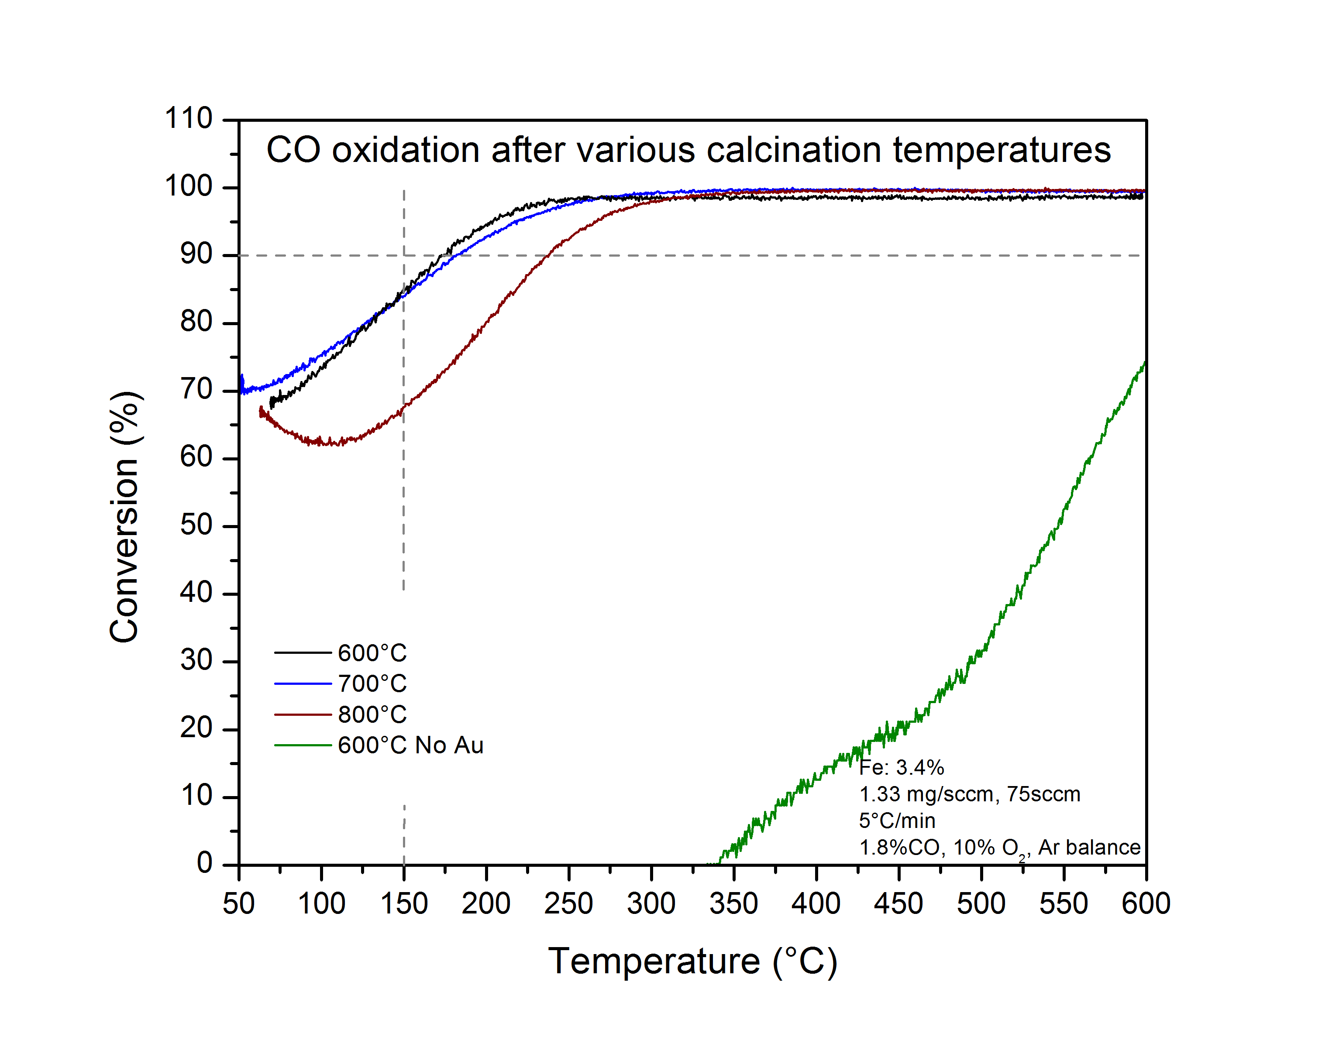
Figure 4.1 CO oxidation of AFS_{3.4%} after calcination at 600°C (black), 700°C (blue), and 800°C (red) in air. CO oxidation of FeO_{x}/SiO₂ calcined at 600°C is shown (green).
promoter when compared to Au/SiO₂. AFS_{3.4%} is shown to be stable up to 700°C with very high activity (T₇₀ ≈ 100°C) but loses activity at 800°C calcination.
To study the effects of varying Fe content on the catalyst performance, Fe_{5%}-DCDA and Fe_{20%}-DCDA were prepared and used to synthesize catalysts AFS_{1.86%} and AFS_{7.86%}, respectively. Light-off curves for CO oxidation under similar conditions to AFS_{3.4%} are shown in figures 4.2 and 4.3. In both cases, the activity was much lower for all calcination temperatures involved (though still higher than the catalyst prepared without Au). In particular though, the low Fe content AFS_{1.86%} was particularly effected by the temperature of calcination with a shift in T₅₀ ≈ 400°C between calcination at 600°C and 800°C.
AFS_{3.4%} was then tested in simulated exhaust consisting of [CO] = 1%, [NO] = 0.05%, [C₃H₆] = 0.1%, [O₂] = 10%, [H₂O] = 1%, and balanced with Ar. Figure 4.4 (green) shows the CO oxidation light-off curve under these conditions. Despite the lower content of CO in the stream, the catalysis activity was greatly reduced by the presence of nitric oxide (NO) and propene (T₅₀ ≈ 300°C). Subsequent experiments with and without these inhibitors indicate that C₃H₆ is the strongest inhibitor by far. Without these inhibitors AFS_{3.4%} is able to achieve complete conversion of CO at 50°C. The presence of NO only reduced the conversion at that temperature to 97% while propene nearly eliminated all CO oxidation at low temperatures.
Hydrocarbons such as propene are known to inhibit the CO oxidation reaction on supported precious metal catalysts by way of competitive adsorption on 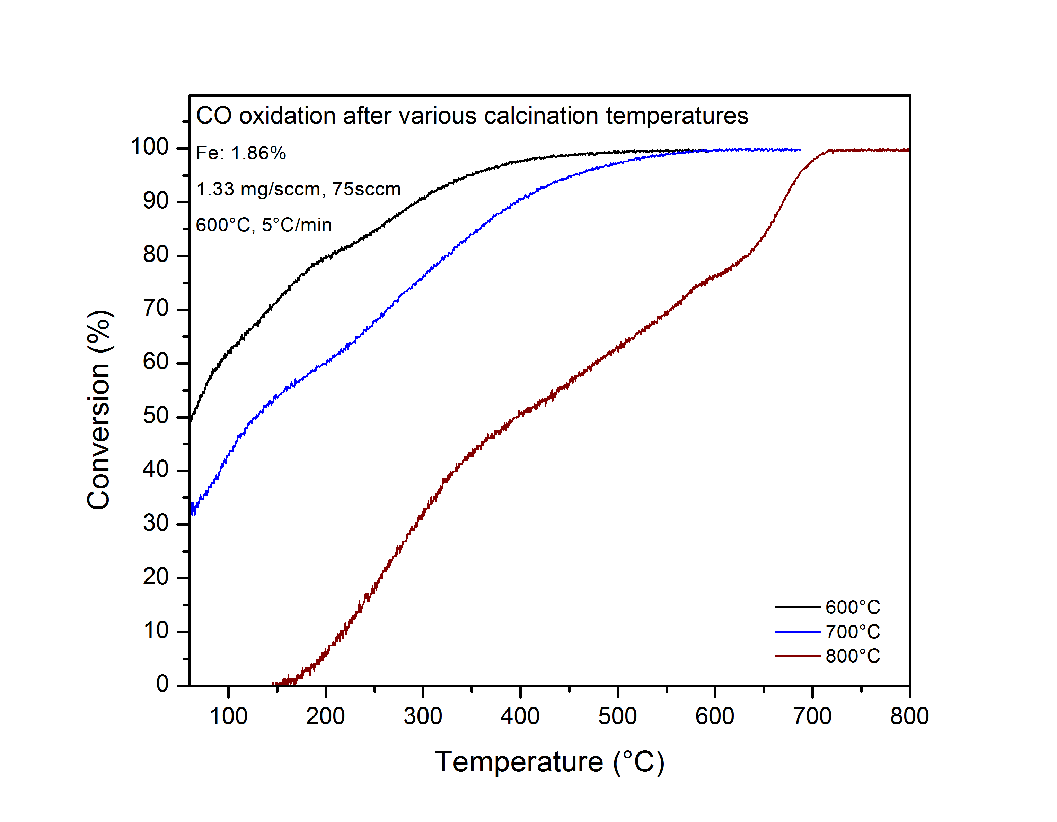
Figure 4.2 CO Oxidation over AFS_{1.86%} calcined at 600°C (black), 700°C (blue), 800°C (red). [CO]=1.8% and [O₂]=10% balanced with Ar.
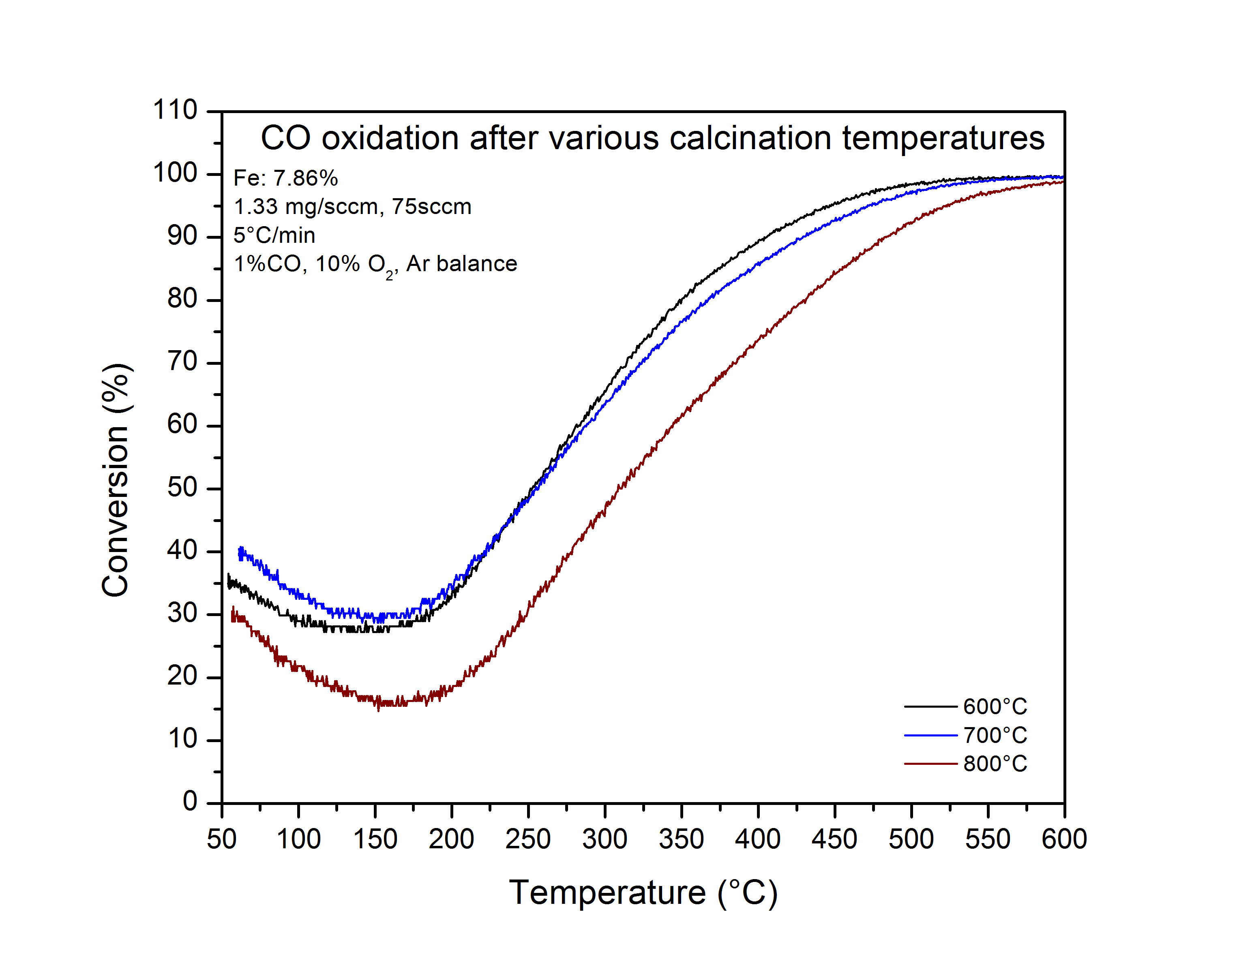

Figure 4.3 CO oxidation over AFS_{7.86%} after calcination at 600°C (black), 700°C (blue), and 800°C (red). [CO]=1.8%, [O₂]=10%, balanced with Ar.
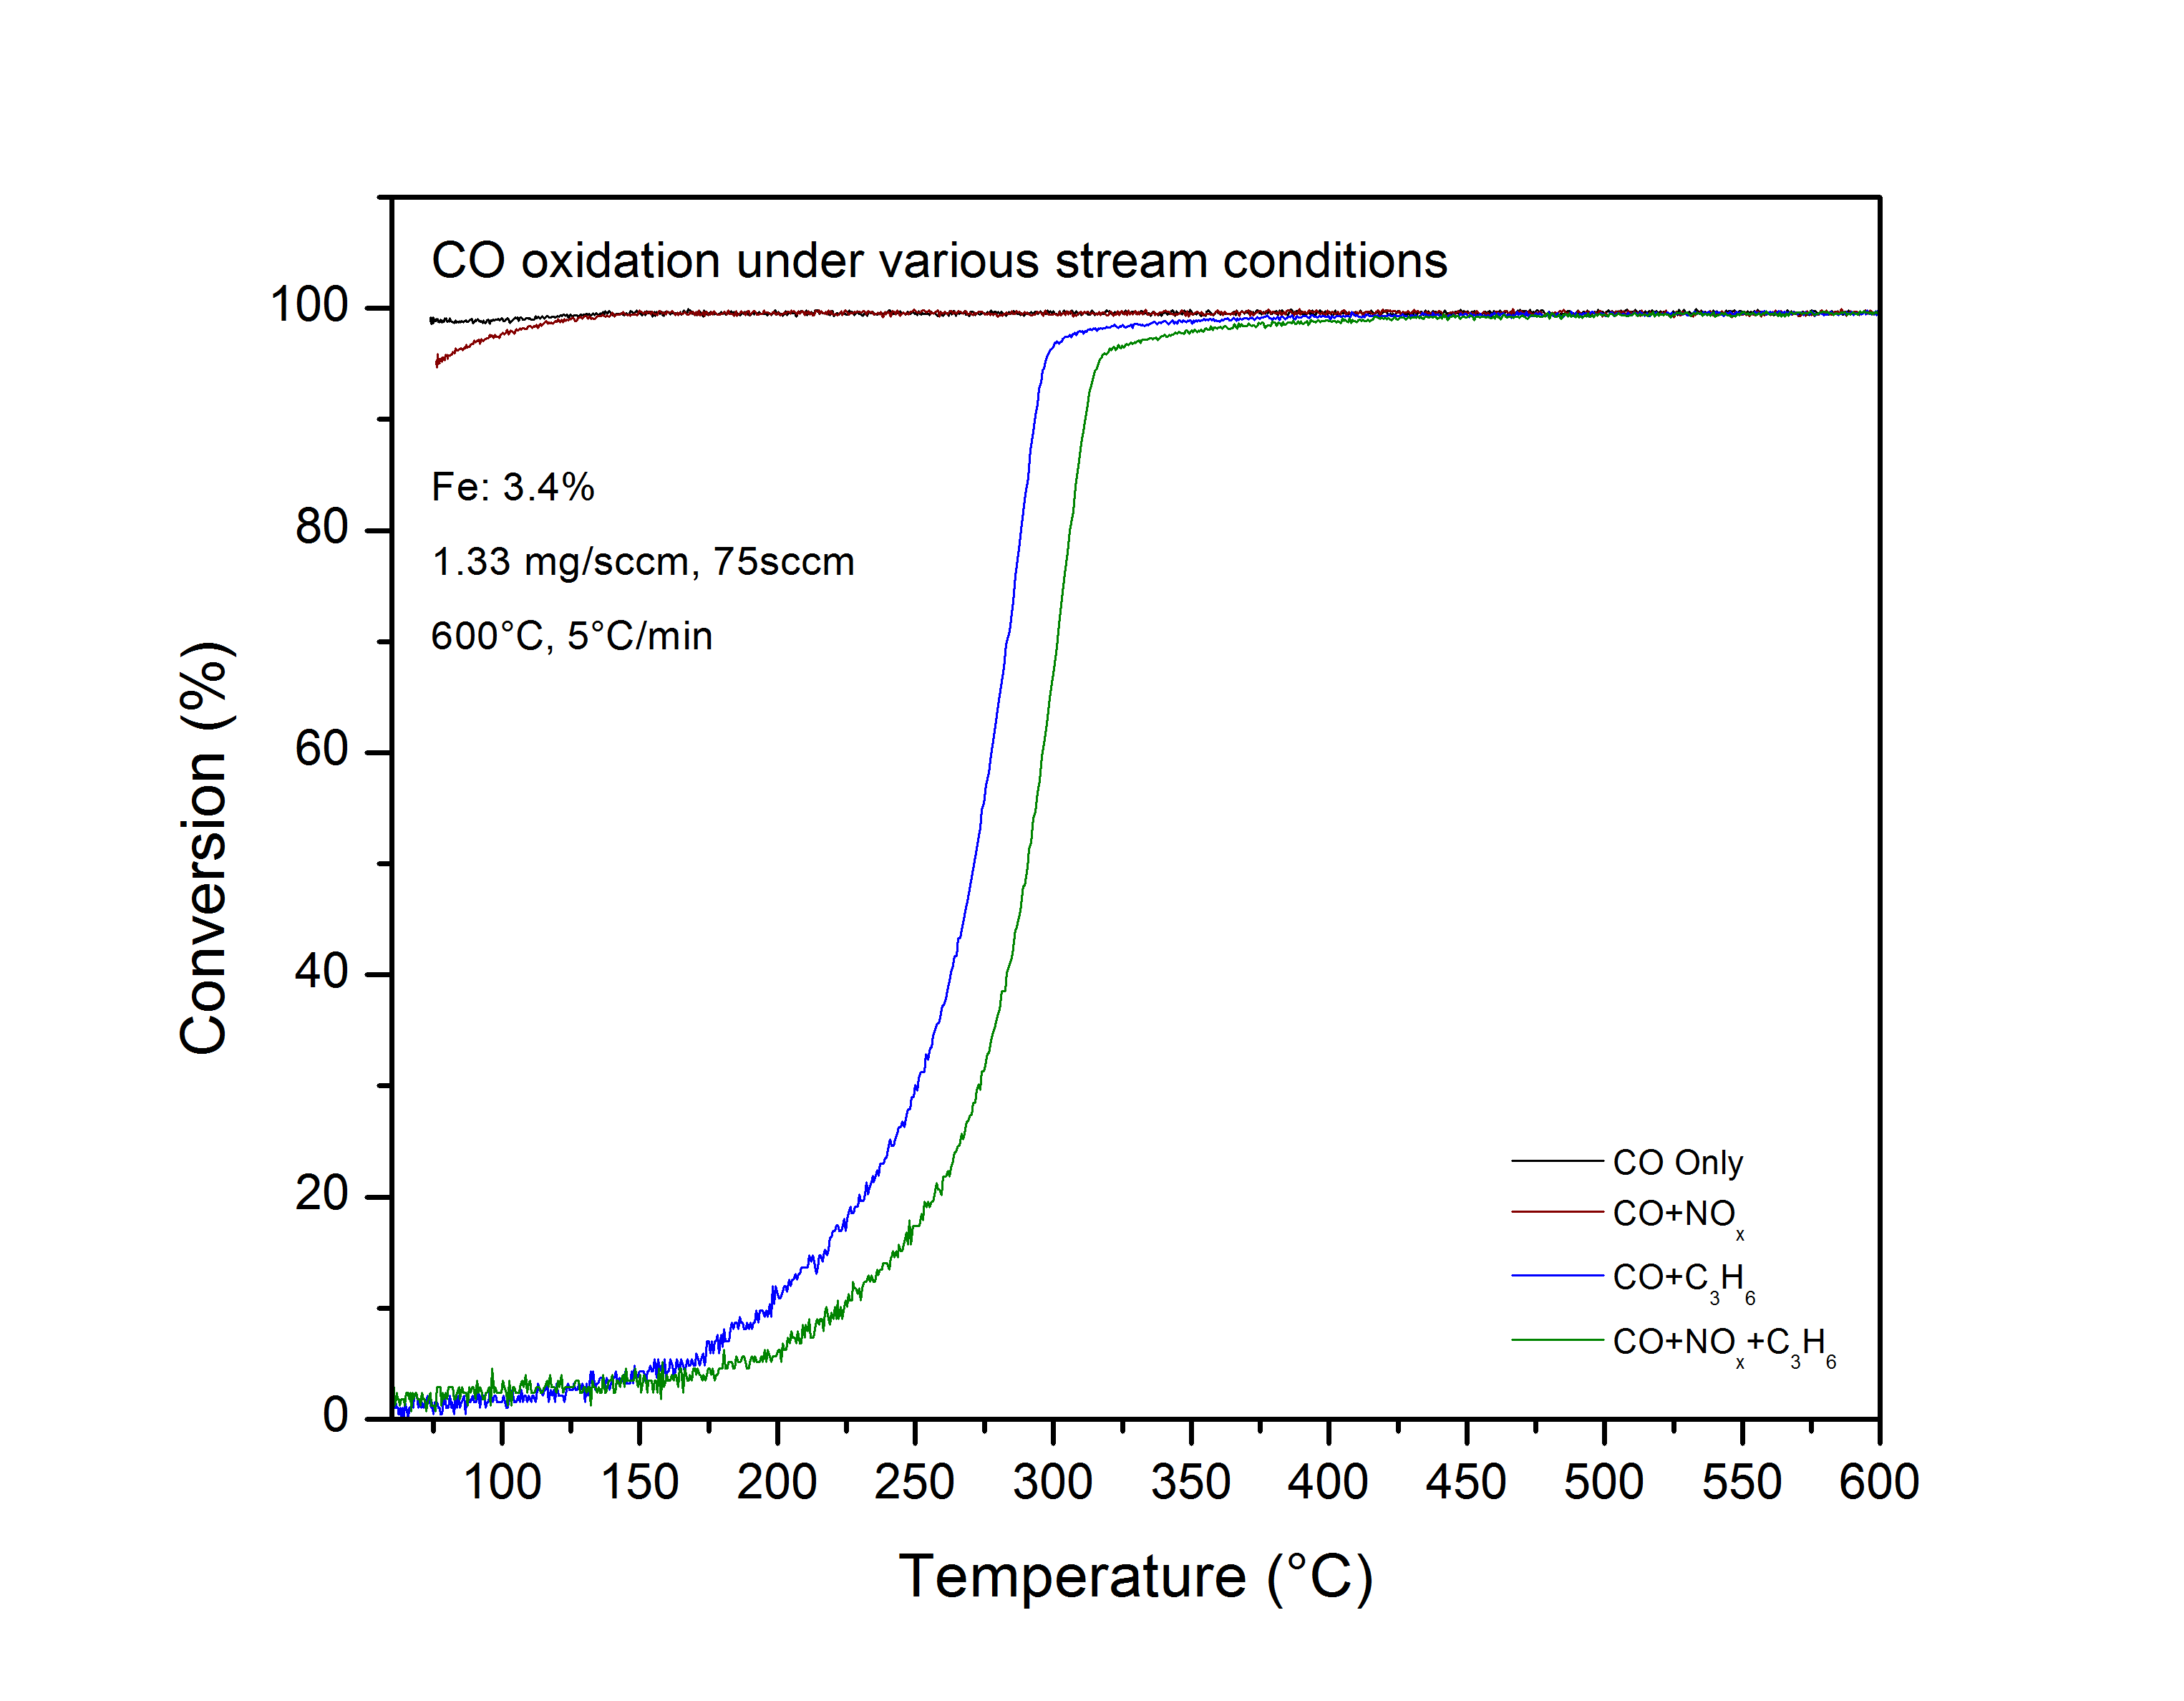
Figure 4.4 CO oxidation over AFS_{3.5%} in the presence of NO (red), C₃H₆ (blue), both NO and C₃H₆(green), and neither (black).
the active sites of the catalyst^{57,99}. The light-off curves for CO and C₃H₆ conversions over AFS_{3.4%} (figure 4.5 black and blue, respectively) show that the CO oxidation light-off has shifted to coincide with the light-off of C₃H₆ which is to be expected if CO oxidation is dependent on the removal of adsorbed propene⁵⁷.
Outlet concentrations of NO and NO_{x} determined by chemiluminescence (figure 4.5 red) indicates that the selective catalytic reduction (SCR) of NO_{x} by propene also occurs over this catalyst. The concentration of NO reaches its minimum near the maximum of propene conversion and then quickly increases, which is a general trend among NO_{x} SCR catalysts when oxygen is present⁵⁴. The concentration of NO_{x} was the same as NO indicating that NO was indeed reduced either to N₂ or N₂O. The CO oxidation inhibition by NO at low temperature and the cumulative nature of the inhibition effects (i.e. the total inhibition by NO+C₃H₆ is greater than that of NO or C₃H₆ individually) indicates that NO is also a competitor for the needed CO oxidation active sites.

Catalyst Characterization Results and Discussion
Nanoparticle size is of utmost importance in supported precious metal catalysts and particularly for Au, which has an incredibly size-dependent activity²⁸. Therefore to determining the culprit for a change in activity for the various catalysts and calcination temperatures, the first step is to determine the effects of Fe loadings and calcination temperatures on the Au particle size. X-ray diffraction was 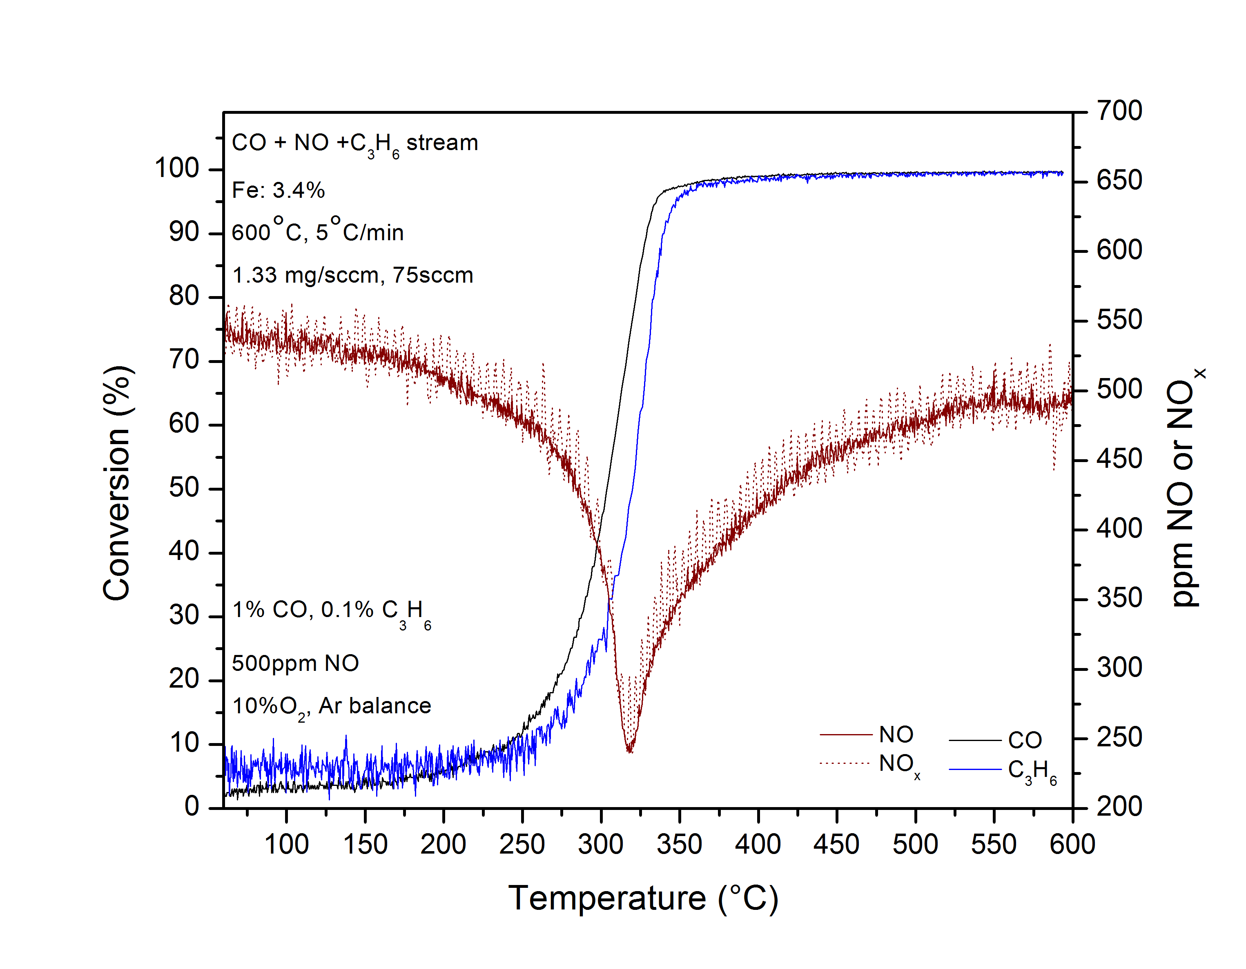

Figure 4.5 Light-off curves for CO oxidation (black) and C₃H₆ conversion (blue), and NO_{x} chemiluminescence data (red) during catalyst testing in simulated exhaust.
performed on AFS_{3.4%} and the resulting patterns are shown in figure 4.6. Scherrer calculation on the Au (111) peak of the as-calcined AFS_{3.4%} (600°C calcination), which showed the highest activity, was found to have ~4 nm average particle size. As expected, sample evaluated in simulated exhaust at 800°C did result in a moderate particle size increase to ~6 nm, which explains the drop in activity for this sample. To rule out the effects of gas phase reactants on the particle size, a post-evaluation 600°C calcined sample was also examined with XRD and showed no sign of increasing average particle size. Thus, the increase in particle size is due to lower Au nanoparticle stability at higher temperatures. TEM imaging (figure 4.7) indicates that while the majority of particles are near the XRD determined averages, the particle sizes are not completely uniform with sizes for the 600°C sample (figure 4.7a) ranging from less than 2.5 nm to 10 nm.
Figure 4.8 shows the XRD patterns of AFS samples calcined at 800°C with varying iron contents. Both AFS_{7.86%} and AFS_{1.86%} showed increases in average particle size of ~11 nm and ~20 nm, respectively, which partly explains their overall lower activity. Interestingly, the XRD pattern of AFS_{1.86%} shows distinct peaks for cristobalite silica, a polymorph of crystalline quartz. Both Au and iron oxide have been shown to induce crystallization of silica to the cristobalite phase, though only Au is able to do so at temperatures approaching 800°C ¹⁰⁰⁻¹⁰². TEM images of the AFS_{1.86%} sample (figure 4.7c and d) confirm the crystallization of the Cab-o-sil as well as encapsulation of Au nanoparticles. Along with the overall large 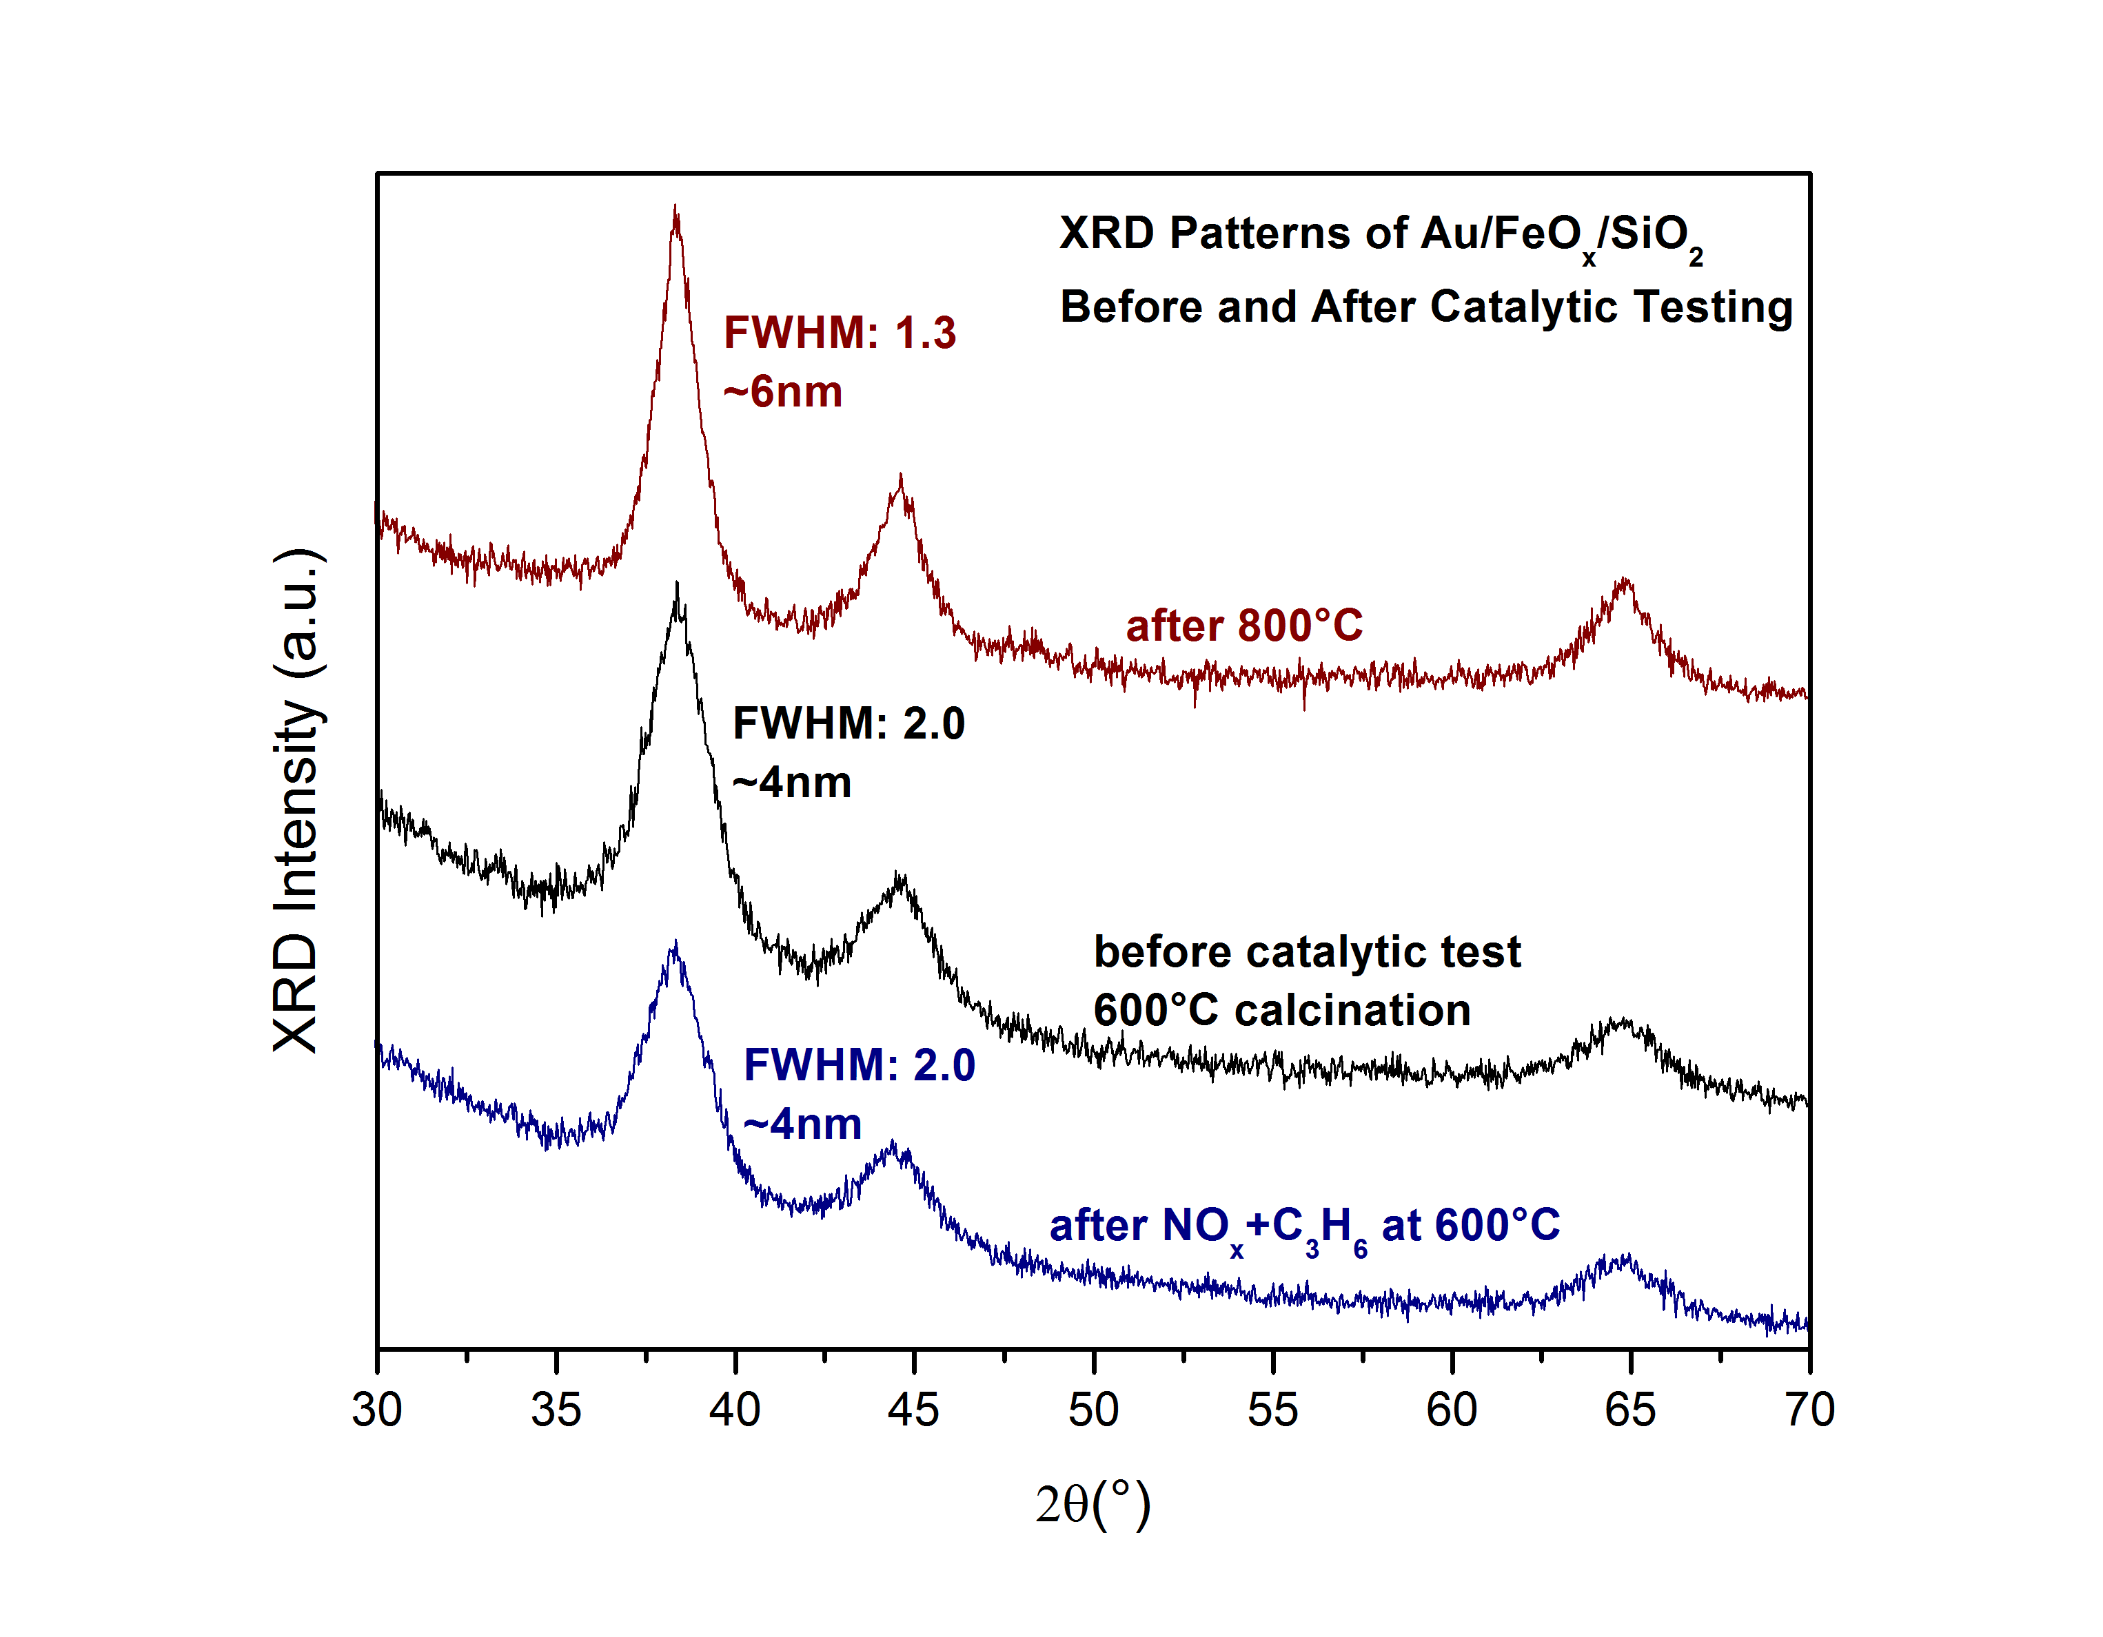
Figure 4.6 XRD patterns of Au/FeO_{x}/SiO₂ (AFS_{3.5%}) before (black) and after catalytic tests at 600°C (blue) and 800°C (red). Au nanoparticle size calculated by Scherrer method.
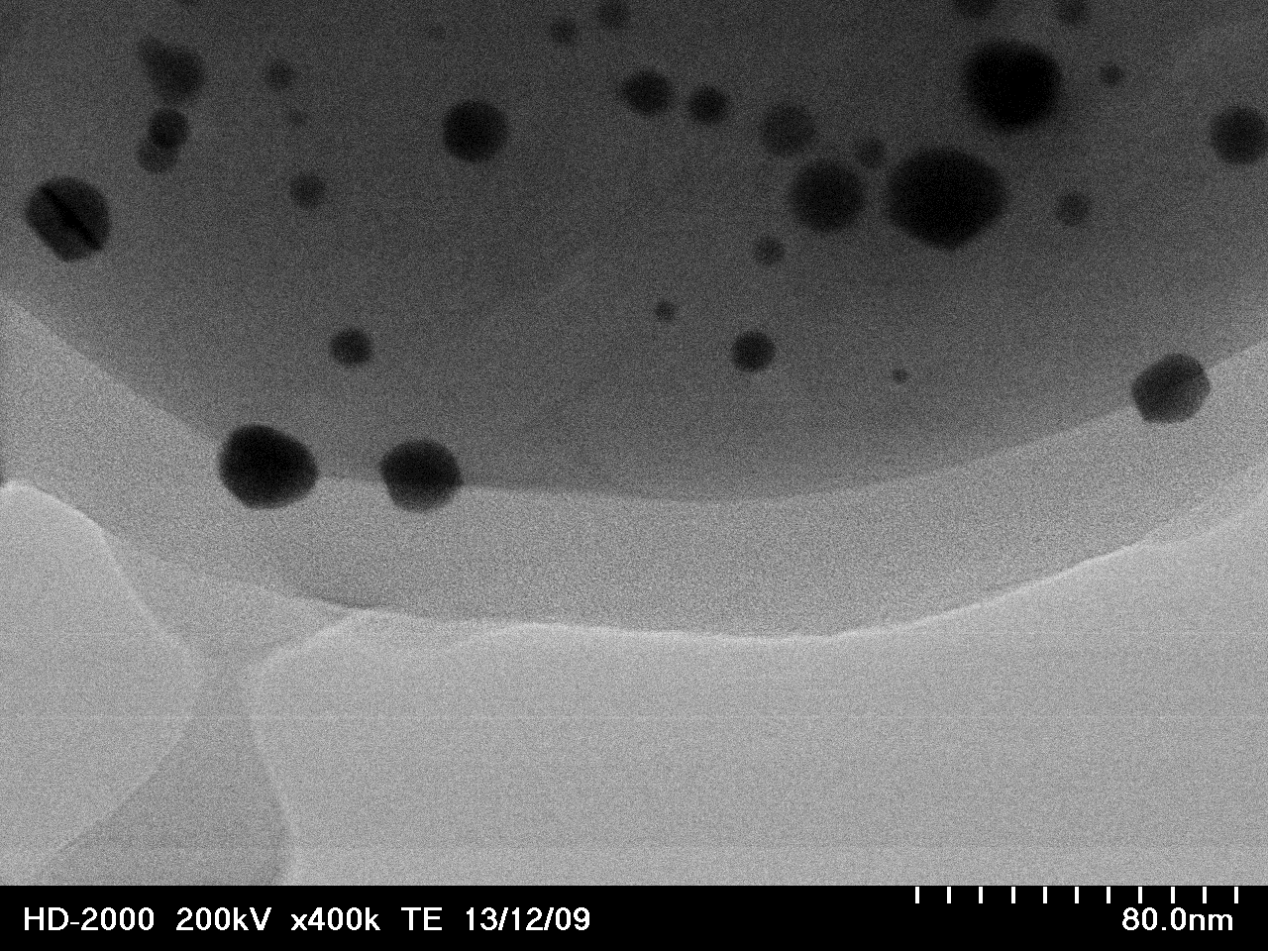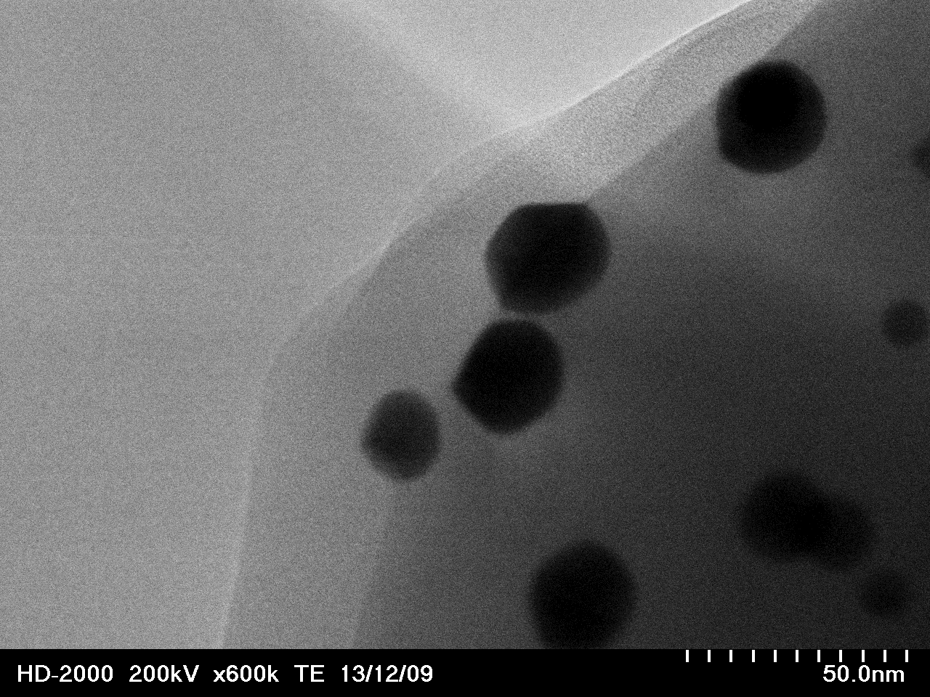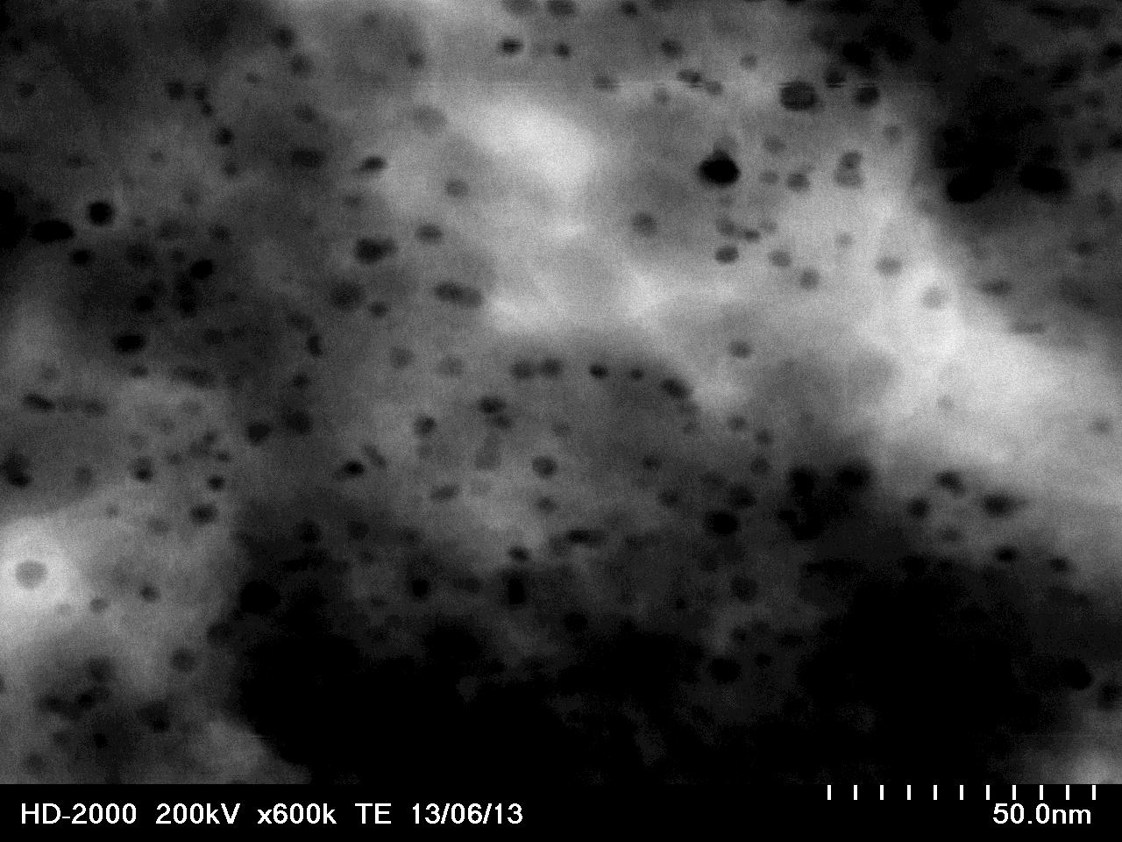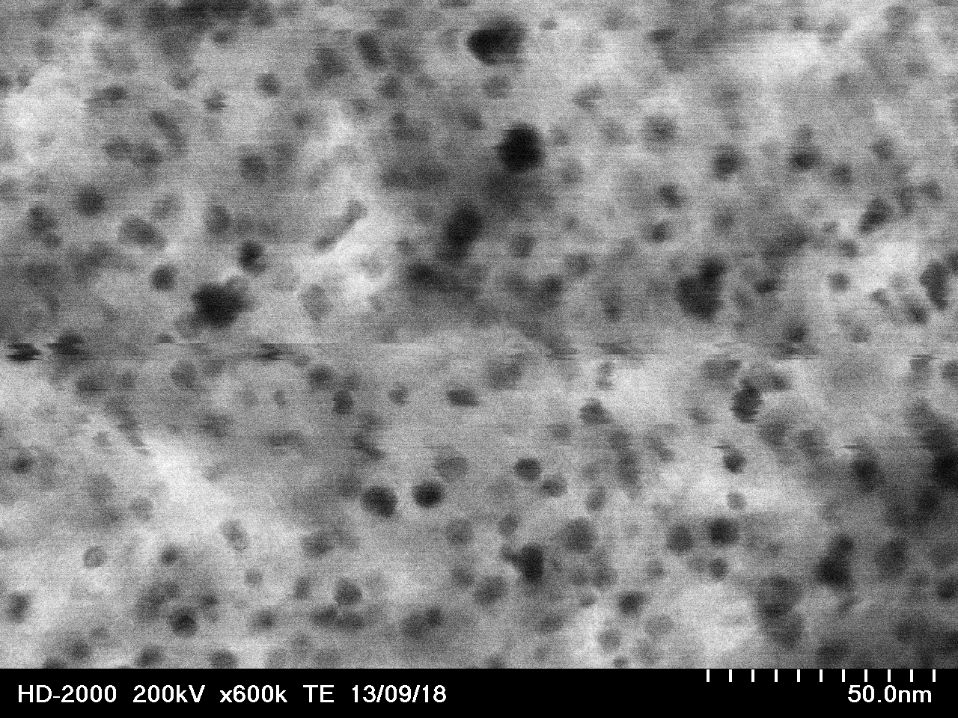
- (A)
- (B)
- (C)
- (D)
Figure 4.7 TEM images of Au/FeO_{x}/SiO₂. AFS_{3.5%} after performance testing at 600°C (A) and 800°C (B). Encapsulation of Au particles in the AFS_{2%} sample after performance testing at 800°C (C) and (D).

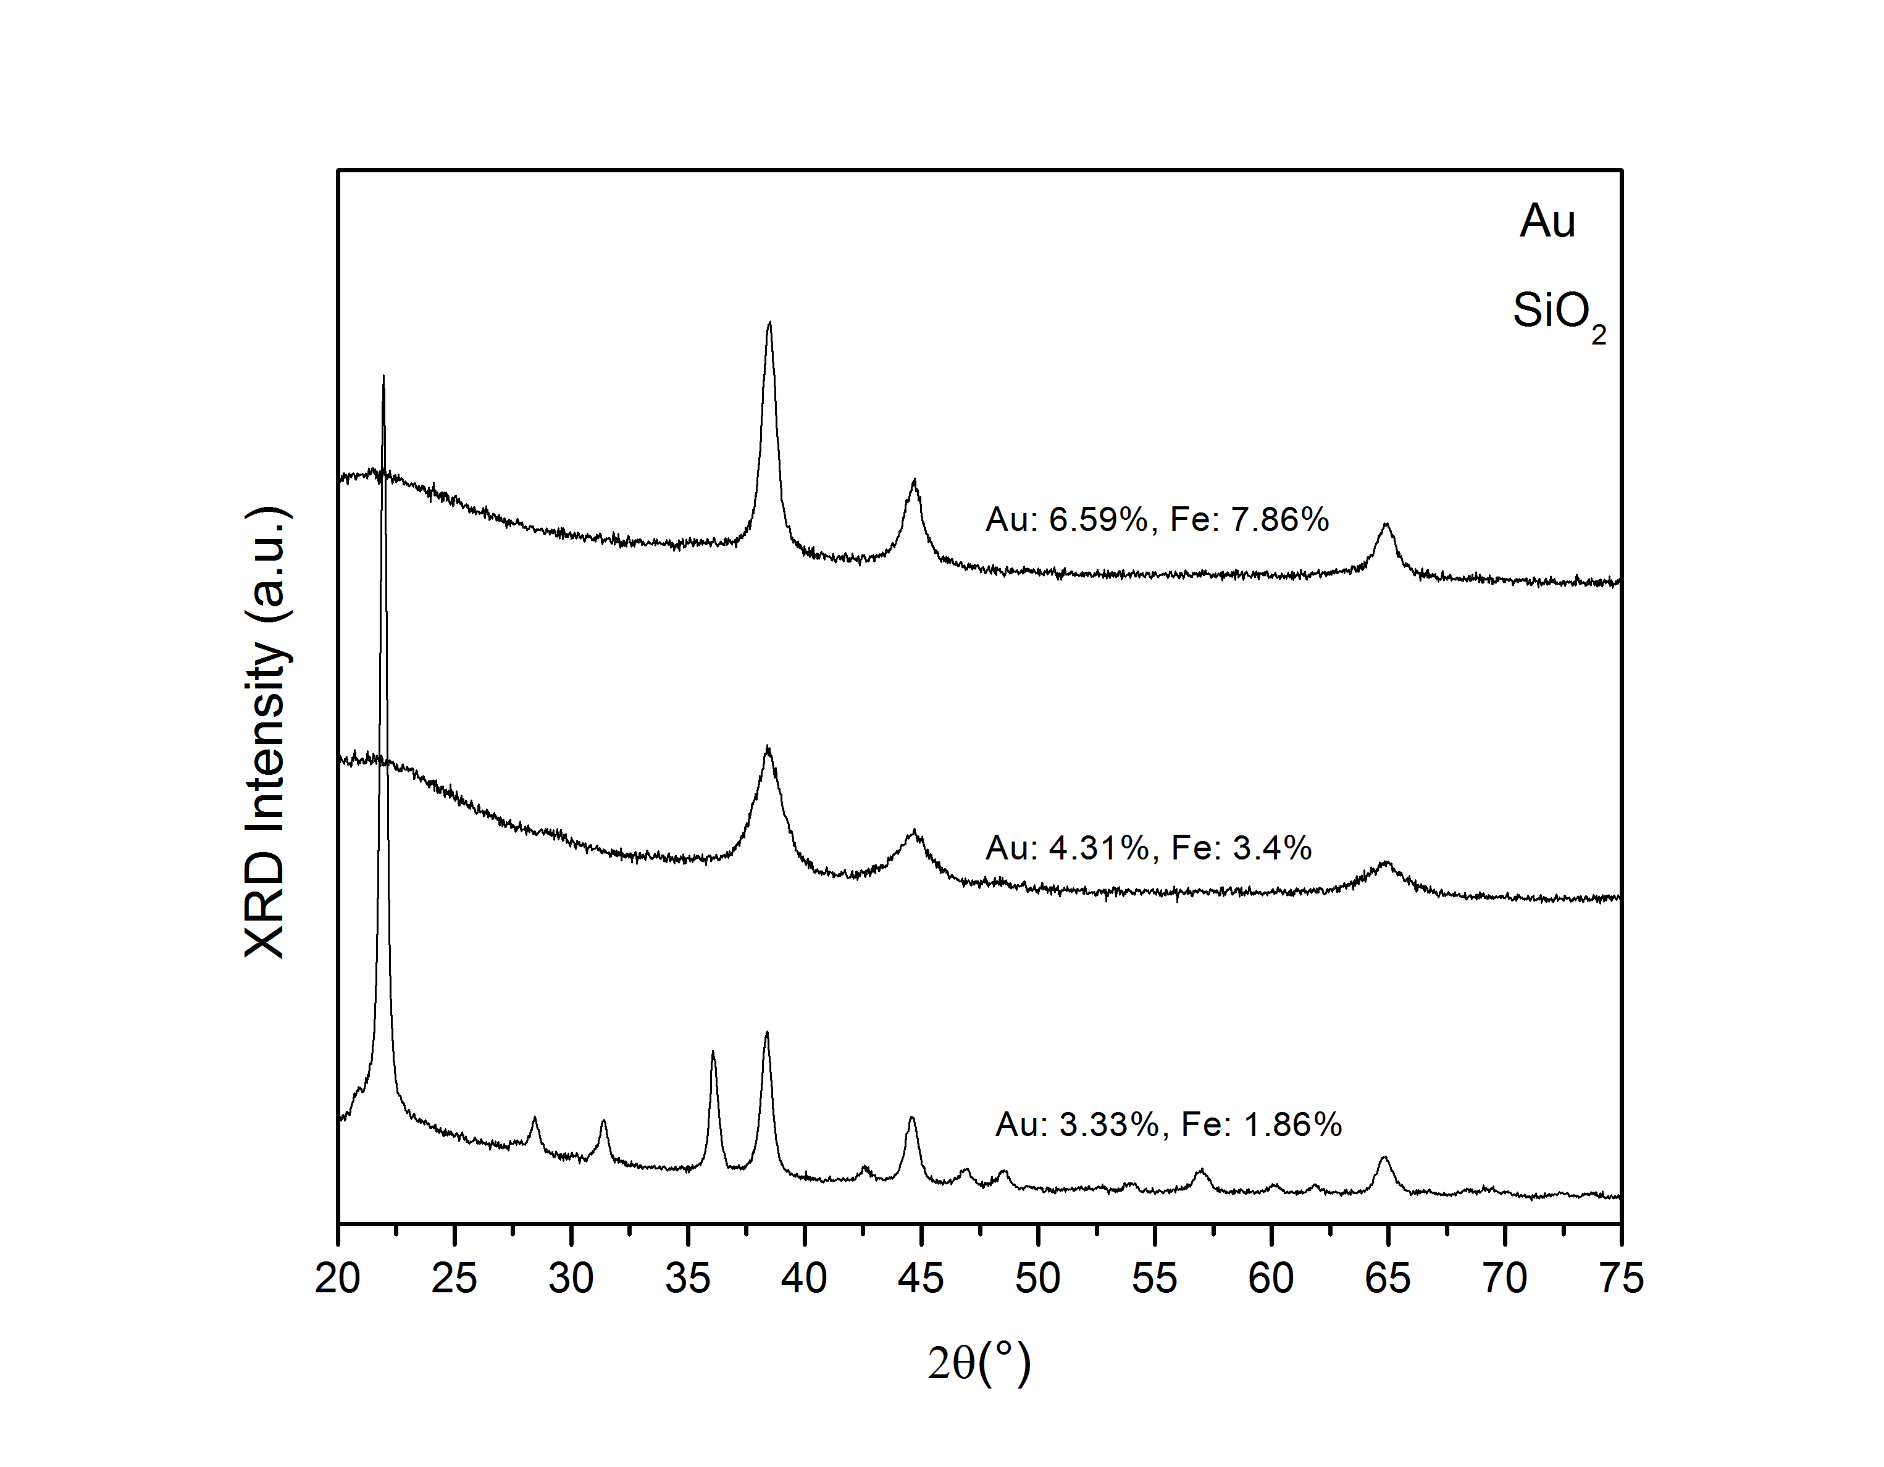

Figure 4.8 XRD patterns for Au/FeO_{x}/SiO₂ with varying content of iron.
average particle size, the encapsulation of the Au nanoparticles explains not only the low activity of the catalyst but also much larger drop in activity upon reaching 800°C compared to the moderate losses found in the other two samples.
The cause of the increased nanoparticle size of AFS_{7.86%} is not clear. A possible explanation is that a higher chloride content was imparted onto the catalyst due to the higher FeCl₂ content in the precursor (Fe_{20%}-DCDA vs the Fe_{10%}-DCDA used for AFS_{3.4%}) since chloride content is a known factor in the sintering of Au nanoparticles

⁶⁶, though the pH at which deposition-precipitation is completed should make this a non-factor. Further analysis of the Fe%-DCDA precursor and Fe%-C₄N₄/SiO₂ support will be required to determine if this is the case.
In all samples no FeO_{x} peaks could be found in the XRD data. This is unexpected, particularly for the high Fe content sample, e.g. AFS_{7.86%}, as previous studies on a Au/FeO_{x}/SiO₂ system showed clear Fe₂O₃ peaks at only 6% wt. Fe and 500°C calcination⁹⁴. Two samples were prepared with nominal 8% wt. Fe content using C₃N₄-deposition and standard impregnation and then calcined to 800°C in air. XRD patterns for these samples are shown in figure 4.9. As before, the sample synthesized using the Fe-DCDA precursor showed no sign of FeO_{x} but the impregnated sample showed definite peaks corresponding to Fe₂O₃. It would seem that the C₃N₄-deposition results in amorphous or very small FeO_{x} particles on the surface of the silica. An explanation for this would be increased initial dispersion of Fe due to its interaction with C₃N₄ as compared to a nucleation processes during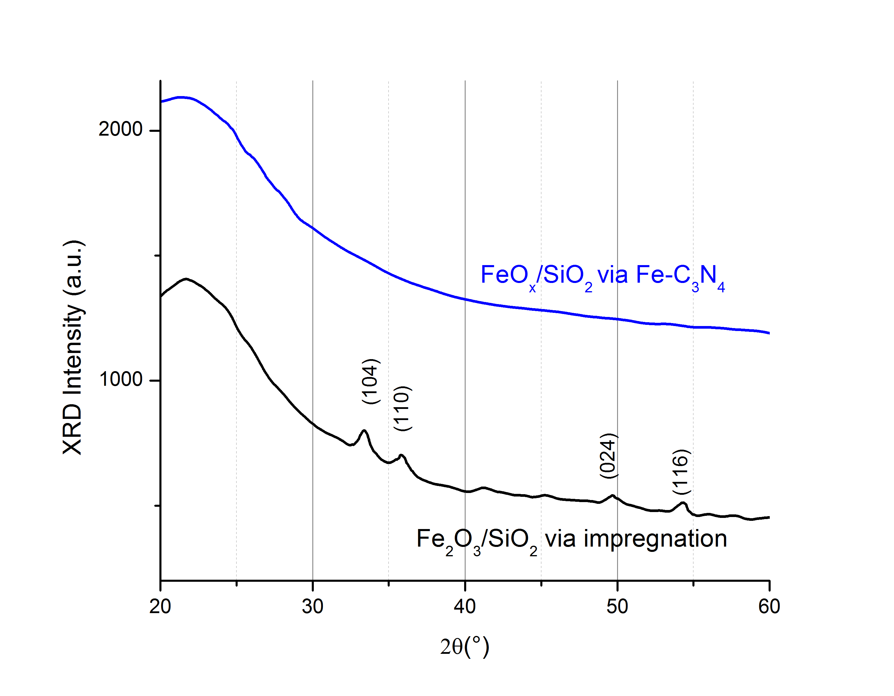
Figure 4.9 X-ray diffraction patterns for Fe-modified silica (~8% Fe) using the C₃N₄-assisted deposition (blue) and standard impregnation (black) after calcination at 800°C in air.
impregnation. Further experiments using XPS and X-ray mapping may help to characterize the state of the iron and the dispersion of Fe species on the support.

Pd/ZrO₂/SiO₂ via Sol-Gel Approach

Collaborative Work Disclosure
The work described below in section 4.3 is collaborative work completed as part of a collaboration with Dr. Mi-Young Kim (XRD, TEM) of the Fuels, Engines, and Emissions Research Center, Oak Ridge National Laboratory and Dr. Jihua Chen (TEM) of the Center for Nanophase Materials Sciences, Oak Ridge National Laboratory.
My contributions to this work included (i) BET measurements of the samples, (ii) catalyst performance evaluation under various simulated exhaust streams, (iii) DRIFTS experiments, (iv) processing and analyzing experimental data for the experiments above, (v) discussion of data and its significance with fellow collaborators, and (vi) presentation of this work at the 8th International Conference on Environmental Catalysis.

Catalyst Characterization
To study the thermal stability of the catalysts, the as-synthesized samples of Pd/SiO₂, Pd/ZrO₂/SiO₂, and Pd/ZrO₂ were aged at 800°C and 900°C. N₂ adsorption-desorption data for each catalyst (fresh and 800°C aged) is shown in figure 4.10. 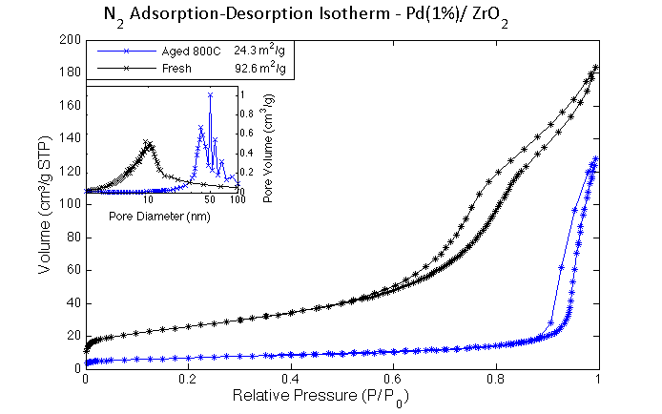
Figure 4.10 N₂ adsorption/desorption isotherms for Pd/SiO₂ (top), Pd/ZrO2/SiO₂ (middle), and Pd/ZrO₂ (bottom) and pore size distribution (inset).
The amorphous silica gel has very high surface area compared to ZrO₂ but after aging the SiO₂ loses ~38% and ~33% of its surface area and pore volume, respectively. Sol-gel addition of ZrO₂ to the silica support results in a corresponding decrease in surface area. Overall pore volume is also lower after the addition of ZrO₂ (0.9 cm³g⁻¹ and 0.7cm³g⁻¹ for SiO₂ and ZrO₂/SiO₂, respectively) consistent with ZrO₂ forming inside the pores of the amorphous silica gel. Additionally, the ZrO₂ surface modification is able to stabilize the silica support at high temperature. While some surface area and pore volume was lost upon aging, the effect was much less drastic with only losses of ~20% surface area and ~15% pore volume. In fact, the final aged ZrO₂/SiO₂ support has higher surface area than SiO₂.
XRD patterns of fresh and aged catalysts are shown in figure 4.11. With respect to the sol-gel synthesis of ZrO₂/SiO₂, the XRD pattern of Pd/ZrO₂/SiO₂ shows no peaks associated with zirconia until 900°C when a very broad zirconia peak is evident. The ZrO₂ coating stays well dispersed even at high temperature. Pd/ZrO₂ is clearly able to stabilize small particles of Pd better than either of the silica-containing supports, no peaks attributable to Pd nanoparticles can be found on the XRD pattern for Pd/ZrO₂ even up to 900°C. Both Pd/SiO₂ and Pd/ZrO₂/SiO₂ were able to stabilize Pd relatively well though, Pd metal diffraction peaks only show at 900°C and are still fairly broad indicating small size. The SiO₂-containing catalysts also show a peak for PdO as aging temperature increases but it is unknown if this is unique to SiO₂ as this peak is very near the monoclinic ZrO₂ peaks found on 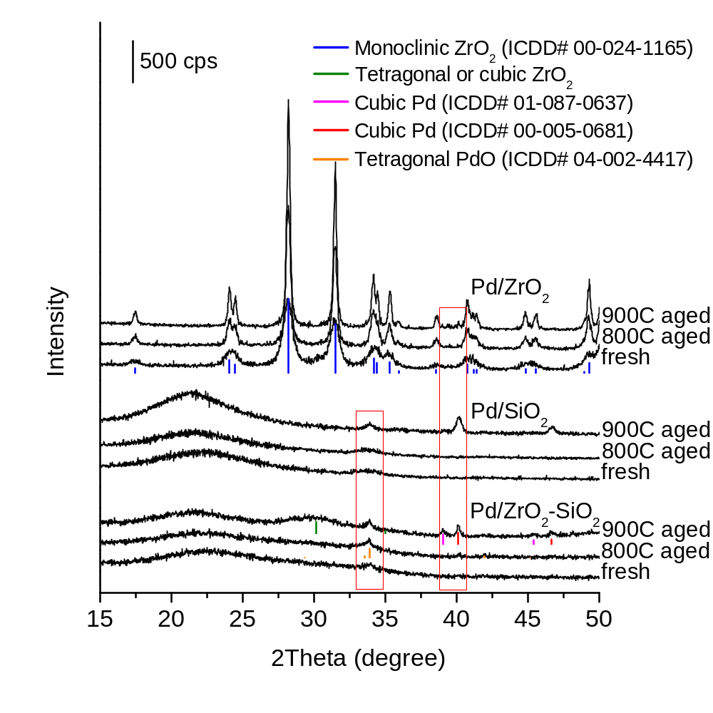
Figure 4.11 XRD patterns of supported Pd catalysts hydrothermally aged at different temperatures.
Pd/ZrO₂.
TEM imaging of each catalyst (fresh and 800°C aged) are shown in figure 4.12. As expected from the XRD, the bulk ZrO₂ support is shown to stabilize the Pd particles to incredibly small size (< 2nm). The zirconia-coated silica only partially retained this advantage. At high temperature the majority of particles are seen to be very small (< 3nm) but a small number of large agglomerates were also found (not shown) similar to those found on Pd/SiO₂ (figure 4.12 inset). The XRD data indicates the presence of some crystalline zirconia at very high temperature, this implies that the even coating of ZrO₂ itself agglomerates into small particles during calcination, leaving some of the silica bare. Pd impregnated on these bare silica patches then grow to a much larger size than those on the zirconia.
TPD of adsorbed NO_{x} was used to probe the surface area of accessible ZrO₂ since it is selective toward zirconia and does not adsorb onto silica¹⁰³, the result is shown in figure 4.13. The large decrease in surface area of ZrO₂ compared to the overall surface area determined by BET demonstrates that the zirconia coating has indeed agglomerated into nanoparticles during calcination rather than evenly coating the full surface of the silica material.

CO Oxidation over Pd/ZrO₂/SiO₂ in Simulated Exhaust Streams
The supported Pd catalysts aged at different temperatures were evaluated in simulated exhaust and the T₅₀ of each is shown in figure 4.14. As expected the ZrO₂ sol-gel coating increased the activity of the catalyst over that of Pd/SiO₂ at all 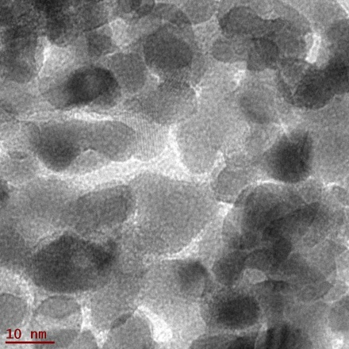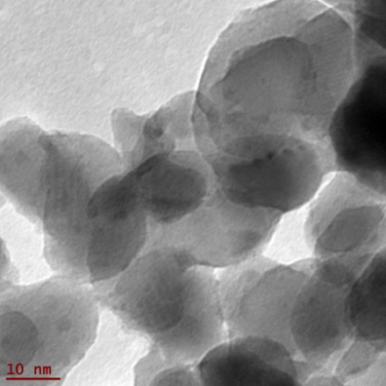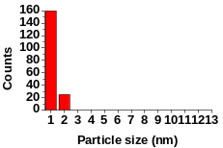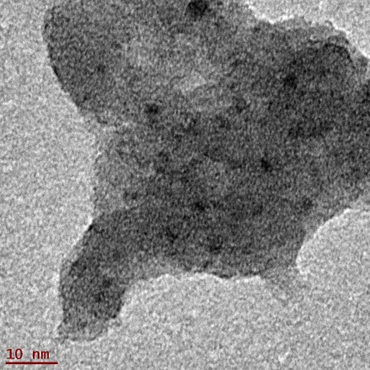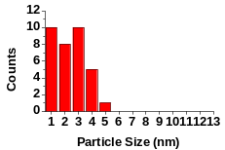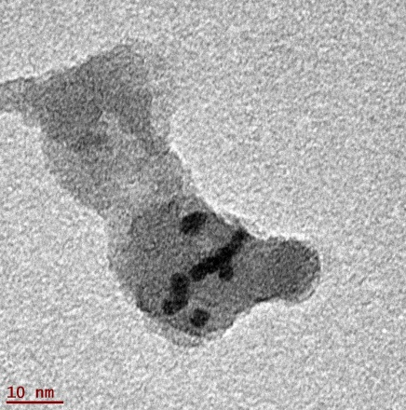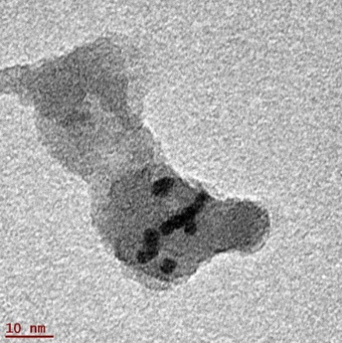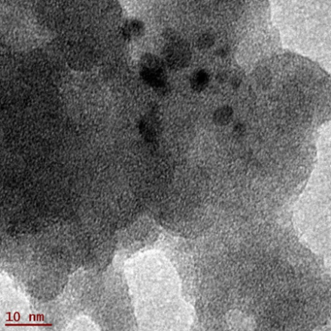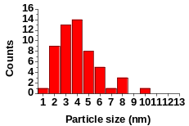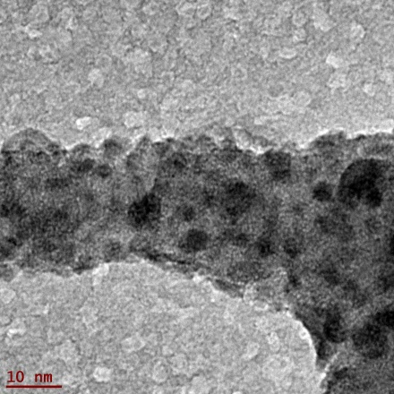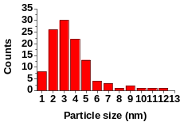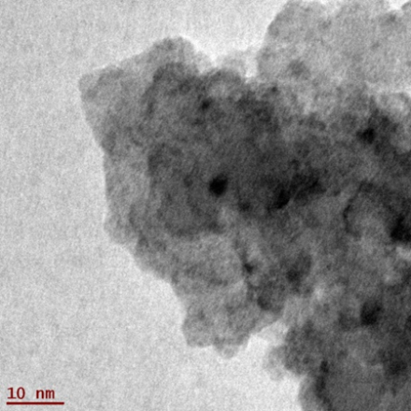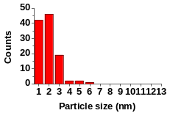
- Fresh Pd/ZrO₂
- 800C aged Pd/ZrO₂

- Fresh Pd/SiO₂

- 800C aged Pd/SiO₂

- Fresh Pd/ZrO₂-SiO₂

- 800C aged Pd/ZrO₂-SiO₂

Figure 4.12 TEM images and particle size distribution (inset) of supported Pd catalysts hydrothermally aged at 800°C (bottom) and fresh (top).
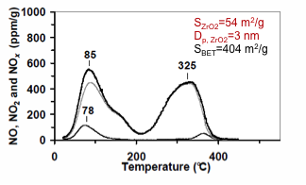
Figure 4.13 NO_{x} TPD results over Pd/ZrO₂/SiO₂ and calculated accessible ZrO₂ surface area and dispersion.
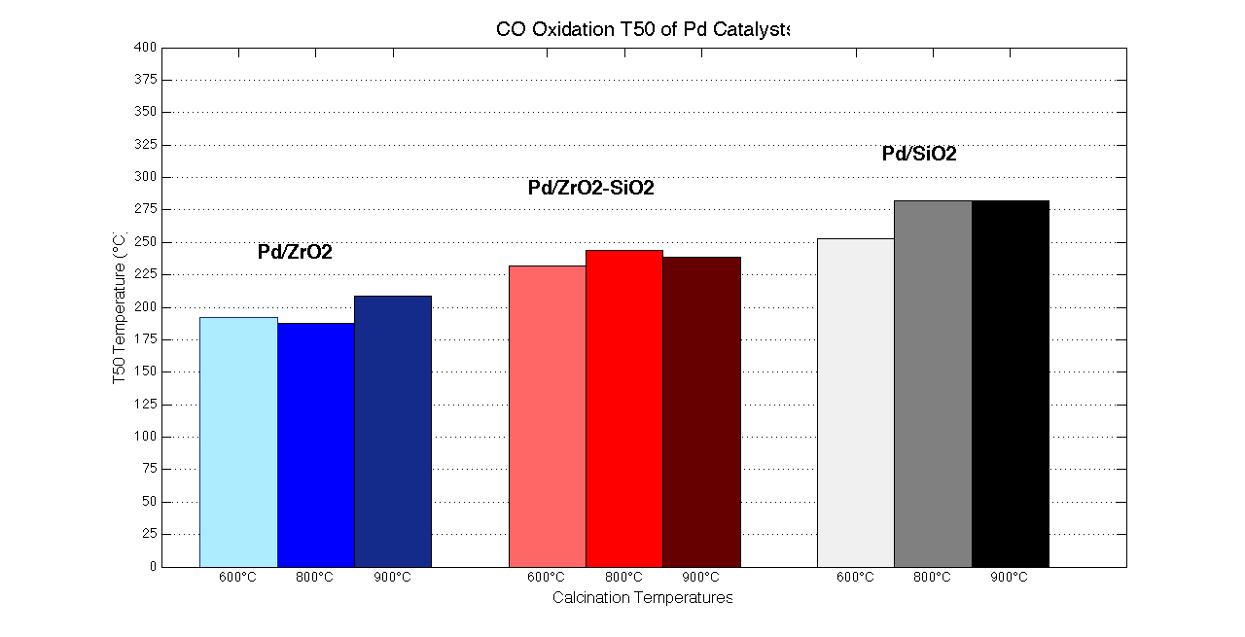
Figure 4.14 CO Oxidation temperatures at 50% conversion (T₅₀) for supported Pd catalysts calcined at 600°C, 800°C, or 900°C.
calcination temperatures. That said, the Pd/ZrO₂/SiO₂ was not as active overall as the Pd/ZrO₂ catalyst. As discussed in the previous section, zirconia is far more able to stabilize small Pd nanoparticles than silica. The smaller particles present on Pd/ZrO₂ over all temperature ranges results in higher CO conversion rates at a given temperature despite the much lower surface area of the catalyst.
The particle size distribution as determined by TEM in figure 4.12 indicates that the mean particle size of Pd on Pd/ZrO₂/SiO₂ is actually reduced at high temperature which is indicative of a strong metal-support interaction (SMSI)¹⁰⁴. In general, the ZrO₂ coating acts to increase the stability and dispersion of Pd nanoparticles on the catalyst surface but the Pd/ZrO₂/SiO₂ catalyst is held back by agglomeration of the ZrO₂ phase and therefore the growth of large (and less active) Pd particles over the silica phase. In effect, the Pd/ZrO₂/SiO₂ is only effectively utilizing part of the deposited active species (Pd). If an even ZrO₂ phase can be made to cover the entire silica surface then perhaps the best of both worlds can be achieved, i.e. high surface area and small Pd particles via SMSI with zirconia.
The Pd/ZrO₂/SiO₂ catalyst was then tested for the inhibition effects found with the Au catalysts by removing NO, C₃H₆, or both from the stream. The CO-oxidation light-off curves for these tests are shown in figure 4.15. Once again we found propene and NO to be significant inhibitors to CO oxidation with propene being the major component.
We examined the inhibition by propene using diffuse reflectance infrared
Figure 4.15 CO oxidation light-off curves over Pd/ZrO₂/SiO₂ under various stream compositions.
spectroscopy (figure 4.16). [CO] = 0.4% was first introduced into the stream and spectrum were taken periodically over 10min. Bands associated with gaseous CO₂ (~2360 cm⁻¹ and ~2340 cm⁻¹) and Pd²⁺-carbonyl (2140 cm⁻¹) can be seen indicating adsorption of CO onto the Pd active sites and oxidation to CO₂¹⁰⁵. Next, [C₃H₆] = 0.1% was introduced and a spectrum taken immediately and periodically over 20 min. Immediately the Pd²⁺-CO band completely disappears and over time a new band associated¹⁰⁵ with Pd⁺-CO reappears. Clearly there is direct interaction between C₃H₆ and the CO binding site. CO was then removed from the stream to see whether this new Pd⁺-CO band is due to adsorbed CO or a result of the C₃H₆ oxidation process. Evidently, the Pd⁺-CO band does not disappear but does reduce in strength along with the reduction of the gaseous CO₂ bands. Fully oxidizing all surface species by O₂ at 450°C (indicated by the black line in figure 4.16) does not change this result, introduction of propene alone also results in a return of the weak Pd⁺-CO band likely from an intermediate in the oxidation of C₃H₆. These results show propene inhibition is caused by a direct competition for Pd active sites between CO and propene oxidation.

Conclusion and Future Work
The initial goal of the two projects shown in this chapter were to increase the activity of precious metal catalysts supported on silica by the addition of an “active” metal oxide, namely FeO_{x} and ZrO₂, and to test their performance in simulated
Figure 4.16 DRIFTS data for Pd/ZrO₂/SiO₂. The reaction of the Pd-CO binding site to the introduction of propene.
exhaust streams. It is clear that the addition of these metal oxides to silica improved the performance of both Au and Pd supported nanoparticles for CO oxidation but these modifications also showed benefits toward the silica support itself. In the case of Au/FeO_{x}/SiO₂, the amorphous silica support underwent crystallization unless the iron content was sufficiently high enough. The encapsulation of Au nanoparticles by SiO₂ crystallization has been reported before and Al₂O₃ was used to protect the silica from crystallization at high loading¹⁰². The results here show that FeO_{x}, even at the relatively low ~3.5% wt. loading can retard the SiO₂ crystallization process and protect the Au nanoparticles from encapsulation. This beneficial effect was also shown in Pd/ZrO₂/SiO₂ where the sol-gel addition of ZrO₂ allowed the catalyst to retain its surface area much better at high temperatures. Further research into this effect would be a boon to synthesis of high surface area silica catalysts which are prone to pore collapse and restructuring at high temperatures.
Another interesting finding of this work was the ability of C₃N₄-deposition to create highly dispersed or amorphous FeO_{x} over silica supports. Much is still unknown about why this procedure leads to less FeO_{x} crystallization than standard impregnation at equivalent iron content, especially considering that carbon nitride was shown in our previous work to be completely removed from the catalyst at the temperatures used in this study and the presence of Fe in C₃N₄ only caused the decomposition of carbon nitride to occur at even lower temperatures

⁸⁹. A start to understanding these results would be to study the state and dispersion of the FeO_{x} via XPS and X-ray mapping before and after removal of the carbon nitride species. High resolution TEM imaging would also be useful to directly investigate the lattice interaction between FeO_{x} and the SiO₂ surface.
The last major finding is the profound effect NO and C₃H₆ has on CO oxidation catalysts in exhaust environments. These stream components reduce the CO oxidation capabilities of the catalysts more than any of the support or structural effects studied here. The creation of low temperature exhaust catalysts hinges upon strategies to overcome this critical problem. DRIFTS data shows that the propene inhibition is caused by direct interaction between C₃H₆ and the CO binding site. Other works ascribe this inhibition to competitive adsorption between propene and CO^{54,57}. Chapter 5 describes work recently completed that shows potential to overcome this problem (at least with respect to propene) utilizing a non-precious metal catalyst.

Mixed Oxide Alternative to Deposited Metal Nanoparticles

Introduction
In order to reduce greenhouse gas emissions and reduce petroleum consumption, new fuel economy standards for passenger cars and light trucks have been implemented by the National Highway Traffic Safety Administration (NHTSA) and the Environmental Protection Agency (EPA) in the U.S¹⁰⁶. As fuel economy improvements occur to meet these standards, the automotive industry will also reduce pollutant tailpipe emissions that affect air quality and human health. Specifically, emission levels of the criteria gaseous pollutants NOx (oxides of nitrogen), CO, and non-methane hydrocarbons are all being further reduced from present day levels by U.S. EPA Tier 3 emission standards¹⁰⁷. The combination of improving fuel economy while reducing tailpipe pollutant emissions presents a challenge for the automotive industry.
Vehicles with internal combustion engines will likely remain a dominant fraction of the light-duty fleet in both hybrid and non-hybrid drivetrains¹⁰⁸, and new combustion techniques are showing greater fuel efficiency for these engines. Obviously, improved engine efficiencies help meet the fuel economy goals, but lower exhaust temperatures resulting from the improved extraction of work inside the engine cylinders can be problematic for catalytic emissions control. Furthermore, a promising class of fuel-efficient advanced combustion techniques, while demonstrating less NOx and particulate emissions, produces higher levels of CO and hydrocarbons. The combination of lower exhaust temperatures and higher CO and hydrocarbons^{109,110} levels challenges existing catalyst technologies and thus new technologies are being considered.
The vast majority of commercial catalysts employed in automotive exhaust streams make use of supported platinum-group metal (PGM) nanoparticles. There are a number of examples of PGM-based catalysts showing exceptional activity for CO oxidation ^{20,105,111} but upon introduction of hydrocarbons (HCs) these catalysts experience severe inhibition due to competition for PGM active sites ⁵⁷ which limits their use for low temperature catalysis in practical applications. PGM catalysts are also susceptible to sintering at high temperature, which can also reduce crucial pollutant conversion at low-temperature. These critical weaknesses, as well as the high cost of precious metal materials, have spurred considerable interest in the development of a low cost, highly stable catalysts that are capable of meeting the demands of complex exhaust streams.
Catalysis studies of binary oxides composed of CuO, Co₂O₃, and CeO₂ have all previously shown high activity for both CO ^{112,113} and hydrocarbon ^{37,114} oxidation. Furthermore, in a report by Luo et. al. ¹¹⁵ the active sites for CO and C₃H₈ oxidations were proposed to be in completely separate locations. The ability to separate the active sites of CO and HCs may be a strategy to reduce the inhibition effects that plague current PGM catalysts. Unfortunately, as with previous binary oxide studies, the oxidation reactions were studied separately and at space velocities far below those necessary for automotive viability. Encouraged by an earlier study on CuO-Co₂O₃-CeO₂ by Liu and coworkers ⁴⁴ which showed room temperature activity for CO oxidation (T₅₀<70°C) even after treatment at temperatures as high as 800°C, we studied this ternary oxide system in hopes of overcoming the weaknesses of current PGM catalysts. In this work we present a ternary oxide catalyst composed of CuO, Co₃O₄, and CeO₂ with a CO oxidation activity that outperforms current commercial PGM-based diesel oxidation catalysts (DOCs) and shows significant resistance to inhibition effects by propene in simulated exhaust streams.

Experimental

Removal of DOC washcoat (DOC)
- A piece of commercial diesel oxidation catalyst (DOC) core obtained from Ford was placed in an ultrasonic bath of deionized water at 60°C. Ultrasonic vibration released considerable washcoat from the core and remaining catalyst was removed by dipping the core into liquid nitrogen and repeating ultrasonic vibration three times. The catalyst was then obtained by vaccum filtration and dried. Any remaining monolith fragments were removed by sieving. The catalyst was then calcined at 600°C in air prior to catalytic testing.

Synthesis of Pd/ZrO₂-SiO₂ catalyst (PdZrSi)
- Amorphous silica gel (Davisil Grade 635, Aldrich) was used as a support for the preparation of Pd catalysts. ZrO₂ was incorporated on the SiO₂ surface following the procedure. SiO₂ was first dehydrated with anhydrous ethanol (≥ 99.5%, Aldrich) and reacted at 80 °C for 3 h with zirconium(IV) n-propoxide (70% w/w in n-propanol, Alfa Aesar) dissolved in ethanol. ZrO₂-incorporated SiO₂ were obtained by removing the non-reacted precursors through washing with ethanol followed by drying at 100 °C and calcining at 500 °C for 2 h. Palladium (II) nitrate solution (Pd 12~16 w/w, Alfa Aesar) was impregnated on ZrO₂-SiO₂ supports by incipient wetness method to 1 wt% Pd loading. After the impregnation, the catalysts were dried at 100 °C in air and reduced in a flow of 10% H₂ in Ar at 500 °C for 2 h. The catalyst was then calcined at 600°C in air prior further analysis. The final catalyst was denoted as PdZrSi.

Synthesis of CuO, Co₃O₄, CeO₂ mixed oxide catalysts (CCC, CuCo, CoCe, and CuCe)
- Mixed oxide catalysts composed of CuO, Co₃O₄, and CeO₂ phases were synthesized by coprecipitation method to desired molar Cu:Co:Ce ratios. For Cu-containing catalysts, 0.2416g (1mmol) of Cu(NO₃)₂·3H₂O and appropriate amounts of CoCl₂·6H₂O and Ce(NO₃)₂·6H₂O were simultaneously added to 100mL deionized water and dissolved at room temperature; 100mL NaOH solution (0.375M) was then added dropwise under vigorous stirring. After approximately 30min the precipitate was ready to be filtered by vacuum filtration. The obtained precipitate was washed with H₂O followed by ethanol and allowed to dry at room temperature until it flaked easily from the filter paper followed by further drying at 60°C in a vacuum oven. Calcination at 600°C (1°C/min rate) in air resulted in the as-synthesized catalyst. The catalysts were calcined again at 600°C in air prior to further analysis.
For CoCe, the procedure was the same except 5mmol each of CoCl₂·6H₂O and Ce(NO₃)₂·6H₂O were added to 100mL deionized water and dissolved at room temperature. Cu, Co, and Ce precursors were obtained from Aldrich.

Catalytic Tests
Catalyst activity for CO and C₃H₆ conversion were taken using a custom fixed bed reactor. Typically, catalyst was packed into a 6mm i.d. quartz U-tube and supported by quartz wool. Catalyst amounts were chosen to maintain equal reactor volume and achieve a gas hourly space velocity GHSV ≈150,000hr⁻¹. Activity was measured as a function of temperature at a rate of 5°C/min to a maximum temperature of 600°C. The simulated exhaust stream consisted of a mixture of [O₂] = 10%, [H₂O] = 5%, [NO] = 0.05%, [CO] = 0.4%, [C₃H₆] = 0.1%, and balanced with Ar. Water was introduced into the system by bubbling Ar gas through water heated consistently at 50°C and heated gas lines maintained at 150°C. Mass flow controllers were used to maintain desired gas concentrations. The gas exiting the reactor was analyzed by mass spectrometer (SRS RGA100). The catalyst activity tests showed good repeatability and stability after an initial run to 600°C; no deactivation was seen over through the course of normal gas exposure.

Catalyst Characterization
Powder X-ray diffraction (XRD) data were collected via a Panalytical Empyrean diffractometer with Cu Ka radiation (k = 1.5418 A ̊ ). Surface area characterization was accomplished using nitrogen adsorption-desorption measurement (Tristar, Micromeretics). JEOL JSM-6060 scanning electron microscope equipped with EDX analyzer operating at a 30kV accelerating voltage determined elemental composition. Atomic percentages were averaged over multiple 200μm scans of different catalyst agglomerates.
To study the adsorption of propene over PdZrSi and CCC, TPO was conducted using the catalyst reactor described above. First the catalyst were brought to 600°C in flowing 10% O₂/Ar for 2 hours and allowed to cool to 30°C. The flow was then switched to Ar only until all mass spectrometer signals stabilized. Next a mixture of [C₃H₆] = 1.5% and [H₂O] = 2% balanced with Ar was flowed over the catalyst for 15 minutes. The flow was then switched back to Ar only to remove physisorbed species. Lastly, 10% O₂/Ar was flowed over the catalyst as the temperature was increased at a rate of 5°C/min. Resulting CO₂ was analyzed by gas chromatography (Agilent Micro GC 490). No partial oxidation products or propene fragmentations were found by mass spectrometry during the runs indicating complete oxidation of any adsorbed propene.

DRIFTS measurements
DRIFTS measurements were performed using a Digilab FTS 7000 series FTIR spectrometer equipped with a Praying Mantis DRIFTS apparatus. The catalyst bed was first cleaned by heating to 400°C in O₂/Ar. DRIFTS spectra were taken at a temperature within a region of of 5-10% CO oxidation as determined by reactor analysis. After the cleaning step, the bed was cooled the analysis temperature and a clean background was taken in 10% O₂/Ar. [CO] = 0.4% was then introduced into the stream and a spectrum taken after 30min of exposure. [C₃H₆] = 0.1% was then added and a spectrum was taken immediately up introduction followed by addition spectrum at 10 min, 20 min, and 30 min exposure times. Spectrum were obtained at 2 cm⁻¹ resolution with 64 co-scans.

Results and Discussion
Figure 5.1 presents CO and C₃H₆ conversion activities for CCC, PdZrSi and the commercial DOC. The PGM-free CCC is active at lower temperatures than the commercial catalyst for CO oxidation in simulated exhaust conditions; however, the propene oxidation activity is significantly worse with the CCC. For further 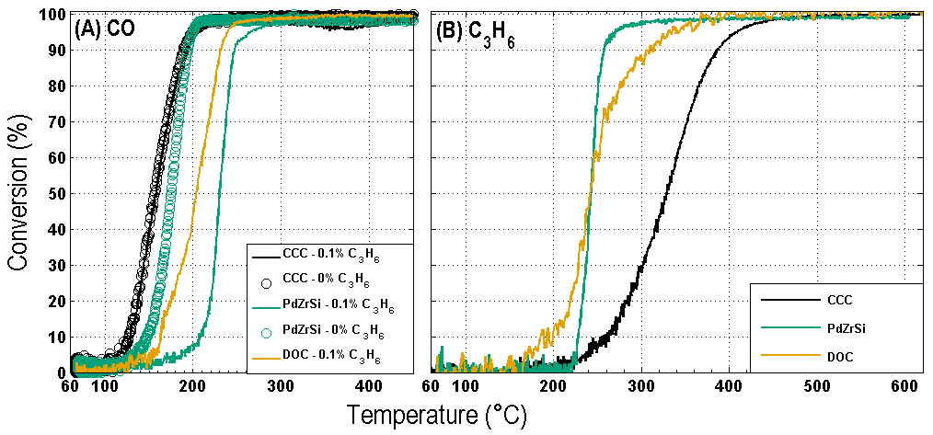
Figure 5.1 Light-off curves under simulated exhaust conditions for CCC, PdZrSi, and DOC catalysts.
(A) CO Oxidation with and without [C3H6] = 0.1% (solid and circle, respectively). (B) C3H6 conversion. [O2] = 10%, [H2O] = 5%, [NO] = 0.05%, [CO] = 0.4% balanced with Ar at GHSV ≈150,000-1.
comparison, we synthesized another high performing PGM catalyst, Pd/ZrO₂/SiO₂ (PdZrSi), and compared its properties with the ternary oxide, CCC. Despite far lower BET specific surface area (SSA_{PdZrSi} = 404 m²g⁻¹, SSA_{CCC} = 41.7 m²g⁻¹), the ternary oxide demonstrates improved CO oxidation activity over the PGM catalyst. Similar to the DOC, PdZrSi also outperformed CCC in C₃H₆ oxidation behavior.
In order to examine the inhibitory effects of hydrocarbons on CO oxidation, propene (0.1%) was included in the evaluation as a model hydrocarbon (figure 5.1a, circles). As expected, the PdZrSi catalyst showed a significant loss in activity (∆T₅₀=56°C) due to the introduction of C₃H₆, whereas CO oxidation activity in the propene-containing stream was unaffected on CCC. The inhibitory effect of hydrocarbons on CO oxidation over PGM-based catalysts is well known^{56,57} and has been widely attributed to competitive adsorption between reactants on PGM active sites^{57,116}. Indeed, DRIFTS data (figure 5.2a) shows that upon introduction of C₃H₆ to PdZrSi with pre-adsorbed CO, the Pd-carbonyl band immediately disappears and reappears with time at a significantly shifted position (Δ = -35cm⁻¹) indicating a reduction in the oxidation state of the Pd metal and a change in the CO adsorption site on the active metal¹⁰⁵. On the CCC catalyst, no disappearance of the Cu⁺-carbonyl band (figure 5.2b) is observed and only a slight shift (Δ = - 5cm⁻¹) can be seen on the DRIFTS spectra of CCC, still within the region for Cu⁺-carbonyl on CuO-CeO₂¹¹⁷. Furthermore, the C-H stretching bands that appear upon C₃H₆ adsorption are significantly weaker and broader for the CCC catalyst compared to PdZrSi, 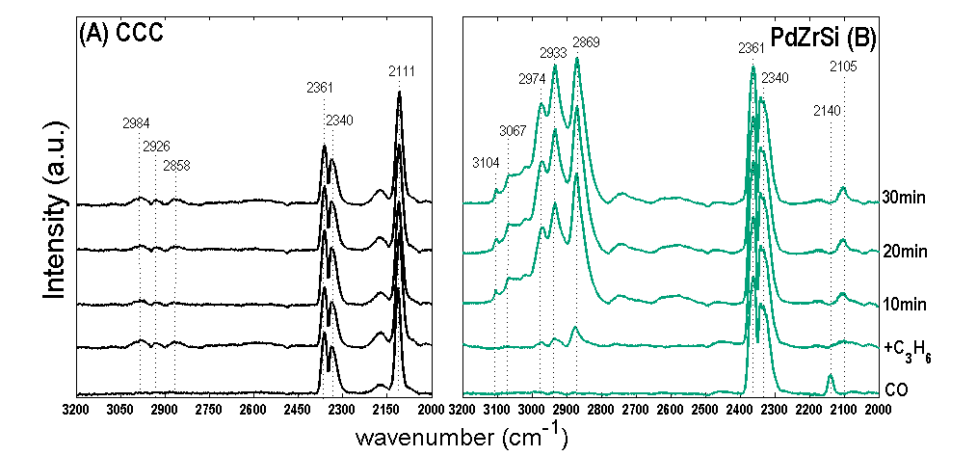
cm⁻¹ |  | Assignment
2105 |  | Pd⁺-CO
2140 |  | Pd²⁺-CO
2111 |  | Cu⁺-CO
2340,2361 |  |  | CO₂ gas
2800-3200 | Propene C-H stretch
Figure 5.2 DRIFTS data collected for (A) CCC at 120°C and (B) PdZrSi at 140°C before and after introduction of [C₃H₆] = 0.1%. Initial stream: [O₂] = 10%, [CO] = 0.4%, Ar balance.

suggesting a weaker C₃H₆ adsorption by CCC at lower temperatures where CO oxidation occurs. The increased adsorption of propene at lower temperatures over PdZrSi was demonstrated by TPO of pre-adsorbed propene (figure 5.3). Weaker propene adsorption and interaction with active Cu sites may play a role in the inherent resistance to inhibition shown by CCC.
To better understand the individual properties of the metal oxides present in the CCC catalyst, a series of binary catalysts were prepared. Molar ratios of individual metals and structural characteristics of the calcined catalysts are given in Table 5.1. EDX elemental data was averaged over several 200μm scans and show expected molar ratios of Cu, Co, and Ce. X-ray diffraction patterns (Figure 5.4) of the catalysts confirm the presence of Co₃O₄ and CeO₂ in the relevant samples but no CuO peaks could be found indicating a well-dispersed CuO phase in each of the Cu-containing catalysts. Previously, Liotta et. al. reported that CeO₂ enhances the textural properties of Co₃O₄-CeO₂ binary catalysts with surface area increasing with increasing ceria content ³⁷. Thus, the combination of BET and XRD measurements indicates that not only is the presence of ceria a requirement for higher surface area but a small CeO₂ crystallite size is critical for increased surface area which agrees with previous work on the temperature dependence of the CCC structure⁴⁴.
Catalytic oxidation under simulated exhaust conditions were again studied to compare the ternary CCC catalyst with the synthesized binary catalysts CoCe, CuCo, and CuCe. Figure 5.5a shows the CO oxidation light-off for each catalyst. While all of 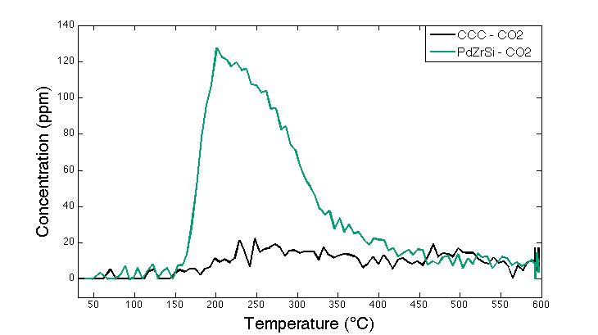
Figure 5.3 CO₂ concentrations during temperature programmed oxidation of pre-adsorbed C₃H₆ on CCC and PdZrSi.
Table 5.1 Compositional and structural properties of ternary and binary catalysts
- Sample | - EDX atomic percentage ª |  |  | - Ratio  - (Cu:Co:Ce) | - Crystallite size ^{b} |  | - SSA  - (m² g⁻¹)
- Sample | - Cu | - Co | - Ce | - Ratio  - (Cu:Co:Ce) | - d_{Co3O4} | - d_{CeO2} | - SSA  - (m² g⁻¹)
- CCC | - 9 ± 2 | - 46 ± 1 | - 45 ± 1 | - 1 : 5 : 5 | - 18 | - 8 | - 41.8
- CoCe | - -- | - 52 ± 2 | - 48 ± 2 | - 0 : 1 : 1 | - 13 | - 10 | - 34.9
- CuCe | - 9 ± 1 | - -- | - 91 ± 1 | - 1 : 0 : 10 | - -- | - 17 | - 26.7
- CuCo | - 9 ± 2 | - 91 ± 2 | - -- | - 1 : 10 : 0 | - 26 | - -- | - 8.6
- ª mean values calculated using several 200μm scans
- ^{b} crystallite size calculated via Scherrer method

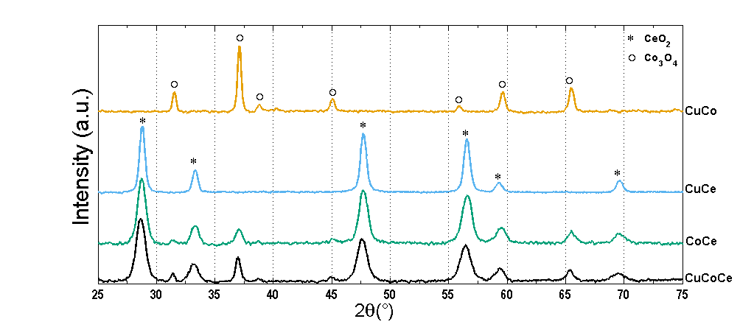
Figure 5.4 Powder XRD patterns of ternary (CCC) and binary (CoCe, CuCe, CuCo) catalysts composed of CuO, Co₃O₄, and CeO₂.
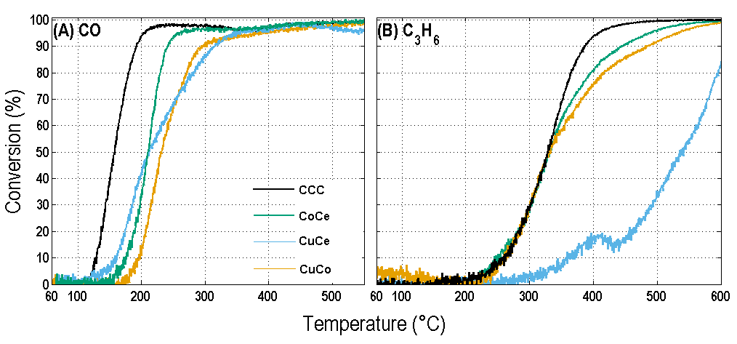
Figure 5.5 Light-off curves under simulated exhaust conditions for ternary CCC and binary catalysts.
(A) CO oxidation. (B) C₃H₆ conversion. [O₂] = 10%, [H₂O] = 5%, [NO] = 0.05%, [CO] = 0.4%, [C₃H₆] = 0.1%, balanced with Ar at GHSV ≈150,000⁻¹.
the catalysts are active for CO oxidation, clearly the unique synergy between all three oxides in CCC increases its activity over the binary catalysts. Of the binary catalysts CuCe is the most active at lower temperatures with the initiation reaction starting at lower temperatures than either CoCe or CuCo, and very similar to CCC. Though it is the most active of the binary catalysts, there is a bend in the light-off curve for CuCe at about 50% conversion. Reports of CO oxidation over these oxide mixtures indicate a low intrinsic activity of pure CeO₂ for CO oxidation ^{112,118-120}; thus, it is likely that the highly dispersed CuO interacting with CeO₂ is the primary active component in the low temperature light-off for CCC. The Co₃O₄ phase (which is more abundant than the CuO phase) may be necessary for maintaining good conversion at the high flow rates studied. In particular, the interaction of CuO or Co₃O₄ and CeO₂ has been reported to weaken the oxygen bonds at the interface increasing the availability of active oxygen at the surface ^{115,119}. The intrinsically higher activity of the CuO phase paired with a high amount of these interface sites provided by the majority Co₃O₄ and CeO₂ phases explains the great improvement in activity for CCC over CuCe.
For propene conversion (figure 5.5b) we find that all three cobalt-containing catalysts show nearly the same light-off temperatures despite the significant differences in surface area and Co₃O₄ crystallite size between CuCo and the other catalysts; however, the temperature at which 90% conversion occurs increases as surface area decreases indicating possible mass-transfer limitations at this flow rate¹²¹. Evidently, the Co₃O₄ phase alone is the primary active component for propene conversion since the increased number of interface sites in CoCe and CCC do not increase the activity over CuCo, and CuCe is incapable of converting propene to the same degree. The high intrinsic activity of Co₃O₄ for volatile organic compound (VOC) oxidation is well known and pure Co₃O₄ alone is even able to catalyze propene oxidation at equivalent or lower temperatures than Co₃O₄-MO_{x} binary mixtures ^{37,122}. The mechanism for olefin oxidation over metal oxides is believed to occur via hydrogen abstraction followed by reaction with electrophilic oxygen at the surface ¹²²⁻¹²⁴ without the need for weakened M-O bonds at interfacial sites. The required hydrogen abstraction step is also what prompted Luo et. al. to propose a separation of active sites for propane (C₃H₈) and CO oxidation¹¹⁵. Though they did not test their catalysts using a stream containing CO and propane simultaneously, a separation in active sites would remove the competition between the reactions seen on PGM catalysts. In this way, another explanation for the lack of CO oxidation inhibition on CCC presents itself in a separation of primary active sites on the catalyst.

Conclusion
Regulations and advances in engine combustion technology have resulted in the need to push the activity of emissions control catalysts to lower temperatures, <200°C, and in turn the catalysts are required to convert higher levels of CO and HCs. The PGM-based catalysts in their current manifestation are unable to operate effectively in these conditions and thus alternative solutions are necessary. The CuO-Co₃O₄-CeO₂ ternary oxide (CCC) presented here shows potential as a low cost alternative to PGM catalysts with higher capability for low-temperature CO oxidation and a unique resistance to inhibition by hydrocarbons. While the necessary hydrocarbon activity is currently too low for CCC, combining these catalysts with a more active HC oxidation catalyst or through the enhancing of the Co-phase activity/surface area in the CCC catalyst, a complete solution for the CO + HC challenges could be achieved.

Summary and Future Work

Summary
The development of effective heterogeneous catalysts is a multifaceted task which requires researchers to address many challenges simultaneously and often overcoming one problem simply serves to bring another into focus. As such, the research presented in this thesis spans a number of related topics in the field. These include: (i) a method for the deposition of active nanoparticles onto unfavorable, low isoelectric point supports; (ii) the promotion of “inert” supports by “active” metal oxides for increased overall activity; (iii) and overcoming inhibition effects which can significantly reduce activity of catalysts in practical conditions.
Initially our focus was on the use of supported Au nanoparticles as highly active carbon monoxide oxidation catalysts^{26,42,43,125,126}. With these catalysts it is vital to obtain small particle size on deposition of the metal and high stability of the particle at high temperatures. Deposition of gold onto low isoelectric point (IEP) supports, such as SiO₂, often results in low loading and very large particle sizes due to unfavorable electrostatic interactions between the support and Au precursor in high pH solutions. We approached this problem by modifying silica supports with a nitrogen-containing polymer, carbon nitride (C₃N₄), which can readily complex with the metal precursor, effectively ignoring the unfavorable IEP of SiO₂⁴². Unlike previous amine surface-modification schemes, this method is advantageous in that it requires no solvents and takes place on previously synthesized SiO₂, meaning a wide range of porous structures are available to use with this method.
The C₃N₄/SiO₂ support readily absorbed gold using the deposition-precipitation process and stabilized small Au nanoparticles even at temperatures as high as 500°C. Unfortunately, we found that removal of the polymer was necessary to achieve good CO oxidation capability. The oxygen adsorption capability of C₃N₄ is poor and thus it is unable to provide needed oxygen to the CO oxidation reaction. Upon removal of the polymer layer, the SiO₂ support is able to better provide oxygen to the reaction and thus the activity increases.
While the activity of the Au/C₃N₄/SiO₂ catalyst increased after removal of the carbon nitride, the activity was still low when compared to gold nanoparticles supported on other metal oxides such as FeO_{x} or TiO₂. Silica is better able than C₃N₄ to provide oxygen to the CO oxidation reaction, but relative to more easily reducible oxides silica is still much less able to supply needed oxygen for the very high activity that is expected of supported Au catalysts

⁴⁹. In order to obtain the benefits of this “inert” support (i.e. its mechanical strength, high thermal stability, and various synthesis methods for porous structures

^{49,91,92}) while increasing the activity we decided modify the silica support with small amounts of “active” metal oxides in order to provide more active oxygen to the supported nanoparticles.
We studied two of these oxide-promoted catalysts, a Au/FeO_{x}/SiO₂ catalyst prepared using an iron containing carbon nitride (Fe-C₃N₄) and a Pd/ZrO₂/SiO₂ prepared via sol-gel modification of the silica. As expected, in both cases these promoted catalysts were more active than their unmodified counterparts (Au/SiO₂ and Pd/SiO₂) but the addition of FeO_{x} and ZrO₂, respectively, also imparted increased stability to the SiO₂ support at very high temperature calcination (≥800°C). Furthermore, we found that the Fe-C₃N₄ modification method results in very small or highly amorphous FeO_{x} on the silica surface even at iron loadings that normally result in Fe₂O₃ crystalline structures (as seen by powder x-ray diffraction) via standard impregnation.
Through a collaboration with the Fuels, Engines, and Emissions Research Center we also began studying these catalysts under simulated exhaust conditions for application in automotive exhaust pollution control. We found that while our previous catalysts were highly active for low temperature CO oxidation, they were also very susceptible to inhibition by other common exhaust stream components, and in particular, propene. The presence of these inhibitors was enough to shift CO oxidation light-off curves for Au/FeO_{x}/SiO₂ and Pd/ZrO₂/SiO₂ to higher temperatures by hundreds of degrees. Through our own DRIFTS characterization we found evidence of competitive adsorption between propene and carbon monoxide over Pd active sites which agreed well with literature on propene inhibition over precious metal catalysts^{54,57}.
In order to tackle problem of inhibition, we sought to create a catalyst that could separate the active sites of propene and carbon monoxide such that inhibition effects would be negligible. Previous research on binary mixed oxide catalysts composed of copper, cobalt, and/or cerium oxides indicated that propene and CO oxidation likely occurred at different sites on these catalysts^{37,99,115}. In particular, CO oxidation occurs primarily at interface sites between metal oxides and C₃H₆ oxidation occurs primarily over the surface of the copper and cobalt oxides. Furthermore, our previous work with a ternary oxide composed of these metals, CuO-Co₃O₄-CeO₂ (dubbed CCC), showed that this catalyst was highly active for CO oxidation at low temperature and stable at temperatures as high as 800°C⁴⁴ making CCC a natural candidate for potentially overcoming the inhibition seen on precious metal catalysts.
CO oxidation studies in simulated exhaust streams showed that the CCC catalyst was able to oxidize CO at lower temperatures than Pd/ZrO₂/SiO₂ and a commercial diesel oxidation catalyst. Moreover, the introduction of propene into the stream showed no effect on this catalyst. DRIFTS data confirmed very little interaction between propene and the Cu⁺-carbonyl binding site in CCC and low adsorption of the propene on the catalyst surface. Catalysis experiments using CuO-Co₃O₄, CuO-CeO₂, and Co₃O₄-CeO₂ binary oxides also matches well with a model in which the interface sites are responsible for CO oxidation and the surface sites are responsible for propene oxidation.

Future Work
The work presented here introduces a number of important problems in heterogeneous catalysis and approaches to tackling them, but there are still many questions left to answer about these catalysts. Further research involving these catalysts would be immensely useful for further generalizing these approaches and understanding the properties of these materials. In particular, the most striking results of these experiments are (i) the observation of small or amorphous FeO_{x} resulting from Fe-C₃N₄ deposition even at concentrations that result in Fe₂O₃ using impregnation and (ii) the lack of propene inhibition effects on carbon monoxide oxidation observed over CuO-Co₃O₄-CeO₂.
For the FeO_{x}/SiO₂ samples our x-ray diffraction results showed a complete lack of iron oxide peaks after the removal of the carbon nitride in the deposited Fe-C₃N₄ and calcination at 800°C in air. This is intriguing because it demonstrates a unique property in this deposition method, the ability to deposit small or amorphous iron onto the surface of silica that is stable at high temperature. Further research into this material should start with a determination of the Fe species. One explanation for our results is that the iron exists in an amorphous oxide on the surface of the silica. The synthesis of amorphous Fe₂O₃ has been reported using a variety of methods¹²⁷ including thermal decomposition of prussian blue (Fe₄[Fe(CN)₆]₃)¹²⁸. If this is the case, high-resolution TEM imaging should be able to see these iron oxide particles and electron diffraction can be used to unambiguously confirm their amorphous nature. X-ray photoelectron spectroscopy can also be used to confirm the presence of Fe³⁺ species indicative of Fe₂O₃¹²⁹. While the vast majority of reported amorphous iron oxides quickly crystallize at temperatures as low as 300°C, Fe₂O₃-SiO₂ composites have been shown to be stable up to 700°C with very high iron content (16.9 wt%)¹³⁰. The discovery of a new method to deposit stable amorphous FeO_{x} would be beneficial to a number of fields including solar energy production, electronics, and electrochemistry¹²⁷.
For the CuO-Co₃O₄-CeO₂ catalyst, the lack of propene inhibition observed is a new and promising property for this type of catalyst (mixed oxides of copper, cobalt, and ceria) but this three-phase system is complex even compared to supported nanoparticle catalysts. While a great deal of work has been done on oxide catalysts to elucidate reaction mechanisms for CO and hydrocarbon oxidation, and the role of oxygen species and vacancies on catalyst activity^{115,122,124,131,132}, the fact remains that the study of mixed oxide systems often require post-hoc analysis to ferret out valuable information. The development and use of model systems to study interfacial effects could prove very valuable in identifying clear paths to improve these catalysts further.
Recently, the use of model particles with well defined shapes and crystallographic planes to understand catalytic effects was highlighted in Yadong and Zhou¹³³. One noteworthy example is that of CuO particles deposited on structured CeO₂ surfaces¹³⁴. This work demonstrated that the reducibility, and thus the CO oxidation activity, of CuO/CeO₂ is greatly improved if the CuO-CeO₂ interface involves {001} or {110} CeO₂ crystal planes. Various nanostructures (including nanobelts, nanocubes, plates, etc..) with different predominant crystal planes can be synthesized for CuO, CeO₂, and Co₃O₄ which present a library of possible interfacial structures to examine¹³³. Further research could utilize these structures and the now familiar battery of characterization techniques to determine key interfaces responsible for increased activity in these mixed oxides and guide future development of mixed oxide catalysts.

LIST OF REFERENCES

(1) Armor, J. N. A History of Industrial Catalysis. Catalysis Today 2011, 163, 3–9.
(2) Lindström, B.; Pettersson, L. J. A Brief History of Catalysis. CATTECH 2003, 7, 130–138.
(3) Robertson, A. The Early History of Catalysis. Platinum Metals Rev 1975.
(4) Vannice, M. A. Kinetics of Catalytic Reactions; Springer, 2005.
(5) Wilkinson, A.; McNaught, A. D.; IUPAC. Compendium of Chemical Terminology; 2nd ed.; Blackwell Scientific Publications: Oxford, 1997.
(6) Ma, Z.; Zaera, F. Heterogeneous Catalysis by Metals. Encyclopedia of Inorganic and Bioinorganic … 2014.
(7) Bond, G. C.; Thompson, D. T. Catalysis by Gold. Catal Rev - Sci Eng 1999.
(8) Cullis, C. F.; Willatt, B. M. Oxidation of Methane Over Supported Precious Metal Catalysts. J Catal 1983, 83, 267–285.
(9) Ahmed, F.; Nagumo, R.; Miura, R.; Ai, S.; Tsuboi, H.; Hatakeyama, N.; Endou, A.; Takaba, H.; Kubo, M.; Miyamoto, A. Comparison of Reactivity on Step and Terrace Sites of Pd (332) Surface for the Dissociative Adsorption of Hydrogen: a Quantum Chemical Molecular Dynamics Study. Applied Surface Science 2011, 257, 10503.
(10) Di Monte, R.; Kašpar, J. Heterogeneous Environmental Catalysis–a Gentle Art: CeO2–ZrO2 Mixed Oxides as a Case History. Catalysis Today 2005, 100, 27–35.
(11) Dumesic, J. A.; Huber, G. W.; Boudart, M. Principles of Heterogeneous Catalysis; Wiley‐VCH Verlag GmbH & Co. KGaA: Weinheim, Germany, 2008.
(12) Wu, X. F.; Anbarasan, P.; Neumann, H.; Beller, M. From Noble Metal to Nobel Prize: Palladium‐Catalyzed Coupling Reactions as Key Methods in Organic Synthesis. Angew. Chem. Int. Ed. Engl. 2010, 49, 9047–9050.
(13) Maillard, F.; Schreier, S.; Hanzlik, M.; Savinova, E. R.; Weinkauf, S.; Stimming, U. Influence of Particle Agglomeration on the Catalytic Activity of Carbon-Supported Pt Nanoparticles in CO Monolayer Oxidation. Phys Chem Chem Phys 2005, 7, 385–393.
(14) Shi, F.; Zhang, Q.; Ma, Y.; He, Y.; Deng, Y. From CO Oxidation to CO2 Activation: an Unexpected Catalytic Activity of Polymer-Supported Nanogold. J. Am. Chem. Soc. 2005, 127, 4182–4183.
(15) Haruta, M. Catalysis of Gold Nanoparticles Deposited on Metal Oxides. 2002, 6, 102–115.
(16) Li, Z.; Yan, W.; Wei, S. Support Effects on Electronic Behaviors of Gold Nanoparticles Studied by X-Ray Absorption Fine Structure. AIP Conference Proceedings 2007.
(17) Yan, W. F.; Mahurin, S. M.; Chen, B.; Overbury, S. H.; Dai, S. Effect of Supporting Surface Layers on Catalytic Activities of Gold Nanoparticles in CO Oxidation. J Phys Chem B 2005, 109, 15489–15496.
(18) Ma, Z.; Overbury, S. H.; Dai, S. Au/MxOy/TiO(2)Catalysts for CO Oxidation: Promotional Effect of Main-Group, Transition, and Rare-Earth Metal Oxide Additives. J Mol Catal A-Chem 2007, 273, 186–197.
(19) Schubert, M. M.; Hackenberg, S.; Van Veen, A. C. CO Oxidation Over Supported Gold Catalysts—“Inert” and ‘Active’ Support Materials and Their Role for the Oxygen Supply During Reaction. J Catal 2001, 197, 113–122.
(20) Liu, L.; Zhou, F.; Wang, L.; Qi, X.; Shi, F.; Deng, Y. Low-Temperature CO Oxidation Over Supported Pt, Pd Catalysts: Particular Role of FeOX Support for Oxygen Supply During Reactions. J Catal 2010, 274, 1–10.
(21) Guzman, J.; Carrettin, S.; Fierro-Gonzalez, J. C.; Hao, Y.; Gates, B. C.; Corma, A. CO Oxidation Catalyzed by Supported Gold: Cooperation Between Gold and Nanocrystalline Rare-Earth Supports Forms Reactive Surface Superoxide and Peroxide Species. Angew. Chem. Int. Ed. 2005, 44, 4778–4781.
(22) Singh, J. A.; Overbury, S. H.; Dudney, N. J.; Li, M.; Veith, G. M. Gold Nanoparticles Supported on Carbon Nitride: Influence of Surface Hydroxyls on Low Temperature Carbon Monoxide Oxidation. Acs Catal 2012, 2, 1138–1146.
(23) Pillay, D.; Hwang, G. Growth and Structure of Small Gold Particles on Rutile TiO2(110). Phys. Rev. B 2005, 72, 205422.
(24) Chen, M. S.; Goodman, D. W. The Structure of Catalytically Active Gold on Titania. Science 2004, 306, 252–255.
(25) Tian, C.; Chai, S.-H.; Zhu, X.; Wu, Z.; Binder, A.; Bauer, J. C.; Brwon, S.; Chi, M.; Veith, G. M.; Guo, Y.; et al. In Situ Growth Synthesis of Heterostructured LnPO4 –SiO2 (Ln = La, Ce, and Eu) Mesoporous Materials as Supports for Small Gold Particles Used in Catalytic CO Oxidation. J. Mater. Chem. 2012, 22, 25227–25235.
(26) Ma, G.; Binder, A.; Chi, M.; Liu, C.; Jin, R.; Jiang, D.-E.; Fan, J.; Dai, S. Stabilizing Gold Clusters by Heterostructured Transition-Metal Oxide-Mesoporous Silica Supports for Enhanced Catalytic Activities for CO Oxidation. Chem. Commun. (Camb.) 2012, 48, 11413–11415.
(27) Haruta, M.; Yamada, N.; Kobayashi, T.; Iijima, S. Gold Catalysts Prepared by Coprecipitation for Low-Temperature Oxidation of Hydrogen and of Carbon Monoxide. J Catal 1989, 115, 301–309.
(28) Haruta, M. Size-and Support-Dependency in the Catalysis of Gold. Catalysis Today 1997, 36, 153–166.
(29) Haruta, M.; Kobayashi, T.; Sano, H.; Yamada, N. Novel Gold Catalysts for the Oxidation of Carbon-Monoxide at a Temperature Far Below 0°C. Chem Lett 1987, 405–408.
(30) Valden, M.; Lai, X.; Goodman, D. Onset of Catalytic Activity of Gold Clusters on Titania with the Appearance of Nonmetallic Properties. Science 1998, 281, 1647–1650.
(31) Cuenya, B. R.; Baeck, S.-H.; Jaramillo, T. F.; McFarland, E. W. Size- and Support-Dependent Electronic and Catalytic Properties of Au⁰/Au³⁺ Nanoparticles Synthesized From Block Copolymer Micelles. J. Am. Chem. Soc. 2003, 125, 12928–12934.
(32) Maillard, F.; Savinova, E. R.; Stimming, U. CO Monolayer Oxidation on Pt Nanoparticles: Further Insights Into the Particle Size Effects. Journal of Electroanalytical Chemistry 2007, 599, 221–232.
(33) Cuenya, B. R. Synthesis and Catalytic Properties of Metal Nanoparticles: Size, Shape, Support, Composition, and Oxidation State Effects. Thin Solid Films 2010, 518, 3127–3150.
(34) Cao, A.; Lu, R.; Veser, G. Stabilizing Metal Nanoparticles for Heterogeneous Catalysis. Phys Chem Chem Phys 2010, 12, 13499–13510.
(35) Royer, S.; Duprez, D. Catalytic Oxidation of Carbon Monoxide Over Transition Metal Oxides. Chemcatchem 2011, 3, 24–65.
(36) Luo, M.-F.; Zhong, Y.-J.; Yuan, X.-X.; Zheng, X.-M. TPR and TPD Studies of CuO/CeO2 Catalysts for Low Temperature CO Oxidation. Appl. Catal. A-Gen. 1997, 162, 121–131.
(37) Liotta, L. F.; Ousmane, M.; Di Carlo, G.; Pantaleo, G.; Deganello, G.; Marcì, G.; Retailleau, L.; Giroir-Fendler, A. Total Oxidation of Propene at Low Temperature Over Co3O4-CeO2 Mixed Oxides: Role of Surface Oxygen Vacancies and Bulk Oxygen Mobility in the Catalytic Activity. Appl. Catal. A-Gen. 2008, 347, 81–88.
(38) Salomons, S.; Hayes, R. E.; Votsmeier, M.; Drochner, A.; Vogel, H.; Malmberg, S.; Gieshoff, J. On the Use of Mechanistic CO Oxidation Models with a Platinum Monolith Catalyst. Appl. Catal. B. - Environ 2007, 70, 305–313.
(39) Baxter, R. J.; Hu, P. Insight Into Why the Langmuir–Hinshelwood Mechanism Is Generally Preferred
. The Journal of chemical physics 2002, 116, 4379.
(40) Arnby, K.; Törncrona, A.; Andersson, B.; Skoglundh, M. Investigation of Pt/Γ-Al2O3 Catalysts with Locally High Pt Concentrations for Oxidation of CO at Low Temperatures. J Catal 2004, 221, 252–261.
(41) Kim, H. Y.; Henkelman, G. CO Oxidation at the Interface of Au Nanoclusters and the Stepped-CeO2 (111) Surface by the Mars–Van Krevelen Mechanism. J. Phys. Chem. Lett. 2013, 4, 216–221.
(42) Binder, A. J.; Qiao, Z.-A.; Veith, G. M.; Dai, S. Deposition–Precipitation and Stabilization of a Silica-Supported Au Catalyst by Surface Modification with Carbon Nitride. Catal Lett 2013, 143, 1339–1345.
(43) Tian, C.; Chai, S.-H.; Mullins, D. R.; Zhu, X.; Binder, A.; Guo, Y.; Dai, S. Heterostructured BaSO4-SiO2 Mesoporous Materials as New Supports for Gold Nanoparticles in Low-Temperature CO Oxidation. Chem. Commun. (Camb.) 2013, 49, 3464–3466.
(44) Liu, Z.-G.; Chai, S.-H.; Binder, A.; Li, Y.-Y.; Ji, L.-T.; Dai, S. Influence of Calcination Temperature on the Structure and Catalytic Performance of CuOx-CoOy-CeO2 Ternary Mixed Oxide for CO Oxidation. Appl. Catal. A-Gen. 2013, 451, 282–288.
(45) Corma, A.; Garcia, H. Supported Gold Nanoparticles as Catalysts for Organic Reactions. Chem Soc Rev 2008, 37, 2096–2126.
(46) Zanella, R.; Giorgio, S.; Henry, C. R.; Louis, C. Alternative Methods for the Preparation of Gold Nanoparticles Supported on TiO2. J Phys Chem B 2002, 106, 7634–7642.
(47) Wolf, A.; Schuth, F. A Systematic Study of the Synthesis Conditions for the Preparation of Highly Active Gold Catalysts. Appl. Catal. A-Gen. 2002, 226, 1–13.
(48) Al-Sayari, S.; Carley, A. F.; Taylor, S. H.; Hutchings, G. J. Au/ZnO and Au/Fe2O3 Catalysts for CO Oxidation at Ambient Temperature: Comments on the Effect of Synthesis Conditions on the Preparation of High Activity Catalysts Prepared by Coprecipitation. Top Catal 2007, 44, 123–128.
(49) Ma, Z.; Dai, S. Development of Novel Supported Gold Catalysts: a Materials Perspective. Nano Res 2011, 4, 3–32.
(50) Arnal, P. M.; Comotti, M.; Schuth, F. High-Temperature-Stable Catalysts by Hollow Sphere Encapsulation. Angew. Chem. Int. Ed. 2006, 45, 8224–8227.
(51) Wang, Y.; Yao, J.; Li, H. R.; Su, D. S.; Antonietti, M. Highly Selective Hydrogenation of Phenol and Derivatives Over a Pd@Carbon Nitride Catalyst in Aqueous Media. J. Am. Chem. Soc. 2011, 133, 2362–2365.
(52) Zhu, H.; Liang, C.; Yan, W.; Overbury, S. H.; Dai, S. Preparation of Highly Active Silica-Supported Au Catalysts for CO Oxidation by a Solution-Based Technique. J Phys Chem B 2006, 110, 10842–10848.
(53) Ma, Z.; Dai, S. Materials Design of Advanced Performance Metal Catalysts. Mater Technol 2008, 23, 81–87.
(54) Botas, J. A.; Gutiérrez-Ortiz, M. A.; González-Marcos, M. P.; González-Marcos, J. A.; González-Velasco, J. R. Kinetic Considerations of Three-Way Catalysis in Automobile Exhaust Converters. Appl. Catal. B. - Environ 2001, 32, 243–256.
(55) Shamim, T. The Effect of Space Velocity on the Dynamic Characteristics of an Automotive Catalytic Converter. SAE Technical Paper 2005.
(56) Kummer, J. T. Use of Noble Metals in Automobile Exhaust Catalysts. J. Phys. Chem. 1986, 4747–4752.
(57) Harbi, M. A.; Hayes, R.; Votsmeier, M.; Epling, W. S. Competitive No, Co and Hydrocarbon Oxidation Reactions Over a Diesel Oxidation Catalyst. Can. J. Chem. Eng. 2012, 90, 1527–1538.
(58) Gandhi, H. Automotive Exhaust Catalysis. J Catal 2003, 216, 433–442.
(59) Mellor, J. R.; Palazov, A. N.; Grigorova, B. S.; Greyling, J. F.; Reddy, K.; Letsoalo, M. P.; Marsh, J. H. The Application of Supported Gold Catalysts to Automotive Pollution Abatement. Catalysis Today 2002, 72, 145–156.
(60) Kapteijn, F.; Stegenga, S.; Dekker, N. J. J.; Bijsterbosch, J. W.; Moulijn, J. A. Alternatives to Noble Metal Catalysts for Automotive Exhaust Purification. Catalysis Today 1993, 16, 273–287.
(61) Ye, S.; Yap, Y. H.; Kolaczkowski, S. T.; Robinson, K.; Lukyanov, D. Catalyst “Light-Off” Experiments on a Diesel Oxidation Catalyst Connected to a Diesel Engine—Methodology and Techniques. Chemical Engineering Research and Design 2012, 90, 834–845.
(62) Ma, Z.; Dai, S. Design of Novel Structured Gold Nanocatalysts. Acs Catal 2011, 1, 805–818.
(63) Soleimani Dorcheh, A.; Abbasi, M. H. Silica Aerogel; Synthesis, Properties and Characterization. Journal of Materials Processing Technology 2008, 199, 10–26.
(64) Tang, J.; Zhu, M.; Zhong, T.; Hou, Y.; Wang, H. Synthesis of Fine Pb (Fe0.5Nb0.5)O3 Perovskite Powders by Coprecipitation Method. Materials chemistry and … 2007, 101, 475–479.
(65) Wachs, I. E. Characterization of Catalytic Materials; Momentum Press, 2009.
(66) Carabineiro, S. A. C.; Silva, A. M. T.; Drazic, G.; Tavares, P. B.; Figueiredo, J. L. Effect of Chloride on the Sinterization of Au/CeO2 Catalysts. Catalysis Today 2010, 154, 293–302.
(67) Barrett, E. P.; Joyner, L. G.; Halenda, P. P. The Determination of Pore Volume and Area Distributions in Porous Substances. I. Computations From Nitrogen Isotherms. J. Am. Chem. Soc. 1951, 73, 373–380.
(68) Liu, J. H.; Zhang, T. K.; Wang, Z. C.; Dawson, G.; Chen, W. Simple Pyrolysis of Urea Into Graphitic Carbon Nitride with Recyclable Adsorption and Photocatalytic Activity. J. Mater. Chem. 2011, 21, 14398–14401.
(69) Hutchings, G. J.; Haruta, M. A Golden Age of Catalysis: a Perspective. Appl. Catal. A-Gen. 2005, 291, 2–5.
(70) Lee, B.; Ma, Z.; Zhang, Z. T.; Park, C.; Dai, S. Influences of Synthesis Conditions and Mesoporous Structures on the Gold Nanoparticles Supported on Mesoporous Silica Hosts. Micropor Mesopor Mat 2009, 122, 160–167.
(71) Comotti, M.; Li, W. C.; Spliethoff, B.; Schuth, F. Support Effect in High Activity Gold Catalysts for CO Oxidation. J. Am. Chem. Soc. 2006, 128, 917–924.
(72) Bore, M. T.; Mokhonoana, M. P.; Ward, T. L.; Coville, N. J. Synthesis and Reactivity of Gold Nanoparticles Supported on Transition Metal Doped Mesoporous Silica. Micropor Mesopor Mat 2006, 95, 118–125.
(73) Qian, K.; Huang, W.; Fang, J.; Lv, S.; He, B.; Jiang, Z.; Wei, S. Low-Temperature CO Oxidation Over Au/ZnO/SiO2 Catalysts: Some Mechanism Insights. J Catal 2008, 255.
(74) Qian, K.; Lv, S.; Xiao, X.; Sun, H.; Lu, J.; Luo, M.; Huang, W. Influences of CeO2 Microstructures on the Structure and Activity of Au/CeO2/SiO2 Catalysts in CO Oxidation. J Mol Catal A-Chem 2009, 306, 40–47.
(75) Kawaguchi, M.; Nozaki, K. Synthesis, Structure, and Characteristics of the New Host Material [(C3N3)2(Nh)3]N. Chem. Mater. 1995, 7, 257–264.
(76) Wang, Y.; Wang, X. C.; Antonietti, M. Polymeric Graphitic Carbon Nitride as a Heterogeneous Organocatalyst: From Photochemistry to Multipurpose Catalysis to Sustainable Chemistry. Angew. Chem. Int. Ed. 2012, 51, 68–89.
(77) Somodi, F.; Borbáth, I.; Hegedűs, M.; Tompos, A.; Sajó, I. E.; Szegedi, Á.; Rojas, S.; Fierro, J. L. G.; Margitfalvi, J. L. Modified Preparation Method for Highly Active Au/SiO2 Catalysts Used in CO Oxidation. Appl. Catal. A-Gen. 2008, 347, 216–222.
(78) Ghosh, A.; Ranjan Patra, C.; Mukherjee, P.; Sastry, M.; Kumar, R. Preparation and Stabilization of Gold Nanoparticles Formed by in Situ Reduction of Aqueous Chloroaurate Ions Within Surface-Modified Mesoporous Silica. Micropor Mesopor Mat 2003, 58, 201–211.
(79) Yang, C.-M.; Liu, P.-H.; Ho, Y.-F.; Chiu, C.-Y.; Chao, K.-J. Highly Dispersed Metal Nanoparticles in Functionalized SBA-15. Chem. Mater. 2003, 15, 275–280.
(80) Zhang, J. A.; Li, Y. A.; Zhu, P. W.; Huang, D. H.; Wu, S.; Cui, Q. L.; Zou, G. T. Graphitic Carbon Nitride Materials Synthesized via Reactive Pyrolysis Routes and Their Properties. Diam Relat Mater 2011, 20, 385–388.
(81) Miller, D. R.; Wang, J. J.; Gillan, E. G. Rapid, Facile Synthesis of Nitrogen-Rich Carbon Nitride Powders. J. Mater. Chem. 2002, 12, 2463–2469.
(82) Meng, Y.; Xin, G.; Chen, D. A Facile Pyrolysis Method for G-C3N4 Synthesizing: Photocatalytic Degredation of Methylene Blue Under Visible Light. Optoelectron. Adv. Mater. 2011, 5, 648–650.
(83) Wang, Y.; Zhang, J. S.; Wang, X. C.; Antonietti, M.; Li, H. R. Boron- and Fluorine-Containing Mesoporous Carbon Nitride Polymers: Metal-Free Catalysts for Cyclohexane Oxidation. Angew. Chem. Int. Ed. 2010, 49, 3356–3359.
(84) Kim, T.-W.; Chung, P.-W.; Lin, V. S. Y. Facile Synthesis of Monodisperse Spherical MCM-48 Mesoporous Silica Nanoparticles with Controlled Particle Size. Chem. Mater. 2010, 22, 5093–5104.
(85) Liu, R.; Mahurin, S. M.; Li, C.; Unocic, R. R.; Idrobo, J. C.; Gao, H.; Pennycook, S. J.; Dai, S. Dopamine as a Carbon Source: the Controlled Synthesis of Hollow Carbon Spheres and Yolk‐Structured Carbon Nanocomposites. Angew. Chem. Int. Ed. Engl. 2011, 50, 6799–6802.
(86) Li, X. F.; Zhang, J.; Shen, L. H.; Ma, Y. M.; Lei, W. W.; Cui, Q. L.; Zou, G. T. Preparation and Characterization of Graphitic Carbon Nitride Through Pyrolysis of Melamine. Appl Phys A 2009, 94, 387–392.
(87) Komatsu, T.; Nakamura, T. Polycondensation/Pyrolysis of Tris-S-Triazine Derivatives Leading to Graphite-Like Carbon Nitrides. J. Mater. Chem. 2001, 11, 474–478.
(88) Guo, Q. X.; Yang, Q.; Yi, C. Q.; Zhu, L.; Xie, Y. Synthesis of Carbon Nitrides with Graphite-Like or Onion-Like Lamellar Structures via a Solvent-Free Route at Low Temperatures. Carbon 2005, 43, 1386–1391.
(89) Zhu, J. J.; Carabineiro, S. A. C.; Shan, D.; Faria, J. L.; Zhu, Y. J.; Figueiredo, J. L. Oxygen Activation Sites in Gold and Iron Catalysts Supported on Carbon Nitride and Activated Carbon. J Catal 2010, 274, 207–214.
(90) Veith, G. M.; Lupini, A. R.; Rashkeev, S.; Pennycook, S. J.; Mullins, D. R.; Schwartz, V.; Bridges, C. A.; Dudney, N. J. Thermal Stability and Catalytic Activity of Gold Nanoparticles Supported on Silica. J Catal 2009, 262, 92–101.
(91) Zhu, H. G.; Lee, B.; Dai, S.; Overbury, S. H. Coassembly Synthesis of Ordered Mesoporous Silica Materials Containing Au Nanoparticles. Langmuir 2003, 19, 3974–3980.
(92) Shah, P.; Ramaswamy, V. Thermal Stability of Mesoporous SBA-15 and Sn-SBA-15 Molecular Sieves: an in Situ HTXRD Study. Micropor Mesopor Mat 2008, 114, 270–280.
(93) Liu, X.; Korotkikh, O.; Farrauto, R. Selective Catalytic Oxidation of CO in H2: Structural Study of Fe Oxide-Promoted Pt/Alumina Catalyst. Appl. Catal. A-Gen. 2002, 226, 293–303.
(94) Xu, H.; Chu, W.; Luo, J.; Liu, M. New Au/FeOX/SiO2 Catalysts Using Deposition–Precipitation for Low-Temperature Carbon Monoxide Oxidation. Catal Commun 2010, 11, 812–815.
(95) Grisel, R.; Weststrate, K.-J.; Gluhoi, A.; Nieuwenhuys, B. E. Catalysis by Gold Nanoparticles. Gold Bull 2002, 35, 39–45.
(96) Zhu, H.; Ma, Z.; Clark, J. C.; Pan, Z.; Overbury, S. H.; Dai, S. Low-Temperature CO Oxidation on Au/Fumed SiO2-Based Catalysts Prepared From Au(en)2Cl3 Precursor. Appl. Catal. A-Gen. 2007, 326, 89–99.
(97) Yan, W.; Chen, B.; Mahurin, S. M.; Hagaman, E. W.; Dai, S.; Overbury, S. H. Surface Sol−Gel Modification of Mesoporous Silica Materials with TiO2 For the Assembly of Ultrasmall Gold Nanoparticles. J Phys Chem B 2004, 108, 2793–2796.
(98) Chen, X.; Zhang, J.; Fu, X.; Antonietti, M.; Wang, X. Fe-G-C3N4-Catalyzed Oxidation of Benzene to Phenol Using Hydrogen Peroxide and Visible Light. J. Am. Chem. Soc. 2009, 131, 11658–11659.
(99) Heo, I.; Wiebenga, M. H.; Gaudet, J. R.; Nam, I.-S.; Li, W.; Kim, C. H. Ultra Low Temperature CO and HC Oxidation Over Cu-Based Mixed Oxides for Future Automotive Applications. Appl. Catal. B. - Environ 2014, 160-161, 365–373.
(100) Perkas, N.; Pol, V. G.; Pol, S. V.; Gedanken, A. Gold-Induced Crystallization of SiO2 And TiO2 Powders. Cryst Growth Des 2006, 6, 293–296.
(101) Ponce-Castañeda, S.; Martínez, J. R.; Ruiz, F.; Palomares-Sánchez, S.; Domínguez, O. Synthesis of Fe2O3 Species Embedded in a Silica Xerogel Matrix: a Comparative Study. Journal of Sol-Gel Science and Technology 2002, 25, 29–36.
(102) Yin, H.; Ma, Z.; Zhu, H.; Chi, M.; Dai, S. Evidence for and Mitigation of the Encapsulation of Gold Nanoparticles Within Silica Supports Upon High-Temperature Treatment of Au/SiO2 Catalysts: Implication to Catalyst Deactivation. Appl. Catal. A-Gen. 2010, 386, 147–156.
(103) Law, H. Y.; Blanchard, J.; Carrier, X.; Thomas, C. NoX-TPD as a Tool to Estimate the Accessible Zirconia Surface of ZrO2-Containing Materials. J Phys Chem C 2010, 114, 9731–9738.
(104) Tauster, S. J.; Fung, S. C.; Baker, R. T.; Horsley, J. A. Strong Interactions in Supported-Metal Catalysts. Science 1981, 211, 1121–1125.
(105) Martínez-Arias, A.; Fernández-García, M.; Inglesias-Juez, A.; Hungría, A. B.; Anderson, J. A.; Conesa, J. C.; Soria, J. New Pd/CeXZr1-XO2/Al2O3 Three-Way Catalysts Prepared by Microemulsion-Part 2. in Situ Analysis of CO Oxidation and NO Reduction Under Stoichiometric CO+NO+O2. Appl. Catal. B. - Environ 2001, 31, 51–60.
(106) 2017 and Later Model Year Light-Duty Vehicle Greenhouse Gas Emissions and Corporate Average Fuel Economy Standards. Federal Register 2012, 77, 62623–63200.
(107) Control of Air Pollution From Motor Vehicles: Tier 3 Motor Vehicle Emission and Fuel Standards. Federal Register 2014, 79, 23414–23886.
(108) Review of the Research Program of the U.S. DRIVE Partnership: Fourth Report; The National Academies Press, 2013.
(109) Kokjohn, S. L.; Reitz, R. D. Reactivity Controlled Compression Ignition and Conventional Diesel Combustion: a Comparison of Methods to Meet Light-Duty NOx and Fuel Economy Targets. International Journal of Engine Research 2013, 14, 452–468.
(110) Curran, S. J.; Hanson, R. M.; Wagner, R. M. Reactivity Controlled Compression Ignition Combustion on a Multi-Cylinder Light-Duty Diesel Engine. International Journal of Engine Research 2012, 13, 216–225.
(111) Luo, M. F.; Hou, Z. Y.; Yuan, X. X.; Zheng, X. M. Characterization Study of CeO2 Supported Pd Catalyst for Low-Temperature Carbon Monoxide Oxidation. Catal Lett 1998, 50, 205–209.
(112) Zheng, X.; Zhang, X.; Wang, X.; Wang, S.; Wu, S. Preparation and Characterization of CuO/CeO2 Catalysts and Their Applications in Low-Temperature CO Oxidation. Appl. Catal. A-Gen. 2005, 295, 142–149.
(113) Luo, J.; Meng, M.; Li, X.; ZHA, Y.; HU, T.; Xie, Y.; Zhang, J. Mesoporous Co3O4–CeO2 And Pd/Co3O4–CeO2 Catalysts: Synthesis, Characterization and Mechanistic Study of Their Catalytic Properties for Low-Temperature CO Oxidation. J Catal 2008, 254, 310–324.
(114) Ma, C.; Mu, Z.; He, C.; Li, P.; Li, J.; Hao, Z. Catalytic Oxidation of Benzene Over Nanostructured Porous Co3O4-CeO2 Composite Catalysts. J Environ Sci (China) 2011, 23, 2078–2086.
(115) Luo, J.-Y.; Meng, M.; Zha, Y.-Q.; Guo, L.-H. Identification of the Active Sites for CO and C3H8 Total Oxidation Over Nanostructured CuO−CeO2 And Co3O4−CeO2 Catalysts. J Phys Chem C 2008, 112, 8694–8701.
(116) Beketaeva, L. A.; Zakumbaeva, G. D.; Kalanova, S. M. Adsorption of Propylene on Platinum-Group Metals. React Kinet Catal Lett 1976, 5, 15–20.
(117) Bera, P.; Cámara, A. L.; Hornés, A.; Martínez-Arias, A. Comparative in Situ DRIFTS-MS Study of ¹²CO- and ¹³CO-TPR on CuO/CeO2 Catalyst. J Phys Chem C 2009, 113, 10689–10695.
(118) Luo, M. F.; Song, Y. P.; Lu, J. Q.; Wang, X. Y. Identification of CuO Species in High Surface Area CuO-CeO2 Catalysts and Their Catalytic Activities for CO Oxidation. The Journal of Physical … 2007, 111, 12686–12692.
(119) Su, Y.; Wang, S.; Zhang, T.; Zhu, B.; Cao, J.; Yuan, Z. Comparative Study on Catalytic Performances for Low-Temperature CO Oxidation of Cu–Ce–O and Cu–Co–Ce–O Catalysts. Catal Lett 2008, 124, 405–412.
(120) Chen, Y.; Liu, D.; Yang, L.; Meng, M.; Zhang, J. Ternary Composite Oxide Catalysts CuO/Co3O4–CeO2 With Wide Temperature-Window for the Preferential Oxidation of CO in H2-Rich Stream. Chem. Eng. J. 2013, 234, 88–98.
(121) Duprat, F. Light-Off Curve of Catalytic Reaction and Kinetics. Chem Eng Sci 2002, 901–911.
(122) Liotta, L. F.; Wu, H.; Pantaleo, G.; Venezia, A. M. Co3O4 Nanocrystals and Co3O4–MOx Binary Oxides for CO, CH4 And VOC Oxidation at Low Temperatures: a Review. Catal Sci Technol 2013, 3, 3085–3102.
(123) Adams, C. R.; Jennings, T. J. Mechanism Studies of the Catalytic Oxidation of Propylene. J Catal 1964.
(124) Haber, J.; Turek, W. Kinetic Studies as a Method to Differentiate Between Oxygen Species Involved in the Oxidation of Propene. J Catal 2000, 190, 320–326.
(125) Li, L.; Chai, S.-H.; Binder, A.; Brown, S.; Veith, G. M.; Dai, S. Catalytic CO Oxidation Over Gold Nanoparticles: Support Modification by Monolayer- and Submonolayer-Dispersed Sb2O3. Catal Lett 2014, 144, 912–919.
(126) Li, L.; Tian, C.; Chai, S.-H.; Binder, A.; Brown, S.; Veith, G. M.; Dai, S. Gold Nanocatalysts Supported on Heterostructured PbSO4-MCF Mesoporous Materials for CO Oxidation. Catal Commun 2014, 46, 234–237.
(127) Machala, L.; Zboril, R.; Gedanken, A. Amorphous Iron(III) Oxide--a Review. J Phys Chem B 2007, 111, 4003–4018.
(128) Zboril, R.; Machala, L.; Mashlan, M.; Sharma, V. Iron(III) Oxide Nanoparticles in the Thermally Induced Oxidative Decomposition of Prussian Blue, Fe4[Fe(CN)6]3. Cryst. Growth Des. 2004, 4, 1317–1325.
(129) Leveneur, J.; Waterhouse, G. I. N.; Kennedy, J.; Metson, J. B.; Mitchell, D. R. G. Nucleation and Growth of Fe Nanoparticles in SiO2: a TEM, XPS, and Fe L-Edge XANES Investigation. J. Phys. Chem. C 2011.
(130) Cannas, C.; Concas, G.; Musinu, A.; Piccaluga, G.; Spano, G. Mössbauer Spectroscopic Study of Fe2O3 Nanoparticles Dispersed Over a Silica Matrix. Z. Naturforsch, A: Phys. Sci. 1999, 54, 513–518.
(131) Somekawa, S.; Hagiwara, T.; Fujii, K.; Kojima, M.; Shinoda, T.; Takanabe, K.; Domen, K. Mineralization of Volatile Organic Compounds (VOCs) Over the Catalyst CuO–Co3O4–CeO2 and Its Applications in Industrial Odor Control. Appl. Catal. A-Gen. 2011, 409-410, 209–214.
(132) Liu, Z.; Wu, Z.; Peng, X.; Binder, A.; Chai, S.; Dai, S. Origin of Active Oxygen in a Ternary CuOx/Co3O4–CeO2 Catalyst for CO Oxidation. J Phys Chem C 2014, 118, 27870–27877.
(133) Zhou, K.; Li, Y. Catalysis Based on Nanocrystals with Well-Defined Facets. Angew. Chem. Int. Ed. 2011, 51, 602–613.
(134) Zhou, K.; Xu, R.; Sun, X.; Chen, H.; Tian, Q.; Shen, D.; Li, Y. Favorable Synergetic Effects Between CuO and the Reactive Planes of Ceria Nanorods. Catal Lett 2005, 101, 169–173.

VITA
Andrew J. Binder was born in Fort Carson, Colorado in 1988. He began attendance at the University of Tennessee at Knoxville in 2006. After four years of work he graduated in 2010 with a Bachelors of Science in Physics in 2010. During that summer his computational work with Dr. Jon Camden resulted in his first publication and an interest in continuing his education. He joined the chemistry department at the University of Tennessee at Knoxville in 2010 and began his doctoral work under the advisement of Dr. Sheng Dai soon after. His dissertation was completed in November 2014 and focused on the synthesis, characterization, and development of heterogeneous oxidation catalysts. He received his Ph.D. in inorganic chemistry in May 2014.

