Impact of Interpreters Filling Multiple Roles in Mainstream Classrooms
on Communication Access for Deaf Students

A Thesis Presented for
the Master of Science Degree
The University of Tennessee, Knoxville

Heather R Lawson
June 2012

Copyright © 2012 by Heather R. Lawson
All rights reserved.

Acknowledgements
I would like to express my gratitude to Dr. Kimberly Wolbers for her encouragement and direction throughout my graduate program, and particularly in the development of this thesis. She always saw more potential in me and what I was doing than I was even aware of myself.
I would also like to thank my husband, Gene, who provided space and time to think and write, support and encouragement to follow my dreams, and love and food to sustain me through this time. I love you.
Thank you to my cousin Kass, without whom I would not have learned her language and entered this field.

Abstract
Educational interpreters nationwide fill a variety of roles in their schools, including interpreter, tutor, assistant, consultant, and others, and the impact of these roles on the interpretation of classroom discourse is uncertain. In order to provide deaf students with the free appropriate public education they are promised through the Individuals with Disabilities Education Act, we need to know what roles and responsibilities are most appropriate for interpreters to provide appropriate access to those students whom they serve. This study was a quantitative study using naturalistic observation of a high school classroom with a deaf student and an interpreter, augmented with qualitative data from interviews with the interpreter, deaf student, and teacher participants. In examining the different roles filled during the class observed, the interpreter in this study filled the interpreter role during only 41.41% of the intervals analyzed. In all, the 35.68% of the intervals were interpreted while 39.78% of the teacher’s discourse was not interpreted. The interpreter in this study spent more time tutoring and not interpreting the class during the days observed than interpreting the classroom discourse even though she was not required to do any tutoring. In this study, communication access seems to have been impacted by the interpreter filling multiple roles in the classroom, particularly the tutor role. Knowing the importance of social communication in language development, and thus cognitive development, the role interpreters fill in the classroom, as well as the placement of the deaf student in an inclusion class, should be carefully examined.
Table of Contents
Chapter 1: Introduction and Literature Review 1
Access to Mainstream Classrooms 1
Roles of Educational Interpreters 3
Defining Roles and Responsibilities 6
Research Questions 9
Chapter 2: Method 10
Participants 10
Design 12
Procedure 13
Analysis 17
Chapter 3: Results 18
Quantitative Analysis 18
Qualitative Analysis 28
Chapter 4: Discussion 32
Roles 32
Access 33
Implications 35
Limitations 35
Future Research 36
List of References 38
Appendices 43
Vita 52

List of Figures
Figure 1. Inverted Triangles of Responsibility 7
Figure 2. Distribution of Responsibilities 7
Figure 3. Intervals by Status of Interpretation 19
Figure 4. Status of Interpretation by Role 19
Figure 5. Status of Interpretation by Activity 22
Figure 6. Status of Interpretation per Role 24
Figure 7. Status of Interpretation per Activity 24
Figure 8. Role by Activity 26
Figure 9. Role per Activity 26
Figure 10. Status of Interpretation by Role per Activity 27

Chapter 1: Introduction and Literature Review
According to the 29th Annual Report to Congress on the Implementation of the Individuals with Disabilities Education Act (IDEA; U.S. Department of Education, 2010), 86.6% of deaf students were in mainstream classrooms for at least part of the school day in 2005. Prior to the 1975 passage of Public Law (PL) 94-142, the Education of All Handicapped Children Act, the precursor of IDEA, approximately 15% of deaf children were in mainstream classrooms (Voneiff & Gentile, 1970). PL 94-142 and IDEA provide for sign language interpreters for deaf students in schools in order to ensure communication access. Throughout these years educational interpreters have been asked to do more than just interpret in the classroom (Winston, 1985). In the 36 years since the passage of PL 94-142, no research has looked at the impact of these additional roles of interpreters on communication access in the K-12 classroom. More students, both deaf and hearing, are impacted by the presence of interpreters in classrooms today and still, we do not know the impact of an interpreter on these classrooms.
Access to Mainstream Classrooms
Access to a classroom is inherently unequal between deaf and hearing students, and although an interpreter can help to close the gap, he or she is not a panacea for these inequalities (Winston, 1990). A typical classroom takes advantage of students’ abilities to listen and watch simultaneously. For a deaf student, much of this information is accessed through visual means, and tends to occur sequentially, thus requiring more time to access the same information (Shaw & Jamieson, 1997). Since there is no more time to be had, a deaf student often misses some information.
Nida (1976) claims that "even among experts discussing a subject within their own fields of specialization, it is unlikely that comprehension rises above the 80 percent level." This situation would be complicated by exchanging the experts for students, known subjects for learning class content, and by adding a second language (Winston, 1990). In a study by Shaw and Jamieson (1997), the 3rd grade deaf student they studied had access to 60% of the classroom instruction that the hearing students experienced. The interpreter in this study also served as a tutor and even as a direct instructor, though she was not certified as such, in addition to interpreting class content. The time taken for these additional duties are implicated by the authors in the loss of access to cultural discourse information, including transition statements, rules for interaction, and understanding of others’ thoughts, knowledge, and behavior.
Another study looking at parallel and divergent interpretation, or the amount of the interpretation that matched or differed from the source message, found that in a 3rd grade classroom the amount of communication that was interpreted as delivered averaged 33.2% (Wolbers, Dimling, Lawson, & Golos, 2012). Some of the divergent interpreting was attributed to interpreter “role changes” including tutoring, functioning as an “adult caretaker”, engaging in “other work responsibilities,” and allowing “direct communication” to occur between the deaf student and another person. More than 80% of the divergent interpretations were omissions from the spoken message, thus impeding access to the classroom discourse.
For deaf students, access to the communication around them is vital. Approximately 95% of deaf children are born into homes in which the language around them is essentially inaccessible (Mitchell & Karchmer, 2004). Since acquisition and development of language is dependent upon exposure to that language (Easterbrooks & Baker, 2002), and the home language is frequently inaccessible, deaf students often have language delays and need as much exposure to language as possible. While direct communication, and so direct instruction would be more natural exposure, one of the goals of mainstreaming students is to provide that interaction and exposure, through the medium of an interpreter (Winston, 1990). Access to social communication is as important to language development, and thus cognitive development, as is access to the academic information (Hoff, 2009). Time spent tutoring, assisting, and even interpreting academic discourse limits a deaf student’s access to certain features of language and types of knowledge (Shaw & Jamieson, 1997). Ultimately, if a student never has access to certain information, be it academic facts or social pragmatics, he or she cannot learn that information.
Roles of Educational Interpreters
A sign language interpreter is typically hired because a deaf student needs access to discourse in the classroom. This is the interpreter’s primary role: to interpret, to facilitate communication, to provide access to the auditory features of the school environment (Antia & Kreimeyer, 2001; Frishberg, 1990; Humphrey & Alcorn, 1995; Seal, 2004; Stuckless, Avery, & Hurwitz, 1989; Winston, 1990). Educational interpreters have a specialized set of skills and knowledge to do their job adequately. Among the skills are English and American Sign Language (ASL) skills as well as skill in use of signed English systems. The knowledge bases often include interpreting theory, linguistics, language acquisition and development, cognitive development, and educational system basics (Lawson, 2012; Winston, 1990).
Smith (2010) defined “five primary categories of what educational interpreters do during the course of their daily work” (p. 93). While these are not role delineations, they do provide insight into the duties and functions performed by educational interpreters in her study. The categories included:
- Assess and respond to a constellation of contextual, situational, and human factors.
- Interpret and/or transliterate.
- Seek, obtain and capitalize on available resources.
- Interact with others
- Perform aide duties and other tasks. Be useful or helpful as needed. (p. 93)
As seen in these categories, in addition to the primary role of interpreting interpreters are often asked to fill other roles, either simultaneously with interpreting or at designated times separate from interpreting. Jones, Clark, and Soltz (1997) surveyed 222 interpreters from Kansas, Missouri, and Nebraska. They defined 19 different activities and reported the mean frequency by state with which the surveyed interpreters reported performing these duties. The non-interpreting duties included tutoring hearing-impaired students, assisting in self-contained hearing-impaired classrooms, helping hearing-impaired students with homework, grading papers, preparing teacher materials, caring for hearing aids, and teaching classes.
Jones (1999) divided these duties into different roles which he conceptualized as blades on a windmill. This “Windmill Model” delineated activities into the interpreter role, tutor role, aide role, and consultant role and recommends decision-making based on these contexts with different codes of ethics applying in different roles (Jones, 1999; Winston, 1998). While this model accounts for the reality of various activities fitting different roles and categorizes those roles, it doesn’t describe how communication in the classroom is affected by these multiple roles.
Kluwin (1994) defined four categories of interpreters and made some description of their duties. “Professional interpreters” were those who held Registry of Interpreters for the Deaf (RID) certification. These interpreters “were not required to do clerical work.” “Educational interpreters” frequently held a state certification or were former teachers of the deaf and did perform some clerical tasks. “Communication aides” varied in whether they held state certification and whether they performed clerical duties, and “aides who interpreted” generally had no certification and were assigned clerical duties in addition to interpreting.
Antia & Kreimeyer (2001) followed a group of students, interpreters, and teachers through three years, collecting both cross-sectional and longitudinal data. The interpreters in this study held the job titles of “interpreter” and “interpreter/aide,” for which they filled different responsibilities. The administration preferred the interpreters fill a “mechanical translator” role (Siegel, 1995), expecting the interpreter to only interpret in the classroom. All three interpreters (interpreters and interpreter/aides) in this study went beyond this expectation by clarifying teacher directions, teaching sign language to hearing students, tutoring the deaf student with teacher supervision, and informing appropriate staff of deaf student progress. The teachers preferred the interpreter be a “full participant” (Siegel, 1995) in the classroom, adding deafness related materials to the curriculum materials for the teacher, teaming with the teacher to plan and modify materials for the deaf student, and teaching the teacher sign language. Only the interpreter/aides filled these additional responsibilities, both concurrently with interpreting and at separate times when interpreting was not expected.
Several authors discuss an additional role of interpreters: language model (Antia & Kreimeyer, 2001; Schick & Brown, 2011; Seal, 2004; Winston, 1985). While it can be argued that anyone who signs is a language model, Monikowski (2004) argues that interpreted communication is not “natural and spontaneous” and so is not adequate for language acquisition by a deaf student. On the other hand, in some regions of the country the interpreter is the only fluent signer with whom the student has regular contact. For a student already delayed in language, the legitimacy of this role becomes questionable.
Zawolkow and DeFiore (1986) discussed the need of interpreters to adjust their roles depending on the age and experience of the deaf students with whom they work. Younger children need more support and have less ability to differentiate adult roles and so an interpreter may fill more roles with these students. As they grow older, the interpreter narrows the roles filled until, by the secondary level, the interpreter is interpreting with very few additional responsibilities (Humphrey & Alcorn, 1995). This paradigm has been described as the “inverted triangles of responsibility” (Davino, 1985), or simply the “inverted triangles,” as shown in Figure 1, and reinterpreted as the “distribution of responsibilities” (Lawson & Hamrick, 2011) as shown in Figure 2.
The activities, responsibilities, and duties reported in the literature were categorized by role and function and can be found in Appendix A, Table A1. While it is neither a recommended or best practices list, included also are items particular authors stated as items interpreters should not be expected perform.
Defining Roles and Responsibilities
Several authors (Humphrey & Alcorn, 1995; Jones, 1999; Jones et al., 1997; Kluwin, 1994; Smith, 2010; Stedt, 1992; Winston, 1990; Yarger, 2001) concur that there is a lack of clear role definitions for interpreters. There is confusion among teachers, parents, administrators, students and interpreters themselves as to what interpreters “should” do. Even within a single school, expectations differ among different employees (Antia & Kreimeyer, 2001; Stedt, 1992). Some authors (Kluwin, 1994; Jones, 1999; Winston, 1985, 1998) point out the difference between community interpreters and educational interpreters in terms of the additional features the educational setting requires of them and suggest that the job title of “educational interpreter”
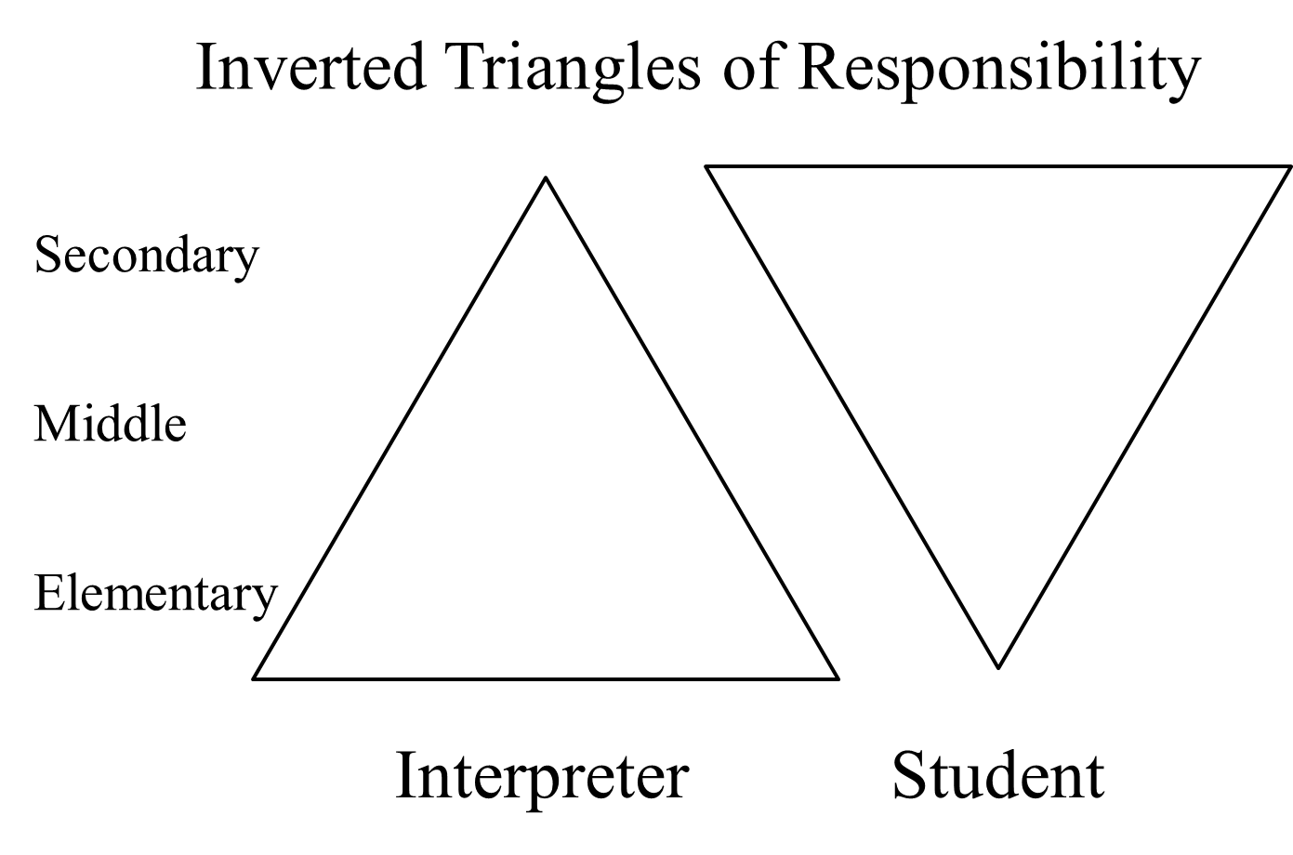
Figure 1. Inverted Triangles of Responsibility (Davino, 1985). Triangles representing the proportion of responsibility held by the interpreter and student during various levels of schooling.

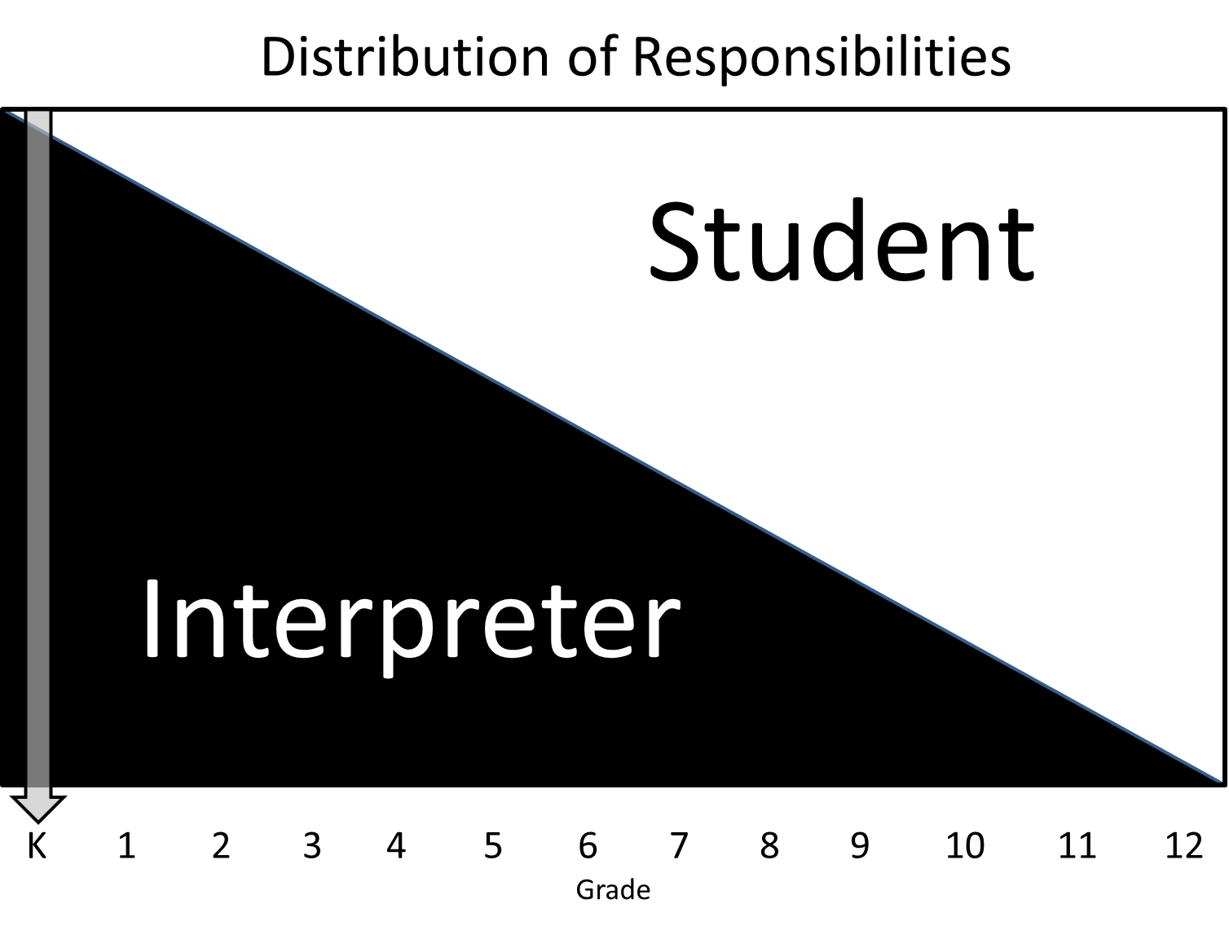
Figure 2. Distribution of Responsibility (Lawson & Hamrick, 2011). Congruent triangles representing the proportion and shift of responsibilities between the interpreter and student during various levels of schooling.

is too narrow to include all the responsibilities that are involved, but deciding what should or should not be included in their role has been nearly impossible (Antia & Kreimeyer, 2001).
Defining the roles of interpreters in educational settings is very difficult because many of the job descriptions of educational interpreters are developed by educator administrators who may have little or no understanding of interpreting (Commission on Education of the Deaf, 1988; Jones et al., 1997; Winston, 1998). This coming together of two fields, education and interpreting, brings two different sets of needs and assumptions while defining the role of the interpreter (Stedt, 1992).
Since many states, and the interpreting field itself, have no set of minimum standards, educational professionals often see interpreting as a paraprofessional position and so include additional duties suited to such a position (Commission on Education of the Deaf, 1988; Jones, 1999). However, the skills and knowledge required to interpret are more in line with professionals and by collaborating with the other professionals at our school, we become viewed as more professional (Dean & Pollard, 2005; Jones, 1999). Unfortunately, the lack of defined roles may lead interpreters and teachers to do what is convenient instead of what is professional which serves to erode the level of services provided to the deaf student (Antia & Kreimeyer, 2001; Commission on Education of the Deaf, 1988). On the other hand, as interpreters become more professional, they become more resistant to duties that are considered “unprofessional” (Kluwin, 1994). Perhaps this is the difference between Stedt’s definitions of professional interpreters and educational interpreters (1992).
In order to facilitate the definition of roles and responsibilities for educational interpreters, research is needed on the impact of interpreters on inclusion education, the effects of different roles, and even on what interpreters do in general (Antia & Kreimeyer, 2001; Jones et al., 1997; Stewart & Kluwin, 1996; Winston, 1990). Other necessary research includes information on the perspectives of all parties involved in educational interpreting: interpreters, teachers, administrators, related service providers, parents, and students (Antia & Kreimeyer, 2001). The literature largely provides suggestions, recommendations, and survey data on reported activities, duties and responsibilities of educational interpreters or on methods of interpreting (Antia & Kreimeyer, 2001; Jones et al., 1997; Stewart & Kluwin, 1996; Winston, 1990). More empirical research will help to clarify what interpreters do, what works in terms of roles and responsibilities for access, and what will best serve all students in an inclusion environment.
Research Questions
In order to further the defining of roles for interpreters, the purpose of this study is to determine whether there is an impact on communication access when an interpreter fills multiple roles. Considering the primary role of the interpreter is to provide access to the spoken discourse of the classroom, any impact on that access informs the number of and manner in which additional roles can be performed. This study will attempt to fill some of the gaps in the literature by answering the questions: “What percentage of a class does an interpreter spend as an interpreter versus filling other roles in the classroom?” and more importantly, “What percentage of spoken communication in the classroom does a deaf student see interpreted when an interpreter is filling multiple roles in a classroom?”

Chapter 2: Method
Participants
The researcher set out to locate one classroom with one interpreter and one mainstreamed deaf student for the study. A 3rd-5th grade science or social studies classroom was preferred. The interpreter would be “qualified” as evidenced by interpreting assessments or certifications and/or by education in the field such as graduation from an interpreter training program. The deaf student would be a typically developing deaf student without secondary disabilities who accesses classroom material primarily through an interpreter. There were no criteria set for teacher participation. These parameters are comparable to other studies of roles and access in the field (Antia & Kreimeyer, 2001; Shaw & Jamieson, 1997; Wolbers et al., 2012) and help to reduce confounding in the data from factors such as other disabilities in the deaf student and interpreting knowledge and skill in the interpreter. Pseudonyms have been given to all participants to protect their privacy.
In order to find settings that fit the desired parameters the researcher directly contacted 11 urban, suburban, and rural school systems as well as inviting interpreters from an additional 13 school systems in a Southeastern state to participate. Of those that replied, several of systems were not currently employing sign language interpreters in their schools and many of the remaining would not allow video cameras into their classrooms. Two school systems indicated they were willing, but the first had only one deaf student enrolled, a senior in high school, which did not meet the conditions required for the study. The final school system had a lengthy review process, and in the end offered only a high school in their system as a potential site for the study. Although this is not a randomized selection process, it was anticipated that there would not be many settings available that fit the criteria in the region. This was found to be the case.
The classroom chosen was a Biology I inclusion class designed to prepare students for the science exam requirements for graduation. This course was chosen because it was likely to provide a large variety in terms of lexicon and did not focus specifically on English language or numbers. The class was a co-teaching environment with the science teacher, Karen, instructing the students and the special education teacher, Annie, observing and supporting the instruction. Karen had been teaching for about 10 years and had been working with interpreters in her classroom for the last 5 years. Annie had been teaching for 17 years and has had interpreters in her classroom at various times through her career.
The interpreter, Denisha, graduated with a Bachelor’s degree in educational interpreting. At the time of the study, she had been working as a K-12 interpreter for four years. The state in which this study occurred does not specifically define “qualified” for interpreter in terms of certifications or licensure, but Denisha is considered a qualified interpreter in her school system.
The deaf student, Anita, is a 10th grade female student who describes herself as hard-of-hearing. Although Spanish is the primary language spoken at home and most of her interpreters use a form of Manually Coded English (MCE) at school, she prefers American Sign Language (ASL). Anita has educational experience at a school for the deaf and accesses classroom discourse primarily through sign language at her current school. She had been using an interpreter in school for the last two years.
All participants and the deaf student’s parents voluntarily signed consent forms prior to participating in the research. Precautions were taken to ensure participant safety and privacy throughout the study, in accordance with ethical standards for participants.

Design
This quantitative study relies on naturalistic observation of a classroom with a single deaf student and an interpreter and is augmented by interviews with the deaf student, interpreter, and teachers to provide some qualitative illuminations to the data. The class was video recorded, and field notes were taken to capture the spoken language, its interpretation, the roles the interpreter filled, and the activities occurring in the classroom. Semi-structured interviews with the interpreter, teacher, and deaf student were also recorded at the conclusion of classroom recording to collect qualitative information on assigned responsibilities and reasons for role changes. The videos were then coded using partial interval recording with 5-second intervals. The raters identified whether each interval was interpreted, what role(s) the interpreter was in during the interval, and what activity was occurring in the classroom during the interval. From the coded data, the research examined frequency and percentage of the status of the interpretation, interpreted or not, as well as the frequency and percentage of the roles and activities that occurred during these times in the classroom in order to discover any relationships among these variables.
“Interpreting” in an interval was defined for this study as facilitating communication between two “through-the-air” languages, spoken English and sign language (ASL or MCE), under this definition, did not include translating written English into sign language or translating sign language into written English.
An examination of the literature provided categories that could be used for coding both the roles and activities. The “Windmill Model” (Jones, 1999) provided the four main categories of roles that were defined for this study: Interpreter, Tutor, Assistant, and Consultant (Appendix A). The activity categories used were previously examined by Winston (2004) in terms of the accessibility of mainstream classrooms, though they were defined a bit differently. These categories included lecture, discussion, group work, read aloud, and independent work.
Procedure
The researcher visited the classroom for five consecutive class sessions, taking field notes and using video cameras each time in order to habituate the class to their presence. The teachers, interpreters, and students were instructed to hold class as usual. The main digital video camera was focused on the interpreter, including the teachers and any visual aids when possible. The second video camera, an Apple iPad 2, was focused on the deaf student. The researcher chose to use the front video camera on the iPad in order to capture the most video without the device timing out. A piece of paper was placed over the screen to reduce distractions caused by seeing oneself on the screen. The researcher controlled the main camera throughout the collection process in order to move with the interpreter as she worked. The recording was started just before the starting class bell and was stopped after the ending class bell, using data collected between bells of the last three days for the analysis. Field notes were made, noting roles the interpreter filled in each minute of the class using the form in Appendix B in Microsoft Excel on a netbook computer.
There were recordings and field notes from each day (6 hours and 50 minutes); however, only the last three days’ data were analyzed for this study (3 hours and 50 minutes). This allowed the students, teachers, and interpreter to all be comfortable with the presence of the researcher and her equipment to ensure the highest validity of the data analyzed. Although only the last three days’ data are analyzed, information from other days is included, particularly in a qualitative fashion, when it is typical of the situation.
After all classroom recording was completed, the researcher interviewed the deaf student, the interpreter, and both teachers on their experience, relationships, roles, duties, rationale for choices, and other issues that arose during the observations. These semi-structured interviews were also recorded. Each interviewee met with the researcher in a semi-private meeting area. Initial questions and ideas for the interview are found in Appendix C.
Coding videos.
The information from the video recordings and field notes were analyzed for target behaviors by two trained raters, bound to confidentiality. Coding definitions and instructions are included in Appendix D. The main camera videos were converted from .MOV to .AVI format to be compatible with the audio/video annotation software, ELAN Linguistic Annotator (http://www.lat-mpi.eu/tools/elan/). These videos were then opened in ELAN and divided into 5-second intervals. Five-second intervals was considered an ideal because at 120 words per minute (approximate speed of typical extemporaneous speech), 5 seconds would contain approximately 10 words, providing enough “information value” (Cokely, 1992) to determine if that segment is being interpreted or not and what role the interpreter is in minimizing the number of segments that are both interpreted and not and that have the interpreter in multiple roles in the same segment.
Tiers were defined in ELAN for the interval numbers, status of the interpretation, roles, and activities as well as a comments tier, in order to code the videos. After this was completed, the researcher tested the setup using the first five minutes of the first video recording. The coding was input to Microsoft Excel for analysis.
For each 5-second interval of video, the raters determined the status of the interpretation. For this study, the researcher considered an interval “fully interpreted” (Y) if all of one teacher’s comments were completely interpreted within the next several intervals, allowing for lag time. Also, if the interpreter interpreted student comments and there was no teacher comment during that time, it was coded as fully interpreted. However, if the interpreter gave precedence to a student’s comments and the teacher was also talking, but not interpreted for, the interval was considered “partially interpreted” (P). If part of a teacher’s comments were interpreted during an interval, but another part was omitted, it was also coded as partially interpreted. An interval coded as “no spoken discourse interpreted” (N), occurred when the teacher spoke, but there was no interpretation of that teacher’s comments. Student comments were not considered for this classification, but instead were coded “not applicable” (NA), when there was no teacher discourse along with the rare intervals of silence. Any segment in which either the spoken language or the interpreted message was impossible to classify due to lack of auditory or visual information was coded “questionable” (Q).
Coding was done in this way to focus on the instructional content and access, particularly when other demands were in play (Smith, 2010; Winston, 2004), such as student side conversations and tutoring needs. As in most classrooms, there was very little time in which no one was talking at all, so interpreting all classroom discourse would be impossible. If all uninterpreted discourse were to be coded as “P,” partial, or “N,” no interpreting, it would not reflect the amount of discourse that is reasonably possible to be interpreted in such a classroom.
Also for each 5-second segment, the raters determined what role the interpreter was filling at that time, preferring the previous role label when defining a role was vague. Denisha was said to be in the “interpreter” role when she was interpreting, ready to interpret, or obtaining materials to facilitate interpreting. She was said to be in the “tutor” role when she examined the deaf student’s work, gave additional instructions or information not provided by the teacher, or worked one-on-one with the deaf student on her work, including translating from written English. “Tutor” and “educator” were both categorized as “tutor” for this study, as it was impossible to determine what direction the teacher had given the interpreter at times the researcher was not present, and so “tutor” was defined as facilitating education, with or without teacher direction.
Denisha was classified as being an “assistant” when she performed manual or supervisory duties such as preparing materials, collecting items for a student, or escorting a student to another room. When the interpreter gave directions on standard interpreting practices to the teacher or the student or when the interpreter and teachers discussed the student’s accommodation needs, the interpreter was said to be filling the “consultant” role. This role was defined as facilitating awareness of deaf education, deaf culture, and interpreting standards. Any functions the interpreter performed outside of these roles were classified as “other.”
Finally, the raters looked at the primary activity of the classroom during that interval. In this study, “lecture” included activities wherein the teacher introduced new material using a PowerPoint or other visual aid, and students were expected to take notes on that material. Unlike Winston’s (2004) definition, there was interaction between the teacher and students during lecture time; however, this interaction was of a different nature than that encountered in the discussion activities. “Discussion” was defined as any large group dialogue that could not be classified as lecture, such as reviewing the answers to assigned work. “Group work” was defined as work among teams of students with little interaction between teams. “Read aloud” activities included reading any prepared text verbatim. “Independent work” was classified as any work the student was expected to complete on their own with occasional guidance from the teachers as they walked around the classroom. Only one classroom activity was defined per interval and intervals in which the activity was vague or was a transition time were coded as continuation of the previous activity.
Analysis
Frequency counts were obtained for each classification by calculating their total number of occurrences. The total was then divided by the total number of intervals to find the percentage of intervals in each classification. Next, cross tabulation matrices were created to compare status of interpretation, role, and activity a variety of ways. Final frequencies and percentages were calculated after the second rater’s codes were received and inter-rater reliability was calculated. All interviews were reviewed for common themes and relevant topics.
A second rater was provided 10 minutes from the first analyzed video and 20 minutes from each of the second and third videos (21.7% of total video time) to code for inter-rater reliability. The data were then analyzed for inter-rater reliability using percent agreement, arriving at 83.43% agreement overall. Agreement of over 80% was targeted as the threshold for coding reliability. Disagreements occurred mainly in detecting the teachers’ voices during independent work time to code the status of the interpretation and in learning and refining the coding procedures. The researcher’s original codes were kept for the analyses.

Chapter 3: Results
Quantitative Analysis
After data were collection, the last three classes (3 hours and 50 minutes of recording) of the five days (6 hours and 50 minutes total recording) of video were divided into 2,758 5-second intervals for coding. Of all the intervals coded, more were not interpreted (39.78%, 1097) than were interpreted (32.16%, 887, fully interpreted and 3.52%, 97, partially interpreted) for the deaf student (Figure 3). A small portion (6.60%, 182) was labeled “questionable,” having an unknown interpreting status, due to not having video of either the spoken discourse or of the interpreter at that time. An examination of the amount of silence in the classroom yielded 1.78% (49) of the intervals contained no discourse. All of these intervals had been categorized “not applicable,” meaning the remaining 446 “not applicable” intervals contained student discourse that was not interpreted.
When looking at the overall graph in Figure 4 (frequencies and percentages available in Table 1), it was apparent that the interpreter functioned as a tutor in nearly 60% of the intervals analyzed. In fact, just over 40% of the intervals fell under the interpreter role. The roles of “assistant,” “consultant,” and “other” accounted for less than 5% of all the intervals. From examination of the videos, the “other” roles were all social interactions, either with the deaf student or with hearing students.
Of the classes analyzed, almost half of the intervals were classified as independent work (47.28%, Table 2 and Figure 5). Another 43.69% of the activities were classified as lecture or discussion, with those activities carrying nearly equal weight. There was no evidence of group work in any of the video collected. Read aloud and “questionable” (no video evidence) activities accounted for less than 10% of all the intervals. The interpreter and science teacher indicated
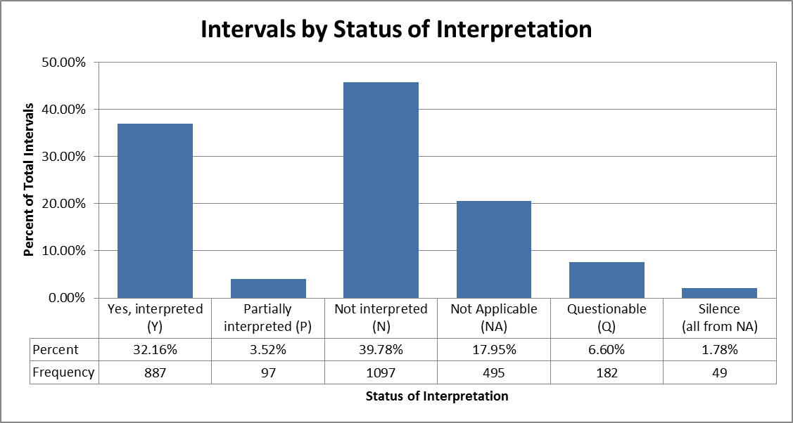
Figure 3. Intervals by Status of Interpretation.

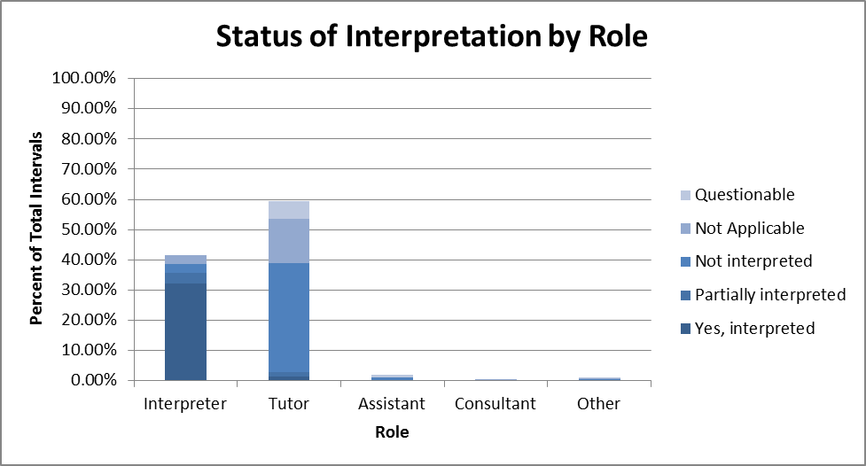
Figure 4. Status of Interpretation by Role.

Table 1
Status of Interpretation by Role (n=2758)
Status of Interpretation | Interpreter |  | Tutor |  | Assistant |  | Consultant |  | Other
Status of Interpretation | Frequency | Percent | Frequency | Percent | Frequency | Percent | Frequency | Percent | Frequency | Percent
Yes, interpreted | 887 | 32.16% | 37 | 1.34% | 0 | 0.00% | 3 | 0.11% | 1 | 0.04%
Partially interpreted | 95 | 3.44% | 43 | 1.56% | 0 | 0.00% | 0 | 0.00% | 2 | 0.07%
Not interpreted | 87 | 3.15% | 992 | 35.97% | 29 | 1.05% | 6 | 0.22% | 9 | 0.33%
Not Applicable | 73 | 2.65% | 407 | 14.76% | 4 | 0.15% | 7 | 0.25% | 10 | 0.36%
Questionable | 0 | 0.00% | 159 | 5.77% | 20 | 0.73% | 0 | 0.00% | 3 | 0.11%
Total Intervals by Role | 1142 | 41.41% | 1638 | 59.39% | 53 | 1.92% | 16 | 0.58% | 25 | 0.91%
Silence (all from NA) | 11 | 0.40% | 37 | 1.34% | 1 | 0.04% | 0 | 0.00% | 0 | 0.00%

Table 2
Status of Interpretation by Activity (n=2758)
Status of Interpretation | Lecture |  | Discussion |  | Read Aloud |  | Independent Work |  | Questionable
Status of Interpretation | Frequency | Percent | Frequency | Percent | Frequency | Percent | Frequency | Percent | Frequency | Percent
Yes, interpreted | 350 | 12.69% | 417 | 15.12% | 2 | 0.07% | 118 | 4.28% | 0 | 0.00%
Partially interpreted | 42 | 1.52% | 18 | 0.65% | 5 | 0.18% | 32 | 1.16% | 0 | 0.00%
Not interpreted | 149 | 5.40% | 141 | 5.11% | 62 | 2.25% | 745 | 27.01% | 0 | 0.00%
Not Applicable | 59 | 2.14% | 26 | 0.94% | 0 | 0.00% | 410 | 14.87% | 0 | 0.00%
Questionable | 0 | 0.00% | 3 | 0.11% | 0 | 0.00% | 1 | 0.04% | 178 | 6.45%
Total Intervals by Activity | 600 | 21.75% | 605 | 21.94% | 69 | 2.50% | 1306 | 47.35% | 178 | 6.45%
Silence (all from NA) | 9 | 0.33% | 0 | 0.00% | 0 | 0.00% | 40 | 1.45% | 0 | 0.00%

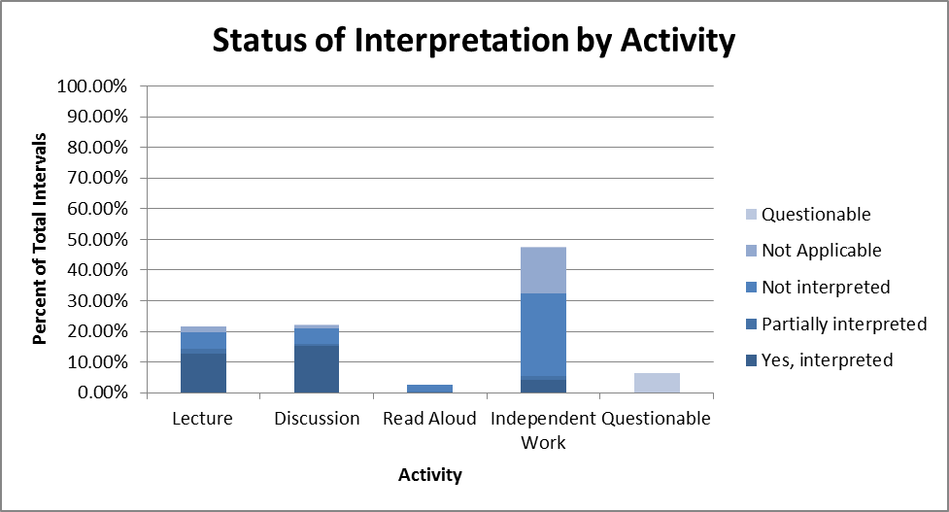
Figure 5. Status of Interpretation by Activity

that this distribution of activities was not particularly typical of the class throughout the semester. The classes observed were focused on review and preparation for the end of course test, a graduation requirement, and so involved more independent work on completing study guides. When asked, Karen said, “I would say [a typical week] is a mixture of lecture, discussion, and individual and group projects.”
In light of communication access with multiple interpreter roles being the focus of the study, a further look at the data was necessary. The coded intervals were cross tabulated in terms of the number and percent of intervals that were interpreted, partially interpreted, or not interpreted per role (Figure 6), and then per activity (Figure 7). A majority of the intervals Denisha filled as an interpreter were fully interpreted (77.67%), but when she was filling the tutor role a majority of the intervals were not interpreted (60.56%) or not applicable (24.85%). Time spent assisting included not applicable (54.72%) and questionable (37.74%) intervals and consulting was generally not applicable (43.75%) or not interpreted (37.50%). When filling the “other” role and being social, the intervals were not interpreted (36.00%) and not applicable (40.00%).
A majority of the lecture and discussion were fully interpreted (58.33% and 68.93%), but were not interpreted 24.83% and 23.31% of the time, respectively (Figure 7). Independent work was largely not interpreted (57.04%) or not applicable (31.39%) and 9.04% of those intervals were interpreted. When silence is factored out and student comments are allowed to remain, 85.43% of teacher and student discourse not being interpreted during independent work. The read aloud shows that it also was not interpreted (89.85%), but that is misleading. During most of the read aloud intervals (88.41%, 61) the interpreter and deaf student were out of the classroom working on a quiz the other students had already finished. Regular class discussion
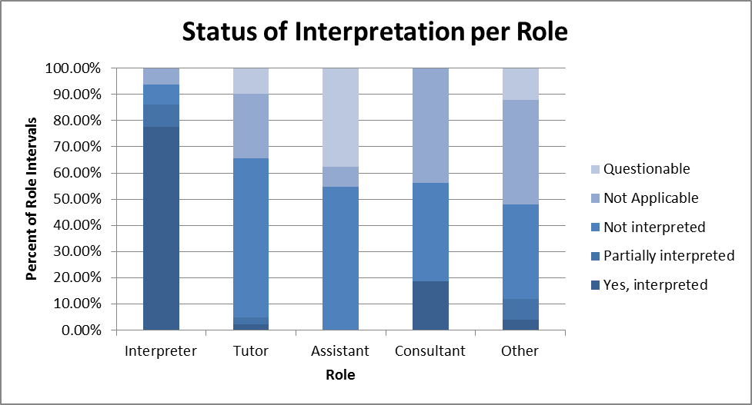
Figure 6
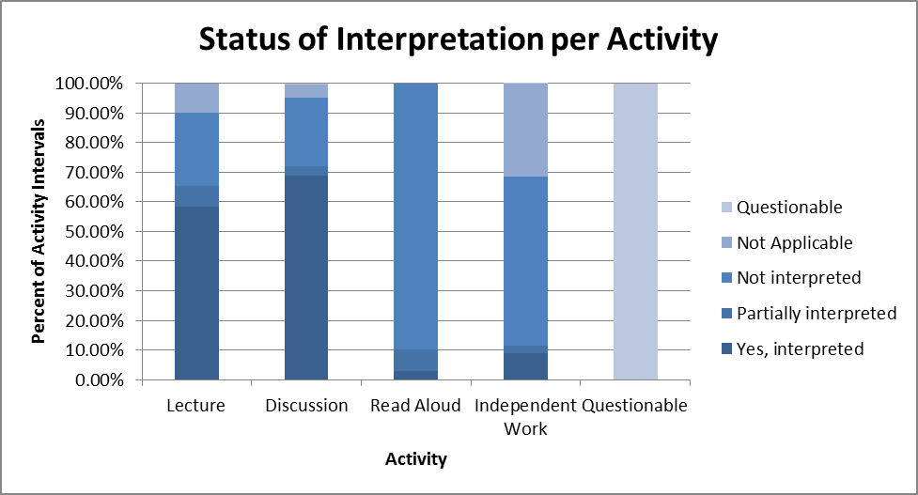
Figure 7

and lessons resumed while they were out of the room. Unanalyzed sections of video show interpreting during other read aloud activities.
To examine the interrelatedness of role and activity separate from the status of the interpretation, a cross tabulated matrix was designed from which Figures 8 and 9 were created. The primary roles Denisha filled during the analyzed classes were tutor and interpreter and the most frequent activities were independent work, lecture, and discussion. Lecture and discussion activities were mostly spent as an interpreter (76.32% and 71.52%) with the remaining time largely spent as a tutor. Independent work was mostly performed in the tutor role (81.29%) with most of the remaining time being spent as an interpreter. Tutoring occurred in all activities to some extent, though, as stated before, the read aloud intervals may be misleading. Intervals spent as an assistant, consultant, or in another role were primarily confined to independent work times, but, again, were minimal.
It was then decided that further analysis the status of the interpretation and role filled in terms of classroom activity might yield further information (Figure 10). Only roles and activities that exhibited the highest frequencies were used. The intervals identified as lecture showed Denisha worked almost entirely as an interpreter or tutor during that time, with interpreting occurring in about 80% of the intervals. The data showed a similar situation for discussion activities, though interpreting was about three-quarters of those intervals. Independent work exhibited about 80% of its intervals as being not interpreted or not applicable while in the tutoring role. The “not interpreted” intervals included only times in which one of the teachers was saying something; therefore, 53.91% of the teachers’ comments during this time were not interpreted. When including student comments during this time, nearly 80% of classroom discourse not interpreted during independent work.
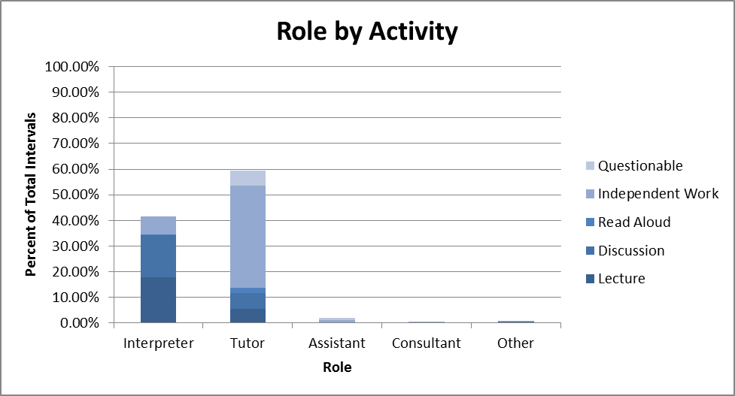
Figure 8
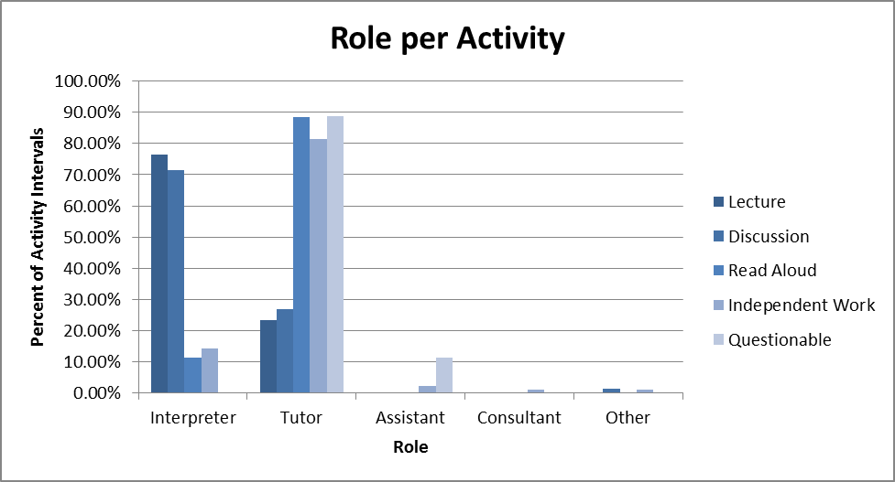
Figure 9

Figure 10
Qualitative Analysis
Each participant interviewed, the deaf student, the science teacher, the special education teacher, and the interpreter, was asked to define the responsibilities of an interpreter. Each person described, in their own words, the interpreter’s job as transmitting information between the teacher and the student. The interpreter in this class was not asked to perform any duties outside of this definition, but admitted she took on more responsibilities due to “the understanding level of the student.” She felt she could help the student understand more when communicating directly with her as a tutor as opposed to “just putting [the information] out there” as an interpreter. The student said that of her nine interpreters this year, she was happy that Denisha and some others went beyond interpreting to help her understand and to encourage her.
All participants that were interviewed recognized that not all spoken discourse was being interpreted in the classroom. The science teacher estimated 75% of the class was interpreted and the special education teacher estimated between 25% and 40% of all classroom discourse was interpreted. When Anita, the deaf student, was asked how she felt about things not being interpreted, she indicated that she understood that the interpreter was just one person and would be incapable of interpreting for multiple speakers at the same time.
When asked about training they received prior to working with an interpreter, the deaf student and both teachers said they had received no training. Both teachers showed significant interest in training related to deaf education and interpreting, in spite of their multiple years of experience with interpreters and deaf students. They emphasized that teachers in general, including special education teachers, get little to no education on how to work with deaf students and so they rely on the interpreters’ expertise to make decisions regarding the deaf student and could learn from how interpreters approach their task.
In particular, the teachers mentioned all teachers need to know how to talk to the student instead of the interpreter; they need information on the language skills of the student; they need guidelines for teaching deaf students; and they need to understand the challenges of an interpreted education. The student wished her interpreters were better at interpreting into American Sign Language so that she could understand the lessons more clearly.
The teachers were also asked about the accommodations they have made to their classes in order to incorporate an interpreter and a deaf student. The number one item they mentioned was adjustment to the pace of the class: slowing down and allowing more wait time. Also, they both discussed the fact that they would provide the deaf student with copies of the PowerPoint presentations to facilitate notetaking during class lectures. Karen talked about her efforts to make sure all videos had captions, in spite of difficulties finding captioned videos on course content. Annie mentioned the need to be aware of the environment to make sure everyone could see without a “tennis match” effect of bouncing back and forth between the teacher or visual aid and the interpreter. She also made an effort to always have eye contact with her deaf students in order to facilitate lipreading. Karen adjusted her own tolerance for noise in the classroom to encourage Anita in using her voice during class. Anita also took responsibility for her accommodations by adapting to understanding the MCE system her interpreters used instead of her preferred language of ASL.
An issue that was not specifically addressed in the interview, but that surfaced from both the teachers involved concerns about a deaf student’s life after high school. Karen’s concerns surfaced as she was discussing the responsibilities of an interpreter and how interpreters often “follow” one student from grade to grade, working not only as an interpreter, but also as a tutor. After graduation, these students will not have as much support in the real world. Annie was also concerned about the lack of support and resources students will face in the world after high school. “The resources won’t be there for them. At least, I don’t believe they will be, as adults….It’s going to be a very difficult adjustment because they’ve had a lot of good resources while they’ve grown up.” There was also concern, with certain interpreters, of learned helplessness in students who become too dependent on the interpreter for tutoring and other help.
A final topic that was examined were decisions regarding interpreting. Both Karen and Annie said they relied on the interpreter’s expertise and generally left it to the interpreter to ask for what she needs or wants. Decisions from the interpreter’s perspective were more complicated. Many decisions were made based on the understanding level of the student and what was Denisha felt was most important moment to moment.
In making these decisions, Denisha said she focused mostly on making sure Anita had the foundations of any lesson or concept. “If we’re on the foundations of a lesson…and she’s not getting the foundation, then there’s no point in me going to step two if she doesn’t understand step one.” She also strongly supported Anita’s desire to complete independent work prior to receiving the answers, even if that put them off-sequence with the rest of the class.
During Annie’s interview, a discussion of making these judgments of importance surfaced. “As an interpreter, I would think you also have to decipher, or decide maybe, what [you] need to make sure they understand more than the [sidebar conversations] over here.” Although Annie recognized this need, Denisha did not receive lesson plans or any material to help her identify the class objectives and prepare for class daily.
Annie’s advice on defining the interpreter’s role started with a question: “What is your purpose for being there?” Additional responsibilities and roles, such as tutoring and teaching, are “a personal issue.” “I think [determining interpreter responsibilities] is the hardest thing for the interpreter to figure out….I can’t tell you what your job is. I think it’s about where your heart lies, just like being a teacher.”

Chapter 4: Discussion
The guiding questions for this research were “What percentage of a class does an interpreter spend as an interpreter versus filling other roles in the classroom?” and more importantly, “What percentage of spoken discourse in the classroom does a deaf student see interpreted when an interpreter is filling multiple roles in a classroom?” Since an interpreter’s primary role in the classroom is communication access, anything that causes a loss of information between the teacher and the deaf student is an impact on that access. In this study, communication access seems to have been impacted by the interpreter filling multiple roles in the classroom, particularly the tutor role.
Roles
The interpreter spent 41.41% of the class time in the role of the interpreter (Figure 4). More time was spent functioning as a tutor to the deaf student—helping her read worksheets and a quiz, walking her through thought processes to answer questions, and re-explaining class concepts—than was spent interpreting classroom discourse. During the independent work time, where a majority of the tutoring occurred, the videos showed teachers clarifying student questions, students are socializing, and academic, social, and language learning is occurring for all members of the classroom, except the deaf student. Instead, the deaf student is receiving more individual instruction, from a person who is not certified as a teacher, and losing opportunities for working independently, similar to what Shaw & Jamieson (1997) found. This interpreter was not asked or otherwise required to serve as a tutor to the student, but felt compelled to because of the student’s level of understanding.
So, what should an interpreter’s role be in the classroom? As Annie, the special education teacher, suggests, interpreters need to ask themselves “What is [my] purpose for being there?” Only through a thorough examination of that question can an interpreter define his or her role. Defining the role of an interpreter in any educational situation must take into account the expectations of administrators, teachers, and parents; the abilities of the interpreters; and the ages, needs, and abilities of the students. Ultimately, it must be done collaboratively.
On the surface it may seem simple: an interpreter is there to “facilitate communication.” However, in the educational setting, more may be required of the interpreter either through administrators’ expectations or through students’ needs, making the purpose more akin to “facilitating education.” Unless additional personnel can be assigned the tutoring duties, a balance must be struck between providing the academic information and language exposure a student needs to develop cognitively and providing the additional support to help a student through lesson. Knowing the importance of social communication in language development, and thus cognitive development, the role interpreters fill in the classroom, as well as the placement of the deaf student in an inclusion class, should be carefully examined.
Access
Over the course of the three days observed, only 35.68% of the 2,758 intervals were fully or partially interpreted. This number is consistent with Wolbers et al. (2012) who found “parallel interpreting” occurred 33.2% of the time in the classrooms they observed. Even if we take away the independent work time as not representative of the regular class routine, we still have only 58.33% of the lecture and 68.93% of discussion being fully interpreted which aligns with the research of Shaw & Jamieson (1997) who found their student participant had access to 60% of “class-directed instruction.” Of the entire observed time, 55.95% of all spoken discourse in the class was not interpreted. If administrators, teachers, parents, or deaf students are expecting equal access to classroom discourse by employing an interpreter, this research, among others, shows that is not what is actually occurring in classrooms.
The interpreter in this study is a trained educational interpreter. With such a qualified interpreter, why do we have these results? What is occurring in classrooms that do not have such trained interpreters?
While the second question cannot be speculated upon without more research, we do have some information from other sources regarding the difficulty of the interpreted education. The sequential nature of visual processing hinders access to the simultaneous nature of classrooms taking advantage of both auditory and visual teaching methods (Shaw & Jamieson, 1997). In addition, classrooms frequently have multiple people talking at the same time which all has to be funneled through one interpreter to be “heard” by the deaf student. This study reduced this issue by only examining the teacher’s comments. These situations produce multiple demands that can lead to the need to prioritize the visual information the deaf student accesses (Smith, 2010; Winston, 2004). Unfortunately, the interpreter makes many of these priority decisions in the moment without consulting or informing either the student or the teacher.
In this study, the interpreter, Denisha, said her primary consideration was the “understanding level of the student” and so she focused on making sure the foundations of a lesson were understood. Decisions such as these rely on the interpreter’s understanding of professional, educational, and personal ethics, using a teleological approach to ethics to take into account the context of the situation and the potential outcomes (Dean & Pollard, 2006). For Denisha, her decisions worked to further Anita’s education, to the best of her ability, without the knowledge of the teacher’s plans for the class.
A more collaborative approach could be suggested to assist with these issues. Opportunities could be provided for teachers, special education or deaf education teachers and interpreters to meet and collaborate. Discussions of teachers’ goals, IEP goals, lesson objectives, and upcoming class materials would benefit everyone involved in the deaf student’s education. Also, these meetings could provide the interpreter the opportunity to discuss class progress, negotiate role issues, and teach interpreting practices. This collaborative process provides everyone the opportunity to participate in the decision making.
Implications
The implications of this study can be severe, depending on the amount of time other roles are filled. Students who are already language delayed suffer social and cognitive deficits which are only further impacted by having access to less communication from the classroom environment than their peers. Additionally, interpreters are not, for the most part, certified teachers, yet many are modifying and tutoring students without direction from the classroom teacher or training in techniques for tutoring.
This research also has implications for the education of interpreters. Interpreter training programs that focus on community interpreting typically do not have the time in their program to deal with the training and curriculum needs of pre-service educational interpreters. In addition to interpreting foundations, educational interpreters need specific emphasis on tutoring and consulting skills as well as principles of education. They need the skills to advocate for themselves and their students by educating those with whom they work.
Limitations
Although this study aligns with other research, it is not generalizable due to only looking at one classroom with one interpreter and one deaf student. In addition, selection of the setting did not occur through a randomized process. This study does, however, give us another snapshot of what is actually occurring in interpreted classrooms.
Also, coding procedures were somewhat cumbersome and subjective. Although reliability was high between the raters, codes for the status of interpretation might have been clearer had they been reduced to interpreted, not interpreted, silence, and questionable. The partially interpreted classification could have been included with the interpreted classification without greatly impacting the results. In addition, it would have been better to not need a questionable classification for any category.
Finally, it could be said that this study exhibits bias from being focused on the more academic discourse of the class, specifically the teachers’ discourse. The “not applicable” category served to filter out student comments as well as periods of silence. However, there are some situations in which children are included in a classroom for more social than academic reasons. This was not explored in any detail in this study.
Future Research
Further information is needed on the subject of educational interpreters, interpreted education, and roles interpreters fill in classrooms. This study looks at how much of the classroom discourse is interpreted into sign language while filling multiple roles, but we need information on how much of that interpreted information is actually received and understood by the student, particularly when multiple roles could potentially confuse the information. We need more generalizable information from a larger variety of interpreters, students, and educational settings in order to see true relationships between roles and communication access. Another topic for further inquiry is the decision making process interpreters undergo when making decisions to move into and out of the various roles they fill. What ends are they trying to accomplish with the various roles and could those ends be better served in other ways?
Ultimately, this study provides another peek into the classroom to see what interpreters are doing. Although many interpreter training programs continue to teach that the interpreter should remain in the role of the interpreter, interpreters are finding it difficult to do. Working so closely with one student, an interpreter sees things that a teacher with 29 other faces in the classroom may miss, but because of the demands of the interpreting job (only 1.78% of the intervals were silence), the interpreter doesn’t often have the opportunity to communicate these things to the teacher. Instead, they take on an additional role to fill the gaps in what the student needs to succeed.
List of References
Antia, S. D., & Kreimeyer, K. H. (2001). The role of interpreters in inclusive classrooms. American Annals of the Deaf, 146(4), 355-365. Retrieved from http://vnweb. hwwilsonweb.com.proxy.lib.utk.edu:90/hww/jumpstart.jhtml?recid=0bc05f7a67b1790ea50545894de012dcf1972fdca06bc4afdfd941a399ac564428f9ce88f75173b8&fmt=P
Commission on Education of the Deaf. (1988). Toward equality: Education of the deaf. A report to the President and the Congress of the United States.
Davino, D. (1985, February) The Roles and Responsibilities of the Educational Interpreter. Topic presented at the meeting of the Orange County Department of Education Secondary Hearing Impaired Program staff, University High School, Irvine, CA.
Dean, R. K. & Pollard, R. Q. (2005). Consumers and service effectiveness in interpreting work: A practice profession perspective. In M. Marschark, R. Peterson, & E. Winston (Eds.), Interpreting and interpreter education: Directions for research and practice, (pp. 259-282). New York: Oxford University Press.
Dean, R. K. & Pollard, R. Q. (2006). From best practice to best practice process: Shifting ethical thinking and teaching. In E. M. Maroney (Ed.), A new chapter in interpreter education: Accreditation, research and technology. (Proceedings of the 16th national convention of the Conference of Interpreter Trainers (CIT).) Monmouth, OR: CIT.
Easterbrooks, S. R. & Baker, S. (2002). Language learning in children who are deaf and hard of hearing: Multiple pathways. Boston, MA: Allyn & Bacon.
Frishberg, N. (1990). Interpreting: An introduction. Silver Spring, MD: Registry of Interpreters for the Deaf Publications.
Hoff, E. (2009). Language development (4th ed.). Belmont, CA: Wadsworth.
Humphrey, J. H. & Alcorn, B. J. (1995). So you want to be an interpreter?: An introduction to sign language interpreting (2nd ed.). Amarillo, TX: H & H Publishers.
Jones, B. E. (1999). Providing access: “New roles” for educational interpreters. VIEWS, 16(2), 15.
Jones, B. E., Clark, G. M., & Soltz, D. F. (1997). Characteristics and practices of sign language interpreters in inclusive education programs. Exceptional Children, 63(2), 257-268. Retrieved from http://find.galegroup.com.proxy.lib.utk.edu:90/gtx/infomark.do? &contentSet=IAC-Documents&type=retrieve&tabID=T002&prodId=AONE&docId= A19006245&source=gale&srcprod=AONE&userGroupName=tel_a_utl&version=1.0
Kluwin, T. N. (1994). Interpreting services for deaf youngsters who are deaf in local public school programs. Journal of American Deafness and Rehabilitation Association, 28(2), 21-29.
Lawson, H. R. & Hamrick, M. (2011). Distribution of Responsibilities. Retrieved from http://www.terptap.org/zdocuments/TerpStudResponsibilities.pdf
Lawson, H. R. (2012). Inclusion of a deaf student: Collaborating with educators. VIEWS, 29(2), 26-28.
Mitchell, R. E. & Karchmer, M. A. (2004). Chasing the mythical ten percent: Parental hearing status of deaf and hard of hearing students in the United States. Sign Language Studies, 4(2), 138-162.
Monikowski, C. (2004). Language myths in interpreted education: First language, second language, what language? In E. A. Winston (Ed.), Educational interpreting: How it can succeed (pp. 48-60). Washington, DC: Gallaudet University Press.
Nida, E.A. (1976). A framework for the analysis and evaluation of theories of translation. In R. W. Brislin (Ed.), Translation Applications and Research. New York, NY: Gardner Press, Inc.
Schick, B. & Brown, S. (2011). Interpreting for children: Some important differences. VIEWS, (28)4, 22-25.
Seal, B. C. (2004). Best practices in educational interpreting (2nd ed.). Boston, MA: Pearson Education, Inc.
Shaw, J. & Jamieson, J. (1997). Patterns of classroom discourse in an integrated, interpreted elementary school setting. American Annals of the Deaf, 142, 40-47. Retrieved from http://vnweb.hwwilsonweb.com.proxy.lib.utk.edu:90/hww/results/results_single_fulltext.jhtml;hwwilsonid=I3LRZU2QAKWKZQA3DKDSFGGADUNGIIV0
Siegel, P. (1995). What they didn’t know may have helped us: How the Supreme Court misinterpreted the role of sign language interpreters. American Annals of the Deaf, 140(5), 386-395.
Smith, M. B. (2010). More than meets the eye: Revealing the complexities of K-12 interpreting (Doctoral dissertation). Retrieved from ProQuest LLC. (UMI No. 3404359)
Stedt, J. D. (1992). Issues of educational interpreting. In T. N. Kluwin, D. F. Moores, & M. M. Gaustad (Eds.), Defining the effective public school program for deaf students, (pp. 83-99). New York, NY: Teachers College Press.
Stewart, D. A. & Kluwin, T. N. (1996). The gap between guidelines, practice, and knowledge in interpreting services for deaf students. Journal of Deaf Studies and Deaf Education, 1(1), 29-39. Retrieved from http://jdsde.oxfordjournals.org/content/1/1/29.full.pdf+html
Stuckless, E. R., Avery, J. C., & Hurwitz, T. A. (1989). Educational interpreting for deaf students: Report of the National Task Force on Educational Interpreting. Rochester, NY: Rochester Institute of Technology, National Technical Institute for the Deaf.
U.S. Department of Education, Office of Special Education and Rehabilitative Services. (2010). 29th Annual Report to Congress on the Implementation of the Individuals with Disabilities Education Act, 2007. Retrieved from http://www2.ed.gov/about/reports/annual/osep/2007/parts-b-c/index.html
Voneiff, P. & Gentile, A. (1970). Type and size of educational programs attended by hearing impaired students, United States: 1968-69. Washington, DC: Gallaudet College, Office of Demographic Studies.
Winston, B. (1985). Mainstreaming: Like it or not. Journal of Interpretation, 117-119.
Winston, E. A. (1990). Mainstream interpreting: An analysis of the task. In L. Swabey (Ed.), Proceedings of the Eighth National Convention, Conference of Interpreter Trainers.
Winston, E. A. (1998). Ethics in educational interpreting. VIEWS, 15(2), 30.
Winston, E. A. (2004). Interpretability and accessibility of mainstream classrooms. In E. A .Winston (Ed.), Educational interpreting: How it can succeed (pp. 132-167). Washington, DC: Gallaudet University Press.
Wolbers, K. A., Dimling, L. M., Lawson, H. R., & Golos, D. B. (2012). Parallel and divergent interpreting in an elementary classroom. American Annals of the Deaf, 157(1), 48-65.
Yarger, C. C. (2005). Educational interpreters tutoring for student success. VIEWS, 22(3), 17, 23.
Zawolkow, E. & DeFiore, S. (1986). Educational interpreting for elementary and secondary level hearing-impaired students. American Annals of the Deaf, 131(1), 26-28.

Appendices
Appendix A
Table A1
Activities, Duties, and Responsibilities Performed by Interpreters, Categorized by Role and Function, as Reported in Literature
Roles | Functions | Activities, Duties, & Responsibilities
Primary Role
Interpreter | Provide access to sounds and communication in educational environments | Facilitate communication between the deaf student and all classroom members  - Mainstream academic settings  - Vocational education settings  - After-school activities (sports, clubs, etc.)  - Before- or after-school tutoring sessions  - Non-academic settings (hallways, lunch room, playground)  - Assemblies and programs  - Interpret/transliterate as per IEP  - Interpret/transliterate according to district policies  Prepare for interpreting assignments  - Learn content  - Identify educator’s goals  - Arrange setting  Assist classroom members with the interpreting process  Allow/support direct communication between the deaf student and other classroom members, teacher or peers  - Providing signs  - Facilitating social interactions and friendships  - Facilitating conflict resolution  - Incidental teaching of signs  Analyze and adjust situations to facilitate the most effective access  Use planning time to meet with teachers and staff  Take scheduled breaks to reduce injury risk and errors due to fatigue  Perform self-evaluations  Work as a team interpreter

Table A1. Continued.
Roles | Functions | Activities, Duties, & Responsibilities
Guided by Codes of Ethics (i.e. NAD-RID Code of Professional Conduct and/or EIPA Guidelines for Professional Conduct)
Non-Duties
Teacher, not interpreter, assesses student's understanding of content
Interpreters should not eliminate, ignore, or censor information
Roles and duties should not interfere with interpreting
Secondary Roles
Tutor | Under the direction of an educator, pre-teach or re-teach class content | Tutor the deaf student under the direction of an educator  - Pre-teach vocabulary & concepts  - Add to and clarify teacher directions and instructions  - Add background & context explanations  - Provide expanded explanations while re-teaching  Pullout from group for individual reading  Peer group tutoring  Non-Duties  Interpreters are not typically trained in effective tutoring strategies
Assistant | Helping with the manual and supervisory tasks in the class or school | Take notes for deaf students  Care for hearing aids, batteries, FM systems, etc.  Remind student of homework or school responsibilities  Work to engage the deaf student  Implement speech lessons  Help hearing students with their work  Self-contained classroom assistance  General classroom assistance  Supervise (recess, lunchroom, bus duty)  Make teacher materials (dittos, worksheets)  Do clerical work (typing, filing, ordering)  Grade papers for teachers  Discipline students  Non-Duties  Interpreters do not have the authority to discipline students  Interpreters should not be involved in evaluating student work  An interpreter cannot also function as a classroom aide
Consultant | Provide information relating to interpreting, deaf education, and student progress | Accessibility & communication expert  - Interpreting impact on an event  - Interpreting impact on education  - Interpreting impact on the classroom  - When interpreting provides or poses barriers to access  - Access & use of captioned media  - Bring in deafness-related resources  Deafness expert  IEP, teaching, and educational team member  - Share appropriate information with the educational team regularly  - Participate in IEP meetings  - Participate in educational team meetings  - Give input on sign communication decisions  - Liaison between special education and general education programs  - Advocate for specific accommodations (captioning, notetaking, etc.)  Educate the teams, administrators, educators, and classroom members  - Interpreter’s role  - Interpreter’s areas of expertise  - Use of interpreting services  - Orientation to deafness  - How to make things “interpretable”  - “Normalcy” of deaf students  Team with the teacher to plan and facilitate visual presentations of content material  Develop a system for monitoring & reporting student understanding  Identify student difficulties & convey to teacher  Inform on student's functioning, attention and inattention, need for additional explanations  Talk to parents  Non-Duties  Interpreters should not provide information in areas in which they have no expertise (i.e. teaching, counseling)  Interpreters cannot interpret meetings in which they are a participant  Reporting progress of a student hinders the teacher-student relationship as well as the interpreter-student relationship  Only the teacher, not interpreter, should contact parents
Language Model | Model typical conversational language  Facilitate language acquisition | Language "teacher" (developing, interacting & modeling)  Help students work on language development goals  Help pair language with activity  Arrange playmates, friendship facilitator  Non-Duties  Interpreted language is unsuitable as a language model
Staff Member | Tasks expected by any staff member | Professional staff duties  Report cheating  Follow absentee policies for absent student  Follow absentee policies when unable to interpret  Follow disciplinary policies  Work with other faculty, staff, and students as expected  Comply with responsibilities in hyphenated roles  Comply with non-interpreting assignments  Drive between schools or assignments  Pursue professional growth and development  Attend school sponsored in-services
Educator | Educating tasks | Teach mainstream classes  Teach self-contained classes  Educational planning – modifying material, establishing goals and objectives  Teach sign language  Non-Duties  Interpreters are not qualified to teach

Note. Table compiled from Antia & Kreimeyer, 2001; Commission on Education of the Deaf, 1988; Dean & Pollard, 2005; Frishberg, 1990; Humphrey & Alcorn, 1995; Jones, 1999; Jones, Clark, & Soltz, 1997; Kluwin, 1994; Schick & Brown, 2011; Seal, 2004; Shaw & Jamieson, 1997; Siegel, 1995; Stedt, 1992; Winston, 1985, 1990, 1998; Wolbers, Dimling, Lawson, & Golos, 2011; Yarger, 2005; & Zawolkow & DeFiore, 1986.

Appendix B
Field Observation Form
Min. | Time | Interpreter | Tutor | Assistant | Consultant | Other | Notes
0:00
1:00
2:00
3:00
4:00
5:00
6:00
7:00
8:00
9:00
10:00
11:00
12:00
13:00
14:00
15:00
16:00
17:00
18:00
19:00
20:00
Appendix C
Interview Starter Questions
Prior Experience
Teacher: What is your prior experience working with an interpreter?
Interpreter: What is your prior experience interpreting in a K-12 setting?
Student: What is your prior experience using an interpreter?
Training
Teacher: What training did you receive prior to working with an interpreter?
Interpreter: What training did you receive related to K-12 interpreting settings?
Student: What training have you receive related to using with an interpreter?
Responsibilities
All: How would you describe the responsibilities of an interpreter?
Classroom Specific Responsibilities
Teacher: What are the interpreter’s responsibilities in your classroom?
Interpreter: What are your responsibilities in this classroom?
Student: What are the interpreter’s responsibilities in your class?
Other Questions Arising from Observations
Teacher: Other roles the interpreter assumed, teacher-interpreter relationship, teacher-assigned duties
Interpreter: Other roles the interpreter assumed, teacher-interpreter relationship, interpreter-student relationship, teacher-assigned duties, interpreter-assigned duties, rationale for role changes
Student: Other roles the interpreter assumed, interpreter-student relationship, preferred duties of the interpreter, Why did the interpreter…, How did you feel when…

Appendix D
Coding Definitions and Instructions
Coding | All coding is done on a partial interval. If the item is present for any portion of the time, it is coded as “1.” If it is not present at all in the interval, it is left null or coded as “0.”
Interpreted? | Was the information in this interval interpreted? While the interpreter is in the interpreter role, all spoken discourse will be coded as “Y” if it is interpreted, giving primacy to the teachers’ comments when there is overlap. “N” is used if nothing the teachers said is interpreted, “P” is used if the teachers’ comments are partially interpreted, and “NA” is used if there is no target discourse to be interpreted.
Roles | Roles should be coded in as continuous a manner as possible. If the interpreter does not exhibit an obvious role, it should be assumed she is still in the previous role.
R-Interpreter | Facilitating communication between two through-the-air languages. This includes signing and voicing, but does not include translating from paper.
R-Tutor | Facilitating education, with or without teacher direction. This includes working one-on-one with the student, but not interpreting one-on-one sessions with the teacher. Translating from paper is in this category.
R-Assistant | Facilitating logistics of the classroom, materials, and manual or supervisory needs. This includes retrieving items for a student or teacher (but not for self), performing physical tasks that do not directly involve interpreting or education, and escorting students.
R-Consultant | Facilitation deaf and interpreting awareness. This includes explanations and prompting for proper use of the interpreter, explanations and advice pertaining to deaf education principles and accommodations, explanations of sign language and deaf culture.
R-Other | Any role not covered above should be included here as a text description.
Activities | Activities should be coded in as continuous a manner as possible based on the direction of the teacher and the activities of the majority of the class.
A-Lecture | Teachers provide new information using visual aids such as PowerPoint or using the whiteboard.
A-Discussion | Teachers and students provide information and ask questions related to previous material.
A-Group Work | Students are divided into teams in order to perform a task. There is little interaction between teams.
A-Read Aloud | Teachers or students read from provided text.
A-Independent Work | Students work on individual tasks with assistance from teachers as needed.
Notes | Interval specific notes or comments
Comments | Comments that span multiple intervals.

Vita
Heather R Lawson was born in Westminster, MD to Douglas and Sharon Devilbiss. She began learning sign language from her deaf cousin as a child and took American Sign Language (ASL) classes at her high school before going to Maryville College, TN, to study Sign Language Interpreting. Her interpreting internship took her to the National Technical Institute of Technology at Rochester Institute of Technology (NTID at RIT) after which she was hired as a staff interpreter and stayed for three years. While there, Heather was involved with the NTID Theatre as a voice actor, to which she attributes much of her fluency in ASL.
Fleeing the cold of upstate New York, Heather returned to East Tennessee and began working in K-12 educational settings as an interpreter. She is now married, working full-time at the Tennessee School for the Deaf and doing freelance interpreting. Her certifications include the Certificate of Transliteration (CT) and Certificate of Interpretation (CI) from the Registry of Interpreters for the Deaf (RID) as well as the Educational Certificate (Ed:K-12) offered by RID through an agreement with the Boys Town Research Hospital using their Educational Interpreter Performance Assessment. Most recently, she has passed the Technology Education PRAXIS exam.
Two of her articles on educational interpreting have been published in RID’s VIEWS magazine. She is also a co-author on an article on parallel and divergent interpreting. Heather’s largest project is building and maintaining The Interpreter’s Tapestry website, becoming a central resource for sign language interpreters.

