Peer Victimization and Internalizing Distress in Youth:
The Moderating Role of Mindfulness and Self-Compassion

A Dissertation Presented for the
Doctor of Philosophy
Degree
The University of Tennessee, Knoxville

Cara Megan King McClain
August 2022
Acknowledgements
First, my deepest gratitude to those individuals that have supported me day-to-day throughout graduate school. For Zack, who makes everything lovely. To my family – I don’t know how I got so lucky. A huge thanks to my friends for supporting me, making me laugh, and helping me learn these past five years. Second, thank you to my advisor – Chris Elledge – for his support of my development as a researcher and for reading many manuscript drafts over the years. Additional thanks go to my dissertation committee members – Drs. Jenn Bolden, Todd Moore, and Shandra Forrest-Bank – for their support and feedback on my dissertation. I would also like to thank Dr. Maureen Vandermaas-Peeler – my mentor at Elon University – for first instilling my love of research, for her continued guidance, and for countless green smoothies. Finally, I am grateful to all the students, teachers, and school leaders that were instrumental in my allowing my project to happen – thank you for sharing your time and information so that we are better able to understand these concepts.

Abstract
Children who are chronic victims of school bullying are at an increased risk for developing anxiety and depression during later childhood, adolescence, and adulthood, but some children who are chronically bullied appear resilient to the emotional consequences of this significant social stressor. The present study examined whether 4th and 5th grade children who scored higher on mindful stance or self-compassion were less likely to experience anxiety or depression as a consequence of peer victimization. The study also examined whether difficulties with emotion regulation, inhibitory control, and rumination – three factors that are generally positively associated with victimization and internalizing distress but negatively associated with mindfulness and self-compassion – mediated this moderation relationship. Data was collected in the fall of one academic year with 311 children. Children’s peer victimization was assessed through self-, peer-, and teacher-report, and the remaining constructs were assessed via child self-report. Results suggest that mindful stance and self-compassion were both negatively associated with symptoms of anxiety and depression. As children scored higher on mindful stance, the relationship between peer victimization and both anxiety and depression was no longer significant. Similarly, among children who were more self-compassionate, the link between peer victimization and depression was no longer significant. However, children scoring higher on self-compassion were more likely to feel anxious in the face of peer victimization. These results suggest that mindful stance may serve as a protective factor and that self-compassion can be protective as well, but only with respect to depression. Additionally, rumination partially mediated the association between peer victimization and both anxiety and depression across several models. These results again generally suggest that mindful stance and self-compassion may disrupt the typical pathway from peer victimization to rumination to internalizing distress. Implications are further explored in the discussion.

Table of Contents
Chapter 1: Introduction 1
Peer Victimization and Internalizing Distress 1
Coping through Mindfulness and Self-Compassion 2
Influence of Mindfulness and Self-Compassion on Key Mechanisms 10
Present Study 15
Chapter 2: Methods 18
Participants 18
Procedures 19
Measures 20
Chapter 3: Data Analytic Plan 24
Treatment of Missing Data 28
Chapter 4: Results 29
Descriptive Statistics 29
Correlations 29
Aim 1: Are there mean-level differences in mindful stance and self-compassion between peer-victimized youth and youth that are not victimized? 30
Aim 2: Do mindful stance and self-compassion moderate the association between peer victimization and internalizing distress? 31
Aim 3: How are mindful stance and self-compassion associated with emotion regulation, rumination, and inhibitory control? 35
Aim 4: Do emotion regulation, rumination, and inhibitory control mediate the relationship between peer victimization and internalizing distress? 36
Aim 5: Is the indirect effect of victimization to internalizing distress through emotion regulation, rumination, or inhibitory control moderated by mindful stance or self-compassion? 38
Chapter 5: Discussion 48
Are there mean-level differences in mindful stance and self-compassion between peer-victimized youth and youth that are not victimized? 49
Do mindful stance and self-compassion moderate the association between peer victimization and internalizing distress? 50
How are mindful stance and self-compassion associated with emotion regulation, rumination, and inhibitory control? 55
Do emotion regulation, rumination, and inhibitory control mediate the relationship between peer victimization and internalizing distress? 57
Is the indirect effect of victimization to internalizing distress through emotion regulation, rumination, or inhibitory control moderated by mindful stance or self-compassion? 59
Limitations and Future Directions 62
Chapter 6: Conclusions and Implications 64
References 67
Appendix 1: Tables and Figures 86
Appendix 2: Study Measures 133
Demographic Questionnaire 133
Adolescent and Adult Mindfulness Scale 135
Self-Compassion Scale – Child 138
PROMIS-A-SF 140
PROMIS-D-SF 142
Social Experiences Questionnaire 144
Peer Nomination Inventory 146
Teacher-reported Peer Victimization 148
Children’s Emotion Management Scale 151
Children’s Response Styles Questionnaire 156
Early Adolescent Temperament Questionnaire 159
Vita 162

List of Tables
Table 1: Means and Standard Deviations of Study Variables 86
Table 2: Correlations Among Primary Study Variables 87
Table 3: Model Fit for CFAs and Structural Models 88
Table 4: Structural Model Results for Aim 2 89
Table 5: Structural Model Results for Aim 3 91
Table 6: Structural Model Results for Aim 4 92
Table 7: Structural Model Results for Aim 5 96
Table 8: Moderated Mediation Indirect Effects for Aim 5 101

List of Figures
Figure 1: Example CFA for Aim 2 that includes self-report victimization and anxiety 104
Figure 2: Example CFA for Aim 3 that includes mindful stance 105
Figure 3: Example CFA for Aim 4 that includes teacher-report victimization and depression 106
Figure 4: Example CFA for Aim 5 that includes peer-report victimization and anxiety 107
Figure 5: Theoretical moderation model for Aim 2 108
Figure 6: Structural model for Aim 2 with self-report peer victimization and anxiety 109
Figure 7: Structural model for Aim 2 with self-report peer victimization and depression 110
Figure 8: Structural model for Aim 2 with teacher-report peer victimization and anxiety 111
Figure 9: Structural model for Aim 2 with teacher-report peer victimization and depression 112
Figure 10: Structural model for Aim 2 with peer-report peer victimization and anxiety 113
Figure 11: Structural model for Aim 2 with peer-report peer victimization and depression 114
Figure 12: Theoretical structural model for Aim 3 115
Figure 13: Structural model for Aim 3 with mindful stance 116
Figure 14: Structural model for Aim 3 with self-compassion 117
Figure 15: Theoretical mediation model for Aim 4 118
Figure 16: Mediation model for Aim 4 with self-report peer victimization and anxiety 119
Figure 17: Mediation model for Aim 4 with self-report peer victimization and depression 120
Figure 18: Mediation model for Aim 4 with teacher-report peer victimization and anxiety 121
Figure 19: Mediation model for Aim 4 with teacher-report peer victimization and depression 122
Figure 20: Mediation model for Aim 4 with peer-report peer victimization and anxiety 123
Figure 21: Mediation model for Aim 4 with peer-report peer victimization and depression 124
Figure 22: Theoretical model for moderated mediation for Aim 5 125
Figure 23: Full statistical model for moderated mediation for Aim 5 126
Figure 24: Statistical model for moderated mediation for Aim 5 with self-report victimization and anxiety 127
Figure 25: Statistical model for moderated mediation for Aim 5 with self-report victimization and depression 128
Figure 26: Statistical model for moderated mediation for Aim 5 with teacher-report victimization and anxiety 129
Figure 27: Statistical model for moderated mediation for Aim 5 with teacher-report victimization and depression 130
Figure 28: Statistical model for moderated mediation for Aim 5 with peer-report victimization and anxiety 131
Figure 29: Statistical model for moderated mediation for Aim 5 with peer-report victimization and depression 132

Chapter 1: Introduction
Peer Victimization and Internalizing Distress
Bullying is an international public health problem (Benedict et al., 2015; Menesini & Salmivalli, 2017), with 17-30% of youth in the United States experiencing some peer victimization at school and 10-15% of elementary school students being chronically bullied (Flannery et al., 2016; Goldbaum et al., 2003; Ladd & Kochenderfer-Ladd, 2002; Solberg & Olweus, 2003). Peer victimization is defined as a systematic abuse of power, and it is characterized by intentionality, frequency, and an imbalance in power (Vaillancourt et al., 2013; Vaillancourt et al., 2008). It is well established that children who experience peer victimization are at risk for academic, social, emotional, and behavioral problems.
Peer victimization is an especially robust predictor of anxiety and depression, both concurrently and longitudinally, and particularly when peer victimization begins in middle childhood (Fussner et al., 2018; Hanish et al., 2004; Hawker & Boulton, 2000; Rudolph, Troop-Gordon, Hessel, et al., 2011; Schwartz et al., 2015; Sigurdson et al., 2015; Stapinski et al., 2015; Zwierzynska et al., 2013). Based on the interpersonal risk framework, youth who face disapproval or disruption in their social context (i.e., peer victimization) are at higher risk for internalizing symptoms due to the interaction of core risk factors (e.g., temperament, genetics) with interpersonal risk factors (e.g., parental and peer relationships; Epkins & Heckler, 2011). This risk is exacerbated in middle childhood when peer relationships are especially meaningful and contribute to a child’s sense of identity (Epkins & Heckler, 2011; Fussner et al., 2018). For example, peer victimization may reduce feelings of self-worth or may activate negative cognitive attributions about the self or others (Fussner et al., 2018). For some youth, these internalizing problems can yield serious repercussions down the road, including delinquency, unplanned pregnancies, alcohol and drug abuse, and suicide (Lam, 2016). Additionally, childhood victimization is associated with higher levels of anxiety and depression in adulthood, coupled with a greater risk of difficulty functioning due to psychiatric problems (Sigurdson et al., 2015).
The negative psychosocial and academic outcomes for children who experience persistent peer victimization are often more severe than for children whose experiences with victimization are more time limited. For example, a longitudinal study by Biggs et al. (2010) found that third to fifth grade students on a chronic peer victimization trajectory experienced the highest level of affective distress. Results from this study support a chronic model of victimization such that effects of victimization on affective distress compound and endure across time (Biggs et al., 2010), which makes efficacious early interventions critically important.
Coping through Mindfulness and Self-Compassion
Children who are chronic victims of school bullying are at increased risk for developing anxiety and depression during later childhood, adolescence, and adulthood (Vaillancourt et al., 2013), but some children who are chronically bullied appear resilient to the emotional consequences of this significant social stressor. The extant literature supports the idea that positive and active coping can buffer youth from the harmful effects of victimization on mental health (Baldry & Farrington, 2005; Hemphill et al., 2014; Kochenderfer-Ladd & Skinner, 2002; McCloy, 2005; Smith et al., 2001; Worsley et al., 2018; Yin et al., 2017).
Coping is defined as the “process of dealing with stressful situations through the changing of behavior, emotion, cognition, or physiology” (Yin et al., 2017, p. 60). Scholars often distinguish between positive coping strategies that are problem-focused or emotion-focused (Worsley et al., 2018). Problem-focused coping aims to reduce emotional distress through the modification of behavior whereas emotion-focused coping aims to reduce distress by having youth refocus their attention on positive aspects of their environment or engage in positive reappraisal. There is some evidence supporting the value of these coping processes for youth experiencing peer victimization. In a sample of adolescents, Garnefski and Kraaij (2014) found that cognitive coping strategies moderated the relationship between victimization and symptoms of depression such that positive refocusing reduced the association while rumination strengthened the association. The authors also found similar results with anxiety, such that positive refocusing reduced the relationship between victimization and anxiety while both rumination and catastrophizing strengthened it (Garnefski & Kraaij, 2014). Similarly, a study of cyberbullying found that endorsement of positive coping strategies attenuated the positive association between cyber-victimization and negative mental health outcomes for adolescents (Worsley et al., 2018).
Two understudied coping skills that could reduce the emotional distress resulting from peer victimization are mindfulness and self-compassion (McCloy, 2005). Previous research suggests that children’s personal attributes, such as trait mindfulness or self-compassion, are particularly salient factors that help explain why children are differentially affected by peer victimization (McCloy, 2005). Deficits in these coping skills prevent youth from being able to use both internal and external coping resources that might limit the effects of victimization. Alternatively, if these coping skills are well developed, they can reduce the impact of victimization or help youth compensate for limited alternative coping skills or resources (McCloy, 2005). Therefore, the present study seeks to understand the potential attenuating role of elementary school children’s trait levels of mindfulness and self-compassion on the association between peer victimization and internalizing distress. In the sections below, mindfulness and self-compassion are defined and a case is made for the value of these skills for peer-victimized youth (Black et al., 2015; McCloy, 2005).
Mindfulness. Mindfulness is defined as awareness that arises through paying attention, on purpose, non-judgmentally, and with curiosity in the present moment (Kabat-Zinn, 2005). The practice of mindfulness involves observing body sensations, thoughts, and emotions as they come and then pass away, which can be done in formal or informal practice (Hölzel et al., 2011). Mindfulness can be thought of as the opposite of being on “automatic pilot” (Lawlor et al., 2014), and while it is a universal human capacity, individuals vary in their tendency to be mindful (e.g., called either trait or dispositional mindfulness; K. W. Brown & Ryan, 2003; Lawlor et al., 2014). Trait/dispositional mindfulness is defined by K. W. Brown et al. (2011) as “more frequent receptive attention to internal and external stimuli as they occur” (p. 1024) and represents the tendency to be in mindful states more frequently over time. Individuals who have higher dispositional mindfulness are also more likely to have state mindfulness (e.g., momentary mindfulness; K. W. Brown & Ryan, 2003).
A tendency toward mindfulness helps youth focus their attention in a way that is non-reactive, non-judgmental, and non-self-critical (Lawlor et al., 2014). These benefits appear to extend from childhood through young adulthood. Lawlor et al. (2014) found that a mindful disposition for children in 4th to 7th grade was positively associated with positive affect, academic efficacy, school self-concept, and optimism while being negatively associated with negative affect, anxiety, depression, and rumination. In studies with adolescents, higher trait mindfulness has been associated with reductions in anxiety, depression, and loneliness along with improved decision making, more positive affect, improved self-control and regulation, and a better recovery from depression (Black et al., 2012a, 2012b; Ciarrochi et al., 2011; Clear et al., 2020; Friedel et al., 2015; Riggs et al., 2015; Riggs & Brown, 2017). In a study of adolescents and young adults with depression, dispositional mindfulness was compared to other common emotion regulation strategies (e.g., cognitive reappraisal and expressive suppression). The authors found mindfulness was associated with lower levels of depression, anxiety, and rumination; higher quality of life; and better recovery from depression than other emotion regulation strategies (Chambers et al., 2015). Another study found that dispositional mindfulness attenuated the association between recent life hassles and symptoms of stress, depression, and anxiety among adolescents while dispositional rumination exacerbated the relationship (Marks et al., 2010).
Despite these findings, there is a significant lack of research on trait mindfulness in childhood, and the few studies that exist are intervention-based (Black et al., 2015; Fung et al., 2019; Lawlor et al., 2014). Some emerging research suggests that interventions supporting the development of mindfulness might increase the long-term resilience and well-being of youth experiencing negative life events (Black et al., 2015; Marks et al., 2010). For example, Schonert-Reichl and Lawlor (2010) found that a mindfulness intervention for students in 4th to 7th grade led to improvements on children’s self-reported mindful awareness, attention, optimism, and self-concept as well as teacher-reported attentional control, aggression, socio-emotional competence, and behavioral dysregulation. A mindfulness-based cognitive therapy for children that focused on increasing mindful attention led to significant reductions in symptoms of anxiety for children with clinically significant anxiety at pre-test (Semple et al., 2010). Finally, a mindfulness intervention with high school students found participants improved their emotion regulation and experienced reductions in negative affect (Broderick & Metz, 2009).
Self-compassion. Along with mindfulness, self-compassion may also be a useful coping skill for youth facing social difficulties. Broadly, self-compassion is the way a person relates to himself or herself during a time of suffering, such as when a child is confronted with persistent bullying by peers (Neff, 2003; Sutton et al., 2018). Specifically, Neff (2003) defines self-compassion as comprised of
three main components: (a) self-kindness – being kind and understanding toward oneself in instances of pain or failure rather than being harshly self-critical, (b) common humanity – perceiving one’s experiences as part of the larger human experience rather than seeing them as separating and isolating, and (c) mindfulness – holding painful thoughts and feelings in balanced awareness rather than over-identifying with them (p. 85).
Self-compassion can be viewed as an outcome of mindfulness as well as an antecedent of mindfulness such that mindfulness and self-compassion are mutually enhancing (Neff, 2003; Neff & Germer, 2013). Within the framework of self-compassion, mindfulness refers specifically to awareness of one’s own suffering (Neff, 2003; Sutton et al., 2018). The three components of self-compassion are interdependent (Sutton et al., 2018). For example, if a child engages with himself with kindness rather than judgment, he may have the emotional safety necessary to become aware of and accepting towards his present-moment experiences. Alternatively, if he is able to view mistakes or challenges as part of the common human experience, then it may be easier to relate to himself with kindness.
Past research with both adults and adolescents has linked self-compassion to psychological well-being, including positive associations with happiness, optimism, self-esteem, life satisfaction, social connectedness, and positive affect and negative associations with stress, anxiety, depression, negative affect, and non-suicidal self-injury (Barnard & Curry, 2011; Bluth & Blanton, 2015; Jiang et al., 2016; Lathren et al., 2019; MacBeth & Gumley, 2012; Marshall et al., 2015; Neff, 2011; Zessin et al., 2015). Higher levels of self-compassion are also associated with empathy, forgiveness, and perspective-taking (Neff & Pommier, 2013). Furthermore, there is evidence that self-compassion moderates the effects of stress on depression, anxiety, and suicidality (Vigna et al., 2020). In a longitudinal study over three months, higher levels of self-compassion predicted greater decreases in symptoms of depression among children and adolescents (Stolow et al., 2016). Sutton et al. (2018) developed and validated a scale to measure self-compassion in children ages 8 to 12 and found that self-compassion was positively related to positive affect, mindfulness, psychological adjustment, optimism, satisfaction with life, well-being, self-concept, prosocial goals, and empathic responding and negatively related to depression, anxiety, and negative affect. Similar to studies of mindfulness, there is a significant lack of research on self-compassion in childhood. In fact, there was not a validated self-compassion scale for children until 2018 (Sutton et al., 2018).
Mindfulness and self-compassion as compensatory resources. It is possible that if a child who is victimized is able to approach and understand the bullying situation mindfully and with self-compassion, they may experience peer victimization as less emotionally distressing and make more helpful cognitive interpretations about the experience. Mindfulness and self-compassion could disrupt the typical and damaging path from peer victimization to significant internalizing distress. Unfortunately, there is some evidence that children who are victimized show lower levels of mindfulness over time, which may make it increasingly difficult for them to cope with bullying (Riggs & Brown, 2017).
As outlined by Yabko (2014), victims of bullying typically exhibit one of two coping styles, passive or aggressive/provocative, which both involve exaggerated displays of emotions (e.g., sadness, surprise) and can lead to helplessness, withdrawal, or aggressive reactions (Mahady Wilton et al., 2000; Olweus, 1993). These responses can reinforce bullying behavior by playing into the bully’s motivations for social dominance. Furthermore, many victims have poor emotion regulation skills coupled with a low arousal threshold for anxiety and fear, which can lead to avoidance of discomfort, difficulty processing the victimization experience, poor identification of contextual clues about the bullying situation, and limited ability to anticipate future victimization (Yabko, 2014). In sum, the victim may be too overwhelmed to choose an effective coping strategy, further reinforcing the bully’s idea of the victim as weak and unable to defend him or herself. However, victimized youth who are more likely to approach situations mindfully and with self-compassion appear to have better emotion regulation and inhibitory control and a lower tendency to ruminate. Youth who are able to engage in these processes may be less likely to develop internalizing distress in the face of victimization.
Dispositional mindfulness – with its emphasis on non-reactivity and present-moment awareness – and dispositional self-compassion – with its emphasis on self-kindness and common humanity – could be particularly useful in helping victimized youth to cope more effectively with victimization. For example, as posited by McCloy (2005), “the child who is mindful can view a bullying situation from different perspectives, take control of his or her thoughts and actions, consider options for reacting, and react in a way that may reduce the likelihood of repeated targeting” (p. 10). However, few studies to date have examined whether children with the capacity to respond with mindfulness or self-compassion are less likely to experience internalizing distress in the face of peer victimization. In a cross-sectional study using a sample of Chinese youth in third to sixth grade, Zhou et al. (2017) examined the mediating effect of resilience and the moderating effect of mindfulness in the association between peer victimization and depressive symptoms. The authors found mindfulness moderated both the effect of victimization on depressive symptoms and the partial mediating effect of resilience with stronger negative effects for children low on mindfulness. The results suggest higher levels of mindfulness could decrease the negative effects of bullying on internalizing distress among elementary school children (Zhou et al., 2017). In another single time point study of Latinx sexual minority adolescents and young adults, high levels of mindfulness coping were protective in terms of mitigating the association between sexual orientation-based victimization and well-being (measured as self-esteem and depressive symptoms; Toomey & Anhalt, 2016). Finally, in a sample of gender and sexual minority adolescents, Vigna et al. (2018) examined self-compassion as a potential resilient coping response to bias-based bullying within a single time point. The authors found that self-compassion drastically attenuated the impact of bias-based bullying on mental health. Alternatively, these studies collectively suggest individuals who are not able to be mindful or compassionate towards themselves in the face of victimization may experience the situation as more emotionally distressing, personal, and overwhelming.
Additionally, it is possible that the experience of peer victimization decreases a youth’s capacity to be mindful or self-compassionate over time, which may make it more difficult for them to cope with being victimized. These youth experience the situation as more emotionally distressing and have negative cognitive interpretations (e.g., about what being victimized means about who they are or their ability to cope with it), leading to more negative outcomes. In line with this possibility, Riggs and Brown (2017) found that early adolescents’ peer victimization predicted lower levels of dispositional mindfulness across a four-month span but baseline mindfulness did not predict victimization. The authors suggest, for victimized youth, attempts at attending mindfully to the present moment are more difficult when faced with thoughts of prior or future victimization. Similarly, while self-compassion appears to be a protective coping strategy, there is some evidence that those who are bullied report lower levels of self-compassion relative to their peers (Vigna et al., 2018).
Influence of Mindfulness and Self-Compassion on Key Mechanisms
Mindfulness and self-compassion may attenuate risk for anxiety and depression as a consequence of peer victimization by influencing key mechanisms that are thought to explain why peer victimized youth experience internalizing distress. Deficits in emotion regulation as well as a propensity to ruminate about a real or perceived stressor are factors often associated with sustained peer victimization and resulting psychological and socioemotional difficulty (Erdur-Baker, 2009; Mahady Wilton et al., 2000; Rudolph, Troop-Gordon, Hessel, et al., 2011; Yabko, 2014). Furthermore, I speculate that inhibitory control may be a third mechanism linking peer victimization with internalizing distress, although no studies to date have examined this specifically. Children who are mindful tend to worry and ruminate less and have better emotion regulation and inhibitory control (Enoch, 2017; Lawlor et al., 2014; Riggs et al., 2015). Therefore, mindfulness and self-compassion may attenuate the relationship between peer victimization and internalizing distress by improving children’s capacity to regulate emotion, behavior, and unwanted cognitions—mechanisms that explain the link between peer victimization and anxiety and depression. While the extant literature has begun to examine these constructs as related to mindfulness in middle childhood, there are no known studies examining these constructs as related to self-compassion.
The bulk of the extant literature has focused on emotion regulation as a mechanism that explains the relationship between peer victimization and internalizing distress. Emotion regulation is defined as the ability to manage one’s emotions in the service of one’s goals in a way that is socially appropriate and adaptive by monitoring, evaluating, and, modifying one’s emotional reactions (Gullone & Taffe, 2012). Successful emotion regulation is critical for adaptive behavior, providing a foundation for healthy intrapersonal and interpersonal functioning (Mahady Wilton et al., 2000). Children who face victimization tend to have more emotion dysregulation (Rudolph et al., 2009; Rudolph, Troop-Gordon, & Granger, 2011) and deficits in emotion skills (Mahady Wilton et al., 2000) that increase risk of later psychological difficulties. Furthermore, Mahady Wilton et al. (2000) argue that skill with emotion regulation forms the foundation for adaptive coping in the face of victimization because victims of bullying must be aware of and control their own feelings and responses, correctly interpret the bully’s signals, and integrate all of this information to implement effective coping. Previous research found that emotion dysregulation mediates the association between peer victimization (specifically relational and reputational victimization) and internalizing distress in a sample of children ages 11 to 14 (McLaughlin et al., 2009). Another longitudinal study with children found that overt and relational victimization predicted depressive symptoms in boys with low negative emotionality while predicting depressive symptoms in girls with high emotionality (Sugimura & Rudolph, 2012). In addition, overt victimization has been positively linked to symptoms of anxiety and depression through sadness dysregulation (Doyle & Sullivan, 2017). Others have found that different processes for regulating emotion explain the link between peer victimization and internalizing distress. In a sample of adolescents, cognitive regulation mediated the relationship between victimization and anxiety whereas behavioral regulation mediated the association between victimization and depression (Adrian et al., 2019).
Mindfulness and self-compassion may enhance children’s capacity to regulate emotion by influencing the extent to which they over-engage with or avoid internal experiences (Adele & Feldman, 2004). Two studies speak to this possibility. In a mindfulness intervention study with elementary school students, Schonert-Reichl et al. (2015) found that children who received the mindfulness intervention showed greater improvements in their emotional control from pre-test to post-test than children in the control condition. The authors theorize that mindfulness practices improve inhibitory control, which leads to subsequent increases in emotional control. Similarly, a classroom-based mindfulness intervention with college students led to significant improvements in emotion regulation (Broderick & Metz, 2009).
Rumination is another mechanism theorized to explain why children who are victimized by peers are at increased risk for developing internalizing symptoms. Rumination is defined as the “tendency to focus repetitively on symptoms of distress and their possible causes and consequences, without attempting to remedy the situation” (Marks et al., 2010, pp. 831-832). A recent study with children found that prior exposure to school-based victimization was associated with rumination in the context of a novel stressor, which then mediated the association between peer-victimization and depressive symptoms (Monti et al., 2017). Additionally, Grodewald (2011) found that rumination fully mediated the longitudinal relationship between peer-victimization and depressive symptoms in a sample of children ages 9 to 14. Similarly, Barchia and Bussey (2010) found that rumination was a partial mediator in the association between peer-victimization and depression in a sample of children and adolescents such that children who were victimized were more likely to ruminate, which then led to higher levels of depression. Finally, Young and Dietrich (2015) found that rumination predicted increases in both anxious and depressive symptoms in a sample of youth.
Children with a tendency toward mindfulness should engage in less rumination in response to a stressor, including peer victimization. Consistent with this notion are studies finding that mindfulness is negatively correlated with rumination (Chambers et al., 2015; Jain et al., 2007; Lawlor et al., 2014). Moreover, in a cross-sectional study, Marks et al. (2010) found mindfulness attenuated the relationship between recent life stressors and adolescent stress, anxiety and worry while rumination exacerbated the relationship. The current study investigates whether mindfulness decreases a person’s tendency toward rumination, thereby decreasing the likelihood of developing depression or anxiety in the face of peer victimization (Lawlor et al., 2014).
Finally, a deficit in inhibitory control is also thought to explain why bullied children are at heightened risk for internalizing symptoms. Inhibitory control, an aspect of executive function, is the “capacity to inhibit an automatic or prepotent thought, emotion, or behavior in favor of a more desirable response” (Riggs et al., 2015, p. 2746). Experiencing social stress, including victimization or peer rejection, is longitudinally associated with lower executive function, including inhibitory control, working memory, and attention (Holmes et al., 2016). Previous research has focused on the effects of executive function on externalizing behavior, such as aggression, with results generally suggesting that peer-victimization predicts increases in aggressive behavior for children with poor inhibitory control (McQuade, 2017; Sugimura & Rudolph, 2012). However, whether executive functioning deficits influence the relationship between peer victimization and internalizing distress is less clear. A study of children ages 8 to 12 found that, among children with ADHD, internalizing behaviors are more strongly associated with concurrent peer victimization (Fogleman et al., 2018), which suggests that inhibitory control might be a mechanism that links peer victimization to internalizing distress. Inhibitory control is particularly relevant for the development of emotion regulation in childhood (Schonert-Reichl et al., 2015), and children with poor inhibitory control have more difficulty controlling their emotions, behaviors, and thoughts. This difficulty may make children more vulnerable to increased peer victimization over time as well as preventing them from effectively coping with peer victimization, thus leading to symptoms of internalizing distress.
With regard to mindfulness, individuals who are better able to use higher-order cognitive processes are more likely to engage in purposeful, self-regulated, and goal-directed behavior and thought. As such, Riggs et al. (2015) found that mindfulness was positively associated with inhibitory control in adolescents. However, this study was correlational and does not clarify directionality. For example, do those with higher trait mindfulness have better awareness of their thoughts in the present moment, giving them a greater ability to use higher-order processes such as inhibitory control? Or does a greater capacity for inhibitory control facilitate an individual in being more mindful by preventing automatic thoughts? In the same study cited above, children who received a mindfulness intervention showed greater improvements in cognitive control (Schonert-Reichl et al., 2015). Specifically, on the measures of executive function, children in the mindfulness condition responded faster to the tasks than the control group and showed a better ability to both inhibit distraction and selectively attend. However, no study demonstrating associations from victimization to mindfulness via emotion regulation, rumination, or inhibitory control have been tested (Riggs & Brown, 2017). As highlighted by Thurman and Torsney (2014), there is some evidence to suggest that mindfulness interventions may be useful to address challenges with executive functioning in children, but this research is in its infancy.
Present Study
Mindfulness curricula are rapidly growing in popularity in elementary, middle, and high schools nationwide (Semple et al., 2016). However, this widespread implementation is largely occurring without sufficient empirical evidence for the effectiveness of mindfulness curriculum for youth and without an understanding of the mechanisms through which mindfulness functions in youth (Burke, 2010; Greenberg & Harris, 2012; Harnett & Dawe, 2012; Lawlor et al., 2014). Furthermore, most studies to date have failed to take a developmental approach to mindfulness or self-compassion – instead favoring intervention research – which limits our understanding of how mindfulness develops and how it interacts with other developmental changes and environmental factors (Lawlor et al., 2014; Roeser & Zelazo, 2012).
This dissertation aims to assess the role of mindfulness and self-compassion in the association between peer victimization and internalizing distress in a sample of fourth and fifth grade elementary school students. This project addresses two primary gaps in the literature. First, few studies have looked at mindfulness or self-compassion as it relates to peer victimization, despite the important potential implications of these variables as protective factors (Riggs & Brown, 2017). Second, little research on mindfulness and self-compassion has studied these constructs in elementary school children, even though middle childhood is a critical period for the development of self-awareness, self-regulation, and meta-cognition, which are all skills that lend themselves to utilization of mindfulness and self-compassion (Eccles, 1999; Lawlor et al., 2014; Sutton et al., 2018). The present study has five aims.
Aim 1. The first project goal is to examine mean-level differences in mindfulness and self-compassion between bullied and non-bullied students. Hypothesis 1. I predict that bullied children will score lower on both constructs than non-bullied children (Riggs & Brown, 2017).
Aim 2. Second, I will examine whether mindfulness and self-compassion moderate the association between peer victimization and symptoms of anxiety and depression. Hypothesis 2. I predict that the relationship between peer victimization and internalizing distress will be weaker for children scoring higher on mindfulness and self-compassion (Marks et al., 2010; Toomey & Anhalt, 2016; Vigna et al., 2018; Zhou et al., 2017).
Aim 3. Third, I will examine whether mindfulness and self-compassion predict changes in emotion regulation, inhibitory control, and rumination, factors thought to be mechanisms linking victimization to deficits in well-being. Hypothesis 3. I hypothesize that mindfulness and self-compassion will emerge as positive predictors of emotion regulation and inhibitory control and negative predictors of rumination (Broderick & Metz, 2009; Lawlor et al., 2014; Marks et al., 2010; Riggs et al., 2015; Schonert-Reichl et al., 2015; Sutton et al., 2018).
Aim 4. Fourth, I will examine whether emotion regulation, inhibitory control, and rumination mediate the relationship between peer victimization and internalizing distress. Hypothesis 4. I hypothesize that peer victimization will exert its effects on internalizing distress through emotion regulation, inhibitory control, and rumination such that children who score higher on peer victimization will show deficits in emotion regulation and inhibitory control and greater rumination, which will subsequently predict high levels of internalizing distress (Erdur-Baker, 2009; Mahady Wilton et al., 2000; Rudolph, Troop-Gordon, Hessel, et al., 2011).
Aim 5. Fifth, I will examine whether the indirect effect of victimization to internalizing distress through emotion regulation, inhibitory control, or rumination is moderated by mindfulness or self-compassion (i.e., moderated mediation). Hypothesis 5. I predict that the mediation path from victimization to internalizing distress through the identified mechanisms will be significant only for those scoring lower on mindfulness or self-compassion (Erdur-Baker, 2009; Riggs et al., 2015; Schonert-Reichl et al., 2015).

Chapter 2: Methods
Participants
Participants were 311 children recruited from six public elementary schools located in the Southeastern United States. Schools were selected to represent the ethnic and socioeconomic diversity of the area. Excluded from the study were the following: a) children in self-contained special education classes and b) children with a pervasive developmental disorder whose pattern of symptoms would preclude them from being able to accurately answer the study questionnaires. Average class size in the study was 20.33 children. Participants were 45.7% male and 47.3% female (7.1% were missing data on sex). The children were between the ages of 9.92 years and 12.28 years (M age at consent = 11.02 years, SD = .58 years). The sample was 67.2% Caucasian, 8.4% Black, 6.8% Bi/Multiracial, 5.8% Hispanic/Latino, 2.9% Asian, 0.6% American Indian, 0.3% Pacific Islander, and 0.3% identifying as “other” (7.7% were missing data on race). For income, 14.8% identified an annual household income of $25,000 or less; 15.1% between $25,000 and $50,000; 16.4% between $50,000 and $100,000; and 37.3% over $100,000 (16.4% were missing data on income).
For analyses involving teacher-report data, the only classrooms included were those where the teacher consented to participate in the study (N = 252). For this sample, participants were 45.2% male and 47.2% female (7.5% missing) with M age at consent = 10.91 years, SD = .58 years. The sample was 67.9% Caucasian, 7.5% Black, 6.3% Bi/Multiracial, 6.0% Hispanic/Latino, 2.8% Asian, 0.8% American Indian, 0.0% Pacific Islander, and 0.4% identifying as “other” (8.3% missing). For income, 15.1% identified an annual household income of $25,000 or less; 13.8% between $25,000 and $50,000; 14.7% between $50,000 and $100,000; and 39.3% over $100,000 (17.1% missing).
For analyses involving peer nomination data, the only classrooms included were those with at least 40% of children participating (N = 209). Previous studies have suggested that nominations from a small subset of participants can be reliable (Prinstein, 2007; Walcott et al., 2008; Zakriski et al., 1999). For this sample, participants were 46.4% male and 45.9% female (7.7% missing) with M age at consent = 11.09 years, SD = .58 years. The sample was 69.9% Caucasian, 5.7% Black, 5.3% Bi/Multiracial, 6.2% Hispanic/Latino, 3.3% Asian, 0.5% American Indian, 0.5% Pacific Islander, and 0.5% identifying as “other” (8.1% missing). For income, 9.1% identified an annual household income of $25,000 or less; 12.4% between $25,000 and $50,000; 16.7% between $50,000 and $100,000; and 43.5% over $100,000 (18.2% missing).
Procedures
Data was collected in Fall 2019. All procedures and surveys were approved by the University Institutional Review Board and the school district. The school district granted permission for us to contact individual elementary school principals to seek support for the project. Six schools were approached, and each agreed to participate. Parental consent forms and demographic surveys as well as child assent forms were sent home, and parent consent and child assent were obtained for all children prior to participation. Teacher consent was also obtained. Each teacher that consented completed a brief questionnaire for the children in their classroom.
The children completed both self- and peer-report measures during the school day under the supervision of trained research assistants who read each item aloud. Children were seated and spaced apart from each other, told to cover their answers, and provided with distractor activities (e.g., mazes, word searches) to complete between questionnaires to reduce the likelihood that children would discuss their responses. Children were given packets containing all questionnaires and asked to answer the questions independently and honestly. For the peer nomination procedures, the children received a numerical roster that listed the names of all students in their classroom and a corresponding number. Children were instructed to nominate (unlimited nominations) peers in their classrooms who engage in specific behaviors or have particular experiences. Children indicated their responses by circling the number (rather than the children’s name) in their packet and rosters were destroyed following the peer nomination procedure. Children were given decorative pencils for their participation.
Measures
Demographic questionnaire. Parents completed a demographic questionnaire that gathered information on student biological sex, race and ethnicity, primary language spoken in the home, family composition, and socio-economic status.
Mindful stance. Mindfulness was assessed with the 19-item Adolescent and Adult Mindfulness Scale (AAMS; Droutman et al., 2018). The AAMS items are scored on a 5-point scale from Never true to Always true. The scale has been validated in children as young as 11, has good internal reliability, and has a four-factor structure, measuring 1) attention and awareness of the present moment, 2) being non-reactive, 3) being non-judging, and 4) being self-accepting (Droutman et al., 2018). In the present study, reliability estimates suggested good internal consistency for the attention and awareness scale (α = .707). For the remaining three scales, which represent a mindful stance, overall internal consistency was good (α = .727) with low to good internal consistency for the three scales separately (non-reactivity, α = .703; non-judgmentalness, α = .518, and self-acceptance, α = .610). The attention and awareness scale and the mindful stance scale were strongly negatively correlated at -.746.
Self-compassion. Self-compassion was assessed with the 12-item Self-Compassion Scale-Child (SCS-C; Raes et al., 2011; Sutton et al., 2018). Items are scored on a 5-point scale ranging from Never to Always. The SCS-C has been validated in a sample of children ages 8-12 with acceptable internal consistency, a two-factor structure (negatively worded items and positively worded items form two subscales), and significant associations in the expected directions with other measures (e.g., mindfulness, self-concept, well-being; Sutton et al., 2018). In the present study, reliability estimates suggested good internal consistency for the full scale (α = .811).
Internalizing distress. Anxiety was assessed with the PROMIS-A-SF (8 items) and depression was assessed with the PROMIS-D-SF (8 items). These measures come from the Patient-Reported Outcomes Measurement Information System (Irwin et al., 2010; Varni et al., 2014). Items are scored on a 5-point scale from 0 (Never) to 4 (Almost Always) and averaged. PROMIS measures were developed using state-of-the-art procedures for item selection and have undergone rigorous psychometric validation demonstrating good reliability and validity (Irwin et al., 2010; Varni et al., 2014). In the present study, reliability estimates suggested good internal consistency for both scales (anxiety, α = .864; depression, α = .908).
Peer victimization and social experiences. Peer victimization was assessed using teacher-, self-, and peer-report. Self-reported peer victimization was assessed with the 12-item Social Experiences Questionnaire (SEQ; Crick & Grotpeter, 1995; Desjardins et al., 2013; Leadbeater & Hoglund, 2009). Children are told “Here is a list of things that sometimes happen to kids your age at school” and asked “How often do they happen to you?” and respond on a 5-point scale from Never to All the time. Subscales tap into relational victimization and physical victimization (Leadbeater & Hoglund, 2009). The measure has demonstrated adequate internal consistency with elementary school children (Leadbeater et al., 2003). In the present study, reliability estimates suggested good internal consistency for the full scale (α = .917).
The peer nomination procedure (Participant Roles; Coie et al., 1982) included one item to assess for overt victimization (hit, pushed, threatened, or teased) and one to assess for relational victimization (gossiped about or left out of activities). Reliability estimates suggested good internal consistency for the two items (α = .788).
Teacher-report included three questions, one of which assessed for physical victimization (“How much is this student hit, pushed, shoved, or kicked by other students?”), one of which assessed for verbal victimization (“How much is this student called mean names, told hurtful things, or teased by other students?”), and one of which assessed for relational victimization (“How much do peers tell this student they can’t play, gossip or spread lies about this student, or not invite this student to things just to get back at them?”) where teachers responded for children in their classroom using a 5-point Likert scale ranging from Never to All the time. Reliability estimates suggested good internal consistency for the three items (α = .781).
Emotion regulation. Emotion regulation was assessed with the widely-cited Children’s Emotion Management Scale (CEMS; Suveg & Zeman, 2004; Zeman et al., 2001). The CEMS assesses for inhibition, dysregulation, and coping with emotion across three subscales: regulation of sadness (CEMS-S; 12 items), regulation of anger (CEMS-A; 11 items), and regulation of worry (CEMS-W; 10 items) across three subscales (inhibition, dysregulation, and coping). Responses are measured on a 3-point scale from Never to Often. Reliability and validity of the measure has been established in 4th and 5th grade children (Zeman et al., 2001). In the present study, only items related to coping were included, and reliability estimates suggested good internal consistency for the full scale (α = .814).
Rumination. Rumination was assessed with the 21-item Children’s Response Styles Questionnaire (CRSQ; Abela et al., 2007). Responses are on a 4-point scale from Never to Almost always. Items are divided into three subscales (ruminative responses, distractive responses, and problem-solving responses) with a two-factor structure: (1) Rumination and (2) Distraction and Problem Solving. The measure has been validated in a sample of third to sixth graders (Abela et al., 2007) with both factors exhibiting strong psychometric properties. For the present study, only the rumination items were included, and reliability estimates suggested good internal consistency (α = .909).
Inhibitory control. Inhibitory control was assessed with the 11-item Inhibitory Control subscale from the widely-cited Early Adolescent Temperament Questionnaire (EATQ-R) (Capaldi & Rothbart, 1992; Ellis & Rothbart, 2001). Items are scored on a 5-point scale from Almost always untrue of me to Almost always true of me. The items assess temperament and self-regulation in children ages 9 to 15 and has shown adequate reliability and moderate to good test-retest ability (Vermeulen et al., 2016). The EATQ-R’s validity is supported by associations in the expected directions with other self-report measures of personality (Vermeulen et al., 2016). For the present study, reliability estimates suggested average internal consistency for the full scale (α = .634).

Chapter 3: Data Analytic Plan
The size of the analysis sample varied based on victimization report source. Self-reported peer victimization data were available for 311 participants; teacher-reported peer victimization data were available for 252 participants (i.e., students in classrooms with consented teachers); and peer-reported victimization were available from 209 participants (classrooms with > 40% student participation). Descriptive statistics for observed variables, correlations among primary study variables (both observed and latent), and primary analyses were estimated using Mplus 8.0. An Analysis of Covariance was run in SPSS 26 to address the Aim 1 goal of examining mean-level differences in mindful stance and self-compassion between bullied and non-bullied students. For this analysis, two groups were compared for self-, peer-, and teacher-reported victimization. The first group (bullied children) consisted of children scoring ≥1 SD above the mean on peer victimization. The second group (non-bullied children) consisted of children scoring at or below the mean on peer victimization. Age, sex, and race were included as control variables.
For Aims 2-5, latent variables were created for all primary study variables. Peer- and teacher-reported victimization items were used as indicators of a latent peer- and teacher-reported victimization construct, respectively. A facet representative parceling method (Kishton & Widaman, 1994; Little et al., 2002) was used to create latent self-reported peer victimization, mindful stance, and emotion regulation constructs, where the items within a given subscale were averaged and subscales scores were used as indicators of the latent construct. Facet representative parceling was again used to create parcels from the items measuring the constructs of self-compassion, mindful attention, anxiety, depression, rumination, and inhibitory control. For each construct, items were assigned to three parcels using the reverse serpentine method which has the goal of distributing item factor loadings equally across parcels. Parceling has several advantages over using individual items as indicators, including higher reliability, communality, and ratio of common-to-unique factor variance; intervals that are smaller and more equivalent; a lower likelihood of distributional violations; and easier model estimation (T. D. Little, Rhemtulla et al., 2013).
In all models, sex (dummy coded where male = 0, female = 1), race (dummy coded where White = 0, Black = 1, Asian = 2, Eskimo = 3, Hispanic/Latino = 4, American Indian = 5, Pacific Islander = 6, Bi/multiracial = 7, Other = 8), and age were included as control variables. Confirmatory factor analysis (CFA) and structural equation models were estimated to address Aims 2-5. Model fit for the confirmatory factor analyses and structural equation models were evaluated using the criteria, CFI > .90, RMSEA < .08, and SRMR < .08 (Bentler, 1990; T. A. Brown, 2015; Hu & Bentler, 1999; T. D. Little, 2013). Given that students in the study were nested within classrooms, interclass correlations were computed to determine whether the amount of between classroom variance explains a significant percentage (greater than 4%) of the total variance in dependent measures. ICC values ranged from 0.49% to 2.80%, suggesting that only a small percentage of the total variability in dependent variables was explained by classroom clustering. Thus, analyses did not control for the fact that students were nested within classroom. To account for variation in classroom size, which affects the total number of peer nominations that are possible, peer-reported victimization scores were standardized within classrooms.
For Aims 2-5, I first conducted a confirmatory factor analysis (CFA) to examine measurement properties of the proposed models. For the mindfulness measure (AAMS), a CFA did not confirm the expected factor structure in this younger sample of children. Based on the results from the CFA analysis, the measure factored into two separate constructs: 1) a measure of mindful attention and awareness and 2) a measure of mindful stance (non-reactivity, non-judgmentalness, self-acceptance). However, the factor of mindful attention was strongly negatively correlated with mindful stance. Additionally, the mindful attention measure did not perform as expected in subsequent analyses, including demonstrating a positive correlation with rumination and positive associations with anxiety and depression (whereas mindful stance and self-compassion were negatively associated with anxiety and depression). Furthermore, including the highly correlated variables of mindful attention and mindful stance simultaneously in models caused estimation issues (e.g., negative residual variances, non-convergence) due to multicollinearity, which resulted in an untrustworthy solution. In light of this evidence, the measure of mindful attention did not appear to measure what it intended to measure in my sample of elementary school students. Therefore, I proceeded with only including the measure of mindful stance in analyses.
In my CFAs, I used the fixed factor method of identification for all latent constructs which standardizes latent variables, constraining the construct variance to 1.0 (Little et al., 2006). Modifications indices suggested limited improvements in model fit by estimating additional parameters in the model and, thus, the original model specifications were retained. The CFAs contained the full set of study variables, including observed control variables (age, sex, race). For Aims 2 and 5, the models with peer-reported victimization and anxiety produced a negative residual variance for the relational victimization item. This was mostly likely due to the fact that the peer victimization latent construct was under identified. To address local non-identification, the two factor loadings for the peer victimization items were constrained to match the loadings from the CFA for peer-reported victimization and depression (overt victimization = .547; relational victimization = .888).
After conducting CFAs, structural models were created for Aims 2-5. The path models all controlled for demographic covariates (age, race, and sex). For Aim 2, structural equation models examined whether mindful stance and self-compassion moderated the association between peer victimization and symptoms of anxiety and depression. Models were run separately for each peer victimization source (3) and for symptoms of anxiety and depression (2) with both moderators included simultaneously, yielding six models. For these models, I used the latent moderated structural equations (LMS method) to create latent interaction terms.
For Aim 3, two structural models were estimated to assess whether mindfulness and self-compassion were associated with changes in emotion regulation, inhibitory control, and rumination. The first model regressed emotion regulation, inhibitory control, and rumination on mindful stance. The second model regressed emotion regulation, inhibitory control, and rumination on self-compassion.
For Aim 4, six structural models were estimated to assess whether emotion regulation, inhibitory control, and rumination mediated the association between peer victimization and internalizing distress. Models were run separately for each peer victimization report source (i.e., 3 report sources) and for depression and anxiety (i.e., 6 total models). The three mediators were included simultaneously in each model, and a biased-corrected bootstrapping procedure was used to test for the significance of indirect effects.
Finally, for Aim 5, a structural model was estimated to examine whether the indirect effect of victimization to internalizing distress through emotion regulation, inhibitory control, or rumination was moderated by mindful stance and self-compassion (i.e., moderated mediation analysis). As with Aim 2, models were run separately for each victimization source and for symptoms of anxiety and depression with both moderators included simultaneously in each model, yielding six models. A Wald test was used to determine the significance of moderated mediation effects, which has been shown to provide similar results to bias-corrected bootstrapping approaches (MacKinnon et al., 2004). Rumination, inhibitory control, and emotion regulation were included simultaneously in each model as the mediators.
Treatment of Missing Data
Composite variables for all scales were created in SPSS using the criteria that at least 75% of items must be answered in order to compute a mean composite score. Missingness ranged from 0.0% to 5.1% for primary study variables with 16.1% missingness for age, 7.1% missingness for sex, and 7.7% missingness for race. Skewness ranged from -.241 to 1.111 and kurtosis ranged from -.397 to 1.573, suggesting dependent variables did not violate the assumption of normality. There were no instances of highly skewed or highly kurtotic data and therefore maximum likelihood (ML) estimation was used, which handles minor violations of normality well. Little’s (1995) MCAR analysis was used to examine whether there was a systematic reason for missing data. Results indicated that data were missing completely at random, χ² (134) = 107.394, p = .956. Full information maximum likelihood (FIML) estimation was used to estimate model parameters, which is an estimation method shown to provide more efficient and less biased estimates than alternative strategies for handling missing data such as pairwise or listwise deletion (Enders, 2010; Kline, 2010).

Chapter 4: Results
Descriptive Statistics
Means and standard deviations are reported in Table 1; correlations are reported in Table 2. Model fit was acceptable for all models and is reported in Table 3; the CFAs for Aims 2-5 are depicted in Figures 1-4. Full model results for Aims 2-5 are presented in Tables 4-8 and depicted in figures (figures 5-11 are for Aim 2, figures 12-14 are for Aim 3, figures 15-21 are for Aim 4, and figures 22-29 are for Aim 5). All tables and figured are located in Appendix 1. The full sample (N = 311) was compared to subsamples of participants for whom data was available for teacher-reported victimization (N = 252) and peer-reported victimization (N = 209) to assess for any meaningful differences in the demographics (see Table 1). Age, sex, and race differed minimally across the samples. Income was slightly higher in the sample for peer-reported victimization. Furthermore, when comparing mean scores on all primary study variables, there were no meaningful differences.
Correlations
Self-, teacher-, and peer-reported peer victimization were all positively correlated with one another. Similarly, anxiety and depression were positively correlated. Self-reported victimization was positively correlated with both anxiety and depression while teacher- and peer-reported victimization were positively correlated with depression only.
Mindful stance was positively correlated with self-compassion. Self-reported victimization was negatively correlated with self-compassion while peer-reported victimization was positively correlated with mindful stance. Additionally, both anxiety and depression were negatively correlated with mindful stance and self-compassion.
Emotion regulation and inhibitory control were positively correlated, and both were negatively correlated with rumination. Both self- and peer-reported victimization were positively correlated with rumination while self-reported victimization was also negatively correlated with emotion regulation and inhibitory control. Additionally, both anxiety and depression were negatively correlated with emotion regulation and inhibitory control but positively correlated with rumination. Mindful stance and self-compassion were both negatively correlated with rumination. Additionally, self-compassion was positively correlated with emotion regulation and inhibitory control.
Race was positively correlated with teacher-reported peer victimization such that teachers were more likely to report that non-white students were experiencing peer victimization. Age was negatively correlated with mindful stance, indicating that older students reported a lower mindful stance.
Aim 1: Are there mean-level differences in mindful stance and self-compassion between peer-victimized youth and youth that are not victimized?
When children were categorized as victims or non-victims based on their self-reported peer victimization status (victims N = 45; non-victims N = 208; 17.79% victims), there was no significant mean difference between victims and non-victims on mindful stance (F(1, 196) = 2.598, p = .109). For self-compassion, children in the victims group based on self-report had lower average scores on self-compassion (F(1, 205) = 33.839, p < .001). When children were categorized as victims or non-victims based on teacher-reported peer victimization status (victims N = 32; non-victims N = 155; 17.11% victims), there were no significant mean differences between victims and non-victims on mindful stance (F(1, 142) = 1.557, p = .214) or self-compassion (F(1, 147) = 1.910, p = .169). When children were categorized as victims or non-victims based on peer-reported peer victimization status (victims N = 23; non-victims N = 148; 13.45% victims), there were no significant mean differences between victims and non-victims on mindful stance (F(1, 126) = 3.087, p = .081) or self-compassion (F(1, 132) = 1.208, p = .274). There was a marginal effect for mindful stance such that children in the victims group based on peer-report also had higher average scores on mindful stance.
Aim 2: Do mindful stance and self-compassion moderate the association between peer victimization and internalizing distress?
Self-reported victimization and anxiety. Self-reported peer victimization was positively associated with anxiety (β = .328, SE = .065, p < .001, 95% CI [.201, .456]), such that children who reported higher levels of peer victimization scored higher on anxiety. Mindful stance was negatively associated with anxiety (β = -.420, SE = .072, p < .001, 95% CI [-.560, -.280]), such that children who reported a higher mindful stance were less likely to experience anxiety. However, these associations were qualified by a significant interaction between self-reported victimization and mindful stance (β = -.186, SE = .063, p = .003, 95% CI [-.311, -.062]). After probing the interaction, peer victimization was positively associated with anxiety when mindful stance was -1SD below the mean (b = .870, p < .001), at the mean (b = .555, p < .001), and at +1SD above the mean (b = .240, p = .049). The positive association between peer victimization and anxiety was stronger at lower levels of mindful stance, suggesting that children who are victimized tend to report more anxiety when they are less mindful, but, as mindful stance increases, the association between peer victimization and anxiety is attenuated. Specifically, examination of regions of significance suggests that when mindful stance is 1.01 units above the mean, peer victimization is no longer significantly associated with anxiety.
Self-compassion was negatively associated with anxiety (β = -.337, SE = .068, p < .001, 95% CI [-.470, -.203]), such that children who reported higher self-compassion were less likely to report feeling anxious. However, that association was qualified by a significant interaction between self-reported victimization and self-compassion (β = .154, SE = .040, p < .001, 95% CI [.074, .233]). After probing the significant interaction, peer victimization was positively associated with anxiety when self-compassion was -1SD below the mean (b = .295, p = .009), at the mean (b = .555, p < .001), and at +1SD above the mean (b = .815, p < .001). Peer victimization was positively associated with anxiety at all levels of self-compassion. However, the effect was stronger at higher levels of self-compassion, suggesting that children who were victimized were more likely to report symptoms of anxiety if they scored higher on self-compassion. Finally, sex was positively associated with anxiety (β = .115, SE = .050, p = .021, 95% CI [.017, .214]), such that girls were more likely to report being anxious than boys.
Self-reported victimization and depression. Self-reported peer victimization was positively associated with depression (β = .405, SE = .071, p < .001, 95% CI [.266, .544]), such that children who reported being victimized by their peers were more likely to feel depressed. Mindful stance was negatively associated with depression (β = -.328, SE = .063, p < .001, 95% CI [-.452, -.204]), such that children who reported a higher mindful stance were less likely to feel depressed. However, these associations were qualified by a significant interaction between self-reported victimization and mindful stance (β = -.278, SE = .078, p < .001, 95% CI [-.432, -.124]). After probing the interaction, peer victimization was positively associated with depression when mindful stance was -1SD below the mean (b = 1.183, p < .001) and at the mean (b = .701, p < .001), but not at +1SD above the mean (b = .220, p = .074). Peer victimization was more strongly positively associated with depression when mindful stance was lower, suggesting that children who are victimized tend to report being more depressed when they are less mindful but that, as mindful stance increases, the association between peer victimization and depression is attenuated and non-significant. Self-compassion was negatively associated with depression (β = -.337, SE = .075, p < .001, 95% CI [-.483, -.190]), such that children who reported higher self-compassion were less likely to feel depressed. Finally, sex was marginally positively associated with depression (β = .080, SE = .046, p = .078, 95% CI [-.009, .170]), such that girls were more likely than boys to report feeling depressed.
Teacher-reported victimization and anxiety. Mindful stance was negatively associated with anxiety (β = -.537, SE = .090, p < .001, 95% CI [-.714, -.361]), such that children who reported a higher mindful stance were less likely to feel anxious. Additionally, self-compassion was negatively associated with anxiety (β = -.416, SE = .081, p < .001, 95% CI [-.575, -.258]), such that children who reported higher self-compassion were less likely to feel anxious. Finally, age was negatively associated with anxiety (β = -.210, SE = .068, p = .002, 95% CI [-.342, -.077]), such that older children were less likely to feel anxious than younger children.
Teacher-reported victimization and depression. Teacher-reported peer victimization was positively associated with depression (β = .154, SE = .076, p = .044, 95% CI [.004, .304]), such that victimized children were more likely to feel depressed. Mindful stance was negatively associated with depression (β = -.353, SE = .079, p < .001, 95% CI [-.508, -.199]), such that children who reported a higher mindful stance were less likely to feel depressed. Additionally, self-compassion was negatively associated with depression (β = -.505, SE = .064, p < .001, 95% CI [-.630, -.380]), such that children who reported higher self-compassion were less likely to feel depressed.
Peer-reported victimization and anxiety. Mindful stance was negatively associated with anxiety (β = -.502, SE = .097, p < .001, 95% CI [-.692, -.313]), such that children who reported a higher mindful stance were less likely to feel anxious. Additionally, self-compassion was negatively associated with anxiety (β = -.439, SE = .080, p < .001, 95% CI [-.597, -.282]), such that children who reported higher self-compassion were less likely to feel anxious. Peer-reported peer victimization was marginally positively associated with anxiety (β = .143, SE = .083, p = .086, 95% CI [-.020, .306]), such that children rated as victimized by their peers were more likely to feel anxious. Finally, age was marginally negatively associated with anxiety (β = -.139, SE = .077, p = .070, 95% CI [-.290, .011]), such that older children were less likely to feel anxious than younger children.
Peer-reported victimization and depression. Peer-reported peer victimization was positively associated with depression (β = .175, SE = .086, p = .040, 95% CI [.008, .343]), such that children rated as victimized by their peers were more likely to feel depressed. Mindful stance was negatively associated with depression (β = -.429, SE = .092, p < .001, 95% CI [-.610, -.249]), such that children who reported a higher mindful stance were less likely to feel depressed. Additionally, self-compassion was negatively associated with depression (β = -.403, SE = .080, p < .001, 95% CI [-.561, -.246]), such that children who reported higher self-compassion were less likely to feel depressed. There was a trend for an interaction effect between peer-reported victimization and self-compassion with depression (β = -.126, SE = .072, p = .080, 95% CI [-.268, .015]). After probing the interaction, simple slopes analysis revealed peer victimization was positively associated with depression when self-compassion was -1SD below the mean (b = .432, p = .009) and at the mean (b = .251, p = .041), but not +1SD above the mean (b = .070, p = .660). Peer victimization was more strongly positively associated with depression when self-compassion was lower, suggesting that children who are rated by peers as victimized tend to report being more depressed when they are less compassionate towards themselves, but that, as self-compassion increases, peer victimization is no longer related to depression. Finally, age was negatively associated with depression (β = -.159, SE = .076, p = .036, 95% CI [-.307, -.010]), such that older children were less likely to feel depressed than younger children.
Aim 3: How are mindful stance and self-compassion associated with emotion regulation, rumination, and inhibitory control?
Mindful stance. Mindful stance was negatively associated with rumination (β = -.672, SE = .063, p < .001, 95% CI [-.796, -.548]), such that children scoring higher on mindful stance scored lower on rumination. Sex was positively associated with inhibitory control (β = .152, SE = .071, p = .033, 95% CI [.013, .291]), such that girls reported higher levels of inhibitory control than boys.
Self-compassion. Self-compassion was positively associated with emotion regulation (β = .591, SE = .056, p < .001, 95% CI [.481, .702]) and inhibitory control (β = .454, SE = .064, p < .001, 95% CI [.329, .580]) and negatively associated with rumination (β = -.657, SE = .041, p < .001, 95% CI [-.737, -.576]), such that children scoring higher on self-compassion reported higher scores on emotion regulation and inhibitory control but lower scores on rumination. Age, race, and sex were not significantly associated with emotion regulation, rumination, or inhibitory control.

Aim 4: Do emotion regulation, rumination, and inhibitory control mediate the relationship between peer victimization and internalizing distress?
Self-reported victimization and anxiety. Victimization was negatively associated with emotion regulation (β = -.169, SE = .069, p = .014, 95% CI [-.303, -.030]) and inhibitory control (β = -.222, SE = .069, p = .001, 95% CI [-.356, -.084]), such that children scoring higher on victimization reported lower scores on emotion regulation and inhibitory control. Victimization was positively associated with rumination (β = .572, SE = .054, p < .001, 95% CI [.459, .672]), such that children scoring higher on peer victimization were more likely to ruminate. Additionally, rumination was positively associated with anxiety (β = .689, SE = .060, p < .001, 95% CI [.566, .801]), such that children scoring higher on rumination were more likely to feel anxious. Rumination mediated the association between peer victimization and anxiety (β = .394, SE = .053, p < .001, 95% CI [.298, .507]), such that the relationship between peer victimization and anxiety was partially explained by rumination. However, the direct effect of self-reported victimization on anxiety remained significant (B= .659, SE = .126, p < .001, 95% CI [.427, .912]), suggesting that rumination did not explain the full association between self-reported victimization and anxiety. Age was positively associated with rumination (β = .137, SE = .057, p = .017, 95% CI [.019, .244]), such that older children were more likely to ruminate. Sex was positively associated with anxiety (β = .134, SE = .053, p = .012, 95% CI [.030, .239]), such that girls were more anxious than boys.
Self-reported victimization and depression. Victimization was positively associated with depression (β = .186, SE = .068, p = .006, 95% CI [.054, .320]), such that children scoring higher on victimization were more likely to feel depressed. Self-reported victimization was negatively associated with emotion regulation (β = -.167, SE = .069, p = .016, 95% CI [-.302, -.029]) and inhibitory control (β = -.227, SE = .069, p = .001, 95% CI [-.361, -.089]), such that children scoring higher on victimization reported lower scores on emotion regulation and inhibitory control. Emotion regulation was negatively associated with depression (β = -.165, SE = .093, p = .076, 95% CI [-.350, .019]) but only at the level of a non-significant trend. Children scoring higher on emotion regulation reported lower scores on depression. Rumination mediated the association between peer victimization and depression (β = .376, SE = .049, p < .001, 95% CI [.288, .481]). Peer victimization was positively associated with rumination (β = .575, SE = .054, p < .001, 95% CI [.464, .674]), such that children scoring higher on peer victimization reported higher scores on rumination. Additionally, rumination was positively associated with depression (β = .654, SE = .061, p < .001, 95% CI [.527, .767]), such that children scoring higher on rumination were more likely to feel depressed. However, the direct effect of self-reported victimization on depression remained significant (B= .965, SE = .133, p < .001, 95% CI [.705, 1.215]), suggesting that rumination only partially mediated the association between self-reported victimization and depression. Finally, age was positively associated with rumination (β = .137, SE = .057, p = .016, 95% CI [.020, .245]), such that older children were more likely to ruminate.
Teacher-reported victimization and anxiety. Rumination was positively associated with anxiety (β = .747, SE = .072, p < .001, 95% CI [.602, .820]), such that children scoring higher on rumination were more likely to feel anxious. Sex was positively associated with anxiety (β = .124, SE = .055, p = .025, 95% CI [.018, .236]), such that girls felt more anxious than boys.
Teacher-reported victimization and depression. Rumination was positively associated with depression (β = .782, SE = .050, p < .001, 95% CI [.673, .871]), such that children scoring higher on rumination were more likely to feel depressed. Emotion regulation was negatively associated with depression (β = -.175, SE = .104, p = .093, 95% CI [-.398, .014]) but only at the level of a non-significant trend. Children scoring higher on emotion regulation were less likely to feel depressed.
Peer-reported victimization and anxiety. Rumination was positively associated with anxiety (β = .704, SE = .065, p < .001, 95% CI [.547, .810]), such that children scoring higher on rumination were more likely to feel anxious.
Peer-reported victimization and depression. Rumination was positively associated with depression (β = .775, SE = .060, p < .001, 95% CI [.647, .879]), such that children scoring higher on rumination were more likely to feel anxious.
Aim 5: Is the indirect effect of victimization to internalizing distress through emotion regulation, rumination, or inhibitory control moderated by mindful stance or self-compassion?
Self-reported victimization and anxiety. Self-reported victimization was positively associated with anxiety (β = .202, SE = .074, p = .006, 95% CI [.057, .346]), such that victimized children were more likely to feel anxious. Additionally, mindful stance was negatively associated with anxiety (β = -.281, SE = .107, p = .009, 95% CI [-.491, -.072]), such that children scoring higher on mindful stance were less likely to feel anxious. However, this association was qualified by a significant interaction between self-reported victimization and mindful stance (β = -.158, SE = .064, p = .014, 95% [CI -.284, -.031]). Largely consistent with what was reported in Aim 2, after probing the interaction, peer victimization was positively associated with anxiety when mindful stance was -1SD below the mean (b = .618, p = .002) and at the mean (b = .347, p = .011) but not at +1SD above the mean (b = .076, p = .618). Additionally, the interaction between self-reported victimization and self-compassion was significantly associated with anxiety (β = .126, SE = .049, p = .009, 95% CI [.031, .221]). Again, largely consistent with what was reported in Aim 2, after probing the significant interaction, peer victimization was positively associated with anxiety when self-compassion was at the mean (b = .347, p = .011) and at +1SD above the mean (b = .564, p = .002) but not at -1SD below the mean (b = .130, p = .354). Sex was positively associated with anxiety (β = .115, SE = .051, p = .024, 95% CI [.015, .215]), such that girls reported higher levels of anxiety than boys.
For emotion regulation, mindful stance was negatively associated with emotion regulation (β = -.350, SE = .109, p = .001, 95% CI [-.565, -.136]) while self-compassion was positively associated with emotion regulation (β = .802, SE = .083, p < .001, 95% CI [.639, .965]). Sex was negatively associated with emotion regulation (β = -.144, SE = .067, p = .032, 95% CI [-.275, -.012]), such that girls reported lower emotion regulation than boys. There were no significant conditional indirect effects with emotion regulation.
For rumination, self-reported victimization was positively associated with rumination (β = .374, SE = .076, p < .001, 95% CI [.225, .523]), such that peer victimized children were more likely to ruminate. Additionally, both mindful stance (β = -.461, SE = .067, p < .001, 95% CI [-.592, -.330]) and self-compassion (β = -.353, SE = .064, p < .001, 95% CI [-.478, -.228]) were negatively associated with rumination, such that children who scored higher on mindful stance or self-compassion reported less rumination. Finally, rumination was positively associated with anxiety (β = .317, SE = .123, p = .010, 95% CI [.076, .558]), such that children who scored higher on rumination were more likely to feel anxious. The indirect effect of self-reported peer victimization to anxiety through rumination was moderated by both mindful stance and self-compassion. After probing the moderated mediation with mindful stance, the indirect effect of peer victimization through rumination to anxiety was significant when mindful stance was -1 SD below the mean (b = .219, p = .013) and at the mean (b = .204, p = .023), but not at +1SD above the mean (b = .189, p = .146). As mindful stance increased, there was no longer a significant effect of rumination mediating the association between peer victimization and anxiety. After probing the moderated mediation with self-compassion, the indirect effect of peer victimization through rumination to anxiety was significant when self-compassion was -1 SD below the mean (b = .200, p = .030), at the mean (b = .204, p = .023), and at +1SD above the mean (b = .208, p = .041). Further examination of regions of significance suggested that at very high (+2SD; b = .213, p = .086) and very low (-2SD; b = .196, p = .069) levels of self-compassion, the association between peer victimization and anxiety through rumination was no longer significant. However, at more extreme values of self-compassion, there were fewer participants and, therefore, larger standard errors, which makes the moderation effect more difficult to interpret with confidence. These results suggest that regardless of level of self-compassion, the indirect effect of peer victimization through rumination to anxiety remained significant.
For inhibitory control, self-compassion was positively associated with inhibitory control (β = .526, SE = .095, p < .001, 95% CI [.339, .712]), such that children with higher self-compassion reported higher inhibitory control. There were no significant conditional indirect effects with inhibitory control.
Self-reported victimization and depression. Self-reported victimization was positively associated with depression (β = .251, SE = .094, p = .008, 95% CI [.066, .436]), such that children scoring higher on peer victimization felt more depressed. The interaction between self-reported victimization and mindful stance was significantly associated with depression (β = -.228, SE = .062, p < .001, 95% CI [-.350, -.106]). Consistent with Aim 2, after probing the interaction, peer victimization was positively associated with depression when mindful stance was -1SD below the mean (b = .895, p = .003) and at the mean (b = .469, p = .017), but not at +1SD above the mean (b = .043, p = .779).
For emotion regulation, mindful stance was negatively associated with emotion regulation (β = -.360, SE = .110, p = .001, 95% CI [-.575, -.145]) while self-compassion was positively associated with emotion regulation (β = .808, SE = .085, p < .001, 95% CI [.641, .974]). Sex was negatively associated with emotion regulation (β = -.145, SE = .067, p = .029, 95% CI [-.276, -.015]), such that girls reported lower emotion regulation than boys. There were no significant conditional indirect effects with emotion regulation.
For rumination, self-reported victimization was positively associated with rumination (β = .389, SE = .080, p < .001, 95% CI [.232, .545]), such that children scoring higher on peer victimization reported higher rumination. Additionally, both mindful stance (β = -.469, SE = .073, p < .001, 95% CI [-.613, -.325]) and self-compassion (β = -.339, SE = .070, p < .001, 95% CI [-.476, -.202]) were negatively associated with rumination, such that children who scored higher on mindful stance or self-compassion reported less rumination. Finally, rumination was positively associated with depression (β = .439, SE = .169, p = .009, 95% CI [.109, .770]), such that children who scored higher on rumination were more likely to feel depressed. The indirect effect of self-reported peer victimization to depression through rumination was moderated by both mindful stance and self-compassion. After probing the moderated mediation with mindful stance, the indirect effect of peer victimization through rumination to depression was significant when mindful stance was -1 SD below the mean (b = .368, p = .004) and at the mean (b = .319, p = .012), but not at +1SD above the mean (b = .271, p = .176). As mindful stance increased, there was no longer a significant effect of rumination mediating the association between peer victimization and depression. After probing the moderated mediation with self-compassion, the indirect effect of peer victimization through rumination to depression was significant when self-compassion was -1 SD below the mean (b = .312, p = .011), at the mean (b = .319, p = .012), and at +1SD above the mean (b = .326, p = .028). Further examination of regions of significance suggested that at very high (+2SD) levels of self-compassion, the association between peer victimization and anxiety through rumination was no longer significant (b = .334, p = .069). These results suggest that, at very high levels of self-compassion, the indirect effect of peer victimization through rumination to depression is no longer significant.
For inhibitory control, self-compassion was positively associated with inhibitory control (β = .537, SE = .096, p < .001, 95% CI [.348, .726]), such that children with higher self-compassion reported higher inhibitory control. There were no significant conditional indirect effects with inhibitory control.
Teacher-reported victimization and anxiety. Mindful stance was negatively associated with anxiety (β = -.370, SE = .149, p = .013, 95% CI [-.662, -.077]), such that children scoring higher on mindful stance were less likely to feel anxious. Age was negatively associated with anxiety (β = -.188, SE = .067, p = .005, 95% CI [-.320, -.056]), such that older children felt less anxious. Race was marginally negatively associated with anxiety (β = -.108, SE = .061, p = .078, 95% CI [-.227, .012]), such that non-white students reported less anxiety than white students.
For emotion regulation, mindful stance was negatively associated with emotion regulation (β = -.403, SE = .126, p = .001, 95% CI [-.651, -.156]) while self-compassion was positively associated with emotion regulation (β = .765, SE = .091, p < .001, 95% CI [.586, .943]). Sex was negatively associated with emotion regulation (β = -.174, SE = .075, p = .021, 95% CI [-.321, -.027]), such that girls reported lower emotion regulation than boys. Additionally, race was negatively associated with emotion regulation (β = -.149, SE = .069, p = .032, 95% CI [-.285, -.013]), such that non-white students reported lower emotion regulation skills compared to white students. There were no significant conditional indirect effects with emotion regulation.
For rumination, both mindful stance (β = -.549, SE = .072, p < .001, 95% CI [-.691, -.407]) and self-compassion (β = -.471, SE = .072, p < .001, 95% CI [-.612, -.330]) were negatively associated with rumination, such that children who scored higher on mindful stance or self-compassion reported less rumination. Additionally, rumination was positively associated with anxiety (β = .402, SE = .134, p = .003, 95% CI [.138, .665]), such that children who scored higher on rumination were more likely to feel anxious. There were no significant conditional indirect effects with rumination.
For inhibitory control, self-compassion was positively associated with inhibitory control (β = .576, SE = .094, p < .001, 95% CI [.392, .760]), such that children with higher self-compassion reported higher inhibitory control. There were no significant conditional indirect effects with inhibitory control.
Teacher-reported victimization and depression. The interaction between teacher-reported victimization and self-compassion was marginally significantly associated with depression (β = -.094, SE = .054, p = .085, 95% CI [-.200, .013]). After probing the interaction, peer victimization was not significantly positively associated with depression when mindful stance was -1SD below the mean (b = .325, p = .060), at the mean (b = .157, p = .167), or at +1SD above the mean (b = -.011, p = .931). However, the effect was stronger at lower levels of self-compassion, suggesting that children who were victimized were less likely to report feeling depressed if they scored higher on self-compassion. Race was marginally negatively associated with depression (β = -.100, SE = .059, p = .093, 95% CI [-.216, .017]), such that non-white students reported less depression than white students.
For emotion regulation, mindful stance was negatively associated with emotion regulation (β = -.404, SE = .124, p = .001, 95% CI [-.647, -.161]) while self-compassion was positively associated with emotion regulation (β = .765, SE = .092, p < .001, 95% CI [.584, .946]). Sex was negatively associated with emotion regulation (β = -.173, SE = .075, p = .021, 95% CI [-.320, -.025]), such that girls reported lower emotion regulation than boys. Additionally, race was negatively associated with emotion regulation (β = -.149, SE = .069, p = .032, 95% CI [-.285, -.013]), such that non-white students reported lower emotion regulation skills than white students. There were no significant conditional indirect effects with emotion regulation.
For rumination, both mindful stance (β = -.546, SE = .070, p < .001, 95% CI [-.684, -.409]) and self-compassion (β = -.468, SE = .072, p < .001, 95% CI [-.610, -.327]) were negatively associated with rumination, such that children who scored higher on mindful stance or self-compassion reported less rumination. Additionally, rumination was positively associated with depression (β = .651, SE = .119, p < .001, 95% CI [.418, .885]), such that children who scored higher on rumination were more likely to feel depressed. There were no significant conditional indirect effects with rumination.
For inhibitory control, self-compassion was positively associated with inhibitory control (β = .577, SE = .094, p < .001, 95% CI [.393, .761]), such that children with higher self-compassion reported higher inhibitory control. There were no significant conditional indirect effects with inhibitory control.
Peer-reported victimization and anxiety. Mindful stance was negatively associated with anxiety (β = -.371, SE = .169, p = .028, 95% CI [-.704, -.039]), such that children scoring higher on mindful stance were less likely to feel anxious.
For emotion regulation, mindful stance was negatively associated with emotion regulation (β = -.508, SE = .160, p = .002, 95% CI [-.821, -.194]) while self-compassion was positively associated with emotion regulation (β = .791, SE = .112, p < .001, 95% CI [.572, 1.010]). Sex was marginally negatively associated with emotion regulation (β = -.161, SE = .086, p = .062, 95% CI [-.330, .008]), such that girls reported lower emotion regulation than boys. Additionally, race was negatively associated with emotion regulation (β = -.145, SE = .073, p = .046, 95% CI [-.288, -.003]), such that non-white students reported lower emotion regulation skills than white students. There were no significant conditional indirect effects with emotion regulation.
For rumination, peer-reported victimization was positively associated with rumination (β = .214, SE = .081, p = .008, 95% CI [.055, .372]), such that peer victimized children reported higher rumination. Additionally, both mindful stance (β = -.531, SE = .093, p < .001, 95% CI [-.714, -.349]) and self-compassion (β = -.471, SE = .073, p < .001, 95% CI [-.614, -.329]) were negatively associated with rumination, such that children who scored higher on mindful stance or self-compassion reported less rumination. Finally, rumination was marginally positively associated with anxiety (β = .309, SE = .162, p = .056, 95% CI [-.009, .627]), such that children who scored higher on rumination were more likely to feel anxious. There were no significant conditional indirect effects with rumination.
For inhibitory control, self-compassion was positively associated with inhibitory control (β = .590, SE = .130, p < .001, 95% CI [.335, .845]), such that children with higher self-compassion reported higher inhibitory control. There were no significant conditional indirect effects with inhibitory control.
Peer-reported victimization and depression. The interaction between peer-reported victimization and self-compassion was significantly associated with depression (β = -.121, SE = .055, p = .029, 95% CI [-.230, -.012]). After probing the interaction, simple slopes analysis revealed peer victimization was not positively associated with depression when self-compassion was -1SD below the mean (b = .301, p = .051), at the mean (b = .099, p = .417), or at +1SD above the mean (b = -.104, p = .494). However, the effect was stronger at lower levels of self-compassion, suggesting that children who were victimized were less likely to report feeling depressed if they scored higher on self-compassion. Age was marginally negatively associated with depression (β = -.114, SE = .069, p = .097, 95% CI [-.249, .021]), such that older children felt less depressed.
For emotion regulation, mindful stance was negatively associated with emotion regulation (β = -.531, SE = .163, p = .001, 95% CI [-.850, -.212]) while self-compassion was positively associated with emotion regulation (β = .803, SE = .114, p < .001, 95% CI [.580, 1.026]). Sex was negatively associated with emotion regulation (β = -.169, SE = .084, p = .046, 95% CI [-.334, -.003]), such that girls reported lower emotion regulation than boys. Additionally, race was marginally negatively associated with emotion regulation (β = -.139, SE = .073, p = .056, 95% CI [-.282, .004]), such that non-white students reported lower emotion regulation than white students. There were no significant conditional indirect effects with emotion regulation.
For rumination, peer-reported victimization was positively associated with rumination (β = .223, SE = .083, p = .007, 95% CI [.061, .385]), such that peer victimized children reported higher rumination. Additionally, both mindful stance (β = -.517, SE = .096, p < .001, 95% CI [-.704, -.329]) and self-compassion (β = -.477, SE = .072, p < .001, 95% CI [-.618, -.336]) were negatively associated with rumination, such that children who scored higher on mindful stance or self-compassion reported less rumination. Finally, rumination was positively associated with depression (β = .668, SE = .119, p < .001, 95% CI [.434, .902]), such that children who scored higher on rumination were more likely to feel depressed. The indirect effect of peer-reported peer victimization to depression through rumination was moderated by both mindful stance and self-compassion. After probing the moderated mediation effect with mindful stance, the indirect effect of peer victimization through rumination to depression was significant when mindful stance was at the mean (b = .249, p = .016) but not at -1 SD below the mean (b = .310, p = .072) or at +1SD above the mean (b = .189, p = .068). Further examination of regions of significance confirmed that at both lower and higher levels of mindful stance, the association between peer victimization and anxiety through rumination was no longer significant. At average levels of mindful stance, there was a significant effect of rumination mediating the association between peer victimization and depression. After probing the moderated mediation with self-compassion, the indirect effect of peer victimization through rumination to depression was significant when self-compassion was at the mean (b = .249, p = .016), but not at -1 SD below the mean (b = .190, p = .145) or at +1SD above the mean (b = .309, p = .057). Further examination of regions of significance confirmed that at both lower and higher levels of self-compassion, the association between peer victimization and anxiety through rumination was no longer significant. At average levels of self-compassion, there was a significant effect of rumination mediating the association between peer victimization and depression.
For inhibitory control, self-compassion was positively associated with inhibitory control (β = .604, SE = .130, p < .001, 95% CI [.350, .859]), such that children with higher self-compassion reported higher inhibitory control. There were no significant conditional indirect effects with inhibitory control.
Chapter 5: Discussion
The current investigation had five aims with the broad goal of understanding how children’s mindful stance and self-compassion were associated with peer victimization, internalizing distress, emotion regulation, rumination, and inhibitory control. Specifically, I first investigated (1) whether mindful stance and self-compassion differed based on victimization status and then (2) whether mindful stance and self-compassion moderated the association between peer victimization and internalizing distress. Next, I used a series of analyses to understand (3) whether mindful stance and self-compassion were associated with rumination, emotion regulation, and inhibitory control and (4) whether rumination, emotion regulation, and inhibitory control mediated the association between peer victimization and internalizing distress. Finally, I examined (5) whether the indirect effect of peer victimization to internalizing distress through rumination, emotion regulation, and inhibitory control was moderated by mindful stance or self-compassion (i.e., moderated mediation). This discussion will first explore the major findings for each research question separately, followed by a review of the limitations and future directions, and ending with a general summary of the key results across aims.
Across aims, self-reported victimization emerged as more consistently and strongly associated with internalizing distress, emotion regulation, rumination, and inhibitory control than either teacher-reported or peer-reported victimization. Peers and teachers both tended to report lower levels of peer victimization as compared to child self-report (Demaray et al., 2013). This discrepancy may help explain my pattern of findings. If peers and teachers reported less victimization then this reduced variability in victimization could attenuate the possible associations between victimization and my outcome and mediator variables. Another factor that might help explain why I had fewer findings for models with teacher- and peer-report victimization is that all constructs except for peer victimization were only assessed using self-report. As outlined by Ladd and Kochenderfer-Ladd (2002), there is some evidence that self-report measures of peer victimization tap into different aspects of adjustment as compared to other report sources. For example, because self-reported victimization assesses for children’s subjective sense of being victimized, it is more likely to be associated with intrapersonal factors related to maladjustment (e.g., depression, anxiety, loneliness). In comparison, peer-reported victimization data reflects the group’s collective assessment of a child and, as such, is more likely to be related to external, interpersonal challenges (e.g., peer rejection; Ladd & Kochenderfer-Ladd, 2002). The variables of interest in this study – except for peer victimization – were all intrapersonal. The present study’s finding that self-reported victimization was more strongly associated with various intrapersonal measures is consistent with past research.
Are there mean-level differences in mindful stance and self-compassion between peer-victimized youth and youth that are not victimized?
Children who were categorized as victims based on self-report data endorsed lower levels of self-compassion relative to non-victims, which aligned with my hypothesis. This finding is consistent with prior studies reporting children and adolescents who were bullied had lower levels of self-compassion relative to their peers (Hatchel et al., 2019; Vigna et al., 2018). Conversely, there was a marginal effect where children whose peers rated them as more victimized had higher scores on mindful stance. While this is a marginal effect and should be interpreted with caution, the zero-order correlation was consistent: peer-reported victimization was positively correlated with mindful stance. In a longitudinal study, Riggs and Brown (2017) found that peer victimized youth actually reported lower levels of mindfulness over time. It may be that children who report being highly self-accepting, non-reactive, and non-judgmental are easier targets for school bullying as they seem more vulnerable and passive. Another possibility is that children who know their peers view them as victimized attempt to compensate for that difficult experience by concurrently increasing their utilization of a mindful stance.
These differing results point to a couple of important considerations. First, victimization report source appears to matter. Children who rated themselves as highly victimized felt less compassionate towards themselves whereas children whose peers reported that they were victimized tended to take a more mindful stance. Second, this study used single timepoint data, which means that these results cannot speak to changes in children’s levels of mindful stance or self-compassion as a consequence of peer victimization. Rather, the results suggest that children who were experiencing higher levels of peer victimization concurrently rated themselves as having higher levels of mindful stance and lower levels of self-compassion as compared to their peers who were not experiencing victimization. In my analyses, I assessed for mean-level differences by comparing a non-victimized group to a highly victimized group whereas previous studies (e.g., Riggs & Brown, 2017) have treated mindfulness as a continuous variable. My results suggest the importance of attending to the experiences of chronic victims by investigating how levels of mindfulness and self-compassion differ for children who are facing high levels of peer victimization.
Do mindful stance and self-compassion moderate the association between peer victimization and internalizing distress?
First, there was some variability across aims in the relationship between peer victimization and internalizing distress. Within Aims 2 and 4, peer victimization was more strongly associated with depression as compared to anxiety. Specifically, within Aim 2, students scoring higher on self-, peer-, or teacher-reported peer victimization were more likely to report feeling depressed. In contrast, only self-reported peer victimization was linked to higher levels of anxiety. Similarly, for Aim 4, children who reported they were victimized were more likely to feel depressed, but there was no association with anxiety. A somewhat different picture emerged for Aim 5 where self-reported victimization was related to feeling more anxious and depressed. For both Aims 4 and 5, teacher- and peer-reported victimization were not linked to either anxiety or depression, which suggests that the addition of the mediating variables attenuated these associations. Collectively, these findings again highlight that self-reported victimization tends to assess for intrapersonal factors more so than peer- or teacher-report (Ladd & Kochenderfer-Ladd, 2002). Additionally, I found some evidence to suggest that the experience of peer victimization is particularly connected to experiencing symptoms of depression. These findings are consistent with a meta-analytic review by Hawker and Boulton (2000), which found that effect sizes for the association between victimization and depression were slightly larger than those for anxiety.
Second, I found that children who were more mindful and more compassionate towards themselves were less likely to feel anxious and depressed. Specifically, for Aim 2, irrespective of victimization report source (i.e., across all six models), children with higher scores on mindful stance and self-compassion reported lower levels of anxiety and depression. For Aim 5, across victimization report source, a high mindful stance was related to feeling less anxious. These results align with existing literature that has consistently found that mindfulness and self-compassion are both negatively associated with and negative longitudinal predictors of internalizing distress (e.g., Lawlor et al., 2014; Sutton et al., 2018). The differing results between Aim 2 and Aim 5 suggests that, as additional factors are accounted for (e.g., rumination, emotion regulation, and inhibitory control), only mindful stance remained a unique correlate of children’s internalizing distress.
Third, for Aim 2 and Aim 5, mindful stance moderated the association between self-reported peer victimization and both anxiety and depression. Probing the interaction found that, as mindful stance increased, the relationship between peer victimization and internalizing distress was no longer significant. In other words, dispositional mindfulness appears to serve a protective function. Children who engaged in a mindful stance of non-judgmentalness, non-reactivity, and self-acceptance in the face of peer victimization were less likely to feel anxious and depressed. Past studies have found a similar protective role of mindfulness in mitigating the association between victimization and internalizing distress in both elementary school students and adolescents (Toomey & Anhalt, 2016; Zhou et al., 2017).
Fourth, self-compassion also emerged as a moderator but with different outcomes for anxiety as compared to depression. Regarding depression, within Aim 2 and Aim 5, self-compassion moderated the relationship between peer-reported victimization and depression, although it was only a marginal effect for Aim 2. Additionally, within Aim 5, self-compassion moderated the association between teacher-reported victimization and depression, although only at the level of a nonsignificant trend. Across these three interaction effects, victimization was more strongly positively related to depression when self-compassion was lower. In other words, as children endorsed higher levels of self-compassion, the link between peer victimization and depression became weaker. For children who are peer victimized, self-compassion may serve a protective function such that children who take a compassionate stance towards themselves are less likely to feel depressed. However, these results must be interpreted with caution given that two of the three moderation effects were nonsignificant trends and that two of the three effects only emerged in Aim 5 when I was controlling for additional mediational processes. Additionally, two of the simple slopes analyses found no significant association between victimization and depression when self-compassion was within one standard deviation of the mean, suggesting that these associations are generally weak. These moderation results are consistent with previous studies that have found that self-compassion can be an adaptive emotion regulation strategy. For example, self-compassion moderated the association between perceived stress and internalizing symptoms such that, among adolescents with higher self-compassion, perceived stress was less related to depressive symptoms (Lathren et al., 2019). In another study, the longitudinal association between peer victimization and non-suicidal self-injury was weaker when children had higher levels of self-compassion (Jiang et al., 2016). Both of these studies involved adolescent samples whereas the present study only included elementary school students. It is possible that self-compassion may be a less effective protective mechanism in younger children, which could help explain these weaker associations.
In contrast, self-compassion functioned differently in the context of anxiety. Self-compassion moderated the relationship between self-reported peer victimization and anxiety for Aim 2 and Aim 5. Probing the interaction found that children experiencing peer victimization were less likely to feel anxious only when self-compassion was lower. In other words, self-compassion does not appear to serve a protective function. In fact, children who reported being more self-compassionate were more likely to feel anxious if they also reported being peer victimized. Zero-order correlations paint a different picture – self-compassion was negatively correlated with both self-reported peer victimization and anxiety. These moderation results differ from my findings for self-compassion in the context of depression. Both of the studies involving the moderating role of self-compassion cited above (Jiang et al., 2016; Lathren et al., 2019) were focused on depressive symptoms explicitly or constructs more closely associated with depression than anxiety (e.g., non-suicidal self-injury). My results suggest that self-compassion may be more helpful in the context of depression, perhaps by targeting children’s sense of hopelessness, low self-worth, or negative beliefs that things will not improve. In contrast, children who are highly anxious may be more focused on worries about the future or fears of judgments from others, which may be more difficult for a self-compassionate stance to address. Additionally, some of the items of the self-compassion scale could be viewed as a tendency towards minimizing (e.g., “When something bad happens, I try not to focus only on the bad, but think about the good things as well” and “When I fail at something, I try to remember that everybody fails sometimes too”). It may be that children who are experiencing peer victimization and attempting to engage in self-compassion are actually engaging in an ineffective attempt to minimize their distress, resulting in continued high feelings of anxiety. This aligns with research by Yabko (2014) that victims tend to have a low arousal threshold for anxiety and fear, which can lead to avoidance of discomfort and difficulty processing the victimization experience. Another possibility is that a tendency to use self-compassion may be a marker for children whose victimization experiences are highly related to anxiety and are related to such a degree that dispositional self-compassion is not sufficient to reduce that association. In other words, children who feel a strong need to engage in self-compassion in response to being victimized may also be more emotionally affected by that victimization, thus experiencing higher concurrent levels of anxiety. A final possibility is that elementary school children, while able to report on their levels of self-compassion, are not yet able to effectively implement a self-compassionate stance to alter their internal experience – particularly for anxiety – in difficult situations. It will be useful for future studies to further investigate the ways in which self-compassion may function differently for anxiety as compared to depression.
How are mindful stance and self-compassion associated with emotion regulation, rumination, and inhibitory control?
Across Aims 3 and 5, children who had higher dispositional mindfulness and self-compassion were less likely to report engaging in rumination, which is consistent with past studies (Chambers et al., 2015; Jain et al., 2007; Lawlor et al., 2014). Two recent studies testing the efficacy of a mindfulness intervention with adolescents found a significant treatment effect for rumination such that rumination decreased for adolescents participating in the mindfulness intervention (Fung et al., 2019; Lam & Seiden, 2020). Additionally, a recent longitudinal study with adolescents found that mindfulness (particularly non-judgmentalness) predicted reductions in rumination, which in turn predicted reductions in negative affect (Tumminia et al., 2020). Collectively, these results suggest that the non-judgmental components associated with a mindful stance may be particularly salient for reducing rumination (Bishop et al., 2004; Fung et al., 2019). Importantly, the present study extends these findings in two ways – to a group of younger children and to self-compassion.
Additionally, as hypothesized, self-compassion was positively related with both emotion regulation and inhibitory control in Aims 3 and 5. Children who were more self-compassionate reported an ability to manage emotions in an adaptive, goal-oriented, and socially appropriate way as well as an ability to inhibit automatic behaviors in favor of more desirable responses. No known studies to date have examined how self-compassion might affect inhibitory control and emotion regulation. Self-compassion includes three main components – self-kindness, common humanity, and mindfulness. The mindfulness component specifically speaks to “holding painful thoughts and feelings in balanced awareness rather than over-identifying with them” (Neff, 2003; p. 85), which may be particularly relevant to managing emotions effectively and inhibiting automatic responses. My findings around self-compassion point to the importance of future studies further assessing the role of self-compassion specifically (and separately from mindfulness) with both emotion regulation and inhibitory control.
Contrary to my hypothesis, inhibitory control was not related to a mindful stance. Additionally, there were no associations between mindful stance and emotion regulation for Aim 3. Few mindfulness studies have included measures of executive functioning broadly with even less attention paid to inhibitory control specifically (see Thurman & Torsney, 2014 for a review). The measure of mindfulness used in the current investigation measured non-reactivity, self-kindness, and non-judgmentalness but did not assess for mindful attention. It is possible that the present study’s exclusion of questions related to mindful attention (which is a construct commonly included in other studies) helps explain this discrepancy. Awareness may be an important component facilitating use of both emotion regulation and inhibitory control.
However, in Aim 5, an unanticipated finding was that children scoring higher on mindful stance reported lower emotion regulation. It is important to note that this relationship only emerged in Aim 5 when I was also measuring the links between peer victimization and internalizing distress. To date, studies have examined the association between mindfulness and various types of emotion regulation, consistently finding that higher mindfulness is either associated with or predictive of better emotion regulation across child, adolescent, and adult samples (Broderick & Metz. 2009; Fung et al., 2019; Galvez Tan et al., 2021; Lam & Seiden, 2020; Schonert-Reichl et al., 2015). Considering the specifics of my measure of emotion regulation may help explain this unanticipated result. Emotion regulation was assessed via a set of active emotion coping strategies (“I do something totally different until I calm down,” “I try to calmly deal with what is making me sad,” and “I can stop myself from losing control of my feelings”). It is possible that students who endorse a non-reactive, non-judgmental, and kind stance towards their internal experiences are less likely to engage in active strategies, leading to this negative association where higher mindful stance is linked with poorer emotion regulation. Another possibility is that emotion coping items may have inadvertently assessed for suppression of difficult emotions. Hafeman et al. (2020) found that a mindful intervention led to decreased suppression of negative emotions in youth, which could help explain why youth reporting higher mindful stance reported lower emotion regulation (e.g., less emotional suppression). Finally, it is possible that mindfulness is a strategy that is less effective for regulating the emotions of younger children. Consistent with this explanation is a finding from a recent study that a mindfulness intervention was more effective for older children – as compared to younger children – at improving the use of emotion regulation strategies (Galvez Tan et al., 2021). Because this association was only found for a single aim and differs from the extant literature, future replication is particularly necessary in order to have more confidence in the results.
Do emotion regulation, rumination, and inhibitory control mediate the relationship between peer victimization and internalizing distress?
Across all models for Aims 4 and 5, children that ruminated were more likely to feel both anxious and depressed, which aligns with findings from Young and Dietrich (2015) that rumination predicted increases in anxious and depressive symptoms in youth. Rumination is the tendency to be overly focused on feelings of distress and their causes and consequences without attempting to change anything (Marks et al., 2010). Rumination partially mediated the relationship between self-reported peer victimization and anxiety. Rumination also partially mediated the link between self-reported peer victimization and depression. For both, children who experienced peer victimization were more likely to ruminate, and children who ruminated were more likely to feel anxious and depressed. These results are consistent with previous studies that have found that rumination mediated the association between peer victimization and depressive symptoms (Barchia & Bussey, 2010; Grodewald, 2011; Monti et al., 2017). The present study extends these results by finding that rumination also serves as a mediating mechanism in the link between peer victimization and anxiety.
Children scoring higher on self-reported peer victimization reported lower emotion regulation, which is consistent with some past research suggesting that peer victimized youth experience more emotion dysregulation (Rudolph et al., 2009; Rudolph, Troop-Gordon, & Granger, 2011). However, the current investigation did not find evidence to support emotion regulation as a mechanism that explains the relationship between peer victimization and depression or anxiety. This finding is not consistent with past research, which has generally found that emotion regulation mediates that association between peer victimization and internalizing distress (Adrian et al., 2019; Doyle & Sullivan, 2017; McLaughlin et al., 2009; Sugimura & Rudolph, 2012). Emotion regulation has been assessed in various ways in past studies (e.g., dysregulation, emotionality, cognitive regulation, behavioral regulation) whereas the present study measured emotion coping. This discrepancy in findings suggests that assessing for the impact of emotion coping specifically may be important.
As with emotion regulation, children scoring higher on self-reported peer victimization reported lower inhibitory control. Experiencing peer victimization has been longitudinally shown to lower inhibitory control (Holmes et al., 2016). I speculated that inhibitory control might be a mechanism linking peer victimization with internalizing distress based on a study which found that, among children with ADHD, internalizing behaviors are more strongly associated with concurrent peer victimization (Fogleman et al., 2018). Additionally, Schonert-Reichl et al., 2015 found that children with poor inhibitory control have more difficulty controlling their thoughts, behaviors, and emotions, which may make them more vulnerable to increased victimization as well as less able to cope with those victimization experiences. However, the present study was the first to directly test whether the association between peer victimization and internalizing distress was mediated by inhibitory control. I found no evidence that inhibitory control mediated the association between peer victimization and internalizing distress.
Is the indirect effect of victimization to internalizing distress through emotion regulation, rumination, or inhibitory control moderated by mindful stance or self-compassion?
I only found evidence that the indirect effect of victimization to internalizing distress through rumination – not emotion regulation or inhibitory control – was moderated by mindful stance and self-compassion. This effect was observed in three of the six models for Aim 5 (both self-reported peer victimization models and one peer-reported peer victimization model).
Specifically, there was evidence that the indirect effect of self-reported peer victimization on anxiety through rumination was conditional on mindful stance. The indirect effect was only found when children scored low and average on mindful stance. The same effect was found for depression. As children’s mindful stance increased, self-reported peer victimization was no longer linked to higher rumination, which was also no longer related to feeling more anxious and depressed. It appears that the pathway from peer victimization to anxiety and depression through rumination could be disrupted when children have the capacity to take a mindful stance. As posited by Fung et al. (2019), the non-judgmental component of mindfulness, which is captured by a mindful stance, may be particularly effective at reducing rumination. Supporting this notion, Fung et al. (2019) found that the effect of a mindfulness intervention on internalizing distress was mediated by reductions in rumination in a sample of adolescents. Similarly, in a longitudinal study, Tumminia et al. (2020) found that rumination mediated the association between mindfulness and negative affect in adolescents. Because neither of these studies speak to the role of peer victimization (or social difficulties more broadly), the present study further expands our understanding. Specifically, these finding suggest a mechanism (rumination) through which mindfulness – both dispositional and intervention-based – might disrupt the typical pathway from peer victimization to internalizing distress.
Additionally, there was evidence that the indirect effect of self-reported peer victimization on anxiety through rumination was conditional on self-compassion. The indirect effect was found when children scored low (-1SD), average, and high (+1SD) on self-compassion. The same effect was found for depression. Specifically, for anxiety, results suggested that at very high and very low levels of self-compassion, the association between peer victimization and anxiety through rumination was no longer significant. For depression, results suggested that at very high levels of self-compassion, the association between peer victimization and depression through rumination was no longer significant. However, it should be noted that there were fewer participants endorsing extreme values of self-compassion, resulting in larger standard errors for parameter estimates; results should be interpreted with more caution. In general, it appears that self-compassion was less effective at disrupting the pathway between peer victimization and internalizing distress through rumination than mindful stance. There is some evidence to suggest that, when children take a highly self-compassionate stance (+2SD), self-reported peer victimization was no longer linked to higher rumination, which was also no longer related to feeling more anxious and depressed. However, as with the moderation effects described above, it appears that self-compassion may be more useful for peer-victimized children struggling with depression as compared to peer-victimized children who feel anxious.
Finally, there was evidence that the indirect effect of peer-reported peer victimization on depression through rumination was conditional on both mindful stance and self-compassion. The indirect effect was only found when children had average scores on mindful stance. The same effect was found for self-compassion. When children were more mindful and self-compassionate, peer-reported peer victimization was no longer linked to higher rumination, which was also no longer related to feeling more depressed. Conversely, when children were less mindful and self-compassionate, peer-reported peer victimization was no longer linked to higher rumination, which was also no longer related to feeling more depressed. On the one hand, these findings suggest that both mindful stance and self-compassion have the potential to serve a protective role – as mindful stance and self-compassion increase, children who are peer victimized may be less likely to experience rumination and, as a consequence, internalizing distress. On the other hand, it is unclear why the reverse would also be true – children who are less mindful and self-compassionate would be less likely to engage in rumination and experience depression in the face of peer victimization. A recent study with adolescents found that dispositional mindfulness (i.e., trait mindfulness) did not buffer against the effects of peer victimization on internalizing symptoms (Clear et al., 2020). In particular, the authors note that the mindfulness subscales of nonjudgment and nonreactivity appeared least effective in these associations. It is possible that mindfulness may be less helpful to children experiencing peer victimization because victimization is outside of a child’s perceived control, which may lead a child to attempt to take control over their response – rather than engage in mindful acceptance (Clear et al., 2020). In other words, regardless of a child’s level of dispositional mindfulness or self-compassion, in the face of peer victimization, a child may choose to use control strategies over acceptance strategies in an attempt to preserve their self-esteem (Clear et al., 2020). In sum, results of moderated mediation analyses suggest that both mindful stance and self-compassion have the potential to disrupt the association between peer victimization and internalizing distress by reducing rumination. However, results were inconsistent depending on report source and differed between mindful stance and self-compassion suggesting further research is needed.
Limitations and Future Directions
There are several limitations to the current investigation that are worth noting. First, due to COVID-19, I was unable to collect my second timepoint of data as scheduled, which meant that these analyses are based on a single timepoint of data. As such, my study design does not allow for drawing causal inferences about the role of mindful stance and self-compassion. Additionally, the cross-sectional nature of the data mean that mediation and moderated mediation effects should be interpreted with more caution. Furthermore, this study relies exclusively on self-report data for all measures except peer victimization. My sample was 67% white, which means that results may not extend to samples that represent greater racial and ethnic diversity. Finally, there were several significant associations with control variables (e.g., sex, race, age), and it would be useful for future studies to specifically investigate these demographic factors. It will be important to better understand how race, sex, and age might impact associations between peer victimization and internalizing distress with mindfulness and self-compassion in order to develop more efficacious interventions.
In this study, the Adolescent and Adult Mindfulness Scale (AAMS) did not perform in the expected way, despite previous validation in children as young as 11 (Droutman et al., 2018). The measure was selected because it includes items that tap into additional aspects of mindfulness beyond mindful attention, which is a limitation of other mindfulness measures. When looking at the internal consistency for each subscale separately, the internal consistency was low for the non-judgmentalness and self-acceptance scales. Additionally, the scale assessing mindful attention and awareness did not appear to accurately measure that construct. Specifically, mindful attention was negatively correlated with the other three scales (non-judgmentalness, non-reactivity, self-acceptance). Furthermore, mindful attention was positively correlated with rumination, anxiety, and depression. This suggests that younger children either did not understand the questions or may have interpreted the questions similarly to the way they interpreted items assessing rumination. For example, one mindful attention scale question was “I notice when my moods begin to change.” It may be that children of this age have difficulty distinguishing between being overly focused of symptoms of distress (e.g., a mood change) versus a mindful approach of paying attention with curiosity and openness to experiences moment to moment. Future researchers should consider whether children this age can accurately understand this measure.

Chapter 6: Conclusions and Implications
To my knowledge, this is the first study to specifically examine how mindful stance and self-compassion are related to children’s peer victimization and internalizing distress. Additionally, this study further builds on our understanding of potential mediating mechanisms by including emotion regulation, rumination, and inhibitory control. Importantly, this study included both mindful stance and self-compassion, which helps increase our understanding of how these two related, but separate, constructs are linked to children’s well-being. I consistently found that self-reported peer victimization was more strongly associated with all outcomes as compared to teacher- or peer-reported victimization, likely due to the intrapersonal and self-report nature of the outcome measures. Additionally, children with a higher mindful stance and higher self-compassion were less likely to feel anxious and depressed and were less likely to ruminate. Children who were self-compassionate also reported better emotion regulation and inhibitory control. Finally, rumination emerged as the only mediator in the link between peer victimization and internalizing distress. Rumination is a cognitive and internal process where children focus repetitively on their distress in a way that is unhelpful. In contrast, both emotion regulation and inhibitory control have more externalizing components, such as displaying emotional dysregulation or engaging in impulsive or aggressive behavior. My results suggest that unhelpful and repetitive cognitions were the primary mechanism linking peer victimization with internalizing distress.
My results point to the potential utility of a mindful stance, in particular, for disrupting the typical association between experiences of peer victimization and symptoms of anxiety and depression. Children who reported having a more mindful stance were less likely to feel anxious and depressed in the face of peer victimization. Additionally, as children’s mindful stance increased, self-reported peer victimization was no longer linked to higher rumination, which was also no longer related to feeling more anxious and depressed. It appears that the pathway from peer victimization to anxiety and depression through rumination may be disrupted when children have the capacity to take a mindful stance. It may be useful for teachers, school administrators, parents, therapists, and other adults in supportive roles to consider ways to encourage children to practice a mindful stance of non-reactivity, non-judgmentalness, and self-acceptance. This appears particularly relevant for children who are dealing with experiences of peer victimization and for children who tend to ruminate. My results suggest that a mindful stance may be effective at interrupting the internal cognitive processes of children who are victimized. If we are better able to support children in taking a self-accepting, non-judgmental, and non-reactive stance towards their experiences – both external and internal – then that has the potential to reduce rumination and, as a consequence, reduce feelings of depression and anxiety. In terms of self-compassion, my study is the first to specifically examine the role of self-compassion in relation to children’s peer victimization. My findings were somewhat mixed across aims. In particular, self-compassion appeared to serve a protective function in the context of depression but not anxiety. Overall, it appears that self-compassion has the potential to be helpful at reducing internalizing distress among peer victimized youth but likely serves a weaker protective function than a mindful stance. It will be important for future studies to further investigate self-compassion in elementary school students as well as the ways in which self-compassion may function differently for anxiety as compared to depression.
Collectively, these results suggest that trait levels of mindful stance and self-compassion are important for children’s functioning under conditions of social stress. Given the cross-sectional nature of this research, longitudinal and intervention-based follow up studies will be important. Interventions designed to increase children’s levels of mindful stance and self-compassion have potential utility, particularly with regard to children who see themselves as highly peer victimized and for children who tend to engage in rumination.

References
Abela, J. R. Z., Aydin, C. M., & Auerbach, R. P. (2007). Responses to depression in children: Reconceptualizing the relation among response styles. Journal of Abnormal Child Psychology, 35(6), 913-927. doi:http://dx.doi.org/10.1007/s10802-007-9143-2
Adele, M. H., & Feldman, G. (2004). Clarifying the construct of mindfulness in the context of emotion regulation and the process of change in therapy. Clinical Psychology: Science and Practice, 11(3), 255-262. doi:http://dx.doi.org/10.1093/clipsy.bph080
Adrian, M., Jenness, J. L., Kuehn, K. S., Smith, M. R., & McLaughlin, K. A. (2019). Emotion regulation processes linking peer victimization to anxiety and depression symptoms in adolescence. Development and Psychopathology. doi:http://dx.doi.org/10.1017/S0954579419000543
Baldry, A., & Farrington, D. P. (2005). Protective factors as moderators of risk factors in adolescence bullying. Social Psychology of Education: An International Journal, 8(3), 263-284. doi:http://dx.doi.org/10.1007/s11218-005-5866-5
Barchia, K., & Bussey, K. (2010). The psychological impact of peer victimization: Exploring social-cognitive mediators of depression. Journal of Adolescence, 33(5), 615-623. doi:http://dx.doi.org/10.1016/j.adolescence.2009.12.002
Barnard, L. K., & Curry, J. F. (2011). Self-compassion: Conceptualizations, correlates, & interventions. Review of General Psychology, 15(4), 289-303. doi:http://dx.doi.org/10.1037/a0025754
Benedict, F. T., Vivier, P. M., & Gjelsvik, A. (2015). Mental health and bullying in the United States among children aged 6 to 17 years. Journal of Interpersonal Violence, 30(5), 782-795. doi:http://dx.doi.org/10.1177/0886260514536279
Bentler, P. M. (1990). Comparative fit indexes in structural models. Psychological Bulletin, 107(2), 238-246. doi:http://dx.doi.org/10.1037/0033-2909.107.2.238
Biggs, B. K., Vernberg, E., Little, T. D., Dill, E. J., Fonagy, P., & Twemlow, S. W. (2010). Peer victimization trajectories and their association with children's affect in late elementary school. International Journal of Behavioral Development, 34(2), 136-146. doi:10.1177/0165025409348560
Bishop, S. R., Lau, M., Shapiro, S., Carlson, L., Anderson, N. D., Carmody, J., et al. (2004). Mindfulness: A proposed operational definition. Clinical Psychology: Science and Practice, 11(3), 230–241. doi:10.1093/clipsy.bph077.
Black, D. S., Belzer, M. G., Semple, R. J., & Galla, B. M. (2015). Mindfulness training for children and adolescents: Updates on a growing science with novel applications. In C. Willard & A. Saltzman (Eds.), Teaching mindfulness skills to kids and teens (pp. 367-379, Chapter xviii, 438 Pages): Guilford Press, New York, NY.
Black, D. S., Sussman, S., Johnson, C. A., & Milam, J. (2012a). Testing the indirect effect of trait mindfulness on adolescent cigarette smoking through negative affect and perceived stress mediators. Journal of Substance Use, 17(5-6), 417-429. doi:http://dx.doi.org/10.3109/14659891.2011.587092
Black, D. S., Sussman, S., Johnson, C. A., & Milam, J. (2012b). Trait mindfulness helps shield decision-making from translating into health-risk behavior. Journal of Adolescent Health, 51(6), 588-592. doi:http://dx.doi.org/10.1016/j.jadohealth.2012.03.011
Bluth, K., & Blanton, P. W. (2015). The influence of self-compassion on emotional well-being among early and older adolescent males and females. The Journal of Positive Psychology, 10(3), 219-230. doi:http://dx.doi.org/10.1080/17439760.2014.936967
Broderick, P. C., & Metz, S. (2009). Learning to BREATHE: A pilot trial of a mindfulness curriculum for adolescents. Advances in School Mental Health Promotion, 2(1), 35-46. doi:http://dx.doi.org/10.1080/1754730X.2009.9715696
Brown, K. W., & Ryan, R. M. (2003). The benefits of being present: Mindfulness and its role in psychological well-being. Journal of Personality and Social Psychology, 84(4), 822-848. doi:http://dx.doi.org/10.1037/0022-3514.84.4.822
Brown, K. W., West, A. M., Loverich, T. M., & Biegel, G. M. (2011). Assessing adolescent mindfulness: Validation of an Adapted Mindful Attention Awareness Scale in adolescent normative and psychiatric populations. Psychological Assessment, 23(4), 1023-1033. doi:http://dx.doi.org/10.1037/a0021338
Brown, T. A. (2015). Confirmatory factor analysis for applied research (2nd ed. ed.): Guilford Press, New York, NY.
Burke, C. A. (2010). Mindfulness-based approaches with children and adolescents: A preliminary review of current research in an emergent field. Journal of Child and Family Studies, 19(2), 133-144. doi:http://dx.doi.org/10.1007/s10826-009-9282-x
Capaldi, D. M., & Rothbart, M. K. (1992). Development and validation of an early adolescent temperament measure. The Journal of Early Adolescence, 12(2), 153-173. doi:http://dx.doi.org/10.1177/0272431692012002002
Chambers, R., Gullone, E., Hassed, C., Knight, W., Garvin, T., & Allen, N. (2015). Mindful emotion regulation predicts recovery in depressed youth. Mindfulness, 6(3), 523-534. doi:http://dx.doi.org/10.1007/s12671-014-0284-4
Ciarrochi, J., Kashdan, T. B., Leeson, P., Heaven, P., & Jordan, C. (2011). On being aware and accepting: A one-year longitudinal study into adolescent well-being. Journal of Adolescence, 34(4), 695-703. doi:http://dx.doi.org/10.1016/j.adolescence.2010.09.003
Clear, S. J., Zimmer-Gembeck, M., Duffy, A. L., & Barber, B. L. (2020). Internalizing symptoms and loneliness: Direct effects of mindfulness and protection against the negative effects of peer victimization and exclusion. International Journal of Behavioral Development, 44(1), 51-61. doi:10.1177/0165025419876358
Coie, J. D., Dodge, K. A., & Coppotelli, H. (1982). Dimensions and types of social status: A cross-age perspective. Developmental Psychology, 18(4), 557-570. doi:http://dx.doi.org/10.1037/0012-1649.18.4.557
Cole, D. A., & Maxwell, S. E. (2003). Testing mediational models with longitudinal data: Questions and tips in the use of structural equation modeling. Journal of Abnormal Psychology, 112(4), 558-577. doi:http://dx.doi.org/10.1037/0021-843X.112.4.558
Crick, N. R., & Grotpeter, J. K. (1995). Relational aggression, gender, and social-psychological adjustment. Child Development, 66(3), 710-722. doi:http://dx.doi.org/10.2307/1131945
Demaray, M. K., Malecki, C. K., Secord, S. M., & Lyell, K. M. (2013). Agreement among students', teachers', and parents' perceptions of victimization by bullying. Children and Youth Services Review, 35(12), 2091-2100.
Desjardins, T., Yeung Thompson, R. S., Sukhawathanakul, P., Leadbeater, B. J., & MacDonald, S. W. S. (2013). Factor structure of the Social Experience Questionnaire across time, sex, and grade among early elementary school children. Psychological Assessment, 25(4), 1058-1068. doi:http://dx.doi.org/10.1037/a0033006
Doyle, S. T., & Sullivan, T. N. (2017). Longitudinal relations between peer victimization, emotion dysregulation, and internalizing symptoms among early adolescents. The Journal of Early Adolescence, 37(2), 165-191. doi:http://dx.doi.org/10.1177/0272431615594458
Droutman, V., Golub, I., Oganesyan, A., & Read, S. (2018). Development and initial validation of the Adolescent and Adult Mindfulness Scale (AAMS). Personality and Individual Differences, 123, 34-43. doi:http://dx.doi.org/10.1016/j.paid.2017.10.037
Eccles, J. S. (1999). The development of children ages 6 to 14. The Future of Children, 9(2), 30-44. doi:http://dx.doi.org/10.2307/1602703
Ellis, L. K., & Rothbart, M. K. (2001). Revision of the Early Adolescent Temperament Questionnaire. Paper presented at the Society for Research in Child Development, Minneapolis, Minnesota.
Enders, C. K. (2010). Applied Missing Data Analysis: Guilford Publications.
Enock, M. R. (2017). Using mindfulness to increase directed attention, self-control, and psychological flexibility in children (Doctoral dissertation). Retrieved from PsychINFO database. (AAI10012760)
Epkins, C. C., & Heckler, D. R. (2011). Integrating etiological models of social anxiety and depression in youth: Evidence for a cumulative interpersonal risk model. Clinical Child and Family Psychology Review, 14(4), 329-376. doi:http://dx.doi.org/10.1007/s10567-011-0101-8
Erdur-Baker, Ö. (2009). Peer victimization, rumination, and problem solving as risk contributors to adolescents' depressive symptoms. The Journal of Psychology: Interdisciplinary and Applied, 143(1), 78-90. doi:http://dx.doi.org/10.3200/JRLP.143.1.78-90
Flannery, D. J., Todres, J., Bradshaw, C. P., Amar, A. F., Graham, S., Hatzenbuehler, M., . . . Rivara, F. (2016). Bullying prevention: A summary of the report of the national academies of sciences, engineering, and medicine: Committee on the biological and psychosocial effects of peer victimization: Lessons for bullying prevention. Prevention Science, 17(8), 1044-1053. doi:http://dx.doi.org/10.1007/s11121-016-0722-8
Fogleman, N. D., Leaberry, K. D., Rosen, P. J., Walerius, D. M., & Slaughter, K. E. (2018). Relation between internalizing behaviors, externalizing behaviors, and peer victimization among children with and without ADHD. ADHD Attention Deficit and Hyperactivity Disorders, 10(3), 209-222. doi:http://dx.doi.org.proxy.lib.utk.edu:90/10.1007/s12402-018-0248-y
Friedel, S., Whittle, S. L., Vijayakumar, N., Simmons, J. G., Byrne, M. L., Schwartz, O. S., & Allen, N. B. (2015). Dispositional mindfulness is predicted by structural development of the insula during late adolescence. Developmental Cognitive Neuroscience, 14, 62-70. doi:http://dx.doi.org/10.1016/j.dcn.2015.07.001
Fung, J., Kim, J. J., Jin, J., Chen, G., Bear, L., & Lau, A. S. (2019). A randomized trial evaluating school-based mindfulness intervention for ethnic minority youth: Exploring mediators and moderators of intervention effects. Journal of Abnormal Child Psychology, 47(1), 1-19. doi:10.1007/s10802-018-0425-7
Fussner, L. M., Luebbe, A. M., Mancini, K. J., & Becker, S. P. (2018). Emotion dysregulation mediates the longitudinal relation between peer rejection and depression: Differential effects of gender and grade. International Journal of Behavioral Development, 42(2), 155-166. doi:http://dx.doi.org/10.1177/0165025416669062
Galvez Tan, Lourdes Joy T., & Alampay, L. P. (2021). Exploring moderators of intervention effects of a mindfulness program for filipino children. International Journal of School & Educational Psychology, doi:10.1080/21683603.2020.1856741
Garnefski, N., & Kraaij, V. (2014). Bully victimization and emotional problems in adolescents: Moderation by specific cognitive coping strategies? Journal of Adolescence, 37(7), 1153-1160. doi:http://dx.doi.org/10.1016/j.adolescence.2014.07.005
Goldbaum, S., Craig, W. M., Pepler, D., & Connolly, J. (2003). Developmental trajectories of victimization. Journal of Applied School Psychology, 19(2), 139-156. doi:10.1300/J008v19n02_09
Greenberg, M. T., & Harris, A. R. (2012). Nurturing mindfulness in children and youth: Current state of research. Child Development Perspectives, 6(2), 161-166. doi:http://dx.doi.org/10.1111/j.1750-8606.2011.00215.x
Grodewald, A. L. (2011). The interrelations among rumination, depression, and social stress in children and adolescents: A longitudinal study (Doctoral dissertation). Retrieved from PsychINFO database. (AAI3431578).
Gullone, E., & Taffe, J. (2012). The Emotion Regulation Questionnaire for Children and Adolescents (ERQ–CA): A psychometric evaluation. Psychological Assessment, 24(2), 409-417. doi:http://dx.doi.org/10.1037/a0025777
Hafeman, D. M., Ostroff, A. N., Feldman, J., Hickey, M. B., Phillips, M. L., Creswell, D., . . . Goldstein, T. R. (2020). Mindfulness-based intervention to decrease mood lability in at-risk youth: Preliminary evidence for changes in resting state functional connectivity. Journal of Affective Disorders, 276, 23-29. doi:10.1016/j.jad.2020.06.042
Hanish, L. D., Eisenberg, N., Fabes, R. A., Spinrad, T. L., Ryan, P., & Schmidt, S. (2004). The expression and regulation of negative emotions: Risk factors for young children's peer victimization. Development and Psychopathology, 16(2), 335-353. doi:http://dx.doi.org/10.1017/S0954579404044542
Harnett, P. H., & Dawe, S. (2012). The contribution of mindfulness‐based therapies for children and families and proposed conceptual integration. Child and Adolescent Mental Health, 17(4), 195-208. doi:http://dx.doi.org/10.1111/j.1475-3588.2011.00643.x
Hatchel, T., Merrin, G. J., & Espelage, a. D. (2019). Peer victimization and suicidality among LGBTQ youth: The roles of school belonging, self-compassion, and parental support. Journal of LGBT Youth, 16(2), 134-156. doi:10.1080/19361653.2018.1543036
Hawker, D. S. J., & Boulton, M. J. (2000). Twenty years' research on peer victimization and psychosocial maladjustment: A meta-analytic review of cross-sectional studies. Journal of Child Psychology and Psychiatry, 41(4), 441-455. doi:http://dx.doi.org/10.1111/1469-7610.00629
Hemphill, S. A., Tollit, M., & Herrenkohl, T. I. (2014). Protective factors against the impact of school bullying perpetration and victimization on young adult externalizing and internalizing problems. Journal of School Violence, 13(1), 125-145. doi:http://dx.doi.org/10.1080/15388220.2013.844072
Holmes, C. J., Kim-Spoon, J., & Deater-Deckard, K. (2016). Linking executive function and peer problems from early childhood through middle adolescence. Journal of Abnormal Child Psychology, 44(1), 31-42. doi:http://dx.doi.org/10.1007/s10802-015-0044-5
Hölzel, B. K., Lazar, S. W., Gard, T., Schuman-Olivier, Z., Vago, D. R., & Ott, U. (2011). How does mindfulness meditation work? Proposing mechanisms of action from a conceptual and neural perspective. Perspectives on Psychological Science, 6(6), 537-559. doi:http://dx.doi.org/10.1177/1745691611419671
Hu, L.-t., & Bentler, P. M. (1999). Cutoff criteria for fit indexes in covariance structure analysis: Conventional criteria versus new alternatives. Structural Equation Modeling, 6(1), 1-55. doi:http://dx.doi.org/10.1080/10705519909540118
Irwin, D. E., Stucky, B., Langer, M. M., Thissen, D., DeWitt, E. M., Lai, J.-S., . . . DeWalt, D. A. (2010). An item response analysis of the pediatric PROMIS anxiety and depressive symptoms scales. Quality of Life Research: An International Journal of Quality of Life Aspects of Treatment, Care & Rehabilitation, 19(4), 595-607. doi:http://dx.doi.org/10.1007/s11136-010-9619-3
Jain, S., Shapiro, S. L., Swanick, S., Roesch, S. C., Mills, P. J., Bell, I., & Schwartz, G. E. R. (2007). A randomized controlled trial of mindfulness meditation versus relaxation training: Effects on distress, positive states of mind, rumination, and distraction. Annals of Behavioral Medicine, 33(1), 11-21. doi:http://dx.doi.org/10.1207/s15324796abm3301_2
Jiang, Y., You, J., Hou, Y., Du, C., Lin, M., Zheng, X., & Ma, C. (2016). Buffering the effects of peer victimization on adolescent non-suicidal self-injury: The role of self-compassion and family cohesion. Journal of Adolescence, 53, 107-115. doi:10.1016/j.adolescence.2016.09.005
Kabat-Zinn, J. (2005). Full catastrophe living: Using the wisdom of your body and mind to face stress, pain, and illness (15th anniversary ed. ed.): Delta Trade Paperback/Bantam Dell, New York, NY.
Kline, R. B. (2011). Principles and Practice of Structural Equation Modeling: Guilford Publications.
Kochenderfer-Ladd, B., & Skinner, K. (2002). Children's coping strategies: Moderators of the effects of peer victimization? Developmental Psychology, 38(2), 267-278. doi:http://dx.doi.org/10.1037/0012-1649.38.2.267
Ladd, G. W., & Kochenderfer-Ladd, B. (2002). Identifying victims of peer aggression from early to middle childhood: Analysis of cross-informant data for concordance, estimation of relational adjustment, prevalence of victimization, and characteristics of identified victims. Psychological Assessment, 14(1), 74-96. doi:http://dx.doi.org/10.1037/1040-3590.14.1.74
Lam, K. (2016). School-based cognitive mindfulness intervention for internalizing problems: Pilot study with Hong Kong elementary students. Journal of Child and Family Studies, 25(11), 3293-3308. doi:http://dx.doi.org/10.1007/s10826-016-0483-9
Lam, K., & Seiden, D. (2020). Effects of a brief mindfulness curriculum on self-reported executive functioning and emotion regulation in hong kong adolescents. Mindfulness, 11(3), 627-642. doi:10.1007/s12671-019-01257-w
Lathren, C., Bluth, K., & Park, J. (2019). Adolescent self-compassion moderates the relationship between perceived stress and internalizing symptoms. Personality and Individual Differences, 143, 36-41. doi:10.1016/j.paid.2019.02.008
Lawlor, M. S., Schonert-Reichl, K. A., Gadermann, A. M., & Zumbo, B. D. (2014). A validation study of the Mindful Attention Awareness Scale adapted for children. Mindfulness, 5(6), 730-741. doi:http://dx.doi.org/10.1007/s12671-013-0228-4
Leadbeater, B. J., Hoglund, W., & Woods, T. (2003). Changing contents? The effects of a primary prevention program on classroom levels of peer relational and physical victimization. Journal of Community Psychology, 31(4), 397-418. doi:http://dx.doi.org/10.1002/jcop.10057
Leadbeater, B. J., & Hoglund, W. L. G. (2009). The effects of peer victimization and physical aggression on changes in internalizing from first to third grade. Child Development, 80(3), 843-859. doi:http://dx.doi.org/10.1111/j.1467-8624.2009.01301.x
Little, R. J. A. (1995). Modeling the drop-out mechanism in repeated-measures studies. Journal of the American Statistical Association, 90(431), 1112-1121. doi:10.2307/2291350
Little, T. D. (2013). Longitudinal structural equation modeling: Guilford Press, New York, NY.
Little, T. D., Rhemtulla, M., Gibson, K., & Schoemann, A. M. (2013). Why the items versus parcels controversy needn't be one. Psychological methods, 18(3), 285-300. doi:10.1037/a0033266
Little, T. D., Slegers, D. W., & Card, N. A. (2006). A non-arbitrary method of identifying and scaling latent variables in SEM and MACS models. Structural Equation Modeling: A Multidisciplinary Journal, 13(1), 59-72. doi:10.1207/s15328007sem1301_3
MacBeth, A., & Gumley, A. (2012). Exploring compassion: A meta-analysis of the association between self-compassion and psychopathology. Clinical Psychology Review, 32(6), 545-552. doi:http://dx.doi.org/10.1016/j.cpr.2012.06.003
MacKinnon, D., Lockwood, C., & Williams, J. (2004). Confidence limits for the indirect effect: Distribution of the product and resampling methods. Multivariate Behavioral Research, 39(1), 99–128. doi:10.1207/s15327906mbr3901_4
Mahady Wilton, M. M., Craig, W. M., & Pepler, D. J. (2000). Emotional regulation and display in classroom victims of bullying: Characteristic expressions of affect, coping styles and relevant contextual factors. Social Development, 9(2), 226-245. doi:http://dx.doi.org/10.1111/1467-9507.00121
Marks, A. D. G., Sobanski, D. J., & Hine, D. W. (2010). Do dispositional rumination and/or mindfulness moderate the relationship between life hassles and psychological dysfunction in adolescents? Australian and New Zealand Journal of Psychiatry, 44(9), 831-838. doi:http://dx.doi.org/10.3109/00048674.2010.487478
Marshall, S. L., Parker, P. D., Ciarrochi, J., Sahdra, B., Jackson, C. J., & Heaven, P. C. L. (2015). Self-compassion protects against the negative effects of low self-esteem: A longitudinal study in a large adolescent sample. Personality and Individual Differences, 74, 116-121. doi:http://dx.doi.org/10.1016/j.paid.2014.09.013
McCloy, S. G. O. (2005). A preliminary study of mindfulness in children as a conceptual framework for coping with bullying (Doctoral dissertation). Retrieved from PsychINFO database. (AAI3142830).
McLaughlin, K. A., Hatzenbuehler, M. L., & Hilt, L. M. (2009). Emotion dysregulation as a mechanism linking peer victimization to internalizing symptoms in adolescents. Journal of Consulting and Clinical Psychology, 77(5), 894-904. doi:http://dx.doi.org/10.1037/a0015760
McQuade, J. D. (2017). Peer victimization and changes in physical and relational aggression: The moderating role of executive functioning abilities. Aggressive Behavior, 43(5), 503-512. doi:http://dx.doi.org/10.1002/ab.21708
Menesini, E., & Salmivalli, C. (2017). Bullying in schools: The state of knowledge and effective interventions. Psychology, Health & Medicine, 22(Suppl 1), 240-253. doi:http://dx.doi.org/10.1080/13548506.2017.1279740
Monti, J. D., Rudolph, K. D., & Miernicki, M. E. (2017). Rumination about social stress mediates the association between peer victimization and depressive symptoms during middle childhood. Journal of Applied Developmental Psychology, 48, 25-32. doi:http://dx.doi.org/10.1016/j.appdev.2016.11.003
Neff, K. D. (2003). Self-compassion: An alternative conceptualization of a healthy attitude toward oneself. Self and Identity, 2(2), 85-101. doi:http://dx.doi.org/10.1080/15298860309032
Neff, K. D. (2011). Self-compassion, self-esteem, and well-being. Social and Personality Psychology Compass, 5(1), 1-12. doi:http://dx.doi.org/10.1111/j.1751-9004.2010.00330.x
Neff, K. D., & Germer, C. K. (2013). A pilot study and randomized controlled trial of the mindful self‐compassion program. Journal of Clinical Psychology, 69(1), 28-44. doi:http://dx.doi.org/10.1002/jclp.21923
Neff, K. D., & Pommier, E. (2013). The relationship between self-compassion and other-focused concern among college undergraduates, community adults, and practicing meditators. Self and Identity, 12(2), 160-176. doi:http://dx.doi.org/10.1080/15298868.2011.649546
Olweus, D. (1993). Bullying at school: What we know and what we can do. Blackwell Publishing, Malden.
Raes, F., Pommier, E., Neff, K. D., & Van Gucht, D. (2011). Construction and factorial validation of a short form of the Self-Compassion Scale. Clinical Psychology & Psychotherapy, 18(3), 250-255. doi:http://dx.doi.org/10.1002/cpp.702
Riggs, N. R., Black, D. S., & Ritt-Olson, A. (2015). Associations between dispositional mindfulness and executive function in early adolescence. Journal of Child and Family Studies, 24(9), 2745-2751. doi:http://dx.doi.org/10.1007/s10826-014-0077-3
Riggs, N. R., & Brown, S. M. (2017). Prospective associations between peer victimization and dispositional mindfulness in early adolescence. Prevention Science, 18(4), 481-489. doi:http://dx.doi.org/10.1007/s11121-017-0750-z
Roeser, R. W., & Zelazo, P. D. (2012). Contemplative science, education and child development: Introduction to the special section. Child Development Perspectives, 6(2), 143-145. doi:http://dx.doi.org/10.1111/j.1750-8606.2012.00242.x
Rudolph, K. D., Troop-Gordon, W., & Flynn, M. (2009). Relational victimization predicts children’s social-cognitive and self-regulatory responses in a challenging peer context. Developmental Psychology, 45(5), 1444-1454. doi:http://dx.doi.org/10.1037/a0014858
Rudolph, K. D., Troop-Gordon, W., & Granger, D. A. (2011). Individual differences in biological stress responses moderate the contribution of early peer victimization to subsequent depressive symptoms. Psychopharmacology, 214(1), 209-219. doi:http://dx.doi.org/10.1007/s00213-010-1879-7
Rudolph, K. D., Troop-Gordon, W., Hessel, E. T., & Schmidt, J. D. (2011). A latent growth curve analysis of early and increasing peer victimization as predictors of mental health across elementary school. Journal of Clinical Child and Adolescent Psychology, 40(1), 111-122. doi:http://dx.doi.org/10.1080/15374416.2011.533413
Schonert-Reichl, K. A., & Lawlor, M. S. (2010). The effects of a mindfulness-based education program on pre- and early adolescents’ well-being and social and emotional competence. Mindfulness, 1(3), 137-151. doi:http://dx.doi.org/10.1007/s12671-010-0011-8
Schonert-Reichl, K. A., Oberle, E., Lawlor, M. S., Abbott, D., Thomson, K., Oberlander, T. F., & Diamond, A. (2015). Enhancing cognitive and social–emotional development through a simple-to-administer mindfulness-based school program for elementary school children: A randomized controlled trial. Developmental Psychology, 51(1), 52-66. doi:http://dx.doi.org/10.1037/a0038454
Schwartz, D., Lansford, J. E., Dodge, K. A., Pettit, G. S., & Bates, J. E. (2015). Peer victimization during middle childhood as a lead indicator of internalizing problems and diagnostic outcomes in late adolescence. Journal of Clinical Child and Adolescent Psychology, 44(3), 393-404. doi:http://dx.doi.org/10.1080/15374416.2014.881293
Semple, R. J., Droutman, V., & Reid, B. A. (2016). Mindfulness goes to school: Things learned (so far) from research and real‐world experiences. Psychology in the Schools, 54(1), 29-52. doi:http://dx.doi.org/10.1002/pits.21981
Semple, R. J., Lee, J., Rosa, D., & Miller, L. F. (2010). A randomized trial of mindfulness-based cognitive therapy for children: Promoting mindful attention to enhance social-emotional resiliency in children. Journal of Child and Family Studies, 19(2), 218-229. doi:http://dx.doi.org/10.1007/s10826-009-9301-y
Sigurdson, J. F., Undheim, A. M., Wallander, J. L., Lydersen, S., & Sund, A. M. (2015). The long-term effects of being bullied or a bully in adolescence on externalizing and internalizing mental health problems in adulthood. Child and Adolescent Psychiatry and Mental Health, 9, 42. doi:10.1186/s13034-015-0075-2
Smith, P. K., Shu, S., & Madsen, K. (2001). Characteristics of victims of school bullying: Developmental changes in coping strategies and skills. In J. Juvonen & S. Graham (Eds.), Peer harassment in school: The plight of the vulnerable and victimized (pp. 332-351, Chapter xix, 440 Pages): The Guilford Press, New York, NY.
Solberg, M. E., & Olweus, D. (2003). Prevalence estimation of school bullying with the Olweus Bully/Victim Questionnaire. Aggressive Behavior, 29(3), 239-268. doi:http://dx.doi.org/10.1002/ab.10047
Stapinski, L. A., Araya, R., Heron, J., Montgomery, A. A., & Stallard, P. (2015). Peer victimization during adolescence: Concurrent and prospective impact on symptoms of depression and anxiety. Anxiety, Stress & Coping: An International Journal, 28(1), 105-120. doi:http://dx.doi.org/10.1080/10615806.2014.962023
Stolow, D., Zuroff, D. C., Young, J. F., Karlin, R. A., & Abela, J. R. Z. (2016). A prospective examination of self-compassion as a predictor of depressive symptoms in children and adolescents. Journal of Social and Clinical Psychology, 35(1), 1-20. doi:http://dx.doi.org/10.1521/jscp.2016.35.1.1
Sugimura, N., & Rudolph, K. D. (2012). Temperamental differences in children's reactions to peer victimization. Journal of Clinical Child and Adolescent Psychology, 41(3), 314-328. doi:http://dx.doi.org/10.1080/15374416.2012.656555
Sutton, E., Schonert-Reichl, K. A., Wu, A. D., & Lawlor, M. S. (2018). Evaluating the reliability and validity of the Self-Compassion Scale Short Form adapted for children ages 8–12. Child Indicators Research, 11(4), 1217-1236. doi:10.1007/s12187-017-9470-y
Suveg, C., & Zeman, J. (2004). Emotion regulation in children with anxiety disorders. Journal of Clinical Child and Adolescent Psychology, 33(4), 750-759. doi:http://dx.doi.org/10.1207/s15374424jccp3304_10
Thurman, S. K., & Torsney, B. M. (2014). Meditation, mindfulness and executive functions in children and adolescents. In N. N. Singh (Ed.), Psychology of Meditation (pp. 187-207) Nova Science Publishers, Hauppauge, NY.
Toomey, R. B., & Anhalt, K. (2016). Mindfulness as a coping strategy for bias-based school victimization among Latina/o sexual minority youth. Psychology of Sexual Orientation and Gender Diversity, 3(4), 432-441. doi:http://dx.doi.org/10.1037/sgd0000192
Tumminia, M. J., Colaianne, B. A., Roeser, R. W., & Galla, B. M. (2020). How is mindfulness linked to negative and positive affect? Rumination as an explanatory process in a prospective longitudinal study of adolescents. Journal of Youth and Adolescence, 49(10), 2136-2148. doi:10.1007/s10964-020-01238-6
Vaillancourt, T., Brittain, H. L., McDougall, P., & Duku, E. (2013). Longitudinal links between childhood peer victimization, internalizing and externalizing problems, and academic functioning: Developmental cascades. Journal of Abnormal Child Psychology, 41(8), 1203-1215. doi:10.1007/s10802-013-9781-5
Vaillancourt, T., McDougall, P., Hymel, S., Krygsman, A., Miller, J., Stiver, K., & Davis, C. (2008). Bullying: Are researchers and children/youth talking about the same thing? International Journal of Behavioral Development, 32(6), 486-495. doi:10.1177/0165025408095553
Varni, J. W., Magnus, B., Stucky, B. D., Liu, Y., Quinn, H., Thissen, D., . . . DeWalt, D. A. (2014). Psychometric properties of the PROMIS pediatric scales: Precision, stability, and comparison of different scoring and administration options. Quality of Life Research: An International Journal of Quality of Life Aspects of Treatment, Care & Rehabilitation, 23(4), 1233-1243. doi:http://dx.doi.org/10.1007/s11136-013-0544-0
Vermeulen, M. C. M., Astill, R. G., Benjamins, J. S., Swaab, H., Van Someren, E. J. W., & van der Heijden, K. B. (2016). Temperament moderates the association between sleep duration and cognitive performance in children. Journal of Experimental Child Psychology, 144, 184-198. doi:http://dx.doi.org/10.1016/j.jecp.2015.11.014
Vigna, A. J., Poehlmann-Tynan, J., & Koenig, B. W. (2020). Is self-compassion protective among sexual- and gender-minority adolescents across racial groups? Mindfulness, 11(3), 800-815. doi:10.1007/s12671-019-01294-5
Vigna, A. J., Poehlmann-Tynan, J., & Koenig, B. W. (2018). Does self-compassion facilitate resilience to stigma? A school-based study of sexual and gender minority youth. Mindfulness, 9(3), 914-924. doi:http://dx.doi.org/10.1007/s12671-017-0831-x
Worsley, J. D., McIntyre, J. C., & Corcoran, R. (2018). Cyberbullying victimisation and mental distress: Testing the moderating role of attachment security, social support, and coping styles. Emotional & Behavioural Difficulties. doi:http://dx.doi.org/10.1080/13632752.2018.1530497
Yabko, B. (2014). Examining the efficacy of the Ninja Mind Training program (NMT): A mindfulness-based intervention for bullied teens (Doctoral dissertation). Retrieved from PsychINFO database. (AAI3567687).
Yin, X.-Q., Wang, L.-H., Zhang, G.-D., Liang, X.-B., Li, J., Zimmerman, M. A., & Wang, J.-L. (2017). The promotive effects of peer support and active coping on the relationship between bullying victimization and depression among Chinese boarding students. Psychiatry Research, 256, 59-65. doi:http://dx.doi.org/10.1016/j.psychres.2017.06.037
Young, C. C., & Dietrich, M. S. (2015). Stressful life events, worry, and rumination predict depressive and anxiety symptoms in young adolescents. Journal of Child and Adolescent Psychiatric Nursing, 28(1), 35-42. doi:http://dx.doi.org/10.1111/jcap.12102
Zeman, J., Shipman, K., & Penza-Clyve, S. (2001). Development and initial validation of the Children's Sadness Management Scale. Journal of Nonverbal Behavior, 25(3), 187-205. doi:http://dx.doi.org/10.1023/A:1010623226626
Zessin, U., Dickhäuser, O., & Garbade, S. (2015). The relationship between self‐compassion and well‐being: A meta‐analysis. Applied Psychology: Health and Well-Being, 7(3), 340-364. doi:http://dx.doi.org/10.1111/aphw.12051
Zhou, Z.-K., Liu, Q.-Q., Niu, G.-F., Sun, X.-J., & Fan, C.-Y. (2017). Bullying victimization and depression in Chinese children: A moderated mediation model of resilience and mindfulness. Personality and Individual Differences, 104, 137-142. doi:http://dx.doi.org/10.1016/j.paid.2016.07.040
Zwierzynska, K., Wolke, D., & Lereya, T. S. (2013). Peer victimization in childhood and internalizing problems in adolescence: A prospective longitudinal study. Journal of Abnormal Child Psychology, 41(2), 309-323. doi:http://dx.doi.org/10.1007/s10802-012-9678-8

Appendix 1
Table 1. Means and Standard Deviations of Study Variables
 | Full Sample | Subsample:  Teacher-reported Peer Victimization | Subsample:  Peer-reported  Peer Victimization
Variables | M (SD) | M (SD) | M (SD)
Age | 11.020 (.579) | 10.914 (.578) | 11.085 (.578)
Sex | .509 (.500) | .511 (.500) | .497 (.500)
Race | 1.00 (2.080) | .965 (2.049) | .906 (1.982)
Anxiety: P1 | 1.399 (1.006) | 1.314 (1.014) | 1.345 (1.001)
Anxiety: P2 | 1.286 (.968) | 1.205 (.943) | 1.264 (.958)
Anxiety: P3 | 1.167 (1.119) | 1.107 (1.105) | 1.170 (1.081)
Depression: P1 | 1.128 (1.016) | 1.084 (1.010) | 1.086 (.986)
Depression: P2 | .951 (1.016) | .912 (1.010) | .916 (.973)
Depression: P3 | .901 (1.073) | .851 (1.061) | .827 (1.012)
Mindful Stance: Non-reactivity | 1.552 (1.012) | 1.600 (1.013) | 1.589 (.984)
Mindful Stance: Non-judgmentalness | 1.739 (.756) | 1.782 (.756) | 1.671 (.745)
Mindful Stance: Self-acceptance | 2.246 (.806) | 2.312 (.785) | 2.263 (.805)
Self-compassion: P1 | 2.129 (.797) | 2.181 (.784) | 2.152 (.767)
Self-compassion: P2 | 2.286 (.785) | 2.322 (.783) | 2.320 (.756)
Self-compassion: P3 | 2.173 (.803) | 2.216 (.795) | 2.187 (.755)
Emotion regulation: Sadness | 1.092 (.480) | 1.089 (.488) | 1.119 (.492)
Emotion regulation: Anger | 1.123 (.587) | 1.117 (.586) | 1.130 (.579)
Emotion regulation: Worry | 1.114 (.495) | 1.121 (.511) | 1.121 (.459)
Rumination: P1 | .984 (.730) | .944 (.708) | .902 (.718)
Rumination: P2 | 1.041 (.806) | .982 (.781) | .985 (.763)
Rumination: P3 | .883 (.772) | .836 (.740) | .817 (.706)
Inhibitory control: P1 | 2.369 (.884) | 2.359 (.919) | 2.400 (.872)
Inhibitory control: P2 | 2.313 (.712) | 2.331 (.736) | 2.317 (.707)
Inhibitory control: P3 | 2.547 (.696) | 2.558 (.711) | 2.588 (.657)
Self-report vic: Physical | .521 (.706) | N/A | N/A
Self-report vic: Relational/exclusion | .847 (.959) | N/A | N/A
Self-report vic: Verbal/teasing | .676 (.831) | N/A | N/A
Peer-report vic: Overt vic | N/A | N/A | .000 (.864)
Peer-report vic: Relational vic | N/A | N/A | .000 (.936)
Teacher-report vic: Item 1 | N/A | 1.260 (.546) | N/A
Teacher-report vic: Item 2 | N/A | 1.578 (.791) | N/A
Teacher-report vic: Item 3 | N/A | 1.486 (.722) | N/A
Note. Sex was dummy coded where male = 0, female = 1. Race was dummy coded where White = 0, Black = 1, Asian = 2, Eskimo/Aleut = 3, Hispanic/Latino = 4, American Indian = 5, Pacific Islander = 6, Bi/multi-racial = 7, and Other = 8. Values for anxiety, depression, mindful stance, self-compassion, emotion regulation, rumination, inhibitory control, and peer victimization represent latent means and standard deviations; P = parcel.
Table 2. Correlations Among Primary Study Variables
 | 1 | 2 | 3 | 4 | 5 | 6 | 7 | 8 | 9 | 10 | 11 | 12 | 13 | 14
1. Age | -
2. Sex | -.004 | -
3. Race | -.020 | -.022 | -
4. SR vic | -.120 | -.114 | .034 | -
5. TR vic | -.066 | -.106 | .306** | .351** | -
6. PR vic | -.032 | -.166 | .011 | .491** | .433** | -
7. Anx | -.055 | .094 | -.070 | .417** | .001 | .129 | -
8. Dep | -.055 | .024 | .017 | .549** | .175* | .191* | .825** | -
9. M stance | -.270** | -.108 | .043 | -.095 | .109 | .211* | -.579** | -.452** | -
10. M attn | .219** | .166* | .091 | -.023 | -.110 | -.233* | .099 | .006 | -.746** | -
11. S-comp | -.026 | .105 | -.021 | -.395** | -.108 | -.131 | -.591** | -.618** | .351** | .177* | -
12. Emo reg | .012 | -.022 | -.111 | -.153* | -.101 | .021 | -.281** | -.342** | -.074 | .282** | .589** | -
13. Rumin | .065 | -.028 | .024 | .556** | .116 | .231** | .721** | .777** | -.632** | .138* | -.654** | -.293** | -
14. In cont | .065 | .127 | .052 | -.242* | -.109 | -.100 | -.278** | -.238** | .075 | .177* | .459** | .578** | -.266** | -
Note. Correlations presented in this table are based on the full dataset of 311 children; *p < .05, **p < .01. Sex was dummy coded where male = 0, female = 1. Race was dummy coded where White = 0, Black = 1, Asian = 2, Eskimo/Aleut = 3, Hispanic/Latino = 4, American Indian = 5, Pacific Islander = 6, Bi/multi-racial = 7, and Other = 8. SR vic = self-reported victimization; TR vic = teacher-reported victimization; PR vic = peer-reported victimization; Anx = anxiety; Dep = depression; M stance = mindful stance; M attn = Mindful attention and awareness; S-comp = self-compassion; Emo reg = emotion regulation; Rumin = rumination; In cont = inhibitory control.

Table 3. Model Fit for CFAs and Structural Models
 | Model Fit
Aim 2
CFA: Self-report vic and anxiety | χ²_{(75, n=311)} = 146.536; RMSEA = .055_{(.042-.069)}; CFI = .961
CFA: Self-report vic and depression | χ²_{(75, n=311)} = 159.415; RMSEA = .060_{(.047-.073)}; CFI = .958
CFA: Teacher-report vic and anxiety | χ²_{(75, n=252)} = 135.850; RMSEA = .057_{(.041-.072)}; CFI = .949
CFA: Teacher-report vic and depression | χ²_{(75, n=252)} = 137.187; RMSEA = .057_{(.042-.072)}; CFI = .952
CFA: Peer-report vic and anxiety | χ²_{(64, n=209)} = 98.806; RMSEA = .051_{(.030-.070)}; CFI = .961
CFA: Peer-report vic and depression | χ²_{(64, n=209)} = 95.028; RMSEA = .048 _{(.026-.068)}; CFI = .967
Aim 3
CFA: Mindful stance | χ²_{(75, n=311)} = 131.324; RMSEA = .049_{(.035-.063)}; CFI = .958
CFA: Self-compassion | χ²_{(75, n=311)} = 127.895; RMSEA = .048 _{(.033-.061)}; CFI = .969
Aim 4
CFA: Self-report vic and anxiety | χ²_{(113, n=311)} = 213.252; RMSEA = .053_{(.042-.064)}; CFI = .960
CFA: Self-report vic and depression | χ²_{(113, n=311)} = 227.551; RMSEA = .057_{(.046-.068)}; CFI = .958
CFA: Teacher-report vic and anxiety | χ²_{(113, n=252)} = 179.929; RMSEA = .048_{(.035-.061)}; CFI = .961
CFA: Teacher-report vic and depression | χ²_{(113, n=252)} = 182.254; RMSEA = .049_{(.036-.062)}; CFI = .963
CFA: Peer-report vic and anxiety | χ²_{(97, n=209)} = 170.204; RMSEA = .060_{(.045-.075)}; CFI = .943
CFA: Peer-report vic and depression | χ²_{(97, n=209)} = 166.095; RMSEA = .058_{(.043-.073)}; CFI = .950
Aim 5
CFA: Self-report vic and anxiety | χ²_{(213, n=311)} = 361.053; RMSEA = .047_{(.039-.056)}; CFI = .956
SEM: Self-report vic and anxiety | χ²_{(216, n=311)} = 382.761; RMSEA = .050_{(.042-.058)}; CFI = .950
CFA: Self-report vic and depression | χ²_{(213, n=311)} = 382.057; RMSEA = .051 _{(.042-.059)}; CFI = .953
SEM: Self-report vic and depression | χ²_{(216, n=311)} = 403.276; RMSEA = .053_{(.045-.061)}; CFI = .947
CFA: Teacher-report vic and anxiety | χ²_{(213, n=252)} = 332.764; RMSEA = .047_{(.037-.057)}; CFI = .950
SEM: Teacher-report vic and anxiety | χ²_{(216, n=252)} = 349.668; RMSEA = .050_{(.040-.059)}; CFI = .944
CFA: Teacher-report vic and depression | χ²_{(213, n=252)} = 339.960; RMSEA = .049_{(.039-.058)}; CFI = .950
SEM: Teacher-report vic and depression | χ²_{(216, n=252)} = 356.896; RMSEA = .051_{(.041-.060)}; CFI = .944
CFA: Peer-report vic and anxiety | χ²_{(193, n=209)} = 300.285; RMSEA = .052 _{(.040-.063)}; CFI = .943
SEM: Peer-report vic and anxiety | χ²_{(196, n=209)} = 322.215; RMSEA = .056 _{(.044-.066)}; CFI = .933
CFA: Peer-report vic and depression | χ²_{(193, n=209)} = 285.200; RMSEA = .048_{(.036-.059)}; CFI = .952
SEM: Peer-report vic and depression | χ²_{(196, n=209)} = 306.689; RMSEA = .052_{(.040-.063)}; CFI = .943
Note. For Aim 2, 3, and 4, there was no change in model fit between the CFA and structural models.
Table 4. Structural Model Results for Aim 2
 |  |  |  |  |  |  | 95% CI
Variables | β | B |  | S.E. |  | Lower |  | Upper
 | Self-report victimization with anxiety
Self-report vic Anxiety | .328 | .555** |  | .128 |  | .303 |  | .807
Mindful stance Anxiety | -.420 | -.710** |  | .146 |  | -.997 |  | -.423
Self-report vic X Mind stance Anxiety | -.186 | -.315** |  | .115 |  | -.540 |  | -.090
Self-compassion Anxiety | -.337 | -.569** |  | .118 |  | -.800 |  | -.338
Self-report vic X Self-comp Anxiety | .154 | .260** |  | .077 |  | .110 |  | .410
Age Anxiety | -.078 | -.228 |  | .173 |  | -.567 |  | .112
Sex Anxiety | .115* | .390* |  | .174 |  | .050 |  | .731
Race Anxiety | -.059 | -.048 |  | .041 |  | -.127 |  | .032
 | Self-report victimization with depression
Self-report vic Depression | .405 | .701** |  | .176 |  | .356 |  | 1.047
Mindful stance Depression | -.328 | -.568** |  | .151 |  | -.863 |  | -.273
Self-report vic X Mind stance Depression | -.278 | -.481** |  | .179 |  | -.832 |  | -.131
Self-compassion Depression | -.337 | -.582** |  | .119 |  | -.816 |  | -.349
Self-report vic X Self-comp Depression | .043 | .075 |  | .072 |  | -.065 |  | .215
Age Depression | -.036 | -.109 |  | .157 |  | -.417 |  | .200
Sex Depression | .080 | .278 |  | .166 |  | -.048 |  | .605
Race Depression | .027 | .022 |  | .041 |  | -.059 |  | .103
 | Teacher-report victimization with anxiety
Teacher-report vic Anxiety | .028 | .045 |  | .124 |  | -.198 |  | .289
Mindful stance Anxiety | -.537 | -.870** |  | .211 |  | -1.283 |  | -.458
Teacher-report vic X Mind stance Anxiety | -.007 | -.011 |  | .140 |  | -.286 |  | .264
Self-compassion Anxiety | -.416 | -.675** |  | .135 |  | -.939 |  | -.411
Teacher-report vic X Self-comp Anxiety | .055 | .089 |  | .125 |  | -.156 |  | .334
Age Anxiety | -.210 | -.587** |  | .215 |  | -1.008 |  | -.166
Sex Anxiety | .069 | .224 |  | .195 |  | -.158 |  | .606
Race Anxiety | -.085 | -.067 |  | .048 |  | -.162 |  | .028
 | Teacher-report victimization with depression
Teacher-report vic Depression | .154 | .229⸸ |  | .118 |  | -.004 |  | .461
Mindful stance Depression | -.353 | -.525** |  | .135 |  | -.789 |  | -.260
Teacher-report vic X Mind stance Dep | -.067 | -.099 |  | .141 |  | -.375 |  | .176
Self-compassion Depression | -.505 | -.749** |  | .112 |  | -.969 |  | -.529
Teacher-report vic X Self-comp Dep | -.059 | -.087 |  | .100 |  | -.284 |  | .109
Age Depression | -.076 | -.196 |  | .183 |  | -.555 |  | .163
Sex Depression | .083 | .246 |  | .169 |  | -.086 |  | .578
Race Depression | -.054 | -.039 |  | .043 |  | -.124 |  | .046
 | Peer-report victimization with anxiety
Peer-report vic Anxiety | .143 | .224 |  | .129 |  | -.029 |  | .478
Mindful stance Anxiety | -.502 | -.787** |  | .197 |  | -1.173 |  | -.401
Peer-report vic X Mind stance Anxiety | .022 | .034 |  | .119 |  | -.199 |  | .268
Self-compassion Anxiety | -.439 | -.688** |  | .134 |  | -.951 |  | -.424
Peer-report vic X Self-comp Anxiety | -.006 | -.009 |  | .121 |  | -.248 |  | .229
Age Anxiety | -.139 | -.377 |  | .221 |  | -.810 |  | .057
Table 4 continued
Sex Anxiety | .079 | .247 |  | .196 |  | -.138 |  | .631
Race Anxiety | -.035 | -.028 |  | .049 |  | -.123 |  | .067
 | Peer-report victimization with depression
Peer-report vic Depression | .175 | .251* |  | .123 |  | .011 |  | .491
Mindful stance Depression | -.429 | -.614** |  | .159 |  | -.927 |  | -.302
Peer-report vic X Mind stance Depression | .044 | .063 |  | .111 |  | -.155 |  | .281
Self-compassion Depression | -.403 | -.577** |  | .127 |  | -.826 |  | -.328
Peer-report vic X Self-comp Depression | -.126 | -.181 |  | .106 |  | -.389 |  | .027
Age Depression | -.159 | -.393* |  | .196 |  | -.777 |  | -.009
Sex Depression | .118 | .337 |  | .178 |  | -.012 |  | .685
Race Depression | .075 | .054 |  | .041 |  | -.027 |  | .136
Note. *p < .05, **p < .01; ⸸ = value that was not significant in the unstandardized model but was significant in the standardized model. Vic = victimization; Mind stance = mindful stance; Self-comp = self-compassion; Dep = depression.
Table 5. Structural Model Results for Aim 3
 |  |  |  |  |  |  | 95% CI
Variables | β | B |  | S.E. |  | Lower |  | Upper
 | Mindful stance
Mindful stance Emotion regulation | -.088 | -.089 |  | .094 |  | -.272 |  | .095
Mindful stance Rumination | -.672 | -.883** |  | .140 |  | -1.157 |  | -.608
Mindful stance Inhibitory control | .116 | .118 |  | .098 |  | -.074 |  | .310
Age Emotion regulation | -.041 | -.071 |  | .140 |  | -.346 |  | .204
Sex Emotion regulation | -.008 | -.017 |  | .140 |  | -.291 |  | .257
Race Emotion regulation | -.093 | -.045 |  | .033 |  | -.111 |  | .020
Age Rumination | -.122 | -.276 |  | .153 |  | -.577 |  | .024
Sex Rumination | -.100 | -.264 |  | .156 |  | -.570 |  | .042
Race Rumination | .048 | .030 |  | .036 |  | -.041 |  | .102
Age Inhibitory control | .103 | .181 |  | .144 |  | -.101 |  | .463
Sex Inhibitory control | .152 | .310* |  | .148 |  | .020 |  | .601
Race Inhibitory control | .039 | .019 |  | .035 |  | -.049 |  | .088
 | Self-compassion
Self-compassion Emotion regulation | .591 | .738** |  | .108 |  | .527 |  | .949
Self-compassion Rumination | -.657 | -.871** |  | .095 |  | -1.057 |  | -.685
Self-compassion Inhibitory control | .454 | .518** |  | .092 |  | .337 |  | .698
Age Emotion regulation | .006 | .013 |  | .145 |  | -.271 |  | .297
Sex Emotion regulation | -.079 | -.196 |  | .159 |  | -.508 |  | .116
Race Emotion regulation | -.096 | -.058 |  | .038 |  | -.131 |  | .016
Age Rumination | .038 | .086 |  | .125 |  | -.159 |  | .331
Sex Rumination | .039 | .105 |  | .140 |  | -.170 |  | .379
Race Rumination | .020 | .013 |  | .034 |  | -.053 |  | .078
Age Inhibitory control | .084 | .166 |  | .144 |  | -.116 |  | .449
Sex Inhibitory control | .089 | .204 |  | .158 |  | -.106 |  | .514
Race Inhibitory control | .048 | .026 |  | .037 |  | -.047 |  | .100
Note. *p < .05, **p < .01.

Table 6. Structural Model Results for Aim 4
 |  |  |  |  |  |  | 95% CI
Variables | β | B |  | S.E. |  | Lower |  | Upper
 | Self-report victimization and anxiety
Self-report vic Emotion regulation | -.169 | -.172* |  | .073 |  | -.319 |  | -.028
Self-report vic Rumination | .572 | .695** |  | .097 |  | .513 |  | .889
Self-report vic Inhibitory control | -.222 | -.231** |  | .076 |  | -.383 |  | -.082
Self-report vic Anxiety | .023 | .035 |  | .113 |  | -.188 |  | .260
Emotion regulation Anxiety | -.010 | -.014 |  | .166 |  | -.344 |  | .311
Rumination Anxiety | .689 | .847** |  | .117 |  | .626 |  | 1.078
Inhibitory control Anxiety | -.098 | -.141 |  | .169 |  | -.461 |  | .204
Self-report vic Emo reg Anxiety | .002 | .002 |  | .032 |  | -.060 |  | .074
Self-report vic Rumination Anxiety | .394 | .589** |  | .100 |  | .411 |  | .788
Self-report vic Inhib control Anxiety | .022 | .033 |  | .042 |  | -.041 |  | .125
Sum of indirect effect | .417 | .624** |  | .105 |  | .436 |  | .830
Age Emotion regulation | -.049 | -.087 |  | .144 |  | -.369 |  | .193
Sex Emotion regulation | -.023 | -.046 |  | .154 |  | -.359 |  | .248
Race Emotion regulation | -.089 | -.044 |  | .035 |  | -.113 |  | .022
Age Rumination | .137 | .287* |  | .122 |  | .035 |  | .517
Sex Rumination | .034 | .082 |  | .136 |  | -.185 |  | .347
Race Rumination | .019 | .011 |  | .033 |  | -.049 |  | .079
Age Inhibitory control | .033 | .058 |  | .141 |  | -.220 |  | .332
Sex Inhibitory control | .117 | .242 |  | .156 |  | -.070 |  | .548
Race Inhibitory control | .051 | .025 |  | .042 |  | -.060 |  | .102
Age Anxiety | -.041 | -.105 |  | .156 |  | -.405 |  | .205
Sex Anxiety | .134 | .400* |  | .167 |  | .063 |  | .726
Race Anxiety | -.074 | -.053 |  | .035 |  | -.120 |  | .019
 | Self-report victimization and depression
Self-report vic Emotion regulation | -.167 | -.170* |  | .073 |  | -.318 |  | -.027
Self-report vic Rumination | .575 | .701** |  | .098 |  | .519 |  | .896
Self-report vic Inhibitory control | -.227 | -.236** |  | .076 |  | -.389 |  | -.086
Self-report vic Depression | .186 | .314* |  | .122 |  | .081 |  | .555
Emotion regulation Depression | -.165 | -.274 |  | .167 |  | -.607 |  | .036
Rumination Depression | .654 | .906** |  | .129 |  | .663 |  | 1.160
Inhibitory control Depression | .081 | .131 |  | .164 |  | -.148 |  | .483
Self-report vic Emo reg Depression | .028 | .046 |  | .037 |  | .000 |  | .153
Self-report vic Rumin Depression | .376 | .635** |  | .108 |  | .448 |  | .854
Self-report vic Inhib cont Depression | -.018 | -.031 |  | .042 |  | -.148 |  | .028
Sum of indirect effect | .385 | .651** |  | .110 |  | .452 |  | .873
Age Emotion regulation | -.041 | -.071 |  | .142 |  | -.353 |  | .200
Sex Emotion regulation | -.028 | -.057 |  | .153 |  | -.367 |  | .237
Race Emotion regulation | -.097 | -.047 |  | .034 |  | -.117 |  | .019
Age Rumination | .137 | .289* |  | .122 |  | .037 |  | .520
Sex Rumination | .042 | .103 |  | .137 |  | -.167 |  | .369
Race Rumination | .016 | .009 |  | .033 |  | -.051 |  | .077
Age Inhibitory control | .031 | .055 |  | .140 |  | -.221 |  | .328
Table 6 continued
Sex Inhibitory control | .112 | .234 |  | .157 |  | -.080 |  | .539
Race Inhibitory control | .051 | .026 |  | .042 |  | -.060 |  | .102
Age Depression | -.033 | -.096 |  | .140 |  | -.375 |  | .173
Sex Depression | .048 | .162 |  | .156 |  | -.143 |  | .467
Race Depression | -.015 | -.012 |  | .042 |  | -.094 |  | .073
 | Teacher-report victimization and anxiety
Teacher-report vic Emotion regulation | -.059 | -.059 |  | .098 |  | -.262 |  | .125
Teacher-report vic Rumination | .115 | .117 |  | .090 |  | -.047 |  | .306
Teacher-report vic Inhibitory control | -.120 | -.123 |  | .095 |  | -.321 |  | .056
Teacher-report vic Anxiety | -.063 | -.102 |  | .116 |  | -.337 |  | .116
Emotion regulation Anxiety | -.059 | -.095 |  | .222 |  | -.509 |  | .294
Rumination Anxiety | .723 | 1.155** |  | .169 |  | .854 |  | 1.479
Inhibitory control Anxiety | -.100 | -.157 |  | .241 |  | -.582 |  | .287
Teacher-report vic Emo reg Anxiety | .003 | .006 |  | .025 |  | -.020 |  | .092
Teacher-report vic Rumin Anxiety | .083 | .135 |  | .104 |  | -.063 |  | .345
Teacher-report vic Inhib cont Anxiety | .012 | .019 |  | .040 |  | -.024 |  | .142
Sum of indirect effect | .099 | .159 |  | .114 |  | -.065 |  | .384
Age Emotion regulation | -.042 | -.073 |  | .165 |  | -.392 |  | .252
Sex Emotion regulation | .012 | .025 |  | .176 |  | -.333 |  | .363
Race Emotion regulation | -.098 | -.048 |  | .043 |  | -.134 |  | .034
Age Rumination | .010 | .018 |  | .131 |  | -.239 |  | .279
Sex Rumination | -.033 | -.066 |  | .148 |  | -.360 |  | .221
Race Rumination | .045 | .022 |  | .043 |  | -.062 |  | .104
Age Inhibitory control | .065 | .116 |  | .157 |  | -.182 |  | .431
Sex Inhibitory control | .150 | .308 |  | .181 |  | -.058 |  | .656
Race Inhibitory control | .107 | .053 |  | .054 |  | -.054 |  | .156
Age Anxiety | -.111 | -.309 |  | .187 |  | -.656 |  | .035
Sex Anxiety | .124 | .399* |  | .188 |  | .036 |  | .763
Race Anxiety | -.107 | -.083 |  | .054 |  | -.182 |  | .022
 | Teacher-report victimization and depression
Teacher-report vic Emotion regulation | -.060 | -.060 |  | .097 |  | -.259 |  | .125
Teacher-report vic Rumination | .121 | .122 |  | .090 |  | -.042 |  | .312
Teacher-report vic Inhibitory control | -.121 | -.124 |  | .095 |  | -.319 |  | .056
Teacher-report vic Depression | .097 | .167 |  | .117 |  | -.049 |  | .402
Emotion regulation Depression | -.175 | -.299 |  | .191 |  | -.719 |  | .035
Rumination Depression | .782 | 1.332** |  | .195 |  | 1.003 |  | 1.727
Inhibitory control Depression | .112 | .188 |  | .206 |  | -.166 |  | .658
Teacher-report vic Emo reg Dep | .010 | .018 |  | .036 |  | -.030 |  | .126
Teacher-report vic Rumin Dep | .095 | .163 |  | .122 |  | -.065 |  | .413
Teacher-report vic Inhib cont Dep | -.014 | -.023 |  | .039 |  | -.164 |  | .014
Sum of indirect effect | .091 | .157 |  | .131 |  | -.091 |  | .427
Age Emotion regulation | -.036 | -.063 |  | .164 |  | -.383 |  | .259
Sex Emotion regulation | .010 | .020 |  | .174 |  | -.331 |  | .353
Race Emotion regulation | -.104 | -.051 |  | .043 |  | -.136 |  | .033
Age Rumination | .004 | .008 |  | .130 |  | -.248 |  | .269
Table 6 continued
Sex Rumination | -.022 | -.044 |  | .148 |  | -.340 |  | .245
Race Rumination | .035 | .017 |  | .042 |  | -.065 |  | .099
Age Inhibitory control | .071 | .126 |  | .155 |  | -.170 |  | .439
Sex Inhibitory control | .148 | .304 |  | .182 |  | -.063 |  | .655
Race Inhibitory control | .108 | .054 |  | .054 |  | -.054 |  | .158
Age Depression | -.050 | -.149 |  | .185 |  | -.515 |  | .199
Sex Depression | .067 | .232 |  | .176 |  | -.114 |  | .573
Race Depression | -.101 | -.084 |  | .061 |  | -.210 |  | .027
 | Peer-report victimization and anxiety
Peer-report vic Emotion regulation | -.014 | -.014 |  | .113 |  | -.251 |  | .211
Peer-report vic Rumination | .148 | .151 |  | .130 |  | -.069 |  | .444
Peer-report vic Inhibitory control | -.025 | -.025 |  | .103 |  | -.240 |  | .177
Peer-report vic Anxiety | -.014 | -.020 |  | .131 |  | -.231 |  | .288
Emotion regulation Anxiety | .068 | .101 |  | .281 |  | -.455 |  | .559
Rumination Anxiety | .704 | 1.029** |  | .174 |  | .684 |  | 1.334
Inhibitory control Anxiety | -.166 | -.246 |  | .307 |  | -.793 |  | .342
Peer-report vic Emo reg Anxiety | -.001 | -.001 |  | .035 |  | -.083 |  | .046
Peer-report vic Rumin Anxiety | .104 | .156 |  | .138 |  | -.085 |  | .453
Peer-report vic Inhib cont Anxiety | .004 | .006 |  | .049 |  | -.053 |  | .134
Sum of indirect effect | .108 | .161 |  | .147 |  | -.088 |  | .484
Age Emotion regulation | .023 | .040 |  | .187 |  | -.309 |  | .416
Sex Emotion regulation | .001 | .003 |  | .195 |  | -.416 |  | .351
Race Emotion regulation | -.106 | -.054 |  | .049 |  | -.155 |  | .034
Age Rumination | .055 | .097 |  | .147 |  | -.192 |  | .384
Sex Rumination | .023 | .047 |  | .172 |  | -.292 |  | .382
Race Rumination | .135 | .070 |  | .046 |  | -.018 |  | .162
Age Inhibitory control | .095 | .166 |  | .187 |  | -.206 |  | .532
Sex Inhibitory control | .090 | .182 |  | .204 |  | -.235 |  | .568
Race Inhibitory control | -.023 | -.012 |  | .059 |  | -.136 |  | .097
Age Anxiety | -.033 | -.084 |  | .210 |  | -.487 |  | .326
Sex Anxiety | .070 | .208 |  | .215 |  | -.211 |  | .623
Race Anxiety | -.075 | -.056 |  | .056 |  | -.154 |  | .065
 | Peer-report victimization and depression
Peer-report vic Emotion regulation | -.010 | -.010 |  | .117 |  | -.245 |  | .226
Peer-report vic Rumination | .152 | .155 |  | .130 |  | -.071 |  | .451
Peer-report vic Inhibitory control | -.023 | -.023 |  | .105 |  | -.233 |  | .187
Peer-report vic Depression | .037 | .060 |  | .114 |  | -.123 |  | .323
Emotion regulation Depression | -.138 | -.224 |  | .344 |  | -.871 |  | .160
Rumination Depression | .775 | 1.236** |  | .203 |  | .903 |  | 1.616
Inhibitory control Depression | .121 | .195 |  | .353 |  | -.190 |  | .877
Peer-report vic Emo reg Depression | .001 | .002 |  | .049 |  | -.056 |  | .124
Peer-report vic Rumin Depression | .118 | .192 |  | .164 |  | -.102 |  | .550
Peer-report vic Inhib cont Depression | -.003 | -.004 |  | .041 |  | -.127 |  | .040
Sum of indirect effect | .116 | .189 |  | .174 |  | -.116 |  | .562
Age Emotion regulation | .036 | .063 |  | .186 |  | -.296 |  | .431
Table 6 continued
Sex Emotion regulation | -.009 | -.019 |  | .194 |  | -.422 |  | .345
Race Emotion regulation | -.118 | -.060 |  | .048 |  | -.158 |  | .029
Age Rumination | .053 | .093 |  | .146 |  | -.191 |  | .378
Sex Rumination | .028 | .058 |  | .172 |  | -.278 |  | .395
Race Rumination | .130 | .067 |  | .045 |  | -.020 |  | .158
Age Inhibitory control | .093 | .162 |  | .186 |  | -.209 |  | .518
Sex Inhibitory control | .087 | .175 |  | .205 |  | -.244 |  | .567
Race Inhibitory control | -.019 | -.010 |  | .059 |  | -.133 |  | .099
Age Depression | -.090 | -.254 |  | .189 |  | -.600 |  | .098
Sex Depression | .071 | .232 |  | .222 |  | -.183 |  | .618
Race Depression | .009 | .007 |  | .060 |  | -.101 |  | .111
Note. *p < .05, **p < .01. Emo reg = emotion regulation; Rumin = rumination; Inhib cont = inhibitory control; Dep = depression.
Table 7. Structural Model Results for Aim 5
 |  |  |  |  | 95% CI
Variables | β | B |  | S.E. |  | Lower | Upper
 | Self-report victimization with anxiety
Self-report vic Anxiety | .202 | .347* |  | .136 |  | .081 | .613
Mindful stance Anxiety | -.281 | -.484* |  | .197 |  | -.870 | -.099
Self-report vic X Mindful stance Anxiety | -.158 | -.271* |  | .117 |  | -.501 | -.042
Self-compassion Anxiety | -.183 | -.314 |  | .215 |  | -.736 | .107
Self-report vic X Self-compassion Anxiety | .126 | .217* |  | .088 |  | .044 | .390
Self-report vic Emotion regulation | .075 | .110 |  | .124 |  | -.134 | .353
Mindful stance Emotion regulation | -.350 | -.510** |  | .182 |  | -.867 | -.154
Self-report vic X Mind stance Emo reg | .006 | .008 |  | .161 |  | -.307 | .324
Self-compassion Emotion regulation | .802 | 1.169** |  | .213 |  | .752 | 1.586
Self-report vic X Self-comp Emo reg | -.067 | -.097 |  | .084 |  | -.261 | .067
Emotion regulation Anxiety | -.051 | -.061 |  | .114 |  | -.285 | .163
Self-report vic Rumination | .374 | .710** |  | .154 |  | .407 | 1.012
Mindful stance Rumination | -.461 | -.875** |  | .183 |  | -1.234 | -.517
Self-report vic X Mind stance Rumination | -.027 | -.052 |  | .239 |  | -.521 | .417
Self-compassion Rumination | -.353 | -.670** |  | .130 |  | -.925 | -.415
Self-report vic X Self-comp Rumination | .008 | .015 |  | .129 |  | -.238 | .267
Rumination Anxiety | .317 | .288* |  | .127 |  | .039 | .536
Self-report vic Inhibitory control | -.083 | -.100 |  | .109 |  | -.314 | .114
Mindful stance Inhibitory control | -.146 | -.175 |  | .141 |  | -.452 | .102
Self-report vic X Mind stance Inhib cont | -.004 | -.004 |  | .115 |  | -.230 | .222
Self-compassion Inhibitory control | .526 | .632** |  | .141 |  | .356 | .908
Self-report vic X Self-comp Inhib cont | -.089 | -.108 |  | .075 |  | -.254 | .039
Inhibitory control Anxiety | -.027 | -.039 |  | .105 |  | -.245 | .168
Age Anxiety | -.072 | -.215 |  | .170 |  | -.548 | .117
Sex Anxiety | .115 | .395* |  | .178 |  | .047 | .744
Race Anxiety | -.070 | -.058 |  | .040 |  | -.136 | .020
Age Emotion regulation | -.041 | -.103 |  | .188 |  | -.472 | .266
Sex Emotion regulation | -.144 | -.420* |  | .202 |  | -.815 | -.025
Race Emotion regulation | -.097 | -.068 |  | .042 |  | -.149 | .014
Age Rumination | -.021 | -.069 |  | .148 |  | -.359 | .222
Sex Rumination | .005 | .020 |  | .168 |  | -.308 | .349
Race Rumination | .028 | .025 |  | .042 |  | -.057 | .108
Age Inhibitory control | .035 | .073 |  | .171 |  | -.263 | .409
Sex Inhibitory control | .052 | .125 |  | .177 |  | -.222 | .473
Race Inhibitory control | .046 | .026 |  | .045 |  | -.061 | .114
 | Self-report victimization with depression
Self-report vic Depression | .251 | .469* |  | .196 |  | .085 | .853
Mindful stance Depression | -.138 | -.258 |  | .223 |  | -.694 | .178
Self-report vic X Mind stance Depression | -.228 | -.426** |  | .136 |  | -.692 | -.160
Self-compassion Depression | -.122 | -.228 |  | .210 |  | -.640 | .184
Self-report vic X Self-com Depression | .018 | .034 |  | .073 |  | -.108 | .176
Table 7 continued
Self-report vic Emotion regulation | .072 | .106 |  | .124 |  | -.138 | .350
Mindful stance Emotion regulation | -.360 | -.528** |  | .185 |  | -.892 | -.165
Self-report vic X Mind stance Emo reg | .005 | .008 |  | .193 |  | -.371 | .387
Self-compassion Emotion regulation | .808 | 1.185** |  | .218 |  | .759 | 1.612
Self-report vic X Self-comp Emo reg | -.071 | -.104 |  | .083 |  | -.268 | .059
Emotion regulation Depression | -.138 | -.175 |  | .112 |  | -.396 | .045
Self-report vic Rumination | .389 | .754** |  | .187 |  | .387 | 1.121
Mindful stance Rumination | -.469 | -.910** |  | .228 |  | -1.356 | -.464
Self-report vic X Mind stance Rumination | -.059 | -.115 |  | .294 |  | -.691 | .462
Self-compassion Rumination | -.339 | -.658** |  | .133 |  | -.918 | -.398
Self-report vic X Self-comp Rumination | .009 | .017 |  | .122 |  | -.221 | .255
Rumination Depression | .439 | .423* |  | .188 |  | .055 | .791
Self-report vic Inhibitory control | -.087 | -.106 |  | .109 |  | -.320 | .108
Mindful stance Inhibitory control | -.169 | -.205 |  | .145 |  | -.490 | .080
Self-report vic X Mind stance Inhib cont | -.037 | -.045 |  | .126 |  | -.292 | .202
Self-compassion Inhibitory control | .537 | .652** |  | .145 |  | .367 | .936
Self-report vic X Self-comp Inhib cont | -.093 | -.113 |  | .077 |  | -.263 | .037
Inhibitory control Depression | .059 | .090 |  | .101 |  | -.108 | .289
Age Depression | -.034 | -.109 |  | .155 |  | -.413 | .196
Sex Depression | .056 | .211 |  | .164 |  | -.111 | .533
Race Depression | -.008 | -.007 |  | .043 |  | -.090 | .077
Age Emotion regulation | -.049 | -.124 |  | .190 |  | -.495 | .247
Sex Emotion regulation | -.145 | -.427* |  | .202 |  | -.822 | -.031
Race Emotion regulation | -.094 | -.066 |  | .042 |  | -.149 | .017
Age Rumination | -.021 | -.070 |  | .148 |  | -.360 | .220
Sex Rumination | .010 | .039 |  | .170 |  | -.295 | .372
Race Rumination | .035 | .033 |  | .043 |  | -.052 | .117
Age Inhibitory control | .026 | .055 |  | .172 |  | -.283 | .393
Sex Inhibitory control | .044 | .107 |  | .180 |  | -.246 | .460
Race Inhibitory control | .047 | .027 |  | .045 |  | -.061 | .115
 | Teacher- report victimization with anxiety
Teacher-report vic Anxiety | -.027 | -.047 |  | .124 |  | -.291 | .196
Mindful stance Anxiety | -.370 | -.654* |  | .294 |  | -1.229 | -.078
Teacher-report vic X Mind stance Anxiety | .025 | .044 |  | .143 |  | -.236 | .324
Self-compassion Anxiety | -.084 | -.148 |  | .246 |  | -.630 | .334
Teacher-report vic X Self-comp Anxiety | .017 | .030 |  | .125 |  | -.215 | .275
Teacher-report vic Emotion regulation | .032 | .049 |  | .138 |  | -.222 | .319
Mindful stance Emotion regulation | -.403 | -.622* |  | .253 |  | -1.117 | -.127
Teacher-report vic X Mind stance Emo reg | -.140 | -.216 |  | .206 |  | -.620 | .188
Self-compassion Emotion regulation | .765 | 1.178** |  | .261 |  | .668 | 1.689
Teacher-report vic X Self-comp Emo reg | -.109 | -.168 |  | .128 |  | -.419 | .083
Emotion regulation Anxiety | -.137 | -.157 |  | .135 |  | -.421 | .107
Teacher-report vic Rumination | .108 | .196 |  | .143 |  | -.084 | .476
Mindful stance Rumination | -.549 | -.998** |  | .212 |  | -1.413 | -.584
Teacher-report vic X Mind stance Rumin | -.088 | -.159 |  | .139 |  | -.433 | .114
Table 7 continued
Self-compassion Rumination | -.471 | -.857** |  | .163 |  | -1.176 | -.538
Teacher-report vic X Self-comp Rumination | .038 | .069 |  | .127 |  | -.180 | .318
Rumination Anxiety | .402 | .390** |  | .136 |  | .124 | .656
Teacher-report vic Inhibitory control | -.050 | -.061 |  | .107 |  | -.271 | .149
Mindful stance Inhibitory control | -.192 | -.237 |  | .179 |  | -.588 | .113
Teacher-report vic X Mind stance Inhib cont | .122 | .151 |  | .160 |  | -.163 | .465
Self-compassion Inhibitory control | .576 | .712** |  | .159 |  | .400 | 1.025
Teacher-report vic X Self-comp Inhib cont | -.106 | -.131 |  | .110 |  | -.345 | .084
Inhibitory control Anxiety | -.116 | -.165 |  | .118 |  | -.397 | .067
Age Anxiety | -.188 | -.573* |  | .224 |  | -1.012 | -.135
Sex Anxiety | .076 | .270 |  | .219 |  | -.159 | .698
Race Anxiety | -.108 | -.093 |  | .053 |  | -.197 | .012
Age Emotion regulation | -.119 | -.318 |  | .256 |  | -.819 | .183
Sex Emotion regulation | -.174 | -.536* |  | .251 |  | -1.028 | -.045
Race Emotion regulation | -.149 | -.112* |  | .054 |  | -.217 | -.007
Age Rumination | -.085 | -.266 |  | .187 |  | -.633 | .101
Sex Rumination | -.033 | -.120 |  | .205 |  | -.521 | .281
Race Rumination | .038 | .033 |  | .062 |  | -.088 | .154
Age Inhibitory control | -.011 | -.025 |  | .199 |  | -.415 | .366
Sex Inhibitory control | .046 | .114 |  | .213 |  | -.303 | .531
Race Inhibitory control | .074 | .044 |  | .057 |  | -.068 | .156
 | Teacher-report victimization with depression
Teacher-report vic Depression | .087 | .157 |  | .113 |  | -.065 | .379
Mindful stance Depression | -.025 | -.045 |  | .212 |  | -.460 | .370
Teacher-report vic X Mind stance Depression | -.044 | -.078 |  | .127 |  | -.328 | .171
Self-compassion Depression | -.179 | -.321 |  | .207 |  | -.727 | .086
Teacher-report vic X Self-comp Depression | -.094 | -.168 |  | .101 |  | -.366 | .030
Teacher-report vic Emotion regulation | .029 | .044 |  | .136 |  | -.223 | .312
Mindful stance Emotion regulation | -.404 | -.623* |  | .248 |  | -1.110 | -.136
Teacher-report vic X Mind stance Emo reg | -.140 | -.216 |  | .210 |  | -.628 | .196
Self-compassion Emotion regulation | .765 | 1.179** |  | .261 |  | .667 | 1.690
Teacher-report vic X Self-comp Emo reg | -.111 | -.171 |  | .128 |  | -.421 | .079
Emotion regulation Depression | -.108 | -.126 |  | .127 |  | -.375 | .123
Teacher-report vic Rumination | .118 | .216 |  | .150 |  | -.078 | .510
Mindful stance Rumination | -.546 | -.998** |  | .209 |  | -1.408 | -.589
Teacher-report vic X Mind stance Rumin | -.112 | -.205 |  | .148 |  | -.494 | .085
Self-compassion Rumination | -.468 | -.856** |  | .164 |  | -1.177 | -.535
Teacher-report vic X Self-comp Rumin | .037 | .067 |  | .123 |  | -.173 | .307
Rumination Depression | .651 | .640** |  | .156 |  | .334 | .946
Teacher-report vic Inhibitory control | -.047 | -.057 |  | .106 |  | -.266 | .151
Mindful stance Inhibitory control | -.193 | -.238 |  | .177 |  | -.586 | .109
Teacher-report vic XMind stance Inhib cont | .123 | .151 |  | .159 |  | -.159 | .462
Table 7 continued
Self-compassion Inhibitory control | .577 | .712** |  | .159 |  | .401 | 1.023
Teacher-report vic X Self-comp Inhib cont | -.106 | -.131 |  | .109 |  | -.344 | .082
Inhibitory control Depression | .095 | .138 |  | .105 |  | -.068 | .344
Age Depression | -.041 | -.126 |  | .199 |  | -.517 | .265
Sex Depression | .081 | .290 |  | .191 |  | -.085 | .664
Race Depression | -.100 | -.087 |  | .053 |  | -.190 | .017
Age Emotion regulation | -.123 | -.327 |  | .253 |  | -.822 | .168
Sex Emotion regulation | -.173 | -.532* |  | .251 |  | -1.024 | -.041
Race Emotion regulation | -.149 | -.112* |  | .053 |  | -.216 | -.007
Age Rumination | -.085 | -.269 |  | .186 |  | -.632 | .095
Sex Rumination | -.027 | -.099 |  | .202 |  | -.496 | .298
Race Rumination | .034 | .030 |  | .062 |  | -.091 | .152
Age Inhibitory control | -.010 | -.021 |  | .199 |  | -.410 | .369
Sex Inhibitory control | .044 | .108 |  | .214 |  | -.311 | .526
Race Inhibitory control | .075 | .045 |  | .058 |  | -.068 | .158
 | Peer-report victimization with anxiety
Peer-report vic Anxiety | .096 | .156 |  | .158 |  | -.154 | .465
Mindful stance Anxiety | -.371 | -.605* |  | .299 |  | -1.190 | -.019
Peer-report vic X Mindful stance Anxiety | .013 | .021 |  | .137 |  | -.248 | .290
Self-compassion Anxiety | -.189 | -.308 |  | .288 |  | -.872 | .257
Peer-report vic X Self-compassion Anxiety | .016 | .025 |  | .140 |  | -.249 | .300
Peer-report vic Emotion regulation | .109 | .169 |  | .159 |  | -.142 | .480
Mindful stance Emotion regulation | -.508 | -.783* |  | .340 |  | -1.449 | -.117
Peer-report vic X Mind stance Emo reg | .022 | .034 |  | .162 |  | -.284 | .352
Self-compassion Emotion regulation | .791 | 1.220** |  | .344 |  | .546 | 1.894
Peer-report vic X Self-comp Emo reg | .006 | .010 |  | .136 |  | -.256 | .276
Emotion regulation Anxiety | -.113 | -.120 |  | .148 |  | -.410 | .171
Peer-report vic Rumination | .214 | .399* |  | .161 |  | .085 | .714
Mindful stance Rumination | -.531 | -.994** |  | .261 |  | -1.505 | -.482
Peer-report vic X Mind stance Rumination | -.035 | -.065 |  | .151 |  | -.362 | .232
Self-compassion Rumination | -.471 | -.881** |  | .182 |  | -1.238 | -.524
Peer-report vic X Self-comp Rumination | .047 | .088 |  | .173 |  | -.251 | .426
Rumination Anxiety | .309 | .269 |  | .154 |  | -.033 | .571
Peer-report vic Inhibitory control | .015 | .019 |  | .127 |  | -.230 | .267
Mindful stance Inhibitory control | -.218 | -.265 |  | .247 |  | -.749 | .220
Peer-report vic X Mind stance Inhib cont | .072 | .087 |  | .173 |  | -.253 | .427
Self-compassion Inhibitory control | .590 | .715** |  | .217 |  | .290 | 1.140
Peer-report vic X Self-comp Inhib cont | -.105 | -.127 |  | .152 |  | -.425 | .170
Inhibitory control Anxiety | -.067 | -.090 |  | .132 |  | -.349 | .169
Age Anxiety | -.106 | -.299 |  | .232 |  | -.754 | .157
Sex Anxiety | .053 | .172 |  | .222 |  | -.264 | .608
Race Anxiety | -.073 | -.060 |  | .054 |  | -.165 | .045
Age Emotion regulation | -.047 | -.125 |  | .274 |  | -.662 | .413
Sex Emotion regulation | -.161 | -.494 |  | .280 |  | -1.043 | .055
Race Emotion regulation | -.145 | -.113* |  | .057 |  | -.225 | -.001
Table 7 continued
Age Rumination | -.070 | -.227 |  | .222 |  | -.662 | .208
Sex Rumination | .049 | .182 |  | .221 |  | -.252 | .615
Race Rumination | .082 | .077 |  | .056 |  | -.033 | .188
Age Inhibitory control | .036 | .076 |  | .251 |  | -.416 | .567
Sex Inhibitory control | .019 | .045 |  | .243 |  | -.430 | .521
Race Inhibitory control | -.001 | -.001 |  | .062 |  | -.121 | .120
 | Peer-report victimization with depression
Peer-report vic Depression | .059 | .099 |  | .121 |  | -.139 | .337
Mindful stance Depression | -.134 | -.225 |  | .262 |  | -.739 | .289
Peer-report vic X Mind stance Depression | .033 | .055 |  | .108 |  | -.156 | .266
Self-compassion Depression | .014 | .023 |  | .283 |  | -.532 | .577
Peer-report vic X Self-comp Depression | -.121 | -.203* |  | .094 |  | -.386 | -.019
Peer-report vic Emotion regulation | .103 | .162 |  | .159 |  | -.150 | .473
Mindful stance Emotion regulation | -.531 | -.834* |  | .362 |  | -1.544 | -.124
Peer-report vic X Mind stance Emo reg | .038 | .059 |  | .165 |  | -.264 | .382
Self-compassion Emotion regulation | .803 | 1.262** |  | .365 |  | .546 | 1.977
Peer-report vic X Self-comp Emo reg | .007 | .011 |  | .132 |  | -.248 | .269
Emotion regulation Depression | -.186 | -.198 |  | .147 |  | -.487 | .090
Peer-report vic Rumination | .223 | .414* |  | .164 |  | .093 | .735
Mindful stance Rumination | -.517 | -.960** |  | .258 |  | -1.465 | -.455
Peer-report vic X Mind stance Rumination | -.054 | -.100 |  | .156 |  | -.406 | .206
Self-compassion Rumination | -.477 | -.886** |  | .180 |  | -1.239 | -.534
Peer-report vic X Self-comp Rumination | .053 | .099 |  | .171 |  | -.235 | .433
Rumination Depression | .668 | .603** |  | .148 |  | .313 | .892
Peer-report vic Inhibitory control | .012 | .014 |  | .127 |  | -.235 | .264
Mindful stance Inhibitory control | -.249 | -.304 |  | .257 |  | -.807 | .200
Peer-report vic X Mind stance Inhib cont | .101 | .123 |  | .171 |  | -.211 | .458
Self-compassion Inhibitory control | .604 | .738** |  | .224 |  | .300 | 1.176
Peer-report vic X Self-comp Inhib cont | -.109 | -.133 |  | .143 |  | -.413 | .147
Inhibitory control Depression | .068 | .093 |  | .109 |  | -.121 | .307
Age Depression | -.114 | -.331 |  | .202 |  | -.726 | .065
Sex Depression | .053 | .178 |  | .199 |  | -.213 | .568
Race Depression | -.002 | -.002 |  | .049 |  | -.097 | .094
Age Emotion regulation | -.054 | -.147 |  | .283 |  | -.702 | .407
Sex Emotion regulation | -.169 | -.528 |  | .286 |  | -1.089 | .034
Race Emotion regulation | -.139 | -.110 |  | .058 |  | -.224 | .004
Age Rumination | -.065 | -.208 |  | .217 |  | -.634 | .217
Sex Rumination | .057 | .211 |  | .219 |  | -.218 | .639
Race Rumination | .079 | .074 |  | .057 |  | -.037 | .186
Age Inhibitory control | .020 | .043 |  | .254 |  | -.454 | .540
Sex Inhibitory control | .006 | .015 |  | .243 |  | -.461 | .492
Race Inhibitory control | .006 | .004 |  | .062 |  | -.118 | .125
Note. *p < .05, **p < .01. Vic = victimization; Mind stance = mindful stance; Self-comp = self-compassion; Emo reg = emotion regulation; Inhib cont= inhibitory control.

Table 8. Moderated Mediation Indirect Effects for Aim 5
 |  |  |  |  | 95% CI
Variables | B | S.E. |  | Lower |  | Upper
 | Self-report victimization and anxiety
Indirect effect through emotion regulation
Self-report vic X Mindful stance (-1SD) | -.006 | .017 |  | -.040 |  | .027
Self-report vic X Mindful stance (Mean) | -.007 | .015 |  | -.035 |  | .022
Self-report vic X Mindful stance (+1SD) | -.007 | .018 |  | -.042 |  | .028
Self-report vic X Self-compassion (-1SD) | -.013 | .025 |  | -.061 |  | .036
Self-report vic X Self-compassion (Mean) | -.007 | .015 |  | -.035 |  | .022
Self-report vic X Self-compassion (+1SD) | -.001 | .011 |  | -.022 |  | .021
Indirect effect through rumination
Self-report vic X Mindful stance (-1SD) | .219* | .089 |  | .045 |  | .393
Self-report vic X Mindful stance (Mean) | .204* | .090 |  | .028 |  | .380
Self-report vic X Mindful stance (+1SD) | .189 | .130 |  | -.066 |  | .444
Self-report vic X Self-compassion (-1SD) | .200* | .092 |  | .019 |  | .381
Self-report vic X Self-compassion (Mean) | .204* | .090 |  | .028 |  | .380
Self-report vic X Self-compassion (+1SD) | .208* | .102 |  | .009 |  | .408
Indirect effect through inhibitory control
Self-report vic X Mindful stance (-1SD) | .004 | .011 |  | -.018 |  | .026
Self-report vic X Mindful stance (Mean) | .004 | .011 |  | -.018 |  | .026
Self-report vic X Mindful stance (+1SD) | .004 | .013 |  | -.021 |  | .029
Self-report vic X Self-compassion (-1SD) | .000 | .004 |  | -.008 |  | .008
Self-report vic X Self-compassion (Mean) | .004 | .011 |  | -.018 |  | .026
Self-report vic X Self-compassion (+1SD) | .008 | .023 |  | -.036 |  | .052
 | Self-report victimization and depression
Indirect effect through emotion regulation
Self-report vic X Mindful stance (-1SD) | -.017 | .042 |  | -.100 |  | .066
Self-report vic X Mindful stance (Mean) | -.019 | .024 |  | -.066 |  | .029
Self-report vic X Mindful stance (+1SD) | -.020 | .041 |  | -.100 |  | .060
Self-report vic X Self-compassion (-1SD) | -.037 | .029 |  | -.094 |  | .020
Self-report vic X Self-compassion (Mean) | -.019 | .024 |  | -.066 |  | .029
Self-report vic X Self-compassion (+1SD) | .000 | .031 |  | -.062 |  | .061
Indirect effect through rumination
Self-report vic X Mindful stance (-1SD) | .368** | .127 |  | .120 |  | .616
Self-report vic X Mindful stance (Mean) | .319* | .127 |  | .071 |  | .567
Self-report vic X Mindful stance (+1SD) | .271 | .200 |  | -.122 |  | .663
Self-report vic X Self-compassion (-1SD) | .312* | .123 |  | .071 |  | .553
Self-report vic X Self-compassion (Mean) | .319* | .126 |  | .071 |  | .567
Self-report vic X Self-compassion (+1SD) | .326* | .149 |  | .035 |  | .618
Indirect effect through inhibitory control
Self-report vic X Mindful stance (-1SD) | -.006 | .018 |  | -.041 |  | .030
Self-report vic X Mindful stance (Mean) | -.010 | .016 |  | -.040 |  | .021
Self-report vic X Mindful stance (+1SD) | -.014 | .021 |  | -.054 |  | .027
Self-report vic X Self-compassion (-1SD) | .001 | .009 |  | -.017 |  | .019
Self-report vic X Self-compassion (Mean) | -.010 | .016 |  | -.040 |  | .021
Table 8 continued
Self-report vic X Self-compassion (+1SD) | -.020 | .027 |  | -.073 |  | .034
 | Teacher-report victimization and anxiety
Indirect effect through emotion regulation
Teacher-report vic X Mindful stance (-1SD) | -.042 | .054 |  | -.147 |  | .064
Teacher-report vic X Mindful stance (Mean) | -.008 | .023 |  | -.052 |  | .037
Teacher-report vic X Mindful stance (+1SD) | .026 | .049 |  | -.071 |  | .123
Teacher-report vic X Self-compassion (-1SD) | -.034 | .038 |  | -.108 |  | .040
Teacher-report vic X Self-compassion (Mean) | -.008 | .023 |  | -.052 |  | .037
Teacher-report vic X Self-compassion (+1SD) | .019 | .036 |  | -.052 |  | .089
Indirect effect through rumination
Teacher-report vic X Mindful stance (-1SD) | .139 | .086 |  | -.031 |  | .308
Teacher-report vic X Mindful stance (Mean) | .076 | .057 |  | -.035 |  | .188
Teacher-report vic X Mindful stance (+1SD) | .014 | .071 |  | -.124 |  | .153
Teacher-report vic X Self-compassion (-1SD) | .050 | .076 |  | -.100 |  | .199
Teacher-report vic X Self-compassion (Mean) | .076 | .057 |  | -.035 |  | .188
Teacher-report vic X Self-compassion (+1SD) | .103 | .076 |  | -.046 |  | .253
Indirect effect through inhibitory control
Teacher-report vic X Mindful stance (-1SD) | .035 | .039 |  | -.040 |  | .111
Teacher-report vic X Mindful stance (Mean) | .010 | .019 |  | -.028 |  | .048
Teacher-report vic X Mindful stance (+1SD) | -.015 | .032 |  | -.078 |  | .049
Teacher-report vic X Self-compassion (-1SD) | -.011 | .025 |  | -.061 |  | .038
Teacher-report vic X Self-compassion (Mean) | .010 | .019 |  | -.028 |  | .048
Teacher-report vic X Self-compassion (+1SD) | .032 | .034 |  | -.036 |  | .099
 | Teacher-report victimization and depression
Indirect effect through emotion regulation
Teacher-report vic X Mindful stance (-1SD) | -.033 | .046 |  | -.124 |  | .058
Teacher-report vic X Mindful stance (Mean) | -.006 | .018 |  | -.041 |  | .030
Teacher-report vic X Mindful stance (+1SD) | .022 | .042 |  | -.061 |  | .105
Teacher-report vic X Self-compassion (-1SD) | -.027 | .035 |  | -.096 |  | .041
Teacher-report vic X Self-compassion (Mean) | -.006 | .018 |  | -.041 |  | .030
Teacher-report vic X Self-compassion (+1SD) | .016 | .032 |  | -.046 |  | .078
Indirect effect through rumination
Teacher-report vic X Mindful stance (-1SD) | .269 | .148 |  | -.021 |  | .559
Teacher-report vic X Mindful stance (Mean) | .138 | .095 |  | -.048 |  | .324
Teacher-report vic X Mindful stance (+1SD) | .007 | .112 |  | -.212 |  | .226
Teacher-report vic X Self-compassion (-1SD) | .095 | .125 |  | -.150 |  | .340
Teacher-report vic X Self-compassion (Mean) | .138 | .095 |  | -.048 |  | .324
Teacher-report vic X Self-compassion (+1SD) | .181 | .122 |  | -.059 |  | .421
Indirect effect through inhibitory control
Teacher-report vic X Mindful stance (-1SD) | -.029 | .035 |  | -.098 |  | .041
Teacher-report vic X Mindful stance (Mean) | -.008 | .017 |  | -.041 |  | .025
Teacher-report vic X Mindful stance (+1SD) | .013 | .028 |  | -.042 |  | .068
Teacher-report vic X Self-compassion (-1SD) | .010 | .020 |  | -.029 |  | .049
Teacher-report vic X Self-compassion (Mean) | -.008 | .017 |  | -.041 |  | .025
Teacher-report vic X Self-compassion (+1SD) | -.026 | .029 |  | -.083 |  | .031
Table 8 continued
 | Peer-report victimization and anxiety
Indirect effect through emotion regulation
Peer-report vic X Mindful stance (-1SD) | -.016 | .037 |  | -.088 |  | .056
Peer-report vic X Mindful stance (Mean) | -.020 | .031 |  | -.082 |  | .042
Peer-report vic X Mindful stance (+1SD) | -.024 | .038 |  | -.098 |  | .050
Peer-report vic X Self-compassion (-1SD) | -.019 | .032 |  | -.082 |  | .044
Peer-report vic X Self-compassion (Mean) | -.020 | .031 |  | -.082 |  | .042
Peer-report vic X Self-compassion (+1SD) | -.021 | .039 |  | -.097 |  | .054
Indirect effect through rumination
Peer-report vic X Mindful stance (-1SD) | .125 | .102 |  | -.075 |  | .325
Peer-report vic X Mindful stance (Mean) | .107 | .069 |  | -.027 |  | .242
Peer-report vic X Mindful stance (+1SD) | .090 | .055 |  | -.018 |  | .198
Peer-report vic X Self-compassion (-1SD) | .084 | .067 |  | -.048 |  | .215
Peer-report vic X Self-compassion (Mean) | .107 | .069 |  | -.027 |  | .242
Peer-report vic X Self-compassion (+1SD) | .131 | .099 |  | -.063 |  | .325
Indirect effect through inhibitory control
Peer-report vic X Mindful stance (-1SD) | .006 | .022 |  | -.038 |  | .050
Peer-report vic X Mindful stance (Mean) | -.002 | .011 |  | -.024 |  | .021
Peer-report vic X Mindful stance (+1SD) | -.009 | .023 |  | -.054 |  | .035
Peer-report vic X Self-compassion (-1SD) | -.013 | .024 |  | -.060 |  | .034
Peer-report vic X Self-compassion (Mean) | -.002 | .011 |  | -.024 |  | .021
Peer-report vic X Self-compassion (+1SD) | .010 | .024 |  | -.037 |  | .057
 | Peer-report victimization and depression
Indirect effect through emotion regulation
Peer-report vic X Mindful stance (-1SD) | -.020 | .051 |  | -.121 |  | .080
Peer-report vic X Mindful stance (Mean) | -.032 | .040 |  | -.111 |  | .047
Peer-report vic X Mindful stance (+1SD) | -.044 | .055 |  | -.152 |  | .065
Peer-report vic X Self-compassion (-1SD) | -.030 | .046 |  | -.120 |  | .060
Peer-report vic X Self-compassion (Mean) | -.032 | .040 |  | -.111 |  | .047
Peer-report vic X Self-compassion (+1SD) | -.034 | .051 |  | -.133 |  | .065
Indirect effect through rumination
Peer-report vic X Mindful stance (-1SD) | .310 | .172 |  | -.028 |  | .647
Peer-report vic X Mindful stance (Mean) | .249* | .103 |  | .047 |  | .452
Peer-report vic X Mindful stance (+1SD) | .189 | .104 |  | -.014 |  | .392
Peer-report vic X Self-compassion (-1SD) | .190 | .130 |  | -.065 |  | .444
Peer-report vic X Self-compassion (Mean) | .249* | .103 |  | .047 |  | .452
Peer-report vic X Self-compassion (+1SD) | .309 | .163 |  | -.010 |  | .628
Indirect effect through inhibitory control
Peer-report vic X Mindful stance (-1SD) | -.010 | .023 |  | -.054 |  | .034
Peer-report vic X Mindful stance (Mean) | .001 | .012 |  | -.022 |  | .025
Peer-report vic X Mindful stance (+1SD) | .013 | .024 |  | -.034 |  | .060
Peer-report vic X Self-compassion (-1SD) | .014 | .021 |  | -.028 |  | .056
Peer-report vic X Self-compassion (Mean) | .001 | .012 |  | -.022 |  | .025
Peer-report vic X Self-compassion (+1SD) | -.011 | .022 |  | -.055 |  | .033
Note. *p < .05, **p < .01. Vic = victimization.
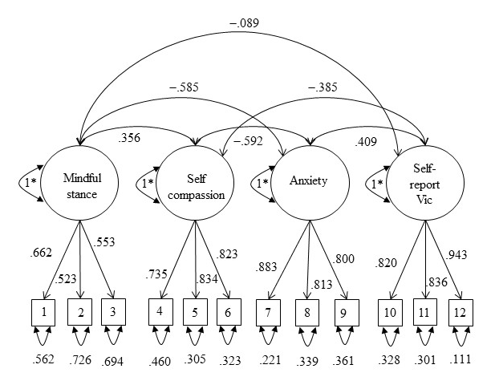
Figure 1. Example CFA for Aim 2 that includes self-report victimization and anxiety. Standardized model results are presented. Not depicted are the correlations with observed control variables (age, ethnicity, sex).

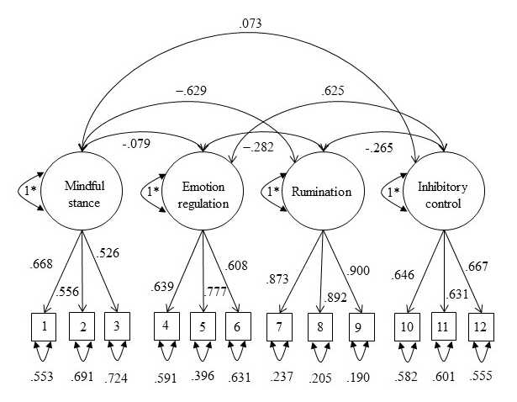
Figure 2. Example CFA for Aim 3 that includes mindful stance. Standardized model results are presented. Not depicted are the correlations with observed control variables (age, ethnicity, sex).

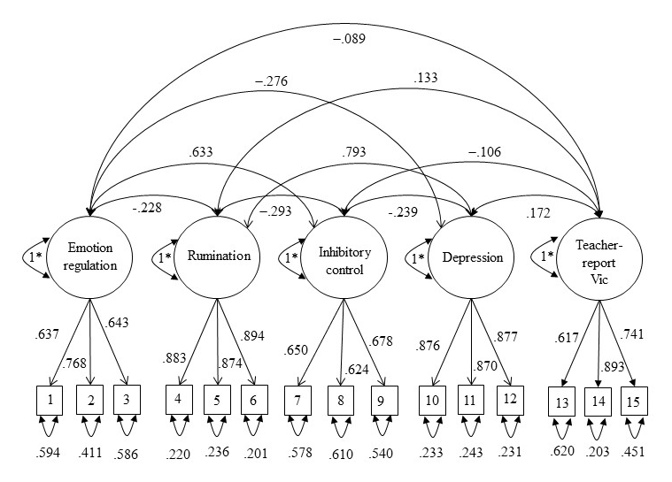
Figure 3. Example CFA for Aim 4 that includes teacher-report victimization and depression. Standardized model results are presented. Not depicted are the correlations with observed control variables (age, ethnicity, sex).

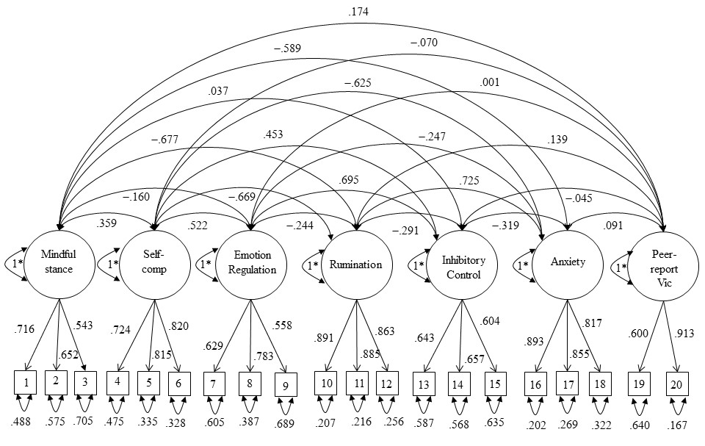
Figure 4. Example CFA for Aim 5 that includes peer-report victimization and anxiety. Standardized model results are presented. Not depicted are the correlations with observed control variables (age, ethnicity, sex).

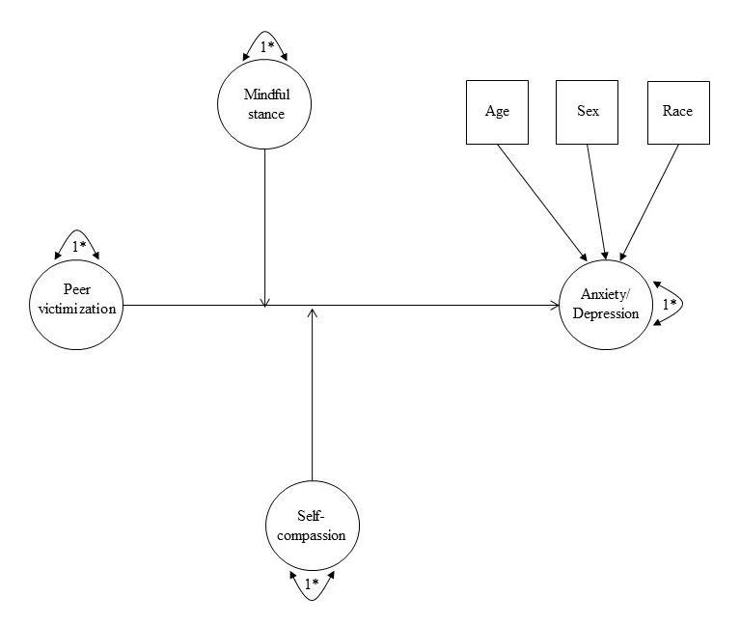
Figure 5. Theoretical moderation model for Aim 2. To reduce complexity in the figure, correlations are not depicted. Correlations were estimated among independent variables and between independent variables and control variables (age, sex, race).

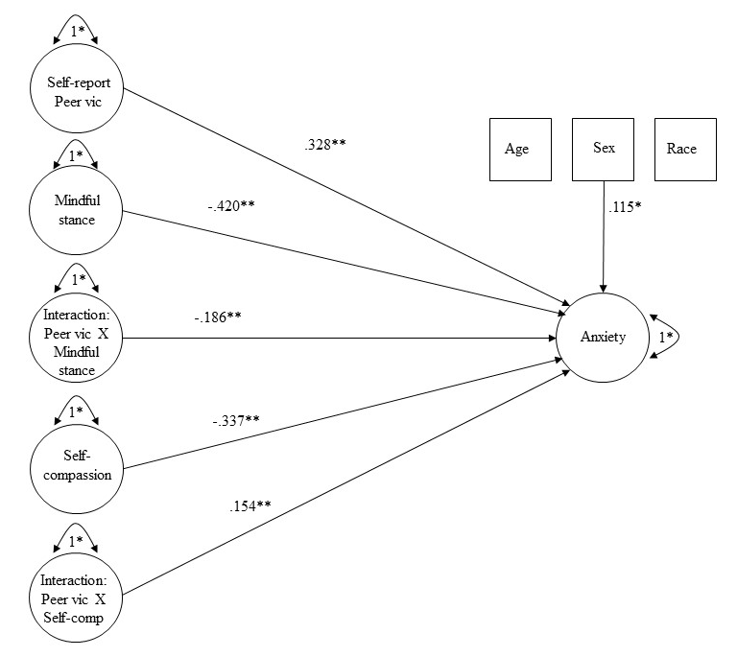
Figure 6. Structural model for Aim 2 with self-report peer victimization and anxiety. Standardized model results are presented; * p<.05. To reduce complexity in the figure, correlations are not depicted. Correlations were estimated among independent variables and between independent variables and control variables (age, sex, race).

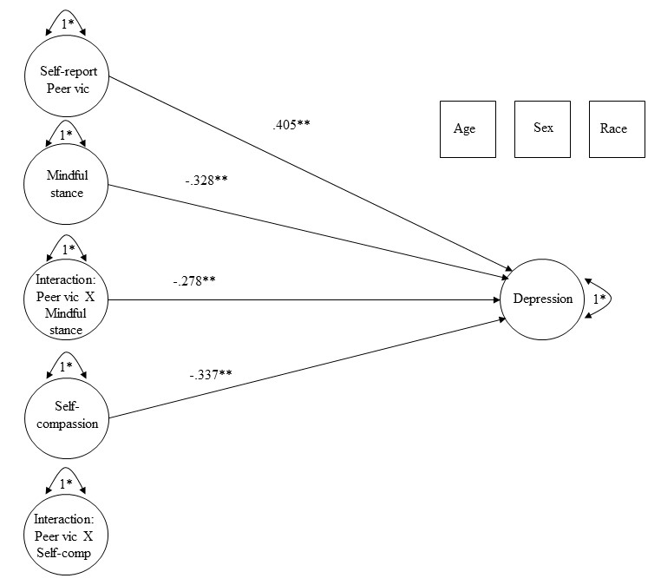
Figure 7. Structural model for Aim 2 with self-report peer victimization and depression. Standardized model results are presented; * p<.05. To reduce complexity in the figure, correlations are not depicted. Correlations were estimated among independent variables and between independent variables and control variables (age, sex, race).

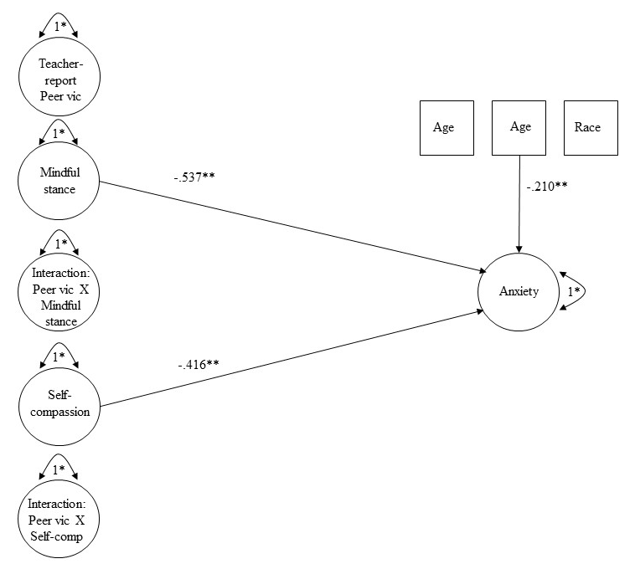
Figure 8. Structural model for Aim 2 with teacher-report peer victimization and anxiety. Standardized model results are presented; * p<.05. To reduce complexity in the figure, correlations are not depicted. Correlations were estimated among independent variables and between independent variables and control variables (age, sex, race).

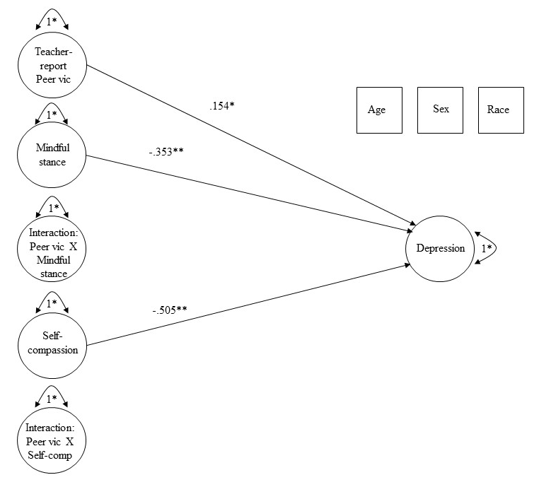
Figure 9. Structural model for Aim 2 with teacher-report peer victimization and depression. Standardized model results are presented; * p<.05. To reduce complexity in the figure, correlations are not depicted. Correlations were estimated among independent variables and between independent variables and control variables (age, sex, race).

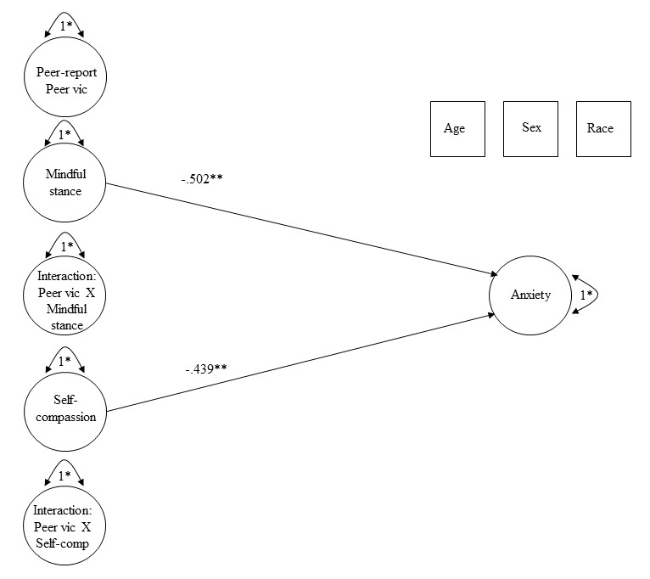
Figure 10. Structural model for Aim 2 with peer-report peer victimization and anxiety. Standardized model results are presented; * p<.05. To reduce complexity in the figure, correlations are not depicted. Correlations were estimated among independent variables and between independent variables and control variables (age, sex, race).
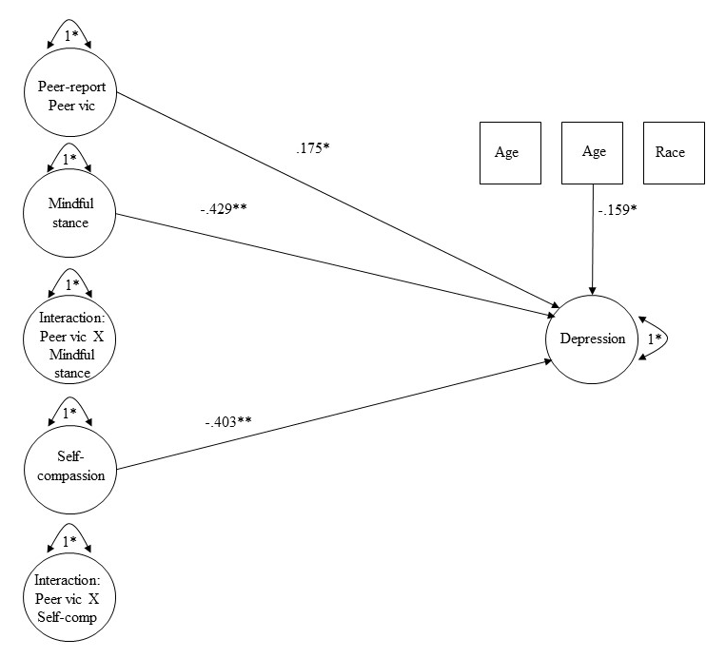
Figure 11. Structural model for Aim 2 with peer-report peer victimization and depression. Standardized model results are presented; * p<.05. To reduce complexity in the figure, correlations are not depicted. Correlations were estimated among independent variables and between independent variables and control variables (age, sex, race).

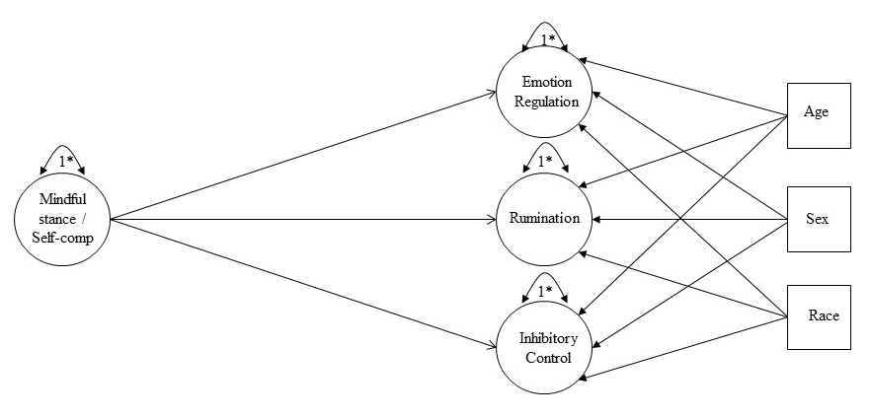
Figure 12. Theoretical structural model for Aim 3. To reduce complexity in the figure, correlations are not depicted. Correlations were estimated among dependent variables and between the independent variable and control variables (age, sex, race).

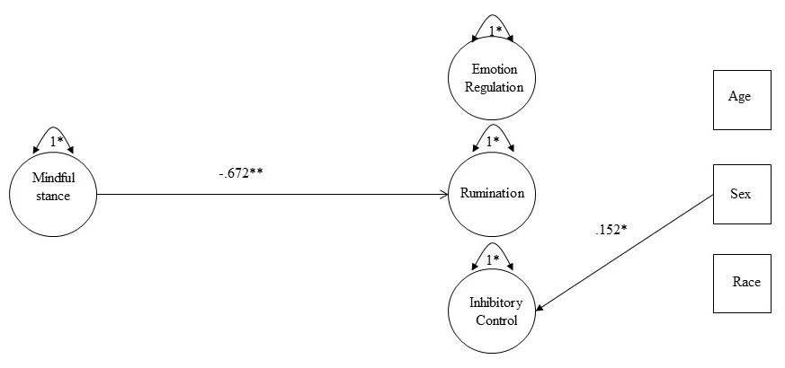
Figure 13. Structural model for Aim 3 with mindful stance. Standardized model results are presented; * p<.05. To reduce complexity in the figure, correlations are not depicted. Correlations were estimated among dependent variables and between the independent variable and control variables (age, sex, race).

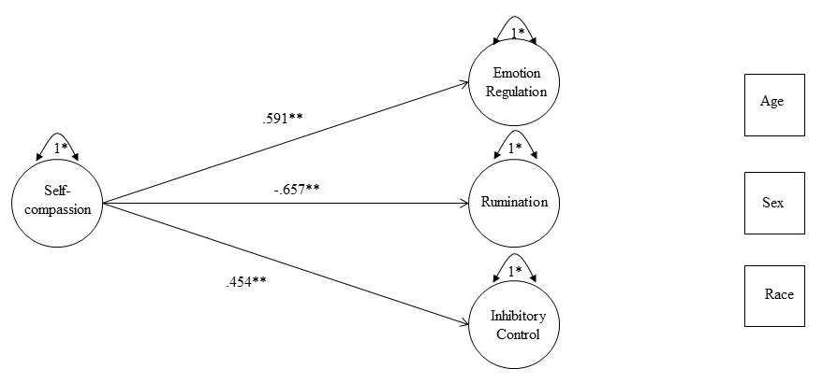
Figure 14. Structural model for Aim 3 with self-compassion. Standardized model results are presented; * p<.05. To reduce complexity in the figure, correlations are not depicted. Correlations were estimated among dependent variables and between the independent variable and control variables (age, sex, race).

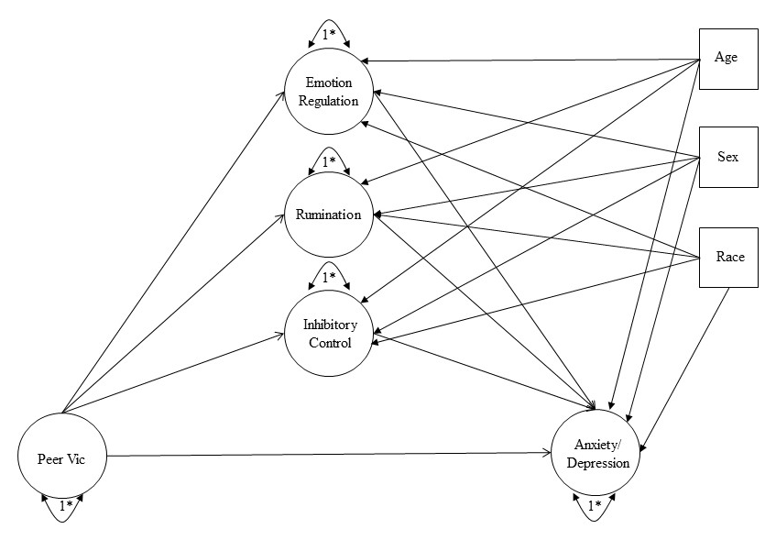
Figure 15. Theoretical mediation model for Aim 4. To reduce complexity in the figure, correlations are not depicted. Correlations were estimated among mediator variables and between the independent variable and control variables (age, sex, race).

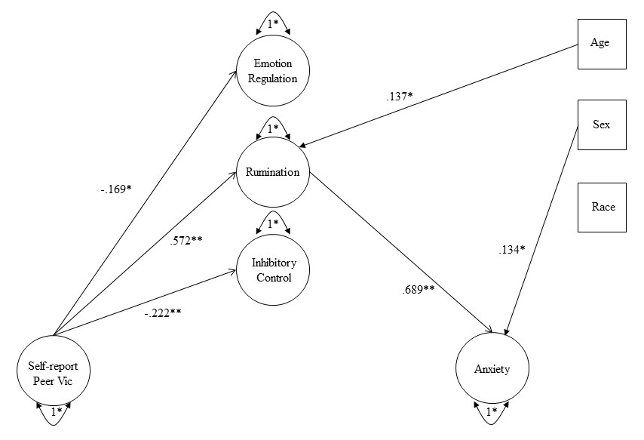
Figure 16. Mediation model for Aim 4 with self-report peer victimization and anxiety. Standardized model results are presented; * p<.05. To reduce complexity in the figure, correlations are not depicted. Correlations were estimated among mediator variables and between the independent variable and control variables (age, sex, race).

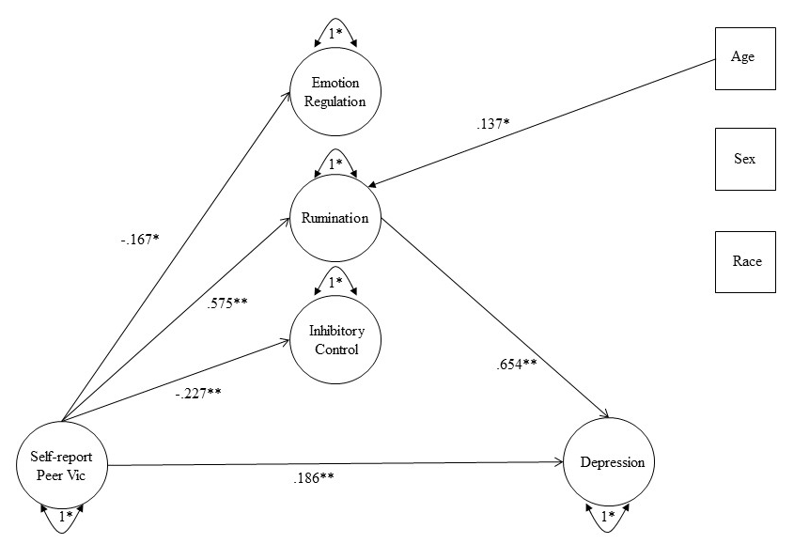
Figure 17. Mediation model for Aim 4 with self-report peer victimization and depression. Standardized model results are presented; * p<.05. To reduce complexity in the figure, correlations are not depicted. Correlations were estimated among mediator variables and between the independent variable and control variables (age, sex, race).

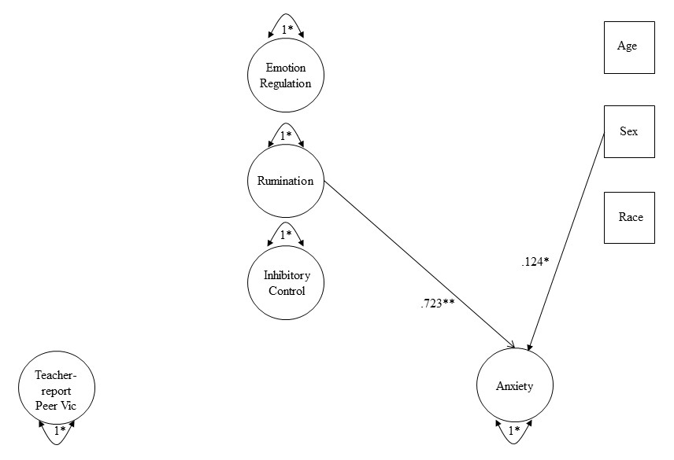
Figure 18. Mediation model for Aim 4 with teacher-report peer victimization and anxiety. Standardized model results are presented; * p<.05. To reduce complexity in the figure, correlations are not depicted. Correlations were estimated among mediator variables and between the independent variable and control variables (age, sex, race).

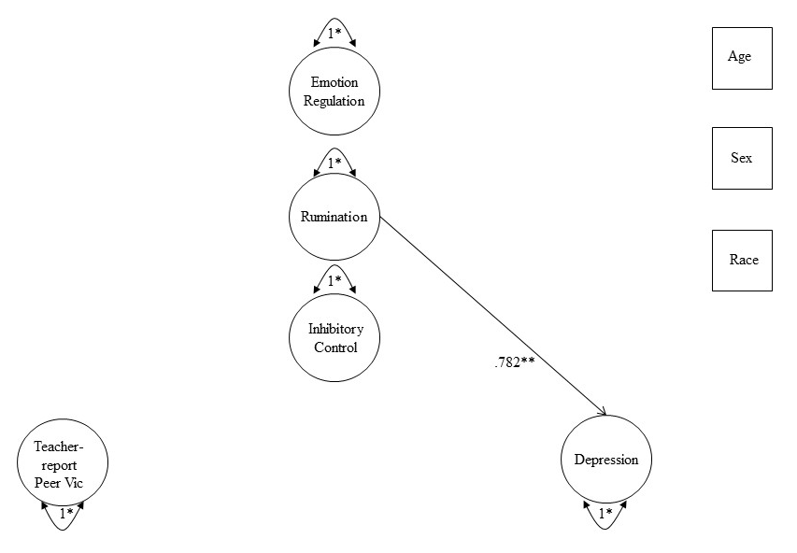
Figure 19. Mediation model for Aim 4 with teacher-report peer victimization and depression. Standardized model results are presented; * p<.05. To reduce complexity in the figure, correlations are not depicted. Correlations were estimated among mediator variables and between the independent variable and control variables (age, sex, race).

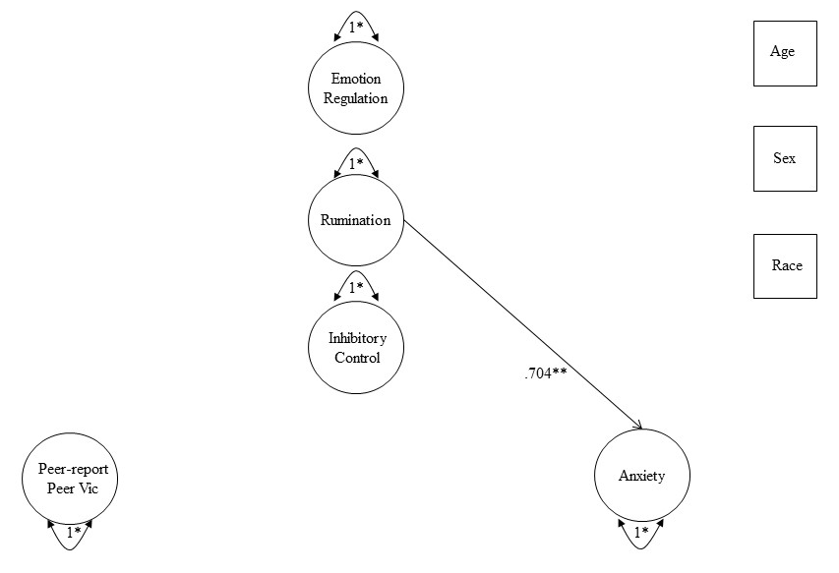
Figure 20. Mediation model for Aim 4 with peer-report peer victimization and anxiety. Standardized model results are presented; * p<.05. To reduce complexity in the figure, correlations are not depicted. Correlations were estimated among mediator variables and between the independent variable and control variables (age, sex, race).

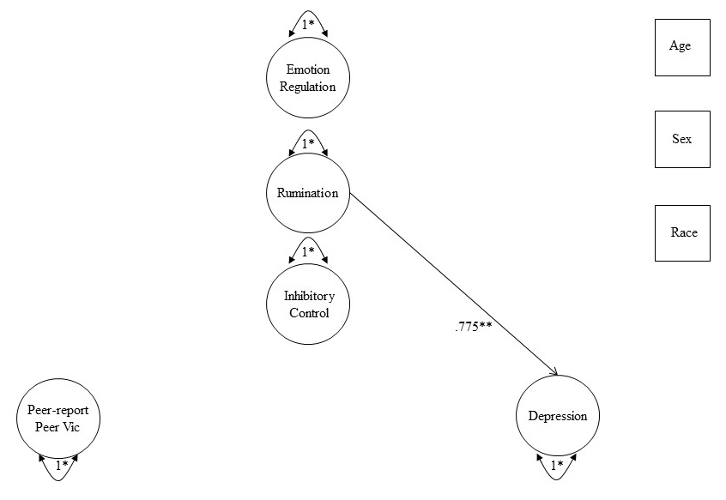
Figure 21. Mediation model for Aim 4 with peer-report peer victimization and depression. Standardized model results are presented; * p<.05. To reduce complexity in the figure, correlations are not depicted. Correlations were estimated among mediator variables and between the independent variable and control variables (age, sex, race).

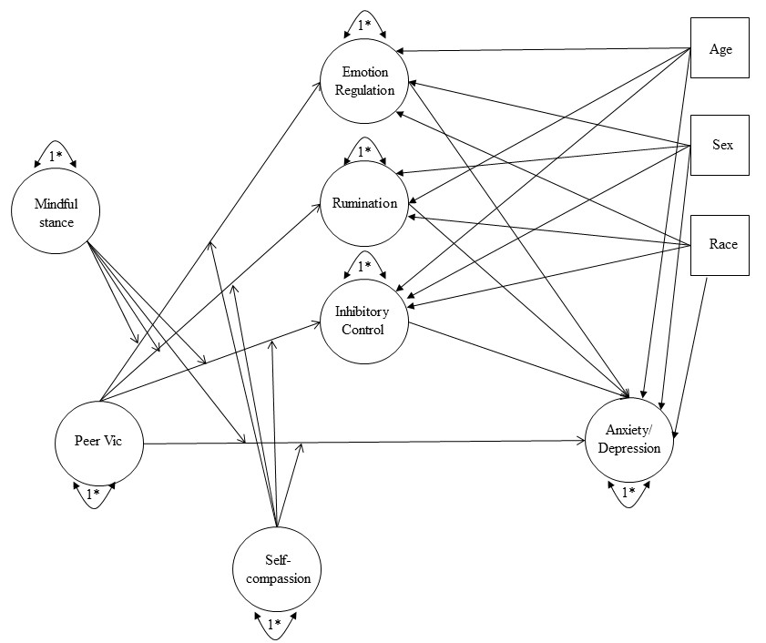
Figure 22. Theoretical model for moderated mediation for Aim 5. To reduce complexity in the figure, correlations are not depicted. Correlations were estimated among the moderator variables, between the independent variable and the moderator variables, between the independent variable and the control variables (age, sex, race), and between the moderator variables and the control variables (age, sex, race).

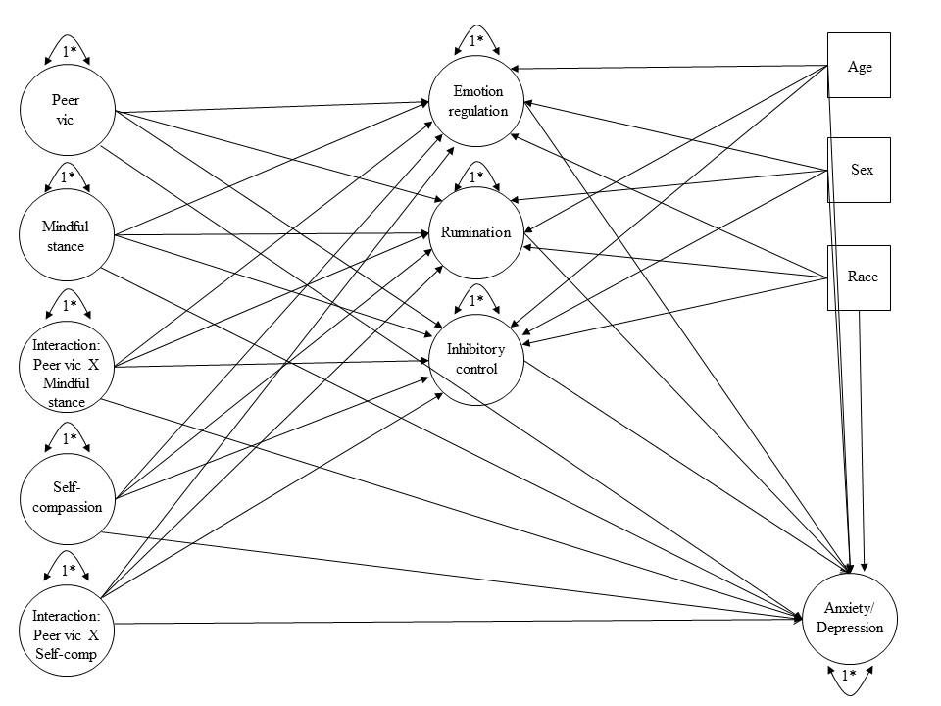
Figure 23. Full statistical model for moderated mediation for Aim 5. To reduce complexity in the figure, correlations are not depicted. Correlations were estimated among the moderator variables, between the independent variable and the moderator variables, between the independent variable and the control variables (age, sex, race), and between the moderator variables and the control variables (age, sex, race).

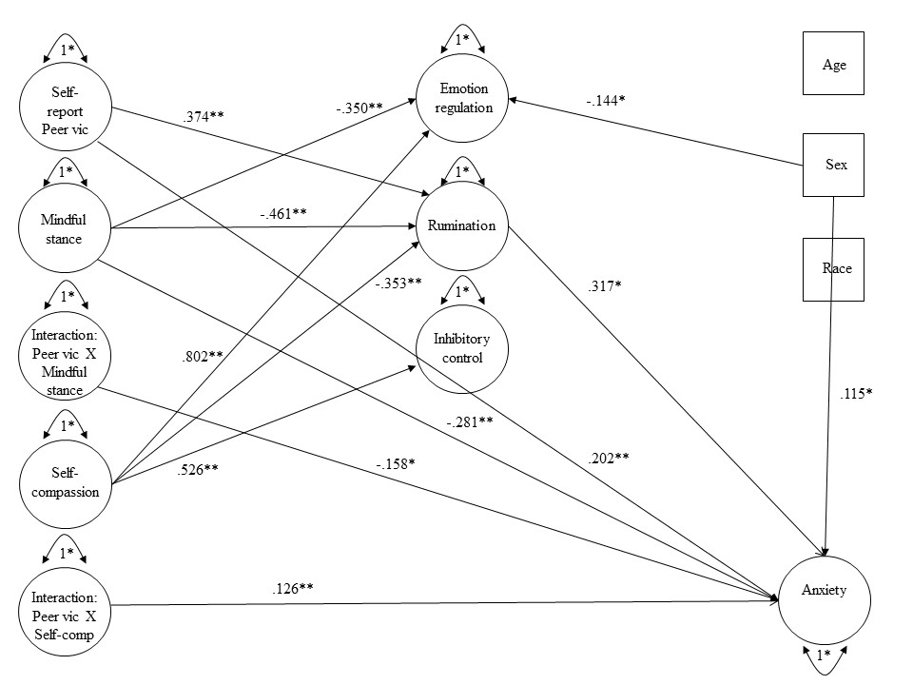
Figure 24. Statistical model for moderated mediation for Aim 5 with self-report victimization and anxiety. Standardized model results are presented; * p<.05. To reduce complexity in the figure, correlations are not depicted. Correlations were estimated among the moderator variables, between the independent variable and the moderator variables, between the independent variable and the control variables (age, sex, race), and between the moderator variables and the control variables (age, sex, race).

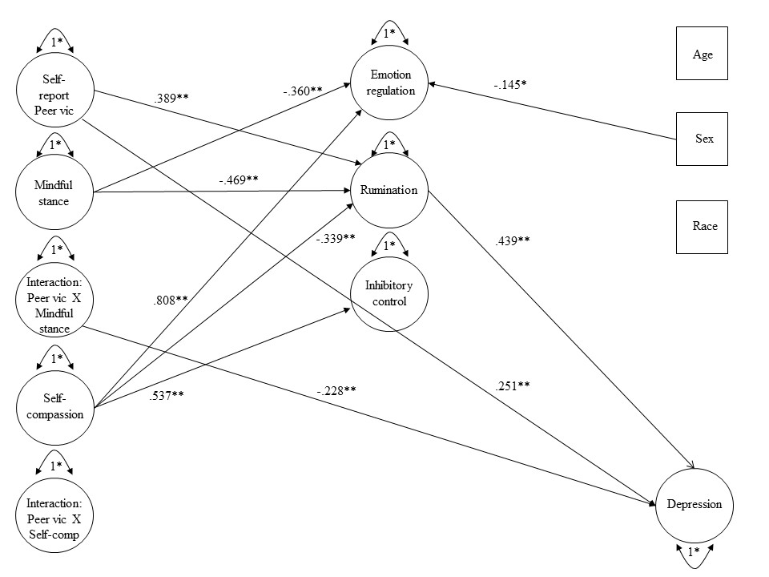
Figure 25. Statistical model for moderated mediation for Aim 5 with self-report victimization and depression. Standardized model results are presented; * p<.05. To reduce complexity in the figure, correlations are not depicted. Correlations were estimated among the moderator variables, between the independent variable and the moderator variables, between the independent variable and the control variables (age, sex, race), and between the moderator variables and the control variables (age, sex, race).

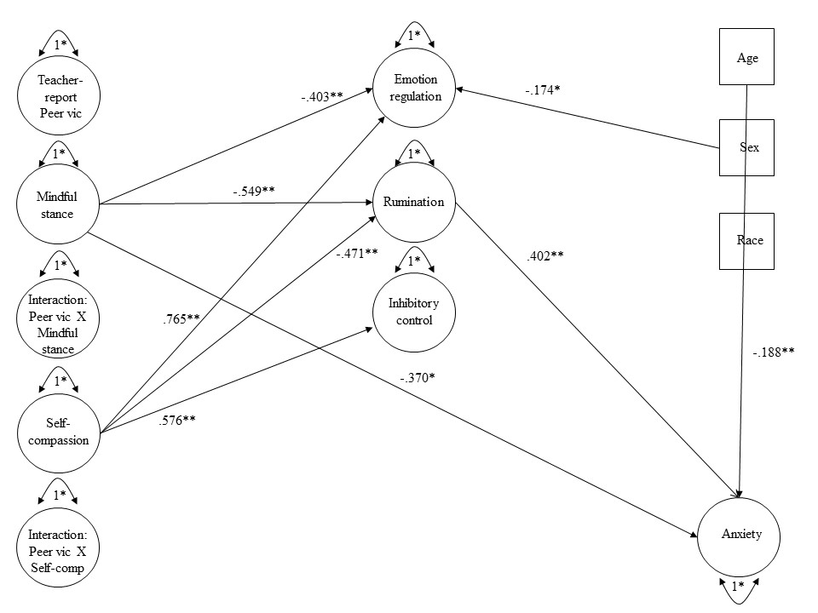
Figure 26. Statistical model for moderated mediation for Aim 5 with teacher-report victimization and anxiety. Standardized model results are presented; * p<.05. To reduce complexity in the figure, correlations are not depicted. Correlations were estimated among the moderator variables, between the independent variable and the moderator variables, between the independent variable and the control variables (age, sex, race), and between the moderator variables and the control variables (age, sex, race).

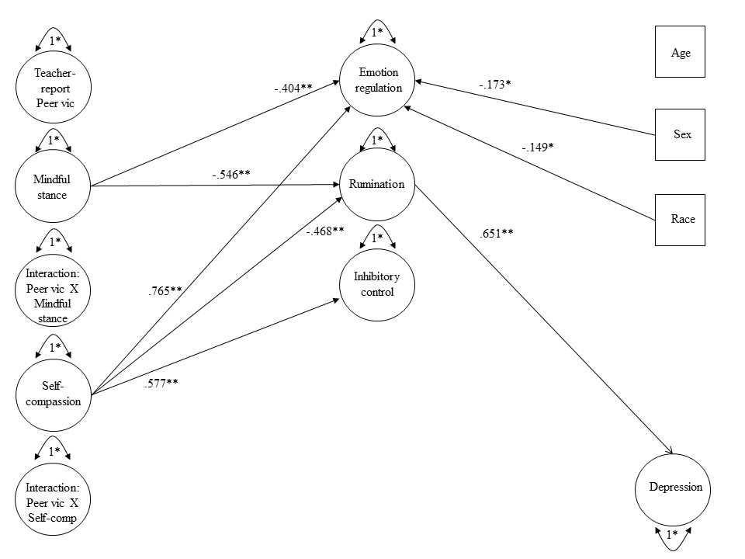
Figure 27. Statistical model for moderated mediation for Aim 5 with teacher-report victimization and depression. Standardized model results are presented; * p<.05. To reduce complexity in the figure, correlations are not depicted. Correlations were estimated among the moderator variables, between the independent variable and the moderator variables, between the independent variable and the control variables (age, sex, race), and between the moderator variables and the control variables (age, sex, race).

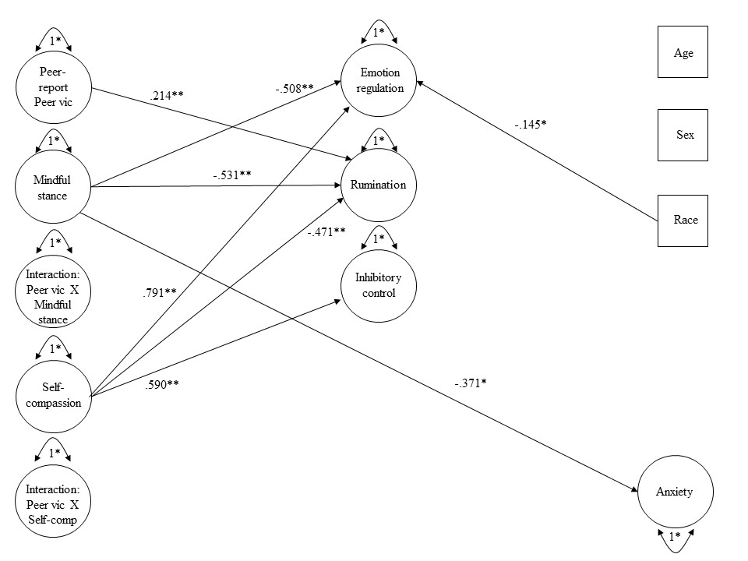
Figure 28. Statistical model for moderated mediation for Aim 5 with peer-report victimization and anxiety. Standardized model results are presented; * p<.05. To reduce complexity in the figure, correlations are not depicted. Correlations were estimated among the moderator variables, between the independent variable and the moderator variables, between the independent variable and the control variables (age, sex, race), and between the moderator variables and the control variables (age, sex, race).

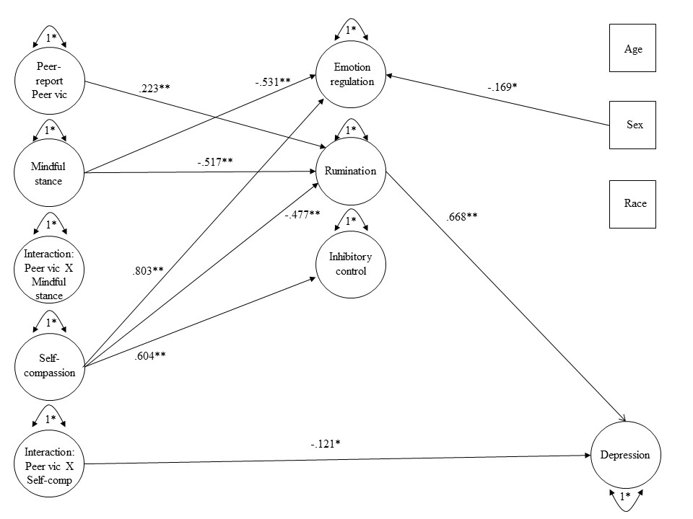
Figure 29. Statistical model for moderated mediation for Aim 5 with peer-report victimization and depression. Standardized model results are presented; * p<.05. To reduce complexity in the figure, correlations are not depicted. Correlations were estimated among the moderator variables, between the independent variable and the moderator variables, between the independent variable and the control variables (age, sex, race), and between the moderator variables and the control variables (age, sex, race).

Appendix 2: Study Measures
Demographic Questionnaire
All responses are voluntary.
ID#: (leave blank) DATE:
SCHOOL: GRADE:
TEACHER: BIRTHDATE:
Please answer the questions below. All responses are voluntary.
1. What is the biological sex of your child?  - BOY  - GIRL  2. Is this the 1st year your child is at this school?  - YES  - NO  3. What is your child’s race or ethnicity?  - WHITE  - BLACK  - ASIAN  - ESKIMO/ALEUT  - SPANISH/HISPANIC  - AMERICAN INDIAN  - PACIFIC ISLANDER  - BI/MULTI-RACIAL  - OTHER:________________  4. What language is spoken most often in your home?  - ENGLISH  - SPANISH  - OTHER  5. Are there any other languages spoken in your home?  - ENGLISH  - SPANISH  - OTHER  6. Who lives in your house?  - MOTHER  - STEP-MOTHER  - FATHER  - STEP- FATHER  - MOTHER’S BOYFRIEND  - FATHER’S GIRLFRIEND  - GRANDMOTHER  - GRANDFATHER  - UNCLE  - AUNT  - COUSIN  - OTHER: ________________ | 7. How many siblings live in the home? _______________  8. Does your child receive a free or reduced lunch at school?  - YES  - NO  9. What is your annual household income?  - Less than 10,000 dollars  - 10,000-25,000 dollars  - 25,000-35,000 dollars  - 35,000 – 50,000 dollars  - 50,000 – 100,000 dollars  - greater than 100,000 dollars

Adolescent and Adult Mindfulness Scale

AAMS
All responses are voluntary.
Directions: The sentences below might describe your everyday experiences. Circle the response that describes how true the following statements are for you.
1. I tell myself that I shouldn't be feeling the way I am feeling.
Never True | Rarely True | Sometimes True | Often True | Always True

2. I notice when my moods begin to change.
Never True | Rarely True | Sometimes True | Often True | Always True

3. I notice whether my muscles are tense or relaxed.
Never True | Rarely True | Sometimes True | Often True | Always True

4. When I take a shower or a bath, I notice how water feels on my body.
Never True | Rarely True | Sometimes True | Often True | Always True

5. I tend to evaluate if the emotions I feel are appropriate.
Never True | Rarely True | Sometimes True | Often True | Always True

6. I pay attention to physical sensations, such as the wind in my hair or sun on my face.
Never True | Rarely True | Sometimes True | Often True | Always True

7. I notice changes in my body, such as whether my breathing (or heartbeat) slows down or speeds up.
Never True | Rarely True | Sometimes True | Often True | Always True

8. How often do you notice detail of buildings or landscape (e.g., trees, etc.) around you?
Never True | Rarely True | Sometimes True | Often True | Always True

9. I tend to evaluate if my experiences are good and valuable or bad and not valuable.
Never True | Rarely True | Sometimes True | Often True | Always True

10. The emotions I feel sometimes seem wrong.
Never True | Rarely True | Sometimes True | Often True | Always True

11. I make judgments about whether my thoughts are good or bad.

Never True | Rarely True | Sometimes True | Often True | Always True

12. I pay attention to sounds, such as clocks ticking, birds chirping, or cars passing.
Never True | Rarely True | Sometimes True | Often True | Always True

13. I recognize art elements in nature, such as colors, shapes, textures, or patterns of light and shade.
Never True | Rarely True | Sometimes True | Often True | Always True

14. I tell myself that I shouldn't be thinking the way I'm thinking.
Never True | Rarely True | Sometimes True | Often True | Always True

15. I notice the smells around me.
Never True | Rarely True | Sometimes True | Often True | Always True

16. I like to judge whether my ideas and opinions are right or wrong.
Never True | Rarely True | Sometimes True | Often True | Always True

17. When I realized I missed something important in a class, I worry about not being able to find the missed information.
Never True | Rarely True | Sometimes True | Often True | Always True

18. When I realized I missed something important in a class, I think about the consequences of missing the information.
Never True | Rarely True | Sometimes True | Often True | Always True

19. When I realized I missed something important in a class, I get angry with myself.
Never True | Rarely True | Sometimes True | Often True | Always True

Self-Compassion Scale – Child
SCS-C
All responses are voluntary.
Directions: Please read each statement carefully before answering. Circle the answer that fits best for how often you behave that way.
- When I fail at something important to me, I feel like I’m not good enough.
Never | Almost Never | Sometimes | Almost Always | Always

- I try to be kind towards those things about myself I don’t like.
Never | Almost Never | Sometimes | Almost Always | Always

- When something bad happens, I try not to focus only on the bad, but think about the good things as well.
Never | Almost Never | Sometimes | Almost Always | Always

- When I’m feeling sad, I feel like most other kids are happier than I am.
Never | Almost Never | Sometimes | Almost Always | Always

- When I fail at something, I try to remember that everybody fails sometimes too.
Never | Almost Never | Sometimes | Almost Always | Always

- When I’m going through a very hard time, I’m really nice to myself.
Never | Almost Never | Sometimes | Almost Always | Always

- When something upsets me I try to stay calm.
Never | Almost Never | Sometimes | Almost Always | Always

- When I fail at something that’s important to me, I feel like I’m all alone.
Never | Almost Never | Sometimes | Almost Always | Always

- When I’m feeling sad, I can’t stop thinking about everything that’s wrong.
Never | Almost Never | Sometimes | Almost Always | Always

- When I feel like I’m not good enough at something, I try to remind myself that everyone feels that way sometimes.
Never | Almost Never | Sometimes | Almost Always | Always

- I am hard on myself about my own flaws and weaknesses.
Never | Almost Never | Sometimes | Almost Always | Always

- I get frustrated or upset about the things about myself I don’t like.
Never | Almost Never | Sometimes | Almost Always | Always

PROMIS-A-SF
PROMIS_A_SF
All responses are voluntary.
Directions: Please respond to each question or statement by marking one box per row.
In the past 7 days…
1. I felt like something awful might happen.
Never | Almost Never | Sometimes | Often | Almost Always

2. I felt nervous.
Never | Almost Never | Sometimes | Often | Almost Always

3. I felt scared.
Never | Almost Never | Sometimes | Often | Almost Always

4. I felt worried.
Never | Almost Never | Sometimes | Often | Almost Always

5. I worried when I was at home.
Never | Almost Never | Sometimes | Often | Almost Always

6. I got scared really easy.
Never | Almost Never | Sometimes | Often | Almost Always

7. I worried about what could happen to me.
Never | Almost Never | Sometimes | Often | Almost Always

8. I worried when I went to bed at night.
Never | Almost Never | Sometimes | Often | Almost Always

PROMIS-D-SF
PROMIS_D_SF
All responses are voluntary.
Directions: Please respond to each question or statement by marking one box per row.
In the past 7 days…
1. I could not stop feeling sad.
Never | Almost Never | Sometimes | Often | Almost Always

2. I felt alone.
Never | Almost Never | Sometimes | Often | Almost Always

3. I felt everything in my life went wrong.
Never | Almost Never | Sometimes | Often | Almost Always

4. I felt like I couldn’t do anything right.
Never | Almost Never | Sometimes | Often | Almost Always

5. I felt lonely.
Never | Almost Never | Sometimes | Often | Almost Always

6. I felt sad.
Never | Almost Never | Sometimes | Often | Almost Always

7. I felt unhappy.
Never | Almost Never | Sometimes | Often | Almost Always

8. It was hard for me to have fun.
Never | Almost Never | Sometimes | Often | Almost Always

Social Experiences Questionnaire
SEQ
All responses are voluntary.
Directions: Here is a list of things that sometimes happen to kids your age at school. How often do they happen to you at school?
- How often are you hit by another kid at school?
Never | Almost Never | Sometimes | Often | All the time

- How often do other kids leave you out on purpose when it is time to play or do an activity?
Never | Almost Never | Sometimes | Often | All the time

- How often does another kid yell at you or call you mean names?
Never | Almost Never | Sometimes | Often | All the time

- How often does a kid who is mad at you try to get back at you by not letting you be in their group anymore?
Never | Almost Never | Sometimes | Often | All the time

- How often do you get pushed or shoved by another kid at school?
Never | Almost Never | Sometimes | Often | All the time

- How often does another kid make fun of you because of the way you look?
Never | Almost Never | Sometimes | Often | All the time

- How often does another kid tell lies about you to make other kids not like you anymore?
Never | Almost Never | Sometimes | Often | All the time

- How often does another kid kick you or pull your hair?
Never | Almost Never | Sometimes | Often | All the time
- How often does another kid say they won’t like you unless you do what they want you to do?
Never | Almost Never | Sometimes | Often | All the time

- How often does a kid try to keep others from liking you by saying mean things about you?
Never | Almost Never | Sometimes | Often | All the time

- How often does another kid make fun of you because of the way you speak?
Never | Almost Never | Sometimes | Often | All the time

- How often does another kid say they will beat you up if you don’t do what they want you to do?
Never | Almost Never | Sometimes | Often | All the time

Peer Nomination Inventory

Participant Roles
All responses are voluntary.
Directions: Using your class roster, circle the numbers of the kids in your class to answer each question. Do not circle yourself. All responses are voluntary.
- Who in your class do you like the most?

01 | 07 | 13 | 19
02 | 08 | 14 | 20
03 | 09 | 15 | 21
04 | 10 | 16 | 22
05 | 11 | 17 | 23
06 | 12 | 18 | 24

- Who in your class do you like the least?

01 | 07 | 13 | 19
02 | 08 | 14 | 20
03 | 09 | 15 | 21
04 | 10 | 16 | 22
05 | 11 | 17 | 23
06 | 12 | 18 | 24

- Who in your class gets hit, pushed, threatened, or teased by other children?

01 | 07 | 13 | 19
02 | 08 | 14 | 20
03 | 09 | 15 | 21
04 | 10 | 16 | 22
05 | 11 | 17 | 23
06 | 12 | 18 | 24

- Who in your class gets gossiped about or left out of activities?

01 | 07 | 13 | 19
02 | 08 | 14 | 20
03 | 09 | 15 | 21
04 | 10 | 16 | 22
05 | 11 | 17 | 23
06 | 12 | 18 | 24

Teacher-reported Peer Victimization
All responses are voluntary. Directions: Using your class roster, for each of these three questions, please rate the extent to which you think each student experiences the following:
1 = Never | 2 = Almost Never | 3 = Sometimes | 4 = Almost Always | - = Always

1. How much is this student hit, pushed, shoved, or kicked by other students?
01: 1 2 3 4 5
02: 1 2 3 4 5
03: 1 2 3 4 5
04: 1 2 3 4 5
05: 1 2 3 4 5
06: 1 2 3 4 5
07: 1 2 3 4 5
08: 1 2 3 4 5
09: 1 2 3 4 5
10: 1 2 3 4 5
11: 1 2 3 4 5
12: 1 2 3 4 5
13: 1 2 3 4 5
14: 1 2 3 4 5
15: 1 2 3 4 5
16: 1 2 3 4 5
17: 1 2 3 4 5
18: 1 2 3 4 5
19: 1 2 3 4 5
20: 1 2 3 4 5
21: 1 2 3 4 5
22: 1 2 3 4 5
23: 1 2 3 4 5
24: 1 2 3 4 5

2. How much is this student called mean names, told hurtful things, or teased by other students?

01: 1 2 3 4 5
02: 1 2 3 4 5
03: 1 2 3 4 5
04: 1 2 3 4 5
05: 1 2 3 4 5
06: 1 2 3 4 5
07: 1 2 3 4 5
08: 1 2 3 4 5
09: 1 2 3 4 5
10: 1 2 3 4 5
11: 1 2 3 4 5
12: 1 2 3 4 5
13: 1 2 3 4 5
14: 1 2 3 4 5
15: 1 2 3 4 5
16: 1 2 3 4 5
17: 1 2 3 4 5
18: 1 2 3 4 5
19: 1 2 3 4 5
20: 1 2 3 4 5
21: 1 2 3 4 5
22: 1 2 3 4 5
23: 1 2 3 4 5
24: 1 2 3 4 5
3. How much do peers tell this student they can’t play, gossip or spread lies about this student, or not invite this student to things just to get back at them?
01: 1 2 3 4 5
02: 1 2 3 4 5
03: 1 2 3 4 5
04: 1 2 3 4 5
05: 1 2 3 4 5
06: 1 2 3 4 5
07: 1 2 3 4 5
08: 1 2 3 4 5
09: 1 2 3 4 5
10: 1 2 3 4 5
11: 1 2 3 4 5
12: 1 2 3 4 5
13: 1 2 3 4 5
14: 1 2 3 4 5
15: 1 2 3 4 5
16: 1 2 3 4 5
17: 1 2 3 4 5
18: 1 2 3 4 5
19: 1 2 3 4 5
20: 1 2 3 4 5
21: 1 2 3 4 5
22: 1 2 3 4 5
23: 1 2 3 4 5
24: 1 2 3 4 5

Children’s Emotion Management Scale
CEMS-S
All responses are voluntary.
Directions: Please circle the response that best describes your behavior when you are feeling sad.
- When I am feeling sad, I can control my crying and carrying on.
Hardly ever | Sometimes | Often

- I hold my sad feelings in.
Hardly ever | Sometimes | Often

- I stay calm and don’t let sad things get to me.
Hardly ever | Sometimes | Often

- I whine/fuss about what’s making me sad.
Hardly ever | Sometimes | Often

- I hide my sadness.
Hardly ever | Sometimes | Often

- When I’m sad, I do something totally different until I calm down.
Hardly ever | Sometimes | Often

- I get sad inside but don’t show it.
Hardly ever | Sometimes | Often

- I can stop myself from losing control of my sad feelings.
Hardly ever | Sometimes | Often

- I cry and carry on when I’m sad.
Hardly ever | Sometimes | Often

- I try to calmly deal with what is making me sad.
Hardly ever | Sometimes | Often

- I do things like mope around when I’m sad.
Hardly ever | Sometimes | Often

- I’m afraid to show my sadness.
Hardly ever | Sometimes | Often

CEMS-A
Directions: Please circle the response that best describes your behavior when you are feeling mad.
- When I am feeling mad, I control my temper.
Hardly ever | Sometimes | Often

- I hold my anger in.
Hardly ever | Sometimes | Often

- I stay calm and keep my cool when I am feeling mad.
Hardly ever | Sometimes | Often

- I do things like slam doors when I am mad.
Hardly ever | Sometimes | Often

- I hide my anger.
Hardly ever | Sometimes | Often

- I attack whatever it is that makes me mad.
Hardly ever | Sometimes | Often

- I get mad inside but I don’t show it.
Hardly ever | Sometimes | Often

- I can stop myself from losing my temper.
Hardly ever | Sometimes | Often

- I say mean things to others when I am mad.
Hardly ever | Sometimes | Often

- I try to calmly deal with what is making me feel mad.
Hardly ever | Sometimes | Often

- I’m afraid to show my anger.
Hardly ever | Sometimes | Often

CEMS-W
Directions: Please circle the response that best describes your behavior when you are feeling worried.
- I keep myself from losing control of my worried feelings.
Hardly ever | Sometimes | Often

- I show my worried feelings.
Hardly ever | Sometimes | Often

- I hold my worried feelings in.
Hardly ever | Sometimes | Often

- I talk to someone until I feel better when I’m worried.
Hardly ever | Sometimes | Often

- I do things like cry and carry on when I’m worried.
Hardly ever | Sometimes | Often

- I hide my worried feelings.
Hardly ever | Sometimes | Often

- I keep whining about how worried I am.
Hardly ever | Sometimes | Often

- I get worried inside but don’t show it.
Hardly ever | Sometimes | Often

- I can’t stop myself from acting really worried.
Hardly ever | Sometimes | Often

- I try to calmly settle the problem when I feel worried.
Hardly ever | Sometimes | Often

Children’s Response Styles Questionnaire
CRSQ
All responses are voluntary.
Directions: Please respond to each statement by marking one box per row.
- When I am sad, I think about how alone I feel.

Almost Never | Sometimes | Often | Almost Always

- When I am sad, I help someone else with something so I don’t think about my problem.

Almost Never | Sometimes | Often | Almost Always

- When I am sad, I go away by myself and think about why I feel this way.

Almost Never | Sometimes | Often | Almost Always

4. When I am sad, I think: “I’m ruining everything.”

Almost Never | Sometimes | Often | Almost Always

5. When I am sad, I think about how sad I feel.

Almost Never | Sometimes | Often | Almost Always

6. When I am sad, I go someplace alone to think about my feelings.

Almost Never | Sometimes | Often | Almost Always

7. When I am sad, I do something I enjoy.

Almost Never | Sometimes | Often | Almost Always
8. When I am sad, I think about how angry I am with myself.

Almost Never | Sometimes | Often | Almost Always

9. When I am sad, I do something fun with a friend.

Almost Never | Sometimes | Often | Almost Always

- When I am sad, I think about other times when I have felt sad.

Almost Never | Sometimes | Often | Almost Always

- When I am sad, I think about a recent situation wishing it had gone better.
Almost Never | Sometimes | Often | Almost Always

- When I am sad, I ask a friend, parent, or teacher to help me solve my problem.

Almost Never | Sometimes | Often | Almost Always

- When I am sad, I think, “There must be something wrong with me or I wouldn’t feel this way.”
Almost Never | Sometimes | Often | Almost Always

- When I am sad, I try to find something good in the situation or something I learned.

Almost Never | Sometimes | Often | Almost Always

- When I am sad, I think: “I’m disappointing my friends, family, or teachers.”

Almost Never | Sometimes | Often | Almost Always

- When I am sad, I talk it out with someone who I think can help me feel better.

Almost Never | Sometimes | Often | Almost Always

- When I am sad, I think about all my failures, faults, and mistakes.

Almost Never | Sometimes | Often | Almost Always

- When I am sad, I think of a way to make my problem better.

Almost Never | Sometimes | Often | Almost Always

- When I am sad, I think, “Why can’t I handle things better?"
Almost Never | Sometimes | Often | Almost Always

20. When I am sad, I remind myself that this feeling will go away.

Almost Never | Sometimes | Often | Almost Always

21. When I am sad, I think about how I don’t feel like doing anything.

Almost Never | Sometimes | Often | Almost Always

Early Adolescent Temperament Questionnaire
EATQ-R
All responses are voluntary.
Directions: You will find a series of statements that people might use to describe themselves. The statements refer to a wide number of activities and attitudes. For each statement, please circle the answer that best describes how true each statement is for you. There are no best answers. People are very different in how they feel about these statements. Please circle the first answer that comes to you.

- When I’m excited, it’s hard for me to wait my turn to talk.

Almost always untrue of me | Usually untrue of me | Sometimes true, sometimes untrue of me | Usually true of me | Almost always true of me

- When someone tells me to stop doing something, it is easy for me to stop.

Almost always untrue of me | Usually untrue of me | Sometimes true, sometimes untrue of me | Usually true of me | Almost always true of me

- I could easily change a bad habit if I wanted to.

Almost always untrue of me | Usually untrue of me | Sometimes true, sometimes untrue of me | Usually true of me | Almost always true of me

- I tend to say the first thing that comes to my mind, without stopping to think about it.

Almost always untrue of me | Usually untrue of me | Sometimes true, sometimes untrue of me | Usually true of me | Almost always true of me

- It's hard for me not to open presents before I’m supposed to.

Almost always untrue of me | Usually untrue of me | Sometimes true, sometimes untrue of me | Usually true of me | Almost always true of me

- When I'm having a really good time, I have a hard time leaving to go home when I'm supposed to.

Almost always untrue of me | Usually untrue of me | Sometimes true, sometimes untrue of me | Usually true of me | Almost always true of me

- I blurt out answers in class before the teacher calls on me.

Almost always untrue of me | Usually untrue of me | Sometimes true, sometimes untrue of me | Usually true of me | Almost always true of me

- The more I try to stop myself from doing something I shouldn't, the more likely I am to do it.

Almost always untrue of me | Usually untrue of me | Sometimes true, sometimes untrue of me | Usually true of me | Almost always true of me

- It’s easy for me to keep a secret.

Almost always untrue of me | Usually untrue of me | Sometimes true, sometimes untrue of me | Usually true of me | Almost always true of me

- I am good at self-discipline.

Almost always untrue of me | Usually untrue of me | Sometimes true, sometimes untrue of me | Usually true of me | Almost always true of me

- I can stick with my plans and goals.

Almost always untrue of me | Usually untrue of me | Sometimes true, sometimes untrue of me | Usually true of me | Almost always true of me

Vita
Cara M. K. McClain was born and raised in Durham, NC and earned her Bachelor of Arts degree in psychology from Elon University. Cara earned her Master of Arts degree in psychology from the University of Tennessee in 2017 and plans to receive her Ph.D. in clinical psychology in Spring 2022 following her internship at the Salt Lake City VA. Cara has a personal and professional interest in mindfulness and self-compassion as strategies that can improve well-being and hopes that her dissertation contributes to our understanding of these constructs.

