Characterization of TMX transmembrane protein in Bacillus subtilis and its effects on antibiotic resistance, membrane permeability, and membrane fluidity

A Thesis Presented for the
Bachelors of Science
Biochemistry and Cellular and Molecular Biology
The University of Tennessee, Knoxville

Henna Manoj Zaver
May 2020
Acknowledgements
I would like to thank Dr. Gladys Alexandre for allowing me to conduct research in her laboratory during the Spring of 2019 and throughout the course of the Undergraduate Summer Research Internship during the Summer of 2019. With her guidance, I was able to pursue a research project that aligned with my professional interests. In addition, I would like to thank Maddison Melchionna for her supervision and guidance throughout the span of the project. I would like to thank Dr. Elena Ganusova for her guidance and supervision, as well. I would also like to thank Kathleen King for her help in any capacity throughout my time in Dr. Alexandre’s laboratory. Finally, I would like express my gratitude to my family and friends for their support and encouragement throughout my undergraduate career.

Table of Contents
Introduction …………………………………………………………………………………...1 – 3
Chapter I: The Role of YplQ with Respect to Membrane Permeability ………………………….4
Introduction ………………………………………………………………………….. 4 – 5
Materials and Methods ……………………………………………………………………5
Results ………………………………………………………………………………...5 – 7
Discussion ………………………………………………………………………….....7 – 8
Figures and Graphs ………………………………………………………………….9 – 14
Chapter II: Complications ……………………………………………………………………….15
Introduction ………………………………………………………………………...15 – 16
Materials and Methods ……………………………………………………………..16 – 18
Results ...……………………………………………………………………………18 – 19
Discussion ………………………………………………………………………….19 – 20
Figures ……………………………………………………………………………...21 – 25
Conclusion …………………………………………………………………………………26 – 27
References ……………………………………………………………………………………… 28

Introduction
Bacteria rely on lipid homeostasis and on the ability to alter the lipid composition in the cell membrane to adjust to the bacterial cells to various environments (1). Aligning with the “fluid mosaic model,” bacterial membranes are composed of proteins embedded in a phospholipid bilayer. As such, phospholipid bilayers consist of a diverse array of phospholipid structures and proteins. This variation in phospholipid structures dictates many of the biophysical properties of the cell membrane. However, most phospholipids in membranes are glycerolipids that contain two fatty acid chains. The acyl chains in phospholipids dictate the viscosity of the membrane which is critical to the viability of bacteria and membrane function. Thus, the acyl chains influence many membrane-associated functions such as the passive permeability of hydrophobic molecules (1). These kind of adjustments that are made in phospholipid structures are referred to as homoviscous adaptation (1). Homoviscous adaptation is said to be a mechanism by which the permeability of the cell membrane is controlled (1). The key to the ability of bacteria to modify the membrane composition in response to changes in their environment (temperature, osmolarity, pH, etc.) lies in lipid metabolism. These mechanisms that work within lipid metabolism control the formation of new fatty acids, as well as the modification of the structure of existing fatty acids. Through prior research, a protein named TMX was identified in Escherichia coli, a Gram-negative bacterium. TMX is theorized to span the membrane seven times and was found to affect the localization of membrane-associated protein, alters the biophysical properties of the membrane, and directly controls membrane fluidity in response to changes in temperature (2). Antibiotic resistances can arise due to these kinds of modifications of the bacterial cell membrane (2).

A homolog of TMX, yplQ, was also identified in Bacillus subtilis, a Gram-positive bacterium leading us to hypothesize that TMX/yplQ is a universal fluidity sensor. The implications of finding this protein in both a Gram-positive and a Gram-negative bacterium are significant in that Gram-positive and Gram-negative bacteria are vastly different, yet TMX/yplQ could aid in conferring antibiotic resistance through similar mechanisms. Further characterizing TMX/yplQ and its effects on membrane fluidity, and in effect, membrane permeability, may aid in the development or design of antibiotics with more effective mechanisms of killing pathogenic bacteria.
The objective of this project is to further characterize the role of TMX/yplQ and its effects on membrane fluidity, and in turn, membrane permeability by measuring the minimum inhibitory concentration (MIC) of various antibiotics in B. subtilis and its ΔyplQ mutant derivative. The mechanisms by which lipid metabolism and membrane homeostasis occur in bacteria are well documented. For example, fatty acid synthesis in bacteria is executed by the activation of a set of highly conserved genes, each of which encodes an individual step in the type II fatty acid biosynthetic pathway (1). The mechanisms for membrane homeostasis are controlled at the level of fatty acid synthesis as the biophysical properties of the cell membrane are determined mainly by the composition of fatty acids in the membrane which are produced by de novo biosynthesis (1). Membrane homeostatic mechanisms would be enacted during environmental changes such as temperature wherein bacteria would modify their membranes accordingly. Bacteria would adjust the kinds of fatty acids found in their membrane to increase or decrease membrane fluidity. The fluidity of the membrane is significant in that it could not support the insertion or folding of proteins into the membrane or the function of transmembrane and membrane-associated proteins if it is too fluid or too rigid (2). These kinds of changes that could arise from the modification of the cell membrane can, a frequently do, result in resistance to antibiotics. In prior research, resistance to antibiotics with diverse modes of action was found to have emerged in E. coli, a Gram-negative bacterium, due to deletion of the gene encoding TMX. Replicating these results in B. subtilis and its mutant, ΔyplQ, will help to further characterize the function of this universal fluidity sensor. B. subtilis and ΔyplQ will be exposed to a gradient of concentrations of an antibiotic overnight. After this period of incubation, the optical density of these samples will be measured by BioTek Cytation3 plate reader and Gen5 software. From this data, conclusions are made regarding the MIC values and the working hypothesis, which states that the mutant, ΔyplQ, presents a greater resistance to the antibiotics being tests versus the wild type of B. subtilis as the deletion of yplQ makes the membrane more rigid reducing membrane permeability.

Chapter I: The Role of YplQ in Respect to Membrane Permeability
Introduction
Cellular biological membranes are formed through the hydrophobic interactions of the lipids. The hydrophobic property of lipids comes from the fatty acyl chains attached to the glycerol backbone of phospholipids. Fatty acyl chains are long hydrocarbon chains of various lengths and degrees of saturation that terminates with carboxylic acid groups. The structures of these fatty acids, such as the fatty acid chain length and the degree of saturation, determine the biophysical properties of the cell membrane. If the shape of fatty acids is considered, straight-chain saturated fatty acids are linear and pack together well to produce a phospholipid bilayer that is more fluid with low permeability properties; however, if a kink is introduced to the chain, this can disrupt the packing of the lipid bilayer resulting in more rigidity with higher permeability properties. These kind of changes, as well as the length of the acyl chain of the fatty acids, are made in the biological membrane when temperature changes in the environment are sensed by the organism. These kinds of changes can alter essential functions of the membrane and, potentially, give rise to antibiotic resistances.
Through prior research, TMX protein has been identified to be a fluidity sensor in E. coli, a Gram-negative bacterium. In E. coli, the deletion in the gene encoding TMX makes the membrane in the mutant more rigid compared to the wild type. Here, we are characterizing how the B. subtilis homolog of TMX, named YplQ, affects antibiotic resistance in this bacterium. A similar response in both types of bacterium would have far reaching implications as Gram-positive bacteria have thick peptidoglycan layers, while the membrane of gram-negative have a thin peptidoglycan layer enclosed by an outer membrane that which consists of lipopolysaccharides, in addition to proteins and phospholipids. It is predicted that the mutant lacking the TMX homolog, yplQ, in B. subtilis, will present a greater resistance to the antibiotics being tested compared to wild type as deletion of TMX/yplQ would make the membrane more rigid reducing membrane permeability.
Materials and Methods
Minimum Inhibitory Concentrations
B. subtilis cultures were grown form Luria broth (LB) plates with no antibiotics. To make liquid cultures, a colony was inoculated into 5 mL of LB and shaken at 200 rpm at room temperature for 48 hrs. Three biological replicates of B. subtilis wild type were grown, as well as three biological replicates of the mutant, ΔyplQ. Cultures were re-inoculated in 1 ml of fresh LB medium with antibiotics to the final optical density (OD₆₀₀) of 0.005. One hundred and fifty μL of the solution containing cultures and antibiotic to be tested were then aliquoted into a 96-well plate. Given that the antibiotics were made up in a stock solution of ethanol, an ethanol control was also diluted to an OD600 of 0.005 with the cultures in Eppendorf tubes to given a final volume of 1-mL. 150 μL of this solution was also aliquoted into the 96-well plate. Plates were read using a BioTek Cytation3 plate reader and Gen5 software. Experiments were conducted for 18 hours at 25°C with optical density (OD₆₀₀) read every 10 minutes. MIC values were determined by the lowest antibiotic concentration at which the growth rate was observably inhibited.
Results
TMX Affects Membrane Permeability
Through prior research, it was suggested that deletion of TMX affected membrane permeability and antibiotic resistance in E. coli. This was established through the determination of minimum inhibitory concentrations (MIC) of wild type and mutant for antibiotics with different modes of actions such as chloramphenicol, tetracycline, gentamycin, and aminoglycosides (Table 1). Given this, it was predicted that a Bacillus subtilis strain lacking the TMX homolog (YplQ) would also show a decrease in membrane permeability and increased resistance to antibiotics. MICs were determined through testing various antibiotics that affected protein synthesis and pore-forming antibiotics (Table 2). Chloramphenicol, an antibiotic that affects protein synthesis, has shown to cause a slight difference in antibiotic resistance in the ΔyplQ, a B. subtilis mutant derivative, in the presence of 1 mg/mL of chloramphenicol. In Figure 1, a broad spectrum of concentrations was tested to determine the MIC for resistance to chloramphenicol in the wild type B. subtilis and its mutant derivative. Figure 2 presents a narrower spectrum of concentrations of chloramphenicol ranging from 0 mg/mL to 15 mg/mL. While a slight difference in resistance between wild type and mutant was seen in the broad spectrum at 1 mg/mL, this was not seen in the narrower spectrum. Likewise, gramicidin has been tested with no significant difference seen between wild type and mutant suggesting that there is no difference in the membrane permeability for this antibiotic in B. subtilis, which is in contrast to the effects in E.coli. This can be seen in Figure 3, which depicts a broad spectrum of gramicidin concentrations.
Because no difference was seen in antibiotic resistance after treating Bacillus subtilis wild type and mutant with gramicidin and only a slight difference with chloramphenicol, the cultures were incubated with the antibiotic to be tested in test tubes and left to shake continuously overnight instead of determining the MIC in a 96 well-plate overnight in a plate reader. This method was used to test gramicidin concentrations 0 mg/mL to 20 mg/mL. These results can be seen in Graph 1. Marks 1 – 5 on the x-axis indicate the results from measuring and taking the average optical density of the wild type samples. Marks 6 – 11 on the x-axis indicate the results from measuring and taking the average optical density of the mutant samples. In Graph 1, a difference in antibiotic resistance can be seen in wild type and mutant. In wild type, the MIC is seen to be between 0 mg/mL and 1 mg/mL. In the mutant, ΔyplQ, the MIC is seen to be between 1 mg/mL and 2 mg/mL. These results suggest that there is a difference in antibiotic resistance between Bacillus subtilis wild type and mutant, ΔyplQ, when determined using test tubes rather than a 96-well-plate for incubation. A definitive MIC values was not able to be determined with gramicidin.
Discussion
While a difference in membrane permeability was found in E. coli in prior work, no difference was found in these series of experiments after testing chloramphenicol and gramicidin multiple times. There is the possibility that deletion of TMX in Gram-positive bacteria does not affect membrane permeability; however, while testing gramicidin, it was noted that the antibiotic precipitated out as soon as it entered room temperature Luria broth. Chloramphenicol and gramicidin are made in stock solutions of organic solvents such ethanol, methanol, and DMSO. This indicates that the antibiotics have a strong hydrophobic character. Luria broth is a polar solution. As such, it can be deduced that the mixing of these nonpolar antibiotics with the polar Luria broth solution caused the antibiotics to precipitate out. However, I tried a different method to determine the minimum inhibitory concentration. In this method, the minimum inhibitory concentration was determined in test tubes rather than a 96-well plate. Bacterial cultures were grown to an optical density (OD₆₀₀) of 0.005. The cultures to be tested were made the same as the previous experiments: 1-mL aliquots of bacterial cultures, antibiotics, and LB with a gradient of antibiotic concentrations. However, unlike the pervious method, the 150 μL were not aliquoted into a 96-well plate, but into glass test tubes and allowed to grow at room temperature for 18 hours overnight while being shaken. These cultures were not incubated in a plate reader. During this experiment, gramicidin did not precipitate out. The results were obtained by measuring the optical density of each liquid culture with gramicidin and taking the average of each sample replicate. The results from this experiment suggest that there is a difference in membrane permeability between Bacillus subtilis wild type and mutant, ΔyplQ, when treated with Gramicidin (Graph 1). Chloramphenicol has not yet been tested using this new method. It is not yet known why gramicidin did not precipitate out of the solution during this experiment.
The next steps taken will be to continue to determinine the minimum inhibitory concentrations of various pore-forming antibiotics (gramicidin, nigericin, and valinomycin) listed in Table 1 using this new method. If these various antibiotics continue to precipitate out of the solution, this method will be abandoned. After determining the minimum inhibitory concentrations of the antibiotics listed in Table 1, the swimming and swarming capabilities of B. subtilis will be tested to determine whether deletion of TMX affect those characteristics in B. subtilis as it does in E. coli. Swimming and swarming capabilities will also be tested at various concentrations of the antibiotics listed in Table 1. After this, membrane staining will also be performed on wild type and mutant to determine if the deletion of TMX affects the cell’s ability to hold the dye, and, in effect, provide another way to determine if TMX affects membrane permeability.

Table 1. Minimum Inhibitory Concentrations of E. coli Wild Type and Mutant, Δtmx°
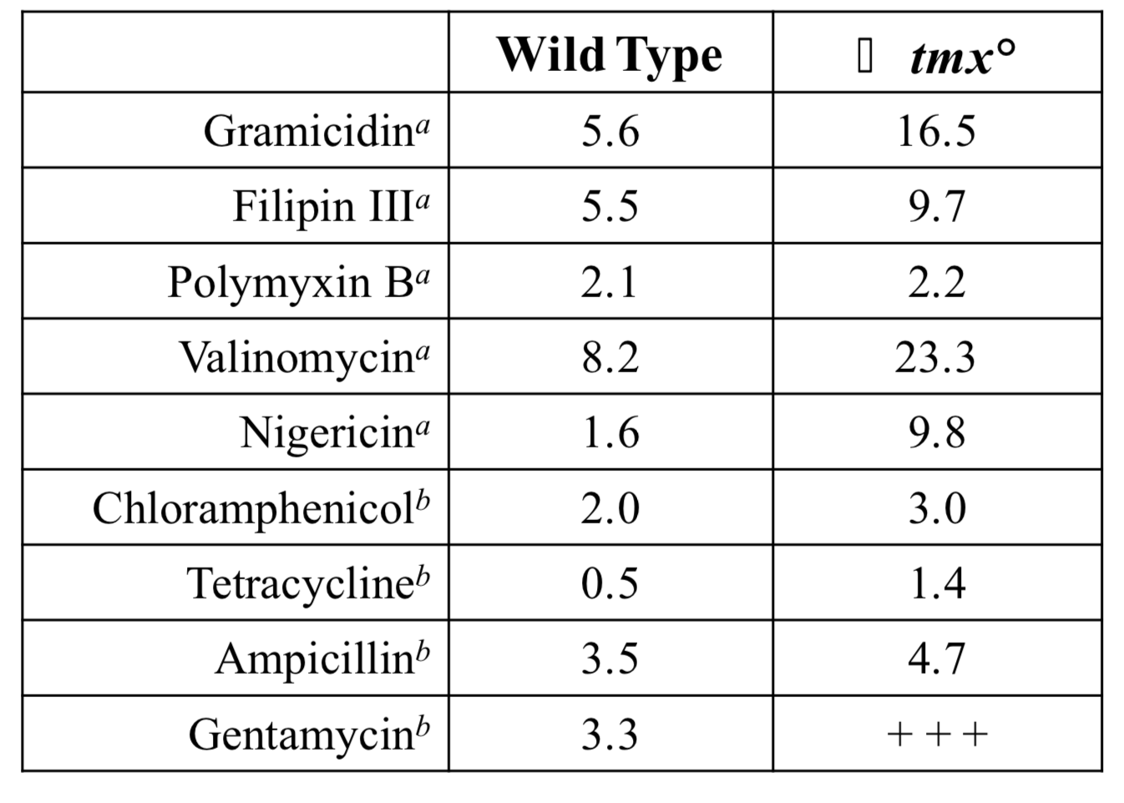

Table 2. Antibiotics for which minimum inhibitory concentrations will be determined in wild type Bacillus subtilis and its ΔyplQ mutant derivative.
Antibiotics To Be Tested
Chloramphenicol
Gramicidin
Nigericin
Valinomycin

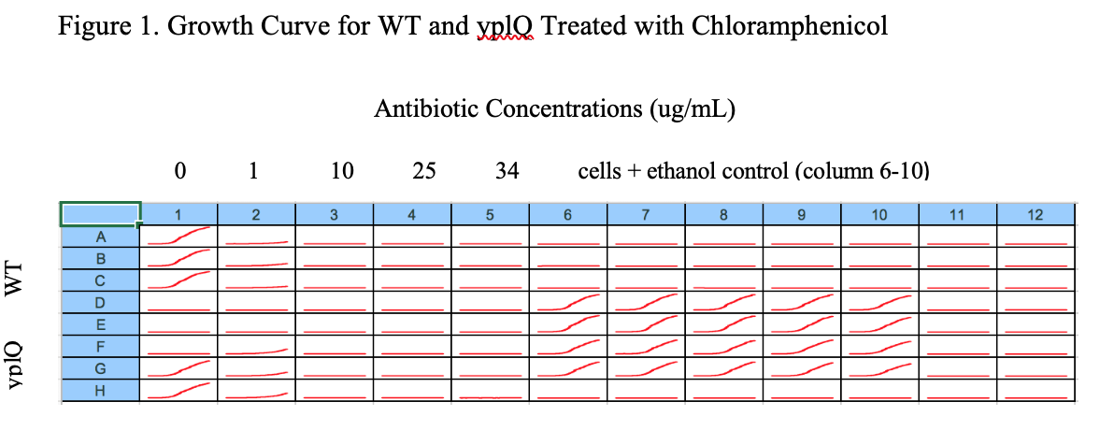

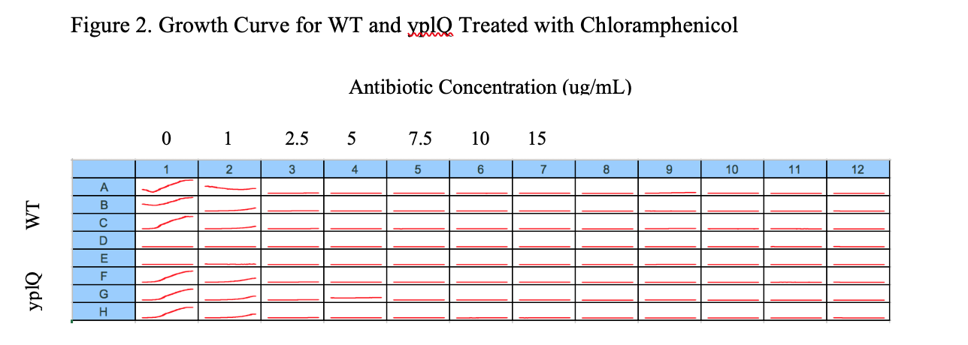

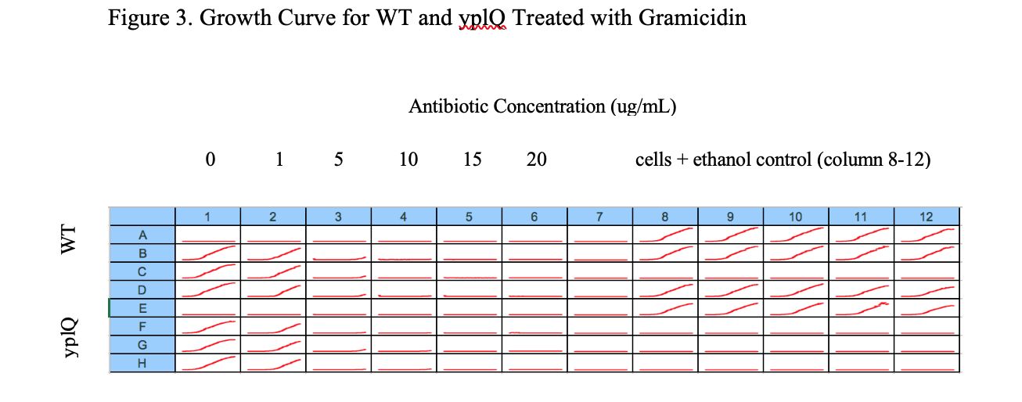

Graph 1. Minimum Inhibitory Concentrations for Bacillus subtilis Wild Type and mutant, ΔyplQ
Mark 1 – 5 on the x-axis indicate the optical density of the wild type. Marks 6 – 11 on the x-axis indicate the optical density of the mutant. There is no significance to the color of each bar in the graph.
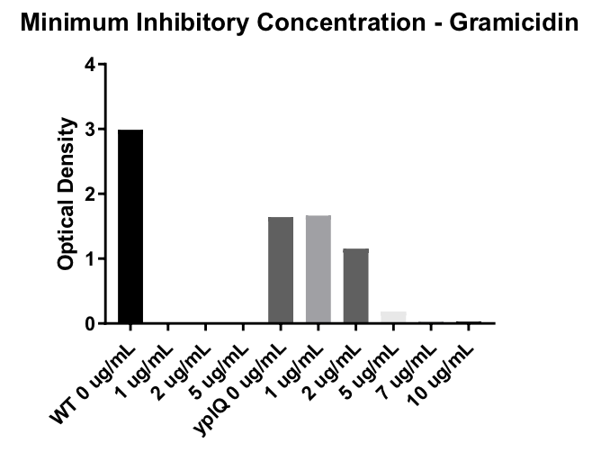

Chapter II: Complications
Introduction
In Chapter I, I tested a hypothesis that stated the mutant lacking the TMX homolog, yplQ, in B. subtilis will present a greater resistance to the antibiotics being tested compared to wild type as deletion of TMX/yplQ would make the membrane more rigid reducing membrane permeability. This hypothesis was tested by determining the minimal inhibitory concentration of the B. subtilis wild type and mutant to a gradient of concentrations of various antibiotics. I tested the hydrophobic antibiotics chloramphenicol and gramicidin. Many of the trials I conducted showed no difference in the minimal inhibitory concentration between the wild type and mutant. Only one trial testing gramicidin yielded promising results that supported the current hypothesis. In those prior experiments, it was deduced that these trials did not produce viable results due to the hydrophobic antibiotics precipitating out of the polar Luria broth solution. However, those results may have also not produced viable results due to contamination of the B. subtilis strains used in the experiments. Through isolation of genomic DNA, polymerase chain reaction to amplify the DNA isolated, and viewing these DNA sequences on a gel, it was determined that the mutant strain being used had been contaminated with the wild type strain to produce another wild type strain.
In order to solve this problem, bacterial cultures were grown from stocks of both strains and an older stock labeled as a mutant. Genomic DNA was isolated from random colonies selected from those bacterial cultures. Polymerase chain reactions were used to amplify this isolated DNA. To ensure the true mutant was isolated, the amplified DNA was ran and analyzed on a gel. Using this method, by chance, we were able to isolate the true mutant. Unfortunately, the new stocks containing the correct bacterial strains were lost. Moving forward, multiple different methods were employed to isolate the mutant from the contaminated stocks. These methods included testing the swimming and swarming abilities of each stock, as well as growing cultures on plates inoculated with a gradient of antibiotics. To determine if the true mutant had been isolated from the swim, swarm, and antibiotic plates, the genomic DNA from the cultures was isolated, amplified through polymerase chain reactions, and analyzed by running on a gel.
Materials and Methods
Swim Plates
B. subtilis and the contaminated stock of the mutant strain, ΔyplQ, cultures were grown form Luria broth (LB) plates with no antibiotics. To make liquid cultures, a colony was inoculated into 5 mL of LB and shaken at 200 rpm at room temperature overnight. After the cultures reached stationary phase, the optical density was measured and diluted to an optical density of 600 for each sample. 5 microliters of each sample was inoculated in the center of plates containing terrific broth (0.3% agar concentration) and 10x PBS before the plates could solidify. Each plate contained 24 mL of terrific broth and 2.2 mL of 10x PBS mixed together.
Swarm Plates
B. subtilis and the contaminated stock of the mutant strain, ΔyplQ, cultures were grown form Luria broth (LB) plates with no antibiotics. To make liquid cultures, a colony was inoculated into 5 mL of LB and shaken at 200 rpm at room temperature overnight. After the colonies reached stationary phase, the optical density was measured and diluted to an optical density of 600 of 0.6 for each sample. 5 microliters of each sample was inoculated in the center of plates containing terrific broth (0.6% agar concentration) and 10x PBS. Each plate contained 24 mL of terrific broth and 2.2 mL of 10x PBS mixed together. The samples were inoculated atop the solidified terrific broth and 10x PBS mixture.
Inoculating Bacterial Cultures with Antibiotics
B. subtilis and the contaminated stock of the mutant strain, ΔyplQ, cultures were grown from Luria broth (LB) plates with either kanamycin (50 mg/mL), ampicillin (100 mg/mL), or gentamycin (20 mg/mL). To make liquid cultures, a colony was inoculated into 5 mL of LB and shaken at 200 rpm at room temperature overnight. After ensuring all the liquid cultures reached the stationary phase, the optical density was measured. Each culture was diluted to an optical density of 600 of 0.005. The kanamycin plates were made with a concentration of 50, 100, 150, and 200 mg/mL of kanamycin per plate. The ampicillin plates were made with a concentration of 100, 200, and 300 mg/mL of ampicillin per plate. The gentamycin plates were made with a concentration of 20, 40, 60, and 80 mg/mL of gentamycin per plate. The bacterial samples were inoculated in each plate after each plate solidified. These plates were left at room temperature, not shaken. The growth of each culture was noted after three days.
Isolating Genomic DNA
To make liquid cultures, a colony from the purported wild type and mutant of B. subtilis was inoculated into 5 mL of LB and shaken at 200 rpm at room temperature overnight. After the cultures were grown, the cultures were centrifuged for 5 minutes at 22 degrees Celsius and 40 rpm. The cells were resuspended in 480 microliters of 50 mM EDTA. To further isolate the genomic DNA, the Wizard® Genomic DNA Purification Kit protocol was used (Promega Corporation).
Polymerase Chain Reaction
To make liquid cultures, a colony from the purported wild type and mutant of B. subtilis was inoculated into 5 mL of LB and shaken at 200 rpm at room temperature overnight. After the cultures were grown and the genomic DNA was isolated, 1 microliter of the isolated DNA was added to Eppendorf PCR tubes containing 1 microliter of STAR polymerase, 5 microliters of buffer, 2 microliters of dNTPS, 0.5 microliters of forward and reverse primers of YplQ, and 15 microliters of deionized water for a total of 25 microliters in each tube. The forward and reverse primer sequences of YplQ can be seen in Figure 1. The denaturation, annealing, and elongation temperatures, as well as the length of time the samples would be in these phases was determined to be 98 degrees Celsius for 45 seconds, 98 degrees Celsius for 10 seconds, 52 degrees Celsius for 15 seconds, 68 degrees Celsius for 30 seconds, and 72 degrees Celsius for 5 minutes. The samples could be held at 4 degrees Celsius for an infinite amount of time.
To ensure the correct DNA sequence was isolated and amplified, the samples were ran on a gel. To make the gel, 100 mL of TAE buffer and 0.8 grams of agarose were heated for 2 minutes or till the solution was transparent and bubbling. The solution was cooled for 5 minutes. 2 microliters of ethidium bromide was added to the solution and the solution was gently swirled so no bubbles were formed. The solution was poured into a mold with combs inserted into the mold. 15 minutes was needed for the solution to solidify. After the solution has solidified, the combs were removed and TAE buffer was poured to cover the wells. The gel was loaded with the amplified DNA by combining 10 microliters of DNA and 2 microliters of 6x loading dye. 10 microliters of this mixture is loaded in each well. The gel is run for 45 minutes at 20 amperes.
Results
In Chapter I, no viable results were produced to indicate that deletion of the gene encoding for YplQ would confer an increased antibiotic resistance in the B. subtilis mutant. While this may have been due to complications with the experimental model, it was also found that the mutant strain was contaminated. It was determined that the purported mutant strain had transformed into a wild type. In an attempt to isolate the mutant strain from the purported wild type and mutant stocks, as well as an older stock labelled as a mutant, as swim plate assay was conducted. 44 hours after inoculating the swim plates, it was seen that the average growth of the purported wild type strain was 0.9 millimeters in diameter. The purported mutant strain had grown to an average of 1.8 millimeters. The older mutant stock had grown to an average of 1.7 millimeters in diameter. These measurements can be seen in Figure 2 and pictures of the swim plates can be seen in Figure 3. The purported wild type strain was also the only strain that was swimming. The purported mutant and older mutant stock were not swimming. Liquid cultures were grown using samples taken from these plates after more time had passed. The genomic DNA was isolated, amplified, and analyzed on a gel. In Figure 4, bands can be see between 500 – 1000 kilobases for all the samples loaded indicating that the gene encoding YplQ (642 nucleotides) is present in the DNA isolated from the samples taken from the swim plates. No band was seen in the negative control. All three samples and sample replicates were shown to still contain the gene sequence encoding for YplQ. This assay was conducted for a second time yielding the same unsuccessful results. A swarm plate assay was also conducted. While the initial results showed a difference in growth among the strains, the genomic DNA was never able to be isolated or amplified as these plates showed contamination.
The strains grown on plates with antibiotics also proved to yield inconclusive results. After 3 days of inoculating the plates with the bacterial strains, the results were noted. While the growth on each plate decreased as the antibiotic concentration increased, no significant differences were seen among the growth of each strain. These results can be seen in Figure 5.
Discussion
The results from the experiments detailed in Chapter I yielded no significant results due to complications with the experimental model, as well as contamination of the mutant strain being tested. This contamination is thought to have been a result of not properly sterilizing the streaking loop after streaking the wild type strain of B. subtilis. The contamination of the mutant strain reintroduced the gene for yplQ resulting in the “mutant” regaining a wild type genotype. To solve this problem, various methods were employed to attempt to isolate the mutant strain from the bacterial stocks. Unfortunately, these experiments yielded no viable results. However, the swim plate assays revealed that the purported wild type strain swam less than the purported mutant strain and the older mutant stock. This indicates that at least two out of the three strains have the same genotype, but it is still unknown if these two strains are a wild type or mutant. This was noted a day after inoculating the swim plates with samples. After 24 hours, each replicate of the strains tested exhibited the same phenotype. The initial difference in swimming motility suggests that a differing genotype is present within these samples. This same initial difference was seen in the swarm plates, as well.

Figure 1. Forward and Reverse Primer Sequences of yplQ
yplQ Fwd |  | TTGTTTACAATCAAAGAAGAG
yplQ Rev |  | TTACGAAAGGAAAGGCACCTT

Figure 2. Diameter Measurements from Swim Plates
Replicates | Purported Wild Type | Purported Mutant | Older “Mutant” Stock
1 | 0.9 mm | 2 mm | 1.7 mm
2 | 0.9 mm | 1.8 mm | 1.9 mm
3 | 0.9 mm | 1.8 mm | 1.7 mm

Figure 3. Swim Plate Pictures
Purported Wild Type
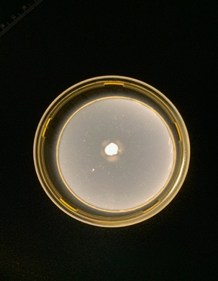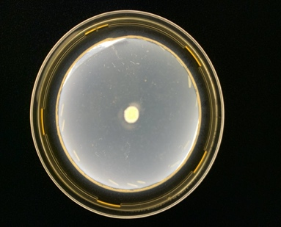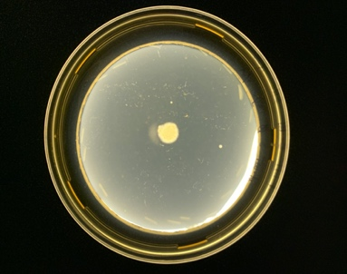
Purported Mutant
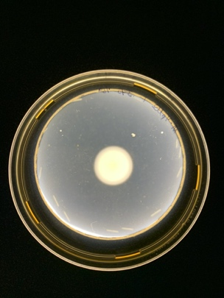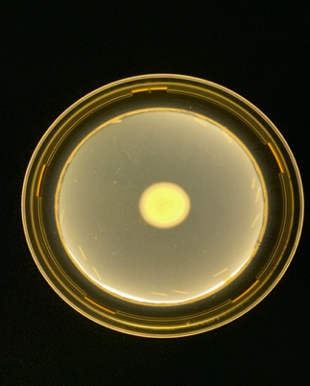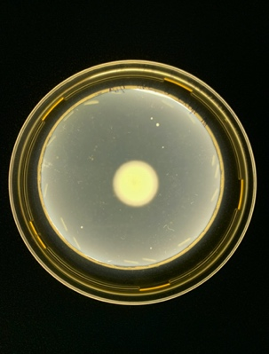
Older Mutant Stock
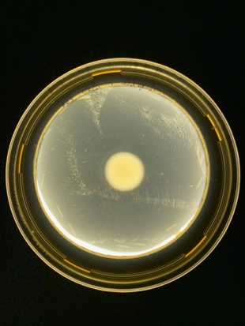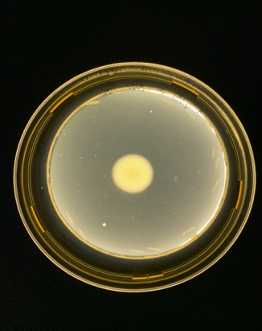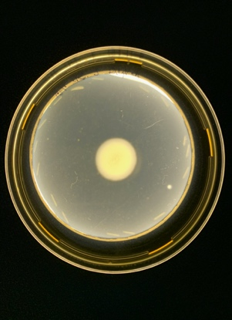

Figure 4. Polymerase Chain Reaction Gel
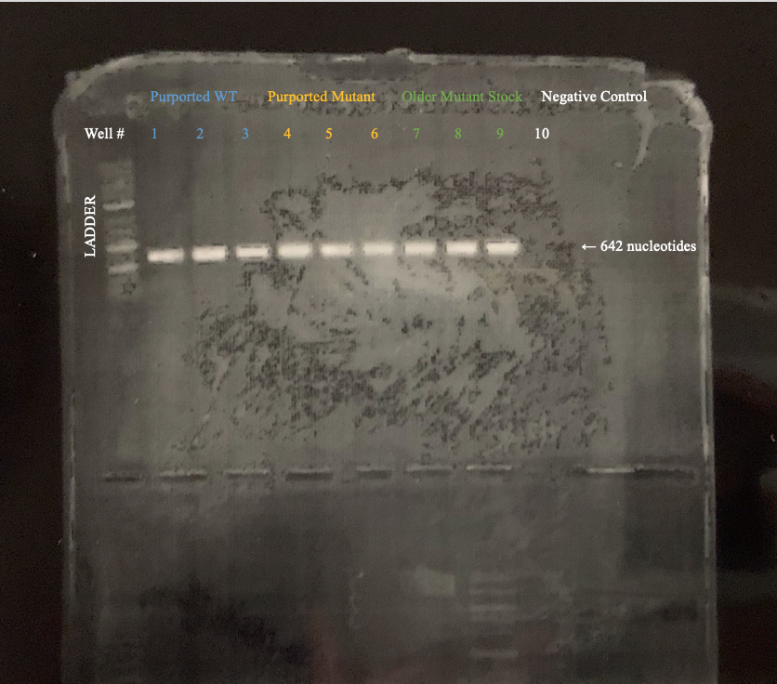

Figure 5. Antibiotic Plate Colony Count
Ampicillin | Purported Wild Type | Purported Mutant | Older Mutant Stock
0 mg/mL | Many colonies | Many colonies | Many Colonies
100 mg/mL | 1 | 2 | 0
200 mg/mL | 0 | 0 | 1
300 mg/mL | 1 | 0 | 1

Gentamycin | Purported Wild Type | Purported Mutant | Older Mutant Stock
0 mg/mL | Many colonies | Many Colonies | Many Colonies
20 mg/mL | 0 | 1 | 0
40 mg/mL | 0 | Contamination | 0
60 mg/mL | 0 | 0 | 0
80 mg/mL | 0 | 1 | 0

Kanamycin | Purported Wild Type | Purported Mutant | Older Mutant Stock
0 mg/mL | Many Colonies | Many Colonies | Many Colonies
50 mg/mL | 1 | 0 | 4
100 mg/mL | 1 | 2 | 1
150 mg/mL | 0 | 2 | 2
200 mg/mL | 0 | 1 | 1

Conclusion
The goal of the present work was to characterize the effect of the homolog of TMX in the Gram-positive bacterium, Bacillus subtilis, and the deletion of this homolog in YplQ. It is thought that the deletion of YplQ would cause changes in membrane permeability, thus conferring increased resistance to antibiotics in the mutant strain. While most of the results from the experiments detailed in Chapter I were inconclusive, the difference in the minimal inhibitory concentration of the wild type and mutant after being exposed to varying concentrations of gramicidin shows promising results for future experiments. These results were obtained after isolating the mutant from the wild type stock confirming that it is possible to isolate the mutant from the wild type once more and prove the stated hypothesis. It is unfortunate that the new stocks containing a true wild type and true mutant were lost; however, using the swim plate assay to separate the two strains shows promise. The best route to move forward with this project is to use the swim plate assay to separate the two genotypes. While the two strains were separated before using a colony polymerase chain reaction, swim plate assays will be a more targeted approach as we have already seen a difference in phenotype among the strains inoculated on the swim plates. The colonies from the swarm plates were never able to be analyzed by isolating the DNA and amplifying it before the plates were contaminated; however, 24 hours after inoculation a difference in swarming motility was able to be seen. This may also be a viable avenue to separating the mutant from the wild type.
As results aligning with the hypothesis were seen with gramicidin, future experiments would concern determining how the deletion of YplQ affects the minimal inhibitory concentration of B. subtilis and its mutant with various pore-forming antibiotics. Pore-forming antibiotics will be a focal point of future research concerning antibiotic resistance in B. subtilis and YplQ as these antibiotics directly attack the cellular membrane of bacteria. This will be give further insight into how YplQ modulates the various biophysical properties of the membrane, as well as how the deletion of this gene affects the antibiotic resistance of Gram-positive bacteria. Along with continuing to test the minimal inhibitory concentration of B. subtilis and its mutant, more swim and swarm plate assays will be conducted. From the results detailed in this work, it is already known that the deletion of YplQ affects the swimming and swarming behavior of the mutant. After ensuring the identity of each strain, future results of swim and swarm plate assays will help to further characterize YplQ and its function within cell membranes.

References
- Zhang, Y., & Rock, C. O., (2008). Membrane lipid homeostasis in bacteria. Nature, 8, 222 – 233.
- Gullet, Jessica Marie. (2017). Functional Characterization of Integrated Chemotaxis Pathways and Proteins in the Soil Bacterium, Azospirillum brasilense (Doctoral Dissertation).

