Utilizing fNIRS to Map the Dynamics of the Motoric Readiness Potential During Reactive Response Inhibition

A Thesis Presented for the
Master of Arts
Degree
The University of Tennessee, Knoxville

James R. Cooper
December 2025
ACKNOWLEDGEMENTS

I would first like to thank my wife, Lori, and our sons, Scotty and Connor, for their support and understanding throughout this endeavor. Also, I would like to thank my advisor, Dr. Aaron Buss. His guidance on this project, while often halfway around the world, and allowing me to explore this topic, has been invaluable. I am equally thankful to Dr. Caglar Tas and Dr. David Sutterer for their constructive feedback, mentorship, and continued support as I completed this degree. Finally, I would also like to extend my gratitude to the graduate and undergraduate students in the ABC Lab, VPC Lab, and the Amp Lab. Though too numerous to name individually, their collective efforts made this project possible.
ABSTRACT

The ability to inhibit a motoric response before the point of no return could mean the difference between an organism's success or failure. Despite decades of research, a disagreement persists regarding the roles of the right inferior frontal gyrus (rIFG) and the pre-SMA in reactive motor inhibition, specifically, which region plays the initiating role. The Bereitschaftspotential (BP), which reflects preparatory activity in motor-related regions of the pre-SMA, SMA, and motor cortices, provides a unique vehicle for visualizing and quantifying motoric activity. Traditionally, this has been investigated utilizing fMRI; however, this study focused on determining the feasibility of leveraging fNIRS during a modified Stop Signal Task to map the neurovascular coupling in these regions. A channel-based analysis during inhibitory control trials revealed significantly greater oxygenated hemoglobin (HbO) in the right inferior frontal gyrus (rIFG) during successful stop trials when compared to go trials. In contrast, when comparing failed to successful stop trials, increased HbO relative to deoxygenated hemoglobin (HbR) was observed in the premotor cortex (PMC) and primary motor cortex (M1), reflecting motor activation in the absence of inhibitory engagement from the rIFG. These findings suggest a dominant role of the rIFG over the pre-SMA when reactive motoric response inhibition is required, initiated, and successful, and validates the use of fNIRS as a robust approach to resolving the temporal and spatial contributions of these structures.

Key Words: Bereitschaftspotential, Readiness Potential, Response Inhibition, Stop Signal
Task, fNIRS, Reactive Inhibition
- Table of Contents

Chapter One: Background 1
Historical Perspectives 1
Neural correlates of Motor Inhibition 6
Present Project 7
Chapter Two: Inhibition 9
Motoric Response Inhibition 9
Testing Response Inhibition (SST) 11
Chapter Three: Experimental Methods 14
Participants 14
Stimuli and Apparatus 14
fNIRS/EEG Data Collection 14
Procedure 17
Behavioral task (SST) 17
Chapter Four: Results 20
Behavioral Results 20
fNIRS-Based Analysis 20
Chapter Five: Discussion 26
Limitations and Future Directions 28
REFERENCES 31
Vita 39

TABLES
Table 1. Characteristics of Types of Inhibition 11
Table 2. Descriptive Statistics for SST (Mean Method) 20
Table 3. Descriptive statistics for the SST (Integration Method) 21

LIST OF FIGURES

Figure 1.Temporal Progression of the Motoric RP 3
Figure 2. Representation of the Rp depicting time(ms). 4
Figure 3. Progression of the readiness potential 7
Figure 4. Descending orders of Inhibition 10
Figure 5. Depiction of commonly used SST 12
Figure 6. Optode array depicting the source and detector placement 15
Figure 7. Photo of fNIRS-EEG cap used in the current study 16
Figure 8. Depiction of the modified SST for this project 18
Figure 9. FNIRS optode array designed for this study 23

Chapter One: Background

Historical Perspectives
A significant finding in cognitive neuroscience is that a negative cortical potential occurs in the medial frontal cortex preceding conscious awareness of voluntary movement. This phenomenon is a process known as the Bereitschaftspotential (BP). The name is derived from the German words ‘Bereitschafts’ and ‘potentials,’ which loosely translates into English as the readiness potential (Patil & Preet, 2015). The phenomenon was first discovered by Hans Helmut Kornhüber and Luder Deecke in 1964 during experiments that sought to measure electrical activity in the cortex using single-sweep EEG recordings during the start of self-initiated movement ( Shibasaki & Hallett, 2006; Schurger et al., 2021). By back-averaging EEG time-locked to movement onset, it was found that electrical activity was noted up to 1.5 seconds before voluntary finger flexion beginning in the pre-SMA and pre-motor cortex (Kornhüber & Deecke, 1965/2016). Continued research findings show that while small amplitude variations exist between human subjects, the primary temporal and spatial properties did not vary between participants.
As the use of EEG became more widespread in the investigation of stimulus-response actions and inhibition, additional event-related potentials closely aligned to the motoric readiness potential were discovered. The Contingent Negative Variation (CNV) was discovered by W. Grey Walter and published in Nature in 1964, which described a slow-moving negative potential along the motor cortex that occurs between a ‘warning stimulus’ and a go signal (Walter et al., 1964). Although many believed it was separate from the motoric readiness potential, debate persists due to the similarities in duration, spatial distribution, and amplitude to the Bereitschaftspotential. As a result of this close functional similarity, Tecce (1972) posited that the CNV is most likely a part of, or identical to, an electronegative progression observed in the BP.
By the 1980s, an additional motoric potential, the lateralized readiness potential (LRP), was first described as being a late-stage component of the BP and identified as a reflection of the preferential component of the premotor cortex and motor cortex M1 just before movement initiation (Coles & Gratton, 1986). It has been described as a difference wave that shows greater activation over the contralateral motor side versus the ipsilateral motor side of the cortex (Eimer, 1998). Even today, many still misidentify the lateralized readiness potential as being the motoric BP. As Chiarenza (2021) noted in EEG studies of the Bereitschaftspotential, the LRP, N100, and P200 are all components of the motoric readiness potential and play a role in motoric reaction to a stimulus.
Shibasaki & Hallett (2006), in the canonical paper on the different stages of BP progression, identified what would become known as the early and late BP (see Figure 1), which serves as a road map of the structural activation viewed through a temporal lens. While motoric output lies at the end of this electrical progression, the lead-up to pre-motor cortex and motor cortex involvement is not as well understood. Surprisingly, while this ‘lead up’ to motoric response to a stimulus is universal Kornhüber and Deecke (1965) noted two distinct forms of Bereitschaftspotential exist: a positive polarity noted in children and a negative polarity as is seen in adults.
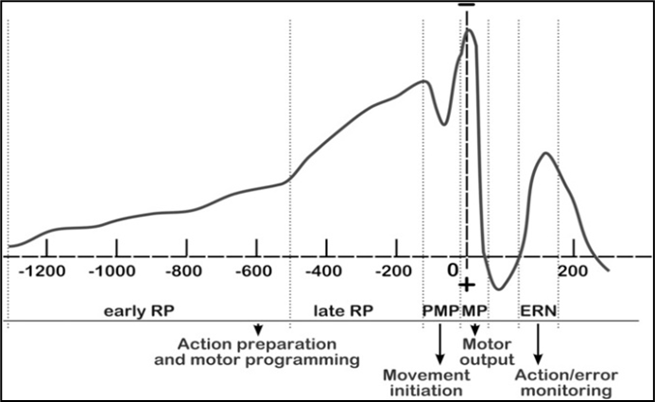
Figure 1.Temporal Progression of the Motoric RP. Adapted from Neuropsychology of the Unconscious (p. 60), by M. Balconi et al, 2019.

The Bereitschaftspotential (BP) moved from its academic underpinnings in research and neurophysiology into the popular culture when Benjamin Libet inexorably linked the potential to human free will and conscious awareness (Libet et al., 1983). He asked participants to respond with a motor movement when they felt the need to flex their wrist while recording the time they consciously decided to act. Libet noted the presence of a BP occurring approximately 200 ms before the participants reported conscious decisions. Clark (2013) illustrates the temporal mapping of the readiness potential (Figure 2), indicating that participants typically reported experiencing the intention to move approximately 200 milliseconds before initiating voluntary movement, roughly 800 milliseconds after the BP was first observed via EEG. Libet et al. (1983) believed this finding suggested that unconscious processes might initiate voluntary actions before individuals become aware of their decision.
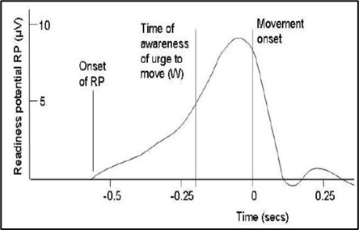

Figure 2. Representation of the Rp depicting time(ms) that Libet’s participants indicated that they felt an awareness to move (Clarke, 2013).

Even after 40 years of debate and repeated publications on variations of the Libet-style experiments to validate the original findings, a meta-analysis was not conducted until recently. Braun & Friese (2021) analyzed 1,614 articles that were data harvested to yield results containing both the words free will and Libet. Even with uniform heterogeneity across the reported times of the intent to move prior to movement, this temporal window was surprisingly narrow. Calling into question the conscious will as an underpinning to the readiness potential, research shows the phenomenon is not just unique to humans but occurs in monkeys (Romo & Shultz, 1987), rodents (Seki et al., 2005), and even invertebrates like crayfish (Kagaya & Takahata, 2010).
By the 1990s, subtle changes in the readiness potential were being used as a
diagnostic tool to investigate a wide range of motor-related abnormalities, like Parkinson's disease (Jahanshahi et al., 1995), psychiatric disorders that often have a motoric component, such as schizophrenia (Leonard et al., 2012), and even severe clinical depression (Haag et al., 1994). Findings by Damme et al. (2021) showed motoric abnormalities were often correlated with depression, but they were not able to conclude a direction of causation. Supporting this comorbidity associated with psychological disorders, recent findings with myoclonic jerky movements, such as those found with Gilles de la Tourette syndrome (GTS), have demonstrated shorter duration Bereitschaftspotential than seen in healthy control subjects (Salm et al., 2012). Not surprisingly, even skilled and unskilled movements have also been found to show that practice effects will result in an increase in the amplitude of the BP. Chiarenza (2020) contended that although the BP serves as an indicator of motor preparation, its subtle fluctuations may reflect enhanced task-related efficiency developed through learning. The author argued that even though the BP is a window into motor preparation, slight variations may be associated with increased learned efficiency to accomplish a task.
More recent work has solidified the BP and the emerging algorithms in modeling
neural networks to drive brain-computer interfaces (BCIs). Hernández‑Gloria et al. (2025) evaluated the BP in a speller paradigm, where participants executed foot flexion to trigger letter selection. Across control, phrase, and random-letter conditions, an average detection rate and interpretation of the BP achieved a rate of close to 70% accuracy on detecting movement before flexion. A meta-analysis by Robinson et al. (2024) looked at results from stroke recovery using a BCI of the motor cortex using both non-invasive neuroimaging and implantable technology. It was reported that through a conditioning feedback loop enhanced by machine learning pattern recognition software and repetitive training that participants regained some functional motor control. Chiarenza (2022) reported the same increased performance and morphological changes in the Bereitschaftspotential during motor activation and repetitive training of stimulus response. Along the same line of inquiry, the current trend lies with mapping the late-phase BP to drive prosthetics and TBI, yet fails to address the ‘black-box’ issue of executive functioning and conscious awareness, and how it drives the early BP prior to pre-SMA activation (Fifel, 2018; Alexander et al, 2015).

Neural correlates of Motor Inhibition
Motoric reactive response inhibition is one of the primary components of executive functioning. Scham et al. (2021) points out that while some studies localize the initiation of motoric inhibition to rIFG, just as many findings attribute this starting point to be located in the pre-SMA as a reflection of bottom-up processing. Temporal studies using EEG have found evidence for both during reactive response inhibition. This debate may exist due to the lack of data on hemodynamic activity across both spatial and temporal dimensions during response inhibition tasks.
While the progression of the readiness potential can generally be observed 1.5 s before voluntary movement onset, fMRI studies concluded earlier activation in the ACC and aMCC prior to pre-SMA activation (Nguyen et al., 2014). While these reciprocal connections between the ACC, aMCC, and pre-SMA are regarded as important for the maintenance of the readiness potential, the exact mechanisms and functional relationships remain unclear.
As demonstrated in Figure 3, and for the scope of this project, the BP can be divided into early and late-stage elements that provide a better understanding of the
associated anatomy involved during the progression of a motoric response. During
the electrical/temporal progression, a slow rising electronegative potential begins
Figure 3. Progression of the Spatial (A) and temporal (B) readiness potential. From “The Libet Experiment and Its Implications for Conscious Will,” Peter G. H. Clarke, https://bethinking.org.

B
A

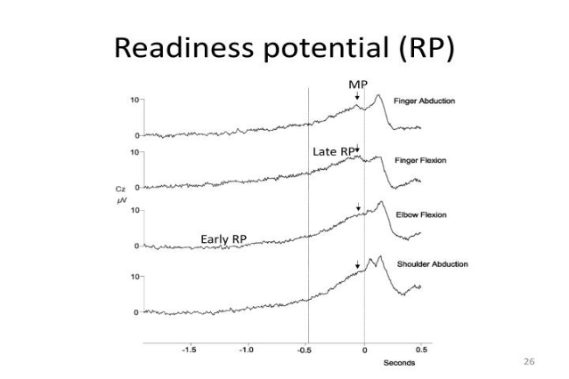
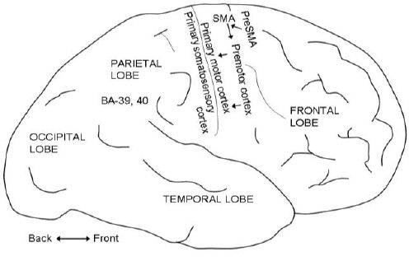
in the early RP, which is analogous spatially to activation of the pre-SMA. During this temporal progression, the SMA proper is activated with no somatotopic organization. Approximately 400 ms before movement begins, the steeper slope referred to as the late BP begins in the contralateral Pre-motor cortex and M1 with precise somatotopy. This final stage is often called the Lateralized Readiness Potential (LRP) and is found to represent motor preparation at the precise moment of flexion (Jahanshahi, 2003).
This non-standard nomenclature has created a great deal of confusion in past studies, with many researchers referring to the Bereitschaftspotential as the (RP) readiness potential, BP (Bereitschaftspotential or (NS) negative slope while they are all describing the same negative potential observed prior to movement (Ashlesh, 2015).

Present Project
The primary focus of this project was the development of a validation study to explore the use of fNIRS as a neuroimaging platform to map cortical activity of the motoric readiness potential (Bereitschaftspotential) and identify the initiating region involved with reactive motoric inhibition. This project sought to replicate and extend current research on whether a functional hemodynamic association exists between the rIFG and the pre-SMA/SMA during reactive motoric inhibition. While numerous studies provide consistent evidence of the importance of the rIFC and the pre-SMA/SMA in response inhibition and show some functional association, the spatial/temporal progression and initiation of these structures is currently still debated (Allen et al., 2018; Meyer, 2015; Aron, 2007).
While a large body of literature exists that utilizes fMRI, limited studies explore the use of fNIRS as an alternative neuroimaging tool for cortical mapping during this motoric progression (Cui et al., 2011). With the availability, portability, and cost effectiveness of fNIRS, it makes for a more viable alternative to studying hemodynamic activity as a bimodal tool with EEG when one considers the limitations of the induced gradient noise and strong magnetic fields associated with fMRIs. While traditionally being considered a spatial neuroimaging platform, Brigdoi et al. (2012) successfully used fNIRS to observe motoric activity during short-duration movements to temporally map activity in the cortex along the progression leading up to flexion.

Chapter Two: Inhibition

Motoric Response Inhibition
In psychology and neuroscience, inhibition has been used interchangeably to explain many physiological and cognitive processes, from the inhibitory effects of Gamma-aminobutyric acid (GABA) neurotransmitters impeding action potentials to the more top-down prepotent inhibition (Aron, 2007). For the scope of this study, it is recognized that maintenance and modulation of inhibitory responses are assisted by the more insular thalamo-cortical loop; however, this project has chosen to focus on the Bereitschaftspotential (BP) that can be imaged solely with fNIRS and provide a surface cortical map of neural activity, thus elucidating the rIFG and pre-SMA.
Aron (2007) finds that researchers have grappled with the definition of response inhibition for decades and have used several diverse cognitive processes to attempt to explain the phenomenon. Included in this diverse catalog are things such as 1) cognitive development to suppress more biological urges, 2) learning and dissociating older information in almost a Bayesian analytical form, and 3) suppression of conscious awareness of memories that allow us to inhibit on an unconscious level.
Recently, experimental psychologists have begun to recognize two distinct forms of response inhibition: proactive and reactive. Reactive inhibition defined as occurring after a response to a stimulus has already been initiated—the cessation of a motoric response that is already in progress. Conversely, proactive inhibition refers to whether a response process will even be initiated or activated (Meyer, 2016). This level of
characterization can be considered as reactive inhibition being a bottom-up process, while
proactive inhibition is a higher-level function involving top-down processing, where a
decision is made prior to movement (Kenemans, 2015).
As seen in Figure 4, an outline of the descending orders of inquiry into response inhibition and the functional and mechanistic divisions that exist between the fields of psychology and neuroscience is depicted. While the line blurs somewhat when looking at the differences between active/willed inhibition and selective attention due to the presence of distractors initiating inhibition, for the scope of this project, only motoric inhibition was addressed.
Notably, the neural correlates demonstrate alignment temporally with respect to
motoric activity in both top-down and bottom-up processing after the involvement of the
frontal cortex (see Table 1). Before pre-SMA involvement, the debate still exists on
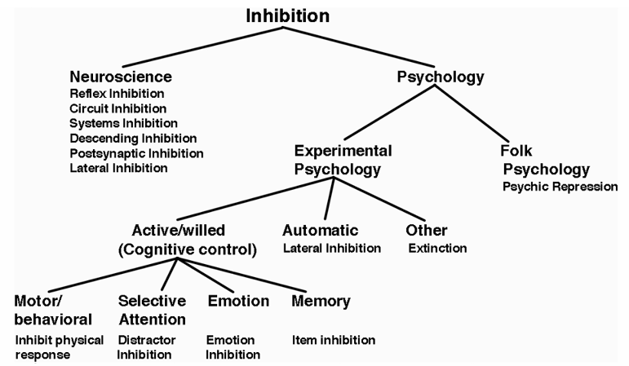
Figure 4. Descending orders of Inhibition. Diagram adapted from The Neural of Basis
of Inhibition in Cognitive Control, by A.R. Aron, The Neuroscientist, 2007, 13(3),
pp. 214–228., 2007 Sage Publications.

functional activation of the rIFG and dLPFC, with both showing varying degrees of
activity and parallel processing. For the scope of the fNIRS data collection of this project, only activity noted during go trials, successful stop trials, and failed stop trials will be analyzed, and then only as a spatial association that exists between the frontal cortex and the area of motor cortices displaying hemodynamic activity where successful inhibition occurs.

Testing Response Inhibition (SST)
While many behavioral tasks exist to test response inhibition and visualize the temporal progression of prepotent motoric activity, one canonical task, the Stop Signal Task, developed in 1966, stands out as a benchmark for measuring reactive inhibitory control. Arguably used more than any other task to test reactive inhibition, the SST allows the researcher to precisely gauge the temporal activity involved with stopping an action once it is already in motion (Lappin & Eriksen, 1966).
The SST is designed to investigate a person's ability to stop a motor response when a signal is presented. In the canonical version of the task, participants are asked to respond quickly to a frequent “go” signal. This is usually represented by an arrow pointing either left or right.
Table 1. Characteristics of Types of Inhibition
Feature | Reactive Inhibition | Proactive Inhibition
Stimulus | External (SST) | Anticipation only
Stim. Timing  Timing (ms) | After signal  ~200-250 ms | Before signal  NA
Neural Strategy | Bottom-up | Top Down
Testing method | Stop Signal Task (SST) | Memory List Tasks
Neural Correlates | rIFG, pre-SMA, SMA, M1 | DLPFC, pre-SMA, SMA, M1

During a subset of trials, a “stop” signal, which historically is set at .25 percent of the total trials, is presented after the go stimulus. This indicates that the participant is to withhold their response, and no further action is required. The key measure observed during this task is the Stop Signal Reaction Time (SSRT), which is an estimate of the time it takes for an individual’s motor cortex to inhibit a response once the stop signal is perceived (see Figure 5).
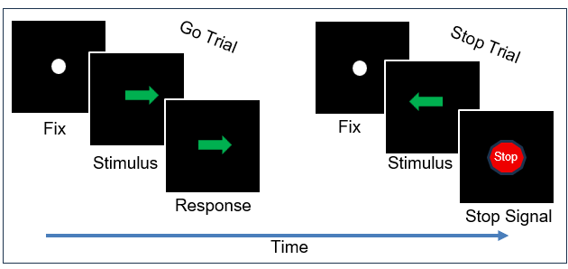
Logan and Cowan (1984) viewed the Stop Signal Task (SST) as a race between two competing runners: a “go runner,” initiated by the onset of a go stimulus, and a “stop runner,” triggered by the stop signal. If the stop runner finishes the race first, the response is successfully inhibited. However, if the go runner wins, the inhibition fails, resulting in the execution of the response. The SST has also become a behavioral tool instrumental in studying cognitive disorders. Filmore & Rush (2002) showed that addiction and
Figure 5. Depiction of commonly used SST

substance abuse resulted in longer SSRTs in chronically addicted cocaine users. This was found to be indicative of PFC damage resulting in executive function abnormalities with processing tasks requiring inhibition.

Chapter Three: Experimental Methods

Participants
Participants were recruited through the University of Tennessee, Knoxville SONA system. While an original sample size of 6 was considered adequate to verify a proof-of-concept exploratory model for this neuroimaging project, 10 were analyzed, with participants who were unable to complete all the trials while wearing the fNIRS cap excluded from analysis. The resulting participant pool consisted of 6 males and 4 females, all between the ages of 18 and 29, M_{age}=21.4, (SD = 3.47). All had normal or corrected-to-normal vision. Participants provided written informed consent, completed a demographics survey upon arrival, and were compensated with course research credit upon completion of the study. The University of Tennessee, Knoxville’s Institutional Review Board approved the proposed study's protocols.

Stimuli and Apparatus
An ASUS TUF gaming monitor, VG259QR with a 24.5-inch 1080P display and a refresh rate of 165Hz was used to display the task. Participants were seated in a desk chair approximately 54 cm from the screen. Stimuli for the tasks were programmed using MATLAB R2023b (The MathWorks, Inc., 2023) and Psychtoolkit (Kleiner, Brainard, & Pelli, 2007), which was based on open-source code by Verbruggen et al. (2008) and
published to run on a Windows-based computer.

fNIRS/EEG Data Collection
Functional Near Infrared Spectroscopy (fNIRS) data sampling at 25 Hz was
collected using a 28-channel (30 mm separation; 8 sources and 16 detectors) TechEn
CW7 system (TechEn Inc., Milford, Massachusetts). Near-infrared wavelengths of 830
nm and 690 nm were utilized to document hemodynamic activity by recording changes in concentrations of oxy and deoxyhemoglobin. In fNIRS, near-infrared light is emitted from the source optodes and travels through tissue, bone, and meninges to the cortex before being recollected by the detector optodes. These were positioned bilaterally along the longitudinal fissure. Using Beer-Lambert’s law, this light is transformed into a spatial measure of cortical activity (see Figure 6-A, B). This data was processed using Forbes et al. (2022) MRI-NIRS Pipeline, which involves using fNIRS analysis software Homer 2 (Huppert et al., 2009), fNIRS preprocessing toolbox NeuroDOT (Eggebrecht & Culver, 2019), and fMRI analysis software AFNI (Cox, 1996). sensors A–E, and detectors 1–16. The fNIRS optode coverage targeted areas of the cortex involving movement and inhibition, and included the right Inferior frontal gyrus (rIFG), premotor cortex
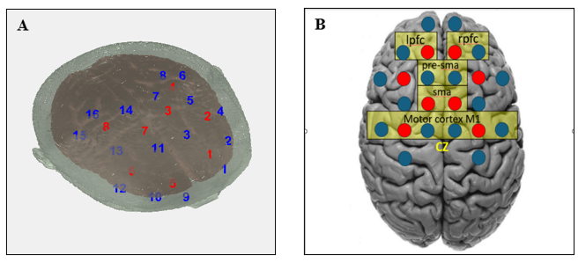
Figure 6. Optode array depicting the source and detector placement. fNIRS sources are
shown in red and the detectors in blue. (A) Polhemus digitalization showing 3-D
representation of source/detector coverage mapped onto the cortex. (B) is the array
designed to cover the left and right prefrontal cortex and motor cortices.

(PMC), primary motor cortex (M1), primary somatosensory cortex (S1), supplementary motor area (SMA), and premotor cortex (PMC) on both hemispheres. mounted between
the fNIRS optodes as seen in Figure 7, using the international 10-20 sites O2, Oz, O1, P8, P4, Pz, P3, P7, PO8, PO4, POz, PO3, PO7, T8, C4, Cz, C3, T7, FC6, FC5, F8, F4, Fp1, Fz, Fp2, F3, and F7. Four additional reference electrodes with stickers were placed on the left and right mastoids and in the corners of the left and right eyes to filter ocular activity. While EEG was not analyzed, pre-processing would have centered on sites Fz, Cz, C3, C4, which display the highest amplitude during the readiness potential, with Cz detecting maximum amplitude (Patel, 2016).
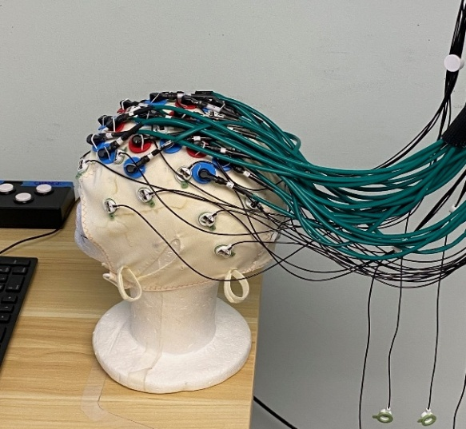

Figure 7. Photo of fNIRS-EEG cap used in the current study. EEG electrodes were
placed using the international 10-20 sites. The fNIRS lights (red grommets) and
detectors (blue grommets) were positioned to measure the right and left PFC and theotor the motor cortices.

Procedure
The study took place over one approximately 2-hour session. After arriving for the scheduled time slot, the participants were provided with a brief description of the task and shown the fNIRS/EEG cap they would be wearing during the trials and the method the researchers would use to gel the EEG electrodes to obtain good impedance between the electrode detector and the participants' scalp. The informed consent was then provided to participants to read, and once completed and signed, they were provided with the demographics form to complete.
The fNIRS/EEG cap was then measured on the participant’s head such that the Cz
electrode was situated at the center point of the scalp. Next, a digitization of the fNIRS
probe was made using a Polhemus motion tracking system. A quality check was then
performed on the fNIRS system, and lights and detectors were adjusted if necessary to provide optimal detection. The initial set-up took approximately 30-45 minutes.
Upon obtaining an acceptable source/detector and EEG coverage of the rIFG and motor cortex, the participants were seated approximately 54 cm in front of the display screen. The participants were asked if they were comfortable and ready to begin the behavioral task. If they responded in the affirmative, the task began; if the cap was uncomfortable, it was readjusted to optimum. Participants were then instructed to remain as still as possible during the behavioral task.

Behavioral task (SST)
The task used for this project was based on a Stop Signal Task, with only the
stimuli being modified in appearance. Once the task was run on the behavioral computer,
the participants were presented with instructions for the upcoming trials and prompted to
press (S) on the keyboard when they are ready to begin the experiment. Intertrial variability was introduced to prevent the participant from developing a potential sensory-motor pattern, which might alter the inhibition times (see Figure 8). It is important to note that the saliency of the go stimuli in the SST has been found to significantly alter the
outcomes of the task. In some later SST trials, the behavioral data suggested that the addition of mapping color/shape onto a motor cue had served to only increase the cognitive load required for the task, creating a significant difference between easily recognizable cues like arrows and shapes like boxes and circles (Verbruggen et al., 2019).
When the trial begins, the participant is presented with a fixation point in the form of a white dot located in the center of the display on a black background. After 250 ms
from the presentation of the fixation point, either a left or right white arrow is displayed
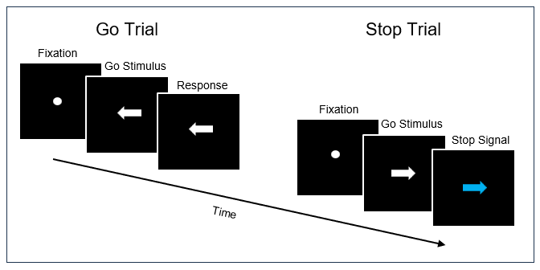
Figure 8. Depiction of the modified SST for this project. Participants respond to either a left or a right arrow as the Go task. On 25% of trials, the arrow turns blue after a stop signal delay, indicating to the participant that they are to withhold their response.

as the go stimulus. The participant would then press either the left or right arrow on the keyboard. The stimulus will remain on the screen until the participant responds or either 1250 ms (maximal RT) has elapsed. For this study, the participant was given one block of 32 trials, which contained 8 stop signals and 24 go signals. Next, the participant was presented with five experimental blocks of 96 trials each. Experimental blocks contained 24 stop signals and 72 go signals. A random intertrial variability was introduced for both the practice and experimental blocks.
On trials where a stop signal is displayed, the stop signal is presented initially at
250 ms and is adjusted throughout the experiment with a staircase tracking procedure. When a participant succeeds at inhibiting a response, the SSD increases by 50 ms. When not successful and a response is made, the SSD is decreased by 50 ms. Between each experimental block, the participants are required to wait 10 seconds before the next experimental block automatically starts.

Chapter Four: RESULTS

Behavioral Results
While only used as a method of eliciting a reactive inhibitory response for fNIRS analysis, the results of the SST were collected and analyzed from participants who completed the entire task. Two different methods are generally used when analyzing data obtained during the SST: the Mean Method and the Integration Method. Both were calculated for this project. While the mean method is less sensitive and does not allow for a visualization of the Horse-Race Model (Logan & Cowan, 1984), it is more straightforward and does have the advantage of aligning spatial and temporal data if one is using bimodal neuroimaging.
With the Mean SSRT Method, the average Stop Signal Delay (SSD) is subtracted from the mean go reaction times (GoRT). The group-level performance on the Stop Signal Task showed an average Go Reaction Time (GoRT) of 709.22 ms (SD = 284.70), with values ranging from 346.48 to 1072.30 ms. The mean Stop Signal Delay (SSD) was found to be 462.33, spanning from 117.22 to 862.02 ms (see Table 2). Using the mean method, the adjusted average Stop Signal Reaction Time (SSRT) was 181.66 ms with individual SSRTs ranging from 132.00 to 279.50 ms.
These SSRT values fall well within the range typically reported in healthy adult populations, which tend to range from approximately 150 to 250 ms (Logan &
Table 2. Descriptive Statistics for SST (Mean Method)
Measure | M (ms) | SD (ms) | Range (ms)
Go Reaction Time | 709.22 | 284.70 | 346.48-1072.30
Stop Signal Delay | 462.23 | 527.81 | 117.66-1060.77
SSRT | 181.66 | 101.10 | 132.00-279.50

Cowan, 1984; Verbruggen et al., 2019), supporting SSRT’s validity in assessing motor
reactive response inhibition.
The second form of analysis conducted was the Integration Method. While appearing very similar, this method provides a truer reflection of the individual differences present in a participant pool, as opposed to averaging across all participants. SSRTs in the Integration Method are calculated by subtracting the mean stop signal delay (SSD) from the nth percentile of the go reaction time (GoRT) distribution, where n corresponds to the probability of responding on stop trials. (see Table 3).
Participants exhibited a mean Go Reaction Time (GoRT) of 709.22 ms (SD = 284.70), with values ranging from 346.48 to 1072.30 ms. The average Stop Signal Delay (SSD) was 527.81 ms with a range from 117.22 to 862.02 ms. The integration method yielded a mean Stop Signal Reaction Time (SSRT) of 206.09 ms (SD = 119.00), with individual scores ranging from 56.00 to 462.14 ms. The average probability of responding on stop trials, p(respond|signal), was 0.37 (SD = 0.22). Again,
these SSRT values fall within the expected normal ranges of 150–250 ms reported in the literature (Logan & Cowan, 1984; Verbruggen et al., 2019), also supporting the Integration Method for estimating inhibitory control. Notably, only half of the participants for this project had a p(respond|signal) ≈ 0.50. While acceptable for a smaller
Table 3. Descriptive statistics for the SST (Integration Method)
Measure | M (ms) | SD (ms) | Range (ms)
Go Reaction Time | 709.22 | 284.70 | 346.48- 1072.30
Stop Signal Delay | 527.81 | 359.17 | 117.22- 862.02
SSRT | 206.09 | 119.00 | 56.00-462.14

behavioral study, it does fall below the historical averages seen in the literature of 70% to 90% of a tested participant pool having a p(respond|signal) ≈ 0.50.
When averaged across all participants, the mean GO reaction time did show a linear slowing in 7 participants. In contrast, 2 showed quicker reaction times from blocks 0 to 5, and 1 participant had mixed results. Verbruggen et al.(2019) found in a large-scale meta-analysis that Go RTs typically ranged from 400–600 ms across different studies in healthy adults. As observed in this study, mean Go RTs initially started in this range; however, a linear progression of the slowing of Go RT within blocks occurred.

fNIRS-Based Results
A channel-based analysis was used to examine activation patterns at the individual source/detector pairs over specific cortical regions associated with motoric initiation and inhibition. This allowed for a visualization of localized hemodynamic
activity. Given the exploratory nature of this study in mapping activity, a significance level of p=.10 was used to minimize the likelihood of overlooking subtle effects that could be identified for future study.
A 2 × 2 repeated measures ANOVA was conducted with trial type (successful stop vs. go trials) and hemoglobin type (HbO vs. HbR) as within-subject factors. In addition, a second ANOVA was conducted, looking at activation patterns between successful stop trials vs. failed stops and hemoglobin type (HbO vs. HbR). This allowed for a spatial mapping of activation of the associated regions, as is depicted in Figures 9A and 9B.

Go Trials vs. Successful Stop Trials
Motor Cortex (M1)
On Channel 6, Condition 1 (Go trials where no inhibition was required) and Condition 2 (Successful inhibitory Stop trials) and hemoglobin types (HbO vs. HbR) were compared. The condition × hemoglobin interaction reached significance at the exploratory threshold of p < .10, F(1, 9) = 3.52, p = .093, ηp² = .28, indicating greater activation during Condition 2. A comparison of the means revealed that during Condition 1 (Go trials), HbR (M = .009, SD = .017) was slightly higher than HbO (M = –.013, SD = .034), whereas during Condition 2 (Successful Stops), the pattern reversed with HbO (M = .006, SD = .026) exceeded HbR (M = –.008, SD = .015). As is seen in Figure 9B, this indicated activation of contralateral primary motor cortex (M1) corresponding to the right hand, fingers, and forearm, but movement was inhibited prior to flexion.
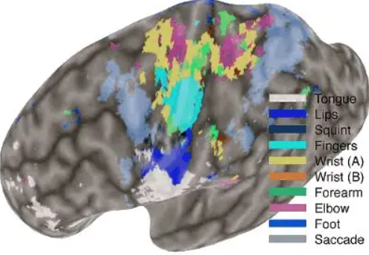
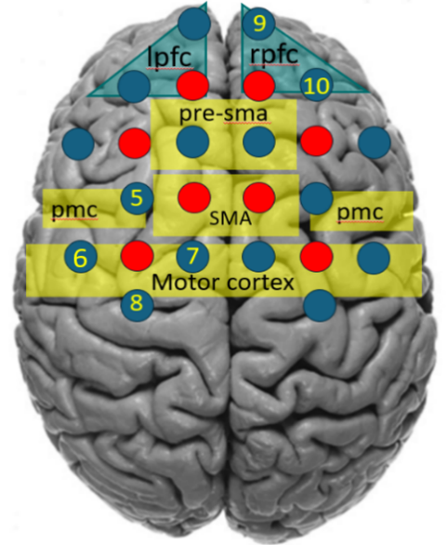
75

75
5

5
6

6
85

85

B

B
A

A
Figure 9:A. FNIRS optode array designed for this study. B. This studies Optode array overlayed on an FMRI mapping of the contralateral motor cortices. Diagram B adapted from Meier, J. D., Aflalo, T. N., Kastner, S., & Graziano, M. S. A. (2008). Complex Organization of Human Primary Motor Cortex: A High-Resolution fMRI Study. Journal of Neurophysiology, 100(4), 1800–1812.

While Channels located over the rIFG, did not show a concurrent significance of condition vs hemoglobin, there was a significant main effect of condition in Channel 9 F(1, 9) = 7.53, p = .023, ηp² = .46, indicating greater activation during successful stops compared to go trials, consistent with increased engagement of the inhibitory control from the rIFG. Channel 10 also approached levels of significance located above the rIFG with the main effect of condition approaching the exploratory threshold with F(1, 9) = 3.22, p = .107, ηp² = .26. As with Channel 9, this could be considered a trending activation of the rIFG during successful inhibitory control.
Successful Stops vs. Failed Stops
Right Inferior Frontal Gyrus (rIFG)
Channel 9, located above the rIFG, reached significance at F(1, 9) = 3.89, p = .080, ηp² =
.30, indicating greater differences between HbO and HbR overall when inhibition was successful vs. unsuccessful. In addition, the condition × hemoglobin interaction was significant F(1, 9) = 3.67, p = .088, ηp² = .29. A comparison of the means showed that in successful stops, HbO (M = .017, SD = .009) was elevated relative to HbR (M = –.006, SD = .003) indicating a recruitment of the rIFG during successful inhibitory control.
Dorsal Pre-Motor Cortex (PMDc)
Channel 5, located above the left dorsal premotor cortical region, showed a significant level of activation just before flexion F(1, 9) = 3.89, p = .080, ηp² = .30, indicating overall differences between HbO and HbR across conditions. A comparison of means suggested that during successful stops, HbO (M = .005, SD = .015) tended to be higher than HbR (M = –.005, SD = .001). While in failed stops, HbO (M = .002, SD = .006) was only slightly higher than HbR. This suggested increased HbO was observed during inhibitory success.
Motor Cortex (M1)
Channel 7 showed an engagement during successful stops compared to failed stops in M1. The condition × hemoglobin interaction was significant, F(1, 9) = 6.86, p = .028, ηp² = .43, suggesting that differences between HbO and HbR varied between successful stops and failed stops. Marginal means revealed that in Condition 2, successful stops, HbO (M = .017, SD = .005) was greater than HbR (M = –.014, SD = .004. This would indicate a
recruitment of contralateral M1 in the location of the right shoulder/arm with the resulting flexion overruled by inhibitory control of the rIFG.
Somatosensory Cortex (S1)
Channel 8 Somatosensory (S1) contralateral engagement and activity were also noted with Channel 8 located in S1 posterior to the point of activation that was seen in Channel 7 over M1. The point of this activation was located approximately 2.5 cm further down the somatosensory homunculus. The main effect of hemoglobin was significant at the .10 level, F(1, 9) = 5.21, p = .048, ηp² = .37, indicating that HbO and HbR differed overall across conditions. The estimated means revealed that in Successful Stops, HbO (M = .012, SD = .007) was greater than HbR (M = –.007, SD = .004), while in Failed Stops, HbO (M = .001, SD = .003) and HbR (M = .000, SD = .001) were almost identical. These results show an elevated HbO relative to HbR over S1in the area of the right arm/hand/fingers during successful inhibition.

Chapter Five: Discussion
The focus of this project was the development of an exploratory study to use fNIRS as a neuroimaging platform to map cortical activation involved with reactive motoric inhibition, relying on identified spatial, and temporal markers associated with the Bereitschaftspotential. Questions still exist on the roles of both the pre-SMA and rIFG in the initiation of successful motoric inhibition. At the heart of this debate is the role of top-down versus bottom-up processing and the effects on whether top-down processing engages the rIFG whereas the pre-SMA is activated as a bottom-up reaction to a stimulus without rIFG involvement.
For this project, the canonical Stop Signal Task was used solely as a means to elicit motoric reactive response inhibition. The behavioral dataset revealed anomalies not typically observed with simple reaction times, which merited further discussion.
Behavioral Data
Consistent with prior findings in the literature and empirical replications noted in a meta-analysis of best methods and procedures by Verbruggen et al. (2019), the current data revealed reliable patterns in stop signal reaction time (SSRT) and inhibition accuracy but not in Go reaction times. The SSRT results align with historical benchmarks, with the SSRT ranging from 150-250 ms. This temporal range is spatially analogous to when the motoric intent to move has already activated the motor cortex, with close somatotopic contralateral involvement. While it is often assumed that reaction times are becoming slower due to increased competing stimuli in our environment, this is not borne out by the data (Verhaeghen, 2011). Deary & Der (2007) found that while simple and choice reaction times slow with age, a large variation exists between sexes, ages, and trained behavior, but all remain within a narrow constraint with no marked speeding up associated with an increase in the amount of stimuli in the environment. While small variations may exist, this is limited, mechanistically due to the limit of propagation of electrical potential in the motor cortex and thalamocortical loop.
Conversely, the Go reaction times, simple reaction times between the presentation of a stimulus and the participant's response to the stimulus, have historically been measured between 400ms and 600ms (Logan & Cowen, 1984; Verbruggen et al., 2019; Cogden et al., 2012). During this project's trials, Go reaction times slowed linearly until the end of the experiment. Verbruggen et al. (2019) did note that the number of trials in an SST varied widely among studies and indicated that increased trial counts may alter the SSRT results. It was a consensus among the paper's authors that a reliable and unbiased SSRT could be obtained with 200 total trials with approximately 50 of those being stop signal trials. In a group-level comparison, smaller sample sizes would be acceptable, but with a smaller participant pool, larger trial counts would be needed. Future meta-analysis of SSRT results from experimental data based on a large sample versus data collected from a small sample may assist in determining the optimum number of trials.
FNIRS Data
The study also examined whether fNIRS could be used during a response inhibition task to map the motoric readiness potential during successful stop signal trials. This would validate the use of FNIRS in being able to elucidate the exact location of inhibition and determine if the rIFG showed increased activity during that small temporal and spatial window when inhibition occurred and succeeded. The use of fNIRS with EEG is the optimum vehicle for looking at spatial and temporal activity concurrently. While the project was designed to initially include a bimodal analysis of temporal and spatial characteristics, due to experimental trial-and-error, the EEG data could not be analyzed and was excluded from the final analysis.
The fNIRS analysis focused on M1, PMC, rIFG, and S1 to identify activity that maps onto successful from unsuccessful stopping. The overall pattern of activation revealed a clear dissociation between motoric and inhibitory regions: motor areas exhibited increased activity when inhibition failed, whereas rIFG was activated during successful inhibitory control. These findings support models proposing that the rIFG serves as the initiating region for inhibitory control for reactive motoric inhibition. No activity was noted associated with the Pre-SMA, which had been found to play an initiating role in prior literature utilizing fMRI.
During successful stop trials versus failed stop trials, the rIFG showed activation during successful inhibition, suggesting that this region activates during motoric output during reactive inhibition. Activity noted in PMC and M1 indicated that the motor plan was initiated but subsequently inhibited just prior to flexion.
These findings map onto the electrophysiological progression of the Bereitschaftspotential (BP), or readiness potential, which reflects the gradual buildup of cortical activity preceding voluntary movement. During Go or Failed Stop trials, the BP progresses to completion within the motor and premotor cortices. During Successful
Stops, the rIFG inhibits the BP before it reaches the motoric point of no return.
The present results fit within the horse-race model of response inhibition, which finds that a race occurs between a go process (motor preparation) and a stop process (inhibitory control). When the stop process, driven by rIFG activation, wins over the go process, inhibition is successful; when it loses, the prepared motoric action proceeds. The activation of the rIFG and suppression of M1, PMDc, and S1 observed here provide support for this model.
Limitations and Future Directions
While EEG data was not analyzed for this project, future directions stand out that could be addressed with this measure. Kornhüber & Deecke (1965/2016) noted in their original work that children show a completely different readiness potential than do adults. While the adult Bereitschaftspotential is electronegative up to the point of M1control and flexion, they found that a child's RP displayed a positive deflection on the EEG (opposite that of an adult). No additional studies were found in the literature review expanding on this phenomenon. A line of future inquiry might be to determine the age at which the BP reverses electrically to that of an adult and whether there is a correlation to better performance on the SST during cognitive development.
Due to technical issues and recruitment challenges, additional studies should be
undertaken on utilizing fNIRS in conjunction with EEG to better view the progression of activity from the rIFG up to the point of contralateral activation just before flexion. This would allow for a point to be mapped onto the temporal and spatial progression of where successful inhibition occurs and where unsuccessful inhibition takes place in the early or late BP. While this study showed that fNIRS could loosely be used to temporally map a cortical motoric progression, the addition of a second neuroimaging modality would allow a finer-grained continuous measure of this activity along this neural pathway.
In conclusion, there are still a large number of questions concerning the cognitive underpinnings of reactive motoric inhibition, such as spatial generation before rIFG and pre-SMA involvement, the mechanistic difference between proactive and reactive inhibition, and the role in top-down and bottom-up processing activating these cortical structures. There is also a debate as to whether a sequential (serial) activation of the cortex exists or whether it is massively parallel processing, with only certain regions showing a great enough activity threshold sensitivity for our present equipment. This study does add to the body of fMRI findings showing the initiation of response inhibition occurring in the rIFG and does validate the use of fNIRS in elucidating these same findings with channel-based analysis.

REFERENCES
Alexander, P., Schlegel, A., Sinnott-Armstrong, W., Roskies, A. L., Wheatley, T., & Tse,
P. U. (2016). Readiness potentials driven by non-motoric processes. Consciousness and Cognition, 39, 38–47. https://doi.org/10.1016/j.concog.2015.11.011
Allen C, Singh KD, Verbruggen F, Chambers CD. 2018. Evidence for parallel activation
of the pre-supplementary motor area and inferior frontal cortex during response
inhibition: a combined MEG and TMS study. Royal Society Open Science
5:171369. DOI: https://doi.org/10.1098/rsos.171369, PMID: 29515852.
Aron, A. R. (2007). The Neural Basis of Inhibition in Cognitive Control. The
Neuroscientist (Baltimore, Md.), 13(3), 214–228.
https://doi.org/10.1177/1073858407299288
Aron, A. R., Robbins, T. W., & Poldrack, R. A. (2014). Inhibition and the right inferior
frontal cortex: one decade on. Trends in Cognitive Sciences, 18(4), 177–185.
https://doi.org/10.1016/j.tics.2013.12.003
Balconi, M. (2019). Handbook of sport neuroscience and psychophysiology (R. A.
Carlstedt, Ed.). (p. 60). Routledge.
Braun, M. N., Wessler, J., & Friese, M. (2021). A meta-analysis of Libet-style
experiments. Neuroscience and Biobehavioral Reviews, 128, 182– 198. https://doi.org/10.1016/j.neubiorev.2021.06.018
Brigadoi, S., Cutini, S., Scarpa, F., Scatturin, P., & Dell’Acqua, R. (2012). Exploring the
role of primary and supplementary motor areas in simple motor tasks with fNIRS.
Cognitive Processing, 13(Suppl 1), 97–101. https://doi.org/10.1007/s10339-012-
0446-z
Chiarenza, G. A. (2022). Movement-related potentials and intelligence. International
Journal of Psychophysiology, 175, 18–23. https://doi.org/10.1016/j.ijpsycho.2022.02.011
Clarke, Peter. (2013, February 5). The Libet experiment and its implications for
conscious will. bethinking.org. https://www.bethinking.org/human-life/the-libet-experiment-and-its-implications-for-conscious-will.
Coles, M. G. H., Gratton, G., Gaillard, A. W. K., & Hockey, G. R. J. (1986). Cognitive
Psychophysiology and the Study of States and Processes. In Energetics and
Human Information Processing (pp. 409–424). Springer Netherlands.
https://doi.org/10.1007/978-94-009-4448-0_29.
Congdon, E., Mumford, J. A., Cohen, J. R., Galvan, A., Canli, T., & Poldrack, R. A.
(2012). Measurement and Reliability of Response Inhibition. Frontiers in Psychology, 3, 37. https://doi.org/10.3389/fpsyg.2012.00037
Cui, X., Bray, S., Bryant, D. M., Glover, G. H., & Reiss, A. L. (2011). A quantitative
comparison of NIRS and fMRI across multiple cognitive tasks. NeuroImage
(Orlando, Fla.), 54(4), 2808–2821. https://doi.org/10.1016/j.neuroimage.2010.10.069
Cunnington, R., Iansek, R., Bradshaw, J.L. et al. Movement-related potentials
associated with movement preparation and motor imagery. Exp Brain Res 111,
429–436 (1996). https://doi.org/10.1007/BF00228732.
Deary, I. J., & Der, G. (2005). Reaction Time, Age, and Cognitive Ability: Longitudinal
Findings from Age 16 to 63 Years in Representative Population Samples. Aging, Neuropsychology, and Cognition, 12(2), 187–215. https://doi.org/10.1080/13825580590969235
Drenckhahn, C., Koch, S. P., Dümmler, J., Kohl-Bareis, M., Steinbrink, J., & Dreier, J. P.
(2015). A validation study of the use of near-infrared spectroscopy imaging in
primary and secondary motor areas of the human brain. Epilepsy & Behavior, 49,
118–125. https://doi.org/10.1016/j.yebeh.2015.04.006.
Eggebrecht, A. T., & Culver, J. P. (2019). NeuroDOT: an extensible Matlab toolbox for
streamlined optical functional mapping. In H. Dehghani & H. Wabnitz (Eds.),
Diffuse Optical Spectroscopy and Imaging VII, 11074, 26. SPIE.
https://doi.org/10.1117/12.2527164
Eimer, M. (1998). The lateralized readiness potential as an on-line measure of central
response activation processes. Behavior Research Methods, Instruments, &
Computers, 30(1), 146–156. https://doi.org/10.3758/BF03209424
Fillmore, M. T., & Rush, C. R. (2002). Impaired inhibitory control of behavior in
chronic cocaine users. Drug and Alcohol Dependence, 66(3), 265–273. https://doi.org/10.1016/S0376-8716(01)00206-X
Forbes, S., Wijeakumar, S., Eggebrecht, A., Magnotta, V., & Spencer, J. (2021)
Processing pipeline for image reconstructed fNIRS analysis using both MRI
templates and individual anatomy. Neurophotonics 8(2),
025010. https://doi.org/10.1117/1.NPh.8.2.025010
Fifel, K. (2018). Readiness Potential and Neuronal Determinism: New Insights on Libet
Experiment. The Journal of Neuroscience, 38(4), 784–786.
https://doi.org/10.1523/JNEUROSCI.3136-17.2017.
HAAG, C., KATHMANN, N., HOCK, C., GÜNTHER, W., VODERHOLZER,
U., & LAAKMANN, G. (1994). Lateralization of the Bereitschaftspotential to the
left hemisphere in patients with major depression. Biological Psychiatry (1969),
36(7), 453–457. https://doi.org/10.1016/0006-3223(94)90640-8
Hernández-Gloria, J. J., Jaramillo-Gonzalez, A., Savić, A. M., & Mrachacz-Kersting, N.
(2025). Toward brain-computer interface speller with movement-related cortical potentials as control signals. Frontiers in Human Neuroscience, 19, 1539081-. https://doi.org/10.3389/fnhum.2025.1539081
Huppert, T.J., Diamond, S. G., Franceschini, M. A., & Boas, D. A. (2009). HomER: A
review of time-series analysis methods for near-infrared spectroscopy of the
brain. Applied Optics, 48(10), D280-D298.
Jahanshahi, M., & Hallett, M. (2003). The Bereitschaftspotential : movement-related
cortical potentials. In Kluwer Academic/Plenum Publishers
eBooks. http://ci.nii.ac.jp/ncid/BA65173529
Katherine S.F. Damme, Jadyn S. Park, Teresa Vargas, Sebastian Walther, Stewart A.
Shankman, & Vijay A. Mittal. (2022). Motor Abnormalities, Depression Risk, and Clinical Course in Adolescence Motor Abnormalities, Depression Risk, and Clinical Course in Adolescence. Biological Psychiatry Global Open Science, 2(1), 61–69.
Kagaya, K., & Takahata, M. (2010). Readiness Discharge for Spontaneous Initiation of
Walking in Crayfish. The Journal of Neuroscience, 30(4), 1348–1362.
https://doi.org/10.1523/JNEUROSCI.4885-09.2010
Kenemans, J. L. (2015). Specific proactive and generic reactive inhibition. Neuroscience
and Biobehavioral Reviews, 56, 115–126. https.doi.org/10.1016/j.neubiorev.2015.06.011
Kornhuber, H. H., & Deecke, L. (1965/2016). Brain potential changes in voluntary and
passive movements in humans: Readiness potential and reafferent potentials (B. J.
Kuper-Smith, Trans.). Pflügers Archiv - European Journal of Physiology, 284(1),
1–17. https://doi.org/10.1007/s00424-016-1852-3
Lappin, J. S., & Eriksen, C. W. (1966). Use of a delayed signal to stop a visual reaction-
time response. Journal of Experimental Psychology, 72(6), 805–811.
https://doi.org/10.1037/h0021266
Leonard, V.M., C. J., Gold, J. M., & Luck, S. J. (2012). Response activation
impairments in schizophrenia: Evidence from the lateralized readiness
potential. Psychophysiology, 49(1), 73–84. https://doi.org/10.1111/j.1469-
986.2011.01288.x
Logan, G. D., & Cowan, W. B. (1984). On the ability to inhibit thought and action: A
theory of an act of control. Psychological Review, 91(3), 295–327.
https://doi.org/10.1037/0033-295X.91.3.295
Libet, B., Gleason, C.A., Wright, E.W. & Pearl, D.K. ‘Time of conscious intention to act
in relation to onset of cerebral activity (readiness-potential). The unconscious
initiation of a freely voluntary act’, Brain (1983) 106: 623- 642.
MARJAN JAHANSHAHI, JENKINS, I. H., BROWN, R. G., MARSDEN, C. D.,
PASSINGHAM, R. E., & BROOKS, D. J. (1995). Self-initiated versus externally
triggered movements. I: An investigation using measurement of regional cerebral
blood flow with PET and movement-related potentials in normal and Parkinson’s
disease subjects. Brain (London, England : 1878), 118(4), 913–933.
https://doi.org/10.1093/brain/118.4.913
Meyer, H. C., & Bucci, D. J. (2016). Neural and behavioral mechanisms of proactive and
reactive inhibition. Learning & Memory (Cold Spring Harbor, N.Y.), 23(10), 504–
514. https://doi.org/10.1101/lm.040501.115
Nguyen, Vinh T, Michael Breakspear, and Ross Cunnington. “Reciprocal Interactions of
the SMA and Cingulate Cortex Sustain Premovement Activity for Voluntary
Actions.” The Journal of Neuroscience 34.49 (2014): 16397–16407. Web.
Patil, Ashlesh & Kochhar, Kanwal. (2016). Bereitschaftspotential as a Tool to Study
Motor Neuroscience. International Journal of Science and Research (IJSR). 5.
1580 - 1587.
Romo, R., & Schultz, W. (1987). Neuronal activity preceding self-initiated or externally
timed arm movements in area 6 of monkey cortex. Experimental Brain Research,
67(3), 656–662. https://doi.org/10.1007/BF00247297
Rubia, Katya et al. “Temporal Lobe Dysfunction in Medication-Naïve Boys With Attention-Deficit/Hyperactivity Disorder During Attention Allocation and Its Relation to Response Variability.” Biological psychiatry (1969) 62.9 (2007): 999–1006. Web.
Schurger, A., Hu, P. ’Ben’, Pak, J., & Roskies, A. L. (2021). What Is the Readiness
Potential? Trends in Cognitive Sciences, 25(7). doi.org/10.1016/j.tics.2021.04.001
Seki, T., Gemba, H., Matsuzaki, R., & Nakao, K. (2005). Readiness potential and
Movement initiation in the rat. Japanese Journal of Physiology, 55(1), 1–9.
https://doi.org/10.2170/jjphysiol.R2073
Shibasaki, H., & Hallett, M. (2006). What is the Bereitschaftspotential? Clinical
Neurophysiology, 117(11), 2341–2356. doi.org/10.1016/j.clinph. 2006.04.025
Smid, H. G. O. M., Mulder, G. and Mulder, L. J. M. (1987). The continuous flow
revisited: Preceptual and central motor aspects. In Johnson, R., Jr., Rohrbaugh, J.
W. and Parasuramen, R. (Eds) Current Trends in Event-related Potentials
Research. (EEG Suppl. 40), pp. 270-280. Amsterdam. Elsevier.
Swann, N. C., Cai, W., Conner, C. R., Pieters, T. A., Claffey, M. P., George, J. S., Aron,
A. R., & Tandon, N. (2012). Roles for the pre-supplementary motor area and the
right inferior frontal gyrus in stopping action: Electrophysiological responses and
functional and structural connectivity. NeuroImage, 59(3), 2860–
2870. https://doi.org/10.1016/j.neuroimage.2011.09.049
Tecce, J. J. (1972). Contingent negative variation (CNV) and psychological processes in
man. Psychological Bulletin, 77(2), 73–108. https://doi.org/10.1037/h0032177
Vaughan, H. G., Costa, L. D., & Ritter, W. (1968). Topography of the human motor
potential. Electroencephalography and Clinical Neurophysiology, 25(1), 1–10.
https://doi.org/10.1016/0013-4694(68)90080-1
Verbruggen, F., Aron, A. R., Band, G. P., Beste, C., Bissett, P. G., Brockett, A. T.,
Brown, J. W., Chamberlain, S. R., Chambers, C. D., Colonius, H., Colzato, L. S.,
Corneil, B. D., Coxon, J. P., Dupuis, A., Eagle, D. M., Garavan, H., Greenhouse,
I.., Heathcote, A., Huster, R. J., … Boehler, C. N. (2019). A consensus guide to
capturing the ability to inhibit actions and impulsive behaviors in the stop-signal
task. eLife, 8. https://doi.org/10.7554/eLife.46323
Verbruggen, F., Logan, G. D., & Stevens, M. A. (2008). STOP-IT: Windows executable
software for the stop-signal paradigm. Behavior Research Methods, 40(2), 479–
483. https://doi.org/10.3758/BRM.40.2.479
Verhaeghen, P. (2011). Aging and Executive Control: Reports of a Demise Greatly
Exaggerated. Current Directions in Psychological Science : A Journal of the American Psychological Society, 20(3), 174–180. https://doi.org/10.1177/0963721411408772
WALTER, W. G., COOPER, R., ALDRIDGE, V. J., MCCALLUM, W. C., & WINTER,
A. L. (1964). CONTINGENT NEGATIVE VARIATION: AN ELECTRIC SIGN
OF SENSORIMOTOR ASSOCIATION AND EXPECTANCY IN THE
HUMAN BRAIN. Nature (London), 203, 380–384.
https://doi.org/10.1038/203380a0

Vita
James Cooper was born in Knoxville, Tennessee, in 1966 and grew up in East Tennessee. He graduated from Harrison Chilhowee Baptist Academy in 1984 and spent over twenty-five years working in law enforcement, from patrol officer to undercover narcotics investigator, he eventually moved into white collar crime investigations. After retiring early in 2019, he went back to school, earning his Associate of Science from Chattanooga State Community College and his Bachelor of Arts degree Cum Laude, from the University of Tennessee with a major in psychology. He is expected to graduate in 2025 with his MA degree in experimental psychology. James will continue working in the experimental psychology department at the University of Tennessee on his Doctor of Philosophy in the Neuroscience and Behavior program. He plans to study phenotypical changes observed in sleep and motoric inhibition, which result from chronic opioid addiction and withdrawal.

