Spatiotemporal analysis of taxi availability and pick-ups: A case study of Suzhou, China

A Thesis Presented for the
Master of Science
Degree
The University of Tennessee, Knoxville

Yicong Zhong
May 2015

ACKNOWLEDGEMENTS
I am grateful to the dedicated support from Dr. Shih-Lung Shaw. During the past three years, Dr. Shaw provided not only many valuable advices and ideas on my thesis, but also valuable suggestions for my life.
Many thanks go to Dr. Hyun Kim and Dr. Nicholas Nagle, my committee members, who provided a lot of helpful feedback on this thesis.

ABSTRACT
This study utilized a seven-day taxi trajectory dataset to investigate the difficulty of finding vacant taxis in Suzhou, China by analyzing the imbalance(IMB) between customer pick-ups and the number of vacant taxis showing up on each road segment in Suzhou. To recognize significant local High vs. Low event frequency pattern and make the values of imbalance as representative as possible, a hierarchical structure of multi-resolution time windows, which split each hour into up to four parts were developed based on the minimum variance method of hierarchical clustering (Ward, 1963). In addition to imbalance, the second variable to be analyzed was the number of time windows (NTW) for each one-hour period. Two tools from ArcGIS Global Spatial Autocorrelation (Moran’s I) and Hot Spot Analysis (Getis-Ord Gi*) played the main roles in the analysis of IMB as well as in the analysis of NTW. During the analysis process, the global spatial autocorrelation, the number of hot spots, and the spatial distribution pattern of both variables were inspected.
An even distribution spatiotemporal pattern was discovered for the NTW hot spots and an “early morning–daytime–transition–early morning” spatiotemporal pattern was discovered for the IMB hot spots these patterns can help us to understand the two types of difficulty of finding vacant taxis: the first type caused by the low event frequency and the second type is caused by the competition among riders. Finally, the results of Pearson correlation analyses show the existence of these two types of difficulty of finding vacant taxis are independent.
Key words: GPS trajectory data, Modifiable Temporal Unit Problem, taxi activity pattern, hot spot analysis, global spatial autocorrelation analysis, Pearson correlation

TABLE OF CONTENTS

CHAPTER 1 INTRODUCTION 1
CHAPTER 2 LITERATURE REVIEW 3
CHAPTER 3 RESEARCH QUESITIONS AND METHODOLOGY 5
3.1 Research questions 5
3.2 Data Collection and Preprocess 5
3.3 Location-based Event Sequence 7
3.4 Counting Availability and Pick-ups 11
3.4.1 Definitions 11
3.4.2 Setting Time Windows 12
3.4.3 Complete the Oracle Database. 15
3.5 Building the Geodatabase for Analysis 15
3.5.1 The number of Time Windows (notated as NTW) 16
3.5.2 Imbalance (Notated as IMB or B) 18
3.6 Analysis 19
3.6.1 ArcGIS tools and their parameter settings 19
3.6.2 Does a higher value of imbalance tend to occur at high event frequency prior to low event frequency? 24
CHAPTER 4 RESULTS AND FINDINGS 26
4.1 Some general facts 26
4.2 How are the time windows divided spatially and temporally? 30
4.2.1 Results of “Global Spatial Autocorrelation (Moran’s I)” using NTW as input 30
4.2.2 Results of “Hot Spot Analysis (Getis-Ord Gi*)” using NTW as input 30
4.3 How is the imbalance between taxi availability and customer pick-ups distributed spatially and temporally? 34
4.3.1 Results of “Global Spatial Autocorrelation (Moran’s I)” using IMB as input 34
4.3.2 Results of “Hot Spot Analysis (Getis-Ord Gi*)” using IMB as input 35
4.4 Does a higher value of imbalance tend to occur at high event frequency prior to low event frequency? 39
4.5 More discussions 40
CHAPTER 5 CONCLUSIONS 42
5.1 Conclusions 42
5.2 Limitations and Future Research 43
LIST OF REFERENCES 44
APPENDIX 48
Appendix Supplementary Tables 49
VITA 65

LIST OF TABLES
Table 1: Event types and their definitions. 7
Table 2-a: An example of record list for road segment 2305 9
Table 2-b: The event sequence derived from Table 2-a 10
Table 3: Pearson correlation coefficient among the number of NTW hot spots, the number of NTW features, and the number of active taxis. 31
Table 4: correlations between the number of IMB hot spots and the number of features. 36
Appendix Table A: The number of active taxis during each hour. 47
Appendix Table B : The number of features in each NTW feature class 48
Appendix Table C: The number of features in each IMB feature class 49
Appendix Table D: Spatial distributions of the number of time windows.. 52
Appendix Table E: The number of NTW hot spots along with the spatial distribution pattern from Table D 53
Appendix Table F: Spatial distribution pattern of imbalance. 54
Appendix Table G: The number of imbalance hot spots with the spatial distribution patterns from Table F 57
Appendix Table H: Correlation between APM and imbalance at each time point. 60

LIST OF FIGURES
Figure 1: Detecting pick-ups. 6
Figure 2: Detecting drop-offs. 6
Figure 3: The algorithm that converts the record list in Table 2-a into the event sequence in Table2-b 11
Figure 4: A local High vs. Low event frequency pattern exists in this one-hour time window. 13
Figure 5: The algorithm to obtain the appropriate time windows. 14
Figure 6: The table in the Oracle database that saves the time window setting for the study day 02-10. 15
Figure 7: A comparison for complexity among the possible activity distributions of NTW(2) vs. NTW(3) on the timeline, each dot on the time line represents an event. 17
Figure 8: The attribute table of the NTW feature class for the hour 00:00-01:000 on 02-10. 17
Figure 9: Assigning value to each 15-minute time window 18
Figure 10: The attribute table of the IMB feature class at the time point in the first quarter of the hour 00:00-01:000 on 02-10. 19
Figure 11: The interface to build network spatial weight matrix 20
Figure 12: the interface of Spatial Autocorrelation (Moran’s I) 21
Figure 13: The spatial autocorrelation report for the NTW feature class of the hour 00:00 to 01:00 on 02-10 22
Figure 14: The interface of Hot Spot Analysis (Getis-Ord Gi*) 23
Figure 15: The attribute table of hot spot analysis result for the NTW feature class of the 00:00-01:00 hour on 02-10 24
Figure 16: The map of the analysis result for the NTW feature class of the 00:00-01:00 hour on 02-10 24
Figure 17: The number of active taxis by time 26
Figure 18: The number of features in NTW feature classes by time. 27
Figure 19: The number of features in IMB feature classes by time. 27
Figure 20: A situation that shows the limitation of the method to divide time windows 28
Figure 21: The number of NTW hot spots by time. 31
Figure 22: Hot Spot map of NTW feature class of 02:00-03:00 on 02-10. 32
Figure 23: Hot Spot map of NTW feature class of 13:00-14:00 on 02-11. 33
Figure 24: Hot Spot map of NTW feature class of 22:00-23:00 on 02-15. 34
Figure 25: The number of imbalance hot spots by time. 36
Figure 26: Hot spot map of imbalance feature class of the first time point during 02:00-03:00 time segment on 02-10. 37
Figure 27: Hot spot map of imbalance feature class of the first time point during 13:00-14:00 time segment on 02-11 38
Figure 28: Hot spot map of imbalance feature class of the first time point during 22:00-23:00 time segment on 02-15. 39

CHAPTER 1

INTRODUCTION
The media in China have recently initiated a public discussion on the difficulty of finding a vacant taxi in large Chinese cities. According to a series of investigations, Zhang (2013) from China Economic Net concluded that the problem was significant, as taxi riders often experienced difficulties in finding vacant taxis when services were needed. These media reports made their conclusions mostly based on interviews without the support of quantitative analysis.
Some previous studies pointed out that the average taxi idle time during a 24-hour period could be as high as 50% in some major Chinese cities (Hu and Feng, 2006; Li et al., 2006). These studies suggested that there were enough taxis in many Chinese cities and thus simply adding more taxis might not be a sufficient solution to ease the difficulty of finding vacant taxis. The most efficient taxi service system maximizes the total utility of taxis while minimizing the average waiting time of customers. Such equilibrium ensures that taxi riders and drivers are perfectly matched in space (Wong and Yang, 1998; Yang et al., 2002; Yang et al., 2010). Although efforts have been made to achieve such equilibrium for decades, it is still far from perfect due to many factors such as changing traffic conditions and urban structures.
Measuring and monitoring the status of taxi service distribution is a very basic but important step to better understand the difficulty of finding vacant taxis. One of the biggest challenges regarding this research was to reduce the effect of the Modifiable Temporal Unit Problem (MTUP) when measuring variables in which we were interested. Temporal granularity often introduces critical issues regarding spatiotemporal analyses. These issues are similar to those of the well-studied Modifiable Areal Unit Problem (MAUP). MAUP involves selecting appropriate spatial units while MTUP involves selecting appropriate temporal units. Inappropriate unit selections may lead to some misleading or improper conclusions. In this thesis, an understanding of the MTUP was necessary when dealing with taxi trajectory data. For instance, although we can conclude that there is a high availability during a one-hour time window, the availability can be concentrated in the first half hour and none in the second half hour. In this case, this one-hour conclusion represents only the first half hour but not the second one. Therefore, a methodology must be developed to choose appropriate temporal granularities.
The objective of this thesis was to analyze the imbalance between taxi availability and customer pick-ups both spatially and temporally using proper time window settings, as well as to determine whether this imbalance was relevant to the frequency of taxi activities.

CHAPTER 2

LITERATURE REVIEW
Since a GPS embedded fare meter has become standard equipment in taxis in many places of the world, taxis service has been experiencing an ongoing evolution (Xu et al., 2005). In literature, such evolution can be summarized from two perspectives.
Enabling real-time GPS tracking of taxis provides the feasibility of constructing a massive real-time taxi dispatch system, as the traditional manual taxi dispatching system only works for small-size business (Liao, 2003; Takada and Tsukada, 2006). Xu et al. (2005) argued that GPSs made a breakthrough contribution to taxi service dispatching, as the location information it provides enables three more dispatching modes other than random hailing on the street. Liu et al. (2009) also suggested that existing GPS-based taxi dispatching systems could be a probe for collecting real-time urban traffic information.
The use of GPS devices provides not only real-time tracking of taxi locations and statuses, but also real time tracking data for research. Since GPS devices have become standard equipment for taxis in many countries, empirical studies related to the movement of riders and their behavior patterns using the taxi trajectory dataset have dramatically increased since the beginning of 21st century. One of the major uses of taxi tracking data is the origin–destination (O–D) distribution analysis, which focuses on the movements of occupied taxis (Deng, 2011; Guo et al., 2012; Hu and Feng, 2006; Li et al., 2007; Liu et al., 2009). While the O-D distribution studies help us understand how people utilize taxis as the transportation mode, people who find it difficult to catch a vacant taxi may be more interested in the movement of vacant taxis. The analysis of vacant taxi started in early demand-supply models, which suggested that taxi riders and drivers exert mutual influence on each other (Abe and Brush, 1976; De Vany, 1975; Foerster and Gorman, 1979; Manski and Wright, 1976; Wong and Yang, 1998). Recently, the equilibrium models of taxi service demand (riders) and availability (vacant taxis) developed fast recently, since taxis trajectory data are more available for case studies (Yang et al., 2002; Yang et al., 2010).
Knowing the accurate customer pick-up and drop-off locations is the basis of research on taxi activities, as the basic function of taxis is to pick up customers and send them to their destinations. However, most taxi tracking datasets do not directly provide information on where these locations are. A typical taxi tracking dataset will only contain records of locations and the status information of multiple taxis over a certain period. Whenever a customer is picked up or dropped off, the status of the taxi must change from vacant to occupied or from occupied to vacant, respectively. For each taxi, temporally consecutive records are collected regularly at constant time intervals. Thus, a customer pick-up or drop-off should always happen between two consecutive records of a taxi whose status changes and at a location somewhere on the route between the two consecutive records. Although various methods have been developed to detect the pick-up and drop-off locations (Hu and Feng, 2006), treating the records that had a status change directly as a pick-up or a drop-off has become a common method, since the time intervals were getting smaller and the deviations were limited to a decreasing range (Deng, 2011; Li et al., 2007; Liu et al., 2009; Guo et al., 2012). In this proposed study, customer pick-ups and drop-offs were detected using this common method.
In spatial analysis, although the Modifiable Areal Unit Problem (MAUP) was well studied, it remained unresolved (Reynolds, 1998; Shawna and Bram, 2007). Similar to the MAUP, temporal granularity is a critical issue in geographic processes (Gibson et al., 2000; Hornsby and Egenhofer, 2002; Meentemeyer, 1989). The Modifiable Temporal Unit Problem (MTUP) provides one framework for understanding these issues. Meentemeyer (1989) argued that every type of activity has its own temporal and spatial resolution range, highlighting the need to consider MAUP and MTUP. Some behaviors could only be recognized at a certain resolution of time. Selecting the level of temporal detail is of critical importance in spatial-temporal analyses (Coltekin et al., 2011; Hornsby and Egenhofer, 2002). In empirical research, different temporal granularities may lead to different results. As mentioned earlier, a high availability within a one-hour time window may also show that the majority of availability is concentrated in the first half hour but not the second one. When considering only the second half hour, we would arrive to an opposite conclusion. By keeping the effects of MTUP in mind, one of the tasks of this proposed study was to choose appropriate temporal scales for the analysis.
Hierarchical clustering is a method widely used in cluster analysis. In geography studies, agglomerative hierarchical clustering can be used as a method to build spatiotemporal hierarchy of clusters (Chen et al., 2011). Meanwhile, divisive hierarchical clustering can be applied to build temporal hierarchy of clusters (Zhou et al., 2013). Ward (1963) suggested that in agglomerative hierarchical clustering, the criterion for choosing the pair of clusters to merge at each step is based on the optimal value of an objective function. He proposed that the minimum variance method is a specific objective function suited for certain circumstances. In the case of this study, in order to handle the potential MTUP, a similar minimum variance method is being developed, but based on divisive hierarchical clustering.

CHAPTER 3

RESEARCH QUESITIONS AND METHODOLOGY

3.1 Research questions
To achieve the research objective of analyzing the imbalance between taxi availability and customer pick-ups both spatially and temporally, the following questions were asked.
1. How are the time windows divided spatially and temporally?
2. How is the imbalance between taxi availability and customer pick-ups distributed spatially and temporally?
Furthermore, to determine whether the imbalance was relevant to the frequency of taxi activities, the following question was designed.
3. Does a higher value of imbalance tend to occur at high event frequency prior to low event frequency?
In the rest part of this chapter, I will explain the details and the methods to answer these questions. The questions were answered in the following steps.
a) Describe how I determined and counted taxi pick-up and drop-off locations and time.
b) Describe the segment-based approach, the record lists, and the event sequences and explain why they were used
c) Describe the definitions of pick-up, availability and imbalance, the MTUP of time window choice and its corresponding multi-resolution time windows solution. Subsequently, I was able to obtain the values of pick-up, availability, and imbalance based on the multi-resolution time windows settings.
d) Describe how I used global spatial autocorrelation analysis, hot spot analysis, and Pearson correlation analysis to provide answers to each of the research questions.

3.2 Data Collection and Preprocess
GaeaInfo is a GIS data company based in Suzhou, China. It is a private company licensed by the National Administration of Surveying, Mapping and Geoinformation of China. Two datasets were provided by GaeaInfo for the study: (1) Taxi GPS tracking data for 4,273 taxis in service in Suzhou between Feb. 10, 2013 and Feb. 16, 2013. These datasets were in plain text format, and they were imported into an Oracle database. The time interval between two consecutive records of each taxi was 30 seconds. (2) Suzhou road segment data: this ESRI Shapefile included information on all road segments with road classifications. GaeaInfo surveyed and mapped this dataset, for which it holds the copyright. The dataset used in this study was last updated in December, 2012.
I reorganized and performed following data cleaning tasks on the raw datasets.
1. Detecting pick-up and drop-off records. All data fields other than taxi ID, recorded time, location (x and y coordinates) were removed. The representation of the status in the raw data was an integer number calculated from an algorithm, and it was converted into 4 simple status codes: Vacant, Occupied, Pick-up, and Drop-off. Pick-up status was a special case of Occupied. It was the first Occupied status after a series of Vacant statuses, which indicated a customer pick-up (Figure1). Drop-off status was a special case of Vacant. It was the first Vacant status after a series of Occupied statuses, which indicated a customer drop-off (Figure 2). This method to detect pick-up and drop-off location has been used commonly in recent research (Deng, 2011; Guo et al., 2012; Hu and Feng, 2006; Li et al., 2007; Liu et al., 2009).
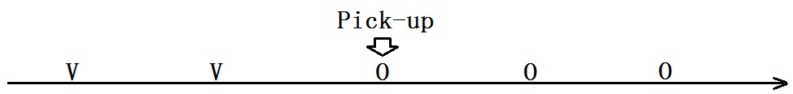
Figure 1: Detecting pick-ups. Each taxi records its status every 30 seconds. For a specific taxi above, its status was recorded as: …Vacant, Vacant, Vacant, Occupied, Occupied…, and after preprocessing, the status became: …Vacant, Vacant, Vacant, PickUp, Occupied…
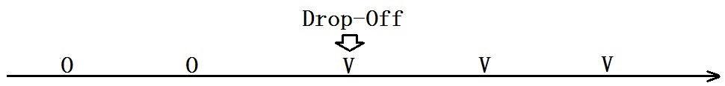
Figure 2: Detecting drop-offs. Each taxi records its status every 30 seconds. For a specific taxi above, its status was recorded as: …Occupied, Occupied, Occupied, Vacant, Vacant…, and after the preprocessing, the status became: …Occupied, Occupied, Occupied, DropOff, Vacant…
2. Matching data records to road segments. Every valid data record in the database was assigned to a road segment using the “Nearest feature” function provided by the ArcGIS Engine with a distance threshold of 10 meters. Following this step, the associated road segment ID is added as a new data field. If a data record failed to be matched to any road segment, it was then considered a noise. Any road segment that was not accessible to a taxi drop-off or pick-up was excluded from the study. Data points associated with these road segments were also excluded from the study. These road segments included but were not limited to freeways, elevated roads, and private roads.
3. Record list: The data in the Oracle database were saved daily. The data records for each study day were saved in an individual table. For each study day, the data records were ordered by road segment ID and timestamp. Thus, the data records that shared the same road segment ID became a group and each group, namely a record list, contained data for a certain road segment.

3.3 Location-based Event Sequence
After obtaining the record list for every road segment, the record lists were transferred to event sequences.
An event was a summary of a taxi’s consecutive records on a specific road segment. Five types of events were defined as shown in Table 1.
Table 1: Event types and their definitions.
Event Type | Record list on the certain road segment
V
P
D
DP
O
- Type V: The taxi entered the road segment as Vacant, and left the road segment as Vacant (Vacant In, Vacant Out). The time of this event was the time of the first Vacant record.
- Type P: The taxi entered the road segment as Vacant, and left the road segment as Occupied (Vacant In, Occupied Out). The time of this event was the time of the Pick-up record.
- Type D: The taxi entered the road segment as Occupied, and left the road segment as Vacant (Occupied In, Vacant Out). The time of this event was the time of the Drop-off record.
- Type DP: This was a special case that combined type D and type P, the taxi picked up another customer right after it dropped off the previous passenger.
- Type O: The taxi entered the road segment as Occupied, and left the road segment as Occupied (Occupied In, Occupied Out).
Type O events were not examined in this study because this event type was not related to the objectives. In practice, type DP was a common situation at busy locations during busy hours. In the process of counting availability and drop-offs, type DP was treated as type P (see the definition of availability in the next subsection for justification).
Table 2-a and Table 2-b illustrate a record list and its corresponding transferred event sequence.

Table 2-a: An example of record list for road segment 2305
Road Segment ID | Taxi ID | Time | Status
… | … | … | …
2305 | 1001 | 17:05:20 | Vacant
2305 | 2198 | 17:05:25 | Vacant
2305 | 3749 | 17:05:49 | Occupied
2305 | 1001 | 17:05:50 | PickUp
2305 | 2198 | 17:05:55 | Vacant
2305 | 3749 | 17:06:19 | Occupied
… | … | … | …
2305 | 1568 | 17:18:16 | Occupied
2305 | 1785 | 17:18:19 | Occupied
2305 | 1001 | 17:18:20 | Occupied
2305 | 1568 | 17:18:46 | Occupied
2305 | 1785 | 17:18:49 | Occupied
… | … | … | …
2305 | 4985 | 17:35:43 | Occupied
2305 | 3358 | 17:35:45 | Occupied
2305 | 1001 | 17:35:50 | Occupied
2305 | 4185 | 17:35:59 | Vacant
2305 | 3358 | 17:36:15 | DropOff
2305 | 1001 | 17:36:20 | DropOff
2305 | 4185 | 17:36:29 | PickUp
2305 | 3358 | 17:36:45 | Vacant
2305 | 1001 | 17:36:50 | Vacant
2305 | 4185 | 17:36:51 | Occupied
2305 | 3358 | 17:37:15 | PickUp

Table 2-b: The event sequence derived from Table 2-a
Event ID | Taxi ID | Event Time | Event Type
1 | 2198 | 17:05:25 | V
2 | 3749 | 17:05:49 | O
3 | 1001 | 17:05:50 | P
… | … | … | …
20 | 1568 | 17:18:16 | O
21 | 1785 | 17:18:19 | O
22 | 1001 | 17:18:20 | O
… | … | … | …
100 | 4985 | 17:35:43 | O
101 | 3358 | 17:36:15 | D
102 | 1001 | 17:36:20 | D
103 | 4185 | 17:36:29 | P
104 | 3358 | 17:37:15 | P
The algorithm behind the conversion from Table 2-a to Table 2-b is shown in Figure 3. It began with the first record in Table 2-a from which two consecutive records of taxi 1001 were compared and a type P event was detected and written into Table 2-b. After this step, these two consecutive records of taxi 1001 were removed from Table 1-a, and the algorithm started over again. A type V event of taxi 2198 was then detected. This loop continued until Table 2-a became empty. Finally, after sorting the records by time, the event sequence of road segment 2305 was derived in Table 2-b. Notice that Taxi 1001 in this example visited this road segment three times, and three events were detected.
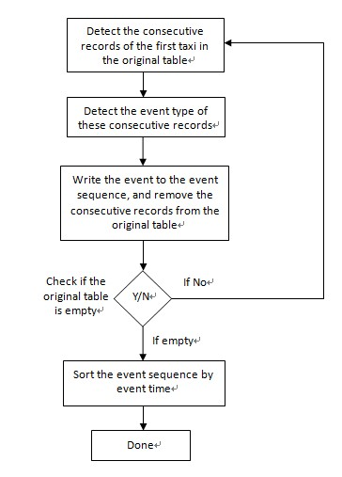
Figure 3: The algorithm that converts the record list in Table 2-a into the event sequence in Table2-b
After performing the transformation on every road segment, every road segment had a unique event sequence for each of the seven study days.

3.4 Counting Availability and Pick-ups

3.4.1 Definitions
The crucial term “imbalance between taxi availability and customer pick-ups” must be quantitatively defined in order to answer the research questions.
Reminding the event types illustrated in Table 1, we notice that in the definitions of Type V, P, D and DP, the taxi was vacant for at least a moment during the single visit to the certain road segment. Meanwhile, in the definitions of type P and DP, the certain vacant taxi was hailed by some customer. Therefore, on a certain road segment, the total number of Type V, P, D and DP events indicated the sum of the number of vacant taxis existent while the total number of Type P and DP events indicated the amount of vacant taxis hailed by customers. Therefore, Pick-ups, Availability and imbalance were defined as follows:
Pick-ups: Pick-ups was the total number of Type P and DP events on a certain road segment during a certain time window divided by the length of the time window, noted as RPM (riders per minute). This index number described the frequency of customers being picked up on a certain road segment within a specific time window.
Availability: Availability was the total number of Type V, P, D and DP events on a certain road segment during a certain time window divided by the length of the time window, notated as APM (availability per minute). This index number described the frequency of available taxis appearing on a certain road segment within a specific time window.
Subsequently, the imbalance was measured as the ratio of RPM to APM. $imbalance= \frac{RPM}{APM}$.
The definitions of RPM and APM indicated that RPM were always smaller or equal to APM, and imbalance actually described the ratio of available taxis that customers picked up, ranging from 0 to 1, with a higher value reflecting a higher pressure for taxi users to find a vacant taxi and a lower value reflecting higher pressure for taxi drivers to find a customer. If both RPM and APM were 0, imbalance was recorded as NULL.

3.4.2 Setting Time Windows
An appropriate time window selection should ensure that the RPM and APM of this specific time window reflects the real situation of the taxi pick-ups and availability as closely as it can to reduce the influence of MTUP (Coltekin et al., 2011; Gibson et al., 2000; Hornsby and Egenhofer, 2002; Meentemeyer, 1989). In other words, we hope that the indices calculated to represent a specific time window can also represent any moment within this time window. However, this is not easy. For instance, Figure 4 illustrates a scenario that the indices calculated representing a one-hour time window can neither represent its first half nor its second half. On the one-hour time line in Figure 4, events occur more frequently across the first half and less frequently across the second half. Such local High vs. Low event frequency pattern makes RPM and APM calculated for the one hour time window not representative for either the first or the second half hour. If we split this one-hour time window in Figure 4 into two 30-minute time windows, events in both 30-minute time windows are spread evenly across the timeline. In this case, indices of the two 30-minute time windows are more representative than that of the one-hour time window.
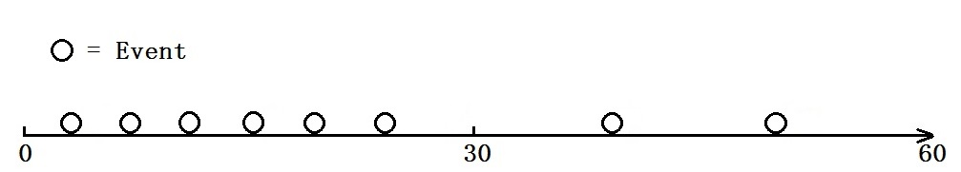
Figure 4: A local High vs. Low event frequency pattern exists in this one-hour time window.
A hierarchical structure of multi-resolution time windows was developed based on Ward’s minimum variance method of hierarchical clustering (Ward, 1963). Such hierarchical structure is needed to allow us to divide a day into time windows with different length for each of the road segment.
For every road segment, the default one-hour time windows were inspected to determine whether they should be equally divided into smaller time windows to allow new time windows to have their events spread across the timeline more evenly. While we were counting the events in specific time windows, the time intervals between two consecutive events constituted a series, namely a time interval series (TIS). In the process of determining whether a time window should be divided, it was the key to compare the variances of TISs before and after splitting. A smaller time window had its events more evenly spread compared to the original time window if and only if the smaller time window had a smaller TIS variance after splitting. Subsequently, an algorithm was used to determine the time window settings (Figure 5). This algorithm used a binary tree and finite recursion as the basic principles to calculate and compare the variances before and after splitting. For each of the 24 one-hour periods of each road segment, the algorithm first calculated the variance of TIS for the one-hour time window, then the one-hour time window was divided into two 30-min time windows, and the variances of their TISs were calculated. This division was accepted if and only if both 30-min time windows had smaller TIS variances compared to the original 1-hour time window. The same process was applied to the new 30-min time windows to determine whether a division into 15-min time windows should be applied. Note that if a time window contained no event, its TIS variance was assigned 0, and no further splitting for this time window was applied.
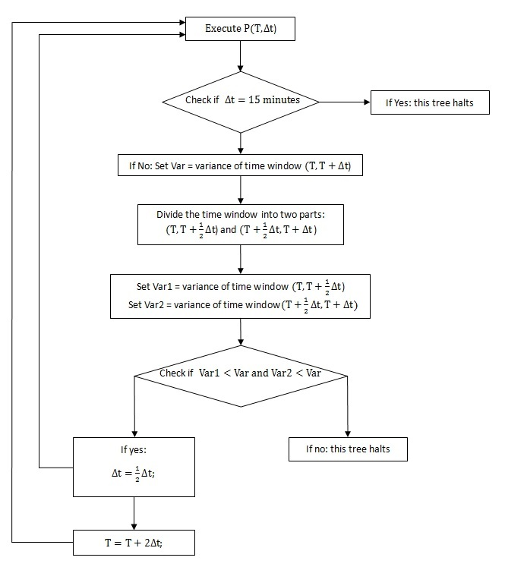
Figure 5: The algorithm to obtain the appropriate time windows.
The results of the time window setting were recorded in the Oracle database. Each hour of each road segment comprised 7 fields representing 7 possible time windows (four 15-minute, two 30-minute, and the1-hour) (Figure 6).
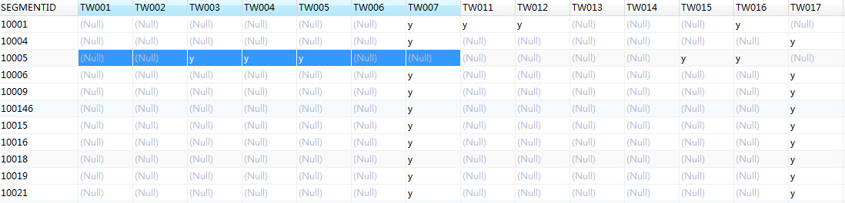
Figure 6: The table in the Oracle database that saves the time window setting for the study day 02-10.
The field names in this table had three parts: 1. “TW”; 2. The hour (00-23); and 3. The time window code (1-7). The time window codes are listed below:
1: minutes 00 to 15;
2: minutes 15 to 30;
3: minutes 30 to 45;
4: minutes 45 to 60;
5: minutes 00 to 30;
6: minutes 30 to 60;
7: minutes 00 to 60.
For instance, the field “TW215” stood for the time window 21:00 to 21:30. The value “y” in the field meant this time window was being used. The highlighted part in Figure 6 shows that on the study day 02-10, for the road segment 10005, the hour 00:00 to 01:00 is divided into three parts: 00:00-00:30, 00:30-00:45, and 00:45-1:00.

3.4.3 Complete the Oracle Database.
After saving the time window settings, all components of the index definitions were hereby resolved. APM, RPM, and imbalance were then calculated and saved in tables with a similar structure as in Figure 6. Additionally, the number of time windows of each hour for each road segment was also being counted and saved for the analysis. The details of the number of time windows will be introduced in the next section.

3.5 Building the Geodatabase for Analysis
The analysis involved two tools from ESRI ArcGIS: “Global Spatial Autocorrelation (Moran’s I)” and “Hot Spot Analysis (Getis-Ord Gi*)”. A file geodatabase is built for the purpose of the analysis. A geodatabase is required because regular ShapeFile cannot handle NULL values. Within the geodatabase, these following feature classes were generated by jointing the road segment feature dataset and the tables in the Oracle database.

3.5.1 The number of Time Windows (notated as NTW)
According to the splitting algorithm, each one-hour time window for a certain road segment could be divided in five possible ways:
- 60 min (1 time window, the time window is not divided)
- 30 min / 30 min (2 time windows)
- 15 min / 15 min / 30 min (3 time windows)
- 30 min / 15 min / 15 min (3 time windows)
- 15 min / 15 min / 15 min / 15 min (4 time windows)
In the Oracle database, the time window setting for each hour of each road segment had to be saved as one of these five types above (recall Figure 6, the highlighted part is saved as type d). Additionally, I considered both type c and d as comprising 3 time windows that were no different.
A time window was divided into two smaller ones because of the uneven distribution of the taxi activities across the timeline. The number of time windows can be considered as a measurement of temporal complexity of taxi activity, with higher value of NTW indicating events that were distributed more unevenly on the timeline. This also indicated that when the NTW of a road segment for a certain hour was greater than 1, a local High vs. Low event frequency pattern is detected, and as the value of NTW increased, the temporal complexity of such local pattern increased as well. Figure 7 illustrates a comparison for complexity among the possible activity distributions of NTW(2) vs. NTW(3) on the timeline: although circumstance B and C have the same level of complexity of 3, which is higher than that in A, the local high frequency and low frequency in B and C are located in different time windows and have different event densities. Thus, NTW only measured the temporal complexity of the local High vs. Low event frequency pattern, and it did not provide any details of the pattern.
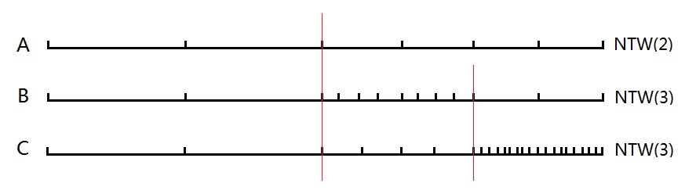
Figure 7: A comparison for complexity among the possible activity distributions of NTW(2) vs. NTW(3) on the timeline, each dot on the time line represents an event.
A feature class was generated for each hour of the day, and 168 NTW feature classes were generated for the 168 hours of the 7 study days. Each feature class contained the number of time windows (range from 1 to 4) for each feature (road segment) within the certain hour. These NTW feature classes were run through Global Spatial Autocorrelation (Moran’s I) and Hot Spot Analysis (Getis-Ord Gi*) to answer the first research question.
Note that for each feature class, road segments with zero availability during the certain hour were excluded. It is improper to speak of the temporal complexity of the local High vs. Low event frequency pattern on a road segment with no taxi activity. Because of this exclusion policy, each feature class had different number of features and the composition of features was unique. Figure 8 is the attribute table of the NTW feature class for the hour 00:00-01:00 on 02-10. The column NTW00 contains the number of time windows (NTW) for each road segment during this hour.
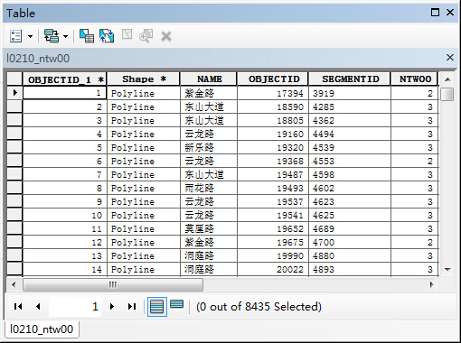
Figure 8: The attribute table of the NTW feature class for the hour 00:00-01:000 on 02-10.

3.5.2 Imbalance (Notated as IMB)
The indices for each time window should also be representative of any moment during the time window. The imbalance at a specific moment was recognized as the imbalance of the time window in which this moment is located. A time point was selected within each quarter of each hour, and 672 time points were selected for all 7 study days (4x24x7=672). The imbalances at these time points were re-assigned. For example, assume that for a certain road segment, the hour 08:00-09:00 had type c division, 15 min / 15 min / 30 min, and the corresponding imbalances were 0.1 / 0.6 / 0.2. Four time points 08:05, 08:20, 08:35, and 08:50 were selected for each quarter of this hour, and the imbalances for the four moments were re-assigned as 0.1 / 0.6 / 0.2 / 0.2. Figure 9 illustrates this assigning process. Practically, it did not matter what time point was selected for each quarter, as the value of imbalance was considered the same at any moment during the quarter. As the example shown, consecutive time points may share the same value of imbalance, as the two time points can locate in the same time window. A feature class was generated for each of the 672 time points. Each of these feature classes contained the imbalance at the different time points for each road segment. These IMB feature classes were run through Global Spatial Autocorrelation (Moran’s I) and Hot Spot Analysis (Getis-Ord Gi*) to answer the second research question.
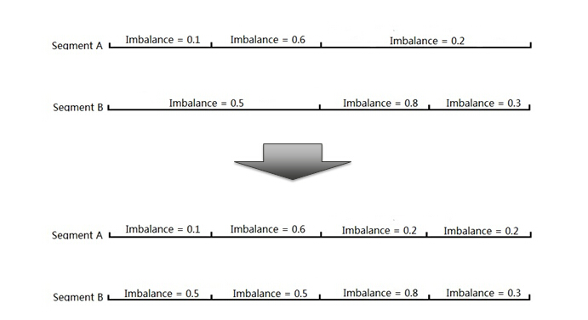
Figure 9: Assigning value to each 15-minute time window
Note that for a certain road segment, the imbalance can be NULL for a certain time window if there is no pick-up/availability. For each feature class, features with NULL imbalance were excluded. This indicated that each of the 672 feature classes had different number of features and the composition of features was unique. Figure 10 shows the attribute table of the IMB feature class at the time point in the first quarter of the hour 00:00-01:00 on 02-10.
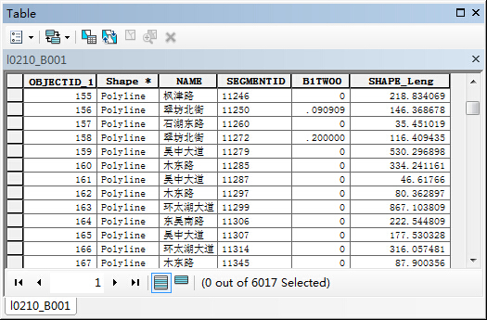
Figure 10: The attribute table of the IMB feature class at the time point in the first quarter of the hour 00:00-01:000 on 02-10.

3.6 Analysis

3.6.1 ArcGIS tools and their parameter settings
The Global Spatial Autocorrelation (Moran’s I) and Hot Spot Analysis (Getis-Ord Gi*) provided by ESRI ArcGIS were used to help identify the spatiotemporal distributions of time window split and imbalance. Both of these two functions should use network distance as the distance method. However, network distance method was not embedded in these functions. This required me to build a spatial weight matrix based on network distance first.

3.6.1.1 Generate Network Spatial Weights
The tool “Generate Network Spatial Weights” generated the spatial weight matrix file (.swm) needed for Global Spatial Autocorrelation (Moran’s I) and Hot Spot Analysis (Getis-Ord Gi*). Figure 11 shows the interface of this tool.
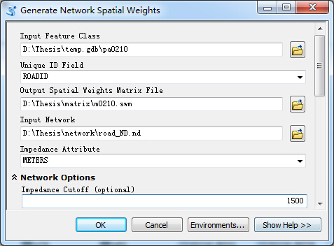
Figure 11: The interface to build network spatial weight matrix
Since the input file had to be point feature class, the line feature class of road segment was converted to a point feature class containing the mid points of the road segments. This was quickly achieved by using the function “FeatureToPoint”. Thus, the spatial weight between two road segments was measured as the network distance between their mid points. The input network dataset was generated from the original road segment dataset. The impedance cutoff was set to 1500 meters, and only features within this distance were considered as neighbors. This distance ensured that two connected road segments would always be neighbors, considering the possible large distance between their mid points. Other important settings remained defaults, such as “Conceptualization of Spatial Relationships” remained “INVERSE” and “Row Standardization” remained checked.

3.6.1.2 Global Spatial Autocorrelation (Moran’s I)
This tool calculated the value of Moran’s I index. It measured the global spatial autocorrelation of our interests. NTW and IMB feature classes underwent this process. Figure 12 shows the interface of this tool. This tool had run 168 times for the 168 NTW feature classes, with the corresponding NTW fields as input field, and had run 672 times for the 672 IMB feature classes, with the corresponding IMB fields as input field. The network spatial weight matrix generated from the last section (Figure 11) was the input for “Conceptualization of Spatial Relationships”, as shown in Figure 12.
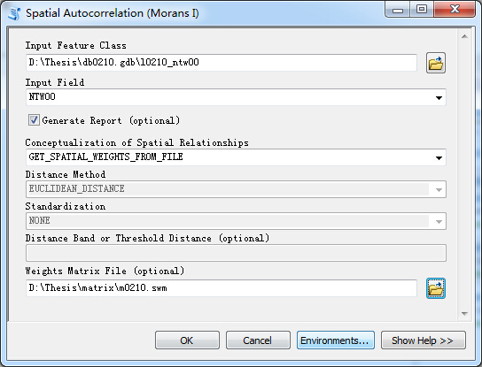
Figure 12: the interface of Spatial Autocorrelation (Moran’s I)
A report was generated for each trial. The report included the Moran’s I index, the Z score, the p value, and the spatial distribution pattern of this feature class. In this study, the Z score played the key role, as it directly determined the spatial distribution. As we used the significance level of 0.1, if z > 1.65, the distribution was clustered, if z < -1.65, the distribution was dispersed, and if -1.65 < z < 1.65, then the distribution was random. Figure 13 shows the report for NTW feature class of the hour 00:00 to 01:00 on 02-10 as an example. A clustered distribution showed that close values tend to stay close to each other while a dispersed distribution showed that opposite values tend to stay close to each other. A random distribution showed no significant correlation between neighboring road segments. However, this report did not provide any other information, such as where the high/low values clusters were located.
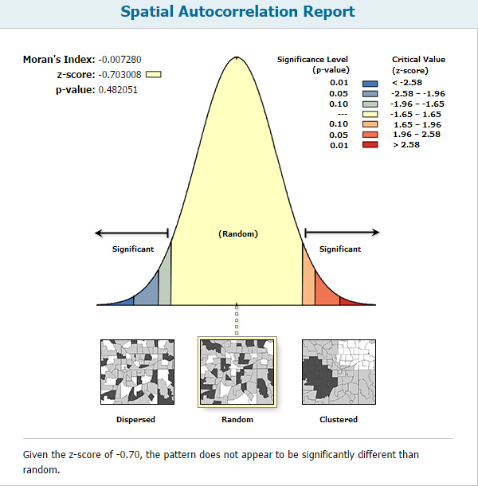
Figure 13: The spatial autocorrelation report for the NTW feature class of the hour 00:00 to 01:00 on 02-10

3.6.1.3 Hot Spot Analysis (Getis-Ord Gi*)
The tool “Hot spot analysis (Getis-Ord Gi*)” calculated the value of Getis-Ord Gi* index. Gi* index was a Z-Value to evaluate hot spots. Figure 14 shows the interface of the tool. Similar to spatial autocorrelation analysis, this tool had run 168 times for the 168 NTW feature classes, with the corresponding NTW fields as input field, and had runs 672 times for the 672 IMB feature classes, with the corresponding IMB fields as input field. The network spatial weight matrix file was the input for “Conceptualization of Spatial Relationships”, as shown in Figure 15.
For each trial, a Gi* index and a p-value were calculated for every road segment in the feature class. For the significance level of 0.1, if Gi* > 1.65, then the road segment was considered an H-H hot spot, that was, a high value surrounded by high values; if Gi* < -1.65, then the road segment is considered an L-L cold spot, that was, a low value surrounded by low values. High value surrounded by low values and low value surrounded by high values were not inspected by this tool and were also not the objective of this study because isolated road segments with high or low values were more likely to be random in practice. This tool made a feature on the map became a hot/cold spot not only for the high/low value it contained, but also for the high/cold values of surrounding features, and therefore, this process detected the local clusters of our interest, the high values of NTW and IMB, over time. Additionally, the total number of detected hot spots for each trial was also obtained and saved.
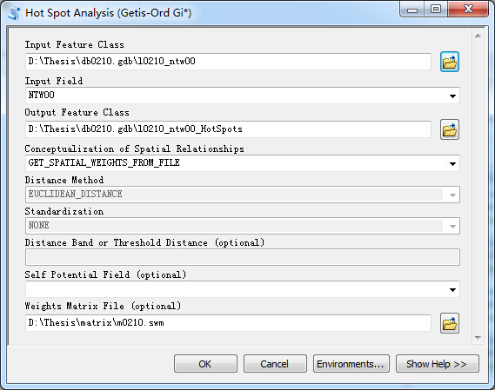
Figure 14: The interface of Hot Spot Analysis (Getis-Ord Gi*)
Figure 15 and Figure 16 are examples of the attribute table and map of the analysis result for the NTW feature class of the 00:00-01:00 hour on 02-10. The attribute table highlighted the Gi* Z-values in the column GiZScore and the map highlighted the hot spots which have Gi* > 1.65. Potential spatiotemporal patterns will be inspected and discovered after obtaining the 168 NTW hot spot maps and the 672 IMB hot spot maps. For instance, the example in Figure 16 shows an even distribution pattern of NTW hot spot during 00:00-01:00 on 02-10.
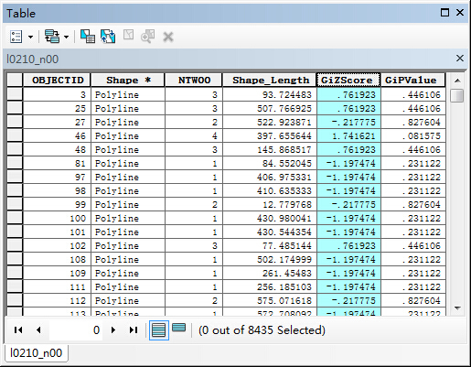
Figure 15: The attribute table of hot spot analysis result for the NTW feature class of the 00:00-01:00 hour on 02-10
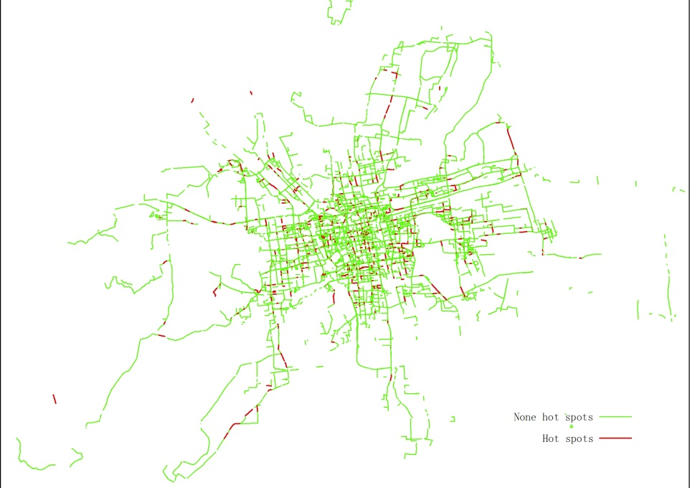
Figure 16: The map of the analysis result for the NTW feature class of the 00:00-01:00 hour on 02-10

3.6.2 Does a higher value of imbalance tend to occur at high event frequency prior to low event frequency?
The appropriate time window selection ensured that the RPM and APM of a road segment for a certain time window reflected the real situation as closely as possible. APM directly measured the event frequency of a certain time window according to its definition. A time window with higher APM had higher event frequency relative to a time window with lower APM. To evaluate the third research question, Pearson correlation analyses between APM and imbalance were applied. From range -1 to 1, a large positive result close to 1 indicated a positive correlation, that was, higher IMB tended to occur with higher APM; a negative result close to -1 indicated a negative correlation, that was, higher IMB tended to occur with lower APM. A result close to 0 indicated no correlation: there was no evidence to prove IMB and APM has any immediate connections
The time-point-based structure introduced previously was adapted in the Pearson correlation analysis. APM was re-assigned for the 672 time points, just as for imbalance introduced in section 3.5.2. APM and imbalance were paired on each road segment at each time point, and a Pearson correlation coefficient was calculated for each time point.
Overall, 672 coefficients were calculated, which indicate how the correlation changes over time and answer the third research question.

CHAPTER 4

RESULTS AND FINDINGS

4.1 Some general facts
This section presents some figures containing general information summarized from the database, and their corresponding tables are in the Appendix.
Figure 17 illustrated the number of active taxis for each hour. An active taxi was a taxi that had at least one event recorded for the hour. The corresponding numerical data were listed in Appendix Table A.

Figure 17: The number of active taxis by time
Figure 18 plotted the number of features in the 168 NTW feature classes. The number of NTW features indicated how many road segments had at least one event recorded for each hour. The corresponding numerical data were listed in Appendix Table B.

Figure 18: The number of features in NTW feature classes by time.
Figure 19 plotted the number of features in the 672 IMB feature class over time. This number of IMB features indicated how many road segments had valid imbalance assigned for each 15-minute time window. This also reflected the number of road segments that had at least one event recorded for each hour, since if there was no event then imbalance would be NULL. The corresponding numerical data were listed in Appendix Table C.

Figure 19: The number of features in IMB feature classes by time.
Figure 18 counted the number of road segments having taxi activities every one hour, and Figure 19 counted the same thing every 15 minutes. The number of NTW features for every hour was an aggregation of the number of IMB features for the four quarters of that hour. Thus, Curves in Figure 18 and Figure 19 shared the same global pattern. We noticed each hour on every line had a clear wave in Figure 19 This is due to the limitation of the method of dividing the time windows. For a certain road segment, the first and fourth quarters with no event recorded had a lower chance to be chosen as 15-minute time windows compared to the second and third quarters. Figure 20 illustrated how this can happen. If the two one-hour time window in circumstances A and B were both divided into two 30-minute time windows, the first 30 minutes in both A and B must be divided again, since the 15-minute time window with no event would be instantly recognized. However, compared to the one-hour time window in circumstance B, the one-hour time window in circumstance A had a higher chance of not being divided into two 30-minute time windows based on the variance-based algorithm. Thus, the first quarter with no event in circumstance A had a higher chance of being assigned the value of the one-hour time window of A, and this road segment was included in the imbalance feature class for the first time point. The second quarter with no event in Circumstance B was likely to be recognized as a 15-minute time window with no value assigned, and this road segment was excluded from the imbalance feature class for the second time point. A similar pattern emerged between the third and fourth quarters of each hour; therefore, the first and fourth time points had a higher chance to include more road segments in the feature class. This type of limitation is called boundary problem or edge effect, and in this case, it does not affect the global trend of the curves.

Figure 20: A situation that shows the limitation of the method to divide time windows
Through Figure 17, we noticed that the number of active taxis increased dramatically from the bottom between 5:00 and 10:00. After reaching the peak between 10:00 and 11:00, the number of active taxis started to progressively drop, the rate of which slightly increased around 17:00 before the number of active taxis reached the bottom between 4:00 and 5:00 the next day. The traditional morning rush hour (7am-9 am) and afternoon rush hour (5am-7pm), had no distinctive characteristics. They were parts of the dramatically increasing phase from 5:00 to 10:00 and the stably decreasing phase from 10:00 to 16:00, respectively. Thus, we can predict that the analysis results of NTW and IMB may not show any rush-hour vs. non-rush-hour pattern.
The curve of Saturday in Figure 17 was a little different compared to other curves in details. During 1am-2am, 9am-10am and 8pm-9pm, the number of active taxis had small peaks. These small peaks indicated that these hours on Saturday had relatively higher service demand expectations. However, such high expectations were not reflected in the Figure for Friday night, where one would expect to see a peak for active taxis. A reasonable interpretation is that the negative traffic conditions, like congestions, on Friday night discouraged the drivers, since the efficiency to collect fares may be even lower than normal hours.
The total number of valid road segment in the dataset was always fixed, the numbers of road segments having taxi activities in Figure 18 and Figure 19 were measuring how many among these valid road segments were visited by vacant taxis. Thus, the number of road segments having taxi activities can represent the coverage of vacant taxis. It is important to keep in mind that this coverage of vacant taxis doesn’t tell the spatial distribution of these road segments. For instance, let’s say at time A, the coverage was 10,000 road segments, and at time B, the coverage was 5,000 road segments. It was possible that at time A, the 10,000 road segments were clustered in a certain area, but at time B, the 5,000 road segments are evenly spread over the entire city. In this case, we simply consider the coverage of vacant taxis at time A was higher than at time B because more road segment was covered at time A, even though more areas may be covered at time B.
The curves in Figure 18 and Figure 19 were overall sharing the same pattern, but due to the boundary problem, the details in Figure 19 were not easy to recognize, so I will only discuss the details in Figure 18. The first noticeable detail in Figure 18 was located in the time slot 7pm-11pm. The curves for Sunday, Monday, and Tuesday during 7pm-11pm dropped fast. For Wednesday, the curve didn’t drop until 9pm. For Thursday, the curve didn’t drop until 11pm. And for Friday and Saturday, the situations became more complicated. We saw increases and peaks during 7-11pm. These late night differences illustrated the normal trend of people’s activity at night. Starting on Sunday night, people’s activities stayed at a low level, and decreased fast as mid night approaches. As the date went on and the weekend approached, the decrease of people’s night activities was getting slower and later. Another difference that must be pointed out was the peaks during 9-11am on Monday and Tuesday, a reasonable cause of the peaks on these two days may be the unofficial tradition of people living in Suzhou who carry out important businesses early in a week.

4.2 How are the time windows divided spatially and temporally?

4.2.1 Results of “Global Spatial Autocorrelation (Moran’s I)” using NTW as input
Table D in the Appendix listed the spatial distribution determined in the result reports of “Global Spatial Autocorrelation (Moran’s I)”.
Most distributions in Table D in the Appendix were random. A random distribution meant that the temporal complexity of taxi activity had no spatial autocorrelation: neighboring values were not correlated.
During the 168 hours, dispersed distributions occurred 4 times. A dispersed spatial distribution indicated that higher complexity tended to appear near lower complexity. These dispersed distribution occurred occasionally with no clear temporal pattern.
Clustered distributions occurred 17 times out of the 168 hours. These clustered distribution concentrated in the morning on weekdays, afternoon on Sunday through Tuesday, and night on Saturday. During these hours, locations tended to have close level of temporal activity complexity in the neighborhood. Note that when the NTW of a road segment for a certain hour was greater than 1, a local High vs. Low event frequency pattern was detected, and as the value of NTW increased, the temporal complexity of such local pattern also increased. The clustered area of high NTW values had higher temporal complexity of local taxi activity. However, the results from Global Spatial Autocorrelation (Moran’s I) did not tell us where these clusters were.

4.2.2 Results of “Hot Spot Analysis (Getis-Ord Gi*)” using NTW as input
Table E in the Appendix listed the number of hot spots for each hour along with the spatial distribution from Table D. By putting these two groups of number together, we found there was no identifiable connection between the number of H-H hot spots and the spatial distribution of NTW. This was because the spatial distribution pattern was a global determination, and an H-H hot spot was a local determination.
Figure 21 has shown the curves of the number of NTW hot spots for the 7 study days. These curves shared a similar global trend to the curves in Figure 17 and Figure 18.

Figure 21: The number of NTW hot spots by time.
Some noticeable details in Figure 21 can make connections to the real world. Firstly, it was surprising that the number of complexity hot spots stayed at low levels on Sunday. Lower level of complexity indicated the taxi activities were overall more evenly distributed across the timeline. Secondly, there were many peaks during many time slots, including but not limited to 1am-2am on Saturday, 7am-8am on Friday, 10am-11am on Monday and Tuesday, 12pm-1pm on Saturday, 5pm-6pm on Tuesday, Wednesday, Friday, and Saturday, 8pm-9pm on Tuesday, Friday and Saturday, and 10pm-11pm on Monday, Friday, and Saturday. These peaks indicated an overall higher chance to experience the local High vs. Low event frequency pattern mentioned earlier. When such a local pattern occurred, the low event frequency part would very likely cause the difficulty of finding vacant taxis, since low event frequency meant less chance to have a vacant taxi appearing on a certain road segment.
Additionally, Table 3 listed the Pearson correlation coefficients among the number of NTW hot spots, the number of NTW features, and the number of active taxis using the values of the 168 hours as samples. The high correlation coefficient listed in the table confirmed the similar global trend of the curves in Figure 17, Figure18 and Figure 19 and furthermore proved that these three numbers were highly related.
Table 3: Pearson correlation coefficient among the number of NTW hot spots, the number of NTW features, and the number of active taxis.
 | Hot Spots | Features | Active Taxis
Hot Spots | 1
Features | 0.936171 | 1
Active Taxis | 0.906457 | 0.976629 | 1
There were 168 hot spot maps generated. Due to the space limit, I only selected the maps of three hours, 02:00-03:00 on 02-10, 13:00-14:00 on 02-11, and 22:00-23:00 on 02-15, as shown in Figures 22, 23, and 24, respectively. These three and other 165 unlisted maps significantly illustrate the coverage of vacant taxis and their temporal variation as shown in Figure 18, as well as the distribution of the hot spots. Over all 168 maps, hot spots tended to be distributed evenly across the coverage of taxi activities.
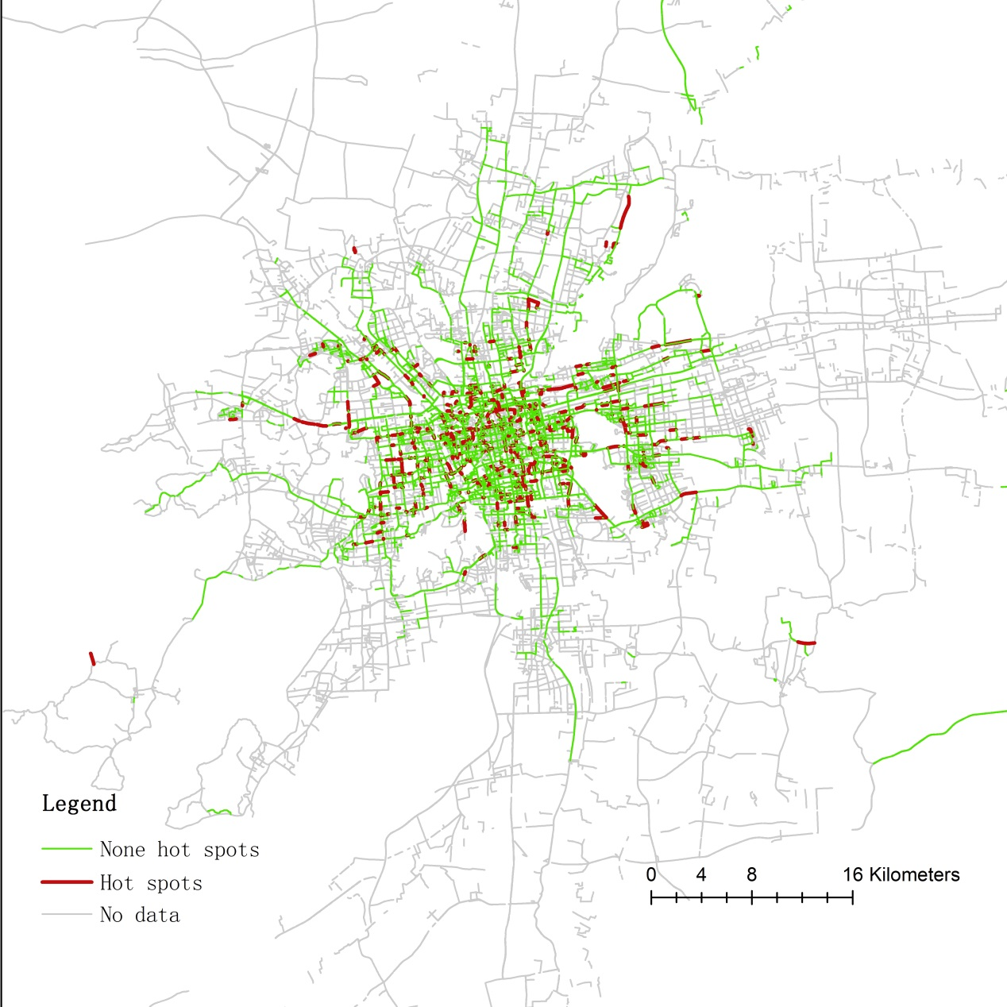
Figure 22: Hot Spot map of NTW feature class of 02:00-03:00 on 02-10.
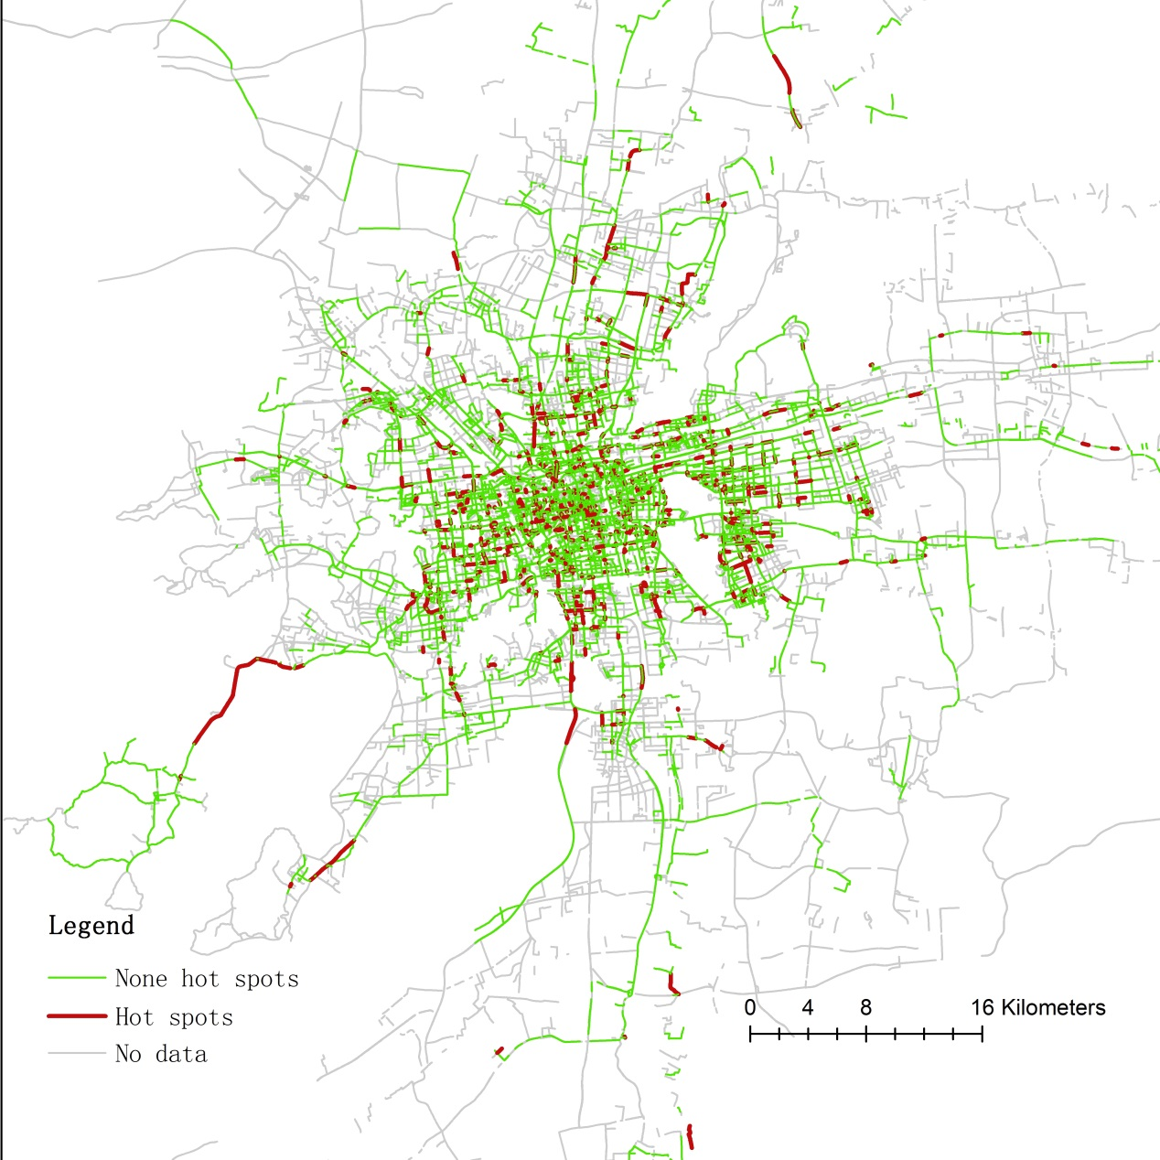
Figure 23: Hot Spot map of NTW feature class of 13:00-14:00 on 02-11.
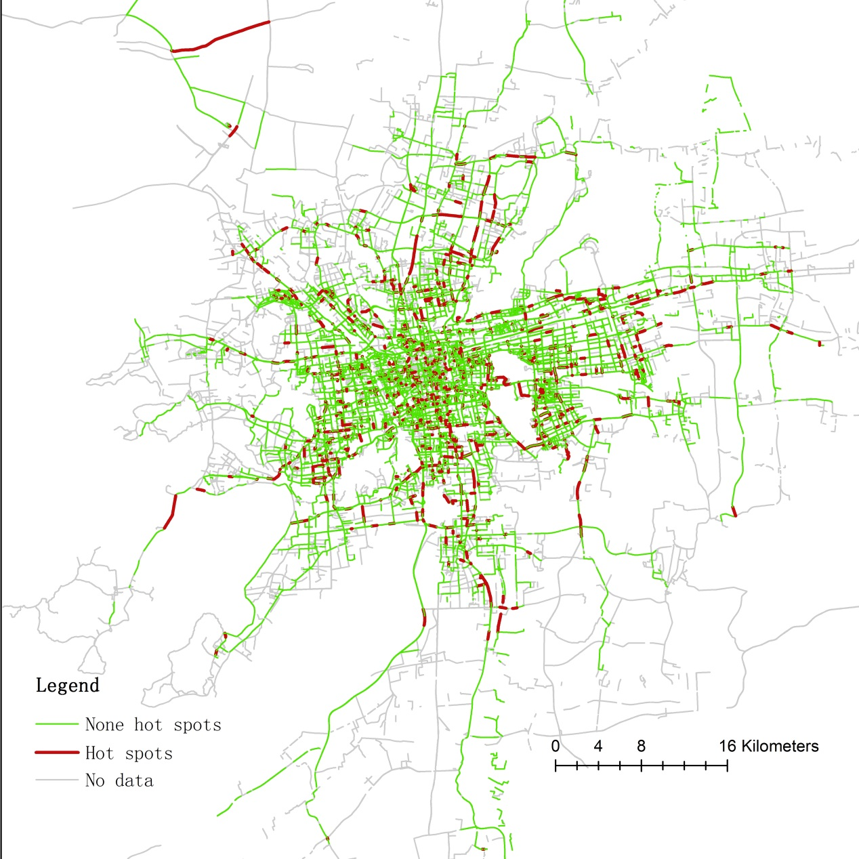
Figure 24: Hot Spot map of NTW feature class of 22:00-23:00 on 02-15.

4.3 How is the imbalance between taxi availability and customer pick-ups distributed spatially and temporally?

4.3.1 Results of “Global Spatial Autocorrelation (Moran’s I)” using IMB as input
Table F in the Appendix listed the spatial distribution determined in the result reports of “Global Spatial Autocorrelation (Moran’s I)”.

Most distributions in Table F were random. A random spatial distribution indicated that the imbalance between taxi availability and pick-ups had no spatial autocorrelation, as the neighboring road segments were not correlated.
Among the 672 time points, dispersed distributions occurred 16 times. A dispersed distribution showed higher imbalance tended to appear near lower imbalance. These dispersed distributions occasionally appeared in the morning. Practically, a global dispersed spatial pattern of imbalance was a good sign to some extent. Locations which lack availability were near locations that lack customers. In this case, if either the driver or rider can move properly to find each other, the overall taxi service utility would improve.
Clustered spatial distributions occurred 103 times out of the 672 time points. Most of them were concentrated during 4pm-6pm Sunday through Friday and 9pm-11pm on Wednesday through Friday. Surprisingly, the concentration during morning rush hour didn’t exist as I expected. A clustered distribution indicated that neighboring locations tended to have close values of imbalance. In the clustered area of high imbalance, riders were having a difficult time to catch a vacant taxi. On the other hand, in the clustered area of low imbalance, it might be difficult for drivers to find a customer. However, the results of Global Spatial Autocorrelation (Moran’s I) didn’t not give us further information about the clusters.

4.3.2 Results of “Hot Spot Analysis (Getis-Ord Gi*)” using IMB as input
Table G in the Appendix listed the number of hot spots at each time point along with the spatial distributions from Table F in the Appendix.
As described in section 4.2.2, no connection existed between the results of Global Spatial Autocorrelation (Moran’s I) and Hot Spot Analysis (Getis-Ord Gi*) since the former is a global determination and the latter is a local determination.
Figure 25 has shown the curves of the number of IMB hot spots for the 7 study days. These curves shared a similar global trend to the curves in Figure 17 and Figure 19.

Figure 25: The number of imbalance hot spots by time.
Due to the boundary problem discussed earlier, the curves in Figure 25 may look messy, but there were still some noticeable details. The entire Sunday stayed at low levels. Lower level of the number of IMB hot spots indicated an overall lower chance to experience difficulty of finding vacant taxis which was directly caused by the imbalance between pick-ups and availability. There were peaks at 10pm on Friday night, 2am on Saturday and during 8am-9am on Saturday. These peaks illustrated that people have more activities on weekends.
Additionally, Table 4 listed the Pearson correlation coefficients between the number of IMB hot spots and the number of IMB features, using the values of the 672 time points as samples. The number of active taxis was not included due to the different sample size. The high correlation coefficient listed in the table confirmed the similar global trend of the curves in Figure 25 and Figure 19, and furthermore proveed that these two numbers were highly related.
Table 4: correlations between the number of IMB hot spots and the number of features.
 | Features | Hot spots
Features | 1
Hot spots | 0.931587 | 1
There were 672 hot spot maps generated. Figures 26, 27, and 28 represented the three imbalance hot spots maps for the three time points, 02:00-03:00 on 02-10, 13:00-14:00 on 02-11, and 22:00-23:00 on 02-15, respectively, corresponding to Figures 22, 23, and 24. These 3 and other 669 unlisted maps illustrated the coverage of vacant taxis (Figure 19), as well as the distribution of the IMB hot spots. After inspecting the 672 maps, I found that the spatial distribution of imbalance hot spots followed a temporal pattern. In the early morning, the hot spots were clustered in the center of the activity coverage, which was the downtown area, and as soon as the morning rush hour started around 7am, the distribution of hot spots suddenly expanded. The hot spots no longer clustered in the downtown area but tended to be evenly distributed over the entire activity coverage during daytime. During the daytime, although the activity coverage and the number of hot spots varied slightly across different hours, this even distribution pattern remained the same. A clear transition from the even distribution pattern in the daytime to the clustered pattern in the early morning was observed from around 8pm to midnight, All 7 study days followed this spatiotemporal pattern.
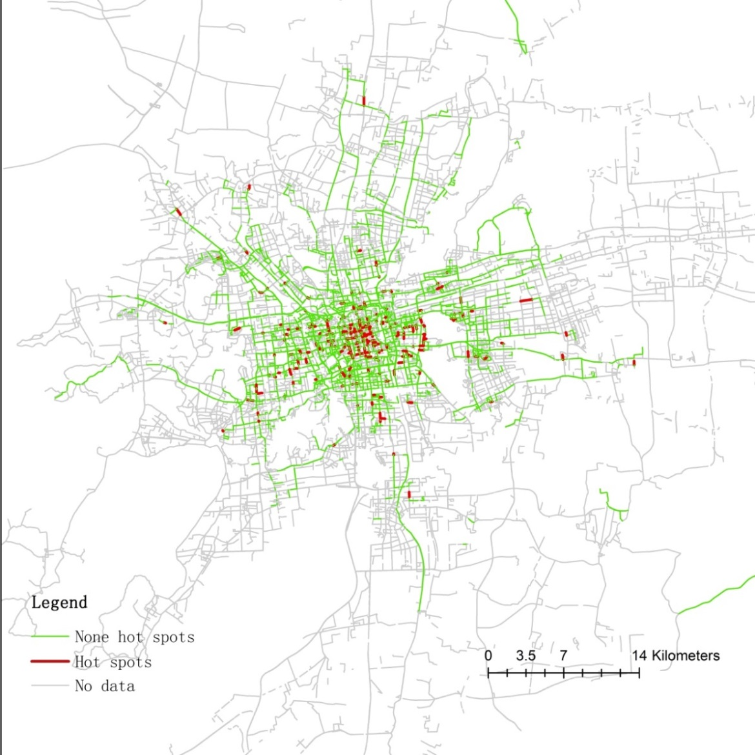
Figure 26: Hot spot map of imbalance feature class of the first time point during 02:00-03:00 time segment on 02-10.
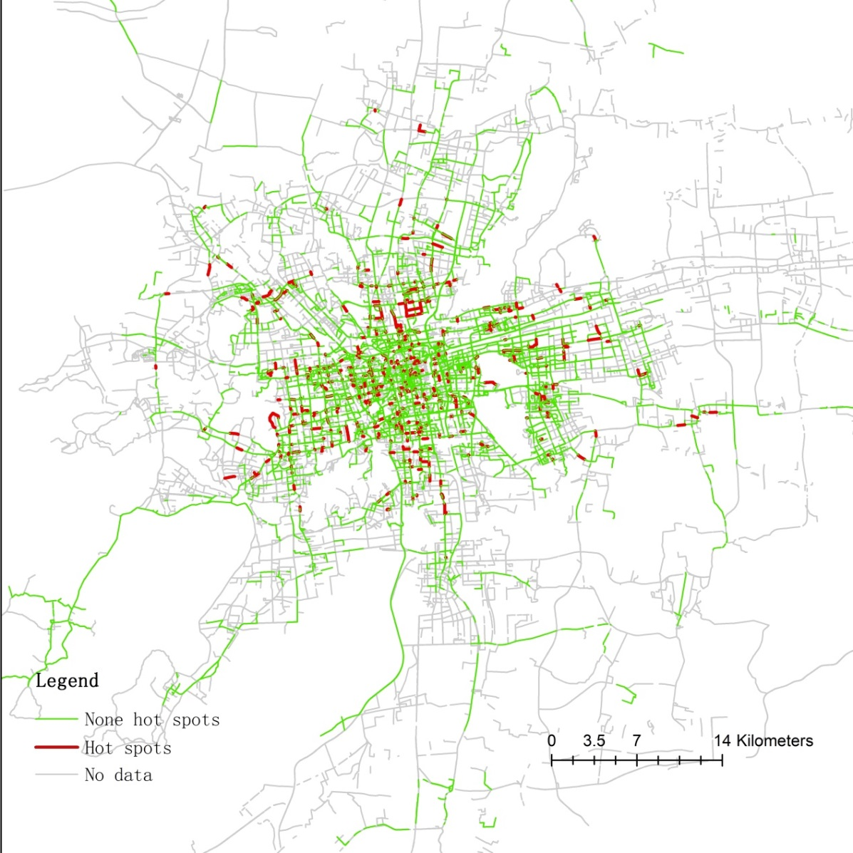
Figure 27: Hot spot map of imbalance feature class of the first time point during 13:00-14:00 time segment on 02-11
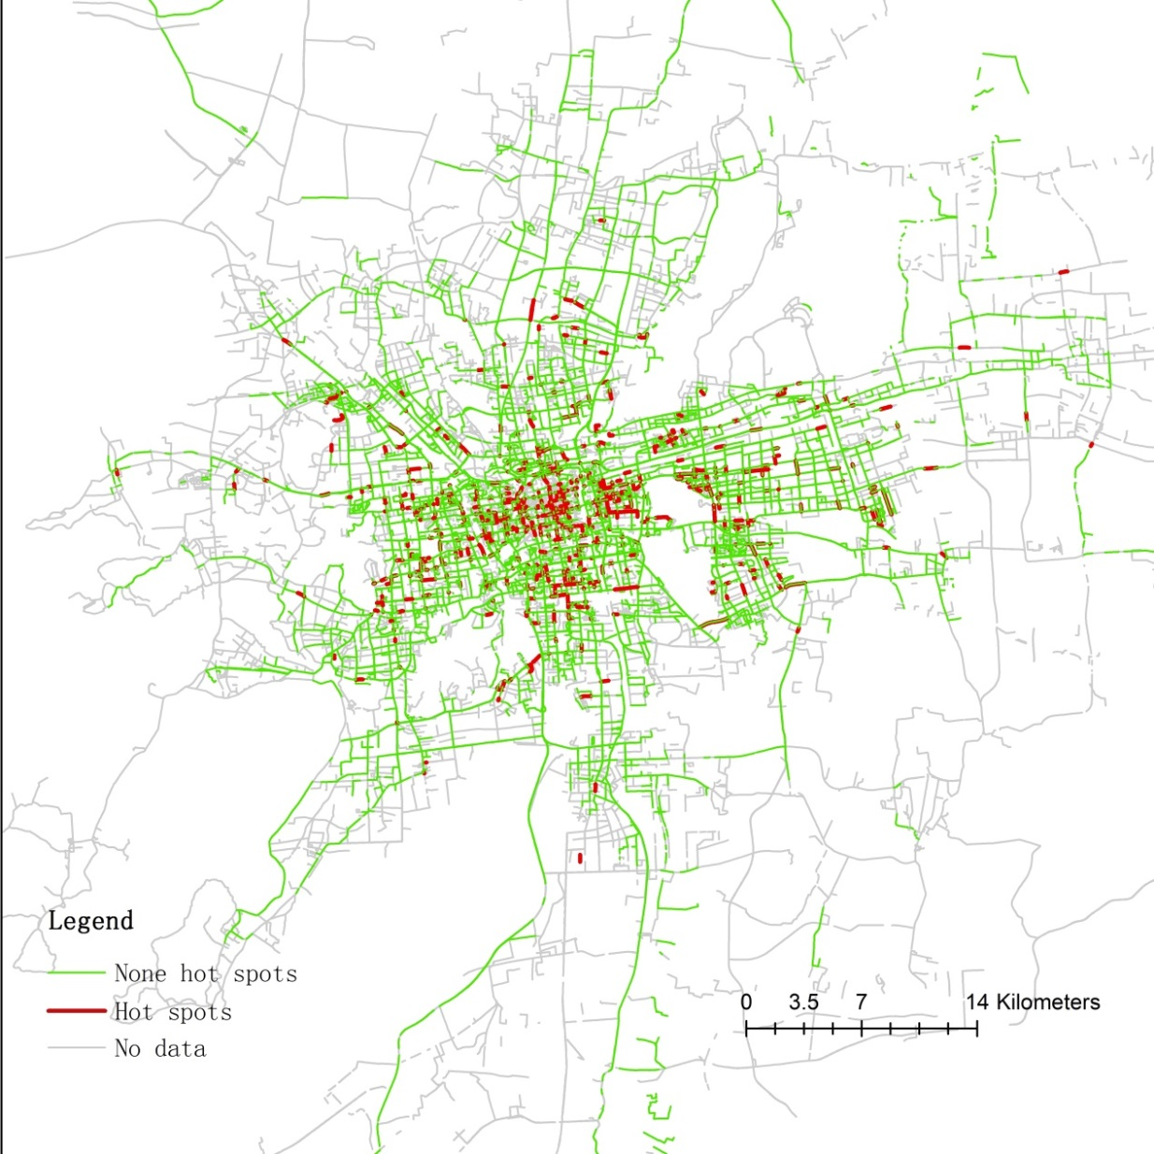
Figure 28: Hot spot map of imbalance feature class of the first time point during 22:00-23:00 time segment on 02-15.

4.4 Does a higher value of imbalance tend to occur at high event frequency prior to low event frequency?
A Pearson correlation analysis returns a coefficient ranged from -1 to 1. A large positive result should indicate a positive correlation: a higher IMB tended to tie with higher event frequency. A large negative result should indicate a negative correlation: a higher IMB tended to tie with lower event frequency. And a result close to 0 should indicate no correlation: there was no evidence to prove IMB and event frequency had any connections.
Table H in the Appendix listed the results of Pearson correlation coefficients between APM and imbalance at each time point. The results suggested that there is little correlation between APM and imbalance as most coefficients calculated were less than 0.1. Therefore, there wasn’t sufficient evidence to prove the connection between imbalance and event frequency.

4.5 More discussions
I described two different real life scenarios of the difficulty of finding vacant taxis in section 4.2 and 4.3. The first was that a taxi rider can’t find a taxi because there was no available taxi. The second was that riders compete for few available taxis.
The first type of difficulty of finding vacant taxis was caused by the High vs. Low event frequency, since low event frequency meant less chance to have a vacant taxi appearing on certain road segments. The analysis to the event complexity (NTW) in section 4.2 has shown this type of difficulty of finding vacant taxis tended to be distributed evenly across the entire city during all the time windows. Additionally, this type of difficulty was also related to the coverage of vacant taxis. On road segments which was not covered by vacant taxis (road segments with no taxi data), potential taxi riders might still exist. However, these potential riders cannot be detected and recorded in the GPS dataset.
The second type of difficulty of finding vacant taxis can be directly illustrated by the values of IMB. The analysis results of imbalance in section 4.3 has shown this type of difficulty of finding vacant taxis had a certain spatiotemporal pattern. The spatiotemporal distribution of IMB illustrated the overall taxi activity pattern in the city. In the early morning of a day, taxi activities are limited and concentrated in the center of the city. Soon after many people wake up in the morning, taxi activities suddenly appear all over the city. When the night comes, taxi activities decrease and start to concentrate in the center of the city again.
The analysis result in section 4.4 demonstrated that these two types of difficulty of finding vacant taxis were independent. There is no sufficient evidence to prove the existence of these two types of difficulty influencing each other.
Taxi’s drivers’ behavior is not only affected by the riders’ behavior as suggested by previous studies in the literature (Abe and Brush, 1976; De Vany, 1975; Foerster and Gorman, 1979; Manski and Wright, 1976; Wong and Yang, 1998), but also influenced by the traffic conditions as discussed in Figure 17. While taxi service demand is at a high level, drivers may be discouraged by bad traffic conditions.
I have several suggestions to ease the difficulty of finding vacant taxis:
- To ease the first type of difficulty, I suggest changing the taxi business pattern. Currently, smartphone taxi hailing apps are getting more and more popular in China. These apps can help reserve taxi service by establishing direct real time connections between riders and drivers. These apps are prohibited by the taxi administration of Suzhou, because their embedded bidding systems involve moral debates. A customer can offer extra tips to bid for vacant taxis, and taxi drivers can choose which customer to serve based on the tips offered. The administration in Suzhou considers such biding system is harm to the first come first serve principle of taxi service. However, regardless the moral debates, the idea to establish real time direct connections between riders and drivers is still valuable, and can help ease the first type of difficulty of finding vacant taxis by leading drivers to riders. Accepting apps with no bidding system is a practical solution to ease the first type of difficulty.
- To ease the second type of difficulty, I suggest improving alternative methods of transportation such as bus and subway systems which can ease the competition for vacant taxis among riders. However, such changes will involve government departments beside the taxi administration. This requires us consider taxi service as part of the urban transportation system, and to develop the transportation system as a whole from a comprehensive perspective.
- To increase the number of taxis in service during busy hours, the drivers must be encouraged. A straight solution is to improve the overall traffic condition in the city. However, this task is another complicated topic and is beyond the scope of this study. Another solution relies on policy making. A flexible taxi fare system can be developed to make up the loss of fare revenue due to traffic congestion. For instance, fees can be calculated for the duration of low speed movement or complete stops due to traffic conditions.

CHAPTER 5

CONCLUSIONS

5.1 Conclusions
This study discussed the difficulty of finding vacant taxis from two different perspectives, as well as the correlation between them. The results of the study helped us to better understand such difficulty. A better understanding can help both drivers and riders to improve their efficiency, as well as helping administration for future policy making.
A 7-day taxi trajectory dataset of Suzhou, China was manipulated to analyze the imbalance, which was the ratio of customer pick-ups to the number of vacant taxis showing up on each road segment. Prior to the process of obtaining imbalance, a hierarchical structure of multi-resolution time windows, which splits each hour into up to four parts, was developed based on Ward’s minimum variance method of hierarchical clustering (Ward, 1963). Such hierarchical structure of multi-resolution time windows can recognize significant local High vs. Low event frequency pattern and make the values of imbalance as representative as possible. Two tools from ArcGIS, Global Spatial Autocorrelation (Moran’s I) and Hot Spot Analysis (Getis-Ord Gi*), played the main roles in the analysis of imbalance (IMB), as well as the analysis of the number of time windows (NTW), which represented the temporal event complexity.
From the first perspective, the even distribution pattern of NTW hot spots showed the difficulty of finding vacant taxi caused by the low event frequency taking place evenly across the city during all time windows. Meanwhile, from the second perspective, the “early morning–daytime–transition–early morning” spatiotemporal pattern of IMB hot spots showed the difficulty of finding vacant taxis caused by the competition among riders followed the overall human activity pattern in the city. This type of difficulty tended to happen at where and when there were more human activities. Finally, the Pearson correlation analysis didn’t find sufficient evidence to prove the connection between these two types of difficulty of finding vacant taxis.
It’s more difficult to overcome the difficulty than to understand it. The suggestions I gave in the discussion all involve real life policy making. This reflected the importance of government orientation and the evolution of taxi service in Suzhou, China relies on it.

5.2 Limitations and Future Research
Though this study answered the proposed questions using a large GPS trajectory dataset, some embedded limitations in the analytical process suggest improvements in future research.
The first limitation concerns the boundary problem, which is also a part of MTUP. In section 4.1, I described how the method to divide time windows could cause the first and the fourth quarters of each hour to include more road segments compared to the second and the third quarters of each hour.
The second limitation concerns the handling of maps. Too many maps were generated to determine the spatial distribution of hot spots. These maps cannot be all listed in the thesis. Furthermore, the spatial distribution patterns of hot spots were determined arbitrarily. Considering the large amount of maps, some of the details could have been omitted. Future research should consider using space-time GIS environment as a potential method for visualization to eliminate this limitation.
Thirdly, during the analysis, I realized that analyzing the taxi service without thinking about the traffic conditions and other transportation modes may limit the conclusions. One of the suggestions I gave in the discussion was to improve alternative modes of transportation such as bus and subway systems. This requires the government to coordinate urban transportation as a whole. The first and the second subway lines in Suzhou were finished in April 2013 and August 2014, respectively. My future research will focus on the coordination between the bus, subway, and taxi systems in Suzhou.

LIST OF REFERENCES

- Abe, M. A. and Brush, B. C., 1976. On the regulation of price and service quality: The taxicab problem. Quarterly Review of Economics and Business, 16 (Autumn), 105-111.
- Chen, J., Shaw, S-L., Yu, H., Lu, F., Chai, Y., and Jia, Q., 2011. Exploratory data analysis of activity diary data: a space-time GIS approach. Journal of Transport Geography, 19, 394-404.
- Cheng, T., Haworth, J. and Wang, J., 2012. Spatiotemporal autocorrelation of road network data. Journal of Geographic System, 14, 389-413.
- Coltekin, A., Sabbta, S. D., Willi, C., Vontobel, I., Phister, S., Kuhnm M. and Lacayo, M., 2011. Modifiable temporal unit problem. Position paper contributes to the workshop on “Persistent problems in geographic visualization”, ICC2011 July 2011, Paris.
- De vany, A. S., 1975. Capacity utilization under alternative regulatory constraints: An analysis of taxi markets. Journal of Political Economy, 83, 83-94.
- Deng, Z., 2011. Spatiotemporal structure of taxi services in Shanghai: Using exploratory spatial data analysis. Proceeding of 19th International Conference on Geoinformatics. June 24-26, 2011, Shanghai.
- Foerster, J. F. and Gorman, G., 1979. Taxicab deregulation: Economic consequences and regulatory choices. Transportation, 8, 371-387.
- Gibson, C.C., Ostrom, E. and Ahn, T. K., 2000. The concept of scale and the human dimensions of global change: A survey. Ecological Economics, 32, 217–39.
- Guo, D., Jin, H., Andris, C., Zhu, X., and Gao, P., 2012. Discovering spatial patterns in Origin-Destination mobility data. Transactions in GIS, 16(3), 411-429.
- Hagerstrand, T., 1970. What about people in regional science? Papers of the Regional Science Association, 24, 7–21.
- Hornsby, K. and Egenhofer, M. J., 2002. Modeling moving objects over multiple granularities. Annals of Mathematics and Artificial Intelligence, 36, 177-194.
- Hu, X., Feng, J., 2006. Research on characteristics of taxi traffic based on GPS data. Urban Transport of China, 5, 91-95.
- Joh, C-H., Arentze, T. A. and Timmermans, H. J. P., 2001. A position-sensitive sequence-alignment method illustrated for space–time activity-diary data. Environment and Planning A, 33, 313–338.
- Li, Y., Yuan, Z., Xie, H., Cao, S. and Wu, X., 2006. Analysis on trips characteristics of taxi in Suzhou based on O-D data, Journal of Transportation Systems Engineering and Information Technology, 7, 85-89.
- Liao, Z, 2003. Real-time taxi dispatching using global positioning systems. Communications of the ACM, 46(5), 81-84.
- Liu, K., Yamamoto, T., and Morikawa, T., 2009. Feasibility of using taxi dispatch system as probes for collecting traffic information. Journal of Intelligent Transportation Systems, 2009, 13(1), 16-27.
- Liu, L., Andris, C., Biderman, A., and Ratti, C., 2009. Uncovering taxi driver’s mobility intelligence through his trace. IEEE Pervasive Computing, 160, 1-17.
- Manski, C. F. and Wright, J. D., 1976. Nature of equilibrium in the market for taxi services. Transportation Research Record, 619, 11-15.
- Meentemeyer, V., 1989. Geographical perspectives of space, time, and scale. Landscape Ecology, 3(4), 163-173.
- Miller, H. J., 1991. Modeling accessibility using space-time prism concepts within geographical information systems. International Journal of Geographical Information Systems, 5, 287-301.
- Miller, H. J. and Wu, Y.H., 2000. GIS software for measuring space-time accessibility in transportation planning and analysis. GeoInformatica, 4, 141-159.
- Reynolds H.D., 1998. The modifiable area unit problem: empirical analysis by statistical simulation. PhD dissertation, Graduate Department of Geography, University of Toronto.
- Shawn, J. D. and Bram, D., 2007. The modifiable areal unit problem (MAUP) in physical geography. Progress in Physical Geography. 31(5), 471-479.
- Shoval, N. and Isaacson, M., 2007. Sequence alignment as a method for human activity analysis in space and time. Annals of the Association of American Geographers, 97, 282-297.
- Takada, K. and Tsukada, N., 2006. Call me a cab: network links GPS-AVM systems; The mobility and flexible availability of private cars constrains efforts to curb their use to reduce congestion and pollution. A Japanese proposal uses GPS and automatic vehicle monitoring to dispatch taxis more efficiently, effectively incorporating taxi fleets into the public transit system. GPS world, 17, 44-49.
- Xu, Z., Jin, H., and Ling, H., 2005. Analyzing the value of location for four taxi dispatching modes. Tsinghua Science and Technology, 10, 844-851.
- Ward, J. H., Jr., 1963. Hierarchical Grouping to Optimize an Objective Function, Journal of the American Statistical Association, 58, 236–244
- Wong, K.I., Wong, S.C. and Yang, H., 2001. Modeling urban taxi services in congested road networks with elastic demand. Transportation Research Part B, 35(9), 819-842
- Wong, S.C., Yang, H., 1998. A network equilibrium model of urban taxi services: an improved algorithm. Transportation Research Record, 1623, 27atio
- Yang, H., Wong, S., and Wong, K., 2002. Demand-supply equilibrium of taxi services in a network under competition and regulation. Transportation Research Part B, 36, 799-819.
- Yang, H., Leung, C.W.Y., Wong, S., and Bell, M.G.H., 2010. Equilibria of bilateral taxi-customer searching and meeting on networks. Transportation Research Part B, 44, 1067-1083.
- Yang, H., Ye, M., Tang, W. H., and Wong, C.S., 2005. Regulating taxi services in the presence of congestion externality. Transportation Research Part A, 39(1), 17-40.
- Zhang, J, 2013. The difficulty of finding vacant taxi. China Economic Net. Retrieved from http://www.ce.cn/ztpd/xwzt/shehui/2013/dachenan/index.shtml (in Chinese).
- Zhou, F., Frade, F., and Hodgins, J., 2013. Hierarchical Aligned Cluster Analysis for Temporal Clustering of Human Motion. IEEE Transactions on Pattern Analysis and Machine Intelligence (PAMI), 35, 3, 582-596.

APPENDIX

Appendix Supplementary Tables

Appendix Table A: The number of active taxis during each hour.
Hours | 02-10(Sun) | 02-11(Mon) | 02-12(Tue) | 02-13(Wed) | 02-14(Thur) | 02-15(Fri) | 02-16(Sat)
0 | 1396 | 1211 | 1485 | 1734 | 2063 | 2437 | 3427
1 | 1204 | 959 | 1163 | 1396 | 1691 | 2120 | 3541
2 | 1016 | 751 | 902 | 1103 | 1331 | 1717 | 2610
3 | 815 | 589 | 686 | 836 | 1030 | 1353 | 1757
4 | 673 | 499 | 572 | 699 | 860 | 1127 | 1450
5 | 620 | 511 | 564 | 682 | 867 | 1033 | 1383
6 | 741 | 691 | 787 | 951 | 1164 | 1318 | 1732
7 | 1261 | 1400 | 1546 | 1723 | 1987 | 2297 | 2911
8 | 1884 | 2251 | 2366 | 2551 | 2794 | 3037 | 3555
9 | 2347 | 2802 | 2860 | 3049 | 3279 | 3407 | 4099
10 | 2638 | 3058 | 3098 | 3294 | 3459 | 3625 | 3902
11 | 2693 | 3057 | 3157 | 3344 | 3514 | 3717 | 3895
12 | 2662 | 2941 | 3069 | 3253 | 3420 | 3651 | 3822
13 | 2590 | 2880 | 2998 | 3146 | 3374 | 3605 | 3792
14 | 2565 | 2849 | 2968 | 3137 | 3397 | 3608 | 3799
15 | 2528 | 2806 | 2901 | 3130 | 3367 | 3591 | 3785
16 | 2521 | 2781 | 2909 | 3130 | 3358 | 3588 | 3789
17 | 2487 | 2732 | 2889 | 3074 | 3299 | 3576 | 3781
18 | 2321 | 2538 | 2696 | 2958 | 3165 | 3412 | 3644
19 | 2147 | 2411 | 2567 | 2888 | 3065 | 3344 | 3585
20 | 1981 | 2373 | 2476 | 2801 | 3020 | 3368 | 3937
21 | 1845 | 2239 | 2360 | 2708 | 2940 | 3276 | 3678
22 | 1654 | 2033 | 2187 | 2560 | 2798 | 3213 | 3465
23 | 1477 | 1798 | 1999 | 2368 | 2667 | 3096 | 3483
Day | 3653 | 3731 | 3815 | 3936 | 4073 | 4145 | 4243
7 Days | 4273

Appendix Table B : The number of features in each NTW feature class
Hours | 02-10(Sun) | 02-11(Mon) | 02-12(Tue) | 02-13(Wed) | 02-14(Thur) | 02-15(Fri) | 02-16(Sat)
0 | 8435 | 7909 | 8799 | 9415 | 10788 | 12129 | 13525
1 | 7864 | 6770 | 7688 | 8083 | 9823 | 11227 | 13043
2 | 7249 | 5801 | 6696 | 7235 | 8389 | 10228 | 11514
3 | 6022 | 5174 | 5545 | 6112 | 7191 | 9061 | 10104
4 | 5606 | 4363 | 4934 | 5496 | 6646 | 7911 | 9206
5 | 5159 | 4262 | 4838 | 5424 | 6637 | 7165 | 8684
6 | 5672 | 5396 | 6060 | 6822 | 7850 | 8288 | 9454
7 | 8155 | 8324 | 8748 | 9883 | 10634 | 11409 | 12675
8 | 10633 | 10938 | 12007 | 12271 | 13033 | 13284 | 14664
9 | 11551 | 12501 | 12700 | 12891 | 13117 | 13597 | 14287
10 | 12575 | 14040 | 13842 | 13637 | 13813 | 14009 | 14577
11 | 12477 | 13888 | 13899 | 13827 | 13973 | 14295 | 15089
12 | 11626 | 12192 | 12590 | 13122 | 13601 | 13885 | 14883
13 | 11547 | 12151 | 12498 | 12670 | 13278 | 13739 | 14894
14 | 11930 | 12350 | 12628 | 12787 | 13930 | 14013 | 14937
15 | 12179 | 12906 | 12841 | 13429 | 13975 | 14313 | 14717
16 | 12370 | 13452 | 13757 | 14037 | 14876 | 15075 | 15243
17 | 12595 | 13461 | 13444 | 13883 | 14375 | 14906 | 15271
18 | 11453 | 12483 | 12271 | 13048 | 13795 | 13890 | 14792
19 | 11089 | 12179 | 12352 | 12892 | 13541 | 13761 | 14532
20 | 10955 | 11809 | 12317 | 12910 | 13766 | 14397 | 15343
21 | 10532 | 11469 | 11779 | 13037 | 13712 | 14513 | 14903
22 | 9631 | 11098 | 11365 | 12766 | 13491 | 14839 | 14915
23 | 8777 | 10079 | 10497 | 11785 | 13234 | 13946 | 14319

Appendix Table C: The number of features in each IMB feature class
# | Time Point | 02-10(Sun) | 02-11(Mon) | 02-12(Tue) | 02-13(Wed) | 02-14(Thur) | 02-15(Fri) | 02-16(Sat)
1 | 0:05:00 | 6017 | 5593 | 6380 | 6987 | 8159 | 9204 | 10199
2 | 0:20:00 | 5088 | 4724 | 5501 | 6080 | 6964 | 8140 | 9081
3 | 0:35:00 | 5055 | 4763 | 5355 | 6014 | 6908 | 7919 | 8921
4 | 0:50:00 | 5891 | 5504 | 6232 | 6780 | 7694 | 8863 | 10302
5 | 1:05:00 | 5731 | 4993 | 5798 | 6122 | 7381 | 8657 | 9849
6 | 1:20:00 | 4727 | 4113 | 4748 | 5087 | 6462 | 7398 | 8366
7 | 1:35:00 | 4664 | 3901 | 4556 | 4952 | 6174 | 7151 | 8222
8 | 1:50:00 | 5422 | 4516 | 5166 | 5563 | 7017 | 7841 | 9644
9 | 2:05:00 | 5216 | 4097 | 4692 | 5192 | 6430 | 7640 | 9017
10 | 2:20:00 | 4397 | 3413 | 3783 | 4354 | 5331 | 6564 | 7486
11 | 2:35:00 | 4171 | 3211 | 3792 | 4320 | 4952 | 6299 | 7263
12 | 2:50:00 | 4795 | 3762 | 4505 | 4875 | 5510 | 7147 | 7958
13 | 3:05:00 | 4164 | 3535 | 3910 | 4314 | 5187 | 6614 | 7563
14 | 3:20:00 | 3450 | 2903 | 3223 | 3575 | 4508 | 5661 | 6552
15 | 3:35:00 | 3337 | 2785 | 3144 | 3556 | 4334 | 5415 | 6414
16 | 3:50:00 | 4008 | 3342 | 3675 | 4142 | 4949 | 6229 | 7210
17 | 4:05:00 | 3848 | 3030 | 3419 | 3870 | 4740 | 5765 | 6646
18 | 4:20:00 | 3086 | 2539 | 2862 | 3247 | 3907 | 4766 | 5712
19 | 4:35:00 | 4080 | 3089 | 3481 | 3993 | 4858 | 5844 | 7118
20 | 4:50:00 | 3688 | 2769 | 3150 | 3568 | 4412 | 5324 | 6528
21 | 5:05:00 | 3482 | 2629 | 2941 | 3574 | 4427 | 5016 | 6072
22 | 5:20:00 | 2880 | 2155 | 2524 | 2957 | 3839 | 4257 | 5284
23 | 5:35:00 | 2851 | 2321 | 2631 | 3036 | 3858 | 4115 | 5182
24 | 5:50:00 | 3353 | 2910 | 3379 | 3613 | 4587 | 4874 | 6138
25 | 6:05:00 | 3434 | 3286 | 3811 | 4141 | 4986 | 5170 | 6167
26 | 6:20:00 | 3001 | 2838 | 3293 | 3765 | 4346 | 4591 | 5336
27 | 6:35:00 | 3088 | 3089 | 3483 | 3953 | 4713 | 4862 | 5739
28 | 6:50:00 | 3933 | 3791 | 4278 | 5086 | 5903 | 6136 | 7176
29 | 7:05:00 | 4856 | 4824 | 5380 | 6289 | 7125 | 7749 | 8663
30 | 7:20:00 | 4253 | 4457 | 4797 | 5601 | 6267 | 6924 | 7950
31 | 7:35:00 | 4912 | 5138 | 5494 | 6448 | 6684 | 7398 | 8388
32 | 7:50:00 | 6218 | 6569 | 6907 | 7790 | 8099 | 8909 | 10076
33 | 8:05:00 | 7359 | 7864 | 8632 | 8832 | 9426 | 9717 | 11025
34 | 8:20:00 | 6702 | 7108 | 7912 | 8066 | 8585 | 8910 | 9912
35 | 8:35:00 | 6796 | 7415 | 8066 | 8269 | 8853 | 9153 | 10185
36 | 8:50:00 | 7972 | 8504 | 9312 | 9491 | 10026 | 10362 | 11340
37 | 9:05:00 | 8277 | 9142 | 9442 | 9566 | 9813 | 10292 | 10953
38 | 9:20:00 | 7298 | 8161 | 8463 | 8487 | 8612 | 9338 | 9624
Table C Continued
# | Time Point | 02-10(Sun) | 02-11(Mon) | 02-12(Tue) | 02-13(Wed) | 02-14(Thur) | 02-15(Fri) | 02-16(Sat)
39 | 9:35:00 | 7668 | 8296 | 8823 | 8707 | 8721 | 9379 | 9624
40 | 9:50:00 | 8897 | 9716 | 9950 | 9819 | 9965 | 10530 | 10988
41 | 10:05:00 | 9181 | 10399 | 10282 | 10260 | 10250 | 10651 | 11055
42 | 10:20:00 | 8227 | 9124 | 9251 | 9195 | 9109 | 9520 | 9814
43 | 10:35:00 | 8258 | 9171 | 9171 | 9219 | 9460 | 9362 | 10012
44 | 10:50:00 | 9505 | 10333 | 10469 | 10396 | 10598 | 10768 | 11255
45 | 11:05:00 | 9406 | 10832 | 10734 | 10700 | 10508 | 11030 | 11455
46 | 11:20:00 | 8168 | 9602 | 9438 | 9468 | 9323 | 9885 | 10372
47 | 11:35:00 | 8054 | 9089 | 9244 | 9190 | 9345 | 9783 | 10371
48 | 11:50:00 | 9064 | 10108 | 10268 | 10254 | 10602 | 10887 | 11688
49 | 12:05:00 | 8708 | 9174 | 9393 | 9933 | 10383 | 10716 | 11310
50 | 12:20:00 | 7498 | 7895 | 8387 | 8690 | 8983 | 9438 | 9932
51 | 12:35:00 | 7322 | 7949 | 8209 | 8739 | 9107 | 9402 | 9846
52 | 12:50:00 | 8414 | 9012 | 9529 | 9733 | 10138 | 10465 | 11423
53 | 13:05:00 | 8438 | 8949 | 9405 | 9292 | 10029 | 10370 | 11194
54 | 13:20:00 | 7461 | 7905 | 8284 | 8232 | 8885 | 9235 | 9803
55 | 13:35:00 | 7451 | 7967 | 8229 | 8395 | 8816 | 9221 | 10068
56 | 13:50:00 | 8657 | 9194 | 9229 | 9539 | 10019 | 10367 | 11532
57 | 14:05:00 | 8793 | 9348 | 9369 | 9631 | 10171 | 10503 | 11376
58 | 14:20:00 | 7697 | 8242 | 8342 | 8524 | 8980 | 9453 | 10086
59 | 14:35:00 | 7954 | 8262 | 8480 | 8671 | 9289 | 9685 | 10185
60 | 14:50:00 | 9037 | 9337 | 9639 | 9717 | 10680 | 10817 | 11422
61 | 15:05:00 | 9119 | 9672 | 9613 | 10138 | 10413 | 10753 | 11395
62 | 15:20:00 | 8048 | 8504 | 8518 | 9186 | 9427 | 9538 | 10157
63 | 15:35:00 | 8100 | 8443 | 8583 | 8973 | 9339 | 9727 | 10040
64 | 15:50:00 | 9196 | 9825 | 9644 | 10226 | 10623 | 10938 | 11214
65 | 16:05:00 | 9216 | 10052 | 10063 | 10388 | 11086 | 11148 | 11695
66 | 16:20:00 | 8047 | 8967 | 8986 | 9264 | 9748 | 10112 | 10411
67 | 16:35:00 | 7997 | 8919 | 9312 | 9633 | 9886 | 10271 | 10547
68 | 16:50:00 | 9233 | 10179 | 10562 | 10923 | 11077 | 11626 | 11914
69 | 17:05:00 | 9363 | 10036 | 10247 | 10624 | 10979 | 11434 | 11888
70 | 17:20:00 | 8381 | 8713 | 8937 | 9204 | 9609 | 9985 | 10419
71 | 17:35:00 | 8029 | 8754 | 8838 | 8844 | 9404 | 9909 | 10329
72 | 17:50:00 | 9076 | 9717 | 9840 | 10142 | 10529 | 11060 | 11443

Table C Continued
# | Time Point | 02-10(Sun) | 02-11(Mon) | 02-12(Tue) | 02-13(Wed) | 02-14(Thur) | 02-15(Fri) | 02-16(Sat)
73 | 18:05:00 | 8559 | 9368 | 9140 | 9853 | 10201 | 10601 | 11328
74 | 18:20:00 | 7301 | 8097 | 8038 | 8690 | 9052 | 9158 | 10012
75 | 18:35:00 | 7065 | 7831 | 7963 | 8757 | 9076 | 9025 | 9994
76 | 18:50:00 | 8188 | 8882 | 9002 | 9662 | 10331 | 10293 | 11257
77 | 19:05:00 | 8076 | 9094 | 9051 | 9640 | 10220 | 10450 | 11212
78 | 19:20:00 | 6902 | 8025 | 8083 | 8508 | 8909 | 9177 | 10017
79 | 19:35:00 | 6896 | 7666 | 7986 | 8390 | 8963 | 9192 | 9927
80 | 19:50:00 | 8100 | 8831 | 9171 | 9697 | 10171 | 10470 | 11120
81 | 20:05:00 | 8005 | 8645 | 9176 | 9680 | 10399 | 10832 | 11665
82 | 20:20:00 | 6966 | 7765 | 8150 | 8486 | 9139 | 9615 | 10400
83 | 20:35:00 | 6909 | 7816 | 7850 | 8416 | 8948 | 9679 | 10378
84 | 20:50:00 | 8019 | 8800 | 8951 | 9599 | 10180 | 10852 | 11791
85 | 21:05:00 | 7759 | 8768 | 8807 | 9650 | 10298 | 10828 | 10673
86 | 21:20:00 | 6750 | 7690 | 7958 | 8710 | 9177 | 9728 | 10304
87 | 21:35:00 | 6770 | 7597 | 7924 | 8837 | 9088 | 9963 | 10530
88 | 21:50:00 | 7795 | 8358 | 8872 | 9987 | 10270 | 11233 | 11883
89 | 22:05:00 | 7292 | 8282 | 8633 | 9869 | 10373 | 11375 | 11805
90 | 22:20:00 | 6267 | 7328 | 7542 | 8682 | 9118 | 10222 | 10341
91 | 22:35:00 | 6059 | 7273 | 7347 | 8496 | 8927 | 10044 | 10182
92 | 22:50:00 | 6831 | 8090 | 8335 | 9472 | 10044 | 11236 | 11253
93 | 23:05:00 | 6511 | 7712 | 7892 | 8953 | 10052 | 10729 | 11008
94 | 23:20:00 | 5540 | 6612 | 6840 | 7659 | 8835 | 9446 | 9777
95 | 23:35:00 | 5256 | 6065 | 6645 | 7620 | 8826 | 9297 | 9794
96 | 23:50:00 | 6124 | 7021 | 7565 | 8701 | 9938 | 10492 | 10855

Appendix Table D: Spatial distributions of the number of time windows. 1 = clustered, 0 = random, -1 = dispersed.
Hours | 02-10  (Sun) | 02-11  (Mon) | 02-12  (Tue) | 02-13  (Wed) | 02-14  (Thur) | 02-15  (Fri) | 02-16  (Sat)
0 | 0 | 0 | 0 | 0 | 1 | 0 | 0
1 | 0 | 0 | 0 | 0 | 0 | 0 | 0
2 | 0 | 0 | 0 | 0 | 0 | 0 | 0
3 | 0 | 0 | 0 | 0 | 0 | -1 | 0
4 | 0 | 0 | 0 | 0 | 0 | 0 | 0
5 | 0 | 0 | 0 | 0 | 0 | 0 | 0
6 | 0 | 0 | 0 | 0 | -1 | 0 | 0
7 | 0 | 0 | 0 | 0 | 0 | 0 | 0
8 | 0 | 1 | 0 | 1 | 0 | 1 | 0
9 | 0 | 0 | 0 | 0 | 1 | 1 | 0
10 | 0 | 0 | 1 | 0 | 0 | 0 | 0
11 | 0 | 0 | 1 | 0 | 0 | 0 | 0
12 | 0 | 0 | 0 | 0 | 0 | 0 | 0
13 | 1 | 1 | 0 | 0 | 0 | 0 | 0
14 | 1 | 0 | 1 | 0 | 0 | 0 | 1
15 | 0 | 1 | 1 | 0 | 0 | 0 | 0
16 | 0 | 0 | -1 | 0 | 0 | 0 | 0
17 | 0 | 0 | 0 | 0 | 0 | 0 | 0
18 | 0 | 0 | 0 | 0 | 0 | 0 | 1
19 | 0 | 0 | 0 | 0 | 0 | 0 | 0
20 | -1 | 0 | 0 | 0 | 0 | 0 | 1
21 | 0 | 0 | 0 | 0 | 0 | 0 | 1
22 | 0 | 0 | 0 | 0 | 0 | 0 | 0
23 | 0 | 0 | 0 | 0 | 0 | 0 | 0

Appendix Table E: The number of NTW hot spots along with the spatial distribution pattern from Table D
Hours | 02-10(Sun) |  | 02-11(Mon) |  | 02-12(Tue) |  | 02-13(Wed) |  | 02-14(Thur) |  | 02-15(Fri) |  | 02-16(Sat)
0 | 0 | 720 | 0 | 613 | 0 | 783 | 0 | 730 | 1 | 808 | 0 | 955 | 0 | 1020
1 | 0 | 662 | 0 | 563 | 0 | 660 | 0 | 637 | 0 | 742 | 0 | 824 | 0 | 1096
2 | 0 | 573 | 0 | 471 | 0 | 573 | 0 | 636 | 0 | 686 | 0 | 861 | 0 | 942
3 | 0 | 537 | 0 | 410 | 0 | 501 | 0 | 536 | 0 | 588 | -1 | 700 | 0 | 882
4 | 0 | 208 | 0 | 158 | 0 | 198 | 0 | 217 | 0 | 250 | 0 | 353 | 0 | 417
5 | 0 | 373 | 0 | 358 | 0 | 408 | 0 | 472 | 0 | 563 | 0 | 637 | 0 | 737
6 | 0 | 405 | 0 | 384 | 0 | 481 | 0 | 551 | -1 | 622 | 0 | 734 | 0 | 849
7 | 0 | 648 | 0 | 662 | 0 | 772 | 0 | 753 | 0 | 861 | 0 | 987 | 0 | 992
8 | 0 | 758 | 1 | 648 | 0 | 815 | 1 | 779 | 0 | 878 | 1 | 913 | 0 | 1005
9 | 0 | 821 | 0 | 866 | 0 | 831 | 0 | 807 | 1 | 941 | 1 | 907 | 0 | 1012
10 | 0 | 844 | 0 | 978 | 1 | 956 | 0 | 894 | 0 | 994 | 0 | 994 | 0 | 1088
11 | 0 | 889 | 0 | 916 | 1 | 971 | 0 | 951 | 0 | 1086 | 0 | 941 | 0 | 1083
12 | 0 | 891 | 0 | 841 | 0 | 907 | 0 | 964 | 0 | 1063 | 0 | 990 | 0 | 1147
13 | 1 | 893 | 1 | 868 | 0 | 875 | 0 | 927 | 0 | 1023 | 0 | 945 | 0 | 1092
14 | 1 | 849 | 0 | 848 | 1 | 895 | 0 | 905 | 0 | 983 | 0 | 1018 | 1 | 1087
15 | 0 | 908 | 1 | 889 | 1 | 944 | 0 | 942 | 0 | 1001 | 0 | 1057 | 0 | 998
16 | 0 | 897 | 0 | 965 | -1 | 951 | 0 | 1070 | 0 | 1049 | 0 | 1075 | 0 | 1116
17 | 0 | 896 | 0 | 953 | 0 | 1011 | 0 | 1153 | 0 | 1102 | 0 | 1110 | 0 | 1170
18 | 0 | 918 | 0 | 923 | 0 | 905 | 0 | 900 | 0 | 1064 | 0 | 1109 | 1 | 1077
19 | 0 | 870 | 0 | 813 | 0 | 916 | 0 | 1050 | 0 | 1059 | 0 | 1050 | 0 | 1036
20 | -1 | 807 | 0 | 787 | 0 | 948 | 0 | 980 | 0 | 998 | 0 | 1144 | 1 | 1177
21 | 0 | 844 | 0 | 765 | 0 | 844 | 0 | 1010 | 0 | 1023 | 0 | 1038 | 1 | 866
22 | 0 | 744 | 0 | 831 | 0 | 831 | 0 | 966 | 0 | 1040 | 0 | 1105 | 0 | 1067
23 | 0 | 706 | 0 | 771 | 0 | 839 | 0 | 955 | 0 | 1037 | 0 | 1084 | 0 | 970

Appendix Table F: Spatial distribution pattern of imbalance. 1 = clustered, 0 = random, -1 = dispersed.
# | Time Point | Code | 02-10  (Sun) | 02-11  (Mon) | 02-12  (Tue) | 02-13  (Wed) | 02-14  (Thur) | 02-15  (Fri) | 02-16  (Sat)
0 | 0:05:00 | TW001 | 0 | 0 | 0 | 0 | 0 | 0 | 0
1 | 0:20:00 | TW002 | 0 | 0 | 0 | 0 | 0 | 0 | 0
2 | 0:35:00 | TW003 | 1 | -1 | 0 | 1 | 0 | 0 | 0
3 | 0:50:00 | TW004 | 0 | 0 | 0 | 0 | 0 | 0 | 0
4 | 1:05:00 | TW011 | 0 | 0 | 0 | 0 | -1 | 0 | -1
5 | 1:20:00 | TW012 | 1 | 0 | 0 | 0 | -1 | 0 | 0
6 | 1:35:00 | TW013 | 0 | 0 | 0 | 0 | -1 | 0 | 0
7 | 1:50:00 | TW014 | 0 | 0 | 0 | 0 | 0 | 0 | 0
8 | 2:05:00 | TW021 | 0 | 0 | 0 | 1 | 0 | 0 | 0
9 | 2:20:00 | TW022 | 0 | 0 | 0 | 0 | 0 | 1 | -1
10 | 2:35:00 | TW023 | 0 | 0 | 0 | 0 | 1 | 0 | 0
11 | 2:50:00 | TW024 | 0 | 0 | 0 | 0 | 0 | 1 | 0
12 | 3:05:00 | TW031 | 0 | 1 | 0 | 0 | 0 | 0 | 0
13 | 3:20:00 | TW032 | 0 | 1 | 0 | 0 | 0 | 0 | 1
14 | 3:35:00 | TW033 | 0 | 0 | 0 | 1 | 0 | 0 | 0
15 | 3:50:00 | TW034 | -1 | 0 | 0 | 0 | 0 | 0 | 0
16 | 4:05:00 | TW041 | 0 | 0 | 0 | 0 | 0 | 0 | 0
17 | 4:20:00 | TW042 | 0 | 0 | 0 | 0 | 0 | 0 | 0
18 | 4:35:00 | TW043 | 0 | 0 | 0 | 0 | 0 | 0 | 0
19 | 4:50:00 | TW044 | 0 | 0 | 0 | 0 | 0 | 0 | 0
20 | 5:05:00 | TW051 | 0 | -1 | 0 | 0 | 0 | 0 | 0
21 | 5:20:00 | TW052 | 0 | 0 | 0 | 1 | 0 | 0 | 0
22 | 5:35:00 | TW053 | 0 | 0 | 1 | 0 | 0 | 0 | 0
23 | 5:50:00 | TW054 | 0 | 0 | 0 | 0 | 0 | 0 | 0
24 | 6:05:00 | TW061 | 0 | 0 | 0 | 0 | 0 | 0 | 0
25 | 6:20:00 | TW062 | 0 | 0 | 0 | 0 | 0 | 0 | 0
26 | 6:35:00 | TW063 | 0 | 0 | 0 | 0 | 0 | 0 | 0
27 | 6:50:00 | TW064 | 0 | 0 | 0 | 0 | 0 | 0 | 0
28 | 7:05:00 | TW071 | 0 | 0 | 0 | 0 | 1 | 0 | 0
29 | 7:20:00 | TW072 | -1 | 0 | 0 | 1 | 1 | 0 | 1
30 | 7:35:00 | TW073 | 0 | 0 | 0 | 0 | 1 | 0 | 0
31 | 7:50:00 | TW074 | 0 | 0 | 0 | 0 | 0 | 0 | 1
32 | 8:05:00 | TW081 | 0 | 0 | 0 | 0 | 0 | 0 | 0
33 | 8:20:00 | TW082 | 0 | 0 | 0 | 0 | 0 | 0 | 0
34 | 8:35:00 | TW083 | 0 | 0 | 0 | 0 | 0 | 0 | 0
35 | 8:50:00 | TW084 | 0 | 0 | 0 | 0 | 0 | 0 | 0
Table F Continued
# | Time Point | Code | 02-10  (Sun) | 02-11  (Mon) | 02-12  (Tue) | 02-13  (Wed) | 02-14  (Thur) | 02-15  (Fri) | 02-16  (Sat)
36 | 9:05:00 | TW091 | 0 | -1 | 0 | 0 | 0 | -1 | 0
37 | 9:20:00 | TW092 | 0 | 0 | -1 | 0 | 0 | 0 | 0
38 | 9:35:00 | TW093 | 0 | 0 | 0 | 0 | 0 | 0 | 0
39 | 9:50:00 | TW094 | 0 | 0 | 0 | 0 | -1 | 0 | 0
40 | 10:05:00 | TW101 | 0 | 0 | 0 | 1 | 0 | 0 | 1
41 | 10:20:00 | TW102 | 0 | 0 | 0 | 0 | 0 | 0 | 0
42 | 10:35:00 | TW103 | 0 | 0 | 0 | 0 | 0 | 0 | 0
43 | 10:50:00 | TW104 | 0 | 0 | 0 | 0 | 0 | 1 | 0
44 | 11:05:00 | TW111 | 0 | 0 | 0 | 0 | 0 | 0 | 0
45 | 11:20:00 | TW112 | 0 | 0 | 0 | 0 | 0 | 0 | 0
46 | 11:35:00 | TW113 | 0 | 0 | 0 | 0 | 0 | 0 | 1
47 | 11:50:00 | TW114 | 0 | 0 | 0 | 0 | 1 | 0 | 0
48 | 12:05:00 | TW121 | 0 | 0 | 0 | 0 | 0 | 0 | 0
49 | 12:20:00 | TW122 | 0 | 1 | 0 | 0 | 0 | 0 | 0
50 | 12:35:00 | TW123 | 0 | 0 | 0 | 0 | 0 | 0 | 0
51 | 12:50:00 | TW124 | 0 | 0 | 0 | 0 | 0 | 0 | 0
52 | 13:05:00 | TW131 | 0 | 1 | 1 | 0 | 0 | 0 | 0
53 | 13:20:00 | TW132 | 0 | 1 | 0 | 0 | 0 | 0 | 0
54 | 13:35:00 | TW133 | 0 | 0 | 0 | -1 | 0 | 0 | 0
55 | 13:50:00 | TW134 | 0 | 0 | 0 | 0 | 0 | 1 | 0
56 | 14:05:00 | TW141 | 0 | 0 | 0 | 0 | 1 | 0 | 0
57 | 14:20:00 | TW142 | 0 | 0 | 0 | 0 | 1 | 1 | 1
58 | 14:35:00 | TW143 | 0 | 0 | 0 | 0 | 0 | 0 | 0
59 | 14:50:00 | TW144 | 0 | 0 | 0 | 0 | 1 | 0 | 0
60 | 15:05:00 | TW151 | 0 | 0 | 0 | 0 | 0 | 0 | 0
61 | 15:20:00 | TW152 | 0 | 0 | 0 | 0 | 1 | 0 | 0
62 | 15:35:00 | TW153 | 0 | 0 | 0 | 1 | 0 | 0 | 0
63 | 15:50:00 | TW154 | 0 | 0 | 0 | 1 | 1 | 0 | 0
64 | 16:05:00 | TW161 | 0 | 1 | 0 | 0 | 1 | 0 | 0
65 | 16:20:00 | TW162 | 1 | 1 | 0 | 0 | 1 | 0 | 0
66 | 16:35:00 | TW163 | 1 | 0 | 1 | 0 | 0 | 0 | 0
67 | 16:50:00 | TW164 | 0 | 0 | 1 | 0 | 0 | 0 | 0
68 | 17:05:00 | TW171 | 0 | 0 | 1 | 1 | 1 | 1 | 0
69 | 17:20:00 | TW172 | 0 | 1 | 1 | 0 | 1 | 1 | 0
70 | 17:35:00 | TW173 | 1 | 1 | 1 | 1 | 1 | 1 | 0
71 | 17:50:00 | TW174 | 0 | 1 | 1 | 1 | 1 | 0 | 0
72 | 18:05:00 | TW181 | 0 | 0 | 0 | 0 | 0 | 0 | 0
73 | 18:20:00 | TW182 | 0 | 1 | 0 | 0 | 0 | 0 | 0
Table F Continued
# | Time Point | Code | 02-10  (Sun) | 02-11  (Mon) | 02-12  (Tue) | 02-13  (Wed) | 02-14  (Thur) | 02-15  (Fri) | 02-16  (Sat)
74 | 18:35:00 | TW183 | 1 | 0 | 0 | 0 | 0 | 0 | 0
75 | 18:50:00 | TW184 | 0 | 0 | 0 | 1 | 0 | 0 | 0
76 | 19:05:00 | TW191 | 1 | 0 | 0 | 0 | 0 | 1 | 0
77 | 19:20:00 | TW192 | 0 | 0 | 0 | 0 | 0 | 0 | 0
78 | 19:35:00 | TW193 | 0 | 1 | 0 | 0 | 0 | 0 | 1
79 | 19:50:00 | TW194 | 0 | 0 | 0 | 0 | 0 | 0 | 0
80 | 20:05:00 | TW201 | 0 | 1 | 0 | 0 | 1 | 0 | 0
81 | 20:20:00 | TW202 | 0 | 0 | 0 | 0 | 0 | 0 | 0
82 | 20:35:00 | TW203 | 0 | 0 | 0 | 0 | 1 | 0 | 1
83 | 20:50:00 | TW204 | 0 | 1 | 0 | 0 | 0 | 0 | 0
84 | 21:05:00 | TW211 | 0 | 0 | 0 | 1 | 1 | 1 | 0
85 | 21:20:00 | TW212 | 0 | 0 | 0 | 1 | 1 | 1 | 0
86 | 21:35:00 | TW213 | 0 | 0 | 0 | 0 | 1 | 1 | 0
87 | 21:50:00 | TW214 | 0 | 0 | 0 | 1 | 0 | 1 | 0
88 | 22:05:00 | TW221 | 0 | 0 | 0 | 0 | 0 | 0 | 1
89 | 22:20:00 | TW222 | 0 | 0 | 0 | 0 | 1 | 1 | 1
90 | 22:35:00 | TW223 | 1 | 1 | 0 | 0 | 1 | 1 | 0
91 | 22:50:00 | TW224 | 0 | 1 | 0 | 1 | 1 | 0 | 1
92 | 23:05:00 | TW231 | 0 | 1 | 0 | 0 | 0 | 0 | 1
93 | 23:20:00 | TW232 | 0 | 0 | 0 | 0 | 0 | 0 | 0
94 | 23:35:00 | TW233 | 0 | 0 | 0 | 0 | 1 | -1 | 0
95 | 23:50:00 | TW234 | 0 | 0 | -1 | 0 | 1 | 0 | 0

Appendix Table G: The number of imbalance hot spots with the spatial distribution patterns from Table F
# | Time Point | Code | 02-10  (Sun) |  | 02-11  (Mon) |  | 02-12  (Tue) |  | 02-13  (Wed) |  | 02-14  (Thur) |  | 02-15  (Fri) |  | 02-16  (Sat)
1 | 0:05:00 | tp001 | 0 | 419 | 0 | 335 | 0 | 378 | 0 | 429 | 0 | 533 | 0 | 534 | 0 | 619
2 | 0:20:00 | tp002 | 0 | 367 | 0 | 280 | 0 | 326 | 0 | 373 | 0 | 449 | 0 | 475 | 0 | 549
3 | 0:35:00 | tp003 | 1 | 351 | -1 | 256 | 0 | 312 | 1 | 355 | 0 | 415 | 0 | 423 | 0 | 534
4 | 0:50:00 | tp004 | 0 | 401 | 0 | 277 | 0 | 358 | 0 | 363 | 0 | 450 | 0 | 460 | 0 | 588
5 | 1:05:00 | tp011 | 0 | 360 | 0 | 306 | 0 | 289 | 0 | 289 | -1 | 344 | 0 | 413 | -1 | 500
6 | 1:20:00 | tp012 | 1 | 315 | 0 | 244 | 0 | 290 | 0 | 267 | -1 | 309 | 0 | 359 | 0 | 447
7 | 1:35:00 | tp013 | 0 | 274 | 0 | 212 | 0 | 261 | 0 | 246 | -1 | 292 | 0 | 338 | 0 | 478
8 | 1:50:00 | tp014 | 0 | 315 | 0 | 256 | 0 | 300 | 0 | 261 | 0 | 309 | 0 | 353 | 0 | 527
9 | 2:05:00 | tp021 | 0 | 290 | 0 | 209 | 0 | 247 | 1 | 262 | 0 | 294 | 0 | 361 | 0 | 690
10 | 2:20:00 | tp022 | 0 | 242 | 0 | 230 | 0 | 198 | 0 | 212 | 0 | 247 | 1 | 295 | -1 | 465
11 | 2:35:00 | tp023 | 0 | 237 | 0 | 169 | 0 | 202 | 0 | 202 | 1 | 230 | 0 | 286 | 0 | 471
12 | 2:50:00 | tp024 | 0 | 254 | 0 | 209 | 0 | 221 | 0 | 255 | 0 | 244 | 1 | 325 | 0 | 503
13 | 3:05:00 | tp031 | 0 | 215 | 1 | 194 | 0 | 198 | 0 | 221 | 0 | 213 | 0 | 288 | 0 | 413
14 | 3:20:00 | tp032 | 0 | 187 | 1 | 162 | 0 | 169 | 0 | 195 | 0 | 197 | 0 | 264 | 1 | 380
15 | 3:35:00 | tp033 | 0 | 181 | 0 | 152 | 0 | 163 | 1 | 186 | 0 | 191 | 0 | 254 | 0 | 351
16 | 3:50:00 | tp034 | -1 | 249 | 0 | 163 | 0 | 180 | 0 | 213 | 0 | 211 | 0 | 284 | 0 | 421
17 | 4:05:00 | tp041 | 0 | 222 | 0 | 161 | 0 | 168 | 0 | 154 | 0 | 206 | 0 | 258 | 0 | 300
18 | 4:20:00 | tp042 | 0 | 155 | 0 | 139 | 0 | 131 | 0 | 127 | 0 | 184 | 0 | 207 | 0 | 238
19 | 4:35:00 | tp043 | 0 | 228 | 0 | 176 | 0 | 141 | 0 | 171 | 0 | 201 | 0 | 263 | 0 | 287
20 | 4:50:00 | tp044 | 0 | 205 | 0 | 156 | 0 | 126 | 0 | 144 | 0 | 189 | 0 | 233 | 0 | 279
21 | 5:05:00 | tp051 | 0 | 210 | -1 | 161 | 0 | 172 | 0 | 184 | 0 | 209 | 0 | 238 | 0 | 278
22 | 5:20:00 | tp052 | 0 | 136 | 0 | 139 | 0 | 115 | 1 | 146 | 0 | 191 | 0 | 211 | 0 | 252
23 | 5:35:00 | tp053 | 0 | 138 | 0 | 142 | 1 | 153 | 0 | 149 | 0 | 194 | 0 | 223 | 0 | 242
24 | 5:50:00 | tp054 | 0 | 173 | 0 | 139 | 0 | 195 | 0 | 197 | 0 | 239 | 0 | 257 | 0 | 286
25 | 6:05:00 | tp061 | 0 | 219 | 0 | 204 | 0 | 199 | 0 | 249 | 0 | 286 | 0 | 300 | 0 | 386
26 | 6:20:00 | tp062 | 0 | 194 | 0 | 172 | 0 | 166 | 0 | 230 | 0 | 252 | 0 | 278 | 0 | 330
27 | 6:35:00 | tp063 | 0 | 193 | 0 | 209 | 0 | 211 | 0 | 202 | 0 | 263 | 0 | 244 | 0 | 316
28 | 6:50:00 | tp064 | 0 | 257 | 0 | 249 | 0 | 277 | 0 | 268 | 0 | 283 | 0 | 307 | 0 | 387
29 | 7:05:00 | tp071 | 0 | 298 | 0 | 317 | 0 | 289 | 0 | 306 | 1 | 446 | 0 | 460 | 0 | 451
30 | 7:20:00 | tp072 | -1 | 263 | 0 | 293 | 0 | 253 | 1 | 276 | 1 | 401 | 0 | 404 | 1 | 439
31 | 7:35:00 | tp073 | 0 | 295 | 0 | 279 | 0 | 299 | 0 | 404 | 1 | 404 | 0 | 449 | 0 | 466
32 | 7:50:00 | tp074 | 0 | 372 | 0 | 376 | 0 | 347 | 0 | 466 | 0 | 409 | 0 | 555 | 1 | 547
33 | 8:05:00 | tp081 | 0 | 347 | 0 | 402 | 0 | 363 | 0 | 380 | 0 | 462 | 0 | 454 | 0 | 626
34 | 8:20:00 | tp082 | 0 | 426 | 0 | 359 | 0 | 329 | 0 | 382 | 0 | 408 | 0 | 406 | 0 | 561
Table G Continued
# | Time Point | Code | 02-10  (Sun) |  | 02-11  (Mon) |  | 02-12  (Tue) |  | 02-13  (Wed) |  | 02-14  (Thur) |  | 02-15  (Fri) |  | 02-16  (Sat)
35 | 8:35:00 | tp083 | 0 | 403 | 0 | 373 | 0 | 356 | 0 | 389 | 0 | 433 | 0 | 409 | 0 | 596
36 | 8:50:00 | tp084 | 0 | 492 | 0 | 440 | 0 | 407 | 0 | 405 | 0 | 498 | 0 | 477 | 0 | 646
37 | 9:05:00 | tp091 | 0 | 422 | -1 | 425 | 0 | 396 | 0 | 430 | 0 | 472 | -1 | 447 | 0 | 526
38 | 9:20:00 | tp092 | 0 | 376 | 0 | 373 | -1 | 340 | 0 | 395 | 0 | 409 | 0 | 397 | 0 | 501
39 | 9:35:00 | tp093 | 0 | 386 | 0 | 394 | 0 | 379 | 0 | 374 | 0 | 421 | 0 | 397 | 0 | 469
40 | 9:50:00 | tp094 | 0 | 490 | 0 | 448 | 0 | 405 | 0 | 434 | -1 | 470 | 0 | 448 | 0 | 536
41 | 10:05:00 | tp101 | 0 | 501 | 0 | 524 | 0 | 497 | 1 | 479 | 0 | 609 | 0 | 489 | 1 | 661
42 | 10:20:00 | tp102 | 0 | 460 | 0 | 483 | 0 | 404 | 0 | 427 | 0 | 535 | 0 | 426 | 0 | 501
43 | 10:35:00 | tp103 | 0 | 489 | 0 | 486 | 0 | 419 | 0 | 484 | 0 | 575 | 0 | 444 | 0 | 509
44 | 10:50:00 | tp104 | 0 | 565 | 0 | 530 | 0 | 486 | 0 | 536 | 0 | 649 | 1 | 507 | 0 | 601
45 | 11:05:00 | tp111 | 0 | 573 | 0 | 623 | 0 | 505 | 0 | 525 | 0 | 656 | 0 | 587 | 0 | 615
46 | 11:20:00 | tp112 | 0 | 494 | 0 | 548 | 0 | 451 | 0 | 458 | 0 | 557 | 0 | 543 | 0 | 554
47 | 11:35:00 | tp113 | 0 | 482 | 0 | 474 | 0 | 458 | 0 | 464 | 0 | 582 | 0 | 547 | 1 | 548
48 | 11:50:00 | tp114 | 0 | 577 | 0 | 544 | 0 | 517 | 0 | 542 | 1 | 658 | 0 | 592 | 0 | 623
49 | 12:05:00 | tp121 | 0 | 516 | 0 | 543 | 0 | 483 | 0 | 544 | 0 | 625 | 0 | 584 | 0 | 602
50 | 12:20:00 | tp122 | 0 | 457 | 1 | 464 | 0 | 461 | 0 | 469 | 0 | 537 | 0 | 486 | 0 | 529
51 | 12:35:00 | tp123 | 0 | 374 | 0 | 464 | 0 | 469 | 0 | 490 | 0 | 571 | 0 | 500 | 0 | 560
52 | 12:50:00 | tp124 | 0 | 433 | 0 | 552 | 0 | 532 | 0 | 561 | 0 | 620 | 0 | 586 | 0 | 633
53 | 13:05:00 | tp131 | 0 | 440 | 1 | 532 | 1 | 566 | 0 | 587 | 0 | 576 | 0 | 608 | 0 | 608
54 | 13:20:00 | tp132 | 0 | 461 | 1 | 485 | 0 | 467 | 0 | 526 | 0 | 437 | 0 | 551 | 0 | 541
55 | 13:35:00 | tp133 | 0 | 380 | 0 | 488 | 0 | 502 | -1 | 561 | 0 | 599 | 0 | 553 | 0 | 552
56 | 13:50:00 | tp134 | 0 | 565 | 0 | 559 | 0 | 551 | 0 | 648 | 0 | 656 | 1 | 608 | 0 | 610
57 | 14:05:00 | tp141 | 0 | 502 | 0 | 514 | 0 | 567 | 0 | 564 | 1 | 656 | 0 | 602 | 0 | 649
58 | 14:20:00 | tp142 | 0 | 428 | 0 | 433 | 0 | 472 | 0 | 503 | 1 | 578 | 1 | 530 | 1 | 584
59 | 14:35:00 | tp143 | 0 | 416 | 0 | 443 | 0 | 470 | 0 | 506 | 0 | 574 | 0 | 524 | 0 | 562
60 | 14:50:00 | tp144 | 0 | 475 | 0 | 514 | 0 | 512 | 0 | 537 | 1 | 656 | 0 | 591 | 0 | 637
61 | 15:05:00 | tp151 | 0 | 499 | 0 | 539 | 0 | 501 | 0 | 570 | 0 | 670 | 0 | 596 | 0 | 578
62 | 15:20:00 | tp152 | 0 | 437 | 0 | 483 | 0 | 451 | 0 | 510 | 1 | 570 | 0 | 547 | 0 | 539
63 | 15:35:00 | tp153 | 0 | 447 | 0 | 478 | 0 | 456 | 1 | 513 | 0 | 595 | 0 | 538 | 0 | 516
64 | 15:50:00 | tp154 | 0 | 501 | 0 | 551 | 0 | 527 | 1 | 577 | 1 | 666 | 0 | 612 | 0 | 595
65 | 16:05:00 | tp161 | 0 | 521 | 1 | 548 | 0 | 574 | 0 | 617 | 1 | 704 | 0 | 641 | 0 | 594
66 | 16:20:00 | tp162 | 1 | 471 | 1 | 502 | 0 | 502 | 0 | 557 | 1 | 615 | 0 | 592 | 0 | 575
67 | 16:35:00 | tp163 | 1 | 486 | 0 | 532 | 1 | 541 | 0 | 587 | 0 | 625 | 0 | 610 | 0 | 584
68 | 16:50:00 | tp164 | 0 | 554 | 0 | 585 | 1 | 591 | 0 | 692 | 0 | 697 | 0 | 672 | 0 | 672
69 | 17:05:00 | tp171 | 0 | 650 | 0 | 564 | 1 | 526 | 1 | 585 | 1 | 674 | 1 | 773 | 0 | 822
Table G Continued
# | Time Point | Code | 02-10  (Sun) |  | 02-11  (Mon) |  | 02-12  (Tue) |  | 02-13  (Wed) |  | 02-14  (Thur) |  | 02-15  (Fri) |  | 02-16  (Sat)
70 | 17:20:00 | tp172 | 0 | 560 | 1 | 487 | 1 | 621 | 0 | 502 | 1 | 527 | 1 | 599 | 0 | 649
71 | 17:35:00 | tp173 | 1 | 418 | 1 | 630 | 1 | 594 | 1 | 496 | 1 | 525 | 1 | 664 | 0 | 627
72 | 17:50:00 | tp174 | 0 | 506 | 1 | 687 | 1 | 675 | 1 | 561 | 1 | 583 | 0 | 735 | 0 | 779
73 | 18:05:00 | tp181 | 0 | 472 | 0 | 601 | 0 | 547 | 0 | 612 | 0 | 625 | 0 | 636 | 0 | 726
74 | 18:20:00 | tp182 | 0 | 388 | 1 | 519 | 0 | 504 | 0 | 544 | 0 | 606 | 0 | 576 | 0 | 646
75 | 18:35:00 | tp183 | 1 | 372 | 0 | 445 | 0 | 556 | 0 | 549 | 0 | 654 | 0 | 532 | 0 | 644
76 | 18:50:00 | tp184 | 0 | 436 | 0 | 452 | 0 | 612 | 1 | 587 | 0 | 698 | 0 | 618 | 0 | 723
77 | 19:05:00 | tp191 | 1 | 491 | 0 | 566 | 0 | 462 | 0 | 647 | 0 | 735 | 1 | 666 | 0 | 669
78 | 19:20:00 | tp192 | 0 | 403 | 0 | 406 | 0 | 523 | 0 | 425 | 0 | 654 | 0 | 565 | 0 | 608
79 | 19:35:00 | tp193 | 0 | 444 | 1 | 398 | 0 | 528 | 0 | 555 | 0 | 668 | 0 | 613 | 1 | 592
80 | 19:50:00 | tp194 | 0 | 480 | 0 | 460 | 0 | 607 | 0 | 518 | 0 | 739 | 0 | 703 | 0 | 648
81 | 20:05:00 | tp201 | 0 | 447 | 1 | 445 | 0 | 483 | 0 | 656 | 1 | 587 | 0 | 702 | 0 | 710
82 | 20:20:00 | tp202 | 0 | 377 | 0 | 507 | 0 | 441 | 0 | 589 | 0 | 575 | 0 | 635 | 0 | 664
83 | 20:35:00 | tp203 | 0 | 379 | 0 | 441 | 0 | 400 | 0 | 546 | 1 | 519 | 0 | 663 | 1 | 649
84 | 20:50:00 | tp204 | 0 | 422 | 1 | 572 | 0 | 544 | 0 | 619 | 0 | 576 | 0 | 759 | 0 | 730
85 | 21:05:00 | tp211 | 0 | 424 | 0 | 551 | 0 | 541 | 1 | 532 | 1 | 578 | 1 | 735 | 0 | 587
86 | 21:20:00 | tp212 | 0 | 377 | 0 | 497 | 0 | 460 | 1 | 578 | 1 | 573 | 1 | 656 | 0 | 665
87 | 21:35:00 | tp213 | 0 | 367 | 0 | 516 | 0 | 461 | 0 | 571 | 1 | 510 | 1 | 669 | 0 | 636
88 | 21:50:00 | tp214 | 0 | 423 | 0 | 538 | 0 | 524 | 1 | 643 | 0 | 585 | 1 | 774 | 0 | 710
89 | 22:05:00 | tp221 | 0 | 392 | 0 | 423 | 0 | 500 | 0 | 628 | 0 | 610 | 0 | 775 | 1 | 609
90 | 22:20:00 | tp222 | 0 | 324 | 0 | 494 | 0 | 403 | 0 | 550 | 1 | 631 | 1 | 691 | 1 | 527
91 | 22:35:00 | tp223 | 1 | 294 | 1 | 469 | 0 | 406 | 0 | 502 | 1 | 506 | 1 | 675 | 0 | 520
92 | 22:50:00 | tp224 | 0 | 339 | 1 | 492 | 0 | 452 | 1 | 573 | 1 | 560 | 0 | 748 | 1 | 591
93 | 23:05:00 | tp231 | 0 | 339 | 1 | 500 | 0 | 464 | 0 | 547 | 0 | 629 | 0 | 665 | 1 | 533
94 | 23:20:00 | tp232 | 0 | 303 | 0 | 419 | 0 | 389 | 0 | 481 | 0 | 533 | 0 | 573 | 0 | 487
95 | 23:35:00 | tp233 | 0 | 307 | 0 | 312 | 0 | 384 | 0 | 467 | 1 | 536 | -1 | 562 | 0 | 513
96 | 23:50:00 | tp234 | 0 | 345 | 0 | 465 | -1 | 397 | 0 | 507 | 1 | 589 | 0 | 618 | 0 | 566

Appendix Table H: Correlation between APM and imbalance at each time point.
# | Time Point | 02-10  (Sun) | 02-11  (Mon) | 02-12  (Tue) | 02-13  (Wed) | 02-14  (Thur) | 02-15  (Fri) | 02-16  (Sat)
1 | 0:05:00 | 0.1448 | 0.0866 | 0.0848 | 0.0976 | 0.0840 | 0.0570 | 0.0579
2 | 0:20:00 | 0.1524 | 0.0917 | 0.0995 | 0.1071 | 0.0892 | 0.0608 | 0.0574
3 | 0:35:00 | 0.1530 | 0.0836 | 0.0782 | 0.1045 | 0.0973 | 0.0737 | 0.0569
4 | 0:50:00 | 0.1402 | 0.0799 | 0.0809 | 0.0987 | 0.0876 | 0.0820 | 0.0536
5 | 1:05:00 | 0.0880 | 0.0869 | 0.0756 | 0.1015 | 0.0886 | 0.0735 | 0.0344
6 | 1:20:00 | 0.0966 | 0.1122 | 0.0910 | 0.1257 | 0.0976 | 0.0771 | 0.0712
7 | 1:35:00 | 0.1084 | 0.1108 | 0.1042 | 0.1246 | 0.1095 | 0.0669 | 0.0834
8 | 1:50:00 | 0.0935 | 0.0938 | 0.0934 | 0.1133 | 0.1024 | 0.0694 | 0.0837
9 | 2:05:00 | 0.0679 | 0.0907 | 0.0976 | 0.1214 | 0.1034 | 0.0544 | 0.0193
10 | 2:20:00 | 0.0816 | 0.1073 | 0.1103 | 0.1248 | 0.1253 | 0.0579 | 0.0595
11 | 2:35:00 | 0.0956 | 0.1071 | 0.1260 | 0.1340 | 0.1238 | 0.0638 | 0.0694
12 | 2:50:00 | 0.0969 | 0.0895 | 0.1126 | 0.1175 | 0.1085 | 0.0695 | 0.0648
13 | 3:05:00 | 0.0929 | 0.0728 | 0.1113 | 0.0975 | 0.0973 | 0.0838 | 0.0833
14 | 3:20:00 | 0.1089 | 0.0737 | 0.1146 | 0.0969 | 0.1113 | 0.0901 | 0.0915
15 | 3:35:00 | 0.1050 | 0.0845 | 0.1193 | 0.1141 | 0.0921 | 0.0882 | 0.0840
16 | 3:50:00 | 0.0961 | 0.0870 | 0.1100 | 0.0871 | 0.0833 | 0.0835 | 0.0852
17 | 4:05:00 | 0.0612 | 0.0487 | 0.0484 | 0.0402 | 0.0517 | 0.0282 | 0.0724
18 | 4:20:00 | 0.0550 | 0.0505 | 0.0469 | 0.0355 | 0.0678 | 0.0246 | 0.0744
19 | 4:35:00 | 0.0572 | 0.0463 | 0.0430 | 0.0399 | 0.0412 | 0.0284 | 0.0581
20 | 4:50:00 | 0.0574 | 0.0551 | 0.0631 | 0.0552 | 0.0370 | 0.0210 | 0.0656
21 | 5:05:00 | 0.0643 | 0.0240 | 0.0236 | 0.0403 | 0.0167 | 0.0150 | 0.0531
22 | 5:20:00 | 0.0446 | 0.0338 | 0.0222 | 0.0371 | 0.0124 | 0.0194 | 0.0535
23 | 5:35:00 | 0.0435 | 0.0376 | 0.0077 | 0.0268 | 0.0109 | 0.0252 | 0.0558
24 | 5:50:00 | 0.0413 | 0.0144 | 0.0127 | 0.0253 | 0.0002 | 0.0200 | 0.0486
25 | 6:05:00 | 0.0181 | 0.0093 | 0.0048 | 0.0267 | 0.0157 | 0.0193 | 0.0682
26 | 6:20:00 | 0.0202 | 0.0077 | -0.0001 | 0.0313 | 0.0230 | 0.0269 | 0.0798
27 | 6:35:00 | 0.0263 | 0.0106 | 0.0066 | 0.0193 | 0.0266 | 0.0234 | 0.0865
28 | 6:50:00 | 0.0290 | 0.0002 | 0.0003 | 0.0116 | 0.0312 | 0.0324 | 0.0593
29 | 7:05:00 | 0.0249 | -0.0051 | 0.0324 | 0.0299 | 0.0504 | 0.0344 | 0.0853
30 | 7:20:00 | 0.0181 | -0.0021 | 0.0312 | 0.0278 | 0.0506 | 0.0350 | 0.0927
31 | 7:35:00 | 0.0261 | 0.0011 | 0.0283 | 0.0359 | 0.0518 | 0.0380 | 0.0827
32 | 7:50:00 | 0.0324 | 0.0038 | 0.0242 | 0.0287 | 0.0394 | 0.0375 | 0.0781
33 | 8:05:00 | 0.0223 | 0.0026 | 0.0355 | 0.0355 | 0.0574 | 0.0456 | 0.0788
34 | 8:20:00 | 0.0267 | 0.0020 | 0.0405 | 0.0453 | 0.0607 | 0.0436 | 0.0831
35 | 8:35:00 | 0.0358 | 0.0019 | 0.0356 | 0.0443 | 0.0720 | 0.0542 | 0.0798
36 | 8:50:00 | 0.0310 | 0.0020 | 0.0401 | 0.0355 | 0.0671 | 0.0490 | 0.0796
37 | 9:05:00 | 0.0411 | 0.0131 | 0.0322 | 0.0407 | 0.0530 | 0.0450 | 0.0679
Table H Continued
# | Time Point | 02-10  (Sun) | 02-11  (Mon) | 02-12  (Tue) | 02-13  (Wed) | 02-14  (Thur) | 02-15  (Fri) | 02-16  (Sat)
38 | 9:20:00 | 0.0384 | 0.0126 | 0.0348 | 0.0449 | 0.0523 | 0.0450 | 0.0579
39 | 9:35:00 | 0.0567 | 0.0144 | 0.0440 | 0.0499 | 0.0734 | 0.0474 | 0.0631
40 | 9:50:00 | 0.0420 | 0.0191 | 0.0425 | 0.0487 | 0.0711 | 0.0502 | 0.0676
41 | 10:05:00 | 0.0748 | 0.0675 | 0.0558 | 0.0701 | 0.0864 | 0.0673 | 0.0774
42 | 10:20:00 | 0.0739 | 0.0675 | 0.0741 | 0.0744 | 0.1047 | 0.0716 | 0.1087
43 | 10:35:00 | 0.0706 | 0.0606 | 0.0757 | 0.0656 | 0.1040 | 0.0693 | 0.1016
44 | 10:50:00 | 0.0674 | 0.0659 | 0.0682 | 0.0592 | 0.1014 | 0.0679 | 0.0944
45 | 11:05:00 | 0.0833 | 0.0935 | 0.1067 | 0.1131 | 0.1275 | 0.0999 | 0.1330
46 | 11:20:00 | 0.0993 | 0.1043 | 0.1098 | 0.1163 | 0.1399 | 0.0927 | 0.1426
47 | 11:35:00 | 0.1045 | 0.1072 | 0.1008 | 0.1113 | 0.1412 | 0.0865 | 0.1411
48 | 11:50:00 | 0.0963 | 0.1043 | 0.0948 | 0.0993 | 0.1339 | 0.0880 | 0.1349
49 | 12:05:00 | 0.0879 | 0.0867 | 0.0952 | 0.1119 | 0.1087 | 0.0956 | 0.1265
50 | 12:20:00 | 0.0907 | 0.0871 | 0.0937 | 0.1096 | 0.1078 | 0.1055 | 0.1313
51 | 12:35:00 | 0.0784 | 0.0895 | 0.0975 | 0.1152 | 0.1066 | 0.0993 | 0.1365
52 | 12:50:00 | 0.0788 | 0.0832 | 0.0967 | 0.1106 | 0.0983 | 0.0905 | 0.1254
53 | 13:05:00 | 0.0934 | 0.1035 | 0.0932 | 0.1256 | 0.1011 | 0.0847 | 0.1271
54 | 13:20:00 | 0.1002 | 0.1102 | 0.0981 | 0.1146 | 0.0990 | 0.0930 | 0.1259
55 | 13:35:00 | 0.0988 | 0.1068 | 0.1036 | 0.1215 | 0.1124 | 0.0927 | 0.1370
56 | 13:50:00 | 0.1042 | 0.1134 | 0.0945 | 0.1169 | 0.1080 | 0.0925 | 0.1387
57 | 14:05:00 | 0.0914 | 0.1003 | 0.1066 | 0.1140 | 0.0943 | 0.1042 | 0.1313
58 | 14:20:00 | 0.0992 | 0.1096 | 0.1083 | 0.1120 | 0.1000 | 0.1038 | 0.1333
59 | 14:35:00 | 0.1187 | 0.1118 | 0.1152 | 0.1343 | 0.1017 | 0.1144 | 0.1380
60 | 14:50:00 | 0.1039 | 0.1079 | 0.1094 | 0.1242 | 0.0973 | 0.1166 | 0.1313
61 | 15:05:00 | 0.1066 | 0.0996 | 0.0969 | 0.0939 | 0.0832 | 0.0820 | 0.1152
62 | 15:20:00 | 0.1160 | 0.1028 | 0.0962 | 0.1007 | 0.0902 | 0.0835 | 0.1123
63 | 15:35:00 | 0.1210 | 0.1103 | 0.0962 | 0.0985 | 0.0899 | 0.0892 | 0.1195
64 | 15:50:00 | 0.1113 | 0.1048 | 0.0876 | 0.1009 | 0.0878 | 0.0921 | 0.1094
65 | 16:05:00 | 0.1148 | 0.1320 | 0.1199 | 0.1013 | 0.0889 | 0.0792 | 0.1283
66 | 16:20:00 | 0.1198 | 0.1325 | 0.1273 | 0.1005 | 0.0956 | 0.0816 | 0.1302
67 | 16:35:00 | 0.1166 | 0.1283 | 0.1234 | 0.0959 | 0.0959 | 0.0736 | 0.1250
68 | 16:50:00 | 0.1186 | 0.1144 | 0.1135 | 0.0955 | 0.0897 | 0.0742 | 0.1133
69 | 17:05:00 | 0.1150 | 0.1256 | 0.1190 | 0.1103 | 0.1017 | 0.0993 | 0.1083
70 | 17:20:00 | 0.1142 | 0.1242 | 0.1319 | 0.1109 | 0.1219 | 0.0978 | 0.1122
71 | 17:35:00 | 0.1201 | 0.1369 | 0.1362 | 0.1049 | 0.1100 | 0.1085 | 0.1190
72 | 17:50:00 | 0.1060 | 0.1344 | 0.1292 | 0.1140 | 0.1115 | 0.1060 | 0.1239
73 | 18:05:00 | 0.1036 | 0.1342 | 0.1403 | 0.1115 | 0.1024 | 0.1020 | 0.1337
74 | 18:20:00 | 0.1095 | 0.1388 | 0.1393 | 0.1203 | 0.1077 | 0.1058 | 0.1357
Table H Continued
# | Time Point | 02-10  (Sun) | 02-11  (Mon) | 02-12  (Tue) | 02-13  (Wed) | 02-14  (Thur) | 02-15  (Fri) | 02-16  (Sat)
75 | 18:35:00 | 0.1343 | 0.1292 | 0.1355 | 0.1367 | 0.1164 | 0.1063 | 0.1367
76 | 18:50:00 | 0.1193 | 0.1313 | 0.1270 | 0.1335 | 0.1221 | 0.1091 | 0.1305
77 | 19:05:00 | 0.1377 | 0.1502 | 0.1369 | 0.1288 | 0.1538 | 0.1144 | 0.1274
78 | 19:20:00 | 0.1476 | 0.1529 | 0.1541 | 0.1211 | 0.1687 | 0.1154 | 0.1375
79 | 19:35:00 | 0.1462 | 0.1476 | 0.1552 | 0.1405 | 0.1638 | 0.1065 | 0.1378
80 | 19:50:00 | 0.1431 | 0.1473 | 0.1554 | 0.1288 | 0.1595 | 0.1081 | 0.1300
81 | 20:05:00 | 0.1068 | 0.1249 | 0.1243 | 0.1458 | 0.1342 | 0.1154 | 0.1018
82 | 20:20:00 | 0.1122 | 0.1373 | 0.1311 | 0.1573 | 0.1478 | 0.1137 | 0.1556
83 | 20:35:00 | 0.1091 | 0.1213 | 0.1412 | 0.1439 | 0.1353 | 0.1204 | 0.1472
84 | 20:50:00 | 0.1083 | 0.1215 | 0.1397 | 0.1395 | 0.1403 | 0.1200 | 0.1399
85 | 21:05:00 | 0.0909 | 0.1255 | 0.1070 | 0.1355 | 0.1357 | 0.1279 | 0.1079
86 | 21:20:00 | 0.0935 | 0.1211 | 0.1278 | 0.1383 | 0.1434 | 0.1264 | 0.1400
87 | 21:35:00 | 0.0974 | 0.1113 | 0.1154 | 0.1563 | 0.1290 | 0.1267 | 0.1474
88 | 21:50:00 | 0.0962 | 0.1101 | 0.1114 | 0.1440 | 0.1298 | 0.1265 | 0.1307
89 | 22:05:00 | 0.0656 | 0.0884 | 0.0745 | 0.0929 | 0.1045 | 0.0947 | 0.0879
90 | 22:20:00 | 0.0765 | 0.0986 | 0.0797 | 0.1082 | 0.1094 | 0.0925 | 0.0878
91 | 22:35:00 | 0.0779 | 0.0975 | 0.0816 | 0.0993 | 0.0955 | 0.0884 | 0.0889
92 | 22:50:00 | 0.0677 | 0.0986 | 0.0814 | 0.0985 | 0.0937 | 0.0872 | 0.0850
93 | 23:05:00 | 0.0826 | 0.0810 | 0.0840 | 0.0925 | 0.0720 | 0.0480 | 0.0615
94 | 23:20:00 | 0.0843 | 0.0847 | 0.0880 | 0.0902 | 0.0678 | 0.0547 | 0.0575
95 | 23:35:00 | 0.0949 | 0.0756 | 0.0878 | 0.0946 | 0.0712 | 0.0541 | 0.0685
96 | 23:50:00 | 0.0806 | 0.0837 | 0.0910 | 0.0986 | 0.0735 | 0.0564 | 0.0726

VITA
Yicong Zhong was born in Suzhou, Jiangsu, China. He received his Bachelor of Science degree from University of Minnesota Duluth and entered the University of Tennessee, Knoxville in 2011 to pursue a Master’s Degree in the Department of Geography.

