Music as a Representational Medium:
Representation in Arnold Schoenberg’s A Survivor from Warsaw

A Thesis Presented for the
Master of Music
Degree
The University of Tennessee, Knoxville

Lucy S. Terrell
May 2022
ABSTRACT
In 1976, Roger Scruton, and English conservative philosopher and writer, dubbed music a non-representation medium. This assertion has resulted in debate among many prominent scholars, and, despite numerous dissenting opinions, Scruton’s premise has persisted as an accepted premise for some scholars in Western music study. In this paper, I survey and analyze prominent writings debating the topic of music as a representational medium, compiling arguments for and against his five criteria for representational art. I then discuss Arnold Schoenberg’s A Survivor from Warsaw in its context as a piece of representational music. In Schoenberg’s work, I use twelve-tone theory, contour theory, and a syllabic analysis of Schoenberg’s version of the Shema Yisrael to show that Schoenberg uses mimesis, performance directions, and combinatoriality to represent the titular subject: the experience of a survivor from Warsaw.

Table of Contents
Introduction 1
Section 1: A – Premises 8
Section 2: B – Criteria and their Application to A Survivor from Warsaw 11
Conclusion 37
References 38
Appendix 42
Vita 44

List of Figures
Figure 1. Prime row of Schoenberg’s “A Survivor from Warsaw.” 12
Figure 2. English text in Schoenberg’s “A Survivor from Warsaw,” measure 12. Arnold Schoenberg, A Survivor from Warsaw (Long Island, NY: Bomart Music Publications, 1949), 3. 15
Figure 3. German text in Schoenberg’s “A Survivor from Warsaw,” measure 40. Arnold Schoenberg, A Survivor from Warsaw (Long Island, NY: Bomart Music Publications, 1949), 9 15
Figure 4. Hebrew text in Schoenberg’s “A Survivor from Warsaw,” measure 80. Arnold Schoenberg, A Survivor from Warsaw (Long Island, NY: Bomart Music Publications, 1949), 17. 15
Figure 5. Reveille bugle call, boxed, in Arnold Schoenberg’s A Survivor from Warsaw, measure 25. Arnold Schoenberg, A Survivor from Warsaw (Long Island, NY: Bomart Music Publications, 1949), 5. 18
Figure 6a. Section of Shema Yisrael in Schoenberg’s “A Survivor from Warsaw,” measures 83-85. Arnold Schoenberg, A Survivor from Warsaw (Long Island, NY: Bomart Music Publications, 1949), 18. 20
Figure 6b. Section of transcription of traditional Shema Yisrael. Transcribed by Claire Terrell. 20
Figure 7. First six measures of the Shema Yisrael, measures 80 through 86. Arnold Schoenberg, A Survivor from Warsaw (Long Island, NY: Bomart Music Publications, 1949), 18. 29
Figure 8: Combinatoriality of rows P0 and I5. 33
Figure 9a: Invariance and symmetry of rows P4 and RI9. 34
Figure 9b: Measure 92 of Survivor, the end of P4 into RI9. Arnold Schoenberg, A Survivor from Warsaw (Long Island, NY: Bomart Music Publications, 1949), 18. 34

It is comforting, as a music scholar, to see music as a purely objective medium. Objectivity allows the scholar to rely on the music and score alone to form an original point, theoretical framework, or purpose to a given piece of music. If the composer is proven to be influenced by a theme, text, philosophy, etc., the scholar is given a choice to delve into the shaded subjectivity of “meaning” or what the composer “meant” to express, though this assertion is controversial in itself. To then treat the musical subject as objective is an ethical dilemma, for “even in a most abstract artwork we have to account for the whole weight of the reality that has yielded it.” However, this objectification of music is pervasive. James Young states, in the context of Western music theory, that the “formalist view that music is pure form and without any, or any significant, representational content is widely held.” In 1976, Roger Scruton (1944-2020), an English conservative philosopher and writer, popularized this perspective of music as a non-representational medium. His position was subsequently adopted by several prominent music scholars, as illustrated by Young above. Despite numerous dissenting opinions, Scruton’s position has persisted as an accepted premise for some scholars in Western music study. For instance, one such prominent scholar, Marion Gluck, begins an article with a sentence that introduces this premise as a passing clause, (“…music, as a non-representative medium,
will...”). There is rarely a subsequent discussion in such articles as to why music is non-representative since this debate is well-known and controversial.
In this paper, I survey and analyze persuasive and well-known writings debating the topic of music as a representative medium. As a foundation, I discuss the progenitor of this debate, Roger Scruton, his article “Representation in Music” and his supporting book chapter, “Representation” in The Aesthetics of Music, and compile arguments for and against each of his five criteria for representational art. I then challenge Scruton’s thesis to show that music can represent a subject, which I illustrate through an analysis and discussion of Arnold Schoenberg’s (1874–1951) A Survivor from Warsaw (1948). As Scruton puts it, “the best way to show that music can be representational is to show that it sometimes is representational” Scruton’s criteria of representation are not specific to any certain era; rather, he discusses Western art music as an aesthetic, though he does focus on the traditional Western art canon. His position lacks limitation which leaves it vulnerable to opposition when considering all of Western music. A Survivor from Warsaw is a work of absolute music (Schoenberg’s chosen position) and a 12-tone composition (Schoenberg’s chosen medium); if proven to be representative, it is a sample fortifying the argument that music can represent a subject that the audience can perceive.
Scruton’s Views on “Representation”

Scruton is a well-known English philosopher who specialized in traditionalist conservative views regarding aesthetics and political philosophy. His political positions were largely defined by what he opposed rather than what he supported. For example, he publicly opposed the idea of “socialist utopia” because it had “little relation to the way most people think.” His position as a traditionalist conservative also influenced his position on aesthetics. For example, in 2009, Scruton swept Britain with a campaign to restore traditional beauty, comparing Botticelli’s Birth of Venus and a photo of Kate Moss in a clothed version of the same pose. This effort was rooted in his aesthetic position against contemporaneity. Rather than building on history, scholars should “revisit the past for edification and instruction.” In Scruton’s opinion, beauty is no longer discussed in academic circles and is barely achievable in the modern age – instead, he turned to past beauty. His perspective is reminiscent of arguments in support of the Western music canon as it stands, exalting master-genius composers of the past and gatekeeping composers of the present by comparing them to past classics. Scruton’s ancestral worship and conservativism may also inform his position against music’s ability to be representative. Absolute music, popular in German Romanticism and the Western canon, has always been exalted for its objectivity, either due to its ease of study or because expression, especially expression of emotion, is feminized. According to Marcia Citron, gendered associations of musical ideas began with A. B. Marx in 1845 and continued well into the twentieth century. The masculine designated cadences and rhythms are main themes: the memorable, sing-able moments of a piece. They are active, strong, and independent, while the feminine counterparts are weak, passive, or dependent counter themes and middling sections, typically where the composer is more expressive in their writing. Dependency and weakness, according to Citron, are associated with femininity, as is the expressiveness typically afforded to “feminine” musical ideas. Further, Susan McClary discusses the Bizet’s Carmen and his musical characterization of Carmen, the seductive “dissonant Other,” and the protagonist Don José. Carmen’s melodies involve “chromatic excess” indicating, according to McClary, manipulation, lust, and unpredictability. McClary then states that Don José’s “musical discourse is that of the ‘universal’ tongue of Western classical music,” and that his music is “transcendental,” meaning it goes beyond the body into a new, purer realm of perception. Carmen’s music is visceral, of the body, and indicates the emotional and physical expression of lust while Don José is afforded the typical, “universal” i.e. academic music. These gendered associations of feminine expression versus masculine objectivity, in conjunction with Citron’s gendered musical tropes, bring us to the following two points: (1) if we consider representation as somewhat of an extension of expression, representation is feminized and reduces the academic value of music on its own from a traditionalist perspective, and (2) if a musical work must have a represented subject to be worthwhile, then the musical work is not worthwhile from a traditionalist perspective. If these points are accepted, then, to protect the aesthetic and academic value of the Western canon, Scruton is biased against music as a representative medium.
Scruton's argument is based upon three negated premises and five criteria of representation. If a listener accepts the premises as true, and a piece of music can pass the criteria, which Scruton ardently argues against, it is proven to be representative. To summarize Scruton’s position, I will reframe his thesis as a logical syllogism. The logic for the thesis is: If all premises are accepted (A), and all criteria are met (B), then the outcome must be valid (C). A, B, and C are defined in Table 1.
Scruton’s reframed thesis is: “If not A and not B, then not C.” He rejects all of the premises (not A), states that music cannot meet any of the criteria (not B), and thus concludes that music is not representational (not C). For the outcome to be valid, all premises must be accepted and all criteria must be met.
First, I will address the three premises which Scruton discusses and negates to support his opinion and argue that they are valid. I will then address the five criteria for representational art and argue that music can meet these criteria using Arnold Schoenberg’s A Survivor from Warsaw.

Table 1: A, B, and C defined in the context of the logical syllogism “If A and B, then C.”
A | Premises
 | - Mimesis is imitation which is representation.
 | - Perceptions and understandings of auditory and visual art are equivalent.
 | - Expression is representation.
B | Criteria
 | - There is some awareness on the part of the beholder or audience of what is represented.
 | - The beholder is able to distinguish the subject from the medium.
 | - There is some interest in the representation as such.
 | - The work of art expresses thoughts about its subject, and the beholder is able to understand the thoughts.
 | - The representation is convincing.
C | Music is a representational medium.

Section 1: A – Premises

The first premise is “Mimesis is imitation which is representation.” “Mimesis comes from the Greek “mīmēsis,” meaning imitation or mimicry. It is defined as the imitation of the real world in art and literature. Scruton defines mimesis as artistic, non-representative imitation, such as mimicking sounds of nature or the form and details of other things, such as in textile-weaving or architecture. He invokes human interest in patterns and “effect” to further this definition. For example, Scruton discusses how Muslim law bans figurative representation as idolatry but tolerates carpets woven with natural patterns. In this instance, nothing is being said of the natural patterns, rather they are reproduced, imitative patterns without true meaning or significance. To Scruton, a mimetic melody sounding like something else is akin to what he found in textile weaving: nothing more than a fascination with pattern. However, to use Scruton’s phrase, the sounds one hears lend themselves to a “fictional world.” To sit in a concert hall and all at once hear birdsong, perhaps in Respighi’s Pines of Rome, is to be taken out of the reality of one environment and into the reality of another, imagined, environment represented in the music. As Walden states, “the senses, in synchronous cooperation,” serve to “situate one’s body in [one’s environment].” When one sense is taken out of the environment the other senses have perceived, it creates an imagined environment relating to what the observer is sensing. In the case of birdsong, the observer is fictionally situated in a new, outdoor environment, generating a “temporary fictional truth.” In this way, mimesis is always representation since it is contributing to the imagined world of the listener.
The second premise is that perceptions and understanding of auditory and visual art are equivalent. Scruton uses the image of a Poussin landscape painting to describe the effect of visual art upon an observer. He states that a landscape “presents a scene and contains an implicit narrative about it.” By viewing this painting, one sense, sight, is removed from the surrounding environment constructed by the other four senses. The observer is then “conducted by his eyes into a ‘fictional world,’” by sight alone, though the other senses are still sensing the observer’s real surroundings. In his discussion of a Poussin painting, Scruton provided a framework for the construction of a “fictional world” due to auditory experience. Given this parallel, one could conclude that an observer may experience a mimetic sound and a landscape painting in the same way, as discussed above. According to Rob Gerwen, “hearing and sight are integral to one’s perceptions of the world and merely provide different routes to [perception].” Nick Zangwill furthers this point, saying that “in our musical experience, in most cases, we have no choice over our experience.” This is all to say that, regardless of whether we should or should not understand and experience music in the same way as a landscape painting, sight and sound can equally create a “fictional world” outside of a beholder’s will to create one. Therefore, our perceptions and understanding of auditory and visual art should be treated as equivalent.
The final premise is that expression is representation. To negate this premise, Scruton calls on Arthur Schopenhauer, who describes music as a representation of the will, and Eduard Hanslick, who denies that music can represent our inner emotions, saying music can truly only express, not represent. His references indicate that Scruton believes representation must be specific, and that music cannot represent a specific subject, only tangential thoughts. A piece of music cannot simply reference an emotion, or a broad general topic to be representative, it must represent a specific act or narrative. For example, music cannot just express the feeling of sadness, in Scruton’s opinion; it must lay out a clear narrative of sadness, complete with cause and effect, to be a representation. Therefore, is a non-figurative painting also non-representational because it is not specific enough? For example, The Snail by Henri Matisse does not necessarily look like a snail until an observer is given the context of the title. Matisse did not draw a snail. He instead expressed the curvature of the shell, therefore representing the figure of a snail. Walton discusses an example of the intersection between musical expression and representation through William Kraft’s performance direction “run amok” in the score of his work Momentum. This directs the performer in how to express the line, which in turn represents the composer’s intentions and the performer’s interpretations of and actions to express that intention. In at least one aspect, musical expression and musical representation are synonymous, or, at minimum, inextricably linked.

Section 2: B – Criteria and their Application to A Survivor from Warsaw

For each criterion, I will first argue that the criterion can and should be applied to music, then I will apply each to Schoenberg’s A Survivor from Warsaw (referred to now as Survivor). Survivor is a cantata set for chamber orchestra, male choir, and male speaker, written using the 12-tone compositional technique. The piece has three main sections, each featuring a different language: English, German, and Hebrew. My discussion of the piece takes the position of a listener who does not speak English, German, or Hebrew, but can recognize these three languages as present during the performance. My reasoning for recognizing the languages, but not the content of the text, is twofold. First, Schoenberg’s identity as a Jewish, German – American is imperative to a nuanced understanding of Survivor because he uses each language as a fractured representation of himself. Second, I am intentionally reducing the influence of the text upon Schoenberg’s piece to illustrate the music’s innate ability to represent a subject; in this case, the experience of a Holocaust survivor. Schoenberg uses mimesis in both the orchestration and the Shema Yisrael, linguistic representation and performance direction, and his prime row’s intervallic content and combinatorial properties to represent this subject in Survivor.
Schoenberg’s prime row in Survivor is shown below in Figure 1. Using moveable 12 tone labeling system, the prime row starts on Bb and is first seen in its entirety in measure 80, on page 17 of the score. There are several unique properties of this row, the first of which is the symmetrical relationship between the first and last pitch classes (pcs) of the row and the relationship between its hexachords. Hex A and B, whose prime forms are (012458), labeled in Figure 1 are separated by pitch interval class 5 (pic5). The first and last notes of the row, Bb and Eb respectively, are also separated by pic5. Because of this intervallic symmetry, Schoenberg’s row is uniquely situated to use hexachords freely and seem to maintain a row. Schoenberg also
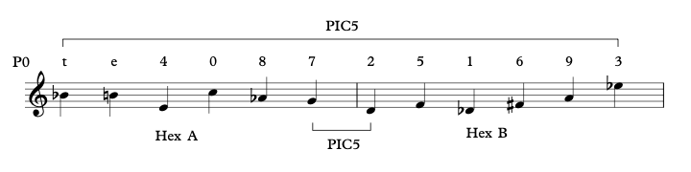

  - Figure 1. Prime row (P0) of Arnold Schoenberg’s “A Survivor from Warsaw.”

emphasizes pic1 in his row, alluding to the accompanying orchestration which is characterized by close chromatic movement, mostly using pic1. As will be discussed later, Schoenberg’s emphasis of pic1 (minor second) and pic5 (perfect fourth) in the prime row and in his use of the rows all serve his representation of the experience of a Holocaust victim in Survivor.
1. There is some awareness on the part of the beholder or audience of what is represented.
According to Scruton, while the meanings of a painting or poem are "facts," there is no such basis for representation in music. To exemplify his first criterion, Scruton states that a representation of a quarrel between husband and wife, musically, could equally be used to 'depict' a forest fire. However, one can challenge Scruton by stating that a forest fire or lover’s quarrel are equally representative of a dispute, transgression, or destructive act. Robinson rebuts Scruton, saying that representational music “does not pick out something uniquely;” therefore, music does pass this criterion if a listener accepts that they will hear a representation of dispute, transgression, or destructive act rather than a specified lover’s quarrel or forest fire. Both Kuhns and Tarasti put the onus on the listener to discern the subject of representative work. They each say that music, or art in general, could be appreciated without knowing, or hearing, what is represented, but it is an ethical fallacy to ignore the subject of a representative medium. As Kuhns states, “we cannot loose the art from its representational intentions and references.” To remove the composer from their piece, or the painter from the painting, will provide an insignificant and shallow understanding of a work.
Schoenberg’s Survivor passes this criterion due to its title and historical context alone, just as one could recognize that Poussin’s Landscape with St. John on Patmos is a painting of a landscape in Patmos due to its title. Further, even disregarding the title, Schoenberg clearly illustrates the represented subject of his work through the languages he uses and the way he characterizes each language. The use of English, German, and Hebrew are a direct reference to the events of the Holocaust and they represent the main characters in Schoenberg’s narrative. English, seen in Figure 2, takes the role of narrator, maintaining a calm yet expressive timbre when speaking and using Sprechstimme to give life to the words without reducing their narrative value.
German, shown in Figure 3, is an active character in the narrative, representing the role of German soldiers; the speaker spits out the words violently and carelessly, seeming to focus more on the volatility and disdain that the words express than ensuring that the audience understands any meaning behind the text. There is no narration in the German, the performance is meant only to express the emotional content of the words.
Hebrew, seen in Figure 4, ends the piece as another active character and the first instance of sung text. Without understanding any meaning behind the words, many Western listeners, the target audience for Survivor, would likely recognize the sung word “Yisrael” as a cognate for Israel, representing the Jewish community.
Because each language has a distinct character and performance tone, regardless of the

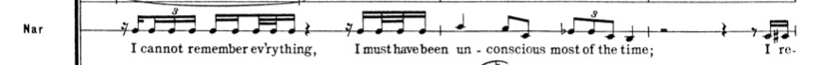
  - Figure 2. English text in Schoenberg’s “A Survivor from Warsaw,” measures 12-14. Arnold Schoenberg, A Survivor from Warsaw (Long Island, NY: Bomart Music Publications, 1949), 3.

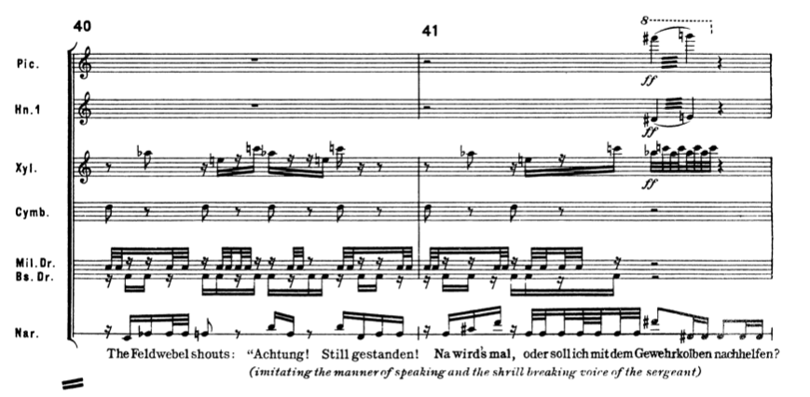
Figure 3. German text in Schoenberg’s “A Survivor from Warsaw,” measures 40-41. Arnold Schoenberg, A Survivor from Warsaw (Long Island, NY: Bomart Music Publications, 1949), 9.

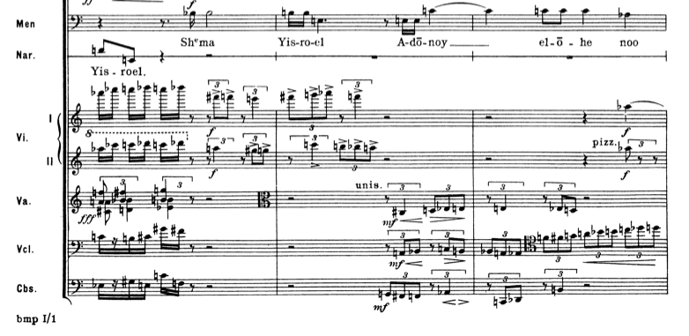
  - Figure 4. Hebrew text in Schoenberg’s “A Survivor from Warsaw,” measures 80-82. Arnold Schoenberg, A Survivor from Warsaw (Long Island, NY: Bomart Music Publications, 1949), 17.

content of the text, an observer will understand that this piece is representative of events of the Holocaust and comprehend that it is in a narrative form due to the order in which the languages appear; not interjecting, but divided into three main sections: English, measures 1 to 31; English and German, measures 32 to 80; and Hebrew, measure 80 to the end.
2. The beholder is able to distinguish the subject from the medium.
Scruton argues that mimetic sounds “cross the barrier between sound and tone, and become part of the musical structure.” In contrast, Robinson argues that “it is impossible to understand either the form or the expression of a representational piece of music without knowing what it represents.” Tarasti echoes Robinson, that "it is insufficient to deal with a subject and choice separately, apart from the context," so Scruton’s second criterion seems to ask a listener to unethically separate a subject from its medium, thus reducing the value and formal stability of said medium. Scruton himself states that “the suggestion that one might understand a figurative painting, and yet not perceive the figures, is inherently absurd.” To
parallel Scruton’s logic, is it not then absurd to say one understands a tone poem without perceiving its subject? Scruton’s routine aversion to mimesis may also be informed by his appreciation for past beauty, and his exaltation of past artists. To Scruton, reducing their music to imitation reduces the value of the artists’ perceived genius. From another perspective, use of mimesis may be a signifier of deeper meaning and a mastery of weaving a mundane sound into a piece, enriching it further.
Schoenberg uses mimesis twice in Survivor, both of which can be differentiated from the structural elements of the composition. These two instances of mimesis are the Reveille bugle call, performed by a trumpet in the orchestra in measure 25, and the “Shema Yisrael," beginning in measure 80, if an audience member recognizes it as a Jewish hymn. The Reveille call, shown in Figure 5, is evocative of the military waking bugle call and uses an amended harmonic series to fit the truncated P8 tone row and idiomatically mimic a bugle. It is also one of the few truly solo moments within the piece, completely unaccompanied, and followed by an orchestra-wide flurry of motion, as if the music is waking up. A listener would likely recognize this trumpet flourish, especially those who have military experience, as an intentional reference to the true Reveille. The orchestration surrounding the trumpet flourish as well as its intervallic content means it is recognizable outside of the piece. De-contextualized, a listener would likely recognize it as a (detuned) bugle call rather than an element of Schoenberg's compositional style.
The second mimetic section of this piece is Schoenberg’s use of the Shema Yisrael. Schoenberg applies pitched notation to the Torah’s traditionally-read prayer. In the Jewish tradition, all Torah readings contain pitch but are considered “readings” rather than sung performances. The pitches are not written out in Western notation; instead, melodic contour is indicated through cantillation markings that are often taught alongside Hebrew and the Torah itself. Hebrew is considered a pitch-accent language, in which words have specific syllabic accents expressed by pitch rather than volume or other methods of intonation.
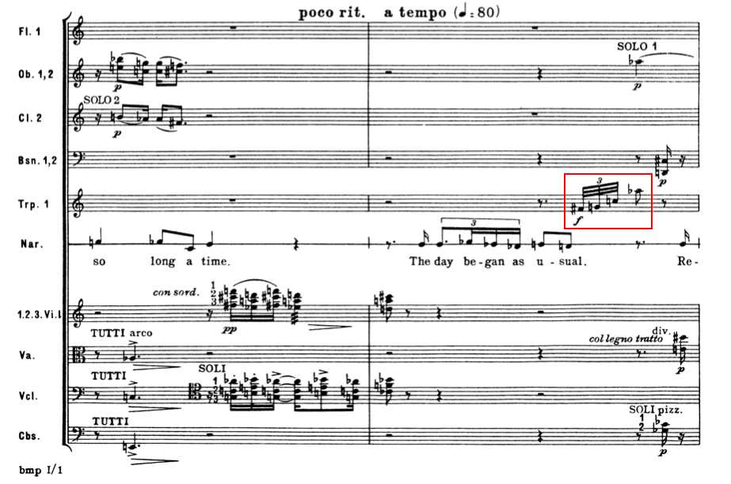
  - Figure 5. Reveille bugle call, boxed, in Arnold Schoenberg’s A Survivor from Warsaw, measure 25. Arnold Schoenberg, A Survivor from Warsaw (Long Island, NY: Bomart Music Publications, 1949), 5.

There are two qualities of the Shema Yisrael in Survivor that parallel the traditional Shema Yisrael. First, the rhythmic content in Schoenberg’s arrangement loosely parallels the traditional chant. The rhythms themselves are not the same, but like the chant, Schoenberg’s Shema includes clear divisions of the prayer based on rhythmic content. The first line is the precant, which functions as the title of and invocation to prayer. When read traditionally, the reader covers their eyes with their hand and says it softly and slowly, announcing the Shema. The prayer itself is quicker and contains much more perceived syncopation, mimicking the pattern of regular, non-pitched speech. Figures 6a and 6b provide a comparative juxtaposition of both Schoenberg’s use of Shema (5a) and a traditional chant rendition of Shema (5b) and the division between the precant and the prayer in both settings. Although the latter does not represent an exhaustive survey of performance transcriptions, it does provide a general realization of how the cantillation might be notated. “Adonai Echad” ends the precant, “v’ahavta” begins the prayer.
The second quality that indicates Schoenberg’s mimetic intentions in the Shema Yisrael is its melodic contour. To express the similarity of these contours, I apply a contour analysis based on Elizabeth West Marvin’s work.
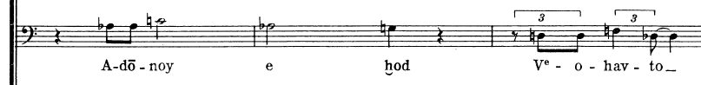
  - Figure 6a. Section of Shema Yisrael in Schoenberg’s “A Survivor from Warsaw,” measures 83-85. Arnold Schoenberg, A Survivor from Warsaw (Long Island, NY: Bomart Music Publications, 1949), 18.

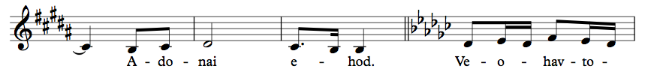
  - Figure 6b. Section of transcription of traditional Shema Yisrael. Transcribed by Claire Terrell.

Table 2 provides parallel sections of the melody in each Shema expressed in c-segs, where melodic segments are labeled from 0 to n-1 pitches in contour space. The cardinality of c-segs varies, though, analogous to pitch class (pc) sets, sets of smaller or larger cardinalities may be considered subsets or supersets of one another, respectively. Table 2 also offers similarity relationships between c-segs, using Marvin’s application of the embedding function, which is suited for differing cardinalities. These predominantly similar relationships illustrate the connectivity and resemblance between the contours of these two versions of the Shema Yisrael.
While this contour similarity may be coincidental, perhaps even subconscious, it does result in a kind of mimesis, where Schoenberg’s Shema Yisrael sounds similar to the traditional manner in which it is read due to its rhythmic content and basic melodic contours. Mimesis is representation, as discussed above in the premises, and Schoenberg’s Shema Yisrael is differentiated from the structure of the piece, thwarting Scruton’s main objection. While it would demand a strong level of familiarity with the contour of the traditional Shema Yisrael, Schoenberg’s version could be recognized outside of Survivor. While the medium, e.g. Schoenberg’s style and use of a 12-tone row, is heavily incorporated into his Shema Yisrael, the contour and rhythmic cadence of the prayer are distinguishable from his compositional style, given a familiarity with the traditional Shema Yisrael and the manner in which it is read.
3) There is some interest in the representation as such.
Scruton states that lack of interest in the represented subject results in a work dominated solely by formal qualities, hinting at this by discussing Mozart’s “Posthorn” Serenade in D
Table 2. Similarity of the melodic contours of eight sections of the traditional Shema Yisrael and their counterparts in Survivor.

Measure | Contour of traditional Shema Yisrael | Contour of Shema Yisrael in Survivor | CEMB (A, B)
81-82 | <0231> | <021> | 3/4 = 0.75
83-84 | <01210> | <0121> | 11/14 = 0.78
85 | <0120> | <021> | 1/4 = 0.25
85-86 | <021> | <0321> | 3/4 = 0.75
90-91 | <012> | <012> | 1/1 = 1
91 | <021> | <0321> | 3/4 = 0.75
92 | <0201> | <0132> | 4/8 = 0.5
96-97 | <01232> | <0132> | 11/14 = 0.78

major, K. 320. He says that a horn is always a horn, evocative of the hunt or the post, but never represents the horn in its ordinary uses, as an instrument. Zangwill responds with an "aesthetic realist view," that music has mind-independent aesthetic properties that we describe metaphorically which are the intentional object of musical experience and judgment. Using this logic, the horn is not meant to be, literally, a hunting horn, but represents the aesthetic value of hunting as a metaphor. Further, both Robinson and Kuhns argue for the interwoven quality of form and representation. Just as language derives its power from grammar and syntax, music's formal, structural qualities fill representation's needs for formal relationships and a means to interpret them. Interest in the subject of the representation is necessary for interest in the piece itself because an observer cannot separate the medium from its subject if they seek to understand it.
The interest in Schoenberg's Survivor as representation is three-fold for a listener before the piece even begins. First, Schoenberg is one of the most prominent modernist composers. Second, the piece is recognizable as representing the experience of a Holocaust survivor, due mostly to its title. However, without the title, due to the content of the languages and performance directions, a listener will sense the subject of the piece in the first few minutes. Lastly, the piece was written by a Jewish, German exile. There were fewer prominent composers closer to the subject of this representation than Schoenberg, perhaps only those who had lived the represented narrative (notably, Olivier Messiaen). Because of these three elements, listeners are intrigued to hear the piece not only because it was written by Schoenberg, the well-known 20th century modernist composer, but also because the Holocaust had staggered the world and Schoenberg's representation of and reaction to the experience would be invaluable and, at least somewhat, authentic. While this authenticity has been contested by scholars due to its exclusion of victims of the Holocaust who were not male or Jewish, a typical listener would likely see Schoenberg’s personal connection to the Holocaust as an authentic one.
4. The work of art expresses thoughts about its subject, and the beholder is able to understand the thoughts.
Scruton defines a thought as a reference to or predication of an object. He denies music's ability to express thoughts since a "sound does not contain within itself the description of the thing that emits it, or of any other thing beside itself.” As previously discussed, William Kraft’s Momentum contains a performance direction, “run amok,” where the performer is meant to “make the music sound as though it has run amok.” A listener will hear the pitch and rhythmic content, the timbral qualities of the instrument, and the inflection the performer is using to “run amok.” As I have accepted the third premise outlined in this paper, the performer’s inflection of the line represents both the composer’s intention and the performer’s interpretation of that intention, both of which are thoughts. This directly contradicts Scruton’s assertion that sound is just sound and cannot contain description. In addition, Kuhns states that the intra- and inter-referring structures of music allow it to express many thoughts: thoughts of feeling, reminiscence, and personal and shared beauty. Robinson and Gerwen, too, discuss music’s descriptive, expressive capacities. Robinson plainly states that “the role which music plays is a descriptive, i.e. semantic role: music conveys thoughts about a subject matter.” Gerwen proposes a psychological perspective, that “the musician’s playing brings the expression in the music to life, and explain[s] its psychological reality.” Even if Scruton does not believe that music can establish an independent subject, music can express thoughts on a pre-established subject and still pass this criterion. Any piece with a titular subject, such as “Threnody for Hiroshima,” expresses thoughts minimally tangential to that subject. Therefore, music is particularly adept at expressing thoughts about a subject.
The most obvious thought that Schoenberg expresses in Survivor is in his portrayal of the characters represented by voice: English narrator, German soldier, and Hebrew victims. He portrays these characters through his presentation on of the three languages in the piece and his use of hexachords and tone rows. The English speaker narrates, removed from the situation, yet still retains humanity in a removed, objective way. Schoenberg gives the English narrator rhythmic tropes, drawn out vowels and room to inflect. While the English narrator does have relative pitch direction, it is mostly to emphasize the minor 2nd, a prominent interval in the prime row, shown in Figure 7. Schoenberg does this throughout the piece, relegating supporting instruments in the orchestration to chromatic passages that loosely fit in a hexachord or incomplete row. By including the English narrator in this supporting role, he is telling the listener that the English is not the main character of the story. The character is restrained, overly trained, and meant only to observe and facilitate the narrative.
The German soldier is percussive and almost robotic. As previously mentioned, the speaker performs the German words in a certain way, with the performance direction “imitating the manner of speaking and the shrill breaking voice of the sergeant.” According to Marcus, humanity is therefore stripped from the voice and replaced by rage and animosity. Schoenberg does include relative pitch direction in the German sections, but it is much more erratic than the English. For example, in measure 41, shown in Figure 8, the speaker has three large intervals in succession, followed by repeated notes, a sudden jump of an augmented 6th, and immediately down a major 7th. While this is still relative pitch direction so a listener will not necessarily hear the intervals as they are written, it clearly contrasts with the English pitch direction, as seen in Figure 7, which is relatively consistent and somewhat melodic, as well as the Hebrew, which is sung rather than spoken. The listener can perceive the stark difference in performance between the languages and can grasp that Schoenberg is depicting the German as separate, different from the English and Hebrew. Schoenberg separates himself from the German, just as German culture, in the time that the narrative of this piece took place, separated itself from him. Schoenberg not
only denies humanity to the German soldiers in his narrative, but he also renounces his own
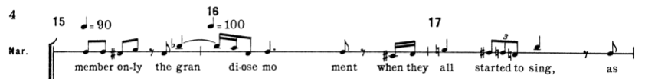
  - Figure 7. English narrator in Schoenberg’s “A Survivor from Warsaw,” measures 15-17. Arnold Schoenberg, A Survivor from Warsaw (Long Island, NY: Bomart Music Publications, 1949), 18.

  - Figure 8. German soldier in Schoenberg’s “A Survivor from Warsaw,” measures 40-41. Arnold Schoenberg, A Survivor from Warsaw (Long Island, NY: Bomart Music Publications, 1949), 18.

German identity in doing so, choosing instead his hybrid Jewish-American identity.
The Hebrew is sung, raucously, by a men's chorus at a high dynamic level. The Hebrew is free to express and is given the most humanity, as it is both involved and actively suffering in the narrative. In addition, the Shema Yisrael is not only the first instance of sung speech, but also the first iteration of the complete prime row, shown in Figure 9. Schoenberg’s presentation of the prime row in the Shema Yisrael reveals not only the key structural element of this piece, but also a key part of his own identity. He uses this prayer to humanize the Jewish victims of the Holocaust, and in doing so, humanize himself by personifying a chant he likely learned as a child.
Schoenberg places the rows clearly in the sung Hebrew melody to emphasize the importance of the Jewish experience in this narrative, further emphasizing with dynamics and range. He intentionally draws the listener through pitch, timbre, and the sudden entrance of the “Shema Yisrael,” accompanied only by a few voices in its introduction. Schoenberg, in the final moments of Survivor, is telling the listener to pay attention to the Jewish victims’ song. In Schoenberg’s use and characterization of the languages, he is expressing thoughts about each character. For example, the performance direction in the German soldier’s lines express not only his own thoughts regarding German soldiers in Warsaw, but also the perceptions and thoughts of the Hebrew victims during their interaction with the German soldiers in the narrative. Further, Schoenberg expresses the importance of the Hebrew victims relative to the other characters through the use of rows, types of performance (sung vs. spoken), and orchestration of the Shema Yisrael. A listener would likely understand the thought that Schoenberg expresses – his work is
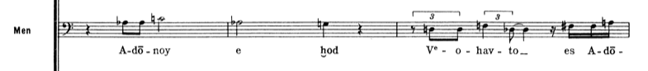
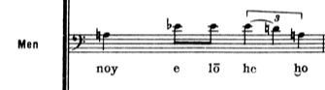

  - Figure 9. First six measures of the Shema Yisrael, measures 80 through 86. Arnold Schoenberg, A Survivor from Warsaw (Long Island, NY: Bomart Music Publications, 1949), 18.

first and foremost a recounting of the experience of a survivor from Warsaw, and their part is, by far, the most important.
5. The representation is convincing.
Scruton qualifies his use of the word “convincing,” saying that it is not “convincing” in a realistic sense, but in some persuasive or expressive sense. Scruton, again, uses mimesis as the basis for his argument that music cannot be convincingly representative. He discusses Mantegna’s La Crucifixion as representing the Crucifixion, but not looking like it, so resemblance is not the sole avenue for a convincing representation. He also discusses a Poussin landscape painting and how the painting, which looks like a landscape, is a representation because an observer is not required to find extra-artistic details to understand what is being represented. Is there a stark contrast in the comparison of bird song mimesis to Poussin’s landscape or the comparison of Debussy’s La Mer to Mantegna’s La Crucifixion? The former set is imitative; bird song mimesis and the landscape painting look/sound like their subject and are therefore representative. The latter set is evocative and contextual; La Mer and Mantegna’s Crucifixion are meant to express thoughts about the subject instead of looking/sounding like it. "Convincing" is almost a value judgment asking about the goodness of music or art in general, and yet another nod to the idea of Western canonical masterworks. A convincing representation to a Western listener might be Bach’s Pastorale, where they hear the natural space Bach is emulating. To a non-Western listener, it may be a patchwork of sounds with little personal meaning. “Convincing” is a subjective criterion but is relatively close to looks like or conforms to. A representational piece is “convincing” if a group of people can come to a consensus on its subject. Bach’s Pastorale is undoubtedly, to a Western listener, a representation of the tranquility of nature or some synonymous phrase. Therefore, musical representation can be convincing.
Although Survivor surely does not replicate the sonic events of the Holocaust in a mimetic sense, it does evoke the trauma that the affected populations experienced. The constant interruption of broken, incomplete rows serves to express the potential brokenness and incompleteness of the people who experienced the represented subject. As discussed above, Schoenberg includes, at most, 6 to 7 notes of a row before measure 80, the entrance of the Shema Yisrael. By using incomplete tone rows and close chromatic harmony, he evokes the chaos and destabilization of individuals who experienced the Holocaust and the aftermath it left globally. The prime row even starts with a minor 2nd, further emphasizing that interval and close chromaticism.
A listener, hearing this destabilization and chaos, and having deduced the subject of the piece based on the characterization of the languages and the inclusion of the Shema Yisrael, will be “conducted by [their ears] into a ‘fictional world,’” as previously discussed. Additionally, “in our musical experience, in most cases, we have no choice over our experience.” Therefore, Schoenberg’s representation is convincing since it forces the listener to attempt to empathize and imagine experiencing the chaos that Schoenberg represents.
The entrance of the Shema Yisrael represents the Jewish victims of the Holocaust, and Schoenberg’s inclusion of the complete basic set represents their importance in his constructed narrative. At this entrance, Schoenberg uses P0 against row I5, transposing by the pitch interval class (pic5) that separates the last pitch of the basic set’s last pc of Hex A, and first pc of Hex B (Figure 10). The pic5 split between hexachords A and B is highlighted in the text setting of the prime row in measures 84 and 85, shown above in Figure 9 in the separation between the precant and the rest of the prayer. Along with the hexachordal split, the rhythmic content quickens and begins incorporating triplets, indicating Schoenberg’s close interpretation of the rhythmic sections of the Shema Yisrael. The rows P0 and I5, and their combinatorial relationship, are shown below in Figure 10. Schoenberg’s use of combinatorial pairing at the very moment he introduces the community of Jewish people – the prefix “com,” or “together,” linking these concepts – is a musically convincing representation of the victims. Furthermore, the row transformations’ broken parts represent victims that rely on one another to achieve unity or peace in a collective identity, or in Schoenberg’s language, an “aggregate.”
Schoenberg follows his combinatorial pairing of P0 and I5 with rows P4 and RI9. His selection of P4 and RI9 result in several invariant pitch classes, shown boxed in Figure 11a. This invariance results in an introspective symmetry within and between the rows, in which dyads are invariantly paired: pcs 4 and 0, 9 and 5, and 7 and 2. Pcs 7 and 2 frame each row and are placed in close proximity in the score to maintain smooth connectivity (Figure 11b). The T₅IR pairing, i.e. P4 against the retrograde of its combinatorial row (I9), exhibits a different perspective of alliance where invariant counterparts rely on each other for balance between hexachords, here summing to 9.
Though Schoenberg utilizes both combinatoriality and invariance liberally throughout most of his compositions, these pairings of rows are significant. The T5 relationship between
Hex A Hex B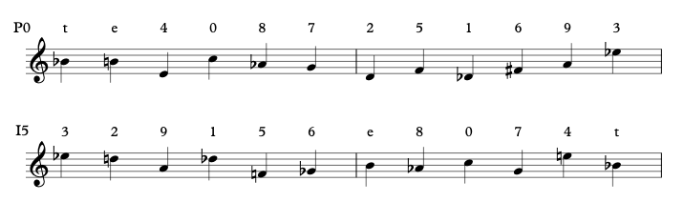

  - Figure 10: Combinatoriality of rows P0 and I5.

Hex A Hex B
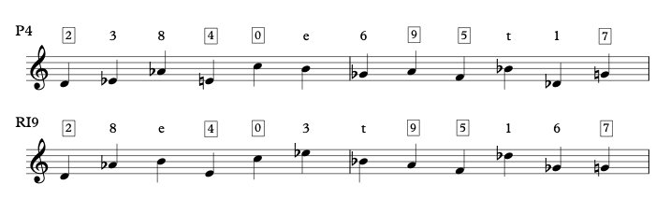
  - Figure 11a: Invariance and symmetry of rows P4 and RI9.

End of P4 RI9
1 7 2 8 e
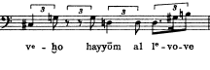
  - Figure 11b: Measure 92 of Survivor, the end of P4 into RI9. Arnold Schoenberg, A Survivor from Warsaw (Long Island, NY: Bomart Music Publications, 1949), 18.

both sets of the paired rows emphasizes ic5, which is considered dissonant as a perfect fourth in common practice composition. His continued use and emphasis of ic5 may be another indication of separation from Germany, a birthplace of common practice contrapuntal composition. In addition, the perfect 5th (pic7) represents normalcy and is a structural interval in most Western art compositions. For example, in sonata form, the theme is presented in the tonic and dominant keys, resulting in a perfect 5th relationship. Schoenberg is consistently using ic5 but reordering it to reference stability (pic7) versus instability (pic5) in his placement of the intervals within the row, and he intentionally retains pic5 in the melody with few exceptions. Emphasis of pic5, the inversion of the pic7, may represent an inversion of conventional structure, perhaps stressing the abnormality of the situation and the apocalyptic feeling created by the Holocaust: a world turned upside down.
Schoenberg introduced the Jewish community with combinatorial rows P0 and I5, intentionally creating relationships between the rows to represent the relationships between all Jewish people affected by the Holocaust, directly or indirectly. While a direct experience and an indirect experience were separated by a multitude of factors, the resulting trauma was intimately connected. His P4/RI9 pairing then represents the introspective symmetry of both directly and indirectly affected members of the Jewish community – dyads bound by trauma. The invariance and symmetry indicate deep connectedness between the paired rows, representing the relationships between the victims who sang the Shema Yisrael at their lowest moment. Although each victim was unique, and perhaps had completely different experiences from their fellow victims, they went from a group of strangers to a commonly minded collective identity in which they found solace and strength. Schoenberg’s decision to move from combinatorial rows to rows
with symmetrical invariance represents this shift to a collective identity. Combinatoriality creates connectivity between the rows, as does invariance, but invariance results in a kind of stability. A listener can trust that the invariant pcs of P4 will be in the same place in RI9. Schoenberg even strengthens this trust by pairing invariant pcs, so a listener can trust to hear the same invariant intervals from P4 to RI9. Further, Schoenberg includes two instances of pic7 in the final row, RI9, adding to the row’s stability. From the beginning of the Shema Yisrael, a listener will hear Schoenberg intentionally forming relationships through combinatoriality, representing a budding connection. By the second half of the Shema, and the entrance of rows P4 and RI9, the victims have found strength in their prayer. The group has formed a trust in God, in each other, and perhaps the comfort of the prayer itself. Schoenberg’s intention to be convincing and his subsequent implementation of truncated rows, close chromaticism, combinatoriality, and invariance in the Shema Yisrael result in a work that can be convincing to a listener.

Conclusion
In this essay, I have set out to show that music is, or can be, a representative medium.
By refuting Scruton’s thesis based on premises and criteria, upon which much of the scholarship arguing that music is not representative is based, I have shown that these premises and criteria can be applied to a piece of music and that music can be representative. I presented one instance of such representation in Schoenberg’s A Survivor from Warsaw. Schoenberg’s use of mimesis in the Reveille bugle call and the Shema Yisrael, his performance directions for each language, and his use of the prime row and its combinatorial properties all work together to represent a subject: the experience of a survivor from Warsaw. Therefore, returning to Scruton’s thesis re-framed as a logical syllogism, I have proved that the premises are valid (A) and Schoenberg’s A Survivor from Warsaw does meet Scruton’s criteria (B). Therefore, music is a representational medium (C).

References

Backenroth, Ofra. “Tip Toe Through Ki Tavo.” YouTube. Last modified September 8th, 2021. Video. https://www.jtsa.edu/torah/tip-toe-through-ki-tavo/
Bayley, Stephen. “Britain has become indifferent to beauty.” The Guardian. Guardian News & Media Ltd, March 21, 2009. https://www.theguardian.com/artanddesign/2009/mar/22/ national-trust-intelligence-squad.
Citron, Marcia. “Approaches to the Discipline: Gender and the Field of Musicology.” Current Musicology 53 (1993): 66-75.
Gerwen, Rob V. “Hearing Musicians Making Music: A Critique of Roger Scruton on Acousmatic Experience.” The Journal of Aesthetics and Art Criticism 70, no. 2 (Spring 2012): 223-230.
Guck, Marion. “Analytical Fictions.” Music Theory Spectrum 16, no. 2 (Autumn 1994): 217-230. https://doi.org/10.2307/746034
Haimo, Ethan. “Atonality, Analysis, and the Intention Fallacy.” Music Theory Spectrum 18, no. 2 (Autumn, 1996): 167-199.
Kremp, Pierre-Antoine. “Innovation and Selection: Symphonic Orchestras and the Construction of the Musical Canon in the United States.” Social Forces 88, no. 3 (March 2010): 1051-1082.
Kuhns, Richard. “Music as a Representational Art.” The British Journal of Aesthetics 18, no. 2 (Spring 1978): 120-125. https://doi.org/10.1093/bjaesthetics/18.2.120
Lubavitch World Headquarters. “Transliteration of the Shema.” Chabad.org. Chabad – Lubavitch Media Center, January 26th, 2010. https://www.chabad.org/library/article_cdo/aid/282822 /jewish/Transliteration.htm
Mantegna, Andrea. La Crucifixion. 1456-1459. Tempera on wood (poplar). 0.76 x 0.96 m. Louvre, Paris, France. https://collections.louvre.fr/en/ark:/53355/cl010064446.
Marcus, Kenneth. “Hiemat and Hybridity: Arnold Schoenberg, Exile, and the Crisis of Modernism.” Fiar 4, no. 1 (2011).
Matisse, Henri. The Snail. 1953. Gouache on paper, cut and pasted on paper mounted on canvas. 2864 x 2870 mm. Tate Modern, London, England. https://www.tate.org.uk/art/artworks/matisse-the-snail-t00540.
McClary, Susan. “Sexual Politics in Classical Music.” In Feminine Endings: Music, Gender, and Sexuality, 53-79. Minneapolis: University of Minnesota Press, 1991.
“Mimesis.” Merriam-Webster.com. Merriam-Webster, Inc., March 5, 2022. https://www.merriam-webster.com/dictionary/mimesis.
Myjewishlearning. “Shema: How to Say This Jewish Prayer.” YouTube. Last modified March 5, 2019. Video. https://www.youtube.com/watch?v=vB58oyck-C8
Nikkyttmessianic PraiseandWorship. “Sh’ma Yisrael (Shema Yisrael) – Prayer – Lyrics and Translation.” YouTube. Last modified November 22, 2013. Video. https://www.youtube.com/watch?v=wxO09BUrkMk
“Olivier Messaien.” Britannica. Encyclopedia Britannica, Inc., April 23, 2021. https://www.britannica.com/biography/Olivier-Messiaen.
Poussin, Nicholas. Landscape with St. John on Patmos. Oil on canvas. 100.3 x 136.4 cm. Art Institute of Chicago, Chicago, Illinois. https://www.artic.edu/artworks/5848/landscape-with-saint-john-on-patmos.
Robinson, Jenefer. “Representation in Music and Painting.” Philosophy 56, no. 217 (July 1981): 408-413. https://doi.org/10.1017/S0031819100050373.
Schoenberg, Arnold. A Survivor from Warsaw. Long Island, NY: Bomart Music Publications, 1949.
Scruton, Roger. “About.” Sir Roger Scruton: Writer & Philosopher. Mindvision. Accessed on April 27, 2021. https://www.roger-scruton.com/homepage/about.
_____________ “Representation in Music.” Philosophy 51, no. 197 (July 1976): 273-287.
_____________ The Aesthetics of Music. New York: Oxford University Press, 1997.
Tarasti, Eero. Existential Semiotics. Bloomington: Indiana University Press, 2000.
TBSonline. “Singing the Shema with Alex Weinberg.” YouTube. Last modified January 28, 2014. Video. https://www.youtube.com/watch?v=ZxvNkdeHXrU
Walden, Joshua S. Representation in Western Music. Cambridge: Cambridge University Press, 2013.
Walton, Kendall. “Listening with Imagination: Is Music Representational?” The Journal of Aesthetics and Art Criticism 52, no. 1 (Winter 1994): 47-61. https://doi.org/10.2307/431584.
West Marvin, Elizabeth. “A Generalized Theory of Musical Contour: Its Application to Melodic and Rhythmic Analysis of Non-Tonal Music and its Perceptual and Pedagogical Implications.” PhD diss. University of Rochester, 1988.
Young, James O. “Music and the Representation of Emotion.” Frontiers of Philosophy in China 8, no. 2 (June 2013): 332-348.
Zangwill, Nick. “Scruton’s Musical Experiences.” Philosophy 85 (2010): 91-104.

Appendix

Precant
Shema Yisrael, Adonai Eloheinu, Adonai Echad

Prayer
V’ahavta eit Adonai Elohecha,
B’chawl l’vav’cha,
Uv’chawl nafsh’cha,
Uv’chawl m’odecha.
V’hayu had’varim haeileh,
Asher anochi m’tsav’cha hayom, al l’vavecha.
V’shinantam l’vanecha, v’dibarta bam
B’shivt’cha b’veitecha,
Uvlecht’cha vaderech,
Uv’shawchb’cha uvkumecha.

Figure 1. Transliteration of the Shema Yisrael. Lubavitch World Headquarters, “Transliteration of the Shema,” Chabad.org, Chabad – Lubavitch Media Center, January 26th, 2010, https://www.chabad.org/library/article_cdo/aid/282822 /jewish/Transliteration.htm

Vita

Claire Terrell was born and raised just outside of Nashville, Tennessee before moving to Knoxville to attend the University of Tennessee. She received a Bachelor’s of Music in Theory and Composition in 2016, and decided to continue at the University of Tennessee to pursue a Master’s of Music in Music Theory. Her research interests include narrativity and story-telling in atonal music, music in media including film, TV, and video game music, as well as the restructuring and expansion of the current pedagogical and performative musical canon. After graduation, she will attend Florida State University to work towards her Doctor of Philosophy degree in Music Theory.

Ethan Haimo, “Atonality, Analysis, and the Intentional Fallacy,” Music Theory Spectrum 18, no. 2 (Autumn, 1996): 168.
Eero Tarasti, Existential Semiotics (Bloomington: Indiana University Press, 2000), 88.
James O. Young, “Music and the Representation of Emotion,” Frontiers of Philosophy in China 8, no. 2 (June 2013): 332.
Roger Scruton, The Aesthetics of Music (New York: Oxford University Press, 1997).
Marion Guck, “Analytical Fictions,” Music Theory Spectrum 16, no. 2 (Autumn 1994): 217.
Young, “Music and the Representation of Emotion,” 332.
This chapter is essentially a restructured reprint of the 1976 article in the scope of the larger subject of the aesthetics of music.
Scruton, The Aesthetics of Music, 124.
Roger Scruton, “Representation in Music,” Philosophy 51, no. 197 (July 1976): 273.
Roger Scruton, “About,” Sir Roger Scruton: Writer & Philosopher, Mindvision, accessed on April 27th, 2021, https://www.roger-scruton.com/homepage/about.
Stephen Bayley, “Britain has become indifferent to beauty,” The Guardian, Guardian News & Media Ltd, March 21, 2009, https://www.theguardian.com/artanddesign/2009/mar/22/national-trust-intelligence-squad.
Stephen Bayley, “Britain has become indifferent to beauty,” The Guardian, Guardian News & Media Ltd, March 21, 2009, https://www.theguardian.com/artanddesign/2009/mar/22/national-trust-intelligence-squad.
Pierre-Antoine Kremp, “Innovation and Selection: Symphonic Orchestras and the Construction of the Musical Canon in the United States,” Social Forces 88, no. 3 (March 2010): 1051.
Kremp, “Innovation and Selection,” 1051.
Marcia Citron, “Approaches to the Discipline: Gender and the Field of Musicology,” Current Musicology 53 (1993): 71. Susan McClary, “Sexual Politics in Classical Music,” in Feminine Endings: Music, Gender, and Sexuality (Minneapolis: University of Minnesota Press, 1991), 55. McClary 55
Citron, “Approaches to the Discipline,” 71.
Scruton, The Aesthetics of Music, 119.
McClary, “Sexual Politics,” 57-58.
McClary, “Sexual Politics,” 57-58.
McClary, “Sexual Politics,” 59.
“Mimesis,” Merriam-Webster.com, Merriam-Webster, Inc., March 5, 2022, https://www.merriam-webster.com/dictionary/mimesis.
Scruton, The Aesthetics of Music, 122.
Scruton, The Aesthetics of Music, 122.
Joshua S. Walden, Representation in Western Music (Cambridge: Cambridge University Press, 2013), 225
Kendall Walton, “Listening with Imagination: Is Music Representational?” The Journal of Aesthetics and Art Criticism 52, no. 1 (Winter 1994): 60.
Scruton, The Aesthetics of Music, 121.
Scruton, The Aesthetics of Music, 121.
Rob V. Gerwen, “Hearing Musicians Making Music: A Critique of Roger Scruton on Acousmatic Experience,” The Journal of Aesthetics and Art Criticism 70, no. 2 (Spring 2012): 223.
Nick Zangwill, “Scruton’s Musical Experiences,” Philosophy 85 (2010): 99.
Scruton, The Aesthetics of Music, 119.
Walton, “Listening with Imagination,” 47.
Henri Matisse, The Snail, 1953, gouache on paper, cut and pasted on paper mounted on canvas, 2864 x 2870 mm, Tate Modern, London, England. https://www.tate.org.uk/art/artworks/matisse-the-snail-t00540.
Walton, “Listening with Imagination,” 50.
Scruton, “Representation in Music,” 274.
Scruton, The Aesthetics of Music, 130.
Jenefer Robinson, “Representation in Music and Painting,” Philosophy 56, no. 217 (July 1981): 408-409.
Tarasti, Existential Semiotics, 88.
Richard Kuhns, “Music as a Representational Art,” The British Journal of Aesthetics 18, no. 2 (Spring 1978): 121.
Nicholas Poussin, Landscape with St. John on Patmos, oil on canvas, 100.3 x 136.4 cm, Art Insitute of Chicago, Chicago, Illinois. https://www.artic.edu/artworks/5848/landscape-with-saint-john-on-patmos.
Scruton, “Representation in Music,” 274.
Scruton, The Aesthetics of Music, 126.
Robinson, “Representation in Music and Painting,” 409.
Tarasti, Existential Semiotics, 89.
Tarasti, Existential Semiotics, 88.
Scruton, The Aesthetics of Music, 131.
P8 tone row: <670843t1925e>
Ofra Backenroth, “Tip Toe Through Ki Tavo,” last modified September 8th, 2021, https://www.jtsa.edu/torah/tip-toe-through-ki-tavo/
Ofra Backenroth, “Tip Toe Through Ki Tavo,” last modified September 8th, 2021, https://www.jtsa.edu/torah/tip-toe-through-ki-tavo/
For sample recordings of the Shema Yisrael, access the following videos: TBSonline, “Singing the Shema with Alex Weinberg,” YouTube, last modified January 28, 2014, video, https://www.youtube.com/watch?v=ZxvNkdeHXrU Myjewishlearning, “Shema: How to Say This Jewish Prayer,” YouTube, last modified March 5, 2019, video, https://www.youtube.com/watch?v=vB58oyck-C8 Nikkyttmessianic PraiseandWorship, “Sh’ma Yisrael (Shema Yisrael) – Prayer – Lyrics and Translation,”YouTube, last modified November 22, 2013, video,https://www.youtube.com/watch?v=wxO09BUrkMk
See Appendix A for the complete transliteration of the Shema Yisrael, 39.
Elizabeth West Marvin, “A Generalized Theory of Musical Contour: Its Application to Melodic and Rhythmic Analysis of Non-Tonal Music and its Perceptual and Pedagogical Implications,” PhD diss., (University of Rochester, 1988).
Marvin’s embedding function is derived from Allen Forte, David Lewin, and John Rahn’s work on interval vectors and relation sets. West Marvin, “A Generalized Theory of Musical Contour,” 81.
Scruton, “Representation in Music,” 274.
Scruton, The Aesthetics of Music, 126.
Scruton, The Aesthetics of Music, 126.
Zangwill, “Scruton’s Musical Experiences,” 104.
Kuhns, “Music as a Representational Art,” 123. Robinson, “Representation in Music and Painting,” 413.
Kenneth Marcus, “Hiemat and Hybridity: Arnold Schoenberg, Exile, and the Crisis of Modernism,” Fiar 4, no. 1 (2011): 1.
For further reading on Messiaen’s experience as a prisoner of war, see: Sarra E. Hey, “Olivier Messiaen’s ‘Quartet for the End of Time’: A look at ‘The Abyss of the Bird’ and socio-political issues, religion, and performance practice in reference to the bible and the holocaust,” PhD diss., (California State University, 2015). Leslie A. Sprout, “Messiaen, Jolivet, and the Soldier – Composers of Wartime France,” The Musical Quarterly 87, no. 2 (2004).
Marcus, “Hiemat and Hybridity,” 19.
Scruton, “Representation in Music,” 274.
Scruton, The Aesthetics of Music, 127.
Scruton, The Aesthetics of Music, 139.
Walton, “Listening with Imagination,” 50.
Kuhns, “Music as a Representational Art,” 123.
Robinson, “Representation in Music and Painting,” 409.
Gerwen, “Hearing Musicians Making Music,” 224.
Arnold Schoenberg, A Survivor from Warsaw (Long Island, NY: Bomart Music Publications, 1949), 17.
Marcus, “Hiemat and Hybridity,” 18.
Marcus, “Hiemat and Hybridity,” 18.
Scruton, “Representation in Music,” 275.
Scruton, “Representation in Music,” 275.
Scruton, The Aesthetics of Music, 124.
Andrea Mantegna, La Crucifixion, 1456-1459, tempera on wood (poplar), 0.76 x 0.96 m, Louvre, Paris, France. https://collections.louvre.fr/en/ark:/53355/cl010064446.
Scruton, The Aesthetics of Music, 121.
Scruton, The Aesthetics of Music, 121.
Nick Zangwill, “Scruton’s Musical Experiences,” Philosophy 85 (2010): 99.
See Appendix A for the transliteration of the Shema Yisrael, 39.

