Machine Learning Approach for Stability Testing Analysis in Milling

Kaitlyn Daniels
Department of Industrial & Systems Engineering
University of Tennessee
Knoxville, TN, USA
kdanie29@vols.utk.edu
Brian Amminger
Department of Interdisciplinary Programs
University of Tennessee
Knoxville, TN, USA
bamminge@vols.utk.edu
Anahita Khojandi, PhD
Department of Industrial & Systems Engineering
University of Tennessee
Knoxville, TN, USA
khojandi@utk.edu
Tony Schmitz, PhD
Manufacturing Science Division
Oak Ridge National Lab
Oak Ridge, TN, USA
tony.schmitz@utk.edu

Abstract—The properties related to chatter and the stability of manufacturing milling machines are dependent primarily on parameters such as axial depth of cut, rotary speed rpm, and cutting force. These parameters are used to calculate the milling process and avoid certain cuts that would result in unstable milling. Using applied data science tools for statistical analysis and machine learning models like SHapley Additive exPlanations (SHAP), this research will produce valuable insight on two stability testing methods used in milling machining operations. By leveraging the data, a partitioning model can be used with known stable and unstable points under certain conditions to sort and select the best point(s) to be used in testing on the stability lobe diagram. The aim is to compare the two testing methods of combination and sequencing testing for cost-effectiveness and accuracy of identifying the milling machine’s stability boundary which in turn will help with reducing the amount of chatter present in the milling. Recognizing the testing method with the better accuracy will help determine the best sequence of testing and the stopping criteria.
Keywords—Milling, Chatter, Stability Mapping, Partitioning Models, Sequencing, Combination

Introduction

Background
The milling manufacturing process is a subtractive manufacturing process where a drilling tool removes material via a shearing method from a section of raw material. The process is used in many manufacturing industries for everyday products like golf clubs to industrial products like machine parts. Metal milling can exceed the stable parameters of the tools and materials, so research seeks to optimize the process to make it more economical, reliable, maintainable, and sustainable. Inadequate milling station parameters will result in poor stability which creates undesirable vibrations or resonances that occur between the cutting tool and workpiece called chatter. Chatter can typically be heard as an audible noise, will leave irregular and undesirable tool marks on the machined surface, and can occasionally break the tool or even damage the machine.

Literature
There are numerous aspects of the milling process that studies have aimed to optimize. Previous research has sought the parameters of the drilling tool itself. The cutting tool used in the milling process affects performance, and the research seeks to determine the effect of tool geometry, length, and stiffness of the tool. Receptance Coupling Substructure Analysis (RCSA) is a technique applied to predict the dynamic response of a milling tool and its holder when subjected to cutting forces and spindle vibrations. Along with choosing the tool selection, when the cutting operation happens, the cutting force and speed affect the stability of the tool. This previous research and calculations have been utilized to create milling stability models. Due to the uncertainty of cutting forces, the stability models use a Monte Carlo simulation to account for the uncertainty of the milling process. This research is focused on a milling stability model on an aluminum workpiece. The simulated model created includes 10,000 simulated data iterations with varying axial depth of the tool and rotation speed. Each simulation has four parameters connected to the stability graph. The beta matrix is the angle of the tool on the workpiece surface (deg). The Kolmogorov-Smirnov (KS) matrix is the force model coefficient $K_{s}$ (N/mm2). The (KTF) matrix is force stiffness $k$(N/rad). The CFT matrix is the connection damping $c$ (N-s/rad). The goal of previous stability mapping was to identify the combinations of parameters such as spindle speed, feed rate, and depth of axial cut that result in the stable operation of a machine; whereas, for this project stability lobes will be used to better visualize the stability boundary line and to analyze the two stability testing methods using a machine learning (ML) model.

Goals
The graphed simulated stability lobe diagrams may be partitioned using real-world tests also known as ground truths in this study to determine which iterations are stable and which are not compared to the ground truths placement on the diagram. The tool rotations and axial depth mapped in the stability map are visualized to show stable combinations. This research aims to enhance the analysis process to select a more accurate, cost-efficient test for stability and reduce the number of tests necessary to find the optimal stability line. Using previous literary works on identifying the stable and unstable boundary line in the milling process, this research will take the point stability identification testing a step further using ML to compare the current capabilities of testing sequentially versus combinations of point(s) all at once. In addition to optimizing the testing point selection process, the ML SHAP model will be provided points and two testing methods to identify the accuracy of these tests and point selections. Then, the model will be provided with the costs of material, time, and monetary expenses to confirm if the two tests have respective advantages and to what extent. The model will be given 24 ground truth points and provide the percentage eliminated from the 10,000 simulated data iterations based on its limited real-world testing inputs to determine which of the two testing methods is more efficient with performance of elimination and the most cost effective.

Data Gaps
The dataset in use has some notable gaps. Labeling gaps are the main concern as we only have 24 real-world tests that are labeled. The gap is that the true boundary between stable and unstable is unknown. The information gleaned from between certain points means a matter of stability as this boundary line is only approximately known and not strictly identified. This project aims to better improve the clarity between the labeled test points and the 10,000 iterations.
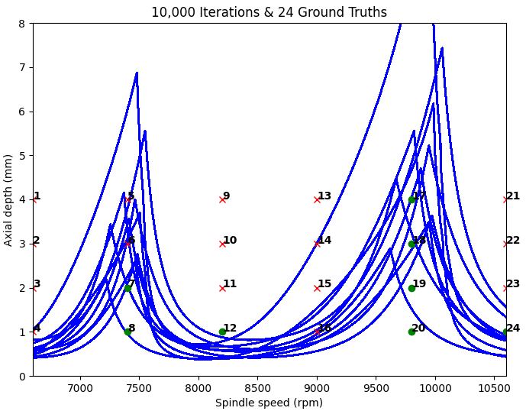
Along with research that has focused on optimizing the partitioning process for stability mapping by selecting test points strategically and reducing the number of experimental tests required. These techniques aim to efficiently explore the parameter space and identify critical boundaries for stable milling conditions.

Literature Review

Previous Research
Researchers have investigated the effects of tool geometry, length, material, and stiffness on milling performance and stability. Research has explored optimal tool designs to minimize vibrations and improve material removal rates (MRR), finding optimal tooling length and stiffness parameters. Other research has focused on developing accurate models to predict cutting forces during milling operations. These models consider factors such as tool geometry, material properties, cutting parameters, and machine dynamics to estimate the forces acting on the tool. Researchers have developed analytical and numerical models to predict milling stability and identify conditions that lead to chatter [1]. These models often consider factors like spindle speed, axial depth of cut, tool geometry, cutting parameters, and machine dynamics to determine stable cutting conditions [2]. Monte Carlo simulation techniques have been used to account for uncertainties in the milling process, such as variations in material properties, tool wear, and cutting conditions [3]. These simulations help to assess the robustness of stability predictions and optimize milling parameters under uncertain conditions. The RCSA method, introduced by Schmitz et al., has been widely studied for predicting tool-tip receptance and coupling tool-holder dynamics with machine tool structures [4]. This approach allows for more accurate stability predictions by considering the dynamic interaction between the tool, holder, and machine. Many research studies have conducted experimental tests to validate stability models and simulation results. These experiments involve measuring cutting forces, tool vibrations, surface roughness, and other parameters to assess the stability of the milling process under different conditions [5].

Methods

Data Collection
The data used in this research is created by a milling stability model. The stability model uses a Monte Carlo simulation to account for the uncertainty of the milling process. The ground truths are 24 real-world tests done by Schmitz with nearly identical parameters to the simulations [4].
Fig. 1 displays simplified 10 out of 10,000 simulated data iterations produced by the simulation represented as blue lines along with the ground truths displayed as red x’s and green circles. The green circles are stable points within the stability map. Meanwhile, the red x’s signify unstable points being affected by chatter. There were four tests performed to partition the sample data between stable and unstable results.
- Simplified stability limit matrix
For each unstable point, it is certain that everything above that point is also unstable; whereas, there is not much to glean for certain about the points below. For each stable point, it is certain that everything under that point is also stable; whereas, there is not much known for certain about the points above.
Since the true stability boundary is unknown, testing data is generated on different sequences and methods of selecting test points by selecting random boundary lines from the stability lobe diagram and using those selections to determine stability during testing. Our model would then iterate over different methodologies selecting testing points to seek the stable boundary. The model simulated is testing at random RPM and axial depth values to act as a null model. For the data, 100 different boundaries were used, doing 50 sets of testing on each boundary, doing 24 tests in a set. The next sequence of testing simulated is median-based testing. Depth selection is determined based on the median axial depth of all the potential stability boundaries in the current diagram. Three different versions of the median-based testing are generated for the RPM values. Two have fixed RPMs set at the two potential peaks demonstrated by the stability lobe diagram, $7400$ and $9800$. One test uses a randomly selected RPM. The depth is chosen as the median depth of the current stability diagram at a given RPM.
The next methodology of testing is probability-based testing. To calculate the probability of stability, a function was used that estimated the probability of stability based on how many other boundaries were above or below the specific point. Depths at the very lowest of the diagram would be assigned a $100\%$ probability of stability and a point at the very top would be assigned a $\frac{1}{10000}$ probability of stability. The method randomly selected RPM and depth to test at and used the point when it fell within the probability threshold. Three different ranges of probability were simulated. A wide test that accepted points with a prior probability of stability within $10-50\%$. A low bound with the threshold of $10-30\%$. A midbound with the range of $15-35\%$. The last methodology simulated is median interval testing. This sequence of testing is aimed at seeking the specific peak of the stability lobe diagram which would maximize the MRR. The testing is done in sets where testing happened in intervals of RPMs across the same depth. The first depth was chosen as the highest median depth at any RPM. A row of tests is done at an interval of RPMs. Then the incorrect stability lobes are removed, where now the depth can be readjusted to a higher or lower value. After each iteration, the RPM interval is halved. So at first intervals of $100$ RPM are tested, after which intervals of $50$ RPM are tested. The range of RPM would also decrease to become narrower to where the highest material removal peak would be located. The test is performed in $6$ sets going across a depth and adjusted in each set. For this test, $100$ different boundaries were simulated with $6$ sets of tests.
Fig. 2 was generated to display the remaining simulated data iterations after four points for partitioning were selected, the four points were labeled stable and unstable points, and the introduction of two randomly placed new points represented by yellow squares.
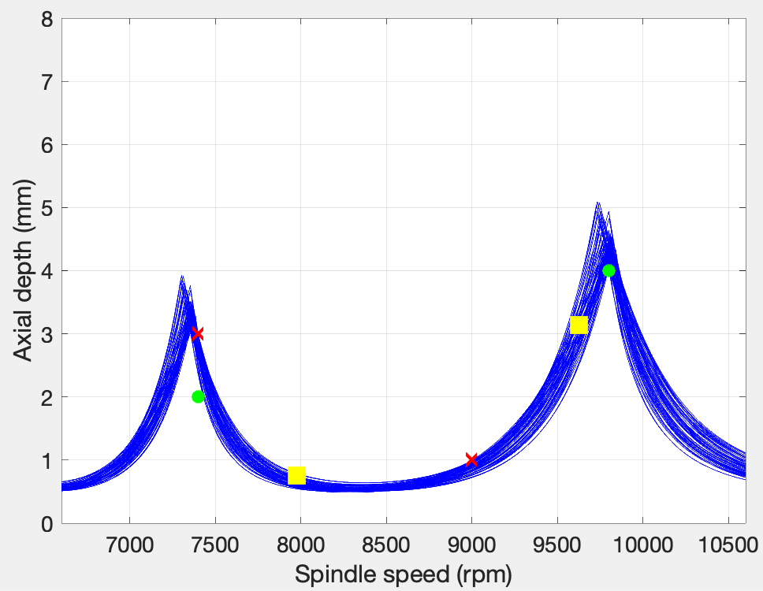
- Stability map with 2 random points
Table I provides an example of the proposed ML testing where the algorithm learns from labeled points and what has occurred in the past. The ML algorithm must predict meaningful results based on previous data since its never seen these two new points before. Point Label Random #1 and Random #2 are the ML outputs generated predictions.
- Example Results of Proposed ML Output Testing
Point label | $$X_{1}$$ | $$Y_{1}$$ | Probability of being stable | Rows remaining out of 10,000
P7 | 7400 | 3 | N/A | 6374
P5 | 7400 | 2 | N/A | 3803
P13 | 9800 | 4 | N/A | 548
P16 | 9000 | 0.759 | N/A | 68
Random #1 | 7975 | 1.75 | 67% | 37
Random #2 | 9625 | 3.133 | 33% | 28

Parameters
- Beta matrix is the angle of the tool on the workpiece surface $(deg)$.
- KS matrix is the force model coefficient $K_{s}$ (N/mm2).
- KTF matrix is force stiffness $k$ (N/rad).
- CFT matrix is the connection damping $c$ (N-s/rad).
- RPM is the rotation speed of the tool in revolutions per minute.
- Axial depth is the tool deepness into the workpiece in $mm$.

Equations
Equation (1) is the relationship between the resultant cutting force, $F$, and the contacting chip area, $A$, is shown in Eq. 1, where $K_{s}$ is the cutting force and $A$ is equal to the product of the axial depth (chip width), $b$, and chip thickness, $h$. The resultant cutting force is the vector sum of the tangential, $F_{t}$, and normal, $F_{n}$, direction force components. The orientation of $F$ relative to $F_{n}$ is defined by the cutting force angle, $β$.
$F=K_{s}A=K_{s}bh$ (1)
Equation (2) is a stiffness matrix for the connection which is multi-valued and frequency-dependent defined in Eq. 2. The symbol $k$ indicates (linear) stiffness, $c$ represents viscous damping, and $ω$ represents frequency. The $k$ and $c$ parameters are uncertain in this study.
$\left[K\right]=\left[\begin{matrix}0 & k+iωc \\ k+iωc & 0\end{matrix}\right]$ (2)
Equation (3) is used to determine the percent improved in the material removal rate $MRR$ defined in Eq. 3. The symbol ${MRR}_{prior}$ indicates the previous optimal point, ${MRR}_{g}$ is the current point’s $MRR$, $p(s_{g})$ represents the probability of being stable at a specified point, $p(u_{g})$ represents the probability of being unstable at a specified point, and $E\left[I(\%MRR)\right]$ represents the expected percent improvement in MRR.
$E\left[I(\%MRR)\right]=p\left(s_{g}\right)×\frac{\left({MRR}_{g}-{MRR}_{prior}\right)×100}{{MRR}_{prior}}+p(u_{g})×0$ (3)
Equation (4) is used to determine the prior percent probability of stability as defined in Eq. 4. The symbol $n$ indicates the favored occurrence, $N$ is the total possible occurrences, and $P$ represents the probability as a percentage.
$P=\frac{n}{N}×100$ (4)

Data Analysis Techniques
By leveraging ML models, research can be enhanced in the partitioning process, identify better boundaries for stability tests, and reduce the number of tests required to characterize stability accurately. Additionally, these models can provide insights into the underlying relationships between input parameters and stability outcomes, contributing to a deeper understanding of the milling process.
Ensemble methods like Random Forests (RF) can be utilized to improve the accuracy of decision tree-based approaches. RF show promise for selecting the most impactful partitioning points. The model is trained on simulated test points and a true boundary point. RF models utilize a set number of trees or estimators to choose model complexity and performance. Increasing the estimators may improve the model’s performance, but also may lead to overfitting. To determine the optimal number of trees, grid search cross-validation using k-fold with $5$ splits of the data is implemented. The estimator range used is $50$ to $550$, and grid search cross-validation selects the estimator count which minimizes the mean squared error. The models are trained with different ranges of tests accounting for their accuracy and their parameters.

Results
After the simulated test data is collected through sequencing and combination methods, it is used within SHAP to provide more insight into the two testing methods. The models’ point rankings are tabled for their performance which is optimized to show the best testing point selections based on percent eliminated and a cost analysis. The different datasets yielded different results.

Data Results
The median and mean number of rows left after the test points had been applied to partition the diagram are compared to judge the effectiveness of testing. When trained on the random data, the accuracy of the model achieved $55\%$ using $24$ test points. The model trained on the median testing data achieved $68\%$ accuracy using $24$ test points, and $62\%$ accuracy predicting stable points using $12$ points.

Analysis of Results
The results show that RF regressor models can reasonably predict stable and unstable points. Using a combination of data and the next test points to identify the best sequence of tests that eliminates the highest number of rows from the $10000$ data iterations varies based on the testing method. The simulated data itself showed that when testing at the median axial depth of the tests, the partitioning process is significantly more efficient than random testing points. The other methods of testing showed some results, but median testing appeared the most effective. When estimating the best stopping criterion, predictions are not being enhanced enough to warrant continuing with tests after a certain point as the tests are providing nearly no value added, and the effort to run the model outweighs the added value. The stopping criterion can vary based on the circumstances of the testing; however, it can be noted that after $12$ tests, median depth testing would average about $30$ rows left, and after $15$ tests, there are typically fewer than $10$ rows left. The model’s accuracy did not significantly increase after adding more tests, and the models showed that data sets such as the random rpm testing data supplying the model with more than 12 tests decreased the accuracy of the model.

Conclusion
Many different iterations, sequences, and changes could be simulated to further determine the most optimal method of testing. Expanding on the criterion for test points such as material removal and multiparameter testing could be explored. Further research could be done into building a model that takes in simulated data of potentially stable points and the inputs of ground truths testing to determine the most informative testing points. Machine learning has promising results in its ability to predict a stable boundary with limited real-world information. Exploration into the fitting of Support Vector Machines could prove a better fit for the data.

References
- Turner, D. S. (2011). Process Damping Parameters. IOP Conference Series. Materials Science and Engineering, 26(1), 12008–12018. https://doi.org/10.1088/1757-899X/26/1/012008
- Shaik, J. H., Mutra, R. R., Galal, A. M., & Tanneeru, S. R. (2022). Investigation of chatter prediction in end milling using morphological studies on aluminum alloy (Al6061). Noise & Vibration Worldwide, 53(4–5), 233–243. https://doi.org/10.1177/09574565221093232.
- Dou, J., Dong, H., Zhang, J., Meng, J., Tian, Y., Pang, M., Luo, W., & Xu, C. (2023). An adaptive method of measuring the rake face wear of end mills based on Image Feature Point set registration. Journal of Manufacturing Processes, 98, 149–158. https://doi.org/10.1016/j.jmapro.2023.05.027.
- Karandikar, J., & Schmitz, T. (2024). (rep.). Uncertainty reduction in milling stability modeling by sample partitioning and Bayesian inference. Knoxville, Tennessee. Article in press.
- Shi, M., Qin, X., Li, H., Shang, S., Jin, Y., & Huang, T. (2020). Cutting force and chatter stability analysis for PKM-based helical milling operation. International Journal of Advanced Manufacturing Technology, 111(11–12), 3207–3224. https://doi.org/10.1007/s00170-020-06252-3.
- Titu, N. A., Baucum, M., No, T., Trotsky, M., Karandikar, J., Schmitz, T. L., & Khojandi, A. (2021). Estimating Johnson-cook material parameters using neural networks. Procedia Manufacturing, 53, 680–689. https://doi.org/10.1016/j.promfg.2021.06.082.
- Cherukuri, H., Perez-Bernabeu, E., Selles, M., & Schmitz, T. (2019). Machining chatter prediction using a data learning model. Journal of Manufacturing and Materials Processing, 3(2), 45. https://doi.org/10.3390/jmmp3020045.
- Karandikar, J., Honeycutt, A., Schmitz, T., & Smith, S. (2020). Stability boundary and optimal operating parameter identification in milling using Bayesian learning. Journal of Manufacturing Processes, 56, 1252–1262. https://doi.org/10.1016/j.jmapro.2020.04.019.

