Heterogenous Retirement Decisions During the post COVID-19 Era
by Individuals' Level of Education

Natalie Varga
Advisor: Dr. María Padilla-Romo
University of Tennessee, Knoxville
April 2023

Abstract
In this paper we analyze how the COVID-19 pandemic changed the probability of people retiring. We looked at different levels of education to see if the probability of retirement in the wake of the pandemic affected those with different levels of education differently. This was done by taking and analyzing data from the Current Population Survey from 2018 to 2022. We used a linear probability fixed effects model to estimate the effects of the COVID-19 pandemic on the probability of retirement. For high school dropouts, we found no statistically significant effect in the probability of retiring after the COVID-19 pandemic. In contrast, for the high school graduates and above, the results indicated that the COVID-19 pandemic increased the probability of retirement. Given the results gathered from this study, we can conclude that COVID-19 changed individuals attitudes towards retirement.

Introduction
In the wake of the COVID-19 pandemic, there has been a great deal of debate centered around retirement and if people would continue to work and as they did before the pandemic. Many individuals opted not to reenter the workforce, but it was difficult to tell whether those individuals retired because of the pandemic or due to other extraneous reasons. It is also difficult to pinpoint the group of individuals that were affected by the pandemic and if they all have anything in common. This leads us to the question that we explore throughout this paper. We investigate if the COVID-19 pandemic had an effect on the probability of individuals to retire. We looked at those that were high school dropouts, high school graduates, had some college experience, and college graduates to see if the pandemic affected the probability that each group would retire differently. Through this analysis, we were able to see how individuals of different levels of education were affected by the COVID-19 pandemic and if they were less or more likely to retire in the wake of the pandemic. Moreover, to answer this question, we were able to perform a detailed analysis of the Current Population Survey (CPS) for the years 2018 through 2022. We wanted to have a couple of years to work with before and after the pandemic to capture its full effects.
While the effect of the COVID-19 pandemic on retirement has been explored at a surface level, we performed an in-depth analysis by including education level and seeing if the probability of retirement changed after the pandemic for those at different education levels. We were able to find that the COVID-19 pandemic did lead to a higher probability of retirement for people, especially those that had a high school diploma, some college experience, or were college graduates. For those that were above the age of 65, we were able to see a significant increase in the probability of retirement after March of 2020. This confirms what we initially believed to be true and highlights the impact that the COVID-19 pandemic had on individuals. Before looking at the results that we gathered, we will first take a look at other relevant research in this field and how it contributes to our area in interest.
Background Information
As we began to gather information, it has become evident that there have been important laws and developments regarding retirement over the years. In 1875, the American Express Company established the first private pension plan in the United States. This was an effort to create a workforce that focused on a long-term career. Then in 1935, Social Security was put into place and age 65 is established as the legal age to retire. Another notable piece of legislation is the Employee Retirement Income Security Act of 1974 (ERISA). According to the Department of Labor, this “is a federal law that sets minimum standards for most voluntarily established retirement and health plans in private industry to provide protection for individuals in these plans.” This act requires plan administrators to inform their clients in writing of plan rules, financial information, and documents that are relevant to the plan’s management and operation. Furthermore, the ERISA covers defined benefit plans and defined contribution plans. A defined benefit plan guarantees a specified monthly benefit when the person retires while a defined contribution plan is a plan in which the employer and/or employee distributes money to the employee’s individual account.
Even more recently, in late March of 2022, the House of Representatives passed the Securing a Strong Retirement Act. This is referred to as “The SECURE Act 2.0” and would require that employers establish contribution plans and automatically enroll new employees in a plan that has a pretax contribution of three percent of the employee’s pay (Miller, 2021). The contribution level would then increase every year by one percent up to ten percent but cannot go over fifteen percent. This act would also increase the amount on catch-up contributions that employees can put toward their plan. Catch-up contributions are essentially extra contributions those over 50 can make towards their plans. The catch-up contributions would stay the same for those over 50 but would increase by $3,500 annually for those ages 62-64, beginning in 2023. SECURE ACT 2.0 would also allow employers to contribute to their employees’ Roth IRAs (Miller, 2021). Roth IRAs or Individual Retirement Accounts are accounts in which taxes are paid upfront so the money is not taxed when it is withdrawn. As evidenced by this act, the United States is becoming more proactive about preparing for retirement and acknowledging that most of the population struggles to prepare for retirement. In looking at the reasoning behind this, it is shown that individuals would rather spend money on things that they can enjoy right now instead of investing money that will be used decades from now (Suknanan, 2021). Individuals in their 20s see retirement as very far into the future and think they have plenty of time to prepare for it. Ultimately, doing nothing is easier than making a change which leads to a situation where that individual in their 20s is now 55 and has nowhere close to enough money saved to retire. Another reason that people struggle to prepare for retirement is that they underestimate the amount of time it will take them to save up enough money to retire. Furthermore, over fifty percent of people underestimate how much money they will need to retire (Suknanan, 2021). This leads to many people in the United States never being able to retire.
Literature Review
Over the years there has been a great deal of research that looks at causes of retirement and factors that determine when a person can and will retire. The choice to retire is attributed to an inability to work or a lower need for earnings. These are the two main reasons for retirement but inability to work appears to be the most important cause of retirement (Palmore, 1971). In looking at factors that affect when an individual retires it was found that age is the factor that had the most direct influence on men and women retiring. When women were looked at, it was found that marital status was the second most important factor, with women who had never married retiring much less than those that had. For men, the second most important factor that caused them to retire was poor health (Palmore, 1971). Many individuals retire in their mid-sixties, but it is becoming more popular retiring early nowadays. In the wake of COVID many people retired early and “5.6% reported that they had retired early or planned to retire early due to COVID-19 and 0.6% reported that they had delayed or planned to delay retirement” (Thompson, 2022). However, while early retirement is becoming more popular, many individuals need to work longer to have enough money to retire and as shown by Figure 1, it can be surmised that the average retirement age has gone up from where it was in the 1980s and 1990s, especially for women. This can be attributed to social security reforms where people can draw more benefits the later that they retire (Blanton, 2018). Jobs are also not as physically taxing since the economy has shifted away from a manufacturing to a service-oriented economy, which enables individuals to stay in the workforce longer (Blanton 2018).
Early retirement is something that some have control over while others do not. In examining the difference between voluntary and involuntary retirement, voluntary early retirement is when the individual has a higher preference for leisure than working while involuntary early retirement is when the individual has employment constraints, or they have a lack of employment options (Dorn & Sousa- Poza, 2010). In Dorn and Sousa- Poza’s study they analyzed voluntary versus involuntary retirement and found that an increase in the unemployment rate leads to higher rates of involuntary early retirement. This essentially means that companies tend to push early retirements to reduce staff when the economy is slowing down. This article demonstrates that in looking at early retirees, most of them are a part of the involuntary group.
Moreover, many individuals must retire early due to a multitude of factors. Different factors including but not limited to health, employment, financial situations, or family matters can cause people to retire early. A study completed at the Center for Retirement Research at Boston College found that of the four factors taken into consideration above, health is most likely to be associated with an early retirement and is followed by involuntary job loss. However, it was also found that changes in finances play a very small role in a worker’s decision to retire early (Munnel et al, 2015). Based on the simple fact that a great deal of individuals are retiring early because they are essentially forced to, this truly exemplifies worker’s lack of preparation going into retirement and the importance of retirement laws and legislation around this subject. On the opposite end of the spectrum, mandatory retirement is when an individual is forced to leave their job at a company because they have hit a certain age. This is usually because of a company policy or a law. Upon examining attitudes towards mandatory retirement, it was found that most Americans are opposed to it (Hayes and Vandenheuvel, 1994). Education was also found to be predictor and that those with more years of education are more likely to be opposed to mandatory retirement. This study also concluded that retired individuals are more in favor of mandatory retirement than individuals that are self-employed or not a part of the labor force (Hayes and Vandenheuvel, 1994).
As we look at the retirement outlook for younger generations such as millennials, we see that it does not look promising. Labor force participation is lower than it was. It was determined that 89 percent of men born in 1986-1990 participated in the labor force at ages 26-30, compared with 96 percent of those born in 1941-1945 (Johnson and Smith, 2022). This mirrors the high unemployment rate and could explain why it is going to be harder for them to retire. It is more concerning though, at age 41-45 male labor force participation rates fell from 94 percent for those born during 1941 to 1945, to 90 percent for the males born from 1971 to 1975 (Johnson and Smith, 2022). Household net worth has also been on the decline and has stagnated for those that were born in the 1970s and 1980s. For those born in the seventies, median per capita household net worth has been slightly below the level at the same age for those born 10 years earlier (Johnson and Smith 2022). The decrease in labor force participation matches the decrease in household net worth and reflects an econo that is declining in production and will have a harder time retiring in the future. Retirement also influences health, and it has been found that retirement does have a small but positive effect on physical health (Bound and Waidmann, 2007). Men are about 5% and women about 10% more likely to engage in some form of exercise once a week upon retiring. This implies that early retirement could be beneficial for one’s health and lead to better health.
Furthermore, looking at more recent studies in the wake of COVID-19, which has had a major effect on the world in the last few years, it is clear that it has had an effect on labor supply. In a study that looked at if the COVID-19 era influenced retirement and if there was a relationship between recessions and retirement in the COVID-19 era it was found that there was a higher probability of transitioning from being employed to exiting the labor force during the pandemic (Coile and Zhang, 2022). However, a positive relationship was not found between the unemployment rate and the probability of retirement during COVID-19. Unemployment rates got very high for older workers during the pandemic but there was no evidence that they were likely to retire in those states that had the highest unemployment rate (Coile and Zhang, 2022). A limitation of this study was that some retirement transitions that were observed may not have been permanent. Overall, it was found that retirements increased during the pandemic, but this happened for reasons that were not the local economic or local COVID conditions.
As we move into our analysis, it is evident that retirement laws still have a long way to go, and many individuals struggle to be able to retire for one reason or another that can be hard to identify. However, through our research we have isolated and have been able to identify the groups that events such as the COVID-19 pandemic affects. The knowledge gathered from this study enables us to better identify how individuals with different levels of education respond differently. This helps to see which groups need to be focused on the most and where we should employ our resources to the most. Finally, by extending the time horizon used in previous work, we are able to test whether the effects on retirement were transitory or if they persist three years after.
Data
The Current Population Survey (CPS) is a monthly household survey that is conducted by the US Census Bureau and the Bureau of Labor Statistics. It acquires detailed information on variables such as participation in welfare programs, job searching, and hourly wages. The CPS is conducted through in-person interviews or over the phone interviews, and a sample of 60,000 households are surveyed.
We have included data from 2018 through 2022. Although 2020 is a year that could potentially skew the data, we have chosen to include it because it is an important year to look at for our analysis. We also grouped the month and year that the CPS interview was conducted and created a variable titled “YEAR_MONTH” that groups them together. We limited the dataset to include ages 55-75 since we will be examining those that are at retirement age. Then we started to control for various variables that could potentially influence the education level that an individual obtains and if they are retired or not. Sex is included and is equal to one if the individual is a male and is equal to two if they are female. A dummy variable has been created for sex and is titled male. The dummy variable is equal to one if the respondent is a male and zero if they respond with anything else. Race has been included in the data and is represented by Table 1. From this table we can surmise that that 82.88 percent of the respondents are white, and 10.09 percent of the respondents are black. A dummy variable was specifically created for race that is named white. It is equal to one if the individual is white and is zero otherwise. We also controlled for the state that the respondent was in (STATEFIP). A variable titled MARST, which is represented by Table 2 and looks at the marital status of the respondent, has been included in the data. Table 2 conveys that 63 percent of individuals are married with a spouse that is present and 16.33 percent of respondents are divorced. Finally, we have controlled for the birthplace of the individual, which is titled BPL. This examines the country that the individual was born in. The birthplace of most individuals is the United States, with 86.61 percent of survey participants being from there.
The variable of interest here is highest level of education that the individual has obtained (EDUC). The data looks at all levels of education, but we wanted to just look at those that have not completed high school (DROPOUT), those that have completed high school (HIGH_GRADUATE), individuals that have gone to college (SOME_COLLEGE), and college graduates (COL_GRADUATE). The dependent variable here is retirement which will be defined as not in the labor force and retired. This comes from the variable EMPSTAT which gives a detailed look at whether an individual is employed, unemployed, or not in the labor force. We have created a dummy variable for this titled retired, and it is equal to one if the respondent is not in the labor and retired and is equal to zero if the respondent selects anything else.
To analyze my data more effectively, we have created a variable titled “POST_COVID” that looks at the months after March of 2020 after COVID-19 hit the nation. This will further help us to see if the COVID-19 pandemic had any effect on whether people decide to retire. Furthermore, in Table 3 we have included a table that depicts summary statistics of all the variables that we described above.
Identification Strategy
We are using a linear probability fixed effects model to estimate the effects of the COVID-19 pandemic on the probability of retirement. The main specification is given by:
$${Retired}_{it}=γ_{m}+α_{s}+λ_{a}+β{Post COVID}_{t}+δX_{it}+ε_{it}$$
The coefficient of interest is $β$ and it captures the change in the probability of retiring after COVID. $γ_{m}$ are month of the year fixed effects and they capture all unobserved and observed differences between the months during different years. $α_{s}$ are state fixed effects that capture all unobserved and observed differences between states that are constant over time. $λ_{a}$ are age fixed effects that capture all observed and unobserved differences that could appear between individuals of different ages that are constant over time. ${Post COVID}_{t}$ is a dummy variable that is equal to one when it is after March of 2020 and zero any time before March of 2020. $X_{it}$ includes controls for marital status, birthplace, sex, and race. $ε_{it}$ is an error term that is clustered at the state level to account for potential serial correlation of the error term within states.
Results
We will start by examining our raw data and will first look at figures 2 through 5. Figures 2 through 5 depict the probability of retiring in the Pre-COVID (Dashed line) and Post-COVID (Solid line) era for different levels of education by age. Figure 2 shows the probability of retirement if the individuals are a high school dropout. This graph does not show a particular change in the probability of retirement before and after the COVID-19 pandemic for dropouts, regardless of age. Figure 3 depicts the probability of retirement if the individual is a high school graduate. Both lines appear to be very similar and follow the same path up until they hit age 70. After this point, post COVID retirement probability is marginally higher than pre-COVID retirement probability. Figure 4 shows the probability of retirement if the individual has had some college education but has not graduated from college. Both lines follow roughly the same path until age 65, which is when those with some college in the post-COVID era depict a higher probability of retiring than those in the pre-COVID era. Figure 5 shows the probability of retirement if the individual is a college graduate. After age 65, college graduates show a slightly higher probability of retiring after the COVID-19 pandemic than they did before the pandemic. Overall, the raw data shows that the COVID-19 pandemic led to a change in the probability of retirement for all higher levels of education and for older individuals but this will be formally tested in the next pages.
The main results are presented in Table 4. In each column a different level of education is examined to see if COVID-19 influenced the probability of individuals with different levels of education retiring. Looking at column one, the linear fixed effects model estimates whether high school dropouts experience a change in whether they will retire after the COVID-19 pandemic. However, this number is not statistically significant at conventional levels. Moving over to column two, for those whose highest level of education is a high school diploma, the linear fixed effects model estimates that they have a 0.00841 increased probability of retiring after the COVID-19 pandemic, holding all else constant. This number is statistically significant at the 1% level so we can infer that the COVID-19 pandemic increased the probability of those with a high school diploma retiring. Upon looking at those that have some college education in column three, the linear fixed effects model estimates that they have a 0.00669 increased probability of retiring after the COVID-19 pandemic, holding all else constant. This number is statistically significant at the 5% level so we can infer that the COVID-19 pandemic increased the probability of those with some college experience retiring. Finally, column four contains those that have graduated college and the linear fixed effects model estimates that college graduates have a 0.00702 increased probability of retiring after the COVID-19 pandemic, holding all else constant. This number is statistically significant at the 1% level; therefore, we can infer that the probability of college graduates retiring increased as a result of the COVID-19 pandemic. From the analysis that were just performed, we can surmise that the COVID-19 pandemic had an impact on the likelihood that an individual would retire. Moreover, after looking at the overall picture, we will examine the probability of retirement if we restrict the ages.
In Table 5, we will examine if age affects the regression analysis from Table 4. Just like in Table 4, in each column a different level of education is examined to see if COVID-19 has an effect on if an individual retires while seeing if this is affected by how much education the individual has obtained. However, now we will only examine those that are under the age of 66, which will mean that our observations include those that are in an age range of 55 to 65. Upon examining the results though, we can surmise that for columns one through four that represent high school dropouts, high school graduates, those with some college education, and college graduates, none of these values are significant. They are not statistically significant at conventional levels and have a p-value that is greater than 10%, meaning there is more than a 10% likelihood that the numbers from this regression analysis are due to chance. It is also notable that this regression analysis has smaller numbers than the previous regression analysis. This could be attributed to less people having the means to retire before they hit age 66, so they are less likely to than someone that is older than this.
In Table 6, we will examine if age affects the regression analysis from Table 4, but instead of looking at those under the age of 66 like we did in Table 5, we will look at those over the age of 65. This means that our observations include those between the ages of 65 and 75. Starting with column one, the linear fixed effects model estimates that high school dropouts over 65 have an increased probability of retiring after COVID-19, holding all else constant. However, there is greater than a 10% probability that this number is due to chance and is not statistically significant at conventional levels. For individuals that have obtained a high school diploma as represented in column two, the linear fixed effects model estimates that those over 65 have a 0.0151 increased probability of retiring after the COVID-19 pandemic, holding all else constant. This number is statistically significant at the 1% level, which allows us to say that there is only a 1% probability that this number is due to chance. As illustrated in column three, if someone’s highest level of education is some college experience and they are over 65, the linear fixed effects model estimates that they have a 0.0121 increased probability of retiring after the COVID-19 pandemic, holding all else constant. This value is statistically significant at the 5% level. Finally, we see that for those that have graduated college and are over 65, the linear fixed effects model estimates that high school graduates have a 0.0178 increased probability of retiring after the COVID-19 pandemic. This number is statistically significant at the 1%, which allows us to conclude that the increase in retirement probability can be attributed to the COVID-19 pandemic.
In Table 7, we will see if sex affects the regression analysis in Table 4. Just like in Table 4, each column examines a different level of education to see if COVID-19 has an impact on individuals with different levels of education retiring. Table 7 will only look at those that are males in this regression analysis. As we look column one that contains high school dropouts, it is evident that this value is not statistically significant at the conventional level. Column two also does not show a significant change in the probability of retirement for males after the COVID-19 pandemic. Although, for those in column three, we see that males with some college experience have a 0.0118 increased probability of retiring after the COVID-19 pandemic. This value is statistically significant at the 5% level so we can infer that the pandemic increased the probability of those with a high school diploma retiring. Looking at the last column, we see that this value is not statistically significant at the conventional level. As we make conclusions about the results of this table, we could potentially attribute the lack of change in probability of men retiring after the COVID-19 pandemic to them being the primary breadwinner and needing to keep a job to support dependents.
In Table 8, the regression analysis resembles that of the one in Table 7, but we will look at only females in this analysis. Starting with column one, we see that this value is not significant at the conventional level and the COVID-19 pandemic did not lead to a change in the probability of high school dropouts that are women retiring. In column two we see that for women, there is 0.0119 increase in the probability of high school graduates retiring, which is statistically significant at the 1% level. For column three, the change in retirement probability for women with some college experience is not significant at the conventional level. Finally, we see that in column four there is a 0.00989 increase in the probability of women that are college graduates retiring after the COVID-19 pandemic. This value is statistically significant at the 1% so we can infer that the pandemic increased the probability of women with a college degree retiring. As we compare Table 7 and 8, women demonstrate a higher overall probability of retiring after the COVID-19 pandemic.
In Figure 6, we can see that change in retirement probability during the months before and after the COVID-19 pandemic. The red vertical line represents the month of March of 2020, when the COVID-19 pandemic hit. The x-axis displays a moving average of the past 5 months and the current month, and the y-axis shows a change in the probability of retiring. We can see by looking at the graph that before the COVID-19 pandemic hit, people were less likely to retire, and the likelihood was decreasing. However, after the COVID-19 pandemic, it is clear that there is an increase in the probability of retirement and there is a positive increase in the number of individuals that retired in the months preceding March of 2020. The increase in the probability of retiring for people in our sample has persisted over the time post COVID.
Conclusion

The topic of retirement is something that has been discussed extensively over the past few decades. As the retirement age gets to be older and older, many individuals question if they will ever be able to retire, but the COVID-19 pandemic has been proven to have an impact on this. Upon conducting this research, we were able to conclude that the COVID-19 pandemic has had an impact on individuals retiring and they are retiring at a more rapid pace than before the pandemic. Specifically, those whose highest educational attainment is a high school diploma, some college experience, or a college diploma are retiring at a more rapid pace than before the COVID-19 pandemic. However, those that are under the age of 66 have not seen an increase in the probability of retiring after the pandemic at any education level. Those that are over the age of 65 have seen an increase in the probability of individuals retiring after the COVID-19 pandemic. Specifically, individuals that are college graduates, have some college education, or are college graduates and are over 65. In examining if there was a difference in the results when they are separated by men and women, we were able to surmise that males did not retire at a more rapid pace after the COVID-19 pandemic. For females though, we were able to see an increase in the probability of retiring for those that are high school graduates and college graduates.
There are certain limitations to our model, and we could improve our model by adding more control variables and including more years in the analysis. The pre covid years only cover 2018 through 2020 and the results could potentially be more accurate if we include data from five or even ten years before the COVID-19 pandemic. In addition, some individuals could potentially go back to work after retiring and are just waiting for the job market to improve in the wake of the pandemic. Even though these individuals are planning to go back to work eventually, they are still retired at the time of the surveys.
Overall, this study helps to demonstrate a clear connection between the COVID-19 pandemic and the rate at which individuals retire, which truly highlights the effects that COVID-19 had on the nation. There has been a great deal of speculation about its effect on the labor supply, but this study gives concrete evidence on this. Including education level also gives a different perspective and helps to show which groups were affected the most by the COVID-19 pandemic. While it was not the only determinant of retirement, the COVID-19 pandemic significantly increased the rate at which retirement aged individuals are retiring. We saw virtually no change in the likelihood that high school dropouts would retire at a faster or slower rate. Yet for those that have higher levels of education such as a high school diploma, some college experience, or a college diploma they saw an increased likelihood of retiring in the aftermath of the COVID-19 pandemic. Furthermore, after the pandemic many individuals began to re-evaluate life and their attitudes towards what is worth doing changed. The pandemic interrupted a longstanding trend of later retirement in the US and shifted many people’s perspective on what they really wanted to do with their lives. This ultimately led many people retiring so they could focus on putting their time and energy into what they really want to do (Public Broadcasting Service, 2022). They established that they enjoyed life more when they worked less. As time goes on, we will see if this type of mindset persists and how individuals’ decisions change as we get farther away from the pandemic.
Figure 1: Average Retirement Ages by Gender
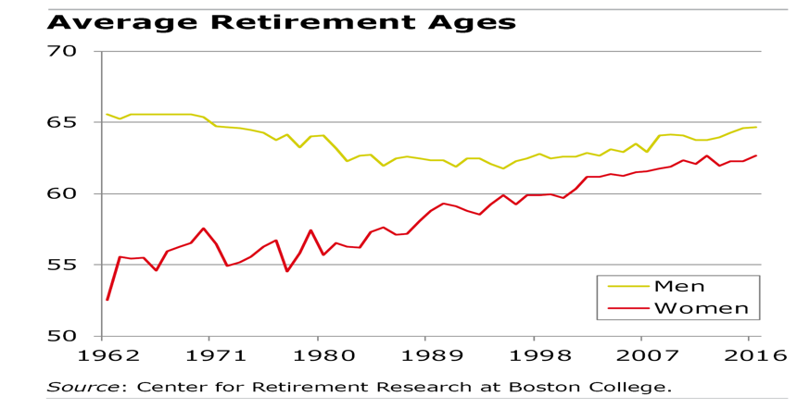
Note: This Graph shows the average retirement ages for men in the yellow line and women in the red line. This shows the average retirement age from 1962 through 2016. Copyright 2018 by Center for Retirement Research at Boston College.

Figure 2: The Probability of High School Dropouts Retiring
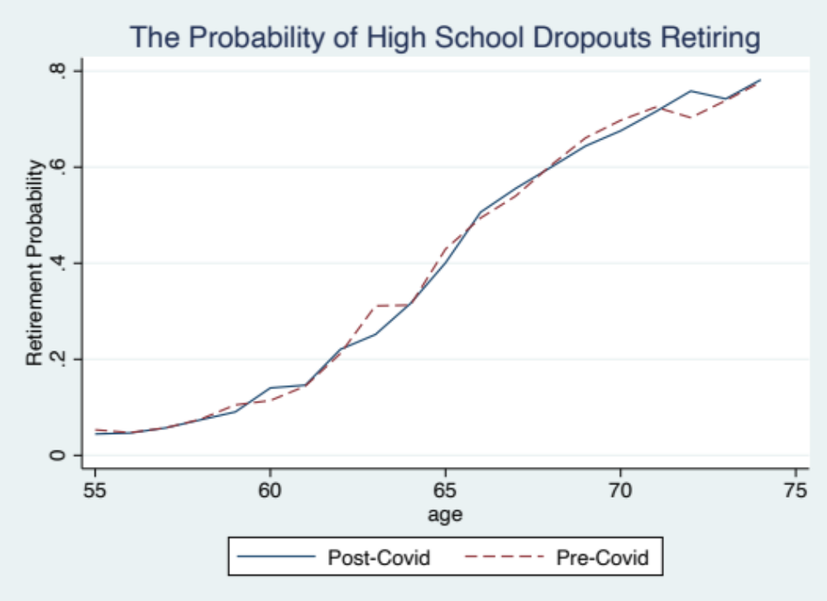
Figure 3: The Probability of High School Graduates Retiring
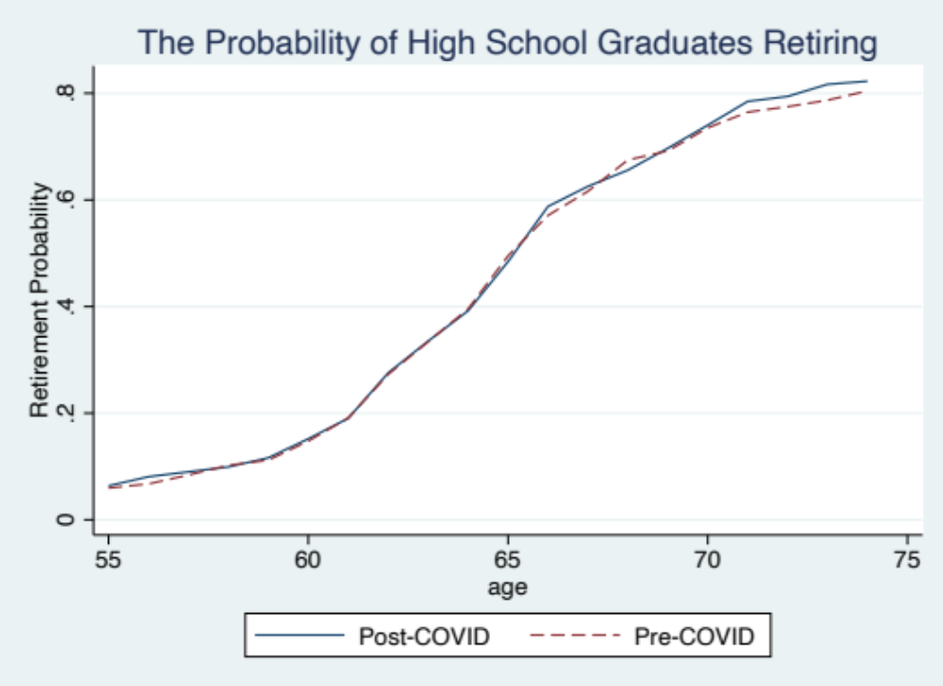
Note: The dashed red line represents the probability of retiring before March of 2020, and the solid blue line represents the probability of retiring after March of 2020.
Figure 4: The Probability of Retiring with Some College Education
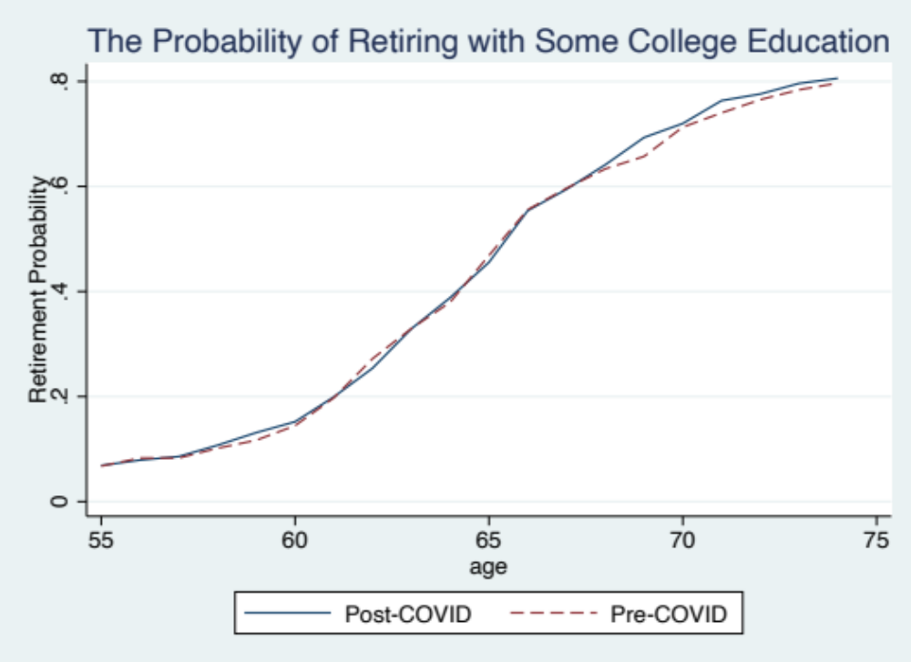
Figure 5: The Probability of a College Graduate Retiring
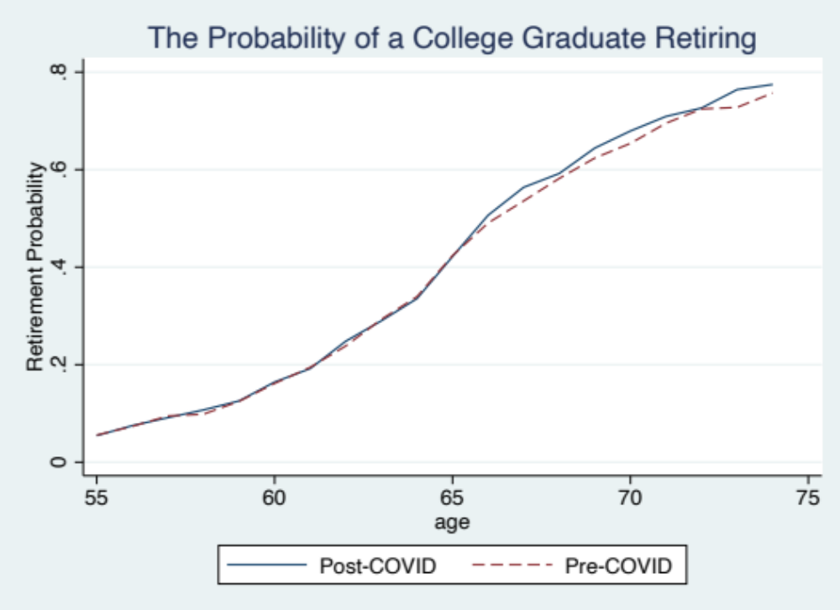
Note: The dashed red line represents the probability of retiring before March of 2020, and the solid blue line represents the probability of retiring after March of 2020.
Figure 6: The Change in Probability before and after COVID-19
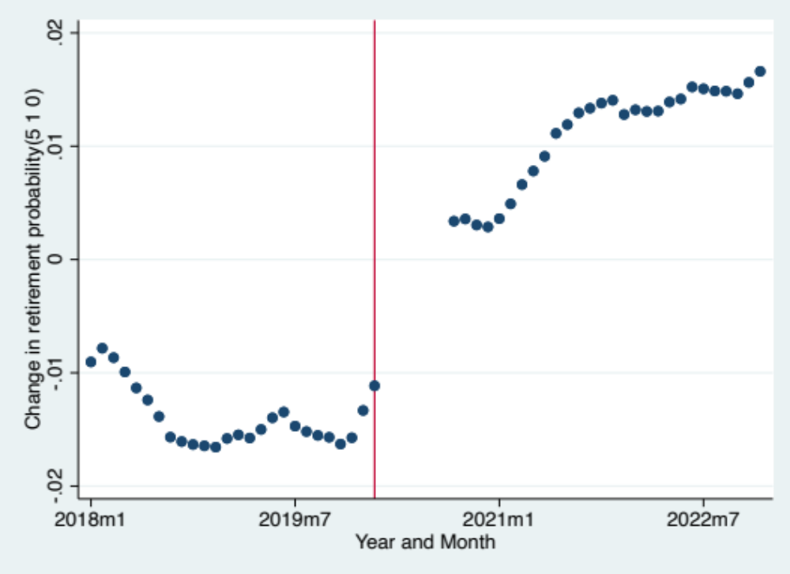
Note: The x-axis is the Year with the month of that year after it denoted by “m” followed by the number of the corresponding month. The y-axis represents the moving average of the change in retirement probability with each new month being the average of the five months before it, including the current month. The red line represents March of 2020, when the COVID-19 pandemic hit the United States.

Table 1: Race Tabulation

Race | Freq. | Percent | Cum.
white | 1,539,610 | 82.88 | 82.88
black | 187,462 | 10.09 | 92.97
American Indian/Aleut/Eskimo | 19,308 | 1.04 | 94.01
Asian only | 84,394 | 4.54 | 98.55
Hawaiian/pacific islander only | 5,834 | 0.31 | 98.86
white-black | 3,113 | 0.17 | 99.03
white-American Indian | 10,288 | 0.55 | 99.59
white-Asian | 2,449 | 0.13 | 99.72
white-Hawaiian/pacific islander | 896 | 0.05 | 99.77
black-American Indian | 1,489 | 0.08 | 99.85
black-Asian | 169 | 0.01 | 99.86
black-Hawaiian/pacific islander | 22 | 0.00 | 99.86
American Indian Asian | 72 | 0.00 | 99.86
Asian Hawaiian/pacific islander | 1,002 | 0.05 | 99.91
white-black-American Indian | 739 | 0.04 | 99.95
white-black-Asian | 37 | 0.00 | 99.96
white-American Indian Asian | 86 | 0.00 | 99.96
white-Asian-Hawaiian/pacific islander | 528 | 0.03 | 99.99
white-black-American Indian Asian | 46 | 0.00 | 99.99
American Indian Hawaiian/pacific island | 14 | 0.00 | 99.99
white-black--Hawaiian/pacific islander | 33 | 0.00 | 99.99
white-American Indian Hawaiian/pacific | 24 | 0.00 | 100.00
black-American Indian Asian | 29 | 0.00 | 100.00
white-American Indian-Asian-Hawaiian/pa | 8 | 0.00 | 100.00
two or three races, unspecified | 14 | 0.00 | 100.00
four or five races, unspecified | 33 | 0.00 | 100.00
Total | 1,857,699 | 100.00

Note: This is a table of the races of each respondent of the survey and how many people of each race that there are.
Table 2: Marital Status Tabulation

Marital status | Freq. | Percent | Cum.
married, spouse present | 1,170,194 | 62.99 | 62.99
married, spouse absent | 25,237 | 1.36 | 64.35
separated | 31,487 | 1.69 | 66.05
divorced | 303,412 | 16.33 | 82.38
widowed | 153,499 | 8.26 | 90.64
never married/single | 173,870 | 9.36 | 100.00
Total | 1,857,699 | 100.00

Note: This is a table of the marital status of each respondent and how many of each type of marital status that there are.

Table 3: Summary Statistics
 | (1) | (2) | (3) | (4) | (5)
 | Mean | Sd | Min | Max | Count
retired | .3890291 | .4875301 | 0 | 1 | 1857699
dropout | .0859359 | .2802694 | 0 | 1 | 1857699
high_graduate | .305718 | .460711 | 0 | 1 | 1857699
some_college | .2738318 | .4459238 | 0 | 1 | 1857699
col_graduate | .3313922 | .4707139 | 0 | 1 | 1857699
age | 63.89412 | 5.586616 | 55 | 74 | 1857699
sex | 1.526907 | .4992756 | 1 | 2 | 1857699
race | 146.9211 | 139.9656 | 100 | 830 | 1857699
marital status | 2.33595 | 1.851615 | 1 | 6 | 1857699
birthplace | 13454.32 | 10725.63 | 9900 | 96000 | 1857699
year_month | 724.2698 | 17.2822 | 696 | 755 | 1857699
months_march20 | 2.269839 | 17.2822 | -26 | 33 | 1857699
post_covid | .5432301 | .4981278 | 0 | 1 | 1857699
Observations | 1857699 | =" | =" | =" | ="

Table 4: Fixed Effects Model Estimates with Retirement Probability as the Dependent Variable
 | (1) | (2) | (3) | (4)
 | Dropout | High_Graduate | Some_College | Col_Graduate
Post_Covid | 0.00178 | 0.00841*** | 0.00669** | 0.00702***
Standard Errors | (0.00443) | (0.00279) | (0.00289) | (0.00224)
_cons | 0.348*** | 0.385*** | 0.387*** | 0.362***
Standard Errors | (0.00245) | (0.00159) | (0.00165) | (0.00131)
N | 141263 | 513909 | 461113 | 559307

Dependent variable for all regressions is Retired (the probability of Retiring)
Note: Dropout= binary variable with 1 is individual has attended some high school but has not graduated; High_Graduate= binary variable with 1 if the individual has graduated high school; Some_College= binary variable with 1 if the individual has attended some college; Col_Graduate= binary variable with 1 if the individual has graduated high school.
*, **, *** significant at the 10%, 5%, and 1% level, respectively.

Table 5: Fixed Effects Model Estimates with Retirement Probability as the Dependent Variable for those younger than 66.
 | (1) | (2) | (3) | (4)
 | Dropout | High_Graduate | Some_College | Col_Graduate
Post_Covid | -0.00291 | 0.00420 | 0.00299 | 0.000541
Standard Errors | (0.00632) | (0.00253) | (0.00371) | (0.00278)
_cons | 0.161*** | 0.199*** | 0.201*** | 0.187***
Standard Errors | (0.00349) | (0.00143) | (0.00208) | (0.00161)
N | 84909 | 316208 | 274260 | 327412

Dependent variable for all regressions is Retired (the probability of Retiring)
Note: Dropout= binary variable with 1 is individual has attended some high school but has not graduated; High_Graduate= binary variable with 1 if the individual has graduated high school; Some_College= binary variable with 1 if the individual has attended some college; Col_Graduate= binary variable with 1 if the individual has graduated high school.
*, **, *** significant at the 10%, 5%, and 1% level, respectively.

Table 6: Fixed Effects Model Estimates with Retirement Probability as the Dependent Variable for those older than 65.
 | (1) | (2) | (3) | (4)
 | Dropout | High_Graduate | Some_College | Col_Graduate
Post_Covid | 0.00747 | 0.0151*** | 0.0121** | 0.0178***
Standard Errors | (0.00971) | (0.00433) | (0.00561) | (0.00390)
_cons | 0.652*** | 0.702*** | 0.683*** | 0.635***
Standard Errors | (0.00537) | (0.00254) | (0.00331) | (0.00231)
N | 56349 | 197693 | 186845 | 231892

Dependent variable for all regressions is Retired (the probability of Retiring)
Note: Dropout= binary variable with 1 is individual has attended some high school but has not graduated; High_Graduate= binary variable with 1 if the individual has graduated high school; Some_College= binary variable with 1 if the individual has attended some college; Col_Graduate= binary variable with 1 if the individual has graduated high school.
*, **, *** significant at the 10%, 5%, and 1% level, respectively.
Table 7: Fixed Effects Model Estimates with Retirement Probability as the Dependent Variable for Males
 | (1) | (2) | (3) | (4)
 | Dropout | High_Graduate | Some_College | (Col_Graduate
Post_Covid | -0.00291 | 0.00487 | 0.0118** | 0.00377
Standard Errors | (0.00645) | (0.00315) | (0.00465) | (0.00274)
_cons | 0.311*** | 0.340*** | 0.359*** | 0.331***
Standard Errors | (0.00364) | (0.00181) | (0.00267) | (0.00159)
N | 70992 | 245220 | 206541 | 269747

Dependent variable for all regressions is Retired (the probability of Retiring)
Note: Dropout= binary variable with 1 is individual has attended some high school but has not graduated; High_Graduate= binary variable with 1 if the individual has graduated high school; Some_College= binary variable with 1 if the individual has attended some college; Col_Graduate= binary variable with 1 if the individual has graduated high school.
*, **, *** significant at the 10%, 5%, and 1% level, respectively.
Table 8: Fixed Effects Model Estimates with Retirement Probability as the Dependent Variable for Females
 | (1) | (2) | (3) | (4)
 | Dropout | High_Graduate | Some_College | Col_Graduate
Post_Covid | 0.00482 | 0.0119*** | 0.00210 | 0.00989***
Standard Error | (0.00480) | (0.00358) | (0.00367) | (0.00289)
_cons | 0.386*** | 0.427*** | 0.410*** | 0.392***
Standard Error | (0.00260) | (0.00204) | (0.00209) | (0.00170)
N | 70267 | 268682 | 254569 | 289557

Dependent variable for all regressions is Retired (the probability of Retiring)
Note: Dropout= binary variable with 1 is individual has attended some high school but has not graduated; High_Graduate= binary variable with 1 if the individual has graduated high school; Some_College= binary variable with 1 if the individual has attended some college; Col_Graduate= binary variable with 1 if the individual has graduated high school.
*, **, *** significant at the 10%, 5%, and 1% level, respectively.
References
Boomers Find Reasons to Retire Later. (2018, November 29). Center for Retirement Research at Boston College. https://squaredawayblog.bc.edu/squared-away/boomers-find-reasons-to-retire-later/
Bound, John and Waidmann, Timothy, (October 1, 2007). “Estimating the Health Effects of Retirement”. Michigan Retirement Research Center Research Paper No. UM WP 2007-168. http://dx.doi.org/10.2139/ssrn.1082047
Coile, Courtney and Zhang, Haiyi, "Recessions and Retirement: New Evidence from the COVID-19 Pandemic" (2022). Wharton Pension Research Council Working Papers. 739.
David Dorn & Alfonso Sousa-Poza (2010) ‘Voluntary’ and ‘involuntary’ early retirement: an international analysis, Applied Economics, 42:4, 427-438, DOI: 10.1080/00036840701663277
Employee Retirement Income Security Act (ERISA) | U.S. Department of Labor. (n.d.). Www.dol.gov. https://www.dol.gov/general/topic/retirement/erisa#:~:text=The%20Employee%20Retirement%20Income%20Security
Hayes, B. C., & VandenHeuvel, A. (1994). Attitudes toward mandatory retirement: an international comparison. International journal of aging & human development, 39(3), 209–231. https://doi.org/10.2190/UEL3-P5UU-9KQU-1W96
Johnson, Richard W. and Smith, Karen E., (2022). "How Gloomy is the Retirement Outlook for Millennials?" Wharton Pension Research Council Working Papers. 741. https://repository.upenn.edu/prc_papers/741
Miller, S. (2021, May 11). Congress Considers “SECURE Act 2.0” with a New Round of Retirement Plan Fixes. Shrm.org; SHRM. https://www.shrm.org/resourcesandtools/hr-topics/benefits/pages/congress-considers-a-new-round-of-retirement-legislation.aspx
Munnell, Alicia and Sanzenbacher, Geoffrey and Webb, Anthony, “What Causes Workers to Retire Before They Plan?” (September 1, 2015). Center for Retirement Research Working Paper No. 2015-22, https://jor.pm-research.com/content/6/2/35
Palmore, E.B. (1971). Why Do People Retire? The International Journal of Aging and Human Development, 2, 269 - 283.
Public Broadcasting Service. (2022, February 23). Why millions of older Americans are retiring early in the wake of the pandemic. PBS. https://www.pbs.org/newshour/show/why-millions-of-older-americans-are-retiring-early-in-the-wake-of-the-pandemic
Suknanan, J. (2021, August 25). Here’s why our brains make it so hard to start saving for retirement. CNBC. https://www.cnbc.com/select/why-retirement-saving-is-hard-according-to-behavioral-economics/
Thompson, D. (2022, September 19). Pandemic Disrupted Labor Markets but Had Modest Impact on Retirement Timing. Census.gov. https://www.census.gov/library/stories/2022/09/did-covid-19-change-retirement-timing.html
Workplace Flexibility 2010, Georgetown University Law Center, "A Timeline of the Evolution of Retirement in the United States" (2010). Memos and Fact Sheets. 50.
https://scholarship.law.georgetown.edu/legal/50

